UNIVERSITY OF OKLAHOMA
GRADUATE COLLEGE

CASCADING EFFECTS OF NUDGING AND EDUCATION ON COMMON GOODS: AN EXPERIMENTAL COMPARISON OF POTABLE WATER RECYLING INTERVENTIONS

A THESIS
SUBMITTED TO THE GRADUATE FACULTY
in partial fulfillment of the requirements for the
Degree of
MASTER OF SCIENCE

By
BRADEN TANNER
Norman, Oklahoma
2021

CASCADING EFFECTS OF NUDGING AND EDUCATION ON COMMON GOODS: AN EXPERIMENTAL COMPARISON OF POTABLE WATER RECYLING INTERVENTIONS

A THESIS APPROVED FOR THE
DEPARTMENT OF PSYCHOLOGY

BY THE COMMITTEE CONSISTING OF

Dr. Adam Feltz, Chair
Dr. Edward Cokely
Dr. Scott Gronlund

© Copyright by BRADEN TANNER 2021
All Rights Reserved.
Acknowledgments
I would first like to express my sincere gratitude to Dr. Adam Feltz for his guidance, encouragement, and continual involvement throughout this process. I would also like to thank Dr. Edward Cokely and Dr. Scott Gronlund for their help and constructive feedback, as well as Dr. David Sabatini and his colleagues at the OU WaTER center for their role in these projects. Finally, I extend my thanks to my family, my friends, and my colleagues in the Ethical Choice Education Lab for their encouragement and support.

Table of Contents
Acknowledgements iv
Abstract vi
Introduction 7
Recycled Water Acceptance and Psychology 9
Educational Decision Aids 11
Libertarian Paternalistic Default Nudges 13
Contrasting Informing and Libertarian Paternalistic Default Nudging 17
Experiment 1 23
Method 24
Participants 24
Procedure 24
Results and Discussion 25
Experiment 2 25
Method 25
Participants 25
Procedure 26
Results and Discussion 28
Experiment 3 31
Method 31
Participants 31
Procedure 32
Results and Discussion 33
Experiment 4 35
Method 36
Participants 36
Procedure 36
Results and Discussion 48
General Discussion 46
References 57
Figures 74
Tables 96
Abstract
Despite calls for research comparing different forms of choice architecture interventions, little empirical work has directly made those comparisons. Here, I evaluate two strategies on whether they increase acceptance of recycled water on ethically relevant dimensions: libertarian paternalistic default nudges and educational decision aids. Experiment 1 (N = 81) showed that defaults increased shallow acceptance of recycled water (i.e., enrollment in a hypothetical recycled water program). Experiment 2 (N = 142) replicated the effect but also indicated that weak educational interventions (simple infographics) interacted with confidence, such that those who switched from the default had measurably higher confidence in their choice when given the infographic. Experiment 3 (N = 146) suggested that strong educational interventions (educational videos) increased shallow acceptance, increased knowledge of recycled water, and interacted with confidence in the same way observed in Experiment 2. Experiment 4 (N = 332) replicated the shallow acceptance, knowledge, and confidence results from previous experiments, and demonstrated that educational decision aids reliably increased deeper indicators of acceptance (e.g., behavioral intentions, affect, etc.). Ultimately, these results suggest that multiple practical and ethical factors (e.g., strength and mediums of educational interventions, depth of acceptance, potential ethical costs in terms of autonomy and decision confidence) need to be taken into account when deciding to implement these kinds of strategies in ethically defensible ways.
Keywords: libertarian paternalism, education, autonomy, recycled water, potable reuse, ethics
Introduction

Over the past decade, governments and organizations around the world have expressed increasing interest in applications and insights from the behavioral sciences. D. Halpern and Sanders (2016) have suggested that more than 20 countries—including the United States, the United Kingdom, and Australia—have either implemented or expressed interest in implementing behavioral insights teams. These teams typically use approaches from psychology, behavioral economics, and other related fields to help people change behaviors. Likewise, the Organisation for Economic Co-operation and Development (OECD) has identified over 40 organizations and more than a hundred case studies where behavioral interventions are being used to improve outcomes across diverse domains (e.g., consumer choices, tax administration, public health; see OECD, 2017)). Overall, it has been estimated that these interventions easily represent hundreds of millions of dollars’ worth of monetary benefits (D. Halpern & Sanders, 2016). As more people continue to turn to behavioral insights, it is becoming increasingly important to identify key criteria that can help decision scientist and policymakers choose among the many forms of choice architecture (i.e., general methods of altering people’s choices; Münscher et al., 2016) that are currently available (Johnson et al., 2012).

Among the many potential criteria for deciding among choice architecture interventions (e.g., effectiveness at changing behavior, monetary costs required to implement the intervention), one important set of criteria is whether interventions are consistent with commonly held ethical standards (e.g., American Psychological Association, 2002). While the ethical implications of different forms of choice architecture have been the subject of much theoretical debate (e.g., Blumenthal-Barby & Burroughs, 2012; Bovens, 2009; Hausman & Welch, 2010; Selinger & Whyte, 2011; Sunstein, 2015a, 2015b), to my knowledge, no empirical work has been conducted to (a) identify ethical relevant criteria for evaluation, and (b) examine whether interventions differ along those criteria. Here, my focus is on the set of criteria surrounding respect for informed deliberation. Informed deliberation is often thought to be important component of autonomy—a factor that almost all ethical codes suggest there is a prima facie duty to protect (and perhaps promote). As such, here I seek to empirically compare two popular kinds of choice architecture interventions—(1) educational decision aids seeking to increase domain specific knowledge and (2) libertarian paternalistic default nudges—with respect to how much they protect (and perhaps promote) informed deliberation.

I contextualize the comparisons in the domain of recycled water acceptance. Recycled water represents one partial solution to increasingly concerning world-wide water scarcity issues. It has been estimated that at least one-third of the world’s population currently lives in water-stressed countries (Elimelech, 2006) and nearly 80% of people live in areas where threats to human water security exceed the 75th percentile (Vörösmarty et al., 2010). As such, interest in non-conventional ways to increase potable water capacity has grown globally (Tortajada & Ong, 2016). One promising and prominent non-conventional source of water involves the treatment and reuse of municipal wastewater, commonly referred to as recycled water, reclaimed water, or reuse water (United States Environmental Protection Agency et al., 2012). However, despite research and implementations demonstrating that recycled water can be safely used for potable, drinking purposes (or is at least as safe as typical tap water; e.g., Khan & Roser, 2007), public acceptance represents a significant barrier to the actual implementation of potable water reuse methods. Thus there has been interest from researchers and policy makers in developing programs to help overcome public distaste for recycled water (Dishman et al., 1989).

Overall, in a series four experiments, I provide evidence that using libertarian paternalistic defaults can sometimes be effective at increasing shallow indicators of recycled water acceptance (e.g., choosing to enroll in a hypothetical recycled water program). I also show that some educational interventions can increase acceptance of recycled water while at the same time contributing to deeper indicators of acceptance, including increasing other desirable outcomes (e.g., increased knowledge, confidence, and satisfaction) and decreasing undesirable outcomes (e.g., intentions to protest and move). These results ultimately highlight some important benefits and practical costs associated with each strategy. They also show that libertarian paternalistic defaults are often less able to support informed deliberation than educational interventions, suggesting that libertarian paternalistic defaults may risk violating moral rules concerning autonomy. Ultimately, these studies suggest that careful consideration and comparisons among choice architectures are required for policy implementation to be ethically and practically justified.

Recycled Water Acceptance and Psychology

Both direct and indirect potable water recycling methods have been implemented and proven effective at providing safe, reliable drinking water (i.e., as safe as traditional tap water) in many locations such as Singapore, Namibia, and parts of the United States (Lee & Tan, 2016; Sanchez-Flores et al., 2016; van Rensburg, 2016). Notably, potable recycled water is, in general, less energy-intensive than some other methods of increasing water capacity (e.g., de-salination), largely resistant to environmental changes (e.g., drought), and reduces waste discharged back into the environment (Fielding et al., 2019). Despite these advantages, however, public acceptance of recycled water in many cases remains low, especially for potable purposes such as cooking and drinking (see Dolničar & Saunders, 2006). Furthermore, the low public acceptance of recycled water represents a significant barrier to the implementation of water recycling methods, as public opposition has, in some cases, halted proposed water recycling projects (e.g., San Diego; Hurlimann & Dolnicar, 2010; Po, Kaercher, & Nancarrow, 2003; Uhlmann & Head, 2011).

Many decades of research into potable recycled water suggest that public acceptance is often a function of the interplay of many psychological factors such as disgust, perception of health risks and benefits, perceived need for alternative water supplies, trust in authority, and relevant knowledge (see Fielding et al., 2019; Smith et al., 2018 for reviews). Given the importance of these kinds of psychological factors, approaches from psychology and behavioral economics may be able to take advantage of some of these psychological factors to help encourage reuse water acceptance. Consistent with the notion that interfaces and affordances can (and should) be scientifically designed to facilitate and enhance human and system performance (Wickens et al., 2015), two prominent forms choice architecture that could take advantage of some of these psychological factors can be broadly categorized into methods that seek to inform decision makers to make them more knowledgeable or skilled and methods that seek to persuade individuals using non-rational means (see Feltz & Cokely, 2018; Grüne-Yanoff & Hertwig, 2016; Hertwig & Grüne-Yanoff, 2017; Hertwig & Ryall, 2019).

Educational Decision Aids

One common type of choice architecture which may be especially relevant to acceptance of science and scientific innovations like recycled water treatment involves providing enough relevant information about the topic so that people can make an informed decision for themselves. While many social, cultural, economic, and political factors are influential in forming attitudes toward science (Hayes & Tariq, 2000; Priest, 2001), domain specific knowledge (i.e., understanding of relevant facts about a given topic) is often thought to be integral to the public’s acceptance of scientific innovations, and public doubt about these innovations are often thought to be largely attributable to misunderstanding or ignorance about key scientific facts (see Sturgis & Allum, 2004). Consistent with this notion, knowledge has often been found to have modest, positive correlations with attitudes towards often polarizing scientific issues (Allum et al., 2008; Nisbet, 2005; Nisbet & Goidel, 2007). Research also suggests that transparent decision aids, simple interventions, and training programs are often able to convey relevant facts and sometimes dramatically improve decision making (i.e., increase decisions that are in line with one’s own best interest or values) among a wide variety of people (Cokely et al., 2018; Garcia-Retamero & Cokely, 2013, 2017; see also Bruine de Bruin & Bostrom, 2013; Bruine de Bruin, Parker, & Fischhoff, 2007; Fischhoff, Brewer, & Downs, 2011; Petrova, van der Pligt, & Garcia-Retamero, 2014; D. Petrova, Garcia-Retamero, & Cokely, 2015; Trevena et al., 2013).

To explain the relationship between educational decision aids, knowledge, and attitudes toward scientific issues like recycled water acceptance, one might look to Cokely et al.'s (2018) framework for skilled decision making. In their paper, Cokely et al (2018) assert that transparent decision aids are specifically designed to promote an increasingly representative understanding (understanding that is sufficiently rich and nuanced that additional random information is unlikely to bias inferences made from that knowledge). Part of the skilled decision framework posits that transparent decision aids and general cognitive abilities (e.g., numeracy) support good decision making by directly influencing deliberation, confidence calibration, and knowledge, which in turn affects the precision and calibration of affective reactions (see Figure 1). That is, at least in part, transparent educational decision aids are thought to affect good decisions by providing individuals with information to come to a deeper understanding of how a decision will factor into their own lives, what they value, and how they feel.

For these reasons, providing people with educational decision aids containing relevant information about recycled water may help them come to a more representative understanding of the decision, which may in turn may promote recycled water acceptance. For example because most people’s objective knowledge of recycled water is low (Glick et al., 2019), a high-quality educational decision aid (i.e., one that provides information that a wide variety of people can understand) might prompt deliberation and facilitate increased understanding of some of the important cognitive (i.e., mental states capable of being true or false) determinants of acceptance (e.g., need for alternative water supplies, potential risks and benefits). In turn, that understanding may lead to more appropriate affective reactions (e.g., decreased disgust and worry about potential risks) and lead to acceptance decisions that are more consistent with expert consensus concerning the safety and need for recycled water.

The current literature contains a few experiments where the effects of information-based decision aids on reuse water decisions were examined (Dolnicar et al., 2010; Fielding & Roiko, 2014; Price et al., 2015; Roseth, 2008; Simpson & Stratton, 2011). Generally, consistent with the framework for skilled decision theory, these studies have found educational aids to be effective in encouraging water reuse acceptance; however, the overall magnitude of their effects have tended to be small (Dolnicar et al., 2010; Price et al., 2015; Roseth, 2008). One potential explanation for the overall small effects is that methods of informing have varied widely across these studies, with the decision aids ranging anywhere from brief statements about the wastewater recycling process (Dolnicar et al., 2010) to 47-page online booklet containing detailed recycled water information (Simpson & Stratton, 2011). Importantly, none of the studies have explored potential proximal cognitive factors (e.g., increase in knowledge; reduction in disgust reactions) that could be changed by educational interventions.

Libertarian Paternalistic Default Nudges

While education could increase recycled water acceptance, an alternative could involve intentionally exploiting heuristics (i.e., mental shortcuts) or biases (i.e., decision making tendencies; see Cokely et al., 2018) to persuade people to accept recycled water (see Tversky & Kahneman, 1974). Approaches that intentionally take advantage of heuristics or biases often fall in the general category of a popular behavioral intervention strategy known as nudging. Nudge strategies construct decision making environments that primarily target automatic processing (i.e., thinking processes that are quick and reflexive; see Evans, 2008; Thaler & Sunstein, 2008) to steer decision makers toward a specific choice without specifically forbidding any choices, thus technically respecting an individual’s right to choose differently (Sunstein, 2014).

Within the broader category of nudges, some forms of nudges might be described as libertarian paternalistic (see Figure 2). Of note, there are several conceptions of what constitutes a libertarian paternalistic intervention (see Hausman & Welch, 2010; Sunstein, 2014; Thaler & Sunstein, 2003). For example, Thaler and Sunstein (2008) define libertarian paternalism as a policy that influences choice “in a way that will make choosers better off, as judged by themselves” (p. 5) while still preserving the individual’s right to choose. On this view, the ‘libertarian’ aspect of Libertarian Paternalism is reflected in leaving open (perhaps formally) choice options where one could choose something other than the encouraged choice, while the ‘paternalistic’ aspect is reflected in encouraging the specific choice that will likely benefit the decision maker. However, I follow the more developed notion of ‘paternalism’ offered by Gert and Culver (1979):

A is acting paternalistically toward S if and only if A’s behavior (correctly) indicates that A believes that (1) his action is for S’s good; (2) he is qualified to act on S’s behalf; (3) his action involves violating a moral rule (or will require him to do so) with regard to S [emphasis added]; (4) S’s good justifies him in acting on S’s behalf independently of S’s past, present, or immediately forthcoming (free, informed) consent; and (5) S believes (perhaps falsely) that he (S) generally knows what is for his own good. (p. 199)

In accordance with this definition, for the purposes of this paper, I adopt a view similar to Hausman and Welch (2010), where a libertarian paternalistic intervention is one that attempts to predictably influence behavior while still leaving open the ability to choose differently (i.e., libertarian), but also involves the violation of some moral rule (i.e., paternalistic).

Often, autonomy (i.e., the actual condition of agents governing themselves; Mele, 2001) is thought to be violated with libertarian paternalistic policies (although autonomy is not the only potential violation). Infringing on individuals’ autonomy is widely regarded as a moral violation (e.g., respecting autonomy is reflected in numerous professional ethics codes, including the American Psychological Associations’). On Mele’s (2001) view of autonomy, a (self-controlled) person has acted autonomously if:

1. The agent has no compelled motivational states, nor any coercively produced motivational states.

2. The agent's beliefs are conducive to informed deliberation about all matters that concern him.

3. The agent is a reliable deliberator. (p. 187)

Adopting this view, the implication is that one way for an individual to be autonomous is to be free from coercion, to have access to whatever correct information is required to deliberate accurately, and to possess the executive skills and habits necessary to meaningfully incorporate relevant factors into their overall decision. Because not all libertarian paternalistic policies inform people (Sunstein, 2015a), and thus often do not engage rational agency (i.e., a set of capacities—competence and being informed—that allow one to integrate available information, values, and prior beliefs to make a decision; Feltz & Cokely, 2021) while influencing choices, libertarian paternalistic interventions are often thought to violate the second condition (for the purposes of this thesis, I leave it open whether libertarian paternalistic interventions also do not satisfy conditions 1 and 3). Notably, however, to my knowledge, no previous work has ever attempted to empirically evaluate this assumption.

One particularly powerful and popular application of Libertarian Paternalistic strategies is the use of default rules (often referred to as “default nudges,” e.g., Blumenthal-Barby & Burroughs, 2012; Ghesla et al., 2019; Venema et al., 2018), which holds that as a result of factors such as heuristics, biases, and inertia (the tendency to stay with an option because it is easier to take no action than it is to perform some action to actively switch options; see Madrian & Shea, 2001; Thaler & Sunstein, 2008) people often stick with default options (Johnson & Goldstein, 2013). That is, when individuals have the choice to stay with the default option, they often tend to stay with the default, even though they are perfectly free to choose something other than the default option. As such, by carefully designing the default option, individuals and organizations can often steer decision makers towards a desired choice while still technically leaving open the option to choose differently (see Thaler & Sunstein, 2008). Under these theoretical assumptions, default nudging often qualifies as libertarian paternalistic because it often fails to inform participants and thus does not engage rational agency (see Figure 3). Defaults do not typically influence choice by increasing cognitive processes typical of rational agency like knowledge, beliefs, deliberation, or confidence. However, educational decision aids typically do not qualify as libertarian paternalistic because they often use information to contribute to representative understanding (e.g., increasing what one knows about a problem) and thus critically engage rational agency.

To illustrate libertarian paternalistic default nudges with a real-world example, Halpern et al. (2013) conducted a field experiment in which they used default rules to influence seriously ill patients’ choice between comfort-oriented end-of-life care or life-extending care. Some of the ill patients received a form where the box to select either the comfort-care option or the life-extending option was already checked with an ‘X’. In total, 77% of patients with the pre-selected comfort option chose the comfort option, while only 43% of patients with the pre-selected life-extending option switched and chose the comfort care, suggesting that the default influenced choice. However, because no information concerning the care options was provided to participants, it is not likely that those individuals understood the problem better in any meaningful way. As such, moral rules concerning autonomy may have been violated by pre-selecting defaults for those patients (or at least autonomy was not promoted).

The effect of defaults has been observed across many domains, including contributing to retirement plans, consenting to be organ donors, end of life health and financial decisions, and various consumer (i.e., buying a product or service) domains (Feltz, 2015, 2016; Jachimowicz et al., 2019; Johnson & Goldstein, 2003; Madrian & Shea, 2001). To my knowledge, no studies have attempted to examine the viability of libertarian paternalistic default nudges in the context of recycled water acceptance. Given the pervasiveness of default nudges, these nudges are likely to be useful in encouraging acceptance of recycled water. Thus, by carefully setting default options, one could theoretically take advantage of heuristic-based decision processes and essentially circumvent other relevant psychological barriers to acceptance of recycled potable water.

Contrasting Informing and Libertarian Paternalistic Default Nudging

Despite calls for research better comparing default nudges to other choice architecture interventions (Jachimowicz et al., 2019) and theoretical frameworks that have been proposed to help policymakers decide between libertarian paternalistic and non-libertarian paternalistic intervention strategies (e.g., Hertwig, 2017), little empirical work has been done to directly compare educational interventions to libertarian paternalistic default nudges on ethically relevant dimensions (e.g., autonomy). Arguments concerning potential violations of moral rules are often minimized or even dismissed solely on the grounds that libertarian paternalistic interventions preserve the individual’s freedom to choose. For example, concerning autonomy, Sunstein (2015a) states, “When sensible nudges are in place, human agency is retained (because freedom of choice is not compromised)” (p. 209) and further goes on to say that “desirable nudges should undermine neither autonomy nor welfare. On the contrary, they can promote both values; indeed, they might be indispensable for them” (p. 210). One of the only empirical studies that has been conducted directly comparing different choice architecture methods was conducted by Benartzi et al. (2017). Using publicly instituted programs and publicly available outcomes, they conducted dollar-based cost-benefit analyses comparing libertarian paternalistic nudges like the default to traditional interventions like educational campaigns and monetary incentive programs. They found that adjusting for costs, interventions like default nudges are often comparatively more impactful per-dollar spent than traditional tools like incentive programs. However, actual experimental comparisons of defaults and educational interventions (e.g., Prusaczyk et al., 2021) are rare.

This lack of empirical work—especially in investigating claims that libertarian paternalistic default nudges might violate moral rules—is concerning. If libertarian paternalistic default nudging does violate a moral rule, there are potential ethical costs associated with selecting this type of intervention compared to using educational decision aids that policymakers might need to consider. However, the fact that a policy violates a moral rule does not entail that it is impermissible to implement that policy. There could be other goods that are obtained that are sufficient to outweigh the costs associated with the moral rule. These considerations are in line with the justification for paternalistic policies in general. Accordingly, even if a moral rule is violated, one important task is to identify relevant criteria to directly compare libertarian paternalistic default nudges to educational decision aids in order to determine in what circumstances the violation of the moral rule might be justified (e.g., when do goods outweigh costs, which costs and benefits, and by how much).

As such the primary goal of this paper is to experimentally compare the effectiveness of libertarian paternalistic default nudges and educational interventions at encouraging recycled water acceptance along ethically relevant dimensions. I do this using several criteria. The first is a shallow indicator of recycled water acceptance, which I operationalize as a binary choice to enroll in a hypothetical program which would deliver recycled water to residential taps. I refer to this binary enrollment choice as a shallow indicator of acceptance because actions might not always be congruent with what people would take to reflect their deeply held values that constitutes who they are (i.e., the “deep” self). For example, Wolf (2013) argues that victims of brainwashing may not be responsible for their actions because external forces have essentially severed the connection between their actions and their deeper self. Similarly, Hausman & Welch (2010) argue that when choice architectures take advantage of psychological foibles (e.g., heuristics and biases) to nudge decisions, actions can often reflect the tactics of the choice architect rather than the will of the decision maker. Thus, a simple acceptance choice may not always be a reliable indicator of true attitudinal or behavioral change that is essential for one to be self-governed. Specifically, I hypothesize:

$H_{1}$: Defaulting individuals into a hypothetical recycled water program will increase shallow acceptance of recycled water (i.e., enrollment in the program) compared to being defaulted out of the program.

$H_{2}$: Relevant educational interventions will increase shallow recycled water acceptance compared to not receiving a relevant educational intervention.

H₃: Relevant educational interventions will be more effective at increasing shallow recycled water acceptance than defaulting individuals into the program.

Second, this paper also adds to previous literature by empirically evaluating claims concerning potential violations of autonomy as a criterion of interest when comparing libertarian paternalistic default nudges to educational interventions. While many have made the case that libertarian paternalistic policies might infringe upon individuals’ autonomy and thus can involve important ethical costs (e.g., Bovens, 2009; Hansen & Jespersen, 2013; Hausman & Welch, 2010; Wilkinson, 2013), the only empirical work that has been conducted seemingly explores only subjective perceptions of autonomy (i.e., the extent to which individuals (would) feel certain policies limit their freedom of choice and autonomy; see Felsen et al., 2013; Hagman et al., 2015; Jung & Mellers, 2016; Yan & Yates, 2019). In line with Mele's (2001) framework described previously suggesting three sufficient conditions for autonomy (i.e., freedom from coercion, access to information needed to deliberate accurately, and possession of executive skills needed to deliberate reliably), in this paper I seek to objectively compare the extent to which libertarian paternalistic default nudges and educational interventions respect one of these conditions—access to informed deliberation. Specifically, using objective knowledge of recycled water as an indicator, I hypothesize:

$H_{4}$: Only relevant educational interventions will reliably increase objective knowledge of recycled water.

H₅: Knowledge will causally mediate the relationship between an effective educational intervention and acceptance of recycled water.

Relatedly, I compared the effects of libertarian paternalistic default nudges and educational interventions on decision confidence levels. Decision confidence (i.e., subjective evaluations of the extent to which individuals felt they made the “correct” recycled water decision) was included as a criterion of interest based on prior research suggesting that appropriate levels of confidence are often indicative of higher quality normative decisions (Gigerenzer et al., 1991; Gronlund et al., 2015; Ybarra et al., 2018), while overconfidence may lead to poorer quality decisions (Bruine de Bruin et al., 2007; Stanovich, 1999; Stanovich & West, 2000). Based on this link between confidence calibration and decision quality, as well as previous research linking knowledge to decision quality (see Cokely et al., 2018) I hypothesize:

$H_{6}$: Individuals will be more confident in educationally informed choices than default-influenced choice.

Finally, this paper adds to previous literature by also exploring deeper indicators of acceptance as a criterion for evaluation. Hertwig (2017) has suggested that default rules can lead to errors (e.g., sometimes individuals fail to opt out of an organ donation default, even when they do not want to be organ donors). Accordingly, a binary choice to enroll in a recycled water program reflect may not fully reflect the will of the decision maker (Hausman & Welch, 2010). Likewise, binary enrollment choice gives very little information about the strength of one’s acceptance (i.e., Person A could be strongly opposed to recycled water, while Person B could be only slightly opposed to recycled water, but a single binary choice would likely not differentiate between these two people). Understanding the strength of one’s acceptance could be valuable practically, as a policymaker would likely want to take this factor into account before investing time and resources into potential interventions.

Accordingly, consistent with some of the relevant factors predicted in Cokely et al.’s (2018) skilled decision framework, I also compare the extent to which libertarian paternalistic defaulting and informing promote behaviors, attitudes, intentions, and emotions that would be indicative of deeper acceptance. Consistent with the idea that external forces can cause actions to be incongruent with deeper held desires (Wolf, 2013), for the purposes of this paper, deep acceptance refers to things like beliefs, desires, and intentions that better reflect one’s true will and values. Specifically, I was interested in exploring the interventions’ effects on acceptance strength, intentions related to recycled water implementation (e.g., protesting/moving), actual participation in behaviors related to acceptance (e.g., signing up for information), how much individuals felt they would be satisfied with a policymaker who decided to implement recycled water, worry about long-term health, and recommendations they would give to others if recycled water were to be implemented in their community. Each of these criteria should provide a more in-depth indication of acceptance than simply staying opted into a recycled water program. Broadly, I hypothesize that:

$H_{7}$: Educational interventions will result in increased levels of deeper acceptance than libertarian paternalistic default interventions.
I tested these hypotheses in a series of four experiments. Experiment 1 tested the effectiveness of the libertarian paternalistic default nudge alone and demonstrated that defaults can influence shallow acceptance choices about recycled water. Experiment 2 tested and compared the effects of defaults and an educational intervention containing simple, brief information about recycled potable water (i.e., an infographic) on shallow acceptance, knowledge, and decision confidence, finding that libertarian paternalistic defaults again influenced shallow acceptance choice while the simple infographic did not influence choice or knowledge. There was also an interaction found for confidence, where those who stayed with defaults had similar confidence in their choice regardless of the information they were given, while those who switched from their default were significantly less confident when they did not receive relevant information, compared to those who did receive the relevant information. Experiment 3 tested and compared the effects of libertarian paternalistic defaults and a longer, more complex educational intervention (i.e., a short educational video) on shallow acceptance, knowledge, and decision confidence, finding that the educational video affected shallow acceptance choice and knowledge, while the default did not. Confidence results from the previous experiment were also replicated. Finally, Experiment 4 used a custom-made educational video to compare the effects of libertarian paternalistic defaults and an educational intervention on both shallow and deep forms of acceptance, as well as knowledge and confidence. Experiment 4 suggested that both the new educational video and the defaults influenced shallow acceptance choice, but only the educational video affected knowledge and the deeper indicators of acceptance.
Experiment 1
Because no previous studies have examined the effects of defaults on recycled water acceptance choices, Experiment 1 was designed to see if libertarian paternalistic default nudges would be effective in this domain.

Method
Participants. Participants for this study were recruited using Amazon’s Mechanical Turk (MTurk). Participants responded to an online survey in exchange for $0.50 USD. Responses were collected from 106 participants, but a total of 25 participants were excluded for answering a multiple-choice attention check question incorrectly:
The scenario I just responded to involved which of the following? (Correct answer = water bill
Of the remaining 81 participants, 54% were female (N = 44). Mean age was 37.85 (SD = 12.10), with a range of 21-67. A post-hoc power analysis indicated that the current study could detect a medium sized effect (power = .8, alpha = .05, V = 0.31).
Procedure. Participants were asked to imagine they were paying their water bill and were presented with the following hypothetical prompt:
Our city is implementing a program to begin using high quality reclaimed (i.e., recycled) water for various purposes, including use in residential taps. Our records indicate that you may be affected by this change. You (are/are not) currently enrolled in this program, but you have the option to (enroll/unenroll). Please indicate your enrollment preference below.
One group (N = 40) was randomly assigned to the default-out condition, while the other group (N = 41) was assigned to the default-in condition. Participants in the default-out condition were informed that they were not automatically enrolled in this program but would be given the option to enroll if they desired. Participants in the default-in condition were informed that they were automatically enrolled in the program but would be given the option to unenroll. Participants were then asked to indicate whether they would prefer to stay with their respective default option (“I would like to remain enrolled/unenrolled”) or switch to the alternate option (“I would like to switch and enroll/unenroll”). Participants also provided basic demographic information.
Results and Discussion
In total, 26 out of 41 (63%) participants in the default-in condition chose to enroll in the program while only 13 out of 40 (33%) participants in the default-out condition chose to enroll in the program, $χ^{2}$(1) = 7.75, p = .005, V = .31 (90% CI [0.13, 0.49]). These data were consistent with Hypothesis 1—defaulting people into the reuse program was associated with greater acceptance of the program compared to defaulting people out of the program.
Experiment 2
Experiment 2 sought to replicate the results of Experiment 1 and to compare the effectiveness of libertarian paternalistic default nudges versus informing people of some facts about recycled water.
Method
Participants. Participants for this experiment were recruited using Amazon’s Mechanical Turk, and they responded to an online survey in exchange for $0.50 USD. Responses were collected from 172 individuals, but a total of 30 participants were excluded for answering attention check questions incorrectly and displaying additional signs of inattention (e.g., excessive attempts to advance timed survey pages before the option was available). Of the remaining 142 participants, 65% were female (N = 92). Mean age was 38.65 (SD = 13.55), with a range of 19-73 (see Table 1 for descriptive statistics from Experiment 2). A post-hoc power analysis indicated that the current study could reliably detect a small sized effect (power = .8, alpha = .05 V = 0.23).
Procedure. Participants in this experiment were first assigned to either a relevant information or irrelevant information condition. Those in the relevant information condition were presented with a simple infographic briefly explaining the benefits and reasons for using recycled drinking water (see Figure 4). Participants in the irrelevant information condition were presented with a similar infographic explaining how the internet works (see Figure 5). All participants were then asked a set of five true or false objective knowledge questions about recycled water created in conjunction with water reuse engineers:
- Highly treated reuse water can be safe to drink. (T)
- Direct potable water reuse refers to advanced treatment of wastewater that is then sent to water treatment plants and then to the drinking water supply. (T)
- Cities around the world are using reuse water as a source for drinking water. (T)
- Highly treated reuse water used for drinking water is resilient to regional droughts. (T)
- Advanced treatment of reuse water can be less expensive than desalinating water for drinking water. (T)
Correct responses to these questions were coded as 1, while other responses were coded as 0. These were then summed to obtain an objective knowledge score.
Next, participants were randomly assigned and responded to one of the default scenarios from Experiment 1. After responding to their scenario, participants were asked three questions to gauge their level of confidence in their choice:
1. I feel confident in my decision.
2. I feel comfortable with my decision.
3. I feel set in my decision.
These three questions were adapted from Scherer et al. (2015) and were measured on a 5-point Likert scale (1= strongly disagree, 5 = strongly agree).
Then, participants completed the Revised Disgust Scale (DS-R; Haidt, McCauley, & Rozin, 1994, modified by Olatunji et al., 2007), a scale that measures individual sensitivity to potentially disgusting objects and scenarios. Past research suggests that disgust sensitivity is negatively associated with acceptance of recycled water (Alhumoud et al., 2003; Bruvold & Ward, 1972; Dishman et al., 1989; Dolnicar & Schäfer, 2009; Madany et al., 1992; Menegaki et al., 2007; Miller & Buys, 2008; Nancarrow et al., 2009; Po et al., 2005; Schmidt, 2008), thus I included the disgust measure in the study primarily to check that indicators of recycled water acceptance were functioning properly (i.e., if enrolling in the hypothetical water program is a valid indicator of recycled water acceptance, I would expect it to be significantly correlated with disgust sensitivity).
Participants next completed the 7-item version of the Berlin Numeracy Test (BNT; Cokely, Galesic, Schulz, Ghazal, & Garcia-Retamero, 2012; Schwartz, Woloshin, Black, & Welch, 1997). The BNT measures statistical numeracy, or the ability to understand and apply basic probabilistic information, which has been shown to predict better understanding and choices across many domains (Cokely et al., 2012; Garcia-Retamero et al., 2019; Peters, 2012) . Finally, participants provided basic demographic information.
Results and Discussion
Consistent with my first hypothesis and results from the previous experiment, the default manipulation was statistically significant, $χ^{2}$(1) = 4.81, p = .03, V = .18 (90% CI [0.04, 0.32]). Specifically, 42 of 73 (58%) participants in the default-in condition chose to enroll, while only 27 of 69 (39%) participants in the default-out condition chose to enroll in the hypothetical water reuse program.
Contrary to my second and third hypotheses, receiving relevant information was not associated with measurably higher enrollment in the program,$χ^{2}$(1) = 0.33, p = .57, V = 0.05 (90% CI [0, 0.18]). However, contrary to Hypothesis 4, there was also no significant difference between information groups in the amount of objective knowledge questions participants correctly answered (relevant: M = 3.39, SD = 1.27; irrelevant: M = 3.29, SD = 1.39; t(140) = .42, p = .68, d = .08 (90% CI [-0.20, 0.35])), meaning the educational intervention might not have been strong, informative, or interesting enough to prompt deliberation and learning. There was also no significant difference in objective knowledge between those in the default-out and default-in conditions (t(140) = .72, p = .47, d = .12 (90% CI [-.16, .40])).
An additional goal of this experiment was to examine characteristics of confidence in light of the information conditions. Responses to the three confidence questions had good internal consistency (Cronbach’s alpha = .89), so confidence scores were averaged into a composite score. Composite confidence ratings were significantly correlated with scores on the objective knowledge test (r = .26, p < .01; see Table 1 for correlations among variables in Experiment 2). To illustrate this difference, I split participants by median knowledge score (high scores > 3). High knowledge participants (N = 67) were more confident in their choice (M = 2.93, SD = 0.87) than low knowledge participants (M = 2.48, SD = 0.80; t(140) = 3.17, p < .01, d = .54 (90% CI [0.26, .82])), suggesting that at least some participants were adequately calibrated in their confidence judgement (i.e., they were likely not overconfident).
Because of the relation between confidence and knowledge, a two-way ANOVA was conducted comparing the effects of switching from/staying with the default and information condition on confidence. Results revealed a significant main effect of switching from/staying with the default on confidence (F (1,138) = 3.91, p = .05, $η^{2}$ = .03 (90% CI [0, 0.09])), such that confidence among those switching from the default (M = 2.87, SD = .88) was greater than it was among those who stayed with the default (M = 2.58, SD = .83). The information condition also had a significant main effect (F (1,138) = 3.78, p = .05, $η^{2}$ = .03 (90% CI [0, 0.08])), with those in the relevant information condition reporting higher confidence (M = 2.81, SD = .88) than those in the irrelevant information condition (M = 2.58, SD = .84). However, these effects were qualified by a significant interaction (F (1,138) = 4.24, p = .04, $η^{2}$ = .03 (90% CI [0, 0.09])), such that those who stayed with the default reported almost equivalent confidence regardless of their information condition (relevant: M = 2.57, SD = .89; irrelevant: M = 2.58, SD = .79; F (1, 138) = .01, p = .93), while those who switched from the default had higher confidence in the relevant information condition (M = 3.14, SD = .75) than did those in the irrelevant condition (M = 2.57, SD = .93; F (1, 138) = 6.78, p = .01; see Figure 6). These results provide some support for my sixth hypothesis that informed decision makers would be more confident in their choice than nudged decision makers.
In sum, Experiment 2 replicated the results of the prior experiment. Libertarian paternalistic defaults influenced choices to accept recycled water. While the effect of defaults observed in this experiment was not as large as that observed in Experiment 1, these results still provide additional evidence that libertarian paternalistic default nudges may be effective tools to encourage acceptance of potable recycled water. The simple infographic did not reliably influence the choice to accept recycled water in this experiment; however, the relationship between objective knowledge and choosing to enroll in the program was significant (r(142) = .21, p = .01), suggesting that the lack of a reliable effect may be because the simple infographic did not increase objective knowledge of recycled water. Finally, the infographic did increase confidence for those who decided to switch from the default relative to those who did not receive the infographic, suggesting potential ethical costs in selection of the interventions (see general discussion).

Experiment 3
Experiments 1 and 2 provided novel, converging evidence that libertarian paternalistic default nudges may encourage acceptance of potable recycled water, but Experiment 2 suggested that using defaults to increase recycled water acceptance may come at a cost in terms of confidence in choices.
Experiment 3 was designed to further explore potential impacts in terms of confidence and knowledge between nudged and informed choices. Experiment 3 also explored one potential reason why the educational intervention in Experiment 2 did not have a main effect on decisions to enroll in the recycled water program: the infographic in Experiment 2 was a relatively weak intervention. Price and colleagues (2015) found that support for general potable reuse schemes increased only when participants received “complex information containing more detailed justification of the positive aspects of recycled water” (p. 2180). The infographic used in Experiment 2 contained only general arguments supporting potable recycled water, rather than detailed justifications, which could explain its relative ineffectiveness. Likewise, it would be easy for participants to skip over the infographic, not read it carefully, or not fully internalize the limited information that was presented in the infographic. For these reasons, a stronger information manipulation was used in Experiment 3 in the form of an educational video about recycled potable water in a controlled, lab-based experiment.
Method
Participants. Participants for this experiment were recruited from the undergraduate participants pool at the University of Oklahoma. These participants were selected partially because I predicted they were more likely to sit through a longer video than Mturk participants. Participants responded to a Qualtrics hosted survey in exchange for partial research participation credit. Responses were collected from 165 participants, but a total of 19 participants were excluded for answering attention check questions incorrectly, displaying additional signs of inattention (e.g., excessive attempts to advance timed survey pages before the option was available), and failing to meet the minimum age requirement. Of the remaining 146 participants, 60% were female (N = 87). The mean age was 19.57 (SD = 3.53), with a range of 18-60 (see Table 3 for descriptive statistics from Experiment 3). A post-hoc power analysis indicated that the current study could reliably detect a small sized effect (power = .8, alpha = .05 V = 0.23).
Procedure. All materials and procedures for this experiment were identical to those described in Experiment 2, except the infographics were replaced with short videos. Previous research has suggested that videos can be effective at conveying information, engaging participants, increasing domain-specific knowledge, and encouraging behavioral change (e.g., Acierno et al., 2004; Curbow et al., 2004; Eaden et al., 2002; Geller et al., 2010; Occa & Suggs, 2016; O’Donnell et al., 1995). Thus, participants in Experiment 3 watched a short video providing detailed information about potable reuse water. In the relevant information condition, participants watched a short (less than five minutes), publicly available video that explained such concepts as direct and indirect potable reuse, the advanced treatment of wastewater in order to make it safe for drinking, and the costs and benefits of using these methods (https://www.youtube.com/watch?v=5VZt431qUZQ&t=146s). Meanwhile, those in the irrelevant information condition watched a video edited to be of equal length describing how the internet works (https://www.youtube.com/watch?v=7_LPdttKXPc).

Results and Discussion
Inconsistent with the previous two experiments and my first hypothesis, the respective defaults were not significantly predictive of reuse water choice,$χ^{2}$(1) = 0.15, p = .70, V = .03 (90% CI [0, 0.05]). Specifically, 46 out of 74 participants (62%) in the default-out condition chose to enroll in the program, while 47 out of 72 participants (65%) in the default-in condition chose to enroll.
Consistent with my second and third hypotheses, information condition significantly influenced water choice, $χ^{2}$(1) = 4.60, p = .03, V = .18 (90% CI [0.04, 0.31]), such that 39 out of 71 participants (55%) in the irrelevant information condition chose to enroll in the water reuse program while 54 out of 75 participants (72%) in the relevant information condition chose to enroll. Additionally, consistent with my fourth hypothesis, the number of correctly answered knowledge questions significantly differed between information condition groups, such that the participants in relevant information conditions answered more questions correctly (M = 3.48, SD = 1.1) than did those in irrelevant information conditions (M = 2.21, SD = 1.4; t (144) = 5.05, p < .001, d = 1.02 (90% CI [.72, 1.30])), while there was no reliable difference in knowledge between the default-in and default-out conditions (t (144) = .58, p = .57, d = .10 (90% CI [-.37, .18])). A logistic regression revealed the relevant information intervention to be a significant a significant predictor of enrollment choice (β = .37, p = .03), and a simple linear regression suggested the relevant information was also a significant predictor of objective knowledge (β = .46, p < .001). As a result, I then conducted a mediation analysis (with bias-corrected percentile bootstrap confidence intervals with 1,000 replications) using objective knowledge as a mediator between the relevant educational intervention and enrollment in the program. The average causal mediation effect (ACME) was significant (ACME = .11 (90% CI [.04, .20], p = .01) while the average direct effect (ADE) was insignificant (ADE = .06, 90% CI [-.08, .20], p = .49; see Figure 7 for the full path model). Consistent with Hypothesis 5, this suggests that the effect of the educational video on enrollment in the program was fully mediated by objective knowledge.
Confidence characteristics were fairly consistent with those observed in Experiment 2. Responses to the three confidence questions were averaged into one composite score (Cronbach’s alpha = .87). Confidence ratings were significantly correlated with scores on the objective knowledge test (r = .24, p < .01; see Table 2 for correlations among variables in Experiment 3). Splitting the sample by median knowledge score (high score > 3) again illustrated that high knowledge participants (N = 51) were more confident (M = 2.65, SD = 0.77) than low knowledge participants (M = 2.19, SD = 0.86; t(144) = 3.16, p < .01, d = .55 (90% CI [0.26, 0.84])) suggesting adequate confidence calibration. Likewise, a two-way ANOVA comparing the effects of switching from/staying with the default and information condition on confidence yielded a main effect of information condition on confidence (F (1,142) = 7.45, p < .01, $η^{2}$ = .05 (90% CI [0.01, 0.12])), such that confidence among those in the relevant information conditions (M = 2.53, SD = .83) was greater than it was among those who stayed with the default (M = 2.16, SD = .84). There was no effect of switching from/staying with the default on confidence (F (1,142) = 0.002, p = .97, $η^{2}$ < .001); however, these results were again qualified by a significant interaction (F (1,142) = 5.47, p = .02, $η^{2}$ = .04 (90% CI [0, 0.10])) in which those who stayed with their default reported almost equivalent levels of confidence regardless of information condition (relevant: M = 2.37, SD = .81; irrelevant: M = 2.32, SD = .84; F (1, 142) = .08, p = .78), while those who switched from the default had higher confidence in the relevant information condition (M = 2.68, SD = .83) than did those in the irrelevant information condition (M = 1.99, SD = .82; F (1, 142) = 12.47, p < .01; see Figure 8). These results again provide partial support for Hypothesis 6.
In sum, contrary to results from Experiment 2, libertarian paternalistic default nudges had little effect on recycled water acceptance, but the relevant educational intervention did. One potential explanation for this discrepancy may be the complexity and depth of the information provided in this experiment. The relevant infographic in Experiment 2 was simple and general, while the relevant video in this experiment contained more relevant information, which likely increased objective knowledge and may have diminished the need to rely on the default. Confidence results were similar to those obtained in Experiment 2, suggesting similar ethical costs (see discussion).
Experiment 4
While Experiment 3 provided evidence that strong educational interventions can also be effective at increasing recycled water acceptance, there were several limitations to this study that warranted further address. For example, Experiment 3 (and all previous experiments) used binary choice about enrolling in the program as the sole indicator of acceptance without taking into consideration strength of acceptance. Likewise, while relative effectiveness and confidence are good starting points for evaluating differences between educational interventions and libertarian paternalistic default nudges, none of the previous experiments examined deeper indicators of acceptance (e.g., relevant intentions, behaviors, and emotions). As such Experiment 4 was designed to address these issues.

Method
Participants. Participants for Experiment 4 were recruited using the student participant pool at the University of Oklahoma. Responses were collected from a total of 409 participants; however, a total of 78 participants were excluded from analyses for failing to complete the survey, not meeting the minimum age requirement, and answering comprehension questions incorrectly. This resulted in a final sample of 332 participants. Of these remaining participants, participants ranged in age from 18 to 44 (M = 19.5, SD = 2.38). 56% identified as female (N = 186), with 145 males and one participant who did not disclose their gender (see Table 4 for descriptive statistics from Experiment 4). A post-hoc power analysis indicated that the current study could reliably detect a small sized effect (power = .8, alpha = .05 V = 0.15).
Procedure. Participants for Experiment 4 first completed a pretest gauging objective knowledge of recycled water. Because the knowledge measure used in Experiments 2 and 3 was not validated prior to use in those experiments, for this experiment I used a set of 39 true/false/I don’t know items validated by Mahmoud-Elhaj et al. (2020). Correct responses to each question were coded as 1, while incorrect or “I don’t know” responses were coded as 0. These were then summed to form a composite pre-knowledge score. Next, participants were randomly assigned to a relevant or irrelevant educational information condition. Materials for the irrelevant condition were identical to those used in Experiment 3. In the relevant information condition, participants watched a new five-minute educational video developed in conjunction with recycled water experts (https://www.youtube.com/watch?v=eGcZjnwQy2w). This new video was used because I hypothesized its content would be more relevant to the participants (Experiment 3 used a video with contents specific to Australia, which covered a wide variety of recycled water topics, while this video was specific to the United States and only covered topics deemed important by water experts). Specifically, this video emphasized the need for recycled water to (e.g., to sustain population growth and resist problems caused by drought), explanations of direct, indirect, and de-facto reuse (i.e., the notion that much drinking water is already recycled because it often contains treated wastewater discharged from upstream communities; see Rice et al., 2013), information concerning the wastewater treatment process, and testimonials and information concerning sites in the United States already using recycled water.
Participants were then randomly assigned and responded to one of the default choice conditions used in all previous experiments. They also responded to a set of four confidence questions similar to those used previously, drawn from Scherer et al. (2015):
1) I feel satisfied with my decision.
2) I feel confident in my decision.
3) The decision that I made was the best possible for me personally.
4) I have no reservations about my decision.
These items were measured on a 5-point Likert scale (1= strongly disagree, 5 = strongly agree) and displayed good internal consistency (Cronbach’s alpha = .84), thus responses were averaged to form a composite confidence score.
Next, participants responded to the objective knowledge of recycled water scale again to obtain a post-knowledge score. Scores on this test were also subtracted from scores on the pre-knowledge test to gauge the amount of recycled water knowledge gained after the education and default interventions. Subsequently, participants responded to a set of questions aimed at gauging deeper acceptance as illustrated by the strength of their recycled water acceptance. This consisted of six questions:
- How likely are you to drink recycled water? (11-point Juster scale; 1 = almost no chance/1 chance in 100, 11 = practically certain/99 chances in 100)
- Would you support or oppose using recycled water at your residence? (7-point Likert scale; 1 = strongly oppose, 7 = strongly support)
- I do not want purified recycled water to be mixed with drinking water. (7-point Likert scale; 1 =strongly agree, 7 = strongly disagree)
- I would be willing to add my name to a mailing list to receive information about recycled water. (7-point Likert scale; 1 =strongly disagree, 7 = strongly agree)
- I would be willing to donate money to an organization advocating for the use of recycled water. (7-point Likert scale; 1 =strongly disagree, 7 = strongly agree)
- I would be willing to attend a townhall meeting discussing the possibility of using recycled water in my community. (7-point Likert scale; 1 =strongly disagree, 7 = strongly agree)
Items 1-3 were drawn from previous literature (Garcia-Cuerva et al., 2016; Kemp et al., 2012; Nancarrow et al., 2009) and were thought to represent “direct acceptance” of recycled water (i.e., items related specifically to supporting/drinking recycled water). Items 4-6 were newly developed for this project and were thought to represent “indirect acceptance” of recycled water (i.e., items not directly related to drinking/accepting recycled water, but nonetheless would likely indicate a high level of support for recycled water). Because Item 1 was measured on a different scale than the other items, I checked skew and kurtosis statistics and ensured none of the items were significantly non-normally distributed (skewness range: [-.48, .16], kurtosis range: [-1.31, -.13]) and then standardized scores by calculating z-scores for each item. Then, to verify the hypothesized structure (i.e., items 1-3 loading onto one “direct acceptance” factor and items 4-6 loading onto an “indirect acceptance” factor), I conducted a confirmatory factor analysis which found that this model fit the data well (χ2 (8) = 9.42, p = .31; RMSEA = .02, 90% CI [.00, .07]; CFI = 1.0; TLI = 1.0, SRMR = .02; see Figure 9 for parameter estimates). Thus, z-scores for items 1-3 were summed to form a score for direct acceptance, and z-scores for items 4-6 were summed to form an indirect acceptance score.
Next, participants completed several items related to other deeper acceptance criteria that should be taken into consideration when comparing libertarian paternalistic default nudges and educational interventions. Specifically, I was interested in gauging the extent to which participants felt they would be satisfied with policymakers, their relevant affective reactions (worry), the extent to which they would endorse engaging in specific actions in protest to recycled water, and the extent to which they would recommend specific courses of action for others if recycled water were to be implemented in their city. To measure satisfaction with policymakers, I asked two questions:
- I would be upset with my local government if they asked people to use recycled water for drinking. (Reverse coded)
- I would trust my local government if they decided to ask people to use recycled water for drinking.
To measure affective reactions, I asked one question:
I would be worried about my health if my local government decided to ask people to use recycled water for drinking.
To measure endorsement of specific courses of action, I asked two questions:
- I would likely protest if my local government decided to ask people to use recycled water for drinking.
- I would consider moving if my local government decided to ask people to use recycled water for drinking.
Finally, to measure recommendations of action for others, I asked one question:
I would tell my friends and family not to move here if my local government decided to ask people to use recycled water for drinking.
Each item was measured on a 7-point Likert scale (1 = strongly disagree, 7 = strongly agree). For the measures with two items, item responses were highly correlated (satisfaction: r = .54, p < .001; intentions: r = .70, p < .001; see Table 5 for correlations from Experiment 4), so those scores were summed to form composite satisfaction and intention scores, respectively.
Next, in order to incorporate some demonstratable behavioral measures of recycled water acceptance, participants were informed that the researchers were interested in estimating the number of students at the University of Oklahoma (OU) that would be supportive of investing in recycled water technologies and were asked if they would be willing to do three things to indicate their support:
- "Like" OU WaTER Center (OU's center for research about water technologies) on Facebook?
- Sign up for OU WaTER Center's newsletter?
- Complete 10 math problems in exchange for the researchers making a $.10 donation to water.org (a global nonprofit organization that works to provide access to safe water in many countries around the world)?
Participants could answer “yes” or “no” to each of these actions and were informed that by answering “yes,” they would be redirected to the appropriate websites at the end of the survey.
Participants then completed several sections of survey unrelated to this experiment, all the covariate and demographic measures from previous experiments, and a popular demographic question gauging political affiliation (see Kivikangas et al., 2021):
Here is a seven-point scale on which political views people might hold are arranged from extremely liberal to extremely conservative. Where would you place yourself on this scale? (7-point Likert scale; 1 = extremely liberal, 4 = moderate, 7 = extremely conservative)
Finally, participants were asked to complete any of the behavioral measures to which they had previously committed.
Results and Discussion
Shallow acceptance. Consistent with Hypothesis 1, in this experiment, defaults were significantly associated with the binary choice to enroll in the hypothetical water recycling program, $χ^{2}$(1) = 19.65, p < .001, V = .24 (90% CI [.15, .33]). Specifically, 128 out of 163 (79%) participants in the default-in condition chose to enroll in the program while 94 out of 169 (56%) participants in the default-out condition chose to enroll. Meanwhile, consistent with Hypothesis 2 (but inconsistent with Hypothesis 3), the educational intervention was marginally associated with enrollment in the program$,χ^{2}$(1) = 2.93, p = .09, V = .09 (90% CI [.00, .18]), with 117 out of 164 (71%) participants in the relevant information condition choosing to enroll compared to 105 out of 168 (63%) in the irrelevant information condition. Notably, however, this marginally significant effect was likely due to high amount participants in the irrelevant information condition choosing to enroll. Participants in the relevant info condition enrolled at almost the same rate as those in the default-in condition, thus it is possible that these results might suggest an overall high willingness for participants in this sample to enroll in the program. Accordingly, these results may be indicative of the power of default-out condition (i.e., the default-out condition may have been effective at influencing people to opt out of the program, while the irrelevant educational intervention was comparatively less effective). I also conducted a logistic regression to check for any interaction between defaults and the educational interventions. Defaults significantly predicted enrollment (β = .54, p = .01) and the educational intervention also had a marginally significant effect (β = -.21, p = .06), but there was no reliably significant interaction effect (β = -.17, p = .18)
Deeper acceptance: acceptance strength. I next used a 2x2 ANOVA to compare the effects of the defaults and educational interventions on strength of recycled water acceptance (see Table 2 for correlations from Experiment 4). Consistent with Hypothesis 7, for direct acceptance, there was a significant main effect of educational intervention (F (1, 328) = 9.66, p < .01, $η^{2}$ = .03 (90% CI [0.01, 0.06])), with the relevant information resulting in higher direct acceptance (M = .46, SD = 2.73) than the irrelevant information (M = -.45, SD = 2.46). There was no reliable effect of default (F (1, 328) = 2.53, p = .11, $η^{2}$ = .01 (90% CI [0.00, 0.03])) and no reliable interaction between the educational interventions and defaults (F (1, 328) = .48, p = .49, $η^{2}$ = .001 (90% CI [0.00, 0.02])) for direct acceptance (see Figure 10). Meanwhile, for indirect acceptance, neither defaults (F (1, 328) = .22, p = .64, $η^{2}$ < .001 (90% CI [0.00, 0.01])) nor educational interventions (F (1, 328) = .41, p = .52, $η^{2}$ = .001 (90% CI [0.00, 0.02])) had reliable main effects, and there was no reliable interaction either (F (1, 328) = .35, p = .55, $η^{2}$ = .001 (90% CI [0.00, 0.01]); see Figure 11).
Knowledge gain. To examine whether knowledge gain could be the mechanism through which the relevant educational intervention influenced recycled water acceptance when using the strength measure, I next looked at knowledge characteristics between the two educational intervention conditions. Consistent with Hypothesis 4, objective knowledge gain (using pre/post-intervention difference scores) differed significantly between the irrelevant and relevant education conditions (t (330) = 9.13, p < .001, d = 1.00 (90% CI [.81, 1.19])) with those in the relevant condition gaining more knowledge (M = 8.42, SD = 7.98) than those in the irrelevant condition (M = 1.21, SD = 6.32), while objective knowledge gain did not reliably differ between those in the default-in and default-out conditions (t (330) = .10, p = .92, d = .01 (90% CI [-.19, .17])). Simple linear regressions revealed the relevant information intervention to be a significant predictor of both direct acceptance (β = .17, p < .01) and objective knowledge gained (β = .45, p < .001). As a result, I then conducted mediation analyses (with bias-corrected percentile bootstrap confidence intervals with 1,000 replications and generalized least squares (GLS) estimators) using knowledge gain as a mediator between the relevant educational intervention and acceptance. The standardized average causal mediation effect was significant (ACME = .08 (90% CI [.04, .14], p < .01) while the average direct effect (ADE) was insignificant (ADE = .09, 90% CI [-.01, .20], p = .12; see Figure 12 for the full path model). Consistent with Hypothesis 5, this suggests that the effect of the educational video on direct acceptance was fully mediated by objective knowledge gained. Meanwhile, the relevant educational intervention was not a significant predictor of indirect acceptance (β = .03, p = .54), meaning the statistical conditions for mediation were not present for that outcome.
Confidence. Next, I compared defaults and educational interventions on decision confidence. Similar to previous experiments, post-objective knowledge was significantly correlated with confidence (r = .13, p = .02), so I used a rough median split to group participants into low (N = 163) and high (N = 169) post-objective knowledge groups (high score > 26). An independent samples t-test revealed that high knowledge participants were more confident in their decision (M = 3.93, SD = .74) than low knowledge participants (M = 3.72, SD = .77; t (330) = 2.53, p = .01, d = .28, 90% CI [.10, .46]), suggesting at least some people’s confidence was calibrated. Thus, I conducted a 2x2 ANOVA comparing the effects of switching from/staying with the default and information condition on confidence. Results largely replicated patterns observed in Experiments 2 and 3. Specifically, there was no reliable effect of switching from the default on confidence (F (1, 328) = 1.20, p = .28, 𝜂² < .01 (90% CI [0.00, 0.02])) and there was a main effect of educational intervention on confidence (F (1, 328) = 8.78, p < .01, 𝜂² = .03 (90% CI [0.01, 0.06])) where those in the relevant information condition were more confident (M = 3.93, SD = .77) than those who watched the control video (M = 3.72, SD = .74). However, the interaction between the two conditions was also marginally significant (F (1, 328) = 3.37, p = .07, 𝜂² = .01 (90% CI [0.00, 0.04])), such that those who stayed with their defaults maintained similar levels of confidence regardless of their educational intervention (irrelevant: M = 3.81, SD = .73, relevant: M = 3.90, SD = .81; F (1, 328) = .82, p = .37), while those who switched were significantly less confident in the irrelevant condition (M = 3.56, SD = .74) than those who were in the relevant condition (M = 3.97, SD = .73; F (1, 328) = 9.40, p < .01; see Figure 13).
Deeper acceptance: other indicators. To assess satisfaction with policymakers, a 2x2 ANOVA between default condition and educational intervention condition yielded no reliable effect of default (F (1, 328) = 2.74, p = .10, 𝜂² = .01 (90% CI [0.00, 0.04])), but a significant main effect of educational intervention (F (1, 328) = 5.29, p = .02, 𝜂² = .02 (90% CI [0.00, 0.05])), such that those in the irrelevant information condition felt they would be less satisfied with policymakers (M = 9.40, SD = 2.47) than those in the relevant information condition (M = 10.05, SD = 2.50). There was no reliable interaction between defaults and educational interventions (F (1, 328) = .87, p = .35, 𝜂² < .01 (90% CI [0.00, 0.02])) for satisfaction with policymakers (see Figure 14). For affective reactions (i.e., worry), there was no reliable effect of default (F (1, 328) = .91, p = .34, 𝜂² < .01 (90% CI [0.00, 0.02])), but a significant main effect of educational intervention (F (1, 328) = 8.40, p < .01, 𝜂² = .03 (90% CI [0.00, 0.06])), such that those in the irrelevant information condition felt they would be more worried about their health (M = 3.76, SD = 1.45) than those in the relevant information condition (M = 3.28, SD = 1.53). There was also no reliable interaction between defaults and educational interventions (F (1, 328) = .02, p = .88, 𝜂² < .001 (90% CI [0.00, 0.01])) on this variable (see Figure 15).
For the intentions variable (i.e., protesting and considering moving), there were significant main effects of both defaults (F (1, 328) = 4.66, p = .03, 𝜂² = .01 (90% CI [0.00, 0.04])) and educational interventions (F (1, 328) = 6.45, p = .01, 𝜂² = .02 (90% CI [0.00, 0.05])), such that those who were defaulted in reported being more inclined to protest and move (M = 5.29, SD = 2.62) than those who were defaulted out (M = 4.70, SD = 2.10), and those in the irrelevant information condition were more willing to protest/move (M = 5.33, SD = 2.30) than those in the relevant education condition (M = 4.65, SD = 2.42). There was no reliable interaction between the two (F (1, 328) = .11, p = .74, 𝜂² < .001 (90% CI [0.00, 0.01]); see Figure 16). Finally, for the recommendations variable, there was a marginally significant main effect of defaults (F (1, 328) = 3.13, p = .08, 𝜂² = .01 (90% CI [0.00, 0.03])) and a significant effect of educational interventions (F (1, 328) = 9.09, p < .01, 𝜂² = .03 (90% CI [0.01, 0.06])), such that those who were defaulted in reported being slightly more inclined to recommend that their family stay away (M = 2.85, SD = 1.55) than those who were defaulted out (M = 2.56, S.E. = 1.33), and those in the irrelevant information condition were more likely to make that same recommendation (M = 2.94, SD = 1.43) than those in the relevant information condition (M = 2.46, SD = 1.42). Likewise, there was no reliable interaction between the two (F (1, 328) = .01, p = .94, 𝜂² < .001 (90% CI [0.00, 0.01]); see Figure 17). In sum, these deep acceptance results were all consistent with my seventh hypothesis that educational decision aids would be more effective at increasing deep acceptance than libertarian paternalistic default nudges.
Integrated decision model. Finally, using Cokely et al's. (2018) model of skilled decision making (see Figure 1) as a guide, I constructed several structural models to illustrate the potential decision pathways. For the first two models, I integrated the educational video, numeracy, post-objective knowledge, worry, and the deeper acceptance outcomes (one model tested direct acceptance and the second tested indirect acceptance; see Figures 18 and 19, respectively). For the final model, I used the shallow binary enrollment choice indicator, and I also integrated defaults (see Figure 20). In all instances, the data fit the hypothesized model well (direct: χ2 (3) = 3.55, p = .31; RMSEA = .02, 90% CI [.00, .10]; CFI = 1.0; TLI = 1.0, SRMR = .02; indirect: χ2 (3) = 4.63, p = .20; RMSEA = .04, 90% CI [.00, .11]; CFI = .99; TLI = .96, SRMR = .02; binary enrollment: χ² (5) = 8.71, p = .12; RMSEA = .05, 90% CI [.00, .10]; CFI = .97; TLI = .94). Across all models, worry was consistently the strongest predictor of acceptance (direct: β = .-58, p < .001; indirect: β = .-20, p < .001; binary enrollment: β = -.39, p < .001). For the deeper acceptance models, objective knowledge was also a good direct predictor of acceptance (direct: β = .26, p < .001; indirect: β = .16, p < .01), but this was not true for the binary enrollment model (β = .12, p = .10). Meanwhile, in the binary enrollment model, defaults were a strong predictor of shallow acceptance (β = .32, p < .001). Finally, across all models, both numeracy (deep acceptance models: β = .14, p < .01, binary choice model: β = .15, p < .01) and the relevant educational video (deep acceptance models: β = .35, p < .001, binary choice model: β = .39, p < .001) directly predicted objective knowledge, and numeracy also directly predicted worry (β = -.19, p < .001), while objective knowledge was also a significant predictor of worry (deep acceptance models: β = -.24, p < .001, binary choice model: β = -.25, p < .001).
Discussion. Results from this experiment replicated many of the relationships observed in prior experiments, but also revealed new relationships that had previously not been explored. In terms of binary enrollment choice, replicating Experiments 1 and 2, defaulting participants into the program was significantly associated with shallow acceptance of recycled water (i.e., choice to enroll in the program). Meanwhile, similar to Experiment 3, the relevant educational intervention also mildly influenced the choice to enroll; however, in this experiment, it was not as effective as the default. This might suggest that even in the presence of a strong educational intervention, libertarian paternalistic defaults can still be a highly effective way to influence shallow acceptance choices. Likewise, this experiment replicated confidence results from Experiments 2 and 3, as those who stayed with respective default options displayed similar levels of confidence regardless of the information they were given, but those who switched without being exposed to the educational intervention were significantly less confident in their choice than those who did receive the relevant educational intervention.
This experiment also added to the previous experiments by comparing the different types of interventions on strength of acceptance. The relevant educational intervention was effective at increasing the strength of direct acceptance of recycled water (which was mediated by objective knowledge gained), while defaulting participants into the program was not effective at increasing acceptance strength. Neither intervention was effective at increasing indirect acceptance, but this might be attributable to the fact that the indirect acceptance measure involved endorsing actions that were more involved (i.e., attending town hall meetings, donating money, and signing up for information) than those involved in direct acceptance. Frequency distributions for individual acceptance items provide some evidence for this, as the indirect acceptance questions were generally positively skewed (see Figure 21), while the direct acceptance questions were generally negatively skewed (see Figure 22).
Finally, this experiment also evaluated libertarian paternalistic defaults and educational interventions regarding additional, deeper acceptance criteria (e.g., satisfaction with policymakers, intentions, affect, and recommended course of action). For each of these variables the relevant educational intervention was effective at increasing desirable outcomes (e.g., satisfaction with policymakers) and decreasing undesirable outcomes (e.g., negative affect, intentions to protest/move) relative to the educational control, while defaulting people in either had no effect (e.g., on satisfaction and negative affect), or increased the undesirable outcome (e.g., intentions of moving/protesting and advising others to stay away) relative to defaulting people out.
General Discussion
Overall, results from these four experiments suggest that both libertarian paternalistic defaults and appropriate educational interventions may be effective at increasing recycled water acceptance for some people and under the right circumstances. Given the consistency with which the libertarian paternalistic default nudges were successful influencing some people to enroll in the hypothetical reuse programs in Experiments 1, 2, and 4, it might be reasonable to conclude that defaults could be used to help some individuals come to accept recycled water. However, Experiment 4 also suggested that libertarian paternalistic defaults may only influence surface-level acceptance, as defaulting people into the recycled water program had no effect (and sometimes negative effects, compared to defaulting people out of the program) on acceptance strength and deeper indicators of acceptance, such as affect, satisfaction with policymakers, and reported behavioral intentions. Meanwhile, simple information conveyed using infographics did not influence recycled water acceptance in Experiment 2, but more detailed, complex information conveyed using videos increased acceptance in Experiments 3 and 4. Likewise, stronger information had positive impacts on acceptance strength and the deeper indicators of acceptance, suggesting that the right kind of information conveyed in the right setting might also increase recycled water acceptance for some (see Table 6 for a simplified summary of results).
Theoretically, these results are largely consistent with what would be predicted by the framework for skilled decision making (Cokely et al., 2018). As was discussed previously, part of skilled decision theory posits that transparent decision aids (i.e., aids that are specifically designed to promote understanding) and general cognitive abilities (e.g., numeracy) support skilled decision making by directly influencing deliberation, confidence calibration, and knowledge, which in turn affects the precision and calibration of affective reactions (see Figure 1). Structural models from Experiment 4 supported this theoretical framework, as the educational video and numeracy both were associated with increased knowledge, which typically had modest direct effects on acceptance outcomes (e.g., acceptance strength, enrollment choice). However, in each case, knowledge seemed to have a stronger indirect effect on acceptance, specifically through affect (i.e., knowledge decreased worries about health, which in turn had a strong impact on acceptance). These results seem consistent with result from Cokely and Kelley (2009), who found that evaluations between feelings, thoughts, and consequences fully mediated relations between cognitive ability and decision making performance. Overall, these results suggest that the effective educational decision aids likely influenced both shallow and deep acceptance decisions by increasing representative understanding (i.e., they increased comprehension of relevant information, which in turn might have helped individuals better understand implications for their own life, leading to appropriate affective reactions and decisions/intentions consistent with expert consensus concerning recycled water). Meanwhile, the ineffective infographic in Experiment 2 did not increase knowledge, and thus might not have been strong enough to prompt representative understanding. Future studies might wish to explore the skilled decision framework more fully (e.g., by collecting and integrating deliberation data).
Meanwhile, the structural model for binary enrollment choice in Experiment 4 supported the idea that libertarian paternalistic default nudges might have had a direct effect on shallow acceptance. Libertarian paternalistic defaults were never associated with increased knowledge and were often only effective at influencing choice when the educational intervention was not effective. Thus, these results seemed largely consistent with the widely accepted notion that nudges affect decisions by influencing automatic processing (i.e., quick, reflexive thinking as opposed to more effortful, reflective processes; Hansen & Jespersen, 2013; Hausman & Welch, 2010; Johnson et al., 2012; Selinger & Whyte, 2011; Thaler & Sunstein, 2008). This might suggest that libertarian paternalistic defaults largely bypassed rational agency. However, future research may wish to verify these assumptions (e.g., by using reaction time data or process tracing methods).
Practically, these results imply that multiple factors often need to be taken into account when deciding which type of intervention will be better suited for specific needs and individuals. For example, future researchers and policy makers contemplating educational-based approaches should carefully consider the types of information they will use (i.e., none vs. simple vs. complex) and the mediums through which they will communicate information (e.g., static infographic vs. video), as both of these factors may play a role—and perhaps interact—in determining the effectiveness of the chosen intervention. Likewise, the type of acceptance (i.e., shallow vs. deep) should also be considered, as it seems libertarian paternalistic defaults may be effective in some regards (e.g., at increasing overall choices), but educational interventions may be effective in other regards (e.g., at increasing willingness to endorse specific actions related to direct acceptance, as well as increasing desirable downstream effects on affect, confidence, etc.).
Apart from practical implementation of these policies, this series of studies also highlights some important ethical evaluative dimensions for choice architecture. Results across these four experiments suggested several ethical costs that could be associated with selecting libertarian paternalistic default nudges over educational interventions. The first ethical cost involves the likely bypassing of rational agency and its potential cost to autonomy. As was demonstrated in both Experiments 3 and 4, knowledge mediated the relationship between successful educational interventions and acceptance but did not mediate the relationship between libertarian paternalistic defaults and acceptance. Given that autonomy involves the ability to make self-determined, informed decisions in accordance with one’s own values (Buchanan et al., 1989; Dworkin, 1981; Mele, 2001), these results show that to the extent the libertarian paternalistic defaults did not provide relevant information, they likely infringed upon (or at least did not promote) an individual’s ability to truly make an informed decision in some cases. Because informed deliberation is thought to be an important component for autonomy, to my knowledge, this is the first empirical demonstration that libertarian paternalistic defaults might come at an observable cost to autonomy (i.e., by making individuals less informed decision makers).
This potential cost in terms of autonomy is concerning, given that autonomy is thought to have both instrumental and intrinsic value (i.e., it helps bring about other good things, and it is also thought to be valuable in and of itself). For example, past literature has revealed a link between autonomy and various indicators of well-being (e.g., positive affect, self-acceptance, prosocial behavior, and improved health outcomes; Vedam et al., 2017; Weinstein et al., 2012; Wichmann, 2011), and some have even called autonomy a basic psychological need (e.g., Deci et al., 2001; Ryan & Deci, 2000; Wichmann, 2011). Likewise, some have suggested that autonomy is important simply because there is value in being the author of one’s own life (Benn, 1975; Dworkin, 1988). Furthermore, it has also been argued that respect for autonomy is one of our most widely agreed upon values (Feltz & Cokely, 2021). As such, this is a line of research that merits further research. Future work should seek to further explore default and other libertarian paternalistic policies’ effects on autonomy (e.g., by using or developing a scale of perceived coercion to measure the extent to which one feels different forms of choice architecture forced them to choose a specific option).
In a similar vein, there could also be a concerning ethical cost involved in the fact that libertarian paternalistic default nudges influenced shallow acceptance but not deep acceptance. Beyond the interesting practical costs that were demonstrated in Experiment 4 (i.e., that on the whole, despite the fact that defaulting people into the program made them more willing to enroll in the program, defaulting people in also made people more likely to protest, move, and make corresponding recommendations to others), there could also be a concerning ethical cost to using an intervention that affects one’s actions but often does not affect their corresponding deeper-self (i.e., deeper-held desires, values, beliefs, etc.). Wolf (2013) might refer to this condition (i.e., incongruence between shallow actions and the deeper self) as a case where individuals have been “alienated from their actions” (p. 376) as their actions then become governed not by their deeper-selves, but by external and independent forces. According to Mele (2001), this could also have implications for autonomy:
Full‐blown, deliberative, intentional action involves (1) some psychological basis for evaluative reasoning (e.g., values, desires, and beliefs); (2) an evaluative judgment that is made on the basis of such reasoning and recommends a particular course of action; (3) an intention formed or acquired on the basis of that judgment; (4) an action, A, executing that intention. An agent who lacks control at any of these junctures does not autonomously A. [emphasis added; p. 13]
To the extent they did not provide relevant information, libertarian paternalistic defaults may not have prompted some people to make evaluative judgements based on their values, desires, or beliefs. Thus, these results might provide additional evidence that conditions for autonomy may not have been fully respected.
Even if, however, we assume that the shallow action was completely autonomous, one would still need to consider which form of self (i.e., shallow or deep) is more important for policymakers to respect. Ultimately, to the extent that the deep-self could be considered more important (a conjecture with which I hypothesize many people would concur—one could easily argue that the deep-self is more reflective of who we are as individuals), there would still be an ethical cost involved in using the default as opposed to the educational intervention. This could be a fruitful topic of future research (e.g., by replicating results from Experiment 4 and by examining the extent to which individuals value the shallow vs. the deep self).
Finally, across all the experiments where it was measured, libertarian paternalistic default nudges were consistently related to concerning trends in decision confidence. Specifically, in Experiments 2-4, there were consistent interactions between education and defaults on confidence where those who switched from their defaults were significantly less confident when they had not received relevant information, compared to those who did receive relevant information). Given the previously discussed link between knowledge, appropriate confidence, and decision quality and the positive associations between knowledge and confidence observed in each of these experiments, there a potential cost involved for those who switched from defaults without relevant information. That is, to the extent that we can consider those who switched active decision makers (because in order to switch from the default, there was arguably at least some consideration as to how the choice fit in with their preferences, beliefs, and values), it is concerning that these participants seemed unable to achieve the level of confidence they could have reached simply because they were denied relevant information. Likewise, these results may also point to potential disparities that policymakers and researchers alike may fail to take into account when implementing interventions (i.e., group differences that could cause the interventions to differ in effectiveness). Future research should seek to take better stock of group differences (e.g., decision making tendencies, political ideologies, cognitive abilities, etc.) that might cause differences in intervention effectiveness, especially when using libertarian paternalistic defaults.
Even with potential ethical costs, however, persuasion using libertarian paternalistic default nudges has benefits that may make them desirable to use in some cases. For example, default nudges usually have low implementation costs. It would likely cost significantly less to use some libertarian paternalistic strategy than it would to develop effective educational materials, run ads on television, print and distribute informational pamphlets, etc. Furthermore, libertarian paternalistic default nudges typically deliver more immediate results (Sunstein, 2014), thus in more urgent situations (e.g., when a water shortage is imminent or where there are urgent public health issues), one might have good reason to use defaults (or even non-libertarian paternalistic policies) to persuade. Moreover, in some cases, as was illustrated in these experiments, defaults can be more effective than information-based approaches, and even after educational materials are distributed, there is no guarantee that individuals will take the time to examine or process the information. Likewise, in many cases, it might not be necessary to influence deeper acceptance (e.g., in decisions that are rare and usually do not affect one’s day-to-day life—for example, registering to be an organ donor). For these reasons, I recommend that future decisions between nudge-based persuasion and knowledge-based interventions in this domain be accompanied by cost-benefit analyses (Hertwig, 2017; Trout, 2005). These analyses should take into account factors such as relative effectiveness compared to other alternatives and implementation costs but should likewise take into account potential ethical costs (e.g., shallow versus deep acceptance, knowledge gain). This need underscores the necessity for future research that can better quantify costs to decision specific autonomy (and other related ethical costs) along with detailing the relevant dimensions those comparisons could be made on.
Of course, these studies have some notable limitations. Perhaps most notable is the hypothetical and somewhat unrealistic nature of the scenarios. The hypothetical scenario and accompanying binary enrollment choice might not have been highly representative of an actual choice environment or the type of recycled water decision one would typically be expected to make (i.e., individuals typically do not choose whether their house specifically will receive recycled water), meaning these results might not generalize to a real-world setting. It is possible that choosing to enroll in a hypothetical program to receive recycled water from a residential tap would predict related actions (e.g., supporting a referendum about recycled water; for example, in Experiment 4 there was a strong correlation between the enrollment choice and direct acceptance (r = .45, p < .001)). However, future studies should seek to replicate these findings using more realistic behavioral outcomes (e.g., by having participants choose between an actual bottle of recycled water vs. a normal water bottle they had received by default; see Leong & Lebel, 2020). Furthermore, data concerning deep acceptance were only gathered from Experiment 4, thus it would be advisable to replicate those results using a general population sample. Finally, this research only explored effects in the domain of recycled water. Future research should seek to replicate these results in other domains.
To summarize, this research suggests there are multiple strategies and factors to consider when designing effective decision environments aimed at ethically increasing potable recycled water acceptance. Many communities across the world are currently debating, planning, or implementing potable recycled water programs. In terms of recycled water acceptance, continued collaboration between water experts, policy makers, and decision scientists will therefore likely be essential to map out the key features that will help, in an ethical way, inform which strategies to use, when, and for whom.

References
Acierno, R., Rheingold, A. A., Resnick, H. S., & Stark‐Riemer, W. (2004). Preliminary evaluation of a video-based intervention for older adult victims of violence. Journal of Traumatic Stress, 17(6), 535–541. https://doi.org/10.1007/s10960-004-5803-y
Alhumoud, J. M., Behbehani, H. S., & Abdullah, T. H. (2003). Wastewater Reuse Practices in Kuwait. Environmentalist, 23(2), 117–126. https://doi.org/10.1023/A:1024831503569
Allum, N., Sturgis, P., Tabourazi, I., & Brunton-Smith, I. (2008). Science knowledge and attitudes across cultures: A meta-analysis. Public Understanding of Science, 17(1), 35–54.
American Psychological Association. (2002). Ethical principles of psychologists and code of conduct. American Psychologist, 57, 1060–1073.
Benartzi, S., Beshears, J., Milkman, K. L., Sunstein, C. R., Thaler, R. H., Shankar, M., Tucker-Ray, W., Congdon, W. J., & Galing, S. (2017). Should Governments Invest More in Nudging? Psychological Science, 28(8), 1041–1055. https://doi.org/10.1177/0956797617702501
Benn, S. I. (1975). Freedom, Autonomy and the Concept of a Person. Proceedings of the Aristotelian Society, 76, 109–130.
Blumenthal-Barby, J. S., & Burroughs, H. (2012). Seeking Better Health Care Outcomes: The Ethics of Using the “Nudge.” The American Journal of Bioethics, 12(2), 1–10. https://doi.org/10.1080/15265161.2011.634481
Bovens, L. (2009). The Ethics of Nudge. In T. Grüne-Yanoff & S. O. Hansson (Eds.), Preference Change: Approaches from Philosophy, Economics and Psychology (pp. 207–219). Springer Netherlands. https://doi.org/10.1007/978-90-481-2593-7_10
Bruine de Bruin, W., & Bostrom, A. (2013). Assessing what to address in science communication. Proceedings of the National Academy of Sciences, 110(Supplement 3), 14062–14068. https://doi.org/10.1073/pnas.1212729110
Bruine de Bruin, W., Parker, A. M., & Fischhoff, B. (2007). Individual differences in adult decision-making competence. Journal of Personality and Social Psychology, 92(5), 938–956. https://doi.org/10.1037/0022-3514.92.5.938
Bruvold, W. H., & Ward, P. C. (1972). Using Reclaimed Wastewater: Public Opinion. Journal (Water Pollution Control Federation), 44(9), 1690–1696. JSTOR.
Buchanan, A. E., E, B. A., & Brock, D. W. (1989). Deciding for Others: The Ethics of Surrogate Decision Making. Cambridge University Press.
Buhrmester, M. D., Talaifar, S., & Gosling, S. D. (2018). An Evaluation of Amazon’s Mechanical Turk, Its Rapid Rise, and Its Effective Use. Perspectives on Psychological Science, 13(2), 149–154. https://doi.org/10.1177/1745691617706516
Buhrmester, M., Kwang, T., & Gosling, S. D. (2011). Amazon’s Mechanical Turk: A new source of inexpensive, yet high-quality, data? Perspectives on Psychological Science, 6(1), 3–5. https://doi.org/10.1177/1745691610393980
Cokely, E. T., Feltz, A., Ghazal, S., Allan, J., Petrova, D., & Garcia-Retamero, R. (2018). Decision Making Skill: From Intelligence to Numeracy and Expertise. Cambridge Handbook of Expertise and Expert Performance, 476–505.
Cokely, E. T., Galesic, M., Schulz, E., Ghazal, S., & Garcia-Retamero, R. (2012). Measuring risk literacy: The Berlin Numeracy Test. Judgment and Decision Making, 7(1), 25–47.
Cokely, E. T., & Kelley, C. M. (2009). Cognitive abilities and superior decision making under risk: A protocol analysis and process model evaluation. Judgment and Decision Making, 4(1), 14.
Crump, M. J. C., McDonnell, J. V., & Gureckis, T. M. (2013). Evaluating Amazon’s Mechanical Turk as a Tool for Experimental Behavioral Research. PLoS ONE, 8(3). https://doi.org/10.1371/journal.pone.0057410
Curbow, B., Fogarty, L. A., McDonnell, K., Chill, J., & Scott, L. B. (2004). Can a brief video intervention improve breast cancer clinical trial knowledge and beliefs? Social Science & Medicine, 58(1), 193–205. https://doi.org/10.1016/S0277-9536(03)00162-X
Deci, E. L., Ryan, R. M., Gagné, M., Leone, D. R., Usunov, J., & Kornazheva, B. P. (2001). Need Satisfaction, Motivation, and Well-Being in the Work Organizations of a Former Eastern Bloc Country: A Cross-Cultural Study of Self-Determination. Personality and Social Psychology Bulletin, 27(8), 930–942. https://doi.org/10.1177/0146167201278002
Dishman, C. M., Sherrard, J. H., & Rebhun, M. (1989). Gaining Support for Direct Potable Water Reuse. Journal of Professional Issues in Engineering, 115(2), 154–161. https://doi.org/10.1061/(ASCE)1052-3928(1989)115:2(154)
Dolnicar, S., Hurlimann, A., & Nghiem, L. D. (2010). The effect of information on public acceptance – The case of water from alternative sources. Journal of Environmental Management, 91(6), 1288–1293. https://doi.org/10.1016/j.jenvman.2010.02.003
Dolničar, S., & Saunders, C. (2006). Recycled water for consumer markets—A marketing research review and agenda. Desalination, 187(1–3), 203–214. https://doi.org/10.1016/j.desal.2005.04.080
Dolnicar, S., & Schäfer, A. I. (2009). Desalinated versus recycled water: Public perceptions and profiles of the accepters. Journal of Environmental Management, 90(2), 888–900. https://doi.org/10.1016/j.jenvman.2008.02.003
Dworkin, G. (1981). THE CONCEPT OF AUTONOMY. Grazer Philosophische Studien, 12(1), 203–213. https://doi.org/10.1163/18756735-90000122
Dworkin, G. (1988). The Theory and Practice of Autonomy. Cambridge University Press.
Eaden, J., Abrams, K., Shears, J., & Mayberry, J. (2002). Randomized Controlled Trial Comparing the Efficacy of a Video and Information Leaflet Versus Information Leaflet Alone on Patient Knowledge About Surveillance and Cancer Risk in Ulcerative Colitis. Inflammatory Bowel Diseases, 8(6), 407–412. https://doi.org/10.1097/00054725-200211000-00005
Evans, J. St. B. T. (2008). Dual-Processing Accounts of Reasoning, Judgment, and Social Cognition. Annual Review of Psychology, 59(1), 255–278. https://doi.org/10.1146/annurev.psych.59.103006.093629
Felsen, G., Castelo, N., & Reiner, P. B. (2013). Decisional enhancement and autonomy: Public attitudes towards overt and covert nudges. Judgment and Decision Making, 8(3), 202–213.
Feltz, A. (2015). Ethical Information Transparency and Sexually Transmitted Infections. Current HIV Research, 13(5), 421–431.
Feltz, A. (2016). Financial Surrogate Decision Making: Lessons from Applied Experimental Philosophy. The Spanish Journal of Psychology, 19. https://doi.org/10.1017/sjp.2016.54
Feltz, A., & Cokely, E. T. (2018). Informing ethical decision making. In The Routledge handbook of neuroethics (pp. 304–318). Routledge/Taylor & Francis Group.
Feltz, A., & Cokely, E. T. (2021). Chapter 7: Ethical Decision Science [Unpublished manuscript].
Fielding, K. S., Dolnicar, S., & Schultz, T. (2019). Public acceptance of recycled water. International Journal of Water Resources Development, 35(4), 551–586. https://doi.org/10.1080/07900627.2017.1419125
Fielding, K. S., & Roiko, A. H. (2014). Providing information promotes greater public support for potable recycled water. Water Research, 61, 86–96. https://doi.org/10.1016/j.watres.2014.05.002
Fischhoff, B., Brewer, N. T., & Downs, J. T. (2011). Communicating Risks and Benefits: An Evidence Based User’s Guide. US Food and Drug Administration. https://books.google.com/books?hl=en&lr=&id=lLA2vrcQN_AC&oi=fnd&pg=PA1&dq=Communicating+risks+and+benefits:+An+evidence-based+user%E2%80%99s+guide&ots=iWiyxLY7pi&sig=dyEO3HFery2j6q1vgNeEZICWxz4#v=onepage&q=Communicating%20risks%20and%20benefits%3A%20An%20evidence-based%20user%E2%80%99s%20guide&f=false
Garcia-Cuerva, L., Berglund, E. Z., & Binder, A. R. (2016). Public perceptions of water shortages, conservation behaviors, and support for water reuse in the U.S. Resources, Conservation and Recycling, 113, 106–115. https://doi.org/10.1016/j.resconrec.2016.06.006
Garcia-Retamero, R., & Cokely, E. T. (2013). Communicating Health Risks With Visual Aids. Current Directions in Psychological Science, 22(5), 392–399. https://doi.org/10.1177%2F0963721413491570
Garcia-Retamero, R., & Cokely, E. T. (2017). Designing Visual Aids That Promote Risk Literacy: A Systematic Review of Health Research and Evidence-Based Design Heuristics. Human Factors: The Journal of the Human Factors and Ergonomics Society, 59(4), 582–627. https://doi.org/10.1177/0018720817690634
Garcia-Retamero, R., Sobkow, A., Petrova, D., Garrido, D., & Traczyk, J. (2019). Numeracy and Risk Literacy: What Have We Learned so Far? The Spanish Journal of Psychology, 22. https://doi.org/10.1017/sjp.2019.16
Geller, M. A., Downs, L. S., Judson, P. L., Ghebre, R., Argenta, P. A., Carson, L. F., Jonson, A. L., Godfrey, K., Vogel, R. I., & Petzel, S. V. (2010). Learning about ovarian cancer at the time of diagnosis: Video versus usual care. Gynecologic Oncology, 119(2), 370–375. https://doi.org/10.1016/j.ygyno.2010.06.032
Gert, B., & Culver, C. M. (1979). The Justification of Paternalism. Ethics, 89(2), 199–210. https://doi.org/10.1086/292097
Ghesla, C., Grieder, M., & Schmitz, J. (2019). Nudge for Good? Choice Defaults and Spillover Effects. Frontiers in Psychology, 10. https://doi.org/10.3389/fpsyg.2019.00178
Gigerenzer, G., Hoffrage, U., & Kleinbölting, H. (1991). Probabilistic mental models: A Brunswikian theory of confidence. Psychological Review, 98(4), 506–528. https://doi.org/10.1037/0033-295X.98.4.506
Glick, D. M., Goldfarb, J. L., Heiger-Bernays, W., & Kriner, D. L. (2019). Public knowledge, contaminant concerns, and support for recycled Water in the United States. Resources, Conservation and Recycling, 150, 104419. https://doi.org/10.1016/j.resconrec.2019.104419
Gronlund, S., Mickes, L., Wixted, J., & Clark, S. (2015). Conducting an Eyewitness Lineup: How the Research Got It Wrong. Psychology of Learning and Motivation - Advances in Research and Theory, 63, 1–43. https://doi.org/10.1016/bs.plm.2015.03.003
Grüne-Yanoff, T., & Hertwig, R. (2016). Nudge Versus Boost: How Coherent are Policy and Theory? Minds and Machines, 26(1), 149–183. https://doi.org/10.1007/s11023-015-9367-9
Hagman, W., Andersson, D., Västfjäll, D., & Tinghög, G. (2015). Public Views on Policies Involving Nudges. Review of Philosophy and Psychology, 6(3), 439–453. https://doi.org/10.1007/s13164-015-0263-2
Haidt, J., McCauley, C., & Rozin, P. (1994). Individual differences in sensitivity to disgust: A scale sampling seven domains of disgust elicitors. Personality and Individual Differences, 16(5), 701–713. https://doi.org/10.1016/0191-8869(94)90212-7
Halpern, D., & Sanders, M. (2016). Nudging by government: Progress, impact, & lessons learned. Behavioral Science & Policy, 2(2), 52–65. https://doi.org/10.1353/bsp.2016.0015
Halpern, S. D., Loewenstein, G., Volpp, K. G., Cooney, E., Vranas, K., Quill, C. M., Mckenzie, M. S., Harhay, M. O., Gabler, N. B., Silva, T., Arnold, R., Angus, D. C., & Bryce, C. (2013). Default Options In Advance Directives Influence How Patients Set Goals For End-Of-Life Care. Health Affairs (Project Hope), 32(2), 408–417. https://doi.org/10.1377/hlthaff.2012.0895
Hansen, P. G., & Jespersen, A. M. (2013). Nudge and the Manipulation of Choice: A Framework for the Responsible Use of the Nudge Approach to Behaviour Change in Public Policy. European Journal of Risk Regulation, 4(1), 3–28. https://doi.org/10.1017/S1867299X00002762
Hausman, D. M., & Welch, B. (2010). Debate: To Nudge or Not to Nudge*. Journal of Political Philosophy, 18(1), 123–136. https://doi.org/10.1111/j.1467-9760.2009.00351.x
Hayes, B. C., & Tariq, V. N. (2000). Gender differences in scientific knowledge and attitudes toward science: A comparative study of four Anglo-American nations. Public Understanding of Science, 9(4), 433–447. https://doi.org/10.1088/0963-6625/9/4/306
Hertwig, R. (2017). When to consider boosting: Some rules for policy-makers. Behavioural Public Policy, 1(2), 143–161. https://doi.org/10.1017/bpp.2016.14
Hertwig, R., & Grüne-Yanoff, T. (2017). Nudging and Boosting: Steering or Empowering Good Decisions. Perspectives on Psychological Science, 12(6), 973–986. https://doi.org/10.1177/1745691617702496
Hertwig, R., & Ryall, M. D. (2019). Nudge versus boost: Agency dynamics under libertarian paternalism. The Economic Journal. https://doi.org/10.1093/ej/uez054
Hurlimann, A., & Dolnicar, S. (2010). When public opposition defeats alternative water projects – The case of Toowoomba Australia. Water Research, 44(1), 287–297. https://doi.org/10.1016/j.watres.2009.09.020
Jachimowicz, J. M., Duncan, S., Weber, E. U., & Johnson, E. J. (2019). When and why defaults influence decisions: A meta-analysis of default effects. Behavioural Public Policy, 3(02), 159–186. https://doi.org/10.1017/bpp.2018.43
Johnson, E. J., & Goldstein, D. (2003). Do Defaults Save Lives? Science, 302(5649), 1338–1339. https://doi.org/10.1126/science.1091721
Johnson, E. J., & Goldstein, D. G. (2013). Decisions by default. In E. [Ed Shafir (Ed.), The behavioral foundations of public policy (pp. 417–427, Chapter xvii, 511 Pages). Princeton University Press (Princeton, NJ, US).
Johnson, E. J., Shu, S. B., Dellaert, B. G. C., Fox, C. R., Goldstein, D. G., Haubl, G., Larrick, R. P., Payne, J., Peters, E., Schkade, D., Wansink, B., & Weber, E. U. (2012). Beyond nudges: Tools of a choice architecture. Marketing Letters, 23, 487–504.
Jung, J. Y., & Mellers, B. A. (2016). American attitudes toward nudges. Judgment and Decision Making, 11(1), 13.
Kemp, B., Randle, M., Hurlimann, A., & Dolnicar, S. (2012). Community acceptance of recycled water: Can we inoculate the public against scare campaigns? Journal of Public Affairs, 12(4), 337–346. https://doi.org/10.1002/pa.1429
Khan, S., & Roser, D. (2007). Risk Assessment and Health Effects Studies of Indirect Potable Reuse Schemes. 46.
Kivikangas, J. M., Fernández-Castilla, B., Järvelä, S., Ravaja, N., & Lönnqvist, J.-E. (2021). Moral foundations and political orientation: Systematic review and meta-analysis. Psychological Bulletin, 147(1), 55–94. https://doi.org/10.1037/bul0000308
Lee, H., & Tan, T. P. (2016). Singapore’s experience with reclaimed water: NEWater. International Journal of Water Resources Development, 32(4), 611–621. https://doi.org/10.1080/07900627.2015.1120188
Leong, C., & Lebel, L. (2020). Can conformity overcome the yuck factor? Explaining the choice for recycled drinking water. Journal of Cleaner Production, 242, 118196. https://doi.org/10.1016/j.jclepro.2019.118196
Madany, I. M., Al-Shiryan, A., Lori, I., & Al-Khalifa, H. (1992). Public awareness and attitudes toward various uses of renovated water. Environment International, 18(5), 489–495. https://doi.org/10.1016/0160-4120(92)90267-8
Madrian, B. C., & Shea, D. F. (2001). The Power of Suggestion: Inertia in 401(k) Participation and Savings Behavior. The Quarterly Journal of Economics, 116(4), 1149–1187. https://doi.org/10.1162/003355301753265543
Mahmoud-Elhaj, D., Tanner, B., Sabatini, D., & Feltz, A. (2020). Measuring Objective Knowledge of Potable Recycled Water. Journal of Community Psychology, 48(6), 2033–2052. https://doi.org/10.1002/jcop.22402
Mason, W., & Suri, S. (2012). Conducting behavioral research on Amazon’s Mechanical Turk. Behavior Research Methods, 44(1), 1–23. https://doi.org/10.3758/s13428-011-0124-6
Mele, A. R. (2001). Compatibilist Autonomy and Autonomous Action. In A. R. Mele, Autonomous Agents: From Self-control to Autonomy. Oxford University Press.
Menegaki, A. N., Hanley, N., & Tsagarakis, K. P. (2007). The social acceptability and valuation of recycled water in Crete: A study of consumers’ and farmers’ attitudes. Ecological Economics, 62(1), 7–18. https://doi.org/10.1016/j.ecolecon.2007.01.008
Miller, E., & Buys, L. (2008). Water-Recycling In South-East Queensland, Australia: What Do Men And Women Think? Rural Society, 18(3), 220–229. https://doi.org/10.5172/rsj.351.18.3.220
Münscher, R., Vetter, M., & Scheuerle, T. (2016). A Review and Taxonomy of Choice Architecture Techniques. Journal of Behavioral Decision Making, 29(5), 511–524. https://doi.org/10.1002/bdm.1897
Nancarrow, B. E., Leviston, Z., & Tucker, D. I. (2009). Measuring the predictors of communities’ behavioural decisions for potable reuse of wastewater. Water Science and Technology, 60(12), 3199–3209. https://doi.org/10.2166/wst.2009.759
Nisbet, M. C. (2005). The Competition for Worldviews: Values, Information, and Public Support for Stem Cell Research. International Journal of Public Opinion Research, 17(1), 90–112. https://doi.org/10.1093/ijpor/edh058
Nisbet, M. C., & Goidel, R. K. (2007). Understanding citizen perceptions of science controversy: Bridging the ethnographic—survey research divide. Public Understanding of Science, 16(4), 421–440. https://doi.org/10.1177/0963662506065558
Occa, A., & Suggs, L. S. (2016). Communicating Breast Cancer Screening With Young Women: An Experimental Test of Didactic and Narrative Messages Using Video and Infographics. Journal of Health Communication, 21(1), 1–11. https://doi.org/10.1080/10810730.2015.1018611
O’Donnell, L., San Doval, A., Duran, R., & O’Donnell, C. (1995). The effectiveness of video-based interventions in promoting condom acquisition among STD clinic patients. - Abstract—Europe PMC. Sexually Transmitted Diseases, 22, 97–103.
OECD. (2017). Behavioral Insights and Public Policy: Lessons from Around the World. OECD Publishing.
Olatunji, B. O., Williams, N. L., Tolin, D. F., Abramowitz, J. S., Sawchuk, C. N., Lohr, J. M., & Elwood, L. S. (2007). The Disgust Scale: Item analysis, factor structure, and suggestions for refinement. Psychological Assessment, 19(3), 281–297. https://doi.org/10.1037/1040-3590.19.3.281
Paolacci, G., Chandler, J., & Ipeirotis, P. (2010). Running experiments on Amazon Mechanical Turk. Judgment and Decision Making, 5(5), 411–419.
Peters, E. (2012). Beyond Comprehension: The Role of Numeracy in Judgments and Decisions—Ellen Peters, 2012. Current Directions in Psychological Science, 21(1), 31–35. https://doi.org/10.1177/0963721411429960
Petrova, D. G., van der Pligt, J., & Garcia-Retamero, R. (2014). Feeling the Numbers: On the Interplay Between Risk, Affect, and Numeracy. Journal of Behavioral Decision Making, 27(3), 191–199. https://doi.org/10.1002/bdm.1803
Petrova, D., Garcia-Retamero, R., & Cokely, E. T. (2015). Understanding the Harms and Benefits of Cancer Screening: A Model of Factors That Shape Informed Decision Making. Medical Decision Making, 35(7), 847–858. https://doi.org/10.1177/0272989X15587676
Po, M., Kaercher, J. D., & Nancarrow, B. E. (2003). Literature Review of Factors Influencing Public Perceptions of Water Reuse (Technical Report No. 54/03). CSIRO Land and Water.
Po, M., Nancarrow, B. E., Leviston, Z., Porter, N. B., Syme, G. J., & Kaercher, J. D. (2005). Predicting community behaviour in relation to wastewater reuse. What drives decisions to accept or reject? CSIRO. https://publications.csiro.au/rpr/pub?list=BRO&pid=procite:d8750bf3-2319-441b-a512-d97ddb757574
Price, J., Fielding, K. S., Gardner, J., Leviston, Z., & Green, M. (2015). Developing effective messages about potable recycled water: The importance of message structure and content. Water Resources Research, 51(4), 2174–2187. https://doi.org/10.1002/2014WR016514
Priest, S. H. (2001). Misplaced Faith: Communication Variables as Predictors of Encouragement for Biotechnology Development. Science Communication, 23(2), 97–110. https://doi.org/10.1177/1075547001023002002
Prusaczyk, E., Earle, M., & Hodson, G. (2021). A brief nudge or education intervention delivered online can increase willingness to order a beef-mushroom burger. Food Quality and Preference, 87, 104045. https://doi.org/10.1016/j.foodqual.2020.104045
Rice, J., Wutich, A., & Westerhoff, P. (2013). Assessment of De Facto Wastewater Reuse across the U.S.: Trends between 1980 and 2008. Environmental Science & Technology, 47(19), 11099–11105. https://doi.org/10.1021/es402792s
Roseth, N. (2008). Community views on recycled water—The impact of information (Research Report No. 48). CRC for Water Quality and Treatment.
Rouse, S. V. (2015). A reliability analysis of Mechanical Turk data. Computers in Human Behavior, 43, 304–307. https://doi.org/10.1016/j.chb.2014.11.004
Ryan, R. M., & Deci, E. L. (2000). Self-determination theory and the facilitation of intrinsic motivation, social development, and well-being. American Psychologist, 55(1), 68–78. https://doi.org/10.1037/0003-066X.55.1.68
Sanchez-Flores, R., Conner, A., & Kaiser, R. A. (2016). The regulatory framework of reclaimed wastewater for potable reuse in the United States. International Journal of Water Resources Development, 32(4), 536–558. https://doi.org/10.1080/07900627.2015.1129318
Scherer, L. D., de Vries, M., Zikmund-Fisher, B. J., Witteman, H. O., & Fagerlin, A. (2015). Trust in deliberation: The consequences of deliberative decision strategies for medical decisions. Health Psychology, 34(11), 1090–1099. https://doi.org/10.1037/t46428-000
Schmidt, C. W. (2008). The Yuck Factor When Disgust Meets Discovery. Environmental Health Perspectives, 116(12), A524–A527. https://doi.org/10.1289/ehp.116-a524
Schwartz, L. M., Woloshin, S., Black, W. C., & Welch, H. G. (1997). The Role of Numeracy in Understanding the Benefit of Screening Mammography. Annals of Internal Medicine, 127(11), 966–972. https://doi.org/10.7326/0003-4819-127-11-199712010-00003
Selinger, E., & Whyte, K. (2011). Is There a Right Way to Nudge? The Practice and Ethics of Choice Architecture: Practice and Ethics of Choice Architecture. Sociology Compass, 5(10), 923–935. https://doi.org/10.1111/j.1751-9020.2011.00413.x
Simpson, J., & Stratton, H. (2011). Talking about water: Words and images that enhance understanding [Report]. National Water Commission.
Smith, H. M., Brouwer, S., Jeffrey, P., & Frijns, J. (2018). Public responses to water reuse – Understanding the evidence. Journal of Environmental Management, 207, 43–50. https://doi.org/10.1016/j.jenvman.2017.11.021
Sturgis, P., & Allum, N. (2004). Science in Society: Re-Evaluating the Deficit Model of Public Attitudes. Public Understanding of Science, 13(1), 55–74. https://doi.org/10.1177/0963662504042690
Sunstein, C. R. (2014). Nudging: A Very Short Guide. Journal of Consumer Policy, 37(4), 583–588. https://doi.org/10.1007/s10603-014-9273-1
Sunstein, C. R. (2015a). Nudges Do Not Undermine Human Agency: A Note. Journal of Consumer Policy, 38, 207–210. https://doi.org/10.2139/ssrn.2594758
Sunstein, C. R. (2015b). The Ethics of Nudging. Yale Journal on Regulation, 32, 413–450. https://doi.org/10.2139/ssrn.2526341
Thaler, R. H., & Sunstein, C. R. (2003). Libertarian Paternalism. American Economic Review, 93(2), 175–179. https://doi.org/10.1257/000282803321947001
Thaler, R. H., & Sunstein, C. R. (2008). Nudge: Improving decisions about health, wealth, and happiness. Yale University Press.
Trevena, L. J., Zikmund-Fisher, B. J., Edwards, A., Gaissmaier, W., Galesic, M., Han, P. K., King, J., Lawson, M. L., Linder, S. K., Lipkus, I., Ozanne, E., Peters, E., Timmermans, D., & Woloshin, S. (2013). Presenting quantitative information about decision outcomes: A risk communication primer for patient decision aid developers. BMC Medical Informatics and Decision Making, 13(S2). https://doi.org/10.1186/1472-6947-13-S2-S7
Trout, J. D. (2005). Paternalism and Cognitive Bias. Law and Philosophy, 24(4), 393–434.
Tversky, A., & Kahneman, D. (1974). Judgment under Uncertainty: Heuristics and Biases. Science, 185(4157), 1124–1131. https://doi.org/10.1126/science.185.4157.1124
Uhlmann, V., & Head, B. (2011). Water Recycling: Recent History of Local Government Initiatives in South East Queensland (Technical No. 45). Urban Water Security Research Alliance.
van Rensburg, P. (2016). Overcoming global water reuse barriers: The Windhoek experience. International Journal of Water Resources Development, 32(4), 622–636. https://doi.org/10.1080/07900627.2015.1129319
Vedam, S., Stoll, K., Martin, K., Rubashkin, N., Partridge, S., Thordarson, D., Jolicoeur, G., & Council, the C. C. in B. S. (2017). The Mother’s Autonomy in Decision Making (MADM) scale: Patient-led development and psychometric testing of a new instrument to evaluate experience of maternity care. PLOS ONE, 12(2), e0171804. https://doi.org/10.1371/journal.pone.0171804
Venema, T. A. G., Kroese, F. M., & De Ridder, D. T. D. (2018). I’m still standing: A longitudinal study on the effect of a default nudge. Psychology & Health, 33(5), 669–681. https://doi.org/10.1080/08870446.2017.1385786
Vörösmarty, C. J., McIntyre, P. B., Gessner, M. O., Dudgeon, D., Prusevich, A., Green, P., Glidden, S., Bunn, S. E., Sullivan, C. A., Liermann, C. R., & Davies, P. M. (2010). Global threats to human water security and river biodiversity. Nature, 467(7315), 555–561. https://doi.org/10.1038/nature09440
Weinstein, N., Przybylski, A. K., & Ryan, R. M. (2012). The index of autonomous functioning: Development of a scale of human autonomy. Journal of Research in Personality, 46(4), 397–413. https://doi.org/10.1016/j.jrp.2012.03.007
Wichmann, S. S. (2011). Self-Determination Theory: The Importance of Autonomy to Well-Being Across Cultures. Journal of Humanistic Counseling, 50(1), 16–26. https://doi.org/10.1002/j.2161-1939.2011.tb00103.x
Wickens, C. D., Hollands, J. G., Banbury, S., & Parasuraman, R. (2015). Engineering Psychology and Human Performance (4th ed.). Psychology Press. https://doi.org/10.4324/9781315665177
Wilkinson, T. M. (2013). Nudging and Manipulation. Political Studies, 61(2), 341–355. https://doi.org/10.1111/j.1467-9248.2012.00974.x
Wolf, S. (2013). Sanity and the Metaphysics of Responsibility. In R. Shafer-Landau, Ethical Theory: An Anthology (2nd ed.). John Wiley & Sons, Inc.
Yan, H., & Yates, J. F. (2019). Improving acceptability of nudges: Learning from attitudes towards opt-in and opt-out policies. Judgment and Decision Making, 14(1), 26–39.
Ybarra, V., Allan, J., Garcia-Retamero, R., Feltz, A., & Cokely, E. T. (2018). Rethinking the bias blind spot: Numeate people are less biased and they know it. Society for Judgment and Decision Making, New Orleans.

Figure 1
Structural Process Model from the Skilled Decision-Making Framework
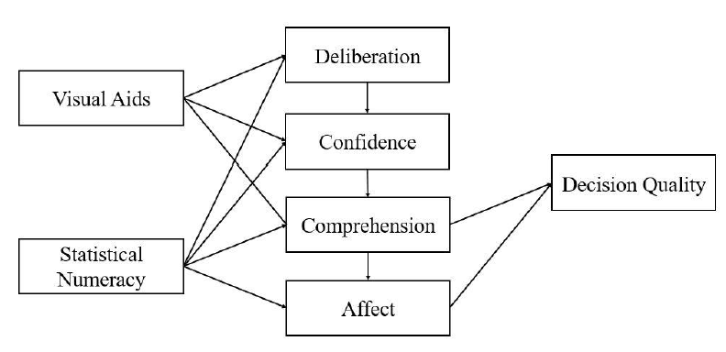

Figure 2
Relation Between Choice Architecture, Nudges, and Libertarian Paternalism
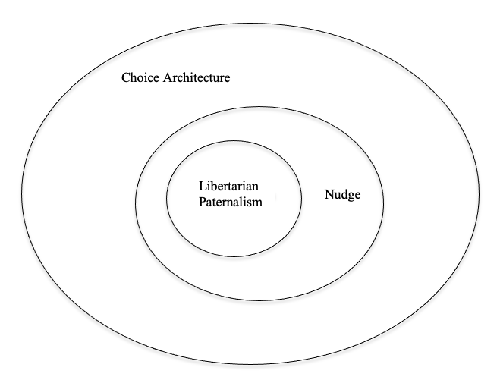

Figure 3
Theoretical Model Illustrating Default Nudging Influence on Decision Making Through Non-Rational Persuasion
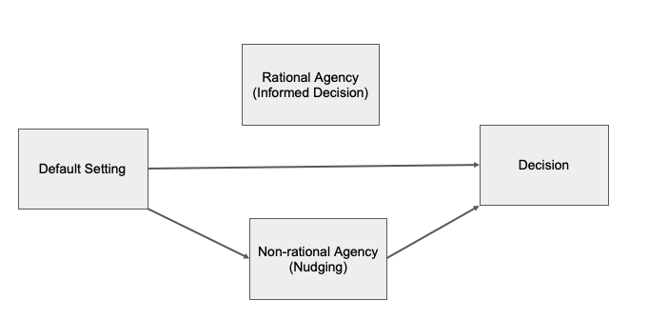

Figure 4
Infographic Used in the Relevant Information Condition of Experiment 2
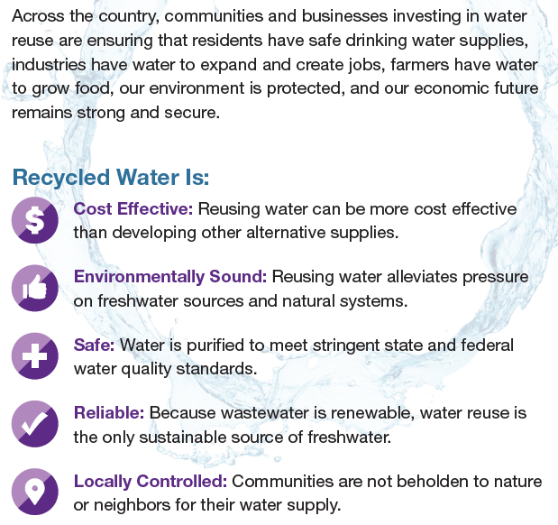

Figure 5
Infographic Used in the Irrelevant Information Condition of Experiment 2
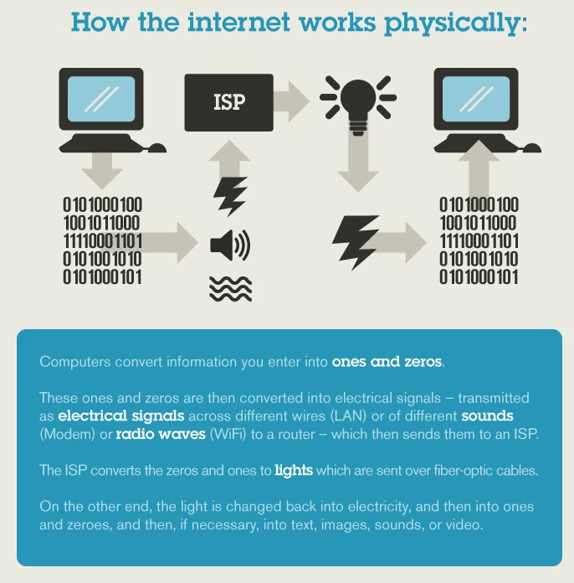

Figure 6
Confidence Results from Experiment 2 with 90% Confidence Intervals

Figure 7
GLM Mediation Path Analysis from Study 3
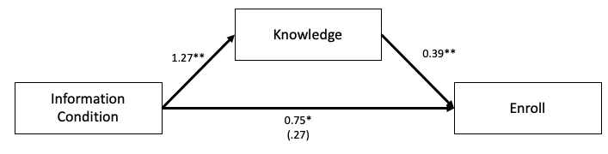
Note. Path values are in logits. * p < .05, ** p < .01

Figure 8
Confidence Results from Experiment 3 with 90% Confidence Intervals

Figure 9
Recycled Water Acceptance CFA with Standardized Parameter Estimates
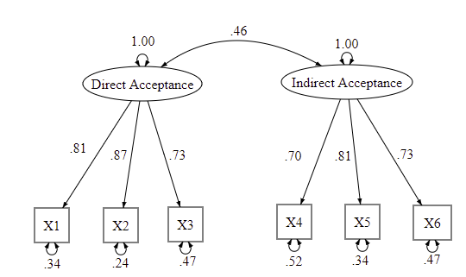

Figure 10
Direct Acceptance Results from Experiment 4 with 90% Confidence Intervals

Note. Values on y-axis represent standardized z-scores

Figure 11
Indirect Acceptance Results from Experiment 4 with 90% Confidence Intervals

Note. Values on y-axis represent standardized z-scores

Figure 12
GLS Mediation Path Analysis for Direct Acceptance of Recycled Water
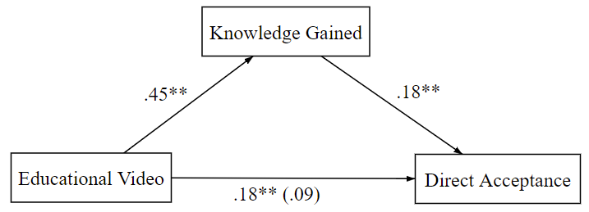
Note. Path values are standardized regression coefficients; * p < .05, ** p < .01

Figure 13
Confidence Results from Experiment 4 with 90% Confidence Intervals

Figure 14
Satisfaction with Policymakers Results from Experiment 4 with 90% Confidence Intervals

Figure 15
Worry about Health Results from Experiment 4 with 90% Confidence Intervals

Figure 16
Intentions to Protest & Move Results from Experiment 4 with 90% Confidence Intervals

Figure 17
Recommendation Results from Experiment 4 with 90% Confidence Intervals

Figure 18
Skilled Decision Path Model for Direct Acceptance
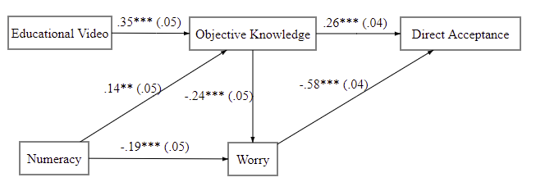
Note. Path values are standardized, with standard errors in parentheses; * p < .05, ** p < .01, *** p < .001

Figure 19
Skilled Decision Path Model for Indirect Acceptance
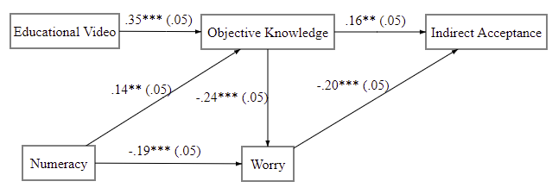
Note. Path values are standardized, with standard errors in parentheses; * p < .05, ** p < .01, *** p < .001

Figure 20
Skilled Decision Path Model for Binary Enrollment Choice (Shallow Acceptance)
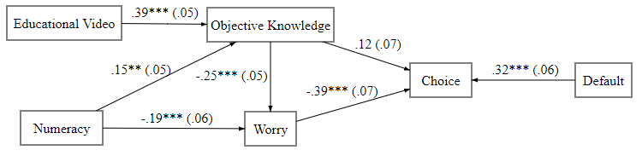
Note. Path values are standardized, with standard errors in parentheses; * p < .05, ** p < .01, *** p < .001

Figure 21

Frequency Distributions for Indirect Acceptance Questions
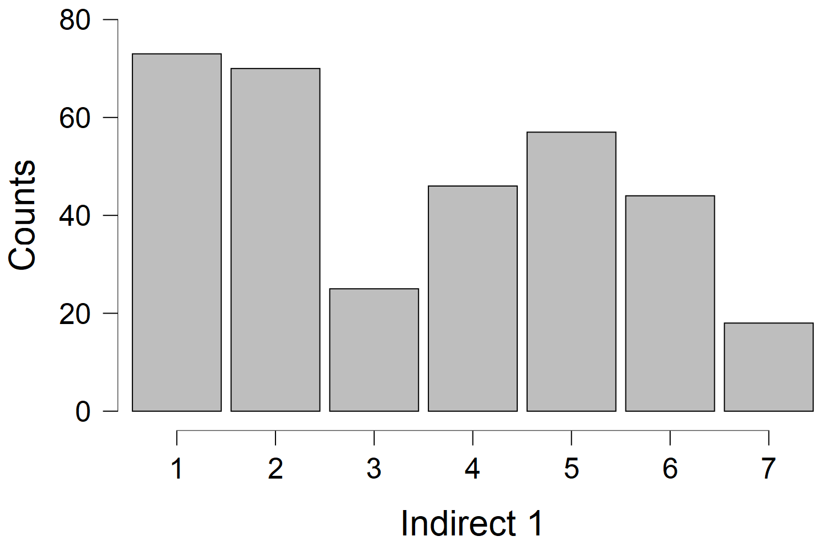
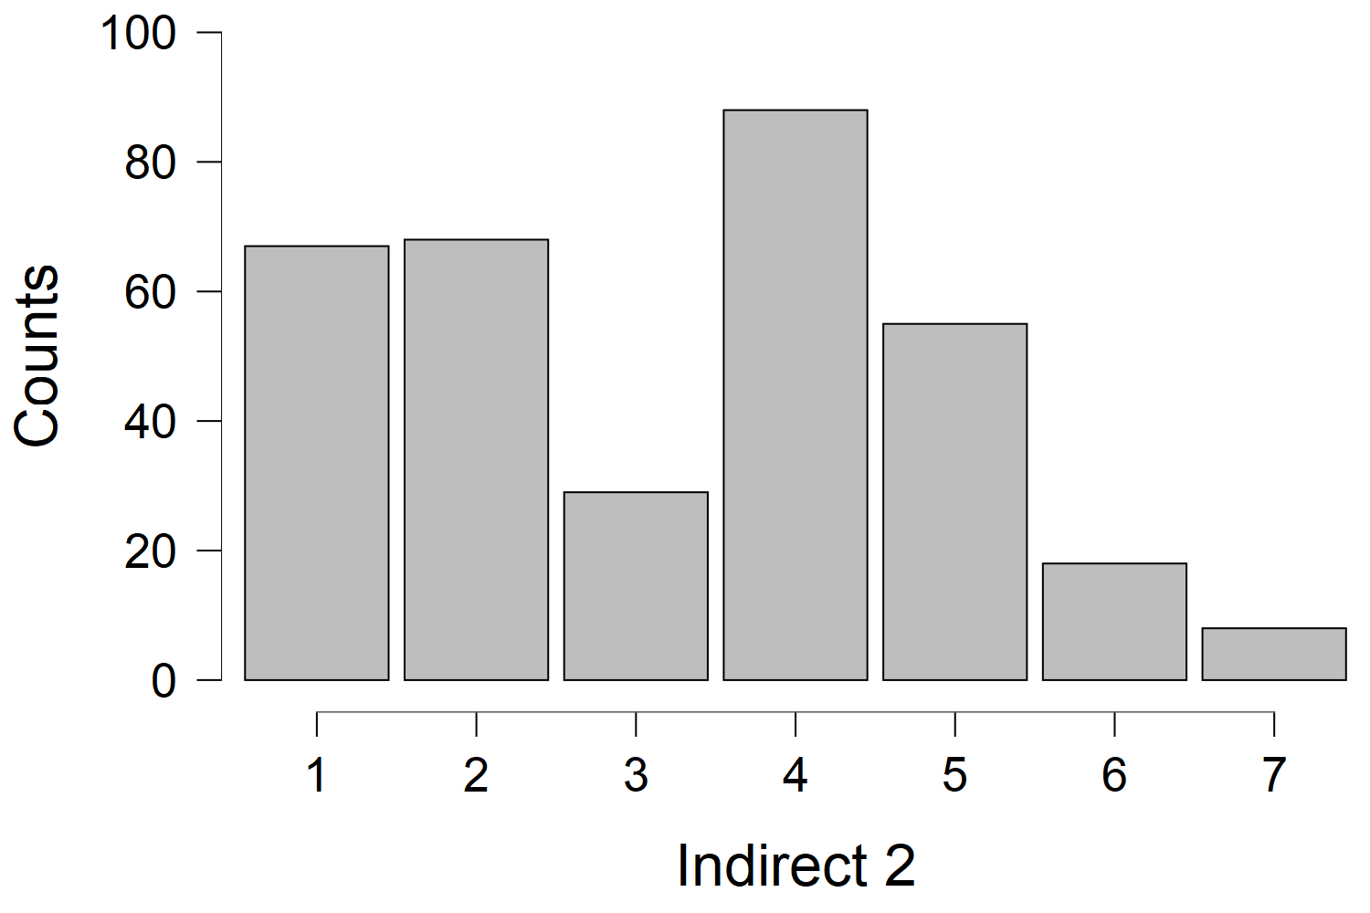
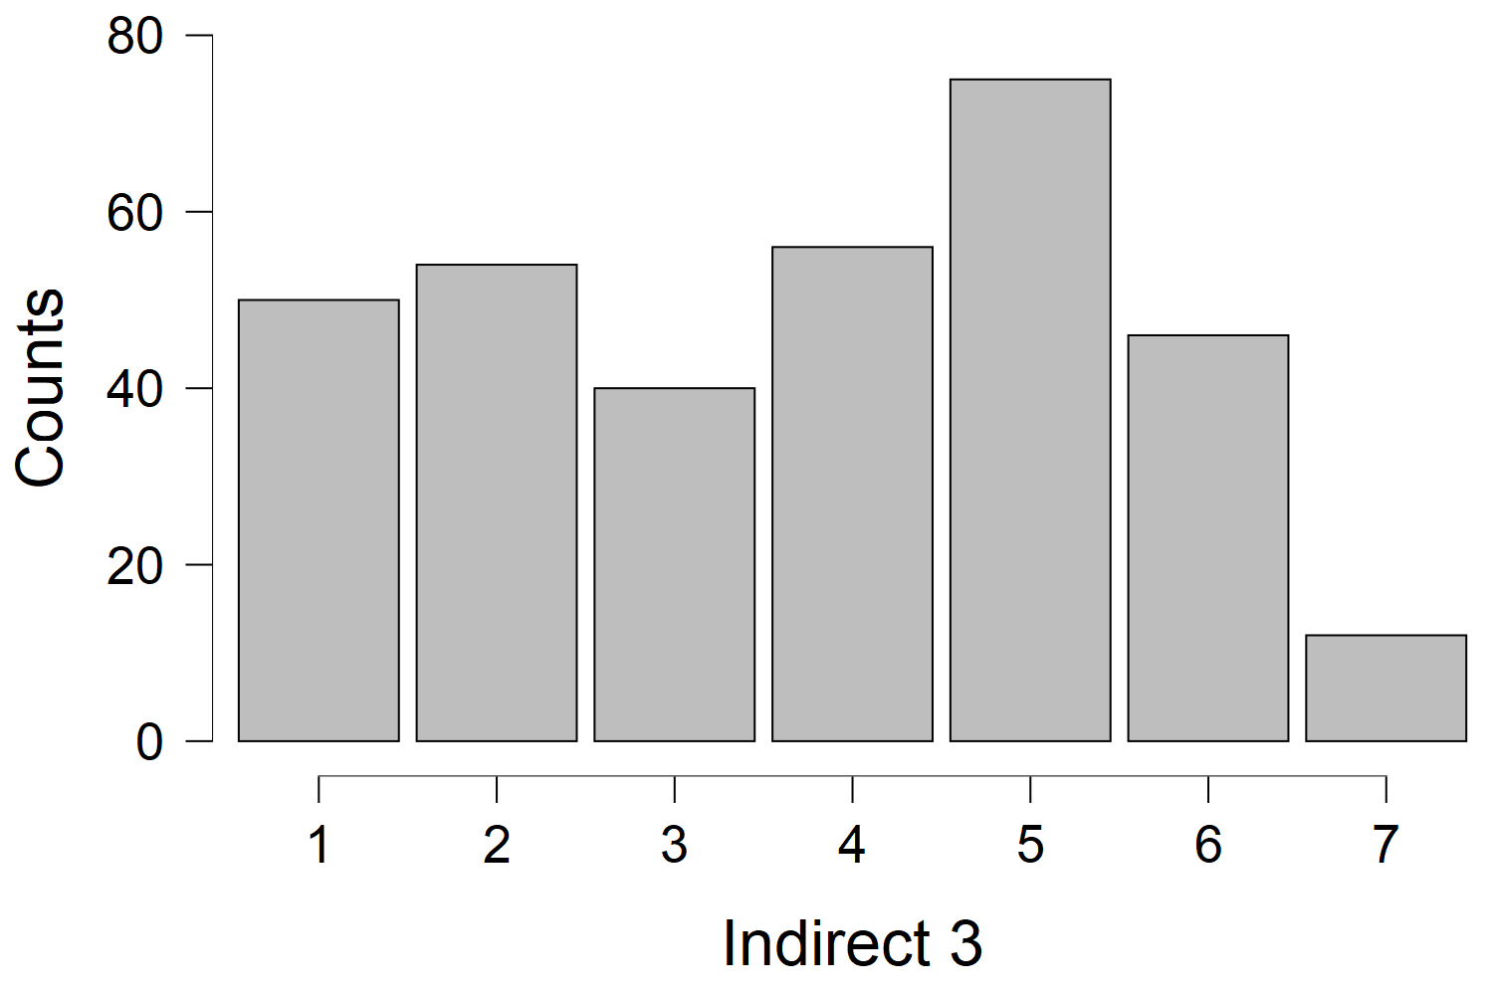

Figure 22

Frequency Distributions for Direct Acceptance Questions

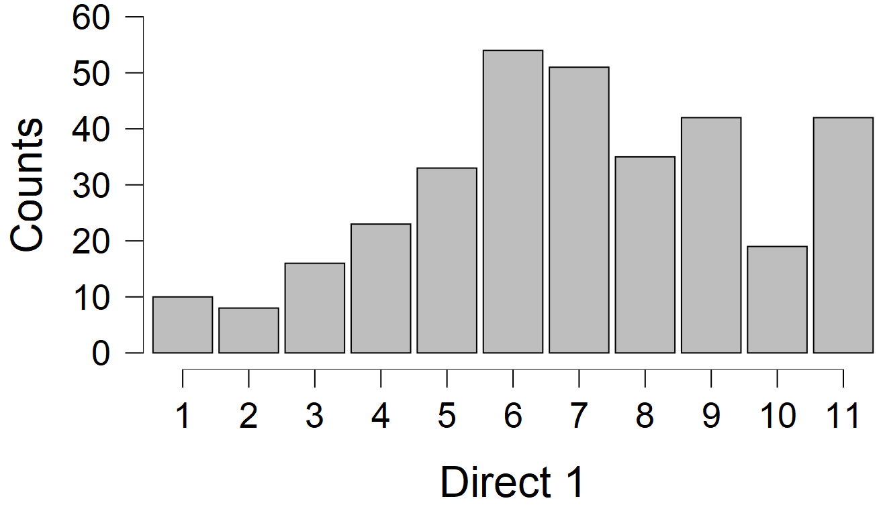

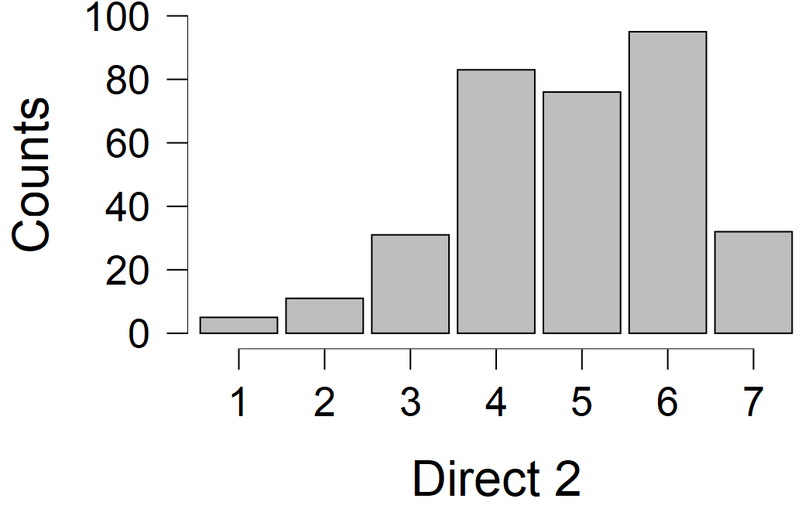
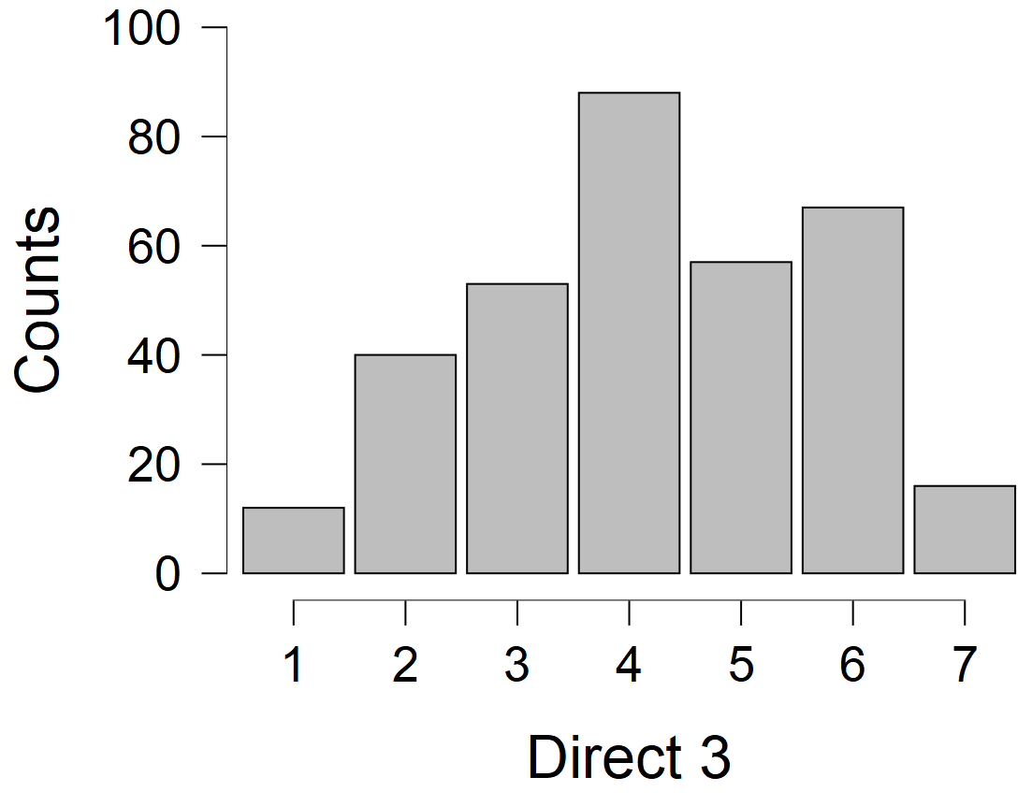

Table 1
Descriptive Statistics from Experiment 2
 | Default Condition |  |  |  | Information Condition
 | In (N = 73) |  | Out (N = 69) |  | Relevant (N = 70) |  | Irrelevant (N = 72)
 | M (SD) |  | M (SD) |  | M (SD) |  | M (SD)
Age | 37.93 (13.46) |  | 39.41 (13.70) |  | 39.71 (14.39) |  | 37.61 (12.69)
Gender | .40 (.49) |  | .30 (.46) |  | .36 (.48) |  | .35 (.48)
Choice | .58 (.50) |  | .39 (.49) |  | .50 (.50) |  | .47 (.50)
Knowledge | 3.26 (1.32) |  | 3.42 (1.33) |  | 3.39 (1.27) |  | 3.29 (1.39)
Confidence | 2.82 (.86) |  | 2.64 (.87) |  | 2.83 (.88) |  | 2.64 (.84)
Disgust | 55.52 (17.45) |  | 56.61 (18.75) |  | 58.06 (18.33) |  | 54.10 (17.65)
Numeracy | 3.0 (2.0) |  | 3.36 (1.59) |  | 3.03 (1.85) |  | 3.31 (1.81)
Note. N = 142; variables were coded as follows: choice (0 = did not enroll in water program, 1 = enrolled); gender (0 = female, 1 = male)

Table 2
Correlation Matrix from Experiments 2 (Top) and 3 (Bottom)
 | 1 | 2 | 3 | 4 | 5 | 6 | 7 | 8 |  | 9
- Acceptance | 1
- Default | .18*  .03 | 1
- Info Condition | .03  .18* | .03  -.03 | 1
- Knowledge | .21*  .28** | -.06  .05 | .04  .46** | 1
- Disgust | -.21*  -.21* | -.03  -.03 | .11  .14 | -.01  -.09 | 1
- Numeracy | .03  -.07 | -.10  -.12 | -.08  -.02 | .06  -.05 | -.17*  .08 | 1
- Confidence | .07  -.12 | .14  .12 | .14  .21** | .26**  .24** | .13  .16 | -.16  -.09 | 1
- Gender | .20*  -.02 | .10  -.06 | .01  .13 | .07  -.03 | -.21*  .04 | .13  .24** | .02  -.05 |  | 1
- Age | -.13  .05 | -.06  .03 | .08  -.10 | .12  -.06 | .07  .01 | .02  .05 | .15  .01 | -.11  .19 |  | 1

Note. Variables were coded as follows: acceptance (0 = did not enroll in water program, 1 = enrolled); default (0 = out, 1 = in); info condition (0 = irrelevant, 1 = relevant); gender (0 = female, 1 = male; * p <.05, ** p < .01

Table 3
Descriptive Statistics from Experiment 3
 | Default Condition |  |  |  | Information Condition
 | In (N = 72) |  | Out (N = 74) |  | Relevant (N = 75) |  | Irrelevant (N = 71)
 | M (SD) |  | M (SD) |  | M (SD) |  | M (SD)
Age | 19.67 (4.89) |  | 19.47 (1.23) |  | 19.23 (1.01) |  | 19.93 (4.95)
Gender | .38 (.49) |  | .43 (.50) |  | .47 (.50) |  | .34 (.48)
Choice | .65 (.48) |  | .62 (.49) |  | .72 (.45) |  | .55 (.50)
Knowledge | 2.93 (1.38) |  | 2.80 (1.42) |  | 3.48 (2.21) |  | 2.21 (1.39)
Confidence | 2.45 (.80) |  | 2.25 (.90) |  | 2.53 (.83) |  | 2.16 (.84)
Disgust | 56.28 (15.83) |  | 57.08 (15.23) |  | 58.79 (14.47) |  | 54.47 (16.29)
Numeracy | 2.96 (1.55) |  | 3.31 (1.37) |  | 3.11 (1.57) |  | 3.17 (1.37)
Note. N = 146; variables were coded as follows: choice (0 = did not enroll in water program, 1 = enrolled); gender (0 = female, 1 = male)

Table 4
Descriptive Statistics from Experiment 4
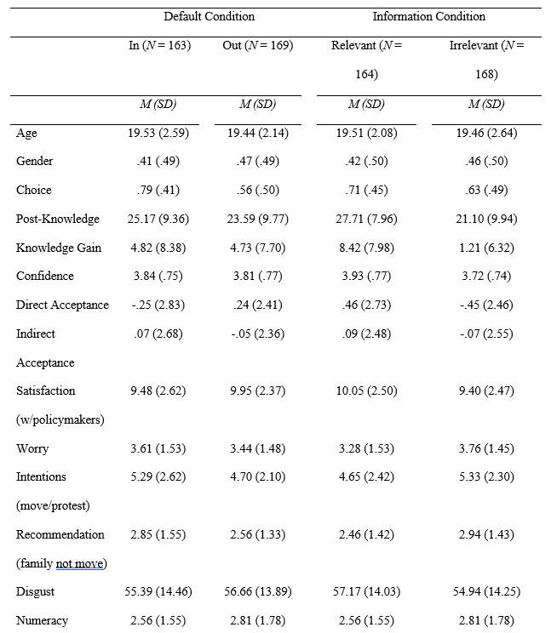

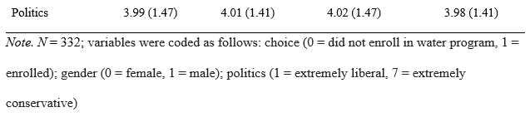
Table 5
Correlations from Experiment 4
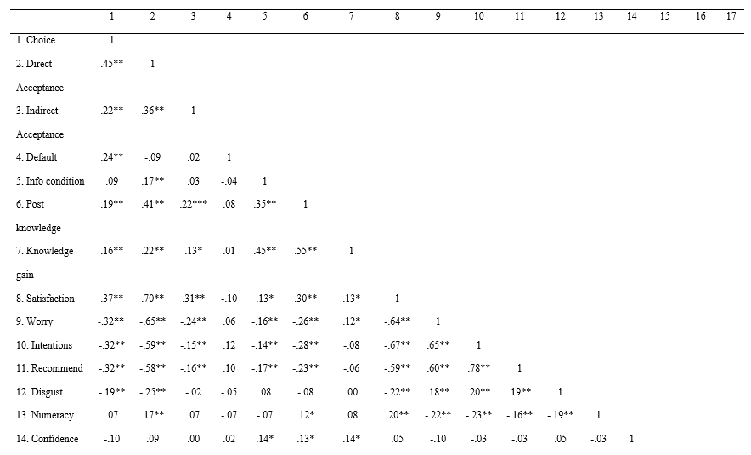
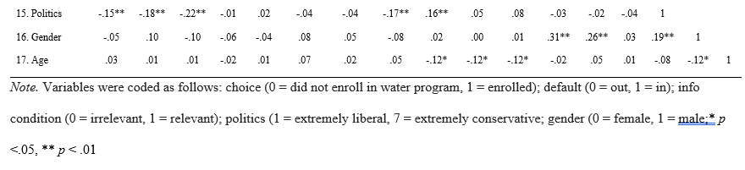

Table 6
Simplified Summary of Reliable Effects for All Experiments
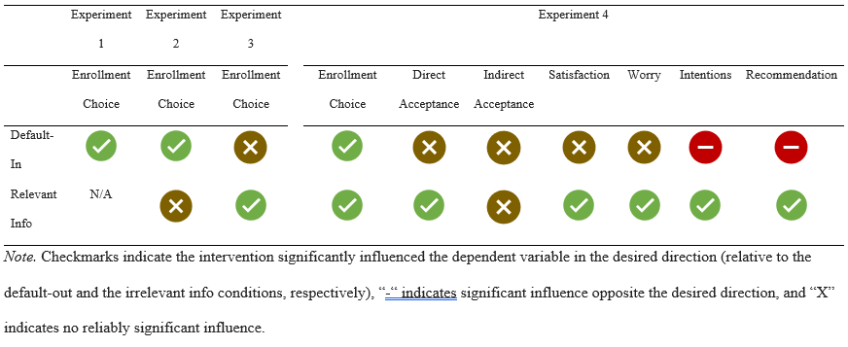

Direct potable water recycling occurs when advanced treated wastewater goes straight to a conventional water treatment plant to be prepared for distribution. Indirect potable recycling happens when treated wastewater is used to augment an existing water source (e.g., a lake, reservoir, or aquifer). The existing water source acts as an environmental buffer before the water is eventually reintroduced into the conventional treatment plant (United States Environmental Protection Agency et al., 2012).
The ‘self-controlled’ qualification is necessary on Mele’s account to rule out some cases of weakness of will. This is a technical point and does not substantially influence the analyses offered here.
Amazon’s Mechanical Turk can be a reliable, quality source of experimental data (M. Buhrmester et al., 2011; M. D. Buhrmester et al., 2018; Crump et al., 2013; Mason & Suri, 2012; Paolacci et al., 2010; Rouse, 2015).
Procedures and materials for all experiments reported in this paper were approved by the Institutional Review Board (IRB) at the University of Oklahoma.
Disgust was significantly correlated with enrollment choice in each of the remaining experiments (see Tables 2 and 5), such that higher disgust was consistently associated with lower enrollment in the recycled water program. This provided sufficient evidence to proceed with analyses in each case. I also checked to ensure there was not an unequal distribution of participants with high disgust across levels of the independent variables (i.e., relevant vs irrelevant info and default-in vs. default-out) and found no evidence of unequal distributions in any of the experiments, thus reducing the concern disgust may have acted as a confound.
Numeracy was not significantly related to any variables of interest in Experiments 2 and 3 (see Table 2 for correlations), thus it was not included in any analyses for those studies.
For the confidence variable, I used switch/stay as opposed to in/out in effort to explore an area of potential ethical concern. Specifically, I was interested in looking at potential disparities between active decision makers (i.e., individuals who, by switching, demonstrated they almost certainly must have processed the scenario) and passive decision makers (i.e., decision makers who might have passively gone with the default without truly processing the decision scenario).
Neither defaults (r = -.02, p = .75) nor educational interventions (r = .04, p = .45) were associated with committing to the behavioral measures, thus it was not included in further analyses. Note, however, that each of the behavioral measures were similar to the items in the indirect acceptance measure, thus in future research, it is possible that behavioral measures related to direct acceptance might yield different results. For example, since the educational video was associated with direct acceptance in this experiment, it might be associated with more willingness to actually drink a bottle of recycled water.

