UNIVERSITY OF OKLAHOMA
GRADUATE COLLEGE

COMPARISON OF BONE, FAT, AND MUSCLE CHARACTERISTICS BETWEEN COMBINED ORAL CONTRACEPTIVE USERS AND NON-USERS

A THESIS
SUBMITTED TO THE GRADUATE FACULTY
in partial fulfillment of the requirements for the
Degree of
MASTER OF SCIENCE

By
HOANG VAN MICHELLE NGUYEN
Norman, OK
2019
COMPARISON OF BONE, MUSCLE, AND FAT CHARACTERISTICS BETWEEN COMBINED ORAL CONTRACEPTIVE USERS AND NON-USERS

A THESIS APPROVED FOR THE
DEPARTMENT OF HEALTH AND EXERCISE SCIENCE

BY

Dr. Debra Bemben, Chair

Dr. Michael Bemben

Dr. Christopher Black

© Copyright by HOANG VAN MICHELLE NGUYEN 2019
All Rights Reserved.
Acknowledgements
I first want to send thanks to Dr. Mike, Dr. Black and Dr. Deb for being on my committee and spending the time to help me polish my thesis. I could not have done this without them. I also want to give special thanks to the Health and Exercise Science Department for providing an environment where I was able to grow and thrive as an individual. I wouldn’t be the same without the experiences I’ve had up until this point. The Bone Lab has been invaluable to me throughout my journey. Thank you to Bree and Sam for teaching me the ins and outs of the equipment in the lab. Thank you to Alison and Cameron for helping me collect data when it was impossible for me to be present. I’m proud of how far everyone has gotten, and know that they will all move on to be successful individuals. I want to give special thanks to Dr. Deb, my mentor, for her undying patience and vast amount of knowledge. I can’t say thank you enough to her for allowing me to join her lab. I have grown more under her guidance than I ever have before. Additionally, I would like to thank the Neuromuscular Lab for the laughs and genuine conversations. I would also like to thank my parents for supporting me in my quest to be a life-long student, and paying for the majority of my education. It is my goal to make their investment worthwhile and to be able to provide for them in return. I want to thank my doggos for always being excited when I return home. They have been my emotional support and given me renewed purpose. I hope to buy them a home with a huge backyard one day. Finally, I want to thank Megan Linette Crawford for being my number one fan. She has been with me through my best and my worst yet always knows how to make me smile. She’s a dork. I’m a dork. We get along like spaghetti and meatballs.

Table of Contents
Abstract ix
Chapter 1: Introduction 1
Purpose 4
Research Questions 4
Sub Questions 5
Research Hypotheses 5
Sub Hypotheses 5
Significance of the Study 6
Delimitations 6
Limitations 7
Assumptions 8
Operational Definitions 8
Chapter 2: Literature Review 12
Bone Remodeling 12
Peak Bone Mass 13
Osteoporosis 15
Assessment of Bone Health 16
Endogenous Estrogen and Bone 18
Progesterone and Bone 20
COC and BMD 21
Estrogen on Fat Metabolism 24
Progesterone on Fat Metabolism 25
COC and Body Composition 26
Fat Infiltration 28
Muscle Quality 29
Summary 33
Chapter 3: Methodology 34
Participants 34
Inclusion Criteria 35
Exclusion Criteria 35
Study Design 36
Screening and Consent 37
Anthropometric Measurements 37
Dual Energy X-ray Absorptiometry 37
Peripheral Quantitative Computed Tomography 40
Ultrasonography 46
Maximal Isokinetic Torque Measurement 47
Quantification of Muscle Quality 48
Data Analyses 48
Effect Sizes 49
Chapter 4: Results and Discussion 51
Participant Characteristics 51
DXA Variables 53
pQCT Variables 60
Muscle Thickness, Maximal Isokinetic Torque, and Muscle Quality 65
BoneJ Analysis of Soft Tissue 67
Correlations 69
Discussion 70
Areal Bone Mineral Density 71
Volumetric Bone Mineral Density 74
Soft Tissue Analysis 77
Limitations 79
Summary 81
Chapter 5: Conclusions 82
Research Hypotheses 82
Sub Hypotheses 83
Clinical Significance 84
Suggestions for Future Research 84
References 85
Appendix A 101
Appendix B 107
Appendix C 116

List of Tables
Table 1. DXA Total Body, Spine, and Dual Femur Precision……………………..…………… 39
Table 2. DXA Appendicular Body Composition CV% ………………………….………….…..40
Table 3. pQCT 4% Tibia Site CV% …………………………………………………….…….…43
Table 4. pQCT 38% Tibia Site CV% …………………………………………………….….…..44
Table 5. pQCT 66% Tibia Site CV% …………………………………………………….….…..45
Table 6. pQCT 50% Femur Site CV% ………………………………………………….…….…46
Table 7. Maximal Isokinetic Torque ICC …………………………………………………….…48
Table 8. Combined Oral Contraceptive Prescriptions Among COC Users ……………………..52
Table 9. Participant Characteristics …………………………………………….........……....….53
Table 10. Regional Body Composition Between Groups ………………………………….…....54
Table 11. Total Body, Lumbar Spine, and Dual Femur Bone Characteristics ……………….…56
Table 12. T-scores and Z-scores for Total Body and Lumbar Spine ……………………...….…57
Table 13. T-scores and Z-scores for Dominant and Non-Dominant Hip Variables ………….…58
Table 14. Hip Structural Analysis Variables Between Groups …………………………...….….59
Table 15. Volumetric Bone Variables at the Tibia 4% Site …………………………………..…61
Table 16. Volumetric Bone Variables at the Tibia 38% Site ……………………………..……..62
Table 17. Volumetric Bone Variables at the Tibia 66% Site ……………………………......…..64
Table 18. Volumetric Bone Variables at the 50% Femur Site …………………………...……...65
Table 19. Muscle Thickness Variables……………………………… ………………….……………66
Table 20. Maximal Isokinetic Torque and Muscle Quality Variables ………………….……………66
Table 21. 66% Tibia Soft Tissue Analysis …………………….……...………….……………..68
Table 22. 50% Femur Soft Tissue Analysis ……………………………...……………………..69
List of Appendices
Appendix A
· Flyer
· Mass Email Script
· Message Board Script
· Facebook.com Script
· Non-User Screening Checklist
· COC User Screening Checklist

Appendix B
· Informed Consent Form
· HIPPA Form

Appendix C
· Health Status Questionnaire
· PAR-Q & YOU
· Calcium Intake
· Bone Specific Physical Activity Questionnaire
· Menstrual History Questionnaire

Appendix D
· Sample PQCT Scan
· Sample DXA Scan
· Sample BIODEX Test Printout

Abstract

Combined oral contraceptives (COC) are widely used as a form of birth control or to reduce negative symptoms associated with menstruation. However, many women discontinue use or fail to initiate use of COC because of the fear of weight gain or negative effects of body composition (1). Increased weight gain has been linked to increases in % body fat in some studies (2-5); however, others have not found this effect (1, 6). Despite this, the possibility of decreased functional muscle due to increased lipid infiltration is cause for investigation. Additionally, decreased endogenous estrogen levels caused by COC use may stunt bone accrual during young adulthood (7, 8). Purpose: The purposes of this study were to: (1) compare areal bone mineral density (aBMD) of the total body, lumbar spine, and proximal femur; and volumetric bone mineral density (vBMD) characteristics of the femur and tibia between COC users and Non-Users; (2) to compare muscle variables such as muscle thickness, muscle cross-sectional area (mCSA), muscle density and muscle quality between COC Users and Non-Users; and (3) to compare fat density and subcutaneous fat cross-sectional area (sfCSA) between COC Users and Non-Users. Additionally, bone, muscle, and fat variables were compared between Non-Users, Low Dose COC, and High Dose COC users. Methods: Forty healthy college aged women were assigned to Non-User or COC User groups based on COC use. Body composition and aBMD measurements were performed using dual energy x-ray absorptiometry (DXA). Peripheral quantitative computed tomography (pQCT) was used to measure volumetric bone mineral density (vBMD) at the 50% femur site and the 4%, 38%, 66% tibia sites. Images of the 50% femur and 66% tibia site were analyzed using BoneJ software to determine soft tissue characteristics. Lastly, muscle thickness (MT) measured using an ultrasound and maximal isokinetic torque (MIT) of the non-dominant quadriceps muscle using a Biodex isokinetic dynamometer were utilized to quantify muscle quality (MIT/MT). Independent t-tests were run to compare Non-Users and COC Users. ANOVA was run to compare Non-Users, Low Dose COC, and High Dose COC Users. Effect sizes were determined for all variables for the 2 and 3 group comparisons. Results: Age of menarche was higher in COC Users (12.9 ± 1.3) compared to Non-Users (12 ± 1.1) (p=0.044) and higher in High Dose COC Users (13.5 ± 1.1) compared to Non-Users (p=0.009). There were no significant differences between Non-Users and COC users for any of the bone or soft tissue variables for DXA or pQCT measures. No significant differences were found between Non-Users, Low Dose COC, and High Dose COC users for any variables. There was no significant differences in MIT or MQ between Non-Users and COC Users or between Non-Users, Low Dose COC, and High Dose COC. Conclusion: COC had similar bone, muscle, and fat tissue characteristics as women not taking COC. Additionally, COC dose did not affect any of the musculoskeletal variables in this cohort of women. However, moderate effect sizes for most of the variables with the 2 and 3 group comparison suggest that COC may have some effect on bone, muscle, and fat tissue, but lacked the number of participants needed to find significance. Future studies should focus on recruiting larger samples sizes to provide greater statistical power for examining effects of COC use on bone and body composition.

Chapter 1: Introduction

Oral contraceptives (OC) are the most common form of birth control used in the United States with an estimated 9.7 million women currently prescribed the medication (9). OC have evolved from synthetic estrogen only pills, to a combination of synthetic estrogen and synthetic progesterone (10). The reduction of chronological variability, negative symptoms associated with menstruation, ease of use, and inhibition of ovulation to prevent pregnancy make it a popular choice (3). Scientific advances have led to the development of a multitude of OC formulations with different pharmacological properties which may be detrimental to women’s health. There is currently no consensus on the metabolic effects of OC use, thus it is important to investigate the physiological effects of using OC on musculoskeletal health and energy metabolism (11).
Since the introduction of OC in 1960, the chemical composition, dosage, and length of the active pill stage has been continually modified (10). Estrogen dose has decreased and has been coupled with progesterone to reduce negative side effects reported with the use of OC. This formulation has been referred to as a combined oral contraceptive (COC). Currently, there are two types of synthetic estrogen and eight different types of synthetic progestins that can be coupled at different doses giving rise to a variety of different pharmacokinetic properties (11). All combinations have varying binding affinities for specific steroid nuclear receptors as well as different mechanisms of action. Higher relative receptor binding affinities require smaller doses of hormones to prevent ovulation (11). Although high-dose COC containing at least 50µg/day of estrogen have been used in the past, it is currently more common to be prescribed low (20-35 µg/day) or ultra-low dose (15 µg/day) COC (11).
COC functions by inhibiting ovulation by inhibiting the secretion of follicle-stimulating hormone (FSH) and luteinizing hormone (LH) (12). FSH is important for the development of follicles which release natural estrogens, while the mid-cycle surge of LH stimulates ovulation (13). Serum levels of both FSH and LH are promptly decreased within the first day of COC use (12), and must be taken daily to ensure the inhibition of ovulation (14). A regularly developed follicle typically secretes natural estrogens, specifically 17β-Estradiol (E₂). Once ovulation occurs, the ruptured follicle becomes a transient endocrine gland known as the corpus luteum that secretes progesterone as well as E₂ (13). The lack of a fully developed follicle, and therefore a corpus luteum, causes a decrease in serum estrogen in women taking combined oral contraceptives. For example, serum E₂ in women taking 30 µg ethinyl estradiol (EE) drops from about 160pg/ml to 57 pg/ml (15) while those taking 20 µg EE decreases to 92 pg/ml after 5 cycles in women (16). Additionally, the ingestion of EE in COC promotes production of sex hormone-binding globulin (SHBG), which reduces the bioavailability of E₂ (13, 15, 17). Treatment with COC is characterized by a reduction in natural levels and bioavailability of serum E₂, which may affect body composition and musculoskeletal health.
Estrogen specific receptors have been found on and within muscle, fat, and bone cells suggesting that estrogen may regulate metabolism in these tissues (18-20). In fact, estrogen has been linked to increased muscle growth, increased muscle regeneration, increased fat oxidation, increased bone formation, and decreased bone resorption (21-26). For these reasons, a decrease in serum E₂ may cause changes in the musculoskeletal system that may be detrimental to musculoskeletal health.
There have been studies that provide evidence that prolonged COC use can cause body weight gain (27). It has been shown that increases in weight when taking COC are linked with increases in fat mass and % total body fat (% BF) (3, 4, 11). Additionally, it has been shown that increased fat mass can cause fat infiltration into muscle fibers (28, 29). It may be possible that an increase of fat mass into muscle fibers may cause an increase in muscle cross sectional area without an increase in muscle strength because there is not an increase in contractile proteins. An increase in E₂ levels has also been associated with increases in fat metabolism, which may be a reason fat composition changes with the use of COC (21). However, even in the absence of weight gain, it is possible for fat mass and % BF to increase (5, 30). While it has been shown that weight can return to baseline after one month of cessation of the pill (27), continuation of the pill through menopause could cause a continued increase in fat mass into the later decades of life. This is a cause for concern as increased fat mass in older age has been linked to an inverse relationship with insulin action (31), decreased strength (32, 33), muscle quality (32, 34), and risk of hospitalization (35).
Additionally, there is evidence that COC use may prevent women from reaching peak bone mass (7, 8). Individuals who begin using COC in early adolescence are affected more than those who begin in early or late adulthood because that is an important time of mineral acquisition (7, 8). It may be possible to increase areal and volumetric bone mineral density while using COC, however bone accrual has been shown to be significantly less than that of Non-Users (36-38). As the number of women taking COC continues to increase, the number of women at risk for osteoporosis may also increase, because women taking COC at a young age may not achieve their optimal peak bone mass. Currently, osteoporosis treatment places a substantial burden on the health care system (39). It has been projected that cases of osteoporosis will increase from 10.2 million from 2010, to 13.6 million cases by 2030 with postmenopausal women being predominantly diagnosed (40).
COC is the most common form of contraception in the United States. As different formulations are developed, doses and regimens are changed; thus, more research is needed to investigate the physiological effects of COC on bone and soft tissue to determine potential negative impacts. Therefore, the purpose of this study was to provide information regarding different COC regimens and their effect on muscle and bone variables.

Purpose

The purposes of this study were to: (1) compare areal bone mineral density (aBMD) of the total body, lumbar spine, and proximal femur; and volumetric bone mineral density (vBMD) characteristics of the femur and tibia between COC users and Non-Users; (2) to compare muscle variables such as muscle thickness, muscle cross-sectional area (mCSA), muscle density and muscle quality between COC Users and Non-Users; and (3) to compare fat density and subcutaneous fat cross-sectional area (sfCSA) between COC Users and Non-Users. Additionally, bone, muscle, and fat variables were compared between Non-Users, Low Dose COC, and High Dose COC users.

Research Questions

- Are there significant differences in total body, lumbar spine, and dual femur areal bone mineral density (aBMD) between COC Users and Non-Users?
- Are there significant differences in volumetric bone mineral density (vBMD) at the 50% femur, 4%, 38%, and 66% tibia sites between COC Users and Non-Users?
- Are there significant differences in muscle thickness, muscle cross sectional area, muscle density, and muscle quality between COC Users and Non-Users?
- Are there significant differences in fat density and fat CSA between COC Users and Non-Users?

Sub Questions

- Are there significant differences in total body, lumbar spine, and dual femur aBMD between Non-Users, Low Dose COC and High Dose COC Users?
- Are there significant differences in volumetric bone mineral density (vBMD) at the 50% femur, 4%, 38%, and 66% sites between Non-Users, Low Dose COC and High Dose COC Users?
- Are there significant differences in muscle thickness, muscle cross sectional area, and muscle density between Non-Users, Low Dose COC and High Dose COC Users?
- Are there significant differences in fat density and fat CSA between Non-Users, Low Dose COC and High Dose COC Users?

Research Hypotheses

- It was hypothesized that COC Users would have lower aBMD, for total body, lumbar spine, and dual femur compared to Non-Users.
- It was hypothesized that COC Users would have lower vBMD, bone size, and bone strength at the 50% femur, 4%, 38%, and 66% tibia sites compared to Non-Users.
- It was hypothesized that COC Users would have higher muscle thickness and muscle cross sectional area, but have lower muscle density and quality compared to Non-Users.
- It was hypothesized that COC Users would have higher fat density and higher fat CSA compared to Non-Users at the 66% tibia and 50% femur sites.

Sub Hypotheses

- It was hypothesized that Non-Users would have higher aBMD for total body, lumbar spine, and dual femur compared to Low Dose COC and High Dose COC COC users.
- It was hypothesized that Non-Users would have higher vBMD, bone size, and bone strength at the 50% femur, 4%, 38%, and 66% tibia sites compared to Low Dose COC and High Dose COC users.
- It was hypothesized that Non-Users would have higher muscle thickness, and muscle CSA, but lower muscle density, and muscle quality compared to Low Dose COC and High Dose COC users.
- It was hypothesized that Non-Users would have lower fat density and fat CSA compared to Low Dose COC and High Dose COC users at the 66% tibia and 50% femur sites.

Significance of the Study

Combined oral contraceptives are widely used as a form of birth control or to reduce negative symptoms associated with menstruation. However, many women discontinue use or fail to initiate use of COC because of the fear of weight gain or negative effects of body composition (1). Increased weight gain has been linked to increases in % body fat in some studies (2-5); however, others have not found this effect (1, 6). Despite this, the possibility of decreased functional muscle due to increased lipid infiltration is cause for investigation. Additionally, decreased endogenous estrogen levels caused by COC use may stunt bone accrual during young adulthood (7, 8). The findings of this study may help clinicians and patients to understand the potential effects of COC use on the musculoskeletal health.

Delimitations

Delimitations for this study included the following.
- The findings of this study apply to moderately active, healthy women between the ages of 18-25 years old.
- The participants were recruited from the Norman and the greater Oklahoma City metro areas.
- Testing was performed at the Bone Density and the Neuromuscular Lab in the Sarkey’s Fitness Center in Norman, Oklahoma
- Non-Users had no history with any type of hormonal contraceptive use prior to participation.
- COC Users had at least an 8 month history of use with the same COC.

Limitations

Limitations for this study included the following.
- Participants were volunteers and thus may not be representative of the general population.
- Participants were limited to individuals within the weight and height limits of the bone densitometer of 300 lbs, and a height of 6’4”.
- Participants were limited to individuals within the gantry diameter limits of the peripheral quantitative computer tomography scanner (pQCT) of 250mm.
- Participants reported regular menstrual cycles and cannot be generalized to a population of women who have irregular menstrual cycles.
- Participants did not include vigorously active people.
- Participants did not have any diseases known to affect joint muscle function or known to affect bone
- Participants were limited to those who were not taking supplements or steroids to enhance muscle mass or taking medications known to affect bone metabolism

Assumptions

The assumptions of this study included the following.
- Participants completes all forms and questionnaires accurately.
- Participants honestly reported the start of their menstrual cycle.
- Subjects gave maximal effort during exercise tasks.
- Participants taking COC took regular doses everyday as prescribed.

Operational Definitions

- Active Pill Phase – phase of oral contraceptive regimen where exogenous sex steroids are provided by any type of COC (11).
- Areal Bone Mineral Density (aBMD, g/cm²) – a 2-dimensional quantification of BMD calculated by dividing the total bone mineral content by the projected area of a region (41).
- Appendicular Skeletal Muscle Mass (ASM) – an estimate of muscle mass contained within the limbs (42).
- Bone Formation – the process by which osteoblasts lay down new bone (43)
- Bone Mineral Content (BMC, mm) – the total amount of bone mineral present measured using DXA (41).
- Bone Mineral Content (BMC, mg) – the total amount of bone mineral present in a cross-sectional bone slice measured using pQCT(41).
- Bone Resorption – the process by which osteoclasts break down bone (43).
- Bone Strength Index (BSI, mm³) – the density weighed polar section modulus of given bone cross-section which gives a measure of compressive bone strength at the metaphysis
- Combined Oral Contraceptive Pills (COC) – a subclass of oral contraceptive pills that contain both synthetic estrogen and progesterone (11).
- Cortical Area (mm²) – the average cross-sectional area of the cortical compartment
between the periosteal and endosteal edge of cortical bone (44).
- Cortical Bone – dense bone that provides strength and structure to the skeleton (45).
- Cortical Thickness (mm) – the mean 3D thickness from periosteal boundary to the enosteal boundary disregarding intracortical pores (44).
- Dual Energy X-ray Absorptiometry (DXA) – an instrument used to assess body composition and areal bone mineral density by measurement of the attenuation of two x-ray beams, ~40kev and ~70 kev, as they pass through the body (42).
- Endosteal Circumference (Endo C, mm) – circumference of cancellous bone that delineates endocortical boundary from the cancellous compartment (44).
- Subcutaneous Fat Cross Sectional Area (mm²) – the area of fat under the skin but not including fat within the skeletal muscle present on an image of a transverse slice of an appendicular limb measured using BoneJ.
- Fat Density (Fat D, mg/cm³)– a function of water and lipid content within a muscle.
- High Dose Combined Oral Contraceptive – for the purposes of this study, high dose COC is defined as COC with EE concentrations > 20 µg of EE.
- Polar Moment of Inertia (iPolar, cm⁴) – the estimation of torsional forces that the bone structure can withstand before breaking (46).
- Intermyocellular fat – visible accumulations of lipids located between muscle groups (2).
- Intramuscular fat – accumulation of lipids between muscle fibers (2, 47).
- Intramyocellular fat – central lipid deposition within the muscle fiber (2, 29).
- Low Dose Combined Oral Contraceptive - for the purposes of this study, low dose COC is defined as COC with EE concentrations ≤ to 20 µg of EE.
- Monophasic Oral Contraceptive Pills (MOC) – a subclass of COC that maintains a constant concentration of estrogen and progesterone throughout the 21 day active pill phase (11).
- Muscle Cross-Sectional Area (mCSA, mm²) – the area of muscle present on an image of a transverse slice of an appendicular limb measured using pQCT (48).
- Muscle Density (MD, mg/cm³) – a function of protein, water, and lipid content within a muscle (49).
- Muscle Quality (MQ) – muscular strength relative to muscle mass, also known as functional muscle mass (32, 50).
- Muscle Thickness (MT, mm) – the thickest part of a muscle group obtained by using ultrasonography of a cross-sectional view of the muscle group (51, 52).
- Oral Contraceptives (OC) – medication that systematically controls the concentrations of endogenous sex hormones to reduce cycle length variability (3).
- Osteopenia – a state of low bone mass defined as a BMD T-score between -1 and -2.5 below the mean of the young adult reference population (53).
- Osteoporosis – a bone disorder defined as a BMD T-score of at least -2.5 below the mean of the young adult reference value in older women and a Z-score of ≤ -2.0 in premenopausal women. It is characterized by low BMD and increased bone fracture risk (53, 54){Marcus, 2008 #82;Schousboe, 2013 #133}.
- Osteoblast – osteocytes that perform bone formation (43).
- Osteoclast – osteocytes that perform bone resorption (43).
- Periosteal Circumference (Peri C, mm)– circumference of cancellous bone that delineates bone from extra-osseal soft tissue (44).
- Peripheral Quantitative Computed Tomography (pQCT) – an imaging tool that can perform noninvasive soft tissue analysis with the use of a volumetric cross sectional image that is quick and uses low amounts of radiation (42).
- Strength Strain Index (SSI, mm³) – a combination of bone geometry and quality to provide a complete measure of bone integrity (55).
- Trabecular Area (mm²) – the average cross-sectional area of the cancellous bone compartment circumscribed by the endosteal edge (44).
- Trabecular Bone – the spongy mineral matrix that undergoes metabolic activity located towards the inner part of the distal ends of long bones (45).
- T-score – the standard deviation an individual is relative to the healthy young adult Caucasian reference population for the same sex.
- Ultrasonography – an imaging modality used to measure muscle thickness with the use of inaudible high frequency sound waves.
- Volumetric Bone Mineral Density (vBMD, mg/cm³) – a 3-dimensional quantification of BMD (41).
- Z-score – SD units from the mean aBMD adjusted for an individual’s age, sex, weight, and ethnicity.

Chapter 2: Literature Review

Combined oral contraceptives have grown in popularity as a form of birth control since the 1960’s. It is well known that COC depress endogenous sex steroids preventing ovulation. However, the effects of COC on muscle and bone variables remain inconclusive. This may be due to the evolution of COC over time, creating a variety of formulations available which researchers had struggled to keep up with. Musculoskeletal health is critical for prevention of osteoporosis, sarcopenia, and facility with aging. Therefore, it is important to investigate the physiological effects or metabolism and health associated with COC use. Thus, the purposes of this study were to: (1) compare areal bone mineral density (aBMD) of the total body, lumbar spine, proximal femur, and volumetric bone mineral density (vBMD) of the femur and tibia between COC Users and Non-Users; and (2) to compare muscle variables such as muscle thickness, muscle cross sectional area, muscle density and muscle quality between COC Users and Non-Users; and (3) to compare fat density and fat CSA between COC Users and Non-Users. Additionally, bone, muscle, and fat variables will be compared between Non-Users, Low Dose COC and High Dose COC users.

Bone Remodeling

Bone provides mechanical support for muscle function, protection to internal organs and acts as storage for essential minerals. Bone is metabolic and undergoes remodeling throughout life. There are three main types of bone cells including osteocytes, osteoblasts, and osteoclasts. Osteocytes sense mechanical strain and translate it into biochemical markers that induce adaptive remodeling. Osteoblasts are largely responsible for the formation of bone including increased bone density, strength, size, and changes in bone geometry. Contrarily, osteoclasts are responsible for resorption of bone. The balance between formation and resorption can lead to increased, maintenance, or a decrease in bone mineral density (BMD) (53).
Though bone remodeling is a cycle, it is widely understood that bone resorption precedes bone formation. Resorption begins with preosteoclasts migrating to the bone surface and forming mature osteoclasts through the RANKL/RANK interaction. The osteoclasts then resorb bone forming a resorption pit. This is followed by the reversal phase where mononuclear cells prepare the new bone surface for bone formation. The osteoblasts that lay down bone are chemotaxic and are signaled to the resorption pit by metabolites released by the mononuclear cells. The osteoblasts initially deposit collagen, then deposit mineral to match the deposit of collagen until the osteoid fully mineralizes. After completion of bone formation osteoblasts either become encased in the bone and become osteocytes, or they flatten out and differentiate into lining cells that cover the newly formed bone. The resorption phase lasts for 2 weeks, the reversal phase can last up to 5 weeks, while the formation phase can take up to 4 or 5 months (56).
The balance between formation and resorption is critical to bone health and is tightly regulated. Deviations from neutral balance can cause accelerated decreases or increases in bone mineral density that could be detrimental to health (57). Osteoblasts and osteoclasts are a largely influenced by estrogen and therefore may be affected by the use of COC (22, 26, 58). The effect of decreased estrogen levels on these bone cells are discussed later in this chapter.

Peak Bone Mass

Peak bone mass (PBM) has been defined as the timeframe in which BMD is stable following the period of bone mineral acquisition and before age related bone loss (59). Sixty through 70% of PBM is determined by genetics while the rest is determined by physical activity, nutrition, and sex steroids (53). Acquisition of bone mass and density in adolescence is important for maintaining bone health after the third decade of life (36, 53, 59, 60). Therefore, it is important to understand factors that may affect PBM.
Berger et al. (59) performed a longitudinal study comparing a young cohort of 328 women and 292 men between the ages of 16-24 years to determine PBM ranges for differing age and sex at varying bone sites. Participants were part of an on-going population based study named the Canadian Multicentre Osteoporosis Study (CaMos), and were measured for aBMD at the lumbar spine and hip using DXA at baseline and 2 to 5 years apart to determine longitudinal changes. Berger et al. (59) found that age of PBM varies by sex and skeletal site. In their study, they found that PBM of younger women at the lumbar spine occurred between ages 33-40 years while younger men was at ages 19-33. This is in contrast to information presented by Marcus et al. (53) that showed PBM occurring between the ages of 17-20 for women at the lumbar spine. For total hip, young women had no significant change from baseline which could be explained by PBM occurring before the age of 16. In young men, PBM of the total hip occurred between 19-21 years of age. Overall, young men had increased aBMD and BMC compared to young women. In addition, 94% of aBMD was already acquired by both young men and women by the age of 16 (59).
Physical activity during adolescence is an important factor for reaching peak bone mass. Baxter-Jones et al. (61) performed a longitudinal study following 113 boys and 115 girls between the ages of 8-15 to determine whether there was a relationship between physical activity and bone mineral accrual. The mixed cohort was split into three groups based off of a self-report questionnaire used to define active, average, and inactive participants. DXA scans were used to measure BMC of the total body, lumbar spine, total hip, and femoral neck annually for up to 7 years during adolescence and up to 4 years during young adulthood. When compared with the inactive group, active men and women had 8% greater adjusted BMC for total body (p<0.05). The active cohort also had increased BMC ranging from 9-15% in all other sites compared to the inactive group (p<0.05) (61). In addition, bone acquisition responds more favorably to physical activity in adolescence compared to physical activity during adulthood (53). This evidence supports the notion that early adolescence is an important time for bone accrual.
Furthermore, sex steroids are also known to play a role in PBM. Gonadotropins such as estrogen and testosterone influence the secretion of growth hormone and IGF-1 which play a role in the development of bone (53). Women taking COC are known to have decreased serum endogenous estrogen caused by influence of synthetic estrogen from COC on the hypothalamic-pituitary-gonadal axis and inhibition of ovulation (12, 36). In fact, a review by Herrmann and Seibel depict conclusive evidence suggesting that taking COC prior to 23 years of age can be detrimental to PBM while taking COC starting at young adulthood has little to no effect (62). This is supported by Cibula et al. (60) and Biason et al. (36) who found that adolescence who were taking low-dose COC had decreased bone mass acquisition than adolescent individuals not taking COC.
PBM is an independent risk factor for osteoporosis. As such, it is important to recognize factors that may affect PBM. The large majority of BMC is obtained prior to 16 years of age, and although BMC can continue to increase through the second decade of life, early adolescence remains an important time for bone development.

Osteoporosis

Osteoporosis has often been defined as a bone disease characterized by a decrease in bone mineral density that causes increased risk of fracture from minimal trauma (63). It is commonly diagnosed in postmenopausal women due to decreased estrogen levels which typically help to maintain bone mineral content as well as in the elderly due to age-related bone loss (53). Osteoporosis is a cause for concern and remains a large economic burden in the United States.
Riggs and Melton (64) first described evidence for two types of osteoporosis in 1983. Type I was described as an increased rate of bone loss due to estrogen deficiency most prominent in postmenopausal women. Riggs et al. (65) later provided evidence that treatment of osteoporosis with estrogen reduced counts of bone resorption markers by 58%, supporting the hypothesis that estrogen deficiency was a cause of osteoporosis. Type II osteoporosis was described as impaired bone formation due to an imbalance in bone remodeling secondary to hyperparathyroidism (64). These were relatively old definitions and only account for decreased BMD. It is now known that risk of fracture is not only dependent on BMD, but on bone microarchitecture and bone quality as well (53). In fact, it has been shown that up to 54% of hip fractures occur in women who do not have osteoporosis but rather a milder diagnosis of low bone density termed osteopenia (66). In the United States, it was projected that there were 10.2 million people over the age of 50 that had osteoporosis and 43.4 million with osteopenia in 2010. Those numbers are expected to rise to 13.6 million and 57.8 million by the year of 2030 (40). Consequently, the direct medical cost associated with fractures is projected to rise from $17 billion to $25 billion (39). Osteoporosis and osteopenia are expected to remain an economic burden in the United States. Thus, research should aim to identify improved methods of prevention and treatment to reduce healthcare costs associated with low bone density and quality.

Assessment of Bone Health

As the population of the United States increases in age, the incidence of osteoporosis also increases. Increased risk of fracture and therefore increased morbidity and medical costs necessitate proper equipment to assess bone health (67). DXA and pQCT have proven to both be valid and reliable measures of bone variables and have helped to define parameters for osteoporosis.
The basic principle of dual energy x-ray absorptiometry (DXA), as the name describes, are contingent upon the attenuation of two different x-ray intensities as they pass through the body. The attenuation of the x-rays depend on density and thickness of the tissue that x-ray is passing though. The end product is a 2-dimensional areal image that can be analyzed using computer software to determine aBMD and BMC in the total body, lumbar spine, total hip, femoral neck, and greater trochanter (67). DXA is currently the golden standard for non-invasive bone examination due to quick scan times, improved image resolution, lower radiation dose, and greater precision than former forms of bone health assessment (67, 68). Consequently, DXA can be used to assess changes in bone variables overtime. Reliability of DXA measurement is high with CV% ranging from 1-1.5% in the spine and total hip, and 2-2.5% in the femoral neck for BMD (67). However, values given by DXA software must still be larger than least significant change (LSC) to be regarded as statistically significant when doing a longitudinal study (67). In other words, the change found overtime must be larger than instrument error to be considered a true biological change. Z-scores are used to determine where an individual’s aBMD or BMC may fall relative to another individual of the same age, sex, weight, and racial origin. Additionally, T-scores are used to determine individual aBMD in relation to the reference healthy young population of the same sex. The WHO has used DXA measurement to define different levels of bone health, and either Z-scores or T-scores should be used depending on the population an individual is a part of. For postmenopausal women, the WHO classification of osteoporosis uses T-scores. A T-score ≥ -1.0 is considered normal, between -1.0 and -2.4 defines osteopenia, and finally a T-score ≤ -2.5 defines osteoporosis in postmenopausal women. In premenopausal women, Z-scores are used to diagnose low bone mass, with a Z-score of -2.0 or higher defined as normal bone mass in women from 20 years of age to menopause (69).
The basic principle of peripheral quantitative computed tomography is similar to DXA in terms of x-ray attenuation through different tissue types. However, the pQCT is capable of creating a cross-sectional image because of the rotation of the x-rays and detection arrays about a 180º axis. The volumetric cross-sectional image captured using a pQCT permits analysis of vBMD, bone mineral content, bone geometry, and estimated bone strength of different sites along almost any peripheral ligament (42). This is different than the DXA which only produces a 2-dimensional image allowing for 2-dimensional analysis called areal BMD. The International Society for Clinical Densitometry reported that ultra-distal radius scans could predict fragility fractures in the hip of postemenopausal women. Though central DXA scans of the spine and hip are the preferred methods of clinical diagnosis of osteoporosis, pQCT analysis paired with clinical risk factors could be used to initiate treatment of low bone density. Additionally, pQCT can be used to monitor age-related decreases in vBMD providing a more comprehensive analysis of bone health when coupled with DXA measurements (54).

Endogenous Estrogen and Bone

There are multiple types of endogenous estrogens in premenopausal women, however 17β-estradiol (E₂) is the most prevalent (70, 71). E₂ is vital for bone mineral density accrual and maintenance (8, 70). It does this by decreasing apoptosis thereby increasing lifespan of osteoblasts, increasing osteoblast gene expression, and decreasing bone resorption (22, 26, 58).
Yang et al. (26) investigated E₂ inhibition of osteoblast apoptosis via promotion of autophagy. First, osteoblastic cells were plated in three different groups. The first group of cells were cultured with serum that acted as nutrients for the cells and acted as the control. The next two groups were cultured in a nutrient free medium that would potentiate apoptosis. One of the two mediums contained a vehicle solution while the other contained E₂. Immunofluorescence analysis and flow cytometry were used to measure incidence of autophagy. After a starvation period of 48 hours, osteoblastic cells treated with E₂ had significantly increased expression of autophagic proteins over the control and vehicle treated cells. The control cells had little to no evidence of autophagy. Moreover, they tested the efficacy of using E₂ by rerunning tests on osteoblastic cells pretreated with ICI 182780 before treating them with E₂. ICI 182780 is a known estrogen receptor inhibitor. Yang et al. (26) found that the E₂ enhanced autophagy was no longer present after inhibition of estrogen receptors. Thus, they concluded that E₂ was capable of preventing apoptosis by promoting autophagy thereby extending osteoblast cell life.
Liedert et al. (58) investigated E₂ on gene expression in osteoblastic cells. Murine osteogenic cells were cultured in essential medium and exposed to mechanical stimulation on day 5. Prior to stimulation separate dishes were exposed to E₂ to potentiate activation of the ER pathway. Furthermore, antagonists of the ER pathway, ICI 187780, were added to separate plates before adding E₂. Respective vehicles were added to control cell dishes parallel to the treatment dishes and were not exposed to mechanical stimulation. Gene expression of Cox-2, a gene known to play an important role in bone formation in mice, was measured using quantitative real-time PCR. Liedert et al. (58) found that E₂ coupled with stimulation increased mRNA levels by up to 7.2 times (p<0.05). When exposed to ICI 182720 prior to treatment, the increase in gene expression disappeared. It was then concluded that the ER pathway, when activated with E₂ and stimulation, could benefit osteoblastic bone formation.
Kameda et al. (22) investigated E₂ effect on osteoclasts. Osteoclast cells were purified and cultured from 10 day old rabbits. Cells were then transplanted onto dentine slices and cultured for 24 hours. After removing the cells from the dentine slices, the number of resorption pits were manually counted under a light microscope, and total area of resorption pits were quantified using densitometric analysis. This process was repeated for the treatment group, but E₂was added to the cultures prior to transplantation on the dentine slices. The number and area of resorption pits were significantly increased in the control group (p<0.05).
It seems that estrogen plays an important role in bone cell signaling. A change to normal concentrations of E₂, similar to what is seen with the use of COC, may therefore cause changes to bone remodeling which could be detrimental to bone health.

Progesterone and Bone

Progesterone is known to counteract estrogen action in some ways including; inhibition of estrogen receptor production, decreasing E₂ tissue levels, and inactivating E₂ with sulfation (71). Indeed, there is evidence that progesterone may inhibit bone formation (72, 73). However, there is evidence that supports the beneficial effects of progesterone on bone accrual (25). Therefore, the role of progesterone in bone acquisition is still under debate. Still, the presence of progesterone and androgen receptors (PR, AR) on osteocytes (74, 75) suggest that progesterone plays a role in bone turnover and warrants investigation.
There are a large number of synthetic progestins that are used in COC. There are progesterone derivatives that include progesterone, retro-progesterone, 19-norprogesterone, and 17α-hydroxyprogesterone; and 19-norprogesterone derivatives including norethisterone, levonorgestrel, desogestel, gestodene, and norgestimatepregnane. Currently, the 19-norprogesterone derivatives are more commonly used. The progestins used for COC are mostly able to bind to AR, but some only act as competitive inhibitors. These progestins cause a net antiandrogenic effect while the ones that can activate AR receptors cause androgenic effects (62). This must be taken into account when studying effects of COC on bone metabolism.

COC and BMD

Inadequate accrual of bone mass by the third decade is a primary risk factor for osteopenia and osteoporosis later in life (53). There is evidence that estrogen and progesterone have a positive influence on bone formation (25, 26, 58). Since COC is known to reduce serum levels of sex steroids, their effect on bone mineral density has been extensively investigated. For example, the mean serum concentration of E₂ in young healthy women not taking COC is 120 pg/ml (8, 76), while those taking a COC containing 30 µg of ethinyl estradiol (EE) is 44 pg/ml (8, 77). This decrease in E₂ concentration could therefore be detrimental to bone formation. This is especially important to consider in the years leading up to the third decade of life, as that is the time of bone accrual (7). In fact, low peak bone mass is a primary risk factor of osteoporosis independent of bone loss related to age (53, 71). There is a large body of evidence that show that COC can be detrimental to bone acquisition when taken in early adolescence. However, research is still inconclusive, partly due to the lack of control of progestins and formulations of COC.
Cromer et al. (37) followed 102 girls taking OC and 188 girls who were untreated controls between 12-18 years of age. Monophasic pills consisting of 20 μg of EE and 100 μg of levonorgestrel were prescribed to the treatment group. DXA measurements of spine and femoral neck were taken at baseline, 6, 12, 18, and 24 months. Difference in bone size was accounted for by looking at bone mineral apparent density. Before corrections, COC Users had a mean 2.3% and 0.3% increase of BMD at 12 months in the lumbar spine and femoral neck respectively. On the other hand, the Non-User group had an increase of 3.8% and 2.3% respectively for the same sites. At 24 months, COC Users had an increase in 4.2% and 6.3% in their lumbar spine and femur while Non-Users had an increase of 6.3% and 3.8%. After corrections, only mean absolute BMAD at the lumbar spine was significantly different between the two groups. Similar results were found in a study done by Biason et al. (36) looking at 12-19 year old girls. The treatment group was taking a monophasic 20 μg of EE and 150 μg of desogestrel. COC Users had a variation of 2.07% in the spine above baseline at 12 months post initiation of the pill while Non-Users saw an increase of 12.16%. It is possible to gain BMD while taking COC pills, but it seems that the acquisition of bone may be limited compared to increases for those not taking COC.
Cibula et al. (60) investigated the effects of different EE concentrations on BMD in girls between the ages of 15 and 19.5 years. Two groups of 28 monophasic COC initiators, who were randomly assigned COC with 30 μg of EE coupled with 75 μg of gestodene or 15 μg of EE and 60 μg of gestodene, were considered the treatment groups. There was a control group of 28 girls who had never used COC. The treatment group took their assigned COC prescription for 9 months before switching to the other formulation for another 9 months. DXA measurements of BMD were taken at baseline, 9 and 18 months. Cibula et al. (60) found that spine density increased significantly by 2% in the control group while there was no increase in COC users. Total body bone mineral content (BMC) acquisition in the treatment groups were suppressed compared to the control group. The group that started on 15 μg EE and ended on 30 μg EE had half the increases as the control group, and those that started on 30 μg EE had even less than that. E₂ concentration was also measured using electrochemiluminessence-based immunoanalysis to examine differences in concentration between groups. EE was not detected using this technique. Plasma concentrations of E₂ remained constant throughout the 18 months in controls, but were significantly decreased in the two COC groups. The two groups did not have significantly different E₂ levels, however the group that started with 30 μg of EE had a significant increase after switching to the 15 μg formulation. Cibula et al. (60) concluded that a decrease in plasma E₂ was associated with delayed acquisition of BMD in this population. However, the difference between COC groups for total body BMC could not be explained by decreases in E₂ concentration.
Shoepe and Snow (7) performed a cross-sectional study investigating COC use of women between the ages of 18-25. There were 44 women who reportedly took COC with EE concentrations between 20 and 35 μg and a control group of 58 women. Both monophasic (MOC) and triphasic COC (TOC) Users were grouped together though there were 21 monophasic and 21 TOC users. DXA was used to measure lumbar spine, total hip, femoral neck, and trochanter BMD. After running an ANCOVA to control for age and BMI, the COC group was found to have significantly decreased BMD at all sites compared to the control group. Despite being grouped together, monophasic and TOC Users had a significant less BMD than controls.
It is evident that use of COC during early adolescence is detrimental to bone health. However, there have been less studies done in a young adult population with evidence being equivocal (7, 78). For example, Sherk et al. found that women taking COC between the ages of 18-24 had no changes in BMD compared to Non-Users while Shoepe and Snow saw a significant decrease in BMD after the use of COC in women between 18-25 years of age. For this reason it is important to continue research on this population of women.
Many systematic reviews have stated that there seems to be a larger risk of BMD decline in those taking COC in doses < 30 µg EE (11, 38, 79). However, Nappi et al. found that there was no significant decrease of BMD with the use of COC containing a dose ≤ 20 µg EE (80). Women between the ages of 22 and 34 were enrolled in the study and were randomly assigned either a 20 µg EE dose (n=20) or 15 µg EE dose of EE (n=20). They were compared to a control group (n=20) who did not receive any form of contraception. DXA measurements of the lumbar spine was performed 12 months after initiation of the contraceptive. There were no significant differences in spine BMD between any groups (80). Though there have been systematic reviews written over COC dose on BMD, more research should be published on the topic so that a meta-analysis can be performed to form a consensus on the topic.

Estrogen on Fat Metabolism

It is widely known that estrogen is important for development of secondary sexual characteristics in women. Increased density of estrogen receptors on subcutaneous adipose tissue versus visceral adipose tissue in women explain the differences seen between fat distribution compared to men (81, 82). However, continued presence of estrogen receptors after puberty may affect body composition throughout life.
There is evidence that decreased endogenous estrogen is associated with increased fat accumulation. D’Eon et al. (83) investigated changes in fat metabolism from E₂ treatment in bilateral ovariectomized (OVX) mice compared to placebo controls. After 40 days of treatment, the mice supplemented with E₂ had decreased adipocyte size, free fatty acid uptake, lipogenesis and increased lipolysis compared to controls. Additionally, Heine et al. (84) found increased adipose tissue in estrogen receptor-α knockout mice due to reduced energy expenditure rather than increased energy intake. In humans, effect of E₂ on fat accumulation is supported by evidence provided by Toth et al. (85), who found increased intra-abdominal fat in postmenopausal compared to premenopausal women.
Additionally, estrogen seems to promote lipid metabolism possibly explaining why COC users report increased fat mass with the use of COC (21, 86). Campbell et al. demonstrated that E₂ supplementation after OVX caused an increase in lipid oxidative genes in skeletal muscle tissue in rats (21). Rats underwent OVX (n=16) or sham (n=8) operations. Half of the OVX rats (n=8) were implanted with a slow E₂ releasing pellet that administered 2.5µg EE/day while the rest of the OVX and sham mice received vehicle pellets. Treatment lasted for 15 days where they were euthanized and testing began. Immunoblotting was used to determine the abundance of PPARα and PPARγ, mRNA which are important to lipid uptake and metabolism in skeletal muscle. They found that expression of both PPARα and PPARγ mRNA were increased in OVX + E₂ mice compared to OVX and sham rats. In support of their findings regarding E₂, they found that OVX rats had significantly decreased levels of PPARα and PPARγ, mRNA compared to sham rats (21).
Estrogen modulates lipid metabolism and may cause changes in body composition as well as muscle composition. If normal E₂ levels cause increased lipid metabolism in skeletal muscle, decreases in E₂ from the use of COC may cause differences in lipid deposition within skeletal muscle which could affect muscle density. The effects of COC on variables such as muscle density and fat density have not been studied extensively. More research must be done to determine if COC causes changes to muscle composition and function.

Progesterone on Fat Metabolism

Effects of progesterone on fat metabolism is not well characterized. However, evidence of androgen response elements, which can receive progesterone and affect DNA transcription, have been found on adipose tissue and may play a role in fat metabolism (87, 88). In fact, women with complete androgen insensitivity syndrome have increased fat mass compared to matched control subjects by age and gender (89).

COC and Body Composition

Research on COC effects on body composition has mainly examined changes in weight and fat mass. However, results have been inconclusive with some providing evidence of body composition changes, while others show non-significant changes due to COC use (1, 4, 6, 27, 30). Inconsistencies in the literature may be attributed to different forms of sex steroid within COC, type of COC, length of use, and physical activity levels of the individual.
Moran et al. was able to demonstrate that OVX mice tended to gain weight after losing their ovaries (90). In 2006, they found that 60 days after the operation, OVX mice had a 13% increase in body mass compared to sham mice (p=0.015). Additionally, muscle mass in the soleus and extensor digitorum longus (EDL) muscle was 20% and 16% greater compared to sham mice (p<0.05) (90). Velders et al. found similar findings in a rat model showing that OVX led to an increase in body mass, but found no difference in muscle mass 7 days after OVX operations (24).
Notelovitz et al. (27) compared women COC Users and Non-Users between the ages of 20-30 for 6 months to determine metabolic changes during exercise. Six women taking a monophasic formulation containing 35 µg of EE and 0.4 mg of norethindrone constituted the treatment group. The control group consisted of six other women matched for age and weight who did not take oral contraceptives. After six months, the women taking COC had gained an average of 2 kg, while the Non-User group had no change in weight. Similar results were reported by Casazza et al. (4) who found that TOC use caused a significant increase in body weight and fat mass after 4 months of use. Additionally, Notelovitz et al. (27) found that Non-Users increased oxygen consumption per heart beat by 9% while the COC users decreased by a difference of 8% (p<0.02) after the 6 month period. This suggests that aerobic metabolism was suppressed, potentially causing decreased lipid metabolism.
In contrast, other studies have shown that COC does not have an effect on body composition (1, 6, 30). Lindh et al. (1) investigated long-term COC use effects on body weight in women using postal questionnaires. Samples of 19 year old women born in 1962 and 1972 were asked to complete a self-reported questionnaire every five years until 2006. Questions included topics such as contraception compliance, menstrual pattern, and height and weight. Lindh et al. (1) concluded that weight gain was only explained by age increases and not COC use. Likewise, Moore et al. (6) found similar results after performing a retrospective study examining changes in weight over a 1 year time frame. In fact, COC Users had a nonsignificant decrease in weight. It is important to note that type of COC was not reported in this study. Additionally, Reubinhoff et al. (30) found that Low Dose COC did not impact weight, body composition, or fat distribution. However, 15 women did gain weight while using COC, which was attributed to increased body fat and not water volume.
Although COC may not cause weight gain explicitly, it may still affect body composition. Berenson et al. (5) used DXA to measure body composition at baseline and every 6 months for 3 years. Four hundred and sixty women were split up into 2 groups; women taking COC (n=245), and women not taking hormonal contraception (n=218). One hundred and twenty eight women completed every testing session. COC Users did not gain more weight compared to Non-Users, but they did have increased fat mass, percent body fat and had a significant decrease in lean body mass comparatively.

Fat Infiltration

There are three main types of fat infiltration. Intermuscular fat infiltration is the increased deposition of fat in between muscle groups; intramuscular fat infiltration is increased fat deposition between individual muscle fibers; and intramyocellular fat infiltration is fat deposition within the muscle cell itself. Fat infiltration into muscle has been commonly measured in older adults as it is a risk factor for loss of strength and mobility dysfunction (2, 32, 34). However, fat infiltration is not limited to older adults because it has been shown to occur in young adults as well (91).
Malenfant et al. (29) examined fat content in individual muscle fibers of lean and obese subjects. Seven lean controls, and 14 obese individuals with comparable numbers of men and women participated in the study. Individuals in both groups were not regularly active. Muscle biopsies were taken from the middle of the vastus lateralis and muscle fiber types were determined by staining myofibrillar ATP. Oil red O histochemical lipid stain was used to expose lipid content within the muscle fibers. An image of the muscle slices were taken, and were run through computer software to determine lipid content within different muscle fiber types. Malenfant et al. (29) found that obese individuals had increased amounts of lipid content within type I and type IIB fibers compared with controls. The quantified amount of fat within obese individuals was 1.5-2.3 times greater than those in the control group. Thus, increase in fat mass can lead to increases in fat infiltration into the muscle.
Manini et al. (91) followed healthy young adults through 4 weeks of unilateral lower leg suspension to investigate how physical activity can affect infiltration of intermuscular adipose tissue (IMAT). Six men and 12 women between the ages of 19-28 years were examined between a 4 week control period followed by a 4 week of unilateral lower leg suspension. Magnetic resonance imaging was used to measure whole muscle volume, subcutaneous fat, and intermuscular fat infiltration in the calf and knee. A knee extension dynamometer was used to test maximal isometric strength. Measurements were taken before and after the control period and after the 4 week reduction of physical activity. No changes were observed during the control period. Though muscle volume decreased by 7.4% in the thigh and 7.9 % in the calf, IMAT was significantly increase in both regions. This was partially explained by the loss in muscle (R²=26%). Over the period of reduced physical activity, strength was significantly decreased in the suspended limb and was associated with increases in IMAT (p=0.039) after adjustment for loss in muscle mass, initial strength, and initial IMAT. Therefore, COC effects on IMAT should be studied as IMAT plays an important role in physical wellbeing in young adults.
The effect of COC on fat characteristics such as IMAT have yet to be investigated. If COC causes weight gain through increased adipose tissue, there may be a possibility that COC causes increases in fat infiltration within muscle tissue. If this is the case, then there could be increases in muscle cross sectional area and thickness without an increase in muscle mass. COC use has been linked to increases in fat mass, and may lead to increases in intramuscular and intramyocellular fat infiltration. Effects of COC use on these types of fat infiltration should be examined as it is linked with chronic inflammation, impaired glucose tolerance, and increased cholesterol (2).

Muscle Quality

Muscle function has often been measured as a variable important to health and wellness. Indeed, the loss of muscle mass and strength has been linked to risk of injury and hospitalization in older adults (35). In young adults, muscle function is often used to measure athletic performance (3, 11). Muscular strength has been correlated to measures such as muscle CSA (49, 92) and muscle thickness (93), but the relationship between muscle strength and muscle density remains inconclusive especially in young adults.
Goodpaster et al. (94) has identified computed tomography as a reliable instrument to detect skeletal muscle lipid content. Though pQCT does not give clear images of specific muscle groups, it is able to determine muscle density which is associated with skeletal muscle lipid content (94). This is because fat is known to be less dense than muscle and water mass (95). Therefore, an increase in IMAT would cause a decrease in muscle density. Increases in lipid content without an increase in muscle mass may lead to increased cross sectional area and thickness without an increase in functional muscle mass. This would could mean that there would be a decrease in muscle quality (MQ) because fat is not functionally contractile in nature.
Estrogens are found on muscle cells, suggesting that estrogen plays a role in muscle cell signaling and function (24, 96, 97). For example, previous studies on rodents have shown that estrogen effects further estrogen receptor gene expression, act as an antioxidant in muscle fibers (96), plays a role in muscle growth and regeneration (24), may affect maximal isometric force, and also the strong binding of myosin to actin (90, 98).
Baltgalvis et al. examined estrogen’s affect with estrogen receptor concentration and antioxidant gene expression in a mouse model (96). They tested 3 treatment groups including an ovariectomized (OVX) group treated acutely with E₂ (acute OVX + E₂) for 48 hours (n=6), an OVX group treated chronically (chronic OVX + E₂) with E₂ for 3 weeks (n=6), and a group of wild type mice injected with ICI 187,780 (n=5), an estrogen antagonist for 1 month. A group of OVX only mice were prepared with placebo (OVX + placebo) for comparison. Additionally a sham group (n=4) acted as a control. Baltgalvis et al. found that both acute and chronically treated OVX + placebo mice had about a 70% increase in ERα mRNA in the soleus (P=0.002) and EDL muscle (p<0.001) compared to sham mice. Levels of mRNA returned to normal with E₂ replacement. This was further confirmed by a 2-fold increase in ERα protein in the muscle of OVX + placebo mice compared to both sham and E₂ replacement mice. Additionally, they found that estrogen may play a role in inducing antioxidant gene expression. OVX + E₂ mice had increased gene expression of 5 different antioxidants compared to OVX + placebo mice (p≤0.027) showing that estrogen may protect muscle from oxidative damage in muscle. This was supported by the group receiving ICI 187,780 injections which had a downregulation of 2 of the same antioxidant genes that were increased in the OVX + placebo mice. The ICI 187,780 group also had an acute reduction in ~45% of MyoD (P=0.046), a measure of satellite cell activation, and a reduction of ~40% chronically (P≤0.019). Baltgalvis et al., found that estrogen receptors were regulated in muscle cells, estrogen activates antioxidant genes and that satellite cell activation may be affected by estrogen. This provides evidence that estrogen is a hormone active in muscle signaling, protects muscles against oxidative damage and promotes muscle repair (96).
Velders et al. investigated estrogen effects on skeletal muscle growth and regeneration. Rats received either OVX (n=32) or sham operations (n=6) and left to heal for 14 before receiving treatment injections (24). The OVX rats were randomly selected to receive either placebo injections (n=18) or E₂ (n=18) injections while the sham operated rats were injected with placebo. All rats were treated for 7 days before being introduced with notexin to induce muscle damage in the right hind limb. Thereafter, the rats were humanely uthenized at 24h, 3 days and 7 days post notexin injection. After 7 days post notexin injection, Velders et al. found that myosin heavy chain (MHC) embyonic mRNA was sitting at significantly decreased levels in OVX rats compared to both sham and E₂ rats (p≤0.05). Additionally, satellite cell activation quantified using presence of PCNA and MyoD were significantly decreased in OVX rats compared to sham and E₂ rats.(p≤0.05). This was also supported by other studies (96). Velders et al. found that estrogen may increase MHC production which would help increase muscle size and aid in muscle repair (24).
In addition to the effects on antioxidant gene expression and muscle repair, Moran et al. demonstrated that estrogen may also affect muscle contractile function and disrupt myosin structural distribution (90). Mice underwent either OVX (n=13) or sham (n=13) operations. The soleus and the contralateral muscles were excised for analysis before the mice were euthanized. Measures of body weight, muscle weight, maximal isokinetic force, MHC protein content, and total protein concentration (total protein per muscle wet weight) were reported in this study. Moran et al. found that soleus and EDL muscle mass OVX mice were 20% and 16% greater than sham mice (p=0.015). However, MHC protein content between the two treatment groups did not differ for soleus (p=0.242) and EDL (p=0.492) muscle groups. When maximal isokinetic force was normalized to protein content and muscle length (P_{o}), both which were not different between groups, the specific torque was decreased by 19% in OVX compared to sham (p≤0.006) which meant that the loss of ovarian hormones led to a decrease in force-generating capacity (90). Later, the same group demonstrated that E₂ supplementation after OVX could reverse muscle contractile and myosin dysfunction in mice (98). They found that the decrease in P_{o} was not present in OVX + E₂ compared to sham while OVX mice had a significant decrease (p<0.001). To support their findings they also reported that the amount of strong-binding myosin in OVX mice was about ~90% that of the sham mice while OVX + E₂ mice had no significant difference (p<0.05). Additionally, they found that there was a positive linear relationship (r=0.458) between plasma E₂ levels and soleus maximal isometric force (p<0.001) (98). So it seems that muscle function may be affected by a decrease in plasma E₂ levels. It should be noted that these studies were did not report changes in fat mass or intramuscular fat infiltration, so the cause of muscle dysfunction cannot be assumed. For this reason, it is important to determine whether or not these same findings translate to a human model.

Summary

Combined oral contraceptives are the most common form of birth control used today. The use of synthetic estrogens and progestins during early adolescence and into adulthood could have detrimental effects on musculoskeletal health. Though a large majority of bone is acquired prior to the 16th year of age, bone continues to develop until PBM is reached during the third decade of life (53). Since PBM acquired during that time has been shown to be an independent predictor of osteoporosis, it is important to determine factors that could influence PBM. Additionally, studies investigating COC effect on BMD have suggested that COC may affect fat metabolism. Increases in fat infiltration into muscle could decrease functional muscle mass, and has been shown to have a relationship with decreases in strength in young adults (91). Thus, as popularity of COC increases, and new formulations of COC evolve, it is important to understand the physiological effects of COC on musculoskeletal health.

Chapter 3: Methodology

The purposes of this study were to: (1) compare areal bone mineral density (aBMD) of the total body, lumbar spine, and proximal femur; and volumetric bone mineral density (vBMD) characteristics of the femur and tibia between COC users and Non-Users; (2) to compare muscle variables such as muscle thickness, muscle cross sectional area (mCSA), muscle density and muscle quality between COC Users and Non-Users; and (3) to compare fat density and subcutaneous fat cross sectional area (sfCSA) between COC Users and Non-Users. Additionally, bone, muscle, and fat variables were compared between Non-Users, Low Dose COC, and High Dose COC users.

Participants

There were 54 healthy college-aged females enrolled in this study; however only 40 completed the testing. Participants were assigned into groups based on COC use consisting of COC Users (n=27) and Non-Users (n=13). For secondary analysis, COC users were then separated into Low Dose COC (≤20 µg EE, n=14) and High Dose (>20 µg EE, n=13) COC. Participants were between 18-25 years of age and included multiple self-identified ethnicities. A priori power analysis was performed with G*Power (v. 3.1) to estimate the sample size for this study. Scholes et al. (38) compared total hip BMD between COC users and non-users using DXA measurement. The effect size was 0.17 (Cohen’s d) based on their findings and would require 1565 participants in each group for 80% power. Lebrun et al. (99) compared changes in body composition between COC users and non-users after COC treatment. Based on their findings, effect sizes range from 0.52 for % fat and 1.42 for skinfold measurement. This would require a sample size between 5 and 25 participants per group for 80% power. Casazza et al. (4) compared fat mass between COC users and non-users after a 4 month treatment period. The effect size was 0.33 and would require 60 participants per group to reach 80% power. Thus, sample size needed to range from 5 to 1565 participants per group. Due to feasibility and time constraints a sample size of 13 participants per group was chosen based on Cohen’s d effect sizes (small = 0.2 SD, medium = 0.5 SD). Participants were recruited from Norman and the Oklahoma City metro area using mass email, flyers, and word of mouth. This study was approved by the University of Oklahoma Health Science Center, Institutional Review Board #9671 (Oklahoma City, Oklahoma).

Inclusion Criteria

Inclusion criteria included the following.
- Female individuals who were 18-25 years old;
- Non-users who had no history with any type of hormonal contraceptive use prior to participation;
- COC users who had been using the same COC for a minimum of 8 months to be included in this study.

Exclusion Criteria

Exclusion Criteria include the following.
- Non-users who had irregular menstrual cycles;
- Individuals who were reported that they performed exercise regularly more than once a day for 5 days a week;
- Individuals who had diseases known to affect joint/muscle function (e.g., arthritis, neuromuscular diseases);
- Individuals who had metabolic diseases known to affect bone (e.g., hyperparathyroidism, bone cancer, hypogonadism);
- Individuals who were taking supplements or steroids to enhance muscle mass;
- Individuals who were taking medications known to affect bone metabolism (e.g., glucocorticoids, anti-depressants, androgens);
- Individuals who had body weight more than 300 lbs or height taller than 6’4”;
- Individuals who had joint replacement or metal implants in the spine, hip, or legs;
- Individuals who had surgeries or injury preventing them from participating in exercise;
- Individuals who were pregnant or planning to become pregnant;
- Individuals who were current smokers.

Study Design

This three visit cross-sectional study was designed to describe differences in muscle, fat, and bone variables between COC Users, and Non-Users; and between Non-Users, Low Dose COC, and High Dose COC users. Participants were asked to complete informed consent, HIPAA release forms, questionnaires, and become familiarized to the Biodex protocol on their first visit. All participants began the second visit within the first 48 hours after the start of menses or within the first two days of the placebo pills for COC users to control for hormone levels. During this visit, body composition and aBMD measurements were taken using DXA, then vBMD measurements were taken using pQCT, followed by a muscle thickness measurement of the quadriceps at the 50% femur site using ultrasound. Finally, a maximal isokinetic torque test of knee extensors was performed using Biodex. In the third visit, these measurements were repeated for a subset of participants (n=13) and were used to calculate reliability of data collection techniques.

Screening and Consent

Prior to beginning the study, volunteers were asked to complete a screening checklist via email. If they met any of the exclusion criteria on the list, they were not scheduled for a first visit. Those that passed were asked to schedule an appointment to complete informed consent, HIPAA release forms, BPAQ (100), calcium intake questionnaire (101), a menstrual history questionnaire, and health status questionnaires that were used to finalize screening. The BPAQ was used to quantify bone loading activities that participants had participated in the past, in the previous 12 months, and over their lifespan (100). The PARQ questionnaire was meant to identify contraindications that would prevent participants from performing exercise tasks (102). People who met the inclusion criteria were able to participate in this study.

Anthropometric Measurements

At the start of the first testing visit, height to the nearest 0.5 cm and weight to the nearest 0.1 kg were measured. Participants were asked to remove their shoes, any excess clothing, empty pockets, and remove any metal piercings. Height and body weight was measured using a stadiometer (PAT #290237, Novel Products, Rockton, IL) and a digital electronic scale (BWB-800, Tanita Corporation of America, Inc., Arlington Heights, IL).

Dual Energy X-ray Absorptiometry

A total body scan was performed to assess body composition using Dual Energy X-ray Absorptiometry (DXA; Lunar Prodigy, GE Medical System, Madison, MI). Scans were then analyzed using the enCORE 2010 software, version 13.31.016 (GE Healthcare, Madison, WI). A standardized block representing known densities was scanned prior to each day of testing for quality assurance. The DXA must have received a passing mark before scans used for data collection could take place. Participants were asked to void their bladder and collect a sample of urine to test for urine specific gravity (USG) using a refractometer (VEE GEE, Model CLX-1) to ensure proper hydration (USG = 1.004 – 1.029). The urine sample was also used to perform a pregnancy test (SA Scientific Ltd. San Antonio, TX). Participants were then asked to remove shoes, excess clothing, any metal piercings or accessories, and other attenuating materials. The scan occurred after proper positioning by a trained technician. Participants were then asked to lie in the middle of the table in a supine position with the top of their head approximately 2-3 cm below the horizontal line at the top of the table. Hips and shoulders were aligned in the middle of the table while arms were held close to the body. Participants were asked to straighten their fingers and hold them with thumbs facing the ceiling for the duration of the scan. Legs were held close together but with space between them. Knees and feet were then secured using two Velcro straps; one below the knees and one at the ankles.
After completion of the total body scan, lumbar spine (L1-L4) and dual femur scans were performed. For the spine scan, a block was placed under the participant’s knees so the hip angle was between 45-90 degrees. Participants were then instructed to remain still while the scanner arm moved down to the spine position. A trapezoidal block was then placed between their feet in preparation for the dual femur scans. The feet were rotated inward against the block and strapped securely using Velcro straps. The left femur was scanned first followed by the right femur. A bag of rice was placed adjacent to the participant’s thigh if they were deemed “thin” by the DXA software. All scans and analyses were performed by the same trained technician.
Osteopenia status of participants was determined by Z-scores; Osteopenia is defined as a Z-score below -2.0 for premenopausal women (53, 54)
A subset of all participants (n=13) were asked to return to repeat the measurements to determine the reproducibility of the DXA for the current technician. Root mean square coefficients of variation (RMS CV%) was used to calculate precision measures. CV% ranges from 0.46% to 2.55% for bone variables, 1.62% to 2.49% for leg composition, and 3.28% to 6.32% for arm composition scans for the technician who performed the scans for this project. Table 1 shows the precision data for DXA bone variables and Table 2 presents precision data for DXA regional body composition variables.
Table 1. DXA Total Body, Spine, and Dual Femur Precision
Variables | CV%
Total aBMD | 0.97%
Total BMC | 2.55%
% Body Fat | 2.35%
Total Fat Mass | 2.53%
BFLBM | 2.01%
Fat Free Mass | 1.77%
L1-L4 Spine aBMD | 1.28%
L1-L4 Spine BMC | 1.13%
Dominant Troch BMD | 0.64%
Non-Dominant Troch BMD | 1.15%
Total Dominant Hip BMD | 0.46%
Total Non-Dominant Hip BMD | 1.13%
aBMD: areal bone mineral density, BMC: bone mineral content, BFLBM: bone free lean body mass,
Troch: trochanter

Table 2. DXA Appendicular Body Composition CV%
Variables | CV%
Dominant Leg Fat Mass | 2.49%
Non-Dominant Leg Fat Mass | 2.24%
Dominant Leg Lean Mass | 2.28%
Non-Dominant Leg Lean Mass | 1.62%
Right Arm Fat Mass | 4.24%
Left Arm Fat Mass | 3.59%
Right Arm Lean Mass | 3.28%
Left Arm Lean Mass | 4.26%

Peripheral Quantitative Computed Tomography

Peripheral quantitative computed tomography with software version 6.00 (pQCT, XCT 3000, Stratec Medizintechnik GmbH, Pforzheim, Germany) was used to measure bone variables at the 50% femur, 4%, 38% and 66% tibia sites on the non-dominant leg including; BMC, vBMD, total area, trabecular area, cortical area, cortical thickness, periosteal circumference, endosteal circumference, BSI, SSI, and iPolar. The pQCT was calibrated using the cone phantom every morning prior to testing to ensure reliability of the measurement. Every 7 days, a cortical calibration was performed. Femur and tibia length of the non-dominant leg was measured manually in mm using a tape measure. Femur length was measured from the top of the greater trochanter to the end of the lateral condyle of the tibia, while the tibia was measured from the inferior articular surface of the tibia to the medial tibial plateau of the medial condyle.
Prior to beginning the scans, participant basic information was entered into the computer, and she was positioned with the non-dominant leg supported for scanning. Tibia scans were performed before femur scans. Participants were asked to sit comfortably in the chair of the pQCT with their non-dominant leg resting on supports located beneath the knee and foot. Velcro straps were then wrapped securely around the foot and knee to minimize movement. Next, a scout view (SV) was used to identify the distal end of the tibia where the reference line would then be placed. Participants were asked to remain still throughout the length of the scan. The femur scan followed the tibia scan. The participant had to be repositioned so that the gantry could move up to the 50% femur mark. The knee and ankle were then allowed to rest on a support, and were securely strapped to help minimize excess movement. Again, a scout view was used to determine the end of the femur where the reference line was placed before proceeding with the 50% femur scan.
Scan speed was set at 20 mm/sec with a voxel size of 0.4 mm and a slice thickness of 2.2 mm. Threshold ranges of 710-40 mg/cm³ were then used to differentiate between bone and muscle. Subcutaneous fat was then separated from muscle using a threshold range of -100 – 40 mg/cm³. Each scan was then performed by the same trained technician under the supervision of Dr. Debra Bemben. This protocol has been used previously in the Bone Lab at the University of Oklahoma before (49). All scans were analyzed by integrated XCT 6.0 software for bone variables (Stratec Medizintechnik GmbH, Pforzheim, Germany). All 66% tibia and 50% femur images were run through BoneJ to perform soft tissue analysis (103).
Bone analysis was performed at all scan sites. The following parameters were used to analyze the 4% tibia site: Contour mode 3, Peel Mode 4, trabecular bone was identified using 169 mg/cm³ and 650 mg/cm³ thresholds. The following parameters were then used to analyze the 38% and 66% sites of the tibia as well as the 50% femur site: Contour Mode 1, Peel Mode 2 with a threshold of 710mg/cm³.
Soft tissue analysis was performed at the 50% femur and 66% tibia site. Images of the cross sectional slices were taken from the Stratec software and run through BoneJ. Density distribution and soft tissue were analyzed to determine muscle density (MD), muscle cross-sectional area, total fat density, total fat area, intramuscular fat density, intramuscular fat area, subcutaneous fat density, and subcutaneous fat area. The image used to analyze muscle was then used to determine MT with the use of region of interest (ROI) dimensions in Stratec software. Unlike ultrasound, there was no error due to flattening of the muscle because physical contact and pressure with a transducer was not present. Dimensions of the ROI length to the nearest mm from the bone-muscle interface to the muscle-subcutaneous fat interface directly aligned with the middle of the femur bone was used to determine MT of the quadriceps and hamstrings.
A subset of participants (n=13) were asked to return to repeat pQCT measurements to assess RMS CV% for the current technician. Tables 3-6. show the CV% for the 4%, 38%, 66%, and 50% femur analysis done by the Stratec software based off of the scans taken. CV% for pQCT measures of muscle thickness was 4.02%

Table 3. pQCT 4% Tibia Site CV%
Variables | CV%
4% Tibia Total BMC | 0.68%
4% Tibia Total vBMD | 0.72%
4% Tibia Trabecular BMC | 1.71%
4% Tibia Trabecular vBMD | 0.26%
4% Tibia Total Area | 1.43%
4% Trabecular Area | 1.77%
4% Tibia Periosteal Circumference | 0.70%
4% Tibia BSI | 0.61%
4% Trabecular BSI | 1.63%
vBMD: volumetric bone mineral density, BMC: bone mineral content, BSI: bone strength index

Table 4. pQCT 38% Tibia Site CV%
Variables | CV%
38% Tibia Total BMC | 0.54%
38% Tibia Total vBMD | 0.48%
38% Tibia Total Area | 0.80%
38% Tibia Periosteal Circumference | 0.41%
38% Tibia Endosteal Circumference | 0.96%
38% Tibia Cortical vBMD | 0.70%
38% Tibia Cortical Area | 1.36%
38% Tibia Cortical Thickness | 1.46%
38% Tibia SSI | 0.92%
38% Tibia iPolar | 0.97%
vBMD: volumetric bone mineral density, BMC: bone mineral content, SSI: strength strain index

Table 5. pQCT 66% Tibia Site CV%
Variables | CV%
66% Tibia Total BMC | 0.36%
66% Tibia Total vBMD | 1.08%
66% Tibia Total Area | 0.82%
66% Tibia Periosteal Circumference | 0.41%
66% Tibia Endosteal Circumference | 1.20%
66% Tibia Cortical BMC | 0.54%
66% Tibia Cortical vBMD | 0.37%
66% Tibia Cortical Area | 0.72%
66% Tibia Cortical Thickness | 1.21%
66% Tibia SSI | 1.00%
66% Tibia Polar Moment of Inertia  66% Muscle Cross Sectional Area | 0.73%  1.4%
vBMD: volumetric bone mineral density, BMC: bone mineral content,

Table 6. pQCT 50% Femur Site CV%
Variables | CV%
50% Femur Total BMC | 0.91%
50% Femur Total vBMD | 1.06%
50% Femur Total Area | 1.17%
50% Femur Periosteal Circumference | 0.59%
50% Femur Endosteal Circumference | 2.19%
50% Femur Cortical BMC | 1.31%
50% Femur Cortical vBMD | 0.62%
50% Femur Cortical Area | 1.43%
50% Femur Cortical Thickness | 1.73%
50% Femur Stress Strain Index | 8.1%
50% Femur Polar Moment of Inertia  50% Femur Cross-Sectional Area | 1.2%  2.92%
vBMD: volumetric bone mineral density, BMC: bone mineral content, SSI: strength strain index

Ultrasonography

MT of the quadriceps was measured using ultrasonography (FF Sonic Fukuda Denshi UF45000, Fukuda Denshi USA, Inc., Redmond, WA) and the 50% femur site measured with pQCT. Participants were asked to remain seated in the pQCT for the duration of the MT measurement. The measurement site was marked for ultrasound from the scan laser of the pQCT to ensure that location of measurement was consistent. A transducer with a scanning head was then placed with minimal pressure perpendicularly to the length of the muscle at the 50% site of the femur. Generous amounts of transmission gel was used to reduce artifacts in the image. Once a clear image was taken, the distance from the muscle-bone interface to the adipose tissue-muscle interface was measured manually using the digital ruler provided with the ultrasound software. MT from the quadriceps and the hamstring was then measured on the non-dominant leg. The average of two consecutive measurements were used for statistical analysis. CV% of muscle thickness measured over two separate visits was 5.96%.

Maximal Isokinetic Torque Measurement

Maximal Isokinetic Torque (MIT) of the knee extensors was measured using an isokinetic dynamometer (Biodex; System 4 Pro, Biodex Medical Systems, Shirley, New York). The Biodex was calibrated in the morning prior to testing following manual instructions. MIT was assessed on their non-dominant leg. Participants were sat comfortably upright in the chair. Their shoulders, waist, and non-dominant thigh were strapped securely. The joint of the participant’s knee was aligned with the dynamometer rotation axis and their ankle was strapped to the lever arm using Velcro straps. Once secured and basic information was entered, the limb was weighed to perform gravity corrections and full range of motion of the leg was defined. A short warm up of 5 repetitions at 60 degrees/second was performed, followed by 3 minutes of rest. Each repetition consisted of knee flexion and extension through their full range of motion. Participants were then asked to repeat 3 repetitions at 60 degrees/second with maximal effort. They were allowed to rest for 3 minutes before completing another 3 maximal repetitions at 180 degrees/second. MIT data for the quadriceps and hamstrings were recorded using the best score of the three contractions for each speed between days. Intraclass correlation coefficients (ICC) are reported in Table 7.

Table 7. Maximal Isokinetic Torque ICC
Variables | ICC
60 º/sec Maximal Isokinetic Torque | 0.838
180 º/sec Maximal Isokinetic Torque | 0.826

Quantification of Muscle Quality

Muscle quality (MQ) measures functional muscle mass. In this study, MQ for the quadriceps muscles was quantified using the following equation:
MQ = MIT_{muscle group} (N*m)/US Muscle Thickness (cm)

Data Analyses

SPSS version 24 (IBM, Chicago, IL) was used to run all statistical analyses. All descriptive data are reported as mean ± standard deviation (SD). Normality of dependent variables was determined using the Shapiro-Wilks test. Variables that were not normally distributed included: total body fat mass, bone free lean body mass, fat free mass, dominant leg fat mass, non-dominant leg fat mass, dominant leg lean mass, non-dominant leg lean mass, right arm fat mass, left arm fat mass, left arm lean mass, dominant hip buckling ratio (BR), dominant hip cross-section moment of inertia (CSMI), non-dominant hip CSMI, 38% tibia endosteal circumference, 66% polar moment of inertia, femur endosteal circumference, femur stress strain index, 66% intramuscular fat density, 66% intra fat area, femur muscular density, total femur fat area, femur intramuscular area, and femur subcutaneous fat area. Independent t-tests were performed first to compare group (COC, Non-users) physical characteristics such as age, height, body weight, BPAQ, and calcium intake to identify potential covariates. ANCOVA was used to determine if there were significant differences between the 3 groups for significantly different descriptive variables. Independent t-tests were used to compare COC Users (n=24) and Non-Users (n=13) for all dependent variables. Variables that were not normally distributed were analyzed using a two-tailed a Mann-Whitney U test to determine differences between Non-Users and COC Users. One-way ANOVA with the Bonferroni post hoc procedures were used to determine differences in physical characteristics between Non-Users, Low Dose COC and High Dose COC Users. Dependent variables that were not normally distributed were analyzed by a two-tailed Kruskal-Wallis test to determine significance between the three groups. Additionally, a Pearson’s correlation coefficient was used to assess the relationship between muscle quality and soft tissue characteristics, the relationship between duration of COC use and soft tissue density variables, and between muscle thickness and mCSA. Spearman’s correlation coefficient was used to assess the relationships between non-parametric soft tissue variables such as femur muscle density, total femur fat area, femur intramuscular fat area, and femur subcutaneous fat area with duration of COC use. Spearman’s correlation coefficient was also used to assess the relationship between non-parametric DXA bone and muscle variables such as dominant leg fat mass, non-dominant leg lean mass, dominant leg lean mass, and non-dominant leg lean mass with duration of COC use. The level of significance was set at p≤ 0.05.

Effect Sizes

Cohen’s d was calculated using degrees of freedom and the t value from independent t-tests.
Cohen’s d = 2t/√(df) where t = t value, and df=degrees of freedom

Cohen’s d values below 0.2 was considered small, between 0.2-0.5 was considered medium, between 0.5-0.8 was considered large, and above a 0.8 was considered a very large effect size (104, 105). Non-parametric tests were run for non-normally distributed data, thus an r value from a Mann-Whitney U test was calculated to determine effect size.

r = Z/√N where N = total number of participants and z = z value

A Mann-Whitney U r below 0.1 was considered small, between 0.1 and 0.3 was considered medium and over 0.5 was considered to be a large effect (106). Partial eta squared (ɳp²) was used to describe effect sizes for variables using one-way ANOVA. Partial eta squared (ɳp²) was derived from Kruskal-Wallis analysis with the following formulas (107).

F = chi²/(k-1) where k=number of groups
ɳp² = (F*(k-1))/((F*(k-1)) + (N-3) where N = total number of participants

Partial eta squared below 0.01 was considered to be small, between 0.01 and 0.06 was considered medium, and 0.14 was considered to be a large effect (106).

Chapter 4: Results and Discussion

The purposes of this study were to: (1) compare areal bone mineral density (aBMD) of the total body, lumbar spine, proximal femur, and volumetric bone mineral density (vBMD) of the femur and tibia between COC Users and Non-Users; and (2) to compare muscle variables such as muscle thickness, muscle cross sectional area, muscle density and muscle quality between COC Users and Non-Users; and (3) to compare fat density and fat CSA between COC Users and Non-Users. Additionally, bone, muscle, and fat variables will be compared between Non-Users, Low Dose COC and High Dose COC users.

Participant Characteristics

There were a total of 54 healthy college aged women enrolled in this study. Five Non-Users and 9 COC Users failed to return for testing visits. Together, there were 40 participants (Non-User n=13, Low Dose COC n=14, High Dose COC n=13) who attended testing visits. One Non-User did not complete the third maximal isokinetic strength test. Her body composition variables were still used for final analysis. Foot dominance was determined by asking which foot they would kick a soccer ball with. All participants reported being right leg dominant.
Age of menarche was significantly different for Non-Users (12.0 ± 1.1 yr) and COC Users (12.9 ± 1.3 yr) with a t-test (p=0.044), and between Non-Users and High Dose COC (13.5 ± 1.1 yr) users (p=0.009). Thirty-four women reported having 12 menses within the previous year prior to enrolling for the study. One Non-User reported only menstruating 11 times while some COC Users reported menstruating 8 (n=2), 6 (n=2), or 0 (n=2) times within the past year. Those that reported not having any period of menstruation were both taking a COC with 10 µg EE and 1 mg of Norethindrone. The average age of COC initiation for the both the Low Dose COC and High Dose COC groups was 16.8. Five COC Users reported using a triphasic oral contraceptive (TOC), while 22 COC Users used monophasic oral contraceptive (MOC) formulations. Table 8 presents the current oral contraceptive prescription for the COC Users.
Table 8. Combined Oral Contraceptive Prescriptions Among COC Users
Compound | Dosage | n
EE / Drospirenone | 20 µg / 3 mg | 3
EE / Norgestimate | 35 µg / 2.5 mg | 3
EE / Norgestimate§ | 35 µg / 1.8, 2.15, 2.5 mg | 5
EE / Norethindrone | 10 µg / 1 mg | 3
EE / Norethindrone | 20 µg / 1 mg | 8
EE / Norethindrone^{ψ} | 20 µg / 1 mg | 1
EE / Norethindrone | 30 µg / 1.5 mg | 2
EE / Norethindrone | 35 µg / 1 mg | 2
§ - triphasic combined oral contraceptive, ψ - 24 day active pill phase, EE: ethinyl estradiol
Descriptive characteristics of participants are found in Table 9. No significant differences existed between groups for age, height, body mass, calcium intake, for BPAQ calculated history of physical activity, or for some body composition variables after comparing Non-Users and COC Users with an independent t-test. None of the aforementioned physical characteristics were significantly different between Non-Users Low Dose COC, and High Dose COC groups after ANOVA comparisons.

Table 9. Participant Characteristics (Mean ± SD)
Variables | Non-Users  (n=13) | COC Users  (n=27) | Low Dose  (n=14) | High Dose  (n=13)
Age (years) | 20.9 ± 1.8 | 21.3 ± 1.1 | 21.4 ± 1.3 | 21.0 ± 0.9
Height (cm) | 165.9 ± 6.3 | 166.2 ± 7.0 | 167.2 ± 7.2 | 165.2 ± 6.9
Weight (kg) | 62.8 ± 11.8 | 62.6 ± 13.0 | 63.3 ± 10.7 | 61.7 ± 15.5
Duration of COC Use (months) | -- | 48.4 ± 25.1 | 49.2 ± 24.8 | 47.5 ± 26.4
Calcium Intake (mg/day) | 620.6 ± 292.5 | 699.3 ± 271 | 708.6 ± 255.5 | 689.3 ± 297.1
Past BPAQ | 53.0 ± 61.5 | 49.8 ± 30.9 | 53.4 ± 35.1 | 45.4 ± 26.4
Current BPAQ | 6.6 ± 7.4 | 11.6 ± 13.7 | 16.1 ± 14.1 | 6.8 ± 12.0
Total BPAQ | 29.8 ± 30.4 | 30.7 ± 16.9 | 35.0 ± 19.2 | 26.1 ± 13.2
% Body Fat | 30.7 ± 8.4 | 32.2 ± 6.3 | 30.8 ± 5.8 | 33.7 ± 6.7
Total Body Fat Mass (kg) | 20.0 ± 9.8 | 21.3 ± 7.5 | 19.8 ± 6.5 | 22.9 ± 8.3
BFLBM (kg) | 39.8 ± 2.9 | 40.8 ± 5.0 | 40.6 ± 4.8 | 41.0 ± 5.4
Fat Free Mass (kg) | 42.4 ± 3.2 | 43.4 ± 5.2 | 43.2 ± 5.0 | 43.7 ± 5.7
BFLBM: bone free lean body mass, BPAQ: bone physical activity questionnaire, COC: combined oral contraceptive

DXA Variables

Table 10 reports the mean ± SD of leg and arm composition between Non-Users, COC Users, Low Dose COC, and High Dose COC Users. Independent t-tests was used to compare right arm lean mass, while Mann-Whitney U non-parametric tests was used to compare the remaining regional composition variables between Non-Users and COC Users. None of the dependent variables were different between groups. Cohen’s d or the Mann-Whitney U r determined moderate effect sizes for dominant leg fat mass, non-dominant leg fat mass, right arm fat mass, right arm lean mass, left arm fat mass and left arm lean mass. Additionally, an ANOVA was used to compare right arm lean mass, while Kruskal Wallis tests were used to compare the remaining regional composition variables between Non-Users, Low Dose COC, and High Dose COC users. There was no significance found for any of these dependent variables. Moderate effect sizes (ɳp²) were found for all of the regional body composition variables besides dominant leg lean mass and right arm lean mass. An ANCOVA covarying for current BPAQ and age of menarche found no significant differences between the 3 groups for any variable.
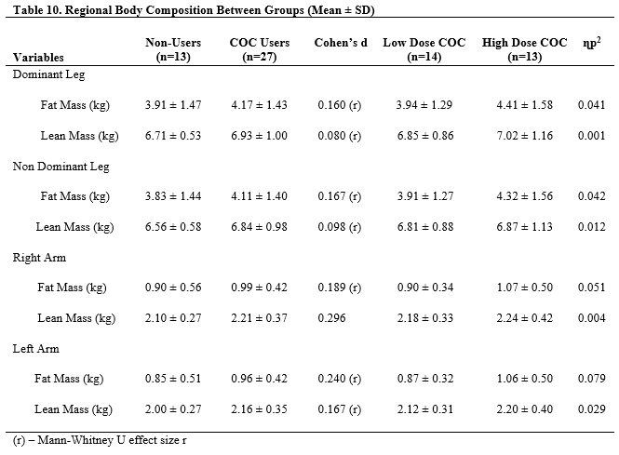
DXA was used to measure aBMD of the total body, lumbar spine, and hips. Table 11 presents the mean ± SD of total body, lumbar spine (L1-L4), and dual femur measures for Non-users, COC users, Low Dose COC and High Dose COC Users. No significant group differences were found between Non-Users and COC Users after performing an independent t-test for these variables. Dominant and non-dominant hip aBMD, for the femoral neck, trochanter, and total hip had moderate effect sizes. There were no significant differences between Non-Users, Low Dose COC, and High Dose COC Users after ANOVA for these dependent variables. Partial eta squared presented moderate effect sizes for L1-L4 aBMD, dominant femoral neck and trochanter as well as non-dominant hip aBMD trochanter a total hip. There were not significant correlations between duration of OC use and DXA bone variables.

Table 11. Total Body, Lumbar Spine, and Dual Femur Bone Characteristics (Mean ± SD)
Variables | Non-Users  (n=13) | COC Users  (n=27) |  |  | Cohen’s  d |  | Low Dose COC  (n=14) |  | High Dose COC  (n=13) |  | ɳp²
TBaBMD (g/cm²) | 1.187 ± 0.100 | 1.206 ± 0.094 |  |  | 0.197 | 1.198 ± 0.081 |  |  | 1.214 ± 0.110 |  | 0.002
TBBMC (g) | 2625.1 ± 561.8 | 2657.3 ± 452.6 |  |  | 0.063 | 2608.093 ± 449.9 |  |  | 2710.4 ± 467.7 |  | 0.004
L1-L4 aBMD (g/cm²) | 1.248 ± 0.140 | 1.243 ± 0.163 |  |  | 0.026 |  |  | 1.200 ± 0.128 | 1.294 ± 0.188 |  | 0.033
L1-L4 BMC (g) | 66.8 ± 15.2 | 68.5 ± 13.8 |  |  | 0.112 |  |  | 66.4 ± 10.6 | 70.8 ± 16.9 |  | 0.005
Dom Hip aBMD
Fem Neck (g/cm²) | 1.047 ± 0.143 | 1.103 ± 0.171 |  | 0.328 |  | 1.083 ± 0.195 |  |  |  | 1.124 ± 0.145 | 0.010
Troch (g/cm²) | 0.833 ± 0.145 | 0.866 ± 0.138 |  | 0.230 |  | 0.837 ± 0.130 |  |  |  | 0.899 ± 0.137 | 0.010
Tot Hip (g/cm²) | 1.050 ± 0.146 | 1.100 ± 0.154 |  | 0.317 |  | 1.070 ± 0.156 |  |  |  | 1.132 ± 0.150 | 0.009
Non-Dom Hip aBMD
Fem Neck (g/cm²) | 1.063 ± 0.155 | 1.098 ± 0.152 | 0.220 |  |  | 1.077 ± 0.180 |  |  | 1.120 ± 0.117 |  | 0.007
Troch (g/cm²) | 0.813 ± 0.135 | 0.864 ± 0.140 | 0.353 |  |  | 0.831 ± 0.144 |  |  | 0.899 ± 0.133 |  | 0.020
Tot Hip (g/cm²) | 1.039 ± 0.142 | 1.089 ± 0.156 | 0.317 |  |  | 1.057 ± 0.163 |  |  | 1.124 ± 0.146 |  | 0.014
TB: total body, aBMD: areal bone mineral density, BMC: bone mineral content, L1-L4: lumbar spine L1-L4, Tot: total, Fem: femoral, Troch: trochanter
Table 12 reports T-scores and Z-scores for total body, lumbar spine, femoral neck, femoral trochanter, and total hip. Participants younger than 20 years of age did not have T-scores. There were no significant differences between groups. There were 2 women who had Z-scores less than or equal to -2.0 (Non-User n=1, High Dose COC n=1) for the lumbar spine. One COC User was osteopenic at the non-dominant trochanter site and two COC Users was osteopenic at the non-dominant trochanter site. There were no differences for T or Z scores for total body or lumbar spine between Non-Users and COC Users after running independent t-tests. Total body T-score had a large effect size when comparing Non-Users to COC Users while lumbar spine T-score had a moderate effect size. ANOVA was used to determine group differences between Non-Users, Low Dose COC, High Dose COC. There were no significant differences between these 3 groups. All variables had a medium effect size for the 3 group comparison.
Table 12. T-scores and Z-scores for Total Body and Lumbar Spine (Mean ± SD)
Variables | Non Users  n=13 | COC Users  n=24 | Cohen’s  d | Low Dose COC  n=14 | High Dose COC  n=13 | ɳp²
Total Body
T-score | 0.3 ± 1.0¥ | 1.1 ± 1.2^{ǂ} | 0.506 | 1.0 ± 1.0^{ɸ} | 1.2 ± 1.5^{ψ} | 0.014
Z-score | 1.0 ± 1.7 | 1.01 ± 1.2 | 0.084 | 1.0 ± 1.0 | 1.1 ± 1.4 | 0.013
Lumbar Spine
T-score | -0.1 ± 0.5¥ | 0.5 ± 1.4^{ǂ} | 0.378 | 0.2 ± 1.1^{ɸ} | 0.9 ± 1.7^{ψ} | 0.023
Z-score | 0.4 ± 1.6 | 0.5 ± 1.4 | 0.0613 | 0.2 ± 1.1 | 0.9 ± 0.8 | 0.013
¥ - n=6, ǂ - n=21, ɸ - n=12, ψ – n=9

Table 13 depicts the T-scores and Z-scores for dual femur variables including femoral neck, trochanter and total hip for both dominant and non-dominant hips. There were no participants who had Z-scores below -2.0. No significant differences were found between Non-Users and COC Users after performing an independent t-test for these t-scores and z-scores. All Cohen’s D effect sizes were moderate for these dependent variables. There was difference in groups for the same variables after comparing Non-Users, COC Users, Low Dose COC, and High Dose COC users with ANOVA. All variables had a medium effect size for the 3 group comparison.

Table 13. T-scores and Z-scores for Dominant and Non-Dominant Hip Variables (Mean ± SD)
Variables | Non-Users  (n=13) | COC Users  (n=27) | Cohen’s  d | Low Dose COC  (n=14) | High Dose COC  (n=13) | ɳp²
Dominant
Femoral Neck
T-score | -0.2 ± 0.5¥ | 0.5 ± 1.3^{ǂ} | 0.479 | 0.3 ± 1.4^{ɸ} | 0.7 ± 1.0^{ψ} | 0.036
Z-score | -0.2 ± 0.6 | 0.4 ± 1.2 | 0.426 | 0.2 ± 1.4 | 0.6 ± 0.9 | 0.032
Trochanter
T-score | -0.5 ± 0.8¥ | 0.1 ± 1.3^{ǂ} | 0.446 | -0.1 ± 1.8^{ɸ} | 0.5 ± 1.2^{ψ} | 0.037
Z-score | -0.5 ± 0.8 | 0.1 ± 1.2 | 0.407 | 0.2 ± 1.2 | 0.4 ± 1.2 | 0.031
Total Hip
T-score | 0.1 ± 0.8¥ | 0.7 ± 1.2^{ǂ} | 0.482 | 0.7 ± 1.3^{ɸ} | 1.1 ± 1.2^{ψ} | 0.029
Z-score | 0.1 ± 0.9 | 0.6 ± 1.3 | 0.420 | 0.7 ± 1.2 | 0.9 ± 1.2 | 0.021
Non-Dominant
Femoral Neck
T-score | -0.2 ± 0.7¥ | 0.4 ± 1.1^{ǂ} | 0.428 | 0.2 ± 1.3^{ɸ} | 0.6 ± 0.9^{ψ} | 0.043
Z-score | -0.2 ± 0.8 | 0.3 ± 1.1 | 0.393 | 0.1 ± 1.3 | 0.5 ± 0.8 | 0.043
Trochanter
T-score | -0.5 ± 0.8¥ | 0.1 ± 1.3^{ǂ} | 0.427 | -0.2 ± 1.3^{ɸ} | 0.4 ± 1.2^{ψ} | 0.025
Z-score | -0.5 ± 0.9 | 0.0 ± 1.2 | 0.340 | -0.3 ± 1.3 | 0.3 ± 1.2 | 0.017
Total Hip
T-score | 0.1 ± 0.8¥ | 0.6 ± 1.3^{ǂ} | 0.345 | 0.5 ± 1.3^{ɸ} | 1.0 ± 1.2^{ψ} | 0.020
Z-score | 0.2 ± 1.0 | 0.6 ± 1.3 | 0.289 | 0.5 ± 1.3 | 0.9 ± 1.2 | 0.015
¥ - n=6, ǂ - n=21, ɸ - n=12, ψ – n=9
Table 14 depicts hip structural analysis variables between Non-Users, COC Users, Low Dose COC, and High Dose COC Users. Non-Users and COC Users were compared using an independent t-test. No significant differences was found between the two groups. All variables besides the dominant hip SI had a medium effect size with the two group comparison. Non-Users, Low Dose COC, and High Dose COC users were compared using ANOVA. There was no significant differences between these three groups after statistical analysis. All hip strength variables had a moderate effect size with the exception of the non-dominant hip section modulus. Comparison of Low Dose COC and High Dose COC using an independent t-test yielded a significant different in dominant hip strength index with High Dose COC users having a higher average (p=0.044).
Table 14. Hip Structural Analysis Variables Between Groups (Mean ± SD)
Variables | Non-Users  (n=13) | COC Users  (n=27) | Cohen’s d | Low Dose COC  (n=14) | High Dose COC  (n=13) | ɳp²
Dominant Hip
Strength Index | 1.6 ± 0.3 | 1.6 ± 0.3 | 0.020 | 1.7 ± 0.3 | 1.5 ± 0.3* | 0.076
Buckling Ratio | 3.0 ± 1.2 | 2.8 ± 1.2 | 0.105 (r) | 3.1 ± 1.4 | 2.5 ± 0.9 | 0.047
Section Modulus (mm³) | 637.1 ± 148.2 | 683.5 ± 128.3 | 0.331 | 677.7 ± 147.1 | 689.7 ± 110.1 | 0.010
CSMI (mm⁴) | 9512 ± 2688 | 10145 ± 2619 | 0.130 (r) | 10050 ± 2853 | 10248 ± 2453 | 0.021
Non-Dominant Hip
Strength Index | 1.7 ± 0.4 | 1.6 ± 0.3 | 0.367 | 1.6 ± 0.2 | 1.5 ± 0.4 | 0.032
Buckling Ratio | 3.2 ± 1.5 | 2.7 ± 1.2 | 0.296 | 2.9 ± 1.5 | 2.5 ± 0.8 | 0.013
Section Modulus (mm³) | 658.9 ± 197.8 | 680.1 ± 158.0 | 0.119 | 654.8 ± 158.8 | 707.4 ± 158.8 | 0.003
CSMI (mm⁴) | 9698 ± 3639 | 10175 ± 3128 | 0.148 (r) | 9715 ± 2772 | 10671 ± 3515 | 0.043
CSMI: cross sectional moment of inertia, (r) – Mann-Whitney U r effect size
*p<0.05 Low Dose COC vs. High Dose COC

pQCT Variables

PQCT was used to measure bone and muscle variables for the 4%, 38%, and 66% of the non-dominant tibia sites as well as the 50% femur site. There were no significant relationships between duration of OC use and bone variables at the femur 50% site, 4%, 38%, or 66% site. Table 15 shows the mean ± SD of the total bone variables, trabecular variables, and periosteal circumference at the 4% site of the tibia between groups. No group differences were found between Non-Users and COC-users when using independent t-tests, or between Non-Users, Low Dose COC and High Dose COC users when testing with ANOVA for pQCT variables at the 4% tibia site. Total BMC, trabecular BMC, trabecular vBMD, and trabecular BSI had medium effect sizes when investigating with Cohen’s d. There were no appreciable effects when looking at the 3 group comparison.

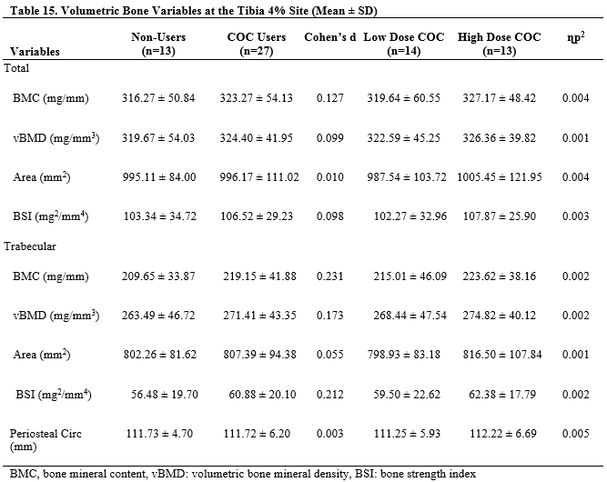
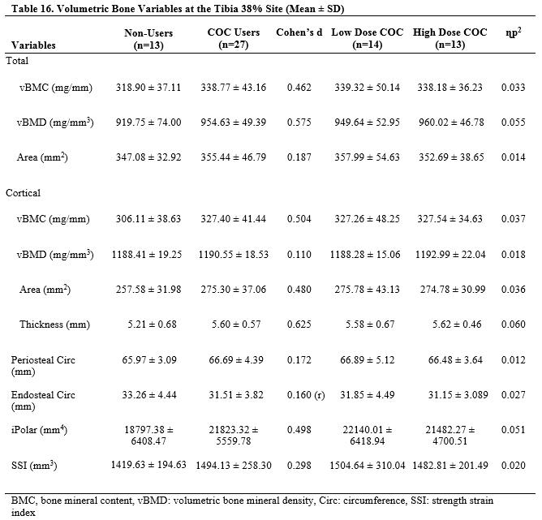
The 38% variables including total bone measures, cortical bone measures, periosteal circumference, endosteal circumference, and bone strength measures between Non-Users and COC users are reported in Table 16 for Non-Users, and COC Users. All variables were compared between Non-Users and COC Users using an independent t-test besides 38% Endosteal Circumference, which was tested using a Mann-Whitney U test. No variables were significantly different between Non-Users and COC Users. Similarly, all variables were compared between Non-Users, Low Dose COC, and High Dose COC users using ANOVA except for 38% Endosteal Circumference, which was tested using the Kruskal-Wallis test. None of the dependent variables at the 38% site were significant different between the three groups. All variables at the 38% tibia site had a medium affect size when examining the 2 group and 3 group comparison.

The 66% tibia site variables including total bone measures, cortical bone measures, periosteal circumference, endosteal circumference, and bone strength measures between Non-Users, COC Users, Low Dose COC, and High Dose COC users are presented in Table 17. Mann-Whitney U and a Kruskal Wallis test were used to determine group differences for 66% iPolar. Independent t-tests were used investigate group differences between Non-Users and COC Users for all other variables. There were no significant differences in any 66% tibia variables between Non-Users and COC Users; however all variables other than total vBMD and endosteal circumference had a medium effect size. ANOVA was used to determine differences between Non-Users, Low Dose COC, and High Dose COC users for all of the variables except 66% iPolar. No significant differences was found for any of the 66% tibia site variables between these 3 groups. Partial eta squared yielded moderate effect sizes for all dependent variables other than cortical vBMD.

Table 17. Volumetric Bone Variables at the Tibia 66% Site (Mean ± SD)
Variables | Non-Users  (n=13) | COC Users  (n=27) | Cohen’s d |  | Low Dose COC  (n=14) | High Dose COC  (n=13) | ɳp²
Total
vBMC (mg/mm) | 354.09 ± 45.33 | 378.65 ± 47.99 | 0.501 | 379.20 ± 58.56 |  | 378.05 ± 35.68 | 0.038
vBMD (mg/mm³) | 726.53 ± 84.57 | 741.19 ± 61.48 | 0.202 | 733.26 ± 68.28 |  | 749.73 ± 54.65 | 0.024
Area (mm²) | 492.04 ± 76.61 | 514.02 ± 78.02 | 0.272 | 520.50 ± 91.21 |  | 507.04 ± 63.82 | 0.027
Cortical
vBMC (mg/mm) | 325.10 ± 41.77 | 346.63 ± 42.04 | 0.493 | 344.39 ± 50.44 |  | 349.03 ± 32.57 | 0.029
vBMD (mg/mm³) | 1154.66 ± 19.38 | 1156.24 ± 19.49 | 0.078 | 1157.38 ± 18.87 |  | 1155.00 ± 20.83 | 0.004
Area (mm²) | 281.51 ± 35.31 | 300.02 ± 37.94 | 0.479 | 297.95 ± 46.16 |  | 302.25 ± 28.27 | 0.027
Thickness (mm) | 4.38 ± 0.57 | 4.57 ± 0.49 | 0.356 | 4.49 ± 0.61 |  | 4.65 ± 0.32 | 0.035
Periosteal Circ (mm) | 78.43 ± 5.93 | 80.15 ± 6.00 | 0.278 | 80.60 ± 6.97 |  | 79.68 ± 5.00 | 0.026
Endosteal Circ (mm) | 50.93 ± 7.50 | 51.46 ± 6.55 | 0.074 | 52.38 ± 7.54 |  | 50.46 ± 5.42 | 0.033
iPolar (mm⁴) | 36251.96 ± 9612.67 | 42428.89 ± 16249.48 | 0.226 (r) | 40889.23 ± 12145.62 |  | 44086.99 ± 20162.97 | 0.052
SSI (mm³) | 2107.11 ± 422.72 | 2307.46 ± 421.15 | 0.457 | 2308.84 ± 479.25 |  | 2305.96 ± 368.05 | 0.030
BMC, bone mineral content, vBMD: volumetric bone mineral density, Circ: circumference, SSI: strength strain index
(r) – Mann Whitney U r
Table 18 shows the vBMD variables for the 50% femur site. No variables were found to be significantly different between Non-Users and COC Users after running an independent t-test; however all variables had medium effect sizes except for endosteal circumference which had a small effect size. No variables were found to be significantly different between Non-Users, Low Dose COC, and High Dose COC users after performing an ANOVA for all of the vBMD 50% femur site variables. Total and cortical BMC and vBMD as well as cortical area, thickness, and strength strain index had medium effect sizes according to pɳ².
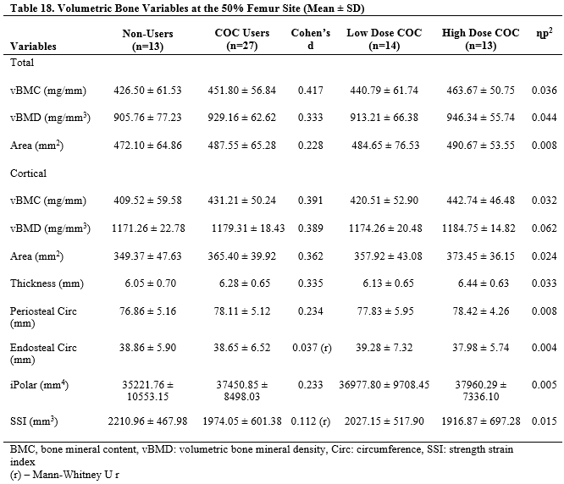

Muscle Thickness, Maximal Isokinetic Torque, and Muscle Quality

Muscle thickness was measured using ultrasound and pQCT at the 50% femur site for the quadriceps muscle group. The mean ± SD for the muscle thickness measurements is reported in Table 19. There were no significant differences for any muscle thickness measurement for the 2 group comparison or the 3 group comparison. Ultrasound MT had a large effect size and pQCT measures of MT had a small negative effect size for the 2 group comparison. For the 3 group comparison, both ultrasound and pQCT measures of MT had moderate effect sizes.
Table 19. Muscle Thickness Variables (Mean ± SD)
Variables | Non-Users  (n=13) | COC Users  (n=27) | Cohen’s d | Low Dose COC  (n=14) | High Dose COC  (n=13) | ɳp²
Ultrasound MT | 3.07 ± 0.5 | 3.33 ± 0.5 | 0.54 | 3.25 ± 0.4 | 3.42 ± 0.5 | 0.097
pQCT MT | 3.27 ± 0.4 | 3.66 ± 0.6 | -0.045 (r) | 3.56 ± 0.6 | 3.76 ± 0.6 | 0.116
MT: muscle thickness of the quadriceps at the 50% femur length
Maximal isokinetic torque was used to quantify muscle quality (MIT/US Muscle Thickness) in the knee extensors. The mean ± SD for MIT and muscle quality are reported in Table 20. An independent t-test was used to compare Non-Users and COC Users. There were no significant differences for MIT or MQ variables between these two groups. Maximal isokinetic torque at 180 º/sec and muscle quality had moderate effect sizes based on Cohen’s d. ANOVA tests were used to investigate differences between Non-Users, Low Dose COC, and High Dose COC users for these dependent variables. There was no significant findings for these 3 groups. All MIT and MQ had moderate effect sizes when looking at ɳp². Also, there were no significant correlations between muscle quality and muscle mass, density, or thickness variables.
Table 20. Maximal Isokinetic Torque and Muscle Quality Variables (Mean ± SD)
Variables | Non-Users  (n=13) | COC Users  (n=27) | Cohen’s d | Low Dose COC  (n=14) | High Dose COC  (n=13) | ɳp²
MIT
60 º/sec | 139.16 ± 26.82 | 137.49 ± 27.20 | 0.059 | 137.05 ± 22.97 | 137.95 ± 32.11 | 0.010
180 º/sec | 91.82 ± 15.29 | 88.14 ± 20.43 | 0.190 | 92.61 ± 15.32 | 83.32 ± 24.52 | 0.095
Muscle Quality (MIT/MT) | 46.60 ± 10.78 | 41.89 ± 9.31 | 0.457 | 42.89 ± 9.36 | 40.81 ± 9.52 | 0.087
MIT: maximal isokinetic torque for quadriceps

BoneJ Analysis of Soft Tissue

BoneJ was used to determine soft tissue characteristics of the 66% tibia and 50% femur sites between groups. Muscle and fat measures for the 66% tibia site are reported in Table 19. Independent t-tests were used to investigate total muscle density, total muscle area, total muscle CSA, fat density, fat area, subcutaneous fat density, and subcutaneous fat area between Non-Users and COC Users. Mann-Whitney U tests were used to compare intramuscular fat density and intramuscular fat area between Non-Users and COC Users. There were no significant differences between Non-Users or COC Users for any of the aforementioned variables. All 66% tibia soft tissue other than total fat density, subcutaneous fat density, and total muscle density had a medium effect size. Total fat density and subcutaneous fat density had very large effect sizes. Total muscle density demonstrated a small effect size. There were no differences found between Non-Users, Low Dose COC, and High Dose COC users when comparing the 66% tibia soft tissue variables using ANOVA. Intramuscular fat density and area was not different for the three groups when using the Kruskal Wallis non-parametric test. After comparing Non-Users, Low Dose COC and High Dose COC users, only total muscle density, fat density, intramuscular fat density and intramuscular fat area had a moderate effect size.

Table 21. 66% Tibia Soft Tissue Analysis (Mean ± SD)
Variables | Non-Users  (n=13) | COC Users  (n=27) | Cohen’s d | Low Dose COC  (n=14) | High Dose COC  (n=13) | ɳp²
TotMu Density (mg/cm³) | 80.25 ± 1.38 | 80.23 ± 0.96 | 0.017 | 80.43 ± 1.03 | 80.02 ± 0.86 | 0.017
TotMu CSA (cm²) | 64.52 ± 7.07 | 66.36 ± 10.95 | 0.218 | 64.79 ± 11.03 | 68.06 ± 11.05 | 0.001
Fat Density (mg/cm³) | 2.10 ± 3.51 | 0.05 ± 2.16 | 0.954 | 0.32 ± 2.47 | -0.23 ± 1.82 | 0.094
Fat Area (cm²) | 29.00 ± 7.93 | 30.75 ± 7.47 | 0.221 | 30.58 ± 7.50 | 30.93 ± 7.75 | 0.007
SubCut Fat D (mg/cm³) | 1.56 ± 3.59 | -0.62 ± 2.8 | 0.994 | -0.34 ± 2.51 | -0.92 ± 1.8 | 0.003
SubCut Fat A (cm²) | 26.45 ± 7.80 | 28.14 ± 7.30 | 0.217 | 28.00 ± 7.34 | 28.28 ± 7.56 | 0.007
Intram Fat D (mg/cm³) | 34.85 ± 2.56 | 34.00 ± 2.71 | 0.144 (r) | 34.55 ± 1.89 | 33.41 ± 3.4 | 0.050
Intram Fat A (cm²) | 0.18 ± 0.20 | 0.30 ± 0.37 | 0.222 (r) | 0.26 ± 0.24 | 0.34 ± 0.48 | 0.051
Totmu: total muscle, CSA: cross sectional area, SubCut: subcutaneous D: density, A: area
(r) – Mann-WhitneyU r

Muscle and fat variables between groups for the 50% femur site are reported in mean ± SD as seen in Table 20. Non-parametric tests were used to determine differences between muscle density, total fat area, intramuscular fat area and subcutaneous fat area for the 50% femur site between groups. No significant differences were found after running an independent t-test and Mann-Whitney U test for any of the 50% femur site variables between Non-Users and COC Users. Additionally, no differences between Non-Users, Low Dose COC, and High Dose COC users were discovered after testing these dependent variables with ANOVA and Kruskal Wallis tests. All of the 50% femur soft tissue analysis variables had medium effect sizes when comparing Non-Users to COC Users and Non-Users to Low Dose COC and High Dose COC users. There were no significant relationships between duration of OC use and muscle or fat variables.
Table 22. 50% Femur Soft Tissue Analysis (Mean ± SD)
Variables | Non-Users  (n=13) | COC Users  (n=27) | Cohen’s d | Low Dose COC  (n=14) | High Dose COC  (n=13) | ɳp²
TotMu Density (mg/cm³) | 79.95 ± 2.05 | 80.20 ± 1.14 | 0.062 (r) | 80.47 ± 1.43 | 79.91 ± 0.70 | 0.053
TotMu CSA (cm²) | 117.22 ± 11.99 | 123.20 ± 16.67 | 0.374 | 118.41 ± 14.04 | 128.36 ± 18.25 | 0.047
Fat Density (mg/cm³) | - 3.07 ± 2.52 | -3.75 ± 2.37 | 0.267 | -3.26 ± 2.23 | -4.23 ± 2.49 | 0.017
Fat Area (cm²) | 83.05 ± 26.33 | 93.08 ± 30.31 | 0.180 (r) | 87.81 ± 29.68 | 98.76 ± 31.13 | 0.062
SubCut Fat D (mg/cm³) | -3.70 ± 2.55 | -4.38 ± 2.38 | 0.270 | -3.89 ± 2.23 | -4.92 ± 2.50 | 0.016
SubCut Fat A (cm²) | 78.87 ± 25.77 | 88.82 ± 29.53 | 0.176 (r) | 83.49 ± 28.94 | 93.94 ± 30.34 | 0.060
Intram Fat D (mg/cm³) | 27.15 ± 2.32 | 26.22 ± 2.25 | 0.395 | 6.34 ± 2.69 | 26.09 ± 1.76 | 0.033
Intram Fat A (cm²) | 5.00 ± 3.72 | 6.32 ± 4.28 | 0.167 (r) | 5.23 ± 3.95 | 7.50 ± 4.45 | 0.100
Totmu: total muscle, CSA: cross sectional area, SubCut: subcutaneous D: density, A: area
(r) – Mann-WhitneyU r

Correlations
Pearson’s correlation coefficient was used to assess the relationship between muscle quality and soft tissue characteristics, the relationship between duration of COC use and soft tissue density variables, and between muscle thickness and mCSA. Spearman’s correlation coefficient was used to assess the relationships between non-parametric soft tissue variables such as femur muscle density, total femur fat area, femur intramuscular fat area, and femur subcutaneous fat area with duration of COC use. Spearman’s correlation coefficient was also used to assess the relationship between non-parametric DXA bone and muscle variables such as dominant leg fat mass, non-dominant leg lean mass, dominant leg lean mass, and non-dominant leg lean mass with duration of COC use.
There were no significant correlations between duration of COC use and bone, muscle, and fat variables. Current BPAQ was significantly correlated with lumbar spine (L1-L4) aBMD (p=0.025, r=0.358), total body fat mass (p=0.038, r=0.329), dominant leg fat mass (p=0.026, r=0.353), and non-dominant leg fat mass (p=0.033, r=0.338). Past BPAQ was significantly correlated with total body aBMD, total body t and z-scores, dominant and non-dominant neck aBMD, dominant and non-dominant trochanter aBMD, total dominant and total non-dominant hip aBMD, 4% total BMC and vBMD, 4% trabecular BMC and vBMD, 4% total BSI and trabecular BSI, 38% cortical BMC, 38% cortical area, 38% cortical thickness, 38% iPolar, 66% total BMC, 66% total area, 66% periosteal circumference, 66% cortical BMC, 66% cortical area, 66% SSI, 66% iPolar, 50% femur total BMC, 50% femur total area, 50% femur cortical BMC, 50% cortical thickness, and 50% periosteal circumference (p≤0.05, r≤0.638). Total BPAQ had similar correlations to bone variables as past BPAQ variables.

Discussion

It is well known that the rate of muscle and bone decline increases significantly at the time of menopause (32, 34). Decreases in bone mineral density and content increases the risk of bone injuries which poses a significant economic burden for the United States (40). Osteoporosis is commonly described as a chronic disease that does not manifest until the late stages of life but result of inadequate bone mineral acquisition during early adolescence leading up until the cessation of bone accrual during the second decade of life (53). For this reason, it is important to determine factors that may impair bone formation during these crucial years. Additionally, it has been shown that a decrease in serum estrogen in levels in human and rodent models may affect body composition (5, 85, 87) and muscle function (24, 90, 97, 98). The purpose of this study was to investigate how the decrease in serum estrogen caused by ingestion of exogenous EE from the use of COC affects musculoskeletal health. Statistical analysis performed for this study presented no significant differences found in any variables between Non-Users and COC Users even after separating them by EE dose.
Forty healthy college aged women volunteered for this study. Participants received DXA scans to measure aBMD and body composition variables for total body, lumbar spine, and dual femur. PQCT scans of the 50% femur, 4%, 38%, and 66% tibia sites were completed to quantify vBMD variables. Images generated by pQCT software was then used to analyze density and area of muscle and adipose tissue at the 50% femur and 66% tibia sites. Ultrasound was used to measure muscle thickness from the bone-muscle interface to the muscle-subcutaneous fat interface at the 50% femur site. This measure was used in conjunction with maximal isokinetic torque measurements of the quadriceps to quantify muscle quality. Independent t-tests and Mann-Whitney U tests compared Non-Users to COC Users. ANOVA and Kruskal-Wallis tests compared Non-Users, Low Dose COC, and High Dose COC users. There were no significant findings for bone, muscle or fat variables between Non-Users or COC Users, and no differences were found for the same variables when comparing Non-Users, Low Dose COC, and High Dose COC Users. This opposes the hypotheses of this study, but is confirmed by multiple studies which will be discussed (78, 90, 98, 108, 109).

Areal Bone Mineral Density

Visual inspection of individual Z-scores was used to determine osteopenic status in this group of premenopausal women. Osteopenia is defined as a Z-score below -2.0 for premenopausal by the ISCD (53, 54, 110). One Non-User and COC User was osteopenic for the lumbar spine. One COC User was osteopenic at the non-dominant neck and two COC Users were osteopenic and the non-dominant trochanter. None of the participants were osteoporotic according to the WHO’s definition.
E₂ has been shown to positively impact bone remodeling and aBMD (22, 26, 58). Thus it was speculated that the decrease in serum E₂ caused by COC use would be detrimental to bone health. It was hypothesized that Non-Users would have greater aBMD for the total body, spine, and dual femur compared to COC Users. This hypothesis was not supported by this study as there were no significant differences between groups for any DXA variables. However, moderate effect sizes between Non-Users and COC Users were noted for hip and spine aBMD variables suggesting the lack of group differences was the result of low statistical power. These findings contradict studies reporting that the use of COC was related to decreases or decrements to acquisition of BMD and BMC (36, 37, 60, 111). However, these studies were performed in early adolescent women, while the current study included young adult women who began COC use at an average of 16.8 years of age. Adolescence is an important time of bone accrual, and is the point in time where the rate of bone acquisition is the greatest (112). It is possible that detriments to bone formation during this time may be augmented and may explain the differences seen between studies looking at varying age groups.
A similar investigation done by Sherk et al. (2009), in a group of women between the ages of 18-30 found that the use of COC had no effect on aBMD of the total body, lumbar spine and neck (78). This is comparable to the non-significant findings for aBMD in this study comparing Non-Users and COC Users as well as Non-Users, Low Dose COC and High Dose COC users. In contrast, Shoepe and Snow (2005) found that 18-35 year old women taking COC with 20-35 µg EE had a significant decrease in total body, lumbar spine, and femur aBMD (7). It is possible that calcium intake differences between the participants in this study (Non-Users averaged 620.6 mg/day and COC Users averaged 699.3 mg/day) and Shoepe and Snow (Non-Users averaged 1005 mg/day and COC Users averaged 1053 mg/day) may account for the discrepancies in conclusions. However, it is expected that participants who ingest less calcium, such as those in this study, would have decreased aBMD compared to those who ingested the recommended amount (53, 113).
It is also possible that the different findings seen between Shoepe and Snow (2005) and this study may have been due to the number of participants taking different multiphasic oral contraceptives. Shope and Snow (2005) had an equal number of COC participants taking TOC versus MOC while the present study had a total of 4 TOC and 23 MOC users. In the current study, there were 8 different formulations of COC with 3 different progestins ranging from 1mg to 3 mg. The difference between multiphasic oral contraceptives is the amount of progesterone that is in each pill during the active pill phase. MOC maintain a higher level of synthetic progesterone throughout the 21 day cycle averaging about 1.40 mg of a while TOC start low at 0.60 mg and increase to about 1.60 mg during the active pill phase (3). As a result, TOC users tend to receive less progesterone over the course of the month long cycle. The effects of progesterone on bone are still inconclusive, but there is some evidence that that it may play a role in bone remodeling. For example, Wang et al. (2009) demonstrated that progesterone prevents osteoblast programmed cell death, thereby prolonging bone formation which could potentially aid increases in BMC (25).
Additionally, it was hypothesized that High Dose COC users would have greater aBMD compared to Low Dose COC and Non-Users would have greater aBMD compared to both Low Dose COC and High Dose COC users due to exposure to different levels of in E₂. These hypotheses were not supported by the findings of this study, however there is data in the literature to support this effect (78, 80). Additionally, a systematic review done by Kuohung et al. (2000) argues that low COC may have a positive effect on BMD. This is supported by Paoletti et al. (2000) who found that treatment with 20 µg EE and 30 µg EE in women 22-30 years of age seemed to decrease bone resorption parameters (109). This may explain the higher mean BMD in COC users compared to Non-Users in this study based off a moderate effect size. However, this contradicts Gersten et al. (2016), who found that bone accrual was decreased in adolescent women taking COC formulations with 20 µg EE but not 30 µg EE. Again, the age that participants begin using COC may account for the discrepant in findings.
Lastly, there were no significant correlations between duration of COC use and any DXA aBMD variable. This is opposed by Scholes et al. (2010) who found that 19-30 year old young adult OC users had a negative linear trend for total body, hip, and spine BMD with increased duration of OC use (111). However, similar to the findings of this study, they found no significant differences between Non-Users, OC users receiving 30-35 µg EE, and those taking < 30 µg EE for total, hip, and spine BMD.

Volumetric Bone Mineral Density

PQCT was used to measure vBMD variables at the 50% femur, 4%, 38%, and 66% tibia sites. Independent t-tests or Mann-Whitney U tests were used to compare Non-Users to COC Users while ANOVA or Kruskal-Wallis tests were used to compare Non-Users, Low Dose COC, and High Dose COC Users. It was hypothesized that Non-Users would have greater vBMD measures compared to COC Users and High Dose COC users would have greater vBMD measures than Low Dose COC users. There was no significant difference between any of the groups when comparing Non-Users to COC Users and Non-Users to Low Dose COC and High Dose COC users. However, medium effect sizes with larger means in COC Users compared to Non-Users suggest COC effects that were not detected due to low statistical power. It is difficult to compare the results of this study with previous studies for vBMD because few investigations have utilized pQCT analysis when looking at the effects of COC. However many of the same arguments related to aBMD could be made here because both are measures of bone health.
There were no significant differences between Non-Users and COC Users for any vBMD variables in this study, which is supported by Hartard et al. (2006) (114). They recruited a group of inactive women between the ages of 18-24 and found that there were no differences at the 4% tibia and 38% tibia sites between Non-Users and COC Users. However, they did find significant differences for COC Users at the tibia 14% site and 4% radius site (114). No further comparison could be made because the 14% tibia site and the 4% radius site were not measured in the present study.
It is possible that physical activity may explain the lack of differences. For example, Ruffing et al. (2006) found that COC users in a group of military cadets had significantly decreased levels of tibia BMC, cortical thickness, and periosteal circumference at the distal third of the tibia compared to military cadets who did not use COC. It is well-documented that resistance training and regular physical activity are beneficial to bone health in women (53, 115). However, too much physical activity may lead to the female athlete triad which is characterized by low estrogen levels leading to bone loss (116). Additionally, the military cadet population is more prone to bone injury than the civilian population which may explain the differences in study conclusions (117, 118). Participants in this study participated in a variety of activities ranging from walking to multiple high-intensity interval classes per week. It is possible that those that performed exercise producing large amounts of ground reaction forces had increased vBMD compared to those who were sedentary. These people may have driven potential differences between groups away from significance. In fact, 18 of the 27 COC Users reported resistance training 1-5 days a week compared to the 4 out of 13 Non-Users who reported resistance training over the past 12 months.
The similarity between Non-Users and COC Users for the 66% tibia site and the failure to find significance at the 66% site in the previously cited studies may be attributed to the fact that it is not the site of greatest stress from ground reaction forces. Because of this, the 66% site would be less responsive to mechanical loading.
Lack of significant differences between groups at the 50% femur, 4%, 38%, and 66% tibia sites were supported by the absence of significant linear relationships on duration of COC use and vBMD variables. Despite this, there were moderate effect sizes for many variables that should be noted. At the 4% tibia site, mean total BMC, trabecular BMC and trabecular BSI was greater for COC users compared to Non-Users. At the 38% site, total BMC, total vBMD, cortical BMC, cortical vBMD, cortical area, cortical thickness, endosteal circumference, iPolar, and SSI averages were all greater in COC users compared to Non-Users with a medium effect size. All 38% tibia variables had moderate effect sizes in the 3 group comparison, but the effects seem to be driven be the difference in Non-Users and COC Users. Again, all 66% tibia variables except for cortical vBMD and endosteal circumference had medium effect sizes with COC Users having greater averages than Non-Users. Finally, all variables measured at the 50% femur site except for endosteal circumference had medium affect sizes when comparing COC Users to Non-Users with COC Users having greater averages for all variables compared to Non-Users. These potential effects are contradictory to the hypotheses for this study because it was speculated that the use of COC would have a detrimental effect on vBMD measures. It is possible that those who begin use of COC after adolescent years may benefit from COC use (108, 109). Paoletti et al. (2000) found that use of COC caused a decrease in bone resorption biomarkers in a group of 22-30 years of age. If less bone is being resorbed, more bone remains settled on the bone which could cause increases in BMC over time. Despite this, conclusions must be made with caution as this study was underpowered.

Soft Tissue Analysis

PQCT images of the 50% femur and 66% tibia sites were analyzed using BoneJ to quantify muscle and fat characteristics. Many previous studies on rodents have shown that decreases in serum estrogen and ovarian hormones caused increases in body mass as well as muscle mass (24, 90, 98). Additionally, some of those studies also reported increases in muscle mass with E₂ supplementation (90, 98). This is contradictory to the findings of this study which found no significant differences between Non-Users, COC Users, Low Dose COC and High Dose COC users for body weight or any body composition variables. These discrepancies may be due to the fact that rat and mice physiology may not directly translate to human physiology. In fact, many of the studies investigating changes in body composition in women from the use of COC remain largely inconclusive. For example, some studies have shown that COC may cause increases in weight (4, 99), while others showed no significant changes in weight (1, 5, 6, 86).
To our knowledge, no studies have investigated fat density, muscle density, fat CSA and muscle CSA between Non-Users and COC Users known to date. It was thought that increases in body fat mass would lead to an increase in intramuscular fat infiltration which would cause an increase in muscle CSA. This investigation found that there were no significant differences in any of the soft tissue characteristics when comparing Non-Users and COC Users or between Non-Users, Low Dose COC, and High Dose COC. Additionally, there were no significant correlations between duration of COC use and soft tissue variables. This suggests that the use of COC and different doses of COC may not affect soft tissue characteristics for this population of women. However, the small number of participants in this study may have limited the chance of significance. Upon analyzing moderate effect sizes with Cohen’s d, it was found that total muscle area and total muscle CSA means were greater in COC Users compared to Non-Users at the 50% femur and 66% tibia sites. This supports part of the research hypothesis stating that muscle thickness and cross sectional area would be increased in COC Users compared to Non-Users as well as past studies on rodent models (90, 98). Additionally, average fat area, subcutaneous fat area, and intramuscular fat area at the 50% femur and 66% tibia sites were greater on average in COC Users compared to Non-Users. This opposes the study hypothesis speculating that COC Users would have greater fat density compared to Non-Users, but supports retrospective data from this lab showing that High Dose COC users had a significantly lower subcutaneous fat density average compared to Non-Users. Further investigation is required to explain the interactions between COC and muscle and fat metabolism to explain these potential effects.
Muscle quality (MQ) is the quantification of muscle strength to amount of muscle present that can be utilized. This was quantified as MIT/US muscle thickness. It was hypothesized that COC Users would have lower MQ compared to COC Users. There were no significant differences found between Non-Users and COC Users; however COC Users had a lower MQ average compared to Non-Users with a moderate effect size quantified with Cohen’s d. This supports the hypothesis as well as rodent based models investigating MQ (90, 98). MQ has been shown to change in a rodent model in response to OVX operations. Moran et al. (2006), demonstrated that OVX caused an increase in muscle size without an increase in contractile protein content or force production and that these changes were eliminated with E₂ supplementation (98). However, fat composition of the muscle was not mentioned. It is unknown whether the change in the size of the muscle was due to changes in fat composition or water retention.
In this study, there were no significant differences in muscle quality between any groups. A possible explanation for this finding may be because there were no significant changes in weight, fat mass, or body fat %. Without the changes in the aforementioned variables, there would be no reason to see infiltration of fat into muscle as seen in a study done by Goodpaster et al. (2000) which demonstrated that obesity was related to fat infiltration into muscle (28). Without fat infiltration into muscle, there would be no artificial increase in muscle CSA, and therefore no change in muscle quality. It is important to note that other factors such as fiber type, fiber size, and nervous innervation are known to affect muscle strength and therefore muscle quality. Since COC use did not seem to affect muscle quality, COC use may not effect these variables either.

Limitations

There are limitations to this study that must be discussed. The small sample size for this cross-sectional study meant that this investigation was severely underpowered with only 38 degrees of freedom for independent t-test comparisons. This may have hidden potential significant differences between groups, however some discussion could be made with the use of effect sizes such as Cohen’s d and ɳp². Despite this, caution should be exercised when using these results to come to conclusions because the lack of statistical power.
Serum estrogen levels were not tested to determine menstrual cycle stage or estrogen concentration due to lack of money and feasibility reasons. It would have been important to determine estrogen concentrations because ethinyl estradiol (EE) is a synthetic form of estrogen that is commonly used in today’s COC formulations (10). It is an agonist to the biological form of estrogen, 17β-estradiol (E₂), binding to ERα and ERβ nuclear receptors to exert its effects (12, 13). The ingestion of EE causes decreases in serum E₂ levels and increases in SHBG (17). Theoretically, the tight binding of E₂ to increased concentration of SHBG would cause decreases in E₂ availability. However, EE does not bind to SHBG readily, and is therefore free to exert biological effects. For this reason, EE is about 100 times more bioavailable than E₂ (12, 13). It is possible that this could be a reason why there was no significance found in this study because decreased serum levels of E₂ could be made up with adequate concentrations of EE may make up for the decrement. Also, there is a large interindividual variability with EE serum concentrations allowing for some women taking 35 µg EE to have the same serum concentration as another women taking 50 µg EE (13). A larger sample size would have been needed to overcome the interindividual variations involved with COC use.
Additionally, because the MIT measure used for analysis was performed on a separate visit than the DXA and pQCT visit, MIT may not truly be representative of muscle thickness. However, this was done in order to ensure that participants were no longer adapting to learning effects which would have underestimated their MIT. Also, the third visit was completed within a couple of weeks of the second visit thereby decreasing the chances for muscle hypertrophy. Precision data between the testing visits suggest that changes in muscle size were small between visits. Also, isokinetic torque was measured. It may have been better to test isometric force as it is better for muscle fiber recruitment.
Lastly, the number of significant correlations between past and total BPAQ on bone variables compared to the lack of significant correlations between duration of COC use suggest the volume of ground reaction forces a person is exposed to may have a larger effect on bone health over COC use. It would be beneficial to further limit physical activity levels for future research.

Summary

In summary, bone and soft tissue characteristics do not differ between Non-Users or COC-Users in this population of women. The findings of this study were similar to some studies done in the past (1, 6, 78, 86, 119), but contradicted others (4, 36, 60, 99). These conflicting results indicate the need for further research. The popularity of COC as a form of contraception makes it an important research topic which could benefit millions of people worldwide. Research on COC should continue to strengthen the understanding of how it affects bone and muscle health.

Chapter 5: Conclusions

The purposes of this study were to: (1) compare areal bone mineral density (aBMD) of the total body, lumbar spine, proximal femur, and volumetric bone mineral density (vBMD) of the femur and tibia between COC Users and Non-Users; and (2) to compare muscle variables such as muscle thickness, muscle cross sectional area, muscle density and muscle quality between COC Users and Non-Users; and (3) to compare fat density and fat CSA between COC Users and Non-Users. Additionally, bone, muscle, and fat variables will be compared between Non-Users, Low Dose COC and High Dose COC users.

Research Hypotheses

- It was hypothesized that COC users would have lower aBMD for total body, lumbar spine, and dual femur compared to non-users.
This hypothesis was not supported by statistical analysis which showed no significant difference in aBMD for any variable between COC Users and Non-Users.
- It was hypothesized that COC users would have lower vBMD at the 50% femur, 4%, 38%, and 66% tibia sites compared to non-users.
Statistical analysis did not support this hypothesis. There were no significant differences between COC Users and Non-Users for any of the vBMD variables.
- It was hypothesized that COC users would have greater muscle thickness and muscle cross sectional area, but have lower muscle density and quality compared to non-users.
Upon completion of the statistical analysis, there were no significant differences between COC Users compared to Non-Users suggesting that the use of COC may not affect muscle thickness, muscle CSA, muscle density, or muscle quality.
- It was hypothesized that COC users would have greater fat density and higher fat CSA compared to non-users.
This hypothesis was not supported by the findings of this study. There were no significant differences between COC Users and Non-Users for fat density or fat CSA.

Sub Hypotheses

- It was hypothesized that non-users would have greater aBMD for total body, lumbar spine, and dual femur compared to Low Dose COC and High Dose COC users.
There were no significant differences between Non-Users, Low Dose COC Users, or High Dose COC Users for aBMD variables.
- It was hypothesized that non-users would have greater vBMD at the 50% femur, 4%, 38%, and 66% tibia sites compared to Low Dose COC and High Dose COC users.
This sub hypothesis was not supported by the statistical analysis performed for this study. There were no significant differences between groups for any vBMD variable.
- It was hypothesized that non-users COC users would have greater muscle thickness, and muscle CSA, but lower muscle density, and muscle quality compared to Low Dose COC and High Dose COC users.
There were no significant differences between Non-Users, Low Dose COC, or High Dose COC Users for muscle thickness, muscle CAS, muscle density or muscle quality.
- It was hypothesized that Non-Users would have lower fat density and fat CSA compared to Low Dose COC and High Dose COC users.
Lastly, this sub hypothesis was not supported. Statistical analysis showed that fat density and fat CSA were not significantly different between groups.

Clinical Significance

The current study did not find any significant differences between Non-Users and COC Users suggesting that the use of COC does not affect bone or muscle characteristics in this population of young adult women. Many studies have shown that initiation of COC during early adolescence may be detrimental to bone health (36, 37, 60). Therefore, the age of initiation should be considered when deciding when to use COC. Additionally, there were no significant differences between Low Dose COC and High Dose COC users for any variable which could mean that either dose could be safe for consumption without detrimental effects to musculoskeletal health. However, it is advised that patients and practitioners take caution when interpreting these findings due to lack of statistical power.

Suggestions for Future Research

No significant differences were found for any variable in this study. However this does not mean that these results can act as a consensus for the effects of COC on musculoskeletal health. The findings of this study can only be generalized to a population of healthy college aged women living around the Norman, OK area. Future research should aim to determine whether use of COC may affect bone and muscle variables in older premenopausal women. Investigators who aim to study COC effects may want to consider standardizing dose, type, and periodization of COC treatment. They may also increase the minimum time requirement on COC needed to be included in the study. Additionally, this study is severely underpowered due to small sample sizes and high interindividual variability. Future research should aim to and increase sample size.
Currently, the research done on the use of COC in humans has been equivocal and there is no consensus on whether or not there are any effects on body composition, muscle strength, and muscle quality.

References

1. Lindh I, Ellström AA, Milsom I. The long-term influence of combined oral contraceptives on body weight. Human Reproduction. 2011;26(7):1917-24.
2. Addison O, Marcus RL, LaStayo PC, Ryan AS. Intermuscular fat: a review of the consequences and causes. International Journal of Endocrinology. 2014;2014.
3. Burrows M, Peters CE. The influence of oral contraceptives on athletic performance in female athletes. Sports Medicine. 2007;37(7):557-74.
4. Casazza GA, Suh S-H, Miller BF, Navazio FM, Brooks GA. Effects of oral contraceptives on peak exercise capacity. Journal of Applied Physiology. 2002;93(5):1698-702.
5. Berenson AB, Rahman M. Changes in weight, total fat, percent body fat, and central-to-peripheral fat ratio associated with injectable and oral contraceptive use. American Journal of Obstetrics & Gynecology. 2009;200(3):329. e1-. e8.
6. Moore LL, Valuck R, McDougall C, Fink W. A comparative study of one-year weight gain among users of medroxyprogesterone acetate, levonorgestrel implants, and oral contraceptives. Contraception. 1995;52(4):215-9.
7. Shoepe HA, Snow CM. Oral contraceptive use in young women is associated with lower bone mineral density than that of controls. Osteoporosis International. 2005;16(12):1538-44.
8. Ziglar S, Hunter TS. The effect of hormonal oral contraception on acquisition of peak bone mineral density of adolescents and young women. Journal of Pharmacy Practice. 2012;25(3):331-40.
9. Daniels K, Daugherty JD, Mosher WD. Current contraceptive use and variation by selected characteristics among women aged 15-44: United States, 2011-20132015.
10. Burkman R, Bell C, Serfaty D. The evolution of combined oral contraception: improving the risk-to-benefit ratio. Contraception. 2011;84(1):19-34.
11. Allaway HC, Mallinson RJ, De Souza MJ. Impact of Combined Oral Contraceptive Use on Exercise and Health in Female Athletes. Exercise and Human Reproduction: Springer; 2016. p. 287-302.
12. Rivera R, Yacobson I, Grimes D. The mechanism of action of hormonal contraceptives and intrauterine contraceptive devices. American Journal of Obstetrics and Gynecology. 1999;181(5):1263-9.
13. Stanczyk FZ, Archer DF, Bhavnani BR. Ethinyl estradiol and 17β-estradiol in combined oral contraceptives: pharmacokinetics, pharmacodynamics and risk assessment. Contraception. 2013;87(6):706-27.
14. Molloy B, Coulson K, Lee J, Watters J. " Missed pill" conception: fact or fiction? British Medical Journal (Clinical research ed). 1985;290(6480):1474.
15. Gaspard U, Romus M, Gillain D, Duvivier J, Demey-Ponsart E, Franchimont P. Plasma hormone levels in women receiving new oral contraceptives containing ethinyl estradiol plus levonorgestrel or desogestrel. Contraception. 1983;27(6):577-90.
16. Coney P, DelConte A. The effects on ovarian activity of a monophasic oral contraceptive with 100 μg levonorgestrel and 20 μg ethinyl estradiol. American Journal of Obstetrics and Gynecology. 1999;181(5):S53-S8.
17. Wiegratz I, Kutschera E, Lee J, Moore C, Mellinger U, Winkler U, Kuhl H. Effect of four different oral contraceptives on various sex hormones and serum-binding globulins. Contraception. 2003;67(1):25-32.
18. Barros RP, Machado UF, Warner M, Gustafsson J-Å. Muscle GLUT4 regulation by estrogen receptors ERβ and ERα. Proceedings of the National Academy of Sciences. 2006;103(5):1605-8.
19. WADE GN, GRAY JM. Cytoplasmic 17β-[3H] estradiol binding in rat adipose tissues. Endocrinology. 1978;103(5):1695-701.
20. Eriksen EF, Colvard DS, Berg NJ, Graham ML, Mann KG, Spelsberg TC, Riggs BL. Evidence of estrogen receptors in normal human osteoblast-like cells. Science. 1988;241(4861):84-6.
21. Campbell S, Mehan K, Tunstall R, Febbraio M, Cameron-Smith D. 17beta-estradiol upregulates the expression of peroxisome proliferator-activated receptor alpha and lipid oxidative genes in skeletal muscle. Journal of Molecular Endocrinology. 2003;31(1):37-45.
22. Kameda T, Mano H, Yuasa T, Mori Y, Miyazawa K, Shiokawa M, Nakamaru Y, Hiroi E, Hiura K, Kameda A. Estrogen inhibits bone resorption by directly inducing apoptosis of the bone-resorbing osteoclasts. Journal of Experimental Medicine. 1997;186(4):489-95.
23. Paquette A, Chapados N, Bergeron R, Lavoie J-M. Fatty acid oxidation is decreased in the liver of ovariectomized rats. Hormone and Metabolic Research. 2009;41(07):511-5.
24. Velders M, Schleipen B, Fritzemeier KH, Zierau O, Diel P. Selective estrogen receptor-β activation stimulates skeletal muscle growth and regeneration. The FASEB Journal. 2012;26(5):1909-20.
25. Wang Q-P, Xie H, Yuan L-Q, Luo X-H, Li H, Wang D, Meng P, Liao E-Y. Effect of progesterone on apoptosis of murine MC3T3-E1 osteoblastic cells. Amino Acids. 2009;36(1):57-63.
26. Yang Y-H, Chen K, Li B, Chen J-W, Zheng X-F, Wang Y-R, Jiang S-D, Jiang L-S. Estradiol inhibits osteoblast apoptosis via promotion of autophagy through the ER–ERK–mTOR pathway. Apoptosis. 2013;18(11):1363-75.
27. Notelovitz M, Zauner C, McKenzie L, Suggs Y, Fields C, Kitchens C. The effect of low-dose oral contraceptives on cardiorespiratory function, coagulation, and lipids in exercising young women: a preliminary report. American Journal of Obstetrics and Gynecology. 1987;156(3):591-8.
28. Goodpaster BH, Theriault R, Watkins SC, Kelley DE. Intramuscular lipid content is increased in obesity and decreased by weight loss. Metabolism-Clinical and Experimental. 2000;49(4):467-72.
29. Malenfant P, Joanisse D, Theriault R, Goodpaster B, Kelley D, Simoneau J. Fat content in individual muscle fibers of lean and obese subjects. International Journal of Obesity. 2001;25(9):1316.
30. Reubinoff BE, Grubstein A, Meirow D, Berry E, Schenker JG, Brzezinski A. Effects of low-dose estrogen oral contraceptives on weight, body composition, and fat distribution in young women. Fertility and Sterility. 1995;63(3):516-21.
31. Pan D, Lillioja S, Kriketos A, Milner M, Baur L, Bogardus C, Jenkins AB, Storlien L. Skeletal muscle triglyceride levels are inversely related to insulin action. Diabetes. 1997;46(6):983-8.
32. Goodpaster BH, Park SW, Harris TB, Kritchevsky SB, Nevitt M, Schwartz AV, Simonsick EM, Tylavsky FA, Visser M, Newman AB. The loss of skeletal muscle strength, mass, and quality in older adults: the health, aging and body composition study. The Journals of Gerontology Series A: Biological Sciences and Medical Sciences. 2006;61(10):1059-64.
33. Newman AB, Haggerty CL, Goodpaster B, Harris T, Kritchevsky S, Nevitt M, Miles TP, Visser M. Strength and Muscle Quality in a Well‐Functioning Cohort of Older Adults: The Health, Aging and Body Composition Study. Journal of the American Geriatrics Society. 2003;51(3):323-30.
34. Delmonico MJ, Harris TB, Visser M, Park SW, Conroy MB, Velasquez-Mieyer P, Boudreau R, Manini TM, Nevitt M, Newman AB, HGoodpaster B. Longitudinal study of muscle strength, quality, and adipose tissue infiltration–. The American Journal of Clinical Nutrition. 2009;90(6):1579-85.
35. Cawthon PM, Fox KM, Gandra SR, Delmonico MJ, Chiou CF, Anthony MS, Sewall A, Goodpaster B, Satterfield S, Cummings SR. Do muscle mass, muscle density, strength, and physical function similarly influence risk of hospitalization in older adults? Journal of the American Geriatrics Society. 2009;57(8):1411-9.
36. Biason TP, Goldberg TBL, Kurokawa CS, Moretto MR, Teixeira AS, de Carvalho Nunes HR. Low-dose combined oral contraceptive use is associated with lower bone mineral content variation in adolescents over a 1-year period. BMC Endocrine Disorders. 2015;15(1):15.
37. Cromer BA, Bonny AE, Stager M, Lazebnik R, Rome E, Ziegler J, Camlin-Shingler K, Secic M. Bone mineral density in adolescent females using injectable or oral contraceptives: a 24-month prospective study. Fertility and Sterility. 2008;90(6):2060-7.
38. Scholes D, Hubbard RA, Ichikawa LE, LaCroix AZ, Spangler L, Beasley JM, Reed S, Ott SM. Oral contraceptive use and bone density change in adolescent and young adult women: a prospective study of age, hormone dose, and discontinuation. The Journal of Clinical Endocrinology & Metabolism. 2011;96(9):E1380-E7.
39. Burge R, Dawson‐Hughes B, Solomon DH, Wong JB, King A, Tosteson A. Incidence and economic burden of osteoporosis‐related fractures in the United States, 2005–2025. Journal of Bone and Mineral Research. 2007;22(3):465-75.
40. Wright NC, Looker AC, Saag KG, Curtis JR, Delzell ES, Randall S, Dawson‐Hughes B. The recent prevalence of osteoporosis and low bone mass in the United States based on bone mineral density at the femoral neck or lumbar spine. Journal of Bone and Mineral Research. 2014;29(11):2520-6.
41. Carter DR, Bouxsein ML, Marcus R. New approaches for interpreting projected bone densitometry data. Journal of Bone and Mineral Research. 1992;7(2):137-45.
42. Erlandson M, Lorbergs A, Mathur S, Cheung A. Muscle analysis using pQCT, DXA and MRI. European Journal of Radiology. 2016;85(8):1505-11.
43. Marcus R, Addison O, Kidde J, Dibble L, Lastayo P. Skeletal muscle fat infiltration: impact of age, inactivity, and exercise. The Journal of Nutrition, Health & Aging. 2010;14(5):362-6.
44. Burghardt AJ, Buie HR, Laib A, Majumdar S, Boyd SK. Reproducibility of direct quantitative measures of cortical bone microarchitecture of the distal radius and tibia by HR-pQCT. Bone. 2010;47(3):519-28.
45. Baker, B.S., Buchanan, S.R., Balderas, A., Nguyen, H.V.M., Combs, C. S., Black, C.D., Bemben, M.G., & Bemben, D.A. Six-month assessment of biomarkers, skeletal attributes, body composition, and performance in collegiate ROTC members. Medicine and Science in Sports and Exercise. 2018; 51(6):685.
46. Hasegawa Y, Schneider P, Reiners C. Age, sex, and grip strength determine architectural bone parameters assessed by peripheral quantitative computed tomography (pQCT) at the human radius. Journal of Biomechanics. 2001;34(4):497-503.
47. Hogrel J-Y, Barnouin Y, Azzabou N, Butler-Browne G, Voit T, Moraux A, Leroux G, Behin A, McPhee JS, Carlier PG. NMR imaging estimates of muscle volume and intramuscular fat infiltration in the thigh: variations with muscle, gender, and age. Age. 2015;37(3):60.
48. Narici MV, Roi G, Landoni L, Minetti A, Cerretelli P. Changes in force, cross-sectional area and neural activation during strength training and detraining of the human quadriceps. European Journal of Applied Physiology and Occupational Physiology. 1989;59(4):310-9.
49. Sherk VD, Thiebaud RS, Chen Z, Karabulut M, Kim SJ, Bemben DA. Associations between pQCT-based fat and muscle area and density and DXA-based total and leg soft tissue mass in healthy women and men. Journal of Musculoskeletal & Neuronal Interactions. 2014;14(4):411.
50. Fabbri E, Chiles Shaffer N, Gonzalez‐Freire M, Shardell MD, Zoli M, Studenski SA, Ferrucci L. Early body composition, but not body mass, is associated with future accelerated decline in muscle quality. Journal of Cachexia, Sarcopenia and Muscle. 2017;8(3):490-9.
51. Miyatani M, Kanehisa H, Ito M, Kawakami Y, Fukunaga T. The accuracy of volume estimates using ultrasound muscle thickness measurements in different muscle groups. European Journal of Applied Physiology. 2004;91(2-3):264-72.
52. Rantalainen T, Heinonen A, Komi P, Linnamo V. Neuromuscular performance and bone structural characteristics in young healthy men and women. European Journal of Applied Physiology . 2008;102(2):215-22.
53. Marcus R, Feldman D, Nelson D, Rosen C. Osteoporosis. 3rd ed. San Diego, California: Elsevier Academic Press; 2008.
54. Schousboe JT, Shepherd JA, Bilezikian JP, Baim S. Executive summary of the 2013 international society for clinical densitometry position development conference on bone densitometry. Journal of Clinical Densitometry. 2013;16(4):455-66.
55. Cointry GR, Ferretti JL, Reina PS, Nocciolino LM, Rittweger J, Capozza RF. The pQCT “Bone Strength Indices”(BSIs, SSI). Relative mechanical impact and diagnostic value of the indicators of bone tissue and design quality employed in their calculation in healthy men and pre-and post-menopausal women. Journal of Musculoskeletal Neuronal Interactions. 2014; 14(1):29-40.
56. Hadjidakis DJ, Androulakis II. Bone remodeling. Annals of the New York Academy of Sciences. 2006;1092(1):385-96.
57. Eriksen EF. Cellular mechanisms of bone remodeling. Reviews in Endocrine and Metabolic Disorders. 2010;11(4):219-27.
58. Liedert A, Wagner L, Seefried L, Ebert R, Jakob F, Ignatius A. Estrogen receptor and Wnt signaling interact to regulate early gene expression in response to mechanical strain in osteoblastic cells. Biochemical and biophysical research communications. 2010;394(3):755-9.
59. Berger C, Goltzman D, Langsetmo L, Joseph L, Jackson S, Kreiger N, Tenenhouse A, Davison KS, Josse RG, Prior JC. Peak bone mass from longitudinal data: implications for the prevalence, pathophysiology, and diagnosis of osteoporosis. Journal of Bone and Mineral Research. 2010;25(9):1948-57.
60. Cibula D, Skrenkova J, Hill M, Stepan JJ. Low-dose estrogen combined oral contraceptives may negatively influence physiological bone mineral density acquisition during adolescence. European Journal of Endocrinology. 2012;166(6):1003-11.
61. Baxter‐Jones AD, Faulkner RA, Forwood MR, Mirwald RL, Bailey DA. Bone mineral accrual from 8 to 30 years of age: an estimation of peak bone mass. Journal of Bone and Mineral Research. 2011;26(8):1729-39.
62. Herrmann M, Seibel MJ. The effects of hormonal contraceptives on bone turnover markers and bone health. Clinical Endocrinology. 2010;72(5):571-83.
63. Abe T, DeHoyos DV, Pollock ML, Garzarella L. Time course for strength and muscle thickness changes following upper and lower body resistance training in men and women. European Journal of Applied Physiology. 2000;81(3):174-80.
64. Riggs BL, Melton LJ. Evidence for two distinct syndromes of involutional osteoporosis. The American Journal of Medicine. 1983;75(6):899-901.
65. Riggs BL, Khosla S, Atkinson EJ, Dunstan CR, Melton LJ. Evidence that type I osteoporosis results from enhanced responsiveness of bone to estrogen deficiency. Osteoporosis International. 2003;14(9):728-33.
66. Wainwright SA, Marshall LM, Ensrud KE, Cauley JA, Black DM, Hillier TA, Hochberg MC, Vogt MT, Orwoll ES, Group SoOFR. Hip fracture in women without osteoporosis. The Journal of Clinical Endocrinology & Metabolism. 2005;90(5):2787-93.
67. Blake GM, Fogelman I, editors. An update on dual-energy x-ray absorptiometry. Seminars in nuclear medicine. Seminars in Nuclear Medicine. 2010; 40:62-73.
68. Bonnick SL. Bone densitometry in clinical practice: Springer; 1998.
69. Lewiecki EM, Watts NB, McClung MR, Petak SM, Bachrach LK, Shepherd JA, Downs Jr RW, Densitometry ISfC. Official positions of the international society for clinical densitometry. The Journal of Clinical Endocrinology & Metabolism. 2004;89(8):3651-5.
70. Compston JE. Sex steroids and bone. Physiological reviews. 2001;81(1):419-47.
71. Kronenberg HM, Melmed S, Polonsky KS, Larsen PR. Williams Textbook of Endocrinology. 11th ed: Saunders Elsevier; 2008.
72. Yao W, Dai W, Shahnazari M, Pham A, Chen Z, Chen H, Guan M, Lane NE. Inhibition of the progesterone nuclear receptor during the bone linear growth phase increases peak bone mass in female mice. PloS One. 2010;5(7):e11410.
73. Rickard DJ, Iwaniec UT, Evans G, Hefferan TE, Hunter JC, Waters KM, Lydon JP, O’Malley BW, Khosla S, Spelsberg TC. Bone growth and turnover in progesterone receptor knockout mice. Endocrinology. 2008;149(5):2383-90.
74. Mac Namara P, Loughrey H. Progesterone receptor A and B isoform expression in human osteoblasts. Calcified Tissue International. 1998;63(1):39-46.
75. Pensler JM, Radosevich JA, Higbee R, Langman CB. Osteoclasts isolated from membranous bone in children exhibit nuclear estrogen and progesterone receptors. Journal of Bone and Mineral Research. 1990;5(8):797-802.
76. Briggs M, Briggs M. Plasma hormone concentrations in women receiving steroid contraceptives. BJOG: An International Journal of Obstetrics & Gynaecology. 1972;79(10):946-50.
77. van den Heuvel MW, van Bragt AJM, Alnabawy AKM, Kaptein MCJ. Comparison of ethinylestradiol pharmacokinetics in three hormonal contraceptive formulations: the vaginal ring, the transdermal patch and an oral contraceptive. Contraception. 2005;72(3):168-74.
78. Sherk VD, Howard CD, Bemben MG, Bemben DA. Influence of body composition, oral contraceptive use, and physical activity on bone mineral density in premenopausal women. International Journal of Exercise Science. 2009;2(1):28.
79. Nappi C, Bifulco G, Tommaselli GA, Gargano V, Di Carlo C. Hormonal contraception and bone metabolism: a systematic review. Contraception. 2012;86(6):606-21.
80. Nappi C, Sardo ADS, Acunzo G, Bifulco G, Tommaselli G, Guida M, Di Carlo C. Effects of a low-dose and ultra-low-dose combined oral contraceptive use on bone turnover and bone mineral density in young fertile women: a prospective controlled randomized study. Contraception. 2003;67(5):355-9.
81. Mizutani T, Nishikawa Y, Adachi H, Enomoto T, Ikegami H, Kurachi H, Nomura T, Miyake A. Identification of estrogen receptor in human adipose tissue and adipocytes. Journal of Clinical Endocrinology & Metabolism. 1994;78(4):950-4.
82. Ibrahim MM. Subcutaneous and visceral adipose tissue: structural and functional differences. Obesity Reviews. 2010;11(1):11-8.
83. Tara M, Souza SC, Aronovitz M, Obin MS, Fried SK, Greenberg AS. Estrogen regulation of adiposity and fuel partitioning evidence of genomic and non-genomic regulation of lipogenic and oxidative pathways. Journal of Biological Chemistry. 2005;280(43):35983-91.
84. Heine P, Taylor J, Iwamoto G, Lubahn D, Cooke P. Increased adipose tissue in male and female estrogen receptor-α knockout mice. Proceedings of the National Academy of Sciences. 2000;97(23):12729-34.
85. Toth M, Tchernof A, Sites C, Poehlman E. Effect of menopausal status on body composition and abdominal fat distribution. International Journal of Obesity. 2000;24(2):226.
86. Procter-Gray E, Cobb KL, Crawford SL, Bachrach LK, Chirra A, Sowers M, Greendale GA, Nieves JW, Kent K, Kelsey JL. Effect of oral contraceptives on weight and body composition in young female runners. Medicine and Science in Sports and Exercise. 2008;40(7):1205-12.
87. Brown L, Clegg D. Central effects of estradiol in the regulation of food intake, body weight, and adiposity. The Journal of Steroid Biochemistry and Molecular Biology. 2010;122(1-3):65-73.
88. Mauvais-Jarvis F. Estrogen and androgen receptors: regulators of fuel homeostasis and emerging targets for diabetes and obesity. Trends in Endocrinology & Metabolism. 2011;22(1):24-33.
89. Dati E, Baroncelli G, Mora S, Russo G, Baldinotti F, Parrini D, Erba P, Simi P, Bertelloni S. Body composition and metabolic profile in women with complete androgen insensitivity syndrome. Sexual Development. 2009;3(4):188-93.
90. Moran AL, Warren GL, Lowe DA. Removal of ovarian hormones from mature mice detrimentally affects muscle contractile function and myosin structural distribution. Journal of Applied Physiology. 2006;100(2):548-59.
91. Manini TM, Clark BC, Nalls MA, Goodpaster BH, Ploutz-Snyder LL, Harris TB. Reduced physical activity increases intermuscular adipose tissue in healthy young adults–. The American Journal of Clinical Nutrition. 2007;85(2):377-84.
92. Weeks BK, Gerrits TA, Horan SA, Beck BR. Muscle size not density predicts variance in muscle strength and neuromuscular performance in healthy adult men and women. The Journal of Strength & Conditioning Research. 2016;30(6):1577-84.
93. Miyatani M, Kanehisa H, Kuno S, Nishijima T, Fukunaga T. Validity of ultrasonograph muscle thickness measurements for estimating muscle volume of knee extensors in humans. European Journal of Applied Physiology. 2002;86(3):203-8.
94. Goodpaster BH, Kelley DE, Thaete FL, He J, Ross R. Skeletal muscle attenuation determined by computed tomography is associated with skeletal muscle lipid content. Journal of applied physiology. 2000;89(1):104-10.
95. Heymsfield S, T.G. L, Wang Z, Going SB. Human body composition. 2005 ed. Champaign, IL: Human kinetics; 2005.
96. Baltgalvis KA, Greising SM, Warren GL, Lowe DA. Estrogen regulates estrogen receptors and antioxidant gene expression in mouse skeletal muscle. PloS one. 2010;5(4):e10164.
97. Spangenburg EE, Geiger PC, Leinwand LA, Lowe DA. Regulation of physiological and metabolic function of muscle by female sex steroids. Medicine and Science in Sports and Exercise. 2012;44(9):1653.
98. Moran AL, Nelson SA, Landisch RM, Warren GL, Lowe DA. Estradiol replacement reverses ovariectomy-induced muscle contractile and myosin dysfunction in mature female mice. Journal of Applied Physiology. 2007;102(4):1387-93.
99. Lebrun C, Petit M, McKenzie D, Taunton J, Prior J. Decreased maximal aerobic capacity with use of a triphasic oral contraceptive in highly active women: a randomised controlled trial. British Journal of Sports Medicine. 2003;37(4):315-20.
100. Weeks BK, Beck BR. The BPAQ: a bone-specific physical activity assessment instrument. Osteoporosis International. 2008;19(11):1567-77.
101. Musgrave K, Giambalvo L, Leclerc H, Cook R, Rosen C. Validation of a quantitative food frequency questionnaire for rapid assessment of dietary calcium intake. Journal of the American Dietetic Association. 1989;89(10):1484-8.
102. Physiology CSfE. PAR-Q and You. 1994.
103. Doube M, Kłosowski MM, Arganda-Carreras I, Cordelières FP, Dougherty RP, Jackson JS, Schmid B, Hutchinson JR, Shefelbine SJ. BoneJ: free and extensible bone image analysis in ImageJ. Bone. 2010;47(6):1076-9.
104. Cohen J. Statistical power analysis for the social sciences. New York: Academic. 1988.
105. Rhea MR. Determining the magnitude of treatment effects in strength training research through the use of the effect size. Journal of Strength and Conditioning Research. 2004;18:918-20.
106. Fritz CO, Morris PE, Richler JJ. Effect size estimates: current use, calculations, and interpretation. Journal of Experimental Psychology: General. 2012;141(1):2.
107. Cohen BH. Explaining psychological statistics: John Wiley & Sons; 2008.
108. Kuohung W, Borgatta L, Stubblefield P. Low-dose oral contraceptives and bone mineral density: an evidence-based analysis. Contraception. 2000;61(2):77-82.
109. Paoletti AM, Orrù M, Floris S, Mannias M, Vacca AMB, Ajossa S, Guerriero S, Melis GB. Evidence that treatment with monophasic oral contraceptive formulations containing ethinylestradiol plus gestodene reduces bone resorption in young women. Contraception. 2000;61(4):259-63.
110. Shepherd JA, Baim S, Bilezikian JP, Schousboe JT. Executive summary of the 2013 international society for clinical densitometry position development conference on body composition. Journal of Clinical Densitometry. 2013;16(4):489-95.
111. Scholes D, Ichikawa L, LaCroix AZ, Spangler L, Beasley JM, Reed S, Ott SM. Oral contraceptive use and bone density in adolescent and young adult women. Contraception. 2010;81(1):35-40.
112. Weaver C, Gordon C, Janz K, Kalkwarf H, Lappe JM, Lewis R, O’Karma M, Wallace T, Zemel B. The National Osteoporosis Foundation’s position statement on peak bone mass development and lifestyle factors: a systematic review and implementation recommendations. Osteoporosis International. 2016;27(4):1281-386.
113. Heaney RP. Calcium, dairy products and osteoporosis. Journal of the American College of Nutrition. 2000;19(sup2):83S-99S.
114. Hartard M, Kleinmond C, Wiseman M, Weissenbacher ER, Felsenberg D, Erben RG. Detrimental effect of oral contraceptives on parameters of bone mass and geometry in a cohort of 248 young women. Bone. 2007;40(2):444-50.
115. Kelley GA, Kelley KS, Tran ZV. Resistance training and bone mineral density in women: a meta-analysis of controlled trials. American Journal of Physical Medicine and Rehabilitation; 2001.
116. Márquez S, Molinero O. Energy availability, menstrual dysfunction and bone health in sports; an overview of the female athlete triad. Nutricion Hospitalaria. 2013;28(4).
117. Cosman F, Ruffing J, Zion M, Uhorchak J, Ralston S, Tendy S, McGuigan FE, Lindsay R, Nieves J. Determinants of stress fracture risk in United States Military Academy cadets. Bone. 2013;55(2):359-66.
118. Wentz L, Liu P-Y, Haymes E, Ilich JZ. Females have a greater incidence of stress fractures than males in both military and athletic populations: a systemic review. Military Medicine. 2011;176(4):420-30.
119. Hartard M, Kleinmond C, Luppa P, Zelger O, Egger K, Wiseman M, Weissenbacher ER, Felsenberg D, Erben RG. Comparison of the skeletal effects of the progestogens desogestrel and levonorgestrel in oral contraceptive preparations in young women: controlled, open, partly randomized investigation over 13 cycles. Contraception. 2006;74(5):367-75.

Appendix A
Flyer
Mass Email Script
Message Board Script
Facebook.com Script
Non-User Screening Checklist
COC User Screening Checklist

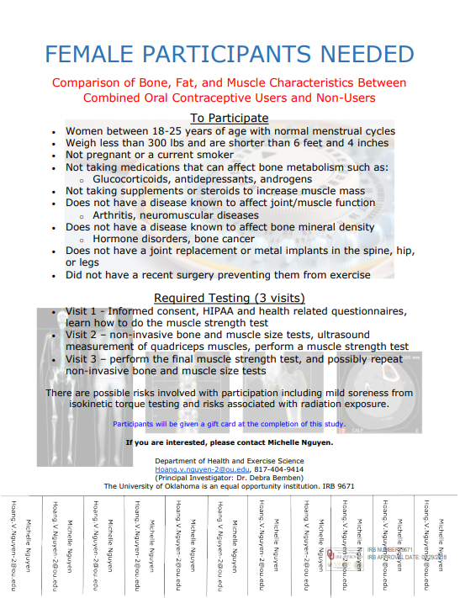

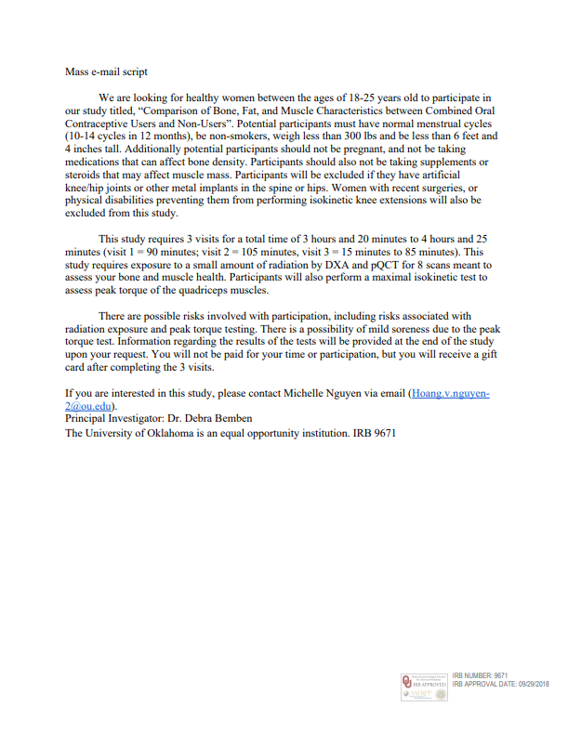

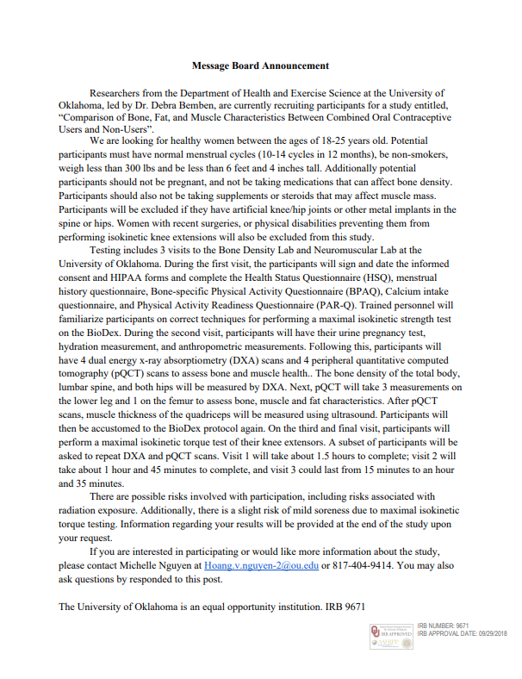



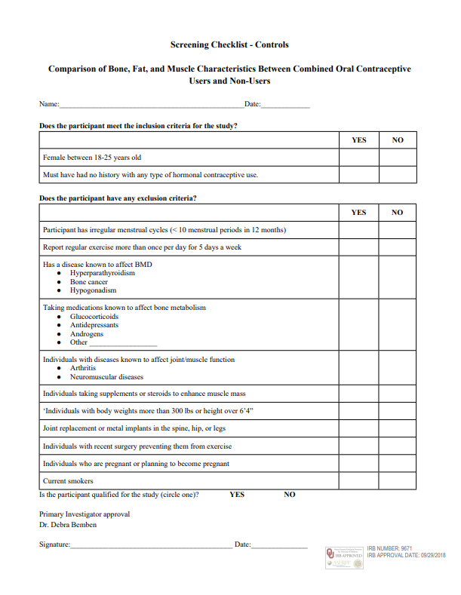

Appendix B
Informed Consent Form
HIPPA Form

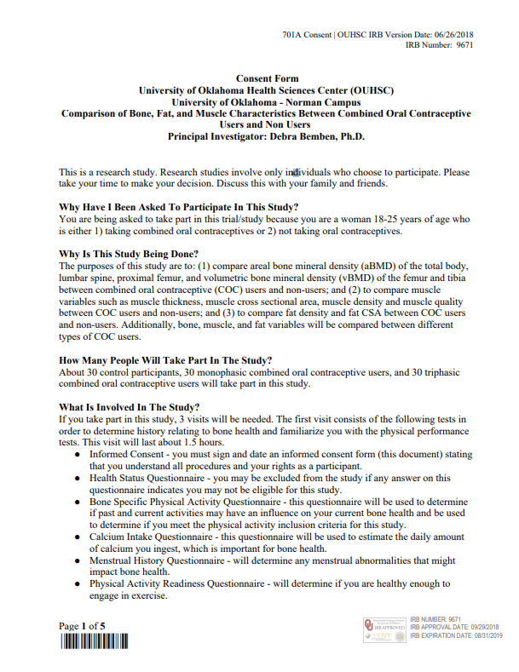

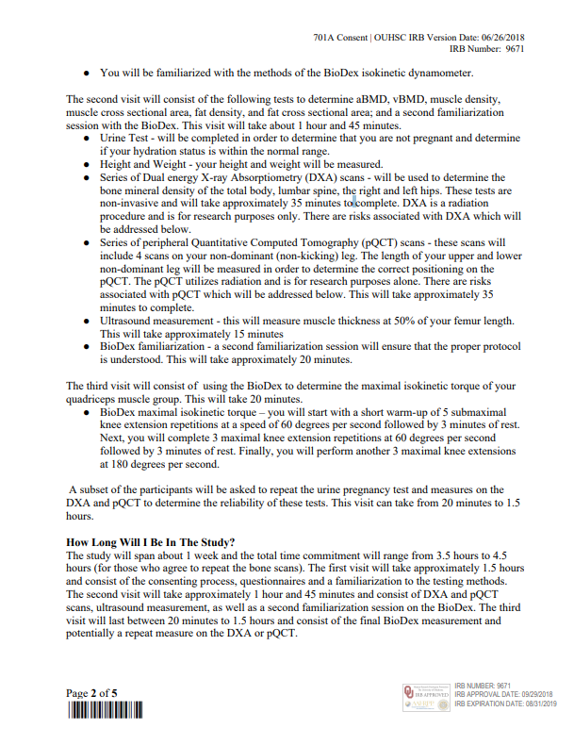





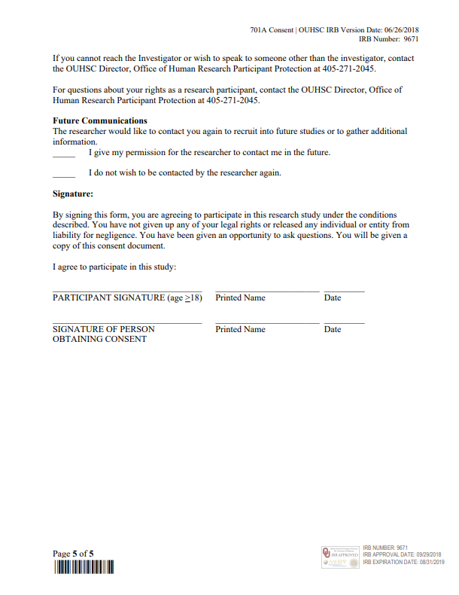

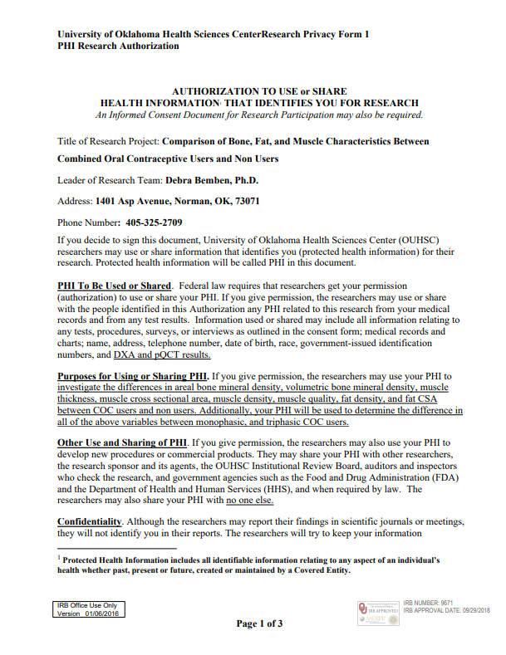

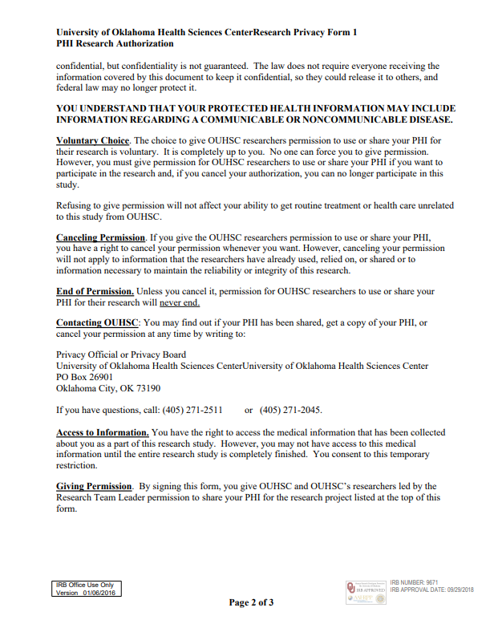



Appendix C
Health Status Questionnaire
PAR-Q & YOU
Calcium Intake
Bone Specific Physical Activity Questionnaire
Menstrual History Questionnaire



