University of Oklahoma

Graduate College

Artist power: DONALD JUDD’s MUSEUM AND FOUNDATION

A thesis

submitted to the Graduate Faculty

in partial fulfillment of the requirements for the

Degree of

Master of Arts in Art History

By

MONIQUE MOGILKA
Norman, Oklahoma
2018

Artist power: donald judd’s museum and foundation

A thesis approved for the
School of Visual Arts

By

______________________________
Dr. Robert Bailey, Chair

______________________________
Dr. William Jackson Rushing III

______________________________
Dr. Alison Fields

© Copyright by MONIQUE MOGILKA 2018
All Rights Reserved.
Dedicated to Mom and Dad, and Oma and Opa.

Acknowledgements

First and foremost, I would like to acknowledge my mentor and committee chair, Robert Bailey. Robert has been a treasured advisor since my undergraduate degree, and he gave me the inspiration to pursue the Chinati Foundation. Not only has he provided guidance in the creation of my thesis and the support of my ideas and research, he has been a valued, supportive friend. Thank you for your support, your friendship, that last minute recommendation letter, and everything that you have done for me.
Jackson Rushing has been a cherished mentor and friend since my undergraduate degree, and pushed me to achieve a graduate degree in art history. His interest in me as a shy student, his unending support, the opportunities he has pushed me to pursue, and his guidance through the college experience are the reasons that I have thoroughly enjoyed the department. Thank you for guiding me through life, for talking about jazz with me, and for pushing me to be successful.
I would like to thank the Graduate Student Senate for a grant to travel to New York City to see the Judd Foundation, without which I would not have been able to go. I would also like to thank the OU School of Visual Arts for a grant to allow me to visit Marfa to see the Chinati and Judd Foundations and take their public tours. Rob Weiner and Caitlin Murray proved vital as contacts when I visited the Foundations. Dr. Fields, additionally, has been supportive of my varied interests and for that I would like to express my thanks.
Lastly, and not in order, I give my thanks and love to Mom, Dad, Oma, Opa, Kelley, Ian, Claire, Ava, Ollie, and Nick. You have kept me financially secure, emotionally well, and unendingly busy throughout the making of this thesis. Kerrie, Mark, Ashley, Alicia, Chelsea: you inspire me to be a better, responsible scholar, and I have thoroughly treasured your input and support. Nick, you have always been my solid “foundation.”

Table of Contents

Acknowledgements iv
List of Figures viii
Abstract x
Introduction 1
Discursive Power: The Chinati Foundation 5
The Chinati Foundation 6
Minimalism 14
The Discourse on Minimalism 15
The Divide Between West Coast and East Coast Minimalists and Its Place in the Discourse 20
The Rhetoric of Power and the Development of Institutional Critique 22
Visual Analysis of Judd, Flavin, and Irwin 29
Flavin vs. Irwin: East Coast and West Coast Minimalism 33
Conclusion 40
Artist Power: A Sociological Approach to the Judd Foundation 42
The Judd Foundation 43
Sociology and Art 44
Sociology, Museology, and Organizational Sociology 45
Methodology 48
Analysis of the Judd Foundation 50
101 Spring Street 51
The Marfa Spaces 54
Daily Life at the Judd Foundation 61
Materials, Personnel, and Conveying Values 62
Building Theories on Artist Foundations 64
The Future of the Judd Foundation and Conclusion 69
Conclusion 70
References 72

List of Figures

Figure 1. 15 untitled works in concrete. 1980-84. Donald Judd. Image courtesy of the Chinati Foundation. 10
Figure 2. Layout of the Chinati Foundation Campus. Image courtesy of the Chinati Foundation. 10
Figure 3. 100 untitled works in aluminum. 1982-86. Donald Judd. Image courtesy of the Chinati Foundation. 30
Figure 4. 100 untitled works in aluminum seen from the outside. Image courtesy of the Chinati Foundation. 31
Figure 5. Untitled (Marfa Project). 1996. Dan Flavin. 35
Figure 6. Untitled (Marfa Project). Image courtesy of the Chinati Foundation. 35
Figure 7. untitled (dawn to dusk). 2016. Robert Irwin. Image courtesy of the Chinati Foundation. 37
Figure 8. Inside of Irwin’s work. Image courtesy of the Chinati Foundation. 38
Figure 9. 101 Spring Street. Image courtesy of the Judd Foundation. 52
Figure 10. Inside of 101 Spring Street, 1st floor. Image courtesy of the Judd Foundation. 52
Figure 11. The library inside the Block. Image courtesy of the Judd Foundation. 56
Figure 12. The courtyard at the Block. Image courtesy of the Judd Foundation. 56
Figure 13. Front entrance to the architecture studio. Image courtesy of the Judd Foundation. 57
Figure 14. Gate House leading into the courtyard of the Cobb House. Image courtesy of the Judd Foundation. 58
Figure 15. Cobb House interior. Image courtesy of the Judd Foundation. 58
Figure 16. Interior of the Whyte Building. Image courtesy of the Judd Foundation. 59
Figure 17. Interior of the art studio. Image courtesy of the Judd Foundation. 60

Abstract

This thesis examines the Chinati and Judd Foundations, established by Minimal artist Donald Judd, to demonstrate how artists can use organizations to wield power and influence in the art world. The Chinati Foundation, a museum, calls for art historical and museological methods to understand its role in the art world, while the Judd Foundation, a nonprofit organization, calls for a multidisciplinary approach where I utilize organizational sociology and participant observation. I argue that the Chinati Foundation uses discursive power in the conceptual break between East Coast and West Coast Minimalism, while the Judd Foundation, a reinstitutionalized museum, exercises power in preserving Judd’s artistic and historical legacy. This thesis builds theories on the form of the artist foundation and how it is becoming institutionalized, a previously understudied phenomenon. Further, it establishes the need for a multidisciplinary approach to understand new organizational forms and demonstrates two types of organizations that artists can create to wield power in an increasingly bureaucratized world.

Introduction

After a long, monotonous drive through the backroads and highways of Texas, you finally arrive to the small town of Marfa. The Chihuahuan Desert and the expanse of the sky surrounds you, with the occasional yucca or desert plant jutting up from the otherwise flat landscape. Mountains and large hills dot the horizon. Coming from the East, you turn left at the only stoplight in town onto US-67. Suddenly, a series of large, varying concrete structures appear before you, blending with the desert yet giving it a more unnatural appearance. The structures are undoubtedly human, but they are simultaneously perfectly made. Flash to New York City, where you board the crowded subway and exit onto Prince Street in Soho in Lower Manhattan. A short walk through the gloriously tall designer stores, boutiques, and fancy art galleries takes you to the corner of Mercer and Spring Street, where an older styled, yet pristine cast-iron building stands. A small, unassuming label on the windows of the doors designates the building: “Judd/101 Spring Street/juddfoundation.org/Guided visits by appointment Tuesday-Saturday.” A peek into the ground-floor windows shows a mostly empty space, with a large desk in the center.
15 untitled works in concrete (1980-84) and 101 Spring Street’s house and studio, two projects in vastly different contexts by Minimal artist Donald Judd, illustrate how the artist made space in the past and continues to make space today. The Chinati Foundation, established in 1986 by Judd, and the Judd Foundation, established in 1994 after his death, present two organizations founded by one artist prepared to exercise power in the art world. The Chinati Foundation, a museum of Judd and friends’ art, exists exclusively in the isolated, desert town of Marfa, while the Judd Foundation, a nonprofit organization, manages Judd’s living/working spaces split between New York City and Marfa. Judd, canonized in art history for his stacked boxes, practiced as a visual artist, curator, architect, art critic, philosopher, and activist. By co-opting these roles in the art world and establishing these organizations, he attempted a grab for power. He continually expressed his frustration with museums, and the Chinati Foundation presented a means for Judd to create his utopian institution that championed the permanency of artworks linked to the Texas landscape. Where Chinati championed multiple artists that he admired, he created the Judd Foundation to defend solely his ideas, preserve his art, and promote his vision in society after his death.
While other artist foundations exist, most if not all of these foundations do not tightly control their offices and mission like the Judd Foundation. Judd’s power play involved a large amount of control in how the Chinati and Judd Foundations preserve, display, and promote his legacy (i.e. you cannot take pictures of the space, objects cannot be moved). I am predominantly concerned with how artists wield power, and how artists use organizational power in the art world. Power, as understood here, means the ability for artists to complete actions without pushback from institutions or other individuals and to garner positive attention. The unique power and control that he exerted over these Foundations proved most insightful for understanding these concepts. I argue that the Chinati Foundation exercises discursive power as a museum, while the Judd Foundation exercises power to prioritize Donald Judd’s legacy in society. Both organizations demonstrate two ways in which artists can wield organizational power. These types of foundations emerged in the 20th century and may be a result of our increasingly organized and bureaucratized world. Simultaneously, artists in the United States must face the ubiquitous role of capitalism and corporations, and organizing their own foundations allows them the resources and power to do so.
I use two different methodologies to approach the two different organizations. I use art historical and museological methods to analyze the Chinati Foundation’s role as a museum, while I use organizational sociology as a framework for understanding the Judd Foundation as a nonprofit organization. This involves an exploration of the discourse on Minimalism, as Judd and his Chinati artists are inextricably tied to Minimalism, while on the other hand I use participant observation, a type of fieldwork, to describe and analyze the Judd Foundation. I split these methodologies for covering the Foundations because artist foundations do not claim to be museums, patrons, or artists, and are therefore not the focus of art historians’ study. Sociology, then, provides the tools for understanding artist foundations in a multidisciplinary way. Pitting these foundations against each other additionally illustrates both the similarities and differences between artist foundations and museums, and why Judd created two organizations.
In the first chapter, I begin with an examination of Donald Judd and the Chinati Foundation’s mission, collecting practices, and programming. I then explore the discourse on West Coast and East Coast Minimalism and institutional critique for understanding where the Chinati can exercise power in the discourse. Through visual analysis of the works of Judd, Dan Flavin, and Robert Irwin at Chinati, I argue that Chinati wields power by displaying certain artists of different Minimalisms together and producing scholarship for these artists, which gives these artists critical attention and resources. The second chapter introduces the Judd Foundation, explores the relationship between organizational sociology and art, provides my experience as a participant observer on the Judd Foundation tours, and explores how we might begin to conceptualize artist foundations as institutions. I conclude that the Judd Foundation uses power to promote Judd’s legacy in society through preservation and promotion. I will build general theories on artist foundations as a whole, an understudied phenomenon, and will illustrate two ways artists can use organizational power in their favor to shape the distribution of their vision, art, and legacy.

Discursive Power: The Chinati Foundation

I argue that the Chinati Foundation, an institution founded by Donald Judd, plays an active role in influencing the discourse on Minimalism. While the discourse treats the Chinati Foundation as an art project (which it was and is) I intend to treat Chinati as an active institution that promotes certain ideals as a leading proponent of the artists of Judd’s liking. My argument is not unlike Anna Chave’s discussion of the Dia Foundation, whose collecting practices influence the discourse on the divide between West Coast and East Coast artists. It is no coincidence that the first image in James Meyer’s book Minimalism is that of Judd’s concrete works at Chinati; the audience receives Chinati as an art mecca – a totally unique institution that reflects the best art of the 20th century and reflects the concerns of arguably the most famous artist of Minimalism. Chinati additionally uses its resources to construct programs that award resources to artists-in-residence and symposia. The chosen directions of the symposia, the publications from these symposia it produces, and the choices of artists-in-residence demonstrates an influence on our understanding of Minimalism and Judd. By examining the Chinati Foundation, the discourse of Minimalism and institutional critique, and by visually analyzing Dan Flavin’s and Robert Irwin’s more recent installations at Chinati, I will demonstrate how Chinati exercises discursive power in the divide between West Coast and East Coast Minimalism. Judd, through Chinati, exercises this discursive power to illustrate that he defies the categories art historians put upon him and the artists of his choosing. He instead insists that these artists need to be understood at once individually and collectively for their emphasis on space, total experience, and location. This museum is one of the ways in which artists can use organizational power to influence the art world.

The Chinati Foundation

Donald Judd (1928-1994), born in Missouri, spent his life defending his ideas and his work. He graduated with a Bachelor of Science in Philosophy in 1953 from Columbia University and later returned to Columbia to graduate with a Master’s Degree in Art History in 1960. These areas of study prepared him for his blooming career as a blunt art critic, where he wrote exhibition reviews for Art News and later for Arts. While he dabbled in abstract painting in the 1950s, he showed his first three-dimensional work at a faculty show for the Brooklyn Institute of Art and Science in 1962 and secured his first solo show at the Green Gallery in 1963. From there, he continued to develop his mature style of three-dimensional box-like objects created with specific measurements and industrial materials. Art historians and critics have canonized his “stacked” boxes within the overarching art movement Minimalism despite his rejection of the term. However, starting in the 1970s, he began to devote increasingly more time away from New York in order to build the Chinati and Judd Foundations until his premature death to lymphoma in 1994. Judd first experienced the West Texas desert when he travelled through it as part of the U.S. army in route to Korea in 1946; this first encounter with the desert entranced him and provided the basis for his return to establish Chinati.
The Chinati Foundation’s mission specifically follows Judd’s vision of departing from the established institution of the museum. Chinati, created in Marfa, Texas in 1979, allowed him to escape to the southwestern landscape, which he sought for its remoteness, unique desert characteristics, and the nearby mountain range. At the time, Marfa was relatively unknown and suffering economically, making its buildings easily available for purchase. Far from the New York art world, the remote location allowed him to seek permanent places for his own art as well as permanent locations for the “selected artists whom he admired” which included works by John Chamberlain and Dan Flavin, longtime friends of Judd’s. As an art critic, Judd actively criticized the institution of the museum and its means of displaying artwork. He decried the ways in which museums removed artworks from their original contexts, often citing Renaissance artists that created artworks intended for specific churches with unique lighting conditions. He also disliked the phenomenon of “blockbuster” exhibitions occurring in the 1970s, which crowded museums and disrupted the serious contemplation of art. Additionally, his hostility towards institutional actors grew as he noted damage to his artwork due to improper handling. Essentially, Judd demonstrated concern over how much power an artist really has in the face of the museum and curators, who had a certain amount of control over the meaning and significance of an artist’s work.
Further, Judd demonstrated concerns over the removal of art from daily life. Unlike Renaissance paintings that were placed permanently in churches, museums take contemporary art and place it in a white cube. In place of the white cube, a separate institution from the daily life of the public, he sought “collaboration among all cultural spheres to form the foundation of a society in which all the arts are more than merely decorative, dispensable accessories.” This is precisely the vacuum in which he hoped to fill with the Chinati Foundation. Ironically dubbed a museum by the public and its website, the Chinati Foundation’s mission is: “to preserve and present to the public permanent large-scale installations by a limited number of artists,” with an emphasis “on works in which art and the surrounding landscape are inextricably linked.” Revitalizing the town of Marfa and creating a permanent museum connected to the Marfa landscape, he attempted to bring the art world to the daily life of Marfa’s residents by inviting them to regular free programming or communally involved art events. On the other hand, he valued a serious contemplation of art even if it occurred in daily life. Unlike the easy access of public museums, his remote location as a pilgrimage site for foreigners “guaranteed at least commitment on the visitor’s part.” The connection to daily life and the artworks’ unification with architecture challenged the unnecessarily decorative architecture of modern museums, which “threatened to overwhelm the art on view.”
The drive to Marfa introduces and prepares visitors for the unique Chihuahuan desert landscape of Southwest Texas, which features nearby mountain ranges, sparse shrubbery, and an open sky. Since Judd disliked the grandiose architecture of museums, the Chinati Foundation still resembles the military barracks it inhabits – thus, the only sign that one is approaching a space dedicated to art are his large concrete works (Figure 1). When first entering the campus, visitors are met at the front desk and gift shop, where staff members give directions and visitors purchase special guided visits of the whole collection. Visitors then begin to peruse the nearby artillery shed with Judd’s aluminum works, while his concrete works appear in the distance. The front desk offers informational guides, but Judd’s artworks lack titles, wayfinding posts, or labels readily available to the visitor in order to encourage a direct visual experience. Museum guards provide security for the aluminum works and are also available to provide information to the visitor. Visitors must hike a short distance to view the works up close, forcing them to enter the natural landscape to experience the monumental concrete blocks.
When visiting the Chinati Foundation campus, visitors can inspect the various buildings at their own pace and without security or wayfinding signs. The absence of signs and people creates a “stillness;” visitors must discover which ruined military buildings contain art by peeking into building windows and trying doorknobs. Interestingly, the Chinati Foundation attracts both visitors serious about art and ex-soldiers who once served at the fort. One ex-soldier, without the supervision of security, moved one of Roni Horn’s copper cones with his foot, costing the Chinati Foundation $40,000 to restore the damaged art. Once Fort D.A. Russell, the ruins of a military camp that housed German prisoners of war during World War II, Chinati provides an eerie atmosphere. Visitors occasionally come upon traces of the military fort, as Judd “insisted that the minatory notices… should be left where they were.” One of the notices, in German, roughly translates to: “It is better to use one’s head than to lose it.” Judd certainly created a unique context for his permanent art, but the fort’s ruins influence the reception of his art arguably as much as the unique southwestern landscape does.
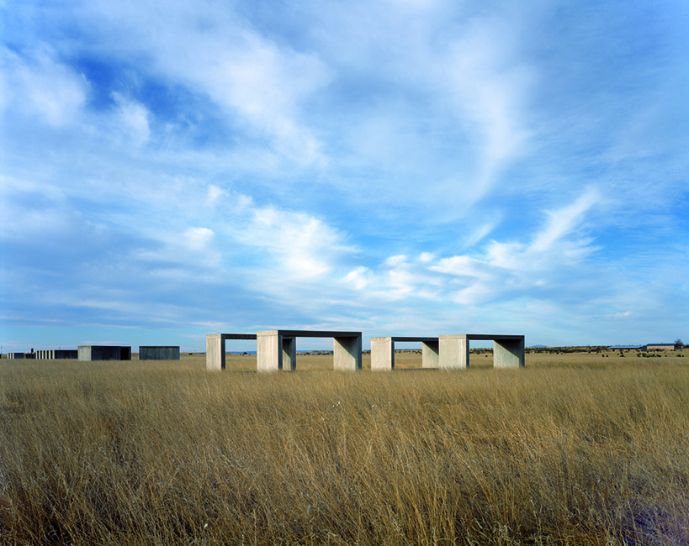
Figure 1. 15 untitled works in concrete. 1980-84. Donald Judd. Image courtesy of the Chinati Foundation.

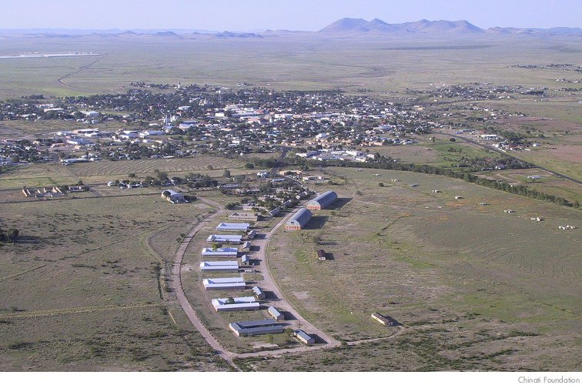
Figure 2. Layout of the Chinati Foundation Campus. Image courtesy of the Chinati Foundation.
Chinati features a large range of work in the Minimal tradition and beyond in an attempt to preserve Judd’s generation’s many different forms. Among the permanent collection, canonized Minimal artists like Carl Andre and Dan Flavin both appear, but other seemingly nonconventional artists like Roni Horn, Claes Oldenburg, John Wesley, and Ilya Kabakov exist in the collection as well. Horn’s Things that Happen Again: For a Here and There (1986-1991) uses a softer copper form than that of Judd’s aluminum or concrete works, but it conforms to Judd’s preoccupation with the changing reality of perception, as the viewer must traverse the space to understand the cone forms in the small building. Claes Oldenburg, known for his soft sculptures of food or other objects, along with Coosje van Bruggen, created Monument to the Last Horse (1991), a literal horseshoe form that acts as a monument to the last cavalry horse that died nearby. The John Wesley gallery seems most at odds with Judd’s goals, since it does not place emphasis on objecthood but on painting, yet Judd admired Wesley’s two-dimensionality. The most recent work, Robert Irwin’s untitled (dawn to dusk) (2016), demonstrates Judd’s interest in the phenomenon of experience, but also bridges the gap between West Coast and East Coast Minimalism. Judd disliked the term “minimal” in defense of the individualism of his own work and invested in the individualized forms of his contemporaries as well. In sum, Judd befriended numerous artists of his generation that he admired, as he was aware of the diverse forms of his era.The relatively recent inclusion of these very forms in the discourse suggests a greater understanding of how we conceptualize the movement and the art of that era.
Chinati additionally features work from international artists Richard Long, Ingolfur Ararrson, and Ilya Kabakov. All of these installations at Chinati suggest a connection between the West Texas desert and a foreign landscape. Richard Long’s Sea Lava Circles (1988) outside of the Arena building uses volcanic rock from Iceland to create three concentric circles, forming a whole from its parts. Judd "embedded this natural, irregular order in his own order" by placing this installation along an imaginary line on a concrete platform at Chinati. Ingolfur Arnarrson, once artist-in-residence, created two paintings and 36 drawings for installation at Chinati called Untitled Works (1991-1992). Arnarrson’s work references the Icelandic landscape while his drawings demonstrate lucid thought into actual form. Lastly, Russian artist Ilya Kabakov’s total installation School No. 6 (1993) features green on the walls that recalls Russian fields, but Marianne Stockebrand compares the blue line above the green to Marfa’s endless horizon. These installations demonstrate that while their forms may differ, the contexts of their creation remain integral to the work like other works at Chinati. The collection reflects Judd’s personal taste in literalness, unity, and the phenomenon of experience, but the collection also reflects a larger concern: the permanent context of Judd’s constructed architecture and the West Texas landscape.
The Chinati Foundation, while unique, would not have been possible without the Dia Art Foundation. Created in 1974 by the couple Philippa de Menil and Heiner Friedrich, the Dia Foundation relied on funding from Schlumberger, the Menil’s Houston-based oil drilling manufacturing corporation. Further, Friedrich “explicitly represented Dia’s founding as a due response to a cultural moment of Renaissance-like dimensions.” Their patronage fostered an interest in Minimalism and avant-garde artists. The Dia Art Foundation gave Judd the funds to purchase Fort D.A. Russell to become the Chinati Foundation and allowed him to carry out his artistic ideas. However, Dia funding suffered due to decreases in the Schlumberger stock, and Judd threatened to sue due to Dia’s agreement to guarantee the permanency of Judd’s artworks, which resulted in the creation of the Chinati Foundation under Judd’s direction. Though not beholden to corporate interests like museums, the Chinati Foundation relied on corporate funding to begin its life as an institution and a museum.
Chinati also features temporary exhibitions that exhibit work related to Judd’s interests or related to Chinati’s permanent collection. One such example is the exhibition of John Chamberlain’s foam sculptures in 2005 and its accompanying catalogue. One of the only publications by the Chinati Foundation, John Chamberlain: The Foam Sculptures consists of Marianne Stockebrand’s attempt to reinstate these works in Chamberlain’s history. The function of this scholarship is to “restor[e] these works to Chamberlain’s oeuvre and make amply apparent the simplicity and directness of their making, as well as their revel in sensuality.” By fleshing out Chamberlain’s larger body of work, Stockebrand contributes to our understanding of him as an artist through the lens of discourse. Stockebrand notes that this scholarship will make apparent that the sculptures “deserve to take their place amongst the works of the so-called “Process” artists who came to the fore in the late 1960s (Eva Hesse, Barry Le Va, Bruce Nauman) and, like Chamberlain, performed everyday physical operations (throwing, folding, smashing) upon pliable, often non-art materials such as felt, molten lead, chicken wire, etc.” Curators who managed exhibitions on Process artists largely excluded Chamberlain, while other Process artists largely ignored him. This may be due in part to Chamberlain’s more famous metal sculptures and the fragile nature of the foam materials. Stockebrand encourages a larger reading of Minimalism and modern sculpture by suggesting the coalescence of Process artists of the 20th century, while placing Chamberlain in that history. In doing so, it recovers the existence of softer forms and allusive content (Stockebrand contends that Chamberlain “labialized” the foam) occurring alongside hard-edge Minimal forms. In terms of quantifiable influence on the art world, Stockebrand quite literally states that “since the exhibition closed, the foam pieces have carved a market niche for themselves.” The exhibition at Chinati of the foam sculptures literally infuses the work with economic value and justifies the importance of art historians studying it. Future exhibitions at Chinati that focus on other topics will again influence the market and the discourse on Minimal artists. The symposia publications instead insist on a fleshing out of Judd’s ideas, with publications titled Art and the Landscape (1995), Art and Architecture (1998), Light in Architecture and Art: The Work of Dan Flavin (2001), It’s All in the Fit: The Work of John Chamberlain (2006), and The Writings of Donald Judd (2008). By establishing Chinati, Judd carved out a perpetually influencing space for his ideals as an artist, something that will continue long after his death.

Minimalism

The discourse on Minimalism is a significant body of literature fraught with contradictions, arguments, and claims. As a movement, Minimal artists employed diverse forms, but with a particular consideration of the viewer’s encounter with the object through space. Because of the diversity of form within the Minimal style and its avant-garde nature, critics have had to develop new terms to describe the art that they began to see. In this literature, critics have tended to separate West Coast and East Coast artists in the Minimal moment, though these artists were, at times, exhibited alongside each other. Most recently, criticism on Minimalism has focused on its connections or lack thereof to the sociopolitical climate of the 1960s and onwards, as well as its masculine and aggressive forms. Minimalism’s concern with space influenced artists who practiced in the mode of institutional critique, as these artists recognized that the organization of space in a museum reflects how viewers interpret the art inside them. Institutions and museums also played a role in influencing the discourse on Minimalism, as the Dia Foundation’s patronage assured a critical reception of West Coast artists. I argue that the Chinati Foundation as an institution plays an active role in influencing the discourse on Minimalism by producing scholarship and selecting artists and artworks to display.

The Discourse on Minimalism

The literature of the movement consists of contested spaces. However, a few aspects of Minimalism are commonly accepted. Modern artists’ tendency to create new and innovative art continues into the beginnings of Minimalism. Thus, Minimal artists or artists working in the Minimal style have a “complete awareness of the development of Western art by artists.” James Meyer, author of a definitive sourcebook of Minimalism, describes Minimalism:
Primarily sculpture, Minimal art tends to consist of single or repeated geometric forms. Industrially produced or built by skilled workers following the artist's instructions, it removes any trace of emotion of intuitive decision-making, in stark contrast to the Abstract Expressionist painting and sculpture that preceded it during the 1940's and 1950s. Minimal work does not allude to anything beyond its literal presence, or its existence in the physical world. Materials appear as materials; color (if used at all) is non-referential. Often placed in walls, in corners, or directly on the floor, it is an installational art that reveals the gallery as an actual place, rendering the viewer conscious of moving through this space.
As museums and galleries began to display this type of art, critics and theorists began attempting to describe the strange, minimal art that they encountered. Meyer notes the many terms that critics used to describe Minimalism, or as Meyer calls it, “different, overlapping Minimalisms.” The term “minimal” first appeared in Richard Wollheim’s 1965 essay “Minimal Art,” which provided an attempt at understanding how these art forms explored the minimum aspects necessary to be considered art. Other critics used different terms like “literal” art or “ABC” art to describe these art forms. However, in 1966, in the catalogue for Primary Structures: Younger American and British Sculptors, Judd declares that Minimalism and categorical labelling is reductive, and that each artist deserves to be better understood individually.
The Minimal style retained some characteristics of geometric abstraction in painting, while championing viewer experience. Lawrence Alloway’s writing on systematic painting provides a primer for Minimalism by describing the ways in which painters began to paint in geometric abstraction. These painters used preconceived notions of scale and geometry, featuring serial or repetitive forms to execute a work, unlike expressionists who allowed their artistic expression to guide their compositions. In addition to seriality, a “desubjectivizing technique” that simultaneously reflected reproduction technologies, Minimal artists employed unification within their work. Unlike compositions that consider the whole of the work subject to parts, seriality and repetitive forms make the parts subject to a whole, something that Judd specifically championed. Also endemic to Minimalism, art in the Minimal style were attempts to go beyond European artistic traditions, and thus the movement became representative of an Americanized artform. This Americanized, modern sculpture differed from British modern sculpture in its “dramatically environmental quality.” Most importantly, these artists were considering space “in an effort to relate the observer to the thing observed… in the magic of the phenomenon of experiencing itself.” The importance of the relationship between the viewer and the work ties many of the Minimal artists together, though some might stress different parts of this relationship (i.e. the object, the concept, the viewer). For Judd, it is the object that is most important in this relationship.
Though Minimalism is undoubtedly indebted to the trajectory of Western art history, critics disagree about the extent of its influence. Michael Fried, who criticized Minimalism for its theatricality, argues that Minimalism grew logically from Abstract Expressionism; the "painting's pursuit of flatness has resulted in an unforeseen conclusion: the Specific Object." Fried explicitly references and criticizes Judd’s essay “Specific Objects” (1965), where Judd asserts that an object be only “interesting” to warrant serious consideration. Where the painted canvas contained its unique quality of flatness, sculptors began to seek the unique qualities of the medium of sculpture, which in turn led artists to seek the literalness of objects and their spaces. Unlike the Abstract Expressionists, however, Minimal artists tended to avoid emotional and gestural qualities. Clement Greenberg, champion of Abstract Expressionism, saw Minimalism as "novelty art, a Dadaist activity" meant to shock. By claiming certain objects as art that seemingly lacked artistic qualities, Minimal artists recalled Marcel Duchamp’s readymade object. In between these claims, Samuel Wagstaff, curator of the 1964 Black, White, and Gray show, locates Minimalism "on the cusp between Modernism and Dada, deriving from both the formal and conceptual traditions of 20th century art."
Despite disputes between critics about Minimalism and its merits, Minimal artists become canonized by being featured in one-person shows and retrospectives that solidify their placement within the canon. As the avant-garde Minimal form becomes assimilated, the period of “High Minimalism” ends in the 1960s, while other forms, namely that of earthworks and Conceptual art, begin to take shape. Artists during the period of Minimalism renegotiate their artworks in relation to these new movements; Robert Morris pursued a “sculpture of pure matter” where Sol Lewitt drifts towards a “dematerialization of the object.” Meyer identifies the Neo-Geo and Cute Commodity artists as a contemporary reading of Minimalism, Jeff Koons among them, that "infused the vocabularies of Minimalism with "low" cultural associations.” Koons specifically does this by using industrial mediums and a minimal style to depict whimsical objects like balloon animals. Additionally, Roni Horn’s contemporary work features references to politically charged historical events. Her Gold Mats, Paired (1995) references the death of Felix Gonzalez-Torres and his lover due to HIV/AIDS, and its “allusion to supine bodies contests Minimalism’s aversion to resemblance.”
Though the discourse focuses on the literalist views that artists like Judd promulgated, 1960s exhibitions featured work by other artists like Anne Truitt and Agnes Martin. These artists used hand-painted forms and included allusive content, aspects that the canon artists Judd and Carl Andre avoided. Meyer claims Truitt and Martin as Minimal artists of the era and includes Eva Hesse as part of the Minimal tradition. Unlike the hard-edged and industrial forms commonly seen in Minimal forms, the "contentless Minimal object is softened and suffused with bodily metaphor" in Hesse’s objects. Meyer even goes as far as to illustrate Robert Morris’ departures from the core beliefs of Minimalism, where his objects derive from performance and “began as a pretext for a bodily encounter” or functioned as “stage props.” In Morris’ work, the objects are less important to the work and instead facilitate a performative encounter. This is totally unlike Judd, who insisted on a work’s objecthood. Although Meyer does not include a multitude of California space and light artists, he does briefly discuss a few of them, namely Larry Bell and John McCracken. This suggests a trend in the discourse towards breaking down the divide between West Coast and East Coast artists. Judd’s acceptance of Robert Irwin, a West Coast artist, further bridges this divide at Chinati.

The Divide Between West Coast and East Coast Minimalists and Its Place in the Discourse

Art historians Rosalind Krauss, Anna Chave, and James Meyer have noted the apparent divide in the scholarship between West Coast and East Coast artists within Minimalism. East Coast artists from New York have dominated the discourse on Minimalism (apparent in Gregory Battcock’s anthology on Minimal art) even though West Coast artists like McCracken and Bell both appeared alongside their East Coast contemporaries in the seminal Primary Structures exhibition. Battcock’s anthology does, however, include Willoughby Sharp’s essay on the Luminic movement in California where he notes that Luminic works “create time” and “create space.” Art historians have recovered these West Coast artists, but distinguish them from East Coast Minimalism. The divide distinguishes “Finish Fetish work from New York Minimalism, opposing the pastel hues and illusionism of the work of Bell and McCracken – organically linked to the light and expansive space of Southern California – to the sober palette and plain materiality of Morris and Andre.” Meyer’s Minimalism notes Los Angeles alongside New York as places important to the development of Minimalism, but he omits both James Turrell and Robert Irwin in his authoritative survey. Anna Chave also posits that the divide between East and West Coast Minimal artists disregards a consideration of the role of spiritual approaches where previously they are characterized as materialist and secular.
Further, Chave recognizes the importance of patronage in the canonization of West Coast artists. In this, the Dia Foundation plays an extremely significant role. Count Giuseppe Panza, a patron in Italy, collected Minimal art and he “monopoliz[ed] the market for Minimalism over the course of a decade when prices were low and competition from fellow collectors scant.” Heiner Friedrich and Philippa de Menil followed Count Panza’s patronage by founding the Dia Art Foundation to support art projects financially that could not be completed otherwise. Friedrich compared the art climate to that of the Renaissance with the de Menil family as its Medici family. Chave recovers the relatively unknown religious aspect of the Dia Foundation, as they supported spaces and installations that can be read as spiritualized, such as the Rothko Chapel. Among those artists were Dan Flavin, Walter de Maria, Mark Rothko, and Donald Judd. The Dia Foundation funded Walter de Maria’s Lightning Field and the original project of the Chinati Foundation, and in doing so, their distant and unique locations created a kind of spiritual aura around them. The Dia Foundation additionally supported land artists such as James Turrell and his Roden Crater, which allowed for a “committed viewing public with possibilities for paying close attention” by forcing visitors to go on a pilgrimage to the site. Through this committed viewing, artists Turrell and Irwin explored Eastern religious practices and meditation, with a focus on “blank consciousness” and “meaningless tranquility.” Chave asserts, overall, that Dia’s patronage “ensured, against prevailing critical bias, the institutional assimilation of some of the California Minimalists.” Like Chinati’s important role in a museal canonization of Judd’s Minimalism, Dia’s role culminates in its museum Dia: Beacon which serves as a “Vatican for Minimalist Art.” Dia: Beacon occupies an old Nabisco box printing factory in Beacon, New York, and dedicates each gallery to a specific installment and design of one artist’s work. Arguably, since Judd took over the Chinati Foundation, Dia: Beacon is Dia’s recovery of their own museum with similar ideas.

The Rhetoric of Power and the Development of Institutional Critique

Minimalism received backlash in the late 1980s from feminists for its supposed elitist and masculine forms. Although Judd’s used industrial materials because he thought they are objects void of allusion, audiences still perceived Judd’s and other’s art as a reflection of mechanical reproduction and corporate elites. Seen as void of emotion with its smooth forms and lack of the artist’s hand, average museum goers like families and those without extensive education in the arts are denied access to this type of art. Judy Chicago’s autobiography and her detailed description of her forays into Minimalism pinpoints its style as entirely masculine with its hard-edged forms. Anna Chave’s “Minimalism and the Rhetoric of Power” (1990) further accentuates an influential critique on Minimal style. Chave, acknowledging that artist intentions may differ from the reception of the work, pointedly states that the smooth industrial forms in Minimal art presents “the impersonal face of technology, industry, and commerce; the unyielding face of the father.” Chave particularly critiques Richard Serra and the disruption to daily life which his public work Tilted Arc caused. The relationship between the viewer and the work of art was not a beneficial one; according to Chave, the “relation between work and spectator in Serra’s art is that between bully and victim.” Serra’s gigantic, industrial art causes fear and discomfort as viewers approach its intimidating form, often placed in a seemingly precarious manner to stress this discomfort. Chave proposes, in conclusion, that Minimalism’s failure to allude to anything other than itself only heightens the status quo of that of corporate and industrial elitism, or of those in power. This critique seems to still hold some truth for Judd, as Chinati’s military history influences its reception as an industrial military barracks. The military fort conjures up images of war, which might be reinforced in the industrial and serial aspects of Judd’s artworks, like lined up soldiers or the mass manufacturing of weapons.
Chave’s essay deserves special consideration in relation to Chinati because it focuses on artist and institutional power, and she writes this essay at the same time institutional critique develops. Artists were engaging in a play for power through institutional critique; they were unhappy with the centers of power such as the art market and museums, and they intended to shift this power back to the artists. This occurs simultaneously with Minimal art’s demands on space, as these forms began to be “too large to fit in existing museums.” Though this occurs a generation after Judd, his ideals reflect considerations of artists practicing within the mode of institutional critique. Judd increasingly called for “fewer and smaller exhibitions,” or, in other words, he wanted more space for fewer works, and to allow for more time for visitors to contemplate them. He disliked the gallery system of subjecting an artwork to context of a gallery, which stripped it of its original context. Further, a short exhibition with numerous works could not possibly allow the serious consideration of each individual work in such a short period. He also contended with museums over their display of art, arguing that "museums of contemporary art are there for the present." While this statement seems redundant, he was suggesting that contemporary museums serve the art of the present, meaning, contemporary museums should show current art within its contemporaneous context rather than subjugating it to the standard white cube. Additionally, Judd did not want a “museum of art history;” he wanted to “preserve the creativity of his generation in the specific form of its thinking and feeling.” Instead of presenting art as an anthology or survey of a movement, which reflects art historical discourse, Judd wanted to preserve permanently a numerous quantity of the work he deemed admirable regardless of the discourse’s divide between West Coast and East Coast artists. He did just that with a careful consideration of each of the artwork’s demands on space and architecture.
While Judd traveled to Marfa to create his own utopian institution to fit his needs, artists practicing institutional critique attempted to reform the current institutions. Overall, artists practicing institutional critique were committed to its ideals, and therefore they held institutions accountable to these ideals and preserved these institutions instead of getting outside them. Generally, these artists called for inclusion of artists of color and women in museums, and they called for museums to become beholden to artists and the public instead of corporate elites. Critic and artist Andrea Fraser (b. 1965) explores how institutional critique becomes institutionalized as an art form, claiming that art’s institutions are “internalized in… the modes of perception that allow us to produce, write about, and understand art, or simply to recognize art as art.” Artists reproduce art as an institution in itself, and artists’ critiques of the institution are an attempt at holding the models of art display to its highest ideals. Instead of breaking the box, Fraser suggests that institutional critique confronts questions of “what kind of institution we are, what kinds of values we institutionalize, what forms of practice we reward.” An interrogation of art’s institutions reveals how these institutions operate with inherent power relationships between artist, viewer, museum, and patron.
Artists engaged in this mode wrote about their positions, protested large institutions, while other artists created a kind of installation or conceptual art that revealed or critiqued museums’ ideological positions. Hans Haacke, a leading artist of institutional critique, wrote in his seminal essay “Museums, Managers of Consciousness” that “every museum is a political institution.” Artists organized in forms like the Artist Workers’ Coalition to demand that artists be on the boards of art museums, and to demand museums – notably the Museum of Modern Art – to include women artists and people of color in their collections. Artists echoed Judd with their concern for where their work was going, and concern for their compensation. Similar to his positioning, artists became frustrated with their meaning of a work becoming subjugated to the general themes of a curated exhibition. Daniel Buren, another leading artist of institutional critique, wrote in his 1971 essay “The Function of the Studio” that the “relationship to its creator and place of creation… was irretrievably lost in this transfer” between studio and museum or gallery display. Judd engaged precisely with these concerns. Artists could not control where their art ended up, the manner in which it was displayed, or its value in the larger art world. To combat this, Judd established Chinati to provide a specific and permanent context for his and his friends’ works. Other artists, namely Adrian Piper, called for the exchanging of roles between artist, critic, and curator so that artists could “collectively determine” art’s “meaning, value, price, public dissemination, and material fate.” Judd fulfilled every role at Chinati, where he was director, artist, curator, and critic. Additionally, by fulfilling the role as critic, he “prepared” the art world for his art’s “receptive context.” In other words, Judd prepared his audiences to value the kinds of art he championed, playing an active role as artist critic to infuse critical value into his work.
Here, I would like to enforce that while Judd’s ideas paralleled artists later practicing institutional critique, he is not an institutional critique artist. His Chinati Foundation allowed him to create his utopian institution away from society in the Chihuahuan desert of West Texas. Artists practicing institutional critique attempted to the reform the institutions that they were trapped in and to hold those institutions accountable to their ideals. Judd also disproved of some artists’ practices, and in 1970 in Artforum’s “Art and Politics” symposium, he complained that the AWC is “full of lawyers and the politics of interest groups.” His politics focused on local governing bodies, the freedom of the individual artist, and enforcing his belief that land should remain unperturbed.
The institutional critique artists’ and the more recent neo-Minimal artists’ concern with the sociopolitical aspects of the art world parallels the social critiques of Minimalism that began with Chave’s critique and runs into contemporary discourse. Felix Gonzalez-Torres, who Meyer identifies in his survey of Minimalism, succinctly states that “the act of looking at an object, any object, is transfigured by gender, race, socio-economic class and sexual orientation.” Here, critics argue over the amount of which Minimal artists concern themselves with the sociopolitical sphere, or over the extent to which audiences perceive an “aloofness” from the hard, geometric forms so common to Minimal art.
Examples of recent exhibitions that produce scholarship on this discourse are Minimal Politics, an exhibition organized by the Fine Arts Gallery at the University of Maryland in 1997, and When Now is Minimal, an exhibition abroad at the Neues Museum in Nuremburg in 2013. Maurice Berger, in the catalogue for Minimal Politics, describes the relationship between political artists and Minimal art. By redeeming Fried’s base argument of the theatricality of Minimalism, Berger focuses on Morris and the ways Minimal artists “were committed to reshaping the traditional relationship between object and viewer.” Berger recovers some of the aspects of activism in Morris’ works of art, similar to art historians recovering of Judd’s activist ideals at play in Chinati. This ideal of transforming the experience of the work, as I have stated previously, runs parallel to artists’ critiques of the museum model of art display. However, according to Haacke, this is where Minimalism’s influence on politics stops. Haacke, echoing Chave’s assertions on Minimal power, “wanted to work beyond [Minimalism’s] ‘determined aloofness,’ a sensibility that he believed resulted in a cold, geometric formalism that tended to distance the viewer from political issues and concerns.” Letizia Ragaglia, in the catalogue of When Now is Minimal, repeats a similar conclusion when she states that “the Minimalists set out from the assumption that there were interactions between the architectural space, the work of art and the viewer, but regarded these factors as almost isolated from the sociopolitical sphere.” Regardless of what Judd or other Minimal artists intended, or whether they were activists or not, the audience continually read Minimal art as cold and aloof. Though Judd counters this notion with his insistence on thought and emotion as one, the public continues to see a divide between cold, calculating thought and expressive emotions, something that may have been tied to the forms of Abstract Expressionism. Contemporary artists working within the Minimal tradition, Gonzalez-Torres being one of them, are negotiating and renegotiating this territory between alleged cold Minimal form and identity politics.

Visual Analysis of Judd, Flavin, and Irwin

The 100 works of aluminum in the artillery sheds (see Figure 2 and 3) at Marfa provide visual evidence of Judd’s ideas. It is in this gallery that Judd attempted to make space with a unified aesthetic through the use of glass walls and barrel-vaulted buildings. The 100 aluminum works are installed across two buildings that were once gunsheds for military trucks. Removing the doors and replacing them with windows, he then placed three rows of the aluminum boxes (41 x 51 x 72 inches) along the buildings’ tripartite column design. The boxes’ brilliant aluminum shine reflects the Texas sunlight and the surrounding landscape, while the perfectly crafted boxes and their flush edges do not show signs of an artist’s hand. Each box contains a variation of a previous form, with the side planes completely removed, partly removed, or dividers placed in varying positions in the boxes. Judd also uses diagonal planes within the boxes to make space within the boxes visually apparent and mathematically readable. These variations are not totally visible until the viewer approaches them, making each configuration a surprise, and keeping the artwork mentally and visually engaging through the entire bodily experience.
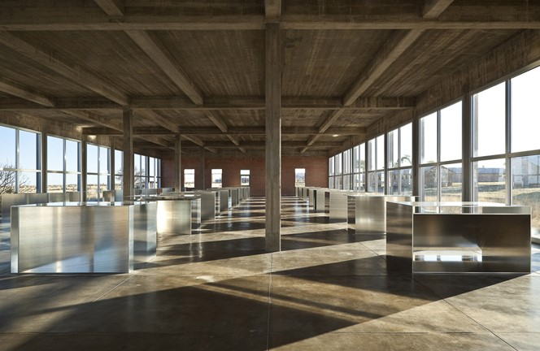
Figure 3. 100 untitled works in aluminum. 1982-86. Donald Judd. Image courtesy of the Chinati Foundation.

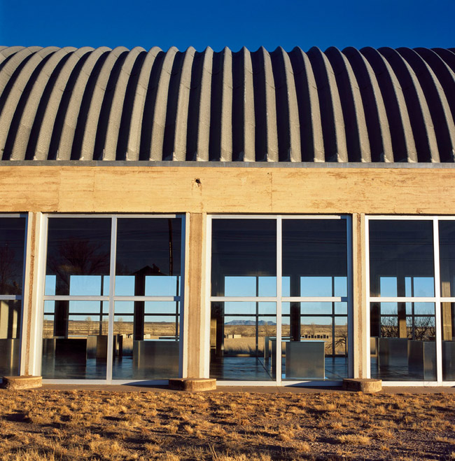
Figure 4. 100 untitled works in aluminum seen from the outside. Image courtesy of the Chinati Foundation.

Unlike Morris, Judd’s repetition of parts into a whole “extends the definite space.” Judd created the works using mathematical configurations he had used in previous ensembles, and employed a distance of four inches between perpendicular and diagonal panels in varying divisions. Strict, mathematical seriality generally deviates from the freer, expressionist tendencies before Judd, and he uses seriality in multiple artworks. Furthermore, repetition provided an order that is formally complex. Yet, paradoxically, portraying repetition in various ways confronts conventional beliefs about the very notion of repetition. The positions of these dividers produce closed, open, or half-open spaces that reflect light in differing ways. The constantly changing scenarios of light and dark in the aluminum spaces accompany the changing reflections of the surrounding landscape. The repetition of windows provides a constant that contrasts from the changing variations of the aluminum works, and the barrel vault of the roof contrasts from the straight edges of the works. Judd placed emphasis on the longitudinal and latitudinal axes within the nave of the building, so that the aluminum works “relate to one half of a window and the relevant square of floor, which means they deviate from the center of the lateral axis.” The placement of the objects reveals the slight varying configurations in each of them. At this complex, the artworks are unified with the landscape and the building’s space to create a highly specified experience.
Although Judd meticulously controls each aspect of the presentation of the aluminum works, the experience of walking through this gallery is “that which cannot be specified.” The practice of using aluminum, a factory made object, makes the material newly visible by placing it in an unconventional art context. Additionally, by changing the mathematical configurations and the scale in the aluminum artworks, Judd “articulate[s] that reality cannot be but briefly fixed.” He conceptualizes each work into a general complexity of 100 works, keeping experience dependent upon the emerging generality. Similar to the concrete works within Marfa, each work is an example of trial and error in attaining knowledge about reality.
The interaction of light and shadow diverge the properties in each aluminum object despite an overall appearance of uniformity. Judd emphasizes the axes and presents the artworks in relation to the mapped-out axes within the buildings. The geometric, mathematical, and sensory aspects of the overall works of aluminum shift as the perspective of the viewer shifts, constantly informing experience. The qualities of these works “falsify categorical thinking.” Judd’s art forces the viewer to leave behind conventional perceptions about art when pursuing the fulfillment of experience. In essence, while Judd uses his Foundations to create space in the world for his art, his art presents visual evidence of space-making through the various mathematical configurations of the boxes. Again, he makes space for viewers to leave behind preconceived notions of art, makes space for his ideas to flourish, and unifies the space visually in terms of art, architecture, and landscape. Literally and figuratively, Judd creates space at the Chinati Foundation.

Flavin vs. Irwin: East Coast and West Coast Minimalism

Dan Flavin’s untitled (Marfa project) (Figures 4 and 5) in 1996 and Robert Irwin’s untitled (dawn to dusk) (Figures 6 and 7) in 2016 are the largest-scale installations installed by Chinati since Judd’s death. Both friends of Judd’s, he envisioned their artwork being displayed at Chinati. The bare design of Flavin’s work, in fact, was “approved by Judd for inclusion in the Chinati Foundation before his death.” The inauguration of untitled (Marfa project) also occurred in 2000, four years after Flavin’s death in 1996. Like Judd’s works at Chinati, Flavin’s work does not have accessible labels, as it is untitled in order to emphasize experience. At the very end of a long road through Chinati’s campus, the visitor encounters multiple U-shaped buildings. The U-shaped buildings contain Flavin’s long strips of fluorescent light bulbs, and they alternate in color and angle. Some of the buildings feature hallways with the lights installed from ceiling to floor, creating grand light effects that mimic the other buildings’ displays. The enclosed dark spaces might seem at odds with Chinati’s mission to include installations that are linked with the landscape, but the visitor must exit each building and enter each one to see the varied sequences of Flavin’s lights. In doing so, it disrupts the viewer’s experience and interjects the natural light of the desert. By the end of the installations, “you have forgotten which is the real light and which is not.” The installation experience ultimately becomes dependent on the Texas landscape. Like Judd, who “uses small-scale things – recessed planes, obtuse angles – to produce large-scale effects,” Flavin has created a large-scale, sequenced installation across multiple buildings with a few lightbulbs at differing angles. Flavin’s work certainly fits with Judd’s, and thereby Chinati’s, ideals and mission.
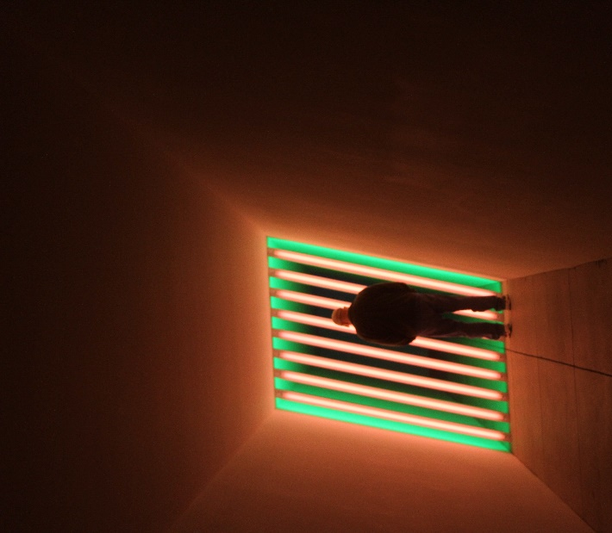
Figure 5. Untitled (Marfa Project). 1996. Dan Flavin.

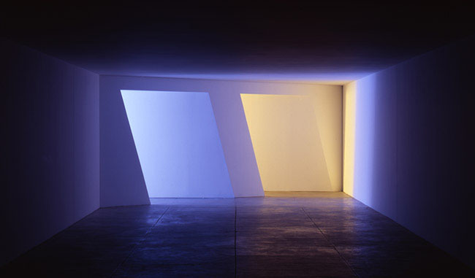
Figure 6. Untitled (Marfa Project). Image courtesy of the Chinati Foundation.
Unlike Flavin’s installation, approved by Judd, Chinati invited Irwin to create an installation in 1999, and Judd did not have the chance to approve the project. While Judd and Flavin were considered Minimalists, Irwin and other artists from the West Coast were considered “light and space” artists. However, Judd and Irwin both attempted “to provide the viewer with an object of attention devoid of elements that might set the imagination wandering beyond immediate physical facts.” This factor set Minimalism apart as a unique art movement, as Minimalists avoided illusionism or complexity in color. Irwin places importance on the transient nature of personal experience, whereas Judd emphasizes the physical object in relation to the environment. By placing Irwin’s work in the Chinati collection, Judd’s works “thereby become contemporary with Irwin’s own piece since they are all rendered visible by the same sunlight falling across one and the same landscape.” Irwin, a living artist, makes Minimalism relevant today and places Judd’s art collection in dialogue with West Coast Minimalists.
Irwin relies on “conditional” factors to inform his work, and began to rely on invitations to install his art. Chinati invited Irwin to create an installation in one of the old hospital buildings on campus, as it featured an “absent roof and floor and “shockingly wide-open sequences of windows,” which “presented a rich, thoroughly keyed-up set of perceptual events before Irwin ever considered the project.” Another conditional factor was Irwin’s relationship with Judd himself. Lastly, “Irwin and Judd shared a desire for a functional alternative to museums”… Both Judd and Irwin argued at a roundtable in 1989 that art is at its best “only when it was free from such external constraints.” Irwin and Judd saw art differently than architecture, as architecture conformed to fit practical needs. Art, as Judd and Irwin envisioned, was best when it was free from institutional constraints – that of the structures of museums, which subjected art to curators, critics, and other institutional actors. Furthermore, Irwin was attracted to the Southwest similarly to Judd, but for different reasons. Irwin began forays into the desert, where he “was not sightseeing but was specifically on the lookout for places where his expectation-fit ratio was interrupted, that is, where what he saw did not confirm his perceptual habits.” The uniqueness of the desert landscape, or the ways in which the sky and lighting created unique aesthetic effects and mirages, attracted Irwin and informed his approach to “conditional” art.
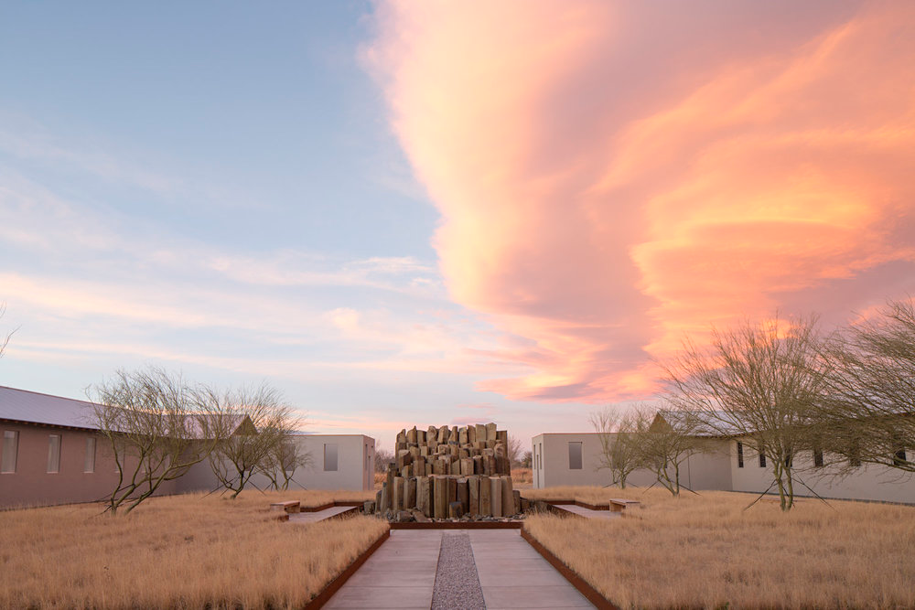
Figure 7. untitled (dawn to dusk). 2016. Robert Irwin. Image courtesy of the Chinati Foundation.

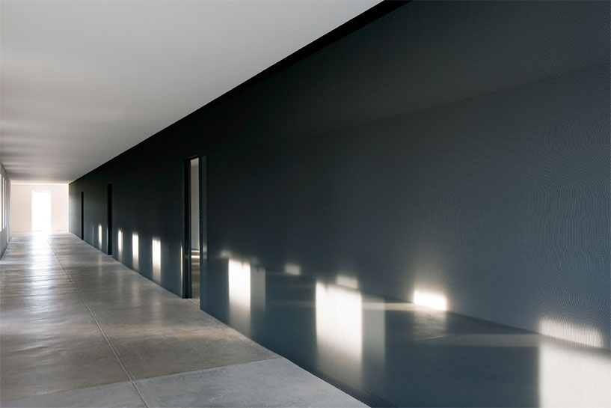
Figure 8. Inside of Irwin’s work. Image courtesy of the Chinati Foundation.

Irwin’s untitled (dawn to dusk) encompasses a U-shaped building that frames a courtyard and garden. The viewer is prepared for the experience by four long strips of concrete sandwiched by gravel that lead the viewer into the courtyard. The concrete sidewalk branches off in two opposite directions, again leading the viewer into the two different wings of the building. The entrances to each wing feature the bare-bones of the building, with walls that enclose the space without roofs. The centerpiece of the courtyard consists of large basalt columns arranged in a sculptural manner, and the columns are surrounded by honey mesquite trees which are indigenous to Texas. Each wing of the building has a sequence of small windows above eye-level along the corridors that allow viewers to see the Texas sky outside. Irwin separated the building into two, with one wing employing black scrim and the other employing white scrim, which subtly tints one’s vision. Each hall in each wing is separated by a wall of either black or white scrim with doorways that allow viewers to pass in between the two halves. Where the wings meet, multiple sequenced scrim walls with aligning doorways allow the viewer to pass from each wing, from dark to light or light to dark.
Irwin’s work features a sequencing of light like Flavin’s work. Unlike Flavin’s work, however, and perhaps more in line with Judd’s aluminum works, “the sky is the key aesthetic reference point.” Untitled (dawn to dusk) features two long hallways with sequences of windows that have varied tinting. As the viewers come into the building, it becomes lighter, while the other hallway is reversed. The lowered floor in the installation places the windows at eyelevel, which creates a view “like a Dutch painting, just a thin strip of land and the rest all sky.” The installation becomes about the experience of ambient environments that change continuously, or “aesthetic events in their own rights, events that were infinitely updating themselves and never exactly repeating.” Conditional art, then, “is fundamentally geared toward the empirical specificity of ground-up aesthetic experience as it becomes… available to a plural and non-hierarchical world of individual and fellow perceivers.” Conditional art relies on a non-hierarchical world where everyone can be a perceiver of an aesthetic event. Irwin’s plural world seems to align with Judd’s ideas about art becoming a part of daily life. The installation becomes about the experience of the viewer, rather than the object of the artwork (which happens to be a carefully constructed building). Conversely, Judd insists that specific objects still retain their importance. Overall, Irwin conforms to Chinati’s standards of contemporary art that is uniquely linked to the Marfa landscape. The artwork, therefore, is permanently linked to its context at the Chinati Foundation in Marfa. The emphasis on light and the desert environment remains central to Judd’s, Flavin’s, and Irwin’s work, wedding West Coast and East Coast Minimalisms together through Chinati.

Conclusion

By examining the Chinati Foundation, the discourse on Minimalism(s) and institutional critique, and visually analyzing Judd’s, Flavin’s, and Irwin’s work, I have illustrated a way that artists can demonstrate power in the art world. Judd created the museum of the Chinati Foundation to exercise organizational power in the discourse of art history, and it operates, as an example, in the discursive break between West Coast and East Coast Minimalism. By choosing artists that he admired, collecting and displaying them, Chinati Foundation canonizes artists and has a stake in the discourse on Minimalism. It suggests that these artists deserve to be shown together and insists that West Coast artists be given as much critical attention as East Coast Minimalists, thereby continually shaping the discourse. It adds value, both material/financial and immaterial, to an artist’s work, as seen in the Chamberlain publication that Chinati published. Judd insists that art historians rethink the unique artists of the 20th century on his terms. Where artists may be subjected to the power of the art critic, curator, the art market, patronage, or museum administrator (roles that additionally shape discourse), Judd’s museum initiates a takeover of these roles and instead interjects the ideas of the artist himself.

Artist Power: A Sociological Approach to the Judd Foundation

Previously, I examined the Chinati Foundation and its discursive power through art historical and museological methodology. However, where Chinati uses discursive power as a museum, the Judd Foundation exercises power as a nonprofit in its ability to preserve and promote a single artist’s legacy in society. This type of work is less artistic and scholarly in nature, and more social in nature because artists set up their foundations with wills, or socially binding documents. Additionally, the Judd Foundation does not claim to be a museum and supposedly exists outside art history’s subject of study. Therefore, it requires a sociological analysis of their function. Sociology, when applied to artistic practice, attempts to understand social systems such as art distribution within the art world. Artist foundations act as distribution systems for one artist’s work and ideals. In particular, organizational sociology provides a framework for understanding organizations (and thereby artist foundations) and the roles they play as collective actors in society. Through description and analysis of the Judd Foundation, an exploration of the methodology of organizational sociology, and doing fieldwork by observing public tours and daily life at the Judd Foundation, I will demonstrate that the Foundation can be conceptualized as a reinstitutionalized museum that exercises its power in the service of the artist. Further, I will build theories on artist foundations as a whole, arguing that this form of organization is a relatively recent phenomenon that is institutionalizing as a means for artists to preserve their legacy after their death.

The Judd Foundation

Judd created the Judd Foundation, separate from the Chinati Foundation, to protect his own creations and the personal spaces in Marfa he bought and remodeled. These included his art offices, ranches, and his living quarters. The Judd Foundation’s mission states that it “promotes a wider understanding of Judd’s artistic legacy by providing access to these spaces and resources and by developing scholarly and educational programs.” The Foundation provides a talk series about Judd and Minimalism, offers guided visits, offers archives for research on his work, publishes his writings, employs teams that work on catalogue raisonné and oral history projects, offers conservation guidelines for Judd’s work not owned by the Foundation, and sells furniture designed by Judd. The Foundation is managed by his children, Flavin and Rainer Judd, who claim they “work hard to ensure that the art is properly protected as Don would have wished.” Unlike Chinati, the Judd Foundation does not claim to be a museum and has a personal aspect as Judd’s children maintain a tighter control on the Foundation.
Despite the Judd Foundation avoiding the term museum, it functions like a private museum. From the books in his library to the objects on his desks, the Judd Foundation perfectly preserves his personal spaces, and allows visitors to view them. This perfect preservation reflects Judd’s ideal of the unification of art, daily life, and architecture, in addition to his insistence on art’s permanence. The Judd Foundation, like private museums, “display[s] personality” and acts “like [a] mausoleum,” especially since the death of Judd in 1994. Unlike public museums, the Judd Foundation becomes a monument to Judd’s personhood in the wake of his death. Additionally, “the private museum gallery forces a perception of its diverse objects in relation to each other. The viewer confronts the space as an entire installation of art, which Judd intended, but this installation occurs simultaneously within a domestic space. Conversely, The Chinati Foundation, a public museum, dedicates itself to education on his artistic ideals with the implementation of artist residencies, internships, symposia, and yearly newsletters. While Chinati may face challenges in its future, the Judd Foundation, like a private museum, sets itself up to “survive the vicissitudes of time” because it is “protected by wills.”

Sociology and Art

A sociological analysis of art has often focused on the way art itself is a socio-cultural institution within society, concentrating on the way art transmits values and facilitates social interaction between members of a society. Sociologists have studied the way art creates interaction between artists and their audiences, though a more detailed process would involve a feedback system between the artist, the critic, and the audience. The feedback system reveals the kind of cooperative activity behind the process of art as an object and the organizations within the art world, which Howard Becker analyzes in Art Worlds. Becker posits that sociological analysis is uniquely situated to analyze the ways in which organizations in the art world define themselves, how they operate, and how they define the art they produce. The art world, defined by Becker, is a “network of cooperative links among participants” who act towards the goal of creating their definition of art. The Judd Foundation consists of these participants who work towards making Judd’s work relevant today, and can be analyzed with the organization as a unit of sociological analysis in order to understand its role in the art world and how it can influence art history.

Sociology, Museology, and Organizational Sociology

Museology and sociology intersect when museology uses the tools of sociology to critique and analyze museums. Sociology attempts to understand how power and privilege function within society, and like the artists practicing institutional critique, museologists recognize the ideological power and privilege of museums. Sociologists, on the other hand, did not take museums as their units of analysis until relatively recently. Pierre Bourdieu, in his famous The Love of Art: European Art Museums and Their Public (1966), used sociological survey techniques to study who visits art museums and why. He found that education played the most important role in whether people used their time to visit art museums, and education in the arts reflects privilege. Sociologists engaging in an institutional critique approach “argue that the alienating effects of the museum are refracted through the class structures of capitalist societies. Curators and museologists use sociological ideas of power and privilege to engage in a reflexive museology to handle representations of people of color and women in the museum setting. A discussion of museums appears in organizational sociology, where blockbuster shows convert museums into commercial organizations, thus “suggest[ing] that museums are shifting coalitions of actors with different stakes in the external worlds of cultural, economic, and political power.” Organizational sociologists Paul DiMaggio and Walter Powell, in their study “Constructing an Organizational Field as a Professional Project: U.S. Art Museums, 1920-1940,” note the increasing importance of professionals who structured museums as a whole at an organizational level.
Organizational sociology has developed as society becomes increasingly organized and takes as its foundation the theories of bureaucratization of Max Weber (1864-1920). Scientists and scholars viewed organizations in the early 1930s as “settings within which work was carried out, not as themselves distinctive social systems, let alone collective actors.” More recently, organizational sociology has begun to consider organizations as collective actors and has focused on factors that cause organizations’ structures or affect organizational performance, while considering organizations on a broad level of power and social inequality. In other words, organizations themselves become players that exercise organizational power in government and society. Why do organizations take the forms that they do, and how do these organizational forms have consequences for the people within them? These types of questions are what inform my study of artist foundations as organizations.
In particular, recent scholarship in organizational sociology argues that organizational power has “never been greater” than in contemporary society and potentially the future. George Ritzer’s critically acclaimed The McDonaldization of Society (1993) is one such example. Building upon the foundation of Max Weber’s theory of bureaucracy’s rationalization and scientific management, Ritzer argues that contemporary society begins to emulate four characteristics (efficiency, calculability, predictability, control) of the fast-food chain McDonald’s. These characteristics, based on rationality, attempt to meet the needs of an ever-increasing population and complex society. Organizations within the arts, particularly nonprofits organizations and other foundations tangential to the arts, also play an increasingly important role in an organizational world as they attempt to meet the various needs of the visual arts and practicing artists. Nonprofit arts organizations “may generate as much as $166 billion in combined organizational and audience spending, employ an estimated 2.6 million workers, and support perhaps as much as another 3 million full-time-equivalent jobs outside of the arts.” The sheer number and revenue of nonprofit organizations and foundations should be of interest to art history, as these organizations act as patrons and quite literally shape art distribution. As art history and museology take museums and patrons as their subjects of study to understand the historical conditions in which art is made and distributed, organizational sociology provides the tools necessary for analyzing the role of organizations related to the arts.

Methodology

While the Judd Foundation functions like a museum, it does not claim to be one. I will analyze it, then, as an organization. Organizational sociology uses either quantitative or qualitative methods to grasp an organization’s identity. I use a purely qualitative approach because it allows for a “holistic view of the situation.” That is, I want to understand on a broad level the Judd Foundation’s intentions, functions, structure, and general atmosphere. To do this, I use a type of participant observation where I am the complete observer “who merely stands back and ‘eavesdrops’ on the proceedings,” or in this case, the public tours offered by the Judd Foundation. Through this observation, I intend to answer three specific questions that Hans van Maanen suggests in studying art worlds: “what opportunities do they provide for the selected works to realize their values, with whom do they do this, and how?” In other words, how does the Judd Foundation use material and personnel resources to convey the values of Donald Judd to potential audiences? Further, how does this promote Judd’s legacy in society?
First, I would like to clarify terms before I use them. There exists some discrepancy in using “organization” and “institution” even in organizational sociology. Some scholars insist that institutions give the “rules of the game,” where the players are the organizations. Others frame organization themselves, including their structures and procedures, as institutions. I agree with the former, and I intend to call individual artist foundations “organizations,” while thinking of them as an “institution” on a broad level. Scholars define institutions as conglomerates of “regulative, normative, and cultural-cognitive elements that, together with associated activities and resources, provide stability and meaning to social life.” Institutions in the forms of organizations regulate behavior, provide norms for behavior, and constitute a shared social reality. Rationalized forms provide stability by providing us with what we expect when we expect it. Once institutionalized, institutions can become deinstitutionalized, or reinstitutionalized. Reinstitutionalization is the emergence of another institutional form “organized around different principles or rules.”
Organizational sociology produces many different findings as it studies a multitude of types of organizations. Nonprofits are especially difficult to classify and analyze, as they are termed “nonprofit” under tax status rather than cause. Nonetheless, organizational sociology has produced some general theories that can be applied to all organizations. The most potent theory of organizations is that of isomorphism, where organizations begin to become homogenized. Predictors of isomorphism include dependence on other organizations, a tense relationship between the means and the ends of obtaining the organization’s goals, and if the goals of the organization are ambiguous. These predictors indicate when “nonoptimal forms are selected out of a population of organizations or because organizational decision-makers learn appropriate responses and adjust their behavior accordingly.” In other words, a cause or need arises in society, and people organize to fulfill those needs. Organizations begin to look like one another when actors develop formal, rationalized structures to keep the gears of the organization running most efficiently. These formal structures, and the organizations attached to them, become institutionalized because they are rationalized to work properly and as many organizations begin to incorporate them. These formal structures further give legitimacy to organizations that use them. It is important to remember that sometimes these institutional rules become “highly rationalized myths that are binding on particular organizations.” This means that although rationalized and legitimized, institutional rules and structures can become irrational traditions that bind to organizations. An interrogation of these rules allows society to rethink institutions, as the artists practicing in institutional critique explored in their art.

Analysis of the Judd Foundation

I begin with a description of the Judd Foundation’s spaces, daily life, and tours, which I gathered by taking the public tours offered in both the New York and Marfa spaces. I follow with an analysis of how the Foundation, as a distribution system in the art world, uses support personnel and material resources to convey its values to potential audiences. I conclude with exploring how artist foundations may be becoming institutionalized.

101 Spring Street

In 1968, Judd purchased his first building at 101 Spring Street, New York City, a five-story cast-iron building designed by Nicholas Whyte and constructed in 1870 (Figures 8 and 9). Opened to the public in 2013, the Judd Foundation started renovation of the building in 2010 with the support of the National Trust for Historic Preservation. The renovation focused on maintaining the façade and Judd’s spaces as originally intended, while meeting museum-quality conditions such as specialized windows and heating and cooling. The space constitutes Judd’s living and studio spaces. Local artists function as tour guides through the spaces and receive training in museum pedagogy even though the Foundation intentionally avoids labelling itself a museum. The Foundation offers private tours that must be scheduled beforehand, and local practicing artists receive free admission. Guests must enter through a door in which the tour guide opens onto the ground floor. In general, the Foundation carefully controls flow of traffic, items brought in, photography, and dissemination of knowledge. The ground floor acts as a temporary exhibition space and includes a desk with a guest book for guests to record their experience. The basement, restricted to Foundation staff, contains small offices and a conference room, presumably for the board of directors and co-presidents to conduct meetings. The tour guide prepares visitors on the ground floor by briefly describing Judd’s life, and by carefully noting what he declared himself not to be: a Minimalist sculptor.
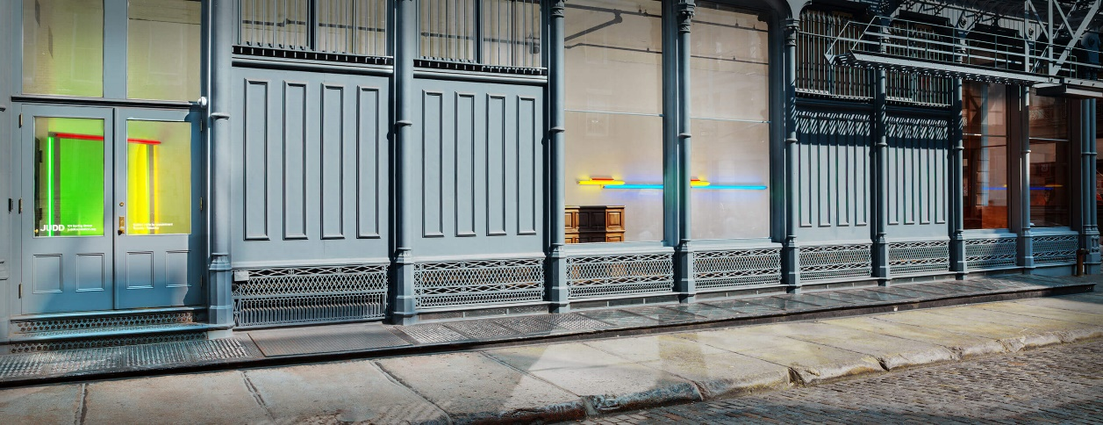
Figure 9. 101 Spring Street. Image courtesy of the Judd Foundation.

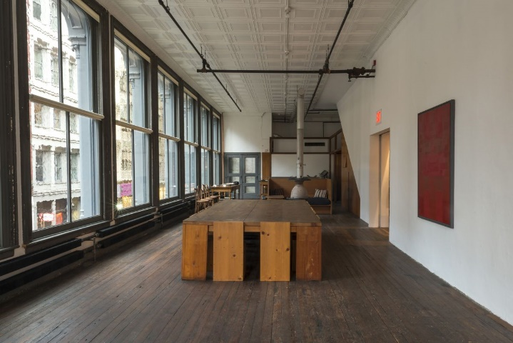
Figure 10. Inside of 101 Spring Street, 1st floor. Image courtesy of the Judd Foundation.

The first-floor and upper floors feature artworks by Judd, cultural artifacts, artwork by other artists, and his carefully conserved living and working spaces. The first-floor features his kitchen, where the Foundation meticulously conserves bowls and kitchen utensils. The tour guide mostly points out the artistically laid and intentional spaces that he created. The dimensions of the tables and kitchen correspond to one another, while the other side of the floor contains a large fresco and another artwork by Ad Reinhardt. According to the tour guide, the area by the large fresco used to be used as a dance studio where John Cage once performed. The artworks are not labelled, and thus knowledge about them remains relegated to the tour guide and the Foundation. However, a book with a description of the spaces and the artworks in them is forthcoming.
The Foundation warns that visitors must climb five flights of stairs. The staircases provide spaces for storage of kitchenware, and Indigenous masks adorn the staircase walls. The second-floor features a small library with objects like rocks and bottles, while it contains large-scale aluminum works by Judd and a work desk. A small rug with a headrest demonstrates Judd’s belief in relaxation while carefully observing art. Judd collected Alvar Aalto (Finnish, 1898-1976) and Gerrit Rietveld (Dutch, 1888-1964) as he admired modernist furniture, though he placed them alongside his own designs. Visitors must ask the tour guide for clarification on which furniture Judd did not design or use their own visual skills to determine so. The fourth-floor features the largest collection of artworks, including a Frank Stella, a Claes Oldenburg, and numerous early works by Dan Flavin. The Foundation offers tours at specific times that allow for the work to be seen in daylight instead of artificial light, and after the restoration of the building, the Foundation improved on its preservation systems while making those systems (i.e. emergency sprinklers) invisible to the visitor eye. Lastly, the fifth-floor presents the most domestic space, with a bathroom, coat closets, a cradle room, a loft, and a bed amidst artworks in the space: a John Chamberlain, some of Judd’s works, a large light installation by Flavin, and a soft sculpture by Oldenburg, to name a few. Interestingly, the tour guide did not provide much information on the cultural artifacts in the spaces as compared to its Western art.
The overall impression of the space and of Judd seems to suggest that while he was nearly freakishly controlling, Judd is held in the highest regard because of his loyalty to his ideas. His ability to carve out each space according to his painstaking design and intention remains as something admired by both the tour guides and the touring public. The space, while both domestic and unintimidating, generally surprises viewers with its detail, while the art and furniture garner appreciation for their design. His commitment to the contemplation of art within daily life or the combination of art and domestic space further inspires visitors. Read negatively, however, Judd can be described as a glorified interior designer, with a considerable amount of resources at his disposal. Either way, his dedication to preserving and defending his work remains foregrounded.

The Marfa Spaces

The studios and living spaces in Marfa are more disjointed than the 101 Spring Street building, and they include the architecture office, the architecture studio, the art studio, the Block, the Cobb House, the print building, the ranch office, and the Whyte Building. Additionally, the Foundation owns Casa Morales, Casa Perez, and Las Casas which are Judd’s ecological ranches by the Chinati Mountains. Due to their rural nature, the Foundation does not provide regular tours for the ranches. The Foundation instead offers two different tours, one for the Block and one for the spaces of the architecture studio, the art studio, the Cobb House, and the Whyte Building. The print building encompasses the Judd Foundation’s operating offices, conservation studio, and archives.
Judd purchased a full city block in downtown Marfa, including two airplane hangars, in 1973. In 1974, he acquired the rest of what is known as “the Block,” a two-story house and previously the offices of the U.S. Army’s Quartermaster Corps (Figures 10 and 11). The Block contains a courtyard with Judd’s pool, gardens, library, and main living spaces, while the tour of the studios mostly demonstrates his work spaces. The Block, enclosed by adobe walls, illustrates again his concern with space, as the buildings, garden, pool, and pergola are carefully arranged in an aesthetic manner upon a bed of gravel. Art exists alongside daily and domestic life, as seen in the artworks in the library and the Navajo Room, where Judd carefully placed Native American rugs and pottery next to a bed and desk. On the other hand, the larger airplane hangars explicitly show a variety of his art with plenty of breathing space, from his famous stacks to his colored, wooden works. Benches situated near the art encourage sustained and leisurely looking, yet the tour does not allow for such due to its time constraints.
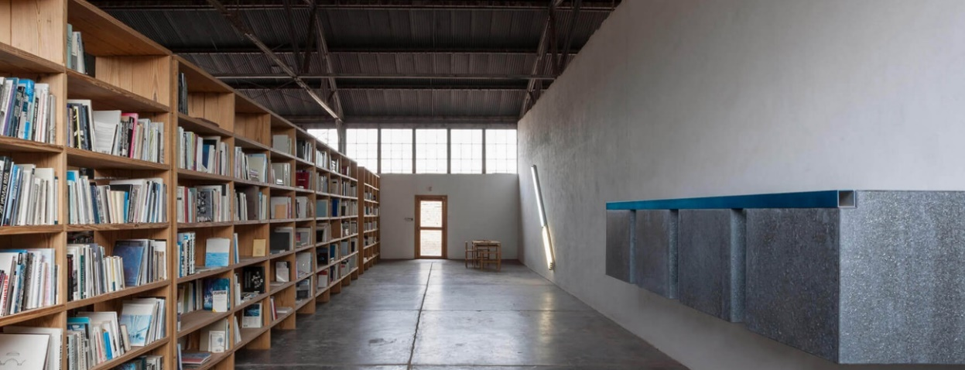
Figure 11. The library inside the Block. Image courtesy of the Judd Foundation.

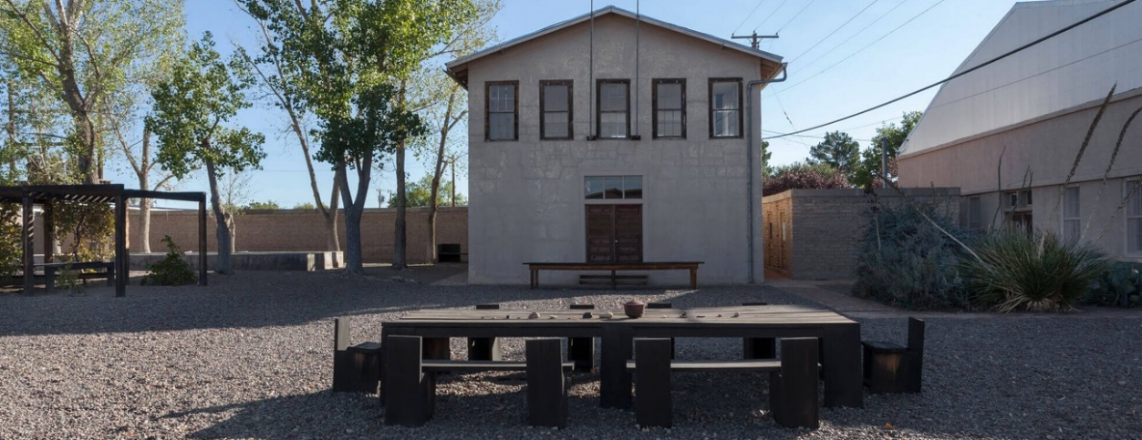
Figure 12. The courtyard at the Block. Image courtesy of the Judd Foundation.

The studios tour flows from the architecture studio, to the Cobb House and Whyte Building, and then to the art studio. As an architecture studio, Judd purchased the Marfa National Bank, built by German architect L.G. Knipe, in downtown Marfa in 1989 and removed some of the renovations it underwent in the 1960s to preserve its initial form. The bottom floor of the building welcomes visitors with an old mural of cows in the desert, and the floor displays several tables and benches from varying Modernist designers, in addition to a kitchenette. The building retains evidence of past renovations, as seen by the imprint of a missing staircase. A narrow staircase leads visitors up to the sequenced offices, small rooms that mostly contain a formula that combines art, prototype furniture, furniture designed by Modernist designers, and desks with tools and notes. The walls of the offices display a plethora of Judd’s architectural designs, such as a drawing of a traffic circle he submitted to a small town in France and his designs for Chinati. The architecture studio additionally encompasses a small domestic space, complete with a bed, balcony, and a Native American pot by a Pueblo artist.
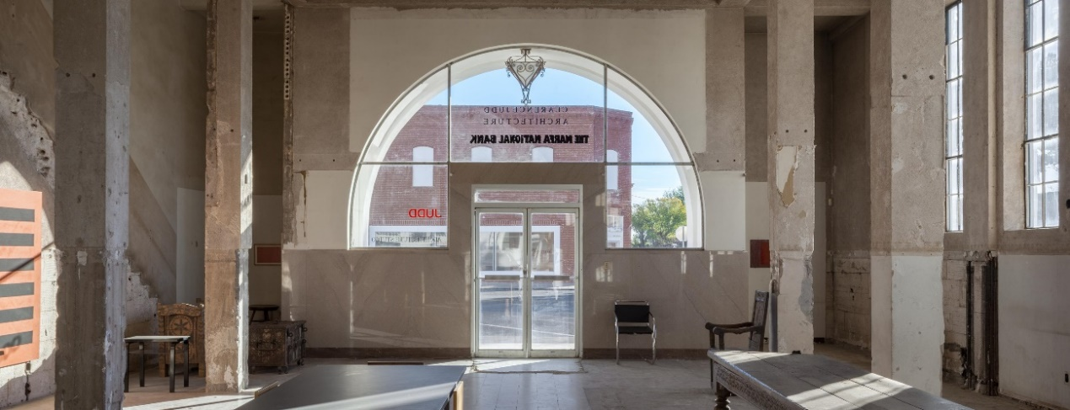
Figure 13. Front entrance to the architecture studio. Image courtesy of the Judd Foundation.

Judd purchased three buildings on Oak Street in downtown Marfa in 1989 to make up the Cobb House, Whyte Building, and Gate House, examples of more living spaces connected with art (Figures 13, 14, 15). The Cobb House, named after a ranching family that owned it in the 1920s, is a 1253-foot adobe-style structure. Dilapidated adobe walls enclose these three buildings, while the Gate House, a tiny, white, square building, formerly a barbershop, acts as an entrance to the compound. Judd opened up the floor plan in the Cobb House by removing partitions, placing domestic furniture inside the space, and restoring the walls and ceiling with adobe-style gypsum plaster to unify the rooms in the house. He exclusively placed his “failed” explorations in abstract painting from the 1950s in this house. The neighboring Whyte building, once a storage barn for Winn’s Five and Dime in 1925, opens from a pivoting barn-like door. This building displays wooden furniture, while older, large works by Judd adorn the walls.
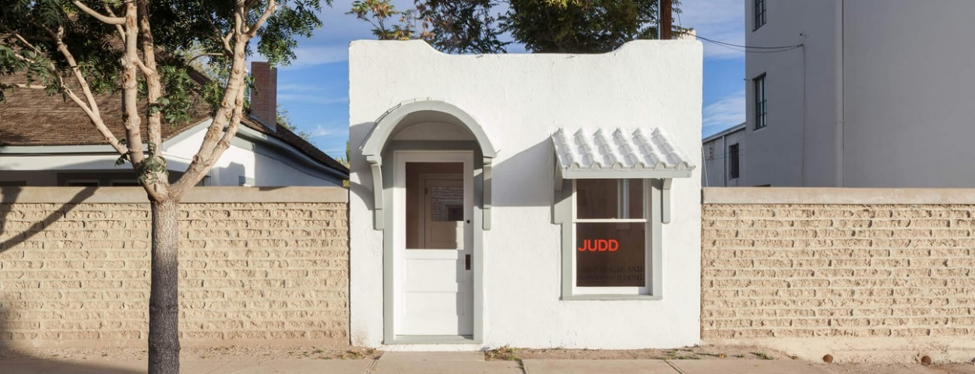
Figure 14. Gate House leading into the courtyard of the Cobb House. Image courtesy of the Judd Foundation.

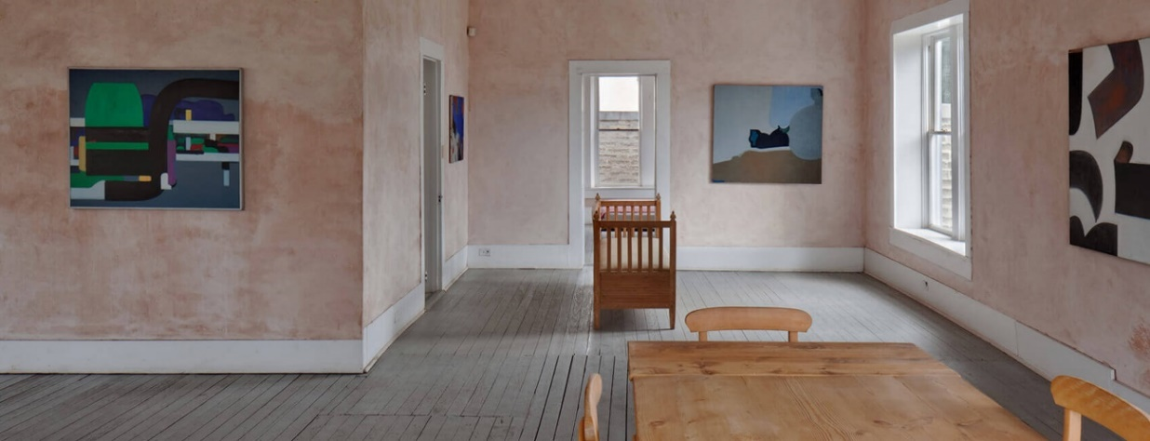
Figure 15. Cobb House interior. Image courtesy of the Judd Foundation.

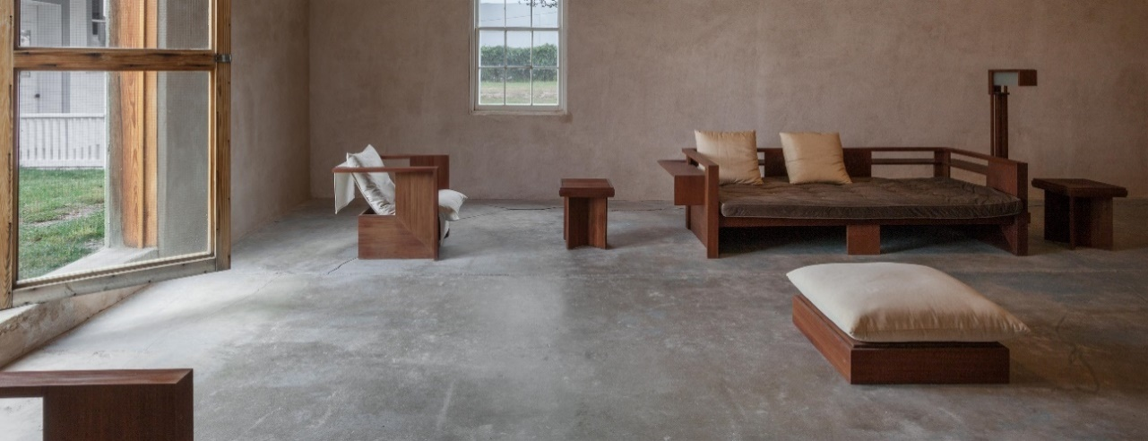
Figure 16. Interior of the Whyte Building. Image courtesy of the Judd Foundation.

In 1990, he purchased a former grocery store to become his art studio by removing the machinery and the drop ceiling (Figure 16). The studio features steel shelves in the front of the rectangular building and long tables that run the length of the building. Upon these tables, he placed objects and materials that informed his artistic practice, such as books, color charts, Plexiglas samples, wood samples, aluminum samples, tools, and partially constructed objects. Finished multicolored works adorn the walls parallel to the tables. Here, Judd examined prototypes and fabrication processes. The art studio perfectly illustrates how Judd worked through a “materials laboratory.” The art studio holds various materials, unfinished or rejected artworks, and reveals how Judd worked through a creative process.
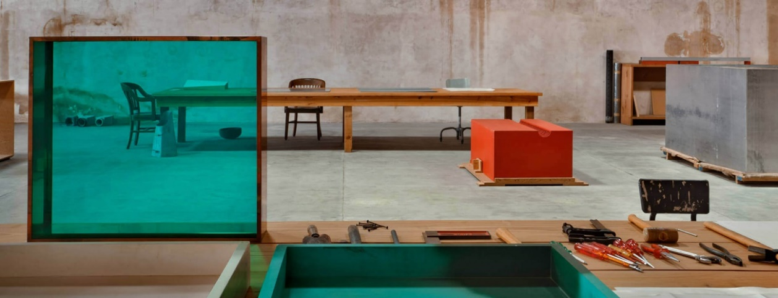
Figure 17. Interior of the art studio. Image courtesy of the Judd Foundation.

Like 101 Spring Street, the Block and studio tours carefully control the flow of traffic, photography, and dissemination of knowledge. The library and its books cannot be touched or used (at least on the tour), photography is banned inside the spaces, doors are locked in between buildings and rooms, and the objects and artworks lack labels or didactic information. Unlike the New York space, the studio tour flows through outside spaces in downtown Marfa. Each studio space contains modernist furniture, either prototypes of Judd’s or finished pieces of artists previously mentioned. Whether lounging spaces or working spaces, Judd and the Foundation carefully places items and working objects in an aesthetically pleasing manner, and artworks fill each space. Cultural artifacts also exist within the space, from Native southwest pottery to bronze Etruscan artifacts in an old hospital cabinet in the architecture studio. All of the spaces intend to validate his ideals: art coexisting with daily life and architectural space, and reconstructing spaces from historic buildings. The tour guides further expound upon these ideals by translating the constructed visual space for the tourists.
Both the spaces in New York and Texas portray Judd as a unique artist concerned with the preservation of his work, the preservation of historical buildings, and the merging of art with daily life. However, unlike 101 Spring Street, the Marfa tours highlight the history of the town as you walk through downtown, and they highlight how important Judd was in preserving it and placing it on the map.

Daily Life at the Judd Foundation

The stage of the Judd Foundation that is presented to the public has a private staging area with personnel that work towards one goal. The daily life at the Foundation consists of managing facilities through housekeeping and grounds keeping, as preservation of Judd’s living spaces are of utmost importance. Further, the Foundation has developed its own routine of checking and cleaning the works and working with a conservator to ensure preservation. Staff members also focus on visitor services, making information about the Judd Foundation more accessible on the website, improving tours, curating temporary exhibitions at 101 Spring Street, and working towards publications. These functions reflect its museological imperatives. Naturally, the Foundation also works like a typical office. Mundane activities like purchasing office supplies and ensuring that the office runs smoothly occur within the Foundation. The catalogue raisonné team, on the other hand, works daily to contact collectors and museums to gather information about the entire body of Judd’s work. The archivist works on cataloguing his vast collection of notes, creating an organizational structure for the archive, and creating a database for searching items within the archive. The archive is already accessible, but the archivist hopes to increase its accessibility through such measures. The board of directors makes executive decisions centered on funding, investing, endowments, programs, and loans. David Zwirner Gallery represents Donald Judd as an artist through negotiations with the Foundation.

Materials, Personnel, and Conveying Values

Judd may not have been able to create the Chinati Foundation and thus the Judd Foundation without the help and resources of the Dia Foundation. Resources in the art world are typically “allocated to existing artistic activities, so that one needs to develop new sources of support, pools of personnel, sources of materials, and other facilities.” The Dia Foundation supplied Judd with the resources to begin the Chinati Foundation, and allowed Judd to pursue his own methods of art presentation in addition to his own distribution system – something that artists must seek in order to be successful or influential. As a nonprofit organization, it seeks donations from corporations, individuals, governing bodies (i.e. the New York State Council on the Arts), and other nonprofit organizations. Donors receive special benefits like trips to the ranches or discounts on goods, in addition to recognition in Judd Foundation publications. The Judd Foundation further contains artwork collected or made by Judd, retains his buildings, and uses his archives as material resources. These material resources exist at the disposal of the Judd Foundation to fund its operations.
An institution consists of support personnel, who are “engaged in a joint effort to make the conventions whose innovative character interests them more widely known or at least viable as one of the resources of art.” The institution reflects society where multiple people act in the organism of the organization: assisting it with daily tasks, hosting symposia, archiving, pursuing new artists to present, assisting with exhibition space, and writing about the artworks at the Foundation. All of these activities contribute towards their understanding of what art should be, and how it should be understood or presented. Even the manufacturers who worked with Judd to create his concrete pieces, among other manufactured artworks, acted as support personnel for his institutional needs. The board of directors consists of eight members, including co-presidents Flavin and Rainer Judd, a treasurer, chairperson, and secretary. The general staff consists of twenty members, and twenty-one tour guides.
The staff translates the material resources into larger societal values to ultimately support Donald Judd’s artistic legacy as a whole. As I discussed with the Chinati Foundation, its scholarly support and its organizational power as a distribution system conveys Judd’s values to potential audiences. Publications and programs about his writings produced by the Judd Foundation make his ideas accessible to scholars, in addition to making the archive and his working/living spaces available for study. However, the Foundation has the capability to control, as Judd wanted, the kinds of information given to scholars with its active role in art historical scholarship (for example, directing the catalogue raisonné team) and the public information offered through the tours. By controlling photography, the Judd Foundation and the Chinati Foundation further control if and how you experience it. The Foundation provides tours for free to practicing local artists or to local residents of Marfa to appeal to them as an audience, and the tour guides are often artists which provides them with a stable job in their field and skills in museum pedagogy. The Foundation also plays a part in exhibition work in museums, a primary way of distributing and giving legitimacy to Judd’s works for larger audiences. As he prepared the art world to receive his art through being an art critic, his Foundation continues this work by preserving everything he created and placing Judd at the center of control of his historic reception. This is unlike, for example, the Rauschenberg and Warhol Foundations, that do not specifically control their legacies in the way that Judd does through the preservation of his living spaces and his unique vision.

Building Theories on Artist Foundations

Understanding the preexisting, conventional institutions within society at the time the Judd Foundation was created are key to understanding why it was created. The art world is composed of varying systems that artists must either work with, ignore entirely, or compete against. Artists may replace organizations that do not work towards their art ideals with their own organizations. In Judd’s case, his frustration with the museum space and the way other actors in the art world mediated art’s contexts led him to seek his own organizations which pursued his own ideals. This may be the case for the development of other artists’ foundations, which will be explored further. The Chinati Foundation acts as a museal institution which has already been explored in museological scholarship. Institutions most importantly preserve artworks and prevent their disappearance. Judd, concerned with the permanence of contexts and their involvement in art meaning, created art works and presented art by other artists with permanence in mind. The Chinati Foundation exists as an institution to preserve these artworks, in addition to seeking other artists and artworks to present permanently. The artist foundation similarly exists as an institution to preserve and display artworks, but it does so with the centrality of the artist in mind. How, then, can we conceptualize artist foundations: as institutionalizing, the institutionalized, or the museum reinstitutionalized? Further, what effect do artist foundations have on the art world if they have become institutionalized?
Due to the limitations of this thesis and its exploratory nature, I intend to treat the Judd Foundation as a case study where I will “generate hypotheses and build theory” on artist driven foundations as a whole. Artist foundations appear to arise as a relatively recent phenomenon in the United States. This may be the result of the vast amounts of wealth given to certain individual artists due to an ever-increasing art market post World War II that produces an artist’s estate to create a foundation. It certainly relates to the increase in nonprofit organizations in general as mentioned previously. Notable American artist foundations that exist alongside the Judd Foundation include the Warhol Foundation, the Rauschenberg Foundation, the Pollock Krasner Foundation, and the Roy Lichtenstein Foundation. The establishment of these types of Foundations occur in the second half of the 1900s, when famous American Modernist artists begin passing away and leaving their estates for this kind of organization. These Foundations begin appearing in the late stages of capitalism in the United States, where corporations exercise increasingly more power in politics, government, and society. For Judd to organize his Foundations as early as he did suggests that he was anticipating what artists must do to exist in a society that places progressively more importance on profit and capital: they must become corporations and organizational entities themselves. In a sense, he predicted “corporate” and huge, commercial artists such as Damien Hirst, Jeff Koons, and Takashi Murakami.
The Judd Foundation exists as a unique organization because Judd proved to be a unique philosopher and Minimal artist committed to his ideals. The Chinati Foundation, on one hand, allowed Judd to control his artistic reception and legacy during his lifetime through the creation of his own museum, something that most artists do not have the means to create. This museum gives legitimacy to his own works and the works of artists of his choosing, as explained in the first chapter. Other artists typically create their artist foundations (or private museums) with their wills. The Foundation also proves to be unique because of Judd’s choice of locations – both New York City and desert Marfa. In these split spaces, the preservation of artistic and architectural space remains central to his legacy and therefore his organizations. The Judd Foundation particularly exercises its power to promote his artistic legacy in society through its ability to link Judd to historic preservation – the public recognizes Judd’s legacy through his preservation of historic buildings, as seen by the support of the National Trust for Historic Preservation for the restoration of 101 Spring Street.
While artist foundations task themselves with specific artists legacies, they share commonalities in how to do so. Conservation, display, scholarship, and outreach programs are the core of what artist foundations must do to develop an artist’s legacy in society. Presumably, artist foundations will need to gather archives and resources to develop accessibility to primary material for scholars. The artist foundations will care for the artists’ works and collection. Furthermore, in some cases, the artist foundation is tasked with authenticating works and evolving a catalogue raisonné to create a legitimate narrative of the artist’s life. The artist foundations must continue to display the artworks either through museums or through their own exhibiting spaces. To convey the artist’s legacy and their values, they must produce programs like symposia, lectures, and talks that engage potential audiences. Artist foundations can additionally provide grants or artist residencies to support practicing visual artists throughout the nation, which does not necessarily directly relate to the founding artist’s legacy. Some grants assist curators and institutions instead of single artists.
I argue that artist foundations as a whole have similar structures given that they have similar goals and functions, and therefore they have isomorphized and are institutionalizing. Predictors of isomorphism consist of dependence on other organizations, an unstable relationship between the ends and the means, and ambiguity of goals. Artist foundations typically rely on a network of other nonprofit organizations, securing donations for the foundation can prove unstable, and “preserving an artist’s legacy” remains fairly ambiguous as a goal. Optimal and successful forms of artist foundations illustrate efficient and rationalized structures that are prepared to handle ambiguous goals and unstable means, and other organizations adopt these structures. However, the role of artist foundations continues to lack attention in the fields of art history and museology, and as organizational sociologists have noted, professionals play a large role in institutionalization. Therefore, they have not become fully institutionalized.
I argue that specifically in the case of the Judd Foundation, the artist foundation represents the museum reinstitutionalized to prioritize a specific artist. Judd wished to retain maximum control over the display and scholarship of his work, and he created two organizations to do so. The main difference at stake here between Chinati and the Judd Foundation, a museum and an artist foundation, lies in the Judd Foundation’s focus on Donald Judd and Chinati’s focus on multiple artists. Otherwise, they both display, conserve, encourage scholarship, and engage in outreach and educational programs to further their goals. Though he postured as “anti-institutional,” Judd instead created the Chinati museum with the help of Dia, and later created the reinstitionalized museum as the Judd Foundation where the Chinati Foundation failed. Other artist foundations may be considered as reinstutionalized museums, but until that work has been done, I simply conclude that they are institutionalizing.
What is at stake for art history and sociology if artist foundations are institutionalizing? For one, the attention given to museums in organizational sociology has equal value for artist foundations. It aids sociologists in understanding how institutional forms change, get adopted, become institutions in entirely new contexts, and how aesthetic values become solidified in society. Artist foundations will, provided they continue to institutionalize, continue to shape the critical reception of artists through history and act as patrons for practicing visual artists. Art historians wishing to understand artist power can look at artist foundations as prime examples. Most importantly, this study reveals the need for an interdisciplinary approach for this kind of work in art history.

The Future of the Judd Foundation and Conclusion

What might the Judd Foundation do to secure funding to support its large projects and preservation of Judd’s personal spaces? In a Christie’s catalogue published in 2006, the Judd Foundation presents his artworks for sale. The sale proceeds “will be used to preserve for future generations the artistic environments of Judd’s former home and work spaces… under the auspices of the Judd Foundation.” Ironically, the catalogue includes his founding essay “In Defense of My Work,” which explicitly states that his art is “not on the market, not for sale, not subject to the ignorance of the public, not open to perversion.” Clearly, the Foundation might have to forsake some of Judd’s ideals to keep the Foundation functioning. The Foundation also offers furniture designed by Judd for sale; he viewed furniture differently than his art, and therefore judged it okay to sell as long as it held up to his standards and was handmade to perfection. Ultimately, the Judd Foundation reveals a power struggle between artist and art world. While artists must make concessions to exist in that world, the Judd Foundation, and presumably other artist foundations, presents another form of organizational power that artists can use to further their own goals even after they have passed away.

Conclusion

Donald Judd, a Minimal artist that rejected the term, created the Chinati and Judd Foundations to defend his ideas after his passing. While he created Chinati as a museum in mind, he intended to create the Judd Foundation to preserve his living and working spaces and therefore his artistic legacy in society. The Chinati Foundation uses its resources to further the scholarship on the artists Judd chose to represent, while the Judd Foundation uses its resources to preserve and promote his ideal of the unification between art, daily life, and architecture. I used two methodologies, art history and sociology, to approach these foundations. In doing so, I demonstrated that the Chinati Foundation uses its discursive power to bring artists of “different” categories together under the West Texas sky, while the Judd Foundation uses its power as a nonprofit organization to preserve and promote Donald Judd the artist.
By looking at the Chinati and Judd Foundations through a multidisciplinary lens, I illustrated methods that artists can use to control how their art is received and displayed in the institutional artworld. Like Howard Becker in Art Worlds, I hope to “provide a framework that would continue to generate researchable ideas” with a specific focus on artist foundations, and possibly nonprofit foundations related to the arts. Most importantly, I intend to generate interest in how and why artist foundations began as a phenomenon (an understudied topic in the field of both art history and sociology), and whether this phenomenon has become institutionalized due to historical and societal factors. I simultaneously stress the need for multidisciplinary research employed towards understanding complex social and artistic phenomena. The logical next step of continuing this research would be to describe and analyze all artist foundations in the United States. In categorizing them, one could provide a general history of their emergence and tie them directly to historical conditions.
It is necessary to recover the history of the artist foundation, because like patronage and the art market, artist foundations have the power to shape the art world. Sociologists have noted the increasingly institutionalized, organized, and bureaucratized world we live in, and artists begin to navigate this world by organizing into artist foundations. Judd is crucial to this consideration because he lived to see the power of organizations in the art world, and in order to counter the institutional museum world, he organized his own foundations. In studying these specific foundations, I revealed two ways artists can exercise agency in contemporary society and how these foundations influence the discourse on Minimalism and therefore art history. Artist-driven foundations are reinstitutionalizing forms of museums and artists use those forms to shape the way their legacy is conveyed – either in academia or in society.

References

Alberro, Alexander, and Blake Stimson. Institutional Critique: An Anthology of Artists' Writings. Cambridge: MIT Press, 2009.
Albrecht, Milton. "Art as an Institution." American Sociological Review 33 (1968): 383-397.
Alexander, Paul. Death and Disaster: The Rise of the Warhol Empire and the Race for Andy's Millions. New York: Villard Books, 1994.
Antliff, Allan, and Donald Judd. The Writings of Donald Judd: A Symposium Hosted by the Chinati Foundation, Marfa, Texas, May 3-4, 2008. Marfa, Texas: Chinati Foundation, 2009.
Battcock, Gregory. Minimal Art: A Critical Anthology. New York: E.P. Dutton, 1968.
Becker, Howard Saul. Art Worlds. Berkeley: University of California Press, 1982.
Belting, Hans, Andrea Buddensieg, and Emanoel Araújo. The Global Art World: Audiences, Markets, and Museums. Ostfildern: Hatje Cantz, 2009.
Berger, Maurice, and Hans Haacke. Minimal Politics: Performativity and Minimalism in Recent American Art. Baltimore: Fine Arts Gallery, University of Maryland, 1997.
Bismarck, Beatrice, Jörn Schafaff, and Thomas Weski. Cultures of the Curatorial. Sternberg Press, 2012.
Bourdieu, Pierre, Alain Darbel, and Dominique Schnapper. The Love of Art: European Art Museums and Their Public. Stanford: Stanford University Press, 1990.
Cassell, Catherine, and Gillian Symon. Qualitative Methods in Organizational Research: A Practical Guide. London, Thousand Oaks, New Delhi: SAGE, 1994.
Chamberlain, John, and Marianne Stockebrand. John Chamberlain: The Foam Sculptures. Marfa, Texas: Chinati Foundation, 2007.
Chave, Anna. "Minimalism and the Rhetoric of Power." Arts Magazine 64.5 (January 1990): 44-63.
Chave, Anna. “Revaluing Minimalism: Patronage, Aura, and Place.” The Art Bulletin 90.3 (2008): 466-486.
Chinati Foundation Website. Accessed April 30, 2018. https://chinati.org.
Darwent, Charles. “Judd’s Uneasy Shade.” Modern Painters 13.4 (2000): 67-68.
Desvallées, André, and François Mairesse, eds. Key Aspects of Museology. Armand Colin, 2010.
Foster, Hal. Discussions in Contemporary Culture. Seattle: Bay Press, 1987.
Goetz, Ingvild, Karsten Löckemann, Angelika Nollert, and Letizia Ragaglia. When Now Is Minimal: The Unknown Side of the Goetz Collection. Ostfildern: Hatje Cantz, 2013.
Gorvy, Brett, et al. Donald Judd: Selected Works from the Judd Foundation. New York: Christie’s, 2006.
Hoffman, Jens and Joanna Montoya. Other Primary Structures. New York: Jewish Museum, 2014.
Judd Foundation Website. Accessed April 30, 2018. https://juddfoundation.org.
Judd, Donald. Complete Writings 1959-1975: Gallery Reviews, Book Reviews, Articles, Letters to the Editor, Reports, Statements, Complaints. Halifax, N.S: Press of the Nova Scotia College of Art and Design, 2005.
Judd, Donald, and Nicholas Serota. Donald Judd. New York: D.A.P., 2004.
Kimmelman, Michael. “The Last Great Art of the 20th Century,” The New York Times, February 4, 2001.
Knight, Christopher and Giuseppe Panza. Art of the Sixties and Seventies: The Panza Collection. New York: Rizzoli International Publications, 1988.
Lorente, Jesús Pedro. The Museums of Contemporary Art: Notion and Development. Farnham, Surrey, U.K., England: Ashgate, 2011.
Maanen, Hans van. How to Study Art Worlds: On the Societal Functioning of Aesthetic Values. Amsterdam: Amsterdam University Press, 2009.
Macdonald, Sharon. A Companion to Museum Studies. Malden, MA: Blackwell Pub, 2006.
McClellan, Andrew. Art and its Publics: Museum Studies at the Millennium. Oxford: Blackwell Publishing, 2003.
Meyer, James Sampson. Minimalism. London: Phaidon, 2000.
Meyer, James Sampson. Minimalism: Art and Polemics in the Sixties. New Haven: Yale University Press, 2001.
Miller, M.H. “MoMA Will Do a Donald Judd Retrospective In 2017.” ARTNEWS. Accessed March 24, 2018. http://www.artnews.com/2015/05/22/moma-will-do-a-donald-judd-retrospective-in-2017.
Obrist, Hans, and Lionel Bovier. A Brief History of Curating. Zurich: JRP / Ringier, 2008.
Powell, Walter, and Paul DiMaggio. The New Institutionalism in Organizational Analysis. Chicago: University of Chicago Press, 1991.
Raskin, David, and Donald Judd. Donald Judd. New Haven: Yale University Press, 2010.
Ritzer, George. The McDonaldization of Society. Thousand Oaks, California: SAGE, 2013.
Scott, W. R. Institutions and Organizations: Ideas and Interests. Los Angeles: Sage Publications, 2008.
Serota, Nicholas, and Richard Koshalek. "Housing Modern Art." RSA Journal 148 (2001): 14-23.
Simms, Matthew. Robert Irwin: A Conditional Art. New Haven and London: Yale University Press, 2016.
Smith, Terry. Thinking Contemporary Curating. New York, NY: Independent Curators International, 2012.
Stockebrand, Marianne, Donald Judd, and Rudi Fuchs. Chinati: The Vision of Donald Judd. Marfa, Texas: Chinati Foundation, 2010.
Stockebrand, Marianne, William C. Agee, Richard Shiff, and Donald Judd. Donald Judd: The Multicolored Works. New Haven and London: Yale University Press, 2014.
Toepler, Stegan, and Margaret Wyszomirski. “Arts and Culture.” The State of Nonprofit America. Washington, D.C.: Brookings Institution Press, 2012.
Weber, Bruce. “Art and Architecture: Dueling on a High Plain.” The New York Times, April 29, 1998.
Wharton, Amy. The Sociology of Organizations: An Anthology of Contemporary Theory and Research. Los Angeles: Roxbury Pub. Co, 2007.

Marianne Stockebrand, Donald Judd, and Rudi Fuchs, Chinati: The Vision of Donald Judd (Marfa, Texas: Chinati Foundation, 2010), 9.
Andrew McClellan, ed., Art and its Publics: Museum Studies at the Millennium (Oxford: Blackwell Publishing, 2003), 32.
Stockebrand, Chinati, 30.
Judd avoided the term “museum” in his founding essay of the Chinati Foundation and instead used “installation,” but the public calls it a museum and the term has come to be used in its website. “Mission & History,” Chinati Foundation, accessed May 1, 2017, https://chinati.org.
Michael Kimmelman, “The Last Great Art of the 20th Century,” The New York Times, February 4, 2001, 39.
McLellan, Art and Its Publics, 21.
Weber, “Art and Architecture, Dueling on a High Plain,” New York Times, April 29, 1998.
Charles Darwent, “Judd’s Uneasy Shade,” Modern Painters 13.4 (2000): 67.
Stockebrand, Chinati, 235.
Ibid., 187.
Ibid., 193.
Ibid., 211.
Anna Chave, “Revaluing Minimalism: Patronage, Aura, and Place,” The Art Bulletin 90.3 (2008): 466.
Donald Judd and Nicholas Serota, Donald Judd (New York: D.A.P., 2004), 263.
John Chamberlain, and Marianne Stockebrand, John Chamberlain: The Foam Sculptures (Marfa, Texas: Chinati Foundation, 2007), 8.
Ibid., 12.
Ibid., 13.
Ibid., 16.
Gregory Battcock, Minimal Art: A Critical Anthology (New York: E.P. Dutton, 1968), 35.
James Meyer, Minimalism (London: Phaidon, 2000), 15.
Ibid., 18.
Serota, Donald Judd, 252.
Battcock, Minimal Art, 58.
Meyer, Minimalism, 32,
An example of non-U.S. global Minimalisms: Jens Hoffman and Joanna Montoya, Other Primary Structures (New York: Jewish Museum, 2014).
Battcock, Minimal Art, 68.
Ibid., 201.
Meyer, Minimalism, 33.
Ibid., 33.
Ibid., 26.
Ibid., 35.
Ibid., 35.
Ibid., 39.
Ibid., 42.
Ibid., 21.
Ibid., 32.
Ibid., 24.
Battcock, Minimal Art, 344.
Meyer, Minimalism, 29.
Chave, “Revaluing Minimalism,” 467.
Ibid., 466.
Christopher Knight and Giuseppe Panza, Art of the Sixties and Seventies: The Panza Collection (New York: Rizzoli International Publications, 1988).
Chave, “Revaluing Minimalism,” 466.
Ibid., 466.
Ibid., 471.
Ibid., 476.
Ibid., 477.
Ibid., 481.
Ibid., 479.
“Visit: About Dia: Beacon,” Dia’s website, accessed March 31, 2018, https://www.diaart.org/visit/visit/diabeacon-beacon-united-states.
Meyer, Minimalism, 36.
Anna Chave, "Minimalism and the Rhetoric of Power," Arts Magazine 64.5 (January 1990): 270.
Ibid., 270.
Battcock, Minimal Art, 294.
Stockebrand, Chinati, 18.
Ibid., 19.
Ibid., 271.
Blake Stimson, “What Was Institutional Critique?” in Institutional Critique: An Anthology of Artists' Writings, eds. Alexander Alberro and Blake Stimson (Cambridge, Mass: MIT Press, 2009), 31.
Andrea Fraser, “From the Critique of Institutions to an Institution of Critique,” in Institutional Critique, 413.
Ibid., 417.
Hans Haacke, “Museums, Managers of Consciousness,” in Institutional Critique, 283.
Jean Toche, “Art Workers’ Coalition Open Hearing Statement,” in Institutional Critique, 95.
Daniel Buren, “The Function of the Studio,” in Institutional Critique, 116.
Adrian Piper, “Power Relations Within Existing Institutions,” in Institutional Critique, 263.
Meyer, Minimalism, 17.
Serota, Donald Judd, 255.
Ingvild Goetz, Karsten Löckemann, Angelika Nollert, and Letizia Ragaglia, When Now Is Minimal: The Unknown Side of the Goetz Collection (Ostfildern: Hatje Cantz, 2013), 51.
Maurice Berger and Hans Haacke, Minimal Politics: Performativity and Minimalism in Recent American Art (Baltimore: Fine Arts Gallery, University of Maryland, 1997), 7.
Ibid., 17.
Goetz, When Now is Minimal, 51.
Stockebrand, Chinati, 268.
David Raskin and Donald Judd, Donald Judd (New Haven: Yale University Press, 2010), 46.
Stockebrand, Chinati, 85.
Meyer, Minimalism, 179.
Ibid., 171.
Raskin, Donald Judd, 68.
Stockebrand, Chinati, 92.
Ibid., 92.
Ibid., 95.
Ibid., 95.
Terry Smith, Thinking Contemporary Curating (New York, NY: Independent Curators International, 2012), 134.
Meyer, Minimalism, 186.
Raskin, Donald Judd, 22.
Ibid., 36.
Ibid., 83.
Ibid., 34.
Ibid., 36.
Ibid., 63.
Darwent, “Judd’s Uneasy Shade,” 67.
Ibid., 67.
Ibid., 67.
Chave, “Revaluing Minimalism,” 467.
Matthew Simms, Robert Irwin: A Conditional Art (New Haven and London: Yale University Press, 2016), 315.
Simms, A Conditional Art, 314.
Ibid., 314.
Ibid., 314.
Ibid., 117.
Ibid., 313.
Ibid., 314.
Ibid., 315.
Ibid., 317.
“Mission,” Judd Foundation, accessed May 1, 2017, http://juddfoundation.org.
“About,” Judd Foundation, accessed May 1, 2017, http://juddfoundation.org.
Brett Gorvy et al., Donald Judd: Selected Works from the Judd Foundation (New York: Christie’s, 2006), 17.
McLellan, Art and Its Publics, 135.
Ibid., 136.
Ibid., 137.
Ibid., 137.
Milton Albrecht, "Art as an Institution," American Sociological Review 33 (1968): 386.
Howard Becker, Art Worlds (Berkeley: University of California Press, 1982), 36.
Becker, Art Worlds, 35.
Sharon Macdonald, A Companion to Museum Studies (Malden, MA: Blackwell Publications, 2006), 33.
Pierre Bourdieu, Alain Darbel, and Dominique Schnapper, The Love of Art: European Art Museums and Their Public (Stanford: Stanford University Press, 1990).
Macdonald, Museum Studies, 38.
Ibid., 40.
Walter Powell and Paul DiMaggio, The New Institutionalism in Organizational Analysis (Chicago: University of Chicago Press, 1991), 267-292.
Amy Wharton, The Sociology of Organizations: An Anthology of Contemporary Theory and Research (Los Angeles: Roxbury Pub. Co, 2007), 3.
Ibid., 4.
Ibid., 11.
George Ritzer, The McDonaldization of Society (Thousand Oaks, California: SAGE, 2013).
Stegan Toepler and Margaret Wyszomirski, “Arts and Culture,” in The State of Nonprofit America (Washington, D.C.: Brookings Institution Press, 2012), 229.
Catherine Cassell and Gillian Symon, Qualitative Methods in Organizational Research: A Practical Guide (London, Thousand Oaks, New Delhi: SAGE, 1994), 5.
Ibid., 108.
Hans van Maanen, How to Study Art Worlds: On the Societal Functioning of Aesthetic Values (Amsterdam: Amsterdam University Press, 2009), 265.
W. R. Scott, Institutions and Organizations: Ideas and Interests (Los Angeles: Sage Publications, 2008), 150.
Ibid., 48.
Powell and DiMaggio, The New Institutionalism, 152.
Ibid., 74-75.
Ibid., 66.
Ibid., 15.
“New York: Guided Visits,” Judd Foundation website, accessed March 24, 2018, https://juddfoundation.org/visit/new-york.
This anecdote was provided by the tour guide Susan Stainman.
Becker, Art Worlds, 157.
“Foundation: Support,” Judd Foundation website, accessed March 24, 2018, https://juddfoundation.org/foundation/support.
Becker, Art Worlds, 67.
“Foundation: About,” Judd Foundation website, accessed March 24, 2018, https://juddfoundation.org/foundation/about.
The Judd Foundation is currently working on assisting a retrospective in MoMa, though its opening has been pushed back. M.H. Miller, “MoMA Will Do a Donald Judd Retrospective In 2017,” ARTNEWS, accessed March 24, 2018, http://www.artnews.com/2015/05/22/moma-will-do-a-donald-judd-retrospective-in-2017.
Becker, Art Worlds, 235.
Ibid., 220.
Ibid., 213.
Gorvy, Donald Judd: Selected Works, 9.
Ibid., 15.
Donald Judd Furniture, accessed May 1, 2017, https://judd.furniture.
Becker, Arts Worlds, xx.

