UNIVERSITY OF OKLAHOMA
GRADUATE COLLEGE

IDENTIFYING HABITAT USE OF RED DEER IN BANFF NATIONAL PARK, ALBERTA, CANADA USING A COST-DISTANCE TIME-GEOGRAPHIC APPROACH

A THESIS
SUBMITTED TO THE GRADUATE FACULTY
in partial fulfillment of the requirements for the
Degree of
MASTER OF SCIENCE

By
KATHERINE HO
Norman, Oklahoma
2021
IDENTIFYING HABITAT USE OF RED DEER IN BANFF NATIONAL PARK, ALBERTA, CANADA USING A COST-DISTANCE TIME-GEOGRAPHIC APPROACH

A THESIS APPROVED FOR THE
DEPARTMENT OF GEOGRAPHY AND ENVIRONMENTAL SUSTAINABILITY

BY THE COMMITTEE CONSISTING OF

Dr. Rebecca Loraamm, Chair
Dr. Thomas Neeson
Dr. Michael Wimberly

© Copyright by KATHERINE HO 2021
All Rights Reserved.

Acknowledgements
The work I have carried out throughout my time at the University of Oklahoma has been supported and enabled by numerous people whom I would like to thank. First, nothing I have accomplished is possible without God; it is wholly by His grace that I am here today.
I wish to thank Dr. Rebecca Loraamm, who has been my advisor for the past three years and significantly guided my academic career. I am extremely grateful for the immense patience that Dr. Loraamm has extended while helping me navigate an extraordinary set of circumstances leading up to this thesis.
I would also like to thank my committee members, Dr. Thomas Neeson and Dr. Michael Wimberly, for their investment of their advice and time. I am especially grateful to Dr. Neeson for teaching the course that introduced me to GIS and led to my studies in DGES. My time in DGES has been characterized by a supportive community and I am grateful to all my colleagues and professors who have impacted my undergraduate and graduate experience.
Thank you to Laura Gray, Joe Gallagher, and Davis Manshardt for being thesis writing partners over the past year and encouraging me to keep chipping away at my research. A special thanks to Gabrielle Hughes and Melissa Henniger for continuously supporting me through all the ups and downs of graduate school, and a very grateful thank you to Melissa, Natalia Johnston, and Joshua Lowery for helping me prepare for my thesis defense.
Finally, I would like to thank my family. To my siblings, thank you for all the laughter between revisions and analyses, and for listening to me ramble about GIS. To my parents, thank you for the work, sacrifices, and love you poured into making a better life for us – your support has kept me focused on the finish line and encouraged me throughout my graduate studies.

Table of Contents
Acknowledgements iv
List of Tables viii
List of Figures ix
Abstract xi
Chapter 1: Background on Time-Geography Theory, Animal Movement, and Geocomputation 1
1.1 Time Geography 1
1.1.1 Historical context 2
1.2 Animal Movement and Habitat Occupancy 3
1.2.1 Home Range Approaches 3
1.2.2 Habitat Selection 6
1.2.3 Habitat Selection Analysis and Cost Surfaces 8
1.3 Geocomputation and Movement Analysis 10
1.3.1 Recent developments in time geography 10
1.3.2 Space-time Prism 11
1.3.3 Incorporating Environmental Data and Movement Analysis 13
1.4 Summary and structure of thesis 15
Chapter 2: Identifying Habitat Use of Red Deer in Banff National Park, Alberta, Canada using a Cost-Distance Time-Geographic Approach 17
2.1 Abstract 17
2.2 Introduction 18
2.3 Background 21
2.3.1 Voxels and Space-Time Prisms 21
2.3.2 A Cost-Distance Based, Probabilistic Voxel Space-Time Prism 24
2.3.2 The Red Deer and the Ya Ha Tinda Deer Population 26
2.4 Methods 28
2.4.1 Red Deer Trajectories and Study Area Context 28
2.4.2 Preference Surface Development Process 31
2.4.3 Applying CDBPSTP and PSTP to Red Deer Trajectories 34
2.5 Results 37
2.5.1 Results of the wi function 38
2.5.2 Results of the CDBPSTP Approach 43
2.5.3 Results of the PSTP approach for comparison 45
2.6 Discussion 48
Chapter 3: Conclusion 52
3.1 Extended Discussion 52
3.2 Study Limitations 55
3.2.1 Representing Environmental Influence 55
3.2.2 Investigating Movement Behavior 57
3.2.3 Estimating Velocity 57
3.3 Future Work 59
3.3.1 Creating an Environment-Based Estimated Velocity for a Moving Animal 59
3.3.2 Exploring the Impact of the CDBPSTP Method on Time Geography 61
3.4 Concluding remarks 63
References 65

List of Tables
Table 1. Summary of movement trajectory data for six deer. Two date ranges are necessary due to the split in winter months from the beginning to the end of the year. 30
Table 2. Selected space-time anchor pairs illustrating various traversal scenarios in the study area. 37
Table 3. Results of the wi function for Red Deer usage of various landcover classes. 39
Table 4. Results of the wi function for Red Deer usage of various classifications of slope. 41
Table 5. Results of the wi function for Red Deer usage of various classifications of elevation. 42
Table 6. The sum of occupancy probabilities for the probability surfaces for point-pair ML_YL29, summed according to the underlying land cover type. 47

List of Figures
Figure 1. The Space-Time prism (R. Loraamm et al. 2020) 19
Figure 2. A Red Deer (Cervus elaphus) hind. Photo credit Charles J. Sharp (2016). 28
Figure 3. Study area with overlaid Red Deer geolocations analyzed. 31
Figure 4. Preference Surface developed for the Study Area. 34
Figure 5. Results of the wi function graphed in descending order, for Red Deer usage of landcover. 40
Figure 6. Results of the wi function graphed in descending order, for Red Deer usage of varying classes of slope (degrees). 41
Figure 7. Results of the wi function graphed in descending order, for Red Deer usage of varying classes of elevation (meters). 43
Figure 8. The landcover underlying point-pair ML_YL29 is shown in the main map, while the resistance values are displayed in the inset map. 44
Figure 9. An occupancy probability surface shown at slight transparency for point-pair ML_YL29, generated by the CDBPSTP model based on the preference surface displayed, where darker colors signify higher probabilities that the deer was located at that site as it traveled from point 812 to point 813. 45
Figure 10. An occupancy probability surface shown at slight transparency for point-pair ML_YL29, generated by the PSTP model, where darker colors signify higher probabilities that the deer was located at that site as it traveled from point 812 to point 813. 46
Figure 11. The bar chart visualizes the differences between the sums of occupancy probabilities calculated for point-pair ML_YL29 for the CDBPSTP (left side, blue) and the PSTP (right side, orange). 48

Abstract
The expressed movements of animals are realizations of complex spatiotemporal processes. The varied environmental contexts (such as varying topography or landcover) in which animals move are central to these processes, fundamentally modulating the movements of individuals through space. As an emerging perspective in the time-geographic study of movement, direct examination of the influence that varying context may have on observed movements yields actionable information to wildlife management, planning and conservation. In support of these pursuits, this research develops a practical extension of a new cost-distance-based, probabilistic voxel space-time prism (CDBPSTP) in efforts to more realistically characterize the unobserved habitat occupancies of animals occurring between the instantaneous positions provided by location-aware technologies. The first chapter of this work frames the scope of my research with a literature review of time geography, particularly in the context of animal movement, habitat selection methods, and recent developments in computational time-geographic methods. The second chapter presents the research completed, “Identifying Habitat Use of Red Deer in Banff National Park, Alberta Canada using a Cost-Distance Time-Geographic Approach,” wherein the CDBPSTP is evaluated on trajectory data collected for a group of Red Deer (Cervus elaphus) tracked near Banff National Park, Alberta, Canada. As a demonstration of the added value offered in examining the influence of context on movement, CDBPSTP habitat occupancy results are compared to the earlier PSTP method in context with empirical and theoretical understandings of Red Deer habitat preference and space-use behaviors. We found that CDBPSTP as-demonstrated offers an alternative construction of the space-time prism that advances time geographic research; CDBPSTP provides a pathway towards a reasonable incorporation of context in probabilistic space-time prism modeling. The third chapter presents an extended discussion that situates the place of CDBPSTP within time-geographic literature, addresses limitations to this study, and proposes avenues of related future research.
Keywords: Time-Geography, animal movement, red deer, habitat use

Chapter 1: Background on Time-Geography Theory, Animal Movement, and Geocomputation

1.1 Time Geography
Fundamentally, Time Geography can be defined as the study of movement through space and time (Hägerstrand 1970; Miller 1991). Time Geography as a discipline is founded on Hägerstrand's (1970) conceptualization of the Space-Time Prism, representing a methodology focused on capturing the set of possible movement opportunities available to a moving object or agent (Miller 1991). Hägerstrand's (1970) work sought to understand qualitatively how space and time constrain the extent of human activities, in the context of an individual’s personal constraints such as access to travel and flexibility of schedule. This landmark work constitutes the theoretical foundation for a range of mobility, accessibility, and equity studies in human movement, animal movement studies notwithstanding.
More broadly, an agent’s movement through space is a combination of local choices informed by influences such as global objectives, varied movement context, and physical constraints (Hägerstrand 1970); these local choices may be made given the agent’s extent of knowledge of the space in which the agent moves. In quantitative terms, considering instantaneous location captures A and B for a moving object, the fundamental or classical Time-Geographic perspective views movement opportunities as constrained by the time available to complete the A to B movement (a time budget) and by the known maximum speed (velocity) the object can travel (Ahearn et al. 2017). Time geography thus uses three basic components in its bounding of the Space-Time Prism’s volume: fixed points which are of a known location and time, space-time paths, and space-time prisms (Downs, Horner, and Tucker 2011). Time geography offers a way to understand movement through time, which is applicable to a variety of fields and especially relevant to understanding animal movement, which is extremely important to improve conservation efforts and better understand the behavior of animal populations (Zeller, McGarigal, and Whiteley 2012).

1.1.1 Historical context
Historical time-geographic studies frequently used conceptual frameworks and informal definitions rather than rigorous analyses or computations to measure movements (Miller 2005). While time geography allowed for the understanding and exploration of constraints upon human movement, which is limited by space and time, it lacked standard definitions making it unsuitable for supporting computational tools (Miller 2005). Through the 1990s, time geography underwent developments that improved computational approaches to understand movement, further boosted by the development of technology for both location data collection and for geographic information availability (Miller 2005). In order to create a complete standard for time geographic elements, such as the space-time path and space-time prism, Miller (2005) defined key features and formulated mathematical functions that express the forms in two- and three-dimensional scenarios. Miller's (2005) work represents the first development of rigorous definitions that moved time geography from limited formulas and conceptual descriptions to a more widely comparable theory of analytical statements.

1.2 Animal Movement and Habitat Occupancy
The present research focuses on time-geographic applications to wildlife movement, which has many benefits. For instance, modeling animal movement using time-geographic methods that can analyze datasets with long intervals of time or distance between recorded geolocations can reduce the need to frequently capture and handle animals to replace tracking device batteries or encumber an animal with a large tracking device with more battery power, improving animal welfare (Technitis et al. 2015). Using time-geography to quantify animal-roadway interactions and identify the time(s) of day that animals are likely to interact with roads can improve wildlife conservation and transportation safety (Loraamm, Downs, and Lamb 2019). Recent methods have also improved time-geographic applications by incorporating observed behaviors to move towards a more nuanced modeling of animal trajectories (Loraamm 2020). Continued growth in understanding animal movement can bolster conservation efforts and promote the success of animal populations in foraging, migrating, and other biological processes as they interact with varied environments (Zeller, McGarigal, and Whiteley 2012).

1.2.1 Home Range Approaches
One classic way of delineating animal habitat occupancy and movement is the use of a home range. A home range is the area used by an animal during normal movement activity, such as searching for food or caring for young, and the bounds of the home range can change due to movements such as migratory travel to different seasonal ranges (Burt 1943); essentially, home range is the area that an animal used during a specified interval of time (Börger et al. 2006). The concept of a home range is distinct from the idea of an animal’s territory, which represents the area of the home range which is defended by the animal (Burt 1943). There have been numerous methods of delineating home range published over the last few decades (Laver and Kelly 2008).
The minimum convex polygon (MCP) is a computationally simple process that has been widely used to estimate the range of animals based on observed locations and has been considered a standard home range estimation method (Burgman and Fox 2003; Börger et al. 2006). An MCP is a polygon that encloses all locations within the smallest area possible, with no internal angle exceeding 180 degrees (Mohr 1947). However, the MCP method has been demonstrated to introduce biases resulting in inaccurate estimations of the home range (Burgman and Fox 2003; Downs and Horner 2009); in fact, Börger et al. (2006) and Laver and Kelly (2008) recommend that MCP not be used in any studies, since in addition to criticism of the methodology, its sensitivity to varying properties of the data, such as data outliers, spatial resolution, and sample size, means that it cannot be comparable among different studies.
Kernel density estimation (KDE), initially defined by Silverman (1986), has also been widely used to calculate home range from spatial point data, and multiple adaptations have been developed to improve selection for sensitive parameters such as bandwidth, which is the radius of a circular area placed over each point to calculate density defined by a kernel function (Laver and Kelly 2008; Thakali, Kwon, and Fu 2015). For KDE, bandwidth selection significantly influences the resulting home range, but methods of bandwidth selection are often not reported and the method of setting a volume contour (the criterion for volume or density that specifies the bounds of the home range) is similarly impactful yet still requires development (Laver and Kelly 2008). Although the traditional KDE method has been adapted by Fleming et al. (2015) to analyze autocorrelated animal tracking data, the implementation still poses the challenges associated with bandwidth selection and setting a volume contour (Laver and Kelly 2008).
Characteristic hull polygons (CHPs) can be made up of disconnected regions, exclude unused areas within the greater polygon, and exhibit concave sides, properties which make CHPs suitable for estimating complex home ranges (Downs and Horner 2009). CHPs have been demonstrated to reduce overestimation of home ranges when compared to MCP or KDE methods (Downs and Horner 2009). As Downs and Horner (2009) describe, CHPs are derived from the Delaunay triangulation which is constructed for a spatial point dataset. Specific triangles, generally a set percentage of the largest triangles, are removed from the Delaunay triangulation, resulting in the CHP (Downs and Horner 2009). While the size of triangles may be calculated using area, Downs & Horner (2009) recommend assessing triangles by their perimeters to target narrow, usually outlying, triangles for removal. The percentage of triangles removed is flexible, with removal of 5% suggested as a starting point (Downs and Horner 2009). The CHP method is recommended for use on home ranges that appear to be disjointed, linear, or perforated (Downs and Horner 2009).
All three measures of home range, MCP, KDE, and CHP, are static or deterministic measurements that estimate the animal’s home range within a specific time interval (Burt 1943). None of the measures evaluates the area that is available to the animal at different times within the time interval on which the home range is based. As a result, MCP, KDE, and CHP are not capable of considering spatiotemporal variation of animal movements at the same scale that space-time prisms can be constructed.

1.2.2 Habitat Selection
Animal movement is linked to numerous ecological processes, including habitat selection, home range and territory occupancy, spread of diseases, and interactions between predators and prey, all of which affect the distribution of animals and the corresponding habitats that the animals occupy (Bestley et al. 2013). Animal populations which exhibit a group dynamic are also influenced in their movements by interactions among individuals within the group itself, introducing an element of social impact where individuals may change their group interaction behavior in response to changes in risk (such as exposure to predators) or competition for resources (Langrock et al. 2014). At an individual level, an animal’s movement is affected by the energy cost of moving across a heterogeneous landscape, which can cause animals to modify movement patterns to save energy (Shepard et al. 2013). The cost of movement is affected by multiple properties of the landscape, including slope, vegetation, and substrate (Shepard et al. 2013), and one way to explore animal movement is to assess the landscape’s properties using habitat selection methods.
Habitat selection often considers a single characteristic of an area, such as type of vegetation, but more recently, using geocomputational technologies offers the ability for multivariate analysis, including additional variables such as elevation, slope, or proximity to features (Calenge 2007). Studies of habitat or resource selection generally seek to answer two questions: first, is habitat selection statistically significant, and second, which habitat(s) or resource(s) is preferentially selected by the studied animal (Calenge and Dufour 2006). Compositional analysis is a habitat selection approach that determines whether habitat use is random, and if use is non-random, then various habitat types may be ranked according to how much each type is used (Aebischer, Robertson, and Kenward 1993). Similarly, resource selection functions (RSFs) can use location data to calculate the types of habitat used by an animal and compare that usage to the habitat that is available, theoretically, to the animal (Calenge and Dufour 2006; Shafer et al. 2012). Although a population’s true preferences under ideal conditions may differ from the observed habitat selections which may be impacted by predation risk, lack of ideal resources, and other factors, because habitat selection methods often use the study population’s observed use of the environment as a metric (Aebischer, Robertson, and Kenward 1993; Calenge and Dufour 2006; Shafer et al. 2012), the results are still representative of the population’s observed habitat selection and avoidance preferences. RSFs are widely used in determining habitats which are preferentially selected and are considered to be strong indicators both theoretically and empirically (Shafer et al. 2012).
When studying a population of animals, there are three types of study design which calculate usage and availability of habitat across different levels (Thomas and Taylor 1990). Population-level data where individuals are not distinguished may be analyzed in a Type I study, where the usage and availability of habitat (or resources) are both measured for the population (Thomas and Taylor 1990). The usage in a Type I study often comes from assessing the number of animals (or indications of the animal such as tracks) in different habitat types (Thomas and Taylor 1990). In a Type II study, usage of habitat is based on individuals and compared to availability of the entire population (Thomas and Taylor 1990). The Type III design calculates usage and availability on an individual level (Thomas and Taylor 1990). All three study designs can be implemented with habitat selection analysis (Calenge and Dufour 2006).
Most habitat selection methods use the availability of habitat and the usage of habitat as inputs for analysis in determining patterns in habitat selection (Calenge and Dufour 2006). Manly’s selection ratio uses the proportion of available habitat types and the proportion of used habitat types to calculate resource selection and identify which (if any) habitat types are strongly selected (Manly et al. 2002; Calenge and Dufour 2006). Here, “strongly selected” corresponds to observed selections which exceed those expected under theoretically random conditions. The ratio, when calculated for individual animals and habitat types, provides a good estimate of which habitat types are selected or avoided, given the observed locations of the studied animal population (Calenge and Dufour 2006; Shafer et al. 2012). Using the ratio with averaged selection ratios for each habitat type assumes that all individuals in the studied animal population make the same selections (Calenge and Dufour 2006). Calenge and Dufour (2006) also warn the spatial configuration of the study area can affect habitat selection calculations, particularly when the study area includes patches of different habitat types. Manly’s use/availability ratio can be implemented using the wi function in the adehabitatHS package from (Manly et al. 2002; Calenge 2006). The wi function for design I analysis requires data that describes the used habitat and the available habitat as named elements that represent a count of the used units (such as observed locations in each habitat type) and the available units (a count of the total available units in that habitat type) (Calenge 2006).

1.2.3 Habitat Selection Analysis and Cost Surfaces
Previous habitat studies have used habitat selection and avoidance analysis to analyze foraging behavior (Hebblewhite, Merrill, and McDermid 2008) and create cost surfaces for a study population (O’Brien et al. 2006). A cost surface can be defined as a raster whose values represent a cost (or resistance) to movement, or a measure of suitability (conductance of movement) associated with a variable (Ortiz‐Rodríguez et al. 2019; Murekatete and Shirabe 2020). The challenge faced when creating a cost surface is setting the cost values (i.e., quantifying the resistance for each cell) (Zeller, McGarigal, and Whiteley 2012); while an ideal process would use empirical data, expert opinion is often used as a substitute due to lack of data (Rayfield, Fortin, and Fall 2010; Spear et al. 2010; Stevenson-Holt et al. 2014). Furthermore, the reasons for assigning specific weights to the values on the cost surface are unclear, and even arbitrary, in many studies (Spear et al. 2010).
To avoid assigning arbitrary resistance values in studies involving habitat selection, RSFs can be used to process the environmental data and resulting selectivity measures can be translated through an inverse function to create resistance values (Shafer et al. 2012). Although multiple ways to create resistance values exist, there is no standard accepted technique when transforming data into resistance surfaces (Spear et al. 2010). Zeller et al. (2012) provide a more extensive review of common methods used to generate cost surfaces to estimate wildlife movements. Combining habitat selection analysis with a cost surface that can represent selected and avoided habitat types is an important step in summarizing environmental context for an area, but such a cost surface is a static representation of where different habitats are located. To incorporate dynamic influences found in the environmental context for movement analysis, geocomputational methods can be applied to understand an animal’s interaction with spatiotemporally varying factors, as demonstrated in Loraamm, Anderson, and Burch (2021). To incorporate cost surfaces as a summarizing metric of environmental context, further development in movement analysis can add to an understanding of an animal’s movement behavior.

1.3 Geocomputation and Movement Analysis

1.3.1 Recent developments in time geography
Analyzing movement can impact numerous fields, including transportation, environmental research, and movement ecology (Dodge et al. 2016). Movement trajectory data have become more accessible with higher quality observations due to technological advancements in global positioning systems (GPS), satellite tracking, spatial and temporal resolution and accuracy, and tools to record an animal’s behavior and physiology, outpacing the development of new methods to explore them (Dodge et al. 2016). Continued developments of computational time geography have led to research in a wide variety of topics, such as long-distance movement (Kuijpers and Technitis 2020), transportation (Kuijpers et al. 2010; Chen et al. 2013; Kuijpers, Miller, and Othman 2017), human social interaction (Farber et al. 2013), and pedestrian movement (McArdle et al. 2014). Methods for exploring animal movement and home range have also grown in recent years (Cagnacci et al. 2010; Downs, Horner, et al. 2014; Long and Nelson 2015; Technitis et al. 2015; Loraamm 2020). Methodologically, time-geographic methods, especially regarding construction of space-time prisms, have been modified to consider space-time anchor uncertainty (Kuijpers et al. 2010), kinematic constraints of acceleration and deceleration (Long, Nelson, and Nathoo 2014), and 3-dimensional space use (Demšar and Long 2019). In particular, developments have been made to incorporate environmental knowledge with time-geographic methods (Long 2018; R. W. Loraamm et al. 2020). Recently, Miller et al. (2019) proposed the convergence of time-geographic approaches to both human and animal movement to merge common methods for a more complete understanding of movement. Analysis of movement by animals and movement by humans have generally remained separate, as movement researchers generally study animal behavior, including assessing migration, habitat selection, and response to change, and human mobility researchers also study a wide range of movements, such as transportation, accessibility, and movement through built environments (Miller et al. 2019). Miller et al. (2019) aim to combine applicable methods, and although they also present challenges that may arise, creating an integrated approach between animal movement and human mobility may lead to further growth in developing research.

1.3.2 Space-time Prism
The canonical space-time path plots straight line connections along consecutive known points of tracking data, forming a sequential trajectory based on recorded time (Downs, Horner, et al. 2014; McArdle et al. 2014). This straightforward linear interpolation produces an approximate trajectory of an agent’s probable movement, essentially relating the shortest possible path through all tracked point locations (Long 2016). Based on the space-time path, the space-time prism (STP) is a volume bounding all the locations in space and time where the agent could have possibly been within the specified time and distance interval reflected by the location captures (Miller 2005). The volume is constructed in consideration of the agent’s maximum velocity and the location of fixed control points (Miller 1991; Winter and Yin 2010; Downs, Horner, and Tucker 2011; Technitis et al. 2015; Yin et al. 2018). Thus, the classical STP’s shape is constrained by the location of the fixed points, the time interval elapsed between them, and the maximum velocity of the agent per an evaluation of these values as inputs to a relatively simple set of time-distance budget inequalities over homogeneous space (Downs, Horner, and Tucker 2011). The sequential fixed points, forming a “beginning” and “ending” point, introduce a general overall direction that the path may be expected to follow (Winter and Yin 2010). While the classical STP bounds all possible locations the agent may have visited, it does not show whether the agent is more likely to traverse certain portions of the prism than others (Pred 1977; Miller 2005).
A more recent derivation of the STP is the PSTP, or the probabilistic space-time prism (Winter and Yin 2010). A key attribute of the probabilistic STP (PSTP) is the method assumes the likelihood of an agent being present at a particular location is not equally distributed or homogeneous across space and time, but rather that the likelihood of presence changes in response to the behavior and goals (Winter and Yin 2011). Unlike STPs, which do not show where an agent is more likely to travel, the PSTP method weights probable locations based on each cell’s distance from the space-time path (Downs, Horner, et al. 2014; Loraamm, Downs, and Lamb 2019). The method assumes that an agent will move along the straight-line space-time path (shortest distance) to conserve energy, an assumption consistent with classical ecological and economic notions about actor behaviors (Zipf 1949; Loraamm, Downs, and Lamb 2019).
While PSTP is a useful method for looking at the movement of objects in space, a methodological assumption inherent to PSTP assumes the agent’s environment is homogeneous with respect to the difficulty of traversal in deviating from the space-time path (Downs, Horner, et al. 2014). In PSTP, movement with increasing deviation from the space time path is considered increasingly difficult for the mover, and this relationship is linear in nature. Additionally under this method, the space-time path between known space-time anchors x_{i} and x_{j} will always be a straight line (Downs, Horner, et al. 2014). PSTP has been applied in studies examining animal-road interactions, animal-animal interactions, and animal habitat usage (Downs, Horner, et al. 2014; Downs, Lamb, et al. 2014; Loraamm and Downs 2016; R. Loraamm et al. 2020; R. W. Loraamm et al. 2020); in cases where these assumptions are acceptable weighed versus the benefits PSTP offers in terms of ease of computation and interpretability, the PSTP method remains a useful modeling approach. However, because PSTP treats distance across a theoretically homogenous environment from the space-time path as the only factor in measuring difficulty of movement, complex and continuous variation present in real environments is essentially overlooked (Long 2018). Factors such as terrain, land-use change, or behavioral responses vary over space and time and may influence an agent’s movement (Spear et al. 2010). For movement analysis scenarios, PSTP will not be able to incorporate environmental context and may even misrepresent an agent’s probable movements particularly where the agent’s mobility is influenced by its environment.

1.3.3 Incorporating Environmental Data and Movement Analysis
Long (2018) presented the first venture in considering environmental context with time-geographic movement analysis of animal movement with the field-based time geography method, which analyzes movement based on the agent’s possible interaction with a cost or resistance surface representing conductance and time cost; the method defines costs in units of time, not distance, and assumes that the agent will move along the shortest-time path between anchor points. To demonstrate the method in a case study focused on a caribou’s movements, Long (2018) created a conductance surface derived from slope and landcover rasters. The slope was modified to represent the caribou’s possible speed of movement across varying slopes, and the landcover categories in the study area were designated as barriers or as areas of easier movement with a scale factor ranging from 0 to 1, respectively (Long 2018). The final conductance surface represents the velocity a caribou can achieve when crossing each cell based on slope, scaled based on the severity or ease of movement afforded by the landcover (Long 2018).
While Long (2018) incorporated some degree of environmental context into the field-based time geography probabilistic space-time prism, only slope and landcover were considered in the construction of the conductance surface. When selecting environmental variables to create resistance surfaces, the analysis should only include factors that influence the agent’s movement behavior (Zeller, McGarigal, and Whiteley 2012). The use of slope and landcover only in Long (2018) may not be sufficient to build context that influences movement; inclusion of commonly used variables such as roads, elevation, and human development, activity, and population may further inform the cost surface for a more realistic movement analysis (Zeller, McGarigal, and Whiteley 2012).
Long's (2018) measurement of probabilities as deviations in time from the shortest-time path mean that the conductance surface represents achievable velocity of movement across varied environments. However, basing an animal’s probable movement on the areas of highest possible speed may not be the best estimate of movement because an animal’s actual speed of movement may change in response to different environments; for example, Vásquez, Ebensperger, and Bozinovic (2002) found that a diurnal rodent moved with higher speeds in open areas of higher predation risk and moved with comparatively lower speeds in safer, shrub-vegetated areas. Moving at faster speeds may also be associated with a higher cost of energy, and the rodent’s selection of open ground and shrub areas was dependent on the presence of predators (Vásquez, Ebensperger, and Bozinovic 2002). Because it bases the animal’s likely choices on speed only, a conductance surface based only on the animal’s achievable velocity across varied slopes and landcover types (as constructed in Long (2018)), not based on the animal’s observed velocity and habitat selection, may not be representative of the animal’s probable movements.
Additionally, while less commonly observed, it is possible for an animal population to select lower-quality habitats (known as an ecological trap) even if higher-quality habitats are available to the population (Battin 2004). Using a habitat selection analysis approach with location data can identify preferred and avoided habitat types for a specific population (Manly et al. 2002; Calenge and Dufour 2006; Shafer et al. 2012). A surface based on habitat selection analysis would avoid the assumption that areas of highest achievable traversal speeds are the most likely areas for an animal to be located, while incorporating environmental context (e.g. elevation, slope, and landcover); a habitat-selection-based surface would not be compatible with an analysis based on time cost because usage and avoidance of certain environments are not necessarily related to higher and lower speeds of movement, respectively (Vásquez, Ebensperger, and Bozinovic 2002). Long's (2018) field-based time geography may be suitable for some applications, but a resistance surface that incorporates environmental context beyond slope and landcover and represents cost as a measure of habitat usage or avoidance may better represent animal populations that demonstrate preferences for certain types of environments.

1.4 Summary and structure of thesis
The intention of this research is to further understand how a cost-distance prism can be used towards understanding animal movement patterns, by incorporating environmental factors into the formulation of PSTPs based on the cost of moving through varied environmental context. In Chapter Two, I apply this new approach, known as the “Cost Distance-Based Probabilistic Space-Time Prism” or CDBPSTP, with the intention of publishing Chapter Two in a peer-review journal as a paper co-authored by R. Loraamm. Chapter Three of this document includes an extended discussion that identifies future research avenues that can utilize this research to improve understanding of animal movement. Overall, the goal of this research is to add to the growing body of literature in time-geography and animal movement, specifically by evaluating animal movements in consideration of environmental context derived from habitat selection analysis that bases probable movements on cost distance rather than time cost.

Chapter 2: Identifying Habitat Use of Red Deer in Banff National Park, Alberta, Canada using a Cost-Distance Time-Geographic Approach

2.1 Abstract
The expressed movements of animals are realizations of complex spatiotemporal processes. Central to the action of these processes are the varied environmental contexts in which animals move, which fundamentally modulate the trajectories of individuals moving through space at fine spatial and temporal scales. As an emerging perspective in the time-geographic study of movement, direct examination of the influence that varying context may have on observed movements presents an approach yielding actionable information to wildlife management, planning and conservation. In support of these pursuits, this research develops the first known practical application of a new cost-distance-based, probabilistic voxel space-time prism (CDBPSTP) in efforts to more realistically characterize the unobserved habitat occupancies of animals occurring between the instantaneous positions provided by location-aware technologies. The CDBPSTP is evaluated on trajectory data collected for a group of Red Deer (Cervus elaphus) tracked near Banff National Park, Alberta, Canada. As a demonstration of the added value offered in examining the influence of context on movement, CDBPSTP habitat occupancy results are compared to the earlier PSTP method in context with empirical and theoretical understandings of Red Deer habitat preference and space-use behaviors. This comparison reveals that with CDBPSTP, variation present in the mover’s environment is explicitly considered as an influence on the mover’s probable path and occupancies between observations of its location. With increasing availability of high-resolution geolocational data and associated environmental data, this study highlights the potential for CDBPSTP to be leveraged as a broadly applicable tool in animal movement analysis.
Keywords: animal movement, habitat utilization, cost-distance

2.2 Introduction
The degree of realism by which we may characterize animal space use is foundationally important to the work of conservationists, biologists, and spatial ecologists interested in understanding pattern and causality in animal movement (Loraamm 2020; R. W. Loraamm et al. 2020; Loraamm, Anderson, and Burch 2021). From early work delineating the space of an animal’s daily activity in a deterministic manner based on known animal locations (Burt 1943; Worton 1987, 1995), the general practice of estimating animal habitat utilization distributions from geolocation data has developed significantly and remains a topic of growth and debate in the literature. With the relatively recent onset of widely available, performant location-aware technologies, the availability and volume of tracking datasets, that is, ordered sets of instantaneous geolocations also termed trajectories, have objectively exploded (Cagnacci et al. 2010; Long and Nelson 2015; Dodge et al. 2016).
With this increased availability of movement trajectory data, a wave of new methodologies aimed at extracting meaning for a range of scientific disciplines including spatial ecology and those adjacent have arrived. A great deal of these methods are rooted in the early ideas of Time Geography, a theoretical framework first introduced by Hägerstrand (1970). From the time-geographic perspective, known parameters about the movement of an actor (position, timing, velocity) can be used to constrain the possible unobserved set of locations the actor may have occupied between known geolocations (Miller 2005, 2017). As a constraints-based perspective on movement, the theoretical tools of time geography include: instantaneous geolocations labeled with a timestamp, termed space-time anchors, straight-line distances between anchors termed the space-time path, and the bounding set of locations accessible to the moving actor or object, termed the space-time prism (Winter and Yin 2011; Miller 2017; Loraamm, Downs, and Lamb 2019). These objects fundamental to the time geography framework are shown in Figure 1, showing here space-time anchors labeled t_{i} and t_{j}. The classical space-time prism is constructed by evaluating a binary accessibility condition (with results such that locations are either accessible, or not accessible to the mover) for all locations in the space and time elapsed between t_{i} and t_{j}, as a function of the mover’s maximum estimated velocity and the distance each evaluated location deviates from the space-time path.
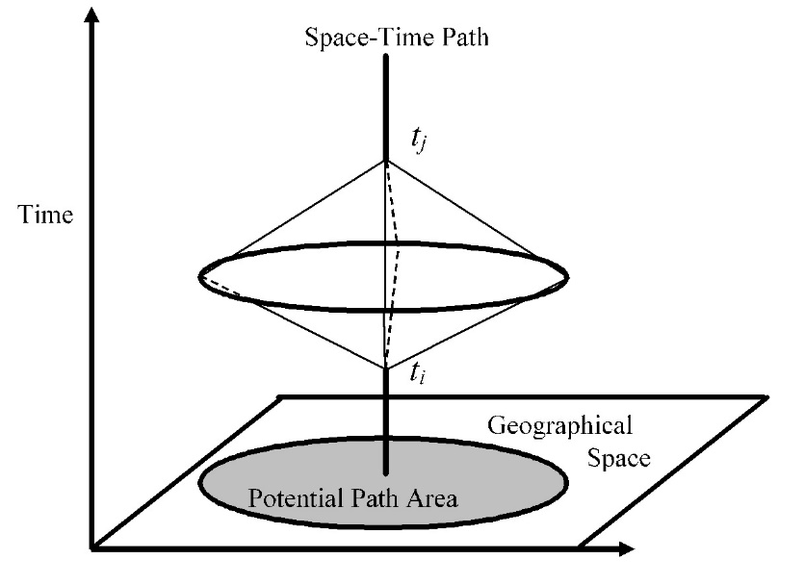
Figure 1. The Space-Time prism (R. Loraamm et al. 2020)
The space-time prism itself has undergone continuing, active development in the literature, with improvements and derivative methods focused on elevating the classical space-time prism from a simple, binary bounding volume for movement possibility towards probabilistic realizations (Winter and Yin 2011; Kranstauber et al. 2012; Downs, Horner, et al. 2014; Song and Miller 2014), formulations examining the interactivity among prism volumes (Downs, Lamb, et al. 2014), prisms which account for uncertainty in anchor locations (Kuijpers et al. 2010; Kuijpers and Othman 2017), consideration of kinematics and the physical limits of acceleration and deceleration on the mover (Long, Nelson, and Nathoo 2014; Long 2016), the introduction of the notion of a space-time prism in 4 dimensions (Demšar and Long 2019) and examinations in the influence of static spatial context on prism volumes (Miller and Bridwell 2009; Long 2018). Further still, prism research extends into examination of the influence that dynamic or temporally modulated factors in the spatial context have on movement (Loraamm, Anderson, and Burch 2021) and the bounding of prism volumes based on the simulated action of behaviorally-informed agent-based models (Loraamm 2020). Advancements in these methods, for example, are demonstrated in application to issues of conservation and wildlife management enabling better spatiotemporal understandings of animal home range (Long and Nelson 2015), long-distance animal movements (Kuijpers and Technitis 2020), animal-to-animal interactions (Downs, Lamb, et al. 2014), animal-to-roadway interactions (Loraamm and Downs 2016; Loraamm, Downs, and Lamb 2019; Loraamm, Anderson, and Burch 2021), and population-level examination of animal habitat use (R. W. Loraamm et al. 2020). Clearly, incorporating spatiotemporal dynamics into the study of animal movement has proven productive for the disciplines engaged with these methods.
Following this pattern of elevating the degree of realism by which the interior volumes of space-time prisms are modeled, the present research seeks to: (1) introduce the method and provide the first known practical application of a new cost-distance-based, probabilistic voxel space-time prism (CDBPSTP) in efforts to more realistically characterize the unobserved habitat occupancies of animals occurring between the instantaneous positions provided by location-aware technologies, (2) compare the results from the demonstration of the CDBPSTP, itself an extension to the Probabilistic Voxel-Based Space-Time Prism, or PSTP (Downs, Horner, et al. 2014), against equivalent results generated by PSTP as a means to illustrate the CDBPSTP method and separate it from similar approaches including PSTP and the field-based method presented in Long (2018), and (3) discuss the probable impacts and known limitations the method may have as a data analysis tool, following its release in forthcoming literature. The present research addresses these objectives by analysing trajectory data collected for Red Deer (Cervus elaphus) (Hebblewhite and Merrill 2016) and modelling the resistance presented to Red Deer movers in context as a cost surface (in this study, termed a preference surface) derived from a classical habitat selection measure (Manly et al. 2002; Calenge 2006) and a priori knowledge on Red Deer habitat preferences. This preference surface is evaluated from variables capturing environmental factors such as terrain and landcover type, along with known animal geolocations as a measure of observed selection preference.

2.3 Background

2.3.1 Voxels and Space-Time Prisms
The canonical space-time prism is a well-tested conceptual foundation for a range of studies interested in analyzing movement uncertainty between space-time anchors. In its original formulation, the space-time prism returns only a binary bounding of this uncertainty in terms of space and time (Miller 2017; R. W. Loraamm et al. 2020). For early formulations of the space-time prism, locations between space-time anchors are evaluated to establish whether they were accessible or inaccessible to the mover during the time and space elapsed between the observed space-time anchor locations. For each evaluated location, this determination of accessibility can be constructed as a piecewise function with inputs including the expected maximum velocity of the mover, the Euclidean distance the evaluated location deviates from the space-time path, and time-budgeting parameters derived from the spatiotemporal locations of the space-time anchor pair under analysis (Equation 1). While formulations for evaluating the space-time prism in continuous space and time exist (Winter and Yin 2011), in practice a discretization of time and space is necessary for simplification and for meeting practical computational concerns (Downs, Horner, et al. 2014; R. W. Loraamm et al. 2020). One widely employed, atomic-level discretization for this purpose is the voxel, a regularly shaped volume of space (X/Y) and time (Z-axis) for which calculations are evaluated from the perspective of its 3D centroid, and then generalized for the entire volume (Huisman and Forer 1998; Downs, Horner, et al. 2014; R. Loraamm et al. 2020). Often, voxel data are modeled in GIScience as regular multidimensional arrays, otherwise known as tensors, stored in a raster data structure or equivalent (R. Loraamm et al. 2020).

${STP}_{x_{a}}=\left\{\begin{matrix}1, \\ 0,\end{matrix}\begin{aligned} if \left\|x_{a}-x_{i}\right\|≤\left(t_{a}-t_{i}\right)s_{ij}∧\left\|x_{j}-x_{a}\right\|≤\left(t_{j}-t_{a}\right)s_{ij} \\ otherwise\end{aligned}\right.$ (1)

Where:
$\left\|x_{x}-x_{x}\right\|$is the Euclidean distance from current voxel centroid location $x_{a}$ to either space-time anchor location $x_{i}$ or $x_{j}$,$t_{a}$ is the voxel Z-axis midpoint associated with $x_{a}$, and $\left(t_{a}-t_{i}\right)s_{ij}$, $\left(t_{a}-t_{j}\right)s_{ij}$ give the maximum distances the object could have successfully traversed between the anchors, given the time elapsed and remaining between $x_{i}$ and $x_{j}$, respectively, considering the object’s expected maximum speed, $s_{ij}$.
While early space-time prisms have served in a range of applied studies, the prevailing understanding holds that interior volumes of space-time prisms are not homogeneous, as movement opportunity is not equally distributed over space and time for the mover (Winter and Yin 2011; Downs, Horner, et al. 2014; Dodge et al. 2016; Loraamm, Anderson, and Burch 2021). As an early improvement on the binary bounding action of the classical space-time prism, Downs et al. (2014a) introduced the Voxel-Based Probabilistic Space-Time Prism, where a mover’s chance of having occupied any given voxel location over the time and space elapsed between space-time anchors is assigned as a function of that voxel’s deviation from the space-time path (Equation 2). This relationship of distance-decay in the probability that a mover will deviate from the shortest path between anchors is reminiscent of theoretical findings on the principle of least effort, applicable in both animal and human mover contexts (Zipf 1949). Applying the PSTP method, the action of Equation 1 first isolates the set of accessible voxels. Next, Equation 2 assigns occupancy probabilities for voxels, leveraging an inverse-distance weighting function for all voxels present in a particular space-time disk, that is, the set of accessible voxels sharing a common z-axis midpoint location, or representing the same unit of duration. Voxel duration (alternatively, voxel Z-axis height) is a user-specified parameter in PSTP; the resulting prism volume will include the number of space-time disks necessary to cover the time elapsed between the space-time anchors analyzed. The sum of probabilities in any given PSTP space-time disk will equal 1.0.
$P\left({STP}_{x_{a}}\right)=\frac{\frac{1}{\left\|x_{s}-x_{a}\right\|}}{\sum_{x_{a}∈k}{\frac{1}{\left\|x_{s}-x_{a}\right\|}}}$ (2)
Where:
$\left\|x_{x}-x_{x}\right\|$is the Euclidean distance between the current voxel centroid location $x_{a}$ and the intersection location $x_{s}$ of its host space-time disk $k$, and the space-time path.

Often, a need presents for the aggregation of probabilities among disks from a given voxel space-time prism or among disks representing equivalent durations in time between two or more space-time prisms. For this purpose, prior studies have applied the probabilistic OR operation, in this context referred to as the Comprehensive Probability Surface method, dealing with events assumed to be realized from independent spatial processes (Downs, Horner, et al. 2014; Loraamm and Downs 2016). When aggregating, CPS demands that input space-time disks have the same temporal resolution. For inputs differing in temporal resolution, aggregation to the lowest common multiple among the inputs is necessary. Equation 3 provides the CPS operation on two space-time disks, A and B.

$P\left(A\right)∪P\left(B\right)=P\left(A\right)+P\left(B\right)-P\left(A\right)P\left(B\right)$ (3)

2.3.2 A Cost-Distance Based, Probabilistic Voxel Space-Time Prism
While prior work has yielded probabilistic realizations of prism interior volumes following the theoretical principle of least effort, we note in the present research that while a least effort path may reflect the behavioral or biological preferences of the mover, this least effort path is most likely not linear, nor does it traverse a homogeneous context in terms of resistance or conductivity to movement posed by the environment (Long 2018; Loraamm 2020). As an exploration in extending the ideas of probabilistic voxel-based space-time prisms towards more realistic constructions of the interior volume of space-time prisms, we introduce here the concept of a Cost-Distance-Based, Probabilistic Voxel Space-Time Prism (CDBPSTP), along with the ideas of cost distance in traversal of the environment and a requisite extension to the Time Geography theory, notably a least-cost space-time path.
First, a least-cost, space-time path is determined by optimizing for the path of least cumulative cost along a cost surface, where resistance values held in the cost surface may indicate the cost of traversing or willingness of the mover to traverse various types of environments (Zeller, McGarigal, and Whiteley 2012). For relevant calculations in constructing PSTPs that involve deviation from the space-time path, construction of the CDBPSTP performs these measures in terms of deviation from a least-cost space-time path (Equation 5). Further, the step bounding accessible voxels in a CDBPSTP also relies on measures based on cost distances (Equation 5). Together, these extensions yield a prism volume informed in both shape and interior structure by the dynamics of cost-distance.
A Cost Surface in the context of CDBPSTP methodology is a type of map capturing a realistic measure of the resistance or conductance the environment poses to movement for a particular type or species of mover. Cost surfaces may be derived by a range of applicable methods; essentially, the cost surface must capture and represent the relative difficulty or assistance any number of modeled characteristics about the environment may pose to the mover of interest. For the present research, we employ the first-known application of habitat selection methodology in space-time prism construction by using habitat selection analysis to inform the multivariate cost surface (as a preference surface) for our demonstration species of interest, the Red Deer (Cervus elaphus). This approach is discussed in detail in the methods sections of this document.
$CDB{STP}_{x_{a}}=\left\{\begin{matrix}1, \\ 0,\end{matrix}\begin{aligned} if 〈x_{a}-x_{i}〉≤\left(t_{a}-t_{i}\right)s_{ij}∧〈x_{j}-x_{a}〉≤\left(t_{j}-t_{a}\right)s_{ij} \\ otherwise\end{aligned}\right.$ (4)

Where:
$〈x_{x}-x_{x}〉$is the Cost distance from current voxel centroid location $x_{a}$ to either space-time anchor location $x_{i}$ or $x_{j}$,$t_{a}$ is the voxel Z-axis midpoint associated with $x_{a}$, and $\left(t_{a}-t_{i}\right)s_{ij}$, $\left(t_{a}-t_{j}\right)s_{ij}$ give the maximum distances the object could have successfully traversed between the anchors, given the time elapsed and remaining between $x_{i}$ and $x_{j}$, respectively, considering the object’s expected maximum speed, $s_{ij}$.
$P\left({CDBSTP}_{x_{a}}\right)=\frac{\frac{1}{〈x_{s}-x_{a}〉}}{\sum_{x_{a}∈k}{\frac{1}{〈x_{s}-x_{a}〉}}}$ (5)
Where:
$〈x_{x}-x_{x}〉$is the Cost distance of traversal between the current voxel centroid location $x_{a}$ and the intersection location $x_{s}$ of its host space-time disk $k$, and the least cost space-time path.

2.3.2 The Red Deer and the Ya Ha Tinda Deer Population
Red deer (Cervus elaphus), shown here in Figure 2, are foraging ungulates exhibiting residential and migratory populations in the wild (Hebblewhite, Merrill, and McDermid 2008). The Red Deer (alternatively known by the common name “Elk” ) population examined for the present study has been examined extensively in the literature (Sachro, Strong, and Gates 2005; Hebblewhite et al. 2006; Hebblewhite, Merrill, and McDermid 2008). While red deer have been researched in multiple montane ecosystems (Hebblewhite and Merrill 2009; Ciuti et al. 2012; Meisingset et al. 2013; Middleton et al. 2013; Prokopenko, Boyce, and Avgar 2017), this research focuses on the herd located in and around Banff National Park (BNP) and the nearby Ya Ha Tinda (YHT) Ranch in Alberta, Canada, found along the eastern faces of the front and main ranges of the Canadian Rocky Mountains (Hebblewhite et al. 2006). During the time that the deer in this study were observed, recent wolf protection measures in BNP had resulted in greater wolf survival in BNP; the YHT herd engages in trade-offs between forage quality and level of exposure to risk of wolf predation, and the YHT Ranch experiences human activity in summer that may induce the wolf population to avoid the area, lowering risk for deer located on the ranch (Hebblewhite et al. 2006; Hebblewhite and Merrill 2009). The YHT population in particular is partially migratory and partially residential in terms of its seasonal movement behaviors. During the spring migration (May or June), migratory individuals move west from the YHT Ranch area, located east of BNP, into BNP and spend the summer season there. This migratory herd returns to the YHT grasslands during the autumn migration (late September to December) (Hebblewhite et al. 2006). Resident deer remain on the YHT Ranch year-round, and up to 90% of the herd are found on the YHT Ranch in winter as migratory members of the herd tend to move toward the YHT area during the autumn migration (Hebblewhite et al. 2006).
Hebblewhite et al. (2006) produced migration data for radiocollared deer from the YHT herd from 1977 to 1980 and from 2002 to 2004 by calculating the midpoint date between two consecutive location points that are each located in a different migratory range. The midpoint date for spring migration (when migratory individuals move from the YHT Ranch to BNP for the summer season) is shown to be June 9 and June 1 with standard deviations of 14.4 and 13.2 for 2002 and 2003, respectively. The midpoint date for autumn migration (when migratory individuals move from BNP to the YHT winter range) is October 30 (with a standard deviation of 27.2) and October 2 (with a standard deviation of 27.1) for 2002 and 2003, respectively. Compared to the earlier years of the study, fewer deer individuals migrate into BNP; roughly 25% of the proportion of the herd that historically migrated in the 1970s continued to do so in 2002 and 2003, and those deer completed the autumn migration nearly one month earlier than was typical in the 1970s. Correspondingly, the number of individuals remaining on the YHT range through the summer increased over 10 times from 1977 to 2002-2004, an unexpectedly large increase even when factoring in the simultaneous population growth (Hebblewhite et al. 2006).
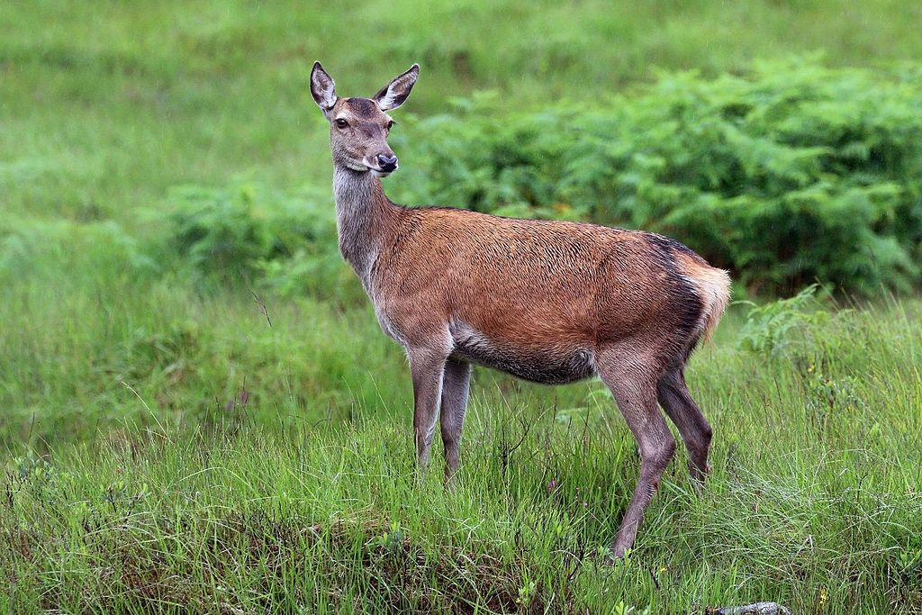
Figure 2. A Red Deer (Cervus elaphus) hind. Photo credit Charles J. Sharp (2016).

2.4 Methods

2.4.1 Red Deer Trajectories and Study Area Context
Collar-based tracking data for Red Deer used in this research were captured and later released in the public domain by Hebblewhite, Merrill, and McDermid (2008). This large set of trajectory data generated by their work was obtained through Movebank.org, an online platform cataloguing animal tracking data (Hebblewhite and Merrill 2016). Hebblewhite et al. collected these trajectories using GPS and VHF telemetry during 2002, 2003, and 2004 in support of research examining the relationship between deer foraging preferences, environmental factors, and migratory behaviours among Red Deer in the Canadian Rocky Mountains. In total, the Hebblewhite study involved 119 deer individuals, all of which were female, with 59% of the studied group behaving in a migratory pattern and the remaining 41% being generally residential in their movements. These deer were monitored and located on a weekly basis, and corresponding GPS data was logged on a 2-hour schedule (Hebblewhite, Merrill, and McDermid 2008).
Defining the bounds of the study area for this research confines interest to areas where the collection interval for data is found to be most consistent, resulting in a consequent filtration of data to winter-only movement patterns centered on the extent of the YHT Ranch (Figure 3). Study area delineation represents an important methodological step in the approach employed for this research, as the extent of environmental context underlying selected trajectories establishes the distribution of environmental characteristics and landcover types available to studied deer.
For cost surface construction, hereafter referred to in this study as a preference surface, simultaneous analysis of both migratory and residential segments of the tracked population would unfairly represent the distribution of environmental conditions and habitat available to migratory individuals who typically spend a large amount of time (up to approximately 7 months) within the winter range versus shorter time intervals (approximately 2 to 6 days) traversing longer distances during migration periods. Therefore, the present research has filtered the available trajectories for only those which occur within the YHT grassland boundary; additionally, six deer were shown to be logged relatively consistently for this winter-only period from November to May during 2002 to 2004 with an extent of traversal largely intersecting the YHT Ranch boundary. Deer in this subset represent members of the migratory population performing their routine winter visitation of the YHT Ranch area (Hebblewhite, Merrill, and McDermid 2008). Here, limitations related to the degree to which the deer’s usage and availability of environmental characteristics are represented are relaxed, by selecting migratory deer found in a common environmental context (the YHT Ranch area) and timeframe (the winter season, during which movements are observed to be more localized compared to longer-distance migratory movement). Descriptive statistics for the six deer trajectories selected and associated winter timeframes are shown in Table 1.
Table 1. Summary of movement trajectory data for six deer. Two date ranges are necessary due to the split in winter months from the beginning to the end of the year.
Deer ID | Number of points | Average time interval (s) | Average distance (m) | Average velocity (m/s) | Date range 1 (mm/dd/yyyy) | Date range 2 (mm/dd/yyyy)
GR193 | 358 | 18422.514 | 872.322 | 0.046 | 04/05/2002-05/22/2002 | 11/01/2002-11/23/2002
YL25 | 3635 | 5594.509 | 250.569 | 0.050 | 03/03/2003-05/31/2003 | 11/01/2003-03/26/2004
YL29 | 2522 | 5522.593 | 263.901 | 0.057 | 03/03/2003-05/29/2003 | 11/01/2003-01/14/2004
YL5 | 1595 | 7249.618 | 307.282 | 0.060 | 2/14/2003-05/29/2003 | 11/09/2003-12/11/2003
YL73 | 2310 | 2816.078 | 220.852 | 0.082 | 2/20/2004-5/03/2004 | 10/23/2004-11/2/2004
YL78 | 1024 | 7354.746 | 465.680 | 0.063 | 2/19/2004-5/16/2004 | n/a

Practical study area delineation follows from the selection of trajectories with the application of the Characteristic Hull Polygon (CHP) approach (Downs and Horner 2009) to the complete set of selected geolocations. The CHP represents a deterministic home range delineation method shown to reduce or avoid areal overestimation issues inherent to the often employed minimum convex polygon (MCP) (Mohr 1947) and kernel-density based methods. Once the CHP boundary was obtained for the trajectories of interest, a buffer having a width of 3178.046473 meters was added to accommodate unobserved deer movements beyond the tracked points. This distance is the longest distance between two points where the time elapsed between the two points is equal to or less than the mean time elapsed for the entire dataset of six individuals’ trajectories. Selecting the longest distance between two points based on the mean time elapsed reduces variation caused by varying timespans between location fixes. The buffered CHP boundary represents the final footprint enclosing the available environmental context used for this study.
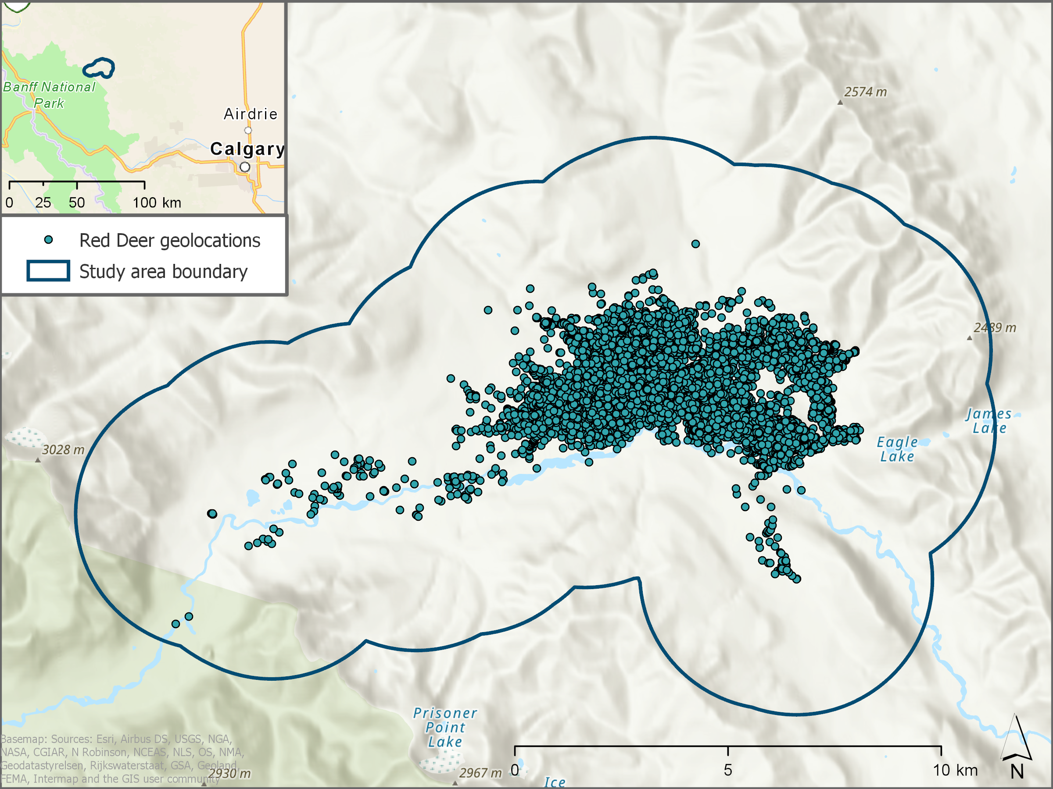
Figure 3. Study area with overlaid Red Deer geolocations analyzed.

2.4.2 Preference Surface Development Process
Having obtained a boundary which is thought to be reasonably inclusive of unobserved movements, we proceed to evaluate the relative abundances of particular types or factors of environmental context which underlie deer locations as a proxy for animals’ habitat selections. While environmental context may refer to numerous factors such as predators, competitors, or disease, this study focuses on landcover, elevation, slope, and roadways as representations of the environment in the study area for the preference surface. The ultimate result of this examination is a raster surface reflecting a single variable that represents the degree to which environmental factors are selected or avoided by the YHT population of deer; in other words, lower values (or higher values) on the preference surface mean that more environmental factors in that location were preferentially selected (or avoided), respectively. Because the surface represents a degree of selectivity, this study refers to it as a preference surface and will refer to the values held in the surface as resistance values, since the values function in a least-cost path analysis the same way that a typical cost surface’s values would, as discussed later.
Raster datasets depicting landcover type (Latifovic 2017; Latifovic, Pouliot, and Olthof 2017) and elevation and slope (Natural Resources Canada 2016) for the study area were collected and masked to the study area extent as indicators for environmental characteristics. The landcover dataset was assessed to have 76.60% accuracy (Latifovic, Pouliot, and Olthof 2017), and this study used the Level I classification scheme (see Table 3 for list of landcover types). A relatively simple measure of habitat preference in terms of use versus availability, Manly’s selection ratio was applied to obtain a measure of habitat selection or avoidance observed in the YHT population during the winter season, given the GPS relocations among the six deer selected as an indication of used habitat types and the proportions of environmental characteristics available within the study area (Manly et al. 2002) at a p value of 0.05. Operationalized as the function wi in the adehabitatHS R package (Manly et al. 2002; Calenge 2006), the wi function for Type I design analysis is capable of assessing both habitat availability and usage for a population (Thomas and Taylor 1990).
Manly’s selection ratio returns higher values for positively selected habitat and lower values for avoided habitat types. Due to this convention, results cannot be directly used to construct a preference surface which represents increasing avoidance of habitat types with increasing magnitude of resistance values. To translate the resulting Manly selectivity measures to this more conventional format, rasters for slope, landcover, and elevation were reclassified to their respective Manly selectivity measures, rounded to the nearest integer. In situations where the Manly selectivity measure was near one, corresponding to either very weak selectivity or very weak avoidance, values were defaulted to 1.0 to avoid divide by zero errors in later analysis. Following the methodology presented in Shafer et al. (2012), all three Manly selectivity measure rasters were transformed to binary rasters depicting habitat use (a value of 0) or avoidance (a value of 1). One additional binary variable capturing the effect of a 250-meter buffer around roadways occurring in the study area was prepared separately from a dataset depicting roads (Statistics Canada 2009), with areas inside the 250-meter buffer set as areas of avoidance, consistent with observed Red Deer preferences in regard to roads (Gagnon et al. 2007; Meisingset et al. 2013). Finally, all binary use/avoidance rasters were added together plus a value of 1, to prevent values of 0 influencing later cost distance calculations to yield a single preference surface (landcover binary raster [BR] + slope BR + elevation BR + roadway BR + 1) (Figure 4).
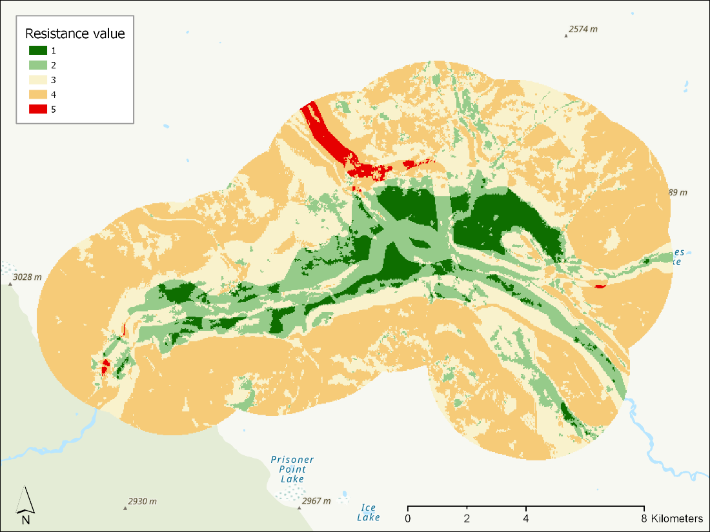
Figure 4. Preference Surface developed for the Study Area.

2.4.3 Applying CDBPSTP and PSTP to Red Deer Trajectories
The CDBPSTP approach as described in this research has been operationalized in an extension to the PySTPrism toolbox which is unreleased at the time of this writing (R. Loraamm et al. 2020). This CDBPSTP implementation was used to generate prism results for the present study. PySTPrism provides a set of voxel-based space-time approaches as an ArcGIS Pro toolbox, compatible with the ArcGIS Pro desktop application from Esri Inc. For each voxel-based prism function found in the toolbox, the interface for the function expects users to supply: (1) an input trajectory dataset as point vector data, (2) the desired X/Y spatial resolution for voxels in the map units of the input data’s coordinate system, (3) the desired Z-axis resolution for voxels in seconds, (4) an optional “Expand Edges” multiple which intentionally expands the processing extent ensuring no results are “cut off” from visualization and (5) a value for the velocity multiplier parameter. The velocity multiplier is a value used to scale the observed velocity of the mover between two consecutive space-time anchors; this parameter is meant to account for the assumed straight-line movements captured in trajectories. Since straight-line, top-speed movements are rare for terrestrial animals’ routine traversal in a varied environmental context, the velocity multiplier offers a means to adjust the reachable distances expressed as terms in Equations 4 and 5, such that prism results do not simply converge to the least-cost space-time path, resulting in a prism having zero volume (Downs, Horner, et al. 2014; R. Loraamm et al. 2020; R. W. Loraamm et al. 2020; Loraamm, Anderson, and Burch 2021).
Selection of an appropriate velocity multiplier value is important, as prism bounds and associated assignment of probabilities are all sensitive to the movement capabilities of the object under study. To realistically estimate a velocity multiplier relating the actual top speed of Red Deer tracked for this study, the observed maximum velocity of the trajectory was divided by all observed straight-line velocities for each of the six selected deer trajectories, respectively, producing velocity multipliers specific to sequential pairs of space-time anchors. For each deer, the average of all anchor-pair velocity multipliers yielded a single velocity multiplier tailored towards the individual capabilities of each deer trajectory supplied for CDBPSTP analysis.
The six deer trajectories selected for this analysis contain 11,444 geolocations or fixes in total, reflecting an exhaustive traversal of the YHT ranch area (Figure 3). For the demonstrative goals of this research, representative space-time anchor pairs were extracted from this set where each selected pair captured a particular movement scenario through the varied context of the study area. To make these selections, 18 anchor pairs representing three distance categories, long (approximately 1100-2000 meters), medium (300-800 meters), and short (less than 200 meters) were isolated (Table 2). The selected anchor pairs were assigned a label associating them with high (predominantly values of 4 and 5), medium (predominantly values of 2, 3, and 4), or low resistance (predominantly values of 1 and 2). Resistance here refers to the values of cells in the preference surface which lie between the two anchors. Once isolated, each of the 18 anchor pairs was supplied as an input to the CDBPSTP function, with parameters including an output cell size of 30 meters, an Expand Edges factor of 1.0, and the velocity multiplier corresponding to the pertinent ElkID in Table 2. Once CDBPSTP prism disks were generated, the CPS technique was applied to the results of each anchor pair to generate occupancy probability surfaces for each pair. As a means to facilitate discussion of the occupancy surface results, zonal descriptive statistics were generated from occupancy surfaces, summarizing the incidence and total probability of occupancy over landcover types. This operation demonstrates an overall view of CDBPSTP’s suggestion of Red Deer habitat occupancy given the inputs.
To provide a comparison between the CDBPSTP method and the PSTP method, this study also generated a PSTP for each point-pair in Table 2, representing a medium distance and overall low, but varied, resistance values. The parameters were identical to those used for the CDBPSTP generated for the same trajectory sample, and CPS was employed to these PSTP results in an identical manner.

Table 2. Selected space-time anchor pairs illustrating various traversal scenarios in the study area.
Distance | Resistance | Code | ElkID | Point  Features | Distance (m) | Elapsed  Time (s) | Velocity (m/s) | Resistance  Values
Long | High | LH_GR193 | GR193 | 694, 695 | 1864.41739 | 14400 | 0.12947343 | 1, 2, 3, 4, 5
Long | High | LH_YL78 | YL78 | 5, 6 | 1620.253693 | 7260 | 0.223175 | 2, 3, 4, 5
Long | Medium | LM_YL25 | YL25 | 5711, 5712 | 1955.097556 | 14400 | 0.135771 | 1, 2, 3, 4
Long | Medium | LM_YL29 | YL29 | 303, 304 | 1327.663144 | 7200 | 0.184398 | 1, 2, 3, 4
Long | Low | LL_YL29 | YL29 | 308, 309 | 1186.757324 | 7260 | 0.1634652 | 1, 2
Long | Low | LL_YL5 | YL5 | 518, 519 | 1395.244368 | 7200 | 0.193784 | 1, 2
Medium | High | MH_YL78 | YL78 | 6, 7 | 589.971924 | 7260 | 0.081263 | 2, 3, 4, 5
Medium | High | MH_YL5 | YL5 | 1, 2 | 426.724348 | 7260 | 0.058777 | 1, 2, 3, 4, 5
Medium | Medium | MM_YL25 | YL25 | 4984, 4985 | 362.959741 | 900 | 0.403289 | 3, 4
Medium | Medium | MM_YL78 | YL78 | 231, 232 | 417.577379 | 7200 | 0.057997 | 1, 2, 3, 4
Medium | Low | ML_YL29 | YL29 | 812, 813 | 416.513625 | 7200 | 0.057849 | 1, 2
Medium | Low | ML_YL5 | YL5 | 513, 514 | 757.321744 | 7200 | 0.105184 | 1, 2
Short | High | SH_YL73 | YL73 | 9597, 9598 | 79.025246 | 3660 | 0.021592 | 3, 4, 5
Short | High | SH_YL5 | YL5 | 307, 308 | 170.104176 | 7200 | 0.023626 | 3, 4, 5
Short | Medium | SM_YL73 | YL73 | 22, 23 | 140.307356 | 3540 | 0.039635 | 2, 3
Short | Medium | SM_YL78 | YL78 | 675, 676 | 178.103747 | 7200 | 0.024737 | 2, 3
Short | Low | SL_YL73 | YL73 | 377, 378 | 179.104847 | 900 | 0.199005 | 1, 2
Short | Low | SL_YL29 | YL29 | 888, 889 | 141.297352 | 7200 | 0.019625 | 1, 2

2.5 Results
Results pertinent to the expressed targets of this study include the results of Manly’s selection ratio, which represents the analysis product on which the preference surface is based, along with mapping and summary statistics for occupancies returned by CDBPSTP and PSTP prism approaches.

2.5.1 Results of the wi function
Based on the complete deer trajectories of the six individuals selected for this study, relative proportions of observed occupancies and availabilities were collected for variables of landcover type, slope, and elevation. Manly’s selection ratio, operationalized as wi, expects habitat occupancies and availabilities as inputs and compares the count of occupied locations for each contextual variable versus the corresponding count of available locations for each variable. Occupied locations consist of the locations where deer space-time anchors were found, or stated alternatively, the locations of deer GPS location fixes, and available locations are represented as cells in each raster that belong to particular variables. Interpretation of the resulting Manly selectivity measure value follows where higher values indicate higher selection of the particular context type than expected. Pseudo-significance for this measure is expressed in terms of a p-value, interpretable as the magnitude of the chance that returned Manly selectivity values are the result of random chance in habitat selections. For this research, selectivity measures were considered significant if p-values were shown below the Bonferroni level corresponding to an alpha = 0.05, translating roughly to a 95% confidence the results are significant (in other words, there is a 5% chance that the null hypothesis was incorrectly rejected if it was true). Manly selectivity measures close to zero indicate avoidance beyond what would be expected at random, given availability of habitat types and animal selection, while values greater than 1 indicate preference with increasing intensity.
For landcover types occupied, particular results of interest include Needleleaf forests and grasslands. Needleleaf forests were highly available in the study area but were weakly selected by deer. Conversely, Grasslands were much less abundant but were found to be much more strongly selected by individuals. Considered from the perspective of available animal relocations, roughly 75% of the deer’s locations occurred on grassland, which made up just under 20% of the available study area’s land cover distribution. The Manly selectivity measure represents this interaction as an easily interpreted single value statistic, found to be significant (by randomization). Manly selectivity results for landcover classes are shown in Table 3.
Table 3. Results of the wi function for Red Deer usage of various landcover classes.
Landcover class | Proportion used | Proportion available | Manly selectivity measure | p-value (Bonferroni level = 0.005)
Needleleaf forest | 0.075 | 0.597 | 0.125 | <0.005
Broadleaf forest | 0.002 | 0.002 | 0.838 | 0.363
Mixed forest | 0.003 | 0.005 | 0.586 | <0.005
Shrubland | 0.155 | 0.054 | 2.882 | <0.005
Grassland | 0.746 | 0.195 | 3.836 | <0.005
Lichen/moss | 0.000 | 0.000 | 0.000 | <0.005
Wetland | 0.004 | 0.010 | 0.379 | <0.005
Barren land | 0.000 | 0.124 | 0.000 | <0.005
Urban and built-up | 0.011 | 0.002 | 4.423 | <0.005
Water | 0.004 | 0.011 | 0.390 | <0.005

Additionally, it is useful to visualize these results in a ranked order, with decreasing selectivity shown to the right of the graph in Figure 5. Here, we note an outlying although significant propensity for deer to utilize Urban and built-up areas. This is consistent with known Red Deer behaviors where roadways present a “soft barrier” to traversal, possibly resulting in this strong selection of built-up areas (Ciuti et al. 2012; Jacobson et al. 2016; Loraamm and Downs 2016; Prokopenko, Boyce, and Avgar 2017; Loraamm, Anderson, and Burch 2021). The behavioral mechanisms underlying this selection may be complex, but where considered at a basic level, deer hesitancy to cross a busy road until traffic has cleared could amount to one factor inflating their use of urban and built-up areas. Additionally, built-up areas make up 0.2% of the study area; the low availability used as a denominator in the RSF may be further inflating the preference value for this landcover category.
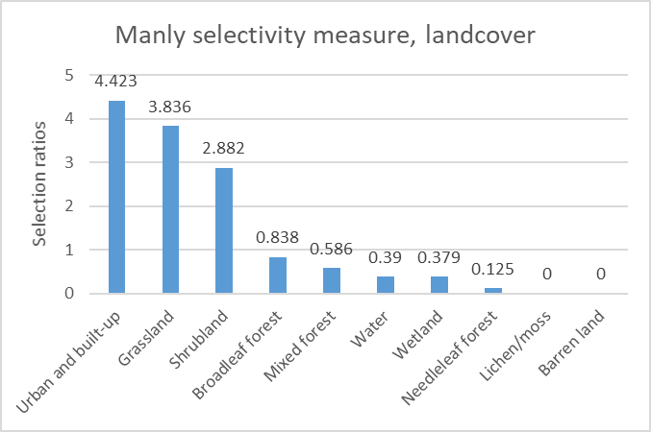
Figure 5. Results of the wi function graphed in descending order, for Red Deer usage of landcover.
Similar treatment of occupied versus available context for slope (measured in degrees) was also completed. Table 4 and Figure 6 summarize the corresponding Manly selectivity measures for this variable. Findings of note include the general avoidance of areas with slope exceeding 7 degrees in the study area, for the individuals observed. It is unknown whether this result is influenced by any particular characteristics common to the tracked individuals or their context; for example, all deer were female, and all geolocations were captured during the winter migration period. Still, this result is consistent with notions of the principle of least effort, where less strenuous routes across the landscape would be preferred.
Table 4. Results of the wi function for Red Deer usage of various classifications of slope.
Bin # | Slope (degrees) | Proportion used | Proportion available | Manly selectivity measure | p-value (Bonferroni level = 0.00625)
Bin 1 | -1 to 7 | 0.803 | 0.355 | 2.261 | <0.00625
Bin 2 | 7 to 15 | 0.134 | 0.295 | 0.453 | <0.00625
Bin 3 | 15 to 23 | 0.061 | 0.161 | 0.376 | <0.00625
Bin 4 | 23 to 31 | 0.003 | 0.118 | 0.025 | <0.00625
Bin 5 | 31 to 39 | 0.000 | 0.050 | 0.000 | <0.00625
Bin 6 | 39 to 47 | 0.000 | 0.013 | 0.000 | <0.00625
Bin 7 | 47 to 55 | 0.000 | 0.006 | 0.000 | <0.00625
Bin 8 | 55 to 63 | 0.000 | 0.002 | 0.000 | <0.00625

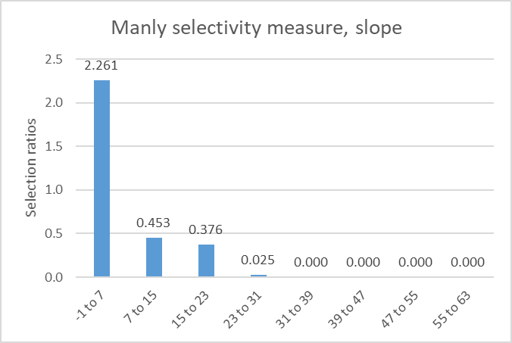
Figure 6. Results of the wi function graphed in descending order, for Red Deer usage of varying classes of slope (degrees).
Manly selectivity measures for occupied versus available elevation were also calculated. Table 5 and Figure 7 summarize the corresponding Manly selectivity measures for this variable. For elevation, usages are most pronounced between roughly 1500 and 1600 meters. This result may be consistent with the occurrence of particular forage or grasses eaten by Red Deer, or coincident with the elevation of the Ya Ha Tinda ranch and surrounding areas as this location represents high-value habitat overall in the study area. Further, the pattern in occupied elevations is generally collinear with the pattern in occupied slope classes. This dynamic could be seen as an illustration of the landscape present in the Banff National Park area itself, an alpine landscape with high local relief in elevation. The complexity inherent to Red Deer movement behavior along varied terrain and the configuration of their environment may be reflected in this result.
Table 5. Results of the wi function for Red Deer usage of various classifications of elevation.
Bin # | Elevation (meters) | Proportion used | Proportion available | Manly selectivity measure | p-value (Bonferroni level = 0.00625)
Bin 1 | 1516 to 1676 | 0.885 | 0.256 | 3.454 | <0.00625
Bin 2 | 1676 to 1836 | 0.112 | 0.302 | 0.370 | <0.00625
Bin 3 | 1836 to 1996 | 0.003 | 0.184 | 0.018 | <0.00625
Bin 4 | 1996 to 2156 | 0.000 | 0.148 | 0.000 | <0.00625
Bin 5 | 2156 to 2316 | 0.000 | 0.071 | 0.000 | <0.00625
Bin 6 | 2316 to 2476 | 0.000 | 0.027 | 0.000 | <0.00625
Bin 7 | 2476 to 2636 | 0.000 | 0.011 | 0.000 | <0.00625
Bin 8 | 2636 to 2796 | 0.000 | 0.002 | 0.000 | <0.00625

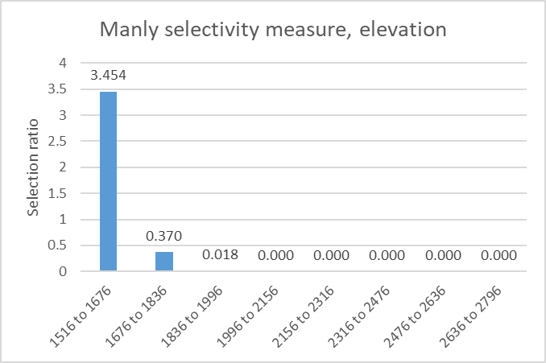
Figure 7. Results of the wi function graphed in descending order, for Red Deer usage of varying classes of elevation (meters).

2.5.2 Results of the CDBPSTP Approach
Towards facilitating a comparison in methodology between CDBPSTP and PSTP, a representative result for a single point pair, ML_YL29 (see Table 2) was chosen for presentation. The space-time anchor pair visualized in these results comes from Deer YL29’s trajectory, during the animal’s traversal of part of the central-northeast portion of the study area (51.7467323°N, 115.5366602°W). The traversal shown navigates across an area peripheral to a stand of Needleleaf forest, with adjacent shrubland and grassland areas available (Figure 8). Corresponding resistance values for this environmental context are visualized for the anchor pair as well (Figure 8, inset map).
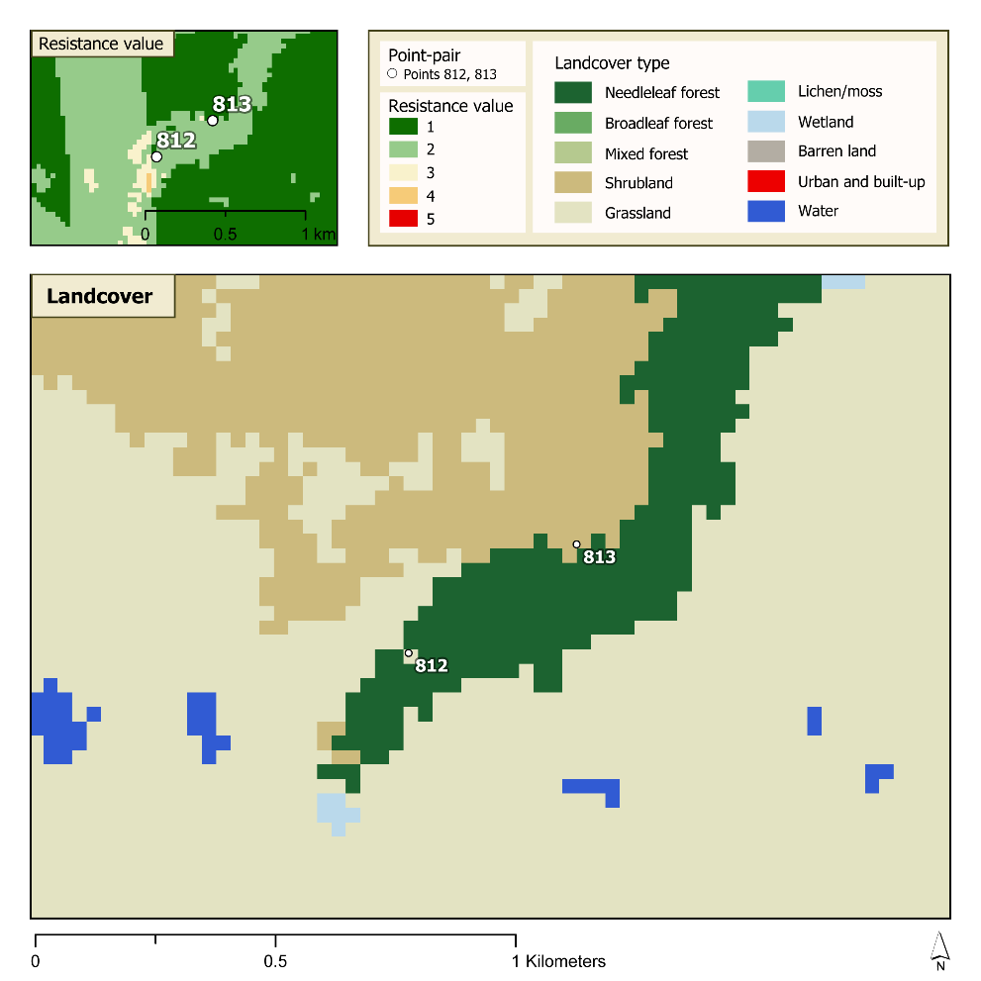
Figure 8. The landcover underlying point-pair ML_YL29 is shown in the main map, while the resistance values are displayed in the inset map.
Results of the CDBPSTP generated for this anchor pair in context are shown in Figure 9. Per the animal’s path of traversal reconstructed by CDBPSTP, available shrubland and grassland areas were preferred to passage through Needleleaf forest. This pattern is consistent with CDBPSTP’s methodological notion of a least-cost, space-time path, which itself is an optimal path of traversal minimizing travel cost as a function of environmental context. This is an alternative mechanism to the straight-line, Euclidean space-time paths considered in PSTP. Additionally, the distribution of occupancy probabilities found diverging from the least-cost space-time path appears imprinted with the underlying variation in the preference surface, an indication of the consideration of cost-distance in the assignment of occupancy probabilities step of CDBPSTP. The animal’s path as suggested by CDBPSTP in Figure 9 denotes an avoidance of areas consistent with a priori knowledge about Red Deer habitat preferences, ranked using a Manly selectivity approach encoded as preference surface values.
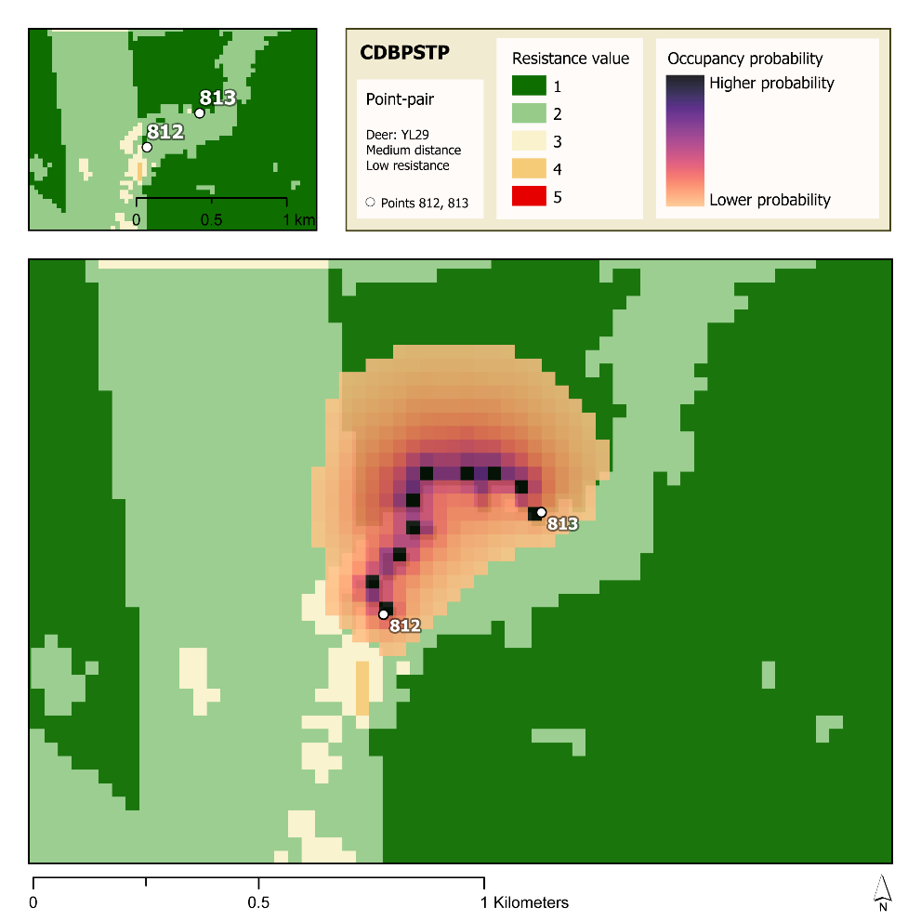
Figure 9. An occupancy probability surface shown at slight transparency for point-pair ML_YL29, generated by the CDBPSTP model based on the preference surface displayed, where darker colors signify higher probabilities that the deer was located at that site as it traveled from point 812 to point 813.

2.5.3 Results of the PSTP approach for comparison
A PSTP was also constructed for point-pair ML_YL29 (Figure 10). The visualization of this approach demonstrates PSTP’s reliance on a Euclidean realization of the space-time path, with assigned occupancy probabilities having magnitudes that are a function of distance-decay from that space-time path. In the absence of consideration for environmental context, the Euclidean-based space-time path is treated as the best-available path when reconstructing a mover’s path between two instantaneous location captures. However, with a visual comparison between the CDBPSTP (Figure 9) and the PSTP (Figure 10) results, the influence of reasonably modeled context on the path of a mover can be significant.
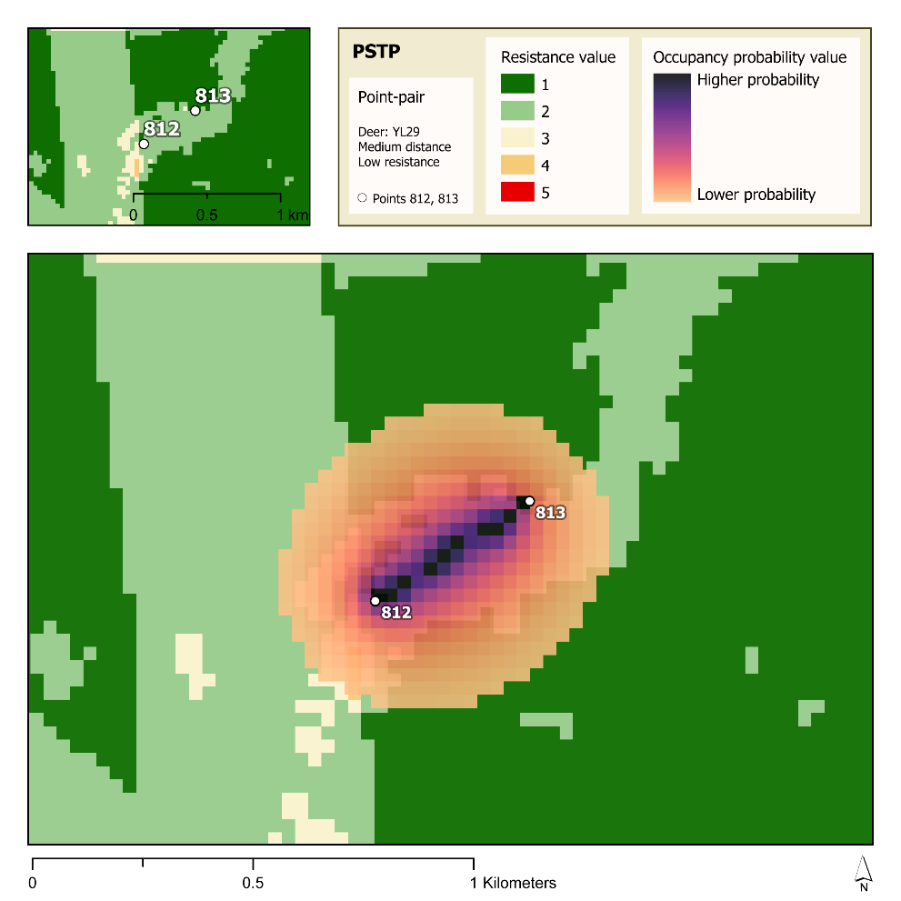
Figure 10. An occupancy probability surface shown at slight transparency for point-pair ML_YL29, generated by the PSTP model, where darker colors signify higher probabilities that the deer was located at that site as it traveled from point 812 to point 813.
In terms of the summarized occupancy probabilities from each of the CDBPSTP and PSTP results shown, the dynamic in the influence environmental context can be expressed quantitatively (Table 6, Figure 11). Higher sums of occupancy probability suggest higher chances the deer would have occupied the corresponding landcover type during its journey between space-time anchors. For the CDBPSTP results, the highest probability is associated with shrubland (6.688), followed by grassland (2.243), and Needleleaf forest (1.050). In contrast, the PSTP results suggest Needleleaf forest carries the highest probability of occupancy (7.971), followed by shrubland (1.336), and lastly by grassland (0.661). Considered in concert with the knowledge that Red Deer in the YHT Ranch area appear to select for shrubland and grassland over Needleleaf forest, the value of CDBPSTP as an alternative to PSTP is demonstrated. CDBPSTP captures the influence of varied environmental context on movement, provided the characterization of this environmental context is rational and fair to the characteristics and observed behaviors of the mover.
Table 6. The sum of occupancy probabilities for the probability surfaces for point-pair ML_YL29, summed according to the underlying land cover type.
Land cover type | Sum of occupancy probabilities, CDBPSTP | Sum of occupancy probabilities, PSTP
Needleleaf forest | 1.050 | 7.971
Shrubland | 6.688 | 1.336
Grassland | 2.243 | 0.661
Wetland | 0.002 | 0.003
Water | 0.005 | 0.009

Figure 11. The bar chart visualizes the differences between the sums of occupancy probabilities calculated for point-pair ML_YL29 for the CDBPSTP (left side, blue) and the PSTP (right side, orange).

2.6 Discussion
The CDBPSTP approach demonstrated in this study offers an alternative construction of the space-time prism, where the resistances presented by the mover’s environment are explicitly considered as an influence on both the probable path and occupancies the mover may have shown between observations of its location. This approach advances time geographic research on space-time prisms by providing a pathway towards a reasonable incorporation of context in probabilistic space-time prism modeling. This contribution represents an approach applicable towards better understandings of animal movement and space use, of interest to conservationists, biologists, and planners. CDBPSTP is methodologically separated from its predecessor PSTP by its explicit incorporation of context as a behaviorally-informed preference surface (more broadly, a form of a cost surface). Furthermore, CDBPSTP is methodologically separated from similar context-aware time-geographic methodologies such as the method employing heterogeneous spatial fields (Long 2018) by CDBPSTP’s focus on leveraging cost distance as a derivative of habitat selectivity, and therefore observed animal behavior. The cost distance derived from a habitat-selection-based preference surface is in contrast to the method used in J. A. Long (2018), where a conductance surface is instead defined in terms of a theoretical maximum achievable speed for the mover.
Limitations associated with the approach in its current demonstration center on issues of scale and generalization, along with concerns surrounding model validation and sensitivity to parameter choices. First, the present study conducted an involved analysis on the habitat selectivity of a particular Red Deer population in a highly selected study area as a means to inform the preference surface. This preference surface is tightly coupled to both the study area and population; for example, applying the resistance valuation scheme generated for this research to similar studies on Red Deer in other areas could amount to Ecological Fallacy. Collecting behavioral preferences and conducting a more general selectivity analysis, perhaps employing the same measures over larger input data representing Red Deer regionally, may relax this limitation.
Additionally, this study focused on four factors (landcover, slope, elevation, and proximity to roadways) pulled from a wide range of influences that make up an animal’s entire environmental context. Other variables that affect where animals move and spend time, such as territorial dynamics, social interaction in an animal population, and predation risk may shed more light on understanding animal movement (Bestley et al. 2013; Langrock et al. 2014). More detailed incorporation of human activity including population, traffic volume, or specific built features (Zeller, McGarigal, and Whiteley 2012) may also help wildlife managers in promoting safer human-wildlife interactions.
With respect to validation, the present study has not sought to establish any measure of internal stability in the results. Ensuring the CDBPSTP approach behaves predictably if provided relatively consistent inputs is a step supporting its adoption for future studies. Future research could apply the preference surface and CDBPSTP methodology to data collected during other timeframes for the same population and compare the results via Bhattacharyya distance, a two-dimensional measure that can determine the separation of distributions of the compared results. Both these “prior” and “future” data sets should be collected under similar conditions.
Further, CDBPSTP is shown to be highly sensitive to the selection and application of the velocity multiplier parameter, as this value corresponds to an estimate of the mover’s top speed, and therefore the extent and interior structure of the resulting prism volume. Advancing the practice of setting this parameter presents as a growth area not just for CDBPSTP research, but for probabilistic space-time prism applications in general. For the present study, an averaged maximum observed velocity to individual anchor-pair velocity ratio was calculated for each individual animal. For a mover traversing real-world context, actual top speed is both unknown at any given time and may be serially influenced by both the last location traversed and the next location ahead of the mover. This translates to infinitely many possible realizations of top speed between any two space-time anchors in context. Also, the behavioral dynamics governing whether or not the mover intended to reach a top speed between anchors cannot be known. CDBPSTP, like other space-time prism methods, always sets outer bounds based on a maximum velocity we assume the mover can actually achieve. It is possible future research could include video or secondary observation of the mover contemporaneous with the collection of space-time anchors/GPS fixes such that some of this dynamic might be described and incorporated into velocity multiplier calculations.
The results of this study have shown that CDBPSTP explicitly considers variation present in a moving agent’s environment and shows the influence that environmental context may have on the probable movements between known locations. This work also shows CDBPSTP is compatible with habitat selection analysis, and the methodology is applicable to species other than red deer because it bases the estimated probability of movement on the population’s specific observed preferences. As a result, different species’ habitat preferences can be represented and considered in the estimation of movements. CDBPSTP’s incorporation of environmental context is an important move toward a more informed understanding of animal movements, beneficial both for conservation efforts now and for future responses to changes in the environment.

Chapter 3: Conclusion

3.1 Extended Discussion
Since its conceptualization by Hägerstrand (1970), time geography has evolved into a discipline with, among other applications, immense potential for understanding animal movement. Gaining a better understanding of animal movement is important to improve conservation and planning efforts, manage wildlife interactions with the built environment, and study populations which are difficult to access. While numerous studies have adapted and developed time-geographic analysis of animal movement, present methods do not consider environmental context based on an animal’s habitat selection preferences directly in the computational stage. The cost-distance based probabilistic space-time prism (CDBPSTP) is a new approach that expands existing methods (notably the voxel-based PSTP (Downs, Horner, et al. 2014)) to more realistically represent movement. This research is the first known demonstration of the CDBPSTP method applied with habitat selection analysis to animal movement trajectory data; inclusion of environmental context to this degree has not been demonstrated in similar work (Long 2018) in time geography literature.
In the second chapter, this study implements a habitat selection analysis for a population of deer in the Banff National Park, Alberta, Canada area, uses the results to integrate environmental context with the CDBPSTP via a preference surface, and compares the results of the CDBPSTP to the performance of the PSTP. The analysis found that the occupancy probability surfaces produced by the CDBPSTP method shows clear responses to the preference surface and in many cases exhibits high probabilities of animal movement in areas that deviate from the space-time path. In comparison to the probability surface produced by the PSTP, the estimated probabilities of occupancy over various types of landcover are very different for the PSTP and the CDBPSTP; the CDBPSTP shows probability values in accordance with selected and avoided landcover types, while the PSTP estimates high probability values in an avoided landcover type.
Overall, this research found that the CDBPSTP responds successfully to the trajectory data and the preference surface used in this study, with occupancy probability clearly varying throughout the prism bounds according to the preference surface values. Because the prism formation is based on the preference surface which in turn is based on the habitat selection analysis, further detail is provided here regarding the data subsetting process, which directly impacts the habitat selection results. The study area used in this research attempts to reduce error stemming from uneven availability of habitat by exploring only elk movements within the known winter range (Ya Ha Tinda Ranch) (Hebblewhite et al. 2006). The winter season is defined as November to May, but the average midpoint dates and associated standard deviations for migration in Hebblewhite et al. (2006) suggest that the migration period can shift up to two weeks before and after both the end of October and the beginning of June. Subsetting the trajectory datasets based on the variation in migration dates published in Hebblewhite et al. (2006) and on the known location of the winter range is important to prevent large variation in observed movement behavior which could arise if residential and migratory movements were treated equally. Trajectory points from all six deer that were logged from November to May during 2002 to 2004 and intersect the YHT Ranch boundary were isolated. The longest distance between two consecutive points of this isolated dataset where the elapsed time between points is equal to or less than the data’s average elapsed time between two points is 2689.919833 meters. The YHT Ranch boundary was then buffered by this distance. The buffer zone allows for the fact that the elk are not necessarily confined by human-designated boundaries and reduces errors that may arise from georeferencing and digitizing the YHT Ranch boundary. Only the winter-month points within the YHT Ranch Boundary were used to generate the buffer distance because those data are likely to represent typical movements during the elk’s winter season (Hebblewhite et al. 2006). The geolocations falling within the buffered YHT Ranch boundary were then considered the dataset for this study and were used to generate the bounds of the study area using the CHP method, as described in Chapter 2. The resulting boundary centering around the winter range encloses the environmental features that are considered available to the studied individuals during the winter season.
Contributing to time-geographic literature that seeks to understand animal movement through space and time, this work is situated at the forefront of continued development of the space-time prism, practically applying the CDBPSTP as an extension of the voxel-based PSTP (Downs, Horner, et al. 2014). The findings of this research show that the CDBPSTP method can be applied in conjunction with habitat selection analysis, which allows the estimated probability of movement to be based on the animal’s observed preferences with greater incorporation of environmental context than seen in similar approaches (Long 2018). This consideration of the environmental setting when modeling movements is a major step toward more completely representing an animal’s movement.
While CDBPSTP is an important contribution to animal movements, the method cannot be as easily applied to human movement. The requirement for a cost surface (whether as a typical resistance surface, a conductance surface, or a preference surface) presents a significant hurdle. Assuming a cost surface can be compiled based on an individual’s capabilities or preferences, from an archaeological perspective, the least-cost path method does not incorporate the individual choices and variation inherent to human movement and problematically offers only a single optimized path (Howey 2011); in reality, humans may prefer paths outside of the least-cost path or change paths in response to numerous influences or decisions (Howey 2011), but despite this hurdle, least-cost path methods are still used in archaeological research (Gowen and de Smet 2020). Interestingly, recent work has shown that least-cost path methods can be incorporated with topography to calculate travel time and energy cost (as kilocalories expended) for humans, but this assumes that the individual follows the constructed least-cost path (Gowen and de Smet 2020). The original challenge of whether a human will consistently follow the least-cost path remains; for CDBPSTP to be used successfully in terms of human movement, the least-cost path needs to be able to accurately plot a single path out of a wide variety of human preferences and reactions to external events.

3.2 Study Limitations

3.2.1 Representing Environmental Influence
While the habitat selection analysis demonstrated in this work does support the CDBPSTP’s consideration of the traversed environment, the variables used (landcover, elevation, slope, and proximity to roads) may not fully represent all environmental factors that influence the deer. Because barriers can impact animal movement (Shafer et al. 2012), the identification of hard and soft barriers to movement beyond the use of a soft barrier along roadways in this study can add important information to the preference surface. The roadway barrier was assigned a binary avoidance value, which means the preference surface holds a higher value (+1) within the roadway barrier zone than without, but the resistance value does not increase by more than any of the other binary selection/avoidance metrics. In comparison, the use of a conductance surface in field-based time geography means certain features such as lakes are designated as hard barriers with no possible movement in the case study on caribou movement (Long 2018). Incorporating hard barriers in CDBPSTP may achieve a similar effect, for features such as large bodies of water or impassable terrain like cliffs, depending on the study species.
Additionally, the environmental factors used in this study were chosen in a combination of the observed terrain and literature on red deer behavior. However, cost surfaces in general should ideally only contain variables that have an influence on the study animal (Zeller, McGarigal, and Whiteley 2012). In the case of the deer in this research, landcover exhibits the most variability across the preference surface, and slope and elevation show low variation in the majority of the study area. Proximity to roads has a localized effect on the raster that does not impact the majority of trajectory points. It is possible that different environmental factors, or different weighting of the chosen environmental factors, may produce a surface that better represents the habitat preferences of the deer. In addition to exploring other variables and barriers that were not included in this research, a weighted-variable preference surface may improve results by allowing for the fact that environmental factors can influence an animal’s behavior and movement to varying degrees (Zeller, McGarigal, and Whiteley 2012). However, weighting various factors in a multivariate preference or resistance surface is challenging and would likely need to be determined for each study population, as there is no set ratio in how each factor should be weighted (Spear et al. 2010). The difficulty in assigning weights to each factor of the surface must be measured against the benefit of a more realistic least-cost path.

3.2.2 Investigating Movement Behavior
In Chapter 2, the occupancy probability values of a CDBPSTP-generated probability surface were summed according to landcover type for comparison to a PSTP-generated probability surface. While these results are used to illustrate the different outcomes of both methods, the investigation of what the probability surface means for the deer’s potential behavior could be extended to visualize the deer’s interaction with each landcover type at a finer timescale using a summarization approach provided by R. W. Loraamm et al. (2020); this approach would generate the probability of the deer occupying various landcovers at different times of day, further exploring the CDBPSTP’s capabilities and assessing how the method in R. W. Loraamm et al. (2020) performs with CDBPSTP-generated occupancy probability values. Another direction to further investigate the CDBPSTP’s probability surface would be to apply the method developed by R. W. Loraamm, Downs, and Lamb (2019) to quantify and visualize the deer’s potential interaction with roads, which can improve understanding of wildlife interactions with fixed features on the landscape. Both of the methods outlined in this section can use the CDBPSTP application in this study and extend the results into actionable information about a studied animal population.

3.2.3 Estimating Velocity
It is also important to note the effect of the velocity multiplier (VM) on prism construction. An agent’s movement when traveling from one point to another is constrained by the location of the points, the time elapsed between points, and the agent’s maximum velocity; in previous research using the PSTP method, studies have used a maximum velocity based on observed movement (Downs, Horner, et al. 2014). Other PSTP approaches have employed an adaptive velocity by setting the VM, which acts like a scaling factor, to counteract the possibility that the observed straight-line velocity generated by GPS points is lower than the true velocity because it does not consider terrain or obstructions to movement (Loraamm, Downs, and Lamb 2019). In both the PSTP and the CDBPSTP methods, the VM can affect the prism construction because it modifies maximum velocity, a central constraint to the bounds of space-time prisms.
It is important to acknowledge that the use of a VM that treats the highest observed velocity in the dataset as a maximum cap assumes that the velocity based on the straight-line distance between points is a realistic measure of an animal’s capabilities. The maximum VM used in this study is based on the observed behavior of deer rather than on a maximum velocity associated with red deer as a species in general. Even though the observed straight-line velocity is also the minimum velocity required for the deer’s movement between points, it is important to use a maximum velocity cap based on the study’s particular population because the subsequent movement analysis depends on velocity as a central constraint. Additionally, the VMs used in this study are specific to each individual deer, to allow for differences in movement capabilities due to age and health. Even with these efforts to derive a representative measure of the deer’s movement capabilities, the VM is ultimately still based on an “ice-rink” or purely Euclidean scenario between anchor points that does not account for any variation in the environment or for responses to events that occur during the time interval. The derivation of an averaged VM that does not exceed the animal’s highest observed velocity can help avoid overestimation of STP bounds in some cases, but it cannot absolutely guarantee that the potential path area will not be underestimated or overestimated in every scenario; further work that improves the estimation of velocity can also improve STP construction and movement representation.

3.3 Future Work
In this section, two areas of future work are presented. Through the course of this research, it has become clear that many of the assumptions underlying time-geographic methods pose a challenge, both in interpretation of results and in adaptation of methods. In particular, maximum velocity derived from anchor points often ignores environmental context (Loraamm, Downs, and Lamb 2019), and the use of a VM scaling factor is in itself another assumptive measure. The first goal for future work details a potential method for addressing part of the assumptions surrounding the velocity constraint by estimating velocity based on environmental factors, which may be of particular use to animal movement studies. The second area of future research focuses on the role of the CDBPSTP in time geography and suggests several studies that may be carried out in order to better understand the scope of CDBPSTP’s efficacy.

3.3.1 Creating an Environment-Based Estimated Velocity for a Moving Animal
Future research in animal movement can seek to more accurately estimate an agent’s velocity as it travels between two points, potentially by combining time-cost methods with cost-distance methods. This computational analysis could produce an environment-based estimated velocity for an agent moving from an origin (point A) to a destination (point B) using both a time cost surface as presented in J. A. Long (2018) and a habitat preference surface as generated in Chapter 2 of this research. Two rasters could be created for a study area: (1) a “habitat preference surface” that represents selected and avoided habitats based on habitat selection analysis, and (2) a “time cost surface” that represents the velocity at which the animal can move based on the animal’s mobility capabilities across varied terrains. The first step would be to chart a least-cost path from point A to point B across the habitat preference surface. Second, the time cost surface can be used to estimate the time required to move along the least-cost path from point A to point B. Third, the animal’s estimated velocity could be calculated by dividing the length of the least-cost path by the time required to cross the time cost surface along the same path; this velocity can be checked against the straight-line velocity and literature to ensure it exceeds that minimum required velocity and is below the maximum expected capabilities for the animal. The method can also be tested on movement datasets that include the animal’s observed velocity between anchor points.
Importantly, by basing the least-cost path on the habitat preference surface, the initial assumption is that the agent chooses a path closest to its most preferred habitats rather than choosing the fastest path; essentially, the agent may move to preferred habitats on a cell-by-cell basis, but it may not be able to choose the fastest path due to incomplete knowledge of distant environments. Then the time cost surface, whose values are also based on the terrain, provides a more nuanced estimate of the agent’s potential velocity. Current estimations of velocity in time-geographic literature rely on observed maximum velocity or scaling factors, which act as estimates of maximum velocity as a central constraint of STPs; a maximum velocity in STP construction returns the total bounds accessible by a moving agent. This avenue of future research proposes that an STP that uses not the maximum possible velocity of an animal, but an environment-based expected velocity, may be useful as a more specific, “velocity-constrained” measure of an animal’s potential movements. Future work in this area can evaluate whether STPs (and subsequently constructed CDBPSTPs) based on an estimated velocity which is derived from both time cost and cost distance in this manner may be more realistic in modeling an agent’s potential movements. In particular, this study’s findings could be incorporated into future research that combines the methods in this research with approaches that consider animal behavior (Loraamm 2020) or Markov models (Patterson et al. 2009; Pohle et al. 2017) when modeling the animal’s path.

3.3.2 Exploring the Impact of the CDBPSTP Method on Time Geography
The application of the CDBPSTP demonstrated in this work has uncovered potential in using environmental data to inform movement analysis, and future research areas proposed are a starting point to further development. First, application of the CDBPSTP method in conjunction with habitat selection analysis for a larger portion of an animal’s or a population’s movement trajectories may reveal movement patterns that are applicable to the population as a whole. This study focused on 18 point-pairs out of a much larger dataset. While the computational time required to generate CDBPSTP made this smaller subset necessary to fit in the scope of this research, further work can use a larger portion of the red deer trajectory data, especially since the preference surface has been completed for this study area. In particular, applying the method to multiple sequential anchor points or to multiple animals that were tracked in the same space at the same time can generate utilization distributions that inform habitat usage patterns for the studied population (R. W. Loraamm et al. 2020). Such a study would contribute to animal movement analysis for wildlife management and conservation efforts, by using a static measure of the population’s habitat selectivity with time geography to identify dynamic patterns of movement and inform the population’s potential preferences over time. Gaining a better perspective of wildlife movement patterns can help managers know when a population spends its time in various environments, and how long it spends there, which can be extremely useful in habitat conservation efforts, as well as in preparing for potential changes in land use, future impacts of climate change, or possible spread of diseases (Zeller, McGarigal, and Whiteley 2012; Langrock et al. 2014).
Further research can also apply the CDBPSTP to different animal populations to explore various types of movement trajectories. This study focused on a land-bound, foraging mammal; the selected movements analyzed had anchor points ranging from approximately 200 meters to 1200 meters apart, logged approximately every two hours. Other types of movement data may respond differently to the CDBPSTP method, such as data with a much longer or shorter time interval between known locations or data for animals with different movement behaviors entirely (e.g. avian or predatory wildlife). With knowledge of the types of movement (if any) that are most suited to the method, CDBPSTP can be situated in time geography as a viable option for a wide variety of animal movement analysis.
Finally, further research can evaluate the efficacy of the CDBPSTP method by implementing validation techniques to assess its performance. One option may be to carry out a full comparison of the CDBPSTP method vs. the PSTP method. Comparing both methods across varying types of data (such as different distances between points, varying temporal intervals, and environments exhibiting varying degrees of homogeneity or heterogeneity) can be useful to assess whether either method is more suitable for certain types of data. In particular, both methods can be tested by applying them to identical datasets but reserving points from the prism generation. For example, CDBPSTP and PSTP can be applied to the first and fifth points of a movement trajectory. Once the corresponding occupancy probability surfaces are generated, the movement probabilities may be compared to the second through fourth points, where the location and overall direction of movement is known. The results of CDBPSTP and PSTP can be compared to determine which method, if either, better reconstructed the agent’s movements.
The results of such a comparison could be useful for researchers: first, the PSTP method is more straightforward and faster to implement because it does not require the construction of a resistance surface of any kind and may be particularly useful for studies which seek to analyze an animal’s movement pattern but are hindered by a lack of environmental data. However, because the CDBPSTP method incorporates environmental context, it can be incredibly useful for studies where the animal analyzed is heavily influenced by the environment. A formal evaluation the CDBPSTP method’s performance on varied datasets can help define the extent of CDBPSTP’s ability in understanding animal movement, highlight key areas of the method that would benefit from further development, and provide a foundation on which to build environment-incorporating time-geographic approaches.

3.4 Concluding remarks
Overall, this study is a contribution to the development of time-geographic analysis techniques that demonstrates the Cost Distance-Based Probabilistic Space-Time Prism with habitat selection analysis. The results of the CDBPSTP method clearly demonstrate how the occupancy probability is distributed in response to the environmental context represented in the preference surface. The recommendations for future research, expanding the factors used in the preference surface, improving the estimated velocity parameter by combining cost distance and time cost, and evaluating the CDBPSTP method’s performance on datasets for animals with various movement behaviors, can benefit time-geographic movement analysis by developing previous methods and defining the CDBPSTP method’s efficacy. As movement trajectory data continue to increase in quality and in accessibility, ongoing work in improving and creating methods to understand those data and apply the findings remains an important contribution.

References
Aebischer, N. J., P. A. Robertson, and R. E. Kenward. 1993. Compositional analysis of habitat use from animal radio-tracking data. Ecology 74 (5):1313.
Ahearn, S. C., S. Dodge, A. Simcharoen, G. Xavier, and J. L. D. Smith. 2017. A context-sensitive correlated random walk: a new simulation model for movement. International Journal of Geographical Information Science 31 (5):867–883.
Battin, J. 2004. When Good Animals Love Bad Habitats: Ecological Traps and the Conservation of Animal Populations. Conservation Biology 18 (6):1482–1491.
Bestley, S., I. D. Jonsen, M. A. Hindell, C. Guinet, and J.-B. Charrassin. 2013. Integrative modelling of animal movement: incorporating in situ habitat and behavioural information for a migratory marine predator. Proceedings of the Royal Society B: Biological Sciences 280 (1750):20122262.
Börger, L., N. Franconi, G. De Michele, A. Gantz, F. Meschi, A. Manica, S. Lovari, and T. Coulson. 2006. Effects of sampling regime on the mean and variance of home range size estimates. Journal of Animal Ecology 75 (6):1393–1405.
Burgman, M. A., and J. C. Fox. 2003. Bias in species range estimates from minimum convex polygons: implications for conservation and options for improved planning. Animal Conservation 6 (1):19–28.
Burt, W. H. 1943. Territoriality and Home Range Concepts as Applied to Mammals. Journal of Mammalogy 24 (3):346–352.
Cagnacci, F., L. Boitani, R. A. Powell, and M. S. Boyce. 2010. Animal ecology meets GPS-based radiotelemetry: a perfect storm of opportunities and challenges. Philosophical Transactions of the Royal Society B: Biological Sciences 365 (1550):2157–2162.
Calenge, C. 2006. The package “adehabitat” for the R software: A tool for the analysis of space and habitat use by animals. Ecological Modelling 197:516–519.
———. 2007. Exploring Habitat Selection by Wildlife with adehabitat. Journal of Statistical Software 22 (6):1–19.
Calenge, C., and A. B. Dufour. 2006. Eigenanalysis of Selection Ratios from Animal Radio-Tracking Data. Ecology 87 (9):2349–2355.
Chen, B. Y., Q. Li, D. Wang, S.-L. Shaw, W. H. K. Lam, H. Yuan, and Z. Fang. 2013. Reliable Space–Time Prisms Under Travel Time Uncertainty. Annals of the Association of American Geographers 103 (6):1502–1521.
Ciuti, S., T. B. Muhly, D. G. Paton, A. D. McDevitt, M. Musiani, and M. S. Boyce. 2012. Human selection of elk behavioural traits in a landscape of fear. Proceedings of the Royal Society B: Biological Sciences 279 (1746):4407–4416.
Demšar, U., and J. A. Long. 2019. Potential path volume (PPV): a geometric estimator for space use in 3D. Movement Ecology 7 (1). https://movementecologyjournal.biomedcentral.com/articles/10.1186/s40462-019-0158-4 (last accessed 5 August 2020).
Dodge, S., R. Weibel, S. C. Ahearn, M. Buchin, and J. A. Miller. 2016. Analysis of movement data. International Journal of Geographical Information Science 30 (5):825–834.
Downs, J. A., and M. W. Horner. 2009. A Characteristic-Hull Based Method for Home Range Estimation. Transactions in GIS 13 (5–6):527–537.
Downs, J. A., M. W. Horner, G. Hyzer, D. Lamb, and R. Loraamm. 2014. Voxel-based probabilistic space-time prisms for analysing animal movements and habitat use. International Journal of Geographical Information Science 28 (5):875–890.
Downs, J. A., M. W. Horner, and A. D. Tucker. 2011. Time-geographic density estimation for home range analysis. Annals of GIS 17 (3):163–171.
Downs, J. A., D. Lamb, G. Hyzer, R. Loraamm, Z. J. Smith, and B. M. O’Neal. 2014. Quantifying spatio-temporal interactions of animals using probabilistic space–time prisms. Applied Geography 55:1–8.
Farber, S., T. Neutens, H. J. Miller, and X. Li. 2013. The Social Interaction Potential of Metropolitan Regions: A Time-Geographic Measurement Approach Using Joint Accessibility. Annals of the Association of American Geographers 103 (3):483–504.
Fleming, C. H., W. F. Fagan, T. Mueller, K. A. Olson, P. Leimgruber, and J. M. Calabrese. 2015. Rigorous home range estimation with movement data: a new autocorrelated kernel density estimator. Ecology 96 (5):1182–1188.
Gagnon, J. W., T. C. Theimer, S. Boe, N. L. Dodd, and R. E. Schweinsburg. 2007. Traffic volume alters elk distribution and highway crossings in Arizona. The Journal of wildlife management 71 (7):2318–2323.
Gowen, K. M., and T. S. de Smet. 2020. Testing least cost path (LCP) models for travel time and kilocalorie expenditure: Implications for landscape genomics. PLOS ONE 15 (9):e0239387.
Hägerstrand, T. 1970. What about people in regional science? Papers of the Regional Science Association 24 (1):7–24.
Hebblewhite, M., and E. Merrill. 2016. Data from: A multi-scale test of the forage maturation hypothesis in a partially migratory ungulate population. doi:10.5441/001/1.k8s2g5v7 (last accessed 21 August 2020).
Hebblewhite, M., and E. H. Merrill. 2009. Trade-offs between predation risk and forage differ between migrant strategies in a migratory ungulate. Ecology 90 (12):3445–3454.
Hebblewhite, M., E. H. Merrill, L. E. Morgantini, C. A. White, J. R. Allen, E. Bruns, L. Thurston, and T. E. Hurd. 2006. Is the Migratory Behavior of Montane Elk Herds in Peril? The Case of Alberta’s Ya Ha Tinda Elk Herd. Wildlife Society Bulletin 34 (5):1280–1294.
Hebblewhite, M., E. Merrill, and G. McDermid. 2008. A multi-scale test of the forage maturation hypothesis in a partially migratory ungulate population. Ecological Monographs 78 (2):141–166.
Howey, M. C. L. 2011. Multiple pathways across past landscapes: circuit theory as a complementary geospatial method to least cost path for modeling past movement. Journal of Archaeological Science 38 (10):2523–2535.
Huisman, O., and P. Forer. 1998. Computational agents and urban life spaces : a preliminary realisation of the time-geography of student lifestyles. In Proceedings of the Third International Conference on GeoComputation, 17-19 September 1998, Bristol, UK 18 p.
Jacobson, S. L., L. L. Bliss‐Ketchum, C. E. Rivera, and W. P. Smith. 2016. A behavior‐based framework for assessing barrier effects to wildlife from vehicle traffic volume ed. D. P. C. Peters. Ecosphere 7 (4). https://onlinelibrary.wiley.com/doi/abs/10.1002/ecs2.1345 (last accessed 9 May 2020).
Kranstauber, B., R. Kays, S. D. LaPoint, M. Wikelski, and K. Safi. 2012. A dynamic Brownian bridge movement model to estimate utilization distributions for heterogeneous animal movement. Journal of Animal Ecology 81 (4):738–746.
Kuijpers, B., H. J. Miller, T. Neutens, and W. Othman. 2010. Anchor uncertainty and space-time prisms on road networks. International Journal of Geographical Information Science 24 (8):1223–1248.
Kuijpers, B., H. J. Miller, and W. Othman. 2017. Kinetic prisms: incorporating acceleration limits into space–time prisms. International Journal of Geographical Information Science 31 (11):2164–2194.
Kuijpers, B., and W. Othman. 2017. The geometry of space-time prisms with uncertain anchors. International Journal of Geographical Information Science 31 (9):1722–1748.
Kuijpers, B., and G. Technitis. 2020. Space-time prisms on a sphere with applications to long-distance movement. International Journal of Geographical Information Science :1–24.
Langrock, R., J. G. C. Hopcraft, P. G. Blackwell, V. Goodall, R. King, M. Niu, T. A. Patterson, M. W. Pedersen, A. Skarin, and R. S. Schick. 2014. Modelling group dynamic animal movement. Methods in Ecology and Evolution 5 (2):190–199.
Latifovic, R. 2017. 2010 Land Cover of Canada. Contains information licensed under the Open Government Licence – Canada. https://open.canada.ca/data/en/dataset/c688b87f-e85f-4842-b0e1-a8f79ebf1133.
Latifovic, R., D. Pouliot, and I. Olthof. 2017. Circa 2010 Land Cover of Canada: Local Optimization Methodology and Product Development. Remote Sensing 9 (11).
Laver, P. N., and M. J. Kelly. 2008. A Critical Review of Home Range Studies. Journal of Wildlife Management 72 (1):290–298.
Long, J. A. 2016. Kinematic interpolation of movement data. International Journal of Geographical Information Science 30 (5):854–868.
———. 2018. Modeling movement probabilities within heterogeneous spatial fields. Journal of Spatial Information Science 16:85–116.
Long, J. A., T. A. Nelson, and F. S. Nathoo. 2014. Toward a kinetic-based probabilistic time geography. International Journal of Geographical Information Science 28 (5):855–874.
Long, J., and T. Nelson. 2015. Home range and habitat analysis using dynamic time geography. The Journal of Wildlife Management 79 (3):481–490.
Loraamm, R., J. Anderson, and C. Burch. 2021. Identifying road avoidance behavior using time-geography for red deer in Banff National Park, Alberta, Canada. Transactions in GIS n/a ((n/a)). https://doi.org/10.1111/tgis.12748 (last accessed 25 June 2021).
Loraamm, R., and J. Downs. 2016. A wildlife movement approach to optimally locate wildlife crossing structures. International Journal of Geographical Information Science 30 (1):74–88.
Loraamm, R., J. Downs, J. Anderson, and D. S. Lamb. 2020. PySTPrism: Tools for voxel-based space–time prisms. SoftwareX 12:100499.
Loraamm, R. W. 2020. Incorporating behavior into animal movement modeling: a constrained agent-based model for estimating visit probabilities in space-time prisms. International Journal of Geographical Information Science 34 (8):1607–1627.
Loraamm, R. W., J. A. Downs, and D. Lamb. 2019. A time-geographic approach to quantifying wildlife–road interactions. Transactions in GIS 23 (1):70–86.
Loraamm, R. W., K. S. Goodenough, C. Burch, L. C. Davenport, and T. Haugaasen. 2020. A time-geographic approach to identifying daily habitat use patterns for Amazonian Black Skimmers. Applied Geography 118:102189.
Manly, B. F., L. McDonald, D. L. Thomas, T. L. McDonald, and W. P. Erickson. 2002. Resource Selection by Animals: Statistical Design and Analysis for Field Studies 2nd ed. Springer, Dordrecht. https://doi-org.ezproxy.lib.ou.edu/10.1007/0-306-48151-0.
McArdle, G., U. Demšar, S. van der Spek, and S. McLoone. 2014. Classifying pedestrian movement behaviour from GPS trajectories using visualization and clustering. Annals of GIS 20 (2):85–98.
Meisingset, E. L., L. E. Loe, Ø. Brekkum, B. Van Moorter, and A. Mysterud. 2013. Red deer habitat selection and movements in relation to roads. The Journal of Wildlife Management 77 (1):181–191.
Middleton, A. D., M. J. Kauffman, D. E. McWhirter, J. G. Cook, R. C. Cook, A. A. Nelson, M. D. Jimenez, and R. W. Klaver. 2013. Animal migration amid shifting patterns of phenology and predation: lessons from a Yellowstone elk herd. Ecology 94 (6):1245–1256.
Miller, H. J. 1991. Modelling accessibility using space-time prism concepts within geographical information systems. International Journal of Geographical Information Systems 5 (3):287–301.
———. 2005. A measurement theory for time geography. Geographical Analysis 37:17–45.
———. 2017. Time Geography and Space-Time Prism. In International Encyclopedia of Geography: People, the Earth, Environment and Technology, eds. D. Richardson, N. Castree, M. F. Goodchild, A. Kobayashi, W. Liu, and R. A. Marston, 1–19. Oxford, UK: John Wiley & Sons, Ltd http://doi.wiley.com/10.1002/9781118786352.wbieg0431 (last accessed 22 August 2018).
Miller, H. J., and S. A. Bridwell. 2009. A Field-Based Theory for Time Geography. Annals of the Association of American Geographers 99 (1):49–75.
Miller, H. J., S. Dodge, J. Miller, and G. Bohrer. 2019. Towards an integrated science of movement: converging research on animal movement ecology and human mobility science. International Journal of Geographical Information Science 33 (5):855–876.
Mohr, C. O. 1947. Table of Equivalent Populations of North American Small Mammals. The American Midland Naturalist 37 (1):223–249.
Murekatete, R. M., and T. Shirabe. 2020. An experimental analysis of least-cost path models on ordinal-scaled raster surfaces. International Journal of Geographical Information Science. https://doi.org/10.1080/13658816.2020.1753204.
Natural Resources Canada. 2016. Data from: Canadian Digital Elevation Model. Contains information licensed under the Open Government Licence – Canada. https://maps.canada.ca/czs/index-en.html (last accessed 21 August 2020).
O’Brien, D., M. Manseau, A. Fall, and M.-J. Fortin. 2006. Testing the importance of spatial configuration of winter habitat for woodland caribou: an application of graph theory. Biological Conservation 130 (1):70–83.
Ortiz‐Rodríguez, D. O., A. Guisan, R. Holderegger, and M. J. van Strien. 2019. Predicting species occurrences with habitat network models. Ecology and Evolution 9 (18):10457– 10471.
Patterson, T. A., M. Basson, M. V. Bravington, and J. S. Gunn. 2009. Classifying movement behaviour in relation to environmental conditions using hidden Markov models. Journal of Animal Ecology 78 (6):1113–1123.
Pohle, J., R. Langrock, F. M. van Beest, and N. M. Schmidt. 2017. Selecting the Number of States in Hidden Markov Models: Pragmatic Solutions Illustrated Using Animal Movement. Journal of Agricultural, Biological and Environmental Statistics 22 (3):270–293.
Pred, A. 1977. The Choreography of Existence: Comments on Hägerstrand’s Time-Geography and Its Usefulness. Economic Geography 53 (2):207–221.
Prokopenko, C. M., M. S. Boyce, and T. Avgar. 2017. Characterizing wildlife behavioural responses to roads using integrated step selection analysis. Journal of Applied Ecology 54 (2):470–479.
Rayfield, B., M.-J. Fortin, and A. Fall. 2010. The sensitivity of least-cost habitat graphs to relative cost surface values. Landscape Ecology 25:519–532.
Sachro, L. L., W. L. Strong, and C. C. Gates. 2005. Prescribed burning effects on summer elk forage availability in the subalpine zone, Banff National Park, Canada. Journal of Environmental Management 77 (3):183–193.
Shafer, A. B. A., J. M. Northrup, K. S. White, M. S. Boyce, S. D. Côté, and D. W. Coltman. 2012. Habitat selection predicts genetic relatedness in an alpine ungulate. Ecology 93 (6):1317–1329.
Sharp, C. J. 2016. Red deer (Cervus elaphus) hind. https://commons.wikimedia.org/wiki/File:Red_deer_(Cervus_elaphus)_hind.jpg.
Shepard, E. L. C., R. P. Wilson, W. G. Rees, E. Grundy, S. A. Lambertucci, and S. B. Vosper. 2013. Energy Landscapes Shape Animal Movement Ecology. The American Naturalist 182 (3):298–312.
Silverman, B. W. 1986. Density Estimation for Statistics and Data Analysis. New York: Chapman and Hall.
Song, Y., and H. J. Miller. 2014. Simulating visit probability distributions within planar space-time prisms. International Journal of Geographical Information Science 28 (1):104–125.
Spear, S. F., N. Balkenhol, M.-J. Fortin, B. H. McRae, and K. Scribner. 2010. Use of resistance surfaces for landscape genetic studies: considerations for parameterization and analysis. Molecular Ecology 19 (17):3576–3591.
Statistics Canada. 2009. Data from: Statistics Canada. Road Network File - 2009 - Alberta. Contains information licensed under the Open Government Licence – Canada. https://open.canada.ca/data/en/dataset/8f7d56c5-c7ad-4ca0-8a7f-b1e2d0d46e5b.
Stevenson-Holt, C. D., K. Watts, C. C. Bellamy, O. T. Nevin, and A. D. Ramsey. 2014. Defining landscape resistance values in least-cost connectivity models for the invasive grey squirrel: a comparison of approaches using expert-opinion and habitat suitability modelling. PLOS ONE 9 (11):e112119.
Technitis, G., W. Othman, K. Safi, and R. Weibel. 2015. From A to B, randomly: a point-to-point random trajectory generator for animal movement. International Journal of Geographical Information Science 29 (6):912–934.
Thakali, L., T. J. Kwon, and L. Fu. 2015. Identification of crash hotspots using kernel density estimation and kriging methods: a comparison. Journal of Modern Transportation 23 (2):93–106.
Thomas, D. L., and E. J. Taylor. 1990. Study Designs and Tests for Comparing Resource Use and Availability. The Journal of Wildlife Management 54 (2):322–330.
Vásquez, R. A., L. A. Ebensperger, and F. Bozinovic. 2002. The influence of habitat on travel speed, intermittent locomotion, and vigilance in a diurnal rodent. Behavioral Ecology 13 (2):182–187.
Winter, S., and Z.-C. Yin. 2010. Directed movements in probabilistic time geography. International Journal of Geographical Information Science 24 (9):1349–1365.
———. 2011. The elements of probabilistic time geography. Geoinformatica 15 (3):417–434.
Worton, B. J. 1987. A review of models of home range for animal movement. Ecological Modelling 38 (3):277–298.
Worton, B. J. 1995. Using Monte Carlo Simulation to Evaluate Kernel-Based Home Range Estimators. The Journal of Wildlife Management 59 (4):794–800.
Yin, Z.-C., Y. Wu, S. Winter, L.-F. Hu, and J.-J. Huang. 2018. Random encounters in probabilistic time geography. International Journal of Geographical Information Science 32 (5):1026–1042.
Zeller, K. A., K. McGarigal, and A. R. Whiteley. 2012. Estimating landscape resistance to movement: a review. Landscape Ecology 27:777–797.
Zipf, G. K. 1949. Human behavior and the principle of least effort. Addison-Wesley Press.

