UNIVERSITY OF OKLAHOMA
GRADUATE COLLEGE

STRATEGIES FOR OVERCOMING THE GRAND CHALLENGES OF IMPLEMENTING ENVIRONMENTAL FLOWS: A COUPLED HUMAN AND NATURAL SYSTEMS PERSPECTIVE

A DISSERTATION
SUBMITTED TO THE GRADUATE FACULTY
In partial fulfillment of the requirements for the
Degree of
DOCTOR OF PHILOSOPHY

By
SEAN M. WINELAND
Norman, Oklahoma
2021

STRATEGIES FOR OVERCOMING THE GRAND CHALLENGES OF IMPLEMENTING ENVIRONMENTAL FLOWS: A COUPLED HUMAN AND NATURAL SYSTEMS PERSPECTIVE

A DISSERTATION APPROVED FOR THE
DEPARTMENT OF GEOGRAPHY AND ENVIRONMENTAL SUSTAINABILITY

BY THE COMMITTEE CONSISTING OF

Dr. Thomas M. Neeson, Chair
Dr. Bruce Hoagland
Dr. Caryn Vaughn
Dr. Daniel C. Allen
Dr. Renee McPherson

© Copyright by SEAN M. WINELAND 2021
All Rights Reserved.

Acknowledgements
I am floored by the amount of support I have received throughout my PhD experience and would like to thank so many folks for their help and collaboration.
First, my deepest thanks go to my advisor, Dr. Tom Neeson for his mentorship, support and patience with my work, and flexibility throughout a global pandemic. Dr. Neeson greatly helped me sharpen my research and writing skills, provided me with collaborative opportunities, and supported my ventures into unfamiliar research topics, and for that I am very thankful.
Second, I would like to thank my committee members for their time, support, and insights. I thank Dr. Bruce Hoagland for GRA funding, guidance, and comedic relief throughout my time at OU, Drs. Dan Allen and Caryn Vaughn for their helpful feedback and ecological perspectives, and Dr. Renee McPherson for her feedback and climate model products that my work builds on.
Third, I would like to thank my co-authors for their support and insight: Drs. Rachel Fovargue, Shabnam Rezapour, Abigail Lynch, and Craig Paukert, as well as Betsey York and Ken Gill. I wish to thank all Neeson lab students who provided invaluable feedback on my work during lab meetings. Additionally, I would like to thank Kurt Kuklinski for the GRA funding opportunity and guidance.
Much of this work would not have been possible without funding support I received from the Oklahoma Natural Heritage Inventory and Oklahoma Fishery Research Laboratory, Science to Action Fellowship through the US Geological Survey’s National Climate Adaptation Science Center, and the Nancy L. Mergler Dissertation Completion Fellowship.
A special note of thanks must go to my wife Abby and our cats Jasper and Ridley for their support throughout my experience.

Table of Contents

Acknowledgements iv
Table of Contents v
List of Figures x
List of Tables xii
Abstract xiv
1. Introduction 1
1.1. Background 1
1.2. Challenges of implementing environmental flows 3
1.2.1. Restoring biodiversity and ecosystem function 3
1.2.2. Integrating human dimensions 4
1.2.3. Adapting to climate change impacts 5
1.3. Dissertation Overview 7
References 10
2. Conservation planning in an uncertain climate: Identifying projects that remain valuable and feasible across future scenarios 24
2.1. Abstract 24
2.2. Introduction 25
2.3. Methods 30
2.3.1. Prioritization framework 30
2.3.2. Study system 33
2.3.3. Downscaled climate projections 33
2.3.4. Fish species distribution models 34
2.3.5. Biodiversity value index (BVI) 36
2.3.6. Conservation feasibility 40
2.3.7. Identification of high priority river reaches 42
2.4. Results 43
2.5. Discussion 47
2.6. Conclusion 52
References 53
3. Small tradeoffs between social equity and conservation outcomes in a freshwater payment for ecosystem services scheme 70
3.1. Abstract 70
3.2. Introduction 70
3.3. Methods 74
3.3.1. Study region 74
3.3.2. Payment for ecosystem services (PES) scheme design 75
3.3.3. Climate and hydrological models 77
3.3.4. Network optimization model 78
3.3.5 Analysis 85
3.4. Results 86
3.4.1. Tradeoffs between social equity and conservation outcomes 86
3.4.2. Distributional equity of conservation incentives 88
3.5. Discussion 90
3.5.1. Equity in PES initiatives 90
3.5.2. PES program design: climate and budget considerations 92
3.5.3. Future priorities 94
3.6. Conclusion 94
References 96
4. Is there enough water? How bearish and bullish outlooks are linked to decision maker perspectives on environmental flows 108
4.1. Abstract 108
4.2. Introduction 109
4.3. Methods 112
4.3.1. Survey design & distribution 112
4.3.2. Survey response processing and clustering 115
4.3.3. Social network analysis 115
4.4. Results 121
4.5. Discussion 129
4.5.1. Key question 1: What additional data/information is needed to make better decisions about e-flows? 130
4.5.2. Key question 2: What are the major socio-political barriers to implementing e-flows? 133
4.5.3. Communication network 135
4.6. Conclusion 137
References 139
5. Identifying conservation influencers using network science boosts the spread of conservation initiatives 154
5.1. Abstract 154
5.2. Introduction 154
5.3. Methods 159
5.3.1. Network descriptions 159
5.3.2. Network topology and structural features 160
5.3.3. Influence maximization 165
5.4. Results 166
5.4.1. Network topology and structural features 166
5.4.2. Influence maximization 172
5.5. Discussion 175
References 182
6. Conclusion 193
6.1. Summary 193
6.2 Broader lessons for conservation and sustainability 194
References 198
Supplemental Materials 212
Chapter 3 212
Chapter 4 217
Appendix 4-1: Survey Questions 217
Chapter 5 232

List of Figures
Figure 1-1. Conceptual diagram of coupled human and natural systems. Arrows show interactions and feedbacks between dimensions and subsystems. Examples of different processes and outcomes are listed for each dimension. Orange “Ch. 2-5” box placement indicates where each dissertation fits within this coupled human and natural system space. 8
Figure 2-1. General prioritization model for identifying conservation projects with varying levels of biodiversity value and conservation feasibility. The vertical and horizontal lines that delimit the quadrants may be shifted to create larger or smaller quadrants as needed for an application. 31
Figure 2-2. Map of the Red River basin depicting how predicted probabilities of occurrence from a species distribution model (A) were masked to 50km river reaches below each reservoir (B). Color represents predicted probability of occurrence values for one species. Values closer to 1 (Yellow) indicate a high predicted probability of occurrence, while values closer to 0 (Purple) indicate a low probability of occurrence. 36
Figure 2-3. Examples of Pareto trade-off curves used to estimate conservation feasibility. Pareto tradeoff curves were generated from a basin-wide hydrologic planning model that considered the satisfaction of societal (y-axis) and environmental (x-axis) water needs at each reservoir in the basin. Societal satisfaction levels are based on meeting water allocations for municipal and agricultural users, and environmental satisfaction levels are based on meeting environmental flow targets below each reservoir. Red points indicate the highest possible societal water satisfaction value that could be achieved when environmental flow goals are fully met. 41
Figure 2-4. Biodiversity Value Index (BVI) values (A) and Conservation Feasibility values (B) across all river reaches below 38 major reservoirs in the Red River (USA). Each metric was calculated across nine future climate scenarios using three General Circulation Models (GCM’s) and Representative Concentration Pathways (RCP’s). Reservoir names are ordered from West (Buffalo) to East (Felsenthal). 43
Figure 2-5. Quadrant plots to identify high conservation priority river reaches among river reaches below 38 major reservoirs in the Red River Basin (USA). Biodiversity Value Index (BVI) values (y-axis) were calculated from species distribution models and various conservation status weights. Conservation Feasibility (x-axis) values were calculated from a basin-scale hydrologic model - extracting the highest possible value of societal water satisfaction when environmental flow targets can be fully achieved. Quadrant lines relate to those delineated in Figure 2-1. River reaches (points) were colored by longitude. 45
Figure 2-6. Map with stacked bar charts showing the proportion of times each river reach fell within each priority quadrant across all nine future climate scenarios. Colors correspond to the colored quadrants delineated in the prioritization model in Fig. 2-1 and the inset figure (i.e., HBV/HCF corresponds to the high biodiversity value/ high conservation feasibility quadrant in Fig. 2-1). 47
Figure 3-1. Distribution of water rights by water use sector for each of the 26 reservoirs (small pies) in the Red River basin (RRB). Large pie indicates the total distribution of water rights by water use sector across the RRB. Reservoir locations approximate. 75
Figure 3-2. Description of model design and scenarios. 77
Figure 3-3. Mean satisfaction value differences between the optimal allocation scenario (y-axis) and other conservation incentive allocation scenarios (rows) aggregated across (A) climate models, RCP’s, and sectors, (B) climate models and RCP’s, and (C) climate models. Note differences in vertical axis scales between top (A, B) and bottom (C) panels. 87
Figure 3-4. (A) Equity (measured by 1- Gini coefficient) across climate and budget scenarios for the optimal allocation scenario, and (B) Total distribution of water conservation incentives by sector across the early century (2011-2030) horizon by climate and budget scenarios for the optimal allocation scenario. Gini coefficients in plot A derived from distribution of conservation incentives in plot B. RCP indicates Representative Concentration Pathway considered across climate scenarios (see section 3.3.3 for details). 89
Figure 4-1. Respondents’ opinions on the potential benefits of e-flows. 122
Figure 4-2. Respondents’ opinions on the current state of e-flows and e-flows implementation. 123
Figure 4-3. Respondent’s opinions on future water availability and climate change. 125
Figure 4-4. Respondents’ opinions on the barriers facing e-flows implementation by cluster. Percentage of responses to question 11 where respondents could select “Serious Barrier,” “Moderate Barrier,” ‘Somewhat of a Barrier,” or “Not a Barrier.” 126
Figure 4-5. Respondent’s ranking of major data needs. Scatterplot of the average ranking (1 = most important, 7 = least important) of responses to question 13. 127
Figure 4-6. Network map showing communication relations from question 15 between decision makers by cluster. Line width indicates frequency of communication. Abbreviations relate to full respondent names in table 1. 128
Figure 5-1. Network maps for both the regional (A) network of water decision makers in the Red River basin, and national (B) network of Sustainable Rivers Program environmental flows workshops. Node color indicates organization type, node size is proportional to node degree. Stacked bar indicates the number of nodes and percent of total for each organization type. Node ID’s in the regional network (A) correspond to node ID’s in table 5-2. Network layout is based on the Fruchterman & Reingold (1991) algorithm. 167
Figure 5-2. Summary of degree distributions for the water decision maker network from the Red River basin (A,B), and the Sustainable Rivers Program environmental flows workshops (C,D). Degree histograms (A,C) indicate node degree frequency. Cumulative node degree distribution plots (B,D) indicate the fraction of nodes with degree smaller than k. 170
Figure 5-3. Mean total activated nodes from the Monte-Carlo simulation using random seeds (left column – “Random”). Maximum total activation from the Monte-Carlo simulation using random seeds (right column – “Maximum Activation”). Y-axis includes seed set size. 173
Figure 5-4. Common metrics of influence underperform at identifying the most influential nodes. Influence maximization results for both the regional (A) network of water decision makers in the Red River basin, and national (B) network of Sustainable Rivers Program environmental flows workshops. Main columns indicate seed selection method, either Integrated Value of Influence (IVI), or Cost-Effective Lazy Forward++ (CELF++). Sub columns indicate seed type, either random or influential. Rows indicate Independent Cascade (IC), or Linear Threshold (LT). Error bars indicate ± 1 standard deviation across 1000 Monte Carlo simulations. Mean total activated nodes (y-axis) includes seed set size. 175
Figure S3-1. Difference in satisfaction level from the reservoir network optimization model (see section 2.4 in text) across the nine climate scenarios (GCMs top facet column, RCPs bottom facet column), six allocation scenarios (right series of facet rows, vertical axis value indicates difference from optimal allocation scenario), and five budget scenarios (left series of facet rows). 213
Figure S3-2. Satisfaction value differences for societal and environmental water targets across the 26 reservoirs we consider in the reservoir network optimization model and global objective values (top left facet). Reservoir position is approximate (i.e., facets on the left side of the figure indicate western reservoirs, facets on the right side of the figure indicate eastern reservoirs, same for north, south, top, and bottom, respectively). Satisfaction value differences are for the equal allocation, and 1% budget scenario. 213
Figure S3-3. Satisfaction value differences for societal and environmental water targets across the 26 reservoirs we consider in the reservoir network optimization model and global objective values (top left facet). Reservoir position is approximate (i.e., facets on the left side of the figure indicate western reservoirs, facets on the right side of the figure indicate eastern reservoirs, same for north, south, top, and bottom, respectively). Satisfaction value differences are for the equal allocation, and 20% budget scenario. 214
Figure S3-4. Satisfaction value differences for societal and environmental water targets across the 26 reservoirs we consider in the reservoir network optimization model and global objective values (top left facet). Reservoir position is approximate (i.e., facets on the left side of the figure indicate western reservoirs, facets on the right side of the figure indicate eastern reservoirs, same for north, south, top, and bottom, respectively). Satisfaction value differences are averaged across each (4) single sector allocation scenarios allocation, and 1% budget scenario. 215
Figure S3-5. Satisfaction value differences for societal and environmental water targets across the 26 reservoirs we consider in the reservoir network optimization model and global objective values (top left facet). Reservoir position is approximate (i.e., facets on the left side of the figure indicate western reservoirs, facets on the right side of the figure indicate eastern reservoirs, same for north, south, top, and bottom, respectively). Satisfaction value differences are averaged across each (4) single sector allocation scenarios allocation, and 20% budget scenario. 216
Figure S5-1.) Correlation matrix between IVI and common network centrality metrics for the regional Red River network (n=24 nodes). Blank cells indicate an insignificant Pearson’s correlation coefficient (p > 0.05). 232
Figure S5-2. Relationship between the mean influence spread from using random seed nodes in the Monte-Carlo simulation (n = 1000) and the Integrated Value of Influence (IVI) for each node (points) in the regional Red River network (n = 24). Error bars indicate ± 1 standard deviation. 233
Figure S5-3. Correlation matrix between IVI and common network centrality metrics for the national Sustainable Rivers Program (SRP) network (n=426 nodes). Blank cells indicate an insignificant Pearson’s correlation coefficient (p > 0.05). 234
Figure S5-4. Relationship between the mean influence spread from using random seed nodes in the Monte-Carlo simulation (n = 1000) and the Integrated Value of Influence (IVI) for each node (points) in the national Sustainable Rivers Program (SRP) network (n = 24). Error bars indicate ± 1 standard deviation. 234

List of Tables
Table 2-1. Data sources, criteria of endangerment, conservation status, and weights used in creating the Biodiversity Value Index (BVI). 38
Table 2-2. Weights for each index term by species considered in the Biodiversity Value Index (BVI). 39
Table 4-1. Respondent names, abbreviations (see Fig. 4-6), the cluster to which they belong, their sector for testing communication relations, and the home state of the institution. 118
Table 5-1. Summary of network metrics for both the regional Red River and National Sustainable Rivers Program (SRP) networks. Values for each metric indicate the mean value for that metric at each scale (number of nodes for that organization type). 162
Table 5-2. Survey respondents used to create the regional Red River network in Figure 5-1. Node ID corresponds node labels in Figure 5-1A. 168

Abstract
Global declines in freshwater biodiversity and the ecosystem services freshwater ecosystems provide have prompted a call for accelerated and expanded implementation of conservation interventions to bend the curve on these losses. Environmental flows are recognized as a powerful freshwater conservation tool to boost biodiversity and ecosystem services through targeted water releases from dams, however widespread implementation is lacking. Because implementing environmental flows requires careful planning and consideration of both humans and nature, there are many challenges conservation planners face as they attempt to boost implementation. The research presented in this dissertation aims to provide strategies to overcome the challenges facing environmental flows implementation by conceptualizing and modeling environmental flows as a coupled human and natural system. The first project presented a conceptual framework to identify locations with both high biodiversity value and conservation feasibility to target for e-flows implementation across future climate uncertainty. Despite climate uncertainty, some locations were identified as high conservation priority. This research suggests that despite significant conservation planning challenges, environmental flows can still be implemented, and offers a conservation planning framework that can be used in other settings. The second project tested different simulated scenarios in an incentive-based Payment for Ecosystem Services (PES) water conservation initiative to identify tradeoffs between equity and conservation outcomes. This research found that aiming for an equitable distribution of payments to reduce water consumption and reallocate that water to environmental flows does not result in large tradeoffs to conservation outcomes. This research suggests that prioritizing equity does not sacrifice conservation outcomes and provides a framework for testing equity tradeoffs in PES schemes. The third project surveyed water decision-makers to identify their perspectives on the barriers and data needs to implementing environmental flows. This research found that despite decision makers’ different perspectives on future water conditions, they identified the same barriers and data needs. This research suggests that cooperation on complex human-environmental problems could happen despite strongly held values and beliefs that might otherwise inhibit implementation. The fourth project tested whether targeting influential individuals in conservation networks as early adopters of an environmental flows initiative would boost overall adoption. This research found robust results that targeting influential individuals boosted overall adoption across spatial scales and information diffusion models. This research suggests that to help accelerate and expand environmental flows initiative adoption, influential individuals should be targeted as early adopters. The results presented in this dissertation contribute to current high-priority research efforts in conservation science that aim to help bend the curve on freshwater biodiversity loss by accelerating and expanding the implementation of environmental flows. Overall, considering the needs of both people and nature is key to successful environmental flows implementation.

1. Introduction

1.1. Background
Worldwide, declines in freshwater ecosystem function and biodiversity have prompted the development of an Emergency Recovery Plan (ERP) to bend the curve on the current trajectory of these losses (Tickner et al., 2020). The key priority action in the ERP is “accelerate the implementation of environmental flows (e-flows)”. E-flows are defined as “the quantity, timing, and quality of freshwater flows and levels necessary to sustain aquatic ecosystems which, in turn, support human cultures, economies, sustainable livelihoods, and wellbeing” (Arthington et al., 2018). Indeed, implementing e-flows inherently involves both people and nature, and is conceptualized as a coupled human and natural system (CHANS), where human components like wellbeing, social equity, and economic efficiency are dynamically interconnected to environmental components like water availability and ecosystem services (Arthington, 2021; Ferraro et al., 2019; Liu et al., 2021).
However, e-flows are often conceptualized separately as “water for nature” rather than “water for nature’s contributions to people” (i.e., the ecosystem services that e-flows provide to both people and nature). Thus, e-flows are often viewed as in conflict with “water for people” (i.e., municipal and irrigation uses that satisfy human needs; Anderson et al., 2019; Arthington, 2021). Thus, “win-lose” or tradeoff outcomes often occur, where full satisfaction of human water needs leaves little or no water left to implement e-flows and vice-versa (Bejarano et al., 2019; Tallis et al., 2008; Zamani Sabzi et al., 2019; Zheng et al., 2020). A key challenge for conservation practitioners aiming to rapidly expand e-flows implementation then is to minimize these tradeoffs and ensure equitable outcomes for both people and nature (Halpern et al., 2013).
Yet, these tradeoffs can intensify in water-scarce regions of the world, where available surface water is often fully allocated for human uses (Lane et al., 2015; Richter, 2010). E-flows implementation in these regions often lacks legal authority, and approaches that aim to reallocate water to nature often leads to socially constructing nature as a rival water user to human water uses (O’Donnell & Talbot-Jones, 2018). In these regions, climate change also compounds the complexity of implementing e-flows by introducing uncertainty and intensifying water scarcity (Schewe et al., 2014). Climate change outcomes in some water-scarce river basins project overall dryer outcomes, but there can be significant variation across models and scenarios (Bertrand & McPherson, 2018, Elias et al., 2015). In the context of e-flows implementation, these challenges can complicate water management that must meet both human and nature delivery targets at discrete timesteps.
Thus, while e-flows are a key priority to help bend the curve on biodiversity loss and work towards water sustainability for both people and nature, implementation faces grand challenges (Pahl-Wostl et al. 2013, Le Quesne et al. 2010, Moore 2004, Wineland et al. 2021). These challenges can be broadly summarized to include (1) restoring biodiversity and ecosystem function, (2), integrating human dimensions in planning, and (3) adapting to the impacts of climate change. However, these challenges are not unique to implementing e-flows, international biodiversity and ecosystem conservation agreements like the Convention on Biological Diversity (CBD) and the United Nations’ Sustainable Development Goals (SDG’s) are structured around these challenges and are currently being revised to better tackle them (e.g., Post-2020 Global Biodiversity Framework). To meet the visionary call for accelerating the implementation of e-flows in the ERP though, conservation practitioners must address these three key challenges from the bottom-up (Harper et al., 2021; Twardek et al., 2021).

1.2. Challenges of implementing environmental flows

1.2.1. Restoring biodiversity and ecosystem function
The need to implement e-flows to restore biodiversity and ecosystem function stems from extensive hydrologic modifications like damming, which homogenizes and changes the seasonality of flow regimes (Poff, 2018; Poff et al., 2007). Approaches to establish an e-flows regime often seek to either restore flow regimes to a pre-dam condition, establish dynamic, characterization-based flows based on flow-ecology relationships, or design flows to maximize ecological outcomes (Acreman et al., 2014; Bednarek & Hart, 2005; Poff et al., 2010; Sabo et al., 2017). A major challenge to successful implementation of e-flows is avoiding assumptions of stationarity (i.e., flows based on a historical reference condition) in flow regimes (Poff, 2018). This is problematic because flow regimes are both naturally dynamic and anthropogenically altered by climate change and human interventions like land use change and infrastructure, so approaches that aim to restore flow regimes to pre-dam flow regimes are no longer feasible (Ren et al., 2018). While these approaches differ in flow regime design, they all seek to restore biodiversity and ecosystem function by providing habitat for aquatic species’ life cycles (Carlisle et al., 2009; Merritt et al., 2010; Mims & Olden, 2012; Olden et al., 2014), structuring aquatic communities (Bogan & Lytle, 2011; Tonkin et al., 2017), improving water quality (Nilsson & Renöfält, 2008), and structuring sediment regimes (Topping et al., 2010). Hence, e-flows are a powerful conservation tool to sustain or improve both biodiversity and ecosystem function.
Because e-flows implementation often faces water quantity constraints, the most significant challenge to restoring biodiversity and ecosystem function is identifying where and when to allocate limited resources to maximize ecological outcomes (Craig et al., 2017). E-flows implementation can thus be realized as a spatial conservation prioritization problem (Fovargue et al., 2021; Kukkala & Moilanen, 2013). While e-flows initiatives differ in their design and target ecological outcomes, prioritization concerns identifying the sites (i.e., dams or river reaches) that are high priority for conserving species of a certain conservation status or value, or for conserving some desirable ecosystem function (Knight et al., 2008; Sinclair et al., 2018). However, it has been widely recognized that conservation plans derived from prioritizations can be derailed by a failure to integrate crucial human factors and climate uncertainty (Kujala et al., 2013; Reside et al., 2018; Toomey et al., 2017). Ultimately, for e-flows implementation to accelerate successfully in accordance with the ERP, these two factors must be incorporated into the design of e-flows initiatives.

1.2.2. Integrating human dimensions
While the biophysical dimensions of e-flows science have been extensively studied for the past 20 years (see Poff, 2018), human dimensions have received little attention (Anderson et al., 2019). Only recently have scholars and international frameworks acknowledged the crucial interdependency between human and environmental dimensions of e-flows. For example, the revised Brisbane Declaration and Global Action Agenda emphasizes that e-flows implementation “…requires a complementary suite of policy, legislative, regulatory, financial, scientific, and cultural measures to ensure effective delivery and beneficial outcomes.”, and that “local knowledge and customary water management practices can strengthen environmental flow planning, implementation, and sustainable outcomes.” (Arthington et al., 2018). The SDG’s also recognize this interdependency in SDG6 with a focus on achieving equitable and sustainable improvements in water quality and use efficiency while also protecting and restoring freshwater ecosystems (Sadoff et al., 2020).
In practice, these human-environmental interdependencies manifest in numerous ways to create context-specific barriers to implementing e-flows. Indeed, previous work has identified barriers that can range from a lack of public and political support to complicated institutional and regulatory mandates (Hirji & Davis, 2009; Moore 2004; Le Quesne et al. 2010; Opperman et al., 2018; Pahl-Wostl et al., 2013). In water-scarce systems, these barriers can grow, driven by a pervasive notion of conflict between human and environmental water needs and a social construction of the environment as another water user (Batchelor et al., 2014; Davies et al., 2013; Koch et al., 2019; Tickner et al., 2017; Wineland et al., 2021). Key research gaps involve identifying equitable water allocation and the context-specific barriers to integrating human dimensions in the design and planning of e-flows initiatives, and whether the involvement of organizational and community leaders can help enable the successful adoption of e-flows initiatives (Arthington et al., 2018; Harwood et al., 2018). Thus, integrating human dimensions in e-flows research and implementation is critical to achieving the ERP goal of accelerating e-flows implementation (Arthington, 2021).

1.2.3. Adapting to climate change impacts
The impacts of climate change pose a significant challenge for implementing e-flows because of future uncertainties in water scarcity that complicate water resources planning (John et al., 2020). Climate change is anticipated to increase water scarcity in many regions globally, but the magnitude, timing, and synergies with other stressors faces some uncertainty (Easterling et al. 2017; Grantham et al., 2019; Schewe et al., 2014). This challenge is highlighted in the revised Brisbane Declaration and Global Action Agenda: “Climate change increases the risk of aquatic ecosystem degradation and intensifies the urgency for action to implement environmental flows.” (Arthington et al., 2018). However, e-flows planning suffers from assumptions of stationarity, and few studies address practical e-flows planning problems such as how to meet both human and environmental water needs while also accounting for climate uncertainties (Fovargue et al., 2021; Kopf et al., 2015; Milly et al., 2008; Rissman & Wardropper, 2021). Further, because water resources management operates at discrete timesteps with often inflexible operating rules, adaptive approaches can be challenging to implement (Webb et al., 2018).
Approaches to modelling adaptive e-flows strategies and ecological outcomes under climate uncertainty often involve using an ensemble of climate projections from outputs of general circulation models (GCMs) that describe Earth’s functional atmospheric components differently and representative concentration pathways (RCPs) that define future scenarios of greenhouse gas (GHG) concentrations and other radiative forcings (Foden et al., 2019; John et al., 2020). Because of the large spatial scale at which these models operate and their difficulties with representing regional-scale phenomena, model outputs are often put through various statistical downscaling techniques to better represent climatological patterns at relevant spatial scales (Wootten et al., 2020). Through scenario analysis, a range of possible future hydrologic and ecological outcomes can be assessed (Li et al., 2019). One adaptive approach from a spatial planning perspective involves identifying the magnitude of climate uncertainty at sites across different future climate scenarios, and assessing whether consistent outcomes can be identified (Lawler & Michalak, 2017). Traditional adaptive management approaches involve a cyclical plan-do-monitor-learn process that also allows practitioners to work with uncertainty rather than against it (Webb et al., 2018). Therefore, implementing adaptive approaches will help accelerate the implementation of e-flows in accordance with the ERP, else inaction due to the complexities of planning under uncertainty might occur (Arthington, 2021; Crespo et al., 2019; Harwood et al., 2018).

1.3. Dissertation Overview
The research in the following chapters aims to improve understanding of the challenges facing e-flows implementation in freshwater ecosystems and provide novel approaches to overcome those challenges. This research combines key social, biological, hydrological, and climatological information and uses an interdisciplinary approach to achieve these goals. For example, the research presented here leverages approaches that range from mathematical optimization and spatial conservation prioritization models to social network analysis and information diffusion models. Because e-flows implementation is inherently a coupled human and natural system (CHAN), this research is structured in four chapters to answer the following research questions through a CHAN lens (Figure 1.1):
- Where can e-flows be implemented to maximize biodiversity conservation and conservation feasibility under future climate uncertainty?
- What are the tradeoffs between social equity and economic efficiency in e-flows programs?
- What are the main barriers and challenges to implementing e-flows from the perspective of water decision makers?
- Can the early recruitment of influential individuals into an e-flows initiative boost overall adoption?
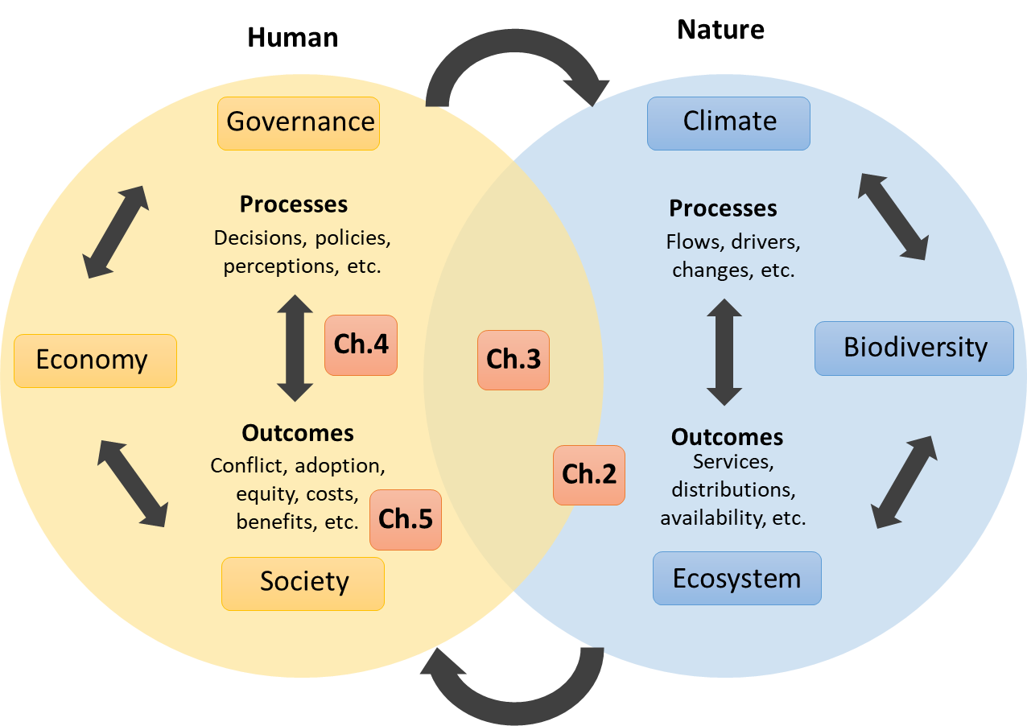
Figure 1-1. Conceptual diagram of coupled human and natural systems. Arrows show interactions and feedbacks between dimensions and subsystems. Examples of different processes and outcomes are listed for each dimension. Orange “Ch. 2-5” box placement indicates where each dissertation fits within this coupled human and natural system space.
Each chapter in this dissertation is written and formatted as stand-alone, peer-reviewed journal publications, each with its own introduction, methods, results, discussion, conclusion, and references sections. These are followed by a sixth chapter than synthesizes findings across the four research chapters. Chapter 2 is published in a peer-reviewed journal and presents a conceptual framework to identify locations with both high biodiversity value and conservation feasibility to target for e-flows implementation across future climate uncertainty. This conceptual framework is tested in the context of implementing e-flows in the Red River basin in the south-central USA. This chapter focuses on maximizing biodiversity outcomes by using climatic processes as inputs, but also attempts to do this within the constraints of water availability for human uses, so it is placed mainly within the nature dimension but crosses into the overlapping space to highlight this integrative approach (Fig. 1-1). Chapter 3 is in the process of submission for a peer-reviewed journal, and tests different simulated scenarios in an incentive-based Payment for Ecosystem Services (PES) water conservation initiative in the Red River basin to determine if aiming for an equitable allocation of incentives worsens environmental and societal water tradeoffs. This chapter focuses on social equity outcomes in the context of hydrological and climatic processes and outcomes like changing water availability, so it is placed in the center of the overlapping space to highlight this integrative approach (Fig. 1-1). Chapter 4 is published in a peer-reviewed journal and surveys water decision makers in Oklahoma and Texas, USA to understand their perceptions of the challenges to implementing e-flows in the region. This chapter focuses on identifying how human processes like perceptions could shape outcomes like adoption, so it is placed between processes and outcomes in the center of the human sphere (Fig. 1-1). Chapter 5 has been submitted for peer-review at a journal and investigates whether targeting influential individuals in water decision maker networks as early adopters of an e-flows initiative results in greater adoption of the initiative. This chapter focuses on identifying how to maximize human outcomes like adoption, so it is placed accordingly near societal outcomes in the human sphere (Fig. 1-1) Chapter 6 provides a discussion of findings across research chapters 2,3,4, and 5.

References
Acreman, M., Arthington, A. H., Colloff, M. J., Couch, C., Crossman, N. D., Dyer, F., Overton, I., Pollino, C. A., Stewardson, M. J., & Young, W. (2014). Environmental flows for natural, hybrid, and novel riverine ecosystems in a changing world. Frontiers in Ecology and the Environment, 12(8), 466–473. https://doi.org/10.1890/130134
Anderson, E. P., Jackson, S., Tharme, R. E., Douglas, M., Flotemersch, J. E., Zwarteveen, M., Lokgariwar, C., Montoya, M., Wali, A., Tipa, G. T., Jardine, T. D., Olden, J. D., Cheng, L., Conallin, J., Cosens, B., Dickens, C., Garrick, D., Groenfeldt, D., Kabogo, J., … Arthington, A. H. (2019). Understanding rivers and their social relations: A critical step to advance environmental water management. WIREs Water, 6(6), e1381. https://doi.org/10.1002/wat2.1381
Arthington, A. H. (2021). Grand Challenges to Support the Freshwater Biodiversity Emergency Recovery Plan. Frontiers in Environmental Science, 9, 118. https://doi.org/10.3389/fenvs.2021.664313
Arthington, A. H., Bhaduri, A., Bunn, S. E., Jackson, S. E., Tharme, R. E., Tickner, D., Young, B., Acreman, M., Baker, N., Capon, S., Horne, A. C., Kendy, E., McClain, M. E., Poff, N. L., Richter, B. D., & Ward, S. (2018). The Brisbane Declaration and Global Action Agenda on Environmental Flows (2018). Frontiers in Environmental Science, 6, 45. https://doi.org/10.3389/fenvs.2018.00045
Barnes, M. L., Lynham, J., Kalberg, K., & Leung, P. (2016). Social networks and environmental outcomes. Proceedings of the National Academy of Sciences, 113(23), 6466–6471. https://doi.org/10.1073/pnas.1523245113
Batchelor, C., Reddy, V. R., Linstead, C., Dhar, M., Roy, S., & May, R. (2014). Do water-saving technologies improve environmental flows? Journal of Hydrology, 518, 140–149. https://doi.org/10.1016/j.jhydrol.2013.11.063
Bednarek, A. T., & Hart, D. D. (2005). MODIFYING DAM OPERATIONS TO RESTORE RIVERS: ECOLOGICAL RESPONSES TO TENNESSEE RIVER DAM MITIGATION. Ecological Applications, 15(3), 997–1008. https://doi.org/10.1890/04-0586
Beever, E. A., Mattsson, B. J., Germino, M. J., Burg, M. P. V. D., Bradford, J. B., & Brunson, M. W. (2014). Successes and Challenges from Formation to Implementation of Eleven Broad-Extent Conservation Programs. Conservation Biology, 28(2), 302–314. https://doi.org/10.1111/cobi.12233
Bejarano, M. D., Sordo-Ward, A., Gabriel-Martin, I., & Garrote, L. (2019). Tradeoff between economic and environmental costs and benefits of hydropower production at run-of-river-diversion schemes under different environmental flows scenarios. Journal of Hydrology, 572, 790–804. https://doi.org/10.1016/j.jhydrol.2019.03.048
Bennett, N. J., Roth, R., Klain, S. C., Chan, K., Christie, P., Clark, D. A., Cullman, G., Curran, D., Durbin, T. J., Epstein, G., Greenberg, A., Nelson, M. P., Sandlos, J., Stedman, R., Teel, T. L., Thomas, R., Veríssimo, D., & Wyborn, C. (2017). Conservation social science: Understanding and integrating human dimensions to improve conservation. Biological Conservation, 205, 93–108. https://doi.org/10.1016/j.biocon.2016.10.006
Bertrand, D., & McPherson, R. A. (2018). Future Hydrologic Extremes of the Red River Basin. Journal of Applied Meteorology and Climatology, 57(6), 1321–1336. https://doi.org/10.1175/JAMC-D-17-0346.1
Bogan, M. T., & Lytle, D. A. (2011). Severe drought drives novel community trajectories in desert stream pools. Freshwater Biology, 56(10), 2070–2081. https://doi.org/10.1111/j.1365-2427.2011.02638.x
Brimont, L., Ezzine-de-Blas, D., Karsenty, A., & Toulon, A. (2015). Achieving Conservation and Equity amidst Extreme Poverty and Climate Risk: The Makira REDD+ Project in Madagascar. Forests, 6(12), 748–768. https://doi.org/10.3390/f6030748
Buxton, R. T., Bennett, J. R., Reid, A. J., Shulman, C., Cooke, S. J., Francis, C. M., Nyboer, E. A., Pritchard, G., Binley, A. D., Avery-Gomm, S., Ban, N. C., Beazley, K. F., Bennett, E., Blight, L. K., Bortolotti, L. E., Camfield, A. F., Gadallah, F., Jacob, A. L., Naujokaitis-Lewis, I., … Smith, P. A. (2021). Key information needs to move from knowledge to action for biodiversity conservation in Canada. Biological Conservation, 256, 108983. https://doi.org/10.1016/j.biocon.2021.108983
Carlisle, D. M., Falcone, J., Wolock, D. M., Meador, M. R., & Norris, R. H. (2009). Predicting the natural flow regime: Models for assessing hydrological alteration in streams. River Research and Applications, n/a-n/a. https://doi.org/10.1002/rra.1247
Craig, L. S., Olden, J. D., Arthington, A. H., Entrekin, S., Hawkins, C. P., Kelly, J. J., Kennedy, T. A., Maitland, B. M., Rosi, E. J., Roy, A. H., Strayer, D. L., Tank, J. L., West, A. O., & Wooten, M. S. (2017). Meeting the challenge of interacting threats in freshwater ecosystems: A call to scientists and managers. Elementa: Science of the Anthropocene, 5(72). https://doi.org/10.1525/elementa.256
Crespo, D., Albiac, J., Kahil, T., Esteban, E., & Baccour, S. (2019). Tradeoffs between Water Uses and Environmental Flows: A Hydroeconomic Analysis in the Ebro Basin. Water Resources Management, 33(7), 2301–2317. https://doi.org/10.1007/s11269-019-02254-3
Davies, P., Naiman, R., Warfe, D., Pettit, N., Arthington, A., & Bunn, S. (2013). Flow-ecology relationships: Closing the loop on effective environmental flows. Marine and Freshwater Research, 65. https://doi.org/10.1071/MF13110
Ferraro, P. J., Sanchirico, J. N., & Smith, M. D. (2019). Causal inference in coupled human and natural systems. Proceedings of the National Academy of Sciences, 116(12), 5311–5318. https://doi.org/10.1073/pnas.1805563115
Foden, W. B., Young, B. E., Akçakaya, H. R., Garcia, R. A., Hoffmann, A. A., Stein, B. A., Thomas, C. D., Wheatley, C. J., Bickford, D., Carr, J. A., Hole, D. G., Martin, T. G., Pacifici, M., Pearce-Higgins, J. W., Platts, P. J., Visconti, P., Watson, J. E. M., & Huntley, B. (2019). Climate change vulnerability assessment of species. WIREs Climate Change, 10(1), e551. https://doi.org/10.1002/wcc.551
Fovargue, R. E., Rezapour, S., Rosendahl, D., Wootten, A. M., Sabzi, H. Z., Moreno, H. A., & Neeson, T. M. (2021). Spatial planning for water sustainability projects under climate uncertainty: Balancing human and environmental water needs. Environmental Research Letters, 16(3), 034050. https://doi.org/10.1088/1748-9326/abdd58
Friedman, R. S., Law, E. A., Bennett, N. J., Ives, C. D., Thorn, J. P. R., & Wilson, K. A. (2018). How just and just how? A systematic review of social equity in conservation research. Environmental Research Letters, 13(5), 053001. https://doi.org/10.1088/1748-9326/aabcde
Garrick, D., Iseman, T., Gilson, G., Brozovic, N., O’Donnell, E., Matthews, N., Miralles-Wilhelm, F., Wight, C., & Young, W. (2020). Scalable solutions to freshwater scarcity: Advancing theories of change to incentivise sustainable water use. Water Security, 9, 100055. https://doi.org/10.1016/j.wasec.2019.100055
Grantham, T. E., Matthews, J. H., & Bledsoe, B. P. (2019). Shifting currents: Managing freshwater systems for ecological resilience in a changing climate. Water Security, 8, 100049. https://doi.org/10.1016/j.wasec.2019.100049
Guerrero, A. M., & Wilson, K. A. (2017). Using a social–ecological framework to inform the implementation of conservation plans. Conservation Biology, 31(2), 290–301. https://doi.org/10.1111/cobi.12832
Haas, J. C., Loft, L., & Pham, T. T. (2019). How fair can incentive-based conservation get? The interdependence of distributional and contextual equity in Vietnam’s payments for Forest Environmental Services Program. Ecological Economics, 160, 205–214. https://doi.org/10.1016/j.ecolecon.2019.02.021
Halpern, B. S., Klein, C. J., Brown, C. J., Beger, M., Grantham, H. S., Mangubhai, S., Ruckelshaus, M., Tulloch, V. J., Watts, M., White, C., & Possingham, H. P. (2013). Achieving the triple bottom line in the face of inherent trade-offs among social equity, economic return, and conservation. Proceedings of the National Academy of Sciences, 110(15), 6229–6234. https://doi.org/10.1073/pnas.1217689110
Harper, M., Mejbel, H. S., Longert, D., Abell, R., Beard, T. D., Bennett, J. R., Carlson, S. M., Darwall, W., Dell, A., Domisch, S., Dudgeon, D., Freyhof, J., Harrison, I., Hughes, K. A., Jähnig, S. C., Jeschke, J. M., Lansdown, R., Lintermans, M., Lynch, A. J., … Cooke, S. J. (2021). Twenty‐five essential research questions to inform the protection and restoration of freshwater biodiversity. Aquatic Conservation: Marine and Freshwater Ecosystems, 31(9), 2632–2653. https://doi.org/10.1002/aqc.3634
Harwood, A. J., Tickner, D., Richter, B. D., Locke, A., Johnson, S., & Yu, X. (2018). Critical Factors for Water Policy to Enable Effective Environmental Flow Implementation. Frontiers in Environmental Science, 6, 37. https://doi.org/10.3389/fenvs.2018.00037
Hirji, R., & Davis, R. (2009). Environmental Flows in Water Resources Policies, Plans, and Projects: Findings and Recommendations. The World Bank. https://doi.org/10.1596/978-0-8213-7940-0
John, A., Nathan, R., Horne, A., Stewardson, M., & Webb, J. A. (2020). How to incorporate climate change into modelling environmental water outcomes: A review. Journal of Water and Climate Change, 11(2), 327–340. https://doi.org/10.2166/wcc.2020.263
Klein, C., McKinnon, M. C., Wright, B. T., Possingham, H. P., & Halpern, B. S. (2015). Social equity and the probability of success of biodiversity conservation. Global Environmental Change, 35, 299–306. https://doi.org/10.1016/j.gloenvcha.2015.09.007
Knight, A. T., Cowling, R. M., Rouget, M., Balmford, A., Lombard, A. T., & Campbell, B. M. (2008). Knowing But Not Doing: Selecting Priority Conservation Areas and the Research–Implementation Gap. Conservation Biology, 22(3), 610–617. https://doi.org/10.1111/j.1523-1739.2008.00914.x
Koch, J., Friedman, J. R., Paladino, S., Plassin, S., & Spencer, K. (2019). Conceptual modeling for improved understanding of the Rio Grande/Río Bravo socio-environmental system. Socio-Environmental Systems Modelling, 1, 16127–16127. https://doi.org/10.18174/sesmo.2019a16127
Kopf, R. K., Finlayson, C. M., Humphries, P., Sims, N. C., & Hladyz, S. (2015). Anthropocene Baselines: Assessing Change and Managing Biodiversity in Human-Dominated Aquatic Ecosystems. BioScience, 65(8), 798–811. https://doi.org/10.1093/biosci/biv092
Kujala, H., Moilanen, A., Araújo, M. B., & Cabeza, M. (2013). Conservation Planning with Uncertain Climate Change Projections. PLoS ONE, 8(2), e53315. https://doi.org/10.1371/journal.pone.0053315
Kukkala, A. S., & Moilanen, A. (2013). Core concepts of spatial prioritisation in systematic conservation planning. Biological Reviews, 88(2), 443–464. https://doi.org/10.1111/brv.12008
Lane, B. A., Sandoval-Solis, S., & Porse, E. C. (2015). Environmental Flows in a Human-Dominated System: Integrated Water Management Strategies for the Rio Grande/Bravo Basin. River Research and Applications, 31(9), 1053–1065. https://doi.org/10.1002/rra.2804
Law, E. A., Bennett, N. J., Ives, C. D., Friedman, R., Davis, K. J., Archibald, C., & Wilson, K. A. (2018). Equity trade‐offs in conservation decision making. Conservation Biology, 32(2), 294–303. https://doi.org/10.1111/cobi.13008
Lawler, J. J., & Michalak, J. (2017). Planning for climate change without climate projections? In Effective Conservation Science: Data Not Dogma (pp. 135–140). https://doi.org/10.1093/oso/9780198808978.003.0021
Li, P., Muenich, R. L., Chaubey, I., & Wei, X. (2019). Evaluating Agricultural BMP Effectiveness in Improving Freshwater Provisioning Under Changing Climate. Water Resources Management, 33(2), 453–473. https://doi.org/10.1007/s11269-018-2098-y
Liu, J., Dietz, T., Carpenter, S. R., Taylor, W. W., Alberti, M., Deadman, P., Redman, C., Pell, A., Folke, C., Ouyang, Z., & Lubchenco, J. (2021). Coupled human and natural systems: The evolution and applications of an integrated framework. Ambio, 50(10), 1778–1783. https://doi.org/10.1007/s13280-020-01488-5
Loft, L., Gehrig, S., Salk, C., & Rommel, J. (2020). Fair payments for effective environmental conservation. Proceedings of the National Academy of Sciences, 201919783. https://doi.org/10.1073/pnas.1919783117
Mahajan, S. L., Jagadish, A., Glew, L., Ahmadia, G., Becker, H., Fidler, R. Y., Jeha, L., Mills, M., Cox, C., DeMello, N., Harborne, A. R., Masuda, Y. J., McKinnon, M. C., Painter, M., Wilkie, D., & Mascia, M. B. (2021). A theory-based framework for understanding the establishment, persistence, and diffusion of community-based conservation. Conservation Science and Practice, 3(1), e299. https://doi.org/10.1111/csp2.299
Merritt, D. M., Scott, M. L., LeROY POFF, N., Auble, G. T., & Lytle, D. A. (2010). Theory, methods and tools for determining environmental flows for riparian vegetation: Riparian vegetation-flow response guilds. Freshwater Biology, 55(1), 206–225. https://doi.org/10.1111/j.1365-2427.2009.02206.x
Mills, M., Bode, M., Mascia, M. B., Weeks, R., Gelcich, S., Dudley, N., Govan, H., Archibald, C. L., Romero-de-Diego, C., Holden, M., Biggs, D., Glew, L., Naidoo, R., & Possingham, H. P. (2019). How conservation initiatives go to scale. Nature Sustainability, 2(10), 935–940. https://doi.org/10.1038/s41893-019-0384-1
Milly, P. C. D., Betancourt, J., Falkenmark, M., Hirsch, R. M., Kundzewicz, Z. W., Lettenmaier, D. P., & Stouffer, R. J. (2008). Stationarity Is Dead: Whither Water Management? Science, 319(5863), 573–574. https://doi.org/10.1126/science.1151915
Mims, M. C., & Olden, J. D. (2012). Life history theory predicts fish assemblage response to hydrologic regimes. Ecology, 93(1), 35–45. https://doi.org/10.1890/11-0370.1
Nilsson, C., & Renöfält, B. M. (2008). Linking Flow Regime and Water Quality in Rivers: A Challenge to Adaptive Catchment Management. Ecology and Society, 13(2). https://www.jstor.org/stable/26268001
O’Donnell, E. L., & Talbot-Jones, J. (2018). Creating legal rights for rivers: Lessons from Australia, New Zealand, and India. Ecology and Society, 23(1). https://www.jstor.org/stable/26799037
Olden, J. D., Konrad, C. P., Melis, T. S., Kennard, M. J., Freeman, M. C., Mims, M. C., Bray, E. N., Gido, K. B., Hemphill, N. P., Lytle, D. A., McMullen, L. E., Pyron, M., Robinson, C. T., Schmidt, J. C., & Williams, J. G. (2014). Are large-scale flow experiments informing the science and management of freshwater ecosystems? Frontiers in Ecology and the Environment, 12(3), 176–185. https://doi.org/10.1890/130076
Opperman, J. J., Kendy, E., Tharme, R. E., Warner, A. T., Barrios, E., & Richter, B. D. (2018). A Three-Level Framework for Assessing and Implementing Environmental Flows. Frontiers in Environmental Science, 6, 76. https://doi.org/10.3389/fenvs.2018.00076
Pahl-Wostl, C., Arthington, A., Bogardi, J., Bunn, S. E., Hoff, H., Lebel, L., Nikitina, E., Palmer, M., Poff, L. N., Richards, K., Schlüter, M., Schulze, R., St-Hilaire, A., Tharme, R., Tockner, K., & Tsegai, D. (2013). Environmental flows and water governance: Managing sustainable water uses. Current Opinion in Environmental Sustainability, 5(3–4), 341–351. https://doi.org/10.1016/j.cosust.2013.06.009
Pascual, U., Phelps, J., Garmendia, E., Brown, K., Corbera, E., Martin, A., Gomez-Baggethun, E., & Muradian, R. (2014). Social Equity Matters in Payments for Ecosystem Services. BioScience, 64(11), 1027–1036. https://doi.org/10.1093/biosci/biu146
Poff, N. L. (2018). Beyond the natural flow regime? Broadening the hydro-ecological foundation to meet environmental flows challenges in a non-stationary world. Freshwater Biology, 63(8), 1011–1021. https://doi.org/10.1111/fwb.13038
Poff, N. L., Olden, J. D., Merritt, D. M., & Pepin, D. M. (2007). Homogenization of regional river dynamics by dams and global biodiversity implications. Proceedings of the National Academy of Sciences, 104(14), 5732–5737. https://doi.org/10.1073/pnas.0609812104
Poff, N. L., Richter, B. D., Arthington, A. H., Bunn, S. E., Naiman, R. J., Kendy, E., Acreman, M., Apse, C., Bledsoe, B. P., Freeman, M. C., Henriksen, J., Jacobson, R. B., Kennen, J. G., Merritt, D. M., OâKEEFFE, J. H., Olden, J. D., Rogers, K., Tharme, R. E., & Warner, A. (2010). The ecological limits of hydrologic alteration (ELOHA): A new framework for developing regional environmental flow standards: Ecological limits of hydrologic alteration. Freshwater Biology, 55(1), 147–170. https://doi.org/10.1111/j.1365-2427.2009.02204.x
Popejoy, T., Randklev, C. R., Neeson, T. M., & Vaughn, C. C. (2018). Prioritizing sites for conservation based on similarity to historical baselines and feasibility of protection: Zooarchaeological Baseline. Conservation Biology, 32(5), 1118–1127. https://doi.org/10.1111/cobi.13128
Rakotonarivo, S., Bell, A., Abernethy, K., Minderman, J., Duthie, A., Redpath, S., Keane, A., Travers, H., Bourgeois, S., Moukagni, L.-L., Cusack, J., Jones, I., Pozo, R., & Bunnefeld, N. (2021). The role of incentive-based instruments and social equity in conservation conflict interventions. Ecology and Society, 26(2). https://doi.org/10.5751/ES-12306-260208
Ren, K., Huang, S., Huang, Q., Wang, H., & Leng, G. (2018). Environmental Flow Assessment Considering Inter- and Intra-Annual Streamflow Variability under the Context of Non-Stationarity. Water, 10(12), 1737. https://doi.org/10.3390/w10121737
Reside, A. E., Butt, N., & Adams, V. M. (2018). Adapting systematic conservation planning for climate change. Biodiversity and Conservation, 27(1), 1–29. https://doi.org/10.1007/s10531-017-1442-5
Richter, B. D. (2010). Re-thinking environmental flows: From allocations and reserves to sustainability boundaries. River Research and Applications, 26(8), 1052–1063. https://doi.org/10.1002/rra.1320
Rissman, A. R., & Wardropper, C. B. (2021). Adapting Conservation Policy and Administration to Nonstationary Conditions. Society & Natural Resources, 34(4), 524–537. https://doi.org/10.1080/08941920.2020.1799127
Sabo, J. L., Ruhi, A., Holtgrieve, G. W., Elliott, V., Arias, M. E., Ngor, P. B., Räsänen, T. A., & Nam, S. (2017). Designing river flows to improve food security futures in the Lower Mekong Basin. Science, 358(6368), eaao1053. https://doi.org/10.1126/science.aao1053
Sadoff, C. W., Borgomeo, E., & Uhlenbrook, S. (2020). Rethinking water for SDG 6. Nature Sustainability, 3(5), 346–347. https://doi.org/10.1038/s41893-020-0530-9
Schewe, J., Heinke, J., Gerten, D., Haddeland, I., Arnell, N. W., Clark, D. B., Dankers, R., Eisner, S., Fekete, B. M., Colón-González, F. J., Gosling, S. N., Kim, H., Liu, X., Masaki, Y., Portmann, F. T., Satoh, Y., Stacke, T., Tang, Q., Wada, Y., … Kabat, P. (2014). Multimodel assessment of water scarcity under climate change. Proceedings of the National Academy of Sciences, 111(9), 3245–3250. https://doi.org/10.1073/pnas.1222460110
Sinclair, S. P., Milner‐Gulland, E. J., Smith, R. J., McIntosh, E. J., Possingham, H. P., Vercammen, A., & Knight, A. T. (2018). The use, and usefulness, of spatial conservation prioritizations. Conservation Letters, 11(6), e12459. https://doi.org/10.1111/conl.12459
Tallis, H., Kareiva, P., Marvier, M., & Chang, A. (2008). An ecosystem services framework to support both practical conservation and economic development. Proceedings of the National Academy of Sciences, 105(28), 9457–9464. https://doi.org/10.1073/pnas.0705797105
Tickner, D., Opperman, J. J., Abell, R., Acreman, M., Arthington, A. H., Bunn, S. E., Cooke, S. J., Dalton, J., Darwall, W., Edwards, G., Harrison, I., Hughes, K., Jones, T., Leclère, D., Lynch, A. J., Leonard, P., McClain, M. E., Muruven, D., Olden, J. D., … Young, L. (2020). Bending the Curve of Global Freshwater Biodiversity Loss: An Emergency Recovery Plan. BioScience, 70(4), 330–342. https://doi.org/10.1093/biosci/biaa002
Tickner, D., Parker, H., Moncrieff, C. R., Oates, N. E. M., Ludi, E., & Acreman, M. (2017). Managing Rivers for Multiple Benefits–A Coherent Approach to Research, Policy and Planning. Frontiers in Environmental Science, 5. https://doi.org/10.3389/fenvs.2017.00004
Tonkin, J. D., Bogan, M. T., Bonada, N., Rios-Touma, B., & Lytle, D. A. (2017). Seasonality and predictability shape temporal species diversity. Ecology, 98(5), 1201–1216. https://doi.org/10.1002/ecy.1761
Toomey, A. H., Knight, A. T., & Barlow, J. (2017). Navigating the Space between Research and Implementation in Conservation: Research-implementation spaces. Conservation Letters, 10(5), 619–625. https://doi.org/10.1111/conl.12315
Twardek, W. M., Nyboer, E. A., Tickner, D., O’Connor, C. M., Lapointe, N. W. R., Taylor, M. K., Gregory-Eaves, I., Smol, J. P., Reid, A. J., Creed, I. F., Nguyen, V. M., Winegardner, A. K., Bergman, J. N., Taylor, J. J., Rytwinski, T., Martel, A. L., Drake, D. A. R., Robinson, S. A., Marty, J., … Cooke, S. J. (2021). Mobilizing practitioners to support the Emergency Recovery Plan for freshwater biodiversity. Conservation Science and Practice, 3(8), e467. https://doi.org/10.1111/csp2.467
Webb, J. A., Watts, R. J., Allan, C., & Conallin, J. C. (2018). Adaptive Management of Environmental Flows. Environmental Management, 61(3), 339–346. https://doi.org/10.1007/s00267-017-0981-6
Wineland, S. M., Bașağaoğlu, H., Fleming, J., Friedman, J., Garza‐Diaz, L., Kellogg, W., Koch, J., Lane, B. A., Mirchi, A., Nava, L. F., Neeson, T. M., Ortiz‐Partida, J. P., Paladino, S., Plassin, S., Gomez‐Quiroga, G., Saiz‐Rodriguez, R., Sandoval‐Solis, S., Wagner, K., Weber, N., … Wootten, A. M. (2021). The environmental flows implementation challenge: Insights and recommendations across water‐limited systems. WIREs Water. https://doi.org/10.1002/wat2.1565
Wootten, A. M., Massoud, E. C., Sengupta, A., Waliser, D. E., & Lee, H. (2020). The Effect of Statistical Downscaling on the Weighting of Multi-Model Ensembles of Precipitation. Climate, 8(12), 138. https://doi.org/10.3390/cli8120138
Zamani Sabzi, H., Rezapour, S., Fovargue, R., Moreno, H., & Neeson, T. M. (2019). Strategic allocation of water conservation incentives to balance environmental flows and societal outcomes. Ecological Engineering, 127, 160–169. https://doi.org/10.1016/j.ecoleng.2018.11.005
Zheng, Y., Tian, Y., Du, E., Han, F., Wu, Y., Zheng, C., & Li, X. (2020). Addressing the water conflict between agriculture and ecosystems under environmental flow regulation: An integrated modeling study. Environmental Modelling & Software, 134, 104874. https://doi.org/10.1016/j.envsoft.2020.104874

2. Conservation planning in an uncertain climate: Identifying projects that remain valuable and feasible across future scenarios

2.1. Abstract
1. Conservation actors face the challenge of allocating limited resources despite uncertainty about future climate conditions. In many cases, the potential value and feasibility of proposed projects vary across climate scenarios. A key goal is to identify areas where conservation outcomes can balance both environmental and human needs.
2. We developed a conservation prioritization framework that jointly considers the value and feasibility of candidate projects across future climate scenarios. We then applied this framework to the challenge of meeting environmental flow targets across the Red River basin of the south-central USA.
3. To estimate the conservation feasibility of meeting environmental flow goals in a river reach in each climate scenario, we used a basin-wide hydrologic planning tool to quantify the reduction in societal water usage needed to meet environmental flow targets. To estimate the biodiversity value of each river reach in each climate scenario, we used climate-driven species distribution models and species’ conservation status.
4. We found that river reaches in the east-central portion of the basin may be good candidates for conservation investments, because they had high biodiversity value and high socio-political feasibility in all future climate scenarios. In contrast, sites in the arid western reaches of the basin had high biodiversity value, but low feasibility of achieving environmental flow goals.
5. Our framework should have broad applicability given that the value and feasibility of conservation projects vary across climate scenarios in ecosystems around the world. It may serve as a coarse filter to identify sites for more detailed analyses and could be integrated with complementarity-based approaches to conservation planning to balance species’ representation across projects.

2.2. Introduction
Climate change and human activities are impacting ecosystems globally, directly contributing to biodiversity loss and threatening human well-being (Scheffers & Pecl 2019, Reside et al. 2018, Diaz et al. 2019, Green et al. 2019, Tickner et al. 2020). The conservation community has responded to this crisis by developing spatial conservation prioritization (hereafter “prioritization”) frameworks to guide conservation investments (Sinclair et al. 2018, Kukkala & Moilanen 2013). Broadly defined, these frameworks aim to identify strategies for allocating resources among sites to maximize return-on-investment in the protection of biodiversity or ecosystem services. It is increasingly recognized that prioritizations must account for uncertain future climatic conditions (Heller et al. 2009, Carvalho et al. 2011, Jones et al. 2016) and consider societal uses and values of biodiversity and natural resources (Knight et al. 2010, Karimi et al. 2017, Guerrero et al. 2018, Whitehead et al. 2014). However, conservation planning frameworks often fail to consider factors like competing societal values for shared resources, and organizational and resource governance processes, which may result in a failure to step from research to implementation phases of planning (Toomey et al. 2017, Moon et al. 2014, McIntosh et al. 2018). Conservation planning thus faces a pressing challenge to effectively inform decision-making under climatic uncertainty while being conscious of the societal context in which conservation actions are being recommended.
When developing a conservation prioritization, accounting for the feasibility of a conservation project is necessary to overcome the “implementation crisis,” wherein sophisticated conservation plans are developed but not implemented (Knight et al. 2008, Toomey et al. 2017). Accounting for conservation feasibility in the assessment phase of planning could help complement the where to act (i.e., the identification of priority sites) with the how to act (i.e., the procurement of adequate funding, support, permissions, and resources to facilitate implementation; Adams et al. 2019). Conservation feasibility may be broadly defined as the likelihood of successful implementation of a conservation action at a target area or site (Guerrero & Wilson 2017, Karimi et al. 2017, Popejoy et al. 2018). Thus, locations with high conservation feasibility are likely to be those locations where the sociopolitical costs of conservation actions are low. Many socio-political factors (i.e., social attitudes and public values that influence resource management, economics, policymaking, and governance structures) contribute to conservation feasibility, including government organizations, resource users, policies, funding, and institutional mandates (Guerrero & Wilson 2017). Recent studies focus on assessing conservation feasibility by examining stakeholders’ or landowners’ willingness to participate in a conservation program (Ma et al. 2012, Kwayu et al. 2014, Wunder et al. 2018) or sell land or water rights (Guerrero et al. 2010, Adams et al. 2014, Tulloch et al. 2014, Wang et al. 2017), whether social and ecological values align (Bryan et al. 2011, Whitehead et al. 2014, Bagstad et al. 2016), social-political and resource governance structures and contexts (Jupiter et al. 2017), conservation conflicts and socio-political resistance to conservation actions (Rastogi et al. 2014, Von Essen & Hansen 2015), and tradeoffs between shared resources (Zamani Sabzi et al. 2019a).
Effective conservation prioritization under climate change requires strategies that operate under climatic uncertainty (Meir et al. 2004, Kukkala & Moilanen 2013, Jones et al. 2016, Bates et al. 2019, He et al. 2019). In this context, uncertainty about future climate conditions stems from variability of projected model or scenario outcomes (Reside et al. 2018). While some researchers argue that climate projections ought to be ignored in conservation planning because they are hampered by uncertainties (i.e., forecast-free approaches, Groves et al. 2012), others have attempted to identify strategies that are robust to climate uncertainty by assessing how conservation priorities vary across a wide range of future climate scenarios (Araújo & New 2007, Araújo & Luoto 2007, Conroy et al. 2011, Lawler & Michalak 2018). In practice, researchers might use predictive species distribution models to identify locations that have consistently high biodiversity value across a wide range of future climate scenarios (Carvalho et al. 2011, Kujala et al. 2013). These sites are likely to be good choices for conservation investments given that biodiversity values are high in all future scenarios.
Simultaneously accounting for climate uncertainty, biodiversity value and feasibility is challenging because biodiversity value is often decoupled from the socio-political costs of conservation actions (Bonebrake et al. 2018, Scheffers & Pecl 2019) and both factors vary independently across future scenarios. Some examples of socio-political factors that vary independently of biodiversity value include polarized views of the importance of conservation (Coffey & Joseph 2013), the exclusion of some stakeholders from planning and negotiations (Foote et al. 2007), funding and economic costs (Balmford et al. 2003), and socio-political borders that exacerbate shared resource conflicts (Dallimer & Strange 2015). Because biodiversity value and conservation feasibility vary independently across locations and across future climate scenarios, researchers must account for these factors separately to identify areas at the intersection of high biodiversity value and low socio-political cost.
Despite many practical and theoretical advances in conservation planning, studies have disproportionately focused on terrestrial and marine ecosystems (Linke et al. 2019). Conservation initiatives are difficult to implement in freshwater ecosystems because of complex factors that influence planning, such as uncertainty in water resources under future climate change scenarios (Moilanen et al. 2008, Wilby et al. 2010, McPherson et al. 2016), species range shifts under climate change (Araújo et al. 2004, Carvalho et al. 2011), shared resource conflicts (Pahl-Wostl et al. 2013, Zamani Sabzi et al. 2019a), and complex water-resource governance systems (Portney et al. 2017, Daher et al. 2019). One approach to improving biodiversity outcomes in freshwater ecosystems is through accelerating the implementation of environmental flows (Tickner et al. 2020). Environmental flows are a system to maintain or restore ecologically relevant aspects of hydrologic regimes that have been altered by human infrastructure or practices; this may include changes in the quantity, timing, and variability of river flows (Arthington et al. 2018). Maintaining environmental flows can significantly improve biodiversity outcomes by restoring functional ecological processes that freshwater species rely on for their life histories (Nilsson & Renöfält 2008, Mims & Olden 2012, Olden et al. 2014, Mims & Olden 2012, Acreman et al. 2014, Vaughn et al. 2015, Vaughn 2018). Water-limited river basins are good model systems for studying the challenges of conservation planning because of the projected decrease in water availability under future climate change (Christensen et al. 2004, Ma et al. 2008, Grafton et al. 2011), projected increase in future societal water demand (Florke et al. 2018), and varying levels of socio-political resistance to environmental flows regulations and policies (Pittock & Finlayson 2011, Mekonnen & Hoekstra 2016). As a result of the inherently coupled relationship between humans and freshwater ecosystems, there are significant tradeoffs between human needs and conservation outcomes (Ziv et al. 2012, Sivapalan et al. 2014, Crespo et al. 2019, Guo et al. 2019, Zamani Sabzi et al. 2019a).
The Red River basin in the south-central United States exemplifies the difficulties of accounting for complex factors and uncertainty in freshwater conservation planning. Here, climate change is expected to decrease overall precipitation and river flows, but there is considerable uncertainty about where and when water shortages may occur (Xue et al. 2015, Bertrand & McPherson 2019). As a result, societal (i.e., municipal, industrial, and agricultural) and ecosystem (i.e., environmental flows) water needs cannot be fully met unless reductions in societal uses are implemented (Zamani Sabzi et al. 2019a). Additionally, fish and freshwater mussel species are projected to decline and undergo range shifts because of climate and human-induced changes in water availability that inhibit habitat connectivity and produce extreme thermal regimes (Perkin et al. 2015, Perkin et al. 2017, Gill et al. 2020). Thus, conservation actors in this region must account for future climatic uncertainty and consider conservation feasibility in planning for freshwater ecosystems but lack the appropriate guidance on where to invest conservation resources.
In this study, we developed a prioritization framework for identifying target sites for implementing conservation actions that remain valuable and feasible across a range of future climate scenarios. Our prioritization framework represents a simple, flexible, and low-data method that can be used in the assessment phase of conservation planning to rapidly winnow the number of sites under consideration. We then applied this framework to the challenge of prioritizing water conservation actions across a drought-prone river basin, the Red River, in the south-central USA. In this application, we sought to identify river reaches that consistently had high biodiversity value and conservation feasibility across a range of possible future climate scenarios. We used data from recent high-resolution hydrologic and climatic modeling in the Red River to parameterize a mathematical optimization model for allocating water conservation incentives across the basin. From these models, we estimated the biodiversity value of river reaches by examining fish species distributions and their endangerment criteria below 38 major reservoirs, as well as the conservation feasibility of river reaches by estimating the socio-political cost of fully meeting environmental flow targets. This case study demonstrates the utility of our framework for identifying conservation projects that remain valuable and feasible across a range of climate scenarios.

2.3. Methods

2.3.1. Prioritization framework
We developed a prioritization framework that integrates measures of biodiversity value and conservation feasibility, and how they vary across future climate scenarios. (Figure 2-1). Our framework extends other two-dimensional planning models that consider biodiversity value and feasibility (Guerrero & Wilson 2017, Popejoy et al. 2018) by exploring how both factors vary across future climate scenarios. Thus, our framework identifies sites that consistently have high biodiversity value and high conservation feasibility across a range of future climate conditions.
In our framework, the biodiversity value (vertical axis) of a site can be quantified using any common ecological measure (e.g., species richness, abundance, occupancy, habitat use and suitability, species’ risk of endangerment, and ecosystem services) or an index of biodiversity derived from these measures (Capmourteres & Anand 2016). Thus, the axis is broadly defined to accommodate the many different ways that humans value, use, and prioritize biodiversity (Manfredo et al. 2016). The conservation feasibility (horizontal axis) of a site can be estimated by considering the socio-political factors that contribute to the likelihood of successful implementation of a conservation action (Popejoy et al. 2018).
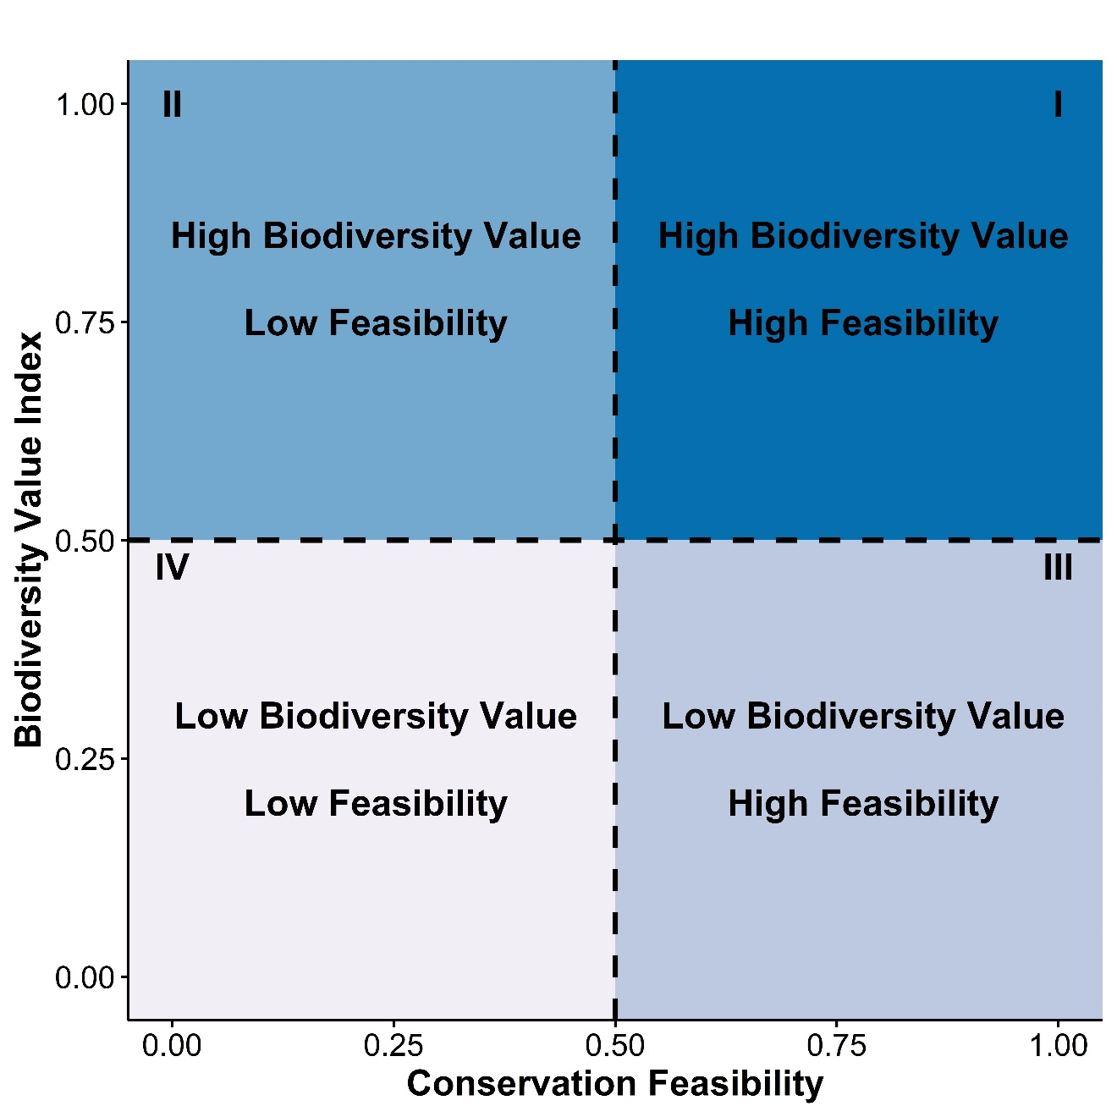
Figure 2-1. General prioritization model for identifying conservation projects with varying levels of biodiversity value and conservation feasibility. The vertical and horizontal lines that delimit the quadrants may be shifted to create larger or smaller quadrants as needed for an application.
Partitioning the biodiversity-feasibility space into user-defined quadrants reveals four tiers of conservation priority (Fig. 2-1). Sites with high biodiversity value and high conservation feasibility (quadrant I) are likely to be the highest priority for investment because conservation actions at these sites would have low sociopolitical costs but high benefits to biodiversity. Sites with high biodiversity value and low conservation feasibility (quadrant II) are of lower priority and represent areas with significant social-ecological tradeoffs. Conservation actions at these sites would provide high benefits to biodiversity but may also have high sociopolitical costs. Sites in quadrant III are low cost, low reward: conservation actions may have low sociopolitical costs but also low benefits to biodiversity. Finally, sites with low biodiversity value and low conservation feasibility (quadrant IV) are high cost, low reward locations that are unlikely to be good choices for conservation investments.
By applying this prioritization framework across multiple future climate scenarios, decision makers can explore how site-level conservation priority varies spatially and temporally. For example, if a site’s positional variation is small across future climate scenarios (i.e., it remains within one quadrant), then there is low uncertainty in measures of biodiversity value and conservation feasibility across future climate scenarios. We also emphasize that the horizontal and vertical lines that delimit the quadrants are arbitrarily placed at the midpoint of each axis. They may be shifted to create large or smaller quadrants to fit the needs of a particular application.
Our prioritization framework represents a simple, flexible method for weighing the tradeoffs between human and environmental aspects of a target conservation objective across future climate scenarios. After conservation objectives have been developed and potential target sites identified, decision makers could use this prioritization framework as a coarse-scale filter to eliminate low priority sites from consideration. Because conservation planners typically weigh a complex set of incommensurable factors in addition to the two considered here in this framework, and many of those factors are difficult to quantify and measure at large spatial scales, our approach can reduce the cost and data needs of typical planning studies by reducing the number of sites that warrant more careful study. Adopting this prioritization framework during the assessment phase of conservation planning could benefit conservation outcomes and improve implementation success through (1) integrating social and ecological data to assess the conservation problem from a systems perspective, (2) identifying key socio-political factors that contribute to conservation feasibility (i.e., the likelihood of conservation implementation and success), (3) identifying site-level variation in conservation priority with a focus on identifying high priority sites, and (4) identifying consistent outcomes under future climate scenarios (Ban et al. 2013, Guerrero & Wilson 2017, Kujala et al. 2013, Moon et al. 2014).

2.3.2. Study system
Our study focuses on the Red River in the south-central United States. The Red River is a semi-arid, drought prone river where water availability is geographically skewed: western reaches are arid and can receive as little as 400mm of rain per year, while eastern reaches can receive up to 1600mm (PRISM Climate Group 2019). Additionally, the combination of consumptive societal water use and extreme thermal and flow regimes in this region can create harsh conditions for aquatic biota (Matthews et al. 2005, Matthews & Marsh-Matthews 2017, DuBose et al. 2019). The Red River has a high density of reservoirs which were constructed for flood control and to provide water storage to meet societal water demands. In this study, we focus on river reaches downstream of 38 major reservoirs in the basin to identify reaches of high conservation priority under climatic and hydrologic uncertainty (Zamani Sabzi et al. 2019a).

2.3.3. Downscaled climate projections
To explore how biodiversity value and conservation feasibility might vary across future climate scenarios, we used recent species distribution (Gill et al. 2020) and hydrologic models (Zamani Sabzi et al. 2019a, Zamani Sabzi et al. 2019b) parameterized with basin-scale high resolution climate projections (Xue et al. 2016, Bertrand & McPherson 2018, Bertrand & McPherson 2019). Briefly, McPherson et al. (2016) used statistical downscaling of global climate model outputs from the Coupled Model Inter-comparison Project Phase 5 (CMIP5) for both historical (1961-2010) and future (2010-2099) time series to estimate daily air temperature and precipitation across the basin at a 1/8⁰ raster resolution for nine future climate scenarios. These nine climate scenarios resulted from taking all combinations of three general circulation models (GCMs; CCSM4, MIROC5, MPI-ESM-LR) and three representative concentration pathways (RCPs; 2.6, 4.5, 8.5 W/m²). These nine scenarios represent a range of plausible air temperature and precipitation biases and climate sensitivities over the south-central United States (Sheffield et al. 2013). Other scenarios (e.g., those that include RCP 6.0) were deemed of lower value to decision makers in the region and not investigated due to computational and personnel cost constraints (Bertrand & McPherson 2019).
Air temperature and precipitation estimates for each of these nine climate scenarios were then used to fit a Variable Infiltration Capacity (VIC) hydrologic model to simulate daily surface runoff, streamflow, and reservoir storage for both historical and future time periods (Xue et al. 2016). VIC is a rainfall-runoff model that uses climate variable inputs (precipitation and temperature), estimates of infiltration and soil moisture, and reservoir storages to estimate evapotranspiration and surface runoff at a daily time step across the basin (Liang et al. 1996). Details of the VIC model calibration process for the Red River basin are given by Xue et al. (2016). VIC model outputs were then used to estimate future fish species distributions (section 2.3.4; Gill et al. 2020) and reservoir storage and environmental flows (section 2.3.6; Zamani Sabzi et al. 2019b) for the 2040-2060 time series.

2.3.4. Fish species distribution models
To determine the biodiversity value of river reaches downstream of the 38 major reservoirs in the basin, we used the predicted probability of occurrence outputs from a suite of species distribution models (SDMs) for 31 fish species native to the Red River (Gill et al. 2020). While there are over 170 fish species native to this catchment, we focus on a suite of 31 species that represent a range of spawning modes, conservation concern, and recreational/societal value based on input from regional fisheries managers (K. Kuklisnki and T. Spark, OK Department of Wildlife Conservation; and B. Matthews and E. Marsh-Matthews, U. Oklahoma). To build SDMs, Gill et al. (2020) used historical fish occurrence records and downscaled climatic and hydrologic data for the Red River basin (Bertrand & McPherson 2019, Xue et al. 2016) to project fish distributions across a range of future climate scenarios using Maxent.
The outputs of the SDM’s are gridded raster datasets in which the value associated with each raster grid cell is the predicted probability of occurrence of a species. To determine which species might benefit from environmental flows releases below each reservoir, we averaged the probability of occurrence values for the 5 grid cells (a total area of 144 km²) downstream of each reservoir for each species under each climate scenario (Fig. 2-2). These five grid cells are a fraction of each fish species’ full distributional range. Given the 1/8⁰ resolution of the raster grid, the five grid cells downstream of each reservoir are approximately equal to 50km of river channel length. This channel length is both the minimum distance between the two closest reservoirs in the basin, and an approximate maximum distance downstream that reservoir water releases can affect flow regulation, thermal stratification, and fish habitat (Kinsolving & Bain 1993, Sinokrot et al. 1995). Though our prioritization focuses on fishes, improvements to instream flows would also benefit other drought-sensitive regional biota (e.g., mussels; Vaughn et al. 2015).
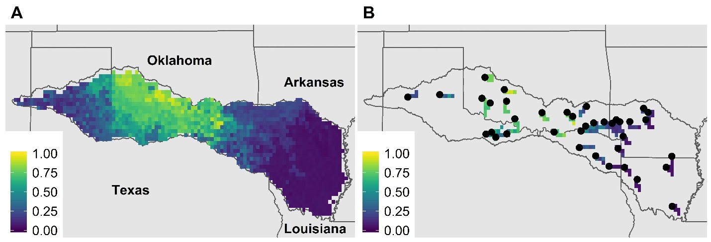
Figure 2-2. Map of the Red River basin depicting how predicted probabilities of occurrence from a species distribution model (A) were masked to 50km river reaches below each reservoir (B). Color represents predicted probability of occurrence values for one species. Values closer to 1 (Yellow) indicate a high predicted probability of occurrence, while values closer to 0 (Purple) indicate a low probability of occurrence.

2.3.5. Biodiversity value index (BVI)
We developed an index to assign biodiversity value to each location based on species probability of occurrence in the downstream river reach and the conservation status of each species. In this index, each species’ probability of occurrence at each river reach across each climate scenario is weighted by multiple conventions and directives that define criteria and conditions for species risk of endangerment (i.e., IUCN vs. NatureServe), and the spatial scale at which conservation status is being evaluated (i.e. state, national, or global scale; Table 1). The BVI is calculated as:
$$BVI=\frac{ \sum_{i}^{s=31}{\sum_{j}^{n=4}{p_{i}}} w_{ij} }{s·n}$$

Where s is the number of species considered, n is the number of conventions or directives used to derive endangerment weights $w_{ij}$, and $p_{i}$ is the probability of occurrence values for each species. The BVI varies between 0 (when the downstream river reach has low predicted probability of occurrences for all species with low conservation value) and 1 (when the downstream river reach has high predicted probability of occurrences for all species with high conservation value).
We used multiple conventions and directives to derive the conservation status weight to capture the multiple spatial scales at which conservation priorities operate (Bergerot et al. 2008). For each convention or directive, we derive conservation status weights based on risk of endangerment categories (Table 1). For example, we used risk of endangerment categories according to the International Union for the Conservation of Nature (IUCN) Red List of Threatened Species™ (IUCN 2019), NatureServe® Global Conservation Status (NatureServe® 2019), and state rankings for the state in which the downstream river reach occurs (Table 2, accessed from the NatureServe® Explorer) to account for varying conservation status criteria at the global, national, and state scale (Akçakaya et al. 2006, Miller et al. 2007, Halmy & Salem 2015). The fourth category we use represents the population status of the species according to the IUCN Red List of Threatened Species™.

Table 2-1. Data sources, criteria of endangerment, conservation status, and weights used in creating the Biodiversity Value Index (BVI).
IUCN Red List (R*) |  |  | NatureServe Global Status (G) |  |  | IUCN Population Trend (T) |  | NatureServe State Status (S)
Category | w_{ij} |  | Status | Category | w_{ij} | Trend | w_{ij} | Status | Category | w_{ij}
Extinct | 0 |  | GX | Presumed Extinct | 0 | Unknown | 0 | SX | Presumed Extinct | 0
Extinct in Wild | 0 |  | GH | Possibly Extinct | 0 | Stable | 0.5 | SH | Possibly Extinct | 0
Critically Endangered | 1 |  | G1 | Critically Imperiled | 1 | Decreasing | 1 | S1 | Critically Imperiled | 1
Endangered | 0.8 |  | G2 | Imperiled | 0.8 | Increasing | 0 | S2 | Imperiled | 0.8
Vulnerable | 0.6 |  | G3 | Vulnerable | 0.6 |  |  | S3 | Vulnerable | 0.6
Near Threatened | 0.4 |  | G4 | Apparently Secure | 0.4 |  |  | S4 | Apparently Secure | 0.4
Least Concern | 0.2 |  | G5 | Secure | 0.2 |  |  | S5 | Secure | 0.2
Data deficient | 0
Not evaluated | 0
*R, G, T, S abbreviate the conventions used in the BVI

Table 2-2. Weights for each index term by species considered in the Biodiversity Value Index (BVI).
Species | Common Name | R_{i}ª | G_{i} | T_{i} | S_{i}^{b} (OK) | S_{i} (TX) | S_{i} (AR) | S_{i} (LA)
Ameiurus melas | Black bullhead | 0.2 | 0.2 | 0.5 | 0.2 | 0.2 | 0.4 | 0.2
Cyprinella lutrensis | Red shiner | 0.2 | 0.2 | 0.5 | 0.2 | 0.2 | 0.6 | 0.2
Cyprinodon rubrofluviatilis | Red River pupfish | 0.2 | 0.2 | 0.5 | 0.2 | 0.4 | 0.0 | 0.0
Etheostoma collettei | Creole darter | 0.2 | 0.4 | 0.5 | 0.6 | 0.0 | 0.4 | 0.4
Etheostoma radiosum | Orangebelly darter | 0.2 | 0.2 | 0.5 | 0.2 | 0.6 | 0.4 | 0.0
Fundulus zebrinus | Plains killifish | 0.2 | 0.2 | 0.0 | 0.4 | 0.2 | 0.0 | 0.0
Gambusia affinis | Western mosquitofish | 0.2 | 0.2 | 0.5 | 0.2 | 0.2 | 0.4 | 0.2
Hybognathus placitus | Plains minnow | 0.2 | 0.4 | 1.0 | 0.2 | 0.4 | 0.0 | 0.0
Ictalurus furcatus | Blue catfish | 0.2 | 0.2 | 0.5 | 0.2 | 0.2 | 0.4 | 0.2
Lepomis cyanellus | Green sunfish | 0.2 | 0.2 | 0.5 | 0.2 | 0.4 | 0.2 | 0.2
Lythrurus snelsoni | Ouachita shiner | 0.2 | 0.6 | 0.5 | 0.8 | 0.0 | 0.0 | 0.0
Macrhybopsis australis | Prairie chub | 0.6 | 0.6 | 0.0 | 0.4 | 0.0 | 0.0 | 0.0
Macrhybopsis hyostoma | Shoal chub | 0.2 | 0.2 | 0.5 | 0.2 | 0.0 | 0.8 | 0.6
Macrhybopsis storeriana | Silver chub | 0.2 | 0.2 | 0.5 | 0.4 | 0.6 | 0.6 | 0.4
Micropterus dolomieu | Smallmouth bass | 0.2 | 0.2 | 0.5 | 0.2 | 0.0 | 0.4 | 0.0
Micropterus punctulatus | Spotted bass | 0.2 | 0.2 | 0.5 | 0.2 | 0.2 | 0.4 | 0.2
Micropterus salmoides | Largemouth bass | 0.2 | 0.2 | 0.5 | 0.2 | 0.2 | 0.4 | 0.2
Morone saxatilis | Striped bass | 0.2 | 0.2 | 0.0 | 0.0 | 0.0 | 0.0 | 0.4
Notropis atherinoides | Emerald shiner | 0.2 | 0.2 | 0.5 | 0.2 | 0.4 | 0.4 | 0.2
Notropis atrocaudalis | Blackspot shiner | 0.2 | 0.4 | 0.5 | 1.0 | 0.6 | 0.6 | 0.6
Notropis bairdi | Red River shiner | 0.4 | 0.4 | 0.0 | 0.6 | 0.6 | 0.0 | 0.0
Notropis boops | Bigeye shiner | 0.2 | 0.2 | 0.5 | 0.2 | 0.0 | 0.4 | 0.6
Notropis ortenburgeri | Kiamichi shiner | 0.0 | 0.2 | 0.0 | 0.6 | 0.0 | 0.8 | 0.0
Notropis perpallidus | Peppered shiner | 0.6 | 0.6 | 1.0 | 0.8 | 0.0 | 0.8 | 0.0
Notropis potteri | Chub shiner | 0.2 | 0.4 | 1.0 | 0.4 | 0.4 | 1.0 | 0.0
Notropis stramineus | Sand shiner | 0.2 | 0.2 | 0.5 | 0.2 | 0.6 | 0.0 | 0.0
Notropis suttkusi | Rocky shiner | 0.0 | 0.6 | 0.0 | 0.4 | 0.0 | 0.0 | 0.0
Percina copelandi | Channel darter | 0.2 | 0.4 | 0.5 | 0.4 | 0.0 | 0.4 | 0.8
Percina pantherina | Leopard darter | 0.8 | 0.8 | 0.5 | 1.0 | 0.0 | 1.0 | 0.0
Phenacobius mirabilis | Suckermouth minnow | 0.2 | 0.2 | 0.5 | 0.4 | 0.4 | 1.0 | 1.0
Pteronotropis hubbsi | Bluehead shiner | 0.4 | 0.6 | 1.0 | 1.0 | 1.0 | 0.6 | 0.8
ªR,G,T,S abbreviate the conventions used in the BVI (see Table 1)
^{b}NatureServe State-level weights for each state in the Red River Basin (OK-Oklahoma, TX - Texas, AR-Arkansas, LA - Louisiana

2.3.6. Conservation feasibility
To estimate the feasibility of meeting environmental flow targets in river reaches downstream of each reservoir, we used estimates of potential societal water satisfaction derived from a water-balance hydrologic model (Zamani Sabzi et al. 2019a, b). Briefly, the hydrologic model uses an optimization framework for allocating scarce water resources across the entire river basin in a way that balances societal (agricultural, industrial, and municipal) and ecosystem (environmental flows) water needs. Using this model, Zamani Sabzi et al. (2019a) delineated Pareto trade-off curves that represent the mathematically optimal trade-offs between meeting societal and environmental flow targets across the basin. Estimates of societal water demands that underlie this analysis are based on analysis of existing water rights and consumption across the basin (McPherson et al. 2016). Estimates of environmental flow demands are based on retrospective analysis of historical flow regimes in each river reach (Zamani Sabzi et al. 2019a). In the model, societal and environmental water satisfaction values range from 0 (completely unsatisfied) to 1 (fully satisfied). For a given weight that determines the relative importance of meeting societal vs. environmental flow targets, the model identifies a mathematically optimal distribution of water across the basin that jointly maximizes societal and ecosystem water satisfaction. Exploring a range of relative weights for societal vs. environmental flow targets results in a Pareto trade-off curve between meeting societal vs. environmental flow targets (Fig. 2-3).

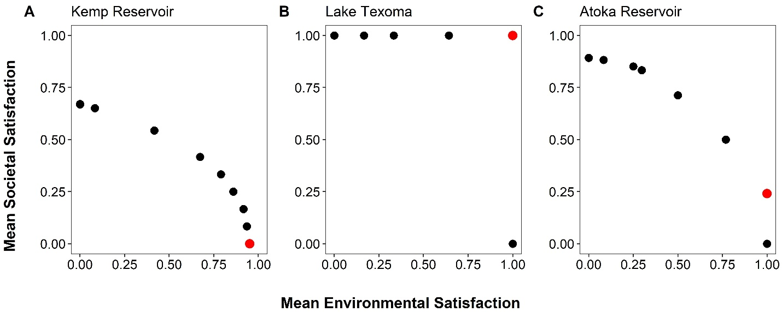
Figure 2-3. Examples of Pareto trade-off curves used to estimate conservation feasibility. Pareto tradeoff curves were generated from a basin-wide hydrologic planning model that considered the satisfaction of societal (y-axis) and environmental (x-axis) water needs at each reservoir in the basin. Societal satisfaction levels are based on meeting water allocations for municipal and agricultural users, and environmental satisfaction levels are based on meeting environmental flow targets below each reservoir. Red points indicate the highest possible societal water satisfaction value that could be achieved when environmental flow goals are fully met.
We estimated the conservation feasibility of meeting environmental flow targets below each reservoir by analyzing individual Pareto tradeoff curves at each reservoir. On each curve, we identified the highest possible societal water satisfaction value that could be achieved while fully meeting environmental flow goals. Conceptually, this point represents the socio-political challenges of meeting environmental flow goals below each reservoir. If it is possible to fully meet environmental flow targets while also maintaining high societal water satisfaction, then water conservation likely has high feasibility because it would entail little socio-political conflict. Conversely, in locations where it is not possible to maintain high societal water satisfaction while meeting environmental flow targets, water conservation likely has low feasibility because it would entail significant socio-political costs. In Lake Texoma, for example, the hydrologic model suggests that 100% satisfaction of both environmental and societal water targets is possible (Fig. 2-3A). Thus, meeting environmental flow goals below this reservoir should have high socio-political feasibility because it would not require any reduction in societal water use. In Atoka Reservoir, however, fully meeting environmental flow targets would result in societal water satisfaction of 25% at most (Fig. 2-3B). As a result, we estimate that meeting environmental flow goals below Atoka Reservoir has low socio-political feasibility because it would require a dramatic reduction in societal water use. Kemp Reservoir (Fig. 2-3C) represents an extreme case in which environmental flow goals cannot be met even by complete elimination of societal water consumption.

2.3.7. Identification of high priority river reaches
We identified high conservation priority river reaches by applying our prioritization framework (Fig. 2-1) across the nine climate scenarios detailed in section 2.3.3. For each climate scenario, we plotted the biodiversity value (i.e., BVI scores) of each river reach against conservation feasibility (i.e., the highest possible societal water satisfaction when environmental flows are fully met). For each river reach, we quantified the proportion of future climate scenarios in which that reach fell into each of the four priority quadrants of Fig. 2-1.
In applying this framework (Fig. 2-1) to the Red River, we used a societal water satisfaction value of 0.50 as the breakpoint between high and low sociopolitical costs. Given that our goal was to use the prioritization framework as a coarse filter to identify sites for more detailed analysis, we chose to use a low breakpoint to retain a larger number of sites for further consideration. We acknowledge that sites with a societal water satisfaction of 0.50 likely have substantial socio-political costs associated with water conservation actions (e.g., payment for ecosystem services; Sone et al. 2019). Similarly, we used the median of the BVI values in each scenario as the breakpoint between high and low biodiversity values.

2.4. Results
The biodiversity value of river reaches (as measured by BVI) varied geographically and across future climate scenarios (Fig. 2-4). For example, river reaches in the eastern portion of the basin (below Bistineau, Bayou D’Arbonne, Catahoula, and Caddo reservoirs) had consistently low BVI values, river reaches in the central portion of the basin (below Arbuckle, Atoka, Broken Bow, and McGee Creek reservoirs) had consistently high BVI values, and river reaches in the western portion of the basin (below Buffalo, Greenbelt, Foss, and Tom Steed reservoirs) had consistently low or medium BVI values. Overall, BVI scores ranged from 0.004 – 0.109 and indicate model (GCM)- and scenario (RCP)-specific variation. For example, for 22/38 river reaches, CCSM4 under RCP 4.5 produced the highest BVI values. Alternatively, for 28/38 river reaches, MPI-ESM-LR under RCP 8.5 produced the lowest BVI values.
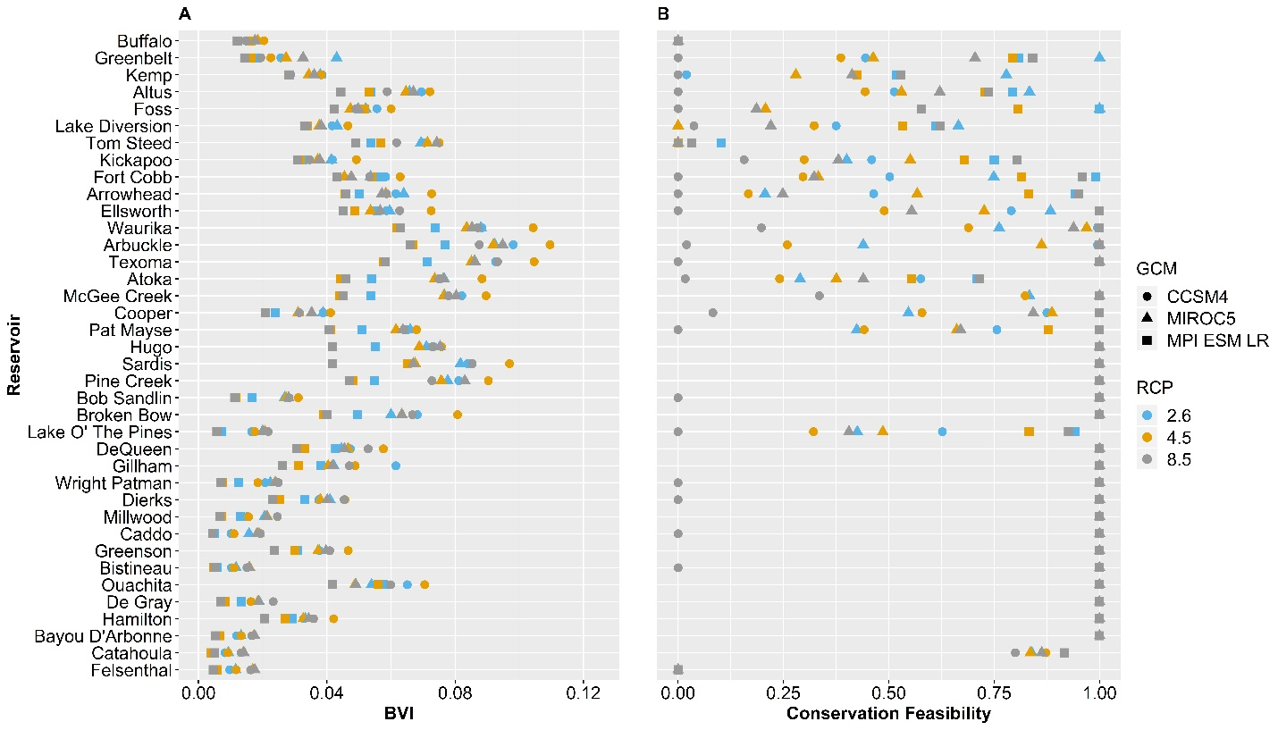
Figure 2-4. Biodiversity Value Index (BVI) values (A) and Conservation Feasibility values (B) across all river reaches below 38 major reservoirs in the Red River (USA). Each metric was calculated across nine future climate scenarios using three General Circulation Models (GCM’s) and Representative Concentration Pathways (RCP’s). Reservoir names are ordered from West (Buffalo) to East (Felsenthal).
The conservation feasibility of river reaches varied geographically and across future climate scenarios (Fig. 2-4) For example, river reaches in the eastern portion of the basin had consistently high feasibility values, river reaches in the central portion of the basin had consistently medium to high feasibility values, and river reaches in the western portion of the basin had generally low feasibility. However, there was some variability across climate scenarios. The CCSM4 model under RCP 8.5 produced the lowest feasibility values, while the MIROC5 and MPI-ESM-LR models under RCP 2.6 produced the highest feasibility values for most of the western reaches. Generally, there is considerably more uncertainty associated with the feasibility values relative to the BVI.
Because the biodiversity value and conservation feasibility of each site varied independently among future climate scenarios, site-level conservation priority varied among future climate scenarios (Fig. 2-5). For example, the CCSM4 model column showed an increasing separation of river reaches across a west-east gradient under higher RCP’s (i.e., most western sites were arranged towards low conservation feasibility, most eastern sites were arranged towards high conservation feasibility). The MIROC5 model column indicated a slight divergence in western reaches towards lower or higher conservation feasibility under higher emissions scenarios. The MPI-ESM-LR model column indicated little variation across sites with increasing RCP’s. Generally, across all GCM’s and RCP’s, reaches in arid western portions of the basin shifted the most between quadrants, while a subset of eastern reaches were consistently of high conservation priority as indicated by the line of blue sites on the right side of all plots.
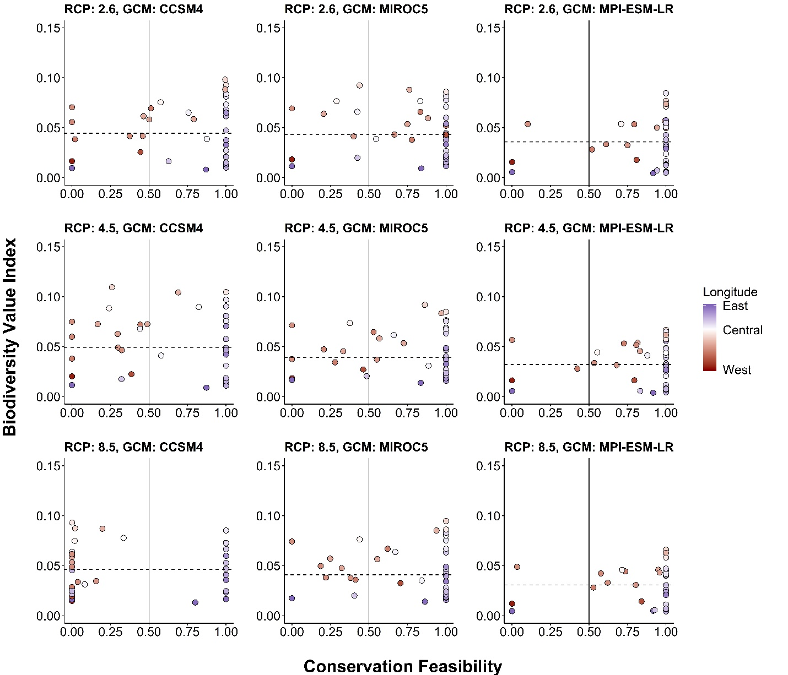
Figure 2-5. Quadrant plots to identify high conservation priority river reaches among river reaches below 38 major reservoirs in the Red River Basin (USA). Biodiversity Value Index (BVI) values (y-axis) were calculated from species distribution models and various conservation status weights. Conservation Feasibility (x-axis) values were calculated from a basin-scale hydrologic model - extracting the highest possible value of societal water satisfaction when environmental flow targets can be fully achieved. Quadrant lines relate to those delineated in Figure 2-1. River reaches (points) were colored by longitude.

Despite considerable uncertainty about future climate conditions, we found a subset of sites that had both high biodiversity value and high conservation feasibility across all future climate scenarios (Fig. 2-6). Reaches in the east-central portion of the basin (below DeQueen, Broken Bow, Hugo, and Sardis reservoirs) were consistently within quadrant I (i.e., they were high conservation priority, due to having high biodiversity value and conservation feasibility). However, some reaches in the west-central region sometimes shifted to quadrant II (i.e., high biodiversity value but low conservation feasibility) because the difficulty of meeting environmental flow targets increased under some future climate scenarios. Reaches in the eastern portion of the basin were consistently within quadrant III (i.e., high feasibility but low biodiversity value), and sometimes shifted to quadrant IV (i.e., they were low conservation priority because they had both low conservation value and low feasibility). The priority levels of reaches in the western portion of the basin had the highest variability across climate scenarios, to the extent that some individual reaches were placed into each of the four quadrants across the nine climate scenarios.
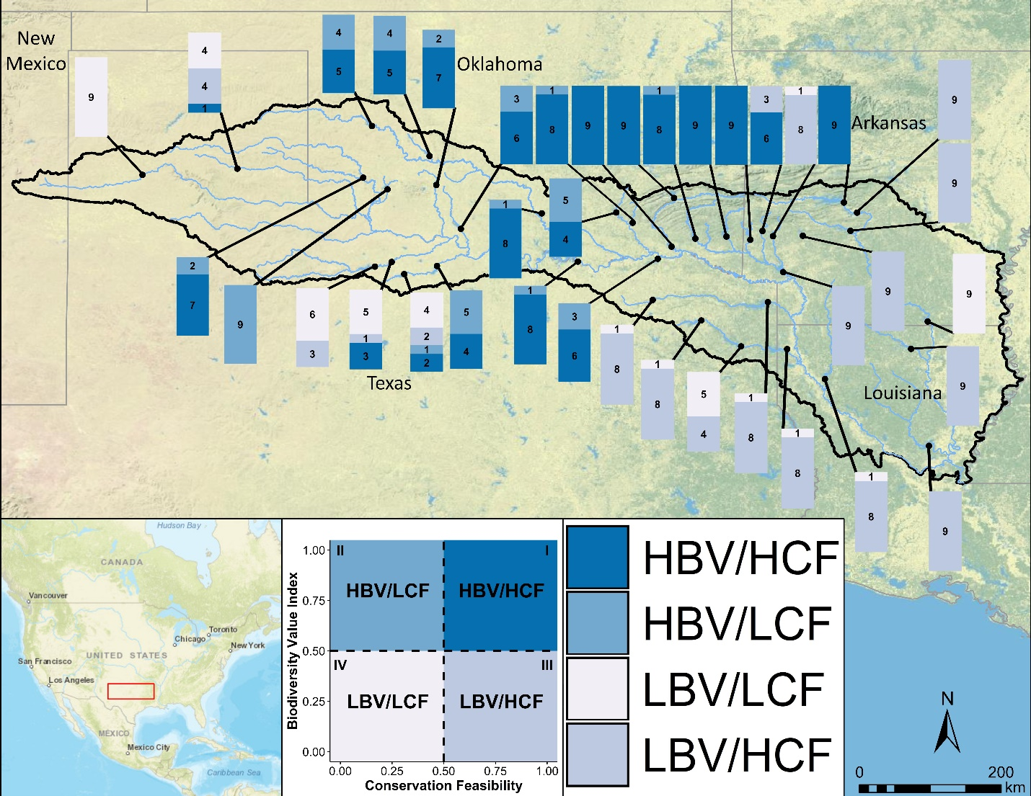
Figure 2-6. Map with stacked bar charts showing the proportion of times each river reach fell within each priority quadrant across all nine future climate scenarios. Colors correspond to the colored quadrants delineated in the prioritization model in Fig. 2-1 and the inset figure (i.e., HBV/HCF corresponds to the high biodiversity value/ high conservation feasibility quadrant in Fig. 2-1).

2.5. Discussion
Planning for biodiversity conservation under climatic uncertainty and socio-political constraints is challenging yet essential (Carvalho et al. 2011, Lawler and Michalak 2017, Guerrero & Wilson 2017). Given that decision makers must choose among candidate conservation projects under climatic uncertainty and socio-political constraints, our approach provides an example of how to integrate biodiversity, climate, and socio-political considerations in a prioritization framework. Our work extends other two-dimensional prioritization frameworks (Guerrero and Wilson 2017, Popejoy et al. 2018) by accounting for uncertainty in future climate conditions. By doing so, our prioritization framework allows decision makers to identify a subset of candidate sites where biodiversity value and sociopolitical feasibility will be consistently high across future climate scenarios. Thus, our prioritization framework could accelerate implementation by focusing research and assessment resources on those sites where conservation actions are most likely to be valuable and feasible in all future scenarios.
Our case study on environmental flows in the Red River illustrates how our prioritization framework may be used to identify freshwater conservation priorities at the regional scale. We found significant geographic variation in conservation priorities across future climate scenarios basin-wide (Fig. 2-6). We found that a subset (5/38) of sites in the east-central portion of the basin could be identified as high priority, low climate risk sites. Using our case study approach, conservation practitioners and resource managers in the region could collaboratively focus attention and resources on these priority sites because they have a high biodiversity value and high likelihood of conservation success while being insensitive to climatic change. Many of these sites are in the Ouachita Mountains, part of the central interior highlands, an ecoregion with a high number of endemic species (Matthews and Robison 1998, Abell et al. 2000). The Kiamichi river, for example, contains a high number of endemic and threatened fish, crayfish, and freshwater mussel species (Cross et al. 1986, Vaughn & Pyron 1995). Endemic species typically have higher risk of endangerment, and thus higher conservation priority, due to their limited geographic ranges. Ultimately, fish species’ future distributions were driven by a combination of static landscape covariates (e.g., lithology and elevation) and dynamic climate-driven covariates that varied among future scenarios (e.g., mean flow and temperature during summer; Gill et al. 2020). The relative importance of covariates in driving species’ distributions mirrors current knowledge on important factors driving stream fish distributions (Dodds et al. 2004, Perkin et al. 2015). In some cases, the biodiversity value of a site varied considerably among scenarios because species’ occurrences at that site were sensitive to climatic factors (Gill et al. 2020). In other cases, probabilities of occurrence were consistently low across climate scenarios because species’ occurrences were constrained by static landscape covariates (e.g., high salinity some western portions of the Red River basin; Winston et al. 1991).
While our prioritization framework identifies some sites as “low conservation priority”, these sites may warrant reconsideration if they align with local conservation priorities despite their low feasibility or broader value (Guerrero & Wilson 2017). For example, sites in the western portion of the basin (in central Oklahoma and North Texas) sometimes fall within quadrant II (high biodiversity value, low conservation feasibility). Some of these sites could be considered more carefully for prioritization if they are of value to local stakeholders. Additionally, our framework assumes that the potential costs and benefits of conserving a site are independent of actions taken at other sites. In reality, water conservation actions at upstream sites may increase downstream water availability, potentially altering the conservation feasibility and biodiversity value of downstream sites. Indeed, for many types of conservation actions, the costs and benefits of conservation projects may be contingent on where and when other projects are done (Moilanen et al. 2008, Sundermann et al. 2011, Runge et al. 2014, Neeson et al. 2015). While our framework does not account for project dependency, high priority sites could be more closely examined to determine how modifying dam operations would impact water availability across the reservoir network (Zamani-Sabzi et al 2019a).
Implementing environmental flows programs is a complex issue, especially in drought-prone river basins with increasing water-related conflicts (Arthington et al. 2006, Pittock et al. 2008, Poff & Matthews 2013, Poff et al. 2018, Wheeler et al. 2018, Zamani Sabzi et al. 2019). For example, in Oklahoma there is currently no mandate for water resource managers to incorporate environmental flows into their water management plans, and environmental flows are not considered a “beneficial use” of water (OWRB, pers. comm.). Texas has an “Instream Flows Program” for specific river basins, but there is no formal plan to establish flow requirements for the Red River basin. Because of high tensions across political boundaries (see Tarrant vs. Herrmann 2013), increasing water demand and decreasing water availability, positive-sum solutions may seem improbable. While there are many factors to consider in the design and implementation of environmental flows policies and programs, we believe our findings may aid in identifying solutions to balance environmental flows and societal water needs. For example, the Oklahoma Water Resources Board’s Instream Flows Advisory Group recently concluded a pilot study that found that implementing environmental flows in an ecologically and recreationally important sub-basin could be feasible under certain conditions (OWRB 2019). Other potential environmental flows programs or policies could include non-profit conservation organization programs (i.e., the Nature Conservancy’s Sustainable Rivers Program), or the purchasing of water rights to allocate specifically to environmental flows (Connor et al. 2013, Wheeler et al. 2013). Additionally, since water conservation incentives are being established in this region (OWRB 2015), water governors, water resource managers, and fisheries managers could explore where incentivizing water conservation may be most beneficial to both societal and ecosystem needs (Zamani Sabzi et al. 2019a). While there is a complex set of incommensurable factors that comprise the socio-political feasibility of increasing environmental flows, our coarse-scale approach is meant to help managers and planners filter among many sites to identify feasible conservation targets.
Our prioritization framework identifies sites that remain valuable and feasible across climate scenarios. Previous work by Popejoy et al. (2018) and Guerrero & Wilson (2017) prioritized sites for conservation by mapping the tradeoffs between conservation feasibility and some relevant ecological measure, but without considering future climate uncertainty. Popejoy et al. (2018) prioritized sites for freshwater mussel conservation in Texas by examining the tradeoffs between mussel communities’ similarity to the past and conservation feasibility. Guerrero & Wilson (2017) prioritized sites for improving connectivity of native vegetation clusters in Australia by examining the tradeoffs between the ecological importance of the vegetation clusters and conservation feasibility in terms of stakeholder presence. Other applications of our framework could include conservation prioritizations of expanding terrestrial protected areas or establishing harvest restrictions in marine protected areas. In these applications, the biodiversity dimension of our framework could be calculated in terms of the species, processes, or ecosystem services protected by a conservation action. Similarly, conservation feasibility may be estimated by examining landowners’ willingness to sell land or participate in a land conservation program, or stakeholders’ willingness to participate in harvest restrictions (Knight et al. 2011, McDonald et al. 2018, Cohen & Foale 2013, Deacon & Parker 2009).
Our framework highlights the importance of considering climate uncertainty in spatial conservation prioritizations. There are numerous studies that assess the impacts of climate change on range shifts, range overlap, or species loss (Midgley et al. 2003, Beaumont et al. 2011, Jones et al. 2013, Cheaib et al. 2012, Biber et al. 2019). A consistent finding among these studies is that projections vary among models and scenarios, and across species, leaving decision-makers uncertain of the utility of planning approaches (Groves et al. 2012, Kujala et al. 2013, Schmitz et al. 2015). However, prioritization approaches that are inclusive of uncertainty may focus attention on sites that are consistently of high value across future scenarios (Lawler & Michalak 2018) or penalize locations with high uncertainty (Moilanen et al. 2014). Because resources for conservation planning are often limited, it is necessary then to explore approaches that are inclusive of uncertainty and examine the trade-offs among the biodiversity value and conservation feasibility of locations to identify areas that can achieve the largest conservation outcome at minimal risk (Reside et al. 2018).

2.6. Conclusion
Our study presents a new conservation prioritization framework that enables conservation planners to identify high conservation priority, low climate risk sites. Overall, the novelty of our prioritization approach lies in allowing decision makers to weigh the tradeoffs among sites with varying levels of biodiversity value and conservation feasibility across future climate scenarios. We show that even under considerable climatic uncertainty, it is possible to identify sites that remain high priority across a range of future climate conditions. Our case study in the Red River basin highlights the complex challenges of conservation planning for freshwater biodiversity and water resource management under climatic uncertainty. Our framework could be expanded to a variety of different taxa and systems to identify similar targeted conservation projects.

References
Acreman, M., Arthington, A. H., Colloff, M. J., Couch, C., Crossman, N. D., Dyer, F., ... Young, W. (2014). Environmental flows for natural, hybrid, and novel riverine ecosystems in a changing world. Frontiers in Ecology and the Environment, 12, 466–473.
Adams, V. M., Mills, M., Weeks, R., Segan, D. B., Pressey, R. L., Gurney, G. G., ... & Álvarez-Romero, J. G. (2019). Implementation strategies for systematic conservation planning. Ambio, 48(2), 139-152.
Adams, V. M., Pressey, R. L., & Stoeckl, N. (2014). Estimating landholders’ probability of participating in a stewardship program, and the implications for spatial conservation priorities. PLoS One, 9(6), e97941.
Akçakaya, H. R., Butchart, S. H., Mace, G. M., Stuart, S. N., & Hilton‐Taylor, C. (2006). Use and misuse of the IUCN Red List Criteria in projecting climate change impacts on biodiversity. Global Change Biology, 12(11), 2037-2043.
Araújo, M. B., Cabeza, M., Thuiller, W., Hannah, L., & Williams, P. H. (2004). Would climate change drive species out of reserves? An assessment of existing reserve‐selection methods. Global change biology, 10(9), 1618-1626.
Araújo, M. B., & Luoto, M. (2007). The importance of biotic interactions for modelling species distributions under climate change. Global Ecology and Biogeography, 16(6), 743-753.
Araújo, M. B., & New, M. (2007). Ensemble forecasting of species distributions. Trends in ecology & evolution, 22(1), 42-47.
Arthington, A. H., Bunn, S. E., Poff, N. L., & Naiman, R. J. (2006). The challenge of providing environmental flow rules to sustain river ecosystems. Ecological applications, 16(4), 1311-1318.
Arthington, A. H., Bhaduri, A., Bunn, S. E., Jackson, S. E., Tharme, R. E., Tickner, D., ... & Horne, A. C. (2018). The Brisbane declaration and global action agenda on environmental flows (2018). Frontiers in Environmental Science, 6, 45.
Bagstad, K. J., Reed, J. M., Semmens, D. J., Sherrouse, B. C., & Troy, A. (2016). Linking biophysical models and public preferences for ecosystem service assessments: a case study for the Southern Rocky Mountains. Regional Environmental Change, 16(7), 2005-2018.
Balmford, A., Gaston, K. J., Blyth, S., James, A., & Kapos, V. (2003). Global variation in terrestrial conservation costs, conservation benefits, and unmet conservation needs. Proceedings of the National Academy of Sciences, 100(3), 1046-1050.
Ban, N. C., Mills, M., Tam, J., Hicks, C. C., Klain, S., Stoeckl, N., ... & Chan, K. M. (2013). A social–ecological approach to conservation planning: embedding social considerations. Frontiers in Ecology and the Environment, 11(4), 194-202.
Bates, A. E., Cooke, R. S., Duncan, M. I., Edgar, G. J., Bruno, J. F., Benedetti-Cecchi, L., ... & Bird, T. J. (2019). Climate resilience in marine protected areas and the ‘Protection Paradox’. Biological Conservation, 236, 305-314.
Bertrand, D., & McPherson, R. A. (2018). Future hydrologic extremes of the Red River basin. Journal of Applied Meteorology and Climatology, 57(6), 1321-1336.
Bertrand, D., & McPherson, R. A. (2019). Development of Downscaled Climate Projections: A Case Study of the Red River Basin, South-Central US. Advances in Meteorology, 2019.
Biber, M. F., Voskamp, A., Niamir, A., Hickler, T., & Hof, C. (2019). A comparison of macroecological and stacked species distribution models to predict future global terrestrial vertebrate richness. Journal of Biogeography.
Bonebrake, T. C., Brown, C. J., Bell, J. D., Blanchard, J. L., Chauvenet, A., Champion, C., ... & Dell, A. I. (2018). Managing consequences of climate‐driven species redistribution requires integration of ecology, conservation and social science. Biological Reviews, 93(1), 284-305.
Bryan, B. A., Raymond, C. M., Crossman, N. D., & King, D. (2011). Comparing spatially explicit ecological and social values for natural areas to identify effective conservation strategies. Conservation Biology, 25(1), 172-181.
Beaumont, L. J., Pitman, A., Perkins, S., Zimmermann, N. E., Yoccoz, N. G., & Thuiller, W. (2011). Impacts of climate change on the world's most exceptional ecoregions. Proceedings of the National Academy of Sciences, 108(6), 2306-2311.
Capmourteres, V., & Anand, M. (2016). “Conservation value”: a review of the concept and its quantification. Ecosphere, 7(10), e01476.
Carvalho, S. B., Brito, J. C., Crespo, E. G., Watts, M. E., & Possingham, H. P. (2011). Conservation planning under climate change: Toward accounting for uncertainty in predicted species distributions to increase confidence in conservation investments in space and time. Biological Conservation, 144(7), 2020-2030.
Cheaib, A., Badeau, V., Boe, J., Chuine, I., Delire, C., Dufrêne, E., ... & Thuiller, W. (2012). Climate change impacts on tree ranges: model intercomparison facilitates understanding and quantification of uncertainty. Ecology letters, 15(6), 533-544.
Christensen, N. S., Wood, A. W., Voisin, N., Lettenmaier, D. P., & Palmer, R. N. (2004). The effects of climate change on the hydrology and water resources of the Colorado River basin. Climatic change, 62(1-3), 337-363.
Cohen, P. J., & Foale, S. J. (2013). Sustaining small-scale fisheries with periodically harvested marine reserves. Marine Policy, 37, 278-287.
Coffey, D. J., & Joseph, P. H. (2013). A polarized environment: The effect of partisanship and ideological values on individual recycling and conservation behavior. American Behavioral Scientist, 57(1), 116-139.
Conroy, M. J., Runge, M. C., Nichols, J. D., Stodola, K. W., & Cooper, R. J. (2011). Conservation in the face of climate change: the roles of alternative models, monitoring, and adaptation in confronting and reducing uncertainty. Biological Conservation, 144(4), 1204-1213.
Crespo, D., Albiac, J., Kahil, T., Esteban, E., & Baccour, S. (2019). Tradeoffs between Water Uses and Environmental Flows: A Hydroeconomic Analysis in the Ebro Basin. Water Resources Management, 33(7), 2301-2317.
Cross, F. B., R.L. Mayden and J.D. Stewart (1986) "Fishes in the western Mississippi drainage" In C. H. Hocutt and E.O. Wiley (Ed.). The zoogeography of North American freshwater fishes. (pp. 363-412) New York, NY: John Wiley & Sons.
Daher, B., Lee, S. H., Kaushik, V., Blake, J., Askariyeh, M. H., Shafiezadeh, H., ... & Mohtar, R. H. (2019). Towards bridging the water gap in Texas: A water-energy-food nexus approach. Science of the total environment, 647, 449-463.
Dallimer, M., & Strange, N. (2015). Why socio-political borders and boundaries matter in conservation. Trends in Ecology & Evolution, 30(3), 132-139.
Deacon, R. T., & Parker, D. P. (2009). Encumbering harvest rights to protect marine environments: a model of marine conservation easements. Australian Journal of Agricultural and Resource Economics, 53(1), 37-58.
Díaz, S., Settele, J., Brondízio, E. S., Ngo, H. T., Agard, J., Arneth, A., ... & Garibaldi, L. A. (2019). Pervasive human-driven decline of life on Earth points to the need for transformative change. Science, 366(6471).
Dodds, W. K., Gido, K., Whiles, M. R., Fritz, K. M., & Matthews, W. J. (2004). Life on the edge: The ecology of Great Plains prairie streams. BioScience, 54(3), 205–216.
DuBose, T. P., Atkinson, C. L., Vaughn, C. C., & Golladay, S. W. (2019). Drought-induced, punctuated loss of freshwater mussels alters ecosystem function across temporal scales. Frontiers in Ecology and Evolution, 7, 274.
Flörke, M., Schneider, C., & McDonald, R. I. (2018). Water competition between cities and agriculture driven by climate change and urban growth. Nature Sustainability, 1(1), 51-58.
Foote, J. L., Gregor, J. E., Hepi, M. C., Baker, V. E., Houston, D. J., & Midgley, G. (2007). Systemic problem structuring applied to community involvement in water conservation. Journal of the operational research society, 58(5), 645-654.
Gill, K. C., Fovargue, R. E., & Neeson, T. M. (2020). Hotspots of species loss do not vary across future climate scenarios in a drought‐prone river basin. Ecology and Evolution, 10(17), 9200-9213.
Gorenflo, L. J., & Brandon, K. (2006). Key human dimensions of gaps in global biodiversity conservation. Bioscience, 56(9), 723-731.
Grafton, R. Q., Chu, H. L., Stewardson, M., & Kompas, T. (2011). Optimal dynamic water allocation: Irrigation extractions and environmental tradeoffs in the Murray River, Australia. Water Resources Research, 47(12).
Green, E. J., Buchanan, G. M., Butchart, S. H., Chandler, G. M., Burgess, N. D., Hill, S. L., & Gregory, R. D. (2019). Relating characteristics of global biodiversity targets to reported progress. Conservation Biology, 33(6), 1360-1369.
Groves, C. R., Game, E. T., Anderson, M. G., Cross, M., Enquist, C., Ferdana, Z., ... & Marshall, R. (2012). Incorporating climate change into systematic conservation planning. Biodiversity and Conservation, 21(7), 1651-1671.
Guerrero, A. M., McAllister, R. R., Corcoran, J., & Wilson, K. A. (2013). Scale mismatches, conservation planning, and the value of social‐network analyses. Conservation Biology, 27(1), 35-44.
Guerrero, A. M., & Wilson, K. A. (2017). Using a social–ecological framework to inform the implementation of conservation plans. Conservation Biology, 31(2), 290-301.
Guerrero, A. M., Bennett, N. J., Wilson, K. A., Carter, N., Gill, D., Mills, M., ... & Januchowski-Hartley, F. A. (2018). Achieving the promise of integration in social-ecological research. Ecology and Society, 23(3).
Guerrero, A. M., Knight, A. T., Grantham, H. S., Cowling, R. M., & Wilson, K. A. (2010). Predicting willingness‐to‐sell and its utility for assessing conservation opportunity for expanding protected area networks. Conservation Letters, 3(5), 332-339.
Guo, L., Zamani Sabzi, H., Neeson, T. M., Allen, J. K., & Mistree, F. (2019). Managing conflicting water resource goals and uncertainties in a dam network by exploring the solution space. Journal of Mechanical Design, 141(3).
Halmy, M. W. A., & Salem, B. B. (2015). Species conservation importance index (SCI) for comparing sites’ conservation value at landscape level. Brazilian Journal of Botany, 38(4), 823-835.
He, Q., & Silliman, B. R. (2019). Climate change, human impacts, and coastal ecosystems in the Anthropocene. Current Biology, 29(19), R1021-R1035.
Heller, N. E., & Zavaleta, E. S. (2009). Biodiversity management in the face of climate change: a review of 22 years of recommendations. Biological conservation, 142(1), 14-32.
Hoagstrom, C. W., & Turner, T. F. (2015). Recruitment ecology of pelagic‐broadcast spawning minnows: paradigms from the ocean advance science and conservation of an imperilled freshwater fauna. Fish and Fisheries, 16(2), 282-299.
IUCN 2019. The IUCN Red List of Threatened Species. Version 2019-1. http://www.iucnredlist.org. Downloaded on 1 May 2019.
Jones, K. R., Watson, J. E., Possingham, H. P., & Klein, C. J. (2016). Incorporating climate change into spatial conservation prioritisation: A review. Biological Conservation, 194, 121-130.
Jones, M. C., Dye, S. R., Fernandes, J. A., Frölicher, T. L., Pinnegar, J. K., Warren, R., & Cheung, W. W. (2013). Predicting the impact of climate change on threatened species in UK waters. PLoS One, 8(1), e54216.
Jupiter, S. D., Wenger, A., Klein, C. J., Albert, S., Mangubhai, S., Nelson, J., ... & Watson, J. E. (2017). Opportunities and constraints for implementing integrated land–sea management on islands. Environmental Conservation, 44(3), 254-266.
Karimi, A., Tulloch, A. I., Brown, G., & Hockings, M. (2017). Understanding the effects of different social data on selecting priority conservation areas. Conservation Biology, 31(6), 1439-1449.
Kinsolving, A. D., & Bain, M. B. (1993). Fish assemblage recovery along a riverine disturbance gradient. Ecological Applications, 3(3), 531-544.
Knight, A. T., Cowling, R. M., Rouget, M., Balmford, A., Lombard, A. T., & Campbell, B. M. (2008). Knowing but not doing: selecting priority conservation areas and the research–implementation gap. Conservation biology, 22(3), 610-617.
Knight, A. T., Cowling, R. M., Difford, M., & Campbell, B. M. (2010). Mapping human and social dimensions of conservation opportunity for the scheduling of conservation action on private land. Conservation Biology, 24(5), 1348-1358.
Knight, A. T., Grantham, H. S., Smith, R. J., McGregor, G. K., Possingham, H. P., & Cowling, R. M. (2011). Land managers’ willingness-to-sell defines conservation opportunity for protected area expansion. Biological Conservation, 144(11), 2623-2630.
Kujala, H., Moilanen, A., Araujo, M. B., & Cabeza, M. (2013). Conservation planning with uncertain climate change projections. PloS one, 8(2), e53315.
Kukkala, A. S., & Moilanen, A. (2013). Core concepts of spatial prioritization in systematic conservation planning. Biological Reviews, 88(2), 443-464.
Kwayu, EJ, Sallu, SM and Paavola, J (2014) Farmer participation in the equitable payments for watershed services in Morogoro, Tanzania. Ecosystem Services, 7. 1 - 9. ISSN 2212-0416
Lawler, J.J., and Michalak, J. (2018). Planning for climate change without climate projections? In: Effective Conservation Science: Data Not Dogma. Edited by Peter Kareiva, Michelle Marvier, and Brian Silliman: Oxford University Press. DOI: 10.1093.
Lehtomäki, J., & Moilanen, A. (2013). Methods and workflow for spatial conservation prioritization using Zonation. Environmental Modelling & Software, 47, 128-137.
Liang, X., Wood, E. F., & Lettenmaier, D. P. (1996). Surface soil moisture parameterization of the VIC-2L model: Evaluation and modification. Global and Planetary Change, 13(1-4), 195-206.
Linke, S., Hermoso, V., & Januchowski‐Hartley, S. (2019). Toward process‐based conservation prioritizations for freshwater ecosystems. Aquatic Conservation: Marine and Freshwater Ecosystems, 29(7), 1149-1160.
Ma, Z., Kang, S., Zhang, L., Tong, L., & Su, X. (2008). Analysis of impacts of climate variability and human activity on streamflow for a river basin in arid region of northwest China. Journal of Hydrology, 352(3-4), 239-249.
Manfredo, M. J., Teel, T. L., & Dietsch, A. M. (2016). Implications of human value shift and persistence for biodiversity conservation. Conservation Biology, 30(2), 287-296.
Matthews, W. J., Vaughn, C. C., Gido, K. B., & Marsh-Matthews, E. (2005). Southern plains rivers. Rivers of North America, 283-325.
Matthews, W. J., & Marsh-Matthews, E. (2017). Stream fish community dynamics: A critical synthesis. JHU Press.
McDonald, J. A., Helmstedt, K. J., Bode, M., Coutts, S., McDonald‐Madden, E., & Possingham, H. P. (2018). Improving private land conservation with outcome‐based biodiversity payments. Journal of applied ecology, 55(3), 1476-1485.
McIntosh, E. J., Chapman, S., Kearney, S. G., Williams, B., Althor, G., Thorn, J. P., ... & Grenyer, R. (2018). Absence of evidence for the conservation outcomes of systematic conservation planning around the globe: a systematic map. Environmental Evidence, 7(1), 22.
McPherson, R., et al., 2016. Impacts of climate change on flows in the Red River Basin. Final report to the South-Central Climate Science Center. Available at: http://www. southcentralclimate.org/content/documents/RedRiverClimateChange_FinalReport.pdf (accessed November 2, 2019).
Meir, E., Andelman, S., & Possingham, H. P. (2004). Does conservation planning matter in a dynamic and uncertain world?. Ecology Letters, 7(8), 615-622.
Mekonnen, M. M., & Hoekstra, A. Y. (2016). Four billion people facing severe water scarcity. Science advances, 2(2), e1500323.
Midgley, G. F., Hannah, L., Millar, D., Thuiller, W., & Booth, A. (2003). Developing regional and species-level assessments of climate change impacts on biodiversity in the Cape Floristic Region. Biological Conservation, 112(1-2), 87-97.
Miller, R. M., Rodríguez, J. P., Aniskowicz‐Fowler, T., Bambaradeniya, C., Boles, R., Eaton, M. A., ... & Pollock, C. (2007). National threatened species listing based on IUCN criteria and regional guidelines: current status and future perspectives. Conservation Biology, 21(3), 684-696.
Mims, M. C., & Olden, J. D. (2012). Life history theory predicts fish assemblage response to hydrologic regimes. Ecology, 93(1), 35-45
Moilanen, A., Leathwick, J., & Elith, J. (2008). A method for spatial freshwater conservation prioritization. Freshwater Biology, 53(3), 577-592.
Moon, K., Adams, V., Januchowski‐Hartley, S., Polyakov, M., Mills, M., Biggs, D., … Raymond, C. (2014). A multidisciplinary conceptualization of conservation opportunity. Conservation Biology, 28, 1484–1496. https://doi.org/10.1111/cobi.12408
Natureserve. 2019. NatureServe Web Service. Arlington, VA. U.S.A. Available http://services.natureserve.org. (Accessed: 1 May 2019)
Neeson, T. M., Ferris, M. C., Diebel, M. W., Doran, P. J., O’Hanley, J. R., & McIntyre, P. B. (2015). Enhancing ecosystem restoration efficiency through spatial and temporal coordination. Proceedings of the National Academy of Sciences, 112(19), 6236-6241.
Nilsson, C., & Renöfält, B. M. (2008). Linking flow regime and water quality in rivers: a challenge to adaptive catchment management. Ecology and Society, 13(2).
Olden JD, Konrad CP, Melis TS, Kennard MJ, Freeman MC, Mims MC, Bray EN, Gido KB, Hemphill NP, Lytle DA. 2014. Are large‐scale flow experiments informing the science and management of freshwater ecosystems? Frontiers in Ecology and the Environment 12: 176–185.
Oklahoma Water Resources Board, 2015. Report of the Oklahoma Water for 2060 Advisory Council. Available at: https://www.owrb.ok.gov/2060/.
Oklahoma Water Resources Board, 2019, Upper Illinois River Instream Flow Pilot Study (Draft). Available at: https://www.owrb.ok.gov/supply/ocwp/instreamflow.php
Pahl-Wostl, C., Arthington, A., Bogardi, J., Bunn, S. E., Hoff, H., Lebel, L., ... & Schlüter, M. (2013). Environmental flows and water governance: managing sustainable water uses. Current Opinion in Environmental Sustainability, 5(3-4), 341-351.
Perkin, J. S., Gido, K. B., Costigan, K. H., Daniels, M. D., & Johnson, E. R. (2015). Fragmentation and drying ratchet down Great Plains stream fish diversity. Aquatic Conservation: Marine and Freshwater Ecosystems, 25(5), 639-655.
Pittock, J., & Finlayson, C. M. (2011). Australia’s Murray–Darling Basin: freshwater ecosystem conservation options in an era of climate change. Marine and Freshwater Research, 62(3), 232-243.
Pittock, J., Hansen, L. J., & Abell, R. (2008). Running dry: freshwater biodiversity, protected areas and climate change. Biodiversity, 9(3-4), 30-38.
Poff, N. L., & Matthews, J. H. (2013). Environmental flows in the Anthropocence: past progress and future prospects. Current Opinion in Environmental Sustainability, 5(6), 667-675.
Poff, N. L. (2018). Beyond the natural flow regime? Broadening the hydro‐ecological foundation to meet environmental flows challenges in a non‐stationary world. Freshwater biology, 63(8), 1011-1021.
Popejoy, T., Randklev, C. R., Neeson, T. M., & Vaughn, C. C. (2018). Prioritizing sites for conservation based on similarity to historical baselines and feasibility of protection. Conservation biology, 32(5), 1118-1127.
Portney, K. E., Vedlitz, A., Sansom, G., Berke, P., & Daher, B. T. (2017). Governance of the water-energy-food nexus: the conceptual and methodological foundations for the San Antonio region case study. Current Sustainable/Renewable Energy Reports, 4(3), 160-167.
Pressey, R. L., Cabeza, M., Watts, M. E., Cowling, R. M., & Wilson, K. A. (2007). Conservation planning in a changing world. Trends in Ecology & Evolution, 22(11), 583-592.
Rastogi, A., Hickey, G. M., Badola, R., & Hussain, S. A. (2014). Understanding the local socio-political processes affecting conservation management outcomes in Corbett Tiger Reserve, India. Environmental management, 53(5), 913-929.
Reside, A.E., VanDerWal, J., Moilanen, A, Graham, E.M. (2017) Examining current or future trade-offs for biodiversity conservation in north-eastern Australia. PLoS ONE 12:e0172230
Reside, A. E., Butt, N., & Adams, V. M. (2018). Adapting systematic conservation planning for climate change. Biodiversity and Conservation, 27(1), 1-29.
Scheffers, B. R., & Pecl, G. (2019). Persecuting, protecting or ignoring biodiversity under climate change. Nature Climate Change, 1.
Sheffield, J., Barrett, A. P., Colle, B., Nelun Fernando, D., Fu, R., Geil, K. L., ... & Lombardo, K. (2013). North American climate in CMIP5 experiments. Part I: Evaluation of historical simulations of continental and regional climatology. Journal of Climate, 26(23), 9209-9245
Schmitz, O. J., Lawler, J. J., Beier, P., Groves, C., Knight, G., Boyce, D. A., ... & Pierce, D. J. (2015). Conserving biodiversity: practical guidance about climate change adaptation approaches in support of land-use planning. Natural Areas Journal, 35(1), 190-204.
Sinclair, S. P., Milner‐Gulland, E. J., Smith, R. J., McIntosh, E. J., Possingham, H. P., Vercammen, A., & Knight, A. T. (2018). The use, and usefulness, of spatial conservation prioritizations. Conservation Letters, 11(6), e12459.
Sinokrot, B. A., Stefan, H. G., McCormick, J. H., & Eaton, J. G. (1995). Modeling of climate change effects on stream temperatures and fish habitats below dams and near groundwater inputs. Climatic Change, 30(2), 181-200.
Sivapalan, M., Konar, M., Srinivasan, V., Chhatre, A., Wutich, A., Scott, C. A., ... & Rodríguez‐Iturbe, I. (2014). Socio‐hydrology: Use‐inspired water sustainability science for the Anthropocene. Earth's Future, 2(4), 225-230.
Sundermann, A., Stoll, S., & Haase, P. (2011). River restoration success depends on the species pool of the immediate surroundings. Ecological Applications, 21(6), 1962-1971.
Tarrant Regional Water Dist. v. Herrmann, 133 S. Ct. 2120, 569 U.S. 614, 186 L. Ed. 2d 153 (2013).
Tickner, D., Opperman, J. J., Abell, R., Acreman, M., Arthington, A. H., Bunn, S. E., ... & Harrison, I. (2020). Bending the curve of global freshwater biodiversity loss: an emergency recovery plan. Bioscience, 70(4), 330-342.
Toomey, A. H., Knight, A. T., & Barlow, J. (2017). Navigating the space between research and implementation in conservation. Conservation Letters, 10(5), 619-625.
Tulloch, A. I., Tulloch, V. J., Evans, M. C., & Mills, M. (2014). The value of using feasibility models in systematic conservation planning to predict landholder management uptake. Conservation Biology, 28(6), 1462-1473.
Vaughn, C. C. (2018). Ecosystem services provided by freshwater mussels. Hydrobiologia, 810(1), 15-27.
Vaughn, C. C., & Pyron, M. (1995). Population ecology of the endangered Ouachita rock-pocketbook mussel, Arkansia wheeleri (Bivalvia: Unionidae), in the Kiamichi River, Oklahoma. American Malacological Bulletin, 11(2), 145-151.
Vaughn, C. C., Atkinson, C. L., & Julian, J. P. (2015). Drought‐induced changes in flow regimes lead to long‐term losses in mussel‐provided ecosystem services. Ecology and evolution, 5(6), 1291-1305.
Von Essen, E., & Hansen, H. P. (2015). How stakeholder co-management reproduces conservation conflicts: revealing rationality problems in Swedish wolf conservation. Conservation and Society, 13(4), 332.
Wang, Y. B., Liu, D., Cao, X. C., Yang, Z. Y., Song, J. F., Chen, D. Y., & Sun, S. K. (2017). Agricultural water rights trading and virtual water export compensation coupling model: a case study of an irrigation district in China. Agricultural Water Management, 180, 99-106.
Wheeler, S., Garrick, D., Loch, A., & Bjornlund, H. (2013). Evaluating water market products to acquire water for the environment in Australia. Land use policy, 30(1), 427-436.
Wheeler, K. G., Robinson, C. J., & Bark, R. H. (2018). Modelling to bridge many boundaries: the Colorado and Murray-Darling River basins. Regional environmental change, 18(6), 1607-1619.
Whitehead, A. L., Kujala, H., Ives, C. D., Gordon, A., Lentini, P. E., Wintle, B. A., ... & Raymond, C. M. (2014). Integrating biological and social values when prioritizing places for biodiversity conservation. Conservation biology, 28(4), 992-1003.
Wilby, R. L., Orr, H., Watts, G., Battarbee, R. W., Berry, P. M., Chadd, R., ... & Hannah, D. M. (2010). Evidence needed to manage freshwater ecosystems in a changing climate: turning adaptation principles into practice. Science of the Total Environment, 408(19), 4150-4164.
Winston, M. R., Taylor, C. M., & Pigg, J. (1991). Upstream extirpation of four minnow species due to damming of a prairie stream. Transactions of the American Fisheries Society, 120(1), 98-105.
Wunder, S., Brouwer, R., Engel, S., Ezzine-de-Blas, D., Muradian, R., Pascual, U., & Pinto, R. (2018). From principles to practice in paying for nature’s services. Nature Sustainability, 1(3), 145-150
Zamani Sabzi, H. Z., Rezapour, S., Fovargue, R., Moreno, H., & Neeson, T. M. (2019a). Strategic allocation of water conservation incentives to balance environmental flows and societal outcomes. Ecological Engineering, 127, 160-169.
Zamani Sabzi, H. Z., Moreno, H. A., Fovargue, R., Xue, X., Hong, Y., & Neeson, T. M. (2019b). Comparison of projected water availability and demand reveals future hotspots of water stress in the Red River basin, USA. Journal of Hydrology: Regional Studies, 26, 100638.
Ziv, G., Baran, E., Nam, S., Rodríguez-Iturbe, I., & Levin, S. A. (2012). Trading-off fish biodiversity, food security, and hydropower in the Mekong River Basin. Proceedings of the National Academy of Sciences, 109(15), 5609-5614.
Xue, X., Zhang, K., Hong, Y., Gourley, J. J., Kellogg, W., McPherson, R. A., ... & Austin, B. N. (2016). New multisite cascading calibration approach for hydrological models: case study in the Red River basin using the VIC model. Journal of Hydrologic Engineering, 21(2), 05015019.

3. Small tradeoffs between social equity and conservation outcomes in a freshwater payment for ecosystem services scheme

3.1. Abstract
Conservation programs around the world aim to balance social equity, economic efficiency, and conservation outcomes. Tradeoffs among these three objectives necessarily exist but have been quantified in only a handful of systems. Here, we use a multi-objective mathematical optimization model in a large, water-limited river basin to quantify the distributional equity of a freshwater payment for ecosystem services (PES) program aimed at establishing environmental flows (e-flows). Across a range of budgetary and future climate scenarios, we find that tradeoffs between social equity and conservation outcomes are small. We also show that payment schemes in which incentives are allocated to a single water use sector are much less cost-effective than schemes in which incentives are allocated among multiple sectors. Thus, payment schemes in which incentives are split equally among agricultural, municipal, and industrial users can be both more equitable and more cost-effective. Despite these small tradeoffs, greater equity was achievable at higher budgets and in climate scenarios with stringent emissions reductions. Our results overall illustrate how some carefully designed conservation programs may be able to achieve a triple bottom line of social equity, economic efficiency and conservation effectiveness.

3.2. Introduction
Prolonged declines in global biodiversity and ecosystem health have prompted interest in innovative conservation initiatives that balance tradeoffs between human and environmental needs (Mace et al., 2018; Williams et al., 2021). One group of initiatives that have rapidly gained attention are Payment for Ecosystem Services (PES). PES schemes aim to restore or protect ecosystem services through voluntary monetary incentives paid to resource users to adopt conservation practices or forgo the use of a resource (Aguilar-Gómez et al., 2020; Venkatachalam & Balooni, 2018; Wunder, 2013). PES initiatives have rapidly expanded in recent years but have exhibited mixed success outcomes (Friedman et al., 2018a; Salzman et al., 2018). Indeed, current research suggests incorporating social equity considerations in PES schemes can be key determinants of their success (Brimont et al., 2015; Daw et al., 2015; Haas et al., 2019; Halpern et al., 2013a; Klein et al., 2015; Law et al., 2018; Loft et al., 2019; Pascual et al., 2014; Rakotonarivo et al., 2021). Thus, a key challenge for conservation practitioners is to minimize the tradeoffs among equity, economic efficiency, and conservation outcomes in PES initiatives.
Social equity, through the lens of conservation, has four dimensions and is defined as “A multi-dimensional concept of ethical concerns and social justice based on the (1) distribution of costs and benefits, (2) process and participation, and (3) recognition, underpinned by the (4) context under consideration” (Friedman et al., 2018a). In the context of PES schemes, achieving triple-bottom-line solutions where economic efficiency (cost), equity, and conservation objectives are balanced is highly desirable (Halpern et al., 2013b). However, incorporating social equity considerations can produce “win-lose” or tradeoff outcomes, where conservation goals can be achieved at the detriment of social equity and/or economic efficiency goals or vice-versa (Halpern et al., 2013b; Law et al., 2018; Tallis et al., 2008). Additionally, PES schemes can result in elite capture, where the dominant resource user receives most of the monetary incentive to the detriment of other users (Hayes et al., 2019; Hayes & Murtinho, 2018; Lund & Saito-Jensen, 2013). Because conservation initiatives like PES require large investments of money and time, minimizing tradeoffs and avoiding elite capture is important to ensuring their success (Klein et al., 2015; Waldron et al., 2013).
Despite PES programs in freshwater ecosystems being the most widespread by geographical distribution and transaction value (Salzman et al., 2018), terrestrial and marine ecosystems have received the most attention, particularly in the context of protected areas implementation (Dawson et al., 2018; Schreckenberg et al., 2016; Zafra-Calvo et al., 2017), REDD+ evaluation (Börner et al., 2020; Brimont et al., 2015; Pascual et al., 2014; Saeed et al., 2018; Schroeder & McDermott, 2014), and marine protected areas (MPAs) or fishing regulations (Bennett et al., 2020; Daw et al., 2015; Eriksson et al., 2019; Halpern et al., 2013; Gill et al. 2019). In fact, the implementation of PES initiatives that aim to establish environmental flows (e-flows) for freshwater ecosystems have received little attention (A. Auerbach et al., 2014; Bellver-Domingo et al., 2016; Hu et al., 2016; Lopes Simedo et al., 2020). E-flows initiatives aim to keep water in rivers at specific quantities and times to help sustain the structure and function of flowing freshwater systems and are key to bending the curve on freshwater biodiversity declines (Tickner et al., 2020). The lack of e-flows PES programs could be due to the limited legal authority to reallocate water rights using monetary payments and inherent tradeoffs between societal and environmental water uses in freshwater ecosystems, especially in water-limited systems (Aguilar-Gómez et al., 2020; Salzman et al., 2018; Ward & Pulido-Velázquez, 2008; Zamani Sabzi, Rezapour, et al., 2019). Thus, as conservation practitioners seek to accelerate and expand implementation of PES programs in freshwater ecosystems, successful programs require a better understanding of whether equity across different water use sectors plays a role in exacerbating tradeoffs between human and environmental water uses (Tickner et al., 2020).
Because water availability is projected to change dramatically under climate change, minimizing tradeoffs among equity, economic efficiency, and conservation outcomes in freshwater PES schemes will become increasingly challenging (Engel & Muller, 2016; Schewe et al., 2014; van de Sand et al., 2014). Indeed, many water-limited and urban areas will experience increased water scarcity – where demand exceeds availability – under future climate change (Fovargue et al., 2021; He et al., 2021; Townsend & Gutzler, 2020; Zamani Sabzi, Moreno, et al., 2019). While water scarcity can potentially derail other conservation initiatives through the paradox of efficiency – where efforts to reduce water consumption through higher efficiency infrastructure fail - PES schemes could reduce water consumption through monetary conservation incentives (Grafton et al., 2018; Kahil et al., 2016; Lopes Simedo et al., 2020; Rai & Nepal, 2022). Additionally, despite the uncertainty present in future climate projections that can often complicate water resources planning and subsequently the implementation of PES initiative goals, incorporating this uncertainty into planning and focusing on low-risk outcomes could help minimize project derailments (Fovargue et al., 2021; Herman et al., 2020; Quinn et al., 2020; Wineland et al., 2021). Thus, planning for climate uncertainty while jointly maximizing equity in PES schemes could greatly improve outcomes and help facilitate rapid expansion of PES initiatives.
Here, we investigate the tradeoffs between social equity and conservation outcomes in a freshwater PES scheme that aims to establish e-flows. Our approach tests whether tradeoffs vary across early century (2011-2030) climate scenarios, water conservation budget scenarios, and incentive allocation scenarios. We focus on a case study of the Texas and Oklahoma portions of the Red River basin (RRB) where high resolution climate, hydrological data and water resources planning models exist (Bertrand & McPherson, 2019). We leverage an existing mathematical optimization model that uses changes to storage and release decisions across the reservoir network to maximize delivery of societal water needs and environmental flows targets (Fovargue et al., 2021; Zamani Sabzi, Rezapour, et al., 2019). We first assess the tradeoffs between social equity and conservation outcomes (defined as meeting both e-flows and societal water delivery targets) across different climate, budget, and incentive allocation scenarios. Second, we quantify the distributional equity of conservation incentives between the optimal and equitable allocation scenarios and across budget and climate scenarios by using the Gini coefficient. Overall, because social equity is a key determinant of success in PES schemes, we highlight how social equity and climate uncertainty considerations could improve the design and implementation of PES schemes.

3.3. Methods

3.3.1. Study region
We focus on the Texas (TX) and Oklahoma (OK) portions of the Red River basin (RRB) in the south-central USA (Figure 1). The RRB spans a sharp precipitation gradient from west to east, with less than 600 mm/yr in the High Plains of the TX panhandle to 1300 mm/yr in the Piney Woods of east TX (Bertrand & McPherson, 2019). While the 4.3 million people that live within the basin rely on its surface water for municipal, industrial, irrigation, and mining uses, there is increasing demand for RRB water from major metropolitan areas outside the basin’s boundary such as Oklahoma City, OK and Dallas-Fort Worth, TX to meet growing water demands from recent population and economic growth (Sargent et al. 2020). Indeed, two major water conflicts over inter-basin transfers from the RRB have occurred recently, between Oklahoma and Texas (Tarrant v. Herrmann, 2013), and between the state of OK and the Chickasaw and Choctaw Nations (Oklahoma Water Unity Settlement, 2016). Water scarcity is expected to intensify under future climate and hydrologic conditions unless water conservation measures are implemented (Fovargue et al., 2021; Zamani Sabzi, Rezapour, et al., 2019). While both states have developed strategic plans to meet the challenges of increased water demand under declining water availability, only OK’s emphasizes the use of incentive-based water conservation strategies (OK Water for 2060 Act, 2012). Existing work on spatio-temporal water resources planning spans 38 major reservoirs across the basin including Arkansas (AR) and Louisiana(LA) (Fovargue et al., 2021; Zamani Sabzi, Moreno, et al., 2019; Zamani Sabzi, Rezapour, et al., 2019). However, because of differences in water rights law (prior appropriation in OK and TX, riparian in AR and LA) and the availability of sector-specific water rights data, we focus on a subset (26) of the major reservoirs in TX and OK (Klebba, 2002.; Perkins, 1993).
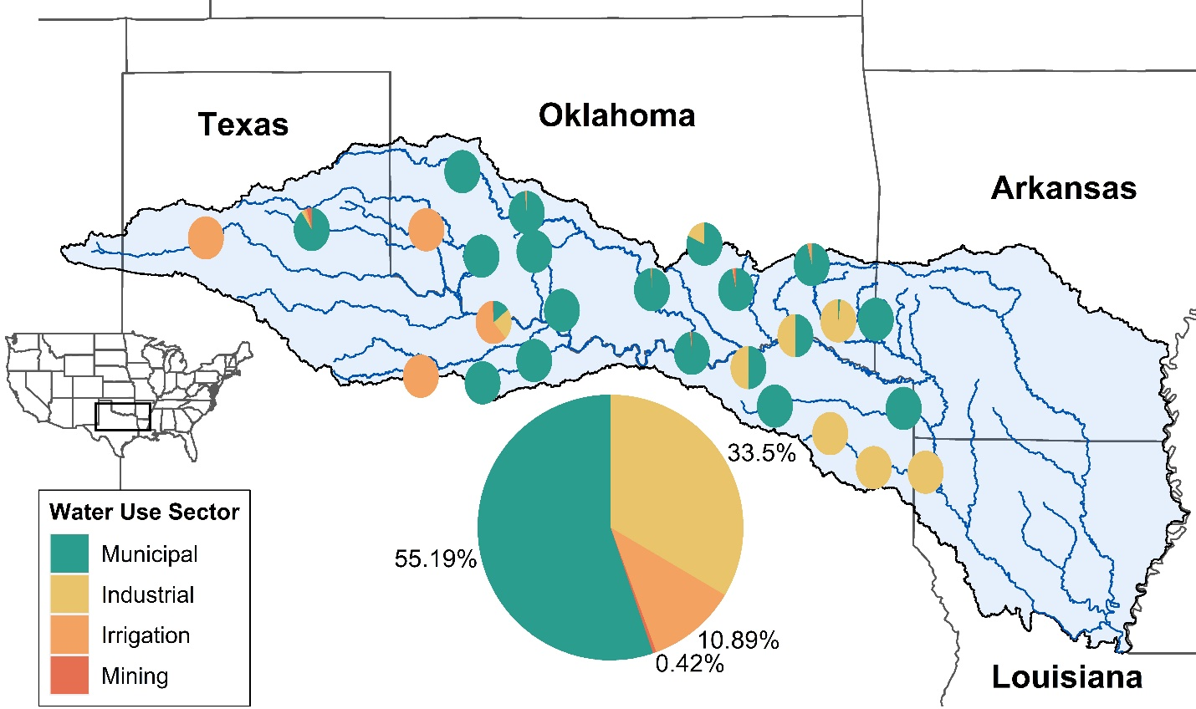
Figure 3-1. Distribution of water rights by water use sector for each of the 26 reservoirs (small pies) in the Red River basin (RRB). Large pie indicates the total distribution of water rights by water use sector across the RRB. Reservoir locations approximate.

3.3.2. Payment for ecosystem services (PES) scheme design
Our model assumes a PES initiative has been implemented in the RRB where conservation organizations provide monetary incentives to water users at each of the 26 reservoirs across the four water sectors: municipal, industrial, irrigation, and mining to reallocate their water rights for environmental flow releases (Fig. 3-1). By using projections of early century (2011-2030) climate conditions (section 3.3.3), we define water availability across a range of possible drying and wetting scenarios. We assume that there are five different budget scenarios that define a quantity of total conservation incentives (a target total quantity of water to reduce derived from a percentage reduction in total water usage across the four sectors basin wide, Fig. 3-2). We test six scenarios that differ in the way they allocate the conservation incentives to each water use sector: (1) conservation incentives allocated optimally in a way that maximizes both the satisfaction levels of the four societal water use sectors, and the water to be released downstream for environmental flows (2) conservation incentives allocated equitably in a way that distributes incentives equally to each water use sector, and (3-6) conservation incentives allocated inequitably by allocating all incentives to each sector individually. These 270 unique scenarios (nine climate scenarios, five budget scenarios, and six allocation scenarios) are fed into a network optimization model described in section 3.3.4, which attempts to maximize the satisfaction levels of the four water use sectors, and the water to be released downstream for environmental flows, subject to constraints unique to each allocation scenario. The optimal allocation scenario represents a model focused on achieving the best conservation outcomes (economic efficiency and e-flows satisfaction are maximized, Zamani Sabzi, Rezapour, et al., 2019). The equitable scenario represents a model focused on achieving a triple-bottom-line outcome –conservation outcomes are maximized, but they are subject to equity constraints that limit the total quantity of conservation incentives that can be allocated to each sector (Halpern et al., 2013b). The single sector allocation scenarios represent inequitable but plausible models. For example, water conservation programs tend to focus on single sectors because either the funding source is specialized for that sector, or that sector uses the most water and thus funding for water conservation goes to reducing water consumption for that sector because it is viewed as the most efficient option (Echols et al., 2019; Ward & Pulido-Velázquez, 2008; Werner & Hauber-Davidson, 2008). This can result in elite capture, where the majority of conservation incentives are received by the largest resource user, which can derail the success of PES schemes (Hayes et al., 2019; Hayes & Murtinho, 2018; Lund & Saito-Jensen, 2013).
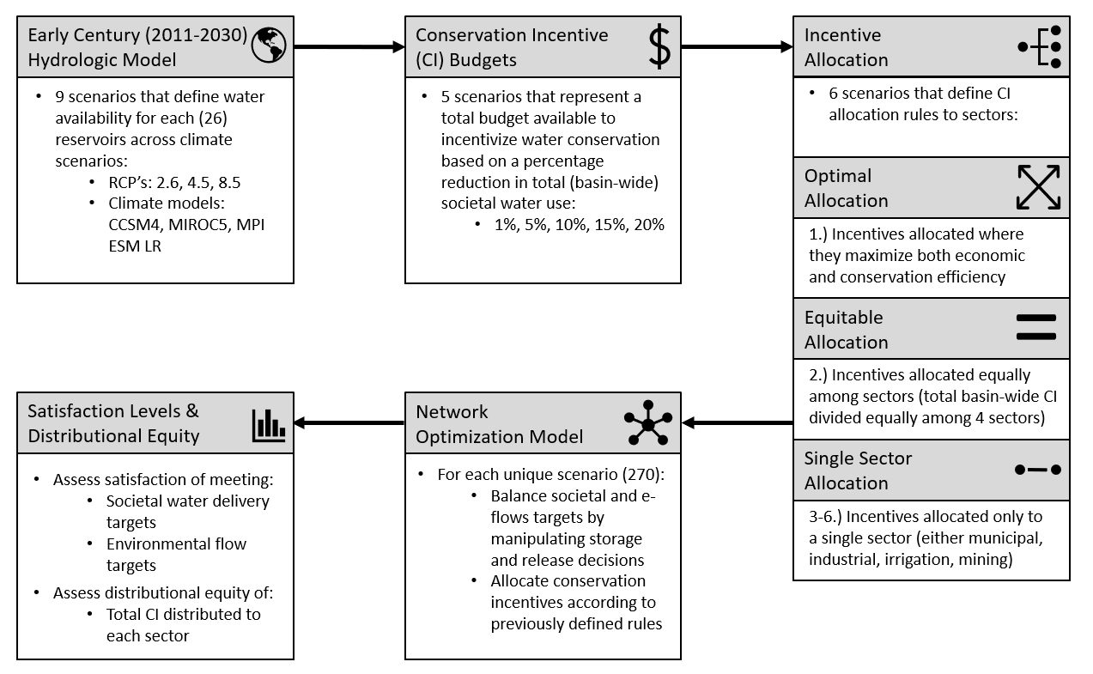
Figure 3-2. Description of model design and scenarios.

3.3.3. Climate and hydrological models
To quantify water availability for each of the 26 reservoirs across an early century (2011-2030) planning horizon, we use downscaled climate projections from an ensemble of three general circulation models (GCMs) from the Coupled Model Intercomparison Project Phase 5 (CMIP5, Bertrand & McPherson, 2019; Taylor et al., 2012). Three GCMs (CCSM4, MIROC5, MPI-ESM-LR) that simulate Earth’s major climate system components differently and three representative concentration pathways (RCP’s, 2.6, 4.5, 8.5) that describe different climate futures based on greenhouse gas (GHG) concentrations were chosen because they represent a range of possible future outcomes and perform well in this particular region (Bertrand & McPherson, 2019). The Cumulative Density Function was used to downscale each GCM and RCP combination from a 3.75° to 1/8° spatial scale, and data were calibrated using daily historical (1961-2005) precipitation and temperature observations (see Bertrand & McPherson, 2019 for details). Across GCMs, general patterns suggest that CCSM4 predicts drier outcomes, MPI-ESM-LR predicts wetter outcomes, and MIROC5 predicts moderate outcomes between the previous two (Bertrand & McPherson, 2019; Fovargue et al., 2021).
To parameterize reservoir inflow and evaporation for the network optimization model (Section 3.3.4), we used outputs from a variable infiltration capacity (VIC) model. Briefly, VIC was calibrated using historical (1981-2012) observations of streamflow from 35 US Geological Survey (USGS) gaging stations and parameterized with historical (1961-2011) and future (2011-2030) daily meteorological data from the GCMs described in the previous paragraph, a 1/8° digital elevation model (DEM), flow direction data, and various land cover variables (see Xue et al., 2016 for details). Monthly reservoir inflow was derived from daily streamflow inputs from each reservoir’s upstream sub-basin, and monthly evaporation volumes were derived from daily evaporation volumes and each reservoir’s surface area. These two parameters were used for input in the network optimization model (Section 3.3.4).

3.3.4. Network optimization model
We used a mathematical reservoir network model that optimizes water allocation using spatio-temporally variable storage and release decisions. These changes to storage and release decisions aim to maximize the satisfaction of societal water delivery and environmental flow targets (see Zamani Sabzi, Rezapour, et al., 2019 for details). The model estimates inflows and outflows at each reservoir $(d)$ in the network $D=\left\{d\right\}$ across monthly timesteps$(t=240)$ in a 20 year (2011-2030) planning period $T= \{t = 1, 2, . . . , |T|\}.$ Each reservoir in the network has inputs comprised of: ground and surface water$(I_{t}^{d})$, derived from VIC model, precipitation $({Pr}_{t}^{d})$, derived from GCMs (both described in section 3.3.3), downstream releases from upstream reservoirs $\left(\sum_{d∈D^{(d)}}{ } F_{t}^{d}\right)$, all added to any water stored from the previous timestep $\left(S_{t-1}^{d}\right)$. Each reservoir has outputs comprised of: evapotranspiration $(E_{t}^{d})$, diversions for societal water use sectors: municipal $(M_{t}^{d})$, industrial $(N_{t}^{d})$, irrigation $(R_{t}^{d})$, and mining $\left(G_{t}^{d}\right)$, and downstream water releases for environmental flows $\left(F_{t}^{d}\right)$. Thus, the water balance equation for each reservoir in the network is as follows:
$$S_{t-1}^{d}+\left(\sum_{{d∈D}^{\left(d\right)}}{F_{t}^{d}}\right)+I_{t}^{d}+{Pr}_{t}^{d}-E_{t}^{d}-M_{t}^{d}-N_{t}^{d}{- R}_{t}^{d}{- G}_{t}^{d}-F_{t}^{d}=S_{t}^{d}$$
$$\left(∀t∈T and ∀d∈D\right)$$
( 1 )
Previous versions of this model parameterized a single variable $(A_{t}^{d})$ for societal water deliveries that summed water diversions across water use sectors (Fovargue et al., 2021; Zamani Sabzi, Moreno, et al., 2019; Zamani Sabzi, Rezapour, et al., 2019). Here, we define four variables for each water use sector - municipal $(M_{t}^{d})$, industrial $(N_{t}^{d})$, irrigation $(R_{t}^{d})$, and mining $\left(G_{t}^{d}\right)$ - to assess the distributional equity of conservation incentives allocated across sectors. However, we use $\left(A_{t}^{d}\right)$here as well in cases where variables are summed across water use sectors (e.g., $A_{t}^{d} = M_{t}^{d}+N_{t}^{d}{+R}_{t}^{d}{+G}_{t}^{d}$). The model attempts to allocate, across the reservoir network, a total water quantity as close to target values for societal $TAt= TMt+TNt+TRt+TGt$, and environmental $\left(TFt\right)$ water needs. Societal target water quantities $(TAt$) are derived from surface water rights data from both Texas and Oklahoma (TCEQ 2018, OWRB 2017, Fig. 3-1). Environmental target water quantities $\left(TFt\right)$ are derived from Tennant (1976) as 60% of average annual flow. In the case that satisfying both targets is infeasible, we quantify water deficiencies for meeting societal $DAt= DMt+DNt+DRt+DGt$ and environmental flow $\left(DFt\right)$ targets. We test five scenarios that assume there is a given budget to incentivize water conservation through a PES program which will reduce the total water needed to satisfy societal water uses across the four sectors $\left(\sum{∀d∈D}\sum{∀t∈ }{TA}_{t}^{d}\right)$ up to $θ$ percentage (1%-20% in 5% increments, Fig. 3-2). Thus, the total target water quantity for societal water uses after accounting for water conservation incentives is equal to $\left(\sum{∀d∈D}\sum{∀t∈ {TA}_{t}^{d}}\right)- α_{t}^{d}$ where $α_{t}^{d}$ represents the total quantity of water that must be reduced by incentivizing water conservation at $θ$ percentage, or the total quantity of conservation incentives available to distribute across the four water use sectors. Thus, $α_{t}^{d}={αM}_{t}^{d}{ + αN}_{t}^{d}+{αR}_{t}^{d}+{αG}_{t}^{d}$, where ${αM}_{t}^{d}$, ${αN}_{t}^{d}$, ${αR}_{t}^{d}$, ${αG}_{t}^{d}$ are the total conservation incentives distributed to the municipal, industrial, irrigation, and mining water use sectors, respectively.
The six incentive allocation scenarios we previously defined (Section 3.3.2, Fig.2) govern how these conservation incentives should be distributed to the four water sectors. In the optimal allocation scenario, the following constraint stipulates that the total conservation incentives should be less than or equal to this budget:
$$\sum_{∀d∈D}{\sum_{∀t∈T}{α_{t}^{d}}}≤ θ ∙ \left(\sum_{∀d∈D}{\sum_{∀t∈T}{{TA}_{t}^{d}}}\right)$$
( 2 )
This constraint allows societal water conservation incentives $α_{t}^{d}$ to be distributed freely to each sector wherever they maximize societal and environmental flow outcomes. In the equitable allocation scenario, however, we define the following constraints that specify how conservation incentives must be allocated equally (into fourths) among each water use sector:
$$\sum_{∀d∈D}{\sum_{∀t∈T}{{αM}_{t}^{d}}}≤0.25 ∙\left(θ∙\sum_{∀d∈D}{\sum_{∀t∈T}{{TA}_{t}^{d}}}\right)$$
( 3 )
$$\sum_{∀d∈D}{\sum_{∀t∈T}{{αN}_{t}^{d}}}≤0.25 ∙\left(θ∙\sum_{∀d∈D}{\sum_{∀t∈T}{{TA}_{t}^{d}}}\right)$$
( 4 )
$$\sum_{∀d∈D}{\sum_{∀t∈T}{{αR}_{t}^{d}}}≤0.25 ∙\left(θ∙\sum_{∀d∈D}{\sum_{∀t∈T}{{TA}_{t}^{d}}}\right)$$
( 5 )
$$\sum_{∀d∈D}{\sum_{∀t∈T}{{αG}_{t}^{d}}}≤0.25 ∙\left(θ∙\sum_{∀d∈D}{\sum_{∀t∈T}{{TA}_{t}^{d}}}\right)$$
( 6 )
In each single sector scenario, all available conservation incentives are only allocated to a single sector, subject to these individual constraints for each sector scenario (i.e., municipal, industrial, irrigation, mining):
$$\sum_{∀d∈D}{\sum_{∀t∈T}{{αM}_{t}^{d}}}≤ θ ∙\left(\sum_{∀d∈D}{\sum_{∀t∈T}{{TA}_{t}^{d}}}\right)$$
( 7 )
$$\sum_{∀d∈D}{\sum_{∀t∈T}{{αN}_{t}^{d}}}≤ θ ∙\left(\sum_{∀d∈D}{\sum_{∀t∈T}{{TA}_{t}^{d}}}\right)$$
( 8 )
$$\sum_{∀d∈D}{\sum_{∀t∈T}{{αR}_{t}^{d}}}≤ θ ∙\left(\sum_{∀d∈D}{\sum_{∀t∈T}{{TA}_{t}^{d}}}\right)$$
( 9 )
$$\sum_{∀d∈D}{\sum_{∀t∈T}{{αG}_{t}^{d}}}≤ θ ∙\left(\sum_{∀d∈D}{\sum_{∀t∈T}{{TA}_{t}^{d}}}\right)$$
( 10 )
In addition, the following constraints apply to the model:
$$A_{t}^{d}+DA_{t}^{d}≥TA_{t}^{d}-α_{t}^{d}(∀t∈T and ∀d∈D)$$
( 11 )
$$\frac{A_{t}^{d}}{TA_{t}^{d}}+\frac{α_{t}^{d}}{TA_{t}^{d}}≤1(∀t∈T and ∀d∈D)$$
( 12 )
$$Z_{t}^{F,d}=\left(1-\frac{DF_{t}^{d}}{TF_{t}^{d}}\right)(∀t∈T and ∀d∈D)$$
( 13 )
For constraints (11-12), we use the variable $\left(A_{t}^{d}\right)$ and its variants for brevity, but a version of each of these constraints exists for each water use sector: municipal $(M_{t}^{d})$, industrial $(N_{t}^{d})$, irrigation $(R_{t}^{d})$, and mining $\left(G_{t}^{d}\right)$. Constraint (11) calculates water deficiencies for societal uses and ensures that allocated water conservation incentives do not exceed the delivery target. Constraint (12) calculates the satisfaction level of meeting societal water delivery targets after water conservation actions and ensures that this value cannot exceed full satisfaction (e.g., municipal water users at a reservoir will never receive more water than their targeted delivery). Constraint (13) calculates the satisfaction level of meeting environmental flow targets. Target water quantities for environmental flow releases $\left({TF}_{t}^{d}\right)$ were calculated as 60% of average annual flow in each river reach downstream of each reservoir (Tennant, 1976). By averaging these satisfaction levels across all reservoirs and timesteps, we can define the model objective functions for each societal water use sector and environmental flows:
$$Max⁡Z^{M}=\frac{\sum_{∀d∈D}{ } \left(\sum_{∀t∈T}{ } \left(\frac{M_{t}^{d}}{TM_{t}^{d}}+\frac{{αM}_{t}^{d}}{TM_{t}^{d}}\right)\right)}{|T|.|D|}$$
( 14 )
$$Max⁡Z^{N}=\frac{\sum_{∀d∈D}{ } \left(\sum_{∀t∈T}{ } \left(\frac{N_{t}^{d}}{TN_{t}^{d}}+\frac{{αN}_{t}^{d}}{TN_{t}^{d}}\right)\right)}{|T|.|D|}$$
( 15 )
$$Max⁡Z^{R}=\frac{\sum_{∀d∈D}{ } \left(\sum_{∀t∈T}{ } \left(\frac{R_{t}^{d}}{TN_{t}^{d}}+\frac{{αR}_{t}^{d}}{TR_{t}^{d}}\right)\right)}{|T|.|D|}$$
( 16 )
$$Max⁡Z^{G}=\frac{\sum_{∀d∈D}{ } \left(\sum_{∀t∈T}{ } \left(\frac{G_{t}^{d}}{TG_{t}^{d}}+\frac{{αG}_{t}^{d}}{TG_{t}^{d}}\right)\right)}{|T|.|D|}$$
( 17 )
$$Max⁡Z^{F}=\frac{\sum_{∀d∈D}{ } \left(\sum_{∀t∈T}{ } \left(1-\frac{DF_{t}^{d}}{TF_{t}^{d}}\right)\right)}{|T|⋅|D|}$$
( 18 )
Where objective functions (14-17) attempt to maximize satisfaction levels for each societal water use sector: municipal $(M_{t}^{d})$, industrial $(N_{t}^{d})$, irrigation $(R_{t}^{d})$, and mining $\left(G_{t}^{d}\right)$, and objective function (18) attempts to maximize satisfaction levels for environmental flow targets. Satisfaction levels can range from 0-1, where 0 indicates no water has been allocated towards a target, and 1 indicates that all water has been delivered to the target and there are no deficiencies. Each objective function (14-18) is implemented in each of the six incentive allocation scenarios, subject to the constraints unique to each allocation scenario that govern how conservation incentives are allocated. In the optimal scenario, objective functions are subject to constraint (2). In the equitable scenario, objective functions are subject to constraints (3-6). In each single sector allocation scenario, objective functions are subject to constraints (7-10) when they apply (e.g., in the municipal allocation scenario when all incentives are allocated to the municipal sector, only constraint (7) is applied because no other sector receives any conservation incentives). In addition, constraints (11-13) and other model constraints that are not unique to each allocation scenario apply to each objective function. The optimization model is a linear programming model coded and solved using LINGO software (see Zamani Sabzi, Rezapour, et al., 2019 for full list of model constraints and details)

3.3.5 Analysis
We performed two analyses using the results from the reservoir network optimization model. First, we assess the tradeoffs between social equity and conservation outcomes (i.e., meeting both societal water and e-flows delivery targets) across climate and budget scenarios. Because the optimal allocation scenario should provide the best outcomes, we use the difference in satisfaction values from the optimal scenario to quantify tradeoffs (Fig.3). For example, Fig. 3-3A shows the difference in satisfaction values from the optimal scenario (vertical axis) for the equitable allocation scenario, and all four single sector allocation scenarios combined. To aggregate satisfaction levels across the 270 unique scenarios we considered here, we average societal and environmental satisfaction levels, GCMs RCPs, water use sectors, and single sector allocation scenarios (Fig. 3-3A), GCMs, RCPs, and single sector allocation scenarios (Fig. 3-3B), and GCMs (Fig. 3-3C). A figure of satisfaction value differences across all GCMs, RCPs, budget, and allocation scenarios can be found in the supplemental material (Fig. S3-1). Second, we assess how equitable the network optimization model distributed conservation incentives in the optimal allocation scenario, and across budget and climate scenarios. We use the total quantity of water conservation incentives allocated to each water use sector (${αM}_{t}^{d}, {αN}_{t}^{d}, {αR}_{t}^{d}, {αG}_{t}^{d}$, for municipal, industrial, irrigation, and mining, respectively) across the 20-year planning horizon for this analysis, and the Gini coefficient to quantify the distributional equity of the allocation of these conservation incentives (Fig. 3-4). While the Gini coefficient is a measure of equality rather than equity (i.e., it only measures how evenly a resource is distributed among users), it has been widely used and adapted as a quantitative metric to assess distributional equity (Dai et al., 2018; Friedman et al., 2018a; Halpern et al., 2013b; Hu et al., 2016, p. 201; Law et al., 2018; Maguire & Sheriff, 2011). Here, we use the inverse of the Gini coefficient (1-Gini) described in Halpern et al., 2013, where a value of 1 indicates a perfectly equal distribution of conservation incentives, and a value of 0 indicates a most inequal distribution of conservation incentives.

3.4. Results

3.4.1. Tradeoffs between social equity and conservation outcomes
Across a range of budgetary and future climate scenarios, we find that tradeoffs between social equity and conservation outcomes are small (Fig. 3-3A). For example, satisfaction value differences of conservation outcomes in the equitable allocation scenario at most differ -0.02 from the optimal allocation scenario across budget at climate scenarios (Fig. 3-3A). When societal water delivery satisfaction levels are split by water use sectors, we find that satisfaction value differences are more pronounced in the dominant water use sectors (Fig. 3-3B). For example, the municipal water use sector that comprises 55% of water use across the basin exhibited the largest differences in satisfaction values from the optimal scenario in the equitable scenario across sectors (Fig. 3-3B). These differences decreased with increasing budget. Tradeoffs between social equity and conservation outcomes worsened in RCP’s that represent increased GHG concentrations (e.g., RCP 4.5 & 8.5, Fig. 3-3C).
We also find that payment schemes in which incentives are allocated to a single water use sector are much less cost-effective than schemes in which incentives are allocated among multiple sectors. For example, when satisfaction value differences are averaged across single sector allocation scenarios and water use sectors, conservation outcomes worsen with increasing budget and are worse overall than the equitable allocation scenario (Fig. 3-3A). This pattern continues when societal water delivery satisfaction levels are split by water use sectors but still averaged across single sector allocation scenarios; satisfaction level differences increase in the dominant water use sectors (e.g., municipal, industrial) as budget increases (Fig. 3-3B). However, when single sector allocation scenarios are considered individually, we find that when all incentives are allocated to the dominant municipal water use sector, conservation outcomes are very similar to the optimal allocation scenario (Fig. 3-3C). However, satisfaction value differences increase for some smaller water use sectors in higher budget scenarios (Fig. 3-3C). In allocation scenarios where incentives are allocated only to smaller water use sectors (e.g., industrial, irrigation, mining), conservation outcomes are worse than the optimal, equitable, and municipal allocation scenarios, but sometimes outperform these other scenarios in satisfying their own water use sector (Fig. 3-3C).
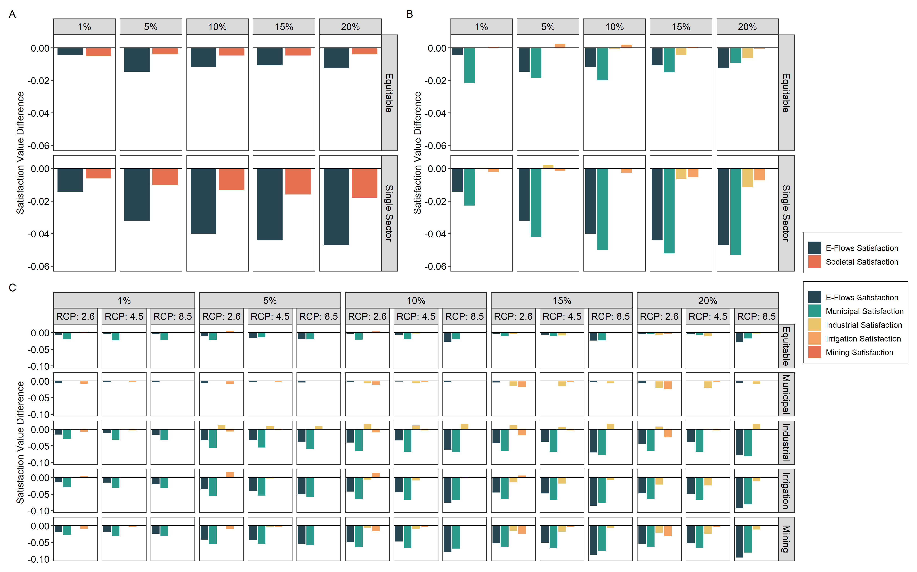
Figure 3-3. Mean satisfaction value differences between the optimal allocation scenario (y-axis) and other conservation incentive allocation scenarios (rows) aggregated across (A) climate models, RCP’s, and sectors, (B) climate models and RCP’s, and (C) climate models. Note differences in vertical axis scales between top (A, B) and bottom (C) panels.

3.4.2. Distributional equity of conservation incentives
While tradeoffs between social equity and conservation outcomes were small, we found that greater equity was achievable at higher budgets (Fig. 3-4A). Overall, in the optimal allocation scenario, mean equity was low across budget and climate scenarios (Gini = 0.39) compared to the equitable scenario (Gini = 0.73). However, equity widely varied across future climate scenarios. For example, greater equity could be achieved in climate scenarios with very stringent GHG concentration reductions at higher budgets in the optimal allocation scenario (e.g., RCP 2.6, Fig. 3-4A). In low budget scenarios (e.g., 1%, 5%), equity remains low across climate scenarios because most incentives get allocated to the largest water use sectors (e.g., municipal, industrial, Fig. 3-4B). In higher budget scenarios, more incentives can be distributed across all water use sectors, improving equity (Figs. 4A&B). However, in some climate scenarios with less stringent GHG concentration reductions (e.g., RCPs 4.5, 8.5) most of the water conservation incentives still become allocated to the largest water use sectors to optimize conservation outcomes (Fig. 3-4B).
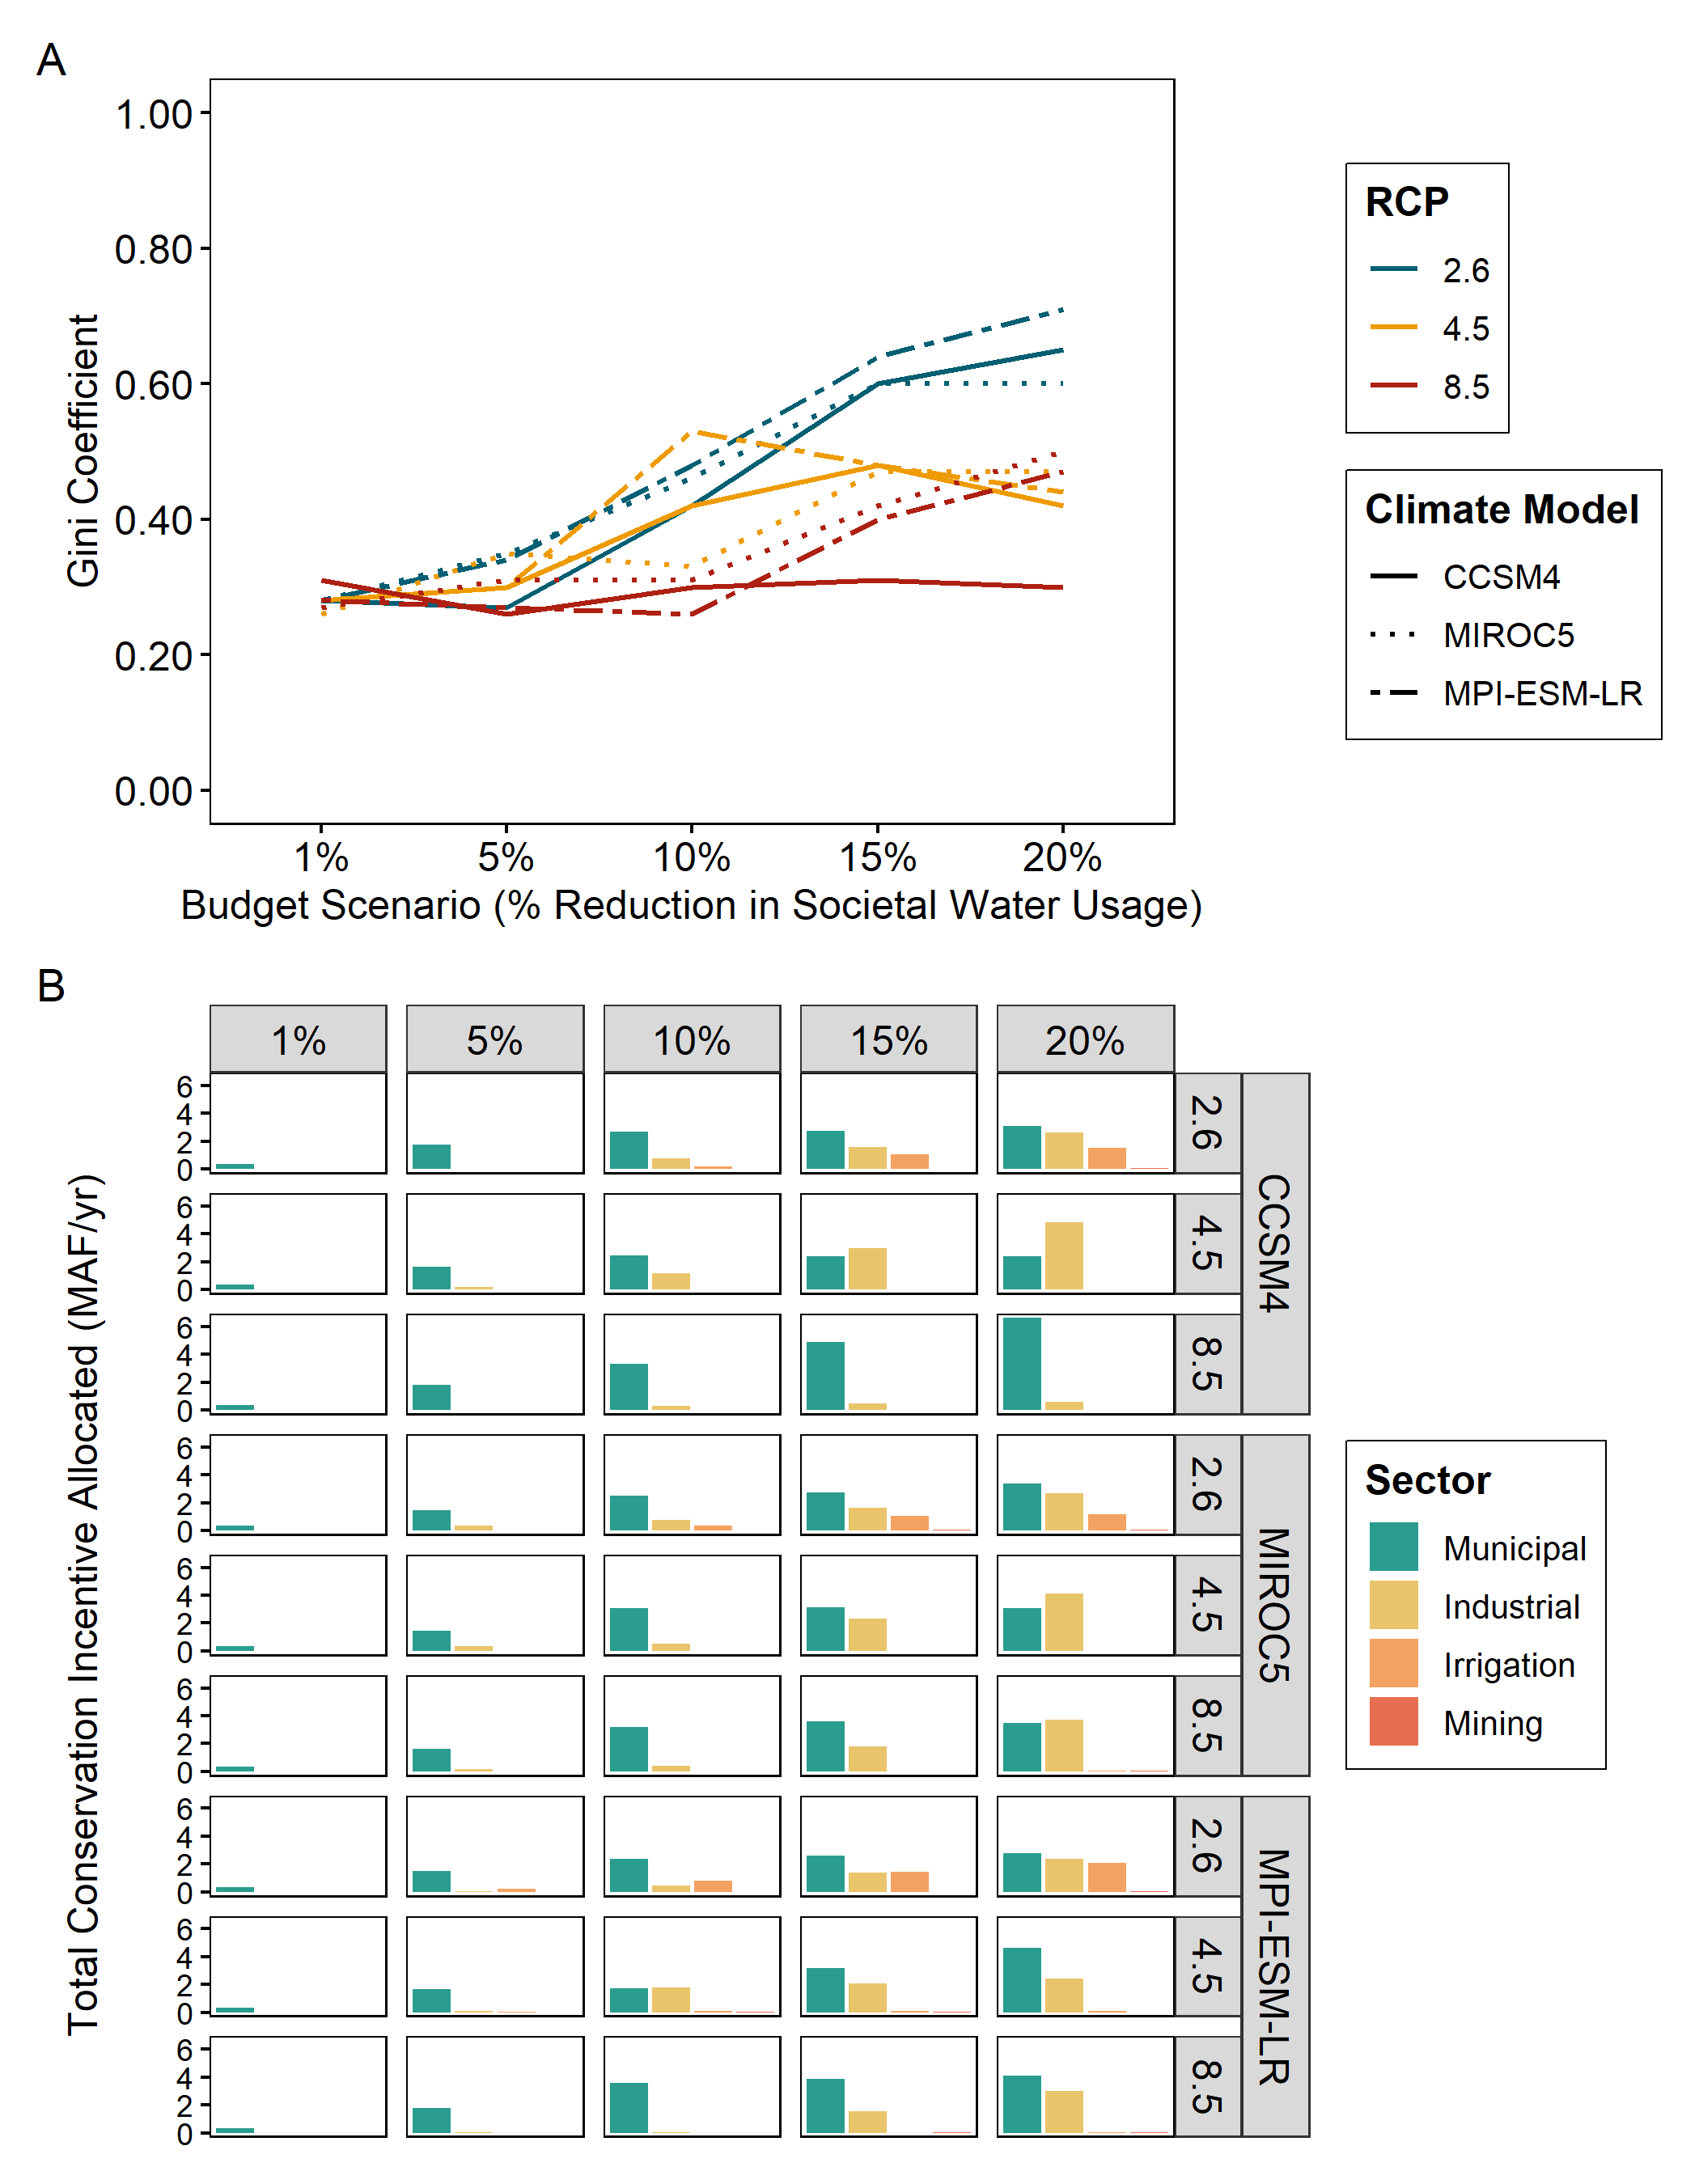
Figure 3-4. (A) Equity (measured by 1- Gini coefficient) across climate and budget scenarios for the optimal allocation scenario, and (B) Total distribution of water conservation incentives by sector across the early century (2011-2030) horizon by climate and budget scenarios for the optimal allocation scenario. Gini coefficients in plot A derived from distribution of conservation incentives in plot B. RCP indicates Representative Concentration Pathway considered across climate scenarios (see section 3.3.3 for details).

3.5. Discussion
Equity is key to the success of PES conservation initiatives, but achieving equitable outcomes can come at a cost to conservation outcomes (Haas et al., 2019; Pascual et al., 2014; Salzman et al., 2018). Our study reveals that social equity can be achieved with very small tradeoffs to conservation outcomes in a freshwater PES scheme aimed at implementing e-flows. Our equitable allocation scenario achieved similar satisfaction levels for conservation outcomes (both e-flows and societal water delivery targets) to an optimal allocation scenario, all while achieving higher distributional equity across climate and budget scenarios. Research on the role equity plays in conservation initiatives has called for a better understanding of the impacts of climate on equity and the relationships among equity, economic efficiency, and conservation outcomes (Friedman et al., 2018b; Haas et al., 2019; Klein et al., 2015; Pascual et al., 2014). Our work supports these current efforts and demonstrates that aiming to implement a PES scheme equitably would not greatly exacerbate tradeoffs with conservation outcomes, and that equity can increase under climate futures with very stringent GHG concentration reductions. Additionally, because there is growing interest in developing freshwater PES programs to help expand the implementation of e-flows (Arthington, 2021; Bellver-Domingo et al., 2016; Salzman et al., 2018; Twardek et al., 2021), our study has practical implications for informing the design of these programs. Our work could be especially useful in water-limited river basins with multiple water-use sectors but could also be applied in both terrestrial and marine ecosystems where multiple resource sectors exist.

3.5.1. Equity in PES initiatives
While there is growing interest in designing and implementing PES initiatives, there has been a call for explicit research on whether considering equity impacts the direction of tradeoffs between economic and conservation efficiency (Haas et al., 2019; Klein et al., 2015; Loft et al., 2019). Tradeoffs between equity and economic and/or conservation efficiency are often presented as inherent in PES schemes, where, given some fixed budget, equity and economic efficiency and/or conservation outcomes are inversely correlated (i.e., a negative direction tradeoff, Chu et al., 2019; Halpern et al., 2013b; Loft et al., 2019; Wunder et al., 2018). Indeed, a recent systematic review by Friedman et al. (2018) reported mostly mixed or negative direction equity outcomes when conservation interventions were implemented. Thus, in practice, some compromise must be made in either equity, economic efficiency, or conservation outcomes when attempting to optimize the design and implementation PES programs (Klein et al., 2015). Here, we find that considering a distributional equity dimension in a simulated PES scheme results in negative tradeoffs between equity and conservation outcomes, however these tradeoffs were very small compared to an optimal allocation scenario (Fig. 3-3). Our results are like those of Halpern et al. (2013) that report similar small tradeoffs when equity is prioritized over optimal efficiency. Thus, our study provides support for the argument that equity tradeoffs are inherent in PES schemes, but we argue that these tradeoffs are small enough to warrant adopting an equitable rather than optimal allocation of conservation incentives.
Our findings highlight another potential key gap in research on social equity in conservation initiatives: do the magnitude of tradeoffs between equity and conservation outcomes impact PES success in addition to tradeoff direction and domain of equity considered (Gill et al., 2019)? For example, distributional equity (Gini coefficient) varied across different budget and climate scenarios, indicating large differences in distributional equity magnitude (i.e., how much individual water use sectors were affected). These differences in magnitude highlight the synergies between equity dimensions. For example, smaller water use sectors could perceive that they are receiving fewer conservation incentives that larger water-use sectors. These differences in perceived equity that arise from the magnitude of distributional equity have been shown to be present in PES schemes like the ones found in Haas et al. 2019 and Loft et al. 2019 & 2020. Thus, while we focus on distributional equity here, we recognize that procedural, recognitional, and contextual equity considerations are also important to the success of PES conservation initiatives (Pascual et al., 2014).

3.5.2. PES program design: climate and budget considerations
Our analysis highlights the importance of considering climate uncertainty in addition to equity in the design and implementation of PES programs. In the context of water resources planning, a key challenge involves minimizing the tradeoffs between societal and environmental water needs while accounting for non-stationary conditions due to climate uncertainty (Fovargue et al., 2021; John et al., 2020). Water resources planners must balance changing water demand and availability under often inflexible operating rules, highlighting the grand challenge of implementing equitable PES schemes under uncertain climate futures. One approach to dealing with uncertainty in climate projections is to explicitly consider a range of possible future scenarios and focus on the consistencies (or agreement) across them (John et al., 2020; Lawler & Michalak, 2017). This adaptation approach could be applicable to PES schemes, where uncertainties associated with cost and future resource availability could hamper project design and implementation (Wertz-Kanounnikoff et al., 2011). For example, while there were no large differences in satisfaction levels between societal and environmental water needs across GCMs in our model (Fig. S3-1), we did find small differences across RCPs; satisfaction level differences increased at higher RCPs (Fig. 3-3C). Additionally, even when equity is not considered under an optimal allocation scenario, greater equity could be achieved under RCP 2.6, which represents a very stringent GHG concentration reduction scenario. There were also large differences in distributional equity across future climate scenarios under optimal allocation (Fig. 3-4A). These results suggest that while water delivery targets could remain relatively consistent across future climate scenarios (Fig. 3-3), the distribution of conservation incentives to conserve water across water use sectors will widely vary (Fig. 3-4B). Thus, explicitly modeling future climate scenarios as part of the design phase of PES initiatives could help planners anticipate these potential changes in equity across different climate scenarios in the implementation phase (Lewis & Polasky, 2018; Monge et al., 2018; Rai & Nepal, 2022).
Because PES program cost can widely vary (Salzman et al., 2018), it is important to contextualize how equity outcomes can vary across different budget scenarios. For example, we found that greater equity was achievable at higher budgets. Halpern et al. (2013) discuss a similar tradeoff among budget, equity, and conservation outcomes in a PES scheme in the context of marine protected areas. In our study, this pattern was observed in the optimal allocation scenario because at low budgets, it is most efficient to allocate all conservation incentives to the largest water use sectors, whereas at higher budgets, it is sometimes more efficient to spread conservation incentives across water use sectors (Fig. 3-4B). This is an example of elite capture in PES schemes, where the largest or dominant resource user can benefit the most, and smaller resource users receive fewer or no payments (Dawson et al., 2018; Haas et al., 2019; Hayes et al., 2019). While our results are specific to the context of our simulated PES scheme, they highlight the importance of considering elite capture and how budget impacts the tradeoffs between optimal and equitable allocation of conservation incentives in the design and implementation of PES schemes (Hayes & Murtinho, 2018; Loft et al., 2020).

3.5.3. Future priorities
While our study supports existing work on equity in conservation initiatives that find negative tradeoffs between equity and conservation outcomes, we also highlight some knowledge gaps and priorities for future studies. For example, we focused explicitly on the distributional equity of conservation incentives as an aggregate measure across a reservoir network, and do not discuss spatial variation in tradeoffs. However, there were inequities in these tradeoffs geographically – reservoirs in arid, western reservoirs often had higher satisfaction value differences compared to eastern reservoirs (Figs. S3-2 – S3-5). This spatial variation in tradeoffs could result in synergies across different equity dimensions like the example of perceived equity discussed in section 3.4.1. Further, we parameterized our equitable scenario to allocate conservation incentives equally among water use sectors, and quantified equity using the Gini coefficient, a common measure of equality rather than equity. While we recognize that equality and equity are not equivalent, future studies should seek to better model and quantify equity (Friedman et al., 2018b; Klein et al., 2015; Pascual et al., 2014). We also highlight a potential key research gap in quantifying the magnitude of equity tradeoffs (Gill et al., 2019). Finally, we suggest future studies seek to better understand the impact that climate uncertainty plays in tradeoffs between equity and conservation outcomes. We focus on this in the context of the challenges of implementing e-flows in freshwater ecosystems, but future work could expand this to terrestrial and marine ecosystems, as approaches that are inclusive of equity and uncertainty apply across ecosystems (Friedman et al., 2018b; Kujala et al., 2013; Lawler & Michalak, 2017).

3.6. Conclusion
Our analysis of a simulated freshwater PES initiative to implement e-flows revealed small tradeoffs between equity and conservation outcomes. We also highlight that payment schemes that allocate conservation incentives to single water use sectors are overall less cost effective and provide worse equity and conservation outcomes. Despite these small tradeoffs, distributional equity increased with increasing budget and under climate scenarios with strict GHG concentration reductions. We suggest that aiming for an equitable allocation of conservation incentives despite small tradeoffs between conservation goals could provide the best overall outcome (i.e., triple bottom line solution). Overall, our findings highlight important equity, climate, and budget considerations for the design and implementation of PES initiatives.

References
A. Auerbach, D., B. Deisenroth, D., McShane, R. R., McCluney, K. E., & LeRoy Poff, N. (2014). Beyond the concrete: Accounting for ecosystem services from free-flowing rivers. Ecosystem Services, 10, 1–5. https://doi.org/10.1016/j.ecoser.2014.07.005
Aguilar-Gómez, C. R., Arteaga-Reyes, T. T., Gómez-Demetrio, W., Ávila-Akerberg, V. D., & Pérez-Campuzano, E. (2020). Differentiated payments for environmental services: A review of the literature. Ecosystem Services, 44, 101131. https://doi.org/10.1016/j.ecoser.2020.101131
Arthington, A. H. (2021). Grand Challenges to Support the Freshwater Biodiversity Emergency Recovery Plan. Frontiers in Environmental Science, 9, 118. https://doi.org/10.3389/fenvs.2021.664313
Bellver-Domingo, A., Hernández-Sancho, F., & Molinos-Senante, M. (2016). A review of Payment for Ecosystem Services for the economic internalization of environmental externalities: A water perspective. Geoforum, 70, 115–118. https://doi.org/10.1016/j.geoforum.2016.02.018
Bennett, N. J., Calò, A., Di Franco, A., Niccolini, F., Marzo, D., Domina, I., Dimitriadis, C., Sobrado, F., Santoni, M.-C., Charbonnel, E., Trujillo, M., Garcia-Charton, J., Seddiki, L., Cappanera, V., Grbin, J., Kastelic, L., Milazzo, M., & Guidetti, P. (2020). Social equity and marine protected areas: Perceptions of small-scale fishermen in the Mediterranean Sea. Biological Conservation, 244, 108531. https://doi.org/10.1016/j.biocon.2020.108531
Bertrand, D., & McPherson, R. A. (2019). Development of Downscaled Climate Projections: A Case Study of the Red River Basin, South-Central U.S. Advances in Meteorology, 2019, 1–14. https://doi.org/10.1155/2019/4702139
Börner, J., Schulz, D., Wunder, S., & Pfaff, A. (2020). The Effectiveness of Forest Conservation Policies and Programs. Annual Review of Resource Economics, 12(1), 45–64. https://doi.org/10.1146/annurev-resource-110119-025703
Brimont, L., Ezzine-de-Blas, D., Karsenty, A., & Toulon, A. (2015). Achieving Conservation and Equity amidst Extreme Poverty and Climate Risk: The Makira REDD+ Project in Madagascar. Forests, 6(12), 748–768. https://doi.org/10.3390/f6030748
Chu, L., Quentin Grafton, R., & Keenan, R. (2019). Increasing Conservation Efficiency While Maintaining Distributive Goals With the Payment for Environmental Services. Ecological Economics, 156, 202–210. https://doi.org/10.1016/j.ecolecon.2018.10.003
Dai, C., Qin, X. S., Chen, Y., & Guo, H. C. (2018). Dealing with equality and benefit for water allocation in a lake watershed: A Gini-coefficient based stochastic optimization approach. Journal of Hydrology, 561, 322–334. https://doi.org/10.1016/j.jhydrol.2018.04.012
Daw, T. M., Coulthard, S., Cheung, W. W. L., Brown, K., Abunge, C., Galafassi, D., Peterson, G. D., McClanahan, T. R., Omukoto, J. O., & Munyi, L. (2015). Evaluating taboo trade-offs in ecosystems services and human well-being. Proceedings of the National Academy of Sciences, 112(22), 6949–6954. https://doi.org/10.1073/pnas.1414900112
Dawson, N., Martin, A., & Danielsen, F. (2018). Assessing Equity in Protected Area Governance: Approaches to Promote Just and Effective Conservation: Assessing equity in protected area governance. Conservation Letters, 11(2), e12388. https://doi.org/10.1111/conl.12388
Echols, A., Front, A., & Cummins, J. (2019). Broadening conservation funding. Wildlife Society Bulletin, 43(3), 372–381. https://doi.org/10.1002/wsb.1003
Engel, S., & Muller, A. (2016). Payments for environmental services to promote “climate-smart agriculture”? Potential and challenges. Agricultural Economics, 47(S1), 173–184. https://doi.org/10.1111/agec.12307
Eriksson, B., Johansson, F., & Blicharska, M. (2019). Socio-economic impacts of marine conservation efforts in three Indonesian fishing communities. Marine Policy, 103, 59–67. https://doi.org/10.1016/j.marpol.2019.02.007
Fovargue, R. E., Rezapour, S., Rosendahl, D., Wootten, A. M., Sabzi, H. Z., Moreno, H. A., & Neeson, T. M. (2021). Spatial planning for water sustainability projects under climate uncertainty: Balancing human and environmental water needs. Environmental Research Letters, 16(3), 034050. https://doi.org/10.1088/1748-9326/abdd58
Friedman, R. S., Law, E. A., Bennett, N. J., Ives, C. D., Thorn, J. P. R., & Wilson, K. A. (2018a). How just and just how? A systematic review of social equity in conservation research. Environmental Research Letters, 13(5), 053001. https://doi.org/10.1088/1748-9326/aabcde
Friedman, R. S., Law, E. A., Bennett, N. J., Ives, C. D., Thorn, J. P. R., & Wilson, K. A. (2018b). How just and just how? A systematic review of social equity in conservation research. Environmental Research Letters, 13(5), 053001. https://doi.org/10.1088/1748-9326/aabcde
Gill, D. A., Cheng, S. H., Glew, L., Aigner, E., Bennett, N. J., & Mascia, M. B. (2019). Social Synergies, Tradeoffs, and Equity in Marine Conservation Impacts. Annual Review of Environment and Resources, 44(1), 347–372. https://doi.org/10.1146/annurev-environ-110718-032344
Grafton, R. Q., Williams, J., Perry, C. J., Molle, F., Ringler, C., Steduto, P., Udall, B., Wheeler, S. A., Wang, Y., Garrick, D., & Allen, R. G. (2018). The paradox of irrigation efficiency. Science, 361(6404), 748–750. https://doi.org/10.1126/science.aat9314
Haas, J. C., Loft, L., & Pham, T. T. (2019). How fair can incentive-based conservation get? The interdependence of distributional and contextual equity in Vietnam’s payments for Forest Environmental Services Program. Ecological Economics, 160, 205–214. https://doi.org/10.1016/j.ecolecon.2019.02.021
Halpern, B. S., Klein, C. J., Brown, C. J., Beger, M., Grantham, H. S., Mangubhai, S., Ruckelshaus, M., Tulloch, V. J., Watts, M., White, C., & Possingham, H. P. (2013a). Achieving the triple bottom line in the face of inherent trade-offs among social equity, economic return, and conservation. Proceedings of the National Academy of Sciences, 110(15), 6229–6234. https://doi.org/10.1073/pnas.1217689110
Halpern, B. S., Klein, C. J., Brown, C. J., Beger, M., Grantham, H. S., Mangubhai, S., Ruckelshaus, M., Tulloch, V. J., Watts, M., White, C., & Possingham, H. P. (2013b). Achieving the triple bottom line in the face of inherent trade-offs among social equity, economic return, and conservation. Proceedings of the National Academy of Sciences, 110(15), 6229–6234. https://doi.org/10.1073/pnas.1217689110
Hayes, T., Grillos, T., Bremer, L. L., Murtinho, F., & Shapiro, E. (2019). Collective PES: More than the sum of individual incentives. Environmental Science & Policy, 102, 1–8. https://doi.org/10.1016/j.envsci.2019.09.010
Hayes, T., & Murtinho, F. (2018). Communal governance, equity and payment for ecosystem services. Land Use Policy, 79, 123–136. https://doi.org/10.1016/j.landusepol.2018.08.001
He, C., Liu, Z., Wu, J., Pan, X., Fang, Z., Li, J., & Bryan, B. A. (2021). Future global urban water scarcity and potential solutions. Nature Communications, 12(1), 4667. https://doi.org/10.1038/s41467-021-25026-3
Herman, J. D., Quinn, J. D., Steinschneider, S., Giuliani, M., & Fletcher, S. (2020). Climate Adaptation as a Control Problem: Review and Perspectives on Dynamic Water Resources Planning Under Uncertainty. Water Resources Research, 56(2), e24389. https://doi.org/10.1029/2019WR025502
Hu, Z., Chen, Y., Yao, L., Wei, C., & Li, C. (2016). Optimal allocation of regional water resources: From a perspective of equity–efficiency tradeoff. Resources, Conservation and Recycling, 109, 102–113. https://doi.org/10.1016/j.resconrec.2016.02.001
John, A., Nathan, R., Horne, A., Stewardson, M., & Webb, J. A. (2020). How to incorporate climate change into modelling environmental water outcomes: A review. Journal of Water and Climate Change, 11(2), 327–340. https://doi.org/10.2166/wcc.2020.263
Kahil, M. T., Dinar, A., & Albiac, J. (2016). Cooperative water management and ecosystem protection under scarcity and drought in arid and semiarid regions. Water Resources and Economics, 13, 60–74. https://doi.org/10.1016/j.wre.2015.10.001
Klebba, J. M. (n.d.). Water Rights and Water Policy in Louisiana: Laissez Faire Riparianism, Market Based Approaches, or a New Managerialism? LOUISIANA LAW REVIEW, 53, 69.
Klein, C., McKinnon, M. C., Wright, B. T., Possingham, H. P., & Halpern, B. S. (2015). Social equity and the probability of success of biodiversity conservation. Global Environmental Change, 35, 299–306. https://doi.org/10.1016/j.gloenvcha.2015.09.007
Kujala, H., Moilanen, A., Araújo, M. B., & Cabeza, M. (2013). Conservation Planning with Uncertain Climate Change Projections. PLoS ONE, 8(2), e53315. https://doi.org/10.1371/journal.pone.0053315
Law, E. A., Bennett, N. J., Ives, C. D., Friedman, R., Davis, K. J., Archibald, C., & Wilson, K. A. (2018). Equity trade‐offs in conservation decision making. Conservation Biology, 32(2), 294–303. https://doi.org/10.1111/cobi.13008
Lawler, J. J., & Michalak, J. (2017). Planning for climate change without climate projections? In Effective Conservation Science: Data Not Dogma (pp. 135–140). https://doi.org/10.1093/oso/9780198808978.003.0021
Lewis, D. J., & Polasky, S. (2018). An auction mechanism for the optimal provision of ecosystem services under climate change. Journal of Environmental Economics and Management, 92, 20–34. https://doi.org/10.1016/j.jeem.2018.08.014
Loft, L., Gehrig, S., Le, D., & Rommel, J. (2019). Effectiveness and equity of Payments for Ecosystem Services: Real-effort experiments with Vietnamese land users. Land Use Policy, 86, 218–228. https://doi.org/10.1016/j.landusepol.2019.05.010
Loft, L., Gehrig, S., Salk, C., & Rommel, J. (2020). Fair payments for effective environmental conservation. Proceedings of the National Academy of Sciences, 201919783. https://doi.org/10.1073/pnas.1919783117
Lopes Simedo, M. B., Pissarra, T. C. T., Mello Martins, A. L., Lopes, M. C., Araújo Costa, R. C., Zanata, M., Pacheco, F. A. L., & Fernandes, L. F. S. (2020). The Assessment of Hydrological Availability and the Payment for Ecosystem Services: A Pilot Study in a Brazilian Headwater Catchment. Water, 12(10), 2726. https://doi.org/10.3390/w12102726
Lund, J., & Saito-Jensen, M. (2013). Revisiting the Issue of Elite Capture of Participatory Initiatives. World Development, 46, 104–112. https://doi.org/10.1016/j.worlddev.2013.01.028
Mace, G. M., Barrett, M., Burgess, N. D., Cornell, S. E., Freeman, R., Grooten, M., & Purvis, A. (2018). Aiming higher to bend the curve of biodiversity loss. Nature Sustainability, 1(9), 448–451. https://doi.org/10.1038/s41893-018-0130-0
Maguire, K., & Sheriff, G. (2011). Comparing Distributions of Environmental Outcomes for Regulatory Environmental Justice Analysis. International Journal of Environmental Research and Public Health, 8(5), 1707–1726.
Monge, J. J., Daigneault, A. J., Dowling, L. J., Harrison, D. R., Awatere, S., & Ausseil, A.-G. (2018). Implications of future climatic uncertainty on payments for forest ecosystem services: The case of the East Coast of New Zealand. Ecosystem Services, 33, 199–212. https://doi.org/10.1016/j.ecoser.2018.04.010
Pascual, U., Phelps, J., Garmendia, E., Brown, K., Corbera, E., Martin, A., Gomez-Baggethun, E., & Muradian, R. (2014). Social Equity Matters in Payments for Ecosystem Services. BioScience, 64(11), 1027–1036. https://doi.org/10.1093/biosci/biu146
Perkins, G. A. (n.d.). Arkansas Water Rights: Review and Considerations for Reform. 25, 33.
Quinn, J. D., Hadjimichael, A., Reed, P. M., & Steinschneider, S. (2020). Can Exploratory Modeling of Water Scarcity Vulnerabilities and Robustness Be Scenario Neutral? Earth’s Future, 8(11), e2020EF001650. https://doi.org/10.1029/2020EF001650
Rai, R. K., & Nepal, M. (2022). A Tale of Three Himalayan Towns: Would Payment for Ecosystem Services Make Drinking Water Supply Sustainable? In A. K. Enamul Haque, P. Mukhopadhyay, M. Nepal, & M. R. Shammin (Eds.), Climate Change and Community Resilience: Insights from South Asia (pp. 357–367). Springer. https://doi.org/10.1007/978-981-16-0680-9_23
Rakotonarivo, S., Bell, A., Abernethy, K., Minderman, J., Duthie, A., Redpath, S., Keane, A., Travers, H., Bourgeois, S., Moukagni, L.-L., Cusack, J., Jones, I., Pozo, R., & Bunnefeld, N. (2021). The role of incentive-based instruments and social equity in conservation conflict interventions. Ecology and Society, 26(2). https://doi.org/10.5751/ES-12306-260208
Saeed, A.-R., McDermott, C., & Boyd, E. (2018). Examining equity in Ghana’s national REDD+ process. Forest Policy and Economics, 90, 48–58. https://doi.org/10.1016/j.forpol.2018.01.006
Salzman, J., Bennett, G., Carroll, N., Goldstein, A., & Jenkins, M. (2018). The global status and trends of Payments for Ecosystem Services. Nature Sustainability, 1(3), 136–144. https://doi.org/10.1038/s41893-018-0033-0
Schewe, J., Heinke, J., Gerten, D., Haddeland, I., Arnell, N. W., Clark, D. B., Dankers, R., Eisner, S., Fekete, B. M., Colón-González, F. J., Gosling, S. N., Kim, H., Liu, X., Masaki, Y., Portmann, F. T., Satoh, Y., Stacke, T., Tang, Q., Wada, Y., … Kabat, P. (2014). Multimodel assessment of water scarcity under climate change. Proceedings of the National Academy of Sciences, 111(9), 3245–3250. https://doi.org/10.1073/pnas.1222460110
Schreckenberg, K., Franks, P., Martin, A., & Lang, B. (2016). Unpacking equity for protected area conservation. PARKS, 22(2), 11–28. https://doi.org/10.2305/IUCN.CH.2016.PARKS-22-2KS.en
Schroeder, H., & McDermott, C. (2014). Beyond Carbon: Enabling Justice and Equity in REDD+ Across Levels of Governance. Ecology and Society, 19(1). https://www.jstor.org/stable/26269469
Social Synergies, Tradeoffs, and Equity in Marine Conservation Impacts | Annual Review of Environment and Resources. (n.d.). Retrieved October 26, 2021, from https://www.annualreviews.org/doi/full/10.1146/annurev-environ-110718-032344
Tallis, H., Kareiva, P., Marvier, M., & Chang, A. (2008). An ecosystem services framework to support both practical conservation and economic development. Proceedings of the National Academy of Sciences, 105(28), 9457–9464. https://doi.org/10.1073/pnas.0705797105
Taylor, K. E., Stouffer, R. J., & Meehl, G. A. (2012). An Overview of CMIP5 and the Experiment Design. Bulletin of the American Meteorological Society, 93(4), 485–498. https://doi.org/10.1175/BAMS-D-11-00094.1
Tennant, D. L. (1976). Instream Flow Regimens for Fish, Wildlife, Recreation and Related Environmental Resources. Fisheries, 1(4), 6–10. https://doi.org/10.1577/1548-8446(1976)001<0006:IFRFFW>2.0.CO;2
Tickner, D., Opperman, J. J., Abell, R., Acreman, M., Arthington, A. H., Bunn, S. E., Cooke, S. J., Dalton, J., Darwall, W., Edwards, G., Harrison, I., Hughes, K., Jones, T., Leclère, D., Lynch, A. J., Leonard, P., McClain, M. E., Muruven, D., Olden, J. D., … Young, L. (2020). Bending the Curve of Global Freshwater Biodiversity Loss: An Emergency Recovery Plan. BioScience, 70(4), 330–342. https://doi.org/10.1093/biosci/biaa002
Townsend, N. T., & Gutzler, D. S. (2020). Adaptation of Climate Model Projections of Streamflow to Account for Upstream Anthropogenic Impairments. JAWRA Journal of the American Water Resources Association, 56(4), 586–598. https://doi.org/10.1111/1752-1688.12851
Twardek, W. M., Nyboer, E. A., Tickner, D., O’Connor, C. M., Lapointe, N. W. R., Taylor, M. K., Gregory-Eaves, I., Smol, J. P., Reid, A. J., Creed, I. F., Nguyen, V. M., Winegardner, A. K., Bergman, J. N., Taylor, J. J., Rytwinski, T., Martel, A. L., Drake, D. A. R., Robinson, S. A., Marty, J., … Cooke, S. J. (2021). Mobilizing practitioners to support the Emergency Recovery Plan for freshwater biodiversity. Conservation Science and Practice, 3(8), e467. https://doi.org/10.1111/csp2.467
van de Sand, I., Mwangi, J. K., & Namirembe, S. (2014). Can Payments for Ecosystem Services Contribute to Adaptation to Climate Change? Insights from a Watershed in Kenya. Ecology and Society, 19(1). https://www.jstor.org/stable/26269505
Venkatachalam, L., & Balooni, K. (2018). Water transfer from irrigation tanks for urban use: Can payment for ecosystem services produce efficient outcomes? International Journal of Water Resources Development, 34(1), 51–65. https://doi.org/10.1080/07900627.2017.1342610
Waldron, A., Mooers, A. O., Miller, D. C., Nibbelink, N., Redding, D., Kuhn, T. S., Roberts, J. T., & Gittleman, J. L. (2013). Targeting global conservation funding to limit immediate biodiversity declines. Proceedings of the National Academy of Sciences, 110(29), 12144–12148. https://doi.org/10.1073/pnas.1221370110
Ward, F. A., & Pulido-Velázquez, M. (2008). Efficiency, equity, and sustainability in a water quantity–quality optimization model in the Rio Grande basin. Ecological Economics, 66(1), 23–37. https://doi.org/10.1016/j.ecolecon.2007.08.018
Werner, M., & Hauber-Davidson, G. (2008). An integrated approach to water conservation for large users. Australasian Journal of Water Resources, 12(2), 179–187. https://doi.org/10.1080/13241583.2008.11465346
Wertz-Kanounnikoff, S., Locatelli, B., Wunder, S., & Brockhaus, M. (2011). Ecosystem-based adaptation to climate change: What scope for payments for environmental services? Climate and Development, 3(2), 143–158. https://doi.org/10.1080/17565529.2011.582277
Williams, B. A., Watson, J. E. M., Butchart, S. H. M., Ward, M., Brooks, T. M., Butt, N., Bolam, F. C., Stuart, S. N., Mair, L., McGowan, P. J. K., Gregory, R., Hilton-Taylor, C., Mallon, D., Harrison, I., & Simmonds, J. S. (2021). A robust goal is needed for species in the Post-2020 Global Biodiversity Framework. Conservation Letters, 14(3), e12778. https://doi.org/10.1111/conl.12778
Wineland, S. M., Fovargue, R., Gill, K. C., Rezapour, S., & Neeson, T. M. (2021). Conservation planning in an uncertain climate: Identifying projects that remain valuable and feasible across future scenarios. People and Nature, 3(1), 221–235. https://doi.org/10.1002/pan3.10169
Wunder, S. (n.d.). When payments for environmental services will work for conservation. Conserv. Lett. 2013, 230–237.
Wunder, S., Brouwer, R., Engel, S., Ezzine-de-Blas, D., Muradian, R., Pascual, U., & Pinto, R. (2018). From principles to practice in paying for nature’s services. Nature Sustainability, 1(3), 145–150. https://doi.org/10.1038/s41893-018-0036-x
Xue, X., Zhang, K., Hong, Y., Gourley, J. J., Kellogg, W., McPherson, R. A., Wan, Z., & Austin, B. N. (2016). New Multisite Cascading Calibration Approach for Hydrological Models: Case Study in the Red River Basin Using the VIC Model. Journal of Hydrologic Engineering, 21(2), 05015019. https://doi.org/10.1061/(ASCE)HE.1943-5584.0001282
Zafra-Calvo, N., Pascual, U., Brockington, D., Coolsaet, B., Cortes-Vazquez, J. A., Gross-Camp, N., Palomo, I., & Burgess, N. D. (2017). Towards an indicator system to assess equitable management in protected areas. Biological Conservation, 211, 134–141. https://doi.org/10.1016/j.biocon.2017.05.014
Zamani Sabzi, H., Moreno, H. A., Fovargue, R., Xue, X., Hong, Y., & Neeson, T. M. (2019). Comparison of projected water availability and demand reveals future hotspots of water stress in the Red River basin, USA. Journal of Hydrology: Regional Studies, 26, 100638. https://doi.org/10.1016/j.ejrh.2019.100638
Zamani Sabzi, H., Rezapour, S., Fovargue, R., Moreno, H., & Neeson, T. M. (2019). Strategic allocation of water conservation incentives to balance environmental flows and societal outcomes. Ecological Engineering, 127, 160–169. https://doi.org/10.1016/j.ecoleng.2018.11.005

4. Is there enough water? How bearish and bullish outlooks are linked to decision maker perspectives on environmental flows

4.1. Abstract
Policies that mandate environmental flows (e-flows) can be powerful tools for freshwater conservation, but implementation of these policies faces many hurdles. To better understand these challenges, we explored two key questions: (1) What additional data are needed to implement e-flows?, and (2) What are the major socio-political barriers to implementing e-flows? We surveyed water and natural resource decision makers in the semi-arid Red River basin, Texas-Oklahoma, USA, and used social network analysis to analyze their communication patterns. Most respondents agreed that e-flows can provide important benefits and identified the same data needs. However, respondents sharply in their beliefs on other issues, and a clustering analysis revealed two distinct groups of decision makers. One cluster of decision makers tended to be bearish, or pessimistic, and believed that: current flow conditions are not adequate, there are many serious socio-political barriers to implementation, water conflicts will likely increase in the future, and climate change is likely to exacerbate these issues. The other cluster of respondents was bullish, or optimistic: they foresaw fewer future water conflicts and fewer socio-political barriers to implementation. Despite these differences, both clusters largely identified the same data needs and barriers to e-flows implementation. Our social network analysis revealed that the frequency of communication between clusters was not significantly different than the frequency of communication within clusters. Overall, our results suggest that the different perspectives of decision-makers could complicate efforts to implement e-flows and proactively plan for climate change. However, there are opportunities for collaboration on addressing common data needs and barriers to implementation. Overall, our study provides a key socio-environmental perspective on e-flows implementation from a semi-arid and socio-politically complex river basin and contextualizes the many challenges facing e-flows implementation in river basins globally.

4.2. Introduction
Water resource managers face the complex challenge of allocating water among societal and freshwater ecosystem needs (United Nations 2018, Rodell et al. 2018, Gleick 2019). This challenge is intensifying in semi-arid, water-limited river basins, where increases in human water demand are met with decreases in water availability driven by climate change (Sanderson et al. 2017, Sabzi et al. 2019b). While human water security is often improved by storing water in reservoirs (WCD 2000, Lehner et al 2011, Gaup et al. 2015), dams and reservoirs also dramatically alter flow regimes and ecosystem processes in river systems (Mims & Olden 2012), negatively impacting freshwater ecosystem structure, function, and services (Poff & Zimmerman 2010, Olden et al. 2010, Di Baldaserre et al. 2018). As a result, implementing environmental flows (e-flows) is a freshwater conservation priority in river systems around the world (He et al. 2019, Tickner et al. 2020, Strayer & Dudgeon 2010).
Policies that mandate e-flows can be important tools for securing water for river ecosystems, but effective implementation involves careful balancing of societal and environmental water needs. E-flows describe the quantity, timing, quality, and variability of water required to sustain freshwater ecosystems (Brisbane Declaration 2007, Arthington et al. 2018a). Initiatives that aim to maintain, restore, or design e-flows can improve freshwater biodiversity and ecosystem services but may also reduce the amount of water available for societal uses (Olden et al. 2014, Poff et al. 2016, Sabzi et al. 2019b). Thus, it might not be appropriate or feasible to implement e-flows policies in semi-arid, drought-prone, or water-limited river basins where human water needs can take priority. In some cases, however, e-flows may offer high conservation benefits with little impact to human economies or water security (Chen & Olden 2017). Despite this potential, e-flows policies have been implemented in a comparatively small number of river basins globally (Tickner et al. 2020).
To explore why e-flows policies are rarely implemented, we focus on two research questions. First, how might the design of e-flows policies be hampered by a lack of data and knowledge sharing, and uncertainty about future environmental conditions? Making good decisions about e-flows requires information about societal and environmental water needs versus availability, and the value of ecosystem services derived from e-flows (Webb et al. 2018). In some cases, these data might be unavailable because the focal river system has not been well studied, or because the data and models generated by researchers are not useful to decision makers (Knight et al. 2008). In other cases, relevant data might exist, but the use of the data for evaluating policy proposals might be hindered by a lack of communication and knowledge sharing among decision makers. For example, individuals with different perspectives and beliefs about socio-environmental challenges like e-flows might tend to communicate less frequently and be less likely to coordinate implementation efforts (McPherson et al. 2001, Katz et al. 2004, Newman & Dale 2007, Daher et al. 2018). Finally, decision makers might face high uncertainty about both future water availability, and societal and environmental water demand (Poff & Matthews 2013). Thus, a better understanding of data needs, patterns of knowledge sharing, and future uncertainty is needed to better inform research and decision-making relating to the implementation of e-flows policies.
Second, in river basins where e-flows policies may be appropriate, what socio-political barriers constrain their implementation? The main obstacles to successful e-flows implementation are largely socio-political (Pahl-Wostl et al. 2013, Le Quesne et al. 2010, Richter 2010, Horne et al. 2017, Mezger et al. 2019). These include a lack of communication, support, and political will among stakeholders; insufficient funds, capacity, and expertise; and institutional and regulatory mandates that present conflicts of interest (Moore 2004, Hirji and Davis 2009, Opperman et al. 2018). Furthermore, we know little about the level of communication and coordination between water and natural resource managers across different sectors (Pahl-Wostl et al. 2013). For example, in some river systems, natural resource managers rely on reservoir water managers to release water to sustain downstream fisheries and mussel beds (Gibbins et al. 2001, Gates et al. 2015), but may lack formal pathways for communicating downstream flow needs. Because a lack of communication and coordination is considered a major barrier to implementing e-flows policies and programs (Le Quesne et al. 2010, Pahl-Wostl et al. 2013,), gaining a better understanding of decision maker relations is an important first step in moving towards effectively implementing e-flows policies.
Here, we explore both research questions by surveying water and natural resource managers in the Red River basin in the states of Oklahoma and Texas, United States (USA). The Red River is a semi-arid basin covering 169,890 km² that exemplifies the challenges facing regional water and natural resource managers, receiving as little as 40cm of rain in the western semi-arid Great Plains of New Mexico, Texas, and Oklahoma to 160cm of rain in the eastern pine forests and cypress swamps of Arkansas and Louisiana (PRISM Climate Group 2019). Climate projections for the Red River basin indicate significant spatial variability and uncertainty in future precipitation and streamflow, with general patterns suggesting western portions of the basin becoming dryer and eastern portions becoming wetter (Bertrand & McPherson 2019, Xue et al. 2016). Recent hydrological modeling studies indicate that there will be insufficient water to satisfy both societal and environmental water needs under future climate scenarios unless significant reductions in water usage occur (Sabzi et al. 2019b). Water conflicts are also common in the Red River basin, including interstate (Tarrant vs. Herrmann 2013) and intrastate issues (Issa et al. 2016, City of Oklahoma 2016, Eck et al. 2019, Burch et al. 2020). There are currently no e-flows policies in either the Oklahoma or Texas portions of the Red River (Red River Compact Commission 1978). This lack of flow regulations has likely led to negative biodiversity and ecosystem service outcomes throughout the basin (Matthews et al. 2013. Vaughn et al 2015, Dubose et al. 2019).
We used an online survey to ask water and natural resource managers in the Red River basin about societal and environmental water needs, climate change, research and data needs, barriers to implementing environmental flow policies, and their frequency of communication with other decision makers and managers. To identify respondents with similar perspectives, we performed a multivariate clustering analysis to group respondents based on their answers to this survey. We then described how perspectives on data needs, climate change, feasibility and implementation barriers varied among respondents and among clusters. We used social network analysis to better understand patterns of communication among clusters and sectors (i.e., water management vs. non-water management entities). Overall, our aim was to increase understanding of barriers and data needs for e-flows decision making and to examine how these perceptions are related to communication patterns among practitioners.

4.3. Methods

4.3.1. Survey design & distribution
We designed and implemented an online survey that included twenty questions about environmental flows (Appendix 4-1). In this paper, we focus on ten of these questions (questions 2, 5, 6, 7, 8, 11, 13, 15, 19, and 20); the remaining ten questions address topics beyond the scope of this study. One question (question 13) focused on our first research question: what additional information is needed to make better decisions about e-flows? This question aimed to capture respondents’ perceptions of additional data needs for implementing e-flows policies. Three questions (questions 2, 11, and 15) focused on our second research question: what are the major socio-political barriers to implementing e-flows policies? These questions focused on better understanding respondents’ perceptions of barriers to implementing e-flows policies and their communication networks. To understand communication networks, respondents indicated the frequencies with which they communicate with each of the other listed entities. Questions 5, 6, 7, 8, 11, and 13 were used to cluster respondents based on: (1) their values and beliefs about the benefits of e-flows for society and ecosystems, (2) their perceptions about future water availability and whether climate change will influence it, (3) their perceptions of barriers to implementation, and (4) their perceptions of data needs. Additionally, we included two open-ended questions (questions 19 and 20) that asked respondents about their understanding of individual water-users’ perceptions about e-flows and provided a place to share any additional information related to their decision-making process.
We developed a list of potential survey respondents by identifying key water decision makers that can implement e-flows in the Red River basin. Here, a decision maker is defined as an individual who has the authority to inform, influence, or make decisions that impact water management (e.g., allocation and permitting) or aquatic natural resource management (e.g., fisheries or other aquatic life) in the Red River basin of Oklahoma and Texas. Because water allocation and management follow the western “Prior Appropriation” water doctrine in this portion of Red River basin - where individual water rights are based on priority date, water is strictly managed and physically controlled, and water must have a “beneficial use” (Tarlock 2001) – our target respondents represent the key actors involved in water decision-making in the basin. We specifically targeted individuals working for water and natural resource management agencies in both states, including individual conservation and irrigation districts that manage water delivery for societal uses. Other target respondents included individuals working for agencies with federal water-management mandates such as the U.S. Army Corps of Engineers and U.S. Fish and Wildlife Service. We also solicited responses from individuals associated with groups that can influence decision making. For example, in Oklahoma, as part of the Oklahoma Comprehensive Water Plan (OCWP), an Instream Flows Advisory Group (ISF Advisory Group) was developed in 2009 to determine the suitability of a potential e-flows program in the state (OWRB 2011). The ISF Advisory group is comprised of various government and non-governmental agencies and organizations that represent both consumptive and non-consumptive uses of water. A complete list of the professional affiliations of potential respondents can be found in Appendix 4-1. In this paper, we define e-flows “implementation” as the process of carrying out or translating plans into practice (Howlett et al. 2009).
We used the survey software Qualtrics© (Qualtrics, Provo, UT) to host the survey and either distributed a web link to the survey via email directly to each individual or asked an individual at the organization to distribute the survey. In total, surveys were completed by 38 of the estimated 60 possible respondents (survey response rate = 63%). Of the 38 completed surveys, fourteen were removed from further analysis because respondents did not answer one or more of the questions in this analysis; thus, our analysis focuses on the remaining 24 (usable response rate = 40%) complete survey responses. Target respondents that were not represented in the final sample included the U.S. Army Corps of Engineers, several water management/conservancy districts in Oklahoma, and some stakeholders from the Oklahoma Water Resource Board’s Instream Flows Advisory Group.

4.3.2. Survey response processing and clustering
To group respondents based on similar values and beliefs regarding e-flows, we used a multivariate, k-means clustering approach (Hartigan and Wong 1979). The k-means clustering algorithm groups observations into k clusters in which each respondents’ answers belong to the cluster with the nearest mean, thus minimizing the difference between respondents within groups and maximizing the difference between groups (Dolnicar & Grün 2007). To determine the optimal number of clusters (k), we used the average silhouette method which computes the average silhouette of observations for different values of k (Lleti et al. 2004). We included questions 5, 6, 7, 8, 11, and 13 (Appendix 4-1) in our clustering analysis as they capture respondents’ values and beliefs about the benefits of e-flows, perceptions of threats to water availability and climate change, and perceptions of barriers and data needs related to the implementation of e-flows. We used the silhouette and stats packages in R (version 3.5.3) to conduct this analysis (R core team 2020).

4.3.3. Social network analysis
To better understand if decision makers’ perceptions, values, and beliefs about e-flows were correlated with whom they communicate with, we performed a social network analysis on decision makers’ current communication networks (Pahl-Wostl 2017). Social network analysis allows a qualitative assessment of the communication network using the underlying quantitative data from survey responses. Each respondent was asked to indicate their communication frequency with each other listed institution (Question 15, Appendix 4-1). Following Daher et al. (2018), the potential frequencies of communication that respondents could indicate, and their numerical weightings were: (4) Once a week or more, (3) Monthly, (2) Once every 3 months, (1) Once a year, (0) Not at all (Appendix 4-1). However, some individuals from the listed institutions declined to participate in the survey, but other institutions indicated communication with them. We retained these communication lines within the network to infer patterns of communication with these entities despite their absence of participation in the survey.
Previous work suggests that individuals with similar workplace challenges, goals, values, or beliefs communicate more frequently with each other than with individuals with different workplace challenges, goals, values, or beliefs (McPherson et al. 2001, Katz et al. 2004, Newman & Dale 2007, Daher et al. 2018). Homophily (the tendency for individuals with shared beliefs or workplace goals to interact more) within groups can be problematic because individuals that share strong values and ties likely influence one another, creating a divide among individuals with different values when faced with a decision-making challenge that requires coordination (Prell et al. 2009, Ingold & Balsinger 2015). Indeed, homophilic groups can have negative impacts on conservation outcomes through a lack of consideration of the appropriate groups and information sharing among peers (Barnes-Mauthe et al. 2013, Barnes et al. 2016). Social influence from dominant actors can also diminish the diversity of perspectives within groups (Lorenz et al. 2011). For example, the belief that e-flows can be a rival water to societal uses can spread among water users and political entities, resulting in widespread negative perceptions of e-flows (Tickner et al. 2017). We tested two hypotheses based on these theories of group dynamics and homophily: (1) sector-driven communication bias, and (2) belief-driven communication bias.
The “sector-driven” hypothesis predicts that individuals at institutions within the same sector (i.e., water vs. non-water, Table 1) communicate more frequently with each other than with individuals at institutions in a different sector (i.e., the frequency of intra-sector communication is greater than inter-sector communication). We define a water institution as an entity that directly makes decisions that impact water allocation and management in their state, and a non-water institution as an entity that is impacted by a water institutions’ decisions or an entity that can influence a water institution’s decision-making processes.
The “belief-driven” hypothesis predicts that individuals with similar values/beliefs communicate more frequently with each other than with those with opposing values/beliefs (i.e., the frequency of intra-cluster communication is greater than the frequency of inter-cluster communication). To test these hypotheses, we calculated the average respondent’s frequency of communication with other entities. For the sector hypothesis, this was calculated by averaging each respondent’s frequency of intra-sector communication (i.e., water ↔ water, non-water ↔ non-water), and inter-sector communication (i.e., water ↔ non-water, non-water ↔ water). For the cluster hypothesis, this was calculated by averaging the respondent’s frequency of intra-cluster communication (i.e., bullish cluster↔ bullish cluster, bearish cluster↔ bearish cluster), and inter-cluster communication (i.e., bullish cluster↔ bearish cluster, bearish cluster↔ bullish cluster). The range of possible average frequency of communication spans from 0-4 based on the weighting assigned to each possible response defined above, with values closer to 0 representing less frequent communication and values closer to 4 representing more frequent communication. To test for differences in the average frequency of communication between these groups in each hypothesis, we use unpaired, two-sample t-tests.

Table 4-1. Respondent names, abbreviations (see Fig. 4-6), the cluster to which they belong, their sector for testing communication relations, and the home state of the institution.
Respondent Name | Abbreviation | Cluster | Sector | State
McGee Creek Authority | MGCA | Bullish | Water | Oklahoma
Oklahoma Department of Wildlife Conservation 2 | ODWC 2 | Bullish | Non-Water | Oklahoma
Texas Water Development Board | TWDB | Bullish | Water | Texas
Texas Parks & Wildlife 3 | TP&W 3 | Bullish | Non-Water | Texas
Altus-Lugert Irrigation District | ALID | Bullish | Water | Oklahoma
Oklahoma Instream Flow Advisory Group - Consumptive Interests | OKISF - CI | Bullish | Water | Oklahoma
Arbuckle Master Conservancy District | AMCD | Bullish | Water | Oklahoma
Oklahoma Department of Wildlife Conservation 3 | ODWC 3 | Bullish | Non-Water | Oklahoma
City of Oklahoma City, Oklahoma City Water Utilities Trust, Lake Atoka Reservation Association, McGee Creek Authority | OKC, ORWP, LARA, MGCA | Bullish | Water | Oklahoma
Oklahoma Department of Wildlife Conservation 1 | ODWC 1 | Bearish | Non-Water | Oklahoma
Texas Parks & Wildlife 1 | TP&W 1 | Bearish | Non-Water | Texas
Texas Parks & Wildlife 2 | TP&W 2 | Bearish | Non-Water | Texas
Oklahoma Water Resources Board 1 | OWRB 1 | Bearish | Water | Oklahoma
Oklahoma Water Resources Board 2 | OWRB 2 | Bearish | Water | Oklahoma
US Fish and Wildlife Service | USFWS | Bearish | Non-Water | N/A
Oklahomans for Responsible Water Policy | ORWP | Bearish | Water | Oklahoma
Texas Parks & Wildlife 4 | TP&W 4 | Bearish | Non-Water | Texas
Texas Commission on Environmental Quality | TCEQ | Bearish | Water | Texas
Oklahoma Water Resources Board 3 | OWRB 3 | Bearish | Water | Oklahoma
Oklahoma Instream Flow Advisory Group - Non-Consumptive Interests | OKISF - NCI | Bearish | Non-Water | Oklahoma
The Nature Conservancy | TNC | Bearish | Non-Water | Oklahoma
United States Army Corps of Engineers | USACE | Declined  Participation | Water | N/A
Foss Reservoir Master Conservancy District | FRMCD | Declined  Participation | Water | Oklahoma
Fort Cobb Reservoir Conservancy District | FCRCD | Declined  Participation | Water | Oklahoma
Mountain Park Master Conservancy District | MPMCD | Declined  Participation | Water | Oklahoma

4.4. Results
Our k-means clustering analysis identified two distinct clusters of respondents, based on the average silhouette test; 20.7% of the variance in the dataset is explained by the clustering. Nine of the 24 usable responses were placed into the bullish cluster, and fifteen were placed into the bearish cluster (Table 1), with a mix of individuals from both water and non-water related institutions being represented in both groups. Two non-water related institutions (Texas Parks and Wildlife, Oklahoma Department of Wildlife Conservation) are divided between the two clusters (Table 1).
Respondents in both clusters agreed that e-flows can provide a range of benefits to ecosystems and humans (Fig. 4-1). For example, 77% (n = 7) of respondents in the bullish cluster and 100% (n = 15) of the bearish cluster strongly or somewhat agreed that e-flows can benefit aquatic life such as fish and freshwater mussels and can benefit society through enhanced quality of life and recreational opportunities. Similarly, 66% (n = 6) of the bullish cluster and 100% (n = 15) of the bearish cluster strongly or somewhat agreed that e-flows can benefit society by facilitating ecosystem services such as nutrient cycling (Fig. 4-1). A minority of respondents in the bullish cluster neither agreed nor disagreed with each statement, with one respondent strongly disagreeing that e-flows can benefit society through providing ecosystem services
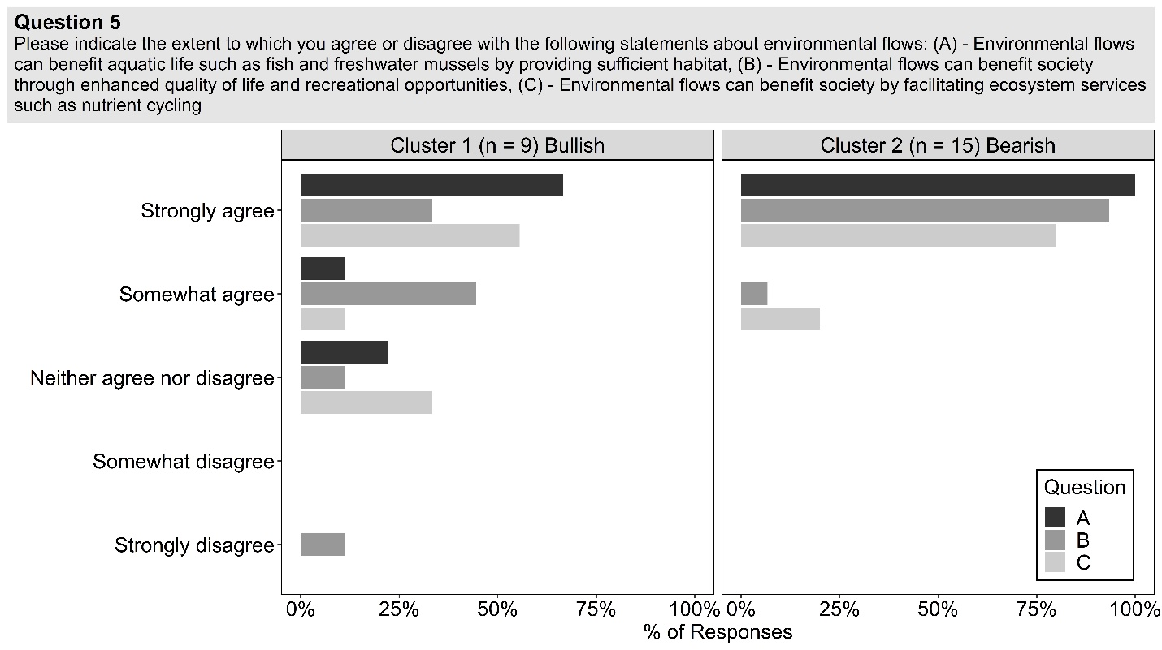
Figure 4-1. Respondents’ opinions on the potential benefits of e-flows.
Despite agreeing that e-flows can provide a range of benefits, clusters differed in their assessment of whether current flow conditions are adequate (Fig. 4-2), the feasibility of implementing e-flows (Fig. 4-2), whether water-related challenges will escalate in the future (Fig. 4-3a), whether climate change will be a driving factor of these water challenges (Fig. 4-3b), and the degree to which various factors are serious barriers to implementing e-flows policies in the Red River (Fig. 4-3). Overall, we found that respondents in the first (bullish) cluster were generally optimistic about current and future e-flows conditions and perceived fewer serious barriers to implementing e-flows. Respondents in the second (bearish) cluster were generally pessimistic about current and future e-flows conditions and perceived more serious barriers to implementing e-flows.
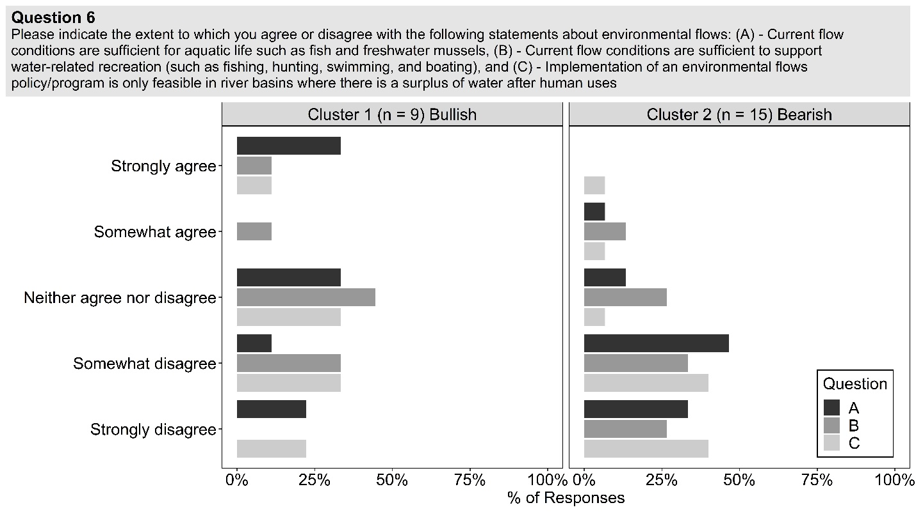
Figure 4-2. Respondents’ opinions on the current state of e-flows and e-flows implementation.
For example, a minority of respondents in the bullish cluster strongly or somewhat disagreed that current flow conditions are sufficient for biological (33%, n = 3) and recreational (33%, n = 3) needs, while most respondents in the bearish cluster strongly or somewhat disagreed that current flow conditions are sufficient for biological (80%, n = 12) and recreational (60%, n = 9) needs (Fig. 4-2). More respondents in the bull cluster opted to take a neutral stance for both questions. Respondents in both clusters also had different opinions about whether implementing e-flows is only feasible in river basins where there is a surplus of water after human uses. For example, only 55% (n = 5) of respondents in the bullish cluster compared to 87% (n = 13) of respondents in the bearish cluster strongly or somewhat disagreed that implementing e-flows is only feasible in rivers basins where there is a surplus of water after human uses.
When asked about future (next 5-10 years) water availability issues, most respondents in the bullish cluster had a neutral stance on whether there will be decreased water for society (55%, n = 5), increased extreme flooding (77%, n = 7), and increased droughts (55%, n = 5) in the future, while 66% (n = 6) of respondents strongly or somewhat agreed that there will be both decreased water for e-flows, and increased water conflicts (Fig. 4-3a). One respondent in the bullish cluster somewhat disagreed that there will be increased droughts and increased water conflicts in the future. Respondents in the bearish cluster were more bearish than respondents in the bullish cluster (Fig. 4-3a). Mostly all respondents in the bearish cluster agreed that the Red River basin will face all listed water-related issues in the near future, with only a few respondents taking a neutral stance (Fig. 4-3a).
When asked whether climate change will be a driving factor of the same issues listed in Fig. 4-3a, the majority of respondents in the bullish cluster shifted to a neutral stance on all issues (Fig. 4-3b). Respondents in the bearish cluster were more likely to believe that climate change will be a driving factor in future water issues (Fig. 4-3b). While some respondents in the bearish cluster also shifted to “neither agree nor disagree,” most respondents still believed that climate change will be a driving factor of these issues in the near future (Fig. 4-3b).
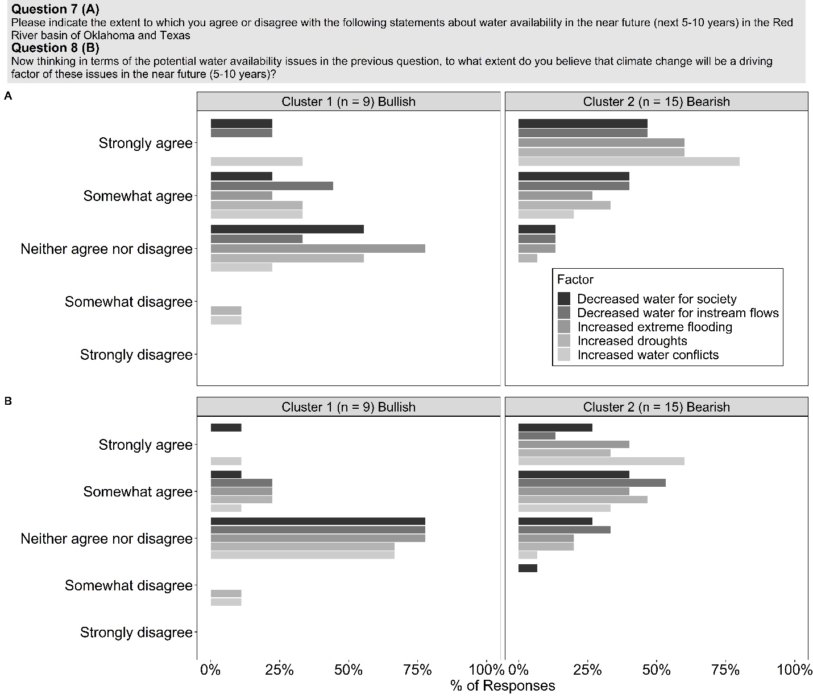
Figure 4-3. Respondent’s opinions on future water availability and climate change.
Respondents in the bullish cluster identified fewer serious barriers to implementing e-flows policies than respondents in the bearish cluster (Fig. 4-4). Over 50% of respondents in the bearish cluster believed that four factors were serious barriers, and only one respondent ranked two factors as not a barrier. In contrast, only a small percentage of respondents in the bullish cluster identified any serious barriers to policy implementation (Fig. 4-4). Despite having different perceptions about the severity of barriers to implementation, respondents in both clusters largely ranked potential barriers in the same order of severity (Fig. 4-4). Sixty-six percent (n = 10) of respondents in the bearish cluster and 33% (n = 4-3) of respondents in the bullish cluster identified beliefs that societal water needs should take precedence over environmental water needs as a serious barrier. 60% (n = 9) of respondents in the bearish cluster and 33% (n = 3) of respondents in the bullish cluster identified lack of funding as a serious barrier. However, the majority of respondents in both clusters also identified lack of economic data and data on the benefits to society as moderate barriers to implementing e-flows (Fig. 4-4).
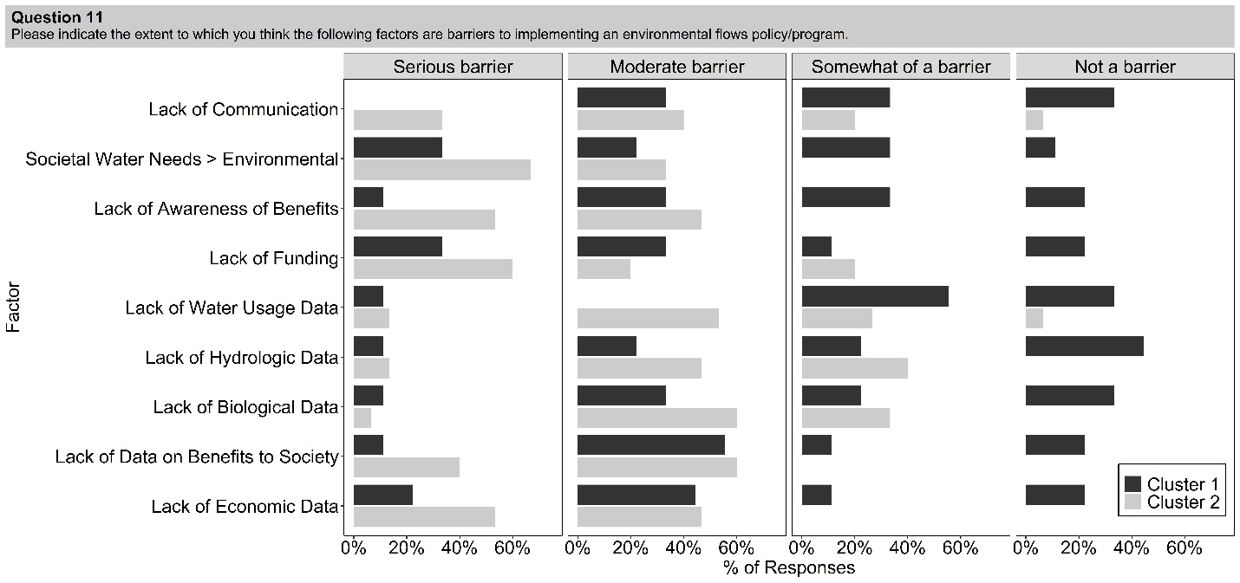
Figure 4-4. Respondents’ opinions on the barriers facing e-flows implementation by cluster. Percentage of responses to question 11 where respondents could select “Serious Barrier,” “Moderate Barrier,” ‘Somewhat of a Barrier,” or “Not a Barrier.”

Despite these differences of opinion, respondents in both clusters largely identified the same research and data needs (Fig. 4-5). Both clusters ranked additional hydrologic data as the highest priority, followed by information on biological flow needs and societal water demand. The largest difference between the two clusters was data on stakeholder’s willingness to participate in an e-flows policy or program: the bearish cluster ranked this factor as least important, and the bullish cluster ranked this factor as their second most important data need.
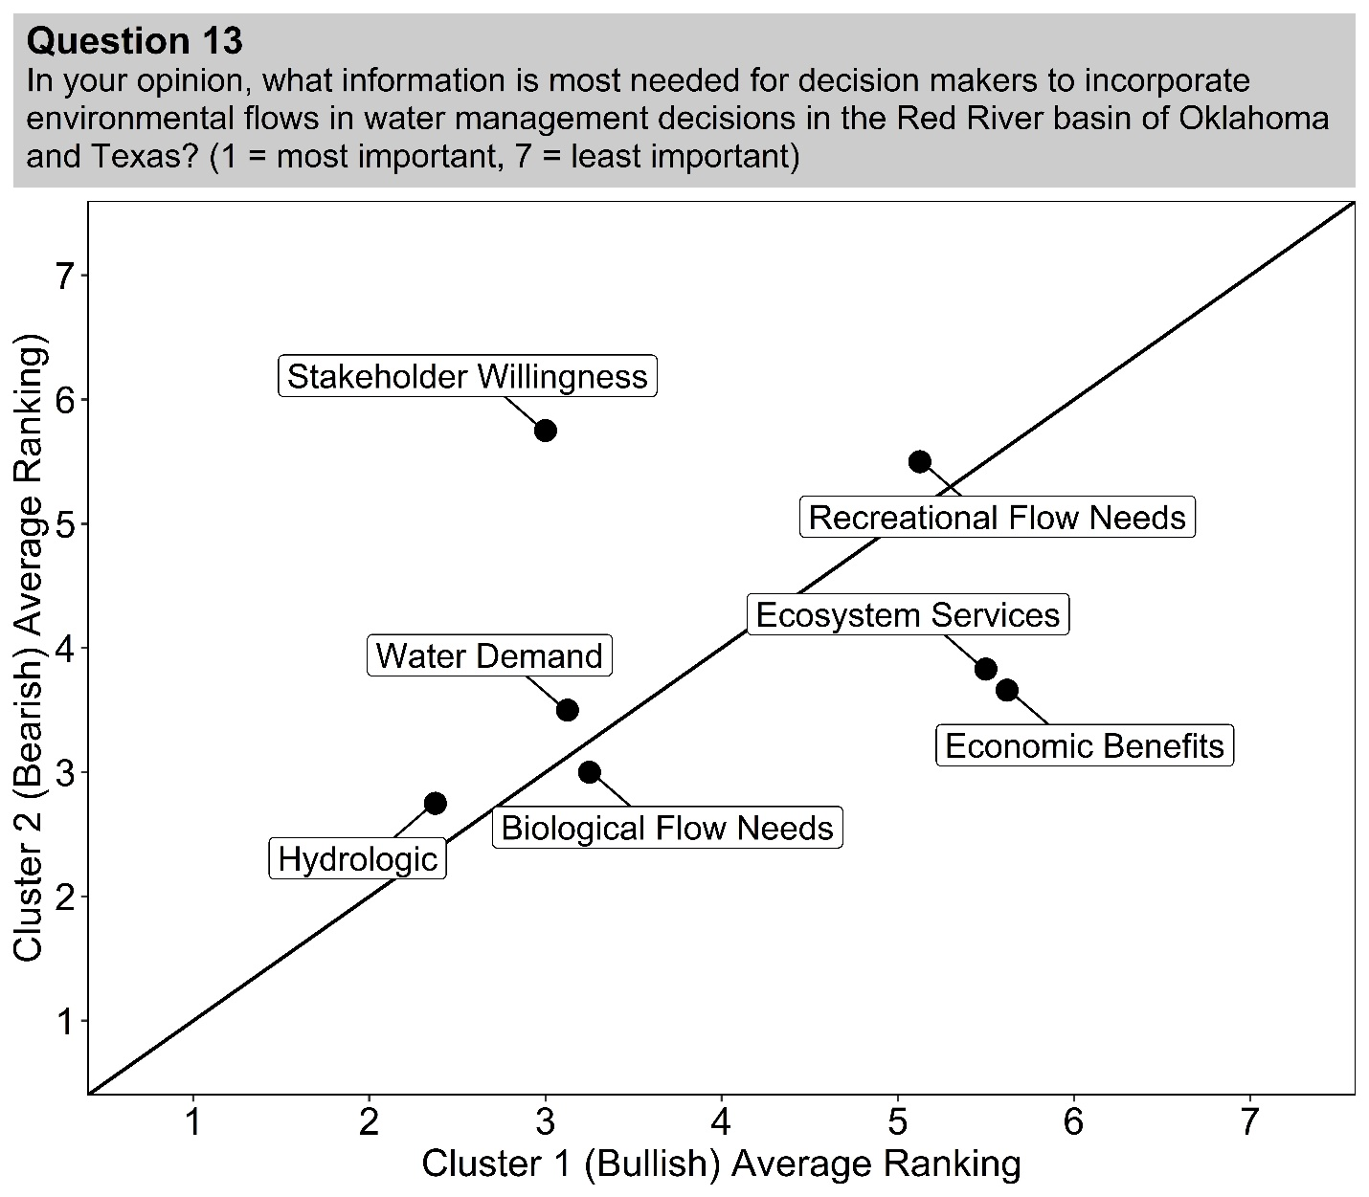
Figure 4-5. Respondent’s ranking of major data needs. Scatterplot of the average ranking (1 = most important, 7 = least important) of responses to question 13.
Although respondents in both clusters held different beliefs about current and future water availability (Figs. 4-2, 4-3) and barriers to implementation (Fig. 4-4), we did not find evidence that respondents communicated more frequently with like-minded individuals (Fig. 4-6). The sector-driven hypothesis aimed to examine if intra-sector communication (i.e., water-water, non-water-non-water, n = 21) was greater than inter-sector communication (i.e., water-non-water, non-water-water, n = 21). We found no support for the sector-driven hypothesis based on the Wilcoxon rank-sum test (W = 193, p = 0.49). The belief-driven hypothesis aimed to examine if individuals with similar values and beliefs about environmental flows (i.e., intra-cluster, n = 21) communicate more frequently with each other than with those with different values and beliefs (i.e., inter-cluster, n = 21). We used an unpaired, two-sample t-test to test this hypothesis. We found no significant difference in the frequency of communication for intra-cluster (μ = 0.556, SD = 0.519) and inter-cluster (μ =0.679, SD = 0.605) communication (t(39.01) = 0.71, p = 0.48).
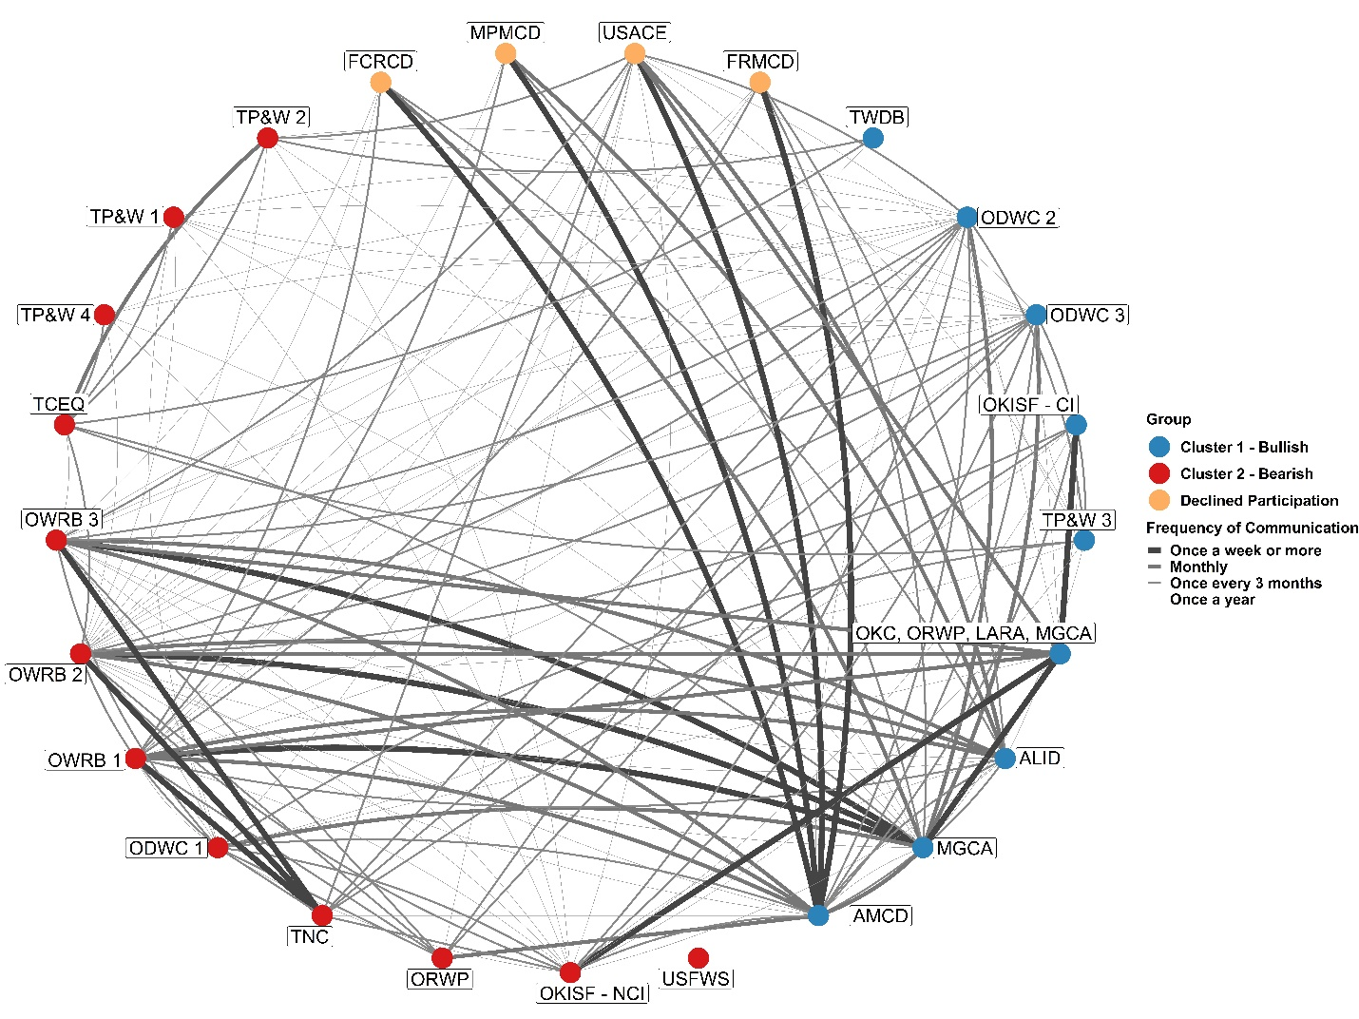
Figure 4-6. Network map showing communication relations from question 15 between decision makers by cluster. Line width indicates frequency of communication. Abbreviations relate to full respondent names in table 1.
Our social network analysis also revealed that individuals at water institutions in Oklahoma frequently communicate with prominent NGOs operating at state and local levels (e.g., The Nature Conservancy, Oklahomans for Responsible Water Policy). Less frequent communication patterns indicate that individuals at water institutions in both states communicate with each other at least yearly. Individuals at non-water institutions in both states communicate at least yearly. Several NGOs and advisory groups communicate at least yearly. Water institutions in Texas (Texas Commission on Environmental Quality, Texas Water Development Board) communicate frequently (monthly) with each other and their natural resource management agency (Texas Parks & Wildlife) and infrequently (once a year) with mostly all other network members. Overall, inter-state communication seemed less frequent that intra-state communication.

4.5. Discussion
Our study highlights how water and natural resource decision makers conceptualize the key challenges facing e-flows implementation in a semi-arid river basin. Decision makers agreed that e-flows can provide important societal and environmental benefits and identified similar data needs. However, they held a wide range of opinions on other issues, and our clustering analysis revealed two distinct groups of decision makers. The first cluster tended to be relatively bullish (i.e., optimistic about the future) but showed high variability in their responses and a range of opinions. They perceived fewer socio-political barriers to implementing e-flows, fewer future water conflicts, and were uncertain about the influence climate change might have on future water conflicts. The second cluster tended to be bearish (i.e., pessimistic about the future), and believed that water conflicts will get worse in the future, climate change will drive these changes, many factors are serious barriers to implementing e-flows, and current flow conditions are inadequate.
The two clusters that emerged in our study exhibited different perspectives on a contentious socio-political issue that could inhibit coordination and collaboration on e-flows implementation and climate change adaptation in our study region. Because the development and implementation of e-flows policies and practices and climate adaptation planning depend on social processes like communication and coordination, it is important to contextualize how the dissenting perspectives of our two clusters could impact decision-making processes (Pahl-Wostl et al. 2013, Daher et al. 2018). We found no support for both our sector-driven and belief driven communication bias hypotheses in our study region, which suggests that despite different institutional or regulatory mandates and different opinions on e-flows, individuals communicate just as frequently with others with opposing views or workplace goals than ones with similar views or workplace goals. This could be a promising precursor for individuals to engage in coordination and collaboration activities (Newman and Dale 2007), however different perspectives and attitudes can complicate decision-making processes despite frequent communication (Crona & Bodin 2006, Prell et al. 2009, Daher et al. 2018). Conversely, groups with diverse perspectives or that include all relevant actors can also achieve positive ecological and policy outcomes (Barnes et al. 2019, Emery et al. 2013). Because good decision-making for e-flows policymaking also requires being inclusive of climatic uncertainty and our clusters showed different perspectives on this issue, this could further impede decision maker coordination (Lempert & Groves 2010, Doell et al. 2015, Sabzi et al. 2019b). Thus, divergent perspectives can either facilitate or inhibit good decision and policy making and reaching a consensus of action for e-flows policymaking despite a divergence of opinion could be a significant hurdle to overcome (Emery et al. 2013, Robinson et al. 2016).

4.5.1. Key question 1: What additional data/information is needed to make better decisions about e-flows?
Both clusters of decision makers that we identified agreed that additional hydrologic/water demand data are most needed to support good decision-making about e-flows (Fig. 4-5). This shared identification of additional hydrologic and water demand data to incorporate e-flows into water management practices supports current efforts in e-flows science to shift from small-scale to basin-scale and regional assessments (Arthington et al. 2018b). While there have been a wealth of hydrologic models developed at the global (Richter & Thomas 2007, Kendy et al. 2009, Poff et al. 2010, Poff, Tharme, & Arthington 2017, Poff 2018) and regional (Sabzi et al. 2019a, Sabzi et al. 2019b, OWRB 2019, TNC Texas Water Explorer 2020, GP EFIT 2020) scale to support hydrologic decision-making, gaining a better understanding of the spatial and temporal hydrologic regime and water demand throughout the basin might foster better e-flows decision-making (Thompson et al. 2018), as one respondent to our survey indicated:
“Water demand and hydrologic data… should be measured and quantified at the appropriate spatial scales so they are useful for determining other responses (i.e., ecological and economic).”
Both clusters of decision makers ranked information on biological flow needs (i.e., flow ecology-relationships) as high priority (Fig. 4-5). While it is well understood that Great Plains aquatic communities have changed in diversity, abundance, and community composition over time due to stream fragmentation, lack of e-flows, and other anthropogenic stressors (Perkin & Gido 2011, Perkin et al. 2015, Matthews et al. 2013, Matthews & Marsh-Matthews 2016, Matthews & Marsh-Matthews 2016,), it is less clear what the specific flow needs are of Great Plains aquatic communities (Brewer et al. 2018, Worthington et al. 2019). Great Plains rivers are characterized by extreme spatial and temporal variability in flows, harsh temperature regimes, and extreme flooding and droughts (Dodds et al. 2004). While Great Plains aquatic communities are adapted to these harsh environmental conditions, gaining a better understanding of the specific dynamic needs of Great Plains aquatic communities could aid in developing a solid understanding of the appropriate biological and ecological needs for implementing an e-flows regime (Davies et al. 2014, King et al. 2015, Webb et al. 2017, Poff 2018).
The two clusters of decision makers indicated differences in their other highly ranked data needs (Fig. 4-6). Data on stakeholder willingness to participate in an e-flows policy or program was ranked second by the bullish cluster, whereas the bearish cluster thought this factor was less important (Fig. 4-5). The bullish cluster’s ranking supports a major data need and knowledge gap to implementing e-flows that requires coordination and co-development among policymakers, stakeholders, scientists, and water managers and users (Le Quesne et al. 2010, Pahl-Wostl et al. 2013, Lukasiewicz & Dare 2016). Some respondents pointed to a lack of understanding among water users and stakeholders and a push for more education about e-flows to bridge this knowledge gap:
“Education of the public is extremely important. Without public support, this will never happen…”
“Lack of understanding and more education on the subject matter.”
Lastly, while the bearish cluster ranked data on the economic benefits of e-flows as a low-priority data need, it is noteworthy to highlight this potentially understudied aspect of e-flows (King & Brown 2006, Gopal 2016). This aspect may address identified concerns expressed by respondents on economic outcomes:
“Further restrictions will inhibit economic development opportunities.”
“Experience in some states with ISF [Instream Flows] is that the ISF program is ONLY used to stop economic development and new permits and to force limitations on existing permits.”
However, there is increasing recognition that the economic benefits of e-flows (i.e., ecosystem services) can be achieved without impeding societal economic benefits (Yang et al. 2016, Jägermeyr et al. 2017, Sabzi et al. 2019a, Anderson et al. 2019), and can be regarded as a public good (Loehman and Loomis 2008).

4.5.2. Key question 2: What are the major socio-political barriers to implementing e-flows?
Both clusters of decision makers identified the same socio-political barriers to implementing environmental flows. Respondents in both clusters identified beliefs that societal water needs should take precedence over environmental needs, and lack of funding as serious barriers. Additionally, both clusters identified a lack of awareness and data on the societal and economic benefits as both serious and moderate barriers. Beliefs that societal water needs are more important than environmental needs and a lack of awareness and data on the societal and economic benefits relates back to the identification of additional data on stakeholder willingness to participate and stakeholder/water user education in the first key challenge (Le Quesne et al. 2010, Pahl-Wostl et al. 2013, Lukasiewicz & Dare 2016). Stakeholders and individual water users might not be willing to support e-flows policies because they might think that e-flows will conflict with water delivery. Respondents reflected this view when asked about why individual water users might not support e-flows policies or programs:
“Users would not be willing to support e-flow policies due to need for water for human demand and views that human demands should be met first...”
“Societal needs (not desires such as watering lawns in a drought or flood irrigation) should take priority during droughts but only if conservation actions are actually prescribed.”
Stakeholders and water users might also be unwilling to support an e-flows policy or participate in an e-flows program because of fears of overregulation, private water rights infringement, and economic loss, as other respondents indicate:
“People don't want the government regulating something that hasn't been regulated in the past.”
“Fear of how regulations would negatively impact them.”
“Private property rights and compensation for what private landowners consider ‘their’ water.”
“The majority of people don't understand the term [environmental flows] and think it will take away from their existing water rights.”
“…agricultural businesses fear of losing water they will need in the future.”
“Loss of revenue from water that could have been sold to customers.”
Respondents in both clusters also identified a lack of funding for e-flows policies and programs as a serious barrier to implementation. Much has been written about both market (Loomis et al. 2003, Qureshi et al. 2007) and voluntary (Dyson et al. 2003, Richter & Thomas 2007) methods to implement e-flows with varying levels of success (see Hirji and Davis 2009 for a full review). Market and voluntary approaches alone are largely inadequate at providing effective e-flows (Loehman & Charney 2011). The feasibility of implementing these approaches, especially in two states where “prior appropriation” water law is the current system – where water demand is filled in order of priority date and e-flows is not considered a “beneficial use” of water – would likely be challenging (Benson 2007). For example, this prior appropriations legacy is embedded in Texas’ Instream Flows Program (TIFP). The TIFP only considers how new permits would impact a standard baseflow in each basin. This inhibits the establishment of a comprehensive e-flows policy because existing permitted uses are strongly protected (NRC 2005, Opdyke et al. 2014). Indeed, when asked about the feasibility of different e-flows approaches, respondents indicated that neither market nor voluntary approaches would be feasible:
“Water rights should not be appropriated as a trading commodity.”
“Funding for construction of most reservoirs is specifically appropriated for authorized uses.”
“I define feasible as possible but that does not mean I think it would work (i.e., voluntary is feasible, but I am doubtful it would work).”
“There would be difficulty enforcing flow regulations.”
While the state of Texas has implemented their TIFP, Oklahoma has no formal policy or regulation that governs e-flows. However, Oklahoma passed the Water for 2060 Act in 2012 that sets a statewide goal to “consume no more fresh water in 2060 than was consumed in 2012...through the use of education and incentives, rather than mandates…” (OWRB 2015). Because the act emphasizes the use of incentives (i.e., money paid or subsidies offered to water users) to achieve water sustainability goals largely through water re-use and efficiency, similar funding sources might be used to incentivize e-flows implementation. However, the act does not currently list e-flows in any of its goals or recommendations. Thus, an additional incentive-based e-flows framework might be the most effective way to implement e-flows in the Red River basin because of the setting (i.e., drought prone, low public support because of a lack of understanding of the benefits and beliefs that societal needs outweigh environmental), water law (i.e., prior appropriations), and the socio-political barriers identified by our respondents.

4.5.3. Communication network
Our analysis of decision makers’ communication relations revealed frequent communication among decision makers in the Red River basin. We did not find support for both our sector-driven and belief-driven communication bias hypotheses. However, our network map suggests strong communication between water allocators, water managers, and natural resource managers in Oklahoma and Texas and less frequent communication between non-water related institutions and individuals at water and natural resource entities (Fig. 4-6). Despite frequent communication, the nature and quality of communication, which was not assessed here, is also important for prolonged collaboration. For example, frequent communication could indicate co-dependent or shared workplace agendas, but these communications may not include any discussion of e-flows. The context of communications is important too because clusters showed divergent perceptions about the future (i.e., bearish vs. bullish) which will likely impact their ability to coordinate future water sustainability efforts. For example, while both clusters agreed that e-flows can benefit society and ecosystems, they generally disagreed that current flow conditions (without any e-flows policies) are sufficient to support those benefits to society and ecosystems. In fact, one respondent believes that e-flows already benefit ecosystems and society throughout the basin:
“The vast majority of water flowing through the Red River Basin is already enjoyed by non-consumptive uses. Consumptive use is minor in comparison.”
While another believes that e-flows are not possible to implement because of the natural hydrologic regime of Great Plains rivers:
“The red river system will not support environmental flows, in much of the basin streams dry up entirely in the summer months habitually making the idea of environmental flows an artificial concept.”
These comments highlight the geographic context of decision maker’s perceptions in the basin. For example, an individual in the western part of the basin might think that e-flows are not feasible to implement because of habitual stream drying, while another in the eastern part might think e-flows are feasible to implement due to an abundance of water. Thus, there might not be a “catch-all” approach to implementing e-flows basin-wide, further highlighting the need for small-scale, regional based approaches (Arthington et al. 2018b).

4.6. Conclusion
Our study revealed the challenges associated with decision-making and implementing e-flows in semi-arid, water limited river basins. We found two distinct groups of decision makers with different perspectives on e-flows implementation and future water management issues, which could complicate e-flows implementation in our study region due to issues with coordination and collaboration. However, we also highlight potential opportunities to better coordinate efforts among decision makers through a shared identification of the major socio-political barriers and data needs facing e-flows implementation. With a large focus on stakeholders/water users’ lack of knowledge and willingness to participate in e-flows programs, decision makers could focus on education and better understanding stakeholder’s perceptions of the topic through surveys and focus groups (Graham 2009). In fact, with one of the primary objectives of Oklahoma’s Water for 2060 Act being education along with incentive-based approaches to water conservation, educating stakeholders on e-flows could be an additional step (OWRB 2015). Additionally, decision makers might also consider expanding incentive-based approaches through exploring additional funding sources given the identification of a lack of funding for e-flows and the inherent challenges and limited success of both market and voluntary approaches (Bennett et al. 2014). Implementing e-flows is a challenging socio-environmental issue that requires coordination among decision makers, often with competing priorities and perceptions of water-related challenges. Our identification of the challenges facing e-flows implementation could be scaled up and applied to other river basins globally, as most semi-arid river basins likely face the same challenges discussed in our study. Future work could seek to expand the use of social science techniques to better understand the challenges of implementing environmental flows. Semi-structured interviews could be used to gain a more in-depth understanding of the challenges that decision-makers face when seeking to implement e-flows.
Overall, we attempted to capture the perceptions and communication patterns of decision makers that have the authority or influence to implement e-flows in the Red River basin of Oklahoma and Texas. While this list of individuals is a small number, our study was likely limited by a small sample size (n = 24) because of individuals not finishing or responding to the survey. Our k-means clustering analysis was likely limited by our small sample size, as only 20.7% of the variance across respondents was explained by the clustering scheme. We also found no significant differences in communication across sectors and beliefs, which could also be limited due to our small sample size and lack of responses from some key entities and individuals in the region. However, because the perceptions and communication patterns we gathered here are representative of individuals with authority and influence in e-flows implementation, we believe the conclusions we draw are representative of the socio-political climate of our study area.

References
Anderson, E. P., Jackson, S., Tharme, R. E., Douglas, M., Flotemersch, J. E., Zwarteveen, M., ... & Jardine, T. D. (2019). Understanding rivers and their social relations: A critical step to advance environmental water management. Wiley Interdisciplinary Reviews: Water, 6(6), e1381.
Aylward, B., et al., 2005. Freshwater ecosystem services. In: K. Chopra, et al., eds. Millennium Ecosystem Assessment, Vol. 3. Policy responses. Washington, DC: Island Press, 215–248.
Arthington, A. H., Bhaduri, A., Bunn, S. E., Jackson, S. E., Tharme, R. E., Tickner, D., ... & Horne, A. C. (2018a). The Brisbane declaration and global action agenda on environmental flows (2018). Frontiers in Environmental Science, 6, 45.
Arthington, A. H., Kennen, J. G., Stein, E. D., & Webb, J. A. (2018b). Recent advances in environmental flows science and water management—Innovation in the Anthropocene. Freshwater Biology, 63(8), 1022-1034.
Barnes, M. L., Lynham, J., Kalberg, K., & Leung, P. (2016). Social networks and environmental outcomes. Proceedings of the National Academy of Sciences, 113(23), 6466-6471.
Barnes, M. L., Bodin, Ö., McClanahan, T. R., Kittinger, J. N., Hoey, A. S., Gaoue, O. G., & Graham, N. A. (2019). Social-ecological alignment and ecological conditions in coral reefs. Nature communications, 10(1), 1-10.
Barnes-Mauthe, M., Arita, S., Allen, S. D., Gray, S. A., & Leung, P. (2013). The influence of ethnic diversity on social network structure in a common-pool resource system: implications for collaborative management. Ecology and Society, 18(1).

Bennett, D. E., Gosnell, H., Lurie, S., & Duncan, S. (2014). Utility engagement with payments for watershed services in the United States. Ecosystem Services, 8, 56-64.
Benson, Reed D. "Rivers to live by: can western water law help communities embrace their streams." J. Land Resources & Envtl. L. 27 (2007): 1.
Bertrand, D., & McPherson, R. A. (2019). Development of Downscaled Climate Projections: A Case Study of the Red River Basin, South-Central US. Advances in Meteorology, 2019.
Brewer, S. K., Worthington, T. A., Mollenhauer, R., Stewart, D. R., McManamay, R. A., Guertault, L., & Moore, D. (2018). Synthesizing models useful for ecohydrology and ecohydraulic approaches: An emphasis on integrating models to address complex research questions. Ecohydrology, 11(7), e1966.
Burch, C., Busch, M., Higgins, E., Bittner, S., Perera, N., Neal, K., ... & Anderson, C. (2020). Revisiting a Water Conflict in Southeastern Oklahoma 6 Years Later: A New Valuation of the Willingness to Pay for Ecosystem Services. Sustainability, 12(3), 819.
Chen, W., & Olden, J. D. (2017). Designing flows to resolve human and environmental water needs in a dam-regulated river. Nature communications, 8(1), 1-10.
City of Oklahoma. Memorandum—Council Agenda, Item No. VIII.C.3. 2016. Available online: http://www.okc.gov/home/showdocument?id=3323 (accessed on 14 November 2019).
Crona, B., Bodin, Ö., 2006. What you know is who you know? Communication patterns among resource users as a prerequisite for co-management. Ecol. Soc. 11 (2). https://doi.org/10.5751/es-01793-110207.
Daher, B., Hannibal, B., Portney, K. E., & Mohtar, R. H. (2019). Toward creating an environment of cooperation between water, energy, and food stakeholders in San Antonio. Science of The Total Environment, 651, 2913-2926.
Davies, P. M., Naiman, R. J., Warfe, D. M., Pettit, N. E., Arthington, A. H., & Bunn, S. E. (2014). Flow-ecology relationships: Closing the loop on effective environmental flows. Marine & Freshwater Research, 65, 133–141.
Declaration, B. (2007, September). The Brisbane Declaration: environmental flows are essential for freshwater ecosystem health and human well-being. In 10th International River Symposium, Brisbane, Australia (pp. 3-6).
Di Baldassarre, G., Wanders, N., AghaKouchak, A., Kuil, L., Rangecroft, S., Veldkamp, T. I., ... & Van Loon, A. F. (2018). Water shortages worsened by reservoir effects. Nature Sustainability, 1(11), 617-622.
Dodds, W. K., Gido, K., Whiles, M. R., Fritz, K. M., & Matthews, W. J. (2004). Life on the edge: the ecology of Great Plains prairie streams. BioScience, 54(3), 205-216.
Doell, P., Jiménez-Cisneros, B., Oki, T., Arnell, N. W., Benito, G., Cogley, J. G., ... & Nishijima, A. (2015). Integrating risks of climate change into water management. Hydrological Sciences Journal, 60(1), 4-13.
Dolnicar, S., & Grün, B. (2007). Cross‐cultural differences in survey response patterns. International Marketing Review.
DuBose, T. P., Atkinson, C. L., Vaughn, C. C., & Golladay, S. W. (2019). Drought-induced, punctuated loss of freshwater mussels alters ecosystem function across temporal scales. Frontiers in Ecology and Evolution, 7, 274.
Dyson, M., Bergkamp, G., & Scanlon, J. (2003). Flow: the essentials of environmental flows. IUCN, Gland, Switzerland and Cambridge, UK, 20-87.
Eck, C. J., Wagner, K. L., Chapagain, B., & Joshi, O. (2019). A Survey of Perceptions and Attitudes about Water Issues in Oklahoma: A Comparative Study. Journal of Contemporary Water Research & Education, 168(1), 66-77.
Emery, S. B., Perks, M. T., & Bracken, L. J. (2013). Negotiating river restoration: The role of divergent reframing in environmental decision-making. Geoforum, 47, 167-177.
Gates, K. K., Vaughn, C. C., & Julian, J. P. (2015). Developing environmental flow recommendations for freshwater mussels using the biological traits of species guilds. Freshwater Biology, 60(4), 620-635.
Gaupp, F., Hall, J., & Dadson, S. (2015). The role of storage capacity in coping with intra-and inter-annual water variability in large river basins. Environmental Research Letters, 10(12), 125001.
Gibbins, C. N., Soulsby, C., Jeffries, M. J., & Acornley, R. (2001). Developing ecologically acceptable river flow regimes: a case study of Kielder reservoir and the Kielder water transfer system. Fisheries Management and Ecology, 8(6), 463-485.
Gleick, P. H. (2018). Transitions to freshwater sustainability. Proceedings of the National Academy of Sciences, 115(36), 8863-8871.
Gopal, B. (2016). A conceptual framework for environmental flows assessment based on ecosystem services and their economic valuation. Ecosystem Services, 21, 53-58.
GP EFIT (2020): The Great Plains Environmental Flow Information Toolkit, Available at: https://www.sciencebase.gov/catalog/item/5e4584b7e4b0ff554f662b4a
Graham, S. (2009). Irrigators’ attitudes towards environmental flows for wetlands in the Murrumbidgee, Australia. Wetlands ecology and management, 17(4), 303-316.
Hartigan, J.A. and Wong, M.A. (1979), “Algorithm AS 136: a K‐means clustering algorithm”, Applied Statistics, Vol. 28 No. 1, pp. 100‐8.
He, F., Zarfl, C., Bremerich, V., David, J. N., Hogan, Z., Kalinkat, G., ... & Jähnig, S. C. (2019). The global decline of freshwater megafauna. Global Change Biology, 25(11), 3883-3892.
Hirji, R., & Davis, R. (2009). Environmental flows in water resources policies, plans, and projects: findings and recommendations. The World Bank.
Hoeinghaus, D. J., Agostinho, A. A., Gomes, L. C., Pelicice, F. M., Okada, E. K., Latini, J. D., ... & Winemiller, K. O. (2009). Effects of river impoundment on ecosystem services of large tropical rivers: embodied energy and market value of artisanal fisheries. Conservation Biology, 23(5), 1222-1231.
Horne, A. C., O’Donnell, E. L., Acreman, M., McClain, M. E., Poff, N. L., Webb, J. A., ... & Tharme, R. E. (2017). Moving forward: The implementation challenge for environmental water management. In Water for the Environment (pp. 649-673). Academic Press.
Horne, A. C., Webb, J. A., O'Donnell, E., Arthington, A. H., McClain, M., Bond, N., ... & Poff, N. L. (2017). Research priorities to improve future environmental water outcomes. Frontiers in Environmental Science, 5, 89.
Howlett, M., M. Ramesh, and A. Perl. 2009. Studying public policy: Policy cycles and policy subsystems. Third Edition. Oxford, U.K: Oxford University Press
Ingold, K., & Balsiger, J. (2015). Sustainability principles put into practice: case studies of network analysis in Swiss climate change adaptation. Regional environmental change, 15(3), 529-538.
Issa, R.; Hare, J.L.; Samandi, S.; Hernandez, S.; Ferguson, C. The Existing Atoka Pipeline Surge Protection System: The Full Story. In Proceedings of the Pipelines (2016), Kansas City, MO, USA, 17–20 July 2016; pp. 1369–1378.
Jägermeyr, J., Pastor, A., Biemans, H., & Gerten, D. (2017). Reconciling irrigated food production with environmental flows for Sustainable Development Goals implementation. Nature Communications, 8(1), 1-9.
Katz, N., Lazer, D., Arrow, H., Contractor, N., (2004). The network perspective on small groups: theory and research. Theories of Small Groups: Interdisciplinary Perspectives, pp. 277–312.
Kendy, E., Sanderson, J. S., Olden, J. D., Apse, C. D., DePhilip, M. M., Haney, J. A., ... & Zimmerman, J. K. H. (2009, February). Applications of the ecological limits of hydrologic alteration (ELOHA) in the United States. In International Conference on Implementing Environmental Water Allocations (pp. 23-26).
King, A. J., Gawne, B., Beesley, L., Koehn, J. D., Nielsen, D. L., & Price, A. (2015). Improving ecological response monitoring of environmental flows. Environmental Management, 55, 991–1005.
King, J., & Brown, C. (2006). Environmental flows: striking the balance between development and resource protection. Ecology and Society, 11(2).
Knight, A. T., Cowling, R. M., Rouget, M., Balmford, A., Lombard, A. T., & Campbell, B. M. (2008). Knowing but not doing: selecting priority conservation areas and the research–implementation gap. Conservation biology, 22(3), 610-617.
Le Quesne, T., Kendy, E., & Weston, D. (2010). The implementation challenge. Taking Stock of government Policies to Protect and Restore Environmental Flows. WWF (World Wide Fund for Nature) and TNC (The Nature Conservancy).
Lehner, B., Liermann, C. R., Revenga, C., Vörösmarty, C., Fekete, B., Crouzet, P., ... & Nilsson, C. (2011). High‐resolution mapping of the world's reservoirs and dams for sustainable river‐flow management. Frontiers in Ecology and the Environment, 9(9), 494-502.
Lempert, R. J., & Groves, D. G. (2010). Identifying and evaluating robust adaptive policy responses to climate change for water management agencies in the American west. Technological Forecasting and Social Change, 77(6), 960-974.
Lleti, R., Ortiz, M. C., Sarabia, L. A., & Sánchez, M. S. (2004). Selecting variables for k-means cluster analysis by using a genetic algorithm that optimises the silhouettes. Analytica Chimica Acta, 515(1), 87-100.
Loehman, E. and Loomis, J., (2008). In-stream flow as a public good: Possibilities for economic organization and voluntary local provision. Review of Agricultural Economics, 30 (3), 445–456.
Loehman, E. T., & Charney, S. (2011). Further down the road to sustainable environmental flows: funding, management activities and governance for six western US states. Water international, 36(7), 873-893.
Loehman, E. T., & Charney, S. (2011). Further down the road to sustainable environmental flows: funding, management activities and governance for six western US states. Water international, 36(7), 873-893.
Loomis, J. B., Quattlebaum, K., Brown, T. C., & Alexander, S. J. (2003). Expanding institutional arrangements for acquiring water for environmental purposes: transactions evidence for the Western United States. International Journal of Water Resources Development, 19(1), 21-28.
Lorenz, J., Rauhut, H., Schweitzer, F., & Helbing, D. (2011). How social influence can undermine the wisdom of crowd effect. Proceedings of the national academy of sciences, 108(22), 9020-9025.
Lukasiewicz, A., & Dare, M. L. (2016). When private water rights become a public asset: Stakeholder perspectives on the fairness of environmental water management. Journal of Hydrology, 536, 183-191.
Matthews, W. J., Marsh-Matthews, E., Cashner, R. C., & Gelwick, F. (2013). Disturbance and trajectory of change in a stream fish community over four decades. Oecologia, 173(3), 955-969.
Matthews, W. J., & Marsh‐Matthews, E. (2016). Dynamics of an upland stream fish community over forty years: trajectories and support for the loose equilibrium concept. Ecology.
Matthews, W. J., & Marsh-Matthews, E. (2015). Comparison of historical and recent fish distribution patterns in Oklahoma and western Arkansas. Copeia, 2015(1), 170-180.
McPherson, M., Smith-Lovin, L., & Cook, J. M. (2001). Birds of a feather: Homophily in social networks. Annual review of sociology, 27(1), 415-444.
Megdal, S. B., Bate, J., & Schwarz, A. (2009). Securing water for environmental purposes: Establishing pilot programs. The International Journal of Environmental, Cultural, Economic and Social Sustainability, 5(6), 189-200.
Mezger, G., De Stefano, L., & del Tánago, M. G. (2019). Assessing the Establishment and Implementation of Environmental Flows in Spain. Environmental management, 64(6), 721-735.
Mims, M. C., & Olden, J. D. (2012). Life history theory predicts fish assemblage response to hydrologic regimes. Ecology, 93(1), 35-45.
Moore, M. (2004). Perceptions and interpretations of environmental flows and implications for future water resource management. A survey study. Masters Thesis. Linköping University, Sweden, 1-67.
National Research Council. (2005). The science of instream flows: a review of the Texas Instream Flow Program. National Academies Press.
Newman, L., Dale, A., (2007). Homophily and agency: creating effective sustainable development networks. Environ. Dev. Sustain. 9, 79–90.
Oklahoma Water Resources Board. (2011). Oklahoma Comprehensive Water Plan Supplemental Report: Instream Flow Issues and Recommendations. Available at: https://www.owrb.ok.gov/supply/ocwp/pdf_ocwp/WaterPlanUpdate/draftreports/OCWP_InstreamFlow_IssuesRecs.pdf
Oklahoma Water Resources Board. (2015). Report of the Oklahoma Water for 2060 Advisory Council. Available at: https://www.owrb.ok.gov/2060/pdf/2060Recommendations.pdf
Oklahoma Water Resources Board. (2019) Upper Illinois River Instream Flow Pilot Study. Available at: https://www.owrb.ok.gov/ISF/OWRB_ISF%20Pilot%20Study_DRAFT%20June%202019.pdf
Olden, J. D., & Naiman, R. J. (2010). Incorporating thermal regimes into environmental flows assessments: modifying dam operations to restore freshwater ecosystem integrity. Freshwater Biology, 55(1), 86-107.
Olden, J. D., Konrad, C. P., Melis, T. S., Kennard, M. J., Freeman, M. C., Mims, M. C., ... & McMullen, L. E. (2014). Are large‐scale flow experiments informing the science and management of freshwater ecosystems?. Frontiers in Ecology and the Environment, 12(3), 176-185.
Opdyke, D. R., Oborny, E. L., Vaugh, S. K., & Mayes, K. B. (2014). Texas environmental flow standards and the hydrology-based environmental flow regime methodology. Hydrological Sciences Journal, 59(3-4), 820-830.
Opperman, J. J., Kendy, E., Tharme, R. E., Warner, A. T., Barrios, E., & Richter, B. D. (2018). A three-level framework for assessing and implementing environmental flows. Frontiers in Environmental Science, 6, 76.
Pahl-Wostl, C., (2017). Governance of the water-energy-food security nexus: a multi-level coordination challenge. Environ. Sci. Policy (January), 1–12 https://doi.org/10.1016/j. envsci.2017.07.017.
Pahl-Wostl, C., Arthington, A., Bogardi, J., Bunn, S. E., Hoff, H., Lebel, L., ... & Schlüter, M. (2013). Environmental flows and water governance: managing sustainable water uses. Current Opinion in Environmental Sustainability, 5(3-4), 341-351.
Perkin, J. S., Gido, K. B., Cooper, A. R., Turner, T. F., Osborne, M. J., Johnson, E. R., & Mayes, K. B. (2015). Fragmentation and dewatering transform Great Plains stream fish communities. Ecological Monographs, 85(1), 73-92.
Perkin, J. S., & Gido, K. B. (2011). Stream fragmentation thresholds for a reproductive guild of Great Plains fishes. Fisheries, 36(8), 371-383.
Poff, N. L. (2018). Beyond the natural flow regime? Broadening the hydro‐ecological foundation to meet environmental flows challenges in a non‐stationary world. Freshwater Biology, 63(8), 1011-1021.
Poff, N. L., & Matthews, J. H. (2013). Environmental flows in the Anthropocence: past progress and future prospects. Current Opinion in Environmental Sustainability, 5(6), 667-675.
Poff, N. L., & Zimmerman, J. K. H. (2010). Ecological responses to altered flow regimes: A literature review to inform the science and management of environmental flows. Freshwater Biology, 55, 194–205.
Poff, N. L., Brown, C. M., Grantham, T. E., Matthews, J. H., Palmer, M. A., Spence, C. M., ... & Baeza, A. (2016). Sustainable water management under future uncertainty with eco-engineering decision scaling. Nature Climate Change, 6(1), 25-34.
Poff, N. L., Richter, B. D., Arthington, A. H., Bunn, S. E., Naiman, R. J., Kendy, E., ... & Henriksen, J. (2010). The ecological limits of hydrologic alteration (ELOHA): a new framework for developing regional environmental flow standards. Freshwater Biology, 55(1), 147-170.
Prell, C., Hubacek, K., & Reed, M. (2009). Stakeholder analysis and social network analysis in natural resource management. Society and Natural Resources, 22(6), 501-518.
PRISM Climate Group, Oregon State University, http://prism.oregonstate.edu, Accessed 5/2019
Qureshi, M. E., Connor, J., Kirby, M., & Mainuddin, M. (2007). Economic assessment of acquiring water for environmental flows in the Murray Basin. Australian Journal of Agricultural and Resource Economics, 51(3), 283-303.
R Core Team (2020). R: A language and environment for statistical computing. R Foundation for Statistical Computing, Vienna, Austria. URL http://www.R-project.org/.
Red River Compact Commission. (1978). Red River Compact. HB 1388, c. 136, § 1
Richter, B. D. (2010). Re‐thinking environmental flows: from allocations and reserves to sustainability boundaries. River Research and Applications, 26(8), 1052-1063.
Richter, B. D., & Thomas, G. A. (2007). Restoring environmental flows by modifying dam operations. Ecology and Society, 12(1).
Robinson, K. F., & Fuller, A. K. (2017). Participatory modeling and structured decision making. In Environmental modeling with stakeholders (pp. 83-101). Springer, Cham.
Rodell, M., Famiglietti, J. S., Wiese, D. N., Reager, J. T., Beaudoing, H. K., Landerer, F. W., & Lo, M. H. (2018). Emerging trends in global freshwater availability. Nature, 557(7707), 651-659.
Sabzi, H. Z., Moreno, H. A., Fovargue, R., Xue, X., Hong, Y., & Neeson, T. M. (2019a). Comparison of projected water availability and demand reveals future hotspots of water stress in the Red River basin, USA. Journal of Hydrology: Regional Studies, 26, 100638.
Sabzi, H. Z., Rezapour, S., Fovargue, R., Moreno, H., & Neeson, T. M. (2019b). Strategic allocation of water conservation incentives to balance environmental flows and societal outcomes. Ecological engineering, 127, 160-169.
Sanderson, M. R., Bergtold, J. S., Heier Stamm, J. L., Caldas, M. M., & Ramsey, S. M. (2017). Bringing the “social” into sociohydrology: Conservation policy support in the Central Great Plains of Kansas, USA. Water Resources Research, 53(8), 6725-6743.
Tarlock, A. D. (2001). The future of prior appropriation in the new west. Natural Resources Journal, 41(4), 769-793.
Tarrant Regional Water Dist. v. Herrmann, 133 S. Ct. 2120, 569 U.S. 614, 186 L. Ed. 2d 153 (2013).
The Nature Conservancy Texas Water Explorer (2020). An online resource to summarize the current state of Texas’ surface and groundwater. Available online at http://www.texaswaterexplorer.tnc.org/
Thompson, R. M., King, A. J., Kingsford, R. M., Mac Nally, R., & Poff, N. L. (2018). Legacies, lags and long‐term trends: Effective flow restoration in a changed and changing world. Freshwater Biology, 63(8), 986-995.
Tickner, D., Parker, H., Moncrieff, C. R., Oates, N. E., Ludi, E., & Acreman, M. (2017). Managing rivers for multiple benefits–a coherent approach to research, policy and planning. Frontiers in Environmental Science, 5, 4.
Tickner, D., Opperman, J. J., Abell, R., Acreman, M., Arthington, A. H., Bunn, S. E., ... & Harrison, I. (2020). Bending the curve of global freshwater biodiversity loss: an emergency recovery plan. BioScience.
United Nations World Water Assessment Programme (UNWWAP) (2018) The United Nations World Water Development Report: Water for a Sustainable World (UNESCO, Paris), Vols 1–8.
Vaughn, C. C., Atkinson, C. L., & Julian, J. P. (2015). Drought‐induced changes in flow regimes lead to long‐term losses in mussel‐provided ecosystem services. Ecology and Evolution, 5(6), 1291-1305.
Webb, A., Arthington, A. H., & Olden, J. D. (2017). Models of ecological responses to flow regime change to inform environmental flows assessments. In A. Horne, A. Webb, M. Stewardson, B. Richter & M. Acreman (Eds.), Water for the environment: Policy, science, and integrated management (pp. 287–316). London: Elsevier Press.
Webb, J. A., Watts, R. J., Allan, C., & Conallin, J. C. (2018). Adaptive management of environmental flows. Environmental management, 61(3), 339-346.
World Commission on Dams. (2000). Dams and development: A new framework for decision-making: The report of the world commission on dams. Earthscan.
Worthington, T. A., Brewer, S. K., Vieux, B., & Kennen, J. (2019). The accuracy of ecological flow metrics derived using a physics‐based distributed rainfall–runoff model in the Great Plains, USA. Ecohydrology, 12(5), e2090.
Xue, X., Zhang, K., Hong, Y., Gourley, J. J., Kellogg, W., McPherson, R. A., ... & Austin, B. N. (2016). New multisite cascading calibration approach for hydrological models: case study in the Red River basin using the VIC model. Journal of Hydrologic Engineering, 21(2), 05015019.
Yang, W., Sun, T., & Yang, Z. (2016). Does the implementation of environmental flows improve wetland ecosystem services and biodiversity? A literature review. Restoration Ecology, 24(6), 731-742.

5. Identifying conservation influencers using network science boosts the spread of conservation initiatives

5.1. Abstract
Conservation programs and policies can preserve biodiversity and boost ecosystem services, but only when widely adopted. While thousands of conservation initiatives exist globally, most fail to spread beyond a few early adopters. Here, we use network science to (1) determine the topology and structure of two networks of conservation actors (one regional, one national), (2) identify influential individuals in those networks, and (3) test whether the adoption of a conservation initiative by influential individuals could increase the spread of that initiative across the network. We find that early adoption by influential individuals results in sharp improvements in the total number of adopters of a conservation initiative network-wide, particularly when a linear threshold diffusion model is used. Under an independent cascade diffusion model, the benefits of targeting influencers are smaller but still substantial. These benefits occurred in both networks despite very different network structures: the regional network resembles a random network comprised mostly of state agencies and local entities, while the national network has a scale-free structure with highly influential hubs of federal agency and NGO entities. Given that many conservation programs fail to reach critical mass, our findings highlight the importance of strategically targeting influential individuals to boost the spread of conservation initiatives.

5.2. Introduction
Conservation practitioners are grappling with the global challenge of accelerating the adoption of conservation initiatives (Tickner et al. 2020, Leclère et al. 2020, Rilov et al. 2020). The adoption of conservation initiatives varies dramatically: some initiatives spread rapidly among potential adopters, but many fail to spread beyond a few initial participants (Mills et al. 2019). To become widely adopted, conservation initiatives must diffuse through networks of potential adopters from an initial set of “seed” adopters, and the type and scale of each conservation initiative shapes adoption dynamics. For example, national-scale regulatory (top-down) initiatives can result in rapid, complete adoption, whereas local-scale, community-based (bottom-up) initiatives can face initial slow uptake followed by rapid adoption as the initiative spreads from initial to potential adopters (Jupiter et al. 2014, Meskell et al. 2015, Tafoya et al. 2020, Atisa et al. 2020). Given this variability, conservation actors are keenly interested in strategies for ensuring that a conservation initiative spreads rapidly and is widely adopted (Butchart et al. 2015, Díaz et al. 2019).
Network science can provide key insights into how and why conservation initiatives spread (Guerrero et al. 2020). Social network analysis (SNA) can reveal stakeholder cooperation, participation, behavior, and barriers to conservation interventions (Cinner 2018, Barnes et al. 2016, Bodin et al. 2019, Riggs et al. 2020, Wineland et al. 2021). However, an emerging line of research has focused on identifying “key players” in conservation networks based on network centrality-based metrics that help spread conservation initiatives to other individuals or organizations (Mbaru & Barnes 2017, Guerrero et al. 2020, de Lange et al. 2021). Yet this work points to a broader aspect of network science known as the influence maximization problem (Güney 2019). Influence maximization is the process of selecting initial seed nodes that will maximize the spread of information or innovation throughout a network (Chen et al. 2009). While this line of research has clear applications in marketing, social media, network security, and computer science (Chen et al. 2010, Chaoqi et al. 2018), influence maximization has yet to be applied to conservation networks to determine if they can improve the spread of conservation initiatives.
In the context of conservation initiatives that operate at different spatial scales (i.e., local, regional, national), influence maximization could be used to strategically target conservation actors to facilitate widespread diffusion (de Lange et al. 2021). There are two information diffusion models that can be used to test whether seeds selected using influence maximization improve spread, the Independent Cascade (IC) and Linear Threshold (LT) models (Kempe et al. 2003). Both models consider a graph G = (V,E) where V is a set of nodes and E is a set of edges, and nodes can be either active (i.e., an adopter of the initiative) V_{a}, or inactive V_{i} (either initially or after interacting with another active node). Under the IC model, an inactive node v can activate after interacting with its active neighbor node u based on the probability P_{u,v}, which indicates the probability of u activating v. Under the LT model, an inactive node v, examines all neighboring nodes, and if the number of active neighbors exceeds a threshold (either absolute or fractional), then node v becomes activated (Shakarian et al. 2015). Both models could be useful for understanding conservation initiative adoption dynamics, as stakeholders’ and decision-makers’ willingness to adopt an initiative widely varies (Knight et al. 2010). For example, individuals and organizations in conservation networks exhibit different values and perspectives on conservation initiatives, which can represent a range of activation probabilities under IC (Thompson et al. 2015, Wineland et al. 2021). On the other hand, willingness to adopt a conservation initiative can depend on how many peers and neighboring organizations are adopting the initiative (e.g., peer pressure), which can represent a range of activation thresholds under LT (Prinbeck et al. 2011, Guckian et al. 2018). Additionally, because both models take an initial set of active seed nodes as input, the selection of these seed nodes using influence maximization can be applied to select highly influential individuals in the network.
Quantifying and classifying the topology of a network of conservation actors is central to the influence maximization problem (Mihara et al. 2015, Guerrero et al. 2020). Network structural features like node degree distributions and centrality-based metrics are important to contextualize the connectedness and importance of individuals and organization types (Bodin et al. 2006). Network topology is an emergent property that affects information diffusion and is important in the context of influence maximization because seed selection algorithms and information diffusion models use the entire network topological structure to detect seed nodes and propagate information through the network (Delre et al. 2010, Mihara et al. 2015, Shakarian et al. 2015). Real-world networks are typically classified as one of three main types: random, small-world, or scale-free (Sole & Valverde 2004). In random networks, the number of links per node follows a binomial or Poisson degree distribution (Erdős & Rényi, 1959). Small world networks are defined by the presence of “cliques”, or highly connected sub-networks, that result in a defining characteristic of a high clustering coefficient (Watts & Strogatz 1998). Small world networks also tend to have right-skewed degree distributions because of the abundance of hubs; however, their degree distribution does not typically follow a power law. Scale-free networks have degree distributions that follow a power law, where the fraction of nodes with degree k follows a power-law distribution k-α, where typically α ≥ 1 (Barabási -Albert 1999). Scale-free networks also operate under a “preferential attachment” mechanism (i.e., “rich get richer”, or existing hubs become more highly connected) that can be either linear or non-linear.
Here, we investigate influence maximization on two networks of freshwater conservation actors: a regional (n=24) network of freshwater decision makers from the Oklahoma and Texas portions of the Red River (Wineland et al. 2021), and a national (n=426) network of e-flows workshop participants from The Nature Conservancy (TNC) and U.S. Army Corps of Engineers’ (USACE) Sustainable Rivers Program (SRP). These two networks contain key hallmarks of conservation networks worldwide: nodes derived from actors within both the resource governance and resource user socio-ecological subsystems, and variation in network ties derived from social processes (Ostrom 2009, Matous & Todo 2015, Bodin et al. 2017). Thus, while we focus on networks derived from freshwater conservation actors, our approaches will be transferable to terrestrial and marine ecosystems. This study was motivated by current efforts to accelerate the implementation of environmental flows (e-flows; Arthington et al. 2021, Tickner et al. 2020). E-flows describe a broad range of conservation initiatives to restore or design ecologically relevant flow regimes to sustain the structure and function of flowing freshwater systems (Arthington et al. 2018). Besides efforts to better understand the network structure of freshwater research collaborations (Kuehne et al. 2017, Bixler et al. 2019), how to facilitate both the rapid uptake and large-scale adoption of e-flows initiatives in freshwater conservation networks remains unstudied.
We use two freshwater decision maker networks to achieve three goals: (1) determine the topology and structural features of two networks of conservation actors (one regional, one national), (2) identify influential individuals in those networks, and (3) test whether the adoption of a conservation initiative by influential individuals could increase the spread of that initiative across the network. We use two different sized networks to represent the different spatial scales (i.e., local, regional, national) at which conservation initiatives operate. The first goal aims to provide much needed data on what conservation networks look like, how their structure might influence adoption dynamics, and how the relative influence of different organization types varies at different spatial scales. The second and third goals aim to provide a practical framework to conservation practitioners so that they can target influential individuals and organizations in conservation networks to help boost the spread of conservation initiatives.

5.3. Methods

5.3.1. Network descriptions
We used two networks of freshwater conservation actors. The first network (hereafter, “Red River network”) was derived from a survey of n = 24 freshwater decision makers from Texas and Oklahoma in the Red River basin in the south-central USA (Wineland et al. 2021). The survey targeted freshwater decision makers- defined as “individuals that have the authority to inform, influence, or make decisions that impact water resource management or aquatic natural resource management” in this region. The goal of the survey was to identify data needs and barriers to e-flows implementation. This network was derived from a survey question that asked individual respondents how frequently they communicate with each other. Thus, in Wineland et al. (2021), network ties were weighted and undirected (i.e., two nodes were connected if one or both respondents indicated that they communicate with each other) based on social relations (frequency of communication). For the purposes of this paper, we use an unweighted version of the Red River network to explore network structural features, topology, and information diffusion.
The second network (hereafter, “SRP network”) was derived from lists of participants in e-flows workshop reports from the SRP. The SRP is arguably the largest e-flows initiative in the United States that functions through dam re-operation and adaptive reservoir management (Hickey & Warner 2006, Warner et al. 2014). As of 2021, the program is active at 24 federal dams on 13 rivers, with 71 additional sites advancing through the program’s process that follows a propose-advance-implement-incorporate progression (John Hickey, personal communication, April 23, 2021). The e-flows workshops are part of the “advance” phase of the program, where regional water managers, scientists, stakeholders, etc. gather to compile information and identify flow-ecology needs prior to an e-flows recommendation workshop, where modeling and scenario testing occurs. We used the available lists of workshops (n = 9, USACE 2021) and their participants (n = 426) to create a network for the SRP. We assumed that all workshop participants had unweighted, undirected ties (i.e., each individual workshop is a complete network, and two nodes were connected if they participated a workshop together), which is a grounded assumption given that each workshop was split into working groups organized by either topic or expertise and that each group subsequently presented findings and fielded questions from other groups (John Hickey, pers. comm. April 23, 2021). For both networks, we identified the organization type (e.g., federal, state, university, NGO, local, other) of individuals to provide context to the relative influence of these groups.

5.3.2. Network topology and structural features
To determine which network topology the Red River and SRP networks resemble (Goal 1), we performed a Monte Carlo simulation (n=1000) where each network was compared against randomly generated networks of each of the three topologies. For the random network topology, we used the G(n, M) variation of the Erdős–Rényi (1959) model to generate networks, where graphs (G) are generated randomly with a uniform probability of edge generation given n nodes and M edges. We used the values of n and M from both the Red River and SRP networks as input for this model. For the small world network topology, we used the Watts-Strogatz (1998) network model to generate networks with rewiring probabilities that ranged from 0.1-0.9 in 0.1 increments. The rewiring probability describes the probability that an edge is rewired or disconnected from a node and subsequently randomly connected to another anywhere in the network. This network model begins with networks of random lattice topology and then uses the rewiring probability to create “shortcuts” across the network to reach farther than the original ties to facilitate faster diffusion through fewer steps (Watts & Strogatz 1998, Centola 2018). For the scale-free network topology, we used the Barabási -Albert (1999) model to generate networks with different preferential attachment powers. While most scale-free networks exhibit linear preferential attachment (i.e., α = 1), some can exhibit non-linear preferential attachment that can be either sublinear (i.e., 0 < α < 1) or superlinear (i.e., α > 1). Sublinear preferential attachment can limit the size of hubs, and superlinear preferential attachment can lead to large hubs (Barabási 2013). We tested a range of values for α ranging from 0.1 – 3. All networks were generated using the igraph package in R version 4.1.0 (Csardi & Nepusz 2006, R Core Team 2021). To better understand the overall and sub-network structural features of each network (Goal 1), we graphed each network, plotted degree distributions, and calculated common network metrics such as degree, clustering coefficient (global and local), shortest path distance, betweenness centrality, and eigenvector centrality (Table 5-1). These network metrics represent a range of centrality measures that indicate the level of influence a group of nodes have in the network. We describe these network metrics for the overall network and each organization type sub-network (e.g., federal, state, university, NGO, local, other) to contextualize the organizational makeup of the networks and relative influence of these groups so that practitioners aiming to maximize the spread of an e-flows initiative might target individuals within the most influential organization types (Kuehne et al. 2017).

Table 5-1. Summary of network metrics for both the regional Red River and National Sustainable Rivers Program (SRP) networks. Values for each metric indicate the mean value for that metric at each scale (number of nodes for that organization type).
Network | Metric | Scale
 |  | Whole Network | Federal | University | NGO | Other | Local | State
# Nodes |  | n = 24 | n = 1 | n = 0 | n = 4 | n = 0 | n = 7 | n = 12
Red River | Degree | 10.66 | 14.00 | - | 10.25 | - | 10.14 | 10.83
Red River | Global Clustering Coefficient | 0.54 | - | - | - | - | - | -
Red River | Local Clustering Coefficient | 0.63 | 0.63 | - | 0.70 | - | 0.68 | 0.57
Red River | Shortest Path Distance | 3.93 | 3.17 | - | 3.93 | - | 4.23 | 3.81
Red River | Betweenness Centrality | 8.19 | 20.17 | - | 9.56 | - | 2.75 | 9.90
Red River | Eigenvector Centrality | 0.53 | 0.58 | - | 0.49 | - | 0.60 | 0.49
# Nodes |  | n = 426 | n = 129 | n = 53 | n = 55 | n =3 | n = 79 | n = 107
Sustainable Rivers Program | Degree | 60.09 | 60.21 | 56.79 | 62.65 | 40.33 | 72.49 | 51.67
Sustainable Rivers Program | Global Clustering Coefficient | 0.86 | - | - | - | - | - | -
Sustainable Rivers Program | Local Clustering Coefficient | 0.97 | 0.94 | 0.99 | 0.94 | 1.00 | 1.00 | 0.99
Sustainable Rivers Program | Shortest Path Distance | 1.99 | 1.96 | 1.98 | 1.97 | 2.10 | 2.08 | 1.99
Sustainable Rivers Program | Betweenness Centrality | 212.27 | 413.24 | 7.10 | 645.84 | 0.00 | 0.00 | 11.41
Sustainable Rivers Program | Eigenvector Centrality | 0.22 | 0.22 | 0.20 | 0.21 | 0.01 | 0.55 | 0.10

To compare both the Red River and SRP networks to the randomly generated networks, we used two commonly used network comparison methods, Graphlet Degree Distribution Agreement (GDDA), and the Jaccard similarity index (Tantardini et al. 2019). The first, GDDA, uses “graphlets”, or small non-isomorphic subgraphs, to measure the number of nodes touching k graphlets (like degree distribution which measures the number of nodes touching k edges). The GDDA measure uses 73 graphlet degree distributions to compare graphlet degree distributions between networks, with the measure ranging between 0-1 where values closer to 1 indicate identical distributions and values closer to 0 indicate disparate distributions (Pržulj 2007). The second method, the Jaccard index, is a commonly used similarity/diversity statistic in ecology but has been extended to network science where graphs are transformed into binary adjacency matrices where 0 indicates no connection and 1 indicates a connection (Bass et al. 2013, Simpson et al. 2013). Here, we used the Jaccard similarity index where values closer to 1 indicate identical networks and values closer to 0 indicate disparate networks. We used the mean across n = 1000 MC simulations to determine which of the three network topologies both the Red River and SRP networks most closely resemble.

5.3.3. Influence maximization
To identify influential individuals in each network (Goal 2), we used both a “brute force” Monte-Carlo (MC) simulation approach, and two seed selection methods: Integrated Value of Influence (IVI) and Cost-Effective Lazy Forward (CELF++). The MC approach used randomly selected seeds using both the Independent Cascade (IC) and Linear Threshold (LT) information diffusion models to simulate diffusion (n = 1000). To identify the most influential individuals, we selected the nodes that resulted in the maximum number of total activated nodes in the diffusion simulation. The IVI approach combines local, neighborhood, and global centrality measures of a network to determine the most influential nodes (Salavaty et al. 2020). The CELF++ approach is one of the most widely used seed selection algorithms in influence maximization, based on a “lazy-forward” optimization that exploits submodularity (i.e., the marginal gain of a node in the current iteration cannot be better than its marginal gain in previous iterations, Goyal et al. 2011). To test whether the MC, IVI, and CELF++ seed selection approaches result in a higher total number of adopters in each network over randomly selected seeds, we used a paired MC simulation approach (Goal 3). First, we tested scenarios where seeds were selected randomly using a random number generator (n = 1000). Second, we tested scenarios where seeds were selected by estimating the maximum total adoption during the MC simulation and using both the IVI and CELF++ seed selection methods (n = 1000). We used both the IC and Linear Threshold LT information diffusion models to test the spread of a hypothetical e-flows conservation initiative in each network. Using the MC seed selection approach, we tested different seed set size scenarios: 1-5 seeds in the Red River network, and 1,5,10,15,20,25 seeds in the SRP network. We tested each seed set size scenario across a range (0.01, 0.05, 0.1-0.9) of activation probabilities (IC) and thresholds (LT). Using both the IVI and CELF++ seed selection approaches, we tested different seed set size scenarios: 1-5 seeds in the Red River network, and 18,36,53,71,88 seeds in the SRP network to match the relative % of total nodes the 1-5 seeds represent in the Red River network. We tested each seed selection (IVI, CELF++) and initial seed set scenarios across a range (0.1-0.9) of activation probabilities (IC) and thresholds (LT). Both seed selection methods and the information diffusion models were employed using the influential and influence.mining packages in R version 4.1.0 (Salavaty et al. 2020, R Core Team 2021).

5.4. Results

5.4.1. Network topology and structural features
Network maps highlight the differences in topology, structure, and organizational makeup of each network (Figure 1). Nodes in the Red River network, for example, are all moderately well-connected, as the average degree, shortest path distance, and centrality metrics do not vary much between the overall network and the different organization type sub-networks (Fig. 5-1A, Table 5-1). However, the high degree, betweenness and eigenvector centrality of the single federal actor in this network highlights the influence of this individual. The SRP network exhibits a series of complete networks connected by hubs (Fig. 5-1B). Among these high degree hubs are an individual at a federal agency and several NGO actors, which supports the Sustainable Rivers Program being a partnership between the USACE and TNC. Some of the lower degree hubs include other federal actors, a few state actors and one university individual (Fig. 5-1B). The SRP network exhibits a range of connectedness among the different organizational sub-groups. For example, federal and NGO actors are well-connected based on their high degree and centrality metrics (Table 5-1). However, the local organization type sub-network had the highest degree (Table 5-1), and one workshop group that is comprised of many local actors is well-connected with other workshop groups through NGO actor bridging ties (Fig. 5-1B).
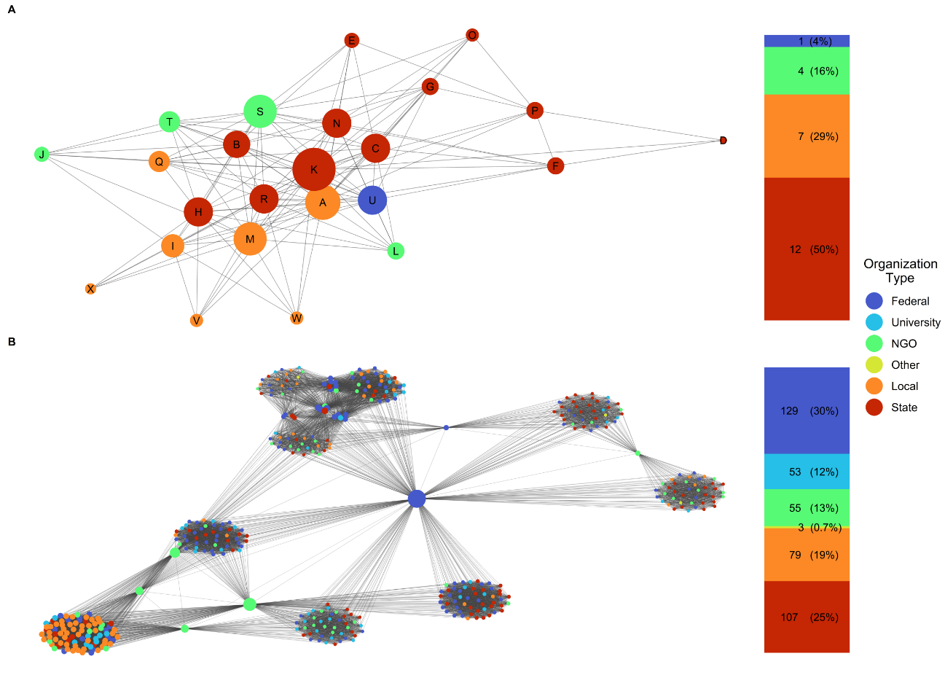
Figure 5-1. Network maps for both the regional (A) network of water decision makers in the Red River basin, and national (B) network of Sustainable Rivers Program environmental flows workshops. Node color indicates organization type, node size is proportional to node degree. Stacked bar indicates the number of nodes and percent of total for each organization type. Node IDs in the regional network (A) correspond to node ID’s in table 5-2. Network layout is based on the Fruchterman & Reingold (1991) algorithm.

Table 5-2. Survey respondents used to create the regional Red River network in Figure 5-1. Node ID corresponds node labels in Figure 5-1A.
Node ID | Respondent | Organization Type
A | McGee Creek Authority | Local
B | Oklahoma Department of Wildlife Conservation 1 | State
C | Oklahoma Department of Wildlife Conservation 2 | State
D | Texas Water Development Board | State
E | Texas Parks & Wildlife 1 | State
F | Texas Parks & Wildlife 2 | State
G | Texas Parks & Wildlife 3 | State
H | Oklahoma Water Resources Board 1 | State
I | Altus-Lugert Irrigation District | Local
J | Oklahoma Instream Flow Advisory Group - Consumptive Interests | NGO
K | Oklahoma Water Resources Board 2 | State
L | Oklahomans for Responsible Water Policy | NGO
M | Arbuckle Master Conservancy District | Local
N | Oklahoma Department of Wildlife Conservation 3 | State
O | Texas Parks & Wildlife 4 | State
P | Texas Commission on Environmental Quality | State
Q | City of Oklahoma City | Local
R | Oklahoma Water Resources Board 3 | State
S | Oklahoma Instream Flow Advisory Group - Non-Consumptive Interests | NGO
T | The Nature Conservancy | NGO
U | United States Army Corps of Engineers | Federal
V | Foss Reservoir Master Conservancy District | Local
W | Fort Cobb Reservoir Conservancy District | Local
X | Mountain Park Master Conservancy District | Local

Figure 5-2. Summary of degree distributions for the water decision maker network from the Red River basin (A, B), and the Sustainable Rivers Program environmental flows workshops (C,D). Degree histograms (A, C) indicate node degree frequency. Cumulative node degree distribution plots (B, D) indicate the fraction of nodes with degree smaller than k.
We found that the Red River network resembles a random topology, and the SRP network resembles a scale free topology. While the node degree histogram for the Red River network is slightly skewed, it fits within the random topologies’ typical characteristic of having a Poisson distribution (Fig. 5-2A). The cumulative node degree distribution plot for the survey network further supports the randomness of the network, indicating that there are relatively few nodes with both small and large degrees, and many nodes with an average degree of 10.66 (Fig. 5-2B, Table 5-1). The SRP network, by contrast, exhibits a highly skewed node degree histogram that clearly shows the few high degree hubs (Fig. 5-2C). The cumulative node degree distribution plot indicates the high frequency of low-degree nodes typical of scale-free networks (Fig. 5-2D). The network topology simulation results further support these findings. For the Red River network, the random topology exhibited the highest mean GDDA (0.49) and Jaccard (0.30) values. For the SRP network, mean GDDA values were identical for both the random and scale free (power = 0.1, 0.3, 0.5, 0.8, 1, 1.5, 2) topologies (0.55), however mean Jaccard values for the scale free topology (0.11-0.16, power = 0.1, 0.3, 0.5, 0.8, 1, 1.5, 2, 2.5) were higher than random (0.08). The equal support for the SRP network being of both the random and scale free topology under GDDA could be due to the G(n, M) model variation we used to generate random networks where the exact number of nodes and edges are specified. For the small world and scale free topologies, the number of nodes and edges will vary around those of the Red River and SRP networks.
Because of this, we performed a post-hoc analysis to determine if the degree distribution for the SRP network followed a power-law, the defining characteristic for the scale-free network topology. We used the combined maximum likelihood fitting and goodness-of-fit test (Komolgorov-Smirnov, KS) method described in Clauset et al. (2009), that hypothesizes the observed data follow a power law distribution and quantifies the distance between the distribution of the observed data and comparable synthetic datasets derived from the same model. If p > 0.05, then this difference between distributions suggests a plausible fit to the hypothesized power law distribution. We found support that the SRP network degree distribution follows a power law where α = 1.57 given the KS test (p = 0.35). This finding indicates that the SRP network exhibits super-linear preferential attachment, which, given the high node degree of a few of the hubs, further supports our characterization that the SRP network exhibits a scale free topology (Barabási 2013).

5.4.2. Influence maximization
We find that early adoption of a conservation initiative by the most influential individuals results in widespread adoption by others in the network (Fig. 5-3). This outcome is consistent across both networks and both diffusion models. However, influential individuals produce more total adopters under LT than IC. For example, in the Red River network under the IC diffusion model at an activation probability of 0.5, 5 random seeds resulted in a total activation of 13 nodes, whereas 5 influential seeds resulted in a total activation of 20 nodes, a 53% increase (Fig. 5-3A). In the SRP network under the LT diffusion model at a threshold of 0.05, 20 random seeds resulted in a total activation of 74 nodes, whereas 20 influential seeds resulted in a total activation of 349 nodes, a 372% increase (Fig. 5-3B).
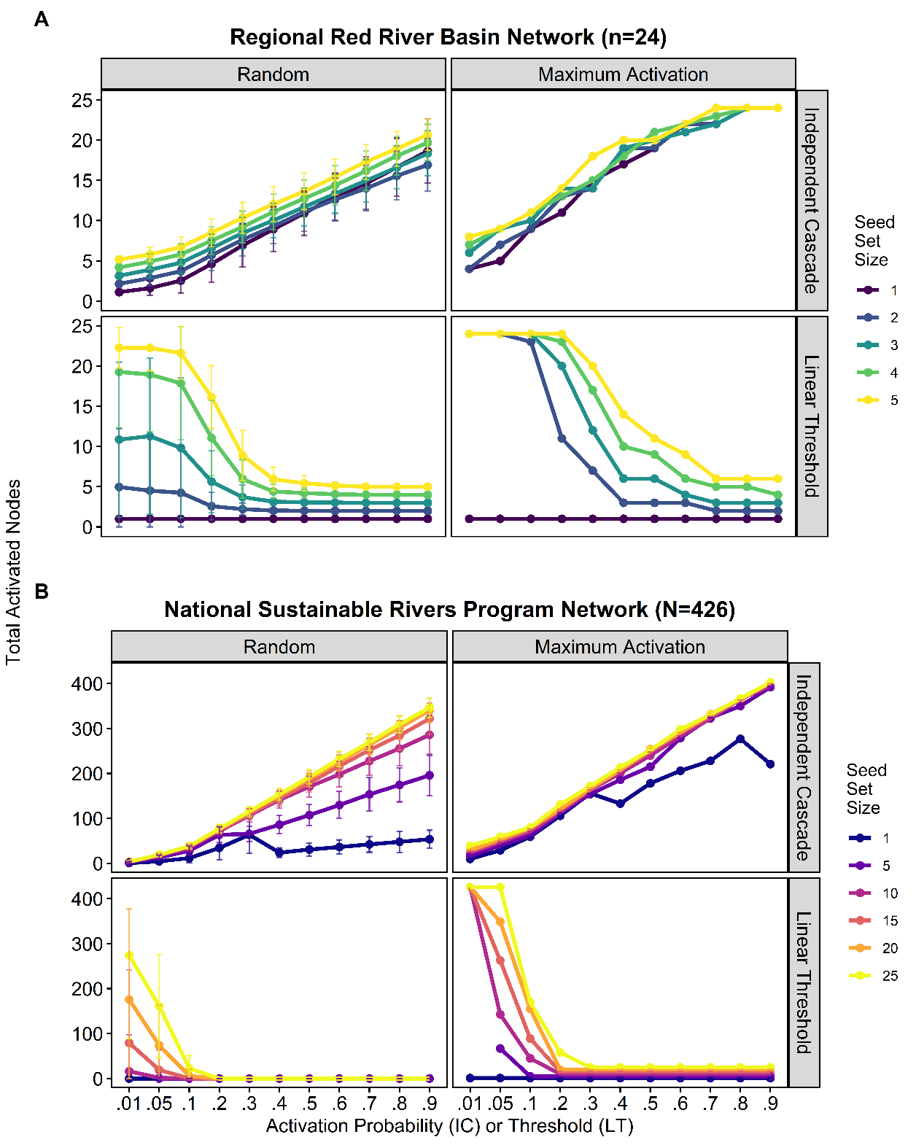
Figure 5-3. Mean total activated nodes from the Monte-Carlo simulation using random seeds (left column – “Random”). Maximum total activation from the Monte-Carlo simulation using random seeds (right column – “Maximum Activation”). Y-axis includes seed set size.

Although IVI and CELF++ are common seed selection methods, we found that these two statistics did not consistently identify the conservation actors with the greatest influence on the spread of an initiative (Fig. 5-4). For example, The IVI seed selection method performed better than random seeds in the small, regional Red River network under the LT and IC model, except when only using 1 seed under IC (Fig. 5-4A). However, seeds selected using IVI failed to initiate any significant diffusion in the SRP network under LT (Fig. 5-4B). The CELF++ seed selection method performed slightly better than random seeds in the Red River network, but only at higher (3-5) seed set sizes under IC and at low (0.1-0.3) activation thresholds under LT (Fig. 5-4A). In the SRP network, CELF++ failed to perform better than random seeds at low (0.1-0.2) activation thresholds but outperformed random seeds at higher (0.3-0.6) thresholds under LT (Fig. 5-4B). In the SRP network, both IVI and CELF++ seed selection methods slightly outperformed random seeds under the IC model across all seed set sizes and activation probabilities.
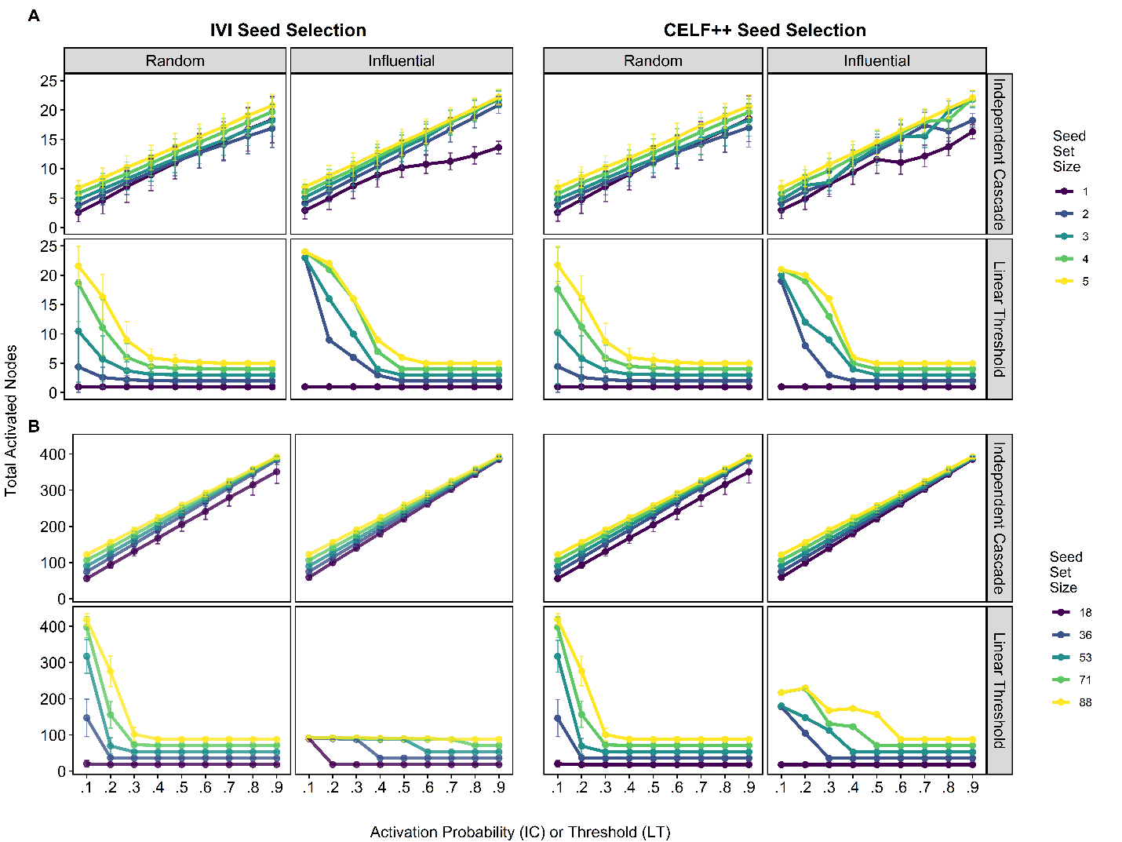
Figure 5-4. Common metrics of influence underperform at identifying the most influential nodes. Influence maximization results for both the regional (A) network of water decision makers in the Red River basin, and national (B) network of Sustainable Rivers Program environmental flows workshops. Main columns indicate seed selection method, either Integrated Value of Influence (IVI), or Cost-Effective Lazy Forward++ (CELF++). Sub columns indicate seed type, either random or influential. Rows indicate Independent Cascade (IC), or Linear Threshold (LT). Error bars indicate ± 1 standard deviation across 1000 Monte Carlo simulations. Mean total activated nodes (y-axis) includes seed set size.

5.5. Discussion
Overall, our results show that targeting influential individuals as early adopters of a conservation initiative improves the total spread of the initiative. This result is robust across the different network spatial scales, topologies, and mechanisms of spread we considered: influencers improved initiative spread in a large, scale-free network (SRP) and in a small, random network (Red River), regardless of whether the initiative diffused via Independent Cascade (IC) or Linear Threshold (LT). Because conservation networks exhibit variation in their topology and structural features as we also demonstrate here, our result that influencers improve total adoption regardless of this variation then has clear implications for improving the spread and adoption of conservation initiatives in conservation networks globally (Mbaru & Barnes 2017, Guerrero et al. 2020, de Lange et al. 2021). Our work is timely, as governments involved in the Convention on Biological Diversity (CBD) are negotiating an effective post-2020 global biodiversity framework focused on facilitating urgent implementation of conservation initiatives (CDB 2021). While our conclusions are drawn based on our two focal real-world freshwater conservation networks and an in-silico experiment, we provide some generalizations in the following paragraphs and suggest that our approach has practical implications and can be extended to other conservation networks in terrestrial and marine ecosystem settings.
While IVI and CELF++ are common influential seed selection methods, they did not identify the most influential individuals across the different network spatial scales, topologies, and mechanisms of spread we considered (Fig. 5-4). In general, both IVI and CELF++ seed selection methods performed poorly with the large, national-scale Sustainable Rivers Program network under the LT model, and with the small, regional-scale Red River network under the IC model. Because these heuristic estimates of the influence of each node are designed to be used on large-scale networks, they aim to provide a result in a reasonable amount of time at the sacrifice of a sub-optimal solution (Goyal et al. 2011, Arora et al. 2017, Yuan et al. 2019). Our results suggest a brute-force MC simulation approach identified the most influential seed nodes that resulted in the highest adoption outcomes more effectively than IVI and CELF++ that require additional computational time. Given the modest size of most conservation networks (Barnes et al. 2016, Kuehne et al. 2017, Mbaru & Barnes 2017), Monte Carlo simulations provide more consistent results at reduced computational cost.
To further investigate why common seed selection methods provided inconsistent outcomes, we examined the correlation between IVI and common network centrality metrics to determine if IVI is biased against either local, neighborhood, or global centrality measures, and the relationship between each node’s IVI and the mean total adoption of that node from the MC simulation when using one initial seed under Independent Cascade. We found that in the Red River Network, local and neighborhood centrality metrics were negatively correlated with IVI, and that nodes with low IVI values resulted in higher total adoption, especially at high activation probabilities (Figs. S5-1 & S5-2). These results could suggest that IVI was biased against local or neighborhood node clusters in the Red River network, and that these nodes were responsible for facilitating greater total adoption than nodes with a high IVI value. On the other hand, in the SRP network, IVI was positively correlated with all centrality metrics, but nodes with low and mid-range IVI values resulted in higher total adoption (Figs. S5-3 & S5-4). These results could explain why heuristic-based seed selection approaches failed to consistently identify the most influential nodes in both networks. The variation in topology and structural features could also explain the inconsistent adoption outcomes observed. For example, both seed selection methods worked either better or almost as good as random seeds in the small, regional-scale, random topology Red River network. However, both seed selection methods performed worse than random seeds in the large, national-scale, scale-free topology SRP network under the LT model. This could be due to the influence maximization approaches not selecting hub nodes in the scale free network, which play a key role in facilitating diffusion (Delre et al. 2010). This variation also underscores that every conservation network is different, and adoption of conservation initiatives can be highly context specific.
Concurrent with existing work, our results also suggest that targeting influential individuals in conservation networks can improve the adoption of a conservation initiative (Mbaru & Barnes 2017, de Lange et al. 2021). Our approach used a range of activation probabilities and thresholds, which allowed us to explore scenarios where individuals in conservation networks are either willing or resistant to adopting a conservation initiative based on their own individual perspectives or values (IC) or peer pressure (LT). While it is impossible to determine whether a conservation initiative will diffuse in a probabilistic (IC) or threshold manner (LT) in the real-world without extensive surveys that gather sociometric data (i.e., data about social or communication ties, Banerjee et al. 2020), data on willingness to participate in an initiative (Knight et al. 2010) or data mining (Lu et al. 2012), we speculate on the differences in diffusion models and their practical implications for conservation network science. For example, we assumed that all nodes have the same probability (IC) or threshold (LT) of activation, but in the real-world this is unlikely to be true. For example, lessons learned from the behavior change literature suggest that individuals and organizations in conservation networks may have different levels of communication or social status, perspectives on the conservation initiative, or feelings of being sidelined which could result in varying levels of willingness or resistance to adopting the initiative (Schultz 2011, Manfredo et al. 2017, Haas et al. 2019). On the other hand, individuals in conservation networks have differing levels of connections and communication (Kuehne et al. 2017, Wineland et al. 2021) and thus different thresholds at which peer pressure can operate to determine whether an individual will adopt a conservation initiative (Prinbeck et al. 2011, Guckian et al. 2018). Thus, we recommend determining individual node probabilities/thresholds of activation as a future research avenue to further understanding of the adoption dynamics and diffusion of conservation initiatives within conservation networks.
Our results that found differences in network topology, structural features, and organizational makeup highlight key social factors to consider in conservation networks. The regional Red River network exhibited characteristics that resemble random networks, while the national SRP network exhibited characteristics that resemble scale-free networks. While research on attributing topologies to complex, real-world networks is still evolving (Tantardini et al. 2019, Broido & Clauset 2019), our network descriptions can help conservation actors better understand network variation at different spatial scales (i.e., local, regional, national) as they attempt to integrate social factors into conservation initiative designs (Tickner et al. 2020, Harper et al. 2021). For example, while most real-world networks are not fully random (Barabási 2013), our findings could suggest that most small conservation networks are well-connected. The absence of hubs could suggest that adoption will propagate through the network rather rapidly (based on small, shortest path distances, Table 5-1) and reach near network-wide levels of adoption if there is low resistance to the conservation initiative. Conversely, in the scale-free SRP network, the presence of hubs can be clearly seen in the network map (Fig. 5-1), degree distributions (Fig. 5-2), and heterogeneity in network metrics by organization types (Table 5-1). Previous work from disciplines ranging from epidemiology to ecology that employ network science techniques emphasize the importance of network topology and structural features in successful diffusion (Minor et al. 2008, Ma et al. 2013, Mihara et al. 2015, Sizemore et al. 2019, Edge & Fortin 2020). In conservation science, efforts to quantify topology and structural features of social conservation networks are lacking (Kuehne et al. 2017, Guerrero et al 2020). Our findings support that investigating conservation network structure and features can reveal a wealth of social information that can be obtained without collecting extensive sociometric data (e.g., SRP network method).
Our work also highlights important differences in organizational makeup and the relative influence of different organization types across different spatial scales. For example, in the regional-scale Red River network, state agencies and local entities form almost 80% of the network and in most cases had the highest sub-network connectivity metrics (Fig. 5-1, Table 5-1). However, the one federal entity and four NGO individuals in this network also had high relative influence based on connectivity metrics, suggesting that influence within this network is relatively balanced (Table 5-1). In the national SRP network however, influence is mostly consolidated in the hubs of federal and NGO entities, but local entities also exhibited high influence based on sub-network connectivity metrics (Table 5-1). Indeed, another study that examined a network of freshwater assessment authors found that federal agency and NGO actors were the most well connected among different organization types and provided important bonding (within group) and bridging (between groups) ties (Kuehne et al. 2017). Our findings highlight the important regional differences in the organizational makeup of conservation networks. We support existing research that highlights the critical role of government agencies and NGO’s in facilitating connections and adoption in conservation networks. However, we found that state and local entities are also important in facilitating the adoption of conservation initiatives, especially at the regional scale. These findings have important practical and ethical applications to the implementation and design of conservation initiatives – practitioners should aim to be inclusive by targeting the most influential individuals across organization types, else excluding important individuals or organizations could inhibit the adoption of conservation initiatives (Mbaru & Barnes 2017).
We tested if conservation influencers could increase adoption of a simulated environmental flows initiative in two networks of freshwater conservation actors. We found that one seed selection method results in robust improvements in adoption across different conservation network scales, topologies, and diffusion models. The brute force Monte-Carlo (MC) simulation approach provides improved outcomes and is more computationally feasible than traditional heuristic-based seed selection approaches. In practice, our study suggests that practitioners should seek to employ information diffusion models using a MC simulation approach to identify and target influencers as early adopters in the design of conservation initiatives. By describing the topological, structural features, and organizational makeup of a regional and national conservation network, we found that the regional network resembles a network with a random topology, while the national network resembles a network with a scale-free topology. We highlight that state and local entities mostly comprise the regional network, but connections to NGO’s and a federal entity balance influence and allow increased connectivity within the network. On the other hand, federal and NGO entities in the national network have outsized influence in the network, but local entities also facilitate connections within sub-networks. These findings should help inform the design of conservation initiatives by aiming to inclusively target all influential actors across different organizations and sub-networks to help boost the adoption of conservation initiatives.

References
Alexander, S. M., Epstein, G., Bodin, Ö., Armitage, D., & Campbell, D. (2018). Participation in planning and social networks increase social monitoring in community‐based conservation. Conservation Letters, 11(5), e12562.
Anderson, E. P., Jackson, S., Tharme, R. E., Douglas, M., Flotemersch, J. E., Zwarteveen, M., ... & Arthington, A. H. (2019). Understanding rivers and their social relations: A critical step to advance environmental water management. Wiley Interdisciplinary Reviews: Water, 6(6), e1381.
Aral, S., & Dhillon, P. S. (2018). Social influence maximization under empirical influence models. Nature human behaviour, 2(6), 375-382.
Arora, A., Galhotra, S., & Ranu, S. (2017, May). Debunking the myths of influence maximization: An in-depth benchmarking study. In Proceedings of the 2017 ACM international conference on management of data (pp. 651-666).
Arthington, A. H., Bhaduri, A., Bunn, S. E., Jackson, S. E., Tharme, R. E., Tickner, D., Young, B., Acreman, M., Baker, N., Capon, S., Horne, A. C., Kendy, E., McClain, M. E., Poff, N. L. R., Richter, B. D., & Ward, S. (2018). The Brisbane Declaration and Global Action Agenda on Environmental Flows (2018). Frontiers in Environmental Science, 6(JUL), 1–15. https://doi.org/10.3389/fenvs.2018.00045
Arthington, A. H. (2021). Grand Challenges to Support the Freshwater Biodiversity Emergency Recovery Plan. Frontiers in Environmental Science, 9(May), 1–6. https://doi.org/10.3389/fenvs.2021.664313
Atisa, G. (2020). Policy adoption, legislative developments, and implementation: the resulting global differences among countries in the management of biological resources. International Environmental Agreements: Politics, Law and Economics, 20(1), 141-159.
Banerjee, S., Jenamani, M., & Pratihar, D. K. (2020). A survey on influence maximization in a social network. Knowledge and Information Systems, 62(9), 3417-3455.
Barabási, A. L. (2013). Network science. Philosophical Transactions of the Royal Society A: Mathematical, Physical and Engineering Sciences, 371(1987), 20120375.
Barabási, A. L., & Albert, R. (1999). Emergence of scaling in random networks. science, 286(5439), 509-512.
Barnes, M. L., Lynham, J., Kalberg, K., & Leung, P. (2016). Social networks and environmental outcomes. Proceedings of the National Academy of Sciences, 113(23), 6466-6471.
Bass, J. I. F., Diallo, A., Nelson, J., Soto, J. M., Myers, C. L., & Walhout, A. J. (2013). Using networks to measure similarity between genes: association index selection. Nature methods, 10(12), 1169-1176.
Bennett, N. J., Roth, R., Klain, S. C., Chan, K., Christie, P., Clark, D. A., ... & Wyborn, C. (2017). Conservation social science: Understanding and integrating human dimensions to improve conservation. biological conservation, 205, 93-108.
Bixler, R. P., Atshan, S., Banner, J. L., Tremaine, D., & Mace, R. E. (2019). Assessing integrated sustainability research: Use of social network analysis to evaluate scientific integration and transdisciplinarity in research networks. Current Opinion in Environmental Sustainability, 39, 103-113.
Bodin, Ö., Crona, B., & Ernstson, H. (2006). Social networks in natural resource management: what is there to learn from a structural perspective?. Ecology and society, 11(2).
Bodin, Ö. (2017). Collaborative environmental governance: achieving collective action in social-ecological systems. Science, 357(6352). Broido, A. D., & Clauset, A. (2019). Scale-free networks are rare. Nature communications, 10(1), 1-10.
Butchart, S. H., Clarke, M., Smith, R. J., Sykes, R. E., Scharlemann, J. P., Harfoot, M., ... & Burgess, N. D. (2015). Shortfalls and solutions for meeting national and global conservation area targets. Conservation Letters, 8(5), 329-337.
Centola, D. (2018). Chapter 2: Understanding Diffusion. In: How behavior spreads. Princeton University Press.
Chaoqi, F., Ying, W., Xiaoyang, W., & Yangjun, G. (2018). Multi-node attack strategy of complex networks due to cascading breakdown. Chaos, Solitons & Fractals, 106, 61-66.
Chen, W., Wang, Y., & Yang, S. (2009). Efficient influence maximization in social networks. In Proceedings of the 15th ACM SIGKDD international conference on Knowledge discovery and data mining (pp. 199-208).
Chen, W., Wang, C., & Wang, Y. (2010). Scalable influence maximization for prevalent viral marketing in large-scale social networks. In Proceedings of the 16th ACM SIGKDD international conference on Knowledge discovery and data mining (pp. 1029-1038).
Cinner, J. (2018). How behavioral science can help conservation. Science, 362(6417), 889-890.
Clauset, A., Shalizi, C. R., & Newman, M. E. (2009). Power-law distributions in empirical data. SIAM review, 51(4), 661-703.
Convention on Biological Diversity. (2021). First Draft of The Post-2020 Global Biodiversity Framework. Accessed online at: https://www.cbd.int/doc/c/abb5/591f/2e46096d3f0330b08ce87a45/wg2020-03-03-en.pdf.
Csardi, G. , Nepusz, T. (2006). “The igraph software package for complex network research.” InterJournal, Complex Systems, 1695. https://igraph.org.
de Lange, E., Dobson, A. D. M., Milner-Gulland, E. J., & Keane, A. (2021). Combining simulation and empirical data to explore the scope for social network interventions in conservation. Biological Conservation, 261, 109292.
Delre, S. A., Jager, W., Bijmolt, T. H., & Janssen, M. A. (2010). Will it spread or not? The effects of social influences and network topology on innovation diffusion. Journal of Product Innovation Management, 27(2), 267-282.
Díaz, S., Settele, J., Brondízio, E. S., Ngo, H. T., Agard, J., Arneth, A., ... & Zayas, C. N. (2019). Pervasive human-driven decline of life on Earth points to the need for transformative change. Science, 366(6471).
Douglas, M. M., Jackson, S., Canham, C. A., Laborde, S., Beesley, L., Kennard, M. J., ... & Setterfield, S. A. (2019). Conceptualizing hydro-socio-ecological relationships to enable more integrated and inclusive water allocation planning. One Earth, 1(3), 361-373.
Edge, C. B., & Fortin, M. J. (2020). Habitat network topology influences the importance of ecological traps in metapopulations. Ecosphere, 11(5), e03146.
Erdős, P.; Rényi, A. (1959). "On Random Graphs. I". Publicationes Mathematicae. 6: 290–297.
Fruchterman, T. M., & Reingold, E. M. (1991). Graph drawing by force‐directed placement. Software: Practice and experience, 21(11), 1129-1164.
Goyal, A., Lu, W., & Lakshmanan, L. V. (2011, March). Celf++ optimizing the greedy algorithm for influence maximization in social networks. In Proceedings of the 20th international conference companion on World wide web (pp. 47-48).
Guckian, M. L., Danylchuk, A. J., Cooke, S. J., & Markowitz, E. M. (2018). Peer pressure on the riverbank: Assessing catch-and-release anglers' willingness to sanction others'(bad) behavior. Journal of environmental management, 219, 252-259.
Guerrero, A. M., Barnes, M., Bodin, Ö., Chadès, I., Davis, K. J., Iftekhar, M. S., ... & Wilson, K. A. (2020). Key considerations and challenges in the application of social‐network research for environmental decision making. Conservation Biology, 34(3), 733-742.
Güney, E. (2019). An efficient linear programming based method for the influence maximization problem in social networks. Information Sciences, 503, 589-605.
Haas, J. C., Loft, L., & Pham, T. T. (2019). How fair can incentive-based conservation get? The interdependence of distributional and contextual equity in Vietnam's payments for Forest Environmental Services Program. Ecological Economics, 160, 205-214.
Harper, M., Mejbel, H. S., Longert, D., Abell, R., Beard, T. D., Bennett, J. R., ... & Cooke, S. J. (2021). Twenty‐five essential research questions to inform the protection and restoration of freshwater biodiversity. Aquatic Conservation: Marine and Freshwater Ecosystems.
Hickey, J. T., & Warner, A. T. (2006). The Sustainable Rivers Project: A partnership between the Corps of Engineers and the Nature Conservancy. In Operating Reservoirs in Changing Conditions (pp. 383-390).
Horne, A. C., O’Donnell, E. L., Acreman, M., McClain, M. E., Poff, N. L., Webb, J. A., ... & Tharme, R. E. (2017). Moving forward: The implementation challenge for environmental water management. In Water for the Environment (pp. 649-673). Academic Press.
Jupiter, S. D., Cohen, P. J., Weeks, R., Tawake, A., & Govan, H. (2014). Locally-managed marine areas: multiple objectives and diverse strategies. Pacific Conservation Biology, 20(2), 165-179.
Kempe, D., Kleinberg, J., & Tardos, É. (2003). Maximizing the spread of influence through a social network. In Proceedings of the ninth ACM SIGKDD international conference on Knowledge discovery and data mining (pp. 137-146).
Knight, A. T., Cowling, R. M., Difford, M., & Campbell, B. M. (2010). Mapping human and social dimensions of conservation opportunity for the scheduling of conservation action on private land. Conservation Biology, 24(5), 1348-1358.
Kuehne, L. M., Strecker, A. L., & Olden, J. D. (2020). Knowledge exchange and social capital for freshwater ecosystem assessments. BioScience, 70(2), 174-183.
Leclère, D., Obersteiner, M., Barrett, M., Butchart, S. H., Chaudhary, A., De Palma, A., ... & Young, L. (2020). Bending the curve of terrestrial biodiversity needs an integrated strategy. Nature, 585(7826), 551-556.
Le Quesne, T., Kendy, E., and Weston, D. (2010). The Implementation Challenge. Taking Stock of government Policies to Protect and Restore Environmental Flows. WWF (World Wide Fund for Nature) and TNC (The Nature Conservancy).
Lu, Z., Zhang, W., Wu, W., Kim, J., & Fu, B. (2012). The complexity of influence maximization problem in the deterministic linear threshold model. Journal of combinatorial optimization, 24(3), 374-378.
Ma, J., van den Driessche, P., & Willeboordse, F. H. (2013). The importance of contact network topology for the success of vaccination strategies. Journal of theoretical biology, 325, 12-21.
Manfredo, M. J., Bruskotter, J. T., Teel, T. L., Fulton, D., Schwartz, S. H., Arlinghaus, R., ... & Sullivan, L. (2017). Why social values cannot be changed for the sake of conservation. Conservation Biology, 31(4), 772-780.
Matous, P., & Todo, Y. (2015). Exploring dynamic mechanisms of learning networks for resource conservation. Ecology and Society, 20(2), 36.
Mbaru, E. K., & Barnes, M. L. (2017). Key players in conservation diffusion: using social network analysis to identify critical injection points. Biological Conservation, 210, 222-232.
Meskell, L., Liuzza, C., Bertacchini, E., & Saccone, D. (2015). Multilateralism and UNESCO World Heritage: decision-making, States Parties and political processes. International journal of heritage studies, 21(5), 423-440.
Mihara, S., Tsugawa, S., & Ohsaki, H. (2015). Influence maximization problem for unknown social networks. In Proceedings of the 2015 IEEE/ACM International Conference on Advances in Social Networks Analysis and Mining 2015 (pp. 1539-1546).
Mills, M., Bode, M., Mascia, M. B., Weeks, R., Gelcich, S., Dudley, N., ... & Possingham, H. P. (2019). How conservation initiatives go to scale. Nature Sustainability, 2(10), 935-940.
Minor, E. S., & Urban, D. L. (2008). A graph‐theory framework for evaluating landscape connectivity and conservation planning. Conservation biology, 22(2), 297-307.
Moore, M. (2004). Perceptions and interpretations of" environmental flows" and implications for future water resource management: A survey study.
Ostrom, E. (2009). A general framework for analyzing sustainability of social-ecological systems. Science, 325(5939), 419-422.
Pahl-Wostl, C., Arthington, A., Bogardi, J., Bunn, S. E., Hoff, H., Lebel, L., ... & Tsegai, D. (2013). Environmental flows and water governance: managing sustainable water uses. Current Opinion in Environmental Sustainability, 5(3-4), 341-351.
Poff, N. L. (2018). Beyond the natural flow regime? Broadening the hydro‐ecological foundation to meet environmental flows challenges in a non‐stationary world. Freshwater Biology, 63(8), 1011-1021.
Prinbeck, G., Lach, D., & Chan, S. (2011). Exploring stakeholders’ attitudes and beliefs regarding behaviors that prevent the spread of invasive species. Environmental Education Research, 17(3), 341-352.
Pržulj, N. (2007). Biological network comparison using graphlet degree distribution. Bioinformatics, 23(2), e177-e183.
R Core Team (2021). R: A language and environment for statistical computing. R Foundation for Statistical Computing, Vienna, Austria. URL https://www.R-project.org/.
Rhodes, J. R., Guerrero, A. M., Bodin, Ö., & Chadès, I. (2020). Fundamental insights on when social network data are most critical for conservation planning. Conservation Biology, 34(6), 1463-1472.
Riggs, R. A., Langston, J. D., & Phann, S. (2020). Actor network analysis to leverage improvements in conservation and development outcomes in Cambodia. Ecology and Society, 25.
Rilov, G., Fraschetti, S., Gissi, E., Pipitone, C., Badalamenti, F., Tamburello, L., ... & Katsanevakis, S. (2020). A fast‐moving target: achieving marine conservation goals under shifting climate and policies. Ecological Applications, 30(1), e02009.
Salavaty, A., Ramialison, M., & Currie, P. D. (2020). Integrated value of influence: an integrative method for the identification of the most influential nodes within networks. Patterns, 1(5), 100052.
Schultz, P. W. (2011). Conservation means behavior. Conservation biology, 25(6), 1080-1083.
Shakarian, P., Bhatnagar, A., Aleali, A., Shaabani, E., & Guo, R. (2015). The independent cascade and linear threshold models. In Diffusion in Social Networks (pp. 35-48). Springer, Cham.
Simpson, S. L., Lyday, R. G., Hayasaka, S., Marsh, A. P., & Laurienti, P. J. (2013). A permutation testing framework to compare groups of brain networks. Frontiers in computational neuroscience, 7, 171.
Sizemore, A. E., Phillips-Cremins, J. E., Ghrist, R., & Bassett, D. S. (2019). The importance of the whole: topological data analysis for the network neuroscientist. Network Neuroscience, 3(3), 656-673.
Solé, R. V., & Valverde, S. (2004). Information theory of complex networks: on evolution and architectural constraints. In Complex networks (pp. 189-207). Springer, Berlin, Heidelberg.
Tafoya, K. A., Brondizio, E. S., Johnson, C. E., Beck, P., Wallace, M., Quirós, R., & Wasserman, M. D. (2020). Effectiveness of Costa Rica’s Conservation Portfolio to Lower Deforestation, Protect Primates, and Increase Community Participation. Frontiers in Environmental Science, 8, 212.
Tantardini, M., Ieva, F., Tajoli, L., & Piccardi, C. (2019). Comparing methods for comparing networks. Scientific reports, 9(1), 1-19.
Thompson, A. W., Reimer, A., & Prokopy, L. S. (2015). Farmers’ views of the environment: the influence of competing attitude frames on landscape conservation efforts. Agriculture and human values, 32(3), 385-399.
Tickner, D., Opperman, J. J., Abell, R., Acreman, M., Arthington, A. H., Bunn, S. E., Cooke, S. J., Dalton, J., Darwall, W., Edwards, G., Harrison, I., Hughes, K., Jones, T., Leclère, D., Lynch, A. J., Leonard, P., McClain, M. E., Muruven, D., Olden, J. D., … Young, L. (2020). Bending the Curve of Global Freshwater Biodiversity Loss: An Emergency Recovery Plan. BioScience, 70(4), 330–342. https://doi.org/10.1093/biosci/biaa002
Twardek, W. M., Nyboer, E. A., Tickner, D., O'Connor, C. M., Lapointe, N. W., Taylor, M. K., ... & Cooke, S. J. (2021). Mobilizing practitioners to support the Emergency Recovery Plan for freshwater biodiversity. Conservation Science and Practice, e467.
United States Army Corps of Engineers, 2021. Environmental Flows Workshop Reports. Accessed online at: https://www.hec.usace.army.mil/sustainablerivers/publications/
Warner, A. T., Bach, L. B., & Hickey, J. T. (2014). Restoring environmental flows through adaptive reservoir management: planning, science, and implementation through the Sustainable Rivers Project. Hydrological Sciences Journal, 59(3-4), 770-785.
Watts, D. J., & Strogatz, S. H. (1998). Collective dynamics of ‘small-world’networks. nature, 393(6684), 440-442.
Wineland, S. M., Fovargue, R., York, B., Lynch, A. J., Paukert, C. P., & Neeson, T. M. (2021). Is there enough water? How bearish and bullish outlooks are linked to decision maker perspectives on environmental flows. Journal of Environmental Management, 280, 111694.
Yuan, J., Zhang, R., Tang, J., Hu, R., Wang, Z., & Li, H. (2019). Efficient and effective influence maximization in large-scale social networks via two frameworks. Physica A: Statistical Mechanics and its Applications, 526, 120966.
Zhang, H., Zhang, J., Zhou, C., Small, M., & Wang, B. (2010). Hub nodes inhibit the outbreak of epidemic under voluntary vaccination. New Journal of Physics, 12(2), 023015.

6. Conclusion

6.1. Summary
The recovery of freshwater biodiversity and ecosystems hinges on the rapid, widescale implementation of e-flows. However, because freshwater ecosystems are deeply coupled human and natural systems that are vulnerable to synergistic stressors and climate change impacts, implementing e-flows faces grand challenges (Arthington, 2021). These grand challenges include: (1) restoring biodiversity and ecosystem function, (2), integrating human dimensions in planning, and (3) adapting to the impacts of climate change.
The research presented in this dissertation aims to help overcome these challenges by identifying where and how to implement e-flows to maximize the restoration of biodiversity, ecosystem outcomes, and social equity while minimizing climate risks (Chs. 2&3), barriers to implementation and perspectives that might facilitate adoption (Ch.4), and who to target as early adopters of e-flows initiatives to maximize adoption outcomes (Ch.5). Chapter 2 presents strategies to overcome grand challenges 1 & 3 through a conservation planning framework that identifies high priority sites for e-flows implementation through inclusive consideration of climate change across species distributions and water availability. Chapter 3 presents strategies to overcome all three grand challenges through investigating the tradeoffs between social equity and conservation efficiency in a simulated water conservation initiative across future climate scenarios. Chapter 4 presents strategies to overcome grand challenge 2 & 3 by providing a better understanding of water decision maker’s perspectives on the socio-political barriers to implementing e-flows and how climate change will impact their ability to implement them. Chapter 5 presents strategies to overcome grand challenge 2 by showing that targeting influential individuals or organizations during the early stages of e-flows initiative adoption can boost the total number of adopters of the initiative.
Overall, the research presented in this dissertation highlights that implementing e-flows - even in a water-scarce and socio-politically complex river basin - can be feasible despite these grand challenges. While there is still much to be done to support the call for accelerated, widespread implementation of e-flows presented in the Emergency Recovery Plan (ERP) for freshwater biodiversity, the research presented here highlights the crucial importance of both tackling the e-flows implementation challenge from an integrative coupled human and natural systems (CHANS) perspective and being inclusive of climate change uncertainty in planning (Arthington, 2021; John et al., 2020; Tickner et al., 2020). The research presented here focuses on a single freshwater ecosystem conservation strategy, e-flows, but also has important implications for conservation planning strategies across ecosystems globally.

6.2 Broader lessons for conservation and sustainability
The research in chapters 2 & 3 showed how to strategically target specific locations to prioritize e-flows implementation under the uncertainties of climate change while also achieving equitable distributions of water conservation incentives. This research is important because limited funding for conservation initiatives is a common problem globally, thus identifying locations where biodiversity and ecological outcomes are maximized and tradeoffs with economic efficiency, social equity, and climate uncertainty are minimized is highly desirable (Fovargue et al., 2021; Halpern et al., 2013; Law et al., 2018; Pahl-Wostl et al., 2013). Chapter 2 presented a conservation prioritization framework that jointly considered the biodiversity value and conservation feasibility at each candidate location across a range of future climate scenarios. This framework could help conservation practitioners overcome spatial conservation planning challenges like identifying where to allocate limited funding and resources under climate uncertainty while also integrating human dimensions (Arthington et al., 2018; Guerrero & Wilson, 2017; Kujala et al., 2013; Kukkala & Moilanen, 2013; Lawler & Michalak, 2017; Popejoy et al., 2018). Thus, the ranking of sites within this framework can serve as a coarse-scale filter to identify high conservation priority sites that represent sound conservation investments.
Chapter 3 investigated tradeoffs between social equity and conservation efficiency across future climate and budget scenarios in an e-flows Payment for Ecosystem Services (PES) scheme. This research found that under an equitable allocation of water conservation incentives, only small tradeoffs to conservation outcomes were present compared to a scenario where incentives were allocated optimally. Globally, conservation strategies can often get derailed by failing to properly consider social equity dimensions in their design and implementation (Friedman et al., 2018; Law et al., 2018). Indeed, others have shown that incorporating social equity considerations in conservation strategies are key to their success (Brimont et al., 2015; Haas et al., 2019; Klein et al., 2015; Loft et al., 2020; Pascual et al., 2014; Rakotonarivo et al., 2021). The research presented here expands on existing work by investigating the magnitude of tradeoffs between social equity and conservation outcomes in the context of different budget and climate scenarios. Conservation practitioners face immense challenges like incorporating climate adaptation and social equity in the design and implementation of conservation strategies (Loft et al., 2020; Reside et al., 2018). Thus, the research presented here highlights how joint consideration of both factors could help design conservation initiatives that are equitable and adaptable to climate change. Taken together, these two chapters highlight that despite the grand challenges and complexities of implementing conservation initiatives like integrating human considerations and adapting to climate change, solutions can be identified. Both chapters promote an overarching theme of strategic, targeted identification of where and how to implement e-flows by through the lens of coupled human and natural systems.
The research in chapters 4 & 5 aimed to identify data needs and barriers to implementing e-flows by water decision makers and individuals to target as early adopters for e-flows initiatives to maximize total adoption. Globally, some conservation initiatives often fail to become widely adopted, thus identifying barriers to implementation and strategies to boost spread could help overcome this adoption bottleneck (Mills et al., 2019). Chapter 4 presented the results of a survey of water resources decision makers - despite the presence of both optimistic and pessimistic perspectives about current e-flows conditions, future water availability and conflicts, and climate change, they identified similar data needs and barriers to e-flows implementation. Thus, given the need to better understand barriers to implementing conservation strategies, this research highlights an important case for decision maker coordination to achieve conservation goals despite different perspectives on common conservation issues (Arthington, 2021; Arthington et al., 2018; Beever et al., 2014; Buxton et al., 2021; Twardek et al., 2021).
Chapter 5 approaches the conservation implementation challenge from a network science perspective, investigating the structure of conservation decision maker networks and if selecting influential early adopters might improve diffusion throughout the network. There is a need to better understand the adoption dynamics of conservation programs globally to better inform conservation initiative design and implementation strategies (Garrick et al., 2020; Mahajan et al., 2021; Mills et al., 2019). This research found that despite differences in network structure and measures of influence, targeting influential individuals as early adopters of a simulated conservation initiative resulted in sharp improvements in the total number of adopters of the initiative. These findings are important because conservation practitioners could leverage network science approaches to target influencers from specific organizations as early adopters to boost the spread of conservation initiatives (Barnes et al., 2016; Bennett et al., 2017; Tickner et al., 2020). Taken together, these two chapters present findings that help fill a crucial research gap on human dimensions of conservation initiative implementation. Both provide context as to why conservation initiatives may sometimes fail to become implemented, with chapter 4 highlighting identification of barriers, and chapter 5 highlighting an information diffusion problem. Overall, these two chapters should help conservation practitioners better understand how to study and integrate human dimensions into the design and implementation of conservation initiatives.

References
Acreman, M., Arthington, A. H., Colloff, M. J., Couch, C., Crossman, N. D., Dyer, F., Overton, I., Pollino, C. A., Stewardson, M. J., & Young, W. (2014). Environmental flows for natural, hybrid, and novel riverine ecosystems in a changing world. Frontiers in Ecology and the Environment, 12(8), 466–473. https://doi.org/10.1890/130134
Anderson, E. P., Jackson, S., Tharme, R. E., Douglas, M., Flotemersch, J. E., Zwarteveen, M., Lokgariwar, C., Montoya, M., Wali, A., Tipa, G. T., Jardine, T. D., Olden, J. D., Cheng, L., Conallin, J., Cosens, B., Dickens, C., Garrick, D., Groenfeldt, D., Kabogo, J., … Arthington, A. H. (2019). Understanding rivers and their social relations: A critical step to advance environmental water management. WIREs Water, 6(6), e1381. https://doi.org/10.1002/wat2.1381
Arthington, A. H. (2021). Grand Challenges to Support the Freshwater Biodiversity Emergency Recovery Plan. Frontiers in Environmental Science, 9, 118. https://doi.org/10.3389/fenvs.2021.664313
Arthington, A. H., Bhaduri, A., Bunn, S. E., Jackson, S. E., Tharme, R. E., Tickner, D., Young, B., Acreman, M., Baker, N., Capon, S., Horne, A. C., Kendy, E., McClain, M. E., Poff, N. L., Richter, B. D., & Ward, S. (2018). The Brisbane Declaration and Global Action Agenda on Environmental Flows (2018). Frontiers in Environmental Science, 6, 45. https://doi.org/10.3389/fenvs.2018.00045
Barnes, M. L., Lynham, J., Kalberg, K., & Leung, P. (2016). Social networks and environmental outcomes. Proceedings of the National Academy of Sciences, 113(23), 6466–6471. https://doi.org/10.1073/pnas.1523245113
Batchelor, C., Reddy, V. R., Linstead, C., Dhar, M., Roy, S., & May, R. (2014). Do water-saving technologies improve environmental flows? Journal of Hydrology, 518, 140–149. https://doi.org/10.1016/j.jhydrol.2013.11.063
Bednarek, A. T., & Hart, D. D. (2005). MODIFYING DAM OPERATIONS TO RESTORE RIVERS: ECOLOGICAL RESPONSES TO TENNESSEE RIVER DAM MITIGATION. Ecological Applications, 15(3), 997–1008. https://doi.org/10.1890/04-0586
Beever, E. A., Mattsson, B. J., Germino, M. J., Burg, M. P. V. D., Bradford, J. B., & Brunson, M. W. (2014). Successes and Challenges from Formation to Implementation of Eleven Broad-Extent Conservation Programs. Conservation Biology, 28(2), 302–314. https://doi.org/10.1111/cobi.12233
Bejarano, M. D., Sordo-Ward, A., Gabriel-Martin, I., & Garrote, L. (2019). Tradeoff between economic and environmental costs and benefits of hydropower production at run-of-river-diversion schemes under different environmental flows scenarios. Journal of Hydrology, 572, 790–804. https://doi.org/10.1016/j.jhydrol.2019.03.048
Bennett, N. J., Roth, R., Klain, S. C., Chan, K., Christie, P., Clark, D. A., Cullman, G., Curran, D., Durbin, T. J., Epstein, G., Greenberg, A., Nelson, M. P., Sandlos, J., Stedman, R., Teel, T. L., Thomas, R., Veríssimo, D., & Wyborn, C. (2017). Conservation social science: Understanding and integrating human dimensions to improve conservation. Biological Conservation, 205, 93–108. https://doi.org/10.1016/j.biocon.2016.10.006
Bertrand, D., & McPherson, R. A. (2018). Future Hydrologic Extremes of the Red River Basin. Journal of Applied Meteorology and Climatology, 57(6), 1321–1336. https://doi.org/10.1175/JAMC-D-17-0346.1
Bogan, M. T., & Lytle, D. A. (2011). Severe drought drives novel community trajectories in desert stream pools. Freshwater Biology, 56(10), 2070–2081. https://doi.org/10.1111/j.1365-2427.2011.02638.x
Brimont, L., Ezzine-de-Blas, D., Karsenty, A., & Toulon, A. (2015). Achieving Conservation and Equity amidst Extreme Poverty and Climate Risk: The Makira REDD+ Project in Madagascar. Forests, 6(12), 748–768. https://doi.org/10.3390/f6030748
Buxton, R. T., Bennett, J. R., Reid, A. J., Shulman, C., Cooke, S. J., Francis, C. M., Nyboer, E. A., Pritchard, G., Binley, A. D., Avery-Gomm, S., Ban, N. C., Beazley, K. F., Bennett, E., Blight, L. K., Bortolotti, L. E., Camfield, A. F., Gadallah, F., Jacob, A. L., Naujokaitis-Lewis, I., … Smith, P. A. (2021). Key information needs to move from knowledge to action for biodiversity conservation in Canada. Biological Conservation, 256, 108983. https://doi.org/10.1016/j.biocon.2021.108983
Carlisle, D. M., Falcone, J., Wolock, D. M., Meador, M. R., & Norris, R. H. (2009). Predicting the natural flow regime: Models for assessing hydrological alteration in streams. River Research and Applications, n/a-n/a. https://doi.org/10.1002/rra.1247
Craig, L. S., Olden, J. D., Arthington, A. H., Entrekin, S., Hawkins, C. P., Kelly, J. J., Kennedy, T. A., Maitland, B. M., Rosi, E. J., Roy, A. H., Strayer, D. L., Tank, J. L., West, A. O., & Wooten, M. S. (2017). Meeting the challenge of interacting threats in freshwater ecosystems: A call to scientists and managers. Elementa: Science of the Anthropocene, 5(72). https://doi.org/10.1525/elementa.256
Crespo, D., Albiac, J., Kahil, T., Esteban, E., & Baccour, S. (2019). Tradeoffs between Water Uses and Environmental Flows: A Hydroeconomic Analysis in the Ebro Basin. Water Resources Management, 33(7), 2301–2317. https://doi.org/10.1007/s11269-019-02254-3
Davies, P., Naiman, R., Warfe, D., Pettit, N., Arthington, A., & Bunn, S. (2013). Flow-ecology relationships: Closing the loop on effective environmental flows. Marine and Freshwater Research, 65. https://doi.org/10.1071/MF13110
Ferraro, P. J., Sanchirico, J. N., & Smith, M. D. (2019). Causal inference in coupled human and natural systems. Proceedings of the National Academy of Sciences, 116(12), 5311–5318. https://doi.org/10.1073/pnas.1805563115
Foden, W. B., Young, B. E., Akçakaya, H. R., Garcia, R. A., Hoffmann, A. A., Stein, B. A., Thomas, C. D., Wheatley, C. J., Bickford, D., Carr, J. A., Hole, D. G., Martin, T. G., Pacifici, M., Pearce-Higgins, J. W., Platts, P. J., Visconti, P., Watson, J. E. M., & Huntley, B. (2019). Climate change vulnerability assessment of species. WIREs Climate Change, 10(1), e551. https://doi.org/10.1002/wcc.551
Fovargue, R. E., Rezapour, S., Rosendahl, D., Wootten, A. M., Sabzi, H. Z., Moreno, H. A., & Neeson, T. M. (2021). Spatial planning for water sustainability projects under climate uncertainty: Balancing human and environmental water needs. Environmental Research Letters, 16(3), 034050. https://doi.org/10.1088/1748-9326/abdd58
Friedman, R. S., Law, E. A., Bennett, N. J., Ives, C. D., Thorn, J. P. R., & Wilson, K. A. (2018). How just and just how? A systematic review of social equity in conservation research. Environmental Research Letters, 13(5), 053001. https://doi.org/10.1088/1748-9326/aabcde
Garrick, D., Iseman, T., Gilson, G., Brozovic, N., O’Donnell, E., Matthews, N., Miralles-Wilhelm, F., Wight, C., & Young, W. (2020). Scalable solutions to freshwater scarcity: Advancing theories of change to incentivise sustainable water use. Water Security, 9, 100055. https://doi.org/10.1016/j.wasec.2019.100055
Grantham, T. E., Matthews, J. H., & Bledsoe, B. P. (2019). Shifting currents: Managing freshwater systems for ecological resilience in a changing climate. Water Security, 8, 100049. https://doi.org/10.1016/j.wasec.2019.100049
Guerrero, A. M., & Wilson, K. A. (2017). Using a social–ecological framework to inform the implementation of conservation plans. Conservation Biology, 31(2), 290–301. https://doi.org/10.1111/cobi.12832
Haas, J. C., Loft, L., & Pham, T. T. (2019). How fair can incentive-based conservation get? The interdependence of distributional and contextual equity in Vietnam’s payments for Forest Environmental Services Program. Ecological Economics, 160, 205–214. https://doi.org/10.1016/j.ecolecon.2019.02.021
Halpern, B. S., Klein, C. J., Brown, C. J., Beger, M., Grantham, H. S., Mangubhai, S., Ruckelshaus, M., Tulloch, V. J., Watts, M., White, C., & Possingham, H. P. (2013). Achieving the triple bottom line in the face of inherent trade-offs among social equity, economic return, and conservation. Proceedings of the National Academy of Sciences, 110(15), 6229–6234. https://doi.org/10.1073/pnas.1217689110
Harper, M., Mejbel, H. S., Longert, D., Abell, R., Beard, T. D., Bennett, J. R., Carlson, S. M., Darwall, W., Dell, A., Domisch, S., Dudgeon, D., Freyhof, J., Harrison, I., Hughes, K. A., Jähnig, S. C., Jeschke, J. M., Lansdown, R., Lintermans, M., Lynch, A. J., … Cooke, S. J. (2021). Twenty‐five essential research questions to inform the protection and restoration of freshwater biodiversity. Aquatic Conservation: Marine and Freshwater Ecosystems, 31(9), 2632–2653. https://doi.org/10.1002/aqc.3634
Harwood, A. J., Tickner, D., Richter, B. D., Locke, A., Johnson, S., & Yu, X. (2018). Critical Factors for Water Policy to Enable Effective Environmental Flow Implementation. Frontiers in Environmental Science, 6, 37. https://doi.org/10.3389/fenvs.2018.00037
Hirji, R., & Davis, R. (2009). Environmental Flows in Water Resources Policies, Plans, and Projects: Findings and Recommendations. The World Bank. https://doi.org/10.1596/978-0-8213-7940-0
John, A., Nathan, R., Horne, A., Stewardson, M., & Webb, J. A. (2020). How to incorporate climate change into modelling environmental water outcomes: A review. Journal of Water and Climate Change, 11(2), 327–340. https://doi.org/10.2166/wcc.2020.263
Klein, C., McKinnon, M. C., Wright, B. T., Possingham, H. P., & Halpern, B. S. (2015). Social equity and the probability of success of biodiversity conservation. Global Environmental Change, 35, 299–306. https://doi.org/10.1016/j.gloenvcha.2015.09.007
Knight, A. T., Cowling, R. M., Rouget, M., Balmford, A., Lombard, A. T., & Campbell, B. M. (2008). Knowing But Not Doing: Selecting Priority Conservation Areas and the Research–Implementation Gap. Conservation Biology, 22(3), 610–617. https://doi.org/10.1111/j.1523-1739.2008.00914.x
Koch, J., Friedman, J. R., Paladino, S., Plassin, S., & Spencer, K. (2019). Conceptual modeling for improved understanding of the Rio Grande/Río Bravo socio-environmental system. Socio-Environmental Systems Modelling, 1, 16127–16127. https://doi.org/10.18174/sesmo.2019a16127
Kopf, R. K., Finlayson, C. M., Humphries, P., Sims, N. C., & Hladyz, S. (2015). Anthropocene Baselines: Assessing Change and Managing Biodiversity in Human-Dominated Aquatic Ecosystems. BioScience, 65(8), 798–811. https://doi.org/10.1093/biosci/biv092
Kujala, H., Moilanen, A., Araújo, M. B., & Cabeza, M. (2013). Conservation Planning with Uncertain Climate Change Projections. PLoS ONE, 8(2), e53315. https://doi.org/10.1371/journal.pone.0053315
Kukkala, A. S., & Moilanen, A. (2013). Core concepts of spatial prioritisation in systematic conservation planning. Biological Reviews, 88(2), 443–464. https://doi.org/10.1111/brv.12008
Lane, B. A., Sandoval-Solis, S., & Porse, E. C. (2015). Environmental Flows in a Human-Dominated System: Integrated Water Management Strategies for the Rio Grande/Bravo Basin. River Research and Applications, 31(9), 1053–1065. https://doi.org/10.1002/rra.2804
Law, E. A., Bennett, N. J., Ives, C. D., Friedman, R., Davis, K. J., Archibald, C., & Wilson, K. A. (2018). Equity trade‐offs in conservation decision making. Conservation Biology, 32(2), 294–303. https://doi.org/10.1111/cobi.13008
Lawler, J. J., & Michalak, J. (2017). Planning for climate change without climate projections? In Effective Conservation Science: Data Not Dogma (pp. 135–140). https://doi.org/10.1093/oso/9780198808978.003.0021
Li, P., Muenich, R. L., Chaubey, I., & Wei, X. (2019). Evaluating Agricultural BMP Effectiveness in Improving Freshwater Provisioning Under Changing Climate. Water Resources Management, 33(2), 453–473. https://doi.org/10.1007/s11269-018-2098-y
Liu, J., Dietz, T., Carpenter, S. R., Taylor, W. W., Alberti, M., Deadman, P., Redman, C., Pell, A., Folke, C., Ouyang, Z., & Lubchenco, J. (2021). Coupled human and natural systems: The evolution and applications of an integrated framework. Ambio, 50(10), 1778–1783. https://doi.org/10.1007/s13280-020-01488-5
Loft, L., Gehrig, S., Salk, C., & Rommel, J. (2020). Fair payments for effective environmental conservation. Proceedings of the National Academy of Sciences, 201919783. https://doi.org/10.1073/pnas.1919783117
Mahajan, S. L., Jagadish, A., Glew, L., Ahmadia, G., Becker, H., Fidler, R. Y., Jeha, L., Mills, M., Cox, C., DeMello, N., Harborne, A. R., Masuda, Y. J., McKinnon, M. C., Painter, M., Wilkie, D., & Mascia, M. B. (2021). A theory-based framework for understanding the establishment, persistence, and diffusion of community-based conservation. Conservation Science and Practice, 3(1), e299. https://doi.org/10.1111/csp2.299
Merritt, D. M., Scott, M. L., LeROY POFF, N., Auble, G. T., & Lytle, D. A. (2010). Theory, methods and tools for determining environmental flows for riparian vegetation: Riparian vegetation-flow response guilds. Freshwater Biology, 55(1), 206–225. https://doi.org/10.1111/j.1365-2427.2009.02206.x
Mills, M., Bode, M., Mascia, M. B., Weeks, R., Gelcich, S., Dudley, N., Govan, H., Archibald, C. L., Romero-de-Diego, C., Holden, M., Biggs, D., Glew, L., Naidoo, R., & Possingham, H. P. (2019). How conservation initiatives go to scale. Nature Sustainability, 2(10), 935–940. https://doi.org/10.1038/s41893-019-0384-1
Milly, P. C. D., Betancourt, J., Falkenmark, M., Hirsch, R. M., Kundzewicz, Z. W., Lettenmaier, D. P., & Stouffer, R. J. (2008). Stationarity Is Dead: Whither Water Management? Science, 319(5863), 573–574. https://doi.org/10.1126/science.1151915
Mims, M. C., & Olden, J. D. (2012). Life history theory predicts fish assemblage response to hydrologic regimes. Ecology, 93(1), 35–45. https://doi.org/10.1890/11-0370.1
Nilsson, C., & Renöfält, B. M. (2008). Linking Flow Regime and Water Quality in Rivers: A Challenge to Adaptive Catchment Management. Ecology and Society, 13(2). https://www.jstor.org/stable/26268001
O’Donnell, E. L., & Talbot-Jones, J. (2018). Creating legal rights for rivers: Lessons from Australia, New Zealand, and India. Ecology and Society, 23(1). https://www.jstor.org/stable/26799037
Olden, J. D., Konrad, C. P., Melis, T. S., Kennard, M. J., Freeman, M. C., Mims, M. C., Bray, E. N., Gido, K. B., Hemphill, N. P., Lytle, D. A., McMullen, L. E., Pyron, M., Robinson, C. T., Schmidt, J. C., & Williams, J. G. (2014). Are large-scale flow experiments informing the science and management of freshwater ecosystems? Frontiers in Ecology and the Environment, 12(3), 176–185. https://doi.org/10.1890/130076
Opperman, J. J., Kendy, E., Tharme, R. E., Warner, A. T., Barrios, E., & Richter, B. D. (2018). A Three-Level Framework for Assessing and Implementing Environmental Flows. Frontiers in Environmental Science, 6, 76. https://doi.org/10.3389/fenvs.2018.00076
Pahl-Wostl, C., Arthington, A., Bogardi, J., Bunn, S. E., Hoff, H., Lebel, L., Nikitina, E., Palmer, M., Poff, L. N., Richards, K., Schlüter, M., Schulze, R., St-Hilaire, A., Tharme, R., Tockner, K., & Tsegai, D. (2013). Environmental flows and water governance: Managing sustainable water uses. Current Opinion in Environmental Sustainability, 5(3–4), 341–351. https://doi.org/10.1016/j.cosust.2013.06.009
Pascual, U., Phelps, J., Garmendia, E., Brown, K., Corbera, E., Martin, A., Gomez-Baggethun, E., & Muradian, R. (2014). Social Equity Matters in Payments for Ecosystem Services. BioScience, 64(11), 1027–1036. https://doi.org/10.1093/biosci/biu146
Poff, N. L. (2018). Beyond the natural flow regime? Broadening the hydro-ecological foundation to meet environmental flows challenges in a non-stationary world. Freshwater Biology, 63(8), 1011–1021. https://doi.org/10.1111/fwb.13038
Poff, N. L., Olden, J. D., Merritt, D. M., & Pepin, D. M. (2007). Homogenization of regional river dynamics by dams and global biodiversity implications. Proceedings of the National Academy of Sciences, 104(14), 5732–5737. https://doi.org/10.1073/pnas.0609812104
Poff, N. L., Richter, B. D., Arthington, A. H., Bunn, S. E., Naiman, R. J., Kendy, E., Acreman, M., Apse, C., Bledsoe, B. P., Freeman, M. C., Henriksen, J., Jacobson, R. B., Kennen, J. G., Merritt, D. M., OâKEEFFE, J. H., Olden, J. D., Rogers, K., Tharme, R. E., & Warner, A. (2010). The ecological limits of hydrologic alteration (ELOHA): A new framework for developing regional environmental flow standards: Ecological limits of hydrologic alteration. Freshwater Biology, 55(1), 147–170. https://doi.org/10.1111/j.1365-2427.2009.02204.x
Popejoy, T., Randklev, C. R., Neeson, T. M., & Vaughn, C. C. (2018). Prioritizing sites for conservation based on similarity to historical baselines and feasibility of protection: Zooarchaeological Baseline. Conservation Biology, 32(5), 1118–1127. https://doi.org/10.1111/cobi.13128
Rakotonarivo, S., Bell, A., Abernethy, K., Minderman, J., Duthie, A., Redpath, S., Keane, A., Travers, H., Bourgeois, S., Moukagni, L.-L., Cusack, J., Jones, I., Pozo, R., & Bunnefeld, N. (2021). The role of incentive-based instruments and social equity in conservation conflict interventions. Ecology and Society, 26(2). https://doi.org/10.5751/ES-12306-260208
Ren, K., Huang, S., Huang, Q., Wang, H., & Leng, G. (2018). Environmental Flow Assessment Considering Inter- and Intra-Annual Streamflow Variability under the Context of Non-Stationarity. Water, 10(12), 1737. https://doi.org/10.3390/w10121737
Reside, A. E., Butt, N., & Adams, V. M. (2018). Adapting systematic conservation planning for climate change. Biodiversity and Conservation, 27(1), 1–29. https://doi.org/10.1007/s10531-017-1442-5
Richter, B. D. (2010). Re-thinking environmental flows: From allocations and reserves to sustainability boundaries. River Research and Applications, 26(8), 1052–1063. https://doi.org/10.1002/rra.1320
Rissman, A. R., & Wardropper, C. B. (2021). Adapting Conservation Policy and Administration to Nonstationary Conditions. Society & Natural Resources, 34(4), 524–537. https://doi.org/10.1080/08941920.2020.1799127
Sabo, J. L., Ruhi, A., Holtgrieve, G. W., Elliott, V., Arias, M. E., Ngor, P. B., Räsänen, T. A., & Nam, S. (2017). Designing river flows to improve food security futures in the Lower Mekong Basin. Science, 358(6368), eaao1053. https://doi.org/10.1126/science.aao1053
Sadoff, C. W., Borgomeo, E., & Uhlenbrook, S. (2020). Rethinking water for SDG 6. Nature Sustainability, 3(5), 346–347. https://doi.org/10.1038/s41893-020-0530-9
Schewe, J., Heinke, J., Gerten, D., Haddeland, I., Arnell, N. W., Clark, D. B., Dankers, R., Eisner, S., Fekete, B. M., Colón-González, F. J., Gosling, S. N., Kim, H., Liu, X., Masaki, Y., Portmann, F. T., Satoh, Y., Stacke, T., Tang, Q., Wada, Y., … Kabat, P. (2014). Multimodel assessment of water scarcity under climate change. Proceedings of the National Academy of Sciences, 111(9), 3245–3250. https://doi.org/10.1073/pnas.1222460110
Sinclair, S. P., Milner‐Gulland, E. J., Smith, R. J., McIntosh, E. J., Possingham, H. P., Vercammen, A., & Knight, A. T. (2018). The use, and usefulness, of spatial conservation prioritizations. Conservation Letters, 11(6), e12459. https://doi.org/10.1111/conl.12459
Tallis, H., Kareiva, P., Marvier, M., & Chang, A. (2008). An ecosystem services framework to support both practical conservation and economic development. Proceedings of the National Academy of Sciences, 105(28), 9457–9464. https://doi.org/10.1073/pnas.0705797105
Tickner, D., Opperman, J. J., Abell, R., Acreman, M., Arthington, A. H., Bunn, S. E., Cooke, S. J., Dalton, J., Darwall, W., Edwards, G., Harrison, I., Hughes, K., Jones, T., Leclère, D., Lynch, A. J., Leonard, P., McClain, M. E., Muruven, D., Olden, J. D., … Young, L. (2020). Bending the Curve of Global Freshwater Biodiversity Loss: An Emergency Recovery Plan. BioScience, 70(4), 330–342. https://doi.org/10.1093/biosci/biaa002
Tickner, D., Parker, H., Moncrieff, C. R., Oates, N. E. M., Ludi, E., & Acreman, M. (2017). Managing Rivers for Multiple Benefits–A Coherent Approach to Research, Policy and Planning. Frontiers in Environmental Science, 5. https://doi.org/10.3389/fenvs.2017.00004
Tonkin, J. D., Bogan, M. T., Bonada, N., Rios-Touma, B., & Lytle, D. A. (2017). Seasonality and predictability shape temporal species diversity. Ecology, 98(5), 1201–1216. https://doi.org/10.1002/ecy.1761
Toomey, A. H., Knight, A. T., & Barlow, J. (2017). Navigating the Space between Research and Implementation in Conservation: Research-implementation spaces. Conservation Letters, 10(5), 619–625. https://doi.org/10.1111/conl.12315
Twardek, W. M., Nyboer, E. A., Tickner, D., O’Connor, C. M., Lapointe, N. W. R., Taylor, M. K., Gregory-Eaves, I., Smol, J. P., Reid, A. J., Creed, I. F., Nguyen, V. M., Winegardner, A. K., Bergman, J. N., Taylor, J. J., Rytwinski, T., Martel, A. L., Drake, D. A. R., Robinson, S. A., Marty, J., … Cooke, S. J. (2021). Mobilizing practitioners to support the Emergency Recovery Plan for freshwater biodiversity. Conservation Science and Practice, 3(8), e467. https://doi.org/10.1111/csp2.467
Webb, J. A., Watts, R. J., Allan, C., & Conallin, J. C. (2018). Adaptive Management of Environmental Flows. Environmental Management, 61(3), 339–346. https://doi.org/10.1007/s00267-017-0981-6
Wineland, S. M., Bașağaoğlu, H., Fleming, J., Friedman, J., Garza‐Diaz, L., Kellogg, W., Koch, J., Lane, B. A., Mirchi, A., Nava, L. F., Neeson, T. M., Ortiz‐Partida, J. P., Paladino, S., Plassin, S., Gomez‐Quiroga, G., Saiz‐Rodriguez, R., Sandoval‐Solis, S., Wagner, K., Weber, N., … Wootten, A. M. (2021). The environmental flows implementation challenge: Insights and recommendations across water‐limited systems. WIREs Water. https://doi.org/10.1002/wat2.1565
Wootten, A. M., Massoud, E. C., Sengupta, A., Waliser, D. E., & Lee, H. (2020). The Effect of Statistical Downscaling on the Weighting of Multi-Model Ensembles of Precipitation. Climate, 8(12), 138. https://doi.org/10.3390/cli8120138
Zamani Sabzi, H., Rezapour, S., Fovargue, R., Moreno, H., & Neeson, T. M. (2019). Strategic allocation of water conservation incentives to balance environmental flows and societal outcomes. Ecological Engineering, 127, 160–169. https://doi.org/10.1016/j.ecoleng.2018.11.005
Zheng, Y., Tian, Y., Du, E., Han, F., Wu, Y., Zheng, C., & Li, X. (2020). Addressing the water conflict between agriculture and ecosystems under environmental flow regulation: An integrated modeling study. Environmental Modelling & Software, 134, 104874. https://doi.org/10.1016/j.envsoft.2020.104874

Supplemental Materials

Chapter 3
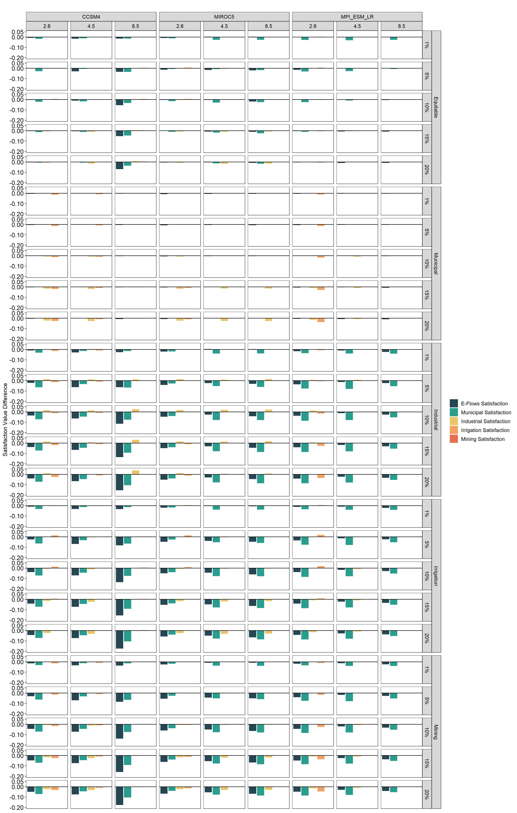
Figure S3-1. Difference in satisfaction level from the reservoir network optimization model (see section 2.4 in text) across the nine climate scenarios (GCMs top facet column, RCPs bottom facet column), six allocation scenarios (right series of facet rows, vertical axis value indicates difference from optimal allocation scenario), and five budget scenarios (left series of facet rows).
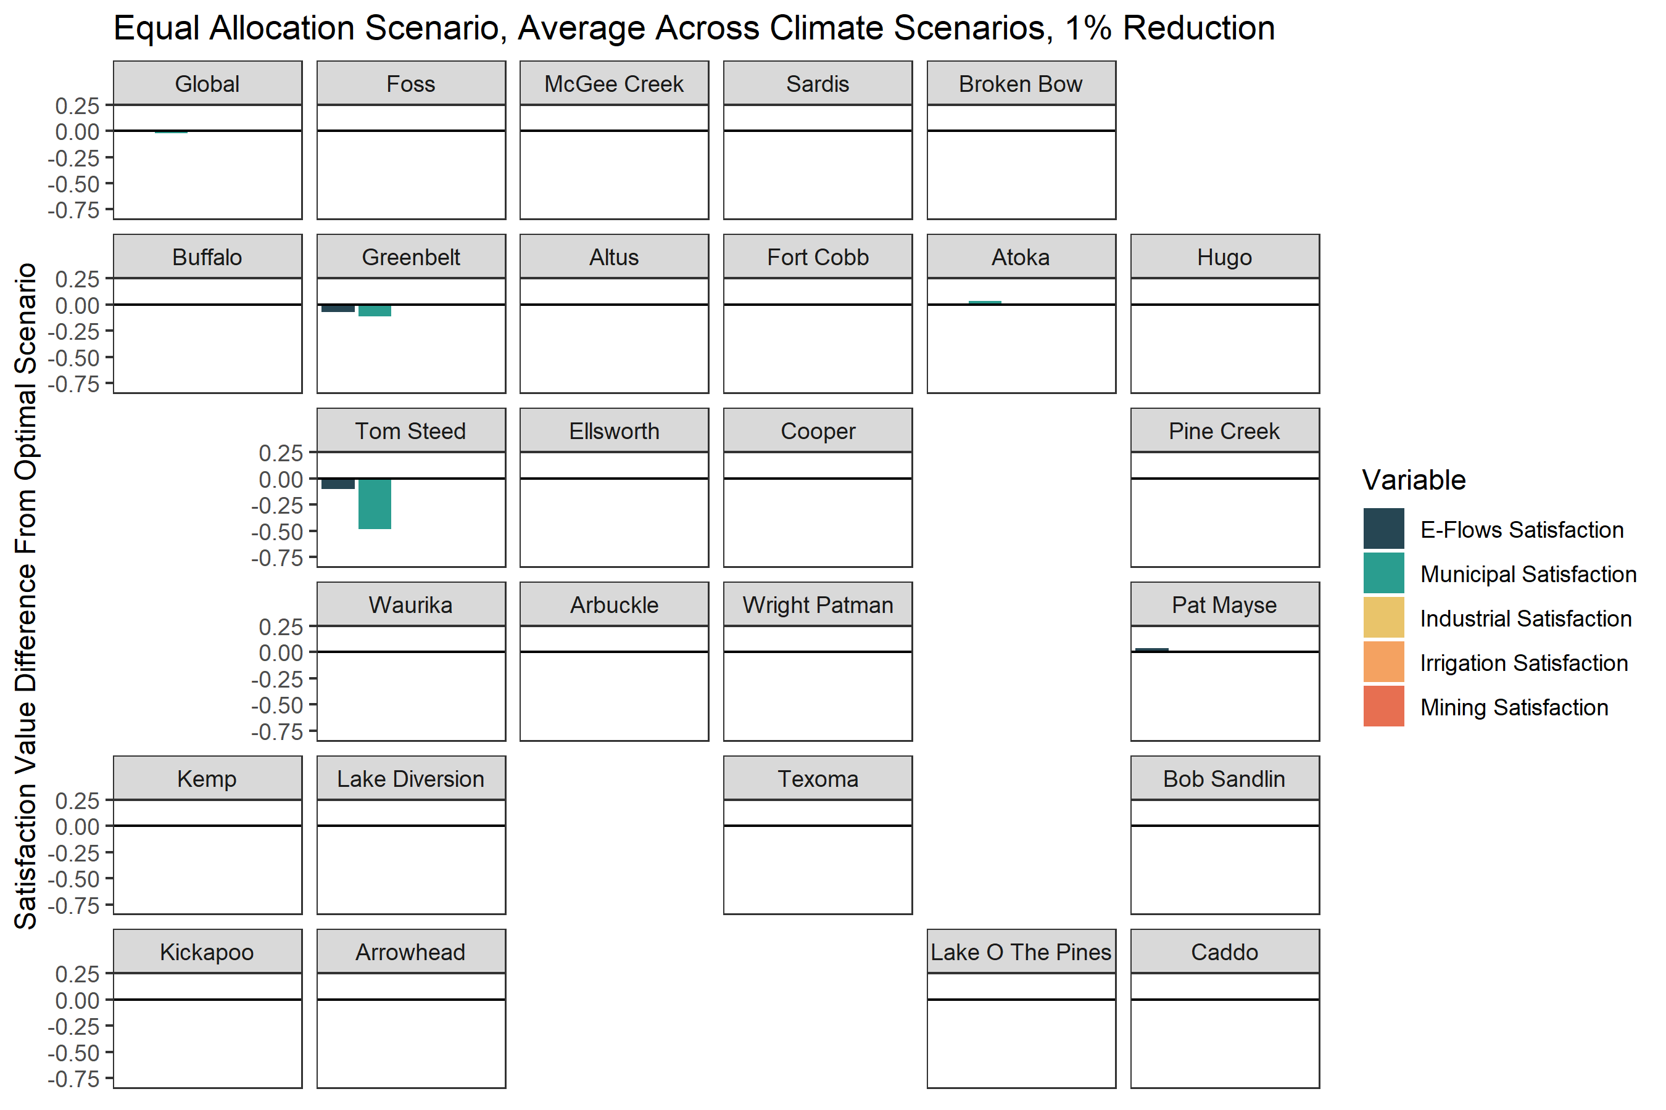
Figure S3-2. Satisfaction value differences for societal and environmental water targets across the 26 reservoirs we consider in the reservoir network optimization model and global objective values (top left facet). Reservoir position is approximate (i.e., facets on the left side of the figure indicate western reservoirs, facets on the right side of the figure indicate eastern reservoirs, same for north, south, top, and bottom, respectively). Satisfaction value differences are for the equal allocation, and 1% budget scenario.
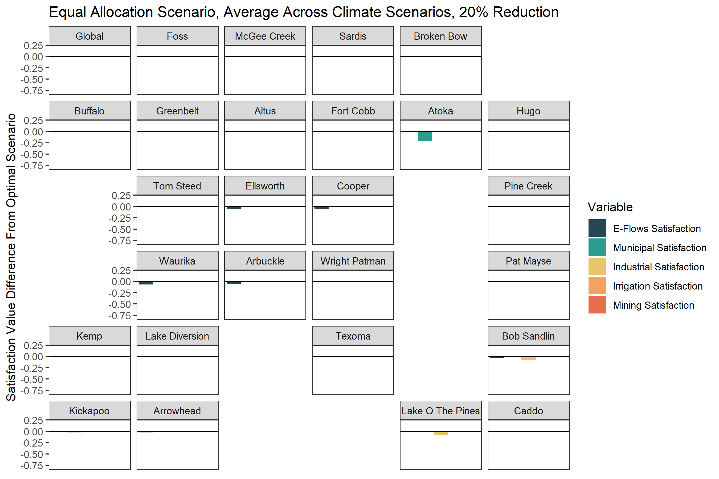
Figure S3-3. Satisfaction value differences for societal and environmental water targets across the 26 reservoirs we consider in the reservoir network optimization model and global objective values (top left facet). Reservoir position is approximate (i.e., facets on the left side of the figure indicate western reservoirs, facets on the right side of the figure indicate eastern reservoirs, same for north, south, top, and bottom, respectively). Satisfaction value differences are for the equal allocation, and 20% budget scenario.
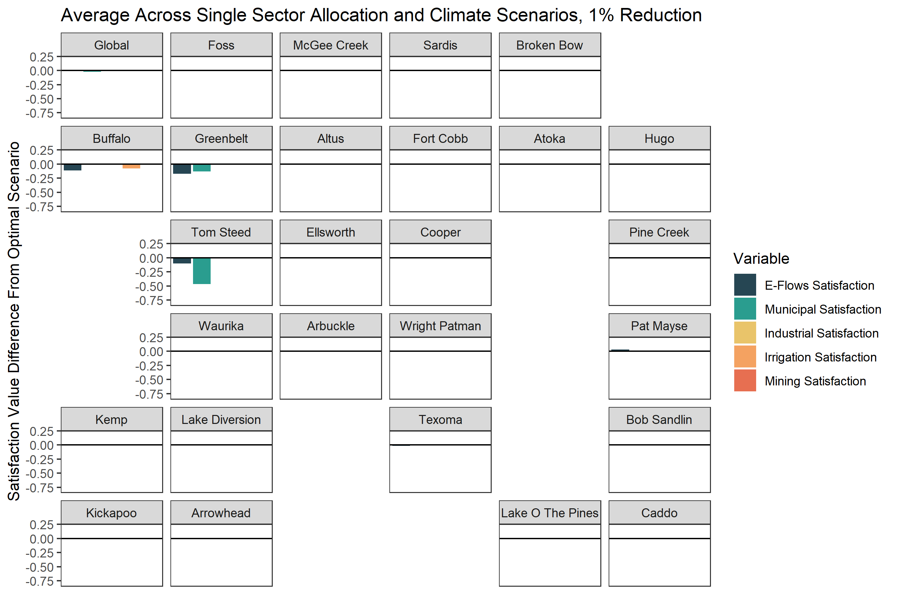
Figure S3-4. Satisfaction value differences for societal and environmental water targets across the 26 reservoirs we consider in the reservoir network optimization model and global objective values (top left facet). Reservoir position is approximate (i.e., facets on the left side of the figure indicate western reservoirs, facets on the right side of the figure indicate eastern reservoirs, same for north, south, top, and bottom, respectively). Satisfaction value differences are averaged across each (4) single sector allocation scenarios allocation, and 1% budget scenario.

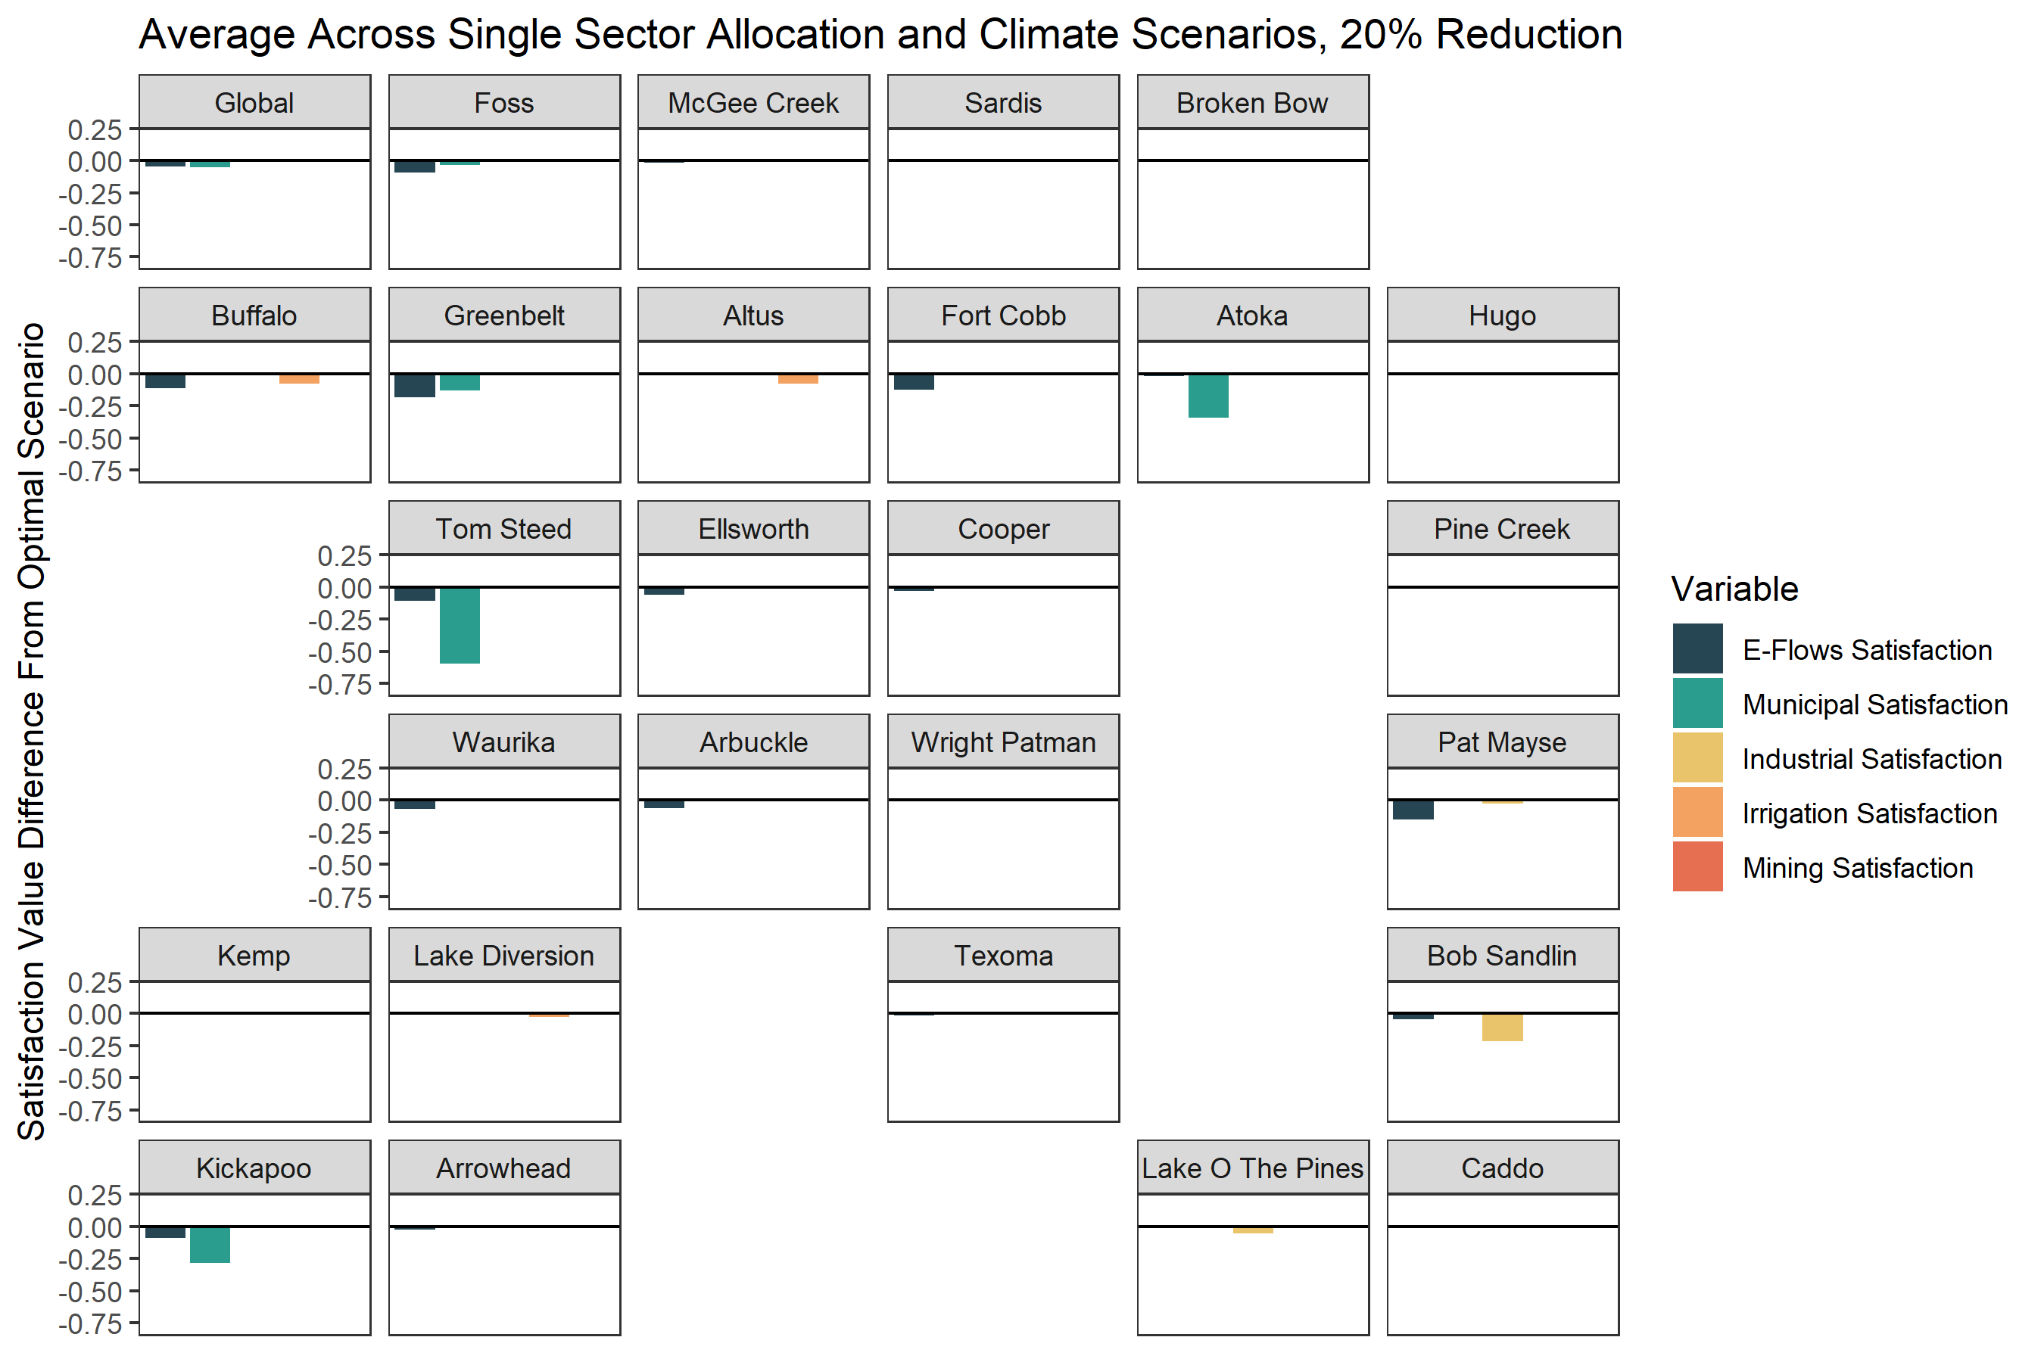
Figure S3-5. Satisfaction value differences for societal and environmental water targets across the 26 reservoirs we consider in the reservoir network optimization model and global objective values (top left facet). Reservoir position is approximate (i.e., facets on the left side of the figure indicate western reservoirs, facets on the right side of the figure indicate eastern reservoirs, same for north, south, top, and bottom, respectively). Satisfaction value differences are averaged across each (4) single sector allocation scenarios allocation, and 20% budget scenario.

Chapter 4

Appendix 4-1: Survey Questions
1 Consent to Participate in Research at the University of Oklahoma [OU-NC IRB Number: 10670 Approval Date: 07/03/2019] You are invited to participate in research about environmental flows in the Red River basin of Oklahoma and Texas. If you agree to participate, you will complete this online survey. There are no risks or benefits. Your participation is voluntary, and your responses will be anonymous. Your response is required for each question, however if you prefer not to provide an answer there are answer choice options to do so, or you can opt not to participate. Even if you choose to participate now, you may stop participating at any time and for any reason. Data are collected via an online survey system that has its own privacy and security policies for keeping your information confidential. No assurance can be made as to their use of the data you provide. If you have questions about this research, please contact: Sean M. Wineland, seanwineland@ou.edu; 412-551-2893 or Dr. Tom Neeson, neeson@ou.edu You can also contact the University of Oklahoma – Norman Campus Institutional Review Board at 405-325-8110 or irb@ou.edu with questions, concerns, or complaints about your rights as a research participant, or if you don’t want to talk to the researcher. Please print this document for your records. By providing information to the researcher(s), I am agreeing to participate in this research. Do you consent to participate in this research?
- Agree (1)
- Disagree (2)

Skip To: End of Block If 1 = Agree
Skip To: End of Survey If 1 = Disagree
End of Block: Consent
Start of Block: Self-Identify
Q2 With what organization are you affiliated?
- Oklahoma Water Resources Board (1)
- Oklahoma Department of Wildlife Conservation (2)
- Texas Commission on Environmental Quality (3)
- Texas Parks & Wildlife (4)
- Texas Water Development Board (5)
- United States Army Corps of Engineers (6)
- Altus-Lugert Irrigation District (7)
- Arbuckle Master Conservancy District (8)
- Foss Reservoir Master Conservancy District (9)
- Fort Cobb Reservoir Conservancy District (10)
- McGee Creek Authority (11)
- Mountain Park Master Conservancy District (12)
- Oklahoma Instream Flow Advisory Group - Consumptive Interests (13)
- Oklahoma Instream Flow Advisory Group - Non-Consumptive Interests (14)
- Other: (15) ________________________________________________

End of Block: Self-Identify
Start of Block: Environmental Flows Familiarity (Section 1)
Q3 Environmental flows describes the quantity, timing, and quality of water flows needed to sustain freshwater ecosystems and support human-related activities such as fishing, hunting, swimming, and boating. How familiar are you with the concept of environmental flows?
- Extremely familiar (e.g., conduct research on environmental flows, apply the concept to management) (1)
- Very familiar (e.g., work with environmental flows on a regular basis) (2)
- Moderately familiar (e.g., work with environmental flows on an intermittent basis) (3)
- Slightly familiar (e.g., have heard of the concept before) (4)
- Not familiar at all (e.g, have never heard of the concept before taking this survey) (5)
Q4 How familiar are you with existing or proposed policies, programs, and regulations that aim to ensure adequate water for environmental flows?
- Extremely familiar (e.g., I directly work with environmental flows policies/programs everyday) (1)
- Very familiar (e.g, I work with environmental flows policies/programs indirectly) (2)
- Moderately familiar (e.g., I sometimes work with environmental flows policies/programs as part of my job) (3)
- Slightly familiar (e.g., I have heard of environmental flows policies/programs but do not interact with them as part of my job) (4)
- Not familiar at all (e.g., I have never heard of environmental flows policies/programs prior to taking this survey) (5)
End of Block: Environmental Flows Familiarity (Section 1)
Start of Block: Ecosystem and Societal Benefits (Section 2)
Q5 Please indicate the extent to which you agree or disagree with the following statements about environmental flows.

(A) Environmental flows can benefit aquatic life such as fish and freshwater mussels by providing sufficient habitat (1)
(B) Environmental flows can benefit society through enhanced quality of life and recreational opportunities (2)
(C) Environmental flows can benefit society by facilitating ecosystem services such as nutrient cycling (3)
Strongly agree (8) | Somewhat agree (9) | Neither agree nor disagree (10) | Somewhat disagree (11) | Strongly disagree (12)

Q6 Please indicate the extent to which you agree or disagree with the following statements about current in-stream flows and the possibility of environmental flows policies and programs in the Red River basin of Oklahoma and Texas.
(A) Current flow conditions (without an environmental flows policy/program) are sufficient for aquatic life such as fish and freshwater mussels. (1)
(B) Current flow conditions (without an environmental flows policy/program) are sufficient to support water-related recreation (such as fishing, hunting, swimming, and boating) (2)
(C) Implementation of an environmental flows policy/program is only feasible in river basins where there is a surplus of water after human uses. (3)

Strongly agree (8) | Somewhat agree (9) | Neither agree nor disagree (10) | Somewhat disagree (11) | Strongly disagree (12)

End of Block: Ecosystem and Societal Benefits (Section 2)
Start of Block: Water Issues and Climate Change (Section 3)
Q7 Please indicate the extent to which you agree or disagree with the following statements about water availability in the near future (next 5-10 years) in the Red River basin of Oklahoma
and Texas
(A) There will likely be decreased water availability for societal (e.g., municipal, agricultural) uses. (1)
(B) There will likely be decreased water availability for environmental flows. (2)
(C) There will be likely be increased extreme flooding events. (3)
(D) There will likely be increased droughts. (4)
(E) There will likely be increased water-related conflicts. (5)
Strongly agree (8) | Somewhat agree (9) | Neither agree nor disagree (10) | Somewhat disagree (11) | Strongly disagree (12)

Q8 Now thinking in terms of the potential water availability issues in the previous question, to what extent do you believe that climate change will be a driving factor of these issues in the near future (5-10 years)?
(A) Climate change will likely decrease water available for societal (e.g., municipal, agricultural) uses. (1)
(B) Climate change will likely decrease water available for environmental flows. (2)
(C) Climate change will likely lead to increased extreme flooding events. (3)
(D) Climate change will likely lead to increased drought. (4)
(E) Climate change will likely lead to increased water-related conflicts. (5)
End of Block: Water Issues and Climate Change (Section 3)
Start of Block: Opinions (Section 4)
Q9 In your opinion, would regulations that require river flows to achieve environmental flow targets conflict with your agency's management and regulatory priorities?
- Yes (1)
- No (2)
Q10 In your opinion, should an environmental flows policy/program be adopted in the Red River Basin of Oklahoma and Texas?
- Yes (1)
- No (2)

End of Block: Opinions (Section 4)
Start of Block: Barriers to implementation (Section 5)
Q11 Please indicate the extent to which you think the following are barriers to implementing an environmental flows policy/program.
(A) Lack of communication among decision-makers and stakeholders (1)
(B) Beliefs that societal water needs are more important than environmental water needs (2)
(C) Lack of awareness of the societal and environmental benefits 3)
(D) Lack of funding (4)
(E) Lack of societal water use data (5)
(F) Lack of hydrologic data (6)
(G) Lack of biological/ecological data (7)
(H) Lack of data on the benefits to society provided by environmental flows (8)
(I) Lack of data on the economic benefits of environmental flows (9)
(J) Other, please explain: (10)

Not a barrier (275) | Somewhat of a barrier (276) | Moderate barrier (277) | Serious barrier (278)
Q12 In your opinion, which of the following are reasons why it might not be appropriate to implement an environmental flows policy or program in the Red River basin of Oklahoma and Texas? Select all that apply.
Select all that apply. (40)
Government regulations/policies may not be the best tool for ensuring adequate instream flows (1)
Possible infringement on private water rights (2)
Water users in my district/region oppose environmental flows policies/programs (3)
Consumptive societal water needs should take priority over environmental flows during drought conditions (4)

Q12 If you have a response that differs from the above answer choices or that you believe should be included, please describe it below:
________________________________________________________________
End of Block: Barriers to implementation (Section 5)
Start of Block: Data Needs (Section 6)
Q13 In your opinion, what information is most needed for decision-makers to incorporate environmental flows in water management decisions in the Red River basin of Oklahoma and Texas? Drag the items to rank the following data needs in order of importance (1= most important, 7 = least important).
______ Hydrologic (e.g., surface and groundwater flows, water availability) (1)
______ Water demand (e.g., current and future projections of area-specific water demand) (2)
______ Stakeholder willingness to participate (e.g., municipal, agricultural, and industry water users) (3)
______ Biological/ecological data on environmental flow needs (e.g., reach-specific flow targets to sustain species) (4)
______ Data on recreational/tourism environmental flow needs (e.g., flow targets to sustain recreational boating/fishing) (5)
______ Ecosystem services derived from environmental flows (e.g., natural processes sustained by environmental flows) (6)
______ Economic benefits of environmental flows (e.g., economic analysis of the value of environmental flows) (7)
Q13 If you have a response that differs from the above answer choices or that you believe should be included, please describe and indicate its rank below:
________________________________________________________________
End of Block: Data Needs (Section 6)
Start of Block: Preference of Environmental Flows Program (Section 7)
Q14 In your opinion, please indicate to the extent you think the following types of environmental flow policies or programs would be feasible to implement in the Red River basin of Oklahoma and Texas.
Regulatory (Mandate some numeric standard amount of water be released from a reservoir through a legislative mandate) (1)
Water trading (Permanent or temporary transfer of water rights in exchange for some form of compensation) (2)
Payment for ecosystem services (Payment to a land or resource manager in exchange for a guaranteed flow of environmental services) (3)
Emergency response (Water must be released from a reservoir when water levels get too low or temperatures too high in downstream ecosystems) (4)
Voluntary (Water users agree to give up some amount of their allocated water to support downstream aquatic ecosystems with no compensation - can be implemented at sub-basin scale) (5)
New permit consideration (All new permit applications are reviewed for their impact on some standard set in that given basin. This is the current method in TX.) (6)

Very feasible (11) | Somewhat feasible (12) | Neutral (13) | Somewhat unfeasible (14) | Not feasible (15)
Q14 If you have a response that differs from the above answer choices or that you believe should be included, please describe and indicate its feasibility below:
________________________________________________________________
End of Block: Preference of Environmental Flows Program (Section 7)
Start of Block: Communication Network (Section 8)
Q15 Over the last year, as part of your job, how often have you communicated with any of these agencies/organizations about water management in the Red River Basin of Oklahoma and
Texas?
Oklahoma Water Resources Board (1)
Oklahoma Department of Wildlife Conservation (2)
Texas Commission on Environmental Quality (3)
Texas Parks and Wildlife (4)
Texas Water Development Board (5)
United States Army Corps of Engineers (6)
Altus-Lugert Irrigation District (7)
Arbuckle Master Conservancy District (8)
Foss Reservoir Master Conservancy District (9)
Fort Cobb Reservoir Conservancy District (10)
McGee Creek Authority (11)
Mountain Park Master Conservancy District (12)
Oklahoma Instream Flow Advisory Group (13)
Other: (14)

Once a week or more (1) | Monthly (2) | Once every 3 months (3) | Once a year (4) | Not at all (5) | This is my own organization (6)
End of Block: Communication Network (Section 8)
Start of Block: Decision Support Tool (Section 9)

Q16 Consider being provided with a decision-support tool that could help you or your agency make decisions about water management. For the below questions, please indicate how helpful the information would be to making decisions about environmental flows.
(A) Priority areas for environmental flows to be established based on water availability and the economic, ecological, and societal benefits of environmental flows (1)
(B) Projections of water availability under future climate scenarios (2)
(C) Priority areas for aquatic species conservation based on future range shifts under climate scenarios (3)

Very useful (1) | Somewhat useful (2) | Slightly useful (3) | Not at all useful (4)

Q17 Would you be willing to watch a 5-minute video on how to use the decision-support tool if you were provided with it?
- Yes (1)
- No (2)
Q18 Would you be willing to attend a one-day workshop to learn how to apply the decision-support tool if you were provided with the opportunity?
- Yes (1)
- No (2)

End of Block: Decision Support Tool (Section 9)
Start of Block: Additional Questions (Section 10)
Q19 In your opinion, what do you believe are some of the most important reasons why individual water users would or would not be willing to support environmental flows policies or programs? A response is not required but requested.
________________________________________________________________
Q20 Please feel free to share anything else you think we should know about your decision-making process as it relates to environmental flows. A response is not required but requested.
________________________________________________________________
End of Block: Additional Questions (Section 10)

Chapter 5
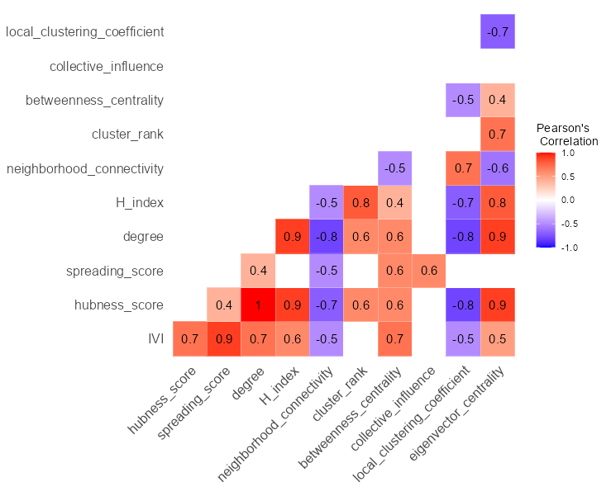
Figure S5-1.) Correlation matrix between IVI and common network centrality metrics for the regional Red River network (n=24 nodes). Blank cells indicate an insignificant Pearson’s correlation coefficient (p > 0.05).
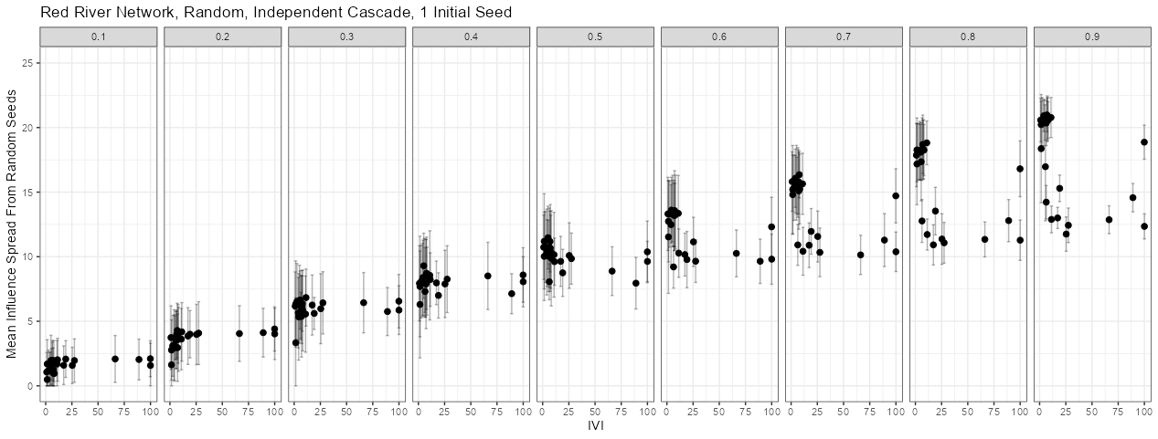
Figure S5-2. Relationship between the mean influence spread from using random seed nodes in the Monte-Carlo simulation (n = 1000) and the Integrated Value of Influence (IVI) for each node (points) in the regional Red River network (n = 24). Error bars indicate ± 1 standard deviation.
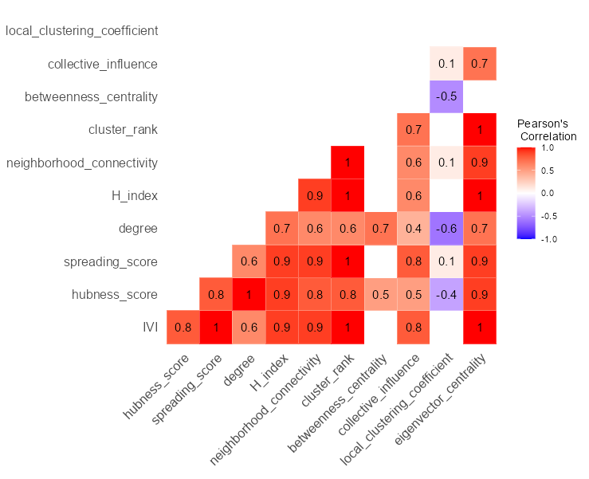
Figure S5-3. Correlation matrix between IVI and common network centrality metrics for the national Sustainable Rivers Program (SRP) network (n=426 nodes). Blank cells indicate an insignificant Pearson’s correlation coefficient (p > 0.05).
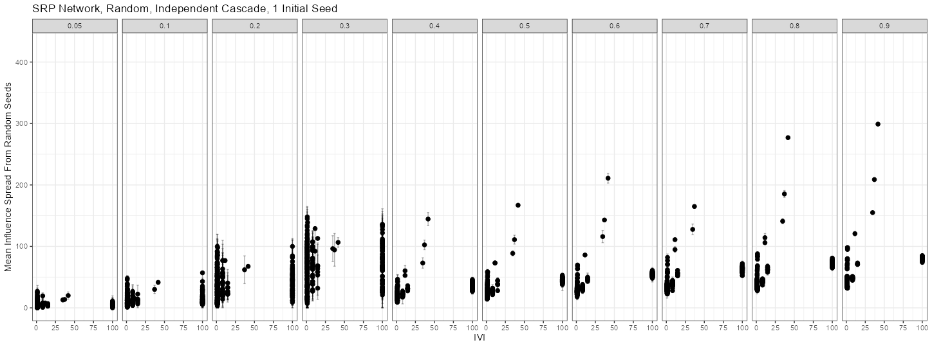
Figure S5-4. Relationship between the mean influence spread from using random seed nodes in the Monte-Carlo simulation (n = 1000) and the Integrated Value of Influence (IVI) for each node (points) in the national Sustainable Rivers Program (SRP) network (n = 24). Error bars indicate ± 1 standard deviation.

