UNIVERSITY OF OKLAHOMA
GRADUATE COLLEGE

GOING THE DISTANCE: DOES FAMILY-TO-WORK ROLE CONFLICT MEDIATE THE RELATIONSHIP BETWEEN COVID-19 DISTANCE LEARNING AND CAREER EXPECTATIONS AND TURNOVER INTENTIONS?

A THESIS
SUBMITTED TO THE GRADUATE FACULTY
In partial fulfillment of the requirements for the
Degree of
MASTER OF ARTS IN ORGANIZATIONAL DYNAMICS

By
KARISSA COLTMAN BURNETT
Norman, Oklahoma
2021

GOING THE DISTANCE: DOES FAMILY-TO-WORK ROLE CONFLICT MEDIATE THE RELATIONSHIP BETWEEN COVID-19 DISTANCE LEARNING AND CAREER EXPECTATIONS AND TURNOVER INTENTIONS?

A THESIS APPROVED FOR THE
DEPARTMENT OF PSYCHOLOGY

BY THE COMMITTEE CONSISTING OF

Dr. Brigitte Steinheider, Chair
Dr. Jennifer Kisamore
Dr. Jody Worley

© Copyright by KARISSA COLTMAN BURNETT 2021
All Rights Reserved.

Table of Contents
Abstract viii
Teleworking and family-to-work conflict 2
Gender inequity in pandemic family-to-work conflict 3
Distance learning: Schools’ answer to the pandemic 5
Family-to-work role conflict 6
Hypothesis 1: 9
Gender disparity in labor division during COVID-19 9
Hypothesis 2: 9
Hypothesis 3: 9
Career expectations 9
Hypothesis 4: 10
Hypothesis 5: 10
Hypothesis 6: 12
Turnover intentions of women due to distance learning 12
Hypothesis 7: 12
Hypothesis 8: 12
Hypothesis 9: 13
Methods 13
Participants and procedures 13
Measures 15
Distance learning interference (DLI) 15
Family-to-work conflict (FWC) 15
Career expectations (CE) 16
Turnover intentions (TI) 16
Demographic variables 16
Results 17
Descriptive statistics 17
Hypothesis 1: 18
Hypothesis 2: 18
Hypothesis 3: 18
Hypothesis 4: 18
Hypothesis 5: 18
Hypothesis 6: 18
Hypothesis 7: 19
Hypothesis 8: 19
Hypothesis 9: 19
Discussion 21
Implications 23
Study limitations and future research 24
Conclusion 25
References 27
Appendix A: Table 1 32
Means, standard deviations, and correlations 32
Appendix B: IRB Approval Letter 33
Appendix C: Study Recruitment Material 34
Appendix D: Questionnaire 35

List of Tables
Table 1. Means, standard deviations, and correlations………………………………….……… 32

List of Figures
Figure 1: Model of distance learning relationships with family-to-work conflict, career expectations, turnover intentions, and gender……………………………………………………13
Figure 2: Significant mediation model in which family-to-work conflict mediates the indirect relationship between distance learning interference and career expectations with gender as covariate………………………………………………………………………………………….19
Figure 3: Not significant mediation in which family-to-work conflict does not mediate the indirect relationship between distance learning and turnover intentions with gender as covariate………………………………………………………………………………………….20
Figure 4: Significant sequential mediation in which family-to-work conflict and career expectations mediate the indirect relationship between distance learning and turnover intentions with gender as covariate………………………………………………………………………….21

Abstract
In response to the worldwide COVID-19 pandemic, many organizations pivoted to teleworking and schools implemented distance learning, resulting in many parents finding themselves teleworking while also overseeing their child(ren)’s distance education. As distance learning responsibilities increase, role theory (Biddle & Thomas, 1966) explains that inter-role conflict will stem from incompatibilities between work and distance learning supervision responsibilities. The current study posits that work interference from distance learning and gender will be positively associated with lowered career expectations and higher turnover intentions, and that family-to-work conflict mediates the relationship. A convenience sample of 107 teleworking adults with children in distance learning were recruited via social media to complete a Qualtrics survey. Moderate correlations were found between gender, distance learning, and family-to-work conflict, with family-to-work conflict mediating the relationship between distance learning and lower career expectations. Women reported more involvement in distance learning, more family-to-work conflict and lower career expectations than men; however, family-to-work conflict as mediator between distance learning and turnover intentions was not supported and gender did not predict turnover intentions. An indirect effect was found of distance learning on turnover intentions, sequentially mediated by family-to-work conflict and career expectations. The study increases awareness of the impacts of the COVID-19 pandemic on working parents, particularly mothers, carrying the burden of their child’s distance learning responsibilities and highlights the opportunity for further research into interventions to help mitigate the impacts of the pandemic on the long-term career achievements of working mothers.
Keywords: COVID-19, distance learning, gender, family-to-work conflict, career expectations, turnover intention
Going the Distance: Will Family-to-Work Role Conflict Mediate the Relationship between COVID-19 Distance Learning and Career Expectations and Turnover Intentions?
In early 2020, an extremely contagious respiratory virus, SARS-CoV-2, that is responsible for a debilitating and sometimes deadly illness called COVID-19, spread rapidly across the world, dramatically impacting the daily lives of people everywhere. Infected asymptomatic persons unknowingly spread the virus, prompting extensive international efforts to curb the spread through various measures including masking and social distancing (Centers for Disease Control, 2020). According to the World Health Organization (2021), as of September 17, 2021, globally there have been 226,844,344 confirmed cases, with 4,666,344 confirmed deaths. Many nation’s governments instituted masking, social distancing measures, and mandatory lockdowns in accordance with guidance from the World Health Organization and Centers for Disease Control (CDC) to slow and stop the spread of the virus and to prevent healthcare systems from becoming overwhelmed (Güner et al., 2020). To maintain essential business functions during the pandemic, many organizations transitioned employees to telework.
In 2020, due to the pandemic, 46% of the U.S. workforce reported teleworking; while in 2019, only 22% of the U.S. workforce teleworked (Bureau of Labor Statistics, 2021a). By February of 2021, the overall percentage of the workforce teleworking had decreased to 22.7% (Bureau of Labor Statistics, 2021b), which is just slightly higher than the average for 2019. However, while the overall percentage of employed persons who were teleworking in 2021 seems comparable to 2019, significant differences were reported by age and gender, specifically, 25.5% of workers aged 25-54 reported teleworking while 25.1% of women (compared to 20.5% of men) reported teleworking (Bureau of Labor Statistics, 2021b).
While businesses moved to teleworking to maintain operations during lockdowns instituted to combat the spread of the virus, many schools moved to distance learning and daycares largely closed. Even as many mandated lockdown measures were lifted in the summer of 2020, schools and daycares grappled with how to safely re-open which impacted the ability of working parents to return to the office in person. A survey of 75,000 U.S. employees revealed that in July 2020, 78% of people who had switched to remote work in March 2020 were still working remotely (Brynjolfsson et al., 2020). Previous research has established the important role of childcare access in supporting parents’ ability to work (Glynn et al., 2013). The closure of schools and daycares impacted the ability of parents to work, while concurrently the risk of viral spread reduced the availability of informal childcare support networks (e.g., elderly parents) that families may have relied upon in the past to reduce family-to-work conflict.

Teleworking and family-to-work conflict
Telework is an approved flexible work arrangement where an employee performs all their position’s duties and responsibilities from an alternate work site other than the location from which they would otherwise perform that work (U.S. Office of Personnel Management, 2013). Previously, telework has been suggested as a potential solution to mitigate tension between family and work responsibilities; however, even pre-pandemic among occupations where teleworking was feasible, only 25% of employees participated (Dey et al., 2020). Increased acceptance of teleworking arrangements may be a positive outcome of the pandemic for balancing family-to-work conflicts, but difficulty separating work and family spheres and fully unplugging from work can increase role conflict for teleworkers (Carnevale & Hatak, 2020). Research has demonstrated a significant positive association between telework done from home on a mobile phone and both work-to-family conflict and turnover-intentions (Ferguson et al., 2016). Furthermore, researchers argue that pandemic telework is quite different than flexible and voluntary telework undertaken prior to COVID-19 in that employees experience increased emotional exhaustion from the challenges in performing highly interdependent tasks remotely during the pandemic (Chong et al., 2020). Distance learning is also a task that is highly interdependent between multiple parties, especially for parents of very young children interacting with teachers in a new role in their child’s education. Because of the pandemic, many parents suddenly shifted to simultaneously juggling telework responsibilities while navigating a full day of distance learning teaching responsibilities with one or more children. Early pandemic research reported that teleworking during the pandemic was especially difficult for working mothers because of increased role conflict between work and caregiving (Minello et al., 2020).

Gender inequity in pandemic family-to-work conflict
Gender equity experts are concerned that COVID-19 has exacerbated family-to-work conflict, especially for working women. Family-to-work conflict is likely to occur when time spent, stress, or role behaviors utilized in family responsibilities increase, thus reducing time and availability for work responsibilities, and ultimately creating conflict. Conversely, work-to-family conflict can occur when time spent, stress, or work role behaviors increase, creating interferences between work and family responsibilities, which can also create conflict at home. Work interference with family and family interference with work each have three sub-domains: Time-based referring to hours spent in one role conflicting with the other role; strain-based when emotional energy/pressure of one role conflicts with the other; and behavior-based when behaviors that are effective in one role are not effective in the other (Carlson et al., 2000). Prior research finds gender inequity exists in dual-income households where at least one parent has a flexible schedule, and women still take on significantly more responsibility for resolving conflicts between family and work than do men (Radcliff & Cassell, 2015). Recent data suggests these pandemic inequity concerns are valid because approximately 400,000 more working women than men have left the workforce since the pandemic began (Ellingrud & Segel, 2021). Experts fear that women who left the workforce to care for young children may find it difficult or nearly impossible to re-join the workforce at all, re-engage at a grade commensurate with their previous status, or to climb the career ladder in the future (Ellingrud & Segal, 2021). Such difficulties in returning to the workforce are likely to result in significantly decreased lifetime employment opportunities and earning potential for an entire generation of women (Cohen & Hsu, 2020). In June of 2021, a year after many lockdown measures began to ease, the percentage of women aged 20 or older participating in the U.S. labor force was still the lowest in 30 years, and experts are concerned that a mix of factors affecting working women were significantly exacerbated by the COVID-19 pandemic (Cassella, 2021).
While some parents attempted to solve their COVID-19 childcare crisis through increased hours teleworking rather than in the office, that was not an option available to many workers. For working parents, however, having increased childcare responsibilities was not the only role that changed due to COVID. When schools shifted towards distance learning, parents became involved in their child’s education in potentially more demanding and conflicting ways than ever before. This study explores how the work interference that resulted from distance learning activities is related to employee and organizational outcomes. Specifically, the current study examines whether the relationship between distance learning supervision needs and both parent turnover intentions and career expectations are mediated by family-work conflict. Based on previous research regarding the role of gender in the distribution of household tasks (Hochschild & Machung, 2012), gender will be examined as a potential co-variate with work interference from distance learning.

Distance learning: Schools’ answer to the pandemic
In a survey of 200,000 U.S. households in the spring of 2020, 72% of parents with K-12 school children reported spending an average of 2.6 hours per day in teaching activities with their children (Bansak & Starr, 2021). When the CDC published guidelines about re-opening requirements for educational institutions, many communities struggled with how to implement the necessary modifications (Gaudiano & Goldberg, 2020). Rather than undertake arduous and expensive mitigation efforts, many schools opted to choose distance learning as their solution for providing education while maintaining safety for students, staff, and families during the pandemic.
Distance learning is not a new phenomenon although distance learning tools have advanced greatly since its inception. In modern society, distance learning includes both blended learning and online learning formats (Broadbent, 2017). Blended learning describes a combination of a web-based learning technology with some face-to-face instruction. Online learning is web-based instruction that may have asynchronous components as well as synchronous interaction with the instructor or peers in a virtual setting (Broadbent, 2017). For the purposes of this study, the operational definition of distance learning broadly incorporates both online learning and blended learning because for children both rely heavily upon parental support. Schools across the United States have approached the goal of providing meaningful instruction for students in a safe and feasible manner with the varied resources available to them by incorporating distance learning in diverse ways. Controlling for household, e.g., employment and family security, and school system characteristics, such as access to technology and distance learning arrangements, the amount of parent time spent helping children was positively associated with parent educational level, parental age (which was used as a proxy for child age), as well as the number of live instruction hours offered (Bansak & Starr, 2021). Because distance learning expands a parent’s role in their child’s education, it must be integrated with and possibly interferes with other existing roles and responsibilities. This study focuses on the interference of increased distance learning on working parents.

Family-to-work role conflict
Role theory (Biddle & Thomas, 1966) strongly established that inter-role conflict stems from incompatibilities between work and family responsibilities, which has been further corroborated by other researchers (Greenhaus & Beutell, 1985). Inter-role conflict occurs when the time spent, required behavior, or stress impacts the time spent, behavior, or stress in another role. The conflict between work and family roles is a robust field of study with many researchers having specifically established a negative impact of work-to-family conflict on both work and life outcomes (Adkins & Premeaux, 2011). The majority of research does not distinguish between family-to-work conflict and work-to-family conflict and Carlson et al.’s (2000) instrument is the primary scale that measures these constructs individually. Because distance learning is a family responsibility that potentially interferes with work responsibilities resulting in conflict, the focus of this study will be on family-to-work conflict.
Consistent with role theory (Biddle & Thomas, 1966), a meta-analysis of 60 work-to-family conflict studies found that family interference with work increases when additional hours are spent on nonwork-related responsibilities such as family care, housework, or childcare (Byron, 2005). Looking specifically at family-to-work conflict, researchers have found that the curvilinear relationship between work hours and family-to-work conflict suggests that while working beyond 40 hours a week is significantly related to family-to-work conflict, people working hours significantly above the standard work week may seem less bothered by the conflict, which may be due to these individuals’ making other arrangements such as additional childcare to balance work-family responsibilities (Adkins & Premeaux, 2011). Based on this research, it would be expected that additional time spent by parents involved in their child’s distance learning would also interfere with work and that increased family-work conflict would exist.
There is a robust body of research about both family-to-work and work-to-family conflict, including its negative impacts on organizations and various strategies that organizations and government leaders can take to reduce it. Increased family-to-work conflict resulting from interferences from a working parent’s responsibilities to support their child’s distance learning has the potential to have widespread impact on organizations, communities, and national post-pandemic recovery efforts. One relevant government strategy for effectively reducing family-to- work conflict is universal childcare. An analysis of 5,296 respondents in 20 European countries found that government subsidized childcare policies significantly reduce levels of experienced family-work conflict (Notten et al., 2016). While there is not a universal childcare policy in the United States, COVID-19 has closed school buildings across the country, effectively removing the childcare support that schools typically provide that is crucial to working families. This reduces support and arguably increases family-to-work conflict given that parents are left struggling to figure out how to keep working without a safe and reliable place for their children to go to during the work week.
Another researched strategy to reduce conflict between family and work are flexible work arrangements, including telework. There have been mixed findings, however, regarding the impact of flexible work arrangements on work-to-family and family-to-work conflict. Pointing out these contradictory findings, Higgins et al. (2014) found that teleworkers experienced higher levels of work-to-family conflict than employees with other flextime schedules and that flexible work arrangements overall were associated with higher levels of work-to-family conflict than with traditional or less flexible schedules. Other research found that the impact of telework on family-to-work conflict is moderated by non-work responsibilities; specifically, employees with high levels of responsibility outside of work experience higher levels of family-to-work interference (Solís, 2017). Controlling for age, gender, and total hours worked, research shows the number of hours worked at home is a significant predictor of family-to-work conflict for the spouse/partner of the employee (Adkins & Premeaux, 2011). With the increase in teleworking due to the pandemic along with distance learning, it is reasonable to expect that this may increase conflict for some families as they navigate new routines, work arrangements, work and family demands, and other constraints.
Experts predict that the pandemic may amplify some of the drawbacks of flexible work schedules, such as difficulty maintaining boundaries between work and family responsibilities, difficulty unplugging from work demands, or increased isolation from the social support of colleagues, which all could result in increased role conflict (Carnevale & Hatak, 2020). Other corroborating research has focused specifically on the impact that social support has on family-to-work conflict. A meta-analysis found broad social support from work was more strongly associated with mitigated family-to-work conflict than specific forms of episodic support (French et al., 2018). Pandemic teleworking employees may lack the broad forms of social support that they previously received from co-workers. Additionally, if parents are not receiving social support from a partner or family member for the increased family responsibility of distance learning duties due to the pandemic, they may experience further family-to-work conflict from teleworking. Thus, it is predicted that:
Hypothesis 1: Distance Learning (DL) will be positively associated with family-to-work conflict.

Gender disparity in labor division during COVID-19
Hochschild and Machung’s (2012) groundbreaking household labor division research, detailed in The Second Shift: Working Families and the Revolution at Home, examined the phenomenon of gender disparity in the division of labor between men and women. The authors found that women perform additional household labor equating to a whole extra month per year compared to men. Early evidence of gender disparity in pandemic responsibility sharing among heterosexual couples is aligned with previous research. For mothers with children aged 10 or younger, 76% report that childcare is in their top three COVID-19 related challenges, compared to only 54% of fathers (McKinsey & Company, 2020.) There is also a COVID-19 gender disparity in perception regarding childcare responsibility sharing for dual-career heterosexual couples, with 70% of fathers reporting that they are equitably sharing labor with their partner, but only 44% of mothers agreeing (McKinsey & Company, 2020). Thus, it is posited that:
Hypothesis 2: Gender will be associated with distance learning reported, with women reporting greater involvement in their children’s distance learning.
Previous family-to-work conflict research has established that women experience more conflict than men from both family interference with work and work interference with family (Bryon, 2005), and women’s reported distance learning involvement and family-to-work conflict are expected to be consistent with previous research. Thus, it is predicted that:
Hypothesis 3: Gender will be associated with reported family-to-work conflict, with women reporting higher family-to-work conflict than men.

Career expectations
Career expectations are beliefs about future employments that include what an employee anticipates providing to an employer as well as likely reciprocal benefits (Anderson & Thomas, 1996; Cho & Ryu, 2016; De Vos et al., 2009). Research has shown that career expectations are influenced by a myriad of societal factors and family role beliefs (Cho & Ryu, 2016). In The Price of Motherhood, Crittenden (2010) describes “the mommy tax” (pg. 88) as the lifetime financial losses incurred by women stemming from time spent focused on caregiving either in terms of time not spent participating in paid work, as well as forfeited career ambitions as women struggle to balance workplace and family pressures. Subsequent research has corroborated Crittenden’s (2010) findings that gaps in employment due to caregiving limit the accumulation of skills and experience needed for career advancement and lower women’s earnings (Budig et al., 2016), so it is hypothesized that:
Hypothesis 4: Distance learning will be negatively associated with career expectations.
Research supports a reciprocal relationship between family-to-work conflict and increased job strain and lower job engagement (Babic et al., 2017) as well as a negative correlation between family-to-work conflict and job performance (Zainal et al., 2020). Job anxiety mediates the relationship between family-to-work conflict and turnover intentions (Vanderpool & Way, 2013). Additionally, research supports the connection between a working mother’s increased role conflict and negative career expectations regarding their ability to advance within their company due to their family responsibilities and a fear of discrimination for using parental leave benefits (Chang et al., 2014). Based on previous research, it is predicted that:
Hypothesis 5: Family-to-work conflict will be negatively associated with career expectations.
Early research suggests that in the short run, flexible telework during the pandemic may help working mothers prevent job loss due to lack of childcare (Alon et al., 2020), but that overall COVID-19 pandemic could widen gender inequalities in perceptions of work productivity and job satisfaction (Feng & Savani, 2020). One year after the start of the pandemic, experts projected that while men’s participation in the workforce should return to pre-pandemic employment levels by 2022, women’s employment may not return to pre-pandemic levels until 2024 (Ellingrud & Segel, 2021). Findings of reduced perceptions of work productivity and job satisfaction due to COVID-19 suggest women could experience substantial negative career impacts due to role conflict resulting from the COVID-19 pandemic. A recent survey found that mothers are twice as likely than fathers to report feeling worried about the impact that COVID-19 caregiving responsibilities may have on the evaluation of their performance (McKinsey & Company, 2020). Furthermore, pandemic performance anxiety coupled with increased caregiving burdens were found to predict employees’ contemplations of downshifting or leaving their career altogether (McKinsey & Company, 2020). If working mothers were concerned prior to the pandemic about workplace discrimination based on their status as a caregiver, it is not surprising that this could worsen during a time of global stress and uncertainty regarding employment. Additional research has shown that when women with high career expectations face high family-to-work conflict, their career expectations are significantly lowered (Cho & Ryu, 2016). Furthermore, role-incongruity between work and family roles is thought to explain the findings of a longitudinal study based on data from the U.S. Department of Labor (Kim, 2020), that showed women who were their family’s primary breadwinner were more likely than men or non-breadwinning women to quit their job due to increased family demands, which were measured by the number of children. Thus, it is hypothesized that:
Hypothesis 6: Family-to-work conflict will mediate the relationship between distance learning and career expectations.

Turnover intentions of women due to distance learning
The Pew Research Center 9 (Bennet, 2021) estimates that approximately 9.6 million US workers between the ages of 16 and 64 lost their job due to the pandemic and the unemployment rate in 2020 (8.6%) was more than double that of 2019 (3.8%). In another survey of households with kindergarten to 12th grade children, 55.9% of households reported that someone lost employment between April and June 2020, a significantly higher number of households with less than a high school degree reported job losses (Bansak & Starr, 2021). Even though previous research supports that in times of high unemployment turnover will be lower (Sousa-Poza & Henneberger, 2004), early data already suggests that the COVID-19 pandemic has contributed to a female recession in the United States. In September 2020 alone, the same month that many schools started the school year with distance learning, the United States lost 1.1 million people from the workforce, and 80% (865,000 workers) were women (Carrazana, 2020). Astoundingly, in December 2020, 100% of the 140,000 U.S net jobs lost belonged to women (Hinchliffe, 2021). Thus, it is posited that:
Hypothesis 7: Distance learning will be positively associated with turnover intentions.
Lack of childcare due to distance learning and the burden of trying to balance the needs of work, caregiving, and household management are being pointed to as reasons why more women than men are leaving their jobs (Carrazana, 2020). Research supports the positive association between work-to-family conflict and turnover intentions (Boyar et al., 2003; Chen et al., 2015; Vanderpool &Way, 2013), and it is hypothesized that:
Hypothesis 8: Family-to-work conflict will be positively associated with turnover intentions.
Additionally, women are more highly represented in many of the industries where employment was hardest hit by the pandemic such as hospitality, restaurants, retail, and healthcare (Schneider et al., 2020). In 2020, one in four women considered downsizing their career or leaving the workforce because of COVID-19 (McKinsey & Company, 2020). For the first time in six years, women reported higher intentions to leave their jobs than men, and respondents listed childcare and/or homeschooling responsibilities as one of the top challenges during COVID-19 (McKinsey & Company, 2020). Thus, it is posited that:
Hypothesis 9: Family-to-work conflict will mediate the relationship between distance learning and turnover intentions.
The assumed relationships between the variables are depicted in Figure 1.

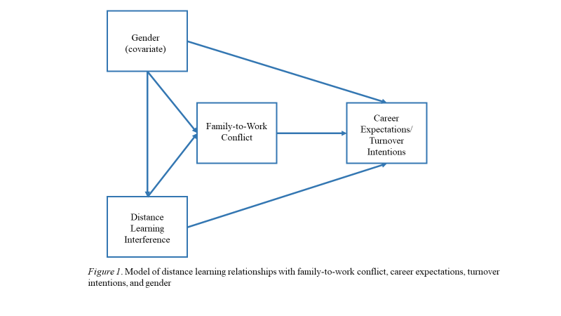

Methods

Participants and procedures
The study received approval from the Institutional Review Board of the University of Oklahoma prior to data collection (see Appendix B). A convenience sample of participants was recruited by sending an electronic Qualtrics survey link to remote working parents with at least one distancing learning child via the researcher’s social media and email network. In the recruitment material participants were encouraged to share the link with other remote working parents in their networks who may be interested in participating, thus a network sample was collected (see Appendix C for study recruitment material). The survey link was available between March 12th and April 24th, 2021. A total of 195 responses were received, but four responses failed to consent, and were thus not included. Additionally, to be eligible to participate, respondents had to meet the following criteria: They must be over the age of 18, have worked remotely at least one day in the last month, and they must be a caregiver to a child who participated in at least one day of distance learning in the last month. Out of the responses received by consenting participants, two were removed because the respondent was not over 18, 21 were removed because they were not working remotely, and 33 were removed because they did not have a child in distance learning. In total, 76 responses did not meet the study participation requirements. Additionally, 12 responses were missing more than 30% of the responses. In total, 107 respondents met the inclusion criteria and were analyzed. The participant sample was predominantly female (85.98%), and Caucasian (76.63%). Participants were largely partnered (77.4%) and the age group with the highest frequency (61.7%) was between 35 and 44 years. The mean number of children was 1.82. The highest frequency of participants (81.9%) had one or two children in distance learning. The majority (91.6%) of participants were employed full-time and worked 40 hours per week remotely. The highest frequency of work experience was 11+ years (58.5%), and 54% reported employment in the government, education, social services, and non-profit sectors. Participants were highly educated, with 54% reporting higher education beyond a 4-year bachelor’s degree. Participants reported that 29.9% had scaled back work hours due to distance learning, and 14% had scaled back work responsibilities due to distance learning. Participants spent between 0 and 37 hours a week assisting their children with distance learning; the mean was 11.5, the median was 10, and the mode number of hours was 20 hours per week.

Measures
The study utilized a cross-sectional design and assessed distance learning as the independent variable, and career expectations and turnover intentions as dependent variables, both mediated by family-to-work conflict, using the responses to 35 items. Gender was controlled for as a covariate. Additional demographic data were also collected. The full survey is included in the appendix.

Distance learning interference (DLI)
Distance learning was measured using one item on a scale from 0 (never) to 100 (always). Please indicate the average frequency that distance learning responsibilities interfere with work responsibilities. Due to the novelty of the global COVID-19 pandemic in the modern U.S. educational system and the sudden widespread shift to distance learning, no validated measure for this construct was available.

Family-to-work conflict (FWC)
The mediating variable was measured using the three family-to-work conflict subscales with three items each developed by Carlson et al. (2000). The scales use a 7-point Likert-type scale (1= strongly disagree, 7 = strongly agree). The scale assesses time-based (α =.79; e.g., The time I spend on family responsibilities often interferes with my work responsibilities), stress-based (α =.87; e.g., Due to stress, I am often preoccupied with family matters at work), and behavior-based strain (α =.85; e.g., The behaviors that work for me at home do not seem to be effective at work).

Career expectations (CE)
Career expectations were measured using Chang et al.’s (2014) three item scale. It uses a 5-point Likert scale that ranges from 1 (strongly disagree) to 5 (strongly agree) and the authors report a Cronbach’s alpha of .83. However, one of the items was discarded because removing the item “I will not be discriminated against in future promotions in the company due to my family responsibilities.” increased the Cronbach’s alpha from .69 to .75. The two items used to measure career expectations both ask respondents about their perceptions of their ability to advance in their company due to their family responsibilities.

Turnover intentions (TI)
Turnover intentions were measured by the Intent to Stay scale developed by Shore and Martin (1989) who report Cronbach alphas of .78 and .74. Each of the four items asks the participant to choose from a set of five statements with five answer options A sample item is “Which of the following statements most clearly reflects your feelings about your future with this organization in the next year?” (a) I definitely will not leave. (b) I probably will not leave. (c) I am uncertain. (d) I probably will leave. (e) I definitely will leave.

Demographic variables
Basic demographic data were collected along with several questions regarding the potential impact of COVID-19 on employment status. Items include age, gender, employment status, tenure, industry, impact of COVID-19 on work status, number of children, distance learning mode, race and ethnicity, education, as well as marital status.

Results
Descriptive statistics, correlation coefficients and scale reliabilities (Cronbach’s alphas) were calculated with IBM SPSS Statistics Version 27. To assess the mediation model parameters, the SPSS-Macro PROCESS based on Model 4 was utilized (Hayes, 2021), and bootstrapping (5000 bootstrap samples) was used to estimate indirect effects. Regression analyses were conducted to test the hypotheses. The criterion for significances were set at α =.05.

Descriptive statistics
Means, standard deviations, reliability coefficients, and correlations are reported in Table 1. All Cronbach’s alpha coefficients were acceptable to very good, varying between .75 (career expectations) and .92 (family-to-work conflict). Cronbach’s alphas of the family-to-work conflict subscales were acceptable and varied between .78 (behavior-based strain), .81 (time-based strain), and .90 (stress-based strain). Distance learning interference had the highest correlation with stress-based family-to-work conflict (.383). Additionally, stress-based family-to-work conflict had the highest correlation with gender (.359), indicating that women were experiencing more stress-based family-to-work strain than men. Mean values indicate that participants, on average, were experiencing some distance learning interference (M=31.35, SD=28.19) and moderate family to work conflict (M=4.21, SD=1.37); mean values for CE (M=3.31, SD=.96) and TI (M=2.44, SD=.96) show slightly positive career expectations and slightly negative turnover intentions.
Hypotheses Testing
Results for this study are reported in order of the hypotheses.
Hypothesis 1: The first hypothesis posited that distance learning would be positively associated with family-to-work conflict. Results for H1 were statistically significant with B=.015, SE=.004, t=3.29, p =.001. Thus, H1 was supported.
Hypothesis 2: It was hypothesized that gender would be associated with distance learning, with women reporting greater involvement in their children’s distance learning. Results for H2 were statistically significant with r=.307, p < .01. Therefore, H2 was supported.
Hypothesis 3: The study hypothesized that gender would be associated with reported family-to-work conflict, with women reporting higher family-to-work conflict then men. Results for H3 were statistically significant with r=.301, p<.01. Accordingly, H3 was supported.
Hypothesis 4: It was hypothesized that distance learning interference would be negatively associated with career expectations. Results for H4 were not statistically significant with B=-.001, SE=.003, t=-.33, p=.746. Thus, H4 was not supported.
Hypothesis 5: It was hypothesized that family-to-work conflict would be negatively associated with career expectations. Results for H5 were statistically significant with B=-.20, SE=.07, t=-2.83, p =.006. Therefore, H5 was supported.
Hypothesis 6: The study posited that family-to-work conflict would mediate the relationship between distance learning and career expectations. Results for H6 were statistically significant with B=-.003, SE=.001. The 95% bootstrap confidence interval of the indirect effect did not include zero [-.0062, -.0005], so this indirect effect is significant. Thus, H6 was supported.
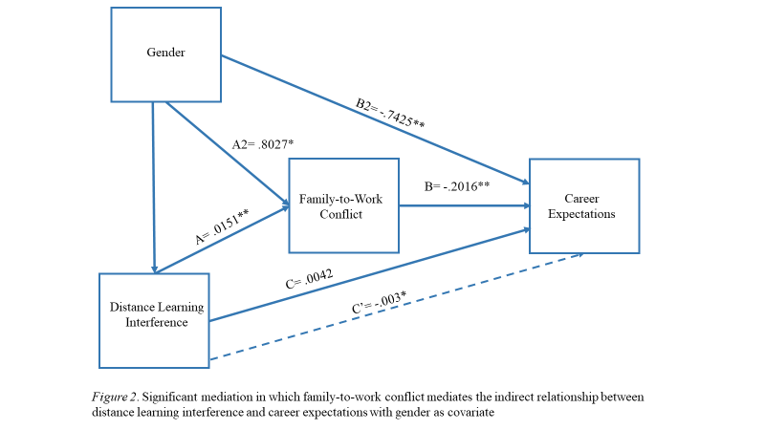
Hypothesis 7: It was hypothesized that distance learning would be positively associated with turnover intentions. Results for H7 were not statistically significant with B=.001, SE=.004, t=.17, p=.86. Therefore, H7 was not supported.
Hypothesis 8: The study hypothesized that family-to-work conflict would be positively associated with turnover intentions. Results for H8 were not statistically significant with B=.02, SE=.076, t=-.287, p=.77. Thus, H8 was not supported.
Hypothesis 9: Finally, the study hypothesized that family-to-work conflict would mediate the relationship between distance learning and turnover intentions. Results for H9 were not statistically significant with B=-.0003, SE=.0013. The 95% bootstrap confidence interval of the indirect effect did include zero [-.0030, .0021], so the indirect effect is not significant. Therefore, H9 was not supported. See Figure 3.
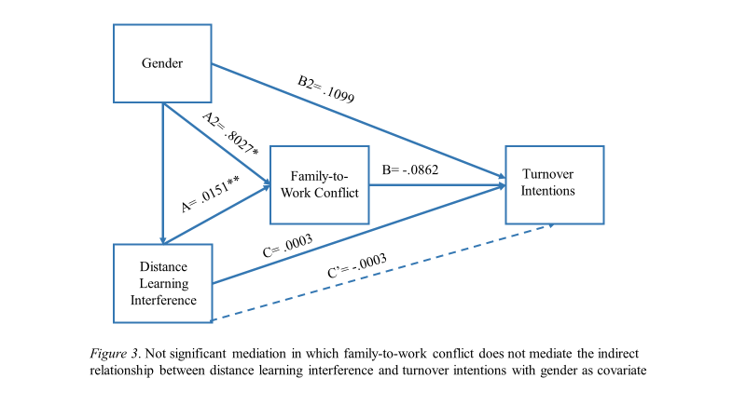
Because of the high correlation between career expectations and turnover intentions (r = -.267, p < .01), a sequential mediation model was tested with family-to-work and career expectations mediating the relationship between distance learning interference and turnover intentions (see Figure 4). The total indirect effect of distance learning interferences on turnover intentions is sequentially mediated by family-to-work conflict and career expectations: B= .0010, Bootstrap SE= .0006, The 95% bootstrap confidence interval of the indirect effect did not include zero [ .0001, .0024], so this indirect effect is significant. See Figure 4, which depicts this significant indirect relationship of distance learning interference and turnover intentions, where all the other significant relationships depicted are related to career expectations, which is then significantly related to turnover intentions.
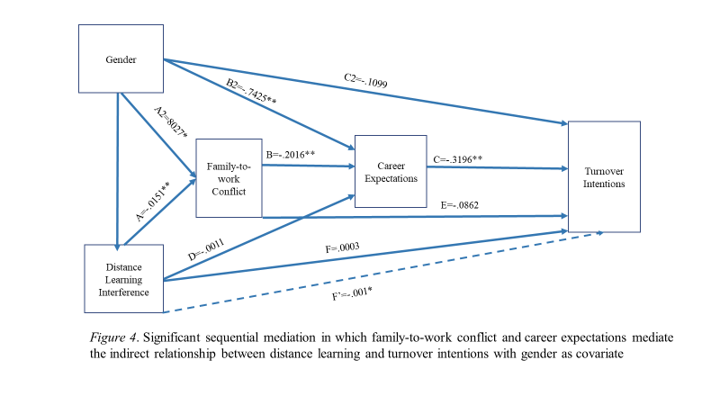

Discussion
This study set out to explore the relationships between work interferences from time spent by parents involved in their child’s COVID-19 distance learning and the parent’s career expectations and turnover intentions, with family-to-work conflict as the mediating mechanism and gender as a covariate.
The study first hypothesized that distance learning would be positively associated with family-to-work conflict (H1), which was supported. Since COVID-19 distance learning interferences are a new phenomenon without much research, this study reviewed the robust literature surrounding family-to-work conflict and posited that distance learning is a family responsibility and thus may have a similar relationship to work conflict as other family responsibilities, which was congruent with other research (Byron, 2005).
Second, it was hypothesized that gender would be associated with distance learning and family-to-work conflict, with women reporting greater involvement in their children’s distance learning (H2) and higher family-to-work conflict than men (H3). Both H2 and H3 were supported, which aligns with other research about the distribution of family responsibilities (Hochschild & Machung, 2012; McKinsey & Company, 2020) and role conflict (Biddle & Thomas, 1966).
Next, it was hypothesized that distance learning would be negatively associated with career expectations. While the direct relationship was not supported (H4), the indirect effect of distance learning interference on career expectations mediated by family-to-work conflict was significant (B= -.0011, Bootstrap SE= .0014), because the 95% bootstrap confidence interval of the indirect effect did not include zero [ -.0062, -.0005], and H6 was supported which aligns with previous research regarding the relationship between family-to-work conflict and career expectations (Adkins & Premeaux, 2011; Budig et al., 2016; Crittendon, 2010) and confirm it within the context of the COVID-19 pandemic distance learning. Further, it was hypothesized that family-to-work conflict would be negatively associated with career expectations (H5), which was supported.
It was hypothesized that distance learning would be positively associated with turnover intentions (H7), which was not supported. The study also hypothesized that family-to-work conflict would be positively associated with turnover intentions (H8), which was not supported, and family-to-work conflict did not mediate the relationship between distance learning and turnover intentions (H9). While the study’s results for H7, H8, and H9 are not congruent with previous research regarding the relationship between family-to-work conflict and turnover intentions, the sequential mediation analysis of family-to-work conflict and career expectations found a significant indirect effect of distance learning interference on turnover intentions found, which does align with the previous literature (Boyar et al., 2003; Chen et al., 2015; Vanderpool & Way, 2013).

Implications
While the current COVID-19 pandemic will be over one day, the effects are expected to be far-reaching for many components of modern life (Banks et al., 2020; Tokic, 2020). Scientists are predicting that COVID-19 will eventually become endemic and sporadic outbreaks will likely continue to impact the global community based on a variety of factors such as vaccination rates and mitigation protocols (Herrero et al., 2021), of which distance learning could continue to be one measure used by schools facing viral outbreaks.
This study found that interference from a parent’s involvement in distance learning was associated with higher reported family-to-work conflict, which has implications for organizations concerned with the mental health, performance, and retention of their workforce. The novelty of pandemic distance learning may cause managers and organizations to underestimate the family-to-work conflict, especially stress-based strain, experienced by parents in the organization and how it could influence an employee’s decision to leave. Managers should consider an employee’s role as a parent when crafting recruitment, retention, and advancement strategies. Organizations concerned with the potential loss of workforce gender diversity due to pandemic family-to-work conflict can use these findings to inform strategies that specifically target working mothers.
While many businesses may not have previously included a potential global pandemic as a part of their business continuity planning, they should be aware in future contingency plans for virus outbreaks, how future family-to-work conflict could impact their employees, and ultimately their organization. Additionally, because breakouts in classrooms are likely to continue to plague schools for the foreseeable future, educational institutions will need to consider how they utilize distance learning as a COVID-19 outbreak quarantine and mitigation tool. Based on the findings of this study, school administrators and teachers should consider the demands placed on parents and the potential work interference from educational strategies.

Study limitations and future research
The study employed a cross-sectional design, thus not allowing for causal inferences. Additionally, this study was conducted after the pandemic had begun, so no pre-pandemic data was available for comparison. Potential limitations of this study include the possible impacts of convenience and network sampling along with a small sample size. Based on the participant demographics (predominantly higher educated, tenured, middle-aged white women with partners), the findings may not be representative of the whole population of working parents with distance learning children. However, the higher educational attainment of the study sample is consistent with the U.S. Census Bureau’s Household Pulse survey about pandemic teleworking, which found that the workers most likely to be teleworking due to the pandemic were more educated (Marshall et al., 2021) and February 2021 data that more women than men were teleworking (Bureau of Labor Statistics, 2021) at a similar time frame as the present study. Furthermore, common method variance is a potential limitation due to single-source data (Podsakoff et al., 2003). Additionally, the survey data were collected when many schools and organizations in the United States were transitioning back to in-person school and work models, which potentially limited the recruitment pool of respondents who met the participation criteria, as observed by the 54 responses removed for either not meeting the remote work or child in distance learning criteria. Because distance learning as it has been experienced during the pandemic is novel, no established measure to assess it existed. This study selected frequency of interference from distance learning, but potentially other variables could have been a more accurate measure of the relationship.
COVID-19 pandemic distance learning is a phenomenon that has yet to be fully researched. While many experts point to the potential for negative impacts of distance learning, especially on working parents, at the time of this study there is no other research yet to support that. This study makes a significant contribution to the family-to-work conflict field by increasing organizational awareness of employees’ pandemic family-to-work conflict and informs policy makers grappling with preparing for the workforce impacts of COVID-19. Future research should further explore differences amongst the three domains of family-to-work conflict to support the development of interventions that will mitigate the impact of pandemic distance learning family-to-work conflict for women and address possible gender gaps in career expectations and lifetime work achievement. Future researchers may also replicate this study longitudinally to explore the impact of distance learning interference in the context of endemic COVID-19 to observe actual relationships with turnover and career outcomes over time. Research could further explore the different subscales of family-to-work conflict with distance learning interference, which might inform research to determine helpful interventions for working parents’ supervising distance learning who are experiencing family-to-work conflict. Given the endemic nature of COVID-19 and the continued possibility of distance learning responsibilities for working parents, the development of a validated scale for measuring distance learning interference would also make a valuable contribution for future research.

Conclusion
While family-to-work conflict, career expectations, and turnover intentions are all constructs which pre-date the COVID-19 global pandemic, many of the related societal challenges, such as gender inequity, have been exacerbated by pandemic mitigation strategies including distance learning. Given the endemic nature of COVID-19, global society will likely benefit from well-developed outbreak mitigation plans that do not contribute unnecessary harm to the workforce. Understanding the role of COVID-19 distance learning interference with the experience of working parents, especially women, will not only enhance current post-pandemic recovery efforts but will support future contingency plans made by individuals, employers, educators, policy makers, and researchers.

References
Adkins, C. L. & Premeaux, S. F. (2012). Spending time: The impact of hours worked on work-family conflict. Journal of Vocational Behavior, 80(2), 380-389.
Alon, T. M., Doepke, M., Olmstead-Rumsey, J., & Tertilt, M. (2020). The impact of COVID-19 on gender equality. National Bureau of Economic Research, Inc. https://doi.org/10.3386/w26947
Anderson, N. & Thomas, H.D.C. (1996). Work group socialization. M.A. West (Ed.), Handbook of work groups. Wiley, Chichester, pp. 423-450.
Babic, A., Stinglhamber, F., Bertrand, F., & Hansez, I. (2017). Work–home interface and well-being: A cross-lagged analysis. Journal of Personnel Psychology, 16(1), 46-55.
Banks, J., Karjalainen, H., & Propper, C. (2020). Recessions and health: The long‐term health consequences of responses to the coronavirus. Fiscal Studies, 41(2), 337-344.
Bansak, C., & Starr, M. (2021). COVID-19 shocks to education supply: How 200,000 U.S. households dealt with the sudden shift to distance learning. Review of Economics of the Household, 19(1), 63-90.
Bennet, J. (2021, April 15). Fewer jobs have been lost in the EU than in the U.S. during the COVID-10 downturn. Pew Research Center. https://www.pewresearch.org/fact-tank/2021/04/15/fewer-jobs-have-been-lost-in-the-eu-than-in-the-u-s-during-the-covid-19-downturn/
Biddle, B. J., & Thomas, E. (Eds). (1966). Role theory: Concepts and research. John Wiley & Sons, Oxford.
Boyar, S. L., Maertz Jr., C. P. Pearson, A. W., & Keough, S. (2003). Work-family conflict: A model of linkages between work and family domain variables and turnover intentions. Journal of Managerial issues, 12(2), 175.
Broadbent, J. (2017). Comparing online blended learner’s self-regulated learning strategies and academic performance. The Internet and Higher Education, 33, 24-32. https://doi.org/10.1016/j.iheduc.2017.01.004
Brynjolfsson, E., Horton, J., Ozimek, A., Rock, D., Sharma, G., & TuYe, H., (2020). COVID-19 and remote work: An early look at US data. National Bureau of Economic Research, Inc. NBER, Working Papers:27344
Budig, M. J., Misra, J., & Boeckmann, I. (2016). Work-family policy trade-offs for mothers? Unpacking the cross-national variation in motherhood earnings penalties. Work and Occupations, 43(2), 119–177.
Bureau of Labor Statistics, U.S. Department of Labor (2021, July 22). American time use survey summary [Press release] https://www.bls.gov/news.release/atus.nr0.htm
Bureau of Labor Statistics, U.S. Department of Labor (2021). Workers ages 25-54 more likely to telework due to COVID-19 in February 2021. The Economics Daily. https://www.bls.gov/opub/ted/2021/workers-ages-25-to-54-more-likely-to-telework-due-to-covid-19-in-february-2021.htm (Retrieved September 25, 2021).
Byron, K. (2005). A meta-analytic review of work-family conflict and its antecedents. Journal of Vocational Behavior, 67(2), 169-198.
Carlson, D. S., Kacmar, K. M., & Williams, L. J. (2000). Construction and initial validation of a multidemensional measure of work–family conflict. Journal of Vocational Behavior, 56(2), 249-276.
Carnevale, J. B. & Hatak, I. (2020). Employee adjustment and well-being in the era of COVID-19: Implications for human resource management. Journal of Business Research, 116, 183-187.
Carrazana, C. (2020, October 11). 865,000 women left the workforce last month. USA Today. https://www.usatoday.com/story/news/politics/2020/10/11/865-000-women-were-laid-off-last-month/3609016001/
Cassella, M. (2021, July 22). The pandemic drove women out of the workforce. Will they come back? Politico. https://www.politico.com/news/2021/07/22/coronavirus-pandemic-women-workforce-500329
Chang, E., Chin, H., & Ye, J. (2014). Organizational work-family culture and working mothers’ affective commitment: How career expectations matter. Human Resource Management, 53(5), 683–700.
Chen, I., Brown, R., Bowers, B., & Chang, W. (2015). Work‐to‐family conflict as a mediator of the relationship between job satisfaction and turnover intention. Journal of Advanced Nursing, 71(10), 2350.
Cho, T., & Ryu, K. (2016). The impacts of family-work conflict and social comparison standards on Chinese women faculties’ career expectation and success, moderating by self-efficacy. Career Development International, 21(3), 299-316.
Chong, S., Huang, Y., & Chang, C.H.D. (2020). Supporting interdependent telework employees: A moderated-mediation model linking daily COVID-19 task setbacks to next-day work withdrawal. Journal of Applied Psychology, 105(12), 1408–1422.
Cohen, P. & Hsu T. (2020, June 3). Pandemic could scar a generation of working mothers. The New York Times. https://www.nytimes.com/2020/06/03/business/economy/coronavirus-working-women.html
Coronavirus disease (COVID-19) pandemic: Numbers at a glance. World Health Organization (2021). Retrieved on September 18, 2021. https://www.who.int/emergencies/diseases/novel-coronavirus-2019
Crittenden, A. (2010) The price of motherhood: Why the most important job in the world is still the least valued. Picador.
Coronavirus Disease 2019 (COVID-19). Centers for Disease Control. https://www.cdc.gov/dotw/covid-19/index.html
Dey, M., Frazis, H., Loewenstein, M., & Hugette, S. (2020, June). Ability to work from home: Evidence from two surveys and implications for the labor market in the COVID-19 pandemic. U.S. Bureau of Labor Statistics Monthly labor review. https://www.bls.gov/opub/mlr/2020/article/ability-to-work-from-home.htm
De Vos, A., De Stobbeleir, K. & Meganck, A. (2009). The relationship between career-related antecedents and graduates’ anticipatory psychological contracts. Journal of Business and Psychology, 24(3), 289-298.
Ellingrud, K. & Segel, L. H. (2021, February 13). COVID-19 has driven millions of women out of the workforce. Here’s how to help them come back. Fortune. https://fortune.com/2021/02/13/covid-19-women-workforce-unemployment-gender-gap-recovery/
Feng, Z. & Savani, K. (2020). COVID-19 created a gender gap in perceived work productivity and job satisfaction: implications for dual-career parents working from home, Gender in Management, 25(7/8), 719-736.
Ferguson, M., Carlson, D., Boswell, W., Whitten, D., Butts, M. M., & Kacmar, K. M. (2016). Tethered to work: A family systems approach linking mobile device use to turnover intentions. Journal of Applied Psychology, 101(4), 520-534.
French, K. A., Dumani, S., Allen, T. D., & Shockley, K. M. (2018). A meta-analysis of work–family conflict and social support. Psychological Bulletin, 144(3), 284-314.
Gaudiano, N. & Goldberg, D. (2020, June 17). It’s just way too much to take on: School systems struggle with the politics of reopening. Politico. https://www.politico.com/news/2020/06/17/reopening-schools-coronavirus-327020
Glynn, S. J., Farrell, J. & Wu, N. (2013, May 8). The importance of preschool and childcare for working mothers. Center for American Progress. https://www.americanprogress.org/issues/education-k-12/reports/2013/05/08/62519/the-importance-of-preschool-and-child-care-for-working-mothers/
Greenhaus, J. H., & Beutell, N. J. (1985). Sources of conflict between work and family roles. Academy of Management Review, 10(1), 76–88.
Güner, R., Hasanoğlu, I., & Aktaş, F. (2020). COVID-19: Prevention and control measures in community. Turkish Journal of Medical Sciences, 50(SI-1), 571–577. https://doi.org/10.3906/sag-2004-146
Hayes, A. F. (2021). The PROCESS macro for SPSS, SAS, and R. [software]. Retrieved from http://processmacro.org/index.html.
Herrero, L., & Madzokere, E. (2021, September 23). COVID-19 will likely shift from pandemic to endemic- but what does that mean? World Economic Forum. https://www.weforum.org/agenda/2021/09/covid-pandemic-epidemic-disease-coronavirus/
Higgins, C., Duxbury, L., & Julien, M. (2014). The relationship between work arrangements and work-family conflict. Work: A Journal of Prevention, Assessment & Rehabilitation, 48(1), 69.
Hinchliffe, E. (2021, January 11). Of all the jobs the U.S. workforce lost in December, 100% belonged to women. Fortune. https://fortune.com/2021/01/11/of-all-the-jobs-the-u-s-workforce-lost-in-december-100-belonged-to women/#:~:text=White%20women %2C%20like%20men%2C%20gained,%2C%2055%25%20belonged%20to%20women.
Hochschild, A. & Machung, A. (2012) The second shift: Working families and the revolution at home. Penguin.
Kim, R. Y. (2020). The unforeseen story of alpha-women: Breadwinner women are more likely to quit the job in work-family conflicts. Applied Economics, 52(55), 6009-6021.
Marshall, J., Burd, C., & Burrows, M. (2021, March 31). Those who switched to telework have higher income, education and better health. United States Census Bureau. https://www.census.gov/library/stories/2021/03/working-from-home-during-the-pandemic.html
McKinsey & Company, & LeanIn.org. (2020). Women in the workplace. https://wiw-report.s3.amazonaws.com/Women_in_the_Workplace_2020.pdf
Minello, A., Martucci, S., & Manzo, L. K. C. (2020). The pandemic and the academic mothers: Present hardships and future perspectives, European Societies, DOI: 10.1080/14616696.2020.1809690
Notten, N., Grunow, D., & Verbakel, E. (2017). Social policies and families in stress: Gender and educational differences in work-family conflict from a European perspective. Social Indicators Research, 132(3), 1281–1305.
Podsakoff, P. M., MacKenzie, S. B., Lee, J. Y., & Podsakoff, N. P. (2003). Common method biases in behavioral research: A critical review of the literature and recommended remedies. Journal of Applied Psychology, 88(5), 879–903.
Radcliffe, L. S., & Cassell, C. (2015). Flexible working, work-family conflict, and maternal gatekeeping: The daily experiences of dual-earner couples. Journal of Occupational & Organizational Psychology, 88(4), 835–855.
Schneider, A., Hsu, A., & Horsley, S. (2020, October 2). Enough already: Multiple demands causing women to abandon workforce. NPR. https://www.npr.org/sections/coronavirus-live-updates/2020/10/02/919517914/enough-already-multiple-demands-causing-women-to-abandon-workforce
Shore, L.M. & Martin, H.J. (1989). Job satisfaction and organizational commitment in relation to work performance and turnover intentions. Human Relations, 42(7), 625-638. https://doi.org/10.1177/001872678904200705
Solís, M. (2017). Moderators of telework effects on the work-family conflict and on worker performance. European Journal of Management and Business Economics, 26(1), 21-34.
Sousa-Poza, A. & Henneberger, F. (2004). Analyzing job mobility with job turnover intentions: An international comparative study. Journal of Economic Issues, 38(1), 113-136.
Tokic, D. (2020). Long‐term consequences of the 2020 coronavirus pandemics: Historical global‐macro context. The Journal of Corporate Accounting & Finance, 31(3), 9-14.
U.S. Office of Personnel Management. (2013). Status of telework in the federal government: Report to the Congress. 17-18. Retrieved from https://www.telework.gov/reports-studies/reportsto-congress/2013reporttocongress.pdf
Vanderpool, C., & Way, S. A. (2013). Investigating work–family balance, job anxiety, and turnover intentions as predictors of health care and senior services customer-contact employee voluntary turnover. Cornell Hospitality Quarterly, 54(2), 149-160.
Zainal, N., Zawawi, D., Aziz, Y. A., & Ali, M. H. (2020). Work-family conflict and job performance: Moderating effect of social support among employees in Malaysian service sector. International Journal of Business and Society, 21(1), 79-95.

Appendix A: Table 1

Means, standard deviations, and correlations
Variables | N | Min | Max | M | SD | 1 | 2 | 3 | 4 | 5
1. Gender | 105 | 1.00 | 2.00 |  |  | -
2. Distance Learning Interference | 107 | 0.00 | 100.00 | 31.35 | 28.19 | .307** | -
3. Family-to-Work Conflict | 107 | 1.33 | 7.00 | 4.22 | 1.37 | .301** | .381** | (.922)
4. Career Expectations | 107 | 1.00 | 5.00 | 3.31 | 1.00 | -0.355** | -.212* | -.371** | (.753)
5. Turnover Intentions | 107 | 1.06 | 5.00 | 2.44 | 0.96 | .043 | .045 | .015 | -.267** | (.875)
*p< 0.05 level, **p<0.01 level
Note: Cronbach's alpha coefficients are listed on the diagonal
Gender (M=1, F=2)

Appendix B: IRB Approval Letter
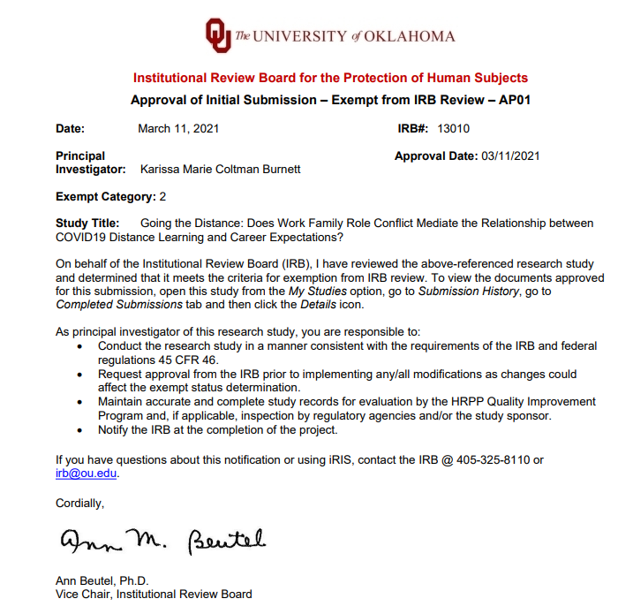

Appendix C: Study Recruitment Material
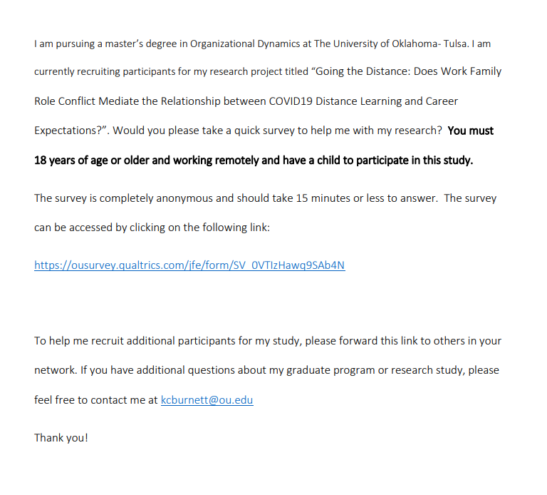

Appendix D: Questionnaire
Demographics I
- Are you 18 years of age or older?
  - No
  - Yes
- Have you worked remotely at least one day in the last month due to the pandemic?
  - No
  - Yes
- Are you the parent/guardian/ primary care giver of at least one child in your household engaged in distance learning for at least one day in the last month?
  - No
  - Yes
- Do you consent to participate in this research?
  - Yes
  - No
- In your typical week, how many hours do you spend working at your worksite versus hours spent working remotely?
  - Number of hours spent working at worksite:
  - Number of hours spent working remotely:

- How old are you?
  - 18-24
  - 25-34
  - 35-44
  - 45-54
  - 55-64
  - 65+
- Gender
  - Male
  - Female
  - Non-binary/third gender
Employment
- What category best describes your current employment status:
  - Not participating in the workforce
  - Unemployed
  - Part-time employed
  - Full-time employed
- Describes COVID’s impact on your employment status in the last 12 months by choosing the most accurate rating. 0-5 (0=Significantly Decreased, 5=Significantly Increased):
  - Quantity of hours worked
  - Quality of hours worked
  - Job responsibilities
  - Salary/wages/ benefits
  - Growth Opportunities
- How many years of career experience do you have in your occupational field?
  - Less than 1 year
  - 1-3 years
  - 4-7 years
  - 8-10 years
  - 11+
- Occupational Industry:
  - Consumer products, services, restaurants, or retail
  - Real estate, housing construction, maintenance
  - Energy, logistics, manufacturing, and transportation
  - Healthcare, pharmaceutical, research
  - Government, education, social services, non-profit
  - IT, finance, insurance, publishing, and professional services
- Below we ask about changes to your work due to distance learning responsibilities. Please choose the most accurate rating based on your experience in the last year. (0=strongly disagree, 5=strongly agree)
  - I have scaled back hours spent at work
  - I have scaled back responsibilities at work
  - I have stepped out of the workforce
Child(ren)’s Learning Mode
- How many children are in your primary care?:
  - One
  - Two
  - Three
  - Four
  - Five
  - Six or more
- How many hours on average do you spend each week attending to distance learning needs for your children? (scale: 0-100 hrs)
- Please indicate the average percent of time that your child(ren) spend(s) in in-person versus distance learning. (0= Fully in-person; 100=Fully Distance Learning)
- Please indicate the average frequency that distance learning responsibilities interfere with work responsibilities. (0= Never; 100= Always)
Family-Work Conflict
Below, we ask you about family-to-work conflict experiences. Choose the most accurate rating for our current situation. (1-7, 1=Strongly disagree to 7=Strongly agree)
Time-based family interference with work
- The time I spend on family responsibilities often interferes with my work responsibilities.
- The time I spend with my family often causes me not to spend time in activities at work that could be helpful to my career.
- I have to miss work activities due to the amount of time I must spend on family responsibilities.
Strain-based family interference with work
- Due to stress at home, I am often preoccupied with family matters at work.
- Because I am often stressed from family responsibilities, I have a hard time concentrating on my work.
- Tension and anxiety from my family life often weakens my ability to do my job.
Behavior-based family interference with work
- The behaviors that work for me at home do not seem to be effective at work.
- Behavior that is effective and necessary for me at home would be counterproductive at work.
- The problem-solving behavior that works for me at home does not seem to be as useful at work.
Career Expectations Scale
Below, we ask you about your career expectations in light of your family responsibilities. Please choose the most accurate rating for your current situation. (1 = strongly disagree, to 5 = strongly agree)
- I believe that I can be promoted to high level positions in the company.
- I can be promoted to my full potential in my company.
- I will not be discriminated against in future promotions in the company due to my family responsibilities.
Intent to Stay
- Which of the following statements most clearly reflects your feelings about your future with this organization in the next year?
- I definitely will not leave
- I probably will not leave
- I am uncertain
- I probably will leave
- I definitely will leave

- How do you feel about leaving this organization?
- I am presently looking and planning to leave
- I am seriously considering leaving in the near future
- I have no feelings about this one way or the other
- As far as I can see ahead, I intend to stay with this organization
- It is very unlikely that I would ever consider leaving this organization

- If you were completely free to choose, would you prefer or not prefer to continue working for this organization?
- Prefer very much to continue working for this organization
- Prefer to work here
- Don't care either way
- Prefer not to work here
- Prefer very much not to continue working for this organization

- How important is it to you personally that you spend your career in this organization rather than some other organization?
- It is of no importance at all
- I have mixed feelings about its importance
- It is of some importance
- It is fairly important
- It is very important for me to spend my career in this organization

Demographics II
- Please describe your ethnicity: choose all that apply
  - African American
  - Asian American
  - Caucasian/ White
  - Hispanic/ Latinx
  - Native American
  - Other than listed
- What is your highest education level:
- Less than high school degree
- High school graduate (high school diploma or equivalent including GED)
- Some college but no degree
- Associates degree in college (2-year)
- Bachelor’s degree in college (4-year)
- Master’s degree
- Doctoral degree
- Professional degree (JD, MD)
- Marital/relationship status
- Never married
- Widowed
- Separated
- Divorced
- Married or co-habitating
- Other

