SOONER HORIZON, Fall 2019
View Static Version

SOONER HORIZON A special collections newsletter for the University of Oklahoma Libraries | Fall 2019 | Vol 7, No 2

THE INDIANS FOR INDIANS RADIO HOUR
Funded by a Recordings at Risk grant from the Council on Library and Information Resources, 400 hours from 152 open-reel tapes have been digitized and are available at repository.ou.edu starting November 14, 2019.
The Indians for Indians radio program was broadcast from the University of Oklahoma’s WNAD radio station from 1941 through the mid-1970s. The show started during the heyday of radio and was enormously popular, with an estimated 75,000 listeners every week. Sac and Fox chief and OU alumnus Don Whistler created the show and invited participants from tribes in Oklahoma, encouraging them to sing or to speak on topics of their choosing. This diversity of expression resulted in an incredible variety of content in the broadcasts and presents an opportunity for listeners to experience American history through a Native American lens.
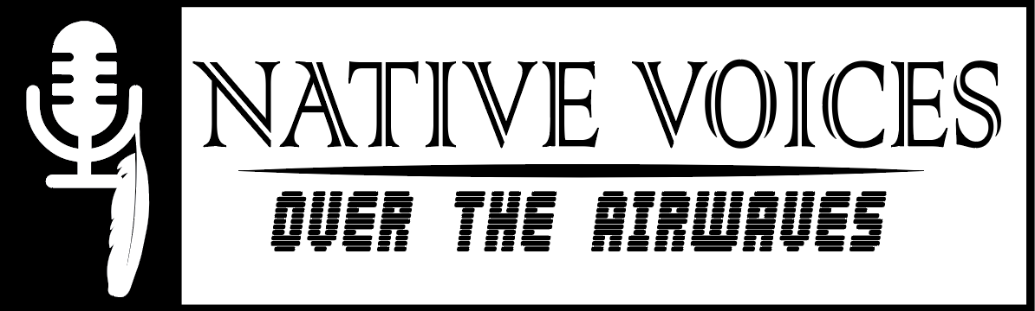
Opening November 14, 2019
To celebrate the improved access to these recordings, OU Libraries will open Native Voices over the Airwaves: The Indians for Indians Hour Radio Show, on November 14, 2019.
Two events are planned in conjunction with the exhibition opening. The events are co-sponsored with the School of Music in the Weitzenhoffer College of Fine Arts, the Department of Native American Studies in the College of Arts and Sciences, and the Native Nations Center, with additional support from the Honors College.
The first event, an opening reception, will be at 2:30 p.m. in Bizzell Memorial Library. Family members of Don Whistler, as well as current Principal Chief of the Sac & Fox Nation, Justin F. Wood, will speak at the reception.
Later that evening, a tribute performance will draw upon the knowledge and talent of eight groups representing tribes or schools who often participated on the original radio show. The 7 p.m. performance will be in the Sharp Concert Hall of the OU Catlett Music Center as a part of the Ruggles Native American Music Series.
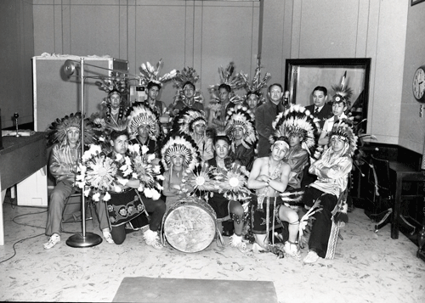
Image courtesy of OU Photographic Service is of a school group, presumed to be students from the Pawnee Indian School, in the WNAD studio (1942). The Pawnee Indian School was the first school group to perform on the show, returning multiple times.
Native Voices over the Airwaves will remain on display in the Bizzell Memorial Library through August 3, 2020.
A corresponding exhibition, The Indians for Indians Radio Show: Sports and Recreation is on display in the Western History Collections Reading Room, Monnet Hall, through January 3, 2020.
Left: Moses J. Yellowhorse (Pawnee) in Pittsburgh Pirates baseball uniform in 1922. | Right: Rex Whistler, brother of Don Whistler. Rex played football under Coach Benny Owen.
Learn more about Native Voices Over the Airwaves
___________________________________________

History of Science Collections Joins National Consortium
The OU History of Science Collections and academic department have joined the national Consortium for History of Science, Technology, and Medicine, an organization founded in 2007 that helps make their member institutions’ collections and scholarly resources more broadly available for global research. It promotes public and academic understanding, awards fellowships for researchers, produces public and academic events, and provides online resources for teaching, learning and research.
Learn more about the opportunities this membership creates
___________________________________________

J. Rud Nielsen Papers and Slides Open for Research
OU Libraries recently completed a grant-funded project to process a collection of the physicist Jens Rud Nielsen’s papers and slides. The grant awarded by the Center for History of Physics, American Institute of Physics, makes accessible this collection housed within the History of Science Collections.
The collection contains Nielsen’s research and teaching papers, along with 50 illustration printing blocks and over 1,000 glass lantern slides that depict physics principles and research results.
Nielsen emigrated from Denmark to the U.S. in 1922, and was recruited to OU in 1924 to found a research program in physics.
During his 41-year tenure at OU, he taught theoretical physics and became an authority on using Raman spectroscopy to study molecular structure.
His papers document his research efforts, such as his WWII-era work on analyzing compounds used in the petroleum and chemical industries. The papers also include manuscripts produced for his post-retirement project translating and editing the works of Nobel-prize winning physicist, Niels Bohr.
Processing the 25-foot collection took place over a 3-month period. It required identification of Nielsen’s original hand-labeled office files and texts written in English, Danish, and German. The fragile glass slides posed the project’s biggest challenge. Formerly stacked in cardboard boxes, the slides were dusty, unorganized, and in danger of breaking. Project staff transcribed data from their original paper labels and arranged them in acid-free slide boxes for safe, permanent storage
"Many visitors enjoy the Physics Instrument Collection on display in the lobby of the 5th floor special collections, which contains instruments used by Jens Rud Nielsen. Yet to date, no one has been able to study Nielsen’s papers. We thank the AIP for their grant to make the Nielsen papers available. We are confident, as are they, that this archive will be of great interest to researchers and the public.” -Kerry Magruder, History of Science Collections curator
“Working with the J. Rud Nielsen papers has been both interesting and exciting. The collection includes a variety of materials and subjects that allowed me to build on my graduate school education with the practical experience of physically processing a collection.” - Dewayna York, a graduate assistant in the OU Libraries special collections processing unit
The collection’s finding aid is now available.
___________________________________________

U.S.-China Poetry Dialogue
Under the direction of curator Jonathan Stalling, who also serves as professor of International and Area Studies and as the Harold J. and Ruth Newman Chair and Co-Director of the Institute for U.S.-China Issues, OU Libraries' Chinese Literature Translation Archive continues to serve as a nexus of cross-cultural discussion.
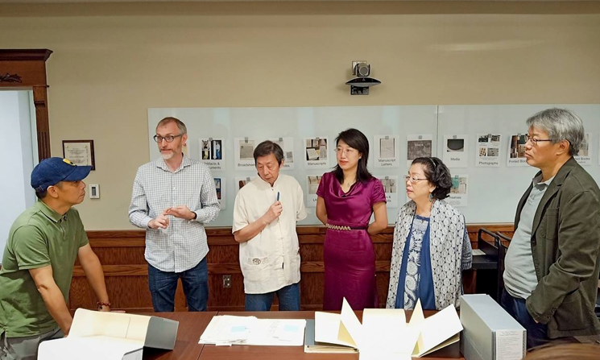
Photo of the U.S.-China Poetry Dialogue delegation exploring the Howard Goldbatt Archive, 5th floor, Bizzell Memorial Library.
Each year, the U.S.-China Poetry Dialogue brings together Chinese and American poets for a week of public conversations, readings and workshops. Sponsored by OU’s Institute for US-China Issues and the Harold J. and Ruth Newman Chair of U.S.-China Issues, the China Poetry Institute and Beijing University, the U.S.-China Poetry Dialogue seeks to foster cross-cultural understanding through the public humanities.
“The US-China Poetry Dialogue was created in the belief that U.S.-China relations cannot be built upon business and policy transactions alone. Rather, we must draw on our shared experiences of what matters most to us, and be cognizant of what could be lost. Literature, especially poetry, can give us insight into the future of our relationship, one that flickers into view in the partial light of our hopes and fears. Poetry has been and remains a vibrant force in both China and the U.S. and provides both nations with a shared cultural space, a public square within which people can share and contest ideas but also find the quiet, personal moments that form the foundation of human flourishing.” - Jonathan Stalling, curator of the OU Libraries Chinese Literature Translation Archive
The biennial U.S.-China Poetry Dialogues explore the unique history of U.S.-China relations specific to each location. The first locale, Kansas City, Missouri, is the home of the Nelson-Atkins Museum of Art, which holds one of the largest and most significant collections of Chinese art anywhere in the U.S. It is also the home of Edgar Snow, the first Western journalist to meet Chairman Mao, and an important early proponent in establishing U.S.-China friendship in the 20th century. Kansas City is also the sister city of Xi’an, the birthplace of China, and of Yan’an, the birthplace of the modern Chinese nation.
The second dialogue location in Norman, focuses on the OU-affiliated programs which create a national hub for Chinese public humanities. OU is home to not only the Institute for US-China Issues, but also the US-China Poetry Dialogue, the Newman Prize for Chinese Literature, the Newman Award for English Jueju, the Chinese Literature Translation Archive and Chinese Literature Today, a leading journal and book series dedicated to bringing Chinese literary culture to the English-speaking world.
Among the events for the second dialogue location at OU, attendees toured the Chinese Literature Translation Archive where the visiting poet Shu Ting has an archive of her work. After visiting materials associated with her career and those of her generation of Chinese poets, the delegation explored the Mo Yan archive on the fourth and fifth floors.
The third and final locale, Northwest Arkansas, has arguably played the largest — although largely unacknowledged — role in modern U.S.-China relations as the home of Walmart, the leading company that shaped the U.S.-China economic relationship into what it is today. This year, the Dialogue will inaugurate a new poetry sister-city relationship between Eureka Springs, Arkansas, and Jinhua City in Zhejiang Province, celebrating their important roles in Chinese and American poetry.
Learn more about the U.S.-China Poetry Dialogue
___________________________________________

COMMUNITY ENGAGEMENT THROUGH EXHIBITIONS
This summer marked the 50th anniversary of Apollo 11, the first manned mission to land on the Moon. OU Libraries launched two pop-up exhibits to mark the occasion.
In November, the Western History Collection's exhibition, Red Dust Oklahoma: A Poetic History, travels to the Cherokee Strip Regional Heritage Center for display.

Celebrating the anniversary of the Apollo 11 Moon landing
"Bizz Lightyear" greeted visitors to the Bizzell Memorial Library. The Extra-Vehicular Mobility Unit (EMU) space suit is a teaching replica on loan to the History of Science Collections by the Educational Resource Center (ERC) of the NASA Oklahoma Space Grant Consortium (OSGC). With an EMU suit, aspiring astronauts can examine the features designed to protect those working outside the International Space Station.
Bizz Lightyear has generated a lot of buzz. From a social media contest during the start of the fall semester and from everyday visitors alike, the space suit has inspired several selfies and sparked conversations.
In July 2019, an exhibit documented three Sooner alumni involved in the Apollo 11 mission.
Apollo 11: The Dream, the Mission, and the Sooners Involved highlighted the contributions of Mareta West (class on 1937), Jerry C. "High Eagle" Elliot (class of 1966), and Captain Fred Haise (class of 1959).
Mareta N. West, the first female astrogeologist and only woman on the Geology Experiment Team for the Apollo 11 lunar landing, selected the exact landing site of the Lunar Lander on the Sea of Tranquility, the location humankind’s first step on another world.
Prior to serving as the Flight Dynamics Retrofire Officer for the Apollo Program and calculating the flight paths of humankind’s journeys to the Moon, Jerry C. Elliot (Osage-Cherokee) was the first Native American student to receive a physics degree from OU. Elliot served NASA for over 50 years as a Flight Mission Operations Engineer, Physicist and currently serves as Senior Technical Manager, Management Integration Office of the Space Station Program Office and has been awarded the Presidential Medal of Freedom.
Before serving as Lunar Module Pilot on the ill-fated Apollo 13 mission in April 1970, Fred Haise was back-up for both Apollo 8 and Apollo 11. Haise served as a fighter pilot in both the U.S. Marine Corps and Oklahoma Air National Guard before joining NASA as a research pilot in 1959. He became an astronaut in 1966. Haise was inducted into the Oklahoma Aviation and Space Hall of Fame in 2001.
On the 5th floor of Bizzell, the History of Science Collections celebrated the Apollo 11 anniversary with various memorabilia, including works that advocated space travel even before it became a reality, such as Arthur C. Clarke’s The Exploration of Space, Willy Ley’s Rockets and Space Travel, or the children’s book You Will Go to the Moon. Casting a broader net, beautiful Soviet space postcards by Aleksei Arkhipovich Leonov, printed in 1968, testify to the aspirations of all humanity to travel to the Moon and beyond.
Leonov is both an artist and a cosmonaut, who commanded the Soyuz capsule that docked with an Apollo module in 1975.
A little girl’s cosmonaut doll reminds us that the Soviet program included female astronauts from an early period.
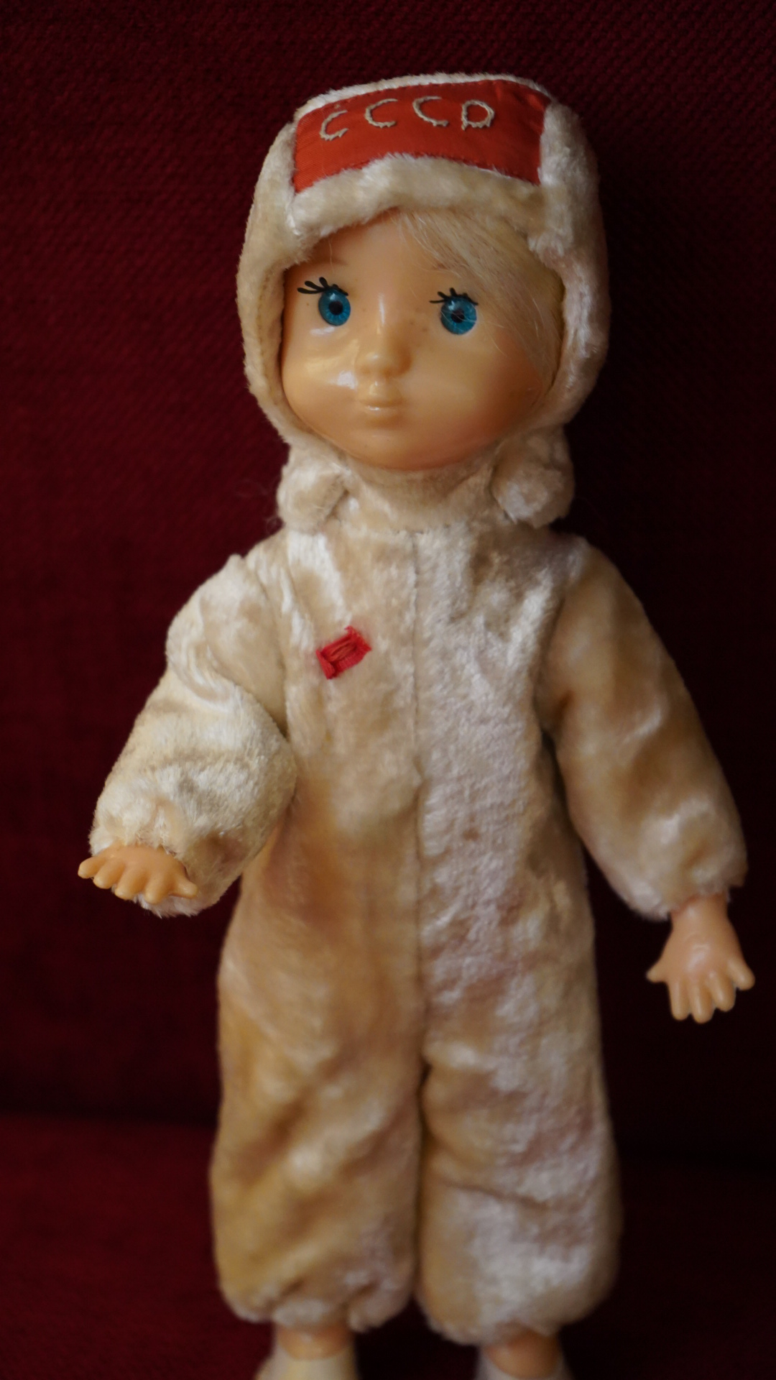
___________________________________________

"Red Dust Oklahoma: A Poetic History" travels to the Cherokee Strip Regional Heritage Center (CSRHC)
Red Dust Oklahoma explores the evolution of poetry in Oklahoma from pre-statehood to 1941. Co-curated by Todd Fuller and Crag Hill, the exhibition was displayed in the Western History Collections Reading Room from October 9, 2018 to August 1, 2019.
“We are excited to be the first host of the ‘Red Dust’ exhibition from the Western History Collections. The exhibition is unique in style and presentation, as it features both prominent and lesser-known Oklahoma poets, several of whom are from the historic Cherokee Strip. We hope to draw attention to the many poets who were not poets by trade but rather as a form of self-expression. Their works helped shape the literary landscape of Oklahoma and provided beautiful and breathtaking insights to everyday life on the plains." - Amy Johnson, curator of the Cherokee Strip Regional Heritage Center (CSRHC)
A few of the poets featured in the exhibition include John Rollin Ridge (Cherokee), Alex Posey (Muscogee Creek), Lynn Riggs (Cherokee), Muna Lee, Winnie Lewis Gravitt (Choctaw), Murine Halliburton McGee, Florence Cobb, Daisey Lemon Coldiron, as well as OU luminaries Charles Gould, Edward Everett Dale, Kenneth Kaufman, John McClure, and Walter Campbell (aka Stanley Vestal).
The exhibition is structured around six categories: Oil, Energy & Environment, University of Oklahoma’s Literary Renascence, Landscape/s & Frontier/s, Love & Nature, War, and Indigenous Perspectives.
The exhibition opens in the CSRHC in Enid, OK, on November 19, 2019 through January 18, 2020.
Learn more about "Red Dust" at CSRHC
___________________________________________

BUILDING ON EXCELLENCE
OU Libraries is building on excellence in special collections through cross-disciplinary collecting initiatives in the history of geology, contemporary Native and Indigenous authors, as well as ongoing work for the American School Archive and project.

The William Murphy Collection, American School of Architecture Archive
The American School project, a collaboration between OU Libraries and the Christopher C. Gibbs College of Architecture, continues to gather collections related to Oklahoma’s distinctive contribution to architectural teaching and practice in the post-WWII era. The most recent donation is from the architect William Murphy, who contributed correspondence and drawings to the archive.
Beginning with Bruce Goff’s arrival on campus in 1947, OU architecture faculty led a pedagogical shift that made them renegades in the field. These professors developed a curriculum that emphasized individual creativity, organic forms, and experimentation. This radical approach to design drew students to Oklahoma from as far away as Japan and South America and later spread the American School influence to professional practices around the world.
The next opportunity to engage with the American School will be through the exhibition, Renegades: Bruce Goff and the American School of Architecture, at the Fred Jones Jr. Museum of Art opening January 24, 2020 on display through April 5, 2020. The show features more than 50 items on loan from the libraries’ American School archive. Also in January 2020, the OU Press will release Renegades: Bruce Goff and the American School of Architecture, edited by OU architecture faculty Stephanie Pilat, Luca Guido and Angela Person. The book is a heavily illustrated collection of essays that examine the history, legacy, and ongoing impact of OU’s architectural innovation.
___________________________________________

Martin J. S. Rudwick papers added to History of Geology Archive
This past summer, History of Science Collections curator Kerry Magruder worked side-by-side with Martin Rudwick to review folders in file cabinets and file boxes on bookcases, selecting relevant papers and correspondence, eventually packing up 35 boxes for shipment to Oklahoma.
Over the last half-century, Martin Rudwick made pioneering contributions to the history of geological mapping, visual illustrations, the social construction of geology, and the rise of geohistory. Rudwick’s numerous books and articles remain points of departure for current research. Earth’s Deep History along with a richly-illustrated, two-volume sequence, Bursting the Limits of Time and Worlds Before Adam substantially revise earlier studies and are now the standard account of how geologists in the 18th and 19th centuries developed a sense of geohistory.
Rudwick is a member of the British Academy and the recipient of numerous awards for lifetime achievement in the history of geology, including the Sue Tyler Friedman Medal of the Geological Society of London, the Mary C. Rabbitt History of Geology Award of the Geological Society of America, the Prix Wegmann of the Société Géologique de France, and the Tikhomirov Medal of the International Union of Geological Sciences.
Rudwick’s papers are being processed by Aja Tolman, a doctoral student in the history of geology.
Alongside Rudwick's papers, the History of Geology Archive in the History of Science Collections includes the papers of David B. Kitts, Alexander Ospovat, Kenneth L. Taylor, Léo Laporte, and Hugh Torrens.
Torrens’ papers were featured in the March 2019 issue of Sooner Horizon. Taylor’s papers, coming next year, focus on the earth sciences in France and science in the Enlightenment. The papers of Kitts, an OU professor of geology and the history of science, span the topics of the history of geology, the philosophy of geology, and the work of Charles Darwin. The papers of Ospovat, an OU history of science alumnus and Oklahoma State University professor, largely deal with A. G. Werner, the most influential 18th century German geologist. Léo Laporte’s papers concern George Gaylord Simpson, a towering figure in early 20th century paleontology.
The larger History of Geology Archive now complements the strong print holdings of the History of Science Collections in geology and solidifies OU’s attraction as a research destination for scholars in the field.
___________________________________________

Contemporary Native and Indigenous Authors Collection launches in the Western History Collections
This new collecting effort brings the Western History Collections forward in time and increases the collections' representation of human voices writing about the West. By seeking out the papers of Native and Indigenous authors, scholars, activists, and other creative individuals whose perspectives and knowledge will deepen and broaden narratives of the American West, the project begins the process of creating an inclusive archive. Establishing the Contemporary Native and Indigenous Authors Collection will allow the WHC to assist authors and tribal nations in their efforts to preserve legacies of sovereignty, culture, history, creativity, and scholarship.
This acquisitions initiative centers on:
- Reexamining the dominant narratives of the American West by identifying underrepresented perspectives, including those of Native authors.
- Establishing collaborations with individuals and organizations that seek to celebrate Native and Indigenous creative expressions and intellectual pursuits.
- Creating dialogues with Native and Indigenous authors, scholars, and others that will result in the WHC preserving individual and cultural legacies for future research.
- Raising awareness about Native and Indigenous authors and their work through programming, including lectures, exhibitions, publications, presentations, traveling classrooms, and via the web.
- Serving as an inclusive research destination for scholars, researchers, students, and tribal citizens for inquiry about Native and Indigenous creative expression.
- Developing a space that provides visual acknowledgement of multiple narratives, including Native narratives and histories.
The first acquisition of this new collecting initiative is the acquisition of the archive of LeAnne Howe.
___________________________________________

RECENT ACQUISITIONS: WHC

LeAnne Howe Collection
LeAnne Howe (Choctaw) is an award-winning author of fiction, drama, poetry, and creative non-fiction. Howe recently donated her archive to establish the Contemporary Native and Indigenous Authors Collection within the Western History Collections, and marks a significant advancement towards our goal of becoming a research destination for scholars, writers, and students who want to study Native and Indigenous literature.
"What a momentous event, for the Western History Collections to acquire the papers of one of the outstanding southeastern Native literary figures, LeAnne Howe." - Joy Harjo (Muskogee Creek), 2019 U.S. Poet Laureate
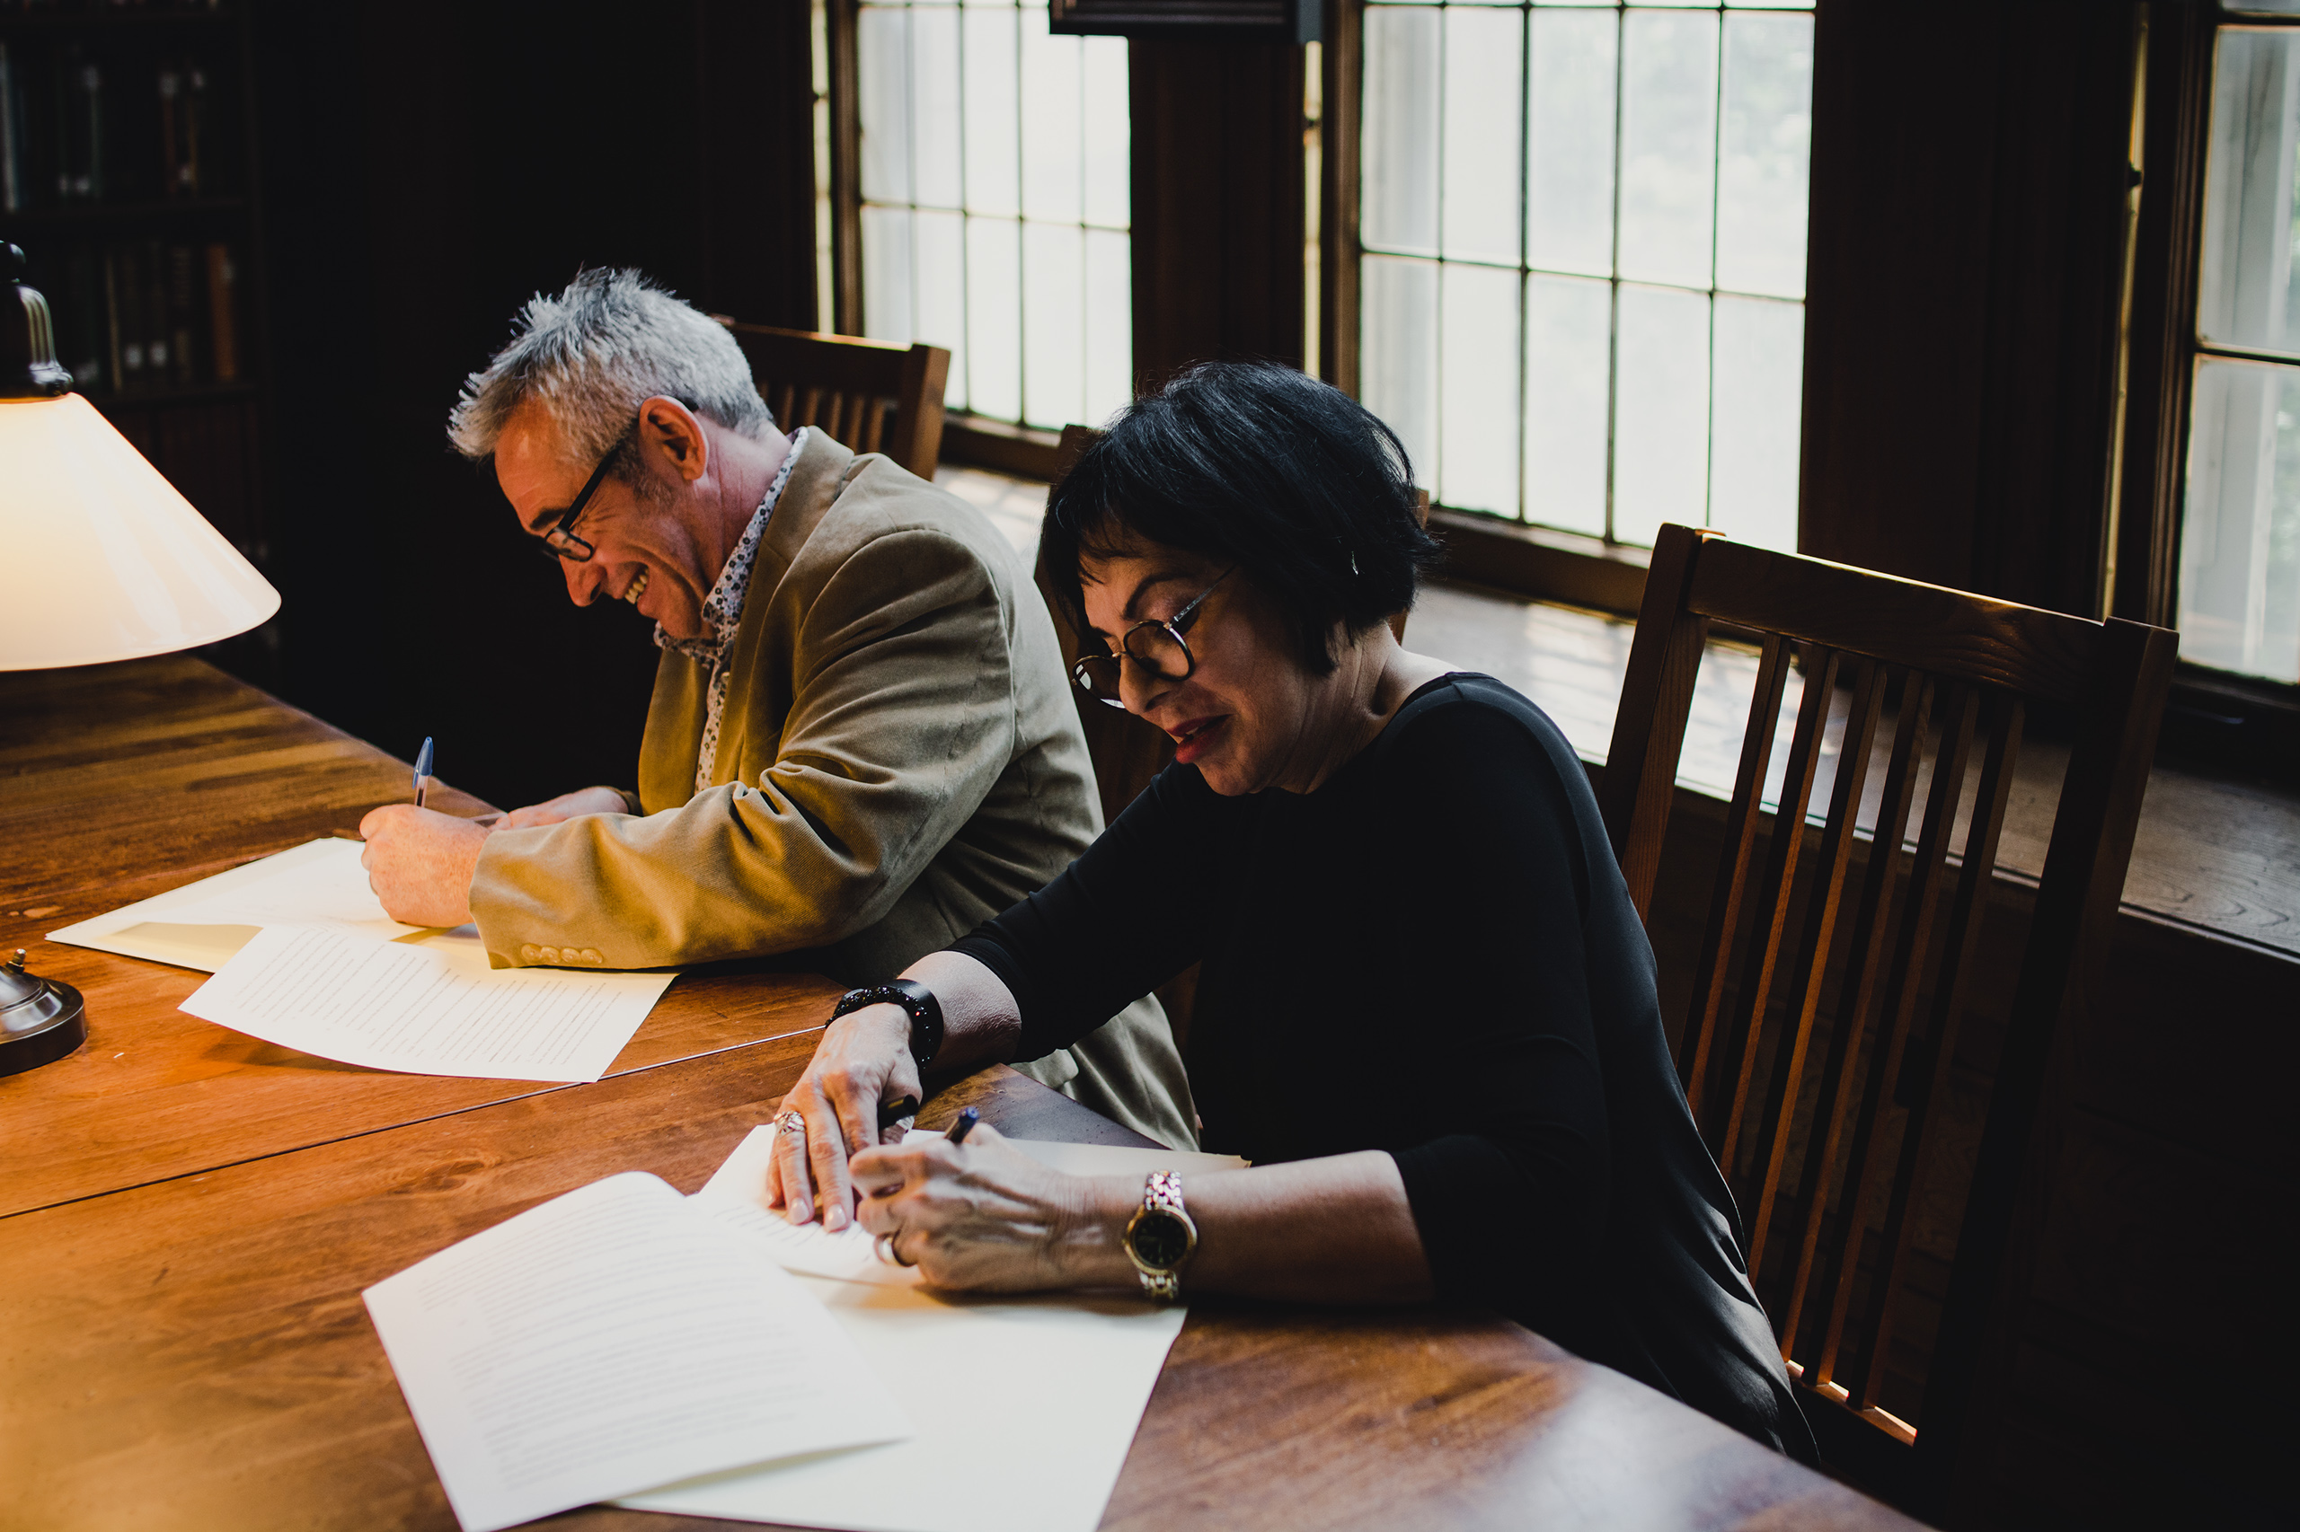
"I am deeply honored for my archive to be at the Western History Collections in Norman where the papers of so many influential Choctaws such as Peter Pitchlynn, Ben H. Dwight, and Muriel Wright are housed." - LeAnne Howe
The LeAnne Howe Collection includes materials from Howe’s time as a journalist in the Dallas metro, original manuscripts (and drafts) of poetry collections, novels, and plays, correspondence with publishers and other authors, and other ephemera.
___________________________________________

The George Henderson Collection
George Henderson, Ph.D., a noted OU educator and activist, recently donated a portion of his papers to OU Libraries’ Western History Collections. The donation represents the largest gift by an African-American scholar, educator, and activist to the University’s archives.
The George Henderson Collection will provide scholars and students the opportunity to examine intersectionalities of race, higher education, activism and service spanning more than 40 years of Henderson’s career. Collection highlights include a significant contribution of Henderson’s papers, including materials associated with the impact of OU’s Human Relations department, many of his research publications, documentation of his activism, as well as evidence of many honors and awards.
"Throughout my professional life, I have been an advocate of social justice, specifically in communities that have a great number of marginalized people,” said Henderson. “It is my hope that the fragments of my life that will be in the University’s Western History Collections will be of some use to scholars, students and the general public – the major sources of my community activism, research, writing and teaching. Each of those sources have interdependently informed the other. The materials in the collection provide insight into my personal journey as a special education student in elementary school in East Chicago and Indiana, to a doctorate in educational sociology at Wayne State University in Detroit, Michigan; from poverty to affluence; from racial segregation to racial integration; and from hate to love in black-white relations" - Dr. George Henderson
The collection includes correspondence with students, professors, civil rights leaders, legislators, and human relations professionals, journal article publications, numerous certificates and lifetime achievement awards, extensive photos of classes, conferences, professional organizations, and OU Department of Human Relations archives, including curricula, faculty appointments, budgets and other ephemera.
The Henderson Collection is being processed and is planned to be available for researchers by spring 2020.
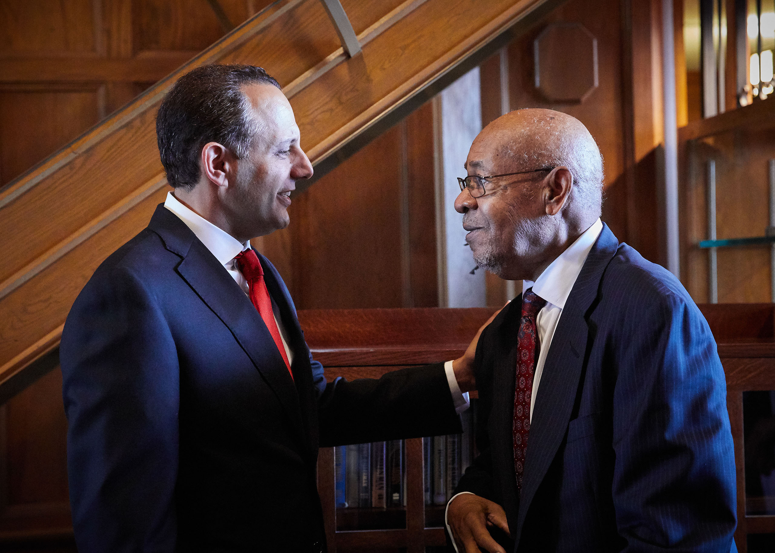
A dedication for the collection, led by President Harroz, was held on September 23, 2019 in the Western History Collections Reading Room.
Read more about the Henderson Collection
___________________________________________

RECENT ACQUISITIONS: HOS

Gunter Quadrant
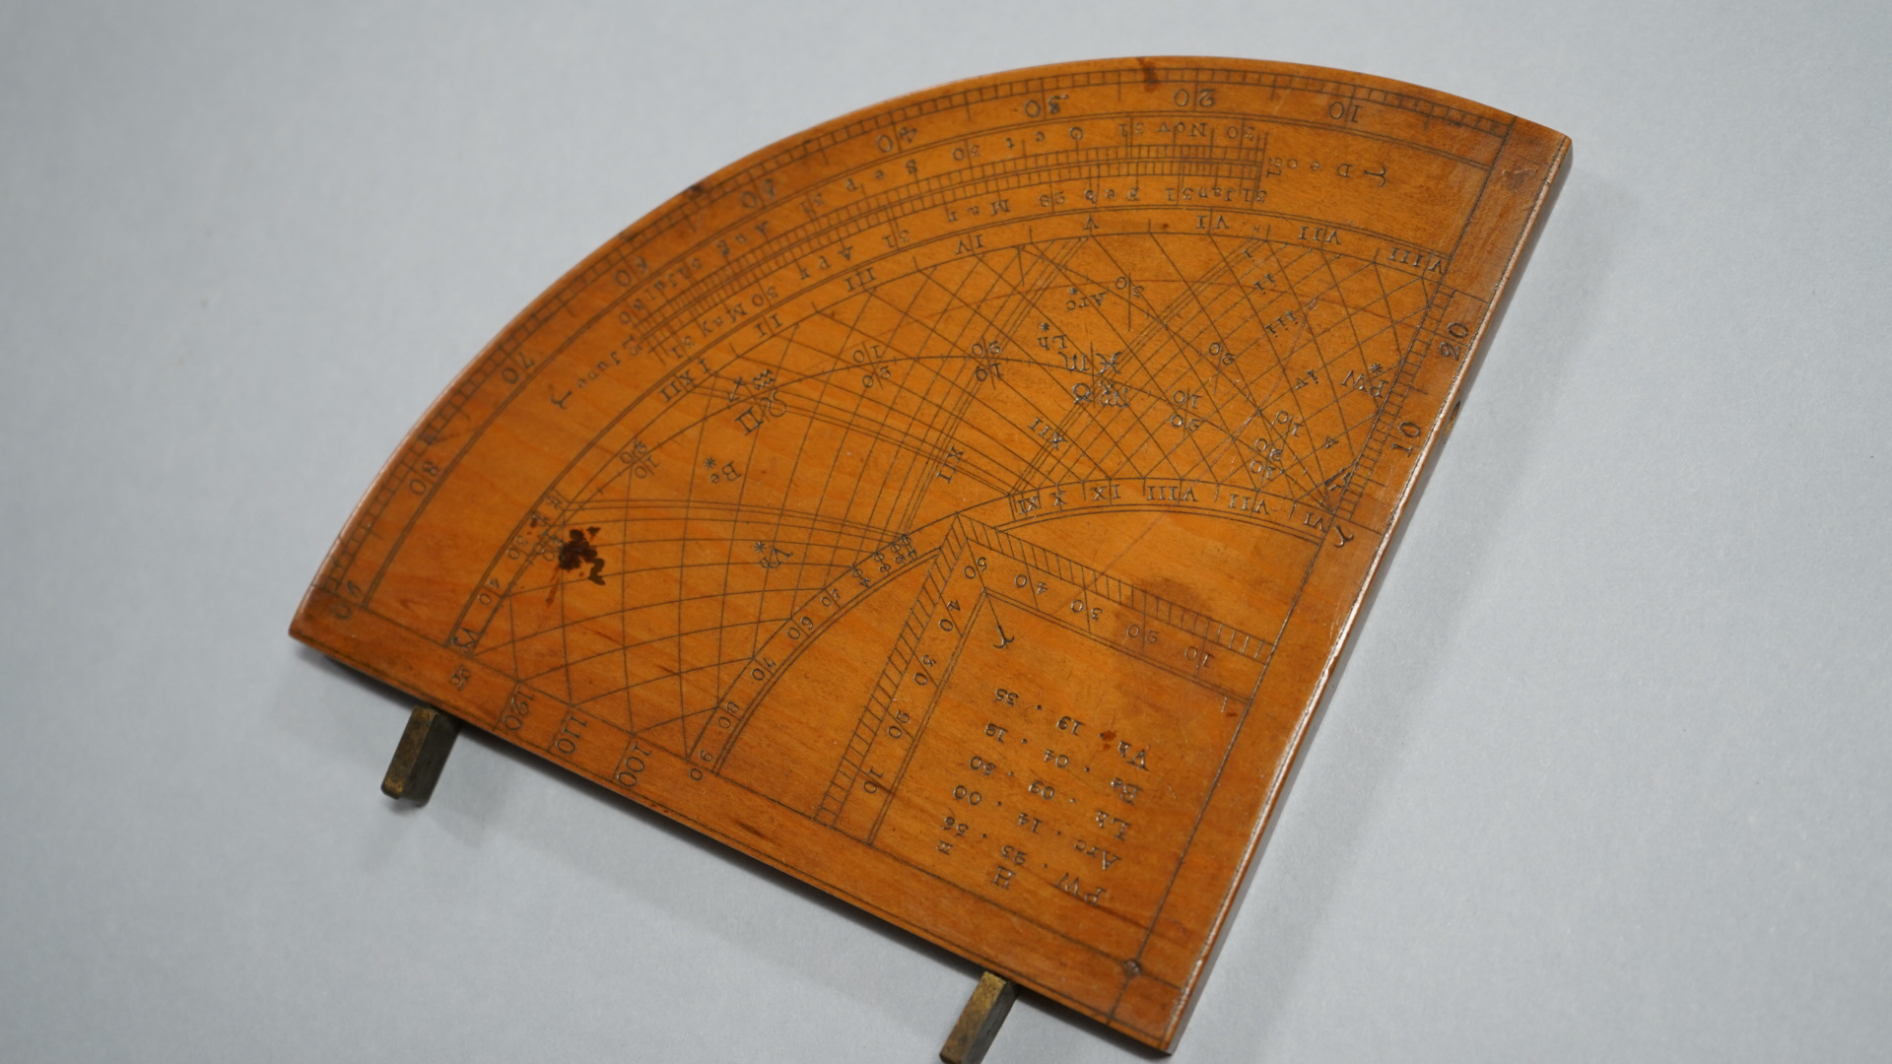
A Gunter quadrant is the latest addition to the instrument collection of the History of Science Collections.
The Gunter quadrant, invented by Edmund Gunter in 1623, is inscribed with projections of the tropics, the equator, the horizon, and the annual path of the Sun or ecliptic. This instrument, made in England in the late 17th century, is constructed of boxwood, with two brass pinhole sights that allow greater precision. With this quadrant, and with reference to companion tables, one may determine the day of the month, the hour of the night, the length of day and night, the time of sunrise and sunset, and the heights of distant towers, buildings or natural features.
A surveyor might use a quadrant to determine the altitude of the Sun or the height of a tall building. An astronomer might use a quadrant or a sextant to measure the distance between a planet and a notable bright star, or the altitude of a star above the horizon. A quadrant measures up to 90° angular separation (one fourth or quadrant of a circle), while a sextant measures up to 60° (one sixth of a circle). Quadrants and sextants might be portable enough to carry outside, or monumental constructions affixed to a wall, mounted on a roof, or permanently anchored in an outdoor observatory.
Our small, but growing, collection of astronomical observing instruments is used in support of university programs in the history of science, astronomy, and science education, as well as the new graduate certificate program in archaeoastronomy.
___________________________________________

SCHOLARLY IMPACT
OU Libraries special collections serve scholars who then amplify the academic significance of the collections through citations and interactions with colleagues and students. As important, are the relationships made between visiting scholars with resident professors, students, and library personnel. The following section describes a few such instances of visiting scholars' use of the collections and the academic impact that follows.

Visiting Scholars to the Chinese Literature Translation Archive
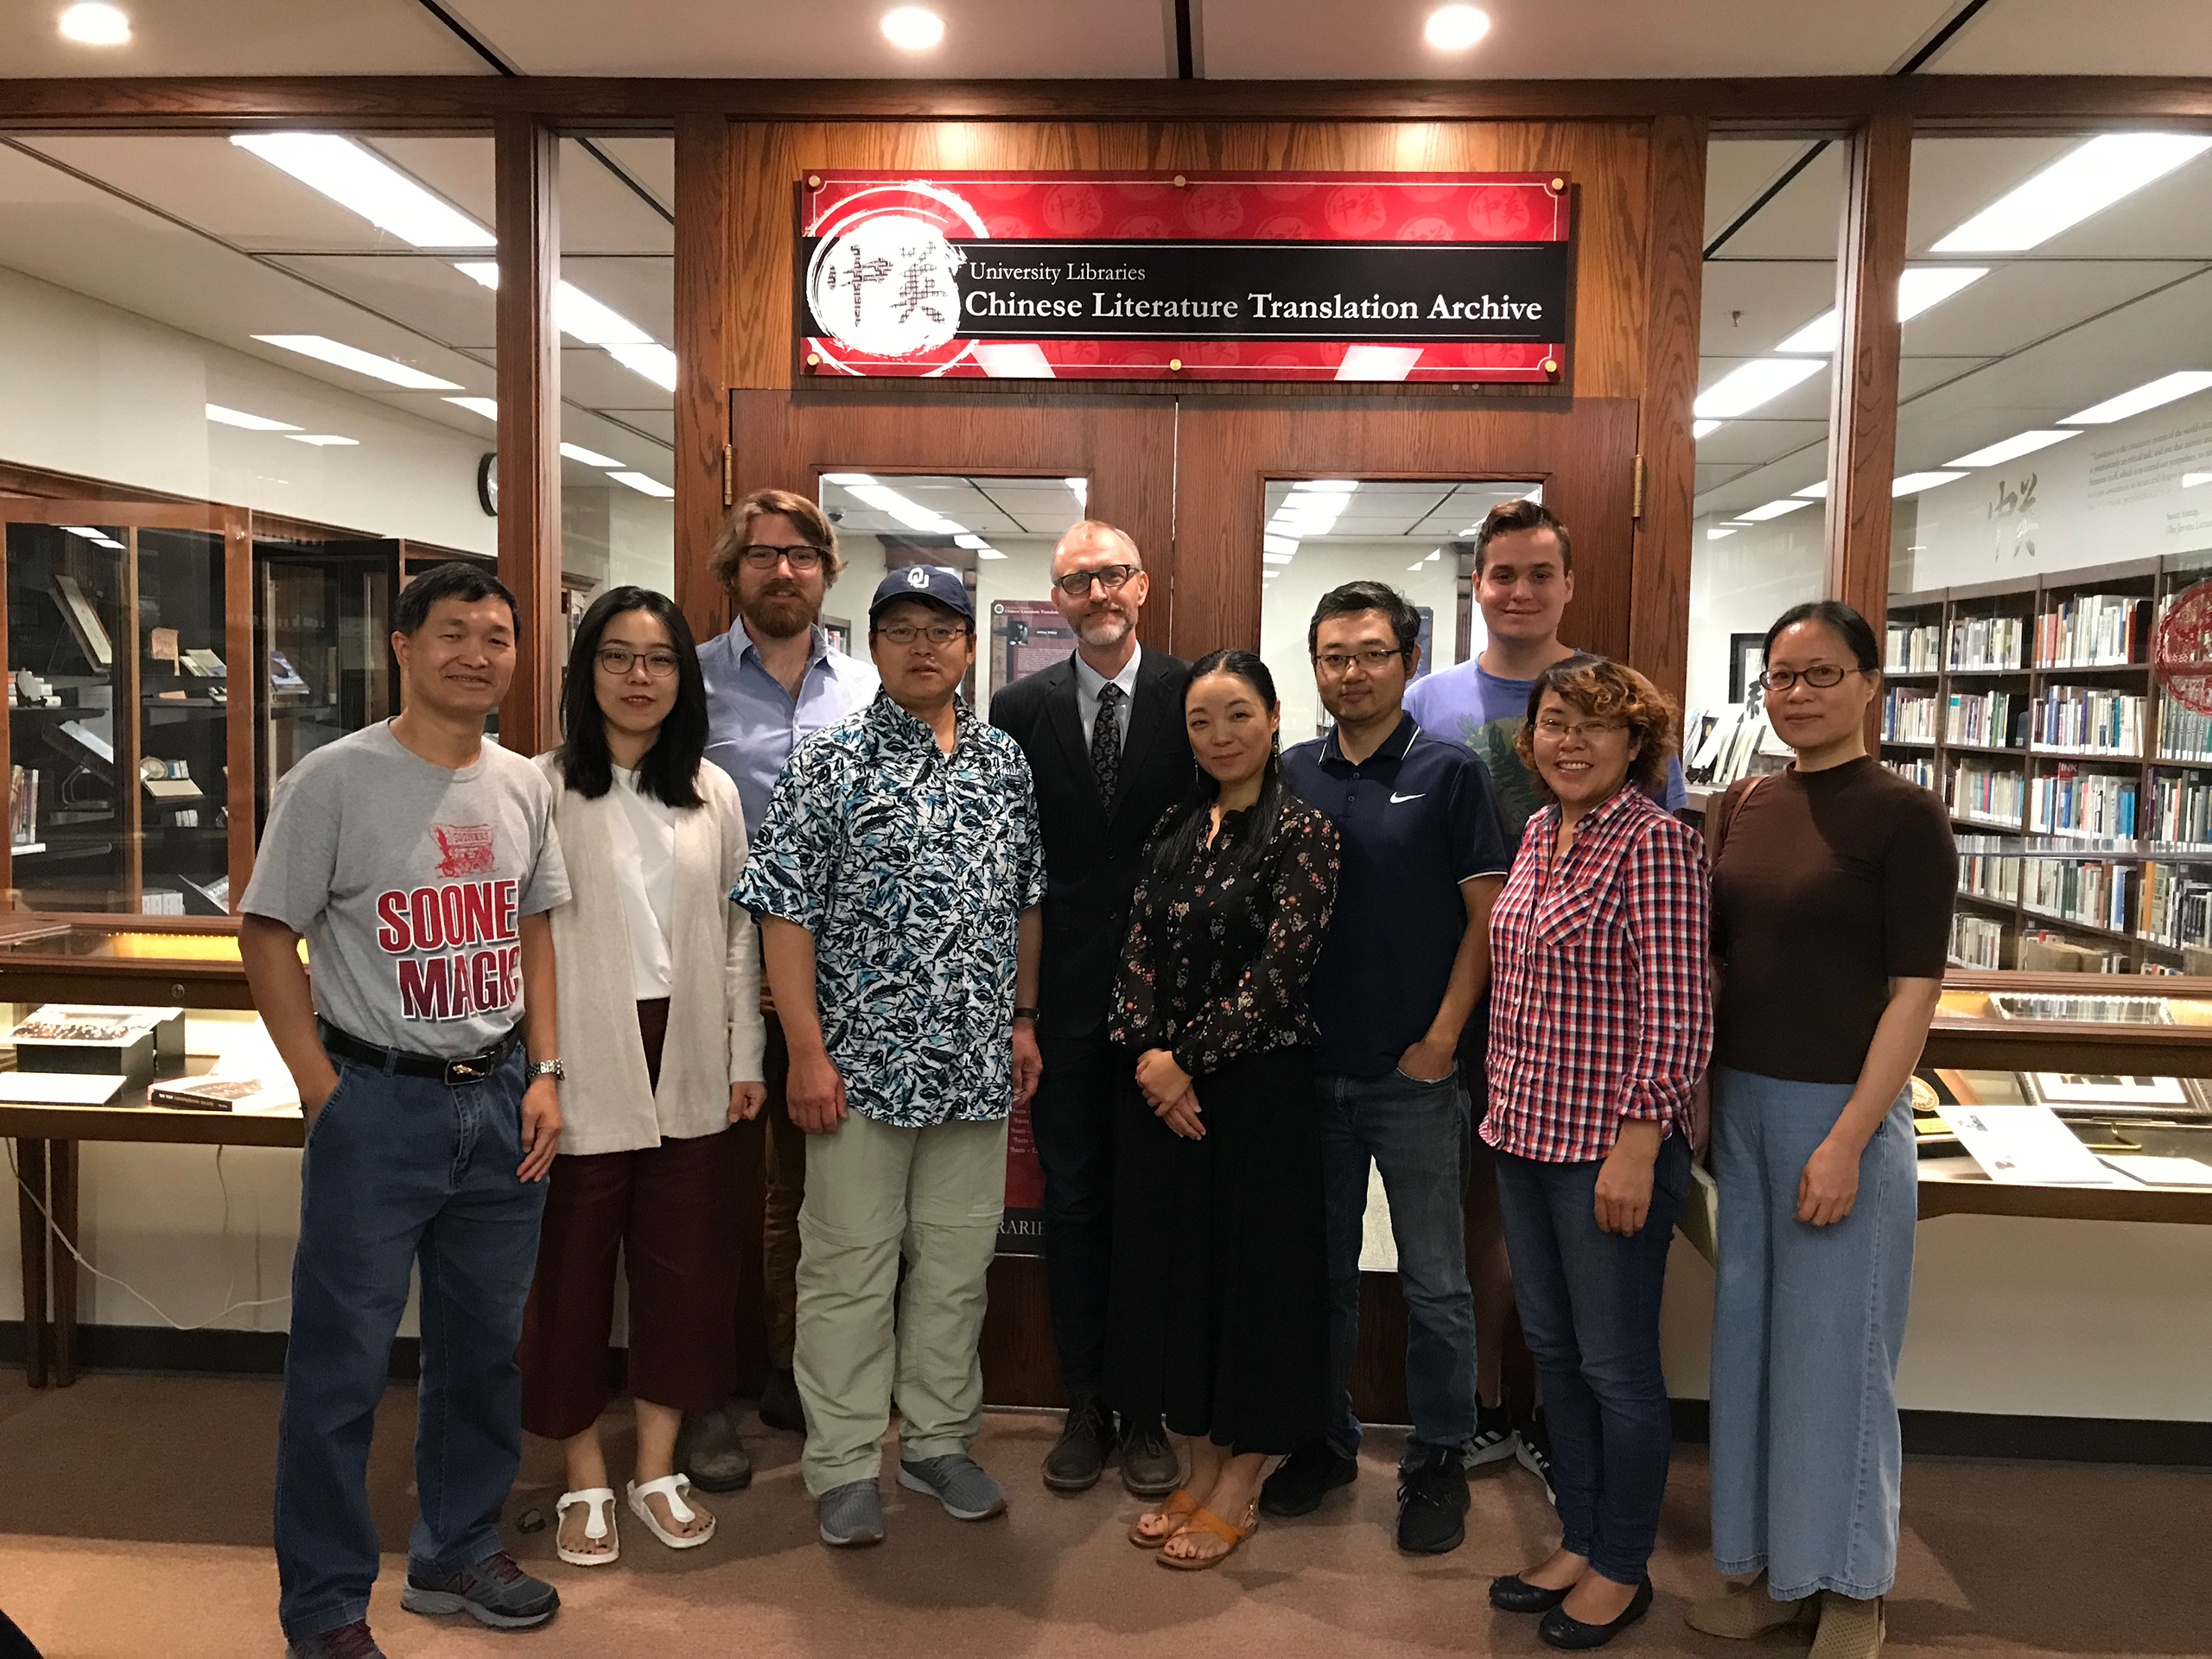
The Chinese Literature Translation Archive hosted five visiting scholars this year.
They include: Gou Limei, associate professor at Lanzhou University of Arts and Science, Jia Ying, a Ph.D. candidate at Beijing Normal University, Zhang Fan, a Ph.D. student at Shanghai Jiao Tong University, Dr. Zhu Xiaomin, associate professor from Peking University, and currently in residence, Xuanming Lu, a Ph.D. candidate from the University of Hong Kong.
"The materials in Howard Goldblatt Collection are abundant. Letters between Goldblatt, authors, literary agents and publishers, drafts of translations, etc. uncover what was behind published translations, which accounts for certain textual phenomena of translations and enlighten us about translation studies. The trip to Norman, despite the short term, was invaluable to my academic career." - Xuanming Lu
___________________________________________

Mellon Fellows: Visiting Scholars to the History of Science Collections
Cosponsored by History of Science Collections and the Department of the History of Science, and funded by the Andrew Mellon Foundation, the Mellon Program at OU provides short-term fellowships to enable researchers to visit the History of Science Collections. During spring and summer this year, OU Libraries hosted three visiting scholars as Fellows of the Mellon Program.
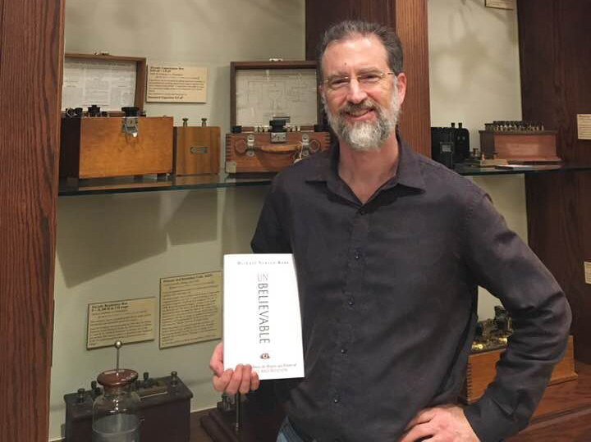
Mike Keas, a lecturer in history and philosophy of science at Biola University, California is pictured with his book, which he donated to the collections.
Dr. Mike Keas is an alumnus of the OU Department of the History of Science. He visited the History of Science Collections in February 2019 to conduct research in support of his book project Incredible: 10 Myths about Science and Religion from Newton to Hawking, a planned sequel to his 2019 book Unbelievable: 7 Myths About the History and Future of Science and Religion.
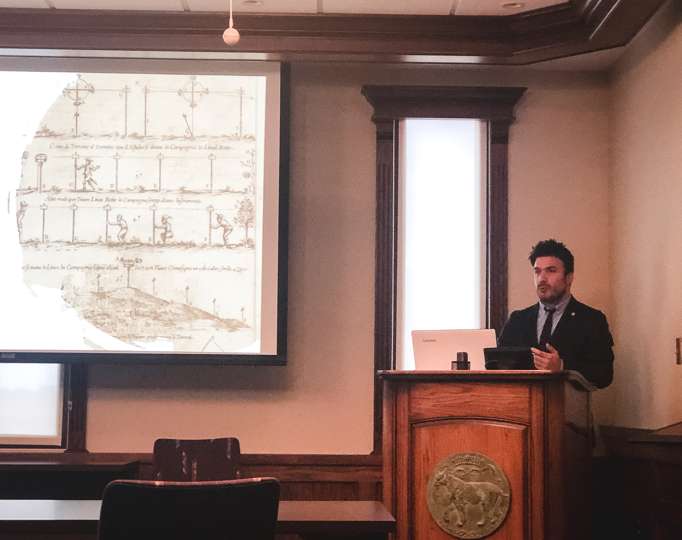
David Solomoni, researcher at Università degli Studi Roma Tre in Rome, Italy, was awarded a Mellow Fellowship for his project, “Teaching of Science and Catholic Education in Early Modern Europe.”
Dr. David Salomoni spent several weeks working in the collections in May 2019 on his project “Religious Orders and their Schools in Early Modern Italy (16th-18th century).” Although he arrived in the summer, Salomoni was able to meet and interact with many faculty members and students from History of Science and other departments. His visit culminated with a presentation on his research at a brown bag held in the collections.
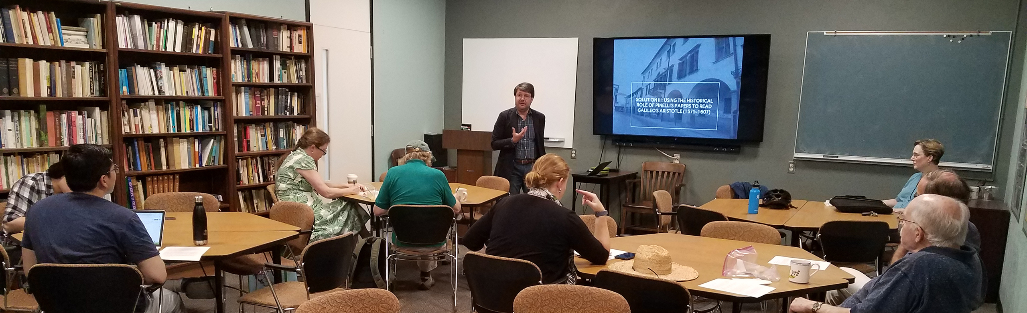
Stefano Gulizia, fellow at New Europe College in Bucharest, was awarded a Mellon Fellowship for his project “Galileo's People: Mapping Scientific Networks and Reading Practices in Early Modern Italy.”
Dr. Stefano Gulizia visited from August through September 2019, conducting research on his project “Galileo's People: Mapping Scientific Networks and Reading Practices in Early Modern Italy.” Gulizia presented his research at a brown bag in the History of Science Department.
___________________________________________

Visiting Scholars to the Western History Collections
Five emerging scholars were selected from three competitive fellowship offerings to study within the Western History Collections over the summer.
The Masterson Fellowship, endowed by Conrad and Ellen Masterson of Cee Vee, TX, provides opportunities for visiting scholars to conduct research in the Western History Collections for up to three months. The fellowship is open to advanced graduate students, faculty or independent scholars whose original scholarly research will benefit directly from the materials held in OU’s Western History Collections. The Masterson Fellowship has been awarded to two recipients for summer 2019.
Megan Baker from the University of California, Los Angeles, for her project, “Oklahoman Progress: Development and Choctaw Land in Southeastern Oklahoma,”
Cecily Zander from Pennsylvania State University for “Agents of Empire: The U.S. Army, Native Americans, and the Civil War in the Making of the American West.”
The Jack Haley Fellowship, endowed by Fred and Patricia Schonwald of Oklahoma City, provides fellowships for graduate students in the Department of History in the OU College of Arts and Sciences. The two recipients of the summer 2019 Jack Haley fellowship are:
Leroy Myers for “Other Indians and Freedmen: the Legacy of Black Migration in Oklahoma, 1840-1921.”
Mark Boxell for “Petroleum’s Frontier: Oklahoma’s Oil Boom and the Ecology of Settler Colonialism”
The Dale Society Fellowship, supported by the Association of Western History Collections Endowment, supports graduate students in other OU graduate programs outside of the Department of History.
This year’s recipient is Christina Giacona, a doctoral candidate in the Department of Anthropology, for her project “Intercultural Mediation and the Rediscovered Compositions of Cherokee Composer Jack Frederick Kilpatrick.”
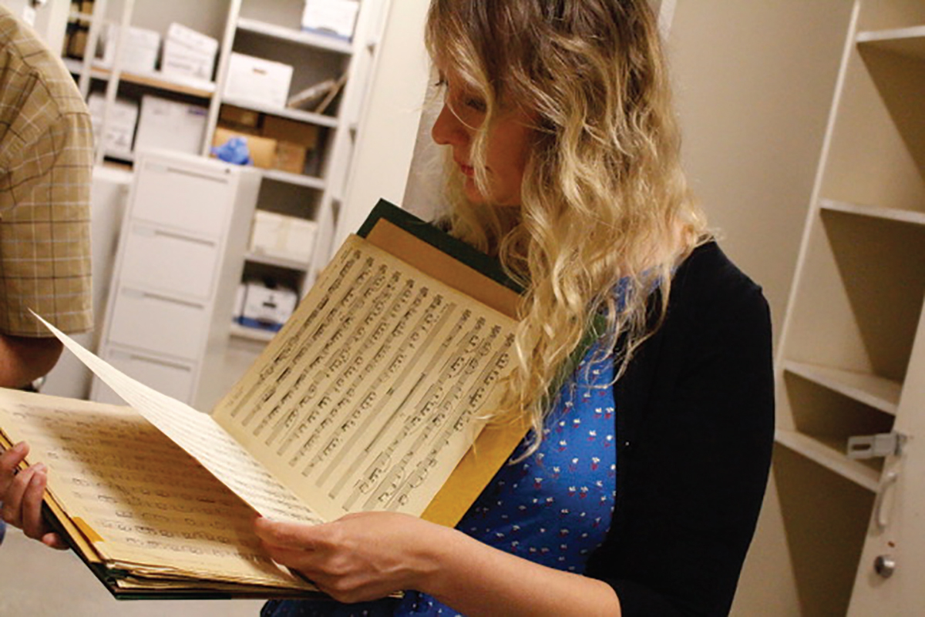
Christina Giacona looking at one of Kilpatrick’s scores
A 2018 discovery of boxes holding the work of noted Oklahoma musician, Jack Frederick Kilpatrick (Cherokee), inspired Christina Giacona to take on the task of organizing this discovery.
Giacona, a doctoral candidate in anthropology and professional musician, was awarded a 2019 Dale Society Fellowship to index the collection and begin to analyze the music in order to better understand how Kilpatrick blended the Cherokee songs and rhythms he learned as a child with the traditions of western classical music.
“Classical music programming has seen a wave of interest and programming of diverse composers who were previously excluded from the classical concert stage including African American composers Florence Price and William Grant Still. Each of these composer’s revivals was driven by the discovery of manuscripts, collaborations with performing organizations, recordings, and subsequent publishing. We’re poised to do the same for Jack Kilpatrick.” -Christina Giacona
When Alexander Mickelthwate, music director of the Oklahoma City Philharmonic learned of the discovery, he selected Kilpatrick's "American Indian Serenade" to be performed on the opening concert of the 2019-20 season.
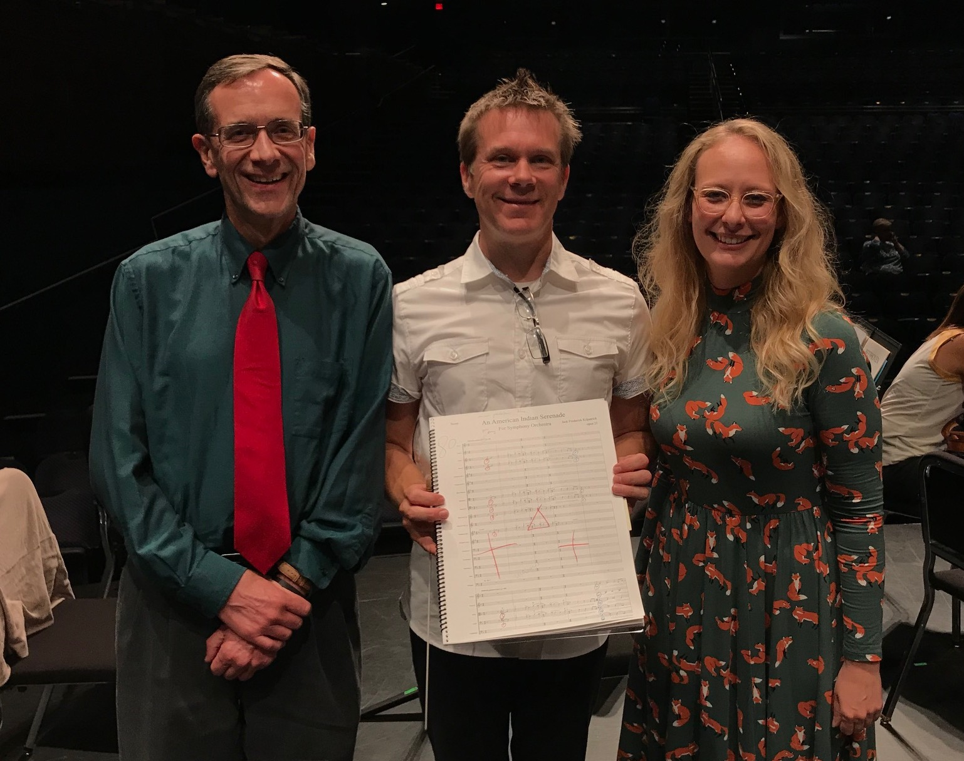
Fine Arts Librarian Matt Stock (left), with Oklahoma City Philharmonic's music director Alexander Mickelthwate (center), and Christina Giacona (right).
___________________________________________

Project STAND Peer Outreach Archivist
In February 2019, OU Libraries joined Project STAND (Student Activism, Now Documented), a national consortium of more than 40 colleges and universities that are creating an online hub to heighten access to digital and analog archival and historical collections documenting student activism.
Sally Johnson, History Department intern and peer outreach archivist, began the process of researching, documenting and digitizing OU student activism, both historical and current.
Learn more about Project STAND
___________________________________________

MAKING AN IMPACT
OU Libraries special collections are visited by a range of scholarly users. Historians, educators, folklorists, ethnographers, linguists, and scholars have all used the collections to tell stories, develop arguments, or illustrate their work for publication.

2019 Scholarly Citations
- [WHC] Broughton, Deanna Tidwell. Hide, Wood, and Willow: Cradles of the Great Plains. (Norman, OK: University of Oklahoma Press, 2019). (Indian-Pioneer Papers, photos from the Phillips Collection.
- [WHC] Fur, Gunlög. Painting Culture, Painting Nature: Stephen Mopope, Oscar Jacobson, and the Development of Indian Art in Oklahoma (Norman, OK: University of Oklahoma Press, 2019).
- [WHC] Fur, Gunlög. “The Earrings: friendship across ethnic and gendered boundaries in the American West.” Women’s History Review, Vol. 28, no. 1 (2019).
- [WHC] Hurt, R. Douglas. Eyewitness to History: Documents of the Dust Bowl. (Santa Barbara, CA: ABC-CLIO, 2019).
- [HOS] Saleh, B.A.E and M.C. Teich. Fundamentals in Photonics. Wiley Series in Pure and Applied Optics. Third Edition (Hoboken, N.J.: Wiley & Sons, 2019) (image credit)
- [HOS] Landers, Matthew. “Semeiologia, Semiotic Bridges, and the “New Science” in Donne's Ignatius His Conclave and An Anatomy of the World.” Journal of English Studies, Vol. 100, no. 2 (2019) (Landers was a Mellon fellow, image credit)
- [HOS] Graney, Christopher M. “The Starry Universe of Johannes Kepler.” Journal for the History of Astronomy, Vol 50, no. 2 (2019). (image credit)
- [HOS] Anderson, Katheryn. “The hydrographer's narrative: Writing global knowledge in the 1830s.” Journal of Historical Geography, Vo1. 63 (2019). (image credits)
- [HOS] Hall, Matthew. The Imagination of Plants: A Book of Botanical Mythology. (Albany, NY: State University of New York Press, 2019).
- [HOS] Timberlake, Tom, and Wallace, Paul. Finding our Place in the Solar System: The Scientific Story of the Copernican Revolution (Cambridge: Cambridge University Press, 2019). (acknowledgements)

CREATING EXCELLENT LIBRARY EXPERIENCES
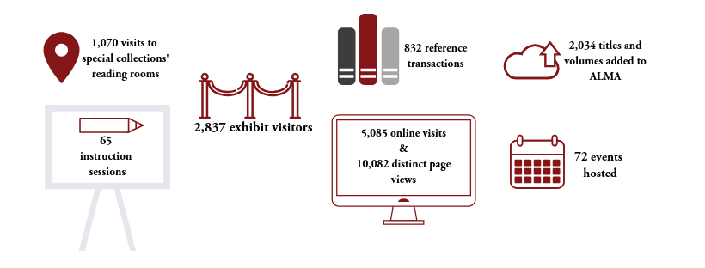
FY 2019

CONTRIBUTIONS TO THE PROFESSION
- Jonathan Stalling presented on the Chinese Literature Translation Archive and on translation scholarship at Nanjing University, Nanjing Normal University and Suzhou University, and presented a paper at the American Literature Translators Association in Bloomington, IN
- Kerry Magruder presented Torrance, Science, and New Creation: Did the Resurrection Change the Order of Nature? at the Thomas F. Torrance Theological Fellowship Firbush retreat in Scotland
- Bridget Burke presented Mapping Migratory Strikebreakers in the Printing Trades: Mobility and Kinship in a Labor Community at the Labor and Working Class History Association conference in Raleigh, NC (in collaboration with OU Libraries digital scholarship unit)
- Bridget Burke presented on a panel on place-based education at the Society of American Archivists national conference in Austin, TX, on Do not try to remember": Teaching What Might Have Been Using Architectural Archives of Unbuilt Environments, featuring the Libraries’ American School Archives Project.
- Melissa Rickman represented the University Libraries at the Rare Books & Manuscripts Conference in Baltimore, MD
- Jackie Reese presented two research workshops at the biannual Western History Association meeting in San Antonio, TX
- Lina Ortega served on the Tribal Libraries Committee of the Oklahoma Library Association
- Cassondra Darling was Elected Chair-Elect of the University and College Division of the Oklahoma Library Association
- Bridget Burke served on the A*Census task force of the Society of American Archivists
___________________________________________

THANK YOU FOR READING
Statement from Bridget Burke, Associate Dean for Special Collections
Like many areas of distinction at the University of Oklahoma, the libraries’ special collections were founded, and have thrived, via the generosity of donors. In the last century the deGolyer, Nichols, and Bass families gifted to OU the nuclei of our premier special collections in the history of science, literature, and American history. Recent donations from the Howard, McKinney, and Masterson families in the Western History Collections, and the gifts of the papers of Martin Rudwick and Hugh Torrens to the History of Science Collections, extend this culture of giving. And our newest collecting initiatives succeed, in part, because we have built something here in the OU libraries that people want to be a part of: we are a trusted repository for material that is valuable and unique.
Stewardship is expensive. Each item we acquire creates an additional investment, the time and knowledge of our cataloguing, curatorial expertise of faculty and staff, the purchase of preservation supplies and cabinetry, the costs of physical and digital infrastructure to host and make available the book, manuscript, sound recording or photograph that has been added to our holdings.
Our extraordinary collections exist as evidence of the deep interests, expertise, passion and relationships that are organic to an active research university with a large and successful alumni base and a broad community reach. They persist because we invest in their future. Please join us in this effort by supporting special collections in the OU libraries with a charitable contribution.
Support OU Libraries Special Collections
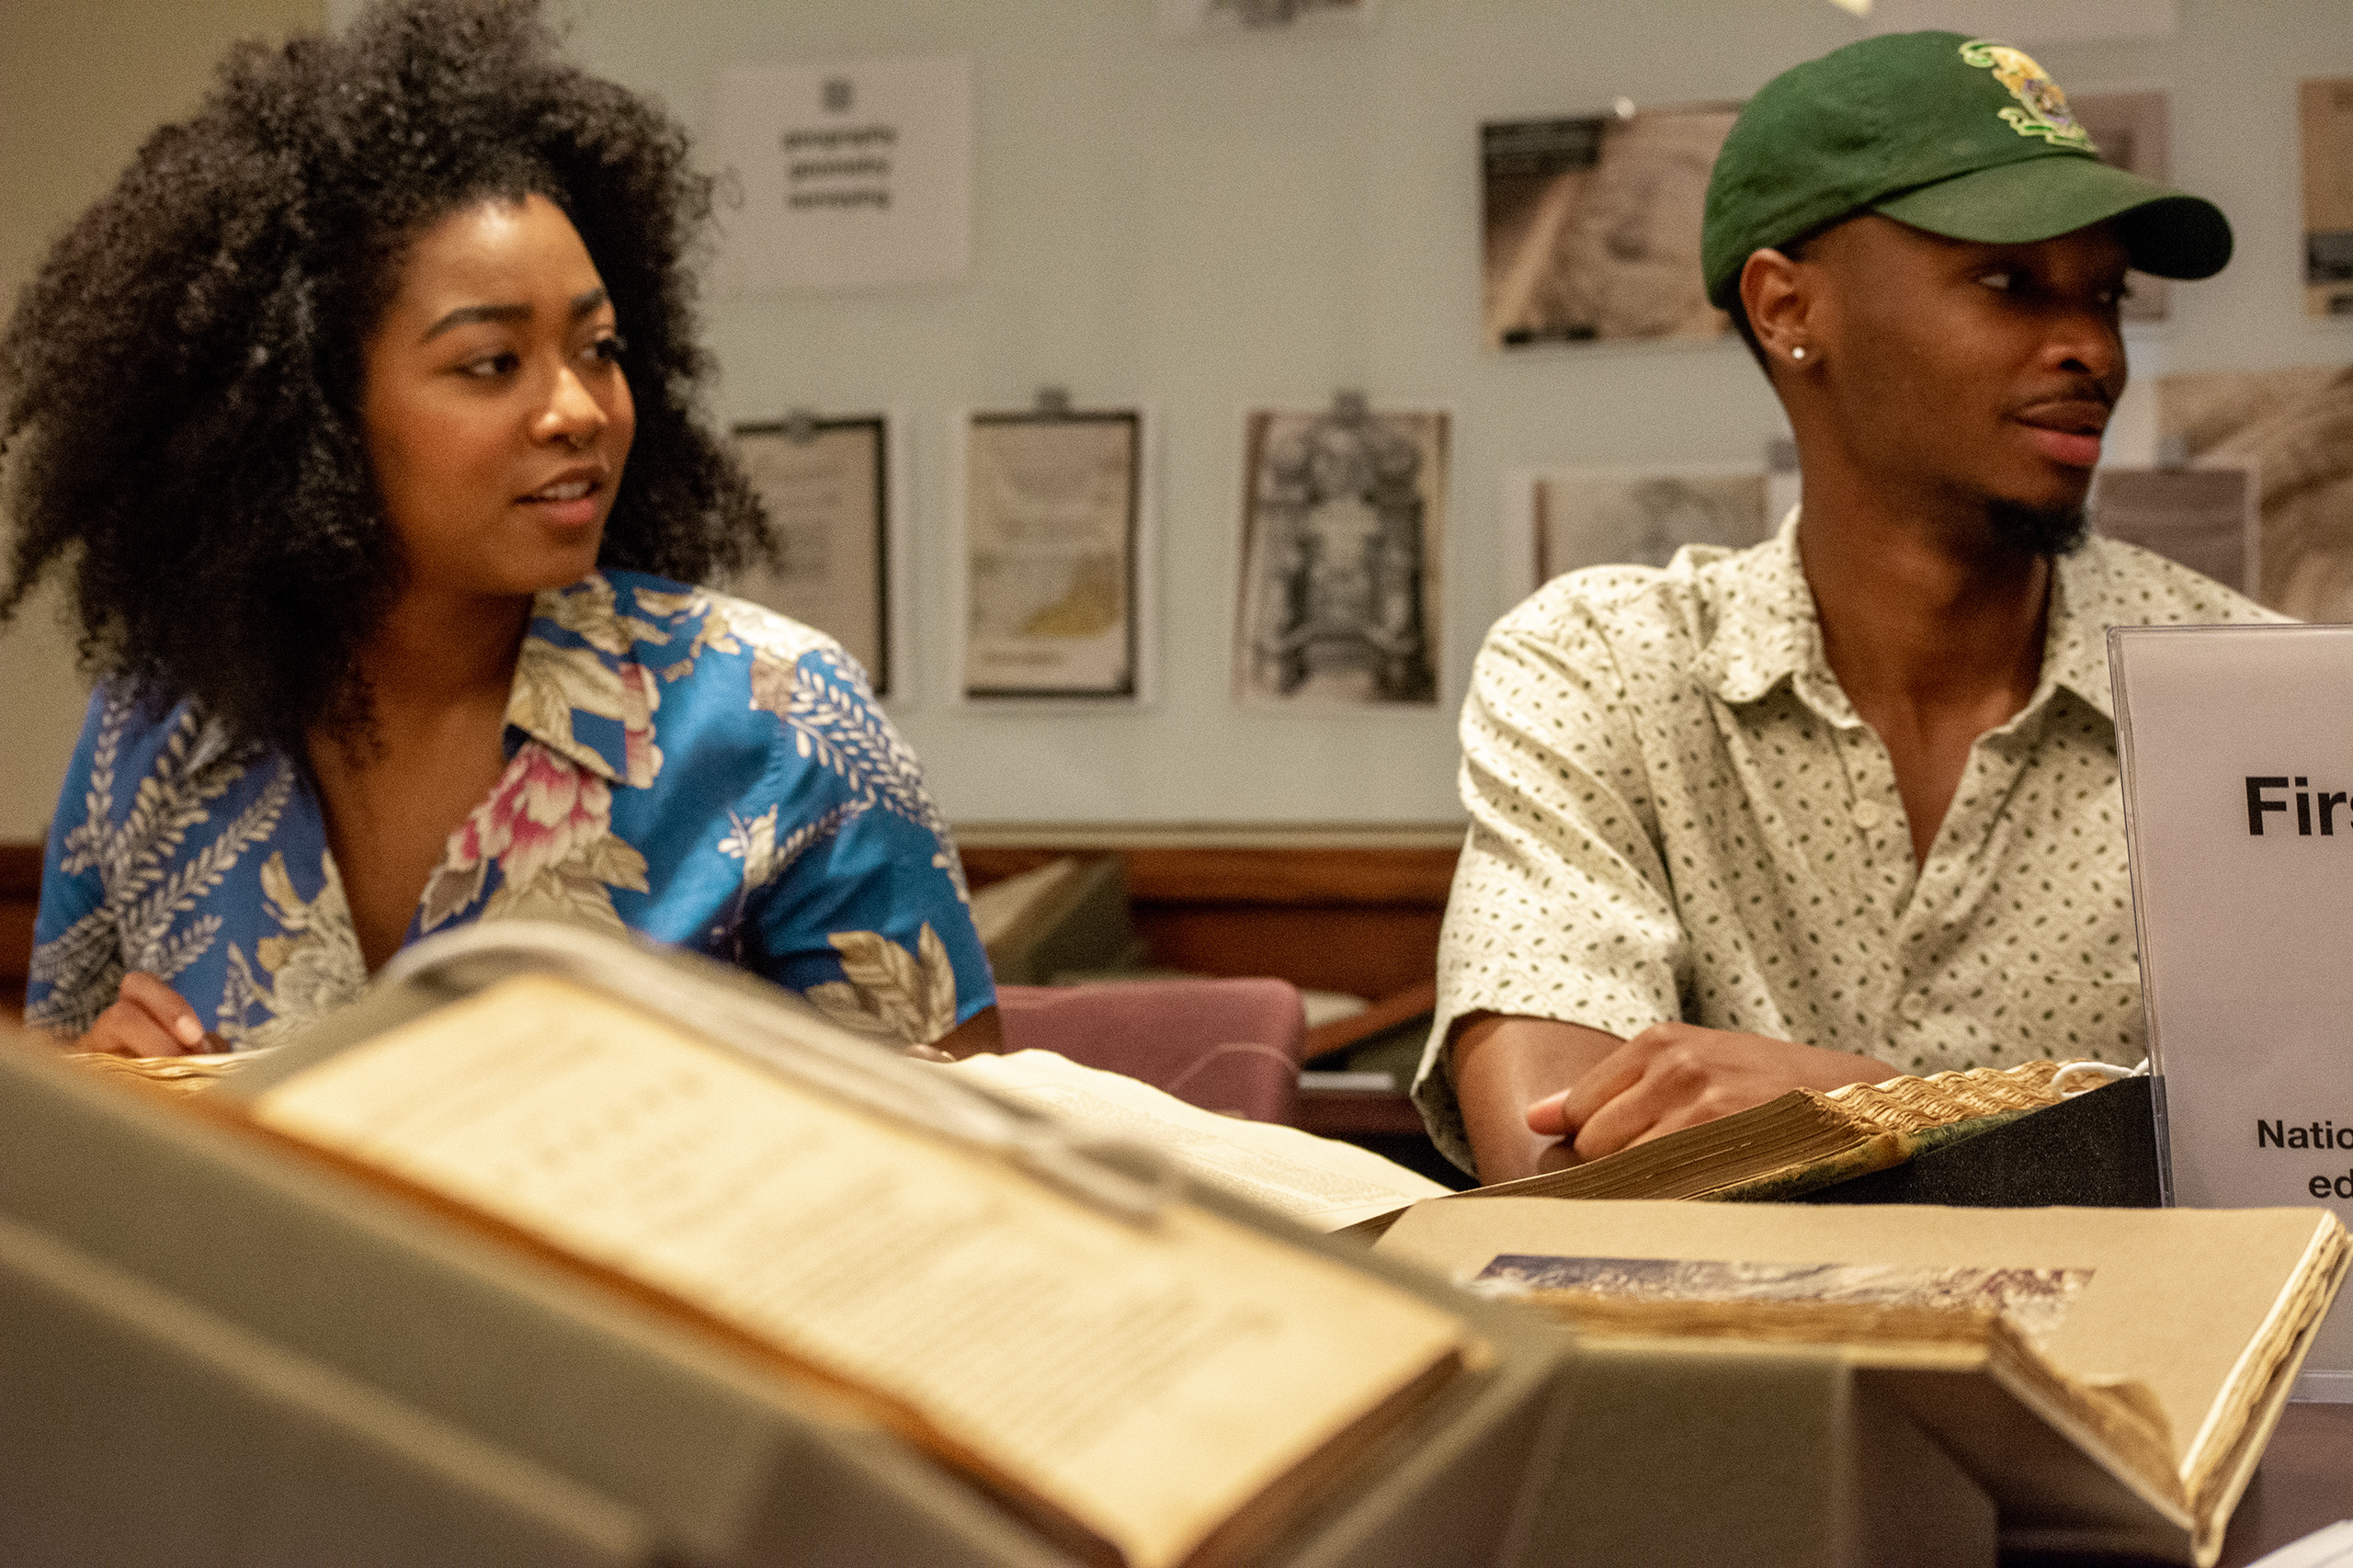
SUPPORT OU LIBRARIES SPECIAL COLLECTIONS
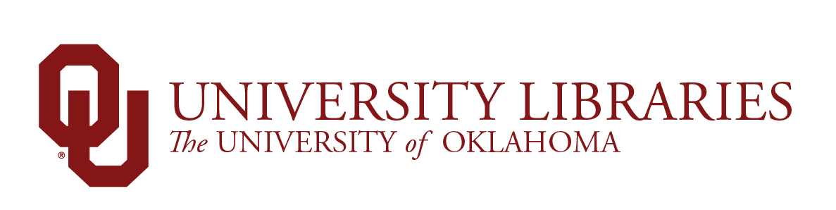
CREDITS
Interim Dean of Libraries, Carl Grant | Associate Dean for Special Collections, Bridget Burke
Editor: Chelsea Julian
Contributors: Bridget Burke, Kerry Magruder, Kristina Grimsley, Todd Fuller, Lina Ortega, JoAnn Palmeri, Jonathan Stalling, and Shuyu Lu
Photos by: Ashley West, Abby Merz, Faith Morgan, Rachael Lester, or provided. Videos by Faith Morgan.

