UNIVERSITY OF OKLAHOMA
GRADUATE COLLEGE

AN EXPLORATION OF THE INFLUENCE OF RURAL TEACHERS’ CURRICULUM BELIEFS AND RURAL CONTEXTS ON INSTRUCTIONAL PRACTICES

A DISSERTATION
SUBMITTED TO THE GRADUATE FACULTY
in partial fulfillment of the requirements for the
Degree of
Doctor of Philosophy

By

JENNIFER SNELL
Norman, Oklahoma
2023

AN EXPLORATION OF THE INFLUENCE OF RURAL TEACHERS’ CURRICULUM BELIEFS AND RURAL CONTEXTS ON INSTRUCTIONAL PRACTICES

A DISSERTATION APPROVED FOR THE
DEPARTMENT OF INSTRUCTIONAL LEADERSHIP AND ACADEMIC CURRICULUM

BY THE COMMITTEE CONSISTING OF

Dr. Jiening Ruan, Chair
Dr. Crag Hill
Dr. Priscilla Griffith
Dr. Heidi Torres
Dr. Beverly J. Edwards

© Copyright by JENNIFER SNELL 2023
All Rights Reserved.

Table of Contents
Abstract vii
Chapter 1: Introduction 1
Background 1
Rural Education and Challenges 1
Teacher Beliefs and Instructional Practices 4
Theoretical Perspectives 5
Problem Statement 6
Purpose of Study 7
Research Questions 8
Significance of Study 8
Definitions of Key Concepts and Terms 9
Limitations of Study 12
Organization of Dissertation 13
Chapter 2: Review of Literature 15
Theoretical Perspectives 16
Theory of Planned Behavior 17
Ecological Systems Theory 19
Sociocultural Theories 21
Review of Relevant Research 22
Rurality 22
Rural Essence and Teachers’ Practices 27
Standardization of Rural Knowledge 29
Funds of Knowledge and Underrepresented Student Populations 31
Placed-Based Instruction Giving Students a Sense of Place 32
Defining Teachers’ Beliefs 33
Modifications of Teachers’ Beliefs 35
Curriculum Reforms 36
Alignment of Teachers’ Beliefs and Instructional Practices 39
Curriculum Ideology 41
Studies Involving Curriculum Ideology 45
Conclusion 47
Chapter 3: Methodology 49
Research Design 49
Setting 51
Participants 54
Data Collection 55
Data Analysis 61
Trustworthiness 65
Subjectivity 66
Conclusion 67
Chapter 4: Findings 68
Participant Profiles 68
Ms. Wilson (Pseudonym) 68
Ms. Smith (Pseudonym) 79
Themes 89
Theme 1: Adverse Aspects of Teaching in Rural Schools 89
Theme 2: Scholar Academic Orientation in Curriculum Beliefs and Instructional Practices 97
Theme 3: Reliance on Academic Standards 101
Conclusion 106
Chapter 5: Discussion 108
Limited Perceptions of Rurality 108
Inconsistent Alignment Between Curriculum Beliefs and Instructional Practices 111
Academic Standards: A Basis for Instruction 115
Implications on Teaching in Rural Schools 116
Future Research 119
Conclusion 120
References 121
Appendix A: Curriculum Ideologies Inventory 140
Appendix B: Interview Protocol 145
Appendix C: Observation Protocol 148
Appendix D: Informed Consent 151
Appendix E: IRB Approval Letter 153

List of Tables
Table 1: Data Type, Data Source, Collection and Duration 56
Table 2: Methods of Data Collection and Analysis 61

List of Figures
Figure 1: Case Study Design (Yin, 2018) 50
Abstract
This holistic single-case study explored how rural teachers’ curriculum beliefs and rural contexts influence their instructional practices. Two teachers from a rural elementary school participated in the study. Data sources include survey, interview transcripts, and field notes. Thematic analysis, constant comparative method, and content analysis were used to analyze data in this study. The themes include adverse aspects of teaching in rural schools, Scholar Academic orientation in curriculum beliefs and instructional practices, and reliance on academic standards. The findings suggest inconsistencies between rural teachers’ curriculum beliefs and instructional practices. In addition, findings indicate that the teacher participants’ views of rural contexts tend to be deficit-oriented and that rural teachers’ instructional practices center on standardized curriculum and state academic standards. This study contributes to research in rural education by highlighting the complexity of curriculum beliefs and instructional practices of rural elementary teachers.
Keywords: rural contexts, rural education, curriculum beliefs, instructional practices, elementary teachers, case study

Chapter 1: Introduction
I began the doctoral program to continue growing my knowledge of curriculum, pedagogy, and theory in education. The gain of knowledge, combined with my experience teaching in rural communities, led me to pursue research concerning rural teachers’ curriculum beliefs, rural contexts, and instructional practices. I find the topic both interesting and relevant, and it is my hope that this investigation helps me understand the connections between and among rural teachers’ curriculum beliefs, instructional practices, and rural contexts.
This study was conducted in a small school district in rural southern Oklahoma in which the nearest metro area is approximately 86 miles. This chapter provides background and contextual information needed to gain understanding of the significance and relevance of this research project.
Background
Rural Education and Challenges
The term rural is neither easily nor consistently defined. Research has exemplified that defining the term is highly dependent upon the area of need for rural research (e.g., funding, health, census, community development). The United States Department of Agriculture (USDA, 2000) explained that there are nine varying definitions of the term rural based upon census locations, states’ business management, rural-urban commuting factors, and factors of business and industry. Because of the variance, statistical evidence regarding many rural areas is extremely limited. The variety of meanings also contributes to the lack of identifiable information classifying many Oklahoma school districts as rural.
Statistics concerning rural areas at the national level can be readily located. The National Center for Education Statistics (NCES, 2020a) has determined 97% of America’s land mass is labeled as rural. NCES has further determined as of fall 2020 there were more than 30,000 rural school districts across the nation employing an estimated 916,000 educators. Although the terms rural and rurality are noted to have a diverse set of meanings determined by the purpose of the investigation, the two terms are many times used synonymously. However, most times, the term rural is defined in reference to massive land areas, while rurality is defined based more upon characteristics of ruralness (i.e., population size, geographical location).
The U.S. Census Bureau has added to meanings by defining the term rural as encompassing “. . . all population, housing, and territory not included within an urban area” (U.S. Census Bureau, 2021). The Health Resources and Services Administration (2020) has defined rural to include “whatever is not urban is considered rural,” thus adding to the existing meanings of the term.
The varying meanings of the term rural could be a leading cause for the shortage of research about rural education. Gallent and Gkartzios (2019) claim elements of meaning, such as causal or social, should be considered when determining meaning to fit research purposes.
Defining rural often reflects a geographical sense. Rural communities make up a large portion of the United States; however, research regarding rural education is estimated having a mere 6% of research studies (Hardré & Hennessey, 2013). Of this 6%, the focus mainly concerns two areas: (1) the need for academic improvement within rural schools (Baeck, 2016; Barley & Beesley, 2007; Biddle & Azano, 2016; Gardener & Borgemenke, 2007; Goodpaster et al., 2012; Vaughn & Saul, 2013), and (2) the need for quality professional development to improve teaching and student academic success (Burton et al., 2013; Goodpaster et al., 2012; Vaughn & Saul, 2013). These two areas possess a common attribute in defining rural–the geographical isolation of rural schools–which is viewed as a contributor to the need for student academic improvement.
Research that demonstrates a need for student academic improvement in Oklahoma has been abundant. For example, the Oklahoma Office of Educational Quality & Accountability (OEQA) student test data for 2019 illustrated that both fourth and eighth grade students fell below their peers nationally in reading and mathematics. To be precise, the reported outcomes in mathematics indicated 34% of Oklahoma fourth graders scored at or above proficient levels, while the national average reported 40.4% of their peers scored at or above proficient levels. Oklahoma eighth graders followed the same trend with a reported average of 25.5% of students scoring at or above proficient in comparison with the national average of peers at 32.9% (OEQA, 2019).
Twenty eight percent of Oklahoma fourth grade students' reading scores demonstrated at or above proficiency in comparison to 34.3% of peer fourth graders nationally. Oklahoma eighth graders also followed the lower trend with 25.6% of students scoring at or above proficiency in reading in comparison to the 32.4% of peers nationally (OEQA, 2019). These trends were low for both state and national fourth and eighth grade students, which strongly support the need for research to focus upon academic improvement in Oklahoma.
Poverty has been directly correlated as a contributing factor in lower academic achievement of students (Ratcliff et al., 2016; Sorhagen, 2013). In Oklahoma alone, 57% of students living in rural areas are considered to live in poverty (Strange, et. al., 2012). Although research has suggested need for academic improvement in Oklahoma schools, research concerning the influence rural contexts, such as poverty, is scarce. Determination of prevalence of poverty within a community’s school district is the percentage of students qualifying for free and/or reduced priced lunch rates. OEQA (2019) reported that 62.8% of students enrolled in public schools in Oklahoma qualify for these lunch price rates, indicating the existence of poverty among many Oklahoma communities.
Rural school districts face needs for academic improvement, as well as challenges of having limited resources, both curricular and professional. Oklahoma school expenditure reports have explained that while 54.6% of funding is attributed to instruction, 3.8% is attributed for instructional support. This financial indicator, as well as rural geographical dispersion, could contribute to the lack of professional development opportunities and available instructional resources available for many teachers (Burton et al., 2013; Cornelius, 2018). It is also very common for rural school districts to “share” professional resources such as psychologists, counselors, special education and curriculum directors, and school nurses with neighboring rural districts (Curran & Kitchin, 2019).
Teacher Beliefs and Instructional Practices
Research has indicated that teachers’ ideological beliefs, beliefs about teaching and learning processes, influence student learning outcomes (French, 2018; Pajares, 1992). Many times, teachers underestimate student academic abilities, leading students to become less likely to reach their potential for academic achievement (Sorhagen, 2013).
The influence teachers’ curriculum beliefs have upon their instructional practices can become an important component in making instructional decisions (Fives & Buehl, 2012). Teachers who understand their beliefs about teaching and learning tend to gain a clearer understanding of the influence their instructional practices have on student academic success (Buehl & Beck, 2015; Schiro, 2013). Because teaching can be viewed as a habitual process, teachers may neglect to reflect on their curriculum beliefs and practices. This habit can become problematic because it is possible that without critical reflection teachers can attribute poor student outcomes to students’ inability rather than to their own curriculum choices and instructional practices.
Teachers’ beliefs are also affected by the community. Research has suggested that teachers who have strong beliefs concerning building community relationships tend to better support student development and academic achievement (Bryan, 2005; Cipriano et al., 2019; Leonard, 2011; Richardson, 2003; Wang et al., 2016). Investments in strong community partnerships can create connections providing an increased opportunity for authentic learning through blending academic and social experiences to promote success in both school and life (Bryan, 2005; Cook-Hunter, 2015).
Theoretical Perspectives
Several theories inform this study investigating how teachers’ beliefs and rural contexts influence instructional practices. Many theories focus upon the social aspect of learning. The theories I chose provide critical lenses through which I am able to view this problem holistically.
The theory of planned behavior and ecological systems theory are the major theories informing this study. The first, the theory of planned behavior, maintains a focus that our behaviors very closely relate to the development of our beliefs. Research by Oh (2003) suggested that this theory is “one of the most successful psychological models used to predict and understand human behavior that is socially relevant” (p. 406). Furthermore, a study by Madden et al., (1992) explained that attitudes, subjective norms, and perceived behavioral control impact one's behavioral intentions, thus, impacting behaviors. I used this lens as a guide in determining how observed behaviors of Oklahoma rural teachers influence expressed curricular ideological beliefs.
The second major theory, the ecological systems theory, explains that the environments in which students exist can have an impact upon their academic development. Research conducted by Lin and Bates (2010) found that when teachers began understanding community contexts and backgrounds of their students, “they started to reflect on their own teaching practice and what they could do to accommodate children of different cultures” (p. 182). The reflection brought about teaching inclusion of more culturally relevant pedagogies to help guide student learning. I utilized the ecological systems theory lens, in combination with the previously mentioned theory, to provide the needed platform to investigate how teachers’ beliefs and rural contexts influence how curriculum instruction was created and delivered.
Sociocultural Learning theories were also consulted to provide a critical aspect as to how instructional practices were delivered. Sociocultural learning theories focus on the needs, backgrounds, and prior learnings of students to enhance the acquisition of new knowledge. Junvova et al., (2015) conducted research centering on social constructivist pedagogy and explained that the learning process is composed of individual perceptions and prior knowledge that teachers build upon by connecting perceptions and knowledge with new content. Steele (2001) used the premise of sociocultural learning theories to explain that when learners are invited to discuss their perceptions and ideas of learning with each other, they make connections with content. Therefore, teachers can lead students to enhance learning through connection of their background knowledge and new academic content. These theoretical perspectives enabled this study to view each teachers’ instructional practices comprehensively and allowed me to investigate how their curriculum beliefs influenced their instructional practices.
Problem Statement
Existing literature has established a lack of consensus of defining rural in educational research. Also, defining the characteristics of rural schools has been suggested as problematic. Furthering lack of consensus in defining the term is the aggregate use of demographics and previous research of urban and suburban schools to represent the demographics of rural school districts. The compilation of data is used throughout each state for research and funding purposes. Furthermore, all demographic research data for Oklahoma students is simply listed under “Oklahoma Schools”. There is no division for rural students.
Several key issues have been identified within literature concerning teachers’ beliefs, but these studies do not investigate how curriculum beliefs or rural contexts influence instructional practices. While many educational researchers express understanding that most teachers bring beliefs, both personal and professional, into curriculum planning and instructional practices, there has been limited information found as to how these beliefs influence the instructional practices of teachers in rural elementary classrooms.
Hence, there is a clear need for studies that investigate how rural elementary teachers’ curriculum beliefs and rural contexts influence instructional practices. This study can possibly guide rural teachers to reflect upon factors influencing their teaching practices and help them improve their instructional practices to support the learning of students in rural schools.
Purpose of Study
The purpose of this holistic instrumental case study was to investigate how rural elementary teachers’ curriculum beliefs and rural contexts influence instructional practices. Schiro (2013) explained that teachers who gain understanding of their own beliefs around teaching and curriculum can better “clarify and accomplish their curriculum and instructional goals” (p. 3). This qualitative case study focused on two elementary teachers from a small rural school district in southeastern Oklahoma.
Stake (1995) emphasized the importance of choosing cases that are accessible and open to informing the researcher that will lead to possible findings posed in the research query. Considering Stake’s advice, I chose a rural elementary school in southeastern Oklahoma that was both close in proximity to my community and had teachers willing to share their stories of teaching in rural communities and teaching rural students to guide me in finding possible answers.
I used thematic analysis along with the constant comparative method, and content analysis to analyze the multiple data sources provided by the case. Stake (1995) explained that searching for meaning requires “…a search for patterns, for consistency, for consistency within certain conditions, which we call ‘correspondence’” (p. 78). I triangulated the different data sources to identify the themes and answer the research questions.
Research Questions
The research questions that guide this study are as follows:
Major question: How do rural elementary teachers’ curriculum beliefs influence their instructional practices?
Sub-questions:
1. How do the rural contexts influence their curriculum beliefs?
2. How do the rural contexts influence their instructional practices?
3. How are their curriculum beliefs reflected in their instructional practices?
Significance of Study
To address the low academic achievement among rural students, teachers must analyze their curriculum beliefs and gain understanding as to how their beliefs influence their instructional practices. Fives and Buehl (2012) stated teachers should understand their beliefs about curriculum as well as reflect upon how these beliefs become predictors of their teaching practices. Teachers must also gain understanding as to how their beliefs about community contexts influence both their curriculum beliefs and instructional practices.
While many studies were found that investigated the role teachers’ beliefs play in their teaching practices (Chant, 2009; Fives & Buehl, 2012; Levin et al., 2013; Schiro, 2013), the associated participant pools mostly consisted of urban and suburban teachers which leaves a gap in research concerning the curriculum beliefs and instructional practices of rural teachers. This study will play a significant role in investigating how rural contexts and curriculum beliefs of rural teachers influence their instructional practices, thus adding to the pool of much needed research concerning rural teachers.
By conducting a case study of elementary teachers in rural southeastern Oklahoma knowledge was gained as to how curriculum beliefs and rural contexts influence instructional practices for rural students. Through gaining understanding of this phenomena, possible answers can reveal how to solve the need for academic improvement in rural Oklahoma. Therefore, this study aimed to investigate how rural teachers’ curriculum beliefs and rural contexts influence their instructional practices.
Definitions of Key Concepts and Terms
Teacher Beliefs
Teacher beliefs are often viewed as unconsciously held assumptions. These beliefs are influenced by our past experiences as students as well as our teaching experiences. Furthermore, teacher beliefs are thought to be more powerful than learnings acquired during teacher preparation programs. Teachers’ beliefs also serve as filters, which guide teachers in creating lesson plans, deciding instructional strategies, and teaching processes (Farrell & Guz, 2019; Kagan, 1992; Phipps & Borg, 2009).
Internal Contextual Factors
Internal contextual factors are factors that guide a teacher in changing his/her teaching beliefs, instructional practices, and knowledge of content teaching. Internal factors consist of factors within the teachers’ control, such as teacher knowledge, teacher attitude, and teacher self-efficacy, which interlace and then alter teacher beliefs and instructional practices (Hunzicker, 2004; Skott, 2015).
External Contextual Factors
Outside contextual factors are factors that guide a teacher in changing his/her teaching beliefs, instructional practices, and knowledge of content. External factors consist of factors outside the teacher’s control, such as professional development, curriculum reform, educational policy changes, and changes in teaching assignments. Each external contextual factor affects teacher beliefs and instructional practices in different ways (Hunzicker, 2004; Skott, 2015).
Rural
Determining a meaning for rural depends upon a specific need for defining (i.e., land area, economic, population size). No consensus seems to exist in defining rural school or rural school district. Defining this term seems to be a difficult task due to the numerous varieties of areas who seek such the label. For examples, administrative concepts, land use concepts, and economic concepts all view rural differently because of the difference each concept plays within a rural area. The most widely used definition concerns the economic concept definition, which defines rural as the nonmetro county areas lying outside metro boundaries. The term rural can also be defined as an open countryside and settlements with fewer than 2,500 residents (Cromartie & Bucholtz, 2008; Ratcliffe et al., 2016).
Curriculum
The purposes, content, activities, and organization inherent in the educational program of the school that learners experience under the guidance of teachers (Walker & Soltis, 2009).
Curriculum Ideology
Curriculum ideologies influence thoughts about curriculum. These ideologies are consistent with meanings of curriculum visions, educational philosophies, conceptual frameworks, and teachers’ beliefs. The term ideology is used to identify the difference between motives that underlie people’s behaviors and their articulated beliefs. Curriculum ideology can refer to people’s endeavors while they engage in curriculum activity or how they think about curriculum issues. It is also important to mention that the term curriculum ideology does not mean to refer to all belief systems related to education (Schiro, 2013).
Scholar Academic Ideology
The Scholar Academic ideology refers to the purpose of education as being one that helps children learn the accumulated knowledge of our culture. The Scholar Academic ideology seeks to initiate children into the disciplines of knowledge by utilizing the thoughts, feelings, and words of academicians within various disciplines. A main goal is to guide learners to think like an academician and to acculturate the learner into the discipline rather than merely learning about the discipline. An end product of this ideology is a student who is able to think, understand, know, reason, reflect, remember, question, and ponder to gain understanding of their surrounding world (Schiro, 2013).
Social Efficiency Ideology
The Social Efficiency ideology refers to the purpose of education as being able to create objectives which will guide the teaching and learning activities. These objectives must be stated in behavioral terms which can be observed by learners. The goal of the Social Efficiency ideology is to preserve functions of society as well as to prepare students to lead meaningful lives. By preparing students in becoming functioning citizens of society, followers of this ideology believe they are bettering society by improving the citizens of tomorrow. An end product of the Social Efficiency ideology is a student who becomes a functioning, mature, contributing member of society (Schiro, 2013).
Learner Centered Ideology
The Learner Centered ideology refers to the purpose of education as providing an enjoyable place where students develop naturally according to their own innate natures. To accomplish this type of development, learning opportunities are created based on the needs and interests of the student rather than around parent or societal expectations. The goal of the Learner Centered ideology is to allow students to experience learning, both developmental learning and social learning, that will in turn develop knowledge and teach children to think through their experiences (Schiro, 2013).
Social Reconstruction Ideology
The Social Reconstruction ideology is accomplished through a social perspective. Based on the idea that society is unhealthy and in need of reconstruction, this ideology persists that a better vision of society must be developed to alleviate existing societal problems, leading to all of society experiencing social justice. Within the Social Reconstruction ideology, education serves to educate students to be able to analyze and understand existing social problems and act to create a society in which these issues become nonexistent (Schiro, 2013).
Limitations of Study
The number of teacher participants for this case study was limited due to the limited number of elementary teachers in the rural school district. Rural school districts, although covering many miles in area, are generally smaller in student population and thus have the need for fewer numbers of teachers for grade levels and content areas. The limited number of teacher participants reduced the amount of overall data collected, but allowed me to create meaningful and purposeful relationships with the selected rural teacher participants. The number was further limited due to the continued outbreak of the Covid-19 pandemic which interrupted the data collection process in this study.
Also, findings were limited due to the fact that the teacher participants came from one rural elementary school amidst many rural districts. Despite the limitation, it was the hope of this investigation that the scope, depth, and variety of interview questions and teacher participant observations reflected the richness in findings related to teacher curriculum beliefs, rural contexts, and experiences that other studies have offered. Because of the limitations, the findings divulged in this study cannot be broadly assumed and linked to all elementary rural teachers. The study will, however, offer a significant contribution to the body of existing research concerning teachers’ beliefs and instructional practices within rural school districts.
Organization of Dissertation
In this dissertation, I sought to gain an understanding of how rural elementary teachers’ curriculum beliefs and rural contexts influence their instructional practices. This dissertation is divided into five chapters which I describe below.
Chapter One introduces the research study. It offers context for the study. This chapter includes a brief review of key issues identified in related literature as well as presents gaps found regarding teachers in rural areas and teachers’ beliefs. Also included is a brief description of the research problem, research design, and research questions. The chapter ends with key terminologies and their definitions used throughout this dissertation.
Chapter Two presents a review of the relevant literature including research concerning teachers’ beliefs and perceptions of community needs as well as sharing an explanation of the theoretical perspectives which helped guide the study. The review of literature explains issues in defining the term beliefs in research, how teachers’ beliefs are developed and sometimes altered, the relation between teachers’ beliefs and instructional practices, how teachers’ beliefs connect to community, and finally, the four curricular ideologies presented by the work of Schiro (2013). The theoretical perspectives include the theory of planned behavior, ecological systems theory, and sociocultural learning theories as well as the connections between these theories and to the context of the study.
Chapter Three explains the instrumental case study design chosen for this study. The chapter further describes the teacher participants and data collection methods. The chapter also explains how thematic analysis, the constant comparative method, and content analysis worked together to analyze the multiple sources of collected data.
Chapter Four provides the findings from the analysis of the collected data, including teacher participant profiles. Findings emerged from analyzing multiple data sources, including survey data, interview transcripts, and field notes. The themes related to the research questions were kept and reported.
Chapter Five provides the interpretations of the study’s findings surrounding how rural elementary teachers’ curriculum beliefs and rural contexts influenced their instructional practices. This chapter also includes implications of the findings as well as the limitations of the study.

Chapter 2: Review of Literature
A large portion of the population lives in rural areas. One in five students in the United States attended a rural school (Robson et al., 2019). Reviews of literature have explored research studies in rural education (Biddle & Azano, 2016; Semke & Sheridan, 2012), but research concerning rural teachers and their teaching practices was scarce (Hardre & Hennessey, 2013; Hatch & Clark, 2021; Waller & Barrentine, 2015). Literature suggested research for rural education does exist, although in small amounts. Investigations focused on rural areas mainly concerned teacher preparation for rural areas (Anthony-Stevens & Langford, 2020; Azano & Stewart, 2016; Blanks et al., 2013; Eckert & Petrone, 2013), recruitment of teachers for rural areas (Monk, 2007), or proclaimed issues hindering rural education (e.g., injustice in funding, concessions for quality education, and poverty) (Farmer et. al., 2006; Irvin et al., 2012; Manly et al., 2020). One commonality suggested the need for, and importance of, active research inside rural schools (Azano, 2011; Irvin et al., 2012; Manly et al., 2020).
Research focused on teachers’ beliefs, particularly of urban and suburban teachers, was abundantly discovered, but findings suggested a lack of investigation into how teachers’ curriculum beliefs might influence their decisions for instructional practices (Cheung, 2000; Cheung & Wong, 2002; Cotti & Shiro, 2004; Jenkins, 2009; Oliver, 1953). Furthermore, investigations focused upon rural teachers and the rural classroom, especially those investigating the influence curriculum beliefs can have upon instructional practices, were scarce (Eckert & Petrone, 2013; Hatch & Clark, 2021).
Studies of teachers’ beliefs suggested the importance for practicing teachers to understand how their curriculum beliefs influence their instructional practices. Many of the studies introduced the inability of researchers to clearly explain the relationship between teachers’ beliefs and their decisions for teaching as well as how this relationship might influence instructional practices (Alfaro, 2008; Cotti & Shiro, 2004; Jenkins, 2009).
The review of literature presents the variety of studies completed concerning rurality, rural education, and teachers’ beliefs. Although the review found many studies investigating the role of teachers’ beliefs in teaching, few studies were found dedicated to rural teachers and their curriculum beliefs and instructional practices.
The review begins by taking the reader through the theoretical perspectives that guided the study. The review then presents the literature relevant to the study. The literature is presented in a thematic style, taking the reader from descriptive components of rural contexts and the rural community connection to rural education. The review then moves on to present literature concerning the development of teachers’ beliefs that continue to adapt throughout career development. In doing so, theoretical perspectives, relevant research, and empirical studies related to these relationships are discussed.
Theoretical Perspectives
Theoretical perspectives serve to give a researcher an opportunity to comprehensively view a problem or issue. Discourse among teachers and students is a predominant aspect in the teaching and learning process. The theoretical perspectives that guided this study gave a lens to view teaching and learning as a social process centered in educational discourse. These social opportunities oftentimes include teachers’ and students’ lived experiences in the community. Bronfenbrenner acknowledged the importance of the connection’s learners have between their learning and their environments (e.g., home, community, school, etc.) (1976). These connections guide in creating a desire for continued lifelong learning within both education and community life (Richardson, 2003). I drew heavily upon two major perspectives to guide my approach in this study of rural teacher curriculum beliefs. The first major theory is Ajzen’s (1985) theory of planned behavior and the second is Bronfenbrenner’s (1976) ecological systems theory.
Theory presents lenses through which phenomena of learning can be understood (Dimitriadis & Kamberelis, 2006). Learning theories confirm the idea that learning involves a transformation of existing knowledge through the addition of new knowledge. Teaching involves understanding that students' cognitive structures are further developed through their academic and community experiences, as well as their personal and social experiences. The importance of the connection between environmental and academic learning has been presented through social learning theories. These theories are also pertinent in identifying the continued development of the relation between teachers’ beliefs and their instructional practices.
Theory of Planned Behavior
Fishbein and Ajzen’s (1975) theory of reasoned action quickly became a powerful model for understanding socially relevant human behavior (Oh, 2003). In 1985, Ajzen suggested an extension to the theory of reasoned action to “explicitly incorporate perceived behavioral control” which contributes to the investigation of behavioral intentions (Madden et al., 1992, p. 3). Ajzen’s suggestion eventually led to the theory being renamed the theory of planned behavior. Additional ideas suggested that actions of behavioral intentions are influenced by one’s attitudes and beliefs. LaMorte (2019) explained that the theory “distinguishes between three types of human beliefs—behavioral beliefs, normative beliefs, and control beliefs” (p. 1). LaMorte further added that a main component of the theory of planned behavior deals with behavioral intent. The theory consists of six constructs which represent a person’s control over their behavior. These constructs include (a) attitude, (b) behavioral intention, (c) subjective norms, (d) social norms, (e) perceived power, and (f) perceived behavioral control (LaMorte, 2019, p. 1).
Many teachers hold beliefs regarding the purpose and practices of teaching in relation to how students learn. These beliefs filter through their teaching decisions, affecting both attitude and behavioral intentions guiding instructional planning and instructional practices. Research has suggested teaching becomes more effective when the instructional practices align with the teachers’ beliefs. For example, Oh (2003) investigated attitudes, subjective norms, and the perceived behavioral controls teachers exhibited when presented with reforms in mathematics curriculum. Findings suggested that the urban math teachers surveyed admitted their attitude towards the math reforms were most influenced by subjective norms such as parents, peer teachers, and their community.
The theory of planned behavior has also been utilized in studies surrounding how stated teacher beliefs influence their teaching behaviors (Kumar et al., 2015; Lee et al., 2010). Studies indicate that teacher stated behavioral intentions are not always observed during actual instructional practices. Kumar et al. (2015) explored the relation between urban area Caucasian teachers’ behavioral intentions and attitudes in both planning and instructional practices in teaching minority students. Results indicated most teachers’ instructional practices exemplified “the promotion of respect among all students” (Kumar et al., 2015, p. 540). The results further implied that teacher behavior often is formed from both conscious and unconscious processes imperative for decisions about instructional practices.
Lee et al., (2010) found that teacher behavior towards various instructional resources influenced how resources were used to enhance student learning. Results indicated that if a teacher has a positive attitude towards utilizing new and updated resources for teaching, they are more likely to utilize to enhance student learning. Both teacher attitude and behavior influence instructional resources, instructional teaching styles, thus influencing student learning.

Ecological Systems Theory
In 1976, Urie Bronfenbrenner explained that research regarding educational phenomena must take place in live classroom environments. Bronfenbrenner introduced the ecological systems theory which suggests the importance of understanding the impact a student’s environment has upon their academic development. To gain understanding, the connections among the various environments of the student’s life must be acknowledged. This theory is comprised of two components: (1) the relations between the learner and their living environments (home, community, school); and (2) the interconnectedness of these environments (p. 5). Bronfenbrenner (1976) further explained that research completed in educational settings becomes one of heuristics, which requires examination of the relations between learner and their surrounding environments, which admittedly, is no easy task.
Bronfenbrenner further expressed that to examine the interconnectedness of a student’s surroundings and their effects upon student learning is to examine the systems “side by side” in order to “see clearly the nature of the differences between them” (p. 6). Utilizing the idea that elements of a student’s environments come together to impact development of learning, Lin and Bates (2010) studied the outcomes of combining home visits with classroom instructional practices. The researchers discovered that by having teachers complete home visits with their students and families, understanding of the relation between the home and school environment and its impact upon a student’s educational development can be gained. Lin and Bates (2010) also found that when understanding the relationship, teachers’ beliefs of teaching and learning were adapted for the benefit of student learning.
A study initiated by Leonard (2011) sought to use Bronfenbrenner’s ecological systems theory to investigate the role the continued evolution of school/community relations have on the promotion of student development and student academic success. The study highlighted the challenges interagency collaboration within school/community relations can have upon urban school reform and student success over long periods of time.
Leonard’s (2011) historical mixed-methods case study of an urban high school found that relations between school and community often dissolved, leaving behind broken promises and lackluster results. Results also report the idea that many times community involvement in school interactions and decisions leave out two very important factors—the teacher and the student. Furthermore, when communities target a small selection of teachers and students to represent the entire school population, success for all students is simply not possible.
Studies emphasizing the ecological systems theory have also focused upon student-classroom and teacher-student relationships. According to Cipriano et al. (2019) “ecological systems models posit that the embedded mechanisms and dynamic relationships between teachers, students, their schools and social contexts” enhance student development (p. 211). Studying 35 urban fifth and sixth grade classrooms, Cipriano et al. (2019) examined how both student and teacher perceptions of classroom support interacted and how these perceptions connected with various aspects of their learning environment. Results indicated teacher perceptions of classroom support did not come from school administration, but rather came from supportive experiences of their teaching peers. Results of student perceptions suggested that educational interventions should be identified by teachers of individual student needs rather than needs identified for the entire school.
Studies utilizing the ecological systems theory supported the idea that both classroom community and community relationships can enhance student academic success (Cipriano et al., 2019; Leonard, 2011). The idea supports the purpose of this study and will help inform analysis on how teachers’ curriculum beliefs and rural contexts influence instructional practices.
Sociocultural Theories
Sociocultural theories highlight “the roles social, cultural, and historical factors have on human experiences (Tracey & Marrow, 2017, p. 162). Learning is a social process developed through discourse (Steele, 2001). Illustrating this point, John-Steiner and Mahn (1996) stated, “Sociocultural approaches emphasize the interdependence of social and individual processes in the construction of knowledge” (p. 191).
Steele (2001) investigated teaching strategies based upon the belief students create knowledge through collaborative discourse. The study found that students gained deeper understanding of content material while communicating with peers. Steele (2001) also explained that a teacher’s belief in the sociocultural approach to teaching and learning enhanced students’ ability to successfully use collaborative discourse to share both social and content prior knowledge (Steele, 2001).
Social constructivism, a sociocultural theory developed by Vygotsky, centers on the idea that student learning is created through social interaction (Junvova et al., 2015; Richardson, 1997; Richardson, 2003). Vygotsky’s theory also suggests the importance that social interaction takes place through interpersonal interactions based upon historical and cultural backgrounds, leading to an integration of language and culture within contexts of learning (John-Steiner & Mahn, 1996; Tudge & Winterhoff, 1993).
Additional research has suggested students involved in learning through social constructivist pedagogy improve significantly in critical thinking, problem-solving, and develop deeper understandings of content (Muis & Duffy, 2012; Richardson, 2003).
Acar and Yilmaz (2015), discovered that when students do not first receive direct or explicit instruction on how to participate and become a collaborative learner, the sociocultural approach of learning can be unsuccessful. They studied a third-grade math classroom, and they found that a blending of direct instruction on social interaction and collaboration led to successful collaboration among students in communication for problem solving. This study suggested that teachers who want to implement a social constructivist pedagogy must provide guidance for their students to help them understand how to successfully build socially shared knowledge together (Acar & Yilmaz, 2015, p. 1013).
Savasci and Berlin’s study (2012) sought to gain a deeper understanding of the impact social constructivist theory can have upon teachers’ beliefs and practices. The results indicated while each of the four veteran urban teachers expressed belief that social constructivism was an integral part of their classroom teaching, observation data revealed three of the four teachers' instructional practices actually demonstrated a teacher-centered approach. This study demonstrated the inconsistency between teachers’ stated curriculum beliefs and their instructional practices.
Review of Relevant Research
Rurality
When discussing rural contexts, one must first define the term rural. The National Center for Education Statistics (NCES, 2020b) noted that in the United States the term rural can be defined under the guises of “rural fringe,” “rural distant,” and/or “rural remote.” These meanings were constructed based upon the locality and distance in which a rural area is located from an “urbanized area.” However, Tieken (2014) accounted for personal experiences living and teaching in rural areas and defined rural as being a constituent of “...one’s identity; it shapes one’s perspectives and understandings; and it gives meaning to one’s daily experiences” (p. 5). Parton (2021) added to this thought by explaining that rurality is different for everyone and that every student “walks into our classrooms with their own definitions based on their own experiences” (p. 4). The rural community in this study can be defined as both a rural remote area that is “more than 25 miles from an urbanized area, and also more than 10 miles from an urban cluster” (NCES, 2017).
Arguments exist enforcing the idea that a single definition of rural must come into consensus for both educational research and decisions for academic improvements needed for rural students. Manly et al. (2020) explained that the inconsistency in defining rural “impact the results, conclusions, and recommendations regarding rural students.” (p. 765). Without clarity in meaning, research guiding educational policymakers as well as educators of rural students continues to create confusion in ways to improve both rural education and the educational attainment of rural students.
The contexts of rural have a consistent pictorial description across research. These areas are continuously characterized with the following contexts:
- Small population size
- Low population density
- Limited services for shopping and medical needs
- Lower earned wages
- Higher levels of poverty
- Homogeneity of culture and beliefs
- Strong sustaining relationships and interactions among community members (Robson et al., 2019).
World Views of Rural Contexts
The views of rural contexts matter when investigating elements of rural education. Azano (2015) argued that even though multiple contexts exist for understanding and defining one's “world” contexts, considerations of rural are “often missing from the conversation,” contributing to the lack of social justice concerning rural education and its glaring inequalities (p. 267). Azano continued, explaining that rural education is often marginalized by both poverty constraints and stereotypical assumptions (2015).
Stereotypes of rural contexts are presented by media and literature greatly influence the world views and perceptions of life in rural America. Stereotypical views of life in rural areas continues to create ubiquitous misconceptions of life these areas. Popular culture has added to these views by depicting the rural community and its people to be uninformed, lawless, and ignorant which leads to the continuance of the marginalized picture of life in rural areas (Parton, 2022; Tieken, 2014; Willitz et al., 2016). Assertions also commonly attributed to rural contexts and those who inhabit these areas are generally those related to perceived deficits. Azano and Stewart (2016) explained these deficits are often created by those “who lacked first-hand rural experience” (p. 115). Deficit thinking leads to beliefs that those living in rural areas lack motivation for learning, have limited knowledge consisting of land and nature, and have limited cultural knowledge to bring inside the classroom (Azano & Stewart, 2016; Walker, 2011).
On the opposite side of the spectrum exists stereotypical views of rural contexts through an idyllic lens of “rural mystique” which historically portrays rural America to be a magical landscape of vast open lands with grazing animals in which limited survival to those who have self-sufficient survival abilities (Willitz et al., 2016). Willitz et al. explained that historical literature, artistic imagery, and advertising add to the portrayal through focusing on rural life as a nostalgic, reverence to the land with overwhelmingly positive feelings of closeness to nature (2016). Many times, these perceptions of rural contexts are not derived from personal experiences, but rather are facets of stories represented in mass media outlets such as movies, documentaries, and reality television (Eckert & Petrone, 2013; Willitz et al., 2016). Viewpoints and defining meaning to rural seems to vary from place to place. However, Parton (2021) explained that while many perspectives and views of rurality exists, it is “necessary to ensure that when teachers are including rural perspectives in their teaching, they’re doing so in a way that honors the experiences of rural people rather than reifying the dominate narrative that already exists” (p. 8).
Rural Contexts and Rural Schooling
Rural contexts flow into rural schools influencing both teaching and learning. A common finding among research suggests that the rural school plays an enormous role in both the social and economic development of the rural community. Schools in rural areas feel tasked with both educating rural youth and guiding enduring civic engagement through shared purposes and identities of their communities; thus, making the school the heart, or center, of the rural community (Schafft & Youngblood-Jackson, 2010). Tieken shared this viewpoint and wrote “the school just is the community;” the school gives the community its substance and meaning (2014, p. 140). Tieken continued by explaining that while each rural community is separate in its needs and descriptions, there is a commonality within its schools– “they knit this assortment of residents into a collective, a unit…” (2014, p. 140).
Rural factors such as lacking economic resources and low property values add to the disparity in rural education by impacting educational funding (Tieken & Montgomery, 2021). While funding is a huge concern for rural schools, Tieken and Montgomery also added that many federal funding policies have a large disconnect in understanding the differences between rural, suburban, and urban contextual factors, thus contributing to the lowering of funding allocations, especially in rural districts (2021).
The low population factor of rural areas further complicates the financial hardships of rural schools. The smaller populations of rural areas equal smaller enrollment numbers of students in their schools. These enrollment numbers contribute to the receipt of less federal money which contributes to a continued lack of resources within rural schools (Robson et al., 2019).
Also, rural factors such as isolated remoteness, lack of professional resources, and low teacher pay contribute to the worldwide epidemic of recruiting and retaining teachers in rural areas (Azano & Stewart, 2016; Ciftci & Cin, 2018; Hatch & Clark, 2021). While these factors play a role in the day-to-day teaching and school administration in rural areas, another large contributing factor to the overall challenge of recruiting and retaining quality teachers in rural areas is the lack of entertainment and cultural amenities that are widely available in urban and suburban settings (Azano, 2015).
One of the most salient factors in rural areas is poverty. Geographical isolation is a large contributor to the poverty factor due to scarce availability of economic resources. Poverty in rural areas continues its desperate cycle through generations of families existing and surviving in these isolated areas (Irvin et al., 2012). Children living in poverty has remained high over the past 40 years contributing to the lack of both children’s educational attainment and their overall well-being (Chaudry & Wimer, 2016).
Children who live in poverty begin school cognitively behind their more affluent peers (Cooper et al., 2010; Hegedus, 2018; Lacour & Tissington, 2011; Saitadze & Lalayants, 2021). Furthermore, there is likelihood that these same children will continue falling behind their peers as they continue their education. Generally, children in poverty are developmentally behind their peers due to the fact that families living in poverty simply cannot afford to provide “stimulating materials” or “engaging activities” (Cooper et al., p. 872) for their children (Chaudry & Wimer, 2016; Saitadze & Lalayants, 2021).
Chaudry and Wimer (2016) added to this by explaining that parents living in the cycle of poverty often experience “psychological distress” due to economic insecurity (p. S26). This distress generally results in less involvement with their child’s physiological and academic needs. The deficit perspective argues many families living in poverty do not “value or understand formal education” or its purpose in academic success (Lacour & Tissington, 2011). Because of this belief, parents in poverty areas neither see the need nor have the desire to become involved in their child’s education.
Poverty affects student academic growth in the classroom as well as future educational growth opportunities. Poor economic conditions within rural areas can produce narrowed curriculum choices and shortage of highly qualified teachers. Irvin et al. (2012) findings aligned with previous research in finding that economic hardship was one of the largest educational barriers for rural students.
Rural Essence and Teachers’ Practices
Rural essence is alive and well in rural areas. Rural communities are made of families of vast generations that share traditions of both lived and school experiences. These families make up the community that packs the school gymnasium for sports events and fundraisers. The rural community has great influence on structures of rural contexts and their influence in the community school. These structures impact the lives of rural families for generations upon generations, blurring the distinction between what is community and what is their school (Tieken, 2014).
While it is documented that “...little research has explored what the expectations of teachers in particular rural contexts might be,” Edmondson and Butler decided to explore “...the conflicting conceptualizations of what it means to be a teacher, particularly within a rural setting” (2010, p. 151). Their investigation suggested that teaching in rural areas, while very rewarding, comes with its own set of challenges (i.e., lack of resources, professional development, and isolation). However, the study found that even with these challenges, rural teachers were always ready to explain why they continue to teach in these poverty-stricken areas. Many of these same teachers commented this is due to the trust, safety, and acceptance they feel within the rural community (Edmondson & Butler, 2010).
Research has shown that the rural community and school relationship are tightly intertwined. Studies, although few, have suggested that teachers in rural areas have strong beliefs about building and maintaining strong community relationships for the betterment of student development and achievement (Cipriano et al., 2019; Leonard, 2011; Richardson, 2003). Waller and Barrentine (2015) commented that “schooling can play a role in bolstering a sense of community” (p. 1).
Waller and Barrentine (2015) investigated how rural teachers teach literacy curriculum to their students. This instrumental case study found that while teachers were very interconnected within their rural community, attempts at utilizing students' lived experience in teaching was extremely rare. It was hypothesized the rarity of using students’ lived experiences could be due to the lack of factors of rural contexts available in the literacy curriculum (Waller & Barrentine, 2015). Similarly, Parton (2022) explained that rural “ways of knowing and being” influenced by growing up in working class backgrounds have often “not been valued in learning spaces” (p. 27). Without this connection, students are less likely to make text-to-self-connections, thus possibly hindering their literacy academic progress.
Teaching is composed of social relationships (John-Steiner & Mahn, 1996; Steele, 2001). An important relationship in social learning is that of the school and community. Teachers who involve aspects of community in their classroom activities and instruction often build a better connection with both the community and student creating better engagement in learning experiences (Cook-Hunter, 2015). Many teachers’ beliefs involve collaboration between school and community which builds stronger teaching efficacy and greater authentic learning experiences for their students (Wang et al., 2016).
Research has also suggested that the school community relationship can further learning and increase both academic and social experiences of students by providing evidence of the importance community connectedness has on personal and academic lives (Cook-Hunter, 2015). In creating this relationship, a common bond of building “funds of knowledge” encourages student, parent, and community involvement in the daily learning opportunities of the classroom (Morrison et al., 2008).
In addition, Azano (2015) commented the push for culturally responsive teaching has “changed the way we think of teaching young people” (p. 267), yet rural contexts are absent in much of standardized curriculum, thus possibly creating conflicts between teachers’ beliefs and their instructional practices. A study of rural contexts and teaching by Eckert and Petrone (2013) found that some teachers find difficulty in guiding students to make connections between the standardized curriculum and their lived experiences. Findings suggest this may be due to curriculum and media literacy that “. . . focuses on urban youth of color” in order for urban students make connections with their diverse cultures and lived experiences.
The same study reported another rural teacher explained that he felt “at a loss” when his students inquired about the role of rural themes in their studies, prompting the teacher to question how to meet their academic needs in literacy (p. 70).
Although the rural school is the essence that keeps rural communities alive and thriving, teachers have come to realize that standardized curriculum and educational policies were not created to meet the lived experiences of their students, a component that is heavily referred to as an element for academic success. Many rural teachers have constant worry about the academic success of their students which often results from a lack of resources, geographic inequalities, standardized curriculum, and the overall feeling of invisibility of their schools (Tieken, 2014).
Standardization of Rural Knowledge
Even though research concerning the influence rural contexts have upon education is scarce, a common theme found throughout is the marginalization of rural knowledge in education reforms and standardized curriculum (Azano, 2015; Eckert & Petrone, 2013; Waller & Barrentine, 2015). Explanations of the marginalization suggests this began in the early part of the 21st century when “performance-based accountability” entered the education scene cementing an idea of a standardized approach to education (Biddle & Azano, 2016, p. 313; Waller & Barrentine, 2015).
To solidify the standardized approach, “performance-based accountability” standardization of curriculum had been decided as a need for all students in all public schools. This decision, however, did not take into account the individualism and uniqueness that rural knowledge and experience offers. Rather, standardized curriculum serves more to support students in urban and suburban areas (Avery & Fortunato, 2016; Azano, 2015; Tieken, 2014; Waller & Barrentine, 2015). The marginalization of rural knowledge and standardization of curriculum has erased student's appreciation of their rural community and their lived experiences, thus further hindering some academic achievement through making connections between their lived experiences and the standardized curriculum (Waller & Barrentine, 2015).
Avery and Fortunato’s research suggested the standardization of curriculum has introduced the idea “there should be one dominant form of knowledge,” which implies that one curriculum fits all learners (2016, p. 162). This research recommends that truly comprehensive education should be composed of a balance of content knowledge and ancestral knowledge of urban, suburban and rural communities. Without this balance, standardization of curriculum assumes uniformity among all student populations, regardless of their diversity and lived experiences. The standardization of curriculum has excluded rural contexts and all of the unique and diversifying factors offered. The standardization of curriculum was summed up in the words of Johnson (2014), “...there is so little that is rural about schooling in most rural places'' (p. 331).

Funds of Knowledge and Underrepresented Student Populations
Moll et al. (1992) defined funds of knowledge as knowledge children bring with them into the classroom stemming from the realistic cultural familial experiences that contribute to their family development and well-being. Investigations documenting funds of knowledge in working class families emphasized the need to
develop both theory and methods through which educators can approach and document the funds of knowledge of families and represent them on the bases of the knowledge, recourses, and strengths they possess, thus challenging deficit orientations that are so dominant, in particular, in the education of working-class children. (Moll et al., 1992, p. 131)
Funds of knowledge seek to end deficit assumptions aimed at underrepresented child populations in education (i.e., minority and low-income) and rather recognize the knowledge and skills developed outside the school realm (Rodriguez, 2013).
Llopart and Esteban-Guitart (2018) built upon Rodriguez (2013) and Moll’s (1992) research, explaining that deficit thinking must be challenged, and the knowledge and skills that students have learned from their families and communities should be acknowledged and utilized in classroom settings. They further suggest that if teachers developed instructional practices based on lived knowledge, stronger trust relationships with families could possibly be developed as well as possibly diminishing deficit stereotyping.
Hedges (2012) pointed out that funds of knowledge “are deeply ingrained in teachers and, as such, are likely to be the first knowledge drawn upon in the spontaneous curricular and pedagogical decision making in early childhood teaching” (p. 18). Hedges (2012) further explains that teachers possess beliefs developed from their experiences that influence their instructional practices. This study revealed the complexity the combination of lived experiences, teacher knowledge, and professional experiences has on daily teaching decisions.
Studies have suggested that utilizing students’ funds of knowledge during planning and instruction can be beneficial for all learners involved (Hedges, 2012; Hedges et al., 2011; Rodriguez, 2013). Even though this benefit has been found, research compiled by Hogg (2011) reported that most educational and curricular experiences are focused on the experiences and lives of middle-class white students, supporting the gap in learning between socioeconomically challenged and minority student populations and their middle-class peers. However, Hedges et al. (2011) explained when teachers take the time to know the child both inside and outside of the educational setting, a stronger and more authentic teaching practice can be developed. The outside knowledge, both cultural and familial, that children bring into the classroom can offer a “richness” that “tends to exceed that of their school experience” (Andrews & Yee, 2006, p. 445).
While encouragement of the authentic use of students’ funds of knowledge is suggested, caution is also given to true authenticity. Rodriguez (2013) cautioned that teachers should be careful not to “reflect a pervasive power” by becoming the executive power who chooses which aspects of students' lived experiences “belong in the realm of the classroom” (p. 93). In essence, teachers must be willing to “embrace the lived experiences of children '' and use these sources of knowledge and experience to enrich and expand learning of all children in the classroom (Rodriguez, p. 94).
Placed-Based Instruction Giving Students a Sense of Place
Donovan (2016) mentioned that using “place” as a basis for helping students gain understanding of content and make connections between content, lived experiences, and diversity of their community creates authentic learning opportunities. Parton (2021) found that many teachers in rural areas understand that utilizing student knowledge of place is needed, but finding the curriculum resources to represent the diversity of rural life was difficult. Standardized curriculum can compromise learning of rural students because standardized curriculum does not allow the opportunity for making connections between their lived experiences and content curriculum (Azano, 2011). This lack of connection hinders student learning, thus creating a deficit in their knowledge gain (Donovan, 2016).
Place-based education utilizes the idea of students' sense of place by allowing them to build knowledge through the use of curriculum that is relevant to their lived and community experiences. Furthermore, using curriculum that exemplifies students lived experiences and diverse aspects of their community can guide students in gaining deeper understandings of academic content through the lens of rural lived experiences (Azano, 2011; Bishop, 2004).
It has also been noted that regardless of the area students are from that teachers are working with, “rural stories deserve to be told and heard across geographical locations (Parton, 2021, p. 7). Parton (2021) has created a website “Literacy in Place” to give teachers additional ideas for literacy resources to implement in the rural classroom.
Studies emphasizing the importance of the implementation of place-based education for rural students guides students to become more engaged in their learning and helps create their sense of identity and belonging. Place-based education not only allows rural students to learn the necessary curriculum in an authentic manner which can lead to taking pride in their learning and community, but also their “place” influences their life experiences (Azano, 2011; Donovan, 2016; Parton, 2022). When teachers implement community examples during instruction, students are better able to make connections of new learning with their prior knowledge and lived experiences (Azano, 2011; Bishop, 2004; Donovan, 2016).
Defining Teachers’ Beliefs
The phrase teachers’ beliefs represent a variety of meanings in educational research. The diversity in defining this phrase seems to be attributed to the complexity in meaning of the term belief as well as the difficulty in capturing and identifying a teachers’ belief system through investigative study (Pajares, 1992). Literature has portrayed continuous debate on the nature of defining teachers’ beliefs, especially in regard to teaching and learning (Eisenhart et al., 1988; Ertmer, 2005; Kagan, 1992; Pajares 1992). Consequently, defining is further complicated through identifying teachers’ beliefs as either implicit thoughts and behaviors or explicit thoughts and behaviors (Buehl & Beck, 2015; Levin et al., 2013). Furthermore, the perplexity of defining this term has also been identified as being “generalizations made within global constructs” which have alluded that the actual defining or identifying of teachers’ belief systems is an impossible feat (Pajares, 1992).
Buehl and Beck (2015) noted that applying meaning to the phrase teachers’ beliefs is a “complex and multidimensional process” (p. 66). Literature has denoted that the attempt to define the term belief must consider components including the differences among teachers’ beliefs and teachers’ knowledge (Ertmer, 2005), teacher thoughts involving teaching styles, and teacher’s thoughts about learning styles (Basturkmen et al., 2004; Buehl & Beck, 2015; Calderhead, 1996). Another component to be considered is the idea that teachers’ beliefs serve as filters for instructional decision making and impact teaching and learning processes (Farrell & Guz, 2019).
Ertmer (2005) reported that teacher belief studies further complicate defining the term belief because many times the terms teachers’ beliefs and teacher knowledge are used interchangeably rather than utilizing components of teacher knowledge to define belief.
Pajares (1992) explained there is a plausible need to advance research of teachers' beliefs. The chosen meaning of the phrase teachers’ beliefs for this study followed the definition created by Farrell and Guz (2019), which stated that teachers’ beliefs are “filters through which instructional decisions are made” (p. 2).
Modifications of Teachers’ Beliefs
Literature revealed various elements can lead to modifications of teachers’ beliefs which leads to changes in thoughts about teaching and learning. For example, factors such as professional development, changes in teaching status and/or teaching areas, and overall teaching maturity have been shown to cause changes of teachers’ beliefs (Clark & Peterson, 2006; Nespor, 1987).
The continuous modification of a teachers’ beliefs has powerful and lasting effects on teaching, learning, and routine classroom procedures (Cheung & Wong, 2002; Richardson, 1996). Van der Schaaf et al. (2008) shared the effects teachers’ beliefs have on teaching and learning and added, “beliefs shape the way teachers perceive and interpret classroom interaction and influence their construction of intentions in response to those interactions. . .” (p. 1692). The altering of teachers’ beliefs has been found to be influenced by the teacher's personal experiences, personal views of the world, and perceptions of the school’s community and its role in education. Blended with these attributes are teacher’s professional experiences which influence the continuous development of teachers’ beliefs (Richardson, 1996; Skott, 2015).
Teachers’ beliefs continue to modify as teachers reflect upon their teaching strategies, learning needs of students, and reforms are made to curriculum. Reflection on processes involved in instructional planning and practice leads teachers to think about the “difference between thinking of action and doing of action” which can both influence and alter a teacher’s beliefs about teaching and planning (Chant, 2009, p. 189). Studies have shown that oftentimes teachers' understandings of who their students are and how students’ lived experiences can shape learning have also contributed to changing teachers’ curriculum beliefs. A multiple case study by Hatch and Clark (2021) sought to understand how teachers' thinking affected their daily instructional decisions. One result of this study found that teachers' processes of understanding the individuality of students continually affected their decisions for instructional practices.
Curriculum changes, or reforms, have been shown to be another factor that contributes to the modification of a teachers’ belief system concerning teaching and learning. Chant (2009) and Spillane et al. (2017) investigated how these reforms alter teachers’ beliefs. Using a longitudinal study, Spillane et al. (2017) researched the impact of teacher peer interaction and collaboration in choosing and planning instructional approaches for reformed curriculum. The results determined that peer collaboration guided several teachers to change their beliefs about teaching and learning processes in order to meet the needs of curriculum requirements.
Similarly, Chang (2009) sought to gain understanding on how implementing reformed curriculum or even newly developed curriculum changes a teachers’ beliefs about teaching content. Results indicated teachers demonstrated a growing awareness and were empowered to reflect upon the “difference between thinking of action and doing of action” (p. 189). This reflection led teachers to change decisions about past instructional styles and modify their beliefs about teaching to include new instructional strategies. Results of these studies illustrated that teacher reflection can be a leading factor leading in the changing of teachers’ curriculum beliefs throughout their career.
Curriculum Reforms
Both curriculum reforms and standardization of American Education inflict internal and external conflicts influence teachers’ beliefs and instructional practices. Curriculum reform can create internal conflicts within consistent development of teachers’ beliefs. Externally, curriculum reform affects this development of beliefs through decisions and curriculum adoptions made by those other than the teachers themselves.
Reforms in curriculum are neither imposed nor created with input from content area teachers. Qualitative studies suggest three main issues that arise with teachers and curriculum reform. First, suggestions are made that teachers struggle internally in adapting appropriate time for both learning new strategies for teaching, and time for implementing curriculum while meeting pacing guides and demands of districts. Second, teachers reported having a hard time externally aligning new curriculum with mandated standards allocated by states to ensure academic growth of students. And, third, teachers simply have a hard time, both internally and externally, validating the need and purpose of continued changes in curriculum reform (Allen & Penuel, 2015; Laskey, 2005; Orrill & Anthony, 2003).
In a time when gaps are wider than ever in education among America’s students, these reforms are generally mandated for increased improvement of student academic success in hopes of improvement of educational productivity (Grant & Kline, 2000; Lomas & Clark, 2016; Shirrell et al., 2019; Spillane et al., 2017).
Many topics of investigation in this area seem to center around ideas of curriculum reform. An aggregate collection of studies suggested curriculum reform, especially in areas of mathematics and science curriculum and instruction, may be the best solution for the betterment of instructional practices and academic achievement of students (Corkin et al., 2015; Spillane et al., 2017). While many reforms propose to have an influential impact on classroom achievement, Pajares (1992) advised that teachers’ beliefs before, during, and after this process can dramatically affect instructional practices.
Several curricular reforms have been introduced in the areas of mathematics and science, and have been indicated to strongly influence teachers’ beliefs towards curriculum and instructional practices (Orrill & Anthony, 2003). These reform changes change aspects of content curriculum and suggest how instruction should be modified to improve instructional practices. All of this is done with consideration of teacher input as to their beliefs of how instructional strategies should be delivered (Hunzicker, 2004).
Although many times curriculum reforms require professional development, it is usually not consistent, on-going teacher training on implementing instructional strategies and use of the new curriculum. Without professional development, expansion of teachers’ beliefs about teaching and instructional planning can subside.
Qualitative studies exploring implementation of new elementary math curriculum suggested that while data illustrated changes in teachers’ beliefs about how mathematics instruction should be presented, data also illustrated a challenge in the change of actual teaching of the curriculum. The findings concluded that when implementation strategies are absent from consistent professional development, neither teachers’ beliefs nor instructional practices were modified (Cross, 2009; Grant & Kline, 2000). Curriculum reforms do not always affect how teachers present their curriculum knowledge.
However, it is also noted that professional development can be both a benefit and detriment in changing teachers’ beliefs and instructional practices. Shirrell et al. (2019) suggested teacher engagement in professional development was crucial for supporting “specific instructional approaches or curricula” (p. 600). Yet, suggestions were also made that professional development must be continuous and grounded in practice.
Shirrell et al. (2019) utilized teachers’ daily work experiences and interactions within the instructional practices of math content. Results of this study concluded that while professional development was geared towards implementing mathematics reform curriculum and suggestions for instructional strategies, teachers’ beliefs about instructional strategies in the teaching of math were relatively unchanged. These researchers suggested that more significant changes in teachers’ beliefs regarding teaching and learning of mathematics curriculum is more closely related to continuous “on-the-job” professional learning than by “formal professional development” training (Shirrell et al., 2019, p. 609).
Results from studies of this nature indicated that while teachers agreed to implement the new curriculum reforms in their teaching, balancing their current teachers’ beliefs with the newly suggested practices seemed difficult. After conducting non-participatory observations, Levitt (2001) conducted interviews to inquire about the teachers’ beliefs on presenting curriculum and then compared the results to observational data.
The findings indicated that while most teachers expressed belief that elementary science should be “student centered,” the observational data found a more direct teacher-centered approach in instructional strategies utilizing reformed science curriculum. Assumptions were gathered that present the idea that due to mandated curriculum reforms, teachers adopt a more traditional approach to teaching rather than following their teacher beliefs (Levitt, 2001).
Teachers’ beliefs can consistently change as teachers work towards providing an authentic presence for learners; therefore, changes outside the control of teachers can greatly affect teachers’ beliefs about teaching and learning. Furthermore, changes to instructional practices brought about by curriculum reforms can send these interlaced factors into a tailspin, thus furthering issues that leave many teachers feeling unsure and unwilling to take risks in changing instructional strategies (Holdsworth & Maynes, 2017; Lomas & Clark, 2016). As Orrill and Anthony explained, “In all cases, though, there was a careful dance undertaken by the teachers to balance the "new" ways with their preferred methods” (2003, p. 11).
Alignment of Teachers’ Beliefs and Instructional Practices
Literature investigating the connection between teachers’ beliefs and enacted instructional practices can be traced back to Oliver (1953), who investigated the “educational lag” documented in many inner-city schools (p. 47). This study found the teacher participants demonstrated inconsistencies between their stated teaching beliefs and direct observations of their instructional practices. Oliver’s study (1953) is just one of many that attempts to identify the connection, or lack thereof, of teachers’ beliefs and instructional practices.
Teachers’ beliefs serve as a filter for decisions concerning instructional practices (Farrell & Guz, 2019; Fives et al., 2015). Investigations of teachers in urban and suburban classrooms spanning nearly three decades have sought to identify the alignment between teachers’ beliefs and instructional practices; however, most results have found inconsistency between the two. Buehl and Beck (2015) explain “references to the connection of teachers’ beliefs and practices” continues to cause arguments involving the lack of clarity in the connection (p. 67).
Literature provided a rich background indicating teachers’ beliefs influence teaching behaviors (Buehl & Beck, 2015; Pajares, 1992). Literature has also noted this connection is often stated as being complex and dynamic, creating a somewhat reciprocal, yet complex relationship to identify (Basturkmen, 2012; Buehl & Beck, 2015; Richardson, 1996). One determined factor in striving to identify this connection is the chosen lens to guide the research query. A research study by Gill and Fives (2015) suggest the most common lenses utilized in determining the relationship between teachers’ beliefs and practices contain a focus of teachers’ beliefs about pedagogy, teachers’ knowledge of academic domains, and constructs of school/community contexts.
However, no matter the lens used for investigation, misalignment has been suggested between teachers’ beliefs and their observed teaching practices. For example, two studies conducted utilizing over 100 early childhood teachers and their beliefs regarding teaching practices determined weak correlations between the beliefs and practices (Wen et al., 2011; Wilcox-Herzog, 2002). Both studies first gathered teachers’ beliefs through survey or self-reports, and then observed classroom practices for comparison to belief outcomes. Wilcox-Herzog’s (2002) findings indicated that varying factors (i.e., data gathering instrument, teacher experience) could have influenced the misalignment between beliefs and practices. However, Wen et al.’s (2011) study found complete misalignment between the participants’ statements of teaching beliefs and observations of teaching.
The variety of data collection for determining teachers’ beliefs (i.e., stated beliefs, espoused beliefs, implied beliefs), did not affect misalignment findings between a teachers’ beliefs and observed practices. While research continued to suggest that determining the influence of a teachers’ beliefs upon their instructional practices is no easy task, saturation of research findings conclude that most times investigations found little to no alignment between teachers’ beliefs and their observed instructional practices. These findings were also not particularly tied to a teacher’s content area of teaching (Basturkmen et al., 2004; Levitt, 2001; Richardson et al., 1991), grade level of teaching (Wen et al., 2011; Wilcox-Herzog, 2002; Wilkins, 2008), or knowledge of content and pedagogy (Buchmann, 1987; Olafson & Schraw, 2006; Polly et al., 2013).
Curriculum Ideology
To help practicing teachers better understand and interpret their views of curriculum beliefs, Schiro (2013) created The Curriculum Ideology Inventory. The purpose of this inventory is to guide teacher awareness of their curriculum ideological beliefs in relation to teaching and learning and to present a “clear, sympathetic, and unbiased perspective on the major curriculum philosophies (ideologies, viewpoints, or visions of schooling) that have influenced American educators and schooling over the last century” (p. xviii).
Schiro defined ideology as a “collection of ideas, a comprehensive vision, a way of looking at things, or a worldview that embodies the way a person or group of people believe the world should organize and function” (2013, p. 8). Understanding one’s ideology guides educators to understand and use their belief systems in an attempt to highlight their way of thinking about teaching and education. The continuous debate around how one should teach, what one should teach, and how one learns best exemplify the complexity and comprehensive number of ideologies that vie for control of both the pedagogical styles of teaching as well as the curriculum development of these content areas.
Curriculum ideology, as discussed by Schiro (2013), includes both ideas concerning the meaning of the terms ideology and curriculum. Ideology, in this sense, “. . . is used to distinguish between motives that underlie behavior and articulated beliefs” (p. 10). Defining the meaning of curriculum in view of ideology must include the ideas of all aspects of curriculum involvement from the instructional domain to learning theory and so on. Therefore, Schiro chose to define curriculum ideology as “. . . people’s endeavors while they engage in curriculum activity or think about curriculum issues” (2013, p. 10).
Schiro’s view of curriculum ideologies involved four visions. These visions are named Scholar Academic ideology, Social Efficiency ideology, Learner Centered ideology, and Social Reconstruction ideology. Each vision infers strong implications upon the way educators view and think about curriculum, teaching, and learning. Each vision follows differing beliefs about the purpose of teaching, types of knowledge to be taught, nature of children and their learning, and evaluation (Schiro, 2013).
Scholar Academic Ideology
The Scholar Academic approach requires teachers to become mini-scholars with a deep understanding of discipline-specific knowledge that they are then expected to transmit to learners (Cotti & Schiro, 2004). Within this ideology, learners are initiated into the disciplines of knowledge through a standardized curriculum created by those considered to be specific content area specialists (Schiro, 2013). The primary goal of the Scholar Academic ideology is to prepare learners to become academicians, or experts in the content, themselves. This ideological belief requires that learners become immersed in content learning through the direction of an academic scholar (i.e., teachers) in order to demonstrate content mastery. The Scholar Academic ideology closely ties with the theoretical ideas of Bruner (1996) who explained that children should learn to think like a mathematician to solve problems, and contemplate issues as a historian would contemplate.
Teachers who demonstrate alignment with this ideology are ones who demonstrate teaching methods of “didactic discourse, supervised practices, and Socratic discussions” (Schiro, 2013, p. 50). Alignment with this ideology involves teaching curriculum in a direct, standardized fashion to ensure student knowledge gain. To accomplish this, teachers who fall into the Scholar Academic ideology strictly follow scopes and sequences created by curriculum developers, adhere to grade-level requirements of academic standards, and use explicit instruction and guided practice to enable students to gain academic excellence.
Social Efficiency Ideology
The Social Efficiency ideology was first introduced by Bobbitt in 1913. This ideology explains that curriculum cannot be created if educational objectives for learning are not first explored. Once the question of what components are needed to produce a skillful, productive citizen for society, educational objectives are created, materials are selected, content is created, and instructional procedures developed (Tyler, 1949, as cited in Schiro, 2013). Social Efficiency ideology places high value in both the learner and the learning experiences—a student learns from active involvement. The Social Efficiency ideology promotes focus upon the development of curriculum objectives that stimulate learning through experience. Schiro (2013) explained that the Social Efficiency ideology views the school as a factory with raw material representing the student. The teacher, viewed as the factory worker, uses the curriculum to turn the raw material into an educated, productive adult. This analogy represents the idea of Social Efficiency in education in that “…education operate efficiently and accountably prepare people for many years of productive adult life within society, and prepares them to perform useful skills… (Schrio, 2013, p. 97).
Learner Centered Ideology
The Learner Centered ideology is known for humanizing education. This ideology, in part, can be attributed to the thoughts of Dewey and his idea that “Knowledge and learning are thus produced through active manipulation of the environment” (Dimitriadis & Kamberelis, 2006, p. 5). This ideology is insistent on having the learner at the center of learning. With the Learner Centered ideology, teachers become facilitators who recognize various learning styles and abilities of students. Through this recognition, these facilitators of knowledge develop learning centers to present curriculum in a hands-on experience differentiated for each learner. Through experiencing learning teachers evaluate using authentic assessments which gauge learner growth based upon student experience and learning.
The Learner Centered ideology’s educational aim is to guide children to “maximize their human potential” (Schiro, 2013, p. 201). Teachers of this ideology hold beliefs that knowledge taught should have personal value to each child through connection with their lives and experiences. The Learner Centered ideology teaches that when children are presented with content that is personal and that they can connect with they will create “their own unique meaning from what they did” and “they would remember it for years” (Schiro, 2013, p. 209)
Social Reconstruction Ideology
The Social Reconstruction ideology has introduced knowledge based on social perspectives. This ideology maintains the belief that survival of society is “threatened” by plagues of problems such as “racism, war, sexism, poverty, pollution” and so on. Therefore, these followers feel it is necessary “to educate” humanity to both realize the depth of existing problems and to “develop a vision of a better world” and then act upon the vision (Schiro, 2013, p. 151).
The Social Reconstruction ideology has introduced the application of social justice into curriculum and teaching must “attend to the social, political, and moral values of the children…” (Schiro, 2013, p. 196). Teachers are viewed as leaders free to voice their opinions of an unjust society, but must also be prepared to correct determined unjust circumstances. Thus, teachers and teaching are viewed as a venue to reconstruct society. Teacher voices of unjust circumstances should lead students to “reconstruct themselves” to better serve society. Student learning is created from involvement in experience. This requires “interaction of learners with the environment outside themselves” (Schiro, 2013, p. 182). The Social Reconstruction ideology requires that the teacher present learning experiences in which the learners socialize and interact through reenactment, discussion, and active thought directed at learning to reconstruct society.
Studies Involving Curriculum Ideology
Teachers in the United States are under constant pressure to accept and adhere to the dominant pressures of standardized curriculum developers and their ideas of what teaching and learning should encompass. Many times, teachers are not even considered to be a part of the curriculum development phase; rather, they are viewed as simple representatives to carry out the ideas set forth in the curriculum. Much of standardized curriculum has become scripted, detailing every action, word, and instructional strategy, leaving teachers’ beliefs isolated from their teaching.
Some researchers have used The Curriculum Ideology Inventory to both help educators identify their beliefs and to reflect on how the alignment of their ideology and beliefs shape their instructional practices. A few educational studies have used the original inventory or a modified version in investigations determining ideological stances and their effects upon perceptions of teaching and learning (Byrne, 2015, 2018; Cotti & Schiro, 1992; Mathew, 2014; Mnguni, 2018; Strawser, 2014).
Both Byrne (2015) and Strawser (2014) sought to identify connections between ideological preferences and pedagogical styles. Byrne (2015) used reflections of suburban area teachers' lived experiences in conjunction with the Curriculum Ideology Inventory results to identify gaps between identified ideology and perceptions of instructional practices. Strawser (2014) used the inventory to determine the relation between university instructors’ ideologies and their professed pedagogical styles of teaching content. Although both studies were able to identify curriculum ideologies of the teacher participants involved, there were no significant findings indicating a connection or relation between ideologies and instructional practices. Thus, indicating that while teachers do hold teaching beliefs that align with Schiro’s (2013) curriculum ideologies, these beliefs are not always evident in the teaching of curriculum.
Mathew (2014) utilized The Curriculum Ideology Inventory to determine how curricular ideologies affected perceived preparedness to teach mathematics under the Common Core State Standards for Mathematics (CCSSM). Mathew (2014) gave the inventory, a questionnaire, and conducted interviews with 37 urban school mathematics teachers. After curricular ideologies were identified, the participants were divided into four groups, one group representing each ideology. Within these groups, the participants were interviewed and then given the preparedness for teaching with a CCSSM questionnaire. Interview data analysis revealed that teachers aligning with the Social Reconstruction ideology earned the highest mean preparedness score (72%), while teachers identifying with the Learner Centered ideology (77%) were most prepared to teach under the CCSSM. However, this study did not conduct observations of teaching to determine a relation between ideologies and instructional practices.
Mnguni (2013) used components of Schiro’s (2013) ideology inventory to identify the curriculum ideology novice teachers felt should inform the teachings and curriculum of biology. The study utilized a modified version of the ideologies inventory changing “purposes of education” to “purposes of life sciences” (Mnguni, 2013, p. 3103). The results suggested that the learner centered ideology was predominantly chosen over other ideologies. The participants explained that the learner centered should be the predominant ideology for the purposes in teaching biology, because they believe life sciences should be enjoyable, student centered, and organized around student needs and interests. However, the results also indicated that the role of teacher should be viewed as “service centered,” meaning teachers should serve as “supervisors of learning” and use instructional leadership that optimizes student learning (Mnguni, 2013, p. 3105).
Conclusion
The theoretical perspectives of the theory of planned behavior, ecological systems theory, and sociocultural theories of learning and teaching portray the importance of social interaction in both teaching and learning. Throughout research and writing of this literature review, several gaps and inconsistencies became apparent. One glaring inconsistency was while many studies suggested a connection or relation between teachers’ beliefs and instructional practices, the effect of this relation on instructional practices and student learning has not been identified. Another prominent issue was that many studies have failed to identify the meaning of the beliefs being sought in investigation. This literature review has demonstrated the lack of consistency in researchers defining teacher beliefs, which leads to various interpretations of research in this area. Furthermore, existing research surrounding the idea of teachers’ beliefs and instructional practices fails to include a critical teacher population in the United States—the rural teacher. There are approximately 25,000 schools in rural areas of the United States, many whose students and teachers have not been included in research regarding how their teaching beliefs influence their instructional practices (National Center for Educational Statistics, 2016). Therefore, this case study research intends to fill the void in research and practice as suggested in the literature review.

Chapter 3: Method
The main purpose of this instrumental case study was to investigate how curriculum beliefs of teachers working in a rural setting influence their instructional practices. This study sought to answer the following research questions:
Major question: How do rural elementary teachers’ curriculum beliefs influence their instructional practices?
Sub-questions:
1. How do rural contexts influence their curriculum beliefs?
2. How do rural contexts influence their instructional practices?
3. How are their curriculum beliefs reflected in their instructional practices?
Research Design
I chose instrumental case study design for this study. Case study research, as explained by Merriam (1998), focuses the researcher’s interest on a process rather than an outcome, thus allowing my study to gather insights into rural teachers’ instructional practices and rural education. Merriam (1998) posited that a case study should be an “intensive, holistic description and analysis of a single instance, phenomenon, or social unit” (p. 27). Creswell (2013) further explained that for case study research to be truly effective, the investigator must determine a clear, identifiable case for study with boundaries that will allow for gaining a clear, in-depth understanding. To obtain this type of understanding, I focused on the influence curriculum beliefs and rural contexts have had on the instructional practices of two rural elementary teachers in a single elementary school.
A case study is a bounded system which allows the case to become “a single entity” for which boundaries are determined (Merriam, 1998, p. 27). Yin (2018) explained that bounding a case will guide the researcher to determine the scope of data collection and to distinguish between data about the case versus data concerning the contextual evidence of the case. In my study, the case was the rural teachers who are bounded by the singular context of being teachers in one elementary school located in a rural section of the southeastern part of the state. Having this bounded case allowed me to collect data identifying how the teacher participants’ curriculum beliefs and rural contexts influence their instructional practices.
According to Creswell (2013), understanding the intent of the case study is important in choosing the methodology for research. Creswell (2013) further explained that employing instrumental case studies “may be to understand a specific issue, problem, or concern and a case or cases selected to best understand the problem” (p. 98). For this case study, my intent was to investigate how both teachers’ curriculum beliefs and rural contexts influence instructional practices in the rural elementary classroom. I used multiple data sources to gain understanding of the teacher’s curriculum beliefs and how rural contexts influence their teaching practices. Finally, I provided rich descriptions of the context of the case (the rural teachers and rural setting) which allowed the themes to emerge. Utilizing multiple data sources led me to gain a deeper understanding of the research queries guiding this study.
Within this research design, Yin (2018) presented four visual designs: holistic single case, embedded single case, holistic multiple case, and embedded multiple case designs (see Figure 1).
Figure 1
Case Study Design (Yin, 2018)
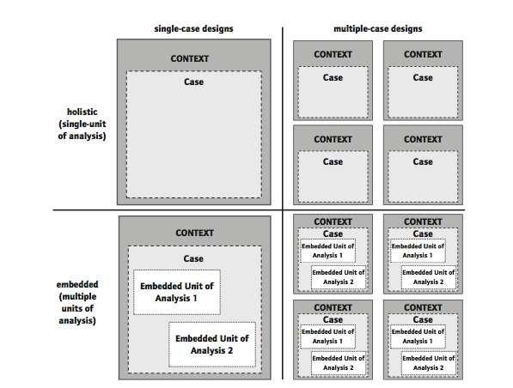
This study followed the holistic single-case study design because a singular case (the curriculum beliefs, rural contexts and instructional practices of two teachers) within a singular defined context (elementary school in one rural school district) was investigated. Yin (2018) posited the holistic design allows for examination of a singular case on a global nature. Yin further explained the holistic design is valid when considering the case may be best understood in a holistic nature (2018). By using the single-holistic-case study design, I was able to analyze this single case within the context of one rural elementary school.
Although this study did not allow cross comparisons with other rural teachers and rural school districts, this design allowed a more in-depth understanding of the chosen elementary teachers and rural contexts within the singular rural school district.
Setting
The rural community, in which the school is located, began its existence in 1903, even before Oklahoma statehood. Its creation and existence during this time was vital as the OCA&A Railroad ran through the northern half of the community. Absent a train station, the train never stopped in the area, but continued on to the next rural community 10 miles north. In 1904, the community built a train station and thus the creation of the official community with a post office and bank began. These developments also brought about the building of one wood frame building which came to serve as the local school.
As the community continued to flourish, people began to relish in the high yielding amounts of water for wells and availability of rich soil. As a result, huge gardens and thousands of Alberta peach trees were planted. This fueled a growing economy for the small rural area, leading to the creation of several hotels, two banks, a canning factory, and general stores. However, the economy came to a devastating halt when the majority of the community was destroyed by fire in 1910. To protect the anonymity of the teacher participants, citations for location history are not included.
The rural community is located in a county of 525 square miles with a population of approximately 5,925 citizens (Ratcliffe et. al., 2016). The small area itself is approximately 42 square miles and has a reported population of 329 residents (U.S. Census Bureau, 2010). The community has a post office, car wash, and two convenience stores for quick necessities and fuel. Adding more to this community's rural identity is that the closest urban area for citizens to grocery shop, attend entertainment activities, and visit the public library is more than 20 miles away.
The U.S. Department of Agriculture (2017) reported this rural community, along with surrounding communities in the county, had approximately 590 existing farms, 98% being named as family farms, with the majority of farmland dedicated to cattle, hogs, forage for livestock, and pecans.
Poverty is visually evident based upon dilapidated housing, lack of household internet access, and the fact that almost 20% of families are labeled as living “below” poverty, which is considerably higher than the state average (OEQA, 2019). The average median household income is $46,458, which is 11% lower than the state median household income (OEQA, 2019). Poverty affects many aspects of life, especially quality employment, education, and health opportunities.
The visual trip down the one main highway shows the community's dependency upon agriculture. Gathering of hay, baled hay, vegetable gardens, fruit orchards, and pastures with sporadic groups of cattle were also seen in the areas surrounding the community’s boundaries.
The county in which the site for this study is located has three school districts serving its rough population of 5,900 citizens. One of the districts is located in the county seat and services approximately 600 students. The second is a kindergarten through eighth grade district serving approximately 500 students. The last district, the site of this study, is a kindergarten through 12th grade school with a population of 239 students. This particular district is located approximately 14 miles from the other two districts in the county.
The site for this study was a small elementary school located within an economically disadvantaged, Title I, rural school district with a radius of 118 miles. State reports indicate 78.9% of the students at this site are considered “economically disadvantaged”. Evidence of poverty is also demonstrated in the fact that 100% of the students at this site qualified for the reduced priced or free meal plans offered by the state. The district contains two school buildings: one for elementary and one for high school (OEQA, 2019).
The designated grades for the elementary site were Pre-K through eighth. Due to lack of space in the elementary building, sixth, seventh, and eighth grades are taught in the high school building adjacent to the elementary. There were nine elementary teachers with an average teaching experience of 20 years; two of these nine teachers were assigned to teach sixth through eighth grades (OEQA, 2019). Additionally, there were four other professionals in the study site, one served as a special education teacher and the remaining were paraprofessionals.
This elementary school had a reading specialist on record; however, this person also served as the full-time second grade elementary teacher (leaving them currently unserved in this area). This site shared art and physical education teachers among all grade levels as well as one librarian within the entire K-12 district. The majority of these teachers and professionals were female with the exception of one 6th-8th grade teacher and the elementary principal.
There were 157 students in the elementary (PK-8), making up over half of the district’s student population. Of this student population, the two largest ethnicity numbers were Caucasian (41.6%), followed by Native American (37.3%). Other ethnic populations represented included Hispanic (3.1%), and two or more races (16.8%). OEQA (2019) reported there were no bilingual students in the district.
The economic demographics of this rural town demonstrated poverty. It bears repeating that the school reported 100% of students in the school district qualify for free or reduced priced meal plans. The elementary school had an average of 24.8% of students with an IEP (with one special education teacher) and 65% of students in K-3rd were placed in a remedial reading program (with one reading specialist who also served as the full-time second grade teacher) (OEQA, 2019).
The teacher participants admitted experiencing some adversity with rural contexts (i.e., poverty, student lack of world experiences); due to this, their choices for curriculum and instructional practices went beyond that of the textbook requirements and into what is often referred to as the “hidden curriculum”. They explained education should include guiding student learning of subjective knowledge including cultural and social interactions with peers and their community. Cubukcu (2012) explains that subjective knowledge can be presented through building good character with aims of creating strong, respectful, and positive citizens for today's world.
Participants
Although rural teachers face fewer choices for shopping and medical services, and constant threats of school consolidation, many of these teachers make the choice to stay and teach in rural districts for years (Monk, 2007). The teacher participants for this study were no different. While they did not live directly in the “city limits” of the rural town, they did live in close proximity and had lived experience of rural life and culture. Each participant was also labeled as a veteran teacher in that they had taught in rural areas longer than eight years.
The teacher participants were selected through purposeful sampling. Purposeful sampling consists of an intentional selection of study participants. I first recruited three elementary teachers from one rural elementary school: one first grade, one third grade, and one fifth grade. Unfortunately, not long after this study was approved, one of the teacher participants lost both parents to Covid-19. Trying to cope with her losses, she withdrew from the study. Therefore, this study included two rural teacher participants. They provided information about themselves, their curriculum beliefs, rural contexts and instructional practices through an ideology survey, interviews, and instructional practices.
The particular grade levels were chosen for two reasons. First, selecting teachers from different grade levels offered a variety of teachers’ beliefs and displayed an array of instructional practices based on students’ developmental levels. Second, students are required to take reading and writing state assessments at the end of the school year, thus possibly influencing decisions for choices of instructional practices.
Data Collection
Case study research requires data collection from multiple sources guided by the research questions to ensure both breadth and depth of information gathered (Merriam, 1998; Stake 1995). For effective data collection in case study research, Stake (1995) also emphasized the importance of the researcher being in the field to objectively observe the “workings of the case” (p. 8). Gathering multiple sources allows for triangulation of data to draw a better understanding of the participants and uniqueness of the case. Data collection is driven by the research questions (Stake, 1995).
I collected data through administration of a curriculum ideology survey, conducted in-depth teacher participant interviews, and classroom observations. Table 1 presents the types of data I collected and the duration of data collection activities in this study.
Table 1
Data Type, Data Source, Collection and Duration
Data Type | Data Source | Duration
Survey data | The Curriculum Ideology Inventory | 30 minutes
Interview transcripts data  Interview 1-Participant 1  Interview 1-Participant 2  Interview 2-Participant 1  Interview 2-Participant 2 | Interviews | 45 minutes  50 minutes  35 minutes  20 minutes
Observational data  Participant 1  Participant 2 | Classroom observations | Sept. 27-Mar. 7  Time: 45 hours  Oct. 7-Mar. 9  Time: 45 hours

Data gathered was stored on a password-protected computer. The data were separated into electronic folders according to type of data (i.e., separate folders for demographic information, survey data, field notes, and interview transcripts). The data were scanned and saved within the appropriate storage folder. The paper copies of these data were stored in a locked drawer inside a locked personal office for safety precautions. Furthermore, before data analysis began, each teacher participant was assigned a pseudonym for anonymity.
Curriculum Ideology Inventory
The first phase of data collection for this study utilized Schiro’s (2013) Curriculum Ideologies Inventory (see Appendix A). This inventory, which will be further referred to as a survey, was created around popular society descriptions of what school and schooling should exemplify. Schiro (2013) explained that the four curricular ideologies presented (Scholar Academic, Social Efficiency, Learner Centered, and Social Reconstruction) represent “very different purposes for schooling and very different methods of achieving those respective purposes” (p. 1). He further posited the competition among these four ideologies, or visions of education, “has stimulated advocates of each to develop increasingly powerful curricula, instructional methods, and research bases” (Schiro, 2013, p. 1). The survey was designed to present and contrast teacher curriculum beliefs around teaching, learning, knowledge, childhood development, and assessment, and compare and align each belief in categories separated into each of the four ideologies.
The survey was divided into six parts (purpose of education, teaching, learning, knowledge, childhood development, and assessment) and uses a Likert scale to rank four statements in each part (see Appendix A):
1 next to the statement you like the most
2 next to the statement you like second most
3 next to the statement you like third most
4 next to the statement you dislike the most (Schiro, 2013, p. 263).
The survey was administered in person during a scheduled elementary faculty meeting after school. First, a short explanation of the survey components and purpose were given. A clear explanation was also given detailing that the survey results would remain anonymous, and information would be used for the sole purpose of this study. This process was chosen so that the teacher participants could complete the survey within a specified time frame and data could be collected and analyzed expeditiously.
Interviews
In case study research, participant interviews are one of the most important sources of information (Yin, 2018). The teacher participant interviews provided the researcher with descriptive, rich perspectives and interpretations that could not be discovered in observation situations. Gathering interview data was necessary because an overall picture of everyday teaching and routines of the elementary classroom could be captured with fidelity (Yin, 2018).
Creswell (2013) pointed out that the participants in a one-on-one interview may be hesitant to provide information (p. 164). In order to avoid this situation, I met with the teacher participants before the research began to build a trusting relationship and assured them their names and schools would not be disclosed in my research, but rather, this research would be used to tell the unique and special story of how rural teachers’ curriculum beliefs and the rural contexts influence their instructional practices.
Before starting the interviews, I acquired a signed consent to participate in research from each candidate. During this time, I also let the teacher participants know the projected amount of time for each interview including information as to how I planned to utilize the gathered information in the study. I also asked permission of each teacher participant to be recorded during the interviews. Then, I informed each that they could stop the interview at any time and that any gathered data to that point would be destroyed at their request.
I followed Creswell’s (2013) essential steps to create interview protocols and to conduct the interviews. First, I asked open-ended questions focused on gaining a thorough understanding of how the teacher participant viewed their curriculum beliefs in relation to their teaching. The interview was conducted in the teacher’s classroom during a time available without students. The teacher participant’s classroom was a familiar place that provided comfort and security, was free from distraction, and allowed for effective audio recording of the interviews.
I conducted two semi-structured interviews with pre-developed interview protocols (see Appendix B). The first interview was completed in early fall before classroom observations began so that I could gain insight as to each teacher participant's stated beliefs and ideas regarding curriculum, teaching, and rural contexts. After observations were completed in early spring, the second interview was conducted. The final interview allowed me to collect reflective information regarding the thoughts of the influence their beliefs have upon their decisions for instructional practices. Interviews were conducted in the teacher participants’ classrooms and lasted approximately 20 to 50 minutes.
The first interview began by asking the teacher participants to provide demographic information to help provide background context. I then moved forward, asking questions, and encouraging each to share their curriculum beliefs, including the roles teaching and community context (i.e., poverty, sparse population, and rural culture) may have upon their beliefs. For example, two questions I asked each to respond to were how rural contexts were reflected in their choices for curriculum and how rural contexts were reflected in their instructional practices. Questions were open-ended in structure, allowing for the questions to be openly explored. The interviews helped to create detailed pictures of the beliefs and worldviews of each teacher participant.
The second interview took place at the end of the study following a similar interview protocol and anticipated time frame. These interview questions were based upon overall self-reflections of teaching practices in relation to their curriculum beliefs and rural contexts.
Classroom Observations
Classroom observations provide face-to-face encounters and interactions with the selected teacher participants during their instructional time and are an important element in case study research (Merriam, 1998). Remaining “sufficiently detached” is key in observational data gathering (Merriam, 1998). To remain as a non-participant observer in each of the classrooms, I remained as detached from the events as I could in order to create observational notes in an unbiased manner. Being a non-participant observer led me to observe and collect notes of instructional practices from a distance without having direct involvement in the classroom happenings. Through observation, I was able to witness each teacher participants’ instructional practices and interactions with students to gain better understanding of the case in study.
To ensure increased understanding of the case, objective recording of events and unbiased reflection/interpretations through creation of field notes were utilized to create meaning (Stake, 1995). To ensure extensive description and understanding of instructional practices, it is suggested that researchers spend adequate time completing observations (Merriam, 1998). Therefore, I dedicated six full days of observation time for each of the two teacher participants. This totaled 12 days of observation, equaling 90 hours of total observation.
While creating field notes, I tried to remain unbiased. I conducted observations of instructional practices and the classroom environment; I took field notes, following a pre-determined observational protocol with a structured format for taking descriptive and reflective notes (see Appendix C).
Before the instructional practices began on each visit, I noted the topic of the lesson and learning activities planned (gained from lesson notes given to me by the teacher). At the end of the observation time, I composed a synopsis of evidence observed. Both descriptive and reflective note taking during the observational time consisted of focusing on types of instructional strategies used to explain content as well as questioning techniques and response interaction with learners. During and after note taking of these events, reflective notes were made of elements witnessed that aligned with particular curricular beliefs and rural contexts.
Because it is important to decipher, decode, and transcribe notes while they are fresh in the observer’s memory, I took time immediately after observation to carefully develop transcribed notes, extracting and describing instructional practices and student interactions during the observation time (Merriam, 1998). I continuously maintained awareness of building a professional and positive rapport with both teacher participants, ensuring my research purpose was to tell the stories of an identified group in research—rural educators.
Data Analysis
Case study data analysis involves a single bounded unit embedded in intensive and holistic description (Merriam, 1998). I utilized thematic analysis, along with the constant comparative method of data analysis, and content analysis to analyze the data. Table 2 presents information illustrating data types, analysis methods and research questions employed in the data gathering for this study.
Table 2
Methods of Data Collection and Analysis
Data Type | Analysis Method | Research Questions
Ideology survey | Analysis protocol provided by Schiro (2013) | How do the rural contexts influence their curriculum beliefs?  How do the rural contexts influence their instructional practices?  How are their curriculum beliefs reflected in their instructional practices?
Interview transcripts | Constant comparative | How do the rural contexts influence their curriculum beliefs?  How do the rural contexts influence their instructional practices?
Field notes | Constant comparative | How do the rural contexts influence their instructional practices?  How are their curriculum beliefs reflected in their instructional practices?

Stake (1995) explained that in conducting analyses of case study data, “we are trying to understand behavior, issues, and contexts with regard to our particular case. . .” (p. 78). Gathering and analyzing case study data requires taking adequate time to study, reflect, and triangulate while attributing skepticism to impressions and simplistic meanings of first impressions of data (Stake, 1995). This required me to study the collected data multiple times to identify patterns and make adequate interpretations that told the story of the case.
Thematic Analysis
Braun and Clarke (2006) explained the purpose of thematic analysis is to guide the researcher in identifying “patterns of meanings across a dataset” in order to answer the research question. Therefore, the thematic analysis method served as the overarching data analysis method which guided in the identification of the themes across all data sources in order to identify prominent ideology(ies) and answer the research questions.
Braun and Clarke (2006) posited that patterns are identified through a careful process of familiarizing oneself with the data, coding the data, and then identifying the themes from the data. Throughout data analysis, I used memos to jot my observer comments and questions “to stimulate critical thinking” and to help “reflect on issues raised” in order to guide in making meaning of codes (Merriam, 1998, p. 163).
Content Analysis
The curriculum ideology survey was analyzed following the procedures provided by Schiro (2013). After the teacher participants completed the survey, the responses were analyzed using the Curriculum Ideologies Graphing Sheet, which has two parts. The first part was a sorting measure in which the teacher participant rankings were transferred in the exact order in which they were recorded on the survey (see Appendix A). This sorting determined the teacher participant preference of Scholar Academic, Learner Centered, Social Reconstruction or Social Efficiency Ideology for each topic section (e.g., purpose of school, purpose of teaching, purpose of learning, purpose of knowledge, purpose of childhood, and purpose of evaluation). The second step of this analysis involved transferring data from the sorting form to the graphing sheet. The graphing sheet is divided into six columns, each containing a category regarding teachers’ beliefs around schooling (see Appendix A).
The transferred data is represented by placing a large dot in the center of the corresponding cell in the graph. The large dot should match the letter-number pairs from the sorting form. Once corresponding data is transferred, the dots will then be horizontally connected. After all compiled data was graphed, the interpretation of the data phase then began. The horizontal lines were interpreted as follows:
- Horizontal line is relatively low (ranking numbers of mainly 1’s and 2’s) is interpreted that the teacher favors this ideology.
- Horizontal line is relatively high (ranking numbers of mainly 3’s and 4’s) is interpreted that the teacher does not favor this ideology.
- A zig-zag line from high to low is interpreted that the teacher has mixed feelings about the ideology (Schiro, 2013, p. 266).
The Constant Comparative Method
The constant comparative method (Strauss & Corbin, 1990) was crucial in analysis of multiple types of data in this study. According to Merriam (1998), the use of the constant comparative method requires that comparisons “are constantly made within and between levels of conceptualization” (p. 159). Throughout analysis of data, I continuously compared findings between and among data sources. During analysis of data sources, comparisons were consistently made between and among survey data, interview transcripts, and field note data. Comparison of data led me in to find likeness between beliefs and practices of both teachers, which then led to the creation of the themes and subthemes among the data.
Strauss and Corbin (1990) explained that throughout the data gathering and analysis process, open coding guides the researcher in understanding the information, while also allowing for identifying questions that analysis might reveal. I conducted open coding to analyze interview transcript data and field note data. During this step, I read and reread the data line by line multiple times to gain familiarity with the data. I created and assigned codes (e.g., free and reduced-price lunches, limited access to educational resources, limited access to travel for extracurricular activities) to capture and label the important concepts or constructs in the data line by line (Strauss & Corbin, 1990).
I made notes of analysis thoughts and ideas and began creating code book as I continued to move through the analysis process. Creation of the code book allowed for constant comparison of incoming data with existing data. The process continued until no new codes could be identified.
After completing open coding, I transitioned into axial coding to identify connectedness between and among the initial codes. When connections among codes were discovered, codes were then further grouped into categories and subcategories. During axial coding, I continued creating memos of analysis to help clarify connections among categories and subcategories as well as to continue extracting meaning from the analysis. For example, I discovered that many codes were related to various aspects of poverty. Therefore, poverty became a broader category that I identified and kept for further analysis.
The final phase of coding data was selective coding. During this coding phase, I sought to identify the prominent themes that emerged from the analysis of the data which were related to my research questions.
Throughout the process of data analysis, I constantly compared and triangulated the findings among all data sources (i.e., survey data, interview transcripts, and field notes) to allow the major themes to emerge. I selected the prominent themes that provided answers to the research questions and reported them.
Trustworthiness
Creswell (2013) explained that validation strategies support the accuracy of findings in research studies. Several validation strategies were utilized in order to present data findings with accuracy. Strategies to ensure this accuracy included prolonged engagement with the teacher participants. I conducted extended classroom observations (six full days with each teacher participant). The process also allowed for building a trusting relationship with the teacher participants as well as showing respect for their time, thoughts, experiences, and physical space. Following the advice of Fetterman (2010), during this “close and long-term contact,” I made use of member checking by sharing my interpretations with the teacher participants and requested that each give feedback as to the credibility and accuracy of the data and findings presented (as cited in Creswell, 2013, p. 251).
I also made use of data triangulation, and rich, thick descriptions as strategies of validation. Data triangulation provided the needed validity measures to ensure the case study findings are credible and trustworthy. I utilized rich, thick descriptions, and teacher participant quotes to construct a case profile of each participant that provides insights into their curriculum beliefs, rural contexts, and instructional practices.
Furthermore, time was set aside for conversations of open-ended questions concerning the teacher participants’ curriculum beliefs in order to add validity and reliability to the findings from the Curriculum Ideology Inventory.

Subjectivity
As an experienced educator, I realized the potential effects of my role outside the PK-12 classroom as well as my position in teacher education at the local university. In my role at the university, I have spent countless hours mentoring beginning teachers as well as tutoring struggling readers; through this, I have built a relationship with both the administrators and most teachers in this district. However, as an outsider, I appreciated that I was not entitled to having access to all school happenings outside of the teacher participants’ classrooms. I also had the understanding that each teacher participant was unique in their teaching styles, and I was by no means entitled to their personal feelings about aspects of education and administration other than those that affected their teacher beliefs and instructional practices.
As a former middle school teacher, I hoped that my years of teaching in rural areas helped guide me in making meaningful connections within the findings as well as helped me to create positive rapport with both teacher participants and other teachers in the building. My hope was that gaining the trust of each teacher and the administrators would aid in the teacher participants’ willingness to share experiences, reflect on experiences, and offer feedback on the interpretations I created.
Another aspect to consider is reflexivity. I was very cognizant of the fact that I, too, am an experienced practitioner. By acknowledging this fact in the beginning of the study, I made clear to all involved that my goal, before, during, and after this study was to tell of their beliefs, their experiences, and to describe their teaching styles rather than my own. For example, I never considered my curricular ideological standing or ideas on perspectives of teaching. I realized that while my experience would aid in the development of the study, the interpretations and conclusions drawn solely derived from the teacher participants.

Conclusion
Chapter 3 details the methodology of my research study. In this chapter, I have explained my research design and discussed my rationale for purposeful sampling of the teacher participants as well as given a lengthy description of the various data gathering methods that were utilized regarding the relation between the teacher participants’ curriculum beliefs and their instructional practices. This chapter also presents a detailed explanation of the methods of data analysis I employed to identify the themes that provided answers to the research questions.

Chapter 4: Findings
This chapter presents the findings from the analysis of the data, including interview transcripts, survey data, and field notes. I also present a detailed profile of the two teacher participants, Ms. Wilson and Ms. Smith (pseudonyms used for both), to illustrate the complexity of the relations between curriculum beliefs, rural contexts, and instructional practices. Multiple themes were identified through data analysis, but I selected three major themes most relevant to this study: 1) the teacher participants focused on the adverse aspects of teaching in rural schools, 2) the teacher participants revealed curriculum beliefs and instructional practices that align with the Scholar Academic ideology orientation, and 3) the teacher participants relied on academic standards for guidance in instructional practices. Embedded within the findings, when appropriate, I presented the challenges the Covid-19 pandemic has created on these rural teacher participants’ curriculum beliefs, instructional practices, and connections with the community.
One overarching question and three sub-questions guided this study. These questions are as follows:
Major Question: How do rural elementary teachers’ curriculum beliefs influence their instructional practices?
- How do the rural contexts influence their curriculum beliefs?
- How do the rural contexts influence their instructional practices?
- How are their curriculum beliefs reflected in their instructional practices?
Participant Profiles
Ms. Wilson (Pseudonym)
Ms. Wilson, the fifth-grade teacher participant, is a Caucasian female who grew up in a small rural area and graduated from this school. This background has given her an ideal experience in understanding rural contexts influence in the education of rural students.
Ms. Wilson is elementary certified and has 30 years of teaching experience. Her experience has been divided in both suburban and rural school districts; however, the majority has been spent in rural areas. She acknowledged that teaching in rural schools is where her passion lies, even though it is sometimes challenging due to lack of funding in rural schools, low socioeconomics of the community, and prevalent drug abuse (interview 1 transcript). While Ms. Wilson has dedicated the majority of her teaching career to rural schools, she no longer resides in a rural area; rather, she commutes from a small suburban town approximately 20 miles northwest of the rural school district in which she is currently teaching (interview 1 transcript).
Ms. Wilson explained that the suburban district in which she spent 13 years teaching was “the biggest place I had ever been” (interview 1 transcript). During this time in her career, she taught almost entirely in elementary school with one year at the junior-high level. During her 12 years of elementary teaching, she taught fourth grade reading and language arts. Ms. Wilson experienced team teaching with another elementary teacher who taught the same fourth grade group science and math. These teachers' classrooms were located directly across from each other, and students rotated back and forth between the two classrooms.
Ms. Wilson stated that the suburban district was much larger and promoted grade-level team teaching, so time for collaboration with peer teachers was a scheduled necessity. She implied that teaching in this district afforded less stress and less workload than in rural areas by saying, “I never had to worry with the other school [suburban district site] because there was a committee and a curriculum director” (interview 2 transcript). She contrasted this experience with her rural teaching by adding that she misses “just getting together and discussing things” because many times in rural school teaching there are no teams of teachers, rather, just one teacher for each grade level (interview 1 transcript).
In her current rural school, Ms. Wilson declared, “I AM the fifth-grade teacher.” This reiterated the fact there was no other fifth grade teacher for collaboration of ideas for teaching (interview 1 transcript).
In an interview, Ms. Wilson stated that a teachers’ curriculum beliefs can influence decisions for teaching. However, her interview responses did not clearly indicate how her curriculum beliefs influenced her instructional practices. Quite often, she emphasized the influence state academic standards have had on her instructional practices. She noted that this process became ingrained in her instructional processes during her years teaching in the larger suburban district. Ms. Wilson claimed this district vehemently pushed teachers to align every learning activity with state academic standards. She proclaimed this process continues to “drive her instructional decisions'' and further elaborated, “I have my standards and I know they [students] have to have narrative writing and so my learning objective is to figure out how to teach them this step by step” (interview 1 transcript; interview 2 transcript).
She explained that she does not create detailed plans, but she is sure to note the academic standards covered in her instruction each week. She added that she keeps a printed copy of the standards on her desk at all times. She reiterated their importance by stating the standards help her teach “step by step to get it covered.” She also mentioned that even though her teaching is “driven by the state,” she does like to add “creative things” into the learning activities, hoping that this addition will increase motivation and academic progress in her students (interview 1 transcript).
Ms. Wilson professed that she consistently studies and uses her state standards for instructional practices, and teaches her students these standards as well. She declared that she specifically tells her students, “This is what the state says you are supposed to learn,” which reinforced her position of the importance state standards have upon her teaching. She added she invites parents to “get them [standards] out and look at them so you know what they [students] need to know,'' further advocating her belief in the importance standards hold in her view of teaching (interview 1 transcript).
Ms. Wilson’s familiarity with rural contexts from her many years of teaching allowed her to demonstrate understanding of its influence upon education. Although her responses regarding the influence her views of rural contexts have upon her curriculum beliefs was not clear; she did, however, reveal her views about how rural contexts influence the school district. She pointed out that the rural community and the school work together to keep the community active and strong. In her first interview, she described her view of the community’s support of the district by saying, “They do play a role in that they support the school when we have functions, and games and they come to ballgames, they come and support in that way”.
She indicated further that while parent involvement in academics is limited, there are parents who offer to help with extra supplies or other items she might need in teaching (interview 1 transcript). She admitted that, at first, she was hesitant to accept the help due to the low socioeconomic status of the community, but then after finally accepting she realized, “They do want to help. I remember when I was a parent, I would have given my right hand to help my child. There are parents like that” (interview 1 transcript).
During her second interview, she further advocated the many advantages the rural community presence has within the school. She divulged one of the main advantages is that, “You have the opportunity for it to be a family atmosphere in a small school.” She continued describing common scenes that illustrate the strong community presence within school activities when she stated the following:
There are events when the whole family comes out [to the school] and the community would provide hamburgers and everyone ate their supper right there at school. It is very family oriented and teachers have the opportunity to meet and mingle with the community.
Ms. Wilson added another attribute of rural contexts is the work ethic in many communities. She said that many of her past students and their families “had a work ethic like I have never seen…. farmers and ranchers….it was a small school.” She also added that while in her current district, “Many of the kids are involved in FFA (Future Farmers of America), but the drugs and poverty…those [students] that could rise are just pulled down because that drug culture is so prevalent in everything and you know it can affect any family, any student” (interview 2 transcript).
When asked about how individual factors of rural contexts influence her instructional practices, Ms. Wilson mentioned poverty and its influence upon learning, not the influence poverty has upon her instructional practices. When talking about poverty, she elaborated its impact upon her students' learning, especially regarding the connection between lived experiences and standardized curriculum. She mentioned her rural students are “very limited in their outside knowledge” and added, “I try to use things they would understand. I am not going to talk about the museum, the metropolitan museum of art, and you know that, well that is just something they could never connect to” (interview 2 transcript).
She admitted to guiding her students in trying to make connections between their lived experiences (i.e., hunting, fishing, agriculture) and the curriculum, but the standardized format does not always afford this opportunity. She elaborated further, explaining that bringing in supplemental resources is sometimes needed, and added, “So, in that regard, it comes down to just being a good teacher to whoever you are teaching, wherever you are teaching, you just give them your best” (interview 1 transcript).
Ms. Wilson also mentioned that due to the poverty these students experience many of her students have never had the opportunity to visit other states or countries, thus limiting their knowledge of cultures and traditions different from their own. She acknowledged, in both interviews, that poverty in addition to living in relative seclusion attributes to her student’s homogeneity of knowledge and world experience.
Ms. Wilson also connected poverty with the lack of parental involvement in academics. She inferred that many of her parents work long hours which limits their availability of time in being a part of their child’s academic life. She also added concern for a lack of parental involvement for stay-at-home parents, and added this may be a result of possible “drug abuse within the community” (interview 1 transcript). She indicated that she diligently gives parents opportunities to become involved in their child’s learning.
One of the opportunities she commented on is that she requires her students to complete a “daily agenda.” Using this agenda, students are required to write down, in detail, the content skills and knowledge learned during the day. Following this explanation, students must write out homework assignments and add the date they are due. Ms. Wilson added that the students are to take the agenda home, go over the contents with parents/guardians, and have them sign to verify they reviewed the information. She advocated for the importance of trying to create a team of support for the student, but also acknowledged that many times the agendas are not signed, but “I can’t do anything about it. Just when they [students] are here, do what I can…” (interview 1 transcript).
Ms. Wilson demonstrated an understanding that being cognizant of her beliefs can play a major role in making connections between the choices in instructional strategies. Analysis of Ms. Wilson’s completed Curriculum Ideologies Inventory revealed her curriculum beliefs fell within two conflicting ideologies–the Learner Centered ideology and the Scholar Academic ideology. Observations, on the other hand, indicated that the Scholar Academic ideology and Social Efficiency ideology had a larger presence in her instructional practices.
Close analysis disclosed that Ms. Wilson connected with the Learner Centered ideology in that she believes that student learning should be individualized and created with elements of student interest tailored to unique learning needs. Further examination also illustrated a connection to the Learner Centered ideology in relation to the purpose of education. Results indicated she held the belief that education should “be an enjoyable, stimulating, child-centered environment organized around the developmental needs and interests of children…” (Curriculum Ideologies Inventory, Schiro, 2013).
In addition, survey data results found Ms. Wilson related to the Scholar Academic ideology in her views regarding the purpose of teaching. Analysis of her survey revealed “Teachers should be knowledgeable people, transmitting that which is known to those who do not know it,” (Schiro, 2013, p. 264), thus creating a learning environment controlled by the teacher, who makes learning “an intentional activity” which is “deliberately aimed at the student” (Schiro, 2013, p. 47). This created an unusual paradox between her ideas regarding purposes of teaching, purpose of learning, and purpose of education, which should all be interlaced in instructional practices.
Observations of Ms. Wilson’s teaching conveyed elements of the Scholar Academic ideology, such as the teacher being a transmitter of knowledge, application of academic standards to measure both student and teacher effectiveness, and the direct implementation of curriculum. Further alignment with this ideology emerged from Ms. Wilson’s statements about her beliefs in the purposes of education, teaching, and learning as she directly stated, “The purposes are to fill these students with as much content knowledge as possible…” (interview 1 transcript).
During her teaching, Ms. Wilson demonstrated the establishment of a stimulating and active learning environment utilizing explicit instruction to deliver standardized content. She admitted at several points, “I like direct instruction” (interview 2 transcript). Ms. Wilson began each lesson by explicitly teaching the concept or skill while having students refer to her notes on board and textbook materials. Following this direct instruction, students would be led through guided practice utilizing content worksheets. She maintained that both independent and guided practice should provide “a product I am able to see. By them [students] doing, I can clearly see they are preparing a product for me,” which highlights student progress toward academic achievement of both the standards and curriculum guidelines (interview 2 transcript).
Traits of the Scholar Academic ideology appeared several times through teaching; however, during one particular time of observation, students failed to recall simple math facts during explicit instruction. After several minutes of instruction, and attempted guided practice, students still struggled with processing the concept of subtracting and regrouping. In a stern, yet polite manner, she reminded her students that the reason for the “math morning work” was to aid them in the recall of simple addition, subtraction, and multiplication facts to help them move onto learning higher order math skills.
Interview responses indicated her strong belief of allowing academic standards to guide her teaching decisions. Although it was never directly stated as to how her instructional practices were influenced by this belief, she did state following the academic standards is necessary in providing her students a proper education. In her first interview, Ms. Wilson explained, “They [students] have to have that basic foundation…there are things they have to know...they have to know how to write, how to put thoughts on paper, they need to know basic math and how to read efficiently enough to get by,” and she acknowledged that following academic standards help her achieve this (interview 1 transcript).
Ms. Wilson admitted to utilizing most of the classroom standardized curriculum while teaching. This statement further demonstrated her belief alignment with the Scholar Academic ideology. She continued her explanation for the use of curriculum by sharing, “curriculum is of utmost importance” and “how we use it is even more important” (interview 2 transcript). She proclaimed that a good curriculum should provide students ample time “to reflect and for them to form answers to comprehension questions” (interview 2 transcript; survey). She ended her thoughts by adding the idea that a strong curriculum and effective teaching should allow students to accurately and effectively demonstrate what they have learned.
Classroom observations verified the importance curriculum has upon Ms. Wilson’s instructional decisions. Regularly throughout the day, teaching was guided through the use of textbooks, especially in math. She continually used textbook guidance as a tool to lead students in gaining understanding of content. Frequent references were made to the examples and explanations given in the text and repeated instances were observed telling students to refer to their texts for more information on content, thus ensuring that each student has the opportunity to gain equal understanding and knowledge. Each teaching cycle consisted of teaching skill, practicing skill, and proving knowledge gained through completion of a worksheet.
In addition, Ms. Wilson, addressed the importance of utilizing student outcomes in state testing in making future teaching decisions. She insisted, “If I need to change something, it will be due to state testing, because this is what I know, this is what I do, this is what I have seen success with” (interview 2 transcript). She exemplified a caring attitude and desire to help every student achieve academic success. She stated that her teaching goal is “to prepare them, right now, it goes from preparing them today for the next day, build on that which all leads to preparing them for the state test,” which in turn, “prepares them for the next year of school” (interview 2 transcript).
Although Ms. Wilson’s ideology survey did not present curriculum belief alignment with the Social Efficiency ideology, observations of teaching revealed a scattering of this ideology blended with the Scholar Academic. Ms. Wilson displayed an idyllic Social Efficiency ideological approach when she discussed the importance of relationship building with and among her students to create an understanding of appropriate actions for behavior that will contribute to them becoming successful adults.
Continual traits of the Social Efficiency ideology arose when she explained that she believes the purposes of education and learning should contribute to preparing students “for their adult lives and to become adults who can go out into the world and function effectively and productively in the real world” (interview 1 transcript). She shared she believes in the imperativeness of students learning “practical things needed to survive” as well as ways “to behave and interact within society” (interview 1 transcript; interview 2 transcript).
Through multiple observations, revelation of this fact became apparent as Ms. Wilson took daily time to teach proper etiquette and social behaviors through both explicit teaching and collaborative learning experiences. She supported the importance of these efforts by explaining, “I teach etiquette because they need to know how to greet people, how to shake hands” (field notes; interview 1 transcript). During daily teaching and learning activities in other content areas, Ms. Wilson frequently utilized teachable moments to emphasize the importance of etiquette and having respect for one another both in the classroom and in the community.
This mixture of ideologies was exemplified in oral descriptions for the need for classroom structure and classroom community as well as observations of the existing community atmosphere. Interview data emphasized a behaviorist approach when she described how community connectedness influenced both student absorption of knowledge and overall learning in the classroom environment. Although this community connectedness was mentioned and observed, it was consistently tied to structured guidance to ensure effective learning was gained by all students.
Another observed example of Ms. Wilson’s mixture of ideologies in teaching connected explicit teaching with society examples. During explicit teaching of a math lesson, she began utilizing examples for students to use the math skills in a practical everyday way. After her explicit teaching of the skill subtracting and regrouping, she guided the students to objectively demonstrate this math skill in figuring a future budget to be able to pay for a car and its insurance (field notes). After giving this example, Ms. Wilson transitioned back to a Scholar Academic style of teaching through the use of explicit instruction followed by completion of a math worksheet to demonstrate newly acquired skills.
It would be remiss if the impact Covid-19 had upon this teacher’s instructional practices, beliefs, and thoughts of students learning were not mentioned. Ms. Wilson admitted that she desperately tried to follow her teaching schedule and routines despite the fact that Covid-19 interrupted and “extremely impacted” her students’ learning (interview 2 transcript).
Her demeanor during this part of the interview became very rigid and she retorted that teaching became wearisome “because we had to sit far apart and I couldn’t get up there and say, ‘blah, blah, blah’[explicit instruction] and talking through a mask.” She added that she continually worried about what knowledge students were truly absorbing (interview 2 transcript). She argued further, “I was weary from it all, they were weary from it all. I couldn’t understand what the kids were saying and I don’t think they could understand me many times” (interview 2 transcript). Her frustration as to the haphazardness Covid-19 caused in the inability to deliver explicit instruction and provide guided and group practice was very apparent.
Ms. Wilson left the suburban school where she had taught for 13 years because she wanted to transition back to teaching in a smaller rural school. She commented that there is more of a need for teachers like herself in rural school districts, stating, “rural students deserve good teachers like myself too” (interview 2 transcript).
Ms. Smith (Pseudonym)
Ms. Smith, the first-grade teacher participant, is a Caucasian female who grew up in an urban area and graduated from its rather large, heterogeneous school district. This background has given her experience in the diverse contextual factors exemplified in an urban community.
She is both early childhood and elementary certified, but her 14 years of teaching experience have been solely in early childhood. Her teaching career began in an urban, inner city early childhood center which quickly led to a transition to teaching in suburban, and lastly, to rural schools. She has spent the last nine years in this rural elementary school where she has taught both kindergarten and first grade. Ms. Smith does not reside in this rural district; rather, she lives in an even smaller rural area approximately 15 miles to the southeast of her current school district (interview 1 transcript). Living in this area, coupled with her experience of living in both urban and suburban areas gives her a unique perspective on the lives of rural students.
Ms. Smith explained that while she enjoyed her time teaching in urban and suburban schools, the obstacles of teaching non-English speaking children and the inability to communicate with parents made teaching quite difficult and stressful (interview 1 transcript). She acknowledged, “a large, like 97%, Hispanic population” contributed to difficulty in communication. She admitted that, “Yes, we had bilingual assistants, but we didn’t have enough” (interview 1 transcript).
She added that often people, both inside and outside of education, do not realize a large population of inner-city school students are “mainly non-English speaking” which can create “a whole other issue that many don’t consider. As a teacher you have to figure out how to teach. It is not the students’ fault they do not speak English” (interview 1 transcript). Ms. Smith pointed out that this difficulty was a large contributor in her decision to move to a rural setting. She boasted that her time teaching in this rural elementary has finally led her to find happiness and satisfaction in teaching.
She commented that she finds teaching in a rural district, while not without its challenges, much more satisfying and enjoyable than her urban experiences. She added further description of the differences, “… these kids [rural] are so different. These kids are country, and they are just sweet. I mean I am not saying they [urban students] weren’t up there too, I am just saying that they are, … I feel like they [rural students] want it more” and “I love the connectedness,” referring to the relationship between herself and her students, peer teachers, and the rural community (interview 1 transcript; interview 2 transcript).
Ms. Smith indicated that she felt she did not receive either administrative or community support in either her urban or suburban teaching experiences; however, as for support in the rural community, she stated, “I like the rural school better than the urban school because my coworkers and administrators are more like family and I have more of a connection with students. I can go to their ballgames and other activities” (interview 2 transcript).
Every teacher holds beliefs about curriculum and learning. These beliefs can influence a teacher's decisions concerning instructional practices. Ms. Smith’s responses to interview questions did not directly indicate the influence her curriculum beliefs have upon her instructional practices. Her responses, rather, addressed her ideas concerning the importance state academic standards have upon educational expectations.
In her first interview, Ms. Smith emphasized priority in following both state academic standards and the scope and sequence guidelines provided in standardized curriculum in her instructional decisions. She shared that these resources also guide her in creating learning goals for her students. In her second interview, she continued that her academic standards demonstrate “What I need, but then they [the standards] are the focus, you know, to make sure they are learning what they are supposed to.”
Throughout her interviews, Ms. Smith elaborated upon the importance of students demonstrating successful learning of the content dictated by the state academic standards. She further indicated she utilized formative assessments during teaching and learning to determine if her students were “mastering the standards” (interview 1 transcript). She indicated that her style of formative assessment is used to gauge mastery of standards “so that I know they are learning those skills and are ready to move on to the next phase of learning” (interview 1 transcript).
Ms. Smith described her instructional practices as, “basically just follow the teacher’s edition,” inferring that the standardized curriculum is aligned with state academic standards and contains most of the content her students are required to learn. She admitted, though, there are times when she must “pull other things in if something more is needed” to be sure academic standards are being met.
She added the standards are now even more important in her instructional decisions because her students are academically behind due to the Covid-19 pandemic. Ms. Smith attested that now more than ever she must follow the academic standards for her instructional practices, as well as use them to review the previous grade’s academic standards when teaching to offer a scaffolded approach in learning (interview 2 transcript).
Ms. Smith has experienced a variety of diversity within both the types of settings and learners she has taught, yet, she did not clearly indicate the influence that rural contexts have on her curriculum beliefs. She did, however, demonstrate understanding that community factors can play a role in student learning. Although Ms. Smith did not clearly articulate the influence rural contexts have had upon her curriculum beliefs, she did reference the importance the community has upon the rural school environment.
Ms. Smith repeatedly pointed out that the community and school have a connectedness like she has not experienced before. She explained this school has a family-like atmosphere created through the willing support received from many retired individuals and local businesses in volunteer time and financial support. She added there seems to be an unspoken understanding of support between the school and community, “Especially when we reach out” with information regarding fundraisers and supporting the students (interview 1 transcript).
She continued her description of the supportive system and admitted several incidents of community members joining with the school for fundraisers and other school celebrations; however, she went into detail about those who volunteer in the elementary building. She stated that there are several community members who reserve time to read with children or to help with whatever a teacher may need. She described the volunteers as, “the grandparents that come up, we have one in particular who comes regularly, and all the kids hug her and call her by her grandma name. It is just a family community” (interview 1 transcript).
She also spoke of gatherings in which the school and community celebrate beginnings of sports seasons, celebrations of accomplishments and so on, “with the bonfires and stuff. Local businesses have always helped as well as parents” (interview 2 transcript). She commented further by describing the feelings of closeness and connectedness with the community:
I can have more of a connection, I can go to their ball games. I can go to the store and I can see them. I go into town to Walmart and I can see them, even though we are 20 miles away from home. They bring me a schedule of their events and I make sure I go. I love having just the community come together.
Interview responses also revealed the importance of building relationships inside the classroom to facilitate learning. Ms. Smith explained, “I want them to know that this is our community and they can come and they are supported and encouraged” because “we have built a family in the classroom” (interview 2 transcript). She also stated that building a classroom community leads in creating relationship and better communication with parents. During her first interview, she elaborated that many parents have her personal cell phone number. She added she encourages them to contact her at any time with any questions or concerns they may have regarding their child(ren) and their academics.
She acknowledged that because of this family connection, parents are not afraid to text and let her know things such as, “Hey will you allow my child to eat breakfast because we were running behind this morning? Of which they know that I will be sure their child has breakfast” (interview 1 transcript). The parents demonstrated their thankfulness for her kindness and support for them and their child(ren).
Observations of Ms. Smith’s classroom revealed a community atmosphere through the essence of etiquette and teaching of manners. The teacher was continually observed reminding students of “their manners” in both action and spoken word. Students were encouraged to exercise politeness with one another as well as demonstrate traits of being a helpful peer. Several observations illustrated this community quality, but one example in particular happened daily. Each day Ms. Smith assigned a “student helper” to aid another student with physical challenges by carrying his gym shoes, art supplies, etc. As the days went on, observations revealed the “helper” guiding and helping, as well as others jumping in to help as they saw need (field notes).
Ms. Smith’s responses also never indicated a clear answer as to how she believes rural contexts influence her instructional practices. She did, at one point, mention that differentiation in teaching is important, but this was never directly stated as an influence of rural contexts. She did however, provide detailed information as to how one factor of rurality, poverty, influences daily education.
She explained that the poverty these rural families experience is a huge contributor in their lack of connection in their child’s academics. Ms. Smith indicated she feels many parents exhibit an attitude towards devaluing education. She supported this idea when she argued, “when I think about parent-teacher conferences, I usually only have about 40% of parents who attend.” She continued, “But still, I push, push, push and I call and urge them to come, but still, many do not attend” (interview 1 transcript).
When asked to elaborate her thoughts as to the main contributing factors, she identified “the poverty in the area.” She continued further, “Sadly, many times these parents don’t have goals for themselves, so they don’t push their children. But again, this is why we are here” (interview 1 transcript).
Ms. Smith expressed that poverty impacts her students and their learning experiences. She commented poverty contributes to her students having limited world knowledge and experiences that help in making personal connections with the curriculum. She lamented she feels that many times during teaching…, “I have to take it [content] down a little bit;” she went on and said, “...I know the importance of higher order thinking and all of that, but, again, I feel I have to take it [content] down” to ensure students can comprehend the intent of the content.
To guide her students to make personal connections with curriculum content, she said she “tries very hard to find ones [stories] with events they have experienced,” but explained this is difficult with standardized curriculum (interview 1 transcript). She emphasized this difficulty by giving an example of teaching a story about a trip to the zoo. She admitted many of her students had never experienced visiting a city zoo and therefore, had difficulty making personal connections. She explained, utilizing “the life experiences some of the students had had [going to the zoo] with the students who had not” (interview 1 transcript). She explained this kind of sharing can contribute in broadening students’ world knowledge and guide them in making connections with ideas presented in standardized curriculum.
Ms. Smith demonstrated understanding that children who live in poverty are generally behind in learning and admitted, “I know they need extra” (interview 2 transcript). She indicated that understanding differentiation is imperative when faced with learners who struggle or who are behind in learning. She explained she uses multiple strategies “to make sure that they get it and to reinforce that it is important. I may have to repeat several times to make sure that they can at least recall the content in order to try and reach each and every learner” (interview 2 transcript).
Observations found Ms. Smith frequently utilized strategies of reteaching and differentiation to ensure student learning. One particular observation revealed several students struggling in identifying and producing sounds of digraphs. Ms. Smith stopped her explicit instruction and began to reteach, using previous digraphs learned. She differentiated her explanations until students began demonstrating mastery of this skill. Ms. Smith shared her reasoning for this type of instruction when she pointed out, “I mean try every avenue because every kid learns differently and so to try to make sure that it gets stuck in their mind. If it doesn’t work one way then I take back and try to go another route…” (interview 1 transcript).
Analysis of Ms. Smith’s completed Curriculum Ideologies Inventory revealed curriculum beliefs that fell within two conflicting ideologies–the Learner Centered ideology and the Scholar Academic ideology. Observations, on the other hand, determined the Scholar Academic ideology and Social Efficiency ideology reflected in her instructional practices.
Ms. Smith’s survey revealed she holds Learner Centered beliefs for both the purposes of education and teaching. Findings demonstrated the beliefs that education should offer opportunities for children to fully reach their individual capabilities through learning foundational education and effective communication. Findings also illustrated that she believes that the purpose of teaching should include a facilitating process in which the teacher observes students and then creates learning experiences based upon observed needs of each student.
The survey data findings also revealed Ms. Smith identified with the Scholar Academic ideology regarding her beliefs for the purpose of learning. Results indicated Ms. Smith believes learning happens most effectively “when the teacher clearly and accurately presents to the student that knowledge which the student is to acquire,” creating a systematic and controlled learning environment strictly following curriculum aligned with state standards and learning activities to demonstrate knowledge gain (Curriculum Ideologies Inventory, Schiro, 2013). This identified belief seems to be a direct contradiction to Ms. Smith’s beliefs concerning the purposes of education and teaching.
Observations illustrated Ms. Smith’s teaching mostly aligned with traits of the Scholar Academic ideology. This alignment revealed the aim of the Scholar Academic ideology which describes the teacher as a transmitter of knowledge, follower of state academic standards to ensure mastery of teaching and student academic success, and implementer of standardized curriculum. Observations of Ms. Smith’s strict following of routine teaching demonstrated further alignment with this ideology. This continual routine included explicit teaching and guided practice followed by independent practice, giving students an opportunity to demonstrate learning. She further admitted that planning for teaching “is not super detailed,” but rather consists of “pretty much just following the teacher’s edition for each content area” (interview 1 transcript). This was observed in the teaching of phonics, reading, math, and science.
Ms. Smith also demonstrated her alignment with the Scholar Academic ideology when she advocated use of standardized curriculum to teach content in her classroom. She explained the role curriculum has in her teaching and said, “Curriculum is a basis. I mean I know we have to use it because the school has purchased it, (laughs) but it gives you the basis for teaching and then you can branch out with examples and differentiation. Curriculum gives you a foundation…” (interview 1 transcript). She summed up her thoughts by stating curriculum is the foundation for classroom teaching. She added the teacher must be knowledgeable enough to determine if the curriculum is effective and adheres to the rigor and requirements of state academic standards so students can demonstrate content mastery.
Several of Ms. Smith’s interview responses about beliefs of teaching and learning also aligned with traits of the Scholar Academic ideology. One example is the emphasis placed upon the importance of assessing student learning. She explained that continual assessment is needed in order “to see if they are meeting standards.” She elaborated this importance when she specified that teachers should witness students “being engaged, and also as much as I hate the word tests, but to see that they have mastered the skills on the test so they can succeed and master academic goals” (interview 1 transcript).
Observations of teaching revealed connection with both the Scholar Academic and Social Efficiency ideologies. This connection was demonstrated through her explanation that education, teaching, and learning should come together to “make them [students] better humans so they can succeed in life” (interview 1 transcript). She elaborated on this statement by explaining, “Every student needs basic knowledge like reading, writing, and math. They need to understand those basics so they can succeed in basic life” (interview 1 transcript).
Ms. Smith continued to demonstrate characteristics of the Social Efficiency ideology through her systematic path of teaching. Observations denoted that she systematically plans teaching so that progress in learning can be evaluated. If knowledge gain is determined, teaching moves forward. If gain is not determined, the skill is practiced again and again until mastery is accomplished.
Ms. Smith advocated for the idea that all students deserve to have opportunities for learning both basic foundational knowledge and appropriate behaviors of productive and constructive members of society. She added she feels the need to make sure her curriculum incorporates “teaching manners and respect” because if students are to learn to act and react appropriately to situations in the community and society, this teaching must exist.
Ms. Smith admitted that the Covid-19 pandemic affected teaching and learning in her classroom. She stated that “having to keep students separated” and “making sure they wore their masks” was tiresome for her and her first graders and took a great amount of time from instructional practices. She explained students had a very hard time understanding her teaching and direction and she, as well, had a hard time understanding them through their masks, especially during their phonics and reading instructional time.
She continued that things became even harder when schools shut down. She explained that her students did not receive the needed technology (hot spots or Chrome books), so she had to resort to sending home worksheet packets. She said that many times, if work was returned at all, it would be incomplete or simply wrong. She admitted that she knew this was a result of missing her explicit instruction of the skills needed to complete the learning activities.
Ms. Smith proclaimed “loving teaching in a rural school.” She attested that while she enjoyed her teaching in urban elementary schools, and also learned a lot about teaching in such a diverse environment, she does not regret her decision to move to teaching in a small, isolated rural area. She stated that this decision was one of the best she has made career-wise and will continue teaching in rural districts until retirement.
Themes
Multiple themes emerged from data analysis. However, this section specifically focuses on presenting three major themes and their related sub themes which emerged from the analysis of the interview transcripts, survey data, and field notes. These themes, as well as supporting data, are presented in this section. They represent findings of the teacher participants' understanding of rural contexts and their influence upon teaching, the strong presence of the Scholar Academic ideology in the teacher participants' instructional practices and adherence to standard-driven, teacher-centered instruction. I also present findings, when appropriate, of the effects the Covid-19 pandemic had on these teacher participants beliefs of teaching and learning.
Theme 1: Adverse Aspects of Teaching in Rural Schools
The teacher participants were conscious of rural contexts within their school and described how these contexts influenced their beliefs about teaching and learning. Their understanding of rural contexts included three factors: rural students' limited world knowledge, poverty, and lack of parental involvement in academics.
Limited Knowledge About Outside World
Both teacher participants considered students limited world knowledge as a challenge to their teaching and student learning. When Ms. Wilson began to describe her feelings regarding this challenge and how it influenced her curriculum beliefs, she let out a deep sigh. She momentarily paused and then began with the following:
Well, I think I mentioned this in the first interview, how I know they are very limited in their outside knowledge other than what they see on Tik Tok, which is not, they are not really learning, that is nothing, it is just garbage, and then what they see on their phones and what they see on the internet, that is what limits their knowledge (interview 2 transcript).
She further added that rural students do not realize what they do not know; therefore, she explained, the “chances of them ever knowing are so slim, so if they are going to get it [worldly knowledge], I am going to have to give it to them.” After a long pause she added, “I know I am going to have to share that with them because they are not going to get it on their own. They are not going to be exposed to the [state] museum of art to see something like van Gogh’s display” (interview 2 transcript).
She then pointed out that this limited world knowledge impacts students’ ability to make connections with examples given in the curriculum. She shared that she must work hard to ensure students understand and comprehend elements of the curriculum and make connections with prior knowledge. She also stressed the importance of providing students with opportunities to make connections between curriculum and their personal lives by adding the following:
Well, being in a small school, when I use analogies or something I try to use things they would understand. Like today I might talk about FFA, like when you go show your animals blah, blah, blah. In rural schools I am going to have AG (agriculture) in the classroom, of course. It has to be important to the children and what they are involved in (interview 2 transcript).
Ms. Smith also emphasized concerns regarding students and their limited world knowledge base. However, she never directly stated how lack of world knowledge influenced her curriculum beliefs; rather, she addressed the influence this has upon her teaching and student learning. She explained that while teaching she strives
…to give them new experiences, like, you know, um, things I know they wouldn’t talk about or discuss at home. I try to pull in things they haven’t done so they get that experience. I try to bring in books that they might not have heard of to broaden their experiences or at least broaden the basis of their knowledge (interview 1 transcript).
She went on to say that many students just do not have the experiences shared in much of the curriculum, especially in reading and social studies.
During one observation of a social studies lesson, the lack of world knowledge was recognized. After Ms. Smith gave the students a handout containing various pictures of foods found at the grocery store, she guided them to study the pictures and make mental notes of what they recognized. As the whole group discussion began, it became apparent that many of the students did not recognize several of the grocery items. One item in particular was a French loaf of bread of which the students thought was “a really long potato.” At this point, Ms. Smith took the time to open conversation about other grocery items that students were finding difficult to identify. This lesson did heighten students' world knowledge of various foods from other areas; however, the concepts of the social studies lesson–how food arrives at the grocery store–was not learned, thus leaving the students behind on another world concept (field notes).
Both teachers openly acknowledged that one of the reasons rural students have a deficit in world knowledge is because they live in such a small remote area. Based on this rural context, Ms. Smith shared her thoughts of the lived knowledge her students bring into the classroom. After a very long pause she began to explain, “um, like country stuff, like horses, fishing, the lake and camping” (interview 1 transcript).
In her description of how this rural knowledge influenced her students' curriculum knowledge, she replied, “For some of our stories, I try to find ones with events they have experienced” so that students might better gain in reading skills, but confessed that is not always an easy task with standardized curriculum (interview 1 transcript).
Another observation of Ms. Smith’s classroom highlighted, once again, her students lack of world knowledge. Ms. Smith began teaching a lesson concerning various modes of transportation. She quickly learned, as the students studied and questioned the pictures in the text, that her students could not recognize some of the modes of transportation. The observations revealed while students demonstrated understanding of some of the concepts presented about traveling safely (i.e., wearing a seat belt in a car or wearing a helmet when riding a bike), they also demonstrated confusion concerning pictures of different modes of inner-city transportation such as the city bus and the passenger train (field notes).
As the questions and dismayed looks continued, Ms. Smith stopped her explicit instruction and utilized the smartboard to share pictures of city buses and inner-city passenger trains. She took time to answer questions about how and why these modes of transportation work and why they do not see them in their community. After the lesson, she explained that she knew she had to stop and change her instructional path because she understood her students would be amiss without this knowledge. Furthermore, she added that student comprehension of this story’s main idea could possibly become constricted had she not stopped to help them build knowledge of these types of transportation (field notes).
Poverty
A second aspect of rural contexts that both teachers frequently spoke about was poverty of the rural community. Both recognized and argued that poverty plays a large role in teaching and learning. Ms. Wilson posited that because many of her students’ experience living in poverty their access to various world cultural experiences, as well as outside learning experiences (i.e., museums, travel, participation in dance, music, and/or art lessons) is very limited (interview 2 transcript). She continued by including the idea that poverty and limited world knowledge contribute to rural teachers' necessity of understanding how poverty can affect student learning as well as how living in poverty can limit student ability to make personal connections with standardized curriculum.
Ms. Wilson described awareness of the effects that poverty has upon her teaching and professed that she must always keep the low socioeconomic status of her students and families in mind when deciding what and how to teach. She added, “Their socioeconomic parts I have to understand. Poverty impacts my teaching because there are projects and things I really want to do, but little Bobby might not have the money to get what he needs; therefore, I will probably be the one footing the bill for most of it” (interview 1 transcript). She continued, “the extra things for projects and activities for outside the box learning, teachers must either forgo the ideas, or pay for the items themselves” (interview 1 transcript).
She elaborated that the school administration was also very aware of the effect’s poverty has upon the community and their students. Each year, the school and administration worked tirelessly to ensure that all students in this school received the basic supplies needed when school began. Both the teachers and the administrators in this district also demonstrated the importance of meeting a child’s physiological needs to ensure an effective learning situation for all by providing students, and many community members, access to free breakfast, lunch, and a third meal that can be taken home.
Ms. Smith also exemplified awareness of the impact poverty has on student learning. She explained that in a perfect, or even more affluent rural school, students attend school every day, come prepared to learn, and have all of their needs met; however, she argued this is not always the case in poverty areas (interview 1 transcript).
In her second interview, Ms. Smith shared the effect that poverty has on student absenteeism and student learning. She began telling the story of a first grader who missed school regularly and on days he did attend, he was always extremely tardy. She disclosed, “I know the child’s background” and the role poverty played, so she volunteered to work with him during “specials” and other breaks throughout the day to help him with the learning that he had missed. She added, “the way he will get the knowledge is if I take the time to catch him up. It is not his fault” (interview 2 transcript).
She proclaimed the importance of elementary teachers understanding the effects poverty can have on student self-esteem. She explained that elementary teachers in rural areas need to become cognizant of the students “who need the extra affirmation and positive comments.” She elaborated this is needed because many students who live in poverty experience feelings of defeat. She went on that simple affirmations and positivity can give students the confidence to work hard even when they are extremely behind (interview 2 transcript).
Ms. Wilson reflected upon her own childhood education in a rural area stricken with poverty and lamented how she feels her education was affected. As she contemplated upon her personal experiences, she recognized the academic opportunities she missed. She sadly admitted, “I mean I come from a small rural school in a poverty area you know, but when you are a kid, you don’t realize, ‘hey, they [bigger schools] are doing this and we don’t get to do anything like that’” (interview 1 transcript).
However, now connecting the reflections of her school days and her current teaching in a poor rural district has been an “eye opening” experience (interview 2 transcript). This reflection made her adamant that all rural students, but especially those in poor areas, deserve strong teachers who will give them the strong learning experiences and opportunities they deserve (interview 2 transcript).
Ms. Wilson gave her final reflections of how she believes poverty impacts teaching and learning with the following words:
Well, this is what I know. Whatever it is I do here it’s important that I do my best. This is a very small, poor rural school. They need someone who cares, someone to hit all of those points we have talked about (interview 1 transcript).
She then concluded the statement with:
So, in that regard, it just comes down to being a good teacher to whoever you are teaching. Because these little kids, these little poor kids deserve it as much if not more. They need to know that this [rural town] is not the ending, it’s, there is so much more out there and they need to know that (interview 1 transcript).
Lack of Parental Involvement in Academics
Lastly, both of the teacher participants frequently referred to the lack of parent involvement in academics as a factor related to rural contexts and how their practices are influenced. Both exemplified awareness that understanding the lack of parental involvement is imperative in instructional practices for rural students. Both demonstrated a bit of anxiety when discussing parental involvement in student academics. Ms. Wilson hesitantly revealed “education-wise, I don’t know that, well, we have, um” after a long pause, she continued, “a drug problem that many parents and families and all that, well, there is just no support there [academically] at all. The kid just gets up themselves and maybe makes it to school or not” (interview 1 transcript).
She explained involving parents academically is not always an easy task in rural areas. She admitted that many parents “do want to help” but just struggle with doing so. She insisted that some “parents are very supportive and I can call and say, you know, little Bobby is not doing his work and ‘I’ll take care of it Mrs. Brown’ you know, discipline that sort of thing, they will be on their end doing what they are supposed to do” (interview 1 transcript).
She elaborated further, acknowledging many of the parent’s lack of academic knowledge: “I know their parents don’t know. And because their parents don’t know, their chances of students knowing is not there. Today, when I send work home on days we are out, I send a key to the parent because otherwise they are not going to be able to help their child” (interview 2 transcript).
Ms. Smith pointed out some of the same concerns. She mentioned that she doesn’t feel parental support when it comes to her students academically. She stated, “um, some parents I feel, help support, but there are others, that well, I hate to say, it's almost like we are just a babysitter. Like, I mean, I worked before school this morning and there were already parents dropping off kids at 6:45” (interview 1 transcript). She continued that she understands the parents have to work, but many do not. As a result of this, she spends many mornings working with students on homework or listening to them practice their reading because these tasks were not completed the night before with parents.
Ms. Wilson addressed how the Covid-19 pandemic impacted parental involvement academically by saying, “During Covid, curriculum needed to be very self-explanatory. It needed to be easy, I don’t mean that the answers would be easy, I mean it had to be kid friendly”. She continued that she had to question herself, “Can the kids get there and do that because the parents are probably, I mean, I got a lot of calls and it was always because the parents didn’t know” (interview 2 transcript). She admitted that this caused her a lot of stress and anxiety in worrying if her students were obtaining the knowledge and skills they needed to be successful in building future knowledge.
Ms. Smith addressed many of the same issues. She explained that now [post Covid] she does not send home homework per se, but rather just sends home “practice.” She added, “If I do send home reading practice, I provide simple questions for the parents to ask their child” to help build comprehension (interview 2 transcript). She shared that she feels the need to send things home that are easy enough for the child to understand what to do on their own, but that she also tries to encourage parental involvement. She added that she does this in hopes of creating a desire in parents to become more involved in their child’s learning.
While these factors of rural contexts are very prevalent and influence teaching and student learning, recognition of these few limits the true understanding of rural contexts.
Theme 2: Scholar Academic Orientation in Curriculum Beliefs and Instructional Practices
The analysis of the survey data revealed the teacher participant curriculum beliefs fell within both the Learner Centered ideology and Scholar Academic ideology. However, both of these beliefs were not reflected during their teaching practices. Survey data disclosed that both of the teacher participants aligned with the Learner Centered ideology in beliefs for the purposes of education, but aligned with different beliefs, one being Scholar Academic, for the purposes of teaching and learning.
The teacher participants did not appear surprised by the survey data findings. As a matter of fact, when these results were revealed, the teacher participants laughed and admitted to not being surprised. The teacher participants also admitted that their curriculum beliefs will probably not change because what they are doing “works” (interview 2 transcript).
One commonality found between both of the teacher participants was the presence of the Scholar Academic ideology in their instructional practices. Findings suggested several components of the Scholar Academic ideology were present throughout the teacher participants descriptions of instructional practices, and teaching of standardized curriculum.
Use of Standardized Curriculum
Two of the most noticeable components of the Scholar Academic ideology demonstrated by both teachers were the direct implementation of standardized curriculum and consistent use of one instructional strategy–explicit teaching.
Both of the teacher participants explained the necessity of using standardized curriculum during instructional practices. During the first interview, Ms. Smith revealed, “It gives you a basis. I mean I know we have to use it because the school has purchased it. It gives you the foundation….” Ms. Wilson added, “Well, I follow what I have been given…it is very comprehensive and there is nothing lacking there that I have found yet” (interview 1 transcript). Ms. Wilson further explained the importance of standardized curriculum by stating, “I would say it drives, it drives my instruction,” (interview 1 transcripts).
Throughout interviews and observations, the importance of using standardized curriculum during instructional practices was apparent. Ms. Wilson said that when planning for instruction she first studies the standardized curriculum and then creates learning goals that “of course, are not the same as state standards, but, but, they’re guided” (interview 1 transcript). Ms. Wilson explained that after she creates the learning goals for her students, she then studies the curriculum, not to plan lessons, but rather to decide how she will teach the curriculum.
Similarly, Ms. Smith revealed the role standardized curriculum plays in creating learning goals for her students, by adding “I don’t post them…but I do follow the academic standards which are lined up with the curriculum.” For both phonics and math, Ms. Smith explained she follows the scope and sequence given with the standardized curriculum because “the curriculum aligns to the academic standards”. She admitted that this makes instructional practices “a lot easier” and the fact that the “learning activities are provided for each skill is wonderful” (interview 2 transcript).
Explicit Teaching Styles
Findings suggest both teacher participants’ instructional practices align with the Scholar Academic ideology. Observations of both of the teacher participants instructional practices revealed explicit, or direct teaching of the standardized curriculum. The explicit teaching consistently included explanation of content skill to be learned followed by teacher led guided practice of a worksheet. Once students demonstrated understanding of the content skill being taught, they were instructed to complete another worksheet independently to demonstrate learning. As students worked independently, teacher participants walked among students observing their work and answering questions if needed.
Ms. Smith described her teaching style as being “one of those sticklers” in her reading instruction. She added, “if they are not using their finger we will start over.” Observations revealed this during her teacher led guided practice in reading. She described her teaching and assessment practices require students to be orderly during instructional practices. She explained she expects her students “to raise their hand, unless I say echo me and then they will echo me, or if I say shout it out and then they can all shout it out” (interview 1 transcript).
Ms. Wilson explicitly stated, “I like direct instruction” and described her style of teaching to be “like a bootcamp, getting kids ready and educated to go out and be a plumber or teacher or doctor. They have to know how to write, how to put thoughts on paper, they need to know basic math, and how to read efficiently enough to get by.” She elaborated further, explaining her teaching “is a process every day and it has to be planned for” (interview 1 transcript). She explained she continually assesses learning throughout her explicit teaching and her teacher led guided practice by having students do things like, “putting their answers on their white boards, waiting to hold them up, and I have some that are struggling, then I will know these 3 over here don’t have theirs yet so they are struggling. So, I will stop and go, okay, everyone having trouble with this, this is how you do it and that sort of thing” (interview 1 transcript).
Instructional styles remained the same through routines of teaching content for both of the teacher participants. Both utilized explicit instruction, followed by teacher led guided practice, and ended with independent practice for students to demonstrate mastery of learning standardized content skills.
Organization of Classroom
Observations of classroom structure and routines revealed organized systems in place to facilitate student learning. Findings suggest that even though the physical organization of each classroom was different (i.e., Ms. Smith’s student desks in rows; Ms. Wilson’s student desks in groups of four), the standardized running of the classrooms were essentially the same. Both of the teacher participants often referenced rules and procedures during instructional practices to promote successful learning behaviors.
Analysis of both interview transcripts and field note data revealed that both of the teacher participants adhere to their daily teaching schedules and classroom rules and procedures. Ms. Wilson explained, “they [students] need that” (interview 1 transcript). The teacher participants also demonstrated similar repercussion responses if and when students did not comply with classroom rules and procedures. First, the teacher participants would ask the student to explain the “proper” rule or procedure that was not followed. Then, the student would be asked to explain their actions and how this error could be corrected.
Reinforcement of classroom rules and procedures was noticed through the rewarding of “coins;” however, as coins were given for following rules and procedures, coins were taken away for not. Ms. Smith explained, “They get a coin as an incentive, so if they are walking down the hall nicely or they raise their hand and everyone else is shouting out, I will go put a coin on their desk” (interview 1 transcript). She further explained that she has noticed students “paying better attention” and following rules as a result.
Daily teaching schedules were also explicitly followed during instructional practices. Ms. Smith shared the importance of following a strict schedule by sharing, “There are some kids who do not like change. Like Friday, our schedule was off and I had to do the reading test and it really threw several of them off because they are used to taking it at a different time. So, the routine is the exact same” (interview 1 transcript). Ms. Wilson added, “...that’s my schedule and I don’t want to miss anything” (interview 1 transcript). Ms. Wilson further explained her adamance of following her teaching schedule by pointing to a large poster on the front bulletin board, “that is my [teaching] schedule and I don’t want to miss something…we have been missing stuff and actually it is really throwing me off, ya, I can’t stand that” (interview 1 transcript). Similarly, Ms. Smith admitted following her teaching schedule and that routines guide her in “making sure they are learning what they are supposed to” and making sure academic standards and curriculum skills are covered in a timely manner. She added, “I like to keep order…so the routine is the exact same every day” (interview 2 transcript)
Both teacher participants were also observed keeping a strict eye on the time during instructional practices (Ms. Wilson actually used the timer on her cell phone) to ensure instruction schedules were continuously followed. When teacher participants called the time, students systematically transitioned to the next scheduled content area (field notes).
Theme 3: Reliance on Academic Standards
Ms. Wilson and Ms. Smith demonstrated alignment with the Scholar Academic orientation of teaching through similar standard-based instructional styles. Both admitted that following state standards for their teaching was an essential element for teaching effectiveness. Both also acknowledged this type of instructional practice allows for assessment of student knowledge and skills gained as dictated by academic standards.
Academic Standards as Guide for Teaching
Analysis of interview data found that the teacher participants referred to using their standards to guide teaching and assessment a total of 30 times. Ms. Smith mentioned using standards for instructional practices and creation of learning goals. She continued her thoughts by claiming that her instructional decisions rely on making “sure that they get the standards and then, but I also try to make sure to go back and make sure they get what they need…they [standards] are the focus you know, to make sure they are learning what they are supposed to” (interview 2 transcript).
Likewise, Ms. Wilson advocated for the importance of academic standards when she described her instructional practices by saying, “I just follow the state standards. I have a list of skills they are supposed to know (theme, figurative language) and I just go over those in different ways either directly or with a worksheet” (interview 2 transcript).
Frequent visits to both classrooms confirmed this standards-based style of teaching. Both of the teacher participants demonstrated explicit instruction that closely followed both state academic standards and sequence of curriculum, especially in reading and math (field notes). For example, Ms. Smith’s teaching included her standing in the front of her students explaining the particular skill to be learned. Intermittently, she would guide student learning by writing on the marker board and asking questions to verify understanding of the new skill concept. As students demonstrated understanding, worksheets would be handed out and completed independently (field notes).
Ms. Wilson’s teaching demonstrated the same type of standards-based instructional style. However, one difference noticed was that her teaching began with a review of prior knowledge, and an explanation of the learning goal and its connection “to what the state says they have to know” (interview 1 transcript). This was followed with explicit teaching, teacher-led guided practice, and then, closely supervised independent work time. Finished work is turned in, unfinished work, at scheduled transition time, was placed in a homework folder to be completed later (field notes).
Organization of Classroom
Observations of classroom structure and routines revealed organized systems in place to facilitate student learning. Findings suggest that even though the physical organization of each classroom was different (i.e., Ms. Smith’s student desks in rows; Ms. Wilson’s student desks in groups of four), the standardized running of the classrooms were essentially the same. Both of the teacher participants were seen often referencing rules and procedures posters illustrating successful student learning in the classroom to guide students in appropriate learning behaviors. As students were led to these references, attitudes and demeanors were altered and learning continued.
Teaching schedules were also explicitly followed during practice. During her first interview, Ms. Smith shared, “There are some kids who do not like change. Like Friday, our schedule was off and I had to do the reading test and it really threw several of them off because they are used to taking it at a different time. So, the routine is the exact same.” Both teachers were observed watching the time (Ms. Wilson actually used the timer on her cell phone) to denote transition times to other content-area teachings. Students demonstrated understanding the change signals and efficiently put their things away and would pull out needed materials for the next scheduled content (field notes).
The teacher participants demonstrated similar repercussion responses if and when students did not comply with procedures. First, teachers would ask the student to explain the “proper” rule or procedure that was not followed. Then, the student would be asked to explain their actions and how this error could be corrected. Taking the time to reinforce each of these rules and procedures demonstrated the teacher participants' tactics in connection with proper classroom behaviors and successful learning.
Reinforcement of classroom rules and procedures was noticed through the rewarding of “coins;” however, likewise as coins were given for following rules and procedures, coins were taken away for not. Ms. Smith explained, “They get a coin as an incentive, so if they are walking down the hall nicely or they raise their hand and everyone else is shouting out, I will go put a coin on their desk” (interview 1 transcript). She further explained that she has noticed students “paying better attention” and following rules as a result.
Analysis of both interview and field note data revealed that both of the teacher participants adhere to their daily teaching schedules and routines. Both revealed the importance placed upon these routines by saying, “they [students] need that” and “...that’s my schedule and I don’t want to miss anything” (interview 1 transcript). She further expressed this importance by pointing to a large poster on the front bulletin board, “that is my [teaching] schedule and I don’t want to miss something…we have been missing stuff and actually it is really throwing me off, ya, I can’t stand that” (interview 1 transcript).
Similarly, Ms. Smith admitted following her teaching schedule and that routines guide her in “making sure they are learning what they are supposed to” and making sure academic standards and curriculum skills are covered in a timely manner (interview 2 transcript). She added, “I like to keep order…so the routine is the exact same every day.” Sometimes, teaching was observed to be a bit rushed to make sure all content was completed within the scheduled time. During one observation, Ms. Smith was informed that school might be dismissed the following day for the state baseball tournament. She quickly began to reconfigure class times so that both days of curriculum could be covered “just in case.” She revealed this was necessary so she could carry on with the next lesson when school resumed and not get behind in her teaching (field notes).
Student Demonstration of Academic Success
The teacher participants described the need for continuous formative assessment to provide proof of student knowledge gain as dictated by academic standards. Ms. Smith explained she must consider “teaching to the standards,” and continuous use of “informal assessments” to determine “mastery of standards.” She then added, “I want them to realize I expect a lot out of them” so she continuously utilized student repetition and echo strategies to informally assess students' knowledge gain. She further explained that she feels it is extremely important for her to provide students with “some kind of worksheet or workbook page” to determine if students are mastering the learning presented in the academic standards.
Similarly, Ms. Wilson emphasized the importance of formative assessment to ensure students' learning of content provided by the academic standards. She explained, “I learn by doing…and if they are doing it, they are providing a product and I am able to see that product” (interview 1 transcript).
Observations demonstrated continual use of handouts, worksheets, and textbook materials to assess student mastery of academic standards. This cycle included the teacher participants grading each activity and making the determination if success of standard was gained or if reteaching was needed. Findings from both observations and interviews suggested teachers differentiating instruction or simply reteaching entire lessons until the majority of students could demonstrate gain of knowledge. Ms. Wilson explained that individual students who struggled to make the gain were pulled aside “...and would work with me, showing her what she missed so she would understand it so next time she doesn't miss it” (interview 1 transcript).
Ms. Smith revealed she understands the importance of students achieving learning success as provided by the academic standards, but explained,
I know every kid can learn and I see that light bulb come on and you have been struggling because you are thinking this kid just cannot get it. Then that light bulb comes on and you are like Okay, I can continue, I can keep doing this. Sometimes you just get so frustrated you are just like okay, I am done. I am ready to be out of the room. But when you see that light bulb come on, you are just like okay, I can go another day, I can continue on…
Both of the teacher participants emphasized the importance of students demonstrating success as dictated by their academic standards. Analysis of explanations found that student mastery of learning activities guided by standards provides assurance for success on the summative assessments provided by the State Department of Education to conclude the year’s teaching. Ms. Wilson admitted her instructional practices revolve around “…those four state tests, three really, but writing and reading that is two more, um so that is what I have to focus on.”
Concluding commentary of the goals of teaching indicated similar belief patterns between the teacher participants. Both of the teacher participants displayed a deep conviction that following academic standards, standardized curriculum, explicit teaching, and formative assessment leads to achieving a main goal of education, “to prepare them for the state test” which “prepares them for the next year and the year following” (interview 2 transcript).
Conclusion
This study found discrepancies among the teacher participants' curriculum beliefs identified from the Curriculum Ideologies Inventory, statements made during interviews, and observations of teaching practices. The Scholar Academic ideology was a predominant feature in instructional practices. Furthermore, analysis suggested that these rural teacher participants allow limited perceptions of rural contexts (i.e., lack of world knowledge, poverty, and lack of parental involvement) to influence teaching practices. The study did not produce much insight into how rural contexts influence curriculum beliefs. Rather, the teacher participants explained how it influences their daily teaching practices.
Chapter 5: Discussion
The purpose of this holistic, single case study sought to gain knowledge of the influence rural contexts and rural teachers’ curriculum beliefs have upon their instructional practices. In this chapter, I present a discussion of the main findings concerning the influence rural contexts and teacher participant curriculum beliefs have upon instructional practices. This is followed with further discussion of the limitations of the study and implications for further research concerning rural teachers. The research questions presented in this study include one overarching question and three sub questions:
Major question: How do rural elementary teachers’ curriculum beliefs influence their instructional practices?
Sub-questions:
1. How do the rural contexts influence their curriculum beliefs?
2. How do the rural contexts influence their instructional practices?
3. How are their curriculum beliefs reflected in their instructional practices?
Drawing upon the theory of planned behavior and ecological systems theory, I investigated how two rural teachers’ curriculum beliefs and rural contexts influence their instructional practices. The teacher participants revealed some awareness of the influence rural contexts can have upon teaching and learning, but they tended to focus on adverse influences of rural contexts. The findings the complex nature of teacher curriculum beliefs and suggested an incongruence between their curriculum beliefs actual instructional practices. Combined, these themes revealed that the teacher participants rely on standards-based instruction delivered with a teacher-centered instructional style.
Limited Perceptions of Rurality
Azano and Stewart (2016) stated, “When discussing potential challenges to working with any student population, it is easy to focus on what is not present or things that are lacking; this is a normal response to thinking about challenges” (Azano & Stewart, 2016, p. 116). This idea revealed itself in this study as well. As Azano and Stewart inferred, when discussing rural contexts and education it tends to be easier to focus on “issues related to perceived deficits” (p. 116). The teacher participants in this study were no different; they quickly identified three challenging rural factors (poverty, limited student world knowledge, and lack of parental involvement) that influences their teaching.
The teacher participants’ views of rural contexts were deficit oriented. The first view was that poverty is extremely prevalent in rural areas (Irvin et al., 2012; Johnson & Strange, 2007; Lichter & Johnson, 2012). Many families in rural areas live 50% below the federal poverty line, which is considered living in “deep poverty” (Robson et al., 2019; Irvin et al., 2012). The other views concern students’ lack of world knowledge and limited parental involvement (Chaudry & Wimer, 2016; Lacour & Tissington, 2011).
Many students living in rural poverty have neither financial nor physical access to many of the outside world experiences of their urban and suburban peers (Chaudry & Wimer, 2016) which allow them to make connections more easily with the content in standardized curriculum. Azano (2011) shared that rural students’ lived experiences may not always be represented in curriculum, therefore, using real-life examples in teaching practices can be effective in increasing both student engagement and academic growth. Azano (2011) further explained that utilizing lived experiences helps students make connections with content and their rural lived experiences.
Both participants admitted to understanding these ideas, but also acknowledged the influence the lack of student world knowledge has upon their teaching based on the standardized curriculum. The teacher participants frequently referenced the importance of helping students link outside experiences their students have (i.e., farming, camping, fishing, etc.) to the concepts within their teaching; however, these connections many times become difficult since much standardized curriculum contains minimal, if any, true reflection of rural experiences.
Students who have limited experiences struggle to make connections while learning content, thus, their learning becomes hindered. Hatton (2016) supported this idea by explaining how students experience “a mismatch” between their experiences and standardized curriculum, or when their “knowledge is culturally misaligned” they tend to struggle in making personal connections with the new knowledge (2016, p. 452). Hatton further expressed that this causes student frustration in learning, which further restricts learning, engagement, and desire to learn new content as well.
The teacher participants also stated understanding that implementing elements of standardized curriculum is essential in proving knowledge gain; therefore, both pointed out having to take extra time to introduce students to world experiences via the Internet. They explained hopes that guiding student learning in gaining world knowledge would help them in making connections with curriculum as well as increasing academic success. Because of this, the teacher participants explained that making learning authentic and meaningful is essential in their instructional practices, but the use of standardized curriculum makes this difficult.
The last deficit mentioned by the teacher participants concerns the lack of parental involvement in academics. Parents raising families in poverty is an overt issue containing covert barriers that hinder involvement in their child’s education. Hill and Taylor (2004) shared that many barriers’ parents living in poverty experience are impacted by things such as “...non-flexible work schedules, lack of resources, transportation problems, and stress due to residing in disadvantaged neighborhoods'' (p. 162). These attributes, alone or combined, inhibit both parent ability and choice in becoming an involved member of school functions, academic meetings, and overall education involvement.
Furthermore, poverty can give parents a feeling of inadequacy in helping their children with their academic activities. These families, many times, have fewer “cognitively stimulating” items such as books, magazines, and access to electronic materials available in the home, affording less opportunity for parents to play an active role in aiding the learning of their child (Cooper et al., 2010, p. 872). The teacher participants in this study mentioned inferring the feelings of inadequacy some of their students’ parents experience. Both explained that many times parents have admitted to not being able to help their child with homework that is taken home. The teacher participants acknowledged that now, if homework is sent home, they are sure the students have a strong understanding so that parental help is not needed or they send home explicit directions and answer keys so that parents can successfully help their child.
Robson et al. (2019) explained that stakeholders in education who maintain a narrow focus of the challenges and factors experienced in rural education can further increase the barriers in the rural classroom. This research further suggests that if stakeholders desire meaningful changes for improving rural education they must be willing to identify and introduce a broader scope of factors to be considered including challenges, strengths, and opportunities (Robson et al., 2019). Sadly, teachers demonstrating a limited perception of rurality factors could be hindering the academic achievement of their students.
Inconsistent Alignment Between Curriculum Beliefs and Instructional Practices
The teacher participants, like many in supporting research, verbally claimed student-centered practice as their main strategy in teaching. Results analyzed from the Curriculum Ideologies Inventory (2013) presented the teacher participants’ varying views of the purposes of education, teaching, and learning. However, neither the student-centered approaches mentioned in the interviews nor the Learner Centered views of education in the survey results were observed; rather, a more direct, explicit, Scholar Academic style of teaching was discovered. Although this style of teaching was readily observed, characteristics of the Social Efficiency ideology were also noticed throughout instructional practices. The presence of both the Scholar Academic ideology and Social Efficiency ideology were made known through consistent use of explicit teaching of curriculum content as well as teaching of proper behavior and etiquette. Interestingly, research investigating the presence of teacher beliefs within their instructional practices supports this finding in that most results indicate that teachers’ stated beliefs often do not align with observed teaching practices; in addition, discovery was made that many teachers are unaware that this misalignment exists (Basturkman et al., 2004; Farrell & Patricia, 2005; Wen et al., 2011).
The study’s findings revealed that the teacher participants align with the Scholar Academic ideology in that they appear to be “mediators between the curriculum and the student” (Schiro, 2013, p. 49). In being the mediators for the students, the teachers assume the role of the knowledge source who, in turn, transmits what needs to be learned to their students. Observations further supported this finding through consistent use of explicit teaching through didactic discourse and supervised instruction—both characteristics of Scholar Academic teaching—as main elements for instructional practices.
The teacher participants' portrayal of explicit teaching aligns well with Torgesen’s (2004) explanation of explicit teaching as “an instruction that does not leave anything to chance and does not make assumptions about skills and knowledge that children will acquire on their own” (p. 363). The Scholar Academic ideology regards knowledge as an “objective reality” in which knowledge that is expected to be known by all is considered to be the most valuable for education. Likewise, this ideology views its learners as “agents of learning” who absorb their knowledge through transmission of knowledge from the teacher. This transmission of knowledge is thought to be best learned when presented in a direct, explicit instructional style.
Both teachers were regularly observed using explicit instruction of standardized curriculum. Explicit teaching is referenced in several research studies as being one of the most effective teaching strategies used to enhance student learning of content material (National Reading Panel, 2000; Rupley et al., 2009; Stipek, 2004). Observations denoted teachers implementing explicit instructional practices and reliance upon academic standards to drive instructional decisions. Research has shown that explicit teaching following standards allows for students to demonstrate learning through creation of a product (Rupley et al., 2009).
The teacher participants' explicit teaching styles generally followed the scope and sequence of content prescribed in standardized curriculum. The teaching of standardized curriculum lends itself to this style of teaching in that publishers add recommendations and directions for using this style of teaching in the presentation of content to students (Reutzel et al., 2014).
Although the teacher participants of this study demonstrated alignment in teaching with the Scholar Academic ideology, characteristics of the Social Efficiency ideology were also discovered within their teaching practices. This ideology explains that teaching should “prepare students for many years of productive adult life within society” as well as making American education useful by preparing students to “perform useful skills” that are “relevant and useful” in the essence of daily life (Schiro, 2013, p. 97). Comparisons of findings from both interviews and observations showed both of the teacher participants following this same mindset of this ideology. One of the main characteristics of the Social Efficiency ideology is that teachers should guide students in reaching their full human potential, which leads them to become contributing members of a democratic society. To guide students in reaching this potential, this ideology states that student learning should be focused on reading, writing, and math; the basic skills needed for survival in society.
Observations of both of the teacher participants demonstrated unique alignment with the Social Efficiency ideology through their desire to teach children how to behave and react in social situations through the teaching of etiquette. Schiro (2013) explained that the Social Efficiency ideology is one that teaches “life skills that will enable them to be productive adult citizens.” Schiro further added that students should have “learning experiences that will let them acquire behavior so that when they are represented with certain stimuli, they can respond in socially productive ways” (2013, p. 216). The teacher participants both exuded passion for this cause and were observed on multiple occasions setting time aside for particular teaching and practice of behaviors, such as proper greetings, hand shaking, and even etiquette during lunch and snack times.
Classroom observations indicated that the teacher participants took a Scholar Academic approach through explicit teaching, guided practice, and independent practice in which the student produced proof of their learning through completion of worksheets and/or group activities–components of a teacher-centered classroom. Combined with the teacher-centered instructional styles, observations also revealed the teacher participants are very regimented in following the same instructional procedures for all content curriculum taught throughout the day.
The misalignment of curriculum beliefs and instructional practices is also noted in previous research. Studies support findings that although teachers claim to hold curriculum beliefs that students should be taught in a learner-centered fashion, their instructional practices reveal more of a direct, teacher-centered style of teaching. These studies also mention the misalignment between beliefs and practices could many times be due to uncontrollable factors, such as set standards for teaching, teaching experiences, and internal school factors (Kaymakamoglu, 2018; Kim, 2004; Song, 2015; Wen et al., 2011).

Academic Standards as a Basis for Instruction
A large driving factor of instructional practices for these teacher participants is following the academic standards set in place by their state. Throughout interview conversations with the teacher participants, continual reference to the grade level standards was mentioned. Both of the teacher participants expressed an adamant attitude that these set standards are the driving force for all planned activities and teaching within the classroom. They emphasized the importance of understanding their own grade-level standards as well as the standards for the grade level above them. They also commented that explained that grade-level standards were created for a reason and, if followed, students should be well prepared for the next year's curriculum.
When discussing lesson planning, teachers admitted to not really writing much down, but rather jotting notes about which standards were to be covered with each element of the standardized curriculum. It was even mentioned that the curriculum used to teach content, particularly in phonics and math, is strictly aligned with the standards, so written planning was not necessary. This could indicate simply following the textbook, which sometimes may not match the state-mandated curriculum mapping. While both of the teacher participants were very adamant in sharing the important guidance that the standards can give teachers, they also admitted that as an effective teacher they must understand the meaning of the standards as well as how to present the curriculum during instructional practices–thus ensuring satisfactory results of student learning. These factors point to additional inconsistency between stated curriculum beliefs and instructional practices.
Effective instruction requires that teachers be mindful about academic standards. To support student learning, other factors need to be considered (e.g., student factors, community factors, and other contextual factors, etc.) (Avery & Fortunato, 2016; Azano, 2015; Azano & Stewart, 2016).
Implications for Teaching in Rural Schools
This study suggested the complexity of identifying teacher curriculum beliefs and the influence these beliefs can have upon instructional practices. The study further acknowledged that teacher awareness of rural contexts influences their teaching practices. The study’s findings revealed the necessity for teachers in rural areas to reflect on their curriculum beliefs and consider how these beliefs influence their instructional practices. The teacher participants in this study reported having ideas of using instructional practices following a Learner Centered approach to teaching; however, observations revealed a more direct, teacher-centered approach. This revealed the need for them to reflect upon their curriculum beliefs and then analyze these beliefs within their daily instructional practices. Effective rural teachers should gain clarity about how their curriculum beliefs and knowledge of rural contexts influences their teaching practices.
Recognizing rural contexts can guide teachers in gaining a better understanding of their students, and facilitate creation of engaging learning activities. The teacher participants grappled with identifying how rural contexts influence their curriculum beliefs. However, both teachers did mention similar barriers in teaching and learning: limited world knowledge, poverty, and lack of parental involvement.
Waller and Barrentine (2015) indicated that when a foundational understanding of community factors is noted, both teaching and learning can begin to help students make connections between their diverse community, lived experiences, and curriculum thus enhancing their academic performance. While human nature leads us to notice challenging aspects, rural contexts do offer learning opportunities as well. Robson et al. (2019) stated that while research does heavily mention the challenging aspects of rurality in rural education, “education policy and practice in rural communities must take into account broader community factors…that can help create and sustain meaningful change in rural schools” (slide 1). Rural schools and their teachers could utilize and focus on the amenities their community has to offer to broaden student knowledge such as “high value on civic and community engagement, tight-knit networks of support, and the deep sense of and commitment that dates back generations” (Robson et al., 2019, slide 1).
Teachers must be thoughtful in their instructional practices and emphasize appropriate experiences to help students relate their experiences to the objectives being taught. Creating instruction and learning activities in which students cannot connect their individual experiences with content knowledge can be problematic for academic growth. Azano (2015) advocated that education for rural students should “promote greater social justice and address educational inequity” (p. 269). Azano further argued that rather than marginalizing rural students, inclusion of rurality and its attributes should be included in the educational curriculum.
Public school systems, urban, suburban, and rural, are offered incentives for adopting standardized curriculum, the main one being that this standardized curriculum is aligned with high-stakes testing (Waller & Barrentine, 2015). However, Waller and Barrentine (2015) also commented that standardized curriculum, while complying with state and federal policies, “may serve to isolate teachers and students from their rural surroundings” (p. 1). Ms. Smith emphasized her beliefs of the importance of following the school's curriculum and state academic standards to ensure her students were gaining the appropriate knowledge. Likewise, Ms. Wilson added that strict adherence to state academic standards and curriculum, especially math, will guide her students to do well on the end-of-year state tests.
Both of the teacher participants admitted to trying (with some difficulty) to make rural connections for students to try and bridge their individual experiences with the content curriculum being taught. Indeed, observations of instructional practices illustrated this was not always an easy task. Azano (2011) supported the idea of bridging rural student experiences with standardized curriculum by explaining challenges in rural education could overcome through “promoting curricular relevance for rural students” (p. 1). This simply is not the case with standardized curriculum. Rather, it seems, real rural world experiences have been ignored in the creation of content in standardized curriculum (Azano, 2011; Donovan, 2016; Gruenwald 2003).
One way for teachers in rural areas to help build the bridge between content and personal lived experiences is implementation of place-based pedagogy. Bishop (2004) explained placed-based education is crucial for rural schools as it builds connections between rural students’ lives and their learning. Research discussing place-based education maintains that the community can have tremendous impact upon student learning (Bishop, 2004; Donovan, 2016; Schulte, 2018; Waller & Barrentine, 2015). Using place-based pedagogical practices requires the teacher to utilize elements of the rural community to teach needed knowledge for student academic progress. Utilizing place-based pedagogy in teaching gives rural students an opportunity to explore content focusing on aspects of the rural community to which they can relate. Through the use of this content, teachers can then teach academic elements required through academic standards.
The teacher participants in this study provided some examples that are closely related to people’s lived experiences in the rural community and their effort to help students make connection with the content was evident. However, standardized curriculum was still followed. Such curriculum usually does not reflect life in rural communities. Significant incongruence exists between rural students’ prior knowledge, lived experiences, and the knowledge required for the mastery of the academic content.

Future Research
Research concerning rural education and rural teachers is limited. This research study examined how rural teachers’ curriculum beliefs and rural contexts influence their teaching practices. The findings reveal limited influence. Additional research focusing on rural teachers’ curriculum beliefs and rural contexts could produce insights to promote reflection among rural teachers and help them to better recognize the influence their beliefs have upon their instructional practices.
Current literature regarding rural education seems to focus upon improvement in rural education rather than the beliefs and practices of the rural teacher. Also, literature suggests that the use of standardized curriculum and academic standards created for all students creates a disadvantage for rural learners due to the absence of materials allowing rural students to make connections with their prior knowledge and lived experiences. These findings further suggest the need for research investigating the effect standardized curriculum and academic standards have upon both teaching and learning.
Existing research was found that discusses the influence placed-based pedagogy can have upon learning for the rural student; however, the amount of research in this area is limited (Bishop, 2004; Waller & Barrentine, 2015). Future research could investigate how placed-based pedagogy and teachers curriculum beliefs could work together to influence students learning in the rural classroom.
Altogether, research seems limited in the area of rural education, particularly that focusing on the rural teacher. Existing educational research, like studies with a focus on standardized curriculum, combines all students regardless of backgrounds and learning environments (i.e., urban, suburban, or rural). While the desire to provide all students with a fair and quality education is admirable, diversity of all students, urban, suburban, and rural, must be considered. Furthermore, identifying the true diversity of rural contexts need not be overlooked. Many research studies do not focus on the combined effect of poverty, isolation, and homogeneity on teaching and learning in rural schools–this in itself could offer avenues for future research.
Conclusion
Both of the teacher participants demonstrate a strong passion for teaching rural students, and they work hard to meet the learning needs of their students. However, their views of rural contexts tend to be deficit-oriented. Their teaching centers on standardized curriculum and was driven by state academic standards. The inconsistencies between their curriculum beliefs and their instructional practices suggested rural teachers need to be more reflective on their curriculum beliefs and the alignment between their curriculum beliefs and instructional practices. This study contributes to research in rural education by shedding light on the complexities of curriculum beliefs and instructional practices of rural elementary teachers, which have not been carefully investigated in previous research in the field of rural education. To improve the learning outcomes of students in rural communities, the researcher calls for rural teachers to adopt place-based curriculum and instructional practices that respect and draw upon rural students’ funds of knowledge in their teaching.
References
Abelson, R. P. (1979). Differences between belief and knowledge systems. Cognitive Science, 3, 355-366.
Acar, E., & Yilmaz, A. (2015). Building a constructivist social learning environment through talk in the mathematics classroom. International Journal of Human Sciences, 12(1), 991-1015.
Ajzen, I. (1985). From intentions to actions: A theory of planned behavior. In J. Kuhland, & J. Beckman (Eds.), Action-control: From cognitions to behavior (pp. 11-39). Springer.
Alfaro, C. (2008). Developing ideological clarity: One teacher’s journey. Counterpoints, 319, 231-249.
Allen, C. D., & Penuel, W. R. (2015). Studying teachers’ sensemaking to investigate teachers’ responses to professional development focused on new standards. Journal of Teacher Education, 66(2), 136-149. doi:10.1177/0022487114560646
Andrews, J., & Yee, W. C. (2006). Children’s funds of knowledge and their real life
activities: Two minority ethnic children learning in out-of-school contexts in
the UK. Educational Review, 58(4), 435-449.
Anthony-Stevens, V. & Langford, S. (2020). “What do you need a course like that for?” Conceptualizing diverse ruralities in rural teacher education. Journal of Teacher Education, 7(3). 332-334. doi:10.1177/0022487119861582
Avery, L. M., & Fortunato, M. W. (2016). Reframing rural education: Implications of the rural mystique and its absence in educational policy. In A. R. Thomas, & G. M. Fulkerson (Eds.), Reinventing rural: New realities in an urbanizing world (pp. 161-178). Lexington Books.
Azano, A. P. (2011). The possibility of place: One teacher’s use of place-based instruction for English students in a rural high school. Journal of Research in Rural Education, 26(10). https://ill-libraries-ou-edu.ezproxy.lib.ou.edu/illiad.dll?Action=10&Form=75&Value=1273472
Azano, A. P. (2015). Addressing the rural context in literacies research: A call to action. Journal of Adolescent & Adult Literacy, 59(3), 267-269.
Azano, A. P., & Stewart, T. T. (2016). Confronting challenges at the intersection of rurality, place, and teacher preparation: Improving efforts in teacher education to staff rural schools. Global Education Review, 3(1), 108-128.
Baeck, U. K. (2016). Rural location and academic success: Remarks on research, contextualisation, and methodology. Scandinavian Journal of Educational Research, 60(4), 435-488. http://dx.doi.org/10.1080/00313831.2015.1024163
Barley, Z. A., & Beasley, A. D. (2007). Rural school success: What can we learn? Journal of Research in Rural Education, 22(1), 1-16.
Basturkmen, H. (2012). Review of research into the correspondence between language teachers’ stated beliefs and practices. System, 40, 282-295.
Basturkmen, H., Loewen, S., & Ellis, R. (2004). Teachers’ stated beliefs about incidental focus on form and their classroom practices. Applied Linguistics, 25(2), 243-272.
Biddle, C., & Azano, A. P. (2016). Constructing and reconstructing the “rural school problem”: A century of rural education research. Review of Research in Education, 40, 298-325. doi:10.3102/0091732X16667700.
Bishop, S. (2004). The power of place. English Journal, 93(6), 65-69. https://doi-org.ezproxy.lib.ou.edu/10.2307/4128896
Blanks, B., Robbins, H., Beasley, L., Greene, M., Kile, M., & Broadus, A. (2013). Why rural schools are important for pre-service teacher preparation. Teacher Educators’ Journal, 20, 75-93.
Braun, V., & Clarke, V. (2006). Using thematic analysis in psychology. Qualitative Research in Psychology, 3(2), 77-101. https://doi.org/10.1191/1478088706qp063oa.
Bronfenbrenner, U. (1976). The experimental ecology of education. Educational Researcher, 15(1), 5-15.
Bruner, J. (1996). The culture of education. Harvard University Press.
Bryan, J. (2005). Fostering educational resilience and achievement in urban schools through school-family-community partnerships. Professional School Counseling. https://www.jstor.org/stable/42732462
Buchmann, M. (1987). Teaching knowledge: The lights that teachers live by. Oxford Review of Education, 13(2), 151-164.
Buehl, M. M., & Beck, J. S. (2015). The relationship between teachers’ beliefs and teachers’ practices. In H. Fives, & M. G. Gill (Eds.), International handbook of research on teachers’ beliefs (pp. 66-84). Routledge.
Burton, M., Brown, K., & Johnson, A. (2013). Storylines about rural teachers in the United States: A narrative analysis of the literature. Journal of Research in Rural Education, 28(12), 1-18. http://jrre.psu.edu/articles/28-12.pdf.
Byrne, M. A. (2015). Implications of understanding: Exploring the relationship between teachers’ beliefs and perceptions of education and curriculum on the implementation of curriculum and of pedagogical design (Publication No. 10148301) [Doctoral dissertation, Aurora University]. ProQuest Dissertations Publishing.
Calderhead, J. (1996). Teachers: Beliefs and knowledge. In D. C. Berliner, & R. C. Calfee (Eds.), Handbook of educational psychology (pp. 709-725). Simon & Schuster.

Chant, R. H. (2009). Developing involved and active citizens: The role of personal practical theories and active research in a standards-based social studies classroom. Teacher Education Quarterly, 36(1), 181-190.
Chaudry, A., & Wimer, C. (2016). Poverty is not just an indicator: The relationship between income, poverty, and child well-being. Academic Pediatrics, 16(3S), 23-29.
Cheung, D. (2000). Measuring teachers’ meta-orientations to curriculum: Application of hierarchical confirmatory factor analysis. The Journal of Experimental Education, 68(2), 149-165.
Cheung, D., & Wong, H. W. (2002). Measuring teacher beliefs about alternative curriculum designs. The Curriculum Journal, 13(2), 225-248. doi:10.1080/09585170210136868.
Ciftci, S. K. & Cin, F. M. (2018). What matters for rural teachers and communities? Educational challenges in rural Turkey. Compare: A Journal of Comparative and International Education, 48(5), 686-701. https://doi.org/10.1080/03057925.2017.1340150
Cipriano, C., Barnes, T. N., Pieloch, K. A., Rivers, S. E., & Brackett, M. (2019). A multilevel approach to understanding student and teacher perceptions of classroom support during early adolescence. Learning Environments Research, 22, 209-228.
Clark, C. M., & Peterson, P. L. (2006). Teachers’ thought processes. In M.C. Wittrock (Ed.), Handbook of research on teaching. Macmillan.
Cook-Hunter, T. (2015). Practising culturally relevant pedagogy: A literature review of classroom implementation. BU Journal of Graduate Studies in Education. https://files.eric.ed.gov/fulltext/EJ1230678.pdf
Cooper, C. E., Crosnoe, R., Suizzo, M., & Pituch, K. A. (2010). Poverty, race, and parental involvement during the transition to elementary school. Journal of Family Issues, 31(7), 859-883. https://doi-org.ezproxy.lib.ou.edu/10.1177/0192513X09351515
Corkin, D. M., Ekmekci, A., & Papakonstantinou, A. (2015). Antecedents of teachers’ educational beliefs about mathematics and mathematical knowledge for teaching among in-service teachers in high poverty urban schools. Australian Journal of Teacher Education, 40(9), 31-62. http://dx.doi.org/10.14221/ajte.2015v40n9.3
Cornelius, S. (2018, January 24). Professional development in rural school districts: Challenges and strategies for effective program design. Edmentum. https://blog.edmentum.com/professional-development-rural-school-districts-challenges-and-strategies-effective-program-design
Cotti, R., & Schiro, M. (2004). Connecting teacher beliefs to the use of children’s literature in the teaching of mathematics. Journal of Mathematics Teacher Education, 7, 329-356.
Creswell, J. W. (2013). Qualitative inquiry & research design: Choosing among five approaches (3rd ed.). Sage.
Cromartie, J., & Bucholtz, S. (2008). Defining the “rural” in rural America. Amber Waves, 6(3), 29-35.
Cross, D. L. (2009). Alignment, cohesion, and change: Examining mathematics teachers’ belief structures and their influence on instructional practices. Journal of Math Teacher Education, 12, 325-346. doi:10.1007/s10857-009-9120-5.
Cubukcu, Z. (2012). The effect of hidden curriculum on character education process of primary school students. Educational Sciences: Theory & Practice, 12(2), 1526-1534.
Curran, F. C., & Kitchin, J. (2019). Documenting geographical isolation of schools and examining the implications for educational policy. Education Policy, 1-39. doi:10.1177/0895904819864445.
Dimitriadis, G., & Kamberelis, G. (2006). Theory for education. Routledge.
Donovan, E. (2016). Learning to embrace our stories: Using place-based education practices to inspire authentic writing. Middle School Journal, 47(4), 23-31. https://www-jstor-org.ezproxy.lib.ou.edu/stable/44321068?seq=1
Eckert, L. S., & Petrone, R. (2013). Raising issues of rurality in English teacher education. English Education, 46(1). www.jstor.org/stable/24570974
Edmondson, J. & Butler, T. (2010). Teaching school in rural America: Toward an educated hope. In K. A. Schafft & A. Youngblood Jackson (Eds.), Rural education for the twenty-first century: Identity, place, and community in a globalizing world (pp.150-170). Pennsylvania University Press.
Eisenhart, M. A., Shrum, J. L, Harding, J. R., & Cuthbert, A. M. (1988). Teacher beliefs: Definitions, findings, and directions. Educational Policy, 2(1), 51-70.
Ertmer, P. A. (2005). Teacher pedagogical beliefs: The final frontier in our quest for technology integration? Educational Technology and Development, 53(4), 25-39.
Farmer, T. W., Leung, M., Banks, J., Schaefer, V., Andrews, B., & Murray, R. A. (2006). Adequate yearly progress in small rural schools and rural low-income schools. The Rural Educator, 27(3), 1-7.
Farrell, T. C., & Guz, M. (2019). ‘If I wanted to survive, I had to use it’: The power of teacher beliefs on classroom practices. The Electronic Journal for English as a Second Language, 22(4), 1-17.
Farrell, T. S., & Patricia, L. P. (2005). Conceptions of grammar teaching: A case study of teachers’ beliefs and classroom practices. Teaching English as a Second or Foreign Language, 9(2), 1-13.
Fishbein, M., & Ajzen, I. (1975). Belief, attitude, intention, and behavior: An introduction to theory and research. Addison-Wesley.
Fives, H., Lacatena, N., & Gerard, L. (2015). Teachers’ beliefs about teaching (and learning). In H. Fives & M. G. Gill (Eds.), International handbook of research on teachers’ beliefs (pp.249-265). Routledge.
Fives, H., & Buehl, M. M. (2012). Spring cleaning for the “messy” construct of teachers’ beliefs: What are they? Which have been examined? What can they tell us? In K.R. Harris, S. Graham, & T. Urdan (Eds.), APA educational psychology handbook: Vol. 2 individual differences and cultural and contextual factors (pp. 471-496). American Psychological Association.
French, K. R. (2018). Critical education & new teachers’ beliefs: A new niche for educational research. The William & Mary Educational Review, 5(1), 137-155. Retrieved from https://scholarworks.wm.edu/wmer/vol5/iss1/15
Gallent, N., & Gkartzios, M. (2019). The routledge companion to rural planning. Routledge.
Gardener, C. E., & Borgemenke, A. (2007). Improving student outcomes in rural and small schools. Education in Rural Australia, 17(1), 41-47.
Gill, M. G., & Fives, H. (2015). Introduction. In M.G. Gill, & H. Fives (Eds.), International handbook of research on teachers’ beliefs (pp.1-10). Routledge.
Goodpaster, K. P., Adedokun, O. A., & Weaver, G. C. (2012). Teachers’ perceptions of rural stem teaching: Implications for rural teacher retention. The Rural Educator, 33(3), 9-21. http://doi.org/10.35608/ruraled.v33i3408.
Grant, T. J., & Kline, K. (2000). Understanding teachers’ changing beliefs & practice while implementing a reform curriculum. Annual Meeting of the American Educational Research Association. https://files.eric.ed.gov/fulltext/ED440965.pdf
Gruenewald, D. A. (2003). Foundations of place: A multidisciplinary approach for place-conscious education. American Educational Research Journal, 40(3), 619-654. doi:10.3102/00028312040003619.
Hardré, P. L., & Hennessey, M. N. (2013). What they think, what they know, what they do: Rural secondary teachers’ motivational beliefs and strategies. Learning Environments Research, 16, 411-436. https://doi.org/10.1007/s10984-013-9131-0.
Hatch, L., & Clark, S. K. (2021). A study of the instructional decisions and lesson planning strategies of highly effective rural elementary school teachers. Teaching and Teacher Education, 108, 1-13. https://doi.org/10.1016/j.tate.2021.103505
Hatton, C. (2016). Prompting rural students’ use of background knowledge and experience to support comprehension of unfamiliar content. Reading Research Quarterly, 54(4), 451-455. https://ila-onlinelibrary-wiley-com.ezproxy.lib.ou.edu/doi/full/10.1002/rrq.270?sid=vendor%3Adatabase
Hedges, H. (2012). Teachers’ funds of knowledge: A challenge to evidence-based practice.
Teachers and Teaching: Theory and Practice, 18(1), 7-24.http://dx.doi.org/10.1080/13540602.2011.622548
Hedges, H., Cullen, J., & Jordan, B. (2011). Early years curriculum funds of knowledge as a conceptual framework for children’s interests. Journal of Curriculum Studies, 43(2), 185-205. https://www-tandfonline-com.ezproxy.lib.ou.edu/doi/full/10.1080/00220272.2010.511275
Hegedus, A. (2018). Evaluating the relationships between poverty and school performance. Northwest Evaluation Association. https://eric.ed.gov/?id=ED593828
Hill, N. E., & Taylor, L. C. (2004). Parental school involvement and children’s academic achievement. Current Directions in Psychological Science, 13(4), 161-164. https://www-jstor-org.ezproxy.lib.ou.edu/stable/20182940?sid=primo#metadata_info_tab_contents
Hogg, L. (2011). Funds of knowledge: An investigation of coherence within the literature. Teaching and Teacher Education, 27, 666-677. doi:10.1016/j.tate.2010.11.005
Holdsworth, S., & Maynes, N. (2017). “But what if I fail?” A meta-synthetic study of the conditions supporting teacher innovation. Canadian Journal of Education, 40(4), 665-703.
Hunzicker, J. (2004). The beliefs-behavior connection: Leading teachers toward change. Principal, 84(2), 44-46.
Irvin, M. J., Byun, S., Meece, J. L., Farmer, T. W., & Hutchins, B. C. (2012). Educational barriers of rural youth: Relation of individual and contextual difference variables. Journal of Career Assessment, 20(1), 71-87. https://journals-sagepub-com.ezproxy.lib.ou.edu/doi/pdf/10.1177/1069072711420105
Jenkins, S. B. (2009). Measuring teacher beliefs about curriculum orientations using the modified-curriculum orientations inventory. The Curriculum Journal, 20(2), 103-120.
Johnson, J. (2014). Durable issues in rural education. In C. B. Howley, A. Howley, & J. Johnson (Eds.), Dynamics of social class, race, and place in rural education (pp.325-349). Information Age Publishing, Inc.
Johnson, J., & Strange, M. (2005). Why rural matters: The facts about rural education in the 50 states. The Rural School and Community Trust. https://eric.ed.gov/?id=ED497988
John-Steiner, V., & Mahn, H. (1996). Sociocultural approaches to learning and development: A Vygotskian framework. Educational Psychologist, 31(3/4), 191-206.
Juvova, A., Chudy, S., Neumeister, P., Plishchke, J., & Kvintova, J. (2015). Reflection of constructivist theories in current educational practice. Universal Journal of Educational Research, 3(5), 345-349. doi:10.13189/ujer.2015.030506.
Kagan, D. M. (1992). Implications of research on teacher beliefs. Educational Psychologist, 27(1), 65-90.
Kaymakamoglu, S. E. (2018). Teachers’ beliefs, perceived practice, and actual classroom practice in relation to traditional (teacher-centered) and constructivist (learner-centered) teaching. Journal of Education and Learning, 7(1), 29-37. doi:10.5539/jel.v7n1p29
Kim, M. (2004). Teachers’ philosophical orientation and practices: A study of novice preschool teachers in South Korea. Contemporary Issues in Early Childhood, 5(3), 276-283. https://journals-sagepub-com.ezproxy.lib.ou.edu/doi/pdf/10.2304/ciec.2004.5.3.3
Kumar, R., Karabenick, S. A., & Burgoon, J. N. (2015). Teachers’ implicit attitudes, explicit beliefs, and the mediating role of respect and cultural responsibility on mastery and performance-focused instructional practices. Journal of Educational Psychology, 107(2), 533-545.
Lacour, M., & Tissington, L. D. (2011). The effects of poverty on academic achievement. Educational Research and Reviews, 6(7), 522-527.
LaMorte, W. W. (2019). The theory of planned behavior. Boston University School of Public Health. https://sphweb.bumc.bu.edu/otlt/MPH-Modules/SB/BehavioralChangeTheories/BehavioralChangeTheories3.html
Lasky, S. (2005). A sociocultural approach to understanding teacher identity, agency, and professional vulnerability in a context of secondary school reform. Teaching and Teacher Education, 21, 899-916. doi:10.1016/j.tate.2005.06.003.
Lee, J., Cerreto, F. A., & Lee, J. (2010). Theory of planned behavior and teachers’ decisions regarding use of educational technology. Educational Technology & Society, 13(1), 152-164.
Leonard, J. (2011). Using Bronfenbrenner’s ecological theory to understand community partnerships: A historical case study of one urban high school. Urban Educator, 46(5), 987-1010. doi:10.1177/0042085911400337
Levin, B. B., He, Y., & Allen, M. H. (2013). Teacher beliefs in action: A cross-sectional, longitudinal follow-up study of teachers’ personal practical theories. The Teacher Educator, 48, 201-217. doi:10.1080/08878730.2013.796029.
Levitt, K. E. (2001). An analysis of elementary teachers’ beliefs regarding the teaching and learning of science. Science Education, 86, 1-22.
Lichter, D. T., & Johnson, K. M. (2007). The changing spatial concentration of America's rural poor population. Rural Sociology, 72, 331-358. https://www.proquest.com/docview/199403504/fulltextPDF/767C5A6A904643A9PQ/1?accountid=12964
Lin, M., & Bates, A. B. (2010). Home visits: How do they affect teachers’ beliefs about teaching and diversity? Early Childhood Education Journal, 38, 179-185. doi:10.1007/s10643-010-0393-1.
Llopart, M., & Esteban-Guitart, M. (2018). Funds of knowledge in 21st century societies: Inclusive educational practices for under-represented students. A literature review. Journal of Curriculum Studies, 50(2), 145-161. https://doi.org/10.1080/00220272.2016.1247913
Lomas, L., & Clarke, D. (2016). Changes in teachers’ knowledge and beliefs about mathematics and mathematics teaching: A case study. 39th Annual Conference of the Mathematics Education Research Group of Australasia. https://files.eric.ed.gov/fulltext/ED572325.pdf
Madden, T. J., Ellen, P. S., & Ajzen, I. (1992). A comparison of the theory of planned behavior and the theory of reasoned action. Personality and Social Psychology Bulletin, 18(1), 3-9.
Manly, C. A., Wells, R. S., & Kommers, S. (2020). Who are rural students? How definitions of rurality affect research on college completion. Research in Higher Education, 61, 764-779. https://doi.org/10.1007/s11162-019-09556-w
Mathew, J. (2014). Impact of mathematics teachers’ beliefs about curriculum on their perceived preparedness to implement the common core state standards for mathematics (Publication No. 3580076) [Doctoral dissertation, Widener University]. UMI Dissertation Publishing.
Merriam, S. B. (1998). Qualitative research and case study applications in education. Jossey-Bass Publishers.
Mnguni, L. (2013). The curriculum ideology of the South African secondary school biology. South African Journal of Education, 33(2), 1-11. http://www.sajournalofeducation.co.za.
Moll, L. C., Amanti, C., Neff, D., & Gonzales, N. (1992). Funds of knowledge for teaching: Using a qualitative approach to connect homes and classrooms. Theory into Practice, 31(2), 132-141. https://www.jstor.org/stable/1476399
Monk, D. H. (2007). Recruiting and retaining high-quality teachers in rural areas. The Future of Children, 17(1), 155-174.
Morrison, K. A., Robbins, H. H., & Rose, D. G. (2008). Operationalizing culturally relevant pedagogy: A synthesis of classroom-based research. Equity & Excellence in Education, 41(4), 433-452. doi:10.1080/10665680802400006.
Muis, K. R., & Duffy, M. C. (2012). Epistemic climate and epistemic change: Instruction designed to change students’ beliefs and learning strategies and improve achievement. Journal of Educational Psychology, 105(1), 213-225.
National Center for Education Statistics. (2016). Selected Statistics from the Public Elementary and Secondary Education Universe: Fall 2015 through fall 2016. https://nces.ed.gov/pubs2018/2018052/tables/table_04.asp
National Center for Education Statistics. (2020a). Public elementary and secondary school enrollment, number of schools, and other selected characteristics, by locale: Fall 2014 through fall 2017. https://nces.ed.gov/programs/digest/d19/tables/dt19_214.40.asp
National Center for Education Statistics. (2020b). Average National Assessment of Educational Progress (NAEP) mathematics scale score of 4th- and 8th-grade public school students, by school locale and state: 2019. https://nces.ed.gov/programs/digest/d19/tables/dt19_222.75.asp?current=yes
National Reading Panel. (2000). Teaching children to read: An evidence-based assessment of the scientific research literature on reading and its implications for reading instruction reports of the subgroups. Washington, DC: U.S. Government Printing Office.
Nespor, J. (1987). The role of beliefs in the practice of teaching. Journal of Curriculum Studies, 19(4), 317-328.
Office of Educational Quality and Accountability. (2019). Oklahoma educational indicators program: Profiles 2019 state report. Author. https://www.edprofiles.info/state-report
Oh, Y. (2003, July). Applying theory of planned behavior model on studying teachers’ change in mathematics instruction. In N.A. Pateman, P. J. Dougherty, & J. T. Zilliox (Eds.), International group for the psychology of mathematics education. Symposium/talk/address conducted at the meeting of the 27th international group for the psychology of mathematics education conference, Honolulu, HI.
Oklahoma Department of Education. (2021, February). Oklahoma public schools fast facts 2020-21. Author. https://sde.ok.gov/sites/default/files/documents/files/Fast%20Facts%20Feb%202020-21_0.pdf
Olafson, L., & Schraw, G. (2006). Teachers’ beliefs and practices within and across domains. International Journal of Educational Research, 45, 71-84.
Oliver, W. A. (1953). Teachers’ educational beliefs versus their classroom practices. The Journal of Educational Research, 47(1), 47-55.
Orrill, C. H., & Anthony, H. G. (2003). Implementing reform curriculum: A case of who’s in charge. American Educational Research Association. https://files.eric.ed.gov/fulltext/ED478740.pdf
Pajares, M. F. (1992). Teachers’ beliefs and educational research: Cleaning up a messy construct. Review of Educational Research, 62(3), 307-332.
Parton, C. (2021). Who’s ‘ere?: Identifying and addressing rural erasure in ela classrooms. Virginia English Journal, 71(2), 1-26. https://digitalcommons.bridgewater.edu/vej/vol71/iss2/2
Parton, C. (2022). Amplifying rural voices: Defining, reading, and writing rural stories. Montana English Journal, 43, 1-7.
Parton, C. (2022). Exploring place and social class-based ways of knowing. English Journal, 111(4), 27-33.
Phipps, S., & Borg, S. (2009). Exploring tensions between teachers’ grammar teaching beliefs and practices. System, 37(3), 380-390.
Polly, D., McGee, J. R., Wang, C., Lambert, R. G., Pugalee, D. K., & Johnson, S. (2013). The association between teachers’ beliefs, enacted practices, and student learning in mathematics. The Mathematics Educators, 22(2), 11-30.
Powell, K. C., & Kalina, C. J. (2009). Cognitive and social constructivism: Developing tools for an effective classroom. Education, 130(2), 241-250.
Ratcliff, N. J., Costner, R. H., Carroll, K. L., Jones, C. R., Sheehan, H. C., & Hunt, G. H. (2016). Causes of and solutions to the achievement gap: Teachers’ perceptions. Teachers’ Educators Journal, 9, 97-111.
Ratcliffe, M., Burd, C., Holder, K., & Fields, A. (2016). Defining rural at the U.S. census bureau: American survey and geography brief. United States Census Bureau. https://www.census.gov/content/dam/Census/library/publications/2016/acs/acsgeo-1.pdf.
Richardson, V. (1996). The role of attitudes and beliefs in learning to teach. In J. Sikula (Ed.). Handbook of research on teacher education (second edition, pp. 102-119). Macmillan.
Richardson, V. (1997). Constructivist teacher education: Building a world of new understandings. Falmer Press.
Richardson, V. (2003). Constructivist pedagogy. Teachers College Record, 105, 1623-1640.
Richardson, V., Anders, P., Tidwell, D., & Lloyd, C. (1991). The relationship between teachers’ beliefs and practices in reading comprehension instruction. American Educational Research Journal, 28(3), 559-586.
Robson, K., Burgoyne-Allen, P., Squire, J., & Schulz, J. (2019). Wide-open spaces: Schooling in rural America today. Bellwether Education Partners. https://files.eric.ed.gov/fulltext/ED602510.pdf
Rodriguez, G. M. (2013). Power and agency in education: Exploring the pedagogical dimensions of funds of knowledge. Review of Research in Education, 37, 87-120. doi:10.3102/0091732X12462686
Reutzel, D. R., Child, A., Jones, C. D., & Clark, S. K. (2014). Explicit instruction in core reading programs. The Elementary School Journal, 114(3), 406-430. https://www.jsotr.org/stable/10.1086/674420
Rupley, W. H., Blair, T. R., & Nichols, W. D. (2009). Effective reading instruction for struggling readers: The role of direct/explicit teaching. Reading and Writing Quarterly, 25(2-3), 125-138. https://doi.org/10.1080/10573560802683523
Saitadze, I., & Lalayants, M. (2021). Mechanisms that mitigate the effects of child poverty and improve children’s cognitive and social-emotional development: A systematic review. Child & Family Social Work, 26, 289-308. DOI: 10.1111/cfs.12809
Savasci, F., & Berlin, D. F. (2012). Science teacher beliefs and classroom practice related to constructivism in different school settings. Journal of Science Teacher Education, 23(1), 65-86.
Schafft, K. A., & Youngblood-Jackson, A. (2010). Introduction: Rural education and community in the twenty-first century. In K. A. Schafft, & A. Youngblood-Jackson (Eds.), Rural education for the twenty-first century: Identity, place, and community in a globalizing world (pp.1-13). The Pennsylvania State University Press.
Schiro, M. S. (2013). Curriculum theory: Conflicting visions and enduring concerns (2nd ed.). Sage.
Schulte, A. K. (2018). Connecting to students through place. The Rural Educator, 38(2), 13-20. Retrieved from http://epubs.library.msstate.edu/index.php/ruraleducator
Semke, C. A., & Sheridan, S. M. (2012). Family-school connections in rural educational settings: A systematic review of the empirical literature. School Community Journal, 22(1), 21-48.
Shirrell, M., Hopkins, M., & Spillane, J. P. (2019). Educational infrastructure, professional learning, and changes in teachers’ instructional practices and beliefs. Professional
Skott, J. (2015). The promises, problems, and prospects of research on teachers’ beliefs. In H. Fives, & M. G. Gill (eds.), International handbook of research on teachers’ beliefs (pp. 13-30). Routledge.
Song, S. (2015). Cambodian teachers’ responses to child-centered instructional policies: A mismatch between beliefs and practices. Teachers and Teacher Education, 50, 36-45. http://dx.doi.org/10.1016/j.tate.2015.04.004
Sorhagen, N.S. (2013). Early teacher expectations disproportionately affect poor children’s high school performance. Journal of Educational Psychology, 105(2), 465-477. https://doi.org/10.1037/a0031754
Spillane, J. P., Hopkins, M., & Sweet, T. M. (2017). School districts educational infrastructure and change at scale: Teacher peer interactions and their beliefs about mathematics instruction. American Education Research Journal, 55(3), 532-571. doi:10.3102/0002831217743928.
Stake, R. E. (1995). The art of case study research. Sage.
Steele, D. F. (2001). Using sociocultural theory to teach mathematics: A Vygotskian perspective. School Science and Mathematics, 101(8), 404-415.
Stipek, D. (2004). Teaching practices in kindergarten and first grade: Different strokes for different folks. Early Childhood Research Quarterly, 19, 548-568. doi:10.1016/j.ecresq.2004.10.010
Strauss, A., & Corbin, J. (1990). Basics of qualitative research: Grounded theory procedures and techniques. Sage.
Strange, M., Johnson, J., Showalter, D., & Klein, R. (2012). Why rural matters 2011-2012: The condition of rural education in the 50 States. Rural School Policy and Community Trust Policy Program. https://files.eric.ed.gov/fulltext/ED528634.pdf
Strawser, C. L. (2014). Curriculum ideology, pedagogy, and interprofessional collaboration: A study of dietetics educator’s views and practices [Doctoral dissertation, Indiana University of Pennsylvania]. Knowledge Repository @ IUP.
Tieken, M. C. (2014). Why rural schools matter. The University of North Carolina Press.
Tieken, M. C., & Montgomery, M. K. (2021). Challenges facing schools in rural America. National Association of State Boards of Education. https://www.nasbe.org/challenges-facing-schools-in-rural-america/.
Torgesen, J. K. (2004). Lessons learned from research on interventions for students who have difficulty learning to read. In P. McCardle & V. Chhabra (Eds.), The voice of evidence in reading research (pp. 355-382). Brookes.

Tudge, J. R., & Winterhoff, P. A. (1993). Vygotsky, Piaget, and Bandura: Perspectives on the relations between the social world and cognitive development. Human Development, 36, 61-81.
United States Census Bureau. (2021, October 28). 2010 census urban and rural classification and urban area criteria. https://www.census.gov/programs-surveys/geography/guidance/geo-areas/urban-rural/2010-urban-rural.html
United States Department of Agriculture. (2000). Oklahoma definitions: State-level maps. United States Department of Agriculture: National Agricultural Statistics Service. https://www.ers.usda.gov/webdocs/DataFiles/53180/25591_OK.pdf?v=39329
United States Department of Agriculture. (2017). 2017 census of agriculture county profile. [Data set]. United States Department of Agriculture: National Agricultural Statistics Service. www.nass.usda.gov/AgCensus
Van der Schaaf, M. F., Stokking, K. M., & Verloop, N. (2008). Teacher beliefs and teacher behaviour in portfolio assessment. Teaching and Teacher Education, 24, 1691-1704. doi:10.1016/j.tate.2008.02.021.
Vaughn, M., & Saul, M. (2013). Navigating the rural terrain: Educators’ visions to promote change. Rural Educator, 34(2), 1-9. http://eric.ed.gov./fulltext/EJ1013124.pdf
Walker, K. L. (2011). Deficit thinking and the effective teacher. Education and Urban Society, 43(5), 576-597. doi:10.1177/0013124510380721
Walker, D. F., & Soltis, J. F. (2009). Curriculum and aims (5th ed.). Teachers College Press.
Waller, R., & Barrentine, S. J. (2015). Rural elementary teachers and placed-based connections to text during reading instruction. Journal of Research in Rural Education, 30(7), 1-13.
Wang, J., Lai, S. C., & Wang, C. M. (2016). Beyond the classroom wall: Community engagement instruction. World Journal of Education, 6(6), 31-41. doi:10.5430/wje.v6n6p31.
Wen, X., Elicker, J. G., & McMullen, M. B. (2011). Early childhood teachers’ curriculum beliefs: Are they consistent with observed classroom practices? Early Education and Development, 22(6), 945-969). doi:10.1080/10409289.2010.507495.
Wilcox-Herzog, A. (2002). Is there a link between teachers’ beliefs and behaviors? Early Education & Development, 13(1), 81-106.
Wilkins, J. L. (2008). The relationship among elementary teachers’ content knowledge, attitudes, beliefs, and practices. 11, 139-164. doi:10.1007/s10857-007-9068-2
Willitz, F. K., Theodori, G. L., & Fortunato, M. W. (2016). The rural mystique in American Society. In G. M. Fulkerson, & A. R. Thomas (Eds.), Reinventing rural: New realities in an urbanizing world (pp. 33-55). Lexington Books.
Yin, R. K. (2018). Case study research and applications: Design and methods (6th ed.). Sage.

Appendix A: Curriculum Ideologies Inventory
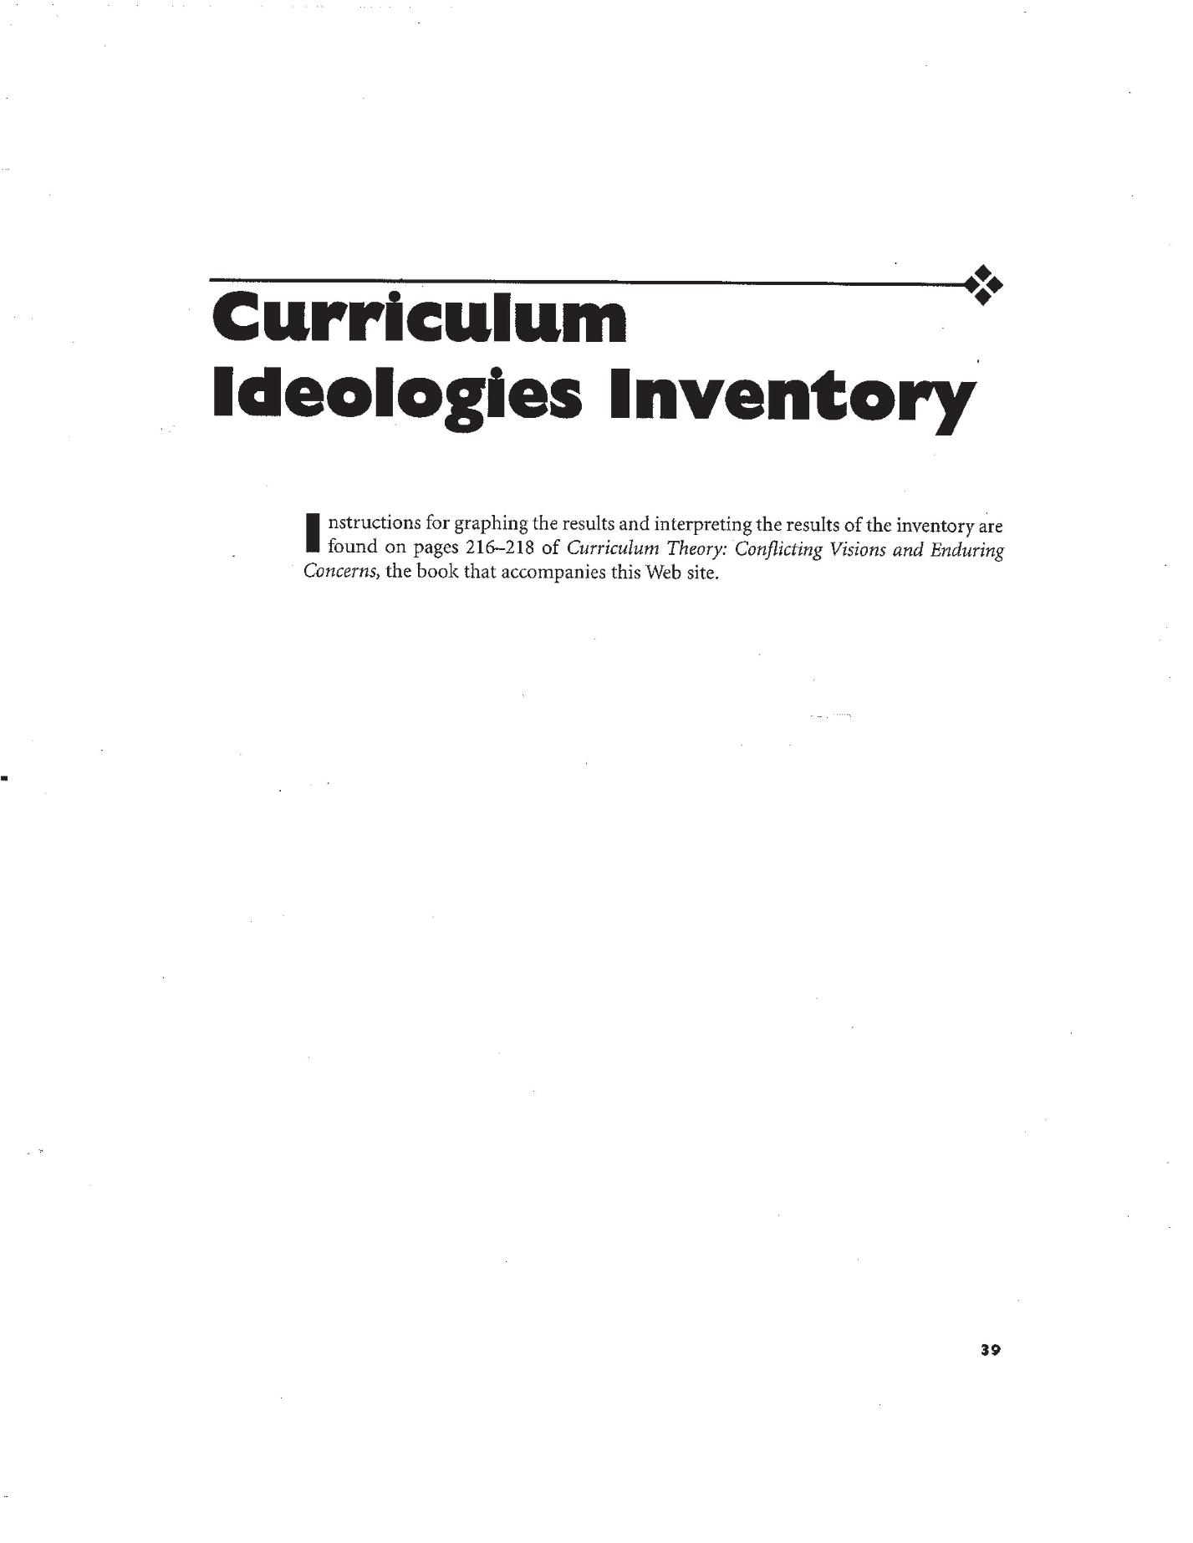
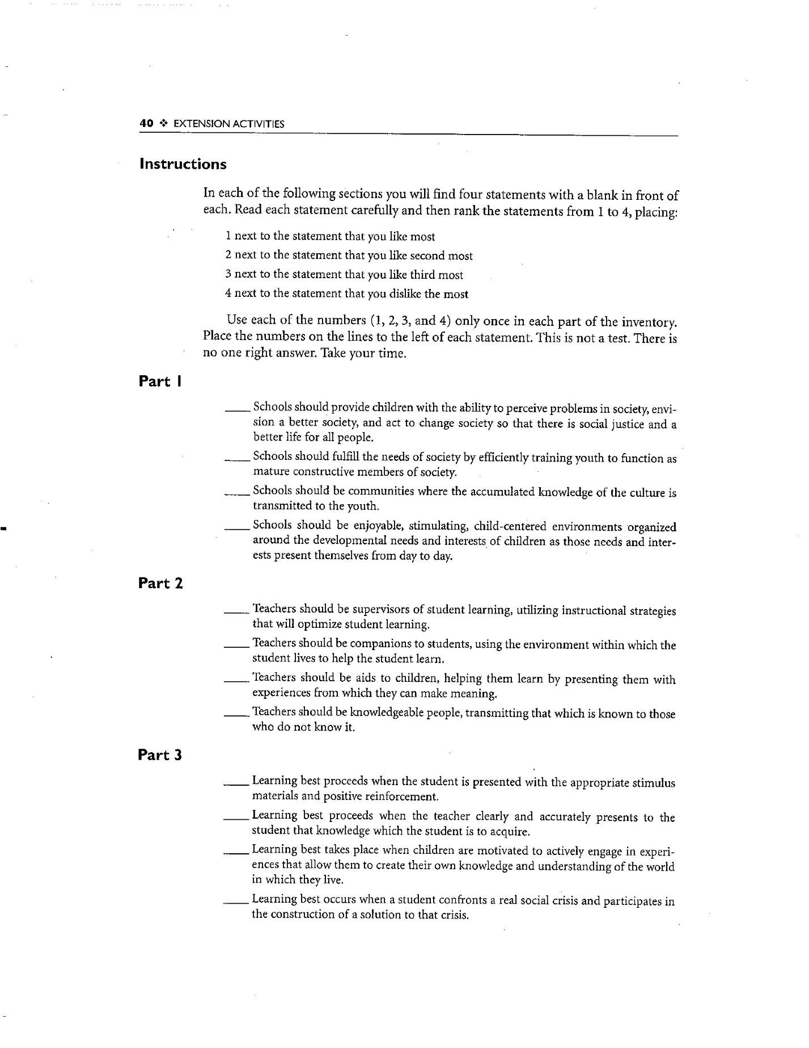

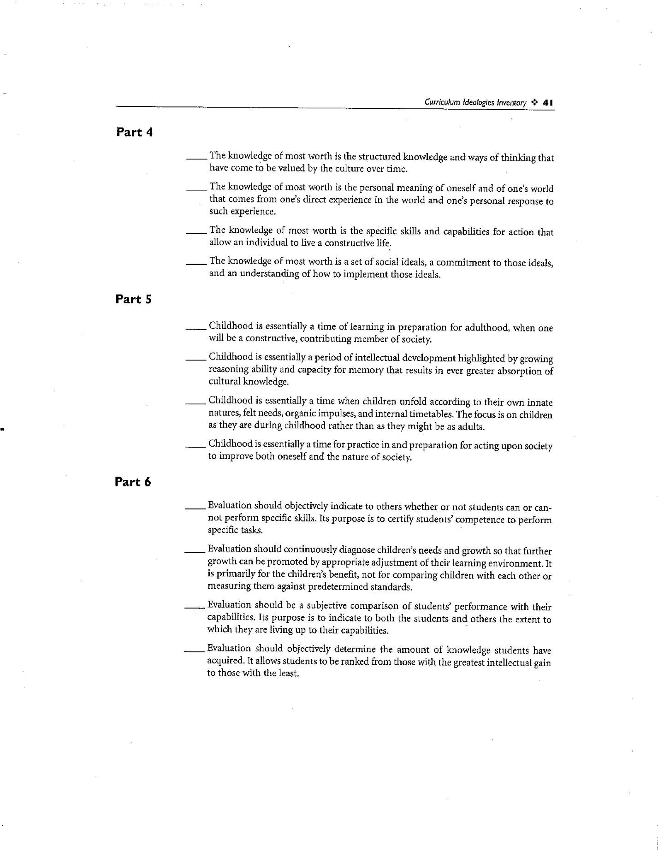

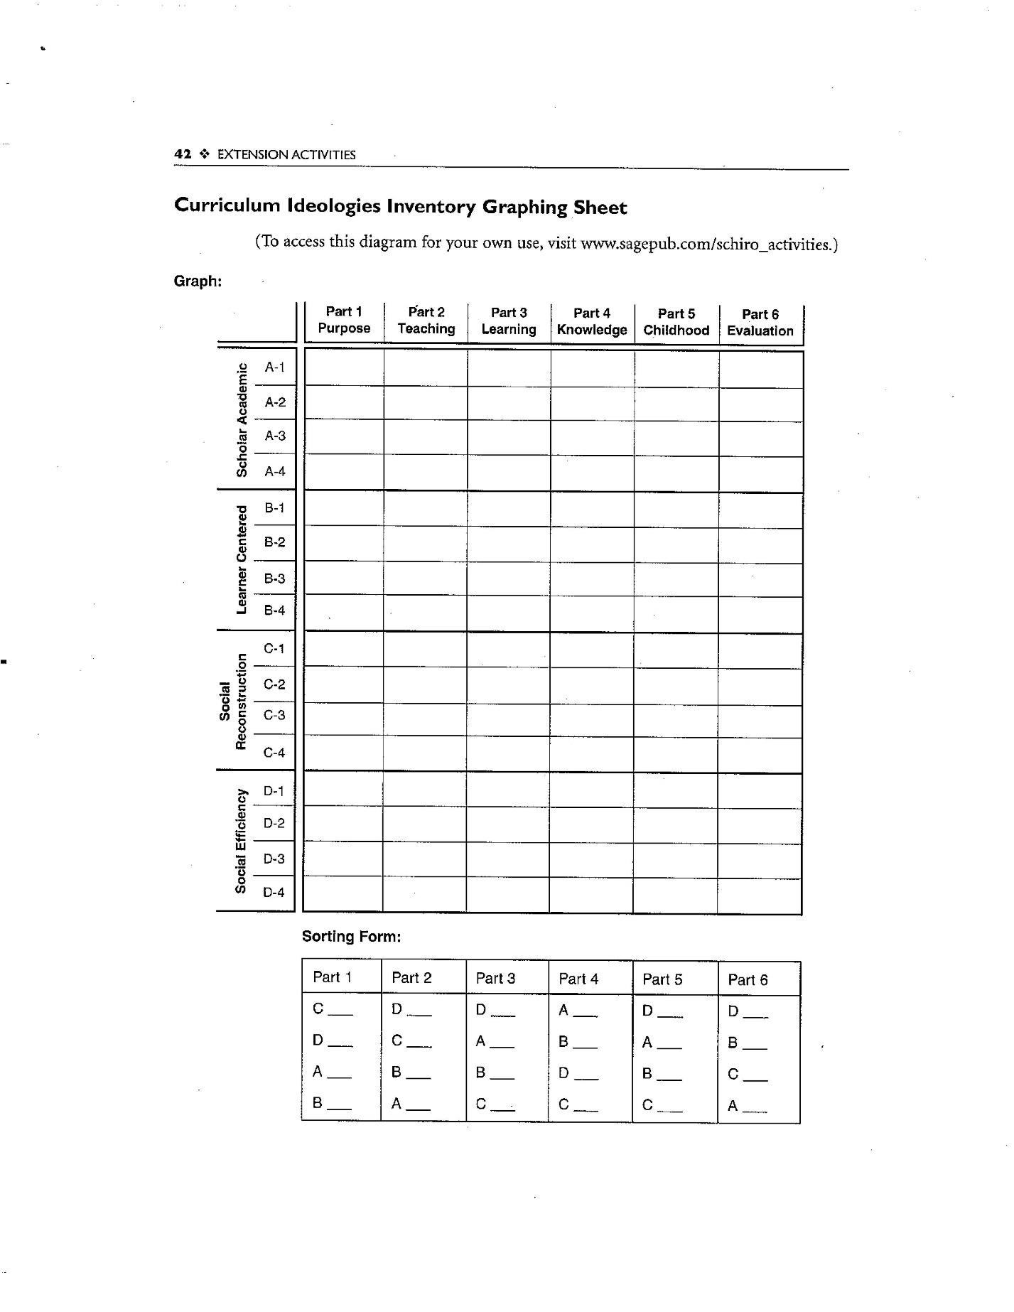

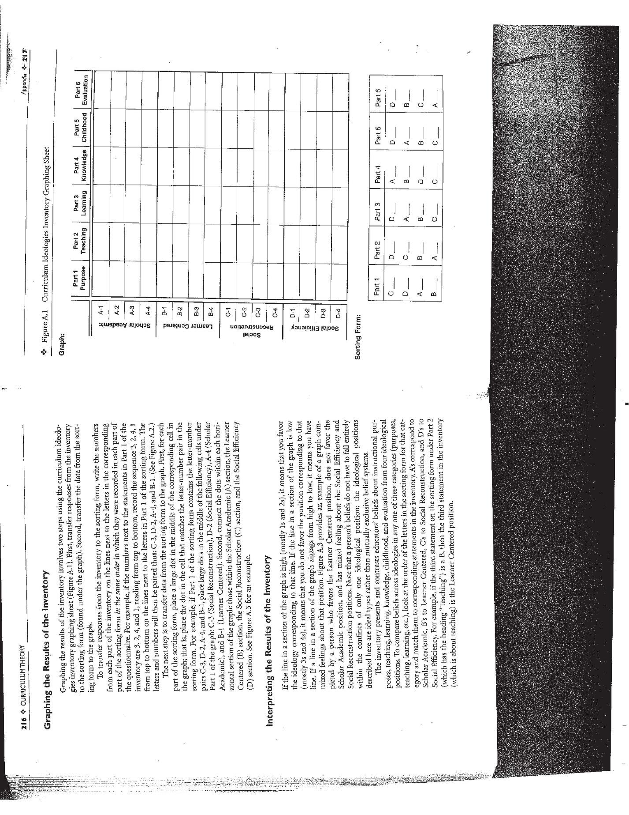

Appendix B: Interview Protocol
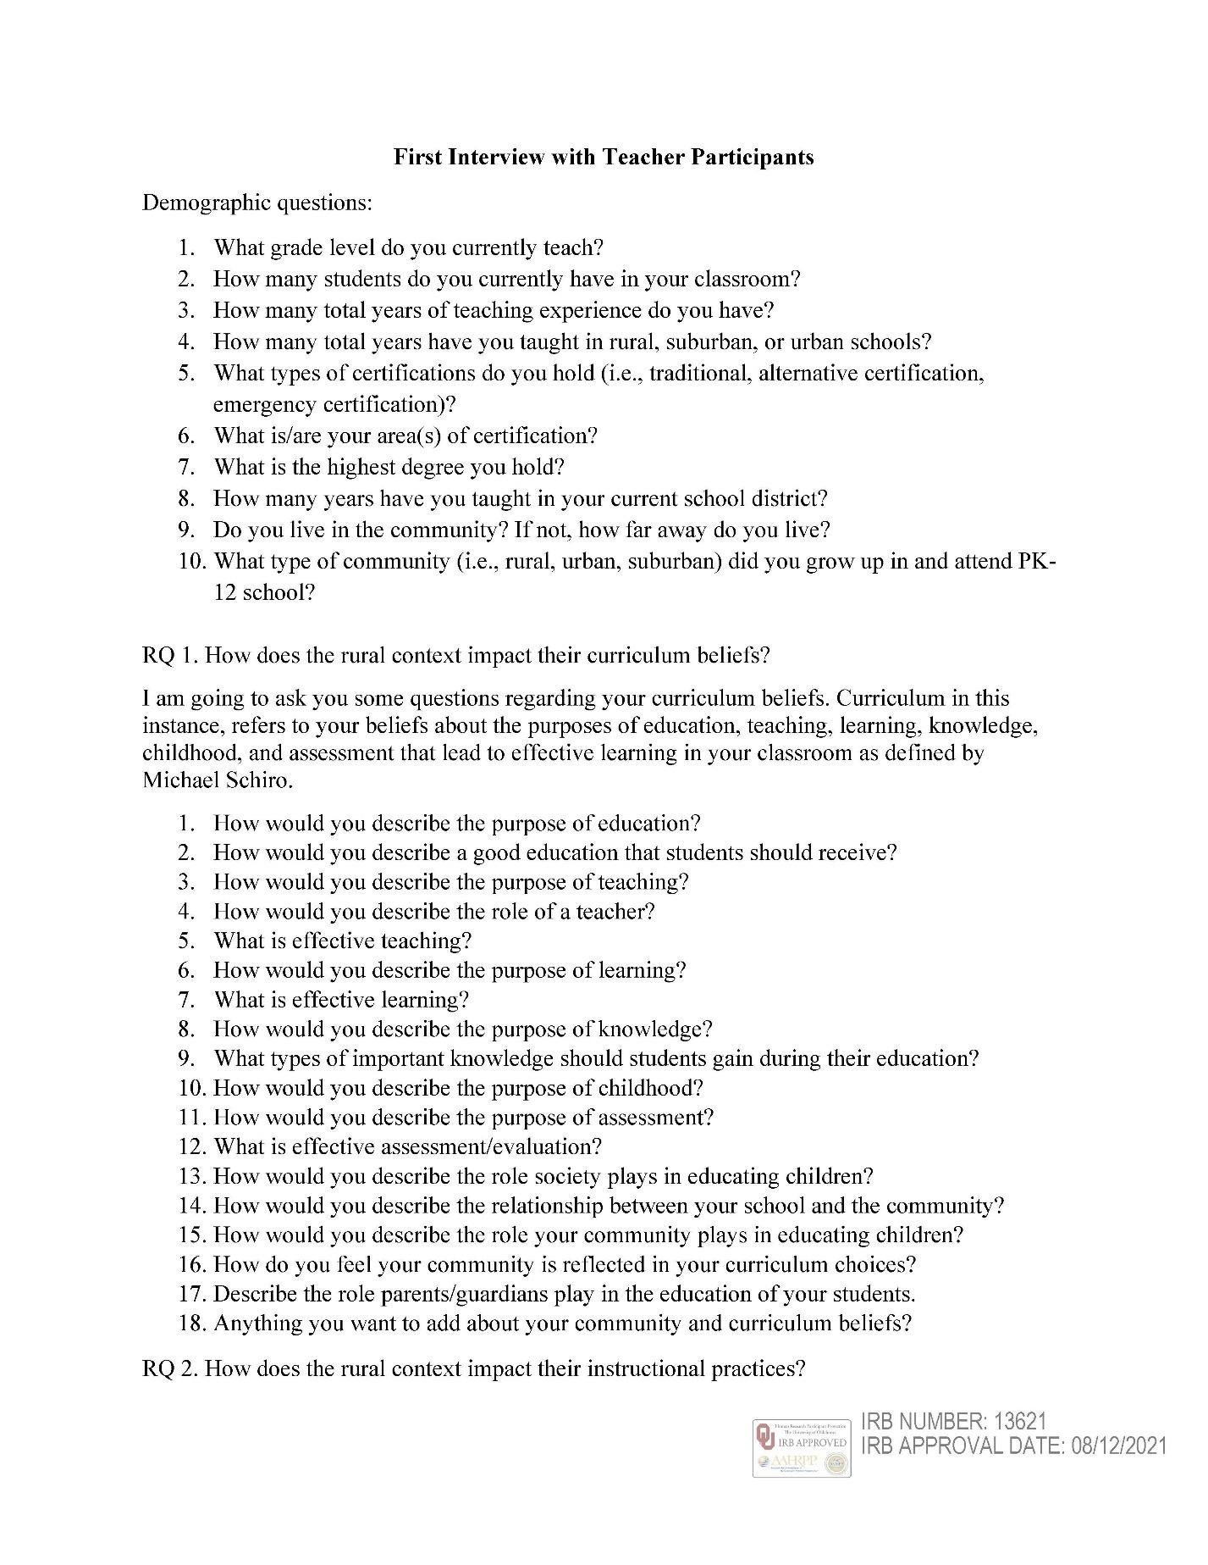
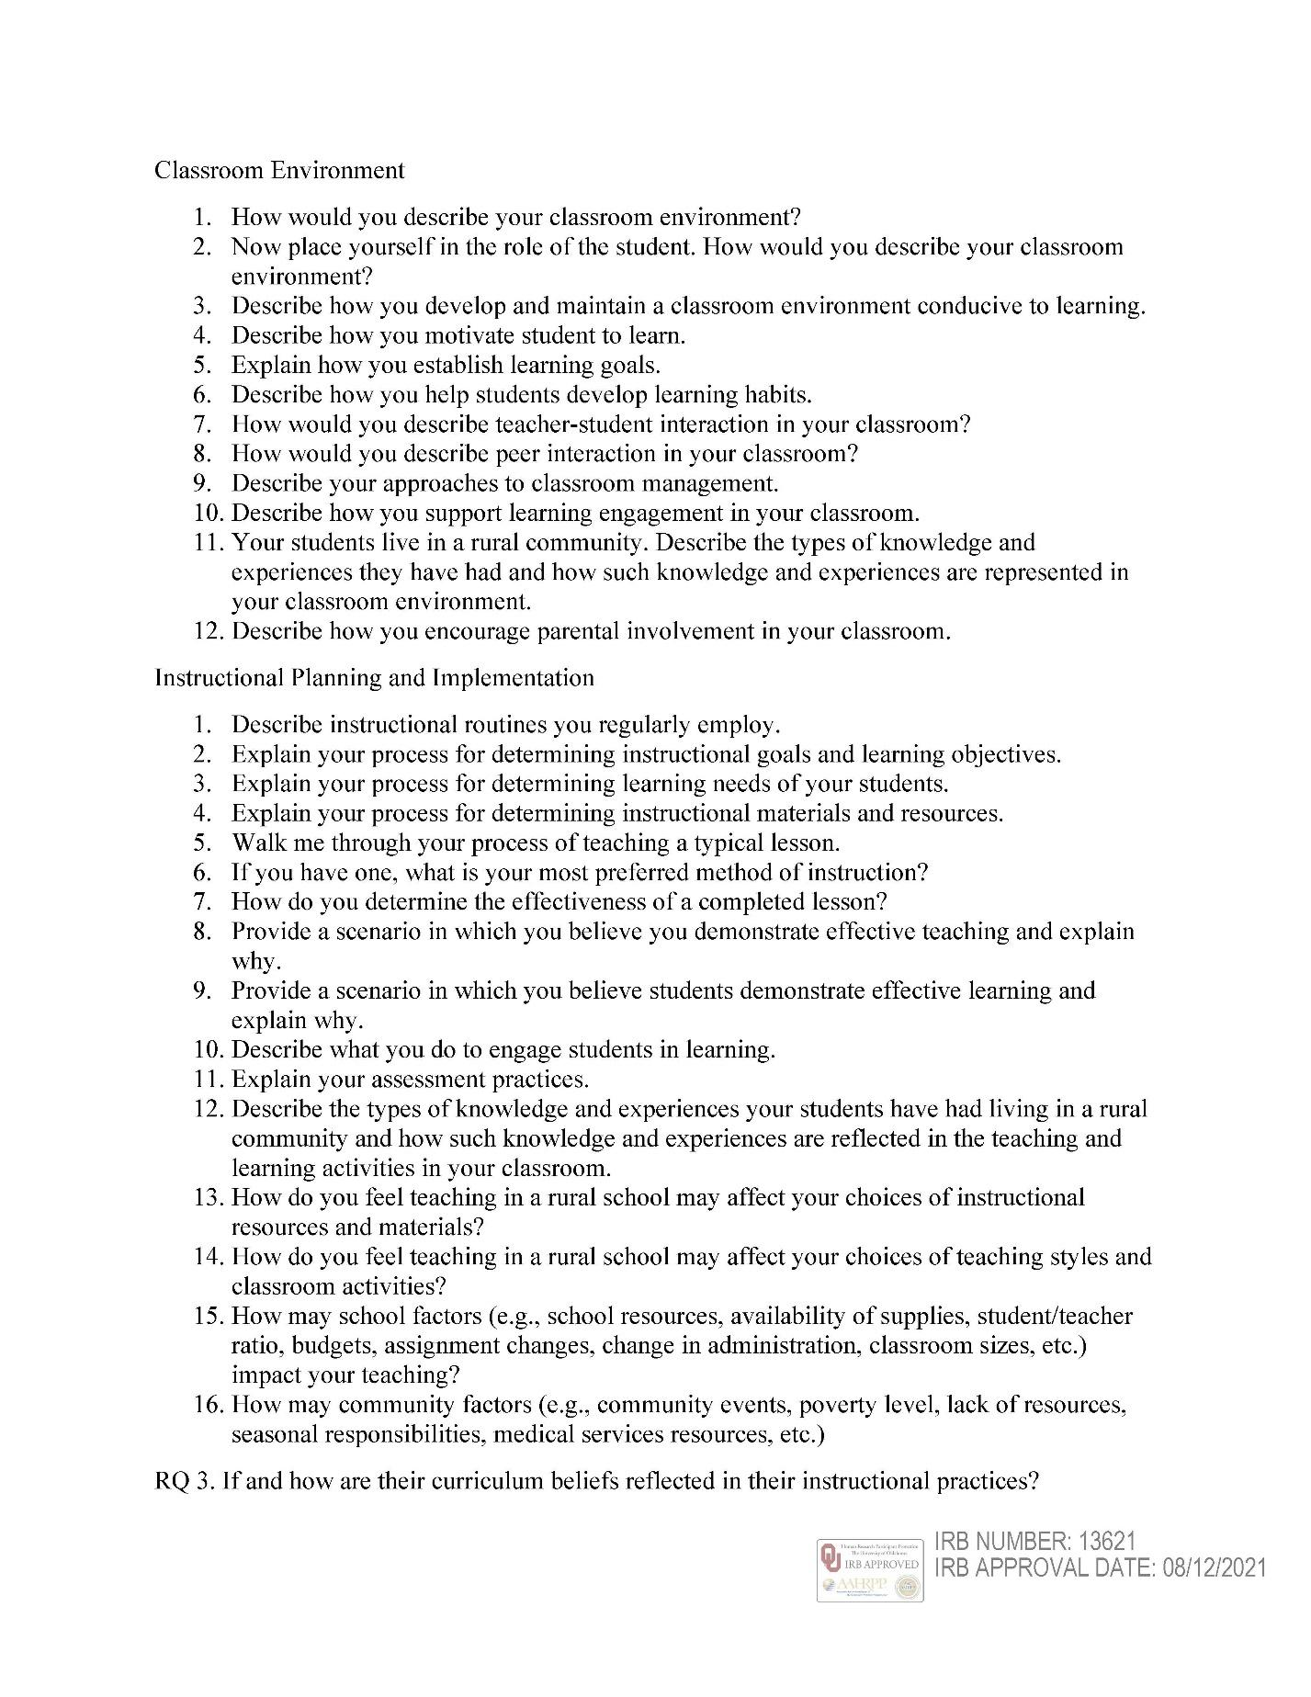



Appendix C: Observation Protocol
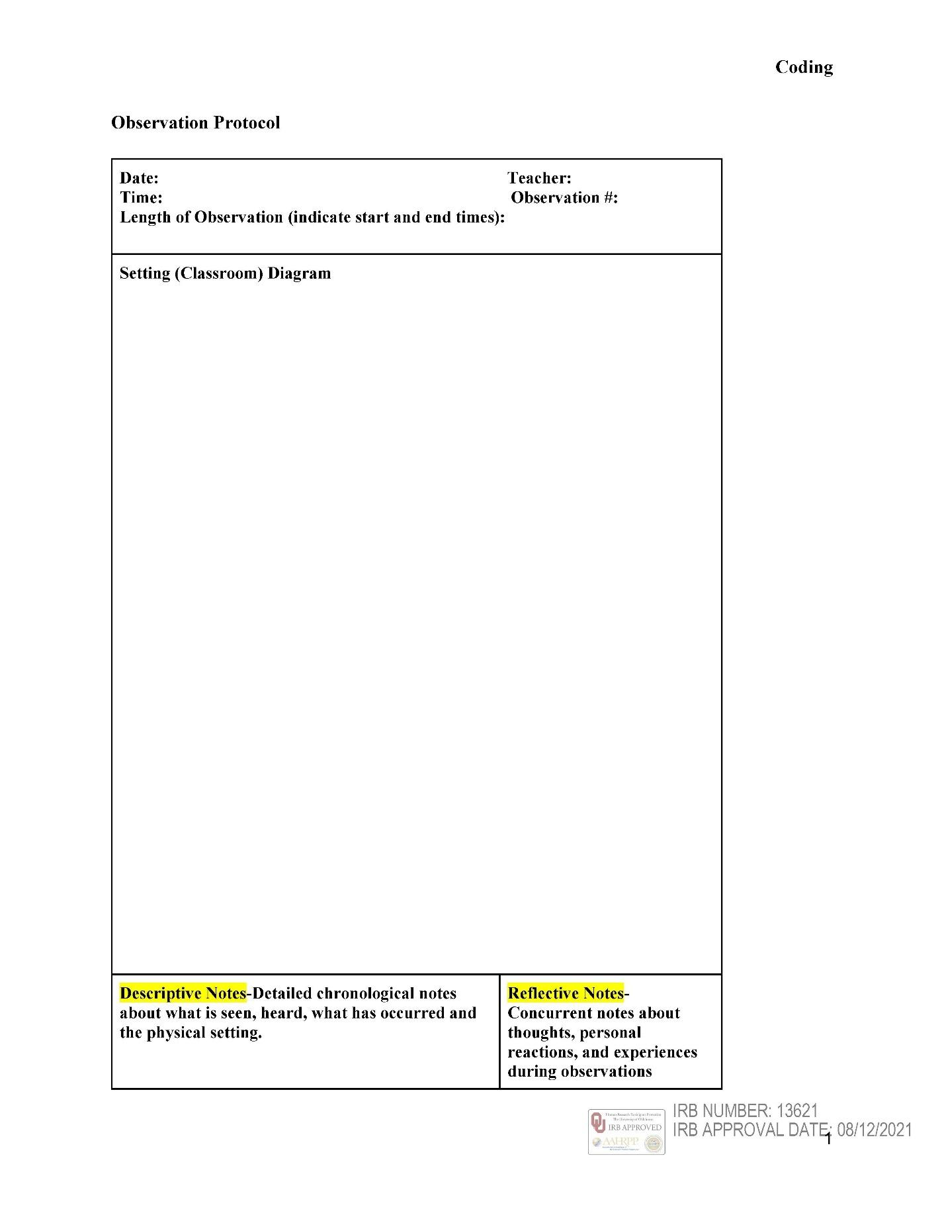
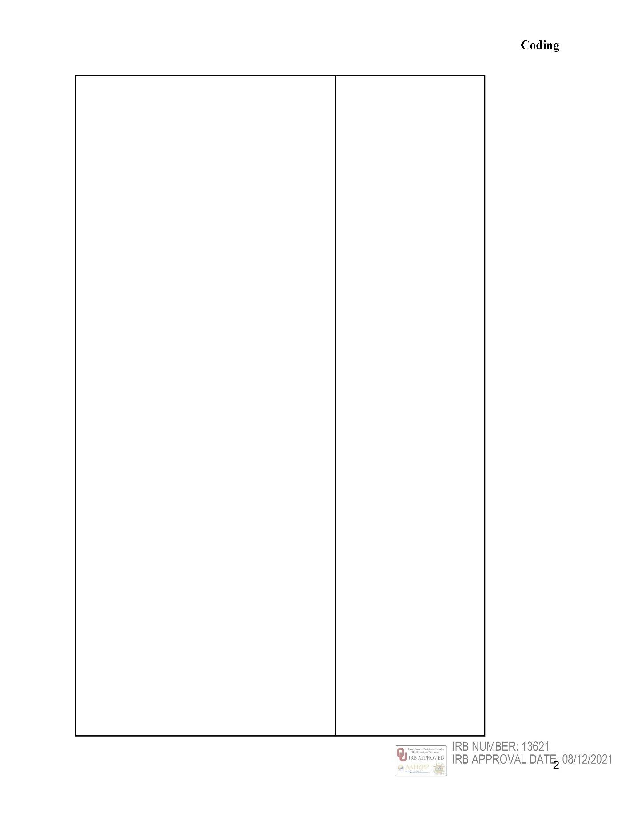



Appendix D: Informed Consent


Appendix E: IRB Approval Letter
