UNIVERSITY OF OKLAHOMA

GRADUATE COLLEGE

BASELINE CONCENTRATIONS OF CONTAMINANTS OF EMERGING CONCERN IN THE LAKE THUNDERBIRD WATERSHED, PLANNING FOR INDIRECT POTABLE REUSE IN OKLAHOMA

A thesis

submitted to the Graduate Faculty

in partial fulfillment of the requirements for the

Degree of

MASTER OF SCIENCE

By

ASHLEY DIANE HORTON
Norman, Oklahoma
2018

BASELINE CONCENTRATIONS OF CONTAMINANTS OF EMERGING CONCERN IN THE LAKE THUNDERBIRD WATERSHED, PLANNING FOR INDIRECT POTABLE REUSE IN OKLAHOMA

A THESIS APPROVED FOR THE
CONOCOPHILLIPS SCHOOL OF GEOLOGY AND GEOPHYSICS

BY

______________________________
Dr. R. Douglas Elmore, Co-Chair

______________________________
Dr. Kyle E. Murray, Co-Chair

______________________________
Dr. Andrew S. Elwood Madden

© Copyright by ASHLey diane horton 2018
All Rights Reserved.

Dedicated to my papa, mom, and dad for always encouraging me to work hard and supporting me in everything I have done or aspired to do.

Acknowledgements
Primarily, I thank my advisor, Dr. Kyle E. Murray for accepting me into his water resources research group at the Oklahoma Geological Survey; especially for his guidance, encouragement, support throughout this study, and for believing in me. He has inspired me to present at multiple conferences, helped refine my GIS skills, given me golden nuggets of wisdom like “dilution is the solution to pollution”, and has made me feel welcome at the University of Oklahoma from day one.

I also thank my committee members, Dr. Douglas Elmore and Dr. Andrew Elwood-Madden, for keeping their doors open to me and answering any questions I have had throughout the thesis-writing process and my graduate studies; they are both excellent professors and I am honored to have learned from them. Additionally, I truly appreciate the complete staff at the ConocoPhillips School of Geology and Geophysics, especially Rebecca Fay for her help with all things administrative and ensuring that I am on the right track to graduating.

Next, I express gratitude to everyone that assisted in water sampling, including Ann Ojeda, Curtis Smith, Stephen Holloway, Erin Thornton, and Ella Walker. Moreover, my sincerest thanks to the wonderful people at the Central Oklahoma Master Conservancy District for driving us around the beautiful and infamous Lake Thunderbird and for funding this project. I also cannot forget Dr. Nairn’s Center for Restoration of Ecosystems and Watersheds (CREW) lab for allowing us to borrow the (YSI 6920) multi-parameter water quality sonde used to test field parameters.

I have been very fortunate for the myriad of new friends I have made in Norman that have helped shape me into a better student, and that have kept me sane in the stresses of life. This list includes, but is not limited to, Paula (my birthday twin), Marlena, Amee, Hayden, Kelly, Javier, Rapha (for helping me with graphs and teaching me R), Dani, Henry, Laura, Hernan, Matt, Victoria, Jordan, Ella, Baylee, Madison, and Jamie.

I am also very blessed for all the amazing people I knew before attending OU, that have offered moral support and inspiration in a variety of ways: Amy, Eme, Matt, Elliott, Tyler, Abby, Emily, Chase, Kristi, John, Jacob, Ryan, and Dr. Laura Ruhl.

Lastly, I want to express my most heartfelt thanks to my family. To Papa, for helping raise me and teaching me to work hard. To my momma, who passed away my first year as a master’s student, but who would talk with me on my thirty-minute trek to Sarkeys every morning (before I had a parking pass), and who was so very proud of me. Likewise, to my dad, who raised me a sooner fan and would have been elated to see me attending OU. Finally, to Mema, Brooke, and Taylor (and my endless aunts, uncles, cousins), I do not know what I would do without your love, support, and encouragement; I am overwhelmed with gratitude for all of you.
Table of Contents
Acknowledgements iv
Table of Contents vi
List of Figures ix
List of Tables x
List of Compound Graphs xiv
List of Field Parameter Graphs xvii
Abstract xx
Chapter 1. Introduction 1
Chapter 2. Background 4
2.1 Contaminants of Emerging Concern 4
2.2 Water Reuse 6
2.3 NWIS Data 8
2.4 Study Area 9
2.5 CEC Treatment Approaches 11
2.6 Research Objectives & Hypotheses 14
Chapter 3. Methodology 15
3.1 Field Parameters 16
3.2 Water Sampling for CEC 16
3.3 CEC Analyses – Eurofins Eaton Analytical 18
3.4 CEC Analyses – University of Arizona WEST 19
3.5 Horton vs. Thornton 20
3.6 CEC Loading 21
3.6.1 Modelling for Relative Loading 23
3.6.2 Equations for Relative Loading 23
Chapter 4. Results and Discussion 28
4.1 CEC Detections – Eurofins Eaton Analytical 28
4.1.1 Industrial Compounds 28
4.1.2 Pesticide Compounds 30
4.1.3 PPCP Compounds 32
4.1.4 Other Compounds 34
4.2 CEC Detections – University of Arizona WEST 34
4.2.1 Industrial Compounds 34
4.2.2 Pesticide Compounds 35
4.2.3 PPCP Compounds 35
4.2.4 Other Compounds 36
4.3 Field Parameters 36
4.4 CEC Loading Mapping 38
4.4.1 Industrial Coefficients 42
4.4.2 Pesticide Coefficients 43
4.4.3 PPCP Coefficients 43
4.4.4 Other Coefficients 44
Chapter 5. Conclusions 46
Appendix A: Tables 57
Appendix B: Graphs of Compounds 74
Appendix C: Codes for R 89
C.1 Code to make graphs for compounds analyzed by EEA lab 89
C.2 Code to make graphs for compounds analyzed by Arizona WEST lab 93
Appendix D: Graphs for Field Parameters 97
Appendix E: Graphs for Loading Factor Evaluation 103

List of Figures
Figure 1. Water demand projections to the year 2060 and anticipated shortages in the water supply, representing the need for Norman to reuse water (Norman Utilities Authority, 2014). 3
Figure 2. Schematic of the proposed IPR project of augmenting water in Lake Thunderbird, Norman, OK by treating the water at Norman’s water reclamation facility (WRF), pumping the water into Dave Blue Creek, then sending it to the water treatment plant (WTP) (Modified from Norman Utilities Authority, 2014). 3
Figure 3. Schematic of a typical DPR project (AWWA, 2016). 8
Figure 4. Schematic of a typical IPR project (AWWA, 2016). 8
Figure 5. Schematic of the Lake Thunderbird Watershed (OCC, 2008). 11
Figure 6. Results of removal of PPCP by the ozone dosages 2, 4, and 8 mg/L (Lee et al., 2012). 12
Figure 7. Sampling locations at Lake Thunderbird. 15
Figure 8. Stainless Steel 1.2 L Kemmerer water sampler. 17
Figure 9. Delineated sub-watersheds based on sampling sites. 39
Figure 10. Sub-watersheds and land uses used to assess potential CEC loading. 40
Figure 11. Domestic wells, storage tanks, and outlines of sub-watersheds. 41

List of Tables
Table A 1. Concentrations detected in Lake Thunderbird were higher for 10 out of 11 benchmark compounds when compared to concentrations observed by Thornton (2017) after 15-day microcosm studies with Dave Blue Creek sediment and Photosynthetically Active Radiation (PAR). Blue text indicates lower (cleaner), red is higher (dirtier), and orange is unknown, respectively, than water in Lake Thunderbird. 57
Table A 2. NWIS industrial compound detection amounts in Oklahoma and medium the compound was discovered (USGS, 2017). 57
Table A 3. NWIS pesticide compound detection amounts in Oklahoma and the medium the compound was discovered (USGS, 2017). 58
Table A 4. NWIS PPCP compound detection amounts in Oklahoma and the medium the compound was discovered (USGS, 2017). 58
Table A 5. NWIS hormone compound detection amounts in Oklahoma and the medium the compound was discovered (USGS, 2017). 60
Table A 6. NWIS other compound detection amounts in Oklahoma and the medium the compound was discovered (USGS, 2017). 60
Table A 7. Compound listed under the EPA NPDWR, with the maximum contaminant level (MCL) in ng/L, the maximum detection in this study, potential health effects, and potential sources (EPA, 2017). 60
Table A 8. Site identifier, longitude, latitude, and site name (OWRB, 2014 & 2015). 61
Table A 9. List of 98 compounds analyzed by EEA lab including the class, method reporting limit (MRL), and the common use of that compound; all compounds were measured in ng/L. Yellow are compounds analyzed by both labs, gray are EEA unique compounds. 61
Table A 10. List of 43 compounds analyzed by Arizona WEST lab including the class and the common use of that compound; all compounds were measured in ng/L. Yellow are compounds analyzed by both labs, gray are WEST unique compounds. 64
Table A 11. List of compounds detected by EEA for summer, including class of compound, MRL, and site # at the top; an "*" indicates a degradant and italics means the compound was analyzed by both labs. All values reported in ng/L, no duplicate was taken this season. 65
Table A 12. List of compounds detected by EEA for fall, including class of compound, MRL, site #, and duplicate at the top; an "*" indicates a degradant and italics means the compound was analyzed by both labs. All values reported in ng/L, duplicate was for site 1. 66
Table A 13. List of compounds detected by EEA for winter, including class of compound, MRL, site #, and duplicate at the top; an "*" indicates a degradant and italics means the compound was analyzed by both labs. All values reported in ng/L, duplicate was for site 6. 66
Table A 14. List of compounds detected by EEA for spring, including class of compound, MRL, site #, and duplicate at the top; an "*" indicates a degradant and italics means the compound was analyzed by both labs. All values reported in ng/L, duplicate was for site 6. 67
Table A 15. List of compounds detected by WEST for winter, including class of compound, site #, and duplicate at the top; an "<" indicates a compound lower than MDL and italics means the compound was analyzed by both labs. All values reported in ng/L, duplicate was for site 6. 68
Table A 16. List of compounds detected by WEST for spring, including class of compound, site #, and duplicate at the top; an "<" indicates a compound lower than MDL and italics means the compound was analyzed by both labs. All values reported in ng/L, duplicate was for site 6. 68
Table A 17. Temperature values for each site and season. 68
Table A 18. Specific conductance values for each site and season. 69
Table A 19. Conductivity values for each site and season. 69
Table A 20. Resistivity values for each site and season. 69
Table A 21. Total dissolved solids values for each site and season. 70
Table A 22. Salinity values for each site and season. 70
Table A 23. pH values for each site and season. 70
Table A 24. Oxidation-reduction potential values for each site and season. 70
Table A 25. Chlorophyll-A values as a concentration for each site and season. 71
Table A 26. Chlorophyll-A values in relative fluorescence for each site and season. 71
Table A 27. Optical dissolved oxygen in saturation for each site and season. 71
Table A 28. Optical dissolved oxygen as a concentration for each site and season, winter values are missing due to instrument error. 72
Table A 29. Sub-watershed loading factor assessment for industrial class contaminants, area in acres. 72
Table A 30. Sub-watershed loading factor assessment for pesticide class contaminants; areas in acres. 72
Table A 31. Sub-watershed loading factor assessment for PPCP class contaminants; areas in acres. 72
Table A 32. Sub-watershed loading factor assessment for other class contaminants; areas in acres. 73
Table A 33. Half-lives of benchmark compounds in aqueous environments. 73

List of Compound Graphs
Figure B 1. BPA detections in ng/L for each season (EEA lab results). 74
Figure B 2. NP detections in ng/L for each season (EEA lab results). 74
Figure B 3. OP detections in ng/L for each season (EEA lab results). 74
Figure B 4. TDCPP detections in ng/L for each season (EEA lab results). 75
Figure B 5. 2,4-D detections in ng/L for each season (EEA lab results). 75
Figure B 6. Atrazine detections in ng/L for each season (EEA lab results). 75
Figure B 7. Bromacil detections in ng/L for each season (EEA lab results). 76
Figure B 8. Cyanazine detections in ng/L for each season (EEA lab results). 76
Figure B 9. DACT detections in ng/L for each season (EEA lab results). 76
Figure B 10. DEA detections in ng/L for each season (EEA lab results). 77
Figure B 11. DIA detections in ng/L for each season (EEA lab results). 77
Figure B 12. Diruon detections in ng/L for each season (EEA lab results). 77
Figure B 13. OUST detections in ng/L for each season (EEA lab results). 78
Figure B 14. Quinoline detections in ng/L for each season (EEA lab results). 78
Figure B 15. Simazine detections in ng/L for each season (EEA lab results). 78
Figure B 16. Clofibric acid detections in ng/L for each season (EEA lab results). 79
Figure B 17. Gemfibrozil detections in ng/L for each season (EEA lab results). 79
Figure B 18. Ibuprofen detections in ng/L for each season (EEA lab results). 79
Figure B 19. Iohexal detections in ng/L for each season (EEA lab results). 80
Figure B 20. Lincomycin detections in ng/L for each season (EEA lab results). 80
Figure B 21. Meclofenamic acid detections in ng/L for each season (EEA lab results). 80
Figure B 22. Salicylic acid detections in ng/L for each season (EEA lab results). 81
Figure B 23. Triclocarban detections in ng/L for each season (EEA lab results). 81
Figure B 24. Trimethoprim detections in ng/L for each season (EEA lab results). 81
Figure B 25. Andorostenedione detections in ng/L for each season (EEA lab results). 82
Figure B 26. Estriol detections in ng/L for each season (EEA lab results). 82
Figure B 27. Estrone detections in ng/L for each season (EEA lab results). 82
Figure B 28. Testosterone detections in ng/L for each season (EEA lab results). 83
Figure B 29. Acesulfame-K detections in ng/L for each season (EEA lab results). 83
Figure B 30. Caffeine detections in ng/L for each season (EEA lab results). 83
Figure B 31. Cotinine detections in ng/L for each season (EEA lab results). 84
Figure B 32. DEET detections in ng/L for each season (EEA lab results). 84
Figure B 33. PFHxA detections in ng/L for winter and spring (WEST lab results). 84
Figure B 34. PFOS detections in ng/L for winter and spring (WEST lab results). 85
Figure B 35. TCPP detections in ng/L for winter and spring (WEST lab results). 85
Figure B 36. Atrazine detections in ng/L for winter and spring (WEST lab results). 85
Figure B 37. Simazine detections in ng/L for winter and spring (WEST lab results). 86
Figure B 38. Diltiazem detections in ng/L for winter and spring (WEST lab results). 86
Figure B 39. Hydrochlorothiazide detections in ng/L for winter and spring (WEST lab results). 86
Figure B 40. Iopromide detections in ng/L for winter and spring (WEST lab results). 87
Figure B 41. Meprobamate detections in ng/L for winter and spring (WEST lab results). 87
Figure B 42. Propyl paraben detections in ng/L for winter and spring (WEST lab results). 87
Figure B 43. Trimethoprim detections in ng/L for winter and spring (WEST lab results). 88
Figure B 44. Acesulfame K detections in ng/L for winter and spring (WEST lab results). 88
Figure B 45. DEET detections in ng/L for winter and spring (WEST lab results). 88

List of Field Parameter Graphs
Figure D 1. Temperature values for every site and season. 97
Figure D 2. Specific conductance values for every site and season. 97
Figure D 3. Conductivity values for every site and season. 98
Figure D 4. Resistivity values for every site and season. 98
Figure D 5. Total dissolved solids values for every site and season. 99
Figure D 6. Salinity values for every site and season. 99
Figure D 7. pH values for every site and season. 100
Figure D 8. Oxidation-reduction potential values for every site and season. 100
Figure D 9. Chlorophyll (concentration) values for every site and season. 101
Figure D 10. Chlorophyll (RFU) values for every site and season. 101
Figure D 11. Optical dissolved oxygen (% SAT) values for every site and season. 102
Figure D 12. Optical dissolved oxygen (as a concentration) values for every site and season. 102

List of Graphs for Loading Factor Evaluation
Figure E 1. Median concentrations of the benchmark industrial compound NP (ng/L) that correspond to a site/sub-watershed plotted against the loading factor. 103
Figure E 2. Median concentrations of the benchmark industrial compound OP (ng/L) that correspond to a site/sub-watershed plotted against the loading factor. 103
Figure E 3. Median concentrations of the benchmark industrial compound TCPP (ng/L) that correspond to a site/sub-watershed plotted against the loading factor. 104
Figure E 4. Median concentrations of the benchmark industrial compound PFOS (ng/L) that correspond to a site/sub-watershed plotted against the loading factor. 104
Figure E 5. Median concentrations of the benchmark pesticide compound atrazine (ng/L) that correspond to a site/sub-watershed plotted against the loading factor. 105
Figure E 6. Median concentrations of the benchmark pesticide compound simazine (ng/L) that correspond to a site/sub-watershed plotted against the loading factor. 105
Figure E 7. Median concentrations of the benchmark PPCP compound clofibric acid (ng/L) that correspond to a site/sub-watershed plotted against the loading factor. 106
Figure E 8. Median concentrations of the benchmark PPCP compound salicylic acid (ng/L) that correspond to a site/sub-watershed plotted against the loading factor. 106
Figure E 9. Median concentrations of the benchmark PPCP compound iopromide (ng/L) that correspond to a site/sub-watershed plotted against the loading factor. 107
Figure E 10. Median concentrations of the benchmark PPCP compound propylparaben (ng/L) that correspond to a site/sub-watershed plotted against the loading factor. 107
Figure E 11. Median concentrations of the benchmark other compound acesulfame-K (ng/L) that correspond to a site/sub-watershed plotted against the loading factor. 108
Figure E 12. Median concentrations of the benchmark other compound DEET (ng/L) that correspond to a site/sub-watershed plotted against the loading factor. 108

Abstract
The City of Norman, OK is planning an indirect potable reuse (IPR) project to augment their water supply. The IPR project involves transferring treated effluent from the Norman Water Reclamation Facility (NWRF) to Dave Blue Creek, which flows into Lake Thunderbird and acts as an environmental buffer. One of the major concerns for IPR projects is the presence of contaminants of emerging concern (CEC) in recycled wastewater. CEC are broadly defined as chemicals that can potentially enter the environment, but that are not routinely monitored and could pose health risks to humans or ecology. The objectives of this thesis research are to analyze baseline CEC concentrations in the lake, evaluate periodic tendencies, compare results to previous CEC studies, and identify probable sources for the detected CEC. Stakeholders can use the results to assess the effectiveness of the environmental buffering, and design necessary advanced water treatment at the NWRF before the IPR project commences.
Four water sampling events were completed at Lake Thunderbird in Norman, OK during 2016 and 2017 with each event representing a season. Water samples were collected at six lake sites and analyzed for 113 unique CEC including compounds in four categories: 1) industrials, 2) pesticides, 3) pharmaceuticals and personal care products (PPCP), and 4) “others”. Sub-watersheds were delineated and loading factor models were developed for each sub-watershed to assess potential CEC contributions based on land use, density of domestic wells (as a proxy for density of septic tanks), and density of storage tanks.
Eight, 21, 24, and 24 CEC were detected in June 2016, October 2016, January 2017, and April 2017 samples, respectively. The compound NP was detected in fall, winter, and spring, making it the most frequently detected industrial compound. The pesticides atrazine and simazine were detected in every season, most likely because of year-round lawn or agricultural applications. Acesulfame-K (artificial sweetener) and DEET (insect repellant) were also detected in every season, those compound detections could be the result of runoff from residential areas or from recreational use of the lake. CEC are likely derived from seasonally variable sources, such as lawn applications and septic systems. Concentrations of atrazine, simazine, and 2, 4-D detected in Lake Thunderbird are well below EPA established maximum contaminant levels (MCLs) for drinking water. Nine other compounds detected in Lake Thunderbird are below non-federal health standards, available from the Minnesota Department of Health, which indicates that Lake Thunderbird water is likely safe for consumption with regard to CEC.
Comparison of Lake Thunderbird CEC concentrations to a microcosm study of Norman Water Reclamation Facility (NWRF) effluent in Dave Blue Creek sediment with photosynthetically active radiation (PAR) indicate that the environmental buffering may sufficiently reduce concentrations of CEC before they reach Lake Thunderbird during the planned IPR project. Future investigations should define the half-life and health standards that are presently unavailable for the 113 CEC analyzed in this study. Additional investigation, sampling, and analysis of current NWRF effluent discharge and receiving waters of the Canadian River would be beneficial for documenting environmental buffering effects.

Chapter 1. Introduction
In 2014, the (City of) Norman (OK) Utilities Authority produced a 2060 strategic water plan that projected a water shortage before the year 2020 (Figure 1). One augmentation option in the strategic water plan was to design an indirect potable reuse (IPR) project that would aid in recycling Norman’s water (Norman Utilities Authority, 2014). The IPR project would consist of discharging treated effluent from the Norman Water Reclamation Facility (NWRF), which currently discharges into the Canadian River, into Dave Blue Creek, a tributary of Lake Thunderbird (Figure 2). Hypothetically, Dave Blue Creek and Lake Thunderbird, managed by the Central Oklahoma Master Conservancy District (COMCD), would serve as an environmental buffer that promotes natural degradation and attenuation of CEC before water reaches the water intake that provides water to Norman, Midwest City, and Del City. In preparation for a potential IPR project, COMCD contracted with researchers at the University of Oklahoma (OU) to evaluate baseline contaminants of emerging concern (CEC) in Lake Thunderbird and examine the data in context with other research related to CEC in the Lake Thunderbird watershed.
Water sampling was completed for six sites on the lake during each season to evaluate the water quality in Lake Thunderbird, and to establish a baseline that could be used in the design of water treatment goals. The samples were analyzed for CEC, which are defined as chemicals that are not commonly monitored in the environment but could have the potential to enter the environment and have harmful effects to humans and ecosystems (Alvarez et al., 2014). A suite of 98 compounds were analyzed during the summer (Jun 2016), fall (Oct 2016), winter (Jan 2017), and spring (Apr 2017), and another suite of 43 compounds were analyzed during winter (Jan 2017), and spring (Apr 2017); which when combined amount to 113 unique compounds.
The compounds are categorized as 1) industrials, 2) pesticides, 3) pharmaceuticals and personal care products (PPCP), and 4) “other” (Murray et al., 2010). Compounds in the other category are chemicals that did not easily fit into the other three but could still be present in a water source, includes compounds such as caffeine (stimulant) and cotinine (an alkaloid of tobacco). The second suite of CEC included perfluorinated compounds (PFC), which were proposed by the OU principal investigator as a project modification because of numerous recent scientific reports documenting their occurrence and health hazards in water, as well as media attention that resulted when PFOA exceeded 400 ng/L in Hoosick Falls, NY water supply (EPA, 2017; Hoffman et al., 2010; Kannan et al., 2005; Post et al., 2012). The PFC have either never been analyzed in waters of Oklahoma or have never been detected and reported to the water quality database maintained in the USGS National Water Information System (NWIS).

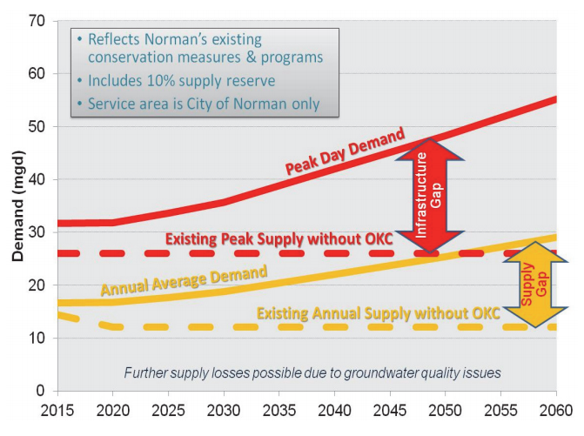
Figure 1. Water demand projections to the year 2060 and anticipated shortages in the water supply, representing the need for Norman to reuse water (Norman Utilities Authority, 2014).

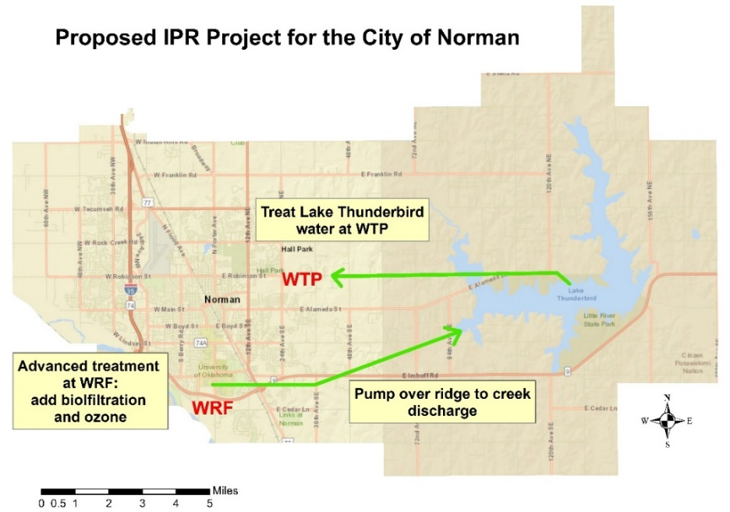
Figure 2. Schematic of the proposed IPR project of augmenting water in Lake Thunderbird, Norman, OK by treating the water at Norman’s water reclamation facility (WRF), pumping the water into Dave Blue Creek, then sending it to the water treatment plant (WTP) (Modified from Norman Utilities Authority, 2014).

Chapter 2. Background

2.1 Contaminants of Emerging Concern
As previously stated, the compounds analyzed in this study fall into four classifications; 1) industrials, 2) pesticides, 3) PPCPs, and 4) others. The industrial compounds fall into three main categories, which include organophosphates, alkylphenols, and PFC. Organophosphates, such as tris-(2-chloro-, 1-methyl-ethyl)- phosphate (TCPP), tris- (2-chloroethyl)-phosphate (TCEP), and tris- (dichloro-iso-propyl)-phosphate (TDCP) are mainly used in polyurethane foam or concrete applications, and are reportedly carcinogenic (Li et al., 2014). They are sourced from sewage treatment plants, concrete, and liquid polyurethane spray (Andresen et al., 2004). Alkylphenols (bisphenol A - BPA, 4-nonylphenol - NP, 4-tert-octylphenol - OP) are endocrine disruptors (the compounds can affect hormone systems), like many of the pharmaceuticals and personal care products (PPCP) (Amiridou and Voutsda, 2011). The alkylphenols are thought to be sourced from septic systems, sewage treatment plants, and textile plant discharges and there are also instances of endocrine disruption (Rudel et al., 1998). The PFC are surfactants like PFBA (perfluorbutanoic acid), PFBS (perfluorobutanesulfonic acid), PFHxA (perfluorohexanoic acid), PFOA (perfluorooctanoic acid), PFOS (perfluorooctanesulfonic acid), and PFpeA (perfluoro-n-pentanoic acid); these compounds are used in shampoo, carpet coatings, foams, and paper (Giesy and Kannan, 2001).
Pesticides have been detected in surface water and groundwater samples across the US since the 1990s. Pesticides most prevalent in the environment are triazines (atrazine, simazine, and cyanazine) and acetanilides (Cohen et al., 1995). Herbicides in drinking water and food may cause acute and chronic health problems to humans (Lichtenberg and Zimmerman, 1999). The triazine herbicides can cause breast cancer, two of which (atrazine and simazine) are listed on the EPA national primary drinking water regulations (NPDWR) (Table A 7). Cyanazine, a triazine herbicide, can cause genetic mutations and birth defects because it is a reproductive toxin (Cohen et al., 1995). These contaminants are usually sourced from runoff of crop lands or hay pasture lands.
Pharmaceuticals and personal care products (PPCPs) are unregulated, but the contaminants have been detected in drinking water supplies across the world since at least 1995 (Baronti et al., 2000). PPCPs are present in the environment predominantly from medicated humans and animals. Research indicates that 90% of antibiotics are excreted after consumption (Storteboom et al., 2010) and then can enter drinking water supplies from municipal wastewater discharge. Another issue is that livestock are heavily medicated with antibiotics and hormones that are also not completely absorbed, meaning runoff from livestock operations could also be contaminating drinking water, either directly from the animal excretion or indirectly through manure applications to agriculture (Boxall et al., 2003). These types of chemicals are also a threat because they can be endocrine disruptors, which sometimes lead to cancer, developmental disorders, and birth defects (Nikolaou et al., 2007).
“Other” compounds include DEET (insect repellant), sucralose (sugar substitute), cotinine (nicotine degradant), caffeine (stimulant), acesulfame-K (sugar substitute), 1,7-dimethylxanthine (caffeine metabolite), and theobromine (caffeine degradant). DEET is present in surface waters and is most likely the result of recreational use when humans are in direct contact with surface water, considering that it is only used on humans, but can also be present in wastewater or as part of urban runoff (Tran et al., 2013). The EPA has defined DEET as a Group D carcinogen, meaning that some effects appear to be carcinogenic but there may not be evidence that is statistically significant. Although it is not a carcinogen, there have been many reports of children having seizures and neurotoxicity when in contact with DEET, so the EPA is investigating a potential direct link between the two (EPA, 1998), but to date there have been no definitive correlations.
Caffeine (including degradants/metabolites) and cotinine are both stimulants that are used worldwide by humans. They are both thought to be present in surface waters because they are sourced from leaking septic systems or wastewater contamination (Bradley et al., 2007). It is unknown if these contaminants have any severe impacts on humans at such small concentrations.
Sugar substitutes, like sucralose and acesulfame- K, are widespread in groundwater, surface water, and wastewater samples (Mawhinney et al. and Soh et al., 2011). Sucralose persists in the environment longer than acesulfame-K, making it a good anthropogenic marker, but the long-term low-dose toxicity effects have not been evaluated, which means it is unknown how this contaminant will affect human or ecological health if consumed over a long period of time (Soh et al., 2011).

2.2 Water Reuse
Recycled water has been widely accepted in the past for irrigation and agricultural purposes, but public concern is greater surrounding reuse for drinking water supply (Rodriguez et al., 2009). While it might not always be accepted, water sources are depleting, and potable reuse is more environmentally sustainable (AWWA, 2016). Water reuse/recycling can either be classified as direct potable reuse (DPR) or indirect potable reuse (IPR). DPR involves the movement of purified water directly into an existing public water supply system (Figure 3). IPR requires the treatment of municipal wastewater to be discharged into a water source to augment the water supply (Figure 4), which acts as an environmental buffer (AWWA, 2016). In this case, the Dave Blue Creek stream system and residence in Lake Thunderbird would be acting as an environmental buffer whereby sorption, photodegradation, biodegradation, and attenuation would be reducing compound concentrations before the water is reintroduced into the City of Norman public water supply system.
Thornton (2017) analyzed the effectiveness of 15 days of sorption to Dave Blue Creek (DBC) sediment and photosynthetically active radiation (PAR) on reducing CEC concentrations in NWRF effluent. Thornton (2017) showed that both sorption to sediment and photodegradation are efficient in reducing or removing CEC concentrations, but photodegradation was more effective and could be very important for CEC removal (Table A 1).
IPR projects have been successful in multiple states including California, Arizona, Colorado, Texas, Florida, and Virginia, with California using these kinds of reuse systems for over 40 years (AWWA, 2016). Each state has its own guidelines for evaluating IPR as a viable option for their water resources, but each of them suggest continuous monitoring of water quality such as turbidity, nitrogen, and CEC compounds.
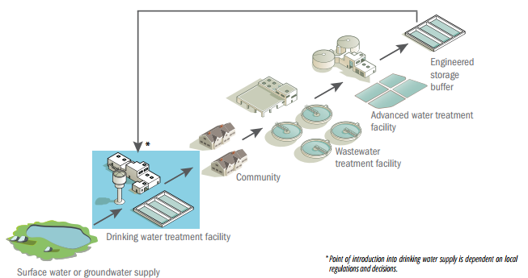
Figure 3. Schematic of a typical DPR project (AWWA, 2016).

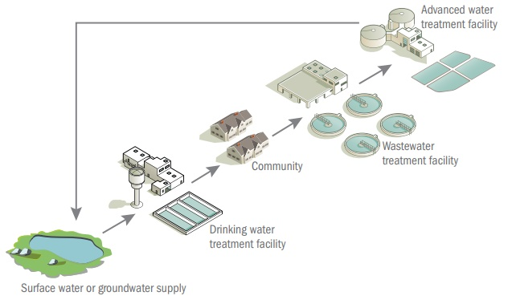
Figure 4. Schematic of a typical IPR project (AWWA, 2016).

2.3 NWIS Data
Only 66 CEC, out of the 113 analyzed in our study, had parameter codes in the U.S. Geological Survey (USGS) National Water Information System (NWIS) database of water quality samples. A parameter code is a unique identifier used on the NWIS site that corresponds to a compound, the sample medium, and the units of measure. Among the 66 compounds with parameter codes, only 44 were detected in Oklahoma (Tables A 2–6). The absence of CEC data emphasizes that CEC are not commonly investigated. However, pesticides such as atrazine and simazine are commonly detected in water sources throughout Oklahoma.

2.4 Study Area
Lake Thunderbird is in central Oklahoma and captures runoff from parts of Cleveland and Oklahoma Counties. The multi-purpose reservoir, constructed in 1966 by the Bureau of Reclamation, has many uses including recreation, municipal water supply, ecosystem propagation, and flood control (OWRB, 2014). Lake Thunderbird has an area of 5,439 acres, volume of 105,838 acre-feet, shoreline of 59 miles (95 km), mean depth of 15 ft (4.7 m) water supply yield of 19.4 million gallons per day (MGD), and a mean monthly discharge of 74.5 cubic feet per second (cfs). Land use in the watershed includes residential (medium and high density), agriculture (generic and pasture), commercial, industrial, transportation, and open water (OWRB, 2001). Sixty percent of the watershed is agricultural and the majority of the remaining 40% is residential, which makes these land uses the focus of source investigations for CEC contamination by runoff. Industrials could be from runoff of storage tanks, septic systems, developed land, or cultivated land (Giesy and Kannan, 2001; Andresen et al., 2004; Li et al., 2014). PPCP entering the lake are possibly sourced from septic systems, developed land, or cultivated land (Baronti et al., 2000; Boxall et al., 2003; Nikolaou et al., 2007; Storteboom et al., 2010; Amiridou and Voutsda, 2011). Pesticide contamination could be the result of runoff from developed, cultivated, or herbaceous land use (Cohen et al., 1995; Lichtenberg and Zimmerman, 1999). The other class of compounds are most likely sourced from septic systems and developed land only (Bradley et al., 2007; Mawhinney et al. and Soh et al., 2011; Tran et al., 2013).
As shown in Figure 5, the Lake Thunderbird watershed has several tributaries with the largest being the Little River. Other tributaries of the watershed include West Hog Creek, Hog Creek, West Elm Creek, Elm Creek, Kitchen Creek, Moore Creek, Rock Creek, Dave Blue Creek, Jim Blue Creek, and Clear Creek (OCC, 2008).
The wildlife present in Lake Thunderbird include sport fish and endemic fish. The sport fish include largemouth bass, white crappie, black crappie, blue catfish, channel catfish, flathead catfish, white bass, saugeye, bluegill sunfish, green sunfish, and redear sunfish. The endemic fish include common carp, small mouth buffalo, big mouth buffalo, river carp sucker, fresh water drum, spotted gar, gizzard shad, inland silverside, warmouth, longear sunfish, yellow bullhead, red shiner, blunt nose minnow, and mosquito fish (ODWC, 2008). Aquatic organisms of the lake will be important for any future studies on the effects of CEC on ecologic systems.
The reservoir is the main source of drinking water for the City of Norman, OK and augments water for the cities of Midwest City and Del City, OK, which have a combined population of 201,435 (OCC, 2008). Lake Thunderbird has been considered a sensitive water supply (SWS) since 2002, meaning that the lake is monitored for water quality parameters and may require treatment by COMCD under regulatory guidance by OWRB (OWRB, 2017). Lake Thunderbird is considered impaired due to excessive chlorphyll-a (Chl-a) and turbidity, and low levels of dissolved oxygen (DO) (OWRB, 2015). Whilst the focus of this project is to analyze CEC concentrations, Chl-a and DO were also evaluated to document water quality indicators of interest for management of the lake.
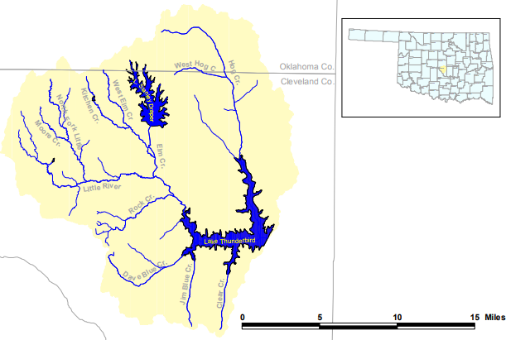
Figure 5. Schematic of the Lake Thunderbird Watershed (OCC, 2008).

2.5 CEC Treatment Approaches
In the original City of Norman IPR project plan, anticipated wastewater treatment techniques included biofiltration and ozone at the water reclamation facility (Figure 2). Lee et al. (2012) investigated the effects of treating 83 different PPCP, with PPCPs that are similar to the compounds in this study, using biofiltration and ozone. Ozone is used to treat PPCP because it forms hydroxyl radicals in the presence of natural organic matter that react quickly, which decreases the concentrations or completely degrades the PPCP or other micropollutants. Although the ozone method can reduce or remove PPCP, the process can create disinfection by-products (DBP); therefore, biofiltration uses biologic material in conjunction with the ozone method to remove oxidation products that were generated. Lee et al. (2012) used ozone doses ranging from 0–12 mg/L and a biofilter media of anthracite (Figure 6).

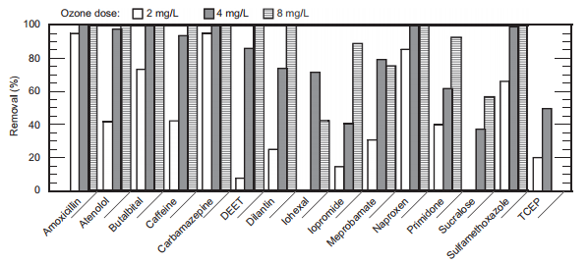
Figure 6. Results of removal of PPCP by the ozone dosages 2, 4, and 8 mg/L (Lee et al., 2012).

Lee et al. (2012) study of the treatment techniques showed that 52 of the PPCP were detected within the ozone contactor influent and had similar concentrations in the ozone and biofilter effluent, which indicated that the biofiltration did not remove or degrade the contaminants (Lee et al., 2012). The results for compound removal by ozone are shown in Figure 6, note that each compound shown was also analyzed in this study. Some CEC including amoxicillin, carbamazepine, and naproxen were rapidly removed even at the lowest ozone dosage. Other CEC such as iohexal, iopromide, meprobamate, primidone, sucralose, and TCEP were never completely removed at any of the ozone dosages. Biofiltration has also been effective for the removal of pesticides (van der Aa et al., 2012).
Reverse osmosis (RO) with nanofiltration (NF), another treatment technology investigated for removal of CEC from wastewater in Norman, involves filtering water through a membrane to remove micropollutants. A study completed by Radjenović et al. (2008) concluded that RO/NF was very effective in removing PPCP, with a rejection >85% for uncharged solutes and >95% for negatively charged pharmaceuticals; researchers stated that the method could remove almost all the residues detected. RO has also been used to remove pesticides in water (Plakas and Karabelas, 2012), but difficulties arose due to membrane fouling.
Jones (2016) investigated the primary and secondary effluent from Norman’s water resource recovery facility (WRRF) and reported that out of the 96 CEC analyzed, 82 were detected in primary effluent and 64 in secondary, which means the biodegradation is already occurring in the WRRF. Jones (2016) also concluded that NF met the available published and regulatory standards for CEC and found that it can remove many PPCP and industrial compounds but did not remove all. While the RO/NF method has been proven to be effective, Lee et al. (2012) argue that biofiltration and ozone is a better option because it is nearly as effective and has lower energy costs, lower waste production, higher water recovery, and lower maintenance costs.
The aforementioned advanced treatment methods can reduce or remove CEC, but with the results from Jones (2016) showing biodegradation is occurring in the WRRF, and Thornton’s (2017) results of DBC sediment and PAR lights reducing or removing concentrations, advanced treatment might not be necessary. The environmental buffer effect might be sufficient in reducing or removing CEC to regulatory and health standards.

2.6 Research Objectives & Hypotheses
The research objectives and hypotheses of this project are to (1) evaluate baseline CEC concentrations in Lake Thunderbird, Norman, OK; CEC have been found in other reservoirs in Oklahoma and in Norman’s WRF, therefore those contaminants could be in Lake Thunderbird as well (2) examine seasonal and spatial variations; seasons with more rainfall will cause more runoff, i.e., there will be more pollution in the lake (3) compare CEC concentrations to established health standards, (4) synthesize CEC work completed by Thornton (2017) in Dave Blue Creek with CEC detected in Lake Thunderbird to assess potential environmental buffering effects of the planned IPR project, and (5) qualitatively assess potential sources of CEC in the Lake Thunderbird watershed and based on land use within each sub-watershed; land use type affects the type of CEC contaminating the lake.

Chapter 3. Methodology
Six locations (Sites 1, 4, 6, 7, 8, and 11), a subset of nine locations previously sampled by the Oklahoma Water Resources Board (OWRB) during water quality studies (OWRB, 2014 & 2015), were selected as the sample sites (Figure 7 and Table A 8). Four water sampling events were planned to represent each season: June 20, 2016 (summer), October 4, 2016 (fall), January 24, 2017 (winter), and April 6, 2017 (spring). Samples were taken seasonally to understand what role temperature and rainfall play in CEC detections. A hypothesis of how the seasons could affect CEC is that more rainfall would lead to more runoff causing more CEC detections in the lake (since many of the CEC are linked to runoff). Turnover of the lake from summer to fall and winter to spring, when the cold layer is on top, could reduce photodegradation of CEC, resulting in greater detections.
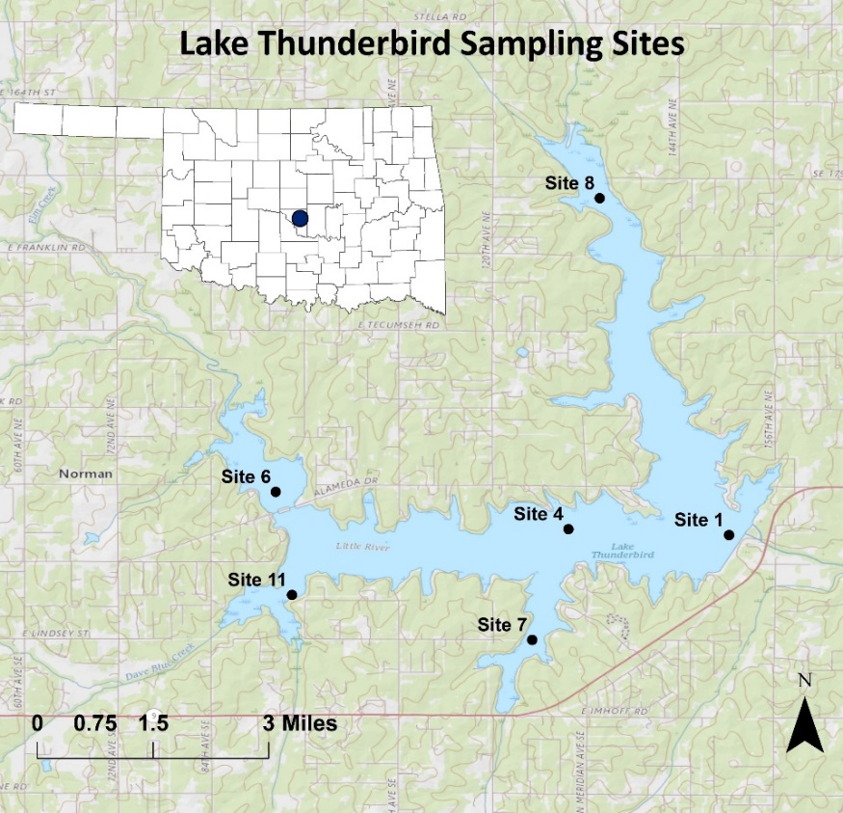
Figure 7. Sampling locations at Lake Thunderbird.

3.1 Field Parameters
Field parameters were measured at 2/3 depth using a Yellow Springs Instruments (YSI 6920) multi-parameter water quality sonde from the Center for Restoration of Ecosystems and Watersheds Lab (CREW) at OU. Parameters measured include temperature (Temp, °C), conductivity (Cond, µS/cm) which was used to calculate specific conductance (SpCond, mS/cm) at 25°C, total dissolved solids (TDS, mg/L), and salinity (Sal, ppt). The YSI 6920 was also used to measure resistivity (Resist, Ohm*cm), pH (-Log[H+]), oxidation-reduction potential (ORP, mV), chlorophyll-a (Chl-a) measured in μg/L and in Relative Fluorescence Units (RFU), and optical dissolved oxygen (ODO) expressed in percentage saturation (SAT) and as a concentration (mg/L).

3.2 Water Sampling for CEC
Since the compounds are measured in trace concentrations (ng/L or ppt), investigators were very careful not to use or touch products containing PPCP or other compounds such as acetaminophen or caffeine. Investigators also wore powderless nitrate gloves, and new gloves were used for every sampling location. Water samples were collected with a 1.2 L stainless steel Kemmerer water sampler that has Teflon-end seals (Figure 8). Samples were collected around 1/3, 2/3, and 3/3 depths. After sample collection at each depth, the Kemmerer sampler was emptied into a one-gallon glass container to form a composite sample of the water column. The Kemmerer water sampler was decontaminated between each site by rinsing with deionized water and passing through the vertical column of water at the next sampling site.
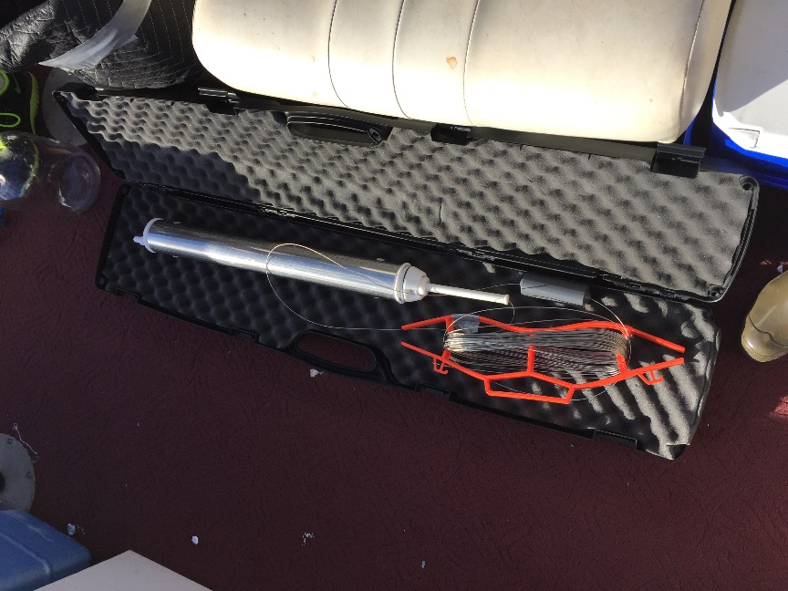
Figure 8. Stainless Steel 1.2 L Kemmerer water sampler.

After samples were composited into a one-gallon glass container, water was transferred into two 40 mL amber glass bottles (for EEA and WEST labs) that contained preservatives to avoid biological degradation of the compounds. The bottles were capped and shaken to combine the preservative and the sample. The samples were stored in a cooler to aid in sample preservation during the field sampling event. An equipment blank and blind duplicate (fall, winter, and spring) were also taken as quality control and quality assurance (QA/QC) samples. The equipment blank was collected by pouring deionized water into the Kemmerer sampler and into a specified equipment blank amber bottle. The purpose of an equipment blank is to assess whether contamination was introduced during the sampling process. Blind duplicates were used to determine the accuracy of the analytical method used, because while it is blind to the lab, the samplers know which site it was taken from and can then compare it to the reported values for that site.
After each sampling event, samples were packed on ice and shipped to labs for CEC analyses. The first suite of chemicals (Table A 9) were analyzed by Eurofins Eaton Analytical lab (EEA) for each sampling event and the second suite of chemicals (Table A 10) were analyzed by the University of Arizona Water & Energy Sustainable Technology (WEST) lab after the winter and spring sampling events.

3.3 CEC Analyses – Eurofins Eaton Analytical
The EEA lab externally analyzed the water samples using solid phase extraction and liquid chromatography/ tandem mass spectrometry (SPE - LC/MS/MS) endocrine disruptor mode (positive and negative) method to test the concentrations of the compounds, in accordance with EPA Method 544 (EPA, 2015). The method involved direct injection and a run time of less than 15 minutes. The water samples were 500 mL and immersed in an intracellular toxin solution and filtered, then the filter and filtrate were kept. The filter was in a solution of methanol that had 20% reagent water (water with low minerals and high resistivity) for a minimum of an hour at -20°C. Next, liquid was taken off the filter and added back into the original sample solution. The sample was then put through an SPE cartridge to extract the target compounds. After extraction, compounds were removed from the solid phase with methanol and 10% reagent water.
Extracts were subsequently evaporated with nitrogen in a heated water bath until they were dry, then refined to 1 mL volume with methanol and 10% reagent water. Once samples were refined to 1 mL, a 10 µL injection was made into an LC that contained a C8 (octylsilane) column for MS/MS. The acquired mass spectra and retention times for calibration standards acquired under identical LC/MS/MS conditions were compared, and the concentrations were determined by external standard calibration (EPA, 2015). The MS was used in positive and negative modes to determine positive or negative ions.

3.4 CEC Analyses – University of Arizona WEST
The University of Arizona WEST lab sampling procedures were similar to the EEA lab in that the water samples collected by the Kemmerer were then transferred to amber vials. The vials contained 50 mg ascorbic acid and 1 g sodium azide to hinder possible microbial activity. The WEST samples also had to be cooled during shipment and were filtered through a 0.7 μm glass filter upon arrival to the facility. Samples were stored in darkness and kept on ice, then analyzed within 14 days of being received (Vanderford et al., 2011).
The WEST lab externally analyzed the water samples using ultra-high-performance liquid chromatography tandem mass spectrometry (UHPLC-MS/MS). The method the lab used was described in Anumol et al., (2013) and is summarized in this section. An automated SPE system was used to extract the samples with a 200 mg hydrophilic-lipophilic balance (HLB) cartridge. HLB cartridges were preconditioned with 5 mL of methyl tertiary-butyl ether (MTBE), then 5 mL of methanol and ultrapure water. After cartridges were prepared, compounds were removed with 5 mL of a 10/90 methanol/MTBE solution. Evaporation dried the extracts to less than 500 μl with a nitrogen flow, volumes were adjusted to 1 mL by adding methanol. Finally, the extracts were put into 2 mL vials and stored in darkness at 4°C until they were ready for UHPLC-MS/MS analysis.
Liquid chromatography was performed on 3 μL of sample extract using an Agilent 1290 binary pump with metal solvent fittings. The Agilent RRHD ZORBAX Eclipse Plus reverse phase C18 (octadecyl) was used to separate compounds in both the negative and positive electrospray ionization (ESI) modes. Next, mass spectrometry was executed with an Agilent 6460 triple quadrupole mass spectrometer. Analysis from both the electrospray ionization (ESI) positive and negative modes was performed using a multiple reaction model (MRM) method. Interpretation of the data was completed with the Agilent MassHunter software and monitoring of the labeled isotope recoveries, the retention time, and the ratio of the two transitions, which increased the accuracy of detection and reduced the possibility of false positives of the method (Anumol et al., 2013).
The WEST lab method detection limit (MDL), lowest concentration that is measurable, varied for each compound and each site. The MDL values were initially determined by removing samples from ultrapure water that contained target compounds two to three times the limit of quantification and spiking them with known concentrations. After being analyzed, the MDL was calculated by the multiplication of the standard deviation and the student’s t-test value for n-1 degrees of freedom at 99% confidence (Anumol et al., 2013).

3.5 Horton vs. Thornton
Thornton’s (2016) study that investigated the use DBC sediment and PAR light treatment to naturally degrade CEC in Norman’s secondary effluent compared to the present study of ascertaining CEC in the lake (without effluent being introduced) is paramount to determine if IPR is achievable. First, the values of secondary effluent, before sediment or PAR light were added, were compiled. Next, the values of the effluent after fifteen days with DBC sediment and effluent after fifteen days under PAR light were compared to the original secondary effluent values. Lastly, the values were compared to median values detected in Lake Thunderbird (Table A 1).

3.6 CEC Loading
A qualitative watershed loading factor model was created using ArcGIS. The term loading factor is meant to describe the possible sources of contamination, e.g. loading, by runoff into the lake, and the purpose of the model is to qualitatively assess which sub-watersheds have higher likelihood of contributing CEC to the lake by runoff based on land use. First, basemap features were downloaded for the Lake Thunderbird watershed in Cleveland and Oklahoma Counties. Next, potential sources of contamination were determined based on percentage of land uses within a sub-watershed, number storage tanks (gasoline and diesel) per acre, and number of domestic wells per acre (domestic wells were used as a proxy for septic tanks, since septic tank data cannot be retrieved). Pesticides are most likely from urban and agricultural runoff. Compounds from the industrials category could be sourced from urban runoff and leaking storage tanks. Sources for PPCP and hormone contamination could be derived from septic tanks, urban runoff, or agricultural runoff. Other compounds are most likely sourced from urban runoff and septic tanks.
After the main watershed and the land uses within it were mapped out, the sub-watersheds were delineated, and the possible loading factors were evaluated for each category of compound. For the purposes of this analysis, sub-watersheds were delineated for the tributaries that directly enter the lake (i.e. Little River, Hog Creek, Dave Blue Creek, and Clear Creek). The sub-watersheds had different loading factors based on land use, and the different land uses were overlaid and weighted depending on what class of compound that map was focused on; an example would be PPCP contamination mostly sourced from developed land use, therefore developed land use would be the most heavily weighted loading factor.
Data for land use was retrieved from the USGS Land Cover Institute (LCI) website and digital elevation model (DEM) data was also collected from the USGS, but the The National Map (TNM) website (USGS, 2017). Storage tank (in use) data was gathered from the Oklahoma Department of Environmental Quality data viewer website (ODEQ, 2017). Lastly, watershed data was collected from the national hydrologic dataset of the USGS.
The thematic land use descriptions that were used in this analysis are as follows: developed land is any area that has a percentage of 30 or higher of constructed materials, like concrete, buildings, or asphalt which can be residential, commercial, or manufactured areas; herbaceous land is an area that is covered 75–100% by herbaceous vegetation and is often used for grazing; and cultivated lands include cultivated crops and hay pasture land cover that are characterized by planted vegetation for the production of food, fiber, or feed (USGS, 2017).
Sub-watersheds were delineated using a variety of spatial analysis tools in ArcGIS. First, a 10-m resolution DEM was downloaded and filled by removing imperfections or sinks in a surface raster (the 10-m DEM). Next, the flow direction tool was applied to create a raster of flow direction from a cell to its steepest downslope neighbor. Following flow direction, the flow accumulation tool was used to compute the number of upstream cells from the flow direction raster that would contribute flow to every cell in the watershed. After flow accumulation, pour points (i.e. points of highest accumulation) were chosen for each sub-watershed to perform the snap pour point method by “snapping” the chosen pour points into the actual points of highest accumulation. Lastly, the watershed tool delineated the basins, or contributing areas, for the snapped pour points.

3.6.1 Modelling for Relative Loading
Relative loading (of CEC) from sub-watersheds was evaluated using an index-modeling approach that resembles the “export coefficient model” approach of Mattikalli and Richards (1996), whereby equations were created to weight the relative contributions of land use to CEC concentrations at the output into Lake Thunderbird. Two benchmark compounds were selected for each classification of analyte for each lab, based on highest number of detections. Equations were constructed using the most probable sources of runoff contamination, i.e. land use types or leaking tanks, for each type of compound (described in Chapter 2.4 “Study Area”). The loading factor variables were weighted by comparing the predicted loading factor to the observed median concentrations of benchmark compounds and adjusted to maximize the coefficient of determination (R²) for the loading factor. All sampling sites have a corresponding sub-watershed except sites 1 and 4, therefore data for the entire watershed was used for those sites in the model for best fit, and if a site did not have a median concentration, ½ the MRL was used.

3.6.2 Equations for Relative Loading
Variables used to assess relative loading are as follows:
ST = # of in use storage tanks per acre
SS = # of domestic wells per acre (proxy for septic systems)
D = fraction of total developed land use
C = fraction of cultivated land use
H = fraction of herbaceous land use

For the industrial compounds, the following equation and benchmark compounds were used:
Equation: ST + SS + D + C
Benchmark compounds:
EEA
- NP: three detections in fall, two in winter, two in spring
- OP: three detections in fall
WEST
- TCPP: three detections in spring
- PFOS: five detections in winter, six in spring

NP and OP are used in commercial and household cleaning products, industrial processing, fabrics, shoes, paints and coatings, lotions, liquid cosmetics, and lawn care, crop protection products (Federal Register, 2014). TCPP is used as a flame retardant and for plastics. PFOS is used to make carpets, clothing, fabrics for furniture, paper packaging for food, materials that are resistant to water, grease or stains, firefighting at airfields, and in industrial processes (EPA, 2016). The industrial compounds evaluated in this study are organophosphorus or alkylphenol compounds. The organophosphorus compounds are most likely sourced from developed land use (used for concrete, flame retardation, and pest control) and the alkyphenols are probably sourced from leaking storage tanks or septic systems (domestic well as proxy for septic tanks).

For the pesticide compounds, the following equation and benchmark compounds were used:
Equation: C + D + H
Benchmark Compounds:
EEA
- Atrazine: six detections in summer, four in fall, six in winter and spring
- Simazine: six detections in summer and fall, five detections in winter and spring
WEST
- Atrazine: five detections in winter, six in spring
- Simazine: five detections in winter, six in spring

Both atrazine and simazine are pesticides that are widely used in agriculture and developed areas (maintenance of roadsides, commercial areas, lawns, and gardens) as effective weed killers, which means runoff from those types of land are the most likely source of contamination (U.S. Geological Survey Circular 1225).

For the PPCP compounds, the following equation and benchmark compounds were used:
Equation: SS + D + C
Benchmark Compounds:
EEA
- Clofibric acid: five detections in fall, six in winter, three in spring
- Salicylic acid: three detections in winter, in spring
WEST
- Iopromide: five detections in winter
- Propylparaben: five detections in spring

Clofibric acid is used as a lipid regulator and salicylic acid is used for skin care; contamination most likely from runoff near pharmaceutical industries, households, livestock, or wastewater treatment plants (Boxall et al., 2012). Iopromide is an iodinated contrast medium and has been detected in wastewater treatment facilities (Schulz et al., 2008) and propylparaben is used as a stabilizer, bactericide, and flame retardant; it has been detected in industrial runoff and wastewater treatment facilities (Martins et al., 2017).

For the other compounds, the following equation and benchmark compounds were used:
Equation: SS + D
Benchmark Compounds:
EEA
- DEET: six detections in summer, fall, and winter; five in spring
- Acesulfame-K: six detections in summer, four in fall, two in winter, five in spring
WEST
- DEET: five detections in winter, six in spring
- Acesulfame-K: five detections in winter, six in spring

The other CEC group consists of an insect repellant (DEET), stimulants, and some artificial sweeteners; since those products are exclusively used by humans, it is plausible that they are only sourced from urban runoff and leaking septic tanks. The principal pathway for DEET to enter a drinking water environment is through sewage effluent from washing off humans and excretion by humans (Costanzo et al., 2007). There is a strong correlation between acesulfame-K concentrations in surface waters near heavier population (Muller et al., 2011), because it is generally a constituent of effluent from wastewater treatment plants (Lange et al., 2012).

Chapter 4. Results and Discussion

4.1 CEC Detections – Eurofins Eaton Analytical
More CEC were detected in fall than in the other seasons for the EEA lab, while the fewest CEC were detected in the summer. In the summer there was one industrial detect, two pesticides, one PPCP, and three other detects. Fall sampling event detections included three industrials, nine pesticides, seven PPCP (two of those being hormones), and three others. Winter had the second most detections with one industrial, nine pesticides, five PPCP including a hormone, and four other compounds. One industrial, ten pesticides (most of any season), four PPCP, and three others were detected in the Spring sampling event. Results of the compound concentrations for each season at all six sites can be found in Tables A 11–14 and Figures B 1–32.

4.1.1 Industrial Compounds
The industrial compounds detected include BPA, NP, OP, and TDCPP. BPA was present at three sites in the summer, but not in any of the other seasons; it is considered an alkyphenol and an endocrine disruptor and is used as a monomer for polycarbons and epoxy resins (Kuch and Ballschmiter, 2001). It was probably only detected in the summer because of higher recreational use of the lake in the summer, considering BPA is mostly used in plastic containers. A toxicological summary for BPA completed in 2015 by the Minnesota Department of Health (MDH) quantified the short term non-cancer health standard of BPA to be 100,000 ng/L and a sub-chronic non-cancer health standard of 20,000 ng/L (MDH, 2015); the highest concentration measured in this study was 120 ng/L, substantially lower than the health standard concentrations.
NP was the most common industrial compound, detected in the fall, winter, and spring. Aside from industrial use, NP is used in many residential and commercial products (Federal Register, 2014). The frequent detections of NP could be related to septic systems or from runoff of lawns/crops due to its applications which could have been used year-round; another hypothesis is that NP is more resistant to degradation than the other industrial chemicals considering the others were only detected in the fall. A toxicological summary for NP completed in 2015 by the MDH determined the short term non-cancer health standard of NP to be 100,000 ng/L, sub-chronic non-cancer health standard of 40,000 ng/L, and chronic non-cancer health standard of 20,000 ng/L (MDH, 2015); the highest concentration reported from the present analysis was 530 ng/L and did not exceed the health standards suggested by MDH (2015).
OP and TDCPP were detected only in the fall. As previously stated, OP is used in industrial, residential, and commercial products. A toxicological summary for OP completed in 2015 by the MDH ascertained that the short term non-cancer health standard of 100,000 ng/L, sub-chronic non-cancer health standard of 400,000 ng/L, and chronic non-cancer health standard of 100,000 ng/L (MDH, 2015); 410 ng/L was the highest concentration detected for OP and did not exceed any health standards. TDCPP is used for polyurethane foams, plastics, and fabrics. A toxicological summary for TDCPP completed in 2013 by the MDH resolved a sub-chronic non-cancer health standard of 20,000 ng/L, and chronic non-cancer health standard of 9,000 ng/L (MDH, 2013); the only value detected in the present analysis was 180 ng/L, therefore lower than the health standards. These chemicals possibly were detected in fall samples because of to higher levels of rainfall in September and October than in the summer months.

4.1.2 Pesticide Compounds
The pesticides detected include 2,4-D, atrazine, bromacil, cyanazine, DACT, DEA, DIA, diuron, OUST, quinoline, and simazine. Atrazine and simazine, herbicides of the triazine family, were detected during every season. Triazine herbicides are used to control weeds and conceivably could have contaminated the lake from residential surface water or agricultural runoff. These pesticides have been related to acute and chronic problems with humans and in ecosystems; they have also been linked to several types of cancer (Cohen et al., 1995; Lichtenberg and Zimmerman, 1999; Leeuwen et al., 1999). Atrazine has specifically been linked to disruptions in menstrual cycle functions (Cragin et al., 2011), positively linked with stomach cancer incidents (Leeuwen et al., 1999), can be toxic to fish (Nwani et al., 2010), and cause hermaphroditism and demasculinize male frogs in concentrations as little as 1,000 ng/L (Hayes et al., 2001); levels of atrazine from the present study did not exceed 1,000 ng/L – the highest reported value was 26 ng/L. The levels for atrazine never exceeded the EPA drinking level standard of 4,000 ng/L (Table A 6). Simazine levels were also lower than EPA drinking level standard of 3,000 ng/L (Table A 6), if the compound had exceeded those levels it could cause issues with blood in humans, but the highest value detected was 1,400 ng/L in the spring season. Cyanazine, another member of the triazine herbicides, had one detection in fall. However, cyanazine production has been banned in the U.S. since 1999 and illegal to use since 2002 (EPA, 2000). The unexpected detection of cyanazine may have been the result of a continuing source of cyanazine in the sub-watershed. DACT, DIA, and DEA are chlorometabolites of the triazine herbicides and presumably persisted in the environment through fall, winter, and spring after summer applications of the parent compounds.
Bromacil, 2,4-D, and Diuron were detected in the fall, winter, and spring. Bromacil is another weed killer and exposure to it has been shown to slow weight gain in dogs, increase incidence of thyroid cysts and tumors in rats, and eye irritation, it is also considered persistent and highly mobile in the environment (EPA, 1996). A weed-killing herbicide, 2,4-D, can cause issues with kidneys, the liver, or adrenal glands. The EPA health standard for 2,4-D is 70,000 ng/L (Table A 6), the standard was never exceeded in this study because the highest value documented was 200 ng/L. Diuron is considered a pre-emergent herbicide to control grasses and weeds, it is usually paired with a surfactant. Diuron is considered persistent in the environment and the estimated health standard for acute (non-cancer) effects is 67,100 ng/L and chronic (cancer) effects is 47,100 ng/L (EPA, 2001). The health standards for diuron were not exceeded in the present study because the highest value attained was 260 ng/ L in the spring season. Diuron is used year-round in residential and agricultural areas and thus detected in nearly every season. Because there is less rainfall in the summer, there is less runoff, and this possibly results in non-detects for diuron in summer.
Quinoline was detected in winter and spring, it is used in petroleum practices, coal processing, wood preservation, solvents, and paints. It biodegrades quickly in aquatic systems (21-day half-life in summer, 160-day half-life in winter), therefore it could have been degraded microbially or photolytically in the summer and fall seasons after initial entrance into the lake from runoff (EPA, 2001). Human health standards for quinoline were not available. OUST was detected at every site in spring, possibly due to higher uses in that season and more runoff; human health standards were not available for OUST.

4.1.3 PPCP Compounds
Several PPCP compounds were detected including clofibric acid, gemfibrozil, ibuprofen, iohexol, lincomycin, meclofenamic acid, salicylic acid, triclocarban, and trimethoprim. Clofibric acid, used as a lipid regulator (Boxall et al., 2012), was the most frequently detected PPCP, occurring in the fall, winter, and spring. Salicylic acid, used for skin care, was also frequently detected in spring and winter. The only PPCP detected in summer was iohexol, an X-Ray contrast media has been shown to cause cancer by enhancing genotoxicity and cell mutation (Jeong et al., 2017). The aforementioned compounds (clofibric acid, salicylic acid, and iohexal) do not have water-based health standards.
Lincomycin, triclocarban, and trimethoprim were detected at one site in the fall. Lincomycin is an antibiotic, widely used for swine, that could be entering waterways through agrarian land use or leaking septic tanks; there are no health standards for this contaminant (USGS, 2014). Ibuprofen, used as an anti-inflammatory medicine for humans, was detected in fall and winter at one site. The primary pathway for ibuprofen to enter a water way is through wastewater effluent (Bound and Voulvoulis, 2006); health standards could not be found for ibuprofen.
Triclocarban is an antibacterial and disinfectant, it has the potential to enter streams downslope of wastewater treatment facilities. A risk assessment completed by the MDH (2013) determined the chronic non-cancer health standard to be 100,000 ng/L; the only detection in the present study was 5.1 ng/L. Trimethoprim is also an antibacterial, often is used alongside antibiotics, it can enter the environment through agricultural runoff or leaking septic tanks. The health standard determined by the MDH (2015) to be 4,000 ng/L; the only value obtained by the EEA lab (9.9 ng/L) was well below this standard.
Meclofenamic acid, medication used to relieve pain, was only detected in the winter, and most likely entered water systems through runoff from leaking septic tanks. Health standards could not be acquired for Meclofenamic acid. Gemfibrozil is used to lower cholesterol and triglyceride levels in pancreatitis patients. It was detected in the spring in our study and has been detected in wastewater effluent and marine receiving waters elsewhere (Vidal-Dorsch et al., 2012). There are currently no available health standards for gemfibrozil.
The hormone compounds detected, which are a subcategory of the PPCP compounds, were andorostenedione, estriol, estrone, and testosterone. There were no hormones detected in the summer. Andorostenedione and testosterone were detected in fall, estriol in winter, and estrone in spring. Andorostenedione and testosterone are androgens, while estriol and estrone are estrogens. Hormone contamination can cause endocrine disruption or cancer (USGS, 2014). These compounds could have entered waterways from agricultural runoff, leaking septic tanks, or effluent from wastewater treatment facilities. Drinking water standards for hormones are not established.

4.1.4 Other Compounds
Compounds from the other class that were detected include acesulfame-K, caffeine, cotinine, and DEET. Acesulfame-K and DEET were detected in each season, which is reasonable considering that these chemicals are probably used in every season and would be constituents of urban runoff. Acesulfame-K does not have a health standard, but the health standard for DEET is 200,000 ng/L (MDH, 2013) which is much higher than any concentrations (7.7-55 ng/L) detected in the present study. Caffeine was detected in the fall, winter, and spring. Cotinine was detected in the summer and winter. Neither caffeine nor cotinine have drinking water standards.

4.2 CEC Detections – University of Arizona WEST
More CEC were detected, by the analytical methods of the WEST lab, in spring than in winter. In the spring, two industrials, two pesticides, four PPCPs, and two other compounds were detected. Winter resulted in two industrial detections, two pesticides, three PPCPs, and two other compounds. Results of the compound concentrations for spring and winter at all six sites can be found in Tables A 15–16 and Figures B 33-45.

4.2.1 Industrial Compounds
Industrial compounds detected by the WEST lab include PFHxA, PFOS, and TCPP. PFHxA is used for protective fire resistance, repellency against oil, grease, and water, used in cleanings, textiles, leather, paper, paints, and wire insulation (EPA, 2012). PFOS is used to make carpets, clothing, fabrics for furniture, paper packaging for food, materials that are resistant to water, grease or stains, firefighting at airfields, and in industrial processes (EPA, 2016). TCPP is used for flame retardation and is most likely sourced from developed areas; it has been shown to be resistant to ozone as a remediation or treatment technology (Pisarenko et al., 2012). The compounds PFOS and PFHxA are PFC and they are persistent in the environment. Studies (described in Chapter 2.4 “Study Area”) have shown that these compounds are linked to higher cholesterol levels in humans, reduced immune responses, thyroid disease, kidney cancer, and testicular cancer. The health standard for PFOS is 27 ng/L, which was not exceeded in this study considering the highest value reported was 3.1 ng/L. Health standards have not been established for PFHxA (MPCA, 2008) and could not be found for TCPP.

4.2.2 Pesticide Compounds
The only pesticide compounds detected by WEST were atrazine and simazine with frequent detections in winter and spring. Results were similar to the EEA lab values. Possible runoff sources and toxic effects of these compounds are mentioned in “4.1.2 Pesticide Compounds”.

4.2.3 PPCP Compounds
The PPCP compounds detected were diltiazem, hydrochlorothiazide, iopromide, meprobamate, propylparaben, and trimethoprim. Iopromide is an iodinated contrast medium (Schulz et al., 2008), it was the most frequently detected PPCP from the WEST lab. There currently are not any available drinking water standards for iopromide. As previously stated, trimethoprim is an antibacterial, it was detected once in winter and once in spring. The health standard for trimethoprim is 4,000 ng/L; values from WEST lab (0.9 and 3.6 ng/L) also did not exceed the standard. Hydrochlorothiazide was detected at a few sites in winter, it is used in the treatment of hypertension and does not have a drinking water health standard.
Propylparaben is used as a stabilizer, bactericide, and flame retardant (Martins et al., 2017), and was the second most frequently detected PPCP, but it was only detected in spring. Health standards could not be obtained for propylparaben. Diltiazem, a calcium channel blocker used to prevent chest pain, was detected at one site in the spring. Studies have shown that diltiazem can cause chronic kidney disease in rats, but toxicity levels in humans could not be found (Ismail et al., 2017). Meprobamate, used for treating anxiety disorders, was only detected in spring and does not have a drinking water standard.

4.2.4 Other Compounds
Other compounds detected by WEST were acesulfame-K and DEET, detected frequently in winter and spring are similar to the EEA results; analysis of these contaminants mentioned in “4.1.4 Other Compounds”.

4.3 Field Parameters
Results from the field parameters illustrate that the most substantial changes detected in any of the parameters were in chlorophyll-a (Chl-a), oxidizing-reducing potential (ORP), and optical dissolved oxygen (ODO). The highest concentrations of Chl-a were measured in the fall with one anomalously high concentration in spring. Chl-a increases could be caused by nutrient enrichment enhancing algal biomass, decreases could be because of nutrient depletion (Harper, 1992).
High concentrations of Chl-a, exceeding 10 µg/L (EPA, 2016), contributed to Lake Thunderbird becoming a SWS. Chl-a levels exceeded the recommended levels at two sites in summer, five sites in fall, six sites in winter, and two sites in spring. Therefore, before proceeding with indirect potable reuse, the City of Norman may need to enforce phosphorous and nitrogen criteria in accordance with OAC 785:45-5-10(7) (EPA, 2016) which could be achieved by imposing phosphorous-free fertilizer rules or by keeping organic matter out of the street, so the fertilizers do not enter drains; if citizens do not comply they could be fined.
ORP was highest (oxidizing) in summer and winter and lowest (reducing) in spring and fall. Differences in ORP values could be due to bacterial activity, more bacterial activity could mean higher ORP and vice versa (Hunting et al., 2013). ODO concentrations were high in summer, winter, and spring and lowest in fall. The dip in ODO during the fall could perhaps be the result of excessive algae growth, because when algae die the process take up DO (MPCA, 2009) – which is consistent with higher levels of Chl-a. The ODO results correspond to the season with the highest number of CEC detections, homologous with the Chl-a spike. In 2011, a supersaturated dissolved oxygen injection system (SDOX) was emplaced to aid the deficiency of dissolved oxygen in the lake, and as of 2014 the SDOX had improved levels of DO to meet EPA requirements; even though DO has met requirements, it can still be affected by algae growth, therefore nutrient reduction should still be a mitigation focus to prevent low DO in the future (OWRB, 2014).
Thermal stratification, and the turnover of the lake, could also be playing a part in seasonal changes in compound detections. Stratification in the summer has the epilimnion layer (warm water) on top that cannot move through the hypolimnion (cold dense water) which means the water cannot mix and photosynthesis cannot occur in the hypolimnion layer of the lake. The lake turns over from summer to fall, then again in winter to spring, meaning the hypolimnion layer becomes the top layer (Elci, 2008). The summer and winter seasons in this study had the fewest detections, while the fall and spring had the most; the higher detections could be due to mixing of sediment (to which contaminants have attached) when the lake turns over along with the reduced effect of photosynthesis. Tables for the field parameter results are in Tables A 17–28, corresponding figures are in Figures D 1–12.

4.4 CEC Loading Mapping
Four sub-watersheds were defined by the snap pour point method (Figure 9): 1) Hog Creek, which coincides with Site 8 and includes West Hog Creek and Hog Creek; 2) Clear Creek, that corresponds to Site 7 and only encompasses Clear Creek; 3) Dave Blue Creek, which equates to Site 11 and is comprised of Dave Blue Creek and Jim Blue Creek; and 4) Little River, the largest sub-watershed containing Stanley Draper Lake, Elm Creek, West Elm Creek, Kitchen Creek, North Fork Little River, Little River, and Rock Creek – corresponding to Site 6. The loading assessments (Tables A 29–32) were based on the land use fractions, storage tanks per acre, and domestic wells per acre for each sub-watershed (Figures 10 & 11).
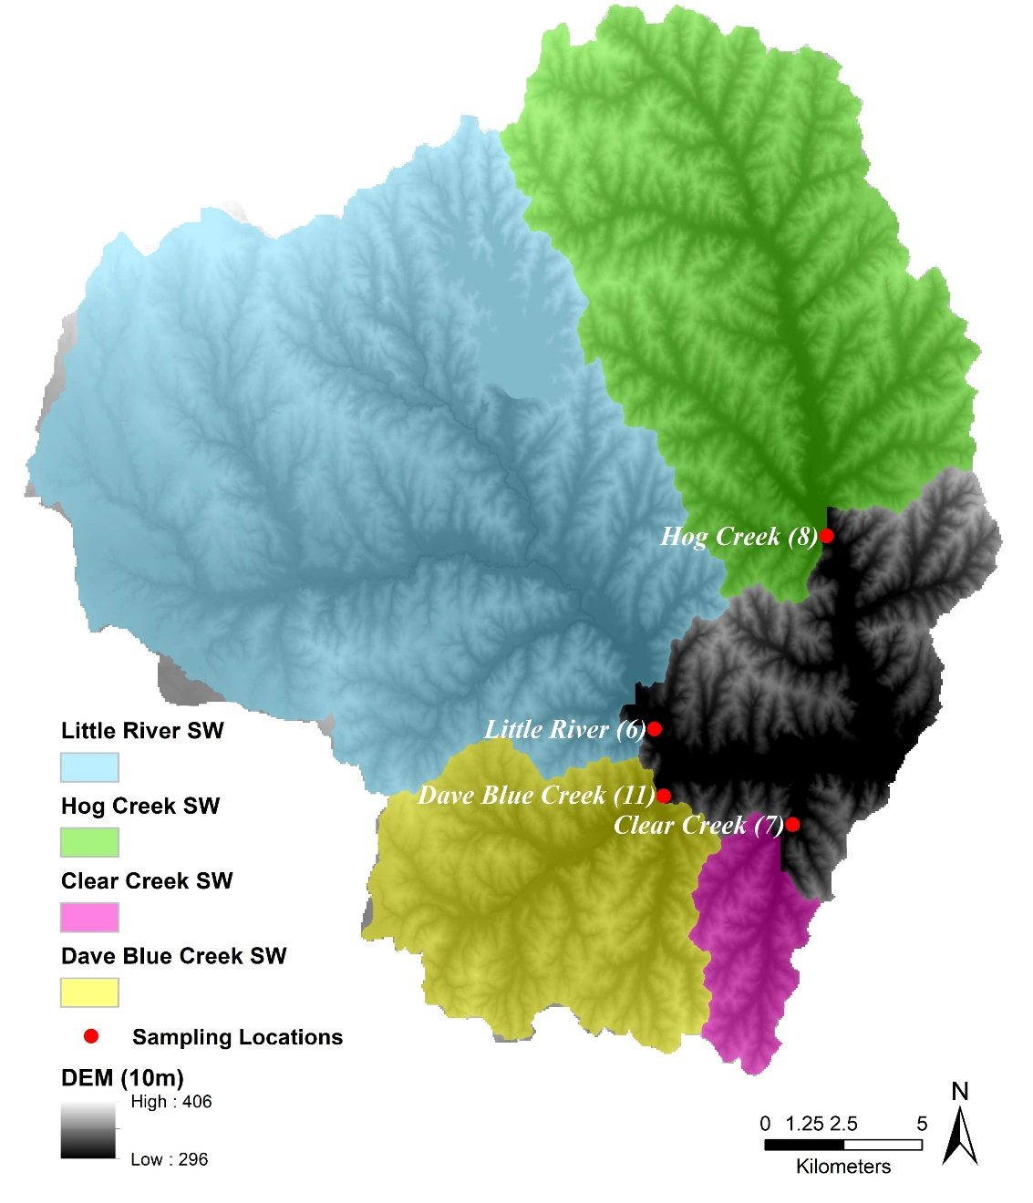
Figure 9. Delineated sub-watersheds based on sampling sites.
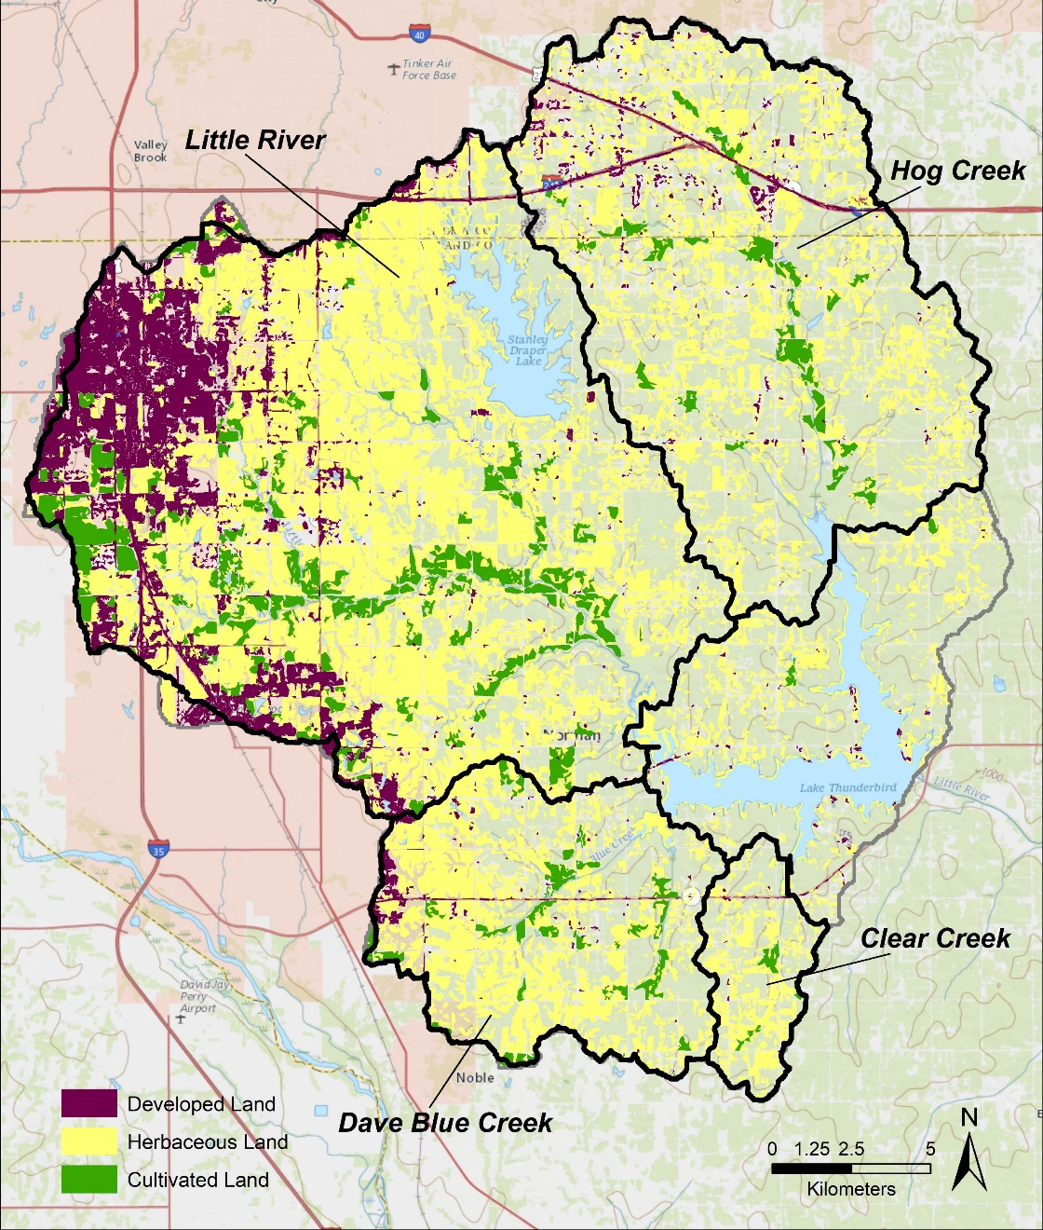
Figure 10. Sub-watersheds and land uses used to assess potential CEC loading.
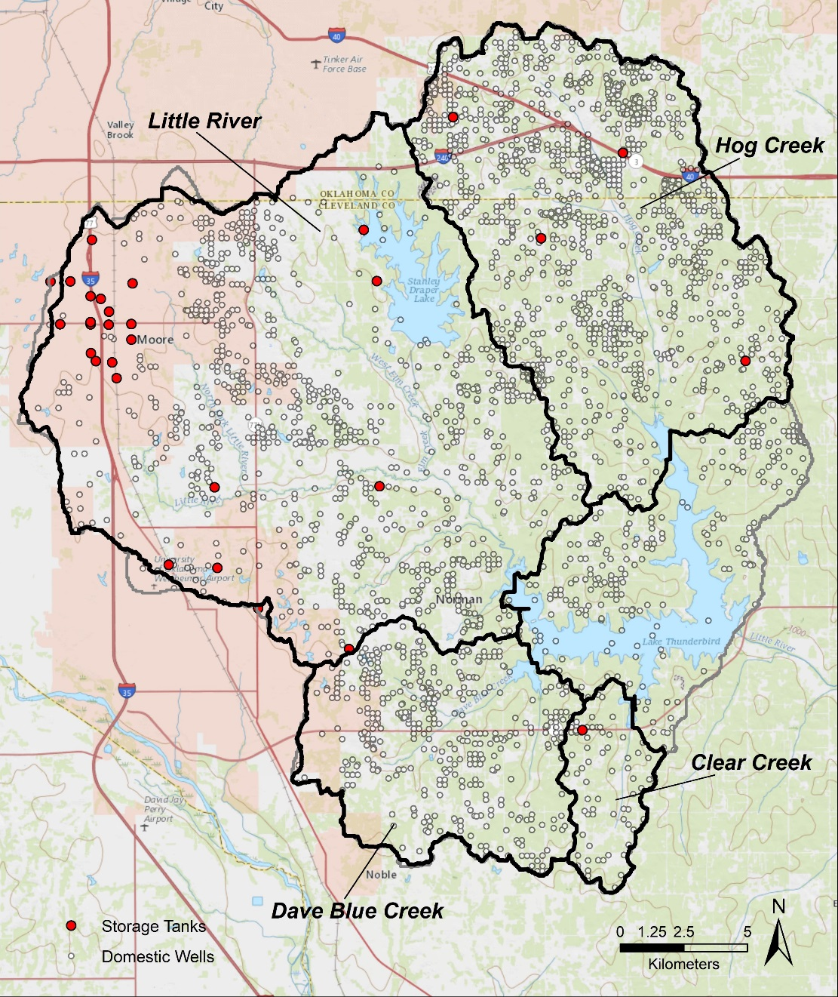
Figure 11. Domestic wells, storage tanks, and outlines of sub-watersheds.

The loading factors (derived by adjusting the land use weighting coefficients to maximize the R²) and the corresponding equations for each benchmark compound are listed in Table A 33 and represented graphically in Figures E 1–12. Variable definitions are as follows:

LF = loading factor
ST = # of in use storage tanks per acre
SS = # of domestic wells per acre (proxy for septic systems)
D = fraction of total developed land use
C = fraction of cultivated land use
H = fraction of herbaceous land use

4.4.1 Industrial Coefficients
NP: LF = 0.1 ST + 0.001 SS + 0.9 D + 3 C; Conc_{NP} = 9.3638 LF + 48.906; R² = 0.9573
OP: LF = 1700 ST + 46 SS + 3 D + 0.009 C; Conc_{OP} = 57.856 LF; R² = 0.9043
TCPP: LF = 0.001 ST + 1000 SS + 0.01 D + 0.01 C; Conc_{TCPP} = 5.7975 LF; R² = 0.5460
PFOS: LF = 0.1 ST + 0.1 SS + 1.1 D + 9 C; Conc_{PFOS} = 0.8247 LF + 2.0117; R² = 0.7111
The non-point source variable (land use) that most affected NP was cultivated land, with developed land possibly having less of an impact. OP was the opposite, with developed land weighting heavier, apparently. TCPP was equally affected by both non-point contamination sources. PFOS was more influenced by cultivated land than developed land, perhaps due to soils being a great sink for PFC (EPA, 2016). The point source variables (septic systems and storage tanks) for NP did not have a large impact, but the coefficient was lower for leaking septic systems than storage tanks, most likely due to its use in plastics. Storage tanks and septic systems were the heaviest weighted coefficients for OP, with storage tanks having more of an impact. TCPP was possibly most affected by septic systems, and least affected by storage tanks. PFOS was not nearly as affected by septic systems as TCPP. The Little River sub-watershed had the highest median concentrations for all the benchmark compounds. Overall, cultivated land was the highest contributing non-point source factor to loading of industrial CEC, which means that best management practices in areas of cultivated land could have the greatest impact on reducing industrial CEC to Lake Thunderbird.

4.4.2 Pesticide Coefficients
Atrazine: LF = 4.8 C + 2 D + 0.45 H; Conc_{Atrazine} = -1.8855 LF + 10.995; R² = 0.9756
Simazine: LF = 4.4 C + 0.01 D + 7.7 H; Conc_{Simazine} = 57.703 LF + 201.73; R² = 0.7633
Atrazine was most likely sourced from runoff from cultivated and domestic land with the Little River sub-watershed having the highest median concentrations, whereas herbaceous land did not contribute substantially to loading. Simazine was also highly influenced by cultivated land, but moreso by herbaceous land possibly because it is considered a selective pesticide and is used widely for tall grasses. Reducing the use of atrazine and simazine as weed-killers for cultivated land, and simazine for herbaceous land could mitigate some of the pesticide loading to Lake Thunderbird.

4.4.3 PPCP Coefficients
Clofibric acid: LF = 1 SS + 0.001 D + 3.1 C; Conc_{Clofibricacid} = 176.72 LF; R² = 0.8752
Salicylic acid: LF = 0.01 SS + 0.1 D + 500 C; Conc_{Salicylicacid} = 12.894 LF + 28.042; R² = 0.6839
Iopromide: LF = 6.5 SS + 1.4 D + 0.2 C; Conc_{Iopromide} = -9.3209 LF + 5.465; R² = 0.6558
Propylparaben: LF = 0.001 SS + 0.01 D + 200 C; Conc_{Propylparaben} = -0.759 LF + 16.838; R² = 0.4228
The Little River sub-watershed had the highest median concentrations for every PPCP benchmark compound, which is reasonable because the Little River sub-watershed has the highest proportion of residential and developed areas. Clofibric acid, salicylic acid, and propylparaben were most strongly related (most heavily weighted coefficient) to the proportion of cultivated land, but it was the smallest for iopromide. Clofibric and salicylic acids have been detected in livestock runoff (Boxall et al., 2012), therefore that is probably the reason that the cultivated land had such an impact. The bulk point source impact for iopromide was apparently from septic systems (assuming that domestic wells are a good proxy), which corresponds to previous studies detecting the iopromide in wastewater effluent (Schulz et al., 2008), but it was not compared to any other point source of pollution. The PPCP loading factors had overall lower R² values than the industrial or pesticide compounds, hence there could be a contributing loading factor not in the current loading factor equation – could possibly be from recreational use and excretion into the lake that was not quantified.

4.4.4 Other Coefficients
DEET: LF = 4 SS + 1.2 D; Conc_{DEET} = 52.312 LF + 24.834; R² = 0.6674
Acesulfame–K: LF = 0.001 SS + 1 D; Conc_{Acesulfame-K} = 68.546 LF + 25.496; R² = 0.3560
DEET and acesulfame-K, like the PPCP compounds, also did not have strong R² values, especially the latter contaminant. The Little River sub-watershed again had higher median concentrations than the other sub-watersheds. DEET was most heavily affected by septic systems and acesulfame-K by developed land. The same issue could be arising with this equation as with the PPCP equation, not being able to gauge the effect of recreational use on the lake as a loading factor. In the case of the other benchmark compounds, it would not even need to be excretion, it could be from entering the lake with DEET on one’s skin or spilling an item containing acesulfame-K.

Chapter 5. Conclusions
Out of the 113 CEC compounds analyzed, 40 were detected in Lake Thunderbird. The EEA lab analysis had the most detections in fall (22) and the fewest in summer (7). The WEST lab analysis resulted in more detections in spring (10) than in winter (9). In total, 54% of industrial compounds analyzed were detected, 55% of pesticides, 25% of PPCP, and 57% of others. None of the detected compounds exceeded an established health standard for concentrations in drinking water, out of the 12 available. However, numerous CEC detected in this study do not currently have a drinking water standard.
A recommendation to the City of Norman and COMCD would be to continue to collect samples during each season and analyze for the most frequently detected compounds and metabolites (benchmark compounds and others mentioned in Chapter 4). When possible, discrete depth sampling would also be informative to better understand the role of stratification in the CEC detections. Another suggestion would be to either adopt the MDH drinking suggested water standards as a rule for Norman for the CEC, or to complete similar toxicological assessments focused on the compounds detected in this study. Chl-a levels will also need to be tracked since the levels were higher than the EPA recommends for a SWS, and phosphorous and nitrogen criterion need to be emplaced. The lake turnover effect, specifically related to its impact on micropollutants, should also be investigated further.
After weighting the loading factors for each benchmark compound, it is apparent that cultivated land has the greatest impact on CEC loading to Lake Thunderbird. Alternative weed-killers and crop protectors that are less toxic should partially replace the ones discussed in this study to lower contamination levels. Septic systems (domestic wells as a proxy) also had heavy coefficients for loading factors for some PPCP and other contaminants; therefore, septic tanks could be a major contributor of those pollutants that are ultimately transported to the lake. A suggestion for preventing further contamination via septic tank discharge would be to compile and evaluate relevant septic system locations and information, since that data could not be attained and apparently contributes to PPCP in the watershed. The effect of septic systems as a potential loading factor for CEC could be reduced by expanding the municipal wastewater treatment system to encompass current rural septic system users.
The highest median concentrations came from the Little River sub-watershed, therefore if there are investigations of loading into Lake Thunderbird in the future, the Little River sub-watershed should be the target sub-watershed for additional characterization and best management practices. The sub-watershed model discussed in this study was qualitative, to make this model quantitative would need to include soil types, slopes, and rainfall data.
From the results of this investigation, an IPR project seems feasible with the current information and health standards at hand. When comparing CEC concentrations of effluent after 15 days of natural processes with DBC sediment and PAR light (Thornton, 2017) with median concentrations in the Lake, indications are that the environmental buffering effect could be sufficient to degrade and attenuate CEC below health standards or to trace concentrations.
Future work should investigate the relationship between Chl-a and ODO with the micropollutants in this study, since anonymously higher values of those parameters coincided with higher frequency of CEC detection. A biological investigation of the accumulated toxins in the fish species of the lake (described in Chapter 2.4) should also be completed since it is a recreational lake and the pollutants could be entering human systems by the consumption of fish. Another analysis that could potentially benefit the City of Norman would be to complete microcosm studies for each creek and river entering the lake, similar to the study with Dave Blue Creek sediment (Thornton, 2017). An effort to sample and analyze the present NWRF effluent discharge and receiving waters of the Canadian River could also be used to evaluate natural degradation and attenuation that is occurring under current water management practices.

References
Alvarez, D. A., Maruya, K. A., Dodder, N. G., Lao, W., Furlong, E. T., and Smalling, K. L., 2014, Occurrence of contaminants of emerging concern along the California coast (2009–10) using passive sampling devices: Marine Pollution Bulletin, v. 81, n. 2, p. 340-346.
Amiridou, D. and Voutsda, D., 2011, Alkylphenols and phthalates in bottled water: Journal of Hazardous Materials, v. 185, n. 1, p. 281-286.
Andresena, J. A., Grundmannb, A., and Bester, K., 2004, Organophosphorus flame retardants and plasticisers in surface waters: Science of the Total Environment, v. 332, p. 155-166.
Anumol, T., Merel1, S., Clarke, B. O., and Snyder, S. A., 2013, Ultra high performance liquid chromatography tandem mass spectrometry for rapid analysis of trace organic contaminants in water: Chemistry Central Journal, v. 7, n. 104, p. 1-14.
American Water Works Association (AWWA), 2016, Potable Reuse 101 An innovative and sustainable water supply solution: http://www.awwa.org/Portals/0/files/resources/water%20knowledge/rc%20reuse/Potable%20Reuse%20101.pdf (accessed January 2018).
Baronti, C., Curini, R., D’ascenzo, G., Di Corcia, A., Gentili, A., and Samperi, R., 2000, Monitoring Natural and Synthetic Estrogens at Activated Sludge Sewage Treatment Plants and in a Receiving River Water: Environmental Science & Technology, v. 34, n. 24, p. 5059-5066.
Bound, P. J. and Voulvoulis, N., 2006, Predicted and measured concentrations for selected pharmaceuticals in UK rivers: implications for risk assessment: Water Resources, v. 40, p. 2885–2892.
Boxall, A. B. A., Kolpin, D., Halling-Sørensen, B., and Tolls, J., 2003, Are veterinary medicines causing environmental risks?: Environmental Science and Technology, v. 37, p. 286–294.
Boxall, A. B. A., Rudd, M. A., Brooks, B. W., Caldwell, D. J., Choi, K., Hickmann, S., et al., 2012, Pharmaceuticals and personal care products in the environment: What are the big questions?: Environmental Health Perspective, v. 120, p. 1221–1229.
Bradley, P. M., Barber, L. B., Koplin, D. W., McMahon, P. B., and Chapelle, F. H., 2007, Biotransformation of caffeine, cotinine, and nicotine in stream sediments: implications for use in wastewater indicators: Environmental Toxicology and Chemistry, v. 26, n. 6, p. 1116–1121.
Canada, 2002, Environment Canada. Canadian Environmental Quality Guidelines for Nonylphenol and its Ethoxylates (Water, Sediment, and Soil) Scientific Supporting Document. Ecosystem Health: Science-based Solutions Report No. 1-3. National Guidelines and Standards Office, Environmental Quality Branch, Environment Canada.
Cohen, B., Wiles, R., and Bondoc, E., 1995, Weed Killers by the Glass: Environmental Working Group, Washington, DC, http://www.ewg.org/research/weed-killers-glass#.Wcf2H8iGPIU (accessed July 2017).
Costanzo, S. D., Watkinson, A. J., Murby, E. J., Kolpin, D. W., and Sandstrom, M. W., 2007, Is there a risk associated with the insect repellent DEET (N,N-diethyl-m-toluamide) commonly found in aquatic environments? Science of the Total Environment, v. 384, p. 214–220.
Cragin, L. A., Kesner, J. S., Bachand, A. M., Barr, D. B., Meadows, J. W., Krieg, E. F., and Reif, J. S., 2011, Menstrual cycle characteristics and reproductive hormone levels in women exposed to atrazine in drinking water: Environmental Research, v. 111, p. 1293-1301.
Elci, S., 2008, Effects of thermal stratification and mixing on reservoir quality: Limnology, v. 9, p. 135-142.
Environment Agency UK, 2005, Environmental Risk Evaluation Report: 4-tert-octylphenol (CAS no. 80-46-6): https://www.gov.uk/government/uploads/system/uploads/attachment_data/file/290845/scho0208bnqr-e-e.pdf (accessed February 2018).
Environmental Monitoring Branch, 2004, Environmental Fate of Simazine: http://www.cdpr.ca.gov/docs/emon/pubs/fatememo/simazine.pdf (accessed February 2018).
Environmental Protection Agency (EPA), 1982, Sampling Protocols for Collecting Surface Water, Bed Sediment, Bivalves, and Fish for Priority Pollutant Analysis Final Report, p. 1-35.
Environmental Protection Agency (EPA), 1996, Bromacil: R.E.D. Facts, p. 1-12.
Environmental Protection Agency (EPA), 1998, DEET: R.E.D. Facts, p. 1-5.
Environmental Protection Agency (EPA), 2000, U.S. Environmental Protection Agency, Status of chemicals in special review: EPA-738-R-00-001: http://www.epa.gov/oppsrrd1/ docs/sr00status.pdf (accessed January 2018).
Environmental Protection Agency (EPA), 2001, Environmental Risk Assessment for the Reregistration of Diuron, PC Code No. 035505: https://www3.epa.gov/pesticides/chem_search/cleared_reviews/csr_PC-035505_27-Aug-01_043.pdf (accessed February 2018).
Environmental Protection Agency (EPA), 2001, Toxicological Review of Quinoline: https://cfpub.epa.gov/ncea/iris/iris_documents/documents/toxreviews/1004tr.pdf (accessed February 2018).
Environmental Protection Agency (EPA), 2012, Significant New Use Rules on Certain Chemical Substances: https://www.regulations.gov/document?D=EPA-HQ-OPPT-2012-0740-0001 (accessed January 2018).
Environmental Protection Agency (EPA), 2015, EPA Science Inventory: Method 544: Determination of Microcystins and Nodularin in Drinking Water by Solid Phase Extraction and Liquid Chromatography/Tandem Mass Spectrometry (LC/MS/MS), p. 1-40.
Environmental Protection Agency (EPA), 2016, 2016 Oklahoma Water Quality Standards, p. 1-130.
Environmental Protection Agency (EPA), 2016, Fact Sheet PFOA & PFOS: Drinking Water Health Advisories, p. 1-5.
Environmental Protection Agency (EPA), 2017, National Primary Drinking Water Regulations: https://www.epa.gov/ground-water-and-drinking-water/national-primary-drinking-water-regulations#one (accessed September 2017).
European Chemicals Agency (ECHA), 2010, Guidance on information requirements and chemical safety assessment, Chapter R.16: Environmental Exposure Estimation, Helsinki, European Chemicals Agency.
Federal Register, 2014, Certain Nonylphenols and Nonylphenol Ethoxylates; Significant New Use Rule: http://www.gpo.gov/fdsys/pkg/FR-2014-10- 01/pdf/2014-23253.pdf (accessed February 2018), v. 79, n. 190, p. 1-10.
Gan, Z., Sun, H., Wang, R., Hu, H., Zhang, P., and Ren, X., 2014, Transformation of acesulfame in water under natural sunlight: Joint effect of photolysis and biodegradation: Water Research, v. 64, p. 113-122.
Geisy, J. P. and Kannan, K., 2001, Global distribution of perfluorooctane sulfonate in the wildlife: Environmental Science & Technology, v. 35, p. 1339-1342.
Haman, C., Dauchy, X., Rosin, C., and Munoz, J. F., 2015, Occurrence, fate and behavior of parabens in aquatic environments: A review: Water Research, v. 68, p. 1-11.
Harper, D., 1992, Eutrophication of freshwaters, principles, problems and restoration: Chapman and Hall, London, p. 320-321.
Hayes, T., Collins, A., Lee, M., Mendoza, M., Noriega, N., Stuart, A. A., and Yonk, A., 2001, Hermaphroditic, demasculinized frogs after exposure to the herbicide atrazine at low ecologically relevant doses: Proceedings of the National Academy of Sciences, v. 99, n. 8, p. 5476-5480.
Hoffman, K., Webster, T. F., Weisskopf, M.G., Weinberg, J., and Viera, V. M., 2010, Exposure to Polyfluoroalkyl Chemicals and Attention Deficit/Hyperactivity Disorder in U.S. Children 12-15 Years of Age: Environmental Health Perspectives, v. 118, p. 1762-1767.
Hunting, E. R. and Kampfraath, A. A., 2013, Contribution of bacteria to redox potential (Eh) measurements in sediments: International Journal of Environmental Science and Technology, v. 10, p. 55–62.
Ismail, B., deKemp, R. A., Croteau, E., Hadizad, T., Burns, K. B., Beanlands, and R. S., DaSilva, J. N., 2017, Treatment with enalapril and not diltiazem ameliorated progression of chronic kidney disease in rats, and normalized renal AT1 receptor expression as measured with PET imaging, PLos ONE, v. 12, n. 5, p.1-17.
Jeong, C. H., Machek, E J., Shakeri, M., Duirk, S. E., Ternes, T. A., Richardson, S. D., Wagner, E. D., and Plewa, M. J., 2017, The impact of iodinated X-ray contrast agents on formation and toxicity of disinfection by-products in drinking water: Journal of Environmental Science, v. 58, p. 173–182.
Jones, S. M., 2016, Nanofiltration Rejection of Contaminants of Emerging Concern from Municipal Water Resource Recovery Facility Secondary Effluents for Potable Reuse Applications [Ph. D. dissertation]: Fayetteville, University of Arkansas, 217 p.
Kalsch, W., 1999, Biodegradation of the iodinated X-ray contrast media diatrizoate and iopromide: The Science of the Total Environment, v. 225, p. 143-153.
Kannan, K., Lao, T., Sinclair, E., Pastva, S. D., Jude, D. J., and Geisy, J. P., 2005, Perfluorinated compounds in aquatic organisms at various trophic levels in Great Lakes food chain: Archives of Environmental Contamination and Toxicology, v. 48, p. 559-566.
Kuch, H. M. and Ballschmiter, K., 2001, Determination of Endocrine-Disrupting Phenolic Compounds and Estrogens in Surface and Drinking Water by HRGC-(NCI)-MS in the Picogram per Liter Range: Environmental Science Technology, v. 35, p. 3201-3206.
Kunkel, U. and Radke, M., 2011, Reactive Tracer Test to Evaluate the Fate of Pharmaceuticals in Rivers: Environmental Science and Technology, v. 45, p. 6296-6302.
Lange, F. T., Scheurer, M., and Brauch, H. J., 2012, Artificial sweeteners-a recently recognized class of emerging environmental contaminants: a review: Analytical and Bioanalytical Chemistry, v. 403, p. 2503–2518.
Lee, C. O., Howe, K. J., and Thomson, B. M., 2012, Ozone and biofiltration as an alternative to reverse osmosis for removing PPCPs and micropollutants from treated wastewater: Water Research, v. 46, n. 4, p. 1005-1014.
Lichtenberg, E. and Zimmerman, R., 1999, Information and farmers’ attitudes about pesticides, water quality, and related environmental effect: Agriculture, Ecosystems and Environment, v. 73, p. 227–236.
Li, J., Yu, N., Zhang, B., Jin, L., Li, M., Hu, M., Zhang, X., Wei, S., and Yu, H., 2014, Artificial Sweetener Sucralose in U.S. Drinking Water Systems: Environmental Science and Technology, v. 45, p. 13668-13674.
Li, J., Yu, N., Zhang, B., Jin, L., Li, M., Hu, M., Zhang, X., Wei, S., and Yu, H., 2014, Occurrence of organophosphate flame retardants in drinking water from China: Water Research, v. 54, p. 53-61.
Mattikalli, N. M. and Richards, K. S., 1996, Estimation of Surface Water Quality Changes in Response to Land Use Change: Application of The Export Coefficient Model Using Remote Sensing and Geographical Information System: Journal of Environmental Management, v. 48, n. 3, 263-282.
Martins, A. S., Nuñez, L., and de Vasconcelos Lanza, M. R., 2017, Enhanced photoelectrocatalytic performance of TiO2 nanotube array modified with WO3 applied to the degradation of the endocrine disruptor propyl paraben: Journal of Electroanalytical Chemistry, v. 802, p. 33–39.
Mawhinney, D. B., Young, R. B., Vanderford, B. J., Borch, T., and Snyder, S. A., 2011, Environmental Science and Technology, v. 45, p. 8716–8722.
Minnesota Department of Health (MDH), 2013, Chemical Name: Triclocarban: Health Based Guidance for Water, Health Risk Assessment Unit, Environmental Health Division, p. 1-6.
Minnesota Department of Health (MDH), 2013, Chemical Name: Tris – (1,3 – dicholorisopropyl) phosphate: Health Based Guidance for Water, Health Risk Assessment Unit, Environmental Health Division, p. 1-6.
Minnesota Department of Health (MDH), 2013, Toxicological Summary for N, N-Diethyl-3-methylbenzamide (DEET): Health Risk Assessment Unit, Environmental Health Division, p. 1-7.
Minnesota Department of Health (MDH), 2015, Toxicological Summary for Bisphenol A: Health Based Guidance for Water, Health Risk Assessment Unit, Environmental Health Division, p. 1-20.
Minnesota Department of Health (MDH), 2015, Toxicological Summary for p-Nonylphenol, branched isomers: Health Based Guidance for Water, Health Risk Assessment Unit, Environmental Health Division, p. 1-6.
Minnesota Department of Health (MDH), 2015, Toxicological Summary for 4-tert-Octylphenol: Health Based Guidance for Water, Health Risk Assessment Unit, Environmental Health Division, p. 1-8.
Minnesota Department of Health (MDH), 2015, Pharmaceutical Water Screening Values Report Methods and Results of Rapid Assessments for Pharmaceuticals, Health Risk Assessment Unit, Environmental Health Division, p. 1-56.
Minnesota Pollution Control Agency (MPCA), 2008, PFCs in Minnesota’s Ambient Environment 2008 Progress Report: https://www.pca.state.mn.us/sites/default/files/c-pfc1-02.pdf (accessed February 2018).
Minnesota Pollution Control Agency (MPCA), 2009, Low Dissolved Oxygen in Water Causes, Impact on Aquatic Life – An Overview: https://www.pca.state.mn.us/sites/default/files/wq-iw3-24.pdf (accessed April 2018).
Muller, C. E., Gerecke, A. C., Alder, A. C., Scheringer, M., Hungerbuhler, K., 2011, Identification of perfluoroalkyl acid sources in Swiss surface waters with the help of the artificial sweetener acesulfame: Environmental Pollution, v. 159, p. 1419–1426.
Nikolaou, A., Meric, S., and Fatta, D., 2007, Occurrence patterns of pharmaceuticals in water and wastewater environments: Analytical and Bioanalytical Chemistry, v. 387, p. 1225–1234.
Norman Utilities Authority, 2014, 2060 Strategic Water Plan: http://www.normanok.gov/sites/default/files/Utilities/images/2060%20SWSP%20-%20August%202014%20Final%20-%20Report%20 Only.pdf (accessed August 2017).
Nwani, C. D., Lakra, W. S., Nagpure, N. S., Kumar, R., Kushwaha, B., and Srivastava, S. K., 2010, Toxicity of the Herbicide Atrazine: Effects on Lipid Peroxidation and Activities of Antioxidant Enzymes in the Freshwater Fish Channa Punctatus (Bloch): International Journal of Environmental Research and Public Health, v. 7, n. 8, p. 3298-3312.
Oklahoma Conservation Commission (OCC), Water Quality Division, 2008, Watershed Based Plan for the Lake Thunderbird Watershed, p. 1-34.
Oklahoma Department of Environmental Quality (ODEQ), DEQ Data Viewer: http://gis.deq.ok.gov/maps/ (accessed August 2017).
Oklahoma Department of Environmental Quality (ODEQ), 2013, Lake Thunderbird TMDL Project: http://www.deq.state.ok.us/WQDnew/tmdl/thunderbird/index .html (accessed August 2017).
Oklahoma Department of Wildlife Conservation (ODWC), 2008, Lake Thunderbird 5 Year Management Plan, prepared by Keith Thomas: https://www.wildlifedepartment.com/fishing/research/lake-management-plans (accessed January 2018).
Oklahoma Water Resources Board (OWRB), Groundwater GIS Data: http://www.owrb.ok.gov/maps/pmg/owrbdata_GW.html (accessed September 2017).
Oklahoma Water Resources Board (OWRB), 2002, Lake Thunderbird Algae and Water Quality 2001, Final Report for the Central Oklahoma Master Conservancy District: Oklahoma Water Resources Board, p. 1-28.
Oklahoma Water Resources Board (OWRB), 2014, Lake Thunderbird Capacity and Water Quality 2013, Final Report for the Central Oklahoma Master Conservancy District: Oklahoma Water Resources Board, p. 1-82.
Oklahoma Water Resources Board (OWRB), 2015, Lake Thunderbird Water Quality 2014, Final Report for the Central Oklahoma Master Conservancy District: Oklahoma Water Resources Board, p. 1-66.
Oklahoma Water Resources Board (OWRB), 2017, Water Quality Standards Fact Sheet: https://www.owrb.ok.gov/about/about_pdf/Fact-Standards.pdf (accessed September 2017).
Plakas, K. V. and Karabelas, A. J., 2012, Removal of pesticides from water by NF and RO membranes — A review: Desalination, v. 287, p. 255-265.
Pisarenko, A. N., Stanford, B. J., Yan, D., Gerrity, D., and Snyder, S. A., 2012, Effects of ozone and ozone/peroxide on trace organic contaminants and NDMA in drinking water and water reuse applications: Water Research, v. 46, p. 316-326.
Post, G. B., Cohn, P. D., and Cooper, K. R., 2012, Perfluorooctanic acid (PFOA), an emerging drinking water contaminant: A critical review of recent literature: Environmental Research, v. 116, p. 93-117.
Radjenović, J., Petrović, M., Venturac, F., and Barceló, D., 2008, Rejection of pharmaceuticals in nanofiltration and reverse osmosis membrane drinking water treatment: Water Research, v. 42, p. 3601-3610.
Rodriguez, C., Buyunder, P. V., Lugg, R., Blair, P., Devine, B., Cook, A., and Weinstein, P., 2009, Indirect Potable Reuse: A Sustainable Water Supply Alternative: International Journal of Environmental Research and Public Health, v. 6, n. 3, p. 1174–1209.
Rudel, R., Melly, S., Geno, P., Sun, G., and Brody, J., 1998, Identification of Alkylphenols and Other Estrogenic Phenolic Compounds in Wastewater, Septage, and Groundwater on Cape Cod, Massachusetts: Environmental Science and Technology, v. 32, p. 861-869.
Schulz, M., Offler, D. L., Wagner, M., and Ternes, T. A., 2008, Transformation of the X-ray Contrast Medium Iopromide In Soil and Biological Wastewater Treatment: Environmental Science and Technology, v. 48, p. 7207–7217.
Soh, L., Connors, K. A., Brooks, B. W., and Zimmerman, J., 2011, Fate of Sucralose through Environmental and Water Treatment Processes and Impact on Plant Indicator Species: Environmental Science and Technology, v. 45, p. 1363–1369.
Storteboom, H., Arabi, M., Davis, J. G., Crimi, B., and Pruden, A., 2010, Tracking Antibiotic Resistance Genes in the South Platte River Basin Using Molecular Signatures of Urban, Agricultural, and Pristine Sources: Environmental Science & Technology, v. 44, n. 19, p. 7397-7404.
Thornton, E., 2017, Microcosm Assessment of Natural Processes Affecting Chemicals of Emerging Concern in Secondary Effluent, [M.S. thesis], Norman, University of Oklahoma, 98 p.
Tran, N. H., Li, J., Hu, J., and Ong, S. L., 2013, Occurrence and suitability of pharmaceuticals and personal care products as molecular markers for raw wastewater contamination in surface water and groundwater: Environmental Science and Pollution Research, v. 21, n. 6, p. 4727–4740.
U.S. Department of Health, 2003, ToxGuideTM for Atrazine C8H14ClN5 CAS# 1912-24-9: https://www.atsdr.cdc.gov/toxguides/toxguide-153.pdf (accessed February 2018).
U.S. Geological Circular 1225, The Quality of Our Nation’s Waters – Nutrients and Pesticides: https://pubs.usgs.gov/circ/circ1225/html/dominate.html (accessed February 2018).
United States Geological Survey (USGS), Water Data for the Nation Help System, Parameters: https://help.waterdata.usgs.gov/codesandparameters/parameters (accessed February 2017).
United States Geological Survey (USGS), The National Map (TNM) Download: https://viewer.nationalmap.gov/basic/ (accessed September 2017).
United States Geological Survey (USGS), The Land Cover Institute (LCI): https://landcover.usgs.gov/landcoverdata.php (accessed July 2017).
United States Geological Survey (USGS), National Hydrography Dataset (NHD): https://nhd.usgs.gov/data.html (accessed September 2017).
United States Geological Survey (USGS), 2014, Contaminants of Emerging Concern in Ambient Groundwater in Urbanized Areas of Minnesota, 2009–12: https://pubs.usgs.gov/sir/2014/5096/pdf/sir2014-5096.pdf (accessed February 2017).
van der Aa, L. T. J., Kolpa, R. J., Rietveld, L. C., and van Dijk, J. C., 2012, Improved removal of pesticides in biological granular activated carbon filters by pre-oxidation of natural organic matter: Journal of Water Supply: Research and Technology, v. 61, n. 3, p. 153-163.
Vanderford, B. J., Mawhinner, D. B., Trenholm, R. A., Seigler-Holady, J. C., and Snyder, S. A., 2011, Assessment of sample preservation techniques for pharmaceuticals, personal care products, and steroids in surface and drinking water: Analytical and Bioanalytical Chemistry, v. 399, n. 6, p. 2227-2234.
Vidal-Dorsch, D. E., Bay, S. M., Maruya, K., Snyder, S. A., Trenholm, R. A., and Venderford, B. J., 2012, Contaminants of emerging concern in municipal wastewater effluents and marine receiving water: Environmental Toxicology and Chemistry, v. 31, p. 2674-2682.
Worley, R. R., Moore, S. M., Tierney, B. C., et al., 2017, Per- and polyfluoroalkyl substances in human serum and urine samples from a residentially exposed community. Environmental International, v. 106, p. 135–43.

Appendix A: Tables
Table A 1. Concentrations detected in Lake Thunderbird were higher for 10 out of 11 benchmark compounds when compared to concentrations observed by Thornton (2017) after 15-day microcosm studies with Dave Blue Creek sediment and Photosynthetically Active Radiation (PAR). Blue text indicates lower (cleaner), red is higher (dirtier), and orange is unknown, respectively, than water in Lake Thunderbird.
Class | Benchmark Compound | DBC Initial (ng/L) | DBC Sediment - 15 Days (ng/L) | PAR Initial (ng/L) | PAR - 15 Days (ng/L) | Lake Thunderbird Median Concentrations (ng/L) from Horton (2018)
Industrial | NP | 1500 | <100 | 280 | 240 | 305-400
Industrial | OP | 120 | <50 | <50 | <50 | 150-220
Industrial | TCPP | 390 | <100 | 560 | 720 | 250-290
Industrial | PFOS | NA | NA | NA | NA | 2.1-2.9
Pesticide | Atrazine | <5 | <5 | <5 | 6 | 9.30-10.35
Pesticide | Simazine | 2200 | 620 | 300 | <5 | 360-432.5
PPCP | Clofibric acid | 17 | 7.5 | <5 | <5 | 19-53
PPCP | Salicylic acid | <100 | <100 | 580 | 100 | 330-515
PPCP | Iopromide | <5 | <5 | 5.4 | <5 | 2.4-4.5
PPCP | Propylparaben | <20 | <20 | <5 | <5 | 6-15
Other | Acesulfame-K | 6600 | 400 | 140 | 54 | 20.00-36.25
Other | DEET | 62 | 89 | <10 | 15 | 30.25-37.75

Table A 2. NWIS industrial compound detection amounts in Oklahoma and medium the compound was discovered (USGS, 2017).
Class | Compound | Medium | Detections
Industrial | 4-nonylphenol (NP) | Spring | 1
Industrial | 4-nonylphenol (NP) | Stream | 14
Industrial | 4-nonylphenol (NP) | Well | 5
 | 4-tert-Octylphenol (OP) | Spring | 1
 | 4-tert-Octylphenol (OP) | Stream | 14
 | 4-tert-Octylphenol (OP) | Well | 5
Industrial | Bisphenol-A (BPA) | Spring | 1
Industrial | Bisphenol-A (BPA) | Stream | 14
Industrial | Bisphenol-A (BPA) | Well | 2

Table A 3. NWIS pesticide compound detection amounts in Oklahoma and the medium the compound was discovered (USGS, 2017).
Class | Compound | Medium | Detections
Pesticide | Atrazine | Combined Sewer | 1
Pesticide | Atrazine | Lake | 2
Pesticide | Atrazine | Spring | 11
Pesticide | Atrazine | Stream | 80
Pesticide | Atrazine | Well | 284
Pesticide | Bromacil | Combined Sewer | 1
Pesticide | Bromacil | Lake | 2
Pesticide | Bromacil | Spring | 12
Pesticide | Bromacil | Well | 214
Pesticide | Bromacil | Stream | 49
Pesticide | Cyanazine | Combined Sewer | 1
Pesticide | Cyanazine | Lake | 2
Pesticide | Cyanazine | Spring | 10
Pesticide | Cyanazine | Stream | 65
Pesticide | Cyanazine | Well | 283
Pesticide | Diuron | Stream | 1

Table A 4. NWIS PPCP compound detection amounts in Oklahoma and the medium the compound was discovered (USGS, 2017).
Class | Compound | Medium | Detections
PPCP  PPCP | Acetaminophen | Well | 10
PPCP  PPCP | Albuterol | Well | 10
PPCP  PPCP | Atenolol | Well | 7
PPCP  PPCP | Azithromycin | Stream | 1
PPCP  PPCP | Benzophenone | Well | 3
PPCP  PPCP | Benzophenone | Stream | 2
PPCP  PPCP | Carbamazepine | Well | 10
PPCP  PPCP | Carbamazepine | Stream | 1
PPCP  PPCP | Carisoprodol | Well | 7
PPCP  PPCP | Chloramphenicol | Stream | 1
PPCP  PPCP | Cimetidine | Well | 7
PPCP  PPCP | Dehydronifedipine | Well | 19
PPCP  PPCP | Diazepam | Well | 7
PPCP  PPCP | Diltiazem | Well | 19
PPCP  PPCP | Diphenhydramine | Well | 10
PPCP  PPCP | Erythromycin | Stream | 1
PPCP  PPCP | Erythromycin | Well | 7
PPCP  PPCP | Hydrocortisone | Well | 7
PPCP  PPCP | Ibuprofen | Stream | 1
PPCP  PPCP | Lidocaine | Well | 7
PPCP  PPCP | Lincomycin | Stream | 1
PPCP  PPCP | Meprobamate | Well | 7
PPCP  PPCP | Prednisone | Well | 7
PPCP  PPCP | Propranolol | Well | 7
PPCP  PPCP | Sulfadiazine | Stream | 1
PPCP  PPCP | Sulfadimethoxine | Stream | 1
PPCP  PPCP | Sulfadimethoxine | Well | 7
PPCP  PPCP | Sulfamethazine | Stream | 1
PPCP  PPCP | Sulfamethizole | Well | 7
PPCP  PPCP | Sulfamethoxazole | Stream | 1
PPCP  PPCP | Sulfamethoxazole | Well | 10
PPCP  PPCP | Sulfathiazole | Stream | 1
PPCP  PPCP | Theophylline | Well | 7
PPCP  PPCP | Triclosan | Stream | 14
PPCP  PPCP | Triclosan | Well | 5
PPCP  PPCP | Triclosan | Spring | 1
PPCP  PPCP | Trimethoprim | Stream | 1
PPCP  PPCP | Trimethoprim | Well | 10
PPCP  PPCP | Warfarin | Well | 10

Table A 5. NWIS hormone compound detection amounts in Oklahoma and the medium the compound was discovered (USGS, 2017).
Class | Compound | Medium | Detections
Hormone | Estrone | Stream | 1
Hormone | Estrone | Well | 7
Hormone | Testosterone | Stream | 1
Hormone | Testosterone | Well | 7

Table A 6. NWIS other compound detection amounts in Oklahoma and the medium the compound was discovered (USGS, 2017).
Class | Compound | Medium | Detections
Other | 1,7-Dimethylxanthine | Well | 10
Other | Caffeine | Stream | 22
Other | Caffeine | Spring | 1
Other | Caffeine | Well | 27
Other | Cotinine | Spring | 1
Other | Cotinine | Stream | 14
Other | Cotinine | Well | 12
Other | DEET | Spring | 1
Other | DEET | Stream | 14
Other | DEET | Well | 5

Table A 7. Compound listed under the EPA NPDWR, with the maximum contaminant level (MCL) in ng/L, the maximum detection in this study, potential health effects, and potential sources (EPA, 2017).
Contaminant | MCL (ng/L) | Highest Concentration (ng/L) for Present Study | Health Effects | Sources
Atrazine | 3,000 | 26 | Cardiovascular system or reproductive problems | Runoff from herbicide used on row crops
2-4 D | 70,000 | 200 | Kidney, liver, or adrenal gland problems | Runoff from herbicide used on row crops
Simazine | 4,000 | 1,400 | Problems with Blood | Herbicide Runoff

Table A 8. Site identifier, longitude, latitude, and site name (OWRB, 2014 & 2015).
Identifier | Longitude | Latitude | Site Name
Site 1 | -97.220786 | 35.223229 | Dam
Site 4 | -97.250944 | 35.224328 | Sec 25
Site 6 | -97.305880 | 35.231323 | Little Arm River
Site 7 | -97.257755 | 35.203538 | Clear Creek Arm
Site 8 | -97.245082 | 35.286420 | Hog Creek Arm
Site 11 | -97.302846 | 35.211994 | Dave Blue Creek Arm

Table A 9. List of 98 compounds analyzed by EEA lab including the class, method reporting limit (MRL), and the common use of that compound; all compounds were measured in ng/L. Yellow are compounds analyzed by both labs, gray are EEA unique compounds.
Class | MRL | Compound | Common Use
Industrial | 10 | BPA (Bisphenol A) | Plasticizer
Industrial | 100 | NP (4-nonylphenol) | Surfactant
Industrial | 50 | OP (4-tert-octylphenol) | Surfactant
Industrial | 10 | TCEP (Tris(2-chloroethyl) phosphate) | Flame Retardant
Industrial | 100 | TCPP (Tris(1,3-dichloro-2-propyl) phosphate) | Flame Retardant
Industrial | 100 | TDCPP (Tris(1,3-dichloroisopropyl) phosphate) | Flame Retardant
Pesticide | 5 | 2,4-Dichlorophenoxyacetic Acid | Herbicide
Pesticide | 5 | Atrazine | Triazine Herbicide
Pesticide | 5 | Bendroflumethiazide | Triazide
Pesticide | 5 | Bromacil | Herbicide
Pesticide | 5 | Chloridazon | Enzyme
Pesticide | 5 | Chlorotoluron | Herbicide
Pesticide | 5 | Cyanazine | Triazine Herbicide
Pesticide | 5 | DACT (Diaminochlorotriazine) | Triazine Degradant
Pesticide | 5 | DEA (Deethylatrazine) | Triazine Degradant
Pesticide | 5 | DIA (Deisopropylatrazine) | Triazine Degradant
Pesticide | 5 | Diuron | Herbicide
Pesticide | 100 | Isoproturon | Herbicide
Pesticide | 5 | Linuron | Herbicide
Pesticide | 5 | Metazachlor | Herbicide
Pesticide | 5 | Metolachlor | Herbicide
Pesticide | 5 | OUST | Herbicide
Pesticide | 5 | Propazine | Triazine Herbicide
Pesticide | 5 | Quinoline | Phosphate Pesticide
Pesticide | 5 | Simazine | Triazine Herbicide
Pesticide | 5 | Thiabendazole | Fungicide and Parasiticide
PPCP | 5 | Acetaminophen | Analgesic
PPCP | 5 | Albuterol | Anti-Asthmatic
PPCP | 20 | Amoxicillin (semi-quantitative) | Antibiotic
PPCP | 5 | Atenolol | Beta Blocker
PPCP | 20 | Azithromycin | Antibiotic
PPCP | 5 | Bezafibrate | Lipid Regulator
PPCP | 5 | Butalbital | Analgesic-NSAID
PPCP | 5 | Butylparaben | Preservative
PPCP | 5 | Carbadox | Antibiotic
PPCP | 5 | Carbamazepine | Anticonvulsant
PPCP | 5 | Carisoprodol | Muscle Relaxant
PPCP | 10 | Chloramphenicol | Antibiotic
PPCP | 5 | Cimetidine | H2 Blocker
PPCP | 5 | Clofibric Acid | Lipid Regulator and Herbicide
PPCP | 5 | Dehydronifedipine | Blood Pressure Drug Metabolite
PPCP | 5 | Diazepam | Valium Anti-Anxiety
PPCP | 5 | Diclofenac | Anti-Inflammatory
PPCP | 20 | Dilantin | Anti-Seizure
PPCP | 5 | Diltiazem | Calcium Blocker
 | 10 | Erythromycin | Antibiotic
 | 20 | Ethylparaben | Preservative
 | 10 | Flumeqine | Antibiotic
 | 10 | Fluoxetine (Prozac) | Antidepressant
 | 5 | Gemfibrozil | Lipid Regulator
 | 10 | Ibuprofen | Analgesic-NSAID
 | 10 | Iohexol | X-ray Contrast Agent
 | 5 | Iopromide | X-ray Contrast Agent
 | 5 | Isobutylparaben | Preservative for Skin Care Products
 | 5 | Ketoprofen | Anti-Inflammatory
 | 5 | Ketorolac | Anti-Inflammatory
 | 5 | Lidocaine | Analgesic
 | 10 | Lincomycin | Antibiotic
 | 20 | Lopressor (Metoprolol) | Beta Blocker
 | 5 | Meclofenamic Acid | Anti-Inflammatory
 | 5 | Meprobamate | Anti-Anxiety
 | 20 | Methylparaben | Preservative as Antifungal in Cosmetics
 | 10 | Naproxen | Analgesic-NSAID
 | 20 | Nifedipine | Calcium Blocker
PPCP | 10 | Oxolinic acid | Antibiotic
PPCP | 5 | Pentoxifylline | Blood thinner
PPCP | 5 | Phenazone | Analgesic
PPCP | 5 | Primidone | Anticonvulsant
PPCP | 5 | Propylparaben | Preservative
PPCP | 100 | Salicylic Acid | Phenolic Acid
PPCP | 5 | Sulfachloropyridazine | Sulfa Antibiotic
PPCP | 5 | Sulfadiazine | Sulfa Antibiotic
PPCP | 5 | Sulfadimethoxine | Sulfa Antibiotic
PPCP | 5 | Sulfamerazine | Sulfa Antibiotic
PPCP | 5 | Sulfamethazine | Sulfa Antibiotic
PPCP | 5 | Sulfamethizole | Sulfa Antibiotic
PPCP | 5 | Sulfamethoxazole | Sulfa Antibiotic
PPCP | 5 | Sulfathiazole | Sulfa Antibiotic
PPCP | 20 | Theophylline | Anti-Asthmatic
PPCP | 5 | Triclocarban | Antibacterial
PPCP | 10 | Triclosan | Antibacterial
PPCP | 5 | Trimethoprim | Antibiotic
PPCP | 5 | Warfarin | Anticoagulant
Hormone | 5 | Andorostenedione | Steroid Hormone
Hormone | 5 | EE2 (17 Alpha-ethynylestradiol) | Contraceptive Hormone
Hormone | 5 | Estradiol | Hormone
Hormone | 5 | Estriol | Steroid Hormone
Hormone | 5 | Estrone | Estrogenic Hormone
Hormone | 5 | Norethisterone | Steroid Hormone
Hormone | 5 | Progesterone | Steroid Hormone
Hormone | 10 | Testosterone | Steroid Hormone
Other | 10 | 1,7-Dimethylxanthine | Caffeine Degradant
Other | 20 | Acesulfame-K | Artificial Sweetener
Other | 5 | Caffeine | Stimulant
Other | 10 | Cotinine | Nicotine Degradant
Other | 10 | DEET (N,N-Diethyl-meta-toluamide) | Mosquito Repellant
Other | 100 | Sucralose | Sugar Substitute
Other | 10 | Theobromine | Caffeine Degradant

Table A 10. List of 43 compounds analyzed by Arizona WEST lab including the class and the common use of that compound; all compounds were measured in ng/L. Yellow are compounds analyzed by both labs, gray are WEST unique compounds.
Class | Compound | Common Use
Industrial | Benzotriazole | Anticorrosion Agent
Industrial | BPA (Bisphenol A) | Plasticizer
Industrial | PFBA (Perfluorbutanoic Acid) | Surfactant
Industrial | PFBS (Perfluorobutanesulfonic Acid) | Surfactant
Industrial | PFHxA (Perfluorohexanoic Acid) | Surfactant
Industrial | PFOA (Perfluorooctanoic Acid) | Surfactant
Industrial | PFOS (Perfluorooctanesulfonic Acid) | Surfactant
Industrial | PFpeA (Perfluoro-n-pentanoic Acid) | Surfactant
Industrial | TCEP (Tris(2-chloroethyl) phosphate) | Flame Retardant
Industrial | TCPP (Tris(1,3-dichloro-2-propyl) phosphate) | Flame Retardant
Pesticide | Atrazine | Herbicide
Pesticide | Simazine | Triazine Herbicide
PPCP | Atenolol | Beta Blocker
PPCP | Benzophenone | Sunscreen
PPCP | Carbamazepine | Anticonvulsant
PPCP | Clofibric Acid | Lipid Regulator and Herbicide
PPCP | Dexamethasone | Glucocorticoid
PPCP | Diclofenac | Anti-Inflammatory
PPCP | Diltiazem | Calcium Blocker
PPCP | Diphenhydramine | Antihistamine
PPCP | Fluoxetine (Prozac) | Antidepressant
PPCP | Gemfibrozil | Lipid Regulator
PPCP | Hydrochlorothiazide | High Blood Pressure
PPCP | Hydrocortisone | Glucocorticoid
PPCP | Ibuprofen | Analgesic-NSAID
PPCP | Iohexol | X-ray Contrast Media
PPCP | Iopamidol | X-ray Contrast Media
PPCP | Iopromide | X-ray Contrast Media
PPCP | Meprobamate | Anti-Anxiety
PPCP | Naproxen | Analgesic-NSAID
PPCP | Prednisone | Glucocorticoid
PPCP | Primidone | Anticonvulsant
PPCP | Propranolol | Beta Blocker
PPCP | Propylparaben | Preservative
PPCP | Sulfamethoxazole | Sulfa Antibiotic
PPCP | Triclocarban | Antibacterial
PPCP | Triclosan | Antibacterial
PPCP | Trimethoprim | Antibiotic
Hormone | Testosterone | Steroid Hormone
Other | Acesulfame-K | Artificial Sweetener
Other | Caffeine | Stimulant
Other | DEET (N,N-Diethyl-meta-toluamide) | Insect Repellant
Other | Sucralose | Sugar Substitute

Table A 11. List of compounds detected by EEA for summer, including class of compound, MRL, and site # at the top; an "*" indicates a degradant and italics means the compound was analyzed by both labs. All values reported in ng/L, no duplicate was taken this season.
Summer (June 2016)
Class | Compound | MRL | 1 | 4 | 6 | 7 | 8 | 11
Industrial | BPA | 10 |  |  | 40 | 78 |  | 120
Pesticide | Atrazine | 5 | 10 | 10 | 11 | 11 | 9.7 | 12
Pesticide | Simazine | 5 | 420 | 420 | 250 | 400 | 380 | 380
PPCP | Iohexol | 10 |  |  | 220 |  |  | 10
Other | Acesulfame-K | 20 | 67 | 51 | 95 | 34 | 40 | 34
Other | Cotinine | 10 | 12 |  | 22 | 10 | 15 | 10
Other | DEET | 10 | 35 | 34 | 78 | 46 | 42 | 42

Table A 12. List of compounds detected by EEA for fall, including class of compound, MRL, site #, and duplicate at the top; an "*" indicates a degradant and italics means the compound was analyzed by both labs. All values reported in ng/L, duplicate was for site 1.
Fall (October 2016)
Class | Compound | MRL | 1 | 4 | 6 | 7 | 8 | 11 | Dup
Industrial | NP | 100 |  | 500 | 480 |  | 500 |  | 530
Industrial | OP | 50 |  | 410 | 220 |  | 150 |  | 140
Industrial | TDCPP | 100 |  | 180
Pesticide | 2,4-D | 5 |  |  | 19 | 37 | 21 | 28
Pesticide | Atrazine | 5 | 11 |  |  | 9.3 | 11 | 8.1
Pesticide | Bromacil | 5 |  | 20 | 25 | 18 |  | 15 | 14
Pesticide | Cyanazine | 5 |  |  |  |  |  | 6.8
Pesticide | DACT * | 5 |  | 33 | 20 |  |  |  | 48
Pesticide | DEA * | 5 |  |  | 5.3
Pesticide | DIA * | 5 | 50 | 70 | 81 | 90 | 36 | 99 | 60
Pesticide | Diuron | 5 |  | 11 | 12 | 18 |  | 16 | 9.5
Pesticide | Simazine | 5 | 310 | 390 | 390 | 370 | 340 | 340 | 380
PPCP | Clofibric Acid | 5 |  | 5.5 | 7.5 | 42 | 8.9 | 35 | 6
PPCP | Ibuprofen | 10 |  |  |  |  | 36
PPCP | Lincomycin | 10 |  | 30 |  |  |  |  | 46
PPCP | Triclocarban | 5 |  |  |  | 5.1
PPCP | Trimethoprim | 5 |  |  | 9.9
Hormone | Andorostenedione | 5 |  |  | 5.2
Hormone | Testosterone | 10 |  |  |  |  |  | 5.8
Other | Acesulfame-K | 20 |  | 22 | 36 |  | 97 | 48 | 25
Other | Caffeine | 5 |  |  |  | 14 |  | 30
Other | DEET | 10 | 55 | 49 | 47 | 49 | 45 | 45 | 52

Table A 13. List of compounds detected by EEA for winter, including class of compound, MRL, site #, and duplicate at the top; an "*" indicates a degradant and italics means the compound was analyzed by both labs. All values reported in ng/L, duplicate was for site 6.
Winter (January 2017)
Class | Compound | MRL | 1 | 4 | 6 | 7 | 8 | 11 | Dup
Industrial | NP | 100 |  | 290 |  | 320
Pesticide | 2,4-D | 5 | 11 | 6.8 | 160 |  |  | 42
Pesticide | Atrazine | 5 | 9.3 | 8.4 | 8.4 | 11 | 8 | 8.2 | 9.2
Pesticide | Bromacil | 5 | 19 | 15 | 24 | 14 | 14 | 13 | 21
Pesticide | DACT * | 5 |  |  |  | 24 |  |  | 31
Pesticide | DEA * | 5 | 8.2 | 6.9 | 5.6 | 31 | 5.5 | 6.5 | 29
Pesticide | DIA * | 5 | 180 | 140 | 160 | 260 | 95 | 110 | 330
Pesticide | Diuron | 5 | 14 | 13 | 11 | 12 | 13 | 12 | 9.2
Pesticide | Quinoline | 5 |  |  | 15 | 5.3 | 8.6 | 6 | 11
Pesticide | Simazine | 5 | 480 | 450 |  | 500 | 470 | 810
PPCP | Clofibric Acid | 5 | 23 | 21 | 53 | 19 | 19 | 27 | 52
PPCP | Ibuprofen | 10 |  |  |  |  | 36
PPCP | Meclofenamic Acid | 5 |  |  | 7.4
PPCP | Salicylic Acid | 100 |  |  | 790 |  | 490 | 650 | 120
Hormone | Estriol | 5 |  |  |  | 7 | 6.2 |  | 5.8
Other | Acesulfame-K | 20 | 20 |  | 21 |  |  |  | 41
Other | Caffeine | 5 |  |  | 31 | 5.3 |  | 5 | 22
Other | Cotinine | 10 | 12 | 11 | 24 | 13 | 14 | 14 | 14
Other | DEET | 10 | 26 | 26 | 28 | 20 | 25 | 23 | 44

Table A 14. List of compounds detected by EEA for spring, including class of compound, MRL, site #, and duplicate at the top; an "*" indicates a degradant and italics means the compound was analyzed by both labs. All values reported in ng/L, duplicate was for site 6.
Spring (April 2017)
Class | Compound | MRL | 1 | 4 | 6 | 7 | 8 | 11 | Dup
Industrial | NP | 100 |  |  |  |  | 110 |  | 100
Pesticide | 2,4-D | 5 | 91 | 120 | 42 | 100 | 200 | 66 | 49
Pesticide | Atrazine | 5 | 12 | 15 | 25 | 16 | 29 | 25 | 32
Pesticide | Bromacil | 5 | 8.8 | 15 | 75 | 7 | 6.2 | 38 | 82
Pesticide | DACT * | 5 | 18 |  | 110 |  | 15 | 36 | 80
Pesticide | DEA * | 5 | 10 | 12 | 16 | 7.2 | 17 | 12 | 10
Pesticide | DIA * | 5 | 120 | 120 | 270 | 110 | 97 | 190 | 260
Pesticide | Diuron | 5 | 32 | 46 | 210 | 21 | 29 | 120 | 260
Pesticide | OUST | 5 | 19 | 110 | 1300 | 74 | 9.2 | 980 | 1300
Pesticide | Quinoline | 5 |  |  | 10 | 8.1 |  | 5.2 | 10
Pesticide | Simazine | 5 | 490 | 670 |  | 500 | 470 | 1100 | 1400
PPCP | Clofibric Acid | 5 |  |  | 190 |  | 50 | 170
PPCP | Gemfibrozil | 5 |  |  |  | 6.2
PPCP | Salicylic Acid | 100 |  | 330 | 240 |  | 230 | 280 | 670
Hormone | Estrone | 5 |  |  | 11
Other | Acesulfame-K | 20 | 50 | 25 | 46 | 27 | 30
Other | Caffeine | 5 |  |  | 24 | 11 |  | 17 | 20
Other | DEET | 10 | 20 | 18 | 11 |  | 16 | 12
Table A 15. List of compounds detected by WEST for winter, including class of compound, site #, and duplicate at the top; an "<" indicates a compound lower than MDL and italics means the compound was analyzed by both labs. All values reported in ng/L, duplicate was for site 6.
Winter (January 2017)
Class | Compound | 1 | 4 | 6 | 7 | 8 | 11 | Dup
Industrial | PFHxA | < 14 | < 14 | 24 | < 14 | < 14 | 16 | <14
Industrial | PFOS | 1.5 | 3.1 | 1.3 | 1.7 | 1.4 | 1.6 | 1.7
Pesticide | Atrazine | 8 | 8.6 | 6.8 | 8.5 | 6.1 | 7.2 | 26
Pesticide | Simazine | 110 | 120 | 430 | 88 | 110 | 160 | 380
PPCP | Hydrochlorothiazide | 4.1 | < 2.6 | < 2.3 | < 2.7 | 3.6 | 3.4 | <2.4
PPCP | Iopromide | 1.9 | 2.1 | 2.7 | 3.4 | 3 | 4.5 | 4.3
PPCP | Trimethoprim | < 1.1 | < 1 | < 1.2 | < 1.2 | < 1 | 0.9 | <1.1
Other | Acesulfame -K | 17 | 18 | 23 | 15 | 19 | 18 | 26
Other | DEET | 18 | 16 | 29 | 17 | 13 | 14 | 7.7

Table A 16. List of compounds detected by WEST for spring, including class of compound, site #, and duplicate at the top; an "<" indicates a compound lower than MDL and italics means the compound was analyzed by both labs. All values reported in ng/L, duplicate was for site 6.
Spring (April 2017)
Class | Compound | 1 | 4 | 6 | 7 | 8 | 11 | Dup
Industrial | PFOS | 2.6 | 2.3 | 2.9 | 2.4 | 2.1 | 2.5 | 1.5
Industrial | TCPP | 95 | 250 | < 21 | < 21 | < 23 | 290 | <22
Pesticide | Atrazine | 12 | 11 | 20 | 11 | 21 | 21 | 22
Pesticide | Simazine | 220 | 42 | 630 | 240 | 190 | 530 | 690
PPCP | Diltiazem | < 1.7 | 21 | < 1.5 | < 1.5 | < 1.5 | < 1.8 | <1.5
PPCP | Meprobamate | < 2.6 | < 1.2 | < 2.6 | < 2.6 | 4.6 | 2.7 | 2.7
PPCP | Propylparaben | 17 | 65 | < 6 | 15 | 8 | 6 | 11
 | Trimethoprim | < 1.6 | < 1.6 | 2.3 | < 1.5 | < 1.6 | 3.6 | <1.3
Other | Acesulfame -K | 26 | 26 | 27 | 23 | 24 | 26 | 29
Other | DEET | 25 | 40 | 18 | 24 | 22 | 24 | 18

Table A 17. Temperature values for each site and season.
Temperature (ºC)
Site | Summer | Fall | Winter | Spring
Site 1 | 23.58 | 22.34 | 6.75 | 15.62
Site 4 | 25.59 | 22.59 | 7.20 | 15.46
Site 6 | 29.98 | 22.99 | 8.72 | 15.29
Site 7 | 28.73 | 23.45 | 7.43 | 15.77
Site 8 | 31.68 | 23.13 | 8.53 | 15.56
Site 11 | 29.15 | 23.6 | 8.49 | 14.61

Table A 18. Specific conductance values for each site and season.
Specific Conductance (mS/cm)
Site | Summer | Fall | Winter | Spring
Site 1 | 0.397 | 0.368 | 0.377 | 0.390
Site 4 | 0.394 | 0.365 | 0.379 | 0.385
Site 6 | 0.521 | 0.364 | 0.448 | 0.387
Site 7 | 0.389 | 0.368 | 0.378 | 0.388
Site 8 | 0.392 | 0.356 | 0.381 | 0.385
Site 11 | 0.415 | 0.365 | 0.403 | 0.347

Table A 19. Conductivity values for each site and season.
Conductivity (µS/cm)
Site | Summer | Fall | Winter | Spring
Site 1 | 386 | 349 | 246 | 320
Site 4 | 398 | 348 | 250 | 315
Site 6 | 571 | 350 | 309 | 315
Site 7 | 416 | 357 | 251 | 319
Site 8 | 442 | 344 | 261 | 316
Site 11 | 448 | 355 | 276 | 278

Table A 20. Resistivity values for each site and season.
Resistivity (Ohm*cm)
Site | Summer | Fall | Winter | Spring
Site 1 | 2590 | 2870 | 4070 | 3120
Site 4 | 2510 | 2870 | 4000 | 3170
Site 6 | 1750 | 2860 | 3240 | 3180
Site 7 | 2400 | 2800 | 3980 | 3130
Site 8 | 2260 | 2910 | 3830 | 3170
Site 11 | 2230 | 2810 | 3630 | 3590

Table A 21. Total dissolved solids values for each site and season.
Total Dissolved Solids (mg/L)
Site | Summer | Fall | Winter | Spring
Site 1 | 258 | 239 | 245 | 254
Site 4 | 256 | 237 | 246 | 250
Site 6 | 339 | 237 | 291 | 251
Site 7 | 253 | 239 | 246 | 252
Site 8 | 255 | 232 | 247 | 250
Site 11 | 270 | 237 | 262 | 226

Table A 22. Salinity values for each site and season.
Salinity (ppm)
Site | Summer | Fall | Winter | Spring
Site 1 | 1.90E-07 | 1.80E-07 | 1.80E-07 | 1.90E-07
Site 4 | 1.90E-07 | 1.70E-07 | 1.80E-07 | 1.90E-07
Site 6 | 2.50E-07 | 1.70E-07 | 2.20E-07 | 1.90E-07
Site 7 | 1.80E-07 | 1.80E-07 | 1.80E-07 | 1.90E-07
Site 8 | 1.80E-07 | 1.70E-07 | 1.80E-07 | 1.90E-07
Site 11 | 2.00E-07 | 1.70E-07 | 1.90E-07 | 1.70E-07

Table A 23. pH values for each site and season.
pH (-Log[H+])
Site | Summer | Fall | Winter | Spring
Site 1 | 7.51 | 8.7 | 8.41 | 8.42
Site 4 | 7.55 | 8.76 | 8.44 | 8.36
Site 6 | 8.15 | 8.45 | 8.55 | 8.19
Site 7 | 8.43 | 8.04 | 8.55 | 8.45
Site 8 | 8.54 | 8.82 | 8.64 | 8.35
Site 11 | 8.39 | 8.29 | 8.56 | 8.18

Table A 24. Oxidation-reduction potential values for each site and season.
Oxidation-Reduction Potential (mV)
Site | Summer | Fall | Winter | Spring
Site 1 | 55.9 | -106 | 156 | -34.0
Site 4 | 179 | -109 | 125 | -31.0
Site 6 | 177 | -91.0 | 93.0 | -37.0
Site 7 | 107 | -66.7 | 135 | -30.0
Site 8 | 177 | -113 | 98.0 | -34.0
Site 11 | 169 | -82.0 | 77.0 | 7.00

Table A 25. Chlorophyll-A values as a concentration for each site and season.
Chlorophyll-A (µg/L)
Site | Summer | Fall | Winter | Spring
Site 1 | 4.10 | 196 | 15.2 | 2.90
Site 4 | 4.30 | 179 | 13.7 | 61.3
Site 6 | 13.3 | 187 | 33.9 | 4.70
Site 7 | 9.30 | 176 | 22.0 | 10.5
Site 8 | 6.30 | 138 | 21.1 | 3.60
Site 11 | 28.4 | 161 | 22.9 | 6.20

Table A 26. Chlorophyll-A values in relative fluorescence for each site and season.
Chlorophyll-A (RFU)
Site | Summer | Fall | Winter | Spring
Site 1 | 1.10 | 16.2 | 3.60 | 0.700
Site 4 | 1.10 | 14.9 | 3.30 | 14.5
Site 6 | 3.30 | 12.5 | 8.10 | 1.10
Site 7 | 2.30 | 8.50 | 5.30 | 2.50
Site 8 | 1.60 | 15.9 | 5.00 | 0.800
Site 11 | 6.90 | 11.5 | 5.50 | 1.50

Table A 27. Optical dissolved oxygen in saturation for each site and season.
Optical Dissolve Oxygen (%SAT)
Site | Summer | Fall | Winter | Spring
Site 1 | 6.80 | 3.90 | 96.4 | 97.0
Site 4 | 18.6 | 3.60 | 99.1 | 92.8
Site 6 | 83.1 | 3.00 | 99.9 | 88.6
Site 7 | 94.8 | 2.00 | 103 | 93.5
Site 8 | 93.7 | 3.80 | 105 | 94.9
Site 11 | 84.9 | 2.70 | 99.4 | 90.8

Table A 28. Optical dissolved oxygen as a concentration for each site and season, winter values are missing due to instrument error.
Optical Dissolved Oxygen (mg/L)
Site | Summer | Fall | Winter | Spring
Site 1 | 0.58 | 4.25 | NA | 9.64
Site 4 | 1.52 | 5.95 | NA | 9.26
Site 6 | 6.27 | 6.94 | NA | 8.87
Site 7 | 7.32 | 6.47 | NA | 9.26
Site 8 | 6.88 | 7.49 | NA | 9.45
Site 11 | 6.51 | 7.21 | NA | 9.23

Table A 29. Sub-watershed loading factor assessment for industrial class contaminants, area in acres.
Site | Storage Tanks/Acre | Domestic Wells/Acre | Fraction of Developed | Fraction of Cultivated | Loading Factor
Entire | 0.0003 | 0.039 | 0.079 | 0.054 | 17.23
Little River | 0.00048 | 0.022 | 0.141 | 0.082 | 24.50
Clear Creek | 0.00058 | 0.015 | 0.006 | 0.022 | 4.36
Hog Creek | 0.00077 | 0.013 | 0.025 | 0.032 | 7.06
Dave Blue Creek | 0 | 0.024 | 0.024 | 0.054 | 10.23

Table A 30. Sub-watershed loading factor assessment for pesticide class contaminants; areas in acres.
Site | Fraction of Cultivated | Fraction of Herbaceous | Fraction of Developed | Loading Factor
Entire | 0.054 | 0.368 | 0.079 | 50.10
Little River | 0.082 | 0.431 | 0.141 | 65.37
Clear Creek | 0.022 | 0.396 | 0.006 | 42.41
Hog Creek | 0.032 | 0.311 | 0.025 | 36.75
Dave Blue Creek | 0.054 | 0.437 | 0.024 | 51.53

Table A 31. Sub-watershed loading factor assessment for PPCP class contaminants; areas in acres.
Site | Domestic Wells/Acre | Fraction of Cultivated | Fraction of Developed | Loading Factor
Entire | 0.022 | 0.054 | 0.079 | 15.50
Little River | 0.013 | 0.082 | 0.141 | 23.56
Clear Creek | 0.039 | 0.022 | 0.025 | 8.56
Hog Creek | 0.024 | 0.032 | 0.024 | 8.02
Dave Blue Creek | 0.015 | 0.054 | 0.006 | 7.54

Table A 32. Sub-watershed loading factor assessment for other class contaminants; areas in acres.
Site | Domestic Wells/Acre | Fraction of Developed | Loading Factor
Entire | 0.022 | 0.079 | 10.10
Little River | 0.013 | 0.141 | 15.40
Clear Creek | 0.039 | 0.025 | 6.36
Hog Creek | 0.024 | 0.024 | 4.80
Dave Blue Creek | 0.015 | 0.006 | 2.10

Table A 33. Half-lives of benchmark compounds in aqueous environments.
Class | Compound | Estimated Half-Life in Water
Industrial | NP | 10-15 hours (Canada, 2002)
Industrial | OP | 6.9 hours (Environment Agency UK, 2005)
Industrial | TCPP | Not available
Industrial | PFOS | 3.3 years (Worley et al., 2017)
Pesticide | Atrazine | > 200 days (U.S. Department of Health, 2003)
Pesticide | Simazine | 145 days (Environmental Monitoring Branch, 2004)
PPCP | Clofibric acid | 2 days (Kunkel and Radke, 2011)
PPCP | Iopromide | 3.1 days (Kalsch, 1999)
PPCP | Propylparaben | 9.6-32.5 hours (Haman et al., 2015)
PPCP | Salicylic acid | Not available
Other | Acesulfame-K | 7-9 days (Gan et al., 2014)
Other | DEET | 5-15 days (ECHA, 2010)

Appendix B: Graphs of Compounds
Industrial Compounds – EEA

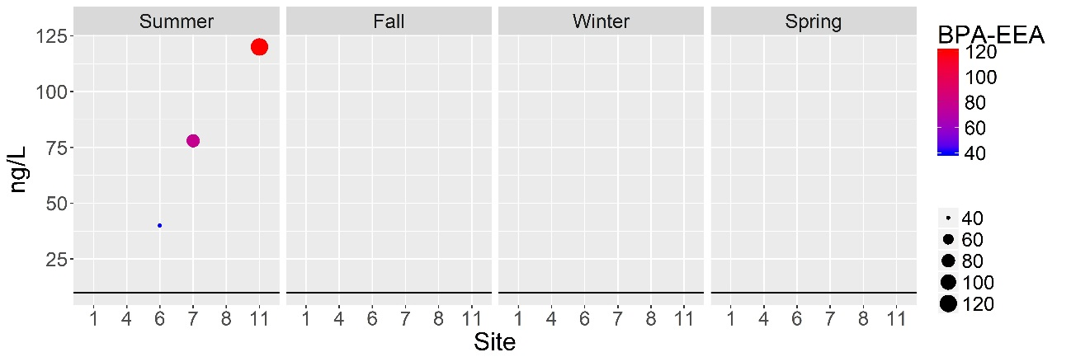
Figure B 1. BPA detections in ng/L for each season (EEA lab results).

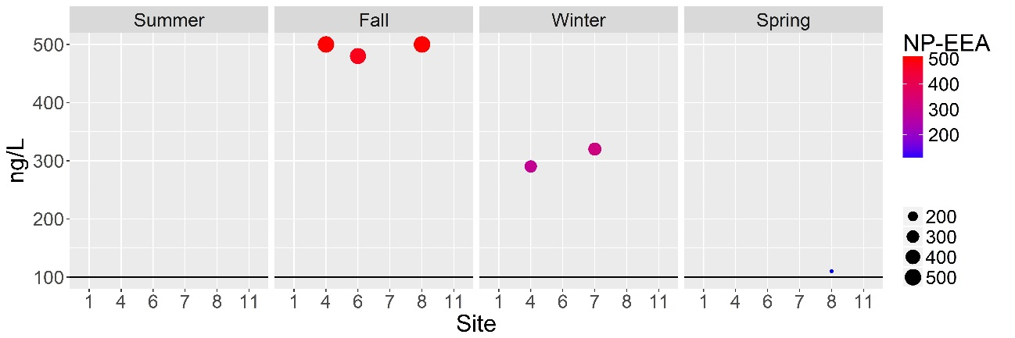

Figure B 2. NP detections in ng/L for each season (EEA lab results).

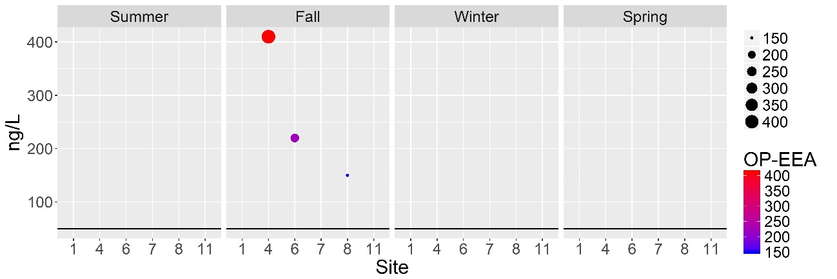

Figure B 3. OP detections in ng/L for each season (EEA lab results).

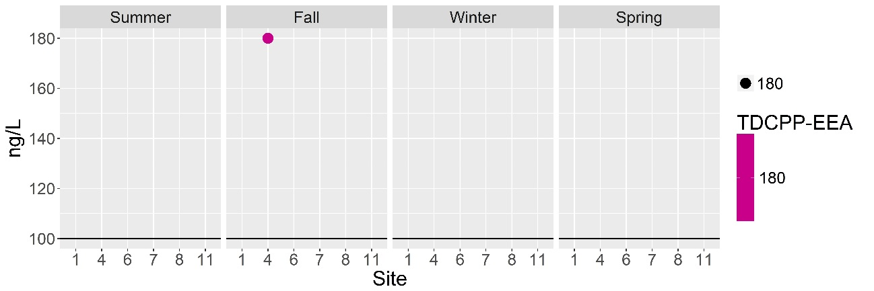
Figure B 4. TDCPP detections in ng/L for each season (EEA lab results).

Pesticide Compounds – EEA

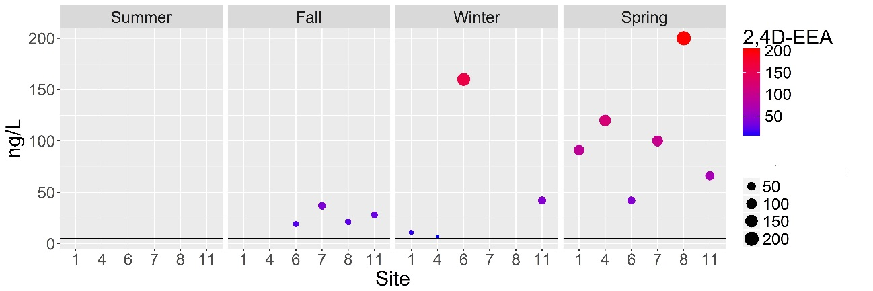
Figure B 5. 2,4-D detections in ng/L for each season (EEA lab results).

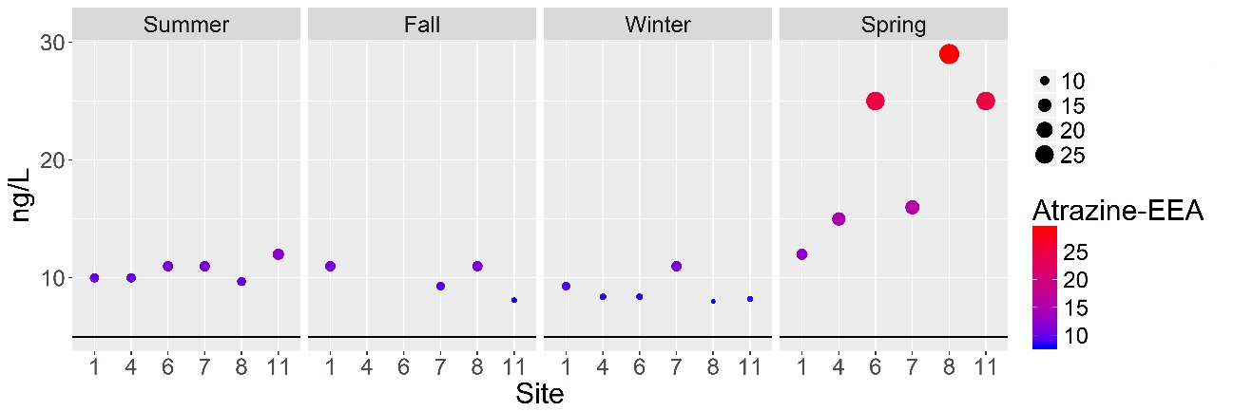
Figure B 6. Atrazine detections in ng/L for each season (EEA lab results).

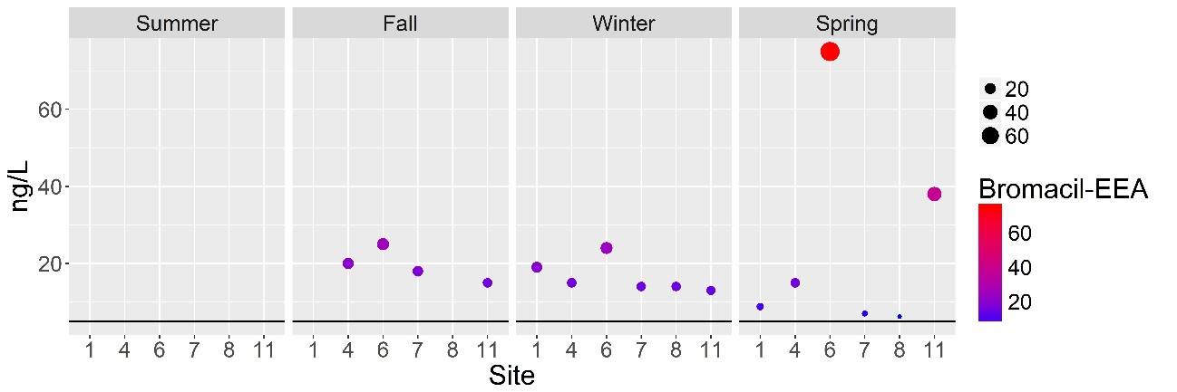
Figure B 7. Bromacil detections in ng/L for each season (EEA lab results).

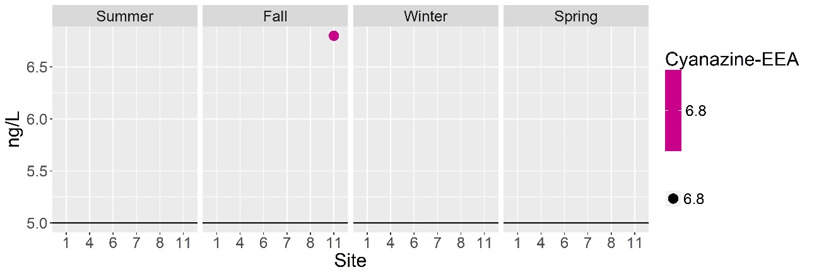
Figure B 8. Cyanazine detections in ng/L for each season (EEA lab results).

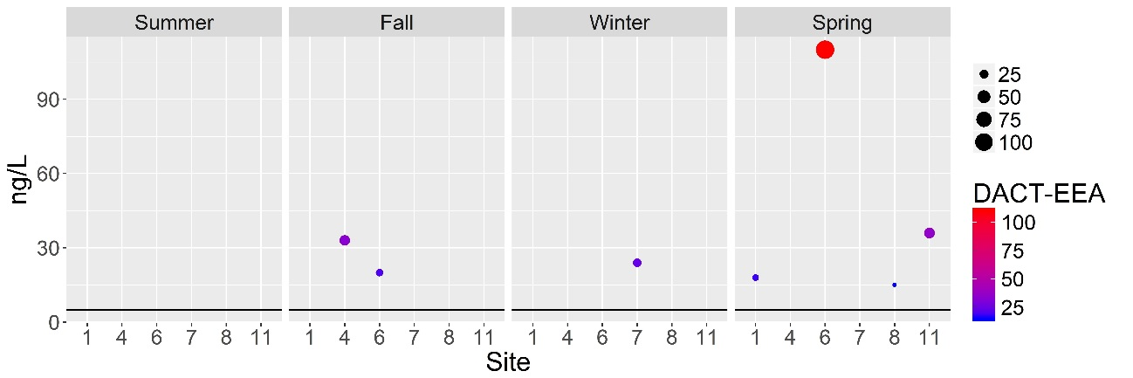
Figure B 9. DACT detections in ng/L for each season (EEA lab results).

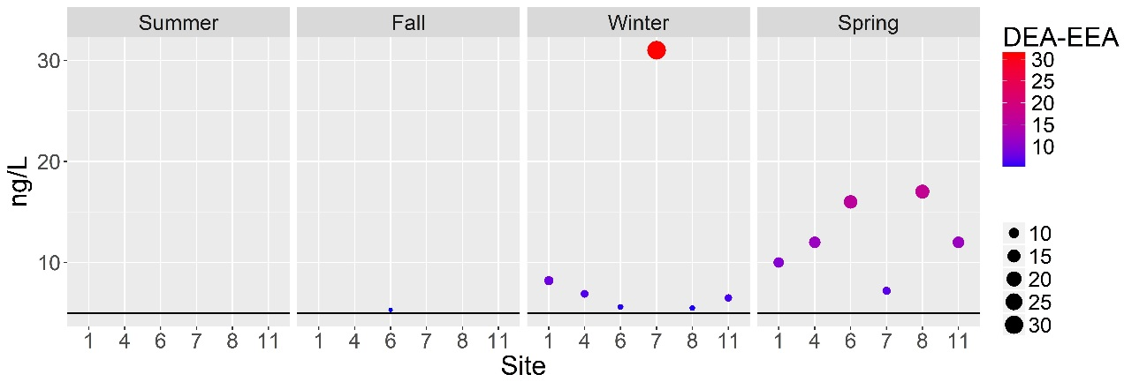
Figure B 10. DEA detections in ng/L for each season (EEA lab results).

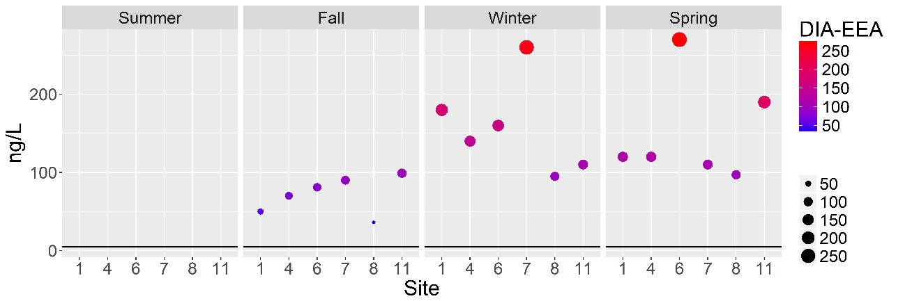
Figure B 11. DIA detections in ng/L for each season (EEA lab results).

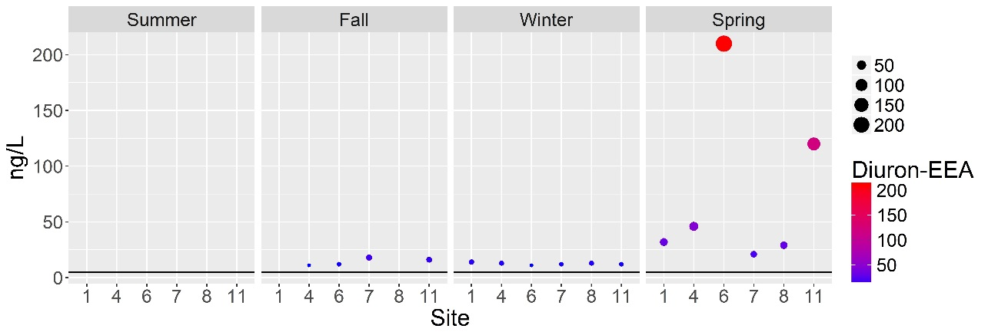

Figure B 12. Diruon detections in ng/L for each season (EEA lab results).

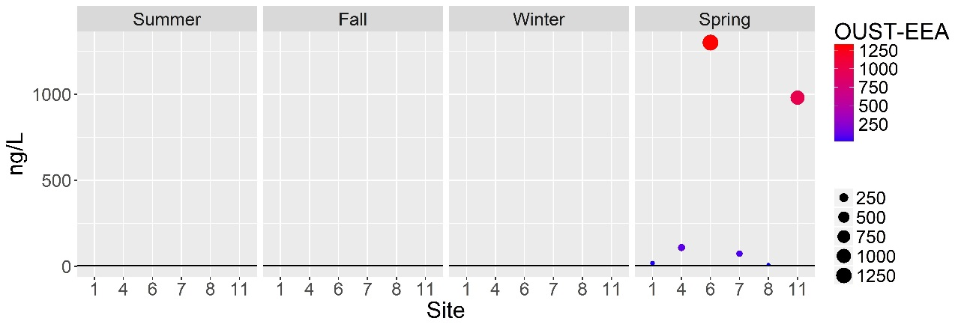
Figure B 13. OUST detections in ng/L for each season (EEA lab results).

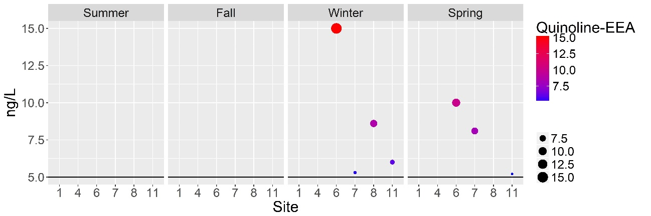
Figure B 14. Quinoline detections in ng/L for each season (EEA lab results).

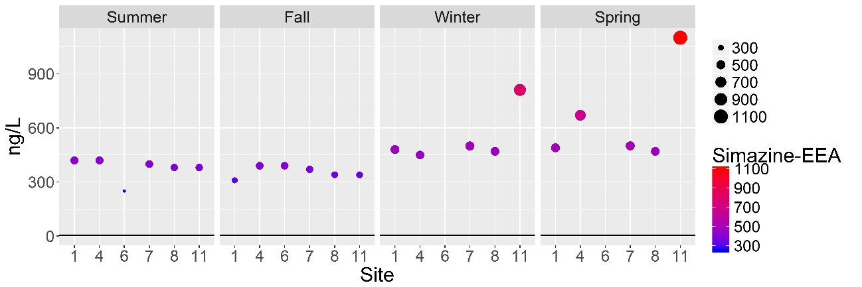
Figure B 15. Simazine detections in ng/L for each season (EEA lab results).

PPCP Compounds – EEA

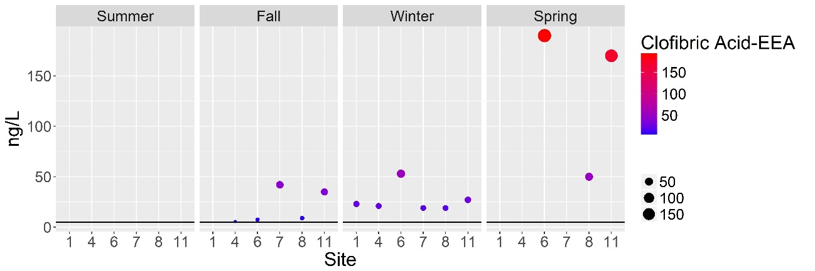
Figure B 16. Clofibric acid detections in ng/L for each season (EEA lab results).

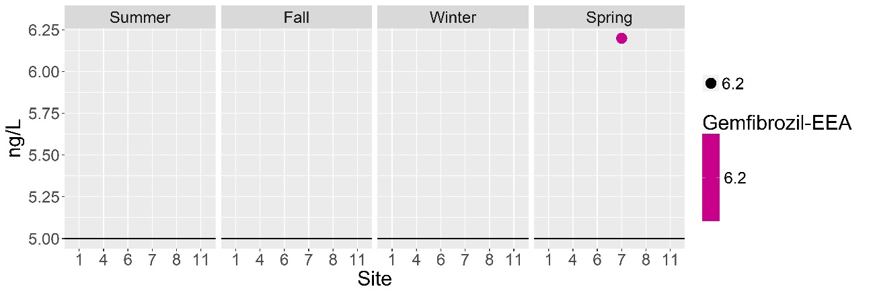
Figure B 17. Gemfibrozil detections in ng/L for each season (EEA lab results).

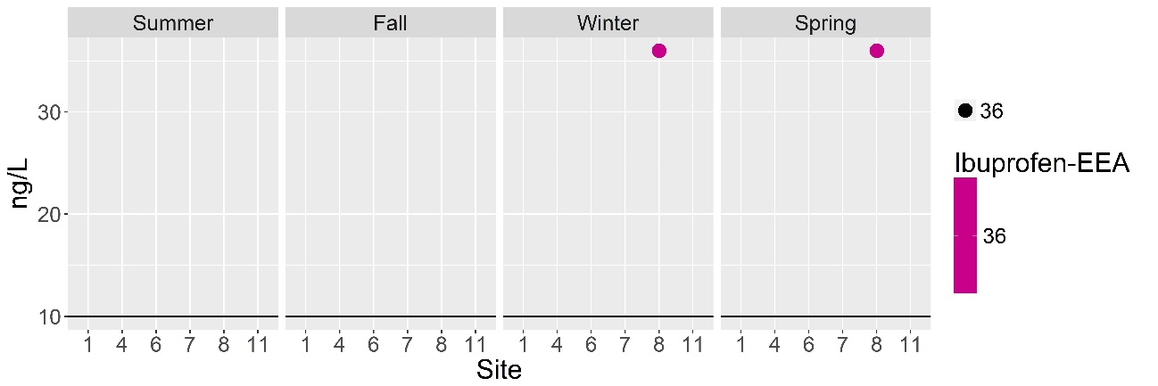

Figure B 18. Ibuprofen detections in ng/L for each season (EEA lab results).

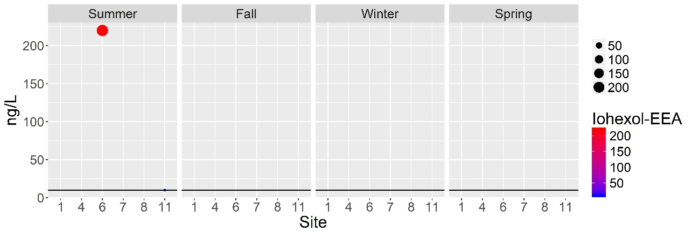
Figure B 19. Iohexal detections in ng/L for each season (EEA lab results).

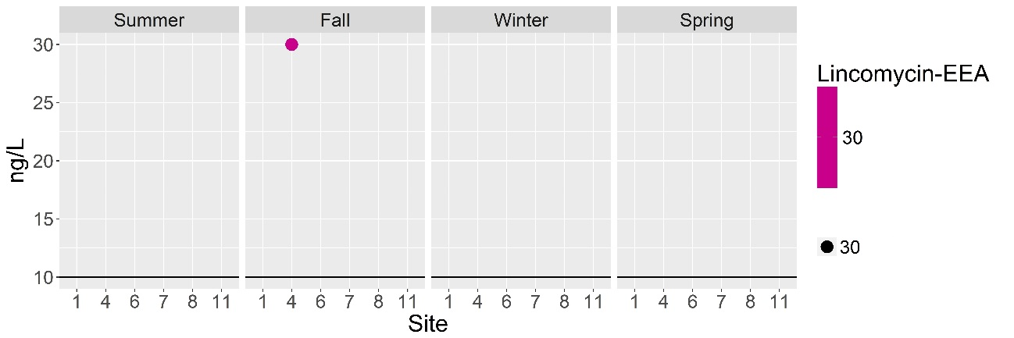
Figure B 20. Lincomycin detections in ng/L for each season (EEA lab results).

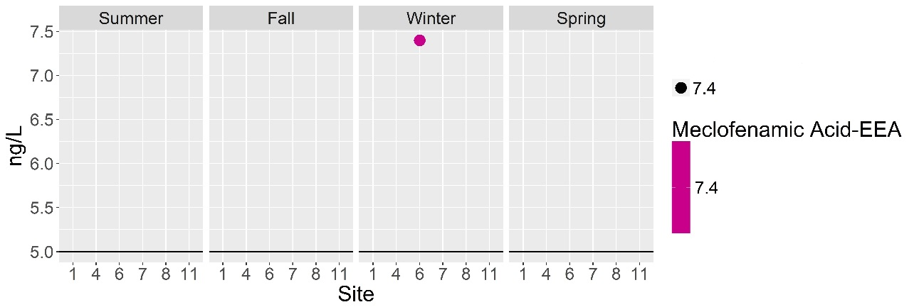
Figure B 21. Meclofenamic acid detections in ng/L for each season (EEA lab results).

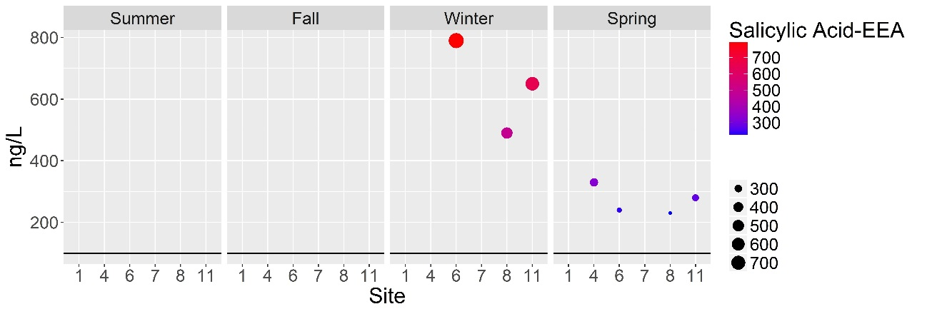
Figure B 22. Salicylic acid detections in ng/L for each season (EEA lab results).

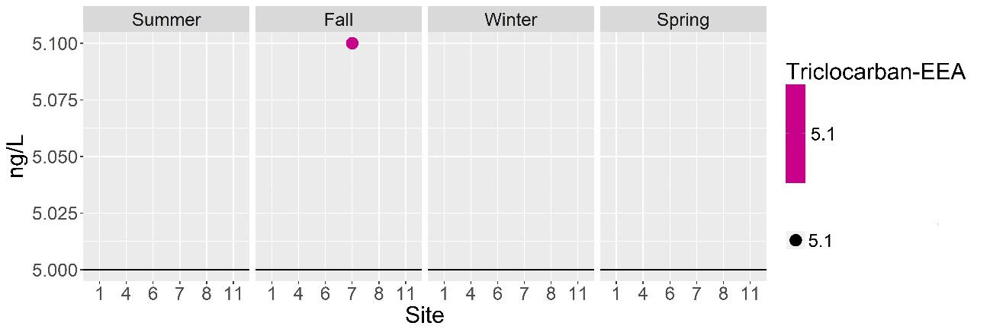
Figure B 23. Triclocarban detections in ng/L for each season (EEA lab results).

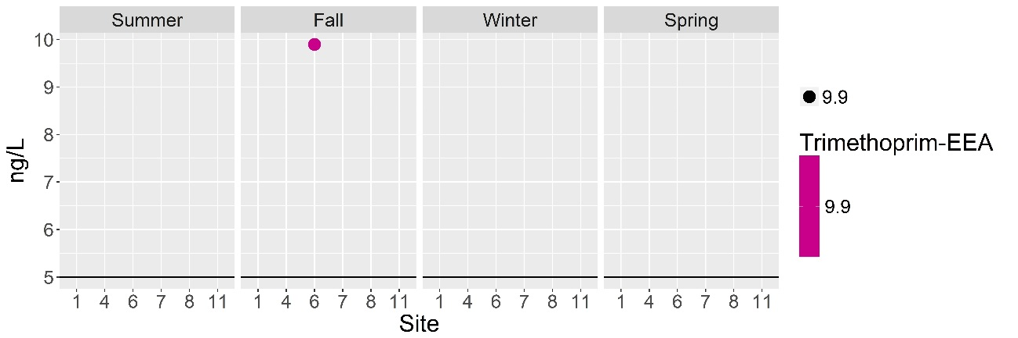
Figure B 24. Trimethoprim detections in ng/L for each season (EEA lab results).

Hormone Compounds – EEA

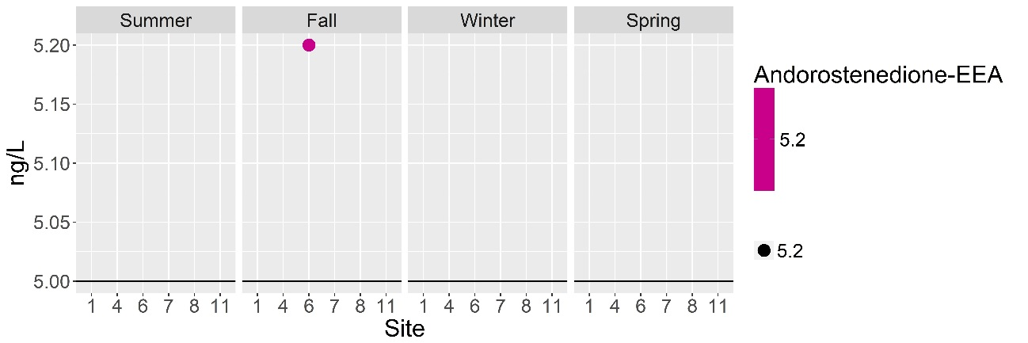
Figure B 25. Andorostenedione detections in ng/L for each season (EEA lab results).

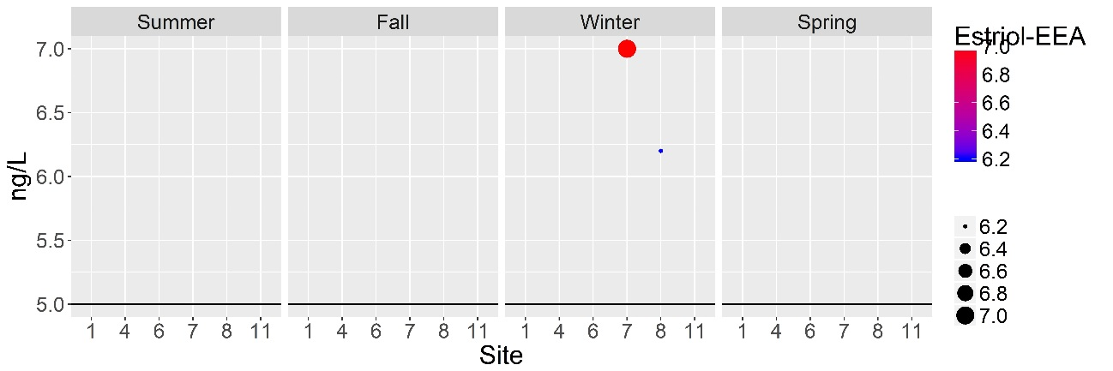

Figure B 26. Estriol detections in ng/L for each season (EEA lab results).

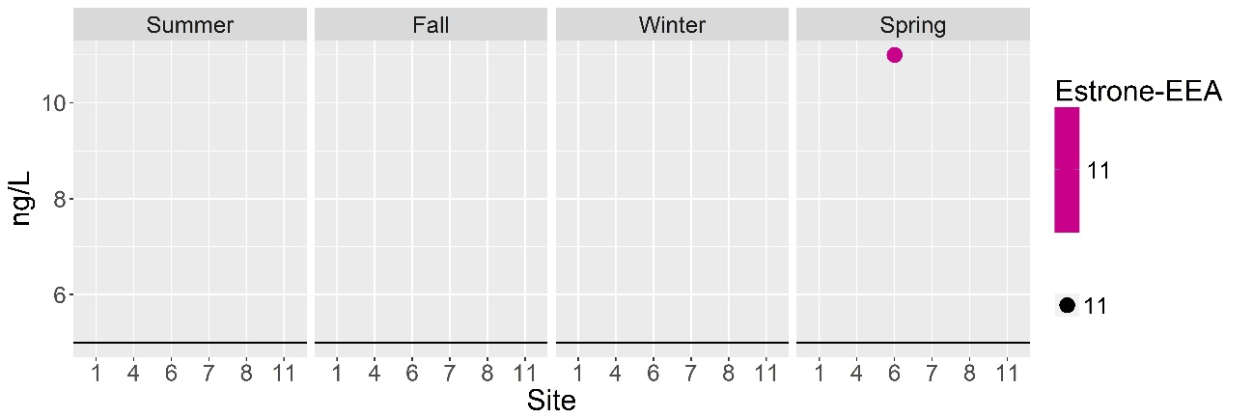

Figure B 27. Estrone detections in ng/L for each season (EEA lab results).
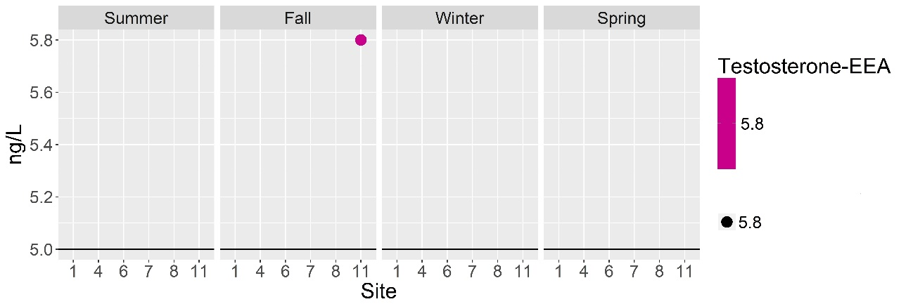
Figure B 28. Testosterone detections in ng/L for each season (EEA lab results).

Other Compounds – EEA

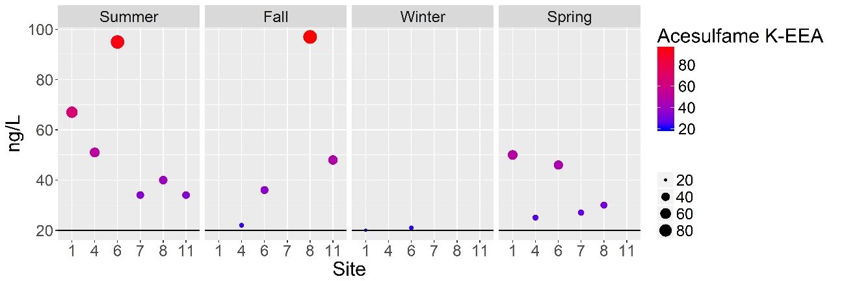
Figure B 29. Acesulfame-K detections in ng/L for each season (EEA lab results).

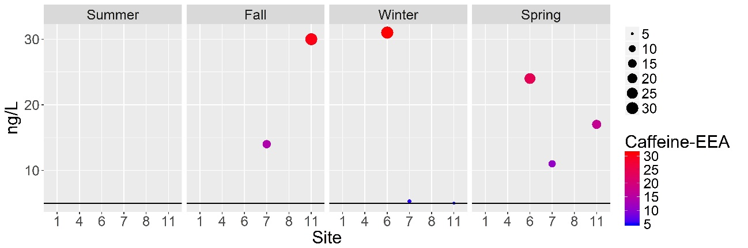

Figure B 30. Caffeine detections in ng/L for each season (EEA lab results).

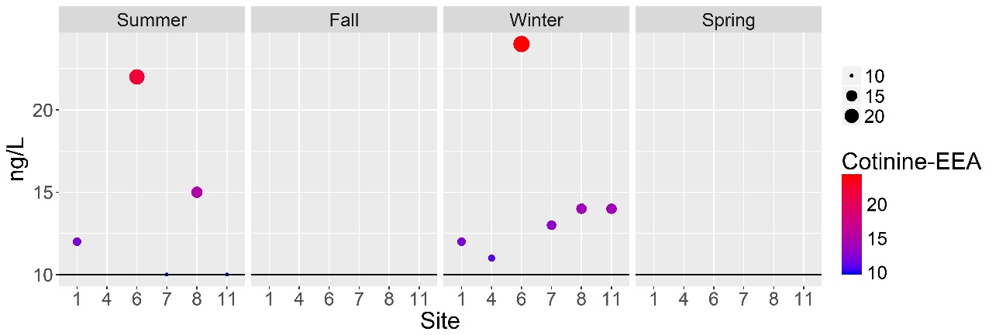

Figure B 31. Cotinine detections in ng/L for each season (EEA lab results).

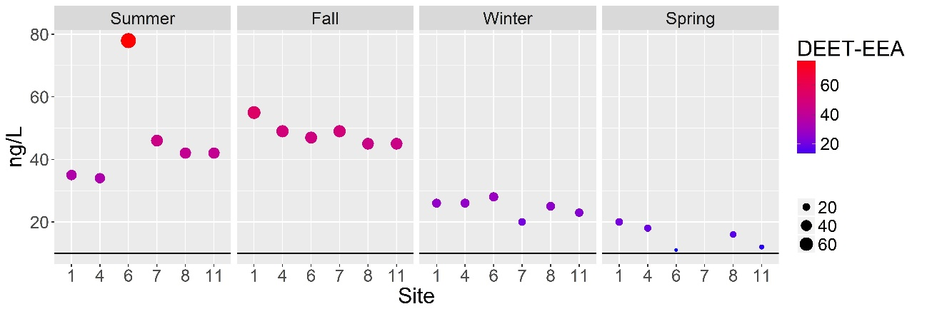
Figure B 32. DEET detections in ng/L for each season (EEA lab results).

Industrial Compounds – WEST

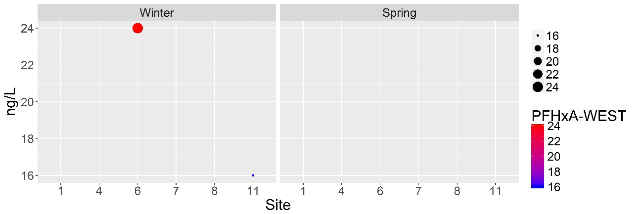

Figure B 33. PFHxA detections in ng/L for winter and spring (WEST lab results).

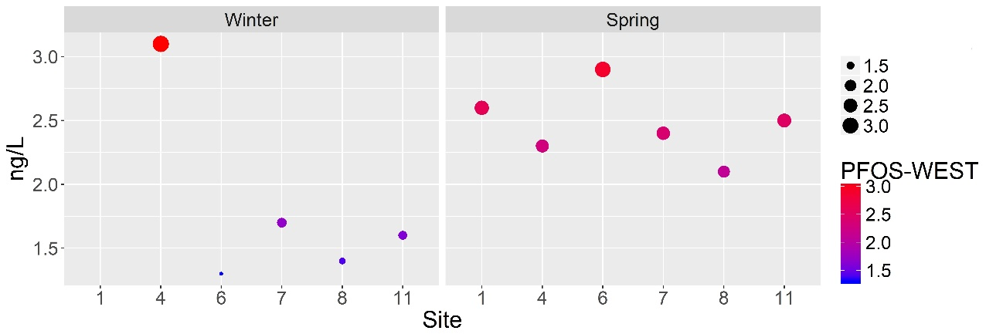
Figure B 34. PFOS detections in ng/L for winter and spring (WEST lab results).

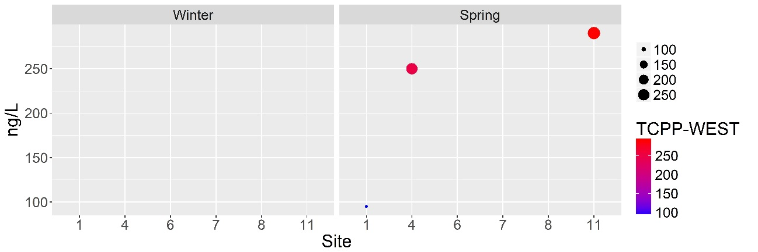

Figure B 35. TCPP detections in ng/L for winter and spring (WEST lab results).

Pesticide Compounds – WEST

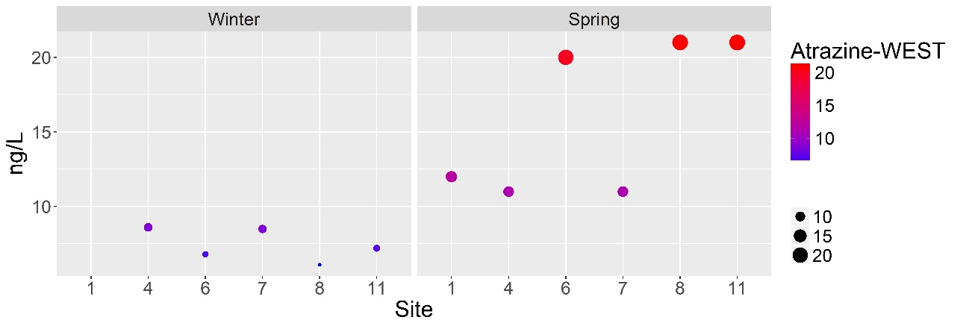
Figure B 36. Atrazine detections in ng/L for winter and spring (WEST lab results).

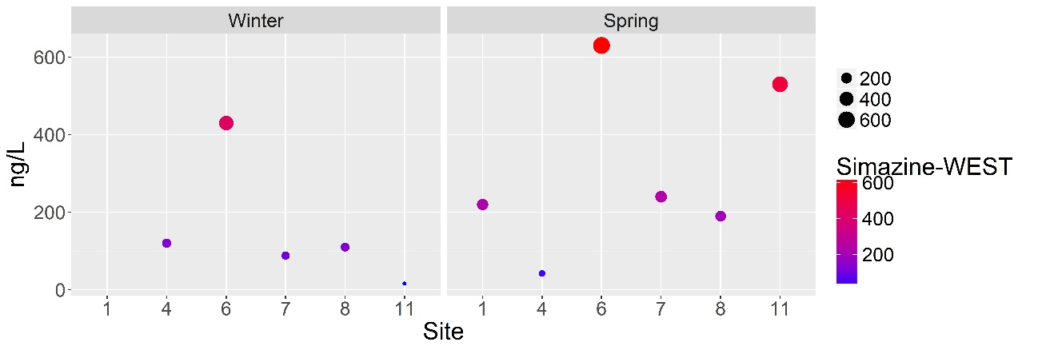
Figure B 37. Simazine detections in ng/L for winter and spring (WEST lab results).

PPCP Compounds – WEST

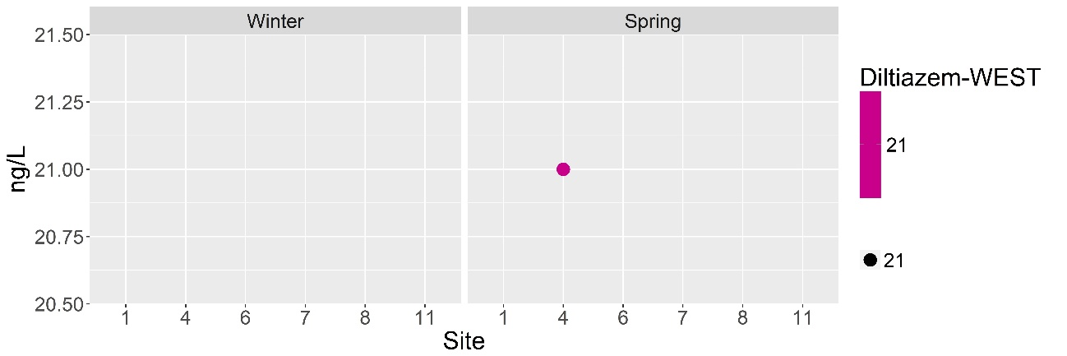
Figure B 38. Diltiazem detections in ng/L for winter and spring (WEST lab results).

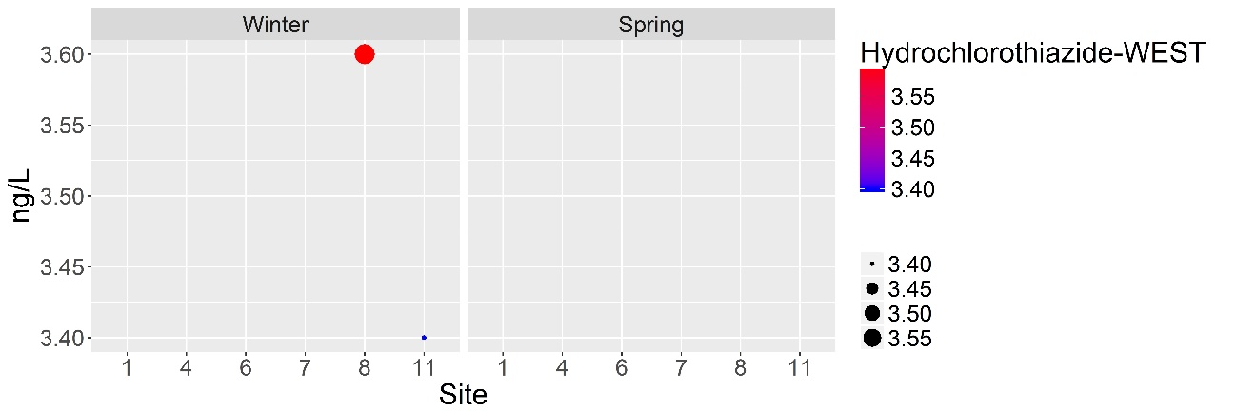
Figure B 39. Hydrochlorothiazide detections in ng/L for winter and spring (WEST lab results).

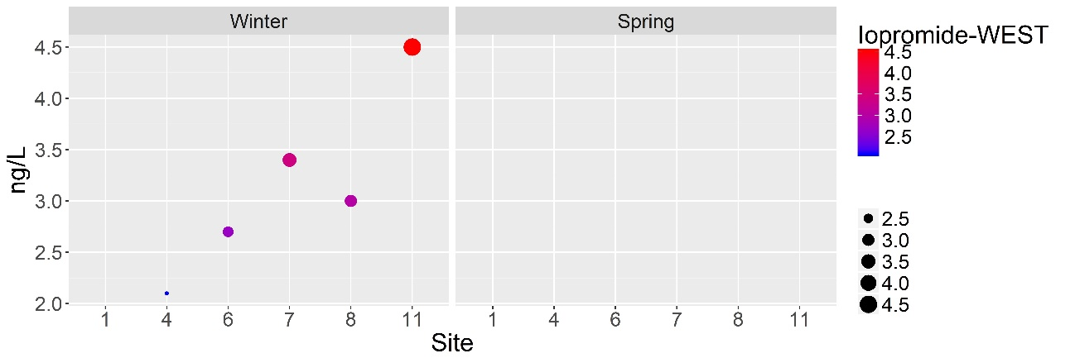

Figure B 40. Iopromide detections in ng/L for winter and spring (WEST lab results).

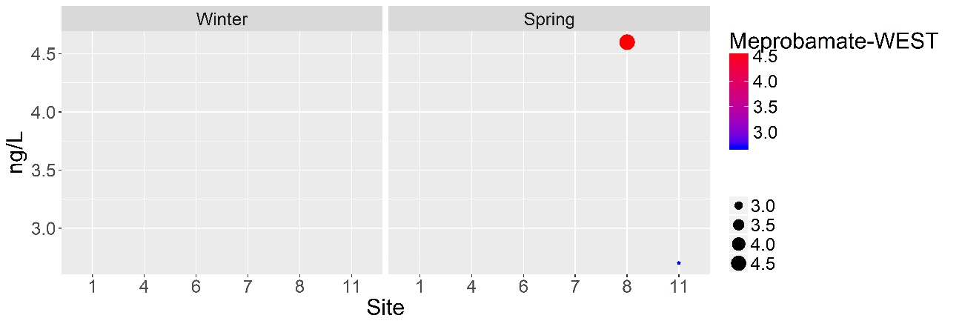

Figure B 41. Meprobamate detections in ng/L for winter and spring (WEST lab results).

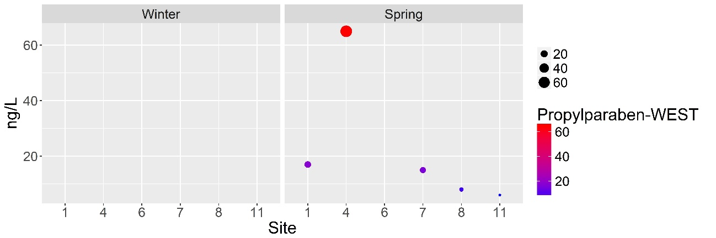
Figure B 42. Propyl paraben detections in ng/L for winter and spring (WEST lab results).

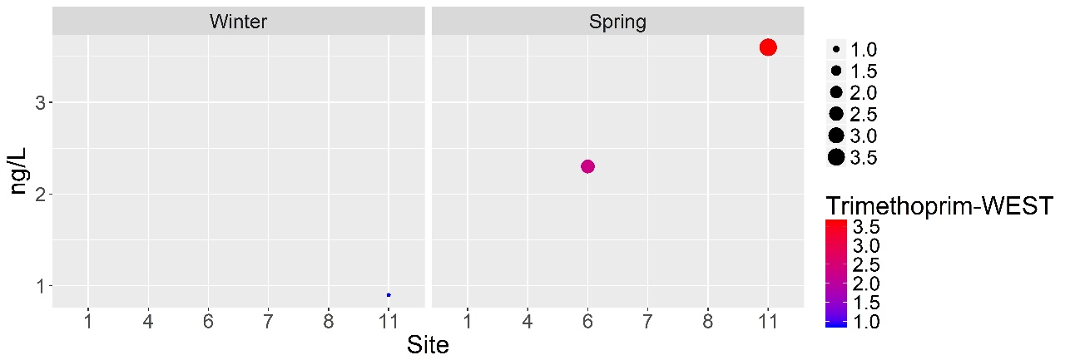
Figure B 43. Trimethoprim detections in ng/L for winter and spring (WEST lab results).

Other Compounds –WEST

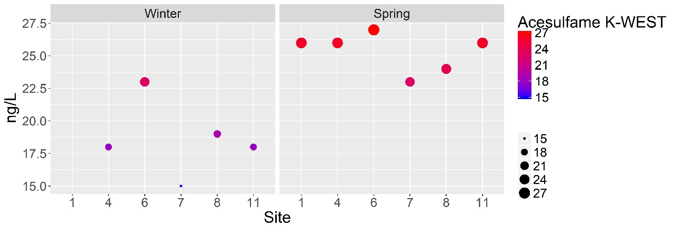
Figure B 44. Acesulfame K detections in ng/L for winter and spring (WEST lab results).

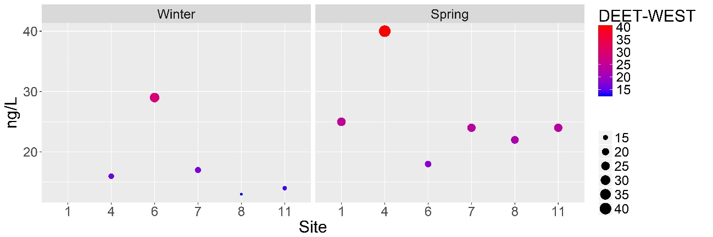
Figure B 45. DEET detections in ng/L for winter and spring (WEST lab results).

Appendix C: Codes for R

C.1 Code to make graphs for compounds analyzed by EEA lab
#set the working directory
#check to see if it's in the right place:
getwd()

library(Amelia)
library(plotly)
library(reshape2)

#clean environment
rm(list=ls())

#read data:
gsa=read.csv("CompoundsEEA.csv") #first row has "MRL" values #gsa is the folder my data is in, CompoundsEEA is the excel file
names(gsa)

#change factor levels for subsequent plotting
gsa$Season=factor(gsa$Season,levels = c("Summer","Fall","Winter","Spring","MRL"),ordered = TRUE)
gsa$Site=factor(gsa$Site,levels = c("1","4","6","7","8","11","MRL"),ordered = TRUE)

#create dataframes for each class
#industrial=gsa[c("BPA...EEA","NP...EEA","OP...EEA","TDCPP...EEA","Site","Season")]
#pesticide=gsa[c("X2.4.D...EEA","Atrazine...EEA","Bromacil...EEA","Cyanazine...EEA","DACT...EEA","DEA...EEA","DIA...EEA","Diuron...EEA","OUST...EEA","Quinoline...EEA","Simazine...EEA","Site","Season")]
#ppcp=gsa[c("Clofibric.Acid...EEA","Ibuprofen...EEA","Iohexol...EEA","Lincomycin...EEA","Meclofenamic.Acid...EEA","Salicylic.Acid...EEA","Triclocarban...EEA","Trimethoprim...EEA","Site","Season")]
#hormone=gsa[c("Andorostenedione...EEA","Estriol...EEA","Estrone...EEA","Testosterone...EEA")]
#other=gsa[c("Acesulfame.K...EEA","Caffeine...EEA","Cotinine...EEA","DEET...EEA","Site","Season")]

missmap(gsa[2:25,1:32])

##########################
##########################Single plot- manually enter every contaminant
##########################
p = ggplot(gsa[2:25,], aes(x=Site, y=Estriol...EEA,col=Estriol...EEA, size=Estriol...EEA)) + geom_point()+geom_hline(yintercept = gsa[1,"Estriol...EEA"])
#p = p + scale_color_gradient2(low="blue",mid="white",high="red")
p = p + scale_color_gradient(low="blue",high="red")

p
# Divide by season, going horizontally and wrapping with 4 columns
p = p + facet_wrap( ~ Season, ncol=4)
p = p + theme(text = element_text(size=20))
p = p + labs(colour = "Estriol-EEA", y="ng/L")
p = ggplotly(p)
p

ggsave("Estriol.EEA.png", width = 12, height = 4, units = c("in"),dpi = 600)
p
##########################
##########################
##########################
#change the dataframe scheme
gsa_long=melt(gsa)
p

#loop through all columns:
#loop will only label them with “contaminant name…lab” not “contaminant name-lab”
feat=names(gsa)
feat=feat[1:32]
#contaminants names
contname=c("Bromacil...EEA","X2.4.D...EEA","Diuron...EEA","OUST...EEA","Simazine...EEA","Atrazine...EEA","Cyanazine...EEA","DIA...EEA","DACT...EEA","DEA...EEA","Quinoline...EEA","BPA...EEA","NP...EEA","OP...EEA","TDCPP...EEA","Clofibric.Acid...EEA","Gemfibrozil...EEA","Iohexol...EEA","Ibuprofen...EEA","Lincomycin...EEA","Meclofenamic.Acid...EEA","Salicylic.Acid...EEA","Trimethoprim...EEA","Triclocarban...EEA","Testosterone...EEA","Andorostenedione...EEA","Estriol...EEA","Estrone...EEA","DEET...EEA","Acesulfame.K...EEA","Cotinine...EEA","Caffeine...EEA")
for (plt in seq_along(feat)){
p=ggplot(gsa[2:25,], aes(x=Site, y=gsa[2:25,plt],col=gsa[2:25,plt], size=gsa[2:25,plt])) + geom_point() +
geom_hline(yintercept = gsa[1,plt])+
scale_color_gradient(low="blue",high="red")+
labs(colour = contname[plt], size = " .")+
guides(size = guide_legend(reverse=TRUE,order = 1))+
# Divide by season, going horizontally and wrapping with 4 columns
facet_wrap( ~ Season, ncol=4) +
theme_get()+
theme(text = element_text(size=20)) +
scale_y_continuous(feat[plt],limits=c(0, max(1.1*gsa[2:25,plt])))

ggsave(paste(feat[plt],".png"), width = 12, height = 4, units = c("in"),dpi = 600)
rm(p)

print(gsa[1,plt])
}

C.2 Code to make graphs for compounds analyzed by Arizona WEST lab
#set the working directory
#check to see if it's in the right place:
getwd()

library(Amelia)
library(plotly)
library(reshape2)

#clean environment
rm(list=ls())

#read data:
gsa=read.csv("CompoundsWEST.csv")
#gsa is the folder my data is in, CompoundsWEST is the excel file
names(gsa)

#change factor levels for subsequent plotting
gsa$Season=factor(gsa$Season,levels = c("Winter","Spring"),ordered = TRUE)
gsa$Site=factor(gsa$Site,levels = c("1","4","6","7","8","11"),ordered = TRUE)

#create dataframes for each class
#industrial=gsa[c("PFHxA...WEST","PFOS...WEST","Site","Season")]
#pesticide=gsa[c("Atrazine...WEST","Simazine...WEST","Site","Season")]
#ppcp=gsa[c("Diltiazem...WEST","Hydrochlorothiazide...WEST","Iopromide...WEST","Meprobamate...WEST","Propylparaben...WEST","Trimethoprim...WEST","Site","Season")]
#other=gsa[c(Acesulfame.K...WEST","DEET...WEST","Site","Season")]

missmap(gsa[2:12,1:12])

##########################
##########################Single plot - manually enter every contaminant
##########################
p = ggplot(gsa[2:12,], aes(x=Site, y=Trimethoprim...WEST,col=Trimethoprim...WEST, size=Trimethoprim...WEST)) + geom_point(yintercept = gsa[1,"Trimethoprim...WEST"])
#p = p + scale_color_gradient2(low="blue",mid="white",high="red")
p = p + scale_color_gradient(low="blue",high="red")

p
# Divide by season, going horizontally and wrapping with 4 columns
p = p + facet_wrap( ~ Season, ncol=2)
p = p + theme(text = element_text(size=20))
p = p + labs(colour = "Trimethoprim-WEST", y="ng/L")
p = ggplotly(p)
p
ggsave("Trimethoprim.WEST.png", width = 12, height = 4, units = c("in"),dpi = 600)
p
##########################
##########################
##########################
#change the dataframe scheme
gsa_long=melt(gsa)
p

#loop through all columns:
#loop will only label them with “contaminant name…lab” not “contaminant name-lab”
feat=names(gsa)
feat=feat[1:12]
#contaminants names
contname=c("Simazine...WEST","Atrazine...WEST","PFHxA...WEST","PFOS...WEST","TCPP...WEST","Diltiazem...WEST","Hydrochlorothiazide...WEST","Iopromide...WEST","Meprobamate...WEST","Propylparaben...WEST","Trimethoprim...WEST","Triclocar,"DEET...WEST","Acesulfame.K...WEST")
for (plt in seq_along(feat)){
p=ggplot(gsa[2:12,], aes(x=Site, y=gsa[2:12,plt],col=gsa[2:12,plt], size=gsa[2:12,plt])) + geom_point()(yintercept = gsa[1,plt])+
scale_color_gradient(low="blue",high="red")+
labs(colour = contname[plt], size = " .")+
guides(size = guide_legend(reverse=TRUE,order = 1))+
# Divide by season, going horizontally and wrapping with 4 columns
facet_wrap( ~ Season, ncol=2) +
theme_get()+
theme(text = element_text(size=20)) +
scale_y_continuous(feat[plt],limits=c(0, max(1.1*gsa[2:12,plt])))

ggsave(paste(feat[plt],".png"), width = 12, height = 4, units = c("in"),dpi = 600)
rm(p)

print(gsa[1,plt])
}

Appendix D: Graphs for Field Parameters

Figure D 1. Temperature values for every site and season.

Figure D 2. Specific conductance values for every site and season.

Figure D 3. Conductivity values for every site and season.

Figure D 4. Resistivity values for every site and season.

Figure D 5. Total dissolved solids values for every site and season.

Figure D 6. Salinity values for every site and season.

Figure D 7. pH values for every site and season.

Figure D 8. Oxidation-reduction potential values for every site and season.

Figure D 9. Chlorophyll (concentration) values for every site and season.

Figure D 10. Chlorophyll (RFU) values for every site and season.

Figure D 11. Optical dissolved oxygen (% SAT) values for every site and season.

Figure D 12. Optical dissolved oxygen (as a concentration) values for every site and season.

Appendix E: Graphs for Loading Factor Evaluation

Figure E 1. Median concentrations of the benchmark industrial compound NP (ng/L) that correspond to a site/sub-watershed plotted against the loading factor.

Figure E 2. Median concentrations of the benchmark industrial compound OP (ng/L) that correspond to a site/sub-watershed plotted against the loading factor.

Figure E 3. Median concentrations of the benchmark industrial compound TCPP (ng/L) that correspond to a site/sub-watershed plotted against the loading factor.

Figure E 4. Median concentrations of the benchmark industrial compound PFOS (ng/L) that correspond to a site/sub-watershed plotted against the loading factor.

Figure E 5. Median concentrations of the benchmark pesticide compound atrazine (ng/L) that correspond to a site/sub-watershed plotted against the loading factor.

Figure E 6. Median concentrations of the benchmark pesticide compound simazine (ng/L) that correspond to a site/sub-watershed plotted against the loading factor.

Figure E 7. Median concentrations of the benchmark PPCP compound clofibric acid (ng/L) that correspond to a site/sub-watershed plotted against the loading factor.

Figure E 8. Median concentrations of the benchmark PPCP compound salicylic acid (ng/L) that correspond to a site/sub-watershed plotted against the loading factor.

Figure E 9. Median concentrations of the benchmark PPCP compound iopromide (ng/L) that correspond to a site/sub-watershed plotted against the loading factor.

Figure E 10. Median concentrations of the benchmark PPCP compound propylparaben (ng/L) that correspond to a site/sub-watershed plotted against the loading factor.

Figure E 11. Median concentrations of the benchmark other compound acesulfame-K (ng/L) that correspond to a site/sub-watershed plotted against the loading factor.

Figure E 12. Median concentrations of the benchmark other compound DEET (ng/L) that correspond to a site/sub-watershed plotted against the loading factor.

