University of Oklahoma
Graduate College

DESIGN, DEVELOPMENT, AND CHARACTERIZATION OF A LOW VELOCITY IMPACT SYSTEM

A THESIS
SUBMITTED TO THE GRADUATE FACULTY
In partial fulfillment of the requirements for the
Degree of
MASTER OF SCIENCE

By
CAMERON COLLUM
Norman, Oklahoma
2023

DESIGN, DEVELOPMENT, AND CHARACTERIZATION OF A LOW VELOCITY IMPACT SYSTEM

A THESIS APPROVED FOR THE
SCHOOL OF AEROSPACE AND MECHANICAL ENGINEERING

BY THE COMMITTEE CONSISTING OF

Dr. Yingtao Liu, Chair
Dr. Christopher Dalton
Dr. Jivtesh Garg

© Copyright by CAMERON COLLUM 2023
All Rights Reserved.

Acknowledgements
I would like to start off by thanking my family and friends for their support and dedication to me. For without my family and friends I cannot begin to imagine where I would be today. I would like to start off by thanking my father, Jerry Collum. He has given me all the necessary life lessons and mental fortitude to take this journey. He will always be one of the greatest teachers that I have had in my academic career. To my mother, Deborah Collum, your patience and ability to raise two boys will forever make me who I am today. I will never forget the early mornings for my track meets and the long nights for my academic meets and every OU sporting event and all the rides to and from. To my brother, Scotlyn Collum, you have always shown me what sacrifice, and hard work can provide to those willing. When we were younger, we may not have gotten along as well but as we have gotten older, I believe that our bond is something that only siblings could ever dream of. To my aunt, Mary Lee Goodner, thank you for always being a listening ear and understanding my feelings in times of when I was going through adversity. To my friends, Chris, Michael, Matt, Preston, Nick, Colton, and everyone else in between, through long nights and much time spent together you have been the best friends that anyone could ever ask for. For without you this process of my academic career would have been absolutely one of the toughest trials anyone could endure. Lastly, to my partner Elaine, I will never forget when we spent countless hours in the machine shop, simply because I asked you to. The past year has been nothing short of being one of the best years of my life and that is in part because of you being there for me when needed.
I would like to thank Dr. Yingtao Liu for without him I would not have chosen to walk down this path of creating this thesis and without his gentle yet firm guidance along the path I would be lost. I can recall a phone call on my 21st birthday that I shared with Dr. Liu about accidentally not turning in an assignment in my 3353 Design of Mechanical Components course. While the phone call was very brief, he assured me there would be no issues turning in the assignment late. However, he made it very clear that this would be the only forgiveness for late assignments. Little did he know that I would take a considerable amount of time to finish this project. Afterwards, he wished me happy birthday and not to worry about the assignment. It takes a great leader to recognize mistakes and lack of trying. Dr. Liu can easily distinguish between the two, which makes him a great mentor and leader for anyone wanting to follow in his path of research, in which I am confident will make a significant contribution to material science. Dr. Liu, thank you.
To Dr. Christopher Dalton, while I have not taken any courses with you, being a teaching assistant for you has been nothing short of a pleasurable experience. Not only have you taken the time to sit down on multiple occasions on my teaching assistantship but have given valuable and comforting advice for the steps in which to manage my thesis. For that I am forever grateful.
To Dr. Garg, while I have not any personal 1v1 time with you aside from briefly visiting your office you were nothing but cordial and polite. I asked if you could be on my thesis committee and without knowing the project or my research you did not hesitate to be helping hand. Thank you.
To Dr. Mistree, being a teaching assistant for you has instilled many valuable lessons in my career moving forward. You make it a point to not give grades based upon whether a student is a good but whether they are learning from their experiences. While most students may not appreciate this it has given me the ability to accurately reflect on everyday occurrences to make myself a better engineer.
Lastly, to all the employees of the AME machine shop and fellow colleagues in Dr. Liu’s lab, especially Billy, Greg, Elijah, John, Peter, and Chris, I do not believe that this project would have concluded. Your advice and ability to understand my ideas when poorly explained has been a miracle within its own right.
Thank you all.

Table of Contents
Introduction 1
Applications of Low-Impact Velocity 2
Materials 3
Impact Machines 5
Design 7
Iterative Design of Catch 9
Magnetic Catch 9
Secondary Design: Mechanical 14
Bow and Trigger 14
Third Design Idea: Rack and Pinion 19
Gear and Rack 2.0 Final Design: 20
Designs Conclusion: 25
Velocity Tracking 25
Simulation 27
Bow Release and Pin 27
Gear and Rack 30
Gear and Rack 2.0 33
Testing 38
Aluminum 40
Kevlar Reinforced EPON 862 42
Conclusion and Future Work 43
Lessons Learned 46

List of Figures
Figure 1: Polymeric Foam 3
Figure 2: Ceramic Bowl 4
Figure 3: Composite Material 5
Figure 4: Old Impact Machine 8
Figure 5: Main Frame 9
Figure 6: Magnet Holds for Weight and Catch 10
Figure 7: The Drop Plate 11
Figure 8: Mechanical Bow Release 15
Figure 9: Spring Release Pin 15
Figure 10: Drop Weight and Impactor 16
Figure 11: Trigger for Catch Mechanism 17
Figure 12: Secure Rods for Catch Mechanism 18
Figure 13: Rack and Pinion Design Free Roll position (Simple) 19
Figure 14: Closed Position 20
Figure 15: Model of Open Position 22
Figure 16: Model of Closed Position 23
Figure 17: Closed System of Trigger 24
Figure 18: Open System of Trigger 24
Figure 19: Adjustable Photogate 26
Figure 20: FEA of Drop Weight Shaft 28
Figure 23: Pin FEA 29
Figure 24: Stress on Gear from Pin 31
Figure 25: Stress on Pin from Gear 32
Figure 26: Stress on Rack from Gear 33
Figure 27: Pin with Teeth Displacement 34
Figure 28: Pin with Teeth Stress 35
Figure 29: Gear Engaged with Teethed Pin Displacement 35
Figure 30: Gear Teeth Displacement from Rack 36
Figure 31: Gear Engaged with Teethed Pin Stress 37
Figure 32: Gear Teeth Stress from Rack 38
Figure 38: Thin Aluminum Sample Before Impact and After Impact 40
Figure 39: Thick Aluminum Sample Before Impact and After Impact 40
Figure 40: Sample of Aluminum Carbon Fiber Composite [10] 41
Figure 41: Samples Before Impact 42
Figure 42: Samples After Impact 42
Figure 36: Rubber Banded Trigger 59
Figure 37: Hole for Release Pin above Release Pin 60
Figure 38: Release Pin in Rack 60
Figure 39: Trigger Flag on Pin Casing 61
Figure 40: Set Locking Pin 61

Abstract
This paper introduces low-velocity impacts (LVI), presents a concept for evaluating them, tests various materials for proof-of-concept, and discusses how the machine could be used in future university projects as well as how it could be improved. The paper begins by defining low-velocity impacts and describing the factors that influence them. The second topic is the iterative design process involved with making an impact machine so that accurate results can be obtained. In the third section, some of the challenges and opportunities associated with the concept of low velocity impacts with a variety of tests conducted on the machine and with different materials. A summary of the design and results of the study is presented at the end of the paper, followed by some suggestions for further research and improvements that could be made.

Introduction
Impact velocity refers to the speed at which an object collides with another object or surface. High-velocity impacts typically cause considerable damage, deformation, and other severe consequences, whereas low-velocity impacts often cause minor damage and deformation. The impact velocity of low impact can happen in a variety of situations, including everyday activities like walking or driving, to more specific contexts like sports, engineering, and medicine.
Several factors affect an object's impact velocity, including its mass, shape, size, and velocity, as well as its material properties and surface characteristics. Several of these variables can be adjusted to control or manipulate impact velocity. For example, in ballistics, the velocity of a bullet can be increased or decreased by changing the powder charge or bullet weight. Similarly, in vehicle design, the speed of impact during a crash can be reduced by incorporating crumple zones or other energy-absorbing materials into the structure.
It is also important to consider the angle of incidence or the angle at which the object hits the target when considering low-impact velocity. Energy transfer during the impact and trajectory of the object after impact can be greatly affected by the angle. For example, a glancing blow may result in less damage than a direct hit. However, for the purposes of this thesis, the object will only experience impacts normal to the surface, therefore making direct contact. This surface will typically be flat but other materials could be irregular and still experience an impact perpendicular to their origin. [1]

Applications of Low-Impact Velocity
Many different applications require low-impact velocity, from ballistics to military operations to building design. Below are some of the most common applications of low-impact velocity.
An important aspect of ballistics is the study of projectiles, such as bullets, shells, and rockets. Low impact velocity is crucial for determining the effectiveness of different weapon systems in this field. Those with high impact velocities cause significant damage to structures and vehicles, whereas those with low impact velocities may fail to penetrate or fail to detonate.
In military operations, low-impact velocity is essential for reducing collateral damage and minimizing the risk of injury or death to non-combatants. It is possible to incapacitate enemies with low-velocity weapons, such as stun grenades and tear gas, without permanently harming them.[2]
In transportation safety, low impact velocity is an essential factor in vehicle design as well as infrastructure design. It is typical for cars to be made from a variety of materials, including steel, iron, and so on. Various safety features reduce the likelihood that passengers will be injured or killed by absorbing and dissipating the energy of an impact.[3]
LVI is also important in building design, particularly in earthquake-prone areas. Various techniques are used by engineers to reduce energy consumption. In the event of a seismic event, damping devices, base isolation, and flexible connections may all be transferred. [4]

Materials
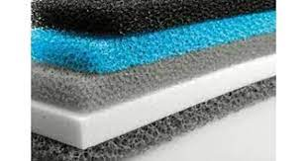
Figure 1: Polymeric Foam
In a variety of industries, such as automotive, aerospace, and sports, polymeric foams are widely used. A polymeric foam's cellular structure allows it to absorb energy effectively and reduce impact severity. In order to meet specific requirements, foam materials can be customized by varying their composition, density, and thickness. In spite of this, polymeric foams are limited in their ability to perform in cold environments, absorb water, and maintain structural integrity over time.[5]
It is well known that metals behave well under low-velocity impacts, and they are among the most common materials used in structural applications. Despite the metal's strength and stiffness, it is susceptible to deformation and fracture when subjected to impact loads. Material properties, impact angle, and geometry all determine the deformation of metals under low-velocity impacts. In addition to composite materials, metals can also be altered microstructurally through heat treatment or alloying in order to improve their energy absorption capacity. [6]
The use of natural fibers for impact-resistant applications has recently been explored because they are renewable and biodegradable. Hemp, flax, and jute are natural fibers with excellent mechanical properties. Under low-velocity impacts, the fibers' intrinsic properties such as alignment and interlocking provide high energy absorption and deformation resistance. Composites made from natural fibers and other materials, such as polymers or ceramics, can enhance their strength and toughness.[7]

Figure 2: Ceramic Bowl
Ceramics are a hard and brittle material that is used in many applications, including body armor, cutting tools, and electronic components. Despite their high strength and stiffness, ceramics are During impact loading, ceramics are susceptible to fracture. Ceramics' impact behavior is affected by their microstructure, porosity, and grain size. It is possible to make ceramics impact-resistant by using composite materials, applying coatings, or controlling their microstructure. [8]
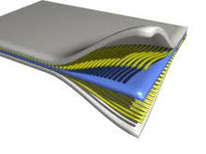
Figure 3: Composite Material
Composite materials consist of a polymer matrix reinforced with fibers, particles, or other materials. Smart Materials and Intelligent Systems lab makes or tests some of these materials, such as carbon fiber-reinforced resin and balloon glass rubber. There are many applications for composite materials, including aerospace, automotive, and sports, due to their unique combination of properties, such as high strength, stiffness, and impact resistance. The matrix, reinforcement, and interfacial properties of composites determine their impact behavior. A composite material's composition, orientation, and manufacturing process can be tailored to meet specific requirements. [9]

Impact Machines

Low Velocity Impact (LVI) machines are rather expensive, especially the ones on today’s markets, which can range anywhere between $3000-4000. LVI’s are meant to study the amount of energy a certain material can withstand before any form of deformation or delamination acts on the material. LVI studies are primarily done now for up-and-coming materials for various applications such as laminates and multiple layer composites. LVI’s are going to be important for the future exploration of composites as much of Dr. Liu’s lab deals in various crystal-line structure materials. Being able to measure if low velocity impacts will break or deform those materials will be important to verify the materials credibly for increased production. There are typically two impact machines, the Charpy impact machine and drop weight machine. The drop-weight impact machine is the focus of this paper as Dr. Liu currently owns a Charpy impact machine and owned a drop impact machine that was impractical, due it’s size and inability to measure the speed correctly.
Drop-weight impact machines have been widely used in the field of materials science and engineering for many years. For the design and development of many products and structures, these machines provide valuable information on the behavior of materials under high-stress conditions, such as impact loading. A drop-weight impact machine works by dropping a heavy weight from a certain height onto a sample material. If the mass and velocity of the impact are known, the force of the impact can be calculated by hand or measured by a load cell.
Metal testing is one of the most common applications of drop-weight impact machines. This is because metals are often used in high-stress applications, such as in the aerospace and defense industries, where they need to withstand high-velocity impacts. It is also possible to test polymers, ceramics, and composites using drop-weight impact machines. Materials such as these are commonly used in a variety of applications.
Depending on the application, drop-weight impact machines can have different designs. Drop weights are used in some machines, while swing weights or multiple weights are used in others. It depends on the machine, some drop weights and heights are fixed, while others are variable. It is also possible to measure other properties of materials using drop-weight impact machines, such as their fracture toughness, deformation behavior, and energy absorption. One of the advantages of drop-weight impact machines is their simplicity and ease of use. These machines can be operated by anyone within Dr. Liu’s lab and other students from other labs. This ease of use is beneficial for any research in material science. Another advantage of drop-weight impact machines is their flexibility. By adjusting the drop height, weight, or sample configuration, these machines can test materials under a wide range of impact conditions. Drop-weight impact machines have many advantages, but they also have some limitations. There may be limitations in their ability to accurately simulate real-life impact conditions, as they can vary and be more complex than what they can create in a computer simulation machine.
As a result, drop-weight impact machines are a useful tool for studying materials under high-stress conditions. For the design and development of many products and structures, these machines provide important information about the behavior of materials under impact loading. Materials science and engineering continue to use drop-weight impact machines despite their limitations.

Design
As aforementioned, the drop-weight impact machine previously in Dr. Liu’s lab was massive in size standing at around 7ft tall, 4ft wide, and 3ft long. Not only was it massive in size but lacked major key components for measuring impact behavior. The machine did not have the capability to correctly measure the speed with one photogate. Also the machine was incapable of stopping the impact load after it bounced once. so the objective in the redesign is to frame in manner that is acceptable. Secondly devise a solution to correctly measure the velocity of the impact head to give accurate results.
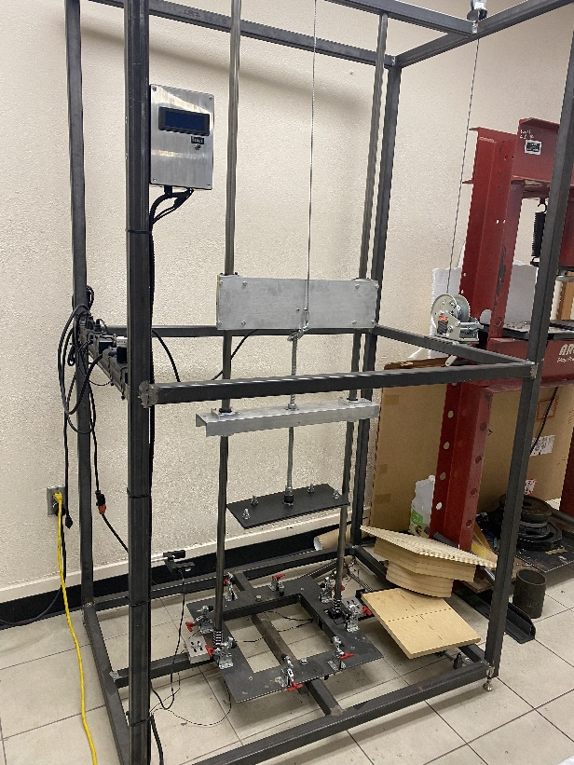
Figure 4: Old Impact Machine
The following goes into the each of the simplistic modifications done to the impact machine through each component with a figure and brief description. This report will also briefly touch on some of the safety factors necessary to prove these can be valid designs if put into practice.
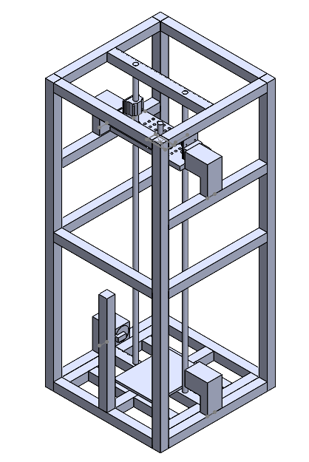
Figure 5: Main Frame
Figure 2 is the main body of the remodeled impact machine. More extensive drawings are made below in appendix A. The remodel uses most of the material from prior impact machine, meaning that the lab would not have to repurchase new frame material. Like in the previous design, all of the supports and main body of the frame will be welded together using a MIG welder provided by the AME machine shop. Even the cylindrical poles will be reused at the guide for the drop weight. This design will stand at 5ft tall, 2.33ft wide and long, about 27ft³. This redesign would condense the volume of the original by nearly 75% allowing for more space within the given area the machine will be standing.

Iterative Design of Catch

Magnetic Catch

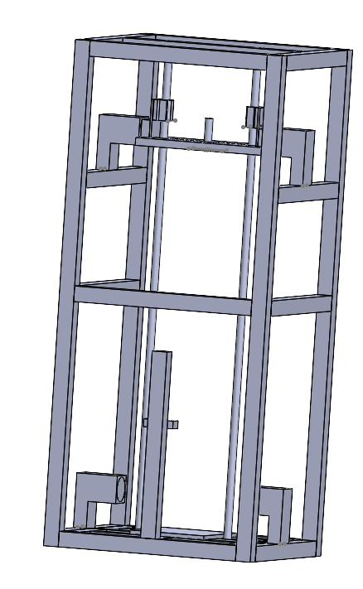
NONADJUSTABLE
ADJUSTABLE
Figure 6: Magnet Holds for Weight and Catch

The holding mechanism for the weight is the same for the catch mechanism except the holding mechanism is not adjustable. The magnets would hold the weight at the top and the bottom after the first initial impact. The design of these magnet houses should be flexible cords will need to run from the back of them. The bottom magnet holders are made to adjust so that when the drop weight passes through the sensors of the microcontroller it activates the catch magnets. This is to prevent the drop weight from hitting the test sample a second time. This method, in most cases, will require two test samples, the first being used to calibrate the photo gate and magnet catch. These magnets will need to be hooked up to a programmed Arduino or some version of a micro controller. Then this will only need a simple program for when the weight flies through the photogate.

GRID
BEARINGS
THREAD
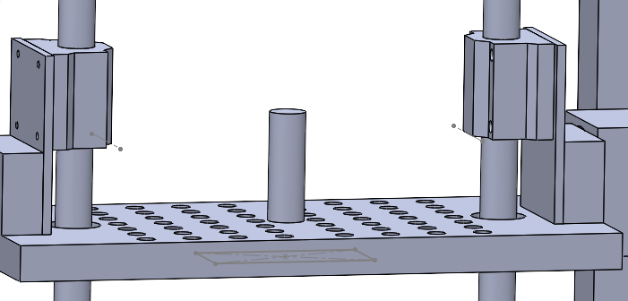
Figure 7: The Drop Plate

On the top of the weight mechanism, shown in Figure 7, are the lateral bearings that will slide down the support rails. The drop weight plate has grided holes allowing the user to attach varying shaped impactors. There are large blocks of ferrous metal on the drop weight for the magnet catches to be able to catch or hold the drop weight. The pole in the middle is also threaded to allow to have a cap to stop the weight from moving. The weight will be your standard weights from a weight set.
Safety Factor for Catch Weight if Magnets are used:

$$t= \sqrt{\frac{2\left(x\right)}{a}}=\sqrt{\frac{2\left(5ft\right)}{32.2\frac{ft}{s^{2}}}}=0.557s$$

Equation 1: time of drop

$$v=g*t=32.2* 0.557=17.94 ft/s$$

Equation 2: speed right before impact

To calculate the safety factor of the impact machine the force of the drop weight must first be calculated. This can be done by finding the amount of time it takes the object to drop (Equation 3) and then using that time to calculate the velocity at when the object would instantaneously hit the bottom (Equation 2).

$$F_{peak}=2*\left(\frac{.5*\left(50lb\right)*{\left(17.94\left(\frac{ft}{s}\right)\right)}^{2}}{5ft}\right)=3.10 slugs=442.982 N$$
Equation 3: Impact force if dropped from maximum height and 50 lbs

Once the velocity is found the impact force can be calculated with the amount of weight and length at which the object will travel (Equation 3). The capacity of holding weight is then divided by the demand, the amount of force produced.
$$SF=\frac{Capacity}{Demand}=\frac{1400N}{442.982N}=3.16$$

Equation 4: Safety Factor of One Magnet
The safety factory of the drop weight is around 3 which is more than enough considering there is two magnets. This is not considering for any friction that the bearing may experience along the way slowing the velocity and decreasing the impact force. It is important to note that the impactor falling is going to experience friction and will experience a loss of speed. So the speed that was calculated would be an overestimation making any future calculations that much more safe.
Conclusion:
The redesign of the impact machine met all the necessary deliverables requested. Not only does this design meet those requirements it all also adds some interesting elements. Most impact machines have some sort of force sensor that uses a force sensor to recognize the weight has dropped and use a hydraulic arm to catch the weight. This design only needs the weight to bounce back through the sensors of the micro controller and then the magnets would catch the weight. Granted the first design only needs one test sample as opposed to the two. This design is semi original being produced at a fraction of the cost. Most impact machines are around the $4000-$3000 range. This design only costs around $400, that’s including material and various parts. Most of the impact machines on the market are very intricate making the replacement of parts rather difficult, and this design allows the user to easily repair or replace parts. However, when having further discussions with Dr. Liu it was decided that the catch needed to be mechanical in nature. There is the possibility of electronics failing and not being able to have the processing power needed to quickly react from a simple microcontroller. There are also concerns of having high power magnets as some of the material being tested might be ferrous inherently. Not only is there concern for the testing material but there is other machinery within the lab that could be affected by such powerful magnets. Being able to make the impact machine have a mechanical mechanism will eliminate these concerns and could simplify the needs for coding for only.

Secondary Design: Mechanical

Bow and Trigger
This design is very similar to those of the last design especially keeping the frame of the impact machine in mind. The difference is that the catch mechanism will be all mechanical instead of using electronics while still having the drop head have three varying types of tips. There will also be a drop shaft opposed to only a drop plate with varying drop head attachments. The mechanical catch will have multiple mechanisms. These mechanisms will be a spring-loaded latch-pin, and a mechanical bow release. The mechanism will start with the mechanical bow release where the impactor drops on the trigger releasing the spring-loaded pin. The spring-loaded pin will then pin into the shaft of the impactor.

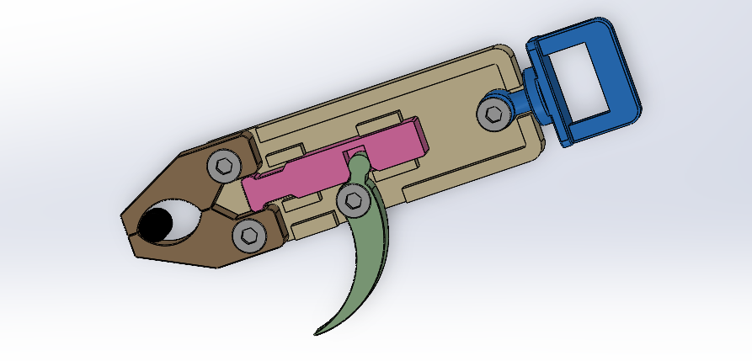
Figure 8: Mechanical Bow Release

This is not the exact bow release that will be used for the mechanism, but this is means to give the reader an idea of what a bow release is and how it would function. The trigger would also be longer as it would need to be triggered by the drop shaft while avoiding the important components of the bow release.
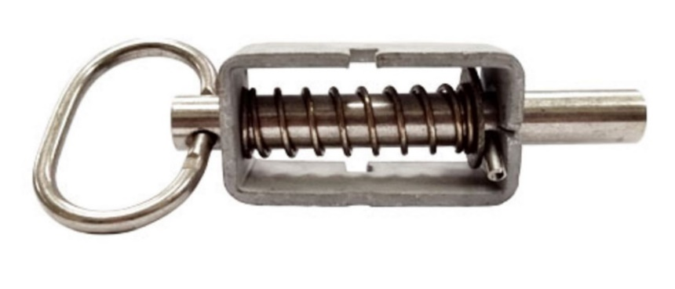
Figure 9: Spring Release Pin

Looking at Figure 8, the bow release would hold the spring pin until the trigger was pulled. Once the trigger is pulled, the bow release would let go of the ring on the pin. Then the pin would go through a hole on the impact shaft therefore stopping the impactor from hitting a second time.
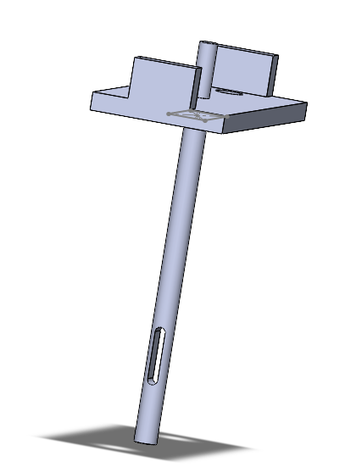
Hole for Pin

Figure 10: Drop Weight and Impactor

This drop weight and impactor are a little different from the previous design with a longer shaft and a hole in the same shaft. The hole in the shift would allow for the pin to go through and catch the weight before it can make another impact.

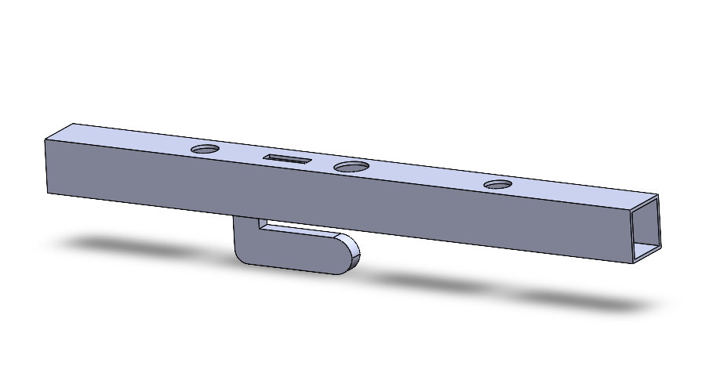
Trigger
Hole to Reset Pin
Figure 11: Trigger for Catch Mechanism

Figures 8 and 9 would be put into Figure 11. The trigger would be directly over the hole of the impactor. Once the impactor goes through the hole on top of the guide it would hit the trigger and then release the spring-loaded pin. Then that pin would stop the drop weight from impacting the sample a second time.

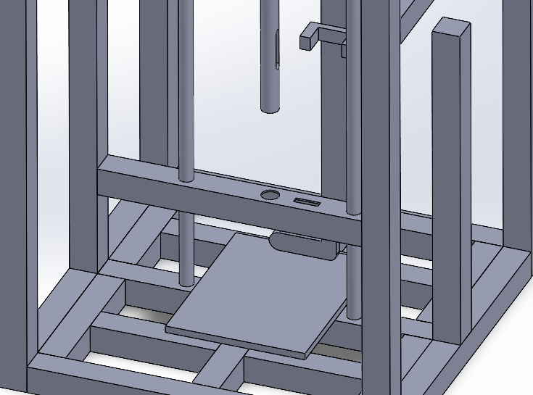
Figure 12: Secure Rods for Catch Mechanism
The poles on the catching mechanism would need to be rigid enough in order to securely catch the weight so the mechanism shaft would be welded on to the body’s left and right of the catching mechanism.
Conclusion:
This design is more than capable of being able to handle the load of the impact and weight thereof. It could even be said that after the initial impact, the design would be even more sound as there would be a major loss of energy. There is also the idea that there is less force just due to the fact that the impact head is longer allowing for less travel time i.e. less force. The price of this new impact rod would be in the range of $200-$400. This is not even including the stock material necessary for machining the parts for the bow trigger. This design would be expected to be around the same price of that of the magnet machine once finally completed.

Keeping all those ideas in mind it is hard to justify this design as the catch is nonadjustable. There needs to be a particular amount of certainty of where the impactor would be after the initial impact. There is also concern for the bow mechanism itself. The bow mechanism, while simple in design posses issues such as the intricacies in some of the parts. There is also the issue of clearance between the rods. There is only about 10 inches between the center of the frame to the sliding rod for the linear bearings.

Third Design Idea: Rack and Pinion
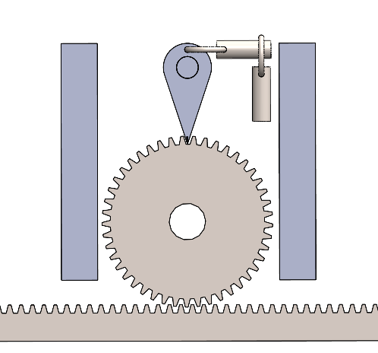
Figure 13: Rack and Pinion Design Free Roll position (Simple)
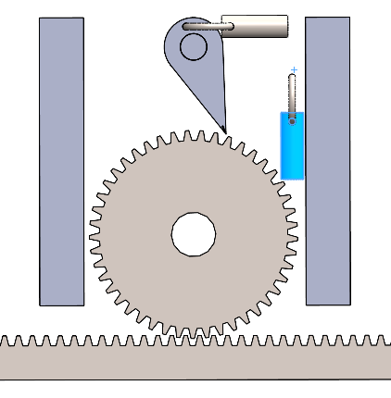
Figure 14: Closed Position

This is another design for the catching mechanism. The remainder of the machine would have minor modifications none of which would change the main functionality of the machine. The pin design was simple from the last design and was carried on to this with slight variation. A lever would be triggered through the rotation of the gear. Once the gear spins a certain direction the lever would release the pin and the pin would essentially act as a stop. This would stop the gear therefore stopping the pin from dropping back on to the sample being tested.

Gear and Rack 2.0 Final Design:
From the prior design, work was clearly needed. The initial idea is still in this design, but it is more refined. Instead of assuming there is just a simple spring-loaded pin pulling back and forth there is a turning lever with a trigger system. This trigger system would launch once the rack went into the upward motion after impact. This trigger system was inspired by the M7 rifle from its simplistic use of a trigger.
Once the rack moves in the downward motion the trigger system will remain open as shown in Figure 15. It will remain closed until the impact occurs. After the impact occurs the impactor should bounce off the sample piece making the rack go back in the upward direction. The upward motion will rotate the lever in the direction of the trigger and release the pin and lock the gear and rack shut as shown in Figure 16.
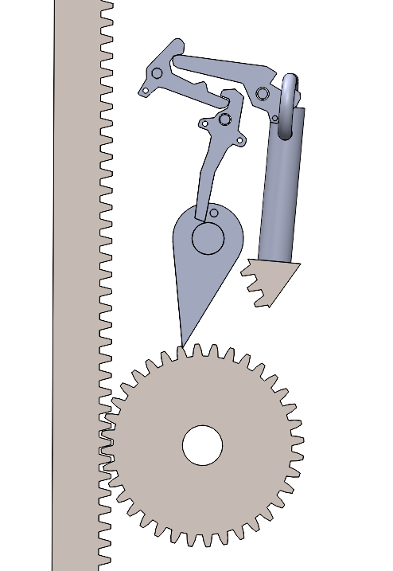
Figure 15: Model of Open Position
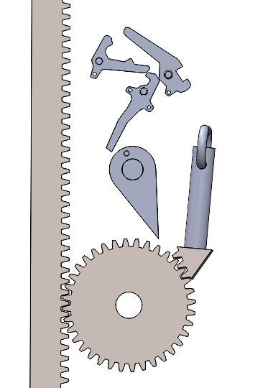
Figure 16: Model of Closed Position

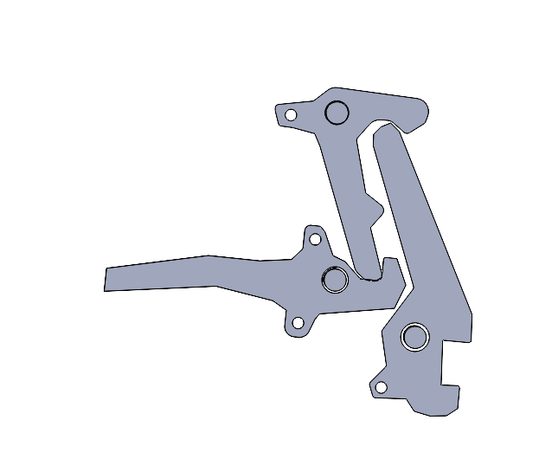
Force of Spring
Pressure
Figure 17: Closed System of Trigger
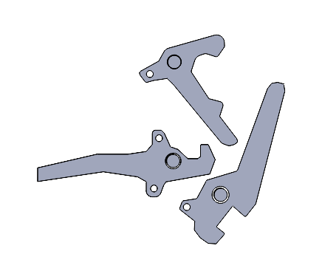
Figure 18: Open System of Trigger
This ensures that the sample does not get hit a second time. The pin shown in the example has a steel case and spring moving the spring in the downward motion. This spring and case were removed for ease of viewing purposes.
Conclusion:
This design, while simple in nature, can be complex at times. Through instructions anyone could use the impact machine and not have the sample be impacted a second time. These parts could be easily 3D printed but are also easily machined. There just so happened to be a stock material of half inch steel to make these parts. This design would only need the gear and rack bought from the internet, some miscellaneous consumables from the hardware store then and a microcontroller and sensors to measure the velocity of the falling impactor.

Designs Conclusion:
All concepts share the same chassis of being nearly 1/3 of the size of the original impact machine. Each design has its own uniqueness with how the impactor will be caught after the initial impact. Each has had their own finite element analysis and could work with some tweaks with the initial concept in mind. As a final decision nears, parts will be modified and tested more heavily. However, all concepts base the initial testing of a 50-pound drop and satisfy the new size requirement asked of the consumer Dr. Liu. Not only does it meet the size requirements it meets the need to stop the impactor from making contact for a second time. This will ensure that the at all the samples being tested with this machine are accurately impacted in a manner that is concise.

Velocity Tracking
Photogate:
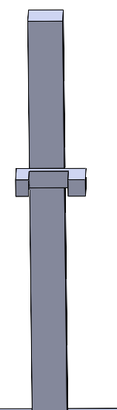
FLAG PASSES
Figure 19: Adjustable Photogate
There is a photogate in the back of the impact machine. This photogate was in the old impact machine allowing for less expenses. However, this might need to be replaced if it is not working upon implementation. This photogate will also need to be adjustable as it will not only be used to catch the time of impact but to activate the catch for the drop weight.

This idea of using a photogate is an acceptable solution but does come with problems. In the last design a photogate was used to monitor the speed at which the object fell. However, in the last design an electromagnet was turned off and then photogate was turned on. The problem lies in the refresh rate of the photogate and the Arduino. Secondly, the design needs to be mostly mechanical. Therefore, using the electromagnet and the photogate would take more work than necessary to complete. While being able to adjust the photogate could beneficial it most could be gotten rid of considering most of the samples being tested are going to be smaller than that of an inch.
IR Infrared Sensor:
Part of the issue the prior design was inaccurate speeds given from the photogate. The device prior would give wildly inaccurate speeds, and this was due impart by the Arduino not having the processing power to consider the speed of the impact head. An Artemis ATP made by Spark-fun is being used instead of an Arduino Uno as it is supposed to have twice the processing power, if not more. Secondly, the photogate, while a perfectly viable option, is no longer needed since there is no longer the need to power off an electromagnet. Since the drop mechanism is purely mechanical the only need for an electrical device is to measure the speed of the impactor. The IR sensors would be at a set distance to be made between both sensors and when the impactor went by both sensors it would display an output speed in km/hr.

Simulation

Bow Release and Pin
Some of the main concerns when looking at the bow trigger design would be the deformation of the hole in the shaft and the pin holding the drop weight after the first impact. The impact for measurements would share the same calculations from the first design for sake of simplicity. Those calculations being the time it would take the drop weight to fall and the amount of impact force the weight would emit. Not only is there concern for the impact head there would also need to be the guarantee that the pin and hole would be in the exact same spot every time after impact.
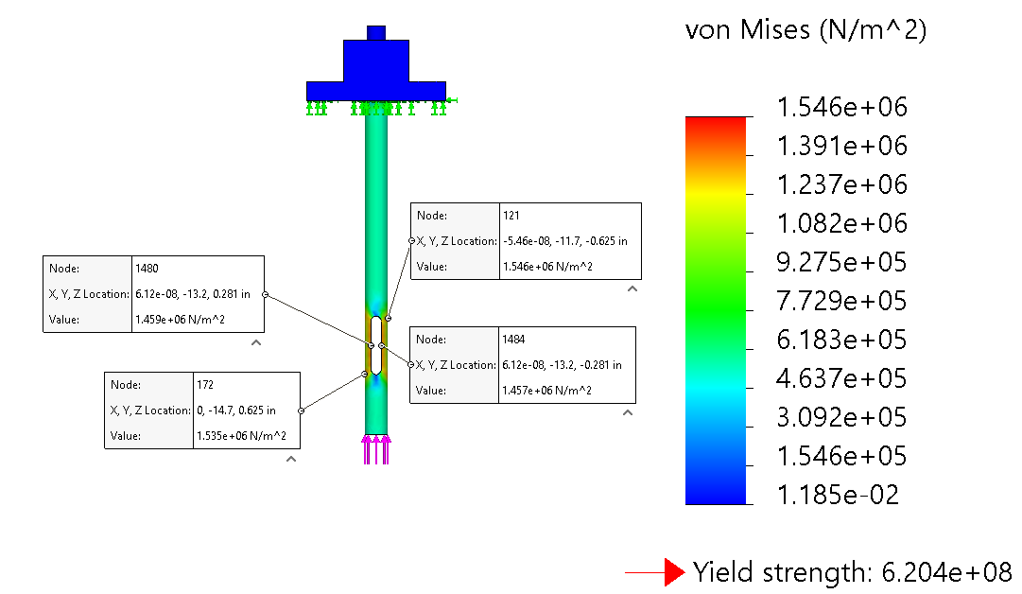
Max
Figure 20: FEA of Drop Weight Shaft

The hole in the drop weight does experience some stress but not enough stress to experience any deformation or bending. The max amount of stress that the shaft experiences is on the outside of the shaft at the top of the hole being around 1.546 MPa, which is safety factor of around 47. Which is nowhere the max of Alloyed Steel yield strength of 620.4 MPa.
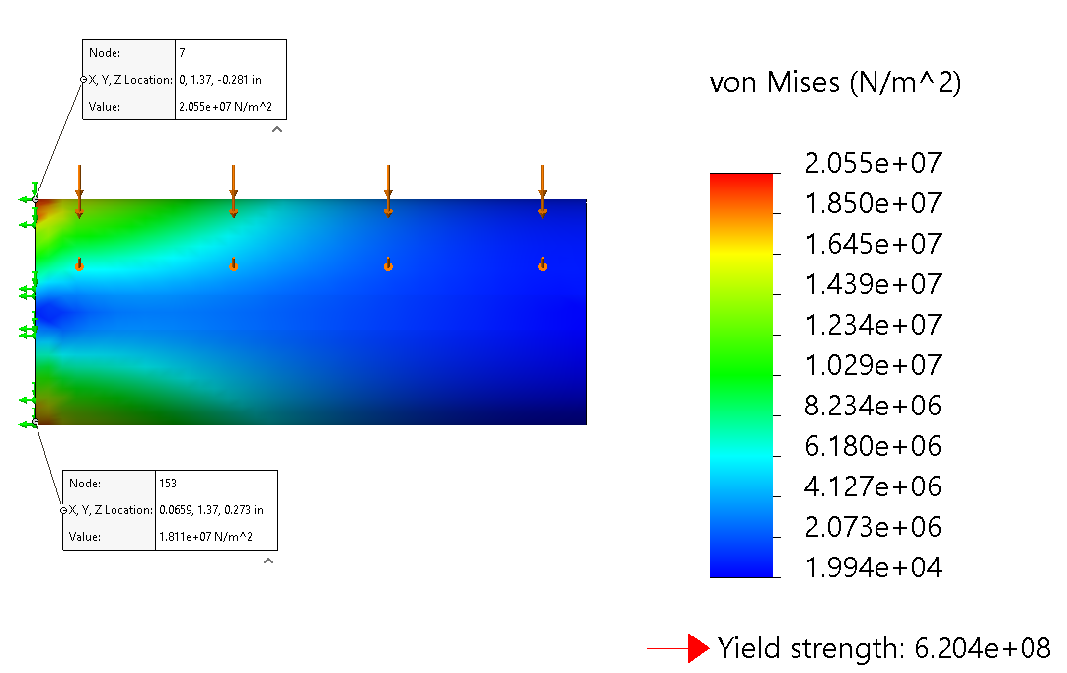
Figure 21: Pin FEA

The amount of stress onto the pin is higher than that of the drop shaft but still not near the amount of stress to begin any deformation or bending on the pin. The highest amount of stress is around the area where the pin will be fixed of around 20.55 MPa. Which is nowhere near the amount of the yield, and has a safety factor of around 30. The argument could be made that the material could be made of a cheaper material, but these objects will see continuous abuse over the course of many experiments and would most likely experience some sort of warping over time. Using the better material now would be more beneficial overtime as the need to replace the parts could be extended.

Conclusion:
This design is more than capable of being able to handle the load of the impact and weight thereof. It could even be said that after the initial impact, the design would be even more sound as there would be a major loss of energy. There is also the idea that there is less force just due to the fact that the impact head is longer allowing for less travel time i.e. less force. The price of this new impact rod would be in the range of $200-$400. This is not even including the stock material necessary for machining the parts for the bow trigger. This design would be expected to be around the same price of that of the magnet machine once finally completed.
Keeping all those ideas in mind it is hard to justify this design as the catch is nonadjustable. There needs to be a particular amount of certainty of where the impactor would be after the initial impact. There is also concern for the bow mechanism itself. The bow mechanism, while simple in design possess issues such as the intricacies in some of the parts. There is also the issue of clearance between the guidance rods. There is only about 10 inches between the center of the frame to the sliding rod for the linear bearings. Making the parts for the bow trigger being only inches apart and the spring-loaded pin itself will be almost 5 inches in length it would be impossible to create such a device given the current constraints.

Gear and Rack
Gear Analysis
$τ=R×F=0.05m × 443N= 22.15 N*m$
Equation 4: Rotational Force (Torque)

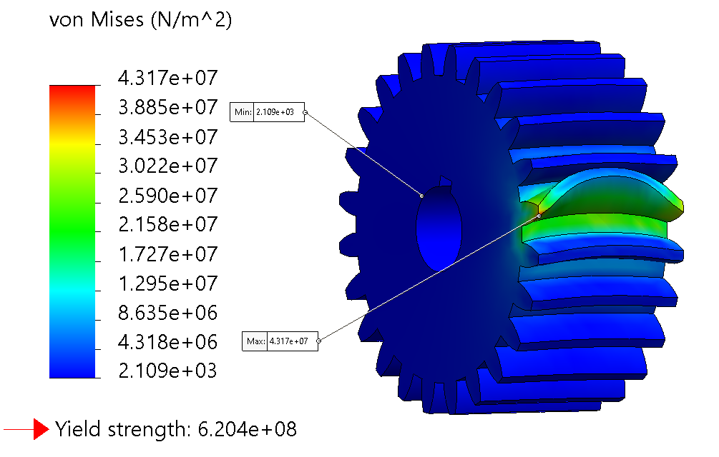
Figure 22: Stress on Gear from Pin

Figure 24 shows the stress at which the pin would be pressed against the gear if using rotational force applied before the initial impact, also providing the yield strength. The gear can handle the full amount torque given by the weight if needed. In most cases the full amount of torque would not even be applied. The gear would be able with stand more than enough stress when referring to Figure 24.
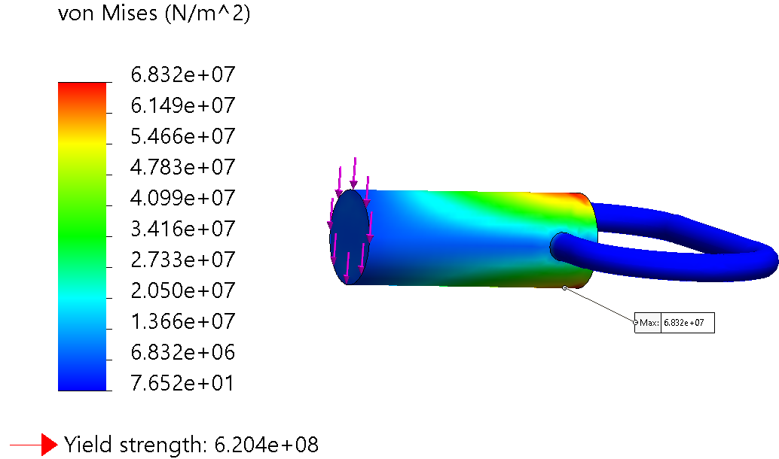
Figure 23: Stress on Pin from Gear

This pin is like the previous one but has more length. This would also be able to be welded into place given the pin has a steel casing. The problem that may cause is the necessary step needed to replace the part if needed be. And is something that should be considered upon installation. A light amount of weld might be good and would make the removal process easier. However, this is high risk and would probably cause damage to the mechanism. It would probably be best to find a larger pin/plunger in the purchase process to ensure that it would still have the structural integrity, but also allowing different mounting. Mounting such as bolts or something of that nature.

Rack Analysis
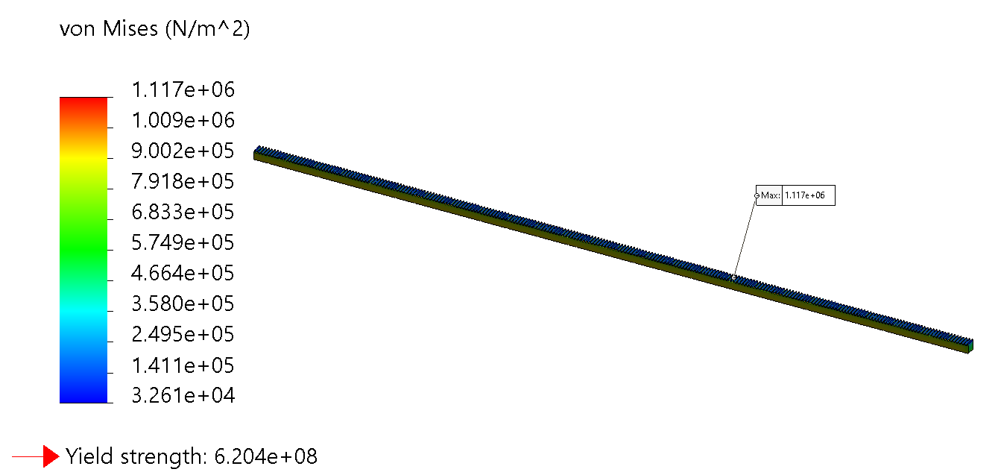
Figure 24: Stress on Rack from Gear

The rack in this instance is about 6ft long and 1 inch wide. The force of 443N was tested on one end of the rack and no value reached the yield at this length. In the final model of the impactor this would be shortened and should cause less stress since the rack would be in compression.

Gear and Rack 2.0
In the redesigned model of the trigger system there are concerns with regards to the amount of torque being applied to the gear, the pin with gear teeth, and perhaps the rack. With the pin having teeth the force between all the teeth could be equally divided. However, for the purposes of this analysis the force was equally evaluated at 442N and 22.2N*m. In Figures 23 and 24 we can see that the pin did not experience enough stress to deform the material 20 MPa. Secondly, the amount of displacement is very negligible at 1.2 micrometers. These ideas agree with the gear as well as shown in Figures 25 and 26. The amount of stress and displacement placed upon the gear is very negligible 13 MPa and 70 micrometers. The rack being made of the same material the FEA upon that should be like that of the gear. After analyzing stress, it was important to also monitor the amount of fatigue that might place upon the pieces as they were the parts for final selection. Simulations were ran and after a million cycles, the pieces never experienced a significant amount of fatigue given the boundary conditions. However, this is assuming perfect contact every time, the parts should not last a million cycles realistically.

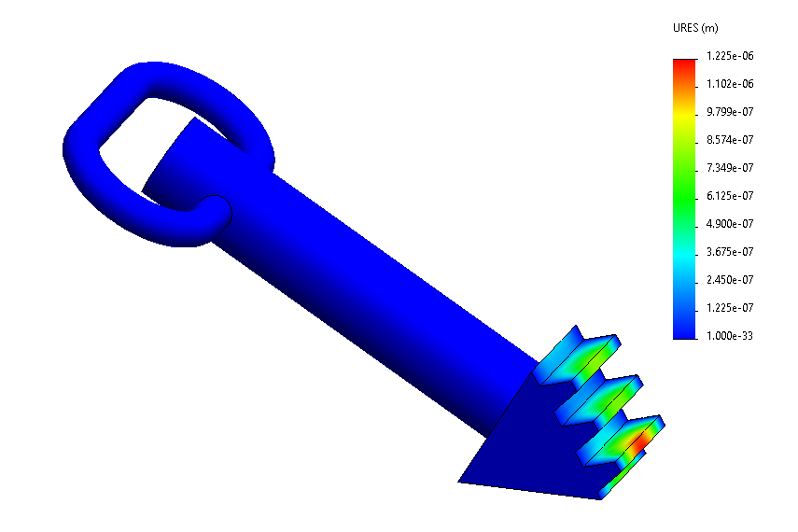
Figure 25: Pin with Teeth Displacement
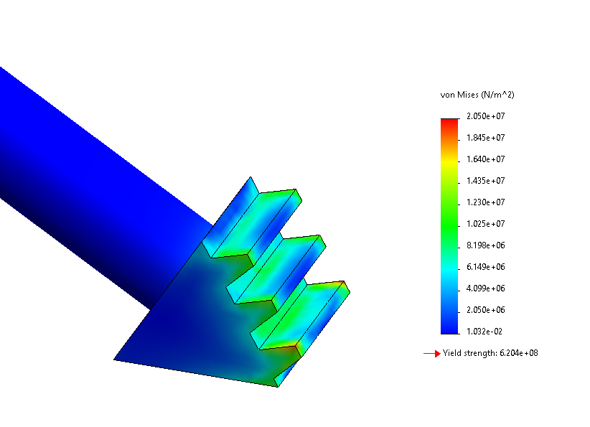
Figure 26: Pin with Teeth Stress
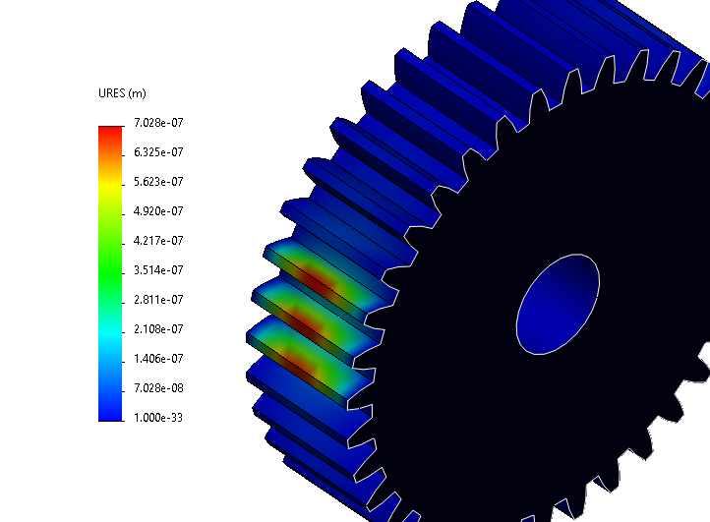
Figure 27: Gear Engaged with Teethed Pin Displacement

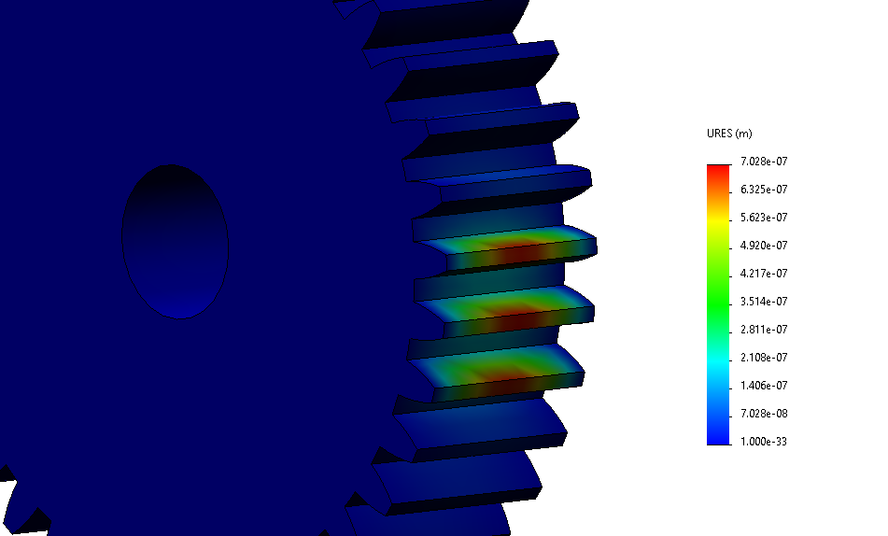
Figure 28: Gear Teeth Displacement from Rack
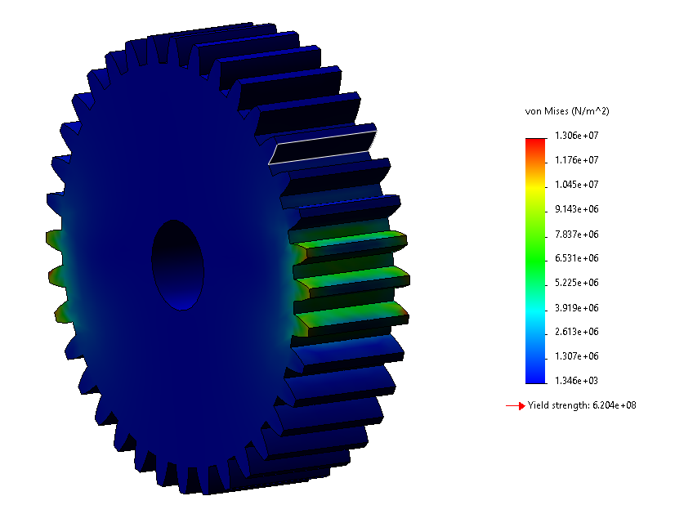
Figure 29: Gear Engaged with Teethed Pin Stress
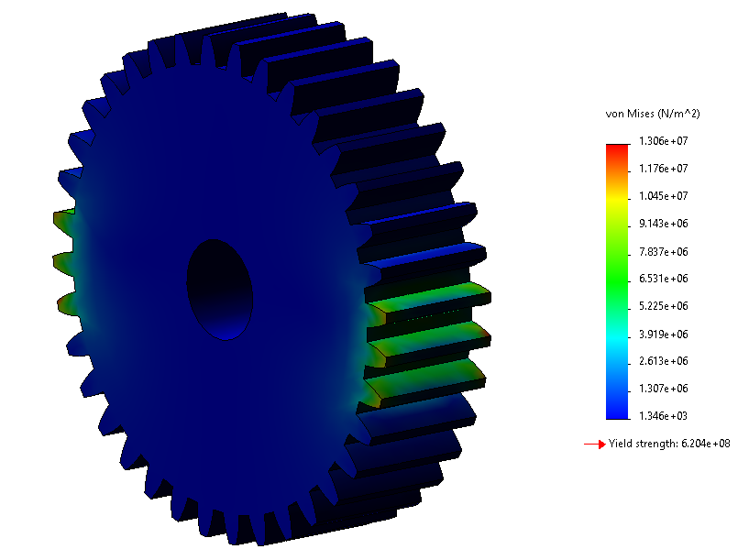
Figure 30: Gear Teeth Stress from Rack

After careful consideration it was best to weld the steel casing of the pin to the frame for ease of use. There was no clear-cut way of adding the frame of the pin to the chassis any other way. A light amount of weld was used and there is plenty of left over rack so that replacement could be made if necessary.

Testing

Samples
After the impact machine was built all impacts would be done from about 1ft in height. This is due the impact head being about 1.5ft long and that about of pressure placed on the gear from the rack not allowing for higher movement. The equations below show the number of joules each sample will be subjected to.
$$t= \sqrt{\frac{2\left(x\right)}{a}}=\sqrt{\frac{2\left(1ft\right)}{32.2\frac{ft}{s^{2}}}}=.249s$$

Equation 5: time of drop

$$v=g*t=32.2* .249=8.024 ft/s$$

Equation 6: speed right before impact

$$KE=\frac{1}{2}\left(m\right){\left(v\right)}^{2}=\frac{1}{2}\left(9.1kg\right){\left(\frac{2.44m}{s}\right)}^{2}=27.1J$$

Equation 7: Number of Joules at Impact
All the sample pieces were tested around 27J of impact. The impactor being a foot above the sample, the estimated speed of the impactor upon impact is shown in equations 7-9. It is important to note that there could be a loss of speed from impactor given there is going to be friction between the rack and gear, so from the loss of speed it more likely to be around 25J. To address this issue, is to add a velocity gate which will be added to machine once the necessary pieces are 3D printed to hold the Artemis and IR sensors. Even without those sensors the values can be easily hand calculated and credible given the verified math above.

Aluminum
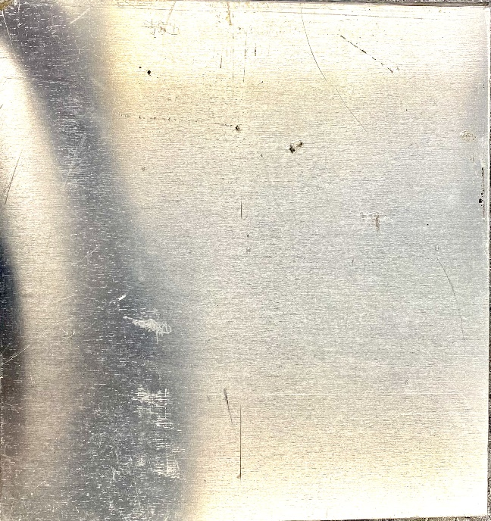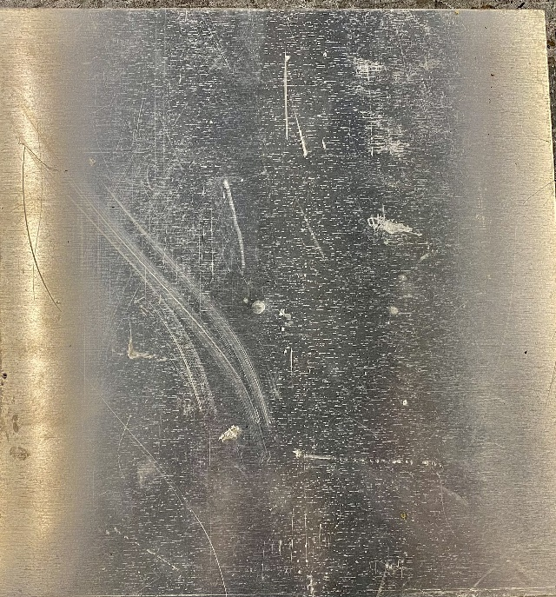
Figure 31: Thin Aluminum Sample Before Impact and After Impact
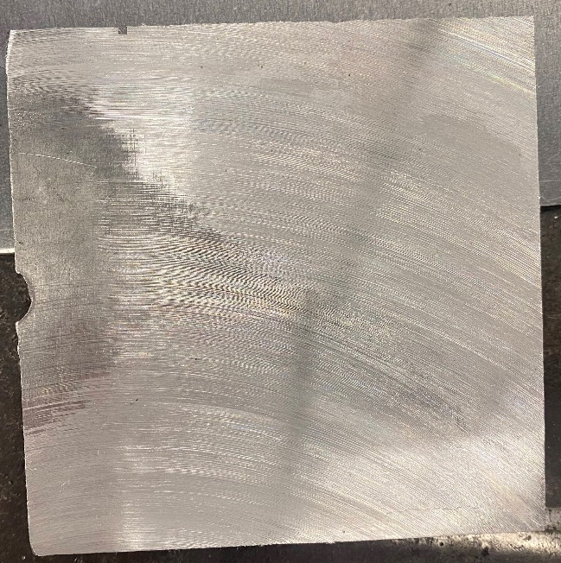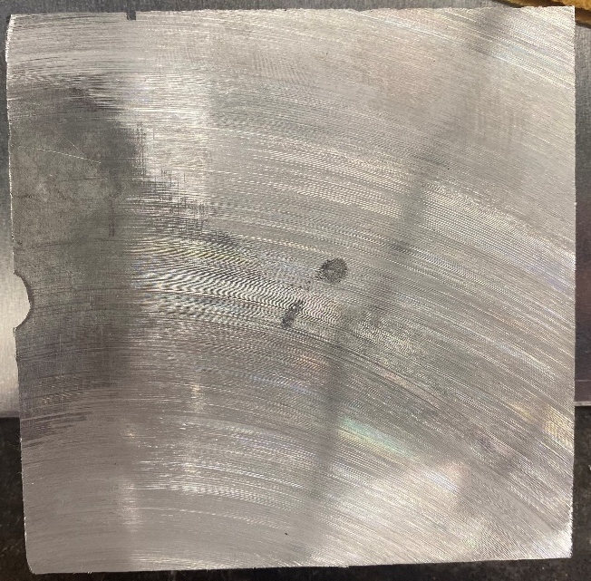
Figure 32: Thick Aluminum Sample Before Impact and After Impact

In Figures 35 and 36 you can see the impactor only making one pact on the material. For the thick material there was no way of securing the sample and this resulted in the material being bounced off the impact bed. This explains why there is a secondary scuff mark on the material. This could be avoided if the user were to find a way to secure material that is more than half an inch thick.
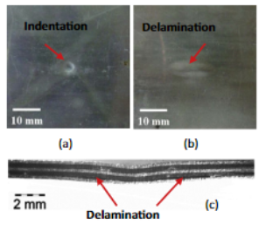
Figure 33: Sample of Aluminum Carbon Fiber Composite [10]

From other studies we can directly compare impact depths allowing us to verify the results of the impact assembled. From these results we can reasonably justify that the impactor that was created agrees with other sources of information making that testing metals is accurate, specifically in the case of aluminum. The indent while small would need to be further analyzed under better imagery devices. The sample provided in the above example (Figure 37) while impacted at a lower impact provides a similar impact crater while not being the exact same material. [10]

Kevlar Reinforced EPON 862
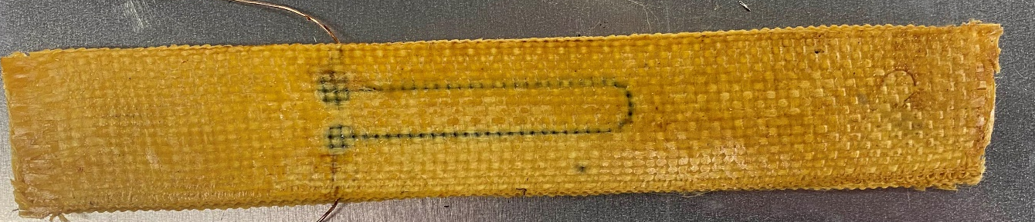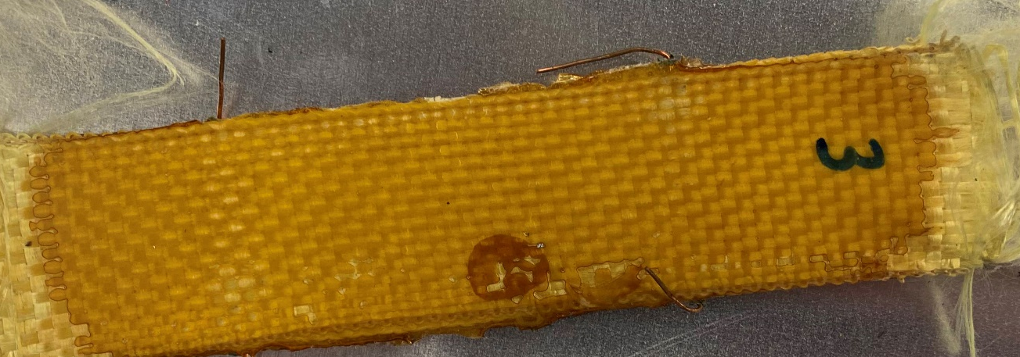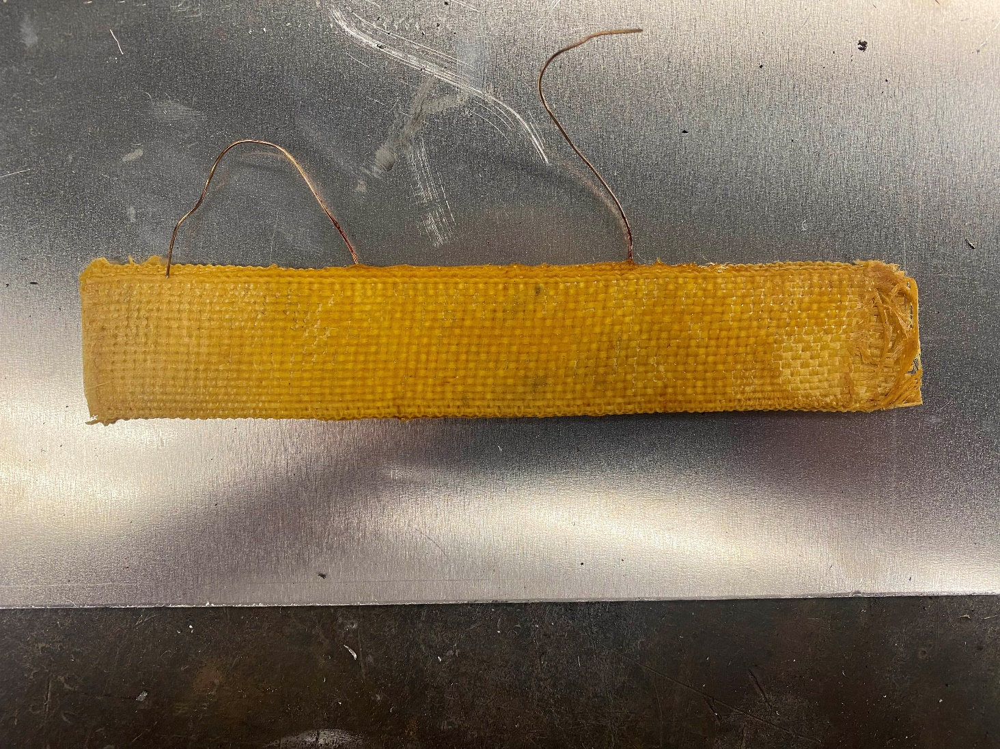
Figure 34: Samples Before Impact
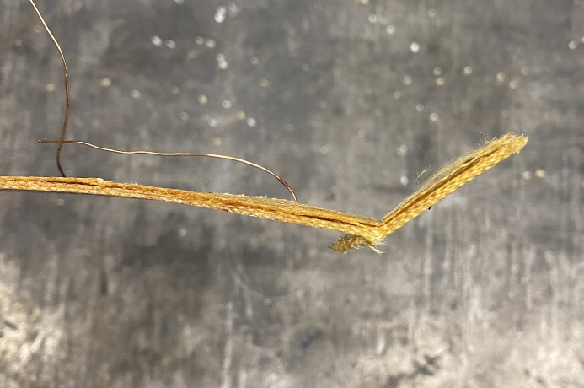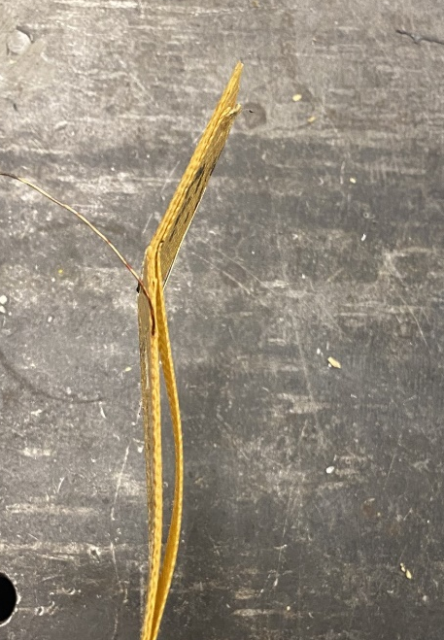
Figure 35: Samples After Impact

Impact research on Kevlar reinforced EPON 862 has not really been done elsewhere as these samples are unique to Smart Materials and Intelligent Systems Lab. Mr. Zhao makes the materials from adding layers of Kevlar on top of one another and then adding a resin coating. These samples after impact showed severe breakage. This could be factor of insecure clamping due to metal on metal.

Conclusion and Future Work

Designing a drop weight impact machine is a complex task that requires a deep understanding of the principles of mechanics and material science. A well-designed machine must be able to deliver a controlled and repeatable impact force to a sample or component, while also ensuring the safety of the operator and bystanders. The choice of materials, dimensions, and components of the machine must be carefully considered to achieve the desired performance and reliability. One of the primary considerations in designing a drop weight impact machine is the type of impact force required for the application. Different types of impact forces, such as compression, tension, or shear, may require different types of machines or modifications to the machine design. Additionally, the desired impact energy, frequency, and duration must be carefully considered when selecting or designing the machine. In this instance almost all of the testing samples would only be tested in compression as that is the purpose of a drop weight impact machine. If the machine were to test shear, then a Charpy impact machine would be more suitable. For tension it would be acceptable if the sample piece is suspended above the ground and impacted with a void below it. All in all most test would be done in compression as the set up required to impact materials would be significantly less complicated. Another key factor in the design of a drop weight impact machine is the choice of materials. The machine must be made from materials that can withstand the high stresses and strains of the impact forces without deforming or failing. In addition, the materials must be able to maintain their properties over time, especially if the machine will be used for long-term testing or experiments. Therefore, all of the material chosen for the impact machine was made with steel. All the parts can withstand high amounts of force loads upon for extended periods of time. being able to take multiple amounts of impacts over and over. If these parts start to fail, they could be replaced as left over material was not used from the prior design. The dimensions of the machine are also critical to its performance. The size and weight of the machine will determine the maximum impact energy that can be delivered, as well as the range of sample or component sizes that can be tested. Therefore, the machine starts at a small amount of 30J and can be more if someone were to add a way to a add weight to the impactor. The dimensions of the machine will also affect its stability and safety, as a poorly balanced or unstable machine can be dangerous to operate. This is why the feet were kept from the prior design to make sure that the machine is stable through the impact process. Lastly very detailed instructions were made so that the user does not injure themselves upon use. Safety is a crucial consideration in the design of a drop weight impact machine. The machine must be designed to minimize the risk of injury to the operator and bystanders. Safety features, such as guards, interlocks, and an emergency stop, must be incorporated into the machine design to prevent accidents and injuries. The machine must also be designed to minimize noise and vibration, which can be harmful to the operator and can affect the accuracy of the results. However, this design does not need this much attention to detail as the amount of impact will not be hard to those using it. Keep in mind the material being impacted needs to be a material that cannot shatter at low impacts. Dents and deformation are fine such aluminum or steel or anything of similar composition but any material that could shatter like glass would not be permitted for use. Noise with machine will vary depending on the material being impacted steel would be loud while other impacts may be quiet such as wood. It is recommended that the user should use ear plugs if near the impact. The machine must be thoroughly tested and calibrated to ensure accurate and consistent results. This requires a careful and systematic approach to testing and calibration, using appropriate standards and procedures. The results of the tests and calibrations must be carefully documented, and any deviations or anomalies must be investigated and resolved. This machine mostly eliminates all of those as there is not a lot of tech involved with the system. The user would just need to ensure that the velocity tracker being used is in agreeance with the equations used above to track the speed with considering some friction. However, if someone in the future were to improve upon on the machine with a force sensor the user would need to make sure that sensor in question gives proper values. The above equation 3 used to measure the impact force above could be used as a reference for calculating that speed. The user could add some rubber near the impact head allowing for higher bouncy back after initial impact. In summary, designing a drop weight impact machine requires careful consideration of a wide range of factors, including the type of impact force required, the choice of materials and dimensions, the design of the components, safety considerations, and testing and calibration. With regards to this project all of these have been met. With careful planning and execution, a well-designed drop weight impact machine can be a valuable tool for researchers and engineers in a wide range of industries, from automotive and aerospace to biomedical and material science. In this project the impact machine, while not perfect, has room for improvement and can still be used in the state that is currently in. If given some adjustments, the machine could easily be modified and perfected in a manner that could yield more accurate results.
The developed low velocity impact testing system can be used for future study of structural composite and metallic materials, focusing on the detection, localization, quantification of impact damages [11-14]. Due to the invisibility of certain impact damages, advanced sensors, high-fidelity models, and artificial intelligence and machine learning algorithms will be needed to effectively analyze the impact testing and sensing data for potential damage diagnostics, prognostics, and structural health monitoring applications [15-20].

Lessons Learned
Through this entire process I have learned some valuables skills that will further my prospects as an engineer going forward. Prior to completing the machine, I had only an understanding of CAD and the ways to conduct FEA. I did not know how to weld, mill, or use most of the machinery provided to us in the AME machine shop. The lessons I have learned using a MIG welder are that it is important to have a consistent feed rate. If the feed rate is inconsistent, then none of your welds are going to have the necessary amount of penetration as there is not a consistent arc from the weld to the piece. Secondly, using the manual and CNC mill I have learned the proper tools needed to cut away at material. Not only proper tools but the varying spin speeds that the tools need to be cut through certain material. Lastly, I have now gained experience in various air tools and drill scenarios that will help me make any future machining process much easier.

References
[1] Zhang, D., Dong, H., Zhao, S., Yan, W., & Wang, Z. (2023). Effect of impact angle on the impact mechanical properties of bionic foamed Silicone Rubber Sandwich Structure. Polymers, 15(3), 688. https://doi.org/10.3390/polym15030688
[2] Safri, Sultan, Yidris, & Mustapha. (2014). Low Velocity and High Velocity Impact Test on Composite Materials – A review. The International Journal Of Engineering And Science, 3(9), 50–60.
[3] Safri, Sultan, Yidris, & Mustapha. (2014). Low Velocity and High Velocity Impact Test on Composite Materials – A review. The International Journal Of Engineering And Science, 3(9), 50–60.
[4] Bogenfeld, R., Kreikemeier, J., & Wille, T. (2019). Validation of the low-velocity impact damage prediction through analytical scaling. Composite Structures, 209, 715–726. https://doi.org/10.1016/j.compstruct.2018.11.011
[5] Flores-Johnson, E. A., & Li, Q. M. (2010). Low velocity impact on polymeric foams. Journal of Cellular Plastics, 47(1), 45–63. https://doi.org/10.1177/0921374010384956
[6] Chai, G. B., & Manikandan, P. (2014). Low velocity impact response of fibre-metal laminates – A Review. Composite Structures, 107, 363–381. https://doi.org/10.1016/j.compstruct.2013.08.003
[7] Wang, A., Wang, X., & Xian, G. (2021). The influence of stacking sequence on the low-velocity impact response and damping behavior of carbon and flax fabric reinforced hybrid composites. Polymer Testing, 104, 107384. https://doi.org/10.1016/j.polymertesting.2021.107384
[8] Andraskar, N. D., Tiwari, G., & Goel, M. D. (2022). Impact response of ceramic structures - A Review. Ceramics International, 48(19), 27262–27279. https://doi.org/10.1016/j.ceramint.2022.06.313
[9] Richardson, M. O. W., & Wisheart, M. J. (1996). Review of low-velocity impact properties of composite materials. Composites Part A: Applied Science and Manufacturing, 27(12), 1123–1131. https://doi.org/10.1016/1359-835x(96)00074-7
[10] Yu, G.-C., Wu, L.-Z., Ma, L., & Xiong, J. (2015). Low velocity impact of carbon fiber aluminum laminates. Composite Structures, 119, 757–766. https://doi.org/10.1016/j.compstruct.2014.09.054
[11] Liu, Y., Nayak, S. (2012). Structural Health Monitoring: State of the Art and Perspectives. JOM Journal of the Minerals. Metals and Materials Society, 64(7): 789-792.
[12] Liu, Y., Chattopadhyay, A. (2013). Low Velocity Impact Damage Monitoring of a Sandwich Composite Wing. Journal of Intelligent Material Systems and Structures, 24(17): 2074 – 2083.
[13] Zou, J., Liu, Y., Shan, B., Chattopadhyay, A., Dai, L. (2014). Early Damage Detection in Epoxy Matrix Using Cyclobutane-Based Polymers. Smart Materials and Structures, 23(9): 095038.
[14] Richardson, M. O. W., and Wisheart, M. J. (1996). Review of low-velocity impact properties of composite materials. Composites Part A: Applied Science and Manufacturing, 27(12), 1123-1131.
[15] Liu, Y., Yekani Fard, M., Chattopadhyay, A., Doyle, D. (2012). Damage Assessment of CFRP Composites Using Time-Frequency Approach. Journal of Intelligent Material Systems and Structures, 23(4): 397 – 413.
[16] Liu, Y., Rajadas, A., Chattopadhyay, A. (2012). A Biomimetic Structural Health Monitoring Approach Using Carbon Nanotubes. JoM Journal of the Minerals, Metals and Materials Society, 64(7): 802-807.
[17] Liu, Y., Kim, S.B., Chattopadhyay, A., Doyle, D. (2011). Application of System Identification Techniques to Health Monitoring of On-Orbit Satellite Boom Structures. Journal of Spacecraft and Rockets, 48(4): 589-598.
[18] Liu, Y., Mohanty, S., Chattopadhyay, A. (2010). Condition Based Structural Health Monitoring and Prognosis of Composite Structures under Uniaxial and Biaxial Loading. Journal of Nondestructive Evaluation, 29(3): 181-188.
[19] Das, M., Sahu, S., & Parhi, D. R. (2021). Composite materials and their damage detection using AI techniques for aerospace application: A brief review. Materials Today: Proceedings, 44, 955-960.
[20] Capineri, L., and Bulletti, A. (2021). Ultrasonic guided-waves sensors and integrated structural health monitoring systems for impact detection and localization: A review. Sensors, 21(9), 2929.

Appendix A (CAD Drawings):
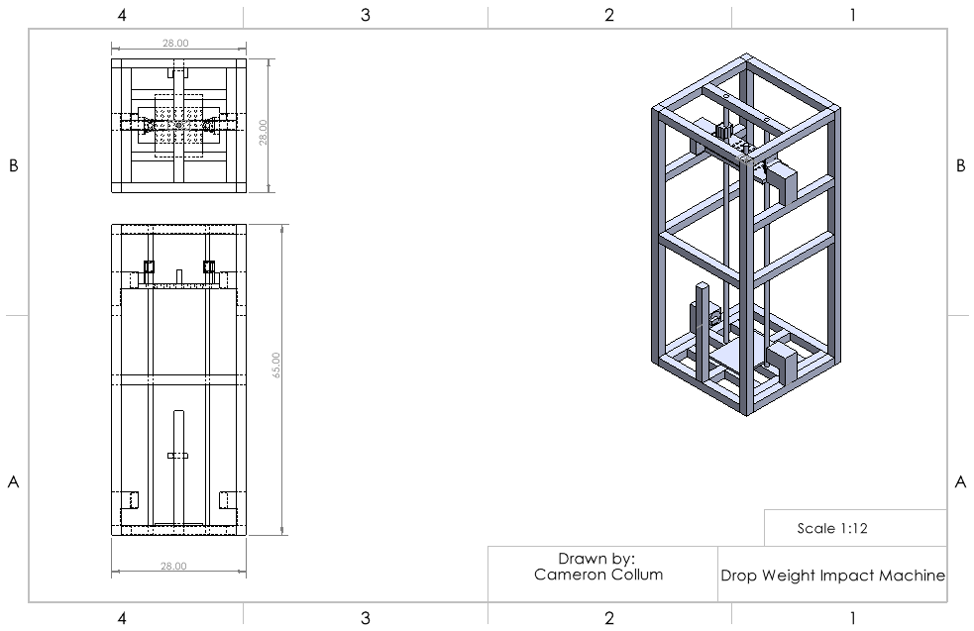
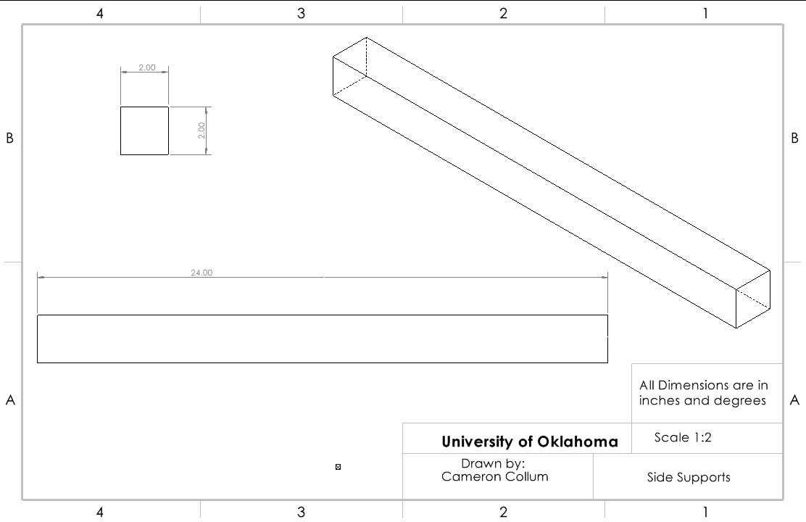
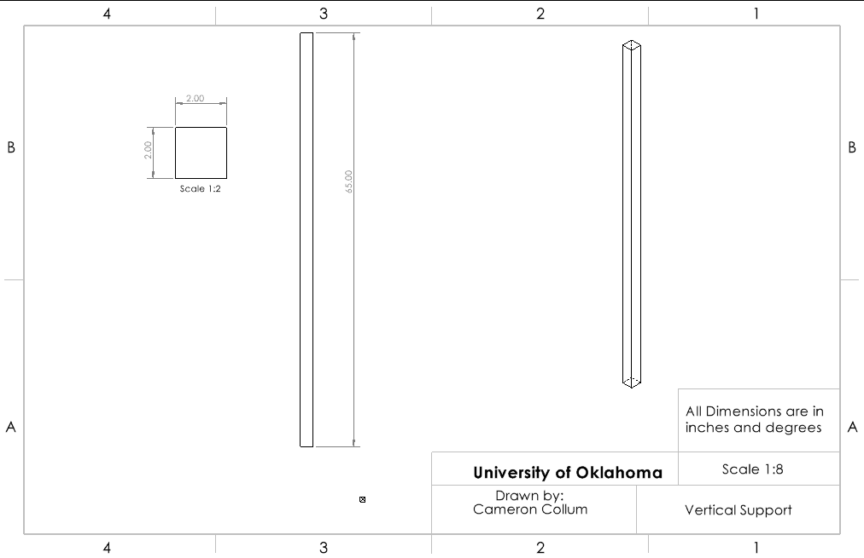
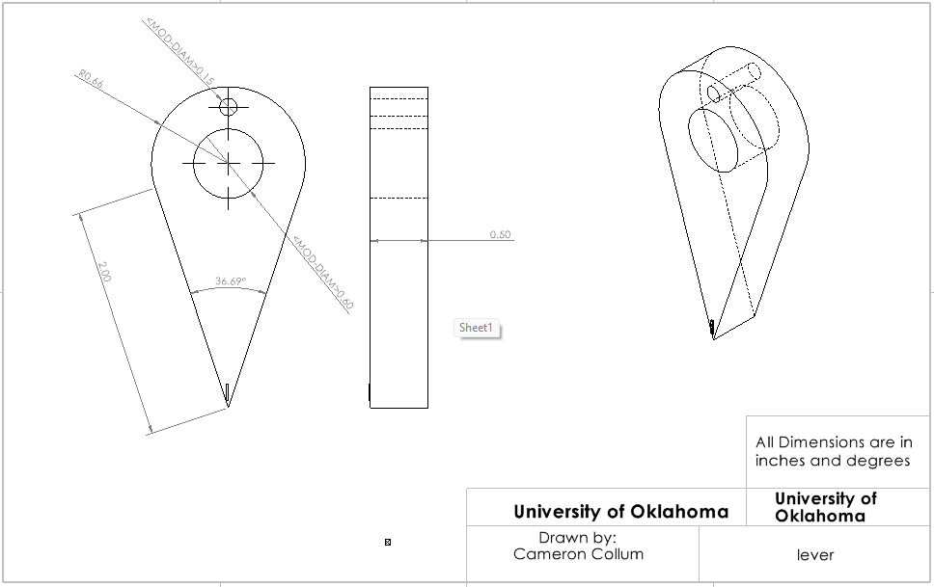
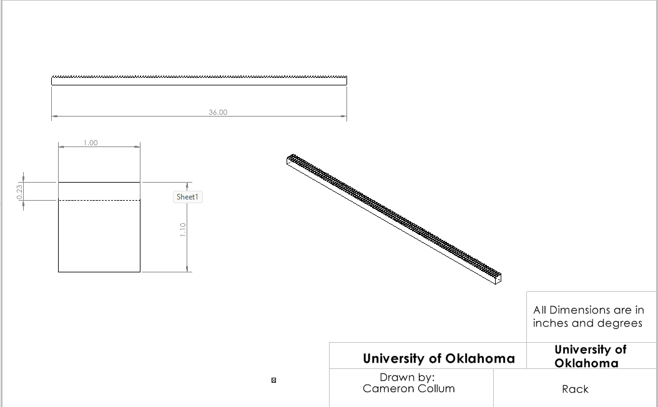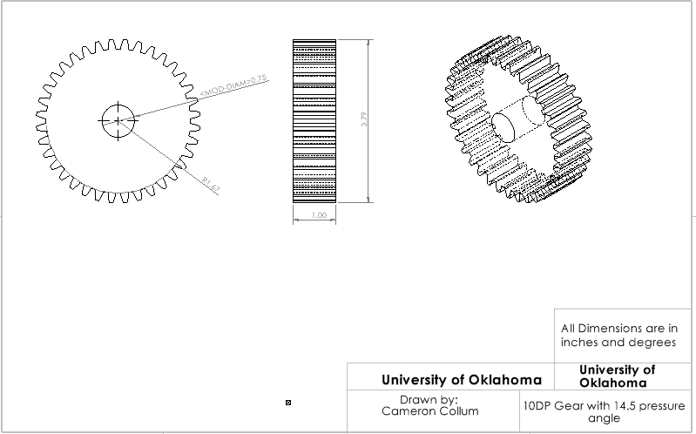
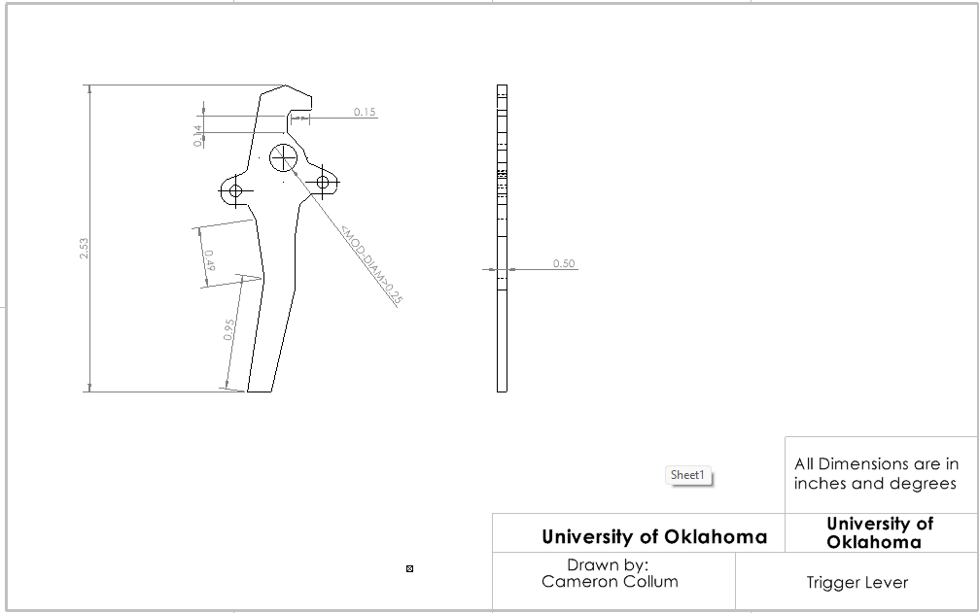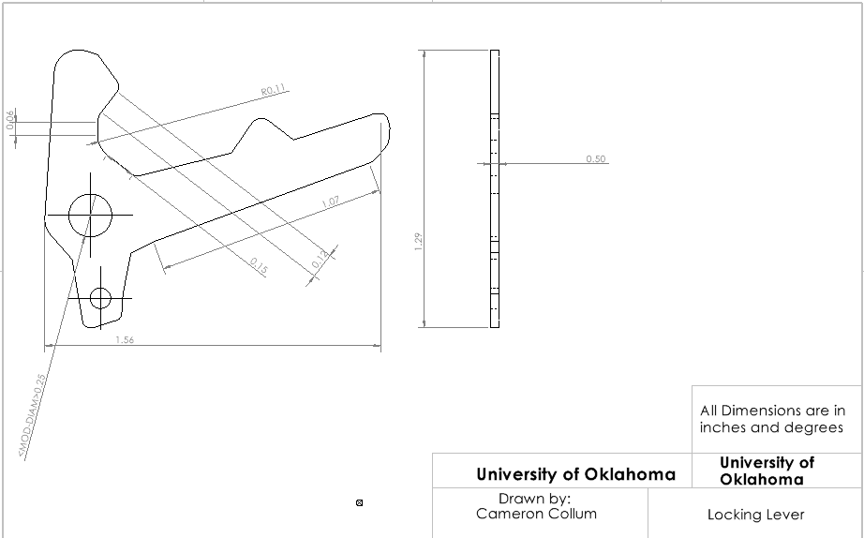

Appendix B (Procedures):
Make sure that trigger is safely rubber banded in the open motion like so add image Figure 36. Lift locking pin and impactor at the same time while ensuring that the release pin is moved out of the way of the impactor rack. Make sure the hole in the rack for the release pin is above the release pin Figure 37. Release pin and move impactor down while ensuring that the locking pin is still lifted and that the flag for the lever moves toward the locking pin. The release pin should be in the rack at this point and the flag for the lever should touching the casing for the locking pin as shown in Figures 38 and 39. Now set the trigger system and lift the locking pin on the trigger system Figure 40. Now release the safety pin at the top and release impactor.

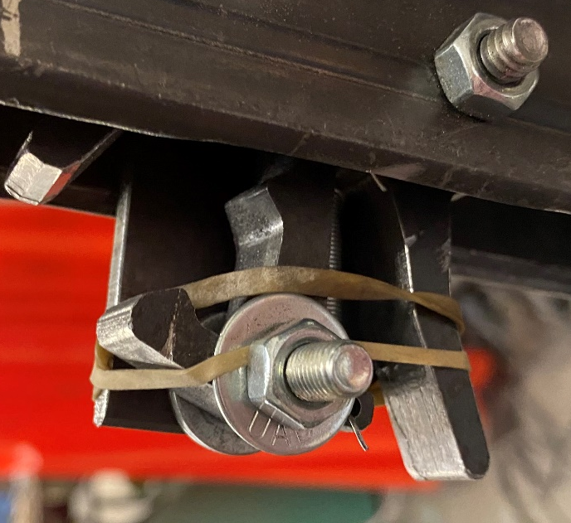
Figure 36: Rubber Banded Trigger

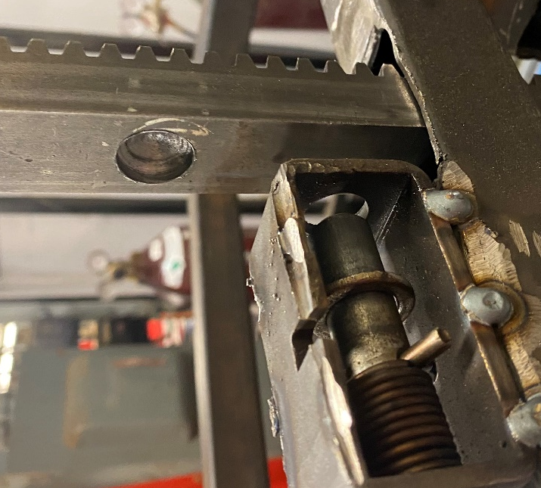
Figure 37: Hole for Release Pin above Release Pin

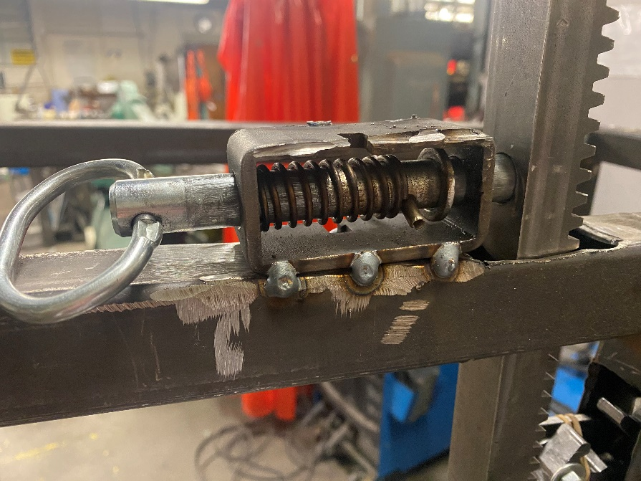
Figure 38: Release Pin in Rack
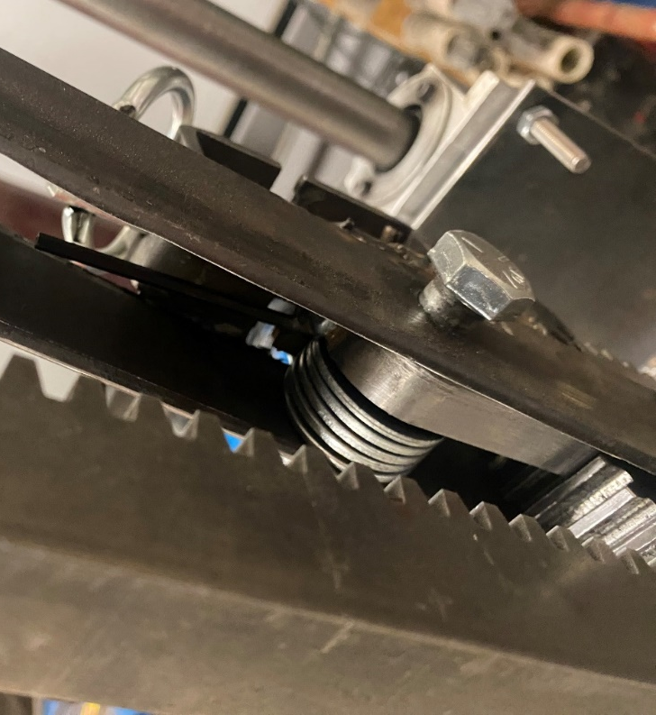
Figure 39: Trigger Flag on Pin Casing

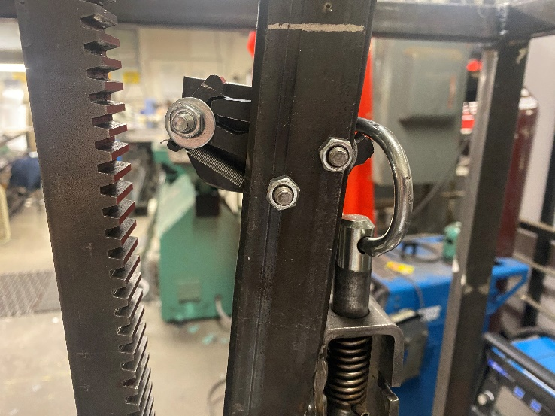
Figure 40: Set Locking Pin

