UNIVERSITY OF OKLAHOMA
GRADUATE COLLEGE

THE ROLE OF HOPE AND PSYCHOLOGICAL NEED SUPPORT
IN THE PREDICTION OF ACADEMIC ACHIEVEMENT AND
PSYCHOLOGICAL WELL-BEING OF
NCAA DIVISION I STUDENT-ATHLETES

A DISSERTATION
SUBMITTED TO THE GRADUATE FACULTY
in partial fulfillment of the requirements for the
Degree of
DOCTOR OF PHILOSOPHY

By
BRIAN S. SCISLO
Norman, Oklahoma
2018

THE ROLE OF HOPE AND PSYCHOLOGICAL NEED SUPPORT
IN THE PREDICTION OF ACADEMIC ACHIEVEMENT AND
PSYCHOLOGICAL WELL-BEING OF
NCAA DIVISION I STUDENT-ATHLETES

A DISSERTATION APPROVED FOR THE
TULSA GRADUATE COLLEGE

BY

____________________________________
Dr. Chan Hellman, Chair

____________________________________
Dr. Jody Worley

____________________________________
Dr. Curt Adams

____________________________________
Dr. Keith Ballard

____________________________________
Dr. Jennifer Kisamore

© Copyright by BRIAN S. SCISLO 2018
All Rights Reserved.

This work is dedicated to all those, past and present,
who provided support, encouragement, and opportunity
along the pathway – you have increased my hope.
Acknowledgements
While the pages of this document represent a work of individual scholarship, it is merely the culmination of a much, much longer journey that began some time ago. Along the journey, indeed, I have been blessed to have many people to lean on for support, guidance, wisdom, and on occasion, tough love. With this in mind, to my parents, friends, family, work colleagues, coaches, teammates, classmates, professors, and committee members, please know that I am truly grateful, and offer to each of you my sincere appreciation. In particular, I would like to give special thanks to Dr. Chan Hellman. From our initial introduction at Starbucks when I wasn’t quite sure what this whole Ph.D. thing was about to the twists and turns of identifying my research interests (which were a little bit all over the board), writing multiple drafts, and having many more meetings, you have been there every step of the way. Your encouragement, counsel, and friendship has made all the difference.

Table of Contents

Acknowledgements iv

List of Tables vii

List of Figures viii

Abstract ix

Chapter 1: Introduction 1

Background of Problem 3

Statement of the Problem and Significance of the Study 8

Purpose of the Study 10

Hypothesized Model 11

Research Hypotheses 13

Definition of Terms 13

Chapter 2: Review of the Literature 16

Hope Theory 16

Hope as a Psychological Strength 29

Hope and Academic Achievement 37

Self-Determination Theory 43

Psychological Need Support 58

Summary 70

Chapter 3: Methodology 72

Research Design 72

Procedure 73

Study Setting 75

Participants 76

Measures 78

Analytical Technique 90

Chapter 4: Results 92

Preliminary Data Screening 94

Model Fit 98

Evaluation of Research Hypotheses 108

Chapter 5: Discussion 113

Implications for Research 117

Implications for Practice 119

Limitations 122

Conclusion 122

References 124

Appendix A: Survey 145

Appendix B: Institutional Review Board Letter of Approval 156

Appendix C: Research Site Approval Letter 157

List of Tables

Table 1. Survey Response Rates and Dates of Survey Administration 74

Table 2. Demographic Variables of Participants 78

Table 3. Correlation Matrix for Key Variables 95

Table 4. Skewness and Kurtosis Values for Key Variables 97

Table 5. Parameter Estimates for Measurement Model (Model 1) 101

Table 6. Parameter Estimates for Measurement Model (Re-specified Model 1) 104

Table 7. Parameter Estimates for Measurement Model (Model 2) 106

Table 8. Parameter Estimates for Measurement Model (Re-specified Model 2) 108

Table 9. Summary of Model Fit Indices 108

List of Figures

Figure 1. Hypothesized Model 12

Figure 2. Full Hope Model 17

Figure 3. Self-Determination Continuum 54

Figure 4. Structural Equation Model (Model 1) 100

Figure 5. Structural Equation Model (Re-specified Model 1) 103

Figure 6. Structural Equation Model (Model 2) 105

Figure 7. Structural Equation Model (Re-specified Model 2) 107

Abstract
Hope is a psychological strength that promotes adaptive psychological and performance outcomes. In addition, an environment which supports an individual’s psychological need to feel autonomous, competent, and connected has been shown to elicit more autonomous functioning, enhanced motivation, increased well-being, and greater academic performance. The purpose of this study was to test the effects of autonomous self-regulation and hope on the relationship between psychological need support, academic achievement, and psychological well-being. Using structural equation modeling (SEM), the plausibility of a proposed model is tested in a sample of 303 collegiate student-athletes. The Learning Climate Questionnaire, Perceived Competence for Learning Scale, Sense of Relatedness Scale, Learning Self-Regulation Questionnaire, Adult Hope Scale, Academic-Specific Hope Scale, and Satisfaction With Life Scale were used. Semester grade point average and demographic information were also gathered. The results of the study demonstrate that increased environmental supports for autonomy, competence, and relatedness predict increased autonomous self-regulation, thus positively influencing levels of hope, leading to greater academic achievement and enhanced psychological well-being. Research findings are discussed in reference to the related literature and implications for future research and practice are suggested.
Keywords: Hope theory; Self-determination theory; Psychological need support; Academic achievement; Well-being; Student-athletes

Chapter 1: Introduction

In 1998, psychologist Martin Seligman, then-President of the American Psychological Association (APA), posed the intriguing question – “what makes life worth living, and how can we build it?” (Seligman, 2010, p. 232). To provide some additional context to the origin of that thought-provoking question, it is helpful to consider the growth and evolution of the discipline of psychology – in both its purpose and practice. Prior to World War II, the aim of psychology was threefold – identifying and alleviating illnesses of the mind, enhancing the lives of all people in order to bring about a more productive and fulfilling life, and cultivating talent and character strengths (i.e., promoting optimal human functioning) (Seligman & Csikszentimihalyi, 2000; Wood, Linley, Maltby, Kashdan, & Hurling, 2011). After World War II, however, for reasons beyond the scope of this paper, psychology began to focus its efforts (and funding) on the study of human problems and human pathology, or quite directly, what is wrong with people and how can we fix them. Thus, the focus of psychology became largely a disease model of human functioning (Peterson & Park, 2003; Seligman, 2010). Out of this imbalance, as well as a realization that the scholarly field of psychology is about much more than fixing damage and weakness, grew the positive psychology movement. This movement began to revisit topics concerning what is right with people, and how we, as a discipline and as practitioners, can nurture high talent, enhance character strengths, and promote optimal human functioning. According to Seligman and Csikszentimihalyi (2000),
Psychology is not just the study of pathology, weakness, and damage; it is also the study of strength and virtue. Treatment is not just fixing what is broken; it is nurturing what is best. Psychology is not just a branch of medicine concerned with illness or health; it is much larger. It is about work, education, insight, love, growth, and play (p. 7).

Positive psychology is “the study of the conditions and processes that contribute to the flourishing or optimal functioning of people, groups, and institutions” (Gable & Haidt, 2005, p. 104). More specifically, positive psychology is the study of positive subjective experiences, positive individual traits, and positive institutions (Seligman, 2002). The goal of positive psychology is not to dismiss the negative aspects of life however, but to move towards a more comprehensive understanding of the human condition, while integrating topics such as character strengths and growth into what is known about human functioning and human potential (Gable & Haidt, 2005). Thus, according to Peterson and Park (2003), scholars interested in these objectives, “need to start with different assumptions and to pose different questions from those of their peers who assume a disease model” (p. 144).
Two important constructs within the positive psychology perspective include hope theory (Snyder, 2002; Snyder, Harris et al., 1991) and self-determination theory (SDT; Deci & Ryan, 1980, 1985a, 1985b, 1991, 2000, 2008b). The construct of hope is defined as “the process of thinking about one’s goals along with the motivation to move toward those goals (agency), and the ways to achieve those goals (pathways)” (Snyder, 1995, p. 355). According to Snyder, Harris et al. (1991), hope is not necessarily an emotion-based concept, but instead, a motivational system with cognitive origins. On the other hand, self-determination theory is a general theory of human motivation, personality development, and well-being with a focus on universal human needs, regulatory processes, and the contextual environment that allows individuals to grow, thrive, and realize optimal motivation. The following study looks to explore and gain a deeper and more unified understanding of the relationships that exist between hope theory and self-determination theory. More specifically, this research empirically tests how environmental supports for the psychological needs of autonomy, competence, and relatedness, as theorized within self-determination theory, promote the development of hope, and of hopeful thinking, thus leading to more adaptive outcomes (i.e., academic achievement and psychological well-being).
Returning to the stated goals of positive psychology, which are to gain a more complete understanding of the human condition and the aspects that support optimal human functioning, it is also important to understand the connections that exist between concepts, ideas, and paradigms in order to fulfill this ultimate objective (Seligman & Csikszentimihalyi, 2000; Snyder & Lopez, 2002). Therefore, according to Snyder and Lopez (2002), future psychological research must embark upon this scholarly line of inquiry where “greater attention needs to be paid to the overlap of constructs so as to ascertain shared operative processes and the shared variance in optimal functioning” (p. 756).
Background of the Problem
Educational history (e.g., high school grades, scores from college entrance examinations, such as the ACT and SAT) has been cited as a significant predictor of college students’ academic potential; research however, has demonstrated that those aforementioned variables account for only a moderate portion of the variance in the prediction of academic outcomes (Gallagher, Marques, & Lopez, 2016). If only a portion can be explained by objective factors such as grades and standardized test scores then it stands to reason that there are other factors, both psychological and environmental, that can provide a more thorough understanding of the factors that affect academic success and achievement. In doing so, scholars and practitioners can recognize the unique impact of other variables and thus, develop strategies to foster the conditions that enable students to succeed.
Hope Theory
One promising line of research is that of hope theory. Several studies have examined the role of hope in the academic achievement of students. For example, a longitudinal study by Snyder, Shorey et al. (2002) found hope to be a positive predictor of grade point average, retention, and graduation rates among entering college freshman. Ciarrochi, Heaven, and Davies (2007), Leeson, Ciarrochi, and Heaven (2008), and Rand (2009) found hope to be positively related to academic achievement. In their study of undergraduate students, Day, Hanson, Maltby, Proctor, and Wood (2010) demonstrated that hope scores measured during the first year of undergraduate study were positively related to grades three years later. More recently, Gallagher et al. (2016) identified hope as the most significant predictor of academic performance, providing incremental prediction beyond educational history. Moreover, while controlling for previous educational history, hope was significantly predictive of enrollment and graduation status.
While the extant literature has demonstrated strong support for the relationship between hope and academic achievement, support for the relationship between hope and several well-being indicators is also quite impressive. A study by Gilman, Dooley, and Florell (2006) found hope to be significantly and positively related to measures of life satisfaction and personal adjustment. Hope has also been found to be positively related to higher levels of positive affect (Ciarrochi, Parker, Kashdan, Heaven, & Barkus, 2015; Snyder, Harris et al., 1991) and negatively related to negative affect (Snyder, Harris et al., 1991). Cotton-Bronk, Hill, Lapsely, Talib, and Finch (2009) examined the relationships between hope, life purpose, and life satisfaction. They found hope to be significantly correlated with purpose, and hope agency mediated the relationship between life purpose and life satisfaction. Hope has also been shown to be a psychological buffer against stressful life events or setbacks. Valle, Huebner, and Suldo (2004) found that adolescents who reported higher levels of hope also reported fewer instances of anxiety and depression, and were less likely to report decreased life satisfaction when confronted with a difficult life event.
Again, while hope has been shown to be an adaptive resource, very little is found in the existing literature as to the environmental conditions that boost levels of hope, and thus lead to positive outcomes. Recently, hope has been hypothesized to be a malleable entity (Gallagher et al., 2016; Hellman & Gwinn, 2017; Marques, Lopez, Reichard, & Dollwet, 2016). In fact, hope-based psychotherapy interventions have been shown to increase levels of hope, sometimes in as little as 90 minutes (i.e., Cheavens, Feldman, Gum, Michael, & Snyder, 2006; Feldman & Dreher, 2012). One such encouraging avenue of inquiry to attempt to close this gap in knowledge, and thus gain a more broad and inclusive understanding of the factors relating to optimal human functioning is through the lens of self-determination theory and psychological need support.

Self-Determination Theory
In their conceptualization of self-determination theory, Deci and Ryan (2000) identified three essential and universal human needs – autonomy, competence, and relatedness – that must be fulfilled within the social environment in order for an individual to realize optimal psychological growth, integrity, well-being, and motivation (Patrick, Knee, Canevello, & Lonsbary, 2007). According to Deci and Ryan (2000), the relationship between the social environment and motivation is not direct, however; it is mediated by ambient supports for an individual’s need to feel autonomous, competent, and connected. Based upon the underlying tenets of SDT, if there exists environmental supports for these three essential needs, motivation will become more integrated within the person (i.e., autonomous), and thus, will be enhanced and optimized. Conversely, if the environment does not facilitate the satisfaction of psychological needs, then motivation will be impaired leading to disaffection and diminished performance (Deci, Vallerand, Pelletier, & Ryan, 1991). At the cognitive, behavioral, and emotional levels, nowhere is this concept more salient than within the educational environment (Nuñez & Leon, 2015).
Numerous studies have revealed the importance of students’ perception of need- supportive behaviors by teachers and other educational personnel on facilitating student motivation (Stroet, Opdenakker, & Minnaert, 2013). For example, support for an adolescent’s psychological needs bears a significant relationship to more self-determined, autonomous functioning (Soenens & Vansteenkiste, 2005). Baeten, Dochy, and Struyven (2013) reported that students who perceived a more need-supportive environment were more autonomously motivated, which subsequently was predictive of academic achievement. Feri, Soemantri, and Jusuf (2016) found similar results, demonstrating the importance of psychological need support in the development of autonomous motivation. Moreover, in their study of medical students, Kusurkar, Cate, Vos, Westers, and Croiset (2013) found positive relationships between autonomous motivation, the use of good study strategies, and increased study effort, which in turn was predictive of academic performance.
The effects of psychological need support are not just related to objective performance measures (i.e., academic achievement), they have also been found to relate positively to indicators of psychological well-being. Vansteenkiste, Niemiec, and Soenens (2010) contend that the satisfaction of the needs for autonomy, competence, and relatedness are a necessity to facilitate human flourishing. Flourishing, in the psychological literature, refers to the experience of positive emotion and engagement, the development and maintenance of meaningful relationships, the finding of meaning in life, and the feeling and realization of accomplishment (Seligman, 2011). For example, Sheldon, Ryan, and Reis (1996) identified fulfillment of the need for autonomy and competence as having significant positive and inverse relationships to positive affect and negative affect, respectively, in a sample of college students. Patrick et al. (2007) found that the fulfillment of feelings of autonomy, competence, and relatedness were positively associated with increased self-esteem, positive affect, and vitality, and negatively associated with negative affect. Students who are more autonomously motivated have reported higher levels of life satisfaction, positive affect, and life meaning (Bailey & Phillips, 2016). Furthermore, in an experimental study manipulating the variable of psychological need support in a sample of university students, those who perceived more supports for competence and relatedness reported higher levels of intrinsic motivation and positive affect, and lower levels of negative affect (Sheldon & Filak, 2008). This provides additional support for Niemiec et al. (2006), who identified need support to be essential in the development of autonomous functioning and psychological health in college students.
Statement of the Problem and Significance of the Study
Based on the preceding scholarly evidence, there exists considerable support for the positive relationships between levels of hope, academic achievement, and psychological well-being. Furthermore, an extensive body of psychological and educational literature has demonstrated the importance of need-supportive environments in the development of autonomous self-regulation, motivation, and several performance and psychological indicators. What has not been fully investigated however, is the extent to which an individual’s experience of support for his or her psychological needs of autonomy, competence, and relatedness promote the character strength of hope, thus leading to adaptive outcomes. Given that, there remains unresolved questions that are critical to address in order to meet the lofty goal of positive psychology initially articulated almost two decades ago, which is to understand “the conditions and processes that contribute to the flourishing or optimal functioning of people, groups, and institutions” (Gable & Haidt, 2005, p. 104). Most importantly and globally, however, is the ability of this present research to add to the body of literature aimed at gaining a more complete picture of the lived human experience.
Furthermore, the sample used in this present study represents a distinctive subset of the college student population – that of the student-athlete (Ting, 2009). According to Rolo and Gould (2007), while student-athletes face challenges similar to those experienced by the general student body population, such as academic-related matters, social adjustment, and time management, participation in an intercollegiate sport provides an additional layer of complexity to the life of a student-athlete (Watt & Moore, 2001) and can contribute to increased college adjustment demands (Ting, 2009). Examples of additional activities related to intercollegiate athletics participation include, practices and competition, team travel, and injury rehabilitation. Taken together, these aforementioned activities, along with the traditional demands of being a college student, can contribute to increased stress, decreased academic performance, and increased drop-out rates (Rolo & Gould, 2007). In addition, intercollegiate student-athletes may experience feelings of isolation (Carodine, Almond, & Gratto, 2001) and distinct emotional anxiety due to pressures to achieve both athletically and academically (Engstrom & Sedlacek, 1991).
To date, very little of the existing research on hope, self-determination theory, and psychological need support has studied these constructs from the perspective of the collegiate student-athlete. Moreover, no study has been found which examines these constructs together in a student-athlete sample. In one of the few studies involving NCAA Division I student-athletes, Curry, Snyder, Cook, Ruby, and Rehm (1997) found higher levels of student-athlete hope to be predictive of better athletic and academic achievement, while Curry and Maniar (2003) identified a positive relationship between enhanced levels of hope, academic performance, and well-being in both students and student-athletes. Within the area of perceived psychological need support, research has focused on the role of the coach relative to student-athlete motivation for his or her sport (Hollembeak & Amorose, 2005). While the aforementioned studies provide preliminary support for the positive, adaptive role both hope and psychological need support can play in the life of a collegiate student-athlete, they are more descriptive in nature. This present study looks to move beyond mere description to put forward a theoretical framework as to the environmental conditions that contribute to goal-directed thought and action, thus leading to adaptive outcomes.
Moreover, this present study seeks to build upon what is already known individually about hope theory, self-determination theory, and need-supportive environments to put forward a unifying framework to understand their conceptual overlap and integration. Again, much research has shown the positive relationship between hope and several performance and psychological variables, yet it remains unclear how to create an environment where hope can be fully and optimally activated. Not only does this study serve the purpose of advancing scholarly discourse on hope theory and self-determination theory, but it will also assist educational practitioners and intercollegiate athletics professionals, alike, as they endeavor to understand the myriad factors that affect achievement and well-being of students in general, and student-athletes specifically, in turn, improving their experience at the environmental, cognitive, and emotional levels.
Purpose of the Study
The primary aim of this research was to examine the structural relationship between the variables of psychological need support, autonomous self-regulation, hope, academic achievement, and psychological well-being. The present study employed a non-experimental, cross-sectional research design. The participants in this study were NCAA Division I student-athletes at The University of Tulsa, a small, private, academically-selective institution of higher education located in Tulsa, Oklahoma. Several instruments were used, including measures of perceived support for the psychological needs of autonomy, competence, and relatedness, behavioral self-regulation, dispositional (trait) hope, academic-specific hope, psychological well-being, and semester grade point average. Survey items can be found in Appendix A.
Hypothesized Model
The current study applied self-determination theory and hope theory in the exploration of the relationships between psychological need support, autonomous self-regulation, hope, academic achievement, and psychological well-being. More precisely, this research looked to establish whether intercollegiate student-athletes’ perceptions of support for the psychological needs of autonomy, competence, and relatedness can predict increased self-determined, or autonomous, behavioral self-regulation, and whether that, in turn, can predict academic achievement and psychological well-being, as mediated by hope. Furthermore, this research tested the direct relationship between psychological need support and hope. There is evidence in the extant literature which has demonstrated support for the satisfaction of an individual’s innate psychological need for autonomy, competence, and relatedness being positively related to autonomous motivation and self-regulation. Moreover, research has also shown a direct relationship between levels of hope, academic achievement, and well-being. What has not been specifically tested, however, are the mechanisms and the social/contextual environment by through which hope is fully activated, thus leading to more adaptive performance and psychological outcomes. Therefore, utilizing a cohesive theoretical framework to examine these hypothesized relationships can assist educators along with educational administrators in gaining a more complete understanding of student motivation, academic achievement, and well-being. Additionally, this study aims to empirically demonstrate the impact of both personality and social factors in the realization of adaptive outcomes.
Based on prior research, the goal of this study was to propose a theoretical model to explain academic and psychological outcomes as mediated by hope, while integrating psychological need support and autonomous self-regulation as predictors of hope. According to this model and following self-determination theory, it was hypothesized that students who perceive higher levels of psychological need support within the educational environment will be more autonomous in their behaviors, thus contributing to higher levels of hope, which in turn, will result in better academic outcomes and enhanced psychological well-being. The complete hypothesized model that guides this study is presented in Figure 1.
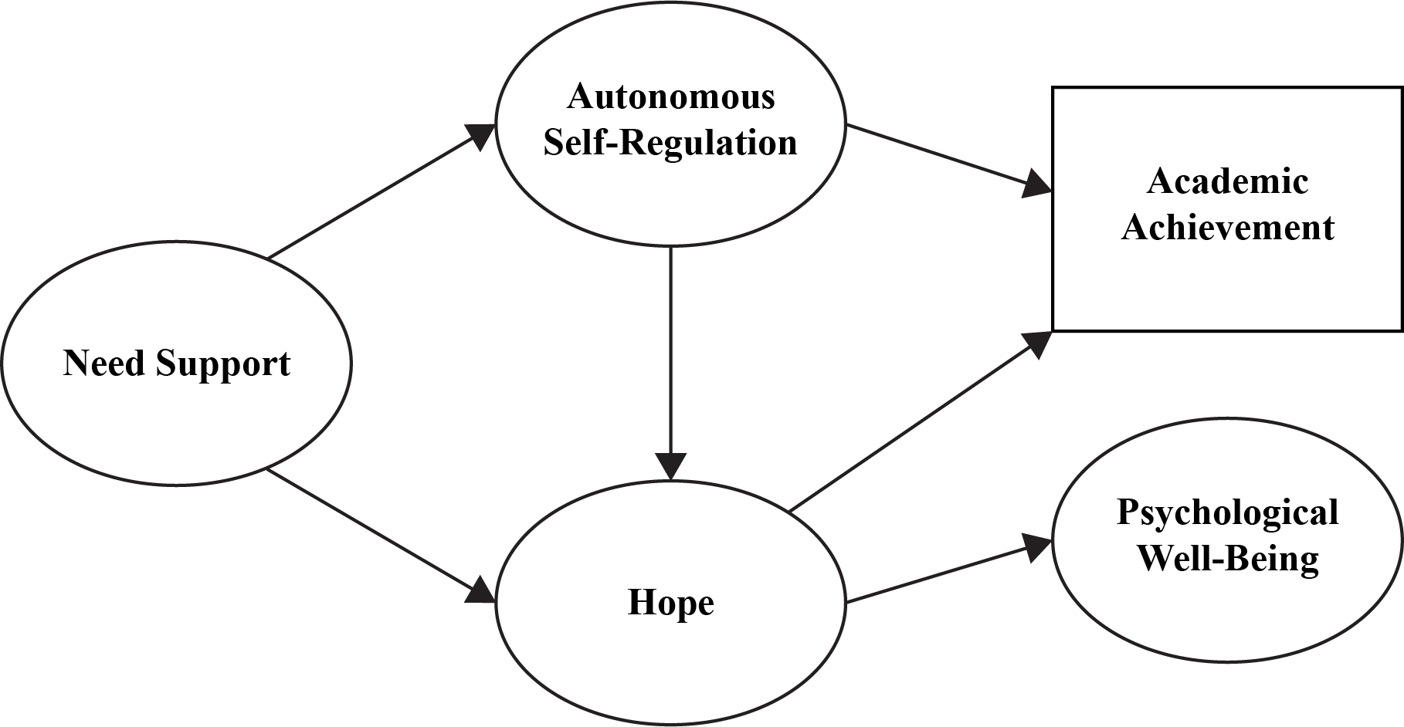
Figure 1. Hypothesized Model

Research Hypotheses
A review of the relevant literature has informed the following hypotheses for this study:
H₁: Individuals who perceive higher levels of psychological need support will have higher levels of hope.
H₂: Individuals who are more autonomously self-regulated will have higher levels of hope.
H₃: Individuals who perceive higher levels of psychological need support will be more hopeful, and will have higher levels of academic achievement and psychological well-being.
H₄: Individuals who are more autonomously self-regulated will engage in more hopeful thought, and will have higher levels of academic achievement and psychological well-being.
H₅: Individuals who perceive higher levels of psychological need support will be more autonomously self-regulated, have higher levels of hope, and will have higher levels of academic achievement and psychological well-being.
Definition of Terms

For the purposes of this research, it is important to establish clarity and a shared understanding of the terms used herein. Thus, several definitions are provided below.
Hope
In common, everyday vernacular, the word hope is defined as “to desire with expectation of obtainment or fulfillment” (Merriam-Webster, n.d., para. 1), or more concisely, “desire accompanied by expectation” (Webster’s New World College Dictionary, 2000, p. 687). The psychological construct of hope, however, as it is defined and conceptualized within hope theory, is much more specific, and perhaps descriptive. Hope in this current study goes beyond simply a desire, wish, or expectation for a specific outcome or attainment of a goal, but involves the willpower (agency) extended and the waypower (pathways) developed and undertaken to arrive at a desired end state or goal. Therefore, presently, hope is defined and conceptualized as “a positive motivational state that is based on an interactively derived sense of successful (1) agency (goal-directed energy) and (2) pathways (planning to meet goals)” (Snyder, Irving, & Anderson, 1991, p. 287).
Psychological Need Support
Self-determination theory hypothesizes that motivation is optimally enhanced when a person’s innate psychological need for autonomy, competence, and relatedness is satisfied (Deci & Ryan, 2000). Psychological need support refers to behaviors and environmental factors experienced by the individual which either enable or impede the natural human tendency towards growth and assimilation of values (Niemiec & Ryan, 2009), and thus the degree to which the psychological needs of autonomy, competence, and relatedness are fulfilled.
Psychological Well-Being
The construct of psychological well-being can be viewed from a hedonic or eudaimonic perspective. Taken from a hedonic perspective, psychological well-being entails the balance of positive and negative affective states, life satisfaction, and subjective happiness (Margalit & Idan, 2004). Alternatively, eudaimonic well-being focuses on “meaning and self-realization and defines well-being in terms of the degree to which a person is fully functioning” (Ryan & Deci, 2001, p. 141). For the purposes of this study, psychological well-being was defined and assessed using a measure of hedonic well-being.
National Collegiate Athletic Association (NCAA)
The National Collegiate Athletic Association (NCAA) is a member-led, national governing body of intercollegiate sports in the United States. It is comprised of 1,123 colleges and universities across three divisions (Division I, II, and III) and almost 500,000 student-athletes competing in 24 sports (National Collegiate Athletic Association [NCAA], 2017c). According to the principles set forth by the NCAA, the organization places high priority on academics, well-being, and fairness so that all collegiate student-athletes can realize success athletically, academically, and personally (NCAA, 2017c). In an effort to meet this objective fully, the NCAA, through its member institutions, implement and regulate rules and bylaws related to competition, recruiting, and academic standards.
Student-Athlete(s)
For the purposes of this study, a student-athlete, or student-athletes, refer to those individuals who are enrolled full-time in an undergraduate course of study leading to an academic degree at an NCAA member institution. Additionally, they are listed on the official team roster at their undergraduate institution in at least one NCAA-sponsored sport.

Chapter 2: Review of Literature
Based upon the stated research hypotheses forming this current study, the following chapter represents a comprehensive review of the extant literature on hope theory, self-determination theory, and psychological need support. In addition, the respective relationships of the aforementioned constructs to academic achievement and psychological well-being are discussed.
Hope Theory
What is hope? Throughout the mid- to late-1900s, theories related to hope were based on a unidimensional model of positive expectancy (see Menninger, 1959; Snyder, Feldman, Taylor, Schroeder, & Adams, 2000; Stotland, 1969), or a sense of confidence an individual possesses to attain his or her identified goal(s) (Carver & Scheier, 2001). While Snyder, LaPointe, Crowson, and Early (1998) did not dismiss this notion as entirely inaccurate, they did however note that the concept of hope encompassed so much more. In many of the previous conceptualizations of hope, the assumption that people were goal-directed was apparent, however the ways in which people pursue their goals was absent (Snyder, Harris et al., 1991). The foundation of hope begins with a goal, which is the desired end point of all behavior and action. The attainment of a given goal, however, is dependent upon two related thought processes – pathways thinking and agency thinking. Pathways are the perceived routes toward an identified goal, while agency is the motivational energy and capacity to utilize those pathways toward goal attainment (Snyder, Cheavens, & Sympson, 1997). Snyder developed a model of hope which postulates hope as not simply an emotion-based concept, but rather a cognitive process involving three interrelated, additive, and iterative components – goals, pathways, and agency (Snyder, Feldman et al., 2000; Snyder, Harris et al., 1991) (see Figure 2). Furthermore, Snyder and colleagues developed a more explanatory model that detailed the motivational and goal-planning elements required in the goal-pursuit process. As such, Snyder, Harris et al., (1991) postulated,
To sustain movement towards the goals in ones’ life, we would argue that both the sense of agency and the sense of pathways must become operative. That is, both agency and pathways are necessary, but neither is sufficient to define hope. Furthermore, hope does not merely involve one iteration in which a person first assesses agency and then proceeds to an analysis of available pathways, thereafter eliciting goal-directed behaviors. Nor does one pathways analysis unleash the agency to eventuate in goal-directed behavior. Rather, agency/pathways and pathways/agency iterations continue throughout all stages of goal-directed behavior; as such hope reflects the cumulative level of perceived agency and pathways (p. 571).

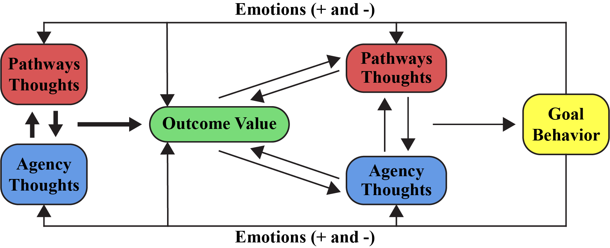
Figure 2. Full Hope Model (adapted from Snyder, 2002; Snyder, Rand, & Sigmon, 2002)

Hope theory falls within the nomological paradigm of positive psychology (Snyder, 1995). Positive psychology has its roots in the humanistic tradition dating back to the works of James, Maslow, and Erikson; however, over the past century, the focus within the discipline of psychology has been one of psychopathology, or a disease model of human functioning (Seligman & Csikszentmihalyi, 2000). In response to the preponderance of research investigating what is wrong with people, positive psychology utilizes the scientific framework to understand and build upon positive human qualities or virtues – in essence, what is right with people. Given that, the coalescing goal of positive psychology is “the study of the conditions and processes that contribute to the flourishing or optimal functioning of people, groups, and institutions” (Gable & Haidt, 2005, p. 103). Hope theory, then, is simply another theoretical lens through which to understand and enhance adaptive ways of functioning, thus increasing well-being and optimal functioning (Snyder, Rand et al., 2002). According to Ciarrochi et al. (2015), “the central tenet of hope is that this attribute, psychological strength, or motivational factor, increases the likelihood of the successful pursuit of goals” (p. 2).
Snyder, Irving et al. (1991) define hope as “a positive motivational state that is based on an interactively derived sense of successful (1) agency (goal-directed energy) and (2) pathways (planning to meet goals)” (p. 287). The basic assumption made is all human activity is inherently goal directed (Snyder, Rand et al., 2002). That is, in simple terms, how can an individual get from here (present state) to there (future state), either literally or figuratively. While the temporal nature of goals might be long- or short-term, the person establishing the goal must hold them as having some value and being potentially attainable, yet encompassing some level of uncertainty (Snyder, Rand et al., 2002). According to Snyder and colleagues (1994; Snyder, Cheavens et al., 1997), goals are the foundation of hope theory and are essential to all regulated behavior because they represent the anticipated endpoint that results from such behaviors. In regard to hope-producing goals, Snyder, Feldman et al. (2000) identified four general types of goals: approach goals (i.e., progressing towards a chosen outcome), forestalling negative outcome goals (i.e., prevention of a negative outcome), maintenance goals (i.e., maintaining the current state), and enhancement goals (i.e., increasing an already positive result). In any of the aforementioned goal categories, the goal represents a desired outcome, or result. Furthermore, within hope theory, a goal may be of high significance to the individual, such as a life-long pursuit, while alternatively, it may be a rather ordinary endeavor, or short-term objective (Snyder, Lopez, Shorey, Rand, & Feldman, 2003). For example, as it relates to the current study, a student-athlete may have a long-term goal of graduating from college, while on the other hand, the goal may have a shorter time horizon such as receiving a passing grade in a particular course, on a specific exam, or even simply remaining academically eligible to participate in competitive intercollegiate athletics.
According to Snyder, Feldman et al. (2000), “goals are defined as the targets of mental action sequences, and they provide the cognitive component that anchors hope theory” (p. 250). Additionally, Snyder et al. (2003) posit that hope can be initiated through various levels of abstraction as in goals in the general sense, goals in a specific area of life, and/or the identification of one specific goal. As mentioned, goals can take many different forms, develop from different origins, and have different temporal aspects, but to fully activate hope, as conceived by Snyder, Harris et al. (1991), they must be of some value to the individual, contain some aspect of challenge, and must be attainable, yet the probability of attainment cannot be certain. In Averill, Catlin, and Chon (1990), hope is present when there exists an intermediate probability of goal achievement. Research has also demonstrated that individuals with higher hope not only set more difficult goals, but also do so in a more constructive fashion by breaking the larger goal into several, more easily attainable sub-goals (Snyder, Ilardi, Cheavens, Michael, Yamhure, & Sympson, 2000).
According to hope theory, goal identification is only one prong of the trident. Snyder, Michael, and Cheavens (1999) have found that the act of thinking about goals initiates a trigger for the other two elements required for goal-directed behavior – agency and pathways. Thus, in order to successfully achieve the goals one has for his or herself, one must also have the necessary motivational energy (agency) and strategies (pathways). In Snyder and colleagues’ (1991) theory, hope is a higher-order construct comprising two first-order, interrelated constructs – agency and pathways. This finding has been replicated repeatedly in several factor-analytic studies (Babyak, Snyder, & Yoshinobu, 1993; Bryant & Cvengros, 2004; Rand, 2009). While the agency and pathways components of hope theory are related, they are not synonymous. Additional factor analytic studies have demonstrated support for agency and pathways being distinguishable constructs (Snyder, Harris et al., 1991).
Pathways Thinking
Pathways thinking is the “cognitive routes to goals” (Feldman, Rand, & Kahle-Wrobleski, 2009, p. 480), or the individual perception of producing effective strategies to goal attainment (Snyder, Feldman et al., 2000; Snyder, Ilardi et al., 2000). Individuals must not only view themselves as having the capacity, but must also develop at least one suitable route, or pathway, to that goal. Snyder, Rand et al. (2002) argue, however, that generating several pathways is important when facing obstacles towards goal achievement. Research has shown that individuals who have higher levels of hope produce more pathways at the start of goal pursuit and develop alternate routes when confronted with impediments along the way (Irving, Snyder, & Crowson, 1998; Snyder, 1994; Snyder, Harris et al., 1991; Snyder, Rand et al., 2002).
Agency Thinking
Agentic, or agency, thinking is the third element of hope theory, and is the “cognitive energy” (Snyder, 1995, p. 355), or the motivational component, of goal-directed thought. Agentic thinking reflects not only a person’s thoughts concerning starting along an identified pathway, but the prerequisite motivational energy in order to continue to advance along said pathway (Snyder, Rand et al., 2002). These thoughts provide the stimulus to continue along an identified route towards goal achievement (Feldman, Davidson, & Margalit, 2015), and are especially important when one encounters obstacles so that they can identify alternative pathways, and thus move forward in the goal pursuit process with equal vigor (Snyder, Rand et al., 2002). Moreover, high-hope individuals view obstacles as more of a challenge to overcome, rather than a perception of failure (Snyder, 1995).
It is clear that agency and pathways are critical elements in the theoretical framework of hope theory; however, one without the other is insufficient. Cheavens, Feldman, Woodward, and Snyder (2006) maintain, “Both pathways and agency thinking must be present in some degree for hope to thrive” (p. 137). According to Snyder, Rand et al. (2002), “hopeful thinking necessitates both the perceived capacity to envision workable routes and goal-directed energy” (p. 258). Furthermore, not only are agency and pathways both necessary, they are also reciprocal, additive, and iterative (Snyder, Rand et al., 2002). The pursuit of a desired goal may lead to increased agency, which in turn can lead to the development of new pathways (Cheavens, Feldman, Gum et al., 2006). On the other hand, the identification of new or additional pathways to goals can bring about increased motivation, or agency. According to Feldman et al. (2009),
not only should hope lead to goal pursuit and attainment, but hope would also be readjusted to bring it in line with the level of goal success. If an individual makes good progress towards goals, hopeful cognitions should receive a boost; if not they should diminish (p. 481).

Additionally, as it relates to the iterative process of hope, individuals can have hopeful thoughts concerning goals in general and indeed those cognitions affect agency and pathway thinking regarding specific goals, however they are not one in the same. According to Feldman et al. (2009), hopeful thoughts are continuously readjusted based upon an individual’s perceptions regarding a specific goal (see Figure 2).
Snyder and colleagues (Snyder, Rand et al., 2002; Snyder et al., 1999) purport, those higher in hope have greater capacity for establishing clear goals, developing multiple pathways to their identified goals, and enhanced motivation for embarking on those pathways. Thus, in theory, higher hope should lead to more successful goal-pursuit outcomes (Snyder, Feldman et al., 2000). Furthermore, when confronted with obstacles along the route to a goal, high- as compared to low-hope individuals, view impediments more constructively in order to gain further insight about not only themselves, but about challenges that may come about in the future (Snyder, Feldman et al., 2000). While goal blockages can be viewed as stressors, according to Tennen and Affleck (1999), higher hope individuals are better equipped to not only deal with those stressors, but to benefit from them as well. According to Snyder, Feldman and colleagues (2000), “should the high-hope person truly be blocked in the pursuit of a given desired goal, instead of being full of anger, self-pity, and negative emotions, as is the case for low-hope individuals in similar circumstances, he or she will find another goal that will fulfill similar needs” (p. 256). Snyder et al. (1998) postulate that high-hope individuals, in comparison to those lower in hope, demonstrate enhanced positive self-perceptions, establish goals of greater difficulty, and identify a greater number of goals. Additionally, high-hope individuals show an increased belief that they will accomplish their desired goals, focus on success in their goal-directed activities, and experience more positive emotional states while pursuing their goals.
Upon initial examination of hope theory, one might conclude that the concept of hope is an emotion-based construct. Indeed, emotions are not irrelevant, nor entirely unrelated to hope, but are merely a consequence of goal pursuit cognitions (Snyder, Harris et al., 1991). As hypothesized by Snyder and colleagues (Snyder, 1995, 2002; Snyder, Rand et al., 2002), hope, however, is premised on cognitive perceptions of goals and goal pursuits, which result in positive (or negative) emotions based upon the success realized in the attainment of those goals. Therefore, emotions emanate from cognitions. According to Snyder (1995), “the current conceptualization of hope is phenomenological in nature and rests upon the cognitive appraisals of one’s goal-related capabilities” (p. 355). While the underlying tenets of hope theory are cognitive, research has supported the notion that the cognitive process that drives goal pursuit also elicits emotion that is then channeled back to the individual as a form of feedback (Snyder, Feldman et al., 2000). Therefore, hope, as conceptualized by Snyder, Harris et al. (1991), is “an interrelated system of teleological thinking that allows for modifying feedback at various points in the temporal sequence of goal-pursuit activities. The feedback component accounts for changes in an individual’s level of hope over time” (Snyder, Feldman et al., 2000, p. 251). According to Oettingen and Gollwitzer (2002), hope, consisting of agency- and pathway-related thoughts, helps to create positive emotional orientations that are beneficial for the achievement of goals.
Similar Constructs
Hope theory, as conceptualized by Snyder and colleagues (Snyder, 1995, 2002; Snyder, Harris et al., 1991; Snyder, Rand et al., 2002) holds similar dimensions to other related theories within the positive psychology tradition, namely optimism (Scheier & Carver, 1985) and self-efficacy (Bandura, 1982). Snyder, Rand et al. (2002) contend however, that while there should exist some relational and empirical similarities to other positive psychology concepts, there too should be distinct differences as to not be duplicative of an already existing theoretical construct.
While the theoretical foundation of hope, optimism, and self-efficacy rests upon the expectancy of future goal attainment, hope offers a unique perspective in that it specifies not only expectancies about one’s self, or individuals’ “capabilities to produce desired effects by their own actions” (Bandura, 1997, p. vii), but expectancies about outcomes as well. Magaletta and Oliver (1999) hypothesize self-efficacy to be more comparable to the will, or agency thinking, component of hope because both relate to the expectancy, or self-efficacy, to accomplish a specific task. Conversely, optimism is more akin to the ways, or pathways thinking, element of hope as a result of the expectancy related to outcomes. Where hope and optimism differ, however, is that the latter concerns the expectation of outcomes obtained via others or through outside forces, while the focus of hope exclusively relates to outcomes obtained by the person themselves. Furthermore, in their study examining the relationships between hope, self-efficacy, optimism, and well-being in a sample of college students, Magaletta and Oliver (1999) found support for their hypothesis in two important ways. First, hope, consisting of both agency and pathways, provided a significant and unique contribution over and above self-efficacy and optimism in the prediction of well-being. Secondly, when the Hope Scale was divided into its two subscales, the agency component of hope made a significant contribution to the prediction of well-being beyond what was accounted for by self-efficacy. Similarly, the pathways component of hope contributed independent of optimism in the prediction of well-being. Taken together, these results lend support to the premise that while hope, self-efficacy, and optimism are related constructs, they are not synonymous. Several subsequent studies (e.g., Alarcon, Bowling, & Khazon, 2013; Luthans, Avilio, Avery, & Norman, 2007) have supported the discriminant validity of the hope construct.
Optimism. The extant literature is replete with findings demonstrating levels of both hope and optimism to be predictive of adaptive behaviors (Barnum, Snyder, Rapoff, Mani, & Thompson, 1998; Elliott, Witty, Herrick, & Hoffman, 1991; Jackson, Taylor, Palmatier, Elliott, & Elliott, 1998); performance and achievement (Chang, 1998; Chemers, Hu, & Garcia, 2001; Curry, Maniar, Sondag, & Sandstedt, 1999; Curry et al., 1997; Gibbons, Blanton, Gerrard, Buunk, & Eggleston, 2000; Snyder, 2002); and improved mental health (Cramer & Dyrkacz, 1998; Irving, Crenshaw, Snyder, Francis, & Gentry, 1990; Kwon, 2002). There appears to be some disagreement among scholars, however, as to what element of hope – agency or pathways – the concept of optimism is most similar. According to Snyder, Rand et al. (2002), Scheier and Carver’s (1985) model of optimism is most similar to hope theory in the agentic-thinking aspect, which they term outcome expectancies, however the theoretical construct of optimism does not provide equal emphasis to pathways-thinking seen in Snyder’s conceptualization of hope. Conversely, Feldman et al. (2015) contend Scheier and Carver’s theory of optimism is most similar to the pathways component of hope because optimism is focused on the strategy-planning (i.e., pathways thinking) aspect of goal-directed activity.
Scheier and Carver (1985) conceptualized optimism as the general expectation that good things will happen. Moreover, an individual’s level of optimism is a determining factor in how the individual approaches and pursues goals. Optimism, much like hope, is viewed as a stable personality trait reflecting a more generalized, rather than specific, outcome expectancy; however, the concepts differ based on their relationships between outcome and efficacy expectancies and how those relationships manifest themselves in the pursuit of goals (Snyder, Harris et al., 1991). Peterson, Gerhardt, and Rode (2006) and Snyder, Rand et al. (2002) contend that while optimism places emphasis on the motivational aspects, or positive expectation of goal attainment, it neglects to take into account the ways in which the goal, or desired outcome, will be achieved. Furthermore, support for this contention has been found in numerous studies where hope has remained a unique predictor of well-being after controlling for the effects of optimism (Kashdan et al., 2000; Magaletta & Oliver, 1999; Snyder, Harris et al., 1991). For example, Alarcon et al. (2013) found optimism to be positively related to overall hope, hope agency, and hope pathways; the magnitude of the relationship was modest however, thus lending additional support to the lack of redundancy in constructs. Anderson (1988) found hope to provide a unique contribution in the prediction of depression and anxiety above what was accounted for by optimism. Bailey, Eng, Frisch, and Snyder (2007), utilizing backwards multiple regression, identified hope agency to be a stronger predictor of life satisfaction in a sample of university students and adults in comparison to optimism.
Scheier, Carver, and Bridges (1994) developed the Revised Life Orientation Test (LOT-R) as a measure of optimism. To be certain, there exists several similarities between the LOT-R and Snyder, Harris et al.’s (1991) Adult Hope Scale, such as the assessment of stable personality characteristics regarding future expectations. They differ, according to Snyder, Sympson, Michael, and Cheavens (2001), however, in that optimism highlights the motivational component of goal-related thinking, while the Hope Scale “emphasizes the mutual contribution of agentic and pathways goal-directed thoughts” (p. 118). Furthermore, according to Snyder, Ilardi et al. (2000),
Scheier and Carver appear to make agency-like thought an explicit part of their model; pathways-like thoughts are implicit. In hope theory, however, equal and constantly iterative and strong emphases are explicitly placed upon pathways thoughts and their motivational companions, agentic thoughts (p. 752).

Self-efficacy. Bandura (1997) defined self-efficacy as “the belief in one’s ability to organize and execute the courses of action required to produce given results” (p. 3). Individuals high in self-efficacy establish challenging goals and persevere in the presence of obstacles, thus increasing the probability of goal achievement (Feldman et al., 2015). Again, similar to hope, self-efficacy has a goal orientation; however, according to Snyder (1995, 2002) hope rests on the premise that both outcome (pathways) and efficacy (agency) expectancies are necessary and iterative in the goal-pursuit process, whereas self-efficacy, while not dismissive of outcome expectancies, is primarily concerned with efficacy expectancies. Feldman and Kubota (2015) argue that “self-efficacy is largely agnostic regarding whether an action will lead to goal outcomes, whereas hope concerns expectancies that one can achieve goals through the goal-directed planning (pathways) and motivation (agency)” (p. 211).
Snyder, Harris et al. (1991) argue that in order to fully activate the cognitive set in the pursuit of desired goals, one must give equal attention to both efficacy and outcome expectancies. Therefore, if the focus rests upon simply one category of expectancy and neglects the other, the predictive impact of the way one thinks about goal-related activities should be reduced. Indeed, Bandura (1989) does not discount the importance of both kinds of expectancies, but he views efficacy as the most important expectancy with regard to goal-directed behavior (Magaletta & Oliver, 1999). Within the hope model, both expectancies, termed agency and pathways, are necessary to sustain movement towards goals. Additionally, Bandura’s model of self-efficacy is premised on a situation- or domain specific framework (Levi, Einav, Ziv, Raskind, & Margalit, 2014; Gallagher et al., 2016), while hope is theorized as a general cognitive set with application across situations and settings (Snyder, Ilardi et al., 2000). Thus Snyder, Harris et al. (1991) contend hope “may yield a wider range of goal-related predictions” (p. 572). According to Peterson et al. (2006), it this reciprocal and additive nature of the agency and pathways components of hope that noticeably differentiates itself from the concept of self-efficacy.
There have been numerous studies conducted examining the hope and self-efficacy constructs and their respective relationships to several variables of interest. Gallagher et al. (2016) found hope and self-efficacy to both be related to academic performance and retention, but hope was consistently the best predictor of college grade point average, retention, and ultimately, graduation. Furthermore, they found hope to account for unique variance in the prediction of grade point average, while self-efficacy did not add to the predictive capabilities beyond previous educational history and hope. Irving, Snyder, Cheavens, Gravel, Hanke, and Hilberg (2004) established the unique factor structure of hope in comparison to self-efficacy, and hope still provided additional variance in measures of well-being, even after controlling for the effects of self-efficacy. In a sample of college students, O’Sullivan (2011) studied the relationships between hope, self-efficacy, and eustress (i.e., a positive psychological response to a stressor) to life satisfaction. Hope was found to be the strongest predictor of life satisfaction, followed by eustress. While related, self-efficacy was a non-significant factor in the prediction of life satisfaction.
Hope as a Psychological Strength
Previously, the concept of hope was explained relative to its relationship to positive human adaptation and well-being through the works of French (1952), Menninger (1959), Frank (1968), Lazarus (1980), and Dufrane and Leclair (1984). Snyder’s (2004) commentary on the essential role hope plays in well-being and other positive psychological variables (e.g., zest, courage, love), includes a poignant metaphor of George Orwell’s (1946) satirical masterpiece, Animal Farm, to argue that “all strengths are equal, but some are more equal than others” (p. 624). In summary, research conducted by Park, Peterson, and Seligman (2004) utilizing The Values in Action (VIA) Classification of Strengths (Peterson & Seligman, 2004), showed that the character strength of hope was one of the best predictors of well-being and life satisfaction. From a positive psychology perspective, a character, or psychological, strength is defined as “a disposition to act, desire, and feel that involves the exercise of judgement and leads to a recognizable human excellence or instance of human flourishing” (Yearley, 1990, p. 13). Human flourishing has become a prevalent term in the positive psychology literature to describe and elaborate upon the concept of well-being and a signature criteria for investigating the impact of strengths (Dodge, Daly, Huyton, & Sanders, 2012). Before a description of human flourishing is provided, it is important to outline the concept of well-being. Well-being is indeed a complex phenomenon; nonetheless, Diener and Suh (1997) come closest to articulating the central essence of well-being. According to Diener and Suh (1997),
Subjective well-being consists of three interrelated components: life satisfaction, pleasant affect, and unpleasant affect. Affect refers to pleasant and unpleasant moods and emotions, whereas life satisfaction refers to a cognitive sense of satisfaction with life (p. 200).

Seligman (2011), however, goes further in his description of flourishing to not only include judgements of happiness and life satisfaction, as well as the absence of negative affect, but to set forth five fundamental features of a flourishing life – positive emotion, engagement, relationships, meaning, and accomplishment.
Hope as a psychological strength has been well-documented in the extant literature (Snyder, 2002), however according to Valle, Huebner, and Suldo (2006), in order for hope to be viewed as a psychological strength it must meet three stringent criteria. First, the measurement of hope must have stability and reliability across time domains; second, hope must be able to sufficiently predict the presence of adaptive and maladaptive outcomes; and finally, hope should manifest itself as a buffer against stressful life events. Indeed, over the past two decades, research has indicated the importance of hope in both adults and children in several life areas including self-esteem (Curry et al., 1997), coping (Chang, 1998), positive affect (Ciarrochi et al., 2015), and life meaning (Feldman & Snyder, 2005; Valle et al. 2004). Returning to Seligman’s (2011) description of human flourishing, it is critical to articulate just how hope as a psychological strength meets these aforementioned principles.
Hope has been found to correlate directly with levels of positive affect and inversely with negative affect (Snyder, Harris et al., 1991). Positive affect is defined as “a state of high energy, full concentration, and pleasurable engagement” (Watson, Clark, & Tellegen, 1988, p. 1063), while negative affect is characterized as “a general dimension of subjective distress and unpleasurable engagement that subsumes a variety of aversive mood states, including anger, contempt, disgust, guilt, fear, and nervousness” (Watson et al., 1988, p. 1063). Snyder et al. (1996) found individuals who possess higher levels of hope also experience positive emotions, a preeminent indicator of well-being in the positive psychology literature (Ciarrochi et al., 2015), with greater frequency and intensity. Additionally, higher hope individuals experience less negative emotional affectivity than do individuals who score lower in overall hope. Moreover, in a longitudinal study of adolescents over a six-year period, Ciarrochi et al. (2015) found hope to significantly predict changes in positive affect, thus supporting the premise of hope being an antecedent of positive emotional states. Conversely, in the same study, the authors found a relationship to exist between hope and decreased negative affect. Based on this research, Ciarrochi and colleagues (2015) go on to hypothesize that the act of goal setting with a sense of motivation and regulated behavior is thus reinforced by positive emotions such that “positive emotional states and well-being are a consequence of goal-directed thought and flexible, determined goal pursuit” (p. 8). In their assessment of character strengths and well-being in a sample of British undergraduate students, Macaskill and Denovan (2014) found hope pathways to be the most significant, unique predictor of mental health, and hope agency to be a strong, in some cases the strongest, predictor of positive affectivity, life satisfaction, and self-esteem.
In a study of adolescent youth, Valle et al. (2004) found those who reported higher levels of hope also reported fewer instances of internalizing behaviors, such as withdrawal, anxiety, and depression, and decreased life satisfaction when confronted with difficult life events. Similarly, in other studies (e.g., Chang, 1998; Ciarrochi et al., 2007; Horton & Wallander, 2001; Valle et al., 2006), hope has been found to enhance the ability to cope with stressful or difficult life events. Additionally, Snyder et al. (1997) found school-aged children who reported higher levels of hope tended to have more positive social interactions, higher self-esteem, increased optimism, and superior academic performance than did children with lower levels of hope. Snyder and colleagues (Snyder, Harris et al., 1991; Snyder et al., 1997) have argued that hopeful individuals report fewer instances of depression and anxiety than their less hopeful counterparts. Marques, Pais-Ribeiro, and Lopez (2009) found hopeful thinking in children to be significantly related to perceived competence, self-worth, and self-esteem.
Scholars have found evidence for the positive benefits of hope in adaptive problem-solving style and ability, which greatly enhances well-being (Chang, 1998). A recent study of Portuguese 6th, 7th, and 8th grade students by Marques, Lopez, Fontaine, Coimbra, and Mitchell (2015) found those with the highest levels of hope scored higher than those with moderate- to low-levels of hope on measures of school engagement, academic achievement, life satisfaction, self-worth, and mental health. These findings replicate earlier studies conducted by Valle et al. (2004) (life satisfaction), Ciarrochi et al. (2007) (self-worth), Marques, Pais-Ribeiro, and Lopez (2011) (mental health), and Gilman et al. (2006) (academic achievement) indicating hope has a significant effect on various psychological and performance indicators. In a meta-analysis of hope and optimism conducted by Alarcon et al. (2013), the authors identified several aspects of physical and psychological well-being, such as positive affect, self-esteem, and generalized self-efficacy as having significant relationships with hope.
Ong, Edwards, and Bergeman (2006) suggest hope can play an important role in how adults cope with stressful situations. They hypothesized that the presence of hope can help to provide meaning to life stressors, thus reducing the intensity of stress and the propensity for stress to proliferate in a maladaptive fashion. Furthermore, Ong and colleagues (2006) found those scoring low in hope reported higher levels of daily stress. Additionally, and quite possible most importantly, the instance of one stressful event affected how subsequent events were experienced throughout the day, thereby increasing stress and negative emotion over time. This lends additional support to Snyder et al.’s (1996) proposition that hope can act as buffer to life stresses and impact emotional health and well-being over time. Other studies have found a high level of hope to be a beneficial tool for coping with life challenges (Snyder et al., 1999), especially when dealing with health ailments such as burn injuries (Barnum et al., 1998), spinal cord injuries (Elliott et al., 1991), and arthritis (Laird, 1992). The rationale for these findings, as articulated by Snyder et al. (1999),
when physically ill, the high- as compared to low-hope person should be especially likely to find strategies for reaching relevant desired goals (e.g., restore physical health and/or alleviate pain) as well as to actually summon the requisite motivation to undertake those strategies (p. 258).

Snyder et al. (1999) found hope to be associated with psychological adjustment, physical and emotional well-being, and adaptive coping strategies. Chang (1998) found students possessing higher levels of hope to be increasingly disposed to engage in more adaptive problem-solving methods, while those low in hope had more instances of negative problem-solving orientations and avoidant problem-solving styles. In this same study, Chang (1998) also found hope to be predictive of academic and interpersonal life satisfaction, however hope agency was identified as the most significant predictor of both criteria.
Frankl (1963, 1965, 1966, 1992) maintained that life meaning is enhanced through the pursuit of goals and discovering purpose. According to Feldman and Snyder (2005),
Like many other constructs in psychology, however, several distinct definitions and theories of meaning exist. It is generally understood that these theories share two notions: (1) life meaning is a global way of assessing or understanding one’s life; and (2) believing that life is meaningful is associated with lower levels of negative emotions (especially anxiety and depression) and lower risk of mental illness (p. 402).

Based on this premise, Feldman and Snyder (2005) found a large correlation (from 0.52 to 0.77) between measures of hope and life meaning. Moreover, Cotton-Bronk et al. (2009) found the existence of a positive relationship among happiness and life meaning, which was fully mediated by the presence of hope. In their examination of the relationship of hope to life meaning and their association with measures of depression and anxiety, Feldman and Snyder (2005) identified hope to be a significant component of various measures of life meaning and both had substantial shared variance with depression and anxiety. Based on factor analytic studies, the authors argue that the operationalized and well-defined characteristics used to conceptualize hope – agency, pathways, and goals – can thus be helpful to explain, in more concrete terms, the ambiguous, ill-defined concept of life meaning. Moreover, according to Feldman and Snyder (2005), “an understanding of hopeful thinking may provide conceptual and empirical insights into what meaning means” (p. 418).
Another study examined the relationships between hope, life purpose, and life satisfaction among three age groups (adolescents, emerging adults, and young adults). At all three life stages, hope was significantly correlated with purpose, and hope agency was a mediating factor between life purpose and life satisfaction (Cotton-Bronk et al., 2009). In providing additional explanation for these findings, Cotton-Bronk and colleagues (2009) put forward the argument that having a purpose for one’s life leads to greater life satisfaction for the individual when he or she is working toward that identified purpose; moreover, the confidence that one has the requisite will, or motivational energy, to make progress towards his or her ultimate purpose, will also support increased life satisfaction. This reciprocal and additive nature of pathways thinking and agency thinking within the goal-pursuit process forms the foundational principles of Snyder and colleagues’ (Snyder, 1995, 2002; Snyder, Harris et al., 1991; Snyder, Rand et al., 2002) conceptualization of hope. Therefore, the relationship of hope to measures of adaptive functioning provides further evidence for the importance of hope as a psychological strength.
Concerning the relationships between hope and self-perception, Onweugbuzie and Daley (1999) found in their examination of college students, scores of hope agency were positively correlated to scores of perceived self-worth, perceived job and scholastic competence, perceived social acceptance, and perceived creativity. Additionally, hope pathways was positively related to perceived job competence, perceived romantic relationships, and perceived creativity. Several studies have found higher levels of hope to be predictive of superior academic performance, when student intelligence (Curry et al., 1999; Curry et al., 1997; Snyder, Harris et al., 1991) and athletic accomplishment (Curry et al., 1997) have been controlled. Snyder, Feldman et al. (2000) postulate that the presence of hope leads to positive expectations of successful goal pursuits, which in turn provides a level of confidence that acts as buffer, or protective element, against the occurrence of stressors that could be encountered along the goal pursuit process.
Cheavens, Feldman, Gum et al. (2006) have argued that hope is malleable. Given that belief, then one can put forth the supposition that hope can be enhanced, and thus be a learned cognition. Feldman and Dreher (2012) conducted a randomized control trial to determine whether a single 90-minute hope-based intervention could bring about an increase in hopeful thinking in college students, thus resulting in increased goal attainment. The intervention consisted of goal identification, education regarding the concept of hope, a goal-mapping exercise, and a hope visualization exercise where they would envision the path towards their identified goal, the possible challenges they may encounter, and possible positive responses to those challenges. Those who received the hope-based intervention treatment, in comparison to two other treatment protocols (relaxation exercise and no treatment) demonstrated greater increases in hope relative to a self-nominated goal, sense of life purpose, and vocational calling. While these increases were not maintained one month later, those in the hope-based treatment group did however, describe making considerably more progress towards the achievement of their goals than did participants in the other two treatment groups. This intervention, of course, does not provide conclusive evidence about the efficacy of hope-based intervention treatments, it does though, provide considerable promise and an avenue of future research. Other future studies could utilize longer-term interventions, opportunities for continual practice, and extending hope-based skills into daily life. In summary, empirical evidence supports the importance of hope as a psychological strength.
Hope and Academic Achievement
It is argued that there exists substantial physiological, psychological, and tangible benefits of increased hope and hopeful thinking (Snyder, 1995). One such tangible benefit is through the realization of superior academic performance. The notion that hope predicts academic achievement is not a new one. Buckelew, Crittendon, Butkovic, Price, and Hurst (2008), Davidson, Feldman, and Margalit (2012), Rand, Martin, and Shea (2011), and Snyder, Shorey et al. (2002) have all presented strong evidence supporting this assertion. According to Alkharusi (2010), school, and thus education, is inherently goal-directed. In order to realize success in the academic domain, one has to establish goals, determine strategies (pathways) to meet those goals, and put forth the necessary effort (agency) to move forward along those pathways (Feldman & Kubota, 2015). Therefore, the relationship between hope and academic success is a practical, and beneficial, area of investigation.
In a study of students in an undergraduate psychology course, Rand (2009) found that while hope did not have a direct influence on academic performance, the unique effect of hope was, however, mediated in part by goal-specific expectancies. Thus, those who exhibited higher levels of hope held higher expectations of performance, which in turn was predictive of greater academic performance in the course. This finding by Rand (2009) provides additional support for Snyder, Harris et al. (1991) in their seminal research on the hope model. They found levels of hope to be positively correlated with grade expectancy such that high-hope individuals perceived greater success in achieving higher grades, actually established higher grade goals, and as a result, did attain higher grades. In addition, Snyder, Harris et al. (1991), found Hope Scale scores provided unique variance in the prediction of final semester grades beyond what was attributed to grades on the first exam. Thus, according to Snyder, Harris et al. (1991), this demonstrates “the Hope Scale appears to tap a cognitive set that is more than cognitive/intellectual capabilities as inferred by early course performance” (p. 580). In a study of Israeli high school students, Levi et al. (2014) found hope to be related to academic achievement via the students’ higher expectations of academic success. Thus, as Levi et al. (2014) posit, “Students who expect high academic achievement tend to take the steps necessary to fulfill their wishes, goals, and anticipations” (p. 380).
In a longitudinal study of Australian high school students, Ciarrochi et al. (2007) found hope to demonstrate reliable predictive power relative to academic achievement, psychological adjustment, and self-rated well-being. Moreover, hope was found to provide predictive variance over and above self-esteem, attributional style, prior academic achievement, and emotional well-being. Day et al. (2010) studied two undergraduate student samples in the United Kingdom over three time points (i.e., upon entry into the university, during the first year of study, and upon graduation three years later) to determine whether hope could uniquely predict academic achievement over general intelligence, divergent thinking, and conscientiousness. It was found that higher hope scores during the first year of undergraduate study had a significant, positive correlation with final grades upon graduation, even when controlling for general intelligence, divergent thinking, conscientiousness, and previous academic achievement.
In a six-year study, Snyder, Shorey et al. (2002) found higher levels of hope in entering college freshman could reliably predict higher grade point average (GPA) upon graduation, probability of graduation, and lower dropout or dismissal rates. Snyder, Shorey et al. (2002) hypothesize that these positive relational findings are the result of higher hope students identifying clear goals, being intrinsically motivated, tracking their progress to established goals, staying focused on their goals, recognizing multiple pathways to their goals, and using setbacks and challenges as opportunities for growth. Therefore, according to the authors, “the collegiate academic advantages of higher hope and disadvantages of lower hope are immediate” (Snyder, Shorey et al., 2002, p. 824). In a related study, this time exploring the adaptive nature of increased hope in a sample of law students, Rand et al. (2011) found higher hope at the beginning of the first semester of law school to be predictive of higher GPA at the end of the semester, over and above the effects of undergraduate GPA and Law School Admission Test (LSAT) score.
In a study of college students, Feldman and Kubota (2015) examined the ability of hope, at both the general and the academic domain-specific levels, to predict GPA. In addition, the authors looked to understand the capacity of the hope construct to account for variance in GPA in relation to the expectancy constructs of self-efficacy and optimism. The subsequent results demonstrated that generalized hope, measured by the Adult Hope Scale, predicted academic-specific hope and academic self-efficacy, which in turn, predicted GPA. Optimism, however, was found to have no predictive capabilities to GPA. These findings lend further support for Rand (2009) in that generalized hope was a predictor of college grades via specific grade expectancies. According to Feldman and Kubota (2015), “being successful in the academic domain requires this combination of planning and motivation. School-related tasks such as writing research papers, taking notes, and scheduling time require putting plans in motion and motivating oneself” (p. 214). Consistent with the characteristics of high hope (see Snyder, 2002), Shorey, Little, Snyder, Kluck, and Robitschek (2007) postulate that students who reveal high levels of hope achieve better academic outcomes because they clearly define their goals, establish multiple pathways towards goal-attainment, display lower levels of performance and test-taking anxieties, and maintain positive emotional states even after encountering goal blockages.
Curry et al. (1997) conducted three separate, but related, studies to test whether higher levels of hope demonstrated by NCAA Division I student-athletes correlated with academic and athletic accomplishments. In the first study, student-athletes scored higher in hope than non-athletes, and hope scores reliably predicted academic achievement controlling for previous academic achievement. In the second study, the researchers found that both measures of hope (dispositional and state) were strong predictors of athletic success above amount of practice time. This finding is of importance in that “although practice tends to predict sport performance outcomes, both state and dispositional hope give researchers, coaches, and their athletes additional insights into actual sport performance” (p. 1261). Following the results of Study 2, Study 3 looked to determine whether hope was a reliable predictor of sport achievement, beyond coach-rated athletic ability. While the predictive variance between hope and athletic performance was comparatively small, the authors did demonstrate that a relationship existed.
Gallagher et al. (2016) maintain that hopeful thinking about the future has a positive effect on academic success, as measured by grade point average, class ranking, and graduation. Results of their longitudinal study found hope, self-efficacy, and engagement to all be linked to academic performance throughout the college experience, however the psychological variable of hope consistently demonstrated the strongest relationship to the prediction of academic performance and retention beyond what was predicted by educational history, self-efficacy, and engagement. The predictive ability of hope to academic achievement was also established in a study of Portuguese grade school students by Marques et al. (2015). In that study, students who reported the highest levels of hope achieved superior grades in comparison to their classmates who reported average or low levels of hope.
Hansen, Trujillo, Boland, and MacKinnon (2014) conducted one of only a handful of qualitative studies investigating the relationship between hope and academic success. The authors examined two groups of college students. The first group consisted of those who were determined to be academically at-risk based on an admissions prediction model which included the variables of high school GPA, SAT score, gender, first-generation college student, working while attending college, and participation in first-year academic support programs, yet achieved high levels of academic success in their first year. Unlike the first group, the second group was comprised of those students who were predicted to succeed academically based on the aforementioned admissions criteria; however, they were placed on academic probation following their first semester but within their second year of college returned to good academic standing. The purpose of this study was to determine whether similar characteristics that led to academic achievement could be identified in each group. Through an analysis of interview data, several themes consistently emerged. Both groups of students identified the importance of setting goals, developing strategies to attain those goals as well as developing alternate strategies to confront impediments along the goal-pursuit process, particularly with those individuals who were placed on academic probation. Moreover, these students reflected the agency component of hope in that they were confident in their ability to achieve their desired academic goals, while actively seeking out pathways, such as social support and academic support programs to assist them in the pursuit of their academic goals. Hansen et al. (2014) contend that the characteristics identified in each group of students told a compelling story of hopeful thinking, which led to the realization of positive academic outcomes.
Self-Determination Theory
While a substantial body of research has been presented on hope theory and the relationship between hope and various psychological and performance indicators (see Snyder, 2002; Snyder, Rand et al., 2002), considerably less attention has been given to the means and mechanisms that promote the development of agency, or motivational energy throughout the goal-pursuit process. Once such promising avenue of further exploration and explication regarding the promotion of agentic thinking and motivation in the pursuit of identified goals can be found in self-determination theory (SDT; Deci & Ryan, 1980, 1985a, 1985b, 1991, 2000, 2008b). Self-determination theory is a macro-theory of human motivation, personality development, and well-being that is concerned with the aspects that either enable or impede the natural human inclination towards assimilation and growth (Niemiec & Ryan, 2009). In doing so, self-determination theory addresses these important factors, and thus motivation, through the framework of universal psychological needs, regulatory processes, and the social/interpersonal context, or environment. Deci and Ryan (2008a) argue,
The topic of motivation concerns what moves people to act, think, and develop. The central focus of motivation research is therefore on the conditions and processes that facilitate persistence, performance, healthy development, and vitality in our human endeavors (p. 14).

According to Deci and Ryan (2000), many modern motivational theories postulate that individuals initiate and persist in goal-directed behaviors insomuch to the degree they believe, or have the expectation, those behaviors will bring about desired outcomes, or the achievement of identified goals. These motivational theories operate under the general assumption that the value an individual places on a particular goal and the individual’s expectancy for achieving that goal determines the quality of performance and affective response to goal-directed behavior. Moreover, motivation was viewed as a singular construct concerned with the overall quantity of motivation people have relative to specific behaviors (Deci & Ryan, 2008b). Thus, the central premise in previous conceptualizations of motivation is that the more motivation one has, regardless of the quality or type, will lead to more successful outcomes and optimal functioning. According to self-determination theory, however, it is not necessarily the amount of motivation, but the type of motivation that is the most influential factor in the prediction of positive goal-directed activity (Deci & Ryan, 2008a).
While self-determination theory is explanatory in nature in regard to goal-directed behavior, it differs from other motivational models in its focus on the differentiation of goal content and the regulatory processes that occur during the goal-pursuit process. Furthermore, self-determination theory further extends the concept of innate psychological needs as a means to integrate these aforementioned factors, thus distinguishing between types of motivation and as a result, realized outcomes and affective responses. Specifically, the foundational tenets of self-determination theory concern the degree to which motivation is enhanced and/or diminished based upon the quality, not quantity, of motivation. Moreover, the quality of motivation is directly related to the degree to which the psychological needs of autonomy, competence, and relatedness are fulfilled (Deci & Ryan, 2000). According to Deci and Ryan (2008b), “the type or quality of a person’s motivation would be more important than the total amount of motivation for predicting many important outcomes such as psychological health and well-being, effective performance, creative problem-solving, and deep or conceptual learning” (p. 182). Furthermore, in Vallerand, Pelletier, and Koestner (2008), the factors affecting optimal motivation and its adaptive outcomes are not strictly dependent upon the environment, but reliant upon an optimal environment that supports the experience and attainment of an individual’s basic psychological needs of autonomy, competence, and relatedness.
Self-determination theory is underpinned by an organismic dialectic perspective (Deci & Ryan, 2000). This perspective puts forward three critical philosophical assumptions in regard to optimal human functioning. First, human beings are inherently proactive creatures that strive to master, rather than be controlled by, their internal drives and emotions, and the external environment in which they encounter. Secondly, humans have an innate predisposition towards growth, development, and integrated functioning, and thus engage with their environment, both internally and externally, in ways that satisfy these predilections and promote positive outcomes and integration. Finally, according to organismic dialectic theory, while activity and growth is an inborn quality of human beings, it does not happen automatically and must be supported by the social environment (Deci & Vansteenkiste, 2004). According to Ryan (2009), these supports, or nutriments, as conceptualized within self-determination theory as a set of basic psychological needs, provide a more detailed explanation and thus a deeper understanding of motivation, and the integrality with psychological growth, integrity, and well-being. Deci and Ryan (2000) maintain that, “a full understanding not only of goal-directed behavior, but also of psychological development and well-being, cannot be achieved without addressing the needs that give goals their psychic potence and that influence which regulatory processes direct people’s goal pursuits” (p. 228).
While outcomes, and the instrumentalities that lead to desired outcomes, are the primary focus of many contemporary motivational theories, they do not directly address the important issue of why certain outcomes are preferred over others. This concept of energization of behavior, or the processes that direct behavior towards desired outcomes, is a central component within the self-determination theory framework (Deci, Vallerand et al., 1991). According to self-determination theory, the energization of behavior is facilitated through the realization of psychological needs. Within self-determination theory, psychological needs are viewed as innate and necessary for the promotion of well-being. The focus, however, does not rest upon the individual variation in the strength of the need per se, but “the degree to which individuals experience basic psychological need satisfaction in different social contexts and the consequences of the various degrees of satisfaction” (Deci & Ryan, 2000, p. 232). The means in which this idea is further expressed is through cognitive evaluation theory, a sub-theory within self-determination theory. Cognitive evaluation theory postulates that through the fulfillment of the three basic psychological needs of autonomy, competence, and relatedness, intrinsic motivation will be nurtured (Cook & Artino, 2016).
The need for autonomy is likened to the concept of volition, or the conscious and deliberate exercise of personal will (Webster’s New World College Dictionary, 2014). In Deci and Ryan (2000), volition can be defined as “the organismic desire to self-organize experience and behavior and to have activity be concordant with one’s integrated self…autonomy concerns the experience of integration and freedom, and it is an essential aspect of healthy human functioning” (p. 231). According to Patrick et al. (2007), however, autonomy is at times interchanged with the concept of independence. From the self-determination theory perspective, autonomy does not mean independence, nor does it look to neglect or minimize a reliance on others. Within SDT, autonomy means to act in a volitional manner, or with a sense of personal choice and self-direction (Deci & Ryan, 2008a). In Cook and Artino (2016), the psychological need of autonomy, or sense of self-initiation (Deci & Ryan, 2000), is optimally satisfied in environments, or contexts, where the individual is provided opportunities for choice, his or her feelings are acknowledged, and personal accountability for his or her actions is supported. Thus, as a result of meeting the basic need of autonomy, intrinsic motivation is enhanced and more positive outcomes are realized (Deci & Ryan, 2000). Furthermore, according to Deci and Ryan (2000), such tactics as rewards and threats can have the opposite effect by undermining autonomy and decreasing intrinsic motivation.
Competence, or self-efficacy, is the second psychological need as identified in self-determination theory. Competence refers to “the experience of behavior as effectively performed” (Munoz & Ramirez, 2015, p. 200). Optimal challenge, feedback promoting a belief in one’s ability to succeed, and the avoidance of negativity promotes the feeling of competence (Cook & Artino, 2016). In regard to positive feedback, several studies (Deci, 1971; Henderlong & Lepper, 2002; Koka & Hein, 2003; Ryan & Deci, 2009; Wiggins, 1998) have demonstrated that positive feedback helps promote feelings of competence, consequently enhancing intrinsic motivation. Relatedness concerns “the need to feel connected to and valued by others, as well as the experience of having satisfying and supportive relationships” (Munoz & Ramirez, 2015, p. 203). Deci and Ryan (2000) suggest that the need for relatedness refers to a desire to “love and care and to be loved and cared for” (p. 231). According to Niemiec and Ryan (2009) people are moved to internalize and accept the values of those individuals they feel connected to, and from environments where they acknowledge a sense of belonging.
As mentioned previously, the foundational principle underlying self-determination theory is that humans have an inherent need to feel autonomous, competent, and connected to others (Deci & Ryan, 2000). According to Ryan and Deci (2000a), environments that enable the satisfaction of these needs will bring about individual goal-directed activity, optimal motivation, positive psychological development and well-being, and effective functioning. In Patrick et al. (2007), the satisfaction of all three needs is essential because as Deci and Ryan (2000) maintain, “psychological health requires satisfaction of all three needs; one or two are not enough” (p. 229). Furthermore, Deci and Ryan (2008b) argue that understanding the presence of human needs and how they relate to motivation provides a valuable framework in the examination of the interplay between social forces and interpersonal environments, and their subsequent relationship with motivation.
In a study of undergraduate education students determining class motivation at three time points during the semester, Ciani, Sheldon, Hilpert, and Easter (2011) found students who felt more autonomous and connected prior to the start of the class reported more self-determined motivation. Sheldon et al. (1996) found in their study of students in a college psychology class that those who experienced greater fulfillment of the needs of autonomy and competence reported increased experiences of positive affect and decreased experiences of negative affect. In a subsequent study examining all three basic psychological needs, Reis, Sheldon, Gable, Roscoe, and Ryan (2000) showed a significant positive relationship between fulfillment of the needs of autonomy, competence, and relatedness and reported well-being. Patrick et al. (2007) demonstrated that need fulfillment was positively related to self-esteem, positive affect, and vitality, while negatively related to negative affect. Veronneau, Koestner, and Abela (2005) further supported the assumptions that underpin self-determination theory by showing that satisfaction of the psychological needs for autonomy, competence, and relatedness, in a two-sample study of third grade and seventh grade children, were associated with levels of well-being, specifically lower levels of negative affect and depressive symptoms, and higher levels of positive affect.
According to self-determination theory (Deci & Ryan, 2000), the satisfaction of autonomy, competence, and relatedness are universal needs, and thus apply across contexts. A study by Milyavskaya and Koestner (2011) provided some insight into the relationship between psychological need satisfaction, autonomous motivation, and well-being across various life domains (e.g., school, work, relationships, sports, volunteerism, religion life, etc.). The authors identified several key findings. First, need satisfaction was significantly related to autonomous motivation and well-being across domains. Secondly, and possibly most importantly, autonomous motivation partially mediated the relationship between need satisfaction and enhanced well-being, thus need satisfaction both directly and indirectly effects well-being. Similar predictions were made by Deci and Ryan (2000) regarding the direct path between need satisfaction and well-being, and Vallerand (1997), who postulated that need satisfaction influences outcome measures indirectly through motivation.
Several studies (e.g., Corpus, McClintic-Gilbert, & Hayenga, 2009; Gottfried, Fleming, & Gottfried, 2001) have identified evidence of a decline in academic intrinsic motivation during adolescence. Consistent with earlier findings, Gnambs and Hanfstingl (2016) established in their study of teenaged students, utilizing an accelerated longitudinal design, that while academic intrinsic motivation did indeed gradually decline between the ages of 11 and 16, it did however remain relatively stable for those individuals who reported a greater fulfillment for the satisfaction of the three basic psychological needs of autonomy, competence and relatedness. It was hypothesized that need satisfaction served as a psychological buffer against a decline in intrinsic motivation during adolescence. Consequently, these finding provide further empirical support for the underlying conceptualization of self-determination theory and the integral relationship between need satisfaction and motivation. Furthermore, these results, according to Gnambs and Hanfstingl (2016), also present practical implications, namely, the observed decline in intrinsic motivation among adolescents can be influenced, and thus minimized, by an environment that is supportive of students’ basic psychological needs of autonomy, competence, and relatedness.
Motivation
Early conceptualizations of motivation viewed the concept as a unitary construct that varied as to the amount (of motivation) that people possessed (Ryan & Deci, 2000a). What was not specifically addressed in the early literature, however, were the “what” and “why” of motivation. Emerging from the works of Harlow (1953) and White (1959) on intrinsic motivation, and deCharms (1968) on extrinsic motivation, researchers began to differentiate between the orientation of motivation, which concerns the attitudes held by individuals, which ultimately directs behavior. Behaviors that are intrinsically motivated are defined as “those that are not energized by physiological drives or their derivatives and for which the reward is the satisfaction associated with the activity itself” (Vansteenkiste, Lens, & Deci, 2006). Put another way, intrinsic motivation encompasses behaviors that are initiated by the individual because of inherent interest, enjoyment, and satisfaction in the absence of external incentive (Deci & Ryan, 2008a; Ryan & Deci, 2000a). Alternatively, extrinsic motivation refers to behaviors that are engaged in because of the anticipation of obtaining some identified outcome that is distinct from the activity itself (Deci & Ryan, 2000). Therefore, according to Vansteenkiste et al. (2006), extrinsically motivated actions involve a means-end relationship whereby there exists an instrumentality to achieve some outcome or consequence separable from the action itself.
Self-determination theory (Deci & Ryan, 1980, 1985a, 1985b, 1991, 2000, 2008b) does not discount the intrinsic-extrinsic distinction, however this dichotomy is not viewed as being entirely incompatible. The assumption that had been hypothesized was that intrinsic motivational orientations were self-determined, while extrinsic orientations presented in a non-self-determined manner (Deci et al., 1991). Moreover, it was viewed that extrinsic orientations, namely extrinsic rewards and reward contingencies, can actually reduce intrinsic motivation (Deci, Ryan, & Koestner, 1999). Beginning with the work of Ryan and Connell (1989), however, the view shifted somewhat in that not all extrinsically motivated behaviors lack a strictly self-determined response, but are manifested in the degree to which they are self-determined versus controlled. This idea was constructed around the concept of internalization of behavior. Within self-determination theory, internalization is regarded as a proactive, motivated process by which people transform regulation by external forces (i.e., controlled) into regulation by internal processes (i.e., autonomous) (Deci et al., 1991). Vansteenkiste et al. (2006) argue the process of internalization “represents a second instantiation (in addition to intrinsic motivation) of the growth-oriented endowment of human beings, and the process can function more or less successfully” (p. 21). More specifically, motivation differs in quality based upon the degree a person feels autonomous, or self-determined, versus controlled in their behaviors, and the successful internalization of behaviors that are externally regulated (Vansteenkiste et al. 2006).
Consistent with the theoretical framework of self-determination theory, in a longitudinal study of Canadian high school students, Guay, Ratelle, Roy, and Litalien (2010) found autonomous motivation towards academics mediated the relationship between academic self-concept and academic achievement. Academic self-concept is defined as the “evaluative self-perception that is formed through the student’s experience and interpretation of the school environment” (p. 644). The authors hypothesized that those students who perceived themselves as academically competent achieved higher grades because their academic self-concept further supported autonomous motivation. When the shared variance between academic self-concept and autonomous motivation was controlled for, however, autonomous motivation was shown to be the best unique predictor of academic achievement.
The concepts of internalization and regulation have been postulated as another way in which to view motivation – not simply from an intrinsic-extrinsic perspective, but through the examination of behaviors being autonomously-driven versus controlled. Deci and Ryan (1985b) maintain that autonomous motivation is experienced through volition and choice, while controlled motivation involves the feelings of being pressured. Self-determination theory proposes a continuum based on causality in regard to the degree to which behavior has been internalized and integrated within the person, the perceived locus of causality of his or her behaviors (deCharms, 1968), and the extent that a person feels autonomous or controlled in their actions (Alivernini & Lucidi, 2011). According to Deci and Ryan (2008b),
Causality orientations are general motivational orientations that refer to (a) the way people orient to the environment concerning information related to the initiation and regulation of behavior, and thus (b) the extent to which they are self-determined in general, across situations and domains (p. 183).

A study by Ratelle, Guay, Vallerand, Larose, and Senecal (2007) provided some additional evidence into various motivational profiles found in a sample of first-year college students and the adaptive outcomes produced. While levels of academic achievement were similar for those students who adopted a purely autonomous profile in comparison to those who had a combined profile of both autonomous and controlled motivational orientations, when it came to academic persistence, measured by continued enrollment following their first year of college, an autonomous motivational profile was found to yield the most adaptive outcomes.
The different forms of motivation hypothesized in self-determination theory lie along a continuum (see Figure 3) based upon the relative autonomy, or the degree to which behaviors are integrated with a person’s sense of self (Deci & Ryan, 2008a). Additionally, a further distinction exists in regard to locus of causality (deCharms, 1968; Ryan & Connell, 1989). According to Deci et al. (1991), while there exists intentionality for both self-determined and controlled behaviors, the self-regulatory processes that initiate those behaviors is actually quite different. Self-determined, or autonomous, behaviors emanate from an internal perceived locus of causality, whereas behaviors that are controlled, the perceived locus of causality is external to the person’s sense of self.
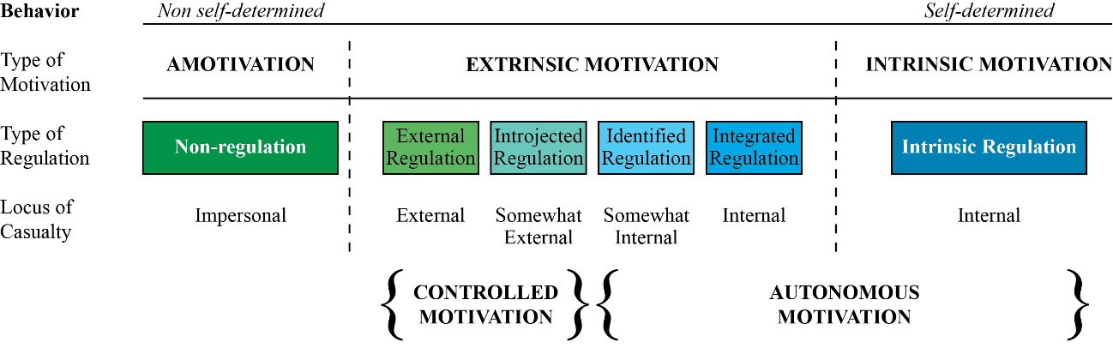
Figure 3. Self-Determination Continuum (adapted from Deci & Ryan, 2000)
At the far left of the self-determination continuum lies amotivation, which in the cognitive-motivation convention, is defined as “a state which people lack the intention to behave” (Deci & Ryan, 2000). Amotivation represents the lowest level of self-determined action because it is characterized by an impersonal perceived locus of causality (Deci & Ryan, 2000). Amotivation is manifested by a general sense of apathy (Alivernini & Lucidi, 2011) and according to self-determination theory, results from the absence of self-efficacy and control, and the inability to regulate behavior relative to an identified outcome (Pelletier, Dion, Tuson, & Green-Demers, 1999). Moving down the continuum, four distinct types of extrinsic motivation have been identified by Deci and Ryan (2000), from the least to the most autonomous in nature: external regulation, introjected regulation, identified regulation, and integrated regulation. While each form is still extrinsic in nature, again, they are differentiated relative to the degree to which motivation is internalized and integrated. According to Deci and Ryan (2008a),
SDT emphasizes that internalization and integration will function more or less effectively, depending on the degree to which organisms experience ambient supports for basic psychological need satisfaction. That is, people are inclined to internalize and integrate within themselves the regulation of activities that were initially prompted and/or regulated by external factors. For this process to operate effectively, however, people must experience satisfaction of the basic psychological needs (p. 16).

External regulation is the most controlled form of regulation where behavior results from external contingencies such as the receipt of rewards and/or the avoidance of punishment (Niemiec & Ryan, 2009). Through external regulation, behaviors have not been internalized (Vansteenkiste et al., 2006) and the individual adopts an external perceived locus of control (Deci et al., 1991). Behaviors are directed by factors external to the person, therefore once the external pressures are removed, the behavior terminates (Deci & Ryan, 1985b). The process of internalization begins with introjected regulation, however the behavior has only been partially internalized. With introjection, the individual acknowledges the external contingency, but has not accepted it as his or her own (Deci & Ryan, 2008a). Introjected regulation involves the feeling of internal pressure, for example, to avoid guilt or to satisfy feelings of self-worth (Taylor et al., 2014; Vansteenkiste et al., 2006). Both external regulation and introjected regulation are expressed as controlled motivation (Deci & Ryan, 2000).
The process of identification, and thus autonomous motivation, begins at identified regulation. Identified regulation involves the acceptance of the behavior as emanating from one’s self (i.e., internal perceived locus of causality) (Niemiec & Ryan, 2009; Deci & Ryan, 2008a; Deci et al., 1991). According to Alivernini and Lucidi (2011), “Identified regulation involves a conscious attribution of value to the behavioral objective” (p. 242). Ryan and Deci (2000a) contend, with identified regulation, the individual perceives his or her behavior as belonging to themselves and recognizes its importance in the achievement of personal goals. While identified regulation still remains extrinsic in nature, it manifests itself in behavior that is relatively volitional, or autonomous, more closely resembling intrinsic motivation (Vansteenkiste et al., 2006).
The penultimate point on the self-determination continuum is integrated regulation. Integration embodies the most wholly internalized form of extrinsic motivation. At this stage, the behavior is fully integrated with the person’s sense of self, and identification with the behavior has been reconciled with the person’s values, needs, and identity (Deci et al., 1991). Integration occurs when the behavior is deemed to be concordant with the values and needs of the individual (Ryan & Deci, 2000b). Integrated regulation, however, is not analogous to intrinsic motivation, which represents the highest level of self-determined activity (Deci & Ryan, 2000; Niemiec & Ryan, 2009). According to Deci and Ryan (2000), while integrated regulation contains similar features to pure intrinsic motivation, it is still viewed as extrinsic in nature because the goals for engaging in a particular behavior are different than simply the inherent pleasure of the activity. More precisely, the individual engages in a particular behavior without seeking an instrumental result outside of the pleasure realized in the activity itself (Deci & Ryan, 1985b). Therefore, intrinsic regulation, or more appropriately, intrinsic motivation, represents the highest form of self-determined action (Alivernini & Lucidi, 2011). Ryan and Deci (2000b) define intrinsic regulation as “the inherent tendency to seek out novelty and challenges, to extend and exercise one’s capacities, to explore, and to learn” (p. 70). Behavior that is intrinsically motivated is considered to fully encompass the self-determination of behavior and represent an entirely internal perceived locus of causality.
Bailey and Phillips (2016) found support for the self-determination theory of motivation in their examination of first-year psychology students. Students who identified with more intrinsically motivated behaviors reported increased levels of life satisfaction, positive affect, life meaning, and higher grades. Conversely, few significant relationships existed between extrinsic motivational orientations, well-being, and academic performance indicators. Amotivation was found to be significantly related to anxiety and depression. The authors thus maintain,
Students who were motivated to study by their curiosity to explore and learn new concepts, and those who found pleasure in the process of creating and achieving tended to feel a stronger sense of well-being, higher life satisfaction and meaning, and also performed better academically (Bailey & Philips, 2016, p. 10).

Kusurkar et al. (2013) found a significant correlation between autonomous, or self-determined, motivation, study strategies, study effort, and academic performance (grade point average). Specifically, those who were more autonomously motivated employed more positive study strategies and expended more effort in their study practices, thus leading to higher academic performance. This finding lends additional support to similar findings in Vansteenkiste, Zhou, Lens, and Soenens (2005) through their examination of Chinese students.
Additionally, in a study examining intrinsic and identified self-regulations and the relationships to academic performance and well-being, Burton, Lydon, D’Allessandro, and Koestner (2006) found intrinsic self-regulation to be positively associated with psychological well-being, independent of academic performance; identified self-regulation was a positive predictor of academic achievement as measured by report card grades; and finally there was a demonstrated interaction effect between identified self-regulation and academic performance in the prediction of psychological well-being. In a meta-analysis examining motivational types (autonomous versus controlled), Taylor et al. (2014), found, in general, autonomous motivational types (intrinsic and identified regulation) to be the strongest positive predictor of academic achievement. In a subsequent study, Di Domenico and Fournier (2015) found a positive relationship between intelligence, conscientiousness, and autonomous motivation to cumulative grade point average. Interestingly, they also identified that at lower levels of conscientiousness, the effect of autonomous motivation was greater than for those students who reported higher levels of conscientiousness.
Psychological Need Support
A foundational tenet of self-determination theory (SDT; Deci & Ryan, 1980, 1985a, 1985b, 1991, 2000, 2008b) is the concept of psychological needs and the social/interpersonal environment that supports the satisfaction of those needs. It is hypothesized that support for a person’s psychological needs leads to the self-regulation of behaviors and values, increased intrinsic motivation, and internalization and/or integration of extrinsic motivation (i.e., autonomous, or more self-determined, forms of motivation) (Williams & Deci, 1996). Niemiec and Ryan (2009) maintain that humans have an inborn desire to engage with their social environment and are “innately curious, interested creatures who possess a natural love of learning and who desire to internalize knowledge, customs, and values that surround them” (p. 133).
Within self-determination theory, Deci and Ryan (2000) define psychological needs as “nutriments that are essential for ongoing psychological growth, integrity and well-being” (p. 229). Therefore, the degree to which an individual’s psychological needs of autonomy, competence, and relatedness are met, more adaptive outcomes (Patrick et al., 2007), internalization of behavior (Deci & Ryan, 2000; Williams & Deci, 1996), and increased motivation (Deci et al., 1991) are hypothesized to follow. Self-determination theory further maintains there exists a distinct developmental process that occurs by which people come to understand the regulatory processes of their social environment, referred to as organismic integration. It is theorized that the process of organismic integration ultimately enables the individual to act in a more autonomous, rather than controlled, manner (Deci, Eghrari, Patrick, & Leone, 1994). In an environment where the needed supports for the promotion of self-determined action are present, the integration process will function in an optimal fashion. Alternatively, when the social environment fails to provide the necessary nutriments for self-determination, the integration process will not function in the most effective manner, leading to introjection, or regulation by external forces (Deci et al., 1994). Vallerand et al. (2008) assert that positive changes in motivation, moving from the situational level to the contextual level, occur through individual interactions with the social environment that are continually internalized within the person.
Over the past several decades, an extensive body of research has been conducted relative to how the social environment can either support or impede the satisfaction of basic psychological needs, and in turn, affect the self-regulation of behavior, motivation, and ultimately performance (Deci et al., 1991). According to Vallerand (2000), support within the social environment for a person’s psychological needs of autonomy, competence, and relatedness has a substantial influence on outcomes, but is mediated by autonomous motivation. The more an individual finds supports within the social environment for the satisfaction of needs, it is theorized that motivation will be more fully integrated within the person (Deci et al., 1991), however, personal experiences of need support are entirely determined by an individual’s environment, or the social context in which they are a part (Ryan, Williams, Patrick, & Deci, 2009). For example, Soenens and Vansteenkiste (2005) found in their study of parenting and teaching styles that perceived support for an adolescent’s psychological needs, specifically autonomy support, indirectly affects outcome variables through more self-determined, or autonomous, functioning. Moreover, Feri and colleagues (2016) found that within a learning environment, psychological need support is a substantial contributing factor in the development of autonomous motivation. Need support is thought to be an essential component for optimal development and functioning (Niemiec et al., 2006)
As it relates to learning environments, within self-determination theory, support for autonomy, competence, and relatedness is posited to affect self-regulated learning, motivation, and indirectly, academic achievement (Schuitema, Peetsman, & van der Veen, 2016). The extent to which a person functions in a more autonomous versus controlled manner is directly related to the interpersonal environment that provides the needed supports for autonomy, competence, and relatedness (Black & Deci, 2000). When needs are satisfied, optimal self-regulation, motivation, and well-being are believed to follow (Niemiec et al., 2006), while conversely, an environment that does not provide the nutriments for need satisfaction leads to distress (Deci & Ryan, 2000) and decreased autonomous motivation (Deci, Koestner, & Ryan, 1999; Deci et al., 1991). Within the academic setting, Niemiec and Ryan (2009) argue that when the needs of autonomy, competence, and relatedness are supported, students are more autonomously engaged academically and are increasingly likely to internalize their motivation relative to adaptive academic behaviors. Therefore, according to Niemiec and Ryan (2009), “understanding how to facilitate internalization becomes a critical educational objective” (p. 139). In a study by Baeten et al. (2013) assessing learning environments and perceived need support of first-year undergraduate teacher education students in Belgium, those who perceived the environment to be more need-supportive were more autonomously motivated, which in turn, was shown to positively predict academic achievement, as measured by class grades.
While each identified dimension of psychological need support (autonomy, competence, and relatedness) is tied to a specific innate psychological need, their association to, and interaction with, one another, however, is not entirely perfect or clear-cut (Connell & Wellborn, 1991). Each specific need acts in a complementary fashion with the each other to enhance aspects of need satisfaction, however each need still has a distinctive influence on overall need satisfaction, motivation, and engagement (Stroet et al., 2013), thus “support for one dimension cannot compensate for lack of support for another dimension” (Stroet et al., 2013, p. 68).

Autonomy Support
Within self-determination theory, support for autonomy is an important environmental variable for fostering motivation (Ciani et al., 2011). In general, the term autonomy support is defined as supports within the social environment that enable an individual to be self-initiating in their actions and to act with volition, or choice, thus reflecting their authentic sense of self (Stroet et al., 2013). According to Niemiec and Ryan (2009), providing choice, meaningful rationales, acknowledging feelings, and minimizing pressure are all beneficial strategies for developing autonomy-supportive environments. In contrast, controlling environments utilize pressure to get others to behave in particular ways, either through implicit or explicit rewards and/or punishments (Black & Deci, 2000), and have been shown to stifle, or inhibit, self-determined regulation (Soenens & Vansteenkiste, 2005). Vansteenkiste et al. (2006) argue that such tactics actually prompt externally controlled regulations, thus hindering autonomous motivation.
In order to promote optimal human functioning in various life domains, one must experience a sense of personal autonomy (Soenens & Vansteenkiste, 2005). Numerous studies have demonstrated how autonomy-supportive environments foster forms of motivation that are more self-determined, or autonomous, in nature (Vallerand et al., 2008). For example, in a study of 10th, 11th, and 12th grade students (Study 1), and those in their last year of high school (Study 2), assessing the level of autonomy- supportive behaviors provided by parents and teachers and its relationship to self-determination, Soenens and Vansteenkiste (2005) found overwhelming evidence of a positive relationship in the domains of performance in school and peer competence (Study 1), and school performance and job-search activities (Study 2). In a study of medical students, Williams and Deci (1996) found a strong positive association between student perceptions of autonomy support provided by instructors and autonomous self-regulation in regard to learning. Interestingly, in this same study, autonomy support provided by instructors had a positive effect on student’s exhibiting more autonomy- supportive behaviors with simulated patients. Black and Deci (2000) found perceived autonomy support provided by study group workshop leaders in an organic chemistry course explained increases in the relative autonomy of the students, increased competence, interest, and enjoyment, and decreased anxiety. This in turn, was a significant predictor of course performance, above what was explained by student ability.
When the social environment provides support for autonomy, intrinsic motivation is enhanced, while it also assists in the internalization and integration of extrinsic motivations (Vansteenkiste et al., 2006). In line with prior theorizing on self-determination theory, Williams and Deci (1996) maintain that the more autonomy- supportive the environment, the more likely people will be to internalize values. In the academic setting, Deci et al. (1994) found that autonomy-supportive environments facilitate increased internalization and integration, lending additional support to similar findings of Grolnick and Ryan (1987) who established a positive relationship between elementary students’ perceptions of autonomy support, increased autonomous functioning, and internalization of material being taught. In a study of high school students, Vansteenkiste et al. (2012) identified those who perceived strong support for autonomy had the most adaptive outcomes, specifically autonomous motivation to study, use of self-regulated learning strategies, and less behavioral problems (i.e., substance use and delinquency).
Burt, Young-Jones, Yadon, and Carr (2013) further extended the importance of autonomy support within the educational setting to the role of academic advisors. They found perceived autonomy support from academic advisors to be a strong predictor in the fulfillment of the need for autonomy, and in some cases, even more so than autonomy support provided by the instructor. Burt et al. (2013) assert that
advising is a teaching and learning process, albeit with a different curriculum and pedagogy than those of traditional instruction. An autonomy-supportive advising relationship may provide a venue for teaching students to develop competencies related to volitional, self-directed decision-making in college and beyond (pp. 50-51).

Overall, this research sets the stage for future studies to explore the role of an underrepresented group within the self-determination theory literature – that of the academic advisor. The results clearly demonstrate that a relationship was found to exist and in some cases, was stronger for the role of the advisors than that of the instructor. Moreover, as a result of limited research in this specific domain, the results are exploratory in nature, but provide initial findings that can spur further research.
Competence Support
Much of the extant literature on need-supportive environments focuses heavily on the positive outcomes related to supports for autonomy, including the facilitation of self-determined motivation. While it can be argued that autonomy support is a critical social-contextual variable that deserves attention, what should not be overlooked is how and why environmental factors that promote feelings of competence interact with the other innate psychological needs to bring about more autonomous functioning, and thus more adaptive outcomes and enhanced well-being. Again, according to self-determination theory, when all three psychological needs are supported – autonomy, competence, and relatedness [emphasis added] – individuals are more likely to internalize motivation, and function in more autonomous ways (Deci & Ryan, 2000; Niemiec & Ryan, 2009).
Again, competence refers to “the experience of behavior as effectively performed” (Munoz & Ramirez, 2015, p. 200). Extending further, according to Stroet and colleagues (2013), in an individual’s interactions with his or her external environment, there is a need to not only feel effective, but to also continually exercise and extend his or her capacities. Therefore, a social environment that affords opportunities for optimal challenge, provides feedback in a non-controlling manner, and identifies ways in which the individual can more effectively meet challenges, and thus become more competent, is competence supporting (Deci et al., 1991; Niemiec & Ryan, 2009; Ryan & Brown, 2005). Elliot and Dweck (2005) maintain that the need for competence is an essential psychological nutriment that helps people to grow within, and adapt to, their environment. Accordingly,
This need for competence instigates and activates behavior that is oriented towards competence. Over time, individuals learn to direct this general motivational energy using concrete, cognitively based goals and strategies; that is people learn to use self-regulatory tools to channel their general desire for competence towards specific outcomes and experiences that satisfy the competence need (Elliot & Dweck, 2005, p. 6).

Taken together, supports for the perception of competence have been theorized to bring about more behavioral self-regulation and internalization of motivation, which in turn facilitates increased autonomous functioning and goal-directed action.
Several studies have demonstrated the positive association between competence support and various performance and psychological indicators. In a study of undergraduate psychology students where need support was experimentally manipulated in a game-learning context, Sheldon and Filak (2008) found those students in the high competence support cohort had unique main effects on several outcomes, including self-rated motivation, positive affect, and game performance. In a subsequent study of middle school students assessing need support from teachers, expectancy-related beliefs, subjective task values, concentration, and persistence in the physical education domain, Zhang, Solmon, and Gu (2012) found that physical education students’ perception of competence support was a significant, positive predictor of expectancy beliefs as well as subjective task values. According to the authors, “the more students perceived they were competent in physical education and valued physical education as an important, interesting, and useful school subject, and perceived autonomy and competence support from physical education teachers, the more likely they were to exert effort and concentrate in physical education” (p. 339). Tong et al. (2009) demonstrated in an examination of Singaporean police officers that satisfaction of the need for competence (and relatedness) was positively related to feelings of joy and negatively related to feelings of anger, sadness, and fear. Similar results were identified by Reis et al. (2000) showing increased levels of competence (and autonomy) were positively related to positive affect and vitality, while negative related to negative affect and physical symptoms.
To further understand the dynamic interplay between autonomy support and competence support, Radel, Pelletier, and Sarrazin (2013) undertook an interesting study in which support for autonomy was deprived and competence support was manipulated within the activity of playing the game of Mahjong among two cohorts – those who were experienced at playing Mahjong and those who were not. The researchers found those individuals who received positive competence feedback exhibited more autonomous behaviors when support for autonomy was removed than did those who received negative competence feedback. Radel and colleagues (2013) go on to hypothesize that competence acts in an integral way as people cope with threats to autonomy. Moreover, those who had feelings of competence, and those feelings were supported, approached the game task in more adaptive ways in their attempt to reclaim feelings of autonomy. Taken together, these results provide further evidence of how an environment that provides support for competence can actually interact and complement one’s need for autonomy to bring about adaptive outcomes.
Relatedness Support
The notion of relatedness support has its origins in people’s need to feel a sense of connection with other people, to develop mutually caring relationships, and to feel a sense of belonging and connectedness with a social group (Stroet et al., 2013). The aforementioned characteristics of relatedness are quite similar to Baumeister and Leary’s (1995) definition of relatedness as “a pervasive drive to form and maintain a minimum quantity of lasting, positive, and significant interpersonal relationships” (p. 497). According to Niemiec and Ryan (2009), ways to provide support of the need for relatedness involves displaying warmth, demonstrating concern for the individual, and offering respect. While this bears similar characteristics to the concept of social support (Furrer & Skinner, 2003; King, 2015), King (2015) maintains that the two constructs – relatedness and social support – are not precisely one in the same. According to King (2015), social support includes features such as active support for the achievement of specific tasks, while characteristics of relatedness support emphasizes an individual’s overall perception of emotional connection within their social environment rather than instrumental support.
The concept of relatedness support is indeed not a new phenomenon, however, much of the research on psychological need satisfaction and need support within the self-determination theory literature tends to focus attention on autonomy and competence (King, 2015; Vallerand, 2000). The attention paid to autonomy and competence is even more apparent within the SDT literature relating to the academic domain (Skinner, Furrer, Marchand, & Kindermann, 2008). In fact, in their review of over two decades of research on self-determination theory and autonomous motivation, Deci and Ryan (2000) suggested that the role of relatedness, or relational support, within the motivational sequence acted in more of a subordinate role to that of autonomy and competence. According to Deci and Ryan (2000),
Relational supports may not be necessary as proximal factors in maintaining intrinsic motivation. Instead, a secure relational base appears to provide a needed backdrop – a distal support – for intrinsic motivation, a sense of security that makes the expression of this innate growth tendency more likely and more robust (p. 235).

Of course, they and others did not discount the significance of the need for, and perception of, connectedness and belonging within the social environment as it relates to self-determined motivation; though, simply stated, it was just not as important.
Nevertheless, Vallerand (2000), in his commentary on self-determination theory and psychological needs, asked the intriguing question, “should it be expected that all three types of perceptions yield equally important effects on motivation?” (p. 316). He hypothesized that the need for relatedness may hold varying levels of prominence depending upon an individual’s desire for fulfillment of that particular need. Moreover, relative to affecting motivation, each psychological need may serve a specific purpose for each individual, and thus elicit different outcomes. Vallerand viewed this idea as a critical component in understanding individual differences in motivation. In their longitudinal study of elementary-aged children, Furrer and Skinner (2003) found those who identified with a greater sense of relatedness demonstrated better academic engagement, motivation, and performance, through both self-report and teacher ratings. Furthermore, based on these results, the authors posited that relatedness may also serve as a psychological resource when faced with challenges and obstacles, or when confronted with a new and unfamiliar situation. Therefore, it would appear that the perception of connection to others, in many ways, acts as a psychological buffer in the face of difficulties, which enables the individual to demonstrate more adaptive responses (i.e., self-confidence, vigor, and resolve) (Furrer & Skinner, 2003).
Even though much of the empirical research within the SDT literature has not focused heavily, or specifically, on the role of relatedness and relatedness support, there exists a strong body of evidence as to its significance and proximal value. For example, Ryan, Stiller, and Lynch (1994) found that the quality of both teacher and parent relatedness representations were unique, significant predictors of measures of school functioning, including enhanced sense of control, positive attitude, engagement, autonomy, and motivation. Positive interpersonal relationships, according to Martin and Dowson (2009), “provides a primary pathway toward motivated engagement in life activities” (p. 330). Within the academic setting, positive teacher relationships can help to facilitate the student’s internalization of values held by the teacher regarding academics (Martin & Dowson, 2009). Moreover, when students’ relatedness needs are met and supported, it has the potential to yield positive emotional responses, which can lead to the self-regulation of behavior (Meyer & Turner, 2002).
Summary
Studies have shown strong support for the role of hope as a psychological strength, thus leading to enhanced well-being (i.e., Ciarrochi et al., 2015; Macaskill & Denovan, 2014; Snyder, Harris et al., 1991; Snyder et al., 1996; Snyder et al., 1999; Snyder, 2002). Furthermore, the positive relationship between hope and academic achievement is also quite strong (i.e., Ciarrochi et al., 2007; Gallagher et al., 2016; Levi et al., 2014; Rand, 2009). Similarly, several studies have revealed the significance of environments which provide ambient supports for the psychological needs of autonomy, competence, and relatedness, as described within self-determination theory (SDT; Deci & Ryan, 1980, 1985a, 1985b, 1991, 2000, 2008b) on increased well-being (Patrick et al., 2007), enhanced motivation (Ciani, et al., 2011), and greater academic achievement (Bailey & Philips, 2016). While considerable attention has been provided in the extant literature on these constructs individually, an empirical understanding of how environmental supports for autonomy, competence, and relatedness lead to higher levels of hope, thus resulting in enhanced psychological well-being and academic achievement is lacking. In particular, how, through the social/contextual environment, does the character strength of hope become fully activated in an individual, and how does this relate to psychological and performance indicators? In short, this present study was developed to explore these specific questions, with the goal of providing educational administrators a more comprehensive understanding of student motivation, academic achievement, and well-being. It is when we endeavor to answer these questions and apply the scientific knowledge gained in real-world settings, we can fully meet the goals of psychology articulated almost a century ago.
Chapter 3: Methodology
The present research explored the structural relationships between psychological need support, autonomous self-regulation, hope, academic achievement, and psychological well-being in a sample of NCAA Division I student-athletes. The following chapter provides a description of those who participated in this research study along with a summary of their demographic characteristics. Additionally, information regarding the research design employed, the measures used, including the psychometric properties of each instrument, the procedures for data collection, and the subsequent data analysis techniques applied is also presented. The University of Oklahoma Institutional Review Board (IRB) for the Protection of Human Subjects approved the protocol for this study (see Appendix B).
Research Design
The present research utilized a non-experimental, cross-sectional design assessing the relationships between psychological need support, autonomous self-regulation, hope, academic achievement, and psychological well-being. Cross-sectional designs collect data at a single point in time among a sample of individual cases for use in establishing relationships between two or more variables. Therefore, variation between and among cases, or participants, is quite important (Bryman, 2016). Participants in this study were undergraduate students at The University of Tulsa (TU) who were listed on the official team roster as a member of at least one of the university’s intercollegiate athletics programs at the time of survey administration. For further information regarding participants in this study, including demographic information, please refer to the Participants section.
Procedure
Following the receipt of approval by the Institutional Review Board (IRB) of the University of Oklahoma to commence with the present research effort (see Appendix B), the researcher met with the Director of Athletics, the Executive Associate Athletics Director for Compliance, and the Associate Athletics Director for Academic and Student Services at the participating institution to explain the purpose of the study and to gain formal approval to survey all undergraduate student-athletes enrolled for the fall 2017 term. Once approval was granted by the Department of Intercollegiate Athletics (see Appendix C), the researcher coordinated with the athletics department office with oversight over academic support programs for student-athletes and the participating institution’s Institutional Review Board to administer the survey instrument.
Quantitative data were collected in two ways: questionnaires and academic data provided by the university (see Measures). The survey (see Appendix A) was administered to individual teams during previously scheduled mid-term academic meetings held over the course of 27 days (from October 26, 2017 through November 21, 2017). A total of 356 student-athletes were eligible to take the survey, however only 303 student-athletes were present at the mid-term academic meeting and received the survey. All 303 student-athletes present at the mid-term academic meetings provided their informed consent and completed the survey for an overall response rate of 100% (see Table 1). Academic data were collected from the Office of Academic and Student Services, in coordination with the university’s registrar’s office, following the submission of final course grades for the fall 2017 academic term. The researcher provided potential participants with a brief overview of the purpose of the research study in addition to data collection procedures, both verbally and in written form. The survey participants were assured of the confidentiality of their responses and that all data would be aggregated at a group-level, therefore no identifying information would be reported. Furthermore, once survey data were matched with academic data, all data were de-identified. It was communicated that completion of the survey was entirely voluntary and that no punitive consequences would result from non-participation in this research study. In addition, no material benefits or compensation was provided to those who participated. The survey was administered via paper and pencil format. According to previous research on methods of survey administration (Dommeyer, Baum, Hanna, & Chapman, 2004; Sax, Gilmartin, & Bryant, 2003), traditional paper and pencil format typically yield higher response rates than online administration of surveys.
Table 1

Survey Response Rates and Dates of Survey Administration
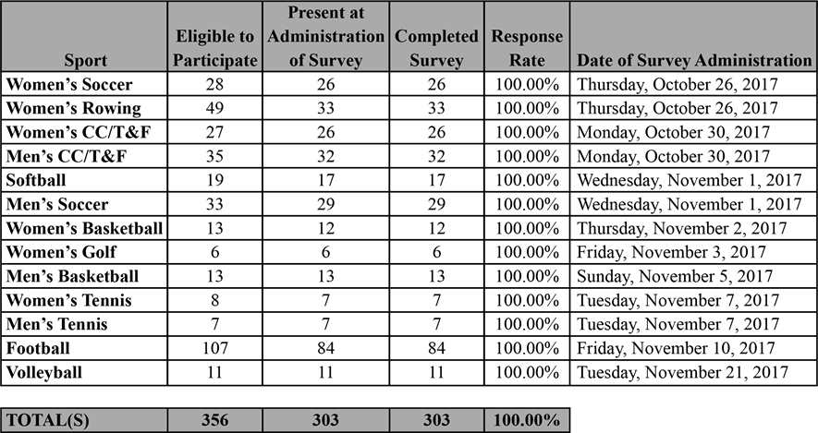
At the beginning of the survey, the participants were asked to provide their informed consent in addition to providing their university-issued identification number, which enabled the researcher to match survey responses with all college and pre-college academic data that were obtained at the conclusion of the semester. Following completion of fall 2017 term, academic data were gathered from the university registrar’s office in coordination with the academics and compliance offices within the athletics department following the participant institution’s standard grade reporting procedures. In addition, pre-college academic data, including ACT and/or SAT score and core high school grade point average (GPA) for each participant, were obtained through the participating institution’s Office of Academic and Student Services. Per NCAA guidelines regarding eligibility for incoming college freshman, high school grade point average was calculated based upon letter grades achieved in NCAA-approved core courses. Honors and/or advanced placement (AP) courses were taken into account in the calculation of core high school GPA, therefore a GPA of greater than 4.0 could be attained (NCAA, 2017b). For NCAA Division I, only classes in English, math (Algebra 1 or higher), natural or physical science, social science, foreign language, and comparative religion or philosophy are used in the calculation of core high school GPA. Courses in the fine arts, physical education, vocations, or courses not considered academic in nature (i.e., film appreciation, video editing, etc.) are not used in the calculation of core high school grade point average (NCAA, 2017a).
Study Setting
The University of Tulsa (TU) is a small, private, academically-selective NCAA Division I – Football Bowl Subdivision (FBS) institution of higher education founded in 1894. TU is located in Tulsa, Oklahoma, a mid-sized city of approximately 400,000 residents, and offers degree programs at the undergraduate (67), graduate (47), and doctoral (16) levels, in addition to law. The university was ranked number 86 in the
U. S. News & World Report’s 2017 rankings of national universities, and within the top-50 among private universities nationwide (U. S. News & World Report, 2016). The 2016-17 incoming freshman class had an average ACT score of 30, average SAT score of 1120, an average high school GPA of 3.9, and 76% were in the top-10% of their high school graduating class (The University of Tulsa, 2017a). Of the 128 universities competing at the NCAA Division I – FBS level during the 2016-17 academic year, only 17, or 13.3%, are private institutions. Additionally, TU is the smallest institution in the country by undergraduate enrollment competing in NCAA Division I – FBS athletics. With an undergraduate student population of 3,406 (The University of Tulsa, 2017b), nearly 11% of the student population are student-athletes. This is a very unique characteristic that distinguishes TU from other NCAA Division I – FBS institutions. The University of Tulsa sponsors 17 intercollegiate sport programs, including 10 women’s programs: basketball, cross country, golf, rowing, soccer, softball, tennis, indoor track and field, outdoor track and field, and volleyball; and 7 men’s programs: basketball, cross country, football, soccer, tennis, indoor track and field, and outdoor track and field.
Participants
The sample in this present study consisted of 303 undergraduate student-athletes at The University of Tulsa. The participants ranged in age from 18 to 23 years of age and included those in their freshman year of study through their senior year. The criteria for inclusion was the student-athlete must be enrolled full-time in an undergraduate course of study at the participating institution and be listed on the official team roster at the time of survey administration. Graduate-level student-athletes were not eligible to participate in the study.
Demographic information was collected from participants including gender, age, ethnicity, year of enrollment at their current undergraduate institution (i.e., first year, second year, third year, etc.), intercollegiate sport team(s) in which they are a member, and academic major of study (see Table 2). The majority of the respondents were male (54.5%), White/Caucasian (60.4%), in their first year of undergraduate study at The University of Tulsa (32.3%), and receiving a full athletic scholarship (46.9%). The mean age of respondents was 19.7 years of age (SD = 1.285). Every sport program sponsored by the university was represented in the sample with a majority participating in the sport of men’s football (27.7%). In addition, the academic major most represented in the student-athlete sample was Exercise Sport Science (21.5%).

Table 2

Demographic Information of Participants
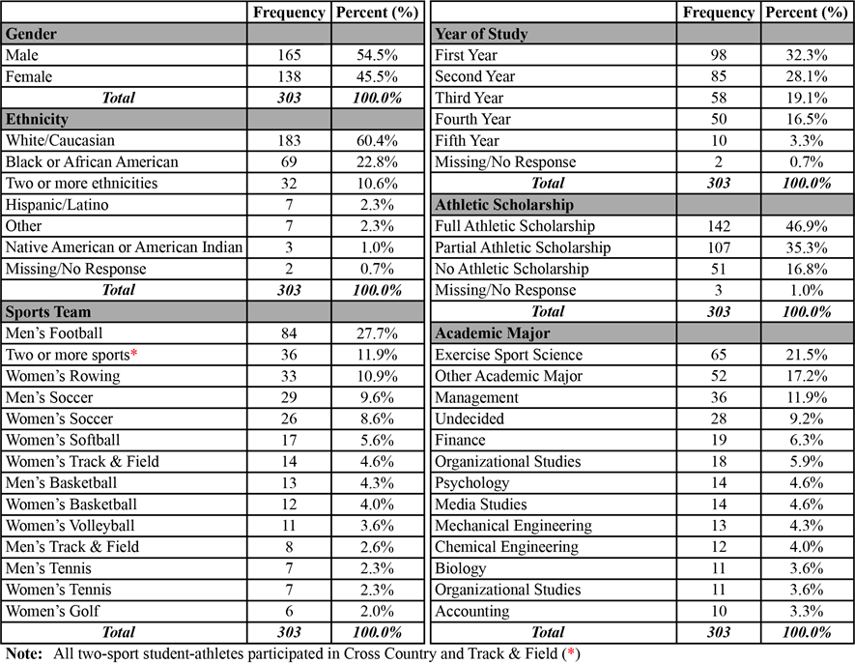
Measures
Several instruments were used in this study to measure perceived psychological need support, autonomous self-regulation, hope, psychological well-being, and academic achievement. Support for the three universal psychological needs of autonomy, competence, and relatedness, as postulated by Deci and Ryan (2000), was evaluated by the use of several scales. For autonomy support, an adapted version of the Learning Climate Questionnaire (LCQ; Williams & Deci, 1996) was applied. To assess support for competence, an adapted version of the Perceived Competence for Learning Scale (PCS-L; Williams & Deci, 1996) was used. For relatedness support, an adapted form of Furrer and Skinner’s (2003) Sense of Relatedness Scale was utilized. The autonomous-self-regulation subscale of the Learning Self-Regulation Questionnaire (SRQ-L; Black & Deci, 2000) was modified slightly to gain a more global assessment of the autonomous behavioral regulation of the research participants. The Adult Hope Scale (AHS; Snyder, Harris et al., 1991) and the Domain-Specific (Academics) Hope Scale (DSHS-A; Sympson, 1999) was used to explore hope. The Satisfaction With Life Scale (SWLS; Diener, Emmons, Larsen, & Griffin, 1985) was used to assess psychological well-being. Finally, academic achievement was objectively measured through the use of semester grade point average (GPA). All abovementioned scales were available for use without cost to the researcher. Survey items are provided in Appendix A.
Psychological Need Support and Autonomous Self-Regulation
According to self-determination theory, there exists three innate and universal psychological needs which must be satisfied in order for an individual to realize optimal functioning and psychological health (Deci & Ryan, 2008b). Moreover, universality implies that the importance of psychological needs extend across cultures and domains (Milyavskaya & Koestner, 2011). As identified in the SDT literature, a significant characteristic of the adaptive human experience lies an individual’s desire “to engage interesting activities, to exercise capacities, to pursue connectedness in social groups, and to integrate intrapsychic and interpersonal experiences into a relative unity” (Deci & Ryan, 2000, p. 229). Thus, satisfaction of, and support for, the needs of autonomy, competence, and relatedness are fundamental to achieving our natural human tendency towards effectiveness, social connection, and coherence (Deci & Ryan, 2000). How psychological need satisfaction translates to more adaptive performance and psychological outcomes, however, has been postulated to occur through more autonomously self-regulated behaviors and motivation (Vallerand, 2000). The extent to which the social environment either supports or thwarts the satisfaction of autonomy, competence, and relatedness, in turn leading to more autonomous functioning, is of keen interest to both scholars and practitioners.
To examine environmental supports for autonomy, competence, and relatedness, along with behavioral self-regulation, several measures were utilized in this current study, including the Learning Climate Questionnaire (LCQ; Williams & Deci, 1996), the Perceived Competence for Learning Scale (PCS-L; Williams & Deci, 1996), the Sense of Relatedness Scale (Furrer & Skinner, 2003), and the Learning Self-Regulation Questionnaire (SRQ-L; Black & Deci, 2000).
Autonomy support. The Learning Climate Questionnaire (LCQ; Williams & Deci, 1996), an adapted version of the Health Care Climate Questionnaire (Williams, Grow, Freedman, Ryan, & Deci, 1996), is an individual differences measure used to assess students’ perception of autonomy support provided by their professors/instructors. The original 15-item version of the scale was used by Williams and Deci (1996) in a study of second year medical students in an interviewing course. The present study utilized the short-form, six-item version of the scale adapted to consider the general learning climate experienced by the student, rather than for the climate of a specific class or professor. All scale items were measured on a seven-point Likert-type scale ranging from 1 (definitely false) to 7 (definitely true). Sample survey items include, “I feel that my professors provide me choices and options,” and “My professors encourage me to ask questions.” Scores range from a high of 7 to a low of 1. Scores are determined by averaging the individual item scores, with larger average scores indicating the student’s greater perception of autonomy support.
In initial validation of the 15-item measure, Williams and Deci (1996) found all items to load on a single factor explaining 63% of the variance. The measure also had high internal consistency with an alpha reliability of 0.96. In a subsequent analysis by Black and Deci (2000), studying the effects of instructors’ autonomy support and students’ autonomous motivation in an organic chemistry class, alphas of 0.93 and 0.94 were reported at two different time points. Nunnally and Bernstein (1994) established a criterion of 0.70 or greater for acceptable internal reliability estimates for scales in the psychological domain. For the present sample, Cronbach’s alpha was 0.91.
Competence support. Support for competence was examined by use of the Perceived Competence for Learning Scale (PCS-L; Williams & Deci, 1996). The Perceived Competence for Learning Scale is a short, four-item questionnaire used to evaluate a person’s perceived competence. The scale was originally developed for use in a study of medical students learning course material, but specifically examined the students’ satisfaction of the need for competence, not necessarily competence support. Therefore, items were adapted to tap specific competence supporting behaviors provided by professors. A Cronbach’s alpha of 0.80 was reported (Williams & Deci, 1996) indicating good internal consistency. In a slightly adapted version of the scale investigating management of glucose levels in patients with diabetes, Williams, Freedman, and Deci (1998) reported alpha levels at three time points to be 0.85, 0.87, and 0.84, respectively. Sample items used in this present study include, “My professors are confident in my abilities to learn course material,” and “My professors demonstrate that I am able to achieve my goals in their courses.” For this present sample, Cronbach’s alpha was 0.91.
All competence support items were measured on a seven-point Likert-type scale ranging from 1 (strongly disagree) to 7 (strongly agree). Total score is determined by averaging the individual item scores, with higher average scores indicating perception of competence supporting behaviors provided by professors. Scores range from a high of 7 to a low of 1.
Relatedness support. Relatedness support was examined in this present study by use of revised items from the Sense of Relatedness Scale (Furrer & Skinner, 2003). The Sense of Relatedness Scale is self-report measure assessing an individual’s sense of belonging, or connectedness, to various social partners. In the first use of the scale, five different social partners were addressed (i.e., mother, father, teacher, classmates, and friends). For this study, only items referring to the sense of relatedness to teachers/professors were used for a total item pool of 4. Each item was measured on a seven-point Likert-type scale ranging from 1 (definitely false) to 7 (definitely true). An overall score was determined by averaging the individual item scores. Initial validation of the instrument demonstrated strong psychometric properties with reported alphas of 0.79 for relatedness to teachers. In a subsequent study of elementary school children assessing engagement and disaffection in the classroom setting, Skinner et al. (2008) used only items referencing the teacher as a social partner, and reported a Cronbach’s alpha of 0.82 in the fall semester and 0.84 for the spring semester. For the present sample of student-athletes, Cronbach’s alpha for relatedness to professors was 0.79.
Behavioral self-regulation. The Learning Self-Regulation Questionnaire (SRQ-L; Black & Deci, 2000), was used to measure the extent respondents were autonomous in their motivation and learning-related behaviors. The particular instrument used in this present study was adapted from Black and Deci’s (2000) original survey, which studied college students in a particular class, to more adequately fit the collegiate learning environment generally. The SRQ-L is just one instrument in a series that can be used within various contexts (i.e., exercise, religion, and prosocial behaviors) and age groups (children, adolescents, and older adults).
The questionnaire was developed with two subscales, or “super” categories – autonomous regulation (identified regulation and intrinsic motivation) and controlled regulation (external and introjected regulation). For the purposes of this present study, only the five items tapping autonomous reasons for engaging in learning-related behaviors were used. An example of a survey item includes, “I will participate actively in my classes because I feel like it’s a good way to improve my understanding of the course material.” Each item was measured on a seven-point Likert-type scale assessing how true each statement is to the respondent (1 = definitely false to 7 = definitely true). An autonomous regulation subscale score was determined by averaging item responses.
The SRQ-L has been used in past studies with older students and has demonstrated adequate psychometric properties. Furthermore, within the family of self-regulation questionnaires, the SRQ-L is an adaptation of the Academic Self-Regulation Questionnaire (SRQ-A; Ryan & Connell, 1989), which was designed for use with elementary school-aged children, and the Learning Self-Regulation Questionnaire developed by Williams and Deci (1996) for use with medical students regarding autonomy for learning about medical interviewing. A Cronbach’s alpha of 0.78 for the autonomous regulation subscale was reported in initial validation procedures for Williams and Deci’s (1996) scale. An alpha score of 0.75 for autonomous regulation was reported for Black and Deci’s (2000) adapted SRQ-L. For this current sample, Cronbach’s alpha for autonomous regulation was 0.78.
Hope
One of the fundamental aspects of positive psychology is that it is rooted in science and the scientific method. According to Peterson and Park (2003),
The goals of positive psychology are description and explanation as opposed to prescription. The underlying premise of positive psychology is of course prescriptive in that it says that certain topics should be studied: positive experiences, positive traits, and positive institutions. However, once the study begins, it has to be hardheaded and dispassionate. The routes to the good life are an empirical matter. Indeed, whether what seems positive is always desirable is also an empirical matter (p. 145).

In light of this impassioned directive, several measures of hope have been previously developed. Two particular scales within the hope literature were utilized in this research study – the Adult Hope Scale (AHS; Snyder, Harris et al., 1991) and the Domain-Specific (Academics) Hope Scale (DSHS-A; Sympson, 1999).
Adult hope scale. The Adult Hope Scale (AHS; Snyder, Harris et al., 1991), also referred to as the Dispositional or Trait Hope Scale, or when administered, the Future Scale, is an individual differences self-report index of hope on a generalized level, rather than for a specific goal. The scale consists of 12 total items, eight tapping the hope construct plus the addition of four filler, or distractor, statements. All scale items are measured on an eight-point Likert-type scale ranging from 1 (definitely false) to 8 (definitely true). For this present study, the four distractor statements were omitted because they are not used to determine total hope score. Additionally, the original scale employed a four-point response format, however, a subsequent revision introduced an eight-point format, which yielded higher average score reliability (Hellman, Pittman, & Munoz, 2013). The scale used in this present study employed the eight-point response format. Four items assess hope pathways, which concerns an individual’s cognitive evaluation of their capacity to generate perceived routes to goals, in addition to their ability to navigate and overcome obstacles that may occur during the goal pursuit process (Snyder, Harris et al., 1991). Examples of hope pathways items include, “There are lots of ways around any problem,” and “Even when others get discouraged, I know I can find a way to solve the problem.” Four additional items measure hope agency, or the capacity to motivate oneself to utilize perceived routes to desired goals (Snyder, Harris et al., 1991). Examples of hope agency items include, “I energetically pursue my goals,” and “I meet the goals that I set for myself.” Sub-scale scores for both hope pathways and hope agency are determined by adding the scores on each of the four items that tap those specific dimensions. Subscale scores range from 4 to 32. The total hope score is derived by summing the hope agency and hope pathways subscale scores. Scores on the Adult Hope Scale range from 8 to 64, with higher scores demonstrating higher levels of dispositional hope.
Initial validation of the Adult Hope Scale, which was administered to six diverse samples of University of Kansas students enrolled in an introductory psychology course and two samples of people undergoing psychological treatment, demonstrated acceptable psychometric properties. Cronbach’s alphas for the total hope scale ranged from 0.74 to 0.84; for the agency sub-scale, 0.71 to 0.76; and for the pathways subscale, alphas were in the range of 0.63 to 0.80 (Snyder, Harris et al., 1991). In confirmatory factor analysis to test the psychometric properties of the Adult Hope Scale, Babyak et al. (1993) found support for a two-factor solution representing agency and pathways. Moreover, in Creamer et al. (2009), agency and pathways are distinct constructs, however for hope to become fully activated, both must be present at some level. Accordingly, Creamer et al. (2009) asserted, “using the total hope score as a single variable in research is useful if researchers recognize the variable represents a higher-order latent variable, not simply a unidimensional first order construct” (p. 616). Marques et al. (2015) further supported this finding in a subsequent analysis. Hellman et al. (2013), in a reliability generalization study of Snyder, Harris et al.’s (1991) scale, observed acceptable mean reliability for internal consistency, ranging between 0.77 for the four-point response format to 0.82 for the eight-point response format, and high levels of test-retest reliability. Additionally, prior studies have shown consistent support for test-retest and internal reliability, factor structure, concurrent and discriminant validity, and convergent validity (Snyder, 1995; Snyder, 2002; Snyder, Harris et al., 1991; Snyder et al., 2001). For the present sample, Cronbach’s alpha for the total hope scale, hope pathways, and hope agency was 0.92, 0.87, and 0.88, respectively.
Domain-specific hope scale. Sympson (1999) developed a measure of hope in six different life domains (i.e., social, academic, family-home, romantic, work, and leisure). The underlying premise of domain-specific hope is that individuals develop various criteria and beliefs regarding hopeful thinking across different life domains, therefore hope should be measured as such, thus increasing the utility of the instrument (Robinson & Rose, 2010). According to Sympson (1999), there are several distinct advantages to gaining an understanding of how hope is exhibited in different life domains, including acquiring an awareness of how hope develops, in addition to effectively directing treatment or intervention strategies to meet the specific needs of the individual. Because this research study will be contextualized within an educational setting, the domain-specific scale utilized was the academic hope subscale of the Domain-Specific Hope Scale, which draws attention to classes, coursework, interest in school, and grades. The academics subscale contains nine total items, eight items specific to the academic realm modified from the agency and pathways items from the original Hope Scale (Snyder, Harris et al., 1991), plus one filler item. The one filler item was omitted in this present study. The academic hope subscale contains four agency items (e.g., “I energetically pursue my school work”) and four pathways items (e.g., “There are lots of ways to meet the challenges of any class”). All item responses are scored on an eight-point Likert-type scale ranging from 1 (definitely false) to 8 (definitely true). Total scores for the academics subscale range from 8 to 64, with higher scores indicating higher levels of academic-specific hope.
In initial validation studies, Sympson (1999) reported a Cronbach’s alpha for the academic hope subscale of 0.90, demonstrating high internal reliability. Additionally, as would be expected, the overall Domain-Specific Hope Scale and each of the domain subscales, positively correlated with the Hope Scale as well as the subscales for pathways and agency. Of the six domain-specific subscales, the academic hope subscale demonstrated the highest correlation to the Hope Scale (0.55) as well as the agency (0.56) and pathways (0.42) subscales. In a study conducted by Shorey, Roberts, and Huprich (2012), in which the Domain-Specific Hope Scale was used, alpha reliabilities for each of the subscales were in the range of 0.87 to 0.97. Subsequently, Feldman and Kubota (2015) reported a Cronbach's alpha of 0.85 in a sample of college students enrolled in an introductory psychology course, thus providing further empirical evidence as to the reliability and validity of scores obtained from the measure. For this present sample of undergraduate student-athletes at The University of Tulsa, Cronbach’s alpha scores for total academic hope, academic hope pathways, and academic hope agency was 0.90, 0.85, and 0.84, respectively.
Psychological Well-Being
The well-being of university students has garnered increased attention in the literature over the past decade (Howell & Buro, 2015). For example, Oades, Robinson, Green, and Spence (2011) advocated for an educational environment which fosters an engagement with learning as well as the requisite knowledge and skills to cultivate well-being within oneself and within others. Michalos (2008) offered this intriguing question, “Does education influence happiness and if so, how and how much?” (p. 348). According to Howell and Buro (2015), how the various components of well-being are nurtured within, and affected by, the educational environment, in addition to the ability to sufficiently measure positive feelings and optimal human functioning, is of critical importance and a key issue in any attempt to understand well-being in university students. The Satisfaction With Life Scale (SWLS; Diener et al., 1985) was used to assess psychological well-being in this research study.
Satisfaction with life scale. The Satisfaction With Life Scale (SWLS; Diener et al., 1985) is a short five-item self-report survey used to measure global life satisfaction. The survey uses a seven-point Likert-type scale to signify level of agreement or disagreement with each statement (1 = strongly disagree to 7 = strongly agree). Representative items include, “The conditions of my life are excellent,” and “If I could live my life over, I would change almost nothing.” Scores range from 5 to 35, with a higher score representing the respondent’s higher satisfaction with life. When the scale was first introduced, it was shown to have acceptable psychometric properties. A Cronbach’s alpha of 0.87 was reported (Diener et al., 1985). Subsequent analyses (Durak, Senol-Durak, & Gencoz, 2010) further supported the psychometric properties of the instrument. In Pavot and Diener (1993),
In making a life satisfaction judgement, the SWLS emphasizes the person’s own standards of evaluation. Furthermore, the respondent draws on the domains she or he find relevant in formulating his or her judgement of global life satisfaction. Because life satisfaction judgements are at least partially independent of affective measures, the SWLS is a promising instrument in terms of measuring change in subjective well-being and intervention outcomes (pp. 169-170).

For the present sample, a Cronbach’s alpha score of 0.87 was obtained.
Academic Achievement
Students’ academic achievement was measured through the use of fall 2017 semester grade point average. To control for initial levels of academic achievement at the start of their undergraduate studies, core high school grade point average was obtained. Academic data were collected from the athletics department’s academic and student services office in consultation with the participating institution’s registrar’s office.

Demographic Variables
Demographic data were also collected. The participants were asked to provide information on their age, gender, year in school, sport(s) in which they participate, ethnicity, and academic major of study (see Table 2).
Analytical Technique
The analytical techniques that were employed include general descriptive statistics, reliability estimates, correlation, confirmatory factor analysis, and structural equation modeling (SEM) analysis to ascertain the relationships between latent and observed variables. In the present study, model fit and parameter estimates were examined to test the strength of the hypothesized relationship between identified variables. Based on recommendations by Kline (2011) and Hu and Bentler (1995), fit indices that were examined included the chi-square (χ²) value, the comparative fit index (CFI), the goodness of fit index (GFI), the root mean square of error approximation (RMSEA), and the standardized root mean square residual (SRMR). Prior to model testing, the statistical assumptions associated with SEM were assessed, including multivariate normal distribution, linearity, freedom from outliers, and sample size. Statistical analysis (i.e., descriptive statistics, reliability, and correlation analysis) was conducted using the Statistical Package for the Social Sciences (SPSS) version 24.0 software program. Factor analysis and SEM analysis was conducted through the use of Analysis of Moment Structure (AMOS) version 24.0 software program (Arbuckle, 2016).
Structural equation modeling (SEM) has been increasingly used the past few decades in psychological and social science research (Anderson & Gerbing, 1988), and particularly, in the examination of individual differences within specified populations (South & Jarnecke, 2017). Furthermore, SEM has been used by many scholars in the examination of the educational environment and its relationship to motivation, self-regulation, attitudes, and several performance and psychological indicators (Khine, 2013). The purpose of SEM is to statistically test a priori hypotheses about the structural relationships between and among both observed variables and latent constructs (Hoyle, 1995). SEM comprises both measurement and structural approaches and models. The structural approach is used to identify interrelationships among variables through the application of simultaneous multivariate regression. In contrast, the measurement model involves determining the overall fit among observed, or indicator, variables in relation to latent constructs, while assessing and correcting for potential measurement error (In’nami & Koizumi, 2013; South & Jarnecke, 2017). The issue of assessment and correction of measurement error is of vital importance, and according to Byrne (2001), is perhaps a distinct limitation of other multivariate techniques solely (i.e., multivariate regression), and presents a potential problem for researchers due to inferring statistical relationships based on simple regression estimates. Additionally, through the use of SEM techniques, the researcher is better able to model the indirect effects among the relationships between variables, namely through a mediating variable or variables (In’nami & Koizumi, 2013).

Chapter 4: Results
The purpose of this present research study was to examine the structural relationships between psychological need support, autonomous self-regulation, hope, academic achievement, and psychological well-being in a sample of NCAA Division I student-athletes. The extent to which those within higher education can understand the contribution of environmental factors (i.e., need-supportive environments) in the development of autonomous self-regulation, motivation, and hopeful thinking, a dialogue can be initiated, based upon an empirical foundation, with leaders in both the educational and intercollegiate athletics community concerning factors that affect academic achievement and well-being. Most importantly, this knowledge can be used in the development and implementation of programs, training, and interventions with the stated goal of improving the educational experience of students and student-athletes alike, at the environmental, cognitive, and emotional levels.
The research hypotheses developed to guide this work were as follows:
H₁: Individuals who perceive higher levels of psychological need support will have higher levels of hope.
H₂: Individuals who are more autonomously self-regulated will have higher levels of hope.
H₃: Individuals who perceive higher levels of psychological need support will be more hopeful, and will have higher levels of academic achievement and psychological well-being.
H₄: Individuals who are more autonomously self-regulated will engage in more hopeful thought, and will have higher levels of academic achievement and psychological well-being.
H₅: Individuals who perceive higher levels of psychological need support will be more autonomously self-regulated, have higher levels of hope, and will have higher levels of academic achievement and psychological well- being.
Means, standard deviations, and bi-variate correlation coefficients (Pearson’s r) for key constructs are presented in Table 3. Table 3 also provides internal consistency reliability (Cronbach’s alpha) scores reported along the diagonal. Score reliability estimates ranged from 0.78 to 0.92, indicating good internal consistency of scale items (Nunnally, 1978; Nunnally & Bernstein, 1994). Correlation strength was interpreted utilizing Cohen’s (1992) effect size categories, ± 0.10 (small), ± 0.30 (medium), and ± 0.50 (large). Consistent with the conceptualization of psychological need support, the relationships between perceptions of autonomy support, competence support, and relatedness support were positive and statistically significant (p < 0.01). Additionally, the observed correlations between academic hope and dispositional hope (r = 0.621; p < 0.01), academic hope and psychological well-being (r = 0.483; p < 0.01), dispositional hope and psychological well-being (r = 0.666; p < 0.01), autonomous self-regulation and dispositional hope (r = 0.493; p < 0.01), and autonomous self-regulation and academic hope (r = 0.481; p < 0.01) were positive, strong, and statistically significant. These findings are consistent with existing theory relative to hope and self-determination theory. The strongest relationship to academic achievement, measured by term grade point average, was through academic hope (r = 0.465; p < 0.01). Specifically, academic hope agency was most strongly correlated to measures of academic achievement (r = 0.476; p < 0.01).
Preliminary Data Screening
According to DeSimone, Harms, and DeSimone (2015), while data screening can be a time-intensive process, employing appropriate data screening methods enhances the accuracy of the research, and “can increase the confidence that both readers and researchers have in the results of the study” (p. 180). Therefore, prior to performing the full analysis, data were reviewed for missing values, statistical power, normality, and linearity.
Missing Data
The original data set consisted of an N = 303 initiated responses, however a total of an N = 263 had complete data on all variables of interest in the present study. Missing data accounted for 13.2% of the total sample. Based upon a review of the literature concerning acceptable levels of missing data in a data set for valid statistical inference, there exists no clear-cut standard (Dong & Peng, 2013). For example, Schafer (1999) contends if 5% or less of the data is missing, it will have no effect on the analysis, while Bennett (2001) sets that level at less than 10%. Because missing data included 13.2% of the total sample, inter-item correlation substitution was performed on all missing individual scale items. Inter-item correlation substitution imputes values for missing data based upon the scale item most closely correlated to the missing item. If missing values could not be determined as a result of extensive missing data, those cases were subsequently dropped from the analysis. Furthermore, three participants
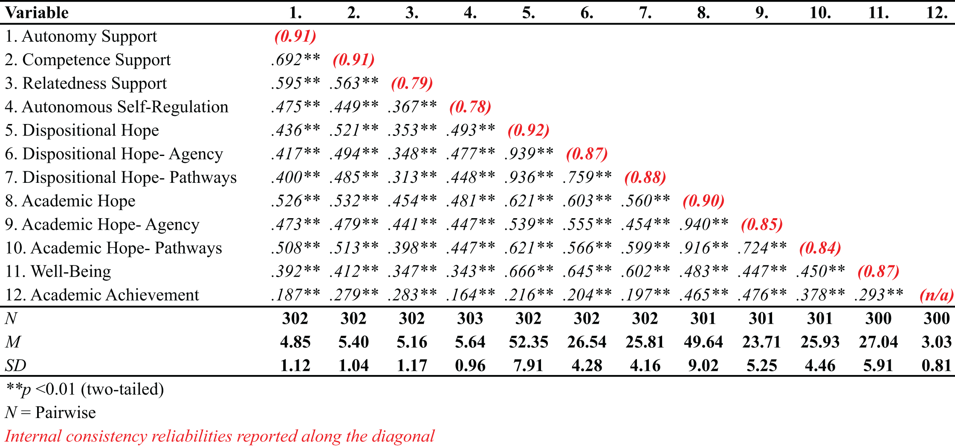
Table 3

Correlation Matrix for Key Variables
provided university-issued student identification numbers that could not be matched to the university roster of current students, therefore were removed from the analysis. The final data set consisted of an N = 294.
Power Analysis
AMOS provides Hoelter’s formula for critical N (CN) to estimate the sample size needed to obtain an adequate model fit for the χ² test (Hu & Bentler, 1995) at both the 0.05 and 0.01 CN values. The values for the first hypothesized model were 159 and 173, respectively. The .05 and .01 CN values for the second hypothesized model were 178 and 193, respectively. Therefore, both models demonstrated acceptable statistical power.
Normality
Before the confirmatory factor analysis (CFA) and structural models were tested, the assumption of normality, or the normal distribution of scores, was assessed. According to Micceri (1989), the normality assumption is often violated in much social and behavioral science research. Moreover, maximum-likelihood estimation (MLE) structural equation modeling and its related test statistics are fairly robust against violations of normality (McDonald & Ho, 2002). Nonetheless, extreme skewness and/or kurtosis can provide biased standard errors and test statistics (McDonald & Ho, 2002). Therefore, a test of multivariate skewness and kurtosis was performed. For the present data, the skewness ranged from -0.46 to -1.12 and kurtosis ranged from 0.02 to 1.76 (see Table 4). Following guidelines established by Kline (2011), for structural equation modeling analysis, skewness and kurtosis indices should be below an absolute value of 3.0 and 8.0, respectively. Based upon this recommendation, the data in this present study was determined to be normal for the purposes of structural equation modeling.
Table 4

Skewness and Kurtosis Values for Key Variables
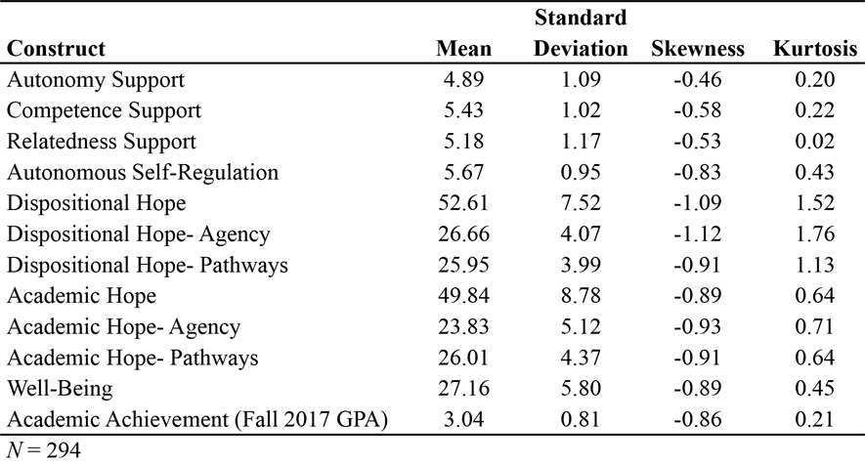
Linearity
The assumption of linearity concerns the existence of a linear relationship between the dependent and independent variables (Warner, 2013). If the relationship between the dependent variables and the independent variables is substantially inconsistent, then structural equation modeling analysis may be affected (Gaskin, 2016). The dependent variables in this present study included psychological well-being and fall 2017 term grade point average. The independent variables of interest include autonomy support, competence support, relatedness support, autonomous self-regulation, dispositional hope, and academic hope. To test for the assumption of linearity, a deviation from linearity test contained within the analysis of variance (ANOVA) procedure was performed. If the p-value for the deviation from linearity test is significant at the 0.05 level, then the relationship between the dependent and independent variables is regarded as non-linear. For the present data, no significant value was obtained. Additionally, a visual review of the partial scatterplot of the independent variables and each dependent variable indicated linearity was a reasonable assumption.
Model Fit
The first step in the model evaluation process was through the examination of the fit indices provided in AMOS. There exists many indices to test how well the empirical data fits the proposed theoretical model. For the purposes of this present study, five indicators of fit to assess the hypothesized models were evaluated based upon recommendations by Kline (2011) and Hu and Bentler (1995). Those fit indices included the chi-square (χ²) statistic, the comparative fit index (CFI), the goodness of fit index (GFI), the root mean square of error approximation (RMSEA), and the standardized root mean square residual (SRMR).
The model chi-square (χ²) value is an absolute measure of overall model fit (Hooper, Coughlan, & Mullen, 2008). According the Hu and Bentler (1999), the chi-square value “assesses the magnitude of discrepancy between the sample and fitted covariance matrices” (p. 2). This value is generally represented relative to the degrees of freedom (df) for the model (Jöreskog & Sörbom, 1993). A small chi-square value in relation to the model’s degrees of freedom, or a ratio of 3.0 or less, with an insignificant p-value at the 0.05 threshold is an indication of good model fit (Barrett, 2007; Hoe, 2008; Kline, 2011). A non-significant p-value is generally not common however, even if the model may be a good fit to the data (Teo, Tsai, & Yang, 2013). While the chi-square value is the initial test statistic to examine, it is sensitive to sample size, often leading to rejection of the model when the sample size is large (Bentler & Bonnet, 1980; Jöreskog & Sörbom, 1993). Therefore, it is also important to evaluate other fit indices. The comparative fit index (CFI) is an incremental fit index which assumes that the latent variables within the model are uncorrelated with each other and compares the sample covariance matrix with the uncorrelated model (Hooper et al., 2008). A benefit of this particular test statistic is that sample size is taken into account (Byrne, 1998). For the CFI, values ≥ 0.90 are considered acceptable, while values ≥ 0.95 are indicative of a good fit to the data. The GFI, or goodness-of-fit, statistic evaluates the proportion of the variance accounted for by the estimated population covariance (Tabachnick & Fidell, 2007). Values on ≥ .90 have been recommended for the GFI (Hooper et al., 2008). The root mean square error of approximation (RMSEA) is regarded as one of the most helpful indices of model fit (Diamantopoulos & Siguaw, 2000) because it provides information as to the extent to which the hypothesized model with unknown parameter estimates fit the population covariance matrix (Byrne, 1998). An RMSEA value of < 0.06 is indicative a “good” fit (Hu & Bentler, 1999), while values of up to 0.08 can be considered an “acceptable” fit (McDonald & Ho, 2002). Finally, the standardized root mean square residual (SRMR) is another absolute measure of fit. Measures of absolute fit test how well an a priori model fits the sample data (McDonald & Ho, 2002). An SRMR value of < 0.08 is generally considered to be an acceptable threshold level (Hu & Bentler, 1999).

Model One
Results of the first structural equation model using MLE appear in Figure 4. Parameter estimates for the observed variables are presented in Table 5. This particular model evaluated the construct of hope using the Domain-Specific (Academics) Hope Scale (DSHS-A; Sympson, 1999). Specifically, for this model, χ² (df = 114, N = 294) = 258.061, p < 0.001, CFI was 0.936, GFI was 0.908, SRMR was 0.063, and RMSEA was 0.066 with a 90% confidence interval of 0.056-0.076.
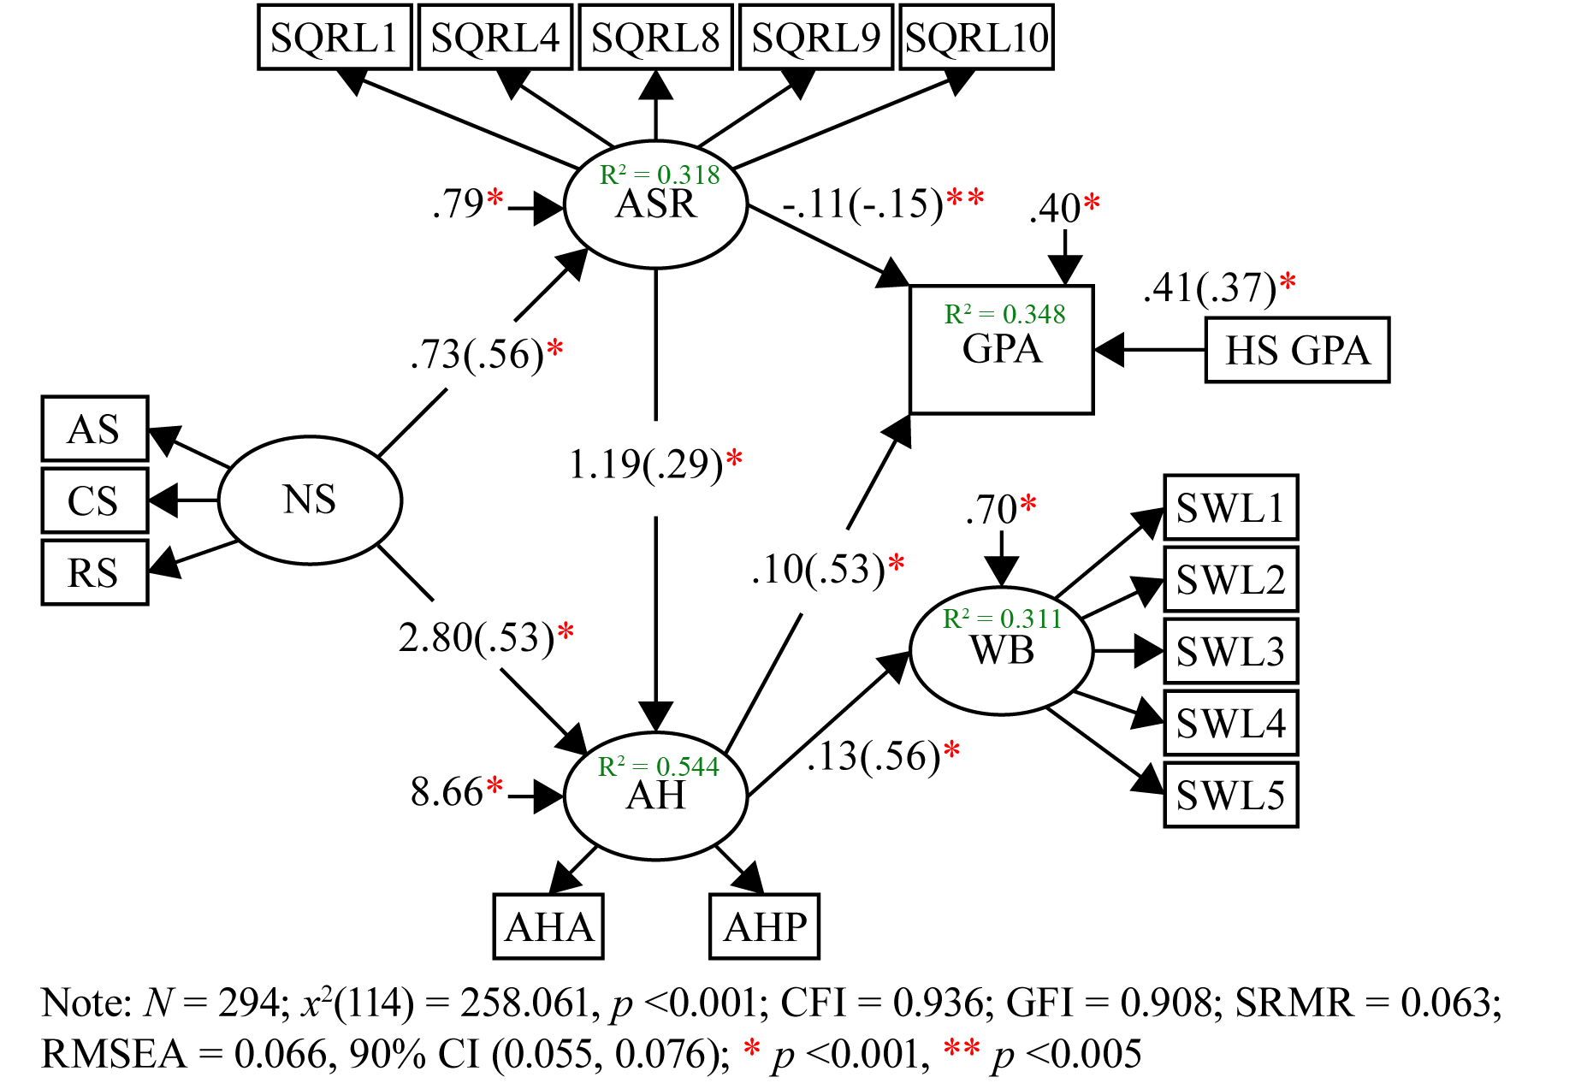
Figure 4. Structural Equation Model (Model 1)

Table 5

Parameter Estimates with Unstandardized (Standard Errors), Standardized, and Significance Levels for the First-Order Measurement Model (Model 1)
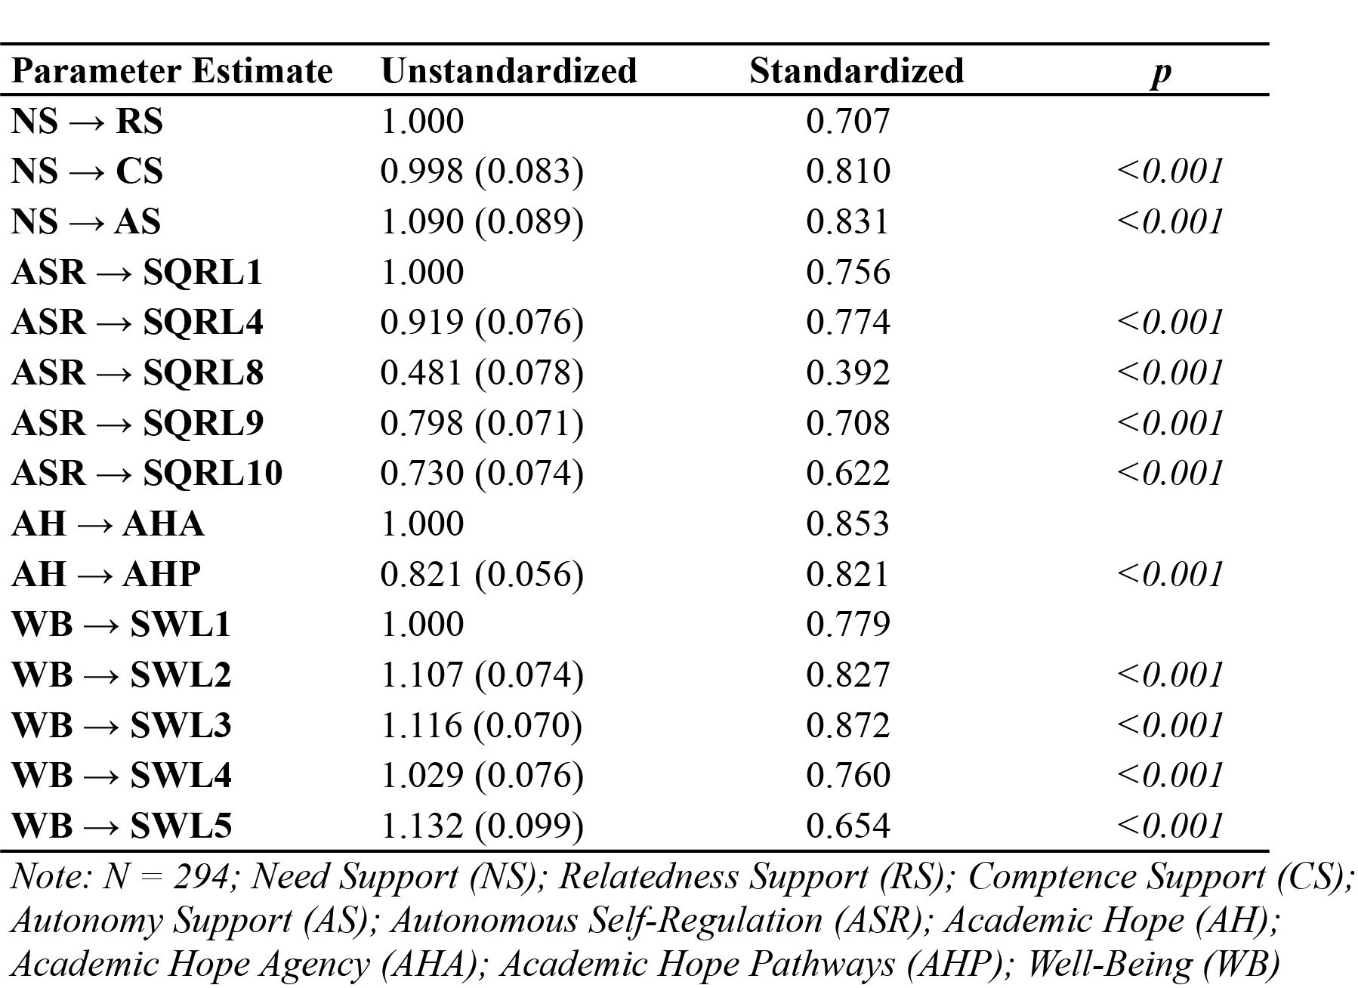
A review of the fit indices for Model 1 demonstrated that the model did not fit the data well; however AMOS provides modification indices to evaluate which aspects of the hypothesized model may be misspecified, and therefore can be modified. While this information provides a useful tool in the evaluation and possible re-specification of a hypothesized model, any changes to the model can only be justified insomuch as they are supported by theory (Afari, 2013; Teo et al., 2013).
Examination of the modification indices provided by AMOS indicated that estimation of a few of the correlated errors would improve the overall fit of this model. More precisely, the addition of four error covariances (items SRQL1 and SRQL4, and items SRQL 9 and SRQL10), both of the autonomous self-regulation subscale of the Learning Self-Regulation Questionnaire (SRQ-L; Black & Deci, 2000). The scale is divided into three groups of items and each item in the group pertains to the statement prompt that begins that particular group. Within the SRQ-L, items SRQL1 and SRQL4 comprise the first group, SRQL8 the second group, and SRQL9 and SRQL10 the third group. Items SRQL1 and SRQL4 suggest redundancy based on content overlap. Both items ask the respondent to indicate how true each statement is to them. Item SRQL1 reads “I will participate actively in my classes because I feel like it’s a good way to improve my understanding of the material.” Item SRQL4 reads “I will participate actively in my classes because a solid understanding of the course material is important for my intellectual growth.” In each instance, the statement refers to a reason why the respondent would actively participate in his or her classes. Relative to items SRQL9 and SRQL10, both items again ask the respondent to indicate how true each statement is for him or her. Item SRQL9 reads “The reason that I will work to expand my knowledge because it’s interesting to learn more about new things,” while SRQL10 reads “The reason that I will work to expand my knowledge because it’s a challenge to really understand how to solve real-world problems.” Again, both items refer to reasons why the respondent works to expand their knowledge. Therefore, these error covariances are defensible in relation to content, and are supported by theory.
After correlating the errors in the identified pairs of observed variables, the model was re-estimated and accepted as the final model using academic hope because it provided a good fit with significant paths: χ² (df = 112, N = 294) = 213.728, p < 0.001, CFI = 0.955, GFI was 0.924, SRMR was 0.059, and RMSEA was 0.056 with a 90% confidence interval of 0.044-0.067. Results of the re-specified model appear in Figure 5, and parameter estimates for the observed indicators are provided in Table 6.
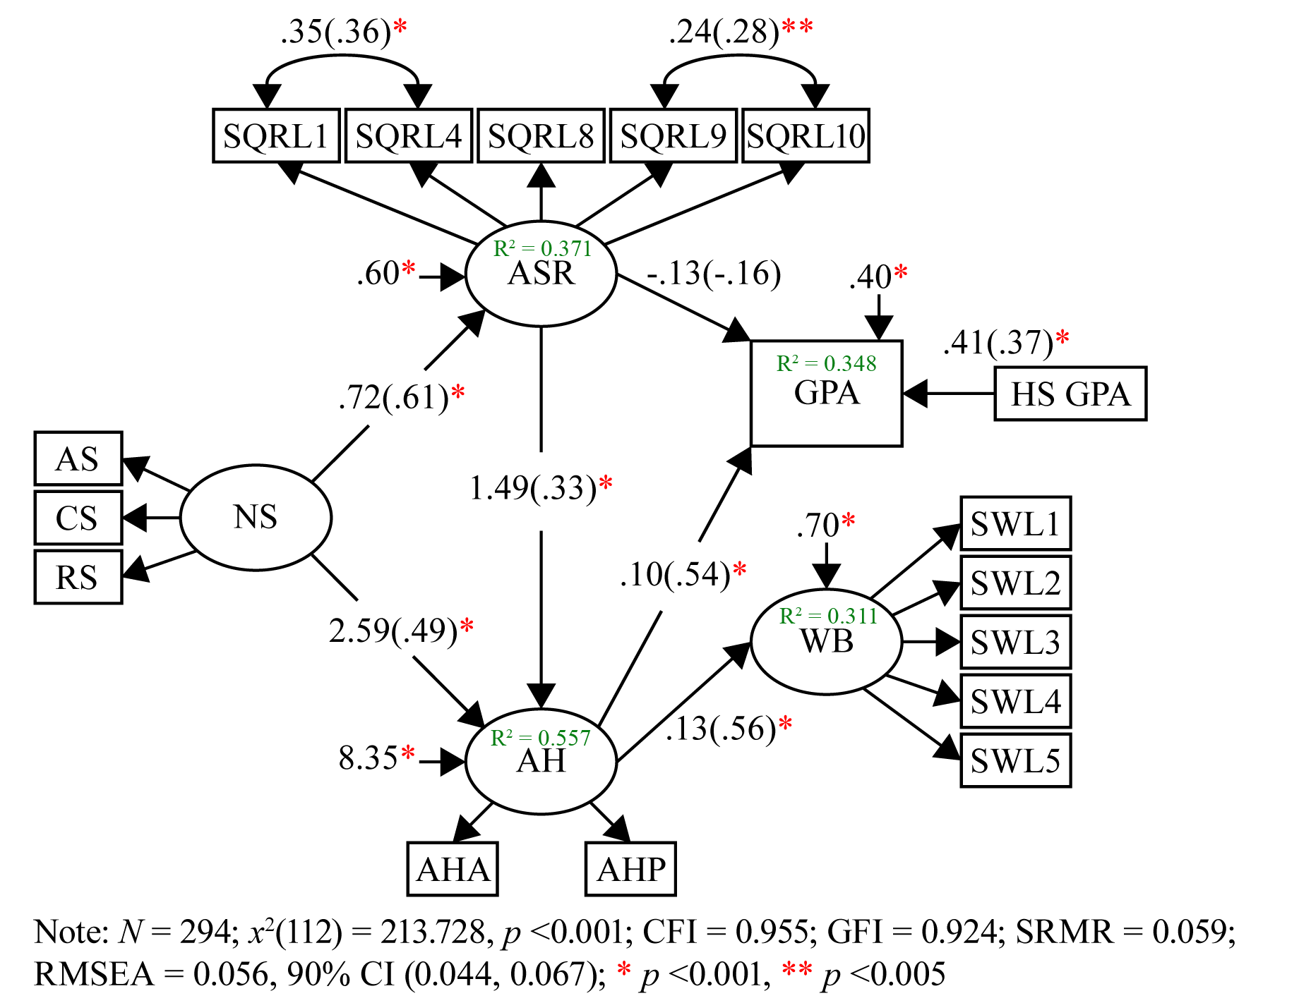
Figure 5. Structural Equation Model (Re-specified Model 1)

Table 6

Parameter Estimates with Unstandardized (Standard Errors), Standardized, and Significance Levels for the First-Order Measurement Model (Re-specified Model 1)
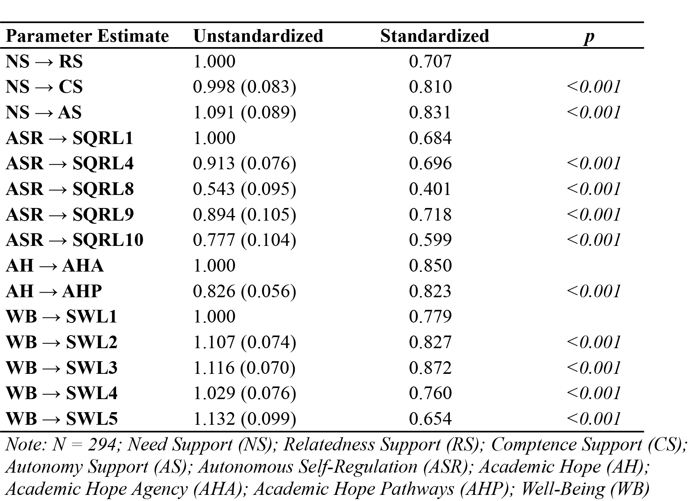
Model Two
Results of the second structural equation model appear in Figure 6. Detailed parameter estimates for the observed indicators appear in Table 7. This particular model evaluated the construct of hope using the Adult Hope Scale (AHS; Snyder, Harris et al., 1991) which assesses dispositional hope. Specifically, for this model, χ² (df = 114, N = 294) = 231.507, p < 0.001, CFI was 0.948, GFI was 0.915, SRMR was 0.054, and RMSEA was 0.059 with a 90% confidence interval of 0.048-0.070.
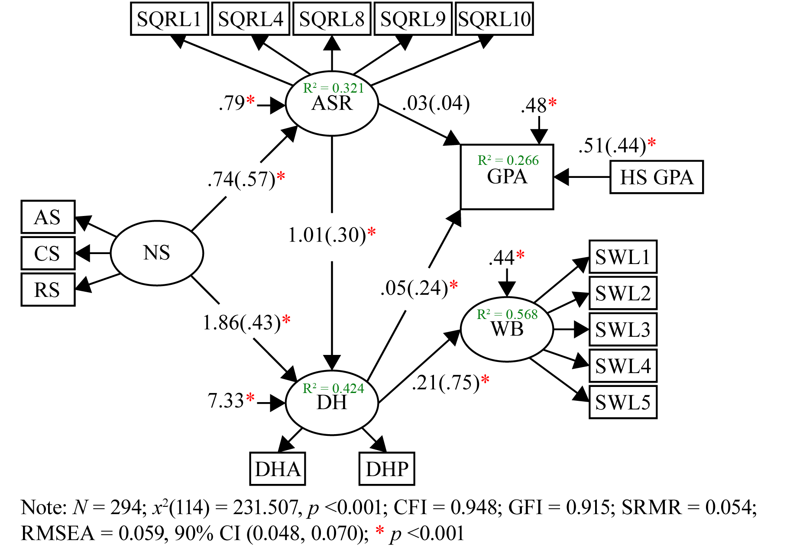
Figure 6. Structural Equation Model (Model 2)

Table 7

Parameter Estimates with Unstandardized (Standard Errors), Standardized, and Significance Levels for the First-Order Measurement Model (Model 2)
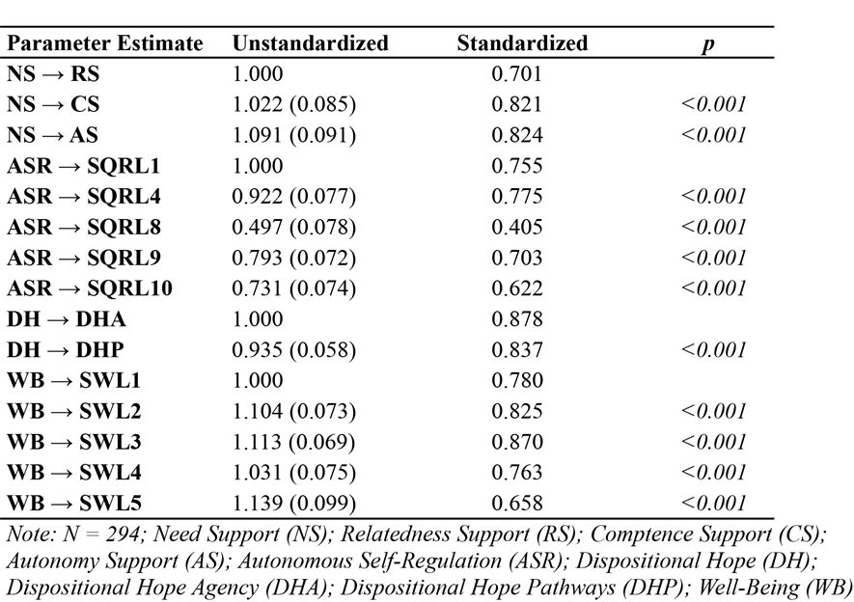
Like the first model, examination of the modification indices indicate that estimation of the same correlated error terms in Model 1 would improve the overall fit of this model as well. Specifically, items SRQL1 and SRQL4, and items SRQL 9 and SRQL10, of the autonomous self-regulation subscale of the Learning Self-Regulation Questionnaire (SRQ-L; Black & Deci, 2000). After correlating the error terms, the model was re-estimated and accepted as the final model using dispositional hope because it provided a good fit with significant paths: χ² (df = 112, N = 294) = 185.818, p < 0.001, CFI = 0.968, GFI was 0.932, SRMR was 0.050, and RMSEA was 0.047 with a 90% confidence interval around 0.035-0.059. Results of the re-specified model are provided in Figure 7. Parameter estimates for the observed indicators appear in Table 8. A summary of fit indices for both re-specified models, using academic-specific hope (Model 1) and dispositional hope (Model 2), are presented in Table 9.
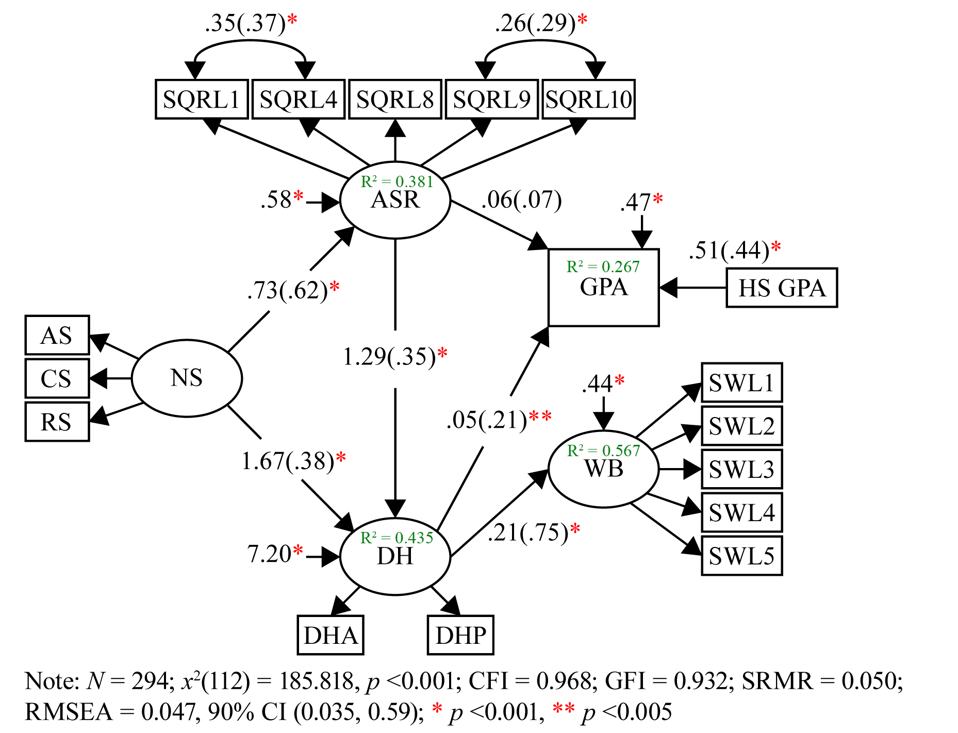
Figure 7. Structural Equation Model (Re-specified Model 2)

Table 8

Parameter Estimates with Unstandardized (Standard Errors), Standardized, and Significance Levels for the First-Order Measurement Model (Re-specified Model 2)
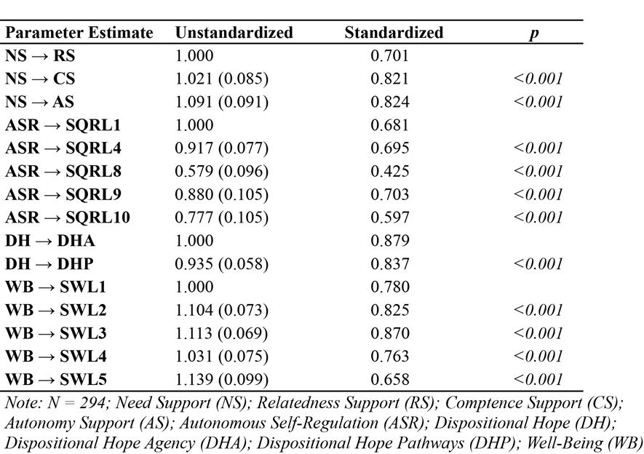
Table 9

Summary of Model Fit Indices
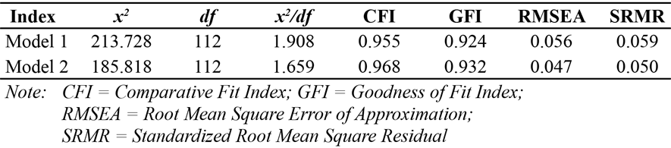
Evaluation of Research Hypotheses
Returning to the research hypotheses that guided this study, support was found for each hypothesis tested. To summarize the results of this study, model fit indices and parameter estimates together, support the hypothesized relationships between psychological need support, autonomous self-regulation, hope, academic achievement, and psychological well-being. Empirical evidence is presented below in relation to each hypothesis.
Hypothesis 1
Hypothesis 1 stated individuals who perceive higher levels of psychological need support will have higher levels of hope. In the dispositional hope model, student-athletes’ perceptions of psychological need support had a moderate, positive effect on levels of dispositional hope (β = 0.38, df = 112, p < 0.001), explaining about 14% of the variance. A one standard deviation increase in need support was related to a 0.38 standard deviation increase in dispositional hope. While the effect size was moderate, the path was statistically significant. In the academic hope model, student-athletes’ perception of psychological need support had a large, positive effect on levels of academic hope (β = 0.49, df = 112, p < 0.001), explaining about 29% of the variance. A one standard deviation increase in need support was associated with a 0.49 standard deviation increase in academic hope. Therefore, Hypothesis 1 was supported.
Hypothesis 2
Hypothesis 2 put forward those who are more autonomously self-regulated would have higher levels of hope. In the dispositional hope model, autonomous self-regulation had a moderate, positive effect on levels of hope (β = 0.35, df = 112, p < 0.001), explaining about 12% of the variance. A one standard deviation increase in autonomous self-regulation was associated with a 0.35 standard deviation increase in dispositional hope. In the academic hope model, student-athletes’ autonomous self-regulation had a moderate, positive effect on levels of academic hope (β = 0.33, df = 112, p < 0.001), explaining about 11% of the variance. A one standard deviation increase in autonomous self-regulation was associated with a 0.33 standard deviation increase in academic hope. Support was found for Hypothesis 2.
Hypothesis 3
Hypothesis 3 stated individuals who perceive higher levels of psychological need support will be more hopeful, and will have higher levels of academic achievement and psychological well-being. The latent variable of psychological need support, as measured by the observed variables of autonomy support, competence support, and relatedness support, had a positive, moderate, and statistically significant effect on dispositional hope (β = 0.38; p < 0.001) and a positive, large, and statistically significant effect on levels of academic hope (β = 0.49; p < 0.001). Dispositional hope had a positive, small-to-moderate, and statistically significant effect on academic achievement, as observed through term grade point average (β = 0.21; p < 0.005), but a very large, positive effect on psychological well-being (β = 0.75; p < 0.001). Academic hope had a large, positive, and statistically significant effect on academic achievement (β = 0.54; p < 0.001) and a large, positive, and statistically significant effect on psychological well-being (β = 0.56; p < 0.001). Hypothesis 3, using both dispositional and academic-specific hope, was supported. The data empirically supports that need- supportive environments work through hope leading to better academic achievement and higher levels psychological well-being.
Hypothesis 4
The fourth hypothesis stated individuals who are more autonomously self-regulated will engage in more hopeful thought, and will have higher levels of academic achievement and psychological well-being. Hypothesis 4 was empirically supported. Autonomous self-regulation had a positive, moderate, and statistically significant effect on levels of dispositional hope (β = 0.35; p < 0.001), explaining approximately 12% of the variance, and a positive, moderate, and statistically significant effect on levels of academic-specific hope (β = 0.33; p < 0.001), explaining about 11% of the variance. Additionally, like in hypothesis 3, dispositional hope and academic-specific hope had a positive relationship with academic achievement and psychological well-being. Support was found for the relationship between higher autonomous self-regulation and enhanced academic achievement and psychological well-being by way of either dispositional hope or academic-specific hope.
Hypothesis 5
The final hypothesis evaluated the model in totality. Specifically, hypothesis 5 stated individuals who perceive higher levels of psychological need support will be more autonomously self-regulated, have higher levels of hope, and will have higher levels of academic achievement and psychological well-being. In combination, model fit (see Figures 5 & 6) and parameter estimates (see Tables 6 & 7) lend support for the positive, statistically significant relationship between psychological need support, autonomous self-regulation, hope (dispositional and academic-specific), academic achievement, and psychological well-being. Furthermore, the explanatory power of both hypothesized models was assessed by evaluating the coefficient of determination (R²) of the endogenous variables within the model. Using an academic-specific measure of hope, Model 1 indicated that student-athletes’ perception of psychological need support, comprising autonomy support, competence support, and relatedness support, was a positive predictor of both autonomous self-regulation (R² = 0.371, or 37%) and academic-specific hope (R² = 0.557, or 56%), and the final consequents of academic achievement (R² = 0.348, or 35%) and psychological well-being (R² = 0.311, or 31%). Relative to the dispositional hope model (Model 2), student-athletes’ perception of psychological need support was a positive predictor of both autonomous self-regulation (R² = 0.381, or 38%) and dispositional hope (R² = 0.435, or 44%), and the final consequents of academic achievement (R² = 0.267, or 27%) and psychological well-being (R² = 0.567, or 57%). Therefore, hypothesis 5 was empirically supported.

Chapter 5: Discussion
The primary goal of this present study was to test, using structural equation modeling (SEM) analysis, the effects of both autonomous self-regulation and hope for the relationship between psychological need support, academic achievement, and psychological well-being among a sample of NCAA Division I student-athletes. Furthermore, the construct of hope, as initially conceptualized by Snyder, Harris et al. (1991), was assessed via a dispositional, or trait-level, measure (Snyder, Harris et al., 1991), as well as an academic-specific measure (Sympson, 1999).
The best-fitting models, using the academic-specific measure of hope (Model 1), and the dispositional measure of hope (Model 2), support the hypothesis that autonomous self-regulation and hope mediate the relationship between psychological need support and academic achievement, as assessed by term grade point average. In addition, the models support the a priori hypothesis that autonomous self-regulation and hope (dispositional and academic-specific) mediate the relationship between psychological need support and well-being. Stated differently, psychological need support, encompassing environmental supports for autonomy, competence, and relatedness, is related to academic achievement and psychological well-being through autonomous self-regulation and hope. These findings suggest that increased environmental supports for an individual’s need to feel autonomous, competent, and connected predicted increased autonomous self-regulation, thus positively influencing levels of hope, ultimately leading to superior academic achievement and enhanced psychological well-being. It should be noted, however, dispositional hope was a stronger predictor of psychological well-being (β = 0.75; p < 0.001), while academic-specific hope was a stronger predictor of academic achievement (β = 0.54; p < 0.001). Kline (2011) has recommended evaluating effect sizes using a criteria of standardized parameter estimates below 0.10 being considered small, 0.30 being considered moderate, and greater than 0.50 considered a large effect size. Based upon these recommendations, it can be stated that psychological need support has a large effect on more autonomous functioning and a moderate-to-large effect on levels of hope; autonomous self-regulation has a moderate effect on levels of hope (dispositional and academic-specific); and autonomous self-regulation partially mediates the relationship between psychological need support and hope. Furthermore, dispositional hope has a very large effect on levels of well-being, and academic-specific hope has a large effect on levels of academic achievement. Taken together, this research provides additional support for the notion that environmental factors affect individual thoughts and behaviors, thus affecting outcomes.
In the related literature on hope theory, there are several studies that have investigated the direct relationship between hope, enhanced well-being, and better academic achievement. For example, O’Sullivan (2011) found levels of hope to be the strongest predictor of life satisfaction, while Ciarrochi et al. (2015) found hope to be a strong predictor of increased levels of positive affect and decreased levels of negative affect. Moreover, in a longitudinal study, Gallagher et al. (2016) identified hope to have the strongest predictive capacity for measures of academic success (i.e., grade point average, class ranking, and graduation).
Along those lines, environmental supports for an individual’s need to feel autonomous, competent, and connected have also been shown to bring about more adaptive outcomes. Ryan and Deci (2000a) suggest that environments which provide ambient supports for an individual’s innate psychological need to feel autonomous, competent, and connected elicits goal-directed activity, enhanced motivation, well-being, and effective functioning. Much research has overwhelmingly supported this assertion in different domains (e.g., Burton et al., 2006; Feri at al., 2006; Milyavskaya & Koestner, 2011; Niemiec & Ryan, 2009).
While the existing literature on hope theory, self-determination theory, and psychological need support is quite promising, this present research is significant because it extends these previous findings by putting forward a unified theoretical framework which integrates environmental, psychological, and behavioral influences in the prediction of adaptive outcomes. Deci and Ryan (2008b) and Vallerand (1997) assert there exists a careful interplay between environmental factors, psychological need satisfaction, and motivation. This research shows empirical support for that assertion. Environments that provide support for an individual’s psychological needs lead to internalization of behavior (Deci & Ryan, 2000; Williams & Deci, 1996), and motivation is optimized when behaviors are internally, or autonomously, regulated rather than controlled (Deci & Ryan, 2000; Vansteenkiste et al., 2006). Following this logic, the construct of hope and the act of hopeful thinking, is yet another beneficial and adaptive means in which to view motivation and goal-directed thought.
Snyder, Irving et al. (1991), define hope as “a positive motivational state that is based on an interactively derived sense of successful (1) agency (goal-directed energy) and (2) pathways (planning to meet goals)” (p. 287). Stated differently, hopeful thoughts are part and parcel to goal-directed thoughts. Expanding further, hope encompasses developing suitable routes, or pathways, to goal attainment, and being motivated to utilize those pathways (Snyder, Rand et al., 2002). The important difference that distinguishes hope from the myriad motivation and goal expectancy paradigms is the idea that for hope to be fully activated, both agency and pathways must become operative. According to Snyder, Harris et al. (1991), one without the other is insufficient to fully characterize and understand hope.
Within the educational environment, the concept of hope is especially important, whether on a dispositional or academic-specific level. With the increased demands of time and attention that are experienced by NCAA Division I student-athletes, a unique subset of the student population, it makes hope an essential adaptive resource all the more. Feldman and Kubota (2005) argue that academic success is precipitated by careful planning and motivation. For the student-athlete, this involves not only class schedules, homework, study time, and leisure time, but practices, competitions, and team travel as well. To be successful in this particular domain, an individual must develop plans, motivate oneself to execute those plans, adapt when faced with setbacks, or goal blockages, and effectively manage the stressors associated with college life and intercollegiate athletics participation. Moreover, Ciarrochi et al. (2015) maintain that the simple act of goal setting with a sense of motivation and regulated behavior contributes to enhanced well-being and positive emotional states, lending additional support for the reciprocal, additive, and iterative nature of hope.
Thus, from a practical standpoint, it makes sense as to why hope is regarded as such a valuable personal resource to be nurtured and developed. Furthermore, what is of particular note is the presence of hope has been shown in this current research to be an integral part of the overall relationship. According to the structural model presented, the relationship between autonomous self-regulation and term grade point average is weak and not statistically significant, however with the addition of hope (dispositional and academic-specific), the relationship to academic achievement becomes significantly stronger, and thus a better predictor of outcomes, and ultimately goal attainment. One can posit, that through the iterations of pathways thinking and agency thinking, hope fully represents the applied, or action-oriented, features of autonomous regulation.
From a theoretical perspective, this present study sheds light on the integration and overlap of central concepts within the positive psychology tradition. It was hypothesized, and the empirical evidence has supported, an environment which support an individual’s psychological needs of autonomy, competence, and relatedness leads to more autonomous self-regulation, leading to increased hope, thus resulting in better academic achievement and enhanced psychological well-being.
Implications for Research
The findings of this research have contributed to the efforts to understand the environmental and psychological factors that contribute to the academic achievement and well-being of university student-athletes. Notwithstanding, these finding can still be regarded as exploratory in nature given that scant research evaluating the concepts of psychological need support and hope, together, can be found in the existing literature. Therefore, this study provides a promising avenue for future research on this important topic.
For example, extending research conducted by Hansen et al. (2014) on the role of hope in the academic performance of academically at-risk students, future research could test the theoretical model presented in this current research on this specific subset of the general student body population. It can be assumed that academically at-risk students face additional challenges than those of their peers that are not considered at-risk academically. How the environmental resource of psychological need support along with the personal resource of increased hopeful thinking lead to increased well-being, academic persistence, and ultimately graduation, is a worthwhile and promising line of further inquiry. Along similar lines, it would be beneficial to also gain clarification as to how the results of this study extend to other student populations, such as non-student-athletes, first-generation college students, international students, and students at other levels of education (i.e., primary and secondary school students).
Secondly, the current study assessed well-being from a hedonic perspective, which places focus on positive and negative feelings, life satisfaction, and subjective happiness. Future research can utilize measures of well-being taken from a eudaimonic perspective, such as Diener et al.’s (2010) Flourishing Scale. Well-being, conceptualized from a eudaimonic viewpoint, pertains to “meaning and self-realization and defines well-being in terms of the degree to which a person is fully functioning” (Ryan & Deci, 2001, p. 141). The concept of flourishing has received increased attention in the positive psychology literature and has been used in many studies to assess the impact of strengths (Dodge et al., 2012). As such, it would be valuable to extend the present findings using other measures of well-being to more effectively understand the nuances of psychological well-being and all that it encompasses.
Finally, Bernardo (2010) proposed an extension of Snyder’s hope theory (Snyder, 2002; Snyder, Harris et al., 1991) which he termed external locus of hope. According to Bernardo (2010), hope, as conceptualized by Snyder, is not explicit as to the agency and pathway components of hope being self-determined, or affected by external agents. Therefore, external locus of hope is theorized to involve “significant others and external forces as agents of goal-attainment cognitions” (p. 945). Further, Bernardo identifies three external agents of hope: family, peers, and spiritual beings/forces. Findings from the limited number of studies (Bernardo, 2010; Bernardo, Salanga, Khan, & Yeung, 2016) have provided compelling evidence as to the positive role others can contribute to the attainment of goals, specifically in the educational domain (Bernardo et al., 2016). In Bernardo (2010), “the attainment of goals need not be a purely individual pursuit. A person can work with external agents in generating plans for attaining goals, and draw from the capacities and resources of external agents in pursuing these goals” (p. 948). Given one of the primary goals driving this present research study was an understanding of the relationship between psychological need support and hope, it would be interesting to gain further insight as to the relationship between psychological need support and external locus of hope, with educational personnel (i.e., teachers, professors, academic advisors, and coaches) as potential external agents of hope.
Implications for Practice
With the increased national demand for accountability from institutions of higher education (Gansemer-Topf & Schuh, 2006), and more globally, from educational institutions at every level, it is imperative from an educational, practical, and financial standpoint to understand factors that contribute to student academic performance and well-being. More importantly, however, is the application of this understanding to bring about constructive changes and thus, positive outcomes. Metrics such as four-year graduation rates, six-year graduation rates, and freshman retention rates are all important outcomes in which to monitor, but what are the salient factors that contribute to these aforementioned outcomes.
Traditionally, colleges and universities have subscribed to an instructional paradigm, whereas the primary purpose of the academy was to deliver instruction or teaching. In doing so, universities are, in essence, confounding a means for an end (Barr & Tagg, 1995). Nevertheless, the purpose of, and the expectations placed upon, the modern-day university encompass so much more than simply instruction. Some of these expectations include career readiness, preparedness to succeed in an increasingly global, interconnected culture, knowledge application, social responsibility, and character development. Similarly, relative to the responsibilities of athletics departments within institutions of higher education, matters of academic achievement, academic persistence, social responsibility, and student-athlete well-being, are all areas of increased focus, accountability, and regulation. With all of these prevailing forces in mind, the present research, and subsequent results, provide significant current and future opportunities for higher education to focus increased attention on not only the outcomes, or results, but the processes and strategies – educational, administrative, and otherwise – that give rise to these results.
One promising line of application is the introduction of hope-based psychotherapy interventions, whereby the language and development of hope is cultivated within students. Studies have supported the role of hope, consisting of agency thinking and pathways thinking, in increasing well-being and achievement in diverse samples. Moreover, recent evidence has reinforced the idea that the act of hopeful thinking is something that can be nurtured and cultivated, and thus is malleable (i.e., Cheavens, Feldman, Gum et al., 2006; Feldman & Dreher, 2012; Gallagher et al., 2016; Hellman & Gwinn, 2017; Marques et al., 2016). Based upon these findings, in combination with findings of the present study, there exists empirical support for the possible efficacy of identifying strategies and programs to develop the personal resource of hope in students and student-athletes alike.
While promoting hope has been shown to be a beneficial endeavor, education, in the purest form, also involves the interaction between, and the relationship among, actors within the educational process. To disregard the involvement of those who can be considered the facilitators of learning, education, and personal student development, would be missing an important element in the “educational supply chain.” This research has shown support for the positive effect of need-supportive environments on the development of the character strength of hope. Additionally, this research has also shown levels of hope to be predictive of student academic performance and psychological well-being. Opportunities to engage those at all levels of the higher education and intercollegiate athletics enterprise (i.e., professors, administrators, coaches, academic advisors, etc.) in order to develop programs and workshops to educate those within higher education on the characteristics of need-supportive environments and ways in which to promote need-supportive climates is of practical importance, and a useful application of this present research.

Limitations
Interpretation of the findings of the present study should be evaluated cautiously given that it is not without limitations. First, the study was conducted utilizing a cross-sectional research design where data were gathered at one specific point in time. Therefore, causal direction of the relationships between variables must be interpreted with this fact in mind. Subsequent research could employ a longitudinal design, whereby following participants throughout their entire college experience. Secondly, all of the measures, with the exception of academic data, was gathered through the use of self-report measures, thus increasing the possibility of response, or survey, bias. Finally, data were collected from a single sample of NCAA Division I student-athletes at one small, Midwestern university, thereby limiting the generalizability of the current findings to all NCAA Division I student-athletes, all intercollegiate student-athletes competing in NCAA Divisions I, II, or III, or all enrolled students at higher education institutions. Further research should extend these findings by gathering data from additional student-athlete samples from other universities participating in NCAA Division I, II, or III athletics. While the aforementioned limitations exist, as they do with all non-experimental social science research, they do not, however, lessen the empirical findings from this study, but suggest avenues for future research and investigation.
Conclusion
In conclusion, despite possible limitations, the current research provides a noteworthy contribution to the existing literature on psychological need support, autonomous self-regulation, hope theory, and most importantly, the integration of these concepts in the relationship to academic achievement and psychological well-being. Research findings have shown support for the mediational effects of autonomous self-regulation and hope between psychological need-supportive environments, and the academic achievement and psychological well-being of NCAA Division I student-athletes. Within the educational and intercollegiate athletics context, it is imperative the role of hope and psychological need support be addressed as to the effects these variables have on academic performance and well-being. In doing so, we can work to improve the experience for all students, at the environmental, cognitive, and emotional levels.

References
Afari, E. (2013). The effect of psychosocial learning environment on students’ attitudes towards mathematics. In M. S. Khine (Ed.), Application of structural equation modeling in educational research and practice (pp. 91-114). Rotterdam, The Netherlands: Sense Publishers.

Alarcon, G. M., Bowling, N. A., & Khazon, S. (2013). Great expectations: A meta-analytic examination of optimism and hope. Personality and Individual Differences, 54, 821-827.

Alivernini, F., & Lucidi, F. (2011). Relationship between social context, self-efficacy, motivation, academic achievement, and intention to drop out of high school: A longitudinal study. Journal of Educational Research, 104, 241-252.

Alkharusi, H. (2010). Literature review on achievement goals and classroom goal structure: Implications for research. Electronic Journal of Research in Educational Psychology, 8, 1363-1386.

Anderson, J. C., & Gerbing, D. W. (1988). Structural equation modeling in practice: A review and recommended two-step approach. Psychological Bulletin, 103(3), 411-423.

Anderson, J. R. (1988). The role of hope in appraisal, goal-setting, expectancy, and coping. Unpublished doctoral dissertation, University of Kansas, Lawrence.

Arbuckle, J. L. (2016). Amos 24.0 User’s Guide. Chicago: IBM SPSS.

Averill, J. R., Catlin, G., & Chon, K. K. (1990). Rules of hope. New York: Springer-Verlag.

Babyak, M. A., Snyder, C. R., & Yoshinobu, L. (1993). Psychometric properties of the hope scale: A confirmatory factor analysis. Journal of Research in Personality, 27, 154-169.

Baeten, M., Dochy, F., & Struyven, K. (2013). The effects of different learning environments on students’ motivation for learning and their achievement. British Journal of Educational Psychology, 83, 484-501.

Bailey, T. C., Eng, W., Frisch, M. B., & Snyder, C. R. (2007). Hope and optimism as related to life satisfaction. Journal of Positive Psychology, 2, 168-175.

Bailey, T. H., & Phillips, L. J. (2016). The influence of motivation and adaptation on students’ subjective well-being, meaning in life and academic performance. Higher Education Research & Development, 35(2), 201-216.

Bandura, A. (1982). Self-efficacy mechanism in human agency. American Psychologist, 37, 122-147.
Bandura, A. (1989). Human agency in social cognitive theory. American Psychologist, 44, 1175-1184.

Bandura, A. (1997). Self-efficacy: The exercise of control. New York: Freeman.

Barnum, D. D., Snyder, C. R., Rapoff, M. A., Mani, M. M., & Thompson, R. (1998). Hope and social support in the psychological adjustment of pediatric burn survivors and matched controls. Children’s Health Care, 27, 15–30.

Barr, R. B., & Tagg, J. (1995). From teaching to learning: A new paradigm for undergraduate education. Change, 27(6), 13-26.

Barrett, P. (2007). Structural equation modelling: Adjudging model fit. Personality and Individual Differences, 42(5), 815-824.

Baumeister, R.F., & Leary, M.R. (1995). The need to belong: Desire for interpersonal attachments as a fundamental human need. Psychological Bulletin, 117(3), 497-529.

Bennett, D. A. (2001). How can I deal with missing data in my study? Australian and New Zealand Journal of Public Health, 25(5), 464-469.

Bentler, P. M., & Bonnet, D. C. (1980). Significance tests and goodness of fit in the analysis of covariance structures. Psychological Bulletin, 88(3), 588-606.

Bernardo, A. B. I. (2010). Extending hope theory: Internal and external locus of trait hope. Personality and Individual Differences, 49, 944-949.

Bernardo, A. B. I., Salanga, M., G. C., Khan, A., & Yeung, S. S. (2016). Internal and external loci-of-hope predict use of individual and collaborative learning strategies: Evidence from university students in four Asian cities. Asia-Pacific Education Researcher, 25(3), 367-376.

Black, A. E., & Deci, E. L. (2000). The effects of instructors' autonomy support and students' autonomous motivation on learning organic chemistry: A self-determination theory perspective. Science Education, 84(6), 740-756.

Bryant, F. B., & Cvengros, J. A. (2004). Distinguishing hope and optimism: Two sides of a coin, or two separate coins. Journal of Social and Clinical Psychology, 23(2), 273-302.

Bryman, A. (2016). Social research methods (5th ed.). Oxford, UK: Oxford University Press.

Buckelew, S. P., Crittendon, R. S., Butkovic, J. D., Price, K. B., & Hurst, M. (2008). Hope as a predictor of academic performance. Psychological Reports, 103, 411-414.
Burt, T. D., Young-Jones, A. D., Yadon, C. A., & Carr, M. T. (2013). The advisor and instructor as a dynamic duo: Academic motivation and basic psychological needs. NACADA Journal, 33(2), 44-54.

Burton, K. D., Lydon, J. E., D’Allessandro, D. U., Koestner, R. (2006). The differential effects of intrinsic and identified motivation on well-being and performance: Prospective, experimental, and implicit approaches to self-determination theory. Journal of Personality and Social Psychology, 91(4), 750-762.

Byrne, B. M. (1998). Structural equation modeling with LISREL, PRELIS and SIMPLIS: Basic concepts, applications, and programming. Mahwah, NJ: Lawrence Erlbaum.

Byrne, B. M. (2001). Structural equation modeling with AMOS: Basic concepts, applications, and programming. Mahwah, NJ: Lawrence Erlbaum.

Carodine, K., Almond, K. F., & Gratto, K. K. (2001). College student athlete success both in and out of the classroom. In M. Howard-Hamilton & S. Watt (Eds.), New directions for student services: Vol. 93. Student services for athletes (pp. 19-33). San Francisco, CA: Jossey-Bass Publishers.

Carver, C. F., & Scheier, M. F. (2001). Optimism, pessimism, and self-regulation. In: E. C. Chang (Ed.), Optimism & pessimism: Implications for theory, research, and practice (pp. 31-51). Washington, DC: American Psychological Association.

Chang, E. C. (1998). Hope, problem-solving ability, and coping in a college student population: Some implications for theory and practice. Journal of Clinical Psychology, 54(7), 953-962.

Cheavens, J. S., Feldman, D. B., Gum, A., Michael, S. T., & Snyder, C. R. (2006). Hope therapy in a community sample: A pilot investigation. Social Indicators Research, 77, 61-78.

Cheavens, J. S., Feldman, D. B., Woodward, J. T., & Snyder, C. R. (2006). Hope in cognitive psychotherapies: On working with client strengths. Journal of Cognitive Psychotherapy, 20(2), 135-145.

Chemers, M. M., Hu, L., & Garcia, B. F. (2001). Academic self-efficacy and first-year college student performance and adjustment. Journal of Education Psychology, 93, 55-64.

Ciani, K. D., Sheldon, K. M., Hilpert, J. C., & Easter, M. A. (2011). Antecedents and trajectories of achievement goals: A self-determination theory perspective. British Journal of Educational Psychology, 81, 223-243.

Ciarrochi, J., Heaven, P. C. L., & Davies, F. (2007). The impact of hope, self-esteem, and attributional style on adolescents’ school grades and emotional well-being: A longitudinal study. Journal of Research in Personality, 41, 1161-1178.

Ciarrochi, J., Parker, P., Kashdan, T. B., Heaven, P. C. L., & Barkus, E. (2015). Hope and emotional well-being: A six-year study to distinguish antecedents, correlates, and consequences. Journal of Positive Psychology, 1-10.

Cohen, J. (1992). A power primer. Psychological Bulletin, 112(1), 155-159.

Connell, J. P., & Wellborn, J. G. (1991). Competence, autonomy, and relatedness: A motivational analysis of self-system processes. In M. R. Gunnar & L. A. Sroufe (Eds.), Self-processes and development: The Minnesota Symposia on Child Development (pp. 43-77). Hillsdale, NJ: Lawrence Erlbaum Associates.

Cook, D. A., & Artino, A. R. (2016). Motivation to learn: An overview of contemporary theories. Medical Education, 50, 997-1014.

Cotton-Bronk, K., Hill, P. L., Lapsley, D. K., Talib, T. L., & Finch, H. (2009). Purpose, hope, and life satisfaction in three age groups. Journal of Positive Psychology, 4(6), 500-510.

Corpus, J. H., McClintic-Gilbert, M. S., & Hayenga, A. O. (2009). Within-year changes in children’s intrinsic and extrinsic motivational orientations: Contextual predictors and academic outcomes. Contemporary Educational Psychology, 34, 154-166.

Cramer, K. M., & Dyrkacz, L. (1998). Differential prediction of maladjustment scores with the Snyder hope scales. Psychological Reports, 83, 1035-1041.

Creamer, M., O’Donnell, M. L., Carboon, I., Lewis, V., Densley, K., McFarlane, A., Silove, D., & Bryant, R. A. (2009). Evaluation of the dispositional hope scale in injury survivors. Personality and Individual Differences, 43, 613-617.

Curry, L. A., & Maniar, S. D. (2003). Academic course combining psychological skills training and life skills education for university student-athletes. Journal of Applied Sport Psychology, 15, 270-277.

Curry, L. A., Maniar, S. D., Sondag, K. A., & Sandstedt, S. (1999). An optimal performance academic course for university students and student-athletes. Unpublished manuscript, University of Montana, Missoula.

Curry, L. A., Snyder, C. R., Cook, D. L., Ruby B. C., & Rehm, M. (1997). Role of hope in academic and sport achievement. Journal of Personality and Social Psychology, 73(6), 1257-1267.

Davidson, O. B., Feldman, D. B., & Margalit, M. (2012). A focused intervention of 1st year college students: Promoting hope, sense of coherence, and self-efficacy. The Journal of Psychology, 146(3), 333-352.

Day, L., Hanson, K., Maltby, J., Proctor, C, & Wood A. (2010). Hope uniquely predicts objective academic achievement above intelligence, personality, and previous academic achievement. Journal of Research in Personality, 44, 550-553.

deCharms, R. (1968). Personal causation: The internal affective determinants of behavior. New York, NY: Academic Press.

Deci, E. L. (1971). Effects of externally mediated rewards on intrinsic motivation. Journal of Personality and Social Psychology, 18, 105-115.

Deci, E. L., Eghrari, H., Patrick, B. C., & Leone, D. R. (1994). Facilitating internalization: The self-determination theory perspective. Journal of Personality, 62(1), 119-142.

Deci, E. L., Koestner, R., & Ryan, R. M. (1999). A meta-analytic review of experiments examining the effects of extrinsic rewards on intrinsic motivation. Psychological Bulletin, 25, 627-668.

Deci, E. L., & Ryan, R. M. (1980). The empirical exploration of intrinsic motivational processes, In L. Berkowitz (Ed.), Advances in experimental social psychology (Vol. 13, pp. 39-80). New York: Academic.

Deci, E. L., & Ryan, R. M. (1985a). The general causality orientations scale: Self- determination in personality. Journal of Research in Personality, 19, 109-134.

Deci, E. L., & Ryan, R. M. (1985b). Intrinsic motivation and self-determination in human behavior. New York: Plenum.

Deci, E. L., & Ryan, R. M. (1991). A motivational approach to self: Integration in personality. In R. Dienstbier (Ed.), Nebraska symposium on motivation: Vol 38. Perspectives on motivation (pp. 237-288). Lincoln, NE: University of Nebraska Press.

Deci, E. L., & Ryan, R. M. (2000). The “what” and “why” of goal pursuits: Human needs and the self-determination of behavior. Psychological Inquiry, 11(4), 227-268.

Deci, E. L., & Ryan, R. M. (2008a). Facilitating optimal motivation and psychological well-being across life’s domains. Canadian Psychology, 49(1), 14-23.

Deci, E. L., & Ryan, R. M. (2008b). Self-determination theory: A macrotheory of human motivation, development, and health. Canadian Psychology, 49(3), 182-185.

Deci, E. L., Ryan, R. M., & Koestner, R. (1999). A meta-analytic review of experiments examining the effects of extrinsic rewards on intrinsic motivation. Psychological Bulletin, 126(6), 627-268.

Deci, E. L., Vallerand, R. J., Pelletier, L. G., & Ryan, R. M. (1991). Motivation and education: The self-determination perspective. Educational Psychologist, 26(3 & 4), 325-346.

Deci, E. L., & Vansteenkiste, M. (2004). Self-determination theory and basic need satisfaction: Understanding human development in positive psychology. Ricerche di psicologia, 27(1), 23-40.

DeSimone, J. A., Harms, P. D., & DeSimone, A. J. (2015). Best practice recommendations for data screening. Journal of Organizational Behavior, 36(2), 171-181.

Diamantopoulos, A., & Siguaw, J. A. (2000). Introducing LISREL. London, UK: Sage Publications.

Di Domenico, S. I., & Fournier, M. A. (2015). Able, ready, and willing: Examining the additive and interactive effects of intelligence, conscientiousness, and autonomous motivation on undergraduate academic performance. Learning and Individual Differences, 40, 156-162.

Diener, E., Emmons, R. A., Larsen, R. J., & Griffin, S. (1985). The satisfaction with life scale. Journal of Personality Assessment, 49(1), 71-75.

Diener, E., & Suh, E. (1997). Measuring quality of life: Economic, social, and subjective indicators. Social Indicators Research, 40, 189-216.

Diener, E., Wirtz, D., Tov, W., Kim-Prieto, C., Choi, D., Oishi, S, & Biswas-Diener, R. (2010). New well-being measures: Short scales to assess flourishing and positive and negative feelings. Social Indicators Research, 97, 143-156.

Dodge, R., Daly, A., Huyton, J., & Sanders, L. (2012). The challenge of defining well-being. International Journal of Wellbeing, 2(3), 222-235.

Dommeyer, C. J., Baum, P., Hanna, R. W., & Chapman, K. S. (2004). Gathering faculty teaching evaluations by in-class and online surveys: Their effects on response rates and evaluations. Assessment & Evaluation in Higher Education, 29(5), 611-623.

Dong, Y, & Peng C. J. (2013). Principled missing data methods for researchers. Springer Plus, 2, 222. https://doi.org/10.1186/2193-1801-2-222.

Dufrane, K., & Leclair, S.W. (1984). Using hope in the counseling process. Counseling and Values, 29, 32-41.
Durak, M., Senol-Durak, E., & Gencoz, T. (2010). Psychometric properties of the satisfaction with life scale among Turkish university students, correctional officers, and elderly adults. Social Indicators Research, 99, 413-429.

Elliot, A. J., & Dweck, C. S. (2005). Competence and motivation: Competence as the core of achievement motivation. In A. J. Elliot & C. S. Dweck (Eds.), Handbook of competence and motivation (pp. 3-12). New York, NY: The Guilford Press.

Elliott, T. R., Witty, T. E., Herrick, S., & Hoffman, J. T. (1991). Negotiating reality after physical loss: Hope, depression, and disability. Journal of Personality and Social Psychology, 61, 608–613.

Engstrom, C. M., & Sedlacek, W. E. (1991). A study of prejudice toward university student-athletes: Implication for advising, training, and programming. Journal of Counseling & Development, 70, 189-193.

Feldman, D. B., Davidson, O. B., & Margalit, M. (2015). Personal resources, hope, and achievement among college students: The conservation of resources perspective. Journal of Happiness Studies, 16(3), 543-560.

Feldman, D. B., & Dreher, D. E. (2012). Can hope be changed in 90 minutes? Testing the efficacy of a single-session goal-pursuit intervention for college students. Journal of Happiness Studies, 13(4), 745–759.

Feldman, D. B., & Kubota, M. (2015). Hope, self-efficacy, optimism, and academic achievement: Distinguishing constructs and levels of specificity in predicting college grade point average. Learning and Individual Differences, 37, 201-216.

Feldman, D. B., Rand, K. L., Kahle-Wrobleski, K. (2009). Hope and goal attainment: Testing a basic prediction of hope theory. Journal of Social and Clinical Psychology, 28(4), 479-497.

Feldman, D. B., & Snyder, C. R. (2005). Hope and the meaningful life: Theoretical and empirical associations between goal-directed thinking and life meaning. Journal of Social and Clinical Psychology, 24(3), 401-421.

Feri, R., Soemantri, D. & Jusuf, A. (2016). The relationship between autonomous motivation and autonomy support in medical students’ academic achievement. International Journal of Medical Education, 7, 417-423.

Frank, J. D. (1968). The role of hope in psychotherapy. International Journal of Psychiatry, 5, 383-395.

Frankl, V. (1963). Man's search for meaning. New York: Washington Square Press.

Frankl, V. (1965). The doctor and the soul: From psychotherapy to logotherapy (R. Winston & C. Winston, Trans.). New York: Knopf.

Frankl, V. (1966). What is meant by meaning? Journal of Existentialism, 7, 21-28.

Frankl, V. (1992). Man's search for meaning: An introduction to logotherapy (I. Lasch, Trans.). Boston: Beacon Press.

French, T. M. (1952). The integration of behavior: Vol. 1. Basic postulates. Chicago: University of Chicago Press.

Furrer, C., & Skinner E. (2003). Sense of relatedness as a factor in children’s academic engagement and performance. Journal of Educational Psychology, 95(1), 148-162.

Gable, S. L., & Haidt, J. (2005). What (and why) is positive psychology? Review of General Psychology, 9(2), 103-110.

Gallagher, M. W., Marques, S. C., & Lopez, S. J. (2016). Hope and the academic trajectory of college students. Journal of Happiness Studies, 1-12.

Gansemer-Topf, A. M., & Schuh, J. (2006). Institutional selectivity and institutional expenditures: Examining organizational factors that contribute to retention and graduation. Research in Higher Education, 47(6), 613-642.

Gaskin, J. (2016). Data screening. Gaskination’s StatWiki. Retrieved from http://statwiki.kolobkreations.com.

Gibbons, F. X., Blanton, H., Gerrard, M., Buunk, B., & Eggleston, T. (2000). Does social comparison make a difference? Optimism as a moderator of the relation between comparison level and academic performance. Personality and Social Psychology Bulletin, 26, 637–648.

Gilman, R., Dooley, J., & Florell, D. (2006). Relative levels of hope and their relationship with academic and psychological indicators among adolescents. Journal of Social and Clinical Psychology, 25(2), 166-178.

Gnambs, T., & Hanfstingl, B. (2016). The decline of academic motivation during adolescence: An accelerated longitudinal cohort analysis on the effect of psychological need satisfaction. Educational Psychology, 36(9), 1691-1705.

Grolnick, W. S., & Ryan, R. M. (1987). Autonomy in children’s learning: An experimental and individual difference investigation. Journal of Personality and Social Psychology, 52(5), 890-898.

Gottfried, A. E., Fleming, J. S., & Gottfried, A. W. (2001). Continuity of academic intrinsic motivation from childhood through late adolescence: A longitudinal study. Journal of Educational Psychology, 93, 3-13.

Guay, F., Ratelle, C. F., Roy, A., & Litalien, D. (2010). Academic self-concept, autonomous academic motivation, and academic achievement: Mediating and additive effects. Learning and Individual Differences, 20, 644-653.

Hansen, M. J., Trujillo, D. J. Boland, D. L., & MacKinnon, J. L. (2014). Overcoming obstacles and academic hope: An examination of factors promoting effective academic success strategies. Journal of College Student Retention, 16(1), 49-71.

Harlow, H. F. (1953). Motivation as a factor in the acquisition of new responses. In Current theory and research on motivation (pp. 24–49). Lincoln: University of Nebraska Press.

Hellman, C. M. & Gwinn, C. (2017). Camp HOPE as an intervention for children exposed to domestic violence: A program evaluation of hope, and strength of character. Child and Adolescent Social Work Journal, 34 (3), 269-276.

Hellman, C. M., Pittman, M. K., & Munoz, R. T. (2013). The first twenty years of the will and the ways: An examination of score reliability distribution on Snyder’s dispositional hope scale. Journal of Happiness Studies, 14(3), 723-729.

Henderlong, J., & Lepper, M. R. (2002). The effects of praise on children’s intrinsic motivation: A review and synthesis. Psychological Bulletin, 128, 774-795.

Hoe, S. L. (2008). Issues and procedures in adopting structural equation modeling technique. Journal of Applied Quantitative Methods, 3(1), 76-83.

Hollembeak, J. & Amorose, A. J. (2005). Perceived coaching behaviors and college athletes’ intrinsic motivation: A test of self-determination theory. Journal of Applied Sport Psychology, 17, 20-36.

Hooper, D., Coughlan, J., & Mullen, M. (2008). Structural equation modeling: Guidelines for determining model fit. Electronic Journal of Business Research Methods, 6(1), 53-60.

Hope [Def.]. (n.d.). In Merriam-Webster Online Dictionary. Retrieved from https://www.merriam-webster.com/dictionary/hope.

Hope [Def.]. (2000). In Webster’s New World College Dictionary, 4th Ed. (p. 687). Foster City, CA: IDG Books Worldwide, Inc.

Horton, T. V., & Wallander, J. L. (2001). Hope and social support as resilience factors against psychological distress of mothers who care for children with chronic physical conditions. Rehabilitation Psychology, 46(4), 382-399.

Howell, A. J., & Buro, K. (2015). Measuring and predicting student well-being: Further evidence in support of the flourishing scale and the scale of positive and negative experiences. Social Indicators Research, 121, 903-915.

Hoyle, R. H. (1995). The structural equation modeling approach: Basic concepts and fundamental issues. In R. H. Hoyle (Ed.), Structural equation modeling: Concepts, issues, and applications (pp. 1-15). Thousand Oaks, CA: Sage Publications.

Hu, L. T., & Bentler, P. M. (1995). Evaluating model fit. In R. H. Hoyle (Ed.), Structural equation modeling: Concepts, issues, and applications (pp. 76-99). Thousand Oaks, CA: Sage Publications.

Hu, L. T., & Bentler, P. M. (1999). Cutoff criteria for fit indexes in covariance structure analysis: Conventional criteria versus new alternatives. Structural Equation Modeling, 6(1), 1-55.

In’nami, Y., & Koizumi, K. (2013). Structural equation modeling in educational research: A primer. In M. S. Khine (Ed.), Application of structural equation modeling in educational research and practice (pp. 23-51). Rotterdam, The Netherlands: Sense Publishers.

Irving, L. M., Crenshaw, W., Snyder, C. R., Francis, P., & Gentry, G. (1990, May). Hope and its correlates in a psychiatric setting. Paper presented at the meeting of the Midwestern Psychological Association, Chicago, IL.

Irving, L. M., Snyder, C. R., Cheavens, J., Gravel, L., Hanke, J., & Hilberg, P. (2004). The relationships between hope and outcomes at the pretreatment, beginning, and later phases of psychotherapy. Journal of Psychotherapy Integration, 14, 419-443.

Irving, L. M., Snyder, C. R., & Crowson, J. J., Jr. (1998). Hope and coping with cancer by college women. Journal of Personality, 22, 195-214.

Jackson, W. T., Taylor, R. E., Palmatier, A. D., Elliott, T. R., & Elliott, J. L. (1998). Negotiating the reality of visual impairment. Hope, coping, and functional ability. Journal of Clinical Psychology in Medical Settings, 5, 173-185.

Jöreskog, K. G., & Sörbom, D. (1993). LISREL 8: Structural equation modeling with SIMPLUS command language. Hillsdale, NJ: Erlbaum.

Kashdan, T. B., Pelham, W. E., Lang, A. R., Hoza, B., Jacob, R. G., Jennings, J. R.,…Gnagy, E. M. (2000). Hope and optimism as human strengths in parents of children with externalizing disorders: Stress is in the eye of the beholder. Journal of Social and Clinical Psychology, 21, 441-468.

Khine, M. S. (2013). Structural equation modeling approaches in educational research and practice. In M. S. Khine (Ed.), Application of structural equation modeling in educational research and practice (pp. 279-283). Rotterdam, The Netherlands: Sense Publishers.

King, R. B. (2015). Sense of relatedness boosts engagement, achievement, and well-being: A latent growth model study. Contemporary Educational Psychology, 42, 26-38.

Kline, R. B. (2011). Principles and practice of structural equation modeling (3rd. ed.). New York, NY: Guilford Press.

Koka, A., & Hein, V. (2003). Perceptions of teacher’s feedback and learning environments as predictors of intrinsic motivation in physical education. Psychology of Sport and Exercise, 4, 333-346.

Kusurkar, R. A., Cate, Th. J. T., Vos, C. M. P, Westers, P, & Croiset, G. (2013). How motivation affects academic performance: A structural equation modeling analysis. Advances in Health Science Education, 18, 57-69.

Kwon, P. (2002). Hope, defense mechanisms, and adjustment: Implications for false hope and defensive hopelessness. Journal of Personality, 70, 207–231.

Laird, S. (1992). A preliminary investigation into prayer as a coping technique for adult patients with arthritis. Unpublished doctoral dissertation, University of Kansas, Lawrence.

Lazarus, A. A. (1980). Toward delineating some causes of change in psychotherapy. Professional Psychology, 11, 863-870.

Leeson, P., Ciarrochi, J., & Heaven, P. C. L. (2008). Cognitive ability, personality, and academic performance in adolescents. Personality and Individual Differences, 45, 630-635.

Levi, U., Einav, M., Ziv, O, Raskind, I, & Margalit, M. (2014). Academic expectations and actual achievements: The roles of hope and effort. European Journal of Psychology of Education, 29(3), 367–386.

Luthans, F., Avilio, B. J., Avery, J. B., & Norman, S. M. (2007). Positive psychological capital: Measurement and relationship with performance and satisfaction. Personal Psychology, 60, 541–572.

Macaskill, A., & Denovan, A. (2014). Assessing psychological health: the contribution of psychological strengths. British Journal of Guidance & Counselling, 42(3), 320–337.

Magaletta, P. R., & Oliver, J. M. (1999). The hope construct, will, and ways: Their relations with self-efficacy, optimism, and general well-being. Journal of Clinical Psychology, 55(5), 539-551.

Margalit, M., & Idan, O. (2004). Resilience and hope theory: An expanded paradigm for learning disabilities research. Thalamus, 22(1), 58-64.

Marques, S. C., Lopez, S. J., Fontaine, A. M., Coimbra, S., & Mitchell, J. (2015). How much hope is enough? Levels of hope and students’ psychological and school functioning. Psychology in the Schools, 52(4), 325-334.

Marques, S. C., Lopez, S. J., Reichard, R. J., & Dollwet, M. (2016). Relation of hope to academic outcomes: A meta-analysis. Journal of Happiness Studies, 14, 251-261.

Marques, S. C., Pais-Ribeiro, J. L., & Lopez, S. J. (2009). Validation of a Portuguese version of the children hope scale. School Psychology International, 30, 538-551.

Marques, S. C., Pais-Ribeiro, J. L., Lopez, S. J. (2011). The role of positive psychology constructs in predicting mental health and academic achievement in children and adolescents: A two-year longitudinal study. Journal of Happiness Studies, 12, 1049-1062.

Martin, A. J., & Dowson, M. (2009). Interpersonal relationships: Motivation, engagement, and achievement: Yields of theory, current issues, and educational practice. Review of Educational Research, 79, 327-365.

McDonald, R. P., & Ho, M. H. R. (2002). Principles and practice in reporting structural equation modeling. Psychological Methods, 7(1), 64-82.

Menninger, K. (1959). The academic lecture on hope. American Journal of Psychiatry, 109, 481-491.

Meyer, D. K., & Turner, J. C. (2002). Discovering emotion in classroom motivation research. Educational Psychologist, 37, 107-114.

Micceri, T. (1989). The unicorn, the normal curve and other improbably creatures. Psychological Bulletin, 105, 156-165.

Milyavskaya, M., & Koestner, R. (2011). Psychological needs, motivation, and well- being: A test of self-determination theory across multiple domains. Personality and Individual Differences, 50, 387-391.

Michalos, A. C. (2008). Education, happiness and well-being. Social Indicators Research, 87, 347-366.

Munoz, A., & Ramirez, M. (2015). Teachers’ conceptions of motivation and motivating practices in second-language learning: A self-determination theory perspective. Theory and Research in Education, 13(2), 198-220.

National Collegiate Athletic Association (2017a). Core courses. Retrieved from http://www.ncaa.org/student-athletes/future/core-courses.

National Collegiate Athletic Association (2017b). Grade-point average. Retrieved from http://www.ncaa.org/student-athletes/future/grade-point-average.

National Collegiate Athletic Association (2017c). What is the NCAA? Retrieved from http://www.ncaa.org/about/resources/media-center/ncaa-101/what-ncaa.

Niemiec, C. P., Lynch, M. F., Vansteenkiste, M., Bernstein, J., Deci, E. L., & Ryan, R. M. (2006). The antecedents and consequences of autonomous self-regulation for college: A self-determination theory perspective on socialization. Journal of Adolescence, 29, 761-775.

Niemiec, C. P., & Ryan, R. M. (2009). Autonomy, competence, and relatedness in the classroom: Applying self-determination theory to educational practices. Theory and Research in Education, 7(133), 133-144.

Nuñez, J. L., & Leon, J. (2015). Autonomy support in the classroom: A review of self- determination theory. European Psychologist, 20(4), 275-283.

Nunnally, J. C. (1978). Psychometric theory (2nd ed.). New York, NY: McGraw-Hill.

Nunnally, J. C., & Bernstein, I. H. (1994). Psychometric theory (3rd ed.). New York, NY: McGraw-Hill.

Oades, L. G., Robinson, P., Green, S., & Spence, G. B. (2011). Towards a positive university. Journal of Positive Psychology, 6, 432-439.

Oettingen, G., & Gollwitzer, P. M. (2002). Turning hope thoughts into goal-directed behavior. Psychological Inquiry, 13(4), 304-307.

Ong, A. D., Edwards, L. M., & Bergeman, C. S. (2006). Hope as a source of resilience in later adulthood. Personality and Individual Differences, 41, 1263-1273.

Onwuegbuzie, A. J., & Daley, C. E. (1999). Relation of hope to self-perception. Perceptual and Motor Skills, 88, 535-540.

Orwell, G. (1946). Animal farm. New York: Harcourt, Brace, and Co.
O'Sullivan, G. (2011). The relationship between hope, eustress, self-efficacy, and life satisfaction among undergraduates. Social Indicators Research, 101(1), 155-172.

Park, N., Peterson, C., & Seligman, M. E. P. (2004). Strengths of character and well- being. Journal of Social and Clinical Psychology, 23(5), 603-619.

Patrick, H., Knee, C. R., Canevello, A., & Lonsbary, C. (2007). The role of need fulfillment in relationship functioning and well-being: A self-determination theory perspective. Journal of Personality and Social Psychology, 92(3), 434-457.

Pavot, W., & Diener, E. (1993). Review of the satisfaction with life scale. Psychological Assessments, 5(2), 164-172.

Pelletier, L. G., Dion, S., Tuson, K. M., & Green-Demers, I. (1999). Why do people fail to adopt environmental behaviors? Towards a taxonomy of environmental amotivation. Journal of Applied Social Psychology, 29, 2481-2504.

Peterson, S. J., Gerhardt, M. W., & Rode, J. C. (2006). Hope, learning goals, and task performance. Personality and Individual Differences, 40, 1099-1109.

Peterson, C., & Park, N. (2003). Positive psychology as the evenhanded positive psychologist views it. Psychological Inquiry, 14(2), 143-147.

Peterson, C., & Seligman, M. E. P. (2004). Character strengths and virtues: A classification and handbook. New York: Oxford University Press/Washington, DC: American Psychological Association.

Radel, R., Pelletier, L., & Sarrazin, P. (2013). Restoration process after need thwarting: When autonomy depends on competence. Motivation and Emotion, 37, 234-244.

Rand, K. L. (2009). Hope and optimism: Latent structures and influences on grade expectancy and academic performance. Journal of Personality, 77(1), 231-260.

Rand, K. L., Martin, A. D., & Shea, A. M. (2011). Hope, but not optimism, predicts academic performance of law students beyond previous academic achievement. Journal of Research in Personality, 45, 683-686.

Ratelle, C. F., Guay, F., Vallerand, R. J., Larose, S., & Senecal, C. (2007). Autonomous, controlled, and amotivated types of academic motivation: A person-oriented analysis. Journal of Educational Psychology, 99(4), 734-746.

Reis, H. T., Sheldon, K. M., Gable S. L., Roscoe, J, & Ryan, R. M. (2000). Daily well- being: The role of autonomy, competence, and relatedness. Personality and Social Psychology Bulletin, 26, 419-435.

Robinson, C., & Rose, S. (2010), Predictive, construct, and convergent validity of general and domain-specific measures of hope for college student academic achievement. Research in the Schools, 17(1), 38-52.

Rolo, C. & Gould, D. (2007). An intervention for fostering hope, athletic and academic performance in university student-athletes. International Coaching Psychology Review, 2(1), 44-61.

Ryan, R. M. (2009). Self-determination theory and well-being. Social Psychology, 84(822), e848.

Ryan, R. M., & Brown K. W. (2005). Legislating competence. In A. J. Elliot & C. S. Dweck (Eds.), Handbook of competence and motivation (pp. 354-373). New York, NY: The Guilford Press.

Ryan, R. M., & Connell, J. P. (1989). Perceived locus of causality and internalization: Examining reasons for acting in two domains. Journal of Personality and Social Psychology, 57, 749-761.

Ryan, R. M., & Deci, E. L. (2000a). Intrinsic and extrinsic motivations: Classic definitions and new directions. Contemporary Educational Psychology, 25, 54-67.

Ryan, R. M. & Deci, E. L. (2000b). Self-determination theory and the facilitation of intrinsic motivation, social development, and well-being. American Psychologist, 55, 68-78.

Ryan, R. M., & Deci, E. L. (2001). On happiness and human potentials: A review of research on hedonic and eudaimonic well-being. Annual Review of Psychology, 52, 141-166.

Ryan, R. M., & Deci, E. L. (2009). Self-determination theory and the role of basic psychological needs in personality and the organization of behavior. In: O. P. John, R. W. Robbins, & L. A. Pervin (Eds.), Handbook of personality: Theory and research (pp. 654-678). New York, NY: The Guilford Press.

Ryan, R. M., Stiller, J. D., & Lynch, J. H. (1994). Representations of relationships to teachers, parents, and friends as predictors of academic motivation and self-esteem. Journal of Early Adolescence, 14(2), 226-249.

Ryan, R. M., Williams, G. C., Patrick, H., & Deci, E. L. (2009). Self-determination theory and physical activity: The motivation in development and wellness. Hellenic Journal of Psychology, 6, 107-124.

Sax, L. J., Gilmartin, S. K., & Bryant, A. N. (2003). Assessing response rates and nonresponse bias is web and paper surveys. Research in Higher Education, 44(4), 409-432.
Schafer, J. L. (1999). Multiple imputation: A primer. Statistical Methods in Medicine, 8(1), 3-15.

Scheier, M. F., & Carver, C. S. (1985). Optimism, coping, and health: Assessment and implications of generalized outcome expectancies. Health Psychology, 4, 219-247.

Scheier, M. F., Carver, C. S., & Bridges, M. W. (1994). Distinguishing optimism from neuroticism (and trait anxiety, self-mastery, and self-esteem): A reevaluation of the life orientation test. Journal of Personality and Social Psychology, 67(6), 1063-1078.

Schuitema, J., Peetsma, T., & van der Veen, I. (2016). Longitudinal relations between perceived autonomy and social support from teachers and students’ self-regulated learning and achievement. Learning and Individual Differences, 49, 32-45.

Seligman, M. E. P. (2002). Authentic happiness. New York: Free Press.

Seligman, M. E. P. (2010). Flourish: Positive psychology and positive interventions (Tanner lectures on human values, delivered at the University of Michigan). Retrieved from http://tannerlectures.utah.edu/_documents/a-to z/s/Seligman_10.pdf.

Seligman, M. E. P. (2011). Flourish: A visionary new understanding of happiness and well-being. New York: Free Press.

Seligman, M. E. P., & Csikszentmihalyi, M. (2000). Positive psychology: An introduction. American Psychologist, 55(1), 5-14.

Sheldon, K. M., & Filak, V. (2008). Manipulating autonomy, competence, and relatedness support in a game-learning context: New evidence that all three needs matter. British Journal of Social Psychology, 47, 267-283.

Sheldon, K. M., Ryan, R. M., & Reis, H. T. (1996). What makes for a good day? Competence and autonomy in the day and the person. Personality and Social Psychology Bulletin, 22, 1270-1279.

Shorey, H. S., Little, T. D., Snyder, C. R., Kluck, B., & Robitschek, C. (2007). Hope and personal growth initiative: A comparison of positive, future-oriented constructs. Personality and Individual Differences, 43, 1917-1926.

Shorey, H. S., Roberts, C. R. D., & Huprich, S. K. (2012). The roles of domain specific hope and depressive personality in predicting depressive symptoms. Personality and Mental Health, 6, 255-265.

Skinner, E., Furrer, C., Marchand, G., & Kindermann, T. (2008). Engagement and disaffection in the classroom: Part of a large motivational dynamic? Journal of Educational Psychology, 100, 765-781.

Snyder, C. R. (1994). The psychology of hope: You can get there from here. New York: Free Press.

Snyder, C. R. (1995). Conceptualizing, measuring, and nurturing hope. Journal of Counseling and Development, 73(3), 355-360.

Snyder, C. R. (2002). Hope theory: Rainbows in the mind. Psychological Inquiry, 13(4), 249-275.

Snyder, C. R. (2004). Hope and the other strengths: Lessons from animal farm. Journal of Social and Clinical Psychology, 23(2), 624-627.

Snyder, C. R., Cheavens, J., & Sympson, S. C. (1997). Hope: An individual motive for social commerce. Group Dynamics: Theory, Research, and Practice, 1(2), 107-118.

Snyder, C. R., Feldman, D. B., Taylor, J. D., Schroeder, L. L., & Adams III, V. H. (2000). The roles of hopeful thinking in preventing problems and enhancing strengths. Applied & Preventative Psychology, 9(4), 249-269.

Snyder, C. R., Harris, C., Anderson, J. R., Holleran, S. A., Irving, L. M., Sigmon, S. T., …Harney, P. (1991). The will and the ways: Development and validation of an individual differences measure of hope. Journal of Personality and Social Psychology, 60(4), 570-585.

Snyder, C. R., Hoza, B., Pelham, W.E., Rapoff, M., Ware, L., Danovsky, M.,…Stahl, K. J. (1997). The development and validation of the Children’s Hope Scale. Journal of Pediatric Psychology, 22, 399-421.

Snyder, C. R., Ilardi, S. S., Cheavens, J., Michael, S. T., Yamhure, L., & Sympson, S. (2000). The role of hope in cognitive-behavior therapies. Cognitive Therapy and Research, 24(6), 747-762.

Snyder, C. R., Irving, L., & Anderson, J. R. (1991). Hope and health: Measuring the will and the ways. In: C. R. Snyder & D. R. Forsyth (Eds.), Handbook of social and clinical psychology: The health perspective (pp. 285-305). Elmsford, NY: Pergamon.

Snyder, C. R., LaPointe, A. B., Crowson, J. J. Jr., & Early, S. (1998). Preferences of high- and low-hope people for self-referential input. Cognition and Emotion, 12(6), 807-823.

Snyder, C. R., & Lopez, S. J. (2002). The future of positive psychology: A declaration of independence. In C. R. Snyder & S. J. Lopez (Eds.), Handbook of positive psychology (pp. 751-767). London, UK: Oxford University Press.

Snyder, C. R., Lopez, S. J., Shorey, H. S., Rand, K. L., & Feldman, D. B. (2003). Hope theory, measurements, and applications to school psychology. School Psychology Quarterly, 18(2), 122-139.

Snyder, C. R., Michael, S. T., & Cheavens, J. S. (1999). Hope as a psychotherapeutic foundation of common factors, placebos, and expectancies. In M. A. Huble, B. Duncan, & S. Miller (Eds.), Heart and soul of change (pp. 205-230). Washington, DC: APA.

Snyder, C. R., Rand, K. L., & Sigmon, D. R. (2002). Hope theory: A member of the positive psychology family. In C. R. Snyder & S. J. Lopez (Eds.), Handbook of positive psychology (pp. 257-276). New York, NY: Oxford University Press.

Snyder, C. R., Shorey, H. S., Cheavens, J., Pulvers, K. M., Adams, V. H. III, & Wicklund, C. (2002). Hope and academic success in college. Journal of Educational Psychology, 94(4), 820-826.

Snyder, C. R., Sympson, S. C., Michael, S. T, & Cheavens, J. (2001). Optimism and hope constructs: Variants on a positive expectancy theme. In: E. C. Chang (Ed.), Optimism & pessimism: Implications for theory, research, and practice (pp. 101-125). Washington, DC: American Psychological Association.

Snyder, C. R., Sympson, S. C., Ybasco, F. C., Borders, T. F., Babyak, M. A., & Higgins, R. L. (1996). Development and validation of the State Hope Scale. Journal of Personality and Social Psychology, 70, 321-335.

Soenens, B., & Vansteenkiste, M. (2005). Antecedents and outcomes of self- determination in 3 life domains: The role of parents’ and teachers’ autonomy support. Journal of Youth and Adolescence, 34(6), 589-604.

South, S. C., & Jarnecke, A. M. (2017). Structural equation modeling of personality disorders and pathological personality traits. Personality Disorders: Theory, Research, and Treatment, 8(2), 113-129.

Stotland, E. (1969). The psychology of hope. San Francisco: Jossey-Bass.

Stroet, K., Opdenakker, M., & Minnaert, A. (2013). Effects of need supportive teaching on early adolescents’ motivation and engagement: A review of the literature. Educational Research Review, 9, 65-87.

Sympson, S. (1999). Validation of the Domain-Specific Hope Scale: Exploring hope in life domains. Unpublished doctoral dissertation, University of Kansas, Lawrence.

Tabachnick, B. G., & Fidell, L. S. (2007). Using multivariate statistics (5th ed.). New York, NY: Allyn and Bacon.

Taylor, G., Jungert, T., Mageau, G. A., Schattke, K., Dedic, H., Rosenfield, S., & Koestner, R. (2014). A self-determination theory approach to predicting school achievement over time: The unique role of intrinsic motivation. Contemporary Educational Psychology, 39, 342-358.

Tennen, H., & Affleck, G. (1999). Finding benefits in adversity. In C. R. Snyder Ed.), Coping: The psychology of what works (pp. 279-304). New York: Oxford University Press.

Teo, T., Tsai, L. T., & Yang, C. (2013). Applying structural equation modeling (SEM) in educational research: An introduction. In M. S. Khine (Ed.), Application of structural equation modeling in educational research and practice (pp. 3-21). Rotterdam, The Netherlands: Sense Publishers.

The University of Tulsa. (2017a). Points of pride. Retrieved from https://utulsa.edu/about/points-of-pride/.

The University of Tulsa. (2017b). TU fast facts. Retrieved from https://utulsa.edu/about/tu-fast-facts/.

Ting, S. -M. R. (2009). Impact of noncognitive factors on first-year academic performance and persistence of NCAA division I student-athletes. Journal of Humanistic Counseling, Education and Development, 48, 215-228.

Tong, E. M., Bishop, G. D., Enkelmann, H. C., Diong, S. M., Why, Y. P, Khader, M., & Ang, J. (2009). Emotion and appraisal profiles of the needs for competence and relatedness. Basic and Applied Social Psychology, 31, 218-225.

U. S. News & World Report. (2016). National university rankings. Retrieved from http://www.usnews.com/bestcolleges/university-of-tulsa-3185.

Valle, M. F., Huebner, E. S., & Suldo, S. M. (2004). Further evaluation of the children’s hope scale. Journal of Psychoeducational Assessment, 22, 320-337.

Valle, M. F., Huebner, E. S., & Suldo, S. M. (2006). An analysis of hope as a psychological strength. Journal of School Psychology, 44, 393-406.

Vallerand, R. J. (1997). Toward a hierarchical model of intrinsic and extrinsic motivation. In M. P. Zanna (Ed.), Advances in experimental social psychology (pp. 271-360). New York: Academic Press.

Vallerand, R. J. (2000). Deci and Ryan’s self-determination theory: A view from the hierarchical model of intrinsic and extrinsic motivation. Psychological Inquiry, 11(4), 312-318.

Vallerand, R. J., Pelletier, L. G., & Koestner, R. (2008). Reflections on self- determination theory. Canadian Psychology, 49(3), 257-262.

Vansteenkiste, M., Lens, W., & Deci, E. L. (2006). Intrinsic versus extrinsic goal contents in self-determination theory: Another look at the quality of academic motivation. Educational Psychologist, 41(1), 19-31.

Vansteenkiste, M., Niemiec, C. P., & Soenens, B. (2010). The development of the five mini theories of self-determination theory: An historical overview, emerging trends, and future directions. In T. C. Urdan & S. A. Karabenick (Eds.), Advances in motivation and achievement: Vol. 16A. The decade ahead: Theoretical perspectives on motivation and achievement (pp. 105-165). Bingley, UK: Emerald Publishing Group.

Vansteenkiste, M., Sierens, E., Goossens, L., Soenens, B., Dochy, F., Mouratidis, A…Beyers, W. (2012). Identifying configurations of perceived teacher autonomy support and structure: Associations with self-regulated learning, motivation and problem behavior. Learning and Instruction, 22, 431-439.

Vansteenkiste, M., Zhou, M., Lens, W., & Soenens, B. (2005). Experiences of autonomy and control among Chinese learners: Vitalizing or immobilizing? Journal of Educational Psychology, 97(3), 468-483.

Veronneau, M., Koestner, R. F., & Abela, J. R. Z. (2005). Intrinsic need satisfaction and well-being in children and adolescents: An application of the self-determination theory. Journal of Social and Clinical Psychology, 24(2), 280-292.

Volition [Def.]. (2014). In Webster’s New World College Dictionary, 5th Ed. (p. 1620). New York, NY: Houghton Mifflin Harcourt Publishing Company.

Warner, R. M. (2013). Applied statistics: From bivariate through multivariate techniques. Thousand Oaks, CA: Sage Publications, Inc.

Watson, D., Clark, L. A., & Tellegen, A. (1988). Development and validation of brief measures of positive and negative affect: The PANAS scales. Journal of Personality and Social Psychology, 54, 1063-1070.

Watt, S., & Moore, J. (2001). Who are student athletes? In M. Howard-Hamilton & S. Watt (Eds.), New directions for student services: Vol. 93. Student services for athletes (pp. 7-18). San Francisco, CA: Jossey-Bass Publishers.

White, R. W. (1959). Motivation reconsidered: The concept of competence. Psychological Review, 66, 297-333.

Wiggins, G. (1998). Educative assessment: Designing assessments to inform and improve student performance. San Francisco, CA: Jossey-Bass.

Williams, G. C., & Deci, E. L. (1996). Internalization of biopsychosocial values by medical students: A test of self-determination theory. Journal of Personality and Social Psychology, 70(4), 767-779.

Williams, G. C., Freedman, Z., & Deci, E. L. (1998). Supporting autonomy to motivate patients with diabetes for glucose control. Diabetes Care, 21(10), 1644-1651.

Williams, G. C., Grow, V. M., Freedman, Z., Ryan, R. M., & Deci, E. L. (1996). Motivational predictors of weight loss and weight-loss maintenance. Journal of Personality and Social Psychology, 70, 115-126.

Wood, A. M., Linley, P. A., Maltby, J., Kashdan, T. B., & Hurling, R. (2011). Using personal and psychological strengths lead to increases in well-being over time: A longitudinal study and the development of the strengths use questionnaire. Personality and Individual Differences, 50, 15-19.

Yearley, L. H. (1990). Mencius and Aquinas: Theories of virtue and conceptions of courage. Albany, NY: State University of New York Press.

Zhang, T., Solmon, M. A., & Gu, X. (2012). The role of teachers’ support in predicting students’ motivation and achievement outcomes in physical education. Journal of Teaching in Physical Education, 31, 329-343.

Appendix A: Survey

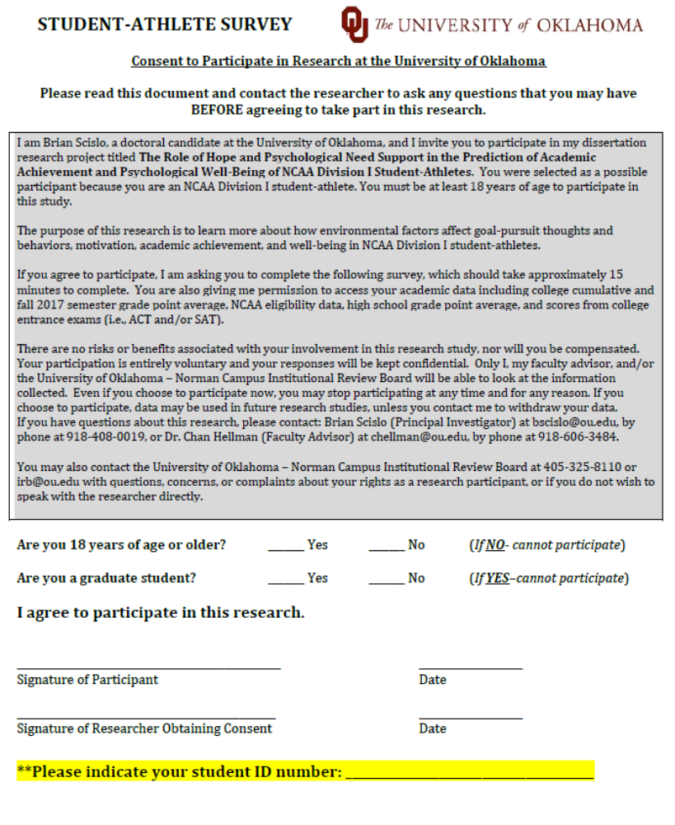

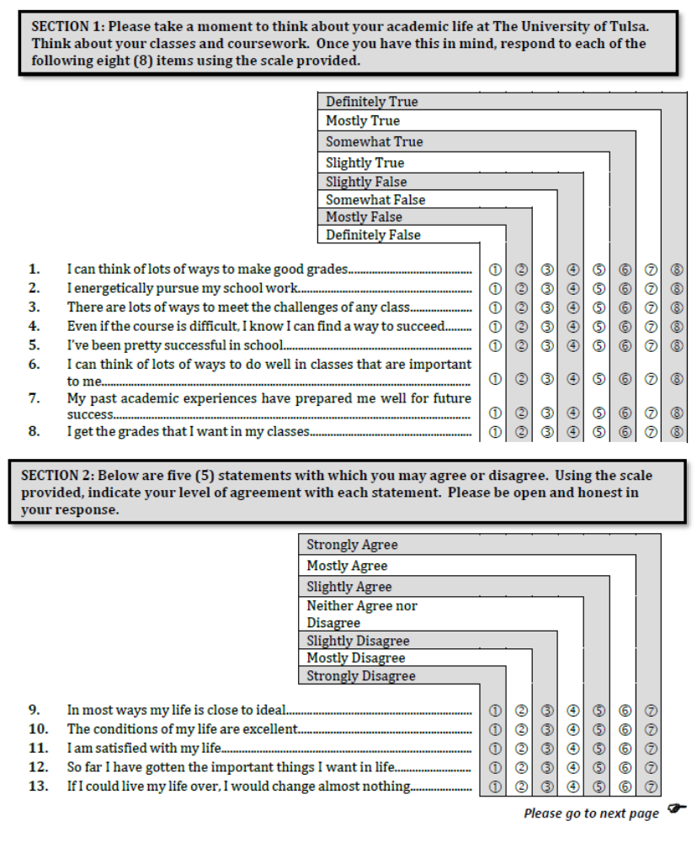

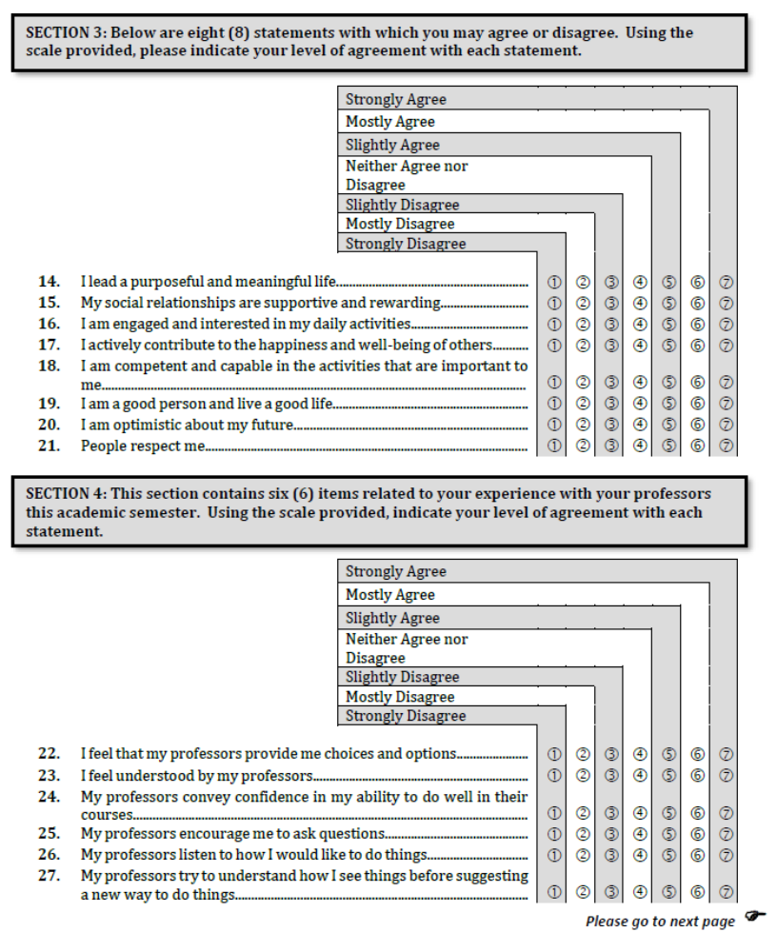

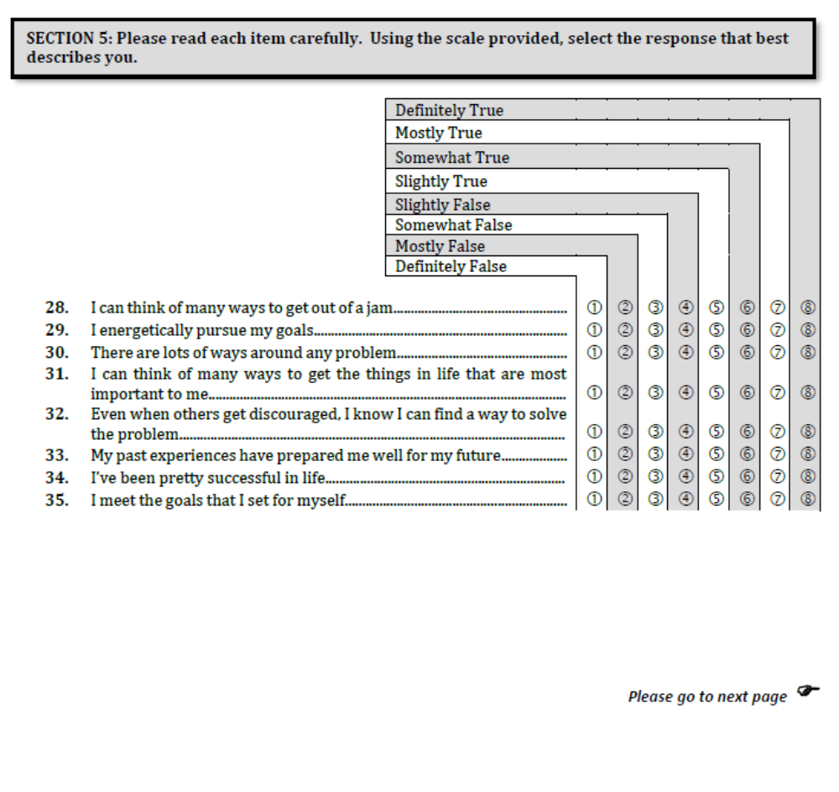

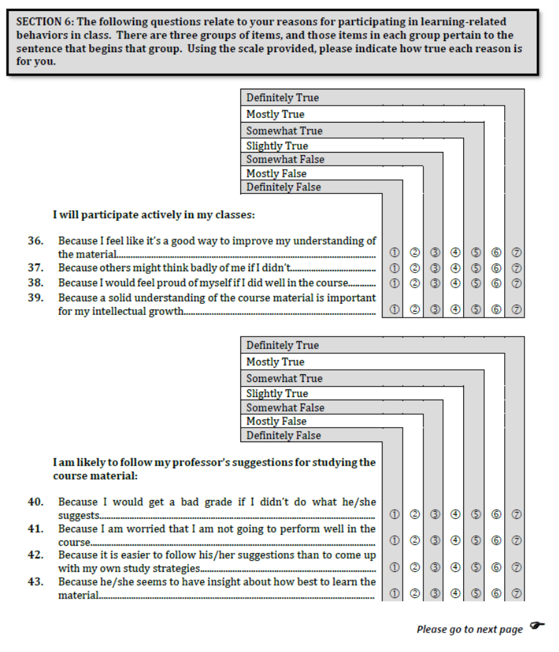

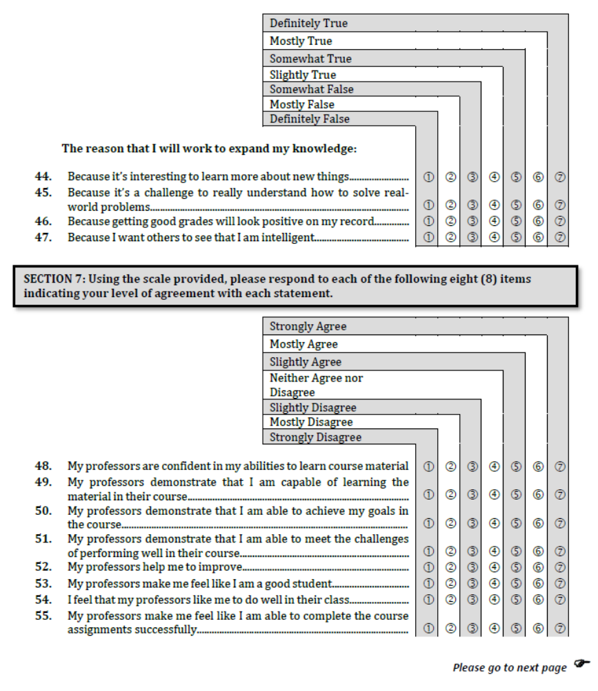

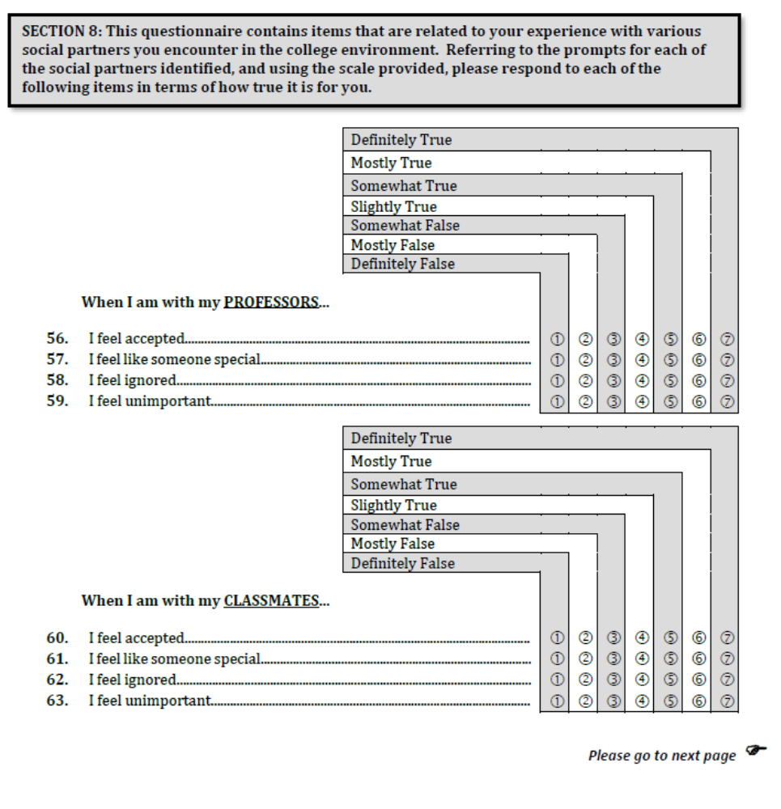

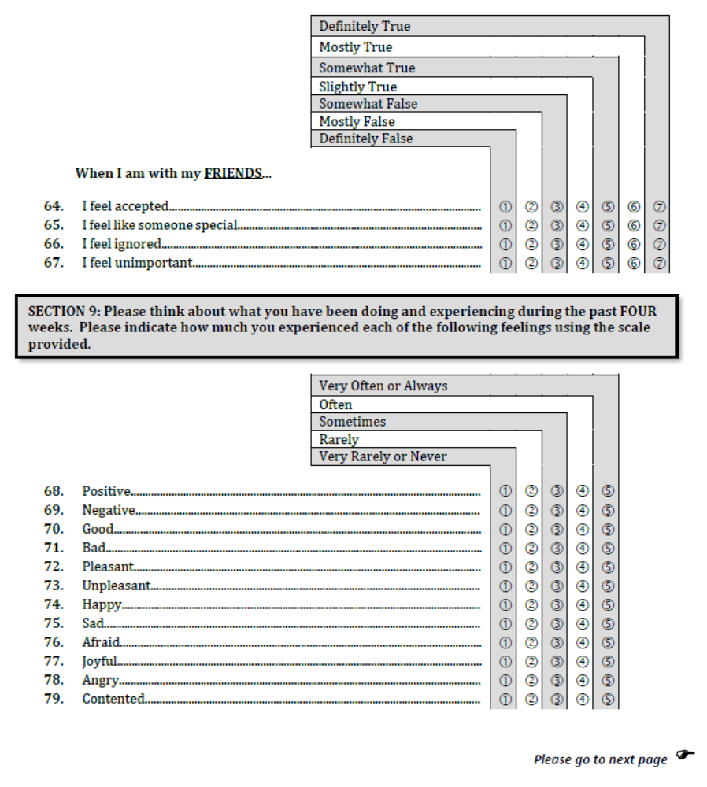





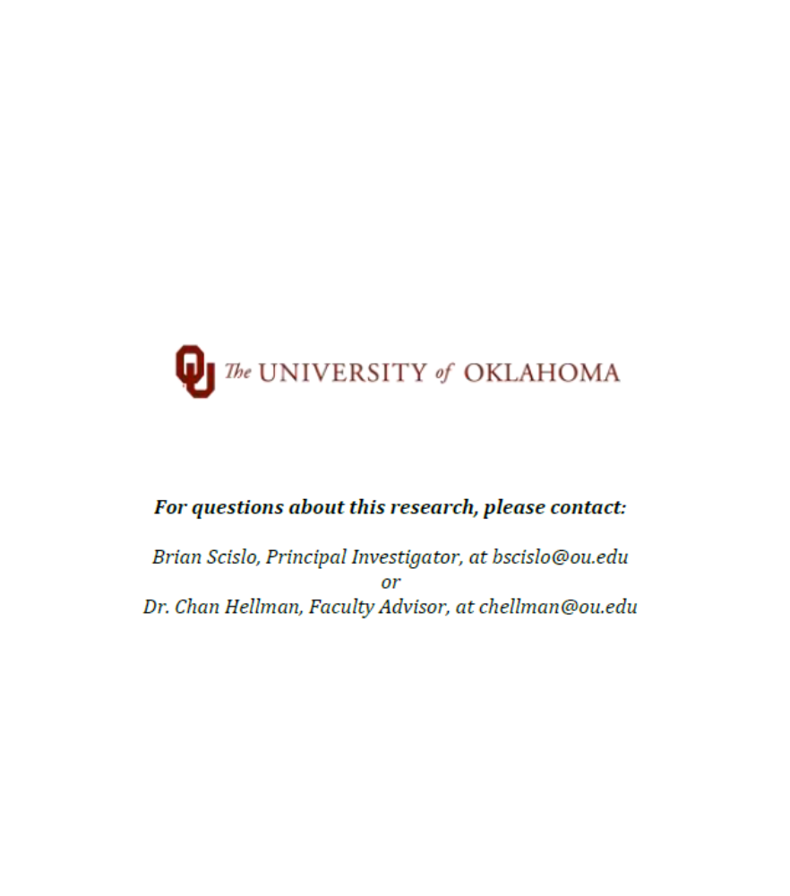

Appendix B: Institutional Review Board Letter of Approval

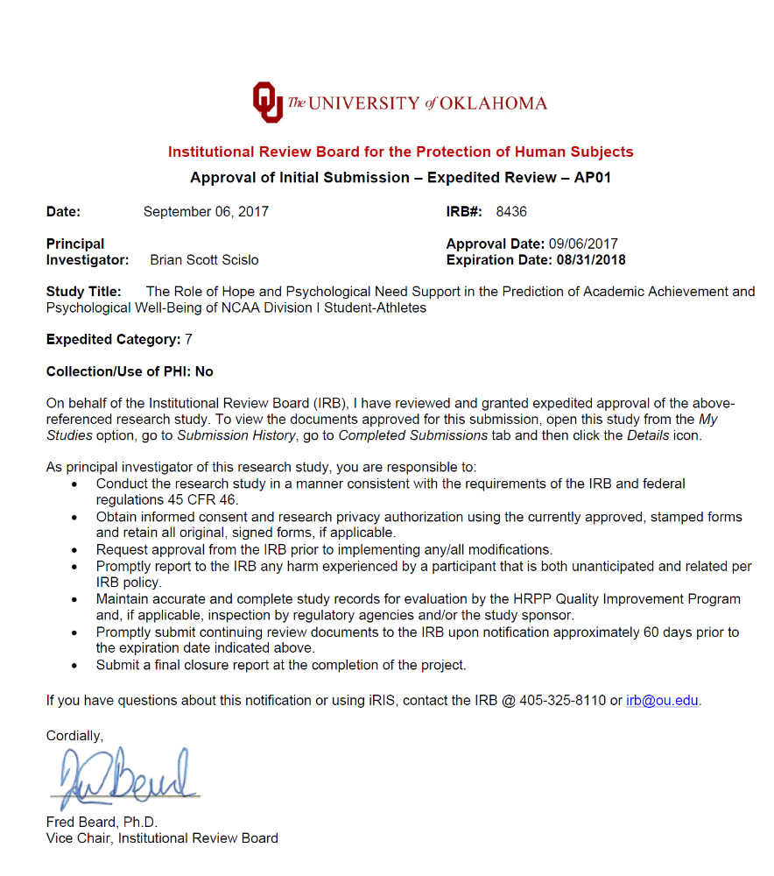

Appendix C: Research Site Approval Letter

