University of Oklahoma

Graduate College

Examining the Effects of Child Maltreatment and Child welfare experience on early sexual initiation and criminal justice contact

A Dissertation

submitted to the graduate faculty

in partial fulfillment of the requirements for the

Degree of

Doctor of Philosophy

By

brandon lee crawford
Norman, Oklahoma
2017

Examining the effects of child maltreatment and child welfare experiences on early sexual initiation and criminal justice contact

A Dissertation approved for the
Department of Sociology

By

______________________________
Dr. Constance Chapple, Chair

______________________________
Dr. Martin Piotrowski

______________________________
Dr. Mitch Peck

______________________________
Dr. Stephanie Burge

______________________________
Dr. Michael Crowson

© Copyright by Brandon lee crawford 2017
All Rights Reserved.

Dedicated to Bill Heist and his shoe, Kristen, and my mom. There’s no way I could have done this without you. Thank you.

Acknowledgments
I would like to thank my dissertation committee members. Thank you, Dr. Stephanie Burge, for your willingness to serve on my committee and for all of the feedback, patience, and flexibility. Dr. Michael Crowson, thank you for your support in both the Power Pony and academic arenas. Thank you, Dr. Mitchell Peck for the feedback, laughs, and words of wisdom. I know you like to keep a low profile and a light load, so I will tell any student who asks not to work with you, but in reality, you have been one of the most supportive faculty in the department, and I am truly grateful. Also, I will only buy black guitars from here on out. Dr. Martin Piotrowski, thank you so much for all of your help. Although you have provided feedback and support throughout my entire tenure at OU, you were on another level for my dissertation. Thank you for working with me over e-mail and always providing prompt and thorough feedback. I could not have done this without your help, and I am so thankful you were willing to serve on my committee. Dr. Constance Chapple, thank you. Thank you for sticking with me when I made the decision to move to AR and teach before finishing (or starting) my dissertation. I know it made things more difficult and I appreciate you sticking with me. You are my best and brightest Ph.D. adviser and I am your best and brightest Ph.D. student. Although I will eventually get dethroned, you will always be the best and brightest Ph.D. adviser I ever have, so thank you. Thank you to the rest of the OU faculty for all of the knowledge, time, and support you gave me throughout my time at OU. Special thanks to Dr. Trina Hope and Dr. Anne Beutel.
I would also like to thank fellow students in the department. You all made my experience at OU more enjoyable and valuable. Thank you to John T. Billington for sharing an office and many classes with me. We had the coolest office in Kaufman Hall by far. Thank you, Mindy Bradley, for continuing to be a mentor and friend. Thank you, Joesph, for stopping by to chat when I was working in my office and for always providing perspective. Thank you to Summer Jackson and Jonathan Kruk. I have consistently said joining a bowling league was the best decision I made in grad school and the main reason for that was that you two were apart of it. Summer, I am so glad that you were a part of my M.A., Ph.D., and first academic jobs. I will miss you dearly when you move but so excited for you. Jonathan, I am so glad Summer met you. Partly because you make her happy, but mostly because I’m not sure we would have become friends otherwise. I’m sure lots of fun times await you two in California and I can’t wait to visit.
Thank you to my mom, sister, and grandparents. You all played a part in making me who I am today and I plan on doing my best to only be a positive reflection of all that you have instilled in me. Finally, thank you Kristen. Words cannot express how much you mean to me and how much your support has helped me throughout my Ph.D. and especially my dissertation. You have both made me a better academic and a better person and for that, I will be forever grateful. I think you have stressed about the dissertation probably more than anyone else! I’m glad it’s done and we can still get married. I’ll still be me, and you will still be you, but I am excited to see what the next chapters hold for us.
Table of Contents
List of Tables ix
List of Figures xii
Abstract xv
Chapter 1: Introduction 1
Chapter 2: Review of Relevant Literature 14
Risky Sexual Behavior 14
Child Maltreatment and Risky Sexual Behaviors 14
Child Welfare and Risky Sexual Behaviors 19
Self-Reported Offending 24
Child Maltreatment and Juvenile Delinquency 24
Child Welfare Experience and Juvenile Delinquency 27
Child Maltreatment and Adult Criminal Behavior 30
Criminal Justice Contact 32
Child Maltreatment and Juvenile Justice Contact 32
Child Welfare Experience and Juvenile Justice Contact 35
Child Maltreatment and Adult Criminal Justice Contact 37
Chapter 3: Description of Data and Analytic Samples 43
Description of the NSCAW Data 43
Description of NSCAW Sample used for Early Sexual Initiation Analyses 54
Description of NSCAW Sample used for Criminal Justice Contact 58
Chapter 4: Variables and Methodology 62
Dependent Variables 62
Early Sexual Initiation 62
Criminal Justice Contact 66
Population Heterogeneity Variables 68
Population Heterogeneity Variables 68
State Dependence Variables 72
Baseline Service 73
Case Substantiation 73
Level of Harm 74
More than 1 Maltreatment 75
Control Variables 77
Gender 77
Race 78
Analytical Approach 78
Chapter 5: Early Sexual Initiation Results 81
Descriptive Statistics of Early Sexual Initiation Analytic sample 81
Bivariate Relationships of Early Sexual Initiation Analytic sample 88
Binary Logistic Regression of Early Sexual Initiation 94
Predictive Margins for the Early Sexual Initiation Final Logistic Regression Model 99
Summary 116
Chapter 6: Criminal Justice Contact Results 118
Descriptive Statistics of Criminal Justice Analytic sample 118
Bivariate Relationships of Criminal Justice Contact Analytic sample 123
Binary Logistic Regression of Criminal Justice Contact 129
Predictive Margins for the Criminal Justice Contact Final Logistic Regression Model 136
Summary 153
Chapter 7: Discussion and Conclusion 156
Early Sexual Initiation 162
Criminal Justice Contact 171
Limitations, Future Research, and Policy Implications 179
Conclusion 184
References 187

List of Tables
Table 3.1: NSCAW CPS Sample: Targeted, Selected, and Responding Sample Size 49
Table 3.2: Summary of Missing Cases for Age-Eligible Early Sexual Initiation (n=1,752) 57
Table 3.3: Summary of 580 Early Sexual Initiation Cases With Missing Weights by Wave 58
Table 3.4: Summary of Missing Cases for Age-Eligible Criminal Justice Contact Sample (n=2,671) 59
Table 3.5: Summary of Criminal Justice Contact Cases With Missing Weights by Wave 61
Table 4.1: Responses for Age at Sexual Initiation (SX#2A) 64
Table 4.2: Age at First Sex (SX510A) 65
Table 4.3: Arrest Past 6 Months Across all Waves (DE#71A) 67
Table 4.4: Ever Been Arrested for Any Offense (YL51A) 67
Table 4.5: Behavior Problem Index Questions 71
Table 4.6: BPI Self-Control Item Rotated Factor Loadings 72
Table 5.1: Frequency Statistics for Age-eligible and Early Sexual Initiation Samples 84
Table 5.2: Descriptive Statistics for 15-Year-Old and Early Sexual Initiation Samples 85
Table 5.3: Comparison of 12-Year-Old and Criminal Justice Contact Analytical Sample 85
Table 5.4: Variance Inflation Factors for Final Logistic Regression Model 91
Table 5.5: Bivariate Relationships between Independent Variables and Early Sexual Initiation 91
Table 5.6: Comparison of Means Between Early and Non-Early Initiators 93
Table 5.7: Logistic Regression of Early Sexual Initiation on Child and Case Predictors 95
Table 5.8 Average Adjusted Predictions and Average Marginal Effects of Early Sexual Initiation by Child Characteristics 102
Table 5.9: Average Adjusted Predictions for Age and Self-Control 105
Table 5.10: Average Marginal Effects for Gender*Case Substantiation 108
Table 6.1: Frequency Statistics for Age-eligible and Criminal Justice Analytical Samples 120
Table 6.2: Descriptive Statistics for 12-Year-Old and Criminal Justice Contact Analytical Sample 121
Table 6.3: Comparison of 12-Year-Old and Criminal Justice Contact Analytical Sample 121
Table 6.4: Variance Inflation Factors for Criminal Justice Contact Final Logistic Regression Model 124
Table 6.5: Bivariate Relationships between Independent Variables and Criminal Justice Contact 125
Table 6.6: Comparison of Means for Future Criminal Justice Contact 128
Table 6.7: Logistic Regression of Criminal Justice Contact on Child and Case Predictors 132
Table 6.8: Average Adjusted Predictions for Age, Level of Harm and Self-Control 139

List of Figures
Figure 3.1: PSU Frame Sampling Domains 48
Figure 3.2: Sample Equation and Notation based on Dowd et al. (2008:7.3-7.4) 51
Figure 5.1: Average Adjusted Probabilities of Early Sexual Initiation by Age at Baseline 104
Figure 5.2 Average Adjusted Probabilities of Early Sexual Initiation by Self-Control 106
Figure 5.3 Average Adjusted Probabilities of Early Sexual Initiation for Gender and Race/Ethnicity by Self-Control 107
Figure 5.4 AMEs for Gender*Case Substantiation Interaction Term 108
Figure 5.5 Average Adjusted Probabilities of Early Sexual Initiation by Case History and Age 110
Figure 5.6 Average Adjusted Probabilities of Early Sexual Initiation by Maltreatment Type and Age 112
Figure 5.7 Average Adjusted Probabilities of Early Sexual Initiation by Baseline Placement and Age 113
Figure 5.8 Average Adjusted Probabilities of Early Sexual Initiation by Baseline Placement and Self-Control 115
Figure 5.9 Average Adjusted Probabilities of Early Sexual Initiation by Baseline Placement, Race, and Self-Control 116
Figure 6.1: Average Adjusted Probabilities of Criminal Justice Contact by Age and Gender 141
Figure 6.2: Average Adjusted Probabilities of Criminal Justice Contact by Level of Harm and Gender 142
Figure 6.3: Average Adjusted Probabilities of Criminal Justice Contact by Self-Control and Gender 143
Figure 6.4: Contour Plot for Average Probability of Criminal Justice Contact by Age and Self-Control 144
Figure 6.5: Average Adjusted Probabilities of Criminal Justice Contact by Self-Control and Gender 145
Figure 6.6 Average Adjusted Probabilities of Criminal Justice Contact by Maltreatment Type, Substantiation, and Age 147
Figure 6.7: Average Adjusted Probability of Early Sexual Initiation for Gender and Race/Ethnicity by Self-Control 148
Figure 6.8: Adjusted Average Probabilities for Criminal Justice Contact Before and After Three-Way Interaction Term 149
Figure 6.9: Adjusted Average Probabilities for Criminal Justice Contact Before and After Three-Way Interaction Term Including Placements Other than a Group Home 151
Figure 6.10: Interaction Effect for Level of Harm and Sexual Abuse by Gender 152
Figure 6.11: AAPs of Criminal Justice Contact Across Levels of Harm by Gender and Maltreatment Type 153

Abstract
Previous research suggests that experiences involving child maltreatment and the child welfare system are related to an increased likelihood of negative outcomes. Specifically, research often finds that placement in a group home significantly increases the likelihood of risky sexual behavior and both official and self-reported offending. Although this relationship is one of the more consistent findings in the literature, less is known about whether this relationship is one of state dependence or population heterogeneity. In other words, previous research has not adequately addressed whether placement in a group home is causally related to these negative outcomes (state dependence) or is simply another symptom related to the causes of group home placements (population heterogeneity). Using the National Survey of Child Adolescent Well-Being (NSCAW) data and the theoretical lenses of Gottfredson and Hirschi’s General Theory of Crime and Sampson and Laub’s Age-Graded Theory of Informal Social Control, I examine if factors such as the timing of maltreatment, type of maltreatment, and types of placements are significantly related to early sexual initiation and criminal justice contact when accounting for propensity via self-control. Findings suggest that when accounting for propensity via self-control, the timing of the maltreatment, type of maltreatment, and placement in a group home are still significantly related to early sexual initiation and criminal justice contact. Specifically, group home placements are related to a significant increase in the odds of early sexual initiation and criminal justice contact

Chapter 1: Introduction
At the federal level, child maltreatment is defined as “any recent act or failure to act on the part of a parent of caretaker which results in death, serious physical or emotional harm, sexual abuse or exploitation” or “an act or failure to act which presents an imminent risk of serious harm” (Child Welfare Information Gateway 2010). Research consistently shows children with histories of maltreatment and contact with child welfare systems are more likely to experience adverse outcomes throughout the life-course. For instance, previous research finds that children with histories of child maltreatment and/or contact with the child welfare system have higher rates of risky sexual behaviors such as teen pregnancy and early sexual initiation (James et al. 2009; Leslie et al. 2010), self-reported offending (Brezina 1998; Chamberlain and Reid 1998; Chapple, Tyler, and Bersani 2005; Cusick et al. 2010a; Fagan 2005; Reilly 2003; Snyder and Merritt 2014; Stouthamer-Loeber et al. 2002; Taussig, Clyman, and Landsverk 2001), and criminal justice contact (Chamberlain and Reid 1998; Ekstrand, Burton, and Erdman 1999; Forsman and Långström 2012; Grogan-Kaylor and Otis 2003; Harlow 1999; Kazemian, Widom, and Farrington 2011; Mersky, Topitzes, and Reynolds 2012; Stewart, Livingston, and Dennison 2008; Taussig et al. 2001).
Despite previous literature linking child maltreatment and child welfare exposure with these adverse outcomes, the causal mechanisms through which this relationship operates is less clear. Furthermore, this relationship is not surprising given the chaotic social environments surrounding many of these youth. There are many events in their lives that may influence later outcomes. Factors such as parent background, SES, and neighborhoods may be correlated with both child maltreatment and later adverse outcomes for the child. Although difficult, disentangling the effects of these factors and distinguishing between their respective mechanisms is critical in understanding the influence of child maltreatment and child welfare experience on future adverse outcomes.
Additionally, a significant portion of previous literature focuses on child maltreatment or child welfare experiences independently. This is potentially problematic because it is likely that both child maltreatment and child welfare experiences exert unique main and joint effects on various adverse outcomes. Additionally, secondary consequences of child maltreatment and child welfare experiences, such as school disruption, are also likely to exert an independent effect on these adverse outcomes. It is also possible that different child welfare experiences may mediate any relationships between child maltreatment and later adverse outcomes. Taken together, any accurate understanding of the risk and protective factors of child maltreatment and child welfare experiences is likely to be complex.
Criminological and sociological theories regarding the root causes of crime are potentially helpful in disentangling the protective and risk factors of child maltreatment and child welfare experiences. These theories have not been utilized often when exploring the relationship between child maltreatment, child welfare experiences, and adverse outcomes later in life. Some relevant theories are classified as theories of population heterogeneity or state dependence (Nagin and Paternoster 2000). Population heterogeneity theories maintain that there is a stable characteristic within an individual that is related to their propensity for criminal behavior. While stable over time, this propensity is believed to vary across individuals, meaning some individuals have a higher propensity for criminal behavior. One of the most empirically supported population heterogeneity theories is Gottfredson and Hirschi’s (1990) general theory of crime. Hirschi and Gottfredson contend that levels of self-control are the major, individual-level cause of criminal offending. Specifically, those who learn self-control are much less likely to participate in criminal behavior. Furthermore, levels of self-control are stable at an early age (8-10 years old) and remain relatively stable throughout the life-course. For population heterogeneity theories, the high correlation between past and future behaviors is explained by an underlying propensity (low self-control) at the root of both the past and future behaviors.
Conversely, state dependence theories do not suggest that there are any initial differences in propensities for criminal behavior. Instead, state dependent theorists suggest that prior criminogenic events precipitate future criminal behavior via changes in lifestyles or opportunities to commit a crime. In other words, past criminal behavior is causally related to future criminal behavior. Whereas population heterogeneity maintains that propensities for criminal behavior are stable over the life-course, state dependence theories maintain that propensities for criminal behavior are fluid, and change as the result of past behaviors. Labeling Theory (Lemert 1972), Social Learning Theory (Akers 1998), and General Strain Theory (Agnew 1992) are all theories that are based on a state dependent framework. In all of these theories, the commission of a criminal act may have a causal influence on future criminal acts.
While these theories are often pitted against each other, or offered as competing theories, Nagin and Paternoster (2000) are clear to point out that population heterogeneity and state dependence theories need not be seen as mutually exclusive or incompatible. They contend that the best theories are those that incorporate both population heterogeneity and state dependence. Sampson and Laub’s (1990, 1995a, 1995b) age-graded theory of informal social control is one such theory. Sampson and Laub’s age-graded theory of informal social control is also referred to as a life-course theory of crime. Life-course theory contends that there are initial differences in propensity for criminal behavior that influence offending throughout the life-course. Indeed, past criminal behavior can also have a causal effect on future criminal behavior by weakening social bonds and increasing the likelihood of more criminal behavior moving forward. Importantly, this process can also work in the reverse, with non-criminal behaviors such as stable employment or marriage working to strengthen bonds and reduce the likelihood of future criminal behavior. It is this life-course perspective that are used to frame this study. This theory allows for exploration of both population heterogeneity and state dependent effects of child maltreatment and child welfare on later adverse outcomes.
Regarding the continuity of offending throughout the life-course, Nagin and Paternoster (2000) explain population heterogeneity processes as being those in which offending is the result of differences in propensities. This propensity is also related to other adverse outcomes such as risky sexual behavior, drug use, or employment instability and therefore may manifest in various ways throughout the life-course. To further explain population heterogeneity’s effects, they use the image of an urn that is filled with red and blue balls that represent the individual’s anti-social and pro-social tendencies respectively. The ratio of red to blue balls varies across the population and therefore, those with colored balls (anti-social tendencies) will be consistently more likely to draw upon an anti-social trait and therefore be more likely to experience an adverse outcome. As a result, the person’s past actions are a significant predictor of their future actions due to their stable ratio of anti and pro-social tendencies.
A population heterogeneity explanation of the relationship between child maltreatment, child welfare exposure, and adverse outcomes would be that maltreatment experienced at early ages results in failure of the child to attain appropriate levels of self-control. The lack of adequate levels of self-control may then manifest itself via an increased propensity for risky sexual behavior, higher rates of self-reported offending, and higher prevalence of criminal justice contact. The maltreatment and resulting lack of sufficient parenting and socialization results in maltreated children having more red balls (anti-social tendencies) than blue balls (pro-social tendencies). Additionally, previous research has shown that the relationship between child behavior and parenting practices can be reciprocal (Lytton 1990). In other words, adverse child temperament can result in harsher and less effective parenting styles which could in turn lead to maltreatment.
Regarding the continuity of offending throughout the life-course, Nagin and Paternoster (2000) explain state dependent processes as those in which a negative life event increases the likelihood of a future negative life events. State dependent processes are those of “contagion” meaning that actions committed by an individual influence multiple areas of their life (such as effecting social bonds or involvement in social institutions), which directly effects their future odds of committing anti or pro-social acts in the future. In other words, rather than differences in offending being the result of individual propensities, different outcomes are the result of differences in external controls preventing crime. To once again use the imagery of an urn and criminal behavior, in a state dependent process, every individual begins with an urn of equally proportioned red and blue balls, meaning every individual has the same initial propensity for committing a crime. If a red ball (anti-social behavior) is removed, it may be replaced with more than one red ball, changing the proportion of balls and increasing the chance of a future anti-social behavior. The same process occurs for every pro-social act that occurs. In this process, the chances of committing a criminal (anti-social) act are constantly changing as events take place. In this process, past behaviors are related to future behaviors, not through some underlying propensity like in a population heterogeneity process, but rather past behaviors are causally related to future behaviors.
As it applies to the current study, I suggest that even when controlling for population heterogeneity via self-control, child maltreatment and child welfare experiences will still exert a state dependent effect on later adverse outcomes. Sampson and Laub’s (1990, 1995a, 1995b) age-graded theory of informal social control, provides theoretical explanations for both the population heterogeneity effect of self-control and the state dependence effects of child maltreatment and child welfare experience on later adverse outcomes. As such, the focus is how child maltreatment and resulting placement in child welfare custody weakens the child’s bonds to institutions such as family, education, and perhaps even employment as they grow older. To once again use urn imagery, every placement disruption or change in school may result in more and more red balls being placed in the urn, resulting in an increased likelihood of adverse outcomes. Conversely, long term placement in a stable foster home, or in a home that could strengthen bonds to various institutions and result in the opposite effect and therefore a decrease in the odds of later adverse outcomes.
Although age graded theory of informal social control is helpful in explaining the link between child maltreatment, child welfare experiences, and adverse outcomes, the current study is particularly interested in the relationship between child maltreatment and child welfare experiences and the specific outcomes of risky sexual behavior and criminal justice contact (arrest and incarceration). Using age graded theory of informal social control and the presence of both population heterogeneity and state dependent effects, the current study answers the following research questions:
- What are the effects of child maltreatment and child welfare experiences on risky sexual behavior throughout the life-course?
- What are the effects of child maltreatment and child welfare experiences on criminal justice contact throughout the life-course?
Literature regarding risky sexual behavior typically focuses on outcomes and behaviors such as failure to use a condom, multiple partners, age at sexual initiation, early/unintended pregnancy, sexually transmitted infections, commercial sex, and sexual activity in general. Child maltreatment has been linked to decreased use of condoms (Lodico and DiClemente 1994; Noll, Trickett, and Putnam 2003; Paolucci, Genuis, and Violato 2001a; Purcell et al. 2004). Research has also shown that child maltreatment is significantly related to an increase in the odds of an early pregnancy (Fiscella et al. 1998; Herrenkohl et al. 1998; Rainey, Stevens-Simon, and Kaplan 1995; Romans, Martin, and Morris 1997; Stevens-Simon C and Reichert S 1994) and a decrease in the age at sexual initiation (Lodico and DiClemente 1994), an increase in the number of both overall partners and high-risk partners (Cunningham et al. 1994), and an overall increase in general sexual activity (Lodico and DiClemente 1994).
As it pertains to sex crimes and prostitution, research has shown that child maltreatment in general increases the likelihood of an individual participating in prostitution or other commercial sex (Cunningham et al. 1994; Wilson and Widom 2008; Zierler et al. 1991). Some research has shown that child sexual abuse specifically is related to an increase in prostitution when there is not a history of neglect or physical abuse (Widom and Ames 1994). Perhaps related to many of the above-mentioned outcomes, child maltreatment has also shown to be significantly more prevalent in populations with an HIV infection than the general population (Anaya, Swendeman, and Rotheram-Borus 2005; Cohen et al. 2000; Loeb et al. 2005; Wilson and Widom 2008).
Child maltreatment has also been linked to a higher prevalence of official criminal justice contact. Criminal justice contact involves events such as an arrest, petition, conviction, and/or incarceration. Research in these areas has shown that being a victim of child maltreatment can lead to increased risk of official criminal justice contact for juveniles (Smith et al. 2012; Spohn 2000; Stewart et al. 2008) and adults (Jung et al. 2014; Mersky and Topitzes 2010; Ou and Reynolds 2010; Thornberry et al. 2010). Research on the relationship between child welfare and criminal justice contact has found that various aspects of child welfare experiences such as placement type, placement stability, and final placement are related to criminal justice contact throughout the life-course. Some studies have found placement outside of the home to be related to higher risk for juvenile justice contact (Doyle 2007; Ryan and Testa 2005). Similarly, research has shown placement in out of home care to result in a higher chance of criminal justice contact as an adult (DeGue and Widom 2009; Doyle Jr 2008). Research has also shown that those who experience a higher number of placements are also at higher risk for criminal justice contact (Cusick et al. 2010b; Widom 1991a). Another area of focus for child welfare research is related to youth who emancipate, or “age out” of care. Emancipation or aging out of care means the child turns 18 while in care and leaves care independently as an adult. When a child exits care due to emancipation they are not considered to have achieved permanency. Aging out of care has been found to result in a significant increase in the odds of criminal justice contact as an adult (Courtney et al. 2011; Mark E. Courtney and Dworsky 2006; Cusick et al. 2010a; Cusick, Havlicek, and Courtney 2012; Ryan, Hernandez, and Herz 2007).
Although the current study focuses on criminal justice contact, child maltreatment has also been linked to increases in rates of self-reported offending. Research in these areas examines the relationship between both specific types of maltreatment (neglect, physical abuse, sexual abuse) and maltreatment in general. Studies have found child maltreatment to be linked to an increase in self-reported offending for both juveniles (Brezina 1998; Chapple et al. 2005; Fagan 2005; Stouthamer-Loeber et al. 2002; Yun, Ball, and Lim 2011) and adults (Buehler et al. 2000; Fagan 2005; Smith et al. 2012; Teague et al. 2008). Similarly, experiences with child welfare have also been linked to higher rates of self-reported offending among juveniles (Chamberlain and Reid 1998; Cusick and Courtney 2007; Snyder and Merritt 2014; Taussig et al. 2001) and adults (Courtney et al. 2001; Cusick et al. 2010a; Reilly 2003).
The current study uses the National Survey of Child Adolescent Well-Being (NSCAW) (Dowd et al. 2008). The NSCAW data is a longitudinal data set of 6,228 children who had contact with a child welfare services agency in a 15 month period beginning in 1999. The data are comprised of two groups with the majority (5,501) consisting of children who were the subject of a child maltreatment investigation conducted by a Child Protection Agency (CPS Sample) and a smaller group (727) consisting of children who had been in out-of-home care for approximately 1 year at the time of sampling as the result of a child maltreatment referral (Longer-term Foster Care Sample). These children ranged from 0-14 years old at the time of sampling. To date, there have been five waves of data collection with the first occurring 2-6 months after the close of the investigation and the last occurring between 59-96 months after the close of the investigation. At the time of the final wave, children were between the ages of 4 and 21. NSCAW data were collected from the child, current caregivers, investigator/services caseworkers, and teachers providing a fairly robust accounting of background and environmental factors surrounding the case.
Based on previous research I predict that age at baseline, previous child welfare involvement, the level of harm for the most severe form of maltreatment, case substantiation, and placement in a group home at baseline will all be related to increases in the odds of early sexual initiation and criminal justice contact. Additionally, I predict that receiving baseline services and placement in a foster home may be related to a reduction in the odds of early sexual initiation and criminal justice contact. I suggest that these relationships will remain even when controlling for the population heterogeneity effect of self-control.
To assess the accuracy of these predictions and the various risk and protective factors for later adverse outcomes in the areas of risky sexual behavior and criminal justice contact, multiple analytic techniques are used. Both analytical models involve dichotomous dependent variables and use logistic regression and provide estimated margins to aid in interpretation. Additionally, given the complex sampling design of the NSCAW data, the svy module within STATA is used to obtain accurate estimates. By using the svy module within STATA, findings are generalizable to a national population of children who were the alleged victim of a maltreatment report in the United States.
As seen above, there are many different pathways in which child maltreatment and child welfare experiences may increase the odds of various adverse events. The current study examines both population heterogeneity and state dependence effects to identify both main and interaction effects of child maltreatment and child welfare experiences on later adverse outcomes related to risky sexual behavior and criminality. The current study contributes to the literature by providing a more comprehensive analysis of adverse outcomes later in life for maltreated children by including various measures of both child maltreatment and child welfare experiences. Additionally, the rigorous underpinnings age graded theory of informal social control in these analyses adds to the literature by providing further insight into how and why certain experiences related to child maltreatment and child welfare may increase the likelihood of adverse outcomes later in life.

Chapter 2: Review of Relevant Literature
The following section provides an overview of the literature regarding child maltreatment, child welfare experience, risky sexual behaviors, self-reported offending, and criminal justice contact. Although the current study is concerned with early sexual initiation and criminal justice contact, a more complete review of outcomes similar or related to early sexual initiation are provided.

Risky Sexual Behavior
The following section will provide an overview of existing literature regarding child maltreatment, child welfare experiences, and a range of risky sexual behaviors. Although not all disciplines agree on what should be considered risky sexual behavior, I will be focusing on behaviors and outcomes such as ever having had sex, age at sexual initiation, number of partners, frequency of sexual activity, use of protective and contraceptive measures, pregnancy, sexually transmitted infections, and commercial sex. Studies typically focus on the influence of different types of maltreatment and child welfare experiences and their effect on sexual behaviors.

Child Maltreatment and Risky Sexual Behaviors
Although there is some inconsistency in the strength of the relationship between child maltreatment and risky sexual behaviors, studies generally show that victims of child maltreatment are at higher risk for engaging in risky sexual behavior throughout the life-course. A significant portion of the research on child maltreatment and risky sexual behaviors focuses solely on childhood sexual abuse. There is some support for childhood sexual abuse being a higher risk factor for sexually risky behavior than other forms of maltreatment. For example, previous research using bivariate analyses of the NSCAW data shows that youth who were victims of childhood sexual abuse are more likely to engage in sexual intercourse than children who experienced a form of maltreatment other than childhood sexual abuse (Leslie et al. 2010). However, a more recent study using multivariate analyses of the Longitudinal Studies of Child Abuse and Neglect (LONGSCAN), shows that childhood sexual abuse is not directly related to ever having had intercourse but rather has an indirect effect on having intercourse through externalizing behaviors in both 12-year-old boys and girls.
Regarding general sexual behaviors, a meta-analysis by Kendall-Tackett, Williams, and Finkelhor (1993) found that childhood sexual abuse victims have higher rates of sexualized behavior when compared to children who were not the victims of childhood sexual abuse. Furthermore, the authors found that childhood sexual abuse accounted for as much as 45% of the variance in these studies. A more recent study found that childhood sexual abuse victims not only had a higher prevalence of sexual behaviors, but also exhibited a higher frequency of engaging in these behaviors (Friedrich et al. 2001). Previous research has also shown individuals who were the victims of childhood sexual abuse to be more likely to engage in various high-risk sexual behaviors (HRSB) such as lower birth control efficacy and earlier sexual initiation, when compared to those without a history of maltreatment (Noll et al. 2003).
When examining the prevalence of risky sexual behaviors among those with various forms of child maltreatment, findings are mixed. A survey of 257 female undergrad students at a university in the Western United States revealed that women who experienced childhood sexual abuse scored higher on a measure of HRSB than both those who experienced maltreatment other than childhood sexual abuse or no maltreatment at all (Batten, Follette, and Aban 2002). However, when examining follow-up data for a cohort of 214 youth who were in foster care between the ages of 7-12, victims of childhood sexual abuse were no more likely to participate in risky sexual behavior than their peers who were victims of a form of maltreatment other than childhood sexual abuse (Taussig 2002).
Another proxy for risky sexual behaviors is a person’s age at sexual initiation. For these studies, sexual initiation (the age at which a person first engages in sexualized behaviors such as vaginal/penile intercourse, oral sex, genital touching, etc.) before the ages of 13-15 is considered a risky behavior. Early sexual initiation has been linked with an increase in the number of partners and a higher likelihood of sexual intercourse under the influence of alcohol (Sandfort et al. 2008) and a higher risk of contracting HIV (Koenig and Clark 2004). Wilson and Widom (2008) found victims of childhood sexual abuse were 1.75 times more likely to have their sexual initiation before the age of 15 than children who experienced physical abuse or neglect. Furthermore, although childhood sexual abuse was a risk factor for both male and female victims, childhood sexual abuse was a greater risk factor for female victims. Multiple studies suggest that female victims of childhood sexual abuse are typically younger at their sexual initiation than female non-victims (Koenig and Clark 2004; Ryan, Mendle, and Markowitz 2015). In addition to childhood sexual abuse, female victims of physical abuse have also exhibited a higher risk for having an early sexual initiation (Ryan et al. 2015).
Several studies have also explored the relationship between various forms of childhood maltreatment and the number of lifetime sexual partners. When limiting childhood maltreatment to only childhood sexual abuse, multiple studies have found no significant differences in the number of lifetime sexual partners for victims and non-victims of childhood sexual abuse. However, multivariate analyses of data from The National Longitudinal Study of Adolescent Health (Add Health) found female victims of childhood sexual abuse had a significantly more lifetime sexual partners than non-victims (Ryan et al. 2015). Similarly, analyses of 298 men between the ages of 18-49 found victims of childhood sexual abuse to have a significantly higher number of lifetime sexual partners than non-victims (Holmes, Foa, and Sammel 2005). Although much of the research has focused on the relationship between childhood sexual abuse and lifetime sexual partners, there is also some support for childhood victims of physical abuse also having more lifetime sexual partners than non-victims (Ryan et al. 2015).
Promiscuity is another behavior used as an example of risky sexual behavior. Definitions of promiscuity may vary, but definitions typically involve behaviors such as frequent involvement in sexual activity and/or engagement in commercial sex. A meta-analysis of 37 studies on the relationship between childhood sexual abuse and promiscuity found childhood sexual abuse to have an unweighted effect size of .59 (Paolucci, Genuis, and Violato 2001b). Findings from more than one-third of the 37 studies exhibited a significant relationship between childhood sexual abuse and promiscuity. Across all the studies, childhood sexual abuse resulted in a 14% increase in sexual promiscuity. Although the meta-analysis did not show any significant differences between male and female victims of childhood sexual abuse, a more recent study did find female victims of childhood sexual abuse to be more likely to engage in promiscuity (Koenig and Clark 2004).
Some studies have found a negative relationship between neglect and condom use (Klein, Elifson, and Sterk 2007), and physical abuse and condom use (Mason, Zimmerman, and Evans 1998). However, when looking exclusively at childhood sexual abuse, most research finds no difference in the consistent use of a condom or other contraceptive and protective methods between victims and non-victims (Miner, Flitter, and Robinson 2006; Wingood and DiClemente 1997; Wyatt, Guthrie, and Notgrass 1992). However, as with promiscuity, Koenig and Clark (2004) found that female victims of childhood sexual abuse are less likely to use a condom than non-victims. Similarly, previous studies find that childhood sexual abuse victims are at higher risk of teenage pregnancy when compared to non-victims (Leslie et al. 2010; Noll et al. 2003). Furthermore, Koenig and Clark (2004) also found female victims of childhood sexual abuse are more likely to engage in behaviors related to increased HIV risk, report ever having a sexually transmitted infection, and commercial sex. Wilson and Widom (2008) found that both male and female victims of childhood sexual abuse and neglect are more likely to participate in commercial sex than non-victims. Due to neglect being a larger risk factor for females and physical abuse only being a risk factor for females, the authors find that overall, maltreatment is a bigger risk factor for female victims than for males.

Child Welfare and Risky Sexual Behaviors
Research on child welfare experiences and risky sexual behaviors typically focuses on differences between those who experienced different forms of placement and various permanency outcomes. As with child maltreatment experiences, findings regarding child welfare experiences and various risky sexual behaviors are mixed. Regarding ever having had sex, James et al. (2009), found children who were removed and placed in out of home care were not more likely to have had sexual intercourse than those who were not removed. To explore risky sexual behavior outcomes among youth formerly in foster care based on how they exited care, Taussig et al. (2001) created a composite measure of risky sexual behaviors that included the number of sexual partners, frequency of intercourse, and the use of protection. When comparing scores among 149 individuals who were placed in foster care between the ages of 7-12, the authors found no significant differences in the scores between those who were not reunified and those who were reunified.
The relationship between child welfare histories and age at sexual initiation is another common area of examination. Risley-Curtiss (1997) found youth placed in out of home care had a higher risk of early participation in sexual behaviors. Carpenter et al. (2001) also explored age at initiation but distinguished between out of home foster care and out of home kinship care. The addition of this distinction allows for the comparison of three groups: kinship out of home placement, foster care out of home placement, and no history of out of home placements. The authors found foster care was not a significant predictor of age at initiation, however, youths placed in out of home kinship care were significantly more likely to have an earlier initiation. Specifically, when compared to the comparison group, those placed in kinship care had their sexual initiation six months earlier than the comparison group with no out of home placements. When comparing the two types of out of home placements, there were no significant differences between the foster and kinship placements across any of the outcomes.
Being placed in out of home care has been shown to increase the overall number of lifetime sexual partners. Specifically, Carpenter et al. (2001) found both children placed in out of home foster care and out of home kinship care were more likely to have more than the median number of lifetime sexual partners when compared to individuals with no history of out of home placements. However, as with age at initiation, there was no significant difference between the two types of out of home placements. When examining the frequency of sexual activity for youth aged 11-15 in the NSCAW data, Leslie et al. (2010) found no significant differences between youths with a history of out of home placements and youths with no history of out of home placements after controlling for factors such as maltreatment type, behavioral and cognitive functioning, deviant peers, and other background demographics. This suggests that the above controls mediate the relationship between out of home placements and frequency of sexual activity.
Inconsistent use of condoms, as well as other protective and contraceptive methods, is another risky sexual behavior that has been examined among youth with child welfare experiences. When maltreated youths with a history of out of home placements were compared to youths without a history of out of home placements there was no significant differences in the frequency or age at first use of condoms or other contraceptive and protective methods (James et al. 2009). In contrast, analyses by Carpenter et al. (2001) found both individuals placed in out of home foster care and out of home kinship care were younger upon their first use of contraceptives when compared to individuals with no history of out of home placements. However, as with their previous findings, there were no significant differences between the two out of home placement groups.
Related to the use of condoms and other contraceptive and protective measures, pregnancy, especially at a young age, has also been explored as a risky sexual behavior related to child welfare experiences. Generally, placement in out of home care has not been found to significantly increase the odds of pregnancy when compared to non-removals (James et al. 2009; Leslie et al. 2010; Risley-Curtiss 1997). However, some studies have found out of home placement to increase the odds of pregnancy. When comparing individuals with a history of out of home placements to both a random group and matched group from the National Survey of Families and Households (NSFH), youths with a history of out of home placements exhibited had more children than both the random and matched groups (Buehler et al. 2000). The matched group attempted to control for potential selection biases in the out of home placement group by matching on gender, race, age, father's educational attainment, mother's educational attainment, and living with a stepparent. Furthermore, placement instability, meaning a high number of placement moves while in child welfare custody, resulted in significantly higher pregnancy for foster youth who emancipated from care (Reilly 2003). When examining pregnancy rates among former foster youth, there were no significant differences when comparing those who were reunified and those who were not reunified (Taussig et al. 2001).
A group warranting special attention are those youths who emancipate from care. These youths turn 18 while in care and then leave care independently. According to the Children’s Bureau, permanency is the ideal outcome for youth in care. Permanency involves placement with the child’s biological family or another permanent family setting (Child Welfare Information Gateway 2010). For youths who emancipate from care, permanency is not achieved. Furthermore, emancipated youth are typically at higher risk for a host of negative life outcomes, including risky sexual behaviors. For example, one study finds that youth who emancipate from care are more than twice as likely to engage in some form of risky sexual behavior when compared to similar peers (Love et al. 2005). Additionally, youths who age out of care also use contraception at significantly lower rates than their peers (Stott 2011). Unsurprisingly, youths who emancipate from care also have higher pregnancy rates. Multiple studies show youth who emancipate from care have significantly higher pregnancy rates (M. E. Courtney, Terao, and Bost 2004; Reilly 2003; Stott 2011). In a study of 18-24-year-olds who aged out of care in Utah, 31% of women reported giving birth within three years of aging out (Singer 2006). Their birth rate was approximately three times higher than birthrate of that age group in the general population. Additionally, youth who emancipate from care are also at higher risk for earlier sexual initiation (Stott 2011).
Youth who emancipate are such a high-risk population that there are some datasets that focus solely on emancipated youth. The Midwest Evaluation of the Adult Functioning of Former Foster Youth which is a longitudinal study following the outcomes of youth in three Midwest states as they transition out of foster care. So far outcomes for participants in the Midwest Study have been collected through the age of 26. The Midwest Study data have been used to compare outcomes of these emancipated youth to their peers in nationally representative samples such as The National Longitudinal Study of Adolescent to Adult Health (Add Health). Regarding pregnancy rates, individuals in the Midwest Study have significantly higher pregnancy rates than similar youth in the Add Health data (M. E. Courtney et al. 2004). When comparing outcomes of males from the Midwest study at age 21 to similar Add Health males, the Midwest Study males were more likely to have had intercourse, less likely to have used birth control, and more likely to have been paid by someone to have sex (Courtney et al. 2007). Additionally, females from the Midwest Study were more likely to have ever had sexual intercourse, more likely to have engaged in behaviors that put them at risk for becoming pregnant, and contracting an STI when compared to similar Add Health females. Each of these comparisons taken together suggest that youth with a child welfare experience that leads to emancipation are more likely to engage in risky sexual behavior.

Self-Reported Offending
The following section will provide an overview of research regarding child maltreatment, child welfare experiences, and self-reported offending. Self-report offending measures are collected from the respondent and pertain to criminal or deviant behavior they have participated in within a given time frame. Self-reported measures of offending have the advantage of not requiring additional data collection from new agencies and may, in fact, provide a more accurate assessment of individual’s involvement in criminal and delinquent behavior. Additionally, previous research shows that overall, self-report and official records have similar levels of validity (Maxfield, Weiler, and Widom 2000).

Child Maltreatment and Juvenile Delinquency
When examining the relationship between child maltreatment and self-reported offending for juveniles, most studies use measures assessing both overall participation and frequency of involvement in a wide range of criminal and deviant behaviors such as assault, theft, vandalism, drug use, gang participation, possession of a weapon, etc. Overall, previous research has generally shown child maltreatment to be associated with increases in the likelihood of criminal or delinquent behavior (Brezina 1998; Herrenkohl, Egolf, and Herrenkohl 1997; Stouthamer-Loeber et al. 2002; Thornberry et al. 2004). Brezina (1998) suggests that maltreatment increases delinquency by reducing social control, fostering deviant socialization, and generating anger. Stouthamer-Loeber, Wei, Homish, and Loeber (2002) found nearly half of maltreated boys in their study were persistent delinquent offenders compared to only 19% of the control group who were matched on age, race, and neighborhoods. Although maltreatment is believed to be significantly related to higher risk of self-reported delinquent and criminal behavior, not all studies find this relationship to be straightforward. Specifically, some results find this relationship to be dependent on factors such as the timing of the maltreatment, timing of delinquency, and education.
Specifically, Ireland and colleagues (2002) found that the timing of abuse matters. To address the issue of timing, the authors split their sample into four categories: no maltreatment, childhood-limited maltreatment (0-12 years old), adolescent-limited maltreatment (12-17 years old), and persistent maltreatment (maltreatment before and after age 12). They also differentiated between delinquency before and after the age of 15. The additions of these distinctions resulted in childhood-limited maltreatment only being significantly related to increases in violent delinquency before the age of 15. However, adolescent-limited and persistent maltreatment were both significantly related to the overall rate of delinquency throughout adolescence. Thornberry et al. (2010) similarly found that rates of self-reported delinquency did not vary between childhood-limited maltreatment and those with no history of maltreatment. However, they did find that those who experienced adolescent-limited or persistent maltreatment had significantly higher rates of delinquency when compared to those with no history of maltreatment.
Regarding mediating factors, Bender (2012) initially found child maltreatment to result in a significant increase in delinquent behavior, however, with the addition of education as a mediating factor, the direct effect was reduced to non-significance. Specifically, school disengagement mediated the relationship between maltreatment and delinquency resulting in maltreatment lacking any significant direct effect on delinquency and only exerted a modest indirect effect on delinquency. Bender (2012) contends that these findings are supportive of life-course theory and by highlighting the importance of social bonding in school, especially throughout adolescence. Chapple et al. (2005) found the relationship between neglect and adolescent violence to be partially mediated by other factors. Specifically, by distinguishing between educational, emotional, and physical neglect, the authors found that peer rejection reduced the relationship between physical neglect and adolescent violence to a non-significant level. Interestingly, this study also found that child neglect did not predict self-control, and despite self-control being a significant predictor of violent behavior, it did not mediate the relationship between neglect and adolescent violence.
Some studies have chosen to focus solely on the link between maltreatment and violent delinquency. Yun and colleagues (2011) examined the relationship between both official and self-reported maltreatment and violent delinquency. Overall they found any substantiated official maltreatment resulted in a 5% increase in the probability of participating in violent behavior. The relationship between self-reported maltreatment and violent delinquency was less clear. Results showed that while sexual abuse and neglect increased the likelihood and frequency of violent behavior, physical abuse was not significantly related to violent behavior. In contrast to this study, Fagan (2005) found that physical abuse resulted in both a higher initial occurrence and frequency of robbery, serious assault, and theft. Taken altogether, previous research suggests that overall maltreatment is linked to higher rates of self-reported criminal and juvenile delinquent behaviors.

Child Welfare Experience and Juvenile Delinquency
In addition to the effects of child maltreatment itself, a child’s experiences while in the care of a child welfare agency is another area likely to influence juvenile offending. There are various aspects of child welfare experience that have been linked to juvenile delinquency such as placement instability, type of placement while in care, and placement when exiting from care. Previous research shows that the presence of placement instability in one form or another is correlated with higher rates of self-reported juvenile delinquency. Although placement instability is typically thought of as instability while in care, it is important to remember that even the initial transition from the child’s home to foster care can be taken as a sign of placement instability. As such, Snyder and Merritt (2014) found that compared to peers who were substantiated for maltreatment but not removed, youth placed in out of home care were two times more likely to engage in delinquent behavior even after controlling for deviant peer friendships. Further, Reilly (2003) found that multiple placements after removal resulted in higher odds of a youth self-reporting having experienced incarceration.
In addition to the number of placements, the type of placement while in care has also been found to influence rates of juvenile delinquency. Chamberlain and Reid (1998) compared outcomes of 79 boys between the ages of 12-19 who were placed in out of home care over the course of 4 years. Upon placement and eligibility screening, the youths were randomly assigned to either a group home or a multidimensional treatment foster care home (MTFC). Results indicated that overall, youth placed in MTFC placements reported lower rates of delinquent acts. Specifically, those with MTFC placements reported lower rates of general delinquency and violent/serious crimes. These findings held even when controlling for variables such as age at placement. Although these out of home placements were mandated by juvenile and not child welfare courts, this study does support the idea that type of placement while in care matters and if a youth is placed in the appropriate setting, type of placement can function as a protective factor.
A child’s placement upon exit from care has also been linked to self-reported juvenile offending. Although the goal in the vast majority of child welfare cases is reunification, research does not always support this as the best outcome. Taussig, Clyman, and Landsverk (2001) examined rates of self-reported juvenile offending among youths who were in foster care for at least five months between the ages of 7-12. They found that at a 6-year follow-up period, those youths who were reunified with their families exhibited more behavioral and emotional problems than those who did not reunify with family. Specifically, the reunified group exhibited more delinquent behavior, were twice as likely to have reported being arrested, had higher rates of substance abuse, self-destructive behavior, and risk behavior problems. At the other end of the spectrum youths fare no better. Research has generally found that those youths who do not achieve permanency while in care and emancipate from care (turn 18 while in care) do not fare as well as those who do achieve some form of permanency (reunification, adoption, permanent guardian, etc.). Using data from the Midwest Study and The National Longitudinal Study of Adolescent to Adult Health (Add Health), Cusick and Courtney (2007) found that those youth who aged out of foster care reported overall higher offending rates during the ages of 16-17. When compared to a group of similar peers from the Add Health data, youth who aged out of care in the Midwest Study reported rates nearly twice as high across various types of offending such as property damage, theft, trespassing, selling drugs, hurting someone badly enough for medical care, the use or threatened use of a weapon, participation in a group fight, and shooting or stabbing someone.

Child Maltreatment and Adult Criminal Behavior
Most research has shown that past experiences with child maltreatment typically result in a higher prevalence of adult criminal behavior and behaviors related to criminal offending such as alcohol abuse, conflict-related behavior, and intimate partner violence. Some research has shown that physical abuse during childhood and adolescence can result in higher rates of self-reported offending in adulthood (Fagan 2005; Teague et al. 2008). Using the National Youth Survey, Fagan (2005) found that victims of adolescent physical abuse had significantly higher likelihoods of self-reported offending during both the transition to adulthood and early adulthood. For some of these youth, the self-reported offending was 6-15 years after the initial victimization, suggesting that physical abuse has both immediate and prolonged effect on offending behavior. Teague and colleagues (2008) had similar findings when examining 480 males serving community correction orders in Australia. Specifically, the authors found that individuals who reported being the victim of physical abuse had a significantly higher prevalence of self-reported violent, property, and total offenses when compared to non-victims. Furthermore, those who reported higher levels of childhood physical abuse (90th percentile and above) reported frequency rates for property and general offending two times higher than non-victims. The difference between those in the 90th percentile and those who did no experience any abuse was even higher for violent offending, with victims in the 90th percentile or higher reporting offending that were rates three times higher than non-victims.
Smith et al. (2012) found similar results when using the Rochester Youth Study to explore the relationship between child maltreatment, education, and various adult outcomes. Child maltreatment was found to be significantly related to an increase in the prevalence of self-reported intimate partner violence. Although the inclusion of variables from their tenure in school, such as GPA as a mediator of the effect of maltreatment on intimate partner violence was marginally significant, childhood maltreatment still exerted a positive effect on intimate partner violence. The authors also found childhood maltreatment to be significantly related to an increase in both self-reports of general and violent offending. A school protection index composed of various school measures such as educational aspirations, GPA, and degree obtained was also used in the model as a mediator of the relationship between child maltreatment and self-reported adult offending. Despite being statistically significant, the inclusion of the education via the school protection index only partially mediated the relationship between child maltreatment for both general and violent offending.
In addition to comparing a group of children with histories of child maltreatment to a random comparison group, Buehler, Orme, Post, and Patterson (2000) also made comparisons to a control group matched on gender, race, current age, father’s educational attainment, mother’s educational attainment, and having ever lived with a step-parent. Although the study did not include any measures directly related to criminal behavior, they did include related behaviors such as alcohol abuse, shouting conflict behaviors, and physically aggressive behavior. The authors found the foster care group reported significantly higher rates of alcohol abuse and shouting conflict behavior when compared to the random group. However, when the foster care group was compared to the matched group there were no significant differences in reported rates. These findings suggest that without appropriate controls for various selection biases, any supposed effect of child maltreatment on adult outcomes such as self-reported criminal behaviors may in fact be spurious.

Criminal Justice Contact
The following section will provide an overview of research regarding child maltreatment, child welfare experiences, and official criminal justice contact. Official criminal justice contact can include arrests, petitions, convictions, juvenile incarceration, and adult incarceration. A petition is when criminal charges are filed against a person under the age of 18 by a prosecutor. Research linking child maltreatment and child welfare experiences to these various forms of criminal justice contact is mixed. For official juvenile contact, this review will focus mainly on the literature linking child maltreatment and child welfare to juvenile arrests and petitions. For official criminal justice contact in the adult years, this review will focus mainly on arrests and convictions, with some review of links to incarceration.

Child Maltreatment and Juvenile Justice Contact
Although the relationship is sometimes nuanced, studies find that child maltreatment increases the chances of experiencing an arrest or petition (Jonson-Reid and Barth 2000; Mersky et al. 2012; Ryan and Testa 2005; J. Ryan, Testa, and Zhai 2008; Stewart et al. 2008; Stewart, Waterson, and Dennison 2002; Cathy S. Widom 1989; Widom and Maxfield 1996; Zingraff et al. 1993). Some studies do not differentiate between the type of maltreatment and instead, only include a control for any experience of maltreatment. One of the most frequently used data sets is Widom’s (1991a) “Child Abuse, Neglect, and Violent Criminal Behavior in a Midwest Metropolitan Area of the United States, 1967-1988". Findings from her data have consistently shown that child maltreatment experiences are significantly related to increases in juvenile arrests (Cathy Spatz Widom 1989; Widom and Maxfield 1996, 2001).
Studies using the same data have also shown that maltreatment experiences are related to violent juvenile arrests, especially for females (Cathy Spatz Widom 1989; Widom and Maxfield 1996, 2001). Widom couches her research on the link between child maltreatment and arrests, especially violent arrests, in a cycle of violence framework. The cycle of violence framework states that those who are victims of violent abuse will then go on to be a perpetrator of the same or similar violent behavior (Cathy Spatz Widom 1989). Other studies have found that maltreatment is not significantly related to higher incidences of arrests for violent behavior (Ireland et al. 2002; Loeber et al. 2005; Maas, Herrenkohl, and Sousa 2008; Mersky et al. 2012; Stouthamer-Loeber et al. 2002).
Previous research has found a significant link between maltreatment in general and an increase in juvenile arrests (Maas et al. 2008; Spohn 2000; Zingraff et al. 1993). When these studies have examined specific types of maltreatment, there has been some support for significant independent effects of neglect (Spohn 2000) and physical abuse (Maas et al. 2008; Spohn 2000) on juvenile arrests. Despite the significant relationship in the abovementioned studies, some studies have not found a significant link between maltreatment and juvenile arrests (Kazemian et al. 2011; Loeber et al. 2005; Stouthamer-Loeber et al. 2002; Thornberry et al. 2004). In some of these studies, there was initial significance at the bivariate level that was lost when using multivariate analyses (Kazemian et al. 2011; Loeber et al. 2005; Stouthamer-Loeber et al. 2002). In other studies, the timing of the abuse affected the relationship between maltreatment and juvenile justice arrests (Ireland et al. 2002; Thornberry et al. 2004). Specifically, Ireland et al. (2002) found that maltreatment experienced only in childhood did not significantly impact the odds of a general juvenile arrest. However, childhood only maltreatment was significantly related to an increase in the odds of a juvenile arrest for violent behavior. Furthermore, persistent maltreatment (experienced in both childhood and adolescence) and adolescent only maltreatment both resulted in significant increases in the odds of a juvenile arrest. Similarly, Thornberry et al. (2004) found that prevalence of arrest histories was twice as high for youth who endured persistent maltreatment when compared to those who did no experience maltreatment or only experienced it in childhood.

Child Welfare Experience and Juvenile Justice Contact
Research regarding the relationship between child welfare experiences and criminal justice contact is more diverse because different child welfare experiences can also function as a protective factor. In other words, whereas maltreatment is always examined as a risk factor for later criminal justice exposure, child welfare experiences may be a risk or a protective factor. Different type of placements may function as a protective factor against risk factors such as maltreatment or other placements. The research around child welfare experiences generally focuses on one of the following areas: removal from the child's home, placement stability, and where the child is placed upon exiting the child welfare system. Research linking removal and juvenile justice contact can be difficult due to selection biases. Specifically, the problem is that when comparing children who were removed and children who were not removed, it can be difficult to distinguish between the effects of the removal or the differential effects of the maltreatment itself, especially because those children who were removed likely experienced more severe maltreatment.
When controlling for factors such as the type of abuse, Widom and Maxfield (2001) found that out of home placement was not significantly related to the number of arrests for children removed due to abuse and neglect. Although not related to removal alone, Widom (1991) found that older children who were removed were more likely to experience a juvenile justice arrest than younger children. In other words, a child who was removed for the first time at the age of 16 was more likely to experience an arrest as a juvenile than a child removed for the first time at age 10. This could be due to factors such as more severe abuse generally needed to justify a removal as children age or perhaps a bigger shock to a child’s social bonds as they age. Related, Ryan et al. (2008) found that the odds of arrest increase 5% every year older a child is at the time of placement. This same study also found that children with a group home placement history are also more likely to have a juvenile arrest. Given the fact that behavioral problems and a higher level of care are generally prerequisites for placement in a group home, this finding is not surprising.
Much of the research regarding placement type focuses on differences in outcomes when comparing children placed in kinship care versus children placed in non-kinship care. Ryan et al. (2008) found that youth placed in kinship home were significantly more likely than youth placed in non-kinship care to have a petition as a juvenile. Ryan et al. (2010) showed some support for the above findings. Specifically, for white and African-American adolescent males, the authors found that youths placed in kinship homes were significantly more likely to experience a juvenile arrest. However, they found that for Hispanic males and females, kinship homes functioned as a protective factor and for African American and white females, there was no difference between kinship and non-kinship placements. The authors suggest that neighborhood effects may be part of the explanation for these differences. In other words, there is something unique regarding the differences in neighborhoods between the respective kin and non-kinship homes that are resulting in these different relationships between child welfare experiences and juvenile justice outcomes. To date, there is little research on this front, but it is an area likely to be expanded upon moving forwards.
Placement stability is the final aspect of child welfare experience that is generally found to be related to juvenile justice contact. Although the number of placements varies, studies generally find that the more placements a child have, the more likely they are to experience a juvenile arrest (Widom 1991; Ryan et al. 2008; Ryan et al. 2008). Both Widom (1991) and Ryan et al. (2008) found that youth with three or more placements were significantly more likely to experience a juvenile arrest. Specifically, Ryan et al. (2008) found that youth with two and three placements experienced odds of experiencing an arrest equaling 3.7 and 5.5 higher, respectively, when compared to youth with less than two moves. Ryan et al. (2008) found that every additional placement after the first increased the odds of a juvenile delinquent petition of 1%. Youth with at least one runaway episode had a 160% increase in the odds of a delinquent petition.

Child Maltreatment and Adult Criminal Justice Contact
There is a large body of research linking childhood maltreatment to adult criminal justice contact. Most studies in this area focus on arrests, convictions, or incarceration. Victims of maltreatment are consistently overrepresented in surveys of incarcerated individuals (Ekstrand et al. 1999; Harlow 1999; Teague et al. 2008). Some studies show rates of previous physical and sexual abuse as high as 57% for females (Ekstrand et al. 1999). Experiencing maltreatment as a child has been shown to increase the odds of criminal justice contact as an adult (Mersky and Topitzes 2010; Smith et al. 2012; Spohn 2000; Cathy Spatz Widom 1989; Cathy S. Widom 1989; Widom and Maxfield 2001). As with juvenile justice contact, Widom’s (1991a) research shows a positive correlation between maltreatment and adult criminal justice contact (Grogan-Kaylor and Otis 2003; Cathy Spatz Widom 1989; Cathy S. Widom 1989; Widom and Maxfield 2001).
Some studies explore more than one form of criminal justice contact as an outcome. For instance, Mersky et al. (2012) use the Chicago Longitudinal Study to examine the link between childhood maltreatment and incarceration, arrest, conviction, number of convictions, violent offense convictions and drug offenses. Across each of these outcomes, they found child maltreatment resulted in a significant increase in odds when compared to non-victims. In fact, some maltreated youths had increases in the odds upwards of 200%. However, not all research has found maltreatment to be significantly linked to criminal justice contact. Jung et al. (2014) initially found a significant bivariate relationship between maltreatment and arrest, conviction, and incarceration. However, when they added controls and background demographics for multivariate analyses, all significant relationships dissipated. When using data from a Swedish Twin Study, Forsman and Långström (2012) found a moderate association between self-reported maltreatment and violent offending, however, once they used the twin control there was no significant association left.
Some studies have shown that maltreatment is not universally related to adult criminal justice contact but instead may be dependent upon variations in the maltreatment type, victim gender, and timing of the abuse. For instance, Maughan and Moore (2010) found that only maltreatment cases involving neglect as a result of poor supervision and a disorganized/chaotic home environments resulted in significantly higher odds of adult criminal justice contact. Similarly, Grogan-Kaylor and Otis (2003) found that physical abuse and sexual abuse were not significant predictors of adult arrests. However, maltreatment involving neglect was marginally significant in OLS models predicting arrests. Furthermore, when they used Tobit regression, neglect showed an even stronger significant association with propensity for adult criminal justice contact via arrest. Related, Spohn (2000) found that when controlling for juvenile delinquency no maltreatment was significantly related to criminal justice contact. However, for females, neglect and the combination of neglect and physical abuse were significantly related to higher odds of criminal justice contact. Furthermore, Widom and Maxfield (2001) found that although maltreatment increased the odds of adult criminal justice contact for male and females, the risk was even higher for females.
Timing has also been shown to affect the relationship between maltreatment and adult criminal justice contact. Perhaps in line with Gottfredson and Hirschi’s General Theory of Crime (1990), Mersky and Topitzes found that maltreatment experienced before the age of 11 was more universally associated with various adult crime measures. Using the theory of low self-control, it is possible that maltreatment experienced before the age of 11 influences acquired levels of self-control by the crucial age of 10 leading to future criminal involvement. Ou and Reynolds (2010) also found timing to influence the relationship between maltreatment and adult criminal justice contact. Specifically, they found that maltreatment between the ages of 0-4 increased the odds of incarceration as an adult and marginally increased the odds of an adult conviction. Finally, child maltreatment experiences after the age of 4 were significantly related to having an adult conviction.
Summary
Research has found that child maltreatment and child welfare experiences are significantly related to a higher prevalence of risky sexual behaviors, self-reported offending, and criminal justice contact. Specifically, there is research that supports a significant relationship between any maltreatment and an increase in risky sexual behavior such as higher numbers of lifetime sexual partners, early sexual initiation, and commercial sex (Leslie et al. 2010; Ryan et al. 2015; Wilson and Widom 2008). Additionally, research finds that childhood sexual abuse is uniquely linked to increases in risky sexual behaviors such as ever having had sex (Leslie et al. 2010), sexualized behavior (Friedrich et al. 2001; Kendall-Tackett et al. 1993), lower rates of birth control use (Koenig and Clark 2004; Noll et al. 2003), early sexual initiation (Koenig and Clark 2004; Noll et al. 2003; Ryan et al. 2015; Wilson and Widom 2008), and number of lifetime sexual partners (Holmes et al. 2005; Ryan et al. 2015)
Various child welfare experiences have also been linked to significant increases in risky sexual behavior. Research has shown that removal from the home is related to a higher likelihood of ever having had sex (James et al. 2009), having a sexually transmitted infection (Carpenter et al. 2001), earlier sexual initiation (Risley-Curtiss 1997), and a higher number of children (Buehler et al. 2000). Related to removal from the home, a lack of stable placements is also significantly related to higher rates of pregnancy (Reilly 2003). Where a child goes upon exiting care is also linked to risky sexual behaviors. Specifically, children who do not achieve permanency are more likely to participate in general risky sexual behaviors (Love et al. 2005), be younger at sexual initiation (Stott 2011), have higher pregnancy rates (Mark E. Courtney, Terao, and Bost 2004; Reilly 2003; Stott 2011), and use contraceptive measures at a lower rate (Stott 2011).
Overall, studies have found that experiences of childhood maltreatment are significantly related to higher rates of self-reported offending for both juveniles (Brezina 1998; Herrenkohl et al. 1997; Stouthamer-Loeber et al. 2002; Thornberry et al. 2004) and adults (Fagan 2005; Smith et al. 2012; Teague et al. 2008). Various aspects of child welfare experience are also significantly related to self-reported offending for both juvenile and adults. Child welfare experiences that involve removal from the home and placement instability are both significantly related to higher rates of self-reported offending for both juveniles (Reilly 2003; Snyder and Merritt 2014) and adults (Cusick et al. 2010a; Reilly 2003). Research also shows that youth who do not achieve permanency also have higher rates of self-reported offending as both juveniles (Cusick and Courtney 2007) and adults (Courtney et al. 2001; Cusick et al. 2010a; Cusick and Courtney 2007). However, there is some research that suggests that those children reunified with their families are at higher risk for self-reported juvenile offending than those who are not reunified (Taussig et al. 2001). This contrast suggests that the environment which a child exits to may be equally as important as who they exit to.
Although the relationship is at times nuanced, research generally finds that experiences of childhood maltreatment are significantly related to increases in criminal justice contact for both juveniles (Jonson-Reid and Barth 2000; Mersky et al. 2012; Ryan and Testa 2005; J. Ryan et al. 2008; Stewart et al. 2008, 2002; Cathy Spatz Widom 1989; Widom and Maxfield 2001; Zingraff et al. 1993) and adults (Ekstrand et al. 1999; Harlow 1999; Mersky and Topitzes 2010; Smith et al. 2012; Spohn 2000; Teague et al. 2008; Cathy Spatz Widom 1989; Widom and Maxfield 2001). Additionally, research also finds that various aspects of child welfare experiences are also significantly related to criminal justice contact. Specifically, experiences such as high placement instability (Cusick et al. 2010a; Ryan and Testa 2005; J. Ryan et al. 2008; Widom 1991b), type of placement (Chamberlain and Reid 1998; J. P. Ryan et al. 2008; Ryan et al. 2010), age at removal (Widom 1991b), and permanency upon exit from care (Cusick et al. 2012; Taussig et al. 2001) have all been found to increase odds of criminal justice contact for juveniles and adults.

Chapter 3: Description of Data and Analytic Samples

Description of the NSCAW Data
The National Survey of Child Adolescent Well-Being data consists of 6,228 child welfare-involved children who were between the ages of birth to fourteen at the time of sampling. The overall sample of 6,228 children is comprised of two different subgroups. The smaller subgroup (727/11.7% of the overall sample) is comprised of children who were in out-of-home (OOH) placement for approximately one year at the time of sampling. This sample is the longer-term foster care (LTFC) sample. The larger subgroup (5,501/88.3% of the overall sample) are children who were the subject of a maltreatment investigation by various states’ Child Protective Services agencies. This sample is referred to as the CPS sample and is the sample used in this study. All of the children were involved with some aspect of the child-welfare system within the 15-month period beginning in October 1999. There are two different versions of the NSCAW data publicly available, the General Release and the Restricted Release. The Restricted Release version of the data includes more background variables and includes variables needed to produce accurate estimates that account for the complex sampling design of the data. More details regarding these variables and the complex survey design can be found below.
The target population for the NSCAW CPS sample is any child in the United States who was the alleged victim in a child maltreatment investigation or assessment. However, due to laws in some states requiring a staff member of the local CPS agency to make contact before any NSCAW field representatives, four states were eliminated from sampling. As such, the target population for the NSCAW CPS sample was modified to be “all children in the U.S. who are subjects of child abuse or neglect investigations (or assessments) conducted by CPS and who live in states not requiring agency first contact” (Dowd et al. 2008:29). The CPS sample is then comprised of both substantiated and unsubstantiated cases, as well as cases that both received and did not receive on-going services.
A two-stage stratified sample design was used to create a representative sample. The first stage of sampling involved dividing the United States into nine sampling strata and 92 primary sampling units (PSUs). The first eight sampling strata were comprised of the eight states with the largest child welfare caseloads. The ninth and final stratum was created using the remaining 38 eligible states and the District of Columbia. As previously mentioned, four states were not included in sampling due to their “first contact” laws. Next, PSUs were formed and selected within each of the nine strata. PSUs were defined as “geographic areas that encompass the population served by a single child protective (CPS) agency” (Dowd et al. 2008:30). Variances in the size of counties required some modifications to the PSUs. Most PSUs formed corresponded to counties or adjacent areas of multiple counties. However, some agencies serving smaller populations were combined, and conversely, PSUs in large metropolitan areas were formed into smaller geographical areas. Furthermore, extremely small counties (those that less than 60-67 cases a year) were deleted from the NSCAW PSU frame. It is estimated that less than 3% of the target population resided in these counties.
Following their creation, PSUs were then randomly selected using a probability-proportion-to-size (PPS) procedure. Probability-proportionate-to-size sampling is the “Unequal-probability sampling method in which the probability of sampling a unit is proportional to the number of elements in the unit” (Lohr 2009:266). As it applies to the NSCAW data, the use of PPS results in a higher chance of selection in PSUs with higher caseloads. To address propensity for selecting areas with the largest caseloads, the sampling procedures were set to select the same number of children within each PSU regardless of the size of the PSU. As a result, children investigated for maltreatment during the sampling period had roughly the same probability of inclusion in the sample regardless of the size of the PSU.
The second stage of the sampling design involved stratifying the children in the CPS agencies based on eight mutually exclusive and exhaustive domains of interest for the study. These eight domains consist of cross-classifications of four different characteristics (Dowd et al. 2008). First children were divided into those not receiving services (Domains 1 and 2) and those receiving services (Domains 3-8). The first two domains (those not receiving services) were then divided into two groups: children less than 1-year-old and those older than 1-year-old. The group of those receiving services was then divided into six different groups. They were divided first by age (children less than 1-year-old and those older than 1-year-old), then within each of those age groups divided again based on placement setting (in-home care and out-of-home care). Lastly, the older groups for both in-home and out-of-home placements were again divided by type of maltreatment reported (sexual abuse vs. all other children). A visualization of the domains can be found in Figure 1. It should be noted that while the groups are the same, the domain numbers in the below figure do not directly correspond to the domain numbers in the NSCAW User’s Manual.
The sampling of NSCAW data involved all children investigated for alleged maltreatment during the 15-month period between October 1999 and December 2000. During the sampling time, participating agencies provided files containing all children who were investigated for child maltreatment in the previous month. Due to a focus on children between the ages of 0-14, children included in the reports who were 15 or older were removed from the frame. Additionally, to eliminate the chances of repeated selection, children who were in the previous month's files were automatically removed. Also, children who were a part of the same family as a child from the previous month's report were also removed. This was done to limit the potential burden on a family due to having multiple children participating in the study. Children were also removed from the report if they were listed as a perpetrator of the alleged maltreatment. After the removal of siblings, previous month's children, and others not meeting the eligibility requirements, cases were selected using simple random sampling. A review of sampling rates and achieved sample sizes was conducted every month so that subsequent sampling rates could be adjusted to ensure that the final sample within each domain was as close to the targeted sample size as possible. The baseline number of targeted CPS respondents selected respondents, and final respondents for the first and second stage strata for the NSCAW can be found in Table 1.

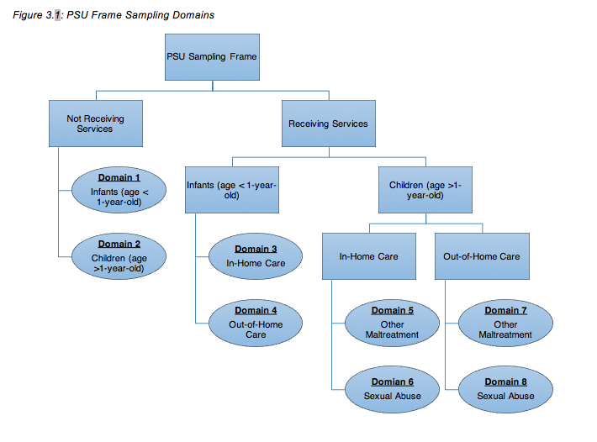
Table 3.1: NSCAW CPS Sample: Targeted, Selected, and Responding Sample Size
First Stage Strata | Total | Not Receiving Services |  | Receiving Services
First Stage Strata | Total | < 1 yr. old | 1-14 yrs. old | In-Home Placement |  |  | Out-Of-Home Placement
 |  |  |  | < 1 yr. Old | 1-14 yrs. old Sex. Abu | 1-14 yrs. old Other Maltreatment | < 1 yr. old | 1-14 yrs. old Sex. Abu | 1-14 yrs. old Other Maltreatment
Allocated Sample Size (Targeted number of Respondents)
California | 703 | 52 | 121 | 98 | 47 | 220 | 39 | 19 | 107
Florida | 304 | 5 | 27 | 47 | 29 | 124 | 19 | 10 | 43
Illinois | 284 | 18 | 52 | 41 | 19 | 86 | 19 | 11 | 38
Michigan | 297 | 26 | 53 | 44 | 25 | 90 | 15 | 8 | 36
New York | 402 | 27 | 67 | 59 | 32 | 124 | 27 | 10 | 56
Ohio | 293 | 17 | 54 | 39 | 21 | 90 | 21 | 12 | 39
Pennsylvania | 300 | 16 | 43 | 37 | 22 | 110 | 18 | 15 | 39
Texas | 473 | 27 | 81 | 77 | 38 | 145 | 28 | 14 | 63
Remainder | 2,381 | 151 | 397 | 341 | 179 | 760 | 148 | 78 | 327
Total | 5,437 | 339 | 895 | 783 | 412 | 1,749 | 334 | 177 | 748
Number Selected
California | 1,359 | 89 | 241 | 179 | 102 | 449 | 70 | 38 | 191
Florida | 503 | 17 | 54 | 75 | 39 | 209 | 33 | 14 | 62
Illinois | 445 | 19 | 72 | 67 | 31 | 147 | 32 | 22 | 55
Michigan | 435 | 43 | 96 | 60 | 35 | 132 | 18 | 1 | 50
New York | 686 | 63 | 160 | 73 | 29 | 213 | 45 | 9 | 94
Ohio | 433 | 27 | 85 | 60 | 32 | 128 | 30 | 19 | 52
Pennsylvania | 439 | 27 | 75 | 51 | 32 | 150 | 28 | 22 | 54
Texas | 683 | 48 | 133 | 97 | 54 | 202 | 41 | 23 | 85
Remainder | 3,978 | 262 | 999 | 472 | 264 | 1,187 | 204 | 104 | 486
Total | 8,961 | 595 | 1,915 | 1,134 | 618 | 2,817 | 501 | 252 | 1,129
Responding Sample Size
California | 695 | 53 | 113 | 105 | 53 | 191 | 45 | 21 | 114
Florida | 298 | 8 | 28 | 45 | 26 | 114 | 21 | 11 | 45
Illinois | 285 | 15 | 45 | 43 | 15 | 87 | 27 | 15 | 38
Michigan | 336 | 33 | 64 | 48 | 26 | 107 | 16 | 1 | 41
New York | 408 | 47 | 97 | 47 | 18 | 119 | 28 | 4 | 48
Ohio | 314 | 17 | 53 | 46 | 22 | 91 | 27 | 13 | 45
Pennsylvania | 300 | 20 | 53 | 36 | 21 | 104 | 17 | 12 | 37
Texas | 485 | 29 | 84 | 78 | 37 | 144 | 33 | 16 | 64
Remainder | 2,380 | 138 | 524 | 321 | 157 | 702 | 154 | 71 | 313
Total | 5,501 | 360 | 1,061 | 769 | 375 | 1,659 | 368 | 164 | 745

To ensure there were sufficient numbers of cases within each domain, some domains were oversampled. As such, although the data are representative, the observations were not selected with equal probability. To correct for the effects of unequal selection probabilities, the NSCAW Restricted Release data include both stratum and PSU identifiers. The inclusion of these variables allows for the use of programs with survey data modules, such as the "svy" command in STATA. The use of these modules ensures that estimates of parameters and variance are adjusted to account for the unequal selection probabilities, stratification, and clustering of the NSCAW sampling design. Additionally, the NSCAW Restricted data include several different weights to be used in analyses. The selection of appropriate weights depends on both the waves of data being analyzed and the population to which findings are being generalized. The NSCAW Codebook provides detailed information regarding the various sample weights and their appropriate uses (Dowd et al. 2008). It is important to note that the use of said weights in analyses is required to obtain unbiased parameter estimation, however, due to their use, standard errors are potentially increased.
For this project, cases are used from all five waves of the NSCAW data to make inferences at the national level. As such, it is important to discuss the construction of the wave 1 (NANALWT) and wave 5 (NANLW345) weights which are the appropriate weights to be used when making inferences at the national level (Dowd et al. 2008). The wave 1 baseline weight (NANLWT) is initially calculated to represent the inverse of the probability of a child's selection into the sample, and its purpose is to adjust estimates to reflect the sampling processes' differential probability of selection. Each child's probability of selection is the product of their first and second stage weights. The first stage weight is the inverse of the probability of selection for their PSU (county of residence). The second stage weight is the inverse of the probability of a child's selection within their county of residence. This is calculated by dividing the number of sampled children by the number of eligible children for sampling at the time the sample was drawn. The full equation and notation of terms can be found in Figure 3.2. Due to the month to month variations in frame sizes, including frame sizes as small as zero, the sampling domains across all months were combined into one. This process is similar to treating the various sampling times across the 15-month period as one sampling period. This reduces instability in the weight due to variations in the sampling rates.

Figure 3.2: Sample Equation and Notation based on Dowd et al. (2008:7.3-7.4)
$π_{hidmj}=π_{hi}×\frac{n_{hidm}}{N_{hidm}}$
h: the sampling stratum for the primary sample selection where h=1, h=2, etc. for eight largest states and h=9 for remaining stratum
n_{h}: number of PSUs sampled in a stratum
i: the PSU sampled within a stratum
d: the sampling domain within each PSU
m: the month of the study
$n_{hidm}$ : number of children sampled in month m stratum h, PSU i, domain d
j: the child sampled within PSU, domain, and month of the study
$N_{hidm}$ : the number of eligible children on the sampling frame in month m stratum h, PSU i, domain d
$π_{hi}$ : the probability of selection for the ith PSU in stratum h

The above product however, is not the final weight. Adjustments to the weight were made to address issues such as siblings, delayed sampling, missing months, and incomplete/missing data. Although the NSCAW codebook does not list specifics, it does note that in some PSUs, data collection was delayed until December 1999 despite a project start date of October 1999. Although most PSUs submitted complete data, some states submitted incomplete data. Data were incomplete for reasons such as the exclusion of unsubstantiated cases due to legal issues, substantial percentages of unsubstantiated cases missing due to late data entry, and cases not receiving services within domains 1 and 2 were excluded from the study (one county).
Two states only included information for children who were the subject of a substantiated investigation. To account for this when making inferences at a national level, a coverage adjustment was applied for unsubstantiated cases at this level. The process involved ratio adjusting weights for sampled unsubstantiated cases in other states to the total number of unsubstantiated in states, including the two missing states. To complete these adjustments, data from the National Child Abuse and Neglect Data System (NCANDS) Detailed Case Data Component were used to estimate the total unsubstantiated cases in the two states with missing data. Data from the National Child Abuse and Neglect Data System are comprised of all reports of child maltreatment made to child protective service agencies in the United States (Children’s Bureau and Administration for Children and Families 2015). Data are voluntarily reported by states to the Children’s Bureau for every fiscal year (October 1st-September 30th). The above process has been shown to improve the precision of final estimates (Folsom and Singh 2000).
To address issues of nonresponse across the data, a model-based method was developed by the Research Triangle Institute. The process uses a constrained logistical and exponential model that allows for nonresponse and post stratification-type sample weight adjustments to be made at the individual level (Folsom and Witt 1994). This process involves creating a logistic regression model using variables present for many children in the sample. Some of these variables were kept administratively and did not require actual interviews with all parties to obtain, resulting in a low missing percentage. Variables initially considered were: age, gender, race, ethnicity, sexual abuse, receipt of services, case substantiated, and out-of-home placement (OOH). The variables used in the final nonresponse adjustment models were age, gender, race/ethnicity, receipt of services, placement in OOH, and the urbanicity of the PSU.
Two additional weights were created for wave 5 to be used in analyses of wave 5 responses (NANALWT5) and for longitudinal analyses of those who responded to Waves 1, 3, 4, and 5 (NANLW345). Wave 5 data collection was divided into four groups: those sampled as infants, those sampled as young children, those sampled as adolescents, and those who were young adults at the time of wave 5 data collection. Adjustments made to the NANLW345 were computed separately for each of the 4 above-mentioned groups. The wave 5 weights were created by making adjustments and calibrations to the wave 1 weight based on nonresponses in wave 5. Adjustments for nonresponse were made using a proprietary generalized exponential modeling procedure (GEM) from the Research Triangle Institute. This process is similar to using a logistic model to make corrections for nonresponse. The advantage of using the GEM software is the ability to complete nonresponse adjustment, weight trimming, and weight smoothing in one step. Further information on the use of GEM for weight adjustments can be found in section 7.4.1 of the NSCAW Data File User Manual (Dowd et al. 2008).

Description of NSCAW Sample used for Early Sexual Initiation Analyses
Many selection criteria were used for this project, as such, not all individuals in the NSCAW data were used in the analyses. Furthermore, different variables of interest required samples of different age groups. Specifics regarding differences in the ages selected are discussed later in this section. As previously mentioned, the first step of selection was to include only observations from the CPS sample. This step does not differ by the variable of interest and therefore was the same for every analysis sample used. This step reduces the number of observations from 6,228 to 5,501. The CPS sample involves those children who were the subject of a maltreatment investigation by various states' state Child Protective Services agencies. Analyses in this project were limited to only the CPS sample for multiple reasons. The first is this sample includes the largest number of children. Second, one of the goals of this study is to distinguish between the effects of child maltreatment and child welfare experiences and, as such, the LTFC portion of the sample includes only those who were in an out-of-home placement setting for at least a year. As such, the LTFC sample does not include a comparison group of those who are not in out-of-home care. Furthermore, those children who have been in out-of-home care for at least a year represent a different and less diverse group when compared to the CPS sample. Stated differently, cases in the LTFC sample include only those cases with significant enough maltreatment and social settings that required out-of-home placement for over one year. In comparison, the CPS sample contains a wide range of cases including those without substantiated maltreatment all the way through the most severe cases which may involve out-of-home placements lasting for more than a year.
Due to the age-dependency of the dependent variables, only those children who were guaranteed to be a certain age at the time wave 5 data collection were included. Specifically, to assess risky sexual behavior in the form of early sexual initiation, sexual initiation prior to the age of fifteen was deemed to be early. As such, observations included in the early initiation sample needed to be at least 15 at the time of the wave 5 data collection to ensure estimations were not biased by observations which had not yet reached the earliest age for early initiation. To accomplish this, only children who were at least nine years old at baseline were included in the risky sexual behavior sample. Age at baseline was used as opposed to age variables at wave 5 due to wave 5 having a higher percentage of missing values for age. When using a minimum baseline age of nine one case was identified where the age at wave 5 was 14. This case was subsequently eliminated from the sample. There were also 10 additional cases where the age at wave 5 was missing. Of these 10 cases, 9 were at least 10 at baseline and 1 was only 9 at baseline. Given the timeframe of data collection, it is very likely the 9 youths who were 10 at baseline were at least 15 at the time of wave 5 data collection. However, it is possible the case identified as 9 at baseline was not 15 during wave 5 data collection and therefore was removed from analyses. After selecting only observations which were at least nine at baseline and fifteen at wave five, the total number of observations eligible is 1,752.
Although there were 1,752 cases eligible for inclusion in analyses based on age, more cases were subsequently removed because of missing data. The reason for cases being dropped by variable and the resulting sample sizes eligible for early initiation analyses can be found in Table 3.2. Of the 1,752 age eligible cases: 158 cases (9.02%) were dropped due to not having enough information to determine early sexual initiation, 125 cases (7.13%) were dropped due to having missing or incomplete responses for self-control, and 150 cases (8.62%) had missing or incomplete information regarding other variables used in the analyses.

Table 3.2: Summary of Missing Cases for Age-Eligible Early Sexual Initiation (n=1,752)
Variable | # Missing | Remaining Cases For Analyses
NANLW345 =0 | 580 (33.11%) | 1172
Early Initiation | 158 (9.02%) | 1014
Self-Control | 125 (7.13%) | 889
Other/Multiple Missing Variables | 150 (8.62%) | 739

Most missing cases in the age-eligible sample were dropped due to missing survey weights. In the final adjustment and calibration of the wave 5 NANLW345 weight, the weight was set to zero for any case where the respondent had died, moved out of the country, or was missing at any previous waves. The reason for these missing weights by wave can be found in Table 3.3. The table lists the four most common reasons for the interview not being completed for each wave. The most common reasons for the interview not being completed across waves are refusals, being unavailable, the child was unlocatable, or partial interviews. Of the 580 cases with missing weights, Wave 3 has the highest number of missing cases with 251 (43.28%). After the elimination of cases with missing data and weights, the analytical sample for early sexual initiation includes 739 cases.

Table 3.3: Summary of 580 Early Sexual Initiation Cases With Missing Weights by Wave
 |  | Missing Cases | Total
Wave 1 |  |  | 32 (5.51%)
 | Refusal | 15
 | Unavailable | 5
 | Incapable | 4
 | Partial Interview | 4
 | Other | 4
Wave 3 |  |  | 251 (43.28%)
 | Refusal | 99
 | Unlocatable | 65
 | Unavailable | 33
 | Partial Interview | 13
 | Other | 41
Wave 4 |  |  | 106 (18.28%)
 | Refusal | 44
 | Unlocatable | 37
 | Unavailable | 12
 | Out of Area | 3
 | Other | 10
Wave 5 |  |  | 191 (32.93%)
 | Unlocatable | 95
 | Refusal | 36
 | Unavailable | 13
 | Out of Area | 8
 | Other | 39
Total |  |  | 580 (100%)

Description of NSCAW Sample used for Criminal Justice Contact
The same process was used to select the criminal justice contact analytical sample. However, for this sample, the minimum age at wave five was lowered to twelve years of age. The cutoff for the criminal justice contact analytical sample was set at twelve because it is believed that this age allows for most respondents to have participated in some form of delinquent behavior and resulting formal interaction with the criminal justice system. Due to the same reasons listed above, the age at baseline was once again used for sample selection. To achieve a high likelihood of the respondent being at least twelve years old by wave five, only those respondents who were at least six years older at baseline were included. This step yielded a sample of 2,671 respondents who were at least twelve years old at the time of wave five data collection.
As with the early sexual initiation analytical sample, cases from the age-eligible criminal justice contact sample were subsequently eliminated due to missing data. The reason for cases being dropped by variable and the resulting sample size can be found in Table 3.4. In this sample, 187 (7.00%) of the 2,671 age eligible cases were missing information regarding self-control. An additional 252 (9.43%) cases were missing information related to other control variables or multiple variables used in the criminal justice contact analytical model.
Table 3.4: Summary of Missing Cases for Age-Eligible Criminal Justice Contact Sample (n=2,671)
Variable | # Missing | Remaining Cases For Analyses
NANLW345 =0 | 901 (33.73%) | 1,770
Self-Control | 187 (7.00%) | 1,583
Other/Multiple  Missing Variables | 252 (9.43%) | 1,331

Most cases dropped from the criminal justice age-eligible sample were dropped due to missing survey weights. As previously mentioned, during the final adjustment and calibration of the NANLW345 weight, weights were set to zero for respondents who died, moved out of the country, or were missing at any previous waves. The reason for these missing weights by interview wave can be found in Table 3.5. The table lists the four most common reasons the interview was not completed for each wave. The most common reasons for the interview not being completed across waves were refusals, being unavailable, and being unlocatable. Waves 3 and 5 contain represent the most missing cases with 390 (43.29%) and 271 (30.01%) respectively. After the elimination of cases with missing weights and data, the final criminal justice analytical sample includes 1,331cases.

Table 3.5: Summary of Criminal Justice Contact Cases With Missing Weights by Wave
 |  | Missing Cases | Total Missing
Wave 1 |  |  | 77 (8.54%)
 | Refusal | 32
 | Unavailable | 15
 | Incapable | 7
 | Partial Interview | 5
 | Other | 18
Wave 3 |  |  | 390 (43.29%)
 | Refusal | 153
 | Unlocatable | 108
 | Unavailable | 53
 | Partial Interview | 20
 | Other | 56
Wave 4 |  |  | 163 (18.09%)
 | Refusal | 77
 | Unlocatable | 53
 | Unavailable | 16
 | Out of Area | 4
 | Other | 13
Wave 5 |  |  | 271 (30.01%)
 | Unlocatable | 130
 | Refusal | 68
 | Unavailable | 16
 | Out of Country | 6
 | Other | 51
Total |  |  | 901 (100%)

Chapter 4: Variables and Methodology
The following chapter provides information on the steps taken to create variables used in analyses and details regarding the analyses used. Except for the early sexual initiation dependent variable, all frequencies reported are based on the sample of children who were at least 12 years older at wave 5 and did not have a missing sample weight (n=1,772). Due to the dependent variable early initiation only being created for those who were at least 15 at wave 5 frequencies reported for this variable are based on the 15-year-old sample who were not missing sample weights (n=1,172).

Dependent Variables

Early Sexual Initiation
Previous literature varies on the definition of "early sexual initiation," but sexual initiation during adolescence is generally considered to be early (Koenig and Clark 2004; Madkour et al. 2010; Sandfort et al. 2008). To measure risky sexual behavior a variable indicating sexual initiation before the age of 16 was created. This variable was created using multiple questions from all five waves of data. The NSCAW data contains multiple questions from which the early sexual initiation variable was created. All of the responses used to create the early sexual initiation variable were self-reported by the victim of the original report.
The first answers used were categorical responses to the question “How old were you the first time you had sexual intercourse?” This set of questions will be referred to as SX#2A, where # stands for the wave number. SX#2A was asked of child respondents who were at least 12 years old in Waves 1, 3, 4, and 5. There is no data on this question for Wave 2 because children were not contacted for this wave. Available answers were “Under 8 years old”, “8 or 9 years old”, “10 or 11 years old”, “12 or 13 years old”, “14 or 15 years old”, and “16 years or older”. Any response indicating sexual initiation before the age of 16 was recoded to indicate early sexual initiation. A frequency table of responses can be found in Table 4.1. For all waves, over 90% of the legitimate skips are accounted for by summing together those said they had never had sex before and those who were 12 or younger at the time of interviews. The remaining legitimate skips are due to other random skip patterns throughout the data. The one exception is wave 5 where the legitimate skips are accounted for by either those who had not had sex yet or who received the Young Adult Instrument. This Young Adult Instrument was reserved for only those individuals who were 18 at the time of wave 5 interviews.

Table 4.1: Responses for Age at Sexual Initiation (SX#2A)
 | Frequency
Response | Wave 1 | Wave 3 | Wave 4 | Wave 5
Partial Interview | 1 | 1 | 1 | 5
Legitimate Skip | 961 | 842 | 715 | 930
Non-Interview | 27 | 53 | 50 | 35
Refused | 2 | 3 | 0 | 0
Don’t Know | 3 | 1 | 4 | 1
Under 8 Years Old | 19 | 24 | 30 | 5
8 OR 9 Years Old | 8 | 12 | 22 | 8
10 OR 11 Years Old | 27 | 38 | 32 | 14
12 OR 13 Years Old | 91 | 110 | 124 | 43
14 OR 15 Years Old | 33 | 84 | 146 | 79
16 Years or Older | 0 | 4 | 48 | 52
Total | 1,172 | 1,172 | 1,172 | 1,172

The second question used for the creation of the early sexual initiation variable was the question “Thinking about the very first time in your life that you had sexual intercourse, how old were you?” This question is referred to as SX510A. This question was asked as part of the Young Adult. Responses for this question can be found in Table 4.2. The 376 legitimate skips are accounted for by skip patterns for those who were under the age of 18 (272), indicated they had never had sex (98), refused to answer if that had ever had sex (6), or did not know if they had ever had sex (2). Respondents who indicated they had sex prior to the age of 16 for question SX#2A in any wave or indicated they had sex prior to the age of 16 for question SX510A in wave 5 were coded as yes for early sexual initiation.

Table 4.2: Age at First Sex (SX510A)
Response | Frequency | Percent
Partial Interview | 6 | 0.51
Legitimate Skip | 378 | 32.25
Non-Interview | 35 | 2.99
Inadvertent Skip | 100 | 8.53
Refused | 4 | 0.34
Don’t Know | 5 | 0.43
5 | 1 | 0.09
9 | 1 | 0.09
10 | 2 | 0.17
11 | 24 | 2.05
12 | 61 | 5.2
13 | 80 | 6.83
14 | 121 | 10.32
15 | 91 | 7.76
16 | 111 | 9.47
17 | 86 | 7.34
18 | 55 | 4.69
19 | 10 | 0.85
20 | 1 | 0.09
Total | 1,172

Children were coded as no for early initiation if they met any of three different criteria in wave 5. First, if a child indicated they had sex for the first time at 16 or older for question SX#2A at wave 5, they were coded as no for early sexual initiation. Second, if the child indicated they had sex for the first time at 16 or older for question SX510A in the Young Adult instrument in wave 5, they were coded as no for early initiation. Finally, if respondents indicated they had never had sex in the General Sexual Activity Instrument (those under 18 at the time of the interview) or indicated they had never had sex in the Young Adult Instrument (those over 18 at the time of interview) they were coded as zero.
After these steps, a total of 957 cases had enough information to generate a yes or no designation for sexual initiation prior to the age of 16. In the age-eligible sample, 381 (39.81%) of respondents engaged in sexual intercourse prior to the age of 16, with 576 (60.19%) engaging in sexual intercourse after the age of 15. After these steps, there were 215 cases (18.4%) of the 1,172 cases eligible for inclusion in the analyses did not have enough information to generate a non-missing response for early sexual initiation. Frequencies can be found in Table 5.1 in the early sexual initiation results chapter. This could be due to partial interviews, refusals, non-interviews, or responses of "Don't Know."

Criminal Justice Contact
To measure criminal justice contact, a variable was created to indicate any arrests or incarceration. This variable was create using three different sets of questions. In the first questions used, respondents were asked if they had been arrested at any time in the past six months at every wave, except for wave 2 when children were not interviewed. This question is referred to as DE#71A. Question DE#71A is part of the Delinquency module delivered to all children who were at least 11 years old at the time of interviews. Responses to DE#71A across all waves can be found in Table 4.3. Legitimate skips are the result of children being younger than 11-years-old at the time of interviews.

Table 4.3: Arrest Past 6 Months Across all Waves (DE#71A)
 | Wave 1 | Wave 3 | Wave 4 | Wave 5
Partial Interview | 1 | 1 | 2 | 10
Legitimate Skip | 910 | 681 | 448 | 0
Non-interview | 81 | 98 | 77 | 63
Refused | 24 | 11 | 21 | 30
Don’t Know | 5 | 2 | 10 | 8
Yes | 59 | 54 | 65 | 106
No | 690 | 923 | 1,147 | 1,553
Total | 1,1770 | 1,1770 | 1,1770 | 1,1770

The next question used was part of the Young Adult Instrument. This question is referred to as YL51A. For question YL51A, the respondents were asked it they had ever been arrested for any offense. Responses for YL51A can be found in Table 4.4. The 946 legitimate skips are fully accounted for by respondents who were younger than 18 years old at the time of their wave 5 interview. The final variable used to identify any criminal justice system contact was the interview summary codes for each wave the respondent was interviewed. Only waves 4 and 5 had any incarcerated individuals who were not otherwise identified by the arrest variables.
Table 4.4: Ever Been Arrested for Any Offense (YL51A)
 | Frequency | Percent
Legitimate Skip | 946 | 53.45
Non-Interview | 63 | 3.56
Inadvertent Skip | 1 | 0.06
Refused | 6 | 0.34
Don’t Know | 2 | 0.11
Yes | 92 | 5.2
No | 660 | 37.29
Total | 1,770 | 100

Coding respondents as no for criminal justice contact posed some unique difficulties compared to early sexual initiation and therefore was approached differently. The first difficulty is the result of the DE#71A question and the fact that these questions only ask about arrests in the past six months and not overall. Additionally, the question that does ask about any arrest ever (YL51A) is only asked of individuals who are 18 years or older. In consideration of this and in an attempt to maintain the most cases, all cases were initially coded as no criminal justice contact. As such, any individual who indicated an arrest in the past six months for question DE#71A at any wave indicated an arrest for any offense for question YL51A at wave 5, or had a summary code of incarcerated for any wave was subsequently recoded to yes for criminal justice contact. As such, there are no missing cases for criminal justice contact. Although not ideal, given the rare occurrence of arrest it is believed that, at worst, this approach will only under-estimate odds of incarceration. In total, 298 of 1,770 respondents (16.84%) had some form of criminal justice contact.

Population Heterogeneity Variables

Population Heterogeneity Variables
As discussed in previous sections, items relating to population heterogeneity are believed to be established early in the life-course, remain stable, and operate as a risk factor for adverse outcomes throughout the life-course. Furthermore, given Nagin and Paternoster’s (2000) specific identification of Gottfredson and Hirschi’s (1990) concept of self-control as one of population heterogeneity, self-control is included in the analyses to control for population heterogeneity. The NSCAW data do not contain any independent measures of self-control. However, the NSCAW data do include the Behavior Problem Index (BPI) which has been used previously as a measure of self-control (Chapple 2005; Hope and Chapple 2004; Turner and Piquero 2002).
Questions asked as part of the BPI can be found in Table 4.5. Bolded responses are related to self-control. Items form the BPI have the answer choices "not true," "sometimes true," and "often true." These answers were reverse coded so that higher scores indicate higher levels of self-control and a lower propensity for deviant behavior. The BPI instrument was given to the child’s caregiver at wave 2 if the child was at least 5 years old at the time of the interview. Of the 1,770 eligible children, 251(14.21%) were missing information needed from the BPI. Of those, 200 were the result of non-interviews due to the caregiver refusing to participate, being unlocatable, or being unable to be reached. The final 51 cases were due to partial interviews, item specific refusals/non-answers, and inadvertent skips.
To create a low self-control scale from the BPI the process originally used originally by Turner and Piquero (2002) and later by Chapple and colleagues (2005; 2004) was followed. This process is believed to result in a self-control scale that captures impulsivity, simple tasks, risk seeking, physical activities, self-centeredness, and quick temper. A total of thirteen items believed to be related to self-control were entered into a principal components factor analysis with varimax rotation. Results from the analysis are found in Table 4.6. From the analyses, one factor emerged. Hair et al. (2014) provide suggestions for factor variable cutoffs for practical significance based on sample size. They suggest that for samples with a sample of at least 350, a factor cutoff of .3 can be used. Based on these recommendations and this studies sample sizes, a total of 10 items were kept in the self-control scale. Items of being restless, having difficulty concentrating, and poor school performance we removed from the self-control measure. The alpha reliability for the scale is .89. The unweighted mean self-control score is 13.29, with a range of 0-20.

Table 4.5: Behavior Problem Index Questions
- Has sudden changes in mood or feelings.
- Is warm and loving.
- Feels or complains that no one loves [fill him/her].
- Is rather high-strung, tense, or nervous.
- Cheats or tells lies.
- Is too fearful or anxious.
- Gets along well with other children.
- Argues too much.
- Has difficulty concentrating or cannot pay attention for long.
- Is easily confused or seems to be in a fog.
- Bullies, or is cruel or mean to others.
- Is admired and well-liked by other children.
- Is disobedient at home.
- Does not seem to feel sorry after [fill he/she] misbehaves.
- Has trouble getting along with other children.
- Is impulsive, or acts without thinking.
- Shows concern for other people’s feelings.
- Feels worthless or inferior.
- Is not liked by other children.
- Has a lot of difficulty getting [fill his/her] mind off certain thoughts or has obsessions.
- Is restless or cannot sit still.
- Is helpful and cooperative.
- Is stubborn, sullen, or irritable.
- Has a very strong temper and loses it easily.
- Is unhappy, sad, or depressed.
- Is withdrawn or does not get involved with others
- Is considerate and thoughtful to other children.
- Breaks things on purpose, deliberately destroys own or others’ things.
- Clings to adults.
- Cries too much.
- Demands a lot of attention.
- Is too dependent on others.
- Acts too young for [fill his/her] age.
- Does poor school work.
- Has trouble sleeping.
- Wets self during the day.
- Refuses to talk.
- Has a speech problem.
- Steals outside the home.
- Has bowel movements outside the toilet.
- Tends to give, lend, and share.

Table 4.6: BPI Self-Control Item Rotated Factor Loadings
Variable | Factor 1 | Factor 2 | Factor 3 | Factor 4 | Factor 5 | Uniqueness
Argues | 0.6232 | 0.2426 | 0.2091 | 0.0732 | 0.0441 | 0.5018
Stubborn | 0.6190 | 0.2872 | 0.2037 | 0.0976 | 0.0268 | 0.4826
Temper | 0.6179 | 0.3301 | 0.2731 | -0.016 | -0.0157 | 0.4342
Disobeys at  Home | 0.5135 | 0.255 | 0.3106 | 0.2406 | -0.0351 | 0.5158
Bullies | 0.4533 | 0.1995 | 0.5098 | 0.0472 | 0.0258 | 0.4919
Impulsive | 0.4479 | 0.5162 | 0.3058 | 0.1308 | 0.0164 | 0.422
Cheats | 0.3892 | 0.3102 | 0.3657 | 0.2706 | 0.0671 | 0.5408
Does Not Get Along | 0.3819 | 0.3093 | 0.4698 | 0.0063 | 0.0744 | 0.5322
Not Sorry | 0.3269 | 0.211 | 0.381 | 0.1688 | 0.0021 | 0.675
Breaks Things | 0.3142 | 0.3141 | 0.4647 | 0.1112 | -0.0601 | 0.5707
Restless | 0.2942 | 0.6019 | 0.1624 | 0.0269 | -0.0736 | 0.5187
Difficulty  Concentrating | 0.2531 | 0.6664 | 0.1804 | 0.0645 | 0.0531 | 0.4523
Poor School  Performance | 0.1653 | 0.4263 | 0.1578 | 0.1075 | 0.177 | 0.7231

It is hypothesized that a population heterogeneity relationship between child maltreatment and adverse outcomes would also be supported if maltreatment at younger ages is significantly related to adverse outcomes. In this case, it could be argued that child maltreatment at a young age influences some propensity within the child that then remains stable throughout the life-course. As it relates to self-control, with Gottfredson and Hirschi’s (1990) assumption that self-control is stable by the age of 10, only maltreatment that occurs prior to the age of 10 would be evidence of a population heterogeneity effect of maltreatment on adverse outcomes.

State Dependence Variables
As discussed previously, state dependence variables are those events that occur at various points in the life-course which act as a precipitator to future outcomes. In other words, these events are believed to be causally related to future outcomes. For the current study, variables for receipt of services, case substantiation, level of harm for the most severe form of maltreatment, having more than 1 form of maltreatment, previous child welfare history, previous parental arrest, type of maltreatment, and placement at baseline are all considered to be elements of state dependence. As such, significance for these variables is interpreted as evidence in support of a state dependence effect of child maltreatment and child welfare experiences on adverse outcomes throughout the life-course.

Baseline Service
A variable for baseline services is included to indicate if the family received any form of service at baseline. This variable was created using an administrative variable from wave 1 indicating if any service was received by the family. There are no missing cases for this variable and 454 (25.65%) of the age-eligible sample received some service.

Case Substantiation
A variable to indicate if the case was substantiated or not was also included. Case substantiation was included as a proxy for both severity and also to distinguish between those cases that are just investigated and those in which the child is entered into child welfare services at some level. One problem with child welfare data from multiple states is that some states have response level others than substantiated vs. not substantiated. Because not all states have these in between levels and also differ in what the call them, only cases that received a full substantiated were coded yes for substantiation as only these cases indicate a consistent level of child welfare determinations. This justification has been previously used in similar data (Crawford and Bradley 2016). As such, there are no missing data, and 1,087 (61.41%) of the 1,770 age-eligible cases were substantiated.

Level of Harm
The level of harm is included as another proxy for case severity. Because multiple forms of maltreatment may have been alleged, the level of harm represents the perceived level of harm for the most severe form of alleged maltreatment. These data were obtained from the caseworker at wave 1. There is a total of 138 cases with missing data. Of these 138, 123 were missing due to non-interviews (caseworker not available, left agency), 14 gave the response "don't know," and 1 refused. Responses ranged from 1 (no harm) – 4 (severe) with a weighted mean response of 1.9.
Most Severe Alleged Maltreatment at Baseline
For each report, there may be multiple forms of maltreatment alleged at baseline. However, including all types of alleged maltreatment is difficult due to problems of mutual exclusivity and reference groups when interpreting. As a result, only the most severe form of alleged maltreatment type was included in analyses. Most severe form of maltreatment was derived from two different variables. Initially, Caseworkers were asked at wave 1 to indicate which of the maltreatment types reported was the most severe. If that question was missing, a process was used to identify cases with only one form of maltreatment and for those cases with no caseworker response and only one form of maltreatment, the type alleged was then kept as the most severe form of maltreatment. Responses for both variables distinguished between 10 different maltreatment types and were then collapsed into the four common categories of neglect, physical abuse, sexual abuse, and other forms of maltreatment. Other forms of maltreatment include things such as exploitation, moral/legal maltreatment, and a category of other. After recoding the two different variables used, a total of 144 (8.14) cases were missing. Most cases reported neglect as most common (721) followed by physical abuse (414), sexual abuse (304), and other (187). As such, neglect serves as the reference category for most severe maltreatment type at baseline.

More than 1 Maltreatment
As previously mentioned, including all forms of alleged maltreatment is difficult due to problems of mutual exclusivity and interpretation of reference groups. As such, in addition to the level of harm and most severe form of alleged, a variable is also included in the model to indicate if more than 1 form of maltreatment was alleged at baseline. At wave 1, caseworkers were asked to provide the number of alleged maltreatments at baseline. There is a total of 125 cases (7.06%) with missing data. Of these, 123 were missing due to non-interviews, and the remaining two were indicated as legitimate skips. Of the 1,770 cases, the majority (1,094) indicated only one form of maltreatment.
Previous Child Welfare Involvement
To control for previous histories of child welfare involvement, a variable was created to indicate if the family had any previous history of child welfare contact. As part of a case history module at baseline administrative caseworkers were asked if the family had any previous reports of alleged maltreatment, prior maltreatment investigations, previously substantiated maltreatments, or previous child welfare service histories. If a respondent did not have any of the above incidents they were coded as no for previous history and if they had at least one of the incidents they were coded as yes. Of the 1,770 age-eligible cases, 192 (10.85%) were missing data. Of the 192 missing cases, 188 were due to non-interviews and four dude to refusals.
Baseline Placement
To control for different types of placement at baseline, a variable was created to differentiate between remaining in the home, kinship placements, foster care placements, and group home/other placements. The category of remaining in the home is the reference group and represents those whose cases were substantiated but remained in the home or those who were not substantiated and remained in the home. Those who remained in the home after a case substantiation and those who remained in the home after unsubstantiated cases were examined for differences to see if different categories were needed. Results showed the two groups were not statistically different in elements of self-control, early sexual initiation, or criminal justice contact. Remaining in the home is the reference group for placement at baseline. Kinship placements are those where a child is removed and placed with a family member. Foster placements are placements with a foster family, typically selected by the agency and previously unknown to the families. Finally, group home/other placements are settings that are more restricted than the previous categories and less similar to a conventional family setting. These placements are typically reserved for youth with a higher level of behavioral needs.
The variable used to create the baseline placement variables was a baseline indicator for out of home placements (OOH). This variable contains 5 categories: not applicable (means the child remained in their own home), foster care, kinship care setting, group home/residential program, and other OOH care arrangement. The last two categories were collapsed into one category due to their low group numbers. Previous research has used a similar approach (Crawford et al. 2017; Cusick et al. 2010b, 2012; DeGue and Widom 2009). Many children remained in the home (1,317/74.41%), followed by foster homes (196/11.07%), kinship care (181/10.23%), and group home/other placements (76/4.29%).

Control Variables

Gender
Given gender is a common correlate of crime, child gender is included in the model as a control variable. Of the 1,770 cases, 949 (53.62%) are female 740 (41.81%) are males. The remaining 81 (4.58%) cases were missing gender. No code was given to indicate why gender was missing.

Race
Finally, race/ethnicity was also included as a control variable. The NSCAW data distinguish between white/non-Hispanic (815/46.05%), black/non-Hispanic (549/31.02%), Hispanic (279/15.76%), and other (124/7.01%). Given precedence of previous research (Chapple et al. 2005; Crawford et al. 2017; Vaughn, Shook, and McMillen 2008) categories of race/ethnicity were collapsed into white versus non-white. In the original variable, 3 (.17%) cases were missing. No reason for the missing cases is given.

Analytical Approach
Both analytical models involve the regression of a binary dependent variables on multiple predictors, as such, binary logistic regression is used for both models (Long and Freese 2014). In STATA, the logit command generates coefficients that represent “…the effect of the independent variable on the log odds of the outcome…” (Long and Freese 2014:228). As Long and Freese note, logit scores or changes in the log odds are difficult to interpret. As such, all regression tables present the odds ratios as the coefficients. For odds ratios, a value greater than 1 represents an increase in the odds and values less than 1 represent a decrease in the odds. STATA provides odds ratios by using the logistic command instead of logit or the or option after logit. Although odds ratios are an improvement over logits regarding interpretation, they do not provide any indication of the magnitude regarding changes in probabilities (Long and Freese 2014).
To further aid in interpretation, the margins command was used to obtain various forms of marginal effects for both analytical models. Marginal effects “…most often measures the effect on the conditional mean of y of a change in one of the regressors…” (Cameron and Trivedi 2010:333). For models with binary outcomes, marginal effects represent the difference in adjusted predictions for two groups (categorical), or the average difference in adjusted predictions for a one unit change in a continuous variable (Williams 2012). Average adjusted predictions (AAP) represent the average probability of y if every case in a dataset were treated as being one category or value. In other words, if we held all other values the same except for gender, our AAPS would represent the average probability if everyone was male and everyone was female.
The average marginal effect (AME) is the difference in probabilities if you averaged the probability of everyone in a data set if they belonged to each group (Williams 2012). Using the example from above, the AME would be the difference between the AAP for males and females. The AME for continuous variables can also be produced, however, it is important to remember that the AME of a continuous variable averages the change in y evenly over all values of a variable. Using the example of age, AMEs assume that a change from 12 to 13 years old has the same AAP as a change from 18 to 19. Given this is not always the case, the use of the marginsplot command is helpful as it provides a plot of AAPs across all values. The resulting graph can help to show if the AAPs vary across different values.
As a result of the weighting and complex survey design of the NSCAW data, analyses used for simple random samples may provide inaccurate estimates and standard errors. Additionally, because the weights for all cases are crucial to accurate estimates, the subpopulation command must be used as opposed to an if statement. The use of an if statement results in those cases not meeting the criteria being dropped. This, in turn, affects the weighting of cases. The use of the subpopulation command avoids this problem by retaining the weights of the cases not in the desired subpopulation. To ensure that estimates and standard errors are provided the svy module in STATA is used.
Furthermore, the use of weighting and the complex survey designs results in inflated standard errors. As a result of the inflated standard errors, significance tests may be effected. The use of the svy module within STATA accounts for some of these changes by converting Pearson statistics into an adjusted F statistic (Thomas and Rao 1987). The p-value from this adjusted F statistics can then be interpreted the same as the p-value for the Pearson Chi-square statistic (Stata Corporation 2015). As a result of the complex survey design, other accommodations must be made for correlations, variance inflation factors (VIF), and goodness of fit tests. Various methods are available to account for these issues. Given that some of these problems have multiple solutions, specific details regarding the problem, solution, and justification are provided on a case by case basis in the results chapters.

Chapter 5: Early Sexual Initiation Results

Descriptive Statistics of Early Sexual Initiation Analytic sample
As previously discussed in the Data and Methods section, the sample was initially limited to children who were at least 15 years old at the time of Wave 5 sampling and were not missing sampling weights. Of these 1,172 cases, 957 cases had responses for questions regarding early sexual initiation, and only 739 cases were not missing responses for the independent variables. The 215 cases missing responses for sexual initiation represent 19.7% of the age-eligible cases. Tables 5.1 (categorical variables) and 5.2 (continuous variables) contain a comparison of the descriptive statistics for both samples. All values and percentages reported here and in the tables represent the weighted value once the survey design is taken into account.
Most youth in both the age-eligible (59.48%) and analytic sample (62.89%) did not initiate sex prior to the age of 16. There was some concern that sexual abuse might predict early sexual initiation too perfectly. However, analyses suggested that sexual abuse was not too predictive of early sexual initiation. In fact, of the 295 who initiated sex early, the most severe form of maltreatment was only sexual abuse for 70. This suggests that not all victims categorized sexual abuse as sexual intercourse or there were multiple alleged maltreatments and sexual abuse was not the most severe.
A Pearson Chi-square test was used to examine if the 218 cases in the age-eligible sample with other missing data were significantly different from the cases used in the final analyses. As a result of the survey design and the need to use the svy module in STATA, the Pearson statistic is converted to an adjusted F statistic and adjusted using second-order design corrections (Thomas and Rao 1987). The p-value for this corrected F statistic can then be interpreted the same as a p-value for the Pearson Chi-square statistic (STATA Corporation, 2015). Results from these tests and for the continuous variables can be found in Table 5.3. Results of this test reveal the two groups are significantly different (p<.05), with analytic sample having a lower percentage of youth who initiated sex early (-3.41%). Any interpretation of how findings apply to the larger population will have to take this difference into consideration.
Both the age-eligible and analytic samples are predominantly female (56.09% and 55.90% respectively). Of the age-eligible sample, 27 (2.3%) cases were missing the youth’s gender. The adjusted Pearson Chi-square test reveals that the age-eligible sample is not significantly different from the analytic sample (p=.93). The adjusted Pearson Chi-Square test does reveal the two groups are significantly different in their racial/ethnic make-up (p<.05). Although both the age-eligible and analytic samples are both predominantly non-white (55.45% and 50.53% respectively), the analytic sample has a significantly higher proportion of non-white youth. There were only 3 (.26%) cases missing data on race/ethnicity.
The average age of the age-eligible and analytic samples is11.52 and 12.00 years old respectively. There were no missing cases for age at baseline. The svy module in STATA does not allow for the use of the t-test command to compare means. However, the same can be accomplished by using the regress command with age at baseline as the dependent variable and a variable distinguishing between the age-eligible and analytic samples. Following the regression model, the test command can be used to generate the F-ratio (UCLA: Statistical Consulting Group 2012). This test reveals that the analytic sample is significantly older than the age eligible sample (p<.001). Once again, although the two groups are significantly different and results should be interpreted as such, the mean difference between the age-eligible sample and the analytic sample is only .48 years. Furthermore, Gottfredson and Hirschi suggest that self-control is stable before the age of 11, further lessening the complications of this difference (Gottfredson and Hirschi 1990).
Table 5.1: Frequency Statistics for Age-eligible and Early Sexual Initiation Samples
 |  |  | Full 15-Year-Old Sample  (n=1,172) |  |  | Early Initiation Model Sample (n=739)
 |  | Missing (%) |  | n | % |  | n | %
Early Sexual Initiation (n=957) |  | 215(19.70)
 | No |  |  | 576 | 59.48 |  | 444 | 62.89
 | Yes |  |  | 381 | 40.52 |  | 295 | 37.11
Child Gender (n=1,145) |  | 27(1.89)
 | Female |  |  | 678 | 56.09 |  | 454 | 55.90
 | Male |  |  | 467 | 43.91 |  | 285 | 44.10
Child Race/Ethnicity (n=1,169) |  | 3(.03)
 | White |  |  | 531 | 44.55 |  | 375 | 49.47
 | Non-White |  |  | 638 | 55.45 |  | 364 | 50.53
Baseline Services (n=1,172) |  | 0.00
 | No |  |  | 297 | 70.43 |  | 203 | 69.67
 | Yes |  |  | 875 | 29.57 |  | 536 | 30.33
Case Substantiated (n=1,172) |  | 0.00
 | No |  |  | 452 | 69.90 |  | 296 | 69.06
 | Yes |  |  | 720 | 30.10 |  | 443 | 30.94
At least 2 Maltreatments at Baseline (n=1,087) |  | 85(6.40)
 | No |  |  | 719 | 73.18 |  | 488 | 72.16
 | Yes |  |  | 368 | 26.82 |  | 251 | 27.84
Previous Child Welfare Involvement (n=1,078) |  | 94(7.2)
 | No |  |  | 358 | 38.93 |  | 252 | 38.79
 | Yes |  |  | 720 | 61.07 |  | 487 | 61.21
Baseline Placement (n=1,172) |  | 0.00
 | In Home |  |  | 864 | 87.37 |  | 546 | 87.04
 | Kinship Care |  |  | 118 | 4.93 |  | 71 | 5.16
 | Foster Home |  |  | 124 | 3.83 |  | 81 | 4.10
 | Group Home/ Other |  |  | 66 | 3.87 |  | 41 | 3.69
Most Severe Maltreatment (n=1,084) |  | 88(6.48)
 | Physical Abuse |  |  | 294 | 31.75 |  | 200 | 30.55
 | Neglect |  |  | 453 | 44.49 |  | 298 | 43.02
 | Sexual Abuse |  |  | 214 | 12.19 |  | 149 | 12.43
 | Other |  |  | 123 | 11.57 |  | 92 | 14.00
*Significant differences are bolded.

Table 5.2: Descriptive Statistics for 15-Year-Old and Early Sexual Initiation Samples
 | 15-Year-Old Sample (n=1,172) |  |  |  | Early Initiation Model Sample (n=742)
 | Missing (%) | Mean | Median | Min/Max | Mean | Median | Min/Max
Age at Baseline | 0 | 11.52 | 11 | 9/16 | 12.00 | 12 | 9/15
Level of Harm | 93 (7.94) | 1.88 | 2 | 1/4 | 1.88 | 2 | 1/4
Self-Control | 168(14.33) | 13.67 | 15 | 0/20 | 13.56 | 14 | 0/20

Table 5.3: Comparison of 12-Year-Old and Criminal Justice Contact Analytical Sample
 | Mean/Percentage Difference | f-statistic | Significance
Early Sexual Initiation | -3.41 | 4.13 | *
Male Child | .19 | .01
Non-white Child | 4.92 | 4.19 | *
Child Age | .48 | 40.05 | ***
Child Self-Control | -.11 | .52
Received Baseline Services | .76 | .15
Case Substantiated | .84 | .17
Level of Harm | .00 | .06
At least 2 Maltreatments at Baseline | 1.02 | .24
Previous Child Welfare Involvement | .14 | .01
Baseline Placement
In Home | -.33 | .06
Kinship Care | .23 | .08
Foster Home | .27 | .21
Group Home/ Other | -.18 | .04
Most Severe Maltreatment
Neglect | -1.47 | .44
Physical Abuse | -1.2 | .33
Sexual Abuse | .24 | .03
Other | 2.43 | 2.47
† p<.10 * p<.05 **p<.01 ***p<.00
The mean scores for self-control were 13.67 for the age-eligible sample and 13.56 for the analytic sample. A total of 168 (14.33%) cases were missing responses for the questions used to create the self-control scale. The process used to examine differences in the means of the two samples for age was once again performed for self-control. The results indicate that there are no significant differences in the mean level of self-control for the two samples (p=.47). Given the importance of self-control in the theoretical underpinnings of this project, this is an ideal finding.
Regarding case characteristics, most cases in the age-eligible and analytic sample were not substantiated (69.90% and 69.06% respectively). There were no cases with missing data for this variable. The adjusted Pearson Chi-Square test shows that the two groups are not statistically different in regards to case substantiation (p=.68). A large number of cases in both samples also had some form of previous child welfare involvement (61.07% and 61.21% respectively). A total of 94 cases (7.2%) were missing data related to previous child welfare involvement. The adjusted Pearson Chi-Square test reveals no significant differences between the two groups (p=.94). Many cases in both samples did not receive any form of service (70.43% and 69.97% respectively). There were no cases with missing data related to receipt of services. Regarding services received, the adjusted Pearson Chi-Square test reveals no significant difference between the two samples (p=.70).
Most cases in both the age-eligible and analytic sample identified neglect as the most severe form of maltreatment (44.49% and 43.02% respectively), followed by physical abuse (31.75% and 30.55%), sexual abuse (12.19% and 12.43%), and other forms of maltreatment (11.57% and 14.00%). A total of 88 (6.48%) cases were missing data related to the most severe form of maltreatment. The adjusted Pearson Chi-Square test reveals no significant differences between the two samples regarding the most severe form of maltreatment (p=.39). An adjusted Pearson Chi-Square test was also used for dummy variables regarding most severe maltreatment type at baseline and found no significant differences.
A large portion of cases in both the age-eligible and analytic samples were comprised of only one alleged maltreatment type (73.18% and 72.16% respectively). A total of 85 (6.40%) cases were missing information related to the more than two maltreatment type variables. The adjusted Pearson Chi-Square test reveals there is no significant difference between the two samples regarding the number of cases with at least two types of alleged maltreatment at baseline (p=.62). The mean levels of harm for both the entire age and full analyses sample were both 1.88. To examine differences between the two groups, both the adjusted Pearson Chi-Square test and regression methods were used. Both tests yielded results showing no significant difference between the two samples (p=.33 and p=.81) respectively.
Regarding placement at baseline, many cases in both the entire age and analytic samples utilized an in-home placement (87.37% and 87.04% respectively), followed by foster care placements (3.83% and 4.10%), kinship placements (4.93% and 5.16%), and group homes or other placements (3.87% and 3.69%). There were no cases with missing data for a type of placement at baseline. The adjusted Pearson Chi-Square test reveals there are no significant differences between the two samples regarding placement type (p=.96). Adjusted Pearson Chi-Square tests were also examined for each placement dummy variable and returned no significant differences.

Bivariate Relationships of Early Sexual Initiation Analytic sample
Variance inflation factors (VIF) and tolerance were calculated to assess issues of collinearity among the independent variables in the final model. There are no special programs designed to examine the VIF and tolerance of complex survey data. However, there is some support from some statisticians for evaluating VIF and tolerance with the traditional commands in STATA despite their failure to account for the complex sampling designs of survey data (McIntosh 2009; Samuels 2011a, 2011a). Furthermore, in a study evaluating the effectiveness of two methods for calculating VIF and tolerance for logistic regressions of complex survey data, the traditional method only differed significantly for one variable (Liao 2010). Specifically, when using a traditional cutoff of VIFs of 10 or higher indicating possible issues of collinearity, the traditional method not accounting for complex sampling designs yielded a VIF of 9.13 compared to values of 11.4 and 11.0 for the complex survey methods. It should be noted that while the results of this study do suggest that complex survey designs can affect traditional VIF calculations, the one failure in this study involved a variable extremely close to the cutoff of 10. Therefore, it can be argued that if traditional VIF calculations do not yield any results that are close to the cutoff of 10, concerns of collinearity can be somewhat alleviated.
Under the guidance of the above findings, analyses of VIF values were calculated using both the collin and estat vif commands in STATA. It should be noted that the estat vif command can only be used after the regress command, which is not the appropriate form of regression for a binary outcome. However, because the VIF is a measure of association between the independent variables the regress command is an appropriate step in the process of obtaining the VIF values for logistic regression models. Neither method returns any values approaching the traditional cutoff of 10 with the highest value for each method being 3.15 and 2.62. Full results from the VIF calculations are in Table 5.4.
To examine significant bivariate relationships between early sexual initiation and the categorical independent variables, the same adjusted Pearson Chi-Square test utilized for differences between the age eligible and analytic sample was used. Frequencies of early sexual initiation broken down by the categorical independent variables can be found in Table 5.5. Variables with a significant bivariate relationship are denoted by an asterisk. Additionally, the percentages presented in Table 5.5 and discussed here are the weighted percentages that account for the complex survey design. There are no significant bivariate relationships between gender, race/ethnicity, case substantiation, or most severe maltreatment type at baseline.
Having previous involvement with the child welfare system is significantly related to early sexual initiation. Of the 295 youth who experienced sexual initiation prior to the age of 16, 205 (69.98%) had previous contact with the child welfare system. Of the 487 (61.21%) youth who had a previous history with child welfare services, 205 (42.42%) also initiated sex early. In sum, while many youth who initiated sex early had previous contact with child welfare services, most of those with previous child welfare history did not initiate sex early. Of the 295 early initiators, 82 (68.74%) did not receive any services and of the 536 (30.33%) youth who did receive services, 213 (38.24%) were early initiators. So, most early initiators did not receive services and most of those who received services were not early initiators.
The remaining two significant bivariate relationships for early sexual initiation are related to initial placement at baseline. The first significant association between baseline placement and early sexual initiation is for those who remain in their home at baseline. Of the 295 early initiators, 212 (81.82%) remained in their home at baseline and 212 (34.88%) of the 546 who remained in their home at baseline were early sexual initiators. Therefore, while most early initiators remained in their home at baseline, many of those who remained in their home at baseline were not early sexual initiators.

Table 5.4 Variance Inflation Factors for Final Logistic Regression Model
Variable | Collin VIF | Estat VIF
Baseline Age | 1.04 | 1.08
Non-white | 2.53 | 1.58
Male | 1.05 | 1.07
Baseline Service | 2.22 | 2.62
Subst. | 1.63 | 1.74
Level of Harm | 1.26 | 1.28
2 or More Mal. | 1.16 | 1.18
Physical Abuse | 1.09 | 1.13
Sexual Abuse | 1.27 | 1.23
Other Mal. | 1.38 | 1.35
Kinship Plmt. | 1.21 | 1.32
Foster Plmt. | 1.13 | 1.09
Group Home/ Other | 1.18 | 1.14
CW History | 1.07 | 1.1
Self-Control | 1.04 | 1.06
Male*Substantiated | 3.15 | 2.45

Table 5.5: Bivariate Relationships between Independent Variables and Early Sexual Initiation
 | Early Sexual Initiation
Male | 97 (41.63%)
Non-White | 145 (52.61%)
Substantiated | 182 (33.61%)
CW History | 205 (69.98%)*
Baseline Service | 213 (31.26%)*
Maltreatment Type
Neglect | 115 (41.07%)
Physical Abuse | 77 (30.74%)
Sexual Abuse | 70 (19.39%
Other | 33 (9.80%)
More than 1 Mal | 92 (23.59%)
Placement Type
In Home | 212 (81.82%)*
Kinship | 27 (5.22%)
Foster Care | 28 (4.06%)
Group Home/Other | 28 (8.90%)***
Percentages presented are the weighted percentages

The second significant relationship between baseline placement and early sexual initiation is for those placed in a group home, residential treatment facility, or other non-traditional placement. Specifically, while 267 (91.1%) of the 295 early initiators were not placed in a group home/other placement, 28 (89.57%) of the 41 youth placed in a group home/other placements were early sexual initiators. Thus, most early initiators were not in a group home/other placement, however, many of those placed in a group home/other placement at baseline were early initiators. Taken together these bivariate relationships suggest that those who remain in their home at baseline are less likely to be early initiators and those who are placed in a group home/other placements at baseline are more likely to be early initiators.
Examining bivariate relationships between early initiation and continuous variables is a two-step process in STATA. The current study used the process outlined by Heeringa et. al (2010). The first step in this process is to produce means for early initiators and non-early initiators for the subpopulation of the analytic sample. Next, the lincom command is used to estimate the difference in means between the early and non-early initiators. In addition to estimating the difference in means, the lincom command also produces a t-statistic to determine if the difference is significant. This process was used to examine mean differences in age at baseline, self-control, and level of harm among those who did and did not initiate sex early. Results from the analyses can be found in Table 5.6.
Table 5.6: Comparison of Means Between Early and Non-Early Initiators
 | Early Initiator | Mean | Std. Error | 95% Confidence Intervals |  | Difference
Age
 | No | 11.51 | 0.15 | 11.21 | 11.81
 | Yes | 12.82 | 0.14 | 12.54 | 13.10 | 1.31***
Self-Control
 | No | 14.03 | 0.35 | 13.33 | 14.73
 | Yes | 12.77 | 0.47 | 11.84 | 13.70 | -1.26*
Level of Harm
 | No | 1.89 | 0.07 | 1.75 | 2.03
 | Yes | 1.88 | 0.10 | 1.69 | 2.08 | -0.01
* p<.05 **p<.01 ***p<.001
The analyses reveal that those who initiate sex prior to the age of 16 were on average,1.31 years older at baseline than those who initiate sex after the age of 16 and this difference is significant (p<.001). This finding is not surprising given previous research linking being older at removal to various negative outcomes such as juvenile justice involvement (Widom 1991b), removal (J. Ryan et al. 2008), and experiencing homelessness (Crawford et al. 2017). Analyses also reveal that early sexual initiators are significantly different from non-initiators in their reported levels of self-control (p.05). Specifically, early initiators exhibit self-control scores 1.26 points lower than those who do not initiate sex early. This is not surprising given previous literature has associated lower levels of self-control with higher likelihoods of early sexual initiation (Kahn et al. 2002).
The level of harm for the most severe maltreatment type at baseline is ordinal, however previous research has provided justification for treating ordinal variables as continuous (Pasta 2009). Therefore, when assessing its relationship with early sexual initiation, the level of harm for the most severe maltreatment type was treated as both a categorical and a continuous variable. For tests treating level of harm as a continuous variable, the same process outlined above for age and self-control was used and when treating level of harm as a categorical variable, the adjusted Pearson Chi-Square test described in the previous sections was used. The mean level of harm for early initiators as .01 lower than that of non-early initiators. Both forms of analyses did not reveal any significant differences between early and non-early initiators (p=.96 and p=.58 respectively).

Binary Logistic Regression of Early Sexual Initiation
To assess the odds of early sexual initiation binary logistic regression was used within with the svy module in STATA. Predictors were then added in blocks. Model 1 contains only child demographics and Model 2 adds baseline case characteristics, maltreatment type, and baseline placement. Model 3 adds a propensity or population heterogeneity measure and the final model adds an interaction term between child gender and case substantiation. The full results for Models 1-4 are in Table 5.7. The coefficients presented are odds ratios. Due to the complex survey design of the data, goodness of fit estimations are not included in the table but are discussed later.

Table 5.7: Logistic Regression of Early Sexual Initiation on Child and Case Predictors
 | Model 1 | Model 2 | Model 3 | Model 4
Child Demographics
Age at Baseline | 1.65*** | 1.63*** | 1.67*** | 1.73***
Male | 1.01 | 0.96 | 1.04 | 1.68
Non-White | 1.35 | 1.63 | 1.75+ | 1.76+
Baseline Case Characteristics
Case Substantiated |  | 1.49 | 1.48 | 2.90*
Level of Harm |  | 0.73 | 0.69 | 0.70
Services Offered |  | 0.76 | 0.78 | 0.76
Multiple Mal. Types |  | 0.84 | 0.87 | 0.89
Prior Child Welfare Involvement |  | 2.09* | 2.08* | 2.18*
Maltreatment Type (Compared to Neglect)
Physical Abuse |  | 0.97 | 0.98 | 0.92
Sexual Abuse |  | 1.92 | 2.16+ | 1.62
Other |  | 0.64 | 0.71 | 0.64
Type of Placement at Baseline (compared to no removal)
Foster Care |  | 1.31 | 1.30 | 1.44
Kinship Care |  | 1.51 | 1.51 | 1.26
Group Home, Residential Treatment Center, or Other |  | 15.31*** | 16.72*** | 23.66***
Propensity
Self-Control |  |  | .92** | .91***
Interaction Term
Male*Substantiated |  |  |  | 0.20*
Observations | 739 | 739 | 739 | 739
Coefficients presented are odds ratios * p<.05 **p<.01 ***p<.001
To begin, variables for age at baseline, gender, and race/ethnicity are included. Only age at baseline is significantly related to early sexual initiation, with the odds of early sexual initiation increasing 65% for every year older a child was at baseline. Model 2 includes variables for case substantiation, the highest level of harm, services offered, having more than one alleged maltreatment type, prior child welfare involvement, type of maltreatment, and placement at baseline. In Model 2, the odds ratio for age at baseline changes slightly (-.02) but the direction and significance of the relationship remains the same. Prior child welfare involvement is significant with those who have prior contact experiencing a 109% increase in the odds of early sexual initiation over those with no previous contact. No forms of maltreatment are significant predictors of early sexual initiation. For placement at baseline, those individuals placed in a group home/other placement are significantly more likely to experience early sexual initiation. Specifically, the odds of early sexual initiation for youth placed in a group home/other placement are 14.31 times higher than those who remain in their home. This finding is not entirely surprising given bivariate findings that many youth placed in group homes were early initiators (89.57%). It should be noted that this is a tremendously higher odds ratio and is likely due to the low group membership for group homes. Although the number of youth placed in group homes is low in the analytical sample, the frequency is similar to that of the entire data set. This is not surprising given that group home placements are some of the least common placements for children.
Model 3 adds self-control to the model as a measure of propensity or population heterogeneity. Because propensities such as self-control may be related to placement types and other child welfare experiences, the addition of a propensity measure is intended to isolate any state dependent effects of exposure to child maltreatment and the child welfare system. In this model, age at baseline sees a minor increase in the odds ratio from the previous model (.04) but the significance and direction of the relationship do not change. With the inclusion of self-control, race/ethnicity becomes marginally significant, with the odds of early sexual initiation being 75% higher for non-white youth when compared to white youth. Previous involvement with the child welfare system maintained the same direction and significance level with a minor decrease in the coefficient (-.01).
The addition of self-control to the model also results in marginal significance for cases where sexual abuse is the most severe form of maltreatment (p<.10). Specifically, cases where sexual abuse is the most severe form of alleged maltreatment see a 116% increase in the odds of early sexual initiation in comparison to cases where neglect is the most serious form of alleged maltreatment. The significance and direction of the relationship between group home/other placements and early sexual initiation are not affected by the addition of self-control. In fact, the odds ratio for group home/other placements increases from 15.31 in Model 2 to 16.72 in Model 3. Additionally, the measure for self-control is significantly related to early sexual initiation. Specifically, for a unit increase in self-control, there is a .08% decrease in the odds of early sexual initiation. Taken together, this suggests that even when controlling for individual propensities, various experiences related to child maltreatment and child welfare exposure still appear to exert a state dependent effect on early sexual initiation.
In anticipation of Model 3 being the final model, goodness of fit tests were performed. Performing a goodness of fit test for this model is complicated due to the complex survey design of the data and the use of subpopulations. The svylogitgof program was specifically designed to deal with issues resulting from complex survey designs. This program uses an F-adjusted mean residual test to assess the fit of logistic regression models using survey data (Archer, Lemeshow, and others 2006). Additionally, as of STATA 13, the estat gof command will work within the svy module in STATA. However, both methods only work when subpopulations are executed with an “if” statement and not with the subpop commands. As previously mentioned, using the an “if” statement instead of the subpop command within the svy module does not account for the weights on non-selected cases resulting in inaccurate standard errors and therefore inaccurate significance tests. However, some have suggested that while the use of the svy and subpopulation commands is crucial for accurate standard errors and significance tests, the use of an if statement is acceptable for assessing a model's goodness of fit with the svylogitgof and estat gof procedures (Samuels 2011b). Both methods returned an F-adjusted statistic of 10.57 (p<.001) suggesting that Model 3 model is misspecified.
Given previous research showing that child maltreatment may be a bigger risk factor for women than men across several domains (Courtney et al. 2007; Widom and Maxfield 2001; Wilson and Widom 2008) and the fact that a missing interaction term can result in the misspecification of a model, an interaction term between child gender and case substantiation was included in the model. The addition of this interaction term results in an F-adjusted statistic 1.13 (p=.35). These results suggest that the addition of this interaction term addresses the misspecification issue and results in a better model. The addition of this interaction term increases the odds ratio of age at baseline by .06; however, the direction and level of significance remain the same. The odds ratio for race/ethnicity increases by .01, but the relationship remains only marginally significant. Similarly, the coefficient for prior child welfare involvement increases (.10) but the direction and level of significance remains the same. Once again, the odds ratio for being placed in a group home/other placement at baseline increases (6.94) and the level of significance and direction of the relationship remains the same. The odds ratio of self-control is virtually unchanged (-.01) and the level of significance and direction of the relationship are the same with each one unit increase in self-control resulting in a .09% decrease in the odds of early sexual initiation.
For the first time across all models, the relationship between case substantiation and early sexual initiation reaches a level of significance (p<.05). Specifically, the odds of early sexual initiation are 190% higher for youth whose case was substantiated when compared to those whose case was not substantiated. Additionally, the interaction term between child gender and case substantiation is also significant (p<.05). Specifically, males whose case is substantiation experience an 80% decrease in the odds of early sexual initiation when compared to both male and females whose cause is not substantiated and females whose case is substantiated.

Predictive Margins for the Early Sexual Initiation Final Logistic Regression Model
To aid in interpretation of the findings from the final logistic regression model the margin commands were used to obtain various predictive margins for variables and variable combinations. A table with the average adjusted prediction (or average predicted probabilities) and average marginal effects (AMEs) of categorical variables can be found in Table 5.8. The average adjusted predictions (AAPs) represent the average probability if everyone in the data were treated as each category for that particular variable when controlling for the other variable in the model (Williams 2012). In other words, in Table 5.9 the average adjusted probability of early sexual initiation for males is .38, meaning if everyone in the data were treated as a male the average probability of early sexual initiation would be .38. In other words, if all other variables were the same but everyone in the sample was a male, nearly 2 in 5 males would initiate sex early. The average marginal effects (AMEs) represent the difference in probabilities if you averaged the probability of everyone in the dataset if they belonged in each of the different categories for a variable (Williams 2012). For example, using the current data, if we calculate and then average the probability of early sexual initiation for every case if they were male and then again if they were all female, the difference between those two averages is the average marginal effect (AME).
Typically, adjusted predictions at different values are used to examine the predictive margins for continuous variables. These simply present the AAPs at set values for a continuous variable. Although the margins command does not return AMEs for continuous variables, a similar value can be calculated by either subtracting the reference value from a common set value (such as the lowest value of the continuous variable) or by subtracting the previous value from the current set value. The first method essentially provides the AME of a set value compared to a reference group and the second method provides the AME from one value to the next. For all continuous variables in the final model, AAPs and both forms of AMEs were included and can be found in Table 5.10.
Regarding gender, the average adjusted probability for males and females is .38 and .37 respectively, which means gender has little average marginal effect on early sexual initiation. For race/ethnicity, the AAP is .32 for white youth and .22 for non-white youth. This difference represents an AME of .10 for non-white children. This difference is marginally significant (p<.10) and suggests non-white children are more likely to initiate sex early. Age at baseline shows a consistent increase in the average probability of early sexual initiation for every year older a child is at baseline.

Table 5.8 Average Adjusted Predictions and Average Marginal Effects of Early Sexual Initiation by Child Characteristics
 | Avg. Adjusted Predictions | Average Marginal Effects
Gender
Female | 0.37
Male | 0.38 | .01
Race/Ethnicity
White | 0.32
Non-White | 0.42 | 0.10†
Substantiated
No | 0.35
Yes | 0.42 | 0.07
Baseline Services
No | 0.39
Yes | 0.34 | -0.05
Multiple Alleged Mal.
No | 0.38
Yes | 0.36 | -0.02
Previous History
No | 0.29
Yes | 0.42 | 0.14***
Maltreatment Type
Neglect | 0.37
Physical Abuse | 0.36 | -0.01
Sexual Abuse | 0.46 | 0.09
Other | 0.30 | 0.08
Baseline Placement
In Home Placement | 0.35
Kinship Care Setting | 0.41 | 0.07
Foster Home | 0.39 | 0.04
Home/Res Program/Other | 0.86 | 0.52***
† p<.10 * p<.05 **p<.01 ***p<.001
The AAPs for each age group can be found in Table 5.9. From age 9 to 15 there is a total change of .57 in the average probability of early sexual initiation which represents an AME of .57 or a percentage change of 475% between ages 9 and 15. If this effect were distributed evenly across all ages, the probability of early initiation would increase approximately .10 each year. However, results show that although AAPs consistently increase for every year older a child is at baseline, the AME from year to year is not consistent. Specifically, the smallest AME among consecutive ages is .05 and occurs between ages 9 and 10 and the largest AME between consecutive years is .12 and occurs between the ages of 13 and 14. To further illustrate the change in AAPs, a visual representation of the AAPs for age can be found in Figure 5.1.
The same process explained above was used to examine the marginal effects of self-control on early sexual initiation. As with age, the predictive margins for self-control exhibit a consistent direction of change throughout its values. However, increases in self-control are associated with decreases in the probability of early sexual initiation. The AAP of early sexual initiation is .34 for those with the lowest self-control scores and .14 for those with the highest self-control scores. This represents an AME of .20 between the lowest (0) and highest (20) self-control scores. Expressed in percentage change, an AME of .20 represents a percentage change of 58.8% in the probability of early sexual initiation between the lowest (0) and highest (20) self-control scores. If this change were evenly dispersed among each unit change in self-control, it would equate to an average change of -.01 in the probability of early sexual initiation per unit change in self-control scores. Although not perfectly distributed, many of the unit changes have an AME of -.01 per unit increase of self-control scores. A visual representation of self-control scores AAPs can be found in Figure 5.2.

Figure 5.1: Average Adjusted Probabilities of Early Sexual Initiation by Age at Baseline
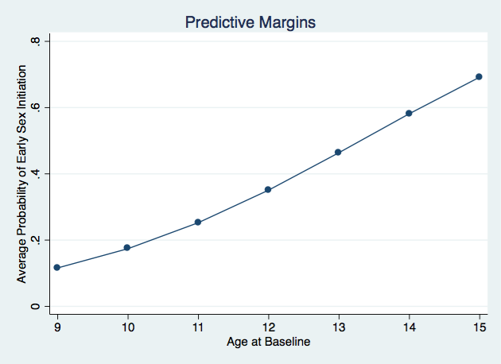

Table 5.9: Average Adjusted Predictions for Age and Self-Control
 | Avg. Adjusted Predictions | Difference from Lowest | Difference Per Unit Increase
Age
9 | 0.12 | 0 | 0
10 | 0.17 | 0.05 | 0.05
11 | 0.25 | 0.13 | 0.08
12 | 0.35 | 0.23 | 0.10
13 | 0.46 | 0.34 | 0.11
14 | 0.58 | 0.46 | 0.12
15 | 0.69 | 0.57 | 0.11
Self-Control Scores
0 | 0.60
1 | 0.58 | -0.02 | -0.02
2 | 0.56 | -0.04 | -0.02
3 | 0.55 | -0.05 | -0.02
4 | 0.53 | -0.07 | -0.02
5 | 0.51 | -0.09 | -0.02
6 | 0.49 | -0.11 | -0.02
7 | 0.48 | -0.12 | -0.02
8 | 0.46 | -0.14 | -0.02
9 | 0.44 | -0.16 | -0.02
10 | 0.43 | -0.17 | -0.02
11 | 0.41 | -0.19 | -0.02
12 | 0.39 | -0.21 | -0.02
13 | 0.38 | -0.22 | -0.02
14 | 0.36 | -0.24 | -0.02
15 | 0.34 | -0.26 | -0.02
16 | 0.33 | -0.27 | -0.02
17 | 0.31 | -0.29 | -0.02
18 | 0.30 | -0.30 | -0.01
19 | 0.28 | -0.32 | -0.01
20 | 0.27 | -0.33 | -0.01

Figure 5.2 Average Adjusted Probabilities of Early Sexual Initiation by Self-Control
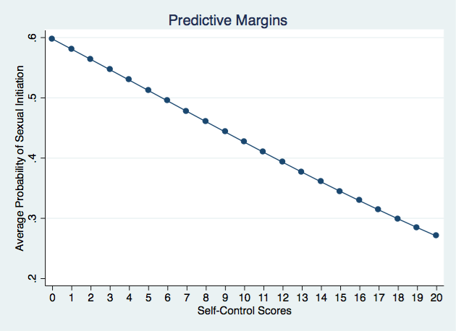
To assess any differences in the relationship between self-control and early sexual initiation across gender and race/ethnicity the AAP of each self-control score was plotted by gender and race. A plot of the subsequent AAPs of self-control by gender and race can be found in Figure 5.3. The AAP of early sexual initiation starts, end, and progresses nearly identically for male and female youth. Male youth exhibit slightly higher AAPs of early sexual initiation for each self-control score but only by .01. For race and ethnicity, non-white youth appear to have AAPs of early sexual initiation that average around .10 higher than white youth across all self-control scores. In other words, non-white youth start with a higher AAP of early sexual initiation (intercept) than white youth, but their probabilities decrease at approximately the same rate (slope).
Figure 5.3 Average Adjusted Probabilities of Early Sexual Initiation for Gender and Race/Ethnicity by Self-Control
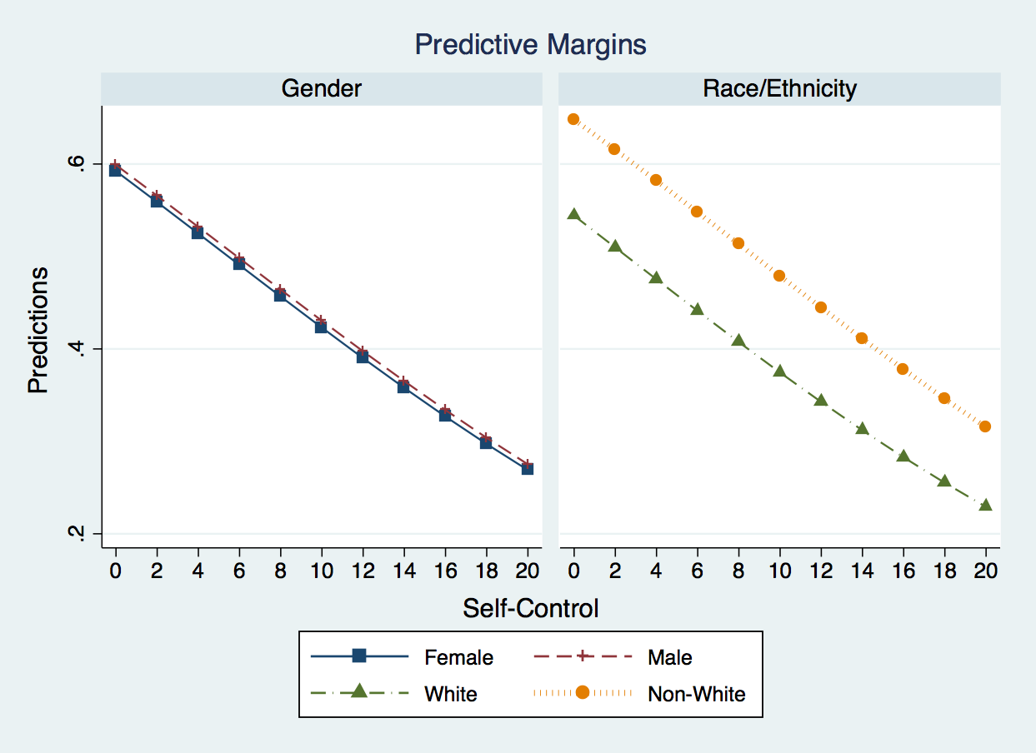
Regarding case substantiation, the average adjusted probability of early sexual initiation is .42 for those whose case is substantiated compared to .35 for those whose case is not substantiated. This AME of .07 is not significant. However, the interaction term between gender and case substantiation is significant in the final logistic regression model. To further assess the nature of this relationship, the AAP and AMEs for each combination of gender and case substantiation were calculated. The AAPs for the interaction term can be found in Figure 5.4. Figure 5.4 provides the AAPs of early sexual initiation by gender and substantiation to help visualize various AMEs. A table showing the resulting AMEs and their statistical significance can be found in Table 5.11. The AAPs of early sexual initiation for males with substantiated and unsubstantiated cases is .31 and .40 respectively. This means that the AME for case substantiation cases is -.09 for males. In other words, males whose case is substantiated have a lower AAP of early sexual initiation than those whose case is not substantiated. Although this relationship is not in the direction one would anticipate, it is important to remember that the AME is not significant.
Table 5.10: Average Marginal Effects for Gender*Case Substantiation
 | Avg. Adj. Pred. | AME Male | AME Subst.
Female | 0.37 |  | .189*
Male | 0.38 |  | -.092
Not Substantiated | 0.35 | 0.089
Substantiated | 0.42 | -0.191*

Figure 5.4 AMEs for Gender*Case Substantiation Interaction Term
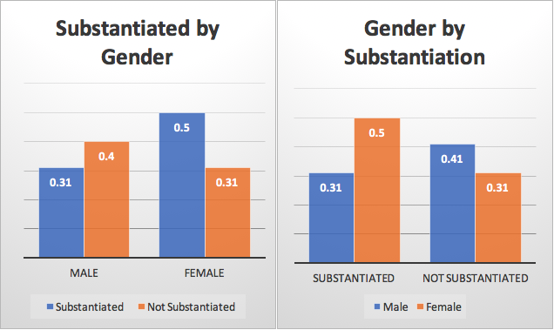
For female youth, the AMEs of a case being substantiated is .189, which is significant (p<.05). In other words, females whose case is substantiated experience a .189 increase in their AAP of experiencing early sexual initiation. We can also examine the AME of being male in substantiated and unsubstantiated cases. Results show that in unsubstantiated cases, the AME of being male is .089 but is not significant. However, the AME of being male in substantiated cases is -.191 and is significant (p<.05). In other words, the average probability of early sexual initiation is almost 20% lower for males than it is for females. Taken altogether, this suggests that being substantiated as a victim of child maltreatment is a significant risk factor for early sexual initiation for female youth. On the other hand, the average probability of early sexual initiation for male youth who are substantiated as a victim of child maltreatment is the same as female who are not substantiated as victims.
Case substantiation was also plotted by self-control and age, however the relationship between self-control and early sexual initiation functioned the same for both substantiated and unsubstantiated cases and did not exhibit any significant AMEs. Receiving services at baseline and having more than one alleged maltreatment type have AMEs of -.05 and -.02 respectively, neither of which is significant. Both more than one maltreatment type and receipt of services at baseline were plotted against age and self-control but no plots exhibited any significant AMEs between the variables.
The AAP of early sexual initiation is .42 for those with previous child welfare history compared to an AAP of .29 for those with no previous child welfare history. This represents an AME of .14, which is significant. The AME for previous child welfare history is the second largest AME among the categorical predictors. The AAPs of previous history were also plotted against age at baseline and the resulting graph can be found in Figure 5.5. The graph shows that the AME of previous child welfare contact is smaller at younger ages but then increases with age at baseline. At age 9, the AME of having previous child welfare contact is .07, however, by the age of 13 it increases to .17. The AME of previous history is significant at every age, with previous child welfare history resulting in higher AAPs of early sexual initiation. A similar plot for previous child welfare history and self-control did not reveal any significant differences.
Figure 5.5 Average Adjusted Probabilities of Early Sexual Initiation by Case History and Age
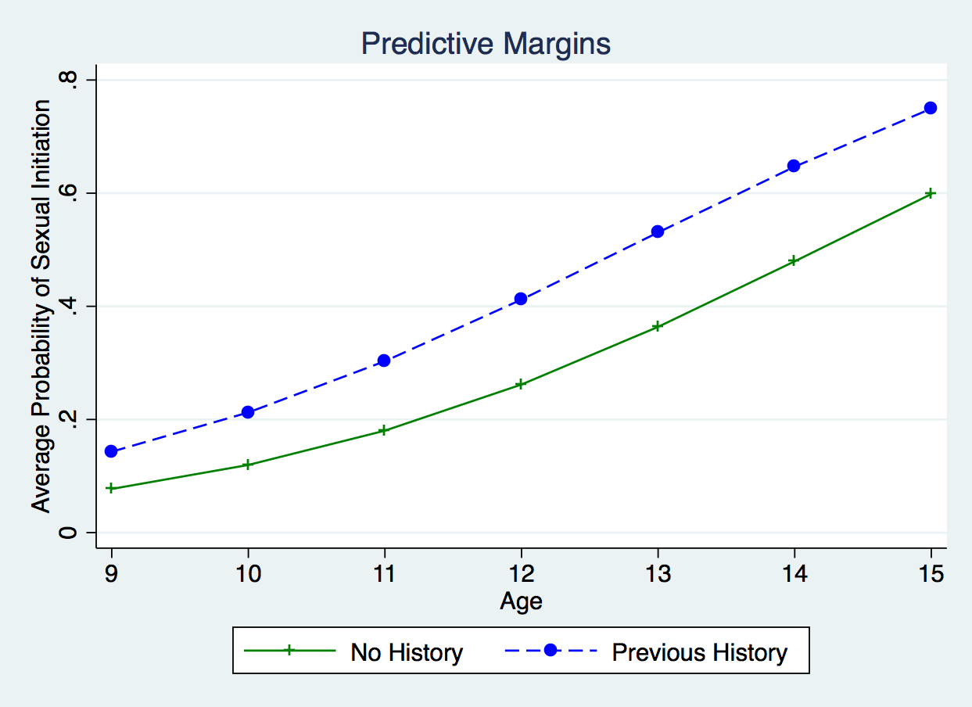
No form of maltreatment has a significant AME on the probability of early sexual initiation when compared to neglect. “Other” forms of child maltreatment has the lowest AAP of early sexual initiation at .30, followed by physical abuse and neglect at .36 and .37 respectively, and then sexual abuse with an AAP of .46. Sexual abuse has an AME of .09 when compared to neglect and an AME of .16 when compared to other forms of child maltreatment. The AAPs of the four different maltreatment types were plotted against age at baseline and can be found in Figure 5.6. There are two major takeaways from this graph. The first is that neglect and physical abuse are nearly identical in their average probabilities of early sexual initiation across all ages. Second, the AME between “other” forms of maltreatment and sexual abuse appears to increase as age at baseline does. For youth who are 9 years old, the AME is only .09 but this grows to .20 for 13-year-old youth. The AAPs for maltreatment type follow largely the same pattern when plotted against self-control scores. Neglect and physical abuse are nearly identical to the scores and “other” forms of maltreatment and sexual abuse represent the low and high AAPs respectively.
The AAPs of early sexual initiation for placement at baseline range from .35 for those who remain in their home, to .39 for foster homes, .41 for kinship care homes, and .86 for group home/other placements. Being place in a group home/other placement at baseline has an AME of .52 for early initiation when compared to those who remain in their own home and is the only significant AME for baseline placement (p<.001). Of all the variables in the final model, baseline placement in a group home has the largest AME. Previous research typically find group homes are associated with adverse life outcomes, which making this finding not surprising. However, what is important to note is that this relationship holds even when controlling for self-control suggesting that group home may be exerting a very strong state dependent effect on adverse life outcomes such as early sexual initiation.
Figure 5.6 Average Adjusted Probabilities of Early Sexual Initiation by Maltreatment Type and Age
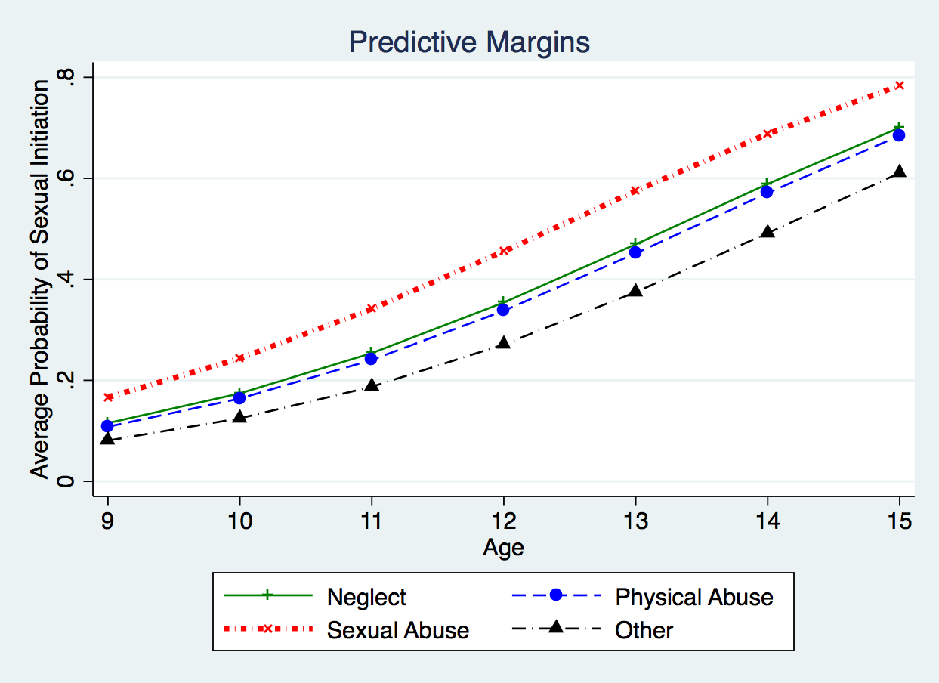
Figure 5.7 shows the margins plot of baseline placement by age. As expected given previous analyses, group home/other placements consistently have higher AAPs of early sexual initiation than other types of placements. The AAPs appear to initially increase at a higher rate when compared to other placements through approximately age 11, at which point the AAPs of other placements increase at a higher rate and close the gap to some extent. This graph reiterates how high the average probability of early sexual initiation is for youth placed in group home/other placements, regardless of age and despite controlling for propensity via self-control. Baseline placements and age were next plotted separately by gender only to reveal that the relationship between baseline placement, age, and early sexual initiation functions the same for male and female youth.
Figure 5.7 Average Adjusted Probabilities of Early Sexual Initiation by Baseline Placement and Age
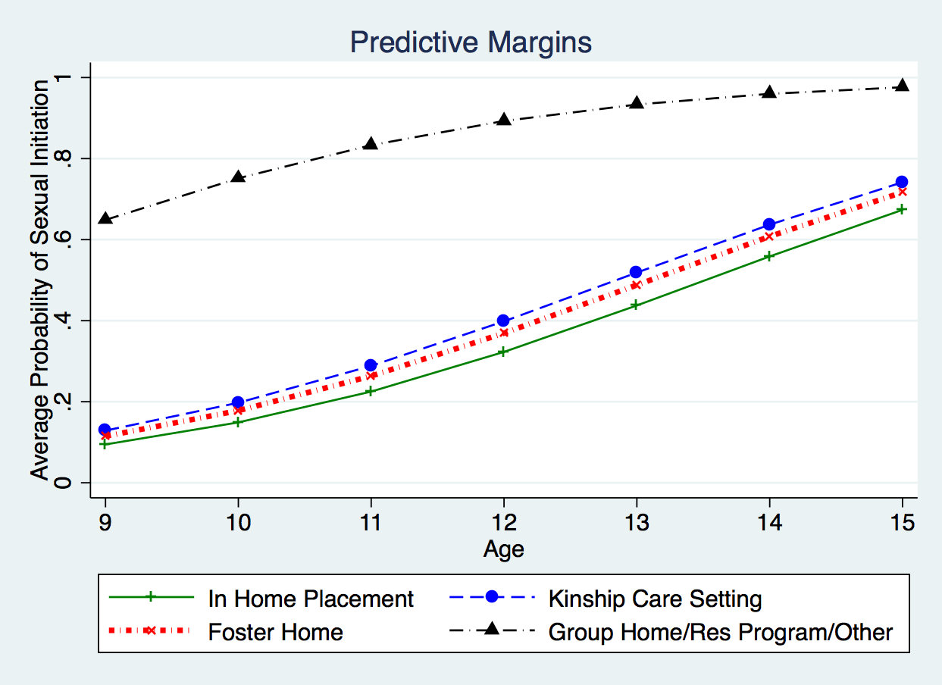
The AAPs of baseline placement were also plotted against self-control scores. Those results can be found in Figure 5.8. The relationships exhibited between baseline placements, self-control, and early sexual initiation follow the expected patterns. What is noticeable in this graph is what little impact that self-control has on reducing the average probabilities of early sexual initiation. The AAP for the lowest self-control score is .95 and only exhibits an AME of .15 for the highest self-control score. By comparison, the other three placements all exhibit AMEs approaching .30. This could suggest that the state dependent effect of group homes is largely resistant to any prosocial propensities such as high levels of self-control. The AAPs of placement at baseline were also plotted against self-control and separated by race/ethnicity. That set of graphs can be found in Figure 5.9. This graph also highlights the limited impact of high self-control scores on the AAP of early sexual initiation for youth placed in a group home/other placement at baseline. In fact, for non-white youth, the AAP (.84) of the highest self-control score only exhibits an AME of -.12 from the AAP of the lowest self-control score (.96). While not great, white youth placed in a group home at baseline experience an AME of -.18 from the lowest to highest self-control scores. Once again these findings suggest that placement in a group home at baseline may exert a strong state dependent effect on early sexual initiation.
Figure 5.8 Average Adjusted Probabilities of Early Sexual Initiation by Baseline Placement and Self-Control
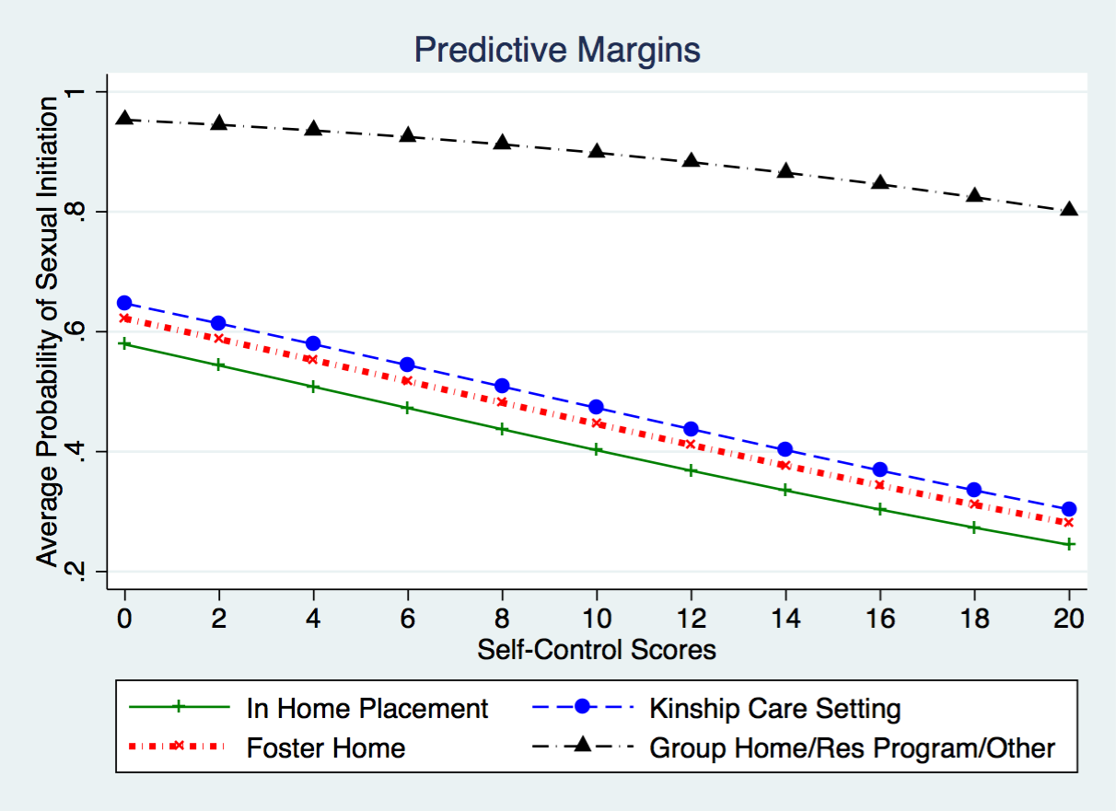
Figure 5.9 Average Adjusted Probabilities of Early Sexual Initiation by Baseline Placement, Race, and Self-Control
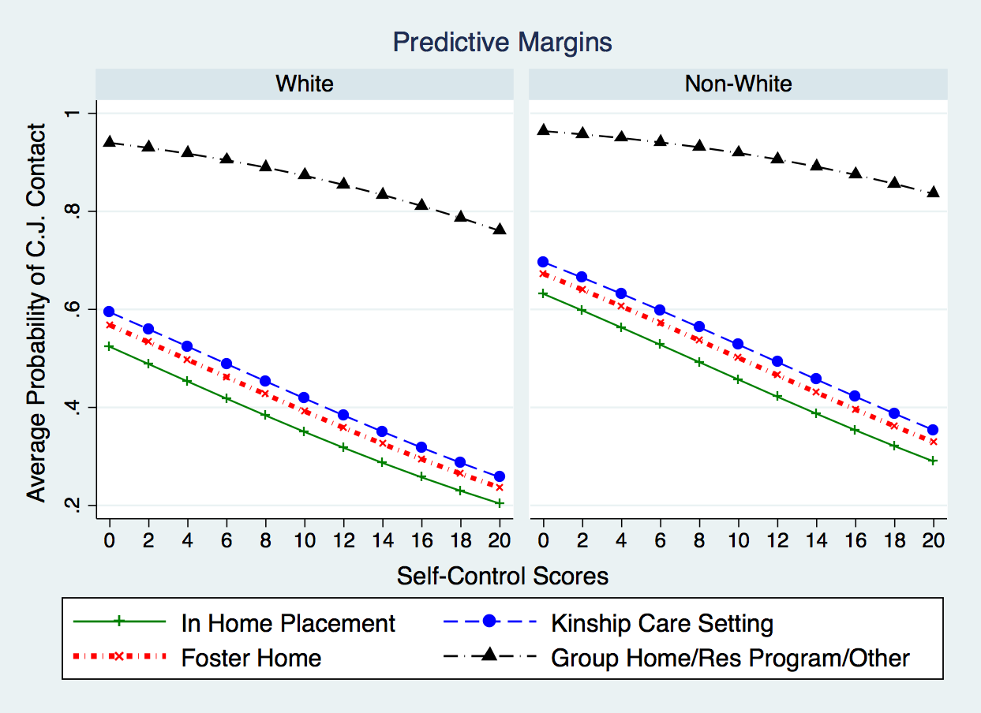

Summary
Consistent with previous literature, children who are older at the time of a child welfare investigation are more likely to experience adverse outcomes, in this case, early sexual initiation. Non-white youth also appear to be at significantly higher risk for early sexual initiation when compared to white youth. However, it should be noted that this relationship was only marginally significant. The final model suggests that both population heterogeneity and state dependence effects are present in the relationship between child maltreatment and child welfare experience and early sexual initiation. Population heterogeneity effects are supported by the finding that lower levels of self-control are significantly related to increased odds of early sexual initiation. Even when controlling for these population heterogeneity effects, state dependence effects are still supported through various negative life events that are significantly related to early sexual initiation. Specifically, youth with a substantiated case and/or who have any form of previous contact with the child welfare system are at higher risk for early sexual initiation. Although there are no significant differences in the odds of early sexual initiation based on maltreatment type, placement type at baseline is significantly related to early sexual initiation. Specifically, placement in a group home at baseline results in significantly higher odds of early sexual initiation. In fact, group homes exhibit such a high impact on the odds of early sexual initiation that despite being significantly related to a reduction in the odds of early sexual initiation, not even high self-control scores do much to reduce the risk of early sexual initiation. One of the more surprising findings is that the interaction of gender and case substantiation results in a reduction in the odds of early sexual initiation, but only for males. Furthermore, male substantiated victims have average probabilities that were equivalent to those of female youth who were not substantiated for maltreatment at baseline. In sum, child maltreatment and child welfare experiences exert both population heterogeneity and state dependence effects on the odds of early sexual initiation, and these relationships can vary across demographics.

Chapter 6: Criminal Justice Contact Results

Descriptive Statistics of Criminal Justice Analytic sample
As previously mentioned in the Data and Methods section, the criminal justice contact sample is limited to those children who were at least 12 years old at the time of Wave 5 sampling and were not missing any sample weights. Of these 1,770 cases, 1,331 cases were not missing information for any of the variables used in analyses. Frequency and descriptive statistics for the categorical and continuous variables can be found in Tables 6.1 and 6.2 respectively. Once again, the percentages and means reported in the table are the weighted to account for the survey design of the NSCAW data.
Most youth in both samples did not have any contact with the criminal justice system. Criminal justice contact is based on if the individual was incarcerated for any of the follow-up waves or had ever been arrested. Despite individuals in the analytical sample having a slightly higher proportion of individuals with some form of criminal justice contact (2.87%), the Pearson’s Chi-Square test suggests the two samples are not statistically different. As mentioned in Chapter V, the Pearson statistic is converted into an adjusted F statistic to account for the complex survey design (Thomas and Rao 1987). Results for all for the comparisons between the age-eligible and analytical samples for all variables can be found in Table 6.3. The age-eligible and analytical sample are both predominantly non-white and female. The percentage breakdown for both race/ethnicity and gender are within 1 percentage point and are not significantly different. Approximately 5% of cases were missing information on the child gender and <.05% were missing information on the child’s race/ethnicity.
Individuals in the analytical sample are on average older (mean=10.02, +.13) and have slightly higher self-control scores (mean=14.11. +.11). To test for differences between the two samples, the regress command was used with age or self-control serving as the dependent variable and a variable distinguishing between the two samples serving as the sole independent variable. Following the regress command, the test command was used to generate the F ratio. This procedure has been previously identified as an appropriate substitution for a t-test when using survey data (UCLA: Statistical Consulting Group 2012). This procedure reveals no significant difference in age or self-control between the two samples.
Regarding family and case background, only a minority of caregivers in the baseline allegations for both the age-eligible and analytical sample indicated a previous arrest (29.57% and 30.49% respectively). This .92% difference is not significant. Most cases in both the age-eligible and analytical sample had some form of previous child welfare involvement (59.55% and 57.86% respectively). This -1.69% difference is not statistically significant. Of the 1,770 age-eligible cases, 7.2% were missing data on previous child welfare involvement.

Table 6.1: Frequency Statistics for Age-eligible and Criminal Justice Analytical Samples
 |  | Full 12-Year-Old (n=1,770) |  |  | CJ Contact (n=1,331)
 |  | Missing (%) | n | % | n | %
CJ Contact (n=1,770) |  | 0(0.00)
 | No |  | 1,472 | 83.87 | 1,107 | 84.00
 | Yes |  | 298 | 13.13 | 224 | 16.00
Child Gender (n=1,689) |  | 81(4.84)
 | Female |  | 949 | 51.89 | 754 | 52.82
 | Male |  | 740 | 48.11 | 577 | 47.18
Child Race/Ethnicity (n=1,767) |  | 3(.03)
 | White |  | 815 | 46.70 | 641 | 46.99
 | Non-White |  | 952 | 53.30 | 690 | 53.01
Baseline Services (n=1,770) |  | 0(0.00)
 | No |  | 454 | 70.70 | 357 | 71.13
 | Yes |  | 1.316 | 29.30 | 974 | 28.87
Case Substantiated (n=1,770) |  | 0(0.00)
 | No |  | 683 | 67.92 | 520 | 66.69
 | Yes |  | 1,087 | 32.08 | 811 | 33.31
At least 2 Maltreatments at Baseline (n=1,645) |  | 85(6.40)
 | No |  | 1,094 | 75.00 | 887 | 75.86
 | Yes |  | 551 | 25.00 | 444 | 24.14
Previous Child Welfare Involvement (n=1,633) |  | 94(7.2)
 | No |  | 543 | 40.45 | 452 | 42.32
 | Yes |  | 1.090 | 59.55 | 879 | 57.86
Parent Arrest History (n=1,770) |  | 0(0.00)
 | No |  | 1,289 | 70.43 | 965 | 69.51
 | Yes |  | 481 | 29.57 | 366 | 30.49
Baseline Placement (n=1,770) |  | 0(0.00)
 | In Home |  | 1,317 | 88.27 | 1,000 | 90.03
 | Kinship Care |  | 181 | 5.04 | 131 | 3.98
 | Foster Home |  | 196 | 4.14 | 147 | 3.78
 | Group Home/ Other |  | 76 | 2.55 | 53 | 2.22
Most Severe Maltreatment (n=1,6264) |  | 88(6.48)
 | Neglect |  | 721 | 45.66 | 584 | 46.62
 | Physical Abuse |  | 414 | 30.79 | 337 | 29.73
 | Sexual Abuse |  | 304 | 11.23 | 249 | 10.57
 | Other |  | 187 | 12.31 | 161 | 13.08
*Significant differences are bolded.
Table 6.2: Descriptive Statistics for 12-Year-Old and Criminal Justice Contact Analytical Sample
 | 12-Year-Old Sample (n=1,770) |  |  |  | C.J. Contact Analytical Sample (n=1,331)
 | Missing (%) | Mean | Median | Min/Max | Mean | Median | Min/Max
Age at Baseline | 0 | 9.89 | 10 | 6/16 | 10.02 | 10 | 6/15
Level of Harm | 138(8.34) | 1.9 | 2 | 1/4 | 1.89 | 2 | 1/4
Self-Control | 251(14.21) | 14.00 | 15 | 0/20 | 14.11 | 15 | 0/20

Table 6.3: Comparison of 12-Year-Old and Criminal Justice Contact Analytical Sample
 | Mean/Percentage Difference | f-statistic | Significance
Experienced CJ Contact | 2.87% | 0.01
Male Child | -.93% | 0.41
Non-white Child | -.29% | 0.04
Child Age | .13 | 2.22
Child Self-Control | .11 | 4.41
Received Baseline Services | -.43% | .12
Case Substantiated | 1.23% | 1.02
Level of Harm | .01 | .69
At least 2 Maltreatments at Baseline | -.86% | .72
Previous Child Welfare Involvement | -1.69% | 2.12
Parent Arrest History | .92% | .61
Baseline Placement
In Home | 1.76% | 3.84 | *
Kinship Care | -1.06% | 2.92 | †
Foster Home | -.36% | .60
Group Home/ Other | -.33% | .56
Most Severe Maltreatment
Neglect | .96% | .61
Physical Abuse | -1.06% | .84
Sexual Abuse | -.66% | .70
Other | .77% | .88
† p<.10 * p<.05 **p<.01 ***p<.001

Most cases only had 1 alleged maltreatment at baseline (75% and 74.86% respectively). Approximately 7% of cases were missing information on the number of maltreatments alleged at baseline. This -.14% difference is not statistically significant. The most severe form of maltreatment reported for both samples was neglect (45.66% and 46.62% respectively), followed by physical abuse (30.79% and 29.73%), other (12.31% and 13.08%), and sexual abuse (11.23% and 10.57%). Approximately 7% of cases were missing information on the most severe form of alleged maltreatment. Differences between the two samples regarding the most severe form of maltreatment reported were examined by using the Pearson’s Chi-Square test for both one categorical variable for placement and individual dummy variables for each maltreatment type. Neither method yielded any significant differences between the two groups. For both samples, approximately 1/3 of cases had at least one of the maltreatment allegations substantiated (32.08% and 33.31% respectively). Despite this 1.23% difference, the two samples are not significantly different.
For both samples, most cases did not receive any services at baseline (29.30% and 28.87% respectively). Once again, the difference between the two samples (-.43%) is not statistically significant. For both samples, most youth remained in their home (88.27% and 90.03% respectively), followed by kinship care (5.04% and 3.98%), foster care (4.14% and 3.78%) and group homes (2.55% and 2.22%). As with maltreatment type, differences between the two samples were examined using a categorical variable and individual dummy variables for placement type. While there are no significant differences when using one categorical variable, the individual dummy variables do reveal some statistically significant differences. Specifically, the analytical sample has a significantly higher percentage of children who remained in their own home (1.76%). This difference is significant at the p<.05 level. The analytical sample also has a significantly lower percentage of children who were placed in kinship care (-1.06%). This difference is marginally significant (p<.10). There are no significant differences between the two samples regarding foster and group home/other placements.

Bivariate Relationships of Criminal Justice Contact Analytic sample
Collinearity among the independent variables in the final logistic regression model was assessed by calculating the variance inflation factors (VIF) and tolerance. Once again, the complex survey design of the NSCAW data presents some challenges regarding appropriate analyses. Specifically, there are no STATA programs currently designed to address the variance structures of survey data when calculating the VIF. However, there is some support among STATA users for using traditional VIF test despite their failure to account for the structure of complex survey data (McIntosh 2009; Samuels 2011a, 2011b). Additionally, at least one study found that traditional methods for calculating VIF provided relatively similar estimates to more advanced methods designed to account for the structure of complex survey data (Liao 2010). In this study, traditional methods only failed to identify one relationship that the more advanced methods did identify. Furthermore, the one relationship not identified by the traditional methods yielded a VIF of 9.13 while the more advanced methods yielded VIFs of 11.4 and 11.1, suggesting that although the traditional test fell short of the commonly used cutoff of 10, the estimates were still relatively close.
Using the above guidance VIF estimates were calculated using both the collin and estat vif commands in STATA. The full results for both VIF calculations can be found in Table 6.4. The highest VIF yielded by traditional methods for the final logistic regression model was 1.58 and 1.59 respectively. The mean VIF values for the two traditional methods was 1.19 and 1.18 respectively. Taken together, this precedence and low VIF values minimize concerns of multicollinearity in the final model.
Table 6.4: Variance Inflation Factors for Criminal Justice Contact Final Logistic Regression Model
Variable | collin VIF | estat VIF
Age | 1.05 | 1.09
Non-White | 1.03 | 1.04
Male | 1.07 | 1.06
Baseline Service | 1.21 | 1.19
Substantiated | 1.44 | 1.55
Level of Harm | 1.58 | 1.59
More than 1 Maltreatment | 1.16 | 1.12
Child Welfare History | 1.09 | 1.10
Parent Arrest | 1.12 | 1.11
Self-Control | 1.06 | 1.07
Physical Abuse | 1.22 | 1.22
Sexual Abuse | 1.27 | 1.22
Other Maltreatment | 1.18 | 1.24
Kinship Placement | 1.16 | 1.09
Foster Placement | 1.24 | 1.15
Group Home/Other Placement | 1.08 | 1.07
Mean VIF | 1.19 | 1.18

The same adjusted Pearson Chi-Square test used for analyses of the age-eligible and analytical sample was used to examine significant bivariate relationships between eventual Criminal Justice contact and categorical independent variables. The frequency of Criminal Justice contact broken down by independent variables can be found in Table 6.5. Significant relationships or p<.10 or less are denoted by the traditional symbols. As with the comparisons of the age-eligible and analytical sample, percentages reported in the table are the weighted percentages that represent the complex sample design of the NSCAW data. There are no significant relationships between criminal justice contact and the child demographics of gender and race/ethnicity.
Table 6.5: Bivariate Relationships between Independent Variables and Criminal Justice Contact
 | CJ Contact (n=224) | % of IV | f-statistic | Significance
Male | 115 (56.31%) | 19.09% | 1.61
Non-White | 124 (61.08%) | 18.43% | 1.45
Substantiated | 138 (35.00%) | 16.82% | 0.11
Baseline Service | 179 (37.32%) | 20.69% | 3.73 | †
More than 1 Mal | 67 (22.88%) | 15.16% | 0.06
CW History | 161 (67.48%) | 18.72% | 2.6
Parent Arrest | 69 (37.57%) | 19.72% | 1.68
Maltreatment Type
Neglect | 79 (51.17%) | 17.56% | 0.6
Physical Abuse | 67 (28.52%) | 15.35% | 0.06
Sexual Abuse | 51 (12.20%) | 18.48% | 0.27
Other | 27 (8.11%) | 9.92% | 2.03
Placement Type
In Home | 164 (84.45%) | 15.01% | 3.93 | *
Kinship | 21 (4.28%) | 17.24% | 0.05
Foster Care | 21 (2.75%) | 11.63% | 0.94
Group Home/Other | 18 (8.52%) | 61.49% | 21.13 | ***
† p<.10 * p<.05 **p<.01 ***p<.001
Regarding baseline case characteristics, there are no significant bivariate relationships between eventual criminal justice contact and more than one alleged maltreatments, previous child welfare history, case substantiation, or the caregiver at baseline having been arrested. However, the bivariate relationship between receiving services at baseline and eventual criminal justice contact is marginally significant (f-statistic=3.73, p<.10). Specifically, of the 224 youth who eventually had criminal justice contact, 179 (37.32%) received services at baseline. Stated otherwise, of the 974 who received services at baseline, 179 (20.69%) had eventual criminal justice contact. In sum, many youth who received baseline services did not have contact with the criminal justice system, and many of the youth who had eventual contact with the criminal justice system did not receive services at baseline. On the surface, this suggests that receiving services at baseline may be a protective factor against eventual criminal justice contact, however, given the correlation between baseline services and other case characteristics such as case substantiation, this relationship may not hold at the multivariate level.
There are no significant relationships between the most severe form of alleged maltreatment at baseline and eventual criminal justice contact. However, two different forms of placement at baseline are significantly related to eventual criminal justice contact. First, having an in-home placement at baseline is significantly related to later criminal justice contact (p<.05). Specifically, of the 224 youth who eventually had contact with the criminal justice system, 164 (84.45%) were in an in-home placement at baseline. Given that 90.03% of the analytical sample were in an in-home placement at baseline, this is not surprising. When examining the breakdown of criminal justice contact for those in an in-home placement, we find that of the 1,000 youth in the analytical sample who remained in their own home at baseline, only 164 (15.01%) had eventual criminal justice contact. In sum, bivariate analyses show that although many those with eventual criminal justice contact remained in the home at baseline, the vast majority of those who remained in the home at baseline did not have any criminal justice contact.
Additionally, placement in a group home/other placement at baseline is significantly related to eventual criminal justice contact at the bivariate level (p<.001). Specifically, of the 224 youth with eventual criminal justice contact, 18 (8.52%) were placed in a group home at baseline. Although 8.52% is low, only 2.22% of the analytical sample were placed in a group home at baseline. Stated differently, of the 53 youth placed in a group home at baseline, 18 (61.49%) had eventual criminal justice contact. Placements in kinship or foster home settings were not significantly related to criminal justice contact at the bivariate level. These findings taken together suggest that those who remain in the home at baseline are underrepresented among those with eventual criminal justice contact and those in a group home/other placement at baseline are overrepresented among those with eventual criminal justice contact. These findings are not surprising given that both placements are likely linked with other important factors such as family supports, the severity of abuse, and potential criminal propensity (self-control) of the youth.
A process outlined by Heeringa (2010) was used to examine bivariate relationships between continuous independent variables and eventual criminal justice contact. The process involves producing weighted means accounting for the complex survey design of the data followed by the lincom command to estimate the difference in means between the age-eligible and analytical samples. In addition to providing mean differences, the lincom command also provides a t-statistic to determine if there is a significant difference between those with and without eventual criminal justice contact. Results of this process for age at baseline, self-control, and level of harm are in Table 6.6. The level of harm variable is ordinal, and its relationship with criminal justice contact was tested treating it as a continuous and a categorical variable. Neither test revealed any significant difference between those with and without eventual criminal justice contact regarding the level of harm for the most severe form of maltreatment.
Table 6.6: Comparison of Means for Future Criminal Justice Contact
 | C.J. Contact |  | Mean | Std. Error | 95% Confidence Intervals |  | Difference
Age
 |  | No | 9.72 | 0.156 | 9.42 | 10.03
 |  | Yes | 11.57 | 0.334 | 10.91 | 12.24 | 1.85***
Self-Control
 |  | No | 14.36 | 0.283 | 13.8 | 14.93
 |  | Yes | 12.82 | 0.571 | 11.68 | 13.96 | -1.54**
Level of Harm
 |  | No | 1.89 | 0.053 | 1.78 | 1.99
 |  | Yes | 1.9 | 0.11 | 1.68 | 2.12 |  | 0.014
* p<.05 **p<.01 ***p<.001
Both self-control and age were significantly difference among those with and without eventual criminal justice contact. Specifically, those with eventual criminal justice contact were on average 1.85 years older as baseline than those without criminal justice contact. This difference is significant at p<.01. As with early sexual initiation, this findings is not surprising given previous research linking being older at removal to various negative outcomes such as juvenile justice involvement (Widom 1991b), removal (J. Ryan et al. 2008), and experiencing homelessness (Crawford et al. 2017). Those with eventual criminal justice contact also scored on average 1.54 points lower on the self-control scale. Once again, given Gottfredson and Hirschi’s (1990) assertion that low self-control is the individual-cause of criminal offending, this relationship is not surprising.

Binary Logistic Regression of Criminal Justice Contact
The relationships between criminal justice contact and various demographic, case, and personal characteristics were assessed using binary logistic regression. Model 1 begins with only child demographics, Model 2 adds background and case information (potential state dependent effects), Model 3 adds the population heterogeneity measure of self-control, and Models 4 and 5 add various interaction terms to the model. Results for all of the models are reported in Table 6.7. Coefficients for all models are presented as odds ratios. Due to the complex survey design, the goodness of fit estimators are not included but are addressed in the text.
For Model 1 (child demographics), age at baseline and gender are both significant, although the relationship between gender and criminal justice contact is only marginally significant. Results show that for every year older a child is at baseline, their odds of criminal justice contact increase 36% (p<.001). For gender, the results suggest that the odds of criminal justice contact are 92% higher for males when compared to females (p<.10). In Model 2, variables for the background characteristics of previous parent arrest, previous child welfare involvement, the level of harm for the most severe maltreatment, receipt of services at baseline, having more than one alleged form of maltreatment, most severe form of maltreatment and baseline placement are added. The addition of these variables decreases the coefficients for age at baseline and gender by 1%, however, neither the significance level or the direction of the relationship changes. No forms of maltreatment are significantly different from one another. For placement, the only significant relationship to criminal justice contact is for those placed in a group home/other placement at baseline. Specifically, the odds of having later criminal justice contact are 6.48 times higher for those placed in a group home/other placement when compared to those who remain in their own home at baseline. This finding is not surprising given prior research and the bivariate tests conducted prior to the final regression model.
The addition of self-control in Model 3 results in some changes for age at baseline, gender, race/ethnicity, and group home/other placements. Specifically, the coefficient for age at baseline decreases 1%, and the coefficient for gender returns to the level of Model 1. The level of significance and direction of the relationships remain unchanged. For the first time, a significant relationship between race/ethnicity and criminal justice contact emerges with the odds of criminal justice contact being 87% higher for non-white youth when compared to white youth. This relationship is marginally significant (p<.10). None of the baseline characteristics or maltreatment types are significantly related to odds of criminal justice exposure. A Wald test for joint significance among the maltreatment variables was also performed and yielded non-significant results for maltreatment types (p=.63).

Table 6.7: Logistic Regression of Criminal Justice Contact on Child and Case Predictors
 | Model 1 | Model 2 | Model 3 | Model 4 | Model 5
Child Demographics
Age at Baseline | 1.36*** | 1.35*** | 1.34*** | 1.34*** | 1.34***
Male | 1.92† | 1.91† | 1.92† | 1.44 | 1.59
Non-White | 1.68 | 1.74 | 1.87† | 1.91† | 2.00*
Baseline Case Characteristics
Parent Prev. Arrest |  | 1.73 | 1.66 | 1.65 | 1.67
Previous CW Involvement |  | 1.38 | 1.43 | 1.47 | 1.42
Level of Harm |  | 0.94 | 0.91 | 0.90 | 0.78
Received Baseline Services |  | 1.32 | 1.28 | 1.34 | 1.37
More than 1 Mal. Type |  | 0.92 | 0.93 | 0.94 | 0.98
Substantiated |  | 1.14 | 1.11 | 1.14 | 1.14
Maltreatment Type (compared to neglect)
Physical Abuse |  | 0.77 | 0.76 | 0.75 | 0.77
Sexual Abuse |  | 0.89 | 0.97 | 0.92 | 0.18*
Other Maltreatment |  | 0.54 | 0.58 | 0.59 | 0.62
Baseline Placement Type (compared to no removal)
Kinship Placement |  | 0.98 | 0.95 | 0.91 | 0.93
Foster Home Placement |  | 0.62 | 0.60 | 0.57 | 0.63
Group Home/Other Placement |  | 7.48** | 7.81** | 0.36 | 0.39
Propensity
Self-Control |  |  | 0.94* | 0.92* | 0.92*
Two-Way Interaction Effects
Male * Group Home |  |  |  | 1.73
Male * Self-Control |  |  |  | 1.02
Group Home * Self-Control |  |  |  | 1.24
Sexual Abuse * Level of Harm |  |  |  | 2.05* | 2.05**
Three-Way Interaction Effects
Female * Group Home * Self-Control |  |  |  |  | 1.22†
Male * No Group Home * Self-Control |  |  |  |  | 1.02
Male * Group Home * Self-Control |  |  |  |  | 1.35†
Coefficients presented are odds ratios * p<.05 **p<.01 ***p<.001
Despite the addition of a control for propensity (self-control) placement in a group home remains significant. In fact, the coefficient increases 33% with the odds of criminal justice exposure rising to 6.81 time the odds of those youth who remain in their own home at baseline. The relationship remains significant at the p<.01 level. As with most severe maltreatment art baseline, a Wald test of joint significance was performed and revealed that the different placement types are significantly related to criminal justice contact (p=.04). Although not significant, it is interesting that youth in both kinship and foster placements have lower odds of criminal justice contact within the sample when controlling for other variables. Finally, self-control is significantly related to criminal justice contact in that those with higher levels of self-control being less likely to experience criminal justice contact. Specifically, a one unit increase in self-control results in an 8% decrease in the odds of criminal justice contact.
Upon the addition of self-control, the goodness of fit tests for the model were performed. Due to the complex survey design and use of a subpopulation, the goodness of fit tests should be interpreted with caution as no test currently available fully account for the survey design and/or the variance in standard errors as a result of the use of a subpopulation. Specifically, although the svylogitgof program has been designed to use an F-adjusted mean residual test to assess model goodness of fit when using complex survey data, it cannot be used when using the subpopulation command. Additionally, as of STATA 13, the estat gof command will now run following analyses using the svy module in STATA. However, it also cannot be used when using the subpopulation command. In the absence of available procedures that account for complex survey data and the use of subpopulations, there has been some support for estimating the final model with the use of an if statement in place of the subpopulation solely for the purpose of assessing goodness of fit (Archer et al. 2006; Long and Freese 2005; Samuels 2011b). The results of these procedures for Model 3 all indicate that the model is misspecified (F-statistic=19.05; p<.001 respectively.
To correct for this misspecification, a series of interaction terms were added. The first interaction is a three-way interaction between gender, being placed in a group home, and self-control. This combination was chosen because these three variables were significant in previous models and are consistent correlates of crime in previous research. This three-way interaction was first added through a series of two-way interactions (Model 4). The addition of this three-way interaction still did not correct the model misspecification as the F-test still was significant indicating some form of misspecification. To address potential issues regarding functional forms, quadratic terms were added for all the continuous variables; however, none of the relationships were significant, nor did the fix the issues of misspecification. The next step was to attempt an interaction between level of harm and forms of abuse. Given that sexual abuse is arguably a very different form of abuse, an interaction between level of harm and having sexual abuse as the most severe form of maltreatment was added. Not only was this interaction significant, but it also fixed the model specification and resulted in a nonsignificant F-statistic of .93 (p=.50).
Model 5 is the final model containing every variable of interest. The coefficient, direction, and level of significance for age at baseline is unchanged in the final model. The coefficient for race/ethnicity increases 9% and exceeds it previous marginal level of significance (p<.05). The direction of the relationship remains the odds of criminal justice contact two times higher for non-white youth when compared to white youth. For most severe maltreatment type at baseline, physical abuse and other forms of maltreatment are not statistically different from neglect regarding criminal justice contact.
However, the addition of the interaction term between the level of harm and sexual abuse results in a 74% reduction in the coefficient of sexual abuse. This change results in the relationship between criminal justice contact and sexual abuse becoming significant (p<.05). The coefficient for sexual abuse is .18 indicating that the odds of criminal justice contact for those whose most significant form of alleged maltreatment at baseline are sexual abuse are 82% lower when compared to those whose most severe form of maltreatment was neglect. Furthermore, the interaction term between the level of harm and sexual abuse is significant and positive. Specifically, Model 5 suggests that as the level of harm increases, as do the odds of criminal justice contact, but only in cases where sexual abuse is the most severe form of alleged maltreatment. Taken together, these findings reveal that the odds of criminal justice contact are very low in cases of sexual abuse when the abuse is indicated as minimal harm or less. This relationship will be explained more and visualized in the Predictive Margins section of the chapter.
In Model 5, the coefficient, direction, and significance level for self-control remains unchanged and continue to show that for every unit increase of self-control scores, there is a .08% reduction in the odds of criminal justice contact later in life. Interestingly, the addition of interaction terms to the models suggests that self-control may, in fact, operate differently across placement types. The three-way interaction between gender, group home/other placement, and self-control results in three interaction terms being added to the model: self-control for females placed in group homes, self-control for males placed in group homes, and males not placed in group homes. As a result, the reference group for the model is then self-control for females not placed in a group home. For both males and females placed in group homes, results show that increases in self-control are related to an increase in odds of criminal justice. This relationship is marginally significant (p<.10) and in the opposite direction of the main effect for self-control. Although this seems at odds with previous research on self-control and criminal justice contact on the surface, it is possible that what these results indicate is that being placed in a group home has a higher impact on children that had higher self-control scores. This relationship will be examined further in the Predictive Margins section.

Predictive Margins for the Criminal Justice Contact Final Logistic Regression Model
To help further interpret and visualize the relationships between predictors and odds of criminal justice contact, the margins and marginsplot commands were used to obtain various predictive margins. A table containing the average adjusted predictions (AAPs) and average marginal effects (AMEs) of categorical variables can be found in Table 6.8. The average adjusted predictions (AAPs) represent the average probability if everyone in the data were treated as each category for that particular variable when controlling for the other variable in the model (Williams 2012). The average marginal effects (AMEs) represent the difference in probabilities if you averaged the probability of everyone in the dataset if they belonged in each of the different categories for a variable (Williams 2012). These AAP and AMEs are those for Model 5 which includes the interaction terms. However, the margins command does not provide AAPs for any continuous variables or interactions with continuous variables. Therefore, while the interactions between sexual abuse and the three-way interaction are not included in the table, their presence in the final model is being accounted for.
For gender, the average adjusted probability (AAP) for males versus female is .12 and .21 respectively. This results in an average marginal effect of .09 for being male. This difference is significant (p<.05) with males having a higher probability of criminal justice contact than females. The AAPs for white and non-white children is .12 vs .20 respectively for an AME of .08. This AME is significant (p<.05) with non-white children having a higher probability of having criminal justice contact than white children. For most severe maltreatment type at baseline, neglect has the highest AAP (.20) followed by physical abuse (.17), other forms of maltreatment (.15), and sexual abuse (.06). The only maltreatment type with a significant AME (compared to neglect) is sexual abuse at -.14 (p<.05). No other variables have significant AMEs.
Typically, adjusted predictions at different values are used to examine the predictive margins for continuous variables. These simply present the AAPs at set values for a continuous variable. Although the margins command does not return AMEs for continuous variables, a similar value can be calculated by either subtracting the reference value from a common set value (such as the lowest value of the continuous variable) or by subtracting the previous value from the current set value. The first method essentially provides the AME of a set value compared to a reference group and the second method provides the AME from one value to the next. For all continuous variables in the final model, AAPs and both forms of AMEs were included and can be found in Table 6.10.

Table 6.8: Average Adjusted Predictions for Age, Level of Harm and Self-Control
Age | AAP |  | AME from Lowest Value of X |  | AME from Previous Value of X
6 |  | 0.05
7 |  | 0.07 |  | 0.02 | 0.02
8 |  | 0.09 |  | 0.04 | 0.02
9 |  | 0.11 |  | 0.06 | 0.02
10 |  | 0.14 |  | 0.09 | 0.03
11 |  | 0.18 |  | 0.13 | 0.04
12 |  | 0.22 |  | 0.17 | 0.04
13 |  | 0.27 |  | 0.22 | 0.05
14 |  | 0.32 |  | 0.27 | 0.05
15 |  | 0.38 |  | 0.33 | 0.06
Level of Harm
1 |  | 0.24
2 |  | 0.22 |  | -0.02 | -0.02
3 |  | 0.20 |  | -0.04 | -0.02
4 |  | 0.18 |  | -0.06 | -0.02
Self-Control
0 |  | 0.38
1 |  | 0.36 |  | 0.00 | -0.02
2 |  | 0.35 |  | -0.02 | -0.01
3 |  | 0.34 |  | -0.03 | -0.01
4 |  | 0.32 |  | -0.04 | -0.02
5 |  | 0.31 |  | -0.06 | -0.01
6 |  | 0.30 |  | -0.07 | -0.01
7 |  | 0.29 |  | -0.08 | -0.01
8 |  | 0.28 |  | -0.09 | -0.01
9 |  | 0.27 |  | -0.10 | -0.01
10 |  | 0.26 |  | -0.11 | -0.01
11 |  | 0.25 |  | -0.12 | -0.01
12 |  | 0.24 |  | -0.13 | -0.01
13 |  | 0.23 |  | -0.14 | -0.01
14 |  | 0.22 |  | -0.15 | -0.01
15 |  | 0.21 |  | -0.16 | -0.01
16 |  | 0.20 |  | -0.17 | -0.01
17 |  | 0.19 |  | -0.18 | -0.01
18 |  | 0.19 |  | -0.19 | 0.00
19 |  | 0.18 |  | -0.19 | -0.01
20 |  | 0.17 |  | -0.21 | -0.01
The AAPs range from .05 at six years old to .38 at 15 years old, which represents an AME of .33 when comparing the youngest at baseline to the oldest. The table also shows that the AME from one value to the next slightly increases with age. Specifically, each year from ages 6-9 is associated with a .02 increase, age 10 a .03, ages 11-12 .04, age 13-14 .05, and finally age 15 .06. The AAPs for age at baseline overall and by gender can be found in Figure 6.1. In addition to showing the growing AME for each year older at baseline, the graph also shows that as age at baseline increases, the difference between males and females increases. Specifically, at age 6, they are within nearly .02 of each other, and this difference grows to over .15. In other words, although 6-year-old male and female children have similar levels of criminal justice contact, the odds grow at a faster rate for males than females.
The AAPs for the level of harm range from .24 at the lowest level of harm, to .18 at the most severe level of harm. This represents an AME of .06 from the least severe cases to the most severe. Regarding AMEs from preceding level of harm, every increase in the level of harm is associated with AME of .02. Figure 6.2 presents the overall AAPs and AAPs by gender. Overall, we see that males have a higher probability of criminal justice contact across all levels of harm and unlike with age, the difference does not appear to be linked to the level of harm. Although the relationship is not significant, it is interesting that as the level of harm increases, the odds of criminal justice contact decreases. This decrease became more pronounced with the addition of the interaction between level of harm and sexual abuse.
Figure 6.1: Average Adjusted Probabilities of Criminal Justice Contact by Age and Gender
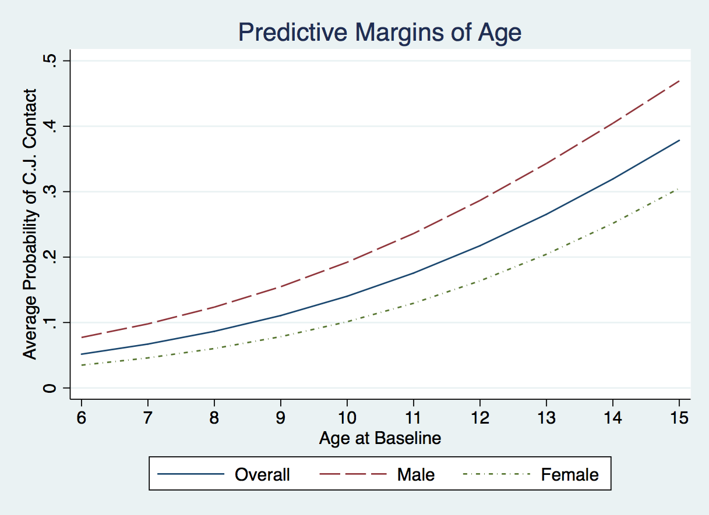

Figure 6.2: Average Adjusted Probabilities of Criminal Justice Contact by Level of Harm and Gender
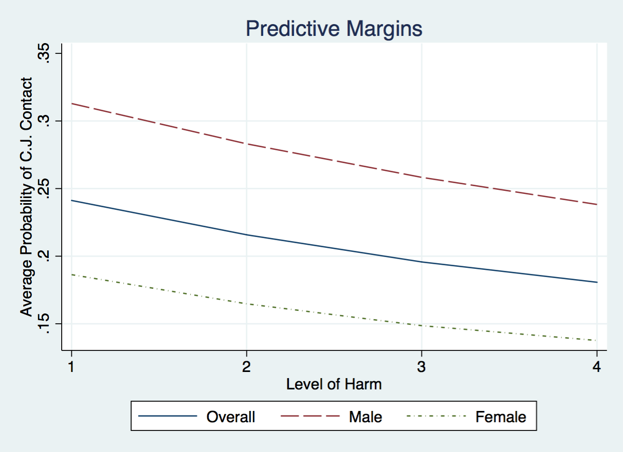

The same process was used to explore the relationship between self-control and the odds of criminal justice contact. Predictive margins reveal the expected relationship that the odds of criminal justice contact decrease as self-control increases. The AAP for those with the lowest self-control score is .38, while the AAP for those with the highest score is .17. This represents an AME from the lowest score (0) to highest score (20) of -.21. Apart from the changes from 0-1 and 3-4 in self-control scores, each unit increase results in an AME of -.01 on criminal justice contact. A graph showing the AAPs of criminal justice contact for self-control scores can be found in Figure 6.3. Results show that across all self-control scores, males exhibit a higher probability of criminal justice contact than females. Despite a small widening of the gap between males and females for scores between 10-16, the gap between genders remains relatively consistent.
Figure 6.3: Average Adjusted Probabilities of Criminal Justice Contact by Self-Control and Gender
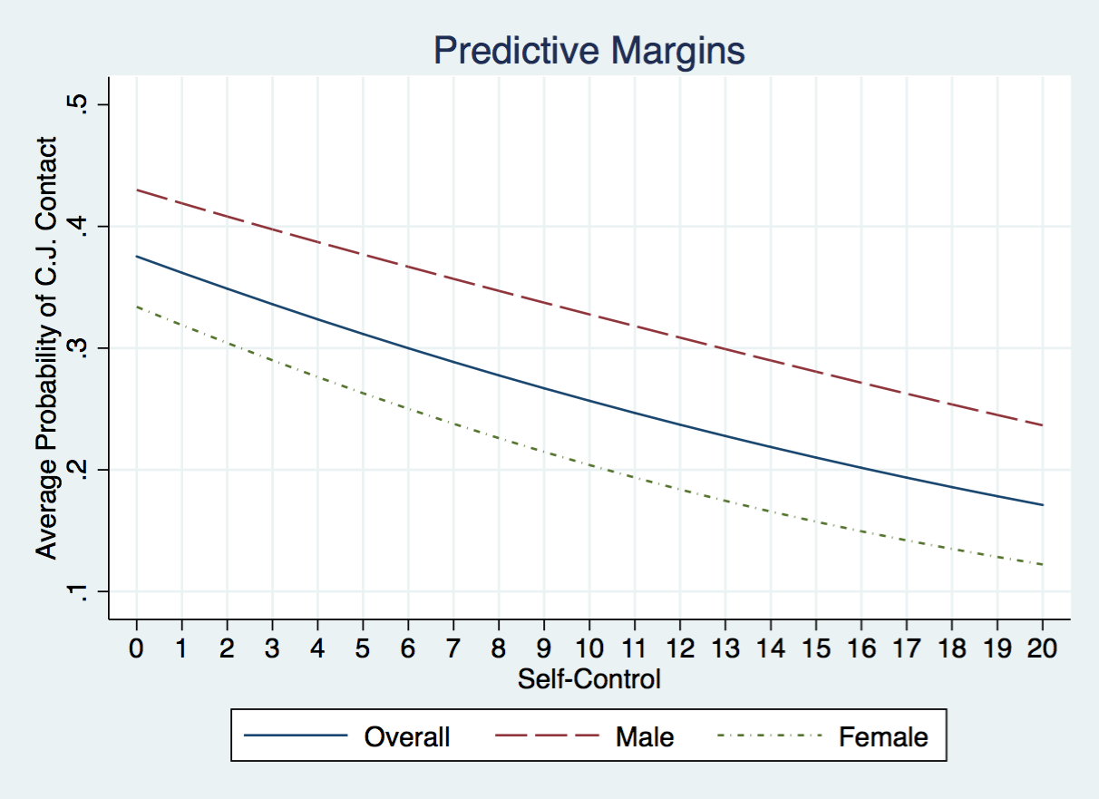
To examine any differences in the probability of criminal justice contact across age and self-control, a contour plot of the predictive margins for age and self-control can be found in Figure 6.4. The contour plot shows that the highest probabilities for criminal justice contact are among those with low self-control who were older at baseline, with their average probabilities approaching .6. Interestingly, the graph also shows that even age and self-control continue to be risk factors, even across the more protective categories of the respective variables (i.e. high self-control and older at baseline). In other words, while the AAP for a 9-year-old is .11, youth with self-control scores less than 16 all have AAPs closer to .2. Conversely, the AAP for someone with a self-control score of 20 has an AAP of .17 in the final model; however, even a youth with a self-control score of 20 who is 15 at baseline still has an AAP approaching .4.
Figure 6.4: Contour Plot for Average Probability of Criminal Justice Contact by Age and Self-Control
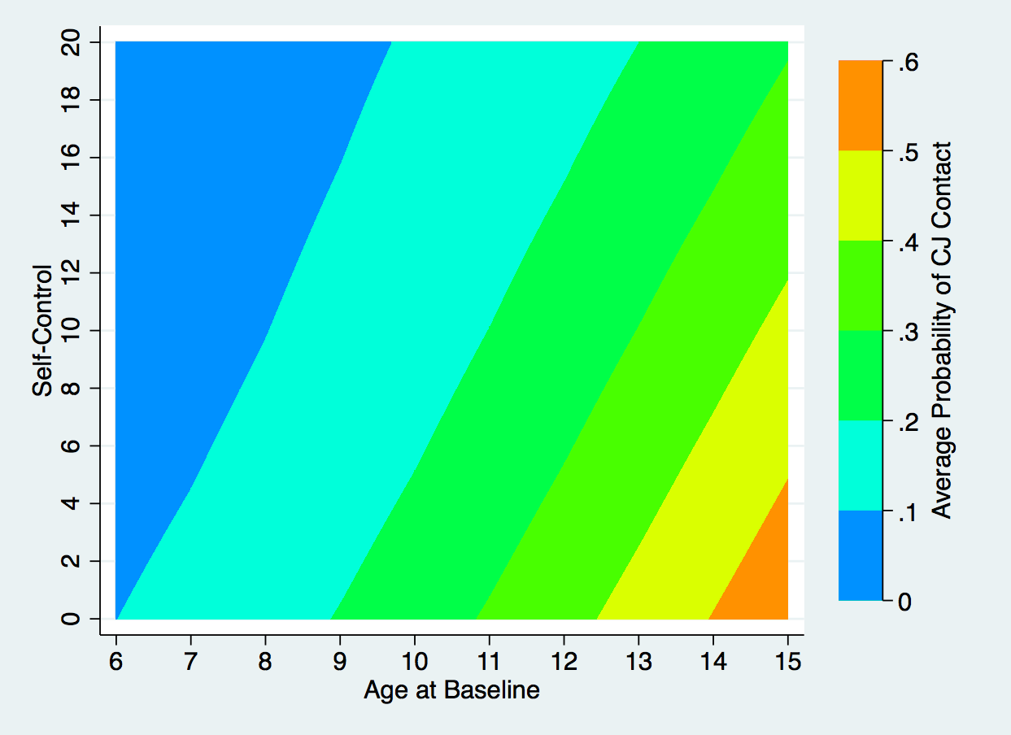

The variables of age, self-control, and level of harm were also examined across various groups within the categorical independent variables to assess if their relationship with criminal justice contact varies across groups. Figure 6.5 is a graph of the predictive margins of criminal justice contact by case substantiation, gender, and age at baseline. Results reveal that for both substantiated and unsubstantiated cases across all ages at baseline males consistently have higher AAPs of criminal justice contact. Also, for both substantiated and unsubstantiated cases, the AME of gender grows as age at baseline increases. In other words, although males consistently have a higher probability of criminal justice contact, the difference in probabilities between males and females is larger for older children than younger children. Another interesting observation from the graph is that although substantiated cases consistently have a higher probability of criminal justice contact, the AME of a case being substantiated is relatively small for male and female youth across all ages at baseline.
Figure 6.5: Average Adjusted Probabilities of Criminal Justice Contact by Self-Control and Gender
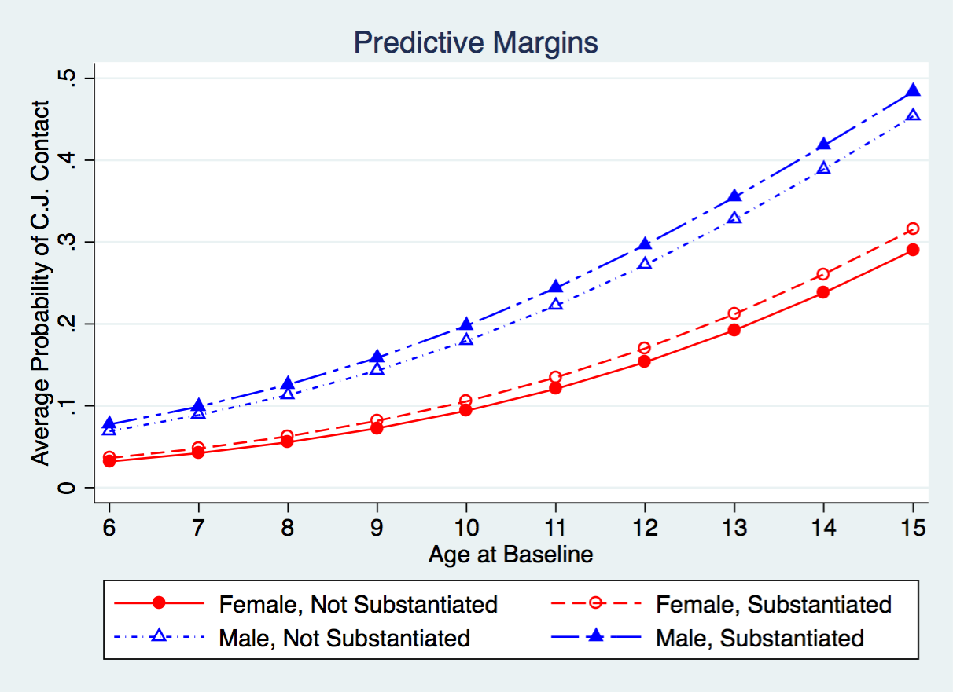
Figure 6.6 contains a graph of the predictive margins for criminal justice contact by age, most severe maltreatment type, and case substantiation. Echoing previous findings for substantiated cases by age and gender, results show that there is not a large difference in the probabilities of criminal justice contact when comparing substantiated and unsubstantiated cases. Across substantiated and unsubstantiated cases at any age, neglect has the higher AAP of criminal justice contact followed by physical abuse, other, and sexual abuse. The graph highlights that although the AAPs for sexual abuse are consistently lower, the AME of sexual abuse is the largest at older ages. The graph also shows that the difference between all of the maltreatment types grows as the age at baseline increases. Specifically, at baseline for both substantiated and unsubstantiated cases, all maltreatment types have AAPs of less than .1. However, when we compare the AAPs at age 15, they range from just under .15 for sexual abuse to levels between .4 and .5 for both substantiated and unsubstantiated cases of neglect. The largest area of growth is between sexual abuse and the remaining three categories. Although the AMEs between neglect, physical abuse and other forms of maltreatments also increase in size from age 6 to age 15 at baseline, their growth is not as large as the AME for sexual abuse.
Figure 6.6 Average Adjusted Probabilities of Criminal Justice Contact by Maltreatment Type, Substantiation, and Age
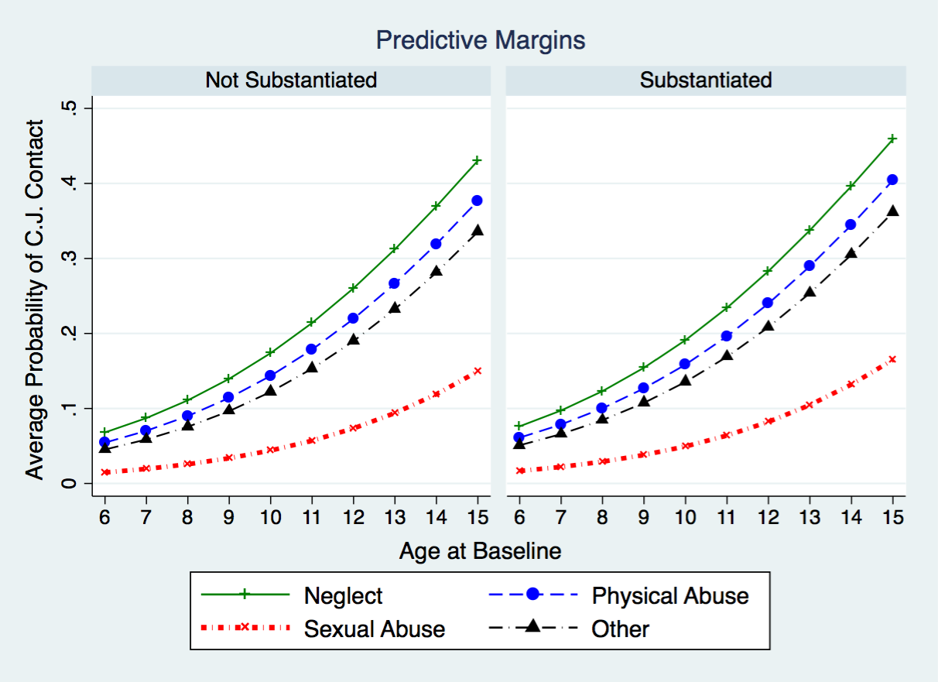
To assess any differences in the relationship between self-control and criminal justice contact across race and gender, the AAP of each self-control score was plotted by gender and race. The results can be found in Figure 6.7. The plots for race/ethnicity are in blue dashed lines and those for gender in solid green. Results indicate that on average females, and white youth have lower probabilities of criminal justice contact across all self-control scores.
Figure 6.7: Average Adjusted Probability of Early Sexual Initiation for Gender and Race/Ethnicity by Self-Control
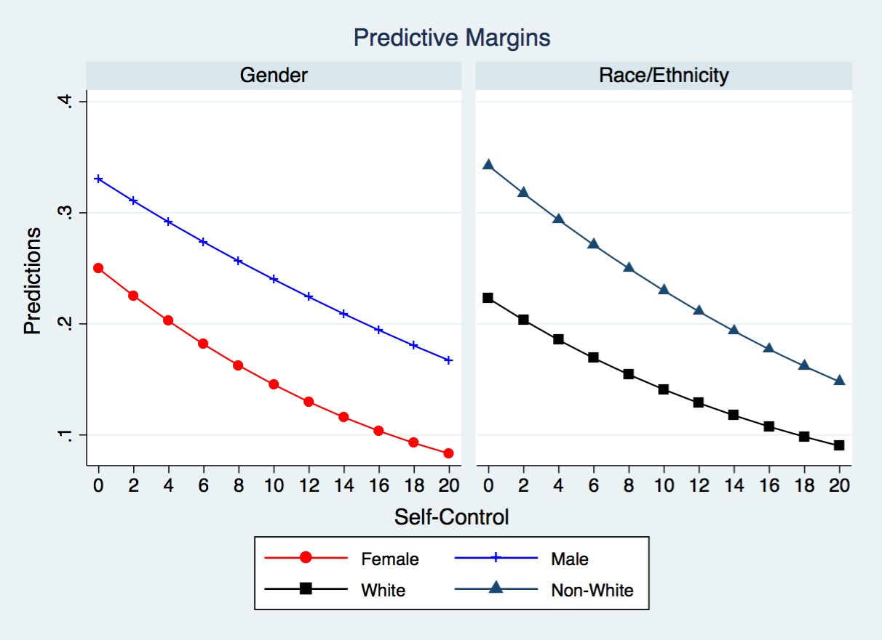
One of the most interesting findings from the final model was the effect of the interaction term between self-control, gender, and group home placement. Figure 6.8 shows the change in AAPs of criminal justice contact for self-control scores among male and females placed in group homes after the interaction term was added to the model. Prior to the addition of the interaction term for gender, self-control, and group home placement (left graph in the figure), the AAPs for criminal justice contact decrease as self-control increases. This relationship is expected given Gottfredson and Hirschi’s General Theory of Crime (1990).
Figure 6.8: Adjusted Average Probabilities for Criminal Justice Contact Before and After Three-Way Interaction Term
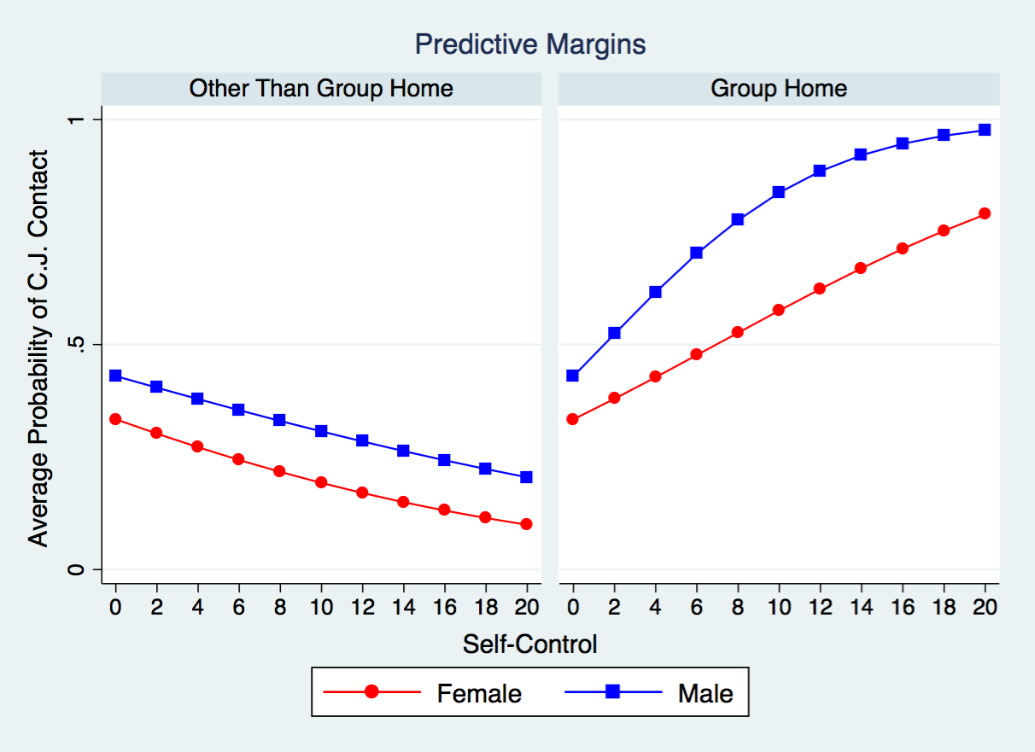
With the addition of the three-way interaction term of self-control, gender, and group home placement (right graph in the figure) this relationship changes drastically. Specifically, results show that for both males and females placed in a group home, the AAPs for criminal justice contact increase as self-control increases. What this suggests is that the effect of being placed in a group home is highest for those youth with higher levels of self-control. Stated in relationship to population heterogeneity (propensity) and state dependence effects, this suggests that for those with a relatively high propensity of committing a crime (low self-control) being placed in a group home does not exert a high state dependent effect. However, for those with a relatively low propensity for committing a crime (high self-control), being placed in a group home has a very high state dependent effect on criminal justice contact later in life.
Figure 6.9 shows the same relationship in comparison to placements other than a group home. Given the lack of significant differences for the other placements, the other placements have been grouped together to make the graph easier to interpret. The addition of the other placements shows that while the AAPs for other placements are not identical after the addition of the interaction term, all changes are very subtle. The graphs also show that for females the effects of one-unit changes in self-control are linear. However, as self-control increase for males, the per-unit changes are not the same across scores. Specifically, the changes per-unit are highest for scores 0-10 and for scores of 10-20 the direction is positive but, the effect is less than that of scores 0-10. In addition to suggesting that the relationship is slightly different for males and females, the graph also shows that the AMEs of being male are highest for mid-level self-control scores and lessens at the high and low ends.
Figure 6.9: Adjusted Average Probabilities for Criminal Justice Contact Before and After Three-Way Interaction Term Including Placements Other than a Group Home
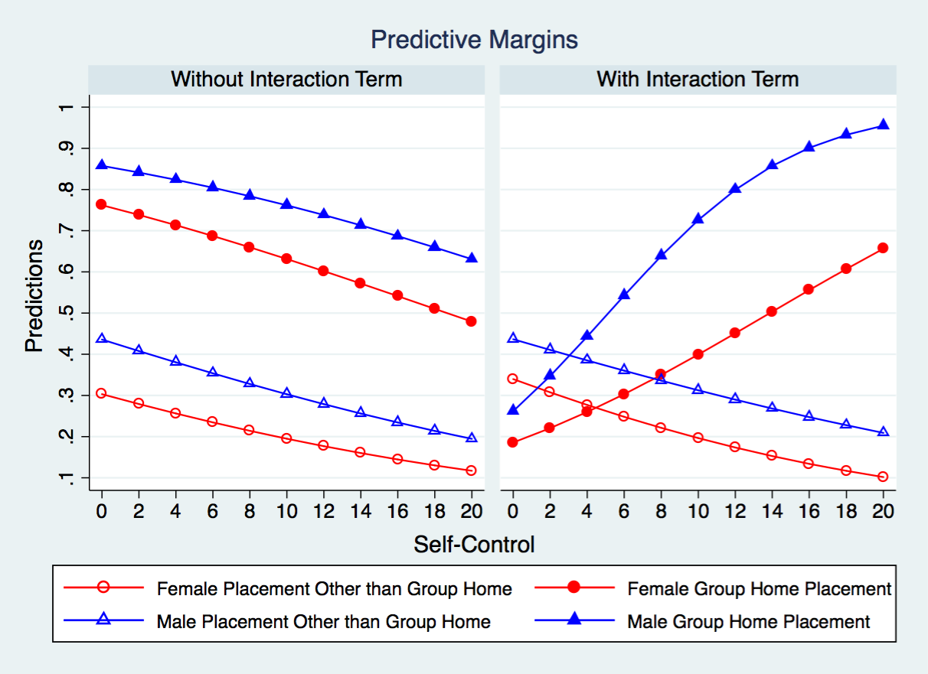
The last relationships examined via predictive margins are those between the level of harm, maltreatment type, and criminal justice contact. The addition of this interaction term shows that for sexual abuse cases, increased levels of harm result in higher odds of criminal justice contact. A graph containing the AAPs for this relationship for males and females can be found in Figure 6.10. The graph shows that for both males and females, the probability of criminal justice contact increases as the level of harm does for those whose most severe form of maltreatment was sexual abuse. However, although not significant, for all other maltreatment types, increases in the level of harm results in a decrease in the probability of criminal justice contact. Figure 6.10 reveals that although males consistently have a higher probability of criminal justice contact, the interaction effect functions the same for both genders.
Figure 6.10: Interaction Effect for Level of Harm and Sexual Abuse by Gender
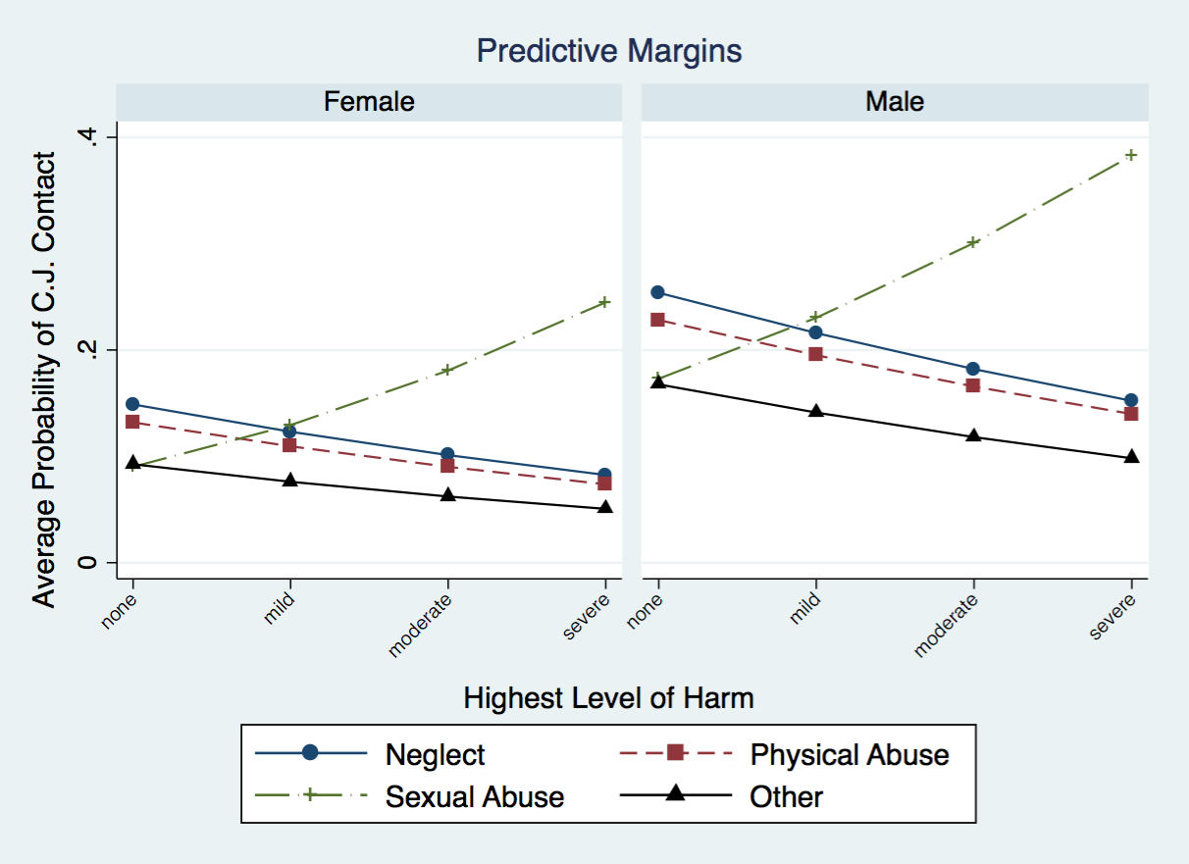
Figure 6.11 contains the AAPs for the level of harm by maltreatment type and gender. Results show that across gender, the relationship between the level of harm and criminal justice contact operates similarly for male and females across forms of maltreatment other than sexual abuse. Across all forms, the AME of gender is largest at the lowest levels of harm and the smallest at highest levels of harm. However, when we examine the AAPs for males and females, they are closest at lower levels of harm and the furthest apart at higher levels of harm. In other words, the AME of gender is lowest at low levels of harm and largest for higher levels of harm. This suggests that for sexual abuse, the per-unit increases in the probability of criminal justice contact for levels of harm are higher for males than females, or stated otherwise, the slope for the level of harm is higher for male than for females.
Figure 6.11: AAPs of Criminal Justice Contact Across Levels of Harm by Gender and Maltreatment Type
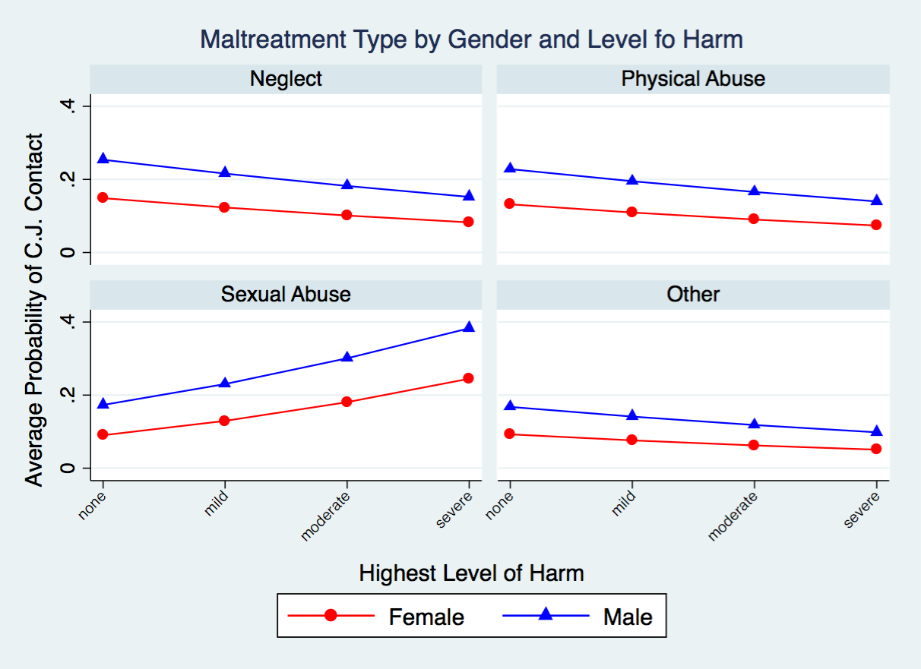

Summary
Various predictors appear to be significantly related to the odds of criminal justice contact later in life. Consistent with previous literature, children who are older at baseline are more likely to have criminal justice contact later in life. Also, non-white youth also appear to be at significantly higher risk for criminal justice contact when compared to white youth. Although there were no significant main effects of maltreatment type on criminal justice contact, the addition of an interaction term between the level of harm and sexual abuse reveals a main effect for sexual abuse and a significant interaction term between the level of harm and sexual abuse. Specifically, for cases where the most severe form of maltreatment was sexual abuse and low levels of harm, the odds of later criminal justice contact are lower than for other maltreatment types. However, the probability of criminal justice contact increases as the level of harm increases for sexual abuse cases.
Furthermore, the level of harm and maltreatment types other than sexual abuse do not have any significant relationship to later criminal justice contact. The final model also shows that generally, low levels of self-control are related to higher odds of criminal justice contact and type of placement at baseline is not significantly related to later criminal justice contact. However, in addition to these main effects, the three-way interaction of self-control, gender, and placement in a group home reveals that the relationship between self-control and criminal justice contact varies by both gender and placement type. Specifically, placement in a group home for males and females appears to exert a stronger state dependent effect on criminal justice contact for youth with higher levels of self-control. In other words, group home placements are not as detrimental for those youth with low levels of self-control when compared to youth with high levels of self-control. Although the slope is relatively consistent for females, the slope of self-control for males is most steep for self-control scores of 0-10 and less steep after that. Taken together, these results suggest that both population heterogeneity in the form of self-control, and state dependence effects, in the form of placement in a group home and sexual abuse, are at play in the relationship between criminal justice contact and child maltreatment and child welfare experiences.

Chapter 7: Discussion and Conclusion
Previous research indicates that individuals with histories of child maltreatment and contact with the child welfare system are at higher risk for risky sexual behaviors (James et al. 2009; Leslie et al. 2010), self-reported offending (Brezina 1998; Chamberlain and Reid 1998; Chapple et al. 2005; Cusick et al. 2010b) and criminal justice contact (Chamberlain and Reid 1998; Ekstrand et al. 1999; Forsman and Långström 2012; Grogan-Kaylor and Otis 2003; Kazemian et al. 2011; Mersky and Janczewski 2013; Taussig et al. 2001). Although previous research points to child maltreatment and child welfare experiences as being linked to these adverse outcomes, it is difficult to parse out exactly how these experiences are related to the adverse outcomes. Stated differently, it is unclear if the relationship between child maltreatment, child welfare experiences, and adverse outcome is one of individual propensity (population heterogeneity) or adverse events (state dependence).
Population heterogeneity explanations are time-stable characteristics within a person that explain both past and future offending (Nagin and Paternoster 2000). As it pertains to this study, a population heterogeneity explanation would point to some time-stable characteristic within the child that existed prior to the child maltreatment, was affected by the child maltreatment, and/or affected later child welfare experiences while also being related to adverse outcomes. In other words, those children with a propensity for deviant behavior, such as low self-control, would also be more difficult to parent and therefore potentially be at higher risk for child maltreatment and potentially require more restrictive placements while in care. This propensity for deviant behavior might also influence experiences of child maltreatment and experiences while in child welfare custody and at the same time also be the driving force behind later adverse outcomes. An alternative population heterogeneity explanation could be that child maltreatment at a young age results in an inability to acquire an adequate level of self-control and therefore an increased risk for adverse outcomes later in life as well as more restrictive placements while in child welfare custody.
It is possible that the relationship between child maltreatment, child welfare experiences, and later adverse outcomes is best explained via a state dependence explanation. State-dependent explanations are causal and suggest certain events precipitate a change in lifestyles or opportunities (Nagin and Paternoster 2000). As it pertains to this study, a state dependence explanation suggests that child maltreatment and child welfare experiences in themselves, are related to these adverse outcomes because they change the child's future behavior or opportunities to participate in deviant behavior. In other words, being maltreated or removed from the home at any age changes the child or their surroundings in a manner that makes these adverse outcomes more likely. Additionally, events such as receiving services or different placements could also function as protective factors and reduce the odds of experiencing one of these adverse outcomes. Specifically, receiving services or placement into a healthier involvement could function as a positive transition that alters the child’s life-course trajectory away from adverse outcomes.
Although the concept of maltreatment changing the child's behavior sounds similar to population heterogeneity explanations of propensity, it is not quite the same. Population heterogeneity explanations require a time-stable difference among individuals. Specifically, in a population heterogeneity explanation, only maltreatment at an early age would be related to adverse outcomes due to the stable nature of self-control by the age of 10 (Gottfredson and Hirschi 1990). In other words, child maltreatment prior to the age of 10 is likely to result in a failure by adults in the child’s life to instill adequate levels of self-control, and therefore the child will be more likely to engage in deviant and risky behavior throughout the life-course. Using such an argument, maltreatment later in life would not be as influential because the child has already acquired their level of self-control. However, if the relationship is one of state dependence, one would expect maltreatment at any age to be related to these adverse outcomes. Furthermore, one would expect events such as being removed from the home or placement in a group home at any age to be related to increased risk for these adverse outcomes.
Although it is helpful to think of population heterogeneity and state dependence as competing explanations, the relationships between child maltreatment, child welfare experiences, and adverse outcomes throughout the life-course are likely a combination of both. In fact, Nagin and Paternoster (2000) suggest that the best explanations of past and future behavior are those that incorporate both. Furthermore, Nagin and Paternoster suggest that theories such as Sampson and Laub’s age-graded theory of informal social control are likely the best theories for explaining the relationship between past and future behaviors due to their ability to account for both population heterogeneity and state dependence. As such, the current study attempts to account for both population heterogeneity and state dependent explanations of the relationship between child maltreatment, child welfare, and adverse outcomes. Specifically, self-control is included in the models to account for population heterogeneity and the different propensities among individuals. Additionally, negative life events, such as previous child welfare history, the severity of abuse, and removal from the home are also included to account for state-dependent effects.
Based on Sampson and Laub’s age-graded theory of informal social control (1995a) and Gottfredson and Hirschi’s general theory of crime (1990), I suggested that low levels of self-control would be correlated with higher odds of both early sexual initiation and criminal justice contact. Additionally, given the assertion by Gottfredson and Hirschi (1990) that self-control remains stable after the age of 10, I theorized that population heterogeneity would also be supported if the odds of experiencing adverse outcomes decreased with age at baseline or did not change after the age of 10. Furthermore, based Sampson and Laub’s theory of informal social control (1995), I suggested that negative life events such as substantiated child maltreatment (even at ages older than ten years old), removal from the home, previous child welfare experience, and different placement types would be significantly related to the adverse outcomes of early sexual initiation and criminal justice contact. Specifically, these events would function as transitions and turning points in the child’s life and therefore increase their odds of experiencing one of these adverse outcomes. Conversely, receiving services or different placements could also function as positive transitions and turning points and result in lower odds of early sexual initiation or criminal justice contact.
The current study seeks to contribute to the body of knowledge regarding the relationship between child maltreatment, child welfare, and adverse life events such as early sexual initiation and criminal justice contact. Not all the factors mentioned here are necessarily unique, but when factored together, they result in a level of rigor and scope that exceeds previous research. First, the NSCAW data are complex and broad in scope. The NSCAW data contain measures of outcomes, propensities, and negative life events collected at five separate waves that span anywhere from five to eight years. Additionally, the NSCAW data were collected using a complex sampling design that allows for generalization of findings to the broader population of all children in the United States who were the alleged victim of a child maltreatment investigation or assessment. There is a sacrifice in the types of analyses that can be performed on the data due to the complex survey weights. Specifically, due to the effect the design has on the standard errors, model fit and significance tests are affected. STATA accounts for the standard errors in some tests but not in others. However, the benefits gained from having a generalizable sample outweigh any associated losses.
Furthermore, in my research, I have encountered problems regarding controls for types of maltreatment at baseline. Because cases often have multiple forms of maltreatment, controlling for types of maltreatments at baseline is often difficult due to the need to have mutually exclusive categories. The NSCAW data contain a measure for the level of perceived harm and risk that is helpful in identifying the most severe form of maltreatment for each case. I control for type of maltreatment at baseline by including dummy variables for the most severe form of maltreatment and a measure for the presence of multiple forms of maltreatment. Furthermore, previous research identified a lack of control for the severity of maltreatment cases as a limitation and consideration for future research. (Crawford et al. 2017; Crawford and Bradley 2016). When used together, measures for the most severe form of maltreatment and the overall level of perceived harm and risk allow for an accounting of type and number of maltreatments at baseline while also having an easily identifiable reference group.
As previously mentioned, previous research rarely incorporates both state dependent and population heterogeneity factors in the link between child maltreatment, child welfare, and adverse life outcomes. While many studies find that factors such as being placed in a group home are linked to adverse outcomes (Crawford et al. 2017; J. P. Ryan et al. 2008) it is unclear if this relationship is the result of the group home placement (state dependence), some other propensity related to both adverse outcomes and placement in a group home (population heterogeneity), or both. This study addresses this limitation by including both placement types and criminal propensity via self-control. Not only does this allow for additional isolation of state dependence and population heterogeneity effects, it also identifies if the effects vary across different demographics. In sum, the use of complex survey weights, longitudinal data, markers of severity, and the inclusion of both state dependent and population heterogeneity variables enable this study to assert a higher level of methodological rigor and address some common limitations of previous research.

Early Sexual Initiation
Based on previous research, as well as theories by Sampson and Laub (1995a) and Gottfredson and Hirschi (1990), I anticipated that age at baseline, prior child welfare involvement, current case substantiation, the level of perceived harm, receipt of services, type of placement, and self-control would be significantly related to early sexual initiation. For age, I predicted that age at baseline would be positively related to the odds of early sexual initiation. In other words, those children who were older at baseline would have higher odds of early sexual initiation. I argue that a relationship of this nature would be more supportive of a state dependence effect rather than a population heterogeneity effect due to the assertion of Gottfredson and Hirschi that self-control is set by the age of 10. If Gottfredson and Hirschi’s assertion is true, abuse that takes place at older ages is less likely to be significantly related to the odds of early sexual initiation due to the static nature of self-control.
Also, significant relationships between prior child welfare involvement, case substantiation, and placement outside of the home are taken as indicators of state dependence. I predicted that even when controlling for age, prior child welfare involvement, and case substantiation, any removal from the home would significantly increase the odds of early sexual initiation. The presence of a significant relationship for any of these factors is interpreted as a negative life event that alters the child’s lifestyle and opportunity for early sexual initiation. Using a lens of age-graded informal social control, I suggest that the presence of any of these factors stand to weaken or disrupt the individual’s bonds to their family and peers as well as institutions such as schools or churches. The presence of these factors and the resulting disruption of social bonds in childhood and adolescence can then begin a process of cumulative disadvantage that alters the youth’s life-course trajectory in a manner that makes an adverse outcome such as early sexual initiation more likely. However, at the risk of appearing to hedge my bets, it is possible that placement in a foster home or with other relatives could also serve as a positive transition and turning point resulting in a negative relationship with early sexual initiation or no significant effect due to the presence of both positive and negative outcomes.
I predicted that although kinship and foster care placements may not be significantly related to early sexual initiation, placement in a group home would be significantly related to an increase in the odds of early sexual initiations. This relationship may be due to the children who are placed in group homes may have lower self-control and therefore a higher propensity for early sexual initiation. However, I predicted that although the addition of self-control to the model may partially mediate the relationship between group home placements and early sexual initiation, group home placements would still exert a significant state dependence effect on early sexual initiation. In accordance with the age-graded theory of informal social control, I suggest that those children placed in group homes are less likely to have strong bonds with the caregivers in the group home, be attached to school, involved in extra-curricular activities, and for youth who are older, will have fewer opportunities for employment. A population heterogeneity explanation would be more supported if self-control fully mediates the relationship between group home placements and early sexual initiation.
Results in the final early sexual initiation model are largely in line with my predictions. That is, the final model provides support for both population heterogeneity and state dependence explanations of the relationship between child maltreatment, child welfare experiences, and early sexual initiation. According to my predictions, age at baseline, case substantiation, prior child welfare involvement, group home placements, and self-control are all significantly related to an increase in the likelihood of early sexual initiation. However, some of the relationships were more nuanced than predicted.
Gender, age, and race are common correlates of crime in the literature and other than gender, each is a significant predictor. Age at baseline is significantly related to increased odds of early sexual initiation for both males and females. Although this specific relationship was not found in previous research, the same relationship has been identified between age at baseline and other adverse outcomes such as homelessness (Crawford et al. 2017) and arrest (Ryan et al. 2008; Widom 1991b). It is possible that the reason older children are more likely to initiate sex early is that the maltreatment has been occurring throughout the life-course but the case identified for the study was just the first to be brought to the attention of child welfare services. In this scenario, the delays between experiencing maltreatment, child welfare services intervention, and child welfare services could explain this relationship. Additionally, it is possible that maltreatment and other experiences such as removal, are more disruptive to the social bonds of the victim. Race was also significantly related to early sexual initiation with non-white children being more likely to initiate sex early. Some previous studies have also shown that race is significantly related to adverse outcomes such as juvenile arrest (Ryan et al. 2008). Understanding the nature of this relationship is difficult and requires careful interpretation. Ryan et al. (2008) suggest that the significant relationship between race and arrest may be the result of external factors such as social bonds or neighborhood effects. It is possible that the same explanation holds true for early sexual initiation.
To assess state dependence effects, controls for case substantiation, the level of harm, receipt of services, multiple maltreatment types, and previous child welfare involvement were included in the model. Surprisingly, the level of harm, receipt of services, and the various alleged maltreatment types were not significantly related to early sexual initiation. Perhaps the most surprising finding is the lack of significance for receiving services. A negative relationship between receipt of services and early sexual initiation is ideal, as this would suggest the services function as a protective factor against early sexual initiation. However, any significant relationship between specific services and early sexual initiation is likely masked due to all services being lumped into one. Although the level of harm is not significant, it's inclusion is still important because previous research often lacks any controls for severity of maltreatment and its inclusion helps to eliminate competing hypotheses. For instance, in my previous research on the role of parental gender and child welfare agencies' decisions to remove a child from home, I found that mother perpetrators of physical abuse were the most likely to have their children removed. Although I contend that this is due to focal concerns and issues around "double-deviance," the lack of a control for severity of abuse leaves open the alternative explanation that when mothers commit physical abuse, they do so more severely than fathers. Although this seems unlikely, a lack of control for severity of abuse leaves that as an alternative explanation.
Both case substantiation and prior child welfare involvement were significantly related to a higher likelihood of early sexual initiation. Interestingly, prior child welfare involvement was tried in several different forms. Various models were run where previous child welfare experience was limited to a removal, a substantiated case, and finally just a referral. Interestingly, the only form that was significantly related to early sexual initiation was the broadest categorization that included any allegation regardless of the case disposition. This suggests that at least for youth with multiple contacts with child welfare services, any contact with child welfare services is a potential risk factor, even if the case is not substantiated. This might be due to the presence of poor parenting or non-traditional environments that although technically not abuse, are less than pro-social. Also, when viewed from a self-control lens, it is possible that parenting methods or other situations that raise enough concern for a child welfare report to be filed are not likely to be associated with those parenting tactics required for the adequate acquisition of self-control.
Interestingly, case substantiation is not significant until an interaction term between case substantiation and gender is added. After the inclusion of the interaction term, the odds ratio increases and the interaction is less than one, signifying a decrease in the odds of early sexual initiation. This suggests that case substantiation is a larger risk factor for female youth than male youth. This finding is in line with prior research on various adverse outcomes and child maltreatment that suggest maltreatment is a larger risk factor for females than for males (Koenig and Clark 2004; Ryan et al. 2015; Spohn 2000; Widom and Maxfield 2001). Although the causal mechanism is less clear, it does appear that maltreatment serious enough to be substantiated places female youth at higher risk for adverse outcomes than males.
Previous research regarding the relationship between types of maltreatment and adverse outcomes is mixed with some studies finding significant differences among the types and others finding no difference. In this study, sexual abuse was not significantly related to early sexual initiation. Furthermore, the joint effect of all the maltreatment types was also not significant. Although the tables are not included here, a model containing only demographics and type of maltreatment was examined and did reveal a significant relationship between sexual abuse and increased odds of early sexual initiation. However, when factors such as level of harm, baseline services, and previous child welfare involvement are added, the significance was lost. It is also possible that this lack of significance is an artifact of the sample or a result of the complex survey design and large standard errors. It is important to note that the sample used is one comprised of children who are at higher risk. Although these data contain both children who were substantiated and not substantiated for maltreatment, all of them were brought to the attention of child welfare services due to concerns around maltreatment.
Consistent with previous research, placement in a group home was significantly related to adverse outcomes. Specifically, those youth who were placed in a group home were at significantly higher risk for early sexual initiation when compared to those who remained in the home, were in a kinship placement, or in a foster care placement. Although this finding is consistent with previous research, what makes this finding unique is that the significant relationship remains even when control for propensity and other demographics are added. The difficulty with previous findings regarding group homes and adverse outcomes is that it is usually unclear if the placement is causally related to these adverse outcomes or is a youth more likely to be placed in a group home due to the presence of a characteristic that makes them more likely to experience these adverse outcomes. In other words, is being placed in a group home a risk factor, or is being placed in a group home and experiencing adverse outcomes such as arrest or early sexual initiation two sides to the same coin?
Although still possible, the fact that the relationship remains even when controlling for propensity via self-control suggests that placement in a group home does exert a state dependence effect on adverse outcome such as early sexual initiation. It is possible that being placed in a group home after being the victim of maltreatment could be a potential transition that leads to a negative turning point in life. Being placed in a group home might have a deleterious influence on the child’s prosocial bonds and therefore result in a higher likelihood of various adverse outcomes. From a learning theory perspective, it is also possible that being placed in a group home with other individuals who are prone to deviance and adverse outcomes may provide more opportunities and technique for these adverse outcomes. Although further examination of the causal mechanisms behind the relationship between group home placements and adverse outcomes is warranted, confirming that the relationship exists even in the presence of a control for propensity is a crucial first step.
Finally, as self-control increases the odds of early sexual initiation decrease. This finding is not surprising and in line with previous research and Gottfredson and Hirschi’s general theory of crime (Gottfredson and Hirschi 1990). The predictive margins of self-control were examined across various groups within the sample and all suggest that self-control functions consistently across types of maltreatment, gender, and placement types. In other words, regardless of settings or group membership, those with higher levels of self-control will generally have lower odds of early sexual initiation. Given Gottfredson and Hirschi’s assertion that levels of self-control are set by the age of 10, a model was also examined with a dummy variable of 10 or younger for age (model not included). The model was largely unchanged, and the age dummy variable was not significant.
Taken together, these findings suggest that even when controlling for propensity (population heterogeneity) child maltreatment and child welfare experiences still exert a state dependence effect on early sexual initiation. In general, these findings show that non-white children who are older at the time of maltreatment, have their case substantiated, have lower levels of self-control, and have any form of previous child welfare involvement are at higher risk for early sexual initiation. Furthermore, the largest risk factor for early sexual initiation appears to be placement in a group home setting, even when controlling for levels of self-control.

Criminal Justice Contact
Based on previous research, as well as theories by Sampson and Laub (1995a) and Gottfredson and Hirschi (1990), I predicted that the final model would provide evidence of both population heterogeneity and state dependence effects for later criminal justice contact. It is important to reiterate that the presence of population heterogeneity effects does not negate the presence of state dependence effects or vice versa. Specifically, I predicted that elements of child maltreatment and child welfare experiences would have a state dependence effect on later criminal justice contact and self-control would have a population heterogeneity effect on later criminal justice contact. As such, I predicted that after controlling for population heterogeneity effects via self-control, child maltreatment and child welfare experiences would still exert state dependence effect on later criminal justice contact via previous child welfare involvement, level of harm for the most severe form of maltreatment, multiple forms of alleged maltreatment, case substantiation, receipt of services, most serious type of maltreatment, and type of placement at baseline.
It is possible that the relationship between child maltreatment, child welfare experiences, and criminal justice contact can be explained via population heterogeneity and self-control. In such a relationship, low levels of self-control in children precipitate some child maltreatment experiences or is the result of factors related to the maltreatment (poor parenting). To be clear, to say that low levels of self-control may precipitate some experiences of child maltreatment is not placing blame on the child but rather acknowledging previous research suggesting that the relationship between parenting and child behavior is reciprocal (Lytton 1990). In other words, children with low self-control are more likely to engage in deviant and antisocial behavior which over time may lead to the parent's engaging ins less effective and potentially abusive parenting practices. Furthermore, a child with low self-control is likely to engage in more deviant behavior and subsequently may be more likely to be placed in a group home. In either of these scenarios the relationship between child maltreatment, child welfare experiences, and criminal justice contact would be best explained via population heterogeneity. However, I predicted that accounting for self-control would not fully mediate the effects of child maltreatment and child welfare experiences on later criminal justice exposure and therefore be more supportive of a state dependence explanation.
As with early sexual initiation, I predicted that the odds of criminal justice contact would increase as the child’s age at baseline increased and therefore be more supportive of a state dependence explanation. I predicted that in the absence of any state dependent effects of child maltreatment and child welfare experiences on criminal justice contact, older ages at baseline would not be significantly related to odds of criminal justice contact. I also predicted that relationships between elements of child maltreatment such as prior child welfare involvement, case substantiation, the level of harm, more than one alleged maltreatment, and most severe type of maltreatment would be significantly, positively related to later criminal justice contact.
For child welfare experiences, I predicted that receipt of services and type of placement at baseline would be significantly related to criminal justice contact and evidence in support of a state dependence effect of child welfare experiences on criminal justice contact. Whereas, the state dependence effects of child maltreatment are predicted to increase the odds of criminal justice contact, it is possible that state dependence effects of child welfare experiences could potentially function as both protective and risk factors. For example, it is reasonable to assume that factors such as the receipt of services at baseline could be a protective factor by significantly reducing the odds of criminal justice exposure. Although it is possible that the receipt of baseline services could be correlated with more severe forms of maltreatment and therefore be related to higher odds of criminal justice contact, the inclusion of a measure for level of harm should generally control for that explanation.
As predicted, the final model for criminal justice contact is more supportive of a state dependence explanation for the effects of child maltreatment and child welfare experienced on later criminal justice contact. Regarding individual relationships between elements of child maltreatment and child welfare experiences and criminal justice contact, the final model for criminal justice contact is somewhat in line with my predictions. Regarding age, the odds of criminal justice contact increase the older a child is at baseline. To test for a population heterogeneity effect, an alternative model with a dummy variable for children 10 or younger was utilized (table not included).
I argued that a population heterogeneity explanation would be supported if children who were 10 or younger at baseline exhibited higher odds of criminal justice contact than children who were older than 10. Unlike in the early sexual initiation results, the dummy variable for being younger than 10 is significant. However, the direction of the relationship is not in a direction that is supportive of a population heterogeneity explanation. Specifically, results suggest that those children who are 10 or younger have lower odds of criminal justice contact. These results in conjunction with the plot of predictive margins found in Figure 6.1 suggest that the relationship is still one of state dependence but that the risk is higher among children 10 and older. In other words, when examining the predictive margins of criminal justice contact, the slope for age at baseline increases after the age of 10. This finding is consistent with previous literature regarding homelessness (Crawford et al. 2017) and arrest (J. Ryan et al. 2008; Widom 1991b). It is possible that the reason for this increased effect is that removal at an older age is more disruptive to peer groups, schooling, extracurricular activities, and work (for those who are 16 or older).
Interestingly, there is not a significant relationship between gender later criminal justice contact. Results suggest that self-control mediates any effect of gender on criminal justice contact. As with early sexual initiation, race is a significant predictor of criminal justice contact. This finding is in line with previous findings regarding children in criminal justice contact among children in the child welfare system (Ryan et al. 2008). Ryan et. al (2008) suggest that this relationship could be the result of differences in social bonds or neighborhood effects. Previous research also suggests that this relationship may also be driven by racial bias within the criminal justice system (Clemons 2014; Piquero 2008). Regardless of the cause, it appears that minority youth with child maltreatment and child welfare experiences are at higher risk than their white counterparts.
Not in line with my predictions, previous child welfare involvement, receiving services, multiple forms of maltreatment, and case substantiation are not significantly related to later criminal justice contact. Furthermore, these variables are not significantly related in any of the models building to the final model. The level of harm exhibited no main effect on criminal justice contact. However, it did exhibit a significant interaction effect when paired with sexual abuse. Specifically, the results show that for sexual abuse only, as the level of harm increases, the odds of criminal justice also increase. This suggests that for all other forms of maltreatment, the level of harm has no relationship to later criminal justice contact. However, for cases where the most severe form of maltreatment is sexual abuse, the odds of criminal justice contact increase as the level of harm does.
Also, only sexual abuse cases are significantly different from neglect. Specifically, victims whose most severe form of alleged maltreatment was sexual abuse are significantly less likely to experience criminal justice contact. This finding is curious given previous findings generally place sexual abuse victims at either higher or no different risk than other forms of maltreatment. However, when interpreted with the interaction term between sexual abuse and level of harm what this suggests is that sexual abuse cases that are identified as not being harmful are at lower risk for criminal justice contact than other maltreatment types with no perceived harm. Within sexual abuse cases, those whose allegation is perceived as having no harm are at significantly lower risk than those whose allegations are perceived as more harmful, whereas levels of harm within other forms of maltreatment are not at significantly higher or lower risk for criminal justice contact.
It is unclear what is driving this relationship, and neither Sampson and Laub’s age-graded theory of informal social control (1995a) nor Hirschi and Gottfredson’s general theory of crime (1990) provide clear guidance in making inferences. It is possible that differences in patterns regarding frequency and types of acts reported for sexual abuse are substantially different from other forms of maltreatment. Furthermore, it is possible that differences in perceived levels of harm for sexual abuse also vary in a manner that is different from other forms of maltreatment. Given that the criminal justice, contact variable is very broad and contains no differentiation between types of contacts and offenses, it is possible that sexual abuse cases for one type of contact or offense are driving the overall results. Finally, it is possible that this finding is a result of type I error and the null hypothesis has been falsely rejected. Regardless of the cause, future research should explore this relationship further. Specific strategies are discussed in the next section.
As predicted, self-control is significantly related to odds of criminal justice exposure. In general, as levels of self-control increase the odds of criminal justice contact decrease. Prior to the addition of interaction terms between gender, self-control, and group home placements, being placed in a group home was the only placement type that was significantly different from remaining in the home. However, the addition of the interaction terms reveals that both group home placements and self-control operate differently for those in a group home placement. Specifically, the addition of the interaction term renders the main effect of group home placements not significant. The interaction terms also reveal that although self-control is generally related to a decrease in the odds of criminal justice contact, for both male and female children placed in group homes, higher levels of self-control are significantly related to higher odds of criminal justice contact.
On the surface, this finding appears to be in opposition to my predictions, previous research, and both Sampson and Laub’s (1995a) age-graded theory of informal social control and Hirschi and Gottfredson's general theory of crime (1990). However, I believe that after proper interpretation this finding is the strongest evidence for the state dependence effect of child welfare experiences. This finding suggests that for those children who have lower levels of self-control and are therefore more prone to criminal justice contact being placed in a group home does not increase or decrease their risks. In fact, it is possible that part of the reason they are placed in a group home is indirectly related to their low levels of self-control. This explanation is consistent with a population heterogeneity explanation of the relationship between child welfare and criminal justice contact and has been offered as a possible explanation for the consistent finding that group home placements are related to adverse outcomes throughout the life-course (Crawford et al. 2017).
However, the revelation that the odds of criminal justice contact increase as self-control increases for those placed in group homes suggests that group homes exert some influence on those that were otherwise unlikely to experience criminal justice contact. In other words, it appears that being placed in a group home precipitates a change in lifestyle and/or opportunities for those children with higher levels of self-control. This resulting change in lifestyle or opportunities is consistent with what Nagin and Paternoster term a state dependence effect (2000). Using the lens of Sampson and Laub’s theory, it appears that being placed in a group home uniquely effects elements related to informal social control. Given that group homes by nature typically have more children than other placements, it is possible that placement in a group home results in a bond to caregivers that is less salient or intimate than in other placements. Also, it is possible that placement in a group home is more likely to reduce the child’s ability to participate in other extracurricular activities that help to increase their stakes in conformity. Group home placements may also just be an environment where the opportunity to commit crime is far greater when compared to other placements. Regardless of whether the explanation is one or all of these, the current findings provide strong support that placement in a group home precipitates some change in lifestyle and/or opportunities for at least some youth who come into child welfare custody.

Limitations, Future Research, and Policy Implications
Although the current study offers various improvements over previous research in this area, it is not without its own limitations. As with most data, missing data is an issue. Specifically, variables of interest for early sexual initiation, self-control, and level of harm all had missing data percentages higher than 10%. Bivariate comparisons between the entire age-eligible and analytical sample were performed and identified few significant differences. Nonetheless, analyses did reveal significant differences between the two samples regarding age at baseline, race, most severe form of maltreatment, and placement at baseline. Although limited, the presence of significant differences suggests that missing data may be affecting some results. Future research should continue to be aware of missing data and choose the best course of action, although there is no consensus regarding the best way to deal with missing data.
As previously mentioned, although the use of a complex sampling design allows for great generalizability, it also provides some limitations. One such limitation is that there is inflation of the standard errors due to the processes used to adjust them to account for the survey design and weighting. It is possible that these inflated standard errors may be influencing some of the significance tests. Additionally, the use of subpopulations in the analyses results in STATA not being to perform some conventional statistical tests, including tests designed specifically for survey data. When these situations were encountered previous research, as well as contributions by scholars in the STATA forums, were consulted to help identify the best course of action. At time tests were performed using multiple methods and generally results were the same. Future research should continue to investigate new ways for handling complex survey data when performing significance tests.
Related to the issue of standard errors and significance tests, some groups had relatively low membership. For both the full and analytical samples for early sexual initiation and criminal justice contact, children placed in group homes represented less than 5% of the sample. This is not surprising given that group homes are generally one of the least common placement types. Furthermore, in the criminal justice contact model group, home placements were interacted with gender resulting in even smaller groups. Given the importance of group home both theoretically and in prior research, they must be included, but caution should be used when generalizing findings for such a small group to the larger population.
The dependent variables used in this study are also not without criticisms. Specifically, the criminal justice contact variable is very broad and categorizes all arrests and incarcerations as the same. It is entirely plausible that some of the significant relationships revealed here are the result of significant correlations to smaller sets of criminal justice contact. Future research should consider separating arrests and incarceration. Furthermore, future research should consider separation of arrests and incarceration by types of crime. Finally, to address issues of frequency and duration, future studies should consider using continuous or count dependent variables. Doing so allows for the assessment of whether relationships vary by duration or frequency. Also, the data collection for the NSCAW data stops approximately 5-8 years after the baseline maltreatment case and future research should seek to incorporate any future waves of the NSCAW data or potentially identify other data with outcomes at older ages.
Also, the dependent variable for early sexual initiation does not take into account whether the event was consensual or an act of sexual assault. Future research should further distinguish between consensual and non-consensual sexual initiation. Also, future studies should also explore the relationship between child maltreatment and child welfare experiences and other adverse life outcomes. Although many of the risk factors were the same for early sexual initiation and criminal justice contact, there were some differences. Exploration of further outcomes such as condom use, unwanted pregnancies, employment, education, self-reported offending, etc… are likely to have some of the same risk factors but equally likely to have different risk factors as well.
Future research should also attempt to provide more specificity for the child welfare experience variables. For instance, the current study only identifies placement type at baseline and does not address future placements or how long the child was in the baseline placement. Given previous research shows that the number of placements is related to later adverse outcomes (Crawford et al. 2017; Reilly 2003; J. P. Ryan et al. 2008; Ryan et al. 2008; Widom 1991b), future studies should attempt to incorporate controls for placement stability and predominant placement types. Related to placement, future studies would greatly benefit from incorporating variables pertaining to the context and environment of placements. Specifically, controls for neighborhood level factors could provide valuable insight. Previous research also shows that case permanency outcomes are related to later outcomes (Mark E Courtney and Dworsky 2006; Crawford et al. 2017; Cusick et al. 2012), and therefore further controls for eventual case outcomes could be helpful in future analyses.
Although the current study identifies several risk factors for adverse outcomes, it does little to identify protective factors. One potential reason is that the current study does not distinguish between types, number, or duration of services received by children and parents. More accounting for the types, number, and duration of services received by parents and children could be helpful in painting a complete picture of the child welfare experience. Such additions might also provide more accurate insights into risk and protective factors for adverse outcomes such as early sexual initiation and criminal justice contact.
One potential protective factor this study did identify is the importance of placements. Although previous studies have also identified group homes as a risk factor for negative outcomes throughout the life-course, little was known about any potential selection effects that might be related to both placement in a group home and adverse outcomes throughout the life-course. The current study controls for these potential selection effects by including a measure of self-control. The addition of self-control reveals that placement in group homes does not affect all children in the same manner. For those children who are low in self-control and more likely to experience adverse events throughout the life-course, being placed in a group home does not appear to influence early sexual initiation or criminal justice contact one way or the other. However, for those individuals with higher levels of self-control and therefore a lower likelihood of adverse outcomes such as early sexual initiation or criminal justice contact, being placed in a group home is a significant risk factor. This finding suggests that child welfare agencies should continue to be very diligent in only placing children in group homes when absolutely necessary. Most states have placement policies that require a child be in the least restrictive placement that is appropriate. These findings suggest that these policies should stay in place and states should continue to improve screening mechanisms to ensure that children who are at low risk for adverse outcomes are not needlessly placed in group homes.
Although the NSCAW data provide a very diverse level of involvement with the child welfare system, it does not include any children without child welfare involvement. Future research should explore comparing similar youth without any exposure to the child welfare system to those with various levels of contact. One potential avenue fur such a comparison is the use of propensity score analyses to create a matched sample from other longitudinal datasets such as The National Longitudinal Study of Adolescent Health (ADD Health) or The National Survey of Youth (NLSY). In fact, some measures used in the NSCAW data were based on measures used in the ADD Health and NLSY data which could make the construction of a matching model easier. The addition of such a control group would also allow for a better assessment of the relationship between adverse life events throughout the life-course and even the slightest contact with the child welfare system.

Conclusion
The current study sought to identify if the relationship between child maltreatment and child welfare experiences and the adverse life-course events of early sexual initiation and criminal justice contact are best explained through a process of population heterogeneity or state dependence. Results suggest that although self-control does have a population heterogeneity effect on the adverse life events, the adverse outcomes relationship to child maltreatment and child welfare experiences are best explained through a state dependence process. In other words, it appears that child maltreatment and child welfare experiences precipitate some change in lifestyle or opportunity that increases the odds of experiencing one of these adverse events.
Models for both outcomes suggest that minority children, who are older at baseline, children placed in group homes, and children who have lower levels of self-control are at higher risk of experiencing early sexual initiation and criminal justice contact. The early sexual initiation model reveals that the odds of early sexual initiation are higher for those children whose case is substantiated and have prior child welfare involvement. Furthermore, the addition of an interaction term between case substantiation and gender reveals that case substantiation is a bigger risk factor of early sexual initiation for females than for males.
The criminal justice contact model reveals that higher levels of perceived harm are a significant risk factor for criminal justice contact only for those children whose most severe form of alleged maltreatment was sexual abuse. For those children whose most severe form of alleged maltreatment was sexual abuse but had a low level of perceived harm, the odds of criminal justice contact are lower when compared to other forms of maltreatment and more severe sexual abuse cases. Findings also revealed that regarding criminal justice contact, placement in a group home is only a risk factor for those youth who had higher levels of self-control and therefore a lower likelihood of criminal justice contact before placement in the group home. For those children who were already low in self-control, placement in a group home appears to be no better or worse than other forms of placement.
In sum, the current study finds that child maltreatment and child welfare experiences are related to the adverse life-course outcomes of early child sexual initiation and criminal justice contact through a process of state dependence. In other words, child maltreatment and child welfare experiences precipitate some change in lifestyle or opportunity that increases the odds of experiencing one of these adverse events. Although the current study mainly identified risk factors for early sexual initiation and criminal justice contact, the presence of a state dependence relationship provides a more optimistic outlook for potential protective factors. By further parsing out the different services offered to parents and children, it is likely that services can be identified that precipitate changes in lifestyle or opportunity and therefore decrease the odds of adverse outcomes such as early sexual initiation and criminal justice contact.

References
Agnew, Robert. 1992. “Foundation for a General Strain Theory of Crime and Delinquency*.” Criminology 30(1):47–88.
Akers, Ronald L. 1998. Social Learning and Social Structure: A General Theory of Crime and Deviance. Boston: Northeastern University Press.
Anaya, Henry D., Dallas Swendeman, and Mary Jane Rotheram-Borus. 2005. “Differences Among Sexually Abused and Nonabused Youth Living With HIV.” Journal of Interpersonal Violence 20(12):1547–59.
Archer, Kellie J., Stanley Lemeshow, and others. 2006. “Goodness-of-Fit Test for a Logistic Regression Model Fitted Using Survey Sample Data.” Stata Journal 6(1):97–105.
Batten, Sonja V., Victoria M. Follette, and Inmaculada B. Aban. 2002. “Experiential Avoidance and High-Risk Sexual Behavior in Survivors of Child Sexual Abuse.” Journal of Child Sexual Abuse 10(2):101–20.
Bender, Kimberly. 2012. “The Mediating Effect of School Engagement in the Relationship between Youth Maltreatment and Juvenile Delinquency.” Children & Schools 34(1):37–48 12p.
Brezina, Timothy. 1998. “Adolescent Maltreatment and Delinquency: The Question of Intervening Processes.” Journal of Research in Crime and Delinquency 35(1):71–99.
Buehler, Cheryl, John G. Orme, James Post, and David A. Patterson. 2000. “The Long-Term Correlates of Family Foster Care.” Children and Youth Services Review 22(8):595–625.
Cameron, A.Colin and Pravin K. Trivedi. 2010. Microeconometrics Using Stata: Revised Edition. 2 edition. College Station, Tex: Stata Press.
Carpenter, Sara C., Robert B. Clyman, Arthur J. Davidson, and John F. Steiner. 2001. “The Association of Foster Care or Kinship Care With Adolescent Sexual Behavior and First Pregnancy.” Pediatrics 108(3):e46–e46.
Chamberlain, Patricia and John B. Reid. 1998. “Comparison of Two Community Alternatives to Incarceration for Chronic Juvenile Offenders.” Journal of Consulting and Clinical Psychology 66(4):624.
Chapple, Constance L. 2005. “Self‐control, Peer Relations, and Delinquency.” Justice Quarterly 22(1):89–106.
Chapple, Constance L., Kimberly A. Tyler, and Bianca E. Bersani. 2005. “Child Neglect and Adolescent Violence: Examining the Effects of Self-Control and Peer Rejection.” Violence and Victims 20(1):39–53.
Child Welfare Information Gateway. 2010. “Definitions of Child Abuse and Neglect in Federal Law - Child Welfare Information Gateway.” Retrieved April 13, 2016 (https://www.childwelfare.gov/topics/can/defining/federal/).
Children’s Bureau and Administration for Children and Families. 2015. “About NCANDS.” Retrieved January 4, 2017 (https://www.acf.hhs.gov/cb/resource/about-ncands).
Clemons, John Tyler. 2014. “Blind Injustice: The Supreme Court, Implicit Racial Bias, and the Racial Disparity in the Criminal Justice System Notes.” American Criminal Law Review 51:689–714.
Cohen, Mardge et al. 2000. “Domestic Violence and Childhood Sexual Abuse in HIV-Infected Women and Women at Risk for HIV.” American Journal of Public Health 90(4):560.
Courtney, M. E., S. Terao, and N. Bost. 2004. “Midwest Evaluation of the Adult Functioning of Former Foster Youth Wave 1: Three State Findings.” Chicago: Chapin Hall Center for Children at the University of Chicago.[Links].
Courtney, Mark et al. 2007. “Midwest Evaluation of the Adult Functioning of Former Foster Youth: Outcomes at Age 21.” Social Work Faculty Publications and Presentations. Retrieved (http://pdxscholar.library.pdx.edu/socwork_fac/60).
Courtney, Mark E. et al. 2011. Midwest Evaluation of the Adult Functioning of Former Foster Youth: Outcomes at Age 26.
Courtney, Mark E. and Amy Dworsky. 2006. “Early Outcomes for Young Adults Transitioning from out-of-Home Care in the USA.” Child & Family Social Work 11(3):209–219.
Courtney, Mark E. and Amy Dworsky. 2006. “Early Outcomes for Young Adults Transitioning from out-of-Home Care in the USA.” Child \& Family Social Work 11(3):209–19.
Courtney, Mark E., Irving Piliavin, Andrew Grogan-Kaylor, and Ande Nesmith. 2001. “Foster Youth Transitions to Adulthood: A Longitudinal View of Youth Leaving Care.” Child Welfare 80(6):685–717.
Courtney, Mark E., Sherri Terao, and Noel Bost. 2004. Midwest Evaluation of the Adult Functioning of Former Foster Youth: Conditions of Youth Preparing to Leave State Care. Citeseer. Retrieved June 15, 2016 (http://citeseerx.ist.psu.edu/viewdoc/download?doi=10.1.1.599.150&rep=rep1&type=pdf).
Crawford, Brandon and Mindy S. Bradley. 2016. “Parent Gender and Child Removal in Physical Abuse and Neglect Cases.” Children and Youth Services Review. Retrieved April 25, 2016 (http://www.sciencedirect.com/science/article/pii/S0190740916301256).
Crawford, Brandon, Alisa West-Cahill, Jacqueline Moxley, Jacqueline McDaniel, and Rachel Dorsett. 2017. “Factors Influencing Risk of Homelessness Among Youth in Transition from Foster Care in Oklahoma: Implications for Reforming Independent Living Services and Opportunities.” Child Welfare 94(1).
Cunningham, Renee M., Arlene Rubin Stiffman, Peter Doré, and Felton Earls. 1994. “The Association of Physical and Sexual Abuse with HIV Risk Behaviors in Adolescence and Young Adulthood: Implications for Public Health.” Child Abuse & Neglect 18(3):233–45.
Cusick, Gretchen, Mark Courtney, Judy Havlicek, and Nathan Hess. 2010a. Crime during the Transition to Adulthood: How Youth Fare as They Leave out-of-Home Care. National Institute of Justice, Office of Justice Programs, US Department of Justice. Retrieved December 11, 2014 (http://www.ncjrs.gov/App/abstractdb/AbstractDBDetails.aspx?id=251697).
Cusick, Gretchen, Mark Courtney, Judy Havlicek, and Nathan Hess. 2010b. Crime during the Transition to Adulthood: How Youth Fare as They Leave out-of-Home Care. National Institute of Justice, Office of Justice Programs, US Department of Justice. Retrieved (http://www.ncjrs.gov/App/abstractdb/AbstractDBDetails.aspx?id=251697).
Cusick, Gretchen R. and Mark E. Courtney. 2007. Offending during Late Adolescence: How Do Youth Aging out of Care Compare with Their Peers? Chapin Hall Center for Children at the University of Chicago Chicago, IL. Retrieved January 28, 2015 (http://www.chapinhall.org/sites/default/files/publications/ChapinHallDocument_0.pdf).

Cusick, Gretchen Ruth, Judy R. Havlicek, and Mark E. Courtney. 2012. “Risk for Arrest: The Role of Social Bonds in Protecting Foster Youth Making the Transition to Adulthood.” American Journal of Orthopsychiatry 82(1):19–31.
DeGue, Sarah and Cathy Spatz Widom. 2009. “Does Out-of-Home Placement Mediate the Relationship Between Child Maltreatment and Adult Criminality?” Child Maltreatment 14(4):344–55.
Dowd, Kathryn et al. 2008. “National Survey of Child and Adolescent Well-Being (NSCAW), Combined Waves 1–5, Data File User’s Manual, Restricted Release Version.”
Doyle, Joseph J. 2007. “Child Protection and Child Outcomes: Measuring the Effects of Foster Care.” The American Economic Review 97(5):1583–1610.
Doyle Jr, Joseph J. 2008. “Child Protection and Adult Crime: Using Investigator Assignment to Estimate Causal Effects of Foster Care.” Journal of Political Economy 116(4):746–770.
Ekstrand, Laurie, Danny Burton, and Eric Erdman. 1999. “Women in Prison: Issues and Challenges Confronting US Correctional Systems.” Pp.[URL: Http://Www. Gao. Gov/New. Items/gg00022. Pdf]. Washington, DC: United States General Accounting Office.
Fagan, Abigail A. 2005. “The Relationship Between Adolescent Physical Abuse and Criminal Offending: Support for an Enduring and Generalized Cycle of Violence.” Journal of Family Violence 20(5):279–90.
Fiscella, Kevin, Harriet J. Kitzman, Robert E. Cole, Kimberly J. Sidora, and David Olds. 1998. “Does Child Abuse Predict Adolescent Pregnancy?” Pediatrics 101(4):620–24.
Folsom, Ralph E. and Avi C. Singh. 2000. “The Generalized Exponential Model for Sampling Weight Calibration for Extreme Values, Nonresponse, and Poststratification.” in Proceedings of the American Statistical Association, Survey Research Methods Section, vol. 598603.
Folsom, Ralph E. and Michael B. Witt. 1994. “Testing a New Attrition Nonresponse Adjustment Method for SIPP.” Pp. 428–433 in Proceedings of the American Statistical Association, Section on Survey Research Methods.
Forsman, M. and N. Långström. 2012. “Child Maltreatment and Adult Violent Offending: Population-Based Twin Study Addressing the ‘cycle of Violence’ Hypothesis.” Psychological Medicine 42(9):1977–1983.
Friedrich, William N. et al. 2001. “Child Sexual Behavior Inventory: Normative, Psychiatric, and Sexual Abuse Comparisons.” Child Maltreatment 6(1):37–49.
Gottfredson, Michael and Travis Hirschi. 1990. A General Theory of Crime. 1 edition. Stanford, Calif: Stanford University Press.
Grogan-Kaylor, Andrew and Melanie D. Otis. 2003. “The Effect of Childhood Maltreatment on Adult Criminality: A Tobit Regression Analysis.” Child Maltreatment 8(2):129–137.
Hair, Joseph F., ed. 2014. Multivariate Data Analysis. 7. ed., Pearson new internat. ed. Harlow: Pearson.
Harlow, Caroline Wolf. 1999. “Prior Abuse Reported by Inmates and Probationers.” Alcohol 75:29–4.
Heeringa, Steven, Brady T. West, and Patricia A. Berglund. 2010. Applied Survey Data Analysis. Boca Raton, FL: Chapman & Hall/CRC.
Herrenkohl, Ellen C., Roy C. Herrenkohl, Brenda P. Egolf, and M.Jean Russo. 1998. “The Relationship between Early Maltreatment and Teenage Parenthood.” Journal of Adolescence 21(3):291–303.
Herrenkohl, Roy C., Brenda P. Egolf, and Ellen C. Herrenkohl. 1997. “Preschool Antecedents of Adolescent Assaultive Behavior: A Longitudinal Study.” American Journal of Orthopsychiatry 67(3):422.
Holmes, W. C., E. B. Foa, and M. D. Sammel. 2005. “Men’s Pathways to Risky Sexual Behavior: Role of Co-Occurring Childhood Sexual Abuse, Posttraumatic Stress Disorder, and Depression Histories.” Journal of Urban Health: Bulletin of the New York Academy of Medicine 82(Suppl. 1):i89–99.
Hope, Trina L. and Constance L. Chapple. 2004. “Maternal Characteristics, Parenting, and Adolescent Sexual Behavior: The Role of Self-Control.” Deviant Behavior 26(1):25–45.
Ireland, Timothy O., Carolyn A. Smith, and Terence P. Thornberry. 2002. “Developmental Issues in the Impact of Child Maltreatment on Later Delinquency and Drug Use*.” Criminology 40(2):359–400.
James, Sigrid, Susanne B. Montgomery, Laurel K. Leslie, and Jinjin Zhang. 2009. “Sexual Risk Behaviors among Youth in the Child Welfare System.” Children and Youth Services Review 31(9):990–1000.
Jonson-Reid, Melissa and Richard P. Barth. 2000. “From Maltreatment Report to Juvenile Incarceration: The Role of Child Welfare Services.” Child Abuse & Neglect 24(4):505–520.
Jung, Hyunzee, Todd I. Herrenkohl, J.Bart Klika, Jungeun Olivia Lee, and Eric C. Brown. 2014. “Does Child Maltreatment Predict Adult Crime? Reexamining the Question in a Prospective Study of Gender Differences, Education, and Marital Status.” Journal of Interpersonal Violence 0886260514552446.
Kahn, Jessica A., Rebekah A. Kaplowitz, Elizabeth Goodman, and S.Jean Emans. 2002. “The Association between Impulsiveness and Sexual Risk Behaviors in Adolescent and Young Adult Women.” Journal of Adolescent Health 30(4):229–232.
Kazemian, Lila, Cathy Spatz Widom, and David P. Farrington. 2011. “A Prospective Examination of the Relationship between Childhood Neglect and Juvenile Delinquency in the Cambridge Study in Delinquent Development.” International Journal of Child, Youth and Family Studies 2(1/2):65–82.
Kendall-Tackett, Kathleen A., Linda M. Williams, and David Finkelhor. 1993. “Impact of Sexual Abuse on Children: A Review and Synthesis of Recent Empirical Studies.” Psychological Bulletin 113(1):164.
Klein, Hugh, Kirk W. Elifson, and Claire E. Sterk. 2007. “Childhood Neglect and Adulthood Involvement in HIV-Related Risk Behaviors.” Child Abuse & Neglect 31(1):39–53.
Koenig, Linda J. and Hollie Clark. 2004. “Sexual Abuse of Girls and HIV Infection among Women: Are They Related?” Retrieved May 29, 2016 (http://psycnet.apa.org/psycinfo/2003-88220-004).
Lemert, E. M. 1972. “Human Deviance, Social Problems, and Social Control (2TM" Ed).” Englewood Cliffs, NJ. Retrieved April 13, 2016 (https://www.ncjrs.gov/App/Publications/abstract.aspx?ID=7591).
Leslie, Laurel K. et al. 2010. “Health-Risk Behaviors in Young Adolescents in the Child Welfare System.” Journal of Adolescent Health 47(1):26–34.
Liao, Dan. 2010. “Collinearity Diagnostics for Complex Survey Data.” Retrieved March 1, 2017 (http://drum.lib.umd.edu/handle/1903/10881).
Lodico, Mark A. and Ralph J. DiClemente. 1994. “The Association between Childhood Sexual Abuse and Prevalence of HIV-Related Risk Behaviors.” Clinical Pediatrics. Retrieved March 30, 2016 (http://0-psycnet.apa.org.library.uark.edu/psycinfo/1996-90645-001).
Loeb, Tamra Burns, Gail Elizabeth Wyatt, Jennifer Vargas Carmona, and John K. Williams. 2005. “HIV-Positive Black Women with Histories of Childhood Sexual Abuse: Patterns of Substance Use and Barriers to Health Care.” Journal of Health Care for the Poor and Underserved 16(4):9–23.
Loeber, Rolf et al. 2005. “The Prediction of Violence and Homicide in Young Men.” Journal of Consulting and Clinical Psychology 73(6):1074.
Lohr, Sharon L. 2009. Sampling: Design and Analysis. 002 edition. Cengage Learning.
Long, J.Scott and Jeremy Freese. 2005. Regression Models for Categorical Dependent Variables Using Stata, Second Edition. 2 edition. College Station, Tex: Stata Press.
Long, J.Scott and Jeremy Freese. 2014. Regression Models for Categorical Dependent Variables Using Stata. 3. ed. College Station, Tex: Stata Press.
Love, Lois Thiessen, J. McIntosh, M. Rosst, and K. Tertzakian. 2005. “Fostering Hope: Preventing Teen Pregnancy among Youth in Foster Care.” Retrieved June 15, 2016 (http://www.popline.org/node/265160).
Lytton, Hugh. 1990. “Child and Parent Effects in Boys’ Conduct Disorder: A Reinterpretation.” Developmental Psychology 26(5):683.
Maas, Carl, Todd I. Herrenkohl, and Cynthia Sousa. 2008. “Review of Research On Child Maltreatment and Violence in Youth.” Trauma, Violence, & Abuse 9(1):56–67.
Madkour, Aubrey S., Tilda Farhat, Carolyn T. Halpern, Emmanuelle Godeau, and Saoirse N. Gabhainn. 2010. “Early Adolescent Sexual Initiation as a Problem Behavior: A Comparative Study of Five Nations.” Journal of Adolescent Health 47(4):389–98.
Mason, W.Alex, Laura Zimmerman, and William Evans. 1998. “Sexual and Physical Abuse among Incarcerated Youth: Implications for Sexual Behavior, Contraceptive Use, and Teenage pregnancy1.” Child Abuse & Neglect 22(10):987–95.
Maughan, Daniel and Simon C. Moore. 2010. “Dimensions of Child Neglect: An Exploration of Parental Neglect and Its Relationship with Delinquency.” Child Welfare 89(4):47–65.
Maxfield, Michael G., Barbara Luntz Weiler, and Cathy Spatz Widom. 2000. “Comparing Self-Reports and Official Records of Arrests.” Journal of Quantitative Criminology 16(1):87–110.
McIntosh. 2009. “RE: St: VIFs under SVY Command and -Collin- Command.” Retrieved March 1, 2017 (http://www.stata.com/statalist/archive/2009-08/msg00640.html).
Mersky, Joshua P. and Colleen Janczewski. 2013. “Adult Well-Being of Foster Care Alumni: Comparisons to Other Child Welfare Recipients and a Non-Child Welfare Sample in a High-Risk, Urban Setting.” Children and Youth Services Review 35(3):367–76.
Mersky, Joshua P. and James Topitzes. 2010. “Comparing Early Adult Outcomes of Maltreated and Non-Maltreated Children: A Prospective Longitudinal Investigation.” Children and Youth Services Review 32(8):1086–96.
Mersky, Joshua P., James Topitzes, and Arthur J. Reynolds. 2012. “Unsafe at Any Age Linking Childhood and Adolescent Maltreatment to Delinquency and Crime.” Journal of Research in Crime and Delinquency 49(2):295–318.
Miner, Michael H., Jill M.Klotz Flitter, and Beatrice Bean E. Robinson. 2006. “Association of Sexual Revictimization with Sexuality and Psychological Function.” Journal of Interpersonal Violence 21(4):503–524.
Nagin, Daniel and Raymond Paternoster. 2000a. “Population Heterogeneity and State Dependence: State of the Evidence and Directions for Future Research.” Journal of Quantitative Criminology 16(2):117–44.
Nagin, Daniel and Raymond Paternoster. 2000b. “Population Heterogeneity and State Dependence: State of the Evidence and Directions for Future Research.” Journal of Quantitative Criminology 16(2):117–44.
Noll, Jennie G., Penelope K. Trickett, and Frank W. Putnam. 2003. “A Prospective Investigation of the Impact of Childhood Sexual Abuse on the Development of Sexuality.” Journal of Consulting and Clinical Psychology 71(3):575.
Ou, Suh-Ruu and Arthur J. Reynolds. 2010. “Childhood Predictors of Young Adult Male Crime.” Children and Youth Services Review 32(8):1097–1107.
Paolucci, Elizabeth Oddone, Mark L. Genuis, and Claudio Violato. 2001a. “A Meta-Analysis of the Published Research on the Effects of Child Sexual Abuse.” Journal of Psychology 135(1):17.
Paolucci, Elizabeth Oddone, Mark L. Genuis, and Claudio Violato. 2001b. “A Meta-Analysis of the Published Research on the Effects of Child Sexual Abuse.” The Journal of Psychology 135(1):17–36.
Pasta, David J. 2009. “Learning When to Be Discrete: Continuous vs. Categorical Predictors.” in SAS Global Forum, vol. 248.
Piquero, Alex R. 2008. “Disproportionate Minority Contact.” The Future of Children 18(2):59–79.
Purcell, David W., Robert M. Malow, Curtis Dolezal, and Alex Carballo-Dieguez. 2004. “Sexual Abuse of Boys: Short-and Long-Term Associations and Implications for HIV Prevention.” Retrieved March 30, 2016 (http://0-psycnet.apa.org.library.uark.edu/books/10785/005).
Rainey, David Y., Catherine Stevens-Simon, and David W. Kaplan. 1995. “Are Adolescents Who Report Prior Sexual Abuse at Higher Risk for Pregnancy?” Child Abuse & Neglect 19(10):1283–88.
Reilly, Thom. 2003. “Transition from Care: Status and Outcomes of Youth Who Age out of Foster Care.” CHILD WELFARE-NEW YORK- 82(6):727–746.
Risley-Curtiss, Christina. 1997. “Sexual Activity and Contraceptive Use among Children Entering out-of-Home Care.” Child Welfare 76(4):475–99.
Romans, Sarah E., J. L. Martin, and E. M. Morris. 1997. “Risk Factors for Adolescent Pregnancy: How Important Is Child Sexual Abuse? Otago Women’s Health Study.” The New Zealand Medical Journal 110(1037):30–33.
Ryan, Joseph P., Pedro M. Hernandez, and Denise Herz. 2007. “Developmental Trajectories of Offending for Male Adolescents Leaving Foster Care.” Social Work Research 31(2):83–93.
Ryan, Joseph P., Jun Sung Hong, Denise Herz, and Pedro M. Hernandez. 2010. “Kinship Foster Care and the Risk of Juvenile Delinquency.” Children and Youth Services Review 32(12):1823–30.
Ryan, Joseph P., Jane Marie Marshall, Denise Herz, and Pedro M. Hernandez. 2008. “Juvenile Delinquency in Child Welfare: Investigating Group Home Effects.” Children and Youth Services Review 30(9):1088–1099.
Ryan, Joseph P. and Mark F. Testa. 2005. “Child Maltreatment and Juvenile Delinquency: Investigating the Role of Placement and Placement Instability.” Children and Youth Services Review 27(3):227–49.
Ryan, Joseph, Mark F. Testa, and Fuhua Zhai. 2008. “African American Males in Foster Care and the Risk of Delinquency: The Value of Social Bonds and Permanence.” Child Welfare 87(1):115.
Ryan, Rebecca M., Jane Mendle, and Anna J. Markowitz. 2015. “Early Childhood Maltreatment and Girls’ Sexual Behavior: The Mediating Role of Pubertal Timing.” Journal of Adolescent Health 57(3):342–47.
Sampson, Robert J. 1995. Crime in the Making: Pathways and Turning Points through Life. Harvard University Press.
Sampson, Robert J. and John H. Laub. 1990. “Crime and Deviance over the Life Course: The Salience of Adult Social Bonds.” American Sociological Review 55(5):609–27.
Sampson, Robert J. and John H. Laub. 1995a. Crime in the Making: Pathways and Turning Points through Life. Cambridge, Mass.: Harvard University Press.
Sampson, Robert J. and John H. Laub. 1995b. “Understanding Variability in Lives through Time: Contributions of Life-Course Criminology.” Studies on Crime & Crime Prevention 4(2):143–58.
Samuels, Steven. 2011a. “Re: St: Multicollinearity with Survey Data.” Retrieved March 1, 2017 (http://www.stata.com/statalist/archive/2011-02/msg01254.html).
Samuels, Steven. 2011b. “Re: St: Svylogitgof after Logistic Using Subpop Option.” Retrieved February 27, 2017 (http://www.stata.com/statalist/archive/2011-03/msg00550.html).
Sandfort, Theo G. M., Mark Orr, Jennifer S. Hirsch, and John Santelli. 2008. “Long-Term Health Correlates of Timing of Sexual Debut: Results From a National US Study.” American Journal of Public Health 98(1):155–61.
Singer, Amanda. 2006. “Assessing Outcomes of Youth Transitioning from Foster Care.” Salt Lake City, UT: Department of Human Services.
Smith, Carolyn A., Aely Park, Timothy O. Ireland, Laura Elwyn, and Terence P. Thornberry. 2012. “Long-Term Outcomes of Young Adults Exposed to Maltreatment: The Role of Educational Experiences in Promoting Resilience to Crime and Violence in Early Adulthood.” Journal of Interpersonal Violence 0886260512448845.
Snyder, Susan M. and Darcey H. Merritt. 2014. “Do Childhood Experiences of Neglect Affect Delinquency among Child Welfare Involved-Youth?” Children and Youth Services Review 46:64–71.
Spohn, Ryan E. 2000. “Gender Differences in the Effect of Child Maltreatment on Criminal Activity over the Life Course.” Contemporary Perspectives in Family Research 2:207–231.
Stata Corporation, ed. 2015. Stata Survey Data: Reference Manual ; Release 14. College Station, Tex. Stata Press.
Stevens-Simon C and Reichert S. 1994. “Sexual Abuse, Adolescent Pregnancy, and Child Abuse: A Developmental Approach to an Intergenerational Cycle.” Archives of Pediatrics & Adolescent Medicine 148(1):23–27.
Stewart, Anna, Michael Livingston, and Susan Dennison. 2008. “Transitions and Turning Points: Examining the Links between Child Maltreatment and Juvenile Offending.” Child Abuse & Neglect 32(1):51–66.
Stewart, Anna, Elissa Waterson, and Susan Dennison. 2002. Pathways from Child Maltreatment to Juvenile Offending. Australian Institute of Criminology Canberra, ACT. Retrieved June 2, 2016 (https://www.researchgate.net/profile/Anna_Stewart4/publication/40871770_Pathways_from_child_maltreatment_to_juvenile_offending/links/0a85e530b132e1cc50000000.pdf).
Stott, Tonia. 2011. “Placement Instability and Risky Behaviors of Youth Aging Out of Foster Care.” Child and Adolescent Social Work Journal 29(1):61–83.
Stouthamer-Loeber, Magda, Evelyn H. Wei, D.Lynn Homish, and Rolf Loeber. 2002. “Which Family and Demographic Factors Are Related to Both Maltreatment and Persistent Serious Juvenile Delinquency?” Children’s Services: Social Policy, Research, and Practice 5(4):261–272.
Taussig, H. N., R. B. Clyman, and J. Landsverk. 2001. “Children Who Return Home from Foster Care: A 6-Year Prospective Study of Behavioral Health Outcomes in Adolescence.” Pediatrics 108(1):E10.
Taussig, Heather N. 2002. “Risk Behaviors in Maltreated Youth Placed in Foster Care: A Longitudinal Study of Protective and Vulnerability Factors.” Child Abuse & Neglect 26(11):1179–1199.
Teague, Rosie, Paul Mazerolle, Margot Legosz, and Jennifer Sanderson. 2008. “Linking Childhood Exposure to Physical Abuse and Adult Offending: Examining Mediating Factors and Gendered Relationships.” Justice Quarterly 25(2):313–348.
Thomas, D.Roland and J. N. K. Rao. 1987. “Small-Sample Comparisons of Level and Power for Simple Goodness-of-Fit Statistics under Cluster Sampling.” Journal of the American Statistical Association 82(398):630–36.
Thornberry, Terence P., Kimberly L. Henry, Timothy O. Ireland, and Carolyn A. Smith. 2010. “The Causal Impact of Childhood-Limited Maltreatment and Adolescent Maltreatment on Early Adult Adjustment.” Journal of Adolescent Health 46(4):359–65.
Thornberry, Terence P., David Huizinga, Rolf Loeber, and others. 2004. “The Causes and Correlates Studies: Findings and Policy Implications.” Juvenile Justice 9(1):3–19.
Turner, Michael G. and Alex R. Piquero. 2002. “The Stability of Self-Control.” Journal of Criminal Justice 30(6):457–71.
UCLA: Statistical Consulting Group. 2012. “Stata FAQ: How Can I Do a T-Test with Survey Data?” STATA FAQ. Retrieved February 14, 2017 (http://www.ats.ucla.edu/stat/stata/faq/svyttest.htm).
Vaughn, Michael G., Jeffrey J. Shook, and J.Curtis McMillen. 2008. “Aging out of Foster Care and Legal Involvement: Toward a Typology of Risk.” Social Service Review 82(3):419–446.
Widom, Cathy S. 1989. “Does Violence Beget Violence? A Critical Examination of the Literature.” Psychological Bulletin 106(1):3.
Widom, Cathy S. and Michael G. Maxfield. 2001. “An Update on the ‘cycle of Violence.’ National Institute of Justice Research in Brief.” Washington, DC: National Institute of Justice.
Widom, Cathy Spatz. 1989. “Child Abuse, Neglect, and Violent Criminal Behavior*.” Criminology 27(2):251–71.
Widom, Cathy Spatz. 1991a. Child Abuse, Neglect, and Violent Criminal Behavior in a Midwest Metropolitan Area of the United States, 1967-1988: Version 1. Retrieved July 12, 2016 (http://www.icpsr.umich.edu/NACJD/studies/09480/version/1).
Widom, Cathy Spatz. 1991b. “The Role of Placement Experiences in Mediating the Criminal Consequences of Early Childhood Victimization.” American Journal of Orthopsychiatry 61(2):195–209.
Widom, Cathy Spatz and M.Ashley Ames. 1994. “Criminal Consequences of Childhood Sexual Victimization.” Child Abuse & Neglect 18(4):303–18.
Widom, Cathy Spatz and Michael G. Maxfield. 1996. “A Prospective Examination of Risk for Violence among Abused and Neglected Childrena.” Annals of the New York Academy of Sciences 794(1):224–237.
Williams, Richard. 2012. “Using the Margins Command to Estimate and Interpret Adjusted Predictions and Marginal Effects.” Stata Journal 12(2):308.
Wilson, Helen W. and Cathy Spatz Widom. 2008. “An Examination of Risky Sexual Behavior and HIV in Victims of Child Abuse and Neglect: A 30-Year Follow-Up.” Health Psychology 27(2):149–58.
Wingood, Gina M. and Ralph J. DiClemente. 1997. “Child Sexual Abuse, HIV Sexual Risk, and Gender Relations of African-American Women.” American Journal of Preventive Medicine. Retrieved May 29, 2016 (http://psycnet.apa.org/psycinfo/1997-43063-002).
Wyatt, Gail E., Donald Guthrie, and Cindy M. Notgrass. 1992. “Differential Effects of Women’s Child Sexual Abuse and Subsequent Sexual Revictimization.” Journal of Consulting and Clinical Psychology 60(2):167.
Yun, Ilhong, Jeremy D. Ball, and Hyeyoung Lim. 2011. “Disentangling the Relationship between Child Maltreatment and Violent Delinquency: Using a Nationally Representative Sample.” Journal of Interpersonal Violence 26(1):88–110.
Zierler, S. et al. 1991. “Adult Survivors of Childhood Sexual Abuse and Subsequent Risk of HIV Infection.” American Journal of Public Health 81(5):572–75.
Zingraff, Matthew T., Jeffrey Leiter, Kristen A. Myers, and Matthew C. Johnsen. 1993. “CHILD MALTREATMENT AND YOUTHFUL PROBLEM BEHAVIOR*.” Criminology 31(2):173–202.

. There are some exceptions to the generalizable population. For more information refer to the Data and Methods section.

