UNIVERSITY OF OKLAHOMA

GRADUATE COLLEGE

Do You Think College Is The Next Step? The Creation and Validation of a Postsecondary Education and Experience Assessment for Individuals with Disabilities

A DISSERTATION

SUBMITTED TO THE GRADUATE FACULTY

in partial fulfillment of the requirements for the

Degree of

DOCTOR OF PHILOSOPHY

By

Andrea L. Suk
Norman, Oklahoma
2020
Do You Think College Is The Next Step? The Creation and Validation of a Postsecondary Education and Experience Assessment for Individuals with Disabilities

A DISSERTATION APPROVED FOR THE
DEPARTMENT OF EDUCATIONAL PSYCHOLOGY

BY THE COMMITTEE CONSISTING OF

Dr. Corey Peltier, Chair

Dr. Lori Peterson

Dr. Teresa Debacker

Dr. Mike Crowson

Dr. Matthew Reyes

© Copyright by Andrea L. Suk 2020
All Rights Reserved.

Dedication

To my Husband, Mentors, Family, Friends, and Students
(as well as Zoey, Lady, and Mozart for knowing the right words are not always words)

Acknowledgements
My mom once wrote me, “You have so many things to accomplish…believe in your worth, trust your insight, nurture yourself, have a goal, and devise a personal strategy. Then, even impossible dreams come true”. As usual, she was right. As I reflect on the long journey to reach and survive my doctoral program, trusting and nurturing myself have only been successful because of my husband, mentors, family, and friends.
I would first like to thank my husband, Will. Without his support, both near and far, I could not have succeeded. He has always listened, given advice, and volunteered for any event.
Thank you to my mentors for all the guidance, words of wisdom, and encouragement. I would not have started this journey without Dr. Lori Peterson. As my professor for my undergraduate degree, I always hoped that if I was ever as passionate as she was, I would also be a special education professor. I hope I can make her proud of my career to come. To Dr. James Martin, I cherish every moment we have spent together on research, with publications, and in courses. Your leadership, knowledge, and devotion to students and the profession is something I strive to carry into my career. To Dr. Amber McConnell, you understand me when I don’t even understand myself. Your advice and instruction supported my growth academically and personally. It is because of you I know I can make it, even when I have to put my “big girl pants on”. To Dr. Corey Peltier, words cannot express how grateful I am to have you as my advisor. The time and energy you have enthusiastically given to me means the world. To Dr. Mike Crowson, there is a lot to say but the “long short of it is”, thank you for sharing your unbelievably advanced statistical mind [insert jazz hands here]. To Dr. Matthew Reyes, thank you for helping me stay calm and for being a strong voice of reason. To Dr. Teresa Debacker, thank you for seeing the best in everyone. I value your positive attitude, fair disposition, and focus on the big picture. To Dr. Nicolle Carr, your willingness to share insights, experiences, and real feedback has meant a great deal to me. To Donna Willis, you are extraordinary. Words cannot express my deep appreciation for your support and friendship. Throughout this journey, you have been my constant, my companion, and the voice of encouragement.
Thank you to my family for all the love and inspiration. To my dad, I learned from your ambition and initiative. To my grandmother, you are my sunshine. To my uncle, I learned from your determination and attention to detail. To my mom, I hope I have made you proud.

Table of Contents
Dedication iv
Acknowledgements v
List of Tables ix
List of Figures x
Abstract xii
Chapter 1 1
Introduction 1
Chapter 2 6
Literature Review 6
Postsecondary Education and Experience Programs 9
Assessments for Postsecondary Planning 19
Problem Statement 27
Significance of the Study 29
Chapter 3 31
Research Questions 31
Methodology 33
Procedures 44
Chapter 4 61
Results 61
Chapter 5 90
Discussion 90
What Admission Attributes and Skills Do PEaE Programs Require? 90
Based on Consensus of PEaE Program Experts, Which Skills Represent Accurate Admission Requirements for PEaE Programs? 92
With Respect to the Importance of Assessment Items, Do the Opinions of the Experts Align with the Larger Group of PEaE Experts? 95
How Do PEaE Program Directors Rate the Usefulness of the Assessment Tool for Admission to Postsecondary Education and Experience Programs? 96
Conclusion 97
Limitations 98
Implications for Practice 101
Recommendations for Future Research 102
References 104
Appendix A 115
Appendix B………………………………………………..……………………………………172

List of Tables

1: List of TPSID Funded Postsecondary Programs on ThinkCollege.net 115

2: Sample of Excel Sheet to Document Admission Requirement and Frequency Counts 117

3. Detailed Process of Grouping and Removing Items to Create Questions 118

4. List of 49 Demographic Questions from Round One Survey 119

5. PEaE Assessment Items and Delphi Average Scores 126

6. PEaE Assessment Item Revisions for Second Round of Delphi Procedure 137
7. PEaE Assessment Items, Suggested Revisions, and Results 143
8. PEaE Assessment Domains, Suggested Revisions, and Results 154
9. PEaE Assessment Created from Delphi Group 1 157
10. Comparing Mean and Median Scores of Items Between Both Delphi Groups 161
11. Comparing Mean and Median Scores of On-Campus Living Requirement Items Between Both Delphi Groups 170

List of Figures

1. Selection for Delphi Procedure Participants in Delphi Group 1 172

2. Participating Programs’ Inclusion and Exclusion Process 175

3. Seventeen Domains Derived from 510 Requirements 176

4. Process of Creating Draft Assessment Questions for Documentation Requirements 177

5. Process of Creating Draft Delphi Focus Group Assessment for 54 Application Requirements. 179

6. Process of Creating Draft Delphi Focus Group Assessment for 11 General Requirements 183

7. Process of Creating Draft Delphi Focus Group Assessment for 11 Guardian Requirements 184

8. Process of Creating Draft Delphi Focus Group Assessment for 10 Personal Goal Requirements 186

9. Process of Creating Draft Delphi Focus Group Assessment for 15 Safety Requirements 187

10. Process of Creating Draft Delphi Focus Group Assessment for 41 Employment Requirements 189

11. Process of Creating Draft Delphi Focus Group Assessment for 78 Academic Requirements 193

12. Process of Creating Draft Delphi Focus Group Assessment for 34 Independence Requirements 199

13. Process of Creating Draft Delphi Focus Group Assessment for 46 Independent Living Requirements 202

14. Process of Creating Draft Delphi Focus Group Assessment for 16 Medical Requirements 205

15. Process of Creating Draft Delphi Focus Group Assessment for 10 Technology Requirements 207

16. Process of Creating Draft Delphi Focus Group Assessment for 71 Behavior Requirements 208

17. Process of Creating Draft Delphi Focus Group Assessment for 20 Social Requirements..213

18. Process of Creating Draft Delphi Focus Group Assessment for 4 Financial Requirements 214

19. Process of Creating Draft Delphi Focus Group Assessment for 20 Communication Requirements 215

20. Process of Creating Draft Delphi Focus Group Assessment for 21 Commitment Requirements 217

21. Overall Creation of Assessment Items 219

22. Sample Survey for Experts in Delphi Group 1 During Round 1 220

23. SPSS Results for Requirements for Admission Domain 221

24. SPSS Results for Parent Responsibilities and Expectations Domain 222

25. SPSS Results for Self-Determination Domain 223

26. SPSS Results for Navigation and Safety Domain 224

27. SPSS Results for Employment Skills Domain 225

28. SPSS Results for Academic Skills Domain 226

29. SPSS Results for Independence and Motivation Domain 227

30. SPSS Results for Independent Living Domain 228

31. SPSS Results for Health and Wellness Domain 229

32. SPSS Results for Technology Skills Domain 230

33. SPSS Results for Behavior Expectations Domain 231

34. SPSS Results for Interpersonal Skills Domain 232

35. SPSS Results for Communication Skills Domain 233

36. SPSS Results for Student Expectations Domain 234

37. SPSS Results for Application Process Domain 235

38. SPSS Results for On-Campus Living Domain 236

39. Correlation Matrix Between Domains and Program Characteristics………………..……237

Abstract
A transformation is underway affecting the way that students with disabilities access postsecondary education options. Historically, students with disabilities requiring direct supports have been unable to gain postsecondary learning opportunities at institutions of higher education. But, the demand for students to continue accessing education opportunities alongside their peers without disabilities, coupled with national funding opportunities, has created the prime occasion for postsecondary education programs for students requiring more direct supports to develop on college and university campuses. While each postsecondary education and experience program is unique and individualized with respect to how classes are offered, what other experiences are provided, the completion credential students earn, the length of the program, and living options for students, one common feature all programs share is the commitment to offer coursework to promote independence in employment and living environments.
The diverse range of program structures and options requires a plethora of prerequisite skills from applicants. This study developed a concise assessment tool containing the most important skills and attributes for admission to postsecondary education and experience programs. Utilizing a modified Delphi procedure, 510 admission requirements were identified through a systematic review of postsecondary education and experience program websites. These admission requirements were reduced to 84 assessment items by (a) combining items with similar context and (b) eliminating items with few programs requiring them. A finite group of postsecondary education and experience directors served as experts to find consensus on the importance of items, wording of items, and the domain description for each item. Through multiple surveys, experts identified 71 items nested within 16 domains to create the assessment tool. The assessment tool was also reviewed by a larger group of postsecondary education and experience directors to evaluate if both groups’ opinions on the usefulness of the assessment aligned.
Results indicated postsecondary education and experience directors valued many of the same skills and attributes related to admission. Furthermore, and overwhelmingly, the majority of postsecondary education and experience directors recommended the assessment tool for high school special education teams to use for planning purposes with students. The relation between domains of the assessment and specific postsecondary education and experience characteristics was measured through multiple regression analyses. Results indicated no statistical significance, suggesting users of the assessment do not need to focus on separate requirements based on specific postsecondary program requirements because the criteria were similar between various types of programs. Further development and research on the assessment tool is needed to determine which student scores on the assessment relate to acceptance into postsecondary education programs and which student scores on the assessment relate to successful completion of postsecondary programs.

Chapter 1

Introduction

Historically, students with disabilities requiring direct supports have not been able to access postsecondary education experiences at college or university programs. The traditional classroom environments at college and university programs require all students to meet specific expectations with minimal accommodations, as delineated by the Americans with Disabilities Act 1990 (ADA). While the ADA of 1990 mandated steps towards equality, the law only required college and university programs to make accommodations to physically access the campus and classroom environment and provide communication supports and services. Consequently, neither the ADA of 1990, nor any other legislation required learning institutions (public or private) to make extensive changes to the curriculum or teaching processes for individuals requiring more direct supports to learn. The absence of access to more intensive educational supports on college and university campuses resulted in the lack of postsecondary education options for individuals who require more direct supports (e.g., those with an intellectual disability, autism spectrum disorder, traumatic brain injury, and other disabilities requiring alternative curriculum needs). The failure to provide postsecondary education options on college and university campuses for individuals requiring more direct supports revealed a divergence between peers who were inclusively educated throughout the K-12 system.
In 2004, the Individuals with Disabilities Education Improvement Act (IDEIA) mandated K-12 educational entities consider the Least Restrictive Environment (LRE) for all students with disabilities, regardless of disability. In response to this mandate, Individual Education Program (IEP) teams across the country created plans for students who required direct supports, modified curricula, and a wide range of accommodations to join peers in the general education environment. Through collaboration and communication of accommodations and modifications, students with more direct needs thrived in environments surrounded by peers without disabilities and with peers only requiring minimal support (Test et al., 2009). While the federal mandate targeted educational inclusivity and prepared students with more direct support needs to continue their education beyond high school graduation with their peers, no options existed for these students to pursue postsecondary education with their peers on college and university campuses. This inequality of choices is cited as one catalyst for change (Grigal & Hart, 2010) and was addressed in the Higher Education Opportunity Act (HEOA) of 2008. The US Department of Education provided funding to colleges and universities who promised to create postsecondary education and experience programs based on the recommendations in HEOA 2008 (Think College, 2020b).
Since the creation of the original government-funded programs, over 270 Postsecondary Education and Experience (PEaE) programs have been developed throughout the United States to meet the needs of students requiring more direct educational supports on college and university campuses (Think College, 2020a; Grigal & Hart, 2010). While each PEaE program is unique, the common feature all share is the commitment to offer coursework to students who would not be able to access the traditional college and university learning environment. Variations among programs exist, ranging from (a) which classes are offered (within a specific pathway or any choice made by student), (b) how classes are offered (e.g., fully inclusive with peers, fully separated in specialized courses, or a hybrid of the two), (c) the completion credential earned (e.g., certificate of completion or diploma), (d) whether or not career activities are included (e.g., job shadowing, internships, or service learning), (e) the length of the program, and (f) living options for students. This diverse range of program structures and options require applicants to master a plethora of pre-requisite skills in order to be successful at PEaE programs. Administrators of PEaE programs have created individualized rubrics, checklists, and assessments to determine if applicants are both prepared for their programs as well as likely to succeed in completing their programs. Through the admissions process, PEaE programs use these checklists, rubrics, and assessments to identify candidates they will accept into or reject from the program.
The requirements of each PEaE program, while often inherently similar, are sometimes distinctively different. While prerequisite skills are described and detailed on numerous individual program websites and through an abundance of program-specific informational documents, it is difficult to determine which skills are most critical for admission. This extreme amount of variance and whereabouts of program-specific information prevents high school IEP teams from efficiently assessing what skills secondary students have and need with respect to PEaE program requirements. While some IEP teams may have the consideration or expectation to plan for a student to go into a specific PEaE program, this narrow focus prevents students with more direct support needs from fully participating in the process of choosing a postsecondary program as performed by their peers. To solely plan for a student to attend a specific PEaE program due to its locale is extremely limiting to students. Even if IEP teams, families, and students are only considering or desiring one PEaE program, admission is not guaranteed. Preparing a student to meet the requirements of numerous PEaE programs will provide the student potential options for consideration.
Prior to 2010 few, if any, PEaE programs existed. Crediting the success of the Transition and Postsecondary Programs for Students with Intellectual Disabilities (TPSID) funded programs, over 280 entities are now listed on the Think College website as potential postsecondary programs. This extreme growth indicates the success these programs are having and the willingness of higher education learning institutions to consider this additional student group in their population served. Based on the past growth of these programs, one can certainly predict these programs will expand to more locations. More than 10 new programs have been recently added to the Think College website (Think College, 2020b). This expansion is expected to lead to new local choices for IEP teams, students, and families to consider when choosing a PEaE program. What is more equalizing is the fact that students and families will be able to consider PEaE programs in other states and regions. It is restricting to assume individuals requiring more direct supports are not able or are not motivated to relocate for a PEaE program, as their peers frequently do. TPSID funded PEaE programs report out-of-state costs for students, clearly indicating their willingness to accept non-resident students (Grigal et al., 2018).
Currently, no generalized tool is available for IEP stakeholders to use to support successful movement to any PEaE program. Without such a tool, IEP teams are unable to quickly create a thorough linear plan for evaluating, targeting, and teaching skills required of students applying for any PEaE programs. A transition assessment concentrated on identifying student skills for successful admission to PEaE programs is needed. To ensure the trustworthiness of assessment questions compared to PEaE requirements, the enigmatic Delphi procedure was used to ground this study and validate the created assessment tool.
The Delphi method is used to “obtain the most reliable consensus of opinion from a group of experts” (Linstone & Turoff, 1975, p. 3) and was chosen due to its many advantages, including repeated expert feedback, prevention of confrontation among experts, and researcher released feedback (Jones, 2018). As described by Rowe and Wright (1999) the four key characteristics encompassing the Delphi method are: (a) the anonymity of experts, (b) an iterative process to allow experts to refine their views based on information from other experts, (c) the leadership of the facilitator to inform experts and provide feedback, and (d) the quantitative analysis of responses. Additionally, the Delphi method allows for researchers to access expert opinions through email and online platforms, not relying solely on costly in-person meetings. This study utilized two groups of experts to complete the Delphi procedure, leading to the creation and validation of the assessment. All PEaE programs meeting the inclusion criteria had the opportunity to review the created assessment and provide information and opinions.
By following recommendations by Skulmoski et al. (2007), a modified multi-step process was used as a guide to apply the Delphi method to create and validate the PEaE assessment. I divided the steps into four categories. First, I gathered frequency counts of skill requirements from PEaE programs and inter-rater agreement was established on these skills. An initial assessment of PEaE requirements was developed from the frequency counts. Second, I identified and selected a panel of PEaE experts. Third, through numerous online questionnaires, PEaE experts provided feedback on revisions of the initial assessment and organization of a finalized assessment. Fourth, the finalized assessment was released to all directors of PEaE programs meeting the original inclusion criteria from step one to elicit their viewpoints on the priority of each of the listed skills within the context of their own admission requirements. Finally, analysis of the data sought to identify a relation between specific program characteristics and domains of assessment items.

Chapter 2

Literature Review

High school graduation typically marks the beginning of a plethora of choices for youth, including enlisting in the military, starting employment, attending college and university programs, participating in vocational training programs, and deciding living arrangements. Historically, postsecondary education opportunities were restricted to youth without disabilities or to those who did not need any accommodations or adaptations to the curriculum (Shaw et al., 2010). While considerable progress has been made for youth with disabilities to access postsecondary education over the last 40 years (Shaw et al., 2010), the expansion of current and the creation of new opportunities in the postsecondary educational environments is needed for students requiring more direct supports. This expansion must occur for individuals requiring more supports to access learning opportunities on college and university campuses with their peers.
To promote equity in various environments, Section 504 of the Rehabilitation Act of 1973 took the first steps of fair access by preventing any entity receiving federal funds from discriminating against people presumed with disabilities, including institutions of higher education. The Americans with Disabilities Act of 1990 (ADA) extended equality by promoting college opportunities for youth requiring minor accommodations to the learning environment, regardless if the institution is privately or publicly funded. By mandating colleges and universities provide physical access to campuses, classrooms, learning environments, and provide communication supports and services, the ADA (1990) opened the door for inclusivity at the postsecondary education level for those with less intensive support needs.
Additionally, the National Council on Disability (1993), promoted four main goals for all individuals with disabilities in the United States: equal opportunity, full participation, independent living, and economic self-sufficiency. While not directly mentioning postsecondary education, each of these goals can be directly linked and are applicable to PEaE programs for students requiring more direct supports. The collaboration of the two federal mandates with the momentum from the National Council on Disability created a skeleton framework for individuals with disabilities to access education at colleges and universities. Despite this progress, individuals with disabilities still had enormous challenges to reach a point where the majority of individuals with disabilities could access the postsecondary education environment. Part of this imbalance was tied to federal education mandates which required secondary educators to prepare all students with a disability to enter various postsecondary education environments, but not all postsecondary environments were prepared to receive all students.
The Individuals with Disabilities Education Act (IDEA) of 1990 introduced the necessity of planning in K-12 public schools for the transition from the high school environment to life after graduation, including the postsecondary educational environment, for all students with disabilities. This initial action required schools to provide notification to parents on upcoming transition planning meetings, inclusion of students (16 years of age and older) and other agencies in meetings, a statement of transition services within the Individualized Education Program (IEP) document, and to define responsibilities of all agencies involved in the student’s education. By mandating these requirements, schools were expected to individualize a student’s educational plan based on a student’s desired future outcomes. The Individuals with Disabilities Education Improvement Act of 2004 (IDEIA) not only strengthened requirements for transition planning but also mandated K-12 educational entities to consider the least restrictive environment (LRE) for educating youth with disabilities. Additionally, and also required by IDEIA (2004), IEP teams are tasked with preparing high school students with disabilities for life after graduation. IDEIA (2004) requires all IEP teams to plan for both postsecondary employment and education for all students with disabilities. As a result, individuals with an IEP had the opportunity to thrive in general education environments and utilize accommodations and modifications to access the curriculum. Therefore, students with disabilities were following a similar trajectory as peers without disabilities to continue on to postsecondary education environments.
The combination of these federal mandates and council recommendations has had a compounding positive effect on students with disabilities continuing their education after high school graduation. As illustrated in various reports, in 1978 (prior to these mandates), less than 1 in 30 college freshmen reported having a disability, but in 2004, more than 1 in 10 college freshman reported having a disability (Horn et al., 2006; Kober, 2002). The National Center for Education Statistics (NCES; 2018) projected 19.9 million students with various disabilities to be enrolled in college and universities during the 2018 academic year. This number is projected to grow to 20.5 million enrolled students by the year 2027.
Despite this encouraging prediction of a significant increase in enrollment for postsecondary education environments, National Longitudinal Transition Study -2 data suggest most individuals with intellectual disabilities do not access postsecondary college environments (Wagner et al., 2003) and although data reported in the National Longitudinal Transition Study is slightly antiquated, it is the most comprehensive set of data on students with disabilities. Students requiring direct supports and modified curricula have historically had limited options to continue their education on college and university campuses (Grigal & Hart, 2010). These students are often classified with an intellectual disability, typically obtained an alternative high school diploma, and participated in alternative high-stakes high school testing (Papay & Bambara, 2011).
There is a historical absence of postsecondary education choices for individuals requiring more direct educational supports compared to peers without disabilities and to peers with disabilities requiring limited supports. As students reached their senior year in high school, the pathway between students diverged; youth requiring direct support could (a) continue to access needed education in the K-12 systems through a transition program or (b) could leave the K-12 system via graduation diploma/certificate of completion and seek out day programs or training programs to meet their educational needs. However, upon graduation from high school youth with disabilities requiring more direct support no longer had a path to join their peers in accessing postsecondary education on college or university campuses. Grigal and Hart (2010) cited this inequality as one catalyst for change because “students with disabilities should have opportunities to develop the skills necessary for college matriculation and completion” (Lombardi et al., 2019, p. 3).
The Higher Education Opportunity Act (HEOA) of 2008 provided an ultimate stimulant for the creation of PEaE programs for individuals with direct support needs by defining critical components of postsecondary programs serving these students. In 2010, in an attempt to address the bleak education options, the US Department of Education funded select postsecondary education programs through the Transition and Postsecondary Programs for Students with Intellectual Disabilities (TPSID) entity (Think College, 2020b).

Postsecondary Education and Experience Programs

Developing programs at colleges and universities provided an age-appropriate education option for individuals with more direct support needs (Lombardi et al., 2019), while also concentrating on an inclusive model framework (Grigal et al., 2019). Colleges and universities applied for TPSID federal grant monies for the purpose of creating programs to support individuals with more direct support needs at the postsecondary level. In 2010, 27 institutions of higher education were awarded TPSID funds for five years to create 52 PEaE programs (Grigal et al., 2018). In 2015, 25 additional institutions of higher education were awarded TPSID funds for five years to create 28 additional PEaE programs (Think College, 2020c). In total, 52 institutions created Think College programs funded through TPSID. Table 1 provides a list of all current TPSID funded PEaE programs.
While the TPSID funded programs are often referred to as Think College Programs, this term has also broadly been used and accepted by the general public to describe all PEaE programs. Think College is responsible for hosting a website where any PEaE program can advertise their program, leading many to coin the term Think College for all programs. Despite 288 entities being listed on the website, only TPSID funded programs can officially label themselves as a Think College program. Additionally, it is important to note some entities listed on the Think College website are dual-credit high school programs, K-12 transition programs, disability offices, or education experiences not located on college/university campuses. These irregular programs are excluded from this review.
Defining Postsecondary Education and Experience Programs
Postsecondary education and experience programs (PEaE) are rooted in providing additional education opportunities for individuals with more direct support needs. Though no formal requirements, processes, programs, or supports are mandated for postsecondary education programs, Think College promotes “evidence-based and student-centered research and practice by generating and sharing knowledge, guiding institutional change, informing public policy, and engaging with students, professionals, and families” (Think College, 2020c). Generally, postsecondary education programs offer coursework (either in inclusive settings, separate settings, or a mixture of settings) within a pathway linked to a career. Additional educational experiences relate to independent living and community connections. At the completion of the postsecondary program most students leave with a certificate to present to employers showing their completion of the program and a stronger resume of knowledge and skills.
Subsequent sections of this review and information provided is primarily from TPSID programs themselves because these programs are required to report outcomes. As acceptance of funding requires reporting, Think College (TPSID funded) programs are tasked with tracking and reporting on the outcomes of students attending the TPSID funded programs. Demographics of non-TPSID funded programs are not reported collaboratively and therefore cannot be articulated. Differences in participant demographics and participant outcomes may be occurring but cannot be analyzed nor expressed.
Expansion of Postsecondary Education and Experience Programs
In response to the success of the TPSID funded Think College programs and need for additional programs throughout the country, colleges and universities continued to develop campus programs to provide experiences and education to youth with disabilities, even without federal funds. An exponential growth of almost 5-fold transpired from the TPSID funded programs. Today, over 280 college programs, predominately non-TPSID funded, have been created and are supporting youth requiring direct supports and modified curricula at postsecondary environments (Bumble et al., 2019).
As reported by Think College (2020b), PEaE programs are currently located in 49 states with the exception of West Virginia. The states with the most PEaE programs include New York (32), Massachusetts (19), Florida (17), California (16), North Carolina (15), Pennsylvania (15), and Illinois (12). Wyoming, North Dakota, South Dakota, Mississippi, Maine, and New Hampshire only have one PEaE program in the state (Think College, 2020a; Think College, 2020b). The remaining states have between 2 and 11 postsecondary education programs.
Population of Students Served
Funding from TPSID purposefully concentrated on programs to serve students with an intellectual disability by providing support and access to academic courses and extra-curricular activities and providing a credential for students graduating from the postsecondary program (Think College, 2019). However, Grigal et al. (2019) noted despite the selective focus on individuals with intellectual disabilities, many programs also included individuals with autism spectrum disorder as well as other developmental disabilities. Furthermore, other PEaE programs are expanding their focus to also include individuals with traumatic brain injuries and other disabilities requiring concentrated support needs. This expanded effort among all PEaE programs attempts to not only provide opportunities for all students requiring direct support needs, but also positively affect long-term success in independent living and employment for individuals with disabilities.
Papay et al. (2017) reported on the demographics of individuals who completed programs funded by TPSID, including (a) 56% male and 44% female; (b) 70% white, 24% Hispanic or Latino, 15% Black or African American, 5% Asian, and 2% American Indian or Alaska Native; and (c) 22 years old as the median age, with a range of 20-40 years old (95% under the age of 30).

Range of Program Structure and Options
Every PEaE program shares the same intention of providing additional experiences and learning opportunities for individuals requiring more direct support needs. The main objective is to teach new skills to promote independence and progress into independent employment and living environments. However, each PEaE program has a different purpose, mission, and structure for providing educational and experiential content to students, including the academic funding options, access options, completion credentials, career activities, length of program, and living options.
Funding Options
Tuition and expenses for these programs can parallel other university programs. For example, the Sooner Works program at the University of Oklahoma costs $29,000 per year for in-state residents ($35,000 for out-of-state) inclusive of fees, tuition, housing, and meal plan. Grigal et al. (2012) studied 149 PEaE programs and found 61% of families and attending students funded through private payment, and 30% through scholarships from local and state agencies. Financial aid (e.g., Pell grants and student loans), tuition waivers, federal/state grants, private grants, and Medicaid waivers provided the remainder of funds.
Academic Access
As described above, the HEOA of 2008 defined critical components of postsecondary programs by emphasizing inclusive academic access while participating in coursework, not just inclusion during activities on-campus. Since the goal is to prepare individuals for competitive employment in non-segregated environments, programs are encouraged to support students taking regular college and university courses. Regular college and university courses in this context refers to courses that are not created for the specialized PEaE programs, are offered to any enrolled student meeting the requirements, inclusive of all students, and earn credits toward an established degree program. It is important to note that while regular courses earn credits, students enrolled in postsecondary and education experience programs may only be auditing these courses by completing adapted assignments and not earning college credits. This manipulation of the PEaE programs deviates from the original TPSID intent of inclusive classes (Jones et al., 2015). The national Think College organization reported only 45% of courses required at TPSID programs are regular courses and inclusive (attended by students without intellectual disabilities), while the remaining 55% of courses are specialized (created and offered only to students with intellectual disabilities) (Think College, 2019).
Specialized courses refer to classes specifically designed for individuals enrolled in the PEaE program. These courses are not offered to students not enrolled in the PEaE program, are not within a degree program, and are often non-credit earning. The trend of having students attend specialized courses within programs instead of regular/inclusive courses within programs is a movement being followed by non-TPSID funded programs. Grigal et al. (2019) found 75% of students attending PEaE programs participated in classes with students in the same program and 45% of students indicated at least 75% of their coursework was only with peers in the same program.
When examining PEaE program elements, Grigal et al. (2019) found specialized courses to consequentially be a negative predictor of employment during and after graduation from PEaE programs. The researchers found the students who enrolled in more specialized courses correlated with the likelihood of not obtaining paid employment. Grigal et al. (2019) hypothesized lower expectations and a strong belief that specialized education is required before employment could be an explanation for this phenomenon. Additionally, Grigal et al. (2019) conjectured the exclusive time spent in specialized courses equated to less time focused employment skills and therefore developed students without furthering job readiness. While these findings contradict the purpose of TPSID funded PEaE programs, students applying for PEaE programs do have the choice of programs with more regular or inclusive practices. Therefore, students can consider and choose the type of academic program and resulting completion credential when going to a PEaE program.
Completion Credentials
Within the TPSID funded programs, colleges and universities are required to offer meaningful credentials to students enrolled in their PEaE programs. However, the term meaningful is undefined to allow flexibility for each institution. PEaE programs may support students in a degree awarding program, may offer an alternative certificate at the completion of the program, or may not offer any completion credential. Complicating the completion credential element further is the inconsistency of earning academic credits. Students enrolled in PEaE programs may or may not be earning course credits in either the regular or specialized courses and this paradox directly affects the ability of institutions to award completion credentials. As reported by Papay et al. (2018), 31% of students were enrolled in courses receiving credit, 33% were auditing courses for no credit, and 19% were attending courses but not enrolled. Papay et al. (2018) reported only 16% of students were enrolled in either regular or specialized courses for credits toward the completion credential.
Completion of a PEaE program resulting in a degree (e.g., associate degree, or a bachelor’s degree in specific field) awarded from the institution undoubtedly qualifies as meaningful. However, most students attending PEaE programs are enrolled in non-degree credentialing programs (Shanley et al., 2014). The award of a credential, or certificate, is an anticipated outcome for most students within PEaE programs because a majority of students are taking specialized courses and are not accessing courses designed by the university to offer credits leading to a degree. Examples of certificates include credentials as an assistant childcare attendant, school paraprofessional, and food service employee.
In 2012, Carnevale et al. found employees with a high school education and credential/certificate earned more compared to co-workers with only a high school education. Therefore, regardless of the type of credential or certificate, the potential positive outcome of earning more is a benefit associated with receiving a credential or certificate. The fact that 27% of U.S. employees hold non-degree credentials reduces the negative stigma related to gaining nondegree credentials (Cronen et al., 2017).
While offering a credential or certificate at the completion of a PEaE program is beneficial, Grigal and Hart (2010) warned this lack of access to degree awarding programs indicates attitudinal barriers of learning institutions and PEaE programs. The intent of the TPSID is clear: to prepare students to transition into competitive employment roles through completion of PEaE programs by providing meaningful credentials. As more PEaE programs develop outside of the TPSID requirements, it is important to create programs which promote inclusion, focus on immediate competitive employment at the conclusion of the PEaE program, and provide supports for students to reach this goal.
Career Activities
Aligning with TPSID’s intent, many students (60%) within funded PEaE programs participate in a plethora of career activities (internships, job training, and service learning) (Grigal et al., 2016). In 1993, Kohler conducted an empirical research study to determine the best transition practices. Kohler found vocational training was cited in more than half the studies reviewed. Furthermore, Kohler (1993) found over a third of the studies cited social skills training, paid work experience, and individual transition plans as best practice for individuals with a disability. In 2010, Landmark et al. provided a reanalysis of past and current information in relation to Kohler’s 1993 review and classified best practices as most-to-least substantiated. They found work experience (paid or unpaid) and employment preparation program participation as the most substantiated best practices for transition, followed by general education inclusion, family involvement, social skills training, daily living skills training, self-determination training, and community/agency collaboration (Landmark et al., 2010).
While this characteristic of TPSID funded programs seems to align with best practices, upon further examination Petcu et al. (2015) found many of the participants in PEaE programs had limited access to paid work experiences, despite the positive outcomes of these experiences found by Qian et al. (2018). They found students who participated in only regular courses (in degree or certificate programs) were more likely to have a paid job during enrollment in the PEaE program. More research is needed to determine (a) if specialized courses are required to meet the employment needs of students, (b) if these students continue to struggle with positive employment outcomes after postsecondary graduation, and (c) if the lack of inclusive programs fails to prepare students for successful integrated employment outcomes. In any case, PEaE programs are concentrated on preparing individuals for their future. Increasing the amount and type of career activities within the career pathway and having a concentrated effort to have paid work experiences will only serve to benefit students.
Length of Programs
The length of PEaE programs ranges from one to five years based on funding, program structure, mission, and required courses. Papay et al. (2017) reported 64% of individuals attended a 4-year institution of higher education, while 36% attended a 2-year institution of higher education. However, it is important to note that the institution type (4-year or 2-year) is not synonymous with the length of the PEaE program.
As reported by Grigal et al. (2019), many students in TPSID programs (46%) participated in 2-year programs, while 30% participated in 1-year programs, 13% in 3-year programs, 9% in 4-year programs, and less than 1% in 5-year programs. Although more research is needed to determine the differences in student outcomes based on the length of PEaE programs, individuals with disabilities have the ability to choose between programs at different educational institutions based on length of time required, paralleling choices of peers without disabilities in postsecondary programs.
Living Options
Campus living options vary among PEaE programs. Having housing options promotes not only access to inclusive environments, but also provides another forum to teach independent living skills (through professors, coaches, or peers). Grigal et al. (2012) found 39% of PEaE programs provided access to residential living options for students in PEaE programs, including dorms, on-campus apartments, off-campus apartments, Greek housing, and special sections of housing for individuals enrolled in these programs. Furthermore, they found over 35% of students lived in the housing provided (Grigal et al., 2019). Housing options may include independent living with assistance from assigned residents, living with college peers not enrolled in the PEaE program, or living with peers enrolled in the PEaE program. No report has been made on why students do not live in on-campus housing when the option exists, but possible reasons may include the cost associated with living on-campus, the desire of the student or family to continue living at home (comfort level or cultural and family expectations), and limited skills to be successful in living on the college campus (indicated by family or program). TPSID funded programs are not required to offer housing options for students (Grigal et al., 2019), but in contrast to the focus on inclusion, 28% of universities and colleges which provide residential living to the general population of students do not offer housing options for those enrolled in the TPSID programs. For programs without any housing options for other peers, traditional housing options for individuals in PEaE programs is unlikely.

Assessments for Postsecondary Planning

Assessments are not new, nor are they unfamiliar, to educators or students. Like all youth continuing education after high school, youth with disabilities face a myriad of assessments when applying for any PEaE programs. For students with disabilities, high school educators must plan for the successful transition to postsecondary environments by creating a multi-faceted transition plan. As mandated by IDEIA (2004), transition assessments should be used to plan for, assist, and guide IEP teams when transition planning for a student with a disability from high school to postsecondary environments. Transition assessments may include the ACT, SAT, and pre-college placement tests to provide an indication of the abilities, skills, strengths, and needs of a student.
Transition Assessment

IDEIA (2004) requires IEP teams to plan for a students’ transition to postsecondary environments by their 16th birthday. As found by Suk et al. (in press), over half of U.S. states and territories require transition planning to begin prior to the age of 16 in order to appropriately plan for transition of students to postsecondary environments. As detailed by IDEIA (2004), transition assessments are necessary to appropriately create the transition plan to address each of the postsecondary environments, including training/education, employment, and, when appropriate, independent living. Sitlington et al. (1997) defined transition assessment as an “ongoing process of collecting data on the individual’s needs, preferences, and interests as they relate to the demands of current and future working, educational, and living…environments” (pp. 70-71). Choosing appropriate transition assessments is a critical component of best planning practices. Information gained from assessments is used to support the IEP team in adapting the current learning environment to prepare the student for postsecondary environments through annual goals, current and future classes, related services, and a coordinated set of activities (Greene, 2018). As found by Morningstar et al. (2010), when students were prepared for postsecondary environments through multiple facets, including transition assessments, students attending postsecondary education environments had higher levels of hope and locus of control. There is no direct correlational research connecting the use of a specific transition assessment and postsecondary education acceptance or success. However, longstanding logic from leaders in the field recognize IEP teams must identify strengths, weaknesses, and preferences through assessment of students to appropriately plan for their postsecondary future (Carter et al., 2009; Kochhar-Bryant & Izzo, 2006; Levinson & Ohler, 1998; Sitlington & Clark, 2007). Transition assessments are a vital component of transition planning and, when properly used, enable IEP teams to fulfill their educational role per IDEIA (2004).
Appropriate Transition Assessments
Despite the federal mandate, IEP teams still struggle to adequately use appropriate transition assessments for the purpose of creating a meaningful transition plan. Green (2018) studied the discrepancy between the mandates of the law and the application of the law. He found IEP teams failed to use quality transition assessments and, therefore, failed to comply with IDEIA (2004). Unlike assessments used for special education eligibility, transition assessments have no mandated guidelines for specific types of assessments or standards of reliability and validity. Although Green (2018) did not define quality, he did make recommendations for utilizing a variety of assessments based on individual student interests, preferences, needs, and strengths. Green’s conclusions echoed previous and concurrent findings by Prince et al. (2014) and Zirkel (2018).
In a review of multiple court cases, Prince et al. (2014) found school districts prevailed if IEP teams used multiple age-appropriate transition assessments to develop IEPs with relevant postsecondary goals. As established by Carrie I. v. Department of Education, State of Hawaii (2012), not employing transition assessments prevents students from accessing education and, therefore, is a denial of Free and Appropriate Public Education (FAPE). Furthermore, as established by Gibson v. Forest Hills School District Board of Education (2013), transition assessments must not be merely informal procedures and documents used with students. Zirkel (2018) reported Gibson v. Forest Hills School District Board of Education (2013) identified appropriate transition assessments as a critical component of providing transition services and lack of these services (e.g., assessments) would equate to loss of educational benefit.
Using Transition Assessments Effectively
While the federal mandate does not clarify what transition assessments to use, various recommendations have been made regarding how to utilize transition assessments effectively. The Division on Career Development and Transition (DCDT; 2019) outlined two approaches to conduct transition assessments. First, by combining recommendations from Rojewski (2002) and Sarkees-Wircenski and Scott (1995), DCDT described a multi-level approach to transition assessments. While each approach utilizes transition assessments, each of the three levels is focused on types of findings. Level one is described as satisfying the needs of most students by conducting intelligence/achievement tests, student interviews, interest assessments, and aptitude testing. Level two is utilized for students struggling with identifying future areas of interest in training/education, employment, and/or independent living. Level three is utilized for students with previously inconclusive testing results, with more significant disabilities, and those with more significant support needs. Furthermore, DCDT (2019) described the Assess, Plan, Instruct, and Evaluate (APIE) model as an additional approach IEP teams can consider when conducting transition assessment. As created by Test et al. (2006), IEP teams should use both formal and informal assessments to gain knowledge of a students’ interests, preferences, and needs associated with postsecondary environments.
Purpose of Transition Assessments
Neubert and Leconte (2013) provided 10 clear purposes of transition assessment
- identify interests, preferences, strengths, and needs associated with the postsecondary environments of education, employment, and independent living
- focus transition services to assist in the success of reaching postsecondary goals
- identify needed accommodations, supports, related services, and technology
- create annual goals to acquire skills related to postsecondary goals
- monitor annual goal progress
- determine which self-determination skills are needed for various postsecondary environments
- determine which postsecondary environments match the students’ interests, preferences, needs, and strengths and examine each environment carefully
- support students’ motivation to achieve postsecondary goals
- provide information and guidance to students and their support networks through the Summary of Performance (SOP)
- identify communication linkages for support after high school graduation
Coupled with these purposes, DCDT recommended selecting a transition assessment by becoming familiar with the large variety of assessments already available, and determining if the assessment assists in answering who a student is, what the student wants in life/in the future, life demands that are currently being met, barriers to accessing school or community elements, and what options are available to prepare for the student’s desired future (2019).
Characteristics of Transition Assessments
While IDEIA (2004) emphasized age-appropriate transition assessments, it did not provide a definition. Instead, IDEIA relied on researchers, professionals, and educators to meet the essence of the law without constraints. Neubert and Leconte (2013) attempted to provide overarching characteristics of transition assessments by describing four traits: humanistic, holistic, therapeutic, and equitable. When assessments were designed, planned for, and implemented with the individual in mind, Neubert and Leconte (2013) considered the assessment to meet humanistic characteristics. Despite each student being an individual, Neubert and Leconte (2013) delineated the importance of considering a person’s family support, background, living situation, ethnicity, and cultural morals (holistic characteristic). Neubert and Leconte (2013) described transition assessment as being therapeutic when IEP teams used the tool as a learning process. Information gained from assessments should create questions and guide the team to support the student during the next educational steps. Finally, Neubert and Leconte (2013) highlighted the need for transition assessments to be accessible for all students through equitable aspects and frameworks.
In addition to these characteristics, many practitioners are familiar with the terms formal assessments and informal assessments. However, these plural choices do not represent all the choices and nuances of transition assessments. Furthermore, within the special education field, there is dissent on how to classify assessments. As described by Thoma and Tamura (2013), formal transition assessments compare skills or performance of students with a disability to peers of similar age/grade without a disability. In an effort to clarify and inform practitioners, DCDT (2019) defined nine types of formal transition assessments.
- Intelligence tests evaluate a person’s cognitive performance (e.g., Stanford-Binet IQ test, and Wechsler Intelligence Scale for Children [WISC]).
- Adaptive behavior/daily living skills assessments illustrate the type and amount of assistance required for individuals in living and community situations. Respondents may include parents, teachers, or care-providers for the individual with disabilities (e.g., Adaptive Behavior Evaluation Scale [ABES]).
- Aptitude tests capture the level of skills obtained. Single aptitude tests are measuring skills in relation to a very specific skill set, while multi-aptitude tests combine multiple skill sets (e.g., Armed Services Vocational Aptitude Battery [ASVAB]).
- Achievement tests are similar to aptitude tests but instead focus on academic skills, strengths, and needs within the educational setting (e.g., American College Test [ACT] and STAR Early Assessment).
- Employability tests utilize a continuum of skills to evaluate a person’s current ability or stage in relation to employment (e.g., Employability and Life Skills Assessment).
- Self-determination assessments yield results regarding one’s readiness to make decisions and identify factors which may promote or inhibit postsecondary goals (e.g., American Institutes for Research Assessment [AIR] and ARC Self-Determination Assessment).
- Interest inventories provide a medium for students to express their interest in careers, education, living environments, or community connectedness. Interest inventories are not always considered formal assessments (e.g., Career Clusters and Picture Interest Career Survey [PICS]).
- Temperament inventories evaluate a person’s disposition toward various environments (usually employment). Like interest inventories, these are not always considered formal assessments (e.g., Temperament and Character Inventory [TCI]).
- Transition planning inventories evaluate a plethora of postsecondary environments and options to identify goals and current knowledge of requirements to be successful in those environments. These assessments are also considered informal by many experts in the field (e.g., Transition Planning Inventory [TPI-2]).
Thoma and Tamura (2013) described informal assessments as either teacher-made, curriculum-based, or direct observations of students. When looking at the results and information gained from informal assessments, it is not appropriate to compare these results to results with peers. DCDT (2019) described four types of informal transition assessments.
- Interviews and questionnaires gather information on students’ interests, preferences, needs, and strengths in relation to postsecondary outcomes through talking or writing (e.g., Study Habits Questionnaire and Accommodations Questionnaire).
- Direct observations can occur in a variety of environments but should occur in the natural environment. For example, if a student is being observed with the purpose of assessing employment skills, tasks at a job site can be given and observed for accuracy, frustration, and focus. When students are not able to clearly communicate, this type of assessment can provide descriptive information on interests, preferences, needs, and strengths (e.g., Field and Hoffman Self-Determination Battery Observational Data Form).
- Curriculum-based assessments are typically created by educators or curriculum publishers to determine knowledge gained within a course (e.g., PAES assessment).
- Environmental Analyses identify expectations, requirements, and needs in relation to a specific opportunity (e.g., Checklist for Assessing the Accessibility of Transportation and Mobility).
Limitations of Current Transition Assessments
An argument could be made that for students with disabilities requiring more direct supports than allowed by ADA (1990) accommodations, high school educators may not know how to appropriately assess or plan for these students’ transition to postsecondary educational environments. Despite mandates from IDEIA (2004), Benitez et al. (2009) found large numbers of educators responsible for transition planning had low perceived levels of preparation in transition assessment, low perceived levels of satisfaction in using transition assessments, and low amounts of frequency in completing transition assessments. Additionally, in a review of 107 higher education institutions, Williams-Diehm et al. (2018) found only 36% of institutions required preservice teachers to take a course in transition planning for students with disabilities. Textbooks meant to prepare educators by focusing on the education of students with intellectual disabilities (e.g., Foreman, 2009) outline postsecondary options but fail to mention the importance or choices of types of transition assessments to prepare for postsecondary environments. Furthermore, Foreman (2009) did not even identify postsecondary education as an option for students with intellectual disabilities. These findings, while alarming, are not entirely surprising. Both of these findings related to educator preparation, coupled with current teacher knowledge and practices, and suggest current and future teachers of students desiring to transition to PEaE programs have limited or no knowledge to appropriately plan for transition using transition assessments. Furthermore, since no current transition assessment exists to directly evaluate the skills required by PEaE programs for individuals with more significant support needs, teachers do not even have the option to utilize a premade transition tool designed for this purpose.

Problem Statement
Currently, PEaE programs utilize a variety of rubrics and self-made checklists (Grigal & Hart, 2010), instead of placement assessments (Grigal et al., 2012), to determine which students are the best fit for their programs. While this personalized approach has many benefits, IEP teams attempting to prepare high school students for these programs do not have access to clear and concise expectations required of applicants. High school graduates apply and enter these programs based on alternative standards, but no consolidated list of expectations for all programs is provided to applicants. Furthermore, no current assessment aligns with the unique and varied requirements of PEaE programs.
Commonly noted requirements of PEaE programs include documentation of an intellectual disability, be over the age of 18, and have a high school diploma or a certification of completion. However, the diverse range of additional requirements and slight variation of wording of requirements makes it difficult to quickly judge if a student is prepared for this environment. For example, some programs require applicants have acceptable social behaviors while other programs require documentation of recent office referrals and attendance records be submitted. As another example, some programs require applicants to be able to function independently, while other programs state applicants must be able to attend class for 90 minutes without support. As shown by these brief examples, expectations vary across programs, are often vague and not precisely defined, and are prone to subjectivity. Additionally, the variance among programs can often lead to confusion among applicants applying to multiple programs.
A comparison between Papay and Bambara’s (2011) and Grigal et al. (2012) research suggests little change in requirements has occurred. Papay and Bambara (2011) cited 87% of programs required students be of a specific age, 52% required students to have a desire to be in college, and 60% excluded students with inappropriate behaviors. Grigal et al. (2012) assented Papay and Bambara’s (2011) findings and expanded the information by noting half of PEaE programs required applicants to be able to independently navigate on campus.
Due to the expansion of PEaE programs, increasing numbers of students with disabilities are now able to consider this option as a postsecondary goal. However, students, their families, and high school educators currently have no clear set of expectations, tool, or condensed resource to assess a student’s current abilities and skills with respect to the general admission requirements of PEaE programs. Without a clear understanding of the expectations of PEaE programs, high school educators and families are unable to create a linear plan to explicitly teach required skills for these programs to high school students with direct support needs.
Instead, high school educators, families, and IEP teams are often constrained to focus on deficits of skills currently seen in the high school setting, not a student’s abilities expected in the postsecondary environment. The differences in environments (high school and PEaE programs) can be so monumental that focusing only on individual “high school” deficits may not prepare the student for skills necessary to be productive in a postsecondary education environment. For example, through observational assessment, a team may find a strong deficit in a student’s ability to be independent in his access of the school lockers. Therefore, the team may focus on teaching, practicing, and monitoring the skills of using a school locker. However, if a student transitions to a university/college environment, the use of the locker would most likely no longer be relevant for the storage of books. Compounding this problem, a continued gap of required skills may exist between the expectations of PEaE programs and high school because skills may not even be identified within the high school environment (e.g., how to travel between buildings for classes, how to administer medications independently). Without a tool to assess a student’s current skills as related to PEaE programs IEP teams will struggle to adequately meet their professional obligation to prepare students for life after high school. A purposeful transition assessment tool, specifically designed to identify student skills for PEaE program requirements, is needed.

Significance of the Study
Therefore, the significance of this study is to inform the public by developing an instrument with directors of PEaE programs. The end users of the assessment will be special education teachers of transition-aged students with disabilities. In addition, PEaE program administrators may prefer to require the assessment results from this instrument for admission to programs in lieu of the numerous ad-hoc checklists and rubrics currently used for assessments. Utilizing recommendations by Shaw et al. (2009) this assessment will allow IEP teams to start transition planning early, to use data to drive decision making within the high school, and to inform students and families the expectations of PEaE programs. Results from the assessment will create opportunities for conversations to occur among IEP team members regarding postsecondary education options, locations, and range of supports (Shaw et al., 2009). This assessment instrument will identify key skills already possessed by applicants and skills still needing development. Use of the assessment, combined with providing needed educational services, will prepare applicants for PEaE programs. Ultimately, the use of this assessment can lead to the recruitment of prepared candidates for PEaE programs.

Chapter 3
High school IEP teams must create a thorough linear plan by evaluating, targeting, and teaching skills to students to support successful transition from secondary education to postsecondary environments. For students with direct support needs desiring to continue their education in postsecondary educational environments, a transition assessment must accurately reflect a student’s skills in relation to the needs and expectations of the postsecondary educational environment. Therefore, an assessment focused on identifying student skills for successful admission to PEaE programs is essential to create a comprehensive plan for individuals requiring more direct supports. An appropriate, reflective, and useful assessment tool must be created to support successful transition.

Research Questions
This study will result in the creation of a PEaE assessment tool reflective of PEaE program expectations. To address this overarching focus, the following research questions guided the project:
- What admission attributes and skills do PEaE programs require?
  - Which attributes and skills do PEaE programs most often require for student admission?
- Based on consensus of PEaE program experts, which skills represent accurate admission requirements for PEaE programs? Specifically,
  - After reviewing assessment items, which items do PEaE experts rate as most important for admittance to programs?
  - After reviewing assessment items, which items do PEaE experts rate as important to programs with on-campus living requirements?
  - After reviewing assessment items, what changes to wording of statements do PEaE experts recommend?
  - Based on the consensus of PEaE program experts, what revisions do PEaE experts recommend to the domain titles?
  - How do PEaE program experts rank the overall importance of each subcategory?
  - How do PEaE program experts evaluate the overall usefulness of the tool?
  - Do PEaE program experts indicate an interest in using this assessment for admission into their programs?
Additionally, the study attempted to answer the following secondary questions:
- With respect to the importance of assessment items, do the opinions of the experts align with the larger group of PEaE directors?
- How do PEaE program directors rate the usefulness of the assessment tool for high school special education planning?
  - Do PEaE program directors recommend this assessment tool to high school IEP teams?
- How do PEaE program directors rate the usefulness of the assessment tool for admission to postsecondary education and experience programs?
- Are any correlational relations found using multiple regression?
  - What relations exist between domains and specific characteristics of PEaE programs, including if the program is TPSID funded, if students are required to live on campus, and if students are required to be employed during the program.

Methodology
To appropriately address the abovementioned research questions, the Delphi procedure (Linstone & Turoff, 2002) was employed to gain expert consensus for a researcher-created assessment to support the transition of students with more direct support needs into PEaE programs. To identify trustworthy opinions from experts and establish face validity of the assessment, the Delphi procedure was used to gain group consensus. Face validity, while not considered strong, directly reflects opinions of experts in the field and contributes to establishing relevance of assessments (Holden, 2010). Consensus is gained through a repetitive process of gaining opinions through questionnaires, revising the information in the questionnaires, and redistributing to experts for additional feedback. This systematic and confidential approach increases the trustworthiness of accurate opinions, narrowing to an agreed-upon consensus of experts. Following the recommendations of Rowe and Wright (1999), four key characteristics of the Delphi procedure were present in this study: (a) the anonymity of experts, (b) an iterative process to allow experts to refine their views based on information from other experts, (c) the leadership of the facilitator to inform experts and provide feedback, and (d) the quantitative analysis of responses.
The chosen Delphi method had the advantages of repeated expert feedback, prevention of confrontation between experts, avoidance of dominant opinions affecting other experts, and the controlled release of information from the researcher (Hus & Sandford, 2007a; Jones, 2018). Furthermore, this method avoided costly in-person meetings by utilizing email and online platforms, while still yielding important data (Jones, 2018). Additionally, while many studies showed no difference in the completion of questionnaires, Fricker and Schonlau (2002) found university-based populations responded to online questionnaires at a significantly higher rate. Therefore, I chose to utilize confidential surveys through an online questionnaire portal to host the focus group collection of information.
While the Delphi procedure often initiates in subjective topics and theories (Linstone & Turoff, 2002), the procedure used in this analysis was rooted in pre-established PEaE requirements documented from individual PEaE websites. This unique modification served to strengthen the trustworthiness of information by framing the questionnaire in an established and shared foundation of knowledge without biasing individual perspectives. Two groups of experts participated in the study.
Participants
The researcher utilized two groups of experts for this study and purposefully selected experts based on specific inclusion criteria. Not typical to the Delphi method is the use of two different expert groups. By using two expert groups, I created an assessment with a finite number of expert opinions and then evaluated the usefulness of the assessment with a broad group of experts. While no set guidelines were established for the number of participants in a Delphi study (Williams & Webb,1994), Linstrone and Turoff (1975) recommended panel size comprised of approximately 10 experts. As supported by Skulmoski and colleagues (2007), a sample size of no more than 15 experts can be utilized for homogeneous groups.
Expert Delphi Group 1
A finite selection of PEaE program experts constituted the first expert group. Through a series of questionnaires, these experts provided experienced opinions with respect to the researcher-created assessment. For the purpose of this group, a PEaE program expert was considered an expert if he or she met the following criteria:
- director, administrator, or professor overseeing PEaE programs on a college or university campus
- involved in the review of PEaE applicant admission materials
- participant in determining if PEaE applicants are accepted or rejected to program (sole decision-maker or a voting party)
I initially composed a list of 162 potential PEaE experts from the Think College website directory of contact names. To balance perceptions of experts, I identified 16 PEaE program experts as potential participants. I selected an even number to ensure (a) balance between TPSID and non-TPSID funded programs, (b) balance among program directors with and without campus living options, (c) not more than one respondent from each state, and (d) balance among regions in the United States. As modified from the recommendation by Skulmoski et al. (2007), I contacted potential PEaE experts and requested a response on their willingness to participate. Originally, I chose programs from Alabama, Alaska, Arkansas, California, Colorado, Florida, Kansas, New Jersey, New Mexico, Nevada, North Dakota, Ohio, Oregon, Texas, Washington, and Wyoming as potential Expert Delphi Group 1 participants. Four programs were non-TPSID funded with housing options, while four programs were non-TPSID funded without hosing options. Four programs were TPSID funded with housing options, while four programs were TPSID funded without housing options. Six program directors did not respond to emails and calls to participate or indicated an inability to participate. Specifically, three TPSID funded programs with housing options did not respond. Consequently, I contacted 13 potential replacement programs. Subsequently, a total of 11 programs agreed to participate, including three TPSID funded programs without housing, three TPSID funded programs with housing, three non-TPSID funded programs with housing, and two non-TPSID funded programs without housing. Participating programs amassed from Alabama, Arkansas, California, Colorado, Florida, Missouri, Ohio, Texas, Rhode Island, Washington, and Wyoming. Figure 1 depicts the selection process of participants for Expert Delphi Group 1.
Expert Delphi Group 2
The broad group of PEaE program directors constituted the second expert group. Through a questionnaire, these experts provided experienced opinions with respect to the researcher/Expert Group 1 created assessment. For the purpose of this group, a PEaE program director was considered an expert if he or she met the following criteria:
- director, administrator, or professor overseeing PEaE programs on a college or university campus
- involved in the review of PEaE applicant admission materials
- participant in determining if PEaE applicants are accepted or rejected to program (sole decision-maker or a voting party)
I composed a current list of 173 potential PEaE experts inclusive of programs involved in the initial frequency count of admission requirements (162) and newly formed programs that met the inclusion criteria and had contact information available as depicted on the Think College website. This list did not include participants in Expert Delphi Group 1.
Response Rate
Due to the capabilities of current technology, an online questionnaire was selected as the most efficient, cost effective, and time considerate option for both myself and participating experts. Utilizing an online questionnaire, experts provided their opinions void of any simultaneous contact with myself or other expert participants. Fricker and Schonlau (2002) and Cobanoglu and Cobanoglu (2003) prompted researchers to consider critical elements of online questionnaires including timeliness, incentives, quality, cost, and ease to promote high response rates. High response rates are required to fully and accurately answer the abovementioned research questions. Therefore, I planned for each critical element. Additionally, the distinct concern of attrition was also addressed.
Timeliness
As described by Fricker and Schonlau (2002), timeliness describes three significant considerations, including length of time to initiate contact with participants, length of time for participants to respond, and length of time for follow-up reminders. Each of these considerations equates to the total time a questionnaire is in the field (Fricker & Schonlau, 2002). It is important to remember that the individual participant response time may vary significantly, but completing the Delphi procedure requires all responses to be submitted before the researcher can continue to the next round of expert feedback. By utilizing the internet-based questionnaire platform, I predicted experts would complete the survey sooner because email reminders and requests are rapidly delivered. However, utilizing an internet-based questionnaire platform was not expected to significantly decrease the time for expert participants to complete the questionnaire (Fricker & Schonlau, 2002).
Tse (1998) found email surveys often had lower response rates compared to mailed surveys. However, the timing of Tse’s research may signal antiquated research due to new modes of technology and the increased use of internet, social media, and mobile device technology in daily lives (Hitlin, 2018). To support the completion of the Delphi study by participants, I followed recommendations to send reminders (Saleh & Bista, 2017). I emailed experts identified in Delphi Group 1 individually, solicited their participation in this study as a PEaE expert, and requested them to confirm their participation. I followed-up with phone calls to each selected potential participant in Expert Delphi Group 1. I solicited experts identified in Delphi Group 2 by an email announcement calling for participation. Interested individuals in both groups completed an online consent form and indicated if their role met the inclusion criteria of being a current director, interim director, administrator, or another position directly responsible for the admittance of students in a PEaE program before being allowed to continue on to the online questionnaire.
The first email to request participation occurred on February 4th, 2020 and was sent to program directors identified to meet specific criteria (Figure 1). Participants confirmed their ability and availability to participate by February 7th. I made phone calls to potential participants on February 7th to attempt to confirm their ability and availability if they had not responded to the first email. I requested participants complete the first survey by February 14th, 2020. After multiple attempts to confirm their participation elicited no response, I removed six experts from Expert Delphi Group 1. On February 14th, I contacted 13 replacement participants for those removed from the expert group. In total, 11 experts in Delphi Group 1 completed the entire survey by February 21st, 2020. These 11 experts constituted the final participants in Delphi Group 1. I made revisions to the assessment based on the feedback from experts in Delphi Group 1. The second survey was emailed to experts in Delphi Group 1 on March 1st, 2020. An email reminder to complete the survey was sent to experts who had not already completed the survey on March 6th, 2020. Nine experts in Delphi Group 1 completed the second survey by March 9th, 2020. On March 13, 2020, the final survey was released to the nine experts in Delphi Group 1 who fully completed the previous survey, but only eight experts completed the second survey by March 25, 2020. Linstrone and Turoff (1975) recommended a minimum of 10 experts were needed to elicit consensus. Therefore, while five participants (16 targeted, 11 participate) from Expert Delphi Group 1 did not participate and could not be replaced, the remaining experts formed a consensus for the first and most critical survey. I did not seek out any additional replacement experts after the first round.
A survey to Expert Delphi Group 2 was released on March 13, 2020. Expert Delphi Group 2 consisted of 173 potential participants and encompassed all program directors of PEaE programs meeting criteria, and therefore no replacements existed. All PEaE program directors had the option to participate. Applying the findings from Tse (1998), I sent multiple follow-up reminders to complete the questionnaire to potential participants after three days, six days, and 10 days. Prior to the first reminder, six participants completed the survey. Prior to the second reminder, an additional 20 participants completed the survey. Prior to the final reminder, an additional 12 participants completed the survey. At the close of the survey, a total of 43 participants completed the entire questionnaire.
Incentives
Multiple findings suggested the use of incentives corresponded to increased response rates (Shaw et al., 2001; Cobanoglu & Cobanoglu, 2003). As described by Hsu and Sandford (2007b), incentives can be material. As a material incentive to participate, and to also align with PEaE directors’ interest, I promised participants access to the finalized assessment if they requested. Obtaining use of the assessment tool was the targeted material incentive, and as Hsu and Sandford (2007b) stated, experts are “more likely than not….[to be] very interested in the results and conclusions of the study” (pp. 19).
However, to increase participation and provide incentive for participating within given timelines, participants had the opportunity to receive monetary incentives. I noted information about the incentives in the announcement email to participants and described it further in the consent document. A minimal monetary incentive was offered to both Expert Delphi Group 1 and Expert Delphi Group 2. Following the recommendations of Cobanoglu & Cobanoglu (2003), the incentive was promptly delivered as promised (raffled at the completion of all questionnaires), participants all had an equal chance of winning (using randomly generated choice via computer), and the incentive was described in detail prior to entering the study. Additionally, through detailed specification, I informed participants their responses to the questionnaire did not correlate to their likelihood of winning the incentive.
Cobanoglu and Cobanoglu (2003) encouraged researchers to carefully evaluate the value of the incentive. Therefore, in an attempt to find a balance between enticement to complete the questionnaire and the importance of the research (not the incentive), I offered $50 gift cards for both groups. Expert Delphi Group 1 originally consisted of 11 participants. However, attrition occurred during rounds two and three of the surveys with this group. I randomly gave a $50 gift card to two participants in Expert Delphi Group 1 if they completed all three rounds of surveys. I randomly gave a $50 gift card to five participants in Expert Delphi Group 2 if they completed the entire questionnaire by the stated deadline. The monetary amount was chosen based on predicted time to complete the survey and value of program directors’ time. As reported for the United States, professors within the field of education, who are often directors of PEaE programs, have a salary range between $76,000 and $130,000, with a median of $95,000 (Salary.com). When using the median salary to calculate a rough hourly rate, a $50.00 gift card was determined to be an appropriate amount per my decision.
Quality
Fricker and Schonlau (2002) cited five main concerns when considering the quality of internet-based questionnaires, including coverage (access to the internet), data transcription, unit/item nonresponse, honesty of responses, and completeness of response. Fricker and Scholnlau’s (2002) concerns of coverage and data transcription were without merit in this study but are worthy of an abbreviated discussion. First, information listed on the Think College website indicated individuals had access to the internet. The professional responsibilities of PEaE directors require the use of email and access to the internet (even if only at the work environment). No questionnaire software was required of participants - only access to the internet via phone, tablet, or computer. Since this study was concentrated reaching a group of experts, it was not the intention to reach most of the population, but only a select few meeting the expert criteria. The transcription concern expressed by Fricker and Scholnlau (2002) was entirely avoided in this study by the elimination of inputting data by hand. With the use of Qualtrics Online Survey Software, questionnaires were created, disseminated, and data collected entirely through a secure, technological manner.
The use of the Qualtrics Online Survey Software also negated Fricker and Scholnlau’s (2002) considerations of unit/item nonresponse and completeness of the responses. As a feature of the Qualtrics Online Survey Software, respondents were redirected to complete nonresponse items. Since most responses were in the form of a Likert-scale and not anecdotal responses, the completeness of the response was directly linked to the choice of interval on a scale. Once the choice was complete, the response was completed. The few anecdotal responses required of Expert Delphi Group 1 were not expected to deter experts from responding due to the minimal amount of information requested.
Finally, and most importantly, Fricker and Scholnlau (2002) discussed the quality of questionnaires in relation to the honesty of responses. This potential flaw is threaded through all survey and questionnaire research, since no guarantee can be made with respect to participants answering questions based on their true feelings or knowledge. In an attempt to address and overcome this threat, I relied on the shared perceived value of the assessment. PEaE directors share a mutual need for the assessment to be created with their input. A clear description of this assessment and potential uses assisted in establishing the shared benefit. Additionally, to attempt to identify non-honest participants, I reviewed responses to ensure the same response was not chosen repeatedly for each question by the same respondent. I was prepared to remove any participant who marked the same response for all questions, but this protocol was unnecessary.
Cost and Ease
The design of this Delphi study (consisting of questionnaires linked to the researcher-created assessment) was an ideal structure for the use of the internet platform. As allowed by the survey software, to access the questionnaire experts utilized their preferred device, including tablet, computer, or phone. In this specific situation, a cost savings was realized by eliminating paper and pencil mail-in questionnaires. No additional expenses were incurred as the Qualtrics Online Survey Software is included in my scholarly package and no software or fee is required of the participants. Unlike paper and pencil questionnaires, my time was required to test the questionnaire to ensure the software was performing correctly, but without cost implications. The increased time associated with checking all online questionnaire components ensured the ease of use for the questionnaire once accessed by participants.
Attrition
As described by Hsu and Sandford (2007b), multiple rounds of responses are required from the experts and can therefore contribute to higher dropout rates. Unlike survey research, finite numbers of experts are chosen and their contribution to or removal from the study can significantly alter the results (Hsu & Sandford, 2007b). In addition to the considerations listed above to support completion of the questionnaire, Hsu and Sandford (2007b) recommended personal endorsements to prevent attrition. While verbally communicating with participants in Expert Delphi Group 1, some noted they had heard about this study or remembered my previous request for information. These personal connections served as an endorsement, as experts shared their excitement to participate. As detailed by Hsu and Sandford (2007b), this recommendation helped build rapport by establishing personal communication with respect to how participants were recommended for the expert grouping. Expert Delphi Group 2 will not complete the questionnaire more than once and therefore encouragement to complete the questionnaire completely and replacement of PEaE program directors is addressed above.
Reported Response Rate
Attrition was experienced within Expert Delphi Group 1’s rounds of surveys. During the first-round survey, response rate was calculated at 67% (11 participants completed full first round, of the 16 participants targeted). During the second-round survey, the response rate was calculated at 82% (9 participants completed full second round, of the 11 participants who fully completed first round). During the third-round survey, the response rate was calculated at 89% (8 participants completed the full third round, of the 9 participants who fully completed second round). An overall response rate of 50% was calculated (8 participants fully completed all rounds of the 16 participants targeted).
To calculate the response rate for Expert Delphi Group 2, I evaluated how many participants completed the full survey of potential participants. Potential participants were directors of programs as follows: (a) programs in the frequency counts phase of the study, (b) previous programs who did not respond to previous requests for information about their programs but met criteria and had listed contact information, and (c) newly created programs which met the inclusion criteria. Potential participants did not include the 11 programs who participated in first Delphi group. I did not include program directors who had no email addressed listed on the program’s website. Therefore, I identified a total of 173 potential participants and included them in this portion of the study. The response rate was calculated at 27% (47 participants entered the survey of the 173 potential participants). As discussed further in the limitations, the Covid-19 virus’ rapid, exponential growth across the United States required many universities to transition into exclusive online learning platforms during the timing of this survey. This extreme shift required many participants included in Expert Delphi Group 2 to take on additional roles and responsibilities within their universities. It was hypothesized, based on some responses from potential participants, that low response rate to this survey was related to the Covid-19 situation.

Procedures
As modified from recommendations by Skulmoski and colleagues (2007), the study was comprised of four distinct phases, including (a) gathering frequency counts of skills requirements from PEaE programs and creating an initial assessment; (b) identifying a panel of PEaE experts to generate Expert Delphi Group 1; (c) collecting data from Expert Delphi Group 1 on recommendations for revisions for the assessment, opinions of the organization of the assessment, and overall thoughts on the importance of the assessment; (d) gathering viewpoints of all program directors of PEaE programs on the importance of each assessment item and overall usefulness of the assessment based on their own admission requirements. Finally, analysis of the data sought to identify the correlational relations between assessment domains and characteristics of PEaE programs using multiple regression analysis. A concluding emphasis of this study was to explore the small sample size of data for possible relations between the variables. Multiple regression was chosen due to its ability to evaluate more than one variable and its flexibility as described by Cohen and Cohen (1983). According to these statisticians, multiple regression analysis can evaluate the type of relation and be used with a variety of factors (nominal, ordinal, interval, or ratio). Therefore, multiple regression was used to evaluate the relation between domains (dependent measures) and three specific program characteristics (independent variables). Each phase of the modified Delphi procedure is described below.
Phase 1: Attributes and Skills of Applicants Required for Admission by PEaE Programs
The data collection procedure used in the first phase of the study was to review, identify, and document admission requirements in terms of frequency counts for PEaE programs. Advantages of this type of data collection procedure included getting comprehensive information and reviewing existing information. To create a comprehensive assessment, the benefits of completing this extensive document review far outweighed the challenges (e.g., time and limited flexibility to access data). I analyzed results from the quantitative frequency count analysis to develop the first draft of the PEaE assessment.
To accurately represent the requirements of PEaE programs, I first identified programs included in the study through inclusion criteria and conducted a systematic review process to document admission requirements of each included PEaE program. To ensure reliability of the information, inter-rater agreement was established and is reported.
Inclusion Criteria
At the time of the review, Think College identified 280 programs on their website. Initially, 194 programs met the inclusion criteria for the study. For the purpose of this study, a PEaE program was included if it met the following criteria:
- listed on the Think College website
- located on a college or university campus
- provided postsecondary education and experiences to students with disabilities through a created program with specific admission requirements
- accepted only students who have graduated or completed high school
I did not include PEaE programs in this study when the publicized program did not exist on a college or university campus. Programs providing services on their own premises were excluded due to their inability to provide inclusive learning environments. I did not include programs providing transition activities for students still enrolled in high school. Finally, I did not include programs only providing disability service office accommodations to all students with a documented disability and not a separate program with specialized admission requirements. I did not include 32 programs into the study because their websites did not provide admission requirements, and no one responded to requests to provide the information. I included 162 programs in phases one and two of the study. As noted previously, I identified 173 program directors to participate in phase three of the study which encompassed a survey to all PEaE directors. This difference is reflective of (a) newly created programs not included in frequency counts of admission items, and (b) allowing non-responsive directors to still provide input. All inclusion criteria above were still followed. See Figure 2 for the inclusion and exclusion process.
Reported Admission Requirements. Various variables were requirements for admission to PEaE programs. Some variables were easily recognized as the applicant meeting the requirement or not meeting the requirement (e.g., age, documentation of IQ, or diagnosis of disability). Contrary to these variables, however, other admission requirements were often difficult to describe and challenging to measure (e.g., determination to learn, being able to work semi-independently). The majority of the assessment focused on admission requirements which were difficult to describe and measure.
Systematic Documentation Process. Using a detailed Excel spreadsheet, I documented admission requirements (variables) from each included PEaE program by following the following steps:
- In alphabetical order by state, used the Think College website to identify the names of PEaE programs. Documented PEaE names, state location, and campus location in Excel spreadsheet. If PEaE program did not have a campus location, grayed out row on Excel sheet to show program was excluded from the study.
- Using the Think College website, clicked on the website link for each PEaE program. If link worked, documented in Excel sheet. If the link did not work, searched for the PEaE program through an internet browser. If link was found, documented in Excel sheet. If link was not found, grayed out row of PEaE program on Excel sheet.
- Searched through the PEaE website to ascertain if this program met additional inclusion criteria for this study (program with specific admission requirements for students with disabilities and required previous completion of high school). If the PEaE did not meet the inclusion criteria, the row in the Excel sheet was grayed out.
- Searched through the PEaE website to document all admission requirements (observable and latent variables). A new column on the Excel sheet was included for every new admission requirement. The number 1 was placed in each column and corresponding row if the program required the item for admission. As admission requirements were repeated by later PEaE programs, a 1 was placed in each corresponding column/row. If the PEaE program did not require the skill/attribute for admission, the corresponding column/row was left blank. A sample of this phase of data collection can be found in Table 2.
Documentation Agreement. To understand reliability, inter-rater agreement was reported. A doctoral student from a different university (trainee) was trained to follow the procedure using an online video platform. The following procedure was followed to train and record inter-rater agreement.
- I taught the trainee on an Excel sheet containing the names of programs, locations, websites, and pre-identified columns of admission requirements.
- By using a randomly selected number through an online generator, I showed the trainee how to find admission requirements on PEaE websites for two PEaE programs.
  - Rows grayed out indicated a program was not included in the study because of not meeting inclusion criteria. If the random number generator selected a grayed-out row the next row in numerical order not grayed out was used.
- If a requirement was already listed as a column, a 1 was placed in the column which corresponded with the appropriate row with the named PEaE. If the requirement was not already listed in a column, trainee was shown how to add a new column for the requirement. If the PEaE program did not require the skills/attributes for admission the column was left blank.
- While I observed and provided feedback, the trainee completed the abovementioned process for two additional randomly selected PEaE programs.
Inter-Rater Agreement. Inter-rater agreement was found by ascertaining the total agreed-to number of admission items found by trainer and trainee and dividing it by the total number of admission items identified by trainer and trainee. For example, if trainer and trainee identified 20 items required for admission and 16 of these items we agreed upon, the inter-rater agreement would be established as 80%. After the initial training session, trainer had trainee independently complete data collection on one randomly selected program. Trainer and trainee had 100% agreement. I randomly selected two additional programs for the trainee to complete independently. The inter-rater agreement dropped to 0% and 33%. The trainee was re-trained with a new protocol and provided instruction to no longer add new columns to the Excel documentation form. Instead, trainee would search a randomly selected PEaE program website and indicate requirements by placing the number 1 in pre-established columns. The new procedure increased our inter-rater agreement to 74% and 92% on the next two randomly selected programs. The trainee then continued coding randomly selected programs. In total, 26 programs were reviewed for inter-rater agreement (not inclusive of the initial four programs used in video training). While I attempted to gather inter-rater agreement for 20% of included programs, the trainee only reviewed 16% of programs independently. Inter-rater agreement was not inclusive of the initial programs used for training. Overall inter-rater agreement was calculated at 57% with the range between 100% and 0%.
In an attempt to review inter-rater agreement, I evaluated each of the responses for every randomly selected PEaE program chosen for inter-rater reliability. As suspected, extremely similar but minutely different admission items were coded differently by the trainer and trainee. For example, the trainer coded an admission requirement for one program as moderate flexibility, while the trainee coded the same requirements as ability to be flexible. Other similarities included admission items such as experience in work environment and previous vocational experience, and be able to be independent and unsupervised on campus and remain unsupervised. When re-evaluating the inter-rater agreement by combining similar admission requirements, the inter-rater agreement rose to 65%. While our level of agreement was low, the process highlighted how much variability is present in finding, reviewing, and understanding admission requirements of PEaE programs. Additional discussion of this limitation occurs in Chapter 5. However, due to the Delphi procedure to create expert consensus the study continued without further attempts to increase inter-rater agreement.
Creation of Initial Assessment. By following the systematic documentation process described previously, I was able to document all admission requirements of included PEaE programs. I identified a total of 510 unique admission requirements. The analysis divided these requirements into 17 different domains of requirements, including documentation, specific application, general program, parent/guardian, personal goal, navigation and safety, employment, academics, independence, independent living, medical/dietary, technology, behavior, social, financial, communication, and commitment. Figure 3 details each domain and how many requirements fell into each domain. I did not include requirements noted in domain 1 (documentation) for further review or assessment creation because these requirements did not define any teachable or nurtured skills to be developed but only if a student had a specific disability or if they had specific paperwork (age, school records). As shown in Figures 4 through 20, I reviewed, and, when able, grouped together requirements within each domain. I did not group together items which did not share a similar purpose or wording. I analyzed all groupings and independent admission items to determine if and how an assessment item would be created. An assessment item was created if the independent admission item had at least five programs requiring the skill or attribute for admission. If an assessment item could not be grouped but had at least four programs requiring the skills, it was retained for the assessment. For example, I grouped the following three admission items together to create one assessment item: (a) arrange own transportation, (b) access to and from campus, and (c) has reliable transportation. Since 25 programs required these admission items, an assessment item was created. I omitted admission requirements so unique they could not be grouped together and had too few programs listing as a requirement. Due to the limited time of experts, not including less common admission requirements would ensure that experts could focus on key admission requirements. However, I did make an exception for academic level grade level requirements. Since many programs used words like “functional” and “basic” academic skills, but few gave a grade equivalent, I kept all grade equivalent admission requirements in the assessment (3rd, 4th, and 5th). Using the actual grade equivalent provided experts a way to define functional academic skills in their review.
In total, I did not include 175 admission items in the assessment because they were not teachable or because too few programs required these items and the items could not be grouped together due to lack of similarity. I identified a total of 97 assessment items for experts to review. See Table 3 for details regarding initially identified items. Unfortunately, due to researcher oversight, two questions created from the frequency counts were not included in the assessment. These included (a) the student has a desire to participate in experiences to develop employment skills, and (b) the student desires to become an independent adult. One question designed from the frequency count (amount of time students should be able to function independently to be successful in the program) was not evaluated in this study as the response indicated a period of time, not a level of importance. Therefore, I initially identified a total of 95 items to be reviewed by experts.
After careful consideration, I removed 11 questions from the study and do not provide further review within this study. These eleven questions, all from the specific application requirement domain, encompassed unteachable skills including items such as the student being eligible for Medicaid, receiving Vocational Rehabilitation services, and providing high school transcripts. Therefore, experts actually reviewed a total of 84 assessment items, and I provide detailed results and interpretation on this information. The assessment items developed from frequency counts reflected 65% of items identified in the systematic documentation process because of the 510 admission requirements, 318 admission items were grouped together, and 17 admission items became their own assessment item. This percentage ensured requirements were shared by the majority of PEaE program, while also including less frequent but still valuable requirements. See Figure 21 for visual representation of grouped items, individual items, removed items, and number of questions.
As described by McCoach, Gable, and Madura (2013), non-observable variables are more difficult to measure. End users will report perceptions of student skills utilizing a Likert scale. The use of Likert scales to evaluate skills has been controversial (Allen & Seaman, 2019). However, within the social science field this practice has become widely accepted (Javaras & Ripley, 2007) and is often used. Therefore, the assessment was designed with a 6-point Likert scale. As found by Leung (2011), in a comparison of 4-, 5-, 6- and 11-point Likert scales, the 6- and 11-point scales followed normal distributions and increased sensitivity. Additionally, a 6-point scale functions similarly to a continuous scale and requires the user to decide a response without being neutral (M. Crowson, personal communication, May 17, 2019). By requiring end users to not be neutral, participants judged items on a scale of not a consideration for admittance (0), minimally important for admittance (1), somewhat important for admittance (2), fairly important for admittance (3), very important for admittance (4), and absolutely required for admittance (5). See Figures 4 through 20 for all items evaluated on the initial assessment. See Figure 22 for a sample assessment question.
Phase 2: Accurate Representation of Skills Required for PEaE Program Admittance
Phase 2 consisted of obtaining consensus of PEaE experts using the Delphi procedure via three rounds of questioning and gathering opinions. In each round, experts reviewed the assessment or components of the assessment through the Qualtrics Online Survey Software and provided their feedback within the same online platform. Between rounds, I reviewed responses of the experts and determined areas of high and low consensus. As depicted by Hung and colleagues (2008), consensus standards are often arbitrary and vary throughout the literature. While aiming for agreement indicating a consensus, I desired at least a moderate (60%) level of agreement (Hsu & Sandford, 2007; Mitchell, 1991). I did allow for lower levels of agreement based on investigation of potential differences in programs, specifically on-campus living options for PEaE programs. It was expected that experts from PEaE programs with on-campus living options will have additional and specialized skills required for admittance compared to programs without on-campus living expectations. I used areas of high consensus to revise the assessment and then released it to experts in the next round.
Phase 2, Round 1
To avoid undue bias in the responses of experts and to build consensus, I did not inform PEaE experts how the initial assessment was created. First, experts responded to a consent question and if their professional role included the responsibility of admitting students to PEaE programs. Then, experts responded to 49 specific demographic questions, including topics such as the state their program was located, how long the program had been in operation, how long participants had been in their role, the type of university, how populated the town was, if the program was TPSID funded, what types of classes were required of students, how many credit hours were required of students, the costs associated with the program, how many employees and volunteers supported the program, types of work experiences required while in the program, and age and disability requirements. A full list can be found in Table 4. Next, experts reviewed each assessment item. Participants evaluated how important the item was in relation to admittance to their program (6-point Likert scale), if they would re-word the statement in anyway, and any other additional questions or concerns they had about the statement. Additionally, each assessment item was grouped in domains I created. After reviewing each group, participants labeled and defined the previous section of skills. Space was provided for participants to indicate any additional absolutely required admission items not previously covered. Finally, participants indicated if they wanted to participate in the random drawing for a gift card.
To revise the initial assessment for the next round of expert review, I evaluated if each requirement was a strongly desired admission prerequisite as shown by majority. To determine this, I looked at each response for each assessment item. Each response was given a value from 0 to 5, aligning with (0) not a consideration for admittance, (1) minimally important for admittance, (2) somewhat important for admittance, (3) fairly important for admittance, (4) very important for admittance, and (5) absolutely required for admittance. The sum of all participant responses was averaged and evaluated. Additionally, the sum of participants whose programs required on-campus living arrangements was averaged and evaluated. If the average score of all participants in Expert Delphi Group 1 was 3 or higher, the assessment item was kept. If the average score of all participants in Expert Delphi Group 1 was below 3, I evaluated the average score of the item by participants whose program required on-campus living of students. If this average score was 3 or higher, the item was kept but moved to a separate section of the assessment. My analysis removed skills with averages below 3. The mean of 3 was chosen because it aligned with the Likert-scale choices of being valued for admission. Items on the Liker-scale rated as 3 or above were fairly, very, and absolutely important for admission and therefore 3 was used as the mean cut score. See Table 5 for assessment items and average scores.
I reviewed all recommended wording changes, questions, and concerns related to each assessment item and developed alternative assessment items. Participants agreed that not all assessment items needed any re-wording or revisions. Additionally, participants reviewed newly identified assessment items and determined if items should be included in the next round based on knowledge from the systematic review of all PEaE programs. Finally, I documented all potential alternate domain names. Utilizing the feedback from Round 1, I developed a revised assessment for Expert Delphi Group 1 to review in Round 2.
Phase 2, Round 2
Similar to Round 1, PEaE experts confirmed their consent to participate in the study. Participants reviewed 43 assessment items (as suggested by experts from previous round to be revised) with both the original wording from the initial assessment and alternative wording identified from Round 1 and chose if they preferred the original or revised wording. See Table 6 for assessment items and suggested revisions. Finally, participants reviewed the domain titles and decided between up to three potential alternative titles or to leave the domain title as is. Table 7 reflects the original domain titles and participant suggested revisions.
I reviewed all responses to find consensus and evaluated responses based on majority opinion. When more than half of respondents indicated to keep the wording from the initial assessment, items stayed in the assessment without changes. Changes to items occurred when more than half of respondents indicated to change the wording. Participants had the option to indicate the item was not important to admission to their program and therefore would not provide their opinion. I also reviewed responses related to domain titles. Similar to the process with assessment items, I kept domain titles when the majority of participants indicated to do so. Utilizing the feedback from Round 2, I developed a revised assessment for Expert Delphi Group 1 to review in the final round.
Phase 2, Round 3
Similar to Rounds 1 and 2, PEaE experts confirmed their consent of participation in the study. During the final round of expert feedback, participants reviewed an image of all assessment questions and their corresponding domains (see Figure 3). Participants identified which domain was the most important to admission to their program. Then, participants ranked each domain in order of most to least importance. Finally, participants responded if they would (a) recommend the assessment to high school special education teams to prepare students for admission to any postsecondary program, (b) recommend the assessment to high school special education teams to prepare students for admission to their postsecondary program, and (c) if this assessment could be used as a screening tool for their program.
I reviewed all responses in an attempt to find consensus among participants on which domain was the most important to admission to their postsecondary program and how each domain ranked in importance. Additionally, I reviewed responses regarding participant opinions on whether recommend the assessment and if they would utilize the assessment as a screening tool.
Phase 3: Acquiring Perspectives of PEaE Program Directors
By following the Delphi process for PEaE experts described previously, I was able to create the finalized assessment with 71 items. To obtain the opinions of all PEaE program directors, participants completed a survey to evaluate admission statements, demographic questions, and overall impression of the assessment. First, participants had to agree to participate in the research study and identify their role to ensure they met the inclusion criteria. Participants responded to six brief demographic information questions, including (a) what state the program is located in, (b) if the program is TPSID funded, (c) if there are living options for students on campus, (d) if living on-campus living is required of students participating in the PEaE program, (e) the length of the PEaE program, and (f) how participants would describe the location of the program (rural, suburban, urban). The survey also contained additional demographic questions at the end. This approach was suggested by Dillman and colleagues (2009) as a way to increase response rate. Dillman et al. (2009) explained that participants were more likely to complete a survey if the questions of most importance were revealed first. Since a critical component of my research questions pertained to the dimensionality of the assessment and if there was a relation between program characteristics and the dimensions, it was extremely valuable to have the six demographic questions answered.
Participants then reviewed the 71 admission statements and evaluated the importance of each skill/attribute as related to admission to their program on a 6-point Likert Scale. Identical to the Round 1 survey for the experts in Delphi Group 1, participants judged each item on a scale of (0) not a consideration for admittance, (1) minimally important for admittance, (2) somewhat important for admittance, (3) fairly important for admittance, (4) very important for admittance, and (5) absolutely required for admittance. Indiscriminately placed on the assessment, assessment items did not include domain titles, nor were they clustered with other items within the domain title. I purposefully designed the survey for participants in this manner in an attempt to avoid any participant bias toward the domains and to promote critical thinking and review of each question by the participants.
After participants completed their review of the 71 assessment items, three essential questions attempted to elicit participants’ overall opinion on the assessment, including whether they would recommend an assessment containing all previous items to high school special education teachers to support individuals desiring to apply to any PEaE program, if they would recommend this assessment to high school special education teachers to support individuals desiring to apply specifically to their PEaE program, and if the assessment could be used as a screening tool for their PEaE program. Similar to the demographic questions in the Round 1 survey for Expert Delphi Group 1, the survey also contained an additional 27 demographic questions. These questions included how long the program had been in operation, how long participants had been in their role, the type of university, what types of classes were required of students, how many credit hours were required of students, the costs associated with the program, and types of work experiences required while in the program. Participants indicated whether they wanted to be included in a random drawing for gift cards at the conclusion of the survey.
Phase 4: Regression Analysis
To address if any correlational relations occurred between domains and specific program characteristics, multiple linear regression analyses were conducted through SPSS. To conduct this analysis, I created a participant score for each domain. This new score was created by finding the mean of all questions within a domain for each participant. For example, the behavior domain consisted of 14 questions. One participant provided Likert scale responses ranging from not required for admittance (0) to absolutely required for admittance (5) on each of the questions. The mean score of these responses was 4.43. This score was used for the behavior domain for this participant. This process was repeated for all other domains, including the newly created domain pertaining to questions only deemed important by directors with on-campus living requirements for students. Each domain was considered a dependent measure.
The independent variables tested in this analysis were specific characteristics of programs and included the current status of TPSID funding (yes/no/unknown), if programs required employment of students while in the program (yes/no), and if programs required students to live on-campus (yes/no). To attempt to avoid skewed results, I reviewed each characteristic to determine if participants had balanced responses within each characteristic. Of the 43 participants, 13 stated their programs required employment of students and were TPSID funded (not necessarily the same participants). Only 7 of the 43 participants indicated their programs had on-campus living requirements.
Each of these responses had to be dummy coded to run SPSS with a numerical value. Following the steps provided by Field (2013), I identified the number of groups to recode and deducted 1. Therefore, the employment requirement group and on-campus living requirement group both had 2 variables and I created dummy codes 0 and 1. The baseline group (0) was identified as not requiring employment and not requiring on-campus living of students. However, the TPSID funded group had a potential of 3 groups including yes, no, and unknown. Two participants identified they did not know if their program was TPSID funded. As an unknown response would not aid in my analysis, I took additional steps to ascertain if their programs were TPSID funded. Since TPSID funding is publicly presented on the Think College website, I was able to identify one response from a state with no TPSID funds and the other response was from a university with no TPSID funds. Therefore, the final variable of TPSID funding status was also able to align with the dummy coding procedure above.
The domain averages from each participant (16 dependent measures), and characteristics of program (3 independent variable) were each retained in one CSV file and uploaded to SPSS. I used SPSS to run and analyze 16 different linear regression models to calculate any predicated dependent measures (e.g., academic skill mean score, health and wellness mean score, and communication skills mean score) based on the independent variables (TPSID funded, employment requirement, on-campus living requirement). I then reviewed the analysis for the omnibus effect of the independent variables on the dependent measure including the coefficient of determination (R-squared), and adjusted R-squared. I also reviewed the statistical significance of the R-squared value (analysis of variance [ANOVA]). Finally, I reviewed the coefficient and values within the Unstandardized B column to identify my regression parameter estimates and reviewed the p-value for each independent variable (predictors) for significance.

Chapter 4

Results

This study investigated six research questions, with the overall intent to identify what skills and attributes are valued by PEaE directors for admission to postsecondary education programs. The results are described below under each research question.
Attributes and Skills of Applicants Required for Admission by PEaE Programs
The survey included 162 PEaE programs as part of the initial analysis. After a systematic review, I identified 510 unique admission requirements for these programs. The number of requirements at PEaE programs ranged from 1 requirement to as high as 38 requirements. The array of these requirements was vast and included areas of focus related to applications, general programming, parent/guardian, personal goals, navigation and safety, academics, independence, independent living, medical/dietary, technology, behavioral, social, financial, communication, and commitments (identified as domains). Figures 4 through 20 detail each admission requirement nested within domains. I eliminated all grouped items with fewer than four programs requiring the admission item. I eliminated non-grouped admission items when less than five programs required the item for admission. After eliminating items, 335 admission items remained. By combining admission items of similar wording and context, I created 84 assessment items for review by experts. Consequently, the initial assessment reflected 65% of all admission requirements documented in the systematic review.
Attributes and Skills Most Often Required by PEaE Programs for Student Admission
Of the 510 unique admission requirements, three items stood out as extremely important to the evaluation process when considering students for admission to PEaE programs. These included having a documented intellectual disability, receiving a high school diploma or high school certificate of completion/attendance, and being at least 18 years old. As identified by websites and program materials, 90 (55% of sample) PEaE directors required individuals to have a documented intellectual disability, 70 (43% of sample) PEaE directors required individuals to have completion credentials from their secondary schools, and 50 (30% of sample) PEaE directors required students to be at least 18 years old. However, I did not include these attributes in the assessment. As noted previously, I did not include requirements noted in domain one (documentation) because these requirements did not define any teachable skills. Ten items emerged as frequently required by PEaE directors. All other admission items were required by less than 12% of PEaE programs. The top ten items included:
- ability to adhere to specific student creeds/handbooks/code of conduct documents (37 programs required; 23% of sample)
- ability to navigate campus (33 programs required; 20% of sample)
- ability to attend to medical needs independently (31 programs required; 19% of sample)
- ability to attend to personal hygiene independently (26 programs required; 16% of sample)
- a demonstrated desire to participate in the program (26 programs required; 16% of sample)
- documentation of an IEP (24 programs required; 15% of sample),
- completion of the PEaE application (24 programs required; 15% of sample),
- ability to participate in an interview (22 programs required; 14% of sample),
- having functional math skills (20 programs required; 12% of sample), and
- ability to arrange own transportation (20 programs required; 12% of sample).
Therefore, ability to adhere to student handbooks, ability to navigate campus, and ability to attend to medical needs independently emerged as the most important skills calculated by frequency counts and had the highest number of programs requiring this skill. After taking steps to consolidate 335 admission items to 84 assessment items, sixty-three programs (39% of sample) required the assessment item of the student is able to independently manage their own self-care, including visiting health services when needed, taking own medication, and handling own specialized dietary needs. Three items had as few as four programs requiring the assessment item, including (a) the student is at a 5th grade academic level, (b) the student is able to manage time independently, and (c) the student demonstrates self-control and self-help. On average, each assessment item was required by approximately 13 programs. Figures 4 through 20 detail each admission requirement nested within domains and provide how many PEaE programs required each admission item.
Skills Which Accurately Represent Admission Items Based on Consensus of Experts
Initially, 11 experts reviewed the researcher-created assessment. Their viewpoints represented a variety of PEaE program characteristics. As shown by Figure 1, experts represented various states (i.e., 11 states from all 4 geographic regions), TPSID funding status (e.g., receiving or not receiving), and on-campus living requirements (e.g., required and not required). Most directors (4) have been in their current role between one and two years. However, three directors have been in their role between 6 and 10 years, while two directors have been in their role for less than one year. Similar to the varieties of length of time directors have been in their role is the amount of time the PEaE programs have been in operation. One program was just started, while one program has been in operation for 10 years. The majority of directors (7) stated their program has been in operation for two years. However, the remaining four program directors indicated their programs have been in operation for four years. Furthermore, PEaE programs had a wide range of annual program costs. A number (4) of directors indicated program costs ranging between $10,000 and $19,999 for students. One director indicated their program cost less than $9,999 for students, while two directors indicated the programs cost more than $30,000 for students. Finally, eight directors indicated students receive a certificate of completion from the university/college at the completion of the program, and two directors indicated students receive a certificate of completion from the program. One director indicated students receive a certificate from the university and that the certificate is approved by the state’s Higher Education Commission.
Most Important Admission Items as Rated by Experts
PEaE experts in Delphi Group 1 evaluated 84 assessment items and rated each item on a 6-point Likert scale ranging from not a consideration for admittance (0) to absolutely required for admittance (5). As detailed in Table 5, the assessment items were nested within 16 domains, including
- 6 items within the general program domain,
- 3 items within the parent abilities domain,
- 3 items within the personal goals domain,
- 4 items within the navigation and safety domain,
- 7 items within the employment skills domain,
- 14 items within the academic skills domain,
- 3 items within the independence domain,
- 7 items within the independent living domain,
- 5 items within the medical/dietary domain,
- 2 items within the technology skills domain,
- 14 items within the behavior skills domain,
- 2 items within the social skills domain,
- 1 item within the finance domain,
- 2 items within the communication skills domain,
- 6 items within the commitments domain, and
- 5 items within the application process domain.
The sum, mean, and standard deviation of each assessment item was found and reported in Table 5. Raw scores, determined by the sum of all Likert scale ratings for an item, ranged from as high as 53 to as low as 11. I identified items with a mean of 3 or higher to automatically be kept for the assessment. I considered items with a mean above 4 most important by experts. Of the 84 assessment items, the following 23 items had the highest means.
- The potential student agrees to follow all rules, creeds, student handbooks, and code of conduct regulations (M = 4.82, SD = 0.40).
- The student completes the application process (M = 4.82, SD = 0.60).
- The student is interested in attending college (M = 4.73, SD = 0.47).
- The student agrees to participate in all program requirements (M = 4.73, SD = 0.47).
- The student has the ability to follow rules and directions (M = 4.64, SD = 0.50).
- The student has the demonstrated desire to participate and complete an integrated postsecondary program (M = 4.64, SD = 0.50).
- The student has the ability to participate in an interview (M = 4.64, SD = 0.92).
- The student has the desire to be competitively employed at the completion of the program (M = 4.55, SD = 0.69).
- The student maintains respect for self and others (M = 4.45, SD = 0.69).
- The potential student has an interest in pursuing a higher education experience and is motivated to achieve goals (M = 4.45, SD = 0.52).
- The student has the desire to participate in experiences to develop employment skills (M = 4.36, SD = 0.47).
- The student is currently free of aggressive behaviors and has no history of aggressive behaviors over the last two years (M = 4.36, SD = 0.67).
- The student wants to be part of campus life (M = 4.36, SD = 0.52).
- The student has the ability to participate in courses and process information with support (M = 4.27, SD = 0.79).
- The student owns a cell phone and is able to use various features (M = 4.27, SD = 0.79).
- The student has basic safety skills to remain unsupervised on campus and in the community (M = 4.10, SD = 1.64).
- The student has identified employment as a goal (M = 4.09, SD = 1.22).
- The family is supportive of the student becoming more independent and self-determined (M = 4.00, SD = 1.61).
- The student would benefit from employment experiences (M = 4.00, SD = 1.41).
- The student is able and willing to learn in all settings (M = 4.00, SD = 1.41).
- The student is able to attend to personal hygiene needs independently (M = 4.00, SD = 1.61).
- The student can commit to active participation throughout the program and program activities (M = 4.00, SD = 1.18).
- The potential student will participate in all mandatory meetings and planning sessions (M = 4.00, SD = 1.48).
As noted above however, only assessment items with a mean of 3 or more advanced. A total of 58 assessment items advanced in the assessment utilizing this process. A full list of all assessment items and scores can be viewed on Table 5.
Admission Items Rated Only Important for Programs with On-Campus Living Requirements
Of the experts in Delphi Group 1, four represented programs with on-campus living requirements. To ensure no assessment item was removed based on disproportionate perspectives, I also reviewed each assessment item by evaluating the item’s mean from only the three experts with on-campus living requirements. Based on a theoretical perspective, I believed programs with on-campus living requirements may have specific requirements not identified by programs without on-campus living requirements. Therefore, I thought it was imperative to review ratings of requirements from only experts with on-campus living requirements. A mean from these experts of 3 or higher, but not higher than 3 from the whole expert group confirmed the admission item was important for programs with on-campus living options. Directors of PEaE programs with on-campus living requirements indicated 13 critical admission items, including:
- The student completes an application essay (M = 5.00, SD = 0).
- The student has and will maintain health insurance while in the program (M = 5.00, SD = 0).
- The student is able to safely function in a residential setting without supervision (M = 5.00, SD = 0).
- The student is interested in living on campus without adult supervision (M = 5.00, SD = 0).
- The student is motivated to learn independent living skills (M = 4.67, SD = .58).
- The student has functional math skills including the use of a calculator and basic money management (M = 4.33, SD = .58).
- The student is at a 3rd grade academic level (M = 4.33, SD = .58).
- The student is interested and capable of using new modes of transportation (M = 4.33, SD = .58).
- The potential student is currently doing something (M = 4.00, SD = 1).
- The student has previous vocational experiences (paid /unpaid work or volunteering) within the community setting (M = 4.00, SD = 1).
- The student has the ability to navigate the campus without support (M = 3.67, SD = 1.15).
- The student has had successful high school experiences of participating in general education classes (M = 3.33, SD = 1.53).
- The student aspires for vocational autonomy in the community (M = 3.33, SD = 2.89).
I constructed an additional domain in the assessment to reflect the items only important to programs with on-campus living requirements. A full list of all assessment items and scores can be viewed on Table 5.
Recommended Revisions of PEaE Experts to Assessment Items
PEaE experts in Delphi Group 1 evaluated assessment items and provided revised wording suggestions for each assessment item, if preferred. The number of PEaE experts declined over each round of the Delphi survey as described in participant information above. Only nine experts provided opinions on recommended revisions (i.e., 2 dropped out). Of the 71 assessment items (58 evaluated as important by whole group and 13 evaluated as important for programs requiring on-campus living), 43 (61%) items had suggested revisions, while 28 (39%) items had no revision suggestions. Table 6 details assessment questions and specific changes recommended by experts. PEaE experts reviewed suggested changes and indicated if they preferred the original assessment item or the revised assessment items. Experts could also decline to provide their opinion if the assessment item was not important to their programs. I reviewed the information to ascertain a majority opinion. In two cases, all experts voted to change the wording on an assessment item. Specifically, experts decided to not use the item originally worded as the student can operate for a sustained period of time and can attend to a task and instead preferred the item to read as the student has the stamina to participate in various environments and attend to a task. Additionally, experts decided to not use the item originally worded as the student has the ability to navigate the campus without support and instead preferred the item to read as the student has the ability to navigate the campus after initial training and support. Due to one expert declining to provide an opinion, one item received equal votes to both change the item and to keep the assessment item as is. Based on expert suggestions, the revised assessment item removed one word (experience) from the statement. I decided to keep the originally worded question as the potential student has an interest in pursuing a higher education experience and is motivated to achieve goals. In total, experts voted on proceeding with changing 35 items and voted to keep 7 items as originally written. Table 7 provides all assessment items, revisions, and voting results.
Recommended Revisions of PEaE Experts to Domain Titles
Experts in Delphi Group 1 (dropped from 11 to 9 through attrition) also reviewed the domain titles and provided recommended changes to the titles. One domain (independent living) had no recommended changes from experts and therefore was kept in its original wording. Experts provided suggested changes to all other domains. When experts in Delphi Group 1 reviewed the proposed changes, they voted on which domain title best reflected the section of assessment items. Only one domain title (navigation and safety) had equal votes to keep as is and to change to transportation and community access. I decided to keep the original domain title as it is widely accepted in the field and publications occur with this term. Based on responses from experts, six domains did not change, including (a) navigation and safety, (b) employment skills, (c) academic skills, (d) technology skills, (e) communication skills, and (f) application skills. Based on expert consensus, revisions to nine domains included changing (a) general program to requirements for admission, (b) parent abilities to parent responsibilities and expectations, (c) personal goals to self-determination of students, (d) independence to independence and motivation, (e) medical/dietary to health and wellness, (f) behavior skills to behavior expectations, (g) social skills to interpersonal skills, (h) finance to tuition and related costs, (i) commitment to student expectations. Table 8 details these results. Table 9 reflects the created assessment.
Overall Importance of Each Subcategory, as Ranked by Experts
When reviewing the new domain titles and assessment items nested under each corresponding domain, PEaE experts evaluated which domain and corresponding assessment items reflected the most important needed for admission when students apply. The number of PEaE experts declined over each round of the survey as described in participant information above. Due to attrition, only eight experts provided information to obtain these results. The greatest number of PEaE experts, three, indicated the domain of student expectations as the most important. This domain contained five assessment items:
- The student has the demonstrated desire to participate and complete an integrated postsecondary education program.
- The student wants to be part of campus life.
- The student agrees to follow program timelines.
- The student agrees to meet participation requirements and follow program guidelines.
- The student can benefit from the program.
Simultaneously, the domain of parent responsibilities and expectations each had two experts who indicated these domains were the most important. The domains of requirements for admission, self-determination of students, and behavior expectations each had one expert who indicated these domains were the most important. A full list of domains and nested assessment items can be found in Table 9.
Overall Usefulness of the Assessment Tool, as Evaluated by Experts
Eight of the original 11 experts provided their attitudes on the overall usefulness of the assessment by deciding if they would recommend the assessment to high school special education teams planning to prepare a student for admission to any PEaE program. Responses from six program experts indicated they would strongly recommend this assessment to special education teams planning for students to go onto any PEaE program. Additionally, these six experts stated they would consider posting the assessment on their own program websites as a general resource tool for high school special education teams. One expert noted they would recommend the assessment for general use by special education teams and share the assessment when requested. One expert noted they would not recommend the assessment and would not share the assessment when asked if there was a resource tool.
To evaluate if the assessment reflected the needs of the programs represented by the experts, experts provided their opinions on whether they would recommend the assessment to high school special education teams planning to prepare a student for admission into their PEaE program. Results from three experts reflected they would strongly recommend this assessment to special education high school teams planning for students to enter their program. Additionally, these experts would consider adding the tool to their website as a tool for high school educators. Results from four experts reflected they would recommend the assessment to special education teams and would share the assessment. One expert noted they would not recommend the tool to high school special education teams planning for a student to apply to their program. Furthermore, this expert noted they would not share the assessment if requested for a tool.
Interest in Using the Assessment Tool at Expert PEaE Programs
Concluding the information gained from PEaE experts, directors indicated if they felt the assessment could be used as a screening tool for their programs. Of the eight respondents, three experts noted they would use the assessment, as is, for screening applicants applying to their programs. Four experts noted they would use the assessment with minor adjustments for screening applicants. One expert noted they would not use the assessment for screening applicants to their program.
Alignment of PEaE Director Opinions
Both PEaE experts from Delphi Group 1 and the larger group of PEaE directors from Delphi Group 2 evaluated assessment items on a 6-point Likert Scale for value of importance. As noted previously, the mean based on raw scores from experts in Delphi Group 1 was used to identify items for removal from the assessment. To compare the two groups, I reviewed the original assessment item means from Delphi Group 1 and the revised assessment item means from Delphi Group 2. I also decided to review the medians from Delphi Groups 1 and 2 to identify similarities and differences of central tendency, as the mean can be greatly affected by outlying responses.
In comparison of the means from both groups, one item was rated almost identically between the two groups: The student has the appropriate social boundaries and acts appropriately while unsupervised. The mean of this item from Expert Delphi Group 1 was 3.55, while the mean of this item from Expert Delphi Group 2 was 3.56. The following six items also had little variance between the groups
- The student wants to learn to communicate desires, wants, needs, and goals (mean difference = 0.02).
- The student would benefit from employment experiences (mean difference = 0.02).
- The potential student has an interest in pursuing a higher education experience and is motivated to achieve goals (mean difference = 0.04).
- The student is interested in living on campus without adult supervision (mean difference = 0.04).
- With respect to family and cultural expectations, the family is supportive of the student becoming more independent and self-determined (mean difference = 0.05).
- The student is able and willing to learn in all settings (mean difference = 0.05).
To corroborate these results, I reviewed the medians from both groups and found 40 (56%) items to have the same median.
However, the experts from Delphi Group 1 and 2 strongly contended the importance of the admission item: The student completes the application process (may include assessments, interviews, observations, and projects) either independently or with minimal support. The mean of this item from Expert Delphi Group 1 was 4.82, while the mean of this item from Expert Delphi Group 2 was 2.27, reflecting a mean difference of 2.05. Three other items showed contention between the groups:
- The potential student will enroll for services at the campus disability service office (mean difference = 1.29).
- The student understands they hold responsibility for their own actions and will be subject to the same disciplinary processes as all other students at the college (mean difference = 1.24).
- The student is able to independently manage their own self-care. This may include taking own medication and handling own specialized dietary needs (mean difference = 1.19).
To identify any other discrepancies, I also evaluated the difference in medians between the two groups. Of the 71 assessment items, 31 (44%) items had different medians between Delphi Group 1 and Delphi Group 2. The items of largest disagreement included the following items with Delphi Group 1 median and Delphi Group 2 median reported respectively.
- The potential student will enroll for services at the campus disability service office (5, 2).
- The student has previous vocational experiences (paid/unpaid work or volunteering) within the community setting (3, 1).
- The student completes an application essay (may include written statement, presentation, artwork, video, or poetry), either independently or with minimal assistance (2, 4).
- The potential student is currently participating in work, school, volunteering, or extra-curricular activities (1, 3).
- The student understands that schedules will change at least every quarter and may change weekly due to participation in campus and career activities (3, 5).
- The student completes the application process (may include assessments, interviews, observations, and projects) wither independently or with minimal support (5, 3).
- The student has the ability to follow rules and directions (5, 3).
- The student is able to manage their own self-care (3, 5).
Table 10 details the mean differences for all assessment questions between the two groups.
I also wanted to explore any mean and median differences between only experts in Delphi Groups 1 and 2 with on-campus living options. As shown in Table 11, experts in Delphi Group 1 and 2 had both agreement and contention on the importance of items. Experts rated the assessment item: The student has the ability to navigate the campus after initial training and support, similarly with only .19 difference. Other items of agreement included
- The student is interested in living on campus without adult supervision (0.43 difference).
- The student has the ability to sit up to a 90-minute course (0.53 difference).
- The potential student is currently participating in work, school, volunteering, or extra-curricular activities (0.57 difference).
- The student is able to function in a residential setting without supervision (0.57 difference).
To corroborate these results, I reviewed the medians from both groups and found 4 of the 13 items to be in agreement.
However, the experts from Delphi Group 1 and 2 with on-campus living options strongly contended the importance of the admission item: The student has and will maintain health insurance while in the program. The mean of this item from Expert Delphi Group 1 was 5, while the mean of this item from Expert Delphi Group 2 was 2, reflecting a difference of 3. This extreme discrepancy was also found in the median as Delphi Group 1’s mean was 5 but the mean of Delphi Group 2 was 0. Four other items showed contention between the groups:
- The student has functional math skills, including the use of a calculator and basic money management (1.76 difference).
- The student completes an application essay (may include written statement, presentation, artwork, video, or poetry), either independently or with minimal assistance (1.57 difference).
- The student is at a 3rd grade academic level (reading, math, writing) (1.33 difference).
- The student has previous vocational experiences (paid/unpaid work or volunteering) within the community setting (1.29 difference).
Of the 13 assessment items, 9 items had different medians between Delphi Group 1 and Delphi Group 2. Table 11 details all other medians, similarities, and differences.
Usefulness of the Assessment Tool for High School Teams, as Evaluated by PEaE Program Directors
The finalized assessment survey was sent to 173 PEaE directors and program contacts. Initially, 47 participants consented to partake in the study (27% response rate) but two were immediately removed from the study because they did not meet the inclusion criteria. I also removed two participants from the study because they did not complete the entire survey. Therefore, the finalized assessment, created through the Delphi process, was reviewed by 43 diverse PEaE program directors.
Directors represented 26 states, (1 director declined to indicate a state) with the most responses from Georgia (9%), Ohio (9%) Texas (7%), and Florida (7%). The most common response of directors (30%) shows they been in their current role between three and five years. However, five directors have been in their role for more than 10 years, while five directors have been in their role for less than one year. Similar to the variety of time directors have been in their role is the amount of time the PEaE programs have been in operation. One program was just started, while 17 programs have been in operation for 10 or more years.
Of the participating directors, 19 (44%) indicated they had previously been funded through TPSID, while 22 (51%) directors indicated they had not previously received TPSID funding. Two directors indicated they did not have knowledge if their program was funded previous. As reported, 28 (65%) programs are currently not being funded through TPSID, while 13 (30%) currently have TPSID funding (2 unknown).
While the majority of directors (23; 53%) indicated students had living options, only 7 directors indicated requirements for students living on campus. Most program directors (29; 67%) indicated their programs are two years in length but program length ranged from one year to four years.
Furthermore, respondents indicated a wide range of annual program costs. The majority (16; 37%) of directors indicated program costs ranging between $10,000 and $19,999 for students. Twelve directors (28%) indicated the program cost less than $5,000 for students, while one director indicated the program cost between $50,000 and $59,000 for students. It is important to note 22 (51%) directors specified the annual cost for students was not inclusive of additional expenses (e.g., meal plan, housing).
Finally, 27 (63%) directors indicated students receive a certificate of completion from the university/college at the completion of the program, and 14 (33%) directors indicated students receive a certificate of completion from the program. One director indicated students receive a diploma from the university/college. Conversely, one director indicated students did not receive any completion document at the end of the program.
Unanimously, all directors (43) recommended the assessment for high school special education teams planning for students to apply for any PEaE programs and 22 (51%) directors reported they would strongly recommend the assessment tool to high school special education teams and would consider adding the tool to their website as a resource. The remaining 21 (49%) directors noted they recommend the assessment and would share the tool when requested.
Recommendations for High School IEP Teams
Similar to the previous results, all 43 directors recommended the assessment be used by high school special education teams planning for students to apply to their PEaE program; 22 (51%) noting they strongly advise using the tool and would consider adding the tool to their website as a resource.
Usefulness of the Assessment Tool for PEaE Programs, as Evaluated by PEaE Program Directors
To evaluate how useful the assessment tool is for PEaE programs, directors evaluated if the assessment tool would be useful as a screening tool for their PEaE programs. Collectively, program directors agreed the assessment could be used as a screening tool for admission to their PEaE program; 24 (56%) noting with minor adjustments and 17 (40%) noting the assessment could be used without changes. Two directors indicated they would not use the assessment as a screening tool.
Regression Analysis
To address if domains were weighted more heavily in admission criteria based on certain program characteristics multiple linear regression analyses were conducted through SPSS. The participant mean score for each of the 16 domains was used as the dependent measure in each analysis. The independent variables tested consisted of three specific program characteristics: (a) the current status of TPSID funding, (b) if programs required employment of students while in the program, and (c) if programs required students to live on campus.
While 25% of the entire population of 173 PEaE directors completed the survey, the overall sample size to conduct analysis was small and only consisted of 43 participant responses. Furthermore, a disproportionality of participants occurred who represented PEaE programs with the specific characteristics being reviewed. Of the 43 participants, 13 stated their programs required employment of students and were TPSID funded (not necessarily the same participants) and only 7 of the 43 participants indicated their programs had on-campus living requirements. I used SPSS to run and analyze 16 different multiple linear regression models to identify if program characteristics predicted difference in rating for domains.
Relations Between Domains and Specific Characteristics of PEaE Programs
For each multiple linear regression ran the R-squared value was small (.012 - .165 range) and the adjusted R-squared for 14 of the 16 models were negative indicating negligible predictive utility of the program characteristics on the domains. This indicated the three independent variables (program characteristics) did not improve the predication of the dependent measure (mean domain score).
Requirements for Admission Domain. Results to predict requirements for admission scores based on program characteristics found a non-significant regression equation reflected by (F (3, 39) = .162, p < .921), with an R-squared of .012 (1.2%). An adjusted R-squared value of -.064 was reported. Participants’ predicted requirements for admission score was equal to 3.614. Reporting values from the regression parameter estimates (Unstandardized B):
- Programs that received TPSID funding led to a mean level increase of .158 when controlling for all other variables.
- Programs that had on-campus living requirement led to a mean level increase of .076 when controlling for all other variables.
- Programs that required employment led to a mean level increase of 0.021 when controlling for all other variables.
See Figure 23 for SPSS results. See Figure 39 for correlation matrix between domains and program characteristics.
Parent Responsibilities and Expectations Domain. Results to predict parent responsibilities and expectation scores based on program characteristics found a non-significant regression equation reflected by (F (3, 39) = .725, p < .543), with an R-squared of .053 (5.3%). An adjusted R-squared value of -.020 was reported. Participants’ predicted parent responsibility and expectations score was equal to 3.806. Reporting values from the regression parameter estimates (Unstandardized B):
- Programs that received TPSID funding led to a mean level decrease of .115 when controlling for all other variables.
- Programs that had on-campus living requirement led to a mean level increase of .473. when controlling for all other variables.
- Programs that required employment led to a mean level increase of .042 when controlling for all other variables.
See Figure 24 for SPSS results. See Figure 39 for correlation matrix between domains and program characteristics.
Self-Determination of Students Domain. Results to predict self-determination of student scores based on program characteristics found a non-significant regression equation reflected by (F (3, 39) = .717, p < .548), with an R-squared of .052 (5.2%). An adjusted R-squared value of -.021 was reported. Participants’ predicted self-determination of students score was equal to 4.048. Reporting values from the regression parameter estimates (Unstandardized B):
- Programs that received TPSID funding led to a mean level increase of .325 when controlling for all other variables.
- Programs that had on-campus living requirement led to a mean level increase of .099 when controlling for all other variables.
- Programs that required employment led to a mean level increase of .079 when controlling for all other variables.
See Figure 25 for SPSS results. See Figure 39 for correlation matrix between domains and program characteristics.
Navigation and Safety Domain. Results to predict navigation and safety scores based on program characteristics found a non-significant regression equation reflected by (F (3, 39) = .232, p < .874), with an R-squared of .018 (1.8%). An adjusted R-squared value of -.058 was reported. Participants’ predicted navigation and safety score was equal to 3.540. Reporting values from the regression parameter estimates (Unstandardized B):
- Programs that received TPSID funding led to a mean level increase of .095 when controlling for all other variables.
- Programs that had on-campus living requirement led to a mean level decrease of .319 when controlling for all other variables.
- Programs that required employment led to a mean level increase of .214 when controlling for all other variables.
See Figure 26 for SPSS results. See Figure 39 for correlation matrix between domains and program characteristics.
Employment Skills Domain. Results to predict employment scores based on program characteristics found a non-significant regression equation reflected by (F (3, 39) = .809, p < .496), with an R-squared of .059 (5.9%). An adjusted R-squared value of -.014 was reported. Participants’ predicted employment skills score was equal to 3.598. Reporting values from the regression parameter estimates (Unstandardized B):
- Programs that received TPSID funding led to a mean level increase of .277 when controlling for all other variables.
- Programs that had on-campus living requirement led to a mean level increase of .077 when controlling for all other variables.
- Programs that required employment led to a mean level increase of .348 when controlling for all other variables.
See Figure 27 for SPSS results. See Figure 39 for correlation matrix between domains and program characteristics.
Academic Skills Domain. Results to predict academic scores based on program characteristics found a non-significant regression equation reflected by (F (3, 39) = .163, p < .920), with an R-squared of .012 (1.2%). An adjusted R-squared value of -.064 was reported. Participants’ predicted academic skills score was equal to 3.974. Reporting values from the regression parameter estimates (Unstandardized B):
- Programs that received TPSID funding led to a mean level increase of .140 when controlling for all other variables.
- Programs that had on-campus living requirement led to a mean level decrease of .004 when controlling for all other variables.
- Programs that required employment led to a mean level decrease of .065 when controlling for all other variables.
See Figure 28 for SPSS results. See Figure 39 for correlation matrix between domains and program characteristics.
Independence and Motivation Domain. Results to predict independence and motivation scores based on program characteristics found a non-significant regression equation reflected by (F (3, 39) = .933, p < .434), with an R-squared of .067 (6.7%). An adjusted R-squared value of -.005 was reported. Participants’ predicted independence and motivation score was equal to 3.438. Reporting values from the regression parameter estimates (Unstandardized B):
- Programs that received TPSID funding led to a mean level increase of .289 when controlling for all other variables.
- Programs that had on-campus living requirement led to a mean level decrease of .238 when controlling for all other variables.
- Programs that required employment led to a mean level increase of .244 when controlling for all other variables.
See Figure 29 for SPSS results. See Figure 39 for correlation matrix between domains and program characteristics.
Independent Living Domain. Results to predict independent living scores based on program characteristics found a non-significant regression equation reflected by (F (3, 39) = .843, p < .479), with an R-squared of .061 (6.1%). An adjusted R-squared value of -.011 was reported. Participants’ predicted independent living score was equal to 3.452. Reporting values from the regression parameter estimates (Unstandardized B):
- Programs that received TPSID funding led to a mean level increase of .152 when controlling for all other variables.
- Programs that had on-campus living requirement led to a mean level increase of .406 when controlling for all other variables.
- Programs that required employment led to a mean level increase of .210 when controlling for all other variables.
See Figure 30 for SPSS results. See Figure 39 for correlation matrix between domains and program characteristics.
Health and Wellness Domain. Results to predict health and wellness scores based on program characteristics found a non-significant regression equation reflected by (F (3, 39) = .376, p < .771), with an R-squared of .028 (2.8%). An adjusted R-squared value of -.047 was reported. Participants’ predicted health and wellness score was equal to 3.942. Reporting values from the regression parameter estimates (Unstandardized B):
- Programs that received TPSID funding led to a mean level decrease of .027 when controlling for all other variables.
- Programs that had on-campus living requirement led to a mean level decrease of .266 when controlling for all other variables.
- Programs that required employment led to a mean level increase of .323 when controlling for all other variables.
See Figure 31 for SPSS results. See Figure 39 for correlation matrix between domains and program characteristics.
Technology Skills Domain. Results to predict technology scores based on program characteristics found a non-significant regression equation reflected by (F (3, 39) = 1.885, p < .148), with an R-squared of .127 (12.7%). A positive adjusted R-squared value of .059 was reported. Participants’ predicted technology skills score was equal to 2.951. Reporting values from the regression parameter estimates (Unstandardized B):
- Programs that received TPSID funding led to a mean level increase of .287 when controlling for all other variables.
- Programs that had on-campus living requirement led to a mean level increase of .392 when controlling for all other variables.
- Programs that required employment led to a mean level increase of .703 when controlling for all other variables.
See Figure 32 for SPSS results. See Figure 39 for correlation matrix between domains and program characteristics.
Behavior Expectations Domain. Results to predict behavior scores based on program characteristics found a non-significant regression equation reflected by (F (3, 39) = .193, p < .901), with an R-squared of .015 (1.5%). An adjusted R-squared value of -.061 was reported. Participants’ predicted behavior expectations score was equal to 3.755. Reporting values from the regression parameter estimates (Unstandardized B):
- Programs that received TPSID funding led to a mean level increase of .119 when controlling for all other variables.
- Programs that had on-campus living requirement led to a mean level increase of .105 when controlling for all other variables.
- Programs that required employment led to a mean level increase of .035 when controlling for all other variables.
See Figure 33 for SPSS results. See Figure 39 for correlation matrix between domains and program characteristics.
Interpersonal Skills Domain. Results to predict interpersonal scores based on program characteristics found a non-significant regression equation reflected by (F (3, 39) = .556, p < .647), with an R-squared of .041 (4.1%). An adjusted R-squared value of -.033 was reported. Participants’ predicted interpersonal skills score was equal to 3.388. Reporting values from the regression parameter estimates (Unstandardized B):
- Programs that received TPSID funding led to a mean level increase of .403 when controlling for all other variables.
- Programs that had on-campus living requirement led to a mean level increase of .049 when controlling for all other variables.
- Programs that required employment led to a mean level increase of .135 when controlling for all other variables.
See Figure 34 for SPSS results. See Figure 39 for correlation matrix between domains and program characteristics.
Communication Skills Domain. Results to predict communication scores based on program characteristics found a non-significant regression equation reflected by (F (3, 39) = .257, p < .856), with an R-squared of .019 (1.9%). An adjusted R-squared value of -.056 was reported. Participants’ predicted communication skills score was equal to 3.780. Reporting values from the regression parameter estimates (Unstandardized B):
- Programs that received TPSID funding led to a mean level increase of .162 when controlling for all other variables.
- Programs that had on-campus living requirement led to a mean level increase of .270 when controlling for all other variables.
- Programs that required employment led to a mean level decrease of .002 when controlling for all other variables.
See Figure 35 for SPSS results. See Figure 39 for correlation matrix between domains and program characteristics.
Student Expectations Domain. Results to predict student expectations scores based on program characteristics found a non-significant regression equation reflected by (F (3, 39) = .442, p < .724), with an R-squared of .033 (3.3%). An adjusted R-squared value of -.041 was reported. Participants’ predicted student expectations score was equal to 3.945. Reporting values from the regression parameter estimates (Unstandardized B):
- Programs that received TPSID funding led to a mean level increase of .282 when controlling for all other variables.
- Programs that had on-campus living requirement led to a mean level increase of .269 when controlling for all other variables.
- Programs that required employment led to a mean level decrease of .043 when controlling for all other variables.
See Figure 36 for SPSS results. See Figure 39 for correlation matrix between domains and program characteristics.
Application Process Domain. Results to predict application process scores based on program characteristics found a non-significant regression equation reflected by (F (3, 39) = .140, p < .935), with an R-squared of .011 (1.1%). An adjusted R-squared value of -.065 was reported. Participants’ predicted application process score was equal to 3.785. Reporting values from the regression parameter estimates (Unstandardized B):
- Programs that received TPSID funding led to a mean level increase of .170 when controlling for all other variables.
- Programs that had on-campus living requirement led to a mean level increase of .028 when controlling for all other variables.
- Programs that required employment led to a mean level decrease of .090 when controlling for all other variables.
See Figure 37 for SPSS results. See Figure 39 for correlation matrix between domains and program characteristics.
On-Campus Living Domain. Results to predict on-campus scores based on program characteristics found a non-significant regression equation reflected by (F (3, 39) = 2.57, p < .068), with an R-squared of .165 (16.5%). An adjusted R-squared value of .101 was reported Participants’ predicted on-campus living score was equal to 2.521. Reporting values from the regression parameter estimates (Unstandardized B):
- Programs that received TPSID funding led to a mean level increase of .442 when controlling for all other variables.
- Programs that had on-campus living requirement led to a mean level increase of .796 when controlling for all other variables.
- Programs that required employment led to a mean level increase of .184 when controlling for all other variables.
See Figure 38 for SPSS results. See Figure 39 for correlation matrix between domains and program characteristics.

Chapter 5

Discussion
The overall goal of this study was to create an assessment detailing important admission requirements of students for PEaE programs. To accomplish this, I (a) identified what attributes and skills PEaE programs required from students for admittance, (b) delineated which skills accurately represented admission requirements according to PEaE program experts, (c) determined the level of agreement between PEaE program experts and PEaE program directors, (d) ascertained the usefulness of the PEaE assessment for high school teams, (e) examined the usefulness of the PEaE assessment for PEaE programs, and (f) analyzed the correlational relations between assessment domains and three program characteristics.
Findings from Carter et al. (2009), Kochhar-Bryant and Izzo (2006), Levinson and Ohler (1998), and Sitlington and Clark (2007) demonstrated high school IEP teams must identify students’ strengths, weaknesses, and preferences through assessments to appropriately plan for their future postsecondary environments. Up until now, no universal assessment was available for high school planning teams to identify a student’s strengths and weaknesses with respect to PEaE programs’ expectations of acquired attributes and skills. As DCDT (2019) identifies, transition assessments must determine what options are available to prepare for the student’s desired future. The PEaE assessment is an initial response to this demand for desiring to go onto PEaE programs.

What Admission Attributes and Skills Do PEaE Programs Require?
Bumble et al. (2019) found over 280 PEaE programs exist to support students requiring more direct support needs in the postsecondary education environment. Each program consists of differing missions, goals, and structures. Researchers have found PEaE programs to have a large variance between populations of students served, academic access, completion credentials, career activities, length of programs, and living options (Grigal et al., 2016; Grigal et al., 2019; Papay et al., 2017; Shanley et al., 2014). The myriad of differences was also reflected in the admission requirements of PEaE programs. In my systematic review of 162 PEaE programs, I identified 510 unique admission requirements. The range of these requirements was vast and included focuses related to the application, general programming, parent responsibilities and expectations, navigation and safety, academic skills, independent living, technology skills, communication skills, self-determination of students, independence and motivation, health and wellness, behavior expectations, and interpersonal skills. To reduce the cumbersome number of items, I reduced the amount to 335 by eliminating items required by very few programs, and by combining items of similar wording and context.
Currently, PEaE programs employ a personalized approach to the admission process by individually identifying attributes and skills required through rubrics and self-made checklists (Grigal & Hart, 2010). Papay and Bambara (2011) found the majority of PEaE programs required students to be a specific age (87%), required students to have a desire to be in the program (52%), and not have inappropriate behaviors (60%). Grigal et al. (2012) found half of PEaE programs required applicants to have the ability to navigate campus independently. My results mimicked all of these previous findings. While eliminated from the assessment because age is not teachable skill, 110 of the 162 PEaE programs had a stated age requirement and 50 required students to be at least 18 years old. Also identified as the most frequently required attributes were the ability to navigate campus (33 of 162), and a demonstrated desire to participate in the program (26 of 162). The ability of students to adhere to specific handbooks and code of conduct regulations was the most frequently cited requirement in my analysis. This requirement seems to align with Grigal and colleagues’ (2012) findings related to students not having inappropriate behaviors.
My findings from the systematic review also implied students’ ability to attend to medical and hygiene needs independently, complete the PEaE application, participate in an interview, have functional math skills, and ability to arrange own transportation were extremely important for successful admission of students into PEaE programs. The vast array of types of admission requirements supports the understanding of how each PEaE program is designed to meet the needs of students with more direct support needs through unique postsecondary education options.

Based on Consensus of PEaE Program Experts, Which Skills Represent Accurate Admission Requirements for PEaE Programs?
Utilizing the Delphi procedure to gain expert consensus on importance and recommended revisions to wording of admission requirements proved to be extremely valuable. Confirming Linstone and Turoff’s (2002) findings that the Delphi procedure was initiated to yield trustworthy findings, the experts in Delphi Group 1 evaluated 71 assessment items, provided recommended revisions to 43 items, and came to a consensus to change 35 items.
Papay and Bambara (2011) found most PEaE programs required students to have a desire to be in the program. My findings from the expert group suggest an extreme similarity. Of the 21 highest means calculated from Delphi Group 1, four directly correlate to a students’ desire to be in the program. These include (a) the student is interested in attending college (M = 4.73), (b) the student has a demonstrated desire to participate and complete an integrated postsecondary program (M = 4.64), (c) the potential student has an interest in pursuing a higher education experience to development employment skills (M = 4.42), and (d) the student wants to be part of campus life (M = 4.36).
Multiple researchers found lack of inappropriate behaviors essential to acceptance at PEaE programs (Grigal et al., 2012; Papay & Bambara, 2011). My findings from experts in Delphi Group 1 correspond with these previous findings. After evaluating the highest means provided by experts in Delphi Group 1, it became apparent four behavior-related assessment items were extremely important to admission. While experts in Delphi Group 1 did not identify the importance of a lack of inappropriate behavior as Grigal et al. (2012) and Papay and Bambara (2011) did, they did define critical aspects of what lacking inappropriate behaviors entails. Researchers identified in their study a student free of aggressive behaviors (M = 4.36), able to respect themselves and others (M = 4.45), capable of following the rules, handbooks, and code of conduct regulations (M = 4.58), and capacity for the student to follow rules and directions (M = 4.64) as extremely important for admission to PEaE programs.
The comprehensive results from Delphi Group 1 do not align with Grigal and colleagues’ (2012) finding of students’ ability to navigate campus independently as important to admission. However, when evaluating the importance of this skill by just Delphi Group 1 experts with on-campus living requirements, they regarded this skill as important (M = 3.00). Experts with on-campus living requirements also identified 12 additional important admission skills, including (a) the student currently participating in work, school, volunteering, or extra-curricular activities; (b) the student is interested in learning about transportation options and is capable of using transportation options, (c) the student aspires to make their own choices and be independent, (d) the student has the ability to sit up to 90 minutes for a course, (e) the student is motivated to increase their independence, (f) the student has and will maintain health insurance, (g) the student completes an application essay, (h) the student is interested in living on campus without adult supervision, (i) the student has functional math skills, (j) the student is at a 3rd grade academic level, (k) the student has previous vocational experience, and (l) the student is able to safely function in a residential setting without supervision.
Further confirming Linstone and Turoff’s (2002) findings on the Delphi procedure, experts in Delphi Group 1 also reviewed 15 domain items, provided recommended revisions to 14 domain titles, and came to a consensus to change seven titles. After evaluating each domain for overall importance, experts in Delphi Group 1 determined the student expectation domain was the most important. This domain contained five assessment items, including (a) the student has the demonstrated desire to participate and complete an integrated postsecondary education program, (b) the student wants to be part of campus life, (c) the student agrees to follow program timelines, (d) the student agrees to meet participation requirements and follow program guidelines, and (e) the student can benefit from the program. Therefore, these findings re-affirm Papay and Bambara’s (2011) findings that most PEaE programs require students to have a desire in the program, because Delphi Group 1 experts identified not only this admission item but the domain as the most important for students.
One of the most accurate representations to determine if the PEaE assessment accurately reflected admission requirements to programs was to evaluate expert opinion on overall usefulness. Holden (2010) affirmed the opinions of experts in the field contributes to establishing face validity and relevance of assessments. Overwhelmingly, the majority of Delphi Group 1 experts indicated they would strongly recommend this assessment to high school IEP teams preparing students to apply to any PEaE programs. To further assert the validity and relevance of the assessment, three experts stated they would strongly recommend, and four experts stated they would recommend the PEaE assessment to high school IEP teams preparing students to apply to their PEaE programs. Moreover, experts endorsed the assessment at such a high degree that most noted they would consider posting the assessment on their own program websites. To further establish the relevance of the PEaE assessment (Holden 2010), three experts noted they would use the PEaE assessment as-is for a screening tool, while four experts noted they would use the PEaE assessment with minor adjustments as a screening tool.

With Respect to the Importance of Assessment Items, Do the Opinions of the Experts Align with the Larger Group of PEaE Experts?
I authenticated Linstone and Turoff’s (2002) conclusions on yielding trustworthy expert responses by using the Delphi procedure through the alignment of opinions between PEaE directors. The similarities of means and medians between both Delphi Group 1 and Group 2 further demonstrate the assessment’s face validity (Holden, 2010). By evaluating the means, seven assessment items had negligible differences between Delphi Group 1 and Group 2, including (a) the student has the appropriate social boundaries and acts appropriately while unsupervised, (b) the student wants to learn to communicate desires, wants, needs (c) the student would benefit from employment experiences, (d) the potential student has an interest in pursuing a higher education experience and is motivated to achieve goals, (e) the student is interested in living on campus without adult supervision, (f) with respect to family and cultural expectations, the family is supportive of the student becoming more independent and self-determined, and (g) the student is able and willing to learn in all settings. To evaluate if the mean scores were accurate and not affected by extreme outlying responses of participants, I also evaluated the median scores of each assessment item. Of the 71 assessment items, I found 40 (56%) assessment items to have the same median. These findings suggest the majority of assessment items are commonly valued by PEaE directors in both Delphi Group 1 and 2.
How Do PEaE Program Directors Rate the Usefulness of the Assessment Tool for High School Special Education Planning?
The opinions of PEaE directors in Delphi Group 2 further affirmed the face validity and relevance of the assessment, as established by Holden (2010). Unanimously, all 43 directors recommended the assessment for high school IEP teams to use when planning for students to transition to PEaE programs. The majority of directors (22; 51%) noted they would strongly recommend the assessment and consider adding the assessment to their own program websites as a resource for high school IEP teams planning for students to transition to PEaE programs. This clearly indicates the created assessment items are purposeful and useful to high school IEP teams and identify the skills and attributes required for PEaE admission. Furthermore, these findings confirm findings from experts in Delphi Group 1, as the majority of directors would recommend the assessment to high school IEP teams for planning purposes.

How Do PEaE Program Directors Rate the Usefulness of the Assessment Tool for Admission to Postsecondary Education and Experience Programs?
As a final indicator of relevance and validity of the assessment as described by Holden (2010), PEaE directors in Delphi Group 2 shared their opinions on the PEaE assessment being used as a screening tool for their PEaE programs. As another strong support for the significance and accuracy of the assessment items, 17 (40%) directors stated the assessment could be used as-is as a screening tool, while an additional 24 (56%) noted the assessment could be used as a screening tool with minor adjustments. These findings confirm findings from experts in Delphi Group 1, as the majority of directors would affirm using the assessment as a screening tool.
Are Any Correlational Relations Found using Multiple Regression?
Multiple linear regression analyses were conducted through SPSS to determine if a relation existed between assessment domain scores and the specific program characteristics of TPSID funding, required employment of students while in the program, and required on-campus living arrangements of students. In total, 16 different linear regression models were analyzed, but I found no statistical significance in any model. Distinctively, a negative adjusted R-squared value was determined for 14 of the models. These findings indicate the three independent variables (program characteristics) do not improve the prediction of the dependent measure (mean domain score). Overall, these findings suggest users of the PEaE assessment do not need to focus on specific domains of the assessment based on type PEaE program as student is applying for because the criteria is similar between various types of PEaE programs.

Conclusion
PEaE programs have a wide variety of skills and attributes required for admission, cumulating in an overabundance of unique admission requirements across all programs. Yet, by utilizing a modified Delphi procedure, 71 skills and attributes were viewed as important for admission to PEaE programs. As described by DCDT (2019), a variety of formal, validated transition assessments are used to determine the level of skills and performance of students in the areas of adaptive behavior, aptitude, achievement, employability, and self-determination. While the PEaE assessment does not evaluate these skills directly, the skills identified in the PEaE do overlap with these assessments by identifying which skills and attributes are important to PEaE programs. It is for this reason, that the PEaE assessment meets the therapeutic criteria established by Neubert and Leconte (2013) for transition assessments because this tool can be used in the learning process. The PEaE assessment was overwhelmingly recognized as a useful tool to assist high school special education planning teams. Additionally, nearly all PEaE directors found the PEaE assessment could be used as a screening tool for programs with no or minimal changes.
The findings from the multiple linear regression analyses yielded no statistically significant results but did reflect an interesting finding. A negative adjusted R-squared value was found in 14 of the 16 models. These findings advocate for the use of the assessment for any PEaE program because specific program characteristics evaluated did not improve the prediction on PEaE assessment domain scores. Therefore, regardless of what type of program a student is applying for (i.e., TPSID funded, employment required, or on-campus living required), the PEaE assessment items are important. As a consequence, the PEaE assessment supports IEP teams in meeting IDEIA (2004) requirements to use transition assessment to plan for postsecondary education environments. By identifying the important skills required of students, high school IEP teams and students with disabilities requiring more direct support can determine how to further prepare the student to apply to PEaE programs.

Limitations
My study had a few limitations, including attrition with Delphi Group 1 experts, limited sample size of PEaE directors in Delphi Group 2, and variable individual item inter-rater agreement and low overall inter-rater agreement.
I took multiple steps to prevent attrition occurring in expert Delphi Group 1. As recommended by Fricker and Schonlau (2002) and Saleh and Bista (2017), I considered and planned for timeliness of the three rounds of surveys by providing time to initiate contact with experts, providing ample time for experts to respond to surveys, and providing follow-up reminder emails to complete the survey for specific experts. To also support the ability of experts to respond in a timely manner, I followed Hitlin’s (2018) findings by ensuring responses could be obtained through computer and mobile devices. Additionally, I followed the recommendations of multiple researchers to provide incentives, including access to the created assessment and monetary (Cobanoglu & Cobanoglu, 2003; Hsu & Standford, 2007b; Shaw et al., 2001). Furthermore, I followed Fricker and Schonlau’s (2002) recommendations to address the honesty of participants’ responses by relying on the shared perceived value of the assessment. Despite these steps, attrition still occurred throughout each round of Delphi Expert Group 1 surveys. As cautioned by Hsu and Sandford (2007b), multiple rounds of surveys can contribute to higher dropout rates. Overall response rate was calculated at 50%, found by 8 participants fully completing all rounds of the 16 participants targeted. However, the response rate actually improved after each survey round. During the first-round survey, the response rate was calculated at 67% (11 experts completed of the 16 participants targeted). During the second-round survey, the response rate was calculated at 82% (9 participants completed of the 11 participants who completed first round). During the final survey, the response rate was calculated at 89% (8 participants completed of the 9 participants who completed second round). I attribute the increased response rate to Hsu and Sandford’s (2007b) findings in which interested participants are more likely to complete the study.
Despite following the same recommendations from researchers cited above (Cobanoglu & Cobanoglu, 2003; Fricker & Schonlau, 2002; Hitlin, 2018; Hsu & Standford, 2007b; Saleh &Bista, 2017; Shaw et al., 2001), the overall sample size of Delphi Group 2 was limited. I expanded my list of potential participants from Delphi Group 1 to include previous programs who did not respond to previous requests for information but met inclusion criteria and newly created programs which met the inclusion criteria. Of the 173 identified potential participants for Delphi Group 2, only 43 completed the survey. Despite the extremely low number of responses, responses still captured 25% of the entire population. During the period of time the survey was released to Delphi Group 2, the Covid-19 virus cases began to spike. While no formally published data is available yet, during this time, many universities transitioned from on-campus learning environments to online-only learning environments. Since many PEaE directors are also professors at their universities, it is estimated many non-responses were due to new roles and responsibilities for these professors as a result of the crisis.
Finally, I found variable individual item inter-rater agreement and low overall inter-rater agreement to be a concerning limitation for this study. Despite an extensive training session with promising results (100%) during the restrictive introductory individual coding sessions, the inter-rater agreement dropped to 0% and 33% for the two programs coded. In an attempt to secure acceptable inter-rater agreement of 80% or higher, I created a new procedure for the trainee. The new procedure increased our inter-rater agreement of two items to 74% and 92%, with an average of 83% agreement. Despite these promising levels of agreement, once all coding was completed, extreme differences were found and ranged between 100% agreement to 0% agreement for individual items, with an average of 57% agreement. To understand what contributed to this extremely poor level of overall inter-rater agreement, I evaluated our responses closely and determined the similar phrasing of admission requirements impacted our inter-rater agreement. The low inter-rater agreement results emphasize the extremely difficult process of determining what is required of students to apply to PEaE programs. While some PEaE programs did have clear rubrics and checklists, as found by Grigal & Hart (2010), many programs detailed requirements on multiple website pages, various downloadable packets, and in introductory paragraphs. The plethora of locations to find requirements was daunting and may imply high school IEP teams would be unsuccessful in attempting to do this on an individual basis.

Implications for Practice
Students with disabilities requiring direct supports now have the opportunity to attend alternative college and university programs to continue their education. The onus to prepare students to successfully transition into postsecondary learning environments rests on the shoulders of high school special education teachers. Through the methods of this study, the first comprehensive assessment tool was created and identifies the skills and attributes important for admission to PEaE programs. As found by many leading researchers (Carter et al., 2009; Kochhar-Bryant & Izzo, 2006; Levinson & Ohler, 1998; Sitlington & Clark, 2007), IEP teams must identify a student’s strengths and weaknesses through assessment to appropriately plan for the student’s postsecondary future. High school special education teachers and IEP planning teams are urged to use this tool to identify what essential strengths and needs a student has in relation to assessment items and therefore admission requirements.
The PEaE assessment focuses on teachable skills and attributes which can be promoted in the secondary environment. It is extremely important for high school education teachers, IEP teams, and families to investigate specific requirements of the PEaE program a student is applying for. I categorized 48 items with the first domain of documentation requirements, and many are in direct contrast to each other. Through the transition planning process, it will be crucial for teachers, teams, and families to ensure the student’s documented disability, age, IEP documents, evaluation documents, and high school completion credentials meet the specific PEaE program’s requirements. Beyond these particular requirements, PEaE programs may also have specific skills and attributes not listed on the PEaE assessment due to program specific characteristics. For example, a program designed to prepare students to be employed in the childcare field may require students to have previous experience with young children. Therefore, it is important to couple the PEaE assessment with program-specific research.
Finally, the PEaE assessment is able to provide information to directors no other commonly used assessment can. The information gained from the PEaE assessment directly relates to PEaE programs. Furthermore, the PEaE assessment is capable of simplifying the application process and would be dually beneficial to both students and PEaE directors. First, the PEaE assessment can replace the numerous program-specific checklists and rubrics designed by directors. This compressed list of required skills and attributes would allow directors to quickly evaluate the strengths and needs of students and determine if the student should advance in the admission process, saving time and energy of PEaE directors and teams. Secondly, applicants with disabilities would be extended the same convenience accessed by their peers by appraising their skills on one assessment and providing those results to any program of choice. Like any other postsecondary education environment, students can then focus on meeting the specific program requirements.

Recommendations for Future Research
This study created a concise assessment tool of the most important skills and attributes required for admittance to PEaE programs. This study needs to be expanded due to the negative impact of Covid-19 on response rate. More research is needed to document data on the same research questions of this study from a larger sample of PEaE program directors to confirm or contradict my findings. It is recommended results from the future study with an increased number of participants be utilized to run an Exploratory Factor Analysis (EFA) to determine if the PEaE assessment items can be reduced to a smaller set of items.
More vigorous evidence of validity for the PEaE assessment is needed. Validity directly ties to the quality of an assessment by reporting on how accurate the assessment is in evaluating items. To establish content validity, further research is needed to determine which student scores on the PEaE assessment relate to acceptance into PEaE programs. Unlike traditional assessments used for college acceptance, I postulate acceptance scores will not relate to the highest or “perfect” scores on the PEaE assessment. However, I do not predict students with the lowest scores on the PEaE assessment will be admitted to programs either. Instead, I theorize students who have basic skills and abilities within each assessment item, but also have capacity for growth within each area will be admitted to PEaE programs. Finally, a follow-up study is needed to determine if specific student scores on the PEaE assessment relate to successful completion of PEaE programs.
When conducted, high school IEP teams will have access to a quality assessment and therefore develop meaningful transition plans for students to reach their postsecondary education goals. Additional research will also support PEaE directors by removing multiple rubrics, checklists, and program-created assessments from the admission process and replacing them with a concise and effective tool.

References
Allen, I. E., & Seaman, C. A. (2007). Likert scales and data analyses. Quality Progress, 40, 64-65. http://rube.asq.org/quality-progress/2007/07/statistics/likert-scales-and-data-analyses.html
Americans with Disabilities Act (ADA) of 1990, PL 101-336, 42 U.S.C. § 12101 et seq.
Benitez, D. T., Morningstar, M. E., & Frey, B. B. (2009). A multistate survey of special education teachers' perceptions of their transition competencies. Career Development for Exceptional Individuals, 32, 6-16. https://doi.org/10.1177/0885728808323945
Bumble, J. L., Carter, E. W., Bethune, L. K., Day, T., & McMillan, E. D. (2019). Community conversations on inclusive higher education for students with intellectual disability. Career Development and Transition for Exceptional Individuals, 42, 29-42. https://doi.org/10.1177/2165143418781303
Carnevale, A. P., Rose, S. J., & Hanson, A. R. (2012). Certificates: Gateway to gainful employment and college degrees (Research Report June).
https://cew.georgetown.edu/wp-content/uploads/.../Certificates.FullReport.061812.pdf
Carrie I. v. Department of Education, State of Hawaii, 59 IDELR ¶ 46 (D. Haw. 2012).
Carter, E. W., Trainor, A. A., Sun, Y., & Owens, L. (2009). Assessing the transition-related strengths and needs of adolescents with high-incidence disabilities. Exceptional Children, 76, 74-94. https://doi.org/10.1177/001440290907600104
Cobanoglu, C., & Cobanoglu, N. (2003). The effect of incentives in web surveys: Application and ethical considerations. International Journal of Market Research, 45, 1-13. https://doi.org/10.1177/147078530304500406
Cohen, J., Cohen, P., West, S. G., & Aiken, L. S. (1983). Applied multiple regression. Correlation Analysis for the Behavioral Sciences, 2. Lawrence Erlbaum Associates, Inc.
Cronen, S., McQuiggan, M., Isenberg, E., & Grady, S. (2018). Adult training and education: Results from the National Household Education Surveys Program of 2016 (Research Report). https://eric.ed.gov/?id=ED580875
Dillman, D. A. (2011). Mail and Internet surveys: The tailored design method--2007 Update with new Internet, visual, and mixed-mode guide. John Wiley & Sons.
Dillman, D. A., Smyth, J. D., & Christian, L. M. (2009). Internet, phone, mail, and mixed-mode surveys: the tailored design method. John Wiley & Sons.
Division on Career Development and Transition (2019, August 19). Age appropriate transition assessment. http://higherlogicdownload.s3.amazonaws.com/SPED/34aee1c1-7ded-4d59af82da4af08d5fc4/UploadedImages/DCDT_Fast_Facts/Age_Appropriate_Transition_Assessment.pdf
Field, A. (2013). Discovering statistics using IBM SPSS statistics. Sage.
Foreman, P. (2009). Education of students with an intellectual disability: Research and practice. Information Age Publishing Inc.
Fricker, R. D., & Schonlau, M. (2002). Advantages and disadvantages of internet research surveys: Evidence from the literature. Field Methods, 14, 347-367. https://doi.org/10.1177/152582202237725
Gibson v. Forest Hills School District Board of Education, 61 IDELR ¶ 97 (S. D. Ohio 2013).
Greene, G. (2018). The emperor has no clothes: Improving the quality and compliance of ITPs. Career Development and Transition for Exceptional Individuals, 41, 146-155. https://doi.org/10.1177/2165143417707205
Grigal, M., & Hart, D. (2010). Think College! Postsecondary education options for students with intellectual disabilities. Brookes Publishing Company.
Grigal, M., Hart, D., Smith, F. A., Domin, D., & Weir, C. (2016). Think College National Coordinating Center: Annual report on the transition and postsecondary programs for students with intellectual disabilities 2014–2015 (Annual Report). https://thinkcollege.net/resource/think-college-national-coordinating-center-annual-report-transition-and-postsecondary
Grigal, M., Hart, D., Smith, F., Papay, C., & Domin, D. (2018). Year three annual report of the TPSID model demonstration projects 2017–2018 (Annual Report). https://thinkcollege.net/resource/program-evaluation/year-three-annual-report-of-the-tpsid-model-demonstration-projects-2017
Grigal, M., Hart, D., & Weir, C. (2012). A survey of postsecondary education programs for students with intellectual disabilities in the United States. Journal of Policy and Practice in Intellectual Disabilities, 9, 223-233. https://doi.org/10.1111/jppi.12012
Grigal, M., Papay, C., Smith, F., Hart, D., & Verbeck, R. (2019). Experiences that predict employment for students with intellectual and developmental disabilities in federally funded higher education programs. Career Development and Transition for Exceptional Individuals, 42, 17-28. https://doi.org/10.1177/2165143418813358
Higher Education Opportunity Act of 2008, PL 110-315. 25 U.S.C. § 1801 et seq.
Hitlin, P. (2018). Internet, social media use and device ownership in US have plateaued after years of growth. Pew Research Center. https://www.pewresearch.org/fact-tank/2018/09/28/internet-social-media-use-and-device-ownership-in-u-s-have-plateaued-after-years-of-growth/
Holden, R. R., (2010). Face validity. The Corsini Encyclopedia of Psychology, 1-2. https://doi.org/10.1002/9780470479216.corpsy0341
Horn, L., Nevill, S., & Griffith, J. (2006). Profile of undergraduates in US postsecondary education institutions, 2003-04: With a special analysis of community college students. (Statistical Analysis Report). https://nces.ed.gov/pubsearch/pubsinfo.asp?pubid=2006184
Hsu, C. C., & Sandford, B. A. (2007). The Delphi technique: Making sense of consensus. Practical Assessment, Research & Evaluation, 12, 1-8. https://scholarworks.umass.edu/cgi/viewcontent.cgi?article=1177&context=pare
Hsu, C. C., & Sandford, B. A. (2007). Minimizing non-response in the Delphi process: How to respond to non-response. Practical Assessment, Research & Evaluation, 12, 62-78. https://scholarworks.umass.edu/cgi/viewcontent.cgi?article=1184&context=pare
Hung, H. L., Altschuld, J. W., & Lee, Y. F. (2008). Methodological and conceptual issues confronting a cross-country Delphi study of educational program evaluation. Evaluation and Program Planning, 31, 191-198. https://doi.org/10.1016/j.evalprogplan.2008.02.005
Individuals with Disabilities Education Act (IDEA) of 1990, PL 101-476, 20 U.S.C. § 1400 et seq.
Individuals with Disabilities Education Improvement Act (IDEIA) of 2004, PL 108-446, 20 U.S.C. § 1400 et seq.
Javaras, K. N., & Ripley, B. D. (2007). An “unfolding” latent variable model for Likert attitude data: Drawing inferences adjusted for response style. Journal of the American Statistical Association, 102, 454-463. https://doi.org/10.1198/016214506000000960
Jones, J. (2018). The Delphi method. In R. V. Small, & M. A. Mardis (Eds.), Research methods for librarians and educators (pp. 226-236). Libraries Unlimited.
Jones, M. M., Bayle, M., May, C. P., Prohn, S., Updike, J., & Wheeler, C. (2015). Building inclusive campus communities: A framework for inclusion. Insight (A Think College Brief). http://fcihe.com/wp-content/uploads/2017/01/26_inclusivecommunities_F.pdf
Kober, N. (2002). Twenty-five years of educating children with disabilities: The good news and the work ahead (Policy Forum Report). https://eric.ed.gov/?id=ED464450
Kochhar-Bryant, C. A., & Izzo, M. V. (2006). Access to post-high school services: Transition assessment and the summary of performance. Career Development for Exceptional Individuals, 29, 70-89. https://doi.org/10.1177/08857288060290020601
Kohler, P. D. (1993). Best practices in transition: Substantiated or implied? Career Development for Exceptional Individuals, 16, 107-121. https://doi.org/10.1177/088572889301600201
Landmark, L. J., Ju, S., & Zhang, D. (2010). Substantiated best practices in transition: Fifteen plus years later. Career Development for Exceptional Individuals, 33, 165-176. https://doi.org/10.1177/0885728810376410
Leung, S. O. (2011). A comparison of psychometric properties and normality in 4-, 5-, 6-, and 11-point Likert scales. Journal of Social Service Research, 37, 412-421. https://doi.org/10.1080/01488376.2011.580697
Levinson, E. M., & Ohler, D. L. (1998). Transition from high school to college for students with learning disabilities: Needs, assessment, and services. The High School Journal, 82, 62-69. https://www.jstor.org/stable/40364711?casa_token=XKUInrQMITMAAAAA:tySWK3WbT_E7J4f_KEJckJ4wqGFI4OJ1zrQzPw8-GNRM-iY9aQSizxtC_Ky8scPDYA-7JFrFXlHFM1RkEGg_HiBAiOMG_rshvZZL2rhg-1xhQur5bWU&seq=1#metadata_info_tab_contents
Linstone, H. A., & Turoff, M. (2002). The Delphi method: techniques and applications. Murray Turnoff and Harold A. Linstone.
Linstone, H. A., & Turnoff, M. (1975). The Delphi method: techniques and applications. Addison-Wesley Publishing Company.
Lombardi, A., Dukes III, L. L., & Petcu, S. (2019). Introduction to the special issue on postsecondary preparation for students with disabilities. Career Development and Transition for Exceptional Individuals, 42, 3-5. https://doi.org/10.1177/2165143418820037
McCoach, D. B., Gable, R. K., & Madura, J. P. (2013). Instrument development in the affective domain. Springer.
Mitchell, V. W. (1991). The Delphi technique: An exposition and application. Technology Analysis & Strategic Management, 3, 333-358. https://doi.org/10.1080/09537329108524065
Morningstar, M. E., Frey, B. B., Noonan, P. M., Ng, J., Clavenna-Deane, B., Graves, P., Kellems, R., McCall, Z., Pearson, M., Wade, D. B., & Williams-Diehm, K. (2010). A preliminary investigation of the relationship of transition preparation and self-determination for students with disabilities in postsecondary educational settings. Career Development for Exceptional Individuals, 33, 80-94. https://doi.org/10.1177/0885728809356568
National Center for Education Statistics. (2018). Fast facts: Back to school statistics. https://nces.ed.gov/fastfacts/display.asp?id=372
National Council on Disability. (1993). Furthering the goals of the Americans with Disabilities Act through disability policy research in the 1900s: Summary of proceeding. https://ncd.gov/publications/1993/December1993
Neubert, D. A., & Leconte, P. J. (2013). Age-appropriate transition assessment: The position of the Division on Career Development and Transition. Career Development and Transition for Exceptional Individuals, 36, 72-83. https://doi.org/10.1177/2165143413487768
Papay, C. K., & Bambara, L. M. (2011). Postsecondary education for transition-age students with intellectual and other developmental disabilities: A national survey. Education and Training in Autism and Developmental Disabilities, 46, 78-93. https://www.jstor.org/stable/23880032?casa_token=Onr8Ya6jY3MAAAAA:erN1HRJO0OrgfUNO18TjOUJi-qqn-kEsqXnYbEVf_ITHrJ7HQiPz2fYC_WCQFtN1b51nvBTAKDi8sqarI8hGgIEP_Z8brvNALQlou6rYZLOsC_Qzru8&seq=1#metadata_info_tab_contents
Papay, C., Grigal, M., Hart, D., Kwan, N., & Smith, F. A. (2018). Predictors of inclusive course enrollments in higher education by students with intellectual and developmental disabilities. Intellectual and Developmental Disabilities, 56, 458-470. https://doi.org/10.1352/1934-9556-56.6.458
Papay, C., Trivedi, K., Smith, F., & Grigal, M. (2017). One year after exit: A first look at outcomes of students who completed TPSIDs (Think College Fast Facts, Issue No. 17). https://thinkcollege.net/resource/student-outcomes/one-year-after-exit-a-first-look-at-outcomes-of-students-who-completed
Petcu, S. D., Chezan, L. C., & Van Horn, M. L. (2015). Employment support services for students with intellectual and developmental disabilities attending postsecondary education programs. Journal of Postsecondary Education and Disability, 28, 359-374.
Prince, A. M., Plotner, A. J., & Yell, M. L. (2014). Postsecondary transition and the courts: An update. Journal of Disability Policy Studies, 25, 41-47. https://doi.org/10.1177/1044207314530469
Qian, X., Johnson, D. R., Smith, F. A., & Papay, C. K. (2018). Predictors associated with paid employment status of community and technical college students with intellectual disability. American Journal on Intellectual and Developmental Disabilities, 123, 329-343. https://doi.org/10.1352/1944-7558-123.4.329
Rojewski, J. W. (2002). Career assessment for adolescents with mild disabilities: Critical concerns for transition planning. Career Development for Exceptional Individuals, 25, 73-95. https://doi.org/10.1177/088572880202500106
Rowe, G., & Wright, G. (1999). The Delphi technique as a forecasting tool: Issues and analysis. International Journal of Forecasting, 15, 353-375. https://doi.org/10.1016/S0169-2070(99)00018-7
Salary.com. (2020, March). Professor – Special education salary in the United States. https://www.salary.com/research/salary/benchmark/professor-special-education-salary
Saleh, A., & Bista, K. (2017). Examining Factors Impacting Online Survey Response Rates in Educational Research: Perceptions of Graduate Students. Online Submission, 13, 63-74. https://eric.ed.gov/?id=ED596616

Sarkees-Wircenski, M., & Scott, J. L. (1995). Vocational special needs. American Technical Publishers.
Shanley, J., Weir, C., & Grigal, M. (2014). Credential development in inclusive higher education programs serving students with intellectual disabilities (Think College Insight Brief, Issue No, 25).
https://thinkcollege.net/sites/default/.../25developing%20student%20credentials_F.pdf
Shaw, M. J., Beebe, T. J., Jensen, H. L., & Adlis, S. A. (2001). The use of monetary incentives in a community survey: impact on response rates, data quality, and cost. Health services research, 35, 13-39. https://www.ncbi.nlm.nih.gov/pmc/articles/PMC1089193/
Shaw, S. F., Madaus, J. W., & Banerjee, M. (2009). Enhance access to postsecondary education for students with disabilities. Intervention in School and Clinic, 44, 185-190. https://doi/10.1177/1053451208326047
Shaw, S. F., Madaus, J. W., & Dukes III, L. L. (2010). Preparing students with disabilities for college success: A practical guide to transition planning. Brookes Publishing Company.
Sitlington, P. L., & Clark, G. M. (2007). The transition assessment process and IDEIA 2004. Assessment for Effective Intervention, 32, 133-142. https://doi.org/10.1177/15345084070320030201
Sitlington, P. L., Neubert, D. A., & Leconte, P. J. (1997). Transition assessment: The position of the Division on Career Development and Transition. Career Development for Exceptional Individuals, 20, 69-79.
Skulmoski, G. J., Hartman, F. T., & Krahn, J. (2007). The Delphi method for graduate research. Journal of Information Technology Education: Research, 6, 1-21.
Suk, A. L., Martin, J. E., McConnell, A. E., & Biles, T. L. (in press). States decrease the age secondary transition planning must begin. Journal of Disability Policy Studies.
Test, D. W., Aspel, N. P., & Everson, J. M. (2006). Best practices and future issues in transition. Transition methods for youth with disabilities (pp. 32-59). Pearson.
Test, D. W., Mazzotti, V. L., Mustian, A. L., Fowler, C. H., Kortering, L., & Kohler, P. (2009). Evidence-based secondary transition predictors for improving postschool outcomes for students with disabilities. Career Development for Exceptional Individuals, 32, 160-181. https://doi.org/10.1177/0885728809346960
Think College. (2019). TPSID grantees? https://www.google.com/maps/d/viewer?mid=1BG48PGG_WnLwg3HN3FFCtBJ_aLY&ll=45.58575413678239%2C-101.41367093749983&z=3
Think College. (2020). College search. https://thinkcollege.net/college-search
Think College. (2020). What is a TPSID? https://thinkcollege.net/tpsid
Think College. (2020). What is Think College? https://thinkcollege.net/about/what-is-think-college
Thoma, C. A., & Tamura, R. (2013). Demystifying transition assessment. Brookes Publishing Company.
Tse, A. C. (1998). Comparing response rate, response speed and response quality of two methods of sending questionnaires: E-mail vs. mail. Market Research Society Journal, 40, 1-12.
Vocational Rehabilitation Act of 1973, PL 93-112, 29 U.S.C. § 701 et seq.
Wagner, M., Cameto, R., & Newman, L. (2003). Youth with disabilities: A changing population: A report of findings from the National Longitudinal Transition Study (NLTS) and the National Longitudinal Transition Study-2 (NLTS2). Menlo Park, CA: SRI International. https://www.google.com/url?sa=t&rct=j&q=&esrc=s&source=web&cd=1&ved=2ahUKEwjZ_4m-n9foAhULlawKHRO4DJMQFjAAegQIARAB&url=https%3A%2F%2Fnlts2.sri.com%2Freports%2F2003_04-1%2Fnlts2_report_2003_04-1_execsum.pdf&usg=AOvVaw2NcF5Z-0Q4KN797vt-RNnD
Williams-Diehm, K. L., Rowe, D. A., Johnson, M. C., & Guilmeus, J. F. (2018). A systematic analysis of transition coursework required for special education licensure. Career Development and Transition for Exceptional Individuals, 41, 16-26. https://doi.org/10.1177/2165143417742404
Williams, P. L., & Webb, C. (1994). The Delphi technique: A methodological discussion. Journal of Advanced Nursing, 19, 180-186. https://doi.org/10.1111/j.1365-2648.1987.tb01376.x
Zirkel, P. A. (2018). An analysis of the judicial rulings for transition services under the IDEA. Career Development and Transition for Exceptional Individuals, 41, 136-145. https://doi.org/10.1177/2165143417732745

Appendix A
Table 1

List of TPSID Funded Postsecondary Programs on ThinkCollege.net

State | Program |  | Year TPSID Funded
Alabama | Crossing Points – University of Alabama |  | 2015
 | ON 2 JSU – Jacksonville State University |  | 2015
 | PASSAGE USA – University of South Alabama |  | 2015
Alaska | TAPESTRY – University of Alaska, Anchorage |  | 2010
Arizona | Project FOCUS – University of Arizona |  | 2010
California | Wayfinders - California State University Fresno |  | 2010, 2015
Colorado | CHOICES – Colorado State University |  | 2010, 2015
Florida | Eagle Connections – Tallahassee Community College |  | *
 | FIU Embrace LIFE & PLUS – Florida International University |  | 2015
 | Inclusive Education Services – University of Central Florida |  | 2015
 | Project STAGE – Indian River State College |  | *
 | VERTICAL/Achieve – Florida State College at Jacksonville |  | 2015
Georgia | CHOICE – East Georgia State College |  | 2015
 | Destination Dawgs – University of Georgia |  | 2015
 | Eagle Academy – Georgia Southern University |  | 2015
 | IDEAL – Georgia State University |  | 2015
 | LEAP – Albany Technical College |  | 2015
 | Project WOLVES – University of West Georgia |  | *
 | The GOALS Program – Columbus State University |  | 2015
Hawaii | Postsecondary Support Project – UH Community College System |  | 2010, 2015
Kansas | KU TPE – University of Kansas |  | 2015
Missouri | Propel – University of Missouri- Kansas City |  | 2015
New Jersey | Career and Community Studies – The College of New Jersey |  | 2010, 2015
 | Garden State Pathways to Independence – Bergen Community College |  | 2015
New York | InclusiveU – Syracuse University |  | 2015
 | Melissa Riggio Higher Education Program – Multiple Sites |  | *
North Carolina | Scholars with Diverse Abilities- Appalachian State University |  | 2015
North Dakota | ASTEP – Minot State University |  | 2010
Ohio | EAGLE Program – Edison State Community College |  | *
 | Human Services Assistant Certificate Program – Columbus State Community College |  | 2015
 | Pioneer Pipeline – Marietta College |  | 2010, 2015
 | Toledo Transition – University of Toledo |  | 2010, 2015
 | Transition and Access Program – University of Cincinnati |  | 2010, 2015
 | Transition Options in Postsecondary Settings – The Ohio State University |  | 2010, 2015
 | Transition Options in Postsecondary Settings – Youngstown State University |  | 2010, 2015
Oregon | Career and Community Studies – Portland State University |  | 2015
Pennsylvania | Career Studies – Penn State Harrisburg |  | 2015
 | Integrated Professional Studies – Widener University |  | *
 | Integrated Studies – Millersville University |  | 2015
 | Leadership & Career Studies – Temple University |  | 2015
 | OASIS – Mercyhurst University |  | 2015
 | RAM Initiative – West Chester University of Pennsylvania |  | *
 | REAL Certificate – Acadia University |  | *
 | Rock Life – Slippery Rock University |  | *
 | SEED – Lehigh Carbon Community College |  | *
Rhode Island | Certificate of Undergraduate Study in College and Career Attainment – Rhode Island College |  | 2015
Tennessee | IDEAL – Lipscomb University |  | 2015
 | Next Steps – Vanderbilt University |  | 2015
 | Tigers Learning Independence Fostering Employment and Education – University of Memphis |  | 2015
Utah | Aggies Elevated – Utah State University |  | 2015
Washington | ACHIEVE – Highline College |  | *
 | PACE Services – Community College of Spokane |  | 2015
Wisconsin | Cutting Edge – Edgewood College |  | *
Note. *Reflects programs listed on Think College website as TPSID funded by information was not corroborated by personal
communication with Clare Papay on February 27th, 2019. Programs may have been renamed or shared funds with other programs.

Table 2

Sample of Excel Sheet to Document Admission Requirements and Frequency Counts

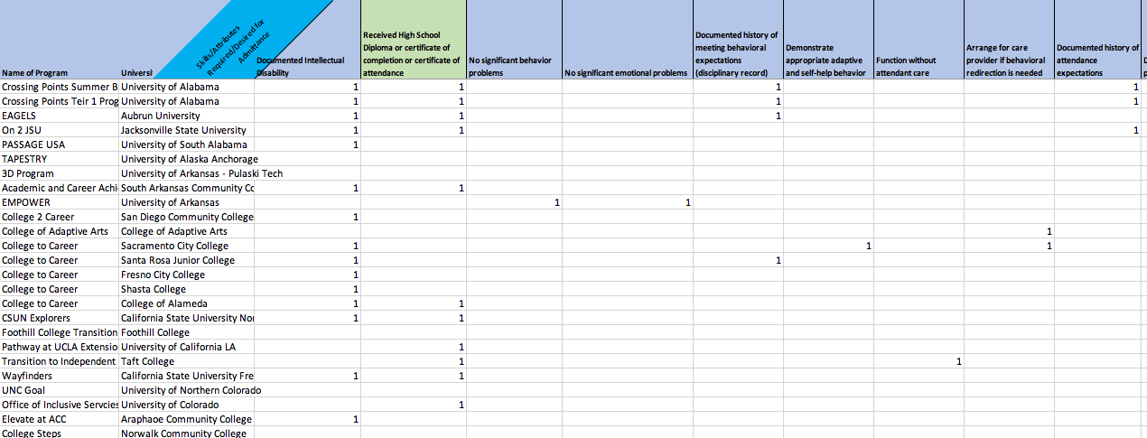

Table 3

Detailed Process of Grouping and Removing Items to Create Questions

Domain |  | Number of Items Grouped | Number of Individual Items |  | Number of Items Removed | Number of Questions Created
Documentation Requirements | N/A |  | N/A | 48 |  | 0
Specific Application Requirements | 31 |  | 4 | 19 |  | 16
General Program Requirements | 8 |  | 3 | 0 |  | 7
Parent/Guardian Requirements | 10 |  | 0 | 1 |  | 3
Personal Goal Requirements | 9 |  | 0 | 1 |  | 3
Navigation and Safety Requirements | 12 |  | 0 | 3 |  | 4
Employment Requirements | 33 |  | 0 | 8 |  | 6
Academic Requirements | 64 |  | 1 | 13 |  | 14
Independence Requirements | 25 |  | 0 | 9 |  | 5
Independent Living Requirements | 25 |  | 1 | 20 |  | 7
Medical/Dietary Requirements | 11 |  | 3 | 2 |  | 5
Technology Requirements | 8 |  | 0 | 2 |  | 2
Behavior Requirements | 45 |  | 2 | 24 |  | 14
Social Requirements | 9 |  | 0 | 11 |  | 2
Financial Requirements | 0 |  | 1 | 3 |  | 1
Communication Requirements | 11 |  | 0 | 9 |  | 2
Commitments Requirements | 17 |  | 2 | 2 |  | 6
 | Total: 318 |  | Total: 17 | Total: 175 |  | 97

Table 4

List of 49 Demographic Questions from Round One Survey

 | Question | Answer Choices
1 | How long have you been in your role (overseeing the program)? | - Less than 1 year  - 1-2 years  - 3-5 years  - 6-10 years  - More than 10 years
2 | Please provide the name of the program you oversee. | Fill-in-the-blank
3 | The best email to reach you at for future communication is: | Fill-in-the-blank
4 | What university/college is the program located at? | Fill-in-the-blank or choose not located on a university/college campus
5 | What state is the program located in? | Drop-down list
6 | What city/town is the program located in? | Fill-in-the-blank
7 | How would you describe the location of the college/university hosting the program? | - Urban – metropolis  - Suburban – residential area on the outskirts of a city  - Rural – settled place outside of cities, would be sparsely population with the college/university presence
8 | Approximately, how many students are enrolled in all programs at the college/university (whole college/university)? | - Less than 1,000  - 1,000 – 1,999  - 2,000 – 5,000  - 5,000 – 9,999  - 10,000 – 19,999  - 20,000 – 29,999  - More than 30,000
9 | Based on the Carnegie Classification of Institutions of Higher Education, how is the college/university classified? | - Research 1 Level  - Research 2 Level  - Master 1 Level  - Master 2 Level  - Master 3 Level  - Baccalaureate Level  - Associate’s Level  - Specialized 2-year program  - Unsure
10 | Previous to 2020, was the program ever funded by TPSID? | - Yes  - Unknown  - No
11 | Is the program currently funded by TPSID? | - Yes  - Unknown  - No
12 | How many academic years has the program been operational (August - May)? | Drop-down list
13 | How many students can be enrolled in the program during each cohort? | Drop-down list
14 | How many paid employees are supporting the program with 100% of their daily work time dedicated to the program? | Drop-down list
15 | How many paid employees are supporting the program but do not spend their entire workday supporting the program? | Drop-down list
16 | How many neuro-typical college/university students directly support students with this program (e.g. mentors, roommates) per academic year? | Drop-down list
17 | How many additional college/university workers have direct contact with students and support their education (e.g. professors, advisors) per academic year? | Drop-down list
18 | Are neuro-typical students paid or offered a monetary incentive to support students in the program? | - Yes  - No  - Depends on their role
19 | Does the program require students to complete summer classes or activities (not including prerequisites or pre-enrollment activities)? | - Yes  - No  - Depends on the student
20 | How many academic years do students spend in the program? | 0.5  Through  More than 5
21 | How many classes (credit receiving) per semester are students required to take? - | Drop-down with other option
22 | How many classes (non-credit receiving) per semester are students required to take? - | Drop-down with other option
23 | How many total classes (credit and non-credit receiving) are students required to take for completion of the program? | Drop-down
24 | For credit receiving classes, how is credit calculated? | - Each course is worth a total of 1 credit hour  - Each course is worth a total of 2 credit hours  - Each course is worth a total of 3 credit hours  - Each course is worth is a total of 4 credit hours  - It depends on the course but for every unit the course is desired for equates to 1 credit hour  - No courses are credit receiving.  - Other option
25 | How many total credit hours are students required to take for completion of the program? | Drop-down list
26 | Please indicate types of classes students take in the program. | - 100% specialized courses  - More than 50% specialized courses  - 50% specialized courses, 50% traditional courses  - More than 50% traditional course  - 100% traditional courses
27 | Throughout the entire program, how many traditional classes do students take with neuro-typical peers? | Drop-down list
28 | Throughout the entire program, how many specialized classes do students take with only peers from the program? | Drop-down list
29 | In addition to classes, are there any other requirements of students (e.g. internships, practicums)? | - Yes  - No
30 | Please describe other requirements of students in the program. | Fill-in-the-blank
31 | For the additional requirements listed above, are students awarded credits?  Are students expected to complete these additional requirements each semester? | - Yes  - No  - There are no additional requirements
32 | Are students expected to complete these additional requirements each semester? | - Yes  - No  - Depends on the plan for the student  - There are no additional requirements
33 | How many hours per week do students spend on additional requirements? | Drop-down list
34 | Are students required to be employed at any point during this program? | - Yes  - No  - Depends on the specific student’s plan
35 | During the program, is it required that students are employed in a field related to your program (e.g. the program is designed to prepare childcare professionals and students must be employed during the program in a job related to children)? | - Yes  - No
36 | Does the program require students to live on campus or in campus housing? | - Yes  - No  - Students are not required to live on campus, but the program requires students to live independently (outside of the family home)
37 | Are there scholarships or grants available for students entering the program (to offset direct costs of students)? | - Yes  - No
38 | What is the annual cost (August - July) to enroll in the program (including fees)? | Less than $5,000  Through  More than $70,000
39 | Are there any specific fees associated with the program? | - Yes  - No
40 | What is the total cost of these extra fees associated with the program per year?  At the completion of the program, what do students receive? | - Less than $100  - $100 - $999  - $1,000 - $1,999  - $2,000 - $5,000  - More than $5,000 per year
41 | At the completion of the program, what do students receive? | - Diploma from college / university  - Certificate of completion from the college /university  - Certificate of completion from the program  - Nothing  - Other
42 | Is the program focused on a specific employment field (e.g. childcare, food service)? | - All students enrolled will be focusing on same employment field  - All students enrolled must choose from a limited selection of employment fields offered by our specific program  - All students enrolled can choose any employment field of their interest  - This program does not relate to any employment field
43 | Please provide the specific employment field(s) the program focuses on. | Fill-in-the-blank
44 | Please select if students must be a minimum age to enroll in the program. | - No minimal age  - Over 17 years old  - Over 18 years old  - Over 19 years old  - Over 20 years old  - Over 21 years old  - Over 24 years old  - Other
45 | Please select if students are restricted to enroll by a specific age (maximum age to enroll in the program). | - No maximum age  - By 21 years old  - By 22 years old  - By 23 years old  - By 24 years old  - By 25 years old  - By 26 years old  - By 28 years old  - By 30 years old  - Other
46 | Does the program have a requirement related to type of disability required for admittance to the program? | - Yes  - No
47 | Think about the types of individuals allowed into the program. Please mark all "types of disabilities" you specifically require proof of to meet an admittance/eligibility requirement for acceptance to the program. | - Intellectual disability  - Developmental disability  - Traumatic brain injury  - Autism spectrum disorder  - An interfering cognitive or developmental disability  - Any individual with an IQ below 70  - Significant limitation to cognitive functioning and behavior  - Multiple disabilities  - Cognitive disability  - Any documentation showing a need for support  - Diverse learning differences  - Learning disability  - Neurological impairments  - Adaptive behavior limitations  - Any special need  - Any disability that limits individuals in one major life area  - Significant cognitive disability  - Mild cognitive disability  - Anyone previously eligible for FAPE  - Any disability  - No type of disability is required for admittance
48 | Please indicate what documents the program requires/allows for admittance to the program (select all that apply). | - High school diploma, certificate of completion, or certificate of attendance  - Document showing student completed at least 4 years of high school  - Document showing student is no longer receiving support from K-12 education system  - Completed alternative assessment portfolio  - Exit document from secondary school  - Proof of participation in function-based curriculum  - Document showing student completed high school requirements  - GED  - Document showing student was served under IDEA or 504  - Documents showing student was alternatively assessed  - Other
49 | Consider the entire list of admittance/eligibility requirements for the program. Was your current list of admittance/eligibility requirements developed from another program (using another postsecondary education and experience program as a model for your program)? | - Yes – we followed the program of –  - Unknown  - No

Table 5
PEaE Assessment Items and Delphi Average Scores
Initial Consolidated Website Domain Items |  | Raw Score | $$\overline{x}$$ | SD | Total Delphi Scores $\overline{x}$= 3 - 3.9 | Total Delphi Scores $\overline{x}$ = 4 - 5 | Delphi Scores from On-Campus Living Programs | Remove from Assessment | Moved to On-Campus Living Section of Assessment
 | General Program Domain
1 | The potential student can participate in a tour, open house, or summer/prerequisite institute. | 26 | 2.36 | 2.25 | - | - | 1.67 | 
2 | The potential student is currently doing something (e.g., working, finishing high school, volunteering). | 20 | 1.82 | 2.00 | - | - | 4 |  | 
3 | The potential student will participate in all mandatory meetings and planning sessions. | 44 | 4 | 1.48 | - |  | 4.3 | - | -
4 | The potential student will enroll for services at the campus disability service office. | 38 | 3.45 | 2.25 |  | - | 3.3 | - | -
5 | The potential student agrees to participate in research and promotional activities. | 11 | 1 | 1.48 | - | - | 1.67 |  | -
6 | The potential student agrees to follow all rules, creeds, student handbooks, and code of conduct regulations. | 53 | 4.82 | 0.40 | - |  | 5 | - | -
 | Parent Abilities Domain
7 | The parent will commit to participate in activities, interviews, and sign any required consent forms. | 43 | 3.90 | 1.58 |  | - | 5 | - | -
8 | The family is supportive of the student becoming more independent and self-determined. | 44 | 4.00 | 1.61 | - |  | 5 | - | -
9 | The family is supportive of the program goals and student goals. | 42 | 3.82 | 1.60 |  | - | 5 | - | -
 | Personal Goal Domain
10 | The potential student has an interest in pursuing a higher education experience and is motivated to achieve goals. | 49 | 4.45 | 0.52 | - |  | 4.67 | - | -
11 | The student will benefit from the program and has the potential to achieve goals. | 40 | 3.64 | 1.50 |  | - | 4.67 | - | -
12 | The student is self-motivated, goal-oriented, and has a purpose to reach tangible goals. | 40 | 3.64 | 0.69 |  | - | 4.67 | - | -
 | Navigation and Safety Domain
13 | The student has the ability to arrange reliable personal transportation to campus. | 36 | 3.27 | 1.42 |  | - | 2 | - | -
14 | The student is interested and capable of using new modes of transportation.* | 33 | 3.00 | 1.61 | - | - | 4.33 | - | 
15 | The student has basic safety skills to remain unsupervised on campus and in the community. | 45 | 4.10 | 1.64 | - |  | 5 | - | -
16 | The student has the ability to navigate the campus without support. * | 34 | 3.10 | 1.64 | - | - | 3.67 | - | 
 | Employment Skills Domain
17 | The student has previous vocational experiences (paid / unpaid work or volunteering) within the community setting. | 31 | 2.82 | 1.78 | - | - | 4 | - | 
18 | The student has the desire to be competitively employed at the completion of the program. | 50 | 4.55 | 0.68 | - |  | 5 | - | -
19 | The student has the desire to participate in experiences to develop employment skills. | 48 | 4.36 | 0.47 | - |  | 5 | - | -
20 | The student aspires for vocational autonomy in the community. | 29 | 2.64 | 1.91 | - | - | 3.33 | - | 
21 | The student would benefit from employment experiences. | 44 | 4.00 | 1.41 | - |  | 4.67 | - | -
22 | The student has the ability to be successful in employment situations (currently and at the completion of the program). | 40 | 3.64 | 1.36 |  | - | 4.67 | - | -
23 | The student has identified employment as a goal. | 45 | 4.09 | 1.22 | - |  | 3 | - | -
 | Academic Skills Domain
24 | The student has had successful high school experience of participating in general education classes (up to 90 minutes). | 24 | 2.18 | 1.79 | - | - | 3.33 | - | 
25 | The student is motivated to learn and grow in academics. | 40 | 3.64 | 0.47 |  | - | 4.67 | - | -
26 | The student is interested in attending college. | 52 | 4.73 | 0.47 | - |  | 5 | - | -
27 | The student is at a 3rd grade academic level (reading, math, writing). | 26 | 2.36 | 1.75 | - | - | 4.33 | - | 
28 | The student is at a 4th grade academic level (reading, math, writing). | 20 | 1.82 | 1.54 | - | - | 2.33 |  | -
29 | The student is at a 5th grade or above academic level (reading, math, writing). | 20 | 1.82 | 1.67 | - | - | 2.33 |  | -
30 | The student has functional reading and writing skills. | 35 | 3.18 | 1.78 |  | - | 4.33 | - | -
31 | The student has functional math skills including the use of a calculator and basic money management. | 27 | 2.45 | 1.91 | - | - | 4.33 | - | 
32 | The student is able and willing to learn in all settings (including in an inclusive classroom). | 44 | 4.00 | 1.41 | - |  | 5 | - | -
33 | The student has the ability to participate in course and process information with support. | 47 | 4.27 | 0.79 | - |  | 4.67 | - | -
34 | The student has the ability to participate in a college-length course (up to 3 hours). | 31 | 2.82 | 1.78 | - | - | 2 |  | -
35 | The student can complete assignments and coursework requirements with minimal support. | 29 | 2.64 | 1.12 | - | - | 2.33 |  | -
36 | The student is able to interact with college-level material (with accommodations and modifications). | 31 | 2.82 | 1.33 | - | - | 2.67 |  | -
37 | The student agrees to participate in all program requirements. | 52 | 4.73 | 0.47 | - |  | 5 | - | -
 | Independence Domain
38 | The student has an appropriate level of independence for the program. | 41 | 3.73 | 1.49 |  | - | 5 | - | -
39 | The student is able to manage time independently. | 38 | 3.45 | 1.37 |  | - | 4 | - | -
40 | The student can operate for a sustained period of time and can attend to a task. | 39 | 3.55 | 1.51 |  | - | 4.67 | - | -
 | Independent Living Domain
41 | The student is motivated to learn independent living skills. | 32 | 2.91 | 1.87 | - | - | 4.67 | - | 
42 | The student is interested in living on campus without adult supervision. | 24 | 2.18 | 2.27 | - | - | 5 | - | 
43 | The student aspires to live independently. | 33 | 3.00 | 2.05 |  | - | 5 | - | -
44 | The student is able to safely function in a residential setting without supervision. | 30 | 2.73 | 2.00 | - | - | 5 | - | 
45 | The student is able to independently prep, cook, and eat food. | 20 | 1.82 | 1.94 | - | - | 2.67 |  | -
46 | The student has some independent living skills and has the potential to improve. | 39 | 3.55 | 1.70 |  | - | 3 | - | -
47 | The student is able to attend to personal hygiene needs independently. | 44 | 4.00 | 1.61 | - |  | 5 | - | -
 | Medical/Dietary Domain
48 | The student has and will maintain health insurance while in the program. | 24 | 2.18 | 2.40 | - | - | 5 | - | 
49 | The student is up to date on immunizations. | 36 | 3.27 | 2.28 |  | - | 3.33 | - | -
50 | The student has no medical condition that is communicable by casual contact. | 35 | 3.18 | 2.52 |  | - | 3.33 | - | -
51 | The student is able to independently manage their own self-care including visiting health services when needed, taking own medication, and handling own specialized dietary needs. | 34 | 3.09 | 1.92 |  | - | 4.33 | - | -
52 | The student is able to provide a personal care attendant if needed. | 33 | 3.00 | 2.37 |  | - | 1.67 | - | -
 | Technology Skills Domain
53 | The student owns a cell phone and is able to use various features (calling / text). | 47 | 4.27 | 0.79 | - |  | 5 | - | -
54 | The student has experience and ability to use technology (laptop, tablet, email search engines, and type documents) with little or no support. | 41 | 3.73 | 1.27 |  | - | 5 | - | -
 | Behavior Skills Domain
55 | The student has a documented history of meeting behavioral expectations. | 42 | 3.82 | 1.40 |  | - | 4.33 | - | -
56 | The student has the ability to follow rules and directions. | 51 | 4.64 | 0.50 | - |  | 4.57 | - | -
57 | The student has appropriate social maturity. | 33 | 3.00 | 1.55 |  | - | 4.33 | - | -
58 | The student has emotional stability and maturity to participate in the program. | 40 | 3.64 | 1.50 |  | - | 4.67 | - | -
59 | The student is able to accept feedback and modify performance based on directions. | 42 | 3.82 | 0.87 |  | - | 4.33 | - | -
60 | The student maintains respect for self and others. | 49 | 4.45 | 0.69 | - |  | 4.67 | - | -
61 | The student is responsible for their own actions without support. | 35 | 3.18 | 1.72 |  | - | 4.33 | - | -
62 | The student is flexible to changes. | 38 | 3.45 | 0.93 |  | - | 4 | - | -
63 | The student has acceptable behaviors on-campus, in the community, and at business settings while unsupervised. | 43 | 3.91 | 1.58 |  | - | 4.67 | - | -
64 | The student has the ability to self-monitor and manage behaviors. | 43 | 3.91 | 1.45 |  | - | 4.33 | - | -
65 | The student demonstrates self-control and self-help. | 37 | 3.36 | 1.86 |  | - | 4.33 | - | -
66 | The student is currently free of aggressive behaviors and has no history of aggressive behaviors over last 2 years. | 48 | 4.36 | 0.67 | - |  | 4.33 | - | -
67 | The student has no significant emotional problems. | 35 | 3.18 | 2.23 |  | - | 4.67 | - | -
68 | The student has no significant behavior problems (e.g., noncompliance, defiance, disruptive, or challenging behaviors). | 43 | 3.91 | 1.97 |  | - | 5 | - | -
 | Social Skills Domain
69 | The student likes to be around others and gets along with others. | 31 | 2.82 | 1.60 | - | - | 2.67 |  | -
70 | The student has appropriate social boundaries and acts appropriately while unsupervised. | 39 | 3.55 | 1.51 |  | - | 4.67 | - | -
 | Finance Domain
71 | The student or family has the ability to fund all costs associated with the program. | 28 | 2.55 | 1.97 | - | - | 2.67 |  | -
 | Communication Skill Domain
72 | The student has the demonstrated ability to reliably, appropriate, and effectively communicate without prompting. | 36 | 3.27 | 1.35 |  | - | 5 | - | -
73 | The student can communicate desires, wants, needs, and goals. | 43 | 3.91 | 0.94 |  | - | 4.33 | - | -
 | Commitment Domain
74 | The student has the demonstrated desire to participate and complete an integrated postsecondary program. | 51 | 4.64 | 0.50 | - |  | 5 | - | -
75 | The student wants to be part of campus life. | 48 | 4.36 | 0.52 | - |  | 4.67 | - | -
76 | The student can commit to the length of the entire program / specific number of credits per semester. | 38 | 3.45 | 1.63 |  | - | 4.33 | - | -
77 | The student can commit to active participation throughout the program and program activities. | 44 | 4.00 | 1.18 | - |  | 4.67 | - | -
78 | The student can commit to participating in school activities more than 20 hours per week. | 24 | 2.18 | 1.83 | - | - | 2.67 |  | -
79 | The student can benefit from the program. | 43 | 3.91 | 1.76 |  | - | 5 | - | -
 | Application Process Domain
80 | The student completes the application process (may include assessments, interviews, observations, and projects). | 53 | 4.82 | 0.60 | - |  | 5 | - | -
81 | The student completes an application essay (may include written statement, presentation, artwork, or poetry). | 31 | 2.82 | 1.76 | - | - | 5 | - | 
82 | The student has an updated resume. | 13 | 1.18 | 1.54 | - | - | 1 |  | -
83 | The student has the ability to participate in an interview. | 51 | 4.64 | 0.92 | - |  | 5 | - | -
84 | The student can complete transition assessment. | 22 | 2.00 | 0.92 | - | - | 1.67 |  | -
Total | 84 Original Assessment Items |  |  |  | 35 | 23 |  | 13 | 13
Note: * Indicates two items with originally incorrectly calculated raw score/mean and therefore were not included in further review of
experts. The raw score/mean is correctly represented above.
Table 6

PEaE Assessment Item Revisions for Second Round of Delphi Procedure

Initial Consolidated Website Domain Items |  | Suggested Revised Wording of Item per Recommendations
 | General Program Domain
1 | The potential student will participate in all mandatory meetings and planning sessions. | The potential student will participate in all mandatory meetings and planning sessions (prior to admittance).
2 | The potential student will enroll for services at the campus disability service office. | The potential student will understand implications and decide if they want to enroll for services at the campus disability service office.
3 | The potential student agrees to follow all rules, creeds, student handbooks, and code of conduct regulations. | The potential student agrees to follow all rules, student handbooks, and code of conduct regulations.
 | Parent Abilities Domain
4 | The parent will commit to participate in activities, interviews, and sign any required consent forms. | The parent/guardian will commit to participate in activities, interviews, and sign any required consent forms.
5 | The family is supportive of the student becoming more independent and self-determined. | With respect to family and cultural expectations, the family is supportive of the student becoming more independent and self-determined.
6 | The family is supportive of the program goals and student goals. | The student's support network is encouraging towards the program goals and student goals.
 | Personal Goal Domain
7 | The potential student has an interest in pursuing a higher education experience and is motivated to achieve goals. | The potential student has an interest in pursuing a higher education and is motivated to achieve goals.
8 | The potential student will benefit from the program and has the potential to achieve goals. | Not Revised
9 | The student is self-motivated, goal-oriented, and has a purpose to reach tangible goals. | Student is willing to work with a team to set goals and to put in the effort to achieve those goals.
 | Navigation and Safety Domain
10 | The student has the ability to arrange reliable personal transportation to campus. | The student has the ability to arrange transportation (e.g., use the bus system, ask a peer, or use an app) to and around campus.
11 | The student has basic safety skills to remain unsupervised on campus and in the community. | The student has basic safety skills to remain unsupervised on campus and in the community, including crossing streets and parking lots.
 | Employment Skills Domain
12 | The student has the desire to be competitively employed at the completion of the program. | Not Revised
13 | The student has the desire to participate in experiences to develop employment skills. | Not Revised
14 | The student would benefit from employment experiences. | Not Revised
15 | The student has the ability to be successful in employment situations (currently and at the completion of the program). | The student has the ability to be successful in employment situations (at the completion of the program).
16 | The student has identified employment as a goal. | The student will identify employment as a goal.
 | Academic Skills Domain
17 | The student is motivated to learn and grow in academics. | The student wants a college experience.
18 | The student is interested in attending college. | The student desires to attend college.
19 | The student has functional reading and writing skills. | Not Revised
20 | The student is able and willing to learn in all settings (including in an inclusive classroom). | The student is able and willing to learn in all settings (including in classroom and employment settings).
21 | The student has the ability to participate in course and process information with support. | The student has the ability to participate in courses with support.
22 | The student agrees to participate in all program requirements. | Not Revised
 | Independence Domain
23 | The student has an appropriate level of independence for the program. | Not Revised
24 | The student is able to manage time independently. | The student is able to manage time independently or use assistive technology to manage time appropriately.
25 | The student can operate for a sustained period of time and can attend to a task. | Student has the stamina to participate in various environments and attend to a task.
 | Independent Living Domain
26 | The student aspires to live independently. | With respect to meeting a student's needs and being respectful of cultural expectations, the student aspires to live as independently as possible.
27 | The student has some independent living skills and has the potential to improve. | Not Revised
28 | The student is able to attend to personal hygiene needs independently. | The student is able to attend to personal hygiene needs independently including toileting.
 | Medical/Dietary Domain
29 | The student is up to date on immunizations. | If required of all students on campus, the student is up-to-date on immunizations.
30 | The student has no medical condition that is communicable by casual contact. | If required of all students on campus, the student has no medical condition that is communicable by casual contact.
31 | The student is able to independently manage their own self-care including visiting health services when needed, taking own medication, and handling own specialized dietary needs. | The student is able to independently manage their own self-care. This may include taking own medication and handling own specialized dietary needs.
32 | The student is able to provide a personal care attendant if needed. | Not Revised
 | Technology Skills Domain
33 | The student owns a cell phone and is able to use various features (e.g. calling/text). | Not Revised
34 | The student has experience and ability to use technology (laptop, tablet, email search engines, and type documents) with little or no support. | The student has experience and ability to use technology (e.g., laptop, tablet, email, search engines, and type documents) with support.
 | Behavior Skills Domain
35 | The student has a documented history of meeting behavioral expectations. | The student has not been involved in misconduct or the justice system within the previous 3 years.
36 | The student has the ability to follow rules and directions. | Not Revised
37 | The student has appropriate social maturity. | Not Revised
38 | The student has emotional stability and maturity to participate in the program. | Not Revised
39 | The student is able to accept feedback and modify performance based on directions. | The student is willing to accept feedback and modify performance based on directions.
40 | The student maintains respect for self and others. | Not Revised
41 | The student is responsible for their own actions without support. | The students understands they hold responsibility for their own actions and will be subject to the same disciplinary processes as all other students at the college.
42 | The student is flexible to changes. | The student understands that schedules will change at least every quarter and may change weekly due to participation in campus and career activities.
43 | The student has acceptable behaviors on campus, in the community, and at business settings while unsupervised. | Not Revised
44 | The student has the ability to self-monitor and manage behaviors. | Not Revised
45 | The student demonstrates self-control and self-help. | The student is willing to learn skills to manage stress in various situations.
46 | The student is currently free of aggressive behaviors and has no history of aggressive behaviors over last 2 years. | Not Revised
47 | The student has no significant emotional problems. | The student has no mental health issues.
48 | The student has no significant behavior problems (e.g., noncompliance, defiance, disruptive, or challenging behaviors). | Not Revised
 | Social Skills Domain
49 | The student has appropriate social boundaries and acts appropriately while unsupervised. | Not Revised
 | Communication Skill Domain
50 | The student has the demonstrated ability to reliably, appropriately, and effectively communicate without prompting. | The student is willing to communicate with instructors, advisers, and employers in order to earn a certificate and achieve career goals.
51 | The student can communicate desires, wants, needs, and goals. | The student wants to learn to communicate desires, wants, needs, and goals.
 | Commitment Domain
52 | The student has the demonstrated desire to participate and complete an integrated postsecondary program. | Not Revised
53 | The student wants to be part of campus life. | Not Revised
54 | The student can commit to the length of the entire program/specific number of credits per semester. | The student agrees to follow program timelines.
55 | The student can commit to active participation throughout the program and program activities. | The student agrees to meet participation requirements and follow program guidelines.
56 | The student can benefit from the program. | Not Revised
 | Application Process Domain
57 | The student completes the application process (may include assessments, interviews, observations, and projects). | The student completes the application process (may include assessments, interviews, observations, and projects) either independently or with minimal support.
58 | The student has the ability to participate in an interview. | The student is willing to participate in an admissions interview.
Total | 58 Assessment Items for All Programs
 | New Section for Programs Requiring Students to Live On Campus
1 | The potential student is currently doing something (e.g., working, finishing high school, volunteering). | The potential student is currently participating in work, school, volunteering, or extra-curricular activities.
2 | The student is interested and capable of using new modes of transportation. | The student is interested in learning about transportation options and is capable of using new modes after instruction and guidance is provided.
3 | The student has the ability to navigate the campus without support. | The student has the ability to navigate the campus after initial training and support.
4 | The student has previous vocational experiences (paid/unpaid work or volunteering) within the community setting. | Not Revised
5 | The student aspires for vocational autonomy in the community. | The student aspires to make their own choices and be independent in the career and community.
6 | The student has had successful high school experience of participating in general education classes (up to 90 minutes). | The student has the ability to sit up to a 90-minute course.
7 | The student is motivated to learn independent living skills. | The student is motivated to increase their independence.
8 | The student has and will maintain health insurance while in the program. | Not Revised
9 | The student completes an application essay (may include written statement, presentation, artwork, or poetry). | The student completes the application process (may include assessments, interviews, observations, and projects) either independently or with minimal support.
10 | The student is at a 3rd grade academic level (reading, math, writing). | Not Revised
11 | The student has functional math skills including the use of a calculator and basic money management. | Not Revised
12 | The student is interested in living on campus without adult supervision. | Not Revised
13 | The student is able to safely function in a residential setting without supervision. | Not Revised
Total | 13 Assessment Items for Programs with On-Campus Living Requirements
Table 7

PEaE Assessment Items, Suggested Revisions, and Results

Initial Consolidated Website Domain Items |  | Proposed Changes to Items (if any suggested by Focus Group in Survey 1) |  | In Favor to Keep |  | In Favor to Change |  | Not Important
 | General Program Domain
1 | The potential student will participate in all mandatory meetings and planning sessions. | The potential student will participate in all mandatory meetings and planning sessions (prior to admittance). | 8 |  | 1 |  | 0
2 | The potential student will enroll for services at the campus disability service office. | The potential student will understand implications and decide if they want to enroll for services at the campus disability service office. | 5 |  | 4 |  | 0
3 | The potential student agrees to follow all rules, creeds, student handbooks, and code of conduct regulations. | The potential student agrees to follow all rules, student handbooks, and code of conduct regulations. | 2 |  | 7 |  | 0
4 | The student will provide high school schedule and transcripts. | - | - |  | - |  | -
5 | The student is not eligible to enroll via traditional admission to the university/college OR would have a high probability of extreme difficulty with standard college curriculum. | - | - |  | - |  | -
6 | The student is able to obtain references and/or letters of recommendation from non-family members. | - | - |  | - |  | -
7 | The student can provide documentation of current Individualized Education Program (IEP). | - | - |  | - |  | -
8 | The student can provide recent documents including psychological evaluation, counselor reports, medical reports, and eligibility reports. | - | - |  | - |  | -
9 | The student is willing to provide consent for videos, photos, interviews, and allow for information collection. | - | - |  | - |  | -
10 | The student has a documented history of meeting attendance expectations. | - | - |  | - |  | -
 | Parent Abilities Domain
1 | The parent will commit to participate in activities, interviews, and sign any required consent forms. | The parent/guardian will commit to participate in activities, interviews, and sign any required consent forms. | 1 |  | 6 |  | 2
2 | The family is supportive of the student becoming more independent and self-determined. | With respect to family and cultural expectations, the family is supportive of the student becoming more independent and self-determined. | 3 |  | 6 |  | 0
3 | The family is supportive of the program goals and student goals. | The student's support network is encouraging towards the program goals and student goals. | 2 |  | 7 |  | 0
 | Personal Goal Domain
1 | The potential student has an interest in pursuing a higher education experience and is motivated to achieve goals. | The potential student has an interest in pursuing a higher education and is motivated to achieve goals. | 4 |  | 4 |  | 1
2 | The potential student will benefit from the program and has the potential to achieve goals. | - | - |  | - |  | -
3 | The student is self-motivated, goal-oriented, and has a purpose to reach tangible goals. | Student is willing to work with a team to set goals and to put in the effort to achieve those goals. | 1 |  | 8 |  | 0
 | Navigation and Safety Domain
1 | The student has the ability to arrange reliable personal transportation to campus. | The student has the ability to arrange transportation (e.g. use the bus system, ask a peer, or use an app) to and around campus. | 2 |  | 6 |  | 1
2 | The student has basic safety skills to remain unsupervised on campus and in the community. | The student has basic safety skills to remain unsupervised on campus and in the community including crossing streets and parking lots. | 1 |  | 7 |  | 1
 | Employment Skills Domain
1 | The student has the desire to be competitively employed at the completion of the program. | - | - |  | - |  | -
2 | The student has the desire to participate in experiences to develop employment skills. | - | - |  | - |  | -
3 | The student would benefit from employment experiences. | - | - |  | - |  | -
4 | The student has the ability to be successful in employment situations (currently and at the completion of the program). | The student has the ability to be successful in employment situations (at the completion of the program). | 4 |  | 3 |  | 2
5 | The student has identified employment as a goal. | The student will identify employment as a goal. | 5 |  | 4 |  | 0
 | Academic Skills Domain
1 | The student is motivated to learn and grow in academics. | The student wants a college experience. | 5 |  | 4 |  | 0
2 | The student is interested in attending college. | The student desires to attend college. | 3 |  | 6 |  | 0
3 | The student has functional reading and writing skills. | - | - |  | - |  | -
4 | The student is able and willing to learn in all settings (including in an inclusive classroom). | The student is able and willing to learn in all settings (including in classroom and employment settings). | 1 |  | 8 |  | 0
5 | The student has the ability to participate in course and process information with support. | The student has the ability to participate in courses with support. | 1 |  | 8 |  | 0
6 | The student agrees to participate in all program requirements. | - | - |  | - |  | -
 | Independence Domain
1 | The student has an appropriate level of independence for the program. | - | - |  | - |  | -
2 | The student is able to manage time independently. | The student is able to manage time independently or use assistive technology to manage time appropriately. | 2 |  | 6 |  | 1
3 | The student can operate for a sustained period of time and can attend to a task. | Student has the stamina to participate in various environments and attend to a task. | 0 |  | 9 |  | 0
 | Independent Living Domain
1 | The student aspires to live independently. | With respect to meeting a student's needs and being respectful of cultural expectations, the student aspires to live as independently as possible. | 3 |  | 6 |  | 0
2 | The student has some independent living skills and has the potential to improve. | - | - |  | - |  | -
3 | The student is able to attend to personal hygiene needs independently. | Option 1: The student is able to attend to personal hygiene needs independently and/or can provide their own personal care attendant to address personal care needs. Revised Option 2: The student is able to attend to personal hygiene needs independently including toileting. | 2 |  | Option 1: 5  Option 2: 1 |  | 1
 | Medical/Dietary Domain
1 | The student is up to date on immunizations. | If required of all students on campus, the student is up to date on immunizations. | 3 |  | 6 |  | 0
2 | The student has no medical condition that is communicable by casual contact. | If required of all students on campus, the student has no medical condition that is communicable by casual contact. | 2 |  | 6 |  | 1
3 | The student is able to independently manage their own self-care including visiting health services when needed, taking own medication, and handling own specialized dietary needs. | The student is able to independently manage their own self-care. This may include taking own medication and handling own specialized dietary needs. | 2 |  | 6 |  | 1
4 | The student is able to provide a personal care attendant if needed. | - | - |  | - |  | -
 | Technology Skills Domain
1 | The student owns a cell phone and is able to use various features (e.g. calling/text). | - | - |  | - |  | -
2 | The student has experience and ability to use technology (laptop, tablet, email search engines, and type documents) with little or no support. | The student has experience and ability to use technology (e.g. laptop, tablet, email, search engines, and type documents) with support. | 3 |  | 5 |  | 1
 | Behavior Skills Domain
1 | The student has a documented history of meeting behavioral expectations. | The student has not been involved in conduct or the justice system within the previous 3 years. | 6 |  | 2 |  | 1
2 | The student has the ability to follow rules and directions. | - | - |  | - |  | -
3 | The student has appropriated social maturity. | - | - |  | - |  | -
4 | The student has emotional stability and maturity to participate in the program. | - | - |  | - |  | -
5 | The student is able to accept feedback and modify performance based on directions. | The student is willing to accept feedback and modify performance based on directions. | 2 |  | 7 |  | 0
6 | The student maintains respect for self and others. | - | - |  | - |  | -
7 | The student is responsible for their own actions without support. | The students understands they hold responsibility for their own actions and will be subject to the same disciplinary processes as all other students at the college. | 1 |  | 7 |  | 1
8 | The student is flexible to changes. | The student understands that schedules will change at least every quarter and may change weekly due to participation in campus and career activities. | 4 |  | 5 |  | 0
9 | The student has acceptable behaviors on-campus, in the community, and at business settings while unsupervised. | - | - |  | - |  | -
10 | The student has the ability to self-monitor and manage behaviors. | The student is willing to learn skills to manage stress in various situations. | 4 |  | 5 |  | 0
11 | The student demonstrates self-control and self-help. | - | - |  | - |  | -
12 | The student is currently free of aggressive behaviors and has no history of aggressive behaviors over last 2 years. | - | - |  | - |  | -
13 | The student has no significant emotional problems. | The student has no mental health issues. | 4 |  | 3 |  | 2
14 | The student has no significant behavior problems (e.g. noncompliance, defiance, disruptive, or challenging behaviors). | - | - |  | - |  | -
 | Social Skills Domain
1 | The student has appropriated social boundaries and acts appropriately while unsupervised. | - | - |  | - |  | -
 | Communication Skill Domain
1 | The student has the demonstrated ability to reliably, appropriate, and effectively communicate without prompting. | The student is willing to communicate with instructors, advisers, and employers in order to earn a certificate and achieve career goals. | 2 |  | 7 |  | 0
2 | The student can communicate desires, wants, needs, and goals. | The student wants to learn to communicate desires, wants, needs, and goals. | 4 |  | 5 |  | 0
 | Commitment Domain
1 | The student has the demonstrated desire to participate and complete an integrated postsecondary program. | - | - |  | - |  | -
2 | The student wants to be part of campus life. | - | - |  | - |  | -
3 | The student can commit to the length of the entire program/specific number of credits per semester. | The student agrees to follow program timelines. | 3 |  | 6 |  | 0
4 | The student can commit to active participation throughout the program and program activities. | The student agrees to meet participation requirements and follow program guidelines. | 1 |  | 8 |  | 0
5 | The student can benefit from the program. | - | - |  | - |  | -
 | Application Process Domain
1 | The student completes the application process (may include assessments, interviews, observations, and projects). | The student completes the application process (may include assessments, interviews, observations, and projects) either independently or with minimal support. | 4 |  | 5 |  | 0
2 | The student has the ability to participate in an interview. | The student is willing to participate in an admissions interview. | 2 |  | 7 |  | 0
 | For Programs with On-Campus Living Requirements
1 | The potential student is currently doing something (e.g. working, finishing high school, volunteering). | The potential student is currently participating in work, school, volunteering, or extra-curricular activities. | 1 |  | 5 |  | 3
2 | The student is interested and capable of using new modes of transportation. | The student is interested in learning about transportation options and is capable of using new modes after instruction and guidance is provided. | 1 |  | 7 |  | 1
3 | The student has the ability to navigate the campus without support. | The student has the ability to navigate the campus after initial training and support. | 0 |  | 9 |  | 0
4 | The student aspires for vocational autonomy in the community. | The student aspires to make their own choices and be independent in the career and community. | 0 |  | 8 |  | 1
5 | The student has had successful high school experience of participating in general education classes (up to 90 minutes). | The student has the ability to sit up to a 90-minute course. | 3 |  | 4 |  | 2
6 | The student is motivated to learn independent living skills. | The student is motivated to increase their independence. | 2 |  | 7 |  | 0
7 | The student has and will maintain health insurance while in the program. | The student has and will maintain health coverage while in the program. | 2 |  | 5 |  | 2
8 | The student completes an application essay (may include written statement, presentation, artwork, or poetry). | The student completes an application essay (may include written statement, presentation, artwork, video, or poetry), either independently or with minimal assistance. | 0 |  | 6 |  | 3
9 | The student has previous vocational experiences (paid/unpaid work or volunteering) within the community setting. | - | - |  | - |  | -
10 | The student is at a 3rd grade academic level (reading, math, writing). | - | - |  | - |  | -
11 | The student has functional math skills including the use of a calculator and basic money management. | - | - |  | - |  | -
12 | The student is able to function in a residential setting without supervision. | - | - |  | - |  | -
13 | The student is interested in living on campus without adult supervision. |  | - |  | - |  | -

Table 8

PEaE Assessment Domains, Suggested Revisions, and Results

Initial Consolidated Website Domain Items |  | Proposed Changes to Items | Number of Responses | Changed To
 | General Program Domain | - Leave as is  - Requirements for admission  - Program agreements  - Acknowledgement of policies and procedures | 2  7  0  0 | Requirements for Admission
 | Parent Abilities Domain | - Leave as is  - Parent requirements  - Family involvement requirements  - Parent responsibilities and expectations | 1  0  1  7 | Parent Responsibilities and Expectations
 | Personal Goal Domain | - Leave as is  - Ambition, drive, and tenacity  - Student motivation  - Self-determination of students | 3  0  1  5 | Self-Determination of Students
 | Navigation and Safety Domain | - Leave as is  - Transportation and community access  - Student safety and support abilities  - Transportation | 4  4  1  0 | Navigation and Safety
 | Employment Skills Domain | - Leave as is  - Vocational skills  - Career skills  - Employment readiness | 5  2  0  2 | Employment Skills
 | Academic Skills Domain | - Leave as is  - Student academic engagement  - Academic background and support  - Academic expectations | 4  1  1  3 | Academic Skills
 | Independence Domain | - Leave as is  - Independence and motivation | 4  5 | Independence and Motivation
 | Independent Living Domain | No changes suggested. |  | Independent Living
 | Medical/Dietary Domain | - Leave as is  - Self-care  - Medical and health needs  - Health and wellness | 2  2  2  3 | Health and Wellness
 | Technology Skills Domain | - Leave as is  - 21st century skills  - Student technology competencies  - Computer skills | 7  1  1  0 | Technology Skills
 | Behavior Skills Domain | - Leave as is  - Behavior expectations  - Student responsibilities  - Growth mindset skills | 1  6  2  0 | Behavior Expectations
 | Social Skills Domain | - Leave as is  - Social intelligence  - Social awareness  - Interpersonal skills | 4  0  0  5 | Interpersonal Skills
 | Finance Domain | - Leave as is  - Fees  - Tuition and related costs  - Financial needs | 0  0  8  1 | Tuition and Related Costs
 | Communication Skills Domain | - Leave as is  - Self-advocacy  - Student expressive communication  - Communication needs | 5  2  0  2 | Communication Skills
 | Commitment Domain | - Leave as is  - Student motivation  - Student expectations  - Level of commitment | 2  0  5  2 | Student Expectations
 | Application Process Domain | - Leave as is  - Application requirements  - Needs based planning  - Applying to the program | 5  2  1  1 | Application Process

Table 9

PEaE Assessment Created From Delphi Group 1

 | Domain Item | Assessment Items
Requirements for Admission |  | - The potential student will participate in all mandatory meetings and planning sessions.  - The potential student will enroll for services at the campus disability service office.  - The potential student agrees to follow all rules, student handbooks, and code of conduct regulations.
Parent Responsibilities and Expectations |  | - The parent/guardian will commit to participate in activities, interviews, and sign any required consent forms.  - With respect to family and cultural expectations, the family is supportive of the student becoming more independent and self-determined.  - The student's support network is encouraging towards the program goals and student goals.
Self-Determination of Students |  | - The potential student has an interest in pursuing a higher education experience and is motivated to achieve goals.  - The potential student will benefit from the program and has the potential to achieve goals.  - The student is willing to work with a team to set goals and to put in the effort to achieve those goals.
Navigation and Safety |  | - The student has the ability to arrange transportation (e.g. use the bus system, ask a peer, or use an app) to and around campus.  - The student has basic safety skills to remain unsupervised on campus and in the community including crossing streets and parking lots.
Employment Skills |  | - The student has the desire to be competitively employed at the completion of the program.  - The student has the desire to participate in experiences to develop employment skills.  - The student would benefit from employment experiences.  - The student has the ability to be successful in employment situations (currently and at the completion of the program).  - The student has identified employment as a goal.
Academic Skills |  | - The student is motivated to learn and grow in academics.  - The student desires to attend college.  - The student has functional reading and writing skills.  - The student is able and willing to learn in all settings (including in classroom and employment settings).  - The student has the ability to participate in courses with support.  - The student agrees to participate in all program requirements.
Independence and Motivation |  | - The student has an appropriate level of independence for the program.  - The student is able to manage time independently or use assistive technology to manage time appropriately.  - Student has the stamina to participate in various environments and attend to a task.
Independent Living |  | - With respect to meeting a student's needs and being respectful of cultural expectations, the student aspires to live as independently as possible.  - The student has some independent living skills and has the potential to improve.  - The student is able to attend to personal hygiene needs independently and/or can provide their own personal care attendant to address personal care needs.
Health and Wellness |  | - If required of all students on campus, the student is up to date on immunizations.  - If required of all students on campus, the student has no medical condition that is communicable by casual contact.  - The student is able to independently manage their own self-care. This may include taking own medication and handling own specialized dietary needs.  - The student is able to provide a personal care attendant if needed.
Technology Skills |  | - The student owns a cell phone and is able to use various features (e.g. calling/text).  - The student has experience and ability to use technology (e.g. laptop, tablet, email, search engines, and type documents) with support.
 | Behavior Expectations | - The student has a documented history of meeting behavioral expectations.  - The student has the ability to follow rules and directions.  - The student has appropriate social maturity.  - The student has emotional stability and maturity to participate in the program.  - The student is willing to accept feedback and modify performance based on directions.  - The student maintains respect for self and others.  - The student understands they hold responsibility for their own actions and will be subject to the same disciplinary processes as all other students at the college.  - The student understands that schedules will change at least every semester and may change weekly due to participation in campus and career activities.  - The student has acceptable behaviors on-campus, in the community, and at business settings while unsupervised.  - The student is willing to learn skills to manage stress in various situations.  - The student demonstrates self-control and self-help.  - The student is currently free of aggressive behaviors and has no history of aggressive behaviors over last 2 years.  - The student has no significant emotional problems.  - The student has no significant behavior problems (e.g. noncompliance, defiance, disruptive, or challenging behaviors).
 | Interpersonal Skills | - The student has appropriate social boundaries and acts appropriately while unsupervised.
 | Communication Skills | - The student is willing to communicate with instructors, advisers, and employers in order to earn a certificate and achieve career goals.  - The student wants to learn to communicate desires, wants, needs, and goals.
 | Student Expectations | - The student has the demonstrated desire to participate and complete an integrated postsecondary education program.  - The student wants to be part of campus life.  - The student agrees to follow program timelines.  - The student agrees to meet participation requirements and follow program guidelines.  - The student can benefit from the program.
 | Application Process | - The student completes the application process (may include assessments, interviews, observations, and projects) either independently or with minimal support.  - The student is willing to participate in an admissions interview.
 | For Programs with On-Campus Living Requirements | - The potential student is currently participating in work, school, volunteering, or extra-curricular activities.  - The student is interested in learning about transportation options and is capable of using new modes after instruction and guidance is provided.  - The student has the ability to navigate the campus after initial training and support.  - The student aspires to make their own choices and be independent in the career and community.  - The student has the ability to sit up to a 90-minute course.  - The student is motivated to increase their independence.  - The student has and will maintain health coverage while in the program.  - The student completes an application essay (may include written statement, presentation, artwork, video, or poetry), either independently or with minimal assistance.  - The student is interested in living on campus without adult supervision.  - The student has functional math skills including the use of a calculator and basic money management.  - The student is at a 3rd grade academic level (reading, math, writing).  - The student has previous vocational experiences (paid/unpaid work or volunteering) within the community setting.  - The student is able to safely function in a residential setting without supervision.

Table 10

Comparing Mean and Median Scores of Items Between Both Delphi Groups

Assessment Items |  | $\overline{x}$From Expert Group of PEaE Directors | Median of Expert Group | $\overline{x}$From All PEaE Directors | Median of PEaE Directors | $\overline{x}$Difference
 | Requirements for Admission Domain
1 | The potential student will participate in all mandatory meetings and planning sessions. | 4 | 4 | 4.35 | 5 | 0.35
2 | The potential student will enroll for services at the campus disability service office. | 3.45 | 5 | 2.16 | 2 | 1.29
3 | The potential student agrees to follow all rules, creeds, student handbooks, and code of conduct regulations. | 4.82 | 5 | 4.63 | 5 | 0.19
 | Parent Responsibilities and Expectations Domain
4 | The parent/guardian will commit to participate in activities, interviews, and sign any required consent forms. | 3.90 | 4 | 3.63 | 4 | 0.27
5 | With respect to family and cultural expectations, the family is supportive of the student becoming more independent and self-determined. | 4.00 | 5 | 3.95 | 4 | 0.05
6 | The student's support network is encouraging towards the program goals and student goals. | 3.82 | 4 | 4 | 4 | 0.18
 | Self-Determination of Students Domain
7 | The potential student has an interest in pursuing a higher education experience and is motivated to achieve goals. | 4.45 | 4 | 4.49 | 5 | 0.04
8 | The potential student will benefit from the program and has the potential to achieve goals. | 3.64 | 4 | 4.23 | 4 | 0.59
9 | Student is willing to work with a team to set goals and to put in the effort to achieve those goals. | 3.64 | 4 | 3.84 | 4 | 0.2
 | Navigation and Safety Domain
10 | The student has the ability to arrange transportation (e.g. use the bus system, ask a peer, or use an app) to and around campus. | 3.27 | 3 | 3.19 | 3 | 0.08
11 | The student has basic safety skills to remain unsupervised on campus and in the community including crossing streets and parking lots. | 4.10 | 5 | 3.98 | 4 | 0.12
 | Employment Skills Domain
12 | The student has the desire to be competitively employed at the completion of the program. | 4.55 | 5 | 4.05 | 4 | 0.5
13 | The student has the desire to participate in experiences to develop employment skills. | 4.36 | 5 | 4.19 | 4 | 0.17
14 | The student would benefit from employment experiences. | 4.00 | 4 | 4.02 | 4 | 0.02
15 | The student has the ability to be successful in employment situations (currently and at the completion of the program). | 3.64 | 4 | 3.26 | 4 | 0.38
16 | The student has identified employment as a goal. | 4.09 | 4 | 3.49 | 4 | 0.6
 | Academic Skills Domain |  |  |  |  | 0
17 | The student is motivated to learn and grow in academics. | 3.64 | 4 | 3.98 | 4 | 0.34
18 | The student desires to attend college. | 4.73 | 5 | 4.47 | 5 | 0.26
19 | The student has functional reading and writing skills. | 3.18 | 4 | 3.26 | 3 | 0.08
20 | The student is able and willing to learn in all settings (including in classroom and employment settings). | 4.00 | 4 | 3.95 | 4 | 0.05
21 | The student has the ability to participate in courses with support. | 4.27 | 4 | 3.98 | 4 | 0.29
22 | The student agrees to participate in all program requirements. | 4.73 | 5 | 4.35 | 5 | 0.38
 | Independence and Motivation Domain |  |  |  |  | 0
23 | The student has an appropriate level of independence for the program. | 3.73 | 4 | 4.28 | 4 | 0.55
24 | The student is able to manage time independently or use assistive technology to manage time appropriately. | 3.45 | 4 | 3.00 | 3 | 0.45
25 | Student has the stamina to participate in various environments and attend to a task. | 3.55 | 4 | 3.40 | 3 | 0.15
 | Independent Living Domain
26 | With respect to meeting a student's needs and being respectful of cultural expectations, the student aspires to live as independently as possible. | 3.00 | 4 | 3.16 | 4 | 0.16
27 | The student has some independent living skills and has the potential to improve. | 3.55 | 4 | 3.44 | 4 | 0.11
28 | The student is able to attend to personal hygiene needs independently and/or can provide their own personal care attendant to address personal care needs. | 4.00 | 5 | 4.28 | 5 | 0.28
 | Health and Wellness Domain
29 | If required of all students on campus, the student is up to date on immunizations. | 3.27 | 5 | 4.16 | 5 | 0.89
30 | If required of all students on campus, the student has no medical condition that is communicable by casual contact. | 3.18 | 5 | 4.09 | 5 | 0.91
31 | The student is able to independently manage their own self-care. This may include taking own medication and handling own specialized dietary needs. | 3.09 | 3 | 4.28 | 5 | 1.19
32 | The student is able to provide a personal care attendant if needed. | 3.00 | 5 | 3.42 | 4 | 0.42
 | Technology Skills Domain
33 | The student owns a cell phone and is able to use various features (calling / text). | 4.27 | 4 | 3.65 | 4 | 0.62
34 | The student has experience and ability to use technology (e.g. laptop, tablet, email, search engines, and type documents) with support. | 3.73 | 4 | 2.98 | 3 | 0.75
 | Behavior Expectations Domain
35 | The student has a documented history of meeting behavioral expectations. | 3.82 | 4 | 4.09 | 4 | 0.27
36 | The student has the ability to follow rules and directions. | 4.64 | 5 | 4.26 | 3 | 0.38
37 | The student has appropriate social maturity. | 3.00 | 3 | 3.33 | 4 | 0.33
38 | The student has emotional stability and maturity to participate in the program. | 3.64 | 4 | 3.77 | 4 | 0.13
39 | The student is willing to accept feedback and modify performance based on directions. | 3.82 | 4 | 3.53 | 4 | 0.29
40 | The student maintains respect for self and others. | 4.45 | 5 | 4.14 | 4 | 0.31
41 | The students understands they hold responsibility for their own actions and will be subject to the same disciplinary processes as all other students at the college. | 3.18 | 4 | 4.42 | 4 | 1.24
42 | The student understands that schedules will change at least every quarter and may change weekly due to participation in campus and career activities. | 3.45 | 3 | 3.30 | 5 | 0.15
43 | The student has acceptable behaviors on-campus, in the community, and at business settings while unsupervised. | 3.91 | 4 | 4.09 | 4 | 0.18
44 | The student is willing to learn skills to manage stress in various situations. | 3.91 | 4 | 3.47 | 4 | 0.44
45 | The student demonstrates self-control and self-help. | 3.36 | 4 | 3.56 | 3 | 0.2
46 | The student is currently free of aggressive behaviors and has no history of aggressive behaviors over last 2 years. | 4.36 | 4 | 4.14 | 4 | 4.36
47 | The student has no significant emotional problems. | 3.18 | 4 | 3.28 | 4 | 4.14
48 | The student has no significant behavior problems (e.g., noncompliance, defiance, disruptive, or challenging behaviors). | 3.91 | 5 | 4.09 | 4 | 0.18
 | Interpersonal Skills Domain
49 | The student has appropriate social boundaries and acts appropriately while unsupervised. | 3.55 | 4 | 3.56 | 4 | 0.01
 | Communication Skill Domain
50 | The student is willing to communicate with instructors, advisers, and employers in order to earn a certificate and achieve career goals. | 3.27 | 4 | 3.81 | 4 | 0.54
51 | The student wants to learn to communicate desires, wants, needs, and goals. | 3.91 | 4 | 3.93 | 4 | 0.02
 | Student Expectations Domain
52 | The student has the demonstrated desire to participate and complete an integrated postsecondary program. | 4.64 | 5 | 4.23 | 5 | 0.41
53 | The student wants to be part of campus life. | 4.36 | 4 | 3.49 | 4 | 0.87
54 | The student agrees to follow program timelines. | 3.45 | 4 | 3.67 | 4 | 0.22
55 | The student agrees to meet participation requirements and follow program guidelines. | 4.00 | 4 | 4.44 | 5 | 0.44
56 | The student can benefit from the program. | 3.91 | 5 | 4.47 | 5 | 0.56
 | Application Process Domain
57 | The student completes the application process (may include assessments, interviews, observations, and projects) either independently or with minimal support. | 4.82 | 5 | 2.77 | 3 | 2.05
58 | The student is willing to participate in an admissions interview. | 4.64 | 5 | 4.86 | 5 | 0.22
 | On-Campus Living Domain
59 | The potential student is currently participating in work, school, volunteering, or extra-curricular activities. | 1.82 | 1 | 2.53 | 3 | 0.71
60 | The student is interested in learning about transportation options and is capable of using new modes after instruction and guidance is provided. | 3.00 | 4 | 2.93 | 3 | 0.07
61 | The student has the ability to navigate the campus after initial training and support. | 3.10 | 3 | 3.79 | 4 | 0.69
62 | The student aspires to make their own choices and be independent in the career and community. | 2.64 | 3 | 4.07 | 4 | 1.43
63 | The student has the ability to sit up to a 90-minute course. | 2.18 | 2 | 3.60 | 4 | 1.42
64 | The student is motivated to increase their independence. | 2.91 | 4 | 3.95 | 4 | 1.04
65 | The student has and will maintain health insurance while in the program. | 2.18 | 1 | 2.30 | 1 | 0.12
66 | The student completes an application essay (may include written statement, presentation, artwork, video, or poetry), either independently or with minimal assistance. | 2.82 | 2 | 2.93 | 4 | 0.11
67 | The student has previous vocational experiences (paid/unpaid work or volunteering) within the community setting. | 2.82 | 3 | 2.07 | 1 | 0.75
68 | The student is at a 3rd grade academic level (reading, math, writing). | 2.36 | 3 | 2.47 | 2 | 0.11
69 | The student has functional math skills including the use of a calculator and basic money management. | 2.45 | 3 | 2.00 | 2 | 0.45
70 | The student is able to function in a residential setting without supervision. | 2.73 | 3 | 2.12 | 2 | 0.61
71 | The student is interested in living on campus without adult supervision. | 2.18 | 2 | 2.14 | 2 | 0.04

Table 11

Comparing Mean and Median Scores of On-Campus Living Requirement Items Between Both Delphi Groups

 | Assessment Items | $\overline{x}$From Expert Group of PEaE Directors (n=3) |  | $\overline{x}$From All PEaE Directors (n=7) |  | Difference
 | On-Campus Living Domain
1 | The potential student is currently participating in work, school, volunteering, or extra-curricular activities. | 4 | 4 | 3.43 | 4 | 0.57
2 | The student is interested in learning about transportation options and is capable of using new modes after instruction and guidance is provided. | 4.33 | 4 | 3.14 | 3 | 1.19
3 | The student has the ability to navigate the campus after initial training and support. | 3.67 | 3 | 3.86 | 4 | 0.19
4 | The student aspires to make their own choices and be independent in the career and community. | 3.33 | 5 | 4.29 | 5 | 0.96
5 | The student has the ability to sit up to a 90-minute course. | 3.33 | 3 | 3.86 | 4 | 0.53
6 | The student is motivated to increase their independence. | 4.67 | 5 | 4.00 | 4 | 0.67
7 | The student has and will maintain health insurance while in the program. | 5 | 5 | 2.00 | 0 | 3
8 | The student completes an application essay (may include written statement, presentation, artwork, video, or poetry), either independently or with minimal assistance. | 5 | 5 | 3.43 | 5 | 1.57
9 | The student has previous vocational experiences (paid/unpaid work or volunteering) within the community setting. | 4 | 4 | 2.71 | 5 | 1.29
10 | The student is at a 3rd grade academic level (reading, math, writing). | 4.33 | 4 | 3.00 | 3 | 1.33
11 | The student has functional math skills including the use of a calculator and basic money management. | 4.33 | 4 | 2.57 | 3 | 1.76
12 | The student is able to function in a residential setting without supervision. | 5 | 5 | 4.43 | 2 | 0.57
13 | The student is interested in living on campus without adult supervision. | 5 | 5 | 4.57 | 5 | 0.43

Appendix B

Figure 1

Selection For Delphi Procedure Participants in Delphi Group 1
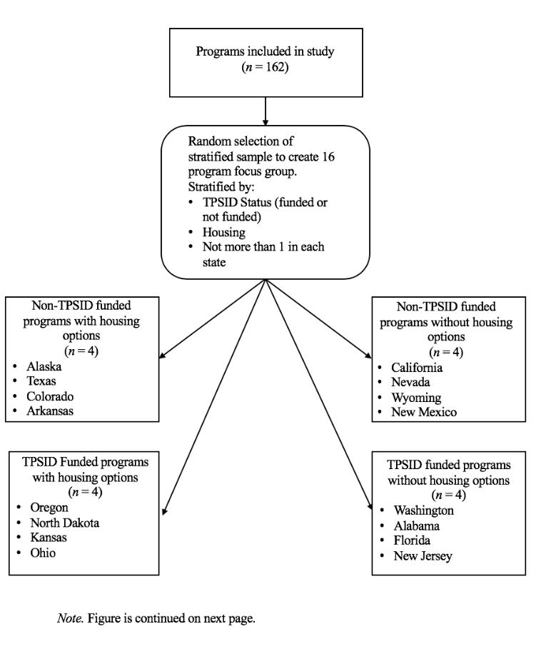

Figure 1 Continued

Selection For Delphi Procedure Participants in Delphi Group 1

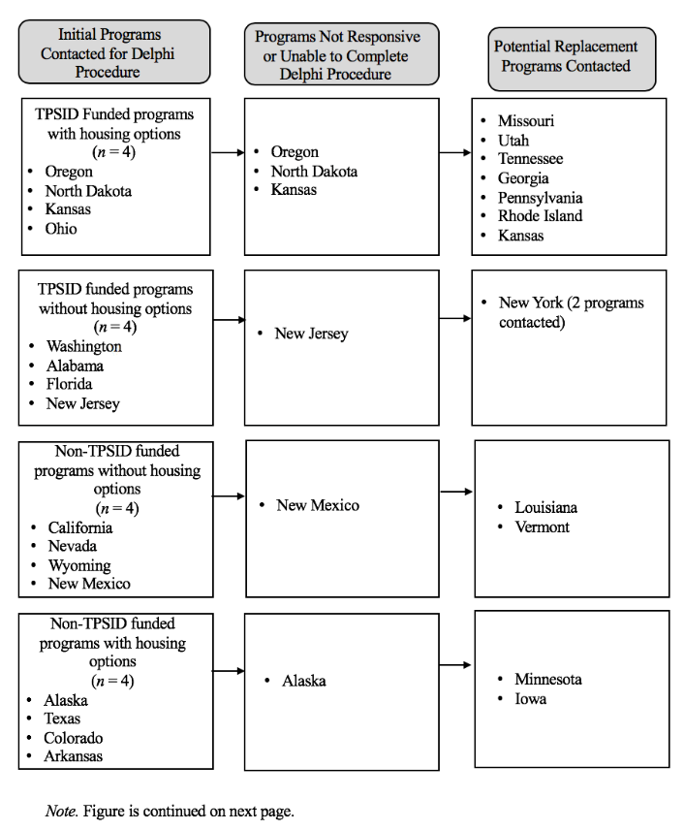

Figure 1 Continued

Selection For Delphi Procedure Participants in Delphi Group 1

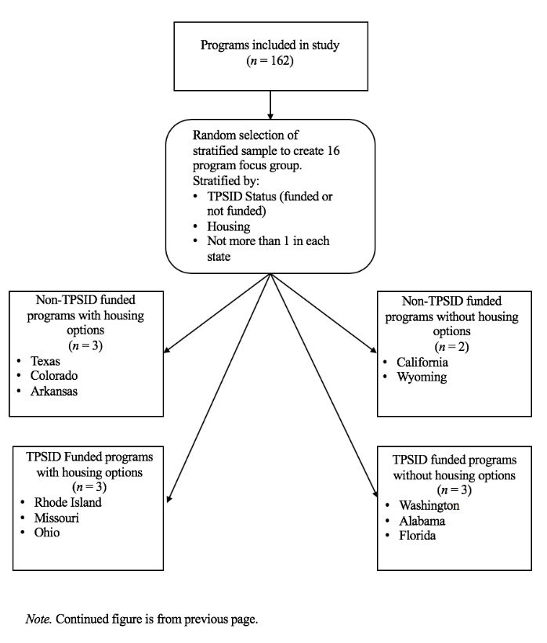

Figure 2

Participating Programs’ Inclusion and Exclusion Process

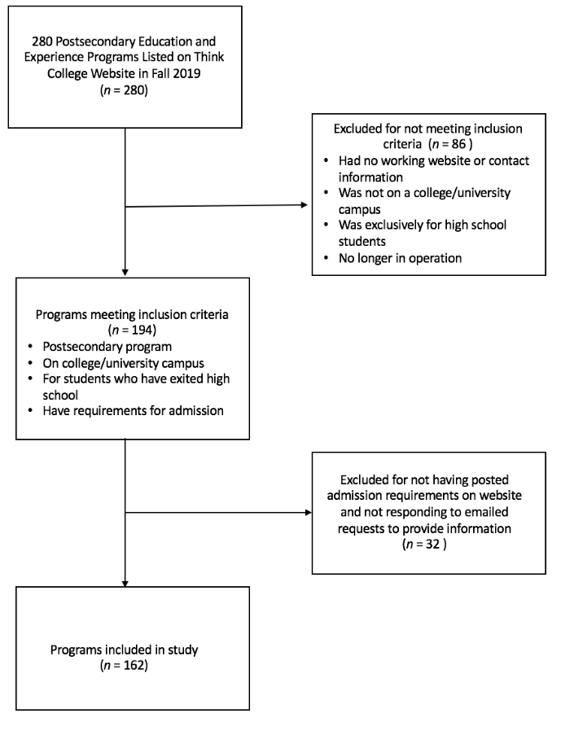
Figure 3

Seventeen Domains Derived from 510 Requirements

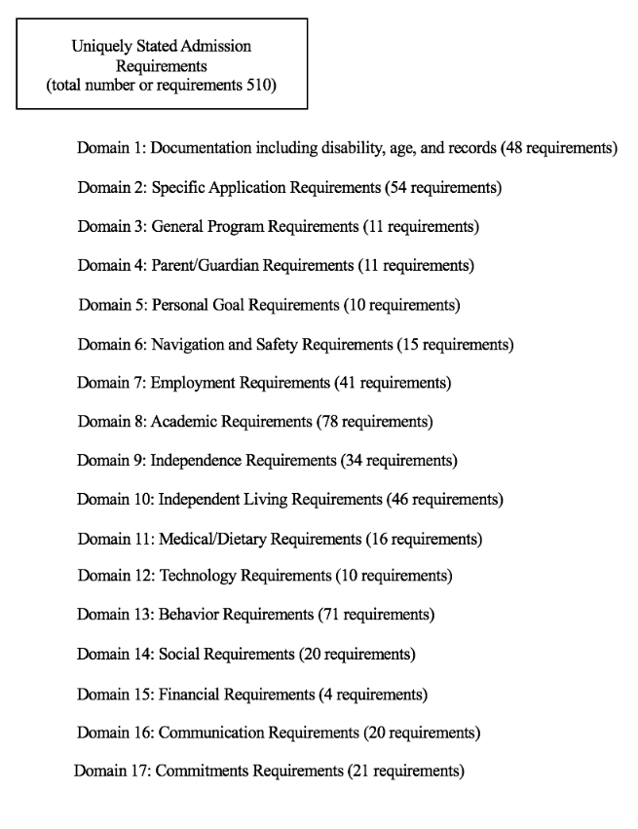

Figure 4

Process of Creating Draft Delphi Group 1 Assessment Questions for Documentation Requirements

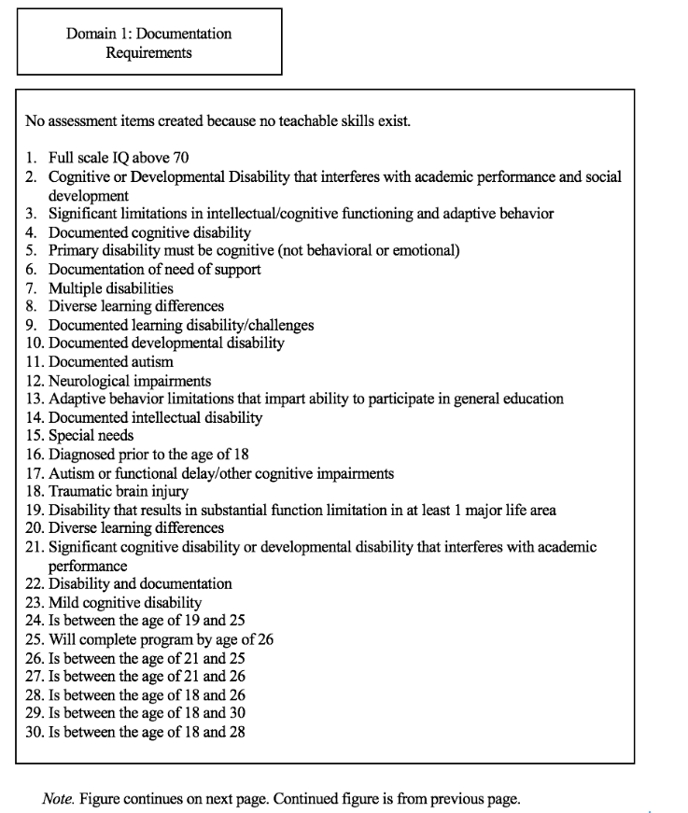

Figure 4 Continued

Process of Creating Draft Delphi Group 1 Assessment Questions for Documentation Requirements
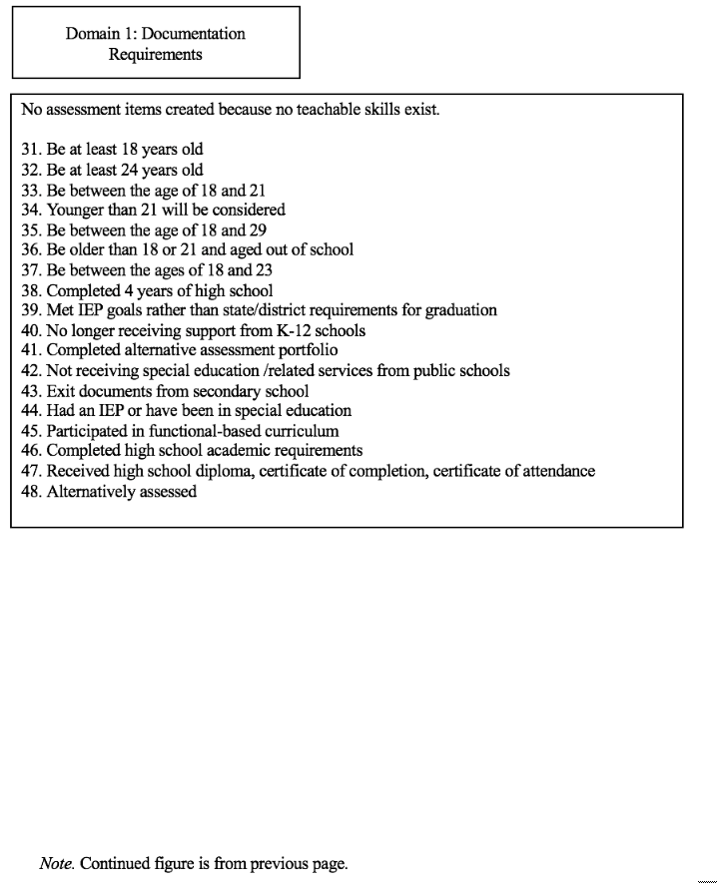

Figure 5

Process of Creating Draft Delphi Focus Group Assessment Questions for 54 Application Requirements

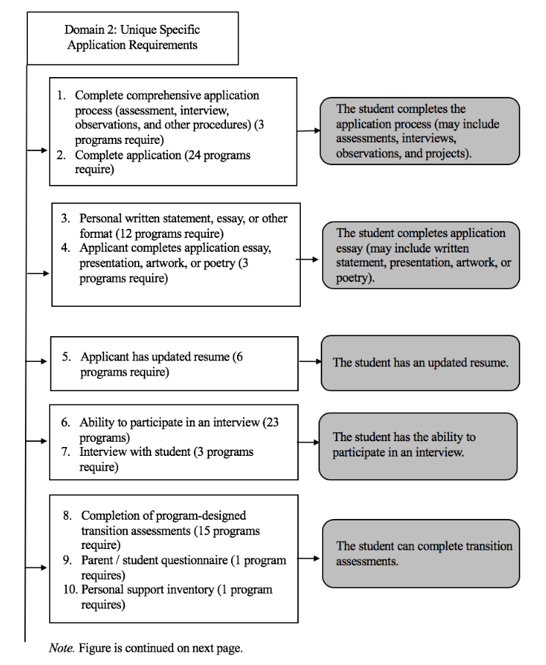

Figure 5 Continued

Process of Creating Draft Delphi Focus Group Assessment Questions for 54 Application Requirements

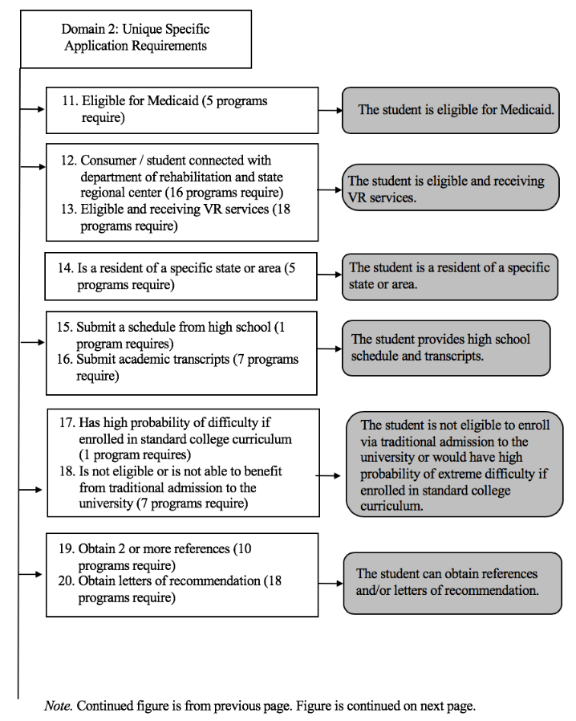

Figure 5 Continued

Process of Creating Draft Delphi Focus Group Assessment Questions for 54 Application Requirements

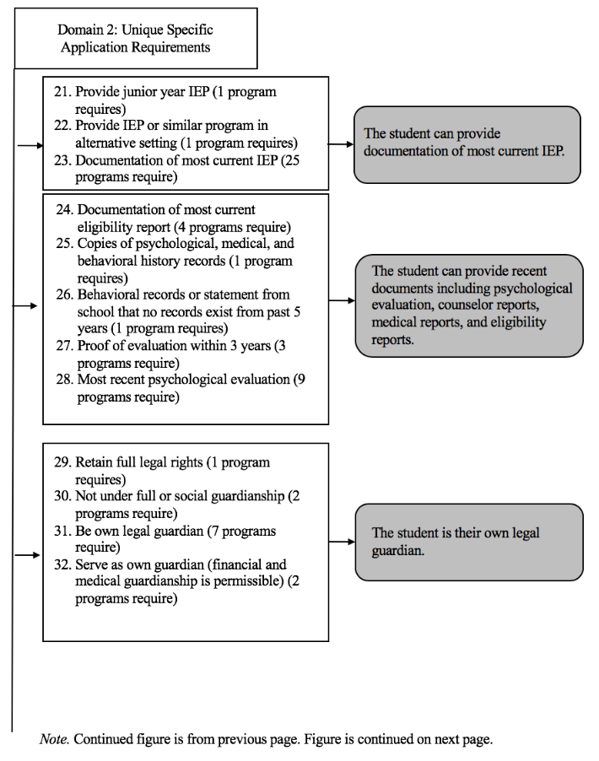

Figure 5 Continued

Process of Creating Draft Delphi Focus Group Assessment Questions for 54 Application Requirements

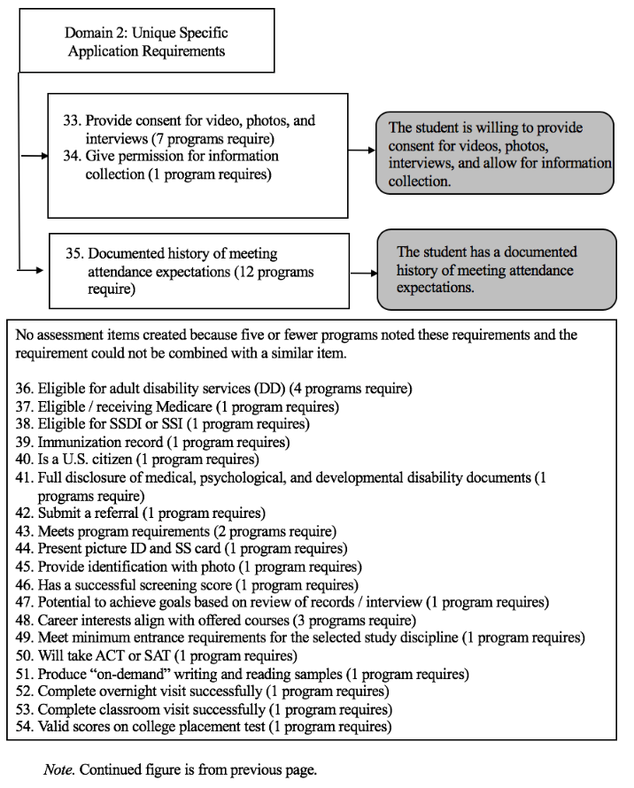

Figure 6

Process of Creating Draft Delphi Focus Group Assessment Questions for 11 General Requirements

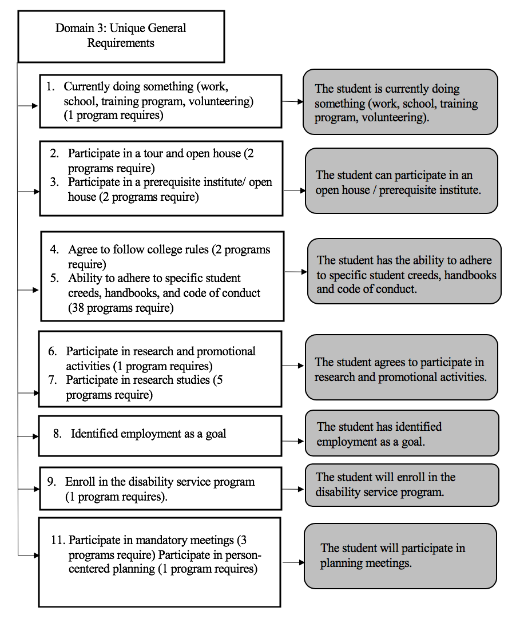

Figure 7

Process of Creating Draft Delphi Focus Group Assessment Questions for 11 Guardian Requirements

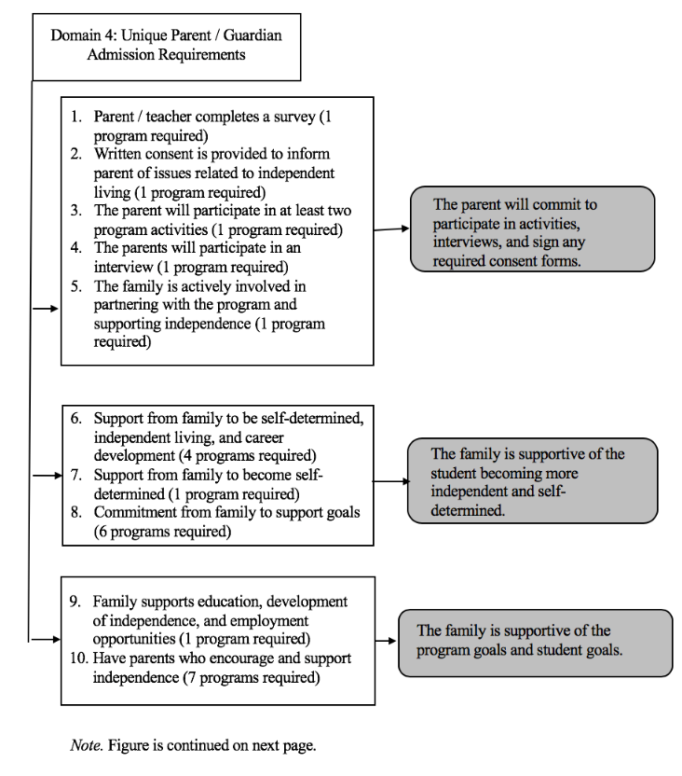

Figure 7 Continued

Process of Creating Draft Delphi Focus Group Assessment Questions for 11 Guardian Requirements

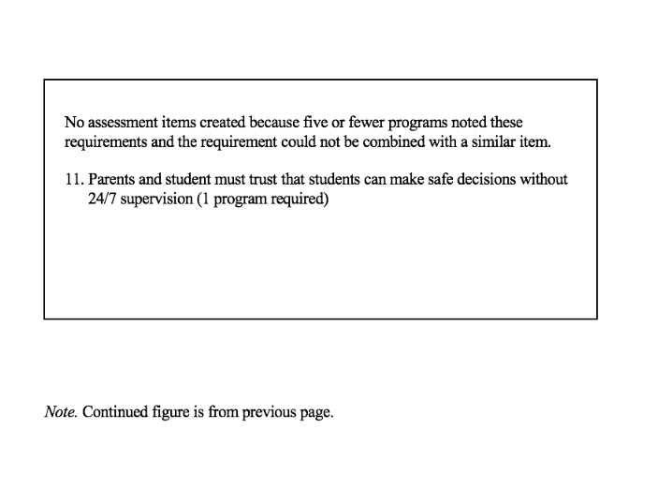

Figure 8

Process of Creating Draft Delphi Focus Group Assessment Questions for 10 Personal Goal Requirements

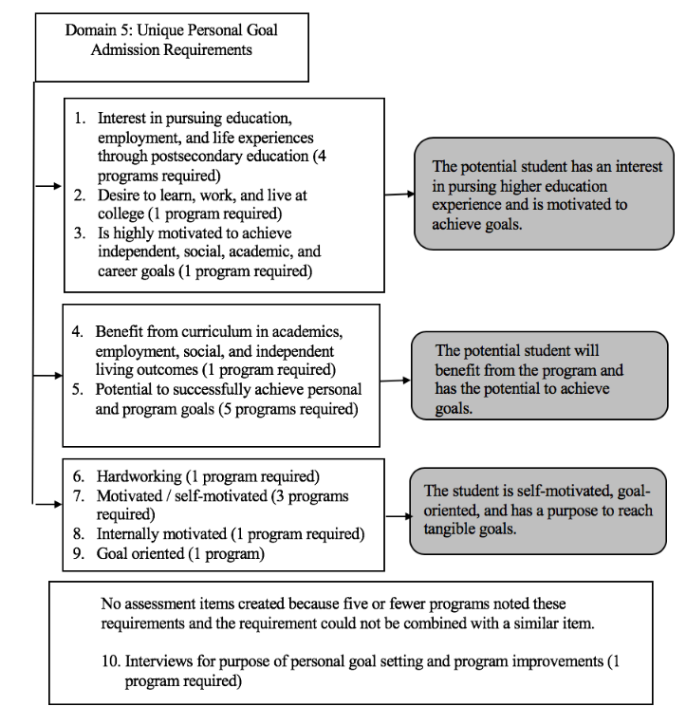

Figure 9

Process of Creating Draft Delphi Focus Group Assessment Questions for 15 Safety Requirements

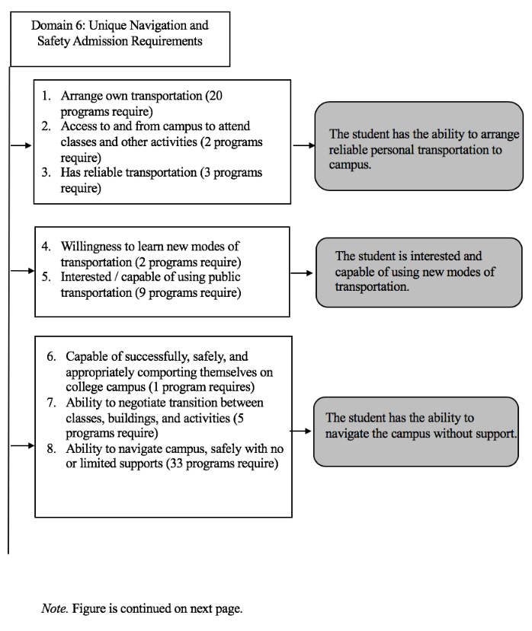

Figure 9 Continued

Process of Creating Draft Delphi Focus Group Assessment Questions for 15 Safety Requirements

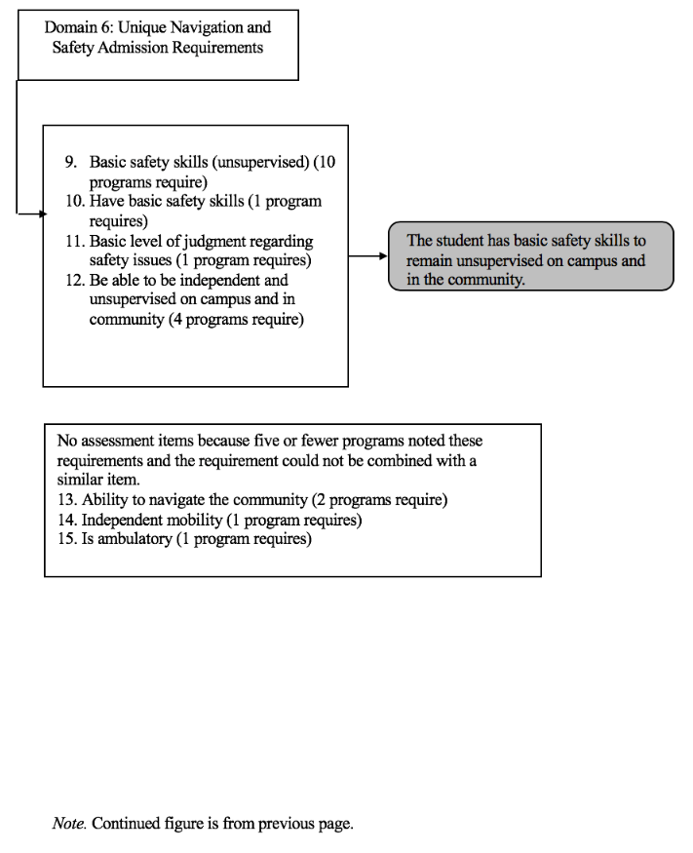

Figure 10

Process of Creating Draft Delphi Focus Group Assessment Questions for 41 Employment Requirements

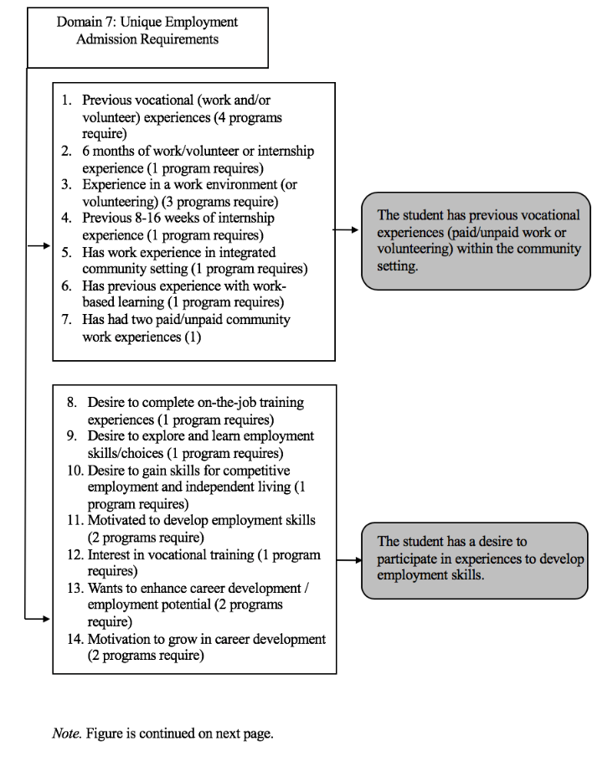

Figure 10 Continued

Process of Creating Draft Delphi Focus Group Assessment Questions for 41 Employment Requirements

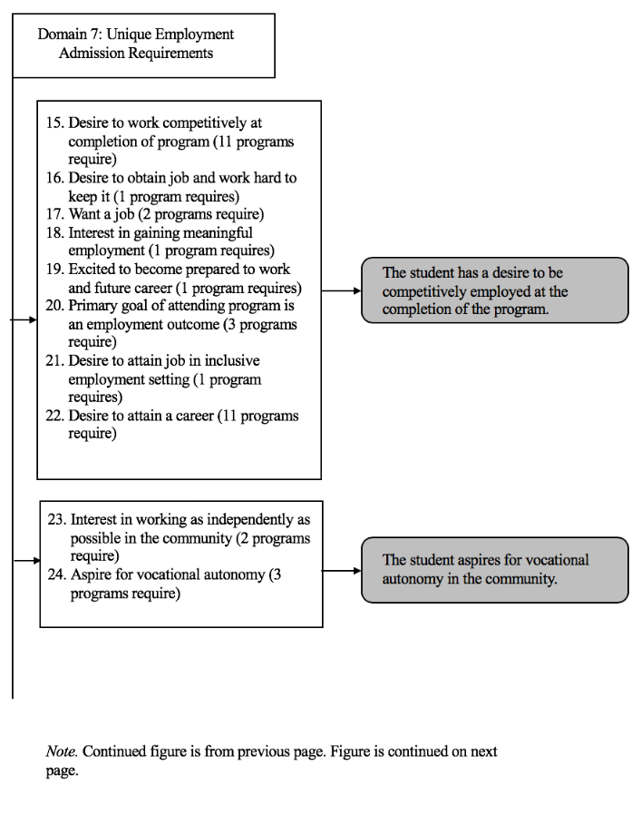

Figure 10 Continued

Process of Creating Draft Delphi Focus Group Assessment Questions for 41 Employment Requirements

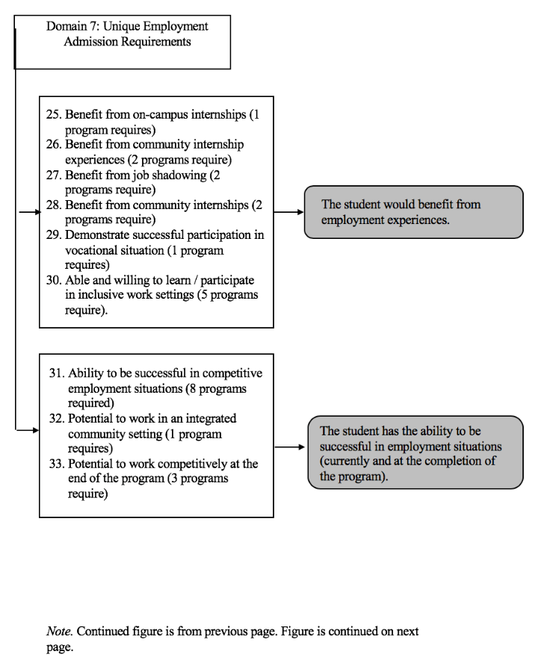

Figure 10 Continued

Process of Creating Draft Delphi Focus Group Assessment Questions for 41 Employment Requirements

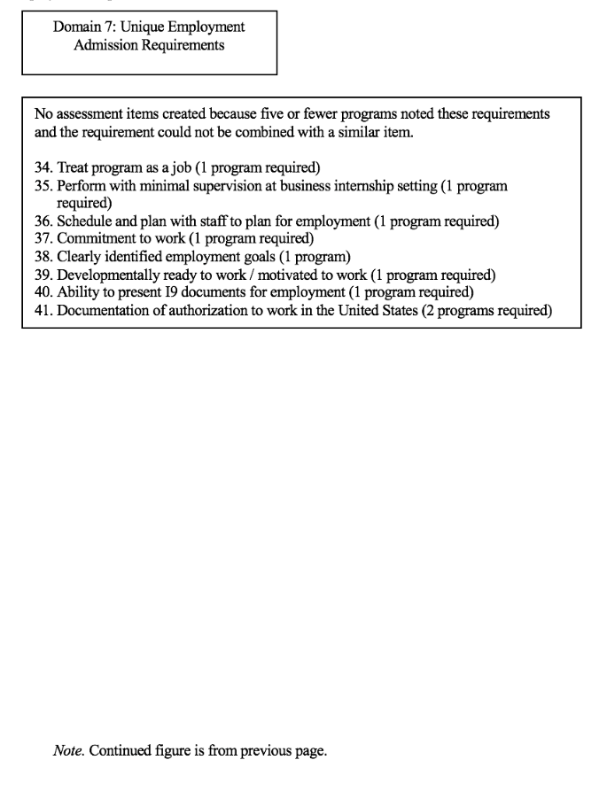

Figure 11

Process of Creating Draft Delphi Focus Group Assessment Questions for 78 Academic Requirements

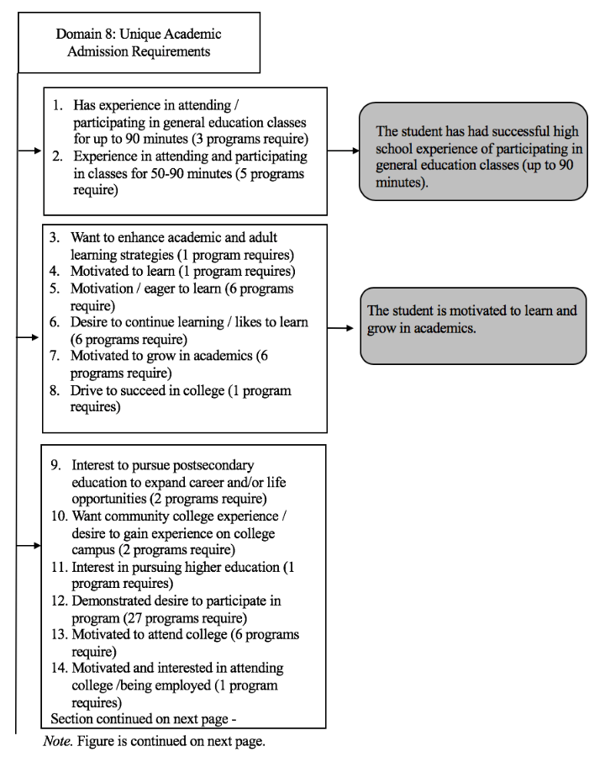

Figure 11 Continued

Process of Creating Draft Delphi Focus Group Assessment Questions for 78 Academic Requirements

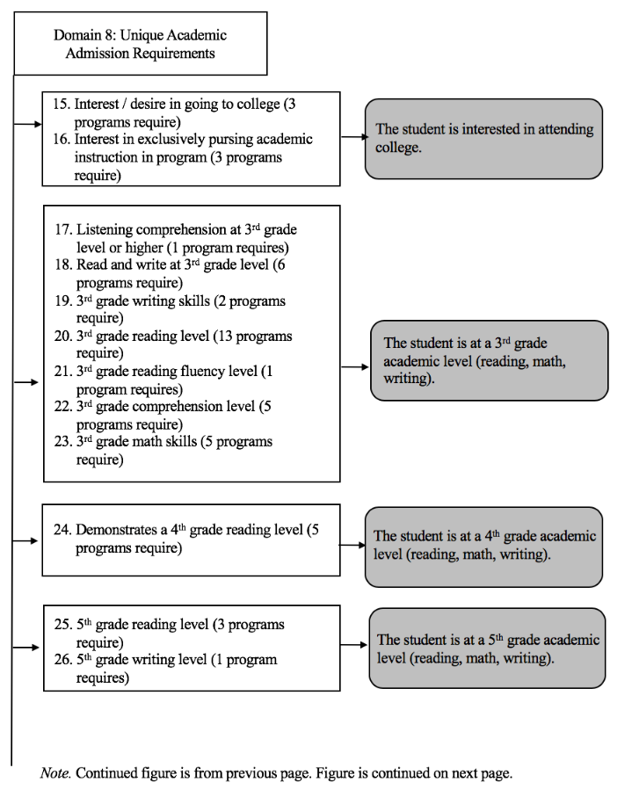

Figure 11 Continued

Process of Creating Draft Delphi Focus Group Assessment Questions for 78 Academic Requirements

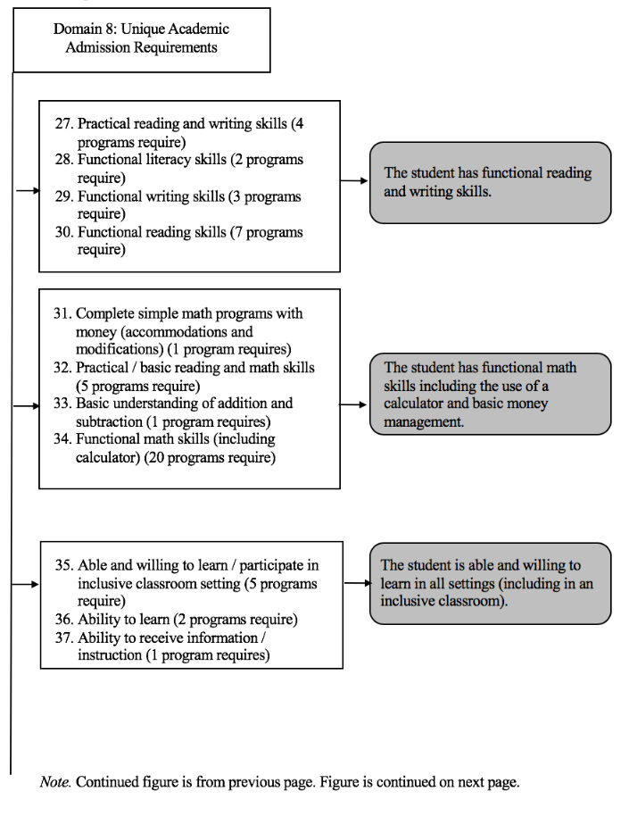

Figure 11 Continued

Process of Creating Draft Delphi Focus Group Assessment Questions for 78 Academic Requirements

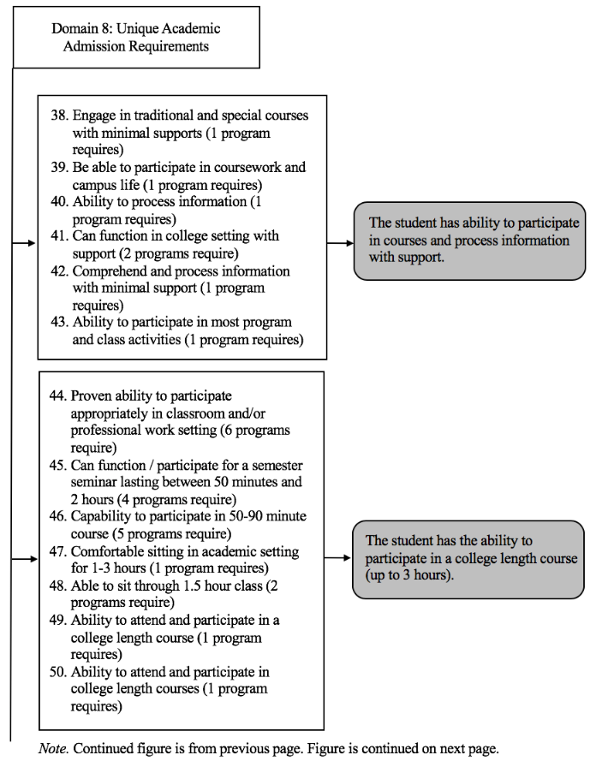

Figure 11 Continued

Process of Creating Draft Delphi Focus Group Assessment Questions for 78 Academic Requirements

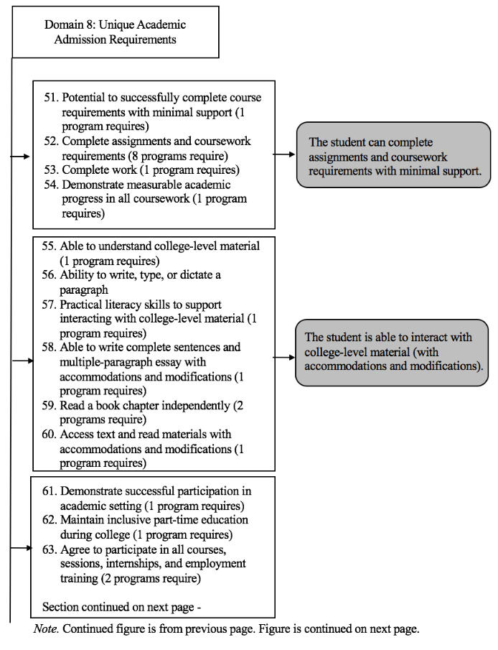

Figure 11 Continued

Process of Creating Draft Delphi Focus Group Assessment Questions for 78 Academic Requirements

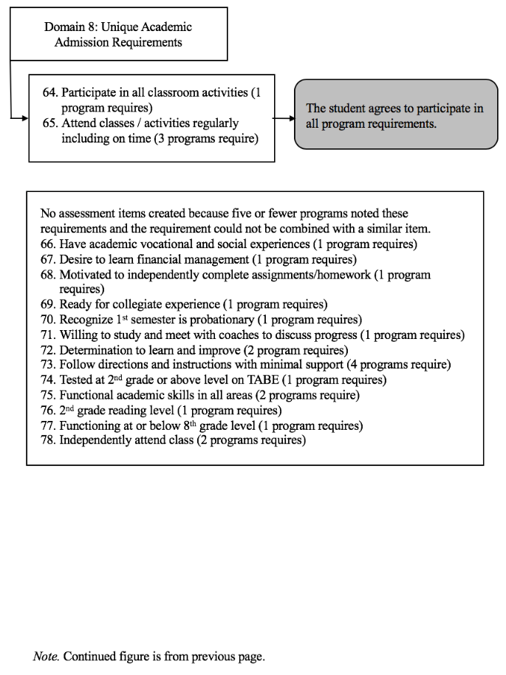

Figure 12

Process of Creating Draft Delphi Focus Group Assessment Questions for 34 Independence Requirements

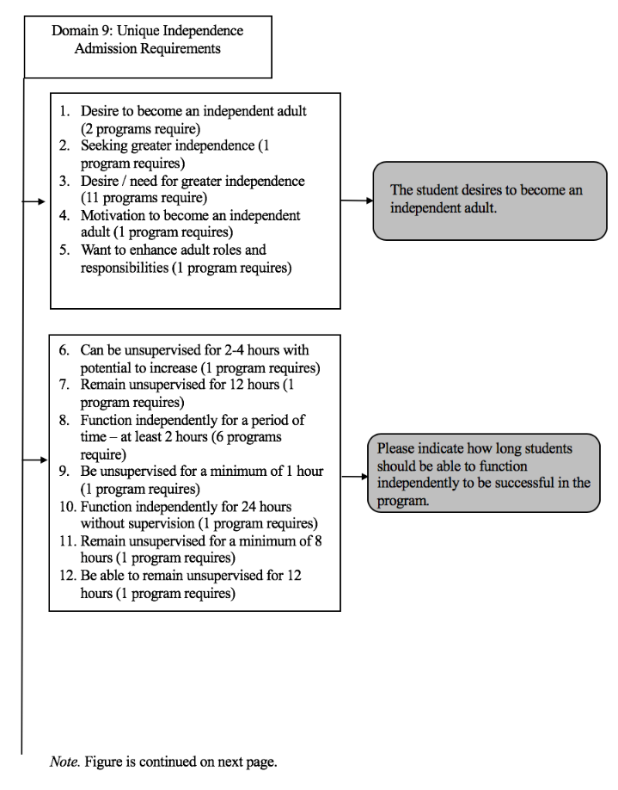

Figure 12 Continued

Process of Creating Draft Delphi Focus Group Assessment Questions for 34 Independence Requirements

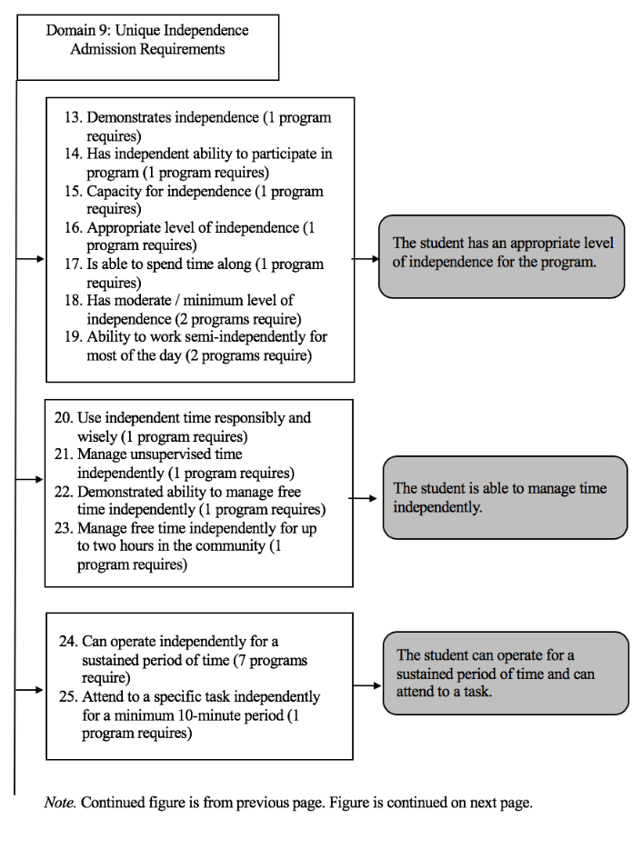

Figure 12 Continued

Process of Creating Draft Delphi Focus Group Assessment Questions for 34 Independence Requirements

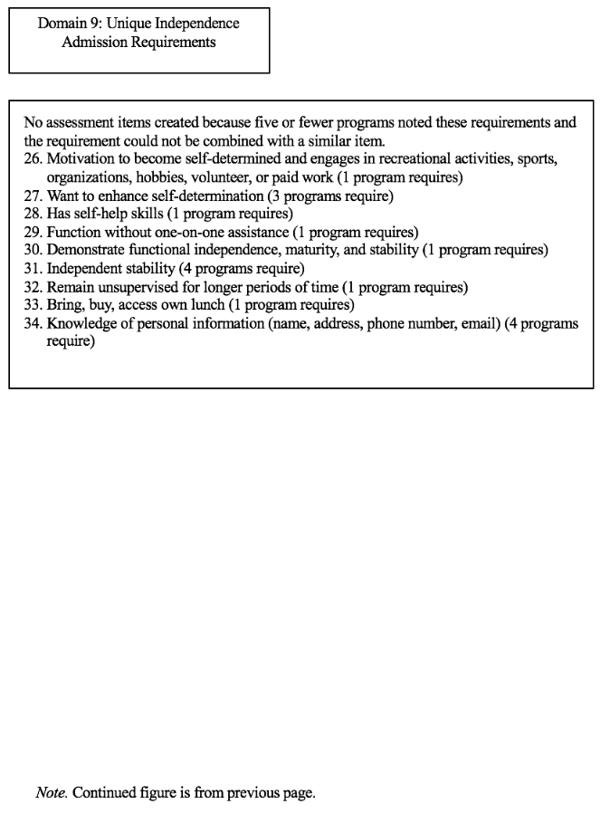

Figure 13

Process of Creating Draft Delphi Focus Group Assessment Questions for 46 Independent Living Requirements

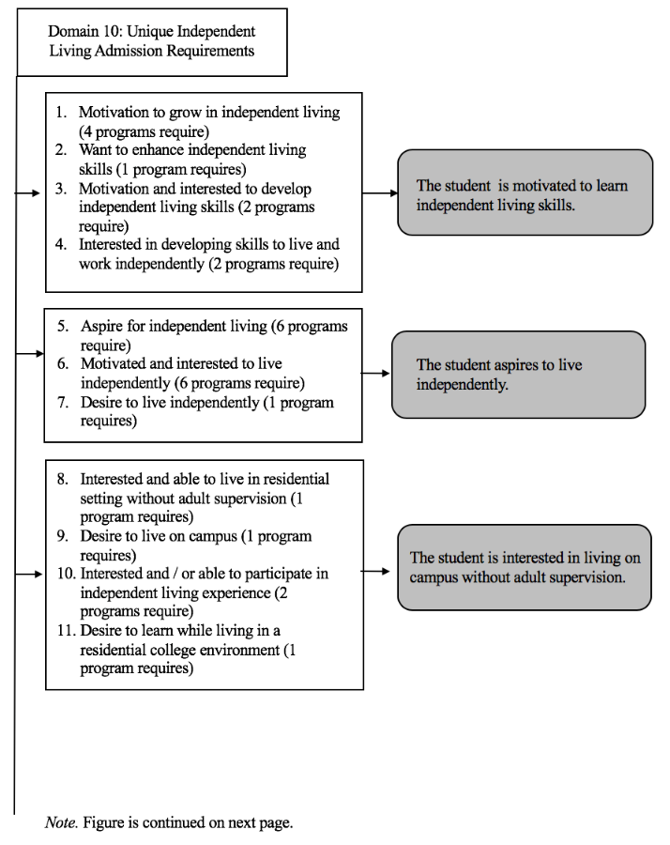

Figure 13 Continued

Process of Creating Draft Delphi Focus Group Assessment Questions for 46 Independent Living Requirements

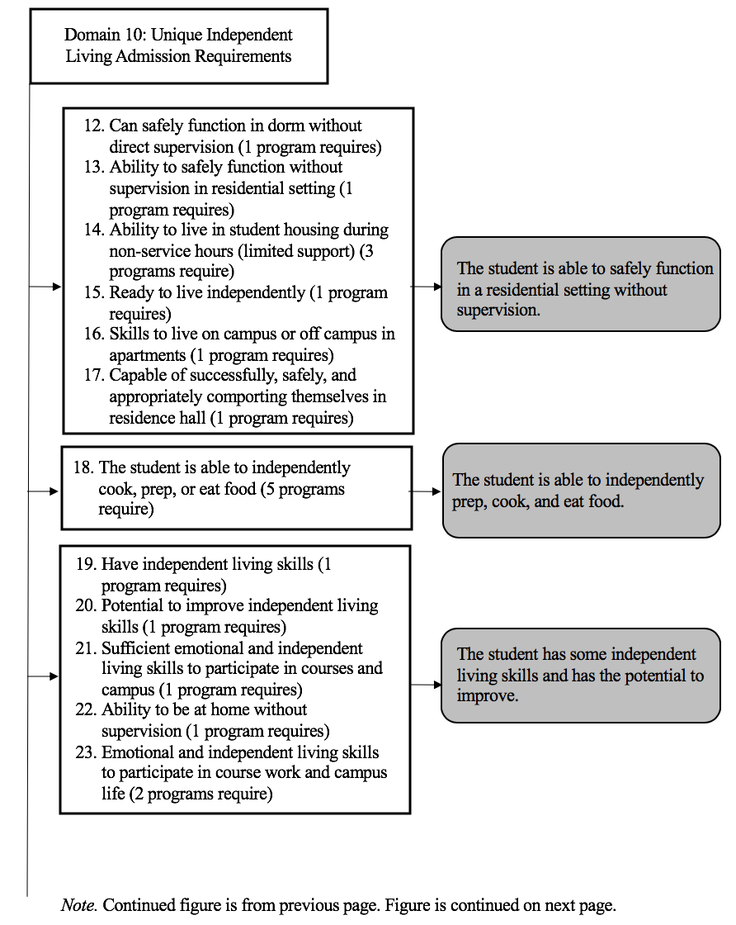

Figure 13 Continued

Process of Creating Draft Delphi Focus Group Assessment Questions for 46 Independent Living Requirements

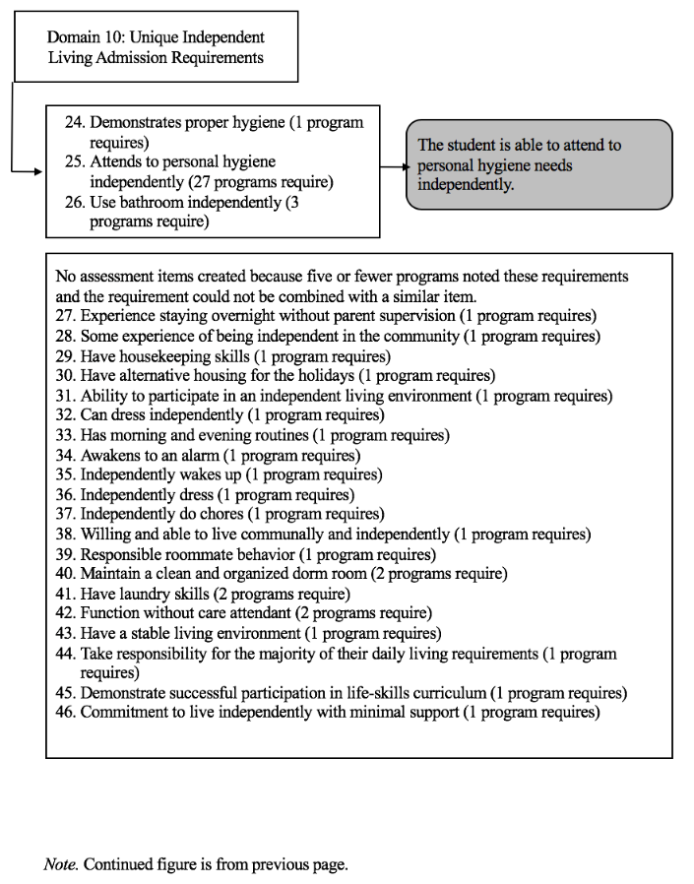

Figure 14

Process of Creating Draft Delphi Focus Group Assessment Questions for 16 Medical Requirements

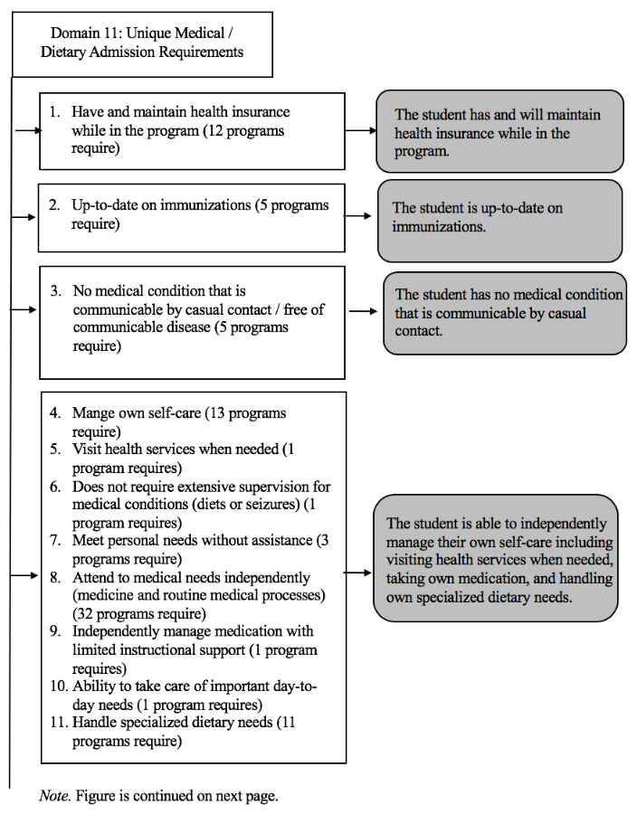

Figure 14 Continued

Process of Creating Draft Delphi Focus Group Assessment Questions for 16 Medical Requirements

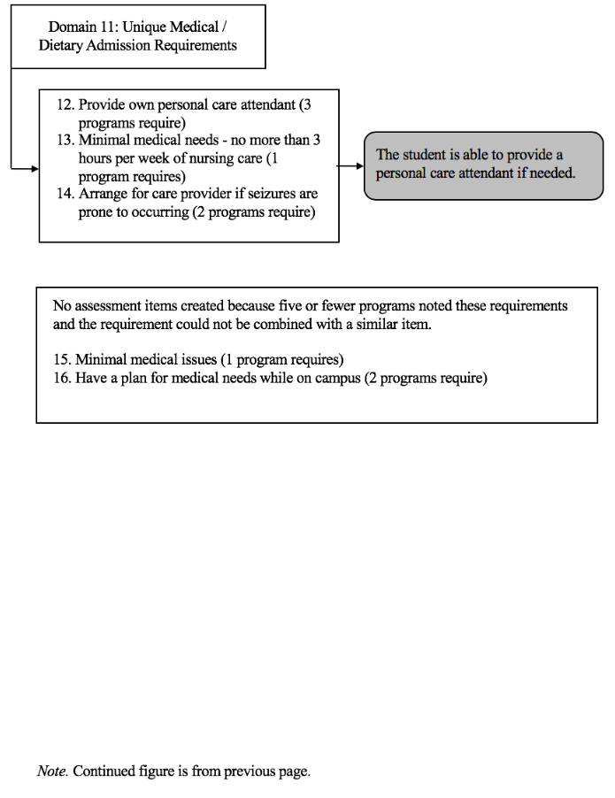

Figure 15

Process of Creating Draft Delphi Focus Group Assessment Questions for 10 Technology Requirements

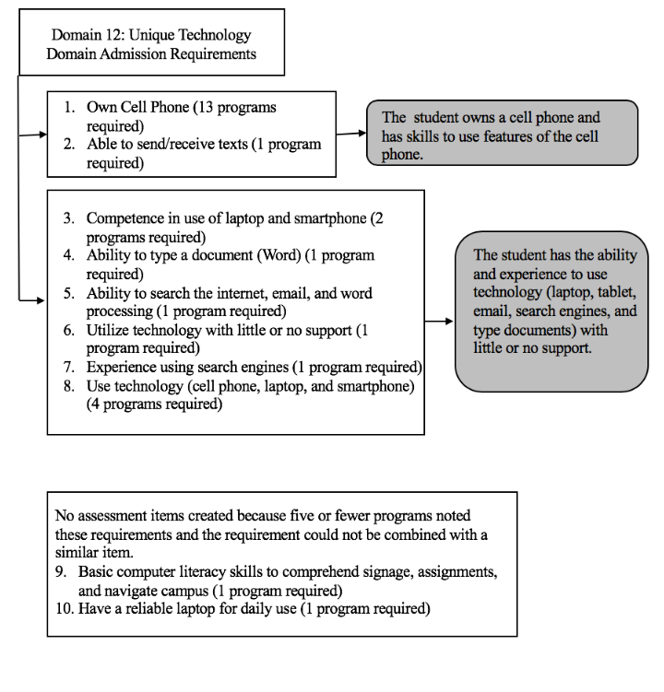

Figure 16

Process of Creating Draft Delphi Focus Group Assessment Questions for 71 Behavior Requirements

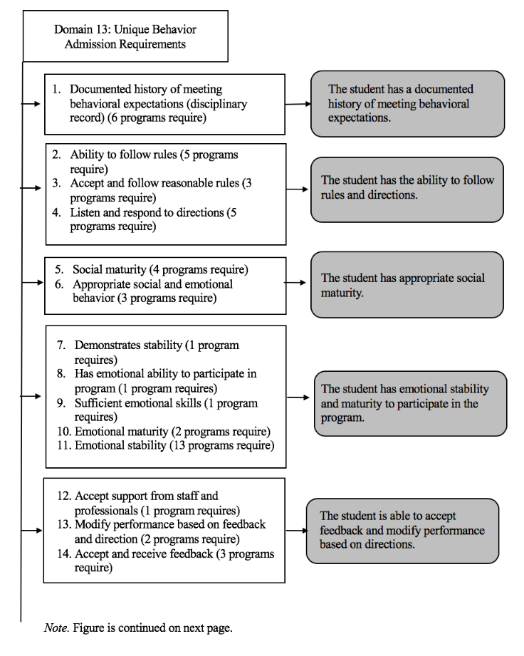

Figure 16 Continued

Process of Creating Draft Delphi Focus Group Assessment Questions for 71 Behavior Requirements

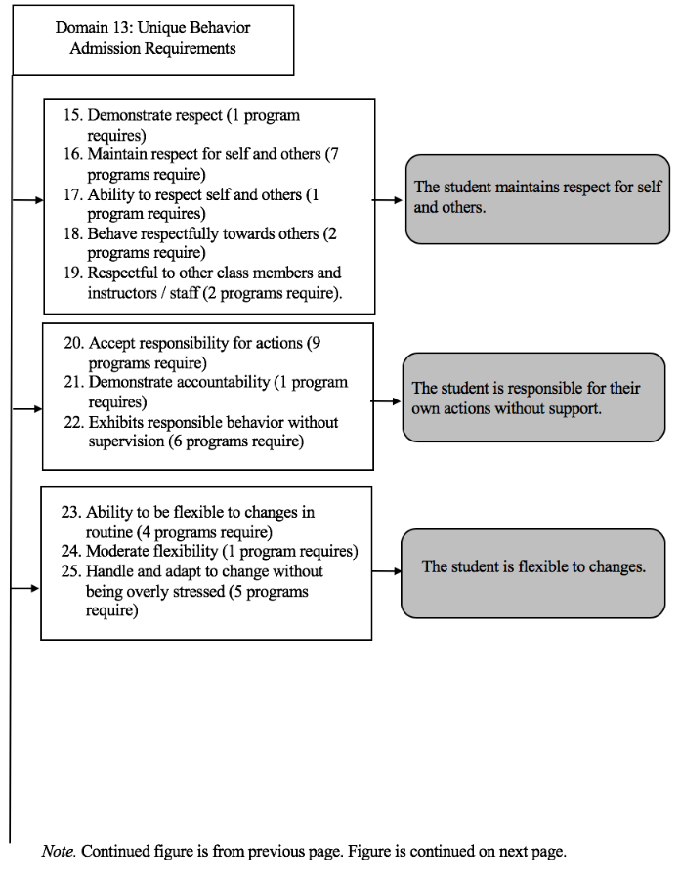

Figure 16 Continued

Process of Creating Draft Delphi Focus Group Assessment Questions for 71 Behavior Requirements

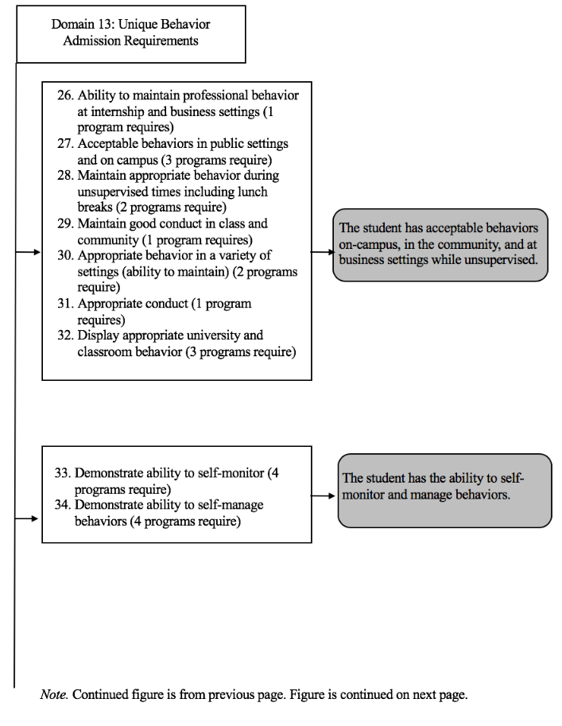

Figure 16 Continued

Process of Creating Draft Delphi Focus Group Assessment Questions for 71 Behavior Requirements

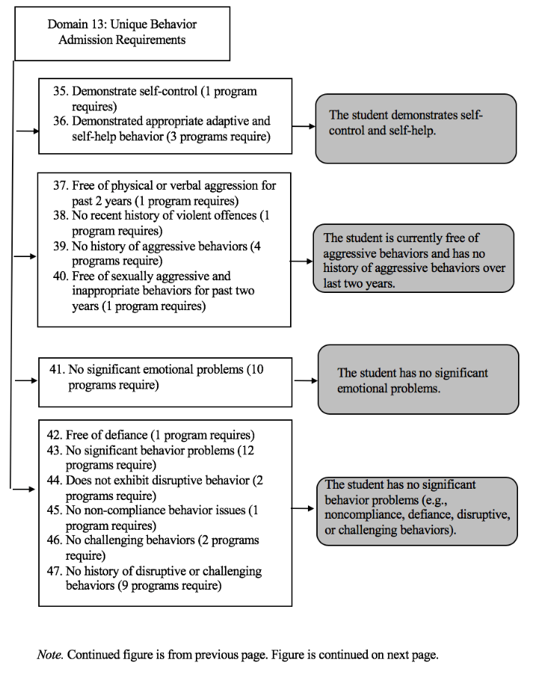

Figure 16 Continued

Process of Creating Draft Delphi Focus Group Assessment Questions for 71 Behavior Requirements

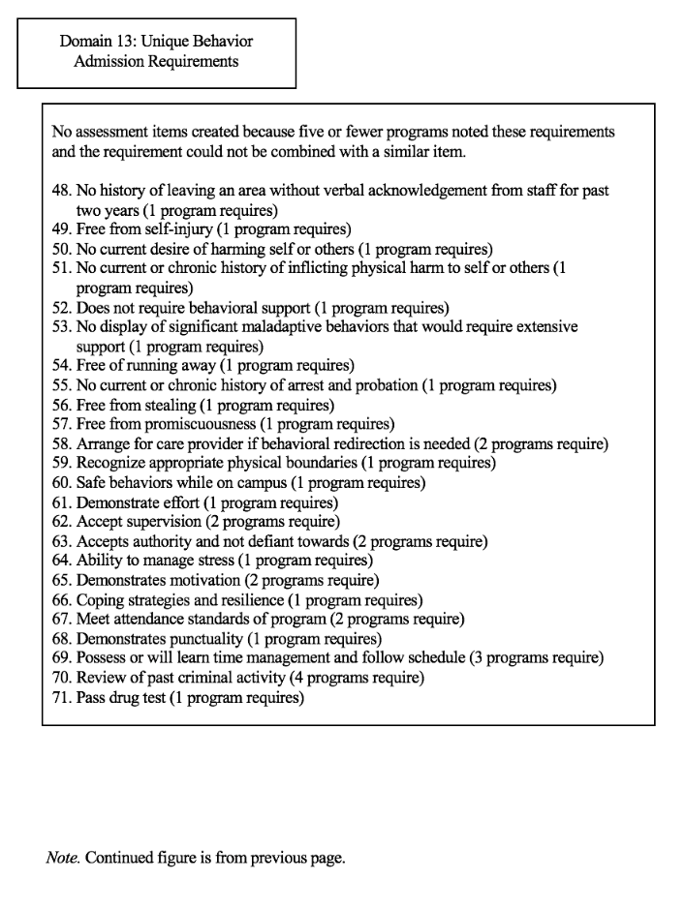

Figure 17

Process of Creating Draft Delphi Focus Group Assessment Questions for 20 Social Requirements

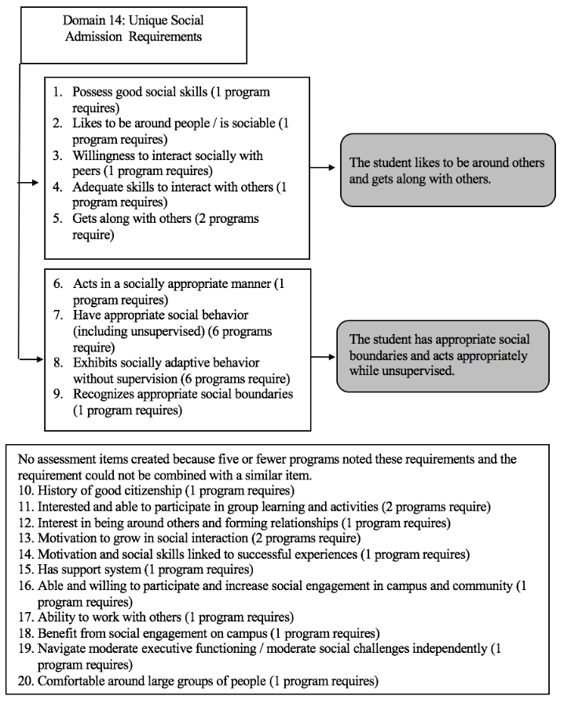

Figure 18

Process of Creating Draft Delphi Focus Group Assessment Questions for 4 Financial Requirements

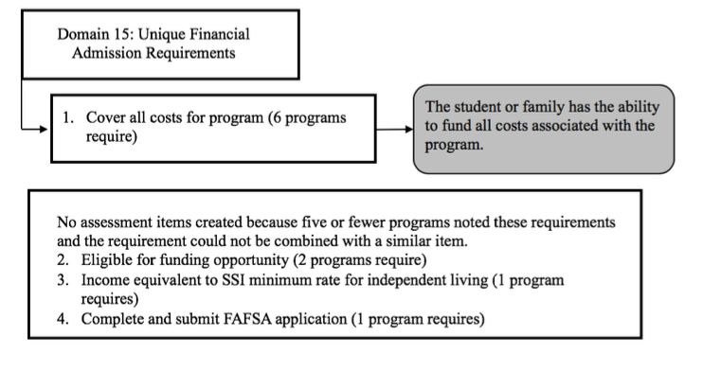

Figure 19

Process of Creating Draft Delphi Focus Group Assessment Questions for 20 Communication Requirements

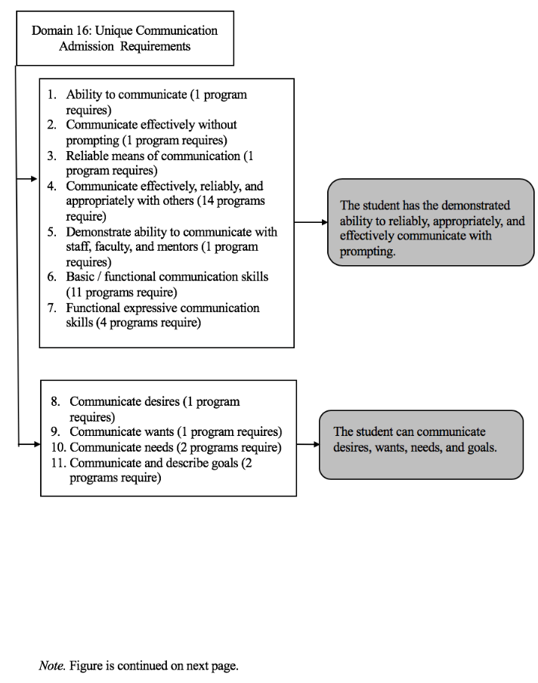

Figure 19 Continued

Process of Creating Draft Delphi Focus Group Assessment Questions for 20 Communication Requirements

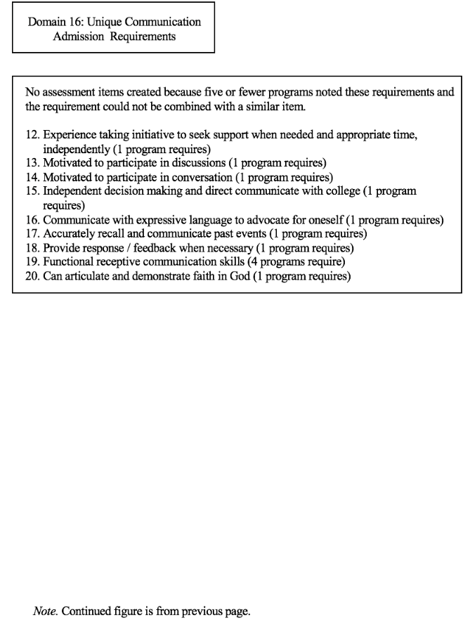

Figure 20

Process of Creating Draft Delphi Focus Group Assessment Questions for 21 Commitment Requirements

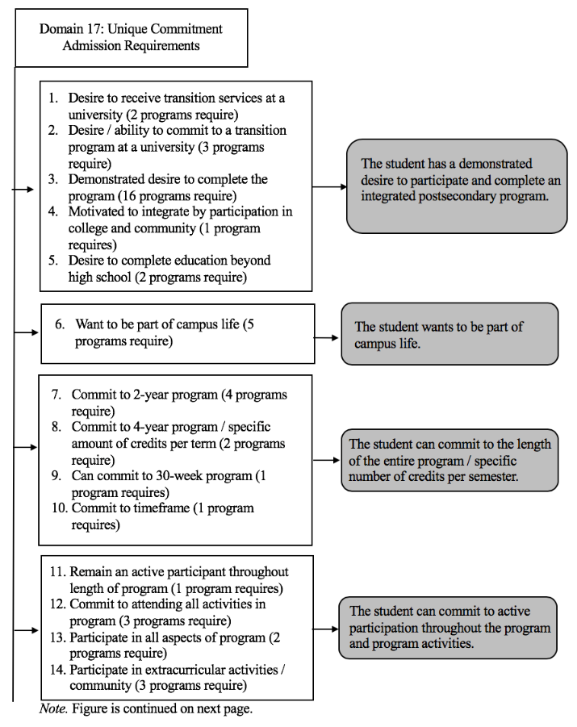

Figure 20 Continued

Process of Creating Draft Delphi Focus Group Assessment Questions for 21 Commitment Requirements

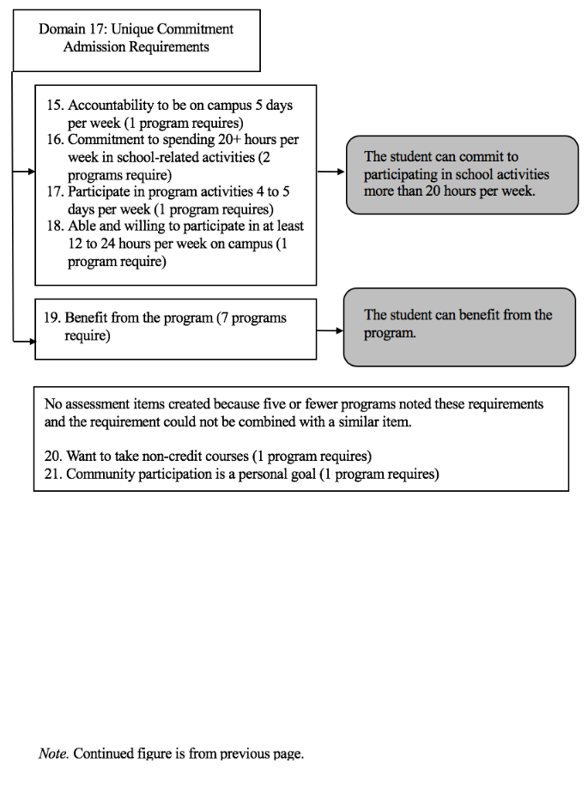

Figure 21

Overall Creation of Assessment Items

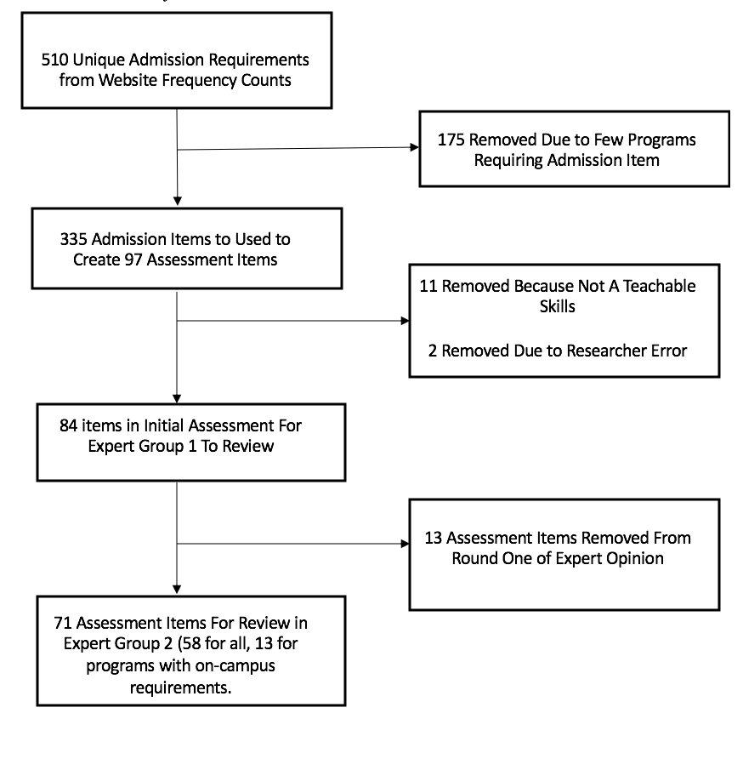
Figure 22

Sample of Survey for Experts in Delphi Group 1 During Round 1

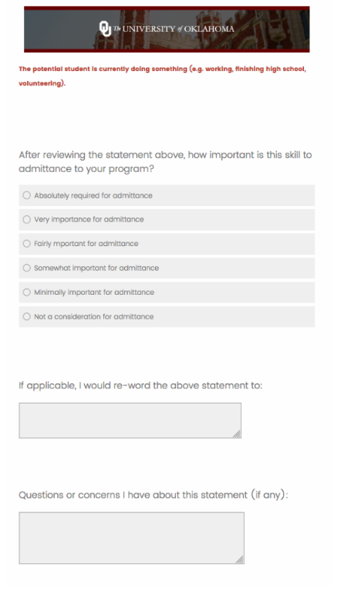

Figure 23

SPSS Results for Requirements for Admission Domain

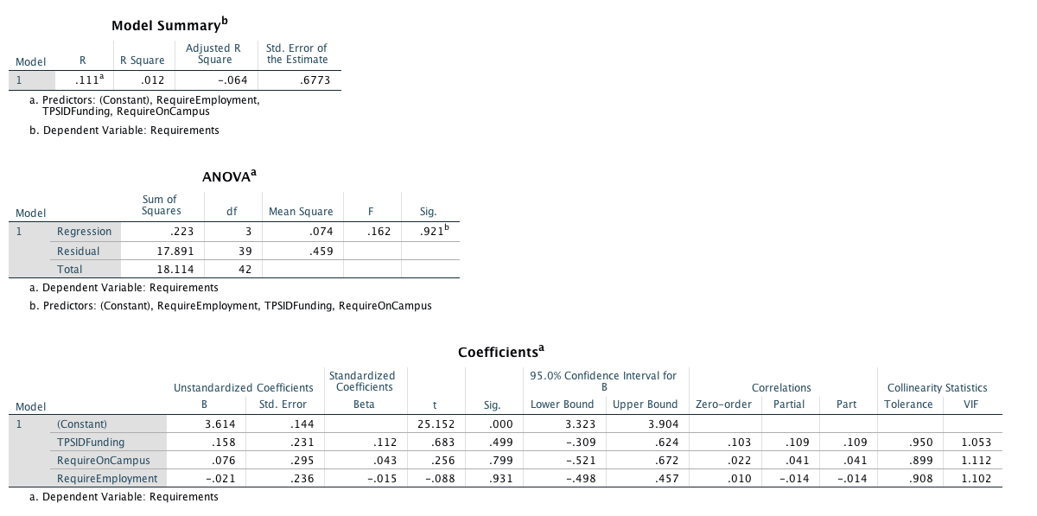

Figure 24

SPSS Results for Parent Responsibilities and Expectations Domain

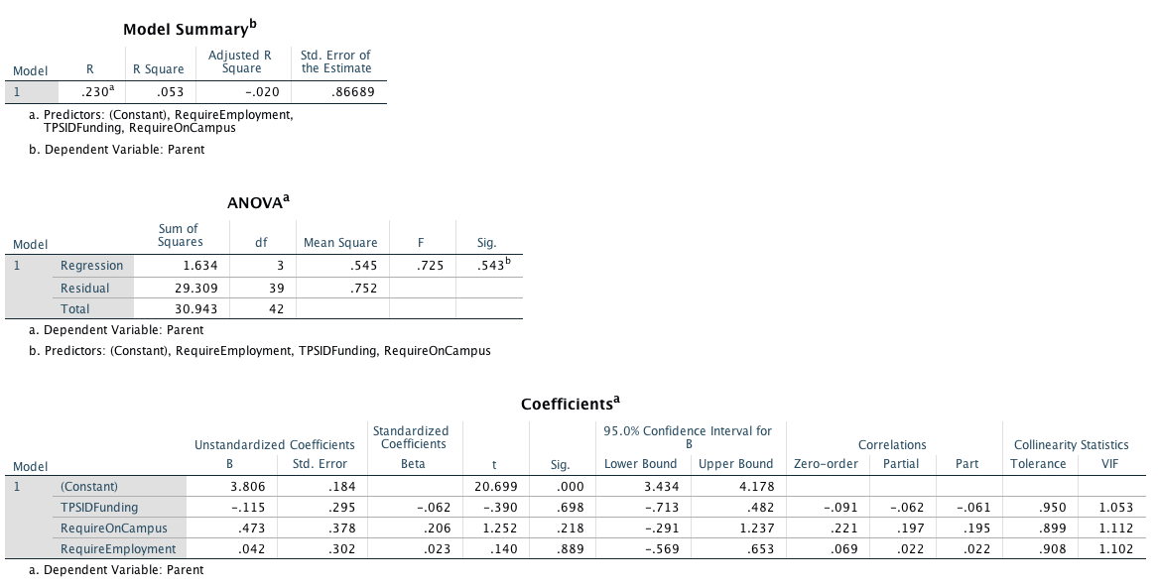

Figure 25

SPSS Results for Self-Determination Domain

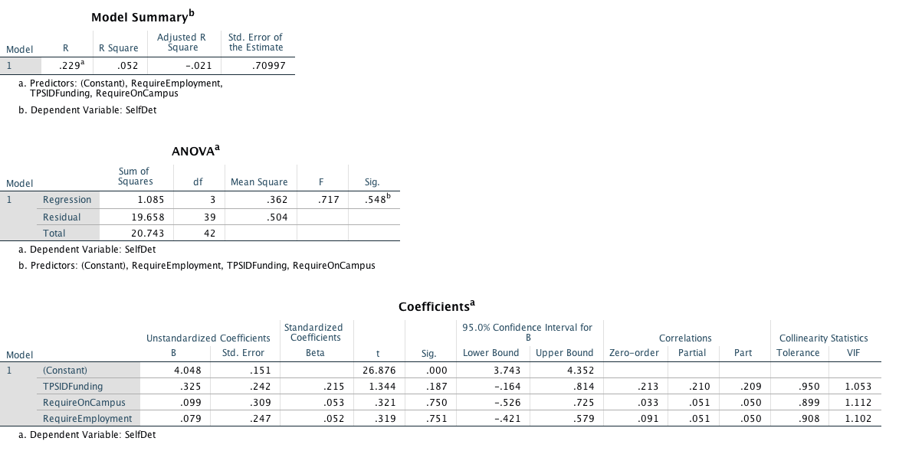

Figure 26

SPSS Results for Navigation and Safety Domain

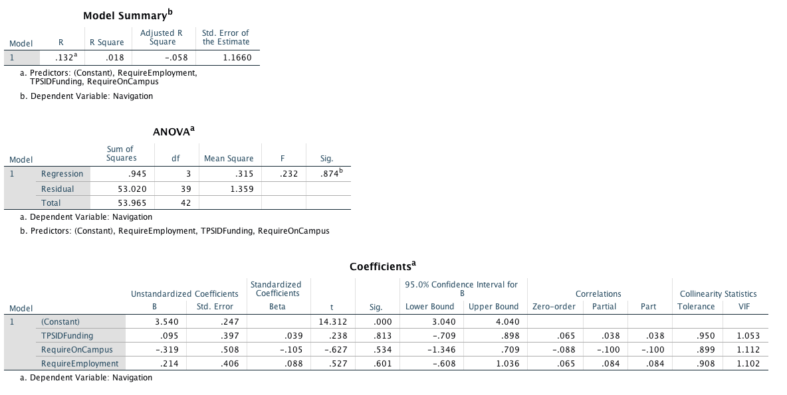

Figure 27

SPSS Results for Employment Skills Domain

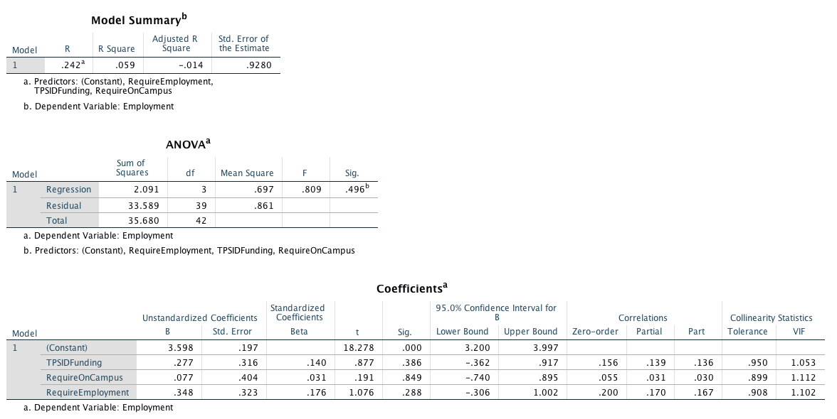

Figure 28

SPSS Results for Academic Skills Domain

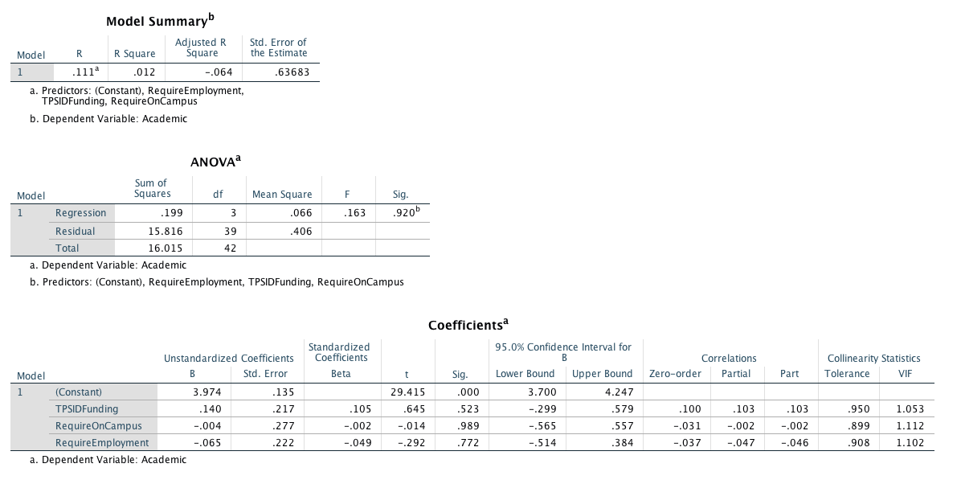

Figure 29

SPSS Results for Independence and Motivation Domain

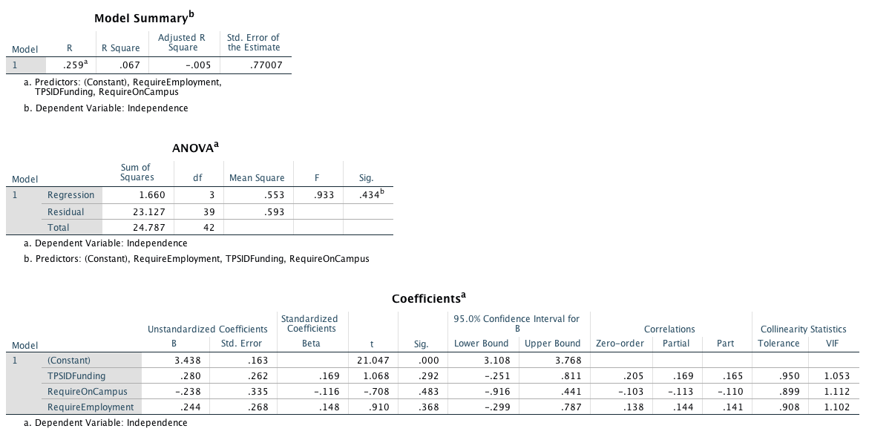

Figure 30

SPSS Results for Independent Living Domain

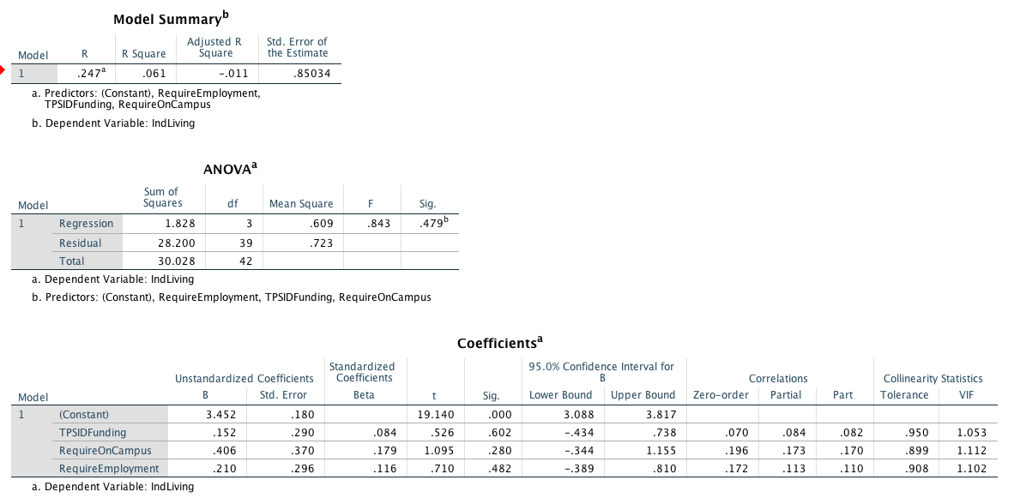

Figure 31

SPSS Results for Health and Wellness Domain

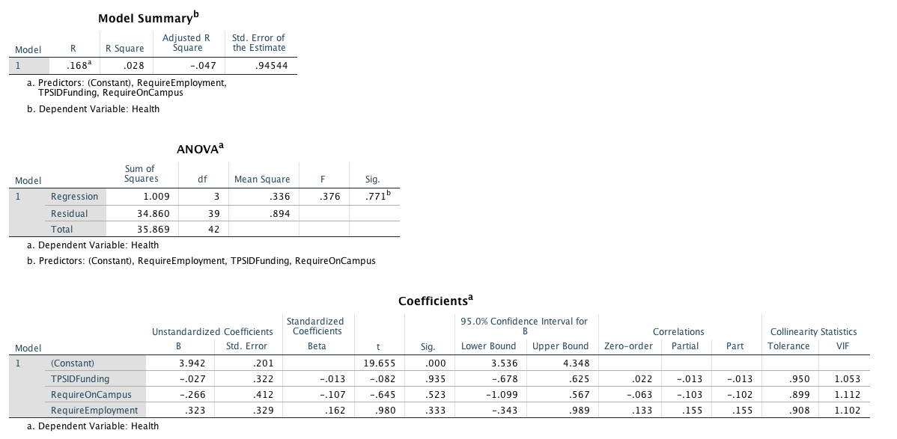

Figure 32

SPSS Results for Technology Skills Domain

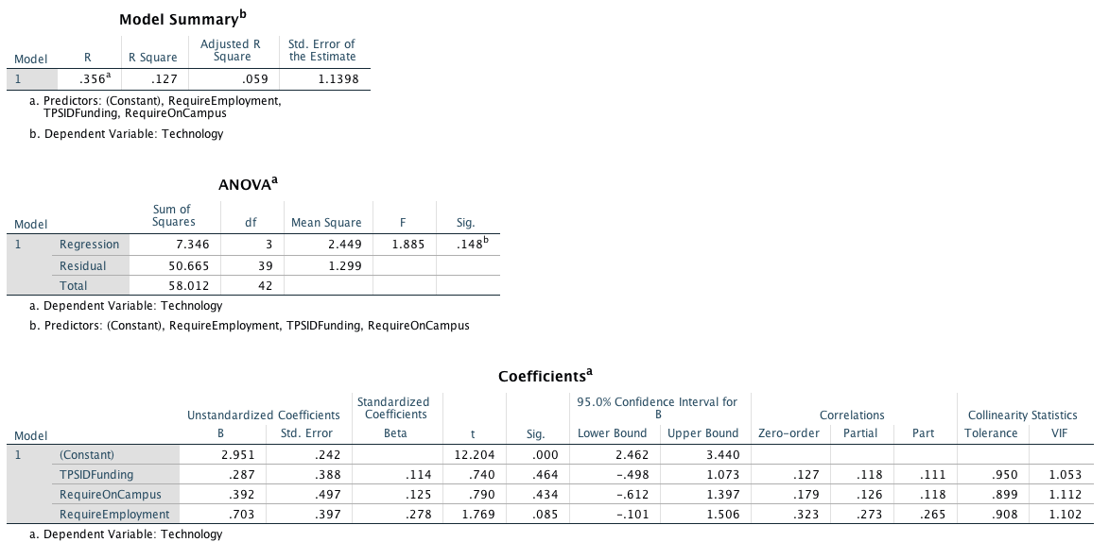

Figure 33

SPSS Results for Behavior Expectations Domain

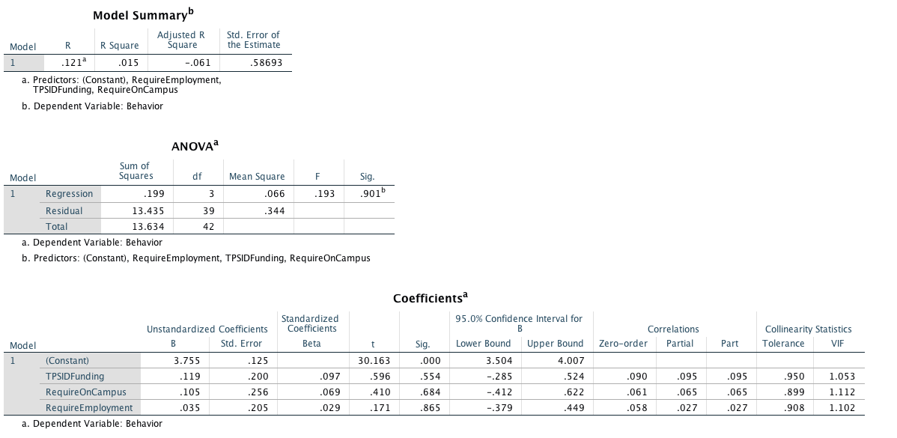

Figure 34

SPSS Results for Interpersonal Skills Domain

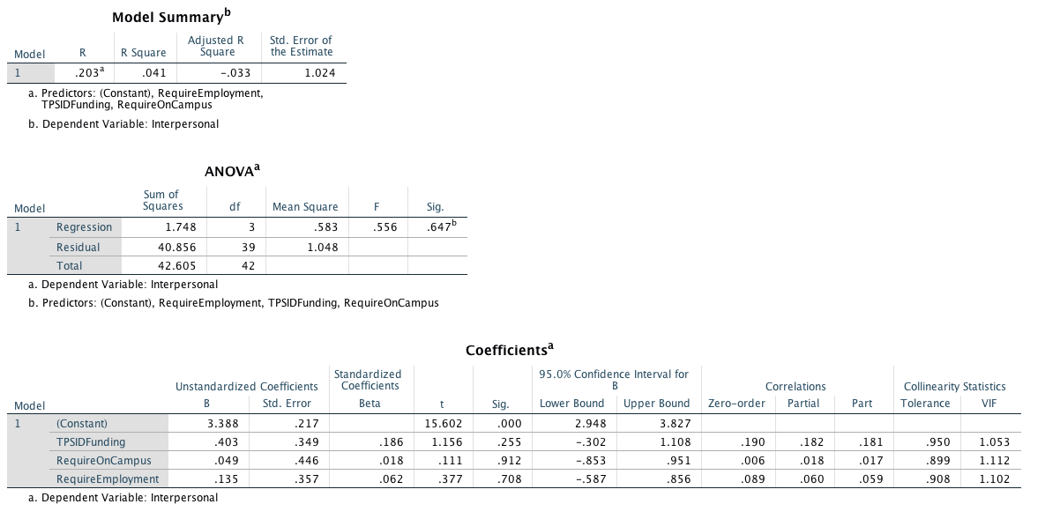

Figure 35

SPSS Results for Communication Skills Domain

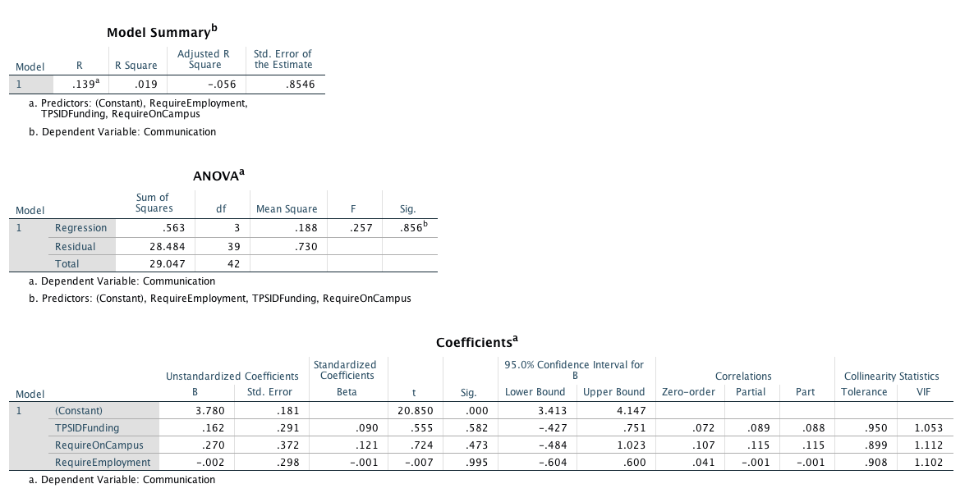

Figure 36

SPSS Results for Student Expectation Domain

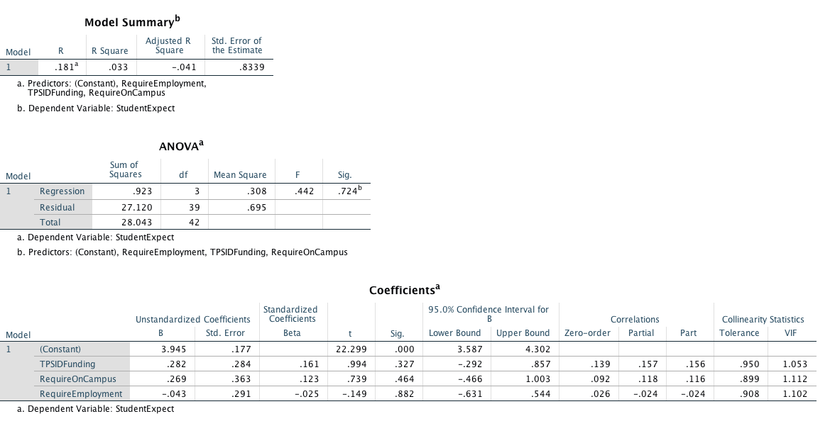

Figure 37

SPSS Results for Application Process Domain

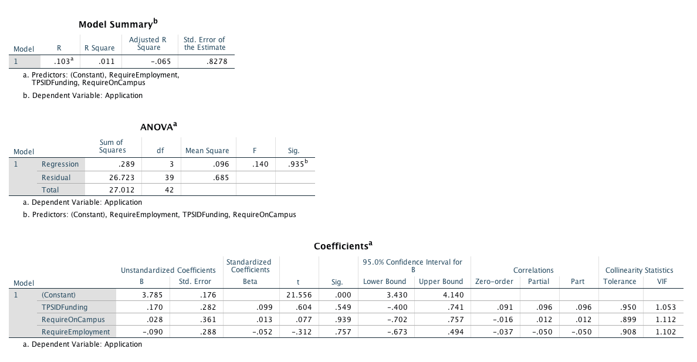

Figure 38

SPSS Results for On-Campus Living Domain

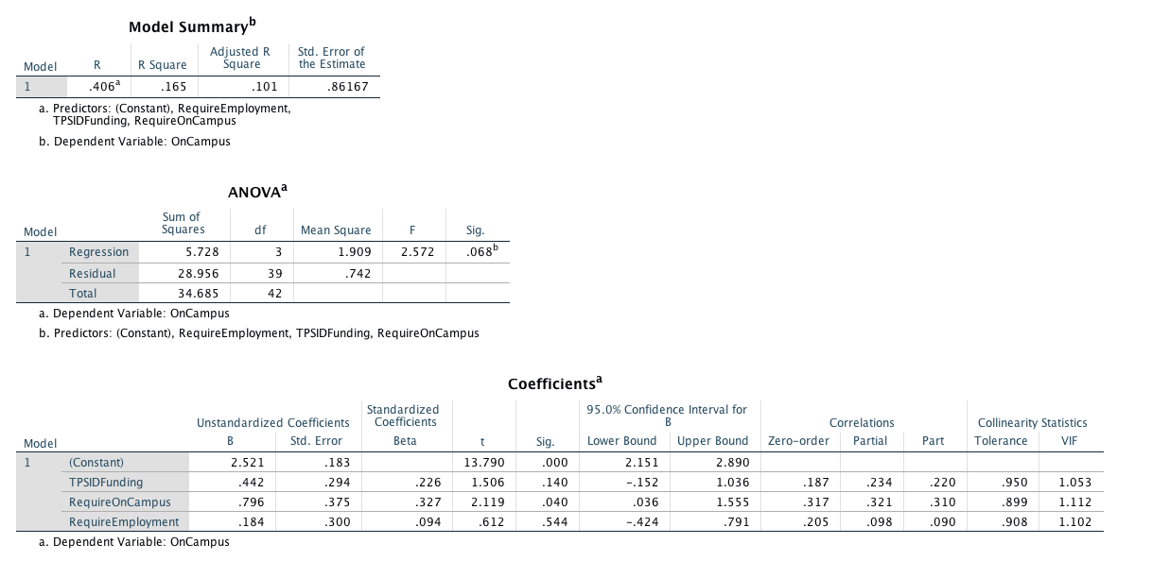

Figure 39

Correlation Matrix Between Domains and Program Characteristics

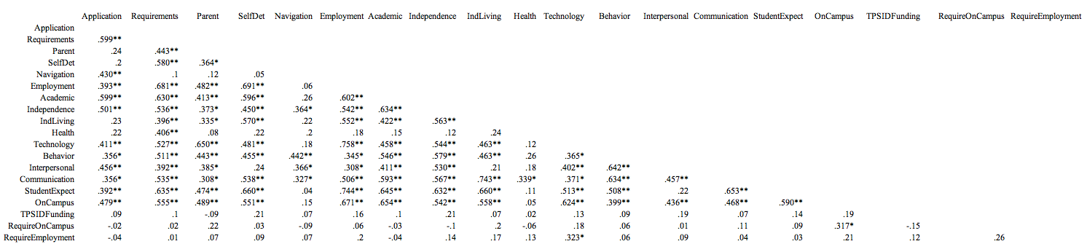

Note. ** indicates correlation is significant at the 0.01 level (2-tailed). * indicates correlation is significant at the 0.05 level
(2-tailed).

