UNIVERSITY OF OKLAHOMA
GRADUATE COLLEGE

THE EFFECT OF UNDERSTANDING KEY STAKEHOLDER MENTAL MODELS ON LEADER CREATIVE PERFORMANCE

A THESIS
SUBMITTED TO THE GRADUATE FACULTY
In partial fulfillment of the requirements for the
Degree of
MASTER OF SCIENCE

By
SAMANTHA ENGLAND
Norman, Oklahoma
2020

THE EFFECT OF UNDERSTANDING KEY STAKEHOLDER MENTAL MODELS ON LEADER CREATIVE PERFORMANCE

A THESIS APPROVED FOR THE
DEPARTMENT OF PSYCHOLOGY

BY THE COMMITTEE CONSISTING OF

Dr. Michael Mumford, Chair
Dr. Shane Connelly
Dr. Jennifer Barnes

© Copyright by Samantha England 2020
All Rights Reserved

Table of Contents
Abstract v
Introduction 1
Leadership and Creative Problem-Solving 3
Leader Sensemaking 4
Mental Models and Leadership 7
Leader Sensemaking and Stakeholder Mental Models 9
Social Factors and Leadership 12
Method 17
Results 27
Discussion 29
References 38
Tables 49-51
Figures 52-54
Appendices 55-58

Abstract
Leaders are faced with increasingly complex, novel, ill-defined, and socially embedded problems that require effective creative problem-solving. Research has identified sensemaking as a primary process underlying leader problem-solving, where leaders gather, interpret, and integrate information to develop mental models representing optimal courses of future action. The socially embedded nature of the problems implies that leaders must adapt their sensemaking to consider the perspectives of organizational stakeholders. Despite these observations, research has failed to investigate how a leader’s ability to understand and incorporate stakeholder mental models during sensemaking influences creative problem-solving performance. The present effort aimed to address these gaps in the literature by investigating how social factors (i.e., the use of heuristics, the presence of risk, and the presence of critical others) influence a leader’s ability to understand stakeholder mental models, as well as the impact of stakeholder mental model accuracy on leader creative performance. Findings emphasize the importance of stakeholder mental model accuracy on leader creative performance, as well as reveal the differential impact of the social factors on mental model accuracy. Theoretical and practical implications, limitations, and future directions are discussed.
Keywords: leadership, sensemaking, stakeholders, mental models

The Effect of Understanding Key Stakeholder Mental Models on Leader Creative Performance
Leadership has been widely understood as a key mechanism contributing to organizational performance and effectiveness. Of the meta-models applied to understand effective leadership, the study of leaders as complex problem-solvers has received the least attention in the literature (Mumford, Todd, et al., 2017; Zaccaro & Klimoski, 2001). However, the increasingly dynamic, unpredictable, and uncertain nature of organizational environments results in complex and ambiguous problems that require leader problem-solving skills for effective performance to occur (Day & Halpin, 2004; Mumford, Todd, et al., 2017). Further, as suggested by sociotechnical systems theory, organizational leaders serve the role of supplying, directing, and coordinating the network of organizational subsystems toward a collective purpose (Katz & Kahn, 1978; Zaccaro & Torres, 2020). The integrated nature of these subsystems further complicates the problems faced by leaders, in that they must consider the contextual demands and social dynamics arising from the various subsystems and their interconnected stakeholders during problem-solving (Hoojiberg & Schneider, 2001; Mumford, 1986; Zaccaro & Klimoski, 2001; Zaccaro & Torres, 2020). These observations suggest that it is critical to understand the cognitive processes that underlie a leader’s ability to develop solutions in response to these complex, novel, ill-defined, and socially embedded problems.
Research has identified sensemaking as a primary cognitive process underlying leader problem-solving. Sensemaking is a complex cognitive process whereby leaders make sense of social and technical information bearing on a problem to develop a framework, or mental model, for understanding and responding to a given situation (Bagdasarov et al., 2016; Drazin et al., 1999; Johnson-Laird, 1983; Medeiros et al., 2020; Thomas et al., 1993; Weick, 1995). Effective engagement in sensemaking allows leaders to develop plausible mental models that represent key goals, causes, and social dynamics which allow the leader to identify optimal courses for future action (Weick et al., 2005). The quality of these mental models developed via sensemaking have been shown to have a significant impact on leader performance and leader problem-solving capacity (Barr et al., 1992; Mumford & Connelly, 1991). Thus, a leader’s ability to generate effective problem solutions is dependent on the viability of the mental models they produce via sensemaking. Given that leaders must consider organizational stakeholders during solution generation, this suggests that the construction of viable mental models is dependent upon a leader’s ability to make sense of the social information bearing on the situation at hand (Geiwitz, 1993; Zaccaro, Gilbert et al.,1991; Zaccaro & Torres, 2020).
Taken together, this evidence suggests that leaders must engage in sensemaking to understand the concerns and perspectives of key stakeholders during solution generation. This implies that leaders need to engage in perspective taking to understand the mental models of stakeholders, or in other words, to understand how stakeholders perceive the problem domain and the elements operating within the problem domain. Understanding stakeholder mental models is likely to contribute to leader creative performance in a number of ways. To begin,
research has suggested that engagement in perspective taking to understand stakeholders mental models is critical for generating problem solutions that fit within the social and organizational environment (Day et al., 2020; Kuhnert & Russell, 1990; Mumford, Zaccaro et al., 2000; Tam et al., 2020). Further, understanding stakeholder mental models may enhance a leader’s ability to identify and integrate relevant social information into their own mental model, which allows the leader to develop a more comprehensive mental model representing the problem domain (Sonenshein, 2007; Theil et al., 2012). This comprehensive mental model may allow leaders to more effectively predict the social implications of various actions that can be taken, thus contributing to the development of more viable problem solutions that fit within the organizational environment (Thiel et al., 2012; Zaccaro, Gilbert et al., 1991; Zaccaro & Torres, 2020). These observations suggest that leader understanding of stakeholder mental models is likely to contribute to more effective sensemaking and enhanced leader creative performance. However, there is minimal research that has investigated how a leader’s ability to understand and incorporate stakeholder mental models during sensemaking influences their subsequent creative problem-solving performance.
Leadership and Creative Problem-Solving
Leadership scholars have frequently noted that leaders are faced with increasingly complex problems requiring a variety of problem-solving skills (Day & Halpin, 2004; Mumford, Todd, et al., 2017). Further, the complex, novel, and ill-defined nature of the problems faced by leaders require that organizational leaders have creative problem-solving skills. Creative problem-solving is defined as the development of high quality, original, and elegant solutions to novel, complex, and ill-defined problems (Besemer & O’Quin, 1999; Mumford & Gustafson, 1988). Creative problem-solving has been shown to be related to leader performance across multiple studies (Medeiros et al., 2020; Puccio et al., 2017). For instance, IBM conducted a study in which they interviewed 1,541 organizational leaders (e.g., CEO’s, general managers). They found that 60 percent of interviewees listed creativity as a critical capacity for leaders of the future. Further, studies conducted by Connelly et al. (2000) and Mumford, Marks, et al. (2000) examined the impact of creative problem-solving within the Army, and found that creative problem-solving skill was positively associated with increases in rank.
This evidence indicates that leader are often faced with novel, complex, and ill-defined problems that require leader creative problem-solving for effective performance. However, it is important to note that these problems faced by leaders are inherently social in nature (Fleishman et al., 1991; Mumford & Connelly, 1991; Mumford et al., 2000; Zaccaro & Klimoski, 2001). Sociotechnical systems theory suggests that organizational leadership serves the purpose of supplying, directing, and coordinating the network of organizational subsystems to achieving a collective purpose (Katz & Kahn, 1978; Zaccaro & Torres, 2020). Due to the integrated nature of these organizational subsystems, leaders must actively consider the contextual demands arising from the various subsystems as well as their interconnected stakeholders to engage in effective decision-making (Hoojiberg & Schneider, 2001; Mumford, 1986; Zaccaro & Klimoski, 2001; Zaccaro & Torres, 2020). The integrated nature of organizational subsystems further complicates the problems faced by leaders, in that this necessitates that leaders consider the social dynamics bearing on the problem at hand (e.g., stakeholder perspectives) in order to develop effective solutions (Geiwitz, 1993; Mumford & Connelly, 1991; Zaccaro & Torres, 2020). Given the socially embedded complexity of these problems, effective execution of the cognitive processes that result in effective creative solutions is critical, and, this begins with a leader’s ability to make sense of social and technical information.

Leader Sensemaking
One cognitive strategy that has been shown to aid in the successful execution of the cognitive processes related to creativity is sensemaking (Medeiros et al., 2020). Sensemaking is a complex cognitive process whereby leaders make sense of social and technical information bearing on a problem to make meaning of their environment; this allows leaders to develop a framework, or mental model, for understanding a given situation and actions that can be taken within this situation (Bagdasarov et al., 2016; Drazin et al., 1999; Johnson-Laird, 1983; Medeiros et al., 2020; Thomas et al., 1993; Weick, 1995). In other words, leaders engage in sensemaking to understand novel, complex, and ill-defined problems, and to guide decision-making in response to these problems.
Sensemaking is a process whereby individuals engage in environmental scanning, information interpretation and integration, and action (Mumford et al., 2007; Thiel et al., 2016; Thomas et al., 1993). Environmental cues serve to signal to leaders the novelty and complexity of the environment, and once identified, this stimulates the leaders to begin scanning the internal and external environment to gather, interpret, and integrate situational information with their conceptual and experiential knowledge (Choo et al., 2008; Strange & Mumford 2005). This process of integration allows leaders to construct mental models that delineate key goals and causes operating in the problem domains (Caughron, Antes et al., 2011; Mumford, Higgs et al., 2020). Having a thorough understanding of the key factors operating within a problem domain reduces uncertainty and enhances clarification with respect to optimal future courses of action (Caughron et al., 2020; Hahn et al., 2014; Jameson, 2009; Maitlis & Christianson, 2014; Tam et al., 2020; Weick, 1995).
Research has demonstrated that sensemaking is critical for complex problem-solving, decision making, as well as creativity. With respect to decision making, studies have indicated that the sensemaking process facilitates the development of ethical decisions. Ethical problems are inherently complex and ambiguous, where multiple decision alternatives are present, and each alternative carries unique and often conflicting implications for stakeholders groups (Werhane, 2002; Zeni et al., 2016). Given the complex and ambiguous nature of ethical problems, sensemaking has been suggested to be a central process whereby individuals make sense of, and integrate, information to understand ethical issues and inform ethical decision making (Thiel et al., 2016). In fact, Bagdasarov et al. (2016) provided evidence demonstrating that the positive relationship between the complexity of people’s mental models and their ethical decision making was fully mediated through sensemaking strategies such as identification and analysis of causes and constraints. With respect to creativity, studies by Dougherty et al. (2000), Jay (2013), and Drazin et al. (1999) have provided evidence indicating that sensemaking is a driving force of creativity and innovation in organizations. Research from Drazin et al. (1999) found that leader engagement of sensemaking activities in response to emerging crises had a critical impact on a large organization’s capacity to develop a new technology. Further, Dougherty et al. (2000) provided evidence indicating that firms differed with respect to sensemaking activities, with the most innovative firms promoting frequent interaction to build a shared understanding of organizational goals and processes, which serves to enhance their ability to make sense of emerging issues.
Taken together, this evidence highlights the criticality of leader sensemaking in response to the complex, novel, ill-defined, and socially embedded problems confronting organizational leaders. Effective sensemaking allows leaders to gather and integrate information bearing on these problems to construct plausible mental models representing key goals, causes, and social dynamics, which serves to inform optimal courses of action that can be taken (Weick et al., 2005). The quality of the mental models developed via sensemaking has been shown to have a significant impact on problem-solving capacity (Barr et al., 1992; Mumford & Connelly, 1991), meaning these models have important implications for performance. Further, the socially embedded nature of the problems faced by leaders implies that rote application of extant knowledge structures (i.e., mental models) is likely insufficient (Mumford & Martin, 2020; Mumford & Connelly, 1991). Rather, leaders must revise, combine, and reorganize these models via sensemaking to construct mental models that are representative of the emerging problem, and the social dynamics surrounding the problem.

Mental Models and Leadership
In general, mental models can be understood as an internal representation of the knowledge that an individual possess. These internal representations of knowledge are developed as a function of experience (Dibello, Lehmann, & Missildine, 2011; Hmelo-Silver & Pfeffer, 2004), and are organized, in that they specify the content of knowledge, as well as indicate relationships between various components of knowledge (Webber et al., 2000; Rouse & Morris, 1986; Lim & Klein, 2006). This organized representation of knowledge is essentially a framework that allows individuals the ability to describe the purpose and form of knowledge, explain functionality, and predict future states (Rouse & Morris, 1986; Werhane, 2000). Mental models underlie the ability to describe, explain, and predict by acting as selective mechanisms that filter our experiences and knowledge (Werhane, 2000). Taken together, this suggests that mental models can be understood as a framework of collected knowledge and experience that is organized into a series of cause-goal linkages (Goldvarg & Johnson-Laird, 2001; Paoletti, Reyes, & Salas, 2019). Mental models are foundational to reasoning, in that they serve to promote an individual’s comprehension of events and prediction of outcomes (Rouse & Morris, 1986; Goldvarg & Johnson-Laird, 2001; Bagdasarov et al., 2016).
Due to the fact that mental models develop as a function of experience, mental models are dynamic and incomplete entities that change as an individual acquires new information from their environment. In fact, research has shown that mental models do indeed vary in accuracy, coherence, and complexity as a function of prior experiences and performance, as well as personal perspective (Werhane, 2008; McKeithen, Reitman, Rueter, & Hirtle, 1981; Rentsch & Hall, 1994; Hmelo-Silver & Pfeffer, 2004). These variations have important implications, as the quality of mental models has been shown to be related to the quality of decision-making and performance (Kraiger, Salas, & Cannon-Bowers, 1995; Rowe & Cooke, 1995; Lim & Klein, 2006; DiBello, Lehmann, & Missildine, 2011).
Since mental models are foundational to reasoning (Goldvarg & Johnson-Laird, 2001), and underlie the ability to describe, explain, and predict (Rouse & Morris, 1986), they have often been studied in the context of leadership. As leaders practice their leadership skill, develop their domain-specific knowledge through experiences, and reflect on their leadership role, they are actively building their mental models (Paoletti, Reyes, & Salas, 2019). A leader’s mental model contains relevant problem-solving knowledge and skills related to leadership (e.g., meta-monitoring, value orientation) which allow the leader to effectively interpret and describe their environment (Lord & Hall, 2005). Individuals who occupy leadership roles must work to make sense of and understand the performance setting and environment that they are in (Weick, 1995; Strange & Mumford, 2005), and they use mental models to do so.
When leaders first attempt to understand the performance setting, they utilize a descriptive mental model to identify the various cause-goal linkages and actions that can be taken to modify performance as needed (Goldvarg & Johnson-Laird, 2001; Strange & Mumford, 2005). Leaders use and manipulate this descriptive mental model to formulate a prescriptive mental model, which serves to provide an ideal effective framework for understanding the given performance setting (Mumford, 2006; Strange & Mumford, 2005). The essential difference between a leader mental model, and the mental models of others, is that a leader influences the development of follower mental models, and shared mental models, through articulating their prescriptive mental model to make sense of the environment and create a shared vision (Steffens, Peters, Haslam, & Van Dick, 2017; Paoletti, Reyes, & Salas, 2019).

Leader Sensemaking and Stakeholder Mental Models
The previously discussed propositions emphasize two important points. First, mental models are fundamental to effective leadership performance. Second, when leaders are presented with novel, complex, and ill-defined problems, sensemaking is the mechanism by which they develop mental models to understand the problem domain and inform creative problem solutions. However, the capacity for to develop creative problem solutions is dependent upon the viability of the leaders mental model. Many scholars have suggested that the viability of leader mental models is dependent on the leader’s ability to make sense of social information bearing on the problem at hand (Geiwitz, 1993; Zaccaro, Gilbert et al.,1991; Zaccaro & Torres, 2020), such as information relevant to key organizational stakeholders. Organizational stakeholders can be understood as “any group or individual who is affected by, or can affect, the achievement of an organization’s objectives” (Freeman, 1984, p. 5; Mitchell et al., 1997).
Leadership researchers have noted that an import element of leader performance is the active consideration of organizational stakeholders when generating and implementing problem solutions (Schneider, 2009; Zaccaro & Torres, 2020). As mentioned previously, the open systems nature of organizations further complicates the problems faced by leaders, in that they must consider various stakeholders embedded in organizational subsystems, and these stakeholders often carry diverging needs, concerns, and perspectives (Day, 2001; Neville & Menguc, 2006; Zaccaro & Torres, 2020). The complexity of these socially embedded problems necessitates that leaders engage in sensemaking to effectively gather and integrate information related to stakeholders. This sensemaking is what allows leaders to identify potential courses of action that can be taken, while taking into consideration diverging stakeholder perspectives, needs, and concerns. In line with these observations, Zaccaro and Torres (2020) argued that effective problem-solving is dependent upon a leader’s social acuity, or the capacity for leaders to “perceive, interpret, and factor social dynamics into their problem meaning-making and solution generation/evaluation processes” (p. 307). Further, research from Mumford, Zaccaro et al. (2000) and Tam et al. (2020) identified social judgment skills as critical to effective leadership, in that these are the skills that allow leaders to integrate demands from the social environment to develop effective problem solutions. Both social acuity and social judgement skills align with the sensemaking process, in that they require the leader to gather, interpret, and integrate social information bearing on the problem at hand to develop viable models for achieving problem solutions (Mumford, Zaccaro et al., 2000; Zaccaro & Torres, 2020).
These observations serve to further emphasize the social nature of the problems faced by leaders, and the need for leaders to make sense of social information within the environment to develop effective problem solutions. This requires leaders to engage in sensemaking to understand how different stakeholders perceive problem domains, and the elements operating within a domain (Zaccaro & Torres, 2020). For a leader to understand the concerns and perspectives of stakeholders, leaders must engage in perspective taking to gain insight into stakeholder mental models. This idea is consistent with models of complex ethical decision making proposed by Werhane (1999, 2006, 2008) and Sonenshein (2007), which suggest that the ability to effectively engage in ethical decision making is dependent on one’s capacity to understand the cognitive models applied by others in response to the ethical situation. This implies that engagement in perspective taking to understand stakeholder mental models is essential for the development of viable problem solutions that fit within the broader social and organizational environment (Day et al., 2020; Kuhnert & Russell, 1990; Mumford, Zaccaro et al., 2000; Tam et al., 2020).
Despite these observations, there is minimal research addressing the implications of understanding stakeholder mental models on leader creative performance. However, research suggests that understanding stakeholder mental models is likely to contribute to leader creative problem-solving (Zaccaro & Torres, 2020). As leaders develop an understanding of stakeholders’ mental models, they are likely to perceive problems more objectively, a capacity deemed necessary for complex and ambiguous problems involving multiple systems and stakeholders (Mumford, Zaccaro et al., 2000). Additionally, understanding stakeholders’ mental models is likely to allow for more effective integration of relevant information into the leader’s mental model (Thiel et al., 2012). This integration process is important for sensemaking and should allow leaders to gain a more comprehensive mental model representing the problem domain in light of the needs, concerns, and perspectives of stakeholders (Sonenshein, 2007; Theil et al., 2012). In turn, they are able to more effectively predict the social implications of various actions (Thiel et al., 2012; Zaccaro, Gilbert et al., 1991; Zaccaro & Torres, 2020). Taken together, these observations suggest that understanding the mental models of stakeholders is likely to contribute to more effective sensemaking and better leader creative problem-solving performance. In addition, the solutions generated in creative problem-solving are likely to account for the concerns and perspectives of stakeholders.
H1: The extent to which participants understand the mental models of stakeholders will positively influence the quality, originality, and elegance of their proposed problem solutions.
H2: The extent to which participants understand the mental models of stakeholders will positively influence the extent to which their problem solutions address the concerns of stakeholders.

Social Factors and Leadership
Heuristics. One social factor that has been shown to influence sensemaking, as well as performance, is the use of heuristics. Heuristics can be understood as an “adaptive strategy that ignores part of the available information in order to make fast and frugal decisions that are more accurate and robust than other complex methods” (Gigerenzer & Gaissmaier, 2011). As for when heuristics are useful, one explanation for the usefulness of heuristics that has found support in the literature can be found in ecological rationality. For a heuristic to be considered ecologically rational, it must be functionally adapted to the structure of the environment that the individual is operating in (Gigerenzer & Todd, 1999; Gigerenzer & Gaissmaier, 2011). In this view, a heuristic is deemed useful based on the degree to which it functionally matches the environment in which it is utilized, and the degree to which it is effectively used to achieve successful outcomes (Mousavi & Gigerenzer, 2017). Based on this understanding of usefulness, a heuristic alone cannot be good or bad, rather, a heuristic is deemed good, or useful, when it functionally matches the environment and can be used to achieve successful outcomes.
Given that organizations operate under inherently uncertain conditions where there is an immense pressure to act effectively and quickly (Mousavi & Gigerenzer, 2017), the use of heuristics by organization leaders is likely to frequently occur. Furthermore, research suggests that when leaders are presented with complex problems, simplification, a common type of heuristic, is often required in order for the leader to make effective decisions (﻿Hogarth, 1981). Given that creativity is a complex cognitive process, simplification, or the use of heuristics, is likely to influence performance. In fact, research has indicated that the use of heuristics has large and consistent effects on creative performance (Vessey & Mumford, 2012; Mumford, Baughman, Threlfall, Supinski, & Costanza, 1996; Mumford, Baughman, Supinski, & Maher, 1996; Ward, Patterson, & Sifonis, 2004). A study conducted by Partlow, Medeiros, and Mumford (2015) investigated the impact of the simplification heuristic on leader creative performance. In this experiment, participants assumed the role of principal of a failing school and were tasked with creating a plan to improve the academic success of the school. Manipulations were implemented that encouraged the use of more or less complex mental models, and the use or more or less relevant concepts and cases. Results indicated that the use of simple mental models and fewer cases and concepts resulted in better creative performance. This provides evidence for the use of simplification heuristics, in that leaders seem to perform better when they simplify the situation and focus only on essential critical information.
Given this evidence, we would expect that leaders who engage in complex problem-solving, like that required when engaging in a creative problem-solving task, may benefit from the use of heuristics. Furthermore, when leaders are presented with a large amount of information about stakeholders who are relevant to a given task, heuristics may allow them to more effectively navigate this information to identify critical elements relevant to achieving successful outcomes. In other words, the use of heuristics may aid a leader in sensemaking as they attempt to understand the mental model of stakeholders by allowing them to identify the few key critical components of these individuals’ mental models. This may serve to enhance leader performance, in that they can focus on incorporating this individuals key concerns into their creative problem solution. However, to date, there is no research that has investigated how the use of heuristics impacts a leader’s ability to understand another individual’s mental model, or how this might influence subsequent leader performance.
H3: The use of heuristics will positively affect participants’ understanding of the stakeholder mental models.
RQ1: How might the use of heuristics be directly related to the quality, originality, elegance, and stakeholder consideration of participants’ plans?

Risk. Leader cognition has been shown to be influenced by the presence of risk, which serves to enhance the stress placed upon leaders as they navigate the multitude of responsibilities that they must balance and fulfil (Yukl, 2010). Risk is invoked in situations in which there is uncertainty surrounding outcome decisions, or the attainment of outcomes (Pablo, Sitkin, & Jemison, 1996; Barrett, Vessey, & Mumford, 2011). The level of risk for a given situation can vary, with high risk situations being characterized as situations in which uncertainty is present, and negative potential outcomes are known (Barrett, Vessey, & Mumford, 2011). When leaders are faced with environmental uncertainty, they must have the capabilities necessary to make sense of and interpret the high risk environment in order to turn the risk into an opportunity (Waldman, Ramirez, House, & Puranam, 2001; Chen, Sharma, Zhan, & Liu, 2019). This may require that the leader adapts their cognition to avoid the potential negative outcomes of the risky situation. In fact, research has shown that when leaders are confronted with change that could imply a future loss, they are more likely to initiate problem-solving (Ford & Gioia, 2000). This provides initial evidence demonstrating that leader cognition changes as a result of the presence of risk, in that they engage in more extensive cognition to compensate for potential negative outcomes.
The presence of risk also has important implications for leader performance. In a study conducted by Barrett, Vessey, and Mumford (2011), leaders worked through a creative problem-solving task where the situation was manipulated to be high or low risk. Better leader creative performance with respect to plan and vision formation was observed when the situation was high risk, rather than low risk. In addition to influencing leader performance, risk has also been shown to moderate the relationship between leadership and firm performance. More specifically, research has indicated that environmental uncertainty had a positive moderating impact on the relationship between charismatic leadership and firm financial performance (Waldman et al., 2001), as well as a positive moderating impact on the relationship between transformational leadership and firm new venture performance (Ensley, Pearce, & Hmieleski, 2006).
Taken together, this evidence suggests that the presence of risk is likely to impact leader cognition, as well as leader performance. Given that risk motivates leaders to adapt their thinking to avoid potential negative outcomes, the presence of risk may also influence a leader’s ability to understand the mental model of key stakeholders by motivating them to think about these individuals more thoroughly. However, no evidence is currently available that has looked at the impact of risk on a leaders ability to understand key stakeholder’s mental models, or how this impacts leader performance.
H4: The presence of risk will positively affect participants’ understanding of the stakeholder mental models.
RQ2: How might the presence of risk be directly related to the quality, originality, elegance, and stakeholder consideration of participants’ plans?

Criticality of Others. Another factor that influences leader cognition is the presence of other critical or salient individuals. According to social cognition theory, social salience is dependent upon both selectivity and intensity, in that the individual must be able to perceive that this other person is different from other individuals in some novel way (selectivity), and they must devote more mental effort to focus on this salient other (intensity) (Fiske & Taylor, 1984). A central component of organizations is leaders working with salient others, such as organizational stakeholders, and reconciling diverging interests presented by stakeholders in order to make effective strategic decisions (Hill & Jones, 1992). Since the relationship between leaders and stakeholders is a central component of an organization, leaders must be able to identify critical stakeholders and incorporate their interests into their decision-making. The theory of stakeholder identification and salience proposed by Mitchell, Agle, and Wood (1997) explains that stakeholders can be identified based on their possession of any or all of the following three attributes: 1) the stakeholder’s power to influence, 2) the legitimacy of the stakeholder’s relationship with the organization, and 3) the urgency of the stakeholder’s claim.
Applying tenants from social cognition theory to stakeholder identification and salience theory can provide a theoretical explanation for why possession of any or all of the three stakeholder attributes contributes to stakeholder salience in a leader. To be more specific, stakeholder salience should be the highest when selectivity and intensity are present. Thus, as leaders perceive stakeholders as having the critical attributions, selectivity and intensity will increase, and the stakeholder will become more salient to the leader. A study conducted by Agle, Mitchell, and Sonnenfeld (1999) investigated the relationship between stakeholder attributes and salience using a sample of CEOs from 80 large United States firms. Results from this study indicated that attributions of power, legitimacy, and urgency were all significantly related to the salience of the stakeholder to the organizational leader. When a stakeholder is more salient to a leader, the leader is more likely to consider this individual’s interests when engaging in decision-making.
Given this research, we would expect that leaders who engage with critical salient others will be more likely to spend time considering this individual’s interests. This enhanced cognition pertaining to the critical other may help leader to accurately project that individuals mental model. In other words, by dedicating more time to understanding the critical elements this person considers to make decisions, the leader may be able to construct a more accurate mental model for that individual, and this may serve to enhance subsequent leader performance. However, to date, there is no research investigating how the presence of critical salient others influences a leader’s ability to accurately project mental models, or how this may influence leader performance.
H5: The presence of critical others will positively affect participants’ understanding of the stakeholder mental models.
RQ3: How might the presence of critical others be directly related to the quality, originality, elegance, and stakeholder consideration of participants’ plans?
RQ4: How might heuristics, risk, and critical others interact to influence the quality, originality, elegance, and stakeholder consideration of participants’ plans?

Method
Sample
The sample for this study consisted of 209 undergraduate students attending a large southwestern university. Participants in this sample ranged in age from 17 years to 35 years (M = 18.63, SD = 1.61) and were 75% female and 25% male. Participants chose to participate through an online system called SONA where they viewed various study descriptions and then registered to participate. Participants were given course credit for participation.
Design
A 2 x 2 x 2 between-subjects design was employed to examine the impact of the use of heuristics (present vs. absent), the presence of risk (present vs. absent), as well as the presence of critical others (present vs. absent) on mental model accuracy. Participants were randomly assigned to one of the nine experimental conditions. Dependent variables of interest included mental model accuracy, as well as quality, originality, elegance, and stakeholder consideration.
General Procedure
Participants were recruited to participate in a 3-hour study. When participants arrived to the study, they were asked to read and sign an informed consent document if they wished to participate. For the first 30 minutes of the study, participants completed a packet containing timed covariate control measures. After these measures are completed, participants began working through a self-paced instructional program that teaches participants how to draw and utilize mental models to solve problems. Once this training program is completed, participants began working on the educational leadership task in which they are asked to assume the role of principal of an experimental high school. The objective of this school is to develop a plan to improve academic performance in a state held to have poor student achievement. Participants are tasked with developing a one to two page written plan for achieving academic excellence. Prior to developing the plan, participants are presented with stakeholder cases within the task that describe three stakeholders that will be relevant for them to consider in their role as principal. After participants review the stakeholder cases, participants are asked to draw a mental model for each of the three stakeholders using the information from the cases. Once the participants have drawn the three mental models, they completed the rest of the educational leadership task by developing their plans.
Mental Model Training
After completing timed covariate control measures, participants were asked to complete a training program intended to provide instruction on how to draw and utilize mental models before beginning work on the experimental task. This training program was developed by Mumford and colleagues, and prior studies have demonstrated the effectiveness of this program, as well as the transfer of this instruction to other problem-solving tasks (Hester et al., 2012; Mumford et al., 2012; Robledo et al., 2012). This self-paced instructional program consisted of four modules. For a detailed description of the four instructional modules, see Hester et al. (2012). An excerpt from one of the modules can be seen in Figure 1. Within this instructional program, participants are asked to assume to the role of general manger of a new professional football team. Participants are presented with concepts involved in sports management (e.g., sponsorship, selection of coaches, selection of team members, profits), and are presented mental models illustrating the relationships amongst concepts. Participants are also provided information that explains the key concepts underlying the shown mental models, for instance, they are informed that lines between concepts indicate causal relationships. As participants progress through the training, additional concepts are introduced, and more complex mental models are presented. After each of the first three modules of the training, participants are asked to respond to two questions, questions intended to check their understanding of the learned concepts, as well as their ability to draw inferences from the presented models. During the fourth module of the training, participants are presented with two additional concepts and are asked to develop a new mental model that incorporates these concepts into their understanding of sports management.
Experimental Task
Once participants completed the mental model training, they were instructed to begin working on a creative problem-solving task. The task used in the present effort has been utilized in multiple studies and has been shown to adequately reflect a problem that requires creative thought (Strange & Mumford, 2005; Robledo et al., 2012). During the educational leadership task, participants are asked to assume the role of principal of a new experimental high school. Participants are informed that the school was established as a part of a federal funding effort to improve academic achievement in secondary education. The experimental school will ultimately be compared to other schools within the state to identify the school that has most improved student performance in multiple areas of study. Schools who are successful at improving student performance will receive more funding in the next academic year and will be asked to share their ideas and plans with other high schools. The task information and description shown to participants can be seen in Appendix A. Participants are asked to develop a one to two page written plan for achieving academic excellence. Participants are informed that their plans should consider elements such as teaching strategies, ideas for improvement, special programs, and stakeholder concerns.
Stakeholder Cases and Mental Models
Prior to developing their written plan to achieve academic excellence, however, participants received an email from an educational consultant informing them of three stakeholders they will be working with and need to consider when developing their plan. These stakeholders were the district superintendent, a state funding representative, and the head of the district school board. These stakeholders were chosen in consideration of the educational literature to represent stakeholders in the education domain with the potential to be invested in the development of a new school. After these stakeholders were chosen, we consulted the educational literature to gain a greater understanding of the general nature of these positions with respect to issues bearing on the development of a new school (Beckham & Willis, 2003; Houston, 2003; Vestergen, 2011). This allowed for greater recognition of the concepts likely to be of concern to each stakeholder (e.g., funding, educational resources, faculty development). Additionally, it provided insight into the causal relationships each stakeholder might perceive to be operating to influence future academic achievement. In turn, this allowed us to construct plausible mental models for each stakeholder (See Figure 2). All three of the developed stakeholder mental models can be seen in Figure 3.
Manipulations
Heuristics. The use of a simplification heuristic was manipulated through an email sent to the participant from an educational consultant. Within this email, participants are informed about heuristics, and how they can be used to enhance decision making and performance. Further, participants are informed about the benefits of utilizing a simplification heuristic, which serves to reduce the situation at hand by focusing on a limited number of concerns they generally believed each stakeholder role to be associated with. Participants were asked to respond to this email with two paragraphs explaining their simplification heuristic for the three stakeholders, as well as how they can use this general understanding of the stakeholder during their role as leader, see Appendix B.
Risk. The imposition of risk into the situation was manipulated through an email sent to the participant from an educational consultant. Research suggests that risk is invoked in situations in which there is uncertainty surrounding outcome decisions, with high risk situations characterized as situations where negative potential outcomes are known and uncertainty is present (Barrett, Vessey, & Mumford, 2011). This manipulation sought to induce risk by imposing uncertainty and negative outcomes into the situation. More specifically, within the email, participants were informed that the development of Oklahoma Excel has become controversial due to rumors about administrative assistants stealing money from the school budget. Further, as a result of this controversy, stakeholders and parents have become hostile and are having doubts about whether or not the school should be developed, meaning the participant may lose their job as principal. Participants were asked to respond to this email with two paragraphs explaining their reaction to the controversy, as well as how their awareness of the controversy will impact their decision-making as principal, see Appendix C.
Criticality of Others. The imposition of critical others was manipulated through an email sent to the participant from an educational consultant. Mitchell, Agle, and Wood (1997) suggest that stakeholders can be identified as salient, or critical, on the basis of their power to influence, their legitimacy to the firm, or the urgency of their claims. This manipulation sought to impose criticality by informing the participants that the stakeholders have power to influence their ability to achieve outcomes. More specifically, within the email, participants were informed that each of the three stakeholders will have final say over whether or not their plan for Oklahoma Excel will be implemented. Participants were asked to respond to this email with two paragraphs explaining their reaction to the stakeholders having influence over their outcomes as principal, as well as explaining how this will impact their decision-making as principal, see Appendix D.
Rated Manipulation and Dependent Variables
The following variables were all rated by three trained judges comprising both graduate and undergraduate students. Judges underwent a thorough five hour training of rating procedures prior to beginning ratings. Judges met regularly to ensure adequate interrater agreement. A detailed description of the study variables, including variable definitions and associated rating cues, can be seen in Table 1.
Heuristics. Three trained judges rated responses for the extent to which they demonstrated heuristic simplicity and heuristic utility, the performance indices for the heuristic manipulation. Both variables were rated on a 5-point Likert scale, with scores of 1 indicating low simplicity and usefulness, and scores of 5 indicating high simplicity and usefulness. Low and high responses were selected from participant data to create benchmarks for each variable. Judges met to ensure adequate interrater judge agreement, heuristic simplicity (r_{wg} = .88) and heuristic utility (r_{wg} = .89).
Risk. Three trained judges rated responses for the extent to which the demonstrated uncertainty, magnitude of impact, and affective magnitude, the performance indices for the risk manipulation. Each variable was rated on a 5-point Likert scale, with scores of 1 indicating low levels of the variable, and scores of 5 indicating high levels of the variable. Low and high responses were selected from participant data to create benchmarks for each variable. Judges met to ensure adequate interrater judge agreement; uncertainty (r_{wg} = .89), magnitude of impact (r_{wg} = .87), affective magnitude (r_{wg} = .88).
Criticality of Others. Three trained judges rated responses for the extent to which they demonstrated stakeholder importance, the performance index for the criticality of others manipulation. Stakeholder importance was rated on a 5-point Likert scale ranging from 1 (lack of stakeholder importance) to 5 (high level of stakeholder importance). Low and high stakeholder importance responses were selected from participant data to create benchmarks. Judges met to ensure adequate interrater judge agreement (r_{wg} = .86).
Mental Model Accuracy. Three trained judges rated the extent to which each of the participant’s stakeholder mental models converged with the stakeholder mental models developed by the researchers. Mental model accuracy for each of the stakeholder mental models was rated on a 5-point Likert scale, with scores of 1 indicating low accuracy, and scores of 5 indicating high accuracy. Low and high accuracy mental models were selected from participant data to create benchmarks. The interrater reliabilities for mental model accuracy were .80 for the state funding representative stakeholder, .82 for the district superintendent stakeholder, and .82 for the head of the district school board stakeholder.
Quality. Three trained judges also rated the quality of participants’ creative plan solutions. Plan quality was rated using a 5-point Likert scale, with scores of 1 indicating low quality plans and scores of 5 indicating high quality plans. Low and high quality plans were selected from participant data to create benchmarks. Judges met to ensure adequate interrater judge agreement (r_{wg} = .83).
Originality. In addition to quality, trained judges rated to extent which the participants’ plans demonstrated originality. Plan originality was rated using a 5-point Likert scale, with scores of 1 indicating low originality, and scores of 5 indicating highly original plans. Plans demonstrating low and high originality were selected from participant data to create benchmarks. Judges met to ensure adequate interrater judge agreement (r_{wg} = .84).
Elegance. Judges also rated the elegance of participants’ creative plan solutions. Plan elegance was rated on a 5-point Likert scale, with scores of 1 indicating low elegance, and scores of 5 indicating highly elegant plans. Plans demonstrating low and high elegance were selected from participant data to create benchmarks. Judges met to ensure adequate interrater judge agreement (r_{wg} = .85).
Stakeholder Consideration. Three judges rated the extent to which participants’ plans demonstrated stakeholder consideration. Stakeholder consideration was rated using a 5-point Likert scale, with scores of 1 indicating low stakeholder consideration, and scores of 5 indicating high stakeholder consideration. Plans demonstrating high and low stakeholder consideration were selected from participant data to create benchmarks. Judges met to ensure adequate interrater judge agreement (r_{wg} = .86).
Covariate Control Measures
A variety of covariate control measures were utilized to capture individual differences likely to influence performance. Divergent thinking, intelligence, and expertise have been shown to influence performance on creative problem-solving tasks (Vincent, Decker, & Mumford, 2002), and as such were included as covariates. Additionally, since the ability to accurately construct mental models requires the organization and integration of spatial information, spatial reasoning ability was also measured. Further, motivation has been shown to influence an individual’s ability to fully engage in cognitively demanding tasks (Jaussi, Randell, & Dione, 2007), and as such was included as a covariate. Finally, personality as well as demographic information (e.g., age, gender) was also collected and controlled for.
Intelligence was measured using the Employee Aptitude Survey (Grimsley, Ruch, Warren, & Ford, 1985). This survey presents participants with sets of four to five factual statements. Each set of factual statements is presented in conjunction with a set of five conclusions. Participants are then asked to indicate, based on the facts provided, whether they believe each conclusion is, true, false, or if they are unsure. The internal consistency coefficient for this scale was .70. Divergent thinking was measured using Guilford’s Consequences Test (Merrifield, Guilford, Chrisiansen, & Frick, 1962). This assessment presents participants with five unlikely events. For each event, participants are given two minutes to list as many possible consequences of the event. The internal consistency coefficient for this scale was .81. Spatial reasoning ability was assessed using the Redrawn Vandenburg & Kuse Mental Rotations Test (MRT-A) (Peters, Laeng, Latham, Jackson, Zaiyouna, & Richardson, 1995). This 24-item measure presents participants with a target object along with four corresponding objects. Of these four corresponding objects, participants are asked to indicate the two which are rotated versions of the target object. The internal consistency coefficient for this scale was .80. Domain expertise was assessed using a measure which asks participants seven questions examining their interest and involvement in educational issues (Mumford, Barrett, & Hester, 2012). The internal consistency coefficient for this scale was .75. Motivation was measured using Cacioppo and Petty’s (1982) Need for Cognition scale. The internal consistency coefficient for this scale was .87. Personality was measured using Gill and Hodginson’s (2007) Five Factor Model Questionnaire (FFMQ), which measures neuroticism, openness, conscientiousness, agreeableness, and extraversion. For the present effort, we only utilized the openness (α = .81) and extraversion (α = .87) scales.
Analyses
Analysis of covariance (ANCOVA) and analysis of variance (ANOVA) tests were conducted to appraise the effects of the social variables on mental model accuracy, as well as the effects of mental model accuracy and the social variables on the quality, originality, elegance, and stakeholder consideration of creative problem solutions. The analyses were first performed with the entire set of covariates. In all analyses, a covariate control was retained only if it produced a significant relationship at the .05 level. Using a composite of the three mental model accuracy ratings, a median split was performed to create a dichotomous mental model accuracy variable. All scores above the median were designated as high mental model accuracy condition, and scores below the median were designated as low mental model accuracy condition. This dichotomous mental model accuracy variable was used as a predictor on the dependent measures of quality, originality, elegance, and stakeholder consideration to assess the impact of mental model accuracy on performance. Table 2 displays the correlations and descriptive statistics among the study variables.

Results
Mental Model Accuracy and Performance. Results from these analyses can be seen in Table 3. Results indicated that mental model accuracy had a significant impact on plan quality F(1, 200) = 10.15, p = .00, η_{p}² = .05, such that high mental model accuracy (M = 2.66, SE = .08) resulted in plans of higher quality than low mental model accuracy (M = 2.31, SE = .08). Results also indicated that mental model accuracy did not have a significant impact on plan originality F(1, 200) = .41, p = .52, η_{p}² = .00. However, mental model accuracy had a significant impact on plan elegance F(1, 200) = 7.18, p = .01, η_{p}² = .04, such that high mental model accuracy (M = 2.73, SE = .09) resulted in more elegant plans than low mental model accuracy (M = 2.40, SE = .09). Furthermore, results indicated that mental model accuracy had a significant impact on stakeholder consideration F(1, 200) = 6.54, p = .01, η_{p}² = .03, such that high mental model accuracy (M = 2.29, SE = .09) resulted in plans that demonstrated more stakeholder consideration than low mental model accuracy (M = 1.97, SE = .09).
Social Variables and Mental Model Accuracy. Results indicated that simplification heuristics had a significant impact on mental model accuracy F(1, 200) = 5.50, p = .02, η_{p}² = .03, such that participants who received the simplification heuristic manipulation (M = 2.25, SE = .10) had less accurate mental models than participants who did not receive the simplification heuristic manipulation (M = 2.59, SE = .10). Results also indicated that risk did not have a significant impact on mental model accuracy F(1, 200) = .95, p = .33, η_{p}² = .01. Further, results indicated that criticality of others had a significant impact on mental model accuracy F(1, 200) = 6.45, p = .01, η_{p}² = .03, such that participants who received the criticality of others manipulation (M = 2.24, SE = .10) had less accurate mental models than participants who did not receive the criticality of others manipulation (M = 2.60, SE = .10). See Table 3.
Social Variables and Performance. With respect to the influence of the social manipulations on the performance indices, results indicated that simplification heuristics (F(1, 200) = .01, p = .94, η_{p}² = .00), risk (F(1, 200) = .75, p = .39, η_{p}² = .00), and criticality of others (F(1, 200) = 3.42, p = .07, η_{p}² = .02) did not have a significant impact on plan quality. Further, simplification heuristics (F(1, 200) = .49, p = .48, η_{p}² = .00), risk (F(1, 200) = .79, p = .38, η_{p}² = .00), and criticality of others (F(1, 200) = 2.20, p = .14, η_{p}² = .01) did not have a significant impact on plan originality. Similarly, simplification heuristics (F(1, 200) = .06, p = .81, η_{p}² = .00), risk (F(1, 200) = .11, p = .74, η_{p}² = .00), and criticality of others (F(1, 200) = .35, p = .55, η_{p}² = .00) did not have a significant impact on plan elegance. In addition, results indicated that simplification heuristics had a significant impact on stakeholder consideration F(1, 200) = 4.54, p = .03, η_{p}² = .02, such that participants who received the simplification heuristic manipulation (M = 1.99, SE = .09) had plans that demonstrated less stakeholder consideration than participants who did not receive the simplification heuristic manipulation (M = 2.26, SE = .09). Results also indicated that risk had a significant impact on stakeholder consideration F(1, 200) = 4.15, p = .04, η_{p}² = .02, such that participants who received the risk manipulation (M = 2.00, SE = .09) had plans that demonstrated less stakeholder consideration than participants who did not receive the risk manipulation (M = 2.26, SE = .09). Further, results indicated that criticality of others had a significant impact on stakeholder consideration F(1, 200) = 3.98, p = .05, η_{p}² = .02, such that participants who received the criticality of others manipulation (M = 2.00, SE = .09) had plans that demonstrated less stakeholder consideration than participants who did not receive the criticality of others manipulation (M = 2.26, SE = .09). See Table 3.
Interactions. A consistent, and significant, interaction was found between simplification heuristics and criticality of others. More specifically, simplification heuristics and criticality had a significant interaction on plan quality (F(1, 200) = 5.48, p = .02, η_{p}² = .03), such that when participants received both the simplification heuristic and criticality of others manipulations, plans were lower quality (M = 2.25, SE = .12). However, participants who received the simplification heuristic manipulation but not the criticality of others manipulation produced plans of higher quality (M = 2.71, SE = .11). Further, simplification heuristics and criticality had a significant interaction on plan elegance (F(1, 200) = 5.19, p = .02, η_{p}² = .03), such that when participants received both the simplification heuristic and criticality of others manipulations, plans were lower elegance (M = 2.40, SE = .13). However, participants who received the simplification heuristic manipulation but not the criticality of others manipulation produced more elegant plans (M = 2.76, SE = .12). There was also a significant interaction between simplification heuristics and criticality of others on plan stakeholder consideration (F(1, 200) = 4.48, p = .04, η_{p}² = .02), such that when participants received both the simplification heuristic and criticality of others manipulations, plans demonstrated the least amount of stakeholder consideration (M = 1.74, SE = .13). However, participants who received the criticality of others manipulation but not the simplification heuristic manipulation produced plans that demonstrated the most stakeholder consideration (M = 2.27, SE = .12). See Table 3.

Discussion
Limitations
Before discussing the findings and implications of the present effort, a few limitations should be noted. To begin, this study was conducted in a laboratory setting where participants were exposed to a fictional leadership scenario using a low fidelity simulation. The use of a low fidelity simulation with a fictional leadership scenario is inherently less salient than leadership within real organizational settings. However, low fidelity simulations have been effectively used in past research (Strange & Mumford, 2005; Robledo et al., 2012). In addition, this study utilized undergraduate participants, which may limit the generalizability of these findings to other populations. Further, the long duration of the study and the fixed order of the manipulations may have influenced the findings obtained. Due to the three hour duration of the study, participants may have experienced a fatigue effect, and this fatigue may have influenced performance on the manipulations that came later in the experiment procedure. For instance, the last manipulation the participants was the imposition of critical others, and participants’ may have been too depleted for this manipulation to have a salient impact. This may in part explain the unexpected findings obtained with respect to critical others. Due to the fixed nature of the manipulations, we are unable to assess the impact of these variables if they were presented in another order.
The nature of the way stakeholders were introduced within the present effort also serves as a limitation, in that three specific stakeholder groups were selected, and detailed information pertaining to the three stakeholder groups was provided to the participants. It is important to note that the stakeholder information presented to participants was developed by researchers, so it may not be a comprehensive reflection of these stakeholder roles. Further, it is likely that leader relationships with stakeholder groups are more complex in real-world settings, requiring leaders to gather information related to stakeholders, and most likely numerous stakeholders, themselves. In addition, this present effort utilized a specific mental model training developed by Mumford and colleagues (Hester et al., 2012; Mumford et al., 2012; Robledo et al., 2012). There may be other methods of training the ability to understand and use mental models that are effective, and the use of other methods may achieve different results. Lastly, to investigate the impact of mental model accuracy on performance, we utilized a median split to differentiate high from low mental model accuracy. While this allowed us to assess the overall impact of mental model accuracy, it prevented us from investigating the importance of accurately understanding each stakeholder, as there is no differentiation of accuracy for the individual stakeholder groups.
Discussion of Findings
Despite these limitations, the findings from the present effort provide noteworthy evidence demonstrating the importance of leader engagement in sensemaking processes to understand and integrate social information related to organizational stakeholders. More specifically, results indicated that the capacity to develop high quality and elegant creative solutions that demonstrated consideration of stakeholder concerns and perspectives was dependent on the leader’s ability to effectively make sense of social information related to the organizational stakeholders. By engaging in sensemaking processes to interpret social information bearing on the problem at hand, leaders were able to develop an accurate mental model for understanding the stakeholders. Having an accurate understanding of the stakeholders allows leaders to construct a more comprehensive mental model representing the problem domain, thus allowing for the development of more viable creative problem solutions. This evidence aligns with past research that has suggested leaders need to engage in sensemaking to effectively process social information to construct viable mental models of the problem domain, and to generate optimal problem solutions that fit within the broader organizational environment (Tam et al., 2020; Zaccaro & Torres, 2020; Geiwitz, 1993; Werhane, 1999; 2006; 2008).
The previously discussed findings emphasize the importance of leader engagement in sensemaking processes to understand stakeholder mental models when generating effective creative problem solutions. However, research suggests that the execution of sensemaking processes can vary in terms of effectiveness (Sonenshein, 2007; Thiel et al., 2012). Results of this study provided evidence for this, in that the imposition of social factors was found to impact a leader’s ability to effectively engage in perspective taking to understand and depict stakeholder mental models. By encouraging participants’ to apply a simplification heuristic during sensemaking, participants were less likely to demonstrate comprehensive mental models that accurately captured the concerns and perspectives of each stakeholder role. This finding may be explained by the low-fidelity nature of the task, in that participants were presented with clear and direct stakeholder cases containing only relevant information related to the stakeholder’s mental models. Since the stakeholder cases contained only relevant information, by encouraging participants to apply a simplification heuristic, participants were constrained to focus on only a limited number of concerns presented within the stakeholder cases. Since the stakeholder cases contained only relevant and important information, the application of a simplification heuristic was determinantal to performance because participants were encouraged to consider less of this critical information.
However, past research has provided evidence indicating that the application of a simplification heuristic resulted in enhanced leader creative performance, such that when leaders worked with more simple mental models, fewer concepts, and less cases, their creative problem solutions were of higher quality, elegance, and originality (Partlow, Medeiros, & Mumford, 2015). Due to fact that people have limited processing capacity, researchers suggest that simplification may allow leaders to more effectively navigate information in the environment by allowing them to allocate attention to critical and diagnostic information (Hogarth, 1981; Partlow, Medeiros, & Mumford, 2015). Considering this evidence, future research is needed that further examines the impact of applying a simplification heuristic during sensemaking of stakeholder information. Further, given that expertise moderates the relationship between heuristic use and success (﻿Eckert & Stacey, 2003; Vessey & Mumford, 2012), leaders must have experience with stakeholders to effectively use a simplification heuristic when gathering and integrating social information. This suggests an important practical implication, in that organizations should encourage leaders to consider the complexity underlying stakeholder concerns and perspectives, as well as provide them with developmental opportunities that allow them to gain exposure to, and experience with, the different subsystems and relevant stakeholders embedded within the organization.
The unexpected findings with respect to the imposition of critical others may in part be explained by the low-fidelity nature of the experimental task. To begin, the participants that received the criticality of others manipulation were informed that all three of the stakeholders were critical because they had influence over the outcomes of the participants’ plans. As mentioned previously, social cognition theory indicates that social salience is dependent upon both selectivity, perceiving someone is different from others in a novel way, and intensity, devoting more cognitive effort to focus on this individual (Fiske & Taylor, 1984). Due to the fact that all three of the stakeholders were imposed as critical others, as opposed to just one of the stakeholders, participants may have been unable to reallocate attention appropriately. In other words, since all of the stakeholders had influence over outcomes, there was no selectivity, in that participants were unable to perceive certain stakeholders as different from others in some novel way. Thus, participants may have been unable to relocate attention to focus on these novel individuals (selectivity), because all of the stakeholders were critical.
However, the positive correlation between stakeholder importance and mental model accuracy suggests that when leaders have a salient perception of stakeholder importance, their mental models for the stakeholders also tended to be more accurate. This correlational evidence aligns with tenants from social cognition theory and stakeholder identification and salience theory, which suggests that when leaders perceive stakeholders as critical and important, the stakeholder’s concerns and perspectives become more salient to the leader (Fiske & Taylor, 1984; Mitchell, Agle, & Wood, 1997; Agle, Mitchell, & Sonnenfeld, 1999). Given this evidence, organizations may benefit from providing leaders with training that serves to help leaders identify the novel stakeholders embedded within a situation that they should focus their attention on. This may serve to enhance leader sensemaking processes, in that it may motivate leaders to more thoroughly consider these stakeholders concerns and perspectives when gathering and integrating information related to these individuals. Further, while there are various stakeholders embedded within organizational subsystems, depending on the specific problem a leader is working on, there are likely to be certain stakeholders that will be more critical to consider during solution generation and implementation. Thus, future research is needed that extends upon the findings of the present effort to examine the impact of critical stakeholders, in addition to non-critical stakeholders, on a leader’s ability to effectively make sense of social information bearing on the problem at hand.
With respect to the influence of the social manipulations on the performance criteria, a noteworthy and consistent interaction was found between simplification heuristics and criticality of others. When participants’ utilized a simplification heuristic to understand and integrate the social information relevant to key organizational stakeholders, and stakeholders did not have the ability to influence outcomes, their creative problem solutions were of higher quality and elegance. However, the use of a simplification heuristic in conjunction with stakeholders that have the power to influence outcomes resulted in creative solutions of lesser quality and elegance. Further, when participants did not utilize a simplification heuristic, and stakeholders had the power to influence outcomes, participants’ creative problem solutions demonstrated more consideration of stakeholder concerns and perspectives. However, the use of a simplification heuristic in conjunction with critical stakeholders resulted in creative problem solutions that demonstrated less stakeholder consideration. This finding may be explained by the low-fidelity nature of the task, in that participants were presented with stakeholder cases that contained only relevant information pertaining to the stakeholder mental models. By utilizing a simplification heuristic, participants constrained the stakeholder information to focus on only a limited number of critical elements. However, since all of the information presented was critical, the use of a simplification heuristic had a detrimental influence on the stakeholder consideration of creative problem solutions because participants focused on fewer of the critical components of the stakeholders’ concerns and perspectives.
Taken together, these findings have important implications for organizations. To begin, when organizational stakeholders are critical in that they have influence over outcomes, leaders need to more actively consider the complexity of these individuals’ concerns and perspectives when they engage in decision-making. As suggested by the open systems nature of organizations, leaders must consider the often diverging needs, concerns, and perspectives of the various stakeholders embedded within the organizational subsystems (Day, 2001; Neville & Menguc, 2006; Zaccaro & Torres, 2020). This finding suggests that leaders may more effectively navigate the diverging stakeholder concerns embedded within a problem by identifying the stakeholders that are most critical, and focusing on the complexity underlying these critical stakeholders’ perspectives. However, when stakeholders are deemed less critical, the use of a simplification heuristic to more efficiently integrate and understand social information relevant to stakeholders was shown to enhance leader creative performance. Given that there are numerous stakeholders with diverging concerns and perspectives embedded within organizational subsystems (Day, 2001; Neville & Menguc, 2006; Zaccaro & Torres, 2020), it is promising that leaders may use a simplification heuristic to more efficiently make sense of information related to stakeholders when they are not critical, while still demonstrating high quality and elegant performance. These results further emphasize the need for organizations to provide leaders with training and development programs that provide them the exposure, experience, and knowledge necessary to identify salient stakeholders. Further, these programs should aim to develop leaders’ knowledge of, and capacity to effectively engage with, strategies to interpret social information related to stakeholders, such as the use of a simplification heuristic.
Key Contributions
The findings of the present effort demonstrate important implications for leader problem-solving. Most notably, the capacity for participants to develop high quality and elegant educational plans was influenced by the extent to which they understood the mental models of stakeholders. This finding provides support for the idea that leaders need to engage in sensemaking to effectively understand and integrate social information specific to organizational stakeholders (Geiwitz, 1993; Zaccaro & Torres, 2020). More specifically, it is critical for leaders to gather and interpret social information in order to develop an accurate mental model, or framework for understanding, the concerns and perspectives of stakeholders (Hoojiberg & Schneider, 2001; Sonenshein, 2007; Thiel et al., 2012; Werhane, 1999; 2006; 2008; Zaccaro & Torres, 2020). Using their understanding of the mental models of stakeholders, leaders are able to integrate this information to construct a more comprehensive mental model representing the problem domain.
These findings are critical in light of the fact that the problems faced by leaders are often highly complex and socially embedded (Day, 2013; Fleishman et al., 1991; Katz & Kahn, 1978; Mumford & Connely, 1991; Mumford, Zaccaro et al., 2000; Zaccaro & Klimoski). Solutions to problems generated by leaders have the potential to affect a variety of organizational stakeholders who carry often diverging concerns, interests, and perspectives (Zaccaro & Torres, 2020). Due to this, leadership scholars have often suggested that leaders need to have the ability to effectively process social information to construct a more viable understanding of the problem domain which, in turn, serves to inform the generation of more optimal solutions (Tam et al., 2020; Zaccaro & Torres, 2020). Evidence provided in this study supports these propositions, demonstrating that participants who successfully made sense of and integrated social information were likely able to develop a more viable mental model representing the problem domain. This, in turn, was shown to result in more optimal solutions, in that leader plans were more likely to be of high quality and elegance. In addition, these solutions were more likely to take into consideration the concerns and perspectives of key stakeholders operating in the problem domain. This is also likely to make for solutions that are more integrated within the broader organizational environment and foster support from organizational constituencies and stakeholders (Collier, 2006; Schneider, 2009; Mumord, Zaccaro et al., 2000).

References

Agle, B. R., Mitchell, R. K., & Sonnenfeld, J. A. (1999). Who matters to Ceos? An investigation of stakeholder attributes and salience, corpate performance, and Ceo values. Academy of Management Journal, 42, 507-525.
Bagdasarov, Z., Johnson, J. F., MacDougall, A. E., Steele, L. M., Connelly, S., & Mumford, M. D. (2016). Mental models and ethical decision making: The mediating role of sensemaking. Journal of Business Ethics, 138, 133-144.
Barrett, J. D., Vessey, W. B., & Mumford, M. D. (2011). Getting leaders to think: Effects of training, threat, and pressure on performance. The Leadership Quarterly, 22, 729-750.
Beckham, J., & Wills, B. K. (2003). In J. W. Guthrie (Ed.), Encyclopedia of education(pp. 2111-2118). Thomson Gale.
Besemer, S. P., & O’Quin, K. (1999). Confirming the three-factor creative product analysis matrix model in an American sample. Creativity Research Journal, 12, 287-296.
Caughron, J. J., Antes, A. L., Stenmark, C. K., Thiel, C. E., Wang, X., & Mumford, M. D. (2011). Sensemaking strategies for ethical decision making. Ethics and Behavior, 21(5), 351-366.
Caughron, J. J., Ristow, T., & Antes. A. L. (2020). Uncertainty and problem-solving: The role of leader information-gathering strategies. In M. D. Mumford & C. A. Higgs (Eds.), Leader thinking skills: Capacities for contemporary leadership (pp. 71-97). Routledge.
Chen, J. X., Sharma, P., Zhan, W., & Liu, L. (2019). Demystifying the impact of CEO transformational leadership on firm performance: Interactive roles of exploratory innovation and environmental uncertainty. Journal of Business Research, 96, 85-96.
Choo, C., Bergeron, P., Detlor, B., & Heaton, L. (2008). Information culture and information use: An exploratory study of three organizations. Journal of the American Society for Information Science and Technology, 59, 792-804.
Connelly, M. S., Gilbert, J. A., Zaccaro, S. J.,Threlfall, K. V., Marks, M. A., & Mumford, M. D. (2000). Exploring the relationship of leadership skills and knowledge to leader performance. The Leadership Quarterly, 11, 65-86.
Day, D. V. (2001). Assessment of leadership outcomes. In S. J. Zaccaro & R. J. Klimoski (Eds.), The nature of organizational leadership: Understanding the performance imperatives confronting today’s leaders (pp. 384-410). Jossey-Bass.
Day, D. V. (2013). Training and developing leaders: Theory and research. In M. G. Rumsey (Ed.), The Oxford handbook of leadership (pp. 76-93). Oxford University Press.
Day, D. V. & Halpin, S. M. (2004). Growing leaders for tomorrow: An introduction. In D. V. Day, S. J. Zaccaro, & S. M Halpin (Eds.), Leader development for transforming organizations: Growing leaders for tomorrow (pp. 3-22). Lawrence Erlbaum Associates.
DeChurch, L. A., & Mesmer-Magnus, J. R. (2010). Measuring shared team mental models: A meta-analysis. Group dynamics: Theory, research, and practice, 14, 1.
DiBello, L., Lehmann, D., & Missildine, W. (2011). How do you find an expert? Identifying blind spots and complex mental models among key organizational decision makers using a unique profiling tool. Informed by Knowledge: Expert Performance in Complex Situations; Mosier, KL, Fischer, UM, Eds, 261-274.
Dougherty, D., Borrelli, L., Munir, K., & O’Sullivan, A. (2000). Systems of organizational sensemaking for sustained product innovation. Journal of Engineering and Technology Management, 17(3), 321-355.
Drazin, R., Glynn, M. A., & Kazanjian, R. K. (1999). Multilevel theorizing about creativity in organizations: A sensemaking perspective. Academy of Management Review, 24, 286-307.
Eckert, C., & Stacey, M. (2003). Adaptation of sources of inspiration in knitwear design. Creativity Research Journal, 15, 355-384.
Ensley, M. D., Pearce, C. L., & Hmieleski, K. M. (2006). The moderating effect of environmental dynamism on the relationship between entrepreneur leadership behavior and new venture performance. Journal of Business Venturing, 21, 243-263.
Fiske, S. T., & Taylor, S.E. (1984). Social cognition. Reading, MA: Addison-Wesley.
Fleishman, E. A., Mumford, M. D., Zaccaro, S. J., Levin, K. Y., Korotkin, A. L., & Hein, M. B. (1991). Taxonomic efforts in the description of leader behavior: A synthesis and functional interpretation. The Leadership Quarterly, 2, 245-287.
Ford, C. M., & Gioia, D. A. (2000). Factors influencing creativity in the domain of managerial decision making. Journal of Management, 26, 705-732.
Geiwitz, J. (1993). A conceptual model of metacognitive skills (ARI Tech. Rep. 51-1). Alaxandria, VA: U.S. Army Research Institute for the Behavioral and Social Sciences.
Gigerenzer, G., & Gaissmaier, W. (2011). Heuristic decision making. Annual Review of Psychology, 62, 451-482.
Gigerenzer, G., & Todd, P. M. (1999). Simple heuristics that make us smart. Oxford University Press, USA.
Goldvarg, E., & Johnson‐Laird, P. N. (2001). Naive causality: A mental model theory of causal meaning and reasoning. Cognitive science, 25, 565-610.
Hahn, T., Preuss, L., Pinkse, J., & Figge, F. (2014). Cognitive frames in corporate sustainability: Managerial sensemaking with paradoxical and business case frames. Academy of Management Review, 39, 463-487.
Halbesleben, J., Novicevic, M., Harvey, M., & Buckley, M. (2003) Awareness of temporal complexity in leadership of creativity and innovation: A competency-based model. The Leadership Quarterly, 14, 433-454.
Hill, C. W., & Jones, T. M. (1992). Stakeholder‐agency theory. Journal of Management Studies, 29, 131-154.
Hmelo‐Silver, C. E., & Pfeffer, M. G. (2004). Comparing expert and novice understanding of a complex system from the perspective of structures, behaviors, and functions. Cognitive science, 28, 127-138.
Hogarth, R. M. (1981). Beyond discrete biases: Functional and dysfunctional aspects of judgmental heuristics. Psychological Bulletin, 90, 197.
Hoojiberg, R., & Schneider, M. (2001). Behavioral complexity and social intelligence: How executive leaders use stakeholders to form a systems perspective. In S. J. Zaccaro & R. J. Klimoski (Eds.), The nature of organizational leadership: Understanding the performance imperatives confronting today’s leaders (pp. 104-131). Jossey-Bass.
Houston, P. D. (2003). Superintendent of schools. In J. W. Guthrie (Ed.), Encyclopedia of education (pp. 2415-2418). Thomson Gale.
IBM (2010). IBM 2010 global CEO study: Creativity selected as most crucial factor for future success. Retreived from https://www-03.ibm.com/press/us/en/pressrelease/31670.wws
Jameson, D. (2009). What’s the right answer? Team problem-solving in environments of uncertainty. Business and Professional Communication Quarterly, 72, 215-221.
Jay, J. (2013). Navigating paradox as a mechanism of change and innovation in hybrid organizations. Academy of Management Journal, 56(1), 137-159.
Johnson-Laird, P. N. (1983). Mental models: Towards a cognitive science of language, inference, and consciousness. Cambridge: Cambridge University Press; Cambridge, MA: Harvard University Press.
Katz, D., & Kahn, R. L. (1978). The social psychology of organizations (2nd ed.). Wiley.
Klimoski, R., & Mohammed, S. (1994). Team mental model: Construct or metaphor? Journal of Management, 20, 403-437.
Kraiger, K., Salas, E., & Cannon-Bowers, J. A. (1995). Measuring knowledge organization as a method for assessing learning during training. Human factors, 37, 804-816.
Kuhnert, K. W., & Russell, C. J. (1990). Using constructive developmental theory and biodata to bridge the gap between personnel selection and leadership. Journal of Managemnt, 16, 1-13.
Lim, B. C., & Klein, K. J. (2006). Team mental models and team performance: A field study of the effects of team mental model similarity and accuracy. Journal of Organizational Behavior: The International Journal of Industrial, Occupational and Organizational Psychology and Behavior, 27, 403-418.
Lord, R. G., & Hall, R. J. (2005). Identity, deep structure and the development of leadership skill. The Leadership Quarterly, 16, 591-615.
Maitlis, S. (2005). The social processes of organizational sensemaking. Academy of Management Journal, 48(1), 21-49.
Maitlis, S, & Christianson, M. (2014). Sensemaking in organizations: Taking stock and moving forward. The Academy of Management Annals, 8(1), 57-125.
Marcy, R. T., & Mumford, M. D. (2010). Leader cognition: Improving leader performance through causal analysis. The Leadership Quarterly, 21, 1-19.
McKeithen, K. B., Reitman, J. S., Rueter, H. H., & Hirtle, S. C. (1981). Knowledge organization and skill differences in computer programmers. Cognitive Psychology, 13, 307-325.
Medeiros, K. E., Williams, B. C., & Damadzic, A. (2020). Creative problem solving: Processes, strategies, and considerations for leaders. In M. D. Mumford & C. A. Higgs (Eds.), Leader thinking skills: Capacities for contemporary leadership (pp. 176-204). Routledge.
Mitchell, R. K., Agle, B. R., & Wood, D. J. (1997). Toward a theory of stakeholder identification and salience: Defining the principle of who and what really counts. Academy of Management Review, 22, 853-886.
Mousavi, S., & Gigerenzer, G. (2017). Heuristics are tools for uncertainty. Homo Oeconomicus, 34, 361-379.
Mumford, M. D. (1986). Leadership in the organizational context: Conceptual approach and its application. Journal of Applied Social Psychology, 16, 212-226.
Mumford, M. D. (2006). Pathways to outstanding leadership. Mahwah, NJ: Lawrence Erlbaum.
Mumford, M. D., Baughman, W. A., Threlfall, K. V., Supinski, E. P., & Costanza, D. P. (1996). Process-based measures of creative problem-solving skills: I. Problem construction. Creativity Research Journal, 9, 63-76.
Mumford, M. D., Baughman, W. A., Supinski, E. P., & Maher, M. A. (1996). Process-based measures of creative problem-solving skills: II. Information encoding. Creativity Research Journal, 9, 77-88.
Mumford, M. D., & Connelly, M. S. (1991). Leaders as creators: Leader performance and problem solving in ill-defined domains. The Leadership Quarterly, 2(4), 289-315.
Mumford, M. D., Friedrich, T. L., Caughron, J. J., & Byrne, C. L. (2007). Leader cognition in real-world settings: How do leaders think about crises? The Leadership Quarterly, 18, 515-543.
Mumford, M. D., & Gustafson, S. B. (1988). Creativity syndrome: Integration, application, and innovation. Psychological Bulletin, 103, 27-43.
Mumford, M. D., Hester, K. S., Robledo, I. C., Peterson, D. R., Day, E. A., Hougen, D. F., & Barrett, J. D. (2012). Mental models and creative problem-solving: The relationship of objective and subjective model attributes. Creativity Research Journal, 24, 311–330.
Mumford, M. D., Higgs, C. A., Todd, E. M., & Elliott, S. (2020). Thinking about causes: How leaders identify the critical variables to act on. In M. D. Mumford & C. A. Higgs (Eds.), Leader thinking skills: Capacities for contemporary leadership (pp. 122-147). Routledge.
Mumford, M. D., Marks, M. A., Connelly, M. S., Zaccaro, S. J., & Reiter-Palmon, R. (2000). Development of leadership skills: Experience and timing. The Leadership Quarterly, 11(1), 87-114.
Mumford, M. D., & Martin, R. W. (2020). Analogies. In M. Runco & S. Pritzker (Eds.), Encyclopedia of creativity (pp. 37-41). Elsevier.
Mumford, M. D., Todd, E. M., Higgs, C., & McIntosh, T. (2017). Cognitive skills and leadership performance: The nine critical skills. The Leadership Quarterly, 28, 23-39.
Mumford, M. D., Zaccaro, S. J., Harding, F. D., Jacobs, T. O., & Fleishman, E. A. (2000). Leadership skills for a changing world: Solving complex social problems. The Leadership Quarterly, 11(1), 11-35.
Mumford, M. D., Zaccaro, S. J., Harding, F. D., Jacobs, T. O., & Fleishman, E. A. (2000). Leadership skills for a changing world: Solving complex social problems. The Leadership Quarterly, 11, 11-35.
Neville, B. A., & Menguc, B. (2006). Stakeholder multiplicity: Toward an understanding of the interactions between stakeholders. Journal of Business Ethics, 66, 377-391.
Pablo, A. L., Sitkin, S. B., & Jemison, D. B. (1996). Acquisition decision-making processes: The central role of risk. Journal of Management, 22, 723-746.
Paoletti, J., Reyes, D. L., & Salas, E. (2020). Leaders, teams, and their mental models. In M. D. Mumford & C. A. Higgs (Eds.), Leader thinking skills: Capacities for contemporary leadership (pp. 277-306). Routledge.
Partlow, P. J., Medeiros, K. E., & Mumford, M. D. (2015). Leader cognition in vision formation: Simplicity and negativity. The Leadership Quarterly, 26, 448-469.
Puccio, G. J., Mance, M., & Acar, S. (2017). Creative leadership among executives and managers. In M. D. Mumford & S. Hemlin (Eds.), Handbook of research on leadership and creativity (pp. 359-383). Edward Elgar Publishing Limited.
Rouse, W. B., Cannon-Bowers, J. A., & Salas, E. (1992). The role of mental models in team performance in complex systems. IEEE transactions on systems, man, and cybernetics, 22, 1296-1308.
Rouse, W. B., & Morris, N. M. (1986). On looking into the black box: Prospects and limits in the search for mental models. Psychological bulletin, 100, 349.
Rowe, A. L., & Cooke, N. J. (1995). Measuring mental models: Choosing the right tools for the job. Human Resource Development Quarterly, 6, 243-255.
Schneider, M. (2002). A stakeholder model of organizational leadership. Organization Science, 13(2), 209-222.
Sonenshein, S. (2007). The role of construction, intuition, and justification in responding to ethical issues at work: The sensemaking-intuition model. Academy of Management Review, 32(4), 1022-1040.
Steffens, N. K., Peters, K., Haslam, S. A., & van Dick, R. (2017). Dying for charisma: Leaders' inspirational appeal increases post-mortem. The Leadership Quarterly, 28, 530-542.
Strange, J. M., & Mumford, M. D. (2005). The origins of vision: Effects of reflection, models, and analysis. The Leadership Quarterly, 16, 121-148.
Tam, S. K., Eubanks, D. L., & Friedrich, T. L. (2020). Leader decision making capacity: An information processing perspective. In M. D. Mumford & C. A. Higgs (Eds.), Leader thinking skills: Capacities for contemporary leadership (pp. 227-259). Routledge.
Thiel, C. E., Bagdasarov, Z., Harkrider, L., Johnson, J. F., & Mumford, M. D. (2012). Leader ethical decision-making in organizations: Strategies for sensemaking. Journal of Business Ethics, 107, 49-64.
Thomas, J. B., Clark, S. M., & Gioia, D. A. (1993). Strategic sensemaking and organizational performance: Linkages among scanning, interpretation, action, and outcomes. Academy of Management Journal, 36(2), 239-270.
Vessey, W. B., & Mumford, M. D. (2012). Heuristics as a basis for assessing creative potential: Measures, methods, and contingencies. Creativity Research Journal, 24, 41-54.
Vestergen, D. A. (2011). Public education finance systems in the United States and funding policies for populations with special educational needs. Education Policy Analysis Archives, 19(21), 1-30.
Waldman, D. A., Ramirez, G. G., House, R. J., & Puranam, P. (2001). Does leadership matter? CEO leadership attributes and profitability under conditions of perceived environmental uncertainty. Academy of management journal, 44, 134-143.
Ward, T. B., Patterson, M. J., & Sifonis, C. M. (2004). The role of specificity and abstraction in creative idea generation. Creativity Research Journal, 16, 1-9.
Webber, S. S., Chen, G., Payne, S. C., Marsh, S. M., & Zaccaro, S. J. (2000). Enhancing team mental model measurement with performance appraisal practices. Organizational Research Methods, 3, 307-322.
Weick, K. E. (1995). Sensemaking in organizations. Sage Publications.
Weick, K. E., Sutcliffe, K. M., Obstfeld, S. (2005). Organizing and the process of sensemaking. Organization Science, 16(4), 409-421.
Werhane, P. H. (1998). Moral imagination and the search for ethical decision-making in management. Business Ethics Quarterly, 75-98.
Werhane, P. H. (1999). Moral imagination and management decision-making. Oxford University Press.
Werhane, P. H. (2000). Exporting mental models: Global capitalism in the 21st century. Business Ethics Quarterly, 353-362.
Werhane, P. H. (2002). Moral imagination and systems thinking. Journal of Business Ethics, 38, 33-42.
Werhane, P. H. (2008). Mental models, moral imagination and system thinking in the age of globalization. Journal of Business Ethics, 78, 46-474.
Yukl, G. (2010). Leadership in organizations. Englewood Cliffs, NJ: Prentice Hall.
Zaccaro, S. J. (2014). 2 leadership memes: From ancient history and literature to twenty-first century theory and research. In D. Day (Ed.), The Oxford handbook of leadership and organizations (pp. 13–38). Oxford: University Press.
Zaccaro, S. J., Gilbert, J., Thor, K. K., & Mumford, M. D. (1991). Leadership and social intelligence: Linking social perceptiveness and behavioral flexibility to leader effectiveness. The Leadership Quarterly, 2, 317-331.
Zaccaro, S. J., & Klimoski, R. J. (2001). The nature of organizational leadership. An introduction. In S. J. Zaccaro & R. J. Klimoski (Eds.), The nature of organizational leadership: Understanding the performance imperatives confronting today’s leaders (pp. 3-41). Jossey-Bass.
Zaccaro, S. J., & Torres, E. M. (2020). Leader social acuity. In M. D. Mumford & C. A. Higgs (Eds.), Leader thinking skills: Capacities for contemporary leadership (pp. 307-339). Routledge.
Zeni, T. A., Buckley, M. R., Mumford, M. D., & Griffith, J. A. (2016). Making “sense” of ethical decision making. The Leadership Quarterly, 27, 838-855.

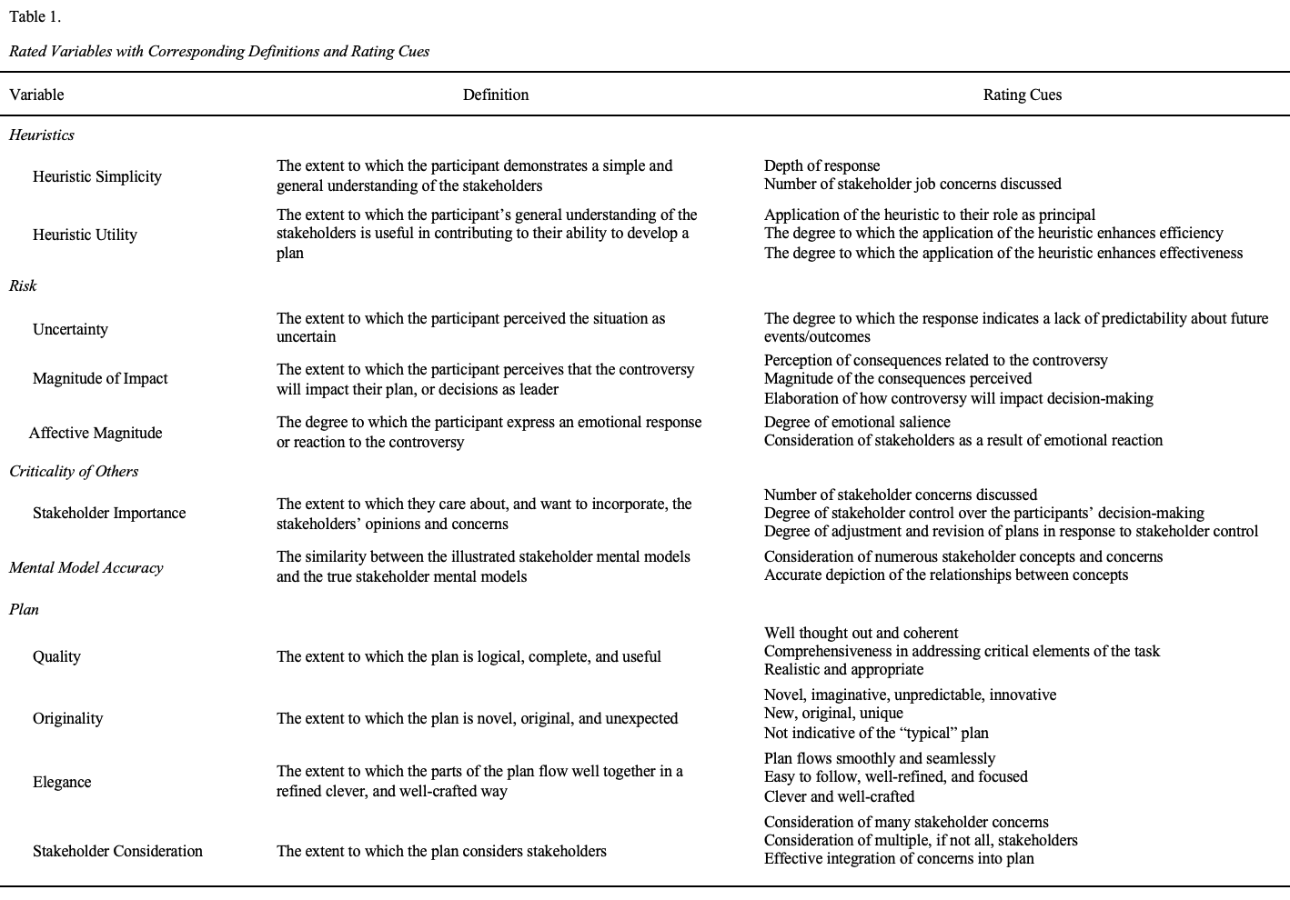
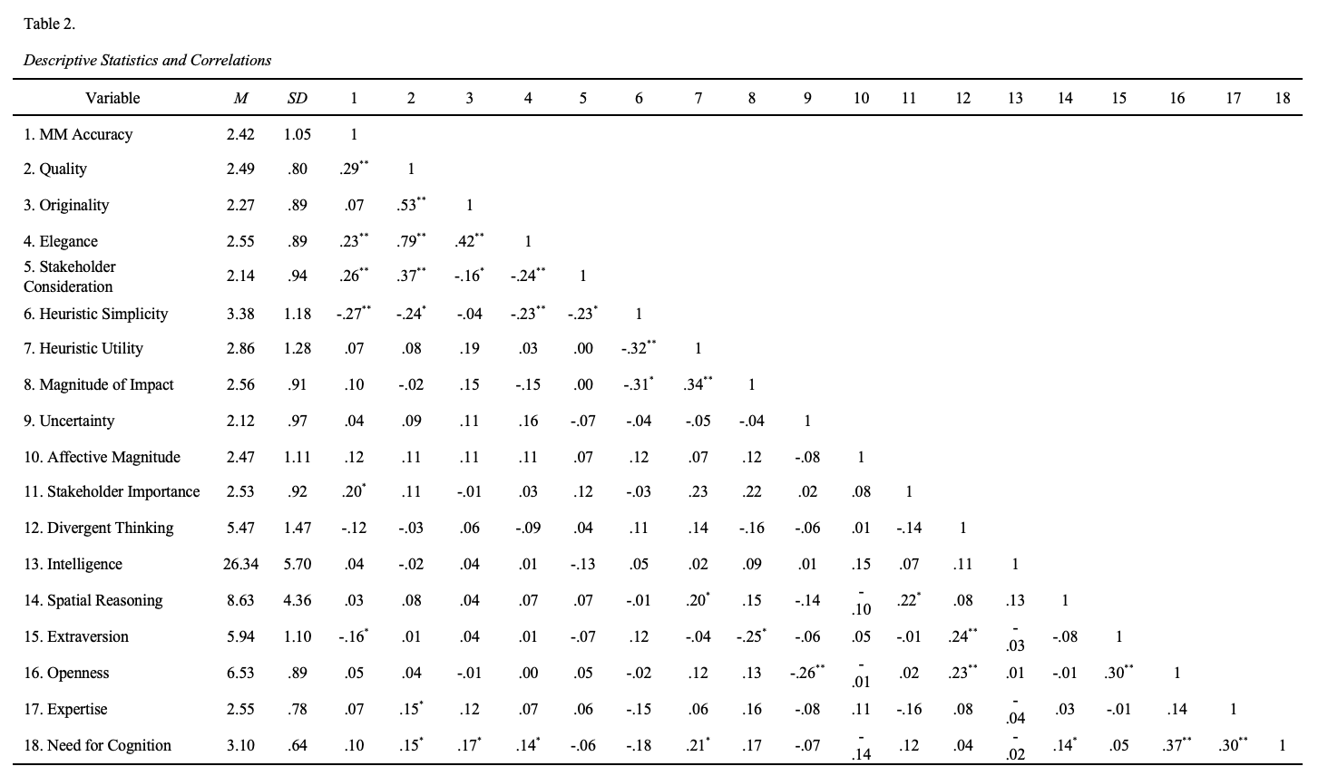

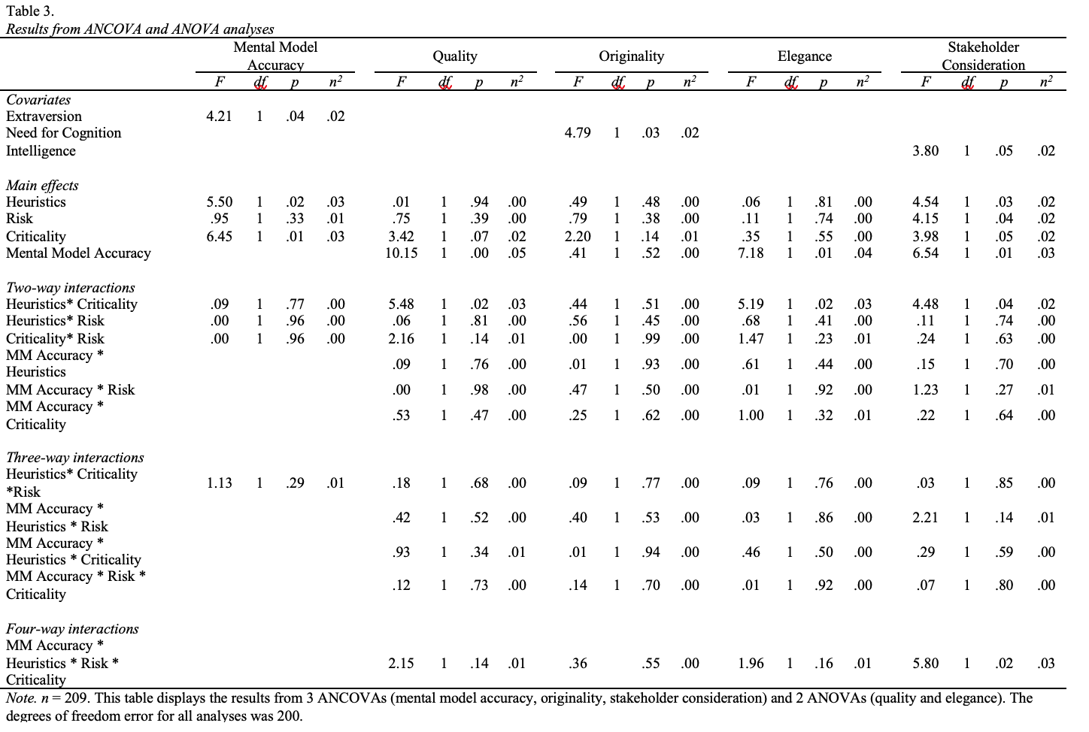
Figure 1
Excerpt from Module 2 of the Mental Model Illustration Training
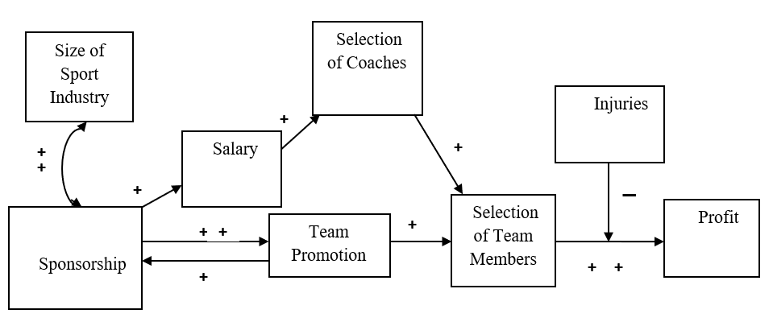
Section 2. After thinking about this mode, Derek realizes there are other important issues he needs to address. He adds the following issues to the list:

- Size of the Sport Industry: The amount buyers (consumers and businesses) are willing to spend on the sport.
- Salary/Contract: The amount the team members and coaches are paid.
- Injuries: The possibility that an athlete can get hurt in a game, during practice, or on their own time which would restrict them from playing.
- Public Promotion of Team: The function of informing or influence people about the sport company’s products, community involvement, or image.

He then adds these issues to his model to see changes in relationships between the issues.

Model #2

Figure 2
District Superintendent Case Information and Corresponding Mental Model

District Superintendent Case Information  As the district superintendent, I have many different responsibilities ranging from securing funding to ensuring curriculum quality, all of which contribute to student success. I have a specific responsibility to ensure that our schools have enough funding to be successful. Obtaining adequate funding is dependent on my ability to be politically competent¹. As I demonstrate political competency, I am able to secure funding from a variety of sources. In addition, I also gain support from the community².  The more funding I secure, the more educational resources I am able to obtain³. Having more educational resources increases curriculum quality⁴ (e.g., better textbooks, more access to technology, etc.). Also, resources give us the ability to create more faculty and staff development programs⁵. As opportunities to develop increase, teaching effectiveness increases as well⁶. As curriculum quality increases, student test scores⁷ and graduation rates⁸ also increase. However, it is important to note that although curriculum quality directly affects student tests scores and student graduation rates, these relationships are positively influenced by teaching effectiveness. In other words, when teachers are more effective, it improves the effect of the curriculum on student test scores⁹ and student graduation rates¹⁰.  As graduation rates increase, I receive more support from the community¹¹, however, when more students fail out or leave the school (i.e., a high attrition rate), graduation rates decrease¹² and community support also decreases¹³. | District Superintendent Mental Model  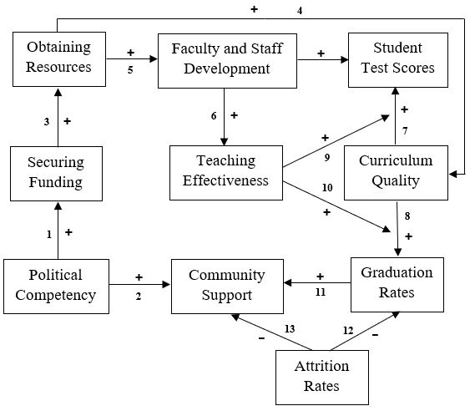
Note. This figure demonstrates the mapping of relationships in the superintendent’s mental model to the superintendent’s case information. The superscripts within the case correspond to the numbered labels in the mental model. The procedure for ensuring this correspondence were the same for all three stakeholders.

Figure 3
Mental Models of Stakeholders

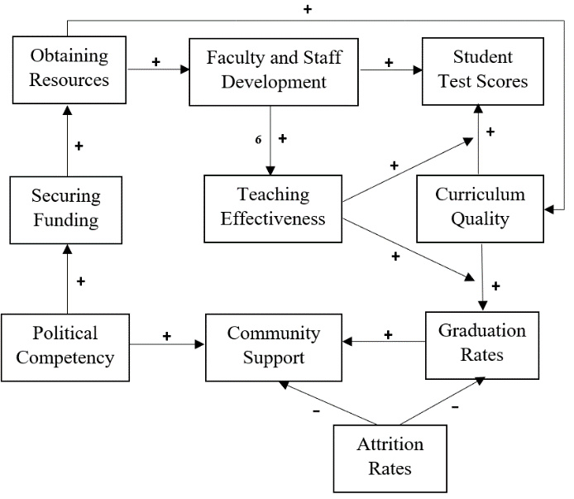  District Superintendent | 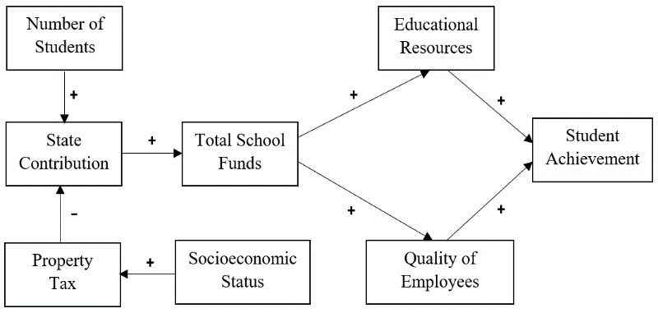  State Funding Representative
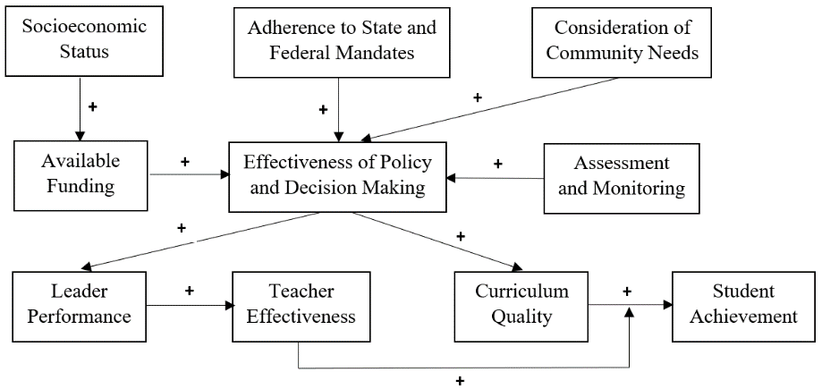
Head of the District School Board
Note. These are the true stakeholder mental models constructed in consultation with the educational literature.

Appendix A: Oklahoma Excel Task Information


Appendix B: Heuristics Manipulation



Appendix C: Risk Manipulation


Appendix D: Criticality of Others Manipulation


