UNIVERSITY OF OKLAHOMA
GRADUATE COLLEGE

WATER USE CONFLICTS IN THE LOWER PECOS, PERMIAN BASIN: A SPATIO-TEMPORAL ANALYSIS OF UNCONVENTIONAL OIL AND GAS DEVELOPMENT AND AGRICULTURE UNDER DROUGHT CONDITIONS

A THESIS
SUBMITTED TO THE GRADUATE FACULTY
in partial fulfillment of the requirements for the
Degree of
MASTER OF SCIENCE

By
ANGELA ROSELLINI-LABOMBARDE
Norman, Oklahoma
2023

WATER USE CONFLICTS IN THE LOWER PECOS, PERMIAN BASIN: A SPATIO-TEMPORAL ANALYSIS OF UNCONVENTIONAL OIL AND GAS DEVELOPMENT AND AGRICULTURE UNDER DROUGHT CONDITIONS

A THESIS APPROVED FOR THE
DEPARTMENT OF GEOGRAPHY AND ENVIRONMENTAL SUSTAINABILITY

BY THE COMMITTEE CONSISTING OF

Dr. Jennifer Koch, Chair

Dr. Travis Gliedt

Dr. Kwangyul Choi

© Copyright by ANGELA ROSELLINI-LABOMBARDE 2023
All Rights Reserved.

ACKNOWLEDGMENTS

I would first like to thank everyone who participated in the research that led to this project and everyone who has contributed to this research over the span of several years. The authors of the precursory paper that guided my research question: Drs. Jennifer Koch, Sophie Plassin, Jack Friedman, Stephanie Paladino, Randy Peppler, as well as Kevin Neal, James Worden, and Madison Wilson. And, of course, the individuals who formulated the idea behind this project and guided my research along the way: Drs. Jennifer Koch, Sophie Plassin, and Randy Peppler. To Dr. Jennifer Koch, thank you for serving as my advisor and guiding me through my first major research project. Your patience, belief in me, and your expertise is probably around 90% of why I was able to complete this project and why I wanted to attend graduate school in the first place.
I also need to thank my family for their immense support and understanding. To my parents, thank you for being so supportive and keeping me motivated despite not fully understanding why I’m willingly subjecting myself to the stress of graduate school. To my partner and best friend, Evan Labombarde, for always listening to my rants about how I’ll never finish this and keeping me on track when I felt it was impossible, and of course, for the input on everything I write or the maps I make. To my son, Lucas, who made sure I don’t work on my computer too much and take the time to ‘relax’ and play with him instead. And a preliminary thank you to my daughter, Olivia, who is not here yet, but her impending arrival prompted me to strongly focus on finishing my writing in time to welcome her to the world.

ABSTRACT

Unconventional oil and gas (UOG) production is increasing rapidly within the U.S., especially the practice of hydraulic fracturing (HF). HF requires large quantities of water, which raises concerns about water scarcity, particularly in arid or semi-arid regions where freshwater is scarce. One of the most productive UOG formations is the Permian Basin, which extends from West Texas into East New Mexico. In this region, the energy sector and the agricultural sector compete for the limited hydrological resources as farmers rely heavily on irrigation using dwindling groundwater supplies or water from the over-allocated Rio Grande River. To make this worse, this area is prone to drought and experienced a megadrought from 2006 to 2015.
This study examines the relationship between UOG production, agriculture, and drought within the Lower Pecos region of the Permian Basin from 2008 to 2021. Previous studies suggest the presence of UOG wells corresponds with an increase in fallow agricultural land, but no such studies have been conducted in a semi-arid region of the U.S. This study uses data from the U.S. Department of Agriculture Cropland Data Layer to identify agricultural areas and their frequency of fallowing agricultural land during the 14-year period. I use point data created from FracFocus data identifying the locations of UOG wells in Texas and New Mexico to examine whether the land immediately surrounding the wells are fallow more often than the land not located near UOG wells. I also use data from the U.S. Drought Monitor to determine if drought impacts this relationship. I hypothesized that agricultural areas immediately surrounding UOG wells will have higher rates of fallowing since water that would normally be used for agriculture is transferred to HF. When under drought conditions, I expected there to be widespread fallowing throughout the study area. The results of this study do not support this hypothesis, and instead found that the fallowing trends throughout the basin do not seem to correspond to either drought conditions or UOG intensity. Overall fallowing trends indicate that until 2018, there were more fallow cells than cropland cells throughout the basin, but the number of fallow cells dropped dramatically in 2017 and after 2018 through 2021, there were more active cropland cells than fallow/idle cropland. UOG intensity increases throughout the basin during the study period, both in the number of wells constructed and the amount of water used per well. This study concludes that while the hypothesis is not supported, there are possibly other factors that impact agricultural and UOG water use. For example, it is possible that farmers switched to less water-intensive crops during drought periods or when new wells were being fractured. It is also possible that HF wells import their water from other sources and are therefore not reliant on available surface or groundwater in the basin. The lack of transparency in UOG wells reporting was the main study limitation. Operators are not required to disclose from the source of the water used. Future research should prioritize verifying UOG wells data by using a combination of sources. This would allow a better understanding of water used across sectors in the Permian Basin.

TABLE OF CONTENTS
ACKNOWLEDGMENTS iv
SUMMARY v
CHAPTER 1: INTRODUCTION 1
CHAPTER 2: BACKGROUND 5
2.1 Unconventional Oil and Gas Production in the United States 5
2.2 Water 7
2.3 Agriculture 8
2.4 Drought 9
CHAPTER 3: MATERIALS AND METHODS 12
3.1 Study Area 12
3.2 Data 14
Cropland Data Layer 15
FracFocus 15
Drought Monitor 16
Lower Pecos HUC (USGS) 16
3.3 Data Processing and Analysis 16
Data Collection and Pre-Processing 16
CHAPTER 4: RESULTS 20
4.1 Fallow Land Frequency & Statistics 20
4.1.1: Fallow and Cropland Frequency 20
4.2 Unconventional Oil and Gas Wells 23
4.2.1: Number of new wells 23
4.2.2: Water use 25
4.3 Drought Statistics 27
4.3.1: Monthly and yearly averages 28
4.3.2: Number of days greater than or equal to 50%, 75%, and 100% drought classification category per month 32
4.4 Agricultural Trends Within Wells Buffer 36
CHAPTER 5: DISCUSSION 39
5.1 Relationships Between Drought, Fallow Land, and UOG Wells 39
5.2 Limitations 40
5.3 Next Steps 42
CHAPTER 6: CONCLUSIONS 44
REFERENCES 45
APPENDIX A 52

LIST OF FIGURES
Figure 1: U.S. Energy Production by Source, 2021. Data from US Energy Information Administration (U.S. Energy Facts Explained - Consumption and Production - U.S. Energy Information Administration (EIA), n.d.) 6
Figure 2: Inset map of study area with each subbasin labeled by hydrologic unit code (HUC), shown in relation to the study area's location within the U.S. (Watershed Boundary Dataset | U.S. Geological Survey, n.d.) 13
Figure 3: Percent of land cover by category from 2008 to 2021 for grass/pasture, evergreen forest, fallow/idle cropland, and developed/low intensity (National Agricultural Statistics Service, USDA, n.d.) 14
Figure 4: Study methodology workflow 17
Figure 5: Fallow land frequency raster for 2008 – 2021 21
Figure 6: Frequency count of cells depicted as fallow from 2008 to 2021 22
Figure 7: Number of cells classified as either active cropland or fallow/idle cropland for each year from 2008 - 2021 23
Figure 8: New wells constructed by year from FracFocus registry (FracFocus, n.d.) 24
Figure 9: Map showing the number of new UOG wells built within each subbasin from 2008 to 2021 25
Figure 10: Cumulative water use by end year (2008 - 2022) 26
Figure 11: Mean, median, and quartile water use by end year (2008 - 2022), outliers removed 27
Figure 12: Drought classification for Lower Pecos (2008 - 2021): Monthly average percent area 28
Figure 13: Annual mean percent of land experiencing extreme drought (D3) and exceptional drought (D4) in 2012 29
Figure 14: Mean percent of land not experiencing drought in 2015 and 2016 30
Figure 15: Mean percent of land experiencing drought conditions vs no drought conditions in 2021 31
Figure 16: Map showing annual percent of land not under drought conditions in 2021 32
Figure 17: Drought classification for Lower Pecos (2008 - 2021): Number of days equal to or greater than 50% in each month 33
Figure 18: Drought classification for Lower Pecos (2008 - 2021): Number of days equal to or greater than 75% in each month 34
Figure 19: Drought classification for Lower Pecos (2008 - 2021): Number of days equal to 100% in each month 35
Figure 20: Map showing UOG wells with 64m radius buffer overlaid with fallow frequency raster (FracFocus, n.d.; National Agricultural Statistics Service, USDA, n.d.) 37
Figure 21: Line chart depicting the frequency count of cropland cells within the UOG wells buffer depicted as fallow from 2008 to 2021 38

LIST OF TABLES
Table 1: Descriptive statistics of UOG well water use excluding 0 values………………….21

CHAPTER 1: INTRODUCTION

The demand for food, water, and energy is increasing worldwide to keep up with population and economic growth, dietary changes, and urbanization. These three aspects are interdependent because both food and energy production are water-intensive practices, and more than a quarter of the world’s produced energy is used on food supply and production (Water, Food and Energy, n.d.). Increased pressure on the food-water-energy nexus threatens progress towards the United Nation’s Sustainable Development Goals, particularly those focusing on hunger and the environment (CITE SDGs). Consistently increased demand on food, water, and energy are a global problem, but specific stressors may change depending on an area’s geography.
As global energy demand continues to rise, oil and gas production must increase to keep pace. In the United States, oil and gas production has skyrocketed, largely due to technological advancements in unconventional oil and gas (UOG) extraction methods like hydraulic fracturing (HF). UOG extraction methods allow for exploitation of oil reserves that were previously too difficult to access using traditional methods. Traditional extraction relies on wells drilled into petroleum reservoirs and using a pump to bring resources to the surface. This effectively limits the depth that can be accessed, and the type of rock plays a major role in determining how cost-effective drilling can be done. HF allows drilling in places that traditional wells cannot easily access, most commonly from shale formations. HF uses large amounts of water mixed with chemicals and proppant to create a slurry, which is then injected into the ground at high pressure. The slurry input causes fractures in the underlying bedrock which allows the shale gas to move freely towards the surface to be captured (Speight, 2016). Thus, UOG production is more water-intensive than conventional natural gas, mainly due to water consumption associated with HF. Currently, the most productive regions in the United States for UOG production are the Marcellus, Utica, Permian, and Haynesville Basins (Annual Energy Outlook 2022 - U.S. Energy Information Administration (EIA), 2022).
The increase in UOG production has brought about environmental concerns such as water availability and water quality. Globally, about 15% of total water consumption is for energy production (Kondash et al., 2018). At the national level, the water used for HF is negligible when compared to other water uses (Kondash et al., 2018). At the regional level, the effects are more apparent in arid and semi-arid climates that experience water stress. In such regions, the high quantity of water required for HF can contribute to groundwater depletion, limited surface water availability, and competition for water resources (Kondash et al., 2018). Many of the UOG producing regions in the United States already face water shortages, which are expected to worsen due to climate change causing more intense and longer lasting droughts (Cayan et al., 2010; Jones & Gutzler, 2016; Melillo et al., 2014). Water security is paramount to energy development; however, it is also essential for agriculture production in semi-arid and arid regions. Irrigation for agriculture is the largest consumer of freshwater in the world (UN-Water, 2023).
In addition to water, UOG expansion requires large amounts of land. Beyond the land required for the well itself, UOG drilling requires the development of roads, drill pads, compressor stations, freshwater storage ponds, and areas for equipment staging and storage (Drohan et al., 2012). Throughout the U.S., more than 200,000 hectares of land were converted or developed for oil and gas development between 2004 and 2015 (Moran et al., 2017). This land use conversion can be associated with decreased ecosystem services, increased fragmentation, and fluctuation in land value (Drohan et al., 2012; Fitzgerald et al., 2020; Moran et al., 2017).
Oil and gas extraction requires significant infrastructure to develop and maintain. One of the largest requirements is human labor. In some areas, particularly those with lower population densities and competitive economic sectors, this can cause competition for labor resources. Since the shale development boom in 2010, the Permian Basin received billions of dollars in direct investment, thus disrupting the region’s economy and already volatile labor market (Wang, 2021). Wages in the energy sector exceed those in the agricultural sector, causing workers to switch sectors for economic gain (Gilmer & Thompson, 2012).
Few studies exist that examine the relationships between a growing UOG sector and local constraints in natural resources. One study found that in North Dakota, the creation and expansion of energy infrastructure was the largest driver of land use change, with a decrease in crop cover and an increase in fallow land (Fitzgerald et al., 2020). Similar trends were observed in Pennsylvania, with 45-62% of well pads built before 2011 occurring on agricultural land, though the extent of agricultural land use conversion was not reported (Drohan et al., 2012).
These issues associated with UOG production have been observed in the Permian Basin of Texas and New Mexico (CITE!). The basin is experiencing rapid UOG development which is projected to continue to exploit the area’s large reserves of oil and natural gas (Scanlon et al., 2020). The prevalence of UOG extraction in the area is economically beneficial and ensures domestic supply can fulfill the national energy demand. However, this put a strain on the region’s water supply which the agricultural industry relies on for irrigation. Irrigation is the primary consumer of water in the Permian Basin, accounting for around 90% of withdrawals (Scanlon et al., 2017). HF wells require large amounts of water, and the water demand per well has increased almost ninefold from 2011 to 2017 (Scanlon et al., 2020). Surface water is scarce in this semi-arid region, and the aquifers beneath the land are overdrawn to the point where they are decreasing around three feet per year (Texas Water Development Board, 2021). The prevalence of HF wells in the Permian Basin has also been associated with an increase in seismic activity (Snee & Zoback, 2018).
One study suggests that agriculture in parts of the Permian Basin is being affected by stressors not present throughout the rest of the state or ecoregion. Researchers examined the practice of leaving agricultural land fallow throughout the U.S. portion of the Rio Grande/Río Bravo River Basin from 2008 to 2018 as a proxy for understanding water conservation practices. Throughout the basin, fallow land decreased overall. At the state level, there was an observed increase in fallow land for Colorado and New Mexico, and a decrease in fallow land in Texas. However, there were hotspots of fallow land identified in Reeves and Culberson counties in West Texas (Plassin et al., 2021). These two hotspots occurred within the semi-arid Permian Basin, an area that is experiencing rapid UOG development and frequent droughts. The authors concluded that further research is needed to investigate the driving factors behind the fallow land hotspots identified in their study (Plassin et al., 2021).
UOG production has been associated with increased competition for water and high rates of land use conversion (Drohan et al., 2012; Fitzgerald et al., 2020). Studies have examined the ecosystem services, forest fragmentation, and decreased water availability associated with UOG expansion, but no such study has focused on a semi-arid region with high agricultural output. The Permian Basin of Texas and New Mexico embodies this climate, and Plassin et al., (2021) observed hotspots of fallow land inconsistent with surrounding land use. Hence, the objective of this research is to investigate the fallow land hotspots in a semi-arid region to better understand the relationship between UOG development, agricultural land use change, and drought in the Lower Pecos region of the Permian Basin. For this, I used methods from the field of Geographic Information Systems to analyze land use/cover data of areas surrounding well pads for the period 2008 to 2021, as well as spatiotemporal information on drought conditions and water use.

CHAPTER 2: BACKGROUND

2.1 Unconventional Oil and Gas Production in the United States
Global energy demand has increased exponentially in recent decades and is projected to continue increasing through at least 2040 (Ahmad & Zhang, 2020). The increase in demand is driven by population and economic growth, dietary changes, and a growing middle-class (Melillo et al., 2014). Nations strive to be energy independent to ensure their own futures and can increase their gross domestic product by selling excess energy resources (Ahmad & Zhang, 2020). Thus, adequate energy generation is tied to sustainable development globally.
A global energy crisis in the 1970s prompted the United States to increase petroleum exploration to find economically viable sources (Speight, 2016). Production fluctuated in the following decades, but since 2019, domestic energy production in the U.S. has exceeded energy consumption (U.S. Energy Facts Explained - Consumption and Production - U.S. Energy Information Administration (EIA), n.d.). This is due largely to unconventional oil and gas extraction techniques that drastically increased access to domestic supplies of natural gas. This shift in increased energy production has coincided with international agreements seeking to decrease carbon dioxide emissions, causing a decrease in the use of coal as an energy source and a slight increase in energy production from renewable sources (Ahmad & Zhang, 2020). Figure 1 shows U.S. primary energy production by source in 2021, with most of it coming from natural gas (U.S. Energy Facts Explained - Consumption and Production - U.S. Energy Information Administration (EIA), n.d.).
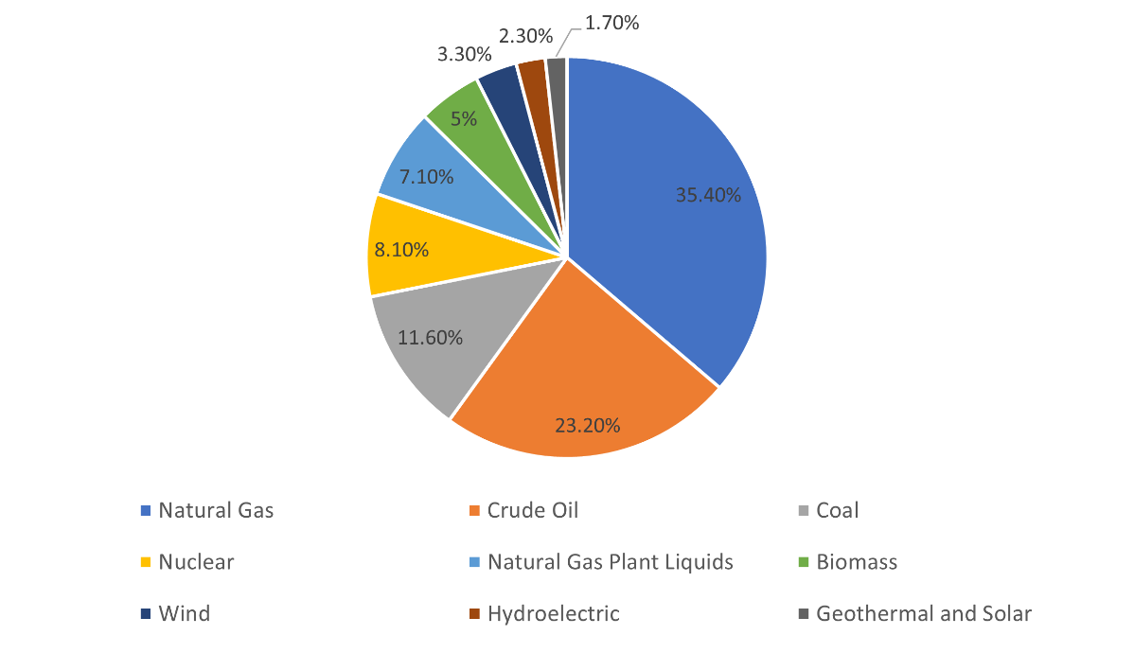
Figure 1: U.S. Energy Production. Source: U.S. Energy Information Administration (U.S. Energy Facts Explained - Consumption and Production - U.S. Energy Information Administration (EIA), n.d.)

Unconventional oil and gas production has increased rapidly over the last decade in the U.S. (Kondash et al., 2018; Scanlon et al., 2020). UOG refers to methods such as hydraulic fracturing and horizontal drilling, which allow for petroleum extraction from geologic formations that were initially thought too difficult to exploit. Hydraulic fracturing is an extractive method that allows for the creation of flow pathways within low-permeability geologic formations so that the oil or gas trapped within can be recovered. HF combined with horizontal drilling allows access to natural gas reserves that were previously thought too difficult or expensive to access (Speight, 2016). Hydraulic fracturing has existed in the U.S. since 1947, but the technology was primitive, so it was not economically viable for widespread use (Speight, 2016). Modern HF technology has bridged this gap, allowing for easier fracturing methods that are economically feasible. To hydraulically fracture a new well, large quantities of water and fracturing fluids are required (Speight, 2016). The composition of the fracturing fluid is dependent on the individual geologic formation. Some consist of only water and sand, whereas others use complex mixtures of chemical additives (Speight, 2016). A typical horizontal shale gas well requires between 2 and 4 million gallons of water during the initial fracturing process (Hitaj et al., 2014).
In 2018, the U.S. became the top global exporter of oil and dry natural gas (Annual Energy Outlook 2022 - U.S. Energy Information Administration (EIA), 2022). That year, the U.S. produced 22 trillion cubic feet of dry natural gas from unconventional reservoirs, accounting for ~70% of total U.S. natural gas production (Scanlon et al., 2020). Especially in highly productive unconventional reservoirs, the production of natural gas is expected to continue increasing. Most domestically produced unconventional natural gas comes from the Wolfcamp Play in the Permian Basin, Marcellus and Utica plays in the Appalachia Basin, and the Haynesville play in the Mississippi-Louisiana Salt Basin (Annual Energy Outlook 2022 - U.S. Energy Information Administration (EIA), 2022). Due to its economic success, UOG is the number one method for all new extraction projects in the U.S., with gas from tight oil plays expected to be the primary source for all natural gas production through 2050 (Annual Energy Outlook 2022 - U.S. Energy Information Administration (EIA), 2022; Moran et al., 2017).

2.2 Water
Global climate change will have a major impact on water availability worldwide. Areas that are prone to large amounts of precipitation will likely see more of it over smaller time scales, leading to events like floods and landslides. Conversely, areas that have lower rates of precipitation and high rates of evaporation may experience even dryer conditions than before (Konapala et al., 2020). The Southwestern U.S. is one such region that is at risk of more frequent droughts due to changing evaporation and precipitation rates due to atmospheric greenhouse gas concentrations. One study suggests that such climatic changes will make this region prone to not only more extreme droughts, but also aridification (Jones & Gutzler, 2016).
Water demand in the Southwestern United States has increased due to population growth, urbanization, urban sprawl, agriculture, and industrial development (MacDonald, 2010). The Permian Basin experiences high water demand for these reasons but is also one of the highly productive oil and gas producing regions identified in the previous section. Globally, about 15% of total water consumption is for energy production (Kondash et al., 2018). Competition for water resources is exacerbated by the oil and gas industry’s UOG extraction operations.
Since the initial boom in horizontal drilling starting in 2008, associated water use has become a concern (Kondash et al., 2018; Pierre et al., 2018). UOG extraction requires large quantities of water to initially fracture the well, but specific amounts are time and location dependent (Clark et al., 2013; Kondash et al., 2018). In the Permian Basin specifically, the amount of water used per well increased almost ninefold from 2011 to 2017, reaching its peak water use in 2017 (Scanlon et al., 2020). With horizontal drilling expected to continue increasing in the Permian Basin, the expected future water demand for energy production exceeds the managed available groundwater and is likely to contribute to aquifer depletion (Scanlon et al., 2020; Texas Water Development Board, 2021). Within the Permian Basin of Texas and New Mexico, about 91% of water use is for agricultural irrigation, followed by about 6% for municipal water use (Scanlon et al., 2017). The mining industry, which includes UOG extraction, accounts for around 2% of the water demand in Texas (Texas Water Development Board, 2021). The Texas State Water Plan anticipates a 32% decrease in groundwater supplies from 2020 to 2070, and they expect the aquifers beneath two of the major UOG plays to be completely depleted by 2070 (Texas Water Development Board, 2021).
Once water is used to fracture a new well, most of it returns to the surface as produced water (Speight, 2016). Produced water contains various additives from the fracturing process, including salts, organic matter, and naturally occurring radioactive elements (Kondash et al., 2018). Produced water is often disposed of by storing it in injection wells, which correlates with increased seismicity (Scanlon et al., 2020). There are concerns about produced water contaminating drinking water when improperly disposed of (Scanlon et al., 2020; Speight, 2016). Of the eight major UOG plays in the U.S., the Permian Basin reports having the largest quantity of produced water (Scanlon et al., 2020). There is potential to reuse produced water in fracturing new wells instead of disposing of it, but it requires further study (Scanlon et al., 2020).

2.3 Agriculture
Worldwide, the largest user of freshwater resources is agricultural irrigation (AQUASTAT - FAO’s Global Information System on Water and Agriculture, n.d.). Not every region will experience water stress or water availability in the same way due to global climate variations. However, in the southwestern U.S., water supplies can be scarce due to competing water uses, growing populations, dietary changes, and urban sprawl (MacDonald, 2010; Melillo et al., 2014). To make matters worse, this region recently experienced a severe drought from 2000 to 2018 (Williams et al., 2020). Seasonal snowpack melt is a primary contributor to the area’s water supply, but this has been declining since the 1950s (Mote et al., 2018). The literature indicates that the U.S. Southwest will be more prone to droughts and decreased surface water availability in the future (Cayan et al., 2010; Jones & Gutzler, 2016).
Within the Permian Basin of Texas and New Mexico, about 91% of water is used for agricultural irrigation (Scanlon et al., 2017). The region’s semi-arid climate means that agricultural production is heavily reliant on irrigation to maintain crop yields (Scanlon et al., 2020). One way to reduce water demand for the agricultural sector is the practice of fallowing, where the land is taken out of production for one or more growing seasons (Food and Agriculture Statistics, n.d.). Not only does this practice temporarily reduce the need for water additions, but fallowing cropland allows the soil to recover and enhance its moisture retention abilities, decrease evapotranspiration, and enhance groundwater recharge (Scanlon et al., 2005). Fallowing land can be done either permanently or on a rotational basis (Richter et al., 2017). Some states, such as California, Colorado, and Texas, offer financial incentives for farmers to leave their land fallow for a set amount of time in an effort to conserve water (Richter et al., 2017). In Texas, farmers can sell their water rights to oil and gas companies, impacting their ability to irrigate (Hitaj et al., 2014). Thus, there is a trade-off in financial incentives involved for farmers. However, through selling their water or mineral rights to oil and gas companies, they can potentially benefit from the associated infrastructure development, such as roads (Fitzgerald et al., 2020). Hence, fallowing trends are likely to be influenced not only by water availability, but also by external factors such as UOG development and other financial incentives.

2.4 Drought
There are several different definitions of drought; drought is generally defined as “a deficiency of precipitation over an extended period of time (usually a season or more), resulting in a water shortage” (Drought Basics | Drought.Gov, n.d.). Different agencies have more specific definitions. For example, according to the American Meteorological Society, drought is “a period of abnormally dry weather sufficiently long enough to cause a serious hydrological imbalance” (Drought Basics | Drought.Gov, n.d.). The National Oceanic and Atmospheric Administration defines drought as “a deficiency of moisture that results in adverse impacts on people, animals, or vegetation over a sizeable area” (Drought Basics | Drought.Gov, n.d.). While most definitions are similar, the variations in definition cause difficulty in definitively stating what does or does not constitute a drought. This lack of a cohesive definition means that droughts have been defined differently across regions and throughout time periods. In the U.S., the U.S. Drought Monitor (USDM) is most commonly used because it is a composite index of multiple factors, including precipitation, soil moisture, evaporative stress, surface water flow, and vegetative health (Kuwayama et al., 2019; What Is the USDM? | U.S. Drought Monitor, n.d.). Here, I also use the composite index provided by the U.S. Drought Monitor (What Is the USDM? | U.S. Drought Monitor, n.d.).
Droughts can have severe consequences, including a potential for decreased agricultural production, supply chain disruptions, wildfires, poor human health outcomes, ecosystem degradation, and decreased water quality and quantity as a result of droughts (Intergovernmental Panel on Climate Change (IPCC), 2023). In semiarid to arid regions, droughts have important impacts on the agricultural sector, with a multitude of studies exploring the relationship between drought and crops yields (Iqbal et al., 2020; Kuwayama et al., 2019; Lipiec et al., 2013). One study examined the impacts of drought on agricultural yields and farm income and found that in dryland or irrigated agricultural areas, being in any drought category reduced corn and soybean crop yields between 0.1% and 1.2% with additional decreases for each additional week under drought (Kuwayama et al., 2019).
Much of the Western U.S. underwent a mega-drought from 2006 to 2015 (Kogan & Guo, 2015), and the Lower Pecos region of the Permian Basin experienced a mega-drought from 2000 to 2018 (Plassin et al., 2021). Climate projections suggest that the Permian Basin region will be more prone to droughts in the future continued greenhouse gas emissions and declining snowpack to replenish the area’s rivers (Jones & Gutzler, 2016; Mote et al., 2018). Over time, the increasing dryness of the Southwestern United States may cause aridification, defined as a more permanent change to a drier climate as measured by the ratio of precipitation to evapotranspiration demand (Jones & Gutzler, 2016; Park et al., 2018).
Two states which are likely to be affected by increased droughts are Texas and New Mexico (New Mexico Interstate Stream Commission, 2018; Texas Water Development Board, 2021). Both states have expressed in their water plans that drought will have the biggest impact on future water supplies due to their prevalence and unpredictable nature (New Mexico Interstate Stream Commission, 2018; Texas Water Development Board, 2021). Texas in particular claims that the state’s climate will be the main factor influencing its water planning, which was evidenced by the statewide drought they experienced from 2010 to 2014, with 2011 being one of the worst one-year droughts on record (Texas Water Development Board, 2021). New Mexico has implemented several drought strategies in its water plan, including the use of surface water during wet years and groundwater during dry years- a technique called conjunctive use portfolio, exploring alternate water supplies such as effluent reuse and desalination, expanding drought mitigation and planning efforts, and more effective monitoring of drought conditions (New Mexico Interstate Stream Commission, 2018). Even with drought mitigation efforts in place, future climate variability indicates that the effects can be unpredictable, and the effects of long-term droughts may be catastrophic to local economies, agriculture, and human health (MacDonald, 2010).

CHAPTER 3: MATERIALS AND METHODS

3.1 Study Area
The Permian Basin is a large sedimentary basin in western Texas and eastern New Mexico consisting of low-permeability shale rock that contains several sub-basins and plateaus (Snee & Zoback, 2018; Speight, 2016). It is known for being a highly productive oil and gas formation, accounting for 40% of U.S. oil production and 15% of its natural gas production (Scanlon et al., 2017). Oil and gas production in this area is expected to continue increasing due to the economic success of HF and to keep up with domestic energy demand. The Permian Basin area into two watersheds: the Rio Grande watershed in the south/southwest, and Texas Gulf watershed in the north/northeast (Texas Water Development Board, 2021).
To focus on agricultural hot spots overlapping with UOG areas, the study area is constrained to the Lower Pecos subregion of the Rio Grande watershed (Figure 2). The Lower Pecos subregion covers the south-central part of the Permian Basin. There are 12 sub-basins within the Lower Pecos Hydrologic Unit, which extends from south-central Texas into western New Mexico. The Lower Pecos basin contains three major aquifers (the Ogallala, Edwards-Trinity Plateau, and Pecos Valley aquifers) and four minor aquifers (Scanlon et al., 2017).
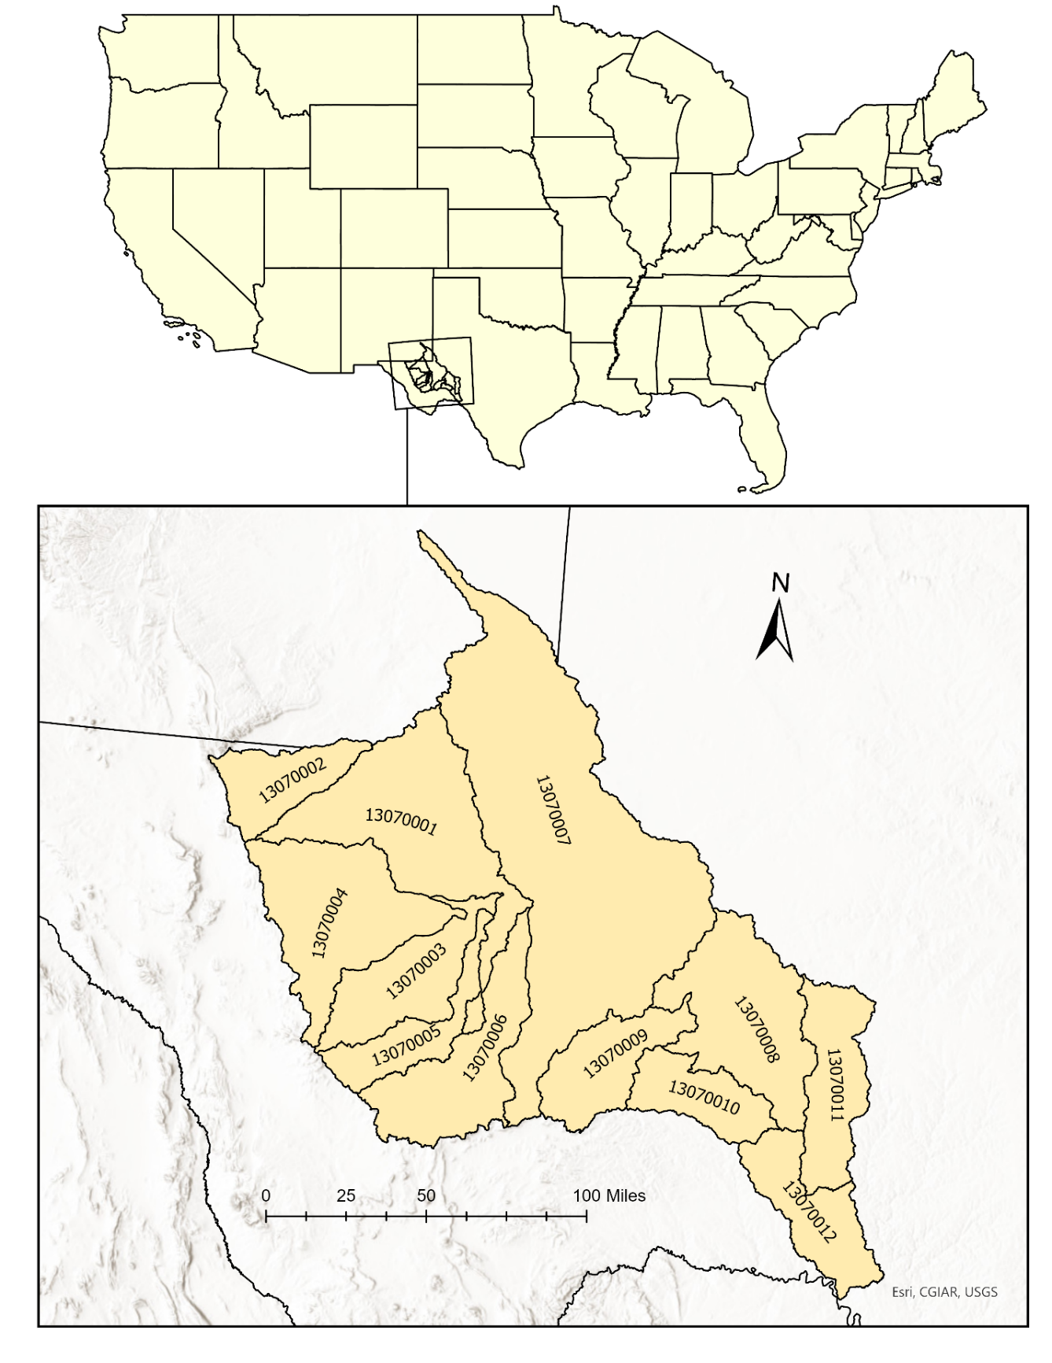
Figure 2: Map of study area with each subbasin labeled by hydrologic unit code (HUC), shown in relation to the study area's location within the contiguous U.S. (Watershed Boundary Dataset | U.S. Geological Survey, n.d.)
Within the Lower Pecos basin, most land use is categorized as shrubland, which ranges from approximately 91% to 94% of the basin’s land cover between 2008 and 2021. After shrubland, the primary land use/land cover classifications are grass/pasture, evergreen forest, fallow/idle cropland, and developed/low intensity (National Agricultural Statistics Service, USDA, n.d.). Figure 3 details the second through fifth most prominent land use/land cover categories throughout the study period. Grass/pasture is consistently the second most common land cover category from 2008 to 2021. Evergreen forest is the third most common in 2008 but drops briefly in 2010 and then again in 2019 to the fourth most common. Fallow/idle cropland starts as the fourth most common land use category but drops to fifth in 2018. Developed/low intensity is the fifth most common land use throughout the study area in 2008 and remains at this position until 2018 when it jumps to third most common.
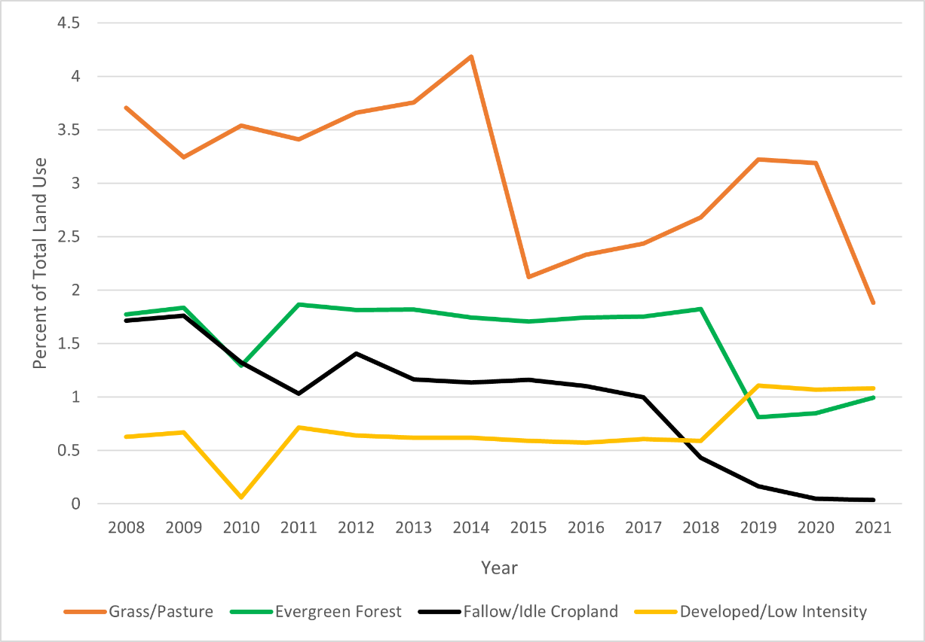
Figure 3: Percent of land cover by category from 2008 to 2021 for grass/pasture, evergreen forest, fallow/idle cropland, and developed/low intensity for the Lower Pecos subbasin (National Agricultural Statistics Service, USDA, n.d.)

3.2 Data
This study uses data from multiple sources to represent the four main components of the analysis. I required agricultural data able to discern specific crop types and fallow/idle cropland, data on UOG wells that includes both the geographic location and the water use, drought data, and a discrete study area outline.

Cropland Data Layer
The U.S. Department of Agriculture (USDA) National Agricultural Statistics Services Cropland Data Layer (CDL) is a satellite-derived dataset starting in 2008 with crop-specific land use information (Boryan et al., 2011). Data has been collected from various sensors since the program began, but the current combination of sensors used includes Landsat 8 and 9 OLI/TIRS sensor, the Disaster Monitoring Constellation DEIMOS-1, and the ISRO ResourceSat-2 LISS-3. Imagery is collected daily throughout the growing season, resulting in an annual 30-meter resolution raster that classifies agricultural land use with more detail than other datasets. The dataset identifies over 130 cropland cover types including fallow/idle cropland. Accuracy assessments are done each year using training and validation data for the overall dataset and for individual land use categories. Throughout the study period, the producer’s accuracy for fallow/idle cropland ranged from 46.9% to 69.6% for New Mexico and between 37.9% to 59.7% for Texas (USDA - National Agricultural Statistics Service - Research & Science - Cropland Data Layer - Metadata, n.d.).

FracFocus
FracFocus is a chemical disclosure registry created in 2011 by the Ground Water Protection Council and the Interstate Oil and Gas Compact Commission with support from the U.S. Department of Energy (About FracFocus, 2022). The goal of FracFocus is to make hydraulic fracturing chemical data accessible. Participation in FracFocus’ registry was optional in the beginning but is now required by many states. Texas is one of the states that allows well operators to meet their state reporting requirements by disclosing chemical information through FracFocus, but New Mexico is not. The downloadable FracFocus registry contains the state name, county name, and the latitude and longitude coordinates for each well. The table also includes the chemicals used as proppant, the chemical supplier, operational start date and end date, well depth, and water use per well in gallons. Data from FracFocus is freely available as a collection of MS Excel files. FracFocus entries are uploaded by individual well operators, which creates potential for human error or misreporting to affect the data. The FracFocus registry started in 2011, but some data was entered retroactively for wells built before then. New FracFocus registry data is available through the present day.

Drought Monitor
The U.S. Drought Monitor (USDM) is a spatial dataset published on a weekly basis, depicting drought conditions within the U.S. The data includes five drought classifications: abnormally dry (D0), moderate drought (D1), severe drought (D2), extreme drought (D3), and exceptional drought (D4) determined by a combined index of soil moisture, surface water flow, vegetative health, and precipitation (What Is the USDM? | U.S. Drought Monitor, n.d.). The USDM is a joint effort between the National Drought Mitigation Center at the University of Nebraska-Lincoln, the National Oceanic and Atmospheric Administration, and the USDA. Weekly drought data is available for download in different data formats.

Lower Pecos HUC (USGS)
The USGS maintains a Watershed Boundary Dataset (WBD) that provides the outlines for watersheds as polygon datasets. Hydrologic unit codes (HUCs) are assigned to each polygon at a hierarchical level. The coarsest resolution is the two-digit hydrologic unit, which divides the U.S. into 21 regions. From there, hydrologic units are divided further into subregions, basins, subbasins, watersheds, and subwatersheds. For this study, I used the subbasin level data.

3.3 Data Processing and Analysis
In my study design, I follow the research described in Fitzgerald et al. (2020). The study also used the CDL for agricultural data but used a private firm’s oil and gas well data. They created a 90 m by 90 m fishnet grid over their study area and calculated the area per cell covered by a given agricultural land use category. They then used oil and gas well point data to determine the intensity of petroleum activity by assigning each well a 64m buffer to approximate each well’s individual footprint. They then analyzed whether the creation of a new well impacted the agricultural activity occurring within the same cell as the UOG activity (Fitzgerald et al., 2020). The data processing flow is outlined in Figure 4.

Data Collection and Pre-Processing
I acquired the CDL annual data from the CropScape website (National Agricultural Statistics Service, USDA, n.d.) for the time series 2008 – 2021 and for the states of Texas and New Mexico. This data comes as individual GeoTIFF files for each state and year. Using ESRI’s ArcGIS Pro and the arcpy Python library, I projected the files to USA Contiguous Albers Equal Area Conic USGS, clipped to the study area, removed the background, and performed the mosaic function to combine the two annual rasters for both states into one, resulting in 14 annual raster files. From here, I created two products. The first being a frequency raster depicting how many times each cell was fallow throughout the study period, and the second being a cumulative point file showing the land use classification for each year for the entire study area.
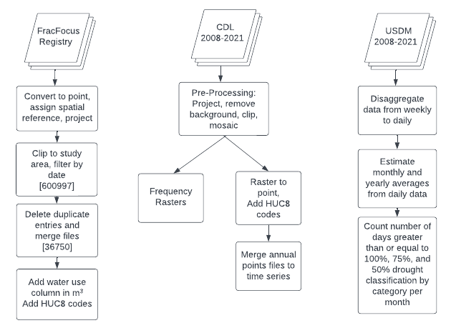
Figure 4: Study methodology workflow

I created a frequency raster for the 14-year period by reclassifying each raster into binary classification. Fallow cells (code 61) were reclassified as value 1, and cropland cells (values 1-6; 10-14; 21-39; 41-60; 66-72; 74-77; 205-215; 217-228; 229-250; 254) reclassified to value 0. All other land use codes were given null values (i.e., nodata values). Next, I used cell statistics to sum the values for each cell, creating one final raster with the value of each cell representing how many times during the study period that cell was classified as fallow.
The second product for the CDL files was a cumulative point file. For this, I used the raster to point tool in the arcpy library to loop through the annual raster files and generate 14 files as output, each containing 59,369,322 points. Next, I spatially joined the files together to create one final output file with the attribute table containing columns for each year’s grid codes. This provided a time series analysis for each point which represents a 30m grid cell. Due to the size of the file, it made more sense to clip the cropland file by HUC-8 code, resulting in 12 individual point files, one for each HUC-8 unit within the study area.
Unconventional oil and gas well data was downloaded from the FracFocus Registry website which arrived as 25 .csv files which I then converted to a shapefile format. I then projected the files to USA Contiguous Albers Equal Area Conic USGS and then used a loop to clip the 25 shapefiles to the study area. Next, I created a temporal filter to keep only the wells that were active during the study period. The original data included start dates and end dates in string format. To allow for date querying, I added two new fields to the attribute tables and formatted them as date data types. Once the dates were in the correct format, I used Python and arcpy to loop through the files, select by attributes the wells that were active during the study period, and delete the rest. Next, I merged the resulting files into one point shapefile. Then I used Microsoft Excel to open the final csv file and create a new column for water use in cubic meters. Water use was originally reported in gallons, so I performed the conversion using the formula described in Equation 1.
$cubic meters=gallons x 0.003785$ (1)
Next, I created a buffered file using the points. I created a 64m radius buffer around each well point. This buffer distance was based on a similar study conducted on the Bakken Shale formation in North Dakota (Fitzgerald et al., 2020). The authors of this study used well point data and imagery to determine the appropriate buffer size to represent the approximate footprint from an individual well pad.
I then used a Python script to take the drought .csv files, downloaded from the U.S. Drought Monitor, to disaggregate the weekly data into approximate daily data by copying the weekly value for each day. From there, the script calculated the monthly and yearly average values. The final step of the script created four new .csv files using the daily, monthly, and yearly averages that counted the number of days greater than or equal to 50%, 75%, and 100% for each drought category per month.

CHAPTER 4: RESULTS

4.1 Fallow Land Frequency & Statistics

4.1.1: Fallow and Cropland Frequency
Figure 5 depicts the fallow frequency raster for the entire study area. This map considers only individual cells that were classified as either cropland or fallow land at least once throughout the study duration. There are large areas of land within the study area that are not classified as agricultural, but there is an apparent concentration of agricultural activity in the central-west portion of the basin. The most prominent areas include sections of subbasins 13070003, 13070004, and 13070001, as well as the northern portion of subbasin 13070007. Almost no agriculture is located in the southeastern or northwestern sections of the study area.
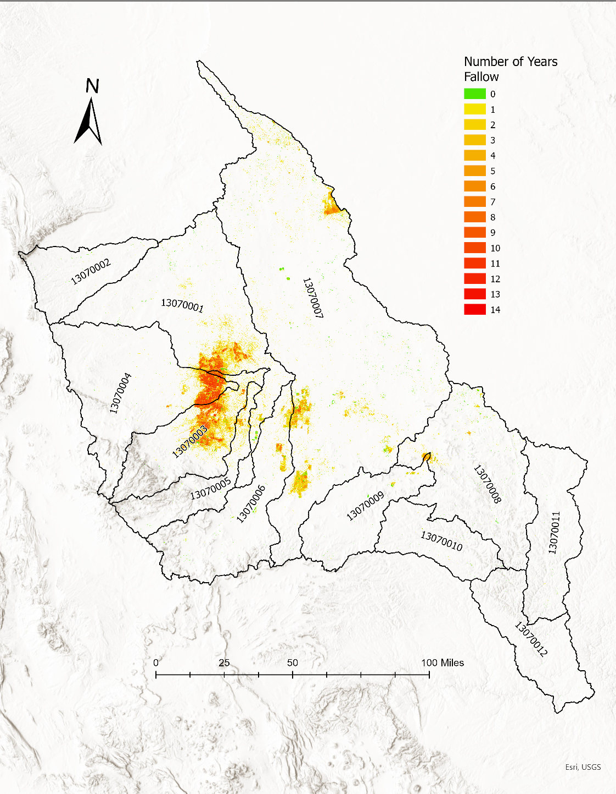
Figure 5: Fallow land frequency raster for 2008 – 2021 (National Agricultural Statistics Service, USDA, n.d.).

Figure 6 details the spatial frequency trends of fallow land throughout the basin. There is a total of 59,369,322 30m by 30m cells within the study area. Figure 6 considers only cells that were at any point during the study period considered either active cropland or fallow/idle cropland. Of those cells, 175,460 were active cropland throughout the entire study period. The majority of cropland was fallow for one year (1,041,782 cells), and then the number decreases as the number of years fallow increases. There is an increase in the number of cells that were fallow 8 and 9 times throughout the study period, then a gradual decrease to the minimum number of cells that were fallow for all 14 years, with only 5 cells.
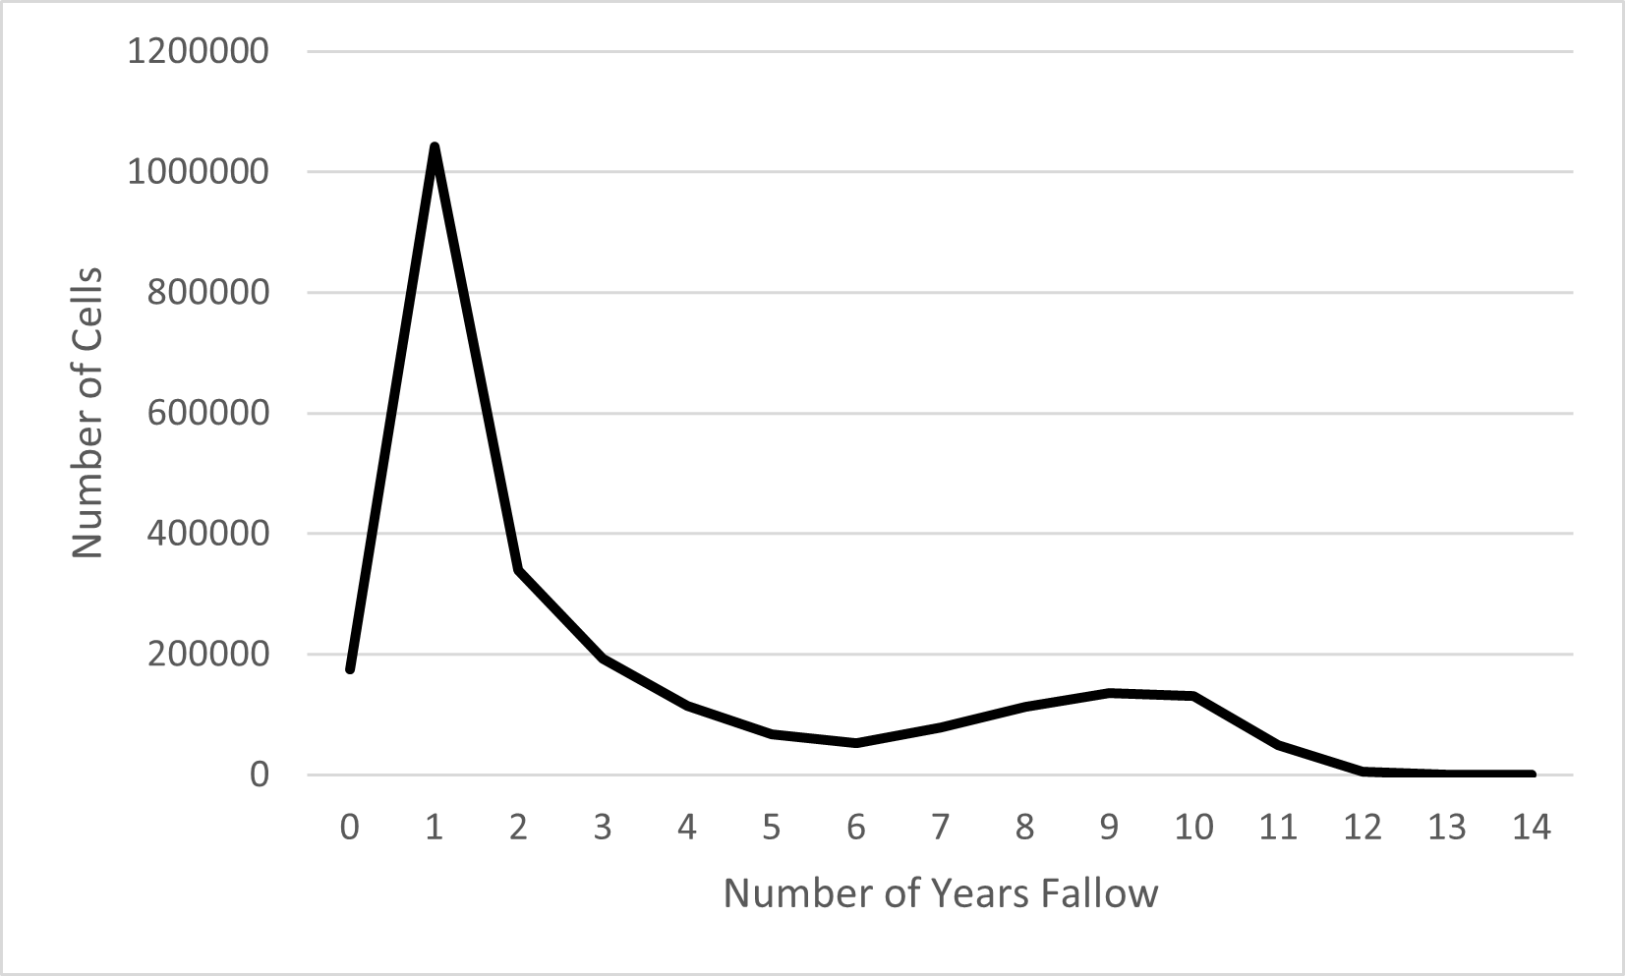
Figure 6: Frequency count of cells depicted as fallow from 2008 to 2021.

Figure 7 displays the comparison between active cropland and fallow/idle cropland, which indicates how many cells were active cropland for each year during the study period compared to the number of cells that were fallow/idle cropland. From 2008 to 2018, there were far more idle/fallow cells than active cropland, with a sharp decrease in fallow land from 2017 – 2018. From 2018 to 2021, there were more cropland cells than fallow cells.
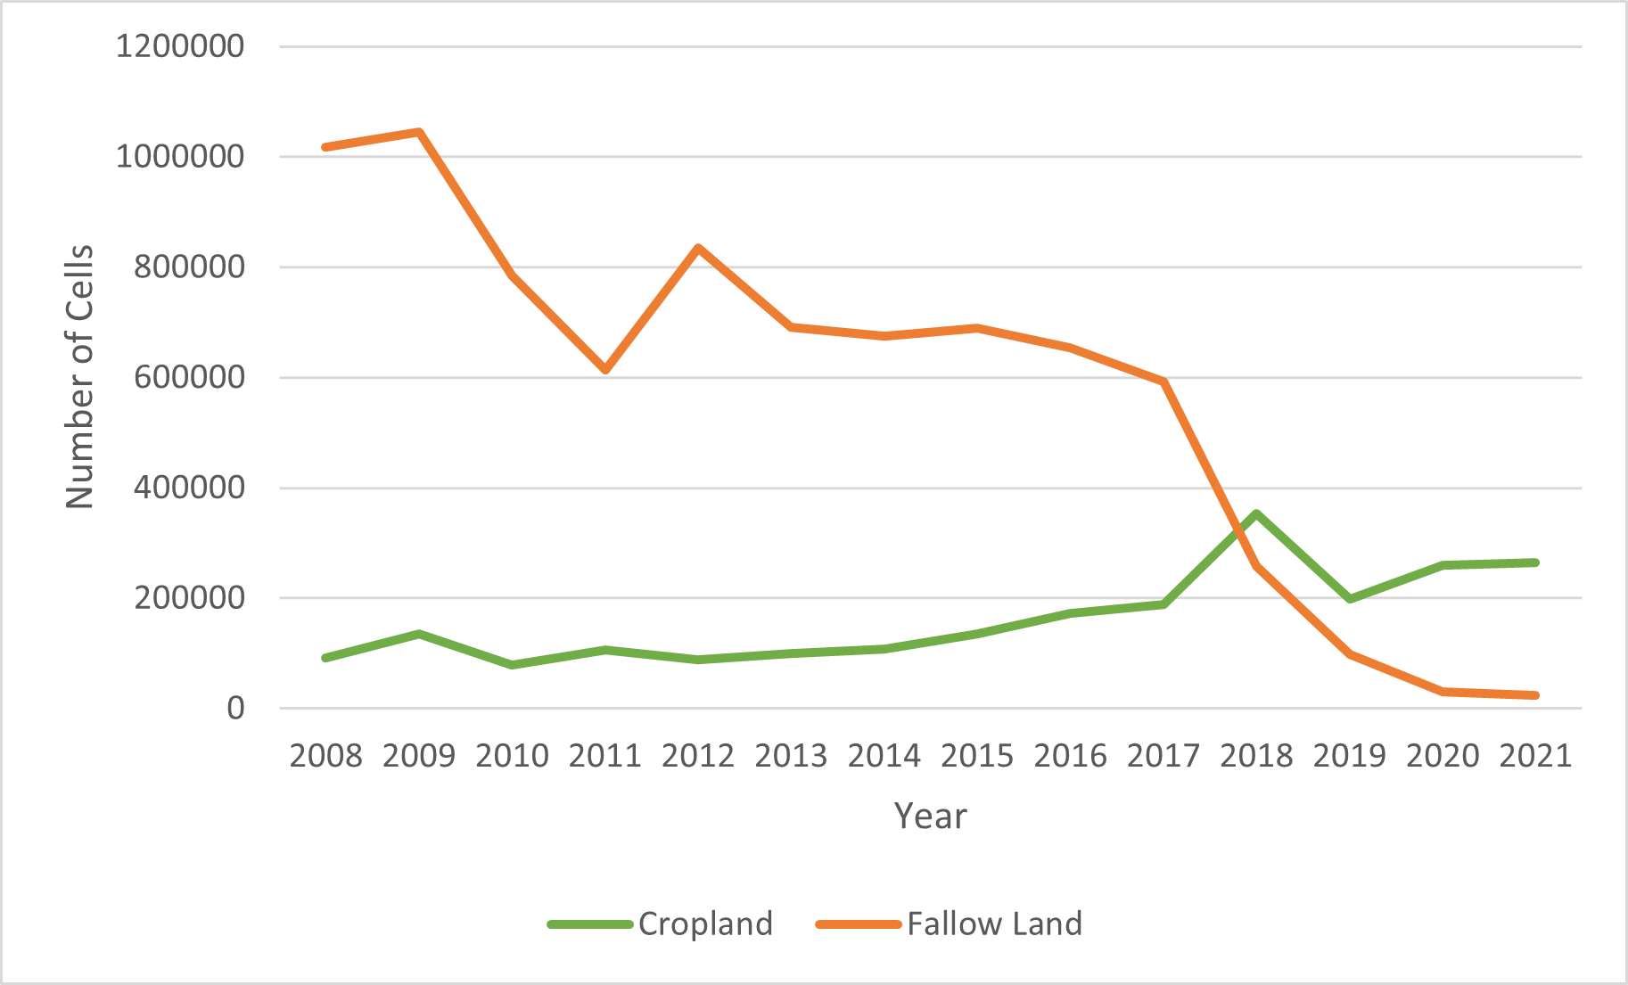
Figure 7: Number of cells classified as either active cropland or fallow/idle cropland for each year from 2008 – 2021.

4.2 Unconventional Oil and Gas Wells

4.2.1: Number of new wells
Figure 8 details how many new wells were reported per year. From 2008 to 2021, there were 36,749 new wells reported to the FracFocus registry. There were no new wells reported in 2008, 6 wells reported in 2009, and 2 wells in 2010. An increase in new wells is visible in 2011, and the numbers increase through 2013. There was a decrease in new wells reported in 2016, followed by another increase through 2019, a decrease in 2020, and another increase in 2021. The most reported new wells occurred in 2019 with 5,013.
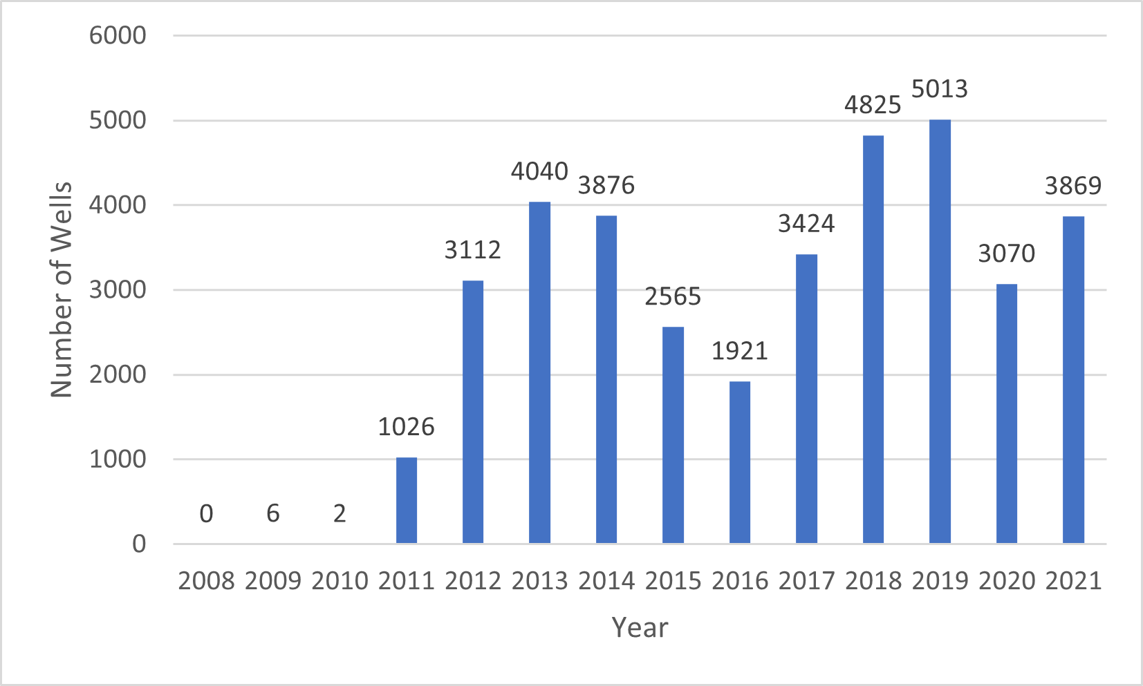
Figure 8: New wells constructed by year from FracFocus registry (FracFocus, n.d.).

Figure 9 details how many UOG wells were built within each subbasin from 2008 to 2021. The greatest number of wells were built in the Landreth-Monument Draws subbasin (13070007) with 15,754 new wells constructed during the study period. The second most were built in the Lower Pecos-Red Bluff Reservoir (13070001) with 13,593. There is a drastic drop in how many wells were constructed in other subbasins, with the third most being 1,966 built in the Toyah subbasin (13070003). The Lower Pecos subbasin (13070012) saw the least number built with only 6 new wells reported during the study period. Most new wells appear to be clustered in the northeast section of the study area.
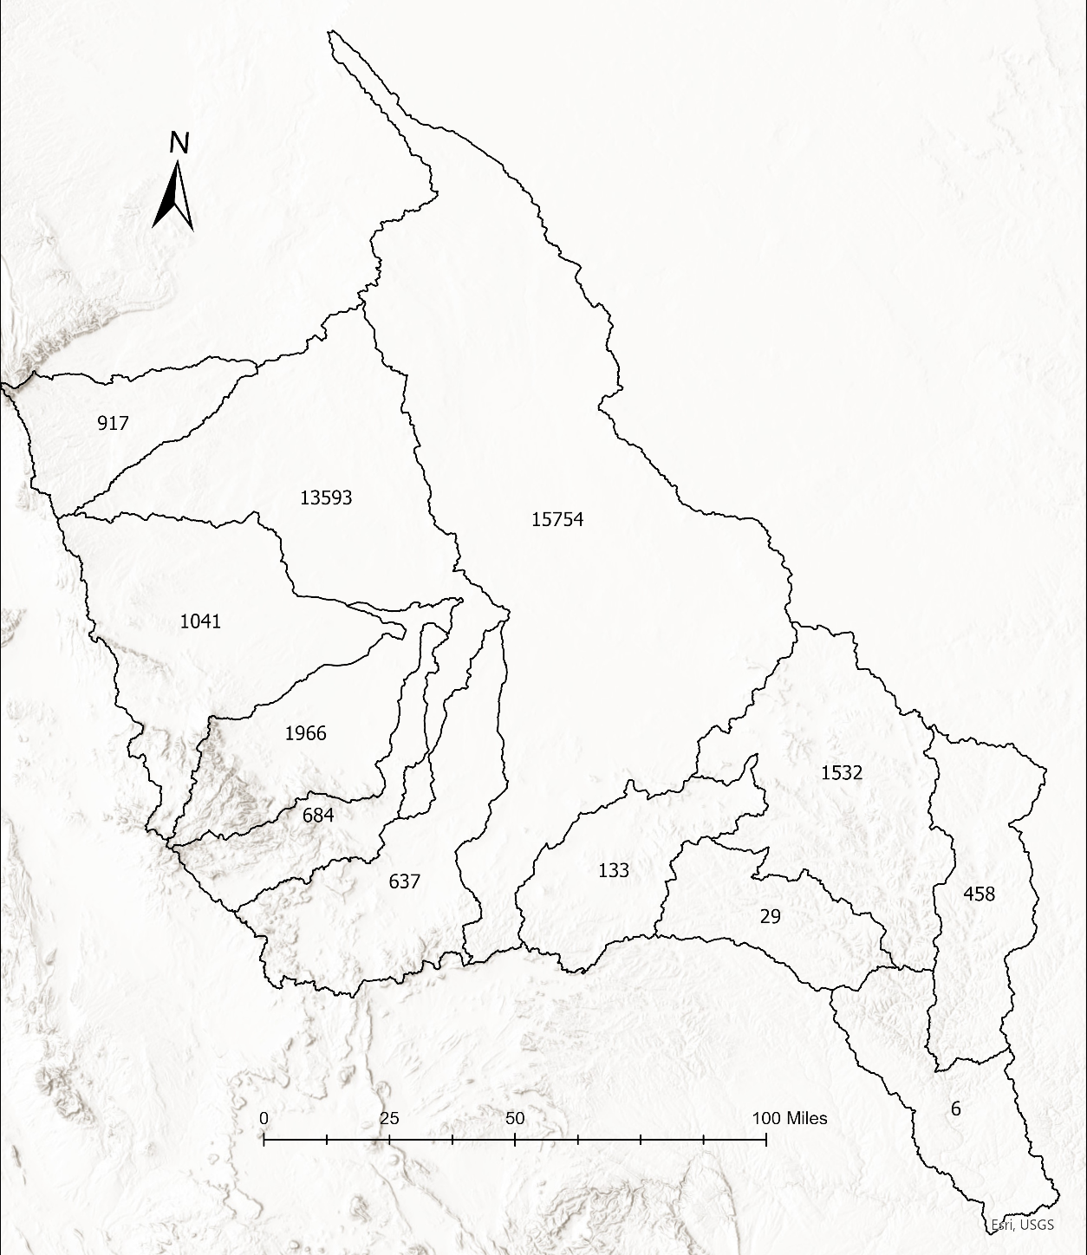
Figure 9: Map showing the number of new UOG wells built within each subbasin from 2008 to 2021.

4.2.2: Water use
There are 16,386 wells entries that have a nonzero value for water use. The minimum value of this dataset is 0.003785 m³ per well and the maximum value is 1,788,201 m³ per well. The mean water use is 38,945.8 m³, the median is 33,751.08 m³, and the standard deviation is 38,402.25 m³. The descriptive statistics are summarized below in Table 1.
Table 1: Descriptive statistics of UOG well water use excluding 0 values.
n | 16386
Min | 0.003785
Max | 1788201
Mean | 38945.8
Median | 33751.08
Standard Dev | 38402.25
Variance | 1474732756

Figure 10 shows the cumulative water use by the end year, accounting for all the water used during the well’s operation, separated by HUC. Since any wells built between 2008 and 2021 were included in this analysis, some of the wells have an end year of 2022. This figure shows that subbasins 13070001 and 13070007 have the greatest UOG well water use during the study period, with an approximate total of 290,276,737 m³ and 198,542,599 m³ respectively. The three subbasins with the highest water use (13070001, 13070003, and 13070007) all saw the greatest total use in 2019. The lowest water use occurred in subbasin 13070012, with 1167.8m³ reported during the temporal span of the study and the second least was in 13070010 with approximately 87,347.m³.
Figure 10: Cumulative water use by end year (2008 - 2022)

Figure 11 displays the mean water use per well by end year, and for each year it also displays the median and quartile range. This figure also includes 2022 end years since some wells built during the temporal span of the study remained operational until 2022. For this analysis, outliers were removed from the dataset. Subbasin 13070012 has the lowest mean water use per well, at approximately 389.3 m³ throughout the study period. The highest mean water use throughout the study period is reported in subbasin 13070006 with approximately 65,312.9 m³ per well, followed closely by subbasin 13070002 with approximately 57,616.9 m³ per well. In general, the mean water used per well increased over time from 2008 to 2022. Figure A1 in the Appendix also shows the mean, median, and quartile water use by end year but with the outliers kept in the data.
Figure 11: Mean, median, and quartile water use by end year (2008 - 2022), outliers removed.

4.3 Drought Statistics

4.3.1: Monthly and yearly averages
Figure 12 displays the monthly average percent of total area under drought conditions for the years 2008 to 2021, for each 8-digit subbasin. The findings indicate an exceptional drought in 2011 through early 2013 throughout the entire basin, with subbasin 13070012 displaying a much longer drought period stretching through 2015. Subbasin 13070011 displays a similar extended drought period, stretching through late 2013. The most intense drought during this period is observed in subbasins 13070002, 13070004, and 13070007. There is a second drought period visible from 2020-2021, though it is significantly less noticeable in subbasins 13070008, 13070009, 13070010, and 13070011. Generally, the drought dynamic observed in subbasin 13070012, which is in the farthest southwest portion of the study area, is different from the other 11 subbasins.

Figure 12: Drought classification for Lower Pecos (2008 - 2021): Monthly average percent area under drought conditions.

Figure 13 shows the two highest drought conditions (D3 – extreme drought and D4 – exceptional drought) experienced by each subbasin for the year 2012, expressed as the yearly mean of land percentage under the respective drought condition. Overall, the percentage of extreme drought is higher than the percentage of exceptional drought, with subbasin 13070009 not experiencing any exceptional drought in 2012. There are slight variations in in the intensity of the drought throughout the subbasins, with the westernmost (13070002, 13070003, and 13070004) sections experiencing the most intense drought. Subbasin 13070009 experienced the least amount of land under drought conditions, with a yearly mean of about 1,680 ha of land (0.7%) under exceptional drought and 59,795 ha (23.9%) under extreme drought.
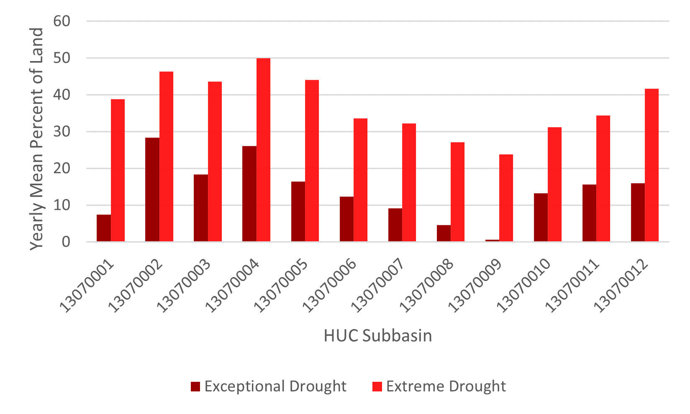
Figure 13: Annual mean percent of land experiencing extreme drought (D3) and exceptional drought (D4) in 2012.

Figure 14 details the percentage of land per subbasin that did not experience any drought conditions during 2015 and 2016. During this period, most of the basin did not experience drought. In 2015, only subbasins 13070011 and 13070012 briefly experienced D1 conditions during 0.9% and 12.1% of the year, respectively. For 2016, the data does not show averages above D1 conditions. Subbasin 13070012 shows the lowest value for 2015, and 13070002 shows the lowest value for 2016. This means that these two subbasins experienced more drought conditions than the other subbasins in their respective years. Subbasin 13070002 is in the far northwest corner of the study area, whereas 13070012 is the farthest southwest.
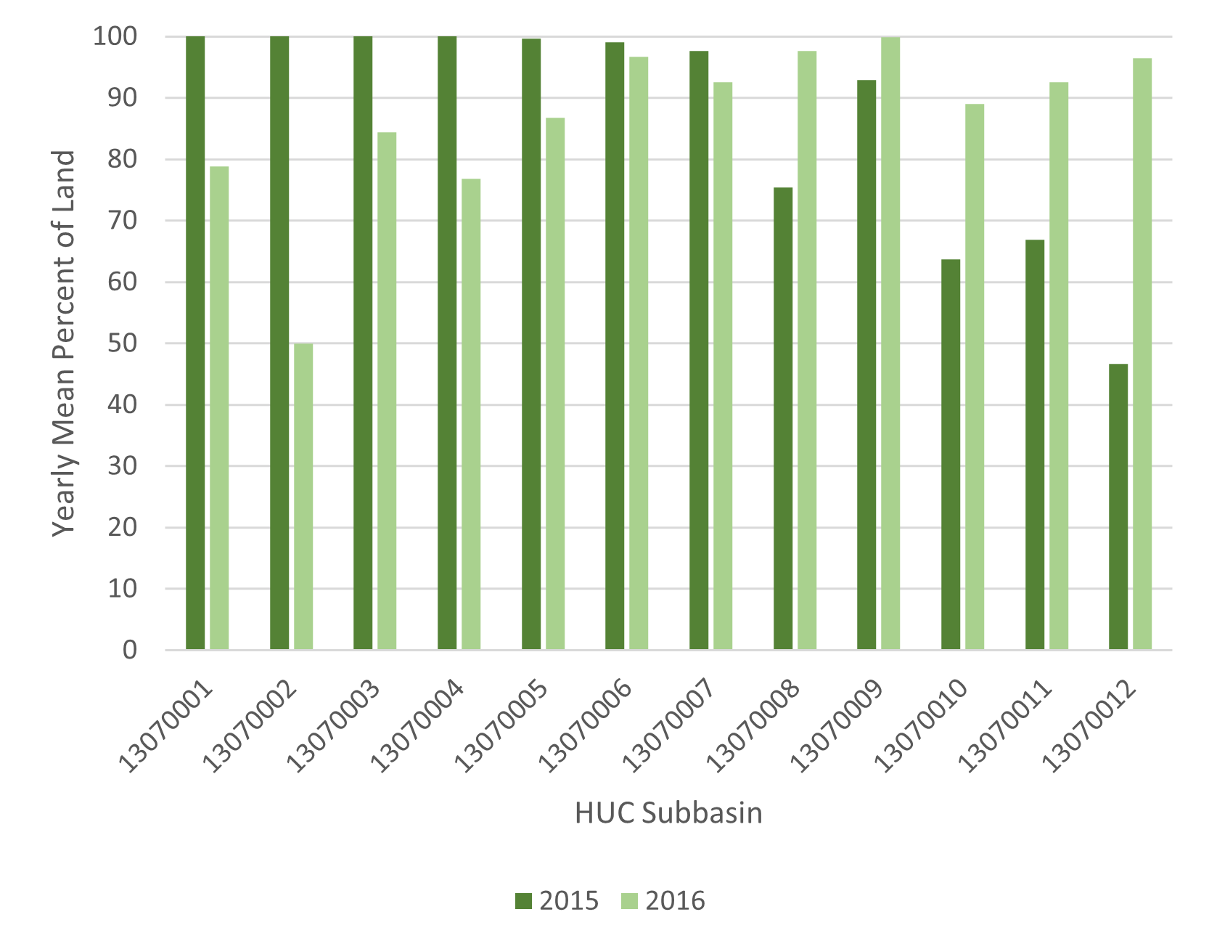
Figure 14: Mean percent of land not experiencing drought in 2015 and 2016.

Figure 15 details the percentage of land under any classification of drought (D0-D4) compared to the percentage of land that was not under drought conditions during the year 2021. There was a spatially variable period of drought in 2021. It shows that subbasin 13070008 had the lowest annual mean percentage of land under drought conditions (51.8%), whereas subbasin 13070012 had the greatest mean percentage of land under drought conditions (83.5%). Figure 16 uses the same data to highlight the spatial differences experienced by each subbasin by displaying the mean percent of land not under drought conditions in 2021.
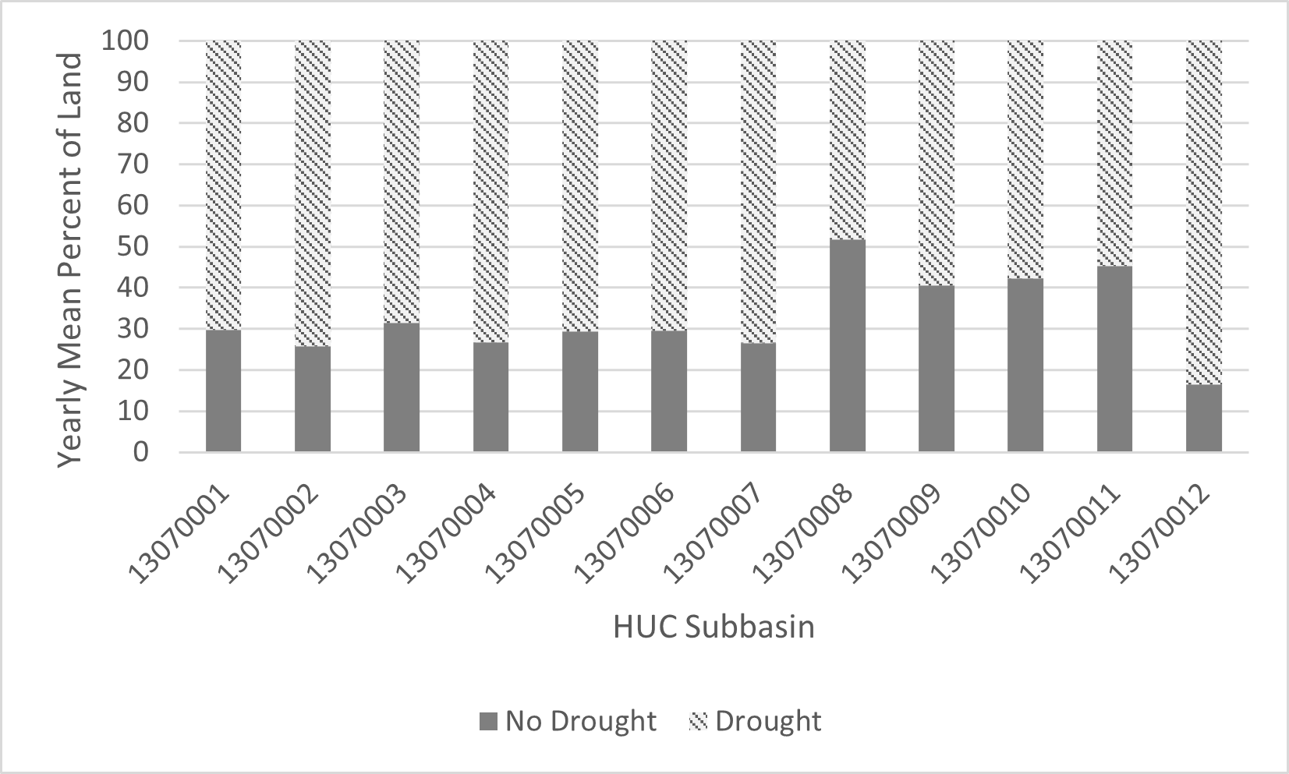
Figure 15: Mean percent of land experiencing drought conditions vs no drought conditions in 2021.

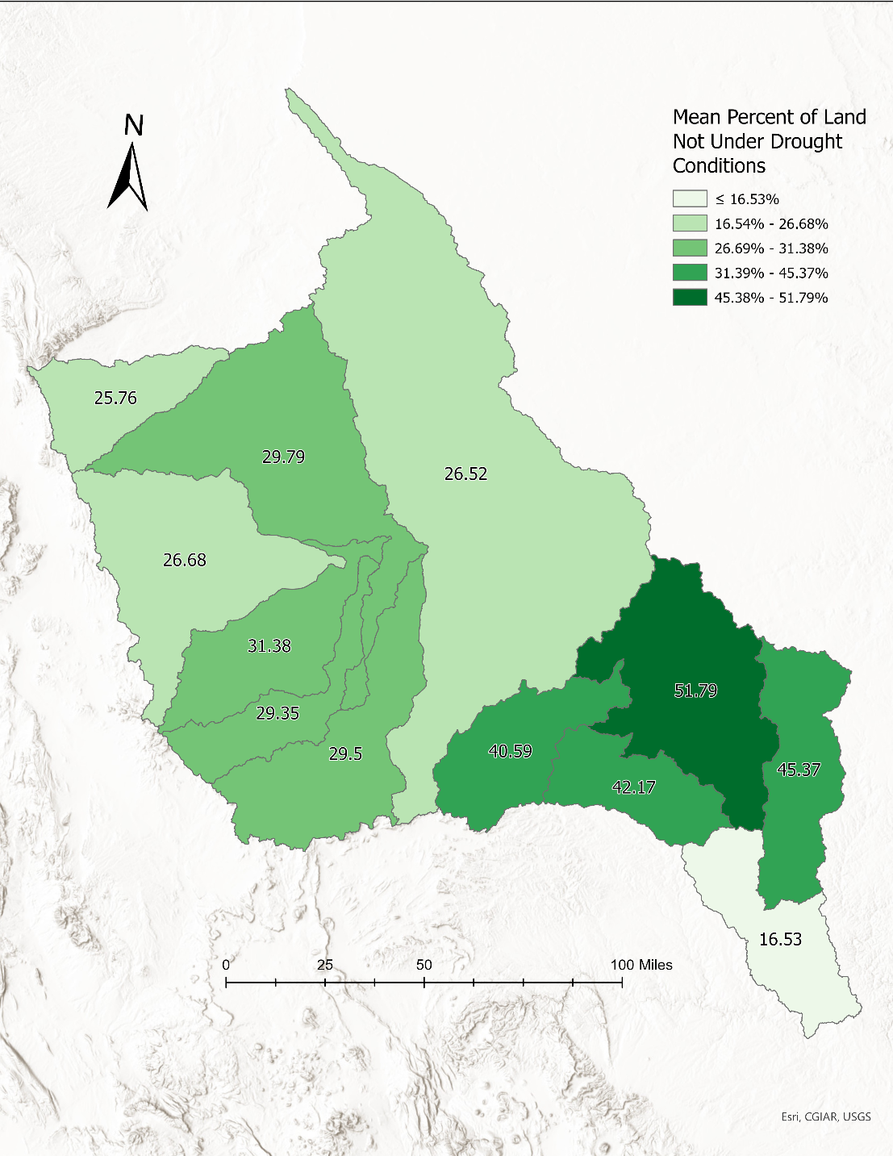
Figure 16: Map showing annual percent of land not under drought conditions in 2021.

4.3.2: Number of days greater than or equal to 50%, 75%, and 100% drought classification category per month
Figure 17 shows the number of days equal to or greater than 50% of a given drought condition for each month broken up by subbasin. There is a basin-wide drought visible from 2011 to 2012 where each subbasin displays many days in at least 50% exceptional drought conditions. Subbasin 13070008 displays the least intense drought conditions during that time, with only September and October 2011 showing any number of days with at least 50% exceptional drought conditions, but the presence of extreme drought conditions exist through May 2012. There was another period of drought conditions apparent at the end of 2020 and beginning of 2021. The least affected subbasins were 13070009 and 13070010. 13070009 had 21 days of at least 50% D2 conditions in November 2020, 31 days in December 2020, and 4 days in January 2021, but then did not reach at least 50% D2 conditions again during the temporal span of this study. Subbasin 13070010 experienced at least 50% D2 conditions for 7 days in August 2020, 14 days in September 2020, 21 days in November 2020, 31 days in December 2020, and then 4 days in January 2021. It did not reach at least 50% D2 conditions again for the duration of the study.
Figure 17: Drought classification for Lower Pecos (2008 - 2021): Number of days equal to or greater than 50% in each month

Figure 18 displays the number of days equal to or greater than 75% for each month broken up by subbasin. The 2011-2012 drought is still visible with the higher percentage threshold, with each basin displaying drought conditions above 75% during that time. Subbasin 13070008 was previously identified as having the least intense drought conditions from 2011-2012. It had 7 days of at least 75% D4 conditions in May 2011, none in June or July, and then 9 days in August, 30 days in September, and 10 days in October. During that same period, subbasin 13070002 experienced more intense drought conditions, with every single day reaching at least 75% D4 conditions from June 2011 to March 2012. There is also an apparent drought from 2020 to 2021, though some subbasins experienced it more strongly than others. From Figure 17, subbasins 13070009 and 13070010 were identified as having the least intense drought conditions during that time. With the higher percentage threshold of 75%, they still exhibit the least intense conditions. Subbasin 13070009 had 21 days of at least 75% D2 conditions in November 2020 and 31 days in December 2020, but did not reach at least 75% D2 conditions again during the study’s time span. Subbasin 13070010 had 7 days of at least 75% D2 conditions in August 2020, 14 days in September 2020, no days in October 2020, 14 days in November 2020, 31 days in December 2020, and 4 days in January 2021. It did not reach at least 75% D2 conditions again for the duration of the study.
Figure 18: Drought classification for Lower Pecos (2008 - 2021): Number of days equal to or greater than 75% in each month.

Figure 19 displays the number of days equal to 100% of a given drought condition for each month broken up by subbasin. There 2011-2012 drought is still apparent with the higher percentage threshold, but the 2020-2021 drought is more variable. As previously identified, subbasin 13070002 seemed to experience the most intense drought conditions from 2011-2012. It reached 100% D4 conditions for 29 days in May 2011, 16 days in June 2011, every day of the month from July to October 2011, and 14 days in November 2011. Subbasin 13070008 experienced the least intense drought conditions during that time and did not reach 100% D4 conditions. It did experience 100% D3 conditions for 3 days in March 2011, and then for every day of the month from April through September 2011, 10 days in October 2011, and then 23 days in February 2012 and 19 days in March 2012. The 2020-2021 drought is still apparent using this higher percentage threshold but with more variation. Subbasins 13070009 and 13070010 were previously identified as having some of the least intense drought during this time. Both subbasins reached 100% D2 conditions for 14 days in November 2020, 31 days in December 2020, and 4 days in January 2021.
Figure 19: Drought classification for Lower Pecos (2008 - 2021): Number of days equal to 100% in each month.

4.4 Agricultural Trends Within Wells Buffer

Figure 20 shows a map of the study area with the fallow frequency raster overlaid with the buffered UOG wells polygons (buffer distance 64 m). The map shows that most wells are concentrated in the north-central portion of the study area in rows that likely correspond to pipelines. UOG wells appear to be built more closely together and are most concentrated in subbasin 13070007, whereas in other subbasins they are slightly more spread out. It appears that many of the wells within the study area are not in areas that are primarily agricultural.
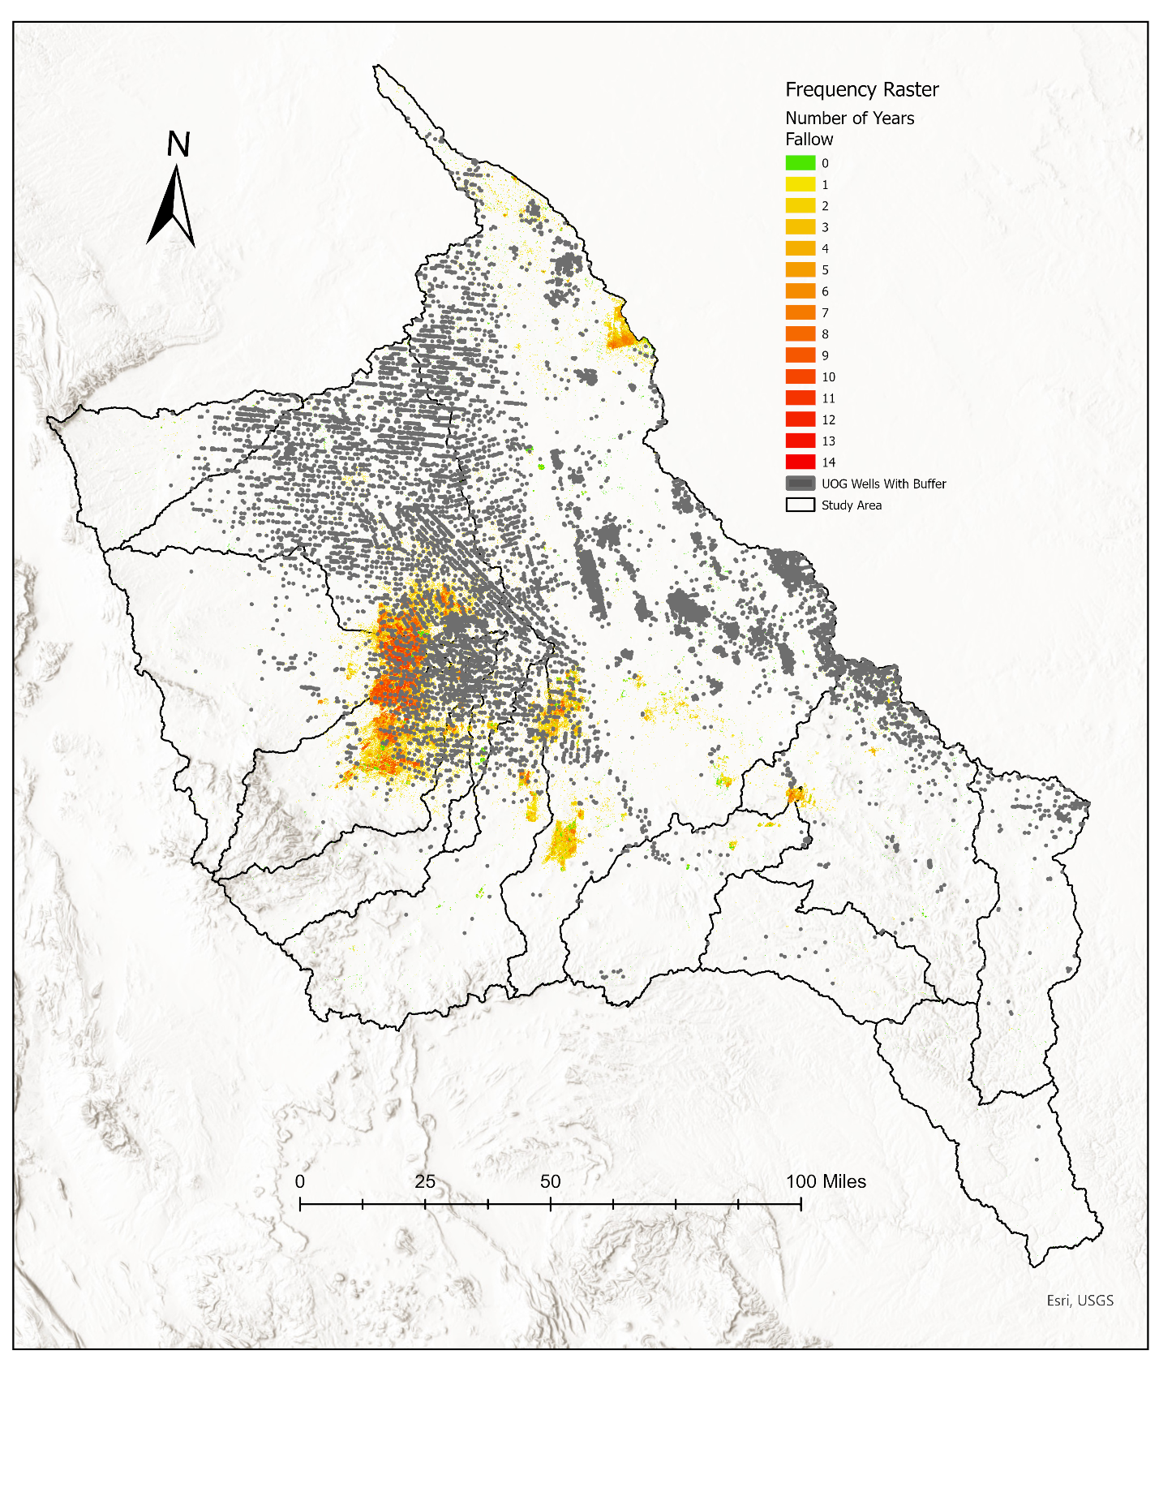
Figure 20: Map showing UOG wells with 64m radius buffer overlaid with fallow frequency raster (FracFocus, n.d.; National Agricultural Statistics Service, USDA, n.d.).

Within the 64m radius buffer around UOG wells in the study area, there are 1,426 cells that were classified as either active or fallow/idle cropland throughout the study period. Figure 21 outlines the number of times each of those cells were classified as fallow throughout the study period. Out of the 1,426 cells considered, there were no cells that were active cropland throughout the entire study period. Most cells were fallow for 2 years during the study, at 665.
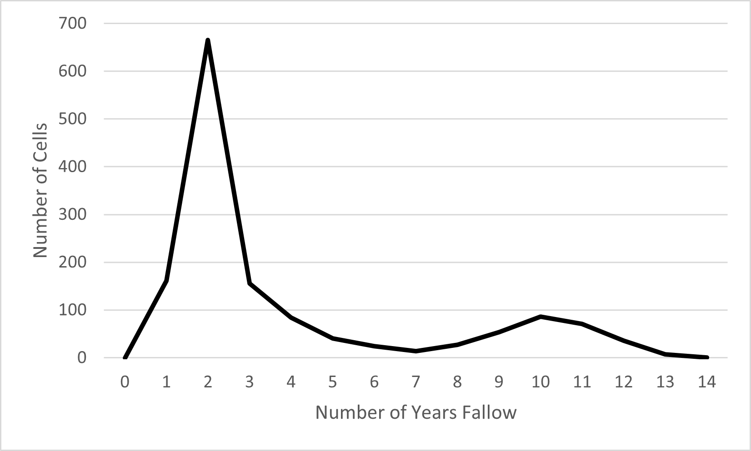
Figure 21: Line chart depicting the frequency count of cropland cells within the UOG wells buffer depicted as fallow from 2008 to 2021.

CHAPTER 5: DISCUSSION

5.1 Relationships Between Drought, Fallow Land, and UOG Wells

To identify the relationship between agriculture, UOG production, and drought in the Lower Pecos region of the Permian Basin, I analyzed these three factors in a time series from 2008 to 2021. I found that the number of UOG wells is increasing overall throughout the Lower Pecos basin (Figure 8), and the water used per well is also increasing, with the greatest increase in both occurring in 2019 (Figure 11). Drought conditions are variable throughout the time series, but the entire basin displayed long-term drought conditions from 2011 to 2013, and again from 2020-2021. In 2015 and 2016, most of the basin was drought-free (Figure 12). Fallowing trends of cropland throughout the basin varied, but the majority of 30m x 30m cropland cells were left fallow at least once throughout the time series (Figure 6). There was significantly more fallow/idle cropland within the basin from 2008 to 2017 but starting in 2018 there was a large drop in fallow land (Figure 7).
I expected to see more fallow land throughout the basin during droughts. The first period of extended drought from 2011 to 2013 (Figure 12) does coincide with an increase in fallow land throughout the basin (Figure 7) , however the second period of drought from 2020-2021 (Figure 12) shows the opposite. Fallow land in 2020 and 2021 is the lowest recorded throughout the study period (Figure 7) despite the prevalence of D3 and D4 conditions. This could indicate that cropland irrigation is less dependent on surface water availability and possibly more reliant on groundwater. Alternatively, since this study did not account for the type of crop being grown, it is possible that the active cropland documented during this period is either drought-resistant or requires low water inputs.
Drought periods only seem to loosely relate to the number of UOG wells being built within the basin. The first period of extended drought from 2011 to 2013 (Figure 12) occurred during a dramatic increase in new well development. There were 1,026 new wells recorded in 2011, 3,112 recorded in 2012, and then 4,040 in 2013 (Figure 8). However, the reported water used per well during this time is relatively low compared to later years. There was a significant drop in the number of wells developed in 2015 and 2016 (Figure 8), which occurred with an almost complete lack of drought conditions (Figure 12). Water use per well is slightly higher during these years (Figure 11), but not yet near the highest recorded amounts. The drought period from 2020 to 2021 coincides with a slight decrease in the number of new reported wells, with only 3,070 in 2020 and 3,869 in 2021. However, water use per well is almost seven times higher during this period than it was during the previous drought period from 2011 to 2013 (Figure 11).
I expected to see more fallow cropland near UOG wells due to increased water competition. Within the 64m buffer around UOG wells in the basin, there were 1,426 raster cells classified as cropland. The fallowing trends within the buffered area (Figure 21) do not indicate a significant difference from the basin-wide fallowing trends identified in Figure 6. It is also worth noting that many of the reported wells within the basin do not occur directly near cropland, as shown by the map in Figure 20. There are several possible explanations for why this study did not observe increased fallowing in proximity to UOG wells. For one, there may be a delayed response to increased water competition. Second, UOG wells may use water from a different source than farmers use to irrigate their cropland. Third, the cropland located near the UOG wells might be drought-resistant or require less irrigation.
The results of the UOG well analysis found in this study are mostly consistent with the literature. Scanlon et al., 2020 showed a dramatic increase in the amount of water used per well from 2011 to 2017. The authors of that study found that the water used for HF in the Permian Basin peaked in 2017, whereas my study found that it peaked in 2019 (Figure 11). However, the temporal spans of our respective studies differ. My data includes up to the year 2021, whereas their study goes to 2017.

5.2 Study Limitations

The data used in this study for UOG wells relied on owner/operator inputs in the FracFocus registry. There were no wells entries for 2008, and very few entries for 2009 and 2010. Texas allows well operators to meet their reporting requirements by using FracFocus, but New Mexico does not mandate its use. Thus, there may be more wells in New Mexico than what was reported here. The registry was officially launched in 2011, therefore any wells built before then were entered retroactively. It is likely that there were significantly more wells built during 2008, 2009, and 2010 than what is reflected in the data. Additionally, because each data point was provided by the owner/operator, there is a chance for human error in reporting. When the raw data was converted to spatial points, there were wells entries outside of the U.S. based on the latitude and longitude coordinates given. Since FracFocus is a national registry, it is likely that those locations were misreported. Out of the 36,749 nonduplicate entries for wells built between 2008 and 2021, only 16,386 reported nonzero water use. It is unlikely that over 20,000 wells were built and then not hydraulically fractured, therefore the reported water use may be inaccurate. The water use that was reported may also not be correct, as evidenced by the extreme outliers in the data (Figure A1). Though water use is reported to FracFocus, owner/operators are not required to disclose the source of their water. Knowing if the water used in UOG wells came from groundwater, surface water, or an outside source would have been an advantage for this study.
Another potential limitation is the temporal span of the study. Over a 14-year period, there was an observed increase in the number of UOG wells built and an increase in the amount of water used per well. At the same time, the amount of fallow/idle cropland decreased overall. This was the opposite of what we expected to see, but it’s possible there will be a delayed response to increased water competition. Additionally, this study does not account for regular crop rotations where farmers leave land fallow for reasons besides water competition, such as financial reasons or to increase soil health.

5.3 Next Steps

Data reliability could be improved for UOG wells in the study area by verifying the FracFocus data with other data sources. For agricultural trends, it would also be beneficial to examine the individual crop types grown within the study area, rather than reclassifying all active cropland into one category. Finally, adding a cumulative time-series analysis could allow for a better understanding of how drought, agriculture, and UOG activity directly relate to one another over time.
For future research on UOG wells within the study area, other data sources should be considered. Though FracFocus is the only registry for UOG-specific operations, there were many issues associated with the data. Scanlon et al. (2020) used a combination of wells data from FracFocus, Energy Information Administration, the University of Texas Bureau of Economic Geology, and IHS Energy. Using the combination of sources listed above for UOG data would enhance the data reliability. Another option is to verify FracFocus data with aerial imagery, such as from the National Agriculture Imagery Program or from Google Earth, a technique used in other study areas to ensure data accuracy (Fitzgerald et al., 2020).
The cropland trends examined did not support my hypothesis that increased UOG activity will correspond with an increase in fallow/idle cropland. However, this study did not consider what types of crops are being grown. It is possible that instead of retiring their land for a growing season or more, farmers may have responded to increased water competition by planting less water-intensive crops. For the next step in crop-specific analysis, I would retain the individual cropland categories that come from the CropScape website (National Agricultural Statistics Service, USDA, n.d.) to understand trends in cropping rotations.
For the next step with this research, I suggest recreating the research technique outlined in Fitzgerald et al. (2020) and creating a fishnet grid over the study area, calculating crop percentages within each grid cell, adding UOG well water use, and percentage of drought for each year throughout the study period. If the study area is divided into HUC-10 watersheds, there would be 76 components to the study area instead of 12. These smaller watersheds may be more digestible for a computer program to run in a timely manner. Alternatively, future studies could utilize more Python libraries to streamline the process. GeoPandas is one such library that is meant to enhance Python’s geographic data processing capabilities, particularly when working with large datasets (Jordahl, 2014).

A future study could also use these same techniques but focus on the Eagle-Ford Shale in South Texas. This area exemplifies many of the same factors as the Permian Basin, as it is experiencing rapid UOG development in a drought-prone, semi-arid area with intensive agricultural activity and a growing population (Allen et al., 2014). UOG development in the Eagle-Ford Shale started in 2008 and has grown exponentially since (Allen et al., 2014; Pierre et al., 2017). There is an observed increase in landscape alteration within the Eagle-Ford from 2008 to 2014, coinciding with the increase in UOG development (Pierre et al., 2017). To better understand how UOG development in this region impacts agriculture, the methodology described above could be applied to the Eagle-Ford Shale.

CHAPTER 6: Conclusions

UOG development requires large water inputs, which in semi-arid regions can exacerbate water competition in already water-scarce areas. The relationship between water demands across various sectors requires further research to understand how UOG development can impact other water-intensive sectors like irrigated agriculture. Drought conditions in the American Southwest are expected to worsen due to global climate change, which is expected to impact agricultural and municipal water availability. More research is needed to understand how future water availability will be impacted by competing water-intensive industries.
This study did not find a an obvious connection between UOG development, agriculture, and drought in the Lower Pecos region of the Permian Basin in Texas and New Mexico. Given the semi-arid conditions of this region, as well as the documented water scarcity and overallocation of water resources, it is reasonable to assume there are other factors contributing to our findings that were not examined in this research. For example, farmers may switch to less water-intensive crops in response to increased UOG development. Oil and gas companies are not required to disclose where they get their water from, so it’s possible they export water from other regions, buy water rights from other sectors, or reuse their produced water from prior drilling operations. More research is needed to determine from where UOG operators source their water. If UOG wells use water from other areas, it is less likely to impact water availability in the immediate area but could have implications for water security at the source.
This study found that the relationship between UOG development, agriculture, and drought is not as straightforward as expected. While these three variables may be the main driving factors, this study did not consider dynamic responses to changes. For example, farmers likely have drought response plans already in place to limit the impact of drought on their crop yields. It’s also possible that farmers already follow established crop rotation practices wherein they fallow their fields at predetermined intervals.
Overall, this study found that drought conditions within the Lower Pecos basin are highly variable, but the droughts that do occur can be long-lasting and intense. Agriculture in the region is also variable but is increasing overall. UOG development rapidly expanded from 2008, and both the number of wells built, and the water used per well is overall increasing as time goes on. These findings are consistent with the background and literature review.

REFERENCES

About FracFocus. (2022, March 1). FracFocus. https://fracfocus.org/learn/about-fracfocus
Ahmad, T., & Zhang, D. (2020). A critical review of comparative global historical energy consumption and future demand: The story told so far. Energy Reports, 6, 1973–1991. https://doi.org/10.1016/j.egyr.2020.07.020
Allen, W. T., Lacewell, R. D., & Zinn, M. (2014). Water Value and Environmental Implications of Hydraulic Fracturing: Eagle-Ford Shale. Texas A&M University.
Annual Energy Outlook 2022—U.S. Energy Information Administration (EIA). (2022, March 3). https://www.eia.gov/outlooks/aeo/narrative/production/sub-topic-01.php
AQUASTAT - FAO’s Global Information System on Water and Agriculture. (n.d.). Retrieved November 2, 2023, from https://www.fao.org/aquastat/en/
Boryan, C., Yang, Z., Mueller, R., & Craig, M. (2011). Monitoring US agriculture: The US Department of Agriculture, National Agriculture Statistics Service, Cropland Data Layer Program. Geocarto International, 26(5), 341–358. https://doi.org/10.1080/10106049.2011.562309
Cayan, D. R., Das, T., Pierce, D. W., Barnett, T. P., Tyree, M., & Gershunov, A. (2010). Future dryness in the southwest US and the hydrology of the early 21st century drought. Proceedings of the National Academy of Sciences, 107(50), 21271–21276. https://doi.org/10.1073/pnas.0912391107
Clark, C., Horner, R., & Harto, C. (2013). Life Cycle Water Consumption for Shale Gas and Conventional Natural Gas. Environmental Science & Technology, 47(20), 11829–11836.
Drohan, P. J., Brittingham, M., Bishop, J., & Yoder, K. (2012). Early Trends in Landcover Change and Forest Fragmentation Due to Shale-Gas Development in Pennsylvania: A Potential Outcome for the Northcentral Appalachians. Environmental Management, 49(5), 1061–1075. https://doi.org/10.1007/s00267-012-9841-6
Drought Basics | Drought.gov. (n.d.). Retrieved October 18, 2023, from https://www.drought.gov/what-is-drought/drought-basics
Fitzgerald, T., Kuwayama, Y., Olmstead, S., & Thompson, A. (2020). Dynamic impacts of U.S. energy development on agricultural land use. Energy Policy, 137, 111163. https://doi.org/10.1016/j.enpol.2019.111163
Food and Agriculture Statistics. (n.d.). Food and Agriculture Organization of the United Nations. Retrieved November 2, 2023, from http://www.fao.org/food-agriculture-statistics/en/
FracFocus. (n.d.). Retrieved October 27, 2022, from https://fracfocus.org/
Gilmer, R. W., & Thompson, J. B. (2012). Spotlight: Shale oil exploration - Permian Basin booms as new techniques resurrect old sites. Southwest Economy, Q2, 1–15.
Hitaj, C., Boslett, A., & Weber, J. (2014). Shale development and agriculture. Choices, 29(4), 1–7.
Intergovernmental Panel On Climate Change (Ipcc). (2023). Climate Change 2022 – Impacts, Adaptation and Vulnerability: Working Group II Contribution to the Sixth Assessment Report of the Intergovernmental Panel on Climate Change (1st ed.). Cambridge University Press. https://doi.org/10.1017/9781009325844
Iqbal, M. S., Singh, A. K., & Ansari, M. I. (2020). Effect of Drought Stress on Crop Production. In A. Rakshit, H. B. Singh, A. K. Singh, U. S. Singh, & L. Fraceto (Eds.), New Frontiers in Stress Management for Durable Agriculture (pp. 35–47). Springer. https://doi.org/10.1007/978-981-15-1322-0_3
Jones, S. M., & Gutzler, D. S. (2016). Spatial and Seasonal Variations in Aridification across Southwest North America. Journal of Climate, 29(12), 4637–4649. https://doi.org/10.1175/JCLI-D-14-00852.1
Jordahl, K. (2014). GeoPandas: Python tools for geographic data [Computer software]. Https://Github. Com/Geopandas/Geopandas
Kogan, F., & Guo, W. (2015). 2006–2015 mega-drought in the western USA and its monitoring from space data. Geomatics, Natural Hazards and Risk, 6(8), 651–668. https://doi.org/10.1080/19475705.2015.1079265
Konapala, G., Mishra, A. K., Wada, Y., & Mann, M. E. (2020). Climate change will affect global water availability through compounding changes in seasonal precipitation and evaporation. Nature Communications, 11(1), Article 1. https://doi.org/10.1038/s41467-020-16757-w
Kondash, A. J., Lauer, N. E., & Vengosh, A. (2018). The intensification of the water footprint of hydraulic fracturing. Science Advances, 4(8), eaar5982. https://doi.org/10.1126/sciadv.aar5982
Kuwayama, Y., Thompson, A., Bernknopf, R., Zaitchik, B., & Vail, P. (2019). Estimating the Impact of Drought on Agriculture Using the U.S. Drought Monitor. American Journal of Agricultural Economics, 101(1), 193–210. https://doi.org/10.1093/ajae/aay037
Lipiec, J., Doussan, C., Nosalewicz, A., & Kondracka, K. (2013). Effect of drought and heat stresses on plant growth and yield: A review. International Agrophysics, 27(4), 463–477. https://doi.org/10.2478/intag-2013-0017
MacDonald, G. M. (2010). Water, climate change, and sustainability in the southwest. Proceedings of the National Academy of Sciences, 107(50), 21256–21262. https://doi.org/10.1073/pnas.0909651107
Melillo, J. M., Richmond, T. (T. C. ), & Yohe, G. W. (2014). Climate Change Impacts in the United States: The Third National Climate Assessment. U.S. Global Change Research Program. https://doi.org/10.7930/J0Z31WJ2
Moran, M., Taylor, N., Mullins, T., Sardar, S., & McClung, M. (2017). Land‐use and ecosystem services costs of unconventional US oil and gas development. Frontiers in Ecology and the Environment, 15(5), 237–242.
Mote, P. W., Sihan, L., Lettenmaier, D. P., Xiao, M., & Engel, R. (2018). Dramatic declines in snowpack in the western US. NPJ Climate and Atmospheric Science, 1(1). https://doi.org/10.1038/s41612-018-0012-1
National Agricultural Statistics Service, USDA. (n.d.). CroplandCROS. Retrieved October 29, 2023, from https://croplandcros.scinet.usda.gov/
New Mexico Interstate Stream Commission. (2018). 2018 New Mexico State Water Plan Part I: Policies.
Park, C.-E., Jeong, S.-J., Joshi, M., Osborn, T., Ho, C.-H., Piao, S., Chen, D., Liu, J., Yang, H., Park, H., Kim, B.-M., & Feng, S. (2018). Keeping global warming within 1.5°C constrains emergence of aridification. Nature Climate Change, 8, 70–74. https://doi.org/10.1038/s41558-017-0034-4
Pierre, J. P., Wolaver, B. D., Labay, B. J., LaDuc, T. J., Duran, C. M., Ryberg, W. A., Hibbitts, T. J., & Andrews, J. R. (2018). Comparison of Recent Oil and Gas, Wind Energy, and Other Anthropogenic Landscape Alteration Factors in Texas Through 2014. Environmental Management, 61(5), 805–818. https://doi.org/10.1007/s00267-018-1000-2
Pierre, J. P., Young, M. H., Wolaver, B. D., Andrews, J. R., & Breton, C. L. (2017). Time Series Analysis of Energy Production and Associated Landscape Fragmentation in the Eagle Ford Shale Play. Environmental Management, 60(5), 852–866. https://doi.org/10.1007/s00267-017-0925-1
Plassin, S., Koch, J., Wilson, M., Neal, K., Friedman, J. R., Paladino, S., & Worden, J. (2021). Multi-scale fallow land dynamics in a water-scarce basin of the U.S. Southwest. Journal of Land Use Science, 16(3), 291–312. https://doi.org/10.1080/1747423X.2021.1928310
Richter, B. D., Brown, J. D., DiBenedetto, R., Gorsky, A., Keenan, E., Madray, C., Morris, M., Rowell, D., & Ryu, S. (2017). Opportunities for saving and reallocating agricultural water to alleviate water scarcity. Water Policy, 19(5), 886–907. https://doi.org/10.2166/wp.2017.143
Scanlon, B. R., Ikonnikova, S., Yang, Q., & Reedy, R. C. (2020). Will Water Issues Constrain Oil and Gas Production in the United States? Environmental Science & Technology, 54(6), 3510–3519. https://doi.org/10.1021/acs.est.9b06390
Scanlon, B. R., Reedy, R. C., Male, F., & Walsh, M. (2017). Water issues related to transitioning from conventional to unconventional oil production in the Permian Basin. Environmental Science & Technology, 51(18), 10903–10912. https://doi.org/10.1021/acs.est.7b02185
Scanlon, B. R., Reedy, R. C., Stonestrom, D. A., Prudic, D. E., & Dennehy, K. F. (2005). Impact of land use and land cover change on groundwater recharge and quality in the southwestern US. Global Change Biology, 11(10), 1577–1593. https://doi.org/10.1111/j.1365-2486.2005.01026.x
Snee, J.-E. L., & Zoback, M. D. (2018). State of stress in the Permian Basin, Texas and New Mexico: Implications for induced seismicity. The Leading Edge, 37(2), 127–134. https://doi.org/10.1190/tle37020127.1
Speight, J. (2016). Handbook of Hydraulic Fracturing. John Wiley & Sons. https://books.google.com/books/about/Handbook_of_Hydraulic_Fracturing.html?id=hRORCgAAQBAJ
Texas Water Development Board. (2021). 2022 State Water Plan: Water for Texas.
UN-Water. (2023). Blueprint for Acceleration: Sustainable Development Goal 6 Synthesis Report on Water and Sanitation 2023.
U.S. energy facts explained—Consumption and production—U.S. Energy Information Administration (EIA). (n.d.). Retrieved August 23, 2023, from https://www.eia.gov/energyexplained/us-energy-facts/
USDA - National Agricultural Statistics Service—Research & Science—Cropland Data Layer—Metadata. (n.d.). Retrieved September 28, 2023, from https://www.nass.usda.gov/Research_and_Science/Cropland/metadata/meta.php
Wang, H. (2021). The Impact of Shale Oil and Gas Development on Rangelands in the Permian Basin Region: An Assessment Using High-Resolution Remote Sensing Data. Remote Sensing, 13(4), Article 4. https://doi.org/10.3390/rs13040824
Water, Food and Energy. (n.d.). UN-Water. Retrieved July 20, 2023, from https://www.unwater.org/water-facts/water-food-and-energy
Watershed Boundary Dataset | U.S. Geological Survey. (n.d.). Retrieved October 29, 2023, from https://www.usgs.gov/national-hydrography/watershed-boundary-dataset
What is the USDM? | U.S. Drought Monitor. (n.d.). Retrieved October 18, 2023, from https://droughtmonitor.unl.edu/About/WhatistheUSDM.aspx
Williams, A. P., Cook, E., Smerdon, J., Cook, B., Bolles, K., Baek, S., Badger, A., & Livneh, B. (2020). Large contribution from anthropogenic warming to an emerging North American megadrought | Science. Science, 368(6488), 314–318.

APPENDIX A

Figure A1: Mean, median, and quartile water use by end year (2008-2022), with outliers

