UNIVERSITY OF OKLAHOMA
GRADUATE COLLEGE

ACTIVE BUILDING FACADES TO MITIGATE
URBAN STREET POLLUTION

A DISSERTATION
SUBMITTED TO THE GRADUATE FACULTY
in partial fulfillment of the requirements for the
Degree of
DOCTOR OF PHILOSOPHY

By
Lee A. Fithian
Norman, Oklahoma
2019

ACTIVE BUILDING FACADES TO MITIGATE
URBAN STREET POLLUTION

A DISSERTATION APPROVED FOR THE
GALLOGLY COLLEGE OF ENGINEERING

BY THE COMMITTEE CONSISTING OF

Dr. Zahed Siddique, Chair
Dr. Reid Coffman
Dr. Petra Klein
Dr. Farrokh Mistree
Dr. Robert Nairn

©Copyright by Lee A. Fithian 2019
All Rights Reserved

TABLE OF CONTENTS
CHAPTER 1 – INTRODUCTION AND MOTIVATION 1
1.1 Observation and Motivation 1
1.2 Significance and Purpose of the Study 3
1.3 New Framework for Building Design 6
1.4 Infrastructure 7
1.5 Urbanization and Air Quality Issues
1.5.1 Form Based Codes Issues 12
1.6 Literature Review and Research Questions 13
1.7 Outline of the Dissertation 18
CHAPTER 2 – HOW FORM BASED CODES CREATE STREET CANYONS 21
2.1 Review of Form Based Codes used to Regulate Urban Morphology 21
2.2 The Design Guides for Urban Cores and Town Centers 25
2.3 Review of Form Based Code Institutes Library of Codes 28
2.3.4 Cincinnati Form Based Code Example 31
CHAPTER 3 - CHALLENGES TO URBAN DESIGN INTERVENTIONS AND SELECTION OF ARCHITECTURAL FAÇADE SYSTEM 34
3.1 Current Urban Built Environment Solutions to Air Quality Issues 34
3.1.1 Vehicular Traffic 34
3.1.2 Urban Tree Canopy 37
3.1.3 Building Materials and Urban Air Pollution 38
3.1.4 The Building and Air Quality Issues 42
3.1.5 Street Side Intake Air Access 39
3.2 Understanding of Building Configuration Influence on Airflow in
Urban Street Canyons 41
3.3 The Case for the Use of the Double Skin Façade 44
3.3.1 Double Skin Facades – Evaluation and Selection 45
CHAPTER 4 – DOUBLE SKIN FACADE MODELING 51
4.1 Analytical Methods of Calculating the Magnitude of Airflow in
Double Skin Facades 51
4.1.1 Wind Tunnel Analysis 55
4.2 Preliminary CFD Approach for Analyzing DSF 56
4.2.1 Computational Model 58
4.2.2 FLUENT and Boundary Conditions for DSF Analysis 59
4.3 Selected Preliminary DSF Airflow and Temperature Analysis 60
4.4 Vegetated Biofilter Integration – Vegetated Biofilter to Ameliorate Air Pollutants 62
CHAPTER 5 SIMULATION AND EXPERIMENTAL RESULTS FOR REMOVING POLLUTANTS 67
5.1 CFD Analysis of the DSF and Urban Street Canyon 68
5.1.1 Modeling Assumptions 68
5.1.2 CFD Results of the DSF and Urban Street Canyon – Modeling Air Pollutants 71
5.2 Wind Tunnel Analysis of the DSF and Urban Street Canyon 74
5.3 Experiment 1 – Vaporized water and glycol-based fluid 79
5.4 Experiment 2 – Dry Ice Vapor used to simulate trapped boundary layer condition 85
5.5 Experiment 3 – Cold Smoke Generator Used to Simulate Trapped
Boundary Layer Condition 90
5.6 Experiment 4 – Dry Ice Vapor and Jet Boundary Layer 97
5.7 Experiment 5 – Smoke Source Placed Inside DSF 102
5.8 Discussion 105
5.8.1 Airflow Rates and Potential Pollutant Mass Flow Removal Rates
for Full Scale Implementation 108
5.8.2 Potential Remediation of Air Pollutants Using an Integrated Active Green Wall
Based on Mass Flow Removal Rates 111
CHAPTER 6 – CONCLUSION 113
6.1 Answering Research Questions 113
6.2 Contributions from Research 115
6.3 Future Research 117

REFERENCES 120
LIST OF FIGURES, TABLES, AND EQUATIONS
Figure 1.1 New Building Design Paradigm – Dissertation Focus 6
Figure 1.2 Skimming and Recirculation in Urban Environments based on OKE 1992 9
Figure 1.3 Simplified Conceptual Framework 16
Figure 1.4 Knowns – Unknowns and New Knowledge 17
Table 1.1 Analysis, Verification and Validation of CFD Simulation and Wind Tunnel Experiments 20
Figure 2.1 A Typical Rural to Urban Transect, with Transect Zones (SmartCode) 23
Figure 2.2 Lane Width Guide (NACTO) where image shows only initial building development not potential building height 26
Figure 2.3 Locations of Communities in FBCI Library 29
Table 2.1 Form Based Codes with Identifiable Height to ROW 30
Figure 2.5 Madisonville Cincinnati FBC Overlay District with Prevailing Winds 32
Figure 2.5 North Cincinnati Wind Rose 35
Figure 2.6 T5 Thoroughfare Guidelines – City of Cincinnati Form Based Code 33
Figure 3.1 Bosco Verticale – Milan, Italy – Example of Building Integrated Vegetation 37
Figure 3.2 NYC Skyscraper with Operable Curtain Wall next to High Line 40
Table 3.1 Evaluation of DSF Types 47
Figure 3.3 Five DSF Ventilation Typologies, Type 1 used in research 49
Equation 4.1 Thermal Uplift 53
Figure 4.1 Flow chart of the simulation process 57
Figure 4.2 (Left) Section view of building before meshing (Right) after meshing 58
Table 4.1 Material Properties for DSF in FLUENT 59
Figure 4.3 Radiative Heat Transfer 59
Figure 4.4 Velocity profile for a building without a DSF (left) and with a DSF (right) 61
Figure 4.5 Cross-sectional view of the inlet (top row) and outlet (bottom row) for air into the DSF cavity 62
Figure 4.6 NEDLAW Vegetated Biofilter, City of Cambridge Civic Center Cambridge, ON (left) with air permeable grow board (middle) and water recirculation well (right) 63
Figure 4.7 Diagram of conceptual DSF with integrated vegetated biofilter 66
Figure 5.1.1 Proportionate Urban Canyon showing accumulating air pollutants (left) and Urban Canyon with DSF showing potential removal and mixing of air pollutants (right) 71
Table 5.1.1 Verification of DSF Evacuation of Air Pollution in Street Canyon via CFD Analysis 72
Table 5.1.2 Summary CFD Results of DSF and Urban Canyon 73
Figure 5.2.1 Wind Tunnel Diagram 74
Figure 5.2.2 Wind Tunnel Boundary Layer Modification Inlet View 75
Figure 5.2.3 Wind Tunnel Boundary Layer Modification Side View 76
Figure 5.2.4 Alignment of Model in Floor of Wind Tunnel with Collimated Laser 77
Figure 5.2.5 Closeup of Urban Canyon DSF Model with Inlet/Outlet 78
Table 5.2.1 Measured Air Flow Rates of DSF Model Inlet and Outlet 78
Figure 5.3.1 Experimental Setup for Hot Smoke 79
Figure 5.3.2 Hot Smoke 0:31s DSF ON Recirculating Vortex Beginning to Form 80
Figure 5.3.3 Hot Smoke 0:34s DSF ON Vortex Flow Taking Shape 80
Figure 5.3.4 Hot Smoke 0:38s DSF ON Vortex Flow Still Apparent but DSF Clearing 81
Figure 5.3.5 Hot Smoke 0:42s DSF ON Additional Smoke Enters Canyon 81
Figure 5.3.6 Hot Smoke 0:46s DSF ON Canyon Nearly Cleared Skimming Seen 82
Figure 5.3.7 Hot Smoke 0:50s DSF ON Canyon Cleared, Skimming Seen 82
Figure 5.3.8 Hot Smoke 0:54s DSF ON Canyon Cleared, Skimming Continues 83
Table 5.3.1 Verification of DSF Evacuation of Air Pollution (Vapor/Glycol) in Street Canyon via Wind Tunnel Analysis 84
Figure 5.4.1 Dry Ice Vapor Experimental Setup 85
Figure 5.4.2 Dry Ice Vapor 0:05s Vapor Gathers in Canyon 86
Figure 5.4.3 Dry Ice Vapor 0:10s Vapor Gathers in Canyon 86
Figure 5.4.4 Dry Ice Vapor 0:15s DSF Fan ON, Vapor Seen Entering DSF 87
Figure 5.4.5 Dry Ice Vapor 0:16s DSF Fan ON, Vapor Seen Entering DSF 87
Figure 5.4.6 Dry Ice Vapor 0:21s DSF ON Vapor Still Seen Entering DSF 88
Figure 5.4.7 Dry Ice Vapor 0:50s DSF OFF Vapor Seen, Canyon Cleared 88
Table 5.4.1 Verification of DSF Evacuation of Air Pollution (Dry Ice) in Street Canyon via Wind Tunnel Analysis 89
Figure 5.5.1 Cold Smoke Experimental Setup 90
Figure 5.5.2 Cold Smoke 0:02s Smoke Entering Canyon 91
Figure 5.5.3 Cold Smoke 0:05s Smoke Entering Canyon 91
Figure 5.5.4 Cold Smoke 0:07s Smoke Starting Recirculation Vortex 92
Figure 5.5.5 Cold Smoke 0:09s Smoke Entering Recirculation Vortex Apparent 92
Figure 5.5.6 Cold Smoke 0:12s DSF FAN ON Vortex Breaking Up Entering DSF 93
Figure 5.5.7 Cold Smoke 0:14s DSF FAN ON Vortex Continuing to Dissipate and Drawn into DSF 93
Figure 5.5.8 Cold Smoke 0:16s DSF FAN ON Vortex Dissipating and Smoke Directly Drawn into DSF 94
Figure 5.5.9 Cold Smoke 0:20s DSF FAN ON Vortex Gone and Smoke Directly Drawn into DSF 94
Figure 5.5.10 Cold Smoke 0:27s DSF FAN OFF Canyon Smoke Rebuilding 95
Table 5.5.1 Verification and Validation of DSF Evacuation of Air Pollution (Cold Smoke) in Street Canyon via Wind Tunnel Analysis 96
Figure 5.6.1 Dry Ice and Jet Boundary Layer Experimental Setup 97
Figure 5.6.2 Overall :02s Dry Ice Vapor Gathering in Canyon 98
Figure 5.6.3 Overall :05s Boundary Layer ON, Dry Ice Vapor Gathering in Canyon, DSF OFF 98
Figure 5.6.4 Overall :17s Boundary Layer ON, Dry Ice Vapor Entering DSF, DSF ON, Boundary Layer Smoke Mixing 99
Figure 5.6.5 Overall :21s Boundary Layer ON, Dry Ice Vapor Entering DSF, Canyon Dry Ice Vapor Cleared, DSF ON, Boundary Layer Smoke Mixing 99
Figure 5.6.6 Overall :28s Boundary Layer ON, Canyon Dry Ice Vapor Cleared, DSF ON, Boundary Layer Smoke Mixing 100
Figure 5.6.7 Overall :40s Boundary Layer OFF, Dry Ice Vapor Gathering in Canyon, DSF OFF 100
Table 5.6.1 Verification and Validation of DSF Evacuation of Air Pollution in Street Canyon via Wind Tunnel Analyses 101
Figure 5.7.1 Tracer Smoke Inside DSF Experimental Setup 102
Figure 5.7.2 Tracer Smoke :02s Tracer Smoke Inside DSF, DSF OFF, Smoke entering Canyon 103
Figure 5.7.3 Tracer Smoke :09s Tracer Smoke Inside DSF, DSF ON, Smoke drawn into DSF, Smoke Not Entering Canyon 103
Figure 5.7.4 Tracer Smoke :23s Tracer Smoke Inside DSF, DSF OFF, Smoke Entering Canyon 104
Table 5.8.1 Results Verification and Validation of DSF Evacuation of Air Pollution in Street Canyon 107
Table 5.8.2 Airflow Rates of DSF MAX Comfort and Experimental Results 109
Equation 5.1 Mass Flow Rate 110
Table 5.8.3 Estimated DSF Mass Flow Evacuation Rate of VOC and PM_{2.5} 110
ABSTRACT
This multidisciplinary research utilizes current thinking in planning, engineering, science and architecture, and proposes an interdisciplinary solution for addressing urban air pollution related to increasing urbanization. The premise that buildings are interconnected with urban infrastructure, with buildings serving as a resource and not just as a load, and the use of an active building facade to remediate environmental air pollutants beyond the building’s perimeter, represents a fundamental paradigm shift as to the nature of buildings in the urban environment.
Form Based Codes (FBCs) are urban design guidelines which also provide requirements for street dimensions between building facades and height limitations of buildings based upon the number of stories. If these FBCs do not control for height to width ratios, they can result in a morphology called an urban street canyon. The vertical dimension of a street canyon corresponds to the height of a building (H) which is typically regulated by the number of stories (floors). The horizontal dimension of a street canyon, the width of the street (W) and associated frontage, corresponds to the right of way (ROW) which is the space between building lot lines. The most important geometric detail about a street canyon is the ratio of the canyon height (H) to canyon width (W), H:W, which is defined as the aspect ratio because when the value of the aspect ratio is >= 1:1, air pollution can accumulate at the street level. The problem becomes one where FBCs are setting urban design guidelines for streets, ostensibly for walkability, but are unintentionally creating street canyons which are accumulating unhealthy air pollutants in the very locations where they hope to encourage people to walk.
Within the envelope of an urban building, air quality is an issue addressed almost completely as an internal requirement. Building ventilation systems rely on internal air quality monitoring and are designed to optimize energy efficiency for the building and its occupants. There are no studies that suggest that the building HVAC system should be used to ameliorate air pollution found outside the building, except for use within the building perimeter. This research investigated the capacity of a double-skin-facades (DSF), an active façade system typically used only for building HVAC, to evacuate air at the street level within the frontage zone of influence, as well as whether the DSF could actually remove criteria pollutants from the streetscape where human interaction is being promoted.
Aside from matters of cost, DSFs have had little impact in the United States because they do not effectively filter air pollutants, which is especially troubling if they are to be used for fresh air intake. Plant integration into a DSF has been proposed for thermal mitigation; however, the suggestion that the plants could also create a functional component to filter the air has not. The NEDLAW vegetated biofilter reduces concentrations of toluene, ethylbenzene, and o-xylene as well as other VOCs and PMs. A DSF integrated vegetated biofilter has numerous benefits for streetscapes and opportunities for expanded use of an energy efficient system that serves not only the building occupants but the urban environment.
This research developed and evaluated an active DSF building system for the evacuation and amelioration of street level air pollutants. Several modeling methods, including computational fluid dynamic (CFD) simulation and experimental validation through the use of a boundary layer wind tunnel were employed. The results based upon CFD modeling showed definitive removal of street level air pollution with mixing with upper boundary air. The numerical modeling process identified gaps in the CFD analyses particularly with regarding to multi-scalar meshing of the DSF within the street canyon. Experimental verification and validation of the active DSF using an urban boundary layer wind tunnel also showed definitive ventilation of street level air pollution and mixing with upper boundary air. Furthermore, the data showed that a vegetated biofilter would be able to operate within the operational parameters of the DSF.
This research identified a means to extend the building systems to function as urban infrastructure for purposes of air pollution removal. The development of a method where investment in a building system is an investment in the city’s infrastructure is a paradigm shift that has led to the identification of multiple avenues of future interdisciplinary research as well as informing future urban design guidelines.

KEYWORDS - double skin façade, street canyon, active building façade, vegetated biofilter, urban air pollution, CFD, form-based codes

ACKNOWLEDGEMENTS
I am grateful to all of those with whom I have had the pleasure to work during the course of this dissertation and other related projects. Each of the members of my Dissertation Committee has provided me extensive professional guidance and taught me a great deal about research. I would especially like to thank Dr. Zahed Siddique, the chairman of my committee. As my teacher and mentor, he has shown me, by example, what a good researcher and Chair should be.
There are many others who have contributed to my success but I would be remiss not to specifically thank the following: Dr. Douglas Gransberg for mentoring my academic career and leading me to the PhD path; Dr. Alan Darlington for being a great host, setting up tours of the labs at the University of Guelph and explaining the functions of the vegetated biofilter; Dr. Thomas Hayes for showing me how to use the wind tunnel and brainstorming the urban boundary layer modifications; Dr. Meghan Wieters for explaining the PhD ins and outs along the way; and Professor Elizabeth Pober for her insight and support.
I would not be at this point without the nurturing and support of my Mom and Dad. They always said I could do whatever I set my mind to. Thanks for telling me always to “look it up” and “figure it out”, for spending Saturdays at all the museums, and for fostering the artist and scientist in me with everything from Monet’s colors to kitchen chemistry. This PhD was earned in their honor.
Last but very far from least, I have to thank my Liam with all my heart. There has never been a son or daughter more willing to put up with a parent’s excitement, frustration, lack of time, and sheer exhaustion, yet still stand ready to support me and this crazy journey. Thanks for listening with interest, being an extra hand in the lab, and cheering me on all the way to the end.
NOMENCLATURE
Atmospheric Boundary Layer - The bottom layer of the troposphere that is in contact with the surface of the earth which is often turbulent and is capped by a stable layer of air or temperature inversion.
Computational Fluid Dynamics (CFD) - A branch of fluid mechanics that uses numerical analysis and data structures to analyze and solve problems that involve fluid flows.
Double Skin Façade (DSF) – A system of building consisting of two skins, or facades, placed in such a way that air flows in the intermediate cavity.
Form Based Code - A land development regulation that fosters predictable built results and a high-quality public realm by using physical form (rather than separation of uses) as the organizing principle for the code.
Genius Loci - A pervading spirit of place, or a distinctive atmosphere, that is felt beyond the built environment.
Human Comfort - The condition of mind that expresses satisfaction with the thermal environment and is assessed by subjective evaluation of temperature, humidity, airflow rate, metabolic rate, and clothing insulation.
Mesoscale - An intermediate scale, especially that between the scales of weather systems and of microclimates, on which storms and other phenomena occur.
Urban Microscale - resides within the roughness sub-layer and smaller urban canopy layer
PM_{2.5} - atmospheric particulate matter (PM) that have a diameter of less than 2.5 micrometers, originating from various sources including power plants, motor vehicles, airplanes, forest fires, and have been found to be a cause of premature death from heart and lung disease
Right-of-Way (ROW) - A type of easement granted or reserved over the land for transportation purposes, such as a highway, public footpath, rail transport, or canal, as well as electrical transmission lines, and oil and gas pipelines.
Setback - The minimum distance which a building or other structure must be set back from a street or road.
Transit Oriented Development (TOD) - A type of urban development that maximizes the amount of residential, business and leisure space within walking distance of public transport.
Urban Canopy Layer (UCL) - The layer of air in the urban canopy beneath the mean height of the buildings and trees.
Urban Street Canyon – A relatively narrow street with tall, continuous buildings on both sides of the road.
Vegetated Biofilter – a type of vegetated vertical wall where air is actively forced through the wall of vegetation and as air pollutants come in contact with the growing media, contaminants are broken down by beneficial microbes in the root zone.
Zero-Lot-Line - a real estate term in which the structure is built out to the edge of the property line.

CHAPTER 1 - INTRODUCTION AND MOTIVATION
Elements for this chapter were published in a peer reviewed conference report and peer reviewed conference proceedings:
Fithian, Lee. 2015. “How Advanced Building Systems Can Offset Water Infrastructure Needs.” 52nd International Making Cities Livable eReport.
Fithian, Lee, Zahed Siddique, and Naiyu Wang. 2017. “Investing in Sustainable Buildings to Enhance Community Resilience.” ASCE Architectural Engineering Institute Conference Proceedings.
1.1 Observation and Motivation
Vitruvius was a Roman architect and military engineer during the time of Caesar Augustus. Vitruvius, among many other things, designed and built cities, summarizing his extensive experience in The Ten Books of Architecture which, in part, contained prescriptive guides for the layout and construction of Greek and Roman buildings, as well as the forms for cities [1]. At that time, the entire population of the Roman Empire was approximately 4 to 5 million people, with the great city of Rome holding slightly more than 1 million.
Two thousand years later, the earth’s population has surpassed 7 billion and it is expected to exceed 9 billion by 2050. No one person, let alone any single discipline, can embody all the knowledge necessary to design and develop cities for all these inhabitants. In 2016, globally there were 512 cities with at least 1 million inhabitants, 45 cities with populations between 5 and 10 million residents, and 31 megacities with more than 10 million inhabitants. By 2030, it is projected that 662 cities will have at least 1 million residents, 45 cities will cross the 5 million mark and there will be more than 41 megacities [2].
Today, this rapid pace of urbanization and the necessary specialization of the many disciplines who support growing populations, has led to a disconnect in information sharing with regard to urban development. This research focuses on that disconnect and serves to complement and inform multiple disciplines, while creating new knowledge, by identifying some of the gaps that have developed. This dissertation relates current scientific thinking in urban planning and urban climatology, with the engineering and architecture of the built environment, while proposing an interdisciplinary solution specifically for addressing urban air quality issues.
Air quality in the urban environment is critical to human health [3]. Urban human health stands to benefit from the intersection of urban climatology and the understanding of climate change, and urban design’s increasing focus on human health issues such as Hong Kong’s Air Ventilation Assessment System (AVS) as a candidate for future performance-based codes [4]. Urban planning primarily looks to urban climatology to help develop resiliency plans for mitigating climate change and forecasting. In the architectural and engineering fields, urban climatology is primarily taken into account for responding to climate change [5], identifying a need for building energy efficiencies [6,7] or as data for large scale wind effects [8]. All these disciplines are collaborating to add new development to the existing inventory of buildings and streets to serve growing populations, assist in sustainable economies, while increasing human health outcomes.
With rapid urbanization, however, there have been unintended health side-effects. Certain building and urban street morphologies form an urban geometry called a street canyon which exacerbated poor urban air quality by accumulating air pollutants. These urban street canyons are little understood and frequently overlooked during urban planning and design of the built environment.
The urban air pollution mix is dominated by CO, CO₂, NO₂, and small particulates. When sufficient sunlight is available, this leads to the development of photochemical smog, ozone and secondary pollutants such as VOCs which are typically viewed as the primary pollutant. The World Health Organization (WHO) establishes the air quality guidelines [9], which provide an assessment of health effects of air pollution and a threshold for health-harmful pollution levels. It has become necessary to identify strategies to mitigate urban criteria air pollutants within these same urban street canyons. Consequently, this dissertation contributes to urban planning, architecture and engineering by investigating the integration of buildings not only as effective contributors to urban streetscape, but also as infrastructure to mitigate air pollutants.
As each of the disciplines coordinate to make streets more walkable, to boost economies, and help people live healthier lifestyles, it is important to take into account that there are misleading popular solutions to urban air pollution. For example, the idea that street trees are sufficient to mitigate air pollution is a widely promoted myth, but in fact street trees lead to a deterioration in air quality in urban street canyons [10]. Urban planners, engineers and architects must become familiar with the ramifications of street configurations and urban form as they relate to the potential of trapped criteria air pollutants as informed by studies in urban climatology. Specifically, design interventions must be investigated to mitigate criteria air pollutants that are found in these urban street canyon configurations.
1.2 Significance and Purpose of the Study
We are beholden to find solutions to address health concerns related to urbanization, and in particular the potential health effects [11,12] caused by urban design. In 2008, at the behest of the U.S. National Science Foundation, the U.S. National Academy of Engineering [13] convened a diverse committee of experts from around the world, some of the most accomplished engineers and scientists of their generation, and proposed 14 Grand Challenges. Rather than attempt to include every important goal for engineering, the panel chose opportunities that were both achievable and sustainable to help people and the planet thrive. One of the 14 Grand Challenges was Restore and Improve Urban Infrastructure “Cities around the world have begun developing integrated approaches, by establishing transportation hubs, for instance, where various transportation elements — rail, bus, taxi, walking and bicycle paths, parking lots — all conveniently meet. While such services can help support growing urban populations, they must be accompanied by affordable and pleasant places for people to live. Engineers must be engaged in the architectural issues involved in providing environmentally friendly, energy-efficient buildings both for housing and for business.” [13].
This research approached the Grand Challenge by reconsidering the role of the building within the urban context. For example, if we examine the issue of water supply and treatment, we find existing demonstration buildings, such as the San Francisco Public Utilities Headquarters [14]. Seeking to set the example for water conservation and reuse for the City of San Francisco, the new headquarters facility was programmed to integrate building water systems from a building scale catchment and treatment perspective. The 277,500 square-foot headquarters houses 950 employees and contains two non-potable water systems: a Living Machine and a rainwater harvesting system. With increasing urbanization, municipal water supply and treatment has struggled to keep pace, but infrastructure needs and funding for expansion have fallen drastically behind [15].
Wastewater infrastructure in the United States is aging, and investment is not able to keep up with the need. State and local governments incur approximately 98 percent of the capital investments annually to maintain and improve the infrastructure. The Congressional Budget Office, Environmental Protection Agency (EPA), and other groups have estimated that it could take an estimated $271 billion to address the nation’s sewage collection and treatment infrastructure needs over the next 25 years to keep our surface waters safe and clean. This is twice the current level of investment by all levels of government. The federal government has provided states an average of $1.4 billion per year over the past five years through the Clean Water State Revolving fund (CSWRF) programs which in turn provide $5.8 billion in financial assistance to municipalities. It is estimated that local governments spend $20 billion on capital sewer expenditures and $30 billion annually on operations and maintenance [16]. Capital funding has not kept pace with the needs for wastewater and water infrastructure, and state and local governments will continue to assume the bulk of investment requirements in the coming decades.
Now consider applying this resource generator/treatment aspect of building water systems holistically to whole building systems, some of these infrastructure needs can be offset by addressing the historic view of building systems and their black box approach to services. The current paradigm to building system design is that buildings should simply “plug-in” to existing infrastructure. For example, the expectation is that a new building connects to a municipal water main and clean water flows and that waste water is flushed away and disposed of at a municipal treatment plant. This belies our growing institutional knowledge of holistic building design and urban development. Rather than becoming a point source load on infrastructure, buildings are capable of becoming resource generators [17]. This reconceptualization is illustrated in Figure 1.1.
This reconceptualization is happening across the board with distributed power generation as well, so it is a small leap to investigate the possibility that buildings could somehow address the issue of street level air pollution in the urban context. In this research we consider that buildings are interconnected with urban infrastructure, serving as a resource and not just as a sink, and therefore the symbiotic relationship extends to the infrastructure grand challenge.
Figure 1.1 New Building Design Paradigm – Dissertation Focus
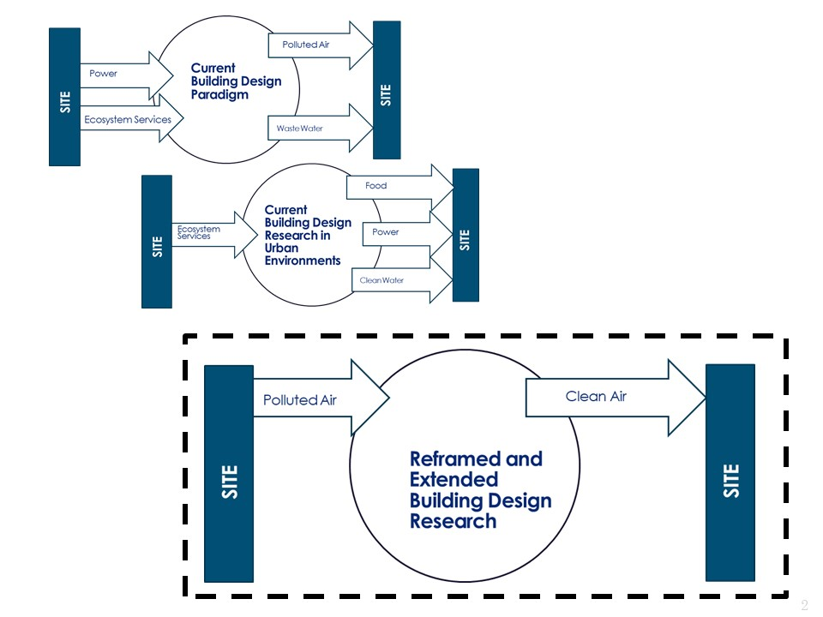
1.3 New Framework for Building Design
The interdependent nature of biological systems are an inspiration to transform our perception of building science and technology. This analogy is made by identifying and developing regenerative building facades – the cell wall analogy of the building - that interact with the streetscape component. Urban planners currently utilize a framework of regulations for urban design, one of which - Form Based Codes - dictates massing (the overall shape and form of a building), floor-to-floor heights, materials, and street widths. It is not a great leap to ask the architectural façade and street interface to contribute a bit more.
The use of a building to remediate environmental pollutants beyond the building perimeter represents a fundamental paradigm shift as to the nature of buildings in the urban and suburban environment.
It can further be assumed, that buildings in urban developments can ameliorate air pollution levels to the benefit of the health and welfare of the people within their area of influence. Indeed, when we look back at urban infrastructure and resiliency issues, we have shown that buildings are already being used to offset water needs and provide resources during and after extreme climate events [17,18].
Building design strategies primarily focus on individual buildings integrating within the urban design context, without properly accounting for the dynamic interactions within their ecological environments. Conceptual tools for the exploration of new forms are available, but intelligent sensing building envelopes (or skin) that scan for ecosystem service needs and selectively adapt to respond to both internal and external demands have not yet been linked to these building envelope forms except in a limited manner.
1.4 Infrastructure
While the world is urbanizing, infrastructure requirements to support it will be reaching crisis proportions in the coming years. Cities must absorb increasing urban populations, respond resiliently to drought or flood conditions due to climate change, and recognize that air quality is becoming increasingly hazardous. For example, the American Society of Civil Engineer’s 2017 Report Card for America’s Infrastructure gives a grade of “D+” for much of America’s infrastructure. The ASCE report card evaluated all aspects of public infrastructure and vulnerabilities related to population change and maintenance expectations.
Precedent models for building based resource generators, such as rainwater harvesting to supply potable water (when treated), reuse and treatment systems already exist, such as in the San Francisco Public Utilities Commission building [19]. Climate change has produced profound drought in the State of California. The City of San Francisco has been proactive by moving ahead with developing plans for implementing recycled water programs on multiple scales with centralized facilities, building scale incentives and district scale opportunities.
Seeking to set the example for water conservation and reuse, the San Francisco Public Utilities new headquarters facility was programmed to integrate building water systems from a building scale catchment and treatment perspective. The City of Tucson, while successful as a desert ecosystem, is undergoing increasing urbanization that is taxing its water and wastewater infrastructure. The city has implemented model water conservation ordinances [20] such as rainwater harvesting and gray water stub outs. People are realizing that buildings can actually offset the added infrastructure needs of increasing urbanization.
1.5 Urbanization and Air Quality Issues
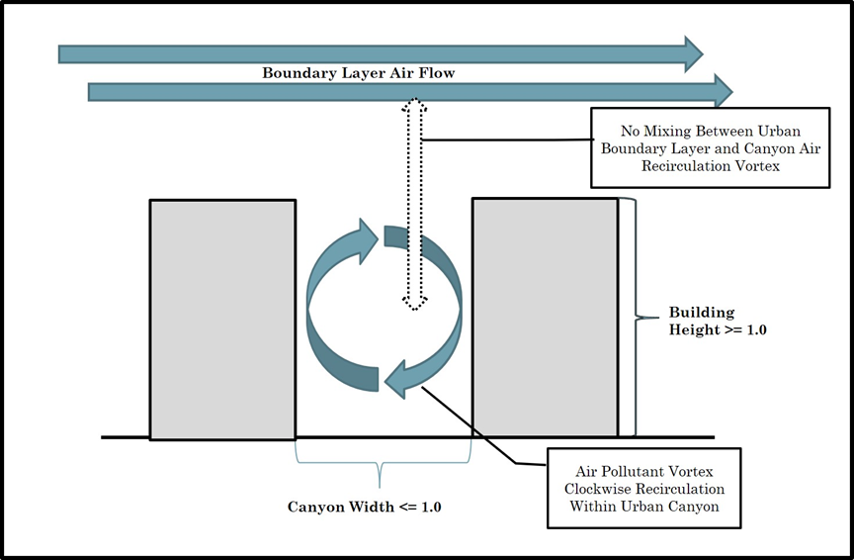
As urbanization and densification increases, the microclimates of urban/higher density suburban areas change. The largest accumulation of air pollution in North America is within the atmospheric boundary layer of a city, caused by its morphology, and with pollutants produced primarily by automobiles [21]. The removal of air pollutants at the street level is dependent upon the free flow of air diluting the pollution into a larger volume. Dispersion is best when there is strong instability and deep mixing characteristics during sunny summer time conditions. “Conversely, the worst conditions for dispersion occur where there is a temperature inversion and the boundary layer is stable. Turbulence is then suppressed, and upward motion is effectively eliminated.” [21]. This concept is illustrated in Figure 1.2.
Figure 1.2 Skimming and Recirculation in Urban Environments based on Oke 1992
Natural dispersion of air pollutants is possible in many urban environments where the free flow of air is possible. However, as streets narrow with buildings contributing to the urban street canyon, dispersion is compromised. “Wind and turbulence are vital to the dispersion of air pollutants. In areas characterized by low buildings, the exchange between street-level where car pollutants are emitted, and above roof-level depends upon the height to width ratio. If the streets are narrow (< 1:1 height to width ratio) air exchange is restricted (Figure 1.2) compared with that in a more open arrangement (>1:1.5) where the vortex circulation aids street-level flushing.”[21].
The climate of street canyons is primarily controlled by the micro-meteorological effects of urban geometry rather than the mesoscale forces controlling the climate of the boundary layer [22]. In certain conditions, the wind flow above the roof-tops is generally separated from the wind flow within the canyon. Depending on the velocity of the wind above the rooftops, dispersion of pollutants in canyon wind flows is least likely when roof top winds flow perpendicular to the street canyon. In the case of perpendicular flow, the up-wind side of the canyon is called leeward, and the down-wind windward [23].
When the above roof wind flow is perpendicular to the canyon and the wind speed is >1.5m/s, flow may be further described depending on the dimensions of the street [21]. In the case of regular canyons (aspect ratio H/W≈1), the bulk of the above roof wind flow skims over the canyon producing a skimming flow, which then traps polluted air in the street canyon and is characterized by the formation of a single vortex within the canyon [22]. Where meteorological influences including wind speed and direction create skimming regimes above the urban canopy, air pollution will accumulate within the street canyon.
Air pollution in the urban environment can compromise the health of people. While there are various sources of the air pollutants, in particular, particulate matter (PM) and ozone (O₃) have a profound association with urban areas and negative health outcomes ranging from severe asthma to breathing problems in elderly and children. The 2017 WHO air quality guidelines offer global guidance on thresholds and limits for key air pollutants that pose health risks. The guidelines are based on the evaluation of scientific evidence for particulate matter (PM), ozone (O₃), nitrogen dioxide (NO₂) and sulfur dioxide (SO₂).
The WHO air quality guideline values for particulate matter (PM) are categorized by particulate size [24]. Particle pollution is a mixture of solid particles and liquid droplets. There are two categories of particle size, PM_{2.5} and PM₁₀. PM_{2.5} particles are smaller than 2.5 micrometers in diameter are small enough to be breathed deep into the lungs, which can cause health effects especially for children, people over 65, pregnant women and people with existing heart or lung conditions (including asthma) because they are more sensitive to the effects of breathing fine particles. Unfortunately in many cities, air quality monitoring for particulate matter shows elevated non-attainment at PM_{2.5} [25]. People who live in high PM _{2.5} cities have more heart attacks, depressed lung function, worse asthma, and overall die younger than people who breathe clean air. Indices that score air pollution in cities typically give more weight to PM_{2.5} than PM₁₀ levels." [26].
Chronic exposure to these fine particles contributes to the risk of developing cardiovascular and respiratory diseases, as well as lung cancer. Air quality measurements are typically reported in terms of daily or annual mean concentrations of PM_{2.5} particles in micrograms per cubic meter (μg/m³)[3]. The 2005 WHO air quality guideline stipulates that PM_{2.5} not exceed 10 μg/m³ annual mean, or 25 μg/m³ 24-hour mean; and that PM₁₀ not exceed 20 μg/m³ annual mean, or 50 μg/m³ 24-hour mean. The 2005 WHO air quality guideline value for ozone (O₃) is 100 μg/m³ in an 8-hour mean and is based upon conclusive association between daily mortality and lower ozone concentrations[9].
Excessive ozone at the ground level is not to be confused with the ozone layer in the upper atmosphere. Ground level ozone in the air can have a marked effect on human health. It can cause breathing problems, trigger asthma, reduce lung function and cause lung diseases[3]. Ground level ozone is also “one of the major constituents of photochemical smog. It is formed by the reaction with sunlight (photochemical reaction) of pollutants such as nitrogen oxides (NO_{x}) from vehicle and industry emissions and volatile organic compounds (VOCs) emitted by vehicles, solvents and industry. As a result, the highest levels of air pollution occur during periods of sunny weather.”[3].
1.5.1 Form Based Codes Issues
The identification of urban street canyons in built urban environments is a matter of calculating height to width ratios. Current urban development guidelines, the modern-day version of Vitruvius’ prescriptive guidelines, are typically based upon regulatory documents called Form Based Codes (FBCs) for buildings in urban cores and the establishment of new town centers. These FBCs normally provide requirements for street dimensions between building facades and height limitations based upon stories. Without setting limits to these height to width rations, they can result in the development of an urban street canyon.
The vertical dimension of a street canyon, the building height (H), corresponds to the height of a building (H) which is typically regulated by the number of stories (floors) allowed. The horizontal dimension of a street canyon, the width of the street (W) corresponds to the Right of Way (ROW) which is the space between building lot lines and typically building facades are built to the edge of the lot line (zero-lot-lines).
The most important geometrical detail about a street canyon is the ratio of the canyon height (H) to canyon width (W), H/W, which is defined as the aspect ratio. The value of the aspect ratio can be used to classify street canyons as follows [23]:
- Regular canyon - aspect ratio ≈1 and no major openings on the canyon walls
- Avenue canyon - aspect ratio < 0.5
- Deep canyon - aspect ratio ≈ 2
In urban design, the amount of vehicular traffic, pedestrians, and bikers governs the width based upon activity within the ROW between buildings. When we consider that most urban design regulations in FBCs outside the urban core and not in suburban areas, call for buildings of 4-6 stories (approximately 62’-74’) with a consistent width of the ROW to accommodate vehicular, and pedestrian traffic (approximately 64’-72’), the morphology of the street canyon creates a > 1:1 aspect ratio of the regular street canyon.
The problem becomes one where FBCs are setting guidelines for streets, ostensibly for walkability, but are unintentionally creating street canyons which are accumulating unhealthy air pollutants in the very locations where they encourage people to walk.
Green infrastructure is assumed to offset some of the air pollution but in actuality, street plantings, integrated building plantings and surface mounted living walls serve only as surfaces for deposition of particulates and minor conversion of CO₂, they do not actually mitigate VOCs [27].

1.6 Literature Review and Research Questions
This research is based upon utilizing the intersection of several disciplines to address one aspect of urbanization – air quality. The research is organized around the use of building facades – the exterior wall or face of a building- which stand at the physical intersection of urban space and architecture, and the application of knowledge typically associated with urban climatology along with a limited amount of ecological engineering.
A literature search of current, peer reviewed Journal Articles, Conference Proceedings, Book Chapters, Technical Reports, Statistical Data Sets and Other for the search terms “building” and “outdoor air quality” was conducted for the years 2009-2019 and yielded 2,835 results. Of the results, there was limited mention of how building systems influenced outdoor air quality [6,28,29], almost all were about how outdoor air quality influences indoor air quality.
There were a set of interventions, however, that evaluated solutions that sought to improve street canyon air quality, where buildings served merely to form the “walls” of the canyon.
Removal of Vehicular Traffic - Overall, there is little evidence that restricting cars within cities improved air quality. In fact, across eight major pollutants, the results of the vehicular removal programs had virtually no discernible effect on pollution levels [30].
Increasing Urban Canopy - A common fallacy is that urban trees can mitigate particulates and VOCs. While it is true that CO₂ is sequestered, PM is not “taken up” and converted to biomass as in mosses, rather it accumulates on leaves and clogs stoma leading to far shorter life spans (less than 10 years) than forest trees [31,32]. Roadside urban vegetation can lead to increased pollutant concentrations rather than improving air quality, which is explained by the fact that trees and other types of vegetation reduce the ventilation that is responsible for diluting the pollutants emitted by traffic [33].
Building Materials and Urban Air Pollution – An investigation into photocatalytic paints, much touted for their air pollutant removal capabilities amongst current design professionals, found that certain photocatalytic paints release significant quantities of nanoparticles and volatile organic compounds (VOCs) over their lifetime. For example, while tests showed that titanium dioxide could eliminate xylene, the reactions behind this process created a series of new VOCs and also degraded the surface of the paint, releasing nanoparticles and formaldehyde which is a known carcinogen [34].
Building Configuration Influence on Flow in Urban Street Canyons – A few studies [28,35,36] attempted to mitigate air pollution in street canyons by suggesting various interventions to modify building geometry, however, the studies merely treated the building as a black box entity that is moved or altered its form or shifted the building back from lot lines to allow for ventilation of the canyon. The list of building configurations suggested by the study is as follows and is further considered in Chapter 3:
- Breezeway – establish spacing between buildings. This does not take in to account building site coverage of most zoning plans, and the desire of most real estate developers to maximize the building footprint within the lot [36].
- Podium Site Coverage – the establishment of a base to the building that then has a setback to again establish space between buildings [36].
- Building Disposition (staggering) – staggering buildings so the front façade is not in line with the street. This does not take in to account zoning requirements for zero lot line coverage, ie no setbacks [36].
- Building Height – placing limitations on the height of buildings. This is one of the most effective, but severely limits economic investment and development of urban core development [28].
- Building Permeability – essentially a suggestion that the buildings have holes through the middle [36]
- Active Ventilation Systems – putting fans and ducting within and under the street to cause mixing [36].
- Modifications of Building Roof Geometry – dictating roof forms to enhance canyon air pollution dispersion [35].
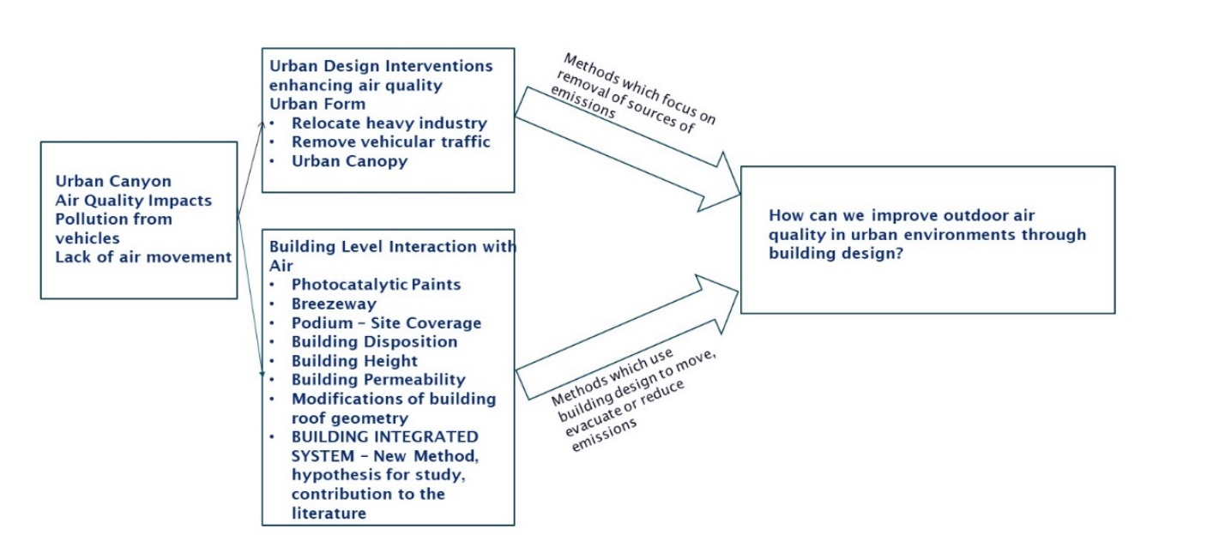
In order to develop the research questions, we must develop a conceptual framework to ascertain the known-knowns and known-unknowns, and ultimately the unknown-knowns and unknown-unknowns. Figure 1.3 represents a conceptual framework, and the means by which we can organize the knowns and unknowns identified through the Literature review.
Figure 1.3 Simplified Conceptual Framework
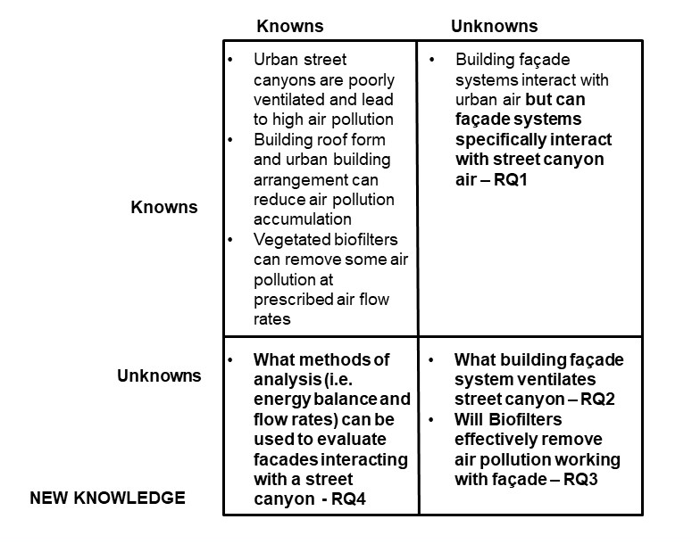
The conceptual framework, and associated gaps in knowledge particularly the known-unknowns and unknown-unknowns that lead to new knowledge, is presented utilizing a method described by the Project Management Institute [37]. Regarding this research, the knowns and unknows have been organized as in Figure 1.4.
Figure 1.4 Knowns–Unknowns and New Knowledge

The questions that arise from examination of the knowns and unknowns lead to several Research Questions (RQ) for purposes of this dissertation:
RQ1: What building systems interact with street canyon airflow?
RQ2: How can the building system ventilate street level air pollution and facilitate mixing?
RQ3: How can vegetated systems operate with a building to ameliorate air pollutants?
RQ4: What analyses demonstrate interaction of building with street level air?
To answer the research questions, several experiments were developed to test the following hypothesis:
- When coupling the building facade and the urban street is it possible to ventilate street level air pollution and facilitate mixing (RQ1 and RQ2 and RQ4)
- Will the operational air flow rates necessary to ventilate the street level air pollution, be within the established operational mass flow air pollution removal rates of the vegetated biofilters (RQ3)?

1.7 Outline of the Dissertation
The research is organized in the following manner:
- Chapter 1 - Background of the urban air quality issues and the urban morphology that gives rise to the dissertation focus.
- Chapter 2 - A review of the current practices in urban design that continue to create new urban morphologies while not addressing air quality issues.
- Chapter 3 - A review of the current methods of addressing urban air quality issues using architectural, urban planning and ecological means, and identification of an architectural façade system – the Double Skin Façade – that can interact with and create a sort of ecosystem service to address air quality issues.
- Chapter 4 - The means and methods of analyzing air flow in a Double Skin Façade.
- Chapter 5 - The results of the CFD and wind tunnel analyses of the Double Skin Façade and its interaction with the urban street.
- Chapter 6 - The conclusions that the Double Skin Façade can evacuate air pollutants within the urban street adjacent to the façade. Additionally, the DSF operational parameters can support integration of a vegetated biofilter potentially ameliorating air pollutants.

For this dissertation, the following definitions of validation and verification are used:
Validation – “Validation means confirmation by examination and provision of objective evidence that the particular requirements for a specific intended use can be consistently fulfilled.”[38].
Verification – “Verification means confirmation by examination and provision of objective evidence that specified requirements have been fulfilled.”[38].

Research in this dissertation was conducted through literature review, simulation, and experimentation. Validation of CFD simulation results were based upon examination of visual display of software derived quantitative results. Wind tunnel analyses were used to validate CFD analyses, and wind tunnel experimental results were based upon examination of the visual recording of the experimental test. Table 1.5 summarizes the validation and verification of the CFD simulations and wind tunnel experiments.
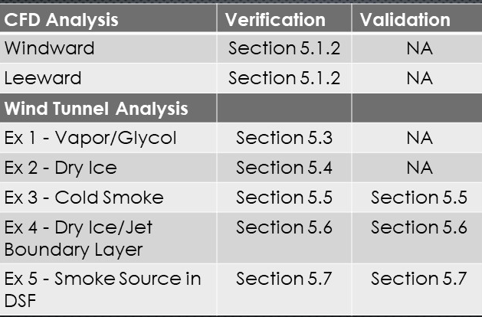
Table 1.1- Analysis, Verification and Validation of CFD Simulation and Wind Tunnel Experiments
CHAPTER 2 – HOW FORM BASED CODES CREATE STREET CANYONS
2.1 Review of Form Based Codes used to Regulate Urban Morphology
Urban planners have a collection of tools at their disposal to manage urban growth. One of their tools is the zoning code. American zoning codes have a relatively short history, but they have had a profound impact on building form – influenced in no small way by the accommodations for the automobile. Zoning typically deals with the arrangement and adjacency of buildings, their uses and their density. Downtown building height regulations are traditionally based on the Floor-Area Ratio (FAR) which addresses lot size and building coverage. Zoning FARs have led to incredibly dense urban centers that rapidly become more speculative than livable, enabling uncontrolled suburban sprawl as people spread outward to live and work and find respite from the stresses encountered in dense urban centers.
In order to counter sprawl, urban planning embraces Smart Growth, which includes rebuilding the urban core, retrofitting underutilized commercial and industrial areas, and densifying and creating suburban town centers. Comprehensive urban planning process is equally a useful tool. If area plans for downtown identify where urban street canyons have emerged, building codes or allowances for additional height may be granted if certain conditions are met - including affordable housing allowances, access to transit -- and offering environmental benefits to water and air quality. One of the elements of Smart Growth is Transit Oriented Development (TOD). TOD is where building districts are arranged near transit, provide a means to arrange a diversity of uses and housing in close proximity, and create walkable corridors to and from public spaces and services. Walkability is important as it contributes to positive health outcomes in the urban environment. “Walkable communities, or neighborhoods, are those in which residents can walk to nearby destinations, and such neighborhoods encourage walking as a means of transportation.”[39]
What makes a street “walkable” has several dimensions including the separation of transportation systems from sidewalks, incorporating trees and plantings in streetscape design as well as connected access. Walking can be enhanced by shaded trees, views into windows, biophilic integrated building design, and connected parks and greenspace. The connection to nature is fundamental to a balanced streetscape design.
Since 1990, planners and urbanists have organized the Congress of the New Urbanism (CNU), the purpose of which is to reform urban planning practice in the United States and the world. The Charter for the New Urbanism provides for visioning urban form. Form-Based Codes (FBCs) encompass the concepts of TOD and are the preferred instrument for implementing new urbanist ideas at all scales and in all settings. Much like Vitruvius’ treatise, the elements of FBCs are developed upon the transect, spatial organization by neighborhood, districts and corridor, and entitlement by type. FBCs for urban districts give a desired walkability to public space through dimension, materials, and façade qualities of the buildings. These FBCs are not dimensionless; indeed, they draw upon neuroscience based perceptions of enclosure and traffic calming streetscapes in order to enhance the pedestrian experience [40].
The transect is a means of coding density and establishing “immersive environments in which building, open spaces, landscape and infrastructure are combined to produce memorable permanent spaces”[41]. FBCs replace sprawl with the idea of regulating within clear, identifiable spatial boundaries. They seek to accommodate a large range of mixed uses while minimizing the dependence on the automobile (but not removing it). There are six Transect Zones, or T-zones, for application on zoning maps. Design Guidelines and standards were developed for the first transect-based codes, which then evolved to become the model SmartCode, released in 2003 by Duany Plater-Zyberk & Company as can be seen in Figure 2.1 [42]
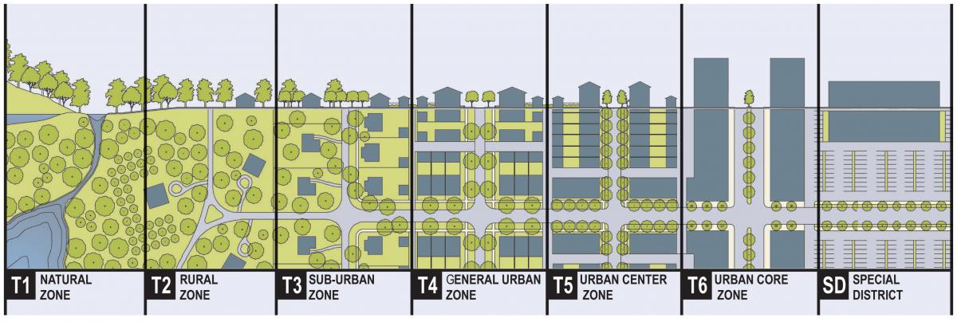
Figure 2.1 A Typical Rural to Urban Transect, with Transect Zones (SmartCode)
This SmartCode system replaces conventional separated-use zoning systems that encouraged a car-dependent culture and sprawl. The six Transect Zones provide the basis for real neighborhood structure, requiring walkable streets, mixed use, transportation options, and housing diversity. The SmartCode [42]system defines the Transects as follows: “T-1 Natural Zone consists of lands approximating or reverting to a wilder-ness condition, including lands unsuitable for settlement due to topography, hydrology or vegetation; T-2 Rural Zone consists of sparsely settled lands in open or cultivated state. These include woodland, agricultural land, grassland, and irrigable desert. Typical buildings are farmhouses, agricultural buildings, cabins, and villas; T-3 Sub-Urban Zone consists of low-density residential areas, adjacent to higher zones that some mixed use. Home occupations and outbuildings are allowed. Planting is naturalistic and setbacks are relatively deep. Blocks may be large and the roads irregular to accommodate natural conditions; T-4 General Urban Zone consists of a mixed use but primarily residential urban fabric. It may have a wide range of building types: single, side yard, and rowhouses. Setbacks and landscaping are variable. Streets with curbs and sidewalks define medium-sized blocks; T-5 Urban Center Zone consists of higher density mixed use building that accommodate retail, offices, rowhouses and apartments. It has a tight network of streets, with wide sidewalks, consistent street tree planting and buildings set close to the sidewalks; T-6 Urban Core Zone consists of the highest density and height, with the greatest variety of uses, and civic buildings of regional importance. It may have larger blocks; streets have consistent street tree planting and buildings set close to the wide sidewalks.” [42].
The T‑zones vary by the ratio and level of intensity of their natural, built, and social components. They may be coordinated to all scales of urban planning, from the region through the community scale down to the individual lot and building [42]. For purposes of this interdisciplinary research, increasing urbanization will deal primarily with T-5 Urban Center and T-6 Urban Core Zones. T-5 Urban Center Zones typically describe New Town Centers created by urban designers.
The FBCs have achieved great successes across the United States and around the world, such as the new town of Seaside in Florida and Curitiba in Brazil. However, while planners and architects are busy developing and redesigning new town centers and revitalizing urban cores, other areas of evidentiary and scientific inquiry are recognizing that much of the developing urban morphology is leading to unintended consequences particularly with regard to urban air quality.
The FBCs are used to regulate urban form by defining the dimensions of street corridors including pedestrian and vehicular paths, building heights and form, street plantings and sometimes stylistic façade elements. Understanding that the FBCs are setting heights of buildings and widths of streets it becomes apparent that FBCs must be examined to determine if any elements of the FBCs respond to answering RQ1 What building systems interact with street canyon airflow and RQ2 How can the building system ventilate street level air pollution and facilitate mixing?
2.2 The Design Guides for Urban Cores and Town Centers
While FBCs are used to restore buildings in urban cores, establish new town centers, develop walkable cities and prevent sprawl, the FBCs also establish the relationship between the building and street with their resulting geometry creating the potential to form an urban street canyon. The movement of traffic, pedestrians, and bikers governs the width ratio based upon activity within the right-of-way between buildings. In association with the CNU, the National Association of City Transportation Officials (NACTO) has created a compendium of principles and practices for Complete Streets based on the local Transect, which includes the design capacity for safe interaction of automobiles, pedestrians, bikers, multi-modal transit, and urban infrastructure [43].
A Complete Street uses an integrated strategy to safely allow activity to inhabit the streetscape. “Lane widths of 10 feet are appropriate in urban areas and have a positive impact on a street's safety without impacting traffic operations. For designated truck or transit routes, one travel lane of 11 feet may be used in each direction. In select cases, narrower travel lanes (9–9.5 feet) can be effective as through lanes in conjunction with a turn lane.” [44]. A Complete Street also incorporates on street parking, bike lanes, and sidewalk areas.
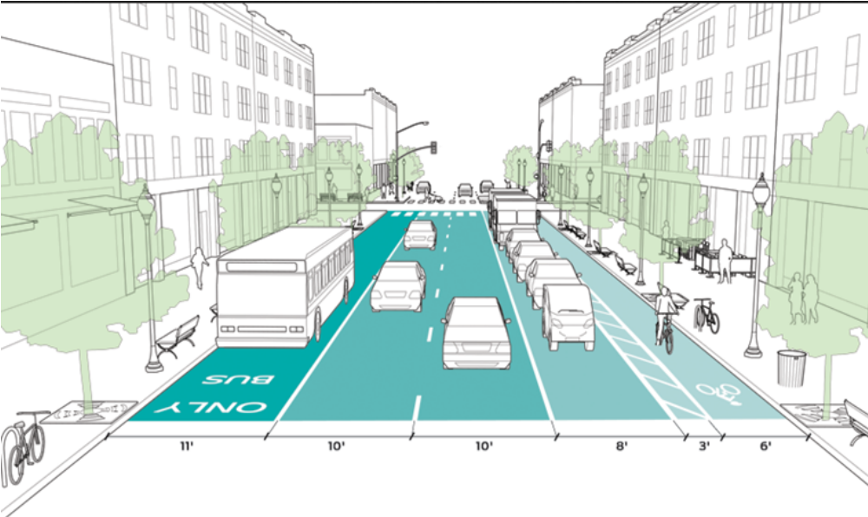
Figure 2.2 Lane Width Guide (NACTO 2017) where image shows only initial building development not potential building height
The sidewalk is the area where people interface with one another and with businesses most directly in an urban environment [45]. As the public space ROW dictates, sidewalk design guides indicate three distinct zones for the sidewalk:
“The frontage zone describes the section of the sidewalk that functions as an extension of the building, whether through entryways and doors or sidewalk cafes and sandwich boards. The frontage zone consists of both the structure and the facade of the building fronting the street, as well as the space immediately adjacent to the building. The pedestrian through zone is the primary, accessible pathway that runs parallel to the street. The through zone ensures that pedestrians have a safe and adequate place to walk and should be 5–7 feet wide in residential settings and 8–12 feet wide in downtown or commercial areas. And the street furniture zone is defined as the section of the sidewalk between the curb and the through zone in which street furniture and amenities, such as lighting, benches, newspaper kiosks, utility poles, tree pits, and bicycle parking are provided. The street furniture zone may also consist of green infrastructure elements, such as rain gardens or flow-through planters.” [45]

Our place making and street design for walkability is placing more people on the street without effectively controlling for the potential air pollution accumulation based upon building height to ROW ratios.

2.3 Review of Form Based Code Institutes Library of Codes
The Form-Based Codes Institute (FBCI) is a professional organization that is part of Smart Growth America. It is dedicated to advancing the understanding and use of form-based codes as well as developing standards for form-based codes [46]. FBCI maintains a library of the best examples of form-based codes from communities across the United States and abroad. The codes represent a variety of community types and applications of form-based standards. Information in this library includes: physical context (size or type of government entity), organizing principle (underlying organization for the code standards), and implementation method (how the code standards operate within the zoning ordinance).
There are listings for 47 FBCs found within the FBCI’s library [46]. Each FBC in the library was searched for regulatory language controlling ROW to building height. Specific search words were:
- References to “transect”, “town center”, “thoroughfare”, “ROW”
- Height Restrictions as identified as: number of “stories” or “maximum (max) height”
- If building height was defined as “stories” then a numerical value of 15 feet in height was applied for the first story and 12 feet in height for each additional story.
Not all FBCs had regulatory information for transect, ROW or building height. Of the 47 FBC’s (Figure 2.3), 17 FBCs had information for both ROW and building height but none provided regulatory language offering constraints that would prevent the creation of the 1:1 (1 or greater) urban street canyon ratio. Of the 17 that were identified, 9 had a ratio greater than 1:1 (Table 2.1). If Building Height and ROW were provided, the Height:ROW ratio was calculated. Any ratio calculation that was greater than or equal to one (1) indicates the potential creation of an urban street canyon condition with the potential for air pollution accumulation.
It is important to note that most of the FBCs were not related to existing communities with high density, T6-Urban Core zones. These existing urban areas would still benefit from the results of this research as many already have urban street canyons as a matter of historical development.
Figure 2.3 Locations of Communities in FBCI Database Used for Study
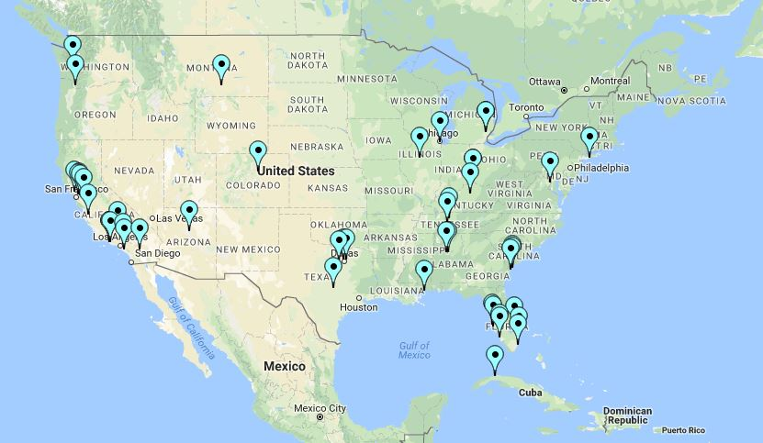
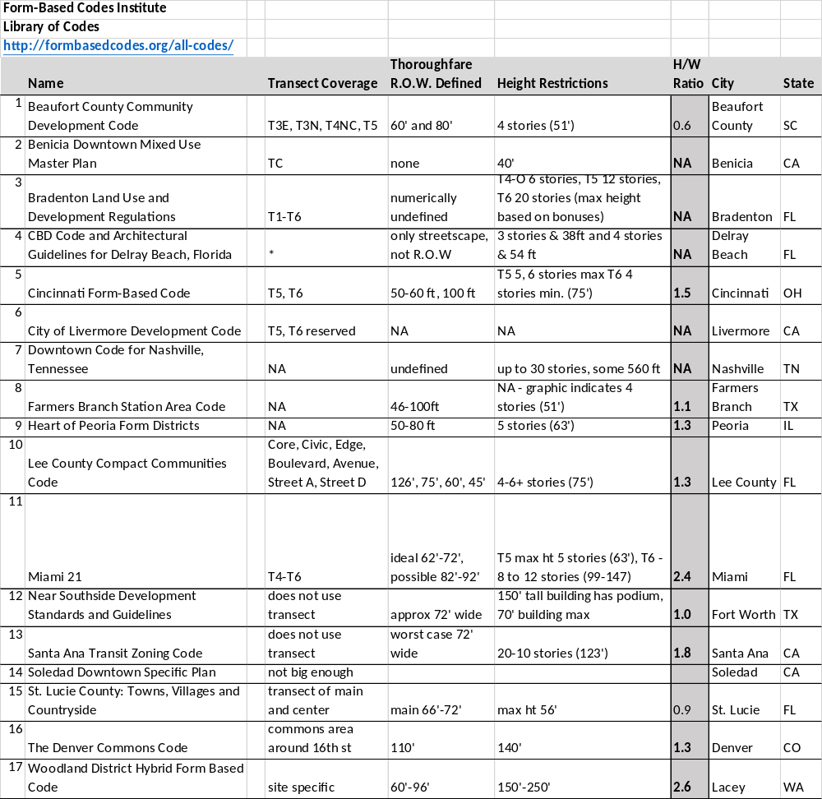
Table 2.1 Form Based Codes with Identifiable Height to ROW

2.3.4 Cincinnati Form Based Code Example
As a selected example, we will review how the City of Cincinnati, Ohio has created FBC guidelines for the T5 development areas of their Urban Design Overlay Districts [47], and how that FBC does not identify the potential to form an urban street canyon. The developing neighborhood of Madisonville (Fig 2.4 [48]) has restricted building heights to 6 stories (~75 ft) but with narrow streets that will be limited to 50 feet (Figure 2.6), it creates the potential H:W ratio of 1:0.67 or 1.5 which has been shown to cause air pollution accumulation.
Prevailing winds in the Madisonville area run perpendicular to the main street identified as a T5 district. When this is coordinated with prevailing winds which run primarily perpendicular to the major orientation of the streets (Figure 2.5 [49]), we can see how the air pollution accumulation will be exacerbated should Madisonville develop streets based on the maximum building height provided by the Cincinnati FBC (Figure 2.6).
It is interesting to note that within the Cincinnati FBC there is no mention of air quality issues. This is unfortunate because it ignores the existing air quality assessments already identified by the 2018 American Lung Association report for Cincinnati: “Cincinnati and other nearby metropolitan areas are on the list of 25 most polluted cities, due to the high levels of year-round particle pollution.” [50]. It is also noted that the American Lung Association’s 19th Air Quality report states that “While all these cities have levels that meet the national air quality standard in the U.S., all have levels above the limit recommended by the World Health Organization.” [51].
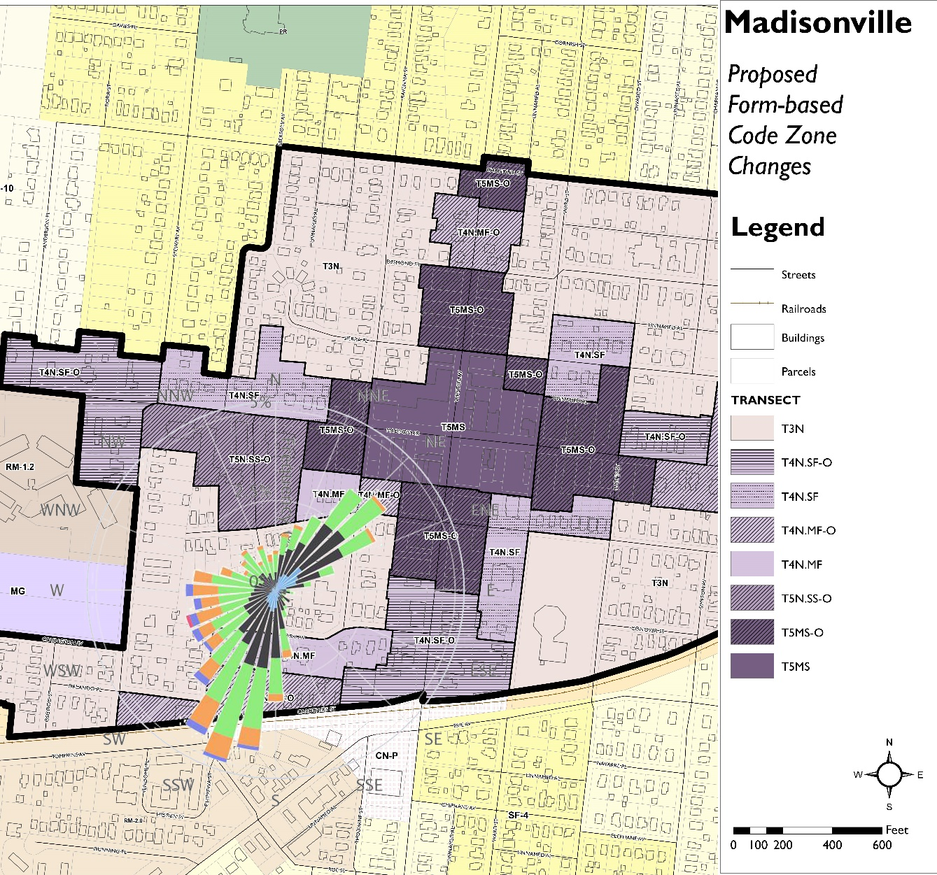
This issue takes on a sense of urgency related to the development of building systems to counter the effects of a regulatory issue within the urban design community that is governing future development. The identification of building systems that could ameliorate the street level air pollutants, as per RQ1 (What building systems interact with street canyon airflow) and RQ2 (How can the building system ventilate street level air pollution and facilitate mixing) becomes more important to informing FBCs and establishing means to counter some of the unintended effects.
Figure 2.5 Madisonville Cincinnati FBC Overlay District with Prevailing Winds

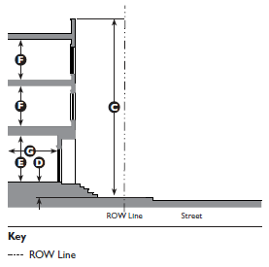
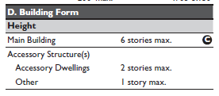
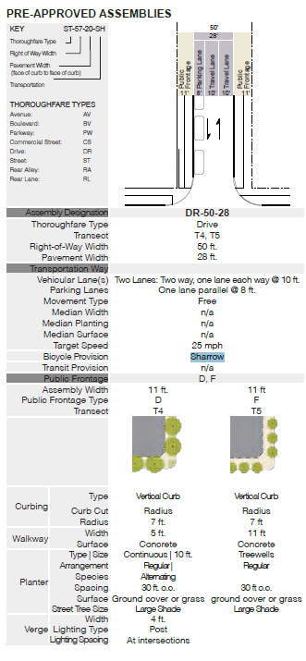
Figure 2.6 T5 Thoroughfare Guidelines – City of Cincinnati Form Based Code

CHAPTER 3 - CHALLENGES TO URBAN DESIGN INTERVENTIONS AND SELECTION OF ARCHITECTURAL FAÇADE SYSTEM
3.1 Current Urban Built Environment Solutions to Air Quality Issues
There are numerous methods that have been introduced to address air quality issues in urban environments. Relocating heavy industries to outside the city limits (zoning), increasing the efficiency of HVAC systems and properly insulating buildings, and removing as many polluting vehicles as possible from the roads. None of these methods truly fit within the established norms of urban design.
3.1.1 Vehicular Traffic
In particular, removal of cars within city centers has been chosen as the primary focus. In 1989 Mexico City banned cars for one day each week based on the last digit of their license plate. Athens, Greece also restricted cars this way in 1982, and other cities have since followed: São Paulo in 1995, Bogotá in 1998, Beijing in 2008, and most recently Delhi in 2016 [52]. Overall, there is little evidence that restricting cars within cities improved air quality, in fact, across eight major pollutants, the programs had virtually no discernible effect on pollution levels [30].
London has implemented measures including banning cars from Oxford Street, switching away from diesel buses, investing in alternative transport such as cycling, and taxing vehicles built before 2006. Paris has enacted car-free days, commissioned redesigns of streets and intersections to favor pedestrians, banned old cars from the city center, and closed portions of a major road along the Right Bank of the Seine to cars. Barcelona has developed a road grid dividing the city into nine-block squares and through-traffic can only use the perimeter roads, including the city’s bus routes.
The removal of cars from city centers, which typically would be designated in Transit Oriented Development nomenclature as T-6 Urban Core Zones fails to consider the T-5 Urban Center Zone which is a primary economic development zone and is not typically included or regulated beyond its urban morphology [46]. Furthermore, the exclusion of vehicular traffic for T-6 Urban Core Zones fails to take in to account equity issues. “The revival of America's core cities is one of the most celebrated narratives of our time — yet, perhaps paradoxically, urban progress has also created a growing problem of increasing inequality and middle-class flight” [53]. Most T-6 Urban Core Zones are now divided between well-paid professionals and lower-paid service workers with real estate rates limiting access to the regulated Core Zones. In virtually all U.S. metro areas, the inner cores are more economically unequal than their corresponding suburbs [54,55].
Social equity issues and economic development maintains the necessity of vehicular traffic within urban cores. Suggesting that the solution to urban street canyons’ air pollution issue, is the removal of that vehicular traffic, again points to finding an alternative solution that expands the potential use of the buildings forming the street canyon.
3.1.2 Urban Tree Canopy
Not all urban air quality solutions are centered around transit, many suggest the “greening” of urban areas to use various plants and trees to sequester pollutants. In Stuttgart, a 100 meter by three-meter-high moss wall was constructed from two moss species (Ceratodon purpureus and Racomitrium canescens). The species selected were suited to filter and degrade fine particulate matter and works passively with localized urban air currents. Another moss-based solution is an actively ventilated streetscape fixture called CityTree by Green City Solutions [56]. While the system cannot operate year-round due to seasonal requirements, the system has been found to have 26-46% reduction in PM_{2.5} and 20-53% reduction in PM₁₀ at a constant air flow of 5.5 m³/min.
A common fallacy is that urban trees can mitigate particulates. One example is the Bosco Verticale in Milan, Italy (Figure 3.1). While it is true that CO₂ is sequestered, PM is not “taken up” and converted to biomass as in mosses, rather it accumulates on leaves and clogs stomata leading to far shorter life spans (less than 10 years) than forest trees [31,32]. Roadside urban vegetation can lead to increased pollutant concentrations rather than improving air quality, explained by the fact that trees and other types of vegetation reduce the ventilation that is responsible for diluting the traffic emitted pollutants [33].
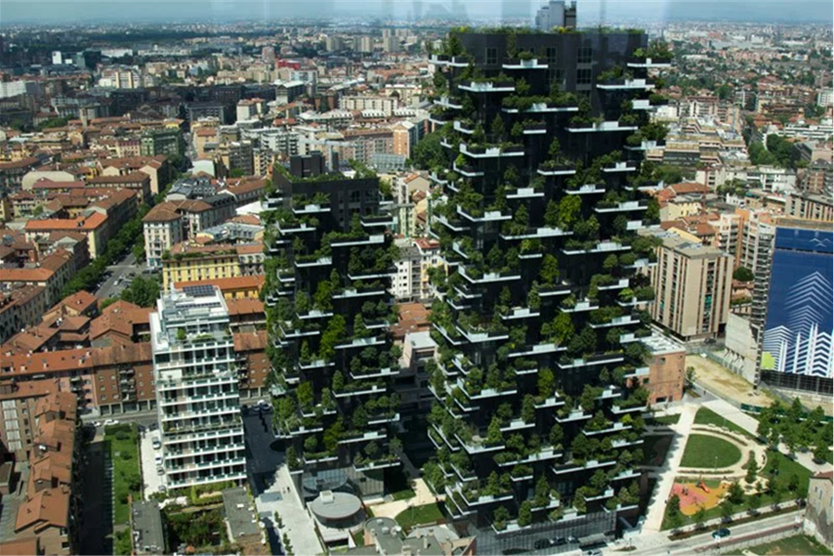
The need to implement “greening” in the city is inherent to human nature [57]. Another solution to outdoor air quality issues are building facades with integrated vegetation. These examples are increasingly being built but their contribution is using photosynthesis to convert CO₂ to O₂ [58,59]. The “either-or” scenario of removing urban trees in favor of better air quality need not be mutually exclusive and leads to integration of “green” into a building system as an option to remediate pollutants is raised by RQ3.
Figure 3.1 Bosco Verticale - Milan, Italy - Example of Building Integrated Vegetation

3.1.3 Building Materials and Urban Air Pollution
There have also been developments in coatings applied to building surfaces that have chemical interactions with air pollutants. Photocatalytic paints containing compounds such as titanium dioxide nanoparticles, when exposed to UV light, can oxidize organic compounds in the air, and are an example of a treatment technology using only sunlight or ambient lighting to work. However, it has been found that these photocatalytic paints release significant quantities of nanoparticles and volatile organic compounds (VOCs) over their lifetime. For example, tests showed that while titanium dioxide could eliminate xylene, the reactions behind this process create a series of new VOCs and also degraded the surface of the paint, releasing nanoparticles and formaldehyde which is a known carcinogen. [34].
While surface coating on facades seem to be part of a building system, the use of coatings is more a matter of materiality and must be ruled out as a building system integration as it relates to RQ1 and RQ2.
3.1.4 The Building and Air Quality Issues
Within the envelope of an urban building, air quality is an issue addressed almost completely as an internal requirement. Building ventilation systems rely on air quality monitoring and are designed to optimize energy efficiency for the building and its occupants. Outside air is drawn in to the building and monitored for temperature, humidity and air quality, before it circulates within the building.
Heating/cooling/dehumidification (HVAC) systems adjust that air as it circulates within the building envelope, and high-efficiency particulate air (HEPA) filters are sometimes used to capture particulates particularly within Medical Facilities [60]. It is important to note that the U.S. Department of Energy (DOE) requires HEPA filters to capture 99.7 of particles larger than 0.3 microns. Air particles are caught through either interception, impaction or diffusion [61] but this does not necessarily meet the WHO PM_{2.5} and PM_{1.0} requirements.
As the building inside air is recirculated, it is monitored for CO₂ levels. When CO₂ levels become too high, recirculating air is exhausted to the environment and “fresh” outside air is brought in to repeat the cycle. In urban environments, outside air is captured primarily from rooftops but sometimes from street side access. The management of inside air quality and energy efficiency are the primary focus of building HVAC systems, while the consideration of the air quality of the urban street is seen only from the perspective of its quality as a fresh air resource.
From the literature review, it was noted that there are no studies that suggest that the building HVAC system should be used to ameliorate air pollution found outside the building, except for use within the building perimeter. Understanding that the building indoor air quality is highly regulated, and that it is highly dependent upon the quality of the outside air, led to the development of RQ1 and RQ2 with the use of alternative biofilters to potentially take on the role of the HEPA filter which led to the development of RQ3.
3.1.5 Street Side Intake Air Access
Street side air intake has been categorized by the type of aperture used, typically a grille or window (fenestration). Most modern HVAC systems will connect the grille to the Air Handling Unit (AHU) and precondition the air before it enters the building system. Operable fenestration was historically used for ventilation prior to the onset of HVAC, but fell out of use because of misguided energy efficiency prescriptive requirements for building HVAC system control. However, operable fenestration systems have seen an upsurge in use for resiliency in certain instances such as power failure.
Climate change is increasing hazardous weather events. The NIST Center of Excellence for Risk Based Community Resilience Planning defines community resilience as: “The ability of a community to prepare for and adapt to changing conditions and to withstand and recover from disruptions to its physical and non-physical structure.”[62] Initial stakeholders are looking to building codes with robust structural guidelines and reinforcing existing infrastructures as a means to withstand hazardous events.
Figure 3.2 NYC Skyscraper with Operable Curtain Wall next to High Line
Envelope considerations play a large role in creating an economically efficient and healthy environment for the occupants and the businesses they shelter, before, during and after hazardous weather events. Glazed window (Figure 3.2) and door systems that are operable before and after a hazardous event provide for many of the needs of a building that is designed to be sustainable and resilient giving it the ability to adapt to changing conditions as well as recover from disruptions.
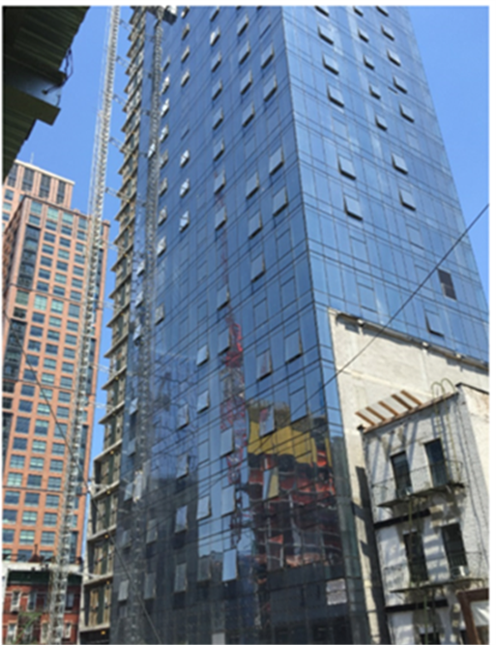
Productivity performance measures also utilize access to daylighting through fenestration systems [63]. Fenestration in the building façade is fundamental to both sustainability and resiliency. Removing fenestration does not create a resilient building. When energy systems fail, HVAC does not function. If power is restored in an emergency situation, it may not be sufficient to heat or cool the building. Operable fenestration, a hallmark of sustainable design as it provides daylighting, natural ventilation and passive systems for net-zero energy capability, allows a building to remain comfortable during the time it takes for municipal power and infrastructure systems to be restored. Responding to power outages and understanding that the operable façade of a building lends itself to the resilient operation of ventilation, leads to the development of RQ1.
3.2 Understanding of Building Configuration Influence on Airflow in Urban Street Canyons
Urban Boundary layer wind tunnel studies have investigated building configurations and the flow modifications inside urban street canyons. These flow modifications have been found to assist in street canyon pollutant dispersal. Variations in roof geometry have been found to impact the in-canyon air vortex formation and dynamics as much as the street width to height ratio. [35]. Unfortunately, Form Based Codes have not taken this recommendation in to account as the aesthetics of the design scenarios are highly stylistic and urban street canyon air quality is not necessarily considered.
Additionally, other design recommendations include the following [36]:
Breezeway: Linking of open spaces, creation of open plazas at road junctions, maintaining low-rise structures along prevailing wind direction routes, and widening of the minor roads connecting to major roads. This is a highly specific solution with limited application as many urban transit systems are already developed. Additionally, the creation of open plazas at road junctions is counter to urban design principles.
Podium - Site Coverage: Stepping building heights in rows would create better wind at higher levels if differences in building heights between rows are significant. The “podium” structures commonly found in Hong Kong are not desirable. The analysis and direction of such a comprehensive design solution, with required limitations to height and form across multiple lots and neighborhoods prevents the introduction of this as a comprehensive solution.
Building Disposition: Stagger the arrangement of the blocks such that the blocks behind are able to receive the wind penetrating through the gaps between the blocks in the front row. This would be applicable in completely new town development, but impossible in existing urban areas due to the existing urban transit systems and property rights.
Building Height: Vary the heights of the blocks with decreasing heights towards the direction where the prevailing wind comes from. If not, it is better to have varying heights rather than similar / uniform height. Again, the analysis and direction of such a comprehensive design solution, with required limitations to height and form across multiple lots and neighborhoods prevents the introduction of this as a comprehensive solution. Additionally, higher real estate values tend to correlate with access to prevailing winds, suggesting taller buildings would be developed closer to the origination of prevailing winds [64].
Building Permeability: Create permeability in the housing blocks. Creation of openings in the building blocks to increase their permeability may be combined with appropriate wing walls that will contribute to pressure differences across the building facades and thus will permit the air to flow through the openings of the buildings. Urban planning practices and the layout of real estate parcels in urban environments typically require zero-lot lines which would preclude the requirement for openings in building blocks. Modification of the building permeability through openings is a morphology that is not considered a building system, but one of form and will not be considered in the research questions.
Active Ventilation System for Deep Urban Canyons: In order to improve the ventilation at the very narrow streets, especially in deep canyons, active ventilation systems may be considered, e.g. using vertical chimneys / stacks that transfer air from the canyons to higher levels above the buildings. Such chimneys will also contribute to decrease in pollution. This solution has the most applicability to this study as one building structure – a double skin façade - can interact at the street level and transfer air from the street canyon to higher levels above the building. How active ventilation systems could be coupled to urban street canyon leads to RQ1 and RQ2.
Modifications of building roof geometry inside street canyons: with flat roofs, flow separation is noted at the upwind edge of the upwind building and recirculating vortex forms within the canyon. With pitched roofs, vortex does not form, and stagnation occurs with increased pollution levels for configurations with pitched roofs at the upwind buildings.[35] Depending on the design guidelines developed for the FBCs, the roof shape can greatly influence the air pollution accumulation in the canyon. Modification of the building geometry is a morphology that is not considered a building system, but one of form and will not be considered in the research questions.

3.3 The Case for the Use of the Double Skin Facade
In the search for energy efficiency, double-skin facades (DSFs) are assuming greater importance in building practice, moreover, their internal and external components can be made operable. They have been increasingly used in German and Belgian architecture as they permit natural ventilation and daylighting while keeping unwanted noise, rain and wind out of the building. While there are still relatively few buildings where DSFs have been incorporated, primarily due to the costs associated with multi-layered facades [65], DSFs are seeing increasing use due to their buffering characteristics and energy efficiencies for street side ventilation access – providing there is sufficiently adequate air quality present.
A ventilated double façade can be defined as a traditional single façade doubled inside or outside by a second, essentially glazed façade. [66]. Automated equipment, such as shading devices, motorized openings or fans, are most often integrated into the façade. [66]. The double skin façade (DSF) is a building façade technology that can meet the needs of the building occupants for natural ventilation, thermal efficiencies, and daylighting. Furthermore, given the correct configuration of DSF, it can satisfy the recommendation of using vertical chimneys/stacks that transfer air from the canyons to higher levels above the buildings. This is the reason for investigating double skin facades for this research and details of the decision are provided next.

3.3.1 Double Skin Facades – Evaluation and Selection
While the understanding of the capacity of the DSF to evacuate air at the street level within the zone of influence is fundamental, there remains the issue as to whether this could actually remove criteria pollutants from the streetscape where human interaction is being promoted.
The various definitions of DSF are characterized and described in the Belgian Building Research Institute publication “Ventilated Double Facades” [66]. The classification takes into account the modes of how the facades work and introduces three criteria which are independent of one another:
1) the type of ventilation (natural, mechanical and hybrid ventilation);
2) the partitioning of the façade; and
3) the modes of ventilation of the cavity.
The main difference between a ventilated double façade and an airtight multiple glazing, whether or not integrating a shading device in the cavity separating the glazings lies in the intentional and possibly controlled ventilation of the cavity of the VDF [66]. The European standard prEN 13119:2004 “Curtain walling – terminology’ defines the terms ‘curtain walling’ and ‘double-skin façade’ without discussing the differences in ventilation of the cavity located between the two skins of the double skin façade. Consequently, the Belgian Building Research Institute (BBRI) classifies ‘Ventilated Double-Skin Façade’ or ‘Ventilated double façade’ as generic terms for this typology and does not include the structural aspect [66].
BBRI classifies VDF’s with regard to:

Type of ventilation (the type of ventilation influences the thermal performance of the façade)
- Natural Ventilation
- Mechanical Ventilation
- Hybrid Ventilation
The types of partitioning of the façade are listed in Table 3.1 with pros and cons regarding their efficacy for interfacing with the street level and potential for providing natural ventilation:
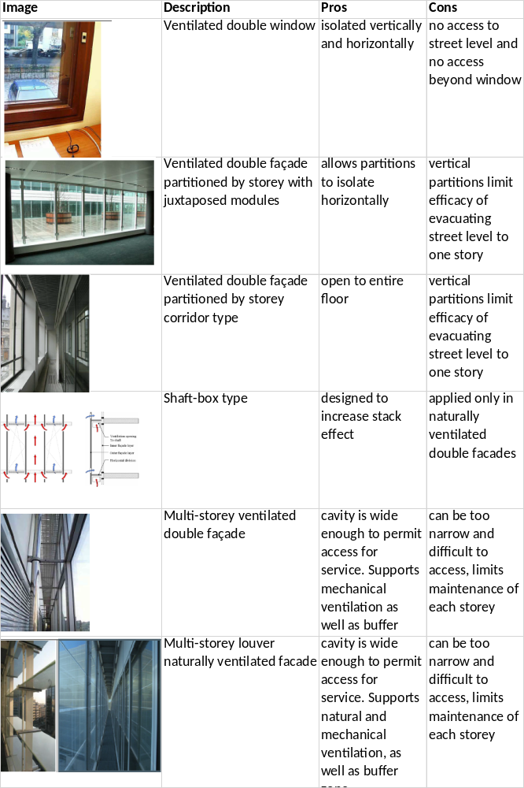
Table 3.1 Evaluation of DSF Types
The partitioning of the façade
- Ventilated double window – also called box window, characterized by a window doubled inside or outside by a single glazing or a second window as a wall infill space
- Ventilated double façade
  - Partitioned by story
    - Juxtaposed modules – the cavity is physically delimited horizontally and vertically and is limited to one story.
    - Corridor type – are partitioned by story and characterized by a large corridor supporting maintenance ie walkable
  - Shaft-box type – the objective is to encourage natural ventilation by linking with an increased stack effect, and is composed of alternation of juxtaposed façade modules partitioned by story and vertical ventilation ducts setup in the cavity which extend over several floors
  - Multi-story type – facades of this type are typically naturally ventilated, however there are examples of facades of this type which are mechanically ventilated to utilize the façade as a preheat or exhaust buffer ventilation space
  - Multi-story louver type – differs from the multi-story façade in that the outdoor facade is composed exclusively of pivoting louvers rather than a traditional monolithic facade

There are five modes of ventilation of the DSF cavity:
- Outdoor air curtain – air introduced into the cavity comes from the outside and is immediately rejected towards the outside, creating an air curtain enveloping the outside facade
- Indoor air curtain – the air comes from inside the room and is returned to the inside of the room or via the ventilation system
- Air supply – the ventilation of the façade is created with outdoor air which is brought to the inside of the room or into the ventilation system
- Air Exhaust - the air comes from inside the room and is evacuated toward the outside
- Buffer Zone – the ventilations mode is distinctive as the skins of the double façade are airtight, with no ventilation of the cavity
The five ventilation technology types are illustrated as follows (Figure 3.3), with the findings indicating only modes 1 and 3 being able to address street level air zones, but only mode 1 being able to bypass the building’s internal ventilation system:
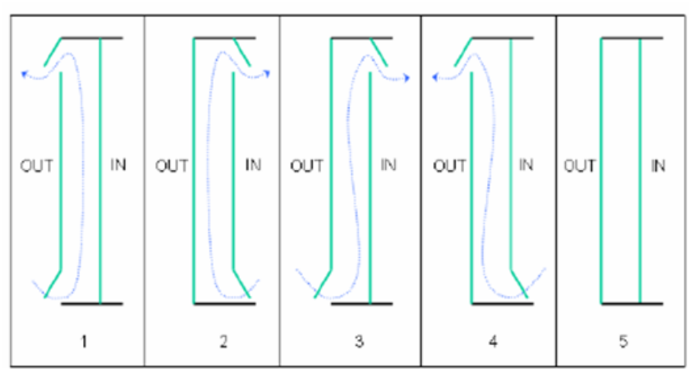
Figure 3.3 Five DSF Ventilation Typologies, Type 1 used in research

Mechanically ventilated facades, or “active facades” are generally characterized by a single ventilation mode, the indoor air curtain, as the double skin façade is used to support the building’s mechanical ventilation system. The types of partitioning encountered in practice that are mechanically ventilated are essentially limited to double windows and to facades partitioned by story with juxtaposed modules [66].
This chapter has examined the existing body of knowledge related to urban design interventions in air quality issues. Within the development and consideration of the new building paradigm, where the building is used to remediate environmental pollutants beyond the building perimeter, the identification of a strategy – chimney – and an associated building system – double skin façade – led to the development of the hypothetical case where we can test the double skin building facade connected to the urban street and determine if it is possible to ventilate street level air pollution and facilitate mixing (based on RQ1 and RQ2 and RQ4).

CHAPTER 4 – DOUBLE SKIN FACADE MODELING
The approaches to study the interaction of wind, air quality, and buildings, within the urban context employs two basic methodologies.
- Numerical analysis through the use of computational fluid dynamics (CFD).
- Wind tunnel tests for individual building wind engineering and urban air pollutant distribution studies.
The advantage of using CFD is that it is generally less expensive than wind tunnel tests for less demanding tasks. CFD results are evaluated and validated with wind tunnel studies. CFD is, however, a highly useful first order tool in and of itself, and is capable of producing visualizations of quantitative information [67].
In this chapter the modeling methods, both analytical and qualitative, are presented. Numerical CFD results are evaluated by varying conditions in same model. Verification of the hypothesis utilized a CFD model as a test of the model DSF system to prove that it met the street canyon evacuation requirements. Qualitative experiments in a modified urban boundary wind tunnel were used to evaluate and verify the CFD model, and control studies were conducted in the wind tunnel to validate that the DSF system performed as designed.

4.1 Analytical Methods of Calculating the Magnitude of Airflow in Double Skin Facades
The cavity in double skin facades is either naturally or mechanically ventilated (Section 3.3.1). For naturally ventilated DSFs air is brought into the cavity and exhausted by two means: wind pressure and/or the stack effect [68]. However, there is a tendency for stack-driven and wind-driven pressures to be counteractive and not additive. Furthermore, this requires the DSF to be south facing to maximize the thermal buoyancy. In urban environments, natural ventilation systems can experience noise transmission and convey pollution if it is the only source of fresh air intake for the building. In areas of poor air quality, a building’s mechanical ventilation system will be required to reduce the influence of outside air.
The main airflow modelling methods [69] are characterized as follows:
A. Zonal Airflow Network (AFN) is linked to whole building modeling and includes the building’s HVAC system. AFN provides a simulation of coupled building heat, gas and air transfer systems models [70]. In this research, we are seeking to identify whether the DSF has sufficient air transfer and flow rates in order to evacuate the urban street canyon. The boundary selection is limited to the DSF system. The building HVAC is required for ordinary ventilation and conditioning for thermal comfort for the building occupants and should not be utilized to uptake and exhaust criteria air pollutants beyond the building perimeter. Therefore, AFN simulation was not used in this research.
B. Building equilibrium equations estimate how a system achieves a state of equilibrium. Air flows from a space with high pressure to one with low pressure if the two spaces are linked. There are three main causes for pressure differences: 1) pressure caused by mechanical differences, 2) pressure differences cause by thermal buoyancy, 3) pressure differences caused by the action of the wind [69].
Thermal buoyancy or uplift is also called the stack effect. Warmer air rises and cooler air sinks because warmer air is less dense than cooler air. As a result of insolation, the air in the intermediate space in the Double Skin Façade becomes warmer than the outside air. When the DSF is connected to the outside air via openings at the top and the bottom, pressure equalization occurs. There will be excess pressure at the top and negative pressure at the bottom of the airspace within the DSF. The magnitude of thermal uplift $∆p\text{th}$ depends solely on the mean temperature difference multiplied by the effective uplift height [65]:
Equation 4.1 $∆p\text{th}= ∆p\text{1} ×g ×∆h × ∆t\text{m} [Pa]$

Where:
$∆p\text{1}$ specific change in air density with temperature change in kg/m³ K
$g$ acceleration due to gravity [m/s²]
$∆h$ effective uplift height [m]
$∆t\text{m}$ mean excess temperature [K]

In the case of the urban street canyons, wind flow demonstrates a skimming effect above the roofs of the building and the typical portion of the airstream that would encounter the building façade will not necessarily create a state of excess pressure or stagnation pressure $q$ and can be ignored. Stagnation pressure is found by: $q=ρ/2×v\text{2}$ [Pa] where $q$ is the stagnation pressure, $ρ$ is the density of the air in kg/m³, and $v$ is the wind speed in m/s. Since pressure differences are proportional to the square of the wind speed, the stagnation pressure $q$ is used as a reference value.
Calculating the magnitude of the airstream within the DSF is straightforward. The pressure differences between the upper and lower openings are forces acting on the areas of the openings, and the force is the product of the pressure difference taken in relation to the opening area. This force pushes enough air through the opening to equalize the resistance caused by the throughflow so that equilibrium is attained. The continuity equation is found from air throughput which will remain constant within the system if no air is diverted for other purposes. V_{in}=V_{out} or A_{in} $×$ v_{in} = A_{out} $×$ v_{out} where V is the local airflow volume in m³/s, A is the local opening area in m², and v is the local air speed (derived from A) in m/s. The continuity equation also applies to mechanical ventilations systems.
In urban conditions, air currents are primarily turbulent. Turbulence happens when the forces of inertia dominate in the airstream. The Reynolds number Re index value is used in urban climatological models to identify incidence of turbulent phenomena. The Reynolds number describes the relationship between air speed v, length L, and the kinematic viscosity of the fluid (in this case air) $ν$_{air}.
Re=v $×$ L/$ν$_{air} (typical air temperature $ν$_{air}=15.5 $×$ 10⁻⁶ m²/s). The Reynolds number describes the relationship between the force of inertia and the frictional force. The critical value above which turbulence occurs in a DSF is approximately Re_{crit} = 10,000 to 20,000 [65].
Typically, DSFs exhibit laminar flows when the airflow speed through the openings is low (typically less than v$≈$10cm/s). In laminar air flow, friction forces prevail over inertial flows and friction is proportionately dependent on airflow speed which can lead to rapidly increasing resistance/drag coefficients with a concurrent decrease in speed. In such cases, the general equilibrium methods may be insufficient and scale trials or CFD simulations may be necessary [65].
C. CFD Analysis in practice and in the building physics domain, poses several problematic issues, of which the amount of necessary computing power, the nature of the flow fields and the assessment of the complex, occupant-dependent boundary conditions are the most problematic. “This has often led to CFD applications being restricted to steady-state cases or very short simulation periods” [71]. CFD simulation, however, has become very popular because of its capability to model particular details of the temperature fields and airflow patterns. Detailed analysis of air flow patterns, energy flows and temperature distribution are only possible with CFD. Boundary conditions must be carefully set as they have a substantial effect on the results [72].
While numerical analysis is widely used for wind flow and air pollutant dispersion in urban areas, there are always questions that arise with respect to evaluating the model and real-world predictions. It is an established procedure to evaluate the numerical analysis with observable data that is initiated with wind tunnel analysis and later in real world data gathering [73].
4.1.1 Wind Tunnel Analysis
Wind tunnel analysis is typically used in urban air pollutant dispersal studies. It is important to note that although urban boundary layer studies take into account Reynolds roughness factors, it has been found that there is Reynolds-number independence of turbulent flow and pollutant dispersion in scaled building models [74]. Reynolds-number independence can be expected to model urban areas as long as the critical values of roughness and height separation of the flow from the model were satisfied [75]. Reynolds numbers were not calculated for this research, as the experimental model met the critical values of roughness and the urban boundary layer modifications met the height separation of the flow.
It has also been shown that wind tunnel studies correspond well to results obtained in the atmosphere by means of large eddy simulations (LES) so that they can be used with confidence for modelling urban situations. “The most important modelling requirement is the establishment of a nature-like boundary layer along the wind tunnel floor.” [76].
Typically, an urban boundary layer wind tunnel simulation will also include a fetch of roughness elements. The wind tunnel available for this study was adapted to include elements that simulated urban boundary layer conditions.
4.2 Preliminary CFD Approach for Analyzing DSF
The general approach to analyzing flow, temperature, and energy simulations (Figure 4.1) of the DSF was developed and presented at conference [77]. It begins with the construction of a CAD model of the desired section. For sectional analysis, only the area of interest needs to be modeled. The finished model is then sent to preprocessing software for meshing (Figure 4.2) and overall preparation for the flow analysis. For more complex 2D constructs an unstructured grid of triangles are typically used to allow for flexibility within the mesh. From the meshing software, the model is exported to the particular CFD software of choice. Once all the initializations are complete, the desired output for the particular model can be simulated, providing better insight into the flow and temperature in the environment.

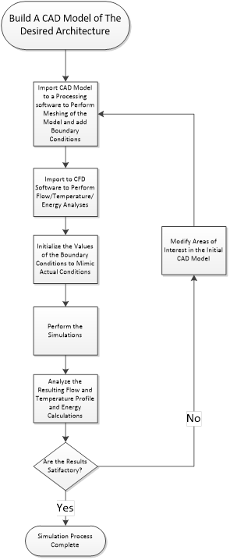
Figure 4.1 Flow chart of the simulation process
4.2.1 Computational Model
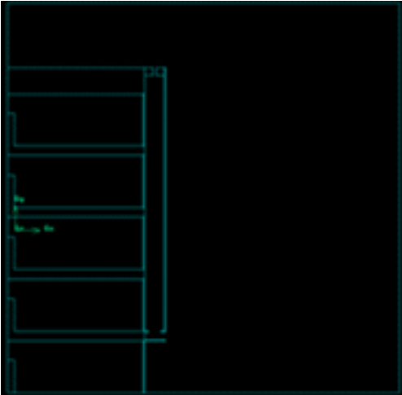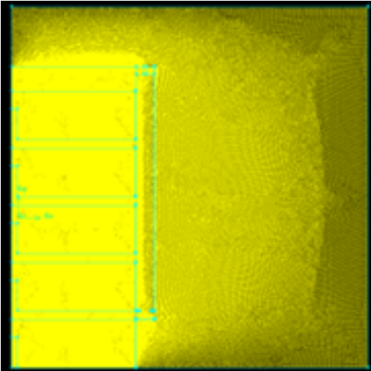
Figure 4.2 (Left) Section view of building before meshing (Right) after meshing
For this research, preliminary studies of a singular DSF were completed using FLUENT. The meshing software GAMBIT was used to create a meshed grid consisting of triangular elements. Constructing an adequate mesh is necessary for the analysis of the DSF, since the accuracy of the final simulation will be dependent on the meshing elements within the model. In theory, meshes with higher degrees of detail or with higher differential in size to that of adjacent grid elements are given a lower meshing ratio, (i.e. more elements). This allows for higher accuracy for the mesh of the building space within and immediately bordering them. By lessening the overall mesh count, some of the burden of the processing power required by the CPU is alleviated. Once the preprocessor meshing is complete, the model is imported into the CFD package.

4.2.2 FLUENT and Boundary Conditions for DSF Analysis
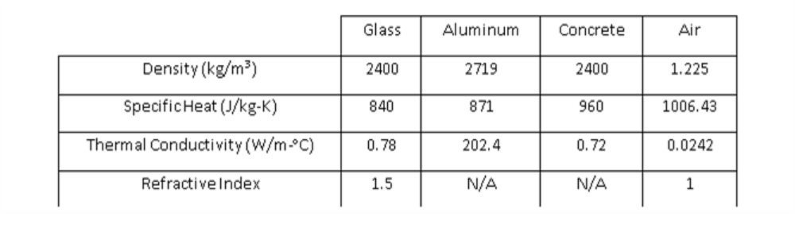
Table 4.1 Material Properties for DSF in FLUENT

The values for the initial materials set used in the preliminary DSF FLUENT simulation are given in Table 4.1. For all flow problems simulated in FLUENT, equations for conservation of mass and momentum are solved, as well as conservation of energy when flow involves heat transfer or compressibility [78]. In the preliminary passive analysis of the DSF, the only energy inputs used were natural convection wherein any fluid motion is caused by natural means such as the buoyancy effect [79]. As discussed earlier, natural ventilation is driven by wind speed and conductive and radiative heat gain. In this case a realizable κ-ε model was used to better approximate the turbulent nature of the air within the DSF. The Boussinesq approximation was selected, as the initial condition was a natural convection problem, and this obviated the need to solve for the full compressible formulation of the Navier-Stokes equations. Due to semi-transparent glazing used as the second facade in the preliminary DSF design, the discrete ordinate (DO) radiation model was used, which was capable of solving for the absorption, emission, and scattering in the air column (Figure 4.3) [79].
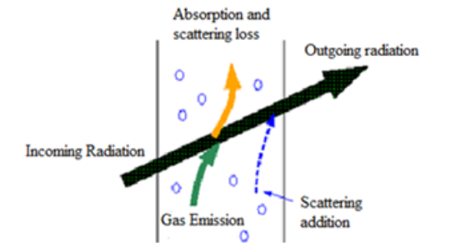
Figure 4.3 Radiative Heat Transfer
The two main sources of heat gain in the DSF system were from the adjacent thermal conditions and insolation. The simulations utilized weather data obtained from the National Oceanic and Atmospheric Administration’s (NOAA) database for Oklahoma City, Oklahoma.
4.3 Selected Preliminary DSF Airflow and Temperature Analysis
In the preliminary analysis of air flow through a DSF, CFD flow analysis was performed for a building without a DSF as well as a building with a DSF (Table 4.1, images courtesy of ASME). All the simulations in this flow analysis assumed that no other constructs surround the building; therefore, there is no obstruction of air moving towards the model. In both cases of the building (with and without the DSF), the wind speed along the building face is increasing along the height, however, in the case with the DSF, the cavity between the inner and outer glazing allows the air to pass through at a much slower rate. The flow alongside the building face, whether there is a DSF or not, is strongly correlated to the convective heat transfer coefficient. In order to reduce the heat loss or gain by convection, designs can be made to slow the air down, in turn reducing the convective heat transfer coefficient, allowing the inner glazing to be opened on higher rooms. Without the DSF as an intermediary, the openings between the inner and outer environment would not be possible due to the excess amount of turbulence that would occur within the rooms [77].
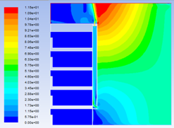
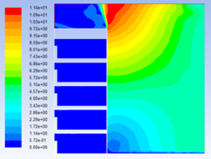
A comparative flow analysis was performed for a building with no DSF as well as a building with a DSF. For the model without the DSF (Figure 4.4, left), the velocity gradient at the base, which would be at street level, shows minor recirculation and no mixing with the upper level air mass flows. For the model with the DSF (Figure 4.4, right), the velocity gradient at the base of the DSF, which would be a street level, shows less recirculation and more flow in to the DSF and mixing with the upper level air mass flows.
Figure 4.4 Velocity profile for a building without a DSF (left) and with a DSF (right)
Figure 4.5 illustrates the geometry of the inlet and outlet of the DSF that was analyzed. The inlets and outlets allow for control of air intake into the DSF cavity (as well as into the building depending if they were integrated into the overall design). While it is necessary for inlets and outlets to be placed in the outer glazing to be considered a twin face system, openings in the inner glazing are not mandatory and were not the typology selected for the study. Double skin facades are typically analyzed as a means of enhancing the energy saving capabilities of buildings. Those energy analyses are not part of this research.
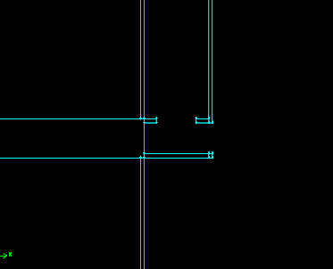 | 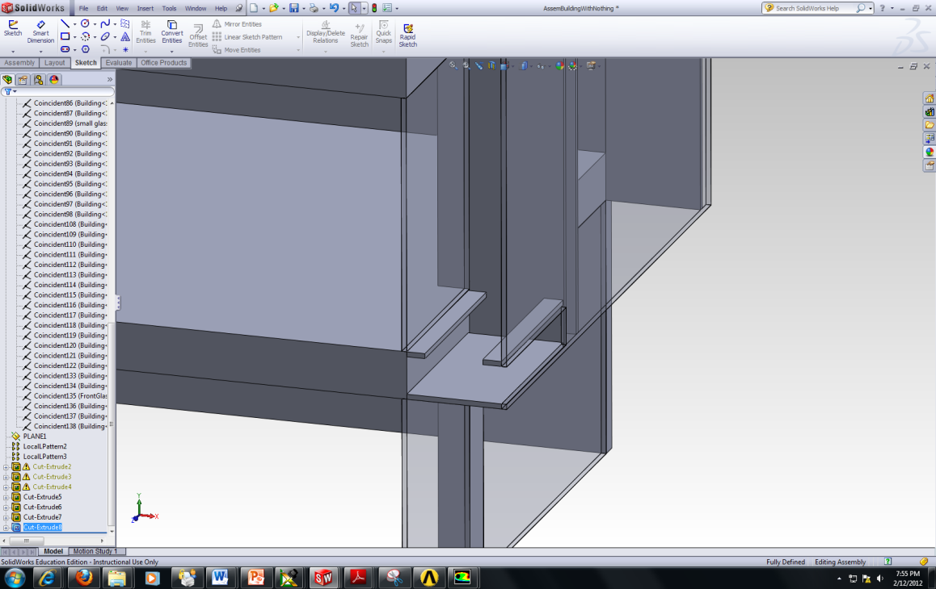
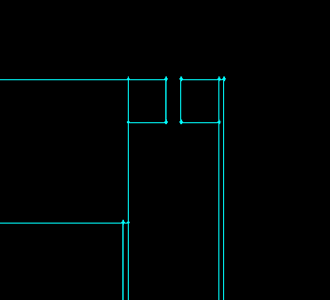 | 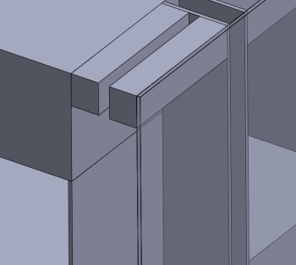
Figure 4.5 Cross-sectional view of the inlet (top row) and outlet (bottom row) for air into the DSF cavity
4.4 Vegetated Biofilter Integration – Vegetated Biofilter to Ameliorate Air Pollutants
While mechanical filtration systems are available to mitigate particulates, the solutions presently used in buildings to reduce CO₂ and other VOCs, are simply to flush the building with outside air. If the DSF is to function as a filtration/mixing system, the VOCs that are present must be removed prior to being used for natural ventilation of the buildings. Aside from matters of initial construction costs, one of the primary reasons why DSFs have had little impact in the United States is because they do not effectively filter air pollutants, which is especially troubling if they are to be used for fresh air intake.
The suggestion of plant integration into a DSF has been proposed for thermal mitigation; however, the suggestion that the plants also create a functional component to filter the air has not. “Using plants in building walls is a bioclimatic strategy to obtain savings in building energy consumption, between other important benefits of aesthetic, psychological and economic origins. The plant, as a living component of the facade, responds to the environment conditions in a very complicated way.” [80].
It is necessary to evaluate the ecological system of the vegetated biofilter or active green wall that would be integrated into the double skin. Basically, green walls are divided into two types: 1) ornamental types such as those designed by Patrick Blanc and 2) active air bio-filtration systems such as those produced by the company NEDLAW International (Figure 4.4). NEDLAW’s research includes those NASA experiments [81] with Biosphere I & II in 1984 and 1989 [2]. Soreanu, Dixon and Darlington have published “Botanical Biofiltration of Indoor Gaseous Pollutants – a Mini Review” [82]. They treat a planted wall as a “biological purifier” which is used to describe any device including a biological component (botanical and/or microbial) used for VOC removal; “botanical purifier” was also used to specifically describe devices using plants and their associated symbiotic root microorganisms. Classical systems were named according to the conventional air treatment nomenclature [82]. Their additional research has shown that VOC removal works through mechanisms within the biofilm that developed in the hydroponic grow board media and the root microbial colonies of the biofilter [83].
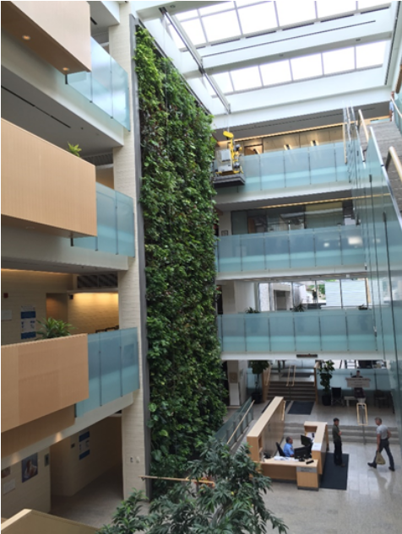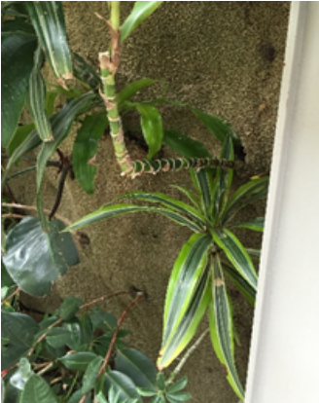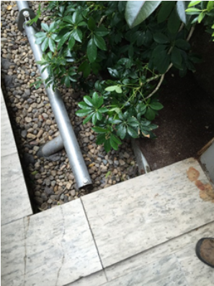
Figure 4.6 NEDLAW Vegetated Biofilter, City of Cambridge Civic Center
Cambridge, ON (left) with air permeable grow board (middle) and water recirculation well (right)
In the active green wall, the air permeable grow board is specifically selected for weight and hydroponic growth of the biofilter’s plants. The media has a positive bulk density to pore space ratio allowing it to have internal space available for both the water and air which is needed for plant growth. Furthermore, the ratio of water holding capacity to available air spaces is part of the proprietary selection of media. Porosity not only allows for good air movement but also good drainage. Lastly, the media has a low bulk density which reduces it’s mass load on the building structure. During installation, hydroponic rooting material has weights of less than an ounce per quart of volume compared to the soil mixes that are typically on the order of a pound or more per quart.
The plants used in the living wall biofilters fall under the general category of “foliage” plants. The major groups of plants include Ficus spp., Dracaena spp., Philodrenon spp., and Syngonium podophyllum. Each “type” of plant includes a number of species and/or varieties meaning there are more than 30 different types of plants that are typically used in any gven installation.
Plants are selected based on several criteria. First, plants are selected based upon their ability to form good relationships with the beneficial root microbes that do the actual remediation of air pollutants in the indoor air. Second, plants are selected that tolerate the unique conditions of the vertical hydroponic system. The indoor air biofilters tend to focus less on the smaller herbaceous material than other plant wall systems. Third, the plants are selected that also match the specific conditions of each installation in terms of light, temperature, and water conditions. Fourth, plants are selected based upon design form. Leaf color, shape, and texture give the wall its distinctive look. Plant size is also taken into account in the design. Varying plant size gives the wall more visual depth. Large walls can easily handle plants over 3 feet (1 meter) in height which would be inappropriate on a smaller wall. Because of the differences in size, each plant covers between 1/2 to over 3 square feet (0.05 and 0.30 square meters) of wall area. This gives a final typical plant density of approximately one plant for every 1.3 square feet, providing 70 percent coverage of the biofilter immediately after planting [84].
The biofilter reduces concentrations of toluene, ethylbenzene, and o-xylene concurrently present at parts per billion (volume) in indoor air. “The greatest reduction in concentrations per pass was under the slowest influent air flux (0.025m/s); however, the maximum amount removed per unit time occurred under the most rapid flux (0.2m/s)”[85]. Furthermore, the biofilter was found to remove formaldehyde and toluene effectively for over 300 days of test period [82]. “Most botanical biofiltration process involves five main mechanisms: rhizosphere biodegradation (by microorganisms), phytoextraction (plant-liquid extraction), stomatal uptake (plant-gas extraction), phytodegradation (via enzymatic catalysis inside tissues), phytovolatilization (directly by evaporation from leaves or indirectly by plant transpiration)” [82]. In the biofilter, the interactions among plant-microorganism-pollutant are due to the fact that rhizosphere microorganisms support plant life. Essentially, botanical biofiltration performance depends on the interactions among pollutants–plants–microorganisms.
It is important to note that the NEDLAW system removes only VOCs. The nature of the system is that the growing medium and leaf/root structures of the plant systems do not capture particulates. However, additive alternatives have been developed including a system called CityTree by Green City Solutions that utilizes mosses [56]. While the system cannot operate year-round due to seasonal requirements, the system has been found to have 56-86% reduction of PM₁₀, 26-46% reduction in PM_{2.5} and 20-53% reduction in PM₁ at a constant air flow of 5.5 m³/min.
A combination filter of the NEDLAW and CityTree housed within the “greenhouse” of an external DSF – building exterior closure as first façade with a second glazed outer façade creating the DSF - could be an effective system for amelioration of criteria air pollutants. Figure 4.5 Shows the hypothetical construct used to test the research questions.
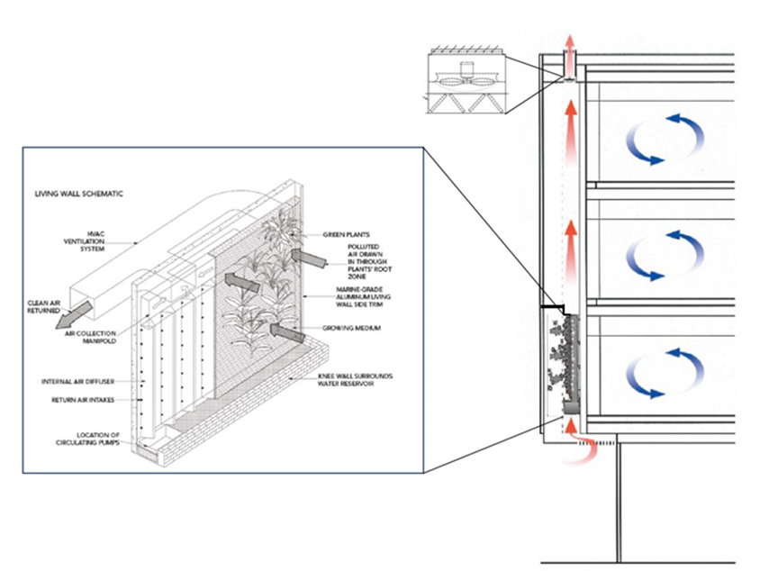
Figure 4.7 Diagram of conceptual DSF with integrated vegetated biofilter
CHAPTER 5 SIMULATION AND EXPERIMENTAL RESULTS FOR REMOVING POLLUTANTS
Elements for this chapter were published in a peer reviewed conference proceeding:
Fithian, Lee. 2018. “The Double Skin Facade: Enhancing Air Quality in Urban Canyons" Pgs. 563-568.” In SKINS on Campus BRIDGING INDUSTRY AND ACADEMIA IN PURSUIT OF BETTER BUILDINGS AND URBAN HABITAT, 1:726. Los Angeles, USA: Tectonic Press. https://facadetectonics.org/wp-content/uploads/2018/03/Facade-Tectonics_2018-World-Congress_Proceedings_Vol-1_Compressed.pdf.

The DSF system, without the integrated biofilter, has been filed under provisional patent number 62/576,947 with the name “Apparatus and Method for Enhancing Air Quality in Urban Street Canyons”.

For purposes of answering the research questions, we developed several experiments to test the following hypothesis: coupling the building facade and the urban street to determine if it is possible to ventilate street level air pollution and facilitate mixing and can vegetated biofilters effectively remove air pollution within a building façade DSF system under established operating parameters while ventilating street level air?
To test the hypotheses, it was necessary to model the double skin façade airflow perpendicular to the urban canyon as this was the most extreme system exhibiting the least amount of mixing. The DSF building system interfaces directly with the urban street canyon and can function in isolation of other building systems while evacuating air pollutants from the street canyon. The model included windward and leeward applications of the system, to determine airflow ventilation. When decoupled from the building environmental volumes and buoyancy effects, it was established that mechanically assisted ventilation was necessary. All analysis is conducted visually through video capture. The formation of a street canyon vortex is taken as an initial condition and subsequent removal of the tracer smoke source as evidence of evacuation.
Identification of removal airflow rates will then be compared to functional operating parameters of the vegetated biofilters to determine effective mass flow rates and their efficacy.

5.1 CFD Analysis of the DSF and Urban Street Canyon
5.1.1 Modeling Assumptions
The use of CFD analysis was initially used to model the DSF and canyon interaction. When coupling the building DSF and the urban canyon it should have been possible to establish if there is enough capacity to ventilate street level air pollution and facilitate mixing.
Initial studies utilizing the DSF in an urban street canyon using FLUENT were problematic. The scale changes between the street canyon and the DSF were such that GAMBIT would either enclose the DSF inlet and outlet preventing studies of airflow from the street canyon through the DSF, or the complex geometry and large variance in the grid cell size prevented GAMBIT from meshing the geometry, and failed attempts to mesh and perform external flow analysis in FLUENT. It was important to note that the computer processing power (i5 quad cores) in the lab machines used, and the current FLUENT license models cannot be solved when nodes and cells exceed 512k, which could easily have caused GAMBIT to crash when meshing the detail necessary for the boundary conditions used to model the DSF in relation to the airflow and thermal properties of the street canyon. Although simulations in research centers have used CFD techniques have been used to simulate airflow and temperature fields using approximately 5 billion computational grid cells [86], these resources were not available for this research, and it was decided to simplify the geometry and analysis system.
In the context of the urban streetscape, there is no guarantee that the street canyon will be perfectly oriented, allow for free flow of air (in fact, the issue at hand is that there is no free flow but rather recirculating vortices in street canyon proportions), nor guarantee as to which side of the street, windward or leeward, the system will be oriented. Without these optimized locations and orientations within the streetscape, the dependence on solar insolation to encourage buoyancy or the stack effect cannot be established, and thermal effects can be ignored for active ventilation purposes. Additionally, we cannot depend upon the general temperature gradient within the DSF to initiate upward flow especially with the temperature inversions seen in urban street canyons that cause the accumulation of the air pollutants in the first place. Mechanical ventilation, however, can be applied at any time. The question becomes whether a mass air flow can be achieved at an optimized speed, that allows for comfort and minimized turbulence within the DSF, to evacuate air pollutants within the urban street canyon. The choice of mechanically assisted ventilation allowed the DSF to be decoupled from the building environmental air exchange and buoyancy effects. As before, the large variance in size and number of grid cells prevented GAMBIT from meshing the geometry and simple airflow analysis could not be performed in FLUENT. The approach to the CFD analytical solution became one of utilizing the proportional nature of the street canyon to building height and understanding the skimming effect and the lack of air exchange within the street canyon.
“In fluid mechanics, non-dimensionalization of the Navier–Stokes equations is the conversion of the Navier–Stokes equation to a nondimensional form” [87]. This can simplify the analysis of the problem and reduce the number of free parameters. Scaling of the Navier–Stokes equation refers to the process of selecting the proper spatial scales – for a certain type of flow – to be used in the non-dimensionalization of the equation. Since the resulting equations need to be dimensionless, a suitable combination of parameters and constants of the equations and flow (domain) characteristics must be defined. As a result of this combination, the number of parameters to be analyzed is reduced and the results may be obtained in terms of the scaled variables.
In addition, a non-dimensionalized equation identifies the relative size of various terms present in the equation [88,89]. Appropriate selection of scales leads to identification of small terms in the equation which can be neglected. “For the case of flow without heat transfer, the non-dimensionalized Navier–Stokes equation depends only on the Reynolds Number and hence all physical realizations of the related experiment will have the same value of non-dimensionalized variables for the same Reynolds Number”[90].
Preliminary analyses were then conducted utilizing a very simplistic – dimensionless CFD application (Algorizk, Wind Tunnel). The app assumes the case without heat transfer, assumes an incompressible and homogeneous fluid with non-dimensionalized Navier -Stokes equations with a simple velocity field in a 120x180 grid to optimize calculations. This CFD modeler includes attributes that can combine urban canyon morphology, façade integrated DSF geometry and wind speed necessary to output visualizations that helped to identify if the DSF could interact with the air flow in the street canyon and transport the flow above the skimming zone.

5.1.2 CFD Results of the DSF and Urban Street Canyon – Modeling Air Pollutants
Preliminary studies utilizing the CFD modeling software focused solely on airflow attributes that combined urban canyon morphology, and the façade integrated DSF. The data generated, yielded results that the technology is sufficient to evacuate the criteria air pollutants from the urban canyon. The findings are illustrated in Figure 5.1.1, and were peer reviewed, published and presented at conference [91].

Figure 5.1.1 Proportionate Urban Canyon showing accumulating air pollutants (left) and Urban Canyon with DSF showing potential removal and mixing of air pollutants (right)
Table 5.1.2 illustrates the summary conditions of the relationship between the urban canyon and the perpendicular airflow. In Condition 1 we see the skimming flow regime that occurs over urban canyons and is demonstrated by the visualization of the airflow and simple urban forms with streetscape in the CFD application. Condition 2 illustrates the accumulating condition that occurs in the urban canyon as the skimming regime that creates the boundary layer and does not interact with the streetscape air source. Condition 3 illustrates the introduction of a leeward side DSF with mechanical ventilation assist, demonstrating mixing of the boundary air and evacuation of the streetscape air source. Finally, Condition 4 illustrates the introduction of a windward side DSF with mechanical ventilation assist, demonstrating mixing of the boundary air and evacuation of the streetscape air source. Table 5.1.1 summarizes the verification of the CFD model confirming the DSF evacuation of simulated air pollution in the street canyon.
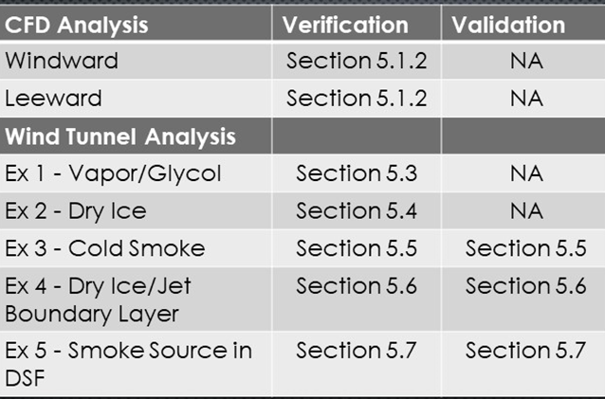
Table 5.1.1 Verification of DSF Evacuation of Air Pollution in Street Canyon via CFD Analysis

Qualitative Results Videos Online:
Leeward CFD Analysis https://youtu.be/URvjHJ00R2s
Windward CFD Analysis https://youtu.be/gJ8N1_iO-Qw

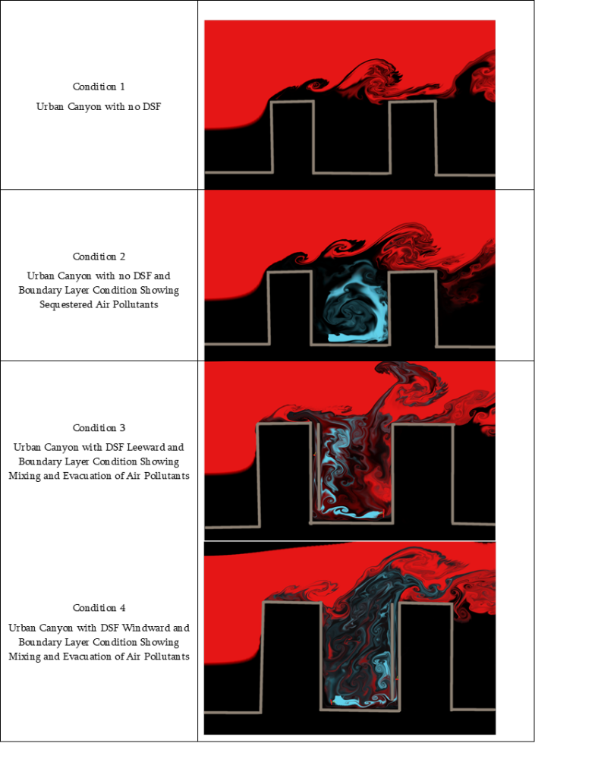
Table 5.1.2 Summary CFD Results of DSF and Urban Canyon
5.2 Wind Tunnel Analysis of the DSF and Urban Street Canyon
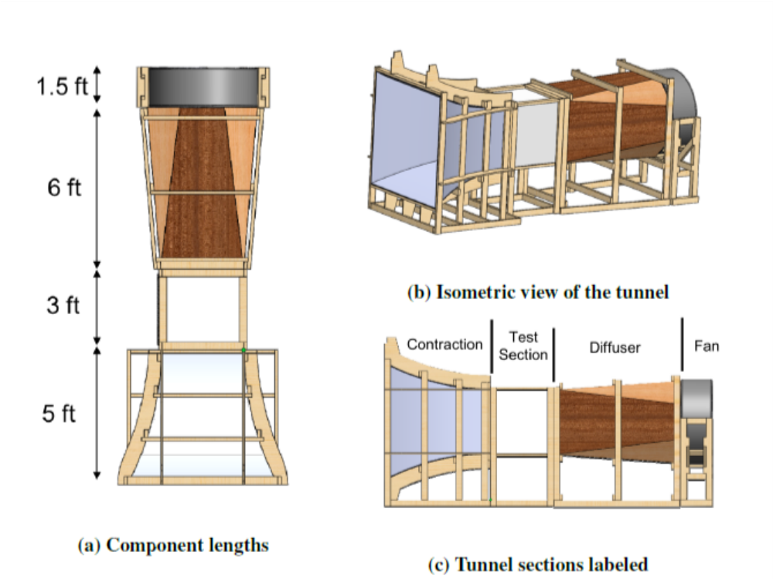
Figure 5.2.1 Wind Tunnel Diagram
The issue with the simplified CFD tool, however, is that the simplified grid tended to obtain absolute convergence of the solutions. At this point, evaluation and validation of the CFD results was necessary and based on previous studies, a physical model of the system was analyzed in a boundary layer wind tunnel.
The experiments were performed in the OU AME Student Wind Tunnel [92]. The wind tunnel has a test section 36”x36”x36” and was modified to create a scaled analogue to demonstrate visually the stratification of the boundary-layer flow as seen in Figures 5.2.2 and 5.2.3. The boundary layer depth varied slightly with each of the experiments. Maximum flow speed in the tunnel was 3.76 m/s. For all studies, the height of the buildings forming the canyon was 12 cm, and the length was 60 cm. The distance between the buildings was chosen to be 12 cm. This corresponds to the canyon aspect ratio of 1:1 and to the length-to-depth ratios equal to 5 for a short canyon. In all experimental configurations, the external wind flow has been directed perpendicular to the axis of the canyon seen as green laser axis in Figure 5.2.4.
The boundary layer was generated at the entrance to the test section by two panels at the inlet and extending just to the test section. The vertical profile was approximately 26 cm.
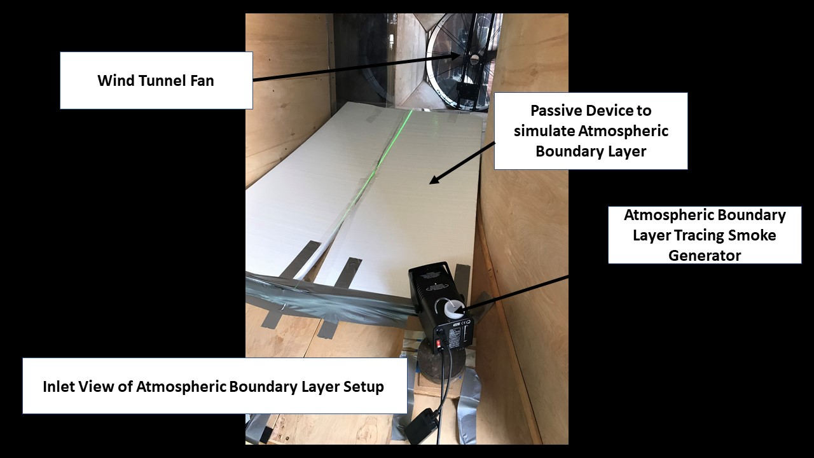
Figure 5.2.2 Wind Tunnel Boundary Layer Modification Inlet View
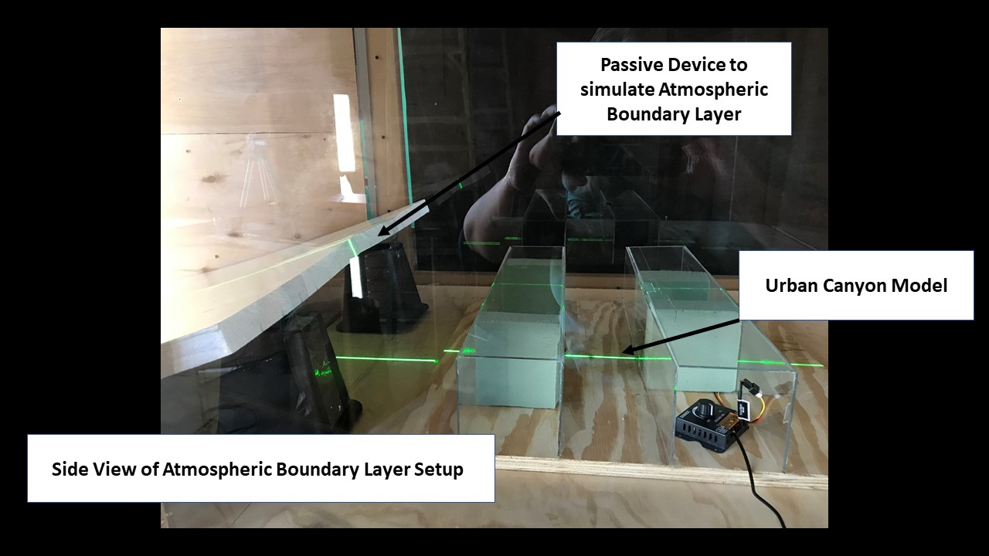
Figure 5.2.3 Wind Tunnel Boundary Layer Modification Side View

The street canyon model followed the experimental setup in “Wind-tunnel Study of Concentration Fields in Street Canyons”[93]. A ceiling mounted collimated laser was used to maintain geometric alignment of the model and center the DSF within the test section. The laser also highlighted that portion of the smoke vortex turbulence for video graphic capture.
Flow measurements in the tunnel were conducted using a hotwire anemometer. Turbulence characteristics were video captured to determine whether the simulated DSF was interacting with smoke sources within the canyon and evacuating. In parallel to the flow and turbulence captures, multiple types of passive tracer gases were used to simulate accumulating air pollutants and buoyancy characteristics within the urban canyon. Ambient temperature within the testing area was approximately 90ºF (32ºC).
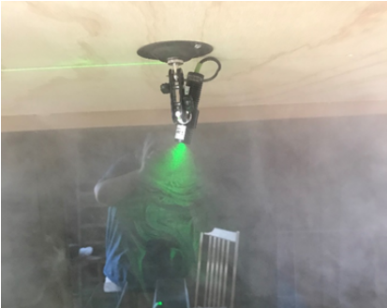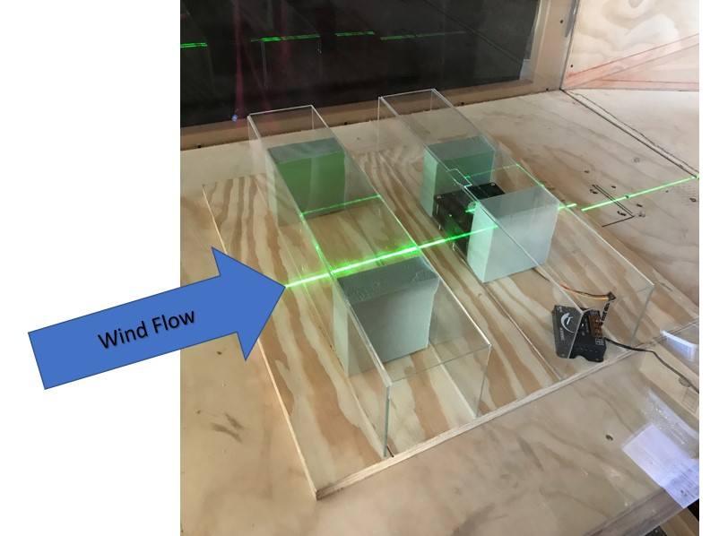
Figure 5.2.4 Alignment of Model in Floor of Wind Tunnel with Collimated Laser
At a 1:200 scale, the DSF was simulated by a scaled opening (1.25 cm x 4 cm) in the middle of the block at the base of the “building” block and another matching opening (1.25cm x 4 cm) at the top as seen in Figure 5.2.5. The intent was to mimic a full-faced DSF across a typical building (lot size 50 feet) located mid-block.
Typical DSF are 36” in depth. At 1:200 scale this would have been too small to be effectively modeled, hence the bottom and top openings were chosen to simulate the effect. Loss of fan efficiency due to the small openings necessitated the larger fan seen in the middle of the model. The fan was coupled to a rheostat and flow speeds were measured with a hotwire anemometer. The inlet and outlet speeds of the simulated DSF are shown in the Table 5.2.1. Differences in ¾ speed and full speed are minimal due to pressure loss between the blocks, hence, all studies were conducted with DSF operating at full speed.
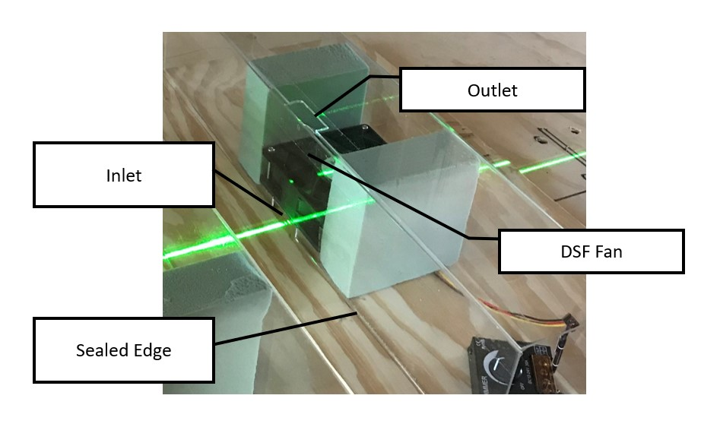
Figure 5.2.5 Closeup of Urban Canyon DSF Model with Inlet/Outlet
 |  | Inlet (m/s) | Outlet (m/s)
Quarter speed |  | 3.1 | 0.81
Half speed |  | 4.32 | 1.04
Three quarter speed |  | 5.03 | 1.53
MAX |  | 5.03 | 1.30-1.53

Table 5.2.1 Measured Air Flow Rates of DSF Model Inlet and Outlet

5.3 Experiment 1 – Vaporized water and glycol-based fluid
A vapor machine was placed to inundate the urban canyon to determine max times for evacuation. Wind Tunnel speed set at 3.76 m/s. Flow speed of DSF was set at MAX. The vaporized water and glycol-based fluid was used to simulate the trapped boundary layer condition. The vapor machine was placed at the end of the “street” of the model to be able to record the entire street canyon and its evacuation. The vapor exhibited buoyancy characteristics. Initial recirculation is very prominent as can be seen in the still taken at 0:38s. Street canyon cleared at point 0:50s of the video.

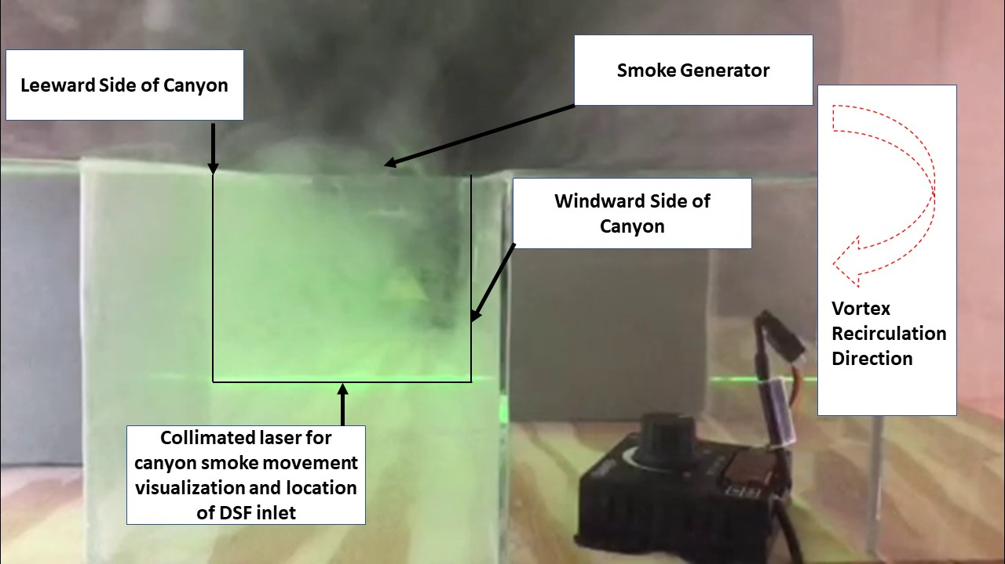
Qualitative Results Video online https://youtu.be/CWRMoAcV_KQ
Figure 5.3.1 Experimental Setup for Hot Smoke

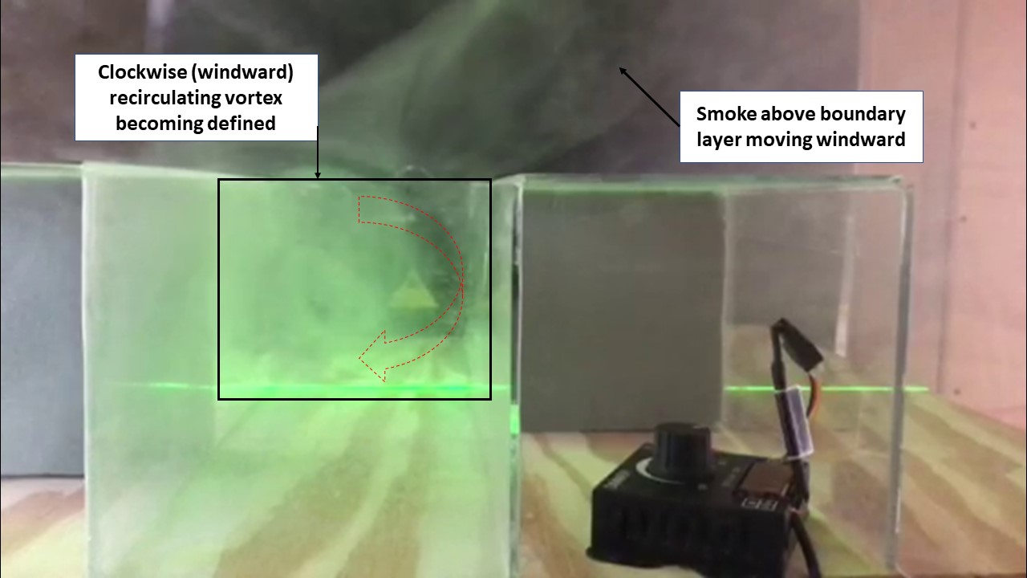
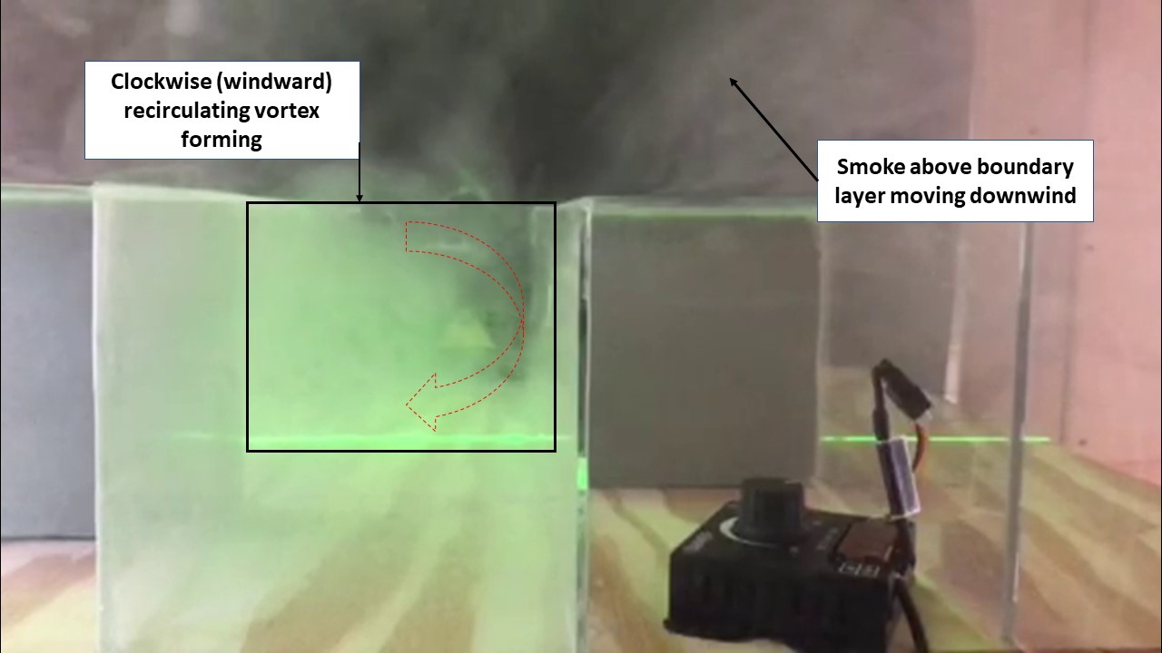
Figure 5.3.3 Hot Smoke 0:34s DSF ON Vortex Flow Taking Shape
Figure 5.3.2 Hot Smoke 0:31s DSF ON Recirculating Vortex Beginning to Form

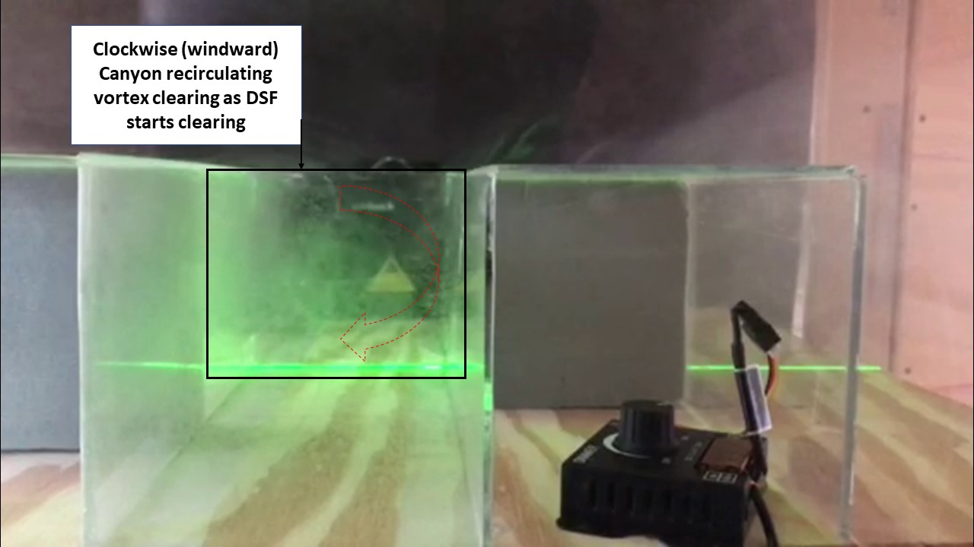
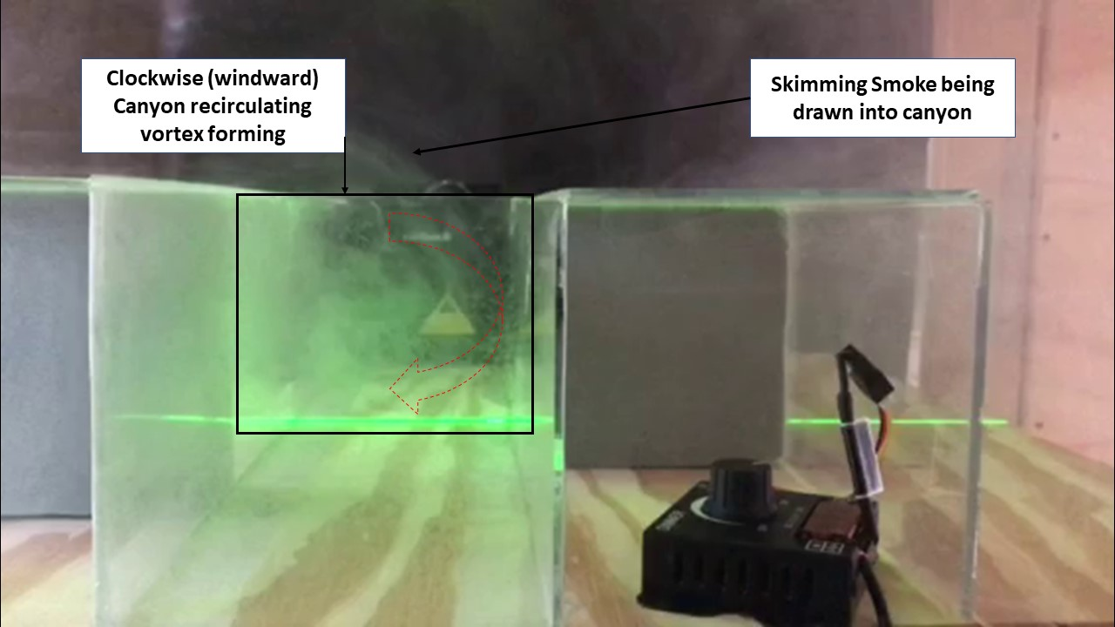
Figure 5.3.5 Hot Smoke 0:42s DSF ON Additional Smoke Enters Canyon
Figure 5.3.4 Hot Smoke 0:38s DSF ON Vortex Flow Still Apparent but DSF Clearing
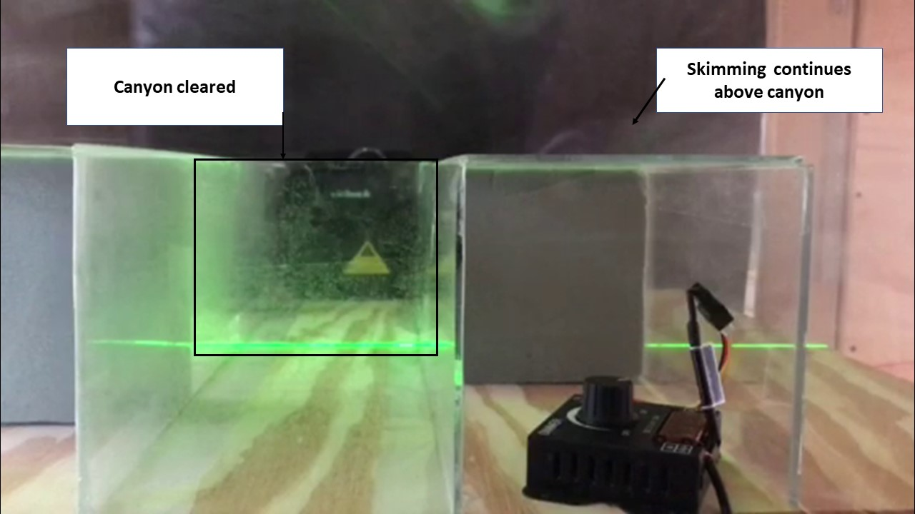
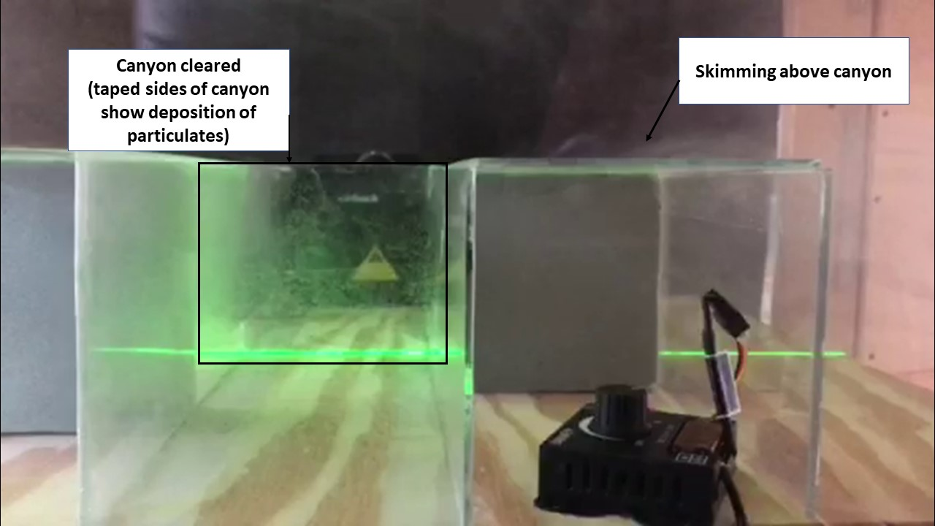
Figure 5.3.7 Hot Smoke 0:50s DSF ON Canyon Cleared, Skimming Seen
Figure 5.3.6 Hot Smoke 0:46s DSF ON Canyon Nearly Cleared Skimming Seen

Figure 5.3.8 Hot Smoke 0:54s DSF ON Canyon Cleared, Skimming Continues
In Experiment 1, a video named "Hot Smoke Works" was created of length 1:15s. Vaporized water and glycol-based fluid was used with a 400W fog machine to simulate the pollutant source. At time 0:04s, the DSF Fan was turned on, and at approximately 0:21s mixing was observed. Additional smoke was generated due to the nature of the machine generating the smoke at 0:22s, 0:26s, 0:28s, 0:42s time marks. The video sequence shows the canyon vortex beginning to form at time mark 0:31s, the vortex flow and movement toward the DSF is visible at 0:34s and at 0:38s the vortex flow is still visible, and it is apparent that the DSF is clearing the canyon. At 0:50s the canyon is cleared, skimming can be seen, and at the 0:54s time mark the model canyon is cleared and skimming continues.
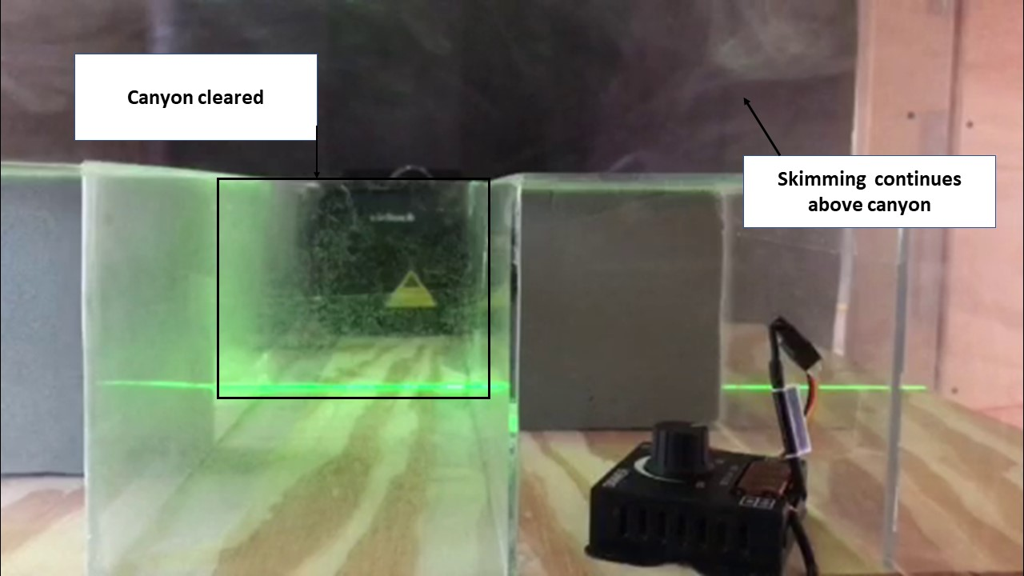
The development of the wind tunnel testing was to establish whether the street canyon could be evacuated by the scaled DSF model with regard to RQ2- How can the building system ventilate street level air pollution and facilitate mixing? Additionally, the wind tunnel setup and scaled street canyon with integrated DSF was the experimental setup that represented the hypothesis that when coupling the building facade and the urban street is it possible to ventilate street level air pollution and facilitate mixing (methodology to analyze RQ1 and RQ2 and RQ4). Table 5.3.1 summarizes the verification of the wind tunnel model confirming the DSF evacuation of simulated air pollution in the street canyon.
Table 5.3.1 Verification of DSF Evacuation of Air Pollution (Vapor/Glycol) in Street Canyon via Wind Tunnel Analysis
5.4 Experiment 2 – Dry Ice Vapor used to simulate trapped boundary layer condition
Hot smoke sources exhibited too much buoyancy even with ambient temperatures 90ºF. A Dry Ice container was placed offset to DSF to show evacuation of pollutants generated at locations furthest from DSF. Wind Tunnel speed set at 3.76 m/s. Flow speed of DSF was set at MAX.
Dry Ice Vapor was used to simulate trapped boundary layer condition as the dry ice vapor stayed closer to the street level of the model. This vapor started to exhibit recirculation but was quickly disrupted by DSF. Wind Tunnel speed set at 0 m/s. Flow speed of DSF was set at MAX.

Qualitative Results Video online https://youtu.be/Xj3bGvGPsQE
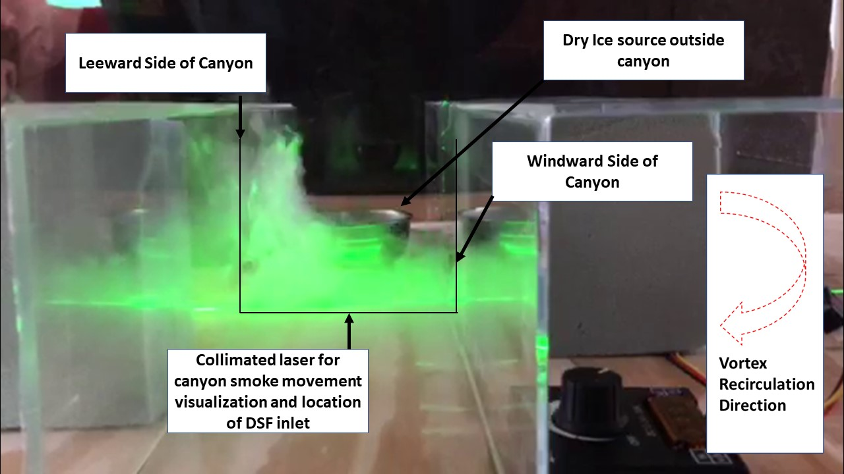
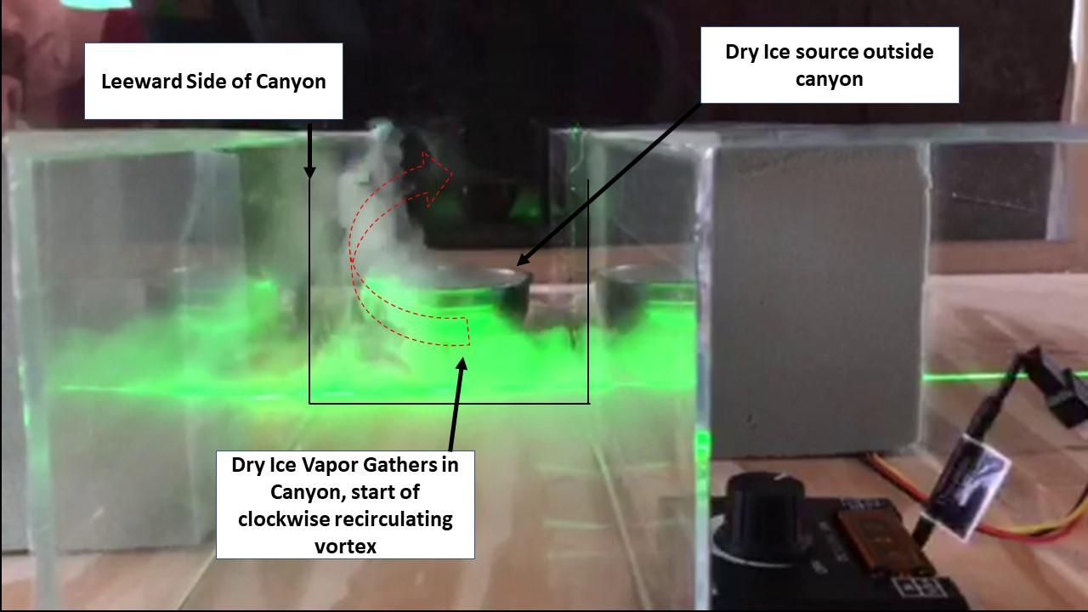
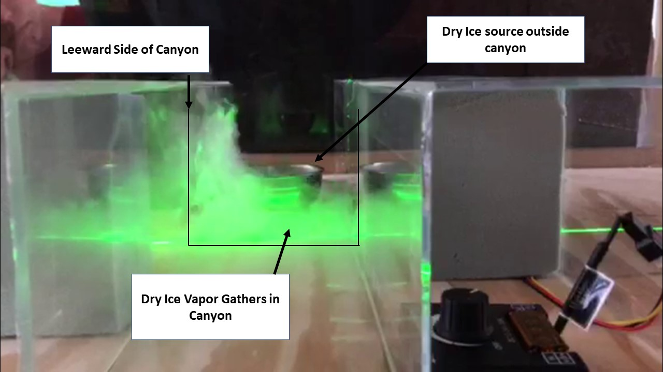
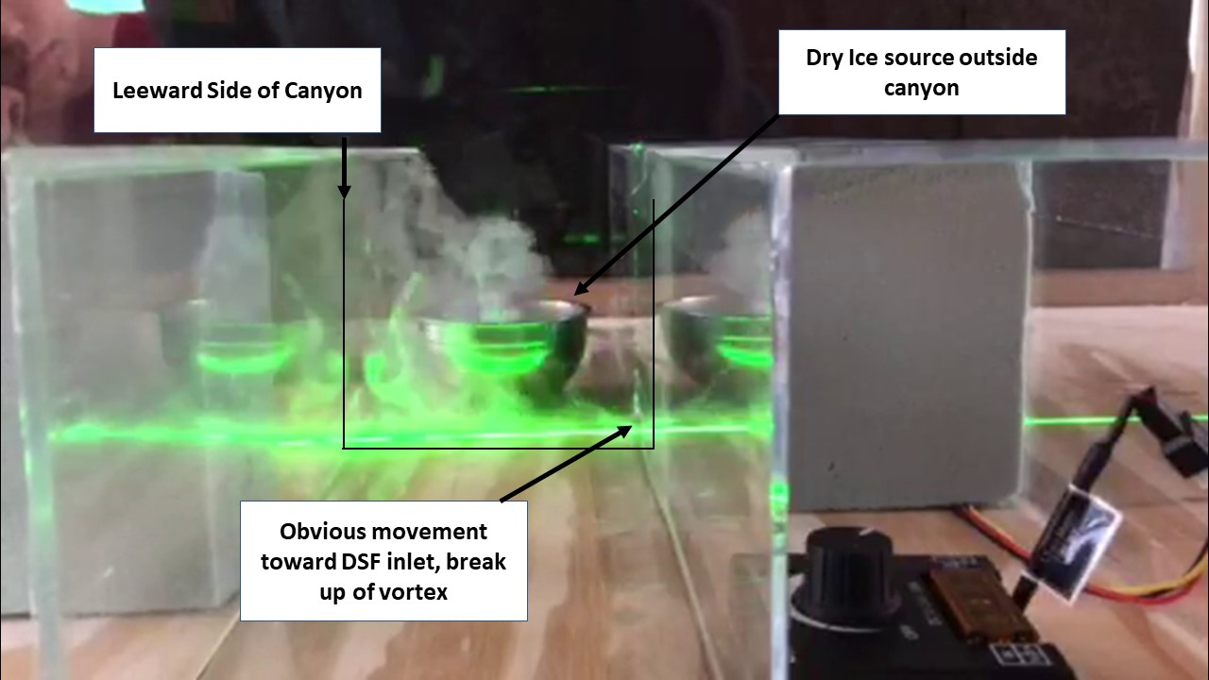
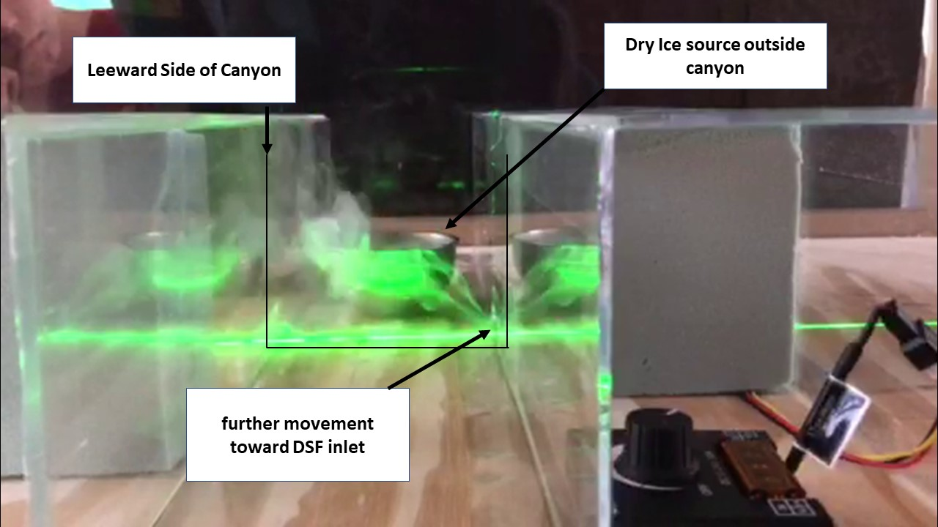
Figure 5.4.1 Dry Ice Vapor Experimental Setup
Figure 5.4.2 Dry Ice Vapor 0:05s Vapor Gathers in Canyon
Figure 5.4.3 Dry Ice Vapor 0:10s Vapor Gathers in Canyon
Figure 5.4.4 Dry Ice Vapor 0:15s DSF Fan ON, Vapor Seen Entering DSF
Figure 5.4.5 Dry Ice Vapor 0:16s DSF Fan ON, Vapor Seen Entering DSF
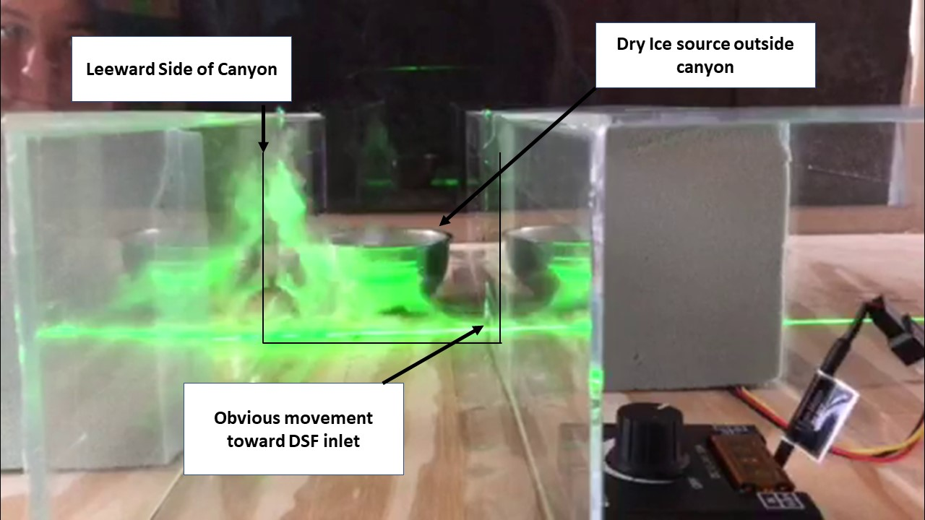
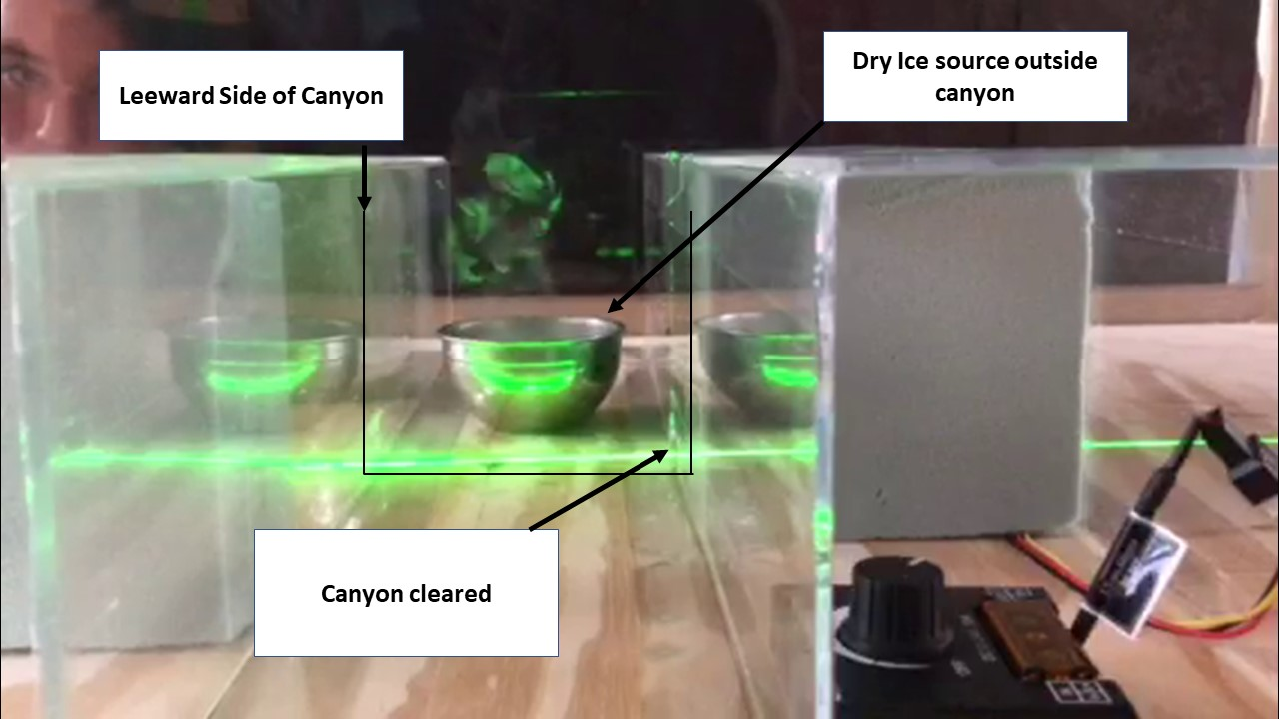
Figure 5.4.7 Dry Ice Vapor 0:50s DSF OFF Vapor Seen, Canyon Cleared
Figure 5.4.6 Dry Ice Vapor 0:21s DSF ON Vapor Still Seen Entering DSF
In Experiment 2, a video named "Dry Ice Vapor Works"" was created of length 0:55s. Dry Ice was used to create a visible vapor at street level with a boundary layer produced in the wind tunnel at 3.8 m/s. At the 0:05s time mark the dry ice vapor can be seen gathering in the model canyon, this is further shown at the 0:10s time mark. At the 0:15s time mark the DSF was turned on and dry ice vapor can be seen entering the DSF, which is further shown at the 0:16s time mark. At the 0:21s time mark the DSF is still on and the dry ice vapor is still seen entering the DSF. At the 0:38s mark the DSF fan is turned off and as the fan slows the dry ice vapor is seen filling the model canyon again. Table 5.4.1 summarizes the verification of the wind tunnel model confirming the DSF evacuation of simulated air pollution in the street canyon.
Table 5.4.1 Verification of DSF Evacuation of Air Pollution (Dry Ice) in Street Canyon via Wind Tunnel Analysis

5.5 Experiment 3 – Cold Smoke Generator Used to Simulate Trapped Boundary Layer Condition
A cold smoke device (wood chips burned in a chamber and smoke exited through a cooling tube) was used to simulate trapped boundary layer condition as the cold smoke stayed closer to the street level of the model. This smoke exhibited recirculation. The cold smoke outlet was placed offset to the DSF inlet to show evacuation of pollutants generated at locations furthest from DSF. Wind Tunnel speed set at 3.76 m/s. Flow speed of DSF was set at MAX.

Qualitative Results Video Online https://youtu.be/dH7NMjcqXdU
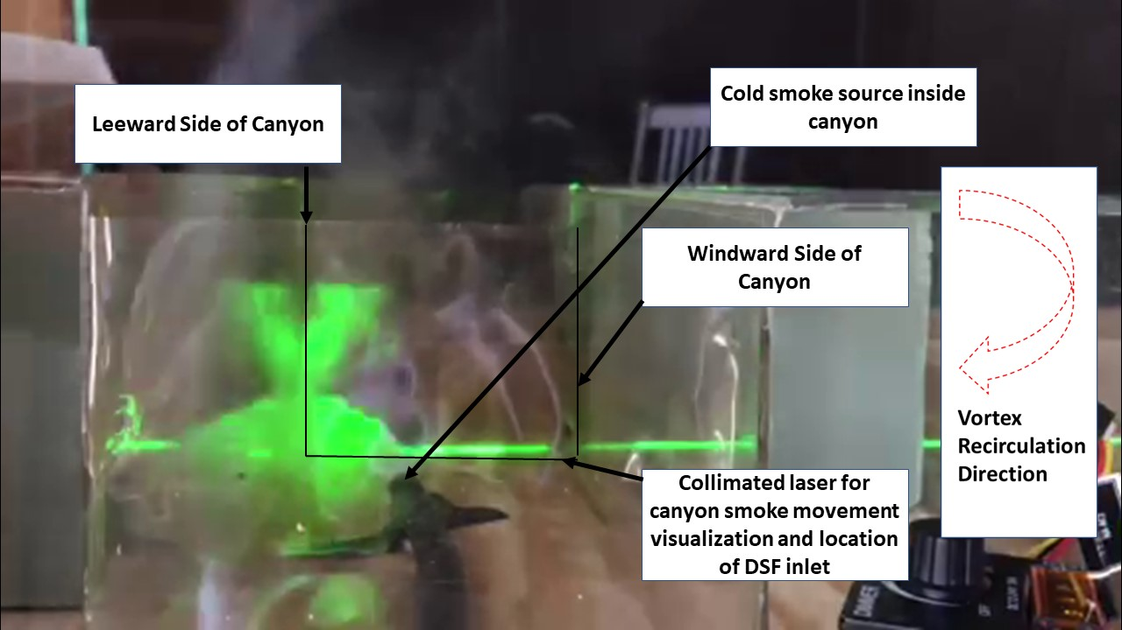
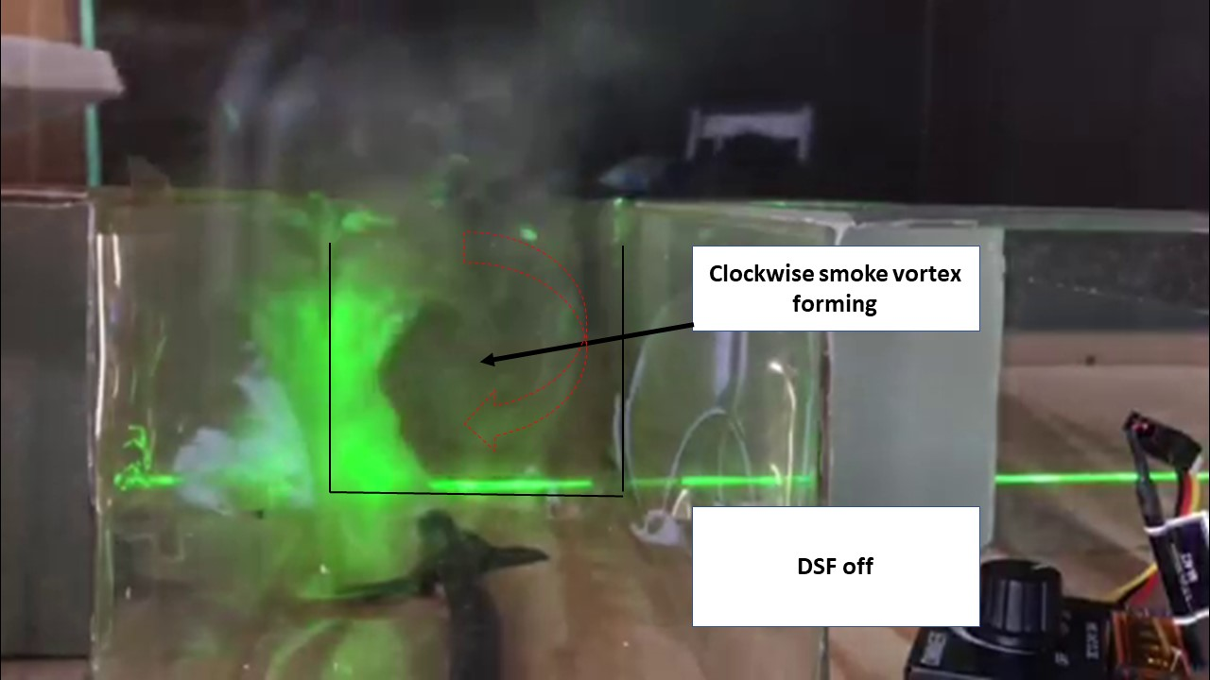
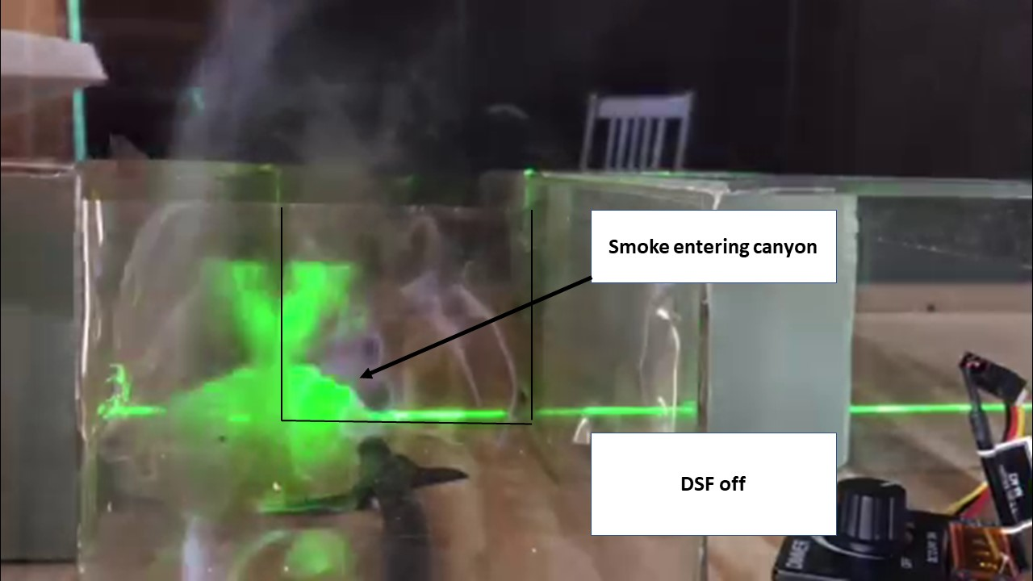
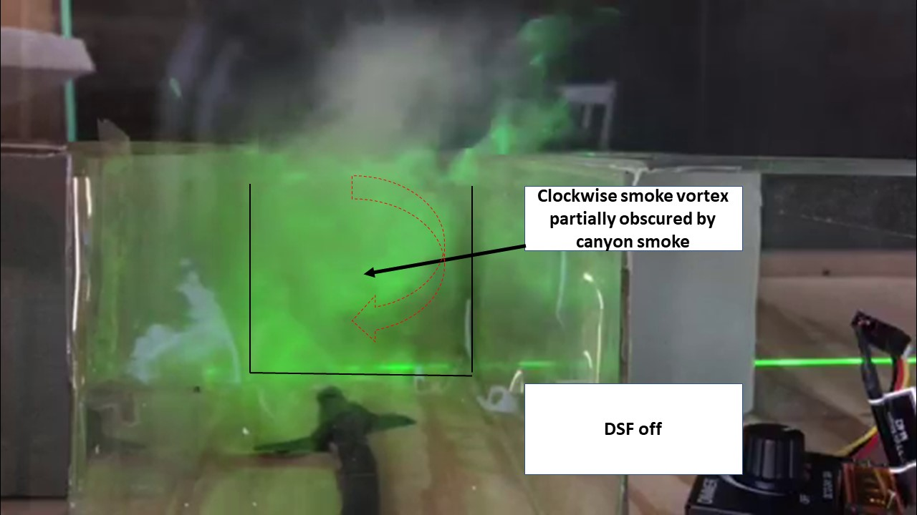
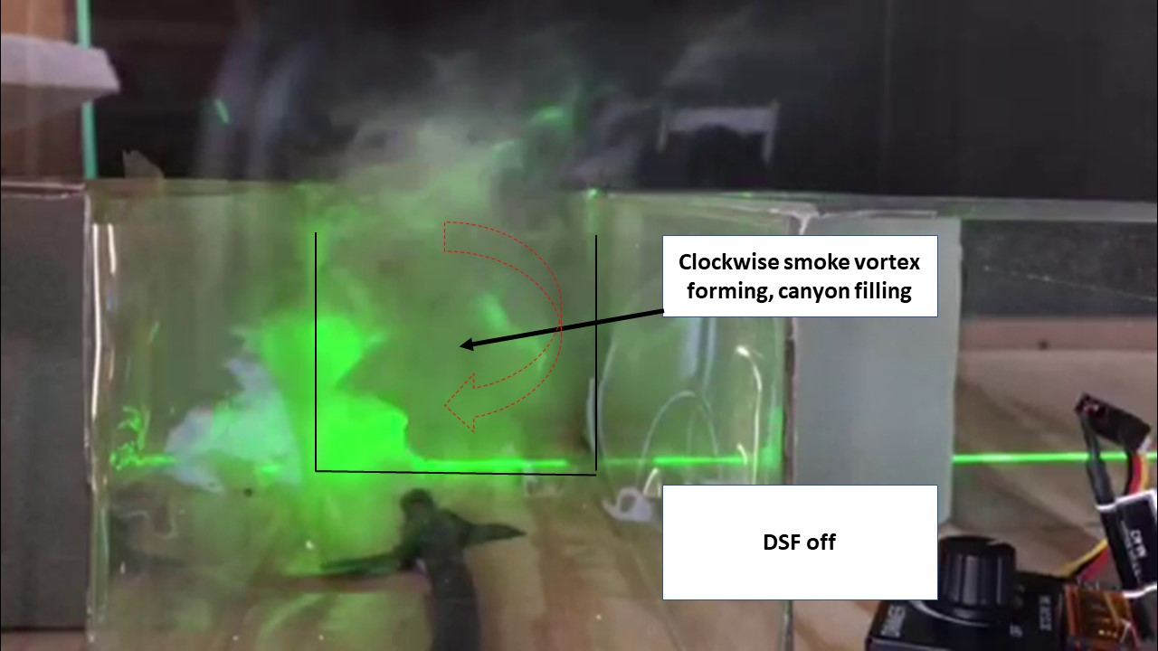
Figure 5.5.1 Cold Smoke Experimental Setup
Figure 5.5.2 Cold Smoke 0:02s Smoke Entering Canyon
Figure 5.5.3 Cold Smoke 0:05s Smoke Entering Canyon
Figure 5.5.4 Cold Smoke 0:07s Smoke Starting Recirculation Vortex
Figure 5.5.5 Cold Smoke 0:09s Smoke Entering Recirculation Vortex Apparent
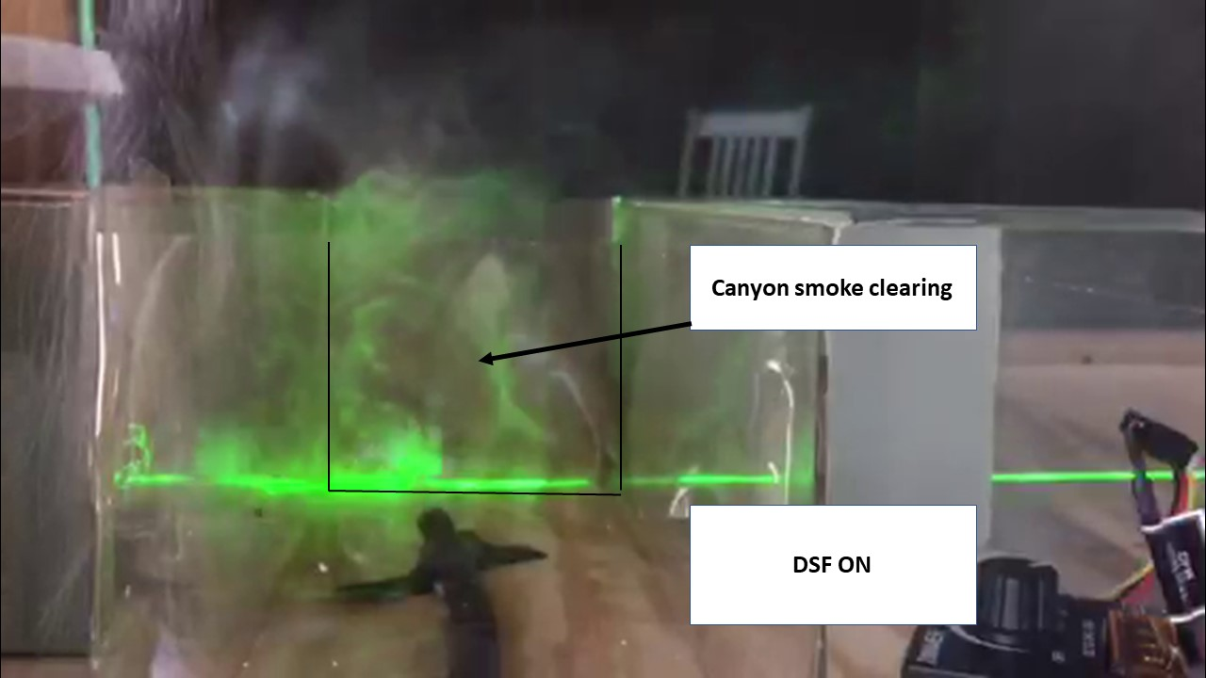
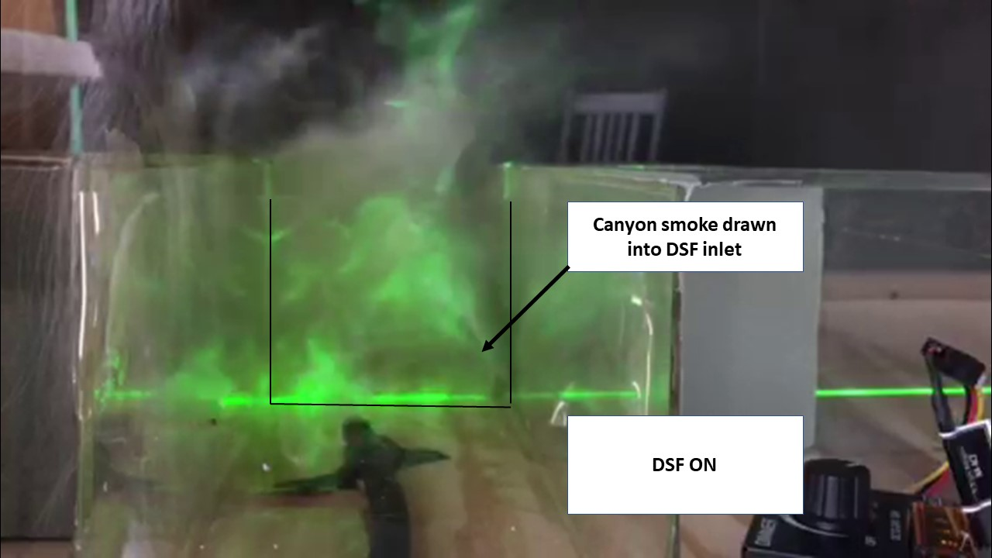
Figure 5.5.6 Cold Smoke 0:12s DSF FAN ON Vortex Breaking Up Entering DSF
Figure 5.5.7 Cold Smoke 0:14s DSF FAN ON Vortex Continuing to Dissipate and Drawn into DSF
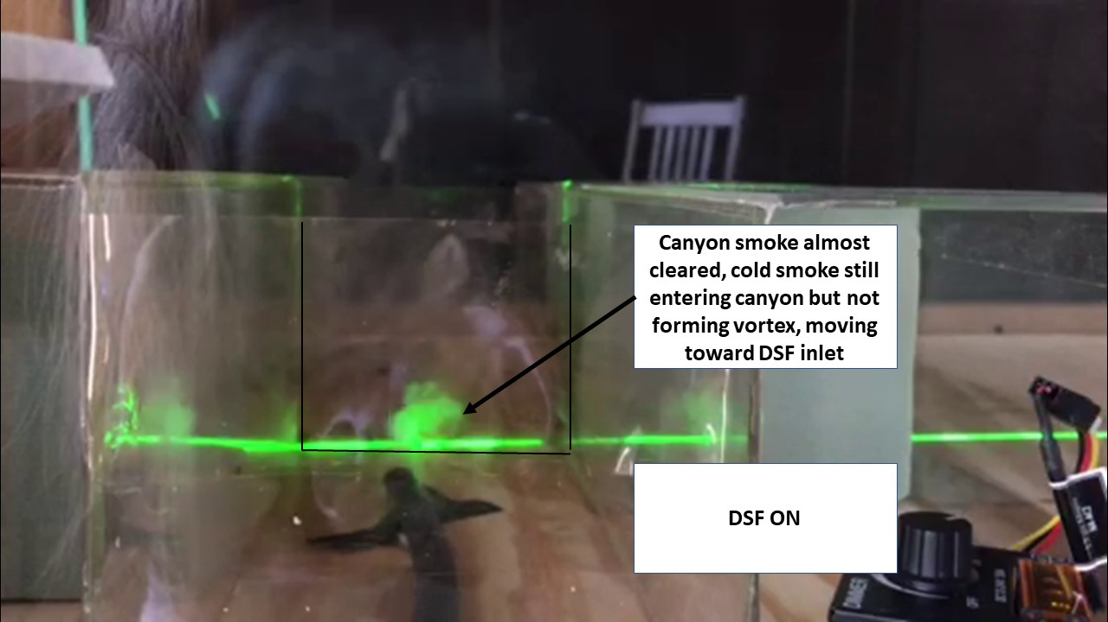
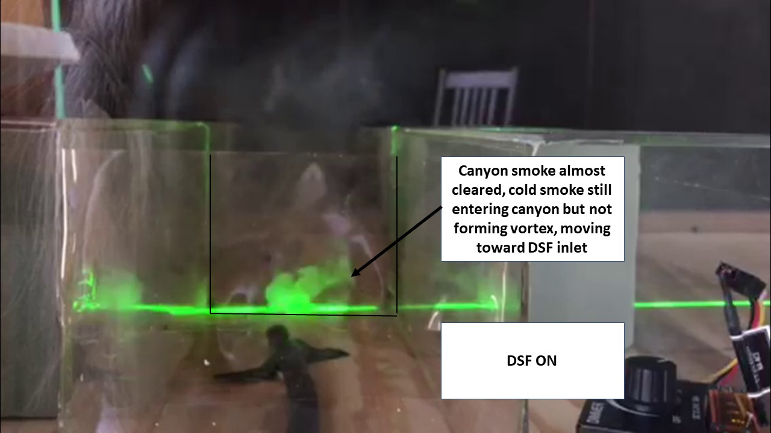
Figure 5.5.8 Cold Smoke 0:16s DSF FAN ON Vortex Dissipating and Smoke Directly Drawn into DSF
Figure 5.5.9 Cold Smoke 0:20s DSF FAN ON Vortex Gone and Smoke Directly Drawn into DSF
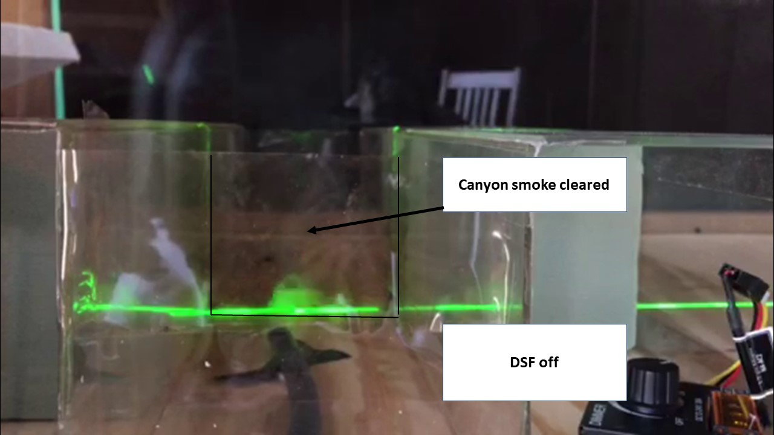
Figure 5.5.10 Cold Smoke 0:27s DSF FAN OFF Canyon Smoke Rebuilding

In Experiment 3, a video named "Cold Smoke Works" was created of length 0:29s. A piece of equipment that burned wood chips and then cooled the smoke was used in the urban canyon model within the wind tunnel boundary layer. This “cold smoke” did not exhibit the buoyancy characteristics of the heated glycol vapor so was ideal for demonstrating the recirculation and function of the DSF. At the 0:02s time mark, the cold smoke is seen entering the canyon. At the 0:05s time mark the cold smoke can be seen continuing to fill the model canyon, and at the 0:07s time mark the smoke can be seen starting to develop the recirculation vortex. At the 0:09s time mark, the smoke is continuing to fill the model canyon and recirculation of the vortex is readily apparent.
The DSF fan was turned on at the 0:12s time mark, and it can immediately be seen that the recirculation vortex is breaking up and entering the DSF. At time marks 0:14s and 0:16s the recirculation continues to break up, entering the DSF and dissipating. At time mark 0:20s recirculation of the cold smoke is almost completely cleared, and remaining smoke being generated is being drawn toward the DSF. At time mark 0:27s recirculation of smoke is cleared, and DSF is turned off. Table 5.5.1 summarizes the verification and validation of the wind tunnel model confirming the DSF evacuation of simulated air pollution in the street canyon.
Table 5.5.1 Verification and Validation of DSF Evacuation of Air Pollution (Cold Smoke) in Street Canyon via Wind Tunnel Analysis

5.6 Experiment 4 – Dry Ice Vapor and Jet Boundary Layer
Due to variable speeds within wind tunnel, which affected the development of the boundary layer, an extreme test was set up using a jet source to achieve higher speeds (10 m/s) at 23 cm above the street level of the DSF. Dry Ice Vapor was used to simulate the trapped boundary layer condition. Dry Ice container was placed offset to DSF to show evacuation of pollutants generated at locations furthest from DSF. Jet funneled glycol vapor was used for visual identification of separation of the urban boundary layer. Wind Tunnel speed set at 1 m/s. Flow speed of DSF was set at MAX.

Qualitative Results Video online https://youtu.be/sNcaXAMPUa0
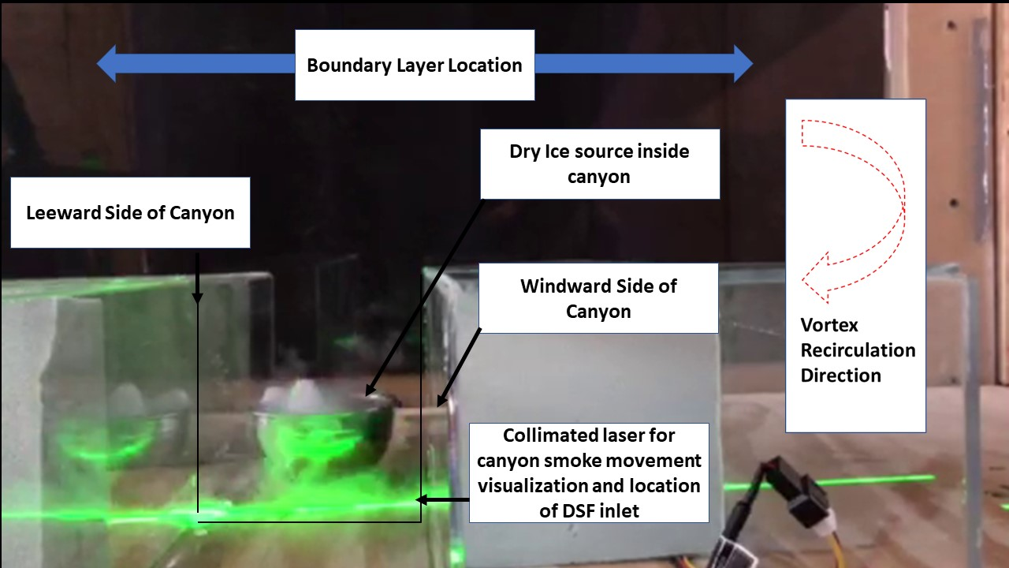
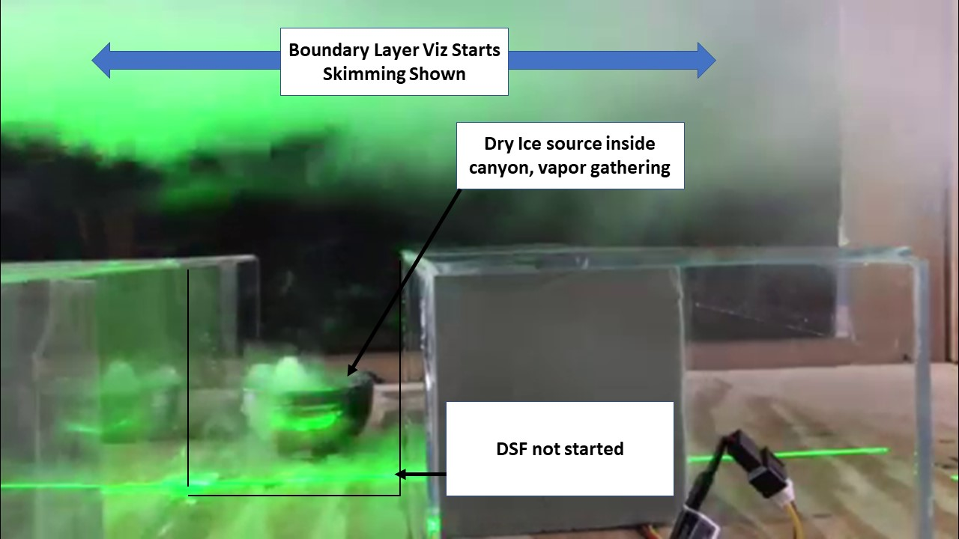
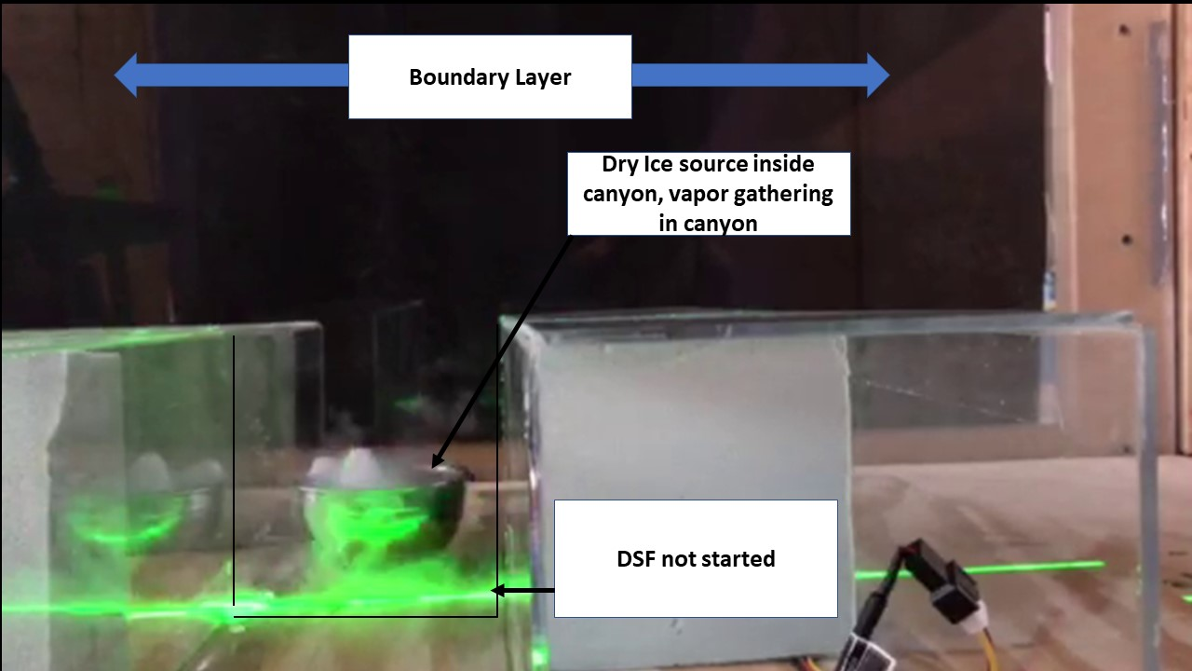
Figure 5.6.1 Dry Ice and Jet Boundary Layer Experimental Setup
Figure 5.6.2 Overall :02s Dry Ice Vapor Gathering in Canyon
Figure 5.6.3 Overall :05s Boundary Layer ON, Dry Ice Vapor Gathering in Canyon, DSF OFF
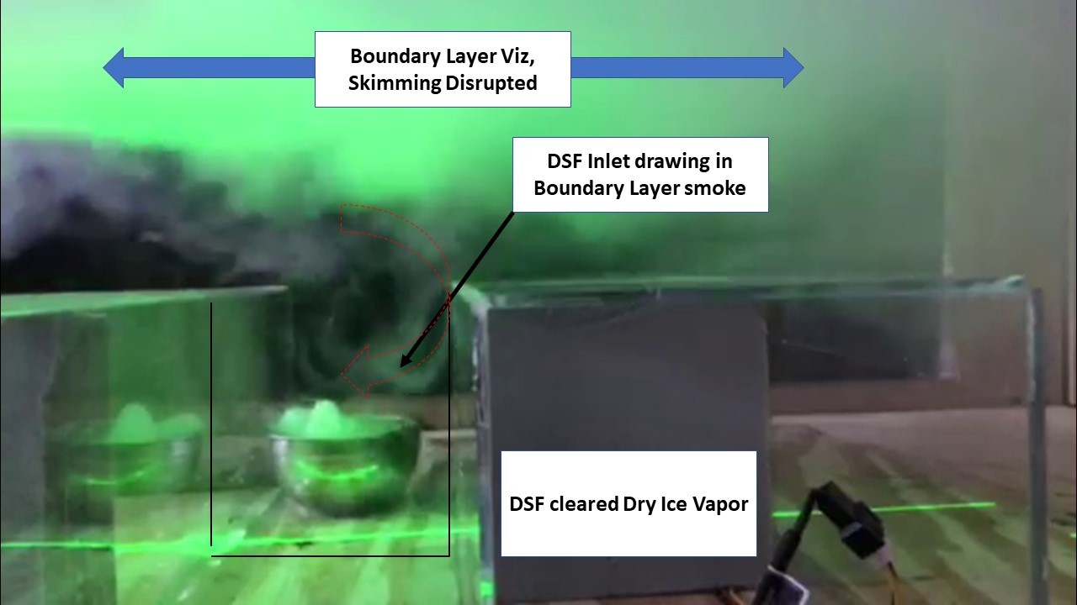
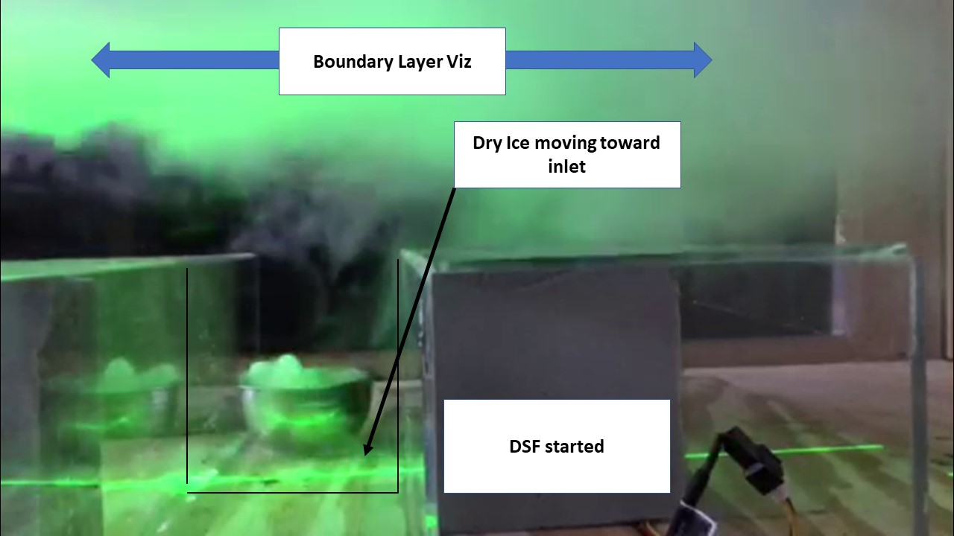
Figure 5.6.4 Overall :17s Boundary Layer ON, Dry Ice Vapor Entering DSF, DSF ON, Boundary Layer Smoke Mixing
Figure 5.6.5 Overall :21s Boundary Layer ON, Dry Ice Vapor Entering DSF, Canyon Dry Ice Vapor Cleared, DSF ON, Boundary Layer Smoke Mixing
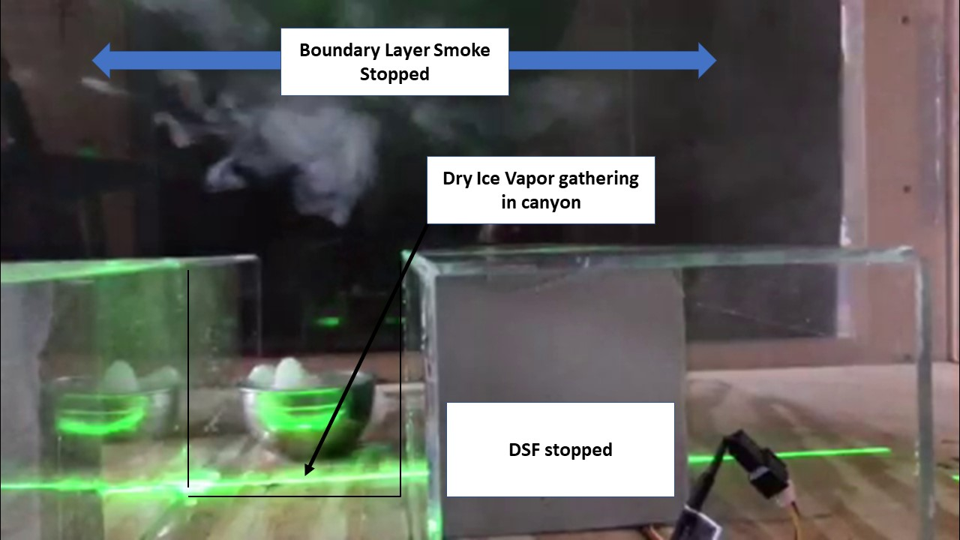
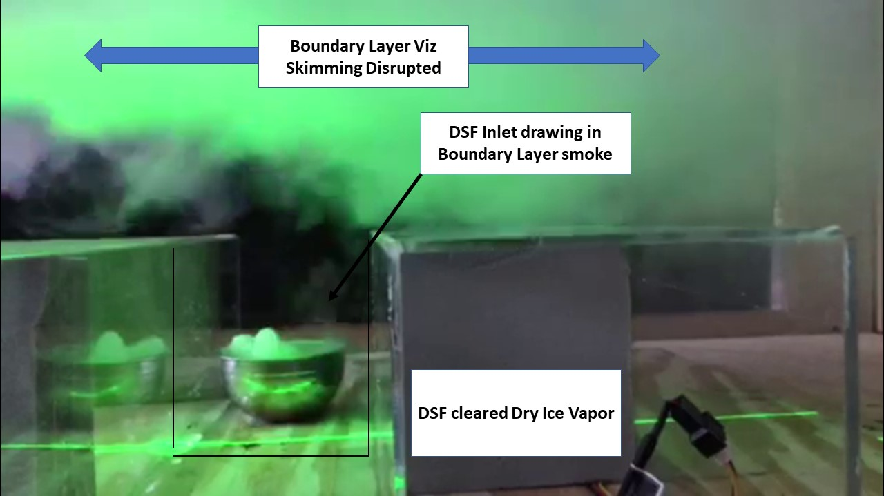
Figure 5.6.6 Overall :28s Boundary Layer ON, Canyon Dry Ice Vapor Cleared, DSF ON, Boundary Layer Smoke Mixing
Figure 5.6.7 Overall :40s Boundary Layer OFF, Dry Ice Vapor Gathering in Canyon, DSF OFF

In Experiment 4, the first simulation control test, created a video named "Overall Viz" was created of length 0:50s. Heated glycol vapor was used with a simulated boundary layer jet running at 10 m/s. This was to test the development of a true boundary layer within a wind tunnel that did not achieve speeds in excess of 3.7 m/s. Dry Ice Vapor was used to simulate urban street canyon air pollution. The boundary layer jet funneled glycol vapor to assist in the visual identification of boundary layer separation. At time mark 0:02s the dry ice vapor can be seen gathering in the model canyon. At time mark 0:05 the boundary layer jet can be seen. At time mark 0:16s the DSF was turned on and the dry ice vapor can be seen entering the DSF along with slight boundary layer smoke mixing. At time mark 0:21s the DSF fan remains on and the dry ice vapor can be seen entering the DSF along with more boundary layer smoke mixing. At time mark 0:28s the DSF fan remains on and the dry ice vapor seen entering the DSF along with model canyon cleared. At time mark 0:38s the DSF fan is turned off. At time mark 0:40s the DSF fan is off and dry ice vapor can be seen gathering in the model canyon. Table 5.6.1 summarizes the verification and validation of the wind tunnel model confirming the DSF evacuation of simulated air pollution in the street canyon.
Table 5.6.1 Verification and Validation of DSF Evacuation of Air Pollution in Street Canyon via Wind Tunnel Analyses

5.7 Experiment 5 – Smoke Source Placed Inside DSF
Hot smoke tracer source was used similar to HVAC ventilation tracer (wax impregnated cloth). Hot smoke source was placed inside DSF to demonstrate that the pollutants were not being removed from the streetscape merely by lift generated by the Bernoulli principle. Wind Tunnel speed set at 3.76 m/s. Flow speed of DSF was set at MAX.

Qualitative Results Video online https://youtu.be/FZJnnAPfhTc
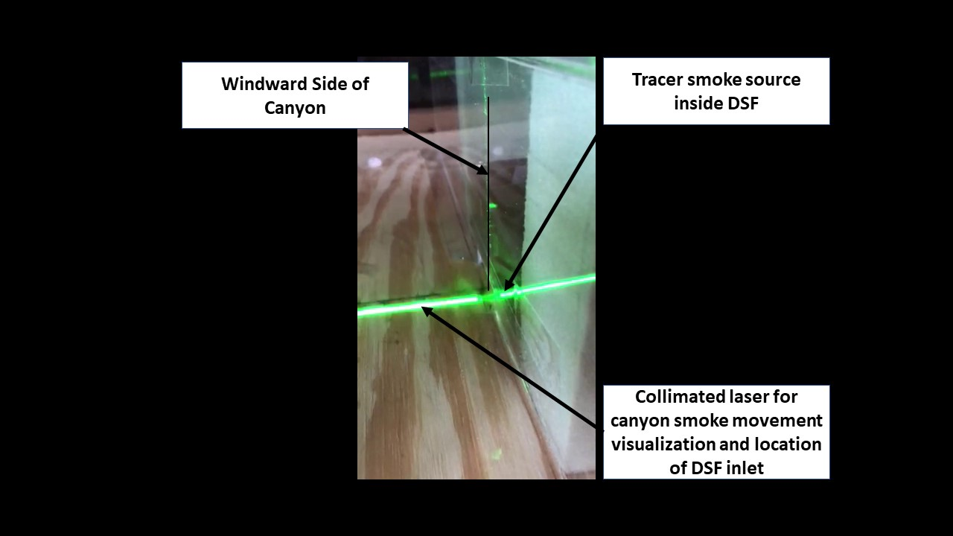
Figure 5.7.1 Tracer Smoke Inside DSF Experimental Setup

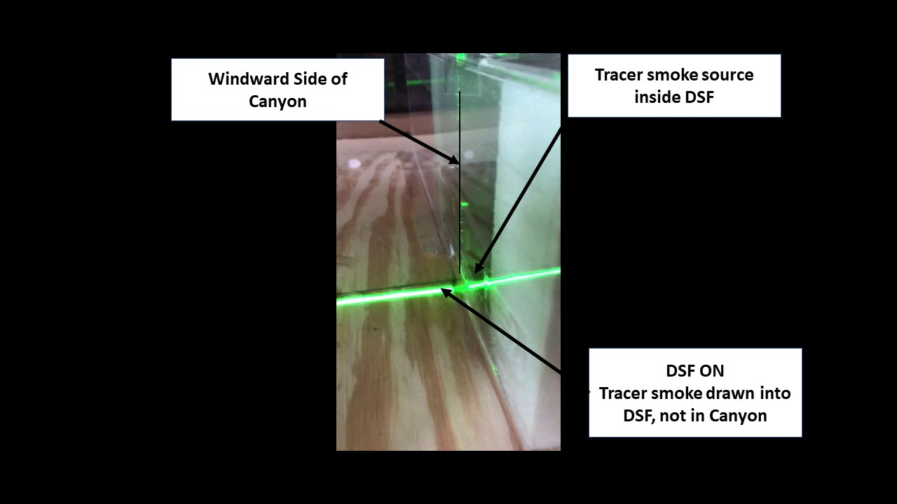
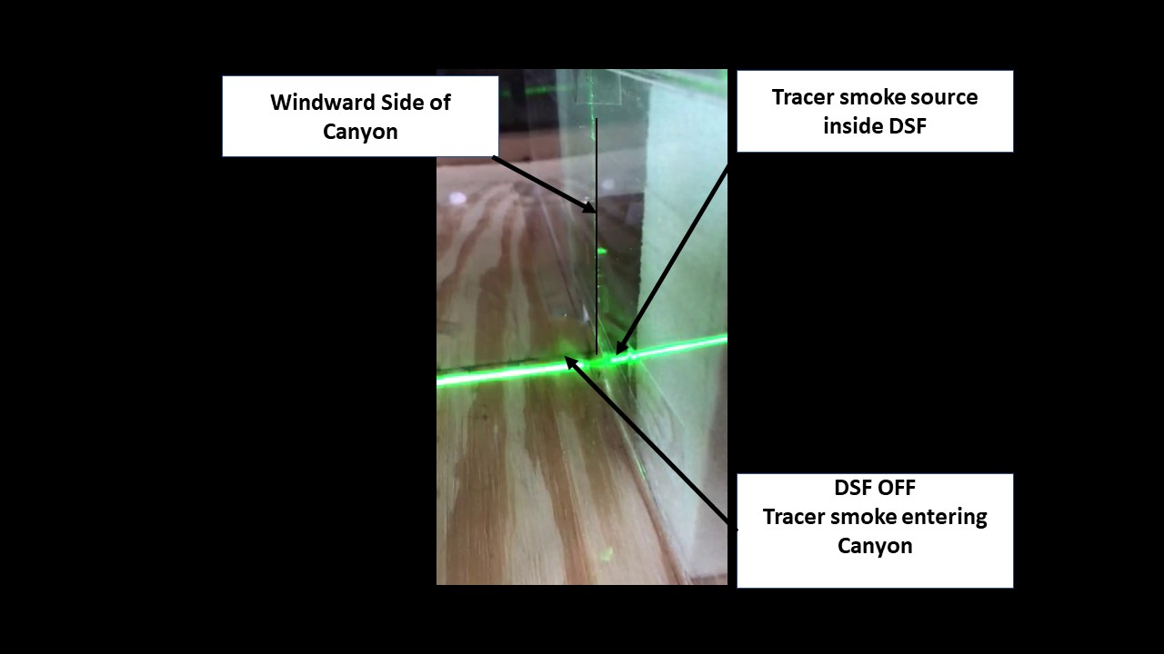
Figure 5.7.2 Tracer Smoke :02s Tracer Smoke Inside DSF, DSF OFF, Smoke entering Canyon
Figure 5.7.3 Tracer Smoke :09s Tracer Smoke Inside DSF, DSF ON, Smoke drawn into DSF, Smoke Not Entering Canyon
Experiment 5 is documented in a video named "Inside Wall Works Only with Fan" with a length of 0:32s. For this video a hot smoke tracer source was used similar to HVAC ventilation tracer smoke (wax impregnated cloth). The hot smoke source was placed inside DSF to demonstrate that the pollutants were not being removed from the streetscape merely by lift generated by the Bernoulli principle. At time mark 0:02s the hot smoke is seen exiting the DSF wall at the inlet. At time mark 0:04s, the DSF fan was turned on. At time mark 0:09s no smoke can be seen exiting the DSF wall at the inlet. At time mark 0:16s the DSF fan was turned off. At time mark 0:23s smoke can again be seen exiting the DSF at the inlet.
Figure 5.7.4 Tracer Smoke :23s Tracer Smoke Inside DSF, DSF OFF, Smoke Entering Canyon
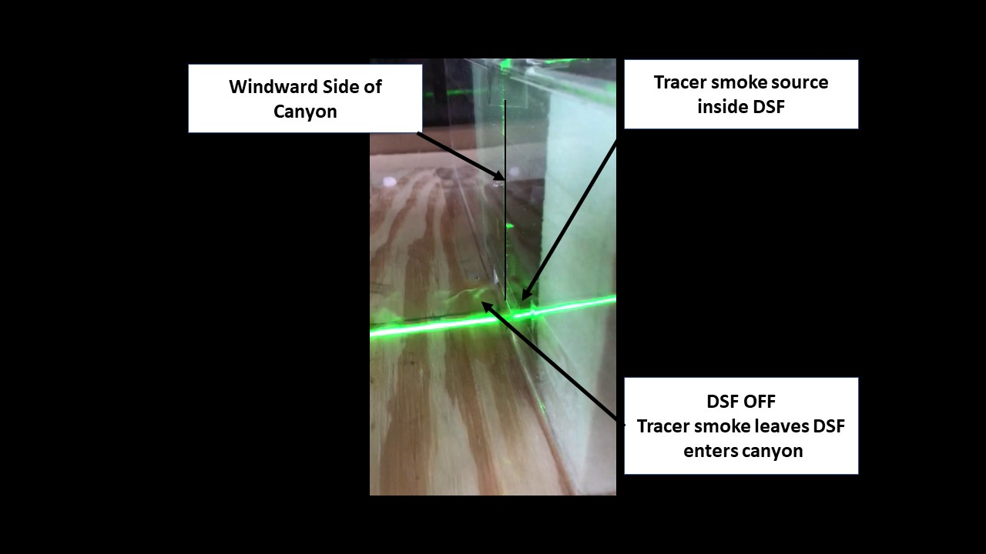
5.8 Discussion
The research questions led to the crafting of the hypothetical questions, where we developed several experiments to test the following hypothesis:
- When coupling the building facade and the urban street is it possible to ventilate street level air pollution and facilitate mixing (RQ1 and RQ2 and RQ4)
The results based upon numerical modeling (CFD) showed definitive ventilation of street level air pollution and mixing with upper boundary air. While more robust CFD software were not able to perform the analyses due to meshing issues related to scale, the non-dimensional Navier-Stokes results supported the hypothesis. Because there were gaps in software capabilities and therefore limits to the performance of the CFD analyses, validation of the software results was performed using a wind tunnel adapted for urban boundary layer models.
Although many of the variables of the wind tunnel operation were less than ideal, what was consistent throughout all the tests was that the DSF evacuated the urban street canyon and showed definitive ventilation of street level air pollution and some mixing with upper boundary air. Due to the nature of the simulated pollutant sources, and the scale with which the DSF had to function (1:200), the pollutant sources were not able to be visually traced after entering the DSF inlet as they were dissipated by the fan within the model.
During most of the experiments, the ambient temperature within the testing room that held the wind tunnel apparatus was consistently more than 90ºF. In Experiment 1 it became apparent that the hot heated glycol-based fluid was extremely buoyant, and after exiting the wind tunnel, rose to the ceiling level of the room. This led to the development of Experiment 2, and the identification of a visible vapor that would generally stay at the street level of the simulated urban canyon.
Dry Ice vapor consists of carbon dioxide and water vapor. Although the visual analysis of the vapor demonstrates the function of the DSF, the vapor itself did not create the coherent structure of the recirculating vortex. Intuitively, we know it is there, but it does not exhibit stable structure. This led to the development of Experiment 3, where a particulate smoke source could be used for visualization.
Experiment 3 clearly demonstrated that the DSF functions very effectively in evacuating simulated air pollutants from the simulated urban canyon. Two other tests, however, were developed to serve as controls as to the function of the DSF in the canyon. The first test, Experiment 4, set up a visual demonstration of extreme conditions of the boundary layer and the canyon air pollutants. The heated glycol mixture was selected for the visualization of the urban boundary, and the dry ice vapor was used to distinguish from the two types of smoke. Although colored smoke would have been ideal, non-toxic colored smoke was not available, and therefore colored smoke could not be used in the closed conditions of the room.
The Experiment 4 control test is also important for demonstrating the potential for the DSF to enhance mixing. The boundary layer jet was 23 cm above the top level of the canyon, but from time mark 0:16s through 0:28s the heated glycol vapor can be seen being drawn into the canyon. This result should be further investigated at larger scale in an environment where colored tracer gases can be used to determine mixing capacity of the DSF.
The second control test, Experiment 5, was set up to show that the DSF was an actively ventilated system. The opportunity to test buoyancy within the DSF was impossible at the 1:200 scale, but, a smoke system internal to the DSF could be used to demonstrate that the Bernoulli effect was not removing the canyon pollutants. This test demonstrated that the DSF worked actively and not passively. This result should also be further investigated at larger scale to determine if solar radiation induce buoyancy could produce sufficient evacuation and definitive ventilation of street level air pollution and mixing with upper boundary air.
As discussed in Chapter 1, each of the CFD analyses were verified. Each of the wind tunnel experiments, verified the DSF operation and removal of air pollutants from the street canyon, with Experiments 4 and 5 serving as controls to verify the DSF operation. Table 5.8.1 summarizes the verification and validation of the wind tunnel model confirming the DSF evacuation of simulated air pollution in the street canyon.
Table 5.8.1 Results Verification and Validation of DSF Evacuation of Air Pollution in Street Canyon

5.8.1 Airflow Rates and Potential Pollutant Mass Flow Removal Rates for Full Scale Implementation
The research questions led to the crafting of the second hypothetical question:
- Can vegetated biofilters effectively remove air pollution within DSF operating parameters while ventilating street level air? (RQ3)
In order to determine whether the flow rates of evacuation would be within the range suitable for human comfort, an off the shelf smoke evacuation fan was selected of a size that would fit within the DSF at full scale (Canarm Ltd. brand Model RB Belt Drive Propeller Up Blast Roof Exhaust Fan, 36”). Calculations in Table 5.8.1 show that the DSF results could be built with 11 fans mounted along the top of the DSF all within the face of a typical 50-foot building, while operating at speeds of 3.76 m/s which is less than the maximum allowed for human comfort (5 m/s).
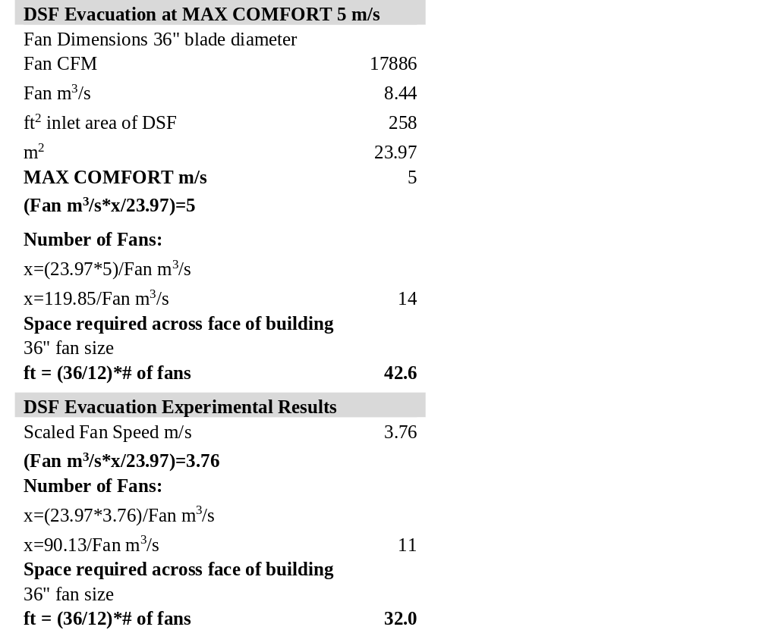
Table 5.8.2 Airflow Rates of DSF MAX Comfort and Experimental Results
Street Canyon Air Pollution removal rates can be estimated based upon data available. “For ozone, a global chemical transport model simulation of seasonal maximum concentrations is available. The estimated levels of ozone are highest in North America, Latin America, Europe, and South and East Asia, as well as parts of Africa. For these regions, seasonal (3-month) hourly maximum ozone concentrations in 2005 were estimated to be greater than 40 ppb [80 μg/m³], with concentrations in some areas in parts of Asia and Africa greater than 80 ppb [160 μg/m³]” [94].

The same report shows that in 2005, PM_{2.5} concentrations were estimated to be
> 50 μg/m³ in South and East Asia, and the population-weighted annual mean PM_{2.5} concentration in North America was estimated as 13 μg/m³.
This allows us to estimate the mass flow removal rates of criteria air pollutants by the DSF without the integrated vegetated biofilter at the fan speed of 3.76 m/s, results are shown in Table 5.8.2. Mass flow rate is calculated as:
Equation 5.1 $mdot=vAρ$
Where $mdot$ is in μg/s
v = flow velocity of the elements
$A$ = cross-sectional area of the DSF
ρ = mass density of the fluid
Volume of Canyon Moved
Fan m³/s |  | 8.44
Number of fans |  | 11
Total m³/s |  | 90
Mass Flow Evacuation Rate
VOC μg/m³ |  | 80
mdot μg/s |  | 7209
PM_{2.5} μg/m³ |  | 13
mdot μg/s |  | 1172
Table 5.8.3 Estimated DSF Mass Flow Evacuation Rate of VOC and PM_{2.5}

5.8.2 Potential Remediation of Air Pollutants Using an Integrated Active Green Wall Based on Mass Flow Removal Rates
To date, active green walls have been studied in interior environments. A recent in situ test [95] described an active green wall, of 9 m² installed in a 120.2 m³ room. The volumetric flow rate through the active green wall was 0.0787 m³/s representing approximately 2.36 air exchanges per hour.
The study found that prior to the installation of the active green wall, the average concentration of total volatile organic compounds (TVOCs) was 300 ± 3.04 ppb, following the installation of the active green wall, the average concentration of TVOCs was reduced to 217 ± 2.00 ppb over the 20-min trial period, representing a reduction of ~ 28% [95]. Furthermore, prior to the active green wall installation, the ambient concentration of total suspended particulates (TSPs) was 101.18 ± 0.29 μg /m³. After the active green wall was installed, the mass concentration of TSP in the room was reduced by 42.6% over 20 min.
The documented air flow rate of the active green wall for effective remediation, is much less than that of the operational DSF in the urban street canyon. It can be assumed that the removal rate of the TVOCs and TSPs would be reduced as the root microbial and mycorrhizae systems have much less time to interact with the air pollutants. Larger scale tests would allow for an active green wall to be installed within the DSF to determine the TVOC and TSP effective remediation.
It is important to note, that in both the CFD and the wind tunnel tests, an object was not present within the DSF system representing the integrated vegetated biofilter. The secondary research question was limited to identifying whether the canyon could be cleared by the DSF at a rate sufficient to support the integrated vegetated biofilter. The fan that was utilized to simulate the extract air in the DSF model used for the wind tunnel operated at a maximum inlet speed of 5 m/s. Pressure losses within the model created an outlet flow rate of 1.30-1.53 m/s. This verified that the maximum inlet flow rate did not exceed the maximum operational flow rate for the vegetated biofilter. The calculated results show that the vegetated biofilter would be able to operate, but the VOC and PM_{2.5} remediation rate is not definitive. The vegetated biofilters could sequester some quantity of air pollution within the DSF operating parameters, while the DSF was removing street level air pollutants (RQ3).

CHAPTER 6 - CONCLUSION
6.1 Answering Research Questions
Responding to increasing population and urbanization is being met at a global scale. Rethinking how building systems operate and how systems function with regard to interfacing with the urban environment can transform the definition of how buildings can contribute to urban infrastructure. Instead of looking at landscape/streetscape as external to the building, we should be looking at it through the lens of a complex multi-dimensional model, a holistic expression of symbiosis as the building seeks to contribute and regenerate the urban environment instead of merely taking from or existing within it.
This research has proposed to extend the building paradigm by considering opportunities for building systems to act beyond their tasks within the building perimeter. Specifically, questions that arose from examination of the knowns and unknowns within that new building paradigm lead to several Research Questions:
- RQ1-What building systems interact with street canyon airflow;
- RQ2-How can the building system ventilate street level air pollution and facilitate mixing;
- RQ3-How can vegetated systems operate with a building to ameliorate air pollutants;
- RQ4-What analyses demonstrate interaction of building with street level air?
After identifying which building systems interact with street level air, this research answered RQ1 - what building systems interact with street canyon airflow - by identifying the Double Skin Façade as a building air delivery (and energy efficiency) system that had potential to interact with street canyon airflow. The hypothesis - when coupling the building facade and the urban street is it possible to ventilate street level air pollution and facilitate mixing (developed to evaluate RQ1 and RQ2 and RQ4) led to the investigation of the analytical methods necessary to demonstrate that the Double Skin Façade can interact with the streetscape level air. The wind tunnel experimental results validated and verified (Chapter 5 sections 5.1.2, 5.3-5.7) that the DSF definitively ventilated street level air and enhanced mixing at the urban boundary layer. This façade technology-based approach yields the promise and expression of a building DSF that serves a functional purpose beyond natural ventilation, daylighting, and thermal efficiency. This presents a transformative approach to building design allowing the façade to enhance adjacent airspace, effectively creating a design intervention with the building façade that can remove criteria air pollutants found in these urban street canyon configurations.
As a follow on to the research questions demonstrating ventilation of the street canyon, RQ3-How can vegetated systems operate with a building to ameliorate air pollutants – led to the hypothesis – can vegetated biofilters effectively remove air pollution within DSF operating parameters while ventilating street level air? If we include the integration of a vegetated biofilter, the opportunity presents itself to remediate criteria air pollutants such as VOCs and PMs in a manner that simultaneously satisfies our need for nature within the built environment. This presents a compelling argument where a building can demonstrate a psychological as well as performative impact beyond its perimeter. While the scale of the experimental models and the limitations of the numerical models did not directly demonstrate the effective remediation of VOCs and PM_{2.5}, it was demonstrated (Chapter 5 section 5.8.1) that the DSF operated at an airflow rate that would support the function of the vegetated biofilter, while mass flow rates indicated potential remediation.
This interdisciplinary approach yields the promise and expression of a building façade that serves a functional purpose beyond aesthetics, natural ventilation, daylighting, and thermal efficiency. By adding the integrated DSF façade, we provide a regenerative opportunity to remove air pollution, which presents a transformative approach to building design. The integration of a vegetated biofilter within a double skin façade that could ameliorate air pollution, represents the connection of systems and environment that gives true meaning to the definition of regenerative built environments.
6.2 Contributions from Research
- Urban Planning and Engineering - An important aspect of this research is the identification of Form Based Codes criteria that have the potential to form H:W ratios creating future urban street canyons (Chapter 2). The research identified urban street canyon configurations that accumulate air pollutants which are of concern for respiratory health. The research identified specific FBCs with street canyon formation potential which can lead to further refinement and development of FBCs and points out the need for solutions to address future urban development.
- Building Integrated Urban Infrastructure – This research identified a means to extend the building systems to function as urban infrastructure for purposes of air pollution removal. The development of a method where investment in a building system is an investment in the city’s infrastructure is a paradigm shift and has led to the identification of multiple avenues of future interdisciplinary research (Chapter 1).
- Identified Gaps in Knowledge - Near wall and urban microscale modeling identified gaps between engineering and urban climatology, between the models capable of analyzing near wall and urban scale air flow movement, and DSF airflow and energy modeling, which presents an exciting opportunity for the CFD development community (Section 5.1.1, 6.3). The research identified the gap by suggesting the building system paradigm shift. Much CFD work at building scale is focused on Building Energy Simulation Models and modeling of Urban Boundary Layer processes supporting thermal comfort, air quality and city ventilation. Identifying and understanding the DSF building system and the need to model the DSF within the context of the street canyon in order to extend its functional purpose toward remediating street canyon air pollution, is transformative in terms of future research.
- Street Trees, Vegetated Biofilters, and Air Pollutants – This research identified that street trees do not necessarily create the benefits that have been promoted in the literature and that trees also contribute to air pollution accumulation (Section 3.1.2). The research suggested the use of a vegetated biofilter on the exterior façade of a building, protected by a glazed DSF, which extends the capabilities of a vegetated biofilter structure. The glazed DSF can function as a greenhouse to extend the climate zones and seasons during which the biofilter can operate. Installing the vegetated biofilter on the street side of the building, extends the types of naturalized environments which have been shown to have beneficial psychological impacts on human beings (Section 1.5, Section 4.4, Section 5.8.1, Section 5.8.2).
- Building Materials and Air Pollutants – During the course of this research, it was identified that a current method being adopted to address urban air pollution, does not in fact perform as promoted. Photocatalytic paints are being used as a means to sequester VOCs, however, the degradation of the paint and interactions with atmospheric air in fact releases additional VOCs known to be carcinogens as well as releasing nanoparticles. This is an area that should be conveyed more widely to the public (Section 1.5).
- Exploring the Façade Building System through Simulations and Experiments – This research identified a building systems façade technology that does not limit building expression, force building owners to alter building setbacks, nor limit building height (Section 3.3). The research had, as a result, a new façade system (an active DSF) which demonstrated removal of street canyon air pollution (Chapter 4,5). Specifically, the introduction of the active DSF as a means to ventilate street level air, facilitate mixing, and remove – and potentially ameliorate through the incorporation of vegetated biofilter - criteria air pollutants, which extends the efficacy and application of building systems. This new active façade also serves as urban infrastructure and is fundamental to providing solutions to solve the air quality issues being created by increasing urbanization. The interdisciplinary methods used to analyze the hypothetical questions, represents opportunities for interdisciplinary teams to be informed by urban climatology and extend their understanding and influence for future urban design development beyond the typical wind loading, building energy and urban heat island, and air pollutant transfer modeling. The DSF system, without the integrated biofilter, has been given provisional patent number 62/576,947 with the name “Apparatus and Method for Enhancing Air Quality in Urban Street Canyons”.
6.3 Future Research
First, it will be necessary to identify and develop software that can perform CFD analyses simultaneously address the differing scales of the street canyon with the finer scales of the DSF and incorporate energy conservation. There is potential in exploring Detached Eddy Simulations (DES) - a modification of RANS models where the model switches to a sub grid scale in regions fine enough for LES calculations – to address the gap in knowledge with near wall and urban scale air flow modeling. This will need to be developed in multiple phases and evaluated with an urban boundary layer wind tunnel. Should this be developed, it presents an opportunity to save energy with the DSF system on days where there may be buoyancy assistance that would reduce the amount of energy needed to run the system and evacuate the street level air pollutants.
Second, refinement of the scale and size of the DSF may result in the findings of smaller DSF systems that could accomplish the same evacuation of the canyon. Indeed, it may be possible to disconnect the system completely from the building façade and have temporary installations as air quality issues arise.
Lastly, full scale in situ field tests would provide the opportunity to fully integrate the vegetated biofilter and measure actual air pollutant remediation as well as analyze the full urban boundary layer penetration and mixing. Identifying an existing urban street canyon location, where a temporary DSF could be set up (or alteration of an existing system) would provide an experimental test bed to quantify mass flow rates, evacuation and air pollutant removal and mass flow rates. Additionally, the types of plants used within existing vegetated biofilters currently operate within conditioned building spaces. The opportunity to identify plants that can also remediate criteria air pollutants such as VOCs and PM_{2.5} while also being exposed to outside climate conditions – such as plants already identified through green roof trials or external living walls - presents another unique opportunity to determine species and regional application that can also remediate air pollution through their symbiotic microbial colonies and root structures.

This research was initiated to explore the potential use of buildings systems to remediate urban air pollutants in addition to functions that are necessary to support the building itself, which is transformational in our approach to building design. The identification of urban conditions that exacerbate air pollution at the street level became the focus for identifying one building system that could be adapted to counter street canyon air pollution. This research has definitively identified a building system – a Double Skin Façade – that can evacuate street level air pollutants and facilitate mixing with urban boundary layer air. The DSF system also shows the potential to ameliorate those air pollutants with the introduction of a vegetated biofilter, thereby demonstrating that buildings are capable of providing urban ecosystem services, which represents a fundamental paradigm shift as to the nature of buildings in the urban and suburban built environment.

REFERENCES
[1] Vitruvius, 1999, “Vitruvius: ‘Ten Books on Architecture,’” Cambridge Core [Online]. Available: /core/books/vitruvius-ten-books-on-architecture/23BAB1A6EB6F063696994CF65037520C. [Accessed: 08-Dec-2019].
[2] United Nations Department of Economic and Social Affairs, 2016, The World’s Cities in 2016, UN.
[3] “WHO | Ambient (Outdoor) Air Quality and Health,” WHO [Online]. Available: http://www.who.int/mediacentre/factsheets/fs313/en/. [Accessed: 07-Mar-2017].
[4] Hiyama, K., and Kato, S., 2012, “Legal Regulations for Urban Ventilation,” Ventilating Cities: Air-Flow Criteria for Healthy and Comfortable Urban Living, S. Kato, and K. Hiyama, eds., Springer Netherlands, Dordrecht, pp. 135–149.
[5] Reckien, D., Flacke, J., Dawson, R. J., Heidrich, O., Olazabal, M., Foley, A., Hamann, J. J.-P., Orru, H., Salvia, M., De Gregorio Hurtado, S., Geneletti, D., and Pietrapertosa, F., 2014, “Climate Change Response in Europe: What’s the Reality? Analysis of Adaptation and Mitigation Plans from 200 Urban Areas in 11 Countries,” Climatic Change, 122(1), pp. 331–340.
[6] Zhang, K., Wang, R., Shen, C., and Da, L., 2010, “Temporal and Spatial Characteristics of the Urban Heat Island during Rapid Urbanization in Shanghai, China.(Report),” Environmental Monitoring and Assessment, 169(1–4), pp. 101–112.
[7] Mcguirk, P., Dowling, R., and Bulkeley, H., 2014, “Repositioning Urban Governments? Energy Efficiency and Australia’s Changing Climate and Energy Governance Regimes,” Urban Studies, 51(13), pp. 2717–2734.
[8] Meng, X. W., and Setoguchi, T., 2010, “Development of Urban Design Guidelines with Wind Tunnel Simulations for Downtown Districts in Winter Cities - New Urban Design Approaches for Cold Region Cities-,” Journal of Asian Architecture and Building Engineering, 9(2), pp. 355–362.
[9] 2017, “WHO | Ambient (Outdoor) Air Quality and Health,” WHO [Online]. Available: http://www.who.int/mediacentre/factsheets/fs313/en/. [Accessed: 10-Mar-2017].
[10] Abhijith, K. R., Kumar, P. S., Gallagher, J. P., McNabola, A., Baldauf, R. W., Pilla, F., Broderick, B. E., Sabatino, S. D., and Pulvirenti, B., 2017, “Air Pollution Abatement Performances of Green Infrastructure in Open Road and Built-up Street Canyon Environments – A Review.”
[11] Vette, A., Burke, J., Norris, G., Landis, M., Batterman, S., Breen, M., Isakov, V., Lewis, T., Gilmour, M. I., Kamal, A., Hammond, D., Vedantham, R., Bereznicki, S., Tian, N., and Croghan, C., 2013, “The Near-Road Exposures and Effects of Urban Air Pollutants Study (NEXUS): Study Design and Methods,” Science of the Total Environment, 448, pp. 38–47.
[12] Lu, X., Lin, C., Li, W., Chen, Y., Huang, Y., Fung, J. C. H., and Lau, A. K. H., 2019, “Analysis of the Adverse Health Effects of PM2.5 from 2001 to 2017 in China and the Role of Urbanization in Aggravating the Health Burden,” Science of the Total Environment, 652, pp. 683–695.
[13] 2017, “Grand Challenges for Engineering” [Online]. Available: http://www.engineeringchallenges.org/File.aspx?id=11574&v=ba24e2ed. [Accessed: 10-Mar-2017].
[14] “San Francisco Public Utilities Commission : Our Headquarters” [Online]. Available: https://sfwater.org/index.aspx?page=583. [Accessed: 14-Mar-2019].
[15] 2017, “Drinking-Water-Final.Pdf” [Online]. Available: https://www.infrastructurereportcard.org/wp-content/uploads/2017/01/Drinking-Water-Final.pdf. [Accessed: 27-Oct-2019].
[16] 2017, “Wastewater-Final.Pdf” [Online]. Available: https://www.infrastructurereportcard.org/wp-content/uploads/2017/01/Wastewater-Final.pdf. [Accessed: 05-Dec-2019].
[17] Fithian, L., 2015, “How Advanced Building Systems Can Offset Water Infrastructure Needs,” 52nd International Making Cities Livable, eReport.
[18] Fithian, L., Siddique, Z., and Wang, N., 2017, “Investing in Sustainable Buildings to Enhance Community Resilience,” ASCE Architectural Engineering Institute Conference Proceedings.
[19] Newsom, G., Lee, E. M., and Reiskin, E. D., 2010, “Fiscal Year 2009-2010 Annual Report,” p. 82.
[20] 2014, “City of Tucson Water Conservation Ordinances” [Online]. Available: https://www.tucsonaz.gov/water/ordinances. [Accessed: 14-Mar-2019].
[21] Oke, T. R., 1992, Boundary Layer Climates, Routledge, London; New York.
[22] Hunter, L. J., Johnson, G. T., and Watson, I. D., 1992, “An Investigation of Three-Dimensional Characteristics of Flow Regimes within the Urban Canyon,” Atmospheric Environment. Part B, Urban Atmosphere, 26(4), pp. 425–432.
[23] Vardoulakis, S., Fisher, B. E. A., Pericleous, K., and Gonzalez-Flesca, N., 2003, “Modelling Air Quality in Street Canyons: A Review,” Atmospheric Environment, 37(2), pp. 155–182.
[24] Team, W. H. O. O. and E. H., 2006, “WHO Air quality guidelines for particulate matter, ozone, nitrogen dioxide and sulfur dioxide : global update 2005 : summary of risk assessment,” Lignes directrices OMS relatives à la qualité de l’air : particules, ozone, dioxyde d’azote et dioxyde de soufre : mise à jour mondiale 2005 : synthèse de l’évaluation des risques.
[25] US EPA, O., 2016, “Particulate Matter (PM) Basics,” US EPA [Online]. Available: https://www.epa.gov/pm-pollution/particulate-matter-pm-basics. [Accessed: 14-Mar-2019].
[26] Kloog, I., Ridgway, B., Koutrakis, P., Coull, B. A., and Schwartz, J. D., 2013, “Long- and Short-Term Exposure to PM2.5 and Mortality: Using Novel Exposure Models,” Epidemiology, 24(4), pp. 555–561.
[27] Pugh, T. A. M., MacKenzie, A. R., Whyatt, J. D., and Hewitt, C. N., 2012, “Effectiveness of Green Infrastructure for Improvement of Air Quality in Urban Street Canyons,” Environ. Sci. Technol., 46(14), pp. 7692–7699.
[28] Ng, W.-Y., and Chau, C.-K., 2014, “A Modeling Investigation of the Impact of Street and Building Configurations on Personal Air Pollutant Exposure in Isolated Deep Urban Canyons,” Science of The Total Environment, 468–469, pp. 429–448.
[29] Chen, Q., and Srebric, J., 2002, “A Procedure for Verification, Validation, and Reporting of Indoor Environment CFD Analyses,” HVAC&R Research, 8(2), pp. 201–216.
[30] Davis, L. W., 2017, “Saturday Driving Restrictions Fail to Improve Air Quality in Mexico City,” Scientific Reports, 7, p. 41652.
[31] Sæbø, A., Popek, R., Nawrot, B., Hanslin, H. M., Gawronska, H., and Gawronski, S. W., 2012, “Plant Species Differences in Particulate Matter Accumulation on Leaf Surfaces,” Science of The Total Environment, 427–428, pp. 347–354.
[32] “Trees in Cities” [Online]. Available: https://fhm.fs.fed.us/pubs/fhncs/chapter1/trees_in_cities.htm. [Accessed: 24-Mar-2019].
[33] Vos, P. E. J., Maiheu, B., Vankerkom, J., and Janssen, S., 2013, “Improving Local Air Quality in Cities: To Tree or Not to Tree?,” Environ. Pollut., 183, pp. 113–122.
[34] September 2017, H. F., “Smog Eating Paint Does More Harm than Good,” Chemistry World [Online]. Available: https://www.chemistryworld.com/news/smog-eating-paint-does-more-harm-than-good/3007932.article. [Accessed: 24-Mar-2019].
[35] Kastner-Klein, P., Berkowicz, R., and Britter, R., 2004, “The Influence of Street Architecture on Flow and Dispersion in Street Canyons,” Meteorology and Atmospheric Physics; Wien, 87(1–3), pp. 121–131.
[36] “Final_report.Pdf” [Online]. Available: https://www.pland.gov.hk/pland_en/p_study/comp_s/avas/papers&reports/final_report.pdf. [Accessed: 09-Dec-2019].
[37] “Characterizing Unknown Unknowns” [Online]. Available: https://www.pmi.org/learning/library/characterizing-unknown-unknowns-6077. [Accessed: 17-Oct-2019].
[38] “CFR - Code of Federal Regulations Title 21” [Online]. Available: https://www.accessdata.fda.gov/scripts/cdrh/cfdocs/cfCFR/CFRSearch.cfm?fr=820.3. [Accessed: 09-Dec-2019].
[39] Andrew L. Dannenberg, Frumkin, H., and Richard J. Jackson, 2011, Making Healthy Places: Designing and Building for Health, Well-Being, and Sustainability, Island Press/Center for Resource Economics, Washington, DC.
[40] Alkhresheh, majdi, 2007, “ENCLOSURE AS A FUNCTION OF HEI GHT-TO-WIDTH RATIO AND SCALE: ITS INFLUENCE ON USER’S SENSE OF COMFORT AND SAFETY IN URBAN STREET SPACE.”
[41] Parolek, D. G., Parolek, K., and Crawford, P. C., 2008, Form-Based Codes: A Guide for Planners, Urban Designers, Municipalities, and Developers, J. Wiley & Sons, Hoboken, N.J.
[42] “SmartCode-v9.2.Pdf” [Online]. Available: http://www.dpz.com/uploads/Books/SmartCode-v9.2.pdf. [Accessed: 10-Mar-2017].
[43] “Urban Street Design Guide,” National Association of City Transportation Officials [Online]. Available: http://nacto.org/publication/urban-street-design-guide/. [Accessed: 10-Mar-2017].
[44] “Lane Width,” National Association of City Transportation Officials [Online]. Available: http://nacto.org/publication/urban-street-design-guide/street-design-elements/lane-width/. [Accessed: 11-Mar-2017].
[45] “Sidewalks,” National Association of City Transportation Officials [Online]. Available: http://nacto.org/publication/urban-street-design-guide/street-design-elements/sidewalks/. [Accessed: 11-Mar-2017].
[46] “Library of Codes,” Form-Based Codes Institute at Smart Growth America [Online]. Available: https://formbasedcodes.org/codes/. [Accessed: 02-Dec-2018].
[47] “Final Draft of Cincinnati Form-Based Code” [Online]. Available: http://mura.cincinnati-oh.gov/planning/news/final-draft-of-cincinnati-form-based-code/. [Accessed: 20-Oct-2019].
[48] 2013, “Madisonville Becomes First Cincinnati Neighborhood to Implement New FBC,” Opticos Design [Online]. Available: https://opticosdesign.com/blog/madisonville-becomes-first-cincinnati-neighborhood-to-implement-new-fbc/. [Accessed: 20-Oct-2019].
[49] “Cli-MATE: MRCC Application Tools Environment” [Online]. Available: https://mrcc.illinois.edu/CLIMATE/Hourly/WindRose2.jsp. [Accessed: 03-Apr-2019].
[50] “Cincinnati One of the Worst Cities in the US for Air Pollution” [Online]. Available: https://www.cincinnati.com/story/news/2018/04/19/study-cincinnati-one-worst-cities-us-air-pollution/527591002/. [Accessed: 03-Apr-2019].
[51] American Lung Association, 2018, “Sota-2018-Full.Pdf,” State of the Air [Online]. Available: https://www.lung.org/assets/documents/healthy-air/state-of-the-air/sota-2018-full.pdf. [Accessed: 07-Dec-2019].
[52] Sorrel, C., and Sorrel, C., 2017, “Cleaning Urban Air Requires Radical Solutions,” Fast Company [Online]. Available: https://www.fastcompany.com/3068662/cleaning-urban-air-requires-radical-solutions. [Accessed: 24-Mar-2019].
[53] 2017, “Elite Cities Are Squeezing out the Middle Class — Straight to More Welcoming Places, Like Dallas,” Manhattan Institute [Online]. Available: https://www.manhattan-institute.org/html/elite-cities-are-squeezing-out-middle-class-straight-more-welcoming-places-dallas-10824.html. [Accessed: 24-Mar-2019].
[54] Booza, G. G., Jackie Cutsinger, and Jason C., 2001, “Where Did They Go? The Decline of Middle-Income Neighborhoods in Metropolitan America,” Brookings.
[55] 2015, “City Observatory - Why Are Metropolitan Areas More ‘Equal’ than Their Central Cities?,” City Observatory [Online]. Available: http://cityobservatory.org/why-are-metropolitan-areas-more-equal-than-their-central-cities/. [Accessed: 24-Mar-2019].
[56] “Solutions,” Green City Solutions.
[57] Joye, Y., and van den Berg, A., 2011, “Is Love for Green in Our Genes? A Critical Analysis of Evolutionary Assumptions in Restorative Environments Research,” Urban Forestry & Urban Greening, 10(4), pp. 261–268.
[58] CNN, O. H., 2018, “The Architect Transforming Cities into ‘Vertical Forests,’” CNN Style [Online]. Available: https://www.cnn.com/style/article/riba-vertical-forest-stefano-boeri/index.html. [Accessed: 25-Mar-2019].
[59] 2016, “The Incredible Vertical Forest Residential Towers in Milan, Italy,” TwistedSifter.
[60] 2018, “The Use Of HEPA Filters Is Vital In Medical Facilities.,” Extract All.
[61] “Specification for HEPA Filters Used by DOE Contractors,” p. 27.
[62] “Center for Risk-Based Community Resilience Planning” [Online]. Available: http://resilience.colostate.edu/. [Accessed: 24-Mar-2019].
[63] “Heschong Mahone Group, Inc. - Daylighting and Productivity” [Online]. Available: http://h-m-g.com/projects/daylighting/projects-pier.htm. [Accessed: 24-Mar-2019].
[64] Nance, C. P., 2003, Modern Real Estate Practice in Texas, Dearborn Real Estate.
[65] Oesterle, E., 2001, Double-Skin Facades: Integrated Planning, Prestel Pub, Munich ; New York.
[66] Loncour, X., Deneyer, A., Blasco, M., Flamant, G., and Wouters, P., 2004, “Ventilated Double Facades. Classification & Illustration of Façade Concepts,” Belgian Building Research Institute, pp. 8–17.
[67] 2005, Feasibility Study for Establishment of Air Ventilation Assessment System, Chinese University of Hong Kong.
[68] Li, S.-S., 2001, “A Protocol to Determine the Performance of South Facing Double Glass Facade System,[Electronic Resource]: A Preliminary Study of Active/Passive Double Glass Facade Systems,” Master’s Thesis, Virginia Polytechnic Institute and State University.
[69] Djunaedy, E., Hensen, J., and Loomans, M. G. L. C., “Towards a Strategy for Airflow Simulations in Building Design.”
[70] Okuyama, H., “THERMAL AND AIRFLOW NETWORK SIMULATION PROGRAM NETS,” p. 8.
[71] Hensen, j, Bartak, m, and Drkal, F., 2002, “Modeling and Simulation of a Double-Skin Facade System,” ASHRAE Transactions 2002, pp. 1251–1258.
[72] Poirazis, H., 2004, Double Skin Façades for Office Buildings: Literature Review, Division of Energy and Building Design, Lund Institute of Technology, Lund University, Lund.
[73] Schatzmann, M., and Leitl, B., 2010, “Validation of Urban Flow and Dispersion CFD Models,” Chapel Hill, North Carolina.
[74] Cui, P.-Y., Li, Z., and Tao, W.-Q., 2017, “Numerical Investigations on Re-Independence for the Turbulent Flow and Pollutant Dispersion under the Urban Boundary Layer with Some Experimental Validations,” International Journal of Heat and Mass Transfer, 106, pp. 422–436.
[75] Uehara, K., Wakamatsu, S., and Ooka, R., 2003, “Studies on Critical Reynolds Number Indices for Wind-Tunnel Experiments on Flow within Urban Areas,” Boundary-Layer Meteorology, 107(2), pp. 353–370.
[76] Plate, E. J., 1999, “Methods of Investigating Urban Wind Fields—Physical Models,” Atmospheric Environment, 33(24–25), pp. 3981–3989.
[77] Abou-Nassar, G., Siddique, Z., and Fithian, L., 2012, “Computational Analysis to Design Energy Efficient Built Environments,” ASME 2012 International Design Engineering Technical Conferences and Computers and Information in Engineering Conference, American Society of Mechanical Engineers, pp. 177–186.
[78] “ANSYS FLUENT 12.0 User’s Guide” [Online]. Available: http://www.afs.enea.it/project/neptunius/docs/fluent/html/ug/main_pre.htm. [Accessed: 26-Mar-2019].
[79] Yunus A. Çengel, 2007, Heat and Mass Transfer: A Practical Approach / Yunus A. Çengel., McGraw-Hill, Boston.
[80] Larsen, S. F., Filippín, C., and Lesino, G., 2014, “Thermal Simulation of a Double Skin Façade with Plants,” Energy Procedia, 57(0), pp. 1763–1772.
[81] Wolverton, B., and Douglas, W., “A Study of Interior Landscape Plants for Indoor Air Pollution Abatement” [Online]. Available: https://ntrs.nasa.gov/archive/nasa/casi.ntrs.nasa.gov/19930072988.pdf. [Accessed: 07-Dec-2019].
[82] Soreanu, G., Dixon, M., and Darlington, A., 2013, “Botanical Biofiltration of Indoor Gaseous Pollutants – A Mini-Review,” Chemical Engineering Journal, 229, pp. 585–594.
[83] D Llewellyn, and Dixon, M., 2011, “Can Plants Really Improve Indoor Air Quality,” Volume 4: Agricultural and Related Biotechnologies, B. Grodzinski, ed., Elsevier Science and Technology, pp. 331–338.
[84] “CE Center -” [Online]. Available: https://continuingeducation.bnpmedia.com/article_print.php?C=1100&L=326. [Accessed: 04-Apr-2019].
[85] Darlington, A. B., Dat, J. F., and Dixon, M. A., 2001, “The Biofiltration of Indoor Air: Air Flux and Temperature Influences the Removal of Toluene, Ethylbenzene, and Xylene,” Environ. Sci. Technol., 35(1), pp. 240–246.
[86] Ashie, Y., and Kono, T., 2011, “Urban-Scale CFD Analysis in Support of a Climate-Sensitive Design for the Tokyo Bay Area,” International Journal of Climatology, 31(2), pp. 174–188.
[87] Montagnac, M., “Variable Normalization (Nondimensionalization and Scaling) for Navier-Stokes Equations: A Practical Guide,” p. 14.
[88] Versteeg, H. K., 1995, An Introduction to Computational Fluid Dynamics: The Finite Volume Method / H.K. Versteeg and W. Malalasekera., New York : Wiley, Harlow, Essex, England : Longman Scientific & Technical ;
[89] Patankar, S. V., 1980, Numerical Heat Transfer and Fluid Flow / Suhas V. Patankar., Hemisphere PubCorp; McGraw-Hill, Washington : New York.
[90] Salvi, R., and International Conference on Navier-Stokes Equations Theory and Numerical Methods, 2002, The Navier-Stokes Equations: Theory and Numerical Methods / Edited by Rodolfo Salvi., Marcel Dekker, New York.
[91] Fithian, L., 2018, “The Double Skin Facade: Enhancing Air Quality in Urban Canyons" Pgs 563-568.,” SKINS on Campus BRIDGING INDUSTRY AND ACADEMIA IN PURSUIT OF BETTER BUILDINGS AND URBAN HABITAT, Tectonic Press, Los Angeles, USA, p. 726.
[92] Jett, S. V., Soto, K. M., Roksa, O., and Mestrovic, M., “Design, Fabrication, and Uniformity Testing of a Versatile, Low-Cost Student Wind Tunnel,” p. 11.
[93] Kastner-Klein, P., and Plate, E. J., 1999, “Wind-Tunnel Study of Concentration Fields in Street Canyons,” Atmospheric Environment, 33(24), pp. 3973–3979.
[94] Humans, I. W. G. on the E. of C. R. to, 2016, Environmental Occurrence and Human Exposure, International Agency for Research on Cancer.
[95] Pettit, T., Irga, P., and Torpy, F., 2019, “The in Situ Pilot-Scale Phytoremediation of Airborne VOCs and Particulate Matter with an Active Green Wall,” Air Quality, Atmosphere & Health, 12(1), pp. 33–44.

