UNIVERSITY OF OKLAHOMA
GRADUATE COLLEGE

THE EXPLORATION OF EQUIVALENT ALKANE CARBON NUMBER OF MOLECULES

A THESIS
SUBMITTED TO THE GRADUATE FACULTY
in partial fulfillment of the requirements for the
Degree of
MASTER OF SCIENCE

By
PAUL MICHAEL DAVIES
Norman, Oklahoma
2020

THE EXPLORATION OF THE EQUIVALENT ALKANE CARBON NUMBER OF MOLECULES

A thesis approved for the
School of chemical, biological and materials engineering

By THE COMMITTEE CONSISTING OF

Dr. Liangliang Huang, Chair

Dr. Jeffrey Harwell

Dr. Xingru Wu

© Copyright by PAUL MICHAEL DAVIES 2020
All Rights Reserved.
Acknowledgements
I am very grateful to Dr. Liangliang ‘Paul’ Huang for his valuable assistance and guidance throughout my research work. I’d also like to thank my friends, coworkers, and my wife and her family for their continuous support throughout my academic career and especially in the last semester.

Table of Contents
Chapter 1 Introduction 1
1.1 Enhanced Oil Recovery 3
1.2 Hydrophilic-lipophilic deviation 6
Chapter 2 Hydrophilic-Lipophilic Deviation 10
2.1 Hydrophilic-Lipophilic Deviation Equation Forms 11
2.2 Modeling Hydrophilic-Lipophilic Deviation 14
Chapter 3 Surfactants 20
3.1 Surfactant Terms in the HLD Equation 21
3.2 Surfactant Selection 23
3.3 Surfactants in EOR 25
Chapter 4 Equivalent Alkane Carbon Number 27
4.1 Collection of EACN Data 29
4.2 Methods of Measuring and Calculating EACN 44
Chapter 5 Predicting EACN 49
5.1 Modelling Individual EACN 49
5.2 Modelling Crude Oil EACN 52
5.3 EACN Functional Groups Trends 56
5.4 Predicting EACN from Functional Groups 68
Chapter 6 Conclusion 75

Table of Figures and Table
Figure 1. Winsor Types Depicted in Test Tubes (Nguyen and Sabatini 2011) 2
Figure 2. Chemical Flooding Method Diagram (Druetta and Picchioni 2018) 4
Table 1. HLB Range of Emulsifiers Reported (Griffin 1949) 6
Table 2. Reported Required HLB Values for Oils (Griffin 1949) 7
Figure 3. HLD as a Balancing of System Conditions (Abbott) 11
Figure 4. Solubilization Ratio/Volume Fraction Prediction (Jin, Jamili et al. 2015) 17
Figure 5. Determining $K$ Constants as Slope (Witthayapanyanon, Harwell et al. 2008) 23
Table 3. K Values (Salager 1999, Castellino, Cheng et al. 2011, Wan, Zhao et al. 2016) 22
Table 4. EACN Range for T between 10 and 100 °C (Bouton, Durand et al. 2010) 24
Figure 6. Depiction of Wettability Alteration (Gbadamosi, Junin et al. 2019) 25
Figure 7. Depiction of Polar Oil Segregating to Interface (Ghayour and Acosta 2019) 29
Table 5. Reported EACN Values from Various Sources 29
Figure 8. Example Calibration Curve for EACN Correlation (Tchakalova and Fieber 2012) 47
Figure 9. Example Fish Diagram to Determine T* (Bouton, Durand et al. 2010) 47
Figure 10. GFA and GPTIPS EACNdo Comparison (Creton, Lévêque et al. 2019) 56
Figure 11. Combining EACNlo and EACNdo Models (Creton, Lévêque et al. 2019) 56
Figure 12. Progression of EACN Decrease with Decreasing Molecule Size 58
Figure 13. Effect of Aromatization Increases with Molecule Size 58
Figure 14. EACN Trends for Alkenes and Alkynes Compared to Alkanenitriles 60
Figure 15. EACN Trends for Ether, Ester, Ketone, and Triglycerol Families 63
Figure 16. Predicted vs. Exp. EACN of Proposed Model for Esters 64
Figure 17. EACN Trends for 1-Chloroalkanes, 1-Alkylcyclohexanes, and 1-Alkylbenzenes 67
Figure 18. Summary of EACN Trends Compared to the Alkane Trend (Lukowicz 2015) 68
Table 6. Effect of Unsaturation on Simple Structures 70
Figure 19. EACN Trends of a Complex Structure and Linear Homologue (Lukowicz 2015) 73

Abstract
This work strives to be a useful compilation of hydrophilic-lipophilic deviation (HLD) information with a focus on explaining the current understanding of Equivalent Alkane Carbon Number (EACN). The industrial interests in microemulsions and the benefits of the HLD equation were argued for. The history and various forms of the HLD equation as well as its applicability to many different surfactant-oil-water (SOW) systems was shared to show its worthiness in continued research. The status of surfactant research was briefly discussed to uphold the versatility of the HLD equation. A significant amount of research was done to compile reported EACN values and the methods of obtaining the EACN of many different oils. The methods of calculating the surfactant’s characteristic curvature $Cc$ and the oil’s EACN, as well as several coefficients in the HLD equation, were compared. For EACN values the fish-tail temperature method is the most accurate and reliable, and EACN data from this method was used to study trends related to the structure and functionalization of the oil. Several simple trends for predicting EACN are reported for structurally similar oil family. In addition, a model for predicting the EACN of alkyl alkanoates was proposed. Finally, examples of predicting EACN of an oil based on the contribution of functional groups, which is dependent on the location and presence of other functional groups.

Chapter 1 Introduction
Microemulsions form the basis of a promising method of Enhance Oil Recovery (EOR), the concept Hydrophilic Lipophilic Difference (HLD) equation, and the interest in the Equivalent Alkane Carbon Number (EACN) of oils. They form from liquid mixtures of oil, water, and surfactants; other ingredients can be involved and are quite common, such as salts, cosurfactants, and alcohols. Microemulsions are particularly intriguing, because they are isotropic, thermodynamically stable, and form easily with mixing. They can also be used to create ultralow interfacial tension, which is of particular interest to EOR efforts that need to coax oil out of reservoir pores by increasing capillary number (Sheng, 2015). Microemulsions have become useful in many different industries. They have been used in soil washing and removing oil from aquifers (West & Harwell, 1992), consumer and industrial cleaning (Schambil & Schwuger, 1987), potential drug delivery systems (Lawrence, 1994), coatings (Dawson & Czipri, 1991), preparation of polymers and nanoparticles (Capek, 1999; Sager, 1998).
Microemulsions can be categorized into four phase behaviors, called Winsor Types (Winsor, 1948). In Type I (or II-) microemulsions, oil-in-water (O/W) micelles form and the surfactant prefers the aqueous phase. Type II (or II+) microemulsions are the opposite; water-in-oil (W/O) reverse micelles form and the surfactant is primarily in the oil phase. A normal micelle is formed in the aqueous phase by an amount of oil being encompassed by surfactant molecules with the tails in the oil phase and the heads in the aqueous phase. Type III microemulsions have three distinct phases: an excess oil, an excess aqueous, and a microemulsion phase. Type IV occurs at high surfactant concentrations that create a single phase by overtaking the excess phases. For most practical uses of microemulsions Type III is the goal for its optimal separation and reduction of interfacial tension.
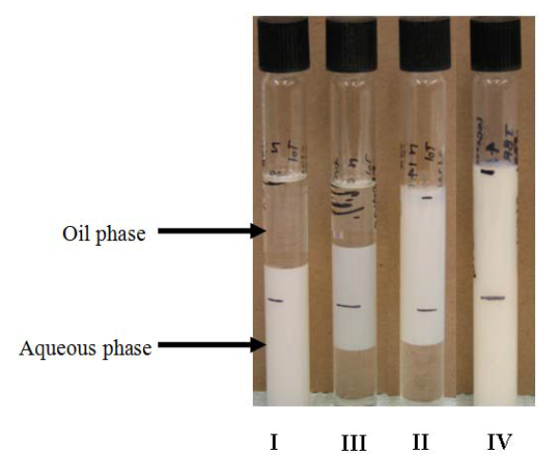
Figure 1. Winsor Types Depicted in Test Tubes (T. Nguyen & D. Sabatini, 2011)

For many instances, where microemulsions are quite useful, a high surfactant concentration is needed. This introduces a significant financial cost and performance issues, as surfactants are typically expensive and could leave residue or act as contaminants (Klier, Tucker, Kalantar, & Green, 2000). In some cases, this can be minimized or avoided with a better understanding of co-surfactants, additives, and optimal formulations. Surfactants, or (highly) surface-active agents, have amphiphilic structures meaning they have hydrophilic and hydrophobic parts. The head is hydrophilic, and the tail is hydrophobic. Surfactants can be grouped by the charges on the head group: anionic (negative charge), cationic (positive charge), zwitterionic (positive and negative charges), and nonionic (no charge). The tail group has a smaller impact on the surfactant’s nature than the head group (West & Harwell, 1992). A term that is used frequently is critical micelle concentration (CMC), which is the concentration of surfactants that is required for micelles to form. Any surfactants above that concentration form micelles.

1.1 Enhanced Oil Recovery
Extracting oil from the ground depends on using the underground pressure or pumps as primary recovery. As pressure decreases, water flooding or natural gas reinjection, called secondary recovery, can be used to increase the pressure again. Between primary and secondary recovery, about 35-45% of OOIP can be recovered (Tzimas, Georgakaki, Garcia Cortes, & Peteves, 2005). To recover additional oil, thermal, gas, and chemical methods under the category of enhanced oil recovery can be implemented. Thermal methods mostly involve steam injection via cyclic steam stimulation and steam flooding; other methods include in-situ combustion (ISC) and high-pressure air injection (HPAI). Gas methods include N₂, CO₂, or hydrocarbon gas injections; of these CO₂ has become a quite popular EOR method. Chemical methods include injections of alkali, polymer, surfactant, and mixtures of these components (Alvarado & Manrique, 2010). In the U.S., gas methods account for almost 60% of EOR, and thermal methods account for 40% (predominantly in California), so chemical methods account for the remaining EOR efforts (Energy.gov, 2010). New methods have sprung up as well, such as: microbial EOR (MEOR), ultrasonic vibrations, and foam flooding (Bera & Mandal, 2015). Figure 1-2 shows the typical system of secondary and enhanced oil recovery methods, which commonly use water as a driving fluid to push the oil and any added chemicals towards the production well.
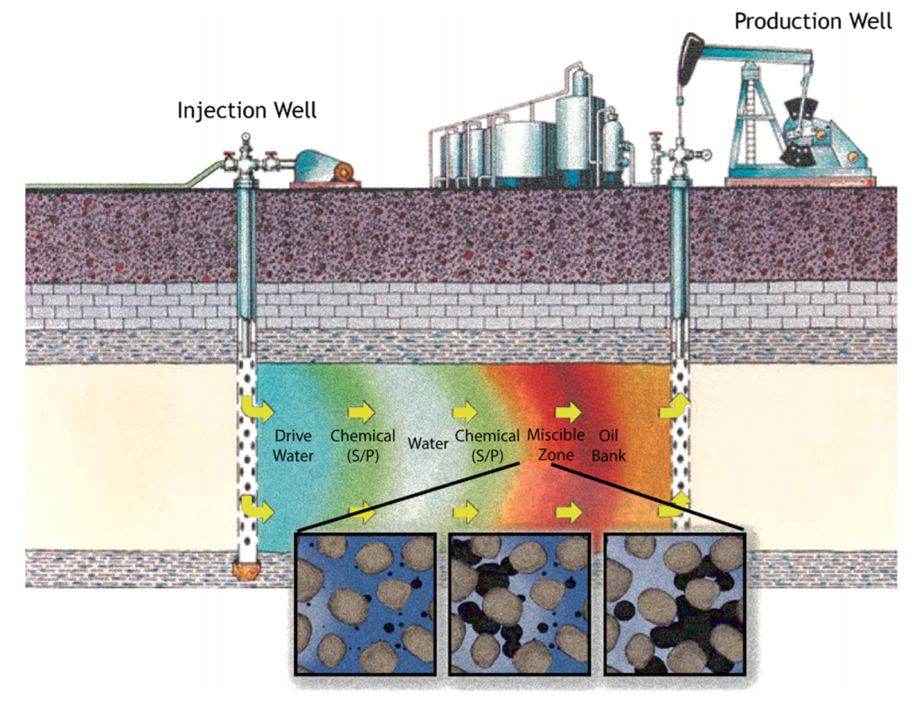
Figure 2. Chemical Flooding Method Diagram (Druetta & Picchioni, 2018)

As mentioned previously, surfactants and similarly polymers have been underutilized, due to their high-cost and lack of understanding surrounding them. They have been recognized as promising since the 1970’s, and they even saw a peak in the mid 1980’s with over 200 projects studying their effectiveness. Some reviewers have the opinion that surfactants and polymers will not have a significant impact on EOR in the near future (Alvarado & Manrique, 2010), but it is clear that their utility is worth investigating. After waterflooding a reservoir will typically have 20-30% of the OOIP (original oil in place) (Negin, Ali, & Xie, 2017), which leaves a significant portion of oil for EOR to be a worthwhile venture. Numerous studies have shown that surfactants can provide a significant recovery. A combination of alcohol propoxy sulfate (APS) and internal olefin sulfonate (IOS) has been used to achieve an additional 30% oil recovery (Levitt et al., 2009; Szlendak, Nguyen, & Nguyen, 2013). Alkyl (or alcohol) ethoxy sulfate (AES) was used in Berea sandstone for an additional recovery of 35-50% of the residual oil (Negin et al., 2017). Secondary alcohol “N” ethoxylate/propoxylate was shown in one case to be able to recover 80% OOIP as opposed to 60% OOIP from waterflooding (Wang, Butler, Liu, & Ahmed, 2011). Tridecyl alcohol 30 ethoxylate (TDA 30 EO) has been used to recover up to 80% OOIP (Sharma & Mohanty, 2013). Tergitol surfactants (nanoemulsions) recovered an additional 30% of OOIP after waterflooding (Mandal, Bera, Ojha, & Kumar, 2012). Dodecyl trimethyl ammonium bromide (DTAB) can recover 70% OOIP in low concentration or 80% when mixing with nonionic surfactants (Sharma & Mohanty, 2013). Numerous other surfactants have been investigated as well (Negin et al., 2017).
Surfactants are useful for EOR, because they can reduce interfacial tension and alter the wettability (Sheng, 2013). Reduction of interfacial tension is important as it increases the capillary number which leads to a decrease of residual oil saturation. The capillary number is a description of the viscous drag forces versus the surface tension forces between two liquids or a liquid and a gas. For low capillary numbers the oil in reservoir pore tends to stay inside the pore. Essentially a decrease of interfacial tension allows for more oil to be recovered. A surfactant injection can typically reduce interfacial tension from 20-30 to the order of 10⁻³ mN/m. Surfactants can also take advantage of microemulsions to either solubilize oil droplets into the water or water droplets into the oil phase. In the situations where water is solubilized into the oil phase, the oil phase grows in volume which makes it easier to recover by increasing the relative permeability (Sheng, 2015). The other aspect of surfactants that is particularly of interest is the wettability alteration. Wettability describes how well a liquid will spread across or adhere to a solid. In the oil and gas field, wettability is used to describe the preferential wetting of water or oil (water-wet or oil-wet). Another term that comes with wettability is imbibition, which describes when the wetting liquid’s saturation increases, so water imbibition is when a water-wet rock becomes more saturated with water (Abdallah et al., 1986). Surfactants and polymers have been used in conjunction due to polymers’ ability to increase the viscosity of the injection fluid (Sheng, 2011), which is especially useful when trying to displace the oil in pores. A polymer solution can provide a ‘stiffer’ volume of fluid for the driving water to push, so that it is more difficult for the fluid to go around or through the oil bank.

1.2 Hydrophilic-lipophilic deviation

Table 1. HLB Range of Emulsifiers Reported (Griffin, 1949)
HLB Range | Use
4-6 | W/O emulsifiers
7-9 | Wetting agents
8-18 | O/W emulsifiers
13-15 | Detergents
15-18 | Solubilizing

Table 2. Reported Required HLB Values for Oils (Griffin, 1949)
 | Required HLB for Emulsion
Oil or Wax | O/W |  | W/O
Cottonseed Oil | 7.5 | -
Carbontetrachloride | 9* | -
Paraffin (household) | 9 | 4
Microcrystalline wax (micropac Q, S.V) | 9.5* | ?
Mineral Oil, White, light (Marcol GX) | 10 | 4
Mineral Oil, White, heavy (Nujol) | 10.5 | 4
Mineral Seal Oil | 10.5* | ?
Petrolatum, white (White Perfecta) | 10.5 | 4
Silicone Oil (G. E.) | 10.5* | ?
Kerosene | 12.5* | ?
Naphtha | 13* | ?
Cetyl Alcohol | 13 | ?
Orthodichlorobenzene† | 13* | ?
Beeswax, white | 10-16 | 5
Carnuba Wax | 14.5* | ?
Candelilla Wax | 14.5* | ?
Lanolin, U. S. P., anhyd. | 15 | 8
Dimethyl Phthalate | 15* | ?
Orthophenylphenol | 15.5* | ?
Stearic Acid | 17 | -
* Original report listed these as expected values
† Plus small amounts (3.5%) of pine oil and isopropyl alcohol.

Empirical descriptions of microemulsions have been studied, but arguably not well understood for at least 70 years. In 1949, Griffin introduces hydrophilic-lipophilic balance (HLB), which gives a surfactant an HLB number that describes what type of emulsion this surfactant would ‘generally’ form. By extension an oil is given a required HLB to for either a O/W or W/O emulsion (Griffin, 1949). The method has its downfalls as it poorly accounts for temperature, salinity, and the nature of the oil, and it is also applicable primarily to nonionic surfactants (Marquez, Forgiarini, Fernández, Langevin, & Salager, 2018).
A newer approach that’s gained significant support is the hydrophilic-lipophilic deviation/difference (HLD). It’s an improvement on the HLB system, because it includes terms that account for the salinity, temperature, pressure, oil, and alcohol, in addition to the surfactant’s hydrophobicity (Salager, Morgan, Schechter, Wade, & Vasquez, 1979). HLD is essentially a balance between the salinity of the system, the Equivalent Alkane Carbon Number (EACN), temperature, and the Characteristic Curvature (Cc) of the surfactant. When these terms ‘balance out’ and HLD is zero, the surfactant interacts with the water and oil phases equally (Rongsayamanont et al., 2017), so Type III microemulsions form, or Type IV if using excessive surfactant, which gives the largest reduction of interfacial tension and the largest increase in solubility.
Salager showed that the HLD concept is applicable to systems where multiple surfactants have been used, where mixtures of anionic surfactants follow a linear mixing rule, while mixtures of anionic and nonionic surfactants are more complex. Oils were also shown to follow a linear mixing rule (Salager, Bourrel, Schechter, & Wade, 1979). The characteristic curvature term of the HLD equation has been found to be useful in describing the hydrophilicity and lipophilicity properties of a large spectrum of surfactants and additives. It has also been shown to support the mixing of surfactants (E. J. Acosta, Yuan, & Bhakta, 2008). The nonideality of mixing Anionic and nonionic surfactants has started to be studied (E. J. Acosta & Bhakta, 2009). The HLD concept has been built upon to form HLD-NAC (net-average curvature) that calculates physical properties of microemulsions such as phase behavior, solubilization capacity, and interfacial tensions (E. J. Acosta, 2008). HLD’s use has also been extended to biosurfactants, which are surfactants produced by microorganisms and have many different structures (T. T. Nguyen & D. Sabatini, 2011; Nguyen & Sabatini, 2009). Extended surfactants have also been shown to work well with HLD; extended means that there are polarity molecules (like polyethylene and polypropylene) between the head and tails of the surfactant (A. Witthayapanyanon, Harwell, & Sabatini, 2008). These studies show how useful HLD can be when used to assist in surfactant selection.
Microemulsions settings that HLD has been studied in include enhanced oil recovery and detergent cleaning, but also drug delivery and hard surface cleaning (Nguyen, Morgan, Poindexter, & Fernandez, 2019). HLD has also been shown to be effective in working with live and dead crude oils (Creton, Lévêque, & Oukhemanou, 2019; Creton & Mougin, 2016). HLD has been used to formulate crude oil spill dispersants, specifically in an effort to find a more benign method for marine life (Rongsayamanont et al., 2017).
In the following chapters HLD, surfactants and EACN will be discussed more in depth. The HLD equation has undergone revisions and expansions over the years and has become increasingly defended both by researchers and their work. Symbiotically, surfactants and HLD have become better understood, and many new surfactants have been developed with the support of HLD or have come to be supported by HLD. The somewhat ambiguous EACN term has been of great importance and of some debate. The various efforts to calculate and correlate EACN will be reported, and tools to predict the EACN of a new oil will be offered.
Chapter 2 Hydrophilic-Lipophilic Deviation
Salager et al. introduced HLD as an experiment-based numerical expression of the dimensionless surfactant affinity difference (SAD), which is the difference in interaction between the oil phase and surfactant, and the aqueous phase and surfactant; the Winsor R ratio describes this surfactant to oil interaction over the surfactant to water interaction as well (Salager, Morgan, et al., 1979). Another interpretation is that HLD is an approximation of the difference in chemical potential of the surfactant in the oil and aqueous phase (E. J. Acosta et al., 2008). HLD can be viewed more simply as a measure of how far the system is from optimum formulation or salinity (A. Witthayapanyanon et al., 2008). HLD has been found to be quite useful for microemulsion formulation, particularly because it can be used to estimate trade-off effects between variables easily, as such it can be seen as an improvement upon HLB and the Winsor R ratio (Salager et al., 2005). HLD has been used frequently to describe regions where microemulsions exhibit a given behavior, where they are stable, and where they would invert. With the concept being expanded into the net-average curvature model, HLD-NAC can be used to describe phase volumes, phase transitions, solubilizations, interfacial tensions, and droplet sizes (E. Acosta, Szekeres, Sabatini, & Harwell, 2003).
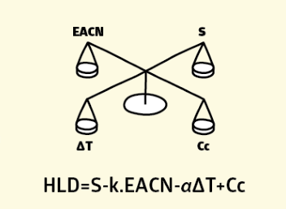
Figure 3. HLD as a Balancing of System Conditions (Abbott)

2.1 Hydrophilic-Lipophilic Deviation Equation Forms
The first form of the HLD equation was proposed as for anionic surfactants as Eq. (1), and it now commonly written as Eq. (2). Salager et al. used extensive data sets to describe each parameter’s contribution to optimum formulation (Salager, Morgan, et al., 1979):
 | $$\ln{{(S}^{*})}=K\left(ACN\right)+f\left(A\right)- σ+a_{T}(T-25)$$ | (1)
 | $$HLD= \ln{(S)}-K(EACN)+f\left(A\right)-a_{T}∆T+Cc$$ | (2)
Where $S^{*}$ is the optimum salinity (g NaCl/100 cm³ of aqueous phase), $K$ is a slope of the logarithm of the optimum salinity as a function of ACN, ACN is the number of carbon atoms in an alkane, f(A) is a function of alcohol content which is zero with no alcohol involved, $σ$ is a parameter characteristic of the surfactant, $a_{T}$ is a temperature coefficient of optimum salinity, T is temperature in ºC, EACN replaces ACN as an equivalent alkane carbon number of the oil, and $Cc$ replaces $σ$ as a characteristic curvature of the surfactant. Following the work done by Salager et al. on anionic surfactants, Hayes et al. and Bourrel et al. studied nonionic ethoxylate surfactants use in microemulsions. These studies focused on the phase behavior and were able to produce a similar HLD equation (Bourrel, Salager, Schechter, & Wade, 1980; Hayes, Bourrel, El-Emary, Schechter, & Wade, 1979):
 | $$α-{EON}^{*}=k\left(ACN\right)+f\left(A\right)-bS-c(T-28)$$ | (3)
 | $$HLD= b(S)-K(EACN)+ϕ\left(A\right)-c_{T}∆T+Cc$$ | (4)
where $α$ and $k$ are constants which depend on the surfactant type, ${EON}^{*}$ is the optimum $EON$ which is the average number of ethylene oxide (EO) numbers for the surfactant, $b$ is a constant that depends on the type of salt, $c$ is a coefficient of the temperature, and $ϕ\left(A\right)$ is again a function of the alcohol content. A secondary form of HLD is one in relation to SAD, the free energy changed in a surfactant moving from the water phase to the oil phase as shown in Eq. (5):
 | $$HLD= \frac{SAD}{RT}=ln\frac{C^{W}}{C^{O}}=\frac{μ_{s}^{*O}-μ_{s}^{*W}}{RT}$$ | (5)
where $C$ is the surfactant monomer concentration in either phase, and $μ$ is the standard chemical potential in either phase.
Equations (1) and (3) were simplified into the more modern Eqs. (2) and (4) by Acosta et al. and Acosta and Bhakta. The optimum formulation terms were replaced by a respective non-optimum term and added HLD to serve as term to describe the resulting phase behavior for the system. $σ$ and $α-{EON}^{*}$ are replaced by the characteristic curvature, $Cc$, which is a term to describe the hydrophobicity or hydrophilicity of a surfactant. $Cc$ values can be both negative and positive for hydrophilic and hydrophobic surfactants (E. J. Acosta, 2008; E. J. Acosta & Bhakta, 2009). $Cc$ is also a descriptor of the surfactant’s leaning towards forming micelles or reverse micelles (E. J. Acosta et al., 2008). $K$ is a constant dependent on the head group of the surfactant, such as 0.10 for alkyl sulfates and fatty acid sodium soaps, 0.16 for alkylbenzene sulfonates, and 0.16 for nonionic surfactants. $a_{T}$ is typically 0.01 for anionic surfactants and 0.02 for cationic surfactants; $c_{T}$ is around 0.06 for nonionic but can range from 0.02 to 0.2. The temperature coefficient is proposed to be zero for sugar surfactants such as alkyl polyglycosides (APGs). The salinity coefficient $b$ is 0.13 for NaCl and 0.1 for CaCl₂ (E. J. Acosta et al., 2008; Salager, 1999). An additional $β$ term that accounts for pressure changes has been studied and argued for that acts similar to the temperature change term (Ghosh & Johns, 2014).
Aubry et al. have worked to propose a normalized and simplified HLD equation, in part for the purpose of making HLD more approachable (Aubry, Ontiveros, Salager, & Nardello-Rataj, 2020). In doing so, they introduce Preferred ACN as a term to replace $Cc$ as a description of a surfactant which is the ACN of the oil which creates an optimum formulation at 25°C without salt or cosurfactants present. This term was introduced in part as the Extrapolated Preferred Alkane Carbon Number at Unit Salinity without alcohol (EPACNUS) or N_{min} (Salager, Morgan, et al., 1979; Wade, Morgan, Schechter, Jacobson, & Salager, 1978).
 | $${HLD}_{N}=PACN-EACN+τ(T-25)$$ | (6)
where PACN is $Cc/K$, $τ$ is $a_{T}/K$ or $c_{T}/K$, and terms for salinity and alcohol would be added if needed. Aubry et al. goes on to defend PACN well and thoroughly by comparing it to cloud point, HLB number, and the PIT-slope value (Aubry et al., 2020).
The EACN of mixtures of oils can generally be calculated from a mole fraction linear additive rule as Eq. (7) (Salager, Bourrel, et al., 1979), but it has been argued that this is not always the case. In the past volume or weight average have been used instead of mole fractions (Arai & Shinoda, 1967). Unfortunately in mixtures of oils, it has been shown that a more polar oil can separate preferentially to concentrate at the interface which introduces nonideality (Graciaa, Lachaise, Cucuphat, Bourrel, & Salager, 1993; Queste, Salager, Strey, & Aubry, 2007). Mixtures of anionic-anionic or nonionic-nonionic surfactants have been shown to mix by a linear mixing combination of HLD as Eq. (8) where $X$ is the molar fraction of each surfactants. Mixtures of anionic-nonionic surfactants introduce nonideality which Acosta and Bhakta have worked to begin modeling (E. J. Acosta & Bhakta, 2009).
 | $${EACN}_{mix}=X_{1}\left({EACN}_{1}\right)+X_{2}({EACN}_{2})$$ | (7)
 | $${HLD}_{mix}=X_{1}\left({HLD}_{1}\right)+X_{2}({HLD}_{2})$$ | (8)

2.2 Modeling Hydrophilic-Lipophilic Deviation
A new term $G_{EX}/RT$ was added to model the nonideal behavior which is the excess free energy of a mole of surfactants moving from the oil phase to the aqueous phase. A positive value would mean the real mixture is more hydrophobic than the ideal mixture for example. $G_{EX}/RT$ was then modelled as a function of the composition of the surfactants through the polynomial expansion of Margules with two parameters because it allows for nonsymmetric solutions and is shown in Eq. (10). Then the optimal formulation can be found through a salinity scan for an ionic-nonionic surfactant mixture which allows for the calculation of optimal HLD for the ionic surfactant and nonionic surfactant separately. This allows for the calculation of $G_{EX}/RT$ through Eq. (11). Acosta and Bhakta were then able to use their model to predict phase transition behavior for pairs of Sodium dihexyl sulfosuccinate (SDHS) and nonionic surfactants. In the following equations the “i” represents the ionic surfactant and the “ni” represents the nonionic surfactant (E. J. Acosta & Bhakta, 2009).
 | $${HLD}_{mix}=X_{i}\left({HLD}_{i}\right)+X_{ni}\left({HLD}_{ni}\right)+G_{EX}/RT$$ | (9)
 | $$G_{EX}/RT=A_{1}X_{i}X_{ni}^{2}+A_{2}X_{i}^{2}X_{ni}$$ | (10)
 | $$G_{EX}/RT=-X_{i}\left({HLD}_{i}^{*}\right)-X_{ni}({HLD}_{ni}^{*})$$ | (11)
Acosta et al. introduced the net-average curvature model to calculate the solubilization, droplet radius, interfacial tension, and phase transitions of microemulsions with anionic surfactants, and Acosta later expanded this to nonionic surfactants as well (E. Acosta et al., 2003; E. J. Acosta, 2008). Net curvature describes the curvature of the oil-water interface as positive, concave towards the oil, and forming micelles, or negative, convex towards the oil, and forming reverse micelles. Average curvature, on the other hand, describes the surface area to volume ratio of the microemulsion. The characteristic length, $ξ$, is the maximum solubilization capacity (Jin et al., 2015). The equations for the net curvature, $H_{n}$, the average curvature, $H_{a}$, and the characteristic length of the microemulsion, $ξ$, are as follows:
 | $$H_{n}=\left|\frac{1}{R_{O}}\right|-\left|\frac{1}{R_{W}}\right|=-\frac{HLD}{L}$$ | (12)
 | $$H_{a}=\frac{1}{2}\left(\left|\frac{1}{R_{O}}\right|+\left|\frac{1}{R_{W}}\right|\right)=\frac{1}{ξ}$$ | (13)
 | $$ξ=\frac{6ϕ_{O}ϕ_{W}V_{M}}{A_{S}}$$ | (14)
where $R_{O}$ and $R_{W}$ are the radii of the hypothetical oil and water droplets, $L$ is a constant proportional to the extended length of the surfactant tail ($δ$) as $L=1.2δ$ for anionic surfactants and $L=1.4δ$ for nonionic surfactants, $ϕ_{O}$and $ϕ_{W}$ are the volume fractions of the middle-phase that is oil and water respectively (typically surfactant volume is neglected), $V_{M}$ is the volume of the middle-phase, and $A_{S}$ is the interfacial area calculated using Eq (15):
 | $$A_{S}=\sum_{j}{V_{M}×{10}^{-3}{Cs}_{j}×6.023×{10}^{23}}×a_{j}$$ | (15)
where $V_{M}$ is in mL, ${Cs}_{j}$ is the concentration of each surfactant and cosurfactant in molar units, and $a_{j}$ is the interfacial area per surfactant molecule. The constant $L$ has been calculated for surfactant mixtures using a linear molar fraction addition as Eq (16). In Type I microemulsions, $R_{W,I}$ approaches infinity, and in Type II microemulsions, $R_{O,II}$ approaches infinity as well, which allows for the calculation of $R_{O,I}$ and $R_{W,II}$. The volume of oil in the solubilized in Type I and the volume of water solubilized in Type II can be calculated as:
 | $$L=L_{i}X_{i}+L_{ni}X_{ni}$$ | (16)
 | $$V_{O,I}=R_{O,I}A_{S}/3$$ | (17)
 | $$V_{W,II}=R_{W,II}A_{S}/3$$ | (18)
For Type III microemulsions, solubilized oil and water volumes can be found by solving Eqs. (12) and (13) together. The following Figure shows the effectiveness of using HLD-NAC to predict microemulsion characteristics such as the solubilization ratio and volume fractions, as compared to experimental data.
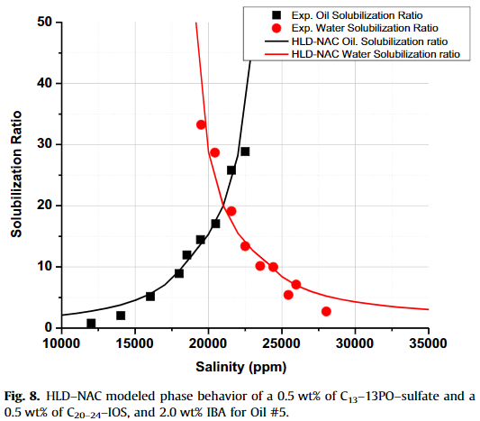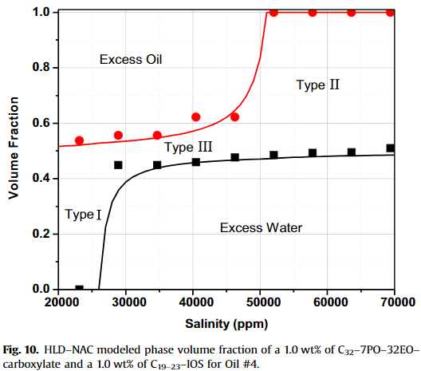
Figure 4. Solubilization Ratio/Volume Fraction Prediction (Jin et al., 2015)
As mentioned above, HLD-NAC can be used to calculate interfacial tension ($γ$) with the assumption of a spherical droplet, but it depends on a new term, the interfacial rigidity ($E_{r}$), which is proportional to the bending modulus ${(k}_{c}$) and usually fit to experimental data for a surfactant. $E_{r}$ values for ionic surfactants are usually near $1k_{b}T$, for linear alcohol ethoxylates it is between $3k_{b}T$ and $5k_{b}T$, and for extended surfactants are around $7k_{b}T$, where $k_{b}$ is the Boltzmann constant (E. Acosta et al., 2003; E. J. Acosta, 2008; E. J. Acosta & Bhakta, 2009; Anuradee Witthayapanyanon, Phan, Heitmann, Harwell, & Sabatini, 2010).
 | $$γ=\frac{E_{r}}{4πR^{2}}$$ | (19)
In HLD-NAC modelling droplets are usually assumed to be spherical, but Kiran and Acosta have worked to extend HLD-NAC to include a prediction of the shape of microemulsion droplets which is important for predicting viscosity. The extension is able to treat droplets as a sphere as usual, a rod, or somewhere in between as a pill shape with a cylindrical neck and hemispherical caps which structure was validated by neutron scattering profiles. It introduces for total integrated curvature, a revised net curvature, a maximum hydrodynamic radius, $R_{H,max}$, which describes a fully extended and rigid droplet:
 | $$curvature=\frac{\left(\frac{1}{R_{d}}\right)surface area of hemispheres+\left(\frac{1}{{2R}_{d}}\right)surface area of cylinder}{total surface area}$$ | (20)
 | $${H'}_{n}=\frac{H_{n}}{2}=\frac{2}{L_{d}+2R_{d}}+\left(\frac{L_{d}}{R_{d}}\right)\left(\frac{1}{2L_{d}+4R_{d}}\right)$$ | (21)
 | $$H_{a}=\left(\frac{1}{3}\right)\left(\frac{surface area}{volume}\right)=\frac{2L_{d}+4R_{d}}{3L_{d}R_{d}+4R_{d}^{2}}$$ | (22)
 | $$R_{H,max}=R_{d}+\frac{L_{d}}{2}+δ$$ | (23)
where $L_{d}$ is the cylindrical length, $R_{d}$ is the hemispherical end cap radius, and $δ$ is the surfactant tail length. $L_{d}$ and $R_{d}$ can be found by finding $H_{n}$ and $H_{a}$ through the original HLD-NAC and then simultaneously solving Eqs. (21) and (22) for them. With a predicted shape found, existing models for predicting viscosities can be used (Kiran & Acosta, 2010).
EACN has been the focus of significant modelling efforts, and they will be discussed more in depth in a later chapter. The two most prominent works are both Quantitative Structure Property Relationship (QSPR) models that use molecular descriptors as variables. The first model considered more than 1000 descriptors that were narrowed down to two terms, the average negative softness and Kier A3, to predict the fish-tail temperatures that can be used to calculate EACN (F. O. Bouton et al., 2010). The second model used COSMO-RS $σ$-moments as the molecular descriptors and was able to predict EACN with three terms (Lukowicz, Benazzouz, Nardello-Rataj, & Aubry, 2015; Lukowicz, Illous, Nardello-Rataj, & Aubry, 2018). Before discussing EACN even further, surfactants will be explored.
Chapter 3 Surfactants
As discussed previously, surfactants are an important piece of microemulsion formulation that would benefit from being better understood. Efforts to make surfactant selection a faster process and using surfactants a more cost-effective method have been underway for many years and still have a long way to go. A surfactant is made up of a hydrophilic head group and a hydrophobic tail group. Surfactants are usually classified by their head group as anionic, cationic, zwitterionic, or nonionic. The critical micelle concentration (CMC) is an important characteristic that can sometimes be forgotten or left out of discussion when looking at HLD; it is the surfactant concentration where adding any more surfactant would cause micelles to form. It depends on the surfactant, medium (usually water), temperature, pressure and salinity. The Krafft point also acts as a description of surfactants and is similar to CMC. It is the minimum temperature needed to form micelles. Another temperature parameter is the cloud point which is the temperature that a nonionic surfactant solution becomes too cold and begins to separate and becomes “cloudy.” Another parameter brought up when discussing surfactants is the packing parameter of the surfactant introduced by Israelachvili which is affected by the oil and temperature (Israelachvili, Mitchell, & Ninham, 1976). Griffin introduced Hydrophilic-lipophilic Balance (HLB) as an extension of Bancroft’s rule. It is a scale for the hydrophobicity of surfactants and oils that is used as a rule of thumb type tool. The HLB values were calculated with microemulsions at room temperature and low salinity. Lower HLB values (4-6) were given to surfactants that tended to form W/O emulsions, and higher HLB values (8-18) were given to surfactants that tended to form O/W emulsions. This brings up a significant fault of HLB is does not account for the conditions of the system (Griffin, 1949). These parameters and characteristics of surfactants have their uses, but $Cc$, which is used in the HLD equation, is arguably a more effective term for characterizing a surfactant, because it is a more quantitative term for microemulsion uses (E. J. Acosta et al., 2008).

3.1 Surfactant Terms in the HLD Equation
It is somewhat unfortunate that there are three values in the HLD equation are dependent on the surfactant: the $Cc$ term which describes the hydrophobicity of the surfactant, the coefficient $K$ for the EACN term whose value depends on the family and structure of the surfactant, and the temperature term coefficients $α_{T}$ and $c_{T}$ which depend on the classification of the surfactant (anionic, ionic, etc.). The primary method of determining $Cc$ is scanning. A scan for an unknown $Cc$ would involve a series of test tubes, the surfactant in question, an oil with known EACN, a salt (usually NaCl), and depending on the scan an additional oil with known EACN or surfactant with known $Cc$. A salinity scan is likely the most common as it introduces the least components into the microemulsion system. It involves increases the salinity of the system until the system has gone from Type I to Type II through Type III. The other two scans involved varying the mixture of surfactants or oils across a series of test tubes and seeing the phase invert. $α_{T}$ and $c_{T}$ can be determined by plotting optimal salinity vs temperature for a given surfactant and oil which would give the coefficients as the slope. Slopes for a type of surfactant is typically similar and assumed constant for each anionic (~0.01), catanionic (~0.02), nonionic (~0.06). $K$ can similarly be found for a given surfactant by using two oils with known EACN and comparing the optimal salinity where $K$ is the slope. $K$ is typically dependent on the family of surfactants such as $K=$ 0.16 for alkylbenzene sulfonates (Salager, 1999).

Table 3. K Values (Castellino, Cheng, & Acosta, 2011; Salager, 1999; Wan, Zhao, Harwell, & Shiau, 2016)
Surfactant Type | K constant
Most Nonionic | ~ 0.16
Most Ionic | ~ 0.17
Alkylbenzene Sulfonate | 0.16
Alkyl Sulfate | 0.10
Fatty Acid Sodium Soap | 0.10
n-Alkylammonium Salts | 0.17
Quaternary n-Alkyltrimethylammonium Salts | 0.19
Sodium Alkyl Sulfates | 0.049
C₈H₁₇–(PO)₄–(EO)₁–SO₄Na | 0.0478
C_{12,15}H_{25,31}–(EO)₂–SO₄Na | 0.062
C_{12,13}H_{25,27}–(PO)₈–SO₄Na | 0.087
C₁₂H₂₅–(PO)₁₂–(EO)₂– SO₄Na | 0.104
C₁₂H₂₅–(PO)₁₄–(EO)₂– SO₄Na | 0.069
C_{14,15}H_{29,31}–(PO)₈–SO₄Na | 0.13
C_{14,15}H_{29,31}–(PO)₈–SO₄Na | 0.053

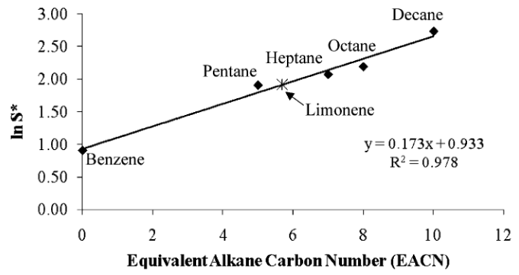
Figure 5. Determining $K$ Constants as Slope (A. Witthayapanyanon et al., 2008)

3.2 Surfactant Selection
When looking to choose a surfactant for a particular purpose it is pragmatic to consider why a pure surfactant with the exact $Cc$ that is needed doesn’t exist, doesn’t exist with a reasonable cost, or doesn’t have good stability at the salinity or temperature conditions. One of the main reasons is that designing a new surfactant to have a desired $Cc$ is not as straightforward as adding building blocks with known contributions. How the structures of a surfactant contribute to the stability and the behavior is not well understood at the time of writing. A surfactant’s $Cc$ from its origin in the nonionic ethoxylate surfactant HLD equation as $α-EON$, has included contribution from functional groups specifically the number of ethylene oxide groups. A recent study produced a group contribution model for alkyl-polypropylene oxide sulfate surfactants using C2 branching and number of polypropylene oxide groups (Hammond & Acosta, 2012). This builds on the idea that as the number of carbons in the alkyl group or the number of methylene groups increases so does the surfactant’s $Cc$ (Salager & Antón, 1999). This line of thinking has significant more progress to be made in the future.
While most surfactants are able to form emulsions with oils of a wide range of EACN values such as the tetraethylene glycol monoalkyl ethers $C_{i}E_{4}$ at ‘normal’ conditions (F. O. Bouton et al., 2010), it is important to consider the stability of the surfactant at the necessary conditions. Chemical stability, thermal stability, and solubility are very important which selecting a surfactant. Surfactants can degrade or precipitate under the wrong conditions, so often cosurfactants are used. Sulfate surfactants have shown good solubility but poor thermal stability at high temperatures, while sulfonate surfactants precipitate at higher salinities (Zulkifli et al., 2020). Cosurfactants like alcohols are commonly used to prevent the formation of gels and liquid crystals, change the viscosity of the microemulsions, and change the solubility to prevent precipitation (Cavalli, Marengo, Caputo, Ugazio, & Gasco, 1996; Pattarino, Marengo, Trotta, & Gasco, 2000; Richardson, Mbanefo, Aboofazeli, Lawrence, & Barlow, 1997; Zhou & Rhue, 2000). Negin et al. have reviewed the most common surfactants used in chemical EOR, and Mattei et al. have produced a guide for selecting surfactants for product designs (Mattei, Kontogeorgis, & Gani, 2014; Negin et al., 2017).

Table 4. EACN Range for T between 10 and 100 °C (F. O. Bouton et al., 2010)
Surfactant | EACN range
$$C_{10}E_{4}$$ | 3 to 35
$$C_{8}E_{4}$$ | -1 to 21
$$C_{6}E_{4}$$ | -4 to 15

3.3 Surfactants in EOR
Surfactants are able to be effective EOR methods via two mechanisms: reducing interfacial tension and altering the wettability of the reservoir. A lower interfacial tension increases the capillary number which leads to a decrease in residual oil saturation, because oil can flow through pores easier. A smaller mechanism occurs in Type II and III microemulsion that swells the oil phase by water solubilizing into it which increases the relative permeability. The change in wettability effects carbonate reservoirs much more than sandstone reservoirs, because carbonate reservoirs are very commonly oil-wet. Alkalis, surfactants, and polymers are all used in chemical EOR, commonly in combination. Alkalis are able to react with components of the oil to form surfactants in the reservoir but are unsuitable for carbonate reservoirs where they react with the ions in the rock and cause scaling. Scale formation can be a significant issue as it plugs wells and pores and fouls equipment (Pal, Mushtaq, Banat, & Al Sumaiti, 2018). Polymers increase viscosity of the injection fluid which decreases the permeability of the injection but degrade at high salinities and temperatures (Gbadamosi, Junin, Manan, Agi, & Yusuff, 2019).

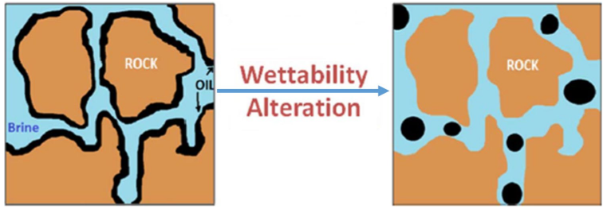
Figure 6. Depiction of Wettability Alteration (Gbadamosi et al., 2019)

Surfactant adsorption in porous medium is a significant issue for EOR (Healy, Reed, & Carpenter, 1975). When flowing through porous media, surfactants tend to adsorb on the rock surface which lowers the concentration of surfactant in the microemulsion system. A measure of the adsorption value is calculated from the difference in initial and final surfactant concentrations in grams divided by grams of rock. Surfactants with longer tails tend to adsorb more on solid surfaces. Generally, surfactant adsorption decreases as temperature and pH increases (Zulkifli et al., 2020). Adsorption is a much larger issue in carbonate reservoirs as they have high clay content. Anionic surfactants significant adsorption in carbonate. Cationic have much less, but are currently quite expensive even relative to anionic surfactants (Sheng, 2015). Anionic surfactants adsorb much less than cationic surfactants in sandstone reservoirs (Zulkifli et al., 2020). One idea that’s being pursued is the use of sacrificial chemicals to adsorb on the surface before the surfactants which are typically much more expensive. Cationic surfactants have been used to desorb acid from the rock surface in carbonate reservoirs which makes the rock more water-wet (Pal et al., 2018). Biosurfactants seem to be a valuable line of research as in theory they can be produced much cheaper and are eco-friendly, non-toxic, and biodegradable. Viscoelastic surfactants are another promising path forward as they combine the properties of surfactants and polymers (Pal et al., 2018).
Chapter 4 Equivalent Alkane Carbon Number
One of the most important terms in the HLD equation is EACN, or ACN as was used in the past. The concept of EACN is to be able to give each oil an EACN dependent on its behavior in relation to an alkane and the alkane’s carbon number, so that even a quite complex and difficult to categorize oil can be treated simply as an alkane or a mix of a few alkanes. Trying to define what EACN is outside of that definition is difficult and perhaps the best line of thinking when dealing with EACN is that it is a measure of the hydrophobicity of the oil, and a higher EACN is more hydrophobic. This allows for EACNs outside the range of most alkanes specifically EACNs of zero and negative, which to the best of reported knowledge has no inherent special properties. Besides using EACN to characterize the oil, Griffin’s required HLBs and Phase Inversion Temperatures (PIT) have been used. Required HLB was an inaccurate value that was given to an oil equal to the HLB value of the surfactant that produced a stable emulsion. The PIT is the temperature that the system switches between Type I and Type II which was able to describe oils when used with a given surfactant, as the PIT depends on both. When EACN is compared to these parameters, EACN is a significant improvement; it is more quantitative than the HLB scale and is able to describe the oil individually and not an oil and surfactant pairing. An oil’s EACN is independent of any other condition of a microemulsion system (Ontiveros et al., 2013).
Many potential applications besides enhanced oil recovery would be more utilized with a better understanding of HLD and EACN. Fuels involving microemulsions would benefit from water content by reducing soot formation and emission of nitrogen oxides and carbon monoxide. Lubricants, cutting oils, and corrosion inhibitors would all benefit from microemulsions partly because the water content would increase the heat capacity. Using microemulsions as opposed to emulsions would be of great benefit to coating technologies. Detergents and dispersants both benefit from a better understand of the oil so that ultralow interfacial tension and high stability. Understanding EACN better would assist the cosmetic industry by allowing for using a smaller concentration of surfactants which can be irritable to the skin at high concentrations. The food industry would benefit from a better understanding of glycerides EACN specifically but would also benefit from research into food safe surfactants and non-hydrocarbon ‘oils.’ Agrochemical fields would benefit by being able to minimize harmful effects to the environment by making the chemical more efficient. The oil phase has even been used to help plants absorb minerals such as iron. The pharmaceutical industry benefits from the improved solubilization capacity and the ease of formation of stable microemulsions. Microemulsions can be miscible with blood. Drug delivery would also improve as absorption can be improved, toxicity can be reduced, and how the drug is released can be manipulated. Microemulsions can help soil remediation after an oil or chemical spill by increasing the wettability and decreasing interfacial tension more than a simple surfactant mixture. Understanding microemulsions can assist in gel and foam formation as well as chemical reaction manipulation (Moulik & Paul, 2001). Many efforts have gone into determining EACN values of oils and the effects of the oil phase, but a few issues have plagued accurate EACN calculations. The first is for oils with EACNs lower than 6, the values are outside the range of n-alkanes that they are compared against, so the values have an inherent uncertainty. The second is that oils with differences in polarity can segregate so that the composition at the interface is different than the bulk composition; some parts of the oil mixture can be amphiphilic and act as a surfactant such as alcohol, amine, amide, and asphaltenes (Aubry et al., 2020).
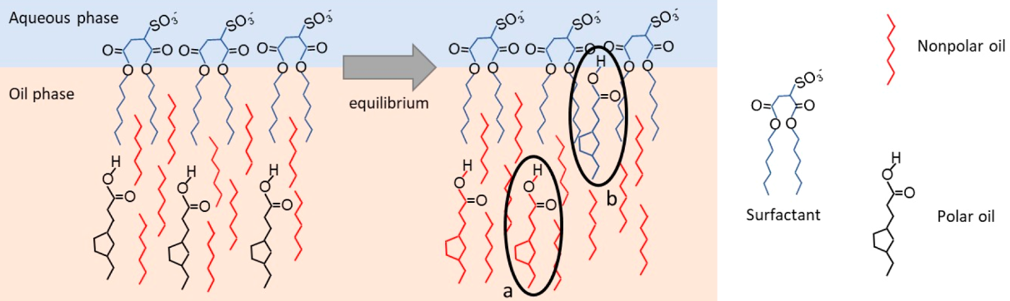
Figure 7. Depiction of Polar Oil Segregating to Interface (Ghayour & Acosta, 2019)

4.1 Collection of EACN Data
The following table is a collection of all reported EACN values that have been found through this research and review. Predicted EACN values from models were chosen to not be included. Multiple reported values from different sources are included as there is some disagreement.

Table 5. Reported EACN Values from Various Sources
Molecule | Structure | EACN | Calculation Method
Alkanes
n-Hexane | 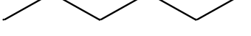 | 6 | Assumed
n-Heptane |  | 7 | Assumed
n-Octane | 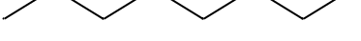 | 8 | Assumed
n-Nonane |  | 9 | Assumed
n-Decane |  | 10 | Assumed
n-Dodecane |  | 12 | Assumed
n-Tetradecane |  | 14 | Assumed
n-Hexadecane |  | 16 | Assumed
n-Octadecane |  | 18 | Assumed
n-Eicosane |  | 20 | Assumed
n-Tetracosane |  | 24 | Assumed
n-Octacosane |  | 28 | Assumed
2,2,4-Trimethylpentane | 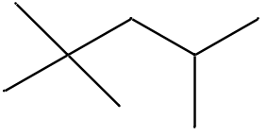 | 8 | Mol. Fraction Additive Rule¹
2,5-Dimethylhexane | 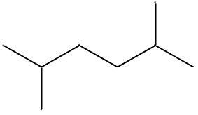 | 8 | Mol. Fraction Additive Rule¹
2-Methylheptane | 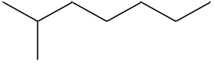 | 8 | Phase Behavior Scan¹
Squalene | 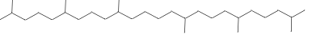 | 24 | Fish-tail T* with C10E4⁶
Unsaturated Alkanes
1-Octene |  | 3.9 | Fish-tail T* with C6E4¹¹
1-Octyne |  | -1.8 | Fish-tail T* with C6E4¹¹
1-Decene |  | 5.5 | Fish-tail T* with C6E4¹¹
1-Decyne |  | 0.1 | Fish-tail T* with C6E4¹¹
1-Dodecene |  | 8.1 | Fish-tail T* with C6E4¹¹
1-Dodecyne |  | 2 | Fish-tail T* with C6E4¹¹
1-Tetradecyne |  | 3.5 | Fish-tail T* with C6E4¹¹
1-Octadecene |  | 14.2 | Fish-tail T* with C10E4¹¹
Squalene | 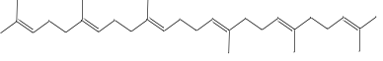 | 13.8 | Fish-tail T* with C10E4¹²
Cyclic Alkanes
Cyclopentane |  | 3 | Mol. Fraction Additive Rule¹
Benzene | 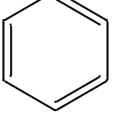 | -4 | Extrapolation of C* vs EACN⁶
Benzene |  | 0 | Mol. Fraction Additive Rule⁵
Cyclohexane | 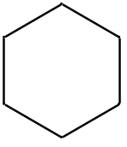 | 1.5 | Extrapolation of C* vs EACN⁶
Cyclohexane |  | 2.2 | Fish-tail T* with C6/8/10E4⁹
Cylcohexene | 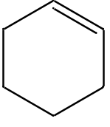 | -1.2 | Fish-tail T* with C6/8/10E4⁹
1-Methyl-1-cylcohexene | 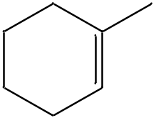 | 0.4 | Fish-tail T* with C6/8/10E4⁹
3-Methyl-1-cyclohexene | 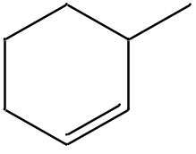 | -0.1 | Fish-tail T* with C6/8/10E4⁹
4-Methyl-1-cyclohexene | 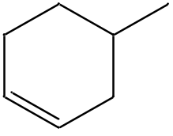 | 0.4 | Fish-tail T* with C6/8/10E4⁹
Methylcyclohexane | 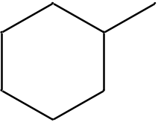 | 3.2 | Fish-tail T* with C6/8/10E4⁹
Toluene | 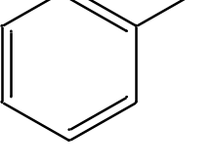 | -3 | Extrapolation of C* vs EACN⁶
Toluene |  | 1 | Mol. Fraction Additive Rule⁵
1,2-Dimethyl cyclohexane | 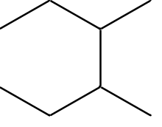 | 3.3 | Fish-tail T* with C6/8/10E4⁹
1,4-Dimethyl cyclohexane | 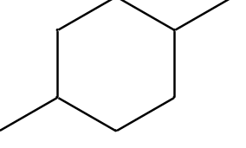 | 4.4 | Fish-tail T* with C6/8/10E4⁹
Cis-Cyclooctene |  | 1.6 | Fish-tail T* with C6E4¹¹
Cyclooctane |  | 4.1 | Fish-tail T* with C6E4¹¹
Cyclooctane |  | 5 | Mol. Fraction Additive Rule¹
Ethylcyclohexane | 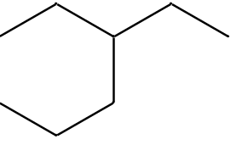 | 3.8 | Fish-tail T* with C6/8/10E4⁹
Ethylcyclohexane |  | 3.8 | Fish-tail T* with C10E4⁶
Ethylbenzene | 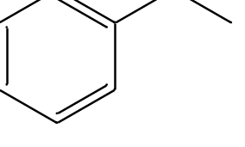 | 2 | Mol. Fraction Additive Rule⁵
Phenyl-1-butyne | 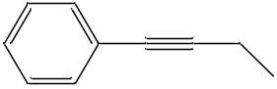 | -3.3 | Fish-tail T* with C6E4¹¹
o-, m-, p-Xylene | 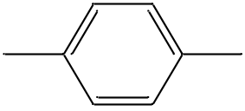 | 2 | Mol. Fraction Additive Rule¹
p-Xylene |  | -2.3 | Fish-tail T* with C6E4¹¹
1,2,4-Trimethylbenzene | 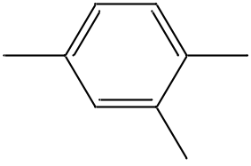 | 3 | Mol. Fraction Additive Rule¹
Cumene (Isopropylbenzene) | 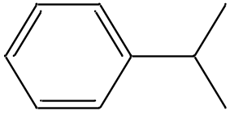 | 3 | Mol. Fraction Additive Rule¹
Isopropylcyclohexane | 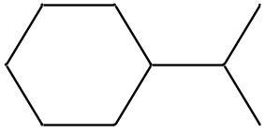 | 5.3 | Fish-tail T* with C6/8/10E4⁹
Propylcyclohexane | 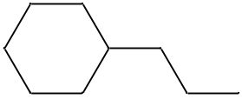 | 5.7 | Fish-tail T* with C6/8/10E4⁹
Propylcyclohexane |  | 5.6 | Fish-tail T* with C10E4⁶
1,4-Diethylbenzene | 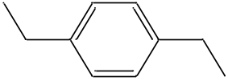 | 4 | Mol. Fraction Additive Rule¹
Butylcyclohexane | 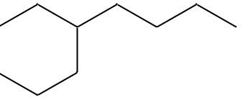 | 7 | Fish-tail T* with C6/8/10E4⁹
Butylcyclohexane |  | 7 | Fish-tail T* with C10E4⁶
Butylbenzene | 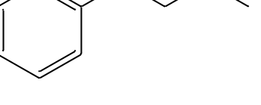 | 0.4 | Fish-tail T* with C6E4¹¹
Decalin | 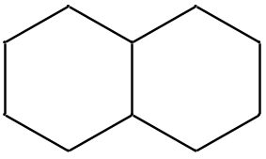 | 5.3 | Fish-tail T* with C6E4¹¹
Decalin |  | 6 | Mol. Fraction Additive Rule¹
Cyclodecane | 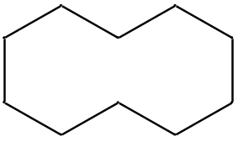 | 5.5 | Fish-tail T* with C6E4¹¹
Pentylcyclopentane | 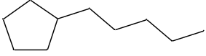 | 8 | Mol. Fraction Additive Rule¹
1-t-Butyl-4 methylbenzene | 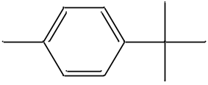 | 5 | Mol. Fraction Additive Rule¹
Cyclopentyl benzene | 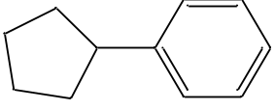 | 3 | Mol. Fraction Additive Rule¹
Cyclopentyl cyclohexane | 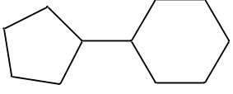 | 7 | Mol. Fraction Additive Rule¹
Bicyclohexyl |  | 8 | Mol. Fraction Additive Rule¹
Octylbenzene | 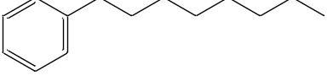 | 3.8 | Fish-tail T* with C10E4⁶
Octylbenzene |  | 4.3 | Fish-tail T* with C6/8/10E4⁹
Decylbenzene | 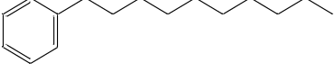 | 6 | Fish-tail T* with C10E4⁶
Decylbenzene |  | 6.2 | Fish-tail T* with C6/8/10E4⁹
Decylcyclohexane | 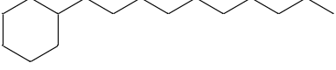 | 14.4 | Fish-tail T* with C6/8/10E4⁹
Decylcyclohexane |  | 14.5 | Fish-tail T* with C10E4⁶
Dodecylbenzene | 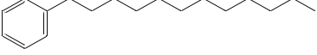 | 7.9 | Fish-tail T* with C10E4⁶
Dodecylbenzene |  | 7.9 | Fish-tail T* with C6/8/10E4⁹
Dodecylcyclohexane | 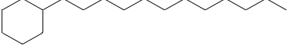 | 17.3 | Fish-tail T* with C6/8/10E4⁹
Dodecylcyclohexane |  | 17.5 | Fish-tail T* with C10E4⁶
Halogenated Alkanes
Tetrachloroethylene | 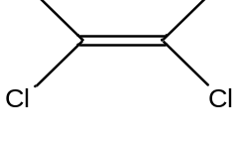 | 2.9 | Mol. Fraction Additive Rule²
Carbon Tetrachloride | 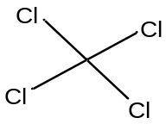 | -0.06 | Mol. Fraction Additive Rule²
Trichloroethylene | 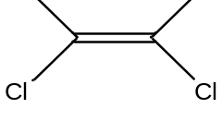 | -3.81 | Mol. Fraction Additive Rule²
1-Bromo-3-methylpropane | 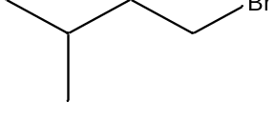 | -3.3 | Fish-tail T* with C6E4¹¹
1-Chlorodecane |  | 3.5 | Fish-tail T* with C10E4¹¹
1-Chlorododecane |  | 5.6 | Fish-tail T* with C10E4¹¹
1-Chlorotetradecane |  | 8 | Fish-tail T* with C10E4¹¹
1-Chlorohexadecane |  | 9.8 | Fish-tail T* with C10E4¹¹
Alcohols
Pentanol | 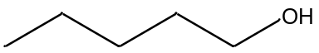 | 5 | Partition Coeff. Interpolation⁴
Hexanol | 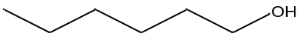 | 6 | Partition Coeff. Interpolation⁴
Heptanol | 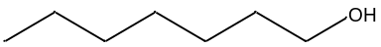 | 7 | Partition Coeff. Interpolation⁴
Octanol |  | 8 | Partition Coeff. Interpolation⁴
2-methyl-2-butanol | 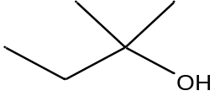 | 4.29 | Partition Coeff. Interpolation⁴
2-methyl-1-pentanol | 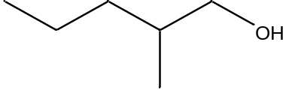 | 5.85 | Partition Coeff. Interpolation⁴
3-methyl-1-pentanol | 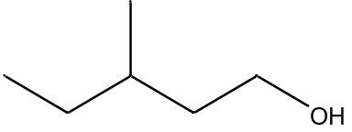 | 5.75 | Partition Coeff. Interpolation⁴
2-methyl-2-pentanol | 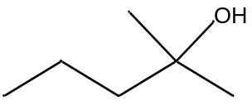 | 5.33 | Partition Coeff. Interpolation⁴
3-methyl-2-pentanol | 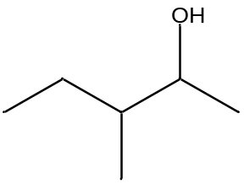 | 5.7 | Partition Coeff. Interpolation⁴
4-methyl-1-pentanol | 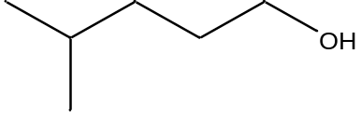 | 5.93 | Partition Coeff. Interpolation⁴
2-methyl-3-pentanol | 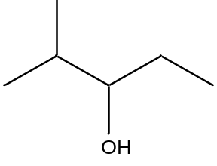 | 5.25 | Partition Coeff. Interpolation⁴
4-methyl-2-pentanol | 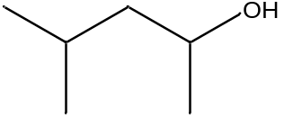 | 5.63 | Partition Coeff. Interpolation⁴
3-methyl-3-pentanol | 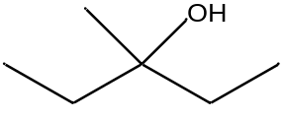 | 5.28 | Partition Coeff. Interpolation⁴
2,3-dimethyl-2-butanol | 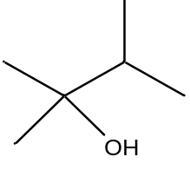 | 5.3 | Partition Coeff. Interpolation⁴
3,3-dimethyl-2-butanol | 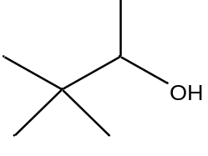 | 5.7 | Partition Coeff. Interpolation⁴
3,3-dimethyl-1-butanol | 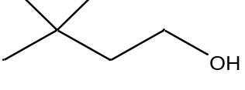 | 5.49 | Partition Coeff. Interpolation⁴
3-methyl-3-hexanol | 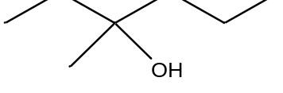 | 6.31 | Partition Coeff. Interpolation⁴
2-methyl-3-hexanol | 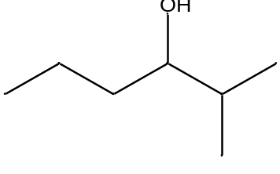 | 6.52 | Partition Coeff. Interpolation⁴
3-methyl-2-hexanol | 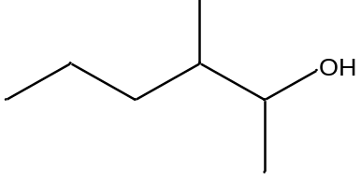 | 6.76 | Partition Coeff. Interpolation⁴
2-methyl-2-hexanol | 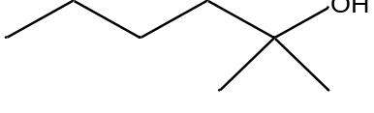 | 6.33 | Partition Coeff. Interpolation⁴
5-methyl-2-hexanol | 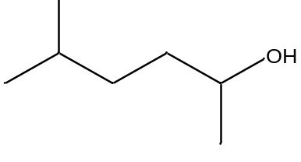 | 6.77 | Partition Coeff. Interpolation⁴
3-ethyl-3-pentanol | 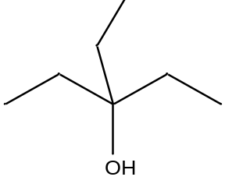 | 6.39 | Partition Coeff. Interpolation⁴
4,4-dimethyl-2-pentanol | 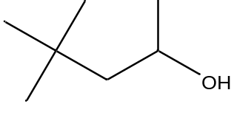 | 6.67 | Partition Coeff. Interpolation⁴
2,3-dimethyl-3-pentanol | 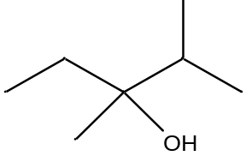 | 6.38 | Partition Coeff. Interpolation⁴
2,2-dimethyl-3-pentanol | 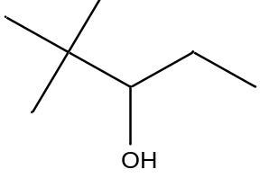 | 6.95 | Partition Coeff. Interpolation⁴
Linalool | 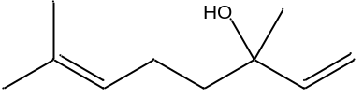 | -11.4 | Fish-tail T* with C12E8¹⁴
Ethers and Esters
Dipropoxyethane |  | 0.4 | Fish-tail T* with C12E6¹²
Dibutoxyethane |  | 2.2 | Fish-tail T* with C12E6¹²
Dipropoxybutane | 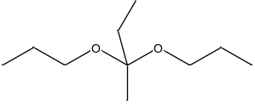 | 2.2 | Fish-tail T* with C12E6¹²
Hexyl methacrylate | 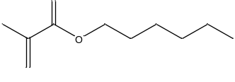 | 1.1 | Fish-tail T* with C10E4¹²
Citronellyl acetate | 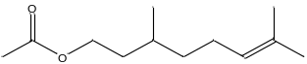 | -0.2 | Fish-tail T* with C6E4¹²
Ethyl decanoate | 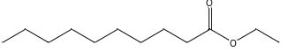 | 2.3 | Fish-tail T* with C10E4¹⁰
Geranyl acetate | 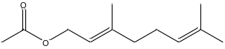 | -0.6 | Fish-tail T* with C6E4¹²
Linalyl acetate | 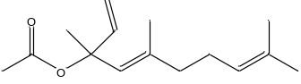 | -0.8 | Fish-tail T* with C6E4¹²
Menthyl acetate | 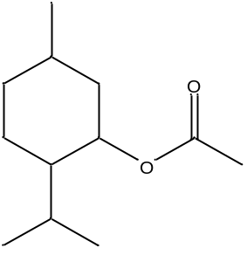 | -0.1 | Fish-tail T* with C6E4¹²
Decyl Butyrate | 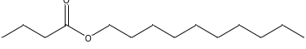 | 5 | Fish-tail T* with C10E4¹⁰
Ethyl Dodecanoate | 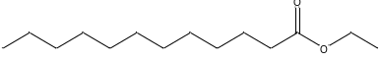 | 3.8 | Fish-tail T* with C10E4¹⁰
Hexyl Octanoate | 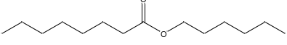 | 6.2 | Fish-tail T* with C10E4¹⁰
Butyl Dodecanoate | 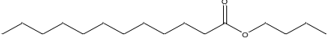 | 7.2 | Fish-tail T* with C10E4¹⁰
Ethyl Myristate | 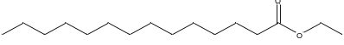 | 5.3 | Fish-tail T* with C10E4¹⁰
Octyl octanoate | 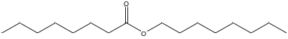 | 8.1 | Fish-tail T* with C10E4¹⁰
Isopropyl myristate | 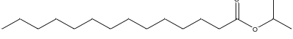 | 7.3 | Fish-tail T* with C10E4¹⁰
Isopropyl myristate |  | 7.5 | Fish-tail T* with C10E4⁶
Myristyl propianoate | 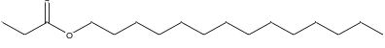 | 6.8 | Fish-tail T* with C10E4¹⁰
Ethyl palmitate | 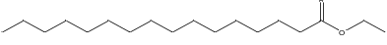 | 6.8 | Fish-tail T* with C10E4¹⁰
Hexadecyl acetate | 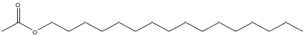 | <5.5 | Fish-tail T* with C10E4¹⁰
Hexyl dodecanoate | 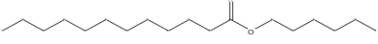 | 9.4 | Fish-tail T* with C10E4¹⁰
Ethyl oleate | 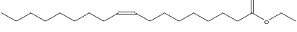 | 7.3  7.3  6-7 | Fish-tail T* with C10E4¹⁰  Fish-tail T* with C10E4¹²  Phase Behavior Scan³
Bis (2-ethylhexyl) adipate | 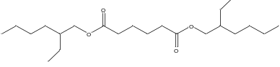 | 9.7 | Fish-tail T* with C10E4¹⁰
Dibutylether |  | 3.4 | Fish-tail T* with C10E4⁶
Dibutylether |  | 2.4 | Fish-tail T* with C6E4¹²
Dipentylether |  | 4.2 | Fish-tail T* with C6E4¹²
Dihexylether |  | 6.2 | Fish-tail T* with C6E4¹²
Diheptylether |  | 8 | Fish-tail T* with C6E4¹²
Dioctylether |  | 10.3 | Fish-tail T* with C6E4¹²
Ketones
2-Octanone | 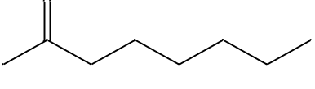 | -3.4 | Fish-tail T* with C6E4¹²
2-Decanone | 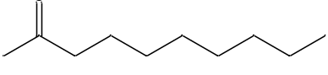 | -2.1 | Fish-tail T* with C6E4¹²
2-Undecanone | 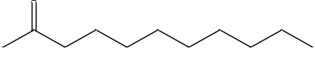 | -1.3 | Fish-tail T* with C6E4¹²
2-Dodecanone | 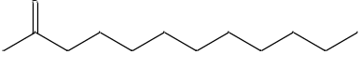 | -0.6 | Fish-tail T* with C6E4¹²
Nitriles
Octanenitrile | 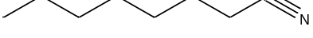 | -1.7 | Fish-tail T* with C6E4¹²
Decanenitrile |  | -0.5 | Fish-tail T* with C6E4¹²
Dodecanenitrile |  | 0.4 | Fish-tail T* with C6E4¹²
Terpenes
Limonene | 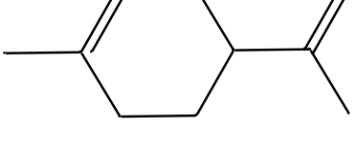 | 1.6 | Fish-tail T* with C8E4⁸
Limonene |  | 2 | Fish-tail T* with C6/8/10E4⁹
Limonene |  | 2 | Fish-tail T* with C6E4⁸
Myrcane | 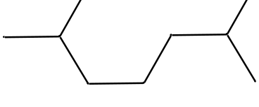 | 9.3 | Fish-tail T* with C8E4⁸
Myrcane |  | 9.7 | Fish-tail T* with C6/8/10E4⁹
Myrcane |  | 10 | Fish-tail T* with C6E4⁸
p-Cymene | 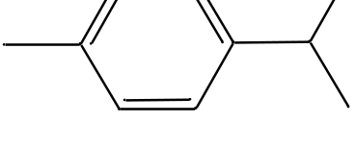 | -0.4 | Fish-tail T* with C6/8/10E4⁹
p-Cymene |  | -0.3 | Fish-tail T* with C6E4⁸
p-Cymene |  | -0.8 | Fish-tail T* with C8E4⁸
Pinane | 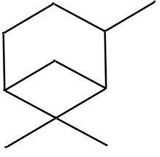 | 3.4 | Fish-tail T* with C8E4⁸
Pinane |  | 4 | Fish-tail T* with C6/8/10E4⁹
Pinane |  | 4.3 | Fish-tail T* with C6E4⁸
p-Menth-2-ene | 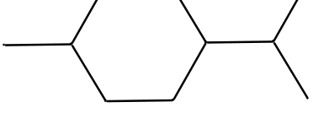 | 3.2 | Fish-tail T* with C8E4⁸
p-Menth-2-ene |  | 3.3 | Fish-tail T* with C6/8/10E4⁹
p-Menthane | 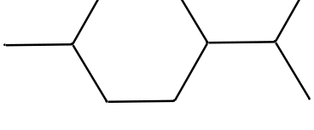 | 5.7 | Fish-tail T* with C8E4⁸
p-Menthane |  | 6 | Fish-tail T* with C6/8/10E4⁹
p-Menthane |  | 6.2 | Fish-tail T* with C6E4⁸
Terpinolene | 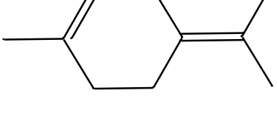 | 0.3 | Fish-tail T* with C8E4⁸
Terpinolene |  | 1 | Fish-tail T* with C6/8/10E4⁹
Terpinolene |  | 1.3 | Fish-tail T* with C6E4⁸
α-Pinene | 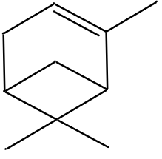 | 3 | Fish-tail T* with C8E4⁸
α-Pinene |  | 3.4 | Fish-tail T* with C6/8/10E4⁹
α-Pinene |  | 3.6 | Fish-tail T* with C6E4⁸
α-Terpinene | 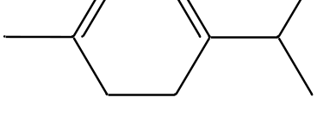 | 0.9 | Fish-tail T* with C8E4⁸
α-Terpinene |  | 1.3 | Fish-tail T* with C6/8/10E4⁹
α-Terpinene |  | 1.5 | Fish-tail T* with C6E4⁸
β-Pinene | 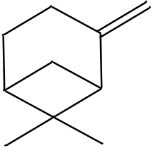 | 1.9 | Fish-tail T* with C8E4⁸
β-Pinene |  | 2.2 | Fish-tail T* with C6/8/10E4⁹
β-Pinene |  | 2.3 | Fish-tail T* with C6E4⁸
γ-Terpinene | 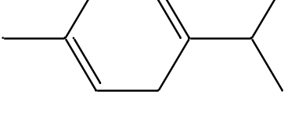 | 1.4 | Fish-tail T* with C8E4⁸
γ-Terpinene |  | 1.8 | Fish-tail T* with C6/8/10E4⁹
γ-Terpinene |  | 1.9 | Fish-tail T* with C6E4⁸
Δ-3-Carene | 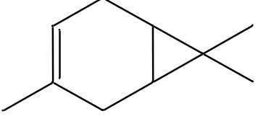 | 1.9 | Fish-tail T* with C8E4⁸
Δ-3-Carene |  | 2.5 | Fish-tail T* with C6/8/10E4⁹
Δ-3-Carene |  | 2.9 | Fish-tail T* with C6E4⁸
2,6,10-Trimethyl undecane-2,6diene | 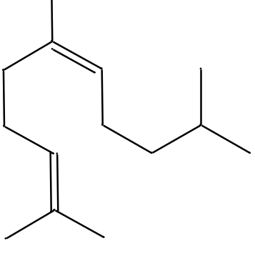 | 8.6 | Fish-tail T* with C8E4⁸
Caryophyllene | 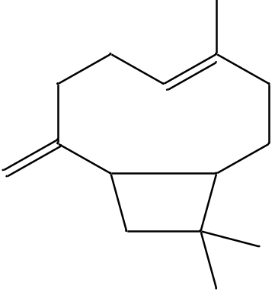 | 5.3 | Fish-tail T* with C8E4⁸
Caryophyllene |  | 5.6 | Fish-tail T* with C6/8/10E4⁹
Caryophyllene |  | 5.7 | Fish-tail T* with C6E4⁸
Longifolene | 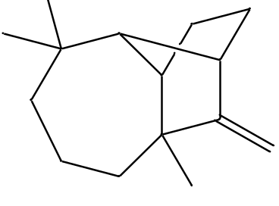 | 6.1 | Fish-tail T* with C8E4⁸
Longifolene |  | 6.5 | Fish-tail T* with C6/8/10E4⁹
Methyl cedrylether | 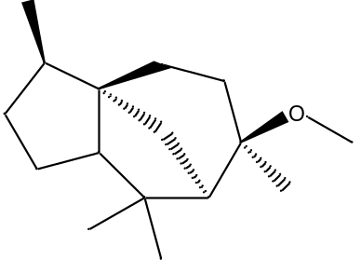 | 3.5 | Fish-tail T* with C6E4¹⁴
$ω$-Hexadecenlactonate | 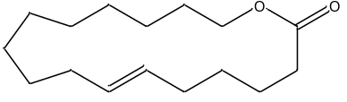 | 1.0 | Fish-tail T* with C6E4¹⁴
Ethylene brassylate | 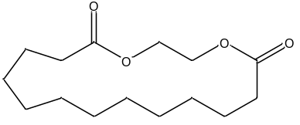 | -1.0 | Fish-tail T* with C6E4¹⁴
$α$-Damascone | 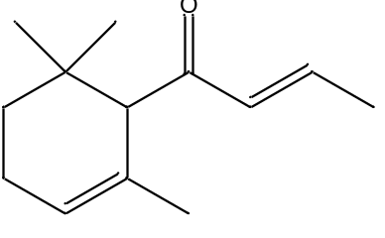 | -1.2 | Fish-tail T* with C6E4¹⁴
Methone | 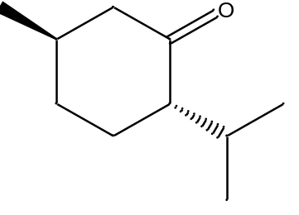 | -1.5 | Fish-tail T* with C6E4¹⁴
Eucalyptol | 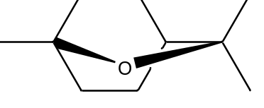 | -1.6 | Fish-tail T* with C6E4¹⁴
Methyl dihydrojasmonate | 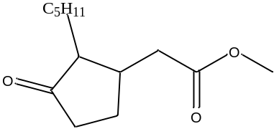 | -1.7 | Fish-tail T* with C6E4¹⁴
Rose oxide | 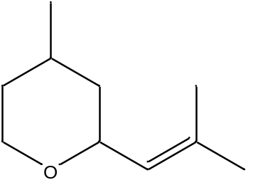 | -1.7 | Fish-tail T* with C6E4¹⁴
$β$-Ionone | 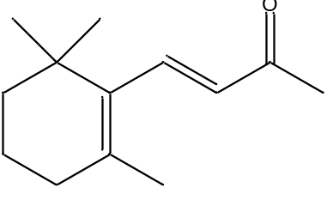 | -1.8 | Fish-tail T* with C6E4¹⁴
$D$-Carvone | 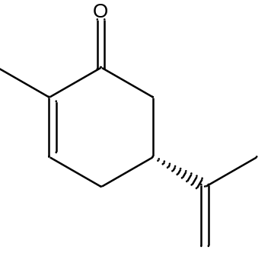 | -3.1 | Fish-tail T* with C6E4¹⁴
Triglyceride
Glycerol trioctanoate | 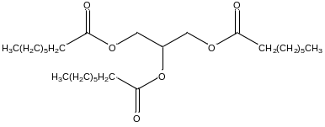 | 12.3 | Fish-tail T* with C10E4¹⁰
Glycerol tridecanoate | 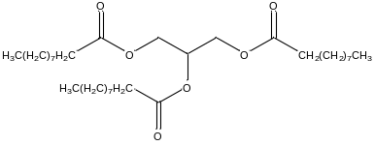 | 13 | Fish-tail T* with C10E4⁷
Glycerol tridecanoate |  | 14 | Fish-tail T* with C10E4¹⁰
Glycerol trilaurate | 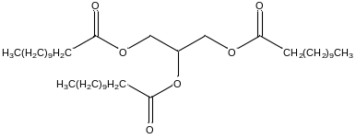 | 16 | Fish-tail T* with C10E4⁷
Glycerol trimyristate | 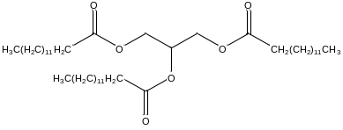 | 19 | Fish-tail T* with C10E4⁷
Glycerol tripalmitate | 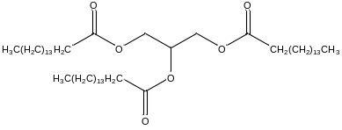 | 22 | Fish-tail T* with C10E4⁷
Glycerol trioleate | 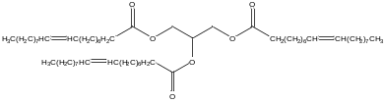 | 22 | Fish-tail T* with C10E4⁷
Glycerol tristearate | 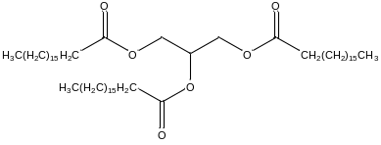 | 25 | Fish-tail T* with C10E4⁷
Silicone
Hexamethyldisiloxane | 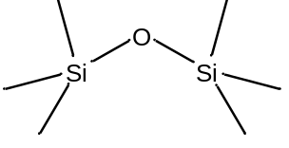 | 12.2 | Vol. Fraction Additive Rule¹³
Polydimethylsiloxane (n=3-6) | 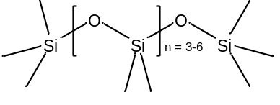 | 14.6 | Vol. Fraction Additive Rule¹³
¹ (Cayias, Schechter, & Wade, 1976); ² (Baran, Pope, Wade, Weerasooriya, & Yapa, 1994); ³ (Miñana-Perez, Graciaa, Lachaise, & Salager, 1995); ⁴ (Dwarakanath & Pope, 1998); ⁵ (Rhee, Cho, & Park); ⁶ (Queste et al., 2007); ⁷ (Engelskirchen, Elsner, Sottmann, & Strey, 2007); ⁸ (F. Bouton, Durand, Nardello-Rataj, Serry, & Aubry, 2009); ⁹ (F. O. Bouton et al., 2010); ¹⁰ (Ontiveros et al., 2013); ¹¹ (Lukowicz et al., 2015); ¹² (Lukowicz et al., 2018); ¹³ (Castellino et al., 2011); ¹⁴ (Lukowicz, 2015)

4.2 Methods of Measuring and Calculating EACN
As was mentioned, EACN seems, in most cases, to follow a linear mixing rule using molar fractions which has been used often to calculate the EACN of an oil that is outside the range of the surfactant or normal n-alkanes (Salager, Bourrel, et al., 1979). Researchers will somewhat commonly use volume fractions instead of molar fractions. Linear mixing is not always the case, as when one oil is significantly more polar than the other it can preferentially concentrate at the interface between phases (Graciaa et al., 1993; Queste et al., 2007). Despite this using a mixture of oils has been very commonplace when determining the EACN of an oil with a very low EACN, so that the EACN of the mixture is in a convenient range for the surfactant being used. There are several ways of determining EACN, and one of the primary methods is scanning. Similar to scanning for an unknown $Cc$, a scan would involve a series of test tubes, the oil in question, a surfactant with known $Cc$, a salt (usually NaCl), and depending on the scan an additional oil with known EACN or surfactant with known $Cc$. A salinity scan is likely the most common as it introduces the least components into the microemulsion system. It involves increases the salinity of the system until the system has gone from Type I to Type II through Type III. The other two scans involved varying the mixture of surfactants or oils across a series of test tubes and seeing the phase invert. While not an easy method of determining EACN, a study has been done to correlate EACNs of oil and alcohol mixtures to alcohol partition coefficients which can be used in reverse to interpolate EACN from the partition coefficients (Dwarakanath & Pope, 1998).
Another method, called the Phase-Inversion-Temperature (PIT) method, has been used effectively to correlate the temperature, that the microemulsion’s phase inverts from Type I to Type II, and the EACN. The method involves choosing a surfactant that preferably has good temperature stability and creating a calibration curve of experimental PIT values vs. the EACN of alkanes (ACN) by slowly raising or lowering the temperature of the microemulsion until it transitions through Type III. Then once the calibration curve is obtained for the surfactant, the PIT can be found for an oil wishing to be studied, and it can be plotted on the calibration curve to find the EACN of the oil. In some cases, mixtures of oils are used to keep the PIT within the calibration curve. One study used pure C₁₀E₄, (an ethoxylated surfactant) suitable for a large range of EACN values between 3 and 35, to create a calibration curve and study cyclic, aromatic and ester oils (Queste et al., 2007). Another used C₁₀E₅ to study fragrances over an even larger range of EACN values by using a mixture of oils, isopropyl myristate (IPM) as a solute and a small portion of the oil to be studied (Tchakalova & Fieber, 2012). The fish-tail temperature (T*) is quite similar to the PIT method and can be correlated to find EACN quite well. Fish diagrams are developed by varying the surfactant concentration and temperature while keeping all other variables constant to find the fish-tail temperature (T*) and concentration which is the point where all four Winsor Type regions meet on the diagram (F. O. Bouton et al., 2010). Equation (24) shows the relationship between $T^{*}$ and EACN. Another method used the fish diagrams and the fish-tail temperatures to calculate EACN, but the oils of interest (benzene, toluene, and cyclohexane) were outside of the range of the surfactant being used, so the trends of benzene rings and cyclohexane with alkyl chains was extrapolated to give a value. As was mentioned by the authors, extrapolation is likely not accurate (Queste et al., 2007).

 | $$T_{C_{i}E_{4}}^{*}=α+βEACN$$ | (24)

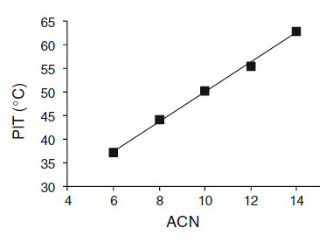
Figure 8. Example Calibration Curve for EACN Correlation (Tchakalova & Fieber, 2012)
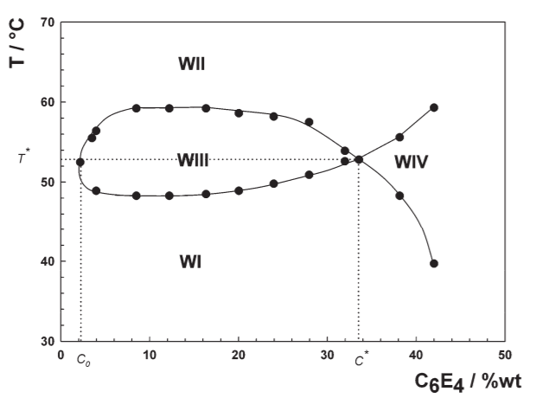
Figure 9. Example Fish Diagram to Determine T* (F. O. Bouton et al., 2010)

One of the limitations of the EACN concept is at the moment there is no clear tie to physical properties of the oil that would allow the EACN to be calculated for an oil without running any tests in the lab. The closest that research has come to that is the modeling using molecular descriptors, but those methods still require special software to calculate or retrieve the molecular descriptors. Another limitation that has seen recent development is describing the behavior of polar oils. Since polar oils will segregate to the interface, they introduce non-ideality that EACN does not fully describe at the moment. Attempts to account for this behavior include treating the polar oil as a surfactant with a $Cc$, treating the EACN as a function of the polar oil’s concentration, and treating the polar oil as both an oil and surfactant with a $Cc$ and an EACN (Ghayour & Acosta, 2019). The last issue with the EACN concept is that in general there is a mistrust of the accuracy of EACN values found by other researchers. The fish-tail method seems to be the most accurate method for finding the EACN of a pure oil, but just about any value found using a mixing rule is somewhat uncertain at this point.

Chapter 5 Predicting EACN
Several efforts have been made to avoid long and tedious lab testing methods to determine the EACN of an oil. A promising method is that of model EACN using molecular descriptors. Two such works have been quite successful, but both use descriptors locked behind pieces of software, which is common for molecular descriptors. Most databases of molecular descriptors are not freely available; MOLE db seems to be an exception (Ballabio, Manganaro, Consonni, Mauri, & Todeschini, 2009). An alternative method that would be beneficial for its accessibility is predicting the EACN from a combination of functional groups. If a new oil is in a simple family of oils that is well understood such as alkylbenzenes then the EACN can be predicted by creating a trend for the family. Unfortunately, an addition rule for functional groups making up an oil is not in place yet. It is understood that functional groups have a significant effect on the EACN of the oil, because they alter the polarity and size of the molecule, but also that there is a diminishing effect when adding additional functional groups (Lukowicz, 2015).

5.1 Modelling Individual EACN
Quantitative structure property relationship (QSPR) approaches look into data mining to gain information from non-obvious correlations between properties (Creton et al., 2019). The first modelling method by Bouton et al. builds upon the fish-tail temperature correlation method, by finding a model for the fish-tail temperature. The model used a data set consisting of 12 n-alkanes, 17 other alkanes and alkenes, and 14 terpenes, with the alkanes being used as reference oils as usual. The genetic function approximation (GFA) script in Molecular Operating Environment (MOE) was the modeling software used for the QSPR approach. Resulting QSPR equations were judged through Friedman’s lack of fit (LOF) which benefits from not being reduced by simply adding more terms which helps avoid overfitting:
 | $$LOF=\frac{LSE}{1-\frac{C+dP}{N}}$$ | (25)
 | $$LSE=\frac{1}{N}\sum_{n=1}^{N}{{\left(\frac{y_{n}-{\hat{y}}_{n}}{y_{n}}\right)}^{2}}$$ | (26)

The resulting QSPR model uses two descriptors from the more than 1000 molecular descriptors from the MOE software: Kier A3 and average negative softness. Kier A3 is one of the Kier and Hall kappa shape index descriptors and is a measure of the amount and location of branching of a molecule. A lower Kier A3 means there is branching near the center of the molecule and a larger Kier A3 means the branching is far from the center or there is little to no branching. This descriptor can be found on MOLE db as “S3K” under the topological descriptors (Ballabio et al., 2009). Average negative softness is a measure of the polarizability (softness) of the electron cloud, where a larger average negative softness has less electron delocalization. It is able to describe the size and volume of the electron cloud and act as a three-dimensional descriptor. This descriptor is not on MOLE db, but other descriptors could likely be used to replace average negative softness (Ballabio et al., 2009). The model showed a good fit for systems using all three surfactants and for polar oils with EACNs between -3 and +35 (F. O. Bouton et al., 2010).
 | $$T_{C_{i}E_{4}}^{*}=a×average negative softness+b×Kier A3-c$$ | (27)
 | $${EACN}_{calc}=2.88×average negative softness+0.88×KierA3-19.84$$ | (28)

The next model by Lukowicz et al. expanded on Bouton’s work with 53 oils including 20 polar oils and uses molecular descriptors from COSMO-RS (Conductor Like Screening Model-Real Solvents) model in the COSMOtherm software instead of MOE. Lukowicz et al. criticized MOE’s descriptors as lacking simplicity and clarity and instead supported the COSMO-RS σ-moments molecular descriptors from COSMOtherm. Given a molecular structure, COSMOtherm creates a σ-surface, which it then uses to create σ-profiles, which is a description of how screening charge density σ is spread on the surface of the molecule. This gives a description of the molecule’s polarity and hydrogen bonding ability. The σ-moments $M_{i}^{X}$ are calculated from the σ-profiles and are used in a function for the partition coefficient $K$ of a solute $X$. EACN is related to the partition coefficient of the oil into the micelle layer, so it is a reasonable jump in logic that σ-moments might be useful in modeling EACN.
 | $$RT\ln{K}=c_{acc}M_{acc}^{X}+c_{don}M_{don}^{X}+\sum_{i=0}^{m}{c_{i}M_{i}^{X}}$$ | (29)
 | $$M_{acc}^{X}=\int_{+σ_{hb}}^{+∞}{p^{X}\left(σ\right)\left(σ-σ_{hb}\right)}dσ$$ | (30)
 | $$M_{don}^{X}=\int_{-∞}^{-σ_{hb}}{p^{X}\left(σ\right)\left(-σ-σ_{hb}\right)}dσ$$ | (31)
 | $$M_{i}^{X}=\int_{-∞}^{+∞}{p^{X}\left(σ\right)σ^{i}}dσ$$ | (32)

$M_{acc}^{X}$ and $M_{don}^{X}$ describe $X$’s ability to act as a hydrogen-bond acceptor and donor. $M_{0}^{X}$ is the total van der Waals surface area of $X$. $M_{1}^{X}$ is the total polarization charge on the σ-surface. $M_{2}^{X}$ is a measure of the overall polarity and describes separation of charges. $M_{3}^{X}$ describes the asymmetry of the σ-profile. The σ-moments of higher order do not have physical meaning. Unfortunately, COSMO-RS was the only method found to obtain these σ-moments. $M_{acc}^{X}$, $M_{don}^{X}$, $M_{0}^{X}$, and $M_{i}^{X}$ ($i$=2-6) were used as the molecular descriptors going into a regression analysis. The least significant descriptor is removed, and the regression analysis repeated. The fitness function was used to determine how many descriptors were needed for the best model, then the best fit was found. This resulted in the following model Eq. (33) which struggles to predict n-alkanes well as $M_{2}^{oil}$ introduces a polarity dependence (Lukowicz et al., 2015). A follow up study by Lukowicz et al. added 16 aprotic polar oils for a total data set of 70 oils. Aprotic polar oils lack acidic hydrogen, and therefore do not act as hydrogen bond donors. This new model followed the previous quite closely and found $M_{acc}^{oil}$ to be significant with the larger data set. n-Alkanes continue to be better described without the $M_{2}^{oil}$ term. The new model Eq. (34) has a lower R² value (0.92 vs. 0.98) than the first model which focused on nonpolar oils. One explanation for this is the inaccuracy of EACN values of very polar oils, which has been discussed previously (Lukowicz et al., 2018).
 | $${EACN}_{pred}^{oil}=0.07M_{0}^{oil}-0.33M_{2}^{oil}-4.03$$ | (33)
 | $${EACN}_{pred}^{oil}=0.06M_{0}^{oil}-\left[0.23M_{2}^{oil}+0.33M_{acc}^{oil}\right]-4.85$$ | (34)

5.2 Modelling Crude Oil EACN
Two models have been developed to predict the EACN of live and dead crude oil (EACNlo and EACNdo). Live crude oil is simply crude oil which contains dissolved gases and volatile components. The first worked to relate EACNlo to EACNdo and better understand the effect of reservoir temperature, pressure, and initial gas to oil ratio ($R_{si}$). The model was based upon the application of the linear mixing rule to oil and gas mixtures and the fact that increasing the gas to oil ratio linearly decreases the optimal salinity (Jang et al., 2014; Marliere et al., 2016). The initial gas to oil ratio, $R_{si}$ is as follows, along with the molar gas fraction, $x_{g}$ and the volumetric fraction of gas, $ϕ_{g}$.
 | $R_{si}=\frac{V_{g}^{o}}{V_{oil}^{o}}=\frac{n_{g}}{n_{oil}}\frac{RZ^{o}T^{o}}{P^{o}V_{m,oil}^{o}}$ | (35)
 | $x_{g}=\frac{1}{1+\frac{RT^{o}}{R_{si}P^{o}V_{m,oil}^{o}} }$ | (36)
 | $ϕ_{g}=\frac{x_{g}V_{m,g}}{x_{g}V_{m,g}+\left(1-x_{g}\right)V_{m,oil}}$ | (37)

where $V_{g}^{o}$ and $V_{oil}^{o}$ are volumes of gas and oil at standard conditions ($T^{o}$ and $P^{o}$), $V_{m,g}$ and $V_{m,oil}$ are the molar volume of gas and oil at reservoir or non-standard conditions, $Z^{o}$ is the compressibility factor at standard conditions, $n_{g}$ and $n_{oil}$ are the number of moles of gas and oil, and $x_{g}$ is the molar gas fraction. Through working to achieve a model to express EACNlo as a function of EACN of the gas (EACNg) and EACNdo, it was found that a volumetric fraction mixing rule worked more effectively that the typical molar fractions. With EACNg being calculated using a volumetric fraction linear addition rule. At high pressures and high temperatures, the straightforward linear mixing rule becomes less effective at predicting EACNlo as changes in temperature or pressure do affect the EACNlo as it decreases when temperature increases and increases when pressure increases. $α^{EACN}$ and $β^{EACN}$ have been defined as the coefficients of the temperature and pressure dependence of EACNlo, but unfortunately it is clear that $α^{EACN}$ is pressure dependent and $β^{EACN}$ is temperature dependent (Creton & Mougin, 2016).
 | $$EACNlo=\left(1-ϕ_{g}\right)EACNdo+ϕ_{g}EACNg$$ | (38)
 | $$α^{EACN}={\left(\frac{Δ\left(EACNlo\right)}{ΔT}\right)}_{P}$$ | (39)
 | $$β^{EACN}={\left(\frac{Δ\left(EACNlo\right)}{ΔP}\right)}_{T}$$ | (40)

The second worked to model EACNdo based on crude oil compositions. Crude oil is made up of many, many compounds to a point where the specific composition is often unknown. This makes EACN calculation via models and linear mixing rule methods unpractical, so to avoid the time intensive scanning methods a new model is desired. This effort investigates QSPR machine learning approaches to predict the EACNdo. The data base collected for this study included the EACNdo, the API gravity, the (w%) fraction of oil that is compounds with less than 20 carbon atoms C₂₀₋, and the (w%) fractions of Saturates, Aromatics, Resins, and Asphaltenes of 29 crude oils. American Petroleum Institute (API) gravity is a measure of how much heavier a crude oil is than water: API = 141.5/SG – 131.5, where SG is the specific gravity and equal to the density of the oil over the density of the water at 5.5 °C (60 °F). The Saturates, Aromatics, Resins, Asphaltenes (SARA) analysis is a method in place to characterize the crude oil content. When starting model EACNdo there are multiple options: Support Vector Machine (SVM), neural networks, partial least squares, Genetic Algorithm (GA), but for a multilinear model, simpler methods can be used such as Evolutionary Algorithms (EA) which are based on Darwinian evolution theory for optimization. It involves iterative evolution of a randomly generated group of equations of the follow format:
 | $$Property=λ_{0}+\sum_{i=1}^{N}{λ_{i}G_{i}}$$ | (41)

where $G_{i}$ is a gene which is combination of descriptors and mathematical functions. The first approach for gene creation used Multi-Gene Genetic Programming (MGGP) models that were generated from the Genetic Programming Toolbox for the Identification of Physical Systems (GPTIPS) in MATHLAB. This method involves fitter equations being passed onto further generations and equations going through crossover and mutation. The number of generations is limited to avoid overfitting. The second method is to associate a gene with only one descriptor, and then using Genetic Algorithm (GA), and Genetic Function Approximation (GFA) as it is in the Materials Studio software. The GFA method also uses iterations of better fitting equations, crossovers, and mutations, and uses criterion like $R^{2}$ to judge the best fitting. The GFA and GPTIPS approaches were compared, and the GPTIPS was found to be more effective, but it must be mentioned that the GFA model was limited to four variables (three genes and a constant) while the GPTIPS model was limited to four genes and a constant.
GFA: | $$EACNdo=λ_{0}+λ_{1}C_{20-}+λ_{2}Sat.+λ_{3}Asp.$$ | (42)
GPTIPS: | $$λ_{0}=-44.28$$ | (43)
 | $$λ_{1}G_{1}=-0.39\frac{Aro.}{Asp.}$$ | (44)
 | $$λ_{2}G_{2}=0.30exp\left(\frac{Sat.}{API-Aro.}\right)$$ | (45)
 | $$λ_{3}G_{3}=4.67×{10}^{-5}\left({API}^{3}+{Sat.}^{3}+{Res.}^{3}\right)$$ | (46)
 | $$λ_{4}G_{4}=55.12exp\left(-exp\left(Aro.\right)\right)$$ | (47)

With these two approaches, EACNdo can be successfully predicted once the general composition of a crude oil is known. This model in combination with the thermodynamic based model discussed above, that predicts EACNlo from EACNdo, is effective and practical tool for a fast prediction of the EACN of a live crude oil (Creton et al., 2019).

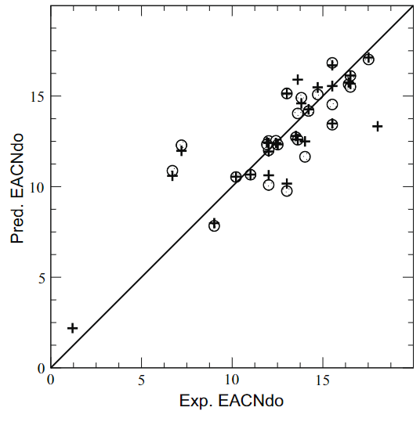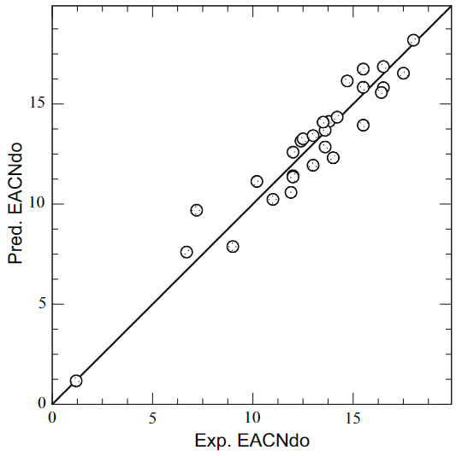
Figure 10. GFA and GPTIPS EACNdo Comparison (Creton et al., 2019)
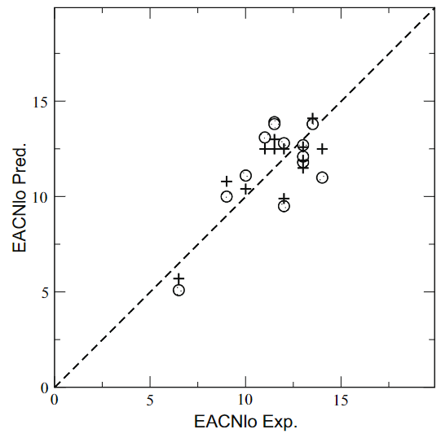
Figure 11. Combining EACNlo and EACNdo Models (Creton et al., 2019)

5.3 EACN Functional Groups Trends
One of the ways I hoped to improve the understanding of EACN was to find trends in the data already collected by many hardworking researchers. EACN has been reported for a substantial number of oils, but unfortunately the available information is usually spread across many different reports and hard to find, so finding relationships in the data is difficult to say the least. Trending the EACN of simple structure families of oils such as nitriles and diethers is relatively straight forward. The resulting trends will hopefully be useful as quick estimates when high accuracy is not needed or when an estimate is desired before running laboratory tests to better calculate the EACN. Linear alkanes should be assumed as normal that EACN is equal to the number of carbon atoms. Linear alkanols similarly have been assumed to have EACN equal to the alkyl chain carbon number (Dwarakanath & Pope, 1998), and there has not been any proposed data to dispute this assumption. Branching does have an effect on EACN. As seen by propylcyclohexane (EACN = 5.7) and isopropylcyclohexane (EACN = 5.3), there is a small decrease in EACN caused by branching which is likely an effect of making the molecule smaller. The decrease in EACN caused by a decrease in size can also be seen through the progression in Fig. 12. Especially interesting is the EACN drop from 1,4-Dimethyl cyclohexane to 1,2-Dimethyl cyclohexane as the placement of the methyl groups effects the size of the molecule significantly while the differences in physical properties of the molecules is quite small compared to the differences in Ethyl and Methyl cyclohexane. Cyclization decreases the EACN differently depending on the resulting structure. Alkylcyclohexanes have small decreases that diminish as the alkyl chain grows. Cycloalkanes have a larger decrease in EACN. For example, when decane (EACN = 10) becomes cyclodecane (EACN = 5.5) it nearly halves the EACN. Aromatization of a cyclohexyl group into a phenyl group has a significant effect on EACN as an aromatic ring makes a molecule more polar especially compared to the alky chain attached to it in alkylbenzenes.

1,4-Dimethyl cyclohexane  EACN = 4.4 | Ethyl cyclohexane  EACN = 3.8 | 1,2-Dimethyl cyclohexane  EACN = 3.3 | Methyl cyclohexane  EACN = 3.2
Figure 12. Progression of EACN Decrease with Decreasing Molecule Size

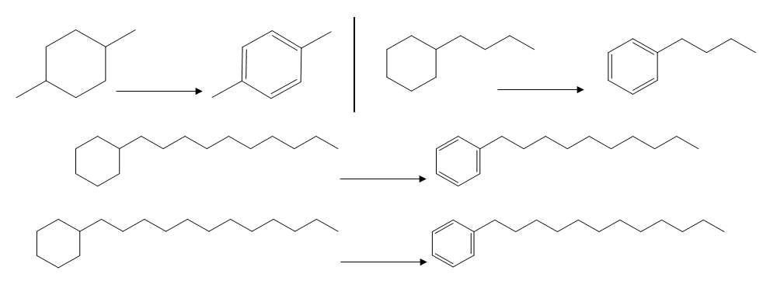
-9.4
-8.2
-6.6
-6.1
Figure 13. Effect of Aromatization Increases with Molecule Size

To begin to understand the effect of double and triple bonds on EACN, 1-alkenes and 1-alkynes can be trended. It can be expected that the unsaturation is going to cause the EACN to decrease with a triple bond being more severe than a double bond, because the $π$-bond increases the molecule’s polarity and interfacial affinity without significantly shortening the molecule. When comparing n-alkanes to 1-alkenes and 1-alkynes, EACN decreases by 4-5 for a double bond and 9-10 for a triple bond. Alkanenitriles seem to follow this triple bond trend with carbon chains of 8, 10, and 12, but the alkanenitriles trend seems to differ from the alkanes’ slope of EACN vs carbon number (m = 1) significantly (m = 0.525).
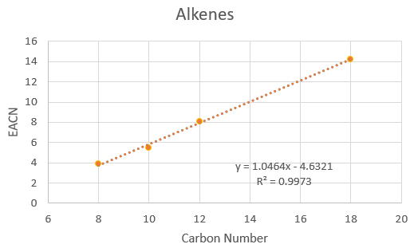
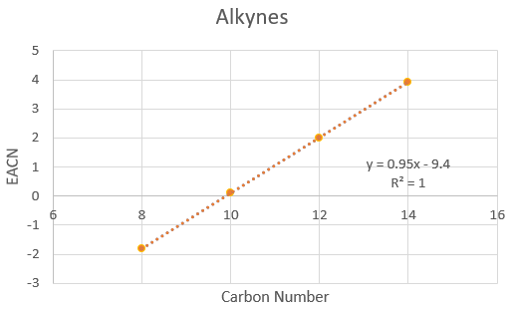
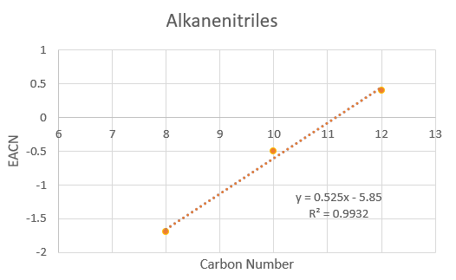
Figure 14. EACN Trends for Alkenes and Alkynes Compared to Alkanenitriles

Dialkylethers are alkyl chains with an oxygen in the middle. The oxygen increases polarity significantly, but the alkyl chains are sterically hindering so the effect is less pronounced than if it were at one end of the molecule. Other oxygen structures like esters and ketones are more complicated due to the dependence on the location in the structure. Triglycerols appeared complicated to trend due to their large tri-branched structure, but a simple trend using the length of the carbon chain attached to the oxygen double bonded carbon was found to accurate fit simple triglycerols without other functional groups. Trends for ethyl alkanoates, octanoates, dodecanoates, and 2-alkanones can be found easily from the available data. When looking to find a model for esters, it was tempting to look for a multilinear regression using the lengths of the carbon chains on either side of the oxygen as variables. Finding a simple multilinear regression using those two variables and an intercept was unsuccessful but adding a term with the two lengths multiplied together gave reasonable prediction power.
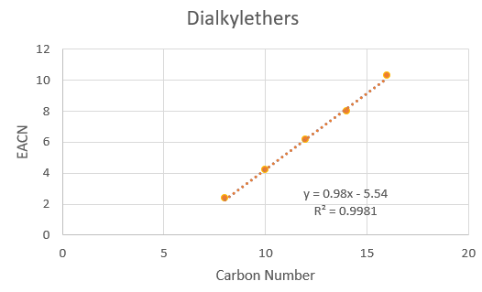
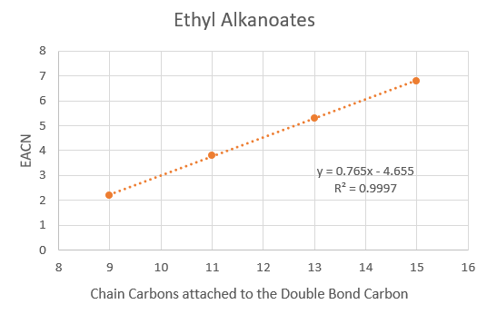
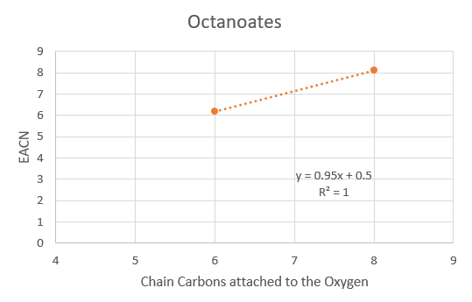
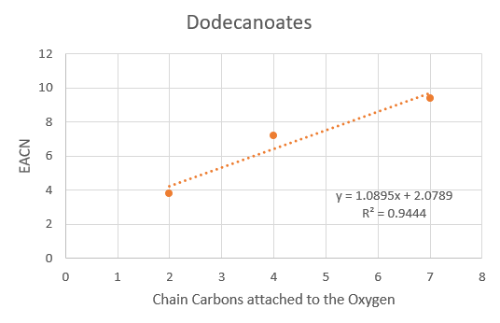
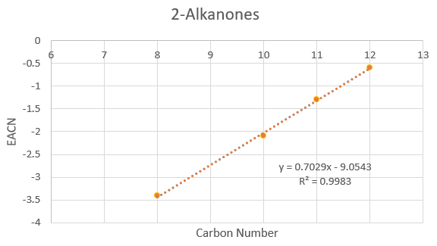
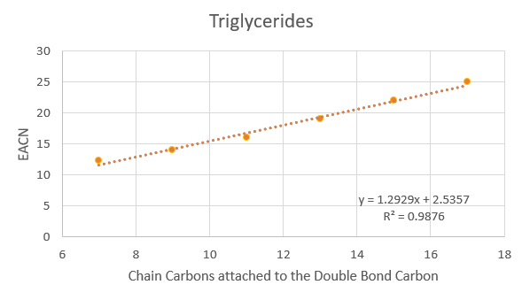
Figure 15. EACN Trends for Ether, Ester, Ketone, and Triglyceride Families

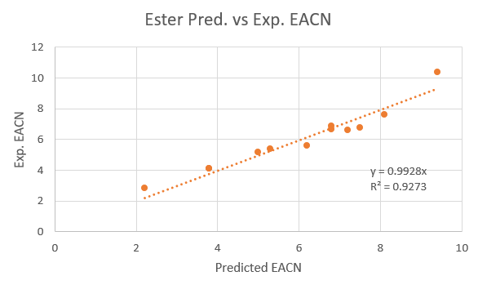
Figure 16. Predicted vs. Exp. EACN of Proposed Model for Esters

 | $${EACN}_{Pred. Ester}=0.51\left(LS\right)+0.58\left(RS\right)+0.061\left(LS*RS\right)-4.0$$ | (48)
 | 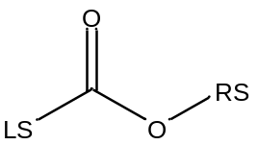

1-Chloroalkanes are larger and more polar than their comparative alkane, because of the large chlorine atom with several free electron, but because it is a large atom the electron cloud is spread out which diminishes their effect. The trend of 1-Alkylcyclohexanes is interesting, because while initially there is an EACN drop when hexane becomes cyclohexane, and this is because likely because the molecule becomes smaller and is able to penetrate and interact with the interface easier. This penetration has a diminishing effect as the alkyl chain grows because it becomes less likely for the cyclohexane to be in the position to penetrate as cyclohexane is nonpolar and essentially does not try to penetrate. For example, dodecyclohexane has an EACN of 17.3 which is near Octadecane which has the same number of carbons. For 1-Alkylbenzenes, benzene and toluene where left out, because their EACNs have only been determined through linear addition rules and do not seem to match the trend of other 1-Alkylbenzenes. This fact has been discussed by Queste et al. who were working to create fish diagrams to calculate EACN values (Queste et al., 2007). It is quite likely that benzene and toluene have negative EACNs, as their extrapolated values are significantly less than their commonly assumed values of 0 and 1. The aromatic ring is more polar than the alkyl chain, so it can reliably penetrate into the interface, so it does not experience the diminishing effect that 1-Alkylcyclohexanes experience. This can explain the increasing drop in EACN from aromatization as molecules grow. Two limitations to using trends based on matching structures is obviously that a trend for the type of structure needed must be available and the necessity that the oil being predicted is near or inside the data range of the trend. Provided a trend is available for the oil of interest, then these trends should give a fast and semi-accurate prediction that would expedite the experimental calculation of EACN and selection of surfactants.
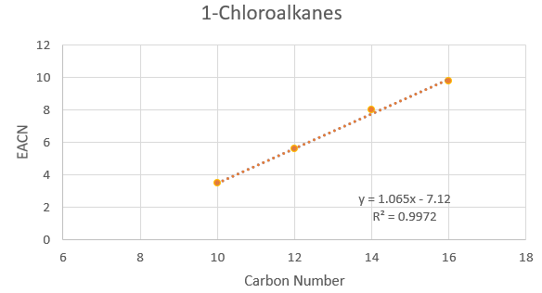
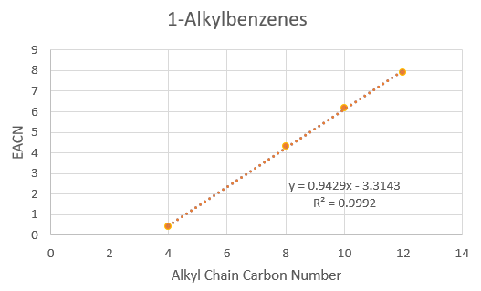
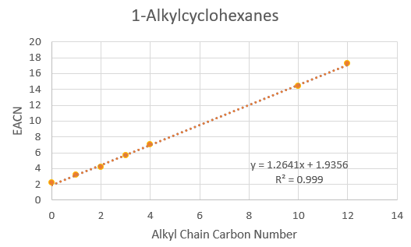
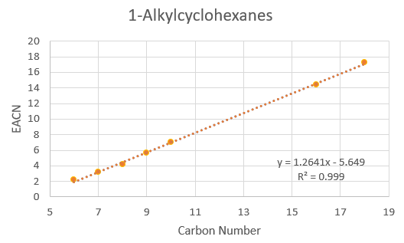
Figure 17. EACN Trends for 1-Chloroalkanes, 1-Alkylcyclohexanes, and 1-Alkylbenzenes
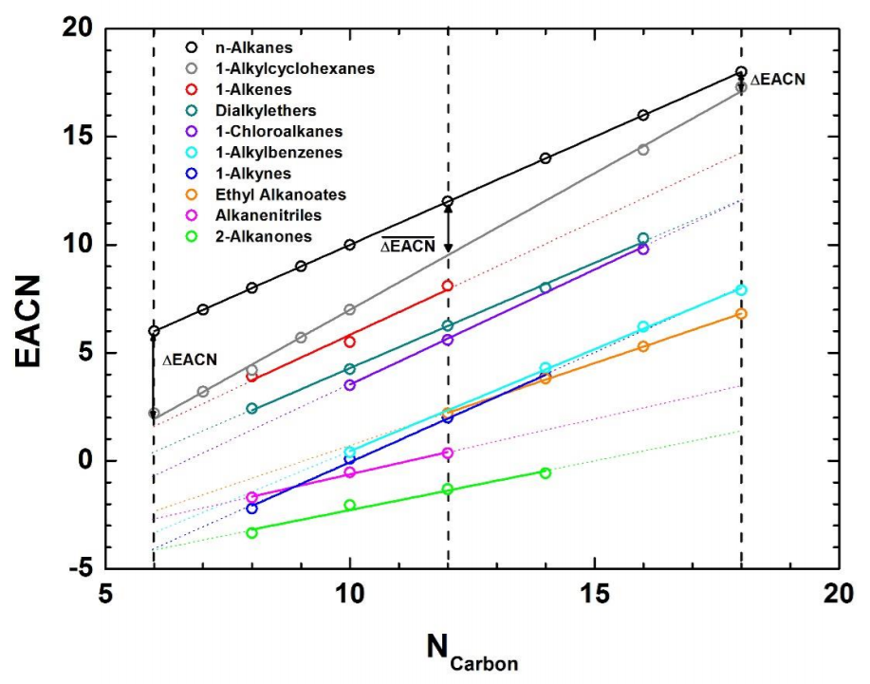
Figure 18. Summary of EACN Trends Compared to the Alkane Trend (Lukowicz, 2015)

5.4 Predicting EACN from Functional Groups
The next improvement to EACN prediction is to understand how adding functional groups affect the EACN. Cyclization is a good place to start determining the effect of functional groups. Looking at cyclo-hexane, octane, and decane and considering myracane becoming p-mentane, it can be seen that forming a ring drops the EACN by 4 ± .5. This does not follow the trend of 1-Alkylcyclohexanes with large carbon chains, but this can be reasoned as with large chains the effect of the cyclization is diminished. An interesting pairing is that of p-menthane (6) and pinane (4). They have the same number of carbons, but pinane has a shorter branch and a second ring that contains 4 carbons. The change in branching likely causes an EACN drop somewhere between 1 and 1.5 which means the cyclization of a second smaller ring only drops the EACN by 0.5 to 1. This agrees with the general feeling that additional functional groups have a diminishing effect.
Next the effect of unsaturation i.e. forming double and triple bonds, is probably the most important or at least the most common functionalization after cyclization. A few simple cases include cyclohexene, cyclooctene, methyl cyclohexene, and p-menth-2-ene. The first unsaturation in a simple structure causes an EACN decrease of about 3: the larger the molecule the smaller the decrease. Unsaturation of citronellyl acetate (-0.2) to geranyl acetate (-0.6) is interesting, because the starting structure already contains an ester group and a double bond; the new double bond is in the middle of the chain, so the effect is diminished by two other functional groups and a central location to cause an EACN decrease of just 0.4. Unsaturation of squalane (24) to squalene (13.8) similarly is diminished by the placement and presence of other functional groups. Six double bonds spaced evenly along the carbon chain only decreases the EACN by 10.2. Ethyl oleate (7.3) is an unsaturated version of ethyl octadecanoate which as of yet has not had an EACN found for it. Using the ethyl alkanoates trend found earlier, ethyl octadecenoate has a predicted EACN of 8.35, which means the double bond in the middle of the alkyl chain lowers the EACN by ~1. Unsaturation of butylbenzene (0.4) to phenyl-1-butyne (-3.3) forms a triple bond in the middle of a carbon chain that’s attached to an aromatic ring. The drop in EACN is smaller than expected for a triple bond due to the location and aromaticity. It is expected that the effect would still be diminished but to a smaller degree if the triple bond was at the end of the carbon chain. It is somewhat surprising that glycerols seem to follow the ‘simple structure’ unsaturation trend that the first double bond decreases the EACN by 3, as shown by the pairing of glycerol tristearate (25) and glycerol trioleate (22). Glycerol trioleate actually has a double bond on each branch in the middle of the alkyl chain.

Table 6. Effect of Unsaturation on Simple Structures
Saturated EACN |  | Unsaturated EACN
 | Cyclohexane  2.2 |  | Cyclohexene  -1.2
 | Cyclooctane  4.1 |  | Cyclooctene  1.6
 | Methylcyclohexane  3.2 |  | 3-Methyl-1-cyclohexene  -0.1  ---  1-Methyl-1-cylcohexene  0.4  ----  1-Methyl-4-cylcohexene  0.4
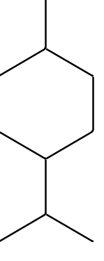 | p-Menthane  6 | 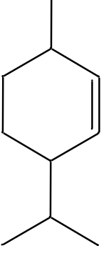 | p-Menth-2-ene  3.3
 | p-Menth-2-ene  3.3 | 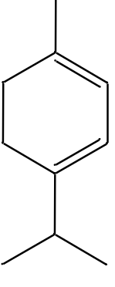  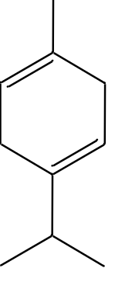 | α-Terpinene  1.3  ---  γ-Terpinene  1.8

On first inspection of aromatization it might be assumed there is not a clear trend in the data. When looking at cyclohexane groups being turned into benzene rings, a straightforward trend was not found, but if the number of carbons in the molecule is considered then what seems to be a trend emerges. Five aromatic molecules with nonaromatic counterparts where both EACNs are known with significant certainty (using fish-tail temperatures) were studied: butyl-, decyl-, and dodecylbenzene, p-xylene, and p-cymene. Considering the number of carbons as the initial EACN, aromatization seems to drop the EACN by 10. For example, decylbenzene has 16 carbons and an EACN of 6, and p-xylene has 8 carbons and an EACN of -2.3. The effect of adding a ketone group is difficult to determine with the limited number of molecules to study with a ketone group. 2-Alkanones experience a drop of about 12 EACN. Methone drops 7.5 EACN which is affected by the ketone’s group in the middle of the molecule and the presence of a ring. D-Carvone also has a ring, but the ketone in closer to the edge of the molecule, and it has two double bonds present, so the drop from the ketone group addition specifically is 5.1 EACN. This is in line with the train of thought that other groups presence and the location matters for functionalization effects, but it prevents a better understanding for ketones. Similarly, the effect of esterification is unclear due to the limited number of molecules where an ester group is included, excluding the alkyl alkanoates family that a trend has already been found for.
Lukowicz compared the functionalization of p-menthane and n-decane and found the drop caused by each functionalization was comparable to the other molecule’s drop. This would be useful in predicting the EACN of a functionalization of an otherwise already well studied structure trending the two molecules EACNs gives a linear relationship. The one outlier is ethyl decanoate, because the better comparison to menthyl acetate would be methyl undecanoate (Lukowicz, 2015).
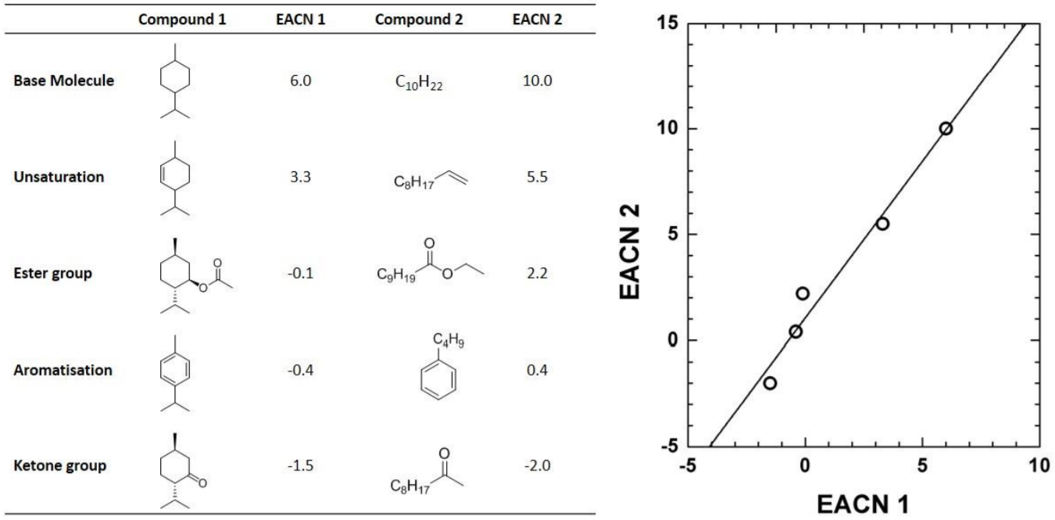
Figure 19. EACN Trends of a Complex Structure and Linear Homologue (Lukowicz, 2015)

For an example of how using the trends of adding functionalization groups can predict the EACN of an oil, linalyl acetate, hexyl methacrylate, and caryophyllene will be discussed. Linalyl acetate is very similar to geranyl acetate structurally; it only adds two branches with one having a double bond. Since the molecule already contains and ester and two other double bonds, and it is on an offshoot from the molecule, it can be expected that there will be almost no drop in EACN (-0.6 to -0.8). Hexyl methacrylate can be predicted ignoring the double bond by the ester trend proposed earlier with LS = 2 and RS = 6 which gives an EACN of 1.6, but considering the double bond could drop the EACN an amount less than 3 due to the presence of the ester group, and it is probably less significant, because it is on the same side of the molecule as the ester group. For a quick and fast prediction of EACN the assumption could be made that the drop from the unsaturation would be about 1 EACN which gives an EACN of about 0.6 (act. EACN 1.1), which is reasonably close compared to other prediction methods. One last example is caryophyllene which is made up of a nine-carbon ring and a four-carbon ring that shares two carbons, 4 methyl branches, and two double bonds, one on the larger ring and the other on one of the methyl branches. Looking at cyclodecane and decalin there is almost no drop in EACN when splitting a ring into two rings, so the two rings could be estimated as a ring with 11 carbons which could be estimated to have an EACN of around 6-6.5; to account for the small drop 6 can be used. For the first methyl group the predicted value increases by 1 EACN and for the three subsequent EACN since they do not increase the size linearly perhaps an increase of 1.5 EACN is reasonable. Next, the unsaturation on the ring will likely drop the EACN by about 2 since it is a larger ring, and the unsaturation on the methyl group likely only drops the EACN by about 1 with the presence of the other unsaturation and cyclization, which leads to a predicted EACN 5.5 compared to the actual EACN 5.6.
Hopefully, these examples encourage those studying or using EACN to seek a meaningful understanding of the functionalization of oil structures. Effort was made to honestly predict EACN for the example without coming to the ‘right’ answer unjustly. The trends found should be used with the understanding that predicted values are dependent on the data currently in place for simple structures and should be updated and improved as new data is calculated experimentally. Besides the mentioned Lukowicz et al. models’ inaccuracy at predicting alkanes, there is one large issue with depending on models to predict EACN. The models likely cannot predict EACNs of oils that are unlike any of the oils included in the data sets, such as silicone-based oils. Despite these considerations that might seem like complaints, these valuable advances have increased the usability of EACN and HLD significantly.

Chapter 6 Conclusion
Many industrial processes depend on or would benefit from a better understanding of microemulsions due to their extremely valuable qualities. Microemulsions are isotropic, thermodynamically stable, and form easily. They can be used to attain ultralow interfacial tension and change the wettability. A better understanding of microemulsions would lead to more cost-effective usage of surfactants, a greater productivity, and less initial trial and error involved in the set-up process. Microemulsions are one of the promising methods of chemical Enhanced Oil Recovery (EOR), because reducing interfacial tension and altering the wettability of the reservoir is very effective at coaxing oil out of reservoir pores after primary and secondary recovery efforts have produced as much oil as possible. Currently it is not a popular method due to the high cost of the necessary surfactant concentrations.
Hydrophilic-lipophilic deviation (HLD) equation is an alternative to the hydrophilic-lipophilic balance (HLB) scale. It has been defined as an experimental based numerical expression of the dimensionless surfactant affinity difference, an approximation of the difference in chemical potential of the surfactant in the oil and aqueous phases, or a measure of how far the system is from optimum formulation or salinity. HLD is a more quantitative approach than HLB and similar methods, and it balances the system conditions, so a trade-off of effects can be accounted for. HLD has been found to be applicable to many different surfactant-oil-water (SOW) systems including mixtures of surfactants, mixtures of oils, and varying salinities, temperatures, and pressures. The HLD concept has been extended into HLD-NAC “net-average-curvature” model which can calculate phase volumes, phase transitions, solubilizations, interfacial tensions, and droplet sizes. One of the most valuable aspects of the HLD concept is its ability to evolve and apply to new systems as the understanding of microemulsions develops.
The surfactant is possibly the most important and researched aspect of microemulsions and the HLD equation. In the HLD equation the surfactant affects three different terms: $Cc$, $K$, $α_{T}$ or $c_{T}$. $Cc$ is the characteristic curvature of the surfactant which is a unique property that describes the hydrophobicity of the surfactant. It is similar to the HLB number for a surfactant, but it is a more effective quantitative term. $K$ is the coefficient of the EACN, and its values depend on the family structure of the surfactant. $α_{T}$ and $c_{T}$ are temperature coefficients that depend on the classification of the surfactant as anionic, nonionic, etc. Scanning methods of determining the values of $K$, $α_{T}$, $c_{T}$, $b$ for a given system were explained, where $b$ is the coefficient of the salinity term based on the salt in the system. Similarly, $Cc$ or EACN can be determined through scanning if a mixture of surfactants or oils is used, or a salinity scan can be performed. It is difficult to find inexpensive and practical surfactants with good stability under the necessary conditions and still effective at low surfactant concentrations. Improving surfactant selection has been the focus of many research efforts and will likely continue to be for many years. One significant source of academic research is for the purpose of chemical EOR where surfactants often need to withstand high salinity and temperatures and have minimal adsorption on reservoir rocks. Biosurfactants produced by microorganisms have been a recent point of interest and could be a solution to the high cost associated with surfactants.
The Equivalent Alkane Carbon Number (EACN) was the primary focus of the present work. EACN is a value given to each oil dependent on its relation to the behavior of alkanes. As discussed, it is an experimentally determined value, and a measure of the hydrophobicity, and so it describes the polarity, size, and shape of a molecule. The EACN of an alkane is equal to the alkane’s carbon number (ACN). EACN values can be zero and negative which in relation to alkanes may seem unclear, but in practice those values have no special characteristics besides the oil being more hydrophilic than alkanes. One of the issues with using alkanes as the scale to measure oils against is that there are oils outside the range of alkanes. Another issued that was discussed is that mixtures including polar oils can introduce non-ideal behavior, because polar oils can segregate preferentially to the interface. This issue furthered the idea that the linear additive mixing rule is unreliable, which led to the argument that EACN values determined using a mixture of oils are unreliable, especially those of polar oils. Several efforts to account for the behavior of polar oils in mixtures were discussed; the most effective method proposed is likely treating polar oils as both a surfactant and an oil. It is clear that many industrial uses of microemulsions would benefit from a better understanding of the oil phase. This work strived to create a large collection of oils’ reported EACN values and methods of obtaining the EACN should prove to be a valuable resource to have compiled in one location. Of the methods used and discussed, the fish-tail temperature method seems to be the most effective method of accurately obtaining EACN. With the unreliability of the mixing rule, pure oils should be used whenever possible when determining EACN values.
Finding the EACN of individual oils or crude oils involves running a series of lab tests which can be a long and resource intensive process, so several works have focused on creating models for the EACN values both using molecular descriptors for individual oils and compositions of crude oils. Modeling through QSPR methods using molecular descriptors have been used successfully to predict EACN values, but access to the molecular descriptors are commonly locked behind premium software. One model for individual oils used Kier A3 and average negative softness descriptors. The other model for individual oils used COSMO-RS software to calculate σ-moments molecular descriptors from COSMOtherm. Both of these models’ descriptors describe the size and structure of the molecule as well as the polarity. Another effort focused on modeling the EACN of crude oils, both dead and live crude oil. Live crude oil contains dissolved gases, whereas dead crude does not. First the model for dead crude oil EACN uses the composition of the crude oil and API gravity, then the EACN of the dead oil is used with the EACN of the dissolved gas to predict the EACN of the live oil. Unfortunately, this work also found that the EACN of live oil’s dependency on temperature depends on pressure, and dependency on pressure is dependent on temperature in return.
Besides having worked to compile the current academic research on the HLD concept with a strong focus on EACN, this work strived to provide clear EACN trends drawn from available data to be able to predict EACN of similar structures confidently. Those structures include 1-alkenes, 1-alkynes, alkanenitriles, dialkylethers, ethyl alkanoates, octanates, dodecanoates, 2-alkanones, simple triglycerols, 1-chloroalkanes, 1-alkylbenzenes, and 1-alkylcyclohexanes. A simple model for alkyl alkanoates (simple esters) was proposed that uses the length of each alkyl chain. This might be the first work to have significantly studied and proposed the prediction of EACN from the structure and functional groups of an oil especially branching, cyclization, unsaturation, and aromatization. The effect of adding ester or ketone groups to non-alkanes is still not well predicted due to the small number of oils containing these groups.
Moving forward, I believe there is significant need to reexamine the use of linear mixing rules for EACN especially when used to determine the EACN of a new oil. Would we, as part of the HLD community, rather know the EACN of a pure oil or just the EACN that agrees with the linear mixing rule for the mixture used? The logical answer is both, if possible, but finding the EACN of pure oils with very low or very high EACNs is more difficult. The fish-tail temperature method would be able to study pure polar oils given a surfactant that is able to produce microemulsions under practical conditions. As will likely be the case for many years to come, accurately calculating the EACN of new oils will be a top priority in the HLD community to better predict and understand the effects of the structure and functionalization of the oil. Polar oils would see a significant benefit with more known EACN values especially those containing ester and ketones.

References

Abbott, S. Hydrophilic Lipophilic Difference. Practical Surfactants Science. Retrieved from https://www.stevenabbott.co.uk/practical-surfactants/hld.php
Abdallah, W., Buckley, J. S., Carnegie, A., Edwards, J., Herold, B., Fordham, E., . . . Signer, C. (1986). Fundamentals of wettability. Technology, 38(1125-1144), 268.
Acosta, E., Szekeres, E., Sabatini, D. A., & Harwell, J. H. (2003). Net-Average Curvature Model for Solubilization and Supersolubilization in Surfactant Microemulsions. Langmuir, 19(1), 186-195. doi:10.1021/la026168a
Acosta, E. J. (2008). The HLD–NAC equation of state for microemulsions formulated with nonionic alcohol ethoxylate and alkylphenol ethoxylate surfactants. 320(1-3), 193-204. doi:10.1016/j.colsurfa.2008.01.049
Acosta, E. J., & Bhakta, A. S. (2009). The HLD-NAC Model for Mixtures of Ionic and Nonionic Surfactants. 12(1), 7-19. doi:10.1007/s11743-008-1092-4
Acosta, E. J., Yuan, J. S., & Bhakta, A. S. (2008). The Characteristic Curvature of Ionic Surfactants. 11(2), 145-158. doi:10.1007/s11743-008-1065-7
Alvarado, V., & Manrique, E. (2010). Enhanced Oil Recovery: An Update Review. Energies, 3(9), 1529-1575. doi:10.3390/en3091529
Arai, H., & Shinoda, K. (1967). The effect of mixing of oils and of nonionic surfactants on the phase inversion temperatures of emulsions. Journal of Colloid and Interface Science, 25(3), 396-400. doi:10.1016/0021-9797(67)90047-1
Aubry, J.-M., Ontiveros, J. F., Salager, J.-L., & Nardello-Rataj, V. (2020). Use of the normalized hydrophilic-lipophilic-deviation (HLDN) equation for determining the equivalent alkane carbon number (EACN) of oils and the preferred alkane carbon number (PACN) of nonionic surfactants by the fish-tail method (FTM). Advances in Colloid and Interface Science, 276, 102099. doi:10.1016/j.cis.2019.102099
Ballabio, D., Manganaro, A., Consonni, V., Mauri, A., & Todeschini, R. (2009). Introduction to MOLE DB - on-line Molecular Descriptors Database. MATCH communications in mathematical and in computer chemistry(62), 199-207.
Baran, J. R., Pope, G. A., Wade, W. H., Weerasooriya, V., & Yapa, A. (1994). Microemulsion Formation with Mixed Chlorinated Hydrocarbon Liquids. Journal of Colloid and Interface Science, 168(1), 67-72. doi:10.1006/jcis.1994.1394
Bera, A., & Mandal, A. (2015). Microemulsions: a novel approach to enhanced oil recovery: a review. Journal of Petroleum Exploration and Production Technology, 5(3), 255-268. doi:10.1007/s13202-014-0139-5
Bourrel, M., Salager, J. L., Schechter, R. S., & Wade, W. H. (1980). A correlation for phase behavior of nonionic surfactants. Journal of Colloid and Interface Science, 75(2), 451-461. doi:10.1016/0021-9797(80)90470-1
Bouton, F., Durand, M., Nardello-Rataj, V., Serry, M., & Aubry, J.-M. (2009). Classification of terpene oils using the fish diagrams and the Equivalent Alkane Carbon (EACN) scale. Colloids and Surfaces A: Physicochemical and Engineering Aspects, 338(1-3), 142-147. doi:10.1016/j.colsurfa.2008.05.027
Bouton, F. O., Durand, M., Nardello-Rataj, V. R., Borosy, A. P., Quellet, C., & Aubry, J.-M. (2010). A QSPR Model for the Prediction of the “Fish-Tail” Temperature of C i E 4 /Water/Polar Hydrocarbon Oil Systems. 26(11), 7962-7970. doi:10.1021/la904836m
Capek, I. (1999). Radical polymerization of polar unsaturated monomers in direct microemulsion systems. Advances in Colloid and Interface Science, 80(2), 85-149. doi:10.1016/s0001-8686(98)00059-1
Castellino, V., Cheng, Y.-L., & Acosta, E. (2011). The hydrophobicity of silicone-based oils and surfactants and their use in reactive microemulsions. 353(1), 196-205. doi:10.1016/j.jcis.2010.09.004
Cavalli, R., Marengo, E., Caputo, O., Ugazio, E., & Gasco, M. R. (1996). THE EFFECT OF ALCOHOLS WITH DIFFERENT STRUCTURES ON THE FORMATION OF WARM O/W MICROEMULSIONS. Journal of Dispersion Science and Technology, 17(7), 717-734. doi:10.1080/01932699608943535
Cayias, J. L., Schechter, R. S., & Wade, W. H. (1976). Modeling Crude Oils for Low Interfacial Tension. Society of Petroleum Engineers Journal, 16(06), 351-357. doi:10.2118/5813-PA
Creton, B., Lévêque, I., & Oukhemanou, F. (2019). Equivalent alkane carbon number of crude oils: A predictive model based on machine learning. Oil & Gas Science and Technology – Revue d’IFP Energies nouvelles, 74, 30. doi:10.2516/ogst/2019002
Creton, B., & Mougin, P. (2016). Equivalent Alkane Carbon Number of Live Crude Oil: A Predictive Model Based on Thermodynamics. 71(5), 62. doi:10.2516/ogst/2016017
Dawson, H., & Czipri, J. (1991). Microemulsions-a new development for the wood preservation industry. Wood Protection, 1, 55-60.
Druetta, P., & Picchioni, F. (2018). Surfactant–Polymer Flooding: Influence of the Injection Scheme. Energy & Fuels, 32(12), 12231-12246. doi:10.1021/acs.energyfuels.8b02900
Dwarakanath, V., & Pope, G. A. (1998). New Approach for Estimating Alcohol Partition Coefficients between Nonaqueous Phase Liquids and Water. Environmental Science & Technology, 32(11), 1662-1666. doi:10.1021/es970744l
Energy.gov. (2010). Enhanced Oil Recovery. Science & Innovation. Retrieved from https://www.energy.gov/fe/science-innovation/oil-gas-research/enhanced-oil-recovery
Engelskirchen, S., Elsner, N., Sottmann, T., & Strey, R. (2007). Triacylglycerol microemulsions stabilized by alkyl ethoxylate surfactants—A basic study. Journal of Colloid and Interface Science, 312(1), 114-121. doi:10.1016/j.jcis.2006.09.022
Gbadamosi, A. O., Junin, R., Manan, M. A., Agi, A., & Yusuff, A. S. (2019). An overview of chemical enhanced oil recovery: recent advances and prospects. International Nano Letters, 9(3), 171-202. doi:10.1007/s40089-019-0272-8
Ghayour, A., & Acosta, E. J. (2019). Characterizing the oil-like and surfactant-like behavior of polar oils. Langmuir. doi:10.1021/acs.langmuir.9b02732
Ghosh, S., & Johns, R. T. (2014). A New HLD-NAC Based EOS Approach to Predict Surfactant-Oil-Brine Phase Behavior for Live Oil at Reservoir Pressure and Temperature. Paper presented at the SPE Annual Technical Conference and Exhibition, Amsterdam, The Netherlands. https://doi.org/10.2118/170927-MS
Graciaa, A., Lachaise, J., Cucuphat, C., Bourrel, M., & Salager, J. L. (1993). Interfacial segregation of an ethyl oleate/hexadecane oil mixture in microemulsion systems. Langmuir, 9(6), 1473-1478. doi:10.1021/la00030a008
Griffin, W. C. (1949). Classification of surface-active agents by "HLB". J. Soc. Cosmet. Chem., 1, 311-326. Retrieved from https://ci.nii.ac.jp/naid/10013018630/en/
Hammond, C. E., & Acosta, E. J. (2012). On the Characteristic Curvature of Alkyl-Polypropylene Oxide Sulfate Extended Surfactants. 15(2), 157-165. doi:10.1007/s11743-011-1303-2
Hayes, M. E., Bourrel, M., El-Emary, M. M., Schechter, R. S., & Wade, W. H. (1979). Interfacial Tension and Behavior of Nonionic Surfactants. Society of Petroleum Engineers Journal, 19(06), 349-356. doi:10.2118/7581-PA
Healy, R. N., Reed, R. L., & Carpenter, C. W., Jr. (1975). A Laboratory Study of Microemulsion Flooding (includes associated papers 6395 and 6396 ). Society of Petroleum Engineers Journal, 15(01), 87-103. doi:10.2118/4752-PA
Israelachvili, J. N., Mitchell, D. J., & Ninham, B. W. (1976). Theory of self-assembly of hydrocarbon amphiphiles into micelles and bilayers. Journal of the Chemical Society, Faraday Transactions 2, 72, 1525. doi:10.1039/f29767201525
Jang, S. H., Liyanage, P. J., Lu, J., Kim, D. H., Arachchilage, G. W. P. P., Britton, C., . . . Pope, G. A. (2014). Microemulsion Phase Behavior Measurements Using Live Oils at High Temperature and Pressure. Paper presented at the SPE Improved Oil Recovery Symposium, Tulsa, Oklahoma, USA. https://doi.org/10.2118/169169-MS
Jin, L., Jamili, A., Li, Z., Lu, J., Luo, H., Ben Shiau, B. J., . . . Harwell, J. H. (2015). Physics based HLD–NAC phase behavior model for surfactant/crude oil/brine systems. Journal of Petroleum Science and Engineering, 136, 68-77. doi:10.1016/j.petrol.2015.10.039
Kiran, S. K., & Acosta, E. J. (2010). Predicting the Morphology and Viscosity of Microemulsions Using the HLD-NAC Model. Industrial & Engineering Chemistry Research, 49(7), 3424-3432. doi:10.1021/ie9013106
Klier, J., Tucker, C. J., Kalantar, T. H., & Green, D. P. (2000). Properties and Applications of Microemulsions. Advanced Materials, 12(23), 1751-1757. doi:10.1002/1521-4095(200012)12:23<1751::Aid-adma1751>3.0.Co;2-i
Lawrence, M. J. (1994). Surfactant systems: Microemulsions and vesicles as vehicles for drug delivery. 19(3), 257-269. doi:10.1007/bf03188929
Levitt, D. B., Jackson, A. C., Heinson, C., Britton, L. N., Malik, T., Dwarakanath, V., & Pope, G. A. (2009). Identification and Evaluation of High-Performance EOR Surfactants. Spe Reservoir Evaluation & Engineering, 12(2), 243-253. doi:Doi 10.2118/100089-Pa
Lukowicz, T. (2015). Synergistic solubilisation of fragrances in binary surfactant systems and prediction of their EACN value with COSMO-RS. Retrieved from https://www.semanticscholar.org/paper/Synergistic-solubilisation-of-fragrances-in-binary-Lukowicz/a1ee9ba2a68922602c8d28d7305170ba72afae7c
Lukowicz, T., Benazzouz, A., Nardello-Rataj, V., & Aubry, J.-M. (2015). Rationalization and Prediction of the Equivalent Alkane Carbon Number (EACN) of Polar Hydrocarbon Oils with COSMO-RS σ-Moments. 31(41), 11220-11226. doi:10.1021/acs.langmuir.5b02545
Lukowicz, T., Illous, E., Nardello-Rataj, V., & Aubry, J.-M. (2018). Prediction of the equivalent alkane carbon number (EACN) of aprotic polar oils with COSMO-RS sigma-moments. Colloids and Surfaces A: Physicochemical and Engineering Aspects, 536, 53-59. doi:10.1016/j.colsurfa.2017.07.068
Mandal, A., Bera, A., Ojha, K., & Kumar, T. (2012). Characterization of Surfactant Stabilized Nanoemulsion and Its Use in Enhanced Oil Recovery. SPE. doi:10.2118/155406-MS
Marliere, C., Creton, B., Oukhemanou, F., Wartenberg, N., Courtaud, T., Féjean, C., . . . Mougin, P. (2016). Impact of Live Crude Oil Composition On Optimal Salinity of A Surfactant Formulation. Paper presented at the SPE EOR Conference at Oil and Gas West Asia, Muscat, Oman. https://doi.org/10.2118/179792-MS
Marquez, R., Forgiarini, A. M., Fernández, J., Langevin, D., & Salager, J.-L. (2018). New Interfacial Rheology Characteristics Measured using a Spinning-Drop Rheometer at the Optimum Formulation of a Simple Surfactant-Oil-Water System. Journal of Surfactants and Detergents. doi:10.1002/jsde.12163
Mattei, M., Kontogeorgis, G. M., & Gani, R. (2014). A comprehensive framework for surfactant selection and design for emulsion based chemical product design. Fluid Phase Equilibria, 362, 288-299. doi:10.1016/j.fluid.2013.10.030
Miñana-Perez, M., Graciaa, A., Lachaise, J., & Salager, J.-L. (1995). Solubilization of polar oils with extended surfactants. Colloids and Surfaces A: Physicochemical and Engineering Aspects, 100, 217-224. doi:10.1016/0927-7757(95)03186-h
Moulik, S., & Paul, B. (2001). Uses and applications of microemulsions. Current science, 80.
Negin, C., Ali, S., & Xie, Q. (2017). Most common surfactants employed in chemical enhanced oil recovery. Petroleum, 3(2), 197-211. doi:10.1016/j.petlm.2016.11.007
Nguyen, T., & Sabatini, D. (2011). Characterization and Emulsification Properties of Rhamnolipid and Sophorolipid Biosurfactants and Their Applications. International Journal of Molecular Sciences, 12(2), 1232-1244. doi:10.3390/ijms12021232
Nguyen, T. T., Morgan, C., Poindexter, L., & Fernandez, J. (2019). Application of the Hydrophilic–Lipophilic Deviation Concept to Surfactant Characterization and Surfactant Selection for Enhanced Oil Recovery. Journal of Surfactants and Detergents. doi:10.1002/jsde.12305
Nguyen, T. T., & Sabatini, D. (2011). Characterization and Emulsification Properties of Rhamnolipid and Sophorolipid Biosurfactants and Their Applications. International Journal of Molecular Sciences, 12(2), 1232-1244. doi:10.3390/ijms12021232
Nguyen, T. T., & Sabatini, D. A. (2009). Formulating Alcohol-Free Microemulsions Using Rhamnolipid Biosurfactant and Rhamnolipid Mixtures. 12(2), 109-115. doi:10.1007/s11743-008-1098-y
Ontiveros, J. F., Pierlot, C., Catté, M., Molinier, V., Pizzino, A., Salager, J.-L., & Aubry, J.-M. (2013). Classification of ester oils according to their Equivalent Alkane Carbon Number (EACN) and asymmetry of fish diagrams of C10E4/ester oil/water systems. Journal of Colloid and Interface Science, 403, 67-76. doi:10.1016/j.jcis.2013.03.071
Pal, S., Mushtaq, M., Banat, F., & Al Sumaiti, A. M. (2018). Review of surfactant-assisted chemical enhanced oil recovery for carbonate reservoirs: challenges and future perspectives. Petroleum Science, 15(1), 77-102. doi:10.1007/s12182-017-0198-6
Pattarino, F., Marengo, E., Trotta, M., & Gasco, M. R. (2000). COMBINED USE OF LECITHIN AND DECVL POLYGLUCOSIDE IN MICROEMULSIONS: DOMAIN OF EXISTENCE AND COSURFACTANT EFFECT. 21(3), 345-363. doi:10.1080/01932690008913271
Queste, S., Salager, J. L., Strey, R., & Aubry, J. M. (2007). The EACN scale for oil classification revisited thanks to fish diagrams. Journal of Colloid and Interface Science, 312(1), 98-107. doi:10.1016/j.jcis.2006.07.004
Rhee, S., Cho, S., & Park, J. (2006). Evaluation for estimating partition coefficients of alcohol tracer partitioning between benzene, toluene, ethylbenzene, and xylenes (BTEX) compounds and water.
Richardson, C. J., Mbanefo, A., Aboofazeli, R., Lawrence, M. J., & Barlow, D. J. (1997). Prediction of Phase Behavior in Microemulsion Systems Using Artificial Neural Networks. Journal of Colloid and Interface Science, 187(2), 296-303. doi:https://doi.org/10.1006/jcis.1996.4678
Rongsayamanont, W., Soonglerdsongpha, S., Khondee, N., Pinyakong, O., Tongcumpou, C., Sabatini, D. A., & Luepromchai, E. (2017). Formulation of crude oil spill dispersants based on the HLD concept and using a lipopeptide biosurfactant. Journal of Hazardous Materials, 334, 168-177. doi:10.1016/j.jhazmat.2017.04.005
Sager, W. F. C. (1998). Controlled formation of nanoparticles from microemulsions. Current Opinion in Colloid & Interface Science, 3(3), 276-283. doi:10.1016/s1359-0294(98)80072-1
Salager, J. L. (1999). In handbook of detergents part A. In (pp. 253-302): Marcel Dekker, New York.
Salager, J. L., & Antón, R. E. (1999). Ionic Microemulsions. Handbook of Microemulsion Science and Tecnhology, 247-280.
Salager, J. L., Antón, R. E., Sabatini, D. A., Harwell, J. H., Acosta, E. J., & Tolosa, L. I. (2005). Enhancing solubilization in microemulsions—State of the art and current trends. Journal of Surfactants and Detergents, 8(1), 3-21. doi:10.1007/s11743-005-0328-4
Salager, J. L., Bourrel, M., Schechter, R. S., & Wade, W. H. (1979). Mixing Rules for Optimum Phase-Behavior Formulations of Surfactant/Oil/Water Systems. Society of Petroleum Engineers journal., 19(05), 271. doi:10.2118/7584-PA
info:doi/10.2118/7584-PA
Salager, J. L., Morgan, J. C., Schechter, R. S., Wade, W. H., & Vasquez, E. (1979). Optimum Formulation of Surfactant/Water/Oil Systems for Minimum Interfacial Tension or Phase Behavior. Society of Petroleum Engineers Journal, 19(02), 107-115. doi:10.2118/7054-pa
Schambil, F., & Schwuger, M. J. (1987). CPS LG 315 Correlation between the phase behavior of ternary systems and removal of oil in the washing process. Colloid & Polymer Science, 265(11), 1009-1017. doi:10.1007/bf01412405
Sharma, G., & Mohanty, K. (2013). Wettability Alteration in High-Temperature and High-Salinity Carbonate Reservoirs. Spe Journal, 18(04), 646-655. doi:10.2118/147306-pa
Sheng, J. J. (2011). Polymer Flooding. In (pp. 101-206): Elsevier.
Sheng, J. J. (2013). Comparison of the effects of wettability alteration and IFT reduction on oil recovery in carbonate reservoirs. Asia-Pacific Journal of Chemical Engineering, 8(1), 154-161. doi:10.1002/apj.1640
Sheng, J. J. (2015). Status of surfactant EOR technology. Petroleum, 1(2), 97-105. doi:10.1016/j.petlm.2015.07.003
Szlendak, S. M., Nguyen, N., & Nguyen, Q. P. (2013). Laboratory Investigation of Low-Tension-Gas Flooding for Improved Oil Recovery in Tight Formations. Spe Journal, 18(5), 851-866. doi:Doi 10.2118/159841-Pa
Tchakalova, V., & Fieber, W. (2012). Classification of Fragrances and Fragrance Mixtures Based on Interfacial Solubilization. Journal of Surfactants and Detergents, 15(2), 167-177. doi:10.1007/s11743-011-1295-y
Tzimas, E., Georgakaki, A., Garcia Cortes, C., & Peteves, S. D. (2005). Enhanced Oil Recovery using Carbon Dioxide in the European Energy System. Retrieved from
Wade, W. H., Morgan, J. C., Schechter, R. S., Jacobson, J. K., & Salager, J. L. (1978). Interfacial Tension and Phase Behavior of Surfactant Systems. Society of Petroleum Engineers Journal, 18(04), 242-252. doi:10.2118/6844-PA
Wan, W., Zhao, J., Harwell, J. H., & Shiau, B.-J. (2016). Characterization of Crude Oil Equivalent Alkane Carbon Number (EACN) for Surfactant Flooding Design. Journal of Dispersion Science and Technology, 37(2), 280-287. doi:10.1080/01932691.2014.950739
Wang, D. M., Butler, R., Liu, H., & Ahmed, S. (2011). Flow-Rate Behavior and Imbibition in Shale. Spe Reservoir Evaluation & Engineering, 14(4), 505-512. doi:Doi 10.2118/138521-Pa
West, C. C., & Harwell, J. H. (1992). Surfactants and subsurface remediation. Environmental Science & Technology, 26(12), 2324-2330. doi:10.1021/es00036a002
Winsor, P. A. (1948). Hydrotropy, solubilisation and related emulsification processes. Transactions of the Faraday Society, 44, 376. doi:10.1039/tf9484400376
Witthayapanyanon, A., Harwell, J. H., & Sabatini, D. A. (2008). Hydrophilic–lipophilic deviation (HLD) method for characterizing conventional and extended surfactants. 325(1), 259-266. doi:10.1016/j.jcis.2008.05.061
Witthayapanyanon, A., Phan, T. T., Heitmann, T. C., Harwell, J. H., & Sabatini, D. A. (2010). Interfacial Properties of Extended-Surfactant-Based Microemulsions and Related Macroemulsions. Journal of Surfactants and Detergents, 13(2), 127-134. doi:10.1007/s11743-009-1151-5
Zhou, M., & Rhue, R. D. (2000). Effect of Interfacial Alcohol Concentrations on Oil Solubilization by Sodium Dodecyl Sulfate Micelles. Journal of Colloid and Interface Science, 228(1), 18-23. doi:10.1006/jcis.2000.6924
Zulkifli, N. N., Mahmood, S. M., Akbari, S., Manap, A. A. A., Kechut, N. I., & Elrais, K. A. (2020). Evaluation of new surfactants for enhanced oil recovery applications in high-temperature reservoirs. Journal of Petroleum Exploration and Production Technology, 10(2), 283-296. doi:10.1007/s13202-019-0713-y

