UNIVERSITY OF OKLAHOMA
GRADUATE COLLEGE

THREE ESSAYS IN DEVELOPMENT & APPLIED MICRO

A DISSERTATION
SUBMITTED TO THE GRADUATE FACULTY
in partial fulfillment of the requirements for the
Degree of
DOCTOR OF PHILOSOPHY

By

SAMUEL ABSHER
Norman, Oklahoma
2018
THREE ESSAYS IN DEVELOPMENT & APPLIED MICRO

A DISSERTATION APPROVED FOR THE
DEPARTMENT OF ECONOMICS

BY

____________________________________
Dr. Kevin Grier, Co-Chair

____________________________________
Dr. Daniel Hicks, Co-Chair

____________________________________
Dr. Ronald Keith Gaddie

____________________________________
Dr. Jaeho Kim

____________________________________
Dr. Ariel Weinberger

Copyright by SAMUEL ABSHER 2018
All Rights Reserved.

Acknowledgements
I would like to acknowledge my coauthor and co-chair, Dr. Kevin Grier for his assistance and direction in Chapter 1 of this dissertation, From Hashtags to Bodybags. In Chapter 2, I would like to acknowledge my coauthors Dr. Kevin Grier and Dr. Robin Grier.

Table of Contents
Acknowledgements iv
List of Tables vi
List of Figures viii
Abstract x
Chapter 1. From Hashtags To Bodybags: Horizontal Media’s Effect On Conflict In The Libyan Revolution 1
1.1 Introduction 1
1.2 Background 4
1.3 Digital Protest As A Substitute For Physical Protest 7
1.4 Data 8
1.5. Empirical Strategy 10
1.6 Results 12
1.7 Robustness Checks 17
1.8 Conclusion 20
References 37
Chapter 2. The Economic & Social Consequences of Left-Populist Regimes in Latin America: Bolivia, Ecuador, Nicaragua, & Venezuela 41
2.1 Introduction 41
2.2 Method, Inference, and Data 43
2.3 Average Treatment Effect Results 48
2.4 Individual Country Results 50
2.5 Discussion 64
References 108
Chapter 3. The Persistent Effects of Military Violence Against Civilians: A Geographic Regression Discontinuity Analysis of the Soviet Occupation of East Germany in WW2 112
3.1 Introduction 112
3.2 Historical Background 114
3.2.2 Soviet War Crimes 115
3.3 Data 117
3.4 Empirical Strategy 118
3.5 Results 122
3.6 Improvements 125
3.7 Conclusion 125
References 143

List of Tables
Table 1. Summary Conflict Statistics by Libyan District 23
Table 2. Blackout Effect on Conflict 24
Table 3. Blackout Effect on Conflict (Restricted Sample) 25
Table 4. Blackout Effect on State-Initiated Conflict 26
Table 5. Blackout Effect on State-Initiated Conflict (Restricted Sample) 27
Table 6. Blackout Effect on Riots, Protests, and Rebel-Initiated Conflict 28
Table 7. Blackout Effect on Riots, Protests, and Rebel-Initiated Conflict (Restricted Sample) 29
Table 8. Blackout's Effect upon Conflict around Communication Infrastructure's Reactivation 30
Table 9. Placebo Effect on Conflict in the Libyan Revolution 31
Table 10. Placebo Effect on Conflict in the Libyan Revolution 32
Table 11. Placebo Effect on Conflict in Libyan Civil War 33
Table 12. Placebo Effect on Conflict in Libyan Civil War (Restricted Sample) 34
Table 13. Jackknife Regression Results 35
Table 14. Donor Countries by Case 65
Table 15. Summary Statistics 66
Table 16. Shenanigans Summary 67
Table 17. Nicaragua's Estimated Synthetic Control Weights by Case 68
Table 18. Nicaragua’s Income Predictor Means 69
Table 19. Nicaragua’s Infant Mortality Predictor Means 70
Table 20. Venezuela’s Estimated Synthetic Control Weights by Case 71
Table 21. Venezuela’s Income Predictor Means 72
Table 22. Venezuela’s Infant Mortality Predictor Means 73
Table 23. Venezuela’s Inequality Predictor Means 74
Table 24. Bolivia’s Estimated Synthetic Control Weights by Case 75
Table 25. Bolivia’s Income Predictor Means 76
Table 26. Bolivia’s Infant Mortality Predictor Means 77
Table 27. Ecuador’s Estimated Synthetic Control Weights by Case 78
Table 28. Ecuador’s Income Predictor Means 79
Table 29. Ecuador’s Infant Mortality Predictor Means 80
Table 30. Ecuador’s Inequality Predictor Means 81
Table 31. Parametric & Semi-Parametric Geographic RD Results 127
Table 32. Geographic RD Results - Former GDR NUTS-3 Regions Only 128
Table 33. Parametric & Semi-Parametric Geographic RD Results with Interaction 129

List of Figures
Figure 1. Reported Conflicts in Libyan ACLED Data by District 36
Figure 2. Left Populist Regimes’ Effect upon Income 82
Figure 3. Left-Populist Regimes’ Effect upon Income with Probability Values 83
Figure 4. Left-Populism Regimes’ Effect upon Infant Mortality 84
Figure 5. Left-Populist Regimes’ Effect upon Inequality with Probability Values 85
Figure 6. Left-Populist Regimes’ Effect upon Inequality 86
Figure 7. Left Populist Regimes’ Effect upon Inequality with Probability Values 87
Figure 8. Nicaragua Per Capita GDP 88
Figure 9. Daniel Ortega’s Effect on Nicaraguan Income 89
Figure 10. Nicaragua Infant Mortality 90
Figure 11. Daniel Ortega’s Effect on Nicaraguan Infant Morality 91
Figure 12. Venezuela Per Capita GDP 92
Figure 13. Hugo Chavez’s Effect on Venezuela Income 93
Figure 14. Venezuela Infant Mortality 94
Figure 15. Hugo Chavez’s Effect on Venezuelan Infant Mortality 95
Figure 16. Venezuela Gini Index 96
Figure 17. Hugo Chavez’s Effect on Venezuelan Gini Index 97
Figure 18. Bolivia Per Capita GDP 98
Figure 19. Evo Morales’ Effect on Bolivian Income 99
Figure 20. Bolivia Infant Mortality 100
Figure 21. Evo Morales’ Effect on Bolivian Infant Mortality 101
Figure 22. Ecuador Per Capita GDP 102
Figure 23. Rafael Correa’s Effect on Ecuadorian 103
Figure 24. Ecuadorian Infant Mortality 104
Figure 25. Rafael Correa’s Effect on Ecuadorian Infant Mortality 105
Figure 26. Ecuador Gini Index 106
Figure 27. Rafael Correa’s Effect on Ecuadorian Gini Index 107
Figure 28. Germany NUTS3 Map 130
Figure 29. Single Dimension Linear Regression Discontinuity – 100 Kilometers 131
Figure 30. Single Dimension Linear Regression Discontinuity – 200 Kilometers 132
Figure 31. Single Dimension Linear Regression Discontinuity – All 133
Figure 32. Single Dimension Quadratic Regression Discontinuity – 100 Kilometers 134
Figure 33. Single Dimension Quadratic Regression Discontinuity – 200 Kilometers 135
Figure 34. Single Dimension Quadratic Regression Discontinuity – All 136
Figure 35. Single Dimension Linear Regression Discontinuity with Interaction – 100 Kilometers 137
Figure 36. Single Dimension Linear Regression Discontinuity with Interaction – 200 Kilometers 138
Figure 37. Single Dimension Linear Regression Discontinuity with Interaction – All 139
Figure 38. Single Dimension Linear Regression Discontinuity with Interaction – 100 Kilometers 140
Figure 39. Single Dimension Linear Regression Discontinuity with Interaction – 200 Kilometers 141
Figure 40. Single Dimension Linear Regression Discontinuity with Interaction – All 142

Abstract
Chapter 1: We explore what effect horizontal communication technologies, like mobile phones and the internet, had on levels of violence in the 2011 Libyan Civil War. We exploit a quasi-experiment within the civil war, where after Libya’s dictator, Muammar Gaddafi, severed telecommunication access in the eastern regions of Libya, the rebels were able to create their own network through a combination of ingenuity and luck. Using difference-in-differences and relying on the exogenous reactivation for identification, we estimate that the 32-day blackout treatment created an additional 116 conflicts in the affected districts. We add controls and estimate a treatment effect with a negative binomial estimator, finding that the blackout multiplied the number of expected per-day conflicts by a factor between 1.87 and 3.10. We find that both state initiated and rebel initiated conflicts increase during the blackout. We offer a novel explanation of the rebel response arguing that protestors may view internet activism and physical protests as substitutes. When Gaddafi removed access to internet and mobile phone technology, he may have funneled political dissent from digital to physical outlets.

Chapter 2: Latin American politics has long contained a Populist, Anti-Capitalist, perhaps we could call it Socialist strain. Despite the controversy surrounding the true effects of such regimes, little to no research has attempted a quantitative analysis of this “Socialist strain”. In this article, we use the synthetic control method to create valid counterfactuals for Bolivia, Ecuador, Nicaragua, and Venezuela and assess their performance relative to their counterfactuals along income, infant mortality, and inequality. The multi-event analysis, which calculates the average effect for these four cases, estimates a significant, both economically and politically, negative effect upon income. We observe a small, statistically significant increase in infant mortality. The treated average is not statistically dissimilar from the counterfactual in the analysis of inequality. At the single-country level, we find heterogeneity in the results. We propose that expropriation and nationalization drive the negative income effects.

Chapter 3: In this article, I use the geographic regression discontinuity framework to test the effect of Soviet occupation during WW2 in East Germany and measure its effect on modern day voting preferences for the Communist party. I find that the occupation, which involved widespread and severe civilian violence, created lasting, intergenerational dissent among the affected regions. Districts that experienced the brunt of the Red Army’s war atrocities observe a significantly decreased vote share for Germany’s Communist party, Die Linke, by approximately 3%.

Chapter 1. From Hashtags to Bodybags: Horizontal Media’s Effect On Conflict In The Libyan Revolution

1.1 Introduction
Recent work in economics has shown that information technologies, both horizontal and vertical, have improved the efficiency of markets in the developing world. Jensen’s (2008) analysis of Indian fish markets, suggests that horizontal media (cell phones) can reduce information asymmetry and generate more efficient market outcomes. Aker (2010) and Muto & Yamano (2009) also study the effect of cell phones on market performance. Others (Svensson & Yanagizwawa (2009), Goyal (2010) have shown that vertical media (e.g. radio) can also improve market efficiency.
On the other hand, economists have also shown how vertical media can negatively affect politics and governance. Yanagizawa-Drott (2013) demonstrates how hate radio stirred anti-Tutsi sentiments and sparked additional violence in Rwanda. Similarly, Adena et al. (2014) show that propaganda radio helped shape pro-Nazi political opinions in Germany. However, there has been little to no work in economics on the question of how horizontal media affects political outcomes. In this paper we provide an answer using the case of the Libyan revolution.
Specifically, we explore the relationship between information and communication technologies (ICT) and conflict using a natural experiment that occurred in the 2011 Libyan Revolution. Using a difference-in-differences approach, we find that a temporary regional deactivation of telephone and internet infrastructure during the revolution increased the total number of reported conflicts within the affected area relative to the baseline. While the timing of the onset of the blackout was deliberately chosen, the end of the blackout occurred when the rebels were able to piece together their own cellular network. We argue that this re-activation is plausibly exogenous, relying on some good luck and exogenous delays (Hill, 2012) and that exogeneity is what gives us identification.
There is also an important confounding factor / additional treatment that we consider, namely that NATO intervened in the conflict from the middle of the blackout period to the end of the war. We take this intervention into account in all our estimates of the treatment effect of the blackout. We also provide several robustness tests and an analysis of the validity of the common trend assumption to bolster support for our findings and a causal interpretation of them.
We estimate that the telecommunications blackout multiplied the expected number of per day conflicts by a factor between 1.87 and 3.10, depending on the model specification. Interestingly, we find that the blackout increased both state initiated and rebel initiated conflicts.
While the increase in state initiated conflicts is consistent with at least some existing studies, our finding of an increase in rebel-initiated conflicts is unique. We argue that political dissidents may view digital and physical protests as substitutes. By eliminating the option to protest digitally, the Gaddafi regime may have unintentionally encouraged physical protest.
The most similar papers to ours are outside of economics and present conflicting results. Warren (2015) studies subnational data on cell phone access in a sample of 24 African countries. He finds that greater access to cellphones significantly increases violent conflict. Similarly, Pierskalla and Hollenbach (PH 2013) find that expansion of horizontal telecommunication technologies encourages collective violent action in a sub-national sample across African countries. Warren defines the events under study as “anti-state violence, non-state violence, and one-sided violence against civilians”, apparently excluding state-initiated violence against rebels. In contrast PH define their events as “the use of armed force by an organized actor against another organized actor or against civilians,” which does not distinguish between state initiated and dissident initiated conflict.
However, the finding that cell phone access increase violent conflict is not universal. Shapiro and Weidmann (SH 2015) examine the expansion of Afghanistan’s mobile phone network, concluding that inclusion into the mobile phone network reduced a region’s likelihood of witnessing insurgent violence. The authors hypothesize that, in this setting, citizens may have exploited the network to inform the state of terrorist whereabouts, thus preventing violent activity.
Gohdes (2015) most resembles the topic and context of this article, because it focuses on the effect of strategically implemented telecommunications blackouts. She finds a positive correlation between blackouts and government initiated violence in Syria, arguing that autocratic regimes have incentive to disable infrastructure since rebels can easily exploit the telecommunication resource. Ghodes paints the restriction as a military tactic to disorient rebels, increasing the odds of successful state repression. However, Ghodes does not present any arguments that the relation between blackouts and conflicts is causal.
Our analysis of the Libyan Revolution provides causal estimates suggesting that the deactivation of telecommunication infrastructure significantly increases conflict. Rather than looking only at conflict by one type of group (government (Ghodes), non-state actors (Warren and SH,) or combining all groups (PH)), we go beyond our aggregate analysis, splitting conflicts into state initiated and rebel initiated events and test each type of conflict separately for a treatment effect. We find the Libyan blackout increased conflicts both for state and non-state actors.
We believe that the existing literature fails to adequately explain why turning off the cellular network would increase violence by non-state actors. We suggest that there is a substitution channel at work, whereby the closing of digital forms of anti-government protest increases the likelihood of physical and possibly violent anti-government activities.
The rest of paper proceeds as follows. Section 2 provides background on the Libyan Revolution and the quasi-experiment we study. Section 3 discusses the possible channels through which horizontal media affect conflicts. Section 4 details the construction and organization of the data. Section 5 presents the empirical strategy, while section 6 examines the results. Section 7 undertakes some placebo and robustness tests. Finally, section 8 concludes.

1.2 Background
The Libyan Revolution began on February 15th, 2011, when police fired on protesters in Benghazi. Violence quickly spread across Libya. As in other Arab Spring movements, pundits speculated that internet and mobile phone access enabled political dissidents to organize. But the conjectured role of telecommunication did not elude Muammar Gaddafi, Libya’s long-reigning military dictator, who exploited the centralized ICT infrastructure to cut access in eastern Libya, ostensibly to disorient anti-regime protesters. Tripoli housed crucial mobile phone and internet hardware and provided access to eastern Libya via a fiber optics cable. Al Jazeera reports that the Gaddafi regime severed access somewhere between Misurata and Khomas (Hill, 2012). The internet blackout lasted from approximately March 1st to precisely April 2nd (Coker and Levinson, 2011).
Although Libya is a developing economy, Libya’s telecommunications infrastructure is impressive. For instance, as of 2012, there were 9.6 million cellular subscriptions, which comes to 148.19 per 100 inhabitants, while 19.9% had internet access (ITU, 2012). Meanwhile, the United States has 317.4 million cellular subscriptions, 100 per 100 inhabitants, and 86.8% have access to the internet (The World Factbook, 2014). Obviously, telecommunication technologies are pervasive within Libyan society and, if they do in fact enable (or discourage) violent behavior, could have substantial and widespread effects upon the behavior of Libyan protesters.
The plausible exogeneity of the blackout rests not on the initiation of the blackout, but upon the timing of the reactivation of the mobile phone and internet infrastructure, which reports describe as “lucky” or “accidental” (Hill, 2012). Although Gaddafi’s regime imposed the blackout on a specific region at a specific and non-random time, we exploit the fact that the rebels reactivated the infrastructure in a plausibly exogenous manner to achieve identification.
Ousama Abushagur, a Libyan expatriate and telecommunication executive, responded to reports of political protests in Libya by delivering humanitarian aid. Like other demonstrators, Abushagur noticed the inaccessible network, which hindered relief efforts. In response, Abushagur planned to create a new network, independent from the influence of Gaddafi. Coker and Levinson (2011) detail the complex process of gathering the necessary expertise and technology to establish an independent network. The independent network would require a number of hardware components not available within the rebel-held territory. Abushagur turned to Huawei Technologies Ltd., a Chinese company and original supplier of Libya’s state-sponsored telecommunication provider (Libyana), to acquire the necessary components, but Huawei refused to assist the rebels. Instead, the Abushagur and his team purchased hardware from Persian Gulf nations. “‘The Emirates government and [its telecommunications company] Etisalat helped us by providing the equipment we needed to operate Libyana at full capacity,’ said Faisal al-Safi, a Benghazi official who oversees transportation and communications issues.” (CL 2011). Between both journalistic accounts of the independent network’s creation, we find no evidence to suspect that the Emirates’ participation hinged on other determinants of Libyan conflict, including likelihood of victory or defeat. Thus, reactivation occurred in a plausibly exogenous manner. What’s more, the importation of the hardware depended also on cooperation from the Egyptian government. The war made flying the equipment into Eastern Libya dangerous so the rebels decided to deliver it through Egypt. Such diplomatic approval again delayed the telecommunication infrastructure reactivation and in a way, that should not correlate with other determinants of conflict. Rebels would likely have no means to reliably predict the outcome of Egypt’s decision or the precise moment when the infrastructure would or could become available. So, again, we do not expect this event to otherwise affect Libyan rebels’ or state forces’ decision to initiate conflict.
Reactivation of the mobile phone network also benefited from a fortuitous salvaging of abandoned hardware (Hill, 2012). Rebel forces in Benghazi acquired a piece of crucial telecommunications hardware: a home location register (HLR). These devices connect and route all mobile phones over networks. Hill describes HLRs as “essential to a functioning mobile phone system” (2012). Although most infrastructure resided in Tripoli, one state-sponsored telecommunications provider, Libyana, held a backup HLR in Benghazi. Without this, the independent network might never have been established or at least may have been further delayed.
On April 2nd, Abushagur placed the first call through the new Free Libyana mobile phone network, marking the return of telecommunication access (Coker and Levinson, 2011). Given the setting of the independent network’s creation, the blackout treatment arguably ended independently of factors, which might also affect levels of violence, lending further validity to our identification strategy of difference-in-differences in this setting.

1.3 Digital Protest as A Substitute for Physical Protest
We have seen above that two papers (Warren, 2015 PH 2013) argue that horizontal media lowers the cost of organizing to non-state actors and thus increases conflict and violence. A third (SW 2015) does not consider this channel of influence but argues that the spread of cell phone coverage allowed government forces to better monitor and contain rebel forces. The fourth paper (Ghodes) shows that blackouts are correlated with state initiated conflict.
We posit that horizontal media has other uses beyond coordinating opposition actions. Beyond the reduction in coordination costs, digital media also serves as a forum for citizens to express political dissatisfaction. This mechanism is similar to that of physical protests, where individuals gather to express their discontent. In short, we propose that mobile phone and internet access can serve as a substitute for physical collective action.
Individuals may prefer to express political dissent within the digital realm, but the deactivation of vital infrastructure forces individuals to shift their anti-regime behavior towards physical protests and conflicts. Anecdotal evidence suggests that the telecommunications blackout strategy likely exacerbated anti-Gaddafi attitudes. In essence, the blackout appears to have created additional dissatisfaction while simultaneously eliminating a peaceful channel through which individuals could express political dissent.
Of course, merely estimating the treatment effect of the blackout upon all conflicts cannot provide adequate evidence to confirm or deny the aforementioned mechanism. If the analysis returns a positive coefficient estimate of the blackout upon civil violence, other, established channels could, in fact, be responsible for the effect. As Gohdes (2015) hypothesizes, state regimes implement blackouts as a strategic military advantage. And, such explanations in the context of the Libyan Revolution might also be accurate. However, to further unravel the response of protestors to the telecommunications blackout and to test the validity of the substitution channel, we examine whether the blackout causes greater increases in rebel initiated and state initiated conflicts separately. If rebel initiated conflicts rise when communications are cut, there is some important effect of horizontal media beyond facilitating coordination.

1.4 Data
The Armed Conflict Location and Event Data (ACLED) provides a conflict-level dataset that includes important descriptors of each observation. It describes the precise timing and geographic location of the conflicts; important in determining whether an observation occurs in the treatment or control region-time. Crucial for our analysis, the data also includes information regarding the nature and initiator of each conflict.
We supplement this data with weather data from the National Oceanic and Atmospheric Administration (NOAA), as previous research has demonstrated that both rainfall and temperature can affect the likelihood of violence (Hsiang, Burke, Miguel, 2004) (Dell, Jones, Olken, 2014). NOAA creates the data from global satellite readings and the samples are gathered monthly. We also include district identifiers for each conflict. Using a political district map from DIVA-GIS, a free distributor of geographic data, we tie each conflict to a particular district. We do so because governance, which varies by district, affects the long-term political attitudes of the residents and thus should be controlled for in our empirical model (Fearon, 2010). Figure 1 displays DIVA-GIS’s political map. The map’s district color scheme indicates the relative level of conflict that occurs within the region during the Libyan Revolution.
Next, we use news reports to establish the duration and approximate geographic location of the telecommunications infrastructure blackout. From Hill (2011), we find that the blackout occurred “somewhere between the cities of Misurata and Khomas”. We choose a central point between these two cities and estimate the treatment variable at the district level, based on portion of district area affected by the blackout, ranging from 0 to 1. Note that imprecise reports mean that our treatment estimates are an approximation, but only in partially treated districts. Most districts are unaffected when varying the blackout point from Misurata to Khomas. Even those affected do not see large variations in the total treatment area, due to the two cities’ proximity. However, to address potential problems that might arise from this approximation, we remove any partially treated districts in a number of specifications and rerun the analysis, to ensure that our results are not driven by the imprecision in treatment levels of split districts. As for the timing of the blackout, we use information from Coker & Levinson (2011), which report the blackout occurred from roughly March 1st to precisely April 2nd.
Finally, we studied the timeline of the conflict to look for confounding effects that might bias our results. We found no evidence that the reactivation was correlated with changes in the fortunes of either group. We did find that NATO intervention in the conflict started on March 17th, 2011, approximately at the halfway point of the blackout and continued to the end of the conflict. We account for this intervention with a NATO dummy variable in all our specifications.
There are 32 observations for each day within the conflict, one for each district. There are 251 days in the Libyan Revolution, from February 15th to October 23rd, 2011. Thus, we have a balanced panel of 8,032 total district-day observations.

1.5. Empirical Strategy
The plausibly exogenous nature of the end of the Libyan blackout allows us to employ a difference-in-differences methodology to estimate the causal effect of ICT on conflict. Gaddafi’s imposed telecommunication restriction generated a treated and control region. However, we acknowledge state forces did not select treatment regions randomly; there exists some inherent and likely unobservable differences between east and west Libya. Fortunately, the difference-in-differences methodology eliminates both observable and unobservable sources of time-invariant heterogeneity between treated and control regions. The inclusion of weather and day of the week controls, along with checking for common trends, can help to assuage concerns regarding time-varying sources of heterogeneity.
Following the difference-in-differences method, we construct an empirical model of the following form to test the hypotheses:
$$y_{dt}=α+β(region*blackout)_{dt}+τ(region)_{d}+μ(blackout)_{t}+θ{(NATO)}_{t}+{ϕ{X'}_{dm}+σmonth_{t}+ηday_{t}+γ}_{d}+ϵ_{dt}$$
The outcome variable $y_{dt}$ contains the number of conflicts in district $d$ at time $t$. ${(region*blackout)}_{dt}$ represents the portion of the district, $d$, that lost communication during the blackout dates, $t$; the variable is simply an interaction between ${(region)}_{d}$, the district treatment variable, and ${(blackout)}_{t}$, the blackout period. The coefficient of interest is $β$, which captures the blackout’s effect upon the total instances of conflict in the affected regions. The model controls for the NATO intervention, which we identify as a potential time-varying determinant of conflict. The model also includes a vector of monthly temperature and precipitation controls, ${X'}_{dm}$ which vary by the district-month and the district fixed effects, denoted by $γ_{d}$.
Due to the discrete-count nature of the dependent variable, estimation by least squares is not optimal, as OLS allows for both non-integer and even negative predicted values. We could use either a Poisson or negative binomial model. However, since the distribution of the dependent variable contains a variance (0.135), which does not equal its mean (.074), the negative binomial will better estimate the model parameters (Cameron and Trivedi, 1999) in our setting. All our models are negative binomial, estimated using iterative maximum likelihood in STATA.
As noted above, to address concerns regarding the approximate, and potentially imprecise, location of the treatment, we include results that exclude all observations from split districts. Thus, there are model specifications, which include only districts that both certainly and completely receive treatment ($region_{d}=1$) or that certainly and completely do not receive the blackout treatment ($region_{d}=0$).

1.6 Results
Table 1 contains conflict summary statistics for the Libyan Revolution. The data has been broken down by district type between treated or control district based on the percentage area that received the treatment during the blackout period. If more than 50% of a district’s area lies in the treated zone, then the district is placed in the treated region. All other districts are allocated to the control region. In addition, the district conflicts are divided into the treated (or blackout period) and control (or post-blackout) period.
Before discussing our regression approach, we also present in Table 1 a basic difference-in-differences calculation of the blackout’s effect on conflict. As can be seen, there were 71 more conflicts in the untreated regions during the control period. However, there are 45 fewer conflicts in the untreated regions during the blackout period. The difference between these two numbers (71- (-45)) is 116, which represents the simple difference-in-differences treatment effect estimate. This exercise indicates that the blackout caused an additional 116 conflicts in the treated areas during the roughly month-long treatment period.
We now turn to our regression-based difference-in-differences results. Table 2 presents the negative binomial estimates of the causal effect of the blackout using the district-day dataset and methodology described in Section V. Column (1) contains estimates for the most parsimonious model specification, framed as a simple difference-in-differences without any control variables. Columns subsequently (2)-(5) add weather controls and district-, month-, and day-of-week fixed effects, respectively. Again, to address concerns regarding the precision of treatment area, we drop all districts that are partially treated in Table 3 repeating the identical model specifications from Table 2, mirroring the format as well. Throughout all 10 model specifications, the blackout effect remains positive and statistically significant at the 1% level. The blackout significantly increases conflicts in the treated districts.
With the estimates completed, we now move to interpret the coefficients. The negative binomial regression coefficients require a different interpretation than ordinary least squares. The negative binomial estimates represent the difference between the log of expected counts ($μ$) ($β=log(μ_{treatment})-log(μ_{control})$) at the level of observation, as the predictor $x$ marginally increases ($μ_{x0}$ to $μ_{x0+1}$, in this case $μ_{treatment}$ to $μ_{control}$, respectively since the dependent variable is binary). In this work, we also use incidence rate ratios (IRR) interpretation of the negative binomial estimates, as it gives an intuitive interpretation of the estimated treatment effect. IRR coefficients present the log of the ratio of expected counts ($log(\frac{μ_{treatment}}{μ_{control}})$) and give the factor by the which the blackout will increase the rate of conflict.
The estimates suggest that the blackout increased the number of expected district-day conflicts by a factor between 1.87 and 3.10, depending on model specification. Comparing this result to the simple result from Table 1, which estimated an increase of 116 conflicts due to the blackout, estimation of the treatment parameter in the empirical models suggest a causal increase of between 27 and 66 conflicts depending on the specification used.
It is possible that the model’s error terms are independent across district but correlated within districts. In these cases, standard errors should be clustered at the district level to avoid bias (Cameron and Miller, 2015). To address this possibility, we also present standard errors that are clustered by district. The estimated treatment effects remain statistically significant, although columns (3), (4), and (5) from table 2 and (3) from 3 are no longer significant at the 1% level.
Comparing Tables 2 and 3, we note that once we omit observations from the partially or approximately treated districts, the magnitude of the estimated treatment effect increases. This is a comforting finding, suggesting that the treatment effect is strongest in districts that are fully treated. If we had obtained smaller effects after dropping the partial districts, it may have raised doubts regarding the legitimacy of our strategy.
Next, to test for evidence on the military-strategy channel and our proposed substitution channel, we classify conflicts as either rebel or state initiated using the information in the ACLED data. We consider conflicts categorized as “Protests/Riots”, battles in which the rebels overtake a territory, and battles, which involve no change of territory, but “Libyan Rebel Forces” is listed as the provoking party to be rebel initiated. 158 conflicts meet these specific requirements. For state initiated we apply similar rules: this group includes battles in which the state retakes a territory and battles in which there is no reported transfer of territory, but “Military Forces of Libya” or “Militia (Pro-Government)” are listed as the aggressor. 179 conflicts are categorized as state initiated based on the above criteria.
We first test the military-strategy channel by taking the data on state initiated conflicts and by repeating the exact methodology described in Section V. Tables 4 and 5 present the estimates of the blackout’s treatment effect; the structure of the table mimics Tables 2 and 3. In Table 4, columns (1)-(2) estimate a statistically significant effect of the blackout upon state initiated conflicts, albeit at varying levels of significance. However, in column (3), the coefficient is only statistically significant when clustering the standard errors. In (4)-(5), the coefficient estimates, although positive, are no longer statistically significant. We next remove all observations within split regions, where the level of treatment is imprecise and repeat the model specifications from 4. Columns (1) and (2) of Table 5 estimate coefficients that are significant at the 1% level. But, again, we see the significance of the results decline as the model specifications acquire additional controls. In columns (3)-(5), the estimates are significant at only the 5% and 10% levels. Using the IRR interpretation again produces a more intuitive result than those found on Table 3. The IRR coefficients range from 1.85 to 3.48, meaning our estimates expect the blackout to have created between 10 and 20 additional state initiated conflicts. The raw difference-in-differences number (similar to what was reported in Table 1) is 23 additional conflicts.
Finally, we estimate the blackout’s effect upon rebel-initiated conflicts, to test for evidence of our proposed substitution channel. Again, the exact methodology from the two earlier tables is repeated, but upon the new, rebel initiated conflict dataset. Tables 6 and 7 present the coefficient estimates from the negative binomial regressions. In Table 6, a data specification that includes all districts, the negative binomial regression estimates treatment coefficients, which are significantly higher in magnitude than those found in Table 4. Columns (1)-(3) display point estimates of the blackout’s effect that are significant at the 1% level. Only with the inclusion of month and day fixed effects is the statistical significant reduces to the 5% level. Once we remove the problem of approximation by excluding split district, in Table 7, we find that all models, regardless of standard error estimation, are significant at the 1% level. Again, the magnitude of the estimates exceeds those returned on the state initiated dataset. On average, we find the substitution point estimates to be a factor of 1.68 higher than point estimates returned from the state initiated conflict analysis. The accompanying IRR coefficients range from 3.52 to 9.88. Thus, our model predicts that telecommunication restriction caused protesters, rioters, and rebels to initiate between 25 and 70 additional conflicts. A simple difference-in-differences analysis, like the one in Table 1, predicts a causal increase of 44 rebel-initiated conflicts, confirming the feasibility of the regression estimates.

1.7 Robustness Checks
In the work above, we took the entire seven-month non-blackout period of the Revolution as the control period. In our first robustness check we pare down the control period by eliminating observations on conflicts that occur more than one month after the cell network was reactivated. This truncation should further alleviate concerns about time-varying differences between the treated and untreated region by focusing on a time where, arguably, mere chance determined access to mobile phones and internet infrastructure. Further sharpen the test, we use only observations from districts where the treatment level is 1 or 0, eliminated partly treated districts.
Table 8 presents the estimates of the blackout upon this much narrower set of district-day observations. In table 8, all model specifications produce coefficient estimates, which are positive and statistically significant, even when using standard errors clustered at the district level. Note that the magnitude of the estimates resemble those from Table 2 and 3, demonstrating that the estimates of the treatment’s magnitude remain consistent in spite of data truncation or model specification, a phenomenon which lends credibility to the accuracy and legitimacy of the estimates. There exist no reasons why differences in the levels of conflict should differ between the treated and control regions around this shortened time period, other than due to the reactivation of the mobile phone and internet infrastructure, which, again, sources report as plausibly exogenous.
Our difference-in-differences approach has uncovered a strong causal effect of the cell phone / internet blackout on conflicts in the Libyan revolution. As additional robustness checks, we next implement two placebo tests where we create an imaginary blackout and test for a significant treatment effect using the same methodology. Finding significant results where there should not be any would cast doubt on the validity of our approach.
First, using the 2011 Libyan Revolution data, we perform a placebo test upon a subsection of the data. Given that the blackout period represents a substantial portion of the total conflict, we abandon observations from the brief pre-treatment period (14 days), the blackout duration (32 days), and a month’s post-reactivation observations (31 days). Thus, we create a dataset of 144 days that witnessed no reported telecommunications restriction and which are removed from the treatment period. We place a placebo treatment that imitates the true treatment, taking place 14 days into the artificial sub-conflict and lasting the same absolute time, 32 days. We repeat the empirical methodology upon the placebo’s subsample in Tables 9 and 10 and, among 20 variations of estimation techniques, we find only one specification, in 10’s column (2), yields a statistically significant effect, at the 10% level. This coefficient, however, becomes insignificant when clustered standard errors are employed.
Second, in 2014, Libya witnessed a second conflict, the Libyan Civil War, which continues today. The Libyan Civil War, unlike the revolution, experienced no reported deactivation of any telecommunication infrastructure. Admittedly, the factions and nature of the Libyan Civil War differs in some fundamental respects to the Libyan Revolution. The magnitude of violence during each conflict is similar, thus presenting a reasonable setting to test the effect of a placebo, while offering far more district-day observations relative to the artificial sub-conflict’s placebo (19,040 observations to 4,608). To lend further credibility to the original coefficient estimates, we create a placebo treatment within the Libyan Civil War, a placebo that takes place at a comparable period within the conflict. The true communication infrastructure blackout occupied 32 days of the 251-day conflict (approximately 13% of the total revolution) and occurred 14 days into the revolution. Thus, we artificially place a placebo 14 days into the 2014 Libyan Civil War, which also occupies 13% (77 days, from May 30th to August 14th, 2014) of the war.
More precisely, this test examines whether Libyan conflicts tend to vary across the specified regions over the course of some large-scale conflict. Identical to the structure of previous tables, tables 11 and 12 include all model specifications. In even the most parsimonious specification, columns (1) in both 11 and 12 are the estimates statistically insignificant. Note that once we use clustered standard errors the significance of the point estimates further evaporates. These results suggest that the original treatment coefficient estimates did not develop spuriously, but instead reflect the existence of a causal treatment effect and should assuage concerns that the difference-in-differences methodology artificially generated a positive treatment effect within the analysis.
Finally, motivated by concern that an outlying district drives the results, we implement a jackknife regression. We repeat the methodology conducted in the primary analysis upon various subsets of the observations. In each subset, all observations from a particular district are omitted. We use this methodology to ensure that the treatment effect alone drives the magnitude and significance of the coefficient estimates. If the magnitude disappears when a district’s observations are omitted, this may call into question the legitimacy of the results. Thus, we repeat the original methodology 32 times, subsequently omitting each of the 32 districts. To expedite communication of the results, we create and present a table that summarizes the results of the jackknife regressions.
Table 13 contains the summary statistics of the treatment coefficient estimates. In each specification, we include all conflicts, rather than restricting the sample to rebel- or state-initiated conflicts. The columns describe the average, standard deviation, minimum, and maximum of the coefficient estimates. Each row contains a unique specification drawn from the original analysis. The specifications’ description not only includes the listed control but all prior controls as well. For example, the “District Fixed Effects” specification contains controls for district fixed effects, weather controls, and the NATO indicator. All estimates remain positive, ranging from 1.358 to .482, depending on specification and omitted district. The results indicate that a single set of district observations fail to explain the entirety of the results, suggesting that the estimated treatment effect is truly driven by the blackout, experience by all eastern districts.

1.8 Conclusion
We provide evidence that the internet and mobile phones actually mitigate collective violent action during a large-scale conflict. The estimates suggest a large and significant treatment effect of the telecommunications blackout. When the Gaddafi regime eliminated access to horizontal media, protesters appear to have shifted anti-regime activities from the digital realm to the physical, manifesting in additional violent behavior. The rate of daily conflict roughly doubled for treated districts during the blackout (the parsimonious models yield an incidence rate ratio (IRR) coefficient of 3.10, while more inclusive models estimate an increase by a factor of 1.87). Because the response variable is a count of conflicts occurring at the district-day level, an IRR between 2 and 3 implies that the expected daily rate of conflict increases by a factor between 2 and 3 during the blackout.
We also find evidence for both the military strategy and substitution channels of horizontal media’s restriction. The telecommunications blackout significantly increased state-initiated conflicts. However, we also find evidence that the blackout either exacerbated anti-regime attitudes or forced dissent to be expressed through physical rather than electronic channels to an even greater extent. We estimate the blackout created between 10 and 20 state initiated conflicts, but the same methodology estimates an additional 25 to 70 rebel initiated conflicts caused by the blackout, a classification that includes riots and protests. Evidence of such a channel has, until now, not been identified by the literature, to our knowledge.
We implement a number of robustness checks. To further exploit the plausibly exogenous re-activation of the internet and mobile phone infrastructure, we remove any observations which occur later than one month after the reactivation, thus measuring the behavior of protesters, rebels, and military closely around the exogenous change in telecommunication access. We again find a positive and statistically significant treatment effect in all model specifications. Finally, we employ placebo tests upon both a subsample of the Libyan Revolution and the Libyan Civil War, where no large scale, persistent telecommunications blackout was reported. Using an identical empirical approach to measuring the effect of the true blackout, we find only one statistically significant estimate among the revolution’s subsample and no statistically significant results from the Libyan Civil War, suggesting that the estimates in the primary analysis are not merely artifacts of the data or estimator.
These results should cause pundits and policymakers to reconsider how they perceive the effect of social media on conflict. Although a convenient tool for the facilitation of collective action, in our case the statistical evidence points towards another, overlooked role of social media; once individuals face restricted access to digital outlets, the choice to express political dissent through rioting or protests becomes relatively more appealing. While the single case nature of our evidence makes it impossible to provide a universal conclusion, in the context of the Libyan Revolution, Gaddafi’s restriction of ICT infrastructure encouraged anti-regime behavior by removing a non-physical means of protest, may well have hurt the regime’s chances in the overall conflict and may be counterproductive for governments in other conflict situations as well.

Table 1. Summary Conflict Statistics by Libyan District
Table 2. Blackout Effect on Conflict

Table 3. Blackout Effect on Conflict (Restricted Sample)

Table 4. Blackout Effect on State-Initiated Conflict

Table 5. Blackout Effect on State-Initiated Conflict (Restricted Sample)

Table 6. Blackout Effect on Riots, Protests, and Rebel-Initiated Conflict

Table 7. Blackout Effect on Riots, Protests, and Rebel-Initiated Conflict (Restricted Sample)

Table 8. Blackout's Effect upon Conflict around Communication Infrastructure's Reactivation

Table 9. Placebo Effect on Conflict in the Libyan Revolution

Table 10. Placebo Effect on Conflict in the Libyan Revolution

Table 11. Placebo Effect on Conflict in Libyan Civil War

Table 12. Placebo Effect on Conflict in Libyan Civil War (Restricted Sample)

Table 13. Jackknife Regression Results
Figure 1. Reported Conflicts in Libyan ACLED Data by District

References
Adena, M., Enikolopov, R., Petrova, M., Santarosa, V., & Zhuravskaya, E. (2015). Radio and the Rise of The Nazis in Prewar Germany. The Quarterly Journal of Economics, 130(4), 1885-1939. doi:10.1093/qje/qjv030

Aker, J. C. (2010, July). Information from Markets Near and Far: Mobile Phones and Agricultural Markets in Niger. American Economic Journal: Applied Economics, 2(3), 46-59. doi:10.1257/app.2.3.46

Blakely, Rhys. 2005. “Terrorists 'threaten' Iraq mobile operators.” The Times, July 22.
http://business.timesonline.co.uk/tol/business/industry_sectors/telecoms/article546896.ece

Brand, Jon. 2007. “Iraqi Insurgents Target Water and Electricity, But Spare the Cell Phone.”
Newshour, January 29. http://www.pbs.org/newshour/extra/features/janjune07/infrastructure_1-29.html

Cameron, A. C., & Miller, D. L. (2015). A Practitioner’s Guide to Cluster-Robust Inference. Journal of Human Resources J. Human Resources, 50(2), 317-372. doi:10.3368/jhr.50.2.317

Cameron, A. C., & Trivedi, P. K. (1999, June 30). Essentials of Count Data Regression. A Companion to Theoretical Econometrics, 331-348. doi:10.1002/9780470996249.ch16

Cerra, V., & Saxena, S. C. (2008). Growth Dynamics: The Myth of Economic Recovery. American Economic Review, 98(1), 439-457. doi:10.1257/aer.98.1.439

Coker, M., & Levinson, C. (2011, April 13). Rebels Hijack Gadhafi's Phone Network. The Wall Street Journal. Retrieved from http://www.wsj.com/articles/SB10001424052748703841904576256512991215284

Crost, B., Felter, J., & Johnston, P. (2014). Aid Under Fire: Development Projects and Civil Conflict. American Economic Review, 104(6), 1833-1856. doi:10.1257/aer.104.6.1833

Dell, Melissa, Benjamin F. Jones and Benjamin A. Olken. 2014. "What Do We Learn from the Weather? The New Climate-Economy Literature." Journal of Economic Literature, 52(3): 740-98.

Dube, O., & Vargas, J. F. (2013). Commodity Price Shocks and Civil Conflict: Evidence from Colombia. The Review of Economic Studies, 80(4), 1384-1421. doi:10.1093/restud/rdt009

Dunne, J. P., & Tian, N. (2013). Military Expenditure, Economic Growth and Heterogeneity. Defence and Peace Economics, 26(1), 15-31. doi:10.1080/10242694.2013.848575

Esteban, J., Mayoral, L., & Ray, D. (2012). Ethnicity and Conflict: An Empirical Study. American Economic Review, 102(4), 1310-1342. doi:10.1257/aer.102.4.1310

Fearon, James D.. 2010. Governance and civil war onset. World Development Report background papers ; 2011. Washington, DC: World Bank. http://documents.worldbank.org/curated/en/119531468181479612/Governance-and-civil-war-onset

Gohdes, A. R. (2015). Pulling the plug: Network disruptions and violence in civil conflict. Journal of Peace Research, 52(3), 352-367. doi:10.1177/0022343314551398

Goyal, A. (2010, July). Information, Direct Access To Farmers, And Rural Market Performance In Central India. American Economic Journal: Applied Economics, 2(3). doi:10.1596/1813-9450-5315

Hill, E. (2012, April 23). How 'rebel' phone network evaded shutdown. Retrieved June 27, 2016, from http://www.aljazeera.com/indepth/features/2011/04/20114233530919767.html

Hijmans, R. (n.d.). Free Spatial Data. Retrieved August 22, 2016, from http://www.diva-gis.org/Data

Hsiang, S. M., Burke, M., & Miguel, E. (2013). Quantifying the Influence of Climate on Human Conflict. Science, 341(6151), 1235367-1235367. doi:10.1126/science.1235367

International Telecommunications Union (ITU). Mobile-cellular subscriptions. Retrieved July 11, 2016, from http://www.itu.int/en/ITU-D/Statistics/Pages/stat/default.aspx

Jensen, R. (2010). The (Perceived) Returns to Education and the Demand for Schooling. Quarterly Journal of Economics, 125(2), 515-548. doi:10.1162/qjec.2010.125.2.515

Justino, Patricia, and Philip Verwimp. 2006. “Poverty Dynamics, Violent Conflict and Convergence in
Rwanda.” Households in Conflict Network Working Paper 16.

Kassim, S. (2012). Twitter Revolution: How the Arab Spring Was Helped By Social Media. Retrieved June 27, 2016, from https://mic.com/articles/10642/twitter-revolution-how-the-arab-spring-was-helped-by-social-media#.blODQp6a2

Khanna, G., & Zimmermann, L. (2017). Guns and butter? Fighting violence with the promise of development. Journal of Development Economics, 124, 120-141. doi:10.1016/j.jdeveco.2016.09.006

Madden, D., Nolan, A., & Nolan, B. (2005, March). GP reimbursement and visiting behaviour in Ireland. Health Economics, 14(10), 1047-1060. doi:10.1002/hec.995

Muto, M., & Yamano, T. (2009, December). The Impact of Mobile Phone Coverage Expansion on Market Participation: Panel Data Evidence from Uganda. World Development, 37(12), 1887-1896. doi:10.1016/j.worlddev.2009.05.004

Nunn, N., & Qian, N. (2014). US Food Aid and Civil Conflict†. American Economic Review, 104(6), 1630-1666. doi:10.1257/aer.104.6.1630

Pierskalla, J. H., & Hollenbach, F. M. (2013). Technology and Collective Action: The Effect of Cell Phone Coverage on Political Violence in Africa. Am Polit Sci Rev American Political Science Review, 107(02), 207-224. doi:10.1017/s0003055413000075

Raleigh, Clionadh, Andrew Linke, Håvard Hegre and Joakim Karlsen. 2010. Introducing ACLED-Armed Conflict Location and Event Data. Journal of Peace Research 47(5) 651-660.

Rodrik, D. (1998). Where Did All The Growth Go? External Shocks, Social Conflict, and Growth Collapses. doi:10.3386/w6350

Scarborough, R. (2005, March 7). Cell-Phone Technology an Explosive Tool for Insurgents; Rebels Set off Bombs, Send Terror Messages. The Washington Times (Washington, DC). Retrieved 2016, from http://www.highbeam.com/doc/1G1-129818654.html?refid=easy_hf

Schreyögg, J., & Grabka, M. M. (2009). Copayments for ambulatory care in Germany: A natural experiment using a difference-in-difference approach. The European Journal of Health Economics, 11(3), 331-341. doi:10.1007/s10198-009-0179-9

Shapiro, J. N., & Weidmann, N. B. (2015). Is the Phone Mightier Than the Sword? Cell phones and Insurgent Violence in Iraq. International Organization Int Org, 69(02), 247-274. doi:10.1017/s0020818314000423

Stata Annotated Output: Negative Binomial Regression. UCLA: Statistical Consulting Group. from http://www.ats.ucla.edu/stat/stata/output/stata_nbreg_output.htm (accessed August 16, 2016).

Svensson, J., & Yanagizawa, D. (2009, April 5). Getting Prices Right: The Impact of the Market Information Service in Uganda. Journal of the European Economic Association, 7(2-3), 435-445. doi:10.1162/jeea.2009.7.2-3.435

Warren, T. C. "Explosive Connections? Mass Media, Social Media, and the Geography of Collective Violence in African States." Journal of Peace Research 52.3 (2015): 297-311. Web.

The World Factbook: United States. (2016). Retrieved July 11, 2016, from https://www.cia.gov/library/publications/the-world-factbook/geos/us.html

Yanagizawa-Drott, D. (2014). Propaganda and Conflict: Evidence from the Rwandan Genocide. The Quarterly Journal of Economics, 129(4), 1947-1994. doi:10.1093/qje/qju020

Chapter 2. The Economic & Social Consequences of Left-Populist Regimes in Latin America: Bolivia, Ecuador, Nicaragua, & Venezuela

2.1 Introduction
Latin American politics has long contained a left-populist strain. On the politically successful side of the ledger, the Cuban revolution in 1958 led the way, followed by the Sandinistas taking power in Nicaragua in 1979. More recently, a new wave of left wing, populist governments have taken power via the ballot box in Venezuela (1999), Bolivia (2006) and Ecuador (2007). Despite their obvious dis-similarities, these regimes all followed a common playbook of strengthening the executive branch, weakening the other branches of government, reducing checks and balances, and attempting to remain in power indefinitely. These 5 countries are the core members of ALBA (Alianza Bolivariana para los Pueblos de Nuestra América), the group founded by Venezuela and Cuba, which endorsed a decidedly non-capitalist economic development path as well as forming a trade group as an alternative to the USA’s Free Trade in the Americas.
Evaluations of these regimes are often slanted in the direction of the politics of the evaluator, with left leaners praising, and right leaners condemning, exactly the same set of outcomes. The problem for rigorous evaluation is creating an appropriate counterfactual. In this paper, we evaluate the economic and social consequences of these left-populist regimes in Nicaragua, Venezuela, Bolivia, and Ecuador, using the Synthetic Control Method. While we are far from the first to grade the performance of these leaders and countries, we are the first to compare their performances to a systematically constructed counterfactual and examine their performances in per-capita income, infant mortality, and income inequality based on our best estimates of what would have happened in those countries without the dramatic policy changes ushered in by these leaders.
We find the average effect of this regime type on per-capita income to be large, negative, significant, and persistent. The average income loss is over $2,000 per person compared to what our “business as usual” counterfactual predicts. This is a huge number indicating that these countries are over 25% poorer than what they would have been without these regimes coming to power.
We find no significant average effects of these regimes on either infant mortality or income inequality. In other words, we find no evidence of a tradeoff, where lower average incomes were perhaps offset by better social outcomes, at least in these two cases that we examine.
When we consider each country separately, we find that the effects these regimes had / have are heterogeneous. With only 4 cases, it is challenging to explain the heterogeneity of the results, but it seems to us that nationalization / expropriation and a poor business climate hurt GDP more than the political upheavals in these countries.
Our research draws most obviously on the work of Abadie & Gardeazabal (2003), and Abadie, Diamond, & Heinmuller (2010, 2015), who created and developed the Synthetic Control Method. We also use a modified version of the method developed by Cavallo et. al (2013) to calculate average effects and period by period p-values for those effects. The paper directly closest to ours was co-authored by one of us and studies the case of Hugo Chavez and Venezuela (Grier & Maynard, 2016). Here we expand and generalize that work.
In what follows below, we present our empirical strategy for generating counterfactuals and assessing significance. Then we discuss our data choices and sources, followed by the presentation of our aggregate results. In the second half of the paper, we discuss the politics and policies of each of these regimes, and then present individual country results. We conclude with a discussion of the implications of our research and some ideas for future work.

2.2 Method, Inference, and Data
A: Method
Our goal is to estimate the average effect of these left-populist regimes on GDP, Infant Mortality, and Inequality. As noted above, evaluating the impact of these leaders and their policies requires the researcher to estimate what would have happened in these countries in the absence of the populist’s leadership and policy change. While randomization is the “gold standard” for causal inference, we will never get a good randomized, controlled, trial (RCT) on political systems in the foreseeable future. We are thus left with our toolkit of quasi-experimental methods, of which, given the long pre-treatment period we have and the few cases we have, synthetic control seems clearly the best choice.
As developed and expounded in Abadie & Gardeazabal (2003), and Abadie et al. (2010, 2015), Synthetic Control is a data driven method to produce credible counterfactuals in case studies. The researcher specifies a group of potential donor units that can be used to construct the control along with a set of indicator variables the researcher thinks are important in the determination of the outcome being studied. The control will be a weighted average of the donor units (in our case, countries). The weights are chosen to both minimize the deviations of the control and the treated unit in the pre-treatment period and to balance the control and the treated unit on the indicator variables. Indicator variables that are more important for predicting the outcome receive more weight in the algorithm.
Abadie, Diamond & Hainmueller (2015) emphasize several points in creating the control:
To avoid interpolation biases, it is important to restrict the donor pool to units with characteristics similar to the treated unit. Another reason to restrict the size of the donor pool and consider only units similar to the treated unit is to avoid overfitting.

In addition, the applicability of the method requires a sizable number of preintervention periods. The reason is that the credibility of a synthetic control depends upon how well it tracks the treated unit’s characteristics and outcomes over an extended period of time prior to the treatment. We do not recommend using this method when the pretreatment fit is poor or the number of pretreatment periods is small.

In the light of this advice, we choose a focused, 24 country, donor pool described in the data section below, and make sure to have a fairly long (from 20 to 26 years depending on the case) pre-treatment period.
As we mentioned in the introduction, we begin by estimating the average treatment effect in the four cases we study. To do so, we use a modified version of the multiple treatment effect model developed by Cavallo et al. (2013). The method works by estimating individual effects for each unit by synthetic control and then averaging the actual outcomes and the synthetic predictions. The difference between those two averages is the average treatment effect. We differ from Cavallo et al. in that instead of using a single common set of indicator variables for all the treated units, we customize the models for each country, choosing the variables that produce the best pre-sample fit.
B. Inference
Beyond reporting the size of the treatment effect, we also want to give some information about its statistical significance. Here, we also follow Cavallo et al.’s use of permutation tests for each period of the treatment interval. For a single country, we take each period’s treatment effect (the deviation from the observed value and the synthetic’s predicted value), find its absolute value, and rank that effect among the absolute values of the period’s placebo effects. The p-value is merely the number of placebos with a larger estimated effect divided by the total number of placebos. This process, again, is repeated for each post-treatment period, allowing the researcher to observe how the effect and statistical significance evolves over time. Note that countries (either treated or donor) that have poor fit in the pre-treatment period are more likely to witness larger deviations in any post-treatment period. To address this concern, each effect is divided by the pre-treatment root mean squared percentage error (RMSPE).
Determining the statistical significance of our average treatment results across multiple regimes in the synthetic control framework requires certain alterations to the inferential methodology used in the single event analysis. As noted above, to measure the average effect of $g$ multiple treatments, we simply average the treatment effect across all $g$ treated observations. We call the result $\overline{α}$. However, when determining the statistical significance of such an average, we must take into account that such an average will smooth out noise in the estimate. It is not appropriate to estimate the p-value using a pool of single event placebos, as done in the single-event analysis. When constructing the distribution to which we compare the average treatment effect, we must use averages as well. We create this distribution by finding all possible averages of placebo effects, ${\overline{α}}^{PL}$, where each event contributes one placebo effect in calculating a placebo average. In the case of our income analysis, we include four countries (Venezuela, Nicaragua, Ecuador, and Bolivia). One placebo average might be composed of Canada (from, say Venezuela’s analysis), Iran (from Nicaragua’s), Panama (from Ecuador’s), and, finally, Canada again (but this time from Bolivia’s analysis). Since Bolivia and Venezuela’s events occur at different times, even when using the same donor country (in our example, Canada) and specification will generate two different placebo estimates. From here, the process is similar to the single-treatment inferential statistics, where the result is effectively ranked among the placebo effects. If the number of donors is j, which is constant across all events, g, then the total number of placebo averages will be equal to j*g. So, for example, if we have 24 donors and 4 events (which we do for the case of real per-capita GDP), we will be calculating 331,776 placebo averages to compute each p-value.
C. Data
Since these four countries are Latin American, and three are energy exporters, we take as our donor pool other countries in the Americas and other important energy exporters. We have a total of 24 potential donor countries, as shown in Table 1. As noted above, we are studying 3 outcome variables. Real Per Capita GDP, which comes from the Penn World Tables, Infant Mortality, from the World Bank, and national GINI coefficients, which are taken from the SWIID. Our potential indicator variables are mainly from the Penn World Tables. They consist of the Human Capital Index, Capital Stock per Capita, Merchandise Exports as a share of GDP, Investment as a share of GDP, Government Consumption as a share of GDP, and Labor Compensation as a share of GDP. We also use the Polity2 score from the Polity Project as an additional indicator variable. Table 15 gives summary statistics and brief descriptions of each of these variables.
As noted above, we employ a different subset of these variables (and their lags) for each country and each outcome variable, looking for a synthetic control that closely matches the outcome under study pre-treatment and whose values on the chosen indicator variables also match up with those for the country under study as well. We discuss the exact specifications for each country and outcome in the second half of the paper, but we begin by presenting and discussing average treatment effects.
D. What is the treatment we study?
Before showing our results, we should be clear as to exactly what is the treatment that we are studying. After all, heads of state change frequently in many countries. Why are we picking these 4 cases? The treatment we are studying here is that of a political outsider coming to power, who significantly changes the political institutions of the country to concentrate power in the executive branch, works to stay in power indefinitely, and is fairly unsympathetic to allocating resources via markets. Table 3 shows a breakdown of these components across the 4 regimes we study. Obviously, not every component is equally implemented in all 4 cases. For that reason, we present regime-specific results in section IV. However, we believe there is enough commonality across these cases to make estimating an average treatment effect relevant and informative, which is what we proceed to do in the next section.

2.3 Average Treatment Effect Results
To calculate the average effects, we specify that the first treatment year for the average is the year each regime took power. For example, the first treatment year in Nicaragua is 1979, in Venezuela it is 1999, in Bolivia, 2006 and in Ecuador, 2007. The GDP values for each of those years are averaged together and plotted as the point labeled 1 on the horizontal axis of Figure 1, with the rest of the years filled out in the same manner. We do the same thing with the synthetic control for each country and plot their average on the same graph. On the right-hand side of the vertical line, the difference between the two plots gives the average treatment effect.
From Figure 2, we can see that the average synthetic for real per-capita GDP closely tracks the average outcome in the pretreatment years. We can also see that the average treatment effect is immediate, large, negative, and persistent. At the end of our experiment, there is roughly a $2000 shortfall of average real GDP per capita relative to the prediction of the averaged synthetic. Comparing this to the final value of average GDP ($8000) shows that the average effect of the left-populist regimes we study was to reduce real per-capita GDP by roughly 25%, which is a very large effect.
Figure 3 presents the period-by-period p-values for the average effects shown in Figure 2. The height of the bars gives the size of the treatment effect and the associated p-value is written at the end of each bar. Except for the 4th treatment period, each year’s effect is significant at the 0.05 level or better and the 4th period is significant at the 0.10 level. In sum, we find very strong evidence of a large GDP penalty from these regimes.
Of course, the rhetoric of these regimes was rarely about economic growth. They tended to stress health, poverty, and inequality. There is a real dearth of internationally comparable poverty data, but we are able to study health and inequality. We take Infant Mortality as our health measure and the GINI coefficient as our inequality measure, and perform the same analysis for these outcomes that we did for real per-capita GDP.
Figure 4 shows the average results for infant mortality. The average of this outcome variable is monotonically declining during the treatment period, a fact that is often used to praise these regimes. However, it was also monotonically declining before the treatment period, and its fall is matched very closely by the averaged synthetic control both before and after the treatment begins. Figure 5 presents the p-values for the average treatment effect each period and shows that the average effect is both relatively small and completely insignificant. The implication of these results is that there is no improvement in infant mortality that can be causally attributed to the advent of the left-populist regimes we are studying.
Figure 6 presents the average results for income inequality. Because we lack consistent data on inequality in the 1960s, this result is computed for Venezuela, Bolivia and Ecuador only. Just as in the case of infant mortality, the average GINI falls during the treatment period. However, as before, it also falls (though less monotonically) during the pre-treatment period and the average synthetic control predicts the average GINI fairly well both before and after the treatment. Figure 7 presents the size of the treatment effect and its p-value for each period. The largest reduction in inequality relative to the control is in the 3rd treatment period and is about 1.25 points, which is small relative to the average GINI value of around 35 for that period. All of the effects are statistically insignificant. In sum, we find no decline in inequality that can be causally attributed to the four left-populist regimes we study.
Overall, these average results paint a grim picture. These regimes cost their polities 25% or more of their national income with no significant improvements in health or equality to show for it. The regimes that preceded these four were certainly not paragons of governance; indeed, their poor performance left the ground open for the regimes we study. However promising the rhetoric or intentions, the performance of the new regimes was either significantly worse, or at best no better, than their predecessors.
In the rest of the paper, we discuss the policies of each regime in more detail and present individual country results. We find some heterogeneity in the results, and it seems to imply that economic disruption is more detrimental to growth than is political disruption.

2.4 Individual Country Results
In this half of this paper, we analyze each of the countries in our sample, describing the political and economic changes introduced by the four regimes. We document some heterogeneity in the outcomes across countries and look for corresponding variation in policies that might help to explain the heterogeneous outcomes. We do this chronologically starting with Nicaragua.
A. Nicaragua
In 1979, the Sandinistas forced the incumbent president/dictator Anastasio Somoza to resign and flee the country. The new ruling junta immediately abolished the existing constitution, the office of the president, the legislature, and the national courts and began to rule by decree. The entire existing political structure was jettisoned all at once. The junta also immediately nationalized the banking system and over 20% of the arable land in the country (which had been held by the Somoza family or its “supporters”). Nationalizations also occurred in the insurance, mining, and transportation sectors. Elections were held in 1984, when Daniel Ortega became president, but a new constitution was not approved until 1987. Ortega lost the 1990 election and also lost in 1996 and 2001 before winning in 2006. He is currently president of Nicaragua again today.
Because the Sandinistas came to power in 1979, we used data back to 1960 in order to have a reasonably sized pre-treatment period. Thus we have 19 years of pre-treatment data and 12 years of treatment. We used six lags of GDP along with the average level of human capital and the average level of investment as our indicator variables. The algorithm chose a control of 61% Honduras, 21% Mexico, 13% USA and 5% Chile, shown in table 17. The pretreatment fit is good with a RMPSE of $127 dollars on a 1978 income level of almost $8000. Table 18 compares the pre-treatment values of the indicator variables between Nicaragua and the synthetic control, revealing no significant dissimilarities. Figure 8 shows the time path of real per capita GDP in Nicaragua along with the time path predicted by our synthetic control. As is clear from the figure, there is an immediate, large, and persistent drop in Nicaraguan income compared to the control. Ortega’s rule corresponds to a cratering of the national economy. Figure 9 graphs the year-by-year treatment effects and reports their p-values. The statistical significance is highest in the first and last two years of the sample.
We next turn to infant mortality. Figure 10 presents the data for infant deaths per 1000 live births in Nicaragua as well as the values predicted by the synthetic control. To create the control, we use 4 lags of infant mortality, the average value of human capital and the average value of investment. Table 19 lists the values of Nicaragua’s and the synthetic control’s indicator variables. The control fits the actual data very well in the pre-treatment period, and the immediate post-treatment years but then diverges in the later part of the treatment period with Nicaragua underperforming the control. Figure 11 shows the estimated treatment effects and their associated p-values. By the end of the first Ortega era, infant mortality was over 15% higher than what is predicted by the control and that effect is consistently significant at the 0.06 level.
As noted earlier, we do not have enough inequality data from the 1960s to estimate the effect Ortega and the Sandinistas had on that outcome, so we conclude our look at Nicaragua by noting that both income and infant mortality underperformed during this period. The effect on income is huge but only marginally significant, while the effect on infant mortality is smaller but more precisely estimated.
B. Venezuela
Hugo Chávez, president from 1999 until his death in 2013, was a hugely polarizing figure in Venezuelan politics. He came to power on a left-leaning platform of ending poverty and inequality, combatting US imperialism, and revolutionizing elite-driven politics in his country. He was a true political outsider. He had helped engineer a failed military coup in 1992 and was jailed for two years afterwards and was not associated with either of the two established political parties in Venezuela.
In his initial campaign for president, Chavez called for a constitutional convention and the abolishment of the existing legislature. The Supreme Court ruled this unconstitutional and argued that any institutional changes must wait until after the convention. Chavez may have lost that battle but he won the war. He responded by greatly expanding the Court and packing it with party supporters. The constitution transformed the bicameral structure of the legislature into a unicameral one, increased the presidential term from 5 years to 6, and allowed for presidential re-election. In 2000, Chavez’s party won such a commanding advantage in the legislature (101 of a total of 165 seats), that the latter ended up granting him the power to rule by decree. Chavez would go on to change the constitution again in 2009 to allow for a fourth consecutive presidential term.
Business uncertainty rose during Chávez’s tenure, as he nationalized large industries (like energy, iron, steel, cement, and mining), food production (rice, grocery chains, farms, and food distribution), as well as services (including banking, telecommunications, and hotels). The International Country Risk Guide (ICRG) dataset calculates a variable it calls “investment profile,” which is determined in part by the risk of expropriation. In the Venezuelan case, the investment profile from an average of 5.84 in the pre-Chávez period to an average of 3.77 during his time as president, a fall of 35%.
We now turn to the country specific results for Venezuela, starting with real GDP per capita. Our predictor variables are three lags of the human capital index, average physical capital per capita, average government consumption and average exports, all from the Penn World Tables. Our control is composed of 17% El Salvador, 44% Nigeria, 21% Norway, 15% Peru, and 2% Saudi Arabia. Table 20 lists the weights for all synthetic Venezuela outcomes. Table 21 shows that the values for the predictor variables for this synthetic match up extremely well to the values for actual Venezuela. Figure 12 shows that the control matches pre-treatment Venezuela reasonably well (the RMSE is $937) and that during the treatment period, Venezuela notably underperforms relative to the control. At the end of our data, Venezuela is about 30% poorer than what it should have been according to the control. Figure 13 shows the annual deviations during the treatment period along with their p-values. The effects are most significant at the beginning and end of the period.
Let us now consider infant mortality. Our predictor variables are three lags of the outcome variable along with average investment share of GDP, average share of government consumption in GDP and the average value of the human capital index. The values of these variables in both actual and synthetic Venezuela are reported in Table 22. The table also shows how much better the synthetic control fits pre-Chavez Venezuela than does the OPEC average, the Latin American average or the values for Panama which would be the single best predictor country to use. The control is in this case is composed of 18% Kuwait, 12% Norway, 40% Panama and 30% Paraguay. Figure 14 shows that the control tracks Venezuelan infant mortality almost perfectly from 1975-1999 and during the Chavez treatment period, Venezuela slightly outperforms its control. Figure 15 shows that from 2000 to 2009 these small improvements are often statistically significant. From 2010 onward the results are completely insignificant. We thus see a significant, but temporary improvement in infant mortality that can be attributed to the Chavez regime.
As for income inequality, our predictor variables are four lags of Gini, labor compensation share, gross capital formation, and three lags of income. Table 23 displays the predictor variables and their respective values. Figure 16 graphs Venezuela’s Gini along with the Gini predicted by our control. We can see that starting in 2006, Venezuela starts to outperform the control with a lower Gini. However, Figure 17 shows that these differences are not statistically significant. The Chavez regime did not significantly lower inequality below the predictions of the “business as usual” synthetic control.
To summarize our results for Venezuela, the Chavez regime is associated with a large and significant decline in real GDP, a small but significant improvement in infant mortality that lasted seven years, and no significant effect on infant mortality.
C. Bolivia
Evo Morales, president of Bolivia since 2006, was also a political outsider. He was the first indigenous President of Bolivia, a somewhat amazing fact given the large proportion of the country with indigenous roots. Before becoming president, he had been a coca grower and head of the cocalero trade union. This was not the typical pathway to the presidency in Bolivia, to say the least. The policies he promised were also a break from the past. Kennemore and Weeks (2011) write that Morales campaigned “primarily against foreign interests by promising to end the US-backed war on drugs, and to nationalize Bolivia’s oil and gas sectors.”
Like Hugo Chávez, Morales called for constitutional change, an act that would “signify a crucial step toward the broader movement of 21st century socialism.” It was a difficult process that lasted years but eventually he was successful and a new constitution was passed in 2009 (the country’s 17th since independence). The constitution allowed the president to be re-elected to consecutive terms, but Morales argued that his first term did not count since the new constitution in 2009 made Bolivia a “plurinational state instead of a republic.” The constitutional tribunal agreed and granted him the ability to run for office for a third time. A 2016 referendum on the issue of him running for a fourth term narrowly lost but Morales is not giving up.
Morales has not changed the structure of the legislature or ruled by decree, although he threatened to do the latter if legislators did not start cooperating with his agenda. A 2009 Wikileaks cable documents how Morales addressed a conference of his MAS party: “Morales then warned congress of the results if implementing legislation is not passed: ‘If some congressmen oppose and do not approve the laws, which are based on the people’s vote, I will implement the constitution through decrees.’” He also has little respect for the judiciary or for the concept of separation of powers. He said that the ‘notion of having separation of powers in government’ is at the service of the American empire’ because it generates ‘judicial coups’ to anti-capitalist presidents such as himself.” He went on to “suggest that the judicial branch of government for the country should not be independent.”
The ICRG investment profile of Bolivia indicates that the Morales administration was not “business friendly.” The index falls from 8.67 in the 10 years before Morales to 3.45 afterwards, a 60% decrease. The precipitous fall is not overly surprising as Morales followed through on his campaign promise to nationalize the oil and gas industry. He went beyond that and nationalized telecommunications and mining, as well as placing price controls on a variety of products including food and gas. The Economist notes that “food producers were forced to sell in the local market rather than export…[and that]…a new state-owned body distributes food at subsidized prices.” Kennemore and Weeks (2011) argue that the Bolivian government has been rather pragmatic about the nationalizations, renegotiating how much foreign firms must pay to the government. The issue, they argue, is that the government’s regulatory policies are causing chaos: “internal polarization and unpredictable regulation have damaged its investment climate.”
We have data for Bolivia from 1970 – 2014, giving us a 36-year pre-treatment period and a 9-year treatment period. For our indicator variables, we have chosen four lags of the outcome variable, three lags of the human capital index, average physical capital per capita, average government consumption and average exports all from the Penn World Tables. Table 24 lists the synthetic control’s weights selected for each analysis. Table 25 shows that our synthetic Bolivia matches actual Bolivia pretty well on these indicators.
Figure 18 displays our estimate of the treatment effect of Morales on Bolivia’s real per-capita GDP. As can be seen, the deviation of Bolivia from its synthetic control is large, negative and persistent. This is a stark contrast to how well the control matched Bolivian performance during the 36-year pre-treatment period where the RMSE was only $100. In this experiment, as shown in Table 24, the control consists of 43% El Salvador, 36% Indonesia, 9% Nigeria, 1% Paraguay, and 12% Peru.
By the end of the period under study, Bolivian per-capita income was almost $2500 lower than what is predicted by the control. In other words, in 2014 Bolivia is almost 40% poorer than what the control, (which predicted very accurately for 36 years pre-Morales) says it should be! Figure 19 graphs the deviations of Bolivian per-capita GDP from the control by year and provides a p-value for each period. As can be seen, for the final 8 of the 9 years, the deviation is significant at the 0.01 level. While Bolivian income did rise under Morales, it rose nowhere near as much as the control predicts. As we will see, this is the single biggest effect we find anywhere in our study. It also underscores the importance of a valid counterfactual. While Bolivia grows the fastest during its treatment period of the four countries we study, it is the worst performer relative to its counterfactual potential.
We now turn to infant mortality, where data availability issues lead us to begin in 1975, giving 31 years pre-treatment and 9 years of treatment. In this case our indicator variables are 5 lags of the outcome variable, average investment share, average share of government consumption and the average value of the human capital index. Table 28 shows that the synthetic Bolivia does a good job of matching the values of these variables in actual Bolivia and that the control tracks Bolivia well pre-treatment with a RMSE of around 6 (deaths per 1000 live births). Figure 20 displays the time series of actual infant mortality in Bolivia and the predictions from our control, which is composed of 35% Nigeria and 65% Peru.
While infant mortality fell under Morales, the graph clearly shows that infant mortality had been steadily falling in Bolivia over our entire study period. Bolivia does out-perform the synthetic control during the treatment period, but as Figure 21 shows, the deviations are not statistically significant.
Our third outcome is income inequality as measured by the Gini coefficient. However, Bolivia’s Gini is very volatile over time and we were unable to find a synthetic control that could track Bolivia acceptably over the 1980 – 2005 pre-treatment period. We can say there seems to be no real effect of Morales on inequality, but we have little confidence in this result.
To summarize our results of how the Morales administration affected Bolivia, we find a huge and significant shortfall in real GDP and a completely insignificant reduction in infant mortality. We cannot offer a fair test of the effect on inequality due to our inability to produce an acceptable control.
D. Ecuador
Rafael Correa, president of Ecuador from 2007-2017, had a considerably more technocratic background than the other three presidents we study. He earned his Ph.D. in Economics at the University of Illinois in 2001 and was named Minister of Finance in 2005. He was, however, largely a political unknown when he ran for president in 2006 and had never been affiliated with a political party. He did not run as a candidate for any major party and instead heralded himself “as a macho family man of modest origins who was angry with the country's political elites” (Conaghan and De La Torre, 2008). Correa framed his election as a citizen’s revolution that would sweep away corruption and institutions (like the legislature) that garnered little respect amongst the populace. In fact, he argued that the country needed a constitutional assembly to sweep away the legislature. For that reason, he boldly decided not to field any candidates from his party in the legislative elections in his first year as president. The gamble worked and Correa succeeded in getting a new constitution passed in 2008.
Like the Venezuelan case, Ecuador’s new constitution greatly strengthened the chief executive relative to other branches of government. Conaghan (2016, p. 111-2) notes that the previous constitution of 1998 had already awarded the president strong powers and the 2008 constitution goes way beyond those. For instance, the president could now “call national referenda, partially veto or amend laws passed by the National Assembly, which in such cases can restore the original legislation only by the vote of a two-thirds majority.” The constitution also allowed the president to be re-elected and to dissolve the National Assembly and call new elections, a power that Correa has not exercised but rather used as a threat to keep legislators in line. Similar to Chavez, Rafael Correa had campaigned on a promise to “depoliticize the courts” and instead “seized control of them.” As De la Torre (p. 35), puts it, “All branches of government are under his (Correa’s) control, so there will be no institutional mechanisms for holding him accountable.”
Correa departs from Chavez and Morales in one important way though; while he often threatened to nationalize the oil industry, he never actually did. He also never expropriated other industries important to the Ecuadorian economy. When he first took over as President, he spooked financial markets by refusing to pay bonds, calling international bondholders “true monsters.” Five years later, he dramatically changed course and re-entered the international bond market. The Economist writes, “Mr. Correa did not strangle growth and spur inflation with price controls, as Hugo Chávez and Nicolás Maduro did in Venezuela.” This difference is reflected in Ecuador’s investment profile. In the 10 years before Correa, the investment profile index averaged 5.64. During his presidency, it fell to an average of 4.82. While this decrease (15%) is not negligable, it is much smaller than the decreases in Venezuela and Bolivia.
Raphael Correa took office in 2007, giving us a 38-year pre-treatment period and an 8-year treatment period. We begin our analysis with real per-capita GDP. Figure 22 presents the time series of actual real GDP per capita in Ecuador along with our estimated synthetic control. The control is composed of 22% Algeria, 2% Canada, 15% El Salvador, 50% Paraguay, 11% Peru, and 1% Saudi Arabia. Estimated weights for all outcome variables in Ecuador’s analysis can be found in Table 27. The predictor variables used in the estimation are four lags of the outcome variable, three lags of the human capital index, average physical capital per capita, average share of government consumption in GDP and average share of exports in GDP, all from the Penn World Tables. Table 28 lists the predictor variables and covariate balance of Ecuador and Synthetic Ecuador.
As can be seen, the control matches Ecuadorian performance very well in the pre-treatment period (the RMSE is $240) and, unlike the previous case of Bolivia, continues to match in the treatment period. This indicates that the policy mix of the Correa administration had no influence on the evolution of real per capita GDP in Ecuador.
We show this formally in Figure 23, which graphs the deviation of Ecuadorian GDP from the control in each of the eight treatment years. The deviations are small and statistically insignificant, indicating that Correa was no improvement over what would have happened in Ecuador if he and his policies had not taken place. However, Ecuador under Correa avoided the huge shortfall of GDP that Bolivia, for example, experienced under Evo Morales.
Next, we consider infant mortality in Ecuador. Due to data limitations, our sample period begins in 1975. Our control is 28% El Salvador, 29% Kuwait, 8% Nigeria, 21% Peru, and 15% Saudi Arabia, as shown in Table 27. Table 29 presents the indicator variables and their values for both Ecuador and its synthetic control. We use three lags of the outcome variable, which comes from the World Bank, along with the average share of government consumption in GDP, the average share of investment in GDP and the average value of the human capital index all from the Penn World Tables. Figure 24 plots infant mortality and its synthetic control before and after Correa. As can be seen, infant mortality falls monotonically over the sample and the control fits almost perfectly before Correa. In the treatment period though, Ecuador underperforms its control. Figure 25 shows that although those deviations are small, they are statistically significant. Infant mortality fell more slowly under Correa by a small but significant amount.
Finally, we consider inequality as measured by the Gini coefficient. In this case our sample begins in 1980 and the control is 49% Colombia, 39% Nigeria, and 12% Panama. In this analysis, we use six lags of the Gini coefficient, labor compensation share, and the human capital index. Table 30 show the predictor variables match closely between actual Ecuador and the synthetic, suggesting the synthetic not only tracks inequality in the pre-treatment period, but resembles the Ecuador along other pertinent dimensions as well. As Figure 26 shows, Ecuador’s Gini is also volatile, rising by 10 points in a little over 10 years and then falling by 10 points. Unlike the case of Bolivia, though, we are able to find a control that adequately mimics Ecuador’s Gini in the pre-treatment period. During the Correa era, we see that inequality in Ecuador fell by more than the prediction of the control, but Figure 27 shows that these sized deviations are common in the data and thus not statistically significant.
To summarize the results for Ecuador, we find that starting around 2000, per-capita GDP rose rapidly and inequality fell rapidly. However, the Correa administration had no measurable impact on these pre-existing trends. The one area where we find a significant impact is in infant mortality, though there we find that the Correa regime underperformed its control by a small but significant amount.

2.5 Discussion
One thing is clear in our results. In none of the four countries did the Populist 2.0 treatment raise real GDP per-capita over what the “business as usual” synthetic control predicted. And in the cases of Nicaragua, Venezuela, and Bolivia, real income dramatically underperformed relative to the control. This leads us to ask the question: why did things go so badly in those countries while staying on the status quo path in Ecuador?
When we look at the policy mixes of these regimes, the thing that stands out is that the countries whose real incomes underperformed are the countries that practiced significant expropriation / nationalization and not just for natural resources but for sizeable chunks of the overall economy as well. For all his rhetoric, Correa did not nationalize at anywhere near the level of the Sandinistas, Chavez, or Morales.
While the above is a far cry from proof, it is a sensible result. Free enterprise makes money like nothing else we know of. It would be weird if, for example, the main policy difference between the status quo countries and the severe underperformers was, say, whether the legislature was unicameral or bicameral!
Table 14. Donor Countries by Case

Table 15. Summary Statistics

Table 16. Shenanigans Summary

Table 17. Nicaragua's Estimated Synthetic Control Weights by Case

Table 18. Nicaragua’s Income Predictor Means

Table 19. Nicaragua’s Infant Mortality Predictor Means

Table 20. Venezuela’s Estimated Synthetic Control Weights by Case

Table 21. Venezuela’s Income Predictor Means

Table 22. Venezuela’s Infant Mortality Predictor Means

Table 23. Venezuela’s Inequality Predictor Means

Table 24. Bolivia’s Estimated Synthetic Control Weights by Case

Table 25. Bolivia’s Income Predictor Means

Table 26. Bolivia’s Infant Mortality Predictor Means

Table 27. Ecuador’s Estimated Synthetic Control Weights by Case

Table 28. Ecuador’s Income Predictor Means

Table 29. Ecuador’s Infant Mortality Predictor Means

Table 30. Ecuador’s Inequality Predictor Means

Figure 2. Left Populist Regimes’ Effect upon Income
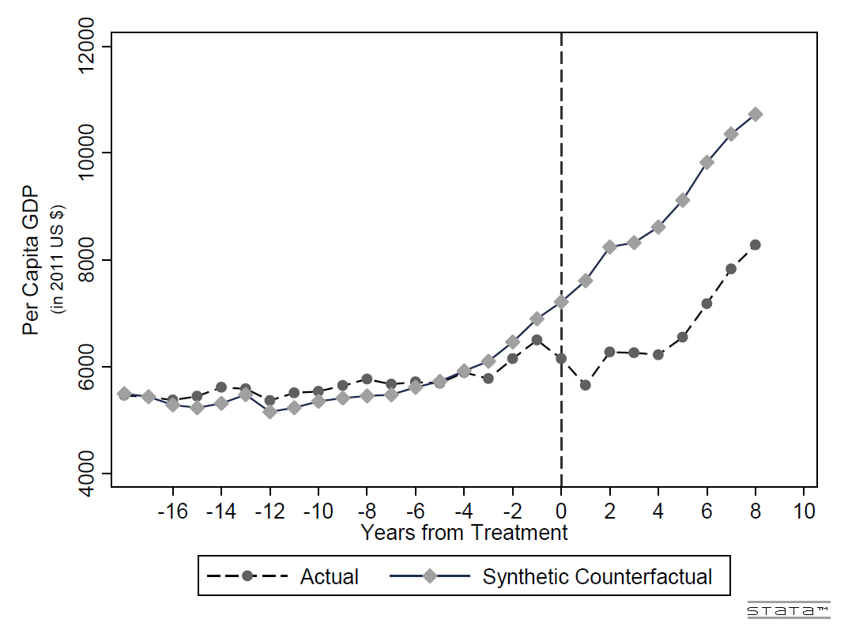

Figure 3. Left-Populist Regimes’ Effect upon Income with Probability Values
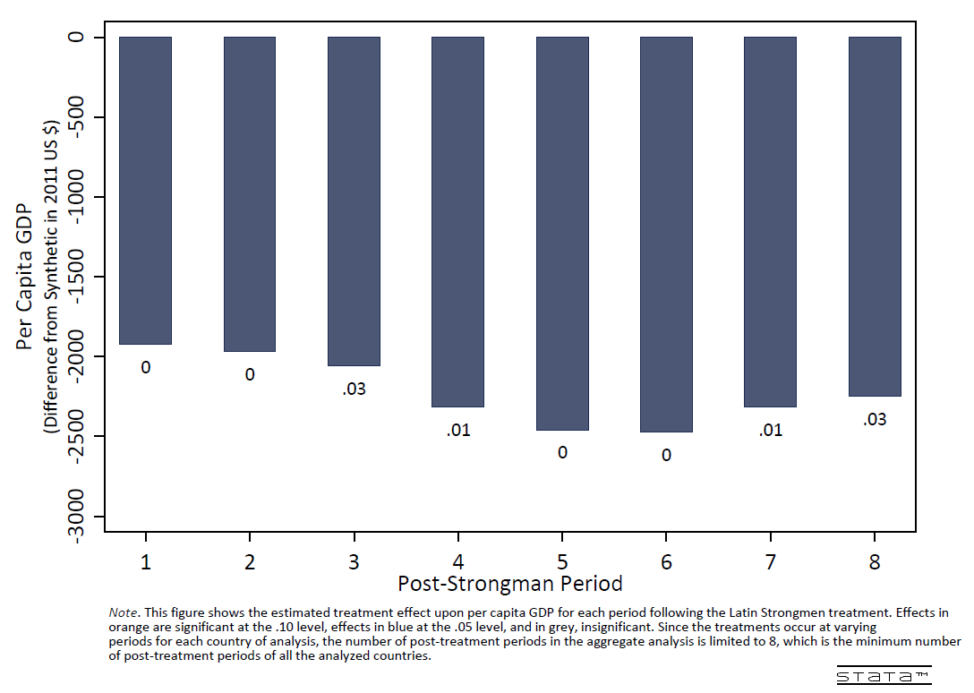

Figure 4. Left-Populism Regimes’ Effect upon Infant Mortality
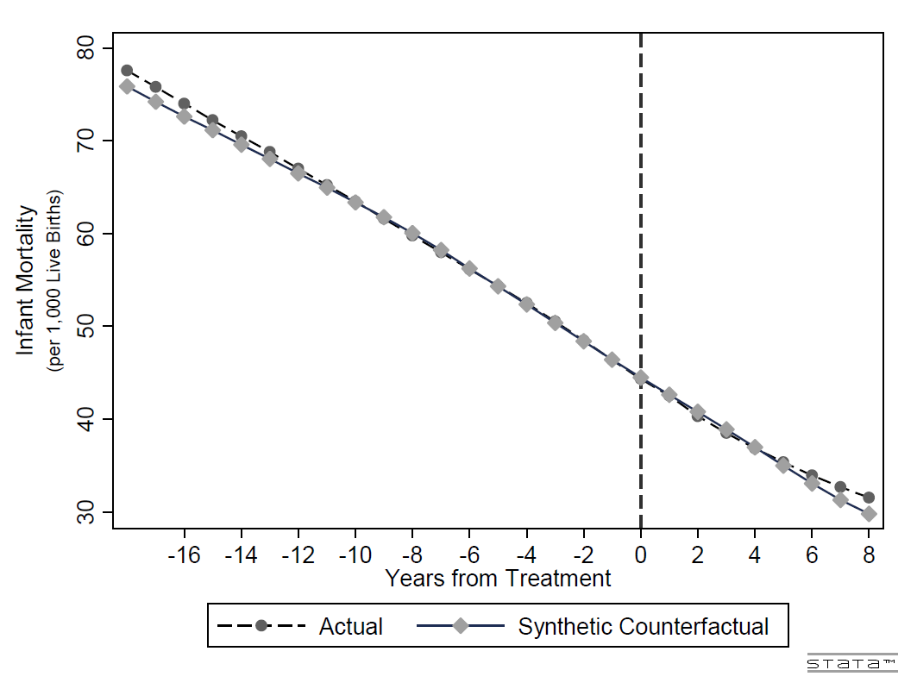

Figure 5. Left-Populist Regimes’ Effect upon Inequality with Probability Values
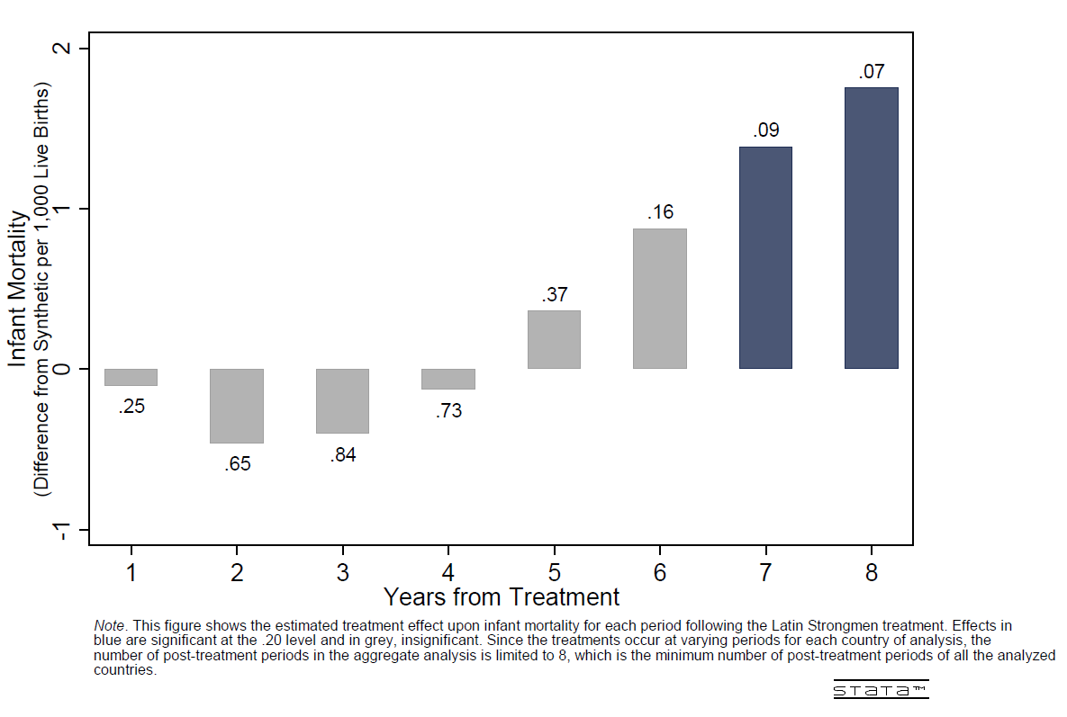

Figure 6. Left-Populist Regimes’ Effect upon Inequality
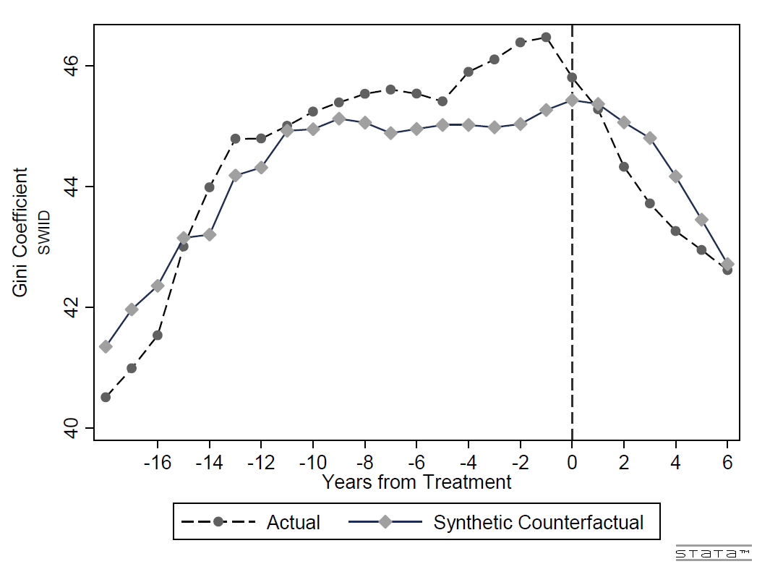

Figure 7. Left Populist Regimes’ Effect upon Inequality with Probability Values
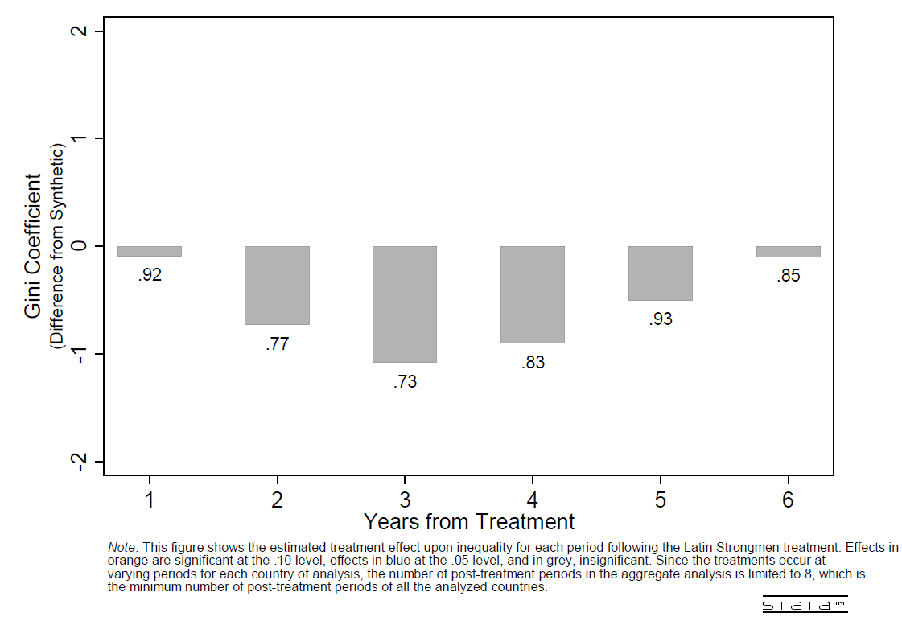

Figure 8. Nicaragua Per Capita GDP
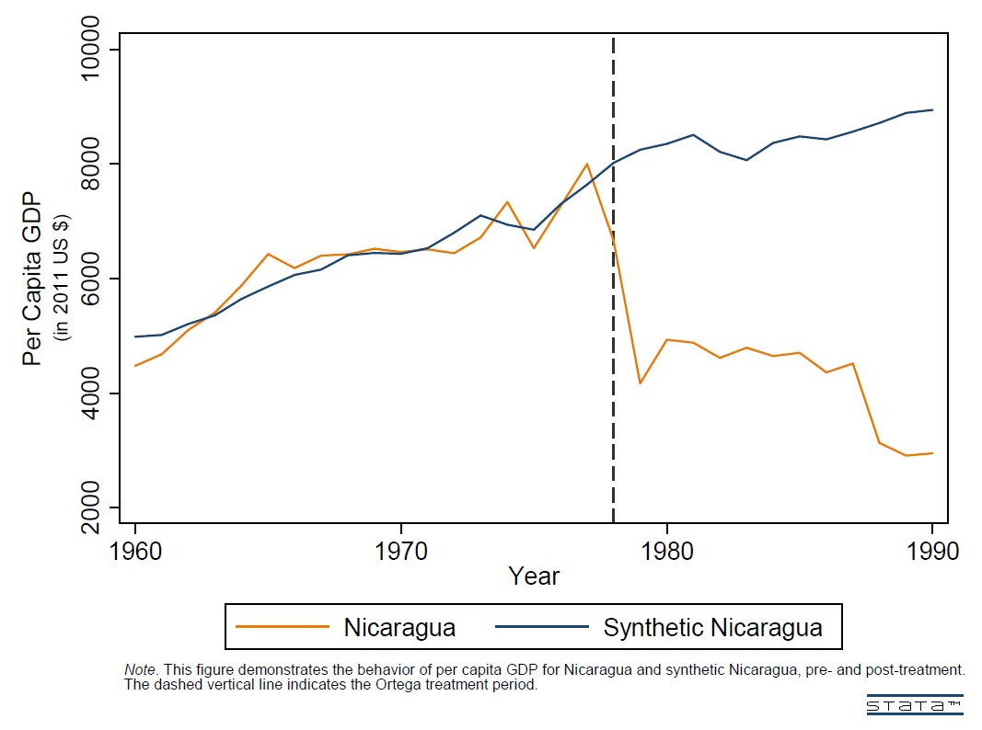

Figure 9. Daniel Ortega’s Effect on Nicaraguan Income
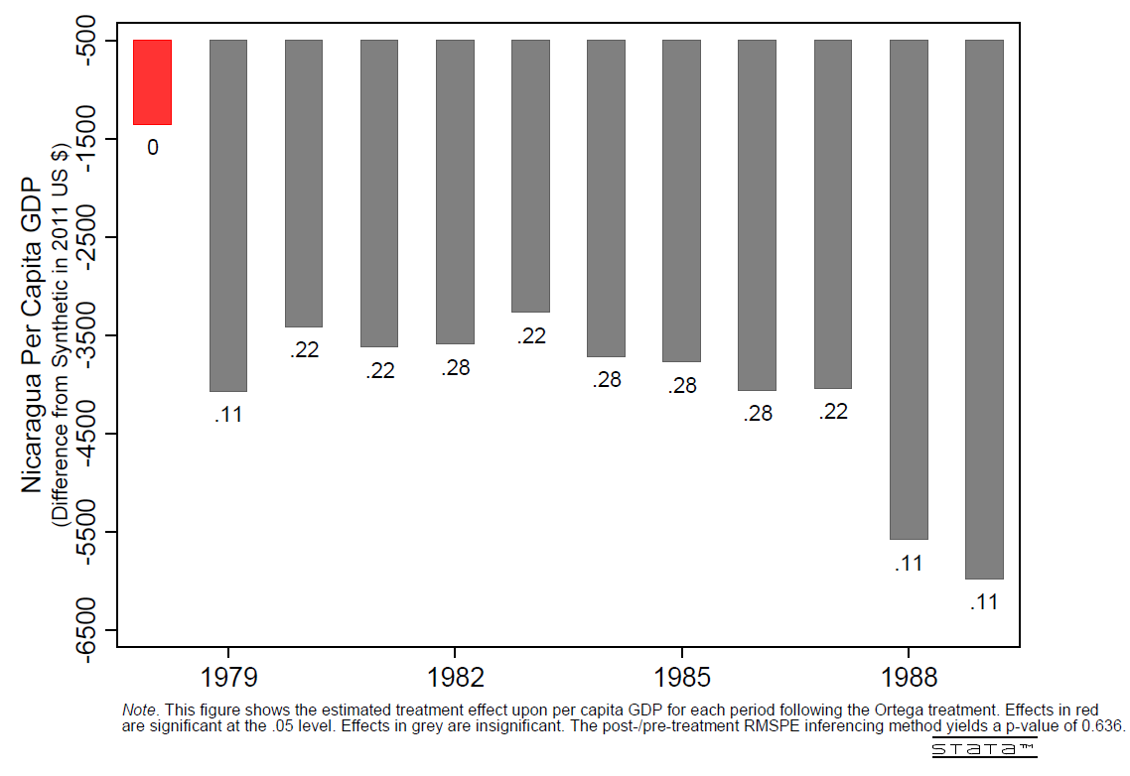

Figure 10. Nicaragua Infant Mortality
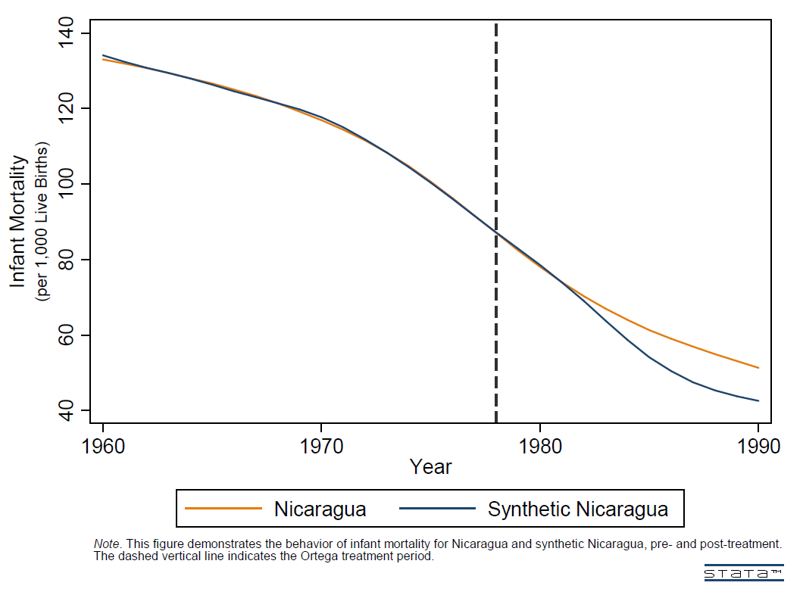

Figure 11. Daniel Ortega’s Effect on Nicaraguan Infant Morality
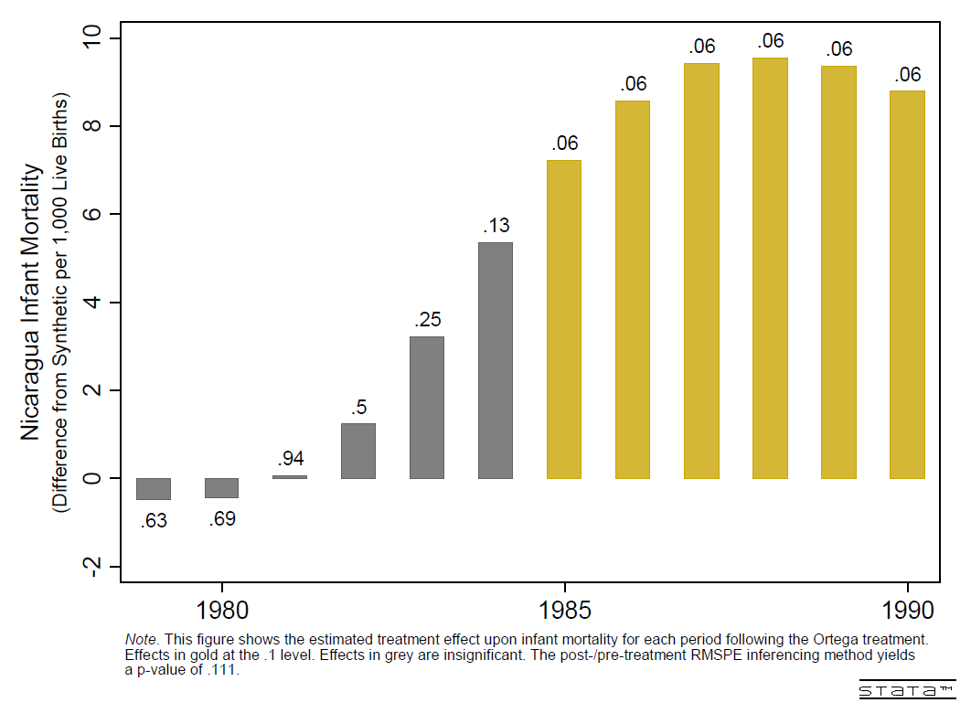

Figure 12. Venezuela Per Capita GDP
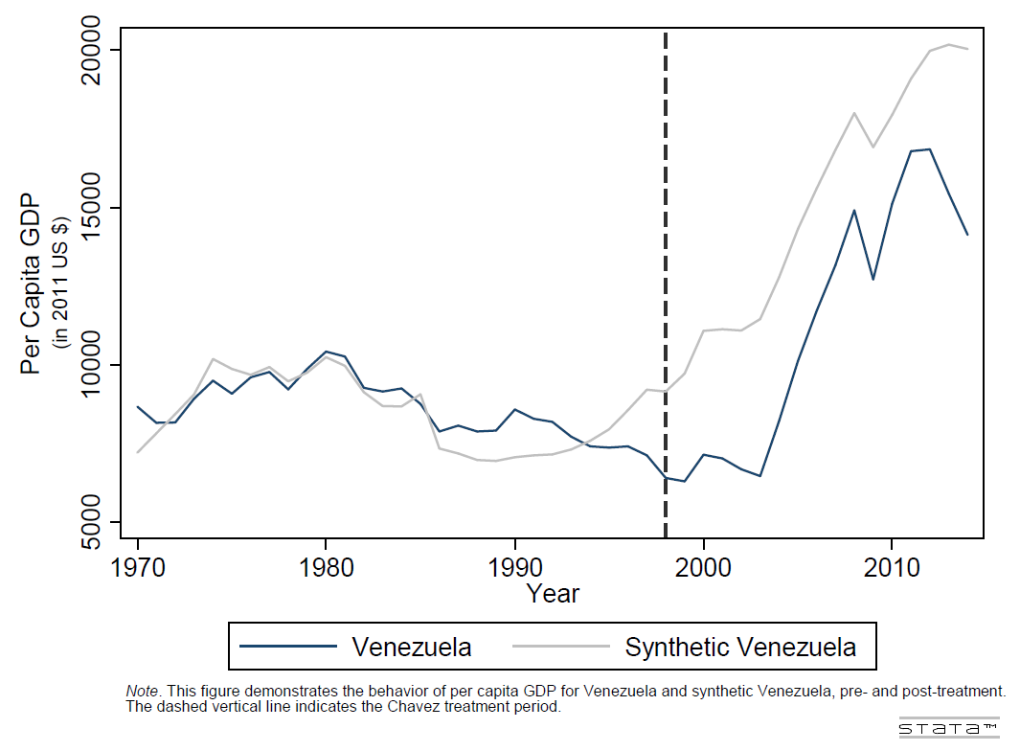

Figure 13. Hugo Chavez’s Effect on Venezuela Income
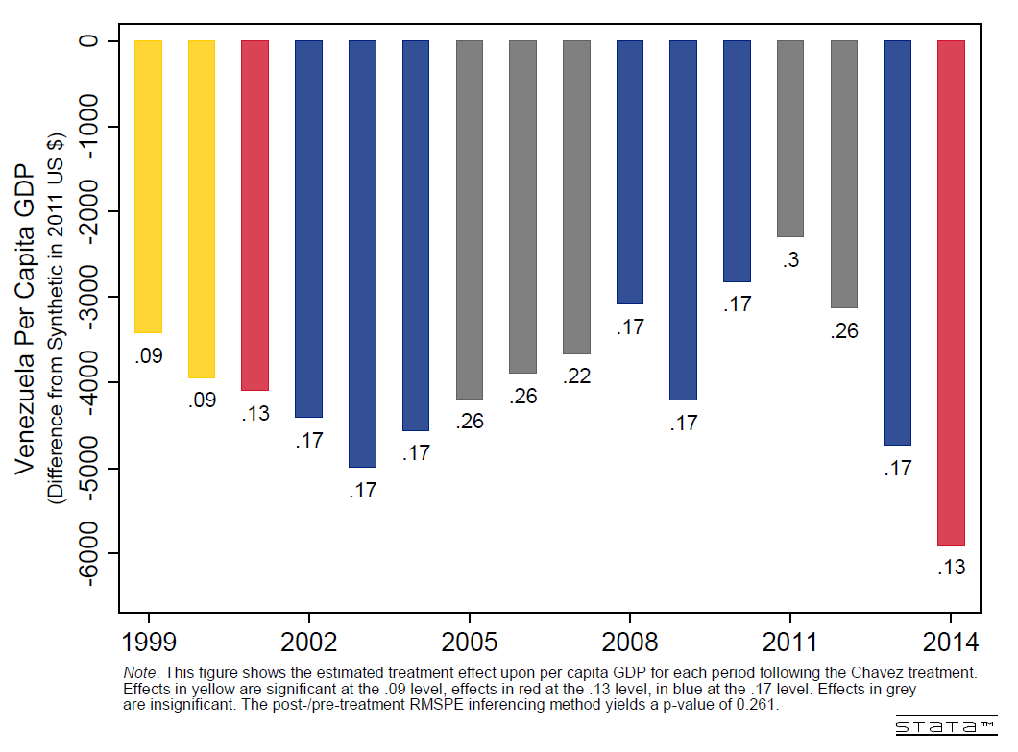

Figure 14. Venezuela Infant Mortality
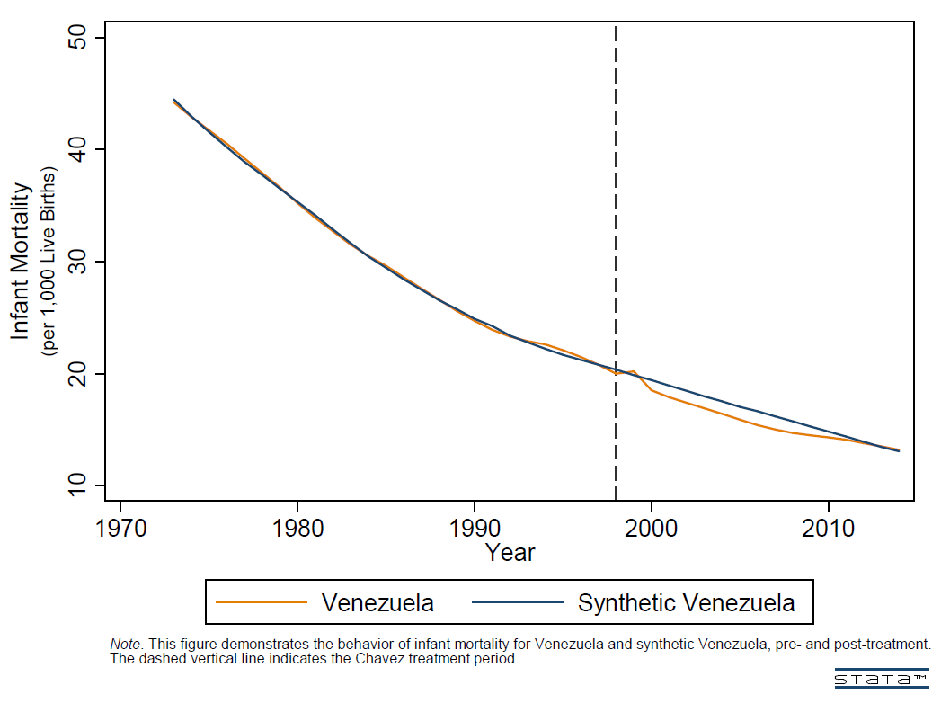

Figure 15. Hugo Chavez’s Effect on Venezuelan Infant Mortality
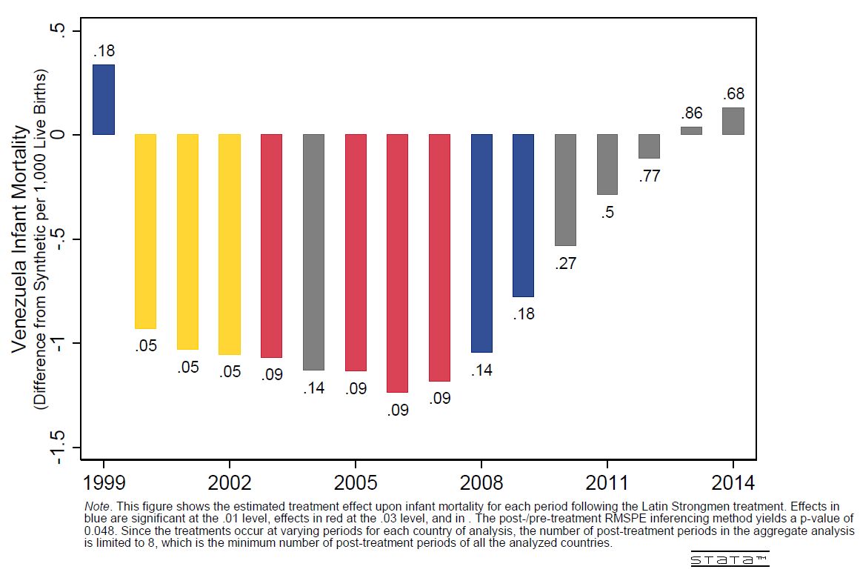

Figure 16. Venezuela Gini Index
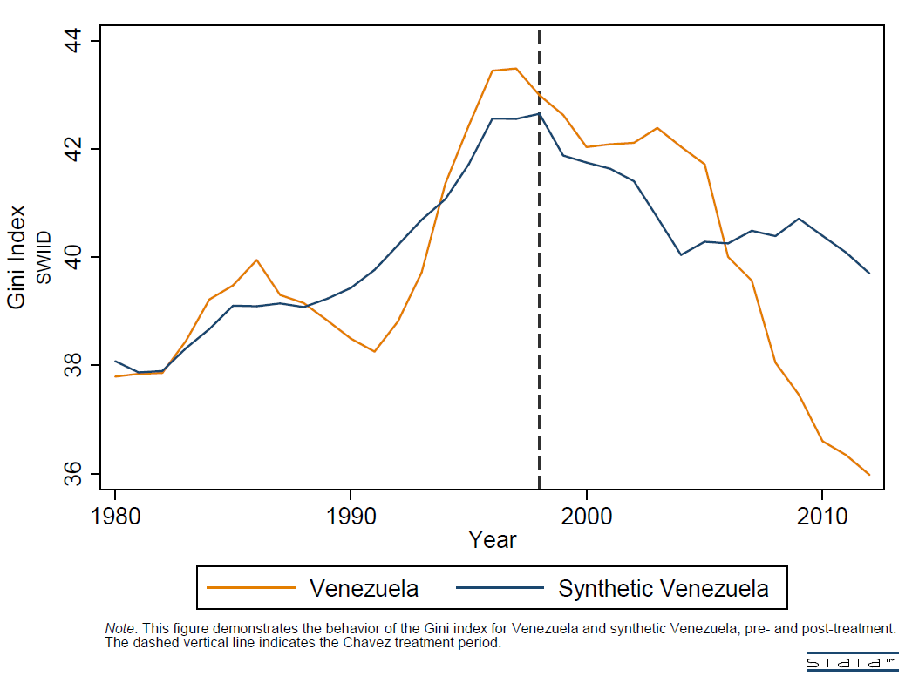

Figure 17. Hugo Chavez’s Effect on Venezuelan Gini Index
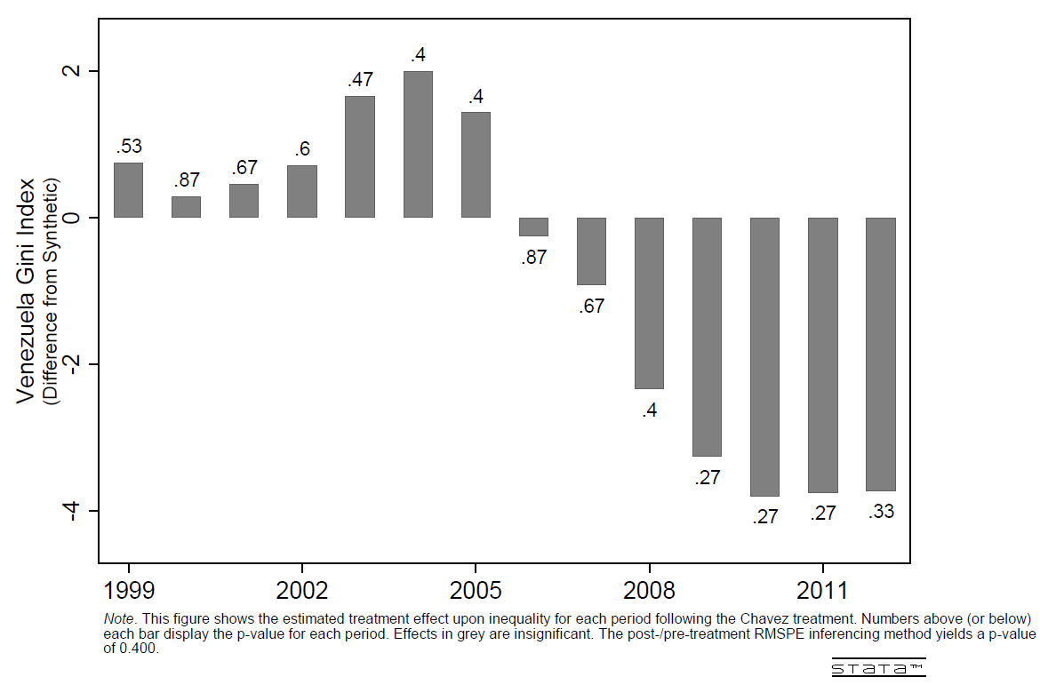

Figure 18. Bolivia Per Capita GDP
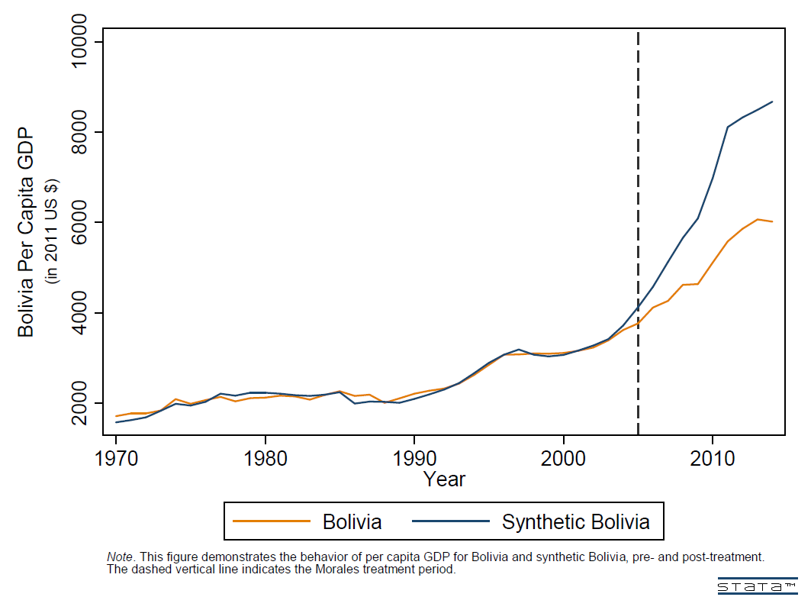

Figure 19. Evo Morales’ Effect on Bolivian Income
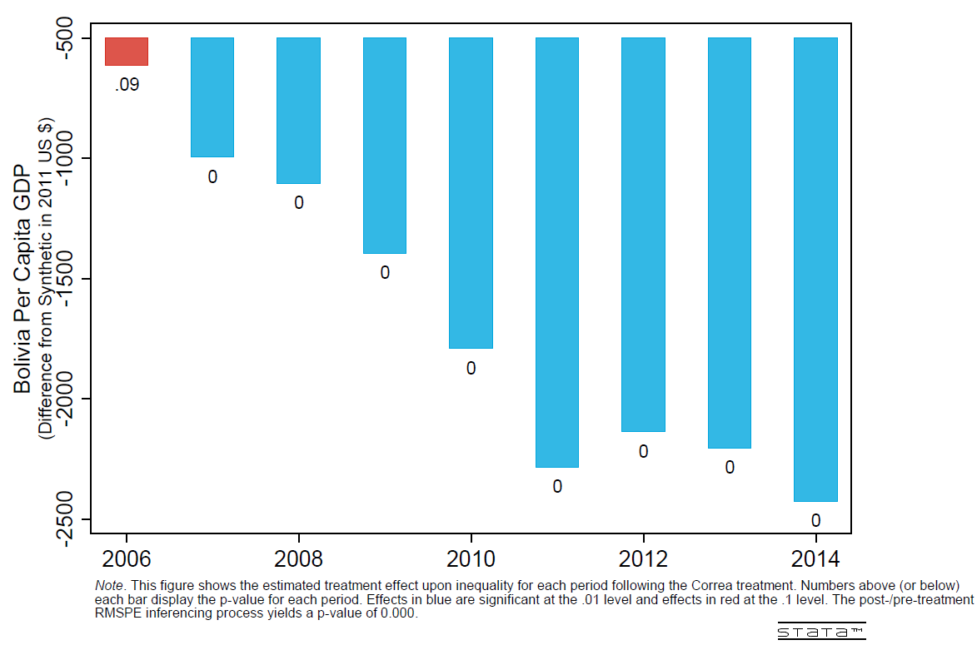

Figure 20. Bolivia Infant Mortality
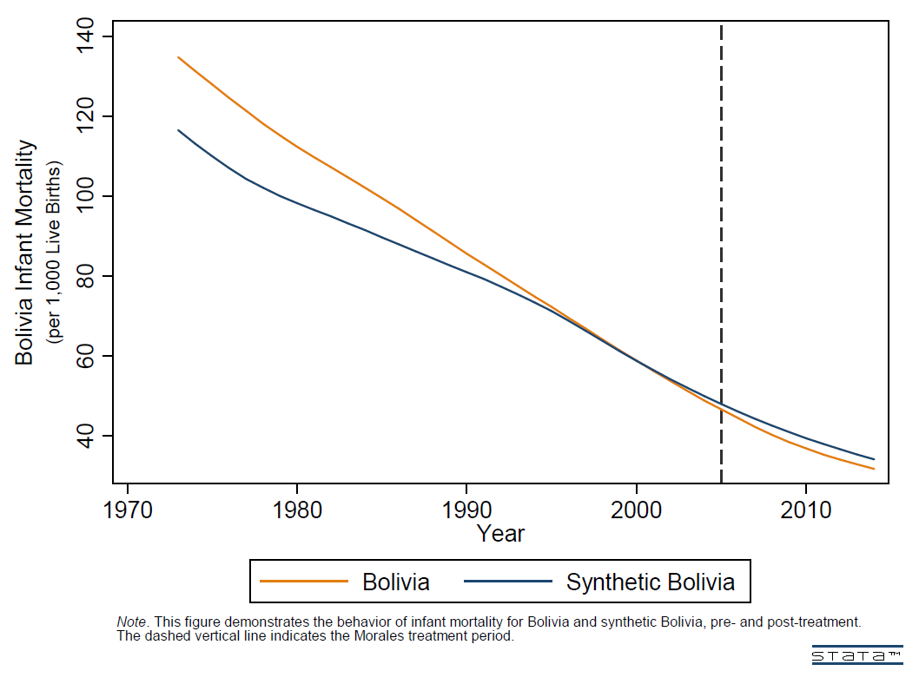

Figure 21. Evo Morales’ Effect on Bolivian Infant Mortality
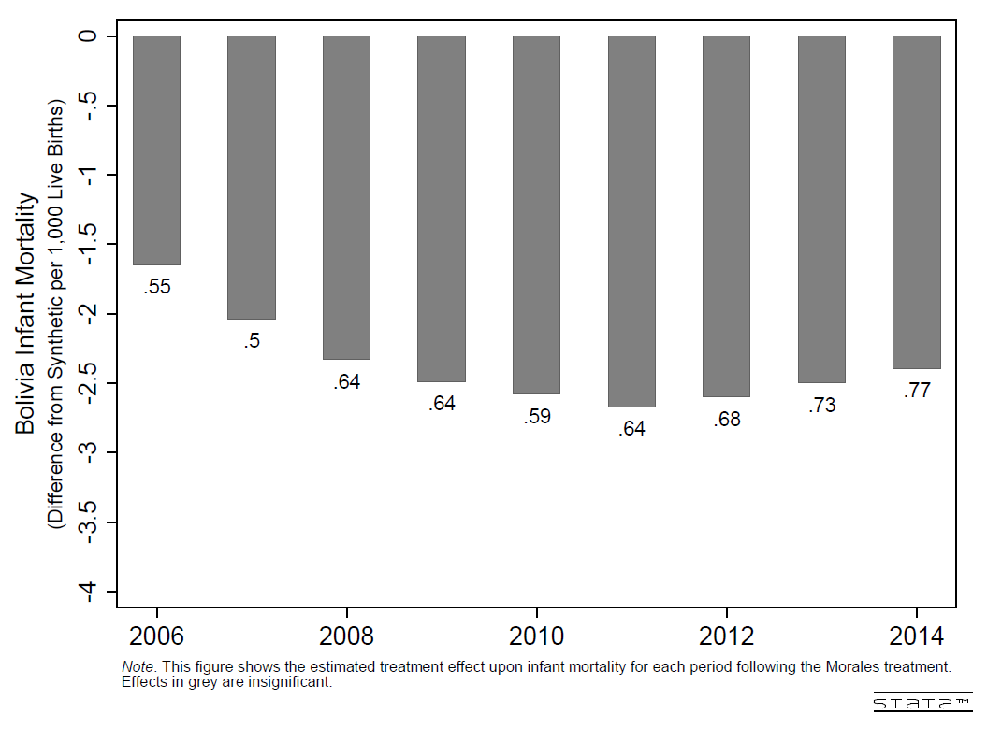

Figure 22. Ecuador Per Capita GDP
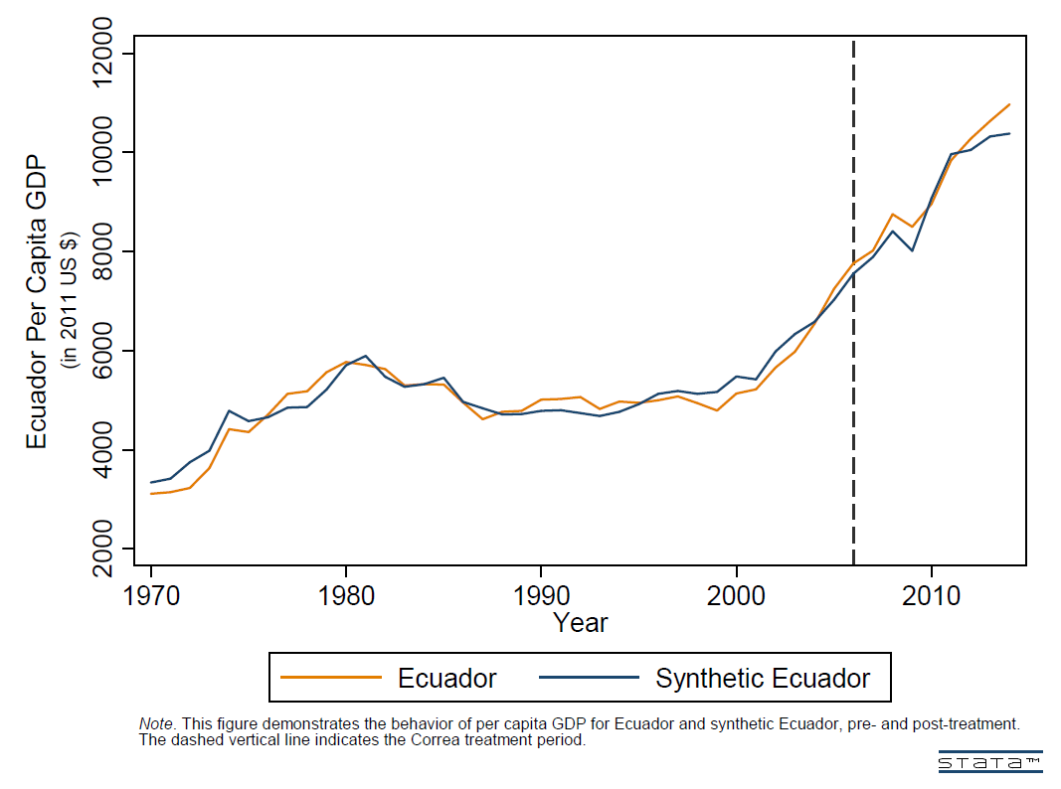

Figure 23. Rafael Correa’s Effect on Ecuadorian
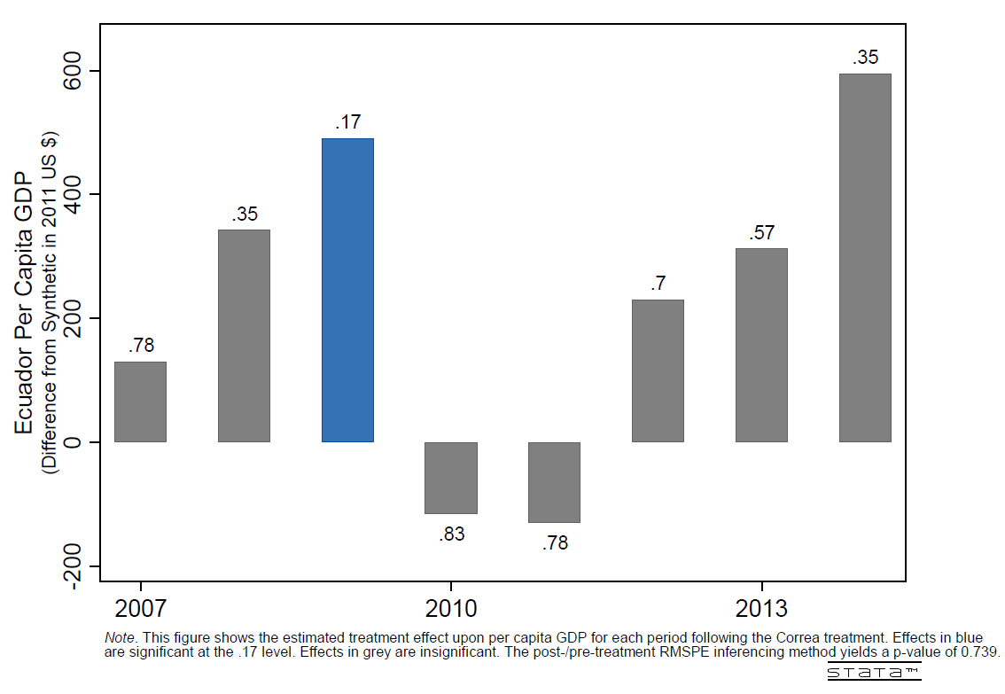

Figure 24. Ecuadorian Infant Mortality
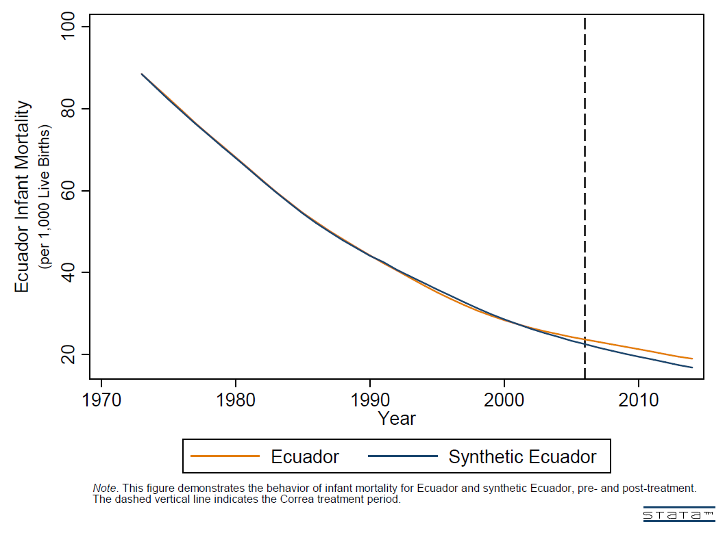

Figure 25. Rafael Correa’s Effect on Ecuadorian Infant Mortality
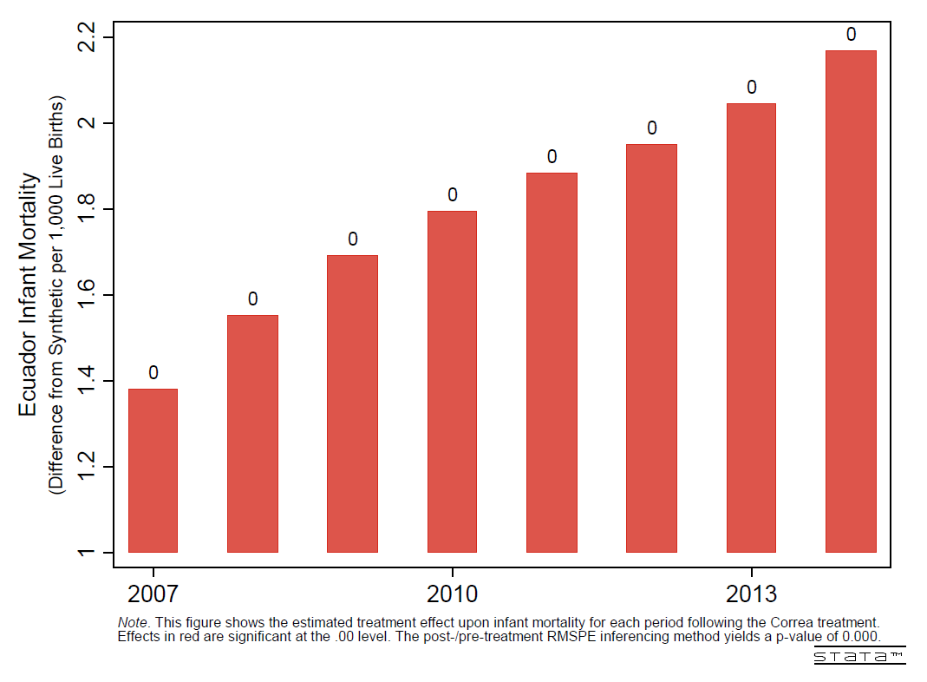

Figure 26. Ecuador Gini Index
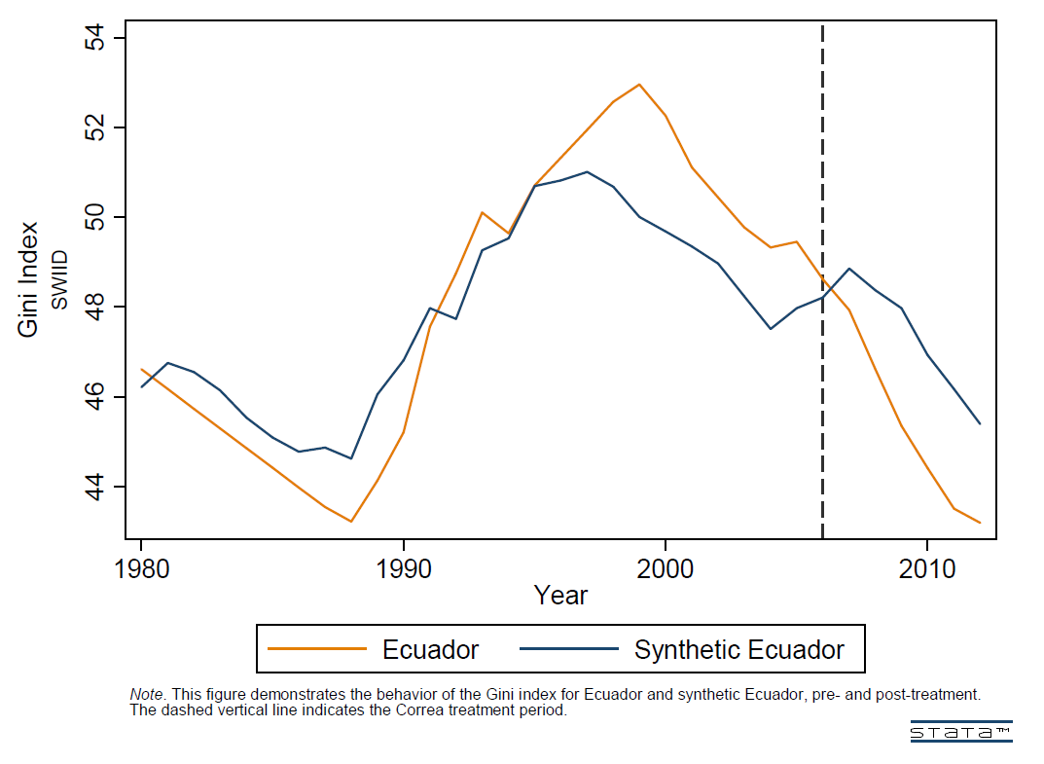

Figure 27. Rafael Correa’s Effect on Ecuadorian Gini Index
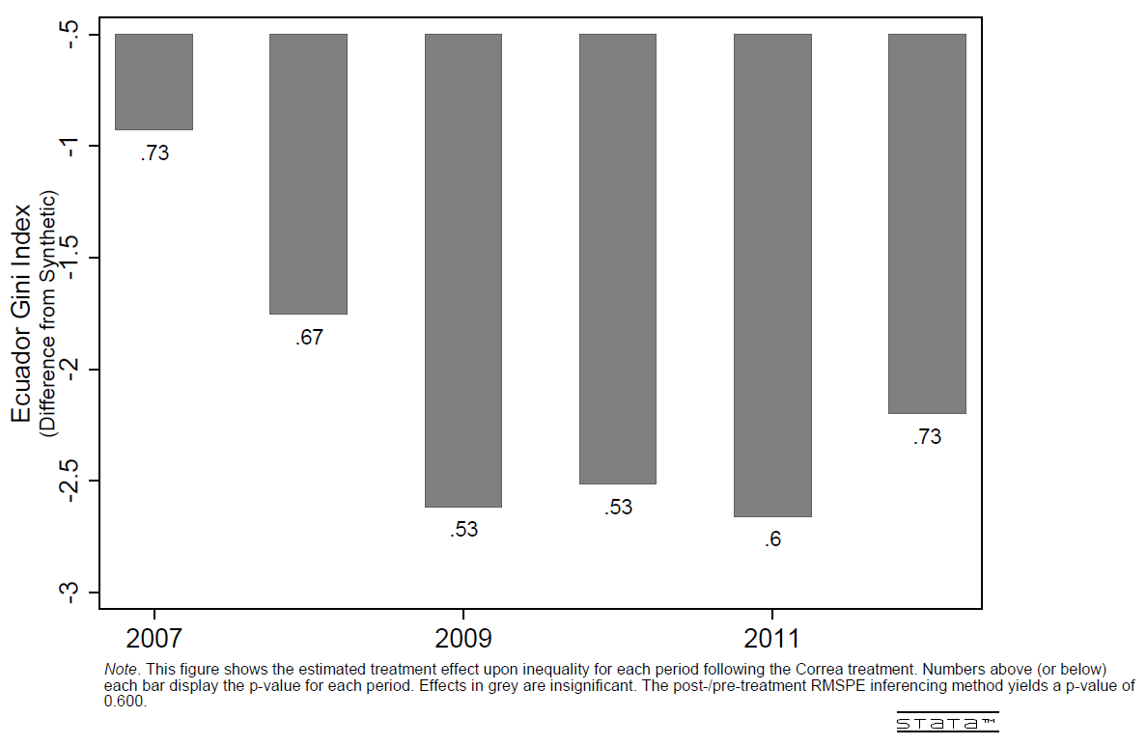

References
Abadie, A., Diamond, A., Hainmueller, J., 2010. Synthetic control methods for comparative case studies: Estimating the effect of California’s tobacco control program. Journal of the American Statistical Association 105 (490), 493–505.

Abadie, A., Diamond, A., Hainmueller, J., 2015. Comparative Politics and the synthetic control method. American Journal of Political Science 59 (2), 495-510.

Abadie, A., Gardeazabal, J., 2003. The economic costs of conflict: A case study of the Basque Country. American Economic Review 93 (1), 113–132.

Billmeier, A., Nannicini, T., 2013. Assessing economic liberalization episodes: A synthetic control approach. Review of Economics and Statistics 95 (3), 983–1001.

Cavallo, E., Galiani, S., Noy, l., Pantano, J., 2013. Catastrophic natural disasters and economic growth. Review of Economics and Statistics 95 (5), 1549–1561.

Conaghan, Catherine and Carlos De La Torre, 2008, “The Permanent Campaign of Rafael Correa: Making Ecuador's Plebiscitary Presidency,” Press/Politics 13 (3): 267–284.

Conaghan, Catherine, 2008, “Ecuador: Correa’s Plebiscitary Presidency,” Journal of Democracy 19(2), 46-60.

Conaghan, Catherine, 2016, “Delegative Democracy Revisited: Ecuador Under Correa,” Journal of Democracy 27(3): 109-118.

Conaghan, Catherine, “Ecuador: Rafael Correa and the Citizen’s Revolution,” in Steven Levitsky and Kenneth Roberts (eds.) The Resurgence of the Latin American Left (Baltimore: Johns Hopkins University Press, 2011), 277.

De la Torre, Carlos, 2013, “Latin America’s Authoritarian Drift: Technocratic Populism in Ecuador,” Journal of Democracy 24(3): 33-46.

Eaton, Kent, 2014, “Recentralization and the Left Turn in Latin America: Diverging Outcomes in Bolivia, Ecuador, and Venezuela,” Comparative Political Studies, Vol. 47(8) 1130–1157.

Ellner, Steve , 2012, “The Distinguishing Features of Latin America’s New Left in Power: The Chávez, Morales, and Correa Governments, “ Latin American Perspectives 182, 39(1): 96-114.

Economist, 2007, “Friends, not clones,” June 7th.

--2009, “Bolivia’s presidential election: The explosive apex of Evo’s power,” December 10th.

--2010, “Hugo Chávez's Venezuela: A coup against the constitution,” December 28th.
--2011a, “The calle gets restive,” March 3rd.

--2011b, “Nicaragua’s presidential election: The survivor,” November 5th.

--2014, “Changing constitutions: all shall have rights,” March 15th.

--2016a, “Fourth time unlucky,” October 29th.

--2016b, “From comrade to caudillo,” September 15th.

Grier, Kevin and Norman Maynard, “The economic consequences of Hugo Chávez: A synthetic control analysis,” Journal of Economic Behavior & Organization, vol. 125 (May): 1-21.

Guardian, 2016, “Bolivia's president Evo Morales to run again despite referendum ruling it out,” December 17th.

Hayes, Benedict, 2011, “Evo Morales is the loser in Bolivia's judicial vote,” Guardian, October 18th.

Human Rights Watch, 2004, “Venezuela: Chávez Allies Pack Supreme Court,” December 13th.

Kennemore, Amy and Gregory Weeks, 2011, “Twenty-First century socialism? The elusive search for a post-neoliberal development model in Bolivia and Ecuador,” Bulletin of Latin American Research 30(3): 267-281.

Library of Congress, Nicaragua Country Studies, “The Sandinista Years: 1979-1990.” http://countrystudies.us/nicaragua/15.htm

Library of Congress, Nicaragua Country Studies, “Nationalization and the Private Sector.”
http://countrystudies.us/nicaragua/34.htm

Marshall, Monty G., Ted Robert Gurr, and Keith Jaggers. 2014, Polity IV Project. Center for Systemic Peace. Available at www.systemicpeace.org

Martín, Sabrina, 2017, “Bolivia’s Morales Dismisses Separation of Powers as ‘Imperialist’ Tool amid Reelection Push, Panam Post, September 20th.

Martí i Puig, Salvador, 2010, “The adaptation of the FSLN: Daniel Ortega's leadership and democracy in Nicaragua,” Latin American Politics and Society 52.4 (2010): 79-106. (tr: Claire Wright).

Martí i Puig, Salvador, 2016, “Nicaragua: Desdemocratización y caudillismo,” Revista de Ciencia Política, 36(1): 239 – 258.

Martí i Puig, Salvador and Eduardo Baumeister, 2017, “Agrarian policies in Nicaragua: From revolution to the revival of agro‐exports, 1979–2015,” Journal of Agrarian Change 17(2), 381-396.

Nelson, B.A., 2009, The silence and the scorpion: the coup against Chávez and the making of modern Venezuela. Nation Books.

Ramirez, Alfredo, 2017, “The Death of Democracy in Venezuela: The Road to Today Pt. II,” Huffington Post, March 22nd.

Rohter, Larry, 1999, “Voters Push Power Toward Venezuela Leader,” The New York Times, July 26.

Thale, Geoff, 2016, “As Nicaragua’s Election Draws Near, Concerns Grow Over Abuse of Power,” WOLA, October 20th.

Treminio Sánchez, Ilka, 2015, “Las reformas a la reelección presidencial del nuevo siglo en América Central. Tres intentos de reforma y un golpe de estado,” Política y Gobierno 22 (1): 147-173.

Wikileaks, 2009, “Bolivia: Evo warns he will rule by decree,” January 13th.

Chapter 3. The Persistent Effects of Military Violence Against Civilians: A Geographic Regression Discontinuity Analysis of the Soviet Occupation of East Germany in WW2

3.1 Introduction
Recently, a literature has begun to explore the role of historical institutions and events upon modern day outcomes, demonstrating a persistent effect that endures long after the “treatment” has ended (Dell (2010), Nunn (2008), Acemoglu, Johnson, & Robinson (2001), Becker et al. (2014)). Most papers in this literature test the effects of exposure that lasts years, decades, or even centuries and so it is perhaps unsurprising that such lengthy exposure creates effects that linger long after the exposure ends. Although this article resembles the existing literature in that it explores how effects can persists over time, it is unique in that the treatment takes place over a relative brief treatment period: the Soviet military invasion and occupation of East Germany during and following the closing weeks of World War 2. The eventual “line of contact” between Soviet and American troops transpired within the future Soviet sphere of influence (the future German Democratic Republic (GDR)), thus preserving a portion of the future-GDR from the brunt, though not all, of Soviet war crimes. The territory was eventually relinquished in full to the Soviet Union, but only after Soviet leadership began implementing punishments for the rape and assault of Germany’s citizenry. I exploit this within-GDR discontinuity to test whether the gross mistreatment of the German people “inoculated” them to the ideals of communism, as Bischof’s quote claims above. Using a geographic regression discontinuity (RD), I estimate that the violent Soviet invasion and occupation reduced support for the modern German communist party, Die Linke, by as much as 3.8%.
This paper’s topic, although analyzing an event in an historical context, holds practical lessons for modern times. Aside from gaining a clearer understanding of the determinants of political preferences, the findings also instruct policymakers on the consequences of a poorly-disciplined, unregulated military invasion and/or occupation that creates “excessive” violence; the paper demonstrates that such victimization of the civilian populace can instill resentment, not only against the military, but the politics and system of government tied to the identity of the aggressor.
Violence against civilians became a pervasive theme throughout World War 2. However, the magnitude of Russian crimes greatly exceeded that of the western Allies within the European theater. Historians estimate that the Soviet troops raped approximately 2,000,000 German women throughout the course of their invasion and occupation. This figure excludes other crimes, like assault, murder, and theft, which would also influence anti-Soviet sentiments among the victims. I argue that the humiliation and victimization of German citizens at the hands of the Soviet troops imparted a lasting distaste for the ideals of communism, which were closely tied the perception of the Soviet state and military.
Because the “line of contact” between Soviet and American troops developed within the future-GDR and is a discontinuity, I implement a geographic RD framework to identify the effect. I follow Dell (2010) and Becker et al. (2014) and use both single-dimension and two-dimension forcing variables when constructing the econometric model. To test the effect upon political preference today, I use European Election Database (EED) and compare the vote share of the modern communist party (Die Linke in 2005) across the discontinuity within former-GDR. The data’s structure differs significantly from earlier geographic RD research. Since the voting data is recorded at the regional- rather than individual-level and contains relatively few observations, I present the parametric regressions as the primary results.
The paper proceeds as follows: section 2 gives an account of the historical background, focusing on two phenomenon: (1) the development of the “line of contact” between American and Soviet troops, in order to demonstrate the qualitative evidence for its exogeneity and (2) the Soviet invasion, occupation, and governance within East Germany, specifically the rape, assault, and murder of the populace, in order to establish the plausibility of the theoretical connection between historical victimization and modern-day voting preferences. Section 3 describes the data. Section 4 explains the methodology and empirical models used to identify the effect. Section 5 presents the results, while section 6 lists planned improvements to the methodology and data. Finally, section 6 concludes.

3.2 Historical Background
3.2.1 Line of contact
Although this paper estimates the effect of Soviet occupation upon the victims’ attitudes toward communism and Soviet rule, the line of contact within East Germany was largely dictated by western Allied military policy. From the east, Stalin, suspicious of American intentions, ordered the capture of as much East German territory as possible. This is evidenced by the “race to Berlin”, where Stalin pitted his general against one another to capture Berlin first. The competition and ensuing strategy inflicted tens of thousands of unnecessary casualties upon the Soviets as the two armies pushed recklessly into Axis defenses outside the Nazi capital.
The western Allied strategy was far more reserved. Some political and military parties within the American and British camps, notable Churchill, Field Marshal Montgomery, and Gen. Patton, advocated for the capture of Berlin, as late as March 1945, two months before the war’s end. However, the Yalta Conference, held in February 1945, had determined the future regions of Allied influence within a post-war Germany, which deterred arguments to seize Soviet zone territory; under Yalta it would be handed over to the Soviets after the war. American military leadership thus deemed an attempt to capture Berlin too costly, with casualty estimates exceeded 100,000. Instead, Eisenhower pursued a more cooperative course of action. Rather than attempting to seize Berlin before the Soviets, Eisenhower ordered American and British troops to surround and destroy the Ruhr, a region in central Germany with significant industrial capacity and military value. Simultaneously, American troops in south Germany were to push eastward to halt any potential Nazi retreat into the Alps, where rumors claimed Hitler had constructed a secret redoubt. These tactics impacted the eventual “line of contact” between the American, British, and Soviet troops. As the reader can see in Figure 1, most of the within-GDR control region lies in the southern region.

3.2.2 Soviet War Crimes
“Destroy the Hiterlites in their Den” and other anti-German propaganda spread among Soviet troops in late 1944, meant to motivate a beleaguered force to seize Berlin before their Western counterparts. Historians speculate that these sentiments would further exacerbate established trends of violence against civilians on the Eastern front. Even before the invasion of Germany proper, reports of rape, assault, theft, and murder reached Stalin from communist party members abroad (from Yugoslavia, Czechoslovakia, and Hungary), where the Red Army “liberated” territory from Nazi control. The complaints, however, would fall on unsympathetic ears. “Can’t he [Djilas, communist party leader from Yugoslavia] understand it if a soldier who has crossed thousands of kilometers through blood and fire and death has fun with a woman or takes some trifle?” (Naimark, pg. 71). Such indifference from Soviet leadership became a constant theme in the late stages of the war.
But the atrocities committed along the road to Berlin would pale in comparison to the violence the Germans soon suffered at the hands of the Russian military. Upon the Red Army’s initial push into East Prussia, reports grew even more grim, “It was not untypical for Soviet troops to rape every female over the age of twelve or thirteen in a village, killing many in the process…” (pg. 73). One might suspect that such intense violence might subside once the front moved further westward, toward Berlin, but the mistreatment of German women persisted even while the invasion became an occupation. The crime remained so ubiquitous and heinous that many women committed suicide to escape the brutality (Naimark, pg. 74). Throughout this period, historians estimated that the Red Army raped over 2,000,000 German women.
Soviet leadership only began to grasp (or perhaps fear) the repercussions of such behavior towards the end of the war, when victory was both certain and imminent. But policies to curb the mass rape and murder of the German populace were not implemented until late summer of 1945, when “soldiers caught in the act of rape were generally punished though the harshness of the punishment varied.” (Naimark, pg. 92). This timeline coincides with the American concession of the Soviet zone territory to Red Army, in exchange for entrance into Berlin, which was also divided into spheres of influence. Germans in the previously American-held zone seem to have been spared from most, though certainly not all, of the Soviet brutalities during the invasion and early occupation.

3.3 Data
Since I use a geographic regression discontinuity (RD) framework to measure the effect of military violence upon the political views of the occupied, I must determine, with accuracy, where the Soviet advances halted within East Germany. To do so, I georeference and digitize maps of Allied troop location, originally drafted by the US 12th Army during WW2. The daily maps give precise indication of all Allied armies in Europe from D-Day until July 16th, 1945, two weeks after the US troops yield GDR territory to the Soviets. Using ArcMap, I trace the line of contact between the western Allies and the Russian military, which marks the discontinuity in the geographic RD framework. I use the line of contact spatial data to calculate values of the forcing variable (latitude & longitude, distance to line of contact) in the electoral data.
To test for an effect on intergenerational or persistent political beliefs, I compare the vote share of the communist party between ex-Soviet occupied regions and ex-Western occupied regions. The European Election database stores the voting outcomes of European countries, across all national and European parliamentary elections. It breaks results down to the finest level of the Classification of Territorial Units for Statistics (NUTS) system, which are called the NUTS-3 regions. It also offers geographical identification at the NUTS-3 level in most post-2003 elections. Germany held two national parliamentary elections after the NUTS classification scheme began, in 2005 and 2009. Unfortunately, the EED’s 2009 electoral data does not contain a NUTS-3 identifier, so I exclude it from this analysis. The results of the 2017 election are not available in any form to date. EED also offers data over the 2002 election, but as this predates the NUTS classification system, I lack the necessary shapefile to calculate the spatial data necessary for the geographic RD framework.
I define the communist party as the “legal successor” to the Socialist Unity Party of Germany (SED), which ruled East Germany as a one-party system under Soviet influence (Weitz, 1997). The SED became the Party of Democratic Socialism (PDS) after reunification, and eventually rebranded as Die Linke just before the 2005 election. I use the 2005 German parliamentary election data to test whether non-Soviet invaded regions demonstrate higher Die Linke voting shares relative to Soviet occupied territories.

3.4 Empirical Strategy
Since the Soviet advance stopped discontinuously within east Germany, it is possible to estimate the occupation’s effect using a geographic regression discontinuity (RD) strategy. Notable papers to implement this strategy include Dell (2010) and Becker (2014). Unlike Becker (2014) which has access to precise household-level location, this article, although similarly using individual-level data, has only geographic identification at the NUTS3 administrative level. This poses difficulty in the geographic RD framework.
The ideal regression discontinuity framework utilizes data that contains precise measurements along the forcing variable, which, in this two-dimensional case, would be latitude and longitude. It is also preferred that there are “many” observations found on either side of the treatment assignment discontinuity. If these conditions are met, the researcher can implement a local linear, nonparametric regression discontinuity strategy. This approach has the advantages of imposing few assumptions on the functional form of the data and minimizes potential bias introduced by expanding the bandwidth of data used to estimate the model parameters.
Despite the European Election Data not fitting these criteria, there are methods to hurdle the problems posed by data shortcomings. Like Dell (2010), it is possible to identify a discontinuity through use of parametric or semi-parametric regressions that impose some functional form and include larger data bandwidths. However, when this approach is taken, the researcher should use a variety of models, to ensure that any significant results are not merely the product of an ill-fitting polynomial. More specifically, within the geographic RD framework, it is also beneficial to use both multidimensional and single-dimension forcing variables. In this context, multidimensional refers to both latitude and longitude as these variables determine location and thus the treatment of each observation. A single dimension approach, which most resembles the traditional RD framework, utilizes only a “distance from discontinuity” variable.
With that in mind, all specifications use the following general econometric model to identify a discontinuity:
$$y_{ik}=α+β{SovietOccupation}_{k}+f\left({RD_{Polynomial}}_{k}\right)+{GDR}_{k}+ϵ_{ik}$$
where $y_{ik}$ is the outcome variable of interest for observation $i$ in the administrative region, NUTS-3 region, $k$. ${SovietOccupation}_{k}$ is an indicator for whether the centroid of the NUTS-3 region lies within the initial Soviet occupation zone between May and July 1945. $f\left({RD_{Polynomial}}_{k}\right)$ is a polynomial of varying degrees that imitates the functional form of the voting behavior along the forcing variables, either latitude and longitude or distance to the line of contact. Finally, ${GDR}_{k}$ indicates whether a NUTS-3 region falls within former East Germany. Since this is a significant determinant of a region’s opinion toward the Communist politics, I control for this variable in all models.
The above specification assumes that the RD polynomial follows a specific form across the entire span of the data and that any treatment effect can be detected through a “jump” in the dependent variable at the threshold. To implement a more flexible approach, I also use models that allow for the functional form of the polynomial to change discreetly across the “line of contact”. In this approach, the lines fit to either the American (control) or Soviet (treatment) regions may have different slopes and intercepts, whereas the previous model only allows for differing intercepts. The terms, which supplement, not replace, the above model are interactions: $λ({SovietOccupation}_{k}*f\left({{RD}_{Polynomial}}_{k}\right))$ and $μ(GDR*f\left({{RD}_{Polynomial}}_{k}\right))$. Thus, the term adapts to the dimensionality and polynomial degree in each model.
In addition to the parametric approaches, I also limit the data to various bandwidths around the line of contact and estimate the model using a semi-parametric framework. This technique limits bias at the cost of increased variance since it reduces the sample to more similar NUTS-3 across the discontinuity. Since the electoral data contains “few” observations, semi-parametric approach is not necessarily ideal for this analysis, but I estimate the coefficients of several such models as a robustness test for the main data specification.
For the geographic RD framework to identify the causal effect of the Soviet occupation several conditions must be met. First, there must be no pre-existing discontinuities along the line of contact between American and Soviet troops at the war’s end. I reject this possibility through historical analysis of the “line of contact’s” development during the closing weeks of WW2.
Given the determinants of the military strategy within Germany, both from the Americans and the Soviets, there is substantial qualitative evidence that the “line of contact” between the two developed exogenously regarding the econometric model I implement. Towards the war’s end, Eisenhower focused on cutting off a possible retreat from Nazis in Berlin to the rumored Alps redoubt. Time ultimately revealed that fear to be baseless as Hitler never ordered the construction of such a bunker, but it encouraged the western Allies to push far into the future Soviet zone, particularly in the south. These determinants seem far removed from those that affect the political attitudes of the occupied inhabitants. There are no qualitative reasons why determinants of communist support (or relevant covariates of a model that explains that variable) would, in turn, determine the line of contact. Thus, although a quantitative test of such a discontinuity is preferred (and planned), its absence does not invalidate the findings.
Another condition for the validity of RD requires that individuals cannot manipulate the forcing variable. Otherwise sorting may cause the appearance of treatment effect, where none may exist. In the context of this analysis, it seems most likely that individuals with greater incentive to move have a predetermined distaste toward the Soviets, relative to the Americans. If, in fact, these individuals move from Soviet occupied territory to western Allied territory, this does introduce a bias, but an attenuation bias. One must also consider the fact that fleeing the GDR was relatively common. Those with the most incentive to go likely held firm anti-Soviet, anti-communist views. Again, this poses some difficulty in the estimation of the treatment effect but does so in a way that will attenuate the coefficient, not exacerbate any negative coefficients.

3.5 Results
I present the estimates of the model parameters in Tables 1, 2, and 3. Table 1 contains the primary results, which resemble the analyses conducted by both Dell (2010) and Becker (2014). In it, I list the coefficients estimated using both the single- and two-dimension forcing schemes, the varied bandwidths, and the two polynomial degrees (linear and quadratic). Panel A shows the results from the single-dimension forcing variable. Columns (1)-(3) use various bandwidths but all implement a linear RD polynomial. The coefficient for “Soviet Occupation” is our parameter of interest and represents the fall in support for Die Linke in the 2005 election due to the militant Soviet occupation. The estimates range from -.507 to -1.801. Columns (4)-(6) use a quadratic polynomial and find higher magnitudes of the treatment coefficient, which range from -1.1 to -3.8. Of the single-dimension results, three of six are statistically significant at conventional levels.
The geographic RD framework allows the researcher to analyze the data visually, since any discontinuous jump in the dependent variable should be visible if plotted along the forcing variable. Figures 2 through 7 are graphs that show the both scatter plots of Die Linke vote share as well as the predicted values of the respective model. Note that, although the models use all the German NUTS-3 data in this specific table and figures, the graphs include only data from the former-GDR. To include all data in the visualization of the jump would force the scale of the x- and y-axes to adjust (i.e. expand) in a way that would diminish the reader’s ability to see the discontinuity, which is small relative to the discontinuity between former-GDR NUTS-3s and West Germany. In these figures, the reader can observe that there appears to be a discontinuity, in the raw scatterplot data. Figures 3, 6, and 7 uses predicted values from the statistically significant models. The predicted jumps are substantial and represent an approximately 15% decrease in support for Die Linke in the 2005 election for NUTS-3 regions subject to the initial Soviet invasion and occupation.
Panel B of Table 1 uses Dell’s (2010) two-dimensional forcing variable strategy. Within each column, I find similar magnitudes across the one- and two-dimensional strategies. Here, the coefficients range from -.332 in the parametric linear model to -3.608 in the parametric quadratic model. Although the 100-kilometer bandwidth specification is not statistically significant, it is still encouraging that the coefficient is negative. Because there is a “bias-for-variance” trade-off as we restrict the data to tighter bandwidths and because the data contains relatively few observations, it is not shocking that the coefficients area not statistically significant.
Given these results, there appears to be fairly strong evidence that the Soviet occupation continues to play some role in the attitudes and voting behavior of Germans today. Since the average vote share for Die Linke in the 2005 election is 9.98%, even the 100-kilometer bandwidth specifications predict at 10% decrease in support for Die Linke (since the coefficients range from -.778 to -1.070).
The parametric and semi-parametric RD approaches rely heavily on the assumption that the RD polynomial is correctly specified, unlike the non-parametric, local linear framework. Given this constraint, I choose to estimate the model parameters again, using only observations from the former-GDR. In addition, I implement a more flexible specification that allows for the functional form (intercept and slope) to change across the data “groups” (former-GDR, West Germany, treatment region). I do so by including an interaction between the polynomial terms and the group indicator.
I present the results of the first robustness check on Table 2, which, again, includes only the former-GDR NUTS-3 data. I omit the 200-kilometer bandwidth specification, since the entirety of East Germany lies within 200 kilometers of the “line of contact”. Thus, Table 2 has only four columns. The robustness check confirms the findings from Table 1. All treatment coefficients are negative, while the parametric regressions also find a statistically significant effect. The semi-parametric models observe noticeable smaller coefficients, which are not significant, but, for the reasons mentioned above, this should not cause substantial concerns. Since the results so closely resemble those found in Table 1 and the original figures from the Table 1 models already exclude West German observations, I do not create RD figures for the Table 2 models.
In Table 3, I present the final robustness check. Here, the functional form, slope and intercept, may vary across the treatment threshold. I conduct this exercise only on the one-dimensional forcing variable framework. The estimation technique again returns negative coefficient estimates for the Soviet occupation, the magnitudes of which resemble those from the previous approaches. The coefficients range from -.314 to -2.641. The linear polynomials return the strongest negative results. Figures 8-13 contain scatterplots of the raw data and the predicted values for each model.
Visualizing the predicted values of the two-dimensional model presents some difficulties; three dimensions of values must be displayed. Rather than plotting the predicted values, I create maps of the NUTS-3 regions and scale the color for each NUTS-3 administrative area based on the vote share of the Communist party (either Die Linke) so that the reader may observe the discontinuity in two-dimensional space. The maps, like the graphs, use only the NUTS-3 regions of the former-GDR. I present the maps for the 2005 election in figure 14, respectively. Similar to previous tables and figures, the discontinuity in the Die Linke’s 2005 vote share is identifiable.

3.6 Improvements
The three most prominent flaws currently in the empirical approach are: (1) no statistical test of smooth covariate behavior across the treatment threshold, (2) low number of observations, and (3) inability to identify individuals who were present during the Soviet occupation. However, all three problems can be addressed relatively easily with additional data. SOEP data will provide far more observations (11,000 per wave) and, since the data exists at the individual-level and includes residential history information, will allow me to compare individuals who plausibly experienced the Soviet occupation to those of similar age within the control region. This addition of observations and precision will hopefully reduce the standard errors of the existing estimates, which are primarily negative, but statistically insignificant.
I am currently in possession of Weimar Republic-era voting and demographic data. Through georeference and calculation of spatial data, I can observe and plot the behavior of communist preferences (vote share of the German Communist Party) and whether earnings, population, housing, etc. behaves smoothly across the 1945 line of contact. This will not affect the results directly but can empirically satisfy identification conditions for the geographic RD model. However, this task is not possible to complete until I obtain a shapefile or geocoded companion dataset.

3.7 Conclusion
This article demonstrates that interventions need not be lengthy to confer persisting effects. I exploit an exogenous discontinuity within former-East Germany to test whether violent and lawless military occupation can instill lasting resentment among the subjugated territories. The geographic RD estimates that the Red Army’s occupation in portions of Germany’s Soviet zone (intervention which lasted only two months) reduced support for the modern communist party, Die Linke, in the 2005 national parliamentary election by as much as 3.8% a statistically and political significant finding. Although this analysis takes place in a historical context, the findings remain relevant today, given the frequent attempts to install democratic systems of government across the globe, by the American military. Policymakers should emphasize the need to maintain a disciplined force when conducting operations on foreign soil as “excessive” civilian casualties and victims are not likely to be quickly forgotten

Table 31. Parametric & Semi-Parametric Geographic RD Results

Table 32. Geographic RD Results - Former GDR NUTS-3 Regions Only

Table 33. Parametric & Semi-Parametric Geographic RD Results with Interaction

Figure 28. Germany NUTS3 Map
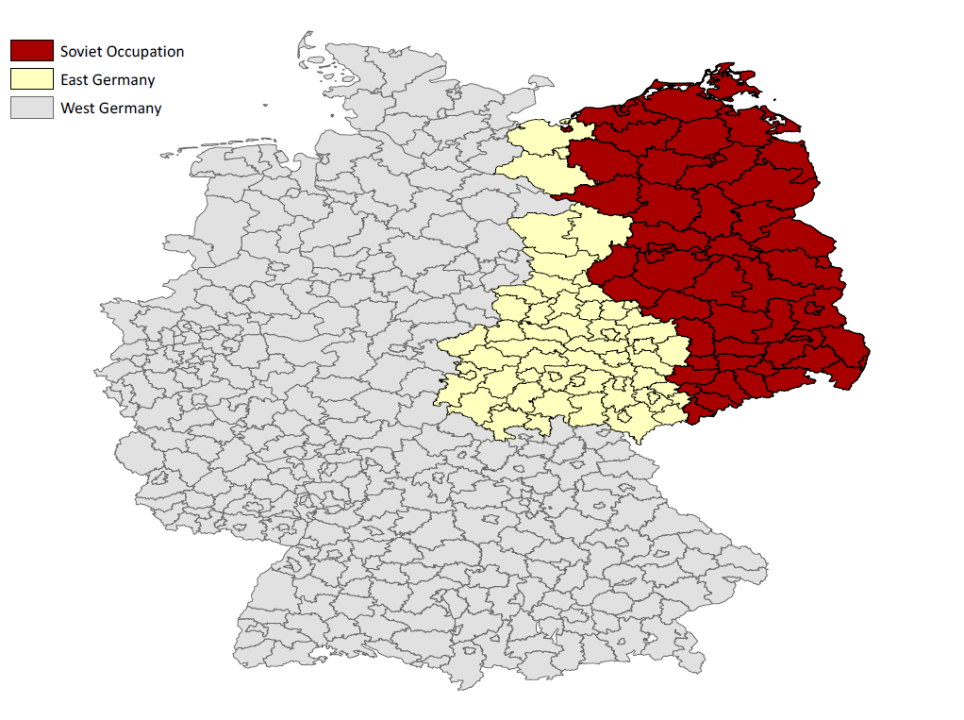

Figure 29. Single Dimension Linear Regression Discontinuity – 100 Kilometers
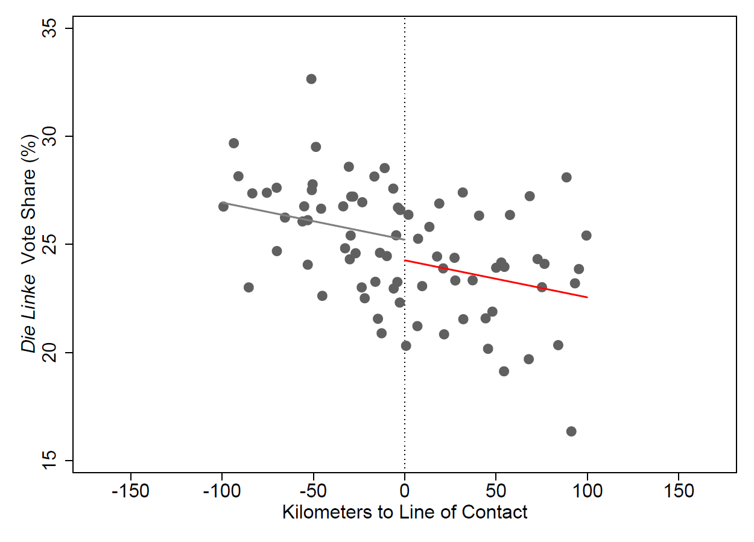

Figure 30. Single Dimension Linear Regression Discontinuity – 200 Kilometers
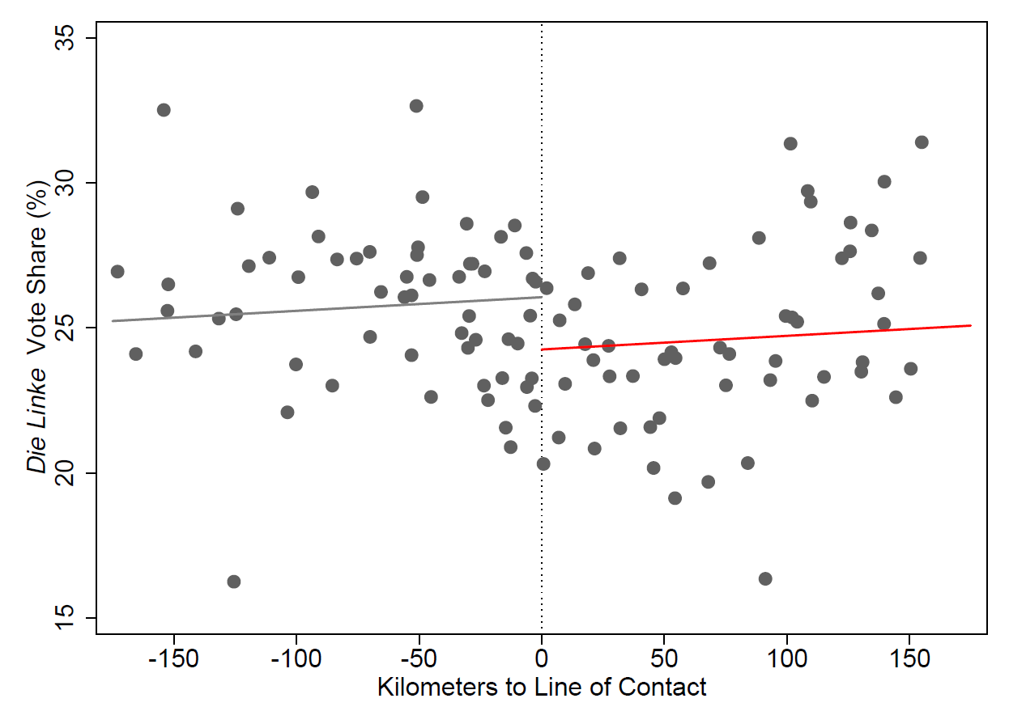

Figure 31. Single Dimension Linear Regression Discontinuity – All
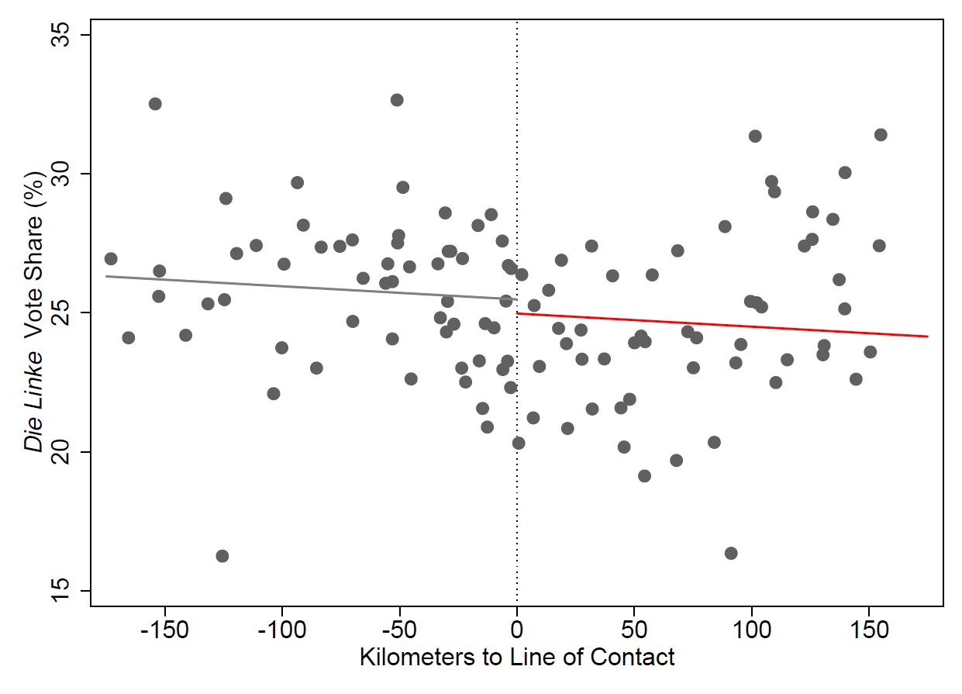

Figure 32. Single Dimension Quadratic Regression Discontinuity – 100 Kilometers
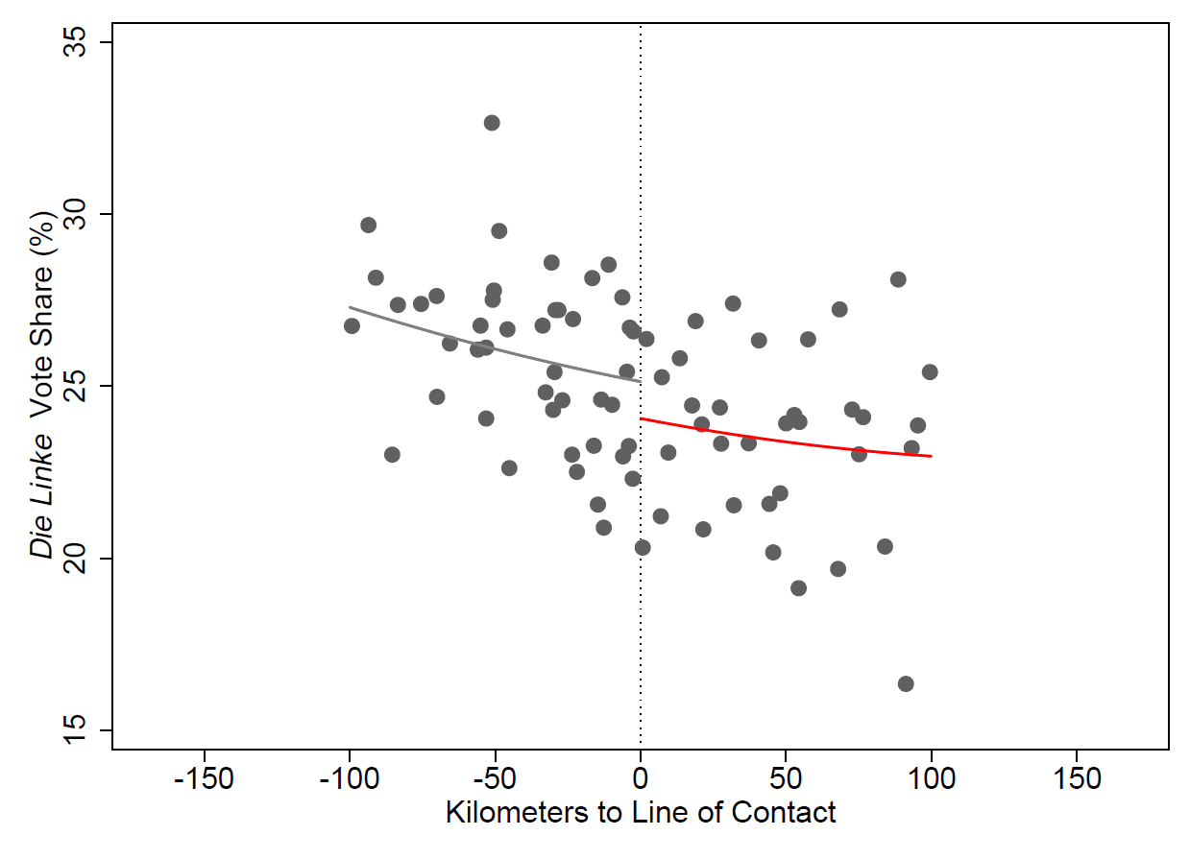

Figure 33. Single Dimension Quadratic Regression Discontinuity – 200 Kilometers
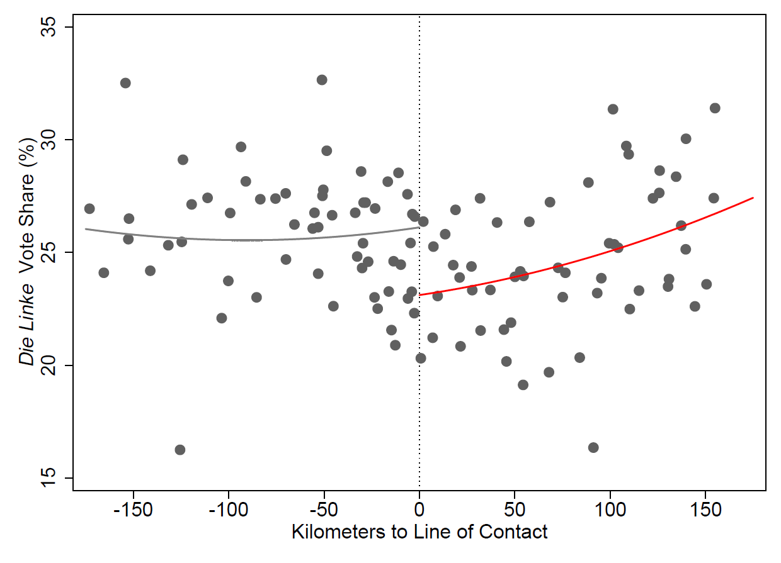

Figure 34. Single Dimension Quadratic Regression Discontinuity – All
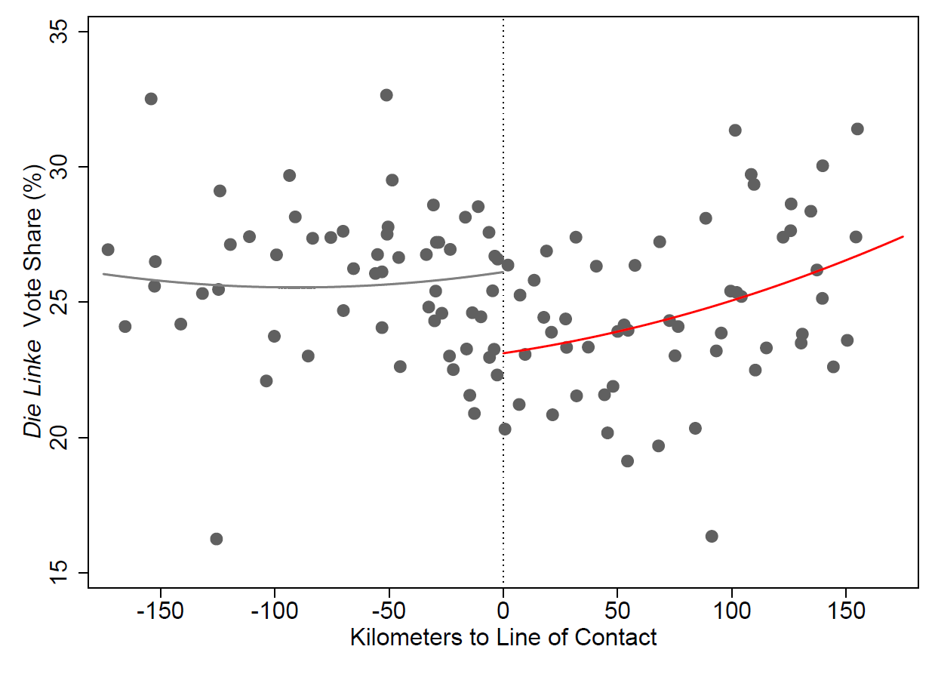

Figure 35. Single Dimension Linear Regression Discontinuity with Interaction – 100 Kilometers
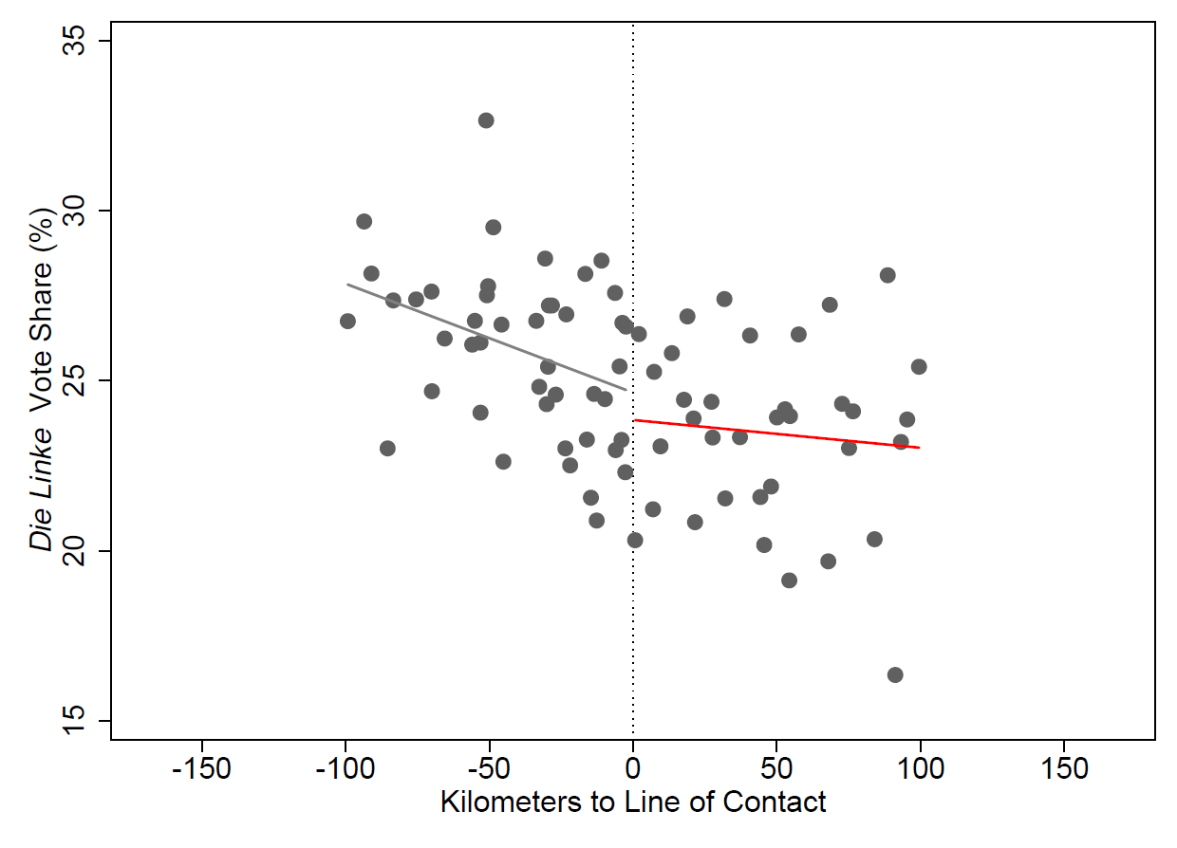
Figure 36. Single Dimension Linear Regression Discontinuity with Interaction – 200 Kilometers
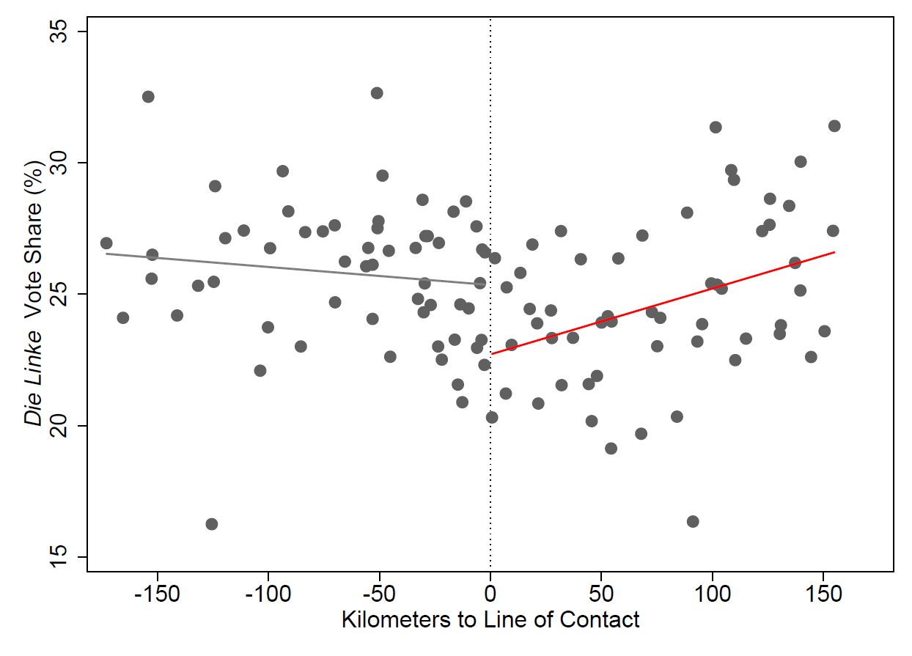
Figure 37. Single Dimension Linear Regression Discontinuity with Interaction – All
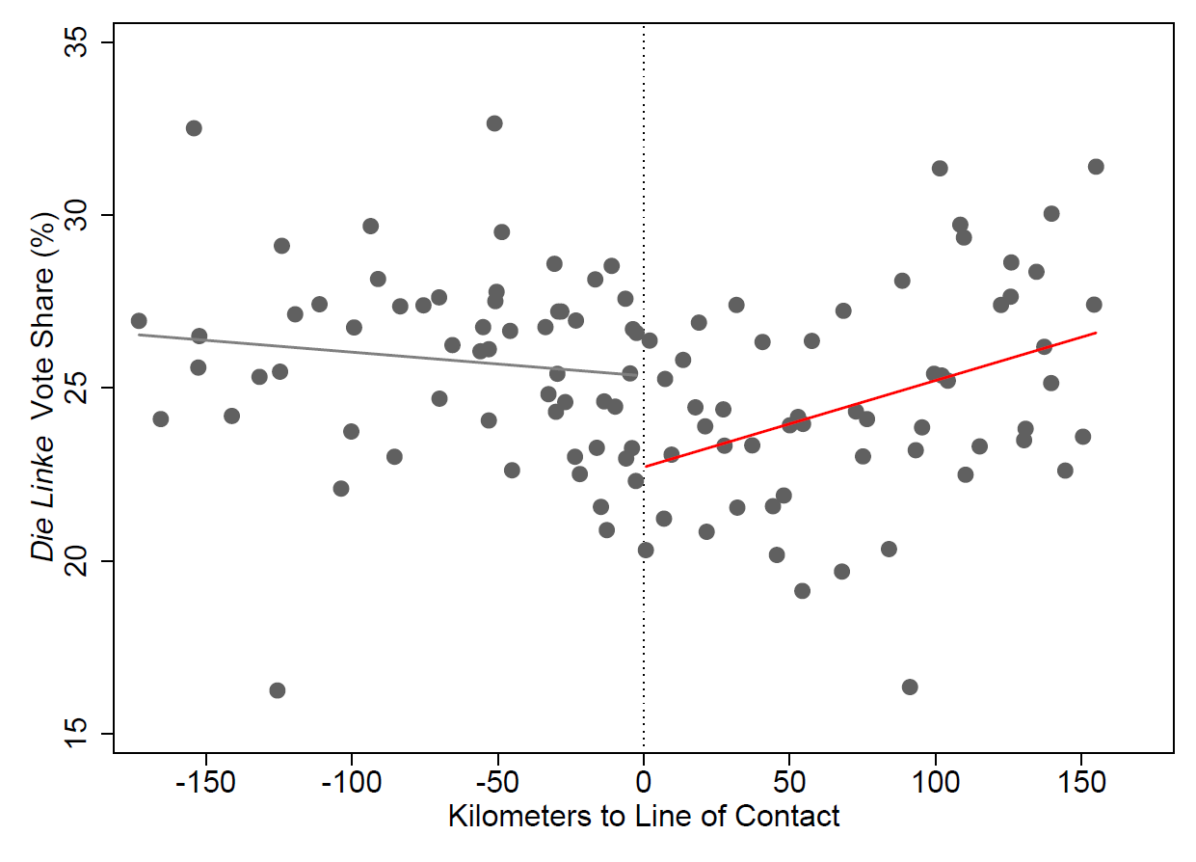

Figure 38. Single Dimension Linear Regression Discontinuity with Interaction – 100 Kilometers
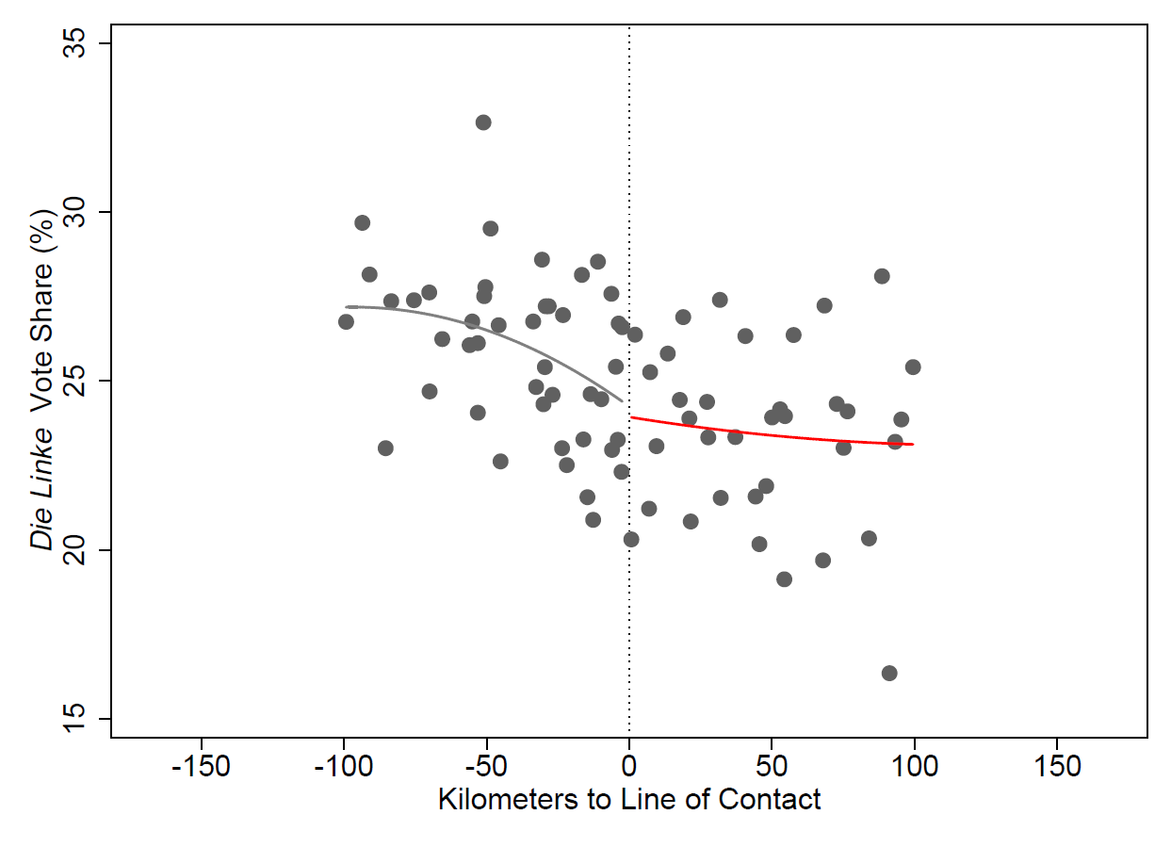
Figure 39. Single Dimension Linear Regression Discontinuity with Interaction – 200 Kilometers
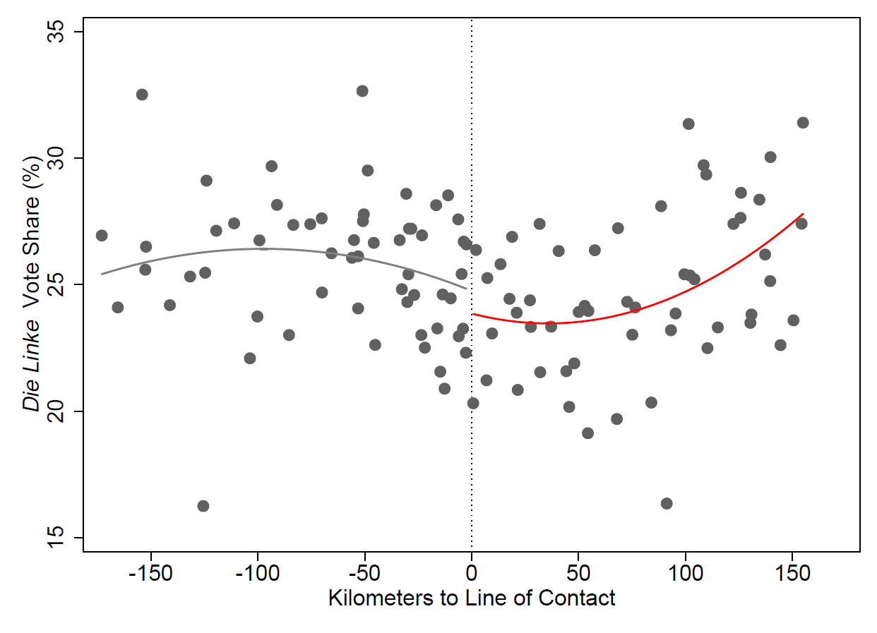

Figure 40. Single Dimension Linear Regression Discontinuity with Interaction – All
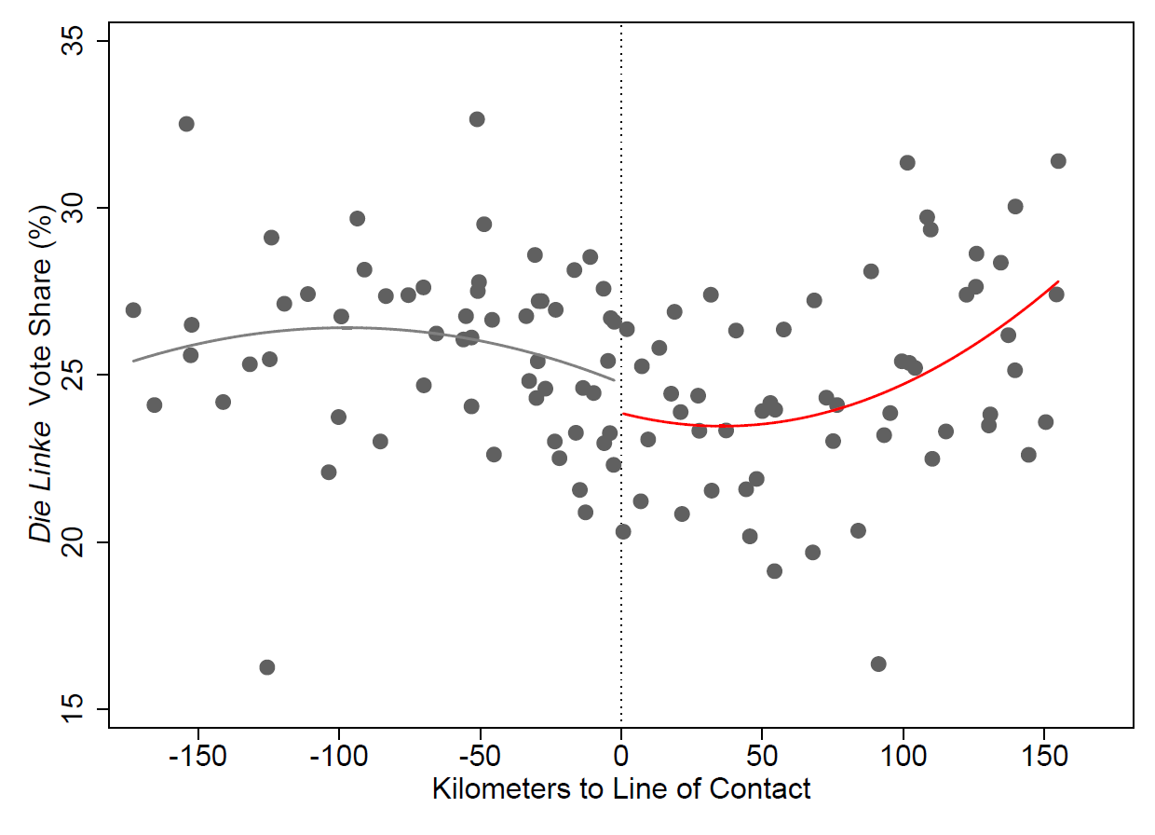

References
Acemoglu, D., Johnson, S., & Robinson, J. A. (2001). The Colonial Origins of Comparative Development: An Empirical Investigation. American Economic Review, 91(5), 1369-1401. doi:10.1257/aer.91.5.1369
Becker, S. O., Boeckh, K., Hainz, C., & Woessmann, L. (2015). The Empire Is Dead, Long Live the Empire! Long-Run Persistence of Trust and Corruption in the Bureaucracy. The Economic Journal, 126(590), 40-74. doi:10.1111/ecoj.12220
Dell, M. (2010). The Persistent Effects of Perus Mining Mita. SSRN Electronic Journal. doi:10.2139/ssrn.1596425
Naimark, N. M. (1997). The Russians in Germany: A history of the Soviet Zone of occupation, 1945-1949. Cambridge, Mass: Belknap Press.
Nunn, N. (2007). The Long-Term Effects of Africas Slave Trades. The Quarterly Journal of Economics. doi:10.3386/w13367

There are papers outside of economics that explore this issue. We discuss them and distinguish our work from theirs below.
There is some journalistic dissonance regarding the magnitude of the blackout. WSJ reports a complete blackout, while Al Jazeera suggests that the east maintained some, although hampered, level of communications (greyout). Regardless of which report is entirely accurate, we refer to the treatment as a blackout. If, in fact, the east experienced only a “greyout”, our estimates would understate the treatment effect.
Because the dependent variable is count with high variance, we use a negative binomial to estimate the model parameters. To create a more accessible interpretation, we present the incidence rate ratio interpretations here, although the tables contain traditional negative binomial coefficients, where coefficients represent the difference between the log of expected counts. More on selection and interpretation of negative binomial estimates presented in Section V and VI.
Similarly, recent work has identified a similar phenomenon between aid and conflict, where states attempt to discourage violence through aid provision, but aid merely draw additional conflict (Crost, 2014) (Khanna, 2017).
Formal definitions of state initiated and rebel initiated conflicts are given in the results section (VI).
For additional details about how ACLED classifies and measures conflict, please visit the following link: http://www.acleddata.com/wp-content/uploads/2016/01/ACLED_Codebook_2016.pdf
Although ACLED’s dataset does include a political district variable, it is not accompanied by any map of Libya and thus presents difficulty in tying in the aforementioned weather data.
This is an approximately 40-mile window.
This applies only to the Libyan Revolution data. When conducting analysis on the Libyan Civil War, as either a placebo or to test for the presence of common trend, the data strategy remains the same, but the start dates, end dates, and overall sample size will differ.
In some specifications we also include month-of-year and day-of-week fixed effects to control for possible seasonality.
The figures listed are unconditional mean and variance. However, we recognize the necessity of comparing the conditional mean and variance. We conduct the formal test of equidispersion found in Cameron & Trivedi (p575) and reject the null. The data are overdispersed, making the negative binomial model preferable to Poisson.
The negative binomial model is non-linear and its coefficients are not directly comparable to least squares regression coefficients. However, the sign, relative size, and significance of the coefficients are straightforwardly dispositive about the effects of the underlying variables under study (Cameron & Trivedi 2013, p94). In some models we employ district fixed effects, which can be consistently estimated in the negative binomial model by directly including district dummies in the likelihood (Cameron & Trivedi 2013, p357). Finally when considering the size of our estimated treatment effect, besides backing them out of our negative binomial regressions, we also present simple difference-in-differences calculations, and we also run least squares regressions and compute effect sizes from them. As Cameron & Trivedi note, “ OLS estimates in practice give results qualitatively similar to those for Poisson and other estimators using the exponential mean” (Cameron & Trivedi 2013, p.102). Madden et al. (2005) and Schreyögg & Grabka (2010) are recent papers that use a negative binomial model to implement the difference-in-difference model in the presence of count data like ours.
When thinking about the absolute movement in the numbers, it is valuable to remember that the control period is significantly longer than the treatment period.
More on interpretation of negative binomial can be found on http://www.ats.ucla.edu/stat/mult_pkg/faq/general/citingats.htm, formally cited at the end of this article.
We obtain this total treatment estimate through the following process: we calculate a “counterfactual” total by assuming each district’s control period rate will continue during the treatment period (32 days). We then separately multiply the control period rate by the IRR coefficient, which represents the rate increase due to the blackout. And again, by district, multiply this coefficient by the treatment level and days in treatment period (33). The difference between the two (counterfactual total and treatment total) figures represents the increase in conflicts due to the blackout. Least squares estimates put the number of additional conflicts between 52 and 67.
There are an additional 345 conflicts, which we cannot determine to be either state- or rebel- initiated and they are not used in this portion of the analysis.
The methodology explained in footnote 15 is repeated to calculate the total state-initiated conflicts caused by the blackout.
Least squares estimates place the number of additional state initiated conflicts between 24 and 27 depending on the specification used.
Again, we repeat the methodology described in footnote 15 to obtain the estimated total causal impact of the blackout upon rebel-initiated conflict.
Least squares estimates put the number of additional rebel-initiated conflicts at between 17 and 33 depending on the specification used.
This dataset is essentially the excluded portion of the preceding, “clean” robustness check’s dataset.
This calculation implicitly assumes that the Libyan Civil War ends on December 31st, 2015, the date at which data becomes unavailable.
We also address the validity of the common trends assumption for our analysis in Appendix B of the paper.
We do not study Cuba due to a lack of comparable data to the other four cases.
In the present paper we will use a different dataset and a slightly different set of donor countries than Grier & Maynard and will report how our results match up to theirs when we show country specific results in the second half of the paper. To preview, we find even larger negative effects on GDP per capita than they did, but our effects are less precisely estimated than theirs. We chose different data in part as a robustness check, but mainly for the practicality that the World Bank has stopped reporting GDP data pre-1990 and so we take our macro data from the latest version of the Penn World Tables. This switch to the PWT also allowed us to use more oil exporting countries than Grier & Maynard did in their donor pool.
For further details on the mechanics of this process see the articles cited above or Grier & Maynard (2016).
Not all countries are available for all outcomes. For example, we do not have sufficient Gini data for Algeria, El Salvador, Honduras, Iraq, Kuwait, Paraguay, Saudi Arabia or United Arab Emirates to use them as potential donors when studying inequality.
In the case of the Gini data, we also do some interpolation to fill in missing values.
We want to emphasize that we are not romanticizing the governance of these countries before the regimes we study come to power. Anastasio Somoza was not providing good governance in Nicaragua. The existing party structures in Bolivia, Ecuador and Venezuela were not inclusive, to say the least.
At least not as measured by income inequality or infant mortality.
Library of Congress, Nicaragua Country Studies, “The Sandinista Years.”
Ibid, “Nationalization and the Private Sector.”
Dropping the USA from Nicaragua’s donor pool does not change our results here in any material way.
He created his own political movement, calling his party the Fifth Republic Movement (MVR – Movimiento Quinta República).
Rohter (1999) and Nelson (2009).
The ICRG data does not extend far enough back in time to show the effect the Sandinistas had on the investment climate in Nicaragua.
It is worthwhile to compare these results to those in Grier & Maynard (2016), which used an older version of the Penn World Tables database. Their conclusion is the same as ours. Venezuela is almost one-third poorer than what the control indicates. However, Grier & Maynard were able to produce a better fitting control in the pre-treatment period and to achieve greater statistical significance. The countries chosen for the control also vary in the two studies (our algorithm selects Norway instead of Canada and Nigeria instead of Iran). If we adopt Grier & Maynard’s specification using our data, we get a worse pre-treatment fit than what we have reported above, but roughly the same estimated underperformance in the treatment period.
Kennemore and Weeks, 2011, p.270.
The Guardian, December 17th, 2016.
Voters rejected the referendum but that has not stopped Morales from trying for a fourth presidential term, despite what his constitution states. His party is still nominating him for the 2019 presidential elections, stating that they will find a way to make it legal. The Guardian, 2016.
Wikileaks, January 13th, 2009. The cable goes on to note that “this is not the first time Morales has declared that he will circumvent the congress by use of decrees. In August 2007, Morales announced at a public meeting with Venezuelan President Hugo Chavez that ‘being subjected to the law is damaging us (the Morales government); though they may say our decrees are unconstitutional, that does not matter.’
The Economist, 2007, argues that “Mr. Morales also has Mr. Chávez's penchant for subverting rival centres of power, but perhaps less talent for it. Take the latest clash with the judiciary. This began when the Constitutional Tribunal ruled that four Supreme-Court justices temporarily appointed by the president should yield their seats. Mr. Morales called for the tribunal's impeachment.”
Panam Post, 2017.
Economist (2009). A subsequent article in the Economist (2011a) notes that inflation had been creeping up to over 8% that January. Besides forces outside of the government’s control, the article argues that the government has exacerbated the situation: “As prices rose in 2008 the government intervened to curb farm exports and imposed price controls. The result was that farmers planted less. Huge queues have formed at state food-distribution centres. Some of those centres closed when they ran out of supplies or their staff feared violence.”
They go on to note that “annual FDI averaged US$452 million between 1990 and 2000, but by 2007 was US$204 million” (p. 271).
De la Torre (2013, p. 35).
Conaghan (2016, p. 111-12) writes that “Traditional checks and balances had long seemed inoperative. Neither Congress, long wracked by corruption, nor the courts, long the targets of partisan tampering, had much legitimacy. Correa blamed the rule of the traditional parties (la partidocracia) for blighted institutions and vowed to sweep them all away.”
Correa would also become dissatisfied with his constitution, going so far as to question its constitutionality as it prohibited him from running for a consecutive third term. He argued that the 2008 constitution was a violation of his human rights!
Conaghan (2016, p. 111-2) notes that the previous constitution of 1998 had already awarded the president strong powers and the 2008 constitution goes beyond those.
Conaghan (2016, p. 111-2). Conaghan (2016, p. 110) describes the legislature under Correa’s presidency a “rubber stamp.” See Conaghan (2016) as well for an interesting description of how Correa has strengthened the executive even more by adding a fifth branch of government in the area of “transparency and social control,” which essentially answers to the executive branch.
The Economist (2/18/2017) notes that “a commission led by a former interior minister disciplines and often removes judges.” Conaghan (2016, p. 110) agrees, noting “An executive-directed restructuring replaced numerous judges and ended judicial autonomy.”
The Economist, June 10th, 2014.
The Economist, February 18th, 2017.
As we mentioned above, the threat of expropriation only makes up a part of this index and we do not have access to data for the sub-components.
This represents approximately a 15% decrease in support relative to the vote share on the untreated side of the discontinuity, where the Die Linke’s vote share is around 25%.
In 2003, the EU implemented the standardized NUTS system across the EU countries. Before this, EED usually includes a geographic identifier at each nation’s finest administrative region. For Germany, that is the kreis.
Germany held another parliamentary election in 2017, but the EED has not released the data yet.

