Edwin C. DeBarr

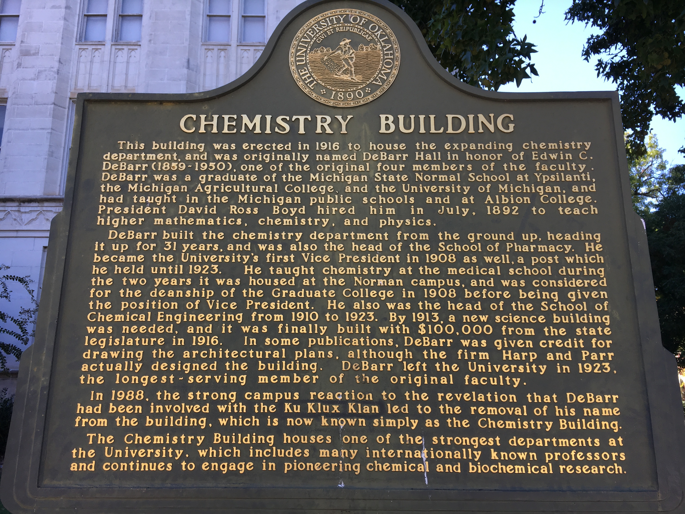
And the University of Oklahoma's Responses from 1923-1988

Kathryn Lynn

Fall 2016

Edwin C. DeBarr

Illuminating, not rewriting, history

In 1982, A University of Oklahoma student initiative strove to change a building's name after uncovering that Edwin C. DeBarr, for whom it was named, had been a grand dragon in the Ku Klux Klan. Then Oklahoma University President William S. Banowsky considered, and concluded in a Board of Regents meeting that the Chemistry Building should continue to be called DeBarr Hall. Among the president's reasons was this: "Should he be tried twice for the same shortcoming? After the passing of half a century, it is inappropriate to attempt to re-write history. 'The moving finger writes, and having writ moves on; nor all piety nor wit can lure it back to cancel half a line, nor all your tears wash out a word of it.'" Although he neglected to attribute the sentiment to Omar Khayyám, that argument might have had merit were it not for the fact that DeBarr was not being tried for the same shortcoming but a completely separate ideological issue that was simply anchored in the same historical event: the Board of Regents asking DeBarr to leave the University of Oklahoma. Two questions present themselves. Why did the Board of Regents fire DeBarr? And, why did the students object to DeBarr's name being used for the chemistry building? Unless those two answers are the same, then President Banowsky's logic in refusing the students' request was flawed. Were the students of 1982 outraged that DeBarr broke with University policy? That he was involved in politics and tried to mobilize his network to elect Robert Wilson as governor? No. They objected to honoring a member of the KKK when the current student body was diverse and opposed to the brutal racism associated with the Klan. DeBarr was never tried in court, but among his peers at the University, and the reasons for his termination in the 20s had nothing to do with racism that the students of the 80s repudiated.
Edwin C. DeBarr was one of the original four professors at the University of Oklahoma. While the governor at that time was a Progressive and anti-KKK, the Klan was at the height of their power and popularity in Oklahoma during and after the Tulsa race riots of 1921. The Oklahoma legislature, in part due to the influence of the KKK, later impeached Gov. Walton. DeBarr, a Klansman of some rank, was crucial in setting up the university's chemistry and pharmacy departments and by many accounts, he was a popular teacher. On April 20, 1922, the Board of Regents, decreed that faculty could not be visibly either anti-KKK or pro-KKK. "Owing to the controversy that exists throughout the state in connection with the Ku Klux Klan and the anti-Ku Klux Klan and the dependency of the University upon retaining the good will of all parties, we believe it unwise for members of the faculty or employes [sic] of the University of Oklahoma to place themselves in a position where they will need to take active part in such controversy.” This indicates that it was not the Klan itself the University disapproved of. In fact, it shows that the University of Oklahoma wanted to retain the good will of the KKK, or at least, it wished not to alienate it. In his article on DeBarr, Professor David Levy says that according to the Tulsa Tribune, by 1921, the Klan had an estimated 70 thousand members, and nearly 100 thousand by 1924. "There were more members of the KKK in the state than members of labor unions. Perhaps one out of every ten eligible males belonged.” With numbers as great as that, the Board of Regents cautioned nonpartisanship. OU President Brooks, added to that, asking, "employees of the university refrain from active participation in politics." The following August, as acting president in the absence of President Brooks, DeBarr, in his capacity of Grand Dragon of the KKK, directed Oklahoma KKK members to vote for their fellow Klansman, Robert Wilson in the gubernatorial primary. The Board of Regents, namely H. L. Muldrow, would not let that stand.

"In so far as his actions have been political they were in violation of the instructions of the President of the University to the effect that the faculty and employees should refrain from active participation in politics.

"The policy of the University of Oklahoma has at all times been to keep clear of factions and parties and to render all citizens of the state, irrespective of creed or party, fair, loyal and efficient service."

Nowhere in the Board of Regents meeting minutes does it denounce the KKK as an organization, merely DeBarr's political activity and his public partisan affiliation. In August 1922, The Oklahoman reported that, "The alleged connection of Dr. Edwin DeBarr, vice-President of the University of Oklahoma, with the Ku Klux Klan and his alleged direction of the Klan vote for R. H. Wilson in the primary has caused the return to Norman of Dr. Stratton D. Books, president of the university, Saturday morning, and a severe reprimand for DeBarr.”
The newspapers in 1922 were aware that the real infraction was political and that only a reprimand was expected. DeBarr might well have got off with an admonishment, but for all his political maneuverings and machinations, Wilson lost. Governor Walton unilaterally replaced most the Board of Regents, who immediately dismissed DeBarr.
"It was moved, and unanimously arrived, that Dr. Edwin DeBarr, Vice-President, Director of the School of Chemical Engineering, Professor of Chemistry, be and is hereby removed from tenure appointment, and that he be given leave of absence without pay, for the term of one year from July 1, 1923."

Despite his dismissal, he enjoyed great popularity and influence in Norman and was well regarded up to and after his death in 1950. It wasn't until 1982 that his membership of the KKK became problematic again, but for different reasons. In 1922, it was a matter of partisanship and politics. In 1982, it was a matter of a racist legacy, an objection to the KKK itself, what it stood for, and what it symbolized to current University of Oklahoma students. "We're planning to do whatever it takes to let people know that this university is honoring a man we feel was committed to violence and racism," said William Stanhope, the freshman who proposed the change. "He (DeBarr) started out as a member and he had to have taken part in some violence to earn that position.”
But President Banowsky recommended that the name DeBarr Hall be kept. "Should he be tried twice for the same shortcoming? After the passing of half a century, it is inappropriate to attempt to rewrite history.” Students did not intend to rewrite history, but to shine light on it. As The Daily Oklahoman reported June 10, 1982, "Rodney McCowan, president of the OU chapter of the National Association for the Advancement of Colored People, said Wednesday the black student officials plan to request that the regents approve a recommendation calling for the renaming of the science building and the placing of a plaque on the structure stating historical facts pertaining to DeBarr."
Nonetheless, Banowsky kept the name, but as a show of good intent appointed a special committee to "recommend an appropriate way to place this issue into its proper historical perspective." That committee came up with the Martin Luther King Jr. Research Institute for Cultural and Social Relations. "This will not be an esoteric center divorced from the people and communities it will study. Nor will it be merely a collection of faculty. Rather it will be a closely knit research oriented institute comprised of talented faculty, staff and students." This institute never materialized, the matter of DeBarr Hall was dropped, and the subject not broached again for another six years.

In 1988, Lori Ann Sharpe, President of the University of Oklahoma Student Association said to the Board of Regents, "It is generally agreed that Dr. DeBarr did a great deal towards the expansion of the University of Oklahoma. However, the organization he was a part of was not accepted in his society and it is not accepted in ours." Sharpe, like Banowsky, assumed that DeBarr's dismissal had been as a result of disapproval of the KKK, when it had not. The Daily Oklahoman reported the following Thursday, "in 1922, OU regents censured DeBarr for his KKK activities, and he was dismissed from OU in 1923. DeBarr was an Oklahoman grand dragon in the KKK, and in 1924 he was national chaplain of the Klan." The description in this and many other newspapers lends itself to the false narrative that it was unacceptable at that time to have been part of the KKK and that he’d been punished for racist/violent affiliations. Reporter Speck Reynolds of the Black Chronicle in 1982 stood alone in giving more historical perspective surrounding DeBarr's termination. "Norman was a "sundown town" during this period: Blacks were not permitted to live in the city and had to be out of town by sundown. Oklahoma Jim Crow lasts set the state for racism to run rampant in the state." Reynolds also included more nuance of the Regents' instructions.
"In 1922, the regents instructed the faculty not to take part in the KKK vs. anti-KKK events. It finally came to a head in 1922 when the regents board president pointed out that Mr. DeBarr had made speeches on behalf of a state politician and... also charged the grand dragon-professor with conduct 'in direct violation of the policy of the university.”

Reynolds understood that the University of Oklahoma was not against racism that the KKK embodied, and points out the reasons for DeBarr's dismissal had more to do with politics than anything else. However, finally in 1988, with the backing of the student body, Graduate Student Senate, Student Congress, the Faculty Senate and the Department of Chemistry, the Board of Regents and President Horton approved the removing DeBarr’s name from the chemistry building. Regent Noble was the sole dissenter. The large limestone block with DeBarr’s name was removed August 8, 1988. A plaque stands in front of the Chemistry Building, stating historical facts pertaining to DeBarr.

The students of 1982 and 1988 were not trying to rewrite history, "nor lure it back to cancel half a line... nor wash out a word of it." They were trying to bring out an issue that had never been addressed. Yes, it was well known DeBarr was a Klansman, but his offense was mobilizing the Klan vote for a gubernatorial race. The University of Oklahoma had never had to confront the fact that the man was head of the Klan in Oklahoma, where there had been daily floggings and worse violence. It is not the rewriting of history, but obtaining some small justice for past wrongs, an illumination of the past, a reckoning for something that the man, in life, had never had to answer for. He was not tried again for the same shortcoming, but judged for the first time for a quality that stands in opposition to what the University later claimed to uphold.

Bibliography

Stratton Brooks, Statement given September 1922

David Levy, “The Rise and fall and rise and fall of Edwin ("Daddy") DeBarr”, The Chronicles of Oklahoma, LXXXVIII (Fall 2010)

Graduate Student Senate Resolution, April 20 1988

Minutes of the University of Oklahoma Board of Regents Meeting, 20 April, 1922

Minutes of the University of Oklahoma Board of Regents Meeting, 1 July, 1923

Minutes of the University of Oklahoma Board of Regents Meeting,10 June 1982

Minutes of the University of Oklahoma Board of Regents Meeting, 9 Sept 1982

Minutes of the University of Oklahoma Board of Regents Meeting, 20 July, 1988

H. L Muldrow, Pres. Board of Regents Statement

Larry O’Dell, Oklahoma Historical Society, “Walton, John Calloway” http://www.okhistory.org/publications/enc/entry.php?entry=WA014

Personnel File of Edwin DeBarr – University of Oklahoma

Newspapers

Black Chronicle, Oklahoma City

The Daily Oklahoman, Oklahoma City

Imperial Night-Hawk, Atlanta

Norman Transcript, Norman

Oklahoma City Times, Oklahoma City

Tulsa World, Tulsa

David Levy, “The Rise and fall and rise and fall of Edwin ("Daddy") DeBarr”, The Chronicles of Oklahoma, LXXXVIII (Fall 2010)
Minutes of the University of Oklahoma Board of Regents Meeting,10 June, 1982 (hereafter cites as Minutes, Board of Regents)
Personnel File of Edwin DeBarr
Larry O’Dell, Oklahoma Historical Society, “Walton, John Calloway” http://www.okhistory.org/publications/enc/entry.php?entry=WA014
“Knights Kamellia Kloran Adopted,” Imperial Night-Hawk, the Klan newspaper, 27 February, 1924; David Levy, The Rise and Fall and Rise and Fall of Edwin ("Daddy") DeBarr,
Minutes, Board of Regents, 20 April, 1922
Levy, “The Rise and fall and rise and fall of Edwin ("Daddy") DeBarr”
Statement, President Brooks September 1922
Levy, “The Rise and fall and rise and fall of Edwin ("Daddy") DeBarr” citing The University of Oklahoma and the Ku Klux Klan, “School and Society”, 16 (October 7, 1933)
Statement of H. L Muldrow, Pres. Board of Regents
The Oklahoman, 6 August, 1922
Levy, “The Rise and fall and rise and fall of Edwin ("Daddy") DeBarr”
Minutes, Board of Regents,1 July, 1923
Levy, “The Rise and fall and rise and fall of Edwin ("Daddy") DeBarr”
Daily Oklahoman 6 May, 1982
Minutes, Board of Regents, 10 June, 1982
The Daily Oklahoman 10 June, 1982
Minutes, Board of Regents 10 June, 1982
Minutes, Board of Regents 9 September, 1982
Black Chronicle, 21 July 1988
Minutes, Board of Regents 20 July, 1988
Levy, “The Rise and fall and rise and fall of Edwin ("Daddy") DeBarr”

