University of Oklahoma

Graduate College

Understanding environmental tobacco smoke and influences for smoking in multiunit housing

A thesis

submitted to the graduate faculty

in partial fulfillment of the requirements for the

Degree of

Master of Science

By

CHRISTOPHER MICHAEL DUNLAP II
Norman, Oklahoma
2018

Understanding Environmental Tobacco Smoke and Influences for smoking in Multiunit housing

A thesis approved for the
Department of Health and Exercise Science

By

______________________________
Dr. Marshall Cheney, Chair

______________________________
Dr. Sarah Maness

______________________________
Dr. Daniel Larson

© Copyright by Christopher Michael Dunlap ii 2018
All Rights Reserved.
Table of Contents
Abstract vii
Chapter 1: Introduction 1
Purpose of the Study 2
Research Questions 3
Significance of the Study 3
Delimitations 4
Limitations 5
Assumptions 5
Operational Definitions 6
Chapter 2: Review of Literature 7
Introduction 7
Risks Associated with Indoor Smoking 7
Factors Associated with Multiunit Housing 9
Research Gaps 13
Chapter 3: Methodology 14
Research Design 14
Recruitment 14
Inclusion and Exclusion Criteria 15
Instrumentation 16
Data Collection 17
Saturation 20
Data Analysis 20
Research Questions and Codes 21
Data Management and Analysis 22
Chapter 4: Results 24
Introduction 24
Participant Themes 30
Theme 1: Apartment Policies 31
Theme 2: Environmental Tobacco Smoke Beliefs 33
Theme 3: Environmental Tobacco Smoke Knowledge 35
Theme 4: Effect of Information about Thirdhand Smoke 37
Summary 39
Chapter 5: Discussion 40
Introduction 40
Significance of Research 40
Implications and Recommendations for Practice 41
Implications and Recommendations for Policy 42
Implications and Recommendations for Research 43
Conclusions for Apartment Policies 45
Conclusions for Environmental Tobacco Smoke Beliefs 47
Conclusions for Environmental Tobacco Smoke Knowledge 49
Conclusions for Effect of Information about Thirdhand Smoke 51
Limitations of the Study 53
Final Thoughts 54
References 55
Appendix A: IRB Approval 58
Appendix B: Demographic Questionnaire 59
Appendix C: Oral Consent Form 67
Appendix D: Codebook 68

List of Tables
Table 1: Demographics of Smokers 24
Table 2: Smokers’ Living Situation 26
Table 3: Smokers’ Tobacco Use Characteristics 27

Abstract
This study explored some underlying reasons to why some smokers choose to smoke indoors as well as some of the factors that contributed to this decision. In addition, this study looked at what smokers know about environmental tobacco smoke (ETS) specifically in multiunit housing. This study primarily used a semi-structured interview to examine these areas as well other unexpected responses from these smokers. A final focus of this study was to see what smokers knew about thirdhand smoke, a form of ETS, and whether information about thirdhand smoke would affect their smoking habits. The results of this study showed that there many reasons as to why smokers choose to smoke indoors such as comfort and housing situation. In addition, many smokers did not know what thirdhand smoke was or what the health risks were when exposed to this form of tobacco byproduct.
Chapter One
Introduction
Introduction
Smoking is the leading cause of preventable death and disease in the United States and remains a primary public health concern. The Center for Disease Control and Prevention reports approximately 15 out of every 100 adults are considered current cigarette smokers with over 16 million Americans reporting a smoking-related disease. The CDC also found that smoking is associated with higher risks of coronary heart disease, stroke, almost all organ cancers including lung, and respiratory diseases (U.S. Department of Health and Human Services, 2014). Over the past several years, smoking has been banned from most areas of the public domain due to the known health risks associated with cigarettes, tobacco products, and resulting second hand smoke. However, a large portion of the average person’s time is not spent out in public, but instead inside of the home (Bureau of Labor Statistics, 2015). Understanding the decisions made by smokers inside of their homes would be helpful in creating programs and interventions specifically designed to reduce and eliminate smoking in home settings.
The Surgeon General has noted that one population group that has higher rates of smoking compared to the rest of the population is adults of a low socioeconomic status (USDHS, 2015). Public housing, multiunit housing, and condominiums are types of residences where this population typically lives and therefore should be a primary target to intervene. These types of housing typically have smaller than average square footage compared to other forms of living spaces and could potentially have higher concentrations of secondhand smoke. A study specifically measuring airborne nicotine concentrations found that non-smoking units in low income housing had nicotine concentrations similar to smoking an average of a quarter of a cigarette per day (Kraev et al. 2009). In this situation, tenants who might not actually smoke could be potentially exposed to risks associated with directly smoking or passively intaking smoke. Remnants of smoke can remain in these housing units as well in the form of third hand smoke, existing as dust or residue on almost all types of surfaces for up to several months (Acuff et al., 2016). Unless managers or landlords diligently monitor their tenants, compliance in regards to smoking behaviors could relatively go unnoticed if tenants take the right precautions to avoid detection while smoking. In some states there are no laws to prevent smoking in residences and multi-unit housing, so any attempt to reduce or eliminate smoking at home would rely on local policies or policies written into leases. Interviews comprised of property managers in Virginia found that managers give warnings for breaking their smoking policies, but never actually evicted anyone over it (Jackson & Bonnie, 2010). If no enforcement of policies occurs in this type of housing, there seems to be little need to even attempt to make smoking policies.

Purpose of the Study
The purpose of this study is to understand the underlying reasons and factors that contribute to smokers’ decision to smoke inside or outside of their apartment. Building off of that, analyzing smokers’ knowledge of the health effects of environmental tobacco smoke (ETS) is vital in developing future interventions specifically targeted towards addressing unfamiliarity among smokers about the health risks associated with ETS. Lastly, another purpose is to understand if there are any policies in place in regards to tobacco use in multiunit housing.

Research Questions
The following research questions will be explored in this study.
RQ1: What do smokers know about secondhand and third hand smoke indoors?
RQ2: How are apartment denizens’ smoking habits influenced by information about third hand smoke?
RQ3: What influences where and when smokers decide to smoke in multiunit housing?
RQ4: Are there any factors from housing policies that affect smoking habits?
RQ5: What are smokers’ perceptions of their own smoking habits?

Significance of the Study
The health risks associated with smoking and exposure to second hand smoke are preventable yet still remain a leading health issue in lower socioeconomic status populations. In addition, there are no federal or state laws regulating smoking inside of housing complexes, apartments, and other non-detached family residences. Also, state laws vary between states, including public housing where this lower socioeconomic status population resides. In these types of housing more vulnerable populations such as children and the elderly can also be exposed to forms of smoke combustion. Few studies focus on the reasons why smokers smoke inside their homes. Most studies have focused on the quantitative values associated with smoker’s rates, habits, or demographics. This study may be helpful for understanding the perspectives and beliefs of smokers and why they smoke inside their residences. This study may also be helpful in understanding if messages about third hand smoke and its effect on others in the building may influence smokers to smoke outside. The findings from this study will help inform interventions to reduce and eliminate smoking in multiunit housing. In addition, third hand smoke research is an emerging area of interest and understanding beliefs about third hand smoke can be beneficial in reducing smoking rates and smoking related illnesses.
Delimitations
The parameters of this study include:
- Potential participants in this study will be both men and women.
- Potential participants live in multiunit housing (defined as 4 or more connected units).
- Potential participants will be current tobacco smokers who smoke when they are at home.
- Participants will be contacted via recruitment postings via one-time job opportunities on Craigslist.
- Participants should be able to understand and communicate in English.
- Interview questions will gauge beliefs, attitudes, and habits associated with smoking, specifically in or near multiunit housing.
- The projected number of interviewees is 40 but will depend on reaching saturation.

Limitations
Limitations for this study include:
- This study will be voluntary. Individuals who participate in this study may not represent all of the target population.
- This study will specifically focus on cigarette and other forms of smoked tobacco and will not focus on non-smoked tobacco products, marijuana, and electronic cigarettes.
- Interviews will be the primary form of data collection so there may be potential for error due to human interaction bias or participants trying to give desirable responses.
- Participants will be collected by advertising online posts only. Potential participants may be missed and the sample may not represent other harder to reach smokers who do not utilize online services such as Craiglist.
- Interview questions may not be able to cover all potential reasons for smoking indoors and facets of indoor smoking habits may be missed.

Assumptions
Assumptions for this study include:
- All participants truthfully and accurately responded to the interview questions.
- Participants understood all interview questions.
Interviewers will not influence interview responses and will give an accurate account of said responses.

Operational Definitions
Multiunit Housing: Apartments, condominiums, and public housing which typically have smaller square footage and are connected by either shared buildings or complexes. For the purpose of this study, multiunit housing will be defined as one structure with at least 4 separate yet connected units contained within the building.
Environmental Tobacco Smoke: Smoke produced from burning tobacco products and refers to mainstream smoke, second hand smoke, and third hand smoke.
Second Hand Smoke: Chemical-containing resultant smoke from burning tobacco products
Third Hand Smoke: The chemical residue that settles on surfaces after smoking cigarettes.

Chapter Two
Review of Literature
Introduction
The purpose of this study is to understand the underlying reasons and factors that contribute to smokers’ decision to smoke inside or outside of their apartment as well as smokers’ knowledge of the health effects of environmental tobacco smoke (ETS). Previous studies have looked at smoking rates inside of the home as well as the negative health risks associated with smoking indoors and several have focused on specifically second hand and third hand smoke exposure. However, few, if any, studies have looked at smoking in non-urban multiunit housing, as well as understanding the key motivators to smoking through a qualitative lens. The first section of this literature review is to examine the risks typically associated with smoking indoors. The second part of the literature will examine research related to housing and how it affects smoking habits as well as compliance of any in place smoke policies.

Risks Associated with Indoor Smoking
Second Hand Smoke (SHS): Also known as environmental tobacco smoke (ETS), and side stream smoke, second hand smoke (SHS) is the byproduct of the burning of tobacco products such as cigarettes, cigars, pipes, and cigarillos. Secondhand smoke is comprised of over 7,000 chemicals, with the United States Surgeon General recognizing at minimum 69 of those chemicals to cause cancer (USDHS, 2015). SHS should be distinguished from mainstream smoke, or the type of smoke directly and actively inhaled by the smoker themselves. Secondhand smoke can be emitted from either the burning end of a tobacco product or from the smoke exhaled by an active smoker (Behera, Xian, Balasubramanian, 2013).
SHS Health Risks: Secondhand smoke is known to be a large factor in the formation of pulmonary and cardiovascular diseases in both children and adults (USDHS, 2015). In addition, smoking in small enclosed areas greatly increases airborne smoke pollution, with an English study of prisons finding airborne concentrations of smoking particulate matter that well exceeded exposure limits from the World Health Organization (Jayes et al., 2016). Components in secondhand smoke are recognized by public health entities to be harmful to children. When combined with diets deficient in dietary fiber and omega-3 fatty acids, secondhand smoke increases negative health effects in children (Moore et al., 2016). Furthermore, children exposed to secondhand smoke exhibit decreased lung growth and increased rates and severity of asthma and respiratory infections (DiFranza, Aligne, and Weitzman, 2004). The previous issue is only further increased by the high exposure to secondhand and third hand smoke that infants, children, and adolescents face.

Third Hand Smoke: While second hand smoke is often the most commonly thought of form of environmental tobacco smoke (ETS), third hand smoke is being recognized as another form of smoke that negatively impacts health. Third hand smoke is defined by Roberts et al. as the compounds put out from smoking that either lingers in the air, accumulates as dust, or settles on surfaces rather than being exposed directly to smoke itself (Roberts, Wagler, & Carr, 2017). Third hand smoke lasts for several months as well. One study found that nicotine was measurable even after cleaning and two months passing after tenants who smoked move out. This study also was able to detect nicotine on the fingertips of non-smokers who moved into the previous home of a smoker (Matt et. al, 2010). While it is not as prolific as second hand smoke due to its lack of visibility, third hand smoke should definitely be of concern. A study looking at the cellular toxicity of third hand smoke component, specifically 4-(methylnitrosamino)-4-(3-pyridyl)butanal (NNA) showed that NNA was capable of causing damage to DNA in human cells (Hang et. al, 2013).

Factors Associated with Multiunit Housing
Multiunit Housing and Apartments: Individuals and families living in this type of housing have higher incidences of tobacco smoke exposure compared to other populations. Multi-unit housing typically has smaller than average square footage than other forms of living situation. Therefore, with what was previously discussed about second-hand smoke, smaller volumes of air that is lived in will increase the concentration of second-hand smoke released into the air. In a qualitative study specifically focusing on children’s perceptions of their parents smoking, many low socioeconomic children noted that their guardians smoke in areas where the family congregates instead of outside or an exterior room (Rowa-Dewar et al., 2014). Because smoke can travel between separate units through air conditioning ventilation, a common misconception is that smoking in a separate room eliminates health risks for the remainder of the family. While allowing for designated smoking areas or not smoking in common areas is the best method to reduce second hand smoke risks, the most effective approach to ensure healthy levels of smoke specifically in multiunit housing is by implementing entire building bans on smoking (Fabian et. al, 2016). Multi-unit housing is typically not sealed very well compared to other forms of housing. A study specifically measuring airborne nicotine concentrations found that non-smoking units in low income housing had nicotine concentrations similar to smoking an average of a quarter of a cigarette per day (Kraev et al. 2009). In this situation, tenants who might not actually smoke could be potentially exposed to risks associated with directly smoking or passively breathing in smoke. Remnants of smoke can remain in these housing units too in the form of third hand smoke, existing as dust or residue on almost all types of surfaces for up to months (Acuff et al., 2016). Second hand smoke carries many risks, especially in multiunit housing. Elderly residents of a multiunit housing property in Florida risk being exposed second hand smoke more than their counterparts (Hollar et. al, 2016). Housing size and value are also large indicators for health outcomes, with families living in smaller square footage apartments having worse health outcomes compared to families with more square footage (Ryu et al., 2016).

Compliance: Unless managers or landlords diligently monitor their tenants, compliance with smoking policies could go unnoticed. For certain states, there are no laws to prevent smoking in residences and multi-unit housing, so any attempt to quell smoking at home would rely on local policies or policies written into leases. For Oklahoma, Title 63 of the Oklahoma Statues covers Public Health and Safety with specific focuses on smoke. While the legislature recognizes the dangers associated with smoke, the laws apply specifically to public outdoor areas, public buildings, and government vehicles. However, no laws cover the home, where the average personal will spend most of their time (Oklahoma Legislature, A study involving interviewing property managers in Virginia found that managers give warnings for breaking their smoking policies, but never actually evicted anyone violating these policies (Jackson and Bonnie, 2010). On the other hand, a different study focusing on Hispanics and Latinos living in multiunit housing found that most participants agreed that if policies were put in place, residents would support non-smoking rules (Baezconde-Garbanati et al., 2010). However, following a brief controlled trial of smoking ban policy, almost 50 percent of participants broke rules in at least in one form or another, especially if weather was not amiable (Kegler et al., 2016). In order to comply with new rules regarding smoking inside, it would be very difficult for tobacco users to quit cold turkey or to cease without some way to transition to smoke elsewhere. One issue that many current smokers face is that they need somewhere safe to smoke if they cannot smoke inside of their residence. In a focus group directed towards smoke-free multiunit housing, one participant noted that any areas designated for smoking would eventually turn into dangerous areas with increased rates of crime (Yerger et. al, 2014). If smokers believe that they have nowhere safe to smoke, it will force them to either quit altogether or to not comply with any policies and smoke inside anyway. The same study noted that in order to follow non-smoking compliance, residents often wanted support quitting along with ample time to try to stop smoking. The addictive nature of smoking makes expecting the residents of a housing unit to quit smoking immediately unrealistic. In addition, due to renters’ often transient nature, they are less likely to maintain and take care of their current place of residence (Cheshire, Walters, & Rosenblatt, 2010).

Tenant and Landlord/Manager Relationship: For landlords, keeping consistent and loyal tenants is often one of their primary objectives. Losing a tenant costs money to renovate for any potential new tenants as well as any lost money that accrues from months without their spot filled or for any advertising that they have to do find a new person. While most research is spent on the relationship between managers and leasing business, many key points can be taken away from their interactions. A British study found that office renters found communication with their manager, their needs being understood, and manager responsiveness to be the most impactful on renter’s satisfaction. This main theme of clear communication would likely hold true to the non-business realm (Sanderson & Edwards, 2016). Because the manager is oftentimes the actual entity in charge of enforcing smoking policy in multiunit housing, there is a need to understand their role and how they interact with tenants.

Socioeconomic Status: Lower income individuals and families remain one of the few groups that still have the highest smoking rates compared to other populations (USDHS, 2015). Children in families receiving healthcare assistance through Medicaid, a program for families with limited resources, exhibited higher levels of hair nicotine, a measure that indicates environmental tobacco smoke exposure (Groner et al., 2012). Changes in housing policy, specifically smoke-free rules, can help these groups adapt positively to reduced or even eliminate smoking. Low-income renters also have a higher tendency to be part of a group with worse effects to being exposed to secondhand smoke, such as being elderly, disabled, or having small children in the residence (Pizacani, et al., 2011). However, lower socioeconomic groups are often the target of increased advertising for smoking and tobacco products compared to other economic groups and may have a more difficult time adapting to smoke-free policy. When comparing higher income white communities to lower income minority communities, the lower income tobacco retailers will have more storefront advertising for the lower socioeconomic status community as well as having lower advertised prices for cigarettes. In addition, lower SES communities are targeted by most tobacco industry marketing efforts (Seidenberg, Caughey, Rees, & Connoly, 2010)

Research Gaps
In regards to the research problem, the main gap in the research findings is that most of the literature is focused on either quantifying smoking rates inside of the home or understanding the health risks associated with smoking indoors. Therefore, a need for a qualitative approach presents itself to understanding the unique social influences on smoking habits in multi-unit housing. In addition, research focusing on thirdhand smoke is an emerging area so a need to understand smokers’ beliefs and behaviors associated with thirdhand smoke is necessary to guide future smoking interventions specifically for indoor spaces.

CHAPTER 3
METHODOLOGY
The purpose of this investigation is to understand the underlying reasons and factors that contribute to smokers’ decision to smoke inside of their apartment. Previous studies have looked at smoking rates inside of the home as well as the negative health risks associated with smoking indoors focused on specifically second hand and third hand smoke exposure in houses. A secondary purpose of this study is to see how well this population understands how second hand and third hand smoke works in multiunit housing and how this knowledge influences their smoking decisions. Exposure to secondhand and third hand smoke is a detriment for health, and lower socioeconomic status groups are more susceptible to increased risks of health disparities compared to other classes (U.S. Department of Health and Human Services, 2014).

Research Design
The research design is qualitative and will help answer the research questions by potentially identifying common background reasons as to why people smoke inside of their apartments. Participants were purposively sampled and may not represent all smokers. Due to a small sample size, findings may not be readily generalizable to the entire population.

Recruitment
Recruitment was completed using online advertising in the “gigs” section of Craigslist looking for participants who live in multiunit housing. Multiunit housing contains a wide spectrum of types of structures, with apartment buildings, condominiums, townhouses, duplexes, and triplexes all falling under the overarching moniker. For the purpose of this study, multiunit dwelling was designated as buildings with at least four family units contained within a single structure with shared walls. This was chosen due to the complex airflow that secondhand smoke can follow between units and how it can travel through electrical outlets, building cracks, ductwork, ventilation, and other means (Fabian et al., 2016). A combination of online advertisements through Craigslist and Reddit, but all participants were recruited through Craigslist due to a lack of responses from Reddit. Advertisements on Craigslist were monitored frequently as well as the email set up for the student researcher to communicate with potential participants.

Inclusion and Exclusion Criteria
Determining participant inclusion or exclusion was made by screening questions prior to interviews. Participants were screened using a questionnaire assessing demographics and smoking habits. Due to the taboo nature of smoking, some questions were asked verbally if participants were uncomfortable writing down answers.
Inclusion criteria included the following:
- participants must have at least smoked 100 cigarettes in their lifetime and were a current daily smoker
- participants must live in multiunit housing with at least 4 units within one main structure and shared walls.
Participants were excluded if:
- they could not communicate adequately in English and
- they were under the age of 18 or over the age of 65.
- they did not smoke at least 21 days out of the month
- they did not smoke inside of their homes at least 21 days out of the month
All sexes and races were recruited. This study population of apartment dwelling people was chosen because they are a population with comparably high levels of tobacco use indoors.

Instrumentation
The main tool used for data collection was a semi-structured interview and a brief survey to capture demographic information and attitudes and behaviors not asked about in the interview. The purpose of doing interviews instead of another collection method such as a survey was to identify any unknown reasons as to why the target population smokes inside. Due to the relatively unknown nature of third hand smoke to the general population, another purpose of the interview was to gauge knowledge of third hand smoke. Questions were developed to specifically address the research questions and to address gaps in knowledge from previous studies (Rowa-Dewar et al., 2014), (Yerger et. al, 2014). The semi-structured interview guide was composed of open-ended questions designed to elicit information from the participants about their behaviors, attitudes, and feelings about smoking in their apartment and to understand their perceptions of third hand smoke. The initial question path was pretested on smokers who lived in multiunit housing. Preliminary testing of the interview question path was necessary to determine whether the questions were understandable and elicited the type of information asked about in the question. This preliminary testing also allowed for any additional missed questions to be potentially added for the actual study. Pilot participants were interviewed if they
1) were outside of an apartment or duplex
2) were current smokers
3) were willing to be interviewed
The first version of the interviews was tested with two different people who lived in multiunit housing and adjustments to the question path were made if the questions garnered little to no response or if they ended up repeating answers to previous questions. Participants were also asked if there were other questions that should be asked to understand the issue. The subsequent versions were altered based on the inclusion of third hand smoke prompts and were restructured to make the question path flow more smoothly. The second version of the interview was tested with an additional participant.

Data Collection
The time frame of the collection process occurred over a several month period, starting in the fall of 2017 and continued until sample size was met and appropriate meaning saturation occurred in responses, ending on May 30th, 2018. Originally, the intention of this study was to use local rural apartment residents with face-to-face interviews. However, due to difficulty recruiting eligible participants directly in person, the sampling radius was eventually extended to the contiguous United States.
Craigslist was the primary location for recruiting participants and advertisements were posted on the “Gigs” board of the site in order to find participants starting in January of 2018. Advertisements were posted in 35 different states in 51 different zip code areas. Cities that were posted in were chosen at random from the ten largest cities from each of these states and each zip code was chosen from the bottom five lowest income per capita based on information from zipatlas.com. However, each posting was not limited to a single zip code and was accessible from other locations.
Advertisements consisted of a flier (Appendix A) that covered basic information regarding the purpose of the study and a few screening criteria to reduce inquiries from ineligible participants that did not smoke tobacco products or did not live in multiunit housing. Once an advertisement was posted, potential participants were screened in two steps. First, the student researcher replied to an inquiry from a potential participant by asking “What and how much do you smoke typically in a day?” and “In your apartment building, how many separate family/tenant units live in the same structure? (For example, 4 different tenants in one larger building/structure but they have separate units, a duplex with 2 units, etc.)” If they contacted the linked gmail account on the posted flier, an additional question was asked to see where they had originally found the advertisement on Craigslist. These two components were done in order to reduce scripted response bots that can be found on online forums as well as to set up a very minimal baseline to make sure participants were consistent between their initial contact and their later screening questionnaire response. At this point, over 300 interested individuals had contacted the student researcher to inquire about the study.
Potential participants who met the 2 inclusion criteria were sent a hyperlink to a Qualtrics questionnaire set up to complete the screening process (Appendix B). Of the 158 potential participants who took the screening questionnaire, 78 qualified for the video interview. Only one participant was removed at this stage due to multiple attempts based on two separate attempts from the same I.P. address with slight variations to responses within a very short amount of time. After taking the screening questionnaire, a script in Qualtrics prompted potential participants to read through and agree to a brief online version of the oral consent form approved by OU Norman IRB and then if they agreed to all of the prompts, another script allowed participants to enter in an email for the student researcher to contact them to schedule an interview to be conducted via Google Hangouts. All 78 who qualified and agreed to the consent were contacted to take part in a video interview and out of those, only 30 participants ended up taking part in the study. Dropout at this point was due mainly to participants either not returning emails to set up a time for an interview or them losing interest in the study and deciding to not participate. In addition, participants who missed scheduled interviews three times were dropped from this study and were removed after the third missed appointment.
Participants who did reply were scheduled for an online video interview. Audio recording began once a steady connection was established online and consent was reaffirmed once more with the participant using the approved oral consent form (Appendix C). After the oral consent, the interview began and recording ended after the participant finished answering the final question of the interview. After the interview, the student researcher emailed a $10 Amazon gift card to whatever email the participant preferred and a receipt was filled out to verify that the participant was compensated for participating in this project.

Process for Assessing Saturation
For the purposes of this qualitative study, when participants no longer contributed unique or emergent new themes during the interviews thematic saturation had occurred. Saturation was assessed primarily during the interview and transcription processes of this study. The codebook was completed at approximately around the 19th participant but was in the process of development before then.
Two primary forms of saturation occur in qualitative research: code saturation, or when the codebook begins to stabilize, and meaning saturation, or when the researchers fully understand the study’s issues and no further unique information can be found. The authors who defined the previous saturation forms conducted a study focusing on interview sample saturation, code saturation occurred at the ninth transcription and thematic saturation occurred at approximately 16 to 24 interviews so the sample size reflected the higher end of this figure with a sample size of 30 participants because this was an exploratory study (Hennink, Kaiser, & Marconi, 2017).

Data Analysis
Recorded interviews were transcribed verbatim and then checked against the recording for accuracy. The transcripts were coded by the student researcher and a qualified faculty mentor using NVivo (ver. 11; QSR International, Burlington, MA) to begin find common themes.

Research Questions and Codes
A codebook was developed in order to look for common recurring themes among participants’ interviews (Appendix D). The following research questions have codes that were developed during and after interview collection that attempts to answer said questions.
RQ1: What do smokers know about secondhand and third hand smoke indoors?
- Knowledge about secondhand smoke
- Knowledge about thirdhand smoke
RQ2: How are apartment denizens’ smoking habits influenced by information about third hand smoke?
- Reaction to knowledge about thirdhand smoke
RQ3: What influences where and when smokers decide to smoke in multiunit housing?
- Social Smoking Habits
- Stop Smoking Conditions
- Relocation Helpers
- Relationships with Neighbors
- Indoor Smoking Conditions
- Places they Smoke
- Household-based rules
- Smoking Habits
RQ4: Are there any factors from housing policies that affect smoking habits?
- Apartment policies
- Resistance to Smoking Rules
RQ5: What are smokers’ perceptions of their own smoking habits?
- Indoor Cleanliness
- Perceptions of Smoking
- Plans to Change Behavior
- Concerns about Smoking

Data Management and Analysis
The student researcher was in charge of both data collection and procedures. All research questions were assessed using an interview and the demographics questionnaire that was also used for screening. Interview data was taken on two recording devices, a Sony Digital Voice Recorder and an iPad, in order to reduce risk of audio failure. During and after the data collection period, transcription of the interview to text was done verbatim by the student researcher. After each interview, the data was backed up on a desktop pc as well as two different flash drives in order to reduce the chance of data loss. Before and during the interview portion, a codebook was developed in order to analyze the transcriptions. Using the codebook, the first three interviews were coded by the student researcher and the faculty mentor together in order to ensure consistency in coding. The fourth transcription was coded separately and after the two coders were confident in their intercoder reliability, the two coders coded the remaining 25 transcriptions separately. Intercoder reliability was at 98%. After resolving any remaining coding differences, the codes were reviewed once more by the student. Nvivo 11 software was used to code the data.

Chapter 4
Results
Introduction
The purpose of this study was to examine different factors associated with smoking inside of MUH to gauge residents’ knowledge of secondhand and thirdhand smoke and whether knowledge about thirdhand smoke would influence smokers’ indoor smoking habits.
For screening purposes and for establishing basic characteristics of this sample, a brief demographic questionnaire was used. The following tables contain the demographic data for all participants.

Table 1: Demographics of Smokers
Characteristic | No. (%)
Age
25 and younger | 3 (10.0%)
26-35 | 11 (36.7%)
36-45 | 9 (30.0%)
46-55 | 5 (16.7%)
56-65 | 2 (6.7%)
Total Average | 38.3
Gender
Male | 12 (40.0%)
Female | 18 (60.0%)
Race/Ethnicity
Black or African American | 9 (30.0%)
Hispanic or Latino | 6 (20.0%)
White | 14 (46.7%)
Other | 1 (3.3%)
Level of Education
Some High School, No Diploma | 2 (6.7%)
High School Graduate or Equivalent | 7 (23.3%)
Some College, No Degree | 7 (23.3%)
Associate Degree | 7 (23.3%)
Bachelor’s Degree | 4 (13.3%)
Post Graduate Degree | 3 (10.0%)
Marital Status
Single, Never Married | 15 (50.0%)
Married or Domestic Partnership | 7 (23.3%)
Divorced/Separated | 7 (23.3%)
Widowed | 1 (3.3%)
Employment Status
Employed Full-Time | 13 (43.3%)
Self-Employed | 4 (13.3%)
Unemployed or Between Jobs | 11 (36.7%)
Retired | 2 (6.7%)
Monthly Bills
A Little Money Left Over | 14 (46.7%)
Break Even | 4 (13.3%)
Still Some Bills to Pay | 12 (40.0%)

Table 2: Smokers’ Living Situation
Home City Population
Less than 10,000 | 6 (20.0%)
Between 10,000 and 50,000 | 2 (6.7%)
Between 50,000 and 100,000 | 3 (10.0%)
Between 100,000 and 250,000 | 4 (13.3%)
More than 250,000 | 15 (50.0%)
Number of People in Household
1 | 5 (20.0%)
2 | 11 (36.7%)
3 | 5 (16.7%)
4 | 7 (23.3%)
5 | 2 (6.7%)
Children in Home
0 | 20 (66.7%)
1 | 4 (13.3%)
2 | 3 (10.0%)
3 | 3 (10.0%)
Bedrooms in Home
1 | 12 (40.0%)
2 | 14 (46.7%)
3 | 4 (13.3%)
Number of Units in their Building
10 and under | 17 (56.7%)
11-20 | 7 (23.3%)
21-50 | 2 (6.7%)
More than 50 | 4 (13.3%)

Table 3: Smokers’ Tobacco Use Characteristics
Most Common Cigarette Brand
Marlboro | 8 (26.7%)
Camel | 4 (13.3%)
Kool | 1 (3.3%)
Maverick | 2 (6.6%)
Newport | 10 (33.3%)
Winston | 1 (3.3%)
Pall Mall | 1 (3.3%)
L&M | 1 (3.3%)
Other | 2 (6.6%)
Average Cigarettes Daily
0-10 | 12 (40.0%)
11-20 | 16 (53.3%)
21-30 | 1 (3.3%)
31 or more | 1 (3.3%)
Smokes in a Vehicle
Yes | 24 (80.0%)
No | 3 (10.0%)
Not Applicable | 3 (10.0%)
Smokes at Work
Yes | 13 (43.3%)
No | 0
Not Applicable | 17 (56.7%)
Heard of Thirdhand Smoke
Yes | 12 (40.0%)
No | 14 (46.7%)
N/A | 1 (3.3%)
Total Number of Types of Tobacco Products Used
Cigarettes Only | 15 (50.0%)
Cigarettes + 1 | 11 (36.7%)
Cigarettes + 2 | 1 (3.3%)
Cigarettes + 3 | 3 (10.0%)
Indoor Home Smoking Policy
Yes | 3 (10.0%)
Probably | 3 (10.0%)
Not Sure | 7 (23.3%)
None | 17 (56.7%)
Indoor and Outdoor Smoking Conditions
Condition |  | Indoor | Outdoor
Rain |  | 23 (76.7%) | 7 (23.3%)
Cold |  | 26 (86.7%) | 4 (13.3%)
Hot |  | 18 (60.0%) | 12 (40.0%)
Windy |  | 24 (80.0%) | 6 (23.3%)
Nighttime |  | 25 (83.3%) | 5 (16.7%)
General Reaction to Information Regarding Thirdhand Smoke
Response |  | Participants Considered
Consider Relocating their Smoking |  | 15 (50.0%)
Clean Indoors More |  | 7 (23.3%)
Consider Quitting Smoking |  | 2 (6.7%)
Nothing |  | 9 (30.0%)
N/A |  | 1 (3.3%)

The data collected shows a fairly diverse group sampled from different areas across the contiguous United States. Of the thirty smokers interviewed, eighteen participants identified themselves as female and the remaining twelve identified as male. The majority of participants were Caucasian (N=14) and over one third (N=11) fell between the ages of 26 and 35. An equal distribution of twenty-one smokers identified themselves as having either having a high school degree or equivalent (N=7), some college with no degree (N=7), or an associate’s degree (N=7). Half of the participants (N=15) identified themselves as single, never married and two-thirds of participants (N=20) had no children in their homes as well. Half of the participants lived in a city with a population of at least 250,000 but a majority (N=17) lived in multiunit housing buildings with less than ten separate units per building. Newport was the most common brand of cigarettes used by participants (N=10) followed by Marlboro (N=8). Most participants smoked eleven to twenty cigarettes per day (N=16) followed by another large group of participants smoking between zero and ten (N=12) cigarettes per day. Lastly most participants (N=24), reported smoking in vehicles.

Participant Themes
Four primary themes were identified, each with underlying subthemes. The themes identified were 1) apartment policies, 2) participants’ beliefs of Environmental Tobacco Smoke (ETS), 3) participants’ knowledge about ETS, and 4) effect of information about environmental smoke. Each theme is paired with supporting quotes by participants (followed by participant number and gender).

Theme 1: Apartment Policies
Apartment policies regarding indoor tobacco use varied among participants but the large majority of participants said their apartment complex had either no rules or no enforcement of any rules regarding smoking. Of the 30 participants, only six knew or were highly confident that there was a non-smoking policy in their apartments. However, even if there was a policy in place for no smoking indoors, there was no enforcement of the policy. Three subthemes were identified within this theme.

Smokers would either not lease from or move away from a non-smoking apartment
A strong sentiment among several participants was that they purposefully chose their living quarters because there was no policy in their units. If their housing management implemented non-smoking policies, they would likely find somewhere else to live that allowed it.
Well number one it would change me to switch residences, I wouldn’t stay there under the premise of… I wouldn’t lie to my landlord and say it’s all right, I can quit anytime. I would be up front and say it’s a big part of who I am and it continues to be so if an act this non-smoking rule I’m not at a point in my life where I’m ready to quit so with given ample notice I would leave. -017M

M: What would make for you personally following a non-smoking policy difficult as a smoker?
P: Yeah not being able to smoke. I probably wouldn’t move into a place that I couldn’t smoke in unless I had no other choice so I would adapt. -029F

Apartment dwellers either have no rules, enforcement, or knowledge of indoor smoking policies.
Almost all (24 participants) noted that they don’t believe or know that they don’t have smoking rules inside of their units. In addition, these smokers said that even if there were potentially rules, their apartment managers wouldn’t enforce the policy.
There are apartment complexes... This is not one of those, that’s all I can say. This is kind of an inner-city, not a bad apartment it’s a nice apartment, but it’s city-fied apartment and you’re going to have a hard time unless you go high-end, real high-end to isolate that smoking behavior. This is more your… It’s a good apartment complex, but people are going to do what they want where they haven’t put that regulation, they don’t have those kind of… Like how people throw their garbage out and their neighbors will complain, building code situations, you’re not gonna find that here. -022F

M: Does your landlord, manager, or housing policy have any rules about smoking inside?
P: Yes, they don’t, like the management, there’s no like, there’s not even a security person, it’s a really small property so it never happens but they do have literally a you’re out of here policy if they even catch you doing that. -026M

I think there’s no smoking here. I actually signed my lease real fast because I used to live here before and they didn’t even care, they just let me move in so I signed the lease and like 10 minutes because my case manager picked me up late. So I was signing it fast but I’ve heard you’re not supposed to smoke in here. They haven’t said any to me but I don’t think you can smoke here so I don’t know. -028F

Apartment tenant smokers believe that smoking policies remove their rights.
Some smoking tenants believed that limiting smokers’ ability to smoke indoors was an infringement of their rights as someone who was paying to rent their unit. In addition, they felt like it was a personal attack on their rights to be able to choose what they want to do with their own bodies.
Maybe that’s why they’re trying to pass this law about people smoking inside they apartment. It’s just a lot of stuff to deal with when you think about it because you can’t tell people that they can’t smoke and they house. If it gets on the furniture, people touch it or whatever the case may be, I’m saying that because I smoke, and I would feel the same way if I didn’t smoke because like you’re paying rent in your apartment, especially living here you’re paying a lot of rent and it’s just like you can’t tell a person that they can’t… That’s just the rest they have to take that’s how I feel. I smoke and I’m not saying it because I smoke a lot but that’s the part that really got me pissed off and away because I keep hearing this about people not being able to smoke in their apartments, that’s just ridiculous to me. That’s just how I feel. -015F

…but I think when you take away options and you think it’s okay to take away those options you are kind of saying that you are better than that person and so those are things I don’t think any type of organized group should be able to tell an individual, like specifically concerning their own health when it’s about… -019M

Theme 2: Environmental Tobacco Smoke Beliefs
Participants often associated both secondhand and thirdhand smoke with the idea of it being primarily distinguishable as a negative smell rather than a risk to health. The large majority of participants primarily described how their smoking indoors affects others primarily though smell or discussed how they made efforts to clean indoors based on removing odors. Three subthemes were identified within this theme.

Smokers assume that their smoking inside has no effect on other residents because they believe others in their buildings smoke.
A common belief among MUH dwelling smokers was that if their neighbors smoked as well, they weren’t harming them. In addition, some assumed that all of their neighbors were also smokers and that only those who chose to use tobacco products indoors were experiencing its negative health effects.
There’s like three or four people that live there but I don’t know. I just know the mom or the grandma that lives there, she smokes I know that. The person below me I don’t know, I think a person below me just moved in. But the person before them who moved out yeah they smoked cigarettes, they smoked weed, I didn’t affect them at all. -018M

I don’t know, it probably affects them because they can probably smell cigarette smoke. My house is big but is not that big so I know it’s like the smoke leaves outside so I really don’t think it bothers them too much because I know my neighbors smoke too. -025F

If neighbors notice and complain about the smell of smoke then smokers believe it affects them.
Many indoor smokers just assumed that if their smoking indoors was not noticed by other residents of their MUH, then it meant that it wasn’t affecting them. One common belief that will be discussed later is that this was often tied with whether their neighbors could smell the smoke or not. These smokers assumed that if their smoking was harming other residents, then the residents would come to them and complain.
M: Okay so moving outside your home, how do you think your smoking affects your next door neighbors?
P: I don’t think they know, I don’t think they know. They haven’t said anything and I don’t… being outside or like in the hallway I haven’t really smelled smoke from our apartment so I don’t really think they pick up on it. -008M

Hmm, honestly I don’t know, I don’t know if they can smell it or if it will bother them or they will… I can understand if I was chain-smoking in the house or something but I don’t think it would bother them. -011F

Smokers associate getting rid of or masking smoke smells as getting rid of the actual ETS.
When asked how they reduced the smoke inside of their homes, several smokers instinctively assumed that masking the smell through air fresheners or getting the air moving would reduce the smoke in the air.
M: Do you do anything to reduce smoke inside of your home?
P: Just like open the windows and kind of like the air out, maybe some air fresheners or something like that.
M: Do you open the windows or use air fresheners every time you smoke inside?
P: No not pretty much every time, just… I don’t know sometimes like when you smoke you can, you don’t smell the smoke and then a lot of times you can smell it and in the daytime when you can smell it that’s when I would be like “Oh I need open up a window, it smells like a whole pack of cigarettes.” But for the most part I know like me as a smoker a lot of the times can’t smell it myself. -013F

M: So moving on, do you do anything inside your home to reduce smoke when you’re smoking or after you have a cigarette?
P: I… Well I have scents that go off, like air fresheners.
M: Do you do anything like open the windows or turn on fans, turn on AC, or anything like that?
P: I have a little portable AC so it like pulls the air from the outside and then lets it out, there’s a little vent so. -020F

Theme 3: Environmental Tobacco Smoke Knowledge
Many participants often associated smoking with smells and residue, but their knowledge of ETS ended there. When discussing how far their smoke might travel indoors, participants’ responses related their smoke as an entity similar to pet smells, aromas from cooking food, other odorous situations, or even excess noise. Several responses hinted towards the idea that participants thought the residue from tobacco smoke was something similar to dust or dirt, something that got on surfaces and just made their home dirty. Three subthemes were identified within this theme.

Smokers associate their smoking with smells.
Indoor smokers often mentioned that they typically want either air circulating inside while they smoke, windows or doors open to bring in outside air, some sort of ventilation or air conditioning on, or a combination of the previous examples.
M: What do you think after the smoke clears happens after you smoke a cigarette?
P: I have no idea, I have never even thought of that. I’ve never really noticed it cause I smoked a few minutes before we started speaking and I don’t smell any smoke in the air or anything. -003F

M: So say like if you’re going to smoke here in your home and you had a cigarette and you don’t have windows open or fans blowing, how long do you think that smoke would stay in the air?
P: I think it stays in the air for a while. I don’t know… It depends on how many people are smoking and how much but I mean for the most part like once it gets dark I’ll usually open the window and that usually helps but anyway I’m not sure how long... It probably stays in the air for a while but as long as I get most of it out with the open window and spray I’m usually okay. I don’t mind the smell of smoke, my boyfriend it bothers little more than me but I don’t mind it. -030M

Smokers understand that tobacco residue from smoking indoors gets onto surfaces.
The first of two conflicting subthemes in this section was that smokers, while not knowing the name of thirdhand smoke, described how tobacco residue dissipated onto and adhered to surfaces and other materials in their homes. However, this is not to be taken as them understanding that this residue is harmful, only that it was capable of attaching to aforementioned surfaces.
M: What do you think happens to the smoke after the air has cleared?
P: It probably just like hangs on to things, like something like curtains, probably sits on it, leaves like nasty, the nasty stuff all over them. -005F

M: What do you think happens to the smoke after the air has cleared?
P: Um I guess it kind of gets absorbed into the walls or the ceiling cause you can definitely tell like discoloration I guess where you know it’s a darker color. Especially like a concentrated area where maybe you smoke more often than not. Like say by the window or you can kind of tell the areas a little bit, they’re a little bit darkened. -007M

Smokers don’t know what happens to the secondhand smoke after they smoke.
The second of two conflicting subthemes was that some smokers had no idea what happened to the smoke after combusting tobacco products.
M: Okay so moving on what you think happens to the smoke after the air has cleared?
P: I have no idea I really don’t I guess it kind of evaporates I’d assume. -010M

M: Okay, so what you think happens to the smoke after the air is cleared?
P: No idea, I’m assuming it just moves, it goes up, never really thought about it. -012M

M: So what you think happens to the smoke after the air has cleared?
P: Uh what happens to the smoke after… It gets circulated into the air and goes about its merry way. I’m not sure I’ve never given it much thought. -017M

Theme 4: Effect of Information about Thirdhand Smoke
When presented with information regarding the health risks associated with thirdhand smoke, participants responded with a variety of answers, ranging from doing nothing, moving outdoors to smoke, to trying to quit altogether. However, some participants took this information to mean that they could negate the health effects of thirdhand smoke by cleaning or cleaning more inside of their homes. Three subthemes were identified within this theme.

Information about thirdhand smoke has no effect on smoker’s indoor smoking habits
Some smokers (N=9) were completely unaffected by information about the health risks associated with thirdhand smoke and they expressed that they had no intentions to change their current habits. Typically, these smokers either lived alone, lived with a partner who also smoked, or didn’t have children who either lived with them or visited frequently.
I mean… I’ve never heard of thirdhand smoke but a lot of the stuff you mentioned I was fairly aware of, um so if I… probably nothing to be honest. I mean I already try my best to make sure the walls are cleaned and everything from all that stuff because like personally I don’t like it, you know? So so probably I would continue to do what I’m doing. -012M

M: So now that you have a little bit more information about thirdhand smoke, how do you think that would affect your smoking habits?
P: Well I think if I wasn’t a clean person and I didn’t clean my house and try to keep it at bay, then yeah it would probably cause more problems but the cleaner you are, the better your house is. That’s just like having a pet.
M: So just in general, not a specific person, what would you say to someone about thirdhand smoke?
P: Well I would tell them about it and that is up to their opinion how they would deal with it.
M: So now that you have this information about thirdhand smoke, what would you do with this information?
P: Oh I would do nothing with it, I would just continue to do what I do, the best plan in my house. -021F

Information about thirdhand smoke makes smokers consider cleaning more indoors.
Some smokers (N=7) took information about thirdhand smoke as a prompt to be sure to clean more inside of their homes or if they considered themselves to already be a clean person, to maintain their current levels of cleaning.
I would definitely pay more attention to cleaning around my house if there were children over or older people in my home that can’t be around smoke because I didn’t know it was that serious. Like I knew it clung to stuff but I didn’t know it was that serious. -016F

M: So now that you have a little bit more information about thirdhand smoke, how do you think it would affect your smoking habits inside?
P: I mean it probably wouldn’t. I think it would make me think about doing a better cleaning but it probably, if anything my thoughts upon cleaning frequency and that sort of thinking. It wouldn’t necessarily make me stop. -030M

Information about thirdhand smoke makes smokers consider either relocating or quitting smoking.
Some participants took information about thirdhand smoke to consider quitting (N=2) and or relocating (N=15) their smoking. However, this research project did not intend on following up with these participants to see if they had actually followed through.
Um, I would probably start maybe trying harder to smoke outside. I would probably [clean] my bedding and maybe the curtains more frequently knowing that, but I think definitely hearing all of that I would probably try to smoke outside more. -004F

I think that I need to go outside, I really think I need to go outside and smoke. Especially I wouldn’t have to clean as much and I would be saving my animals and helping their health. I didn’t know that. You know what? In my apartment complex they won’t let us have a chair out on the balcony, like they won’t let us have any chair. You know how people can sit out and have a coffee thing with maybe sand in it and they will keep it out there and they will sit out there and smoke and stuff so it’s comfortable? They won’t let us have that here. -023F

Summary
What become evident after coding and analyzing the subsequent codes was that one of the defining factors associated with smoking for MUH smokers was that they associated their smoking and how it affects both themselves and others primarily through smell. In addition, smokers had varied responses when presented with information that illuminates the health risks associated with thirdhand smoke.

Chapter Five
Discussion
Introduction
This study examined a sample of smokers from across the contiguous United States to analyze the background reasons as to why smokers who live in MUH choose to smoke inside of their homes as well as looked at the potential use of using information about thirdhand smoke as a disincentive for smokers to continue smoking indoors. Information from this study’s results will be discussed in this chapter as well as the significance of its findings and recommendations for future research, practice, and policy.

Significance of Research
Multiunit housing remains a major area that needs to be addressed for smoking policy. In the 2009 American Community Survey, 79.2 million (25.8%) Americans were estimated living in MUH with 28 million of those Americans having been exposed to smoke infiltration in their homes (King, et al., 2012). In addition, lower socio-economic populations are one of the largest remaining groups that still are negatively impacted by ETS. Because creating effective smoking interventions for this population is difficult and there are no overarching policies completely banning indoor tobacco use in MUH, there is a need to find other potential options to frame the need for smoking cessation indoors.
This study is unique in that its study sample were from a varied demographic and several different geographic locations. In addition, the sample of smokers interviewed was unique in that they reported smoking inside at least 21 of the past 30 days before they took the screening questionnaire. Previous studies have emphasized the effects of ETS on children’s health when talking to both parents and grandparents (Escoffery, et al., 2012). Likewise, this study reaffirmed this with several participants who had children in their homes or grandchildren who visited frequently say that they would consider either moving outside to smoke or consider quitting altogether.

Implications and Recommendations for Practice
One of the major issues illuminated by this study is to make sure that smokers understand that thirdhand smoke is not a substance similar to dust, grime, or dirt but instead a toxic substance that could potentially negatively affect not only themselves but other unaware non-smokers or even pets. Likewise, reinforcing to smokers that the smells associated with tobacco smoke isn’t just an unpleasant odor but also a signal that you are breathing in harmful chemicals when you smell smoke needs to be made apparent. In addition, many smokers in this study mentioned that they were desensitized to the smell of smoke so they could potentially be creating more smoke indoors than they realize. Lastly, making sure that smokers know that air fresheners is just masking the smell and not remove the harmful effects of ETS and that opening windows to move their smoke outdoors doesn’t completely remove the health risks of ETS needs to be reinforced.
Another issue for MUH smokers that needs to be incorporated is that they need to be made aware that their units are not completely sealed off from other units. Several smokers who either lived alone or lived with other smokers in this study often just thought that their decision was only affecting them and not the other residents of their apartment buildings. In addition, many assumed that all of their neighbors also smoked so that made their smoking indoors a non-issue. Convincing these smokers who may not want to quit regardless of interventions or education that they have the right to continue smoking but to move outside so they don’t harm non-smokers should be paramount.

Implications and Recommendations for Policy
For both policy makers and for local MUH managers, there are several important findings that have come from this study. To begin, understanding that even though there may be a policy in place in MUH does not mean that indoor smokers will follow said rules. Many smokers mentioned that they either did not know or did not remember exactly what the rules were for their units. Having posted signs and reminders in common areas or near the units could help tenants at least know what smoking rules they could potentially be subject to. This action may still not motivate smokers to move their smoking outdoors but it would make them aware of any places they cannot smoke. In addition, finding a good balance of being aware of what tenants are doing in their units and making sure that they are not being overly intruded on should be a goal of managers. However, this may not be entirely effective because several participants seemed to either be indifferent or have negative feelings towards their housing managers. For participants who mentioned a positive relationship with their managers, several mentioned that the managers also smoked so the managers might not be motivated themselves to implement any housing policies due to their own tobacco use. Also, making sure that tenants know up front before they sign any leasing contract what the indoor tobacco policies are for their units would help tenants be more aware of what is expected of them. Having the smoking policy as a separate signed agreement rather than included in the “fine print” of the tenant agreement would make the rules clear before the tenant formally agrees to move in. Lastly managers should make tenants aware of any new smoking policies being implemented and give them ample time to either adjust to new regulations indoors or to find new housing that supports their lifestyle decisions. Providing safe, weather-resistant, and comfortable areas appropriate distances away from housing for smokers to utilize would not only isolate smokers from non-smokers but could also help lower costs for MUH by reducing costs accrued from repairs after smoking tenants move out and making other non-smoking tenants happier due to not having ETS incursion into their units.
For policy makers, this study demonstrates the continuing need for protective laws for MUH to protect not only non-smoking adults but also at-risk non-smoking populations such as children, the disabled, or the elderly. Because the average American spends most of their time in their home and the fact that children are most vulnerable to ETS inside of their home, stronger indoor tobacco use regulations for MUH are needed. Framing this issue to policy makers similarly to how the issue was presented for public places, indoor workplaces, and commercial areas such as restaurants could be a potential approach for implementing new policy.

Implications and Recommendations for Research
After the conclusion of this study, there are two main avenues for future studies to be considered based on what was either learned or reaffirmed from this research project. First, testing the effects of messages about secondhand smoke compared to thirdhand smoke for smokers who do not live with non-smokers might find a better approach to take when attempting to move smokers who live in MUH outside since that group seemed resistant to information about thirdhand smoke. Second, taking the information from this study and translating it to a quantitative study could confirm or deny these findings at a much larger scale by testing them with a larger sample.
Lastly, utilizing a health behavior theory, specifically the Precaution Adoption Process Model (PAPM) to create a framework could have potential in analyzing understand the decision making behind smokers when presented with information about thirdhand smoke. This theory could be especially helpful in developing interventions specifically using thirdhand smoke. Thirdhand smoke research is an emerging area of tobacco research in the past few years and still needs to be researched. With this, much of the population is unaware of this facet of ETS and the PAPM excels when people are exposed to new information and understanding what decision they make in taking in this information how they translate that information into action. Within this study, while the PAPM was not utilized to setup a framework for educating smokers about thirdhand smoke, participants could readily be placed in the first and second stages of the PAPM, “Unaware of the Issue” and “Unengaged by the Issue” respectively. When provided information about thirdhand smoke near the conclusion of the interview in this study, an argument could be made that they were moved into the third stage of the PAPM, “Undecided about Acing” and then forced to make the decision to either move to the fourth stage, “Decided not to Act” or the fifth, “Decided to Act.” Looking at differences between participants and their decisions and then following up with participants who continued through the model to the acting and maintenance stages could potentially illuminate what factors about thirdhand smoke did or did not motivate smokers’ decisions.

Conclusions
Apartment Policies
Of the 30 participants, only three were positive that they had smoking policies in place for their homes and another three were fairly certain that there were rules. Everyone else either didn’t know or explicitly knew there were no non-smoking policies. With this in mind, all participants regardless of policy were not subject to any actual enforcement of policies because even smokers who lived in non-smoking areas were still able to smoke inside of their homes. For any of these smokers, while they may not have a non-smoking policy, they could be fiscally responsible for their smoking indoors due to many participants noting that they could potentially lose the security deposits on their homes to pay for any smoke related damages. However, the potential threat of losing their security deposit seemed to have no influence on this sample of smokers because they were already aware of this possibility and chose to smoke indoors anyway. With many municipal legislatures implementing smoking bans in MUH across the nation as well as different MUH operators, MUH managers need to be aware of where tenants have difficulty following rules as well as where they purposefully skirt the rules. With all of this in mind, finding feasible and effective ways to enforce non-smoking policies needs to be explored because this sample of smokers were still able to smoke indoors without any major issues. A few avenues for finding a balance could be something such as installing smoke monitors in units to monitor ETS or giving MUH tenants the option of opting into random cotinine checks for a reduction in the cost of rent. However, making sure that policies are enforced needs to be in place even if municipal legislature passes non-smoking policy. A study looking at pre- and post-implementation of the Boston Housing Authority found that many participants were frustrated that the smoking policies were barely, if at all, enforced, with 24% of their sample reporting that they had complained to management that neighbors had violated smoking policies (Rokicki, et al., 2015).
A subtheme which emerged from apartment policies was a resistance to smoking policy by smokers. This theme took the form of several different ideas, such as purposefully avoiding apartment properties that had non-smoking rules or moving away from their current housing if management decided to implement a non-smoking policy. While not a large portion of the sample openly expressed this belief, at least six participants (20%) felt strongly that their rights as both a smoker and a renter were being taken away if management told them they couldn’t smoke inside of their units. Another study also found this among smokers in the southeast United States where 28.9% MUH tenants of a 752 participant survey noted that they would move if a non-smoking policy was implemented (Berg, et al., 2015). A few participants from this research project mentioned that they would prefer living in segregated buildings separated by non-smoking and smoking so they could still smoke inside but and not harm other smokers. However, this would likely not work due to there likely being other people like children or dependent adults who would have to live in smoking-only buildings as well. Unfortunately, there appears to be no work around that maintains the “rights” of smokers to smoke in their own homes while preventing non-smokers from being exposed to ETS. Potential options for apartments to reduce unit smoke-related repairs, eliminate non-smoker exposure to ETS, and allow smokers to continue their habit without being exposed to the elements or unsafe areas would be for MUH to divert funds to create weather-proofed enclosures for smokers to use. This might be financially viable for some MUH complexes in that the renovation costs per unit can be upward of $1,500 and fire-related damages per state annually ranging from $0.58 million to $124.68 million (King, Peck, & Babb, 2014). However, whether or not indoor smokers would utilize potential enclosures would need to be tested.

Environmental Tobacco Smoke Beliefs
For the main theme of participants’ beliefs about ETS, the primary codes used for analysis were “Secondhand Smoke Knowledge” and “Indoor Cleanliness.”
Many smokers assumed that the majority of other tenants in their buildings also used tobacco products based on their interactions with their closest neighbors. Similar to how many college students overestimate binge drinking rates, these smokers could be potentially overestimating the rates of smoking around them (Wechsler & Kuo, 2000). For several of the smokers in this study, by assuming that everyone else in their MUH building also smoked, they justified their own use of tobacco indoors. Finding accurate numbers on how many people actually smoked in MUH should be a focus for any tobacco research entity specifically focused on MUH. Most figures covering statistics involving MUH focuses more on how many people are exposed to ETS in MUH or how many residents support smoke-free policies. This would be especially necessary in lower socioeconomic areas where there are higher rates of tobacco users compared to non-users.
Several smokers in this study justified their smoking indoors because no one had ever complained to them about the smell of their smoke. With this, these smokers would mention that if someone did talk to them about their smoke being an issue, they would consider other options for their smoking. Following this line of thought, certain types of smokers might be reactionary rather than proactive when it comes to interactions with their neighbors. This could be an issue for MUH residents who are either incapable or uncomfortable with voicing discontent with smoke exposure such as the elderly, the disabled, or other at-risk groups. Some research has been done in MUH with large representation from these groups but instead focused on support for non-smoking policies among residents. In addition, a large percentage of smokers from this study did not support non-smoking policies in their housing with this type of population (Ballor, Henson, & MacGuire, 2013). Finding better ways to communicate this issue to smokers could be a potential next step for future research in MUH.
Lastly, many different beliefs and opinions appeared among MUH smokers when it came to how cleaning and indoor smoking goes together. Almost all of this study’s participants had different ways they attempted to either clean, mask, or remove smoke indoors. While manual cleaning will be covered in a later section, almost all participants attempted to manage smoke inside of their homes using changes in airflow such as opening windows and doors and using fans. Based on a Surgeon General’s Executive Summary’s findings, this study shows the need to educate smokers that doing these things does not make smoking indoors safe (CDC, 2006). In addition, several smokers in this study assumed that using air fresheners such as Febreze helped get rid of smoke in the air. This might be due to how air fresheners are often advertised in that they absorb and remove odors from the air. If smokers associate tobacco smoke with bad odors, they might assume that utilizing these types of products will remove tobacco smoke from the air. Making sure smokers understand that these types of cleaning methods and products do not actually remove the health risks of smoking tobacco needs to be included in any future education endeavors.

Environmental Smoke Knowledge
One common characteristic that found its way across almost every theme in this study was that smokers associate their tobacco use primarily through smell, whether that be through how much they believe they are smoking, how well they clean indoors, or how their smoking affects others. However, smokers’ responses involving combusted tobacco smell did not carry the connotation of it being harmful but instead was instead viewed as almost an annoyance for non-smokers to be around. Many smokers equated the smell of their smoking tobacco to smelling other neighbors cooking, marijuana use, pet odors, or even just the smell of somewhere that has been lived in. Creating health messaging and other programs in the future involving ETS needs to remind smokers that smelling tobacco products in the home and other enclosed areas like bars or vehicles would likely also mean that other harmful chemicals are in the air affecting not only them but non-smokers who can smell it.
Smokers, while not knowing what thirdhand smoke is called, typically knew the characteristics of what it was. A large majority of participants from this study could accurately describe how the residue from their tobacco use would get onto indoor surfaces, furniture, and fabrics and how the residue would stain and make those items smell bad. Many of those participants would then describe their disgust with how this occurred and the lengths they would go to clean such as using carpet shampooers for the floors or how they would manually clean their walls with rags and bleach. However, the term “thirdhand smoke” seems to be fairly difficult for these participants to grasp. When asked if they had ever heard of this term before, many either participants had never heard of the term before or they inaccurately described it as being a form of tobacco smoke even worse than secondhand smoke. Another study specifically focusing on thirdhand smoke as a potential intervention also reported that their participants had never heard of the term but already understood generally how it works (Escoffery, et. al, 2013). Clearly defining what thirdhand smoke is to both smokers and non-smokers should be a concern for health professionals as well as pairing secondhand smoke with thirdhand smoke when creating tobacco-related education programs and interventions.
Lastly, many smokers, while knowing what happened with the residue from tobacco smoke, did not know what happened to the smoke itself after smoking indoors. Some responses varied from completely vanishing, to going out of their doors and windows into the atmosphere, to just never even thinking about it. In addition, several questions were asked as to how far the smoke would travel in their homes and how far it could potentially invade into other units. These responses varied with common answers falling within either the smoke only staying in the room where the smoker was using tobacco products, staying only within their unit, going to only the adjacent units, to the smoke traveling through the whole MUH building. Another unique response from smokers was that they believed that their smoking inside would affect those above them and not those below if they shared ceilings and floors because they said that smoke rises. While research has been done to analyze where and how SHS travels through apartment buildings, very little if any at all has been done assessing how smokers in MUH believe their smoking affects other tenants in their building.

Effect of Information about Thirdhand Smoke
The majority of participants took the information about thirdhand smoke to stop smoking inside and to relocate their smoking outdoors (N=15). For many of these participants however, conditions such as weather, safety, or convenience often influenced them to smoke indoors in the first place. For example, some smokers had balconies where they could go out and smoke but these locations either were too small to be comfortable for smokers or they had inadequate coverings above and weather conditions such as rain would force them inside. Like some other qualitative studies have shown in MUH, many smokers are also concerned about safety when smoking outdoors and would prefer to be indoors instead (Hoehn, et al., 2016). One example from this study was that smokers typically didn’t prefer to be outside after dark or early in the morning unless they had a secluded balcony that was not accessible from other places. Making sure that these smokers who are considering relocating their smoking have a space to go to smoke that is convenient for them to use and is away from other populations would likely help reinforce this behavior change.
Another response that participants discussed after being presented with information about thirdhand smoke was that they would likely clean the insides of their homes more frequently and or to a greater degree (N=7). Instead of taking the information about the health risks of thirdhand smoke residue, the degree it gets onto surfaces, and the need to clean surfaces and fabrics indoors, participants instead used this information to continue smoking indoors instead of reducing their smoking indoors and moving outdoors. This type of response could be a liability to future interventions or health education programs if they use vocabulary that makes smokers believe that they can negate the health risks of smoking indoors by cleaning. For example, the prompt was directly adapted from a FAQ section from the Mayo Clinic about thirdhand smoke and the answers provided by a physician was that residue needs to be removed by physically cleaning the residue from surfaces. While the answer does state that the only way to protect non-smokers was through not smoking at all indoors, smokers could potentially take the cleaning information as justification to keep smoking indoors.
The final category of responses from participants after being exposed to information about thirdhand smoke was that they had no plans to change their behavior (N=9). These smokers were primarily concerned with their rights to do what they want for their own health, they and anyone who lived with them smoked, and typically didn’t have any children who would be exposed to thirdhand smoke residue in their homes. Creating interventions for this population to stop smoking indoors could be difficult because many other current interventions involving ETS often focus on either the families with young children. Thirdhand smoke interventions focusing specifically on health risks might not be the best focus for future interventions involving this type of smoker due to their lack of concern. Focusing on thirdhand smoke’s potential to damage to personal property or make indoor spaces smell noxious and to permanently damage walls and other surfaces might be a better avenue to focus on if specifically using thirdhand smoke as a deterrent to smoking indoors.

Limitations of the Study
Many limitations appeared during this study. One issue was that the general focus of this study changed over the course of its implementation and execution due to difficulty in recruitment. Originally, this study was intended to focus on rural smokers but locating rural smokers who smoked primarily indoors proved to be too difficult. Following that, the next limitation is that because participants were only recruited from Craigslist, specific populations of smokers such as those who do not utilize the site would not be able to take part. This might eliminate groups that are not computer-savvy such as older smokers. In addition, the primary location for recruitment was the “gigs” section of Craigslist where users could find short or one-time jobs. While the student researcher did triple check answers through an initial brief email, a screening questionnaire, and asking the questions again in the video interview, there was not a guaranteed way to verify participants were being truthful since smoking rates and locations were entirely self-reported. Lastly, because this was the student researcher’s first qualitative study where he was the primary moderator for interviews, he may have unintentionally influenced participants’ responses due to poor prompting or a lack in other interviewing skills.

Final Thoughts
In summary, the need to educate MUH smokers about the risks of ETS inside of their homes presented itself in this study, not only for their own health, but for their families and neighbors’ as well. These smokers have many misconceptions about how ETS functions inside of their homes and they need to be educated about the health risks associated with not only secondhand smoke, but thirdhand smoke as well. When MUH smokers are not motivated to quit smoking themselves, policy needs to be implemented and enforced to protect non-smokers who typically do not willingly choose to expose themselves to the health risks associated with ETS. However, making sure MUH residents who do choose to use tobacco products are given adequate time and resources for either smoking cessation or help in transitioning to only outdoor smoking when implementing policy needs to be a concern of policy makers and MUH managers as well.

References
Acuff, L., Fristoe, K., Hamblen, J., Smith, M., & Chen, J. (2016). Third-Hand Smoke: Old Smoke, New Concerns. Journal Of Community Health, 41(3), 680-687.

Baezconde-Garbanati, L. A., Weich-Reushé, K., Espinoza, L., Portugal, C., Barahona, R., Garbanati, J., & ... Unger, J. B. (2011). Secondhand smoke exposure among Hispanics/Latinos living in multiunit housing: exploring barriers to new policies. American Journal Of Health Promotion: AJHP, 25(5 Suppl), S82-S90.

Behera, S. N., Xian, H., & Balasubramanian, R. (2014). Human health risk associated with exposure to toxic elements in mainstream and sidestream cigarette smoke. The Science Of The Total Environment, 472947-956.

Bonevski, B., Paul, C., Jones, A., Bisquera, A., & Regan, T. (2014). Smoky homes: Gender, socioeconomic and housing disparities in second hand tobacco smoke (SHS) exposure in a large population-based Australian cohort. Preventive Medicine, 6095-101.

Burdette, L. K., Rowe, G. C., Johansen, L., Kerkvliet, J. L., Nagelhout, E., Lewis, K., & Fahrenwald, N. L. (2014). A Statewide Assessment of Smoke-Free Policy in Multiunit Housing Settings. Nicotine & Tobacco Research, 16(12), 1593-1598.

CDC - Fact Sheet - Health Effects of Cigarette Smoking - Smoking & Tobacco Use. (2017). Smoking and Tobacco Use., from https://www.cdc.gov/tobacco/data_statistics/fact_sheets/health_effects/effects_cig_smoking/

Charts from the American Time Use Survey. (2017). Bls.gov, from https://www.bls.gov/tus/charts/

Cheshire, L., Walters, P., & Rosenblatt, T. (2010). The Politics of Housing Consumption: Renters as Flawed Consumers on a Master Planned Estate. Urban Studies, 47(12), 2597-2614.

Cheney, M. K., & Mansker, J. (2014). African American Young Adult Smoking Initiation: Identifying Intervention Points and Prevention Opportunities. American Journal Of Health Education, 45(2), 86-96.

Fabian, M., Lee, S., Underhill, L., Vermeer, K., Adamkiewicz, G., & Levy, J. (2016). Modeling Environmental Tobacco Smoke (ETS) Infiltration in Low-Income Multifamily Housing before and after Building Energy Retrofits. International Journal of Environmental Research and Public Health, 13030327.

Groner, J., Huang, H., Nicholson, L., Kuck, J., Boettner, B., & Bauer, J. (2012). Secondhand Smoke Exposure and Hair Nicotine in Children: Age-Dependent Differences. Nicotine & Tobacco Research, 14(9), 1105-1109.

Gullstrand Edbring, E., Lehner, M., & Mont, O. (2016). Exploring consumer attitudes to alternative models of consumption: motivations and barriers. Journal Of Cleaner Production, 1235-15.

Hang, B., Sarker, A. H., Havel, C., Saha, S., Hazra, T. K., Schick, S., & ... Gundel, L. A. (2013). Thirdhand smoke causes DNA damage in human cells. Mutagenesis, 28(4), 381-391.

Hennink, M. M., Kaiser, B. N., & Marconi, V. C. (2017). Code Saturation Versus Meaning Saturation: How Many Interviews Are Enough?. Qualitative Health Research, 27(4), 591-608.

Hoehn, J., Riekert, K., Borrelli, B., Rand, C., & Eakin, M. (2016). Barriers and motivators to reducing secondhand smoke exposure in African American families of head start children: A qualitative study. Health Education Research, 31(4), 450-464.

Jackson, S. L., & Bonnie, R. J. (2011). A systematic examination of smoke-free policies in multiunit dwellings in Virginia as reported by property managers: implications for prevention. American Journal Of Health Promotion: AJHP, 26(1), 37-44.

Jayes, L., Ratschen, E., Murray, R., Dymond-White, S., & Britton, J. (2016). Second-hand smoke in four English prisons: An air quality monitoring study. BMC Public Health, 16, BMC Public Health, 2016, Vol.16.

Kegler, M., Haardӧrfer, R., Berg, C., Escoffery, C., Bundy, L., Williams, R., & Mullen, P. (2016). Challenges in Enforcing Home Smoking Rules in a Low-Income Population: Implications for Measurement and Intervention Design. Nicotine & Tobacco Research, 18(5), 976-981.

King, B., Babb, S., Tynan, M., & Gerzoff, R. (2013). National and State Estimates of Secondhand Smoke Infiltration Among U.S. Multiunit Housing Residents. Nicotine & Tobacco Research, 15(7), 1316-1321.

King, B., Peck, R., & Babb, S. (2014). National and state cost savings associated with prohibiting smoking in subsidized and public housing in the United States. Preventing Chronic Disease, 11(10), E171.

Kraev, T., Adamkiewicz, G., Hammond, S., & Spengler, J. (2009). Indoor concentrations of nicotine in low-income, multi-unit housing: associations with smoking behaviours and housing characteristics. Tobacco Control, 18(6), 438-444.

Matt, G. E., Quintana, P. E., Zakarian, J. M., Hoh, E., Hovell, M. F., Mahabee-Gittens, M., & ... Chatfield, D. A. (2016). When smokers quit: exposure to nicotine and carcinogens persists from thirdhand smoke pollution. Tobacco Control, doi:10.1136/tobaccocontrol-2016-053119

OKLAHOMA STATUTES. (2017). Oklegislature.gov. Retrieved 20 August 2017, from http://www.oklegislature.gov/osstatuestitle.html

Pizacani, B., Maher, J., Rohde, K., Drach, L., & Stark, M. (2012). Implementation of a Smoke-free Policy in Subsidized Multiunit Housing: Effects on Smoking Cessation and Secondhand Smoke Exposure. Nicotine & Tobacco Research, 14(9), 1027-1034.

Roberts, C., Wagler, G., & Carr, M. M. (2017). Environmental Tobacco Smoke: Public Perception of Risks of Exposing Children to Second- and Third-Hand Tobacco Smoke. Journal Of Pediatric Health Care: Official Publication Of National Association Of Pediatric Nurse Associates & Practitioners, 31(1).

Rowa-Dewar, N., Amos, A., & Cunningham-Burley, S. (2014). Children's perspectives on how parents protect them from secondhand smoke in their homes and cars in socioeconomically contrasting communities: a qualitative study. Nicotine & Tobacco Research: Official Journal Of The Society For Research On Nicotine And Tobacco, 16(11).

Seidenberg, A. B., Caughey, R. W., Rees, V. W., & Connolly, G. N. (2010). Storefront Cigarette Advertising Differs by Community Demographic Profile. American Journal of Health Promotion : AJHP, 24(6), e26–e31.

Wechsler, H., & Kuo, M. (2000). College students define binge drinking and estimate its prevalence: Results of a national survey. Journal of American College Health : J of ACH, 49(2), 57-64.

U.S. Department of Health and Human Services. The Health Consequences of Smoking: 50 Years of Progress. A Report of the Surgeon General. Atlanta, GA: U.S. Department of Health and Human Services, Centers for Disease Control and Prevention, National Center for Chronic Disease Prevention and Health Promotion, Office on Smoking and Health, 2014.

Appendix A: IRB Approval
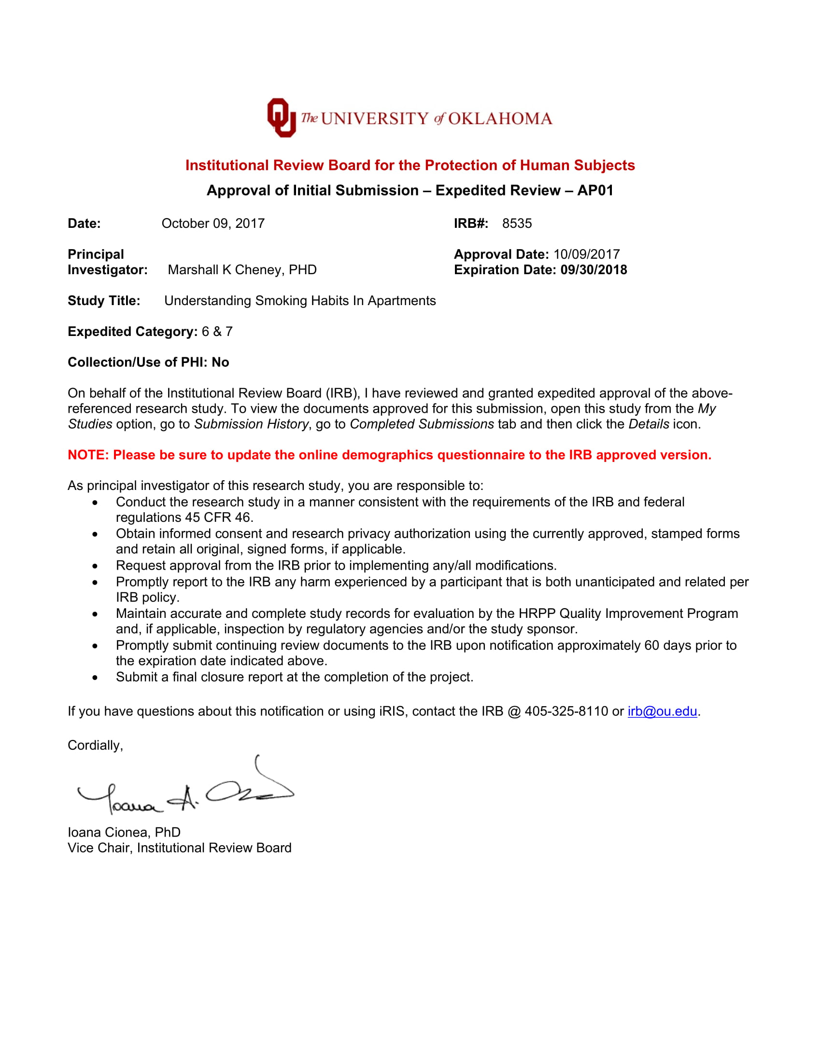

Appendix B: Demographic Questionnaire
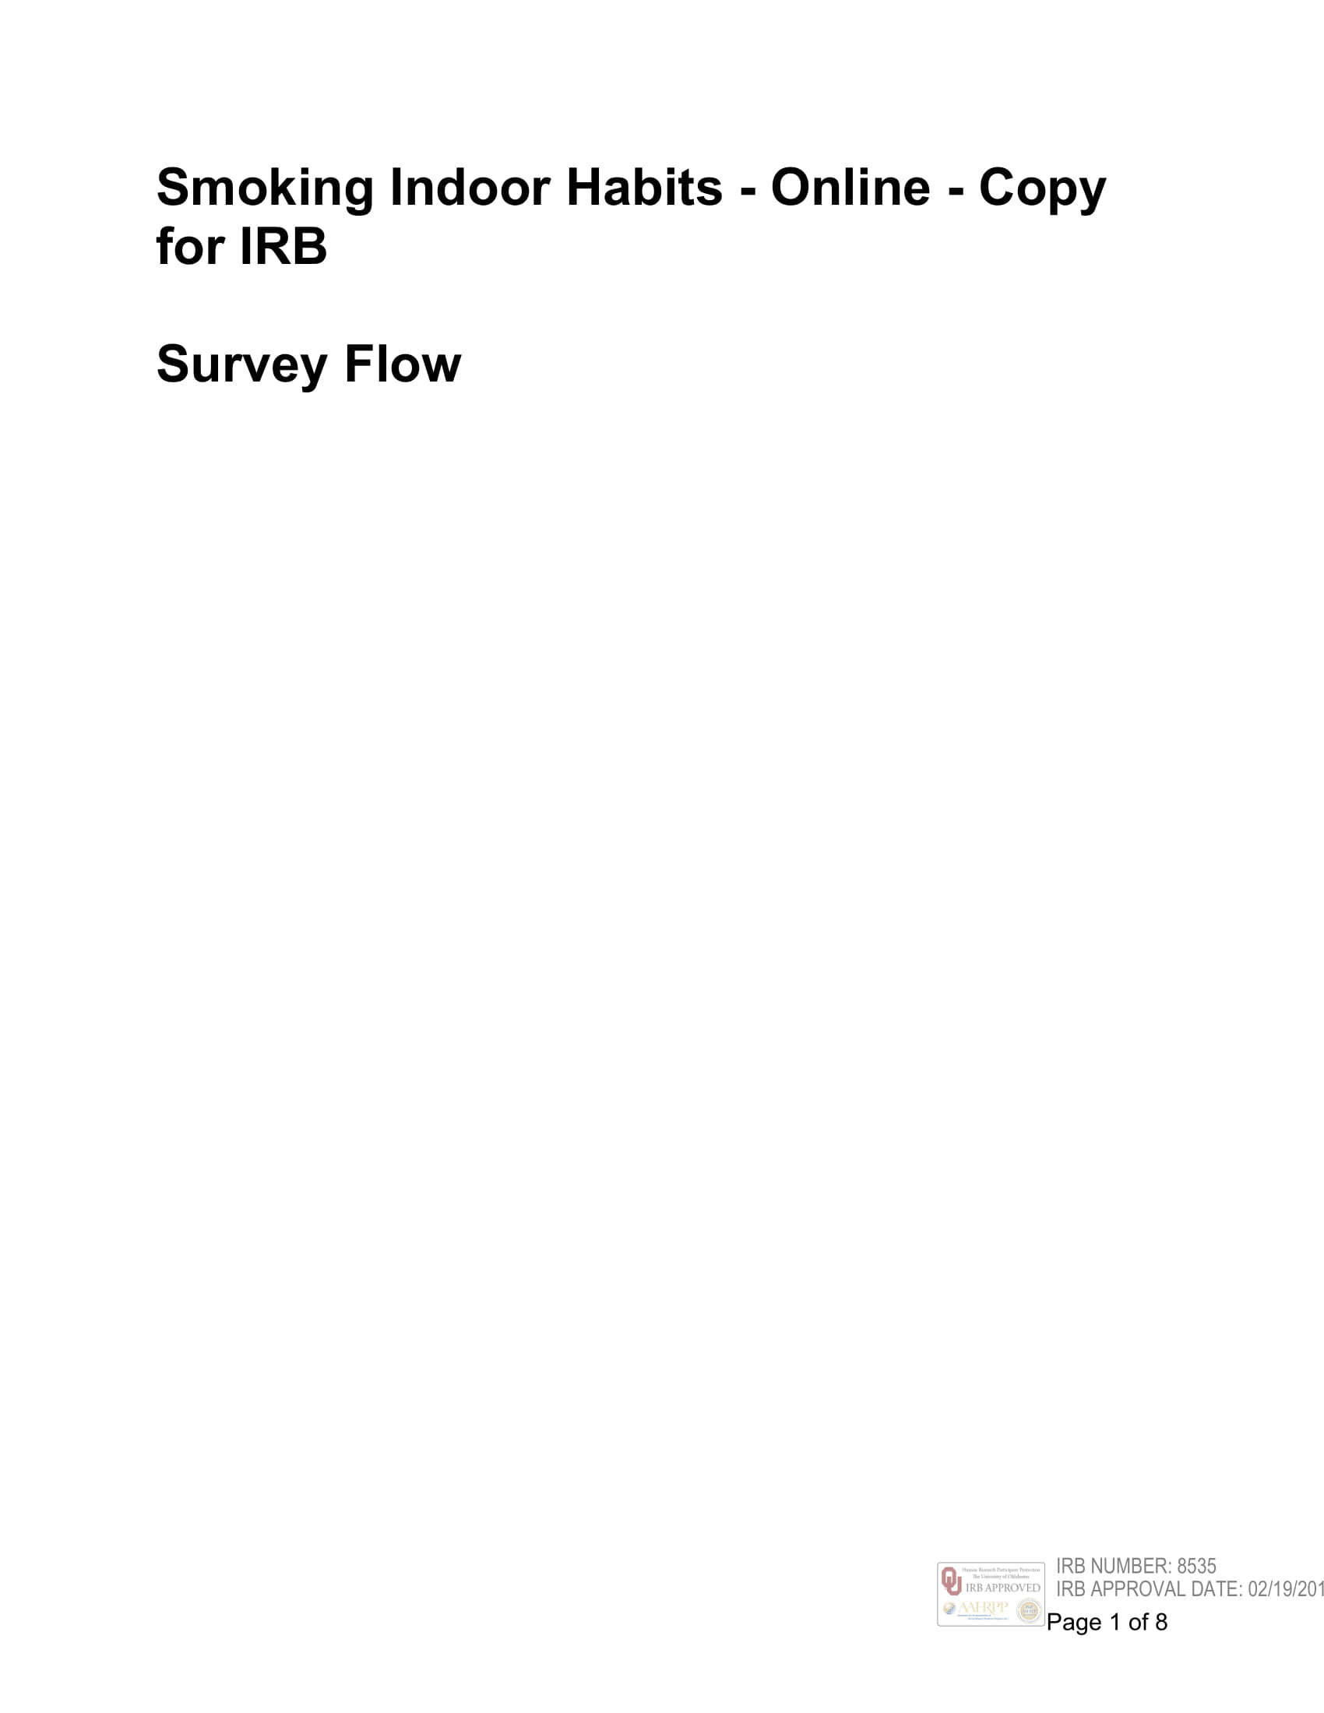

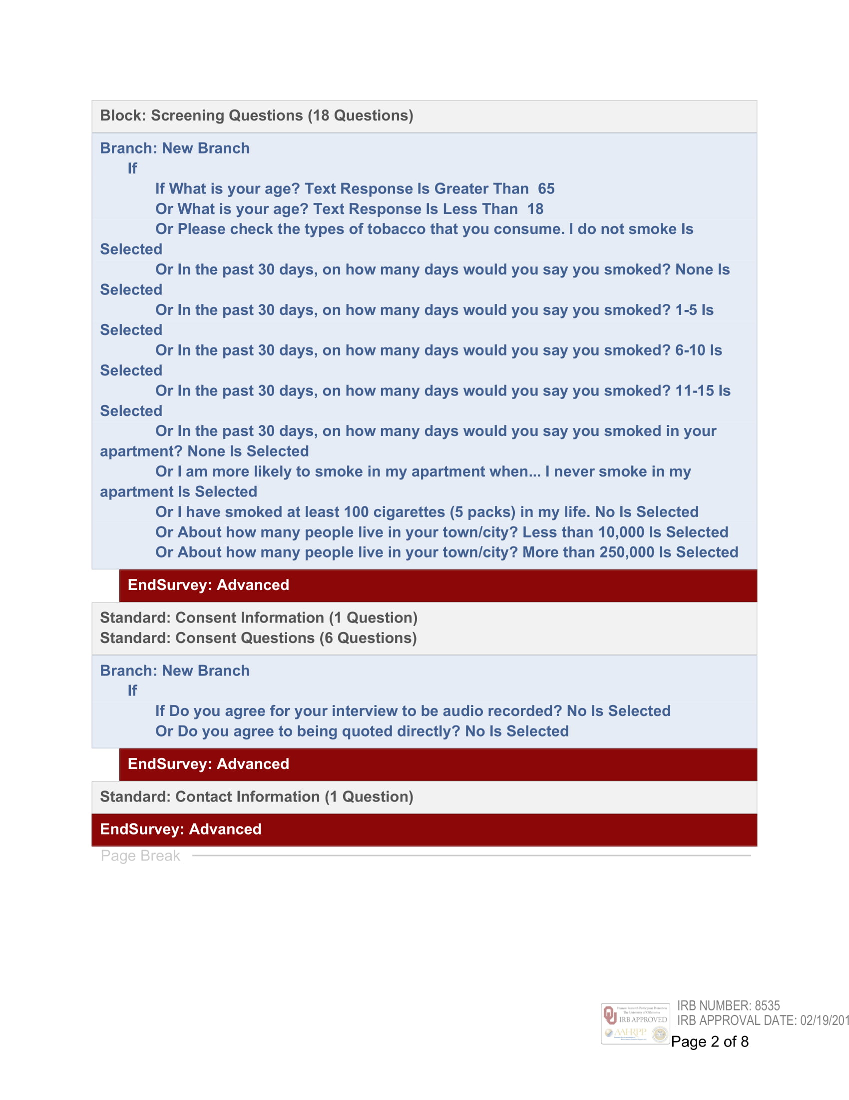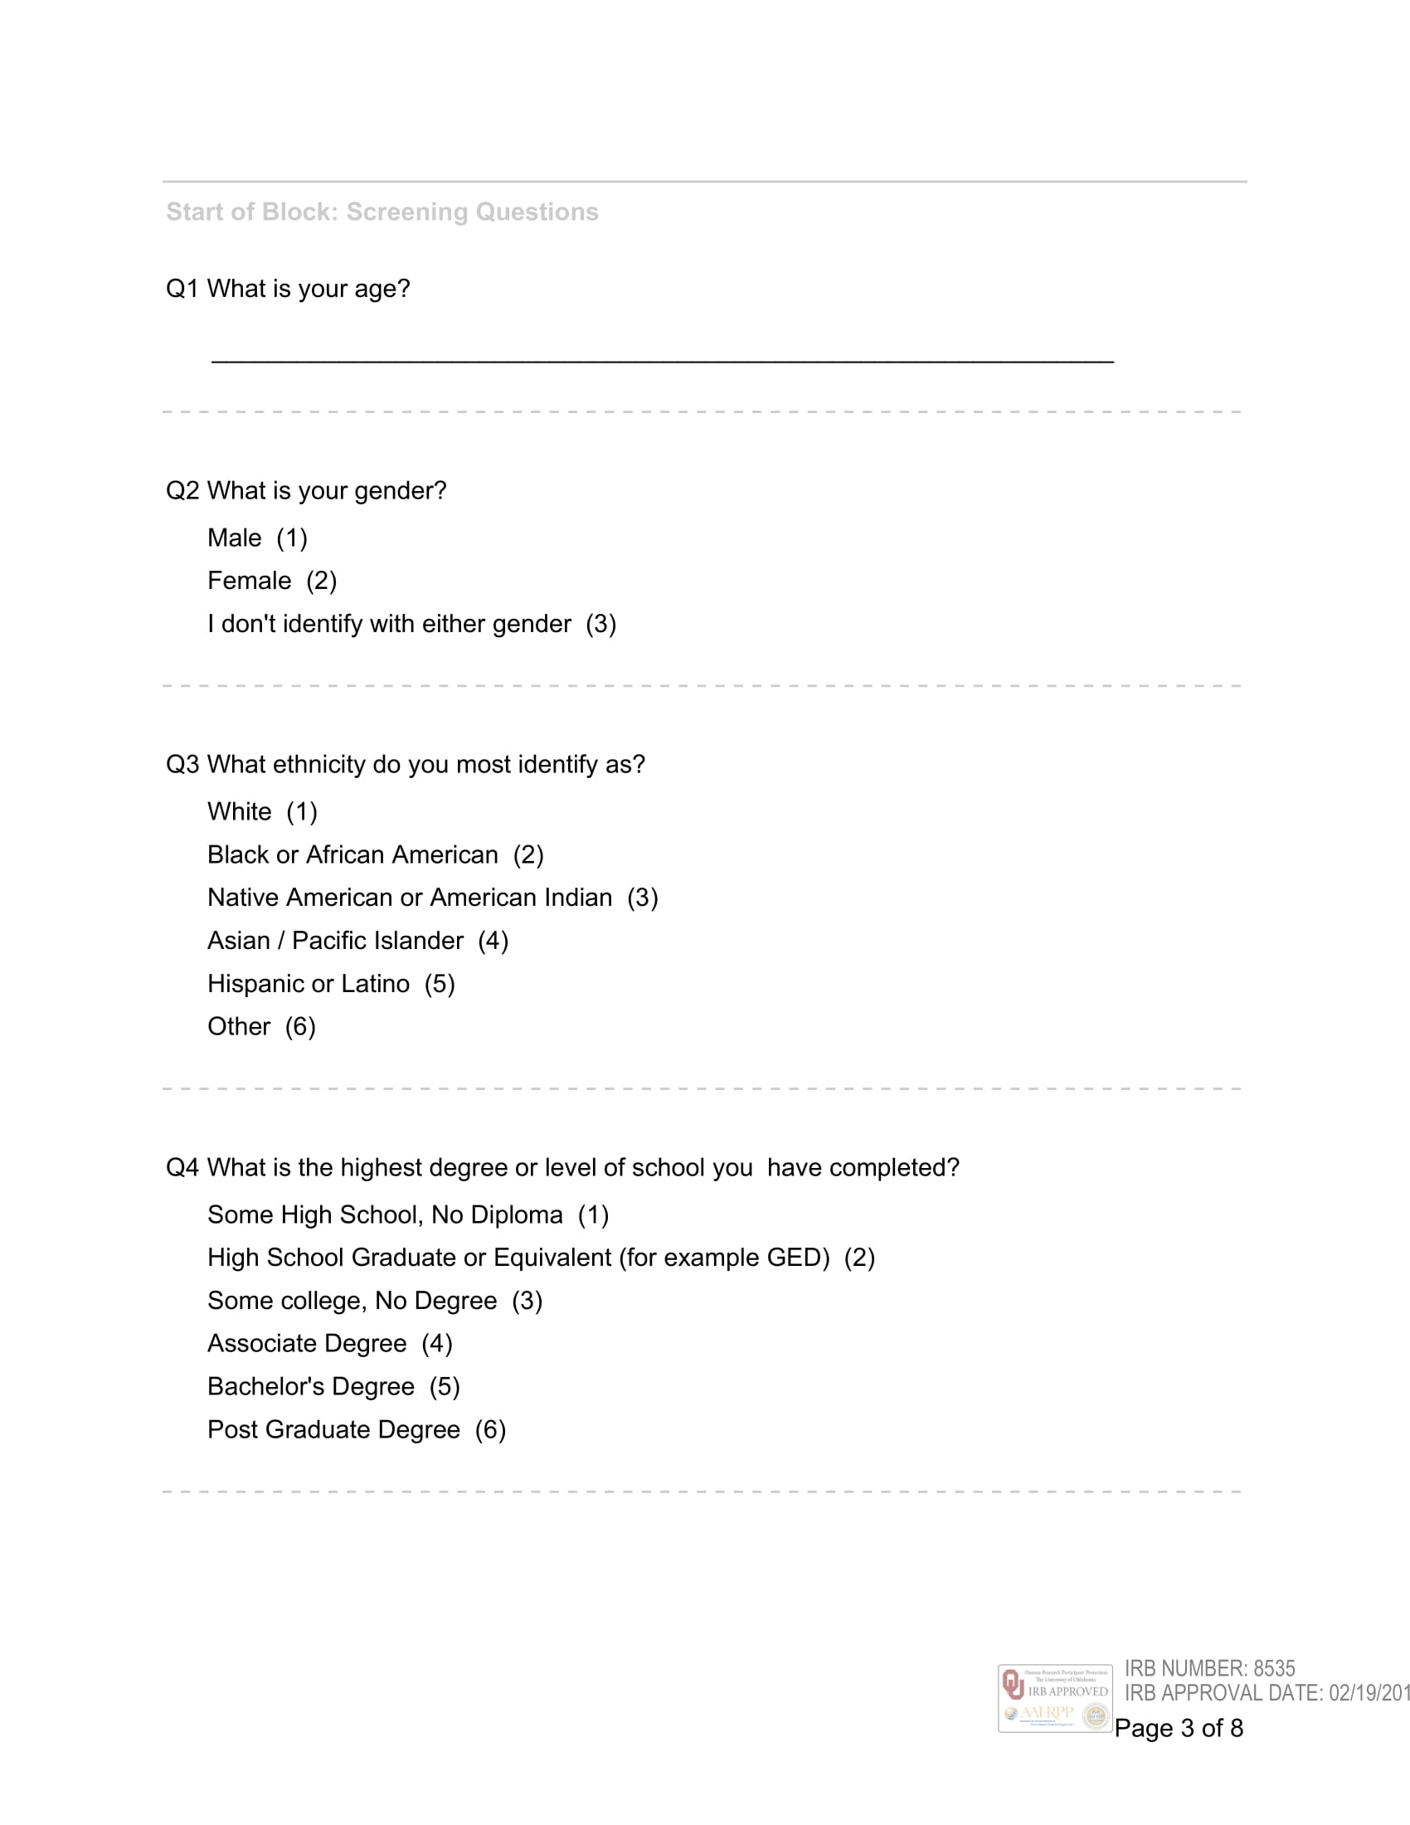

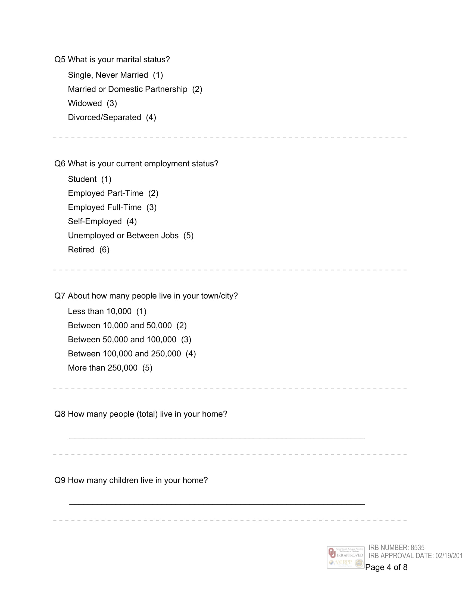
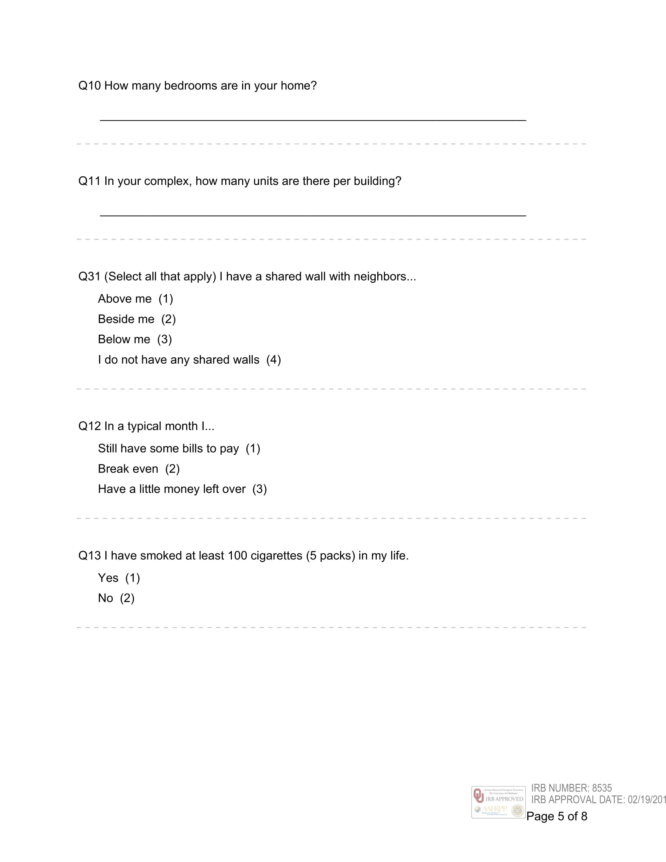

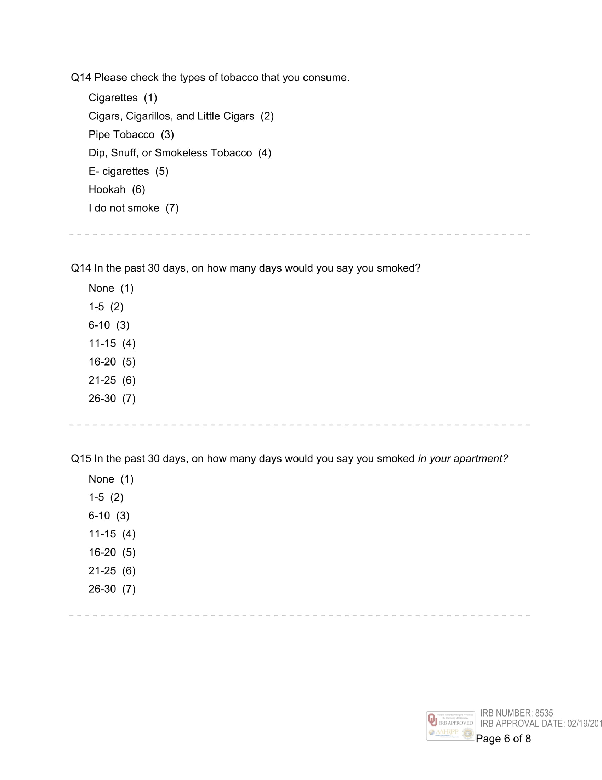

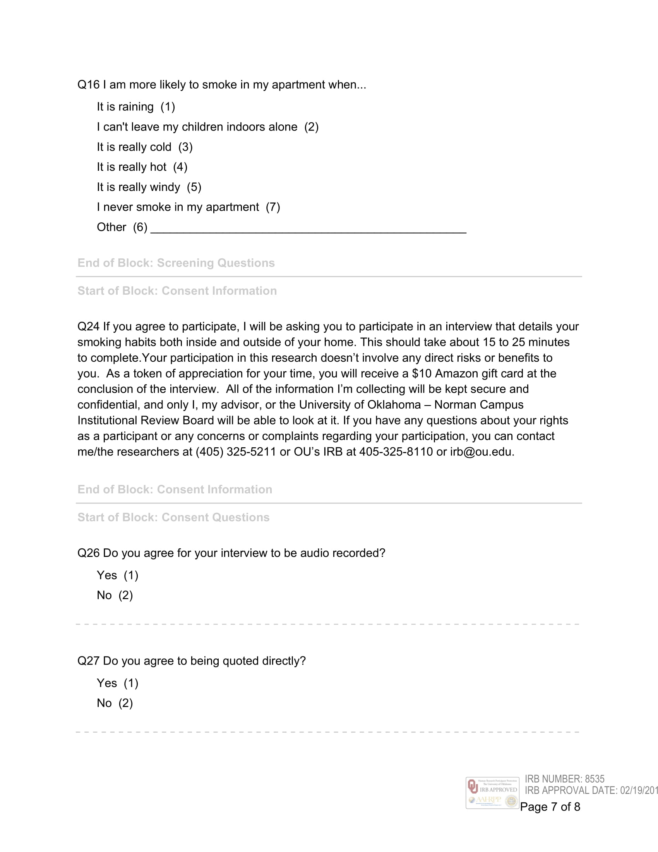
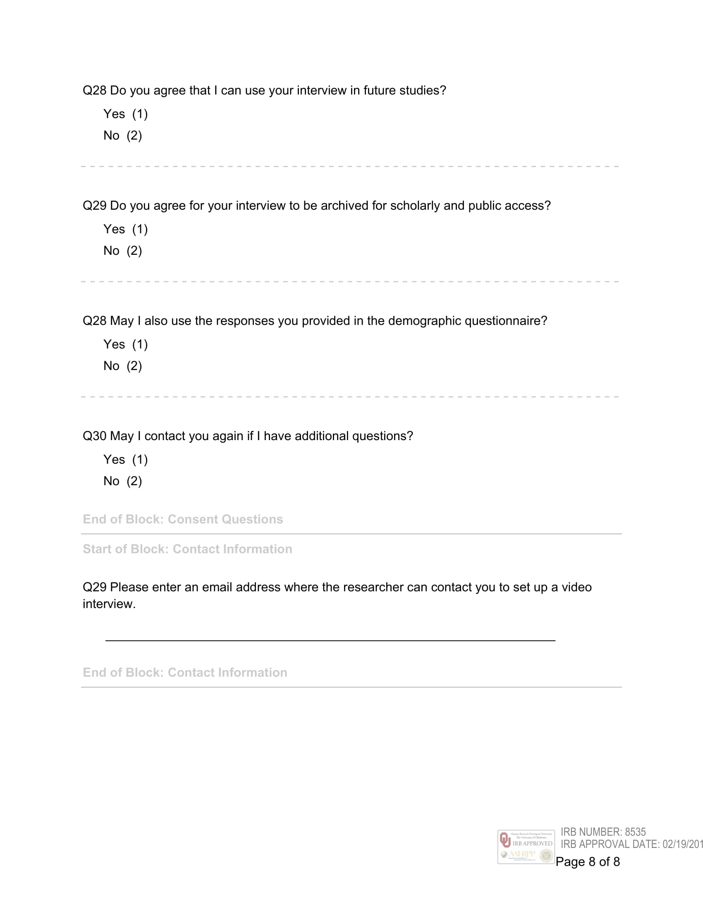

Appendix C: Oral Consent Form
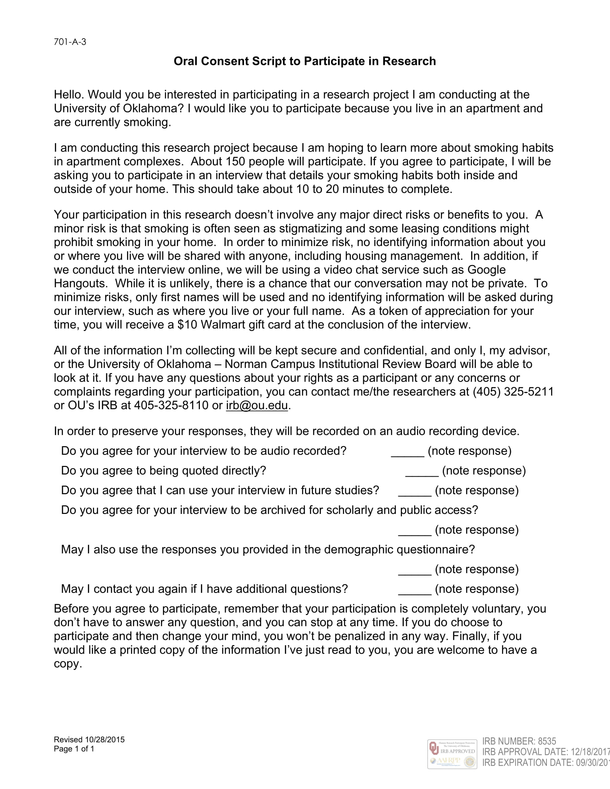
Appendix D: Codebook
Code | Description
Knowledge about 2nd Hand Smoke | Any comments related to how 2nd hand smoke functions and how it affects others.
Knowledge about 3rd Hand Smoke | Any comments related to how 3rd hand smoke functions (residue on furniture/walls/etc), may not necessarily know the term.
Reaction to Knowledge about 3rd hand smoke | Any comments describing their thoughts and plans when exposed to new information about 3rd hand smoke.
Social Smoking Habits | Any comments about positive reinforcing from others or a lack of reinforcement socially.
Apartment Policies | Any comments about rules/policies that regulate (or don’t) smoking inside of their apartments or around their complex. May include lack of knowledge.
Indoor “Cleanliness” | Any comments about how they think their cleaning/or lack of affects ETS. Includes getting rid of smell.
Stop Smoking Conditions | Any conditions where the smoker would cease/relocate their smoking.
Concerns about Smoking | Any comments about how their smoking affects others within their household.
Plans to Change Behavior | Any comments regarding past attempts to stop/relocate smoking or a desire to in the future.
Household-based rules | Any rules or situations that the residents of the apartment have established that effect smoking indoors.
Indoor Smoking Conditions | Any conditions that force or influence smokers to decide to smoke indoors.
Relocation Helpers | Any comments about features that would make it more comfortable to smoke outside, such as balconies, chairs, ashtrays, etc.
Places they Smoke | Indoors and Outdoors
Smoking Habits | What people like to do or typically do while they are smoking
Perceptions of Smoking | How they think their family and friends perceive their smoking
Relationships with Neighbors | Description of how well they know and or get along with their neighbors
Memorable quotes | Items that do not fit in other categories but are worth mentioning.
Resistance to Smoking Rules | Any mentions of how they are against smoking policies.

