Nouvelle Méthode de Trompe: Introduction, Observations, & Foreword
[185?]
By Jean-Baptiste Bertin
Translated and annotated by Dr. Sion M. (Ted) Honea
© 2021 Ted Honea
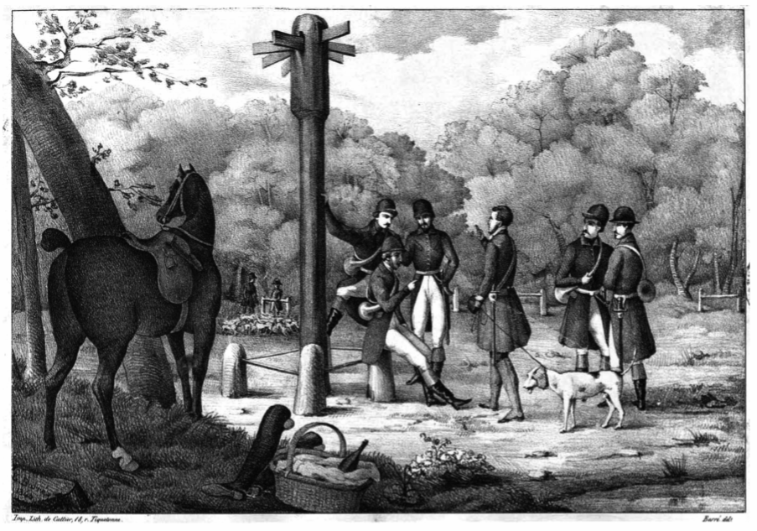

Translator’s Preface
Very little is known of Jean-Baptiste Bertin beyond the information he gives about himself or can be inferred from his text. His claim to the title of “professor” was a common one of the time, adopted unilaterally by teachers in any discipline. He does not appear in the faculty list of the Paris Conservatory. Cecil Hopkinson reports that he possessed some level of activity in music publishing in the 1860’s. It may be that his publishing career was limited only to the editions of his own method books and perhaps other music related to the hunt.
Bertin appears to have had an ongoing rivalry with another “professor” of the trompe, who was almost certainly N. Tellier. Internal evidence in the form of critical remarks in both their books, though directed anonymously, clearly relates to each other and forms reciprocal accusations and rebuttals.
If a modern former hornist never trained in the hunting trompe may judge, the explanatory material in Bertin’s book strikes the reader as more reliable than Tellier’s on the grounds of greater explicitness and precision. The two authors’ discussions of tonguing styles provide a good example, Tellier’s being so vague as to call in question either his efficacy as a teacher or his knowledge of the subject. It would be much more nearly possible to learn the practice of the style from Bertin. On the other hand, both authors leave much to be desired in regard to terminology, both at times leaving terms vague or completely undefined, even ones apparently critical. Both also provide a dictionary of hunting terms, though neither is entirely satisfactory.
Tellier’s Album seems preferable for a study of the actual music. He provides far more calls in the original monophonic version as well as in trio arrangement than does Bertin, whose music is predominantly for trompe trio.
The final judgment is that any student of the subject should probably best refer to both Bertin and Tellier. Both are available on IMSLP Petrucci, as well as Tellier’s earlier Manuel, though there is no copy of Bertin’s first edition similarly available. Translations of the explanatory matter are also both available in the Historical Translation Series, including the present translation.

Introduction
Of all those who have written for the trompe, none has endeavored to reproduce the fanfares such as they ought to be played in the hunt. Also I have thought it a duty, as a professor, and at the solicitation of several hunters and masters of horse and dogs to publish a simple method in which each fanfare will be found notated in two manners—simple or roulé—in order that students may be able to learn to play them according to their individual dispositions.
Of all the brass instruments, the trompe is the one with the most power. By its vibrant and sonorous sounds it speaks to the soul of the true hunter, animates the horse, excites the dogs and serves for encouraging them in place of the voice of the hunters (piqueurs), who would grow too fatigued if they were obliged to speak to them all the time of the hunt. Finally, the trompe is also indispensable in a hunt, like a megaphone on a ship. With a megaphone you make yourself heard by all the crew when you order a maneuver, the same as with a trompe, you designate all the movements of the hunt, because each fanfare is a language that all the hunters ought to understand, even without knowing how to play them. One will find in this method five plates representing the hoofs and tracks of the animals that one hunts, a summary of the natural history of these same animals, which the hunt concerns, and a dictionary of all the terms used in connection with the hunt. Without wanting to make a complete treatise, I wanted for amateurs, in perusing my manual, to be able to have recourse to others works, gain a general understanding of the circumstances of the hunt and the animals, for which they will want to play fanfares, reviewing those that they would want in fuller detail in the Manuel Général des Chasses or in the Parfait Chasseur, or general treatise of all the hunts by Auguste Desgraviers.

The Trompe in its Different Dimensions
The trompe is fourteen feet four inches long, whether it is coiled as a grand trompe, a demi-trompe, or a trompe of eight coils. It is in the key of D, that is to say that the C of the trompe corresponds to the orchestra’s D.
Formerly one made use of the grande trompe, in order to pass it more easily over a tricorn hat. Today one only uses the demi-trompes, which are preferable in that they hold them without being supported. Then the two hands being free, the one serves to guide the horse and the other for taking the whip with which one corrects the dogs.
The little trompe of eight coils is very convenient for persons who hunt on foot, in view of being attached with a string, one has the facility of passing it behind oneself and, it being placed in that way, it is not bothered by taking a blow from the gun when one doesn’t hunt with dogs (à forcer).

Holding the Trompe
The trompe is held in the right hand, which one ought to place closer to the bell than to the mouthpiece so that the trompe may be in balance on the arm and that one may be able to regulate the pressure of the mouthpiece on the lips.

The Mouthpiece (Embouchure)
The mouthpiece is composed of three parts—the rim, the cup, the shank.
The choice of a mouthpiece depends on the formation of the student’s mouth. A No.1 is appropriate for thin lips, a No.2 for medium lips, and a No.3 for large lips. A narrow mouthpiece facilitates making high notes but does not permit descending to all the low ones that one makes easily with a wide mouthpiece, which, consequently, is less favorable for ascending. Individuals who would have any facility in making low notes would do well to cultivate second parts, all the more because good second parts are more rare than first ones.
The most suitable mouthpieces are those in silver or gilded silver. Those in brass are not appropriate, dangerous, and always leave a bad taste in the mouth. Some are also made of ivory, but they have less sound and more inconvenience in being easily broken.
I enjoin students, when they have chosen a mouthpiece, to furnish themselves with a second one similar, so that, in case of loss, there remains one for them to serve as a model for the machinist who will be able to make one for them exactly alike, for the least difference is a great trouble in performance.

The Sound
The quality of sound depends on the manner of placing the mouthpiece on the lips and on the attack of the tongue.
For medium range sounds (such as Mi on the first line to Mi between the lines) it is necessary to place the mouthpiece equally on the lips with a pressure sufficient to maintain and give a tongue attack lightly by pronouncing the syllables Tu and Ta.
By means of a stronger pressure and by pulling up the lower lip against the upper lip and with a drier tongue attack one obtains the higher sounds. For the low sounds one relaxes and decreases the pressure of the mouthpiece and gives a less strong tongue attack.
It is impossible to specify the greater or lesser opening that one must give to the lips; it is for the student to apply himself to preserve or to rediscover on his own the exact degree of pressure of the lips or the mouthpiece when he produces with facility the low and high sounds, which he will only be able to acquire with practice and study.
The exercises that are at the beginning of this work are appropriate for training the mouthpiece (embouchure) quickly. The student who wishes to make rapid progress will need to work with application, all the more because by knowing the exercises well, it will be easy for him to play the fanfares that always contain only the notes that he will have studied separately.

The Different Manners of Playing Fanfares and the Different Tongue Attacks
One plays some fanfares in two manners: in pleine trompe and in radouci. The first is for practical use, the latter is pleasant. When one can combine the two it does no damage. But, since radouci is unusable for the hunt, and that it would produce bad habits, the student will do well always to play in pleine trompe until perfectly sure of his mouthpiece (embouchure).
The student ought to refrain from inflating the cheeks in blowing, it detracts from the force to the lips and produces only disagreeable sounds. He ought also to apply himself to breathe enough air in order to be able to play an entire reprise and to sustain the final without having recourse to the throat, which produces sounds that imitate closely the way of a person who makes hauts de corps.
When the student feels the tongue numbed and the lips fatigued, he ought to end the lesson, for in persisting to blow he would fatigue the lungs and the throat and would produce only bad sounds. It is better to play little and often. For example, one can without fear of being fatigued take two lessons each day, one in the morning and one in the evening, by especially avoiding playing on an empty stomach, from which comes the old proverb that says “full stomach plays well.”
There are three different tongue attacks: Simple, Roulé, and Tayauté.
The Simple tongue attack is made by playing all the notes separated by pronouncing Tu or Ta.
The Roulé tongue attack is habitually three eighth-notes that one must produce by attacking the first strongly and by rolling (roulant) on the other two without stopping the breath, as if one were pronouncing tourourou, not tou rou rou.
The Tayauté attack resembles a little the Roulé attack in that it is also composed of three notes, but the difference is that the Tayauté is composed of two little notes and one large and that they are not all three on the same pitch. It is what is called trill or grupetto on other instruments. [See the examples at the end of this translation.]

Observations
In the fanfares notated in the manual one will often find some double notes. The performer will choose those which will be easier for him to make, considering that they are both equally good and that it changes nothing in the fanfare.
When one finds a dotted black note or three eighth-notes, he will also be able to do the one or the other at his discretion.
All the fanfares ought to be played in the movement of a pas redoublé, a movement faster or slower does not conform to this genre of music.
Up until the present, fanfares have been notated in 6/8, I don’t well know why. Experience has proven to me that the meter in 3/8 was much more natural than the movement of the horse’s gallop, and a short explanation will easily make the truth of this understood. The beats of the gallop of a horse are regular and equal in force and the beats of the 6/8 meter are not. If for example, in the 6/8 meter one beats the first beat and lifts on the second, the second beat will be weaker than the first. In order to equalize them, one is obliged to beat both of them, which produces a 3/8 meter. I have, then, adopted the meter 3/8 in order to notate the fanfares contained in this manuel, this being the only appropriate for dividing and regulating the beats well.
For the same reason the fanfares that were written in 2/4 are notated in this collection with the meter in 1/4.

Foreword
Gaston, surnamed Phoebus, is one of the oldest authors who have written in French on the hunt, and among others on the stag. There is a treatise by him that bears the title Déduits de la Chasse, printed in Gothic font by Antoine Vérard at Paris without date. But, one determines by the time when the printer worked that the imprint can have been issued in 1518, in the reign of Francis I. It is ornamented with miniatures of a very rich execution. Two-thirds of this work are in prose and the other third in verse, the entire treatise on different types of the hunt.
The passion that Charles IX, king of France, had for this noble amusement caused him to compose himself a treatise on the hunt of the stag in particular. This little work is full of erudition and of good inquiries into the nature of the stag, for which he says he has caused to labor the greatest savants of the time in what concerned the hunt.
Jacques du Fouilloux, a Poitevin gentleman, dedicated to him a Vénerie Complète in one quarto volume, of which there are several editions. The Vénerie of du Fouilloux reinforces a large amount of knowledge and details on all the types of hunt in general. One sees that this author had a passionate taste for the art.
During the same reign, Charles Gaucher, native of Dammartin, chaplain of the king, began a work in French verse on the same subject, as he says in his preface, but it appeared only after the death of Charles IX. It is titled Les Plaisirs des Champs, and was printed in 1585 and dedicated to M. Joyeuse, admiral of France and governor of Normandy. There is a second edition of it dedicated to M. de Montbazon.
Forty years afterward, the treatise on the hunt for the stag of Charles IX appeared, printed in Paris in 1625, dedicated to Louis XIII.
In 1655, Robert Salnove dedicated his Vénerie Royale to Louis XV [sic], which gained for him a great reputation.
It was in the same year that Jacques Savary, native of Caen, had printed there a Latin poem divided into seven books solely on the hunt for the hare, titled Album Dianae Leporicidae, sive Venationis Leporinae Leges. He dedicated it to M. Pomponne de Bellièvre, president of the parliament of Paris. The success that this work received encouraged him to compose three other Latin poems under the title of Venationis Cervinae Capreolinae, a Prugnae, et Lupinae Leges, printed in 1659 and dedicated to MM. the princes of Longueville, to whom Savary was long previously strongly attached, they are subsequent by four years to the Vénerie of Salnove, which Savary followed in many matters, but of which he reduced the principles into a much greater precision. One can believe that he formed the plan of writing Latin verse only in view of enlivening the studies of the young princes, by flattering the extreme passion they had for the hunt, and in which, by long experience, he himself had acquired profound knowledge, perhaps also in the idea of making pass into foreign lands, by a common language, the principles of an art whose origin he attributed to the Gauls, predecessors of the French.
In 1734 there appeared the poem of the Dos des enfants de Latone, dedicated to Louis XV by M. de Sarré, which is a work very well written and of great merit.
In 1740 M. Pierre-Clément de Chapeville published a work on the hunt and falconry titled Nouveau Traité de Vénerie.
In 1788 there appeared a Traité de Vénerie by M. d’Iauville, premier hunter and ancient commandant of the Royal hunt.
In 1804 appeared a little collection in quarto containing different calls and fanfares of the hunt, followed by a vocabulary of the usage of the hunt and of falconry.
In 1810 appeared the Traité de Vénerie by M. Auguste Desgraviers, horseman and commandant of the hunt of Monseigneur the Prince of Conti.
Finally in 1825 appeared the Manuel General des Chasses by M. Jourdain and dedicated to M. the Count Girardin, premier hunter of the Crown.
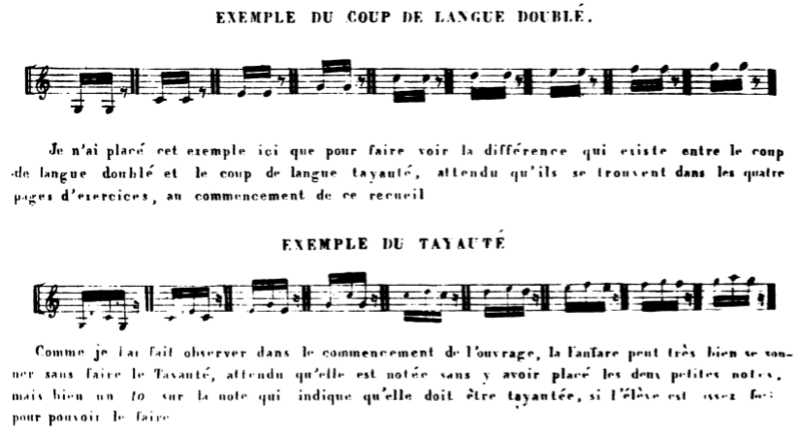

Translations of Bertin’s text
Double-Tongue: I have placed this example here only to make clear the difference that exists between the double-tongue stroke and the tayauté stroke. Seeing that they are found in all four pages of the exercises at the beginning of the collection.
Tayauté: As I gave notice in the beginning of the work, the fanfare can very well be played without the tayauté, seeing that it is notated without having placed on it the two little notes, but indeed one “to” on the note that indicates that it ought to be tayauté, if the student is sufficiently [illegible word] to be able to do it. [In Bertin’s book see pages 1,2,4,6,7, 11, 12, etc.]

Bibliography
Bertin, [Jean-Baptiste]. Nouvelle Méthode de Trompe: ou Manuel Raisonné. 2nd ed. Paris: The Author, [1850’s?]
Lassabathie, M. Histoire du Conservatoire Impérial de Musique et de Déclaration. 1860. Reprint, Delhi: n.p., n.d.
Hopkinson, Cecil. Parisian Music Publishers 1700-1950. London: The Author, 1954.
Tellier, N. Grand Album du Chasseur. Paris: Au Ménesterel: A. Meissonnier, Heugel, [1848?]

M. Lassabathie, Histoire du Conservatoire Impérial de Musique et de Déclamation (1860. Repr., Delhi: n.p., n.d.).
Cecil Hopkinson, Parisian Music Publishers 1700-1950 (London: The Author, 1954).
See notes below in the text and refer also to the translation of Tellier’s Album, also in this series.
The term is chasse à courre, which Harrap’s New Standard French & English Dictionary (1980) defines as “hunt.” Whether or not Bertin intends some distinction in his various terms for the hunt is unclear.
I have omitted the very extensive section on the natural history of the animals as being irrelevant to the subject of the trompe itself.
See the entry for Jourdain in Bertin’s bibliography below.
Bertin does not list this work in his bibliography.
Traité de Vénerie (1810), see below.
Bertin does not specifically define the term à forcer, but forcer une bête he defines as taking down an animal with the dogs.
It must be supposed that the numbers refer to standard variants of mouthpieces.
e’ to e” in the treble clef.
It is difficult to escape the feeling that Bertin’s use of the word embouchure = mouthpiece has passed over into the modern meaning of the formation of the lips.
The difference between pleine and radouci is that the former is a full robust sound and the latter a more gentle one. The reference to embouchure might possibly refer to either the modern embouchure or the mouthpiece.
The word is gosier and the sense is obscure to the translator.
I find no reference to this expression in Collins-Robert Unabridged, Cotgrave (1611), Grossjean, French Idiom Study, Harrap’s Slang French, or Harrap’s New Standard French and English Dictionary (1980).
Collins-Robert defines taïaut as tallyho!
Oxford Music Online, s.v. “March,” accessed March 5, 2021, http://www.oxfordmusiconline.com/grovemusic, accessed March 5, 2021 defines this as a quick march tempo varying from 100-140 bpm, with a norm of 116-120.
This is a point of contention between Bertin and Tellier in the latter’s Album.
Bertin’s explanation does not really address Tellier’s argument, if it is his intention to do so. Bertin seems to focus on 6/8 as including a strong and weak beat. Tellier’s argument is that the triplet figure is composed of unequal notes in the pattern short-short-long. A pattern very familiar from the old radio imitation of a horse’s gallop and from imitations by children.
Given the imprint date, this must be a misprint for Louis XIV. Louis XV was not born until 1710.
The title is presumably somewhat tongue in cheek and would translate something like Album of Diana Hare-Killer, or Rules for the Hunt of the Hare. Diana is the Roman goddess of the hunt.
Straightening out this title, either grammatically incompetent or more probably corrupt, is possibly more trouble than it is worth. The adjectives are all feminine forms in agreement with leges. There is also a misprint for aprugnae. The title is probably (or hopefully) a spoof in an erudite scholarly style. Stag, Roebuck, Boar, and Wolf Laws of the Hunt.
Gifts of the Children of Leto, namely Apollo and Artemis, both hunters and the latter the Greek goddess of the hunt and wild creatures.

