University of Oklahoma

Graduate College

A guided approach to teaching hand percussion instruments in a collegiate applied percussion curriculum

A Document

submitted to the Graduate Faculty

in partial fulfillment of the requirements for the

Degree of

Doctor of Musical Arts

By

Jordan Shippy
Norman, Oklahoma
2022

A guided approach to teaching hand percussion instruments in a collegiate applied percussion curriculum

A Document approved for the
School of Music

By

Dr. Marvin Lamb, Chair

Dr. Andrew Richardson

Dr. Sarah Ellis

Dr. Michael Lee

Dr. Allison Palmer

© Copyright by Jordan shippy 2022
All Rights Reserved.

Table of Contents
List of Figures vi
Abstract xviii
Chapter 1: Introduction 1
Purpose for the Document 1
Need for the Document 1
Limitations of the Document 2
Design of the Document 2
Chapter Two: Review of Related Literature 4
Hand Percussion Texts 4
Other Related Texts 7
Related Research Documents 8
Chapter Three: Overview of the Approach to Technique 11
Heel/Toe Family 12
Congas 13
Bongos 20
Pandeiro 25
Split Hand Family 30
Tar 31
Dumbek 36
Riq 40
Chapter Four: Sample Curricula 45
Curricula Overview 45
Congas 46
Bongos 67
Pandeiro 84
Tar 108
Dumbek 128
Riq 148
Curricula Strategies 170
Chapter Five: Summary and Conclusions 172
Works Cited 175
Discography 178
Appendix 1: Quick Reference Curricula 181
Appendix 2: Transfer of Basic Strokes Reference Table 192

List of Figures
Figure 1 – Playing Position for Congas 14
Figure 2 – Congas Notation Key 16
Figure 3 – One-Drum Tumbao Pattern 17
Figure 4 – Two-Drum Tumbao Pattern 17
Figure 5 – Basic Bolero Pattern for Congas 18
Figure 6 – Guaguancó Tumba Pattern 18
Figure 7 – Guaguancó Conga Pattern 18
Figure 8 – Basic Merengue Pattern for Congas 19
Figure 9 – Rumba Colombia Tumba Pattern 19
Figure 10 – Rumba Colombia Conga Pattern 19
Figure 11 – Playing Position for Bongos 20
Figure 12 – Bongos Notation Key 22
Figure 13 – Basic Martillo Pattern 23
Figure 14 – Basic Bolero Pattern for Bongos 23
Figure 15 – Basic Bossa Nova Pattern 24
Figure 16 – Basic Merengue Pattern for Bongos 24
Figure 17 – Basic Swing Pattern 25
Figure 18 – Playing Position for Pandeiro 25
Figure 19 – Pandeiro Finger Roll 27
Figure 20 – Pandeiro Notation Key 28
Figure 21 – Basic Samba Pattern 28
Figure 22 – Basic Partido Alto Pattern 29
Figure 23 – Basic Baião Pattern 29
Figure 24 – Drumset Rhythm 1 for Pandeiro 30
Figure 25 – Upright Style Playing Position for Tar 31
Figure 26 – Lap Style Playing Position for Tar 32
Figure 27 – Tar Notation Key 34
Figure 28 – Basic Baladi Pattern 34
Figure 29 – Basic Maksum Pattern 35
Figure 30 – Basic Saidi Pattern 35
Figure 31 – Basic Masmoudi Pattern 35
Figure 32 – Basic Chiftitelli Pattern 36
Figure 33 – Basic Malfuf Pattern 1 36
Figure 34 – Playing Position for Dumbek 37
Figure 35 – Dumbek Notation Key 39
Figure 36 – Basic Position for Riq 40
Figure 37 – Classical Position for Riq 41
Figure 38 – Riq Notation Key 43
Figure 39 – Heel/Toe Exercise for Congas 46
Figure 40 – Open Tone Exercise for Congas 46
Figure 41 – Closed Slap Exercise 47
Figure 42 – One-Drum Tumbao Variation 1 49
Figure 43 – One-Drum Tumbao Variation 2 49
Figure 44 – One-Drum Tumbao Variation 3 49
Figure 45 – Two-Drum Tumbao Variation 1 51
Figure 46 – Two-Drum Tumbao Variation 2 51
Figure 47 – Tumbao Fill 1 52
Figure 48 – Tumbao Fill 2 52
Figure 49 – Tumbao Fill 3 53
Figure 50 – Tumbao Fill 4 53
Figure 51 – Heel/Toe Sixteenth Note Exercise 54
Figure 52 – Merengue Variation 1 for Congas 56
Figure 53 – Merengue Variation 2 for Congas 56
Figure 54 – Merengue Variation 3 for Congas 56
Figure 55 – Double Stroke Exercise for Congas 57
Figure 56 – Rumba Colombia Tumba Variation 1 58
Figure 57 – Rumba Colombia Tumba Variation 2 58
Figure 58 – Rumba Colombia Conga Variation 1 59
Figure 59 – Rumba Colombia Conga Variation 2 59
Figure 60 – Rumba Colombia Combined Variation 1 59
Figure 61 – Rumba Colombia Combined Variation 2 59
Figure 62 – Rumba Colombia Combined Variation 3 59
Figure 63 – Paradiddle Exercise for Congas 61
Figure 64 – Guaguancó Tumba Variation 1 61
Figure 65 – Guaguancó Tumba Variation 2 61
Figure 66 – Guaguancó Conga Variation 1 62
Figure 67 – Guaguancó Conga Variation 2 62
Figure 68 – Guaguancó Combined Variation 1 62
Figure 69 – Guaguancó Combined Variation 2 62
Figure 70 – Guaguancó Quinto Rhythm 1 63
Figure 71 – Guaguancó Quinto Rhythm 2 63
Figure 72 – Guaguancó Quinto Rhythm 3 63
Figure 73 – Heel/Toe Sixteenth-Note Variations Exercise 64
Figure 74 – Heel/Toe Exercise for Bongos 68
Figure 75 – Open Tone Exercise for Bongos 68
Figure 76 – Martillo Variation 1 69
Figure 77 – Martillo Variation 2 69
Figure 78 – Martillo Variation 3 69
Figure 79 – Conga-Style Bolero Variation 1 for Bongos 73
Figure 80 – Conga-Style Bolero Variation 2 for Bongos 73
Figure 81 – Closed Slap Exercise for Bongos 73
Figure 82 – Bossa Nova Variation 1 75
Figure 83 – Bossa Nova Variation 2 75
Figure 84 – Bossa Nova Variation 3 76
Figure 85 – Double Stroke Exercise for Bongos 76
Figure 86 – Merengue Variation 1 for Bongos 77
Figure 87 – Merengue Variation 2 for Bongos 78
Figure 88 – Paradiddle Exercise for Bongos 78
Figure 89 – Swing Pattern Variation 1 for Bongos 79
Figure 90 – Swing Pattern Variation 2 for Bongos 79
Figure 91 – Triplet Exercise for Bongos 80
Figure 92 – Open Tone and Closed Slap Combination 82
Figure 93 – Heel/Toe Exercise 1 for Pandeiro 85
Figure 94 – Heel/Toe Exercise 2 for Pandeiro 85
Figure 95 – Open Tone Exercise 1 for Pandeiro 85
Figure 96 – Open Tone Exercise 2 for Pandeiro 86
Figure 97 – Open Tone Exercise 3 for Pandeiro 86
Figure 98 – Closed Slap Exercise for Pandeiro 86
Figure 99 – Basic Samba Pattern with the Closed Slap 87
Figure 100 – Samba Pattern Variation 1 87
Figure 101 – Samba Pattern Variation 2 88
Figure 102 – Samba Pattern Variation 3 88
Figure 103 – Samba with the Closed Slap Variation 1 89
Figure 104 – Samba with the Closed Slap Variation 2 89
Figure 105 – Samba with the Closed Slap Variation 3 89
Figure 106 – Choro Pattern 1 90
Figure 107 – Choro Pattern 2 91
Figure 108 – Choro Patten 3 91
Figure 109 – Choro with the Thumb Slap Variation 1 92
Figure 110 – Choro with the Thumb Slap Variation 2 92
Figure 111 – Choro with the Thumb Slap Variation 3 93
Figure 112 – Finger Roll Exercise for Pandeiro 93
Figure 113 – Heel Double Stroke Exercise 93
Figure 114 – Heel Double Stroke Part 1 94
Figure 115 – Heel Double Stroke Part 2 95
Figure 116 – Finger Roll Double Stroke Exercise 96
Figure 117 – Heel/Toe Flam Exercise 97
Figure 118 – Partido Alto Variation 1 97
Figure 119 – Partido Alto Variation 2 97
Figure 120 – Partido Alto Variation 3 97
Figure 121 – Vertical Shake Exercise 99
Figure 122 – Vertical Shake Motion 99
Figure 123 – Horizintal Shake Exercise 100
Figure 124 – Horizontal Shake Motion 100
Figure 125 – Baião Variation 1 100
Figure 126 – Baião Variation 2 101
Figure 127 – Baião Variation 3 101
Figure 128 – Drumset Rhythm 2 for Pandeiro 102
Figure 129 – Drumset Rhythm 3 for Pandeiro 102
Figure 130 – Syncopation Exercise for Pandeiro 103
Figure 131 – Pandeiro Funk Groove 1 103
Figure 132 – Pandeiro Funk Groove 2 104
Figure 133 – Open Tone Triplets Exercise 105
Figure 134 – Alternating Open Tone Triplets 105
Figure 135 – Open Tone and Closed Slap Alternating Triplets 105
Figure 136 – Dum Exercise for Tar 108
Figure 137 – Tek/Ka Exercise for Tar 109
Figure 138 – Pa Exercise for Tar 110
Figure 139 – Baladi Variation 1 for Tar 110
Figure 140 – Baladi Variation 2 for Tar 110
Figure 141 – Baladi Variation 3 for Tar 110
Figure 142 – Maksum Variation 1 for Tar 111
Figure 143 – Maksum Variation 2 for Tar 111
Figure 144 – Maksum Variation 3 for Tar 111
Figure 145 – Finger Snap Exercise 112
Figure 146 – Baladi with Pa Variation 1 for Tar 113
Figure 147 – Baladi with Pa Variation 2 for Tar 113
Figure 148 – Maksum with Pa Variation 1 for Tar 113
Figure 149 – Maksum with Pa Variation 2 for Tar 113
Figure 150 – One-Hand Finger Roll Exercise for Tar 114
Figure 151 – Two-Hand Finger Roll Exercise for Tar 115
Figure 152 – Masmoudi Variation 1 for Tar 115
Figure 153 – Masmoudi Variation 2 for Tar 116
Figure 154 – Masmoudi Variation 3 for Tar 116
Figure 155 – Baladi and Masmoudi Combination for Tar 117
Figure 156 – Maksum and Masmoudi Combination for Tar 117
Figure 157 – Split Hand Pa Exercise 1 for Tar 118
Figure 158 – Split Hand Pa Exercise 2 for Tar 119
Figure 159 – Chiftitelli Variation 1 for Tar 119
Figure 160 – Chiftitelli Variation 2 for Tar 120
Figure 161 – Chiftitelli Variation 3 for Tar 120
Figure 162 – Split Hand Pa Exercise 3 for Tar 121
Figure 163 – Basic Malfuf Pattern 2 for Tar 121
Figure 164 – Advanced Finger Snap Exercise 1 122
Figure 165 – Malfuf Variation 1 for Tar 122
Figure 166 – Malfuf Variation 2 for Tar 122
Figure 167 – Malfuf Variation 3 for Tar 122
Figure 168 – Malfuf Variation 4 for Tar 123
Figure 169 – Advanced Finger Snap 2 123
Figure 170 – Advanced Finger Snap 3 124
Figure 171 – Saidi Variation 1 for Tar 124
Figure 172 – Saidi Variation 2 for Tar 124
Figure 173 – Saidi Variation 3 for Tar 124
Figure 174 – Dum Exercise for Dumbek 129
Figure 175 – Tek/Ka Exercise for Dumbek 129
Figure 176 – Pa Exercise for Dumbek 130
Figure 177 – Baladi Variation 1 for Dumbek 130
Figure 178 – Baladi Variation 2 for Dumbek 131
Figure 179 – Baladi Variation 3 for Dumbek 131
Figure 180 – Maksum Variation 1 for Dumbek 131
Figure 181 – Maksum Variation 2 for Dumbek 131
Figure 182 – Maksum Variation 3 for Dumbek 131
Figure 183 – Closed Slap Exercise for Dumbek 132
Figure 184 – Pop Exercise 133
Figure 185 – Baladi with the Slap and Pop Variation 1 133
Figure 186 – Baladi with the Slap and Pop Variation 2 133
Figure 187 – Baladi with the Slap and Pop Variation 3 133
Figure 188 – Maksum with the Slap and Pop Variation 1 134
Figure 189 – Maksum with the Slap and Pop Variation 2 134
Figure 190 – Maksum with the Slap and Pop Variation 3 134
Figure 191 – One-Hand Finger Roll Exercise for Dumbek 135
Figure 192 – Two-Hand Finger Roll Exercise for Dumbek 136
Figure 193 – Masmoudi Variation 1 for Dumbek 136
Figure 194 – Masmoudi Variation 2 for Dumbek 136
Figure 195 – Masmoudi Variation 3 for Dumbek 136
Figure 196 – Baladi and Masmoudi Combination for Dumbek 137
Figure 197 – Maksum and Masmoudi Combination for Dumbek 138
Figure 198 – Split Hand Pa Exercise 1 for Dumbek 138
Figure 199 – Split Hand Pa Exercise 2 for Dumbek 139
Figure 200 – Chiftitelli Variation 1 for Dumbek 140
Figure 201 – Chiftitelli Variation 2 for Dumbek 140
Figure 202 – Chiftitelli Variation 3 for Dumbek 140
Figure 203 – Split Hand Pa Exercise 3 for Dumbek 141
Figure 204 – Basic Malfuf Pattern 2 for Dumbek 141
Figure 205 – Paradiddle Exercise 1 for Dumbek 142
Figure 206 – Malfuf Variation 1 for Dumbek 142
Figure 207 – Malfuf Variation 2 for Dumbek 142
Figure 208 – Malfuf Variation 3 for Dumbek 142
Figure 209 – Malfuf Variation 4 for Dumbek 143
Figure 210 – Paradiddle Exercise 2 for Dumbek 143
Figure 211 – Paradiddle Diddle Exercise 144
Figure 212 – Saidi Variation 1 for Dumbek 144
Figure 213 – Saidi Variation 2 for Dumbek 145
Figure 214 – Saidi Variation 3 for Dumbek 145
Figure 215 – Dum Exercise for Riq 149
Figure 216 – Tek/Ka Exercise 1 for Riq 149
Figure 217 – Tek/Ka Exercise 2 for Riq 149
Figure 218 – Pa Exercise for Riq 150
Figure 219 – Baladi Variation 1 for Riq 151
Figure 220 – Baladi Variation 2 for Riq 151
Figure 221 – Baladi Variation 3 for Riq 151
Figure 222 – Maksum Variation 1 for Riq 151
Figure 223 – Maksum Variation 2 for Riq 151
Figure 224 – Maksum Variation 3 for Riq 152
Figure 225 – Basic Shake Roll Exercise 153
Figure 226 – Baladi with a Shake Roll Variation 1 153
Figure 227 – Baladi with a Shake Roll Variation 2 153
Figure 228 – Baladi with a Shake Roll Variation 3 153
Figure 229 – Maksum with a Shake Roll Variation 1 154
Figure 230 – Maksum with a Shake Roll Variation 2 154
Figure 231 – Maksum with a Shake Roll Variation 3 154
Figure 232 – Finger Roll Exercise for Riq 155
Figure 233 – Sideways Shake Roll Exercise 156
Figure 234 – Masmoudi Variation 1 for Riq 156
Figure 235 – Masmoudi Variation 2 for Riq 156
Figure 236 – Masmoudi Variation 3 for Riq 156
Figure 237 – Baladi and Masmoudi Combination for Riq 158
Figure 238 – Maksum and Masmoudi Pattern for Riq 158
Figure 239 – Split Hand Pa Exercise 1 for Riq 159
Figure 240 – Split Hand Pa Exercise 2 for Riq 160
Figure 241 – Chiftitelli Variation 1 for Riq 160
Figure 242 – Chiftitelli Variation 2 for Riq 160
Figure 243 – Chiftitelli Variation 3 for Riq 160
Figure 244 – Split Hand Pa Exercise 3 for Riq 161
Figure 245 – Basic Malfuf Pattern 2 for Riq 161
Figure 246 – Classical Position Dum Exercise 162
Figure 247 – Classical Position Tek Exercise 162
Figure 248 – Malfuf Variation 1 for Riq 163
Figure 249 – Malfuf Variation 2 for Riq 163
Figure 250 – Malfuf Variation 3 for Riq 163
Figure 251 – Malfuf Variation 4 for Riq 163
Figure 252 – Classical Position Sixteenth-Note Dum Exercise 164
Figure 253 – Classical Position Sixteenth-Note Tek Exercise 164
Figure 254 – Classical Position Double Stroke Exercise 165
Figure 255 – Saidi Variation 1 for Riq 165
Figure 256 – Saidi Variation 2 for Riq 166
Figure 257 – Saidi Variation 3 for Riq 166
Figure 258 – Sideways Shake Roll Combination Exercise 167

Abstract

Hand percussion is a broad term that includes many different instruments, techniques, and styles and can be difficult to decide what to include in a collegiate percussion curriculum. Although there are several resources available for most hand percussion instruments, these resources are often too large to incorporate into a collegiate curriculum, leaving the university percussion teacher to decide what information is essential. Moreover, most of the available resources only discuss how to play one hand percussion instrument which means the instructor must purchase several volumes of materials or limit the number of available options in their curriculum.
This document serves to consolidate the available resources for congas, bongos, pandeiro, tar, dumbek, and riq into a single volume and provides flexible 7-Week and 14-Week curricula for each instrument, allowing for maximum implementation based on the specific needs of a percussion program. Each curriculum will guide the student and the teacher through the basic strokes, traditional grooves, play-along assignments, and solo strategies for each drum as well as how the techniques of one hand percussion instrument can be applied to another.
This document fills a hole in the pedagogical literature by providing a concise

guide to the essential skills needed for playing, teaching, and performing on congas,

bongos, pandeiro, tar, dumbek, and riq.

Chapter 1: Introduction

Purpose for the Document
The purpose of this study is to provide a guided approach to playing and teaching six hand percussion instruments (congas, bongos, pandeiro, tar, dumbek, and riq) in a collegiate applied percussion setting. This document will provide flexible curricula addressing the techniques of each drum, applications of techniques to traditional styles, and the transfer of techniques between drums.

Need for the Document
Hand percussion is a broad term that includes many different instruments, techniques, and styles. With so many options available, it can be difficult to decide on which instruments or method books to include in a curriculum and how to navigate a course of study that efficiently covers the information without compromising the other areas of study (snare drum, mallet keyboards, timpani, etc.). There are several method books that succinctly and thoroughly explain how to approach the instruments discussed in this document; however, these resources are typically quite large and using them requires the university percussion instructor to pick and choose what to include. Moreover, each of these resources covers one drum of many in the world of hand percussion, requiring the percussion teacher to assemble several volumes of materials if they wish to effectively teach multiple instruments. There is a need for a document that consolidates the available materials into succinct curricula that allow the university percussion teacher to efficiently teach hand percussion.

Limitations of the Document
This document will be limited to six drums (congas, bongos, pandeiro, tar, dumbek, and riq) and how to teach them in a collegiate applied percussion setting. The proposed curricula are constructed to fit a variety of formats based on the individual needs of a program, teacher, or student. Each curriculum will provide the student with a foundational understanding of the basic techniques, traditional grooves, and listening examples for each drum. Resources for further study will be provided at the end of the document.

Design of the Document
The document will be in two parts. The first part will provide information on each instrument including a discussion of the techniques, technical exercises, application of techniques to traditional grooves and rhythms, application of rhythms to appropriate styles, and the transfer of techniques between instruments. The instruments in this document have been separated into two categories: heel/toe and split-hand. The Heel/Toe Family consists of congas, bongos, and pandeiro, while the Split-Hand Family consists of tar, dumbek, and riq. Separating the instruments into these categories reveals the techniques that apply to each instrument in a given family.
The second part will provide sample curricula for each instrument in a seven-week and fourteen-week format. These curricula will provide flexible options for the applied percussion instructor to implement the concepts in a way that best fits their individual needs. The second part will also discuss different ways that these curricula can be implemented depending on the individual needs of a given program including how to teach within a thirty-minute format, a sixty-minute format, or considerations when teaching these instruments during the same semester as other percussion instruments.

Chapter Two: Review of Related Literature

The literature included in this review can be divided into three categories. The first category includes a notable text for each instrument. Each of these resources is well-written and provides valuable insight on the given instrument; however, they also pose at least one challenge for a potential course of study. Challenges include too much content for a one-semester course of study, a lack of a systematic approach for learning the proposed content, and a lack of discussion regarding how the techniques learned can be applied to other instruments. The second category includes other related texts that discuss multiple instruments, but there is not a resource that discusses how to teach multiple hand percussion instruments in an applied percussion setting. The third category includes curricula-based documents that explore areas of the percussion curriculum such as drum set, and composition and how to approach teaching these topics in a semester format. The formal structures of these documents will serve as models for this document.

Hand Percussion Texts
Michael Spiro – Conga Drummer’s Guidebook
This is a useful resource that covers everything a student would want to know about playing congas. Michael Spiro explains the techniques used to play congas, the concept of clave, and how to correctly apply the techniques into phrases. He also provides exercises to develop coordination, stamina, and speed. Lastly, this resource provides details on how to play traditional conga grooves such as tumbao or rumba with a stylistically appropriate feel.

Trevor Salloum – Bongo Drumming: Beyond the Basics
Salloum’s text provides a historical overview of bongo drumming as well as other resources including a list of recorded bongo solos, a glossary of terms, and a transcription of a solo by Armando Peraza. Much of the performance application of this book is dedicated to playing martillo, the most common groove played on bongos, but there is also information on how to play in other styles such as nengon, changui, and rock.

Luiz Roberto Sampaio – Pandeiro Brasileiro
Sampaio’s text is written in two volumes and each uses a comparable format. Both volumes begin with descriptions of the techniques used and how to read the provided notation. The second section provides exercises that help develop the techniques, and the third section is the application of the techniques to styles such as samba, choro, capoeira, and funk. The second volume includes a fourth section that provides additional etudes for solo pandeiro or duets for two pandeiros.

Glen Velez – Tar Manual
Velez’s text provides an overview of the techniques, syllables associated with the techniques, exercises, and grooves associated with playing the tar. The content is introduced in a logical stepwise fashion that allows students to gradually expand the number of sounds at their disposal, the number of techniques incorporated into their playing, as well as the number of grooves in their repertoire. The styles covered in this resource include baladi, maksoum, masmoudi, and saidi.

Raquy Danziger – Dumbek Fever
Danziger’s text is written in four volumes and is designed to be a fully comprehensive resource for dumbek playing. The text thoroughly explains the techniques and grooves used to play dumbek, but it also discusses other facets of playing dumbek such as accompanying a dancer, playing duets, or soloing in a variety of styles.

Mary Ellen Donald – Arabic Tambourine
Donald’s text is a thorough and comprehensive study of the riq, tar, and mazhar. The study includes notation examples of practice routines and exercises as well as information regarding the history and social aspects that come with playing these instruments.

Other Related Texts
Gilson De Assis – Brazilian Percussion
Brazilian Percussion serves as a resource for an educator to teach a Brazilian Percussion ensemble. The text includes information on how to play repinique, surdo, agogo, tamborim, caixa, cuica, and gonza in variety of styles including samba, reggae, baião, and marcatu. The information is centered around how these instruments function in an ensemble.

Cheryl Grosso – Hand Drumming Essentials
Grosso’s text outlines techniques and approaches to performing in a hand percussion ensemble. Instruments are broken into three categories: drums of the ensemble, accessory percussion, and marimba. Drums of the ensemble include congas, bongos, surdo, timbales, and log drums. Accessory percussion includes agogo bells, claves, cowbell, guiro, tamborim, tambourine, toke, triangles. The text also includes perspectives on rehearsal organization, improvisatory exercises, dexterity exercises, and performance excerpts for the ensemble.

Chalo Eduardo and Frank Kumar – Drum Circle: A Guide to World Percussion
This text is similar to Grosso’s Hand Drumming Essentials, but it covers a wider array of instruments and includes a more specific outline of technical procedures for each instrument. Instruments covered in the text include congas, timbau, djembe, dumbek, tamborim, frame drum, bohdran, pandeiro, riq, surdo, djun-djun, and tan-tan. Although many instruments are covered, the content focuses on basic techniques and retains the focus of ensemble performance.

Al Payson – Techniques of Playing Bass Drum, Cymbals, and Accessories
Payson’s text is similar to Hand Drumming Essentials and Drum Circle: A Guide to World Percussion in that it combines several instruments into a single resource; however, it focuses on how to approach orchestral percussion instruments instead of hand percussion. Payson discusses the different types, sizes, and techniques related to each instrument and includes a standard symphonic repertory for each.

Related Research Documents
J. Thomas Morgan – A basic drum set course of study for the undergraduate percussion major
This document stresses the importance of drum set in the percussion curriculum, surveys percussion teachers regarding their approach to teaching drum set, and posits a
drum set curriculum based on the results of the survey. The document is written in several chapters, but it is really written in three big sections, followed by a conclusion. The first section states the problem, addresses the need for the study, and provides related literature. The second section details the survey provided to various directors, presents the results, and quantifies them into learning objectives. The third section builds a curriculum based on those learning objectives; including necessary styles, skills, and listening suggestions. Most college percussion teachers agree that drum set should be part of the college curriculum. Most report playing at a moderate or advanced level, but almost half of the instructors were self-taught, and about half of college percussionists enter programs with inadequate abilities on drum set. There is no consensus in the field regarding which skills should be taught, which books should be used, or what recordings are best for teaching purposes. This document posits several options for further study such as a compilation of drum set teaching strategies used by university instructors, the effectiveness of those strategies, which drum set skills should be taught in a collegiate drum set curriculum, and what order those skills should be taught.

Jamie Whitmarsh – A Resource for Composition Pedagogy Within the University Percussion Curriculum
This document serves as a composition resource for percussion teachers looking to implement composition into their curriculum. Several different flexible curricula are presented to provide compatible options for any applied percussion context. Each option provides subject modules that are then broken down to weekly assignments for the applied student. The study is presented in five parts. First is an introduction clarifying the intent, scope, and need for a pedagogical guide for incorporating composition in the percussion curriculum. Next, a survey of related literature followed by modules that contain assignments. The assignments in each module contain four sections: Purpose, Description, Score Study/Listening Suggestions, and Additional Information. Whitmarsh then arranges modules into curricula based on the degree path of the percussion student. The final chapter includes summary and conclusions based on the progress of the paper.

Chapter Three: Overview of the Approach to Technique
Developing a curriculum with the transfer of techniques in mind allows for maximum efficiency in teaching a student how to play these instruments. The term “hand percussion” encompasses many types of drums, styles of music, as well as a variety of cultures. It is impossible to cover every drum, or to cover all of the musical styles associated with a single drum (at least within the context of an applied percussion curriculum), and it is not uncommon for musicians to dedicate many years to studying these instruments. Studying these instruments in a collegiate setting can be difficult given the broad scope of the hand percussion field as well as the already large number of instruments that are typically included in a collegiate curriculum.
The proposed solution to this problem is a curriculum centered on efficient learning and teaching within a one-semester framework by building the skills and techniques that transfer to multiple drums. The techniques that are learned on a given drum are then applied to a style or groove typically associated with that drum. At this point, the student would have a basic understanding of the chosen instrument and would also have developed the basic technical facility for other instruments that use the same techniques. The learned techniques would simply need to be used in new combinations to form the patterns or grooves associated with the second instrument. This means it is imperative to have an understanding of multiple hand drums and how the techniques to transfer from one drum to another from the onset of the curriculum. One way to do this is to create a list or table of the techniques used for each drum to see if there are any overlaps in technique. In the context of this document, the technical overlaps reveal two distinct families of instruments that will be referred to as the Heel/Toe Family (includes congas bongos, and pandeiro) and the Split-Hand Family (includes tar, dumbek, and riq).
Understanding the overlap in techniques is especially important for maximizing the number of techniques that are included in any given curriculum. For example, if a student were to learn congas, learning bongos is not an inherently bad decision, but it is not the most effective decision. In the case of learning congas and bongos, the student is simply nuancing and juxtaposing the techniques they’ve already learned to play the new styles. This approach doesn’t provide much more value than continuing to work through additional styles on congas. Instead, learning to play a second drum from the Split-Hand Family would be a better decision because it expands the technical skillset of the student, while exposing them to another instrument and a greater number of styles.

Heel/Toe Family
The three primary techniques that apply to each of the instruments in the Heel/Toe Family are the:
- Heel/Toe
- Open Tone
- Closed Slap
Each drum uses nuanced versions of these techniques, but they are largely the same and students will be able to quickly transfer the techniques learned on one drum to another. In addition to these techniques, congas sometimes require variations of the Closed Slap technique, and pandeiro uses a variety of rolls to activate the jingles. The primary distinguishing factor when learning these instruments is the Basic Strokes are used in different combinations resulting in unique accompaniment patterns or grooves for each instrument.

Congas
Playing Position
There are two ways to play conga drums, seated and standing. If playing seated, the drums typically rest on the floor but may also have small rubber feet on the bottom to slightly raise the drum off the ground. If playing standing, the drums are usually on a stand, which is common if the musician needs to move to other instruments during a performance. When seated, sit tall near the edge of the seat and keep your shoulders relaxed. Position a drum between your legs allowing it to tilt slightly away from you allowing for maximum resonance, but not so far that the drum is at risk of falling. If done correctly, the drum should be tilted away, but it should feel as if the drum is leaning against your legs.

Figure 1 – Playing Position for Congas
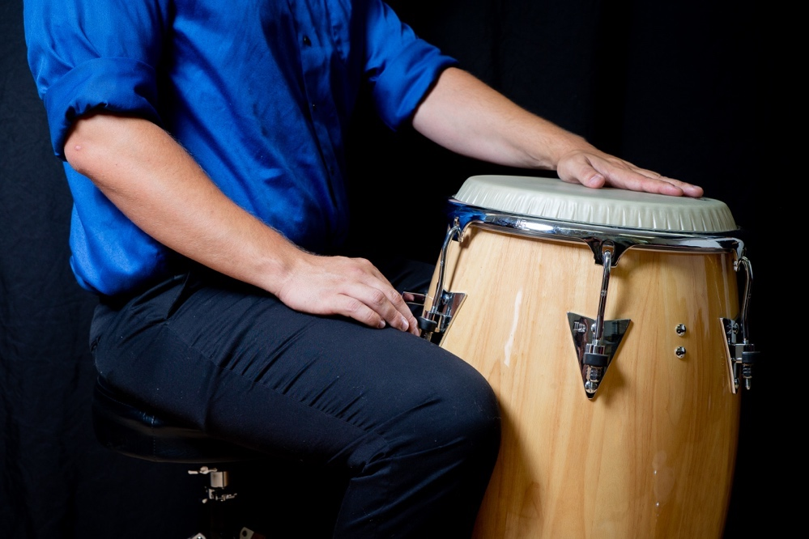

Basic Strokes
Bass – The Bass Stroke, also referred to as the palm stroke, is produced by playing a down stroke that is initiated by the wrist and leads with the lower half of the palm. The palm should strike somewhere between the center and edge of the drum head. The hand should not immediately rebound off of the drum, creating a muted stroke. In the context of playing Heel/Toe it is advisable to perform this stroke with your fingers not touching the head, creating a preparatory motion for the Tip Stroke that would follow the Bass Stroke. However, it is not incorrect for the fingers to touch when performing this stroke.
Tip – This stroke produces a muted tone that is initiated by the wrist and produced by striking near the center of the drum with the pads of the fingers without immediately lifting them off of the drum. In the context of playing Heel/Toe, it is advisable to allow the wrist to raise above the fingertips after the Tip Stroke, creating a preparatory motion for the Bass Stroke.
Heel/Toe –Heel/Toe is produced by alternating between the Bass and Tip strokes. Heel/Toe typically fills in the smallest rhythmic subdivisions of a given groove. It is quite common for the left hand to alternate between the Bass and Tip strokes while the right hand fills in with the Open Tone and various Slap Tones, but it is beneficial to learn to execute this pattern with both hands.
Open Tone – This stroke is named for the clear resonant pitch that resonates from the drum when performed correctly. The stroke is performed at the edge of the drum using the arm and the wrist to initiate the stroke. The fingers strike the drum and should immediately rebound off of the drum head to avoid any sound dampening or muffling.
Muffled Tone – The Muffled Tone is performed in a similar fashion to the Open Tone. The one difference is that the fingers should not come off of the drum after contact, creating a higher-pitched muted tone produced by striking the edge of the head with the fingers.
Closed Slap – The Closed Slap is achieved with the fingers and is initiated by the wrist. Upon impact, the hand should be cupped in the shape of a semicircle creating a small pocket between the palm of the hand and the drum. The resultant sound should be a bright and short crack sound. The fingers should not rebound off of the head. This is arguably the hardest of the basic strokes and can take a moderate amount of practice to develop proficiency.
Open Slap – This slap is a combination of the Open Tone and the Closed Slap. It is achieved with the same technique as the Closed Slap, but the fingers rebound off of the head as they do when performing an Open Tone. The Open Slap will have more resonance than the Closed Slap or the Pressed Slap.
Pressed Slap – This slap uses the same mechanics as the Open Slap. It is achieved by playing an Open Slap while the other hand is pressing into the drum head. The resultant sound is similar to that of a Closed Slap.

Selected Grooves and Styles
Figure 2 – Congas Notation Key
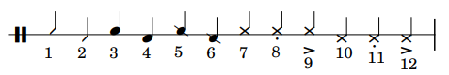
1. Tip Stroke
2. Bass Stroke
3. Open Tone (High Drum)
4. Open Tone (Low Drum)
5. Muffled Tone (High Drum)
6. Muffled Tone (Low Drum)
7. Closed Slap (High Drum)
8. Pressed Slap (High Drum)
9. Open Slap (High Drum)
10. Closed Slap (Low Drum)
11. Pressed Slap (Low Drum)
12. Open Slap (Low Drum)

Tumbao – This groove is most often used as an accompaniment pattern in son clave contexts. The One-Drum Tumbao Pattern is a great place to start for beginning conga players.

Figure 3 – One-Drum Tumbao Pattern
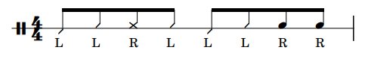

Figure 4 – Two-Drum Tumbao Pattern
Bolero – Bolero is a genre of song that originated from Cuba. The Basic Bolero Pattern is very similar to tumbao and is also used to accompany in son clave contexts.

Figure 5 – Basic Bolero Pattern for Congas
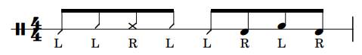

Guaguancó – This style of Cuban rumba can be used in rumba clave or son clave contexts. Traditionally, there are three different conga parts known as tumba, conga, and quinto. The tumba and conga patterns are relatively fixed and the quinto patterns are improvised.

Figure 6 – Guaguancó Tumba Pattern

Figure 7 – Guaguancó Conga Pattern
Merengue – Merengue is a fast dance genre in 2/4 originating from the Dominican Republic.

Figure 8 – Basic Merengue Pattern for Congas
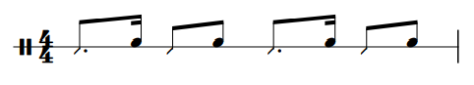

Rumba Columbia – Like Guaguancó, Rumba Colombia uses tumba, conga, and quinto patterns, but utilizes a 6/8 feel.

Figure 9 – Rumba Columbia Tumba Pattern
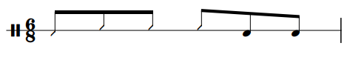

Figure 10 – Rumba Columbia Conga Pattern
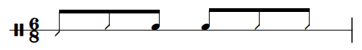

Bongos
Playing Position
Bongos are traditionally played in a seated position and are held between the performer’s legs just under the knee, and the feet should be flat on the floor. The small drum (macho) is typically on the left and the larger drum (hembra) is typically on the right. The drums should be tilted away the performer. If this position is uncomfortable, it is also possible to put the drums on a stand and play from a standing position. In this context, the drums should also be tilted away from the performer.

Figure 11 – Playing Position for Bongos
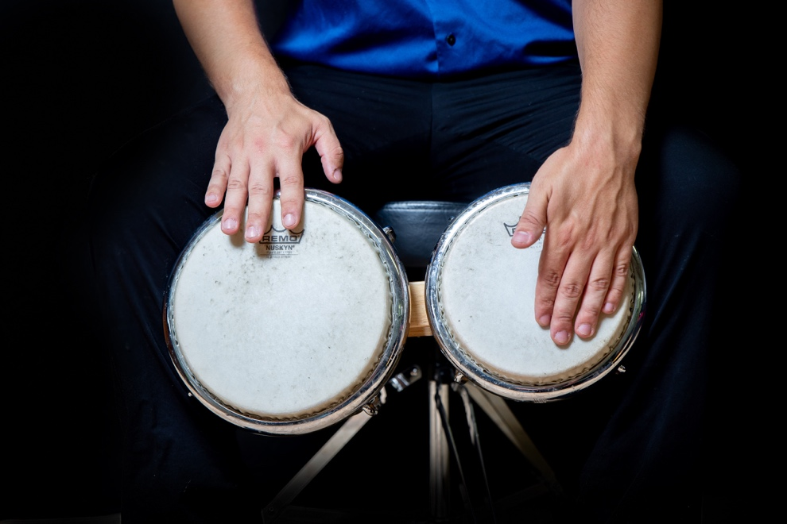

Basic Strokes
Thumb – This sound achieved by striking the center of the drum with the thumb and should produce a muted sound. The stroke is initiated by rotating the wrist allowing the thumb to strike without the other fingers touching the head. The thumb should not rebound off of the drum head but should maintain contact after impact.
Fingers – This stroke is played by striking the center of the head with the finger tips. The stroke is initiated from the wrist and does not utilize any rebound creating a muted sound. It is common for the pinky to be excluded and for most of the sound to result from the other three fingers.
Heel/Toe – The Heel/Toe motion for bongos is achieved by alternating between the Thumb and the Fingers. Both strokes occur in the center of the drum and are typically executed on the smaller drum (macho).
Open Tone – The Open Tone can be played with either the index finger or with the index, middle, and ring fingers together. The stroke is initiated with the wrist and the fingers should rebound off of the head allowing the drum to resonate. Either the first digit or the first two digits of the fingers should be used when performing this stroke.
Muted Tone – The Muted Tone uses the same technique as the Open Tone but is achieved by muting the head with opposite hand while striking the drum.
Muffled Tone – This stroke is also nearly identical to the Open Tone. The one difference is that the fingers should not come off of the drum after contact, creating a higher-pitched muted tone produced by striking the edge of the head with the fingers.
Closed Slap – The Closed Slap is achieved with the fingers and is initiated by the wrist. Upon impact, the hand should be cupped in the shape of a semicircle creating a small pocket between the palm of the hand and the drum. The resultant sound should be a bright and short crack sound. The fingers should not rebound off of the head.

Selected Grooves and Styles
Figure 12 – Bongos Notation Key
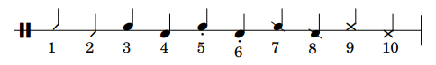
1. Finger Stroke
2. Thumb Stroke
3. Open Tone (High Drum)
4. Open Tone (Low Drum)
5. Muted Tone (Low Drum)
6. Muted Tone (Low Drum)
7. Muffled Tone (High Drum)
8. Muffled Tone (Low Drum)
9. Closed Slap (High Drum)
10. Closed Slap (Low Drum)

Martillo – Martillo is a common groove for bongos and a nice place to start. This groove is used to accompany in son clave contexts.

Figure 13 – Basic Martillo Pattern
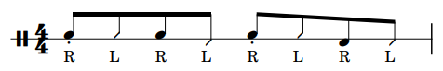

Bolero – Bolero is a genre of song that originated from Cuba. This style alternates between ornamented rhythms and cycles of martillo. It is also used to accompany in son clave contexts.

Figure 14 – Basic Bolero Pattern for Bongos
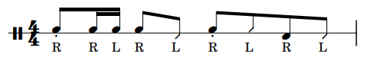

Bossa Nova – This style is a type of samba music characterized by its harmonic devices, syncopation, improvisational sections, and is a popular dance form in Brazil.

Figure 15 – Basic Bossa Nova Pattern

Merengue – Merengue is a fast dance genre in 2/4 originating from the Dominican Republic.

Figure 16 – Basic Merengue Pattern for Bongos

Jazz – Like other instruments, bongos have been used increasingly in non-traditional contexts including jazz or “swing”. There are many subsets of jazz, but below is a basic accompaniment pattern for playing bongos within this genre.

Figure 17 – Basic Swing Pattern
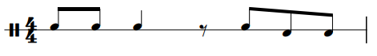

Pandeiro
Playing Position
To hold the pandeiro, start by bending your elbow at a 90-degree angle with your palm facing up, but in front of your belly button. Locate the portion of the drum shell that does not have jingles and place that portion of the shell where your fingers connect to your palm. With as little tension as possible, grab the drum with your fingers and allow the thumb to rest on top of the drum near the rim or bearing edge without muffling or dampening the sounds produced on the drum.

Figure 18 – Playing Position for Pandeiro
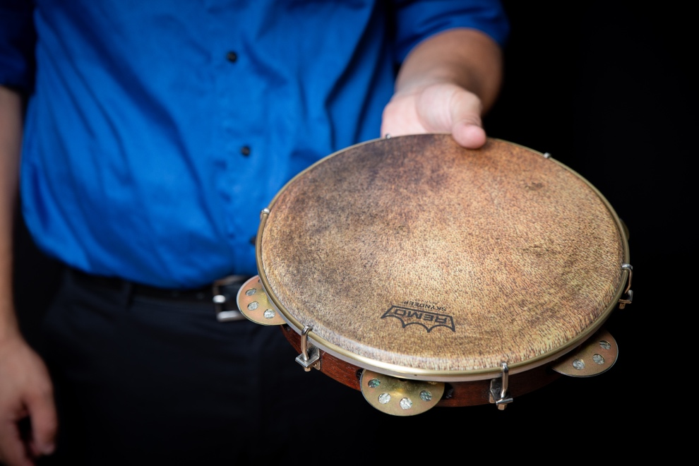
Basic Strokes
Heel – This stroke is achieved by striking the pandeiro on the edge of the drum with the base of the palm just above the wrist. The stroke is initiated with the forearm and is intended to engage the jingles.
Fingers – To perform this stroke, strike the edge of the drum with the tips of the fingers. The stroke is initiated with the wrist and is also intended to engage the jingles.
Heel/Toe – The Heel/Toe for Pandeiro is achieved by alternating between the Heel and Finger strokes while simultaneously rotating the pandeiro with the other hand to shorten the distance the striking hand would otherwise have to travel. The hand should be slightly cupped while performing this motion.
Open Tone – The Open Tone for pandeiro is most often achieved with the thumb striking near the edge of the drum and rebounding off of the head to create a resonant sound. It may also be achieved by using the Finger Stroke approximately 2-3 inches away from the edge and allowing the fingers to rebound off of the head. Either technique should result in a resonant sound.
Muted Open Tone – This stroke is performed the same as the Open Tone, but with the non-striking hand muting the drum. Use the middle finger of the hand that is holding to the drum to mute the drum head from the back side of the drum head.
Closed Slap – The Closed Slap for pandeiro is most often achieved by striking the center of the drum with the pads of all of the fingers except for the thumb. It can also be achieved by striking the center of the drum with the thumb in the same fashion as the Open Tone except the thumb should not rebound from the head when attempting a Closed Slap.
Finger Rolls – Finger Rolls are achieved by applying a medium amount of pressure with the middle finger and sliding your finger along the edge of the drum head. If done correctly, the drum will vibrate while your finger is sliding, causing the jingles to resonate. This is most easily achieved by keeping your hand and forearm in a straight line and positioning your body the middle finger is perpendicular to the drum head.

Figure 19 – Pandeiro Finger Roll
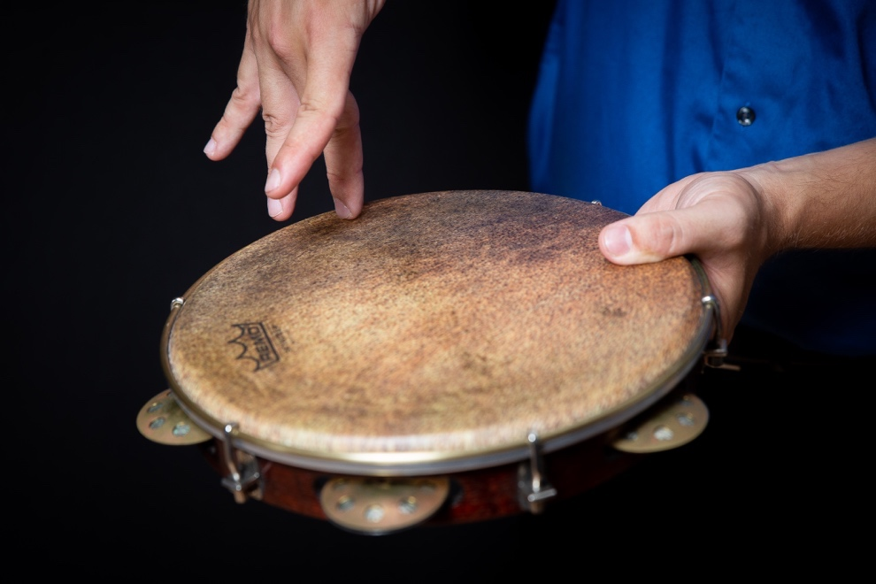

Selected Grooves and Styles
Figure 20 – Pandeiro Notation Key
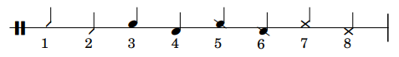
- Fingers
- Heel Stroke
- Open Tone (with Fingers)
- Open Tone (with Thumb)
- Muted Open Tone (with Fingers)
- Muted Open Tone (with Thumb)
- Closed Slap (with Fingers)
- Closed Slap (with Thumb)

Samba – Samba is a Brazilian dance rhythm of African origin. Much of the rhythmic vocabulary of the pandeiro in this style is determined by surdo rhythms.

Figure 21 – Basic Samba Pattern
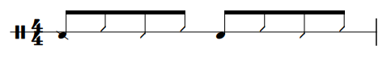
Choro – Choro is similar to Samba and is a fusion of European music, Brazilian rhythms, and improvisation. The rhythmic structure of the pandeiro part is similar, but the pandeiro rhythms are drawn from emphasizing the melody as opposed to interacting with the surdos. The Basic Samba Pattern in Figure 21 is a good starting point for this style.

Partido Alto – Partido Alto is a genre of samba but uses more frequent syncopation.

Figure 22 – Basic Partido Alto Pattern
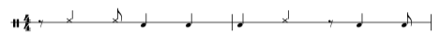

Baião – Baião is a subset of Forró and is mostly associated with the music of Luis Gonzaga. The primary percussion instrument in this style is traditionally the zabumba, but other instruments such as the pandeiro were eventually added.

Figure 23 – Basic Baião Pattern
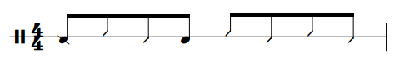
Drumset Rhythms – Most rhythms below are not traditional Brazilian rhythms, but other genres such as pop, rock, funk, and hip-hop have had a profound influence on the rhythmic vocabulary used on the pandeiro.

Figure 24 – Drum Set Rhythm 1 for Pandeiro
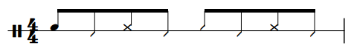

Split-Hand Family
The four primary techniques that apply to each of the instruments in the Split-Hand Family are:
- Dum
- Tek
- Ka
- Pa
Each drum uses nuanced versions of these techniques, but they are largely the same and students will be able to quickly transfer the techniques learned on one drum to another. The transfer process in this family is even quicker than the Heel/Toe Family because the instruments use the same accompaniment patterns and musical styles.

Tar
Playing Position
There are two primary playing positions for the tar known as Upright Style and Lap Style. Upright style accommodates a seated or a standing position, but lap style requires the performer to be seated. To hold the drum in an upright position, think of the drum shell as a clock face. The bottom of the drum, or the six o’clock position, should rest on the edge of the palm of the left hand between the thumb and the index finger. In this position, it should still be possible to touch the drum head with your ring finger. If not, adjust accordingly. The right thumb supports the side of the drum at approximately three o’clock.

Figure 25 – Upright Style Playing Position for Tar
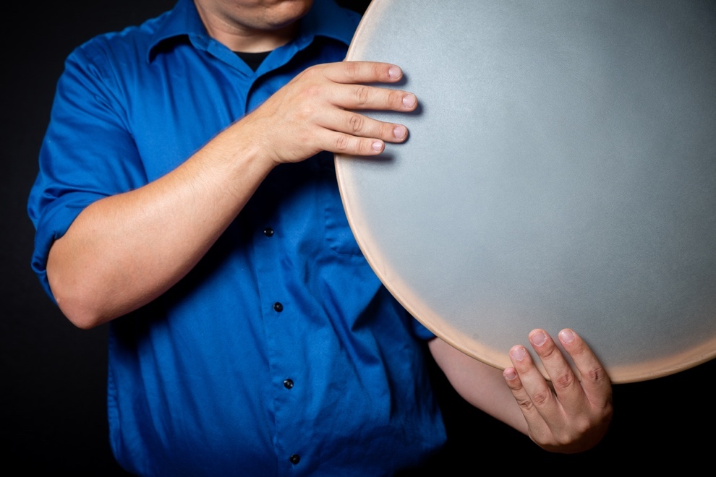
To hold the drum in a lap style, the drum rests on the left leg while the left hand rests on top of the drum. If done correctly, the ring finger should still be able to touch the drum head. With the drum secure, the right hand plays from the same 3 o’clock position (if looking from behind the drum), but the thumb is not needed to help hold the drum in place.

Figure 26 – Lap Style Playing Position for Tar
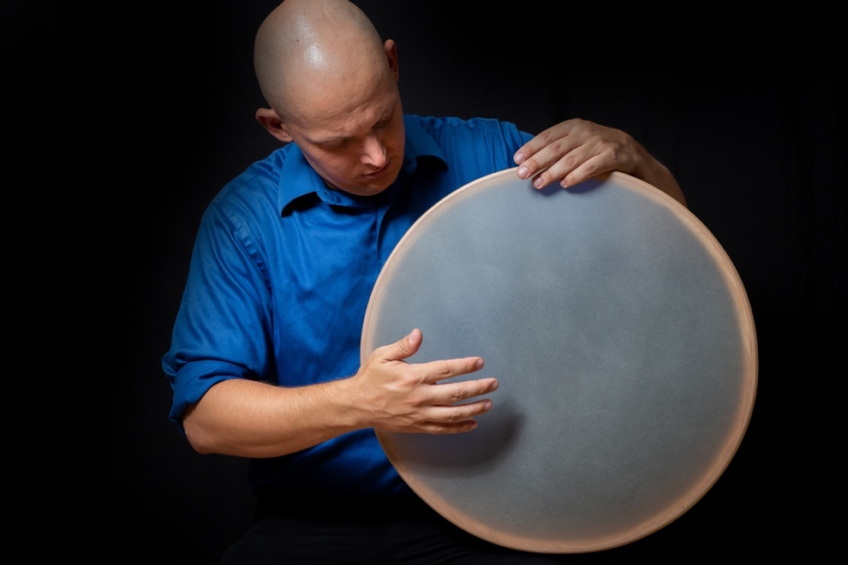

Basic Strokes
Dum – Dum is a low sound typically produced in the right hand and involves a rotational stroke that rebounds off of the drum head. In the upright position, this stroke is prepared by rotating the bottom of the hand away from the drum and achieved by striking the drum with your ring finger. In the lap position, this stroke is prepared by rotating the top of the hand away from the drum and achieved by striking with the thumb. In both cases, the desired playing zone is between the center and edge of the drum. Dum may be played by the left hand in the upright position and uses the same technique as the right hand.
Tek – Tek is a high-pitched right-hand stroke. For both positions, this is achieved the same by striking near the edge of the drum and allowing your finger to rebound off of the head.
Ka – Ka is the left-hand version of Tek. It is also produced by striking near the edge of the drum and allowing your finger to rebound off of the head. In the upright position your left hand will come from underneath the drum or it will be on top in the lap position.
Pa – Pa is a muted sound played by the right hand and is achieved by striking the center of the drum with the finger pads. The fingers should be condensed with no spaces between them and they should not rebound off of the head after striking the drum. The technique is the same regardless of the playing position.
Finger Snap – This tone is produced by striking the drum on the edge and can be performed with any of the fingers. The tone is similar to Tek and Ka, but with a sharper attack. A Finger Snap is produced being pressing one of the fingers against the tip of the thumb. After, the given finger slides down like an ordinary snap, but strikes the edge of the drum instead of the palm of the hand.
Rolls – Rolls, commonly called flourishes, can be achieved by playing a series of Tek Strokes with either hand. First, play a Tek with your pinky, then play a Tek with the ring finger, then with the middle finger, and lastly with the index finger. Proceed to do the same with Ka, playing with the pinky, ring, middle, and index fingers. This full eight-note progression serves as the foundation for a basic tar roll.

Selected Grooves and Styles
Figure 27 – Tar Notation Key
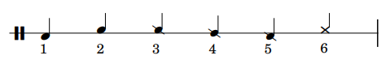
- Dum Stroke
- Tek or Ka Stroke
- Pa Stroke (Index Finger)
- Pa Stroke (Full-Hand)
- Pa Stroke (Pinky, Ring, and Middle Fingers)
- Finger Snap
Baladi – An Egyptian rhythm with a four-beat rhythmic structure and is a common accompaniment pattern for belly dancers.

Figure 28 – Basic Baladi Pattern
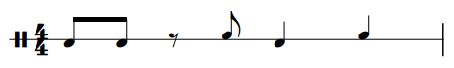

Maksum – A four-beat rhythmic cycle commonly used in many pop, folk, and dance songs of the Middle East.

Figure 29 – Basic Maksum Pattern
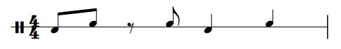

Saidi – Saidi is similar to Baladi but uses an extra Dum in the basic pattern.

Figure 30 – Basic Saidi Pattern
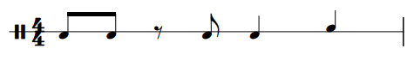

Masmoudi – An eight-beat rhythmic cycle that sometimes appears between cycles of Maksum and is also a popular accompaniment for belly dancers.

Figure 31 – Basic Masmoudi Pattern
Chiftetelli – Chiftitelli is a slow eight-beat rhythmic cycle to accompany belly dancers.

Figure 32 – Basic Chiftitelli Pattern

Malfuf – Malfuf is perhaps the most universal of Arabic rhythms and is also used in many other genres of music. This groove is characterized by its 3-3-2 rhythmic structure.

Figure 33 – Basic Malfuf Pattern 1
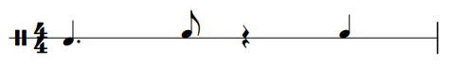

Dumbek
Playing Position
Dumbek is traditionally performed from a seated position, either seated cross-legged on the floor or seated in a chair. Regardless of the performance position, the drum rests on the left leg with the head facing away from the performer, but slightly turned in to accommodate the right hand. The drum is secured by resting the left hand on top of drum with the left elbow resting on the back of the drum.
Figure 34 – Playing Position for Dumbek
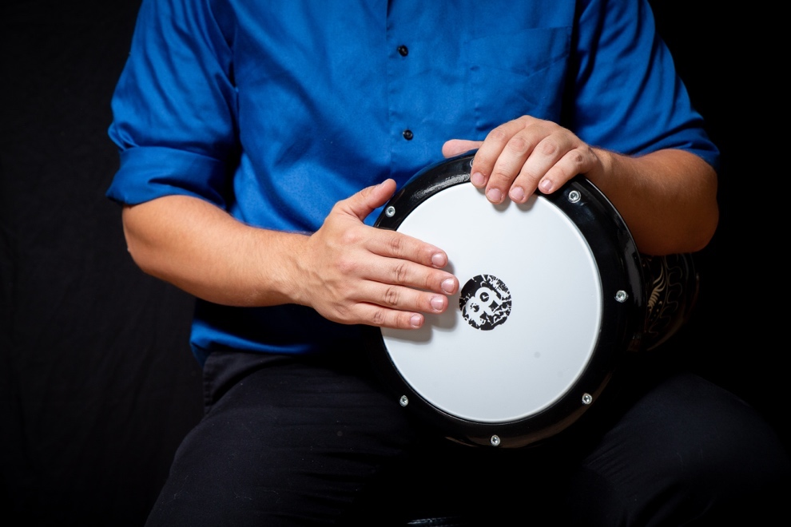

Basic Strokes
Dum – Dum is played by the right hand and is achieved by striking the drum with the finger pads between the rim and the center of the drum. Oftentimes, you can use the rim or bearing edge of the drum as a landmark for the base of your fingers to achieve a low and resonant sound. The fingers should be condensed with no spaces between them and rebound off of the head after striking the drum. The desired sound is a low pure tone with as little extraneous sound as possible.
Tek – Tek is a high-pitched sound produced by the right hand. This stroke is achieved by striking near the rim of the drum with the first and second digits of the index, middle, and ring fingers rebounding off of the head. The achieved sound should be as high as possible.
Ka – This stroke is a left-hand version of Tek with a modified technique due to the playing position of the drum. As the left hand is resting on top of the drum, prepare for the stroke by facing your palm away from you. Finish the motion by striking near the edge of the head with the ring finger, allowing it to rebound off of the head to produce a high-pitched sound comparable to a Tek.
Pop – A Pop uses the same technique as Ka, but the right hand applies pressure to achieve a high pitch sound similar to a slap. The pressure is applied near the center of the head with the palm of the right hand facing up. The side of the palm near where the pinky is located presses against the head.
Pa – This stroke uses a technique similar to Dum, but the finger pads strike the center of the drum and do not rebound off of the head, creating a muted tone.
Closed Slap – The preparatory motion for a Closed Slap is similar to the technique used to achieve a Pa sound, but additionally involves cupping the hand to produce a “crack” sound. The base of the palm should also be touching the rim to achieve this sound.
Rolls – The basic dumbek roll utilizes individual fingers playing near the rim of the drum producing a sound similar to Tek or Ka. To play a roll, play a tek with the ring finger, then with the middle finger, and lastly with the index finger. Proceed to do the same with Ka, playing with the ring, middle, and index fingers. This full six-note progression serves as the foundation for a basic dumbek roll.

Selected Grooves and Styles
Figure 35 – Dumbek Notation Key
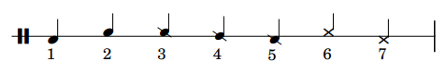
- Dum Stroke
- Tek or Ka Stroke
- Pa Stroke (Index Finger)
- Pa Stroke (Full-Hand)
- Pa Stroke (Pinky, Ring, and Middle Fingers)
- Pop Stroke
- Closed Slap

Refer to Figures 28-33 on p.34-36 for an overview of the styles typically performed on dumbek.

Riq
Playing Position
The riq may be held in Basic Position or the Classical Position. The Basic Position is achieved by placing your left hand in front of you as if you were going to shake somebody’s hand. Cup your hand and turn your wrist slightly so the palm of your hand is starting to face up. With the drumhead facing away from you, place the shell of the drum along the edge of the palm between the thumb and the index finger. Locate the jingles closest to the thumb and rotate the drum till the thumb is touching the jingles. Press the thumb into the back pair of jingles and allow your index finger to grab the drum along the edge of the shell.

Figure 36 – Basic Position for Riq
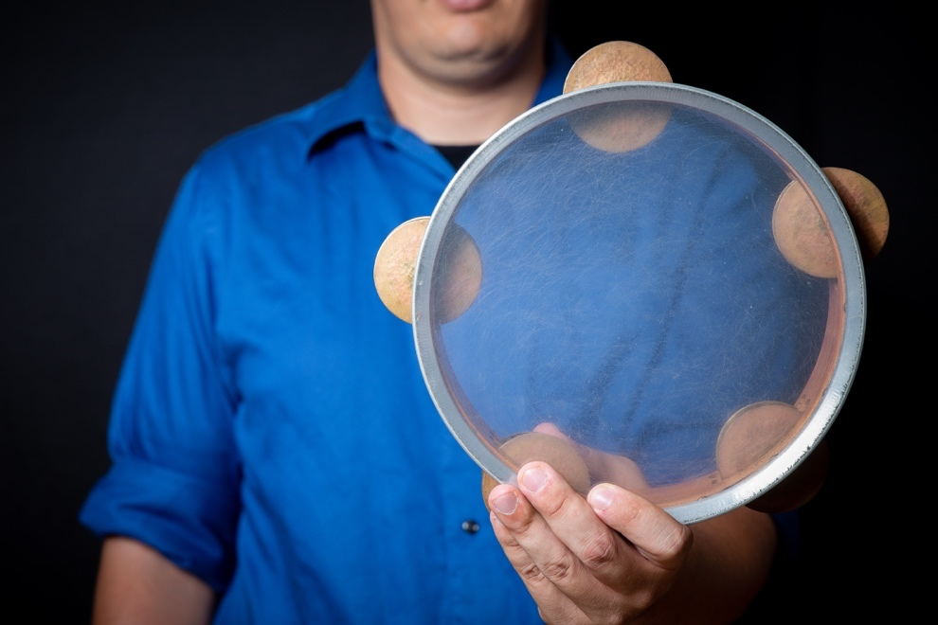
The Classical Position is similar to the Basic Position but uses the right hand for stability. The result is a subtler style of playing that is better suited for smaller ensemble. The Classical Position is achieved by starting in the Basic Position. Next, grab the riq with the right hand and rotate the drum so that it is evenly between both hands. Lastly, tilt the drum away from you. The left hand will still be carrying most of the weight of the drum and the right hand serves as a stabilizer.

Figure 37 – Classical Position for Riq
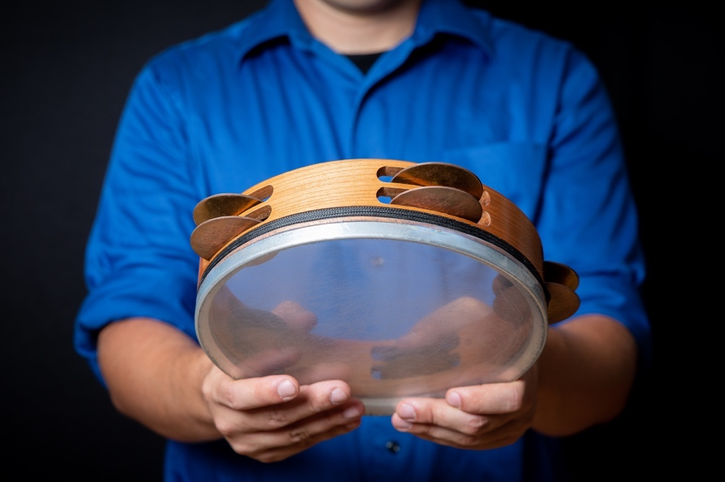

Basic Strokes
Dum – Dum is a low sound typically produced in the right hand and involves a rotational stroke that rebounds off of the drum head. In the Basic Position, this is achieved by rotating the bottom of the hand away from the drum and striking the head with the first two digits of the index or the ring finger. In the Classical Position, the motion is the same but only the ring finger is used to achieve the sound.
Tek – This stroke is performed by the right-hand on the edge of the drum or the jingles. The Tek stroke is achieved with the first digit of the ring finger in a similar fashion to a Dum, but it is produced by striking near the edge of the drum with and allowing your finger to rebound off of the head. This can be achieved in either the basic or classical position. To play a Tek on the jingles involves a comparable motion but uses the tip of the finger and can be played with any of the fingers.
Ka – This sound is the same as Tek, but it is performed wih the left hand, and is most often used to strike the jingles.
Pa – Pa is a muted sound played by the right hand and is achieved by striking the center of the drum with the finger pads. The fingers should be condensed with no spaces between them and they should not rebound off of the head after striking the drum.
Shake Rolls – There are a variety of rolls that may be produced on the riq including a side-to-side roll and a front-to-back roll. The side-to-side roll is initiated from the basic position by turning the wrist inward and followed by returning to the original position. It is achieved by quickly alternating between these two motions. The front-to-back roll is similar, but it is initiated by allowing the drum to tilt forward slightly and returning to the original position. The front-to back-roll is also achieved by alternating between these two motions. When performing both of these rolls, the goal is to cause the jingles to resonate. These rolls can be performed at varying speeds creating either a metric rhythmic effect or a continually resonating sound that does not appear to be metrically in time. Both of these rolls are achieved from the basic position.
Finger Rolls – Finger rolls on riq are a series of Tek and Ka strokes that are performed on the jingles where the left hand is holding the drum in the basic position. The most basic pattern for a finger roll contains four notes. The first three are played by the right hand (ring, middle, and index), and the last one is played by the ring finger in the left hand.

Selected Grooves and Styles
Figure 38 – Riq Notation Key
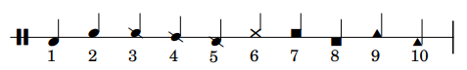
- Dum Stroke
- Tek or Ka Stroke
- Pa Stroke (Index Finger)
- Pa Stroke (Full-Hand)
- Pa Stroke (Pinky, Ring, and Middle Fingers)
- Tek or Ka played on Jingles
- Sideways Shake Roll (to the left)
- Sideways Shake Roll (to the right)
- Front-To-Back Shake Roll (forward)
- Front-To-Back Shake Roll (back)

Refer to Figures 28-33 on p.34-36 for an overview of the styles typically performed on riq.

Chapter Four: Sample Curricula
Curricula Overview
The curricula in the following sections provide a 7-week and 14-week structure to allow for maximum flexibility to accommodate the individual needs of any given program. The fundamental aspects of each of these curricula are:
- Technical exercises to learn and develop the Basic Strokes for each drum.
- Combinations of the Basic Strokes to form grooves and patterns.
- Play-along Assignments that use the assigned groove or pattern.
- Improvisation.
The weekly lessons will prepare the student to play each drum with the appropriate technique and tone production as well as how to appropriately play in traditional styles, guided by reference recordings in weekly play-along assignments. These curricula can be implemented in a variety of ways including studying one hand drum for a semester using a single 14-week curriculum, studying two hand drums in a semester using two 7-week curricula, studying one hand drum in conjunction with another percussion instrument, or anything in between these options.

Curricula
Congas
Week 1
Lesson Plan
The objective of the first lesson is to provide an overview of some of the Basic Strokes, exercises to develop the Basic Strokes, and the One-Drum Tumbao Pattern. The Basic Strokes needed to for this lesson are Heel/Toe (alternating Bass and Tip), Open Tone, and Closed Slap.

Figure 39 – Heel/Toe Exercise for Congas
This exercise should be performed with each hand individually and with both hands together for a total of three variations.

Figure 40 – Open Tone Exercise for Congas
The Open Tone Exercise should be performed with each hand individually and with an alternating sticking for a total of three variations.
Figure 41 – Closed Slap Exercise for Congas
The Closed Slap Exercise should first be performed freely, without a strict tempo. This is often the hardest of the basic strokes to perform correctly and the technique can be foreign to students approaching hand percussion for the first time. To learn the motion for the Closed Slap, lay your right hand on the drumhead with the palm facing down. Prepare to strike the drum by pivoting your hand away from the head using only the wrist. Place the palm of your left hand against the fingers of your right hand and apply pressure from your right hand as if you were attempting to strike the drum. Slowly slide your left hand up and out of the way from your hand, allowing your right hand to quickly strike the drum head. The fingertips should strike the drum head without rebounding but with the hand in a cupped position. Repeat this procedure using the left hand to strike the drum with the right hand assisting. Once students feel comfortable with the produced sounds, they should try to perform the Closed Slap without the off-hand assisting, but still free of a strict tempo. Finally, they should perform the Closed Slap with a metronome. Students should be able to perform the Closed Slap with both hands.

Assignment
- Develop the Basic Strokes using the Exercises from Week 1.
- Play along to “Fried Neckbones and Some Home Fries” by Willie Bobo using the One-Drum Tumbao Pattern.

Week 2
Lesson Plan
The primary goals of Week 2 are to continue to refine the Basic Strokes from Week 1, perform the assigned tune, and to learn variations of the One-Drum Tumbao Pattern. Common pitfalls for the Basic Strokes include:
- One of the Heel/Toe strokes is louder than the other.
- The Open Tone is too close to the edge, creating a high overtone along with the fundamental pitch.
- The Open Tone is too close to the center, creating an emptier sound than a full-sounding Open Tone.
- The Closed Slap likely be the stroke that takes the longest of these to develop and as such will need the most attention. Make sure students are leading with the finger tips and that their hand is cupped. Hand placement may also be a problem as each drum is different. Try a variety of locations on the head and see what yields the best results.

Figure 42 – One-Drum Tumbao Variation 1
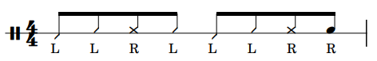

Figure 43 – One-Drum Tumbao Variation 2
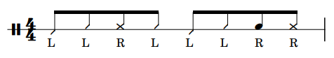

Figure 44 – One-Drum Tumbao Variation 3
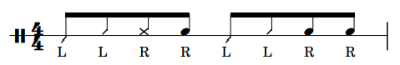

These variations should be used as a jumping off point. Students should be encouraged to write their own variations in addition to performing these. Tips for writing variations include:
- Replace a Closed Slap with an Open Tone or vice versa.
- Remove a Closed Slap or Open Tone and replace it with a Bass or Tip Stroke
- Add a Closed Slap or an Open Tone in place of a Bass or Tip Stroke.
Assignment
- Continue to play the exercises from Week 1 and push the tempo if need be.
- Play along to “Mama Papa Tu” by Mongo Santamaria using at least two of the variations given above and write two of your own variations.

Week 3
Lesson Plan
The primary goals of this lesson are to learn the Muted Slap and Open Slap strokes, the Two-Drum Tumbao Pattern, and to start performing the Closed Slap Exercise alternating between the right and left. Learning the Muted Slap requires the student to first learn the Open Slap. The Open Slap is similar to the Closed Slap. The primary difference is that the hand rebounds off of the head in the Open Slap. The Muted Slap is achieved by performing an Open Slap while the off-hand rests on the drum head, creating a sound similar to the Closed Slap. The rebound after impact in the Muted Slap allows the hand performing the stroke to move between the two drums more freely, simplifying the performance of the Two-Drum Tumbao Pattern. This pattern is twice as long as the One-Drum Tumbao Pattern and requires a second drum on the right of the performer. The first measure is the same for both versions of tumbao, but the second measure incorporates the second drum after the slap on beat two. The immediate movement from the slap to the second drum is what requires the Muted Slap for optimal performance. The rebound in the Muted Slap allows for a more efficient transition between the two playing surfaces, especially at faster tempi.
Assignment
- Continue to play exercises from Week 1 adding the alternating Closed Slap and the Open Slap to the routine.
- Play along to “Hitch it to the Horse” by Poncho Sanchez using the Two-Drum Tumbao Pattern.

Week 4
Lesson Plan
The focus of Week 4 is to play variations of the Two-Drum Tumbao Pattern, create longer patterns, and to play fills or licks outside of the tumbao groove.

Figure 45 – Two-Drum Tumbao Variation 1

Figure 46 – Two-Drum Tumbao Variation 2

These variations also should be used as a jumping off point and students should be encouraged to write their own variations in addition to performing these. The same rules for creating variations (given in Week 2) still apply. One new concept that can help students play longer phrases is alternating between one cycle of the Two-Drum Tumbao Pattern and one cycle of a Two-Drum Tumbao Variation. The result is a longer four-bar phrase that can be used to create phrases with greater variety. Students should also be encouraged to switch between the One-Drum and Two-Drum Tumbao Patterns. A simple way to do this is to change at the start of new sections or entrances of new musical voices. The last consideration should be to incorporate fills or rhythmic ideas at the ends of phrases to help set-up the next phrase. Mirroring rhythmic ideas found in other areas of the ensemble is a great place to start, but fill ideas are provided below as a jumping off point.

Figure 47 – Tumbao Fill 1
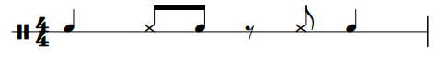

Figure 48 – Tumbao Fill 2
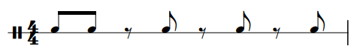

Figure 49 – Tumbao Fill 3
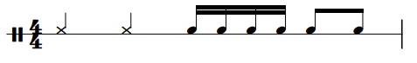

Figure 50 – Tumbao Fill 4
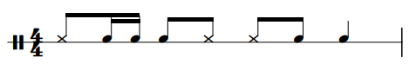
Assignment
- Continue to play exercises from Week 1 if needed or desired.
- Play along to “Manteca” by Dizzie Gillespie paying special attention to:
- When to use One-Drum Tumbao and when to use Two-Drum Tumbao.
- Using Variations to create new and/or longer ideas.
- Use fills to create transitions between sections.

Week 5
Lesson Plan
Much of Week 5 will be spent reviewing the assignment from Week 4, but there should be time for learning to play a second style. Typically, it is effective to teach the Bolero Pattern next because it is similar to the previously learned tumbao patterns. The inevitable familiarity with the new pattern allows for meaningful discussion of the previous assignment as well as a seamless transition to a new style of playing. The main difference between this pattern and the One-Drum Tumbao Pattern is the low-high-low motion of the last three eighth notes in the last bar. Some instances of Bolero use only the second bar of the pattern, and some use the full two-bar cycle. If playing variations in this style, it is advisable to:
- Preserve the low-high-low motion of the last three eighth notes.
- Use variations in the context of the full two-bar pattern limiting the variety to the first bar of the cycle.
- Place fills at the beginning of the second bar and finish with the low-high-low motion.
These ideas are general jumping off points, but there will be situations where breaking the low-high-low repetitions will be desirable. The primary point is that the low-high-low motion is a definitive part of the style and should be preserved more often than not.

Figure 51 – Heel/Toe Sixteenth-Note Exercise
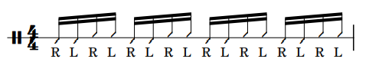

Assignment
- Play along to “Bolero Medley” by Tito Puente and Eddie Palmieri using the Basic Bolero Pattern for Congas. Variations and fills are left up to the discretion of the performer.
- Practice the Heel/Toe Sixteenth-Note Exercise.

(Proceed to Week 13A if following the 7-Week Curriculum and proceed to Week 6 if following the 14-Week Curriculum).

Week 6
Lesson Plan
The goal for Week 6 is to wrap up the Bolero Assignment, learn the Basic Merengue Pattern for Congas, and to continue with the Heel/Toe Sixteenth-Note Exercise.
Assignment
- Play along to “El Watusi” by Ray Barretto using the Basic Merengue Pattern for Congas.
- Practice the Week 5 Heel/Toe Sixteenth-Note Exercise.
Week 7
Lesson Plan
The goal for Week 7 is to learn the Merengue Variations while continuing to practice the Week 5 Heel/Toe 16th Note Exercise.

Figure 52 – Merengue Variation 1 for Congas
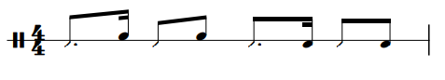

Figure 53 – Merengue Variation 2 for Congas
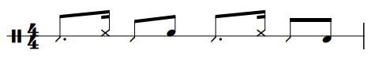

Figure 54 – Merengue Variation 3 for Congas
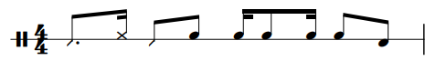

Assignment
- Continue to practice the Week 5 Heel/Toe Sixteenth-Note Exercise.
- Play along to “La Quiero Morir” by Sergio Vargas using the Merengue Variations above and compose two original variations.

Week 8
Lesson Plan
The focus for Week 8 is to learn the Basic Rumba Colombia Pattern and another coordination exercise. There are multiple types of rumbas, and this curriculum will highlight the Rumba Colombia and Guaguancó styles (to be discussed later). Traditionally, rumbas employ three drum parts that are commonly played by different size congas. These congas are referred to as tumba, conga, and quinto (large, medium, and small). The tumba and conga parts are typically fixed with room for variation and the quinto parts are improvised. Week 8 and Week 9 will focus primarily on the tumba and conga parts, but quinto playing will be covered in Week 12 during the Guaguancó portion of the curriculum.

Figure 55 – Double Stroke Exercise for Congas
Assignment
- Play along to “Recuerdo a Malanga” by Colombia de Puerto using the Rumba Colombia Conga and Tumba patterns.
- Practice the Week 8 Double Stroke Exercise.

Week 9
Lesson Plan
The goal for Week 9 is to develop strategies for combining the conga and tumba parts to create variations and continue to practice the Week 8 Double Stroke Exercise.

Figure 56 – Rumba Colombia Tumba Variation 1
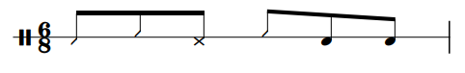

Figure 57 – Rumba Colombia Tumba Variation 2
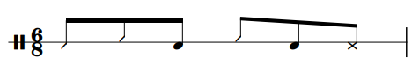

Figure 58 – Rumba Colombia Conga Variation 1
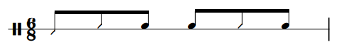

Figure 59 – Rumba Colombia Conga Variation 2
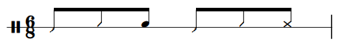
There may be performance settings that have fewer than three conga players. In these contexts, the performer should combine elements of the conga and tumba patterns to create additional variations.

Figure 60 – Rumba Colombia Combined Variation 1
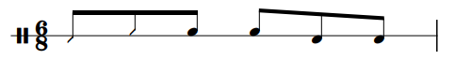

Figure 61 – Rumba Colombia Combined Variation 2
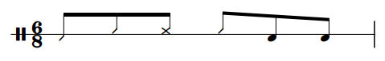

Figure 62 – Rumba Colombia Combined Variation 3
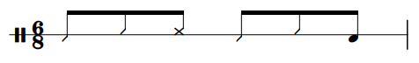
Assignment
- Play along to “Recuerda a Malanga” by Colombia de Puerto using Rumba Colombia Variations.
- Continue to practice the Week 8 Double Stroke Exercise.

Week 10
Lesson Plan
The goal for Week 10 is to wrap up the Rumba Columbia variations and move to a different style of rumba known as Guanguancó. The style traditionally uses three conga parts played to a rumba clave on the tumba, conga, and quinto drums. This week will focus on learning the basic patterns for the tumba and conga drum patterns.
Assignment
- Play along to “Guaguancó Callejero” by Abrahim Ferrer using the Guaguancó Tumba Pattern and the Guaguancó Conga Pattern.
- Continue to practice the Week 8 Double Stroke Exercise.

Week 11
Lesson Plan
The goal for Week 11 is to learn the Paradiddle Exercise for Congas, learn variations that incorporate the Guaguancó Tumba and Guaguancó Conga Patterns, and learn about how the quinto drum fits into this style of playing, Quinto parts are improvised over the other two parts and assigned listening will be imperative for students to learn how to appropriately improvise in the style.

Figure 63 – Paradiddle Exercise for Congas

Figure 64 – Guaguancó Tumba Variation 1
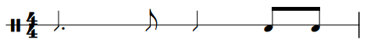

Figure 65 – Guaguancó Tumba Variation 2
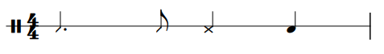

Figure 66 – Guaguancó Conga Variation 1

Figure 67 – Guaguancó Conga Variation 2

Figure 68 – Guaguancó Combined Variation 1

Figure 69 – Guaguancó Combined Variation 2

Assignment
- Play along to “Amor Verdadero” by the Afro-Cuban All Stars using the Guaguancó Variations above and compose two original variations.
- Practice the Paradiddle Exercise for Congas.
Week 12
Lesson Plan
The primary focus of Week 12 is to focus on the quinto playing in Guaguancó. The ideas listed below will also serve as jumping off point for students to get started.

Figure 70 – Guaguancó Quinto Rhythm 1
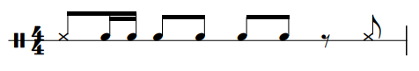

Figure 71 – Guaguancó Quinto Rhythm 2
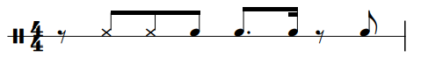

Figure 72 – Guaguancó Quinto Rhythm 3
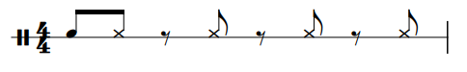
Assignment
- Play along to “Amor Verdadero” by the Afro-Cuban All Stars improvising rhythms that are appropriate in a Guaguancó setting.
- Continue to practice the Week 11 Paradiddle Exercise.

(Proceed to Week 13B if following the 14-Week Curriculum)

Week 13A
Lesson Plan
After wrapping up the play along assignment from Week 5, the primary focus of Week 13A is to develop technical facility using the Heel/Toe Exercise Variations as well as develop an understanding of playing the instrument in a solo setting.

Figure 73 – Heel/Toe Sixteenth-Note Exercise Variations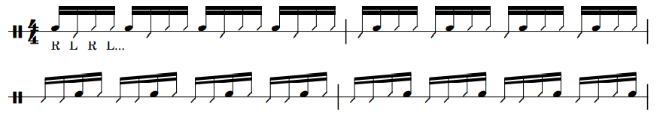

The exercise variations listed above show how to place an Open Tone on any given partial. Also practice these exercises by replacing the Open Tone with a Closed Slap, an Open Slap, and a Muff Tone until all the sounds have been explored in the context of the above exercises. By mastering these exercises, the student will have an understanding of how to present an underlying rhythmic texture while creating other combinations of tones simultaneously.

Assignment
- Practice Heel/Toe Sixteenth-Note Exercise Variations.
- Write an original conga solo that is 30-45 seconds in duration.

Week 13B
Lesson Plan
After wrapping up the play along assignment from Week 5, the primary focus of Week 13A is to develop technical facility using the Heel/Toe Exercise Variations as well as develop an understanding of playing the instrument in a solo setting. The exercise variations shown in Figure 83 show how to place an Open Tone on any given partial. Also practice these exercises by replacing the Open Tone with a Closed Slap, an Open Slap, and a Muff Tone until all the sounds have been explored in the context of the above exercises. By mastering these exercises, the student will have an understanding of how to present an underlying rhythmic texture while creating other combinations of tones simultaneously.
Assignment
- Practice Heel/Toe Sixteenth-Note Exercise Variations
- Write an original conga solo that is 30-45 seconds in duration.

Week 14
Lesson Plan
The focus of Week 14 is to wrap up the unit with a discussion of the solo written by the student and to show the student how the Closed Slap, Open Tone, and Heel/Toe Strokes transfer to other instruments (primarily bongos and pandeiro). When transferring these techniques to bongos, students will need to make two adjustments. First, they will perform a Thumb Stroke in place of a Bass Stroke (played with the lower part of the palm) when performing a Heel/Toe motion on bongos. Second, students will perform an Open Tone using the index finger instead of each of each of the fingers. After learning the nuanced techniques, students apply these techniques to the Basic Martillo Pattern. Martillo is the most common groove to learn for bongos and is used in similar contexts as Tumbao. When applying these conga techniques to pandeiro, the student will have to learn how to play an Open Tone for pandeiro which differs in that the thumb is used to produce the tone as opposed to the fingers. After learning to perform an Open Tone the student is ready to perform the Basic Samba Pattern. Samba is the most basic groove for pandeiro and is a simple jumping off point. Students should also perform the Week 1 Exercises on the new instruments to help isolate and develop the nuanced techniques.

Assignment
- Perform the Week 1 Exercises on bongos and pandeiro with the adjusted techniques.
- Play along to “Meloda De Cana” by Jack Costanzo using the Basic Martillo Pattern.
- Play along to “Escurinho” by Monarco using the Basic Samba Pattern.

Bongos
Week 1
Lesson Plan
The objective of Week 1 is to provide an overview of most of the Basic Strokes, exercises to develop the Basic Strokes, and the Basic Martillo Pattern. The Basic Strokes needed to for this lesson are Heel/Toe (alternating Thumb and Fingers), Open Tone, and Muted Tone. Martillo is the most common groove to learn for bongos and is a simple groove for students to start with. The right hand plays all of the downbeats, performing the Muted Tone. The left hand plays all of the upbeats using the Heel/Toe technique. The Muted Tone on the first and third beat occur because the thumb is in place from the Heel/Toe motion.

Figure 74 – Heel-Toe Exercise for Bongos
Perform this exercise with each hand.

Figure 75 – Open Tone Exercise for Bongos
The Open Tone Exercise should be performed with each hand individually and with an alternating sticking for a total of three variations.

Assignment
- Develop Basic Strokes using the Exercises from Week 1.
- Play along to “Meloda De Cana” by Jack Costanzo using the Basic Martillo Pattern.

Week 2
Lesson Plan
The objectives of Week 2 are to continue to refine the Basic Strokes from Week 1, perform the assigned tune, and to learn variations of the Basic Martillo Pattern. Common pitfalls for the basic strokes include:
- One of the Heel/Toe strokes is louder than the other.
- The student is not lifting between the different Heel/Toe strokes creating a swishing or sliding sound on the head.
- The thumb is coming off the head too soon in anticipation of the Finger Stroke limiting the sound quality of the Muted Tone.

Figure 76 – Martillo Variation 1
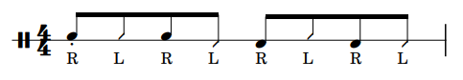

Figure 77 – Martillo Variation 2
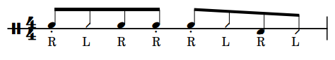

Figure 78 – Martillo Variation 3
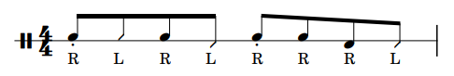
These variations should be used as a jumping off point and students should be encouraged to write their own variations in addition to performing these. Tips for writing variations include:
- Change the contour of the Open Tones in the right hand.
- Remove an Open Tone to create syncopation
- Add an Open Tone in place of a Thumb or Finger Stroke
Assignment
- Continue to play the exercises from Week 1 and push the tempo if need be.
- Play along to “Bien Sabroso” by Poncho Sanchez using at least two of the variations given above and write two of your own.

Week 3
Lesson Plan
The objectives of Week 3 are to play variations of the Martillo Pattern, create longer patterns, and to play fills or licks outside of the Martillo Pattern. One new concept that can help students play longer phrases is alternating between one cycle of the Basic Martillo Pattern and one cycle of a Martillo Variation. The result is a longer two-bar phrase that can be used when a longer accompaniment pattern is desired. Another consideration should be to incorporate fills or rhythmic ideas at the ends of phrases to help set-up the next phrase. Playing bongos allows for much more freedom in certain contexts than playing an instrument like congas. For example, if playing in a group that already has a drum-set groove and a conga tumbao groove, there are many instances when playing a Martillo Pattern would be appropriate. However, it would also be appropriate to improvise rhythmic ideas in place of the Martillo Pattern because other members of the rhythm section would be providing a steady pulse.
Assignment
- Continue to play exercises from Week 1 if needed or desired.
- Play along to “Caravan” by Jack Costanzo paying special attention to:
- The overall texture of the rhythm section and decide where to use the Martillo Pattern and where to improvise fills and licks in place of Martillo.
- Use Martillo Variations to create new and/or longer ideas.

Week 4
Lesson Plan
Much of the focus for Week 4 will be spent reviewing the assignment from Week 3, but there should be time for learning to play a second style. Typically, it is effective to teach the Basic Bolero Pattern for Bongos next because the basic pattern is simple, and it is often used in conjunction with the Martillo Patterns learned up to this point. The inevitable familiarity with the new pattern allows for meaningful discussion of the previous assignment as well as a seamless transition to a new style of playing. The Basic Bolero Pattern for Bongos is characterized by the ornamentation on the first upbeat. In the initial week of playing this style, students should experiment with a variety of rhythmic figures that can serve as an ornament in the span of an eighth-note. In addition to the two sixteenth-note figure, students should also try:
- One sixteenth-note triplet.
- Four thirty-second notes.
- An unmeasured single-stroke roll.
Assignment
- Play along to “Bésame Mucho” by Nucho Leal. Perform the Basic Bolero Pattern for Bongos, experimenting with a variety of ornaments, and alternate with the Martillo Pattern.

Week 5
Lesson Plan
The primary goal for Week 5 is to explore more Bolero Variations and to play a Closed Slap. Although the Closed Slap is not present in the variations given below, it will be a useful skill as the student begins to explore playing in a solo context in future lessons.

Figure 79 – Conga-Style Bolero Variation 1 for Bongos
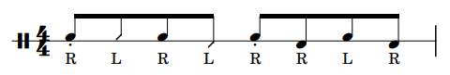
This variation contains the low-high-low Open Tone movement in the last three eighth notes that is indicative of the Basic Bolero Pattern for Congas. This can be useful in contexts where the bongo performer is one of the primary timekeepers.

Figure 80 – Conga-Style Bolero Variation 2 for Bongos
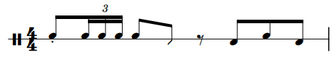

Figure 81 – Closed Slap Exercise for Bongos
First, perform the Closed Slap Exercise freely, without a strict tempo. This is often the hardest of the Basic Strokes to perform correctly and the technique can be foreign to students approaching hand percussion for the first time. To learn the motion for the Closed Slap, lay your right hand on the drum head with the palm facing down. Prepare to strike the drum by pivoting your hand away from the head using only the wrist. Place the palm of your left hand against the fingers of your right hand and apply pressure from your right hand as if you were attempting to strike the drum. Slowly slide your left hand up and out of the way from your right hand, allowing your right hand to quickly strike the drum head. The finger tips should strike the drum head without rebounding but with the hand in a cupped position. Repeat this procedure using the left hand to strike the drum with the right hand assisting. Once students feel comfortable with the produced sounds, they should try to perform the Closed Slap without the off-hand assisting, but still free of a strict tempo. Finally, they should perform the Closed Slap with a metronome. First perform the exercise with the right hand and then with the left hand.
Assignment
- Play along to Bolero Medley by Tito Puente using the variations given above and write two of your own variations.
- Practice the Closed Slap Exercise for Bongos.

(Proceed to Week 13A if following the 7-Week Curriculum and proceed to Week 6 if following the 14-Week Curriculum).

Week 6
Lesson Plan
The objectives for Week 6 are to finish the Bolero Assignment, continue to work on the Closed Slap Exercise for Bongos, and to learn the Basic Bossa Nova Pattern.

Assignment
- Continue to practice the Week 5 Closed Slap Exercise.
- Play along to the “Girl from Ipanema” by João Gilberto and Stan Getz using the Basic Bossa Nova Pattern.

Week 7
Lesson Plan
The objectives for Week 7 are to learn variations of the Basic Bossa Nova Pattern and to start to develop greater hand speed through the use of the Double Stroke Exercise for Bongos.

Figure 82 – Bossa Nova Variation 1

Figure 83 – Bossa Nova Variation 2

Figure 84 – Bossa Nova Variation 3

These variations serve as a jumping off point and students should write their own variations. Principles for composing variations include:
- Altering the contour of the Open Tones.
- Replacing Heel/Toe Strokes with Open Tones.
- Replacing an Open Tone with a Closed Slap.

Figure 85 – Double Stroke Exercise for Bongos

Double strokes are an important technique for developing hand speed and an extended vocabulary. Moreover, the use of double strokes allows students to play combinations and patterns that would be more difficult if performed by alternating the hands.
Assignment
- Play along to “Girl from Ipanema” using the Bossa Nova Variations above and write two original variations.
- Practice the Double Stroke Exercise for Bongos.

Week 8
Lesson Plan
The objectives for Week 8 are to finish the study of Bossa Nova, learn the Basic Merengue Pattern, and continue with the Week 7 Double Stroke Exercise.
Assignment
- Play along to “El Watusi” by Ray Barretto using the Basic Merengue Pattern.
- Continue to practice the Week 7 Double Stroke Exercise.

Week 9
Lesson Plan
The objectives of Week 9 are to learn variations of the Basic Merengue Pattern and to learn the Paradiddle Exercise for Bongos.

Figure 86 – Merengue Variation 1 for Bongos

Figure 87 – Merengue Variation 2 for Bongos

Figure 88 – Paradiddle Exercise for Bongos
The Paradiddle Exercise is also an important tool for opening up new combinations and patterns for student.
Assignment
- Play along to “La Quiero Morir” by Sergio Vargas using the Merengue Variations above and compose two original variations.
- Practice the Paradiddle Exercise for Bongos.

Week 10
Lesson Plan
The objectives for Week 10 are to finish the Merengue section of the curriculum, learn the Basic Swing Pattern for Bongos, and to continue to practice the Week 9 Paradiddle Exercise.
Assignment
- Play along to “Let Me Love You (Album Version)” by Johnny Hartman using the Basic Swing Pattern.
- Continue to practice the Week 9 Paradiddle Exercise.

Week 11
Lesson Plan
Week 11 will continue to focus on swing and will add variations of the Basic Swing Pattern. Students will also learn the Triplet Exercise for Bongos, adding new possibilities for rhythmic ideas that also fit into a swing style.

Figure 89 – Swing Pattern Variation 1
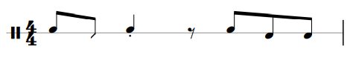

Figure 90 – Swing Pattern Variation 2
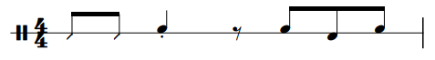

Figure 91 – Triplet Exercise for Bongos
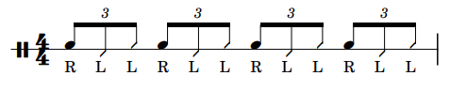
Students should also perform this exercise with an LRR sticking.
Assignment
- Play along to “Somebody Loves Me” by The Command All-Stars using the Swing Pattern Variations and compose two original variations.
- Practice the Triplet Exercise for Bongos.

Week 12
Lesson Plan
The objectives of Week 12 are to shift the focus from fixed swing patterns to improvising and to continue to practice the Week 11 Triplet Exercise. Learning to improvise will require active listening skills, but rhythmic ideas can be created by:
- Imitating or replicating the rhythmic idea of one or more instruments.
- Playing something that contrasts with one or more instruments.
In many cases it will also be appropriate for the student to play the Basic Swing Pattern or a Swing Pattern Variation.

Assignment
- Play along to “C’est ci bon” by Los Amiradores focusing on when to improvise and when to play a swing pattern.
- Continue to practice the Week 11 Triplet Exercise.

(Proceed to Week 13B if following the 14-Week Curriculum)

Week 13A
Lesson Plan
The primary goal for Week 13A is to wrap up the Bolero Pattern discussion, continue to develop the Closed Slap, and to start to play in a solo context. Transitioning to a solo setting on bongos is often approachable for students because they have been encouraged to play extended fills in prior assignments. Meaning, most students will have at least a basic comfort level improvising for a small period of time and will simply need a few exercises to help them be creative while working through the assignment for this week.

Figure 92 – Open Tone and Closed Slap Combination
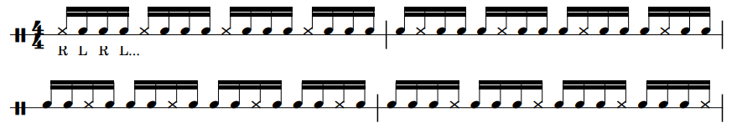
This exercise is designed to help students brainstorm solo ideas if improvising ideas proves to be difficult.
Assignment
- Practice the Closed Slap Exercise.
- Practice the Open Tone and Closed Slap Combination.
- Write an original bongo solo that is 30-45 seconds in duration.

Week 13B
Lesson Plan
The objectives for Week 13B are to wrap up the swing discussion, continue to practice the Week 11 Triplet Exercise, and to start to play in a solo context. Transitioning to a solo setting on bongos is often approachable for students because they have been encouraged to play extended fills in prior assignments. Meaning, most students will have at least a basic comfort level improvising for a small period of time and will simply need a few exercises to help them be creative while working through the assignment for this week.

Assignment
- Practice the Open Tone and Closed Slap Combination.
- Write an original bongo solo that is 30-45 seconds in duration.

Week 14
Lesson Plan
The focus of Week 14 is to wrap up the unit with a discussion of the solo written by the student and to show the student how the Closed Slap, Open Tone, and Heel/Toe Strokes transfer to other instruments (primarily congas and pandeiro). When transferring these techniques to congas, students will need to make two adjustments. First, they will perform a Bass Stroke (played with the lower part of the palm) in place of a Thumb Stroke when performing a Heel/Toe motion on congas. Second, students will perform an Open Tone of each of the fingers instead of just the index finger. After learning the nuanced techniques, students will apply these techniques to the One-Drum Tumbao Pattern. Tumbao is the most common groove to learn for congas and is used in similar contexts as Martillo. When applying these bongo techniques to pandeiro the same strokes will have to be adjusted. The Heel/Toe motion will need to be adjusted the same way it was when being applied to congas, and the Open Tone will need to be performed the thumb instead of the index finger. After making these adjustments, the student is ready to perform the Basic Samba Pattern. Students should also perform the Week 1 Exercises on the new instruments to help isolate and develop the nuanced techniques.
Assignment
- Perform the Week 1 Exercises on congas and pandeiro with the adjusted techniques.
- Play along to “Fried Neckbones and Some Home Fries” by Willie Bobo using the One-Drum Tumbao Pattern.
- Play along to “Escurinho” by Monarco using the Basic Samba Pattern.

Pandeiro
Week 1
Lesson Plan
The objective of the first lesson is to provide an overview of some of the Basic Strokes, the exercises to develop the Basic Strokes, and the Basic Samba Pattern. The Basic Strokes needed to for this lesson are Heel/Toe (alternating Heel and Finger Strokes), Open Tone, and Closed Slap.

Figure 93 – Heel/Toe Exercise 1 for Pandeiro

Figure 94 – Heel/Toe Exercise 2 for Pandeiro

This is the most important exercise for developing the coordination and endurance needed for playing the pandeiro. A portion of the playing motion will come from the right hand performing the strokes, but the majority of the playing motion is achieved by rotating the drum with the left wrist to meet the right hand. At first, students should perform these exercises without moving the right hand to develop a greater understanding of how the technique functions. Performing both of these exercises is imperative as students will need lead with either the Heel or the Fingers depending on the rhythmic vocabulary needed. Initially students will only be able to perform these exercises for short durations. Several small practice sessions throughout the day is the best course of action to develop the proper endurance.

Figure 95 – Open Tone Exercise 1 for Pandeiro
Figure 96 – Open Tone Exercise 2 for Pandeiro

Figure 97 – Open Tone Exercise 3

Figure 98 – Closed Slap Exercise for Pandeiro

The Closed Slap Exercise should first be performed by striking with the index, middle, and ring fingers and then with the side of the thumb. In both contexts, the left wrist should rotate to allow the drum to turn towards the hand during the stroke. This is not necessary to achieve the basic tone, but it is necessary to achieve the tone with proper technique in the context of many grooves and patterns.
Assignment
- Develop Basic Strokes using the Exercises from Week 1 paying special attention to the Heel-Toe Exercises.
- Play along to “Escurinho” by Monarco using the Basic Samba Pattern.

Week 2
Lesson Plan
The primary goals of Week 2 are to continue to refine the Basic Strokes from Week 1, perform the assigned tune, learn variations of the Basic Samba Pattern, and incorporate the Closed Slap into the Basic Samba Pattern. The biggest focus for the Basic Strokes is to ensure that the student is rotating the drum with left wrist not using solely the right hand to play the pattern.

Figure 99 – Basic Samba Pattern with the Closed Slap
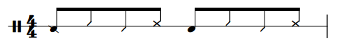
Some would refer to this as the Basic Samba Pattern. It could certainly be included in Week 1, but it is probably best served in Week 2 as the student spends the first week attempting to develop the endurance needed in the left-wrist.

Figure 100 – Samba Variation 1
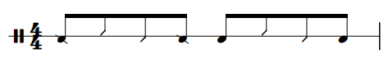
Figure 101 – Samba Variation 2

Figure 102 – Samba Variation 3

At this point, the goal is to focus on variations that use the Open Tone. The vocabulary in this style is traditionally meant to reflect the bass patterns played by the surdos. Variations including a Closed Slap will be included in Week 3. These variations should be used as a jumping off point and students should be encouraged to write their own variations in addition to performing these. The primary methods for creating variations should be:
- Replace a Heel or Finger Stroke with an Open Tone.
- Determine if the present Open Tones of a given variation should be played with or without the dampening of the left hand.
- Mimic the rhythmic content of the surdos.
Assignment
- Continue to play the exercises from Week 1 and increase the tempo.
- Play along to “Thiá de Junqeira” by Osvaldinho da Cuica using at least two of the variations given above and write two of your own variations.

Week 3
Lesson Plan
The primary goals of this lesson are to continue to develop speed and endurance of the Heel/Toe motion and to learn Samba Variations that use the Closed Slap.

Figure 103 – Samba with Closed Slap Variation 1

Figure 104 – Samba with Closed Slap Variation 2

Figure 105 – Samba with Closed Slap Variation 3
Students should create their own variations incorporating the Closed Slap and possibly additional Open Tones if desired. The possibilities for incorporating the Closed Slap are similar to Week 2.
- Replace a Heel or Finger Stroke with a Closed Slap.
- Mimic rhythmic content of other percussion instruments with the Closed Slap.
Assignment
- Continue to play exercises from Week 1.
- Play along to “Batuque De Pirapora” by Osvaldingo da Cuica using two of the variations given above and write two original variation.

Week 4
Lesson Plan
The focus of Week 4 is to transition to the Choro Style, add the finger-based Open Tone to grooves, and to play fills or licks outside of the groove.

Figure 106 – Choro Pattern 1
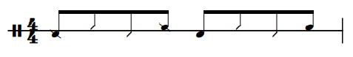

Figure 107 – Choro Pattern 2
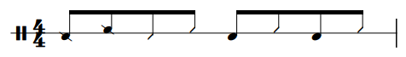

Figure 108 – Choro Pattern 3
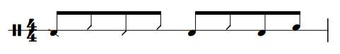

Playing in a Choro style uses a similar vocabulary to the Samba style, but the inspiration for the vocabulary is nuanced between the two styles. Much of the Samba content is pulled from the surdos and sometimes from the other percussion instruments. The Choro style fuses elements of Samba, European forms, and Jazz allowing for a style of playing that allows for more freedom than a traditional Samba setting. The addition of the finger-based Open Tone allows for a greater number of possibilities that allow the performer to more freely express themselves within the style. Students should also incorporate fills or licks as appropriate for the assignment
Assignment
- Continue to play exercises from Week 1 if needed or desired.
- Play along to “Aluizio no Choro” by Entre Amigos using at least two of the patterns from above. Compose at least two original variations and remember to incorporate fills into the performance.

Week 5
Lesson Plan
The goal for Week 5 is to add the Closed Slap played with the thumb, continue to explore the Choro style, start to develop the finger roll, and learn to play double strokes with the wrist.

Figure 109 – Choro with Thumb Slap Variation 1
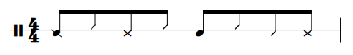

Figure 110 – Choro with Thumb Slap Variation
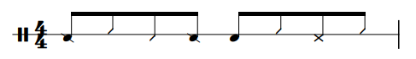

Figure 111 – Choro with Thumb Slap Variation 3
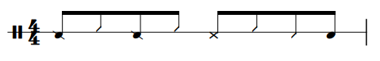
At this point, the student has spent substantial time in developing the ability to play variations within the samba and choro contexts. Adding the Closed Slap with the thumb is primarily needed to complete the skillset. The familiarity with the content also leaves room for the student to work on new techniques that will be valuable when learning to play in a solo context in Week 13A, Week 13B, and Week 14.

Finger 112 – Finger Roll Exercise for Pandeiro
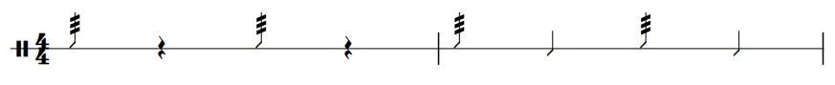
This should be performed freely while students learn to play a correct finger roll. The roll should be initiated with the middle finger and completed with a Heel Stroke. After getting comfortable with this exercise, students should play patterns from previous weeks and substitute a Finger Stroke with a Finger Roll to learn how to add this technique to a groove.

Figure 113 – Heel Double Stroke Exercise
The Heel Double Stroke serves more as an extended technique than a basic stroke, but it can be a helpful tool when playing a solo. To perform a Heel Double Stroke, perform a Heel Stroke, but use the outer part of the wrist to make the sound (Figure 125). Then quickly rotate your wrist and strike the drum with the inner part of the wrist to create the second note (Figure 126). The forearm should still move as if a single Heel Stroke is being performed and the rotation of the wrist helps create the two different sounds.

Figure 114 – Heel Double Stroke Part 1
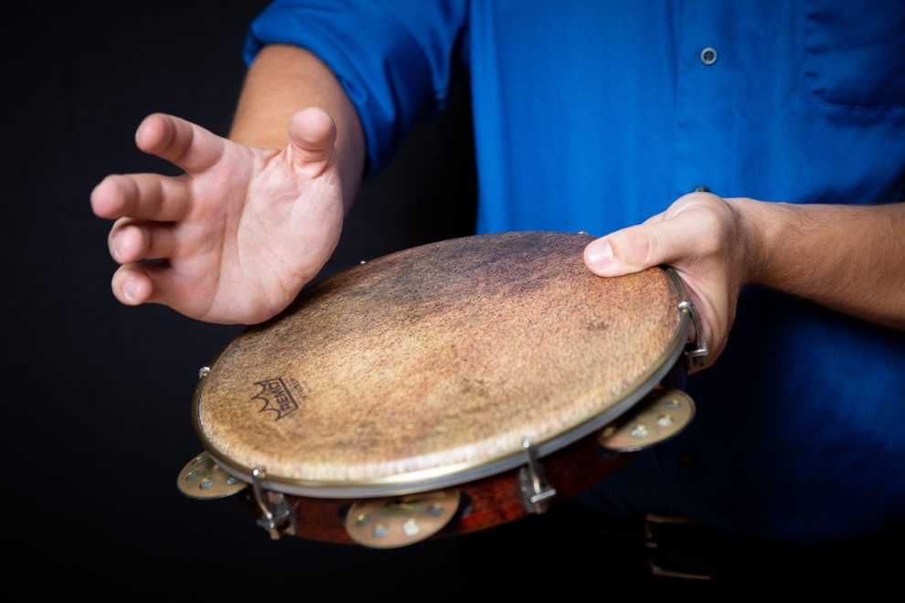

Figure 115 – Heel Double Stroke Part 2
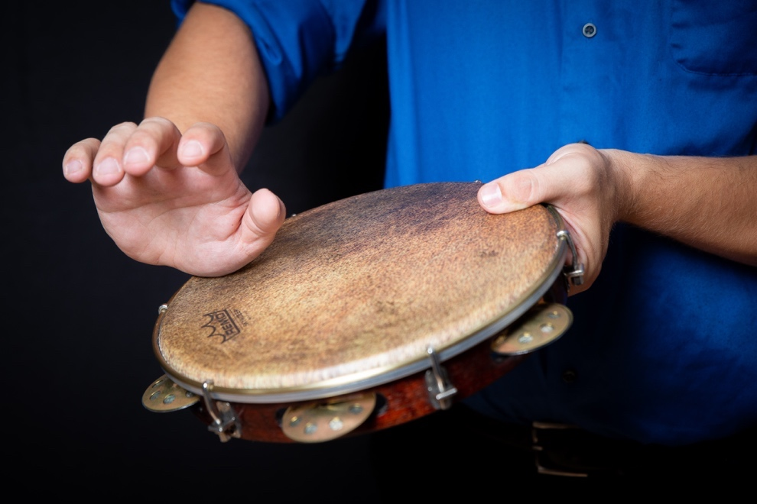

Assignment
- Play along to “Miguelito No Choro” by Arnoldino and Familia Contemporeano using Choro Variations that incorporate a Closed Slap performed with the thumb.
- Practice the Finger Roll and Heel Double Stroke Exercises.

(Proceed to Week 13A if following the 7-Week Curriculum and proceed to Week 6 if following the 14-Week Curriculum).

Week 6
Lesson Plan
The primary goal of Week 6 is to continue to practice Finger Rolls, and Heel/Toe Doubles Exercises and learn the Basic Partido Alto Pattern. Partido Alto is another style of samba characterized by heavy syncopation and is traditionally improvised, but fixed songs have become increasingly popular in this style.
Assignment
- Continue to practice the Finger Rolls and Heel Doubles Exercises.
- Play along to “Sambe de Marte” by Beth Carvalho using the Basic Partido Alto Pattern.

Week 7
Lesson Plan
The focus for Week 7 is to learn to play Finger Roll Double Strokes, modify the Heel/Toe Stroke to play flams, and to learn variations of the Basic Partido Alto Pattern.

Figure 116 – Finger Roll Double Stroke Exercise
Finger Roll Double Strokes are achieved with the same technique as a Finger Roll but are achieved by using less pressure between the head and the finger, allowing the finger to bounce across the drum head.

Figure 117 – Heel/Toe Flam Exercise
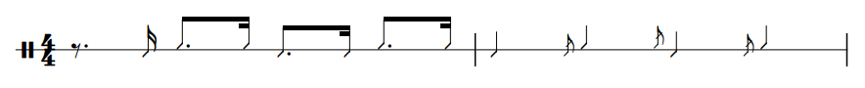
Flams are achieved on pandeiro with a much faster Heel/Toe motion. The left-hand is still aiding this motion by rotating the drum.

Figure 118 – Partido Alto Variation 1

Figure 119 – Partido Alto Variation 2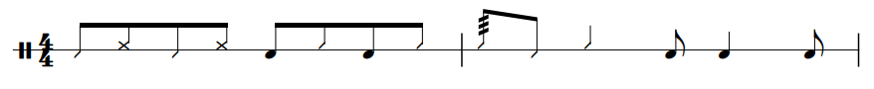

Figure 120 – Partido Alto Variation 3

Assignment
- Practice the Finger Roll Doubles Exercise.
- Practice the Heel/Toe Flam Exercise.
- Play along to “Partido Alto Da Antiga” by Monarco using Partido Alto Variations and compose at least two original variations.

Week 8
Lesson Plan
The focus for Week 8 is to continue practicing the exercises from Week 7 and to learn the Basic Baião Pattern. The zabumba was the original percussion instrument used for this style, but these patterns were adapted later when the pandeiro was incorporated into the style.
Assignment
- Continue to practice the Week 7 Exercises.
- Play along to “Baião De Dois” by Luiz Gonzaga using the Basic Baião Patterns.

Week 9
Lesson Plan
The primary goal for Week 9 is to learn the Vertical and Horizontal Shake Exercises and variations of the Basic Baião Pattern.

Figure 121 – Vertical Shake Exercise
The Vertical Shake is achieved by first raising the drum and then returning to the playing position.

Figure 122 – Vertical Shake Motion
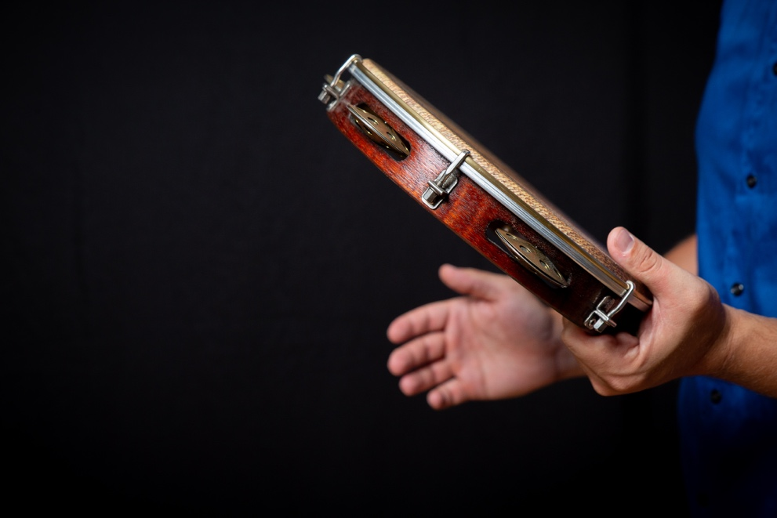

Figure 123 – Horizontal Shake Exercise
The Horizontal Shake is achieved by moving the drum away from your body and then returning to the playing position.

Figure 124 – Horizontal Shake Motion
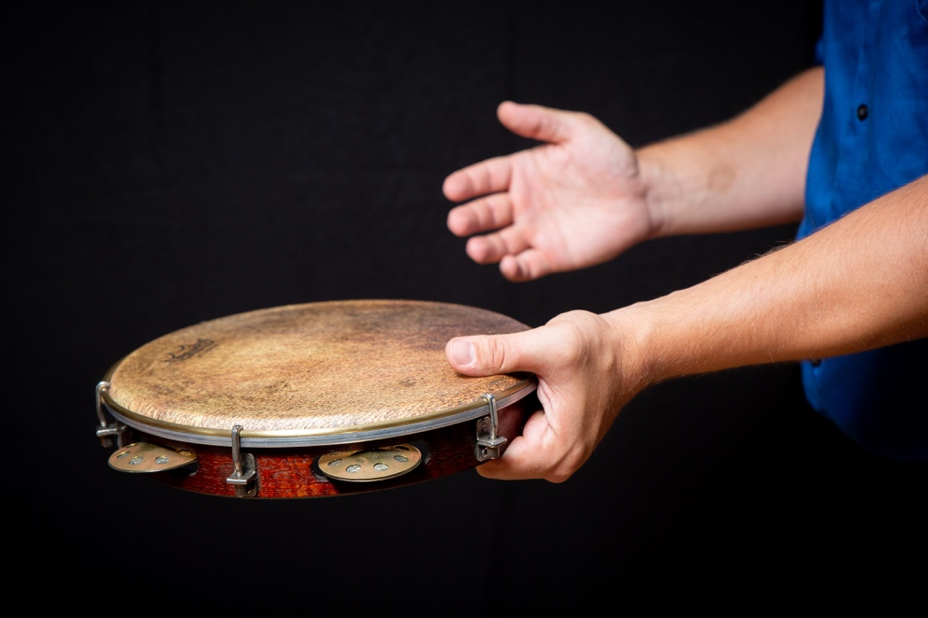

Figure 125 – Baião Variation 1
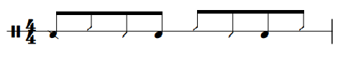

Figure 126 – Baião Variation 2
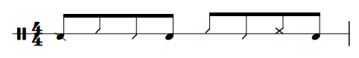

Figure 127 – Baião Variation 3
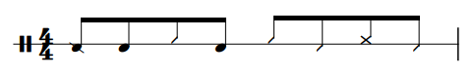

Composing variations in this style should lean heavily on the Basic Baião Patterns found in Week 8. Students can create variations by:
- Add Heel/Toe strokes on the eighth-note values between rhythms.
- Replace an Open Tone with a Closed Slap or Vice Versa.
- Omit an Open Tone or Slap.
- Slightly vary the rhythm of the Basic Baião Patterns.
Assignment
- Practice the Vertical Shake and Horizontal Shake Exercises.
- Play along to “Moda Da Mula Preta” by Luiz Gonzaga using the Baião Variations above and compose two original variations.

Week 10
Lesson Plan
The goal for Week 10 is to continue to practice the Week 9 Exercises and transition to playing common drum set grooves. Although playing drum set grooves is not a traditional application of the instrument, it is becoming increasingly common. Examples of drum set grooves are provided, but most drum set texts will also be suitable options if desired.

Figure 128 – Pandeiro Drum Set Rhythm 2
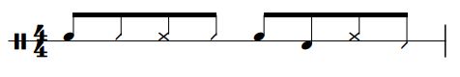

Figure 129 – Pandeiro Drum Set Rhythm 3
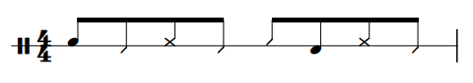

Assignment
- Continue to practice the Vertical Shake and Horizontal Shake Exercises.
- Play along to “Thank You” by Sly and the Family Stone using Pandeiro Drum Set Rhythm 3.

Week 11
Lesson Plan
The main focus of Week 11 is to continue to apply drum set rhythms to the pandeiro using the Syncopation Exercise for Pandeiro and Pandeiro Funk Groove 1. The syncopation exercises are designed to help students develop the coordination to place an Open Tone or Closed Slap on any sixteenth note partial while sustaining the Heel/Toe movement.

Figure 130 – Syncopation Exercise for Pandeiro
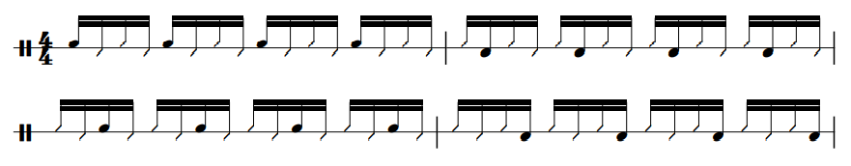
This exercise should also be performed with the Closed Slap in place of the Open Tone.

Figure 131 – Pandeiro Funk Groove 1

Assignment
- Practice the Week 11 Syncopation Exercise.
- Play along to “I Got You (I Feel Good)’ by James Brown using Pandeiro Funk Groove 1.

Week 12
The goal for Week 12 is to continue to play the Week 11 Syncopation Exercises and learn to play funk grooves on pandeiro.

Figure 132 – Pandeiro Funk Groove 2
Assignment
- Continue to practice the Week 11 Syncopation Exercise.
- Play along to “Cold Sweat” by James Brown using the Pandeiro Funk Groove 2.

(Proceed to Week 13B if following the 14-Week Curriculum)

Week 13A
Lesson Plan
After wrapping up the play along assignment from Week 5, the primary focus of Week 13A is to develop technical facility and an understanding of playing the instrument in a solo setting. In addition to the Finger Roll and Heel Stroke Double Exercises on Week 5, the exercises listed below will help add to the existing rhythmic vocabulary for performing in a solo context.

Figure 133 – Open Tone Triplets Exercise
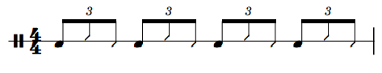

Figure 134 – Alternating Open Tone Triplets Exercise
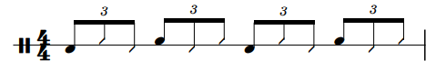

Figure 135 – Open Tone and Closed Slap Alternating Triplets
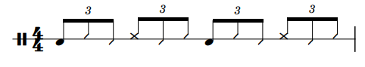
Assignment
- Practice the Exercises from Week 5 and Week 13A.
- Write an original pandeiro solo that is 30-45 seconds in duration.
Week 13B
Lesson Plan
After wrapping up the play along assignment from Week 12, the primary focus of Week 13B is to develop technical facility and an understanding of playing the instrument in a solo setting.

Assignment
- Practice the Week 13B Exercises.
- Write an original pandeiro solo that is 30-45 seconds in duration.

Week 14
Lesson Plan
The focus of Week 14 is to wrap up the unit with a discussion of the solo written by the student and to show the student how the Closed Slap, Open Tone, and Heel/Toe Strokes transfer to other instruments (primarily congas and bongos). When applying these pandeiro techniques to congas, the student will have to learn how to play an Open Tone using each of the fingers as opposed to the thumb. After learning to perform an Open Tone the student is ready to perform the Basic Samba Pattern. When transferring pandeiro techniques to bongos, students will need to make two adjustments. First, they will perform a Thumb Stroke in place of a Heel Stroke (played with the lower part of the palm) when performing a Heel/Toe motion on bongos. Second, students will perform an Open Tone using the index finger instead of the thumb. After learning the nuanced techniques, students will apply them to the Basic Martillo Pattern. Martillo is the most common groove to learn for bongos and is used in similar contexts as Tumbao. Students should also perform the Week 1 Exercises on the new instruments to help isolate and develop the nuanced techniques.
Assignment
- Perform the Week 1 Exercises on congas and bongos with the adjusted techniques.
- Play along to “Fried Neckbones and Some Home Fries” by Willie Bobo using the One-Drum Tumbao Pattern.
- Play along to “Meloda De Cana” by Jack Costanza using the Basic Martillo Pattern.

Tar
Week 1
Lesson Plan
The objectives of the first lesson are to learn the Basic Strokes, the corresponding exercises for the Basic Strokes, and how to perform the Basic Baladi Pattern and the Basic Maksum Pattern. The basic patterns for Maksum and Baladi are nearly the same and typically have comparable tempo ranges. The Basic Strokes needed to for this lesson are Dum, Tek, and Ka. It is also important to have students recite the syllables before they play them, and while they play them. Recitation is an important aspect of the tar and is a tool used by other tar drummers to share information. Teachers may choose either Upright or Lap style for the curriculum.

Figure 136 – Dum Exercise for Tar
This exercise should be performed with each hand individually.

Figure 137 – Tek/Ka Exercise for Tar
This exercise should be performed with each hand individually and by alternating right and left for a total of three variations.

Assignment
- Develop the Basic Strokes using the Exercises from Week 1.
- Play along to “Balady Hillow” by Eddie Kochak using the Basic Baladi Pattern or play along to “Afrah Baladi” by Mostafa Sax using the Basic Maksum Pattern.

Week 2
Lesson Plan
The primary goals of Week 2 are to continue to refine the Basic Strokes from Week 1, perform the assigned tune, learn the Pa Stroke, and to learn variations of the Baladi and Maksum patterns. Common pitfalls for the basic strokes include:
- Failing to rotate the wrist when playing a Dum or a Tek.
- Poor striking location on the drum. Tars come in a wide variety of sizes, and it can take students some time to learn where to strike a particular drum for the best possible sound.

Figure 138 – Pa Exercise for Tar

Figure 139 – Baladi Variation 1 for Tar
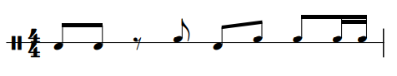

Figure 140 – Baladi Variation 2 for Tar
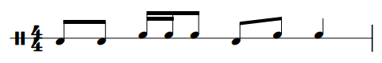

Figure 141 – Baladi Variation 3 for Tar
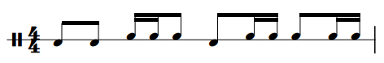

Figure 142 – Maksum Variation 1 for Tar
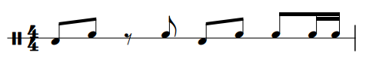

Figure 143 – Maksum Variation 2 for Tar
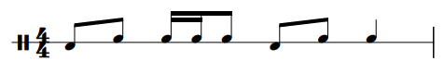

Figure 144 – Maksum Variation 3 for Tar
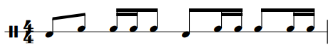
These variations should be used as a jumping off point and students should be encouraged to write their own variations in addition to performing these. Tips for writing variations include:
- Replace a Tek or Ka with a Pa.
- Add at least one Tek, Ka, or Pa in a rest.
When composing variations, students should keep the beat placement of the Dum Strokes intact.
Assignment
- Practice the Pa Exercise for Tar.
- Continue to play the exercises from Week 1 if needed.
- Play along to Balady Hillow by Eddie Kochak using the Basic Baladi Pattern or play along to Afrah Baladi by Mostafa Sax using the Basic Maksum Pattern. Students should be encouraged to choose the style they did not play along to in Week 1.

Week 3
Lesson Plan
The primary goals of this lesson are to learn Snap strokes, how to incorporate them into Baladi or Maksum variations, and playing fills outside of the groove.

Figure 145 – Finger Snap Exercise
This exercise could be performed with any finger on either hand, but it is typically best for students to start with either the middle or the ring finger. This stroke is performed the same way as an ordinary snap, but with one major difference. When performing an ordinary snap, the sound is produced when the finger-tip strikes the lower part of the palm. When performing a Snap Stroke on a tar drum, the preparation for the snap is the same, but the finger-tip strikes the edge of the drum head instead of the lower part of the palm.

Figure 146 – Baladi with Pa Variation 1 for Tar
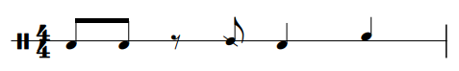

Figure 147 – Baladi with Pa Variation 2 for Tar
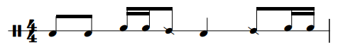

Figure 148 – Maksum with Pa Variation 1 for Tar
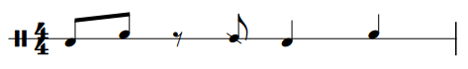

Figure 149 – Maksum with Pa Variation 2 for Tar
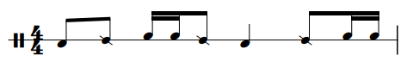
These variations also only serve as a jumping off point for students, and the Week 2 concepts for creating variations should be modified to include the Snap for the assignment.
Assignment
- Practice the Finger Snap Exercise.
- Play along to “Ijdid Baladi” by Iasir Hasson using the Baladi Variations above and write two original variations or play along to “Ya Msaharni” by The Upper Egypt Ensemble using the Maksum Variations above and write two original variations.

Week 4
Lesson Plan
The focus of Week 4 is to wrap up the Maksum and Baladi Patterns, learn the Basic Masmoudi Pattern, and start to develop the proper coordination for the Finger Roll.

Figure 150 – One-Hand Finger Roll Exercise for Tar
This exercise should first be performed with the right hand performing the finger roll. Then with the left hand performing the finger roll.
Assignment
- Continue to practice the Finger Snap Exercise if needed.
- Practice the One-Handed Finger Roll Exercise for Tar.
- Play along to “Through the Ank” by Phil Thornton using the Basic Masmoudi Pattern.

Week 5
Lesson Plan
The focus for Week 5 is to learn variations of the Basic Masmoudi Pattern, and to continue to develop the Finger Roll.

Figure 151 – Two-Hand Finger Roll Exercise for Tar
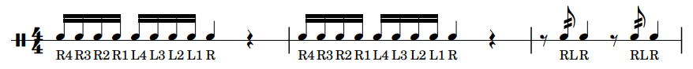
This exercise should first be performed with the right hand initiating the finger roll. Then the exercise should be performed starting with the left hand initiating the roll.

Figure 152 – Masmoudi Variation 1 for Tar

Figure 153 – Masmoudi Variation 2 for Tar

Figure 154 – Masmoudi Variation 3 for Tar

Assignment
- Practice the Two-Handed Finger Roll Exercise for Tar.
- Play along to “Through the Ank” by Phil Thornton using Masmoudi. Variations and fills are left up to the discretion of the performer.

(Proceed to Week 13A if following the 7-Week Curriculum and proceed to Week 6 if following the 14-Week Curriculum).

Week 6
Lesson Plan
The goal for Week 6 is to continue to practice the Week 5 Finger Roll Exercise and to use combinations of the Baladi, Maksum, and Masmoudi patterns. Masmoudi is used in many different songs, but it is not commonly used exclusively. It often appears for one or two cycles in between cycles of Baladi and Maksum.

Figure 155 – Baladi and Masmoudi Combination for Tar
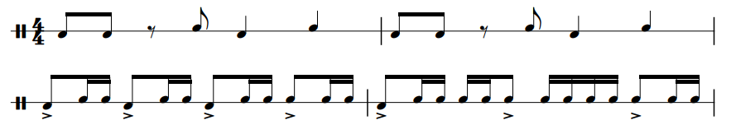

Figure 156 – Maksum and Masmoudi Combination for Tar
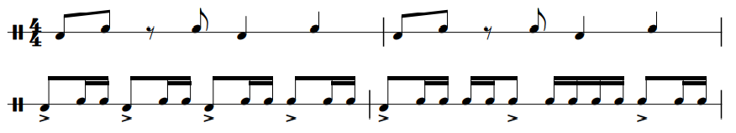

Assignment
- Continue to practice the Week 5 Finger Roll Exercise.
- Play along to “Maddah al Amar” by Suhail Salimpour using the Pattern Combinations above.

Week 7
Lesson Plan
The primary goal for Week 7 is to learn Split-Hand Pa Exercise 1 for Tar and the Basic Chiftitelli Pattern.

Figure 157 – Split-Hand Pa Exercise 1 for Tar
Pa is typically played with all of the fingers of the right hand (except for the thumb), but it is also possible to play Pa with just the index finger. This allows for faster rhythms to be played using strictly the Pa sound. When playing consecutive Pa Strokes, the middle, ring, and pinky fingers strike first followed by the index finger. The above exercise should be performed by alternating between the two different Pa strokes.
Assignment
- Practice Split-Hand Pa 1 Exercise for Tar.
- Play along to “Violin Takism/Oud Chiftetelli” by Eddie Kochak using the Basic Chiftitelli Pattern.

Week 8
Lesson Plan
The focus for Week 8 is to progress to Split-Hand Pa Exercise 2 for Tar and learn variations of the Basic Chiftitelli Pattern.

Figure 158 – Split-Hand Pa Exercise 2 for Tar
This exercise adds varying rhythms allowing the student to apply the technique at quickly changing speeds.

Figure 159 – Chiftitelli Variation 1 for Tar

Figure 160 – Chiftitelli Variation 2 for Tar

Figure 161 – Chiftitelli Variation 3 for Tar
Assignment
- Practice Split-Hand Pa Exercise 2 for Tar.
- Play along to “Taxim and Chiftitelli” by the Fred Elias Ensemble using the Chiftitelli Variations above and compose two original variations.

Week 9
Lesson Plan
The goal for Week 9 is to progress to Split-Hand Pa Exercise 3 for Tar and to learn the Basic Malfuf Patterns for Tar.

Figure 162 – Split-Hand Pa Exercise 3 for Tar
This exercise shows ways to add left hand sounds with the Split-Hand Pa Technique.

Figure 163 – Basic Malfuf Pattern 2 for Tar
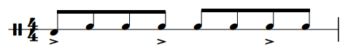

Assignment
- Practice the Split-Hand Pa Exercise 3 for Tar.
- Play along to “Malfuf Hidgaz” by Armen Kusikian and Samir Abut using the Basic Malfuf Patterns.

Week 10
Lesson Plan
The focus for Week 10 is to learn Advanced Finger Snap Exercise 1 and variations of the Basic Malfuf Patterns.

Figure 164 – Advanced Finger Snap Exercise 1
This exercise is the first step in developing the coordination for snapping with every finger. The student should practice this exercise using three different combinations:
- Pinky and Ring Fingers.
- Ring and Middle Fingers.
- Middle and Index Fingers.

Figure 165 – Malfuf Variation 1 for Tar
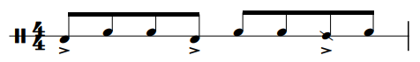

Figure 166 – Malfuf Variation 2 for Tar
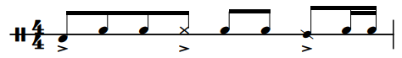

Figure 167 – Malfuf Variation 3 for Tar
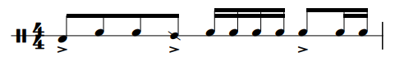

Figure 168 – Malfuf Variation 4 for Tar
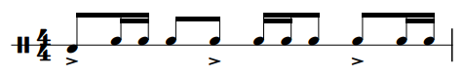
When composing Malfuf Variations, it is imperative to maintain a three-three-two rhythmic cycle.
Assignment
- Practice Advanced Finger Snap Exercise 1.
- Play along to “Malfuf Ala Westi” by Hossam Ramzy using the Malfuf Variations above and compose two original variations.

Week 11
Lesson Plan
The goal for Week 11 is to progress to Advanced Finger Snap Exercise 2 and to learn the Basic Saidi Pattern.

Figure 169 – Advanced Finger Snap Exercise 2
This exercise progresses to sequences of three snaps and should be performed using two different combinations.
- Pinky, ring, and middle fingers.
- Ring, middle, and index fingers.
Assignment
- Practice Advanced Finger Snap Exercise 2.
- Play along to “Habibi Baladi, We Zay el Amar” by Hossam Ramzy and Mohen Allam using the Basic Saidi Pattern.

Week 12
Lesson Plan
The goal for Week 12 is to learn Advanced Finger Snap Exercise 3 and variations of the Basic Saidi Pattern.

Figure 170 – Advanced Finger Snap Exercise 3
This exercise is the final step in developing the proper dexterity of the finger snap. This exercise uses the pinky, ring, middle, and index fingers.

Figure 171 – Saidi Variation 1 for Tar
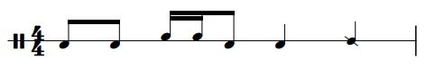

Figure 172 – Saidi Variation 2 for Tar
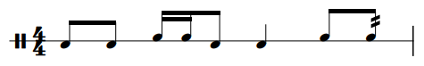

Figure 173 – Saidi Variation 3 for Tar
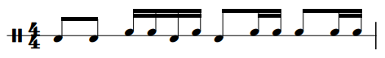
Given the similarities to Baladi and Maksum, students will be able to compose variations with relative ease. This style is saved for the end because it is often faster than the other styles, affording students the opportunity to learn to play at faster tempi.
Assignment
- Practice Advanced Finger Snap Exercise 3.
- Play along to “Saidi Festival” by the Upper Egypt Ensemble using the Saidi Variations above and compose two original variations.

(Proceed to Week 13B if following the 14-Week Curriculum)
Week 13A
Lesson Plan
After wrapping up the play-along assignment from Week 5, the primary focus of Week 13A is to develop an understanding of playing the instrument in a solo setting. To perform a solo, students should:
- Play moderately modified versions of Baladi, Maksum, or Masmoudi.
- Alternate between cycles of Baladi, Maksum, or Masmoudi.
- Brainstorm 4-5 short rhythmic ideas and several different ways to orchestrate and embellish those ideas using the Basic Strokes.
Assignment
- Continue to practice the Two-Handed Finger Roll Exercise if necessary.
- Write an original tar solo that is 30-45 seconds in duration.

Week 13B
Lesson Plan
The focus of Week 13B is to develop an understanding of playing the instrument in a solo setting. To perform a solo, students should:
- Play moderately modified versions of Baladi, Maksum, or Masmoudi.
- Alternate between cycles of Baladi, Maksum, or Masmoudi.
- Brainstorm 4-5 short rhythmic ideas and several different ways to orchestrate and embellish those ideas using the Basic Strokes.

Assignment
- Continue to practice Advanced Finger Snap Exercise 3.
- Write an original tar solo that is 30-45 seconds in duration.

Week 14
Lesson Plan
The focus of Week 14 is to wrap up the unit with a discussion of student’s solo and to show the student how the Dum, Tek, Ka, and Pa Strokes transfer to other instruments (primarily dumbek and riq). When performing these strokes on dumbek, the Dum and Tek strokes will require modification, but the Ka and Pa strokes are the same. Performing a Dum Stroke on dumbek requires striking the drum with each of the fingers simultaneously as opposed to the ring finger or thumb on tar. Similar adjustments will also need to be made to appropriately perform the Tek stroke on Dumbek in which all of the fingers strike the edge of the head instead of being performed by the ring finger. When performing these strokes on riq, the Dum stroke will need to be modified, but the remainder of the strokes are the same. Performing a Dum on riq requires the student to use their index finger instead of the ring finger. After modifying the strokes for each drum, the student will be capable of playing each of the grooves covered in this curriculum on all three instruments of the Split-Hand Family. In this lesson, students will perform the Basic Masmoudi Pattern and the Basic Baladi Pattern for dumbek and riq respectively. Students should also perform the Week 1 Exercises on the new instruments to help isolate and develop the nuanced techniques.
Assignment
- Perform the Week 1 Exercises on dumbek and riq with the adjusted techniques.
- Play along to “Through the Ankh” by Phil Thornton and Hossam Ramzy using the Basic Masmoudi Pattern for Doumbek.
- Play along to “Baladi Hillow” by Eddie Kochak using the Basic Baladi Pattern for Riq.

Dumbek
Week 1
Lesson Plan
The objectives of the first lesson are to learn the Basic Strokes, the corresponding exercises for the Basic Strokes, and how to perform the Basic Baladi Pattern and the Basic Maksum Pattern. The basic patterns for Maksum and Baladi are nearly the same and typically have comparable tempo ranges. The Basic Strokes needed to for this lesson are Dum, Tek, and Ka. It is also important to have students recite the syllables before they play them, and while they play them. Recitation is an important aspect of the tar and is a tool used by other dumbek players to share information.

Figure 174 – Dum Exercise for Dumbek
This exercise should be performed with the right hand.

Figure 175 – Tek/Ka Exercise for Dumbek
This exercise should be performed with each hand individually and by alternating right and left for a total of three variations.
Assignment
- Develop the Basic Strokes using the Exercises from Week 1.
- Play along to “Balady Hillow” by Eddie Kochak using the Basic Baladi Pattern or play along to “Afrah Baladi” by Mostafa Sax using the Basic Maksum Pattern.

Week 2
Lesson Plan
The primary goals of Week 2 are to continue to refine the Basic Strokes from Week 1, perform the assigned tune, learn the Pa Stroke, and to learn variations of the Baladi and Maksum patterns. Common pitfalls for the basic strokes include:
- Fanning the fingers when playing Dum, rather than keeping the fingers together. This results in a poor fundamental pitch from the drum.
- Tek is played too far in. The fingers should strike as close to the edge as possible.
- The wrist is not rotating to perform Ka, making it hard to project the sound as loud as the others.

Figure 176 – Pa Exercise for Dumbek

Figure 177 – Baladi Variation 1 for Dumbek

Figure 178 – Baladi Variation 2 for Dumbek

Figure 179 – Baladi Variation 3 for Dumbek

Figure 180 – Maksum Variation 1 for Dumbek

Figure 181 – Maksum Variation 2 for Dumbek

Figure 182 – Maksum Variation 3 for Dumbek
These variations should be used as a jumping off point and students should be encouraged to write their own variations in addition to performing these. Tips for writing variations include:
- Replace a Tek or Ka with a Pa.
- Add at least on Tek, Ka, or Pa in a rest.
- Do not add or subtract a Dum from the pattern.
Assignment
- Practice the Pa Exercise for Dumbek.
- Continue to play the exercises from Week 1 and push the tempo if need be.
- Play along to “Balady Hillow” by Eddie Kochak using the Basic Baladi Pattern or play along to “Afrah Baladi” by Mostafa Sax using the Basic Maksum Pattern. Students should be encouraged to choose the style they did not play along to in Week 1.

Week 3
Lesson Plan
The primary goals of this lesson are to learn the Slap and Pop strokes, how to incorporate them into Baladi or Maksum variations, and playing fills outside of the groove.

Figure 183 – Closed Slap Exercise for Dumbek
This exercise should be performed with the right hand.

Figure 184 – Pop Exercise
This exercise should be performed with the left hand. Students should explore different dampening spots with the right hand to produce the desired sound.

Figure 185 – Baladi with the Slap and Pop Variation 1
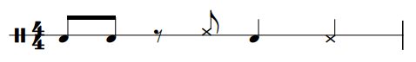

Figure 186 – Baladi with the Slap and Pop Variation 2
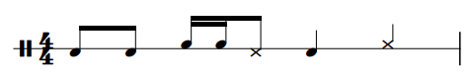

Figure 187 – Baladi with the Slap and Pop Variation 3
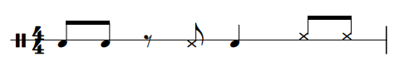

Figure 188 – Maksum with the Slap and Pop Variation 1
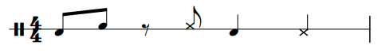

Figure 189 – Maksum with the Slap and Pop Variation 2
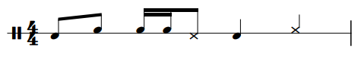

Figure 190 – Maksum with the Slap and Pop Variation 3
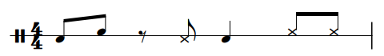
These variations also only serve as a jumping off point for students, and the Week 2 concepts for creating variations should be modified to include the Snap for the assignment.

Assignment
- Practice the Closed Slap and Pop Exercises.
- Play along to “Ijdid Baladi” by Iasir Hasson using the Baladi Variations above and write two original variations or play along to “Ya Msaharni” by The Upper Egypt Ensemble using the Maksum Variations above and write two original variations.
Week 4
Lesson Plan
The focus of Week 4 is to wrap up the Maksum and Baladi Patterns, learn the Basic Masmoudi Pattern, and start to develop the proper coordination for the Finger Roll.

Figure 191 – One-Hand Finger Roll for Exercise for Dumbek
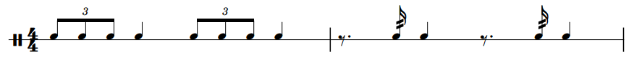
This exercise should first be performed with the right-hand performing the finger roll. Then with the left hand performing the finger roll.
Assignment
- Continue to play Snap Exercises if needed.
- Practice Finger Roll Exercises.
- Play along to “Through the Ank” by Phil Thornton using the Basic Masmoudi Pattern.

Week 5
Lesson Plan
The focus for Week 5 is to learn variations of the Basic Masmoudi Pattern, and to continue to develop the Finger Roll.

Figure 192 – Two-Hand Finger Roll Exercise for Dumbek
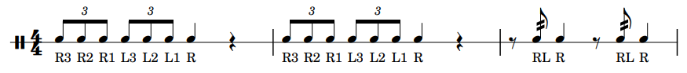
This exercise should first be performed with the right hand initiating the finger roll. Then with the left hand initiating the roll.

Figure 193 – Masmoudi Variation 1 for Dumbek

Figure 194 – Masmoudi Variation 2 for Dumbek

Figure 195 – Masmoudi Variation 3 for Dumbek
Assignment
- Practice the Two-Hand Finger Roll Exercise.
- Play along to “Through the Ank” by Phil Thornton using Masmoudi. Variations and fills are left up to the discretion of the performer.

(Proceed to Week 13A if following the 7-Week Curriculum and proceed to Week 6 if following the 14-Week Curriculum).

Week 6
Lesson Plan
The goal for Week 6 is to continue to practice the Week 5 Finger Roll Exercise and to use combinations of the Baladi, Maksum, and Masmoudi patterns. Masmoudi is used in many different songs, but it is not commonly used exclusively. It often appears for one or two cycles in between cycles of Baladi and Maksum.

Figure 196 – Baladi and Masmoudi Combination for Dumbek
Figure 197 – Maksum and Masmoudi Combination for Dumbek

Assignment
- Continue to practice the Week 5 Finger Roll Exercise.
- Play along to “Maddah El Amar” by Suhaila Salimpour using the pattern combinations above.

Week 7
Lesson Plan
The primary goal for Week 7 is to learn Split-Hand Pa Exercise 1 for Dumbek and the Basic Chiftitelli Pattern.

Figure 198 – Split-Hand Pa Exercise 1 for Dumbek
Pa is typically played with all the fingers of the right hand (except for the thumb), but it is also possible to play Pa with just the index finger. This allows for faster rhythms to be played using strictly the Pa sound. When playing consecutive Pa Strokes, the middle, ring, and pinky fingers strike first followed by the index finger. The above exercise should be performed by alternating between the two different Pa strokes.
Assignment
- Practice Split-Hand Pa Exercise 1 for Dumbek.
- Play along to “Violin Takism/Oud Chiftetelli” by Eddie Kochak using the Basic Chiftitelli Pattern.

Week 8
Lesson Plan
The focus for Week 8 is to progress to Split-Hand Pa Exercise 2 for Dumbek and learn variations of the Basic Chiftitelli Pattern.

Figure 199 – Split-Hand Pa Exercise 2 for Dumbek

Figure 200 – Chiftitelli Variation 1 for Dumbek

Figure 201 – Chiftitelli Variation 2 for Dumbek

Figure 202 – Chiftitelli Variation 3 for Dumbek

Assignment
- Practice Split-Hand Pa Exercise 2 for Dumbek.
- Play along to “Taxim and Chiftitelli” by the Fred Elias Ensemble using the Chiftitelli Variations above and compose two original variations.

Week 9
Lesson Plan
The goal for Week 9 is to progress to Split-Hand Pa Exercise 3 for Dumbek and to learn the Basic Malfuf Patterns.

Figure 203 – Split-Hand Pa Exercise 3 for Dumbek
This exercise shows ways to add left hand sounds with the Split-Hand Pa Technique.

Figure 204 – Basic Malfuf Pattern 2 for Dumbek

Assignment
- Practice Split-Hand Pa Exercise 3 for Dumbek.
- Play along to “Malfuf Hidgaz” by Armen Kusikian and Samir Abut using the Basic Malfuf Pattern.

Week 10
Lesson Plan
The goal for Week 10 is to learn Paradiddle Exercise 1 for Dumbek and variations of the Basic Malfuf Patterns.

Figure 205 – Paraddidle Exercise 1 for Dumbek
This exercise applies the same principles of the Split-Pa Technique and applies them to the Tek and Ka Strokes.

Figure 206 – Malfuf Variation 1 for Dumbek

Figure 207 – Malfuf Variation 2 for Dumbek

Figure 208 – Malfuf Variation 3 for Dumbek
Figure 209 – Malfuf Variation 4 for Dumbek
When composing Malfuf Variations, it is imperative to maintain a three-three-two rhythmic cycle.
Assignment
- Practice Paraddidle Exercise 1 for Dumbek.
- Play along to “Malfuf Ala Westi” by Hossam Ramzy using the Malfuf Variations above and compose two original variations.

Week 11
Lesson Plan
The goal for Week 11 is to progress to Paraddidle Exercise 2 for Dumbek and to learn the Basic Saidi Pattern.

Figure 210 – Paraddidle Exercise 2 for Dumbek
This exercise is similar to Paradiddle Exercise 1, but it adds the Dum Stroke. This requires the right hand to change playing zones between the Dum and Tek Strokes.
Assignment
- Practice Paraddidle Exercise 2 for Dumbek.
- Play along to “Habibi Baladi, We Zay el Amar” by Hossam Ramzy and Mohsen Allam using the Basic Saidi Pattern.

Week 12
Lesson Plan
The goal focus for Week 10 is to learn the Paradiddle Diddle Exercise for Dumbek and variations of the Basic Saidi Pattern.

Figure 211 – Paradiddle Diddle Exercise for Dumbek
This exercise serves to take the split tek and ka technique one step further by adding an additional split hand Tek/Ka Stroke.

Figure 212 – Saidi Variation 1 for Dumbek

Figure 213 – Saidi Variation 2 for Dumbek

Figure 214 – Saidi Variation 3 for Dumbek
Given the similarities to Baladi and Maksum, students will be able to compose variations with relative ease. This style is saved for the end because it is often faster than the other styles, affording students the opportunity to learn to play at faster tempi.
Assignment
- Practice the Paradiddle Diddle Exercise for Dumbek.
- Play along to “Saidi Festival” by the Upper Egypt Ensemble using the Saidi Variations above and compose two original variations.

(Proceed to Week 13B if following the 14-Week Curriculum)

Week 13A
Lesson Plan
After wrapping up the play along assignment from Week 5, the primary focus of Week 13A is to develop an understanding of playing the instrument in a solo setting. To perform a solo, students should:
- Play moderately modified versions of Baladi, Maksum, or Masmoudi.
- Alternate between cycles of Baladi, Maksum, or Masmoudi.
- Brainstorm 4-5 short rhythmic ideas and several different ways to orchestrate and embellish those ideas using the Basic Strokes.
Assignment
- Practice the Paradiddle Diddle Exercise for Dumbek.
- Write an original dumbek solo that is 30-45 seconds in duration.

Week 13B
Lesson Plan
After wrapping up the play along assignment from Week 12, the primary focus of Week 13B is to develop an understanding of playing the instrument in a solo setting. To perform a solo, students should:
- Play moderately modified versions of Baladi, Maksum, or Masmoudi.
- Alternate between cycles of Baladi, Maksum, or Masmoudi.
- Brainstorm 4-5 short rhythmic ideas and several different ways to orchestrate and embellish those ideas using the Basic Strokes.
Assignment
- Practice the Week 12 Paradiddle Diddle Exercise for Dumbek.
- Write an original dumbek solo that is 30-45 seconds in duration.

Week 14
Lesson Plan
The focus of Week 14 is to wrap up the unit with a discussion of student’s solo and to show the student how the Dum, Tek, Ka, and Pa Strokes transfer to other instruments (primarily tar and riq). When performing these strokes on tar, the Dum and Tek strokes will require modification, but the Ka and Pa strokes are the same. Performing a Dum Stroke on tar requires striking the drum with the ring finger or thumb (depending on the playing position) as opposed to each of the fingers simultaneously on dumbek. Similar adjustments will also need to be made to appropriately perform the Tek stroke on tar in which the ring finger strikes the edge of the head (both playing positions) instead of being performed by all of the fingers. Similar modifications will need to be made when applying these strokes to riq as well. Performing a Dum on riq requires the student to use their index finger instead of the all of the fingers and modifying the Tek stroke for riq requires the same adjustments as it did for tar. After modifying the strokes for each drum, the student will be capable of playing each of the grooves covered in this curriculum on all three instruments of the Split-Hand Family. In this lesson, students will perform the Basic Masmoudi Pattern and the Basic Baladi Pattern for dumbek and riq respectively. Students should also perform the Week 1 Exercises on the new instruments to help isolate and develop the nuanced techniques.
Assignment
- Perform the Week 1 Exercises on tar and riq with the adjusted techniques.
- Play along to “Through the Ankh” by Phil Thornton and Hossam Ramzy using the Basic Masmoudi Pattern for Tar using either the Upright or Lap Style of Playing.
- Play along to “Baladi Hillow” by Eddie Kochak using the Basic Baladi Pattern for Riq.

Riq
Week 1
Lesson Plan
The objectives of the first lesson are to learn the Basic Strokes, the corresponding exercises for the Basic Strokes, and how to perform the Basic Baladi Pattern and the Basic Maksum Pattern. The basic patterns for Maksum and Baladi are nearly the same and typically have comparable tempo ranges. The Basic Strokes needed to for this lesson are Dum, Tek, and Ka. It is also important to have students recite the syllables before they play them, and while they play them. Recitation is an important aspect of the riq and is a tool used by other riq players to share information.

Figure 215 – Dum Exercise for Riq
This exercise should be performed with each hand individually.

Figure 216 – Tek/Ka Exercise 1 for Riq
This exercise should be performed with each hand individually and by alternating right and left for a total of three variations.

Figure 217 – Tek/Ka Exercise 2 for Riq
This exercise should be performed with each hand individually and by alternating right and left for a total of three variations.

Assignment
- Develop Basic Strokes using the Exercises from Week 1.
- Play along to Balady Hillow by Eddie Kochak using the Basic Baladi Pattern of play along to Afrah Baladi by Mostafa Sax using the Basic Maksum Pattern.

Week 2
Lesson Plan
The primary goals of Week 2 are to continue to refine the Basic Strokes from Week 1, perform the assigned tune, learn the Pa Stroke, and to learn variations of the Baladi and Maksum patterns. Common pitfalls for the Basic Strokes include:
- Failing to rotate the wrist when playing a Dum or a Tek.
- Poor striking location on the drum. The placement of a Dum and a Tek is not drastically different, but the sound is.

Figure 218 – Pa Exercise for Riq
This exercise should be performed with the right hand.

Figure 219 – Baladi Variation 1 for Riq
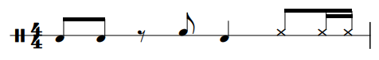

Figure 220 – Baladi Variation 2 for Riq
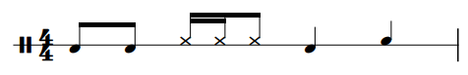

Figure 221 – Baladi Variation 3 for Riq
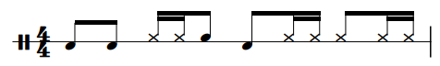

Figure 222 – Maksum Variation 1 for Riq
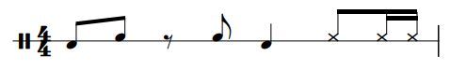

Figure 223 – Maksum Variation 2 for Riq
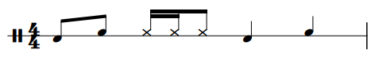

Figure 224 – Maksum Variation 3 for Riq
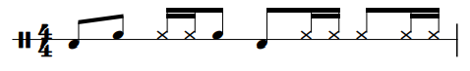
These variations should be used as a jumping off point and students should be encouraged to write their own variations in addition to performing these. Tips for writing variations include:
- Replace a Tek or Ka with a Pa.
- Vary whether a Tek or Ka is played on the drum or the jingles.
- Add at least one Tek, Ka, or Pa in a rest.
When creating variations, students should keep the beat placement of the Dum Strokes intact.
Assignment
- Practice the Pa Exercise for Riq.
- Continue to play the exercises from Week 1 and push the tempo if need be.
- Play along to “Balady Hillow” by Eddie Kochak using the Basic Baladi Pattern or play along to “Afrah Baladi” by Mostafa Sax using the Basic Maksum Pattern. Students should be encouraged to choose the style they did not play along to in Week 1.

Week 3
Lesson Plan
The primary goals of this lesson are to learn to play a Basic Shake Roll, how to incorporate the roll into Baladi or Maksum variations, and to learn to play fills outside of the groove.

Figure 225 – Basic Shake Roll Exercise
This exercise should first be performed freely, and then in strict time for a total of two variations.

Figure 226 – Baladi Shake Roll Variation 1
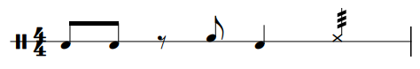

Figure 227 – Baladi Shake Roll Variation 2
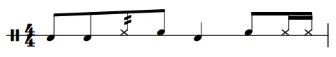

Figure 228 – Baladi Shake Roll Variation 3
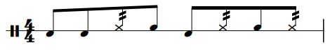
Figure 229 – Maksum Shake Roll Variation 1
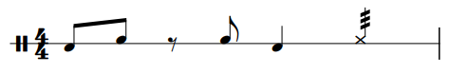

Figure 230 – Maksum Shake Roll Variation 2
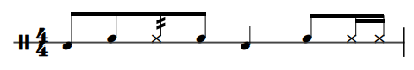

Figure 231 – Maksum Shake Roll Variation 3
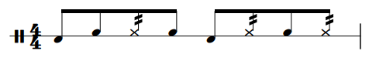
These variations also only serve as a jumping off point for students as they learn how to incorporate the Shake Roll into different patterns.
Assignment
- Practice the Basic Shake Roll Exercise.
- Play along to “Ijdid Baladi” by Iasir Hasson using the Baladi Variations above and write two original variations or play along to “Saidi Style” by the Upper Egypt Ensemble using the Maksum Variations above and write two original variations.

Week 4
Lesson Plan
The focus of Week 4 is to wrap up the Maksum and Baladi Patterns, learn the Basic Masmoudi Pattern, and start to develop the proper coordination for the Finger Roll.

Figure 232 – Finger Roll Exercise for Riq
There are many possible fingerings for a Finger Roll, but this is the most common pattern. Students should start slowly and gradually increase the tempo.
Assignment
Continue to play the Basic Shake Roll Exercise if needed.
Practice the Finger Roll Exercise for Riq.
Play along to “Through the Ank” by Phil Thornton using the Basic Masmoudi Pattern.

Week 5
Lesson Plan – The focus for Week 5 is to learn variations of the Basic Masmoudi Pattern, and to start to develop the Sideways Shake Roll.

Figure 233 – Sideways Shake Roll Exercise
The Sideways Shake Roll is an important technique for the Riq. It will be a building block for performing as a soloist in the coming weeks, but it takes some time to develop the proper coordination. Students should start slowly and gradually increase the tempo. Shorter practice sessions may be desired if fatigue becomes an issue when practicing this technique. The Sideways Shake Roll can be achieved from the Basic Position for Riq by first turning the drum to the left and then to the right.

Figure 234 – Masmoudi Variation 1 for Riq

Figure 235 – Masmoudi Variation 2 for Riq

Figure 236 – Masmoudi Variation 3 for Riq

Assignment
- Practice the Basic Finger Roll Exercise.
- Practice the Sideways Shake Roll Exercise.
- Play along to “Through the Ank” by Phil Thornton using Masmoudi. Variations and fills are left up to the discretion of the performer.

(Proceed to Week 13A if following the 7-Week Curriculum and proceed to Week 6 if following the 14-Week Curriculum).

Week 6
Lesson Plan
The goal for Week 6 is to continue to practice the Finger Roll and Sideways Shake Roll Exercises, and to use combinations of the Baladi, Maksum, and Masmoudi patterns. Masmoudi is used in many different songs, but it is not commonly used exclusively. It often appears for one or two cycles in between cycles of Baladi and Maksum.

Figure 237 – Baladi and Masmoudi Combination for Riq
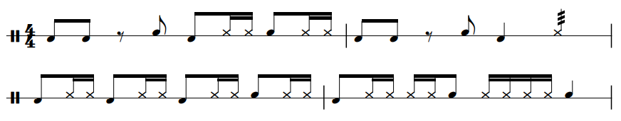

Figure 238 – Maksum and Masmoudi Combination for Riq
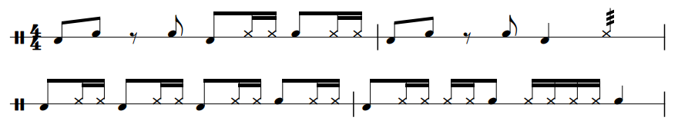
Assignment
- Continue to practice the Week 5 Finger Roll Exercise.
- Continue to practice the Week 5 Sideways Shake Roll Exercise.
- Play along to “Maddah al Amar” by Suhaila Salimpour using the pattern combinations above.

Week 7
Lesson Plan
The primary goal for Week 7 is to learn Split-Hand Pa Exercise 1 for Riq and the Basic Chiftitelli Pattern.
Figure 239 – Split-Hand Pa Exercise 1 for Riq
Pa is typically played with all of the fingers of the right hand (except for the thumb), but it is also possible to play Pa with just the index finger. This allows for faster rhythms to be played using strictly the Pa sound. When playing consecutive Pa Strokes, the middle, ring, and pinky fingers strike first followed by the index finger. The above exercise should be performed by alternating between the two different Pa strokes.
Assignment
- Practice Split-Hand Pa Exercise 1 for Riq.
- Play along to “Violin Takism/Oud Chiftetelli” by Eddie Kochak using the Basic Chiftitelli Pattern.

Week 8
Lesson Plan
The focus for Week 8 is to progress to Split-Hand Pa Exercise 2 for Riq and learn variations of the Basic Chiftitelli Pattern.

Figure 240 – Split-Hand Pa Exercise 2 for Riq
This exercise adds varying rhythms allowing the student to apply the technique at quickly changing speeds.

Figure 241 – Chiftitelli Variation 1 for Riq

Figure 242 – Chiftitelli Variation 2 for Riq

Figure 243 – Chiftitelli Variation 3 for Riq

Assignment
- Practice Split-Hand Pa Exercise 2 for Riq.
- Play along to “Taxim and Chiftitelli” by the Fred Elias Ensemble using the Chiftitelli Variations above and compose two original variations.

Week 9
Lesson Plan
The goal for Week 9 is to progress to Split-Hand Pa Exercise 3 for Riq and to learn the Basic Malfuf Patterns.

Figure 244 – Split-Hand Pa Exercise 3 for Riq
This exercise shows ways to add left hand sounds with the Split-Hand Pa Technique.

Figure 245 – Basic Malfuf Pattern 2 for Riq
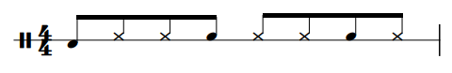
Assignment
- Practice Split-Hand Pa Exercise 3 for Riq.
- Play along to “Malfuf Hidjaz” by Armen Kusikian and Samir Abut using the Basic Malfuf Pattern.

Week 10
Lesson Plan
The goal for Week 10 is to learn the exercises for the Classical Position and variations of the Basic Malfuf Patterns.

Figure 246 – Classical Position Dum Exercise

Figure 247 – Classical Position Tek Exercise
The technique for performing a Dum or a Tek Stroke in the Classical Position is similar to the technique for performing these strokes in the Basic Position. However, the drum is held differently in each position and performing these strokes in the Classical Position will likely be more difficult. Perform these exercises with each hand.

Figure 248 – Malfuf Variation 1 for Riq
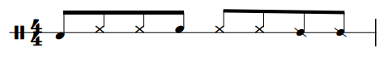

Figure 249 – Malfuf Variation 2 for Riq
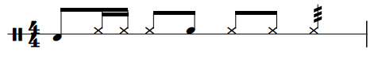

Figure 250 – Malfuf Variation 3 for Riq
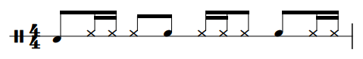

Figure 251 – Malfuf Variation 4 for Riq
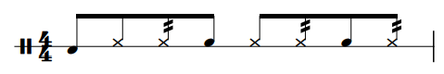
When composing Malfuf Variations, it is imperative to maintain a three-three-two rhythmic cycle.
Assignment
- Practice the Classical Position Dum Exercise and the Classical Position Tek Exercise.
- Play along to “Malfuf Ala Westi” by Hossam Ramzy using the Malfuf Variations above and compose two original variations.

Week 11
Lesson Plan
The goal for Week 11 is to progress to the next set of Classical Position Exercises and to learn the Basic Saidi Pattern.

Figure 252 – Classical Position Sixteenth-Note Dum Exercise

Figure 253 – Classical Position Sixteenth-Note Tek/Ka Exercise
Assignment
- Practice the Classical Position Sixteenth-Note Dum Exercise and the Classical Position Sixteenth Note Tek/Ka Exercise,
- Play along to “Habibi Baladi, We Zay el Amar” by Hossam Ramzy and Mohsen Allam using the Basic Saidi Pattern.

Week 12
Lesson Plan
The goal focus for Week 10 is to learn the Classical Position Double Stroke Exercise and variations of the Basic Saidi Pattern.

Figure 254 – Classical Position Double Stroke Exercise
Each double stroke should be performed with the ring finger (R3 or L3) and the middle finger (R2 or L2). Also practice this exercise using the Tek/Ka Strokes.

Figure 255 – Saidi Variation 1 for Riq
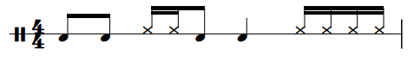

Figure 256 – Saidi Variation 2 for Riq
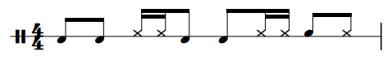

Figure 257 – Saidi Variation 3 for Riq
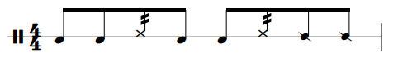
Given the similarities to Baladi and Maksum, students will be able to compose variations with relative ease. This style is saved for the end because it is often faster than the other styles, affording students the opportunity to learn to play at faster tempi.
Assignment
- Practice the Classical Position Double Stroke Exercise.
- Play along to “Saidi Festival” by the Upper Egypt Ensemble using the Saidi Variations above and compose two original variations.

(Proceed to Week 13B if following the 14-Week Curriculum)

Week 13A
Lesson Plan
After wrapping up the play along assignment from Week 5, the primary focus of Week 13A is to develop an understanding of playing the instrument as a soloist.

Figure 258 – Sideways Shake Roll Combination Exercise
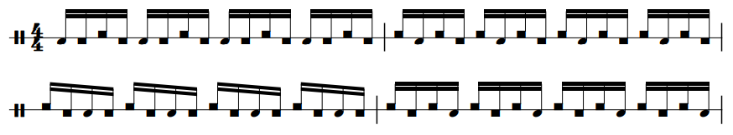
One possibility for a solo is to layer other Basic Sounds over the top of a Sideways Shake Roll. The exercise above is a simple way to help students develop the necessary coordination for layering sounds over the Sideways Shake Roll. Also perform this exercise with Tek/Ka Strokes.
Assignment
- Practice the Sideways Shake Roll Combination Exercise.
- Write an original riq solo that is 30-45 seconds in duration.

Week 13B
Lesson Plan
After wrapping up the play along assignment from Week 12, the primary focus of Week 13B is to develop an understanding of playing the instrument as a soloist.
Assignment
- Practice the Sideways Shake Roll Combination Exercise.
- Write an original riq solo that is 30-45 seconds in duration.

Week 14
Lesson Plan
The focus of Week 14 is to wrap up the unit with a discussion of student’s solo and to show the student how the Dum, Tek, Ka, and Pa Strokes transfer to other instruments (primarily tar and dumbek). When performing these strokes on riq, the Dum and Ka strokes will need to be modified, but the remainder of the strokes are the same. Performing a Dum on tar requires the student to use their ring finger or thumb (depending on the playing position) instead of the index finger and performing a Ka stroke requires the performer to strike the drum instead of the jingles. When performing these strokes on dumbek, the Dum, Tek, and Ka strokes will require modification, but the Pa strokes are the same. Performing a Dum Stroke on dumbek requires striking the drum with each of the fingers simultaneously as opposed to the index finger or thumb on riq. Similar adjustments will also need to be made to appropriately perform the Tek stroke on Dumbek in which all of the fingers strike the edge of the head instead of being performed by the ring finger. Lastly, the Ka stroke must be modified to strike the drum head instead of the jingles. After modifying the strokes for each drum, the student will be capable of playing each of the grooves covered in this curriculum on all three instruments of the Split-Hand Family. In the lesson students will perform the Basic Masmoudi Pattern and the Basic Baladi Pattern for tar and dumbek respectively. Students should also perform the Week 1 Exercises on the new instruments to help isolate and develop the nuanced techniques.
Assignment
- Perform the Week 1 Exercises on tar and dumbek with the adjusted techniques.
- Play along to “Through the Ankh” by Phil Thornton and Hossam Ramzy using the Basic Masmoudi Pattern for Tar using either the Upright or Lap Style of Playing.
- Play along to “Baladi Hillow” by Eddie Kochak using the Basic Baladi Pattern for Dumbek.

Curricula Strategies
There are four primary ways to implement these curricula:
- Use one 7-Week curriculum.
- Use one 14-Week curriculum.
- Use two 7-Week curricula and include two instruments from the same family.
- Use two 7-Week curricula and include one instrument from each family.
Each of these approaches are beneficial, but some are more beneficial than others. For example, using one 7-week or one 14-week curriculum only exposes the student to one drum and fails to expose the student to other hand percussion skills covered in the other curricula. Between these two options, the 14-week curriculum is more advantageous because the student will cover more musical styles and techniques.
Using one 14-week curriculum or two 7-week curricula with instruments from the same family may or may not be more advantageous depending on the goals for the semester. The 14-week curriculum offers greater technical growth as it only focuses on one instrument but using two 7-week curricula affords the opportunity to explore a second instrument to a greater degree than the 14-week curriculum. Both of these approaches use the same number of styles, and they also fail to expose the student to other hand percussion skills covered in the other curricula.
Using two 7-week curricula with instruments from different families is the most beneficial approach because it allows the student to learn all of the skills in the curricula and includes the same number of styles as two previous options. Moreover, the two families of instruments are used in vastly different styles of music, allowing for this approach to expose the student to a greater variety of styles. It does not explore the same depth of technical development as using one 14-week curriculum, but it does help build a strong technical foundation for all of the instruments, effectively equipping the student to continue to pursue any of these instruments if they wish.

Chapter 5: Summary and Conclusions
Teaching hand percussion poses a challenge to university percussion teachers because it is a broad term that encompasses a wide variety of instruments. Furthermore, there are many more instruments to be covered in a collegiate curriculum including snare drum, timpani, drum set, mallet percussion, and multi percussion which can make it difficult to devote extended time to studying hand percussion. Despite this problem, a hand percussion curriculum can be simple and efficient to implement.
Chapter Two lists several resources for studying different hand drums and each of these resources are a suitable course study for a student. However, these resources often have too much content to include in a collegiate semester leaving the instructor responsible for determining what drums, styles, grooves, and techniques should be taught. Most importantly, each of these resources often only discuss one instrument and do not discuss how the techniques of one hand drum apply to another.
Chapter Three provides an overview of the techniques, styles, and rhythms most commonly performed on the instruments covered in this study and separates the drums into two groups based on the common techniques that are used between the two groups of instruments. Focusing on technique and the transfer of techniques between instruments is the most efficient approach to teaching these instruments in a collegiate setting. If a student learns to play dumbek, they have simultaneously learned the basic skillset needed to get started on tar or riq. Some of the techniques may be nuanced from drum to drum, but the techniques are quite similar and will be learned quickly. This approach still allows for learning various styles and traditional rhythms for each drum, but a focus on the requisite technical skills of an instrument effectively means that students are learning the foundational skills for multiple instruments simultaneously. Traditional styles and grooves should still be included in a curriculum and are learned as an application of the basic techniques.
Chapter Four provides curricula for each of the six instruments as well as strategies for how to implement them based on the individual needs of a collegiate percussion program. Each curriculum can be followed as a 14-Week or 7-Week module depending on the instructor’s preference and the allotted time for studying hand percussion. Regardless of the format, each curriculum covers the basic techniques, exercises for developing the techniques, appropriate grooves and styles, fills, and how to play the instrument in a solo context. The lessons in these modules are not intended to occupy the student’s entire workload and will function along-side curricula for simultaneous study of other areas such as snare drum, timpani, or mallet keyboards. Multiple 7-Week Curricula may also be used in conjunction with one another to create a 14-week course study. This approach will allow students to learn all of the skills required for these instruments if teachers choose one instrument from each family.
Although this document has outlined course studies for six hand percussion instruments further research is still needed. A logical next step is to investigate the differences between teaching these instruments in an applied lesson setting versus an ensemble or group setting. It is also possible for these instruments to be used in non-traditional contexts such as wind band literature or multi-percussion solos. Further research could explore how hand percussion instruments are being used in a variety of contexts, especially those that go beyond traditional uses of the instruments. Lastly, more research is needed to include other hand percussion instruments such as cajon, djembe, mridangam, kanjira, ghatam, and tabla, and how to teach these instruments within the context of a collegiate curriculum. Completing this research would require a consolidation of available materials into a single pedagogical resource that helps implement the teaching strategies in an efficient manner.
This document serves to fill the void in the literature regarding how to teach congas, bongos, pandeiro, tar, dumbek, and riq. By simplifying and consolidating the available resources, the university percussion teacher is now able to efficiently teach multiple hand percussion instruments without needing to spend exorbitant amounts of time combing through the fine details of dozens of resources.

Works Cited
Cruz, Tomás. The Tomás Cruz Conga Method. Pacific, MO., Mel Bay, 2004.

Danziger, Raquy. Dumbek Fever: Dumbek Instructional Kit. Brooklyn, N.Y., Jordan Press, 2006.

De Assis, Gilson. Brazilian Conga. Rottenburg, Germany, Advance Music, 2006.

De Assis, Gilson. Brazilian Pandeiro. Rottenburg, Germany, Advance Music, 2009.

De Assis, Gilson. Brazilian Percussion. Rottenburg, Germany, Advance Music, 2003.

Donald, Mary Ellen. Arabic Tambourine: A Comprehensive Course in Techniques and Performance for the Tambourine, Tar, and Mazhar. San Francisco, Mary Ellen Books, 1985.

Donald, Mary Ellen. Doumbec Delight. San Francisco, Mary Ellen Books, 1976.

Dworsky, Alan. Conga Drumming. Minnetonka, MN., Dancing Hands Music. 1994.

Eduardo, Chalo, and Frank Kumor. Drum Circle: A Guide to World Percussion. Van Nuys, Calif., Alfred Pub, 2001.

El-Dabh, Halim. The Derabucca. New York. Edition Peters. 1965.

Gajate-Garcia, Richie. Play Bongos and Hand Percussion Now: The Basics and Beyond. Van Nuys, CA., Alfred Publishing Co., 2002.

Gajate-Garcia, Richie. Play Congas Now: The Basics and Beyond. Van Nuys, CA., Alfred Publishing Co., 2000.

Gloss, Randy. Through the Looking Glass: Brazilian Pandeiro. Randy Gloss Music, 2007.

Göcmez, Behnan. Darbuka Method. Pacific, MO., Mel Bay, 2001.

Grosso, Cheryl. Hand Drumming Essentials. Alfred Pub Co, 2003.
Hidalgo, Giovanni. The Ultimate Conguero. Oskalooa, IA., PlayinTime Productions, 2006.

Hines, Eric. “Recipe for a Guaguancó Sabroso: Understanding Quinto Drum Improvisation in Cuban Rumba.” DMA, Document, University of Arizona, 2015.

Lacerda, Vina. Pandeirada Brasileira. Curitaba, Brazil. V. Lacerda Publishing. 2007.

LeCorgne, Nicole and Michel Merhej Baklouk. Classical Riqq Technique. Pacific MO., Pacific, MO., Mel Bay, 2011.

Kalani. All About Bongos. Van Nuys, CA., Alfred Publishing Co., 2003.

Kalani. All About Congas. Van Nuys, CA., Alfred Publishing Co., 2003.

Mattingly, Rick and Peter Fagiola. Frame Drumming: Free Hand Style. Milwaukee, WI., Hal Leonard Publishing. 2000.

Morales-Matos, Rolando. Techniques and Basic Patterns for Congas, Bongos, and Timbales. New York, Bachovich Music Publications. 2007.

Morgan, J. Thomas. “A basic drum set course of study for the undergraduate percussion major.” DMA, Document, University of Oklahoma, 1993.

Payson, Al. Techniques of Playing Bass Drum, Cymbals and Accessories (Tambourine, Castanets, Triangle, Tam-Tam). Park Ridge, Ill., Payson Percussion Products, 1971.

Rodriguez, Arturo. Traditional Afro-Cuban Concepts in Contemporary Music. Pacific, MO., Mel Bay, 2003.

Salloum, Trevor K. Bongo Drumming: Beyond the Basics. Pacific, MO., Mel Bay, 2000.

Salloum, Trevor K. First Lessons: Conga. Pacific, MO., Mel Bay, 2012.
Salloum, Trevor. School of Bongo. Pacific, MO., Mel Bay, 2011.
Sampaio, Luiz Roberto. Pandeiro Brasileiro. Bernúncia Editoria, 2006.

Sanchez, Poncho and Chuck Silverman. Conga Cookbook. Berkeley, CA., Cherry Lane Music Company. 2002.

Sheronick, Yousif. Riq Instructional DVD and Book. NY. Bribie Recordings. 2005.

Spiro, Michael, and Josh Ryan. The Conga Drummer’s Guidebook. Petaluma, CA., Sher Music Co, 2006.

Thaler, Richard. Afro-Latin Percussion Fundamentals. Los Angeles, CA., Paws Books. 2010.

Velez, Glen. Tar Manual: Frame Drumming. New York, Ny, Framedrum Music Llc, 2013.

Whitmarsh, Jamie. “A Resource for Composition Pedagogy within the University Percussion Curriculum.” DMA, Document, University of Oklahoma, 2021.

Woods, Bill. Playing the Frame Drum. Pacific, MO., Mel Bay, 2014.

Discography

Afro-Cuban All Stars. “Amor Verdadero.” Track 1 on A Toda Cuba Le Gusta, World Circuit Records, 1997, compact disc.

Arnaldinho e Familia Contemporânea. “Miguelito no Choro.” Track 1 on Na Chama do Choro, CPC Umes, 2001, compact disc.

Barretto, Ray. “El Watusi.” Track 6 on Latin Soul Man, Fania Records, 2007, compact disc.

Bobo, Willie. “Fried Neckbones and Some Home Fries.” Track 7 on Willie Bobo’s Finest Hour, Verve, 2007, compact disc.

Brown, James. “I Got You (I Feel Good).” Track 1 on 20 All-Time Greatest Hits, Universal, 1991, compact disc.

Brown, James. “Cold Sweat” Track 12 on 20 All-Time Greatest Hits, Universal, 1991, compact disc.

Carvalho, Beth. “Samda de Marte.” Track 2 on Pérolas Do Pagode, Globopolydor, 1998, compact disc.

Colombia de Puerto. “Recuerdo a Malanga.” Track 13 on Africa en América, Rounder Records, 1992, compact disc.

Cuica, Osvaldinho da. “Thiá de Junqeira.” Track 2 on História do Samba Paulista I, CPC, Umes 1999, compact disc.

Entre Amigos. “Aluizio No Choro.” Track 2 on Chorinhos, Paulinos, 2000, compact disc.

Ferrer, Ibrahim. “Guaguancó Callejero.” Track 4 on Buenos Hermanos, World Circuit Records, 2003, compact disc.

Getz, Stan and João Gilberto. “Girl from Ipanema.” Track 1 on Getz/Gilberto, Verve, 2009, compact disc.

Gillespie, Dizzy. “Manteca.” Track 1 on Afro, Verve, 2002, compact disc.

Gonzaga, Luiz. “Baião de Dois.” Track 10 on Baião de Dois, Sony, 2012, compact disc.
Hartman, Johnny. “Let Me Love You (Album Version).” Track 8 on Hartman for Lovers, Verve, 2004, compact disc.

Hassan, Iasir. “Ijdid Baladi.” Track 13 on Arabic Music Vol. 1. Iasir Hassan, 2021. Apple Music audio.

Jack Costanzo and His Afro-Cuban Band. “Melado De Cana.” Track 6 on Mr. Bongo, GNP Crescendo, 1998, compact disc.

Jack Costanzo and His Afro-Cuban Band. “Caravan.” Track 13 on Mr. Bongo, GNP Crescendo, 1998, compact disc.

Kochak, Eddie. “Balady Hillow.” Track 5 on Strictly Belly Dancing Vol. 4. Hollywood Music Center, 2002, compact disc.

Kochak, Eddie. “Violin Takism/Oud Chiftitelli.” Track 3 on A Night at the Casbah, Hollywood Music Center, 2006, compact disc.

Kusikian, Armen, and Samir Abut. “Malfuf Hidjaz.” Track 3 on El Sabbah, D and D SA, 2004, compact disc.

Leal, Nucho. “Bésame Mucho.” Track 1 on Boleros Románticos Clásicos, Mezculturas, 2015, compact disc.

Los Admiradores. “C’est Ci Bon.” Track 3 on Bongos/Flutes/Guitars, Leverage, 2011, compact disc.

Monarco. “Escurinho.” Track 8 on Uma Historia Do Samba, Rob Digital, 2004, compact disc.

Monarco. “Partido Alto Da Antiga.” Track 10 on Uma Historia Do Samba, Rob Digital, 2004, compact disc.

Mostafa Sax. “Afrah Baladi.” Track 1 on Egyptian Bellydance: Afrah baladi. ARC, 2010, compact disc.

Puente, Tito and Eddie Palmieri. “Bolero Medley.” Track 9 on Masterpiece Obra Maestra, RMM, 2000, compact disc.

Ramzy, Hossam. “Malfuf Ala Westi.” Track 7 on Baladi Plus, ARC, 2012, compact disc.

Ramzy, Hossam and Mohsen Allam. “Habibi Baladi, We Zay El Amar.” Track 2 on El Amar, ARC, 2000, compact disc.

Salimpour, Suhaila. “Maddah al Amar.” Track 5 on Arabian Musicals Vol. 1, ADC/CA, 1993, compact disc.

Sanchez, Poncho. “Bien Sabroso.” Track 2 on Bien Sabroso, Concord Jazz Picante, 1984, compact disc.

Sanchez, Poncho. “Hitch It to the Horse.” Track 3 on Out of Sight, Concord Picante, 2003, compact disc.

Santamaria, Mongo. “Mama Papa Tu.” Track 8 on Santa Maria, Colombia, 2007, compact disc.

Sly and the Family Stone. “Thank You.” Track 18 on The Essential Sly and the Family Stone, Sony, 2002, compact disc.

The Command All-Stars. “Somebody Loves Me.” Track 1 on Provocative Percussion, Command Records, 1995, compact disc.

The Fred Elias Ensemble. “Taxim and Chiftitelli.” Track 3 on Elegant Music for Belly Dance Vol. 2, The Fred Elias Ensemble, 2011, compact disc.

Thornton Phil, and Hossam Ramzy. “Through the Ankh.” Track 11 on Music for Bellydancing, New World Music, 2006, compact disc.

Upper Egypt Ensemble. “Saidi Festival.” Track 8 on Egypt – A Musical Voyage, Hollywood Music Center, 2004, compact disc.

Upper Egypt Ensemble. “Saidi Party.” Track 9 on The Masters of Bellydance Music Vol. 4, Hollywood Music Center, 2007, compact disc.

Vargas, Sergio “La Quiero a Morir.” Track 1 on Los Hijos Del Rey, Karen Records, 1986, Apple Music.

Appendix 1: Quick Reference Curricula

Congas 7-Week Curriculum
Week # | Basic Strokes/Exercises | Groove/Style | Play-along Track
1 | Heel/Toe Exercise  Open Tone Exercise  Closed Slap Exercise | One-Drum Tumbao | “Fried Neckbones and Some Home Fries” by Willie Bobo
2 | See Week 1 | One-Drum Tumbao Variations | “Mama Papa Tu” by Mongo Santamaria
3 | Muted Slap  Open Slap | Two-Drum Tumbao | “Hitch it to the Horse” by Poncho Sanchez
4 | n/a | Two-Drum Tumbao Variations  Tumbao Fills | “Manteca” by Dizzy Gillespie
5 | Heel/Toe Sixteenth-Note Exercise | Bolero | “Bolero Medley” by Tito Puente and Eddie Palmieri
6 | Heel/Toe Sixteenth-Note Exercise Variations | Solo | n/a
7 | n/a | Solo  Martillo for Bongos  Samba for Pandeiro | “Meloda De Cana” by Jack Costanzo  “Escurinho” by Monarco

Bongos 7-Week Curriculum
Week # | Basic Strokes/Exercises | Groove/Style | Play-along Track
1 | Heel/Toe Exercise  Open Tone Exercise | Martillo | “Meloda Da Cana” by Jack Costanzo
2 | See Week 1 | Martillo Variations | “Bien Sabroso” by Poncho Sanchez
3 | n/a | See Week 2 | “Caravan” by Jack Costanzo
4 | n/a | Bolero | “Bésame Mucho” by Nucho Leal
5 | Closed Slap Exercise | Bolero Variations | “Bolero Medley” by Tito Puente and Eddie Palmieri
6 | Open Tone and Closed Slap Combination | Solo | n/a
7 | n/a | Solo  Tumbao for Congas  Samba for Pandeiro | “Fried Neckbones and Some Home Fries” by Willie Bobo  “Escurinho” by Monarco

Pandeiro 7-Week Curriculum
Week # | Basic Strokes/Exercises | Groove/Style | Play-along Track
1 | Heel/Toe Exercise  Open Tone Exercise  Closed Slap Exercise | Samba | “Escurinho” by Monarco
2 | See Week 1 | Samba Variations | “Thiá de Junqeira” by Osvaldinho da Cuica
3 | n/a | Samba Variations | “Batuque de Pirapora” by Osvaldinho da Cuica
4 | n/a | Choro | “Aluizio no Choro” by Entre Amigos
5 | Finger Roll Exercise  Heel Double Stroke Exercise | Choro Variations | “Miguelito No Choro” by Arnoldinho and Familia Contemporeano
6 | Heel/Toe Sixteenth- Open Tone Triplets Exercise  Alternating Open Tone Triplets Exercise  Open Tone and Closed Slap Alternating Triplets | Solo | n/a
7 | n/a | Solo  Tumbao for Congas  Martillo for Bongos | “Fried Neckbones and Some Home Fries”  “Meloda De Cana” by Jack Costanzo

Tar 7-Week Curriculum
Week # | Basic Strokes/Exercises | Groove/Style | Play-along Track
1 | Dum Exercise  Tek/Ka Exercise | Baladi  Maksum | “Balady Hillow” by Eddie Kochak  “Afrah Baladi” by Mostfa Sax
2 | See Week 1  Pa Exercise | Baladi Variations  Maksum Variations | See Week 1
3 | Finger Snap Exercise | Baladi Variations  Maksum Variations | “Ijdid Baladi” by Iasir Hasson  “Ya Msaharni” by The Upper Egypt Ensemble
4 | One-Hand Finger Roll Exercise | Masmoudi | “Through the Ank” by Phil Thornton
5 | Two-Hand Finger Roll Exercise | Masmoudi Variations | See Week 4
6 | See Week 5 | Solo | n/a
7 | n/a | Solo  Masmoudi for Dumbek  Baladi for Riq | “Through the Ank” by Phil Thornton and Hossam Ramzy  “Balady Hillow” by Eddie Kochak

Dumbek 7-Week Curriculum
Week # | Basic Strokes/Exercises | Groove/Style | Play-along Track
1 | Dum Exercise  Tek/Ka Exercise | Baladi  Maksum | “Balady Hillow” by Eddie Kochak  “Afrah Baladi” by Mostfa Sax
2 | See Week 1  Pa Exercise | Baladi Variations  Maksum Variations | See Week 1
3 | Closed Slap Exercise  Pop Exercise | Baladi Variations  Maksum Variations | “Ijdid Baladi” by Iasir Hasson  “Ya Msaharni” by The Upper Egypt Ensemble
4 | One-Hand Finger Roll Exercise | Masmoudi | “Through the Ank” by Phil Thornton
5 | Two-Hand Finger Roll Exercise | Masmoudi Variations | See Week 4
6 | See Week 5 | Solo | n/a
7 | n/a | Solo  Masmoudi for Dumbek  Baladi for Riq | “Through the Ank” by Phil Thornton and Hossam Ramzy  “Balady Hillow” by Eddie Kochak

Riq 7-Week Curriculum
Week # | Basic Strokes/Exercises | Groove/Style | Play-along Track
1 | Dum Exercise  Tek/Ka Exercise | Baladi  Maksum | “Balady Hillow” by Eddie Kochak  “Afrah Baladi” by Mostfa Sax
2 | See Week 1  Pa Exercise | Baladi Variations  Maksum Variations | See Week 1
3 | Closed Slap Exercise  Pop Exercise | Baladi Variations  Maksum Variations | “Ijdid Baladi” by Iasir Hasson  “Ya Msaharni” by The Upper Egypt Ensemble
4 | One-Hand Finger Roll Exercise | Masmoudi | “Through the Ank” by Phil Thornton
5 | Two-Hand Finger Roll Exercise | Masmoudi Variations | See Week 4
6 | Sideways Shake Roll Combination Exercise | Solo | n/a
7 | n/a | Solo  Masmoudi for Tar  Baladi for Dumbek | “Through the Ank” by Phil Thornton and Hossam Ramzy  “Balady Hillow” by Eddie Kochak

Congas 14-Week Curriculum
Week # | Basic Strokes/Exercises | Groove/Style | Play-along Track
1 | Heel/Toe Exercise  Open Tone Exercise  Closed Slap Exercise | One-Drum Tumbao | “Fried Neckbones and Some Home Fries” by Willie Bobo
2 | See Week 1 | One-Drum Tumbao Variations | “Mama Papa Tu” by Mongo Santamaria
3 | Muted Slap  Open Slap | Two-Drum Tumbao | “Hitch it to the Horse” by Poncho Sanchez
4 | n/a | Two-Drum Tumbao Variations  Tumbao Fills | “Manteca” by Dizzy Gillespie
5 | Heel/Toe Sixteenth-Note Exercise | Bolero | “Bolero Medley” by Tito Puente and Eddie Palmieri
6 | See Week 5 | Merengue | “El Watusi” by Ray Barretto
7 | See Week 5 | Merengue Variations | “La Quiero Morir” by Sergio Vargas
8 | Double Stroke Exercise | Rumba Colombia | “Recuerdo a Malanga” by Colombia de Puerto
9 | See Week 8 | Rumba Colombia Variations | See Week 8
10 | See Week 8 | Guaguancó | “Guaguancó Callejero” by Abrahim Ferrer
11 | Paradiddle Exercise | Guaguancó Variations | “Amor Verdadero” by the Afro-Cuban All-Stars
12 | Week 11 | Guaguancó Improvisation | See Week 11
13 | Heel/Toe Sixteenth-Note Exercise Variations | Solo | n/a
14 | n/a | Solo  Martillo for Bongos  Samba for Pandeiro | “Meloda De Cana” by Jack Costanzo  “Escurinho” by Monarco

Bongos 14-Week Curriculum
Week # | Basic Strokes/Exercises | Groove/Style | Play-along Track
1 | Heel/Toe Exercise  Open Tone Exercise | Martillo | “Meloda Da Cana” by Jack Costanzo
2 | See Week 1 | Martillo Variations | “Bien Sabroso” by Poncho Sanchez
3 | n/a | See Week 2 | “Caravan” by Jack Costanzo
4 | n/a | Bolero | “Bésame Mucho” by Nucho Leal
5 | Closed Slap Exercise | Bolero Variations | “Bolero Medley” by Tito Puente and Eddie Palmieri
6 | See Week 5 | Bossa Nova | “Girl from Ipanema” by João Gilberto and Stan Getz
7 | Double Stroke Exercise | Bossa Nova Variations | See Week 6
8 | See Week 7 | Merengue | “El Watusi” by Ray Barretto
9 | Paradiddle Exercise | Merengue Variations | “La Quiero Morir” by Sergio Vargas
10 | See Week 9 | Swing | “Let Me Love You (Album Version) by Johnny Hartman
11 | Triplet Exercise | Swing Variations | “Somebody Loves Me” by The Command All-Stars
12 | See Week 11 | Swing Improvisation | “C’est ci bon” by Los Amiradores
13 | Open Tone and Closed Slap Combination | Solo | n/a
14 | n/a | Tumbao for Congas  Samba for Pandeiro | “Fried Neckbones and Some Home Fries” by Willie Bobo  “Escurinho” by Monarco

Pandeiro 14-Week Curriculum
Week # | Basic Strokes/Exercises | Groove/Style | Play-along Track
1 | Heel/Toe Exercise  Open Tone Exercise  Closed Slap Exercise | Samba | “Escurinho” by Monarco
2 | See Week 1 | Samba Variations | “Thiá de Junqeira” by Osvaldinho da Cuica
3 | n/a | Samba Variations | “Batuque de Pirapora” by Osvaldinho da Cuica
4 | n/a | Choro | “Aluizio no Choro” by Entre Amigos
5 | Finger Roll Exercise  Heel Double Stroke Exercise | Choro Variations | “Miguelito No Choro” by Arnoldinho and Familia Contemporeano
6 | See Week 5 | Partido Alto | “Samba de Marte” by Beth Carvalho
7 | Finger Roll Double Exercise  Heel/Toe Flam Exercise | Partido Alto | “Partido Alto Da Antiga” by Monarco
8 | See Week 7 | Baião | “Baião De Dois” by Monarco
9 | Vertical Shake Exercise  Horizontal Shake Exercise | Baião | “Moda Da Mula Preta” by Luiz Gonzaga
10 | See Week 9 | Drum Set Grooves | “Thank You” by Sly and the Family Stone
11 | Syncopation Exercise | Drum Set Grooves | “I Got You (I Feel Good)” by James Brown
12 | See Week 11 | Drum Set Grooves | “Cold Sweat” by James Brown
13 | Open Tone Triplets Exercise  Alternating Open Tone Triplets Exercise  Open Tone and Closed Slap Alternating Triplets | Solo | n/a
14 | n/a | Solo  Tumbao for Congas  Martillo for Bongos | “Fried Neckbones and Some Home Fries”  “Meloda De Cana” by Jack Costanzo

Tar 14-Week Curriculum
Week # | Basic Strokes/Exercises | Groove/Style | Play-along Track
1 | Dum Exercise  Tek/Ka Exercise | Baladi  Maksum | “Balady Hillow” by Eddie Kochak  “Afrah Baladi” by Mostfa Sax
2 | See Week 1  Pa Exercise | Baladi Variations  Maksum Variations | See Week 1
3 | Finger Snap Exercise | Baladi Variations  Maksum Variations | “Ijdid Baladi” by Iasir Hasson  “Ya Msaharni” by The Upper Egypt Ensemble
4 | One-Hand Finger Roll Exercise | Masmoudi | “Through the Ank” by Phil Thornton
5 | Two-Hand Finger Roll Exercise | Masmoudi Variations | See Week 4
6 | See Week 5 | Baladi/Masmoudi Combination  Maksum/Masmoudi Combination | “Maddah al Amar” by Suhail Salimpour
7 | Split-Hand Pa Exercise 1 | Chiftitelli | “Violin Takism/Oud Chiftitelli” bv Eddie Kochak
8 | Split-Hand Pa Exercise 2 | Chiftitelli Variations | “Taxim and Chiftitelli” by the Fred Elias Ensemble
9 | Split-Hand Pa Exercise 3 | Malfuf | “Malfuf Hidgaz” by Armen Kusikian and Samir Abut
10 | Advanced Finger Snap Exercise 1 | Malfuf Variations | “Malfuf Ala Westi” by Hossam Ramzy
11 | Advanced Finger Snap Exercise 2 | Saidi | “Habibi Baladi, We Zay el Amar” by Hossam Ramzy and Mohen Allam
12 | Advanced Finger Snap Exercise 3 | Saidi Variations | “Saidi Festival” by the Upper Egypt Ensemble
13 | See Week 12 | Solo | n/a
14 | n/a | Solo  Masmoudi for Dumbek  Baladi for Riq | “Through the Ank” by Phil Thornton and Hossam Ramzy  “Balady Hillow” by Eddie Kochak

Dumbek 14-Week Curriculum
Week # | Basic Strokes/Exercises | Groove/Style | Play-along Track
1 | Dum Exercise  Tek/Ka Exercise | Baladi  Maksum | “Balady Hillow” by Eddie Kochak  “Afrah Baladi” by Mostfa Sax
2 | See Week 1  Pa Exercise | Baladi Variations  Maksum Variations | See Week 1
3 | Finger Snap Exercise | Baladi Variations  Maksum Variations | “Ijdid Baladi” by Iasir Hasson  “Ya Msaharni” by The Upper Egypt Ensemble
4 | One-Hand Finger Roll Exercise | Masmoudi | “Through the Ank” by Phil Thornton
5 | Two-Hand Finger Roll Exercise | Masmoudi Variations | See Week 4
6 | See Week 5 | Baladi/Masmoudi Combination  Maksum/Masmoudi Combination | “Maddah al Amar” by Suhail Salimpour
7 | Split-Hand Pa Exercise 1 | Chiftitelli | “Violin Takism/Oud Chiftitelli” bv Eddie Kochak
8 | Split-Hand Pa Exercise 2 | Chiftitelli Variations | “Taxim and Chiftitelli” by the Fred Elias Ensemble
9 | Split-Hand Pa Exercise 3 | Malfuf | “Malfuf Hidgaz” by Armen Kusikian and Samir Abut
10 | Paradiddle Exercise 1 | Malfuf Variations | “Malfuf Ala Westi” by Hossam Ramzy
11 | Paradiddle Exercise 2 | Saidi | “Habibi Baladi, We Zay el Amar” by Hossam Ramzy and Mohen Allam
12 | Paradiddle Diddle Exercise | Saidi Variations | “Saidi Festival” by the Upper Egypt Ensemble
13 | See Week 12 | Solo | n/a
14 | n/a | Solo  Masmoudi for Tar  Baladi for Riq | “Through the Ank” by Phil Thornton and Hossam Ramzy  “Balady Hillow” by Eddie Kochak

Riq 14-Week Curriculum
Week # | Basic Strokes/Exercises | Groove/Style | Play-along Track
1 | Dum Exercise  Tek/Ka Exercise | Baladi  Maksum | “Balady Hillow” by Eddie Kochak  “Afrah Baladi” by Mostfa Sax
2 | See Week 1  Pa Exercise | Baladi Variations  Maksum Variations | See Week 1
3 | Basic Shake Roll Exercise | Baladi Variations  Maksum Variations | “Ijdid Baladi” by Iasir Hasson  “Ya Msaharni” by The Upper Egypt Ensemble
4 | Finger Roll Exercise | Masmoudi | “Through the Ank” by Phil Thornton
5 | Sideways Shake Roll | Masmoudi Variations | See Week 4
6 | See Week 5 | Baladi/Masmoudi Combination  Maksum/Masmoudi Combination | “Maddah al Amar” by Suhail Salimpour
7 | Split-Hand Pa Exercise 1 | Chiftitelli | “Violin Takism/Oud Chiftitelli” bv Eddie Kochak
8 | Split-Hand Pa Exercise 2 | Chiftitelli Variations | “Taxim and Chiftitelli” by the Fred Elias Ensemble
9 | Split-Hand Pa Exercise 3 | Malfuf | “Malfuf Hidgaz” by Armen Kusikian and Samir Abut
10 | Classical Position Dum Exercise  Classical Position Tek Exercise | Malfuf Variations | “Malfuf Ala Westi” by Hossam Ramzy
11 | Classical Position Sixteenth-Note Dum Exercise  Classical Position Sixteenth-Note Tek Exercise | Saidi | “Habibi Baladi, We Zay el Amar” by Hossam Ramzy and Mohen Allam
12 | Classical Position Double Stroke Exercise | Saidi Variations | “Saidi Festival” by the Upper Egypt Ensemble
13 | Sideways Shake Roll Combination Exercise | Solo | n/a
14 | n/a | Solo  Masmoudi for Tar  Baladi for Dumbek | “Through the Ank” by Phil Thornton and Hossam Ramzy  “Balady Hillow” by Eddie Kochak

Appendix 2: Transfer of Basic Strokes Reference Table

 | Congas | Bongos | Pandeiro | Tar | Dumbek | Riq
Heel/Toe | x | x | x
Open Tone | x | x | x
Closed Slap | x | x | x |  | x
Muffled Tone | x | x
Muted Tone |  | x
Open Slap | x
Pressed Slap | x
Dum |  |  |  | x | x | x
Tek |  |  |  | x | x | x
Ka |  |  |  | x | x | x
Pa |  |  |  | x | x | x
Pop |  |  |  |  | x

Michael Spiro and Josh Ryan, The Conga Drummer’s Guidebook (Petaluma, Calif.: Sher Music Co, 2006).
Trevor K Salloum, Bongo Drumming: Beyond the Basics (Pacific, Mo.: Mel Bay, 2000).
Luiz Roberto Sampaio, Pandeiro Brasileiro (Bernúncia Editoria, 2006).
Glen Velez, Tar Manual (N.Y.: Framedrum Music Llc, 2013).
Raquy Danziger, Dumbek Fever: Dumbek Instructional Kit (N.Y.: Jordan Press, 2006).
Mary Ellen Donald, Arabic Tambourine: A Comprehensive Course in Techniques and Performance for the Tambourine, Tar, and Mazhar (Mary Ellen Books, 1985).
Gilson De Assis, Brazilian Percussion (Rottenburg, Germany: Advance Music, 2003).
Grosso, Cheryl, Hand Drumming Essentials (Alfred Pub Co, 2003).
Chalo Eduardo and Frank Kumor, Drum Circle: A Guide to World Percussion (Van Nuys, Calif.: Alfred Pub, 2001).
Al Payson, Techniques of Playing Bass Drum, Cymbals and Accessories (Tambourine, Castanets, Triangle, Tam-Tam) (Park Ridge, Ill.: Payson Percussion Products, 1971).
J. Thomas Morgan, “A basic drum set course of study for the undergraduate percussion major” (DMA Document, University of Oklahoma, 1993).
Jamie Whitmarsh, “A Resource for Composition Pedagogy within the University Percussion Curriculum” (DMA Document, University of Oklahoma, 2021).
See Appendix 2 on p. 192
Kalani, All About Congas, (Van Nuys, CA., Alfred Publishing Co.), 12.
Michael Spiro and Josh Ryan, The Conga Drummer’s Guidebook (Petaluma, Calif.: Sher Music Co, 2006), 67.
Richie Gajate-Garcia, Play Congas Now: The Basics and Beyond (Van Nuys, CA., Alfred Publishing Co., 2000), 18.
Ibid, 20.
Kalani, All About Congas, (Van Nuys, CA., Alfred Publishing Co.), 14.
Richie Gajate-Garcia, Play Congas Now: The Basics and Beyond (Van Nuys, CA., Alfred Publishing Co., 2000), 19.
Rolando Morales-Matos, Techniques and Basic Patterns for Congas, Bongos, and Timbales (Bachovich Music Publications, 2007), 66.
Ibid, 82.
Ibid, 88.
Eric Hines, “Recipe for a Guaguancó Sabroso: Understanding Quinto Drum Improvisation in Cuban Rumba.” (DMA Document, 2015), 103.
Trevor K Salloum, Bongo Drumming: School of Bongo (Pacific, Mo.: Mel Bay, 2011), 3.
Ibid, 3.
Kalani, All About Bongos, (Van Nuys, CA., Alfred Publishing Co.), 13.
Trevor K Salloum, Bongo Drumming: Beyond the Basics (Pacific, Mo.: Mel Bay, 2000), 9.
Ibid, 9.
Ibid, 9.
Rolando Morales-Matos, Techniques and Basic Patterns for Congas, Bongos, and Timbales (Bachovich Music Publications, 2007), 126.
Kalani, All About Bongos, (Van Nuys, CA., Alfred Publishing Co.), 29.
Gilson De Assis, Brazilian Pandeiro (Rottenburg, Germany: Advance Music, 2009), 27.
Trevor K Salloum, Bongo Drumming: School of Bongo (Pacific, Mo.: Mel Bay, 2011), 18.
Vina Lacerda, Pandeirada Brasileira (Curitaba, Brazil. V. Lacerda Publishing, 2007), 35
Ibid, 34
Ibid, 42.
Ibid, 58.
Ibid, 70.
Randy Gloss, Through the Looking Glass: Brazilian Pandeiro, (Randy Gloss Music, 2007), 3.
Ibid, 8.
Ibid, 17.
Ibid, 22.
Ibid, 58.
Glen Velez, Tar Manual (N.Y.: Framedrum Music Llc, 2013), 2.
Ibid, 2.
Ibid, 6.
Ibid, 2.
Ibid, 11.
Ibid, 17-18.
Ibid, 19.
Ibid, 23.
Raquy Danziger, Dumbek Fever: Dumbek Instructional Kit (N.Y.: Jordan Press, 2006), 23.
Ibid, 26.
Ibid, 24
Ibid, 25.
Ibid, 25.
Ibid, 17.
Ibid, 18.
Ibid, 20.
Ibid, 34.
Ibid, 36.
Ibid, 38.
Nicole LeCorgne and Michel Merhej Baklouk, Classical Riqq Technique, (Pacific MO., Pacific, MO., Mel Bay, 2011), 16, 22.
Ibid, 14.
Ibid, 22.
Ibid, 17, 23.
Mary Ellen Donald, Arabic Tambourine: A Comprehensive Course in Techniques and Performance for the Tambourine, Tar, and Mazhar (Mary Ellen Books, 1985), 13.
Ibid, 22.
Ibid, 98.
Ibid, 46.
Ibid, 37.
Refer to Figure 3 on p. 17 for the One-Drum Tumbao Pattern.
“Fried Neckbones and Some Home Fries,” track 7 on Willie Bobo, Willie Bobo’s Finest Hours, Verve, 2007, compact disc.
“Mama Papa Tu,” track 8 on Mongo Santamaria, Santa Maria, Colombia, 2007, compact disc.
Refer to Figure 4 on p. 17 for the Two-Drum Tumbao Pattern.
“Hitch It to the Horse,” track 3 on Poncho Sanchez, Out of Sight, Concord Picante, 2003, compact disc.
“Manteca,” track 1 on Dizzy Gillespie, Afro, Verve, 2002, compact disc.
Refer to Figure 5 on p. 18 for the Basic Bolero Pattern for Congas.
“Bolero Medley,” track 9 on Tito Puente and Eddie Palmieri, Masterpiece Obra Maestra, RMM, 2000, compact disc.
Refer to Figure 8 on p.19 for the Basic Merengue Pattern for Congas.
“El Watusi,” track 6 on Ray Barretto, Latin Soul Man, Fania Records, 2007, compact disc.
“La Queiro a Morir,” track 1 on Sergio Vargas, Los Hijos Del Rey, Karen Records, 1986, Apple Music.
Eric Hines, “Recipe for a Guaguancó Sabroso: Understanding Quinto Drum Improvisation in Cuban Rumba.” (DMA Document, 2015), 19.
Ibid, 19.
Refer to Figure 6 and Figure 7 on p. 18 for the Rumba Colombia Tumba Pattern and the Rumba Colombia Conga Pattern.
“Recuerdo a Malanga,” track 13 on Colombia de Puerto, Africa en América, Rounder Records, 1992, compact disc.
“Recuerdo a Malanga,” track 13 on Colombia de Puerto, Africa en América, Rounder Records, 1992, compact disc.
Refer to Figure 6 and Figure 7 on p. 18 for the Guaguancó Tumba Pattern and the Guaguancó Conga Pattern.
“Guaguancó Callejero,” track 4 on Ibrahim Ferrer, Buenos Hermanos, World Circuit Records, 2003, compact disc.
Ibid, 20.
“Amor Verdadero,” track 1 on Afro-Cuban All Stars, A Toda Cuba Le Gusta, World Circuit Records, 1997, compact disc.
More information on quinto drumming can be found in Recipe for a Guaguancó Sabroso: Understanding Quinto Drum Improvisation in Cuban Rumba by Eric Christopher Hines.
“Amor Verdadero,” track 1 on Afro-Cuban All Stars, A Toda Cuba Le Gusta, World Circuit Records, 1997, compact disc.
Refer to Figure 73 on p. 64 for the Heel/Toe 16th Note Exercise Variations.
Refer to Figure 13 on p. 23 for the Basic Martillo Pattern.
Refer to Figure 21 on p. 28 for the Basic Samba Pattern.
Refer to p. 21-22 for a review of the Basic Strokes for bongos and refer to p. 26-27 for a review of the Basic Strokes for pandeiro.
“Melado De Cana,” track 6 on Jack Costanzo and His Afro-Cuban Band, Mr. Bongo, GNP Crescendo, 1998, compact disc.
Escurinho,” track 8 on Monarco, Uma Historia Do Samba, Rob Digital, 2004, compact disc.
Refer to Figure 13 on p. 23 for the Basic Martillo Pattern.
“Melado De Cana,” track 6 on Jack Costanzo and His Afro-Cuban Band, Mr. Bongo, GNP Crescendo, 1998, compact disc.
“Bien Sabroso,” track 2 on Poncho Sanchez, Bien Sabroso, Concord Jazz Picante, 1984, compact disc.
“Caravan,” track 13 on Jack Costanzo and His Afro-Cuban Band, Mr. Bongo, GNP Crescendo, 1998, compact disc.
Refer to Figure 14 on p. 23 for the Basic Bolero Pattern for Bongos.
“Bésame Mucho,” track 1 on Nucho Leal, Boleros Románticos Clásicos, Mezculturas, 2015, compact disc.
“Bolero Medley,” track 9 on Tito Puente and Eddie Palmieri, Masterpiece Obra Maestra, RMM, 2000, compact disc.
Refer to Figure 15 on p. 24 for the Basic Bossa Nova Pattern.
“Girl from Ipanema,” track 1 on Stan Getz and João Gilberto, Getz/Gilberto, Verve, 2009, compact disc.
“Girl from Ipanema,” track 1 on Stan Getz and João Gilberto, Getz/Gilberto, Verve, 2009, compact disc.
Refer to Figure 16 on p. 24 for the Basic Merengue Pattern for Bongos.
“El Watusi,” track 6 on Ray Barretto, Latin Soul Man, Fania Records, 2007, compact disc.
“La Queiro a Morir,” track 1 on Sergio Vargas, Los Hijos Del Rey, Karen Records, 1986, Apple Music.
Refer to Figure 17 on p. 25 for the Basic Swing Pattern for Bongos.
“Let Me Love You (Album Version),” track 8 on Johnny Hartman, Hartman for Lovers, Verve, 2004, compact disc.
“Somebody Loves Me,” track 1 on The Command All-Stars, Provocative Percussion, Command Records, 1995, compact disc.
“C’est Ci Bon,” track 3 on Los Admiradores, Bongos/Flutes/Guitars, Leverage, 2011, compact disc.
Refer to Figure 92 on p. 82.
Refer to Figure 3 on p. 17 for the One-Drum Tumbao Pattern.
Refer to Figure 21 on p. 28 for the Basic Samba Pattern.
Refer to p. 14-16 for a review of the Basic Strokes for congas and refer to p. 26-27 for a review of the Basic Strokes for pandeiro.
“Fried Neckbones and Some Home Fries,” track 7 on Willie Bobo, Willie Bobo’s Finest Hours, Verve, 2007, compact disc.
“Escurinho,” track 8 on Monarco, Uma Historia Do Samba, Rob Digital, 2004, compact disc.
Refer to Figure 21 on p. 28 for the Basic Samba Patttern.
“Escurinho,” track 8 on Monarco, Uma Historia Do Samba, Rob Digital, 2004, compact disc.
“Thiá de Junqeira,” track 2 on Osvaldinho da Cuica, História do Samba Paulista I, CPC, Umes 1999, compact disc.
“Batuque de Pirapora,” track 5 on Osvaldinho da Cuica, História do Samba Paulista I, CPC, Umes 1999, compact disc.
“Aluizio No Choro,” track 2 on Entre Amigos, Chorinhos, Paulinos, 2000, compact disc.
“Miguelito no Choro,” track 1 on Arnaldinho e Familia Contemporânea, No Chama do Choro, CPC Umes 2001, compact disc.
Refer to Figure 22 on p. 29 for Basic Partido Alto Pattern.
“Samba de Marte,” track 2 on Beth Carvalho, Pérolas Do Pagode, Globopolydor, 1998, compact disc.
““Partido Alto Da Antiga,” track 10 on Monarco, Uma Historia Do Samba, Rob Digital, 2004, compact disc.
Refer to Figure 23 on p. 29 for the Basic Baião Pattern
Randy Gloss, Through the Looking Glass: Brazilian Pandeiro, (Randy Gloss Music, 2007), 22.
“Baião de Dois,” track 10 on Luiz Gonzaga, Baião de Dois, Sony, 2012, compact disc.
“Moda Da Mula Preta,” track 2 on Luiz Gonzaga, Ao Vivo Volta Pra Curtir, RCA, 2001, compact disc.
Refer to Figure 24 on p. 30 for Pandeiro Drum Set Rhythm 1.
“Thank You,” track 18 on Sly and the Family Stone, The Essential Sly and the Family Stone, Sony, 2002, compact disc.
“I Got You (I Feel Good),” track 1 on James Brown, 20 All Time Greatest Hits, Universal, 1991, compact disc.
“Cold Sweat,” track 12 on James Brown, 20 All Time Greatest Hits, Universal, 1991, compact disc.
Refer to Figures 133-135 on p. 105 for the appropriate exercises.
Refer to Figure 21 on p. 28 for the Basic Samba Pattern.
Refer to Figure 13 on p. 23 for the Basic Martillo Pattern.
Refer to p. 14-16 for a review of the Basic Strokes for congas and refer to p. 21-22 for a review of the Basic Strokes for bongos.
“Fried Neckbones and Some Home Fries,” track 7 on Willie Bobo, Willie Bobo’s Finest Hours, Verve, 2007, compact disc.
“Melado De Cana,” track 6 on Jack Costanzo and His Afro-Cuban Band, Mr. Bongo, GNP Crescendo, 1998, compact disc.
Refer to Figure 28 on p. 34 for the Basic Baladi Pattern and refer to Figure 29 on p. 35 the Basic Maksum Pattern.
Additional information on the nuances between each playing position may be found in the Bohran Manual or Tar Manual by Glen Velez.
“Balady Hillow” Track 5 on Eddie Kochak, Strictly Belly Dancing Vol. 4, Hollywood Music Center, 2002, compact disc. “Afrah Baladi,” Track 1 on Mostafa Sax, Egyptian Bellydance: Afrah baladi, ARC, 2010, compact disc.
“Balady Hillow” Track 5 on Kochak, Eddie, Strictly Belly Dancing Vol. 4, Hollywood Music Center, 2002, compact disc, and “Afrah Baladi,” Track 1 on Mostafa Sax, Egyptian Bellydance: Afrah baladi, ARC, 2010, compact disc.
“Ijdid Baladi,” track 13 on Iasir Hassan, Arabic Music Vol. 1, Iasir Hassan, 2021, Apple Music audio. “Saidi Party,” track 9 on Upper Egypt Ensemble, The Masters of Bellydance Music Vol. 4, Hollywood Music Center, 2007, compact disc.
Refer to Figure 31 on p. 35 for the Basic Masmoudi Pattern.
“Through the Ankh,” track 11 on Phil Thornton and Hossam Ramzy, Music for Bellydancing, New World Music, 2006, compact disc.
“Through the Ankh,” track 11 on Phil Thornton and Hossam Ramzy, Music for Bellydancing Vol. 4, New World Music, 2006, compact disc.
“Maddah al Amar,” track 5 on Suhaila Salimpour, Arabian Musicals Vol. 1, ADC/CA, 1993, compact disc.
Refer to Figure 32 on p. 36 for the Basic Chiftitelli Pattern.
“Violin Takism/Oud Chiftitelli,” track 3 on Eddie Kochak, A Night at the Casbah, Hollywood Music Center, 2006, compact disc.
“Taxim and Chiftitelli,” track 3 on Elegant Music for Belly Dance Vol. 2, The Fred Elias Ensemble, 2011, compact disc.
Refer to Figure 33 on p. 36 for the Basic Malfuf Pattern 1.
“Malfuf Hidjaz,” track 3 on Armen Karsikian and Samir Abut, El Sabbah, D and D SA, 2004, compact disc.
“Malfuf Ala Westi,” track 7 on Hossam Ramzy, Baladi Plus, ARC, 2012, compact disc.
Refer to Figure 30 on p. 35 for the Basic Saidi Pattern.
“Habibi Baladi, We Zay El Amar,” track 2 on Hossam Ramzy and Mohsen Allam, El Amar, ARC, 2000, compact disc.
“Saidi Festival,” track 8 on Upper Egypt Ensemble, Egypt – A Musical Voyage, Hollywood Music Center, 2004, compact disc.
Refer to Figure 31 on p. 35 for the Basic Masmoudi Pattern and refer to Figure 28 on p. 34 for the Basic Baladi Pattern.
Refer to p. 37-39 for a review of the Basic Strokes for dumbek and refer to p. 41-43 for a review of the Basic Strokes for riq.
“Through the Ankh,” track 11 on Phil Thornton and Hossam Ramzy, Music for Bellydancing Vol. 4, New World Music, 2006, compact disc.
“Balady Hillow” Track 5 on Eddie Kochak, Strictly Belly Dancing Vol. 4, Hollywood Music Center, 2002, compact disc.
Refer to Figure 28 on p. 34 for the Basic Baladi Pattern and refer to Figure 29 on p. 35 for the Basic Maksum Pattern.
“Balady Hillow” Track 5 on Kochak, Eddie, Strictly Belly Dancing Vol. 4, Hollywood Music Center, 2002, compact disc. “Afrah Baladi,” Track 1 on Mostafa Sax, Egyptian Bellydance: Afrah baladi, ARC, 2010, compact disc.
“Balady Hillow” Track 5 on Kochak, Eddie, Strictly Belly Dancing Vol. 4, Hollywood Music Center, 2002, compact disc. “Afrah Baladi,” Track 1 on Mostafa Sax, Egyptian Bellydance: Afrah baladi, ARC, 2010, compact disc.
“Ijdid Baladi,” track 13 on Iasir Hassan, Arabic Music Vol. 1, Iasir Hassan, 2021, Apple Music audio. “Saidi Party,” track 9 on Upper Egypt Ensemble, The Masters of Bellydance Music Vol. 4, Hollywood Music Center, 2007, compact disc.
Refer to Figure 31 on p. 35 for the Basic Masmoudi Pattern.
“Through the Ankh,” track 11 on Phil Thornton and Hossam Ramzy, Music for Bellydancing Vol. 4, New World Music, 2006, compact disc.
Ibid.
“Maddah al Amar,” track 5 on Suhaila Salimpour, Arabian Musicals Vol. 1, ADC/CA, 1993, compact disc.
Refer to Figure 32 on p. 36 for the Basic Chiftitelli Pattern.
“Violin Takism/Oud Chiftitelli,” track 3 on Eddie Kochak, A Night at the Casbah, Hollywood Music Center, 2006, compact disc.
“Taxim and Chiftitelli,” track 3 on Elegant Music for Belly Dance Vol. 2, The Fred Elias Ensemble, 2011, compact disc.
Refer to Figure 33 on p. 36 for the Basic Malfuf Pattern 1.
“Malfuf Hidjaz,” track 3 on Armen Karsikian and Samir Abut, El Sabbah, D and D SA, 2004, compact disc.
“Malfuf Ala Westi,” track 7 on Hossam Ramzy, Baladi Plus, ARC, 2012, compact disc.
Refer to Figure 30 on p. 35 for the Basic Saidi Pattern.
“Habibi Baladi, We Zay El Amar,” track 2 on Hossam Ramzy and Mohsen Allam, El Amar, ARC, 2000, compact disc.
“Saidi Festival,” track 8 on Upper Egypt Ensemble, Egypt – A Musical Voyage, Hollywood Music Center, 2004, compact disc.
Refer to Figure 31 on p. 35 for the Basic Masmoudi Pattern and refer to Figure 28 on p. 34 for the Basic Baladi Pattern.
Refer to p. 32-34 for a review of the Basic Strokes for tar and refer to p. 41-43 for a review of the Basic Strokes for riq.
“Through the Ankh,” track 11 on Phil Thornton and Hossam Ramzy, Music for Bellydancing Vol. 4, New World Music, 2006, compact disc.
“Balady Hillow” track 5 on Eddie Kochak, Strictly Belly Dancing Vol. 4, Hollywood Music Center, 2002, compact disc.
Refer to Figure 28 on p. 34 for the Basic Baladi Pattern and refer to Figure 29 on p. 34 for the Basic Maksum Pattern.
“Balady Hillow” track 5 on Kochak, Eddie, Strictly Belly Dancing Vol. 4, Hollywood Music Center, 2002, compact disc. “Afrah Baladi,” track 1 on Mostafa Sax, Egyptian Bellydance: Afrah baladi, ARC, 2010, compact disc.
“Balady Hillow” track 5 on Kochak, Eddie, Strictly Belly Dancing Vol. 4, Hollywood Music Center, 2002, compact disc. “Afrah Baladi,” track 1 on Mostafa Sax, Egyptian Bellydance: Afrah baladi, ARC, 2010, compact disc.
“Ijdid Baladi,” track 13 on Iasir Hassan, Arabic Music Vol. 1, Iasir Hassan, 2021, Apple Music audio. “Saidi Party,” track 9 on Upper Egypt Ensemble, The Masters of Bellydance Music Vol. 4, Hollywood Music Center, 2007, compact disc.
Refer to Figure 31 on p. 35 for the Basic Masmoudi Pattern.
“Through the Ankh,” track 11 on Phil Thornton and Hossam Ramzy, Music for Bellydancing Vol. 4, New World Music, 2006, compact disc.
Ibid.
“Maddah al Amar,” track 5 on Suhaila Salimpour, Arabian Musicals Vol. 1, ADC/CA, 1993, compact disc.
Refer to Figure 32 on p. 36 for the Basic Chiftitelli Pattern.
“Violin Takism/Oud Chiftitelli,” track 3 on Eddie Kochak, A Night at the Casbah, Hollywood Music Center, 2006, compact disc.
“Taxim and Chiftitelli,” track 3 on Elegant Music for Belly Dance Vol. 2, The Fred Elias Ensemble, 2011, compact disc.
Refer to Figure 33 on p. 36 for the Basic Malfuf Pattern 1.
“Malfuf Hidjaz,” track 3 on Armen Karsikian and Samir Abut, El Sabbah, D and D SA, 2004, compact disc.
“Malfuf Ala Westi,” track 7 on Hossam Ramzy, Baladi Plus, ARC, 2012, compact disc.
Refer to Figure 30 on p. 35 for the Basic Saidi Pattern.
“Habibi Baladi, We Zay El Amar,” track 2 on Hossam Ramzy and Mohsen Allam, El Amar, ARC, 2000, compact disc.
“Saidi Festival,” track 8 on Upper Egypt Ensemble, Egypt – A Musical Voyage, Hollywood Music Center, 2004, compact disc.
Refer to Figure 258 on p. 167.
Refer to Figure 31 on p. 35 for the Basic Masmoudi Pattern and refer to Figure 28 on p. 34 for the Basic Baladi Pattern.
Refer to p. 32-34 for a review of the Basic Strokes for tar and refer to p. 37-39 for a review of the Basic Strokes for dumbek.
“Through the Ankh,” track 11 on Phil Thornton and Hossam Ramzy, Music for Bellydancing Vol. 4, New World Music, 2006, compact disc.
“Balady Hillow” Track 5 on Kochak, Eddie, Strictly Belly Dancing Vol. 4, Hollywood Music Center, 2002, compact disc.

