UNIVERSITY OF OKLAHOMA
GRADUATE COLLEGE

SOCIAL JUSTICE IN URBAN SECONDARY SOCIAL STUDIES CLASSROOMS: PEDAGOGY AND BEYOND

A DISSERTATION
SUBMITTED TO THE GRADUATE FACULTY
in partial fulfillment of the requirements for the
Degree of
DOCTOR OF PHILOSOPHY

By

LINDSAY AARON WILLIAMS
Norman, Oklahoma
2021

SOCIAL JUSTICE IN URBAN SECONDARY SOCIAL STUDIES CLASSROOMS: PEDAGOGY AND BEYOND

A DISSERTATION APPROVED FOR THE DEPARTMENT OF INSTRUCTIONAL LEADERSHIP AND ACADEMIC CURRICULUM

BY THE COMMITTEE CONSISTING OF

Dr. Kristy Brugar, Chair
Dr. Sara Beach
Dr. Aiyana Henry
Dr. Crag Hill
Dr. Amy Bradshaw

© Copyright by LINDSAY AARON WILLIAMS 2021
All Rights Reserved.
Acknowledgments
I would first like to acknowledge my wonderful and supportive family. My daughters, Lauren and Mia, my mom Celestia, and my husband Michael. They patiently listened every time I mentioned the newest developments, frustrations and obstacles associated with the Ph.D. and dissertation process. They were always understanding when I had to pass on outings and events, and always encouraged me, even when I doubted myself. Many events transpired during this six- year process: five moves, a marriage, and the loss of both my father and sister. Throughout these trying and exciting times, these four people uplifted and sustained me.
I would also like to thank my patient and brilliant committee, Drs.’ Beach, Bradshaw, Henry and Hill. What a fabulous group of people, full of insight, inspiration, and a love of learning that is contagious and tangible! I would like to especially thank my chair, Dr. Kristy Brugar. Her knowledge and wisdom is enhanced by her reliability and her approachability. She is a committed researcher, educator, scholar, and advisor, and her contributions to my growth and learning cannot be overstated.
I want to also include my many colleagues, friends and partners in justice at the K20 Center. We had many conversations, (some to simply come off the ledge) and I can’t imagine having done this without such a supportive organization and group of people. To my friends from my master’s cohort, I can’t believe I got “our” Ph.D.!! Thank you for believing in me and dismissing my notions of quitting as silliness.
Finally, I would like to thank the Fairfield Marriott in Yukon, Oklahoma for two productive and dug in weekends in the Spring of 2021. Without which I would NOT have finished in time or had the focus to get over the finish line. Thank you all so, so much. This endeavor took all of you.

Abstract

In this collective case study about urban secondary social studies teachers, the researcher examines the beliefs and practices of teachers who support social justice approaches in their classrooms, and their local and professional communities. Social justice and social justice educational practices are a perfect fit for the content of secondary social studies, which aims to promote democratic principles and education for citizenship. The examples from the teachers in this study provide tangible behaviors and instructional insights regarding social justice practices. They also share their ideas about risk, support, and unfinishedness. Social justice educators and researchers may benefit from the everyday school and classroom examples of practices and perspectives that support secondary social studies content and instruction.

Table of Contents
List of Tables viii
List of Figures ix
Social Justice in Urban Secondary Social Studies: Classroom Pedagogy and Beyond 1
Prologue 1
Introduction 3
Purpose of School in a Democratic Society 5
Problem- Pedagogical Situation in US Public Schools 7
Study Objectives and Purpose 10
Chapter 2 13
Defining Terms 13
Urban 13
Social Studies 15
Citizenship Education 16
Social Justice 18
Social Justice Education 19
Theoretical Framework 20
Literature Review 22
Teacher Beliefs 23
Issues of “normalcy”- White is Right 23
Teacher Expectations 25
Teacher Practices and Social Justice 26
The Prevalence of Traditional Practices in Social Studies 26
Narrowing of Curriculum 30
Pedagogical Approaches/Understandings that Promote Social Justice Teaching 31
Obstacles to Pursuing Social Justice Teaching 38
Pedagogy and Beyond - Teachers’ Roles in Schools, Local and Professional Communities 40
School Level/Fostering Relationships 41
Relationships and Action in the Local Community 41
Professional Communities and Learning 42
Chapter 3 45
Methods 45
Research Design- Qualitative Case Study 46
Context 48
Sample 51
Participants 52
Data Sources 53
Interviews 54
Observations 55
Artifacts 56
Data Analysis 57
Trustworthiness and Triangulation 62
Researcher Positionality 64
Ethics 66
Chapter 4 68
Findings 68
The Teachers: Who They Are and What They Believe 69
Environment: The Room Where It Happens 70
Instruction: The Way That It Happens 70
Service and Involvement: The Action in Civic Engagement 71
Risk and the Importance of Support 71
Unfinishedness and the Role of Collegiality 72
Adam 72
Adam’s Story 73
The Environment of Adam’s Classroom 74
Instruction: The Way that It Happens in Adam’s Class 83
Risk and the Importance of Support to Adam 91
Unfinishedness and the Role of Collegiality; “A Book I’ll Never Finish” 93
Connor 95
Connor’s Story 96
The Environment of Connor’s Room 97
Instruction in Connor’s Class 105
Service and Involvement-:The Action in Civic Engagement 110
Risk and the Importance of Support 111
Unfinishedness and the Role of Collegiality 113
Leonard 114
Leonard’s Story 115
Environment: The Physical Space of Leonard’s Classroom 117
Environment - Promoting Classroom Culture 120
Instruction in Leonard’s Class 122
Service and Involvement: First, Best Instruction 128
Risk and the Importance of Support 129
Unfinishedness and the Role of Collegiality 131
Chapter 5: Discussion 133
Review of Findings 133
Interpretation of the Findings 133
The Importance of Environment and Instruction 133
Service and Civic Engagement 136
Risk, Unfinishedness, and Isolation 138
Limitations 141
Implications for Practice 142
Classroom Practice - Environment & Instruction 142
School Administration - Mitigating Risk and Increasing Support 143
Professional Learning and Development - Learning our Unfinishedness 145
Preservice Teachers - The Importance of Those To Be 146
Implications for Research 148
Recommendations for Future Research 150
Conclusion 152
References 154
Appendix A Recruitment Email 168
Appendix B Social Justice Structured Interview Question Protocol 169
Appendix C Follow Up Artifact Prompts 171
Appendix D Final Interview Questions (Adam) 172
Appendix E Final Interview Questions (Connor) 173
Appendix F Final Interview Questions (Leonard) 174
Appendix G Observation Protocol 175
Appendix H Code Key 176
Appendix I Adam’s MAPS Curriculum Artifact 181
Appendix J Connor’s SE Asia Project and Rubric Artifact 188
Appendix K Leonard’s Multiple Intelligence Questionnaire 190

List of Tables

Table 1: Student Demographics 49
Table 2: 2019-2020 PR Secondary Social Studies Faculty Gender Breakdown 50
Table 3: Participants 53
Table 4: Code Key Excerpt 60

List of Figures
Figure 1: Data Collection Process 54
Figure 2: Adam’s Desk 75
Figure 3: Wall Décor in Adam’s Classroom 78
Figure 4: Adam’s Classroom Door 80
Figure 5: What We Believe Activity Book on Whiteboard 83
Figure 6: Adam’s MAPS Timeline 85
Figure 7: Generation Citizens’ “Advocacy Hourglass” 87
Figure 8: Adam’s Generation Citizen Curriculum Introductory Activity 87
Figure 9: Reproducible MAPS Curriculum 90
Figure 10: Class Culture Quilt in Connor’s Room 100
Figure 11: Whiteboard Student Musings 101
Figure 12: Connor’s Championship Belt for Best Teacher 104
Figure 13: Debate Day Instructions 105
Figure 14: Political Cartoon Assignment 109
Figure 15: Leonard’s Wall Clocks and Flags 118
Figure 16: Leonard’s Wall Map and Reward Bags 119
Figure 17: Leonard’s Displayed Student Artwork 122
Figure 18: Power Point Slides Featuring Equality of Language 124
Figure 19: Leonard’s Handwritten Assignment Featuring Equality of Language 126

Social Justice in Urban Secondary Social Studies: Classroom Pedagogy and Beyond

Prologue
When this study began in late 2018, social justice was a critical conversation in education and an important aspect of the narrative of social studies education. As I entered into this study, social justice included public action, voice, and representation. Black Lives Matter (BLM) was a growing, yet established movement. Our campus was attempting its own ameliorations for racially unjust events close to home, establishing the Office of University Community and forming a “task force to work on a strategic plan and include voices of the entire OU community.” Diversity, equity and inclusion were familiar and important words, though not necessarily the name of any department or office, in K-12 or higher education. In the Spring of 2020, the Office of University Community was renamed the Office of Diversity, Equity, and Inclusion and in the fall semester all employees and students at the university were required to engage in asynchronous Diversity training. In June of 2020, Norman Public schools hired its first Executive Director of Diversity, Equity and Inclusion and Oklahoma City Public Schools re-established its Office of Student Supports as the Office Equity and Student Supports.
As I continued to work on this study through 2019 and into 2020, discussions of social justice inside and outside of school contexts endured. The New York Times published The 1619 Project to commemorate the 400th anniversary of enslaved people being brought to North America and "aims to reframe the country's history by placing the consequences of slavery and the contributions of Black Americans at the very center of [the United States'] national narrative.” Enter summer 2020. Violent and racially motivated events have unfortunately been all too common in our nation’s history. In the summer of 2020, these events reached advanced tipping points and outrage with the murder of George Floyd, Breonna Taylor and so many others. In an attempt to recognize and increase awareness of systemic racism, media outlets began referring to this as a “reckoning” (Cobb, 2020; Coleburn, 2020; Elving, 2020). In June of 2020, books about race, anti-racism and white privilege such as Robin DiAngelo’s “White Fragility; Why It’s So Hard for White People to Talk About Racism”, “The New Jim Crow” by Michelle Alexander and two books by Ibram X. Kendi; “How to Be an Anti-Racist” and his collaboration with Jason Reynolds, “Stamped; Racism, Antiracism and You”, dominated the New York Times best sellers list (Harris, 2020; Ward, 2020). Support of the BLM movement increased (Elving, 2020), protests of racial injustice and inequality occurred around the nation, and the removal of confederate monuments received widespread attention and support (along with its own backlash). This climate also had a profound impact on education and schools. The flame of social justice pedagogical approaches that existed in classrooms now necessitated a revamped and inferno level undertaking.

Introduction
Bell (2016) describes social justice as “both a goal and a process” with the goal of “full and equitable participation of people from all social identity groups in a society that is mutually shaped to meet their needs” (p. 1). The process for attaining the goal of social justice should be democratic and participatory, and inclusive and respectful of human diversity. It should seek to affirm human agency and build the capacity of collaborative work with others to create change. The application of this thought and action is a seamless fit for social studies pedagogical practices. Both in the practice of citizenship and community as part of the classroom environment and the importance of representation, perspective and interrogation in the curriculum.
My experiences as a classroom teacher, graduate student, and curriculum developer, led me to wonder, what are urban secondary social studies teachers’ beliefs and practices regarding social justice? In order to address this issue, I believe it is important to discuss philosophies surrounding the purpose of school in a democratic society and the situation facing many public-school classrooms in the United States, including urban classrooms. In the following chapters, it is critical to discuss the specific contextual aspects of the study, including the theories regarding the purpose of social studies education and research regarding challenges, the literature regarding social justice pedagogy, and finally secondary social studies teaching in urban classrooms. The purpose of this study was to explore and describe the beliefs and practices of urban secondary social studies teachers who self-identify as teaching for social justice. I believe this study will have implications for researchers and practitioners, alike. For researchers, since this topic is ever changing, constant and continuous exploration of current practices is essential to progress within the content of social studies and the field of education. For practitioners, my hope is that by showcasing teachers’ classrooms beliefs and classroom practices, they may garner tangible ideas, see examples that they can follow to change or expand their practices, or be validated in their own practices.
Exposure to social justice pedagogical ideas differ depending on a person’s position or role in social studies education. In years past, institutes of higher education and organizations that represent them seemed to position social justice education and social justice education at the forefront of conversation and action. K-12 organizations and faculty struggled to embody the same enthusiasm. One such example was the programming at the National Council for the Social Studies (NCSS) annual conference. The College and University Faculty Assembly (CUFA) is an affiliate group of NCSS and consists of higher education faculty members, graduate students, K-12 teachers, and others interested in a diversity of ideas and issues associated with social studies education. CUFA convenes a few days prior to the main conference. The types of sessions, discussions and research presented maintained a high emphasis on social justice in our nation and around the world, and social justice pedagogical practices in higher education. There was a marked difference between the topics featured in these conference offerings versus those that were attended by the K-12 practitioners on the subsequent days. However, the 2020 annual conference that convened (virtually) in December of 2020, reflected the growing shift and focus on the topic for all levels and types of educators involved. The theme that year’s entire conference was “Advancing Social Justice”. This study sought to shed light on the beliefs about and manifestation of practices by secondary teachers in urban classrooms, a group that has received considerably less engagement with this topic.
My Background
I am tied to this study for many reasons; my own background as a White, middle class female, (the dominant demographic of teachers in the US) and as a K-12 student that experienced traditional, teacher-centered instruction. There was a profound shift in my thinking and philosophical approach to teaching in my teacher preparation program. This continued to develop in subsequent student teaching, and in the six years of teaching in an urban social studies classroom. The questions that guide my interviews with participants in this study are similar to ones I have reflected upon for myself.
What do I believe about social justice?
What experiences did I have that made me aware of issues surrounding social justice?
What does it look like in an urban secondary social studies classroom?
What steps have I taken (and continue to take) to try to make my teaching better serve my students and the students of the teachers I teach?
How are teachers sharing ideas, communicating frustrations and triumphs and gaining awareness of new ideas or practices?
To answer these questions, I provide historical context in regard to what public education in America is for, how social studies education specifically supports that in relation to social justice, and the current status of instruction in many urban secondary social studies classrooms. With these educational issues in mind, I explored the following research question.
What are urban, secondary social studies teachers’ beliefs and practices regarding social justice in their classroom, and their school, local, and professional communities?

Purpose of School in a Democratic Society
To firmly ground this study in foundations of education, it is important to start with the ideas and theories regarding the purpose of school and education in a democratic society. For the purposes of this study, school is the place in which a student’s formal education for the purpose of citizenship occurs (Stanley, 2010).
Stanley (2010) described his idea regarding school in the United States as, “an integral component of a democratic society” (p. 17). Nieto (2005) reasoned that “public education and democracy have been firmly linked in the popular imagination” by Horace Mann, (education as the great equalizer) and then cemented by Dewey (apprenticeship for civic life) (p. 43). Noddings (2013) said, “All [my emphasis] political philosophers recognize the importance of education in preparing the young for citizenship” (p.15). There is certainly much debate about how to do that, but there is even debate about what a citizen is or does. Banks (2004) advocates that students who are educated for the purposes of citizenship in a diverse democratic society, “should have the knowledge skills and commitment needed to change [my emphasis] the world to make it more just and democratic” (p. 298). A diverse democratic society should be an uncontested description of the United States, and to teach for democracy an uncontested aim of teaching citizenship. However, for many students in the US, the daily pledge of allegiance, “With liberty and justice for all” may fall short of what they experience in their daily life. Stanley (2010) also notes that if one accepts the idea that there is a dominant system that serves its own interests, “education for social transformation becomes a moral imperative in the service of democracy” (p.18).
The purpose of school is to give students the experiences that will continue their development and growth so that they are ready for each new responsibility and hopefully opportunities in their life. They must be given opportunities to not just learn about citizenship, but also practice it. This is true for all students. It becomes problematic in schools that serve populations of students that are typically relegated to curriculum and instruction that is low level and unconnected to their background and their real lives.
Bell (2016) describes the goal of social justice itself as “full and equitable participation of people from all social identity groups in a society that is mutually shaped to meet their needs” and that social justice education “aims to help participants develop awareness, knowledge and processes to examine issues of justice/injustice in their personal lives, communities, institutions, and the broader society” (p. 4). Social justice teaching and learning practices should be at the very core of our educational endeavors and tangibly present in social studies instruction since it is indeed for education for citizenship and civic action (Au, 2009; Banks, 2004; Lo, 2017; Rodriguez, 2018; NCSS, 2013; Parker, 2010; Stanley, 2003; Westheimer & Kahne, 2004).

Problem- Pedagogical Situation in US Public Schools
At the core of study are the ways in which students are presented with and taught about citizenship. Across the nation, the learning tasks in many classrooms are lower order calling for memorization and reporting, instead of giving opportunities for students to think critically, interpret or problem-solve (King, et al., 2009, Newman, et al., 2015). Years of literature and research have yielded insights about this type of instruction for students in lower socioeconomic schools (See Chapter 2, Literature Review).
For decades, researchers have described instances and trends in urban school districts as frequently marked by higher concentrations of poverty, greater racial and ethnic diversity, larger concentrations of immigrant populations and linguistic diversity, and more frequent rates of student mobility (e.g., Kincheloe, 2010). Foundational research showed that students in these situations were often being taught in ways that emphasize the rote over the analyzed, the single answer over the possibilities, and the standard assessment over the choice when demonstrating knowledge (Anyon, 1980). Haberman (2010) further discussed this situation and termed it the “pedagogy of poverty”. This type of instruction is more prevalent in urban classrooms that are low socioeconomic classrooms and these classrooms are more often than not, the most diverse as well (Kincheloe, 2010; Milner, 2011). More recent research by Tomlinson and Jarvis (2014), addresses the disparities of the disproportionate number of students of color and students from low-income backgrounds that are subject to low ability grouping and tracking; and the low-level, fact based, drill oriented pedagogy characterized by Haberman (2010) that comes with being in these groups. Research in social studies classrooms echoes these findings, attesting to teacher focused instruction and rote, low-level tasks (Levinson, 2016; Saye, 2018). Based on these studies, it can be reasoned that urban classrooms with the highest poverty and the most diversity have the least opportunities to experience activities that foster inquiry, critical thinking, decision making, and action. Students in these situations are less likely to benefit from opportunities to think, question, discuss or create. When students are denied these experiences, they are stripped of opportunities to engage in the very process of participatory citizenship at even the classroom level, not to mention the other life endeavors they hope to pursue. It seems logical to concede to Nieto’s (2005) thought that “because of the increasing diversity in race, language and socioeconomic status in our nation and schools the challenge to expand the dream of an equal education for more students has been even greater” (p. 53). The challenge may prove great, but the dream itself is fundamental to pursue.
In addition to pedagogical challenges, teacher qualifications, or lack thereof, is also an unfortunately relevant situation in our state and the district in which this study took place. According to the Oklahoma State Department of Education Office of Teacher Certification, the number of State Board of Education approved emergency teacher certifications rose from just 32 individuals in 2011-2012 to 1,975 individuals in the 2017-2018 school year, a 6,071% increase. In the 2018-2019 school year, that number rose to 2159 new emergency certifications and over 3000 certifications total (OSSBA, 2019). Emergency certificates are only issued to school districts that lack qualified candidates to fill teaching vacancies. These individuals lack the formal professional training of a teacher who has gone to school to study the skills and the science of teaching. The number of emergency certified teachers in the district for this study is the third highest in the state, standing at 109 for the 2018-2019 school year (the last updated report year from the Oklahoma State Department of Education Report on Emergency Certifications) and in secondary classrooms this constitutes 35% of new teacher hires. This situation further exacerbates the issues concerning the quality of instruction and could be particularly harmful to marginalized students in an urban classroom (OACTE, 2019).
Much secondary social studies instruction is focused on traditional methods that include lecture, note-taking, reading the chapter and memorization. Research by Saye and colleagues (2013), found low levels of authentic pedagogy in what they termed as a diverse sample of US social studies classrooms. The type of example classroom assignments I have witnessed in many secondary urban social studies classrooms included: memorizing and labeling all 77 counties on a blank map of Oklahoma as an exam, popcorn reading of the chapter and answering the questions at the end as the everyday activity, worksheet after worksheet, or copious notes students were instructed to copy from a PowerPoint or even an overhead projector. Seldom were students given the opportunity to discuss anything with each other or asked to write an original thought about the topics being covered. In my years of interactions with high school students and undergraduate pre-service teachers, many think they do not like social studies because of the disconnected and rote way it has been taught. This type of instruction leaves little space for discussion and questioning of ideas or differing perspectives, connection to students' lives or opportunities for empowerment and action, the hallmarks of citizenship. It is unreasonable to expect students to enact the responsibilities and duties of citizenship if they are never given chances to practice these expectations often and in a safe environment. Students need an opportunity to practice thinking, critiquing information, creating their own knowledge and acting upon it. All students should have the chance to go beyond simply consuming knowledge to being producers of knowledge and active as a citizen. A shift in the status quo, in inequality and oppression will only come as a result of these opportunities.
The situation in many classrooms may be the rule, but it is not the absolute. I was also inspired by and worked with many teachers that purposefully and successfully implemented pedagogical practices that promoted social justice in their classroom. And their efforts did not stop there. The actions of a teacher that promotes social justice can transpire in many ways. These teachers also built relationships with students and their families, served in the community and always strove to better their teaching by collaborating and learning. Despite the challenges and circumstances of urban classrooms, both from the inside and outside, there is unmistakable resilience. Teachers keep teaching, learners keep learning, and it is evident that “brilliant teachers can change students’ lives” (Kincheloe, 2010, p. 9).

Study Objectives and Purpose
An important aspect of critical qualitative inquiry is that it is not for research alone; that it must have a purpose beyond itself (Pasque & Perez, 2015). It is in this realm that all facets for this study fit together. My own background and experiences in urban classrooms, the purpose of school and specifically social studies education, and the traditional teaching practices of many urban secondary classrooms. However, this study intended to explore and describe the beliefs and practices of urban secondary social studies teachers that purposefully and intentionally practice teaching that is centered around social justice to empower students to shift the status quo. It also sought to explore how teachers' non-pedagogical approaches promote social justice as well by describing the relationships that teachers have with students as mentors, guides, sounding boards, or as examples of what it means to be a citizen in a democracy. These can take the form of conversations about personal issues, concerns about students’ futures, shared interests, or sometimes simply the attentive listening of a supportive adult.
The aim was to explore the work they do so that it may serve my own learning, other practitioners, researchers, teacher educators and perhaps through reflection, the teachers themselves. Social studies teachers need concrete and tangible examples of how to implement pedagogical and non-pedagogical practices that challenge and critique the status quo. There is no denying the challenges these teachers face, but as Milner (2011) discusses in his counter narrative on urban teachers, this study sought to “counter, disrupt, and interrupt pervasive discourses that only focus on the negative characteristics of teachers and students in urban schools” (p. 1573).
I believe research can be a powerful source of influence and service to professions, groups, and societies. This research project could serve many purposes beyond academic knowledge that are not yet known, but because of the importance of democracy and social justice to our society as a whole, what is desired is at least that the findings and implications could inform communities of teachers; whether that be secondary, elementary or post-secondary; social studies, language arts, fine arts or other content areas; urban, suburban or rural contexts. There is also the possibility that the process of discussing and reflecting on social justice and their own practices could thus result in action on the part of the teachers involved in the study. Freire (1970) discusses praxis as “reflection and action upon the world in order to transform it” (p. 28). The hope is that, by allowing teachers to articulate their ideas, they may feel inclined to further expand their teaching practices. It is also a sincere aim that by including these teachers voices and practices, there may be opportunities for other teachers to see themselves and follow the examples and models that these teachers have forged despite the challenges they face.

Chapter 2

In order to explore my research question, “What are urban secondary social studies teachers’ beliefs and practices regarding social justice in their classroom, and their school, local, and professional communities?”, this study draws on several areas of research including social studies education and teaching in urban centers. At the center of this study is an interest in social justice. In the following pages, I will summarize the definitions/understandings of social justice and social justice education, followed by my theoretical framework. I will also provide an overview of research that has been done in social studies education, as well as urban teaching with consideration to social justice, and teacher beliefs regarding social justice.

Defining Terms
There are several terms essential in this study: namely, urban, social studies, citizenship education, social justice and social justice education. In the following section these terms will be defined in regard to the relevant research and understandings related to this study.

Urban
This study took place in an urban district in the largest city of the state. In order to position this definition in the most appropriate manner, I would like to offer two parts to the definition of urban; one as it relates to the population of an area, and the other as it relates to the way the term has come to be used to describe schools.
The U.S. Census classifies the term urban in a quantitative manner for the purposes of geographic delineation based on residential population density. A 2012 Federal Register states, “An urbanized area consists of densely settled territory that contains 50,000 or more people.” (Department of Commerce, Bureau of the Census). The National Center for Education Statistics reaffirms this definition stating, “Core areas with populations of 50,000 or more are designated as urbanized areas” (2006). This definition indicates the denotation of the word urban, but what about its connotation in the educational realm?
Milner (2008) discusses urban education as being defined by scholars in various ways: as an inner-city school or large metropolitan region. He recognizes the situation in these schools as high poverty and served by the least qualified or credentialed teachers. The district in this study can be considered high poverty for a number of reasons, but particularly because of its eligibility to participate as a Community Eligibility Provision (CEP) district which, according to the US Department of Agriculture Food and Nutrition Service, allows the nation’s highest poverty schools and districts to provide breakfast and lunch at no cost to enrolled students without collecting household applications. As discussed in Chapter 1, this district is also the third highest in the state in the number of emergency certified teachers it employs. The term urban often has become associated with poverty, nonwhite violence and bad neighborhoods, and though much more complex than a two-word phrase could capture, in education, “failing schools” (Kincheloe, 2010). The complexity comes from factors related to poverty and funding inside many urban schools, but also from decades of marginalization, racism and oppression from society outside the schools. Kincheloe (2010) lists many factors that he considers the characteristics of urban schools. The ones that apply to the district in this study include:
- serving more students than rural or suburban schools (approximately 19,500)
- marked by profound economic disparity
- ethnically, racially, religiously and linguistically diverse
- high student, teacher and administrator mobility
- and teachers that reside outside of the community in which they teach

Social Studies
The National Council for the Social Studies (NCSS) defines social studies as:
the integrated study of the social sciences and humanities to promote civic competence. Within the school program, social studies instruction provides coordinated, systematic study drawing upon such disciplines as anthropology, archaeology, economics, geography, history, law, philosophy, political science, psychology, religion, and sociology, as well as appropriate content from the humanities, mathematics, and natural sciences. The primary purpose of social studies is to help young people make informed and reasoned decisions for the public good as citizens of a culturally diverse, democratic society in an interdependent world.
As seen in this definition, social studies is much more than learning within specific content areas such as history or geography. When considering the nature of the term social, we can easily come to understand it as the study of people, their stories, their surroundings, and their interactions and how each person is a part of the bigger whole. The definition speaks to specific characteristics of our society; democratic and culturally diverse. It also speaks to the goal of individual content areas contained within it: citizenship for the public good by those that are well-informed and reasonable.
As society has changed, so too have the ideas behind the focus of social studies instruction. In 1984 Barth discussed the idea that the field of social studies was “dimly perceived at the end of the 19th Century.” He attributes the change from all subjects teaching citizenship to it becoming the focus of one content area to industrialization and urbanization. Thus, the mission of citizenship education as its own subject was born. He goes on to cite, and shorten, the four NCSS objectives, to:
- Gaining knowledge (work, roles, services, define, identify)
- Processing information (interpreting symbols, map skills, fact from fiction, inquiry, propaganda, questioning, stereotyping, bias)
- Valuing (evaluate, divergent, clarify, rank)
- Participating (find and solve, social action, establish rules)

Citizenship Education
Barth argued that if students were doing these four things, the curriculum was aimed at the goal of citizenship education. But there was still much debate in the 20th century about what should be taught under the umbrella of social studies and how to teach it.
While stakeholders (e.g., Au, 2009; Banks, 2004; Lo, 2017; Rodriguez, 2018; NCSS, 2013; Parker, 2010; Stanley, 2003; Westheimer & Kahne, 2004) have long agreed that citizenship is the educational aim of social studies, even in the 21st Century, there is still disagreement on how to accomplish this. Should this aim be achieved by scholarship within each academic discipline, (i.e., history, government, geography), or rather what students need to know about these subjects to become caring and responsible citizens; aggregation versus interrogation (Thornton, 2005)? Furthermore, what type of citizen is not easily reconciled. In their research of educational programs in the United States that aimed to promote democracy, Westheimer and Kahne (2004) detailed three concepts of the “good” citizen. As such, these concepts could be considered to convey the aims of instruction for citizenship. They are: the personally responsible citizen, the participatory citizen, and the justice-oriented citizen. Interestingly enough, they reported that the conception of the personally responsible citizen receives the most curricular attention, but the authors caution the limits of this type of curriculum because the focus becomes one of “individual acts of kindness, not on collective social action and the pursuit of social justice” (p. 244). Therefore, even as some classrooms are pursuing action-oriented citizenship goals, it becomes a version of “social justice lite”, playing safe and insulated from bigger ideas and controversial subjects.
Parker (2010) says citizenship education can further be interrogated as a political issue. On the right, success and service of the current social order. On the left, change for a more just and vibrant democracy. He goes on to explain a Deweyan position in the center. Students build knowledge by studying historical concepts, but are encouraged to wrestle with ideas, to critically examine, to inquire. The ultimate goal of these skills is not indoctrination, but rather an educated populace that can make decisions based on what they have learned and how they have learned to think.
In 2004, Banks asserted that citizenship education needed to be changed in significant ways to better serve and reflect the rights of people from diverse groups. The quest of social justice is that more people, all people, are deserving and demanding recognition and rights, and this can start in classrooms. In 2014, Banks again addressed this concept and called for a shift from what he referred to as mainstream citizenship education, that reinforces institutional knowledge and the status quo, to transformative citizenship education that challenges inequalities for the purpose of improving the human condition. It can be reasoned therefore that the purposes of social studies education should work in concomitance with these shifts in overall goals of education for the purposes of citizenship, and that means education that recognizes, promotes and empowers learners. If education for democracy is to become a great equalizer in a way more open to the ideas of empowerment, equality, and social justice, we can turn again to the ideas of Freire. For Freire (1998), the purpose of education is about freedom, self-direction, and self-knowing; schooling is not for institutionalization but to foster a sense of autonomy to allow students to recognize their own unfinishedness. These are the inherent goals of social justice teaching practices and of teachers that seek to implement them.

Social Justice
Social justice is an idea addressed in many fields and disciplines such as social work, law, or human relations. Bell (2016) describes social justice as a goal and a process. The goal described as “full and equitable participation of people from all social identity groups in a society that is mutually shaped to meet their needs” (p. 1). The process for attaining the goal of social justice should be democratic and participatory, respectful of human diversity and group differences and inclusive and affirming of human agency. It should also practice and build the capacity of working collaboratively with others to create change. All of these aspects can be present at many levels, and classrooms are no exception.
Scholars in other fields such as politics and political philosophy also have developed theories in regard to social justice. Nancy Fraser’s work outlines three dimensions of social justice. She states that claims for social justice are often divided between redistribution, an economic focus, and recognition, a cultural focus (2018). She argues that these approaches do not have to be and should not be mutually exclusive. A third dimension is representation, which encompasses a political lens (Fraser, 2009). Her approach to this dimension emphasizes the who of decision making in policy. In education and classrooms, representation can include student voice in decision making and could be expanded to students seeing themselves in the curriculum, and even the environment of the school, such as posters, pamphlets, or murals. Economic, political and social lenses align particularly well to the content of social studies, as these lenses inform much of the categories of analysis and instruction in secondary social studies classrooms.
Misco and Shiveley (2016) contend that “Although social justice is an overarching goal of most every department of teacher education, college of education, and US College or University, it is rarely an identified goal for K–12 schools” (p. 186). Furthermore, research on teaching for social justice at a K-12 classroom varies widely and is insufficiently evaluated (Dover, 2009). The absence of research regarding social justice teaching at the K-12 level is additional fodder for a study that seeks to showcase teachers whose practices support its implementation.

Social Justice Education
The Social Justice Education in Schools (SJES) Project sought to offer a framework to multiple school constituents for implementing social justice in urban schools. In this study, Carlisle, et al., (2006) defined Social Justice Education as, “the conscious and reflexive blend of content and process intended to enhance equity across multiple social identity groups (e.g., race, class, gender, sexual orientation, ability), foster critical perspectives, and promote social action” (p. 57). They established the following five Principles of Social Justice Education in Schools: 1. Inclusion and Equity, 2. High Expectations, 3. Reciprocal Community Relationships, 4. Systems- Wide Approach and 5. Direct Social Justice Education and Intervention. Katsarou, et al., (2010) definition is very similar; they describe social justice education as,
the day-to-day processes and actions utilized in classrooms and communities centered in critical analysis, action, and reflection (praxis) amongst all educational stakeholders (students, families, teachers, administrators, community organizations, community members) with the goal of creating tangible change in their communities, cities, states, nation, and the larger world (p. 139).
North (2008) discusses Social Justice Education as encompassing three interlocking ideas: recognition/redistribution, micro/macro and knowledge/action. The first idea has to do with cultural groups' claims for respect and equality of wealth and power. The second with levels of where social justice interactions occur, either on a big picture or on an individual level, and the third with education in general. In her research on Social Justice Education, Woodrow (2018) extended North’s three ideas to also include a fourth concept of solidarity. She discusses this as connections to other’s feelings and experiences, and solidarity in unification. These four ideas can be seen in teacher student interactions, classroom interactions and assignments, and discussion of issues.
Bell, (2016) also offers a description of social justice education. “Social justice education aims to help participants develop awareness, knowledge and processes to examine issues of justice/injustice in their personal lives, communities, institutions, and the broader society” (p. 4). Based on these ideas and descriptions, social justice teaching and learning practices should be at the very core of social studies instruction if it is indeed for education for citizenship and civic action.

Theoretical Framework
This study was informed by three theoretical positions that overlap as well as inform; social justice (Bell, 2016, Fraser, 2018) and social justice education (Carlisle, et al., 2006; Katsarou, et al., 2010; North, 2008; Woodrow, 2018;) as a foundation for democratic education. It was also influenced by the existence of teacher educator communities; communities of practice (Wenger, 1998), that form as teachers continue to develop their practice and support each other. These positions will serve to articulate the conceptual framework that will be used in analyzing the collected data.
Long held as the ideal for public education, democracy is an integral part of American schooling. In 1916, Dewey asserted that the aim progressive education was to correct unfair privilege, not to perpetuate it. Apple and Beane (1995) share Dewey’s belief regarding democratic education as an ideal and that schools and educators should promote the types of educational opportunities that support education in a democratic society. Social justice education is perfectly aligned to this because of the ways teachers that practice social justice, particularly in social studies classrooms, support the skills, understandings and philosophies associated with democratic principles.
Social justice education in social studies must also include an element of action, to not just lessen the harshness of social inequities, but to change the conditions that create them (Apple & Beane, 1995). Social studies social justice educators see their work not just as preparing students to critically transform their worlds (Dover, et al., 2016; Agarwal, 2011), but as active participants for change in their current role (Apple & Beane, 1995; Au 2009; Haberman, 2010; Katsarou, et al., 2010) about things that are real and matter to them (Bradshaw, 2017; Greene, 1995).
Because social justice education is described as both a goal and a process (Bell, 2016) the theory of communities of practice (Wenger, 1998) is also an appropriate lens. Social studies teachers that share a concern or a passion for social justice and learn how to do it better as a result of their interactions are, by Wenger’s definition, a community of practice. This theory offers constructs in which to understand urban secondary social studies teachers as they endeavor to both seek and offer each other support. As they continue to learn, face obstacles and challenges, they better their practice by supporting each other through the process of awareness; with the ultimate purpose of becoming an instrument of change (Darling-Hammond, 2002). They form informal associations that, over time, reflect shared experiences and goals. A teacher that has a background rooted in normative whiteness will probably experience a range of emotions as they become exposed to things that may be new to them, learn from the students they teach, and reflect on the best way to refine their own identity and sociopolitical consciousness (Ladson-Billings, 2014).
An aspect of a community of practice could also occur as teachers seek to offer support and guidance to others as they are becoming more adept at their practices. Teachers may desire to share what they have learned, experienced and been successful at as they continue to inquire and reflect on their own practice. Opportunities to learn from non-experts may also present themselves and can include members of the community, families, or even new teachers (Katsarou, et al., 2010). Including these members in the community of practice can help to increase not only knowledge but belonging on the part of many stakeholders (e.g., teachers, families, students, community). Thus, the community of practice comes full circle to the ideals of social justice and democracy, including multiple voices and perspectives and being open to change because of those perspectives and a range of ideas.

Literature Review
The following sections include research associated with teacher beliefs, practices and roles in different communities (e.g., school, local and professional) in regard to social justice teaching/education. Social studies is the quintessential content in which to incorporate social justice content AND practices. It is widely established that traditional teaching (a banking approach) is not conducive to this goal or process in social studies classrooms (Au, 2007; Levinson, 2016; NCSS, 2013; Reisman, 2015; Saye, 2018). Unfortunately, this approach is more common and pronounced in diverse, urban, classrooms that struggle with high teacher turnover, a majority white teaching force, and debilitating hetero-normative, “white is right”, hegemonic mentality (Bickmore, 2008; Howard, 2016; Kincheloe, 2010; Milner, 2011; Nieto, 2005). Hegemonic in terms of White, middle-class, monocultural, monolingual and cis-hetero-patriarchal-ableist norms of educational achievement (Paris, 2016).
There exists abundant research on best practices to support social justice education; some of which will be included herein. There is also a plethora of literature that attests to the importance of building community inside and outside of schools, which will also be addressed. Though not meant to be an exhaustive list, these sources help to frame an understanding and foundation for the principles that teaching for social justice seek to promote.

Teacher Beliefs
Teacher beliefs and expectations set the stage for what will (or won’t) be taught in a classroom, as well as how it will be taught. Beliefs are powerfully influenced by teachers' own experiences as learners and can provide the filter and the lens by which teachers make curricular decisions (Borg, 2017). Because beliefs and practices are so strongly linked, and because they influence each other (Britzman, 2012), a section and a question about teacher beliefs as they relate to social justice practices is important to include. Research suggests that studying teacher beliefs can highlight the connection between thought and action, which is especially helpful regarding the application of good practices; research also suggests that studying teacher beliefs can provide insight into the impact of educational innovation and change (Borg, 2017).

Issues of “normalcy”- White is Right
It is worth recognizing the power structure in classrooms that can influence the type of instruction that is prevalent in US public schools (Bickmore, 2008; Howard, 2016; Nieto, 2005). As indicated by current census data, the United States is becoming an ever more diverse nation. As a mirror to the larger society, U.S. classrooms are also becoming increasingly more diverse as indicated by the National Council for Education Statistics (NCES) (Digest of Education Statistics, 2019). In juxtaposition to this, the population of teachers in the US is predominantly white. According to the NCES report titled “The State of Racial Diversity in the Educator Workforce” in 2017-18 (the latest data available as of Feb 2020), 76 percent of public-school teachers overall were female, and 82 percent of public-school teachers were white. In secondary this number shifts some, with only 64 percent of teachers categorized as female. Even in 1994, Gomez asserted that there was an “undisputed mismatch in the race, social class, and language background between many teachers and their students in the USA” (p. 320). Current National Center for Education Statistics continues to report an increase in this trend. Therefore, even as the population of K-12 students have continued to change over the last twenty plus years, the demographics of those who teach them have not changed as rapidly. As a matter of fact, the report also states that since the 1999-2000 school year, the percentage of teachers that identify as white has only decreased by 5 percent (NCES, 2020).
The demographic difference in teachers versus students has been well documented and Milner (2010) considers race a critical element in the teaching and learning exchange. An implication of this was described by Howard in 2003 when he stated, “the racial and cultural incongruence between students and teachers may be another factor that explains school failure of students of color” (p. 197). More than a decade later he considered the situation little changed and asserted that white dominance continued to be powerful influence in the educational process. (Howard, 2016). Because of this continuing mismatch, much positing and research has been done around what Kaur (2012) considered the “biggest challenge facing today’s teachers and teacher educators: how could schools be made to work more effectively and equitably for all learners in ever more diverse classrooms” (p. 485).
Bell (2016) asserts that people in dominant groups learn to accept their groups socially advantaged status as normal and deserved, instead of realizing how it has been reiterated through systems that perpetuate inequality. Teachers may also fail to understand the complexity of racism, privilege and hegemony because it contradicts their own personal experiences which are usually presented as normative (Yosso, 2005). This is termed by Howard (2016) as the dominance paradigm- “a pervasive and persistent worldview wherein White assumptions are held to be true and right, White ignorance of other groups the norm, and White privilege flourishes essentially unchallenged and unacknowledged” (p. 68) This can make for the appearance of dominant discourse as natural or common sense (Bickmore, 2008). To teach for social justice, teachers must counter this by first recognizing their privilege, interrogating into the situation and deciding to be part of the push against it. They must realize that there should be no hierarchy of background or experience and that all students have cultural capital that is valid and valuable. This is an idea further explored when discussing teacher expectations.

Teacher Expectations
Teacher expectations of students can also influence their methods and instruction. Teacher education courses are still mainly composed of white women who thought about people of color in deficit terms (Ladson-Billings, 2014). Though many teacher education programs seek to remedy this, it is still a consideration of in-service teachers since the demographic representation of white and female continues to be dominant. A study by the Center for American Progress analyzed data from the National Center for Education Statistics’ Education Longitudinal Study (ELS) and concluded that secondary teachers have lower expectations for students of color and students from disadvantaged backgrounds (Boser, et al., 2014). Low expectations of students can be a crippling factor in the academic achievement and advancement of students. Even when controlling for other factors such as student demographics, teacher expectations were more predictive of college success than student motivation and student effort and were a more powerful predictor than parent expectations or even those of students themselves.
By contrast, setting high expectations for students can pay high educational dividends (Kincheloe, 2010). Often referred to as the Pygmalion effect, teachers who have high expectations of all learners, regardless of their background, serve those students by understanding that their expectations matter. Howard (2010) contends that diverse students frequently enter the classroom with cultural capital that is different from mainstream norms and worldviews. Understanding that this cultural capital is not only usable, but valuable and worthwhile can be a bridge for dispelling deficit thinking and low expectations (Yosso, 2005).

Teacher Practices and Social Justice
This section will explore the prevalence of the banking model (Freire, 2000, 1970), in which classroom instruction is teacher focused, and students are viewed as passive receptacles of information. It will also investigate the situation surrounding a narrowed curriculum, that ultimately robs students of perspective and representation. However, the literature, both theoretical and empirical, that counters these situations will also be explored, as a way to discover the possibilities of what can be in classrooms that strive to incorporate social justice teaching practices.

The Prevalence of Traditional Practices in Social Studies
Pedagogical practices that provide opportunities for students to understand and exercise their voice, their rights, and participate in self-determination, are valuable approaches to social studies instruction and citizenship education. Sadly, plentiful research reports that this type of instruction is glaringly absent from many classrooms, especially social studies (Au, 2007; Levinson, 2016; Reisman, 2015; Saye, 2018). The NCSS specifically names and considers the future of our democracy as one of the motivating factors for their College, Career and Civic Life Framework (C3) (2013). It states,
Abundant research bears out the sad reality that fewer and fewer young people, particularly students of color and students in poverty, are receiving a high-quality social studies education, despite the central role of social studies in preparing students for the responsibilities of citizenship (p.1)
The NCSS C3 Framework goes on to say that for too many years a social studies education has meant a “didactic, unidirectional process” (p. 84) and that “the days are long past when it was sufficient to compel students to memorize other people’s ideas and hope that they would act on what was memorized” (p. 89). In a six-state study of 62 U.S. social studies classrooms, Saye and colleagues (2018) found generally low levels of authentic instructional work, such as opportunities to use knowledge to generate solutions, or apply topics to the world outside the classroom. Analogous to Freire’s (2000, 1970) banking model, this approach treats students as empty vessels to be filled with information and that the only way they can access information is for the teacher to tell them. This was further evidence in a 2015 study by Reisman that found disciplinary discussion in social studies classrooms, a canon of promoting student voice and higher order thinking, surprisingly rare, and discussion that promoted historical understanding even rarer.
The results of a metasynthesis of qualitative research regarding high stakes testing conducted by Au (2007) concluded that high stakes testing has had an impact on curriculum and instruction. The synthesis found narrowing of curricular content was strongest among secondary social studies and language arts. The most prominent theme suggested a relationship between the narrowing of curriculum and an increase in teacher-centered instruction. Since high stakes testing has been the reality for schools for many years, this research speaks to the situation of narrowed curriculum and traditional, teacher centered pedagogy in many classrooms.
Thornton (2005) poses that gatekeeping is just as important, if not more important to curriculum and instruction. Teachers hold the key to promoting inquiry or simply providing notes and sharing information. For example, telling students who won a battle or what a law means requires that they accept the teacher’s word without question or evaluation. Many social studies teachers feel pressure from content coverage, school accountability or other demands and spend their time talking “at” students (Meuwissen, 2017). Au’s (2009) review of empirical literature regarding pedagogy and high stakes testing in social studies revealed that teachers feel pressure to match their teaching to this type of assessment, and their instruction emphasizes multiple-choice, list making, and factual recall. However, he also poses the possibility that high stakes testing has not been the impetus for this type of instruction after all. Rather, that lecture-based, textbook focused instruction has been the normal modus operandi of social studies educators in general. It stands to reason that content coverage and testing are factors, but there are those that still contend that social studies is for maintaining the current social order (Parker, 2010; Stanley, 2003), and this could also determine how a teacher might go about instruction. If they subscribe to this idea, how they were taught is how they teach. Whether teachers willingly open the gate, partially open the gate or are unable to open the gate, clearly matters in matters of instruction, and it also applies to curriculum (Thornton, 2005).
Research attests that a traditional, banking approach is more pronounced in urban schools. Decades of research confirms that the instruction in these classrooms has a pronounced negative effect on marginalized students. The emphasis on the rote over the analyzed, the single answer over the possibilities, and the standard assessment over the choice when demonstrating knowledge limits students’ opportunities for success in their present situation at school, and post-secondary options (Anyon, 1980). Haberman (2010) termed this situation the “pedagogy of poverty” for the same reasons. Ludlow and colleagues (2008) concur that there are marked disparities in the opportunities, resources, and achievement of minority and low-income students versus their white middle class peers, and effects on long term outcomes as well.
More recent research in social studies classrooms also found that access to meaningful instruction was further stratified by race and class (Levinson, 2016), characterized as the “civic empowerment gap”. Not only does it apply disproportionately to the instruction provided to students in urban classrooms, but it also often serves to predict their future lack of opportunities and lack of critical thinking skills. To contextualize the problem Howard (2016) posed the following question to educators around the country, “What evidence is there that we have not yet solved the problem of race and inequality in our schools?” He states that the answers are many and varied, but include:
disproportionate academic outcomes for different racial groups, increasing incidents of racially motivated violence and hate group activity, inequalities in educational funding, inadequate preparation of teachers to deal effectively with increasing diversity, curriculum that remains Eurocentric and monocultural, political manipulation of ethnic and racial fears and hostilities, and resistance from educators, school boards and communities to face the reality of their changing populations (p.7)

Narrowing of Curriculum
Research shows that social studies teaching and curriculum have been traditionally presented through white lenses and that this situation continues (Brown & Au, 2014; Martell & Stevens, 2017). Martell and Stevens (2017) maintain that this not only has negative impacts on students of color, but on white students as well. They also consider this situation exacerbated by the predominately white teaching force. This is echoed by Woodson (2015) in her study of urban Black students’ perspectives on history textbooks. She states, the “Problematic narratives of race in dated textbooks, and the reality that many urban teachers serve students whose social, cultural, linguistic and socioeconomic needs differ from their own, foreshadow a contentious relationship between Black urban students and history textbooks” (p. 58). This has also been reflected in studies of Latinas/os represented in US History curriculum as well (Almarza & Fehn, 1998; Busey & Cruz, 2015). Bickmore (2008) goes even further offering that “Official curriculum materials and textbooks (which guide teachers as well as students in school knowledge and development) often not only gloss over or censor social justice relevant information, but also are downright inaccurate” (p. 163). If teachers don't allow themselves and their students to critically examine curriculum and perspectives, history becomes an idea that is either a given, inaccessible, or both (VanSledright, 2010).
Stanley (2003) states that the frameworks that guide social studies textbooks focus on people who came from Europe, and celebrate Europeans and their accomplishments. This situation is unfortunate and true for textbooks in most classrooms, but in diverse, urban classrooms it takes on a special significance. Fitchett, et al., (2012) confirmed this view and stated that, especially for urban classrooms the changes in classroom demographics are not reflected in the curriculum or teaching of social studies. Resources and texts remain situated in Eurocentric, Westernized ideals and fail to consider non-White perspectives. Not only does this narrow the curriculum, but it can also serve to promote a skewed acceptance of the validity of the narratives presented. This situation minimizes the idea that history and information is subject to censorship (Bickmore, 2008), intensifies the misconception that history is a given (VanSledright, 2010), and ultimately that narratives contained in much curriculum are “at best incomplete, are always told from particular points of view, and are often open to considerable dispute” (Stanley, 2003, p. 38).
Experiences of marginalized groups are important to recognize, and as such can function as an avenue to disturb the ideas within the Eurocentric and Westernized standards that are prevalent in many curricular documents (Fitchett, et al., 2012). Minoritized students are hard pressed to find stories and examples that reflect them, or even acknowledge struggles or accomplishments of diverse groups; this leaves students feeling left out and contentious of the curriculum (Woodson, 2015). This can lead to disengagement and the belief on the part of students of color “that the educational system is stacked against them” (Brown-Jeffy & Cooper, 2011, p.76). Teachers must recognize and reflect on their own biases, and the biases of their instruction. It is no wonder that when students lack access to the curriculum, they become indifferent and uninterested in historical and civic issues, which continues the cycle of racialized disenfranchisement and disconnectedness (Almarza & Fehn, 1998; Busey & Cruz, 2015; Kincheloe, 2010; Woodson, 2015).

Pedagogical Approaches/Understandings that Promote Social Justice Teaching
To further the idea of what social studies education and citizenship education is for, pedagogical considerations of “how” this should happen should be discussed. McKnight and Chandler (2009) deliberate the aforementioned “dialectical tension” that has been a discussion of the purpose of teaching social studies; should it be to preserve and transmit societal values, or for action that promotes social change? They resolve that, “Essential to the social studies in a fully functioning democracy is the freedom to question, interrogate, criticize, and evaluate the past and the present in order to create a better world by improving the conditions of people unjustly impacted” (2009, p. 64). Students should be allowed to feel and think about their own culture and beliefs as valid and valuable, all while practicing the thoughts and actions of a questioning mind. This means also questioning and evaluating the information and curriculum that is often posed as a given. This is the nature of empowerment, and a canon of social justice.
Social justice practices in classrooms are one in-road to disrupting the pervasive situation of inequality and marginalization of certain groups. But what is the impetus for advocating for social justice? Besides the curricular and instructional fit of social studies as citizenship education, there is a bigger idea and calling for addressing issues that affect urban schools, and ultimately our society. A goal of social justice education is to engage all people in recognizing systems of oppression, and the costs to all people in maintaining them (Bell, 2016). As discussed previously when defining social justice education, race, language and poverty are not the only factors when considering social justice teaching practices. Adams and Zuniga (2016), contrast the focus of diversity education, which emphasizes the appreciation of differences among groups, with social justice education, which emphasizes the interaction of perspectives such as race and ethnicity, national origin, language, religion, gender, sexuality, class, disability and age, and how these positions either privilege or subordinate certain groups. Teachers must consider many aspects of their students’ identity that may or may not match their own and be ever vigilant when considering the ways in which a classroom can serve all students. To push beyond teaching about diversity, teachers who strive to incorporate social justice education practices must also speak to the unequal and dominant social structures that exist in society.
Pedagogical approaches that have gained much momentum in the past 20 years are the ideas of culturally relevant pedagogy (CRP) and culturally relevant teaching (CRT). The pedagogical stance of CRP has grown in popularity, and one aim of these practices is to address the potential of students to be critical participants in the policies and practices that impact their own life, or directly impact their community (Ladson- Billings, 2014). Brown-Jeffy and Cooper (2011) defined CRP as “a way for schools to acknowledge the home- community culture of the students, and through sensitivity to cultural nuances integrate these cultural experiences, values, and understandings into the teaching and learning environment” (p. 67). A framework developed by these authors merges years of research on CRP and includes five themes as a way to actionize this approach to teaching. The themes are: identity and achievement, equity and excellence, developmental appropriateness, teaching the whole child, and student-teacher relationships. Developed to promote relationships and understanding between the majority teacher and minority students, the concepts and actions create a conducive environment to learning for any classroom and is especially well poised to promote the type of environment necessary to promote social justice. Culturally responsive teaching has many similarities; grounded in an ethic of care of students, an emphasis on learning about their own culture as well as others, and approaches anchored in possibilities, not problems (Gay, 2014).
The connections between the learners’ own culture and experiences and community ties run throughout the aforementioned approaches. The concept of community outreach, home visits and the importance of cultural and linguistic resources is also contained in the research by Gonzalez and colleagues (2006) and is termed Funds of Knowledge. Funds of Knowledge is defined by these researchers to “refer to the historically accumulated and culturally developed bodies of knowledge and skills essential for household or individual functioning and well-being” (p. 133). When teachers shed their role of teacher and expert and, instead, take on a new role as learner, they can come to know their students and the families of their students in new and distinct ways. With this new knowledge, they can begin to see that the households of their students contain rich cultural and cognitive resources and that these resources can and should be used in their classroom. As such, it is an important concept in classrooms that seek to promote social justice practices.
Cochran-Smith (2004) identified six principles of pedagogy for teaching for social justice based on reviews of multicultural, urban and minority education, culturally responsive curriculum and pedagogy and research on schools, classrooms and community cultures. Though she is explicit when explaining that these principles are not generic nor specific, they are a guide that can help conceptualize these complicated aims. They are:
- Enable significant work within communities of learners
- Build on what students bring to school with them- knowledge and interests, cultural and linguistic resources
- Teach skills, bridge gaps
- Work with (not against) individuals, families and communities
- Diversify forms of assessment
- Make inequity, power and activism explicit parts of the curriculum
Moje (2007) differentiates between the two ideas of socially just pedagogy and social justice pedagogy. She suggests that socially just pedagogy risks assimilation into a dominant, White narrative, while social justice pedagogy encourages different cultural practices to coexist and even nurture one another. Consistent with Moje’s reasoning, research on culturally relevant pedagogy (Ladson- Billings. 1995, 2011), has been built upon by more recent researchers with a call to advance the stance, terminology and practice associated with the term CRP (Paris, 2012). Paris’ work offers the term “sustaining” as a better approach to not only perpetuate and foster a student’s knowledge about their own culture and community, but also the value of cultural pluralism itself. It pushes back on teaching as a means to assimilation into dominant culture, and further attests to the dynamic nature of culture.
In 2018, teachingtolerance.org, a project of the Southern Poverty Law Center, published a document titled, Social Justice Standards. The Social Justice Standards are composed of anchor standards and learning outcomes divided into four domains—Identity, Diversity, Justice and Action. These standards provide a framework for “Anti-bias Education” and could be used for any content area but are especially applicable to social studies educators. Because each domain within these standards provides learning outcomes and school-based scenarios, they may be considered more accessible to practitioners, while still maintaining the essence of empirical and theoretical research that has come before them. In early 2021, teachingolerance.org also changed their name. Their new name is Learning for Justice, in an effort to “better reflect their mission and work”. An important message they seek to disseminate is that their work and their approach have evolved. This sentiment of change and progress is powerful on many levels, whether to an organization as a whole, a teacher seeking to promote social justice practices in their classroom, or to all of us as individuals realizing and working on our unfinishedness.
There is considerable overlap between critically pedagogy, culturally relevant and responsive pedagogy and teaching, culturally sustaining pedagogy, a funds of knowledge approach and social justice education. They all seek to treat students as individuals and to value and respect them as thinking human beings. At the heart of any social justice-oriented pedagogy is the belief that students can and should be given opportunities to participate as citizens of many communities; the classroom, the school, the community and beyond, which includes conversation, thinking and evaluating the thinking of others, and empowerment to action.
Misco and Shiveley (2016) suggest that, “although social justice is not prominently situated within the mission statements of K–12 public schools, it actually is embedded within the field of social studies education, which is and has been ideally suited to teach for social justice” (p. 186). The NCSS College, Career, and Civic Life (C3) Framework describe the role of active and responsible citizens: “they can identify and analyze public problems, deliberate with other people about how to define and address issues, take constructive action together, reflect on their actions, create and sustain groups, and influence institutions both large and small.” In their research on justice-oriented teachers, Dover, et al., (2016) concede that teaching for social justice is well suited to social studies and is aligned on several levels to not only support instruction, but curriculum as well. And indeed, when we consider the aims of social justice education and education for democracy, they are quiet in sync. Bickmore (2008) also echoes this notion, indicating that social studies promotes social justice by educating for pluralist, equitable, democratic citizenship. To revisit the ideas of gatekeeping (Thornton 2005; Misco & Shiveley, 2016) social studies teachers are well positioned to empower students. Teachers can model social justice ideas and practices inside the classroom by providing student opportunities for exploration of content and processes that include dialogue, but also outside the classroom in assignments that bring in real world social problems and civic action.
Teachers that support social justice in their classroom value students as individuals and appreciate the knowledge they bring (Brown-Jeffy & Cooper, 2011; Gonzalez, et al., 2006; Ladson- Billings, 1995) and the variety of ways they can demonstrate that knowledge in assessment (Cochran- Smith, 2004). They allow students to inquire, converse about, and challenge ideas (Cochran- Smith, 2004; Katsarou, et al., 2010; Moje, 2007). In social studies specifically this might mean evaluating the stories, text and curriculum presented, or the things they are seeing and hearing in their everyday lives.

Obstacles to Pursuing Social Justice Teaching
Dover, et al., (2016) discuss the charge of justice oriented social studies teachers; “they challenge culturally hegemonic portrayals of history, examining how women, people of color, youth and other traditionally excluded groups contribute to and change their worlds” (p.458). They reject the “white as right” mentality. They promote these ideas through pedagogical practices that are student-driven, contextually responsive and inquiry based (Dover, et al., 2016). These approaches are in line with research that has been done in social studies classrooms on authentic instruction, discussed in the next paragraph, but are often challenging to teachers because of perceived coverage demands (Au, 2007), or perceived push back from administrators or colleagues (Rubin & Justice, 2013).
Research in social studies classrooms demonstrates that authentic instruction raises student achievement, but there are still low levels of implementation of this approach (Saye, 2013). Regarding social studies specifically, King, et al., (2009) promote the idea of authentic intellectual work, emphasizing the components of construction of knowledge, disciplined inquiry, and value beyond school. Much of the NCSS C3 framework is interwoven within these three concepts, allowing students to tackle questions, solve real problems and to do these things collaboratively. In congruence with this, teachers should regard their students as active learners who can best learn if they are faced with real tasks (Greene, 1995). This could also serve to combat the indifference and disconnectedness many students feel with the prescribed, Eurocentric curriculum (Rodriguez, 2018; Woodson, 2015). Ladson- Billings (2014) promotes a “sociopolitical consciousness” which encourages reflecting and learning beyond the classroom to analyze and solve real world problems. Haberman (2010) also discusses the potential to use school problems as part of the curriculum, that school is living, not preparation for living. If a quintessential goal of education is to inspire students in pursuit of lifelong learning, encouraging them to choose to learn about things that affect them in real ways, in real time, not only promotes their success in the classroom, but in endeavors beyond. However, current events or local community concerns are not topics that are easily supported in a textbook reliant curriculum.
While curriculum aimed at pursuing social justice may be the least implemented and arguably the most challenging, it is exactly what students want and need. Though social studies topics often rank at high levels of interest for students, their interest in social studies as a subject can still be rated relatively low as compared to other curricular fields; and it is the removal of these ideas from their intrinsically human character that reduce the ideas to information (Goodlad, 1984). Since a curriculum that includes current events, local issues, student interests and societal ills is less prescriptive it can be considered a daunting and difficult task to manage. However, it can also be freeing. It allows teachers opportunities to include subjects that students are naturally curious about, or that relate to them in a personal way. Every topic, idea, or concept cannot be covered; instead, inspired curiosity and a sense of confidence to take action should guide curriculum and classroom instruction.
Many theorists and researchers pose education and especially social justice education as a political act (Apple, 2015; Bickmore, 2008) teaching as a political activity (Freire, 1970) and educational spaces as inherently political (Bradshaw, 2017). Au (2009) says that critical history is social studies for social justice, it is a challenging of the hegemonic, status quo norms of historical knowledge. There can be many obstacles to this such as teacher content knowledge, but also the fear of the unknown. Teaching for social justice takes courage. Even when teachers are trained and committed, teaching for social justice is not an easy task (Darling- Hammond, et al., 2002). Our society faces a polarized political, religious, and ideological climate. It can be very difficult for teachers to navigate topics they feel uncomfortable with, or that they feel will render pushback from other stakeholders, such as families or administrators. But controversy and disagreement are part of life in a democratic society. It is the epitome of the rights of citizens to disagree. This also gives rise to the potential for hope. Ludlow and colleagues (2008) inspire us with the thought that “teachers have the potential to be both educators and activists committed to the democratic ideal and the reducing the inequities in American society.” (p 194).

Pedagogy and Beyond - Teachers’ Roles in Schools, Local and Professional Communities
Beyond pedagogical practices in the classroom, teachers can support social justice practices in many ways and by taking on many roles. Including knowing and working in the larger social context to address issues of social justice and human possibility (Kincheloe, 2001). This is supported by approaches discussed earlier such as culturally relevant pedagogy and funds of knowledge (Brown-Jeffy & Cooper 2011; Cochran-Smith 2004; Gonzalez, et al., 2006). It can also be supported by being an active participant in professional communities as a learner or contributor.

School Level/Fostering Relationships
Fostering relationships with students is one such method and there are many inroads to developing relationships with students. Knowing about students beyond the classroom by attending school sponsored events or knowing about their outside hobbies and interests (Gonzalez, et al., 2006). Also, being aware of youth pop culture and the links it may have to content, or just as a way to show interest in students as people (Goldenberg, 2014; Milner, 2010). Secondary teachers are often approached as a sounding board and can be considered a role model, a safe space, or an advocate. Sharing struggles with students so that they do not feel alone in their own struggles can also be a powerful way to build solidarity, comradery and trust (Woodrow, 2018).

Relationships and Action in the Local Community
Teachers can model social justice practices by their involvement and activism in the community (Apple, 2009). Kincheloe (2010) states, “there is no limit to what can happen when urban teachers possess the intellectual and interpersonal savvy to forge relationships based on a vision of educational purpose, dignity, respect, political solidarity and cooperation with the local community” (p.15). In a secondary social studies classroom, this means knowing about the community and working within the community to address real world social problems that students are connected to and interested in addressing. This can be one approach to action civics, and it can be in the form of addressing community issues, a phrase Greene (1995) refers to as local immediacies. These immediacies often affect students directly and have a natural capacity for relevance and interest.
Teaching and learning extend beyond the classroom and the school, especially when considering that students that have been marginalized can be empowered and therefore empower their own communities. Katyal and Evers (2004) state that teachers are “change agents in their own classrooms because they help in the socialization process of their students by being a bridge between the world outside and the school (p. 373). Teachers become role models and sources of inspiration and information. Classrooms should be the place where students learn how to handle difficult situations, use strategies to advocate for their own beliefs, and understand that the way it is, does not have to be the way it stays. And though breaking out from a cycle of poverty is an important consideration for schooling and students, learning should not be viewed as a strict avenue for maximizing earning potential (Delpit, 2012; Greene, 1995; Kincheloe, 2010). It is also an endeavor that should incorporate how to treat other people, how to contribute to society, how to fulfill one’s own callings and be happy in a vocation (Greene, 1995; Noddings, 2013). There is more to happiness than material success. It is important to learn to get along with others and feel a sense or ability and responsibility to remake our own worlds (Greene, 1995). Teachers can support and guide students, empowering them to be change agents in their own community.

Professional Communities and Learning
Teaching for social justice takes skill, confidence, and humility (Grant, 2006). Teachers must know their content, their students, and their community. They must also know their own “unfinishedness” (Freire, 1970). Teachers are in a position of authority, and a big risk for many is acknowledging that they don't know everything. This echoes ideas of Freire and reciprocity; that the teacher and student are both teachers and learners. It requires capacities of heart, as well as capacities of mind (Bickmore, 2008). Teaching is a dynamic profession, and social studies is a dynamic content. Though most teachers participate in professional development, being an active participant in a community of practice can solidify their identity and strengthen their practice (Wenger, 1998).
Summary of the Literature
People in a current status of privilege and power might seek to maintain this position and advocate for education in service to that order. However, those who would advocate for social justice see the marginalization of any people as a threat to all people. People in both groups are dehumanized by oppression (Freire, 1970). Those who have been fortunate enough to have been born with both a social and economic advantage may seek to promote the rights, voices and privileges of all people for many reasons, but in a society committed to democracy it should be simple. Our values, and thus education, should reflect that goal. A profoundly appropriate relationship resides between social justice and social studies education, especially in an urban classroom environment where so many of the ills it seeks to address reside. Because one of the aims of social studies education is citizenship (Au, 2009; Banks, 2004; Lo, 2017; Rodriguez, 2018; NCSS, 2013; Parker, 2010; Stanley, 2003; Westheimer & Kahne, 2004), it is perfectly poised to address issues and practices related to social justice. These issues and practices become even more pronounced in urban schools where students have been marginalized and subjected to a pedagogy of poverty (Kincheloe, 2010; Levinson, 2016; Ludlow, et.al., 2008; Milner, 2008), a narrow curriculum, (Almarza & Fehn, 1998; Busey & Cruz, 2015; Bickmore, 2008; Brown & Au, 2014; Fitchett, et. al., 2012; Martell & Stevens, 2017; Stanley, 2003, Woodson, 2015) and a culture of low expectations by a majority white teaching force (Boser, et.al., 2014; Howard, 2016; Ladson-Billings, 2014).
Though much literature exists on the theoretical ideas associated with social justice, one of the biggest questions about the nature of social justice education, is the how, of everyday implementation (Ladson-Billings, 2015). Woodrow (2018) specifically calls for the necessity of “more studies of contemporary everyday practices of social justice educators”, especially in “schools that may not share a social justice education orientation” (p. 58). Urban secondary social studies teachers that are an exception to the previously described situation in Chapter 1 exist, and their beliefs and practices should be explored and described for many reasons. First of all, they feature as a counter narrative to negative popular opinion. Just as importantly, they provide a tangible template for others to follow and a source of hope to students, families, other teachers and our deeply divided and ailing nation. It is here that this study seeks to address this gap and provide a window into the beliefs and everyday practices of teachers. I found only one dissertation that contextualized the study to specifically urban, secondary social studies classrooms and it followed first year teachers from their teacher prep program to their first year in the classroom. Secondary urban social studies teachers need tangible examples of those that are doing important social justice work that not only aligns to the goals of their field but contributes to the transformative purposes of education itself for a better and more just society. Milner (2010) challenges researchers to pose different kinds of questions, ones that look at possibilities, rather than difficulties. In doing so, we must acknowledge and explain the real situation, but we must also maintain the attitude of hope and the propensity for change.

Chapter 3

Methods
Chapter 1 of this study established the problems facing our nation and schools regarding issues of social justice. Chapter 2 further described the situation in urban secondary classrooms, along with the appropriateness of social studies content to support social justice educational practices. Because this study sought to explore complexity in teachers’ beliefs and practices, a qualitative study was determined as the best approach to answer the research question:
What are urban, secondary social studies teachers’ beliefs and practices regarding social justice in their classroom, and their school, local, and professional communities? This chapter describes the methods utilized to address this question.
Denzin (2015) discusses the nature of qualitative research, while varied and debated, as having a “shifting center to the project: the avowed humanistic and social justice commitment to study the social world from the perspective of the interacting individual” (p. 36). This was a critical qualitative study because by researching teachers’ social justice beliefs and practices, it examined the power structures that exist in society, schools and classrooms. Its central concern was social justice, equity, and an opportunity to bring about social change (Pasque & Perez, 2015). Apple (2015) discusses that if education is to change society, critical researchers should “engage with individuals engaged in challenging existing relations of unequal power” and in doing so “must point to contradictions and to spaces of possible action” (p. 308).
For this study, I conducted an in-depth exploration of secondary social studies teachers, their practices and beliefs associated with social justice. Through these interviews and observations, I explored their interactions as they navigated multiple communities (school, local, professional). The possible implication of such an investigation was to seek to “critique the way things are in the hopes of bringing about a more just society” (Merriam, 2009, p. 35). As described in the previous chapters, “the ways things are” could be considered the following issues: traditional banking approaches and narrowed curriculum as the norm in urban secondary social studies classrooms, low teacher expectations, the majority white middle class teaching force, and the issues of power and normalcy. This study sought to uncover another reality; speaking to these issues through a lens of teachers that are not characterized as upholding the status quo, but in fact are acting to bring about a more just society. The teachers that, despite the challenges and circumstances, keep teaching, and supporting their students learning. The brilliant teachers that Kincheloe attests can change students’ lives (2010).

Research Design- Qualitative Case Study
Across my coursework in qualitative methods, I was introduced to a variety of potential methodologies including phenomenology, narrative inquiry and case study. After considering these methodologies I decided that a case study design would be the most appropriate to answer the research questions because it provided, within reason, an opportunity to collect comprehensive data that explored a group of teachers’ practices bound by an environmental and professional context. Creswell and Poth (2018) define a case study as,
a qualitative approach in which the investigator explores a real-life, contemporary, bounded system (a case) or multiple bounded systems (cases) over time, through detailed, in-depth, data collection involving multiple sources of information (e.g., observations, interviews, audio-visual material, and documents and reports), and reports a case description and case-based themes (p. 97).
Further, Merriam (2009) explains the strength of a case study as a “means of investigating complex social units consisting of multiple variables of potential importance in understanding the phenomenon”, that “results in a rich and holistic account of a phenomenon” (p. 50). The complex social units in this study were the teachers and rich and holistic accounts of their beliefs, practices and community interactions. This was accomplished by interviewing and observing multiple teachers (n =3), and by capturing their beliefs (interviews) and practices (observations and document analysis) that promoted social justice.
An essential feature of a case study is the idea of a bounded system. A bounded system is the parameters that surround the unit of study. Merriam (2009) discusses it as, the unit of analysis, from which the selection might occur because it is “an instance of some issue, process, or concern” (p.41). For this study, the bounded system was secondary social studies teachers in an urban district who self-identified as practicing social justice pedagogy. The collective cases consist of three urban secondary social studies teachers themselves and their beliefs and practices regarding social justice pedagogy and their interactions as members of multiple communities (school, local, professional).
There are different options when designing a case study and the nature of the research problem guided this decision. A single case study design emphasizes a particular interest in a specific case, but since each teacher in this study represented more of a sub case of the whole, it was designed as collective, or multiple, case study. A multiple case study entails collecting and analyzing data from multiple cases (Merriam, 2009). In this study each individual teacher represented their own subcase within the bounded system. Stake (1995), states, “In multi-case study research, the single case is of interest because it belongs to a particular collection of cases” (p. 5). The individual cases in this study share the common characteristic or condition of urban secondary social studies teachers and are categorically bound together. The purpose of a collective case study is “to investigate a phenomenon, population or general condition” of a number of cases (Stake, 1995, p. 445). A collective, multi-case study approach for these research questions was most appropriate because it addressed the beliefs and practices of teachers that belonged to the same group, as evidenced by their interview responses, observations of their teaching and analysis of instructional or environmental artifacts.
Thus, I used a collective case study to address the question of the beliefs and demonstration of pedagogical practices of multiple teachers in the same district. I wanted to gather insight into how social justice pedagogical practices are used by multiple secondary social studies teachers in an urban school setting, and how they shared and communicated ideas with other teachers; all in an effort to highlight the practicality and applicability to other teachers, researchers and other interested parties in the field of social studies education.

Context
The context for this collective case study was a Midwestern, urban district serving approximately 19,000 students. It is designated as a Community Eligibility Provision (CEP) district which, according to the US Department of Agriculture Food and Nutrition Service, allows the nation’s highest poverty schools and districts to provide breakfast and lunch at no cost to enrolled students without collecting household applications (Food Research and Action Center, 2017). According to the National Center for Education Statistics, there are a total of 27 schools; 18 neighborhood elementary schools, 5 middle schools, 3 high schools and one alternative school, with 50,000 total households served by the district. It employs approximately 2,300 administrators, teachers, and support personnel. Students and their families represent many different languages; the top two being English 80.4% and Spanish 15.5%. The district special education programs serve 3,095 students with disabilities or special needs.
The middle and high schools in the district serve approximately 9,500 students. The average of high school students designated as economically disadvantaged is 80%. The demographic makeup of the high schools’ students in this district mimic that of the district as a whole (Table 1). Though ACT data should not be used as an overall indicator of student achievement, it is one measurable outcome. The ACT scores for the district fall well below college readiness benchmarks, as well as state average scores (Oklahoma State Regents for Higher Education, 2016).
Table 1.
Comparison of Student Demographics of Prairie Ridge District v. State

 | District Demographics | State Demographics
Asian | 3.8% | 2.39%
American Indian | 2.1% | 13.59%
White*  Caucasian | 40.7% | 48.85%
African American/Black /Non-Hispanic | 20.7% | 8.61%
Hispanic | 22.7% | 17.23%
Hawaiian/Pacific Islander | 0.1% | --
Multi  Two or More Races | 9% | 9.33%
Economically Disadvantaged  FARL | 71% | 61.48%
* Terminology was/is inconsistent between the state and district data; therefore, I have used both descriptive terms.
Sources: National Center for Education Statistics, 2014-18 https://nces.ed.gov/programs/edge/TableViewer/acsProfile/2018
Oklahoma State Office of Accreditation, 2017

The information regarding the demographics of secondary teachers in this district (such as average number of years teaching) was limited, but I was able to procure some information to contextualize the teachers of the district as a whole and of the secondary social studies staff specifically. Almost 600 of the district’s 1,253 Full Time Equivalent (FTE) teachers are classified as secondary school teachers, and 16% of these (94 out of 600) taught social studies. Regarding the breakdown of secondary teachers in the social studies department, the district curriculum coordinator provided information documenting the number of teachers at each site and the gender stratification. As evidenced by the chart below, teachers in this content area in this district are majority male. A point that became even more relevant when it came to recruitment.
Table 2
2019-2020 Prairie Ridge Secondary Social Studies Faculty Gender Breakdown
6th | Female- 5  Male- 10
7th | Female – 4  Male- 8
8th | Female- 4  Male- 9
PR High | Female- 3  Male- 14
PR South | Female- 7  Male- 8
PR Central | Female- 3  Male- 13
PR Academy | Female- 0  Male- 3
Total | Female- 26  Male- 65

Sample
To select the participants for this study I used criterion sampling, and I endeavored to vary the participants in terms of demographic background to the extent possible. Criterion sampling (Creswell & Poth, 2018) occurred because teachers need to meet specific criteria: they needed to be a current social studies teacher so that I could observe them, they needed to be in an urban classroom because that is the boundedness of the collective case study.
The first criterion of selecting the cases for any case study is maximizing what we can learn (Stake, 1995). I believe that the participants' varied backgrounds served to provide insight and perspective, which Creswell and Poth (2018) state is ideal in qualitative research. The findings also yielded differences and similarities and thus themes based on these categories (similarities and differences). The combination of these sampling strategies intentionally contributed to insight, perspective and understanding within the time frame of the study. Stake (1995) poses the question, “given our purposes, which cases are likely to lead us to understandings, to assertions, perhaps even modifying our generalizations?” (p.4) For the purposes of this study these participants, though all part of the same bounded system, provided these understanding and insights into beliefs and practices of teachers who promote social justice approaches.
Initially, I requested that the district curriculum director send an email invitation to participate in this study to all secondary social studies teachers and she agreed to do so. The text of invitation email is included as Appendix A. I received two responses rather immediately, and another after a second communication from her. Only three participants responded, and they were ultimately the ones included in the study.
By responding to participate in the study, and subsequent emails detailing the parameters of the study, teachers self-identified as furthering social justice in their teaching. Even though the demographic of the teachers that agreed to participate was ultimately out of my control, their representation came close to mirroring the student demographic of the district (20.7% of the district that is African American students and 40.7% of the district that are White students). The lack of gender diversity within the participants (all male) is an interesting occurrence in juxtaposition to the K-12 field at large, which includes a majority of white, middle class females and studies of the same, however, it does align with representation in the district. Information such as classroom experience, educational level, educational preparation (such as alternative certification) or age were not defining factors but are disclosed in the following participant section as part of the description of each teacher’s characteristics.

Participants
The three participants in this study all teach in the same school district but at different school sites. They have varying degrees of teaching experience and differing educational and personal backgrounds.
Adam is in his ninth year of teaching, but this was his first year in Prairie Ridge Public Schools. His previous experience was in another district with similar demographics and size in the metro area. His bachelor’s degree is in seminary and he has a master’s degree in Theological Studies. His position was 9th grade Oklahoma History and 10th grade World History.
Connor is in his fourth year of teaching at Bridges Middle School in the Prairie Ridge district. He started his teaching career there and has stayed, making him one of the “veteran” teachers at that site. His bachelors is in social studies education and at the time of the study taught 7th grade Geography.
Teaching is a second career for Leonard who is in his second year of teaching middle school. His previous experience in the military seemed to influence much of his beliefs and practices. He is traditionally certified with a bachelor’s degree in education. At the time of the study, he was teaching 6th grade Geography.
Table 3
Characteristics of Participants
Name | Demographic | Age | Undergraduate Major | Current Teaching Assignment | Years Teaching
Adam | White male | 35-45 | Religious Studies | Oklahoma History (9th grade) World History (10th grade) | 9
Connor | White male | 25-35 | SS Education | Middle school geography | 4
Leonard | African American male | 45-55 | Education | Middle school geography | 2

Data Sources
This study was dependent on three data sources: teacher interviews, classroom observations and teacher created/teacher adapted instructional artifacts. Figure 1 outlines the process and steps taken to procure all evidence and each step is outlined in more detail in the following paragraphs. My goal in gathering these data was to provide opportunities for teachers to speak about their practice, see teachers engaged in their practice, and examine the approaches and artifacts from classroom experiences.

Figure 1
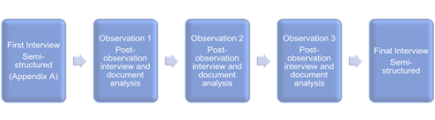
Data Collection Process

Interviews
Interviewing is important to qualitative research for many reasons. Answers to interview questions can lead to information unattainable by observation and is a good technique when conducting case studies of individuals (Merriam, 2009). This study included five interviews. To begin, I conducted an initial semi-structured interview with each participant (Appendix B) with the purpose of exploring their notions of understandings of, and experiences with social justice within and outside of classroom settings. This interview included basic demographic questions (e.g., years teaching) that served as a type of “pre-game stretch” or warm up to help participants feel at ease and prime their mind for later more in-depth questions. This technique is in line with the suggestion of Cresswell and Poth (2018) that interviews are very “bounded on the front end by questions to invite the interviewee to open up and talk” (p. 164). The questions followed a pattern of remembering, then explaining. This also corresponds with the purposes Stake (1995) attributes to an interview; “to get a description of an episode, a linkage, an explanation” (p. 65). I conducted all of the first interviews in teachers’ classrooms or at other locations they deemed convenient, for example, the conclusion of a state social studies conference. Each interview lasted approximately 60 minutes.
I also conducted a follow-up semi-structured interview after each observation, to compare what was said to what was seen and vice versa. I had a few prompts for questions for this interview as needed, (Appendix C), but mostly they were related to the artifacts they had shared or to the classroom practices I had just observed. These interviews mainly served to clarify topics or questions that resulted from these experiences in their classrooms.
The final interview occurred after all observations and document analysis. Because of the COVID-19 pandemic, all final interviews occurred virtually at time of the participants choosing. The observation and initial interview data had been analyzed and a subsequent interview allowed new questions to be crafted as a result of responses to other interviews, observations or analysis. Each set of questions were drafted individually to gain insight about something specific to each participant based on their definition of social justice, a previous story they had told, or something I had observed in their classroom practice (Appendices D, E, F). It also allowed my participants another opportunity to provide information they may have thought about following the initial interviews and observations. Before this final scheduled, face to face interaction, participants were emailed all previous interview transcripts to review for purposes of member checking so that we had time if they felt it necessary to discuss, but none did.

Observations
The second source of data for the study was classroom observations for the purpose of observing regular, everyday instruction to compare what teachers said about their practices to observable actions in their classroom. I positioned myself as a non-participant observer (Cresswell & Poth, 2018) to minimize the disturbance to the natural context of the classroom to the extent possible, usually at a desk on the side of the room, or in the case of a class that occurred in the gym, in the bleachers. I conducted 2-3 observations per participant at a time and date mutually agreed upon with the teacher. All of these observations occurred after the first interview and were directly followed by a brief post observation interview including artifact analysis, lasting up to 30 minutes. The purpose of the post observation interview was to clarify any questions about the observation or allow the teacher to volunteer any information they thought relevant.
First and foremost, observations are essential to “record behavior as it is happening” (Merriam, 2009, p. 118). Behavior, interaction, conversations, and even procedures are of paramount importance to the data of this study. Not only did I need to know what teachers said about social justice teaching, I need to see what they did in their classrooms. This idea corresponds to the process of methodological triangulation to increase confidence in our interpretation (Stake, 1995). Observation data can also serve to initiate reference points for questions that should be asked in the follow up interview (Merriam, 2009). I used an observation protocol that began with the date, location and time, and purpose of the observation. Creswell and Poth (2018) suggest using a protocol that has a place for both descriptive and reflective notes. LeCompte (1993) also discuss a, “who, what, where, when, how, why” format. I believe by combining these suggestions, my notes provided not only a thorough description of what was happening at the time of the observation, but also prepared me to be cognizant of various things to look for during the observation (Appendix G).

Artifacts
The final data source was classroom artifacts. This third data point further illustrated the ways in which teachers incorporated social justice ideals and understandings in their instructional design and choices for students. These included: lesson plans, classroom design and decor, teacher created surveys and student interest inventories, rubrics, student assignments and general presentation materials. The use of documents to enhance analysis was useful because it did not disturb practices or approaches the way interviews and observations have the potential to do. Document analysis can also “help the researcher uncover meaning, develop understanding and discover insights relevant to the research problem” (Merriam, 2009, p.163). All artifacts were reviewed in conjunction with interview questions such as, “how do you plan for a lesson?” with possible prompts such as, “do you specifically consider socially just practices or topics, or does that occur organically?” if necessary, to clarify (see again, Appendix C). This review expanded upon and clarified intentions and ideas associated with these materials and their use to promote social justice. I analyzed these documents with the information from interviews and observations always in mind to enhance the description of the case and inform emerging themes. These documents shed additional light on the ideas the teachers had before implementing the lesson, their sources of inspiration, and the types of materials used in situations where I was not able to observe or ask specific interview questions. To note, these artifacts were reviewed with the lens of intended instruction or post instruction for the purposes of analyzing and reflecting on teacher practice not student work or responses.

Data Analysis
This study was done through a critical lens by examining power structures and opportunities to bring about social change. Cresswell and Poth (2018) describe critical research as that which calls for societal change with the purpose of action and transformation, which they also classify as the aims of social justice itself, a key aspect of this study. It was essential to keep this lens and idea in mind when analyzing data collected from the interviews, observation and artifacts. When analyzing the data collected, it was important to consider the urgency of reflection, and the ultimate purpose of the analysis, which for this case study was to explore and describe these three teachers and their beliefs and practices. I used a combination of both open and axial coding and direct interpretation to analyze collected data.
Merriam (2009) states that, “Analysis begins with the first interview, the first observation, the first document read” (p.165). As soon as the words are heard or read, a qualitative researcher should begin questioning, analyzing and interpreting. Reflection immediately after an interview is crucial to chronicle insights regarding the interview itself, verbal and nonverbal behavior of the interviewee and to begin the process of analysis (Merriam, 2009). This immediacy holds true for observations as well. The idea of urgency is important for two reasons. Memory can fade over time and thoughts should be gathered quickly to capture the most accurate and descriptive information about the situation or insights the researcher is having. Secondly, to wait to review data after collecting multiple sources can become cumbersome and can cause opportunities for subsequent data collection to be missed (Merriam, 2009). Creswell and Poth (2018) suggest the specific technique of memoing to include writing “short phrases, ideas or concepts that occur to the reader” (p. 188), as a step between initial reading and coding. It can also serve to form initial codes and aid in the credibility of the study because it chronicles the thoughts of the researcher and can benefit the depth of the description.
Coding is essentially aggregating the data into small categories of information. Creswell and Poth (2018) present the process of coding as, “central to qualitative research and involves making sense of the text collected from the interviews, observations and documents” (p. 190). For this study, no provisional (Miles & Huberman, 1994) or a priori (Cresswell & Poth, 2018) codes were developed prior to fieldwork, though some did result from initial memoing. Rather, a more inductive technique in which, initial data were collected, written up and reviewed line by line, was used (Miles & Huberman, 1994). Being open to anything possible that might prove useful, is another way to describe this process, a term Merriam (2009) refers to as open coding. After coding of interviews and observations, I conducted axial coding to group my open codes (Merriam, 2009). This is similar to the process of categorical aggregation (Stake, 1995) which included the analysis of the codes of interview transcripts, observation notes, and instructional documents to establish patterns, themes, and connections across cases.
Based on the literature review, subsequent reading, and initial analysis, five codes were developed. These codes were: promoting student decision making/voice, focusing on student strengths, importance of relationships/knowing students, high expectations, and service/involvement. After further transcription and reading of the interviews, several more codes emerged: the recognition of asset based instruction and interactions, the importance of relevant curriculum, a personal interest or passion in social studies as a subject or in social studies teaching, collegiality and the importance of professional and personal growth (and with that the concept of unfinishedness), the importance of support, the integral role of environment, instruction, and finally the act of teaching having its share of risk. All participants displayed all of these codes at some point in the interviews or observations, but the most frequent codes that emerged from the final analysis were categorized as the five major findings (1) environment, (2) instruction, (3) service, (4) support in the face of risk, and (5) the role of collegiality and unfinishedness. Interwoven in these beliefs and practices were characteristics that supported student outcomes and such as student choice, empowerment, and action, high expectations, the imperative of a relevant curriculum, asset-based instruction and interactions, and the value of developing trust and relationships. An excerpt of these categories is in Table 4. The full list of codes with their description, literature references, and exemplar quotes are detailed in Appendix G.

Table 4.
Excerpt of Code Key

Code | Working Definition | Reference (informed by) | Exemplar Quote or Observation
Service/  Involvement  purple | Altruistic feelings or moral or spiritual belief that oppression is wrong. P 33  Teacher’s involvement for the purpose of a greater good (either directly expressed by the speaker OR interpreted by the researcher) | Bell, Lee Anne. Readings for Social Justice and Diversity. | lobbied at the capital with permission of the district and it turns into conversations with my students of okay, you know, here's who I'm going to be talking to and here’s why I want to talk to them
Importance of Relationships/  knowing students/  building  community/  transparency  blue | Expresses personal and/or academic connections with students that further learning and understanding or support an environment that fosters trust, comfort or mutual respect. | Adams, 2016  Woodrow, 2018  Gay, 2014 | build them up socially and emotionally  For me it's like you might have a kid that comes to you (pause) with a reputation. And so, you shouldn't judge that kid because of that reputation. You should judge that kid from the interaction that you have with them.
Risk- pink | Taking a chance on an activity or stance that may not be supported or may have professional consequences (peer or administrative). | Darling Hammond, French Garcia Lopez | -The biggest fear for me before that was giving up control.  I feel like I have had instances where allowing students to have a voice maybe has burnt me a little bit, but in the grand scheme of things. I would rather give them a voice, allow them to have these conversations and kind of run that risk rather than just trying to silence students when they're trying to have these conversations, especially in such a critical time where they're just gaining ground on critical thinking skills and forming their own opinions and determining who they are. And so, I'm willing to take that risk it if it's even considered a rift.  And the social justice things are a lot of times are alarming to administrators, so I have to be able to know the difference and decide. Okay, you know in the on the first hand I invite the principal to be there in that moment on the second-hand, I keep as quiet as possible because there is a subversive nature. There is the equity work as a subversive component to it because the institutional rules and practices by and large are still built on particularly white supremacy, so undercutting those I mean, I'm interested in conversations to change the rules and practices but the ways that I support them in my classroom need, to need to go largely unspoken.  But I've yet to find someone that wants to go the places that I go.
Because the nature of case study is to ultimately understand the case, direct interpretation was also a useful tool. At least one instance occurred in which a key meaning was drawn from an interview response and this was an appropriate instance in which to use direct interpretation (Stake, 1995). One example of this was a comment by Adam. When he was reflecting on what inspires him to keep doing things the way he does despite the obstacles, he made a statement about his own journey regarding anti-racism. He stated,
“I’m not going to find the end of that book. It’s not like I’m going to wake up one morning and realize that (my privilege) is completely gone and I’m no longer fragile, right? There’s always something to learn.”
This comment connects directly to the concept of unfinishedness, and the nature of the evolution of language, thought, and ultimately practice.
Data collection and analysis occurred simultaneously (Merriam, 2009), for many reasons, one being that analysis, specifically coding, drives ongoing data collection (Miles & Huberman, 1994). In the same vein, coding itself was ongoing and was subject to revisions based on new information, the fact that some codes no longer seemed to work, or some codes became so oversaturated as to necessitate subdividing them (Miles & Huberman, 1994). Consistent with the previously described suggestion of urgency, ongoing analysis and data collection served to inform next steps in data collection and analysis.
Codes and subsequent themes were consistently and continuously compared with the analysis of the new instructional materials, interviews and field notes of the observations. For example, a code that was considered during interview analysis, but that really fully developed after observations was asset-based instruction/interactions. This could be considered an extension of relationships, but it goes further. While most, if not all research suggests building relationships is important, these teachers interacted in a way with their students that was worth deeper exploration. It seemed that no matter the situation, such as a missed assignment, or a behavioral concern, they all started interactions with something positive, or with a prompt that called attention to the students’ strengths. Comments such as, “thanks for being patient,” to students that were getting restless during presentations, and “I can see your point,” to another that was defending his distracting actions. These types of interactions and comments were consistent enough that they warranted a subdivision of the code regarding the importance of relationships, and the addition of a specific code regarding asset-based interactions.

Trustworthiness and Triangulation
Merriam (2009) discusses multiple strategies for enhancing the rigor of a qualitative study. The ones I employed for this study included: variation of participant demographics, memoing, thick descriptions of the observations, multiple interviews and member checking. The purpose of varying the demographic background of social studies teachers, within the criteria of setting and current teaching assignment, was to attain multiple perspectives and voices of persons within these criteria. While criterion sampling was employed, the variation of participants in the sample provided additional insights and is representative of the demographics of the bounded system of this case.
Creswell and Poth (2018) discuss memoing as lending credibility to the qualitative data analysis process because it “helps track the development of ideas” (p. 198). I used memoing to leave a trail of my thoughts during collection and analysis, to add depth to descriptions and interpretation, and to further support the rich and holistic accounts needed for a case study.
Observation notes must be as descriptive as possible in order to paint the most accurate, but also the most compelling picture. Additionally, Stake (1995) discusses the need for readers to have a vicarious experience; “our accounts need to be personal, describing the things of our sensory experiences, not failing to attend to the matters that personal curiosity dictates” (p. 86.) By doing this, I hoped to achieve a sense of actually being there for the readers of the study, and to perhaps provide a better understanding of the analysis and interpretation of the researcher. Stake (1995) also suggests providing information about the researcher, which I endeavored to do as I explain my positionality.
The purpose of multiple interviews was to gain new insights, but they also served to clarify topics or questions from another interview or from an observation. These sources were initially analyzed, and a subsequent interview allowed new questions to be crafted as a result of responses to other interviews, observations or analysis. It also allowed participants another opportunity to provide information they may have thought about following the initial interview.
Member checking provided trustworthiness because interview transcripts were reviewed by participants to corroborate their answers and intentions. I hope it also served to promote goodwill between the participants and myself as the researcher since there was transparency and full disclosure of the transcripts. I emailed the transcribed interviews to participants before the final interview so that they served as a check-in for accuracy regarding their ideas, intentions and voice.
Creswell and Poth (2018) define triangulation as, “using multiple and different sources, methods, investigators, and theories to provide corroborating evidence for validating the accuracy of a study” (p. 328). Triangulation occurred by using the varied sources of participant interviews, observations and document analysis to compare these sources for consistency and themes.

Researcher Positionality
The very endeavor of research is rooted in the perspectives and viewpoint of the researcher (Dillard, 2000; Merriam, 2009). We are part of our research. Part of the reason I am drawn to critical inquiry is my propensity to look upon culture with a good measure of suspicion (Crotty, 1998) and in this instance the culture is social studies curriculum and pedagogy. I must understand my own journey and reflect upon how I have come to view things the way I do.
My interest about this topic began when I was a social studies teacher in the same city that the study was conducted in. I fit the demographic of the typical American teacher, and my students fit a very similar demographic to the students in this study. My philosophy became rooted in the idea that I had as much to learn from my students as they did from me, and that I wanted my classroom to be a place of inquiry, excitement, and mutual respect. I realized early on my own gaps in knowledge, what Freire (1970, 2000) might refer to as unfinishedness. Not only because I couldn’t know everything about social studies, but also, I couldn’t presume to know all the stories and ways in which history and society had impacted each of my students and their families.
It was also important for me to respect student autonomy and create a space where they could make the ideas of what we were studying their own. At the end of every school year, students completed a comprehensive exam. While everyone had the same content to cover, they were allowed to demonstrate what they had learned in any media or format they wished. Some students made videos, or art projects. Some made games they could play with their fellow classmates, or scrapbooks, or essays, or graphic novels. One group created a 30-foot annotated timeline that I hung in my room and other groups produced their own rap albums with original lyrics. My students had much success in my classroom and some teachers in the building were surprised by their level of interest, dedication, and learning when it came to their class projects. I was always disheartened by this, and I knew that many other teachers were promoting student choice, culturally relevant, and socially just practices. I have always been interested in learning about these teacher’s approaches, successes and revisions. When I was a classroom teacher, I was the minority and was well aware of my ignorance regarding so many aspects of my students’ culture. But I was willing and excited to learn from them. As I read Freire’s philosophy regarding reciprocity, that while we teach, we learn, I felt in many ways we were both the teachers and the learners (2000). I believe that this attitude helped to develop the relationships and the reciprocity that was established. I also hope to develop this kind of relationship with my participants and learn from them as well.
In the years since I have left the classroom and become involved in professional development and higher education, I have learned so much from my experiences, conversations, and formal and informal educational opportunities. Even with all this, I feel I have so much to learn and continue to investigate regarding social justice teaching. It is important for a researcher to reflect on their positionality not only to inform themselves of what might be influencing their research and findings, but also for the reader’s benefit. Merriam (2009) states that, “Investigators need to explain their biases, dispositions, and assumptions regarding the research to be undertaken” (p. 219). Because the researcher is the primary instrument of data collection, prior experiences and knowledge can influence what is seen and will surely influence analysis. If this information is disclosed to the reader, it can aid in the understanding of the interpretation. My study could both be strengthened and perhaps limited by my closeness to the setting and topic. I have a background in the same subject and the environment as the participants. This background may aid in the comfortability that the participants will have with me knowing that I share both their experience in teaching the content and the community. A key aspect of this research is the ability of social studies education as uniquely poised to do this important work. I believe teachers have a responsibility and privilege to empower youth, especially those who come from groups that are typically marginalized. This type of research can help communities of teachers, policy makers, and even those outside of education see a glimpse of what is happening in schools and understand the ways in which teachers are incorporating practices that promote civic activism. Teachers need to know that their endeavors are acknowledged, are not happening in isolation, and can help inform others’ practices, even if they do not share the same geographic location.

Ethics
One ethical challenge that may arise is the identification of participants. This issue of confidentiality was addressed by the use of pseudonyms for all participants that I encouraged them to choose for themselves. To set participants at ease and provide full disclosure of the study, all participants were asked to sign an informed consent form (or consent verbally to a read form in the case of virtual interviews), that explained the purpose of the inquiry and methods to be used (Merriam, 2009). In his narrative and counter-narrative research in US urban schools, Milner (2008) describes his situatedness and his desire to understand his participants' experiences and stories and thus his own, more deeply. This is also a goal of mine. In order to accomplish this, he “made explicit his goals, rationales and thinking in posing questions and in my focus during observations.” (p. 1577). This was an important part of my process when conducting interviews and observations and explaining to teachers the purpose of the research and the document analysis.
An advantage of collective case study was that the potential to provide an in-depth understanding of the case. The limitation is inherent in this as well. Full coverage and equal attention to all data is impossible (Stake, 1995). Thus, all information cannot be analyzed or presented, and deciding which is the most important is the task of the researcher. Another limitation could be that these teachers have a varied educational background and that could be a factor that influences their practices. But in case study, the goal is not to generalize; it is more to understand. Furthermore, Stake (1995) discusses the idea that “balance and variety are important; opportunity to learn is of primary importance” (p. 6). Therefore, while the cases must fit within the bounded system, attributes other than that may vary.

Chapter 4

Findings

This study sought to explore and describe the social justice beliefs and practices of urban secondary social studies teachers, and their roles in classroom, local and professional communities. As I worked through the study, I unpacked curiosities related to ideas the study would be examining. I considered broad questions like the one I posed to my participants; what is social justice? I thought about the things they were doing and wondered, how does it manifest itself in classroom practice? Is it as simple as creating a safe space or as complex as navigating controversial topics in classroom discussions and assignments? Is it evidenced in nuanced ways that only reveal themselves with close examination, or should it be explicit and immediately recognizable? What about beyond the classroom such as community involvement, service, or personal and professional development? Are these practices merely influential or are they essential to the growth and sustainability of a classroom teacher whose aim is to promote social justice?
These musings are not part of my research question, nor sub-questions of the study, but rather things that I thought about and ways in which I approached the complexities of teacher notions and classroom practices concerning social justice. And though this study sought to answer a question regarding the beliefs and practices of the teachers that participated; it ultimately also created more and deeper questions for consideration. Acknowledging these curiosities and to explore my research question, I used a collective case study approach to explore and share the stories of three teachers (Adam, Connor, and Leonard). Based on interviews, observations of their instruction and classroom environments, and analysis of instructional artifacts, I explore and describe their beliefs on social justice and how these beliefs are exhibited in classroom practice. To begin this chapter, I describe the findings or actions that were commonly identified across my three participants. Next, I introduce each of my three participants to better contextualize who they are before describing their actions as teachers. Following the introduction of each, I then discuss the teacher-focused codes that developed from the analysis of the data from each teacher’s interviews, classroom observations, and instructional artifacts. The overarching codes that developed as similarities between all three participants and serve to guide section headings under each teacher were (1) environment, (2) instruction, (3) service, (4) support in the face of risk, and (5) the role of collegiality and unfinishedness.
Woven into each of these sections, I describe participant beliefs and practices that resulted in codes interconnected to the approaches, dispositions, and interactions they have with students. These codes were determined to be student choice, empowerment, and action, high expectations, the imperative of a relevant curriculum, asset-based instruction and interactions, and the value of developing trust and relationships.

The Teachers: Who They Are and What They Believe
I begin each section of the stories with an introduction to the teacher including background and beliefs. As per the bounded system parameters of case study, all three teachers are secondary social studies instructors in urban classrooms. They all happen to be male, as the majority of secondary social studies teachers in this district are. Their backgrounds, however, are very different and reflect the distinct nature of individuals; each dynamic and interesting. Though all in education, none have the same degree. They all come from different places, have different paths to becoming a teacher, and reasons why they ended up in the same district. However, at the intersection of their interest in social studies and teaching, lies the impetus for social justice teaching and a heart for their students. Because of this fact, overarching themes emerged from all participants; these were further categorized into teacher-focused and student interaction codes and were explained as part of each story.

Environment: The Room Where It Happens
Discussions of the environment were replete throughout the participant interviews and an important part of my observations. I consider the environment foundational because of its significance and how it can potentially influence so many other aspects of a classroom, whether that be the climate or culture, how teachers approach instruction, or how teachers build relationships with students. The environment can be categorized as organizational regarding the physical space or decor, and even how students sit, are grouped, or are encouraged to work together to achieve certain goals. For each teacher, it served as a window into their personality and their priorities.

Instruction: The Way That It Happens
Though often difficult to determine where the environment stops and instruction begins, the focus of these sections include the specific actions of the teacher. These actions include the strategies and approaches of lessons or class activities, and expectations regarding assessments of learning. Instruction might also include the way teachers incorporate state standards, social studies content, and process skills. Finally, for this study, it is also the way teachers engage students in meaningful work, build on what students bring to school with them, value cultural pluralism, diversify assignments and assessments, or make critique, inquiry, power, activism, participation, and hope part of the curriculum (Cochran-Smith, 2004; Gay, 2014; Gonzalez, et al., 2006; Ladson-Billings, 2014; Paris, 2012; Moje, 2007). These instructional moves are intentional - sometimes the intentions are explicitly shared with students while other times they are not.

Service and Involvement: The Action in Civic Engagement
Service is a complex concept. Essentially it is the teacher’s involvement for the purpose of a greater good, either directly expressed by the speaker or interpreted by the researcher. For this study, it relates to several aspects including, service to students by providing meaningful instructional opportunities, service to the profession of teaching, and service as a part of civic engagement. It can be evidenced by the civic engagement teachers take on a personal level in the local community (Apple, 2009; Kincheloe, 2010), the instructional decisions they make, and the opportunities they provide to empower students (Beyer, 1998; Katyal, 2004), or their leadership and contributions to the learning and teaching of social studies and social justice (Keiser, 2013). When social studies teachers engage in service, they align their practice to the ideals expressed in the National Council for Social Studies C3 framework; the importance of not just knowing but using knowledge to inform action.

Risk and the Importance of Support
For the purpose of this study, I have defined risk and the importance of support as taking a chance on an activity or stance that may feel uncomfortable, might not be supported by peers, or have professional consequences from administrators, or the community (Darling- Hammond, 2002; Rubin, 2013). Examples of this may include providing choice or promoting controversy. There is inherent risk when providing choice and voice because outcomes are not always predictable. Discussion of controversial topics in social studies classrooms takes skillfulness but reaps great rewards in engagement and student understanding. Hess (2004) states that “controversy is not an unfortunate byproduct of democracy, but one of its core and vital elements” (p. 257), and its inclusion in social studies curriculum to support social justice is a valuable way to promote perspective, representation, and practice. The level of risk a teacher assumes relies heavily on trust and the relationships built with both students and administrators. Often the level of risk the teacher will assume is concomitant with the number of years they have been teaching.

Unfinishedness and the Role of Collegiality
The art and science of teaching are always evolving and the content of social studies itself is dynamic and multidimensional. When also considering a concept as crucial and multifaceted as social justice and social justice teaching practices, vocabulary, understandings, and approaches must also be subject to critique and revision. New and veteran teachers that strive to encompass socially just teaching and support the learning of all children should be open to change and engage in personal reflection (Grant, 2006). The role of collegiality as support to unfinishedness encompasses the theory surrounding a community of practice. Teachers can find solidarity and gain skills and confidence by being part of a community that inquires, critiques, and shares knowledge and practices through participating in, or the facilitation of, professional development. Teachers can and should empower each other to change their teaching practices by talking to one another and “collaborating in a discussion that crosses boundaries and creates a space for intervention” (hooks, 1994, p. 129).

Adam
Adam is in his ninth year of teaching, but at the time of this study, it was his first year in Prairie Ridge Public Schools. His previous experience was in another district with similar demographics and size in the same metro area. His bachelor’s degree is in seminary and he has a master’s degree in Theological Studies. His position was ninth grade Oklahoma History and tenth grade World History.

Adam’s Story
Adam started teaching after years of serving in Christian ministry. During his formative years, he lived in three different states, finally graduating from a high school in Nashville, TN, and attending a small private religious college there. He then spent three years in professional ministry and attended seminary in St. Louis, where he earned a master’s degree in Theological Studies. He came to Oklahoma shortly after that and transitioned to teaching. He said in the years leading up to certification and finding a teaching position he went through “personal political changes” and “knew that social justice was going to be a key component for me.” He defined social justice in three words:” diversity, equity, and inclusion,” and stated that “aside from perhaps English/Language Arts, no other subject rivals the pursuit of social justice teaching the way social studies can.”
His personal interest and passion for the subject are evidenced by his knowledge and the constant pursuit of knowledge about topics such as decolonization, anti-racism, and social justice. He specifically acknowledged the importance of other content areas but holds social studies in the highest regard, and the best fit for teaching matters related to social justice. When I asked him about the purposes of education, he said he believes in the idea of “education as the great equalizer”. He went on to explain the distinct situation and opportunity education, and specifically classrooms, have.
In my mind, many classrooms around the country represent the height of diversity and multiculturalism in our society. We don't go to church the way we do public schools. We might rub shoulders in a grocery store or something, but that doesn't have the same community that a classroom does. So, for me to answer a question about [the purpose of] education is to answer a question about public education.
This view aligns with democratic theorists from Dewey to Mann and more recently social studies scholars Hess (2004) and Gibson (2020). Both Hess (2004) and Gibson (2020) present the argument that schools may be one of the few experiences in which students are exposed to both demographic and ideological diversity, which she implores is necessary to navigate controversy.

The Environment of Adam’s Classroom
The classroom environment includes the physical environment as well as the climate that is developed and fostered among students and the teacher. Adam discussed the significance of the classroom environment, stating that “it’s everything”. We started with the notion of the actual class as a place and the space that it encompasses. He stated,
Yeah, the physical space is important. We've learned that students do pick up on visuals whether it be on the wall or.... it may not be really conscious. But you know, there are social studies classrooms with a lot of American flags, which is very traditional. And I think it sends a certain message.
His classroom has multiple flags, and the American flag is one. However, it does not hang alone. “My classroom has various Pride flags that are displayed. When I have a Trans Pride flag and I have the Philly Pride flag, which includes a black and brown stripe, students are interested in those kinds of things.” (See Figure 2.) As seen below, he has a Pride flag on the wall next to his desk. Above a bulletin board that documents his values is a poster that reads, “Unfortunately, history has set the record a little too straight”, and features historical figures as James Baldwin, Willa Cather, Errol Flynn, and Michelangelo.

Figure 2
Adam’s Desk
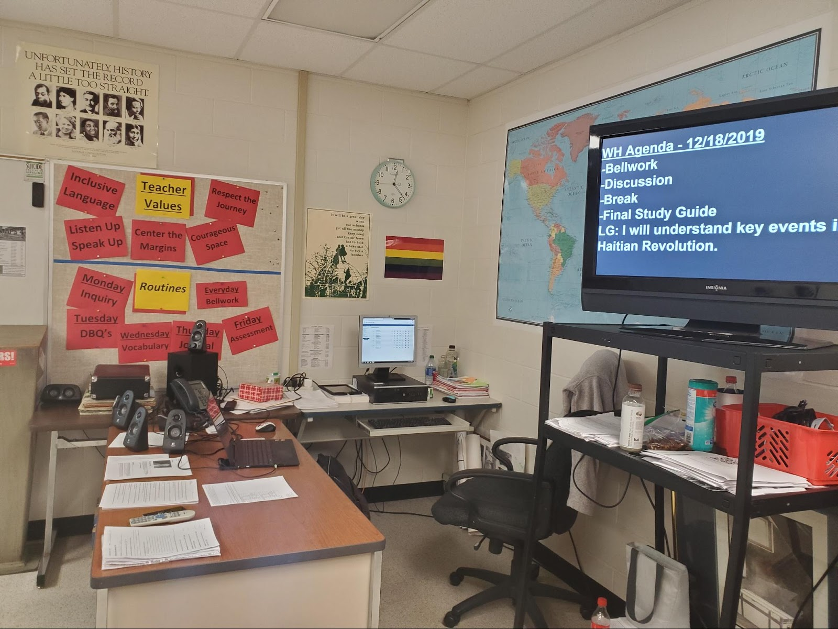
Note: Adam’s Pride flag and posters are prominently displayed for all to see.

Adam’s class has multiple artifacts that signal welcome and acceptance. It is a key aspect of the environment, and one obvious to not only the students who learn there but to any visitor in the room. Adam said,
I do embrace the term multicultural for the classroom. That means that students are bringing a broader picture of what it means to be who they are, and they may not necessarily be able to articulate all of that, but it's still in the room and part of my job as an educator. It's not to create a space where my particular culture dictates the climate of the room.
A core aim of social justice is the representation of marginalized identities (Fraser, 2009, North, 2008). Despite progress made in the last decade, whether in mainstream popular culture or in schools, LGBTQ representation still remains inconsistent and lacking. As part of the Gay, Lesbian, and Straight Education Network’s (GLSEN) National School Climate Survey, four out of five students reported that there were no positive representations of LGBTQ people or issues in any of their classes (Sadowski, 2017). Since research attests that LGBTQ students' identities are sparsely represented at school, it stands to reason that these students are even more rarely presented with historical personalities that mirror their identity. These artifacts help set the stage for his emphasis on the environment, and also the concept of an environment that extends beyond the physical space and into conditions or climate. A compelling discussion ensued when he mentioned that the climate of his class was not necessarily one that was “safe for all”. Especially when it came to disparaging or derogatory remarks. Adam says that he learned the hard way to not “ask questions that will open doors for bigotry”. He further eloquently explained that “If I ask a question and it naturally leads to someone being dehumanized, or someone's personal value attacked then I asked the wrong question.” This idea not only addresses the concept of risk, but also the importance of the environment. He went on to explain,
I will not shy away from the content. I will not back away from the non-discrimination policy of the district or of our school. But I'm not going to open a discussion and say, what do you think, because I already know some of you think some pretty asinine stuff that I don't want the other half to hear because they will be sick.
His respect for students that have been marginalized is not just something he says is important, moreover, it is an observable action he takes in different environmental iterations such as class discussions, class assignments, or questions. The situation of pervasive power structures being present in the classroom as a microcosm of the nation is a sentiment expressed by Gibson as a critique of deliberative pedagogies. “Although schools are often held up as an idealized space in which to practice democratic discourse, it is important to acknowledge that social inequalities—most specifically, racial inequalities—are (re)produced in schools.” (2020, p. 435). Though this reference speaks directly to racial inequalities, a parallel could easily be drawn to other aspects of students' identities that may leave them feeling marginalized.
As evidenced by his interviews, his artifacts, and observations of his lessons and activities, Adam sought to bring into question normative takes on history. One example was a poster using the words “Homeland Security” and “Terrorism” in ways that might give pause to some of those that seek to maintain the status quo. However, they are completely in line with ideas concerning criticality, perspective, decolonization, and social justice (Au, 2009; Cochran- Smith, 2004, Dover, et al., 2016; Fitchett, et al., 2012; Katsarou, et al., 2010; Moje, 2007) (see Figure 3).

Figure 3
Wall Decor in Adam’s Class
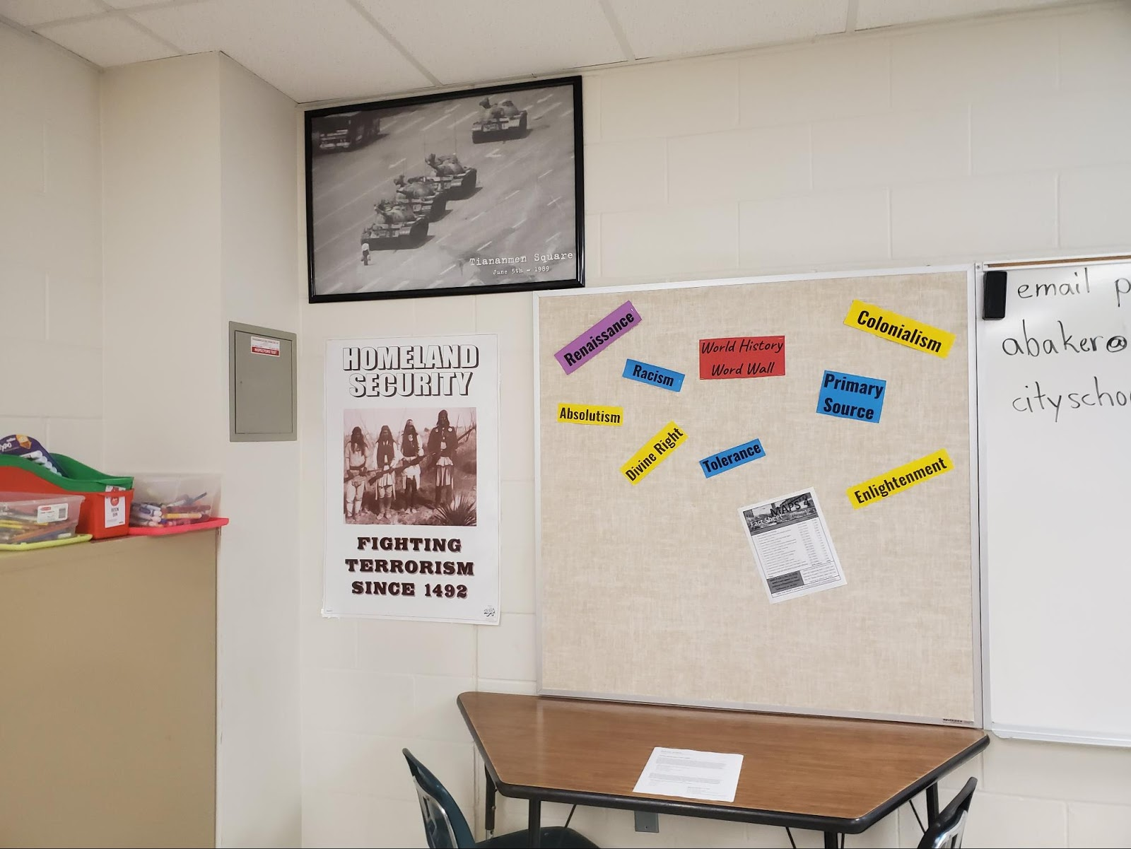
Note: Posters and decor that challenge normative vocabulary.

Observing Adam’s class sessions reified this stance. He started many classes with a few questions on Google classroom that reviewed previous material and engaged students with the content of the day. Some were quick multiple-choice, but usually at least one was open-ended. After students had just a few minutes to get their answers in (while he completed attendance or chatted with a student who had a question or was absent) he would walk around the room and discuss their answers. I noticed that he acknowledged even flawed answers with respect and genuine interest in what might have led students to their answer. When I asked him about this approach in a follow-up interview, we discussed the importance of perspective and also controversy. Controversy can be a successful tool to promote buy-in and thought-provoking discussion to a subject, namely social studies, that is often seen as boring or unrelatable because of the emphasis on what Adam called “stupid questions which have right or wrong answers about dates and people” (Goodlad, 1984; Hess, 2004; VanSledright, 2010; Woodson, 2015). This harkened back to our interview and discussion on the importance of asking the right questions, and that skill was one he had to learn. He provided one additional example: This scenario did not actually happen in his classroom, but rather an instance of some back and forth with an organization concerning a fake classroom. The fake scenario in their piece was of a student speaking up about their belief in gay people going to hell. The response to the question directed back to him was, is that not a valid opinion in Mr. A’s class? He stated simply to me, “No it's not a valid opinion in my class. Like we're going to talk about the issue and I'm going to try to give opportunities for students to express their views, but like a student condemning another student, no.” He went on to explain. “Equity and equality of safe space are not the same for everyone” (Carlisle, 2006; hooks, 1994). The sign on the door further explains his stance on many topics, and it is clear for all who enter and exit to see (see Figure 4.).
There is a fascinating story behind this poster. When I saw it, I asked him if he made it, a student made it or, not wanting to take anything for granted, if it came from another source. He stated that a former colleague from another district made it for him as part of their yearly Secret Santa exchange. This is another testament to the transparency of his goals and ideals. The fact that a colleague knew these ideals and knew they would be something he would want to display proudly, even as he changed classrooms and districts.

Figure 4
Adam’s Classroom Door

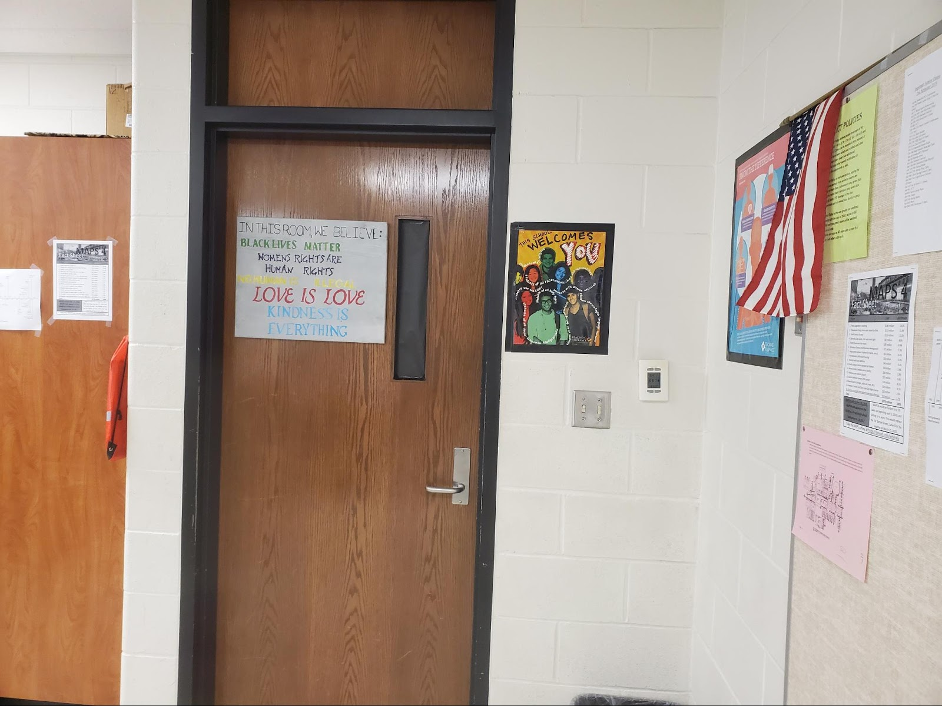
Note: Decor that promotes inclusivity and welcoming are flanked by the American flag.

IN THIS ROOM, WE BELIEVE:
BLACK LIVES MATTER
WOMENS’ RIGHTS ARE HUMAN RIGHTS
NO HUMAN IS ILLEGAL
LOVE IS LOVE
KINDNESS IS EVERYTHING

A Teaching Tolerance (now Learning for Justice) poster also hangs on the wall that states:
This school WELCOMES YOU
- Students of all religions
- Students of all races, ethnicities and nationalities
- Students who are LGBT
- Students of all socio-economic backgrounds
- Students who are English Language Learners
- Students of all body types
- Students of all family structures
These statements represent many of the characteristics of students in all our nation's schools, but several are more representative of urban school populations, which typically are more diverse, both ethnically and linguistically, and are likely to serve students that are struggling with poverty (Kincheloe, 2010). The sentiments expressed by the poster might be a difficult thing to articulate out loud for many reasons. When would be the appropriate time? Who are we to think we know which characteristic or perhaps multiple characteristics fit which students? Teachers should not assume they have undue insight on a students’ identities or make a judgment for an identity they assume that student possesses. Therefore, this simple artifact serves as a gentle notification that no matter who you are, this is a place you are accepted and belong. Belonging and acceptance for students of all backgrounds and situations is something that is often difficult to “see”, but it functions on many levels of a supportive environment (North, 2008, Woodrow, 2018). It promotes trust, builds relationships and it can also serve to encourage those who may be struggling.
One of the subsequent visits to Adam’s classroom provided another unique and interesting addition to the classroom environment. On the whiteboard were pages from the resource, What We Believe: A Black Lives Matter Principles Activity Book (see Figure 5). Students were encouraged to interact with the documents and were provided copies of whatever pages interested them to explore further. To my knowledge, there was not a formal lesson or assignment that accompanied the pages, rather students were allowed to engage with this resource at a level that they desired. This resource is self-described as:
“a way that young people can explore the powerful principles of empathy, loving engagement, and just action among its participants; affirm the importance of Black women, families, elders, and LGBTQ folk; and celebrate the strength and diversity of Black people in their communities and around the globe. It is written in down-to-earth, child-friendly language, with each principle accompanied by writing prompts, space for children or adults to create their own reflections, and a coloring page. Supporting materials guide adults in sharing the principles with children and encourage kids to dream big and take action within their communities. An essential resource for anyone discussing racial equity with young people, What We Believe offers a beautiful and inspiring lens on the most important social justice movement of our time.”
The activities are offered by Adam to all students. This allows them to explore identities that mirror their own or provide a window into issues that garner new perspectives. Often considered a literacy strategy for teachers to assess their text offerings to students, “mirrors” and “windows” can be a valuable tool to use when assessing the usage of any curriculum. It is a tangible, concrete approach teachers can use to promote inclusion and perspective, important aspects of pushing back against the Eurocentric and Westernized textbook curriculum (Brown-Jeffy & Cooper, 2011; Fitchett, et al., 2012; Kincheloe, 2010; Woodson, 2015).

Figure 5
What We Believe Activity Book on Whiteboard
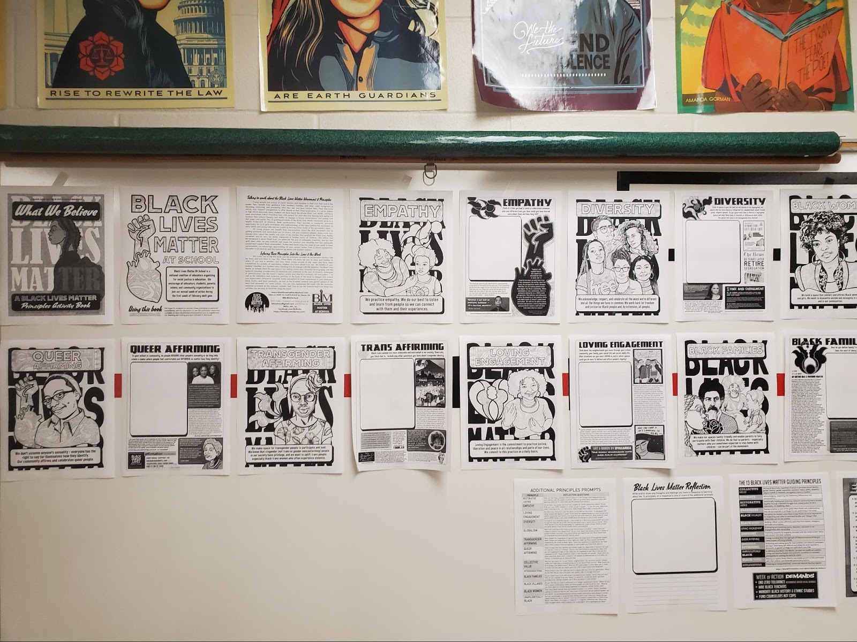
Note: The pages of What We Believe: A Black Lives Matter Principles Activity Book are taped to the whiteboard for students to interact with.

Instruction: The Way that It Happens in Adam’s Class
Though sometimes hard to delineate where the environment stops and instruction begins, the examples in this section relate more to content and instructional opportunities for students directly related to teaching practices. The first time I visited Adam’s classroom, he had a giant timeline of the Metropolitan Area Projects (MAPS) plan covering his entire whiteboard. MAPS is Oklahoma City's visionary capital improvement program for new and upgraded sports, recreation, entertainment, cultural, and convention facilities. It has been a decades-long, voter-approved, sales tax endeavor by the City of Oklahoma City to improve infrastructure and facilities. MAPS For Kids is a school program that includes hundreds of construction, transportation, and technology projects. He and the students had been working on research to annotate the timeline (see Figure 6) and analyze the local and personal effects MAPS has had on their lives. Other important events, such as the Murrah Building Bombing were also chronicled. For all of his students, these occurrences began before they were born, but continue to impact their community. The additional assignments that accompanied the timeline completion include a “Design Your Own City” activity, a “What Kind of Mayor Would You Be?” writing assignment, a “MAPS and Me” exit ticket, and a “Mock Maps 4 Vote” activity that includes the real language from the MAPS proposition (See Appendix I). In these assignments not only does Adam align his instruction to current state standards, but he also uses real-life names, vocabulary, places, and situations (regressive vs progressive taxation), asks students about their own thoughts, allows them to personally evaluate the initiative, and encourages their participation in civic duty by assigning them homework that includes “explaining what you have learned about MAPS to an eligible Oklahoma voter”.

Figure 6
MAPS Timeline
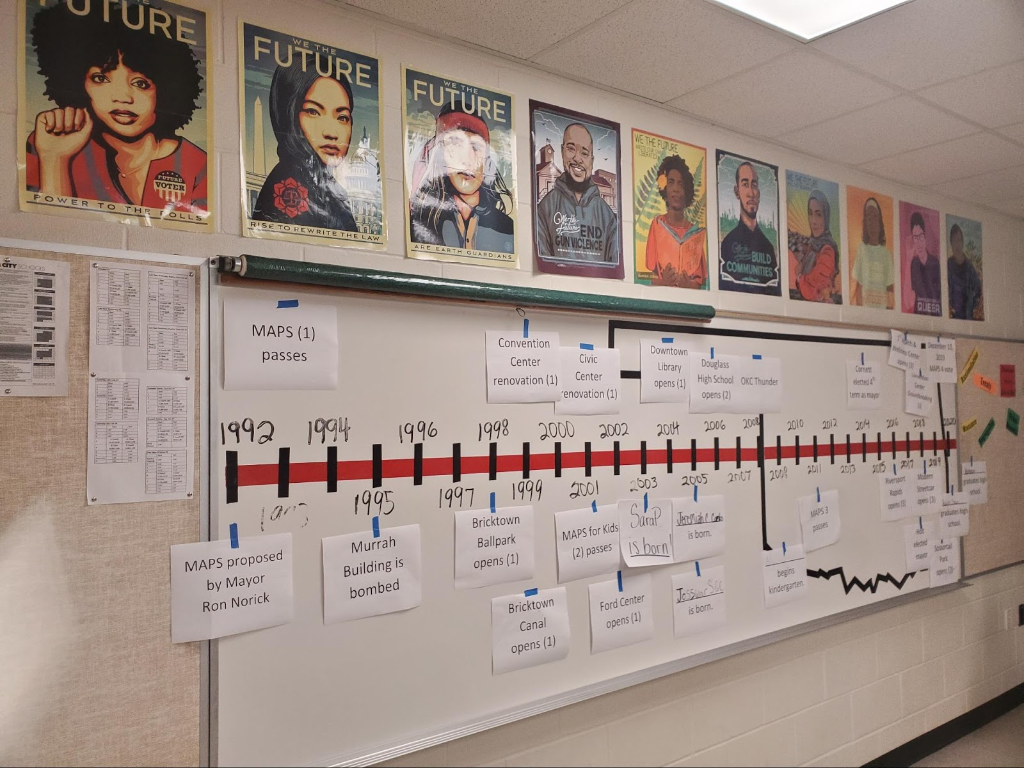
Note: Across the whiteboard is a timeline that showcases the progression of the MAPS project and other events contextual to Oklahoma City.

This type of activity supports research and theory regarding social justice teaching on many fronts. By exploring a real-life ordinance about their own community with real names, the accurate language and formatting used on the ballot, and an activity that discussed the real cost and taxation process, Adam made connections to real life, and contextual issues within the community (Greene, 1995; Kincheloe, 2010; Misco & Shiveley, 2016). By encouraging students to evaluate the proposal and create a city of their own, students were engaging in meaningful, connected and authentic work (King, et al., 2009; Saye, et al., 2013). For the final aspect of this assignment, students were tasked with discussing their knowledge with and engaging in conversation with an eligible voter; a developmentally appropriate task for a 9th-grade student and one in line with the citizenship goal of social studies education (Au, 2009; Banks, 2004; Lo, 2017; Rodriguez, 2018; NCSS, 2013; Parker, 2010; Stanley, 2003; Westheimer & Kahne, 2004).
The MAPS activity served as a scaffolding to the next semester project in which students in Adam’s class would participate in a unit about student-identified issues in the local community. The name of the curriculum that was guiding this process was Generation Citizen; a nationwide initiative driven to incorporate action civics into social studies classrooms in six sites across the country (San Francisco, Massachusetts, New York City, Oklahoma, Rhode Island, and Texas). The organization's stated mission reads: “Generation Citizen (GC) is working to transform civics education so that young people are equipped and inspired to exercise their civic power.”
The framework begins with students brainstorming issues they see facing their communities and through a process of analysis and research, ends up in a plan of action the students implement to address the issue. Though I was only able to observe one class period after this project started, I did witness the beginnings of the activity, and a blank hourglass figure on the wall, a trademark visual representation of the entire process (see Figure 7 for Generation Citizen completed graphic). Students had begun their brainstorming process and had also completed the distilling process in which ideas were consolidated and voted upon (see Figure 8).

Figure 7
Generation Citizens’ “Advocacy Hourglass”
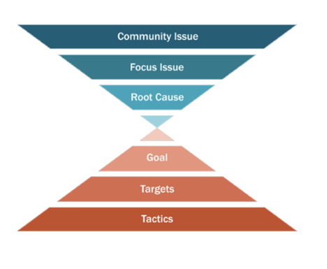
Note: The “Advocacy Hourglass” provides the framework and outlines the process followed when engaging in the Generation Citizen initiative.

Figure 8
Adam’s Generation Citizen Curriculum Introductory Activity
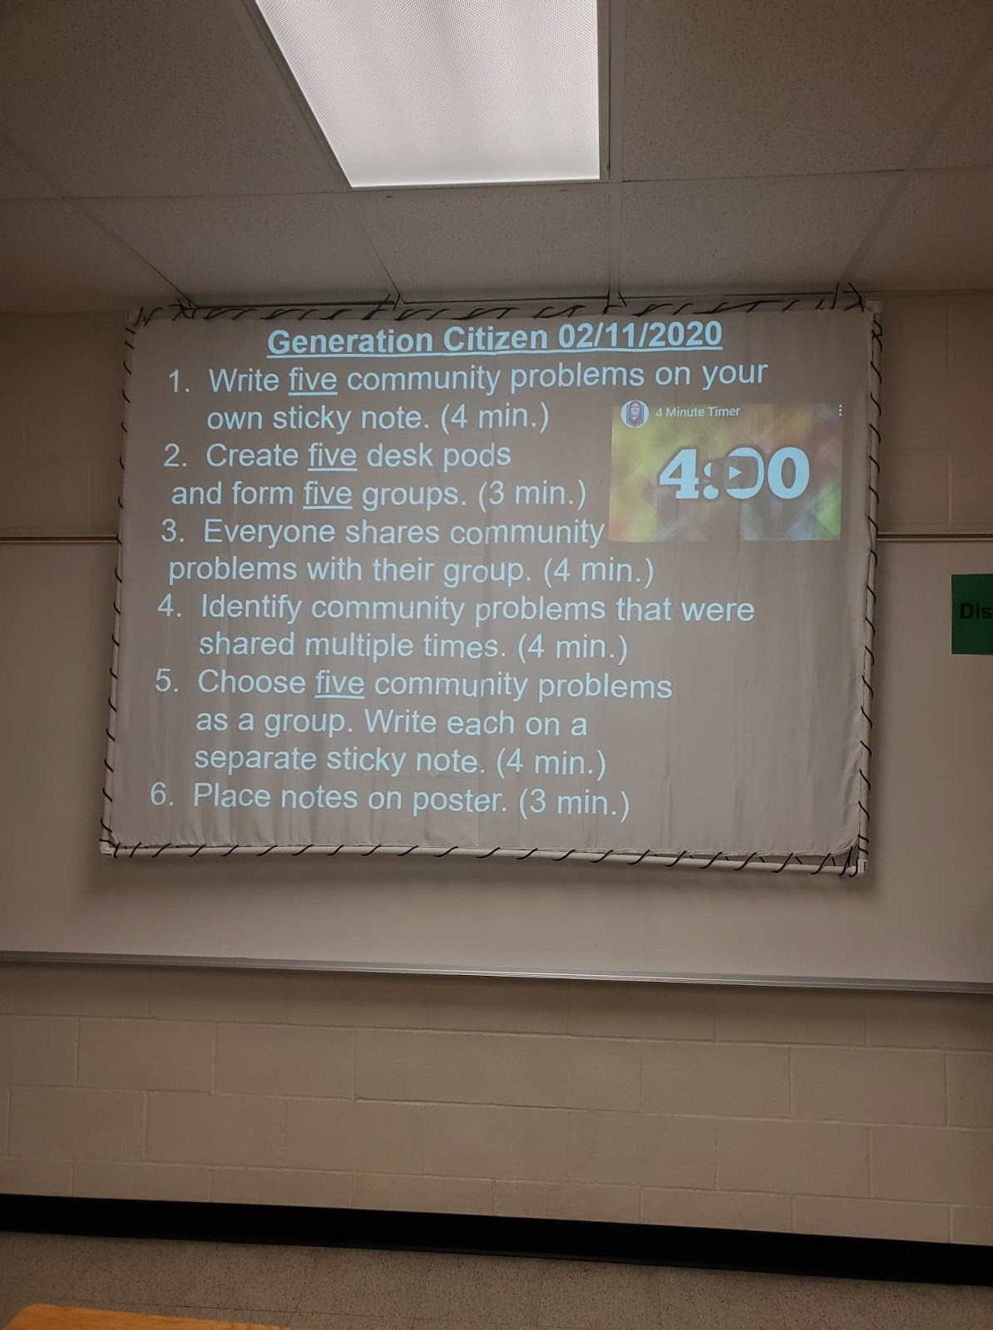
Note: Students participating in the Generation Citizen curriculum begin the process of identifying a community issue individually, then discuss overlapping ideas as groups.

Boyd (2017) states that teachers’ instructional approaches should be informed by student interests and the injustices they seek to address. Processes and actions used in classrooms that put students in the role of decision-maker, researcher and activist, are very much in line with the goals of not only social studies instruction (Au, 2009; Westheimer & Kahne, 2004), but also the goals of social justice education (Apple & Beane, 1995; Bell, 2016; Carlisle, 2006; Katsarou, et al., 2010). Adam’s students were able to start the process and had decided on the topic of racism as their issue and the root cause of ignorance before they were dismissed for Spring Break. Unfortunately, the COVID-19 pandemic thwarted their efforts to complete the process in full. Adam stayed in touch with his students for the rest of the semester by text but did not assign any work that resulted in grades. I asked if the content of the texts was instructional, socio-emotional, or a mix. He relayed that, “yeah, those texts are like SEL, right from beginning to end” demonstrating his commitment to focus on the social-emotional health and well-being of his 9th and 10th graders that never ended up returning to school that year.
Service and Involvement: Civic Engagement and Action in Adam’s Class
As I consider examples in this category, these are opportunities both personally and instructionally that Adam took to promote civic engagement in and beyond the classroom.
I would consider Adam an advocate for social justice not just because of his classroom approaches, but also because of his willingness to learn and share his learning with others both inside and outside of the school community and education.
As described previously, the fake classroom/student story in a media publication was a way for him to be vocal about the beliefs he has about the atmosphere of his classroom. It was provided as an example of his classroom environment. For this section, that same example demonstrates his commitment to service. Though the other party in the exchange attempted to provoke him by questioning his limits on speech, he held steadfastly and was clear that all opinions, especially those that espouse hate or condemnation, are not protected opinions.
So, when I was writing about queer students’ experiences about three years ago, to the Oklahoma Council of Public Affairs, I wrote a response piece and the fake scenario in their piece was of a student speaking up about their belief in gay people going to hell. Then the response to the question directed at me was, “Is that not a valid opinion in Mr. A’s class?” My response was, No. It's not a valid opinion in my class. Like we're going to talk about the issue and I'm going to try to give opportunities for students to express their views, but a student condemning another student? No.
His approach to action-oriented civics manifests in many ways and I was fortunate enough to observe two of the instances. Both the MAPS assignment and the Generation Citizen curriculum have a student-focused, real-world approach to local community issues. The MAPS activity was a comprehensive, multi-day unit that incorporated many essential aspects of social studies and social justice teaching, such as encouraging students to be critical participants in the policies and practices that impact their own life, or directly impact their community (Ladson- Billings, 2014). Adam created all the resources and has them published on his WordPress site. All the activities, handouts, and instructions are free for any Oklahoma History teacher to use. As seen in Figure 9, “Permission is granted to share, to download, to reproduce and for general education use of the above materials.” In this way, Adam is supporting a community of social justice teachers and teaching, creating and sharing resources for any teacher to use.

Figure 9
Maps Curriculum on Adam’s Website

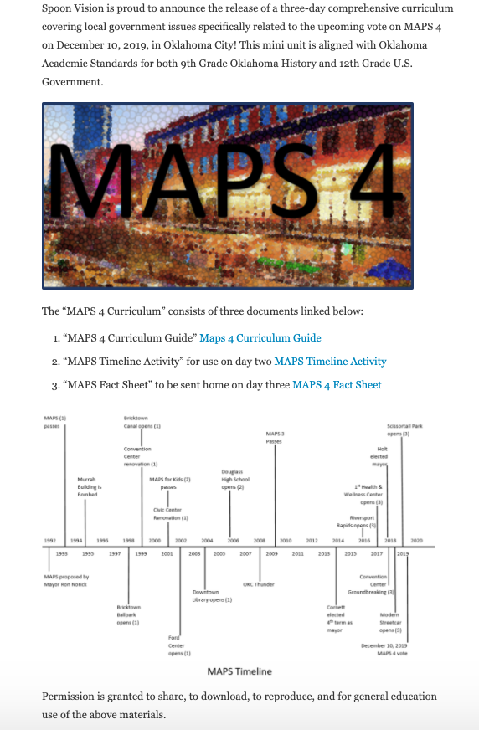
Note: Adam created community relevant content to use and share with other teachers.
Even though the Generation Civic project was cut short, students were still able to experience the initial aspects that allowed them to inquire about problems they saw in their own community and to begin thinking about the ways they could be empowered to address them.

Risk and the Importance of Support to Adam
In this study, risk is defined as taking chances or stances that may have consequences with peers and/or administrators. Adam related his stance to what he termed the “subversive component of equity work”.
And the social justice things are a lot of times alarming to administrators, so I have to be able to know the difference and decide. On the first-hand, I invite the principal to be there at that moment. On the second-hand, I keep as quiet as possible because there is a subversive nature.
Based on my participants, if risk and the amount of support a teacher feels when implementing social justice practices could be considered on a continuum, the longer you teach and/or work with people (both peers and administrators) the more comfortable you feel and the more risks you feel comfortable taking.
Over a period of time, I realized that my position was safer, and my reputation was such that I could be more vocal and then toward the end of that particular position at that particular school I could just be very straightforward about what was happening in my classroom and how I feel about what was happening in my classroom. But I had a very solid relationship with one particular administrator, five years, you know? It really matters.
However, he also stated,
It's definitely an obstacle finding support at the building level, and that is not the end-all because there still could be obstacles at the district level, and I found that out the hard way. Knowing that you have the full support of the people in the building does not mean that (you have support at the district level).
Moving further up on a spectrum of social justice practices can result in fewer and fewer peers that may want to take these risks. This can be isolating to teachers that know they are doing the right thing, but don’t feel that others want to join.
There is the equity work that has a subversive component to it because the institutional rules and practices by and large are still built on particularly white supremacy, so undercutting those... I mean, there's institutional level work, but I have no aspirations to be an administrator. I'm interested in conversations to change the rules and practices, but the ways that I support them in my classroom need to go largely unspoken. Equity work has a subversive nature. And I've yet to find someone that wants to go the places that I go.
When I asked for an example of this, he described an activity he termed a “power analysis”. He described it this way:
It's basically a one-sheet deal where students have to identify various roles of leadership in their life via political power, or power at home, or power at school, that kind of thing. And then identify, particularly race and gender, of all those people.
He mentioned that this can make some colleagues uncomfortable, and for that, a lot of the work he does he described as self-awareness and self-work.
I feel like most of the work that I do, and most of the ways that social justice informs my classroom is like through self-work. So, the bulk of it is actually not pedagogy or curriculum. It's um… it's self-examination.
This is an important reflection that I will further unpack as part of the next section on collegiality.

Unfinishedness and the Role of Collegiality; “A Book I’ll Never Finish”
As a reminder, social studies is a dynamic content area - teachers are teaching about the world as we are living in it. As a result, it is evolving or unfinished in reference to content, professional learning, and personal development through reflection.
An unfortunate reality for Adam is the lack of professional development with respect to ideas and practices of social justice, at least in the way of a social studies focus. As initially described earlier, Adam feels that aside from perhaps English/language arts, no other subject rivals the pursuit of social justice teaching the way social studies can. He stated, “In math, you uncover the value, in social studies you create it”. Further attesting to its dynamic nature, that understandings very much depend upon an individuals’ perspective and personal experience. He explained, “If you just go looking for it, like externally, you're not going to find it. You have to...bring yourself to it, I think.”
In the final interview, he relayed his research for anti-racist teaching practices was yielding much more fodder in the English Language Arts community.
My impression from a distance is that social justice has a bigger presence at the national level in English Language Arts than in social studies. Which doesn't make any sense, but that's my impression. I'm interested in decolonization and that is trending in ELA discussions.
Adam’s perspective regarding the lack of professional development regarding social justice at the k-12 level is reflective of the situation described in Chapter 1. Social justice as a topic is pervasive in the higher education realm of conferences and research, but opportunities are still sorely lacking at the K-12 level. This is not to say that progress is not being made as evident by the theme of the 2020 NCSS conference, “Advancing Social Justice” and also the availability of sessions at the conference surrounding this topic. But as evidenced by Adam’s quote, some teachers may still feel it’s missing from their purview as a public-school teacher.
He also spoke to the true concept of being open to change and the importance of reflection when he said, “I think social studies more than anything there's evolving language and if we're in this we've got to be willing to evolve with the language.” He acknowledged that there is no such thing as “arrived”. He stated, “I’m not going to find the end of that book. It’s not like I’m going to wake up one morning and realize that (my privilege) is completely gone and I’m no longer fragile, right? There’s always something to learn.” This comment connects directly to the concept of unfinishedness, and the nature of the evolution of language, thought, and ultimately practice.
Even though he does a lot of self-examination and personal reflection, Adam still values collaboration. He said, “for white anti-racist educators, the highest thing to aspire to is to really be effective with their peers.” This relates to the theory of a community of practice because he is seeking to learn from and to offer support and guidance to others as they are working to become more adept at their practices (Wegner, 1998). He has a desire to share what he has learned, experienced, and been successful at, and to continue to inquire and reflect on his own practice.
As mentioned in the section about Adam’s instruction, many of his created lessons including all the handouts and resources from the MAPS lesson are published on his website for any teacher to use. He also engages in social media, specifically Twitter.
Educolor and just Black Twitter, in general, I find very helpful for me. Twitter can provide kind of an open forum for that. Then there's Clear the Air, and I'm trying to get into that.
Clear The Air is a website, and their Twitter handle is @ClearTheAirEdu. They are a group of educators from around the country that feature discussions, guest speakers, and a platform for educators to discuss the movement toward a more just and equitable society. The website and blog emphasize the importance of engaging “in public discourse because it allows us to live our values out loud.” It is a place for educators to engage in dialogue and community in action.
So, Adam finds his community of practice online and on social media. This is his way to ameliorate his isolation when he engages in practices of social justice that are not necessarily embraced by his school colleagues. As part of this group, he increases not only his knowledge and perspective but experiences a sense of community and belonging (Darling Hammond, 2002). A full circle back to the goals of social justice for Adam; diversity, equity, and inclusion.

Connor
Connor is in his fourth year of teaching at Bridges Middle School in the Prairie Ridge district. He started his teaching career there and has stayed, making him one of the “veteran” teachers at that site. His bachelor's degree is in social studies education and at the time of the study taught 7th-grade Geography.

Connor’s Story
Connor was born, raised, and still lives in the same city in which Prairie Ridge is located. He conveyed the idea that he was “lucky enough” to spend his K-12 experience in the same school district. He earned a bachelor's degree from a private university in the same city. He describes his coursework as “basically the entire track of a history degree. Then you take the course work of an Education major.” He described his childhood this way:
I had a great upbringing, super supportive parents. They were there for everything. Although we weren't like, well off, you may have thought so because my parents were just always there and always supportive and made sure we had what we needed.
His desire to teach in an urban school district stems from a call to “servant leadership”. He wholeheartedly acknowledged that, “students of all backgrounds, be it rural or suburban they have needs too,” but felt he wanted to be that support in an urban setting. He attributed his desire to teach to two things: the needs of students (service) and his personal interest in the subject of social studies (passion for the subject).
Social studies as a passion and personal interest rings true for all my participants, and Connor is no exception. He relates his most memorable learning experience as one about his high school government teacher and her, “passion about all things government, and politics related.” He shared her routine, “Every time a student turned 18, whenever they showed up, they had a voter registration form. So, it was just something where everyone knew she was passionate, and it wore off on everyone.” He described his goal for his students as to “not just be informed but understanding their own involvement.” His emphasis on real life and the relevance of social studies manifests itself in action in his personal life. Connor participated in the teacher walkout of 2018, stating that it “reignited a passion for me”, and at its conclusion, he stayed active. He continued his visits to the state capital, continued lobbying, and was deemed as the “go-to” for colleagues, bringing back answers to their questions, and information to students in his classroom about legislation and bills. Connor tied his beliefs regarding the purposes of education and social studies education together. His goals for students are to “understand how the world works” in relation to social studies content such as “social systems, religion, and culture” and “a greater sense of civic engagement”. His strategies to achieve that goal include “building students up” to develop self-esteem and agency and allowing for diverse opinions.
To Connor, the definition of social justice is “treating everyone equally, and that efforts are pulled together to ensure that happens.” This ideal is evident in his classroom which includes consistent opportunities that feature student voice and collaboration such as class norms, debates, and research projects.

The Environment of Connor’s Room
Connor connected his definition of social justice “(treating everyone equally, and that efforts are pulled together to ensure that happens”) and the environment by saying,
Well to kind of put the two together is... creating an environment that allows openness for all different backgrounds and all different opinions. One thing that we do a lot of is debates. But also, intentional discussions, you know, more structured discussions, like that's intentionally my lesson is a discussion. And it's always structured in a way where okay, this person speaks they're going to fully hash out their opinion. Okay, and then another student gets to do theirs. So, 7th grade is not always the most, um, compelling (laughs). They're not giving a thesis on a topic, but I do believe students feel comfortable doing that in here because we do it often. Every day when we come in, and this is a staple of my classroom, where if time allows, I allow students to come in and just sit and relax for a couple of minutes and it's not structured. But that's with intention. I can walk around; I can talk to kids I can...if they have a grade issue, I could call them over here. We can have a conversation. If I know that they had a basketball game last night, I can talk to them about their basketball game. If they said something weird about their mom last night or yesterday during class, I can say okay what's going on with that? So, it helps me build that community in here.
This starter or transition activity demonstrates Connor’s commitment to the emotional state of his students as well as the cognitive. The attention to emotional needs before the heavy lifting of meaningful cognitive work is an approach mentioned by Adams (2016) to support an environment conducive to social justice teaching.
Connor is barely ever seated. He visits every students’ desk and chats with almost all of them. Some interactions are just a simple, “you doin’ ok?”, for others a more focused conversation about sports or something going on with them occurs. Going back through my observation notes for the multiple visits, I wrote “trust” in the reflective column multiple times. Such as when he allows students to go into the hall when recording their projects, or simply to go to the restroom, or when he actually told a student “I trust you” even though he only had a title on his project after 20 minutes of work time.
On one wall is a weekly assignment board under a class culture quilt project done at the beginning of the year (see Figure 10). Each student gets a square and colors it how they’d like. This activity marks the start of the year and students are encouraged to consider their designs and compare them to other students to promote understanding, appreciation of difference and diversity, and class community (Woodrow, 2018; Yosso, 2005). Connor has many lessons throughout the year in which students work together, and this is one opportunity he provides for students to get to know each other and build relationships with each other. It is also a starting point for many lessons about culture that are part of Geography. Lessons and activities that focus on identity, diversity, recognition, and relationships provide inroads to empowering and uplifting students. These are the types of transformational classroom practices that hold the importance of student humanity in as high regard as institutional knowledge (Banks, 2014; Brown-Jeffy, 2011; Gay, 2014; Ludlow; 2008; Paris, 2012).

Figure 10
Class Culture Quilt in Connor’s Room

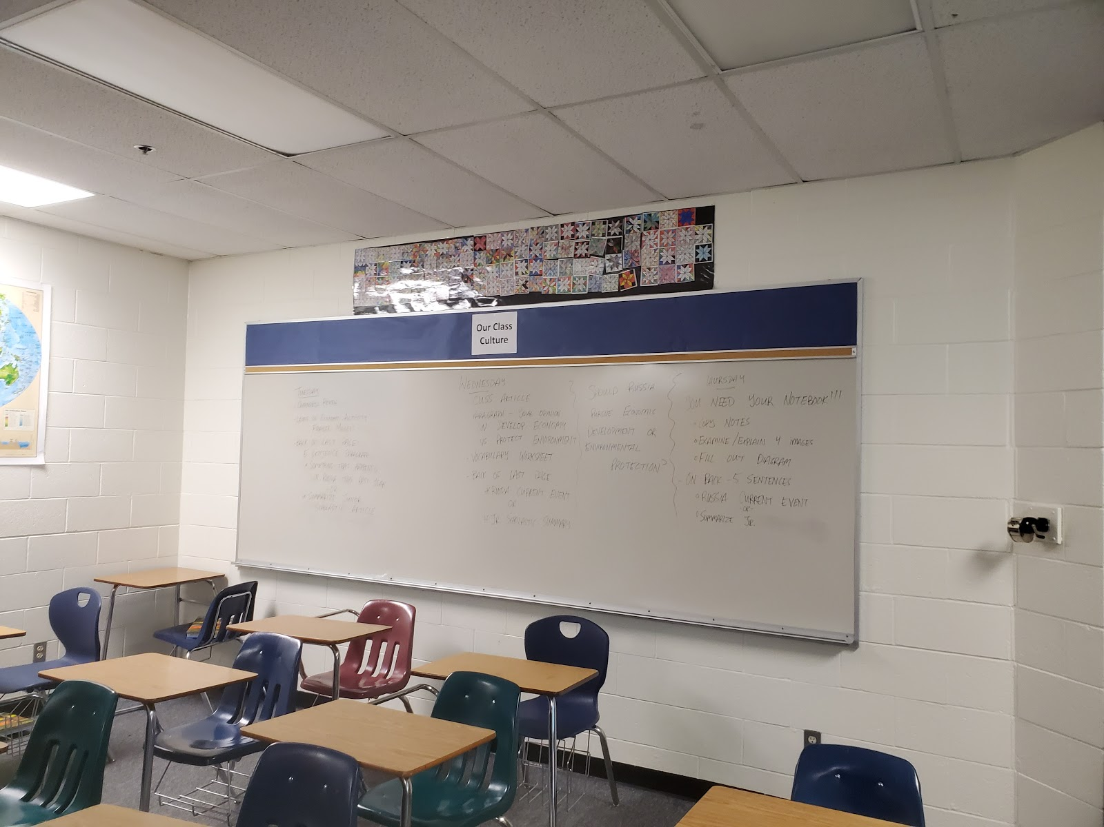
Note: Student-decorated “quilt” pieces are displayed on the wall of Connor’s room.
On a subsequent visit, instead of assignments on the board under the Class Culture Quilt, there was a poem left by a student (See Figure 11). I was curious as to whether this was a reference to a song or other poem, so I did an internet search to see if anything similar came up. Nothing that matched this particular order or wordsmithing, so I deemed it an original musing by one of his students.

Figure 11
Whiteboard Student Musings
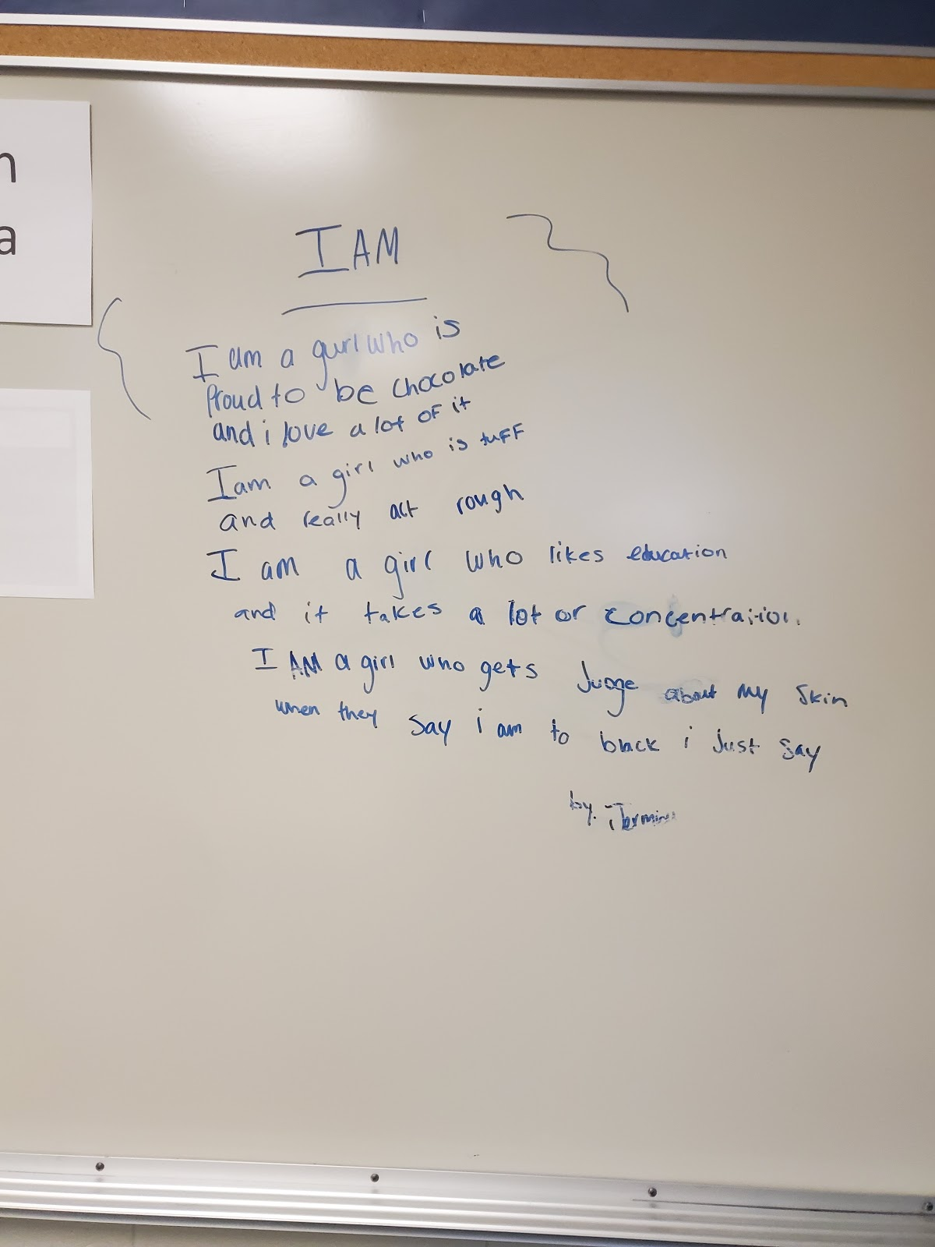

I AM
I am a gurl who is
Proud to be chocolate
and i love a lot of it
I am a girl who is tuff
and really act rough
I am a girl who likes education
and it takes a lot of concentration
I am a girl who gets judge about my skin
When they say i am to black i just say
By ---------
The musing left on the whiteboard is entertaining and insightful. The fact that the student felt comfortable leaving it on Connor’s whiteboard is also insightful to his openness to student freedom of expression and his value of individuality ((Brown-Jeffy & Cooper, 2011; Gonzalez, et al., 2006; Ladson- Billings, 1995). It may be worth noting that she didn't end the poem with two words that could have rhymed, but perhaps that is the point; you say them in your head anyway. Perhaps she was keeping it PG for classroom purposes, or she just wanted the reader to do some of the work. The other notable thing about this photo opportunity to me is that Connor did not feel obligated to erase this expression before the “lady from OU” (that is what the students called me) came to observe him. I hope that speaks to the relationship we built because I was certainly glad I was able to see it, but it is probably more accurate to say that he was simply proud of the student’s creativity.
To provide a further understanding of the way Connor promotes social-emotional well-being and positive relationships, he described a strategy he used to start class regularly.
I also allow good news to be shared almost every day. It takes up a whole 10 minutes of my class. Which, in the whole grand scheme of things we have an hour. So, it really doesn't kill a lot of class time and then whenever we're ready to go the kids are ready to go. They had some talking, then they sit down and are ready to work. They feel more comfortable with me, they feel more comfortable talking in front of their classmates. And so, I think it kind of builds that community and it allows students to one, share from different backgrounds, share what they've got going on at home, share about their families, share about their friends and what they're concerned about. I tend to think it helps. Whether it does or not. I'll never know because I'll always stand behind that.
This is where the environment and the relationships that support it are, again, hard to parse out. The relationships and the community he develops within his classroom support an environment of belonging and care (Bickmore, 2008; Gay, 2014; Greene, 1995; Noddings, 2013). As evidenced by these quotes, it also provides the building blocks, the mental prime, for the type of instruction that yields deep discussion, critical considerations, and respect for the differences and experiences of others, including their home life and culture (Brown-Jeffy & Cooper, 2011; Gonzalez, et al., 2006; Ladson- Billings, 1995). The impact of this environment on instruction will be discussed more in the instructional approach section.
Finally, since the purpose of a case study is to provide rich, thick descriptions that result in a holistic account of a phenomenon (Merriam 2009), it may be worthwhile to provide further illumination to Connor’s personality in his classroom. In his class on the whiteboard by his desk, there is a playful unicorn headband and a professional wrestling-inspired championship belt (See Figure 12). When I inquired about these items, he said the belt was a competition between himself and the other 7th-grade social studies teacher each year; students vote for the “best teacher” and that person gets to wear the belt and keep it in the classroom the next year. He said the unicorn headband was “just for fun”.

Figure 12
Connor’s Championship Belt for Best Teacher
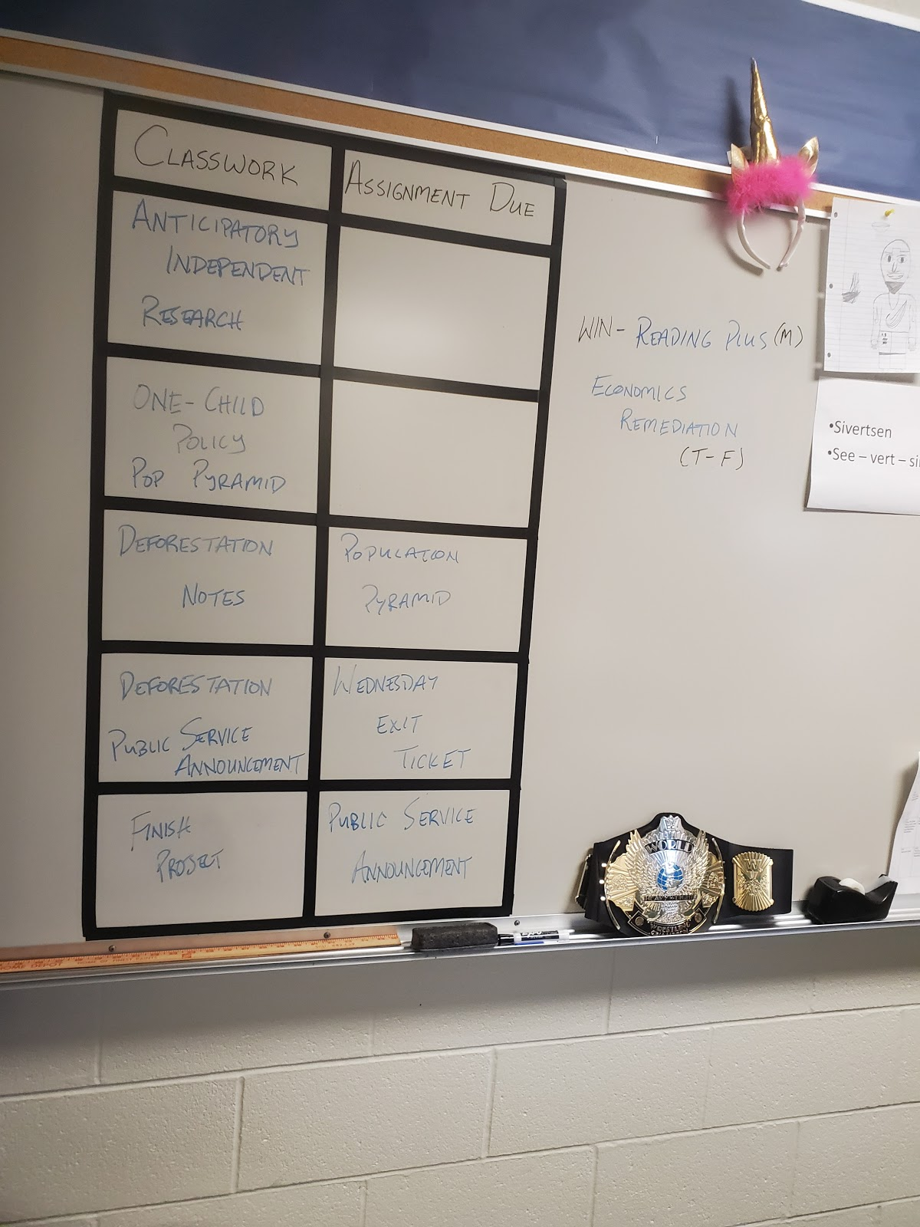
Note: The belt is won, the headband is for fun.

Instruction in Connor’s Class
Based on my classroom observations, Connor is a young teacher with a lot of energy. The activities and instruction I observed were thoroughly prepared and organized. On the first day I observed his class, even though we had confirmed via email, he said he wasn't prepared with a lesson he thought would be worth observing. I asked if it would be okay if I stayed anyway and he agreed. We went back down to his room and Figure 13 was on his projector.
Figure 13
Debate Day Instructions
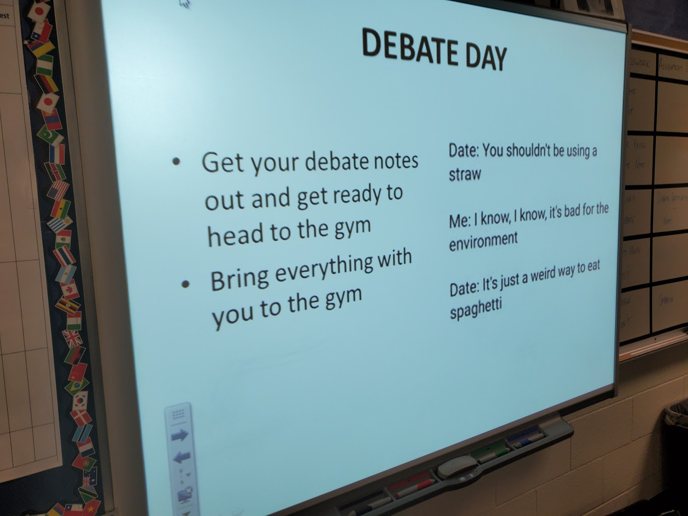
Note: Students are reminded about the days’ activities both verbally and visually. There is also an insight into Connor’s jovial personality.

Not only were his students about to embark upon a lively experience that challenged their critical thinking skills, speaking, and listening skills, and had them engaged in thoughtful research, they were going to the gym to do it AND they were participating with students from another geography class. I wanted to balk at his suggestion that he wasn't doing something meaningful, but I caught myself.
For this assignment, students had been researching a topic of interest from a list both teachers created based on state standards such as the economic impact of government policies on the environment concerning topics such as logging or nuclear power. They then were divided into “for” and “against'' those policies (their choice) and participated in a scaffolded debate with the other class. Students from both classes would read a short claim and the research they had found to back it up.
His approach encompassed more than just promoting academic aptitude. One student was reluctant to approach the podium, so he allowed her to take her friend. Another reluctant student asked if he (Connor) would accompany him, and he did so without hesitation. When we discussed this in the follow-up interview, he mentioned that, yes, the assignment was about allowing students to speak and listen and to build their confidence doing so, but he didn't want any of them to miss out on the content that they had worked on so hard to research and make meaning of (Cochran-Smith 2004; King, et al., 2009; Saye, 2013).
He was also constantly monitoring student engagement by being up in the bleachers, down on the floor, always within earshot of both spaces. When a few young ladies began to distract the other students in the stands by being loud and disparaging toward the activity, instead of admonishing them, he simply strolled over and started talking to them about something he heard them talking about before. It seemed almost effortless the way he was able to bring their focus back to the assignment and keep the class from completely derailing. Recognizing and treating students with respect and dignity is a behavior management practice correlated with an environment conducive to social justice (Woodrow, 2018). In another instance, an interaction with a disgruntled student included the phrase, “I can see what you’re saying,” acknowledging the students' concern, and trying to come together to determine the solution. Listening to students and acknowledging their ability to make decisions that concern them is also an appropriate way to support social justice in classrooms, and for pursuits in life beyond the classroom (Ginwright & James, 2002).
Debate Day exemplifies Conner’s instructional approach in general. In his interview, he defined social justice as “treating everyone equally, and that efforts are pulled together to ensure that happens”. He also categorized the pursuit of social justice as “action-oriented” and “dynamic” This is an important aspect of self-reflection and the pursuit of growth, which will be discussed more in the section on unfinishedness.
At the first interview, I asked Connor how his instructional approach is impacted by what his students bring to class (Appendix B). He stated that,
“I have to be really thoughtful about the way I approach things because I have to understand that due to the different backgrounds of my students, they're gonna respond in very, very polarizing ways to the different topics that I put in front of them”.
This is similar to the approach in Adam’s class in which he doesn’t condone all speech or all opinions. During Debate Day I watched this careful planning transpire into an effective and positive interaction. Students had a choice when it came to their topic and stance, but also had to do research and substantiate their claim. Every student was given an opportunity to speak and present their findings and justification, but no students were allowed to interrupt, be disrespectful or make disparaging remarks about their classmates.
The next time I visited Connors class students were working on a Public Service Announcement (PSA) project to demonstrate their understanding of deforestation in SE Asia (Appendix J). The nature of the content is not a social justice topic per se, but it does have to do with redistribution and its impact on marginalized groups (Fraser, 2018). In this instance, the aspects of social justice demonstrated in this assignment aligned with Bell’s assertion that social justice is both a goal and a process (Bell, 2016). Students had a choice about their product (iMovie or poster), a choice about their included reasoning and information, and had to consider a possible solution to a real problem (Cochran- Smith, 2004; Dover, et al., 2016; Katsarou, et al., 2010; Ladson-Billings, 2014). Also, the very nature of a Public Service Announcement, an announcement made for the public good, is a service-oriented project. There are a number of ways Connor could have approached this lesson, but the one he chose gave students an opportunity to dabble in action-oriented civics, at a level appropriate for 7th grade.
The last time I visited Connor’s class the assignment was for students to create a political cartoon. They were given the topic but were not steered in a particular direction for their claim. They had done this type of activity before, so they knew they had to have evidence and an explanation for their stance and were reminded of this by the instructions on the slide (see Figure 14). The content for this assignment was China’s One-Child Policy. Though I didn't get to observe the students presenting their cartoons, there was probably a certain level of controversy surrounding this topic, or at least it can be discussed as a once-controversial topic. Based on Connor’s interview responses and the other classes I observed, it is likely he embraced the discussions with scaffolded questioning and allowed students to grapple with the different ideas surrounding this content. Classroom practices such as debates and discussion offer students meaningful experiences and are excellent ways to engage students and practice democratic discourse (Gibson, 2020; Hess & McAvoy, 2014).

Figure 14
Political Cartoon Assignment
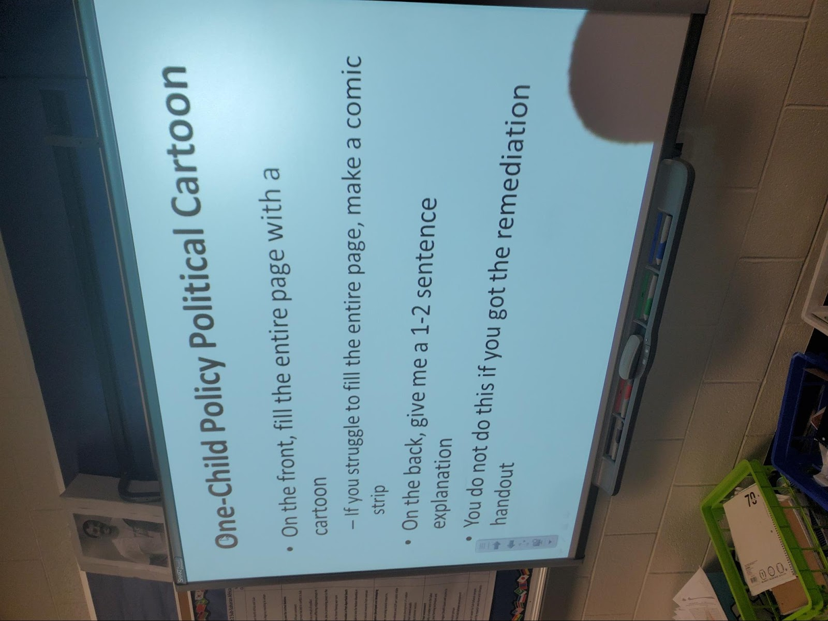
Note: A visual reminder of the instructions for the One-Child Policy Political Cartoon assignment.

Service and Involvement-:The Action in Civic Engagement
As I consider examples regarding a teacher’s involvement for the purpose of a greater good for Connor, three avenues come to mind: his dedication to the well-being of his students, the opportunities he takes to be involved and learn for himself, and how he shares that learning with others.
I believe it has been demonstrated that Connor is dedicated to the well-being and socioemotional needs of his students. Most days and many assignments start and end with an aspect of connection, interaction, or demonstration of care. At the end of one class, the bell rang, and Connor shouted, “I love you! Go Away!” The students laughed and high-fived him out the door. Connor creates a welcoming and inclusive learning environment and balances the emotional needs of his students with the instructional expectations of the content (Adams, 2016, Woodrow, 2018). This is an important environment to create, not just as a means to an end of social justice, but an end in and of itself. He described his outlook toward service to students and civic engagement this way:
We have a responsibility. To just be present and be... Just to give everything, every day in the classroom. And in preparation for what goes on here for our students. We are giving them the building blocks to be successful. It kind of comes with the job. So being more than just what goes on right here.
His service to society and civic engagement includes personal action, and “being more” refers to his involvement in local and state policy, especially involving public education. For many years he has been a State Capitol Liaison and Oklahoma Education Association state representative. He also brings his experiences back to his colleagues and his students. “I lobbied at the capital with permission of the district, and it turns into conversations with my students of, okay, here's who I'm going to be talking to, and here’s why I want to talk to them.” This behavior demonstrates what Apple (2009) might refer to as a scholar/activist; someone who through their own life actions shows what it means to be a committed member of society. Keiser (2013), states that “those committed to social justice must defend public schools and public-school teachers” (p. 53). Connor is engaged in civic action, and he models this behavior to his students. It is hopeful that by engaging students with his own experiences and classroom experiences like Debate Day and other assignments, he will inspire students the way he was inspired by his own social studies teacher. The other promising aspect of both of these situations is that research shows that classroom practices that offer students meaningful deliberative experiences around issues have been found to influence their political and civic engagement into early adulthood, regardless of the demographics of the school (Hess & McAvoy, 2014).
Another indicator of Connor’s service and action is his dedication to the field of social studies education. He has been active in the Oklahoma Alliance for Geographic Education (OKAGE) and has participated in training to become a teacher consultant. He also designs and facilitates professional development sessions at his site and the district level about social studies content, student engagement, and technology integration. This aspect of his service and action not only increases the knowledge and skills of his colleagues but also allows him an opportunity to reflect and improve his own practice.

Risk and the Importance of Support
In this study, risk is defined as taking chances or stances that may have consequences with peers and/or administrators. Like Adam, Connor relayed that there was risk when teaching with social justice in mind. And like Adam, these were risks he was willing to take and defend.
I feel like I have had instances like that where allowing students to have a voice maybe has burnt me a little bit, but in the grand scheme of things, I would rather give them a voice, allow them to have these conversations, and kind of run that risk rather than just trying to silence students when they're trying to have these conversations. Especially in such a critical time where they're just gaining ground on critical thinking skills and forming their own opinions and determining who they are. They need to hash some of the stuff out...Especially when most of these conversations, even amongst adults it seems like, are had behind a computer screen. They need to learn to have these conversations face-to-face with people who are going to say something back right away, right? And so, I'm willing to take that risk if it's even considered a rift.”
This echoes the aforementioned discussion regarding controversy in the social studies classroom. If the goal of social studies education is citizenship (Au, 2009; Banks, 2004; Lo, 2017; Rodriguez, 2018; NCSS, 2013; Parker, 2010; Stanley, 2003; Westheimer & Kahne, 2004), conversations that include controversy can enhance democratic thinking, are reflective of the circumstance of the real world, and can help to teach young people to effectively deal with situations they will ultimately encounter (Hess 2004; Hess & McAvoy, 2014). Having a safe space and a caring adult to scaffold this situation allows students to ease into this skill, and build confidence (Gibson, 2020). Both important tools for any citizen to have to recognize injustice and speak truth to power.
When asked about administrative support for his pursuits, he replied, “I’m supported 100 percent in everything I do. I've really never felt as if I'm not supported by my administration.” There is evidence of this in some regards because of his status as a veteran teacher at his school, his position as a go-to for professional development, and his teacher leadership roles such as department chair. Leadership turnover is such that he has already had at least two different head principals in his four years there. This puts him in a position of longevity and continuity that constitutes exceptionality and possibly deference. There may be other reasons that he answered so quickly and in such affirmation, but they are not mine to assume.

Unfinishedness and the Role of Collegiality
Learning and teaching are reciprocal pursuits, and teachers, particularly in the content of social studies, must be committed to the constant of change. As approaches and understandings are refined, many teachers seek to share their ideas with others in an effort to reflect and grow.
In the case of Debate Day, this is not a new activity for Connor or his colleague that teaches the other 7th-grade Geography class (the one that he competes with for the Championship Belt). He and his colleague have been refining it for quite some time, learning what works well and listening to the feedback of students (Ginwright & James, 2002). This aligns with the community of practice theory because it offers an example in which to understand urban secondary social studies teachers as they endeavor to both seek and offer each other support. As they continue to learn, face obstacles and challenges, better their practice and “help each other through this process of awareness to become agents of social change” (Darling- Hammond, 2002, p. 6), they form informal associations that, over time, reflect shared experiences and goals. He stated that he definitely has plans to do Debate Day again but is always revising the approach to better the students’ experience and outcomes. As explained in the previous section about service, Connor is also looked to at the building and district level to design and facilitate social studies professional development, and he is always willing to try an idea that could help his students and to share both successes and challenges with his colleagues.
When I asked him about the ways he shares and communicates ideas and practices with other teachers, he discussed a similar phenomenon to Adam’s. The more you want to do, the less people there are that share that level of commitment.
Even though I haven't been teaching long I've already realized the people who are really involved, that want to reach out and want to do more and more, and want to have their voice heard... It's really a small community.
He also discussed his personal pursuits to continue to foster social justice practices as part of his teaching. He discussed the obstacle of state assessments being the indicator of his effectiveness, but that he was determined to continue to,
take our content and make it relevant, you know for a seventh grader, that lives in Oklahoma City that goes to Bridges Middle School. How can I make this something that matters to them? Because I think if I'm doing that with my content I'm hitting social justice all the time. So, I think I do a good job of it currently, but the huge challenge of making Eastern Hemisphere content relevant to a 7th grader here in Oklahoma City. I could continue to grow in that.

Leonard
Teaching is a second career for Leonard who is in his second year of teaching middle school. Previously, he served in the military which influenced much of his beliefs and practices. He is traditionally certified with a bachelor’s degree in education. At the time of the study, he was teaching 6th-grade Geography.

Leonard’s Story
Leonard was born and went to school in Charleston, South Carolina. He said he didn't move around until he joined the military as a young person. When asked about why he decided to teach in an urban school, he said he never pictured teaching anywhere else. He relayed the personal importance of his experience attending an all-black high school, “where all my teachers looked like me. You know, the administrators looked like me, so all the people who I looked up to, like teachers, looked like me.” He described his elementary and middle school experience as being very different from high school experience because those schools were “mixed” and “rural”, but his high school was “the only inner-city school in Charleston at the time.” Like the other participants, he has a deep-seated interest and passion for social studies. He is a self-described history buff.

I always was a history buff. I love history. It was always like one of the things that I liked. I watched documentaries, historical documentaries, when I was younger, just because it was fun to watch. Yeah, learning new stuff about different people.
This was much to the chagrin of his siblings, who picked on him and called him a “geek”. “It was extremely hard. Because my youngest brother is six foot two, something. My older brother was six foot one, something. And I was five-five, 140 pounds wet.”
As stated earlier, teaching is a second career for Leonard. Participant-wise, he is the oldest teacher in age, but the newest to teaching. It is evident that the experiences he had in his military career influence his perspective and approach. As illustrated by the quote below, he describes that his classroom environment, and many of his classroom assignments, stem from this experience and the idea that students need opportunities to work, empathize, and interact with each other.
Letting them understand that you're not always going to like the person that's across from you. I learned that in the army, like, you might not like that person that's across from you, but that person might save your life. Or you might have to save their life. I know it's not that extreme but it's a lesson that kind of teaches a little bit of humility and tolerance for the next person because you don't know what that person is going through or whatnot. I think the biggest thing is teaching them how to work with each other regardless of what their personal feelings are. And I think that's the biggest lesson that schools should teach, cooperation in a sense.
It was noteworthy to me that none of my participants talked about the purpose of education is to get a good job or to be economically secure. Leonard discussed the importance of education not to just teach, but to make a difference. The idea that in education is it just as important to learn to get along with others, how to treat people, and feel a sense of ability and responsibility to remake our own worlds (Greene, 1995; Noddings, 2013).
To Leonard social justice is, “equality, you know, treating everybody the same. Being across the board just a level player.” He described how this belief influences his disposition and interactions with students.
For me, it's like you might have a kid that comes to you... (pauses) with a reputation. And so, you shouldn't judge that kid because of that reputation. You should judge that kid from the interaction that you have with them. But to me, the whole idea is to kind of destroy that precedent. So that kid might not be the person everybody said he is. That's my belief about social justice. It’s kind of like giving that kid a chance to prove them wrong in a sense. Maybe, I don't have that problem with that kid because I sat down and talked to him and listened. And I think that's what kind of resonates with all my classes. There are misunderstood students. There are students that don't want to” do”. There are students that don't know how to “do”. But they're not bad students and to me, it's our goal to kind of show them. I tell them they're a good student. Because to me, there's no such thing as bad students. Then there are little, small victories, where you know they turn their papers in late, but it's not late to me, it’s on time. So... giving them a second chance to get their grades up.
Having high expectations, believing in the capacity of all students to learn, and that all students are deserving of multiple opportunities to learn, are critical elements of supporting student success, especially in diverse, urban classrooms where these approaches are often lacking (Delpit, 2012; Kincheloe, 2010). Part of healthy adolescent development is providing opportunities for students to be decision-makers, and that includes listening to their concerns and letting them see the impact their decisions make (Ginwright & James, 2002). Leonard’s approach yields results, as the students he works with show themselves to be the “good” students he always believed them to be.

Environment: The Physical Space of Leonard’s Classroom
The physical classroom environment such as seating arrangements, posters, or decor, all influence the surroundings and can impact instruction. The environment can also include the relationships and the culture of the classroom that can hinder or promote learning. Much like the other participants, the environment is paramount to Leonard. For his classroom, it starts with the actual physical surroundings and setup. Students sit in groups at tables and are allowed to talk freely and help each other. His classroom is decorated with flags from different nations, and five clocks that show what time it is in different locations around the world. The setup is very clever because he uses the school clock as the one that displays Central Standard Time and clocks in other colors to show the times in other locations, including the United States and around the world (See Figure 15).

Figure 15

Leonard’s Wall Clocks and Flags
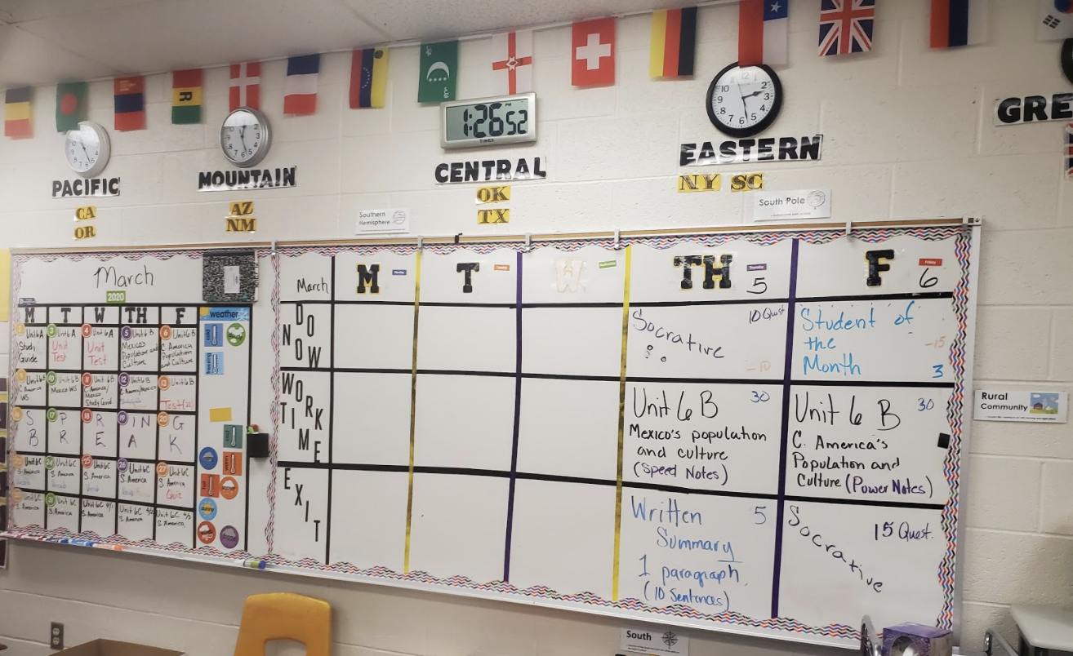
Note: Time Zones around the world displayed using the school clock to reflect local time.

He has an enormous mural of the continents on the wall that shows the topographic layout of the earth, instead of its political borders. This gives students a view of the world that is more holistic, instead of divided by national boundaries. He achieved this by laying strips of wallpaper (that he purchased and hung up himself) in meticulous fashion so that they line up exactly right. On other walls, he has vocabulary words in English and Spanish and a drawstring bag for each class that houses small rewards for students, such as stickers, candy, or pencils, for special outside of school occasions like birthdays or other milestones, or in school achievements, like the student of the month, or honor roll (see Figure 16). All these elements demonstrate the thoughtfulness, effort, and care that he invests in making the environment a welcoming space for students (Brown-Jeffy & Cooper 2011; Gay, 2014; Woodrow, 2018).
Figure 16
Leonard’s Wall Map and Reward Bags
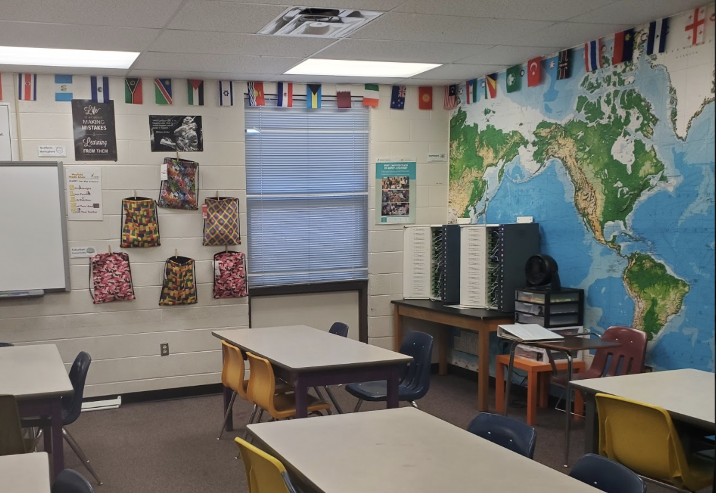

Environment - Promoting Classroom Culture
Shifting to the culture and the climate of the class, one of the first “assignments” students have is a self-assessment of their learning preferences. The name of the instrument he uses is the Connell Multiple Intelligence Questionnaire for Children (Appendix K), and Leonard said the students are often surprised that they are being asked about themselves and what they like. He uses these responses to come up with different “themes'' for classes based on their responses and overarching threads, such as music, technology, kinesthetic, or writing activities. He then describes that the “theme teaches me how to teach them” and what kind of lesson approaches might work best with that class, but he varies these approaches throughout the year. He also uses it as a way to introduce them to the types of projects they can choose to do throughout the year (digital, drawings, writings, or models). Stating that options are important, he said, “I always give them options because life is about options”, and he feels it is valuable to model this in his classroom.
Leonard wants to be thought of as “approachable”, and he thinks he’s doing ok because many students come to him about schoolwork, other teachers, or personal and home life issues. Leonard has been transparent with students about his own struggles in life such as suffering from Post-Traumatic Stress Disorder (PTSD) at one point and being arrested for a bar fight in his early twenties. The judge suspended the charge because he was going into the military, and he said, “I got lucky. So, I tell them, from that point on I was a... I wouldn't say a model citizen, (laughs), but I was a well-behaved person from that point.” He also shares how he has dealt with those things, such as therapy, talking to friends and people that have also struggled, and working out. He tells students that trauma “doesn’t define who they are or what they are going to be.” Sharing struggles with students so that they do not feel alone in their own struggles can also be a powerful way to build solidarity, comradery, and trust (Woodrow, 2018). When I was in his classroom after school interviewing him a 7th-grade student that he taught last year came by to say hello. He chatted with her for a while and asked how she was doing. After she left he said that many students do that, even though at first many think he is “mean” because he has such high expectations and is very straightforward with students. He works collaboratively with students to set rules and “standards” at the beginning of the year together and when someone is faltering, he addresses it head-on.
You have to give them the truth. You can't sugarcoat it. You can't say, Johnny, you know, your behavior is not, this or that, no, your behavior is messed up. You're not behaving to the standard that we have decided we were going to behave in class. But you know setting guidelines, setting expectations, setting up what all that stuff is and when they don't meet it, you have to tell them. I'm not nice about it, but I am tactful about it (laughs). I'm very like, okay... you’re messing up, you're not doing what you're supposed to be doing.
This further demonstrates the aforementioned description about Leonard regarding his approach as a “warm demander” and having high expectations for his students (Delpit, 2012; Kincheloe, 2010). The students I saw in his class seemed very comfortable with him, and their interactions and exchanges exhibited good rapport and relationships.
One additional aspect of the classroom environment was the display of student work (See Figure 17). As evidenced by the art behind and all around his desk, students give him things they have created as “gifts” and he proudly displays them. He said it all started when one student gave him something and he asked them if he could put it up. He said they seemed surprised but agreed excitedly. After that, he told me, many other students asked if he would display their work too, which he said he is happy to do.
Figure 17
Displayed Student Artwork

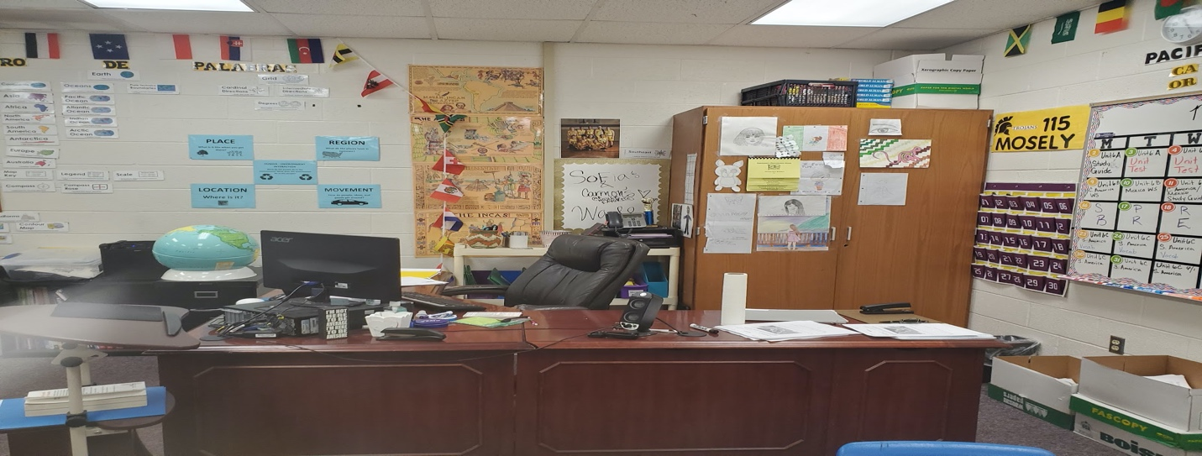
Note: Leonard’s cabinet features artwork gifted to him by students.

Instruction in Leonard’s Class
To reiterate, the separation of environment and instruction can sometimes be difficult. Is setting the stage for an assignment an aspect of the environment, or is it part of instruction? Is the investment creating class-developed norms an aspect of the environment, or is that part of the instruction for an assignment? Some of the examples in this section weave in and out of these two aspects, but since they were directly tied to instruction and pedagogical practices, I decided to explain them as related to instruction.
During my first observation, Leonard introduced me to the class, told them I was only there to watch him, and not to worry, I wouldn’t be watching or reporting anything that they were doing. That seemed to set them at ease. Then he said to me, loudly enough for them to hear, but not too obviously, that “this is a high-level class”. I saw many of them sit up and beam with pride that their teacher would think so highly of them and would make sure that the observer knew that fact about them. This was exactly the kind of thing he talked about in his interview, that “it's our goal (teachers) to show them (that they are good students). I tell them they're a good student.” He believed that about them and wanted them to believe it too. It was important for him to build them up, to communicate to them their strengths and his high expectations, valuable and worthwhile behavior to support their efforts and achievement (Kincheloe, 2010; Yosso, 2005).
On both instances of visiting Leonard’s class, students were taking notes, but it was a different approach than I’d seen before. He termed this “speed notes'' and there were marked differences between this technique and traditional transcription.
After bell work but before the lesson, a “rules” slide was shown. I found out later that these rules were developed together with students. These co-designed rules were concerning the speed notes process and outlined things such as the timing of the slides, how to earn more time, and that students would ask questions and answer questions to the best of their ability. Before he began the notes each time, he asked if everybody agreed to the rules. Most verbally agreed, and they started on their notes.
Every slide had a visual that was animated or striking. Almost all slides had both English and Spanish text, which, as an avenue of cultural pluralism, or cultural sustainability, is advantageous for both native Spanish speakers and English-speaking students (Moje, 2007; Paris, 2016). As evidenced by Figure 18, he provides text in dual languages, and the font of each is almost always the same size, instead of the Spanish text being relegated to a footnote or afterthought status. This is an example of equality in a visual way and is also demonstrated in the handwritten assignments he creates for students (Figure 19).

Figure 18
Leonard’s Power Point Slides Featuring Equality of Language
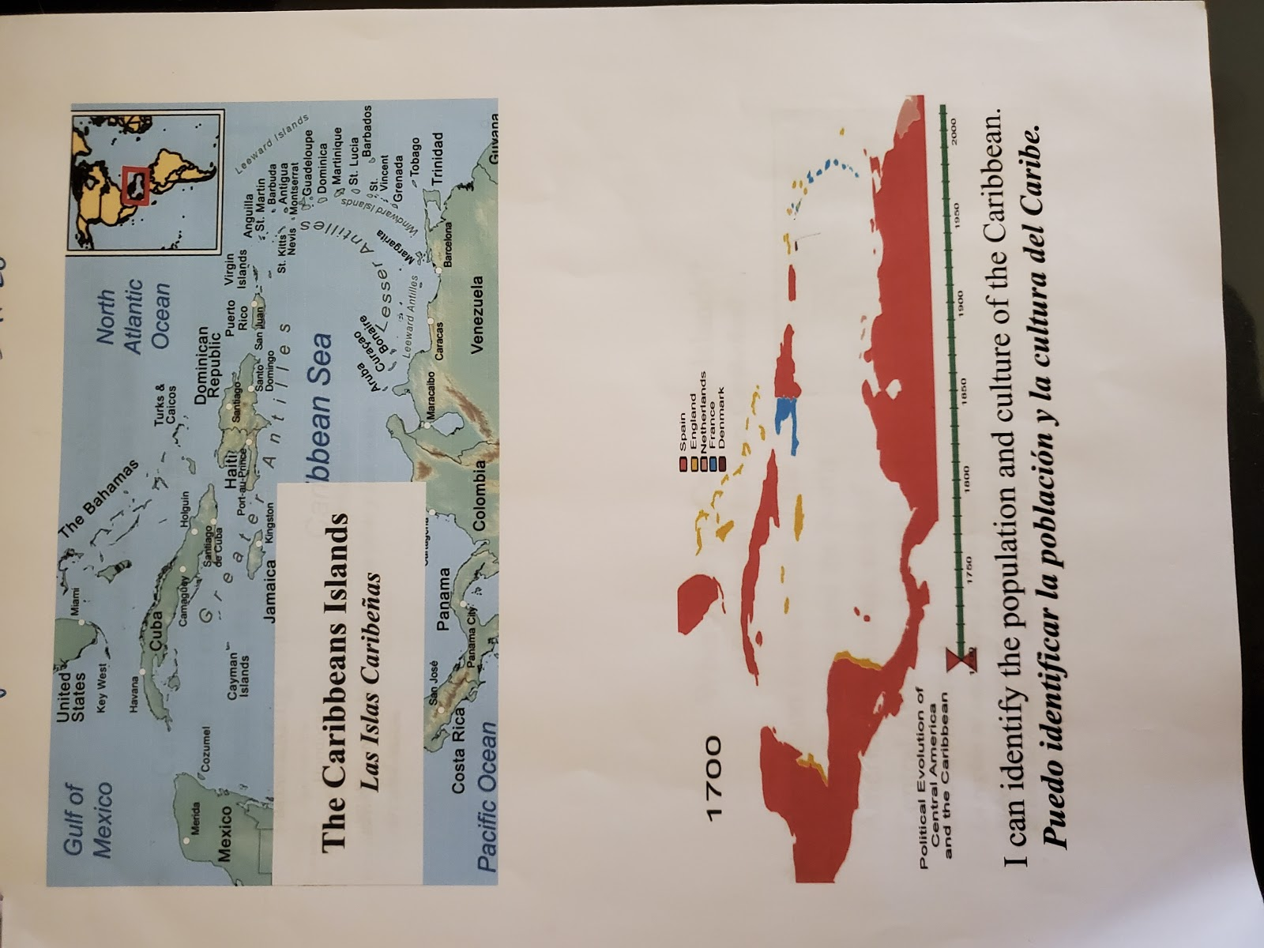
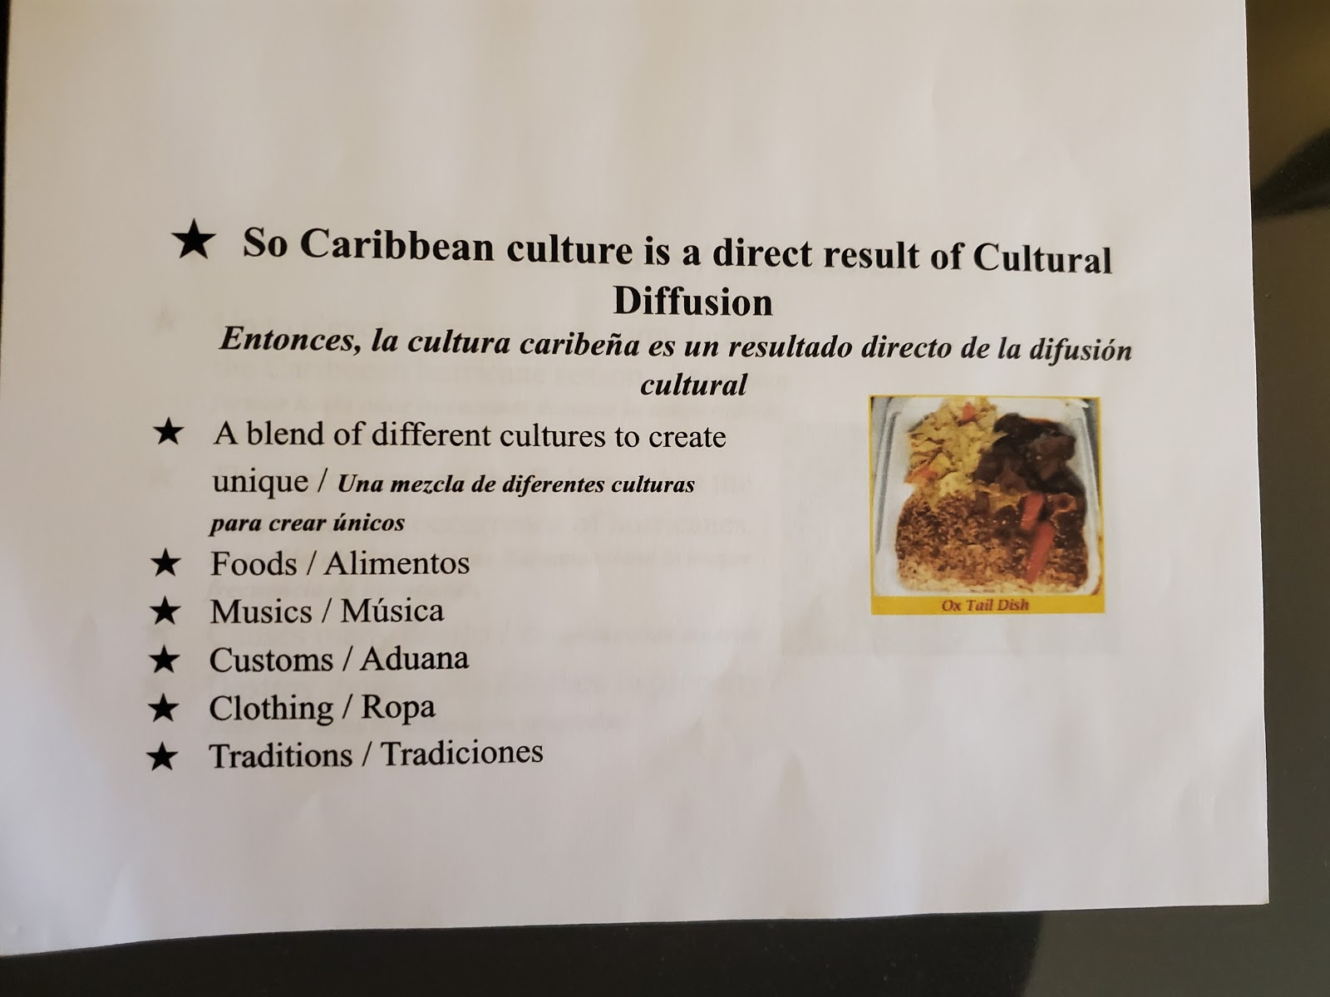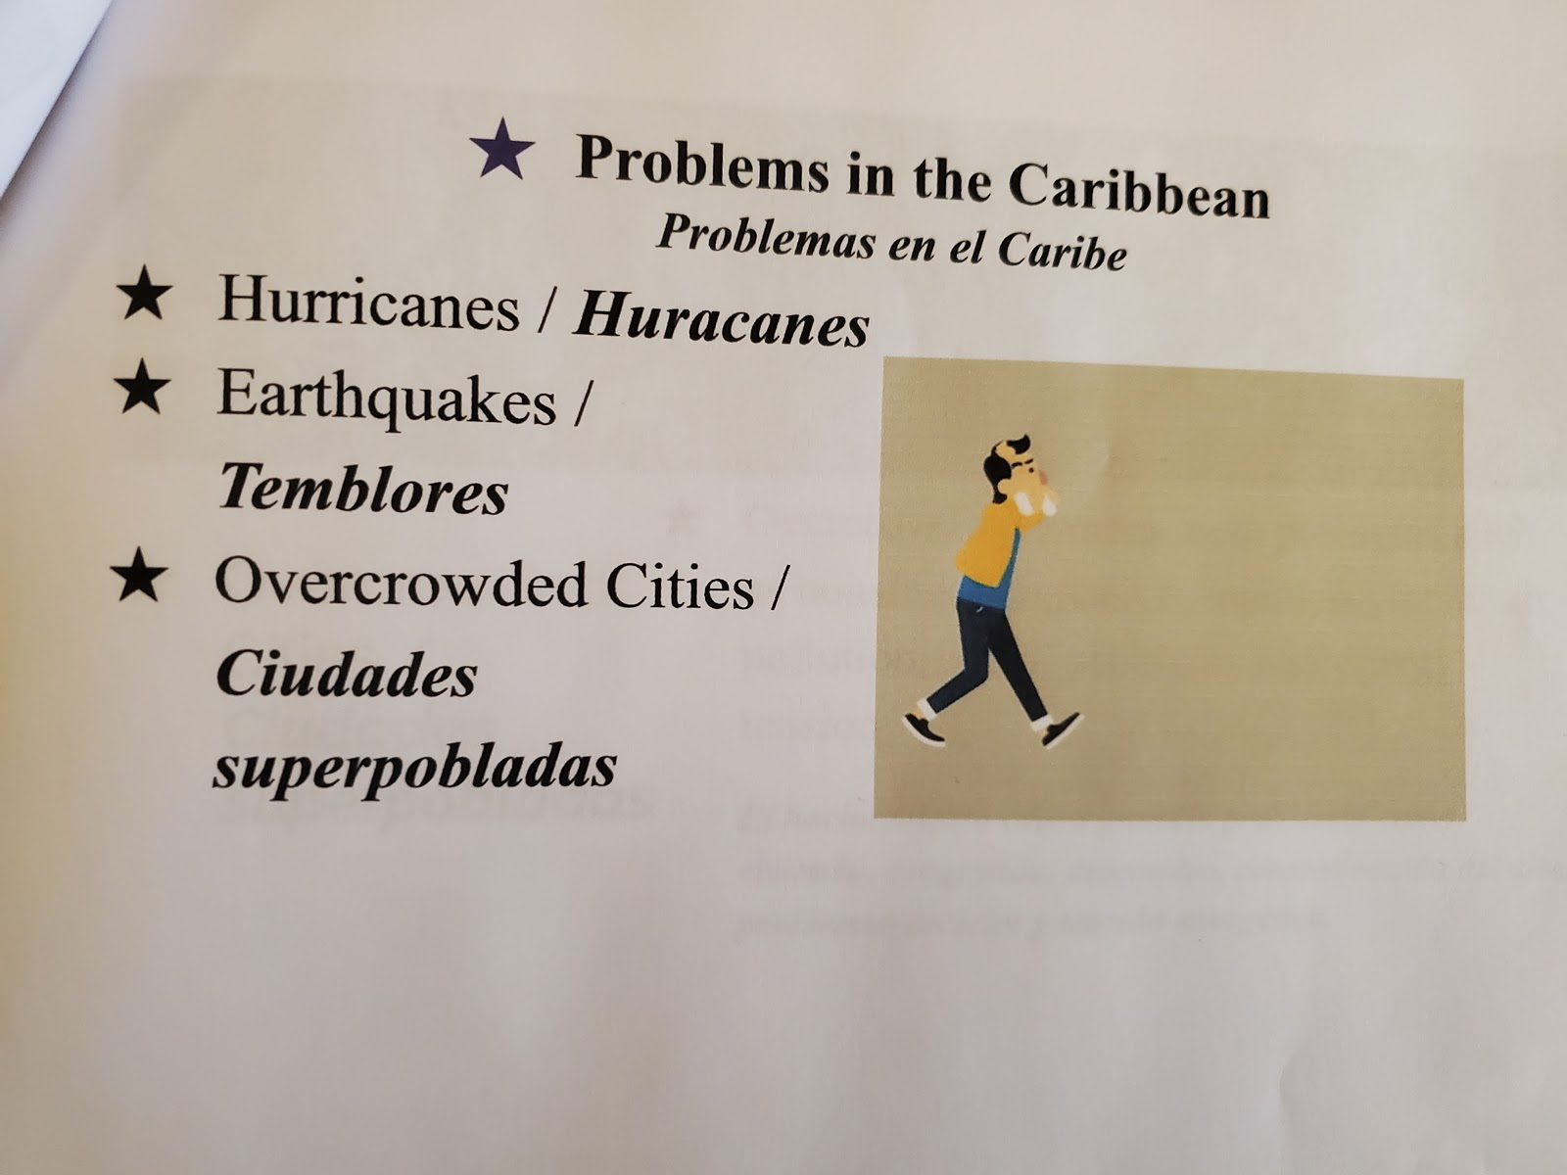

Figure 19
Example of Leonard’s Handwritten Assignments
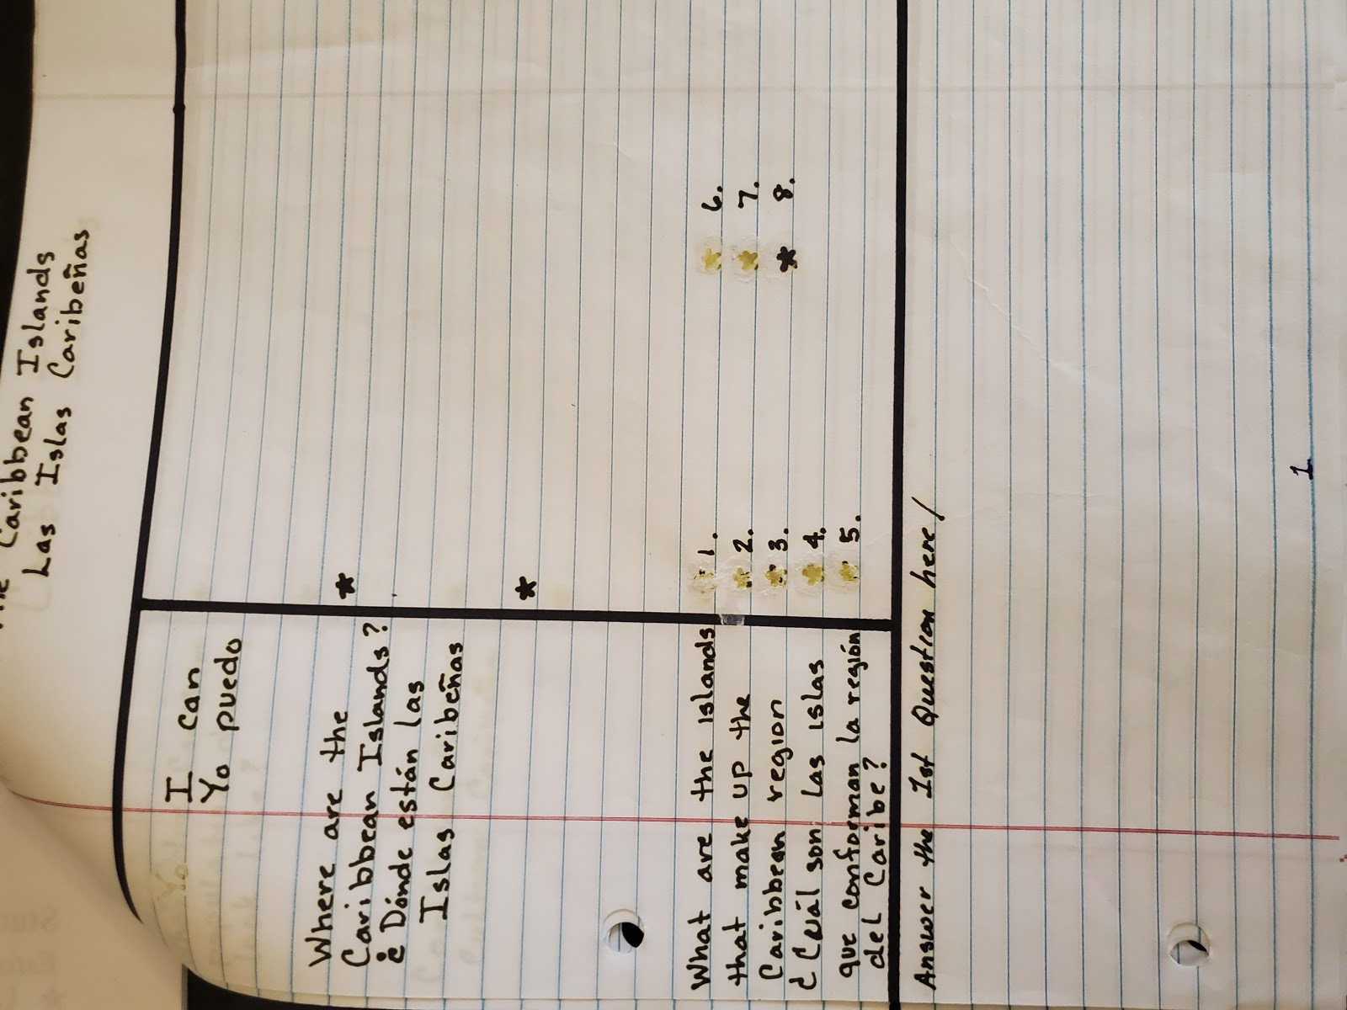
Note: Assignment sheets Leonard makes for students to make their notes and drawings on.

The class was in charge of the pace of the slides and could “earn” extra time if someone could answer a question about a previous slide or some other previously provided material. In the class sessions I observed, every time the students asked for more time, he would pose a question and different students would answer. He was always very encouraging about their answers, and students seemed to have pride and community in this shared endeavor/shared control of the environment and the instructional approach. Anytime anyone was stuck they were encouraged to “phone a friend” and work together to come up with the best answer. One instance occurred in which he switched the slides too fast. Vehement protests about the first rule being broken rang out across the room. He was such a good sport. He apologized to them, all in stride, and said, “I stand corrected,” and they all laughed.
The end of semester project his first year was about different real-world problems they had been learning about in their geography class. Students did research and worked together to create a presentation. They used the presentation to teach each other about the problem and the possible solutions. They had some choice in their research, but the aspect that required them to pose solutions was action oriented and inquiry based and is in line with goals related not to just social studies instruction, but also to the role of an active and responsible citizen (Dover, 2009; Misco & Shiveley, 2016) He discussed it in terms of building self-confidence and “liberating for students who didn't think they could do it because many teachers before would just give them the answers.” In the Spring of 2020, the plans for that project fell through because of COVID-19. When I asked about how he would approach that assignment this year, he said he wasn’t even worried about it. That calling students and checking on their well-being was the most important task. “Yeah, so we have assignments, but reaching out to the kids like, to make sure they are doing ok. To provide some kind of assurance, some kind of normalcy” was a more important goal, a philosophy in line with social justice principles regarding the balance of emotional and cognitive components of learning (Adams, 2016).

Service and Involvement: First, Best Instruction
Leonard’s engagement with service and involvement exist mainly to serve students, in the classroom, as well as outside in roles like coaching basketball. For Leonard, teaching itself should be an act of service to students, and for them. He told me,
The purpose of education is to teach but to me, the underlining is to show them how to function in society. I think social studies teaches them...for example, Geography teaches them how they interact with the world and history teaches them their course of action after they interact with the world. I think they both are important for them to learn so that they can interact with the world appropriately. I love teaching because to me...it's like you make a difference. It might not look like it today, but coming in my first year versus my second it’s been like totally... I was... I wouldn't say unsure myself, but I had my doubts. Yeah, but yeah teaching has a great impact and I love doing it.
Student opportunities for interactions with each other, as a scaffold to interactions with the world, is one-way teachers can serve as a bridge in the socialization process, and it empowers students to contribute in an individual and meaningful way (Greene, 1995; Katyal & Evers 2004).
Similarly to Connor, he also relayed the importance of giving students your all, and the high expectations he has for himself, and his commitment to serve his students.
Students shouldn't get okay and alright; they should get great. They shouldn't get the middle of the road. They should get everything. They should get your first, best instruction every time. And that's like even in the middle of the day, at the end of the day when you're tired, the first best instruction. That's why a lot of the classes get different types of instruction (themes) so they can get that first best instruction for them.

Risk and the Importance of Support
In addition to risk being determined by ideas or expectations of outside stakeholders such as peers or administrators, risk can also be considered as taking chances that may have felt uncomfortable internally.
Leonard said he feels supported by the administration in his school, and by his team. His biggest cheerleader and harshest critic was his University Evaluator. He recounts the time she implored him with these words, “at the end of the day if you're not giving them your first, best instruction why are you here? You're here to teach kids so it's about them”.
A risk that reaped big dividends for Leonard was a change in his instructional approach. Whereas Adam’s description of risk was more about content, and Connor’s was more about student voice, Leonard’s risk was more about sharing the role of leading the class. Leonard said his biggest fear “was giving up control”.
I'm a former drill sergeant. So, giving up control was not something I was used to doing and then retiring and then coming to a place where you know, it was okay to give up control. I wasn't comfortable with it until that moment and then I realized that it's... you have to teach them (students) how to use that control effectively.
His most memorable social studies moment was about his own students, and a risk he took with them. He discussed his version of a “flipped” classroom; students do research, prep for presentations, and take turns teaching the class. He explained he was hesitant at first to “flip” the classroom and let students have ownership and control.
And I think the idea was that they would be mimicking me (as the teacher). But then they were keeping themselves accountable and a lot of it was stuff that I was preaching to them all year to do, and they were actually putting it into practice and doing it! After that when the benchmarks (scores) were going up, they were like enthused, and doing the work and they were happy to come to class [my emphasis]. I think that was the most memorable moment for me. The climate went up, the morale... [my emphasis] I thought... I think with this class I started off late. I should have done this earlier with them! I felt I didn't want to give up control. So that was on me instead of them. They were ready for the moment and I was like a parent waiting and not wanting to let their kids leave the house. Yeah, I think that was the most memorable when they actually were engaging each other, you know, academically engaging each other, socially, you know keeping each other on task, keeping each other accountable for the information. It was the last three weeks of school, you know, it was awesome because all I had to do was just come in and just sit!
He relayed that he felt a little guilty telling me that because that’s “not what teachers are supposed to do”. Even though it was successful for both him and his students, this “guilt” is evidence of the high level of inculturation of traditional, teacher-centered practice that many social studies teachers feel is the way they are supposed to teach, or all that they have time for (Au, 2007; Meuwissen, 2017; Reisman, 2015; Saye, et al, 2018).

Unfinishedness and the Role of Collegiality
As an early career teacher, perhaps it should be a given to recognize your own newness to ideas, approaches, and information associated with teaching and especially teaching for social justice. That does not however diminish the importance of self-reflection and growth, and the pursuit of learning as an individual and as part of a team. Leonard is still quite early in his career and though all participants acknowledged their “unfinishedness,” he was still grounded in a sense of becoming confident in himself as a teacher. He was often reflective throughout the interviews about the growth he has experienced, even in his first two years. This is an important positionality to hold as an educator that is committed to social justice, as researchers advocate for reflection is a fundamental practice for teaching for social justice (Freire, 1970; Howard, 2003; Paris, 2016). Leonard reflected on his growth and how he has already changed or modified many of his approaches. One was the example described in the previous section concerning the “flipped” approach he began using, and another approach he started using that year, multilingual slides and visuals on all assignments and activities. When I asked about that in the final interview he said,
That was something different I did this year. It's not only helped them, but it helped me because it introduced me to new words also. And when I tried to pronounce them, they corrected me (laughs) Right? (laughs) Kind of like teaching both ways. I think with that they kind of see the vulnerability and that is okay. And even the English-speaking students, so now we ALL learn a new word, including the teacher!
Teaching for social justice takes skill, confidence, and humility (Grant, 2006). Teachers must know their content, their students, and their community. They must also know their own “unfinishedness” (Freire 1970). Teachers are in a position of authority, and a big risk for many is acknowledging that they don't know everything. This echoes ideas of Freire and reciprocity; that the teacher and student are both teachers and learners.
During our final interview, over Zoom, at the beginning of a global pandemic, he
summed up the philosophy that has served him well over the years, and one we can all aspire to.
When you sew in all the different experiences I’ve had, what I've learned is I'm still growing. That's one of the beautiful things about life in general. Regardless of all your experiences, there are still new ways to approach things.

Chapter 5: Discussion
The purpose of this qualitative case study was to explore and describe the social justice practices of secondary urban social studies teachers. This chapter includes a review of the findings, followed by a discussion and interpretation of the findings related to the literature on social studies instruction, social justice, and social justice education. In addition, I share study limitations and implications for researchers and practitioners. The chapter concludes with areas for future research and a brief summary of the importance of the study.

Review of Findings
Three participants in this study expressed their beliefs and demonstrated social justice teaching practices in many ways. The five major findings that emerged as themes for all participants were the importance of (1) environment, (2) instruction, (3) service, (4) support in the face of risk, and (5) the role of collegiality and unfinishedness. Interwoven in these beliefs and practices were characteristics that supported student outcomes and such as student choice, empowerment, and action, high expectations, the imperative of a relevant curriculum, asset-based instruction and interactions, and the value of developing trust and relationships.

Interpretation of the Findings

The Importance of Environment and Instruction
The teachers in this study demonstrated this ethic of care and support of students’ socioemotional condition, by the opportunities they gave students to bring in their own culture (e.g., Connor’s quilt), have opportunities to make things personal (e.g., Adam’s inclusion of birthdays), and for many of them the use their first language as equal to English (e.g., Leonard’s notes and handwritten assignments). In addition to these consistent classroom approaches, they also embraced a huge pivot of priorities when school was no longer a place to go. All participants prioritized students' mental and emotional health during the COVID-19 shutdown; deciding to make check-ins about how students were faring the most important thing they would do as their teachers. When considering the components that are necessary to social justice teaching approaches, Bell (2016) indicates that attending to the emotional as well as the cognitive is an important aspect of supporting an environment conducive to that goal. The classroom environment including its physical spaces and setup, as well as the mood of the classroom, was of paramount importance. The emphasis on the environment is consistent with what is in the literature regarding theoretical and empirical studies related to social justice, social studies, and secondary urban classrooms (North, 2008; Woodrow, 2018). Building relationships and trust with students to support meaningful instruction is a goal of social justice practices. For my participants, it also serves as a goal in and of itself. Research in diverse classrooms indicates the necessity of teachers to know their students beyond the classroom (Gonzalez, et al., 2006; Yosso, 2005), set high expectations (Kincheloe, 2010), and demonstrate their interest and care in students as individuals (Gay, 2014; Noddings, 2013).
Regarding the physical aspect of classrooms, the teachers in this study provided visual indicators of belonging that featured diverse identities. This was one way they promoted a feeling of welcoming and supported the value of representation, for example, Adam’s display of the Teaching Tolerance poster, and another one that hung on his door (Sadowski, 2017). In social studies specifically, decor and messaging can help to disrupt traditional Eurocentric approaches and can be an inroad into inquiry, examination, and decolonization/perspective as in Adam’s Homeland Security poster (Bickmore, 2008; Fitchett, et al., 2012; Stanley, 2003; VanSledright, 2010). Decor also served as a way to enlighten students on the teacher as a person, their values, and their interests. For example, Connor displayed personal artifacts, and Leonard consistently posted student work around the room. The overall ambiance of each classroom indicated approachability and shared values. Woodrow (2018) discusses this as connections to other’s feelings and experiences, and solidarity in unification, which can be manifested in both spoken and visual interactions.
The importance of instruction also aligns with much theoretical and empirical literature related to social justice, social studies, and secondary urban classrooms. As discussed in the section on environment, the purpose of school is to socialize and grow, but no one would deny it is also about learning skills and acquiring knowledge and understanding. There are still individuals, inside and outside of classrooms, that consider interpretations of history, policy, and ideas that directly reflect a Eurocentric worldview should be respected. Some scholars posit that “omissions are no accident. It is simply not in the interests of people in relatively powerful positions to teach the less powerful how to resist them” (Schutz & Sandy, 2011, p. 15). In the middle, are those that take for granted their privilege and stature or are unaware in a way that makes dominant discourse feel natural or common sense (Bickmore, 2008). At the other end is teaching as a subversive act to those notions. Those that believe that education should seek to actively dismantle Eurocentric dispositions and that it is our job as educators (especially teacher educators of mostly white teacher candidates) to allow, even promote controversy in the classroom (Hess, & McAvoy, 2014). To one end, this allows students to engage in respectful dialogue, and on the other end to bring in perspectives that the white, heteronormative majority might not even consider, or have not been exposed to. This indicates the importance of teachers as gatekeepers of topics and approaches in which to investigate these topics (Thornton, 2005; Parker, 2010; VanSledright. 2010).
In many urban schools students have been marginalized and subjected to teacher-centered instruction (Kincheloe, 2010; Levinson, 2016; Ludlow, et.al., 2008; Milner, 2008; Reisman, 2015; Saye, et al, 2018), and a narrow curriculum (Almarza & Fehn, 1998; Bickmore, 2008; Brown & Au, 2014; Busey & Cruz, 2015; Fitchett, et. al., 2012; Martell & Stevens, 2017; Stanley, 2003, Woodson, 2015). The teachers in this study made an active effort to push back on the prevalent conditions related to teacher-centered instruction, and non-relevant, Eurocentric curriculum. The types of assignments that they created and implemented featured student-voice in classroom discussion, student choice in research and demonstration of knowledge, and real-world application of content. They seldom used prescribed curriculum or textbooks; instead creating their own resources, such as Adam’s MAPS curriculum or allowing students to research and refine their own sources, such as Leonard’s research projects and Connor’s Debate Day. They related this content to students' real-lives, interests, and goals, and because of this often had to refine these lessons each year to make sure they were incorporating timely and relevant information. Lessons and activities of this nature exemplify a dynamic curriculum. They also indicate the effort and work it takes to be constantly reflecting, revising, and considering how best to disrupt the status quo to serve students, other teachers, and the profession.

Service and Civic Engagement
Service is a concept of both social studies instruction and social justice teaching practices. Social studies education is about citizenship in a democracy and social justice is about securing that the principles of democracy are indeed guaranteed for ALL people. Related to this finding was the varied investment teachers demonstrated in both their personal civic engagement and how much the idea of citizenship was included in their curriculum. As introduced in Chapter 2, Westheimer and Kahne (2004) detailed three concepts of the “good” citizen: the personally responsible citizen, the participatory citizen, and the justice-oriented citizen.
For my participants, their level of civic engagement seemed to fall along a continuum related to years of teaching, though there may be no correlation. Leonard supported democratic practices in line with the first concept, the personally responsible citizen. In his classroom, he was working to provide student choice, a welcoming environment, and buy-in. Connor exemplifies the participatory citizen level as he practices civic involvement in his personal life and modeled, discussed, and supported this type of involvement with students. Finally, Adam created assignments and implemented a curriculum that has direct, action-oriented citizenship goals, for example, the MAPS unit and the Generation Citizenship project. These increments may be due as much to individual personality as years teaching, but it became an interesting view regarding the findings related to service.
Teaching that promotes practices associated with social justice, such as diversifying the curriculum, providing choice, or including controversy, can be deemed a personal or professional risk on many levels. Education promoting critically informed citizens, that is, not directly tied to basic literacy or numeracy, is seen by some policymakers as threatening, disposable, or inappropriate (Michelli & Keiser, 2013). The nature of social studies teaching specifically can become a political issue because there are those on the right that consider the aim of social studies instruction as the success and service of the current social order (Parker, 2010). Counter to that notion is the inherent goal of social justice which is to change society for the betterment of more people and disrupt the status quo (Banks, 2004; Stanley, 2010). Social studies teachers that do seek to disrupt this paradigm could feel they are taking a risk, especially if the community in which they teach subscribes to traditional values or fails to see a need for change. Teachers who want to change that traditional, dominant narrative may be viewed as challenging or difficult, or even radical. For many teachers, recognizing the dominance paradigm takes the hard work of self-reflection. For all teachers, a willingness to speak this situation of power to those that hold delusions of America as a democracy, and schools as places of equality, can be uncomfortable, risky, and isolating.

Risk, Unfinishedness, and Isolation
As a result of this study, my interpretation regarding risk is that it ascribes to a continuum of experiences. Research shows that pre-service teachers are very nervous to implement a curriculum they think might make waves (Rubin & Justice, 2013), or that they may not even fully understand. As teachers learn more for and about themselves or more about their students, they may feel this conviction more strongly. It may also be easier for a veteran teacher to balance all the responsibilities of teaching and thus easier for them to navigate the complexities. Teaching is mired in daily struggles that are not only educational but political as well (Beyer & Apple, 1998). It stands to reason that those who have more experience in these daily struggles and the nature of the day-to-day decisions of teaching would more successfully navigate these complexities. Finally, risk and service are more closely related than I initially thought. Because there is an inherent risk in disrupting the status quo, a teacher must be strongly committed to the goals of social justice and to the service of students to that end.
The literature regarding the importance of knowing your own unfinishedness, and the evolution of terms, approaches, even stances, is replete throughout the field of education in general and social studies and social justice specifically. All three teachers expressed the constant of change not only as a practitioner, but specifically in regard to the teaching of social studies content (e.g., changing policy, revised political boundaries, new information or perspectives), and social justice practices.
In addition to the idea of unfinishedness influenced by Freire, is another mindset critical for all teachers; that of reciprocity (1970, 2000). A teacher that considers themself both a teacher and a learner is especially crucial when their background or culture is different from that of their students. This was demonstrated by Leonard when using two languages for notes and assignments. Even when a teacher and student share similar backgrounds and culture, there remain generational divides that pose opportunities for teachers to learn from students, show an interest in new ideas, and create an environment built on trust and the lifelong pursuit of knowledge.
A noticeable difference in the results of this study as compared to existing studies may be the correlation between the number of years teaching and the ability or willingness to practice social justice teaching at levels that may be considered subversive or challenge the status quo. Whereas there has been research on the trepidation of preservice teachers to enact approaches such as debates, controversy, or non-normative perspectives (Rubin & Justice, 2013), I am not aware of any studies that compare the perception of risk in service teachers feel implementing social justice practices. For this study, the longer a participant had been teaching, the more comfortable they felt. This could be related to the trust and relationships they had built in their school, but not always. For example, in the case of Adam, this was his first year teaching at Prairie Ridge HS. Another factor that might explain the level of conviction in the face of risk could be past experiences. Due to these experiences and the reflection upon them, individuals may be further convinced of the importance of social justice; not to just support the goals of social studies, but of humanity and human rights.
Another consideration that I did not encounter in the literature was the isolation social studies teachers can feel when pursuing and promoting what others might see as subversive, as indicated by Adam’s seeking a community outside of his school and district, out of the state, even outside of his content area. The theory of community of practice supports the notion of improvement of skill and increased personal satisfaction by being a part of a like group (Wenger, 1998); research on professional learning communities supports this as well (DuFour & Eaker, 2009). Counter to this could be a feeling of isolation when convictions are not held or supported by a majority of colleagues or even a small group. It is difficult to pursue a change alone. An interesting consideration that came from this study correlated to 21st-century technology. If a teacher is not able to feel like part of a group at their own site, other avenues can offer support and real-time sounding boards. Adam found these communities online and on social media. Not only can they provide opportunities to discuss ideas and practices, but because they are not limited by geography, can also serve as a pool of diverse participants, further increasing their members’ skills, approaches and perspectives. With the addition of perspectives and voices, the goals of social justice can be reified and amplified for all those who participate.
This study's findings emphasize that though much literature indicates the need for, but lack of, pedagogy that supports social justice, there are teachers that are putting their beliefs into practice in tangible, replicable ways. Regardless of their personal backgrounds or educational journeys, these three teachers have demonstrated their commitment and action regarding social justice teaching in urban secondary social studies classrooms. This further emphasizes the importance of such beliefs and the significance of gatekeeping (Thornton, 2005). Of equal note, for this study, much of the risk participants took and the level at which they demonstrated the different aspects of the study (environment, instruction, service, unfinishedness) often correlated with the number of years they had been teaching. This is not necessarily an earth-shattering revelation, rather an additional impetus for teacher longevity.

Limitations
This section will discuss limitations that may have affected the validity or trustworthiness of the results. There are two limitations to this study: sample and study interruption. One of these limitations included the homogenous nature of the participant sample concerning gender. The other was the onset of the worldwide COVID-19 pandemic toward the end of the fieldwork.
The study sample included three participants. All of the participants in this study were male teachers. Though this does represent a majority of secondary social studies teaching staff in this district, it does pose a limitation on views and perspectives that could have been broadened if any female teachers had chosen to participate. However, since these were the only teachers that responded to the recruitment email, it was an impossibility to include additional representation.
In March of 2020, schools around the country and in Oklahoma adjourned for Spring Break, never to return to face-to-face instruction that year. Thankfully, I had conducted all my initial interviews and all but one classroom observation of one participant. However, all final interviews were conducted virtually, and all participants had varying levels of familiarity and comfort with this technology. I am so grateful to them for seeing the study through and allowing me to conduct these final interviews from their homes, with new technology, occasional internet issues, and one very bad thunderstorm. This could have posed a greater limitation than it did, even though the juggling, rescheduling, and use of new technology was challenging.

Implications for Practice
When considering the implications for practice regarding the findings of this study, several categories of stakeholders and approaches emerged. Certainly, there are practices to consider for classroom teachers and these relate directly to the findings of environment and instruction. Risk and support are related to classroom practices but are also influenced by school leaders and administrators. In any endeavor, especially that of social justice education practices, it is essential to continue to learn and develop understandings and to take action to implement this learning. Professional development can be key to achieving these goals, and it can come in many forms. Finally, in the higher education realm, those who teach and work with pre-service teachers are an important piece in service to the disruption of the dominance paradigm and instilling confidence in those who take up the charge of social justice education.

Classroom Practice - Environment & Instruction
Despite all the factors that may be beyond a teacher’s control, there is hope in the fact that many aspects of a student’s experience are within a teacher’s influence. Teachers are gatekeepers (Thornton, 2005). As such, they can make decisions about the environment, the curriculum, and the relationships they have with students. As in the case of my participants, they all embraced the physical space of the classroom as an opportunity to share of themselves, promote belonging, and in some cases to supplement the curriculum. They all spoke of the importance of the environment, and they all had taken the time and care to make sure it reflected what was important to them. Teachers can make thoughtful conscious decisions about their classroom environment and continually evaluate and reevaluate its message to make the environment reflective of social justice practices such as representation, inclusion, attention to emotional as well as cognitive concerns, and by challenging taken for granted Eurocentric, heteronormative narratives. Simply considering ideas such as windows and mirrors in the environment and the curriculum, and the frequency and type of opportunities for student voice can be beginning steps for any teacher to implement in their own classroom (Woodrow, 2018).
Though teachers are not necessarily free to teach whatever they want, there is room for creativity and conviction. The participants in this study all used state curriculum standards to drive their instruction but used these standards as starting points and parameters, not limitations. None of them were confined to a textbook. In all fairness, this takes a level of comfort with the content, and freedom that comes with the realization that it is impossible to “cover” all prescribed material in a meaningful way. This allows for opportunities to provide students choice, to relate content to what they know and like, or to their culture and community. Every learner wants and needs new ideas and skills to somehow relate to what they already know or want to know about. Social studies is beautifully poised to do this. In addition to the connections social studies can make to learners’ real lives, one of its other goals is that of citizenship. Teachers can empower students in developmentally appropriate and scaffolded ways. This was demonstrated by my participants, and especially by Adam, whose second-semester project built upon the skills and opportunities, students had on the first semester, to ultimately put students in the position of change-maker in their own community. As with any new venture, starting small, building efficacy, and practice are the keys to success. For teachers in secondary classrooms, this can also be the recipe for incorporating social justice practices into their curriculum.

School Administration - Mitigating Risk and Increasing Support
A finding present for all the participants in this study was that of risk and the importance of support. Administrators and school leaders play an important role in this finding. In many instances, they can be the factor in the perception of risk and are more often than not a factor in the perception of support. Administrators can play an active and supportive role when it comes to the promotion and implementation of practices related to social justice in a school.
School leaders must first recognize the issues and inequity that plague society and their own school. A study on aspiring administrators that required them to analyze the inequities in their schools and develop an implementation plan found that there was growth in the ability of these administrators to not only recognize the need to address issues but how to address them as well (Hernandez & Marshall, 2017). Analysis and reflection are important tools for administrators to engage with, and to promote within their faculty as well. When school personnel have a common understanding and purpose, support for all teachers' endeavors becomes easier and the feeling of risk due to misunderstanding or misalignment can diminish. Administrators must be open and approachable so that teachers feel comfortable sharing their class assignments and activities with administrators, mitigating instances of feeling blindsided by a family member, community, or Central Office inquiry.
Another effective way administrators can support their teachers is by promoting teacher autonomy, support, and collaboration (Duncan-Andrade, 2005; Hernandez & Marshall, 2017). Administrators are in the position to provide structures and time for teachers to work together and share best practices and ideas. They can also support resources and initiatives that focus on social justice in classrooms and school wide. Initiatives such as Generation Citizen have designed materials aimed specifically at administrators. One of these documents is organized into sections that address impact, connections to literacy, academic success, and social-emotional learning, resources, and cost; all relevant and important considerations for administrators. As described earlier, some entities consider curriculum not directly tied to numeracy or literacy as threatening, disposable, or inappropriate (Michelli & Keiser, 2013). Resources that make connections between the support of both social justice practices and student achievement can be powerful aids to both teachers and administrators as they seek to promote social justice and social justice education practices in their schools.

Professional Learning and Development - Learning our Unfinishedness
The phrases professional development and professional learning are sometimes used synonymously, but can also imply different approaches to teacher development depending on context or intent. To clarify terminology used in this paper, professional development encompasses more than an occurrence of learning on a predetermined day. It refers to the cyclical nature of learning, practice, and reflection, and the partnership teachers endeavor upon together to grow (Zepeda, 2012). Professional development is dynamic and multifaceted. It extends from the formal to the informal, and from a discreet single activity to an embedded discussion or experience while teaching, co-teaching, or observing another’s practice (Desimone, 2009).
A sad reality is that professional development across the country does not address issues of social justice in the classroom. A 2018 survey of teachers conducted by the Metropolitan Center for Research on Equity and the Transformation of Schools, found that less than one-third of teachers had received ongoing professional development on how to address issues of race and ethnicity in the classroom (Muniz, 2020). There are many challenges to providing quality professional development including time, expertise, and the perception of teachers that any change is just “another thing” they have to add to their long list of responsibilities.
In the previous section about administrators, much of the time teachers might have to collaborate is a direct result of the structures and schedules created by administrators. Time to collaborate and participate in a community of practice is essential to supporting understandings related to social justice. To further support implementations of these practices, one of the most effective avenues is teachers teaching teachers (Duncan-Andrade, 2005). When teachers model for each other, or provide answers to real classroom scenarios and challenges, some of the risk and much of the doubt surrounding classroom context is removed. The reassurance and support of colleagues go far regarding follow-up and sustainable practices. External expertise is also often helpful, but opportunities to learn from non-experts may also present itself and can include members of the community, parents, and families, or even new teachers (Katsarou, et al., 2010).
Professional development must relate to teachers and meet them where they are. Acknowledging that inequities exist is crucial to implementing any change in practice (Hernandez & Marshall, 2017). Whether a formal session or a meeting of colleagues, a professional learning experience must feature resources and tools to inspire confidence on the part of the teacher, appeal to their sense of why and the purposes of education. This circumstance is evident in the case of Leonard and his incorporation of student voice and choice. His students had increased satisfaction and achievement, and the morale of the classroom was higher. When teachers and students experience this success, they are more likely to take another chance and are less likely to consider these approaches risky. These experiences may also serve to disrupt notions of obligation to teacher-centered, traditional classroom approaches.

Preservice Teachers - The Importance of Those To Be
Teachers of preservice teachers have a demanding responsibility. The demographics of preservice teachers still overwhelmingly match that of the current teaching force, and many experience cultural dissonance (Fitchett, et al., 2012; Ladson- Billings, 2011; Milner, 2011). If these students have not had any experiences or exposure to circumstances outside mainstream norms and worldviews, they may struggle to realize their own disposition, or why these approaches are necessary. If they have had these experiences and are ready to engage in social justice pedagogy, they may still struggle with their confidence regarding social studies content, or the feeling of apprehension and risk they feel when implementing practices beyond traditional teaching (Rubin & Justice, 2013). Teacher educators usually only have two years beyond university general education courses to help prepare students to wrestle with normative dispositions or to build their confidence in curriculum and pedagogy.
Unfortunately, while some educator preparation programs are now required to offer coursework on teaching diverse students, these courses are often narrow and disconnected from the mainstream curriculum (Muniz, 2020). Studies suggest that a social studies methods course that embeds culturally responsive teaching practices can increase preservice teacher self-efficacy. (Fitchett, et al. 2012). Preservice teachers are often also concerned about pressure from administrators, parents, and peers, with questions such as, will the administration let us teach this way? (Rubin & Justice, 2013). Preservice teachers yearn for tangible examples and studies such as this one can help answer questions not just about the how, but about how we think and why teaching with a social justice agenda is so important (Ladson- Billings, 2011). The teachers in this study employed varying ways to engage students in social studies content and all discussed how they mitigate risk. Examples like these from the field can provide tangible models for both preservice and in-service teachers and can answer questions of can it be done and how, but just as importantly, why.
If preservice teachers don't have a strong background in social studies content, they may struggle, because textbooks often seem like the quintessential resource. However, as evidenced by the participants in this study, textbooks need not be a crutch for teaching content. In fact, textbooks overwhelmingly promote the Eurocentric, hegemonic views that proponents of social justice and social justice education must disrupt (Brown-Jeffy & Cooper, 2011; Fitchett, et al., 2012; Kincheloe, 2010; Woodson, 2015). There is an abundance of other resources and ways to teach standards, that can include creating your own lessons, as in the case of Adam, or working with colleagues to develop them, such as Leonard and Connor. The theory of community of practice is a valuable consideration for prospective educators as well (Wenger, 1998). There is a sense of safety in solidarity, and new teachers should be encouraged to find others that are trying and succeeding with students, both in their pedagogical and curricular approaches.

Implications for Research
Chapter 2 included definitions and approaches associated with social justice teaching and social justice education. The results of this study suggest that many of these approaches are well represented in these three urban secondary social studies classrooms. The participants of this study all defined social justice similarly, though not exactly the same, and they all took approaches in their classrooms that were connected to much previous social justice and social justice education research.
As evidenced by the content of Chapter 2, there is a considerable amount of research on what should be done to promote social justice practices in classrooms. This study was influenced by many of these approaches and also attempted to address the need for studies about the “how” of everyday practice (Ladson- Billings, 2014). Research can help illuminate models and examples for others to follow. Keiser (2013) discusses the need for “promotion and emulation of successful programs. Teaching is an affective profession; if we are to learn from what has been tried already, we need models and suggestions, as well as understandings” (p. 52). Woodrow (2018) echoes this sentiment and specifically calls for the necessity of “more studies of contemporary everyday practices of social justice educators”, especially in “schools that may not share a social justice education orientation” (p. 58). Though the status of these schools’ orientation to social justice education was not a part of the inquiry, based on the feelings of risk each teacher communicated, it could be concluded that this district did not necessarily espouse such an orientation and that this study filled that call both in teacher and school context.
For researchers, since discussions and approaches about social justice are an ever-changing, constant, and continuous exploration of current practices is essential to progress within the content of social studies and the field of education. There is no substitute for the examination of theory and how it is implemented in classrooms. It is there that we can find what is working, who is struggling, what is different than what we thought before. Vocabulary and naming are big ideas to address as a "teacher" of social justice. They are always evolving. The ultimate purpose is to serve ALL students and to improve their achievement and their experiences. The intersection of race, class, gender, and culture influences everyday teacher and student interactions, especially in diverse schools. Practitioners as well researchers need to be informed on these interactions and research should provide models, meaningful explanations, and methodological approaches in service to that end (Howard, 2019). As discussed in the previous section there is also an impetus and importance to those who are heading into the field (preservice teachers) and to the teacher educators that serve them at the university level.
When comparing this study’s results with other theories similarities and differences exist. This study confirmed, at least for these participants, that teaching with a social justice approach has its own share of risks and may be viewed as a subversive activity. It may also require a certain amount of trust by peers and administrators which is usually only gained after years of teaching. What was not evident in my search through the literature was the feeling of isolation that teachers may feel specifically when pursuing social justice practices, as Adam phrased as “not many teachers want to go where I go”. He ameliorated this isolation by finding a community of practice online. There are also extraordinary instances of nationwide action in tandem such as the implementation of a Black Lives Matter Week of Action that included the launch of a shared set of lessons and an examination of schools’ policies in pursuit of social and educational equity for their black students. Events and movements such as these fuel connections and enthusiasm as well as the potential for new communities of practice to develop as like-minded individuals from across the country share in efforts and results to become part of something bigger than themselves.

Recommendations for Future Research
Areas and ideas for future research came as a result of the literature review, and also as queries that resulted from the interactions with the participants and the findings. As I reviewed the literature regarding social justice, it is evident that the conditions and approaches associated with achieving it are very broad. Within the context of marginalized populations, there are unfortunately so many reasons that people are left on the margins (hooks, 1994) and many ways that future research could serve to enlighten and expand social justice beliefs and practices and the voices associated with its implementation.
This study cast a very wide purview when exploring social justice practices. Any single aspect of a marginalized identity, such as race, culture, language, sexuality, or religion could yield insights as its own study. Furthermore, the intersection of two or more identities would drill down even further into the beliefs and experiences of specific groups of people who may not often have their voice or experiences considered.
A change of context from urban to suburban or rural schools and teachers could also produce similar or new findings, as the challenges and approaches in these schools might be quite different. The possibilities of research in rural schools, where there are often less opportunities for professional development, historically less propensity for change, and typically less racial diversity, could yield findings that would be an interesting comparison to those found in this study of urban teachers. This becomes important when considering the paths of preservice teachers. Since newly graduated teachers may enter teaching in any one of these contexts (urban, suburban, rural), it becomes critical that they have the knowledge and aptitude to do the necessary work of social justice education, no matter their own background or teaching assignment.
A follow-up to this study could be the perception and inclusion of student voices as it relates to their experience of social justice practices in urban secondary social studies classrooms. In addition to that voice, a study on the interactions with or the perceptions of parents and families, or the community, regarding social justice practices would also be a fascinating next step. The inclusion of these stakeholders would help to provide incredible insight and perspective that could enlighten both researchers and practitioners.
Finally, a study could be done on any one of the aspects that aim to empower marginalized students, counter-narratives to given curriculum, critical literacy, power literacy, or civic education curriculum that aims to specifically include justice-minded, action-oriented activities as part of its implementation, such as Generation Citizen or Youth Participatory Action Research.
I believe the need for more research in service to students who have been marginalized was most eloquently described by Howard (2019) when he stated:
Despite noble efforts and rigorous works, there remains a need for additional research to provide insights into plausible models, meaningful explanations, and methodological approaches that may yield new knowledge that can improve experiences for all students, and particularly those whose learning outcomes are far from ideal” (p. 7)
There is no doubt that more inquiry and exploration of social justice practices in schools is warranted. Although this study could be considered a part of the call for additional research at the K-12 level, more studies of teacher practice are needed at every level and in varying contexts. This study was an opportunity to showcase a counter-narrative to so much unfavorable literature about the teaching practices in urban schools. Any of the suggested possibilities for future research listed in this section would only strengthen understandings and models for those that seek to learn about social justice and social justice education.

Conclusion
Realistically, teachers may feel overwhelmed by the social and economic factors that contribute to the challenges students and families face every day, by the disequilibrium they feel inside themselves, and the pressures from outside their classroom. Providing practitioners with examples and understandings gained from research with their peers can increase their knowledge, skills, and self-efficacy to better educate students from diverse backgrounds (Howard, 2019). The results of this study suggested that despite all the things that are out of a teacher’s scope of control or influence, there are so many things that are within their control, and so many reasons to strive and stay hopeful.
For practitioners, my hope is that by showcasing teachers' classroom beliefs and classroom practices, they may garner tangible ideas, see examples that they can follow to change or expand their practices, or be validated in their own practices. The art and science of teaching can be a difficult practice for the most veteran teacher in the most well-funded school. Unfortunately, in urban schools, these two conditions are often the opposite, there are more inexperienced teachers and inadequate resources. This study sought to explore and share the “personal and situational language of teachers’ who must make informed, flexible and humane decisions in very uncertain and trying circumstances'' (Beyer & Apple, 1998). I would argue there have been fewer uncertain and trying circumstances on the scale at which COVID-19 affected teachers and students. But even then, the teachers in my study stayed committed to their beliefs to support social justice and the wellbeing of their students. The field of education and practitioners can hopefully be served by the models and stories my participants shared, in the same way their students are served by them.
As part of this study and discussion there has been an argument for the importance of professional development and communities of practice. In the case of the three participants and their future growth and professional development possibilities, they vary according to experience and personality. Adam already creates and shares curriculum with a wide audience, and this service could also prove invaluable to practitioners and researchers at content and topic specific conferences such as the National Council for the Social Studies and the Oklahoma Council for Social Studies. For Connor, he has stepped into a role of professional development provider for his site and district, and has also begun work with some state organizations. His expertise could also prove valuable at conferences, and to new teachers or preservice teachers at local universities. Leonard’s career is new, but he has been a sponge and an avid implementor of so many of the things he has learned. As his confidence and expertise builds, he too could move forward in providing professional development and mentoring to new teachers.
For research and researchers, the ultimate goal of any study is to add to knowledge and understanding. No single study on social justice could accomplish this as a whole, and that is why studies and research should continue as a way to explore understandings, new approaches, effective methods, or even the fidelity of implementation of specific goals. In this way research also functions as service to advance ideas and to give a voice to those who need to be heard. In the case of qualitative research, to attempt to capture the complexities of humanity, gain insight, and explore ideas in a deep and meaningful way, from the perspective of the interactive individual (Creswell & Poth, 2018; Denzin, 2015). The stories of these teachers were enlightening and inspiring. Their beliefs and approaches substantiated much of the existing literature, but they also added layers of individuality, perspective, practicality and context.
As many organizations and entities have, in early 2021, teachingolerance.org also changed its name. Their new name is Learning for Justice, in an effort to “better reflect their mission and work”. An important message they seek to disseminate is that their work and their approach have evolved. This sentiment of change and progress is powerful on many levels, whether to an organization as a whole, researchers seeking new insights, a teacher aiming to promote social justice practices in their classroom, or to all of us as individuals realizing and working on our unfinishedness. Incorporating social justice practices can be challenging; especially since there is little consensus upon its definition. We do know that it is grounded in the democratic principles we all say we aspire to, but still fall short of, and the belief that the aim to serve all students is possible. There has to be time and space allotted to learn, to wrestle, to self-critique, to hope, to grow. But all progress is progress and the work matters. It matters to the field of social studies education, to social justice education, to our teachers, to our students, and to the conditions that impact our nation and the world.

References
Adams, M., & Zúñiga, X. (2016). Core concepts for social justice education. Teaching for
diversity and social justice, 96-97.
Agarwal-Rangnath, R., Dover, A. G., & Henning, N. (2016). Preparing to teach social studies
for social justice: Becoming a renegade Teachers College Press.
Almarza, D., & Fehn, B. (1998). The Construction of Whiteness in an American History
Classroom: A Case Study of Eighth Grade Mexican American Students. Transformations: The Journal of Inclusive Scholarship and Pedagogy,9(2), 196-211.
Anyon, J. (1980). Social class and the hidden curriculum of work. Journal of Education, 67-92.
Apple, M., & Beane, James A. (1995). Democratic schools / edited by Michael W. Apple
and James A. Beane. Alexandria, Va.: Association for Supervision and Curriculum Development.
Apple, M. W. (Ed.). (2009). Global crises, social justice, and education. Routledge.
Apple, M. W. (2015). Reframing the Question of Whether Education Can Change Society.
Educational Theory, 65(3), 299–315. doi-org.ezproxy.lib.ou.edu/10.1111/edth.12114
Au, W. (2007). High-stakes testing and curricular control: A qualitative metasynthesis.
Educational Researcher, 36(5), 258-267. doi:10.3102/0013189X07306523
Au, W. (2009). Social Studies, Social Justice: W(h)ither the Social Studies in High-Stakes
Testing? Teacher Education Quarterly, 36(1), 43-58.
Banks, J. A. (2004). Teaching for social justice, diversity, and citizenship in a global
world. The Educational Forum, 68(4), 296-305. doi:10.1080/ Taylor & Francis Group.
Banks, J. A. (2014). Diversity, group identity, and citizenship education in a global age. Journal
of Education, 194(3), 1-12.
Barth, J. L. (1984). Secondary social studies curriculum, activities, and materials. ERIC.
Bell, L.A., (2016). Theoretical Foundations for Social Justice Education. In M. Adams & L. A.
Bell with D. J. Goodman & K. Y. Joshi. (Eds.), Teaching for diversity
and social justice. (Third ed.) Routledge/Taylor & Francis Group.
Beyer, L. E., & Apple, M. W. (1998). Values and politics in the curriculum. The curriculum:
Problems, politics, and possibilities, 3-15.
Bickmore, Kathy. 2008. “Social justice and social studies”. In A handbook of research in social
studies education, Edited by: Levstik, L. S. and Tyson, C. A. 155–171. New York: Routledge.
Borg, S., Garrett, P., & Cots, J. M. (2018). Teachers’ beliefs and classroom practices. The
Routledge handbook of language awareness, 75-91.
Boser, U., Wilhelm, M., & Hanna, R. (2014). The Power of the Pygmalion Effect: Teachers'
Expectations Strongly Predict College Completion. Center for American Progress.
Boyd, A. S. (2017). Social justice literacies in the English classroom: Teaching practice in
action. Teachers College Press.
Britzman, D. P. (2012). Practice makes practice: A critical study of learning to teach. Suny
Press.
Bradshaw, A.C. (2017). Critical pedagogy and educational technology, in A.D. Benson, R.
Joseph, & J.L. Moore (eds.) Culture, Learning and Technology: Research and Practice (pp. 8-27). New York: Routledge.
Brown, Anthony L, & Au, Wayne. (2014). Race, Memory, and Master Narratives: A Critical
Essay on U.S. Curriculum History. Curriculum Inquiry, 44(3), 358-389
Brown-Jeffy, S., & Cooper, J. E. (2011). Toward a conceptual framework of culturally relevant
pedagogy: An overview of the conceptual and theoretical literature. Teacher Education Quarterly, 38(1), 65-84.
Busey, C., & Cruz, B. (2015). A Shared Heritage: Afro-Latin@s and Black History. The Social
Studies, 106(6), 293-300.
Carlisle, Lenore Reilly, Jackson, Bailey W., & George, Alison. (2006). Principles of social
justice education: The social justice education in schools project. Equity & Excellence in Education, 39(1), 55-64.
Cobb, J. (June 14, 2020). An American Spring of Reckoning. The New Yorker.
https://www.newyorker.com/magazine/2020/06/22/an-american-spring-of-reckoning
Cochran-Smith, M. (2004). Walking the road: Race, diversity, and social justice in teacher
education. Teachers College Press.
Coleburn, C. (June 29, 2020). The Ostrich Rears its Head: America's 2020 Racial Reckoning is
a Victory and Opportunity. Harvard Civil Rights-Civil Liberties Law Review.
https://harvardcrcl.org/the-ostrich-rears-its-head-americas-2020-racial-reckoning-is-a-victory-and-opportunity/
College, Career, and Civic Life (C3) Framework for Social Studies State Standards: State
Guidance for Enhancing the Rigor of K-12 Civics, Economics, Geography, and History http://www.p21.org/storage/documents/summit/2015_Breakout_presentations/NCSS-C3flyerUpdated.pdf
Creswell, J. W. and Poth, C. N. (2018). Qualitative inquiry and research design: choosing
among five approaches. Los Angeles: SAGE Publications.
Crotty, M. (1998). The foundations of social research: Meaning and perspective in the research
process. Thousand Oaks, CA. SAGE Publications.
Darling-Hammond, L., French, Jennifer, & Garcia-Lopez, Silvia Paloma. (2002). Learning to
teach for social justice / Linda Darling-Hammond, Jennifer French, Silvia Paloma Garcia-Lopez, editors. (Multicultural education series (New York, N.Y.). New York: Teachers College Press.
Delpit, L. (2012). "Multiplication is for White people”: Raising expectations for other people's
children / Lisa Delpit. New York: New Press.
Denzin, N. (2015). What is Critical Qualitative Inquiry? In Cannella, G., Pérez, Michelle
Salazar, Pasque, Penny A. (Eds.), Critical qualitative inquiry: Foundations and futures (31-50). Walnut Creek, CA: Left Coast Press, Inc.
Department of Commerce, Bureau of the Census- Qualifying Urban Areas for the 2010
Census. National Archives and Record Administration Federal Register / Vol. 77, No. 59 / Tuesday, March 27, 2012. Retrieved from: https://www.gpo.gov/fdsys/pkg/FR-2012-03-27/pdf/2012-6903.pdf
Desimone, L. M. (2009). Improving Impact Studies of Teachers’ Professional Development:
Toward Better Conceptualizations and Measures. Educational Researcher, 38(3), 181–199.

Dewey. J. (1916). Democracy in Education. New York: Free Press.

Dillard, C. B. (2000). The substance of things hoped for, the evidence of things not seen:
Examining an endarkened feminist epistemology in educational research and leadership.
International Journal of Qualitative Studies in Education, 13(6), 661-681. doi:10.1080/09518390050211565
Dover, Alison George. (2009). Teaching for social justice and K-12 student
outcomes: A conceptual framework and research review. Equity & Excellence in Education, 42(4), 506-524.
Dover, Henning, & Agarwal-Rangnath. (2016). Reclaiming agency: Justice-oriented social
studies teachers respond to changing curricular standards. Teaching and Teacher
Education, 59, 457-467.
DuFour, R., & Eaker, R. (Eds.). (2009). On common ground: The power of professional
learning communities. Solution Tree Press.
Duncan-Andrade, J. M. R. (2005). Developing Social Justice Educators. Educational
Leadership, 62(6), 70–73.
Elving, R. (June 13, 2020). Will This Be The Moment Of Reckoning On Race That Lasts?
NPR.org.https://www.npr.org/2020/06/13/876442698/will-this-be-the-moment-of-reckoning-on-race-that-lasts
Fitchett, P. G., Starker, T. V., & Salyers, B. (2012). Examining culturally responsive teaching
self-efficacy in a preservice social studies education course. Urban Education, 47(3), 585-611.
Fraser, N. (2009). Social justice in the age of identity politics. Geographic thought: A praxis
perspective, 72-91.
Fraser, N. (2018). Recognition without ethics?. In The culture of toleration in diverse societies.
Manchester University Press.
Freire, P. (1970). Pedagogy of the oppressed. New York: Continuum.
Freire, P., Ramos, Myra Bergman, & Macedo, Donaldo. (2000). Pedagogy of the oppressed
(30th anniversary ed.). New York: Continuum, Bloomsbury.
Freire, P., Clarke, Patrick Joseph, Macedo, Donaldo P., & Aronowitz, Stanley. (1998).
Pedagogy of freedom: Ethics, democracy, and civic courage. Lanham, Md.: Rowman &
Littlefield.
Gay, G. (2014). Culturally responsive teaching principles, practices, and effects. Handbook of
urban education, 1(1), 353-372.
Gibson, M. (2020). From deliberation to counter-narration: Toward a critical pedagogy for
democratic citizenship. Theory & Research in Social Education, 48(3), 431-454.
Ginwright, S., & James, T. (2002). From assets to agents of change: Social justice, organizing,
and youth development. New directions for youth development, 2002(96), 27-46.
Goldenberg, B. M. (2014). White Teachers in Urban Classrooms: Embracing Non-White
Students’ Cultural Capital For Better Teaching and Learning. Urban Education, 49(1),
111–144. https://doi.org/10.1177/0042085912472510
Gomez, M. L. (1994). Teacher education reform and prospective teachers' perspectives on
teaching “Other people's” children. Teaching and Teacher Education, 10(3), 319-334.
González, N., Moll, L. C., & Amanti, C. (Eds.). (2006). Funds of knowledge: Theorizing
practices in households, communities, and classrooms. Routledge.
Goodlad, J. I. (1984). A place called school. Prospects for the future. McGraw-Hill Book
Company, 1221 Avenue of the Americas, New York, NY 10020.
Grant, C. A., & Gillette, M. (2006). A candid talk to teacher educators about effectively
preparing teachers who can teach everyone’s children. Journal of Teacher Education,
57(3), 292-299.
Greene, M. (1995). Releasing the imagination: Essays on education, the arts, and social change.
Jossey-Bass.
Haberman, M. (2010). The pedagogy of poverty versus good teaching. Phi Delta Kappan, 92(2),
81-87.
Harris, E. (June 5, 2020). “People Are Marching Against Racism. They’re Also Reading About
It”. New York Times. https://www.nytimes.com/2020/06/05/books/antiracism-books-race-racism.html
Hernandez, Frank, & Marshall, Joanne. (2017). Auditing Inequity. Education and Urban
Society, 49(2), 203-228.
Hess, D. E. (2004). Discussion in social studies: Is it worth the trouble?. Social education, 68(2),
151-157.
Hess, D. E., & McAvoy, P. (2014). The political classroom: Evidence and ethics in democratic
education. Routledge.
hooks, b. (1994). Teaching to transgress: Education as the practice of freedom. New York:
Routledge.
Howard, G. R. (2016). We can't teach what we don't know: White teachers, multiracial schools.
Teachers College Press.
Howard, T. C. (2003). Culturally relevant pedagogy: Ingredients for critical teacher reflection.
Theory into practice, 42(3), 195-202.
Howard, T. C. (2019). Why race and culture matter in schools: Closing the achievement gap in
America's classrooms. Teachers College Press.
Hytten, K., & Bettez, S. C. (2011). Understanding education for social justice. Educational
foundations, 25, 7-24.
Katsarou, E., Picower, B., & Stovall, D. (2010). Acts of Solidarity: Developing Urban Social
Justice Educators in the Struggle for Quality Public Education. Teacher Education Quarterly, 37(3), 137-153. Retrieved from http://www.jstor.org/stable/23479502
Katyal, K. R., & Evers, C. W. (2004). Teacher leadership and autonomous student learning:
Adjusting to the new realities. International Journal of Educational Research, 41(4-5), 367-382.
Kaur, B. (2012). Equity and social justice in teaching and teacher education. Teaching and
Teacher Education, 28(4), 485-492.
Keiser, D. L. (2013). Learners not widgets: Teacher education for social justice during
transformational times. In Teacher Education for Democracy and Social Justice (pp. 31-55). Taylor and Francis.
Kincheloe, J. (2010). CHAPTER ONE: Why a Book on Urban Education? Counterpoints, 215,
1-25. Retrieved from http://www.jstor.org/stable/42980434
Kincheloe, J. L. (2001). Getting beyond the facts: Teaching social studies/social sciences in the
twenty-first century. New York, NY: Peter Lange.
King, M. B., Newmann, F., & Carmichael, D. (2009). Authentic intellectual work: Common
standards for teaching social studies. Social Education, 73(1), 43-49.
Ladson-Billings, G. (1995). Toward a Theory of Culturally Relevant Pedagogy. American
Educational Research Journal,32(3), 465-491.
Ladson-Billings, G. (2011). “Yes, but how do we do it?”: Practicing culturally relevant
pedagogy. In Landsman, J. G., Lewis, C. W. (Eds.), White teachers/diverse classrooms:
Creating inclusive schools, building on students’ diversity, and providing true educational equity (2nd ed., pp. 33-46). Sterling, VA: Stylus.
Ladson-Billings, G. (2014). Culturally relevant pedagogy 2.0: A.k.a. the remix. Harvard
Educational Review, 84(1), 74-84. doi:10.17763/haer.84.1.p2rj131485484751
Ladson- Billings, G. (2015). Foreword. In K. Kumashiro (Ed.), Against common sense;
Teaching and learning toward social justice (pp.xvii-xxviii). New York, NY: Routledge Falmer.
LeCompte, M. D. (1993). In Preissle J., Tesch R. (Eds.), Ethnography and qualitative design in
educational research (2nd ed.. ed.). San Diego: Academic Press.
Levinson, M. (2016). The civic empowerment gap: Defining the problem and locating solutions.
Handbook of research on civic engagement in youth, 1, 331-362.
Lo, J. C. (2017). Empowering young people through conflict and conciliation: Attending to the
political and agonism in democratic education. Democracy & Education, 1-9.
Ludlow, L. H., Enterline, S. E., & Cochran-Smith, M. (2008). Learning to Teach for Social
Justice-Beliefs scale: An application of Rasch measurement principles. Measurement and Evaluation in Counseling and Development, 40(4), 194-214.
Martell, C. C., & Stevens, K. M. (2017). Equity-and Tolerance-Oriented Teachers: Approaches
to Teaching Race in the Social Studies Classroom. Theory & Research in Social Education, 45(4), 489-516.
McKnight, D., & Chandler, P. (2009). Social Studies and the Social Order: Telling Stories of
Resistance. Teacher Education Quarterly,36(1), 59-75. Retrieved from http://www.jstor.org/stable/23479201
McLaren, P., & Kincheloe, J. L. (Eds.). (2007). Critical pedagogy: Where are we now? (Vol.
299). Peter Lang.
Merriam, Sharan B. (2009). Qualitative research: A guide to design and implementation. San
Francisco: Jossey-Bass.
Meuwissen, K.W., Choppin, J.M. (2017). Representing Teaching Within High-Stakes Teacher
Performance Assessments. In: Peters M., Cowie B., Menter, I. (eds) A Companion to Research in Teacher Education. Springer, Singapore.
Michelli, N. M., & Keiser, D. L. (2013). Teacher education for democracy and social justice.
New York: Routledge.
Miles, M. B. (1994). In Huberman A. M. (Ed.), Qualitative data analysis : An expanded
sourcebook (2nd ed.. ed.). Thousand Oaks, CA.: SAGE Publications.
Milner, H. R. (2008). Disrupting deficit notions of difference: Counter-narratives of teachers
and community in urban education. Teaching and Teacher Education, 24(6), 1573-1598.
Milner, H. (2010). Culture, curriculum, and identity in education / edited by H. Richard Milner
IV. (1st ed.). New York: Palgrave Macmillan.
Milner, H. R. (2011). But good intentions are not enough: Doing what’s necessary to teach for
diversity. In Landsman, J. G., Lewis, C. W. (Eds.), White teacher/diverse classrooms:
Creating inclusive schools, building on students’ diversity, and providing true educational equity (2nd ed., pp. 56-74). Sterling, VA: Stylus.
Misco, T., & Shiveley, J. (2016). Operationalizing Social Justice in Social Studies Education.
The Social Studies, 107(6), 186-193.
Moje, E. B. (2007). Developing socially just subject-matter instruction: A review of the literature
on disciplinary literacy teaching. Review of Research in Education, 31, 1-44.
Muñiz, J. (2020). Culturally Responsive Teaching: A Reflection Guide. New America.
National Center for Education Statistics (2019)- Status and Trends in the Education of Racial
and Ethnic Groups. Digest of Education Statistics.
https://nces.ed.gov/programs/raceindicators/indicator_rbb.asp
National Center for Education Statistics (2020)- Annual Reports: The Condition of Education-
Characteristics of Public School Teachers. https://nces.ed.gov/programs/coe/indicator_clr.asp
National Council for the Social Studies (NCSS). (1994). Expectations of Excellence:
Curriculum Standards for Social Studies. Washington, D.C.
National Council for the Social Studies (NCSS). (2013). The college, career, and civic life (C3)
framework for social studies state standards: Guidance for enhancing the rigor of K-12 civics, economics, geography, and history. Silver Spring, MD.
Newmann, F. M., Carmichael, D. L., & King, M. B. (2015). Authentic intellectual work:
Improving teaching for rigorous learning. Corwin Press.
Nieto, S. (2005). Public education in the twentieth century and beyond: High hopes, broken
promises, and an uncertain future. Harvard Educational Review, 75(1), 43-64.
Noddings, N. (2013). Education and democracy in the 21st century. Teachers College Press.
North, C. E. (2008). What is all this talk about “social justice”? Mapping the terrain of
education’s latest catchphrase. Teachers College Record, 110(6), 1182-1206.
Oklahoma Association of Colleges for Teacher Education (OACTE). (2019). The Value of
Comprehensive, University-Based Teacher Education for Oklahoma Children. https://www.uco.edu/ceps/files/teacher-education-services/program-quality/5-one-pager-value-of-teacher-preparation.pdf
Oklahoma State Department of Education- GUIDELINES AND ELIGIBILITY FOR THE
ALTERNATIVE PLACEMENT PROGRAM. Retrieved from:
http://sde.ok.gov/sde/sites/ok.gov.sde/files/GUIDELINES%20AND%20ELIGIBILTY%2
0FOR%20THE%20ALTERNATIVE%20PLACEMENT%20PROGRAM%20%281%29.pdf
Oklahoma State Department Report on Emergency Certifications 2017- 2018 - Retrieved from:
http://sde.ok.gov/sde/documents/2018-08-10/17-18-emergency-certification-data
Oklahoma State School Boards Association Report on Emergency Teacher Certifications.
(2019). https://www.ossba.org/2019/06/27/state-of-emergency-the-good-the-bad/
Parker, W. C. (2010). Social studies education eC21. Social studies today: Research and
practice, 3-13.
Paris, D. (2012). Culturally Sustaining Pedagogy: A Needed Change in Stance, Terminology,
and Practice. Educational Researcher, 41(3), 93–97.
https://doi.org/10.3102/0013189X12441244
Paris, D. (2016). On educating culturally sustaining teachers. Teaching Works, University of
Michigan.
Pasque, P. & Perez, M. (2015). Centering Critical Inquiry: Methodologies that Facilitate Critical
Qualitative Research. In Cannella, G., Pérez, Michelle Salazar, Pasque, Penny A. (Eds.),
Critical qualitative inquiry : Foundations and futures (139-170). Walnut Creek, CA: Left Coast Press, Inc.
Reisman, A. (2015). Entering the historical problem space: Whole-class text-based discussion in
history class. Teachers College Record , 117(2), 1–44. https://www-tcrecord-org.ezproxy.lib.ou.edu/content.asp?contentid=17783
Rodríguez, N. N. (2018). From margins to center: Developing cultural citizenship education
through the teaching of Asian American history. Theory & Research in Social Education, 46(4), 528-573.
Rubin, B. C., & Justice, B. (2013). Preparing social studies teachers to be just and democratic:
Problems and possibilities. In Teacher Education for: Democracy and Social Justice (pp.
79-103). Taylor and Francis.
Sadowski, M. (2017). More than a Safe Space: How Schools Can Enable LGBTQ Students to
Thrive. American Educator, 40(4), 4.
Saye, J., & Social Studies Inquiry Research Collaborative. (2013). Authentic pedagogy: Its
presence in social studies classrooms and relationship to student performance on state-mandated tests. Theory & Research in Social Education, 41(1), 89-132.
Saye, J. , Stoddard, J. , Gerwin, D. , Libresco, A. , & Maddox, L. (2018). Authentic pedagogy:
Examining intellectual challenge in social studies classrooms. Journal of Curriculum Studies , 50(6), 865–884. https://doi-org.ezproxy.lib.ou.edu/10.1080/00220272.2018.1473496
Schutz, A., & Sandy, M. (2011). Collective action for social change: An introduction to
community organizing. Springer.
Stake, R. E. (1995). The art of case study research. Thousand Oaks, CA.: SAGE Publications.
Stanley, T. (2003) featured in Educators Roundtable in Kahne, J., & Westheimer, J., Teaching
democracy: What schools need to do. Phi Delta Kappan, 85(1), 34-66.
Thornton, S. J. (2005). Teaching social studies that matters: Curriculum for active learning.
Teachers College Press.
Tomlinson, C. A., & Jarvis, J. M. (2014). Case studies of success: Supporting academic success
for students with high potential from ethnic minority and economically disadvantaged
backgrounds. Journal for the Education of the Gifted, 37(3), 191-219.
VanSledright, B. A. (2010). What does it mean to think historically… and how do you teach it.
Social studies today: Research and practice, 113-120.
Ward, M. (June 11, 2020) The New York Times bestseller list this week is almost entirely
comprised of books about race and white privilege in America. Business Insider. https://www.businessinsider.com/new-york-times-bestseller-list-books-about-race-in-america-2020-6
Wenger, E. (1998). Communities of practice : Learning, meaning, and identity / Etienne
Wenger. (Learning in doing). Cambridge, U.K. ; New York, N.Y.: Cambridge University Press.
Westheimer, J., & Kahne, J. (2004). What kind of citizen? the politics of educating for
democracy. American Educational Research Journal, 41(2), 237-269.
Woodson, A. N. (2015). "What You Supposed to Know": Urban Black Students' Perspectives on
History Textbooks. Journal of Urban Learning, Teaching, and Research, 11, 57-65.
Woodrow, K. (2018). Practicing Social Justice Education Through Solidarity and Connection.
Curriculum & Teaching Dialogue, 20, 45-59.
Yosso, T. J. (2005). Whose culture has capital? A critical race theory discussion of community
cultural wealth. Race ethnicity and education, 8(1), 69-91.
Zepeda, S. J. (2012). Professional development: What works. Eye on education.

Appendix A Recruitment Email
TO: Any PRPS Secondary Social Studies Teacher
My name is Lindsay Williams, and I am a former secondary social studies teacher and current doctoral candidate at the University of Oklahoma. Based on my experience in urban districts, I have witnessed exceptional teaching in social studies classrooms. That is why I would like to do a study highlighting urban secondary social studies teachers’ social justice practices and am asking for volunteers to participate.
If you would be willing to share your ideas and practices regarding social justice in urban secondary social studies classrooms, please consider participating in this study. Participants will be asked to:
1. Participate in two one-on-one interviews, outside of your work schedule.
2. Work with the researcher (myself) to schedule three classroom observations that include access to lesson plans and other teaching documents and a short debrief immediately following.
There is no minimum amount of experience or time in the district required, and no compensation will be offered. Any interested participants should contact me at lindsay.williams@ou.edu.

Thank you for the work you do for the students of PRPS.
Respectfully,
Lindsay Williams

Appendix B Social Justice Structured Interview Question Protocol

Introduction:
Thank you for your time and willingness to participate in this research. As you may know, I am interested in how social studies teachers in urban secondary classrooms incorporate social justice in their teaching practices and beyond. Particularly I am trying to understand and include your voice in this question:

What are urban, secondary social studies teachers’ beliefs and practices concerning social justice in their classroom, and their school, local, and professional communities?

Initial Interview questions

Preview: To begin, I would like to ask you about your background and thoughts about social studies.

1. What subject(s) are you teaching currently and for how many years?

2. What, if anything, have you taught previously and for how long?

3. Would you tell me a little about your educational background, such as where you attended K-12 and college?

4. Why did you decide to teach in an urban school?

5. Why did you decide to teach social studies?

6. For you, what do you see are the broad purposes of education? of social studies education?

7. Do these larger goals align with your goals as a social studies teacher? If yes, in what ways?

8. Tell me about a memorable social studies experience you had.

TRANSITION:
Now, I would like to shift gears somewhat and ask you about your beliefs regarding social justice.

9. When you think of social justice, what does that mean to you?

10. What does social justice look like in a social studies classroom?

11. In what ways does your teaching promote social justice? Can you provide specific examples?

12. In what ways, if any, has your teaching evolved throughout your teaching career as it pertains to social justice?

13. What do your students bring to the classroom? How do you know?

14. What do you think access/citizenship means to your students?

15. Are there any local problems to which you respond to in your classroom? How do you know this is best for students?

16. Do you feel like you promote social justice in any ways outside of classroom instruction (community, relationships with students, civic involvement)?

17. What is your responsibility as a teacher to your community?

18. How do administrators (other school personnel) support your pursuits?

19. Have you experienced any challenges or obstacles as a result of your social justice teaching practices? If so, how did you address these obstacles?

20. In what ways do you share and communicate ideas and practices with other teachers? (professional networks, presentations (national/state/local/district, resources)

21. As you reflect on your own practice, in what areas do you still want to develop or learn related to social justice practice/pedagogy?

Conclusion:
Again, thank you very much. Your voice, thoughts and participation are very important to this research.

22. Is there anything else you would like to tell me or that you think I should know concerning social studies teaching and social justice?

Now that we are done, do you have any questions you’d like to ask me about this research project? If you want to contact me later, here is my business card with my information. Also, I may need to contact you later for additional questions or clarification. Can I also have your follow-up contact info?

Appendix C Follow Up Artifact Prompts

Artifact questions (only as needed)

Lesson Plans/General Presentation Materials:
How do you plan for a lesson?
Possible Prompt: do you specifically consider socially just practices or topics, or does that occur organically? if necessary to clarify.

Classroom Design:
Can you tell me about your classroom design?
Possible Prompt: Does your classroom design or environment promote social justice in particular ways?

Student Assignments:
Can you provide an example of a student assignment that you feel particularly exemplified social justice?

Appendix D Final Interview Questions (Adam)

- When we first met you described SJ as diversity, equity and inclusion. In what ways, if any, has your definition of SJ changed?
- Based on the things you’ve said, and I’ve seen (participant specific example) how did you develop this particular view?
- May I include your age range in my study? For my study, I plan to report age ranges of my participants, within a decade, which decade best represents your age 30s, 40s, 50s, 60s, prefer not to answer.
- What role do standards play in your instructional decisions?
- How do you support your peers and vice versa?
- Barring the current circumstances, what were your biggest plans/goals for the rest of the semester?
- Based on your discussion of the importance of trauma informed instruction in our preliminary interview, what is your biggest goal for the rest of the semester?
- How important is environment to your sj approach?
- Can you tell me about the biggest obstacles you face in your approach to a social justice pedagogy and how you overcome them?
- What inspires/motivates makes you want to keep doing things this way when the obstacles present themselves?

Appendix E Final Interview Questions (Connor)
- When we first met you described SJ as, ““treating everyone equally, and that efforts are pulled together to ensure that happens”. In what ways, if any, has your definition of SJ changed?
- Based on the things you’ve said, and I’ve seen (participant specific example) how did you develop this particular view?
- For my study, I’d like to report the age ranges of my participants, within a decade. May I include your age range? (If yes - Which decade best represents your age 30s, 40s, 50s, 60s? If no - SKIP)
- What role do standards play in your instructional decisions?
- How do you support your peers and vice versa?
- Barring the current circumstances, what were your biggest plans/goals for the rest of the semester?
- Based on your discussion of the importance of trauma informed instruction in our preliminary interview, what is your biggest goal for the rest of the semester?
- How important is the environment to your sj approach?
- Can you tell me about the biggest obstacles you face in your approach to a social justice pedagogy and how you overcome them?
- What inspires/motivates makes you want to keep doing things this way when the obstacles present themselves?

Appendix F Final Interview Questions (Leonard)
- When we first met you described SJ as, “equality, treating everybody the same. Being across the board just a level player”. In what ways, if any, has your definition of sj changed?
- Based on the things you’ve said, and I’ve seen (participant specific example) how did you develop this particular view?
- For my study, I’d like to report the age ranges of my participants, within a decade. May I include your age range? (If yes - Which decade best represents your age 30s, 40s, 50s, 60s? If no - SKIP)
- What role do standards play in your instructional decisions?
- How do you support your peers and vice versa?
- Barring the current circumstances, what were your biggest plans/goals for the rest of the semester?
- What is your biggest goal for the rest of the semester?
- How important is the environment to your sj approach?
- Can you tell me about the biggest obstacles you face in your approach to a social justice pedagogy and how you overcome them?
- What inspires/motivates makes you want to keep doing things this way when the obstacles present themselves?

Appendix G Observation Protocol

Date:
Location:
Time:
Purpose of observation: (indicate observation is ONLY of teacher)

Descriptive Notes (who, when, where, how) Reflective Notes (why)
_______________________________________________________________________________________

(describe the exchange between students and teacher,
but do not quote students)

Appendix H Code Key

Code | Working Definition | Reference (informed by) | Exemplar
Promoting student decision making/  voice- yellow | Allowing/encouraging student responsibility in deciding what needs to be done, how, and by whom.  Listening to student concerns and incorporating their ideas. | Ginwright, S., & James, T. (2002). From assets to agents of change: Social justice, organizing, and youth development. New directions for youth development, 2002(96), 27-46. | way that I enforce or don't enforce school rules. AB
Focusing on  strengths- green | Language is situated in positive or affirmative words, phrases, or statements associated with students and their actions |  | Debate Day interactions  I tell them they are good students
Service/  Involvement purple | Altruistic feelings or moral or spiritual belief that oppression is wrong. P 33  Teacher’s involvement for the purpose of a greater good (either directly expressed by the speaker OR interpreted by the researcher) | Bell, Lee Anne.  Readings for  Social Justice and Diversity. | lobbied at the capital with permission of the district and it turns into conversations with my students of okay, you know, here's who I'm going to be talking to and here’s why I want to talk to them
Importance of Relationships/  knowing students/  building community/  transparency blue | Expresses personal and/or academic connections with students that further learning and understanding or support an environment that fosters trust, comfort or mutual respect. | Adams, 2016  Woodrow, 2018  Gay, 2014 | build them up socially and emotionally  For me it's like you might have a kid that comes to you (pause) with a reputation. And so, you shouldn't judge that kid because of that reputation. You should judge that kid from the interaction that you have with them.
Risk- pink | Taking a chance on an activity or stance that may not be supported or may have professional consequences (peer or administrative). | Darling Hammond,  French Garcia Lopez | -The biggest fear for me before that was giving up control.  And so, I feel like I have had instances like that where allowing students to have a voice maybe has burnt me a little bit, but in the grand scheme of things. I would rather give them a voice, allow them to have these conversations and kind of run that risk rather than just trying to silence students when they're trying to have these conversations, especially in such a critical time where they're just gaining ground on critical thinking skills and forming their own opinions and determining who they are. Like they need to have some of the stuff out...Especially when most of this most of these conversations even amongst adults it seems like, are had behind a computer screen. It's like they need to learn to have these conversations face-to-face with people who are going to say something back right away, right? And so, I'm willing to take that risk it if it's even considered a rift.  And the social justice things are a lot of times are alarming to administrators, so I have to be able to know the difference and decide. Okay, you know in the on the first hand I invite the principal to be there in that moment on the second-hand, I keep as quiet as possible because there is a subversive nature. There is the equity work as a subversive component to it because the institutional rules and practices by and large are still built on particularly white supremacy, so undercutting those I mean, there's institutional level work, but I have no aspirations to be an administrator. I'm interested in conversations to change the rules and practices but the ways that I support them in my classroom need, to need to go largely unspoken.  But I've yet to find someone that wants to go the places that I go.
High expectations- orange perhaps  merge with asset based? | Teachers/participants voice the positive “can/will do” that their students are capable of moving beyond their current situation (academically, behaviorally, personally, socially, or otherwise)
Asset Based- aqua | “Asset-based teaching seeks to unlock students’ potential by focusing on their talents. Also known as strengths-based teaching.”  An asset-based approach focuses on (in the context of discipline) building relationships with and an understanding of students rather than punishing them with detentions, suspensions, and expulsions. | Association of College & Research Libraries, 2018  https://teachereducation.steinhardt.nyu.edu/an-asset-based-approach-to-education-what-it-is-and-why-it-matters/ | I do embrace the term multicultural for the classroom. That means that students are bringing a broader picture of what it means to be who they are
Warm demander  red | Expecting a great deal of their students, reassuring them of their own brilliance, and help them to reach their potential in a disciplined and structured environment  show strength, listen and affirm, and challenge and offer a choice  Each coded example is situated within a teacher example when he was interacting with a student or students | Delpit, L. (2013). Multiplication is for white people: Raising expectations for other people's children. New York: The New Press.  http://www.ascd.org/publications/educational-leadership/mar19/vol76/num06/Becoming-a-Warm-Demander.aspx | you have to be truthful. With these kids you can’t like sugarcoat. Cause they done seen stuff, let's put it in perspective.  It's my work and my work will get done. Yeah, or you don't get paid which is your grade.  But you know guideline setting guidelines setting expectations setting all that stuff is and when they don't meet it, you have to tell them. You can't be I'm not nice about it, but I am tactful about it (laughs). You know is like I am not nice about but I'm very tactful about I'm very like, okay... you’re messing up, you not doing what you're supposed to be doing.
Relevant based curriculum- coral | Knowing what interests a student and which injustices they seek to address should inform a teacher's pedagogies. | Boyd, A. S. (2017). Social justice literacies in the English classroom: Teaching practice in action. Teachers College Press.
Personal interest/  passion  in history/social studies  (enthusiasm)-  neon green | COP?  Expresses (in examples, or voice) a genuine interest in the content associated with history and/or the social studies. |  | “History nerd”  In math you uncover the value, in social studies you create it”
Collegiality  Importance of professional  growth  Unfinishedness  grey | COP- engagement in social practices, pursue shared enterprises over time.  Acknowledging there is much to learn as a professional and as a human being | Wegner  Freire | I think social studies more than anything there's evolving language and if we're if we're in this we've got to be willing to evolve with the language. AB  Well, it's Dynamic. One of those things throughout history. We see, we see certain trends that change.  Like for white anti-racist educators, like the highest thing to aspire to is to really be effective with their peers.
Importance of  support | Having the support of colleagues or administration that comes with time, trust, reputation or relationships. |  | over a period of time, I realized that my position was more safe and my reputation was such that I could be more vocal and then toward the end of that particular position that particular school I could like, you know, just be very straightforward about what was happening in my classroom about how I feel about I mean be straightforward about what was happening in my classroom.  very solid, with one particular administrator at you know, five years, a relationship, you know? It really matters.
Environment | The intentional setting up of a classroom both the physical space and the climate/culture. |  | Yeah, the physical space is important. We've learned that students do pick up on visuals whether it be on the wall. And again, it may not be, it may not be really conscious. But you know, there are...there social studies classrooms with a lot of American flags, which is very traditional. And I think it sends a certain message my classroom would more likely have at times I've had like various Pride flags that are displayed when I have a Trans Pride flag and I have the Philly Pride flag which includes a black and brown stripe and students are interested in those kinds of things.
Instruction | The approaches the teacher takes in regard to curriculum and pedagogy. |  | Class Assignments  Debate Day/Political Cartoon  MAPS/Gen Citizen  EOY Project/Bilingual notes
Beliefs/  Dispositions | Describing thoughts and ideas regarding their personal perspectives.  Lead to or inform actions in classrooms and with students
Experiences | The experiences of a teacher are essential to developing their social justice practices, not necessarily their own demographic makeup p31. | Boyd, A. S. (2017). Social justice literacies in the English classroom: Teaching practice in action. Teachers College Press.

Promoting student decision making/voice- yellow
Focusing on strengths- green
Importance of Relationships/knowing students/building community/transparency- blue INSIDE?OUTSIDE OF CLASS
High expectations- orange perhaps merge with asset based?
Service/Involvement - purple
Asset Based- aqua
Warm demander red
Relevant based curriculum- coral
Personal interest/passion in history/social studies (enthusiasm)- neon green
Risk- pink
Collegiality grey
Importance of professional growth
Disposition

Environment bold
Instruction italicized
Beliefs underlined

Appendix I Adam’s MAPS Curriculum Artifact

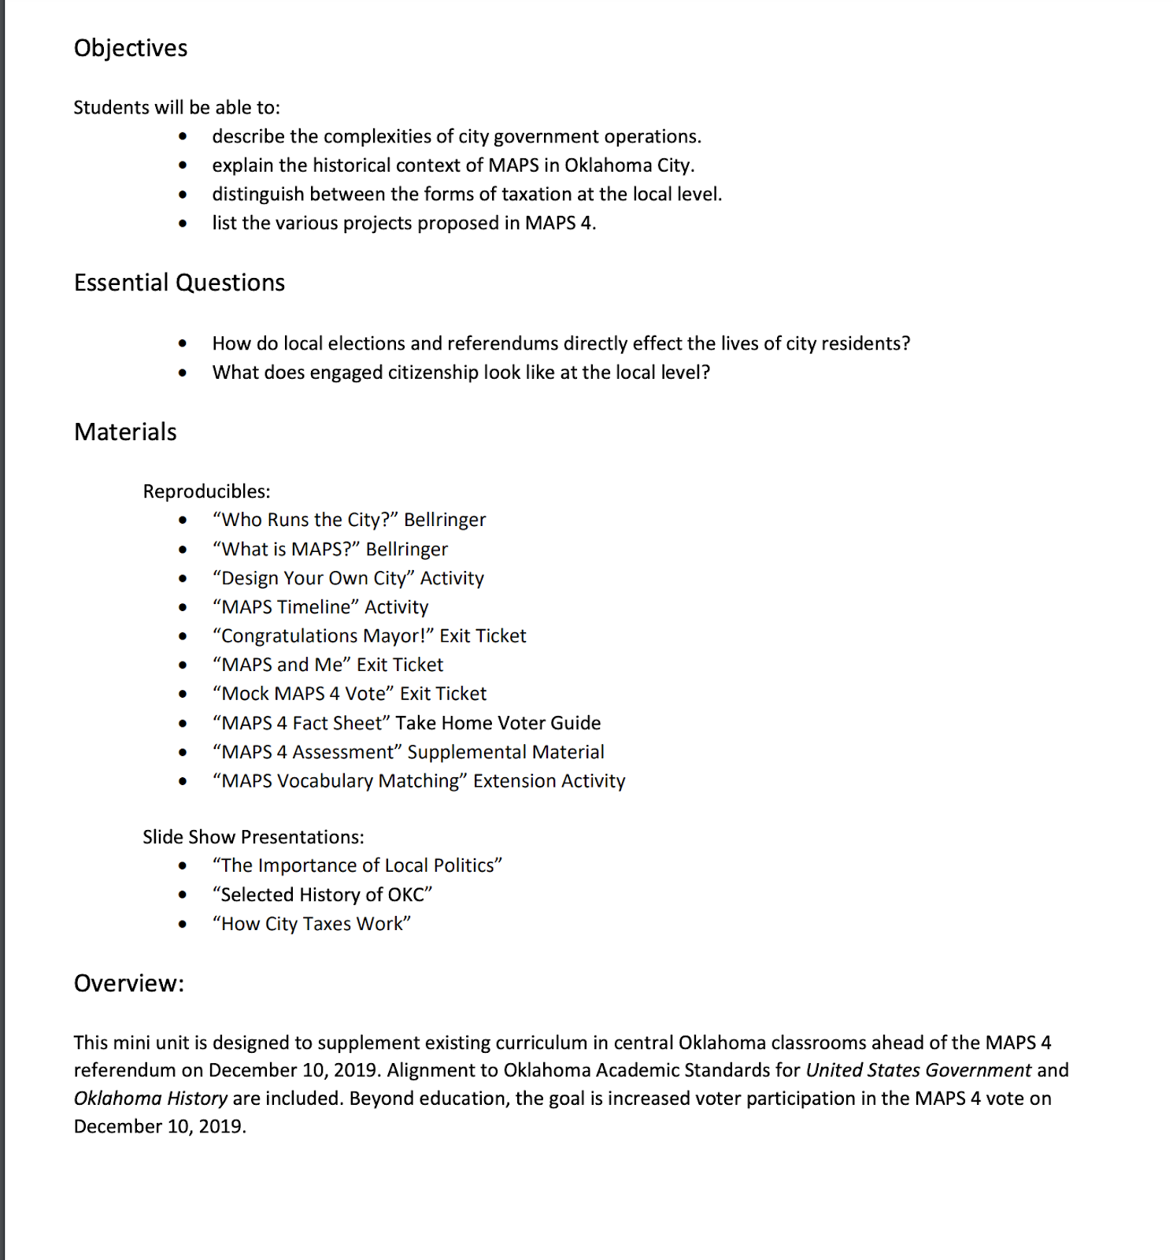

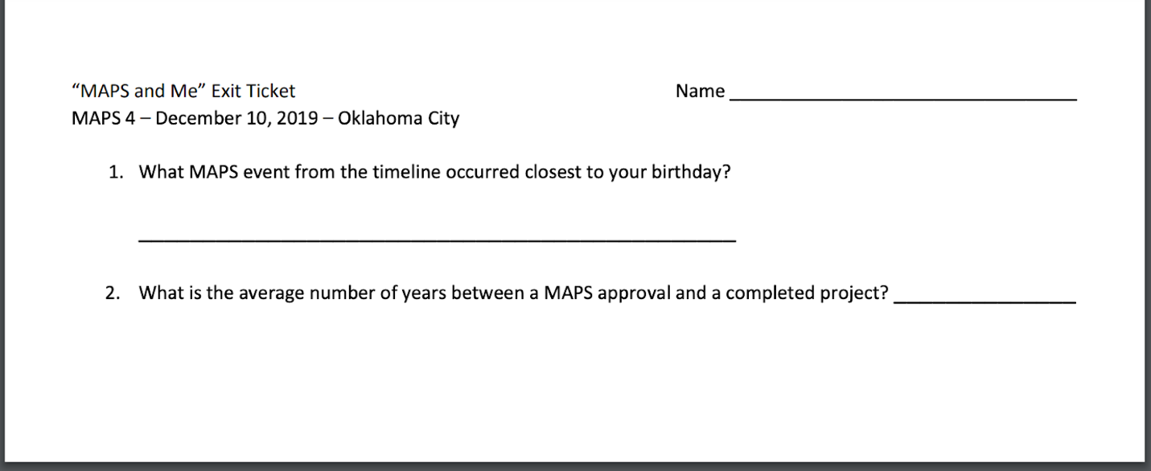


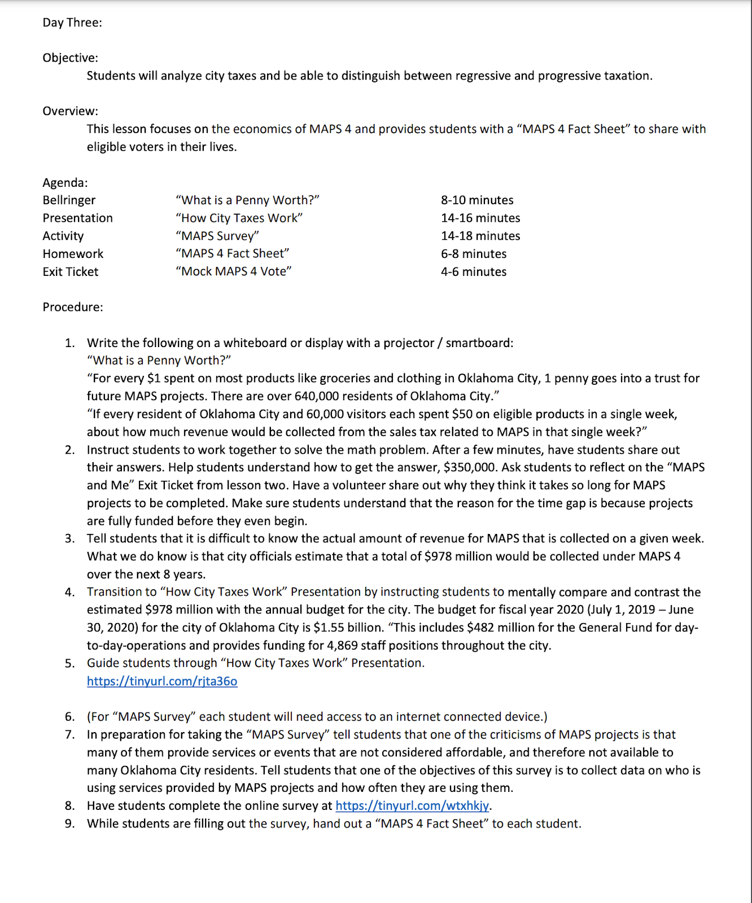

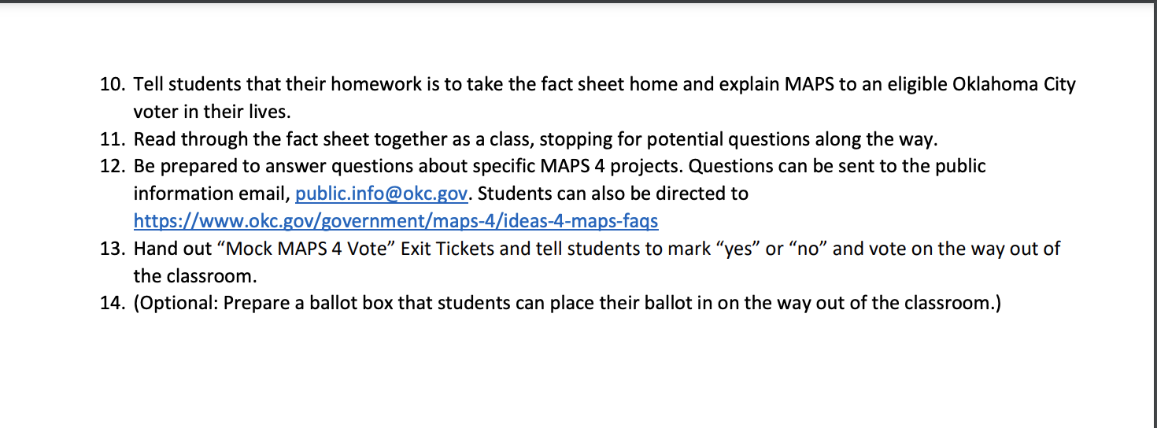

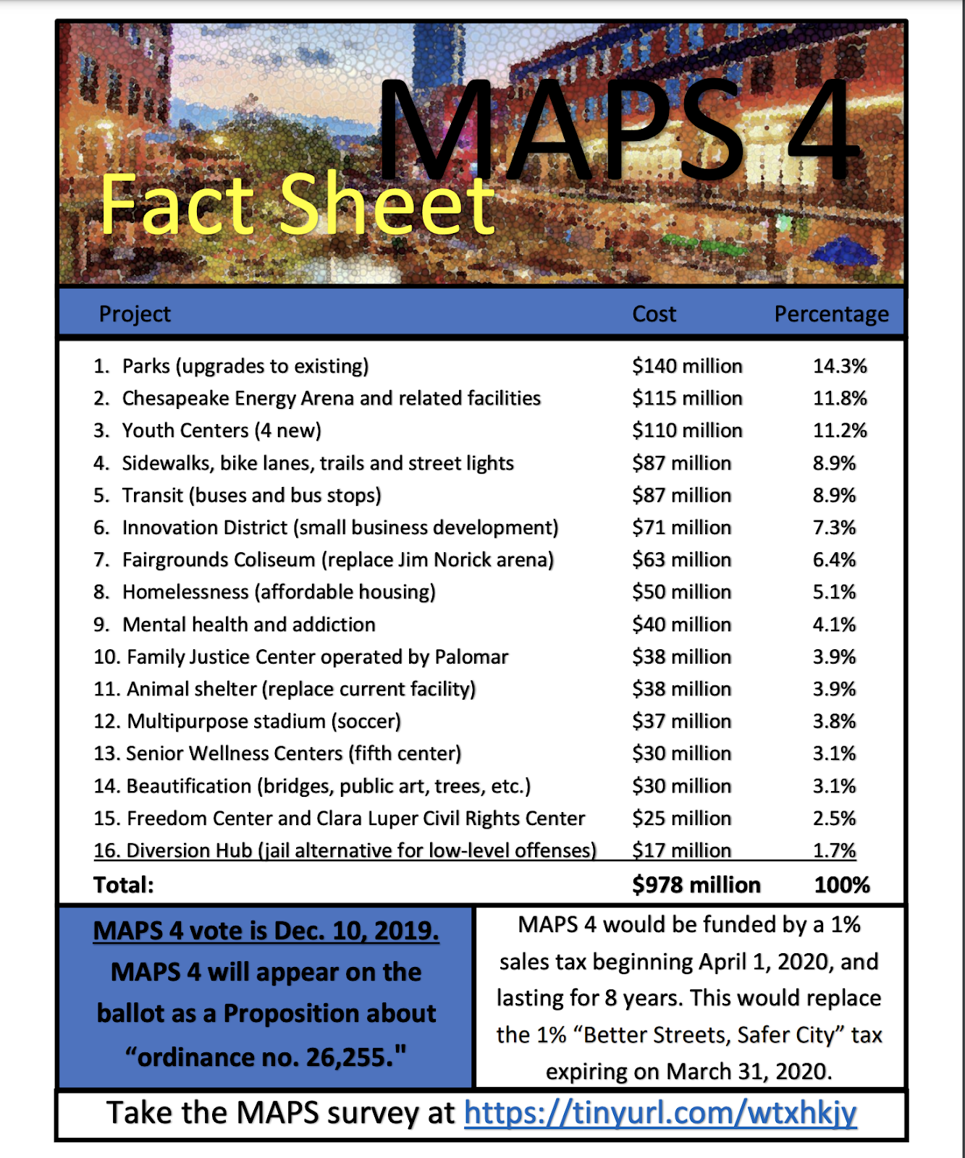

Appendix J Connor’s SE Asia Project and Rubric Artifact
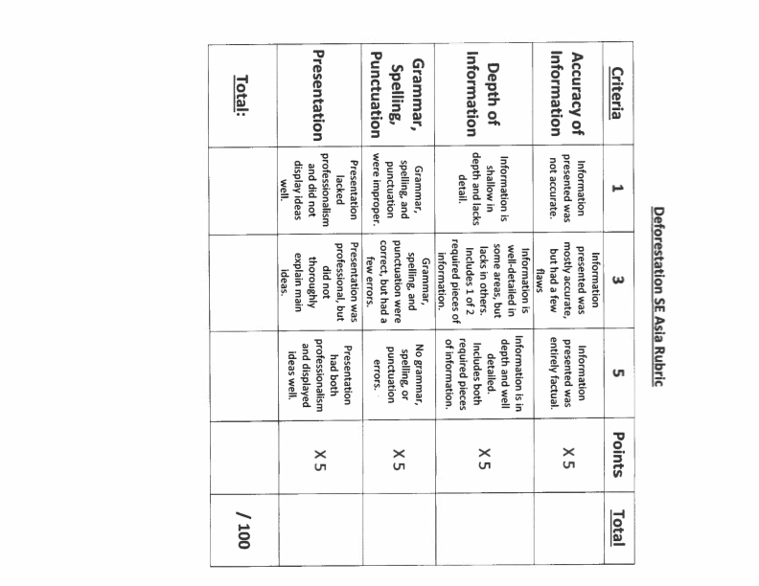

Southeast Asia Deforestation Project

Directions: In this project, you will be creating a public service announcement discussing the problem of deforestation in the Southeast Asia region.

Include at least two of the following:
- What deforestation is
- Why it is bad for Southeast Asia
- Why it is bad for the world
- How we can fix the problem

Information will be presented in an iMovie or a poster (done on printer paper). Posters are exclusive to students who will TAKE THEIR TIME and INCLUDE ALL NECESSARY COMPONENTS.

A rubric including the expectations for the project is on the first page. This shows what should be included in each aspect of the project, and how you will be scored.

Appendix K Leonard’s Multiple Intelligence Questionnaire
Classroom Artifact
