UNIVERSITY OF OKLAHOMA
GRADUATE COLLEGE

FORCED IMMIGRANTS AND PLACEMAKING:
HOW THE INTERIOR DESIGN OF REFUGEE HOMES IMPACTS THEIR SMOOTH INTEGRATION IN HOST COMMUNITY

A THESIS
SUBMITTED TO THE GRADUATE FACULTY
In partial fulfillment for the requirements for the
Degree of
MASTER OF SCIENCE
IN INTERIOR DESIGN

By
AZRA FIFIĆ
Norman, Oklahoma
2023

FORCED IMMIGRANTS AND PLACEMAKING:
HOW THE INTERIOR DESIGN OF REFUGEE HOMES IMPACTS THEIR SMOOTH INTEGRATION IN HOST COMMUNITY

A THESIS APPROVED FOR THE
CHRISOPHER C. GIBBS COLLEGE OF ARCHITECTURE

BY THE COMMITTEE CONSISTING OF

Dr. Suchismita Bhattacharjee, Chair

Ron Frantz

Dr. Chie Noyori-Corbett

© Copyright by AZRA FIFIC 2023
All Rights Reserved.

Acknowledgements
I would like to acknowledge all those who have made the development and execution of this research study possible. First, I would like to thank my thesis committee members Ron Franz and Dr. Chie Noyori-Corbett for being so supportive of me throughout this process and for helping me organize the large scale of this research project into clear and digestible sections. Next, I would like to specially thank my Thesis Committee Chair Dr. Suchismita Bhattacharjee for encouraging me to develop this project idea into a grant awarded project, and to take on such a life-transforming challenge. Beyond being a role model and mentor to me, Dr. Bhattacharjee has gone above and beyond to keep me on the right track and to keep surpassing milestones in both my professional and personal life. Her advice and guidance has been invaluable to me through all the years of being her student.
Next, I would like to thank the wonderful study participants who have welcomed us into their homes like family, recounted their journey with us, and trusted us to share their stories with those who need to hear it them. Such a connection with the wonderful Afghan community in Oklahoma would not have been possible without our cultural liaison who has worked tirelessly and become a vital bridge connecting our research team with eh participating Afghan families. I am very grateful for his time and knowledge shared with us, and for his family who have helped make the data collection process a lot more comfortable and smoother.
Lastly, I would like to thank my beautiful majkica Đeni (my beautiful mother, Jenny, in English), supportive family, and amazing friends for being as invested in this projects as I have been, for being there for me every step of the way for the last two years, and for helping me overcome obstacles whenever I’d get discouraged or overwhelmed. To my friends - you have been my rock and my home away from home. And of course, for me, a home wouldn’t be it without a motherly figure. My final thank you is dedicated to Elizabeth Pober, Director of our Division of Interior Design, who I have had the immense honor of working with during my time as a Graduate Assistant. Beyond being the best boss, Elizabeth has always been the biggest advocate for her students, which is not something commonly seen outside of our division. The strength of our program and the richness of my experience as its student for the past six years would not have been the same without her at the helm. When I grow up, I want to be like her!

Table of Contents
Acknowledgements iv
List of Figures vii
List of Tables ix
Terms and Definitions x
Abstract xii
CHAPTER 1: INTRODUCTION 1
Background and Problem Statement 1
Research Goal 3
Research Questions 4
Research Objective 4
Research Strategy 5
Study subjects 5
Strategy 5
Research Methodology and Outcome 6
Methodology 6
Outcome 8
Limitations and Delimitations 8
Conclusion 9
CHAPTER 2: LITERATURE REVIEW 10
The worldwide refugee crisis 10
Afghan Refugee Resettlement in the United States and Oklahoma 11
Refugees and Placemaking 13
Placemaking inside refugee shelters and homes 14
Placemaking inside immigrant homes in the United States 16
Conclusion 17
CHAPTER 3: METHODOLOGY 19
Study Location 19
Data Collection 20
Introduction 20
Participants 21
Method of Contact/Recruitment 22
Section I: Interview type and process 23
Section II: Field Observation 24
Data Analysis 25
Conclusion 26
CHAPTER 4: RESULTS & ANALYSIS 27
Demographics 27
Transcript Analysis 29
Spatial analysis 30
Comparison with native home 30
Spatial Division, Sizing & Placement 31
Furniture Analysis 36
Comparison with native home 36
Furniture Type and Arrangements 38
Specialty treatments 42
Ornamentation 44
Expression of Culture 45
Expression of Religion 46
Expression of Nationality 47
Expression of Personal Identity 48
Interior Design Elements Analysis 50
Patterns 50
Movement/ Dynamics 51
Materiality 52
Color and texture 53
Odor 54
Lifestyle Analysis 55
Activities Impacted as a Result of Displacement 55
Housing Adjustment Analysis 58
Conclusion 60
CHAPTER 5: CONCLUSION 62
Recommendations 62
Study Improvements and Future Research 64
References 65
Appendix A: IRB Consent Form 67
Appendix B: Full Interview Questionnaire 68
Appendix C: Word Frequency List 71
Appendix D: Full Source List 77

List of Figures

Figure 1: Review of global literature on refugees........................................................................ 2
Figure 2: Review of global literature on placemaking................................................................. 2
Figure 3: Gap analysis flowchart …............................................................................................. 6
Figure 4: Word cloud …..............…........................................................................................... 27
Figure 5: Formal living room in master bedroom ...................................................................... 32
Figure 6: Split bathroom in formal living room ….................................................................... 32
Figure 7: Visual separation between public entry and private informal living room & kitchen area …..............…........................................................................................................................ 33
Figure 8: Visual separation between informal living and kitchen spaces .................................. 33
Figure 9: Formal living room design in Afghanistan …............................................................ 37
Figure 10: Traditional storage unit in Afghanistan made of carved wood ................................ 38
Figure 11: Western furniture pieces stored away from main circulation paths and not utilized in daily life ....….............................................................................................................................. 39
Figure 12: Difference in design of informal (left) and formal (right) rooms in house #6 …..... 40
Figure 13: Difference in design of informal (left) and formal (right two) rooms in house #9 .. 40
Figure 14: Variations in bedroom design and furniture across visited homes …....................... 41
Figure 15: Wooden storage units observed in visited homes .................................................... 42
Figure 16: Specialty treatments present in traditional homes in Afghanistan …....................... 43
Figure 17: Specialty treatments observed in visited homes …................................................... 43
Figure 18: Window and table covers observed in visited homes ….......................................... 44
Figure 19: Traditional sewing machine observed in home #4 …............................................... 45
Figure 20: Traditional kitchenware doubling as ornamentation ................................................ 45
Figure 21: Religious symbols and calligraphy utilized as wall ornamentation …..................... 46
Figure 22: A prayer mat was present in most rooms of every household visited ….................. 46
Figure 23: Homage to Afghanistan was paid in different ways across the visited homes ….... 47
Figure 24: Homage to Afghanistan paid through clothing and vehicle ornamentation in visited homes …...................................................................................................................................... 47
Figure 25: Placemaking through personal belongings of sentimental value …......................... 48
Figure 26: Placemaking for children in visited homes ….......................................................... 49
Figure 27: Placemaking though spatial personalization in home #6 …..................................... 50
Figure 28: Pattern types observed in visited homes ….............................................................. 51
Figure 29: Pattern layering and movement observed in visited homes .................................... 51
Figure 30: Comparison of wood stain colors between furniture observed in native (left) and visited (right) homes ................................................................................................................... 53
Figure 31: Kitchen placemaking intervention observed in house #5 …..................................... 55

List of Tables

Table 1: Demographic information summary …........................................................................ 28
Table 2: Summary of spatial division and utilization of visited homes …................................. 35
Table 3: Comparison of customs between culture in Afghanistan and United States …........... 57
Table 4: Relationship between lifestyle and spatial adaptations through placemaking ............. 60

Terms and Definitions

- Asylum seeker: An asylum seeker is an individual who has fled their home country due to fear of persecution or harm and seeks protection in another country through a legal status that allows them to remain in that country while their refugee claim is assessed.

- Biomimicry: Biomimicry is a design approach that involves emulating biological forms, processes, and functions in design.

- Building typology: Building typology refers to a classification or categorization system used to group buildings based on their common characteristics or features.

- Built environment: The built environment encompasses the physical, human-made surroundings where people live, work, and interact, and includes buildings, infrastructure, transportation systems, public spaces, and other physical elements of the urban or rural landscape.

- Collective sense of identity: Involves a shared sense of belonging, cohesion, and identification among members of a group, and can be formed through shared experiences, traditions, language, customs, and other factors that shape the group's collective identity.

- Cultural liaison: A person or entity that serves as an intermediary between different cultures or communities to facilitate communication, understanding, and cooperation.

- Forced displacement: Individuals or communities are forcibly uprooted from their homes or places of habitual residence due to conflicts, persecution, human rights violations, natural disasters, or other factors beyond their control.

- Household: Unlike in the United States, Afghan households consist of multiple blood-related families living in one large home together, with the oldest male serving in the role of household-head. Typically, a household consist of 4 generations of family members, including grandparents, their children, grandchildren, and great-grandchildren.

- Household head: Considered to be the leader or primary decision-maker of a household. This is the individual who is responsible for managing the household's finances, making major decisions, and representing the household to the outside world.

- Native home: The place or region where a person or a community originally comes from, or where they have ancestral or cultural ties. It can have social, emotional, and cultural significance, and is often associated with a sense of belonging, identity, and heritage.

- Placemaking: An approach to design that reflects the needs, desires, and identities of the people who use them.

- Refugee: A person who has been forced to flee their home country due to persecution, war, violence, or other forms of threats to their life, safety, or freedom. Refugees are granted protection under international law and have the right to seek asylum in another country, while often facing challenges such as displacement, loss of home and possessions, and difficulties in resettling in a new country.

- Resettlement: Resettlement is the process of relocating displaced persons from their initial place of refuge to a new location where they can permanently settle and rebuild their lives.

- Vernacular design: A design approach that involves using knowledge, skills, and resources characteristic to a specific location or culture to create buildings, objects, or environments that reflect the native climate, context, and way of life.

Abstract
This study investigated whether placemaking techniques were present in the interior design of homes occupied by refugees who moved to Oklahoma City after evacuating from Afghanistan in August of 2021, after the democratic government fell to Taliban forces and the United States Military was recalled from the region.
The data collection process consisted of semi-structured interviews being conducted at the participants’ homes, after which a brief tour of the home was provided by the household heads. Additionally, each household head was asked to share photographs of their native home in Afghanistan during the interview, so that a comparison between how the interior design of those homes influenced the design decisions made for their new Oklahoma City homes can be conducted. A cultural liaison was commissioned to translate during the interviews, so that any language-related barriers could be eliminated from all sides.
The identified placemaking methods and needs addressed by the participants demonstrated a clear and strong presence of a collective sense of identity among Afghan people. As a highly communal culture deeply rooted in religion and tradition, many aspects of the standardized housing units common for United States residential construction needed adaptation in order to accommodate the newcomers’ needs.
Rather than approaching interior design from an esthetic perspective, the collected data suggests that the Afghan home design style is primarily focused on functionality despite overflowing with rich colors, elaborate patterns, hand-carved furniture, and dynamic textures – all pointing to an aesthetic focus. Due to the strong sense of unity and pride in the country and its heritage, each visited home paid homage to their homeland through an array of placemaking interventions, as detailed out in this dissertation.

CHAPTER 1: INTRODUCTION

Background and Problem Statement

According to the United Nations' Global Trends report for the fiscal year 2020 (UNHCR, 2021), there were 82.4 million forcibly displaced individuals worldwide. A total of 18,000 asylum seekers were to be allowed entry and resettlement into the United States, but the COVID-19 pandemic delayed the processing time considerably, roughly 7,000 spots remained open and were added to the FY 2021 refugee admission quota (US Department of State, 2021).
The conflict in Afghanistan has made a significant impact on the refugee crisis since the release of the UNHCR report, and the number of refugees is rising every day. Although no official report for FY 2021 is available at this time, it is believed that close to 70,000 Afghan refugees have already been resettled in the United States (Camilo, 2021). As a continuation of those efforts, approximately 1,800 individuals, or 200 families, have been resettled in Oklahoma as of October 2022 (CAIR Oklahoma, 2022), making it the country's third-largest resettlement site after California and Texas. The city of Tulsa was set to take in 850 individuals (Polansky, 2021), and Oklahoma City welcomed over 1,000 by February 2022 (Hinton, 2022), which is more than what most states are accommodating (Kight, 2021).
When it comes to researching appropriate accommodations for refugee immigrants who need to be resettled, most currently available literature focuses on surveying temporary shelters (Ziersch & Due, 2018). From their construction methods, master plans, and environmental quality properties, professionals in the field have conducted extensive research of refugee camps, but little information has been gathered on how the interior design of such shelters effects their inhabitants’ assimilation process.
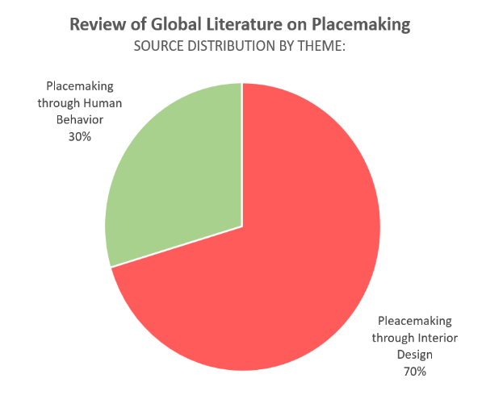
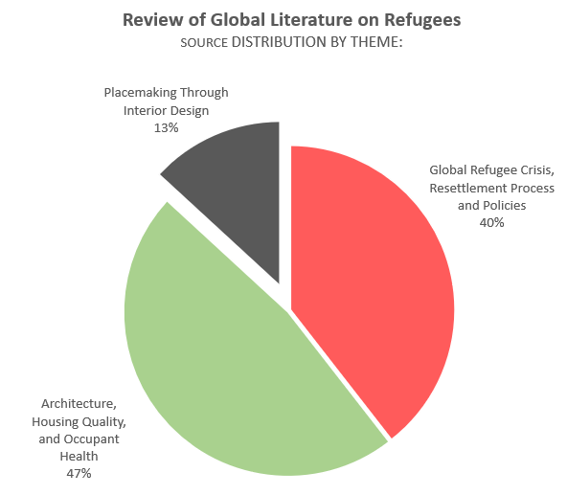
During the research gap identification process, more than 80 articles and books related to refugees and placemaking through the built environment have been categorized into umbrella topics. Please refer to Appendix D for a full list of these sources. Out of the literature written on refugees, only 13% addressed placemaking from an interior design perspective, while 40% largely focused on analyzing politics and policies of the global refugee crisis in general, and 47% investigated indoor environmental quality and architecture of temporary camp shelters. Then an analysis of literature on placemaking in general was conducted, which concluded that there is a large body of information currently existing on the topic and majority of it was explored in the context of interior design. Thus, in order to fill the gap between research on placemaking and research on refugee housing, the intersection of the two major topics had to be explored.
Figure 1: Review of global literature on refugees
Figure 2: Review of global literature on placemaking

Investigating the influence of vernacular design on displaced persons is of great importance in our field because refugee immigrants, while fleeing their homes, often aren’t able to carry much that could remind them of their families, culture, and identity. Thus, it is crucial that we understand how those coming from areas of conflict compensate for their visions of a ‘home’ through customizing interior environments by utilizing the limited resources available to them. This process of transforming one’s environment to fit one’s needs is better known as placemaking. Since interior design can greatly impact human behavior, thinking, and emotions, the resettlement process could potentially become significantly easier and less stressful if placemaking elements are provided early on during the process, so that refugee immigrants’ feel less homesick and more at home in their host communities, allowing them to channel more energy and assimilation efforts on other areas such as language learning, relationship development, employment, education, etc. (Sabie et. al, 2020)
Contrasting research on camps and shelters, research on how placemaking through the interior design of permanent refuge accommodations affects their resettlement process in the United States is much lower, and such research for the state of Oklahoma specifically hasn’t been identified at all. Therefore, this research project aims to explore the abovementioned research gap by investigating differences and similarities between native and current homes of Afghan refugees newly resettled throughout Oklahoma City.

Research Goal

The purpose of this study is to identify the presence and significance of placemaking design interventions in Afghan refugee homes in Oklahoma City by comparing the extent to which designs of their native and current homes accommodate identity, cultural, personal, and lifestyle needs.
When an individual, refugee or not, is placed in a new environment, they typically first seek comfort in familiarity, something that connects them with their place of origin (Sabie et. al, 2020). This usually happens due to our instinct for maintaining our sense of self, which is especially important to a vulnerable group such as Afghan refugees who were able to keep only a few tangible items that could remind them of their heritage and identity. Thus, to maintain as much of their past lifestyle, they mostly rely on projecting knowledge and traditions from their memories onto their surroundings upon their arrival in the United States, which represents placemaking.
The goal of this study is to investigate whether placemaking through interior design of refugee housing in Oklahoma City has had an impact on the successful integration of Afghan refugees into the local community.

Research Questions
- How does interior design impact the ability of Afghan refugees to ‘feel at home’ in their new Oklahoma City housing units?
- What specific activities or cultural observations are being negatively affected by the current home design and how?
- Are placemaking methods being utilized to create a more accommodating and comfortable environment in the current homes of Afghan refugee families?

Research Objective
The following objectives will guide this study towards achieving the abovementioned goal:
- Literature review on the significance of placemaking through interior design on maintaining identity and sense of belonging in refugee and minority immigrant groups in the United States.
- Conduct in-person interviews and home visits with Afghan refugee families in Oklahoma City to collect data on current and native housing conditions.
- Analyze gathered data to determine common themes describing US housing expectations as well as differences and similarities between native and current housing.
- Identify placemaking methods utilized by Afghan refugees to adapt their current housing to native lifestyle, traditions, norms, and practices.
- Identify specific activities and spaces targeted with such adaptations, and their impact on the occupants’ daily lives and behavior.
- Provide design recommendations/ opportunities to resettlement agencies working with Afghan refugees on what placemaking methods could potentially smoothen the integration process based on findings from this research.

Research Strategy

Study subjects
Families of Afghan origin who have been forcibly displaced from their homes in Afghanistan and resettled in Oklahoma City as a direct result of the United States military troops pulling out of the Afghan war against the Taliban in 2021.

Strategy
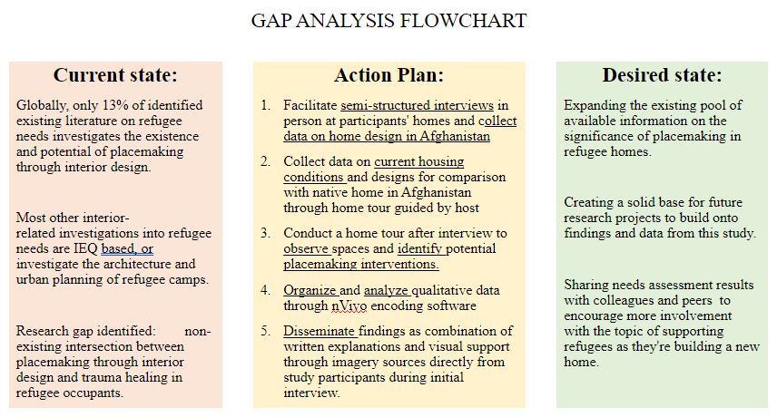
This study’s design utilizes a combination of in-person semi-structured interviews, observation, and photographs of the participants native home to collect data. An in-person visit to the subjects’ homes was combined with an in-depth interview about their housing-related experiences in both Afghanistan and Oklahoma City. Comparisons between how well their native and current home designs accommodated cultural observations, behaviors, family norms, and lifestyles was conducted during the visit through observation of current and photographs of native dwellings. These two methods had been utilized to identify placemaking interventions that have already been implemented, while the interview was the main tool for collecting information on the subjects’ backgrounds and interior design features that still need to be adapted and why. Once the gathered data was transcribed and organized into a database, the information was dissected to identify common placemaking interventions performed by the subject group, which were then assembled into a toolkit in the form of recommendations on what design-related placemaking methods resettlement agencies could consider implementing to help smoothen the resettlement process for current and future refugee families arriving from a similar cultural or geographical background.
Figure 3: Gap analysis flowchart

Research Methodology and Outcome

Methodology
The research methodology is a case study which utilizes in-person semi-structured interviews, observation through photo taking during home visits and photograph of the participants native home to collect qualitative data. Following data collection, all information was transcribed and transferred into an online database format and analyzed using the NVivo software, which identified key placemaking interventions and their purposes through the comparison of each performed case study and the identification of common themes between them.
Observation through photo taking during home visits was the primary method of qualitative and quantitative data collection on the Oklahoma homes, through which the current state of subjects’ homes’ was assessed and documented in the form of photographs, videos, and annotated sketches. Once placemaking interventions had been identified through observation, follow-up questions were be utilized to illustrate the reasoning behind those adaptations through photographs and verbal stories of the subjects’ native experience with the adapted design feature. Lastly, interviews served to collect background information on the subjects, and further elaborate on the reasoning behind placemaking adaptations identified during the home visits and observations from photographs of the subject’s native homes. During this phase, inquiries into future necessary placemaking adaptations and their significance have been made as well.
Upon data collection completion, information from all three data-collection methods was transcribed onto NVivo, a qualitative data analysis software, which was then used to identify social, cultural, and personal behaviors and needs the subjects addressed through placemaking. Once identified, these were encoded through the thematic analysis method, which then classified qualitative data into themes through the same software mentioned earlier in this paragraph, out of which keywords were extracted for the purpose of data categorization and analysis.
For the data analysis step, a cross-comparison of data between individual case studies was be conducted following a model from an existing study conducted by Tasoulla Hadjiyanni (2008), where the subject’s placemaking needs were assessed by comparing how certain activities were conducted in the subjects native homes versus their current homes in the United States. The previously identified keywords shall serve as the topics being compared.
Furthermore, comparisons between each subject’s native home and current home designs will be performed to identify future placemaking opportunities that the subjects weren’t able to integrate into their Oklahoma homes at the time of this study, but which could significantly help transform their Oklahoma accommodations into a ‘home’ they feel safe in and like they belong to.

Outcome
Lastly, a toolkit containing design recommendations on how to successfully accommodate the subjects’ needs this research project identified as most commonly addressed through placemaking was created. It includes the significance and impact of said placemaking interventions on the subjects’ daily lives and assimilation progress found through this study.

Limitations and Delimitations
While this study will be conducted in English, the native languages of the subjects are Dari and Pashto, the main languages spoken in Afghanistan. Due to the author’s significant yet limited familiarity with the subject’s rich culture and language, these were a factor limiting the author’s full understanding of how the subject’s native culture and norms were reflected and observed within their homes’ interior design. A cultural liaison joined this project to help address this limitation.
With recollection of their native homes, family dynamics, and past lifestyle, traumatic memories and experiences resurfaced, limiting the quality and quantity of data obtainable through interviews and photographs of their native homes. Because the subjects were forced to leave their native homes abruptly, the availability and quality of photos and visual aids needed for data collection was limited as well.
Different families had different dynamics, traditions, and socioeconomic backgrounds, and hailed from different regions within Afghanistan, so their ideas of what makes a home were vastly subjective and differed between households. The current state of their Oklahoma homes also varied depending on the resources and support network available to them.
Lastly, this study was tailored to Afghan refugee families in Oklahoma City, therefore the recommendations are applicable to that population and region only. Research on any other groups or regions is out of the scope of this projects, however, the methodology and findings of this study can serve as a base reference and starting point for future research due to the large gap present in the research currently available on this topic.

Conclusion
This research aimed to investigate the impact of interior design on the assimilation progress of Afghan refugee families into their host communities by identifying placemaking interventions that were integrated into their Oklahoma City accommodations in order to create a sense of familiarity and minimize differences between their current homes in Oklahoma and native home in Afghanistan.

CHAPTER 2: LITERATURE REVIEW
This literature review outlines the ongoing refugee crisis worldwide, defines the concept of placemaking, and introduces background information regarding resettlement policies in the United States and Oklahoma. A brief description of cultural, economic, and psychological factors impacting the ability of interior design to affect human behavior is also included.

The worldwide refugee crisis
According to the aforementioned United Nations Global Trends report, there were a total of 82.4 million forcibly displaced persons in FY 2020 worldwide (UNHCR Flagship Reports, 2021). This means that 1 in every 95 individuals had been forcibly relocated by that year, illustrating a significant increase compared to data reported in FY 2010, when only 1 in every 159 was displaced. Out of that number, close to 26.4 million were classified as refugees displaced due to ‘persecution, conflict, violence, human rights violations and events seriously disturbing public order’ by the same report. (UNHCR Flagship Reports, 2021)
The United Nations High Commissioner for Refugees (UNHRC) estimated that the number of refugees needing resettlement was 1.4 million in FY 2020 , with the biggest displacement hotspots being the Syrian Arab Republic, Afghanistan, Somalia, South Sudan, and Yemen. When it came to accepting refugees from those regions, Turkey hosted the largest number – just under 4 million, followed by Germany, Pakistan, and Uganda. A total of 34,400 refugees were resettled in third-world countries, and 39,500 in the United States. (UNHCR, 2021)
Out of the 26.4 million refugees identified, only 0.25 million refugees were able to return to their place of origin, while the rest have either been admitted to a resettlement program in a host country or are in the process of seeking or awaiting official assistance at the time of the report. (UNHCR, 2021)
The average term of displacement estimated by the UNHCR is 17 years, during which most refugees spend their time in camps or other transitional housing units waiting to be resettled. (Sabie et. al., 2017). When it comes to resettling refugees, the primary goal is to provide them with food, shelter, and medical treatment for a certain period, meeting their basic survival needs but little beyond that. The entire process, as well as its benefits, differ widely from one host country to the next. Certain governments provide substantial assistance to refugees until they can live independently of resettlement agencies (Donato & Ferris, 2020). Others, like as the United States, provide only minimal assistance and resources to the refugees, who are then forced to fend for themselves in an unfamiliar culture and language (Donato & Ferris, 2020).

Afghan Refugee Resettlement in the United States and Oklahoma
Global inflation is currently increasing the cost of living in almost every country in the world, and the United States is no exception to the rising prices across every sector of the economy. One of the most prominent markers of inflation in the US has been the rapid increase in housing prices, which has thrown the nation into a housing crisis (National Low Income Housing Coalition, 2022). Demand is high, and the availability of quality accommodations low in comparison, especially for those of low income and coming from marginalized groups (National Low Income Housing Coalition, 2022). This housing crisis is significantly harder on one of the nation’s most vulnerable populations – the newly resettled Afghan refugees.
Upon their arrival to the United States, the Afghan evacuees receive monetary assistance from local resettlement agencies for at least 30-90 days, which adds up to around $1,200 in government assistance per person (Mansoor, 2022). Although welcomed, that sum of money is usually spent on necessities and daily expenses and is typically not enough to cover rent as well. Depending on the size of the family and the ages of their members, different families need to distribute that assistance in different ways (Mansoor, 2022). The situation becomes even more complicated if the newcomers are trying to master the language and look for employment to provide for their family, which in turns lowers their government support by a large percentage, regardless of how much help the extra income is realistically (Mansoor, 2022). Our study has found that a family’s government support was cut by as much as 50% which included valuable food stamps and resources that the father’s income couldn't hope to ever match in the position he is working at the time of this study.
To secure a safe roof over one’s head in the United States, landlords often require specific documentation be submitted along with an application to even be considered as a potential renter, which includes documentation the Afghan families don't possess, have no knowledge of what they mean nor how long it takes to obtain them. It is a long process which no newcomer can afford considering the situation they are in. From credit scores, employment history, work permits, social security numbers, and driver’s licenses to co-signers, security deposits, and savings equal to several months' worth of rent, it goes without saying that the Afghan population is not familiar with the concepts as those simply did not exist in their country or government when they were living there. (Mansoor, 2022)
Another layer of complexity added to the newcomer’s experience in successfully settling into their new communities is the trauma and stress from leaving their home and all they are familiar with. While additional resources for food and monetary assistance are available, it is a very difficult bureaucratic process to navigate if one is not familiar with the local language or government structure, so it is often up to the resettlement agencies and volunteers to navigate through (Mansoor, 2022). While resettlement agencies are better equipped to help, they often lack manpower to do so effectively due to the sheer amount of time and dedication each resettled family requires to ensure their comfort, safety, and wellbeing (Mansoor, 2022). Volunteers on the other hand, while they are doing selfless and inspiring work, often don’t possess the knowledge, resources, or time to be as efficient and thorough in their support compared to the potential of agency staff, especially if the issues are bureaucratic in nature.

Refugees and Placemaking
When a person is placed in a new environment, they usually immediately seek comfort in familiarity, something that connects them to their origins. This need can be met in a variety of ways, ranging from resuming old hobbies or habits and socializing with likeminded individuals, to incorporating tangible elements that represent one's heritage or even a specific life goal into the built environment, which gives purpose and direction. This is where the process of placemaking may either greatly assist the resettlement process or cripple it if it isn’t properly cultivated. (Sabie et. al, 2020).
Placemaking is essentially adjusting one’s environment, both physical and psychological, to meet its user’s needs when it comes to embodying their cultural pride and identity. It is the process of transforming a generic space that usually focuses on function, into a place that creates a new reality which represents the user’s unique idea of ‘home’ (Sabie et.al, 2020).
It is through placemaking that many refugees can safely survive the displacement duration in camps, and it is especially important in larger camps where thousands of individuals are seeking shelter. Two camps like that are the Azraq and Zataar in Jordan, and because of the large number of refugees temporarily living there, as well as the unique ecosystem of site and user that has naturally developed over the years, these camps are slowly turning into ‘cities of tomorrow rather than temporary dwellings’ (Sabie et. al, 2017). Because of this rapid growth, the residents have taken it upon themselves to manually expand, build, and improve the camp, even though there was limited construction knowledge and resources present within the community. This has greatly impacted the safety, organization, and comfort of the residents (Sabie et. al, 2017)

Placemaking inside refugee shelters and homes
A very straightforward and easy to achieve placemaking method includes redecorating one’s built environment. Because shelter and refugee home units often tend to be produced according to standardized sizing and local codes, completely redesigning them might be costly for those who have newly arrived at their resettlement location, so many turn to utilizing smaller symbols of heritage that represent their cultural pride (Sabie et. al, 2020). These could be pieces of art, furniture, religious objects, smaller decorative pieces, traditionally patterned finishes, etc.
One study that started indoors was performed within the Azraq and Zaatari camps by researchers Albadra, D., Coley, D., and Hart, J. (2018), in order to assess the indoor environmental quality of the shelters. An interesting discovery they made was the fact that, due to the indoor environment being unsatisfactory, many households have used scrap materials to expand their shelter and open it towards the outdoors in the form of courtyards and living spaces. This was their way of placemaking on their individual lots, and those expansion are an accumulation of building knowledge shared by their predecessors, as well as scrap materials that have made many long journeys and are full of stories they can tell.
Another fieldwork study conducted in the Zaatari camp was conducted by a group of researchers (Kirk et. al, 2018) to assess life inside standardized modular shelter units. Their observations show that interior decorations serve a purpose beyond just functionality, that it serves as an escape from reality and compensation for the loss the residents have experienced. Old material is being upcycled due to the lack of new resources, so the culture of treasuring everything they have is strong. The décor created from the upcycled materials help maintain a sense of dignity and pride.
A third fieldwork study conducted in Zaatari and Azraq investigated how different levels of refugee agency impacted their mental health and overall wellbeing. The findings showed that having more agency humanizes the refugee and displacement experiences, and that resettlement organizations should focus on improving refugee homes to fit their unique experiences and needs, instead of simply meeting the minimum requirements of being a roof over their heads (Paszkiewicz & Fosas, 2019).
A fourth Zaatari camp fieldwork study focused on the interior decorations and placemaking was conducted in 2017 (Dalal, 2017). The author identified groups of Syrian refugees that came from different parts of Syria and showcased how they all had different styles and decorative techniques, even though they came from the same country originally. While this is one of the few studies that contain information on shelter interiors that is highly relevant to what my research for this class will be, it is still lacking many details and a standardized comparison categories system. More research into the original study findings will have to be done.
As can be seen from the research identified, most studies that are available for public reference focuses on the shelter master plan, on overall connection between architecture and community dynamics in the outdoors, and how those elements impact the mental health and wellbeing of resident refugees. Very little material can be found on interior design and its impact on refugee assimilation, as most studies focused on quantitative research by physically measuring indoor environmental quality categories such as air and thermal quality.

Placemaking inside immigrant homes in the United States
Tasoulla Hadjiyanni, a Professor at the University of Minnesota College of Design, is one of the few researchers investigating placemaking through interior design in immigrant homes in the United States, and the only one who studies placemaking in refugee homes specifically. In her 2007 ‘Bounded Choices’ article, Hadjiyanni outlined three options refugees are forced choose from when they are relocating to an unfamiliar destination that is often extremely different from what they were surrounded by in the past: 1. adjusting their living environment to better suit their way of life; 2. changing their way of life to fit the new living environment; 3. do nothing. All three choices are sources of extreme discomfort and stress, and require a deep re-evaluation of how one’s needs, identity, ability to observe tradition and culture, familial and social relationships, impact one’s mental and physical health. This is equally important for Afghan refugees, as the men can no longer provide for the family as they used to due to the complex issues mentioned in the resettlement process section above, and for women who are culturally more anchored to the concept of ‘home’ and are significantly more impacted by the loss of it (Hadjiyanni, 2007)
During her research on placemaking in homes of Somali refugees, Hadjiyanni often found that the newcomers often combined choices 1 and 2 to create their new homes. Combining the resources available to them with endless imagination and creativity, the Somali women put their best efforts to emulate their native culture in the new homes by implementing familiar space plans, furniture, accessories, and finishes into the standardized American housing units. Cultural norms and traditions that couldn’t be incorporated were adapted to fit their new environment. Some of the most prominent placemaking techniques observed during the study were a strong and colorful presence of patterns, a distinct smell produced by a traditional incense called unsi, multiple layers of drapery on windows, earthy color palettes similar to the nature present in their native homes. Preferred materials for statement pieces as well as home structure were brick and stone, while the interior design lacked individuality, which is a strong symbol of how community-oriented the Somali culture truly is. (Hadjiyanni, 2007)
In their 2009 article ‘The Spatiality of Veiling’, Tasoulla Hadjiyanni and her co-writer Vahaji Samaneh investigated the connection between interior design, spatial division and privacy-related placemaking interventions with religious observations and practices, mainly the practice of women covering with a hijab in Muslim households. By focusing the analysis on a single home, this study dissected, simplified, and illustrated different ways placemaking was, or could be, utilized to add comfort and feelings of safety to a space without changing the entire design of the home.

Conclusion
When we, as humans, are faced with a new and completely unfamiliar environment, the first thing we typically do is seek comfort in familiarity (Sabie et. al, 2020). This is especially important for the newly arrived Afghan population, which was forced to leave almost everything they've known behind in one night, to escape certain death and start a new life in the United States. Due to the vast difference in culture, tradition, topography, government structure, language, food, and about everything else one could think of between the two counties, one aspect of life that could bring almost immediate relief and a strong sense of belonging, attachment, and healing is the home. This could be achieved through a process called placemaking – adjusting one’s environment to fit one’s needs. While the process and effects of placemaking have been extensively researched in refugee camps and non-forcibly displaced immigrant homes, there is much work to be done in regards to refugee homes, especially in a country such as the United States, which had over 150,000 pending asylum applications in 2022 alone (TRAC, 2022).
One author has, however, pioneered research into placemaking through interior design or permanent refugee housing, and her name is Tasoulla Hadjiyanni. Two of her publications, ‘Bounded Choices’ and ‘The Spatiality of Veiling’ have helped create a detailed framework for identifying, showcasing, and evaluating placemaking techniques in immigrant and refugee homes.
While ‘Bounded Choices’ was focused more on esthetic and lifestyle inspired placemaking interventions, ‘The Spatiality of Veiling’ added a spiritual and religious layer to placemaking. When combined, the two studies provided a through framework through which the presence and effectiveness placemaking in interior design can be investigated, and it was utilized as a reference for the framework designed for this study as well.

CHAPTER 3: METHODOLOGY

This chapter outlines the process which was followed to investigate the presence of placemaking interventions in home of Afghan refugee families who arrived in Oklahoma City in late 2021 and early 2022. Methods to achieve this project’s objectives are outlined below.

Study Location
The geographic location selected for this study was the Oklahoma City Metro area, which is one of the most densely populated areas by Afghan refugee families in the State of Oklahoma - the state with the third-largest Afghan refugee intake number following California and Texas. A total of 200 families, or 1800 individuals, have made Oklahoma their home since August 2021 (CAIR Oklahoma, 2022).
A total of 9 sites were visited during this project. Home typologies selected for the study included single-family homes (3 study sites), apartments (4 study sites), semi-detached homes (2 study sites). Homes chosen for the study were located in neighborhoods considered safe and attractive, and areas considered unsafe and unattractive to the wider population. This was done to reflect the spectrum of housing types, quality, and neighborhood quality available to the subject population in reality.

Data Collection

Introduction
Data for this study has been collected through two methods. Firstly, a semi-structured interview was conducted with the help of a cultural liaison who served as translator during this stage. Questions were asked in both English and the native language of the participants, which was either the Dari or Pashto language. At the same time, observations were made in relation to the home’s interior and written down by the author.
Following the successful conclusion of the interview phase, the household head then conducted a tour of the home which included access to the family’s private quarters and detailed explanations of different placemaking techniques implemented by the residents. Photographs of all observations relevant to this study were taken and later annotated by the author.
The cultural liaison for this project was a member of the Afghan refugee community in Oklahoma City himself, so he was very familiar with the subject population’s past experiences, native culture, cultural norms, and traditions, and how those translated into the design and functionality of one’s home. Due to the cultural liaison’s strong connection to the subject community, the participant recruitment process was also conducted by him under the researcher’s guidance.

Participants
All participants chosen for this study were members of the Afghan refugee community that arrived in Oklahoma City in late 2021 and early 2022 as a direct consequence of the United States military pulling out of Afghanistan in August of 2021. All participants left their native homeland within days after the Afghan democratic government fell to the Taliban regime on August 15th, 2021, and arrived to the United States as part of a mass-evacuation organized by the retreating US military force.
Due to Afghan families having a different structure compared what is traditionally known to the western nations, most families are quite large and include several generations as part of it. So, for example, one what one household of 30 persons would constitute one family in Afghanistan, the same household would be separated into several families according to United States laws. Because of this large family structure, most Afghan families were not able to evacuate all of their members to safety during the 2021 US military retreat, so many participants were forced to leave close family members behind, such as children, siblings, and parents who continue living in hiding and in fear for their safety.
According to gathered data, some of the study subjects arrived directly to the United States from Kabul Airport in Afghanistan’s capital, while others flew through transition points such as Qatar and Germany. Once in the United States, they were temporarily housed in a military base in Wisconsin to await processing of relevant paperwork and directions on further, more permanent, relocation. Once the documents and their new refugee statuses were finalized, they had the option to select a state from a list of those accepting refugees and chose to settle in Oklahoma.
Arriving to Oklahoma was only the beginning of a long journey filled with bureaucratic obstacles and cultural differences. While many families were paired with sponsors from local resettlement agencies who were willing to support the newcomers for a year, many were left to their own devices with no one to help or check on their wellbeing. With little to no knowledge of the local culture, government, and language, and even less funding available to support their large families, it was hard for the participants to secure housing appropriate enough to meet even the most basic needs in some cases.
The participant pool for this study was diverse in terms of household size, socio-economic background, current economic state, household-head age, and mean household age. This was done to ensure that the data collected was not from a monolithic source, increasing its overall accuracy. A total of 9 households were interviewed with the household-head as representative.

Method of Contact/Recruitment
Following approval from the OU Institutional Review Board (IRB) on December 13, 2022, study subjects were recruited with a recruitment graphic circulated in the community by the cultural liaison. Because the subject group is considered as highly vulnerable, informed consent was obtained from the participants before each interview. Participation was voluntary and the participants were given a $25 VISA gift card incentive to join the study. The IRB Outcome Letter can be viewed as Appendix A attached to the end of this document.

Section I: Interview type and process
The first section of the data collection process was an in-person visit conducted in the study participant’s home. The interview typically took place in the formal living area of the home, with only the household-head being interviewed. Because the Afghan tradition follows strict gender separation rules when socializing, as well as separation between public spaces a visitor is allowed to be in and private spaces reserved for family members only, sometimes only sons were allowed to sit in the interviews while the daughters helped serve refreshers to the research team.
This study is part of a larger needs assessment study conducted by other members of the research team, thus the questionnaire categories encompassed a broad range of topics. The 7 categories the interview questions were grouped in were: journey to the US, housing quality, neighborhood quality, clothing and food, community relationships and cultural expression, health and activities of daily living, and demographic information. Only demographic and housing-related information was extracted from the interviews and analyzed for this study. The full questionnaire is attached as Appendix B to the end of this document.
The interview was recorded through a voice-recording application on a tablet. Following a pre-approved list of 54 questions from 7 categories, each question was asked in both English and the subject’s native language by the cultural liaison. Each answer was received in the subject’s native language, which the cultural liaison would then translate for the recording. Follow-up questions were asked by the research team where necessary.
Due to the interview’s semi-structured design, meaning that both the order and working of questions asked could be adjusted based on the interview flow with each individual participant, probes were often utilized to expand information the interviewee was providing. This was most helpful in instances where participants spoke about their native home in Afghanistan but weren’t sure how interior design can affect and control one’s behavior, actions, thoughts, feeling, and mental health. Prompts were utilized to extract specific information from participants regarding ways traditional furniture supports the participant’s traditional lifestyle and culture, as that was another category most participant’s never thought about or reflected upon before. (Robson, 2009)
Once the interview was complete, it was stored on an online cloud as an audio file which was then transcribed into a written form through listening to its contents and typing the English translation up.

Section II: Field Observation
Once the interview was completed, the head of the household took the research team on a tour of the home, where they allowed taking pictures of many spaces in the home. Despite the families strictly following separation between public spaces where visitors are allowed and private spaces reserved for family members only, the research team was allowed to sidestep those norms for the sake of accurately recording the comments, needs, and observations made in exchange for the tour.
Photographs were taken of all placemaking interventions the author was permitted to see with a Samsung phone camera, and later edited to obscure any identity compromising elements. Finally, once observations were noted down during tour, all notes and relevant photographs were uploaded onto NVivo and encoded using the software.

Data Analysis
As mentioned earlier in this chapter, all raw data was processed, organized, and encoded through NVivo – a qualitative analysis software. Qualitative research, particularly semi-structured interview generates large amount of data, hence the primary aim of data analysis was to condense the data as suggested by Robson (2009). The data analysis process included multiple stages of investigating, sorting, and arranging with the intention to address the primary goal of the study as suggested by Yin (2009). Before uploading the data into NVivo, the interviews were transcribed by referencing the original questionnaire and listening to recordings from each interview.
Another primary component of the raw data included photographs collected during home tours and photographs of the participants native home shared by them. Several scholars have successfully used photography as a methodological tool for social research (Langmann, 2018). All photographs had to be transferred to a computer and sifted through to ensure only high-quality and information-rich photographs were used in this study while maintaining the anonymity of the participants . Then they were imported into NVivo and encoded using notes and observation made during the home tours.
Thematic analysis was utilized to encode each interview and selected photograph through NVivo, and a total of 72 codes made up the final codebook, which was grouped into the following categories of a themes (Robson, 2009): spatial analysis, furniture analysis, ornamentation, lifestyle, general housing information, and design elements. This coding scheme was developed partially by referencing an existing one created by Tasoulla Hadjiyanni for her 2007 ‘Bounded Choices’ study and combining it with the author’s own scheme based on prominent themes noted during the literature review.

Conclusion
This chapter described the methodology implemented to conduct a study into placemaking techniques in Oklahoma City homes inhabited by Afghan refugees. A combination of semi-structured in person interviews and an observation tour of the participants’ homes was utilized to collect data, which was then transcribed onto a qualitative analysis software – NVivo – and encoded.
During every interview, participants also had the option to share photographs of their native homes in Afghanistan with the author in order to help create comparison points between the interior design of their native and current home styles. Once encoded, an analysis of the data was conducted and findings were grouped into five distinct placemaking categories specific to interior design: space planning, furniture, ornamentation, design elements and principles, and lifestyle accommodation.

CHAPTER 4: RESULTS & ANALYSIS
The purpose of this study was to identify the existence of placemaking interventions in the interior design of Afghan refugee homes in Oklahoma City. The study consisted of a site visit to the subjects’ homes, where a semi-structured interview was conducted in conjunction with a home tour during which field observations were made by the author. This chapter contains the demographics of the subject population as well as the data analysis and results of the study. Findings regarding placemaking techniques and their presence in the analyzed homes are summarized at the end of this chapter.

Demographics
Out of the 9 households visited in this study, each interview was conducted with the household head, who answered on behalf of their whole families. The average age of a household head was 34 years old, and average household size was 8 persons. In total, the subject pool consisted of 70 persons, 33 adults and 37 children under 18 years old. Four out of nine households had close family members that weren’t able to evacuate on time, and are currently living in Afghanistan.
All subjects belonged to one of Afghanistan largest ethnic groups – Pashtun. The Pashtun population is settled mostly in central and eastern Afghanistan. The languages spoken were Pashto (all households), Dari (3 households), Urdu (4 households) and basic English (5 households). In relation to religion, all subjects identified as Sunni Muslims.
The table below contains a summary of this study’s demographic information relevant to the data analyzed in this chapter.
Table 1: Demographic information summary
 | Description | Frequency
Household Size | 1 to 5 | 3
Household Size | 6 to 10 | 4
Household Size | 11 or more | 2
Household head age | 30 to 35 | 3
Household head age | 36 to 40 | 2
Household head age | 41 to 45 | 2
Household head age | 46 to 50 | 1
Household head age | 51 or more | 1
Household Head education level | Elementary School | 1
Household Head education level | Primary school | 2
Household Head education level | High school | 2
Household Head education level | Vocational training | 6
Languages spoken | Pashto | 9
Languages spoken | Dari | 3
Languages spoken | Urdu | 4
Languages spoken | English | 5
Ethnicity | Pashtun | All households
Religion | Sunni Islam | All households
Currently employed members per household | None  One  Six | 3  5  1
Monthly income from employment | Unknown  None  $1, 400  $2, 000 | 4  3  1  1
Monthly rent cost | Unknown  $1, 000  $2, 000  $2, 200 | 6  1  1  1
Children under 18 per household | None  Five  Six  Seven  Nine  Ten | 2  1  1  1  1  1
Children enrolled in school per household | Unknown  None  Three  Four  Five  Nine | 1  3  1  1  2  1

Transcript Analysis

Upon finalizing the transcription and encoding processes, a word frequency tool was utilized to filter through encoded sections of each interview and a total of 250 most commonly mentioned words was compiled into a word cloud, as seen on Figure 4. Some of the most prominent words identified were closely related to the subjects’ sense of identity and community, their family and friends, current housing needs, and privacy in relation to gender separation, as well as spaces closely intertwined with their native lifestyle such as: kitchens, bedrooms, formal living rooms. The complete word frequency list can be found as Appendix C attached to this document.

Figure 4: Word cloud

Spatial analysis

Comparison with native home

According to interview responses, the Afghan culture practices gender separation which directly reflects on the interior design of their homes. To observe this norm, Afghan homes strictly separate private spaces, spaces exclusively reserved for the family’s use, and public spaces, the spaces where outsiders such as family friends and other visitors are invited to occupy. For this reason, a formal living room is typically constructed farther away from the kitchen and bedrooms, which are spaces designated for the children and women of the household.
The formal living space usually has access to exterior doors leading into a large courtyard enclosed by high walls that sometimes contain an exterior bathroom and kitchen as well, which minimizes access to the deeper interior of the home for visitors. This was how many of the interviewees described the layout of their native homes as well. In some homes, separate formal living rooms were constructed for females and for males, while in others a curtain is stretched between two opposite walls to visually separate one large formal living room into two spaces while still keeping the whole group in one room.
Kitchens are usually large and exclusively available to females due to gender roles that are observed in Afghan culture. Women typically stay at home to take care of the household and children, while men are the ones working to financially support the family. While in the privacy of their home, women do not have to dress as strictly to cover their bodies compared to when they are spending time outside of their homes, so having their private spaces separate from public ones gives them more freedom to move around the home comfortably.
According to the data collected, the living room and kitchen are two spaces that can impact an Afghan family’s social dynamic and lifestyle drastically if not constructed appropriately enough to allow the family to observe their cultural norms, thus, a lot of the information presented in this chapter is related to those two spaces.

Spatial Division, Sizing & Placement
During the site visits, most families hosted visitors in formal living rooms, which were sometimes designated rooms for that purpose, and sometimes bedrooms that served a dual purpose for the sake of observing native cultural norms. Two of the households visited had a designated formal living room used only for visitors, however those rooms were originally intended as bedrooms per local building customs but were permanently transformed into formal living rooms by the Afghan tenants to observe native tradition. Four households had bedrooms that are temporarily transformed into living rooms when needed, meaning that visitors are forced to occupy the family’s private space during their stay. Only two households hosted the researcher in the home’s original living room as designated by the building norms in the United States willingly, while two other households had little choice to do otherwise as the space available to the family didn’t allow for the establishment of neither a permanent nor temporary formal secondary living room. Out of all households visited, three households had two separate living rooms, as described in the following paragraphs.
House #5 had two bedrooms that served as formal living rooms in order to accommodate gender separation when needed - one could serve males while another could serve females if a large group was visiting. The main formal living utilized also doubled as the household head’s bedroom and was closest to the home’s entry and backyard doors, while the secondary served as the children’s bedroom and was located in a more private part of the home and surrounded by other bedrooms and bathrooms. Additionally, the household head’s room was a master bedroom, meaning that a bathroom was directly adjacent to it. In this case it was two three-quarter bathrooms split by a double vanity in the middle, as seen on Figure 6, so one side served the household head while the other was designated for visitors.
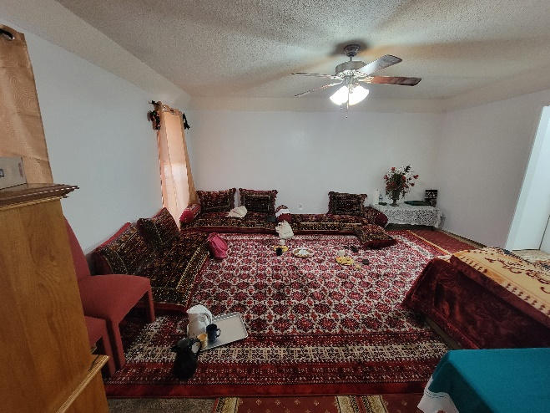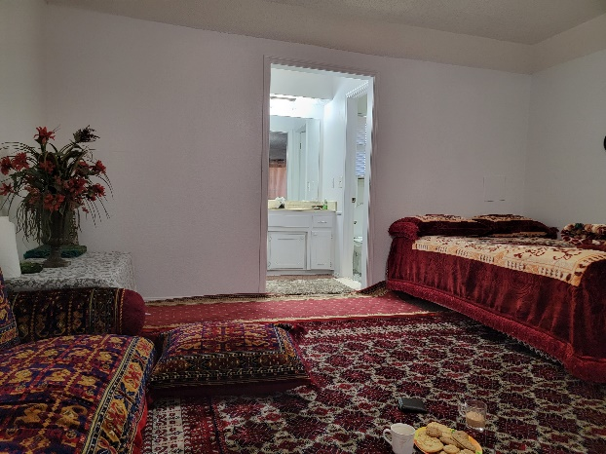
Figure 6: Split bathroom in formal living room

Figure 5: Formal living room in master bedroom

House #6 hosted the author in the home’s original living room on the ground floor close to the home’s entry, however it was not as isolated from the home as the formal living room was on the second floor. The informal living was directly adjacent to the kitchen, and curtains were utilized to visually separate the two spaces, pictured on Figure 8. To access the formal living on the second floor, one had to climb a set of stairs directly accessible from entry door, which could be fully visually separated from the informal living and kitchen with another curtain, as seen on Figure 7.
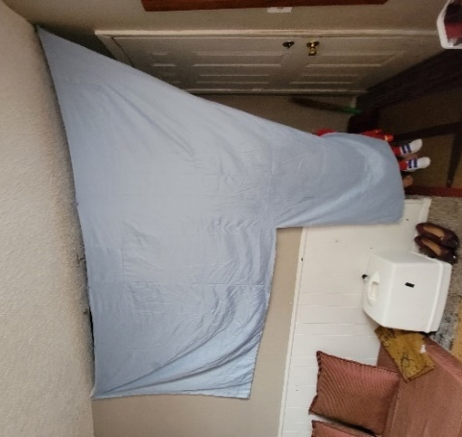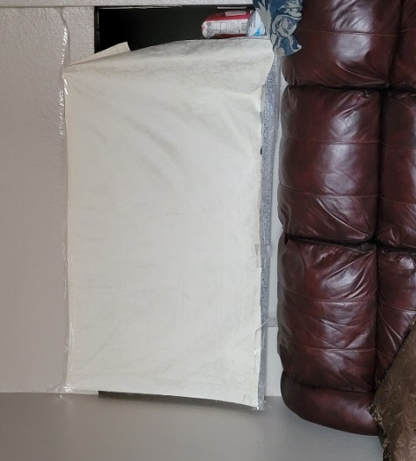
Figure 7: Visual separation between public entry and private informal living room & kitchen area

Figure 8: Visual separation between informal living and kitchen spaces

The formal living room of home #6 was, due to doubling as a single-person bedroom, highly personalized and ornamented, as can be seen in Figure 27. This could potentially be the reason why the author was hosted in the informal rather than formal living room. Perhaps the usual visitors have a closer relationship with the host family and thus are allowed to enter the personalized formal living, while strangers are hosted in the informal/ homes original living room - close to the entry door and visually separated from the kitchen.
House #9 was the only home with a formal living room accessible from the home’s exterior as the original garage was transformed into a formal living room. According to the family, because they have 12 members living together, the interior space had to be maximized to allow for enough privacy to everyone while maintaining native customs and traditions. The original living rooms was utilized by family only as it was directly adjacent to kitchen. Transforming the garage into a formal living room despite owning two vehicles and being familiar with Oklahoma’s frequent severe weather conditions serves as a strong illustration of how important following tradition is to the Afghan newcomers.
In regard to bathrooms and bedrooms, due to the household size, most homes did not have enough facilities to accommodate everyone. While the lack of separate bedrooms spaces was a problem noted by all household head, the lack of bathrooms was more pressing for various reasons. Some households only had one or two full bathrooms shared by everyone including visitors, while others had a powder bathroom visitors could utilize. The overall lack of bedrooms, showers and bathroom lavatories is especially problematic in this study due to the subject’s religion – Islam, which is explained in more detail in the lifestyle analysis section of this chapter. One notable reflection on bedroom quantities was mentioned by every household that had children under 18 years old, which will become a much bigger concern as they are becoming adults. Currently most children share bedrooms with each other or their parents, but as they’re growing older and their needs become more like those of their American peers in addition to gender separation traditions of their native culture, privacy is going to become a large issue for all of the households, and they will most likely have to search for bigger and more expensive accommodations.
A summary of spatial division, sizing, and utilization can be found in Table 2. Overall, out of the nine households visited during this study, four were somewhat successful at separating private and public spaces within the home, three where successful, one unsuccessful, and for one it was difficult to achieve due to the nature of the hoe’s utilization by the occupants.

Table 2: Summary of spatial division and utilization of visited homes
House | Living Room | Kitchen | Spatial division | Private and public space separation
#1  Apartment | Family’s bedroom adapted into formal living room. Original living room used as hallway or occasionally dining space if needed. | Too small for the family’s needs. Entry door to kitchen located away from home’s entry door and original living – allows for additional privacy from those walking through them home to access formal living. | Bedroom farthest from kitchen was chosen to be transformed into formal living to allow for most privacy to the family, especially women who are cooking for the visitors per Afghan customs. | Somewhat successful*
#2  Apartment | Home’s original living room used due to household size and inhabitants’ age. | Home belongs to elderly couple. Their children’s apartment is in same building, thus most of the socializing and coking is done in that apartment rather than this one. | Most spaces in home are used as originally intended by US building norms. Non-family related visitors are hosted in children’s apartment, so privacy is not an issue in this case nor is spatial division applicable. Home is used by elderly couple and children only. | Not applicable
#3  Single-family Home | Home’s original living room used due to spatial constraints. | Large kitchen directly adjacent and open to living room. One doorway leads to formal living while another connects to a hallway leading to private section of home accessible to family only. | Curtains draped over all openings between kitchen and living to visually separate the private and public space. Separate hallway connects kitchen to other spaces within home, so it is not difficult to isolate visitors from the rest of the home. | Successful**
#4  Apartment | Original bedroom transformed into permanent formal living. Original living room used as a hallway and children’s play area. | Kitchen too small and low quality for family’s use. Located away from entry door and formal living allowing for privacy. Adjacent to it is the only designate dining room observed among all visited households. | Formal living room contains adjacent bathroom thus visitors do not access the family’s bathroom during visits. This room is farthest away from entry door, however it is a suitable location due to the adjacent bath. | Successful**
#5  - Single-family Home | Two original bedrooms double as formal living rooms, male and female. The household head’s bedroom doubles as the main formal living. Original living room used as a hallway and children’s play area. | Kitchen is large and adjacent to original living room. Access to exterior through garage s also available, which women utilized while the author was touring the home’s original living room. | Family chose to transform household-head’s master bedroom into main formal living due to two restrooms being directly adjacent to space, thus one is designated to the visitors while the other is utilized by head. Additionally, this room is closest to exterior doors (home entry and backyard), and can be isolated from private spaces by closing the bedroom door. The kitchen can be visually separated from rest of home with doors and curtains draped over openings. | Somewhat successful*
#6  Semi-detached Home | Original living used as informal living due to being directly adjacent to kitchen. A secondary, formal, living is located on second floor and doubles as a bedroom. | Kitchen adjacent to original living which is used as an informal living room by family only. Visually separated from entry door (public space) and informal living with curtains draped over openings in both the entry and living room area (pictured on Figures 7 & 8) | Second floor of home, where formal living is located, is isolated from the family’s informal living and kitchen with curtains draped across opening of staircase. Rest of rooms on second floor are bedrooms with doors that can be closed and locked for privacy. Formal living doubles as a bedroom, and was the most personalized space of all the spaces visited in this study. | Somewhat successful*
#7  Semi-detached | Original bedroom transformed into permanent formal living. Original living room used as a hallway and children’s play area. | Kitchen is directly adjacent to original living on ground floor by home’s main entry door, thus a bedroom on the second floor doubles as a formal living to maximize privacy for the family. | The formal living room also serves as a bedroom for the household head, his spouse, and 2 young children. This room can be isolated from rest of home by closing he door. Additionally, upper floor is used for sleeping and hosting mostly, thus the first floor is fully available to the for family activities. | Somewhat successful*
#8  Studio Apartment | Because this household was a studio apartment occupied by a single individual, the living, sleeping, dining, and cooking areas were all condensed in a single space. |  | Due to the typology of the apartment, no attempt to spatially divide the | Unsuccessful***
#9  Single-family Home | Original living utilized by family only as it is directly adjacent to kitchen. Additional living room, a formal one, was created in place of the garage. Cars are parked outside. | Kitchen is directly adjacent to original living room, thus the area is only available to family members. It is very small for a family of 12, but not of low quality. Observed appliances were fairly new and well maintained. | A formal living room was constructed in place of garage to maximize the space available to family only. It is the most | Successful**

*Somewhat successful – Some separation was achieved, but a private space doubles as a public space due to spatial constraints or partial spatial division within home
**Successful – Full separation was achieved, no private space doubles as a public space
***Unsuccessful – No separation achieved, all private spaces are accessible to visitors

Furniture Analysis

Comparison with native home
During each interview, the household members shared photos and memories of their native home with the author, which varied greatly from the standardized furniture pieces utilized in the United States. Although not prominent in western countries, the furniture types and arrangements perfectly accommodate Afghan culture, traditions, norms, religion, and overall lifestyle, thus are essential for Afghans to have in their built environment to preserve their sense of safety, identity, and belonging.
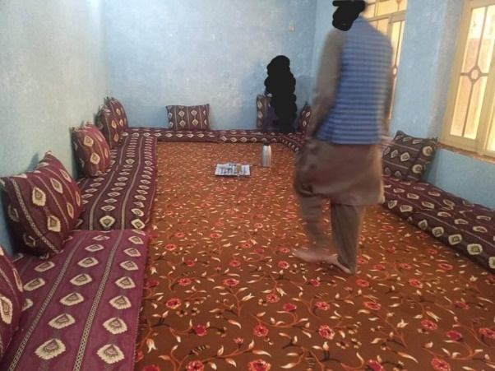
In a traditional Afghan formal living room, furniture is arranged close to the walls, leaving the middle of the room empty. This is because meals are served on a cloth on the ground, and not at a dining table as is customary in western cultures. The seating consists of a series of seat and back cushions arranged on the floor to simply provide comfort to those seated on the ground, pictured on Figure 9. Western seating such as chairs or sofas are not common. The entire socializing, sleeping, and eating experience is closely related to the ground, which is tied to the communal nature of the Afghan culture – everything a person has is shared with those around them, family or not. Thus, the traditional furniture perfectly complements the families’ lifestyle.
Figure 9: Formal living room design in Afghanistan

Some households utilize beds that consist of a wooden frame topped by a mattress, while for other beds were made of a simple and thick mattress. In both cases, the bed was and covered in multiple layers of embroidered covers and pillows that were often handmade by the mothers and grandmothers of the household. If a bed frame was present, all of its parts would be carved and adorned with patterns traditional to the storage unit in Figure 10 pictured below.
Additional furniture is seldom present unless it is used for storage or display of traditional or holy objects. Those pieces are typically made of solid wood usually adorned with engravings of different geometric or organic patterns which are done by carpenters in extreme detail. Some pieces are also finished with etched glass or mirrors containing traditional patterns.
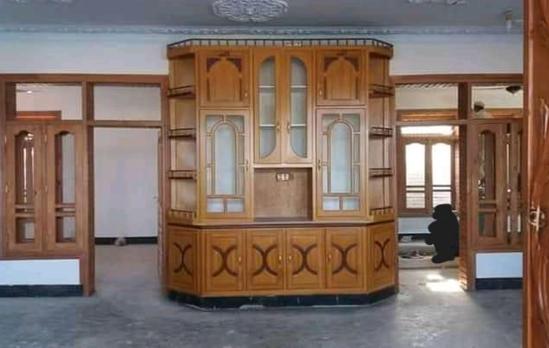
Figure 10: Traditional storage unit in Afghanistan made of carved wood

Furniture Type and Arrangements
The furniture present in the Oklahoma homes varied as both western-style and traditional Afghan furniture was observed. This different furniture did not have the same level of utility in the homes however, as most western furniture was lined up against walls and moved out of the way to make room for traditional Afghan groupings.
This mixture of furniture types and styles was largely due to the families’ access to resources that could be spared on purchasing traditional furniture, which typically also required a trip to the Texas city of Dallas in addition to funds needed for purchasing items. Thus, upon each family’s arrival to their Oklahoma City dwellings, donations were made by mostly American families who had western-style furniture in their homes, which were then utilized by the family until they were able to settle in more and start earning their own funds through employment. Once they were financially more comfortable, they had the ability to obtain access to traditional furniture. For cases in which the family wasn’t able to purchase traditional furniture themselves, sponsors from local resettlement agencies helped out and purchased items for them.
When it comes to the placement and arrangement of furniture, the Oklahoma homes closely followed what was present in Afghanistan. Seat and back cushions were lining the walls while the middle was left open for serving food and refreshments in equally traditional containers. All western furniture was stored in a corner and out of the way as seen on Figure 11.
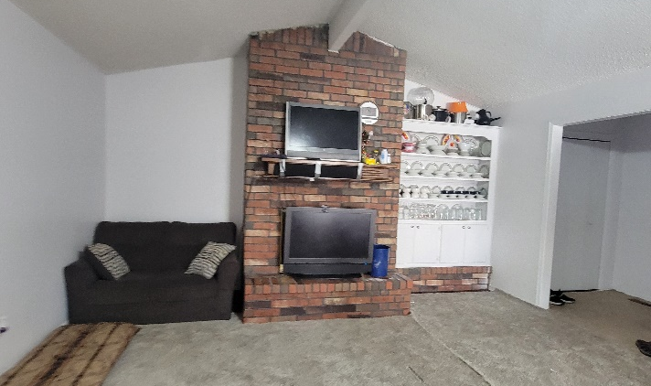
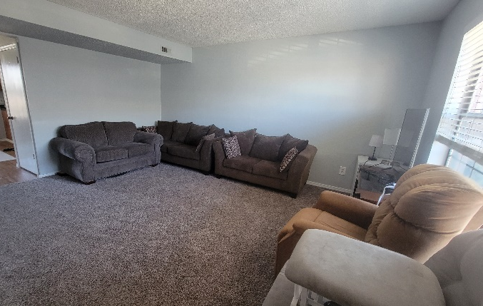
Figure 11: Western furniture pieces stored away from main circulation paths and not utilized in daily life

In instances where two living rooms were present in the home, the informal living which was in most cases the home’s original living room contained some western-style furniture was present and used, while the more traditional furniture with higher-end finishes was placed in the formal living room reserved for guests only. Figures 12 and 13 below display the difference in informal and formal living room furniture types, quality, design, and arrangements observed in in house #6 and house #9.

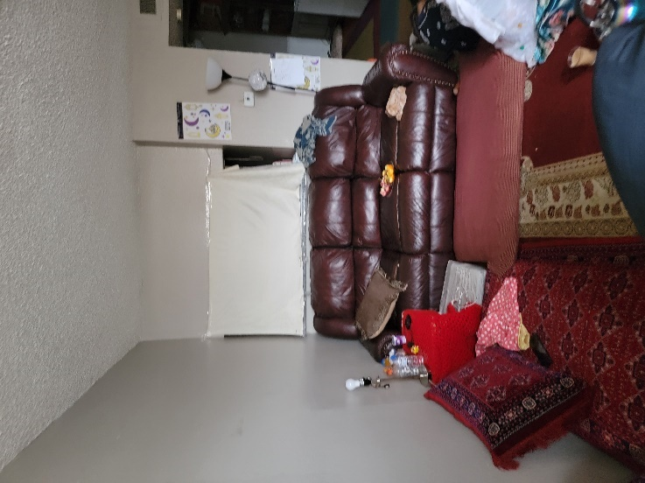
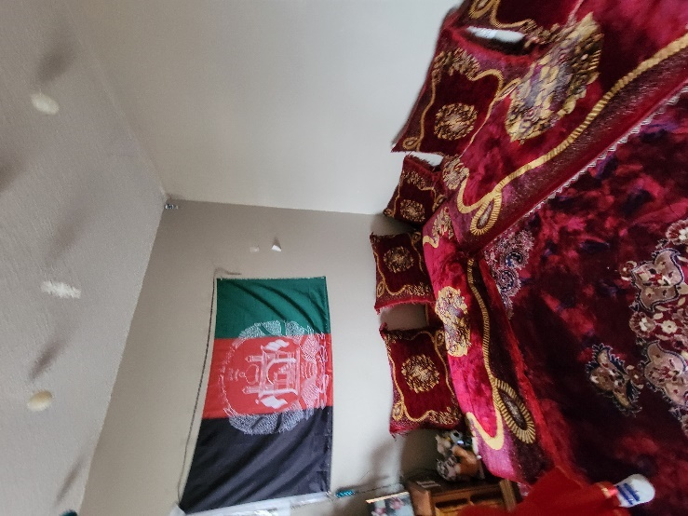

Figure 12: Difference in design of informal (left) and formal (right) rooms in house #6
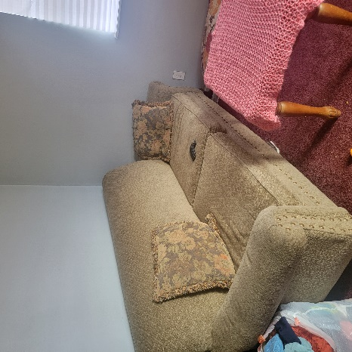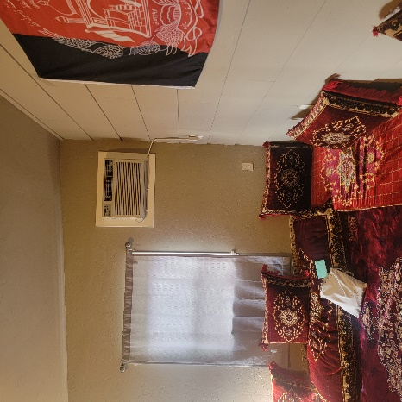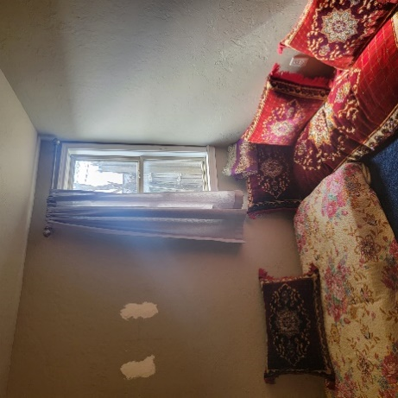
Figure 13: Difference in design of informal (left) and formal (right two) rooms in house #9

Beds were one furniture item that was utilized equally in both styles in both Afghanistan and the United States. As observed during household visits, if a frame was available, the older members in the household were utilizing it while the children were typically sleeping on mattress placed directly on a rug-covered floor. Their US bed frames and covers were not as luxuriously carved and patterned as their native ones were, but an attempt at bringing in some familiar elements was noted as all frames were wooden, and most covers contained color palettes and patten motifs similar to those from Afghan traditional homes. Most bedroom contained only the most basic furniture pieces, and often accommodated two to three persons. The bedroom furniture most commonly present in visited homes were beds or mattresses, desks if the occupants were attending school, a small dresser, and occasionally children’s toys, which serves as representation of how much of the occupants’ time is spent outside the bedroom, with family and friends.
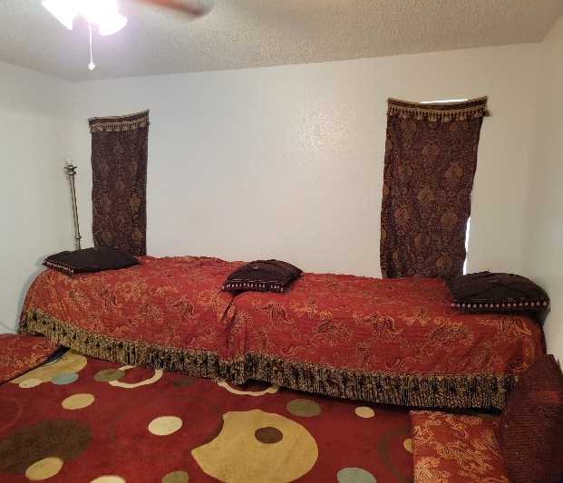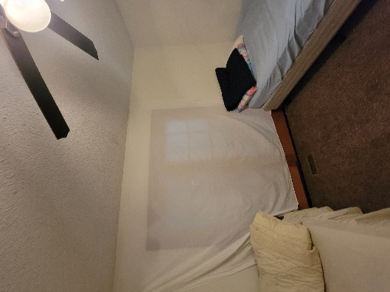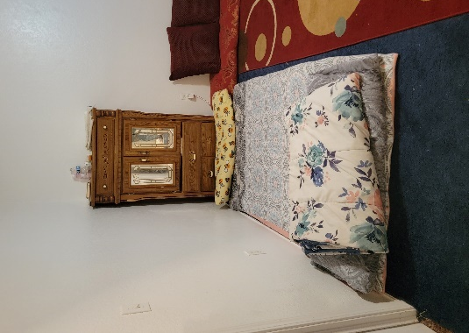
Figure 14: Variations in bedroom design and furniture across visited homes

Another furniture category that was similar to what was present in homes in Afghanistan were storage pieces. Some units served to store clothing and bedding while others were used to display decorative objects such as traditional dinnerware or family heirlooms. While not as large or grand in scale or ornamentation compared to those from Afghanistan, wooden dressers with a simple and functional design were present in every home’s living or bedroom as the only consistent furniture piece aside from beds and seating, as pictured in Figure 15.
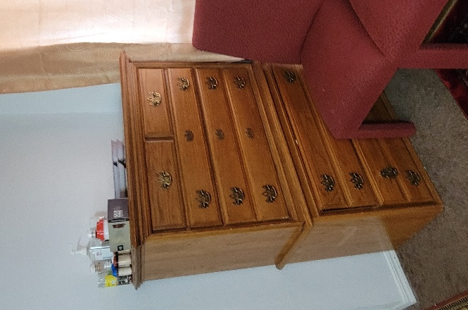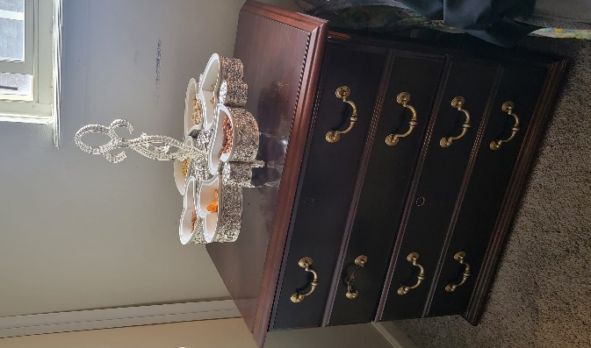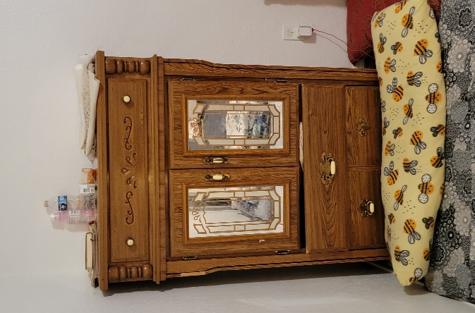
Figure 15: Wooden storage units observed in visited homes

Specialty treatments
In traditional Afghan homes described by the study participants, other than carved wooden storage units and bed frames mentioned earlier in this section, walls, floors and ceilings are also adorned with wood. Because décor objects and furniture not directly supporting an essential activity such as socializing, sleeping, cooking, or eating are not a priority when it comes to Afghan interior design, visual interest in spaces is created with utilizing patterns and colors on specialty treatments such as flooring, wall finishes, ceiling finishes, doors and doorframes, and window treatments. These are usually made up of wood carved with traditional patterns, or wood stained in different colors and arranged in a way to create a geometric pattern on the floor or wall. In the case of rugs and window drapery, embroidered or crocheted fabrics containing the same traditional organic or geometric motifs are utilized. Examples of this can bees seen on Figure 16.
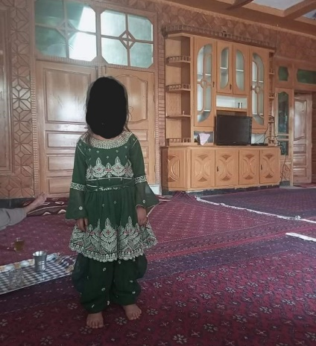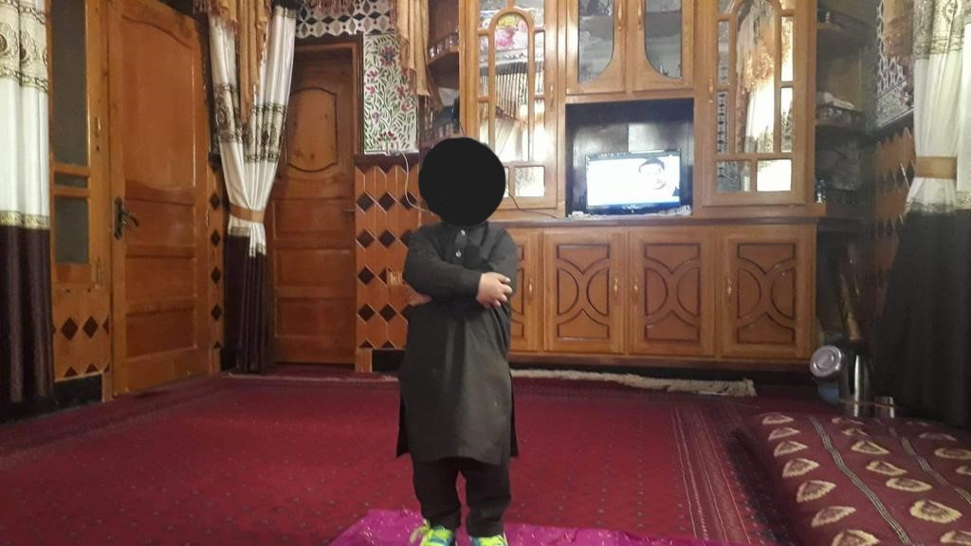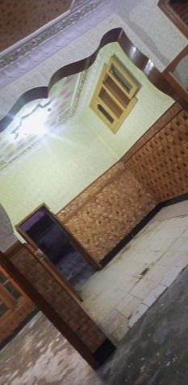
Figure 16: Specialty treatments present in traditional homes in Afghanistan

In their US homes, the same specialty treatments mentioned above were utilized to bring in a sense of familiarity and home to each space. While most walls were left blank compared to the Afghan interior design style, thick rugs of rich colors and dynamic patterns covered bland carpets that are typically installed in US housing units and ensured the space still feels fully utilized. Light was also reflected in different ways by the rug and traditional seating fabrics, adding another layer of luxury feel to the space. Examples can be seen on Figure 17.
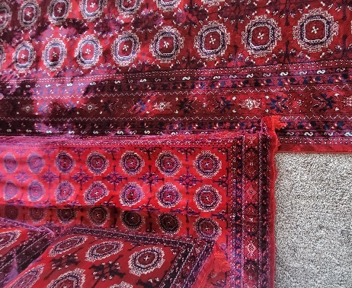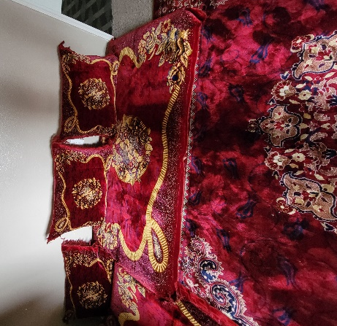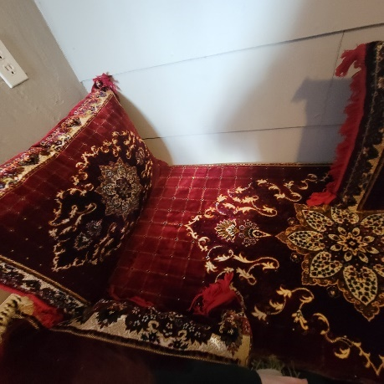
Figure 17: Specialty treatments observed in visited homes

Most furniture observed during visits was made of wood stained in a similar color as what is showcased in Figures 10 and 16, creating another placemaking parallel with their native homes in their new space. Embroidered and hand crocheted table and window covers were draped across surfaces for either esthetic or privacy reasons, and one household even added carpet on top of the kitchen counter to prevent the rental space from being stained by spices when cooking for the large family.
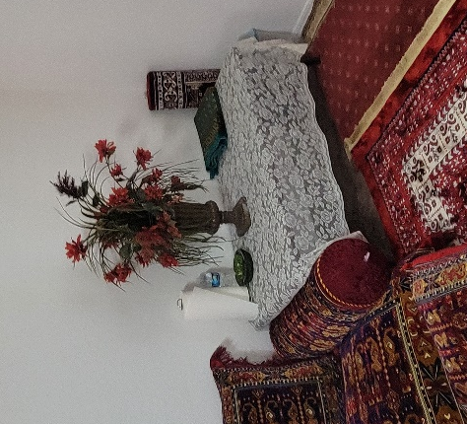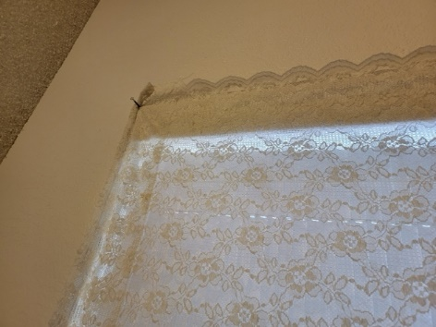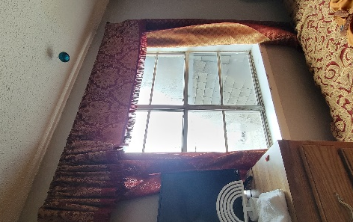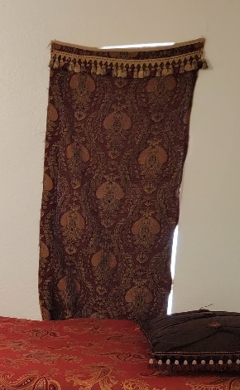
Figure 18: Window and table covers observed in visited homes

Ornamentation
This section analyzes placemaking techniques related to ornamentation. As can be seen from photographs showcased throughout this dissemination, objects are rarely used in Afghan native homes for decorative purpose. This design characteristic was also implemented in the visited homes in the US, as most displayed décor objects served a dual purpose, a decorative and a utilitarian one, unless directly related to religion, nationality, or personal experiences.

Expression of Culture
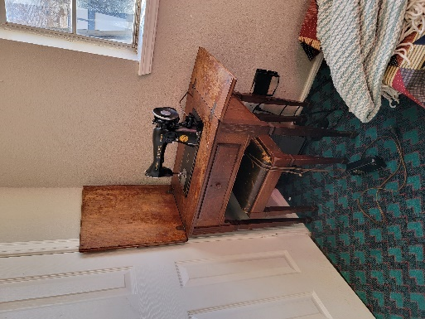
As mentioned in the previous paragraph, because traditional Afghan interior design stye is expressed through patterns and colors mostly, objects are not on the forefront of the experience of a space. Most of the cultural ornamentation was done through objects that serve both a decorative and a utilitarian function, such as eating, cooking or event sewing. For example, since most Afghans prefer their traditional clothing style over what is popular in the US, they sew their own clothing pieces according to what they’re familiar with, thus a sewing machine was present in almost every household visited.
Figure 19: Traditional sewing machine observed in home #4
Another category of cultural ornamentation that is also utilitarian are objects and tools utilized to serve food and drinks, as pictured on Figure 20. Compartmentalized refreshment serving trays and traditional water pitchers are used during meal times, and porcelainware is displayed in a traditional method in storage units.
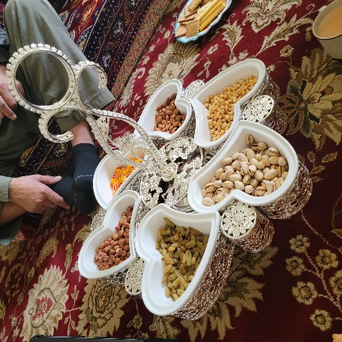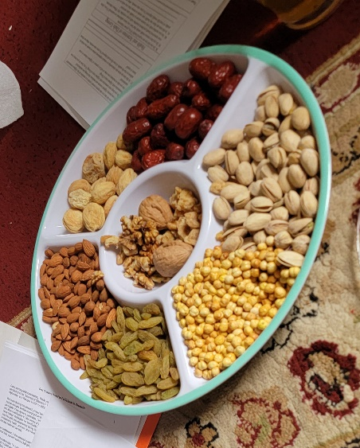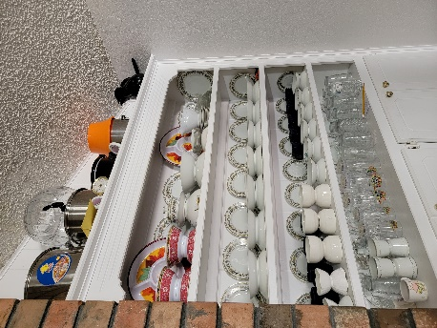
Figure 20: Traditional kitchenware doubling as ornamentation

Expression of Religion
Religion is an aspect of life strongly embodied and followed in Afghan tradition, thus many ornamentation techniques observed during home visits were influenced by Islamic practices. For example, due to images or likenesses of living beings not being allowed as décor motifs in Islam, all ornamentation patters present were limited to geometric motifs and organic motifs based on plants only, as can be seen on almost all photographs in this dissemination. Most wall-hung elements observed were analogue clocks to monitor prayer times, art pieces depicting holy Islamic sites and symbols, as well as holy scriptures written in calligraphy. Lastly, almost every bedroom and living room contained at least one payer mat.
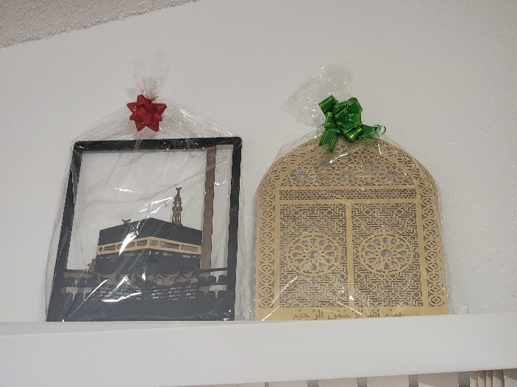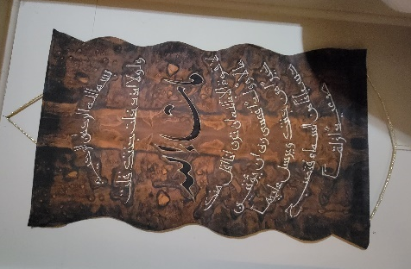
Figure 21: Religious symbols and calligraphy utilized as wall ornamentation
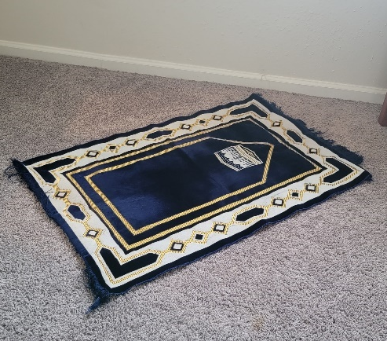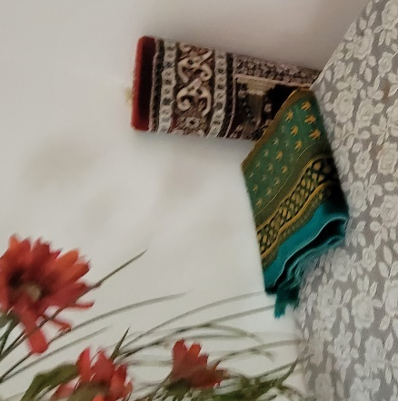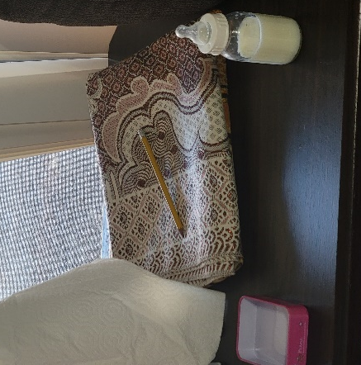
Figure 22: A prayer mat was present in most rooms of every household visited

Expression of Nationality
After religion, nationality and patriotism were the most commonly and most intentionally expressed identity aspects in the visited homes. Although the actual methods of expression rarely went past flags and children’s drawings of Afghanistan displayed on walls as can be seen on Figure 23, every single one of the nine visited households had this present in their formal living or bedrooms, out of which some are pictured below.
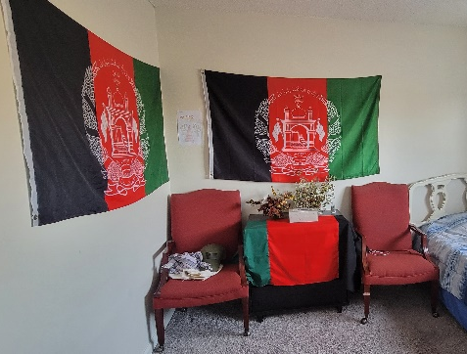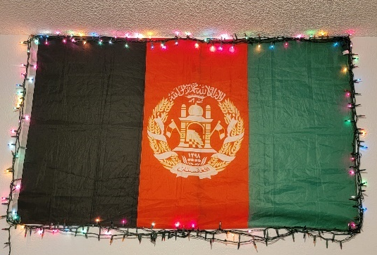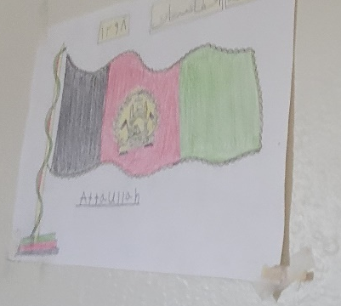
Figure 23: Homage to Afghanistan paid through ornamentation in visited homes
Although not directly related to interior design bit still an interesting placemaking observation made, other methods of expressing Afghan nationality utilized was through clothing that is more patriotic than traditional, as well as stickers pasted on Afghan families’ cars or prayer beads and calligraphy suspended from the vehicles’ rearview mirrors. Photographs of examples observed are included below.
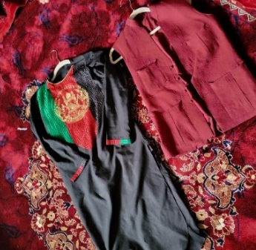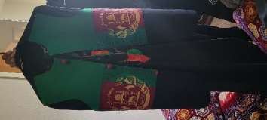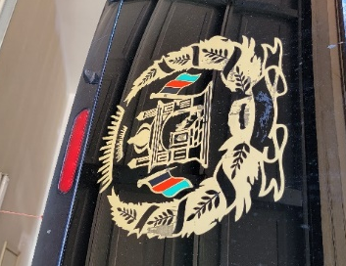
Figure 24: Homage to Afghanistan paid through clothing and vehicle ornamentation in visited homes

Expression of Personal Identity
Because the Afghan people have a strong collective sense of identity and their lifestyle isn’t based on expressing oneself through objects as much as it is about self-reflection and expression through behavior, most households lacked personalization that moved beyond the family creating placemaking adaptations as a whole, utilizing techniques described throughout this chapter. Other than ornamentation related to utility, religion, and nationality, the author observed only a few individuals amongst all study participants who expressed their personal identity through interior design. The two most common methods utilized to do so were displaying photographs and sentimental objects, and displaying children’s art on walls.
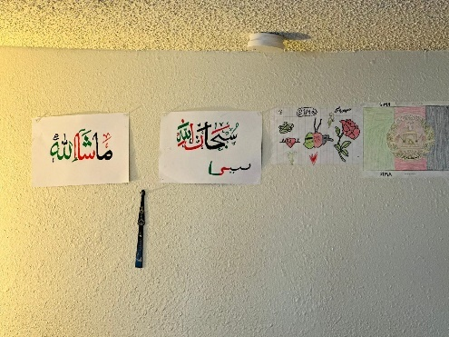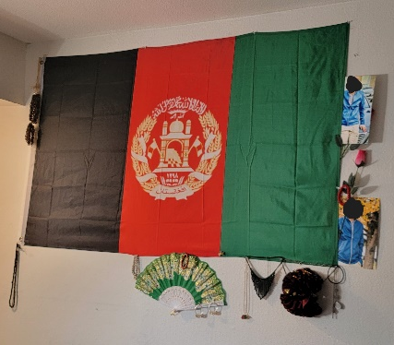
Figure 25: Placemaking through personal belongings of sentimental value
In some households where children under 6 years old were present, items such as play area rugs, soccer balls, doll houses, toy cars, and dolls were distributed around the homes, as seen on Figure 26. In most cases however, despite having children of all ages occupying the space and often being confined to the indoor space for majority of the day, no toys or other indicators of children’s’ presence were observed. This could either be due to Afghan children being encouraged to play outside and spend most of their day in nature, as is customary to Afghan culture, so the need for relaying on toys rather than other children for entertainment is not a habit yet. Many families also have several children of similar ages in the same household, so they could also be entertaining each other or being entertained by older family members as a group.
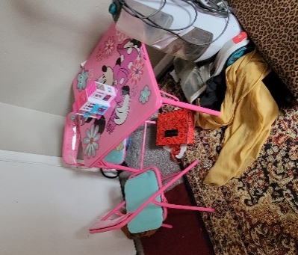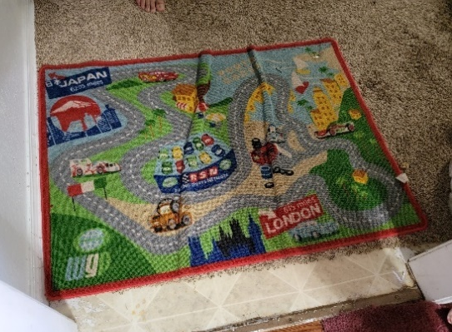
Figure 26: Placemaking for children in visited homes

Home #6 however stood out in this aspect compared to other visited households as its formal living room doubled as one son’s bedroom, however it was extensively decorated in many personal and non-personal items such as photographs, posters, Christmas tree ornaments which are not typically utilized in Islam, colored lamps containing rainbow symptoms which are also looked down upon in the conservative Afghan culture, and drapery over both the windows and door frame. This was not commonly found in Afghan formal living rooms, as they are meant for both friends and strangers visiting the home, so the family’s personal life is usually kept outside of that room for privacy reasons and only the basic furniture pieces and specialty treatments are installed in the space. This room was also fascinating because it was one of only 2 spaces across all households visited which contained décor elements mimicking nature, better known as biophilic décor, which are the faux plants gung across the wall. The formal living room of home #6 is pictured below.
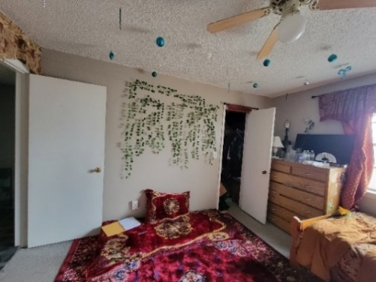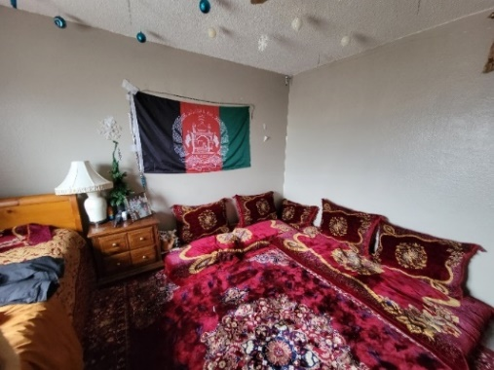
Figure 27: Placemaking though spatial personalization in home #6

Interior Design Elements Analysis
During the interviews and house visits, each family was asked to reflect on the interior design of their native homes. Additional to verbal descriptions, some families provided the author with original photographs of their native homes in Afghanistan, which are included in this section. This section also contains an analysis of interior design elements that were consistent with the homes visited and described, and includes the following: color, texture, patterns, movement, materiality, and odor.

Patterns
Due to the Afghan culture’s strong ties to religion, mainly Islam, most patterns observed on photographs from both their current and native dwellings were either geometrical or based on biomimicry, which includes motifs of blossoming flowers and other flowing plants, but rarely animals. Calligraphy, considered to be the most fundamental and highly respected form of art in Islam, was also another prominent set of patterns that could be noted on different surfaces of the home, including walls, ceiling, ornaments, and furniture. In Islam, motifs depicting humanlike creatures are not allowed, thus geometry, biomimicry, and calligraphy are used for décor and storytelling through design.
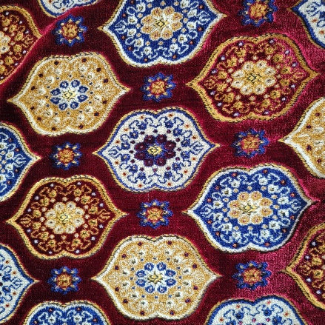
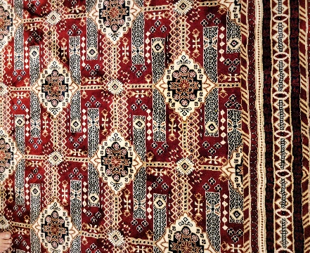
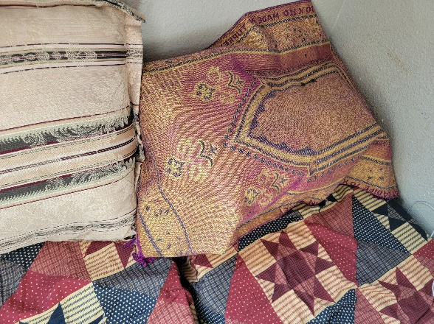

Figure 28: Pattern types observed in visited homes

Movement/ Dynamics
Because patterns observed in native and current subjects’ homes were limited to three families, as mentioned in the previous paragraph, visual interest was typically created through movement and dynamics. Different movement-creating techniques could be extracted from traditional Afghan designs the author observed, with the most present being strong contrast created by color and/or light, patterns containing repetition of motifs and patterns consisting of organic shapes that appear to be flowing or growing across a design piece, texture that reflects light in different ways depending on viewing angle, and forms containing soft and curved lines rather than crisp and straight lines or sharp angles.
Figure 29: Pattern layering and movement observed in visited homes
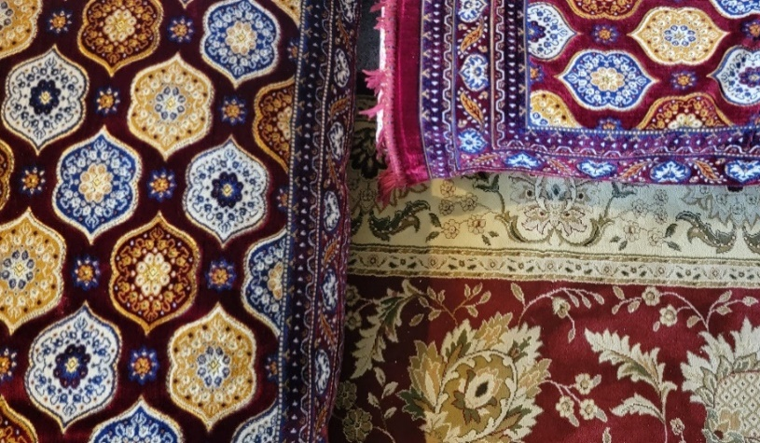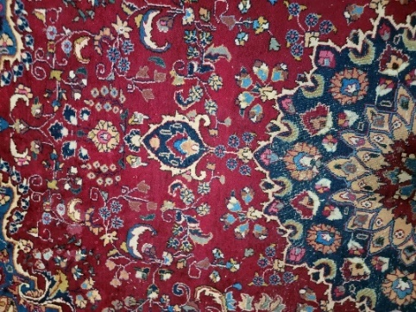

Materiality
As per interview data and the photographs shared with the author by the subjects, Afghan interiors usually contain materials that can be directly extracted from the nature around the building site, so the most common finishes are wool, stone, concrete and wood. While the exact same materials are not available in the US, alternative sources were used to mimic the original look characterizing interior design elements of Afghan traditional homes.
For example, due to most study participants originating from the Kunar region in Afghanistan, they had easy access to a high-quality wood type that comes from trees native to the banks of the Kunar River, known as Kunar wood. It is a popular, versatile, and reliable wood type in Afghan construction and design according to the participants’ experiences, and many of the photographs displayed in the furniture analysis section of this chapter contained native design elements created with that material. A clear indicator of it being the same wood type is the close similarity in wood stain color across all photographs of Afghan interior elements despite every photograph being of a different home in the region. As an ode to Kunar wood, the author observed that most households contained furniture pieces of a similar stain color here in the US, as compared in the photographs below.
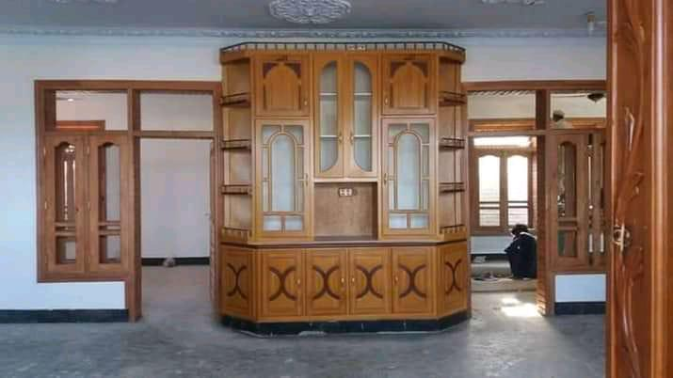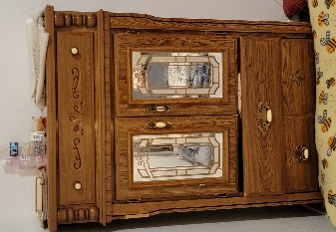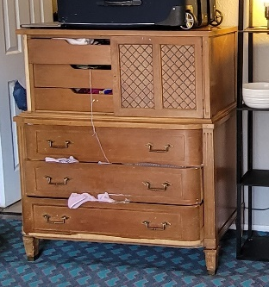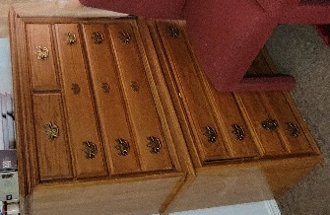
Figure 30: Comparison of wood stain colors between furniture observed in native (left) and visited (right) homes

Wool rugs and drapery were not too hard to obtain in the US, but participants had to source all textiles in the neighboring state of Texas. Cups and serving trays, however, utilized the same mimicry present with wood, as many dishes were not available in the same metal alloys that were available in Afghanistan. What used to be dishes made of porcelain and copper or silver alloys in Afghanistan are replicated using plastic, aluminum, and stainless steel in the United States.

Color and texture
The most common color palette present in Afghan interior design is deep shades of red combined with tones of cream, brown, orange, and gold to add dramatic contrast to the space. Shades of blue are most often incorporated as an accent or to add dimension to a design. Due to specialty treatments and furniture being highly ornamented in native Afghan design, if a space is too saturated with patterns and color, walls are painted white to add visual relief and reflect light more effectively in the space. This is especially useful in spaces where the seating and flooring are dark and walls are either paneled with carved wood or lined with wooden furniture. The mirrors often incorporated in such furniture pieces serve as light reflectors while also capturing the existing patterns in it’s photograph thus no surface is standing out as plain or undetailed enough.
Other than textures created by carving and layering wood on different interior elements, color is also utilized to emphasize different textures or create a textured effect on an otherwise smooths surface, especially in rugs, seating, and drapery. This is largely possible due to the high light reflectance of finishes used to create different interior elements, such as veneers and textiles.

Odor
The last major placemaking method noted during this study was odor. Upon entering the homes, one is often greeted by one of two scents – burning incense or traditional meals.
Because cooking and eating together is an integral part of Afghan culture, recipes native to Afghanistan is what is being prepared in the households visited in this study. Due to the large group sizes that join every meal, cooking is often being done throughout the whole day, and because the Afghan traditional recipes are very rich in flavor and spices, many odors spread throughout the homes every day. Thus incense are often burned to mask the smell of spices native to Afghanistan because, as could be seen through this chapter, Afghan homes are filled with rich fabrics that are prone to odor absorption. Just like one household covered their kitchen counter with carpet to avoid staining the rental home’s millwork, incense smells can be used to avoid the food odors locking into the rental’s soft surfaces. The smell of familiar food, however, does add an important layer of placemaking that is very effective at transforming a space into a home.

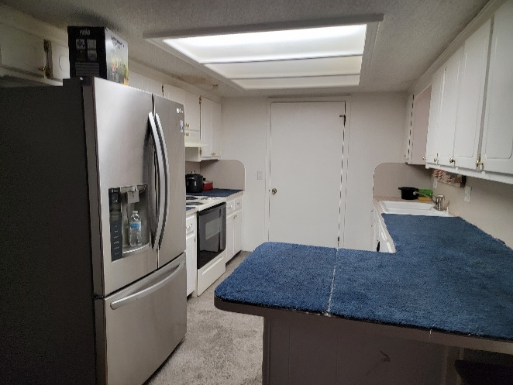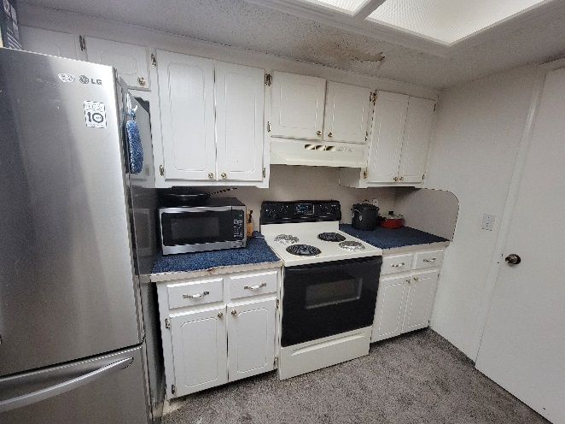
Figure 31: Kitchen placemaking intervention observed in house #5

Lifestyle Analysis

Activities Impacted as a Result of Displacement
Other than socializing, which is more affected by the participants’ unfamiliarity with local culture, language, and communication style rather than placemaking though the interior design of their homes, one aspect of life that was greatly impacted by displacement is religion. All subjects of this study belong to the Sunni sect of Islam. In Islam, a believer is required to pray 5 times a day at exact times of the day, as well as read the Qur’an and other holy books daily. Before doing so, it is necessary to perform ablution - a ritual of washing body parts in order to cleanse themselves before starting the prayer or handling holy books and items. All study subjects were strict followers of Islam and observed all requirements, thus having a lack of bathrooms significantly impacted their ability to pray on time due to the large queue of people waiting to perform ablution at designated prayer times.
Additionally, when praying, one has to set up a prayer rug in a clean room, and with no persons walking in front of it during prayer. If an individual’s prayer is interrupted by a person walking in front of the rug, the prayer is considered invalid and has to be started over. Having a lack of private spaces in the home meant that, while adults are praying, the little children would often roam around the home and interrupt prayers, or the individuals who finished praying wouldn’t be able to walk around certain spaces until everyone in that space was done praying as well, restricting movement and prolonging the otherwise relatively short prayer during a busy day. Many households were also complaining about pest problems – most concerningly mice, meaning that they aren’t able to pray inside rooms infested by pests as they are not considered clean enough. Furthermore, special attention would have to be paid towards the clean rooms so that the doors are always closed to avoid infestation, but because many rooms serve three to four people, often little children, that task is hard to maintain.
Religion was highlighted in this section as it is one of the main sources for feelings of safety, comfort, hope, identity, belonging, and community among the study participants. Therefore, if the current home design cannot accommodate all that is needed for them to properly observe religious obligations, it will have a large negative impact on the effectiveness of placemaking through interior design.
A description of how different lifestyle aspects and activities identified in this study are observed in Afghan customs and American customs are listed in Table 3, and their impact on placemaking through interior design is summarized in the next section.
Table 3: Comparison of customs between culture in Afghanistan and United States
Activity | Customary to Afghan culture | Customary to US culture
Socializing | Household sizes often exceed 30 persons as multiple families live under the same roof. They usually visit each other on a daily basis and are well connected with the neighborhood too. A strong sense of community is present. Socialization happens in spaces designated as formal living rooms, where men and women are visually separated by gender. All guests are sat on floor cushions lining the wall on a rectangular room, so that everyone can clearly see each other while talking and the middle space is open for refreshments. | The US is a highly individualistic culture where privacy of both space and personal information is preferred. Individuals enjoy expressing their uniqueness through the built environment, thus personal spaces and territories are often well guarded. Relationship building largely depends on personality compatibility or professional network, and families are often much smaller compared to Afghanistan. Guests are sometimes hosted in personal homes, but more often they are planned in external spaces such as restaurants or clubs. The furniture used is standardized to fir western style, users, and building requirements.
Cooking | Cooking is mostly done by the mothers and daughters of the household through the whole day. Because refrigerating or reusing leftovers is not customary, throwing unfinished food is common in Afghanistan. Thus, kitchens are spacious to ensure that large quantities of food can be prepared and served to the family at least two times per day. It is also customary to always cook for extra mouths because Afghans always expect guests to visit due to being a communal culture. | Because families are much smaller and dining out is very popular, individuals do not cook at home as much thus their kitchens are often enough to accommodate a family of up to 4 comfortably depending on home size. Cooking also takes a long time sometimes, so many individuals prefer buying ready-made meals to invest the extra free time into a different task or activity, as the lifestyle in the s is more fast-paced and busy compared to Afghanistan.
Eating | Food is usually served on a cloth on the floor and is eaten with bare hands which are washed beforehand in a traditional manner of water being poured over one’s hands into a bowl set below the hands at the spot where the guest is seated. It can be described as a manned portable washbasin. Neighboring seats often share plates as each dish is served in large quantities, and the variety of food types is always high. | When at home, individuals usually eat in dining rooms equipped with specific dining furniture meant for the activity, which is separate from lounging furniture present in living rooms. If a dining space is not available or there is a need for multitasking, then meals are consumed at kitchen counters, study and work desks, or living rooms.
Sleeping | In Afghanistan, it is common for youn777ger children to sleep with their parents due to religious superstitions and general concerns for the children’s safety, so low privacy while sleeping is not seen as an issue. Once children become older, they are separated by gender and moved to larger bedrooms to shar with siblings. Both framed beds and mattresses set directly on floor are utilized. | In the US, each person often has their own room where they are able to fully express their identity as needed. This includes a bed, a desk, a dresser or storage of sorts, and a full closet. Bed are usually framed, and are often occupied by ne person unless the occupants have a special relationship.
Playing | Because Afghanistan isn’t densely populated outside of big cities and the weather is nice for most of the year, children are able to freely play outside however and wherever they would like. It is a generally safe culture because of the strong community aspect, so everyone keeps watch over each other. Sports such as soccer and cricket are very popular outdoor activities, and swimming is almost never done unless fully clothed. Courtyards of each home also serve as a safe playing area for children. | Because the US is a capitalistic economy, children have access to many sources of entertainment both outside and inside the home. With the increasing popularity of social media, video games, and TV subscription services, less and less children spend the majority of time playing face-to-face with friends outside of school. Almost every home is equipped with basic technology and internet access. Most children also have access to an abundance of mass-manufactured toys and physical games as well.
Studying  (school) | Formal education is not common in Afghanistan outside of big cities, and the literacy level varies between households. Some individuals in cities complete a few grades while some pursue higher education degrees. Many Afghans can speak multiple languages but cannot read or write them,. No formal study spaces, furniture arrangements or types were observed on the photographs provided by participants. | Higher education and vocational trainings are highly valued in the US, so most homes have an office or study set up specifically to support schooling or working from home. Special attention to their design is being paid now since the recent covid-19 pandemic outbreak changed the way many people think, work, focus, and stay motivated.
Entertainment/ technology | No electronics devices were observed in the native home photographs the author was given access to by the study participants (TVs, personal computer devices, gaming consoles, etc.). A more popular entertainment source is face-to-face interaction. | Entertainment is at the heart of US culture and its economy. Within the home, there are numerous elements created for this purpose. From board games and puzzles, various genres of books, exercise equipment or crafting kits to TVs, smart devices, screens, consoles and even home theaters, interior design can be largely impacted by the entertainment aspect of culture in the US.
Praying | Although literacy and education levels vary from person to person, being educated in religion and taught how to read the Qur’an is very common, thus many Afghans are able to read some Arabic. Prayers are strictly observed five times every day, and often performed in Mosques with other community members. | Due to diversity of religions, sects, and spiritual organizations in the US, praying varies from one group t the next. In some it is done alone while in others it is done in groups. Some go to external establishments while others are able to pray at home. However, most individuals are able to read their respective holy scriptures due to the literacy level in the US being much higher compared to Afghanistan.

As summarized in the table above, there were many differences between the subjects’ lifestyle in Afghanistan and in the US observed during this study. These are directly related to placemaking adaptations made to the built environment because the Afghan lifestyle needed to be accommodated in standardized US housing due to the newcomers strive for maintaining cultural identity, observing tradition, creating familiarity in an unfamiliar environment, and overall building a new home for their families. All homes visited had demonstrated the presence of placemaking through interior design.

Housing Adjustment Analysis
In this section, an analysis of placemaking techniques that were utilized by the families to create the abovementioned adaptations and needs are summarized in the table below. Each prominent lifestyle aspect identified as integral to the Afghan culture and identity in Table 3 was analyzed against the main three options refugees usually choose from when moving to an unfamiliar space based on Hadjiyanni’s 2007 ‘Bounded Choices’ article: 1. adjusting their living environment to better suit their way of life; 2. changing their way of life to fit the new living environment; 3. do nothing and endure inconveniences.

Table 4: Relationship between lifestyle and spatial adaptations through placemaking
Activity | Lifestyle changed to fit design of home | Home design adapted to fit lifestyle needs | No compromise was found,  inconveniences are being tolerated | Effect on placemaking through interior design
Socializing |  | x |  | Every studied household made changes to either the home’s original socializing spaces or adjusted the original space plan to accommodate the incorporation of a formal living room designated for hosting guests in a controlled environment to ensue traditional norms are observed while the test of the family is given enough privacy and freedom to move around the unit. All furniture utilized in native Afghan living room design has been incorporated into US housing as well, except for the ornate wood furniture and specialty treatments.
Cooking |  |  | x | Kitchens were quite restrictive in terms of storage space, available appliances, open floor space and counter space in almost every home. As mentioned earlier Afghans eat abundant meals in large groups, so having the appropriate facilities to cook multiple times a day is important but sadly not available. Additionally, they prefer using fresh ingredients while cooking, but due to the cost and low availability of fresh and organic foods, they have turned towards freezing and refrigerating groceries. However, doing so is almost impossible with only 1 available fridge and 12 members to feed every meal.
Eating |  | x |  | Eating is being done exactly as it was in Afghanistan, and only minimal changes, if any, had to be made to the US homes to accommodate it, which mostly comes down to moving any western style furniture to he outskirts of the space and laying a cloth down to serve as separation from flooring.
Sleeping | x |  | x | Due to large household sizes having to live in 2- or 3-bedroom apartments and houses, the biggest sleeping problem is related to future needs that will have to be accommodate as all children are growing up and becoming more westernized in their thinking, behavior, and needs. Currently however, most individuals sleep either on framed beds or mattresses laid on the floor, and share their bedroom with 3 or other family members. This will become a big problem in a few years, because renting a home with more than 3 bedrooms is outside of the budget of most Americans in the current housing market, let alone war refugees.
Playing |  |  | x | Because US neighborhoods are not as safe or abundant in nature compared to Afghanistan, most children are confined to the home unless they’re attending classes in school. Toys are expensive to purchase in the US, so children usually play with each other or assist the parents with chores. This lack of social interaction with peers outside of their household is starting to negatively impact the children, who are gradually becoming sadder and more introverted.
Studying (school) | x |  |  | Because attending school is mandatory in the United States, children of all households are facing issues that they haven’t encountered in Afghanistan due to its lack of regulations mandating required education. Since most children share rooms with multiple persons, studying at home can be a challenge due to noise and potentially frequent interruptions. While no household contained a personal computer device, desks were provided in many of the households for the students to utilize as a designated workstation.
Entertainment / technology |  | x |  | Contrasting common US household design, no technology was present in the visited Afghan homes. No laptops or desktop computers were observed in study spaces nor were there TVs in bedrooms or living rooms except in a few occasions where the TV was mounted on the wall and was included in the rental of the current housing unit. This could potentially be due to smartphones being the main source of information for the Afghan newcomers, as the sources, content, and language of news and entertainment of their preference were not available on local TV, and obtaining internet through a phone plan was more cost-effective and hassle-free than obtaining it through other, more-expensive means such as computers, wireless network systems, and support services. Additionally, some controversial information that access to the internet could potentially expose the families’ young children could be another reason, as Afghan culture favors following tradition and customs that their strong Afghan identity is rooted in.
Praying |  | x |  | An analogue, wall-hung clock was present in almost every living room visited despite the absence of any other décor piece beyond the basic seating arrangement and occasional native trinket. Taking the participants’ strong relationship with religion into account, the clock was most likely present so that one could always know what time it was in the space most commonly occupied by family members and visitors through the day. This ensures that prayers can be performed at the correct times. A prayer mat was present in almost every visited living and bedroom.

Conclusion
Although nine distinctly unrelated households hailing from different regions in Afghanistan were visited during this study in different housing typologies and neighborhoods, many parallels between them were drawn during the data analysis phase. From utilizing the same color palettes for fabrics and almost identical-looking stain color on furniture, to arranging both native and western-style furniture in the same manner, it is evident that the Afghan people have a strong sense of collective identity.
This collective sense of identity was reflected on standardized US housing through various placemaking techniques mentioned in this chapter. When available, the household’s surplus resources were primarily invested in traditional furniture pieces that emulated colors, patters, design, forms, and functionality of what was present in their homes in Afghanistan. With unity expressed as being one of the most important aspects of Afghan culture, spaces were arranged in ways that would best accommodate the socializing style in Afghanistan. Elaborately embroidered seat cushions laid on top of richly colored carpets were installed in formal living spaces so that all visitors could feel as comfortable, important, and welcome as possible, before a cloth would be placed on the floor between the guests to serve as a food serving and eating surface.
The entire ethnic eating and socializing experience is carefully curated inside each home so that visitors only dwell in the spaces allowed by the family and are isolated from the rest of the home which is intended for the family’s unrestricted use. Furthermore, different cultural items such as flags, patriotic drawings and art pieces, and religious décor add to creating a sense of belonging and community.
Overall, with the resources available to them until now, each visited household implemented placemaking techniques that are not difficult to accommodate, but which completely transformed the standardized US construction into a home they feel comfortable creating a new life in. While not fully resembling what was present in Afghanistan, it will certainly support their healing and resettlement journey.

CHAPTER 5: CONCLUSION
Based on the findings of this study, placemaking through interior design is an actively ongoing process vastly utilized by Afghan refugees in their efforts to build a new home for their families in a completely new and unfamiliar environment. The level of placemaking success varied by the amount of surplus funds each household had to invest on their home’s design, their personal preferences, their opinion on how impactful transforming ones’ home with placemaking techniques actually is on health and wellbeing, as well as the typology, quality, and size of housing accommodations they were able to obtain.

Recommendations
Before recommendations are made, it is important to recognize that the participants experienced tragedy and displacement just one short year before this study was conducted. Therefore, the placemaking process is still largely ongoing as all households are still in the process of establishing themselves and transitioning to become independent from government assistance. Taking this into consideration, suggestions based on the quality and quantity of design features and elements incorporated into the visited homes cannot be made at this stage Thus, only two easily implemented suggestions will be made in this chapter, which could help improve the overall feelings of comfort, safety, and privacy within their homes.
The first suggestion directly references a point every household made when talking about their daily lives in Afghanistan – being outdoors. Since most women and children still do not feel comfortable walking outside and spending time in nature at the time of this study, bringing nature int the home is an effective way of introducing more life and energy into the space. As living beings, we naturally crave to be outside surrounded by animals, plants, and fresh air, so capturing even the smallest fraction of that effect can bring immense benefits. Aside from providing mental and visual relief, incorporating living flora such as potted plants also create a sense of obligation to nurture life and has potential to create some manner of routine in a chaotic environment. Where living plants are not possible to incorporate, faux greenery will have eh same effect but without the nurturing and routine-creating element.
This suggestion has been made because not one living plant was observed in any of the visited spaces or households, and only two incorporated small biophilic elements that could have been more impactful if present in larger quantities. While it is not customary in Afghanistan to have potted plants inside the home as it is in the US, many described Afghan homes were surrounded by open fields, rolling hills, and untouched nature, which is not the reality of their US homes, thus a compromise should be made.
The second suggestion is related to adjustments made to the home’s original space plan in efforts to accommodate a traditional formal living area while meeting adequate privacy needs and gender-separating norms being observed in Afghan culture. When looking to lease accommodation, if the housing market allows, Afghan families should prioritize renting homes where the kitchen is not open to the living room, otherwise the intended living space will be utilized as a corridor and an important bedroom will be either given up completely or transform to double as the formal living room, as was observed in this study. This should also be prioritized by case workers in charge of assisting the families. For cases in which the family isn’t looking to move from their current housing, living rooms should be compartmentalized more with ceiling suspended curtains or solid spatial dividers so that wasting an entire living room on a corridor is avoided. In US construction, living rooms are often the biggest rooms in the entire home, so a lot of otherwise precious space is left unused, which is especially unhealthy for Afghan families due to the number of individuals making up a typical household.

Study Improvements and Future Research
This study focused on providing an overview of how placemaking is being incorporated by the participants trough interior design. Because it is one of the first projects on this topic involving this specific participant group, there are many design-related needs sill left to be investigated. For future improvements, a better system for collecting photovoice information could be developed to maximize the amount and scope of information provided by the participants, and more interior-specific housing questions should be posed during the interview, because those not related to this field often aren’t familiar with how design can impact and control our behavior, thought, feeling, and actions.

References
Albadra, D., Coley, D., & Hart, J. (2018). RIBA president’s awards for research 2017 winner of the annual theme - Housing: Toward healthy housing for the displaced. Journal of Architecture, 23(1), 115–136. https://doi.org/10.1080/13602365.2018.1424227
Camilo, C. (2021, November 8). U.S. waives work permit and Green Card application fees for Afghan evacuees. CBS News. Retrieved November 29, 2021, from https://www.cbsnews.com/news/us-waives-work-permit-green-card-application-fees-for-afghan-evacuees/ .
Dalal, A. (2017). Uncovering Culture and Identity in Refugee Camps. Humanities, 6 (3), 61. https://doi.org/10.3390/h6030061

Donato, Katharine M., & Ferris, Elizabeth. (2020). Refugee Integration in Canada, Europe, and the United States: Perspectives from Research. American Academy of Political and Social Science, 690(1). https://doi.org/10.1177/0002716220943169

Hadjiyanni, T. (2007). Bounded choices: Somali women constructing difference in Minnesota housing. Journal of Interior Design, 32(2), 13–27. https://doi.org/10.1111/j.1939-1668.2006.tb00310.x
Hinton, C. (2022, February 17). Oklahoma City welcomes 1,000th Afghan refugee. The Oklahoman. Retrieved October 5, 2022, from https://www.oklahoman.com/story/news/religion/2022/02/17/oklahoma-city-has-welcomed-1-000-afghan-refugees-leaders-said/6727673001/
Kight, S. W. (2021, September 16). Mapped: Afghan refugees headed to 46 states. Axios. Retrieved October 5, 2022, from https://www.axios.com/2021/09/16/afghan-refugees-each-state-data?utm_source=twitter&utm_medium=social&utm_campaign=editorial&utm_content=politics-afghanrefugees
Kirk, D. S., Nabil, S., Talhouk, R., Trueman, J., Bowen, S., & Wright, P. (2018). Decorating public and private spaces: Identity and pride in a refugee camp. Conference on Human Factors in Computing Systems - Proceedings, 2018-April. https://doi.org/10.1145/3170427.3188550
Langmann, S., & Pick, D. (2018). Photography as a social research method.
Mansoor, S. (2022, May 26). Afghan refugees in U.S. struggle to find permanent housing. Time. Retrieved February 8, 2023, from https://time.com/6180724/afghan-refugees-housing-crisis/

National Low Income Housing Coalition. (n.d.). (rep.). Washington, DC: The Gap: A Shortage of Affordable Homes, from The GAP | National Low Income Housing Coalition (nlihc.org)

Paszkiewicz, N., & Fosas, D. (2019). Reclaiming refugee agency and its implications for shelter design in refugee camps. International Conference on: Comfort at the Extremes: Energy, Economy and Climate, 584- 594
Polansky, C. (2021, September 29). Oklahoma welcomes hundreds of Afghan refugees - despite the state GOP's objections. NPR. Retrieved November 29, 2021, from https://www.npr.org/2021/09/29/1041571019/oklahoma-afghan-refugees.
Robson, C. (2009). Real World Research (Second). Blackwell.
Sabie, D., Sabie, S., & Ahmed, S. I. (2020). Memory through design: Supporting cultural identity for immigrants through a paper-based home drafting tool. Proceedings of the 2020 CHI Conference on Human Factors in Computing Systems, 1–16. https://doi.org/10.1145/3313831.3376636

Sabie, S., Chen, J., Abouzied, A., Hashim, F., Kahlon, H., & Easterbrook, S. (2017). Shelter dynamics in refugee and IDP camps: Customization, permanency, and opportunities. LIMITS 2017 - Proceedings of the 2017 Workshop on Computing Within Limits, 11–20. https://doi.org/10.1145/3080556.3080560
Samaneh, V., & Hadjiyanni, T. (2009). The Spatiality of Veiling - Muslim Women Living Practices in Minnesota Homes. International Journal of Architectural Research Archnet-IJAR , 3(2).
Support for Afghan Refugees in Oklahoma. CAIR Oklahoma. (2022, September 8). Retrieved October 5, 2022, from https://www.cairoklahoma.com/afghan-refugees/
The Gap: A Shortage of Affordable Rental Homes. National Low Income Housing Coalition. (n.d.). Retrieved April 1, 2023, from https://nlihc.org/gap
Transactional Records Access Clearinghouse (2022). A sober assessment of the growing U.S. asylum backlog. (n.d.). Retrieved February 8, 2023, from https://trac.syr.edu/reports/705/
UNHCR Flagship Reports. (2021, June 18). UNHCR Global Trends - Forced Displacement in 2020. Retrieved October 15, 2021, from https://www.unhcr.org/flagship-reports/globaltrends/
U.S. Department of State. (2021, May 10). Report to Congress on proposed refugee admissions for fiscal year 2021 - United States Department of State. U.S. Department of State. Retrieved November 29, 2021, from https://www.state.gov/reports/report-to-congress-on-proposed-refugee-admissions-for-fy-2021/.
Yin, R. K. (2009). Case study research: Design and methods(Vol. 5). sage.
Ziersch, A., & Due, C. (2018). A mixed methods systematic review of studies examining the relationship between housing and health for people from refugee and asylum seeking backgrounds. Social Science & Medicine, 213, 199–219. https://doi.org/10.1016/j.socscimed.2018.07.045

Appendix A: IRB Consent Form
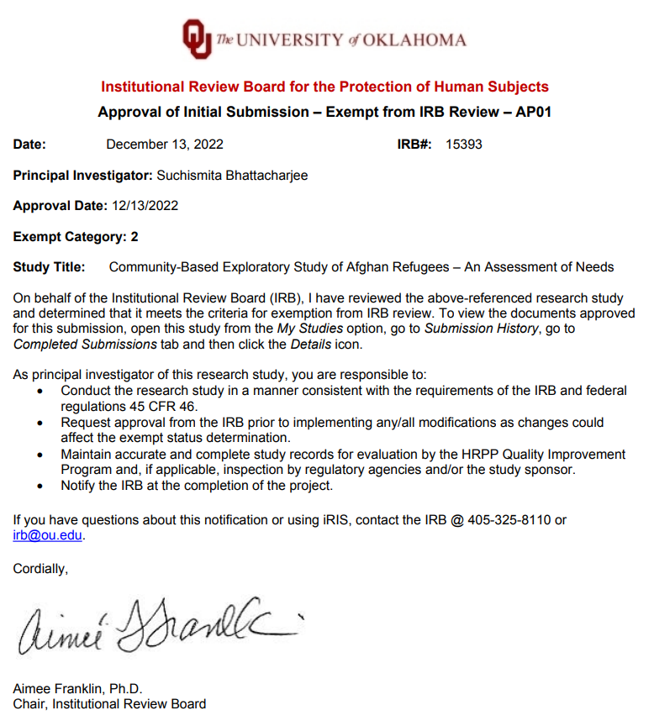

Appendix B: Full Interview Questionnaire
Thank you for your time today. We are meeting today so that our research team can get an understanding of how you see your life as an Afghan person living in OKC metro area. The purpose of the interview is to have a better understanding about your needs as you are re-settling in this new country. This is a reminder that you are not required to answer all question. This interview is completely voluntary, and you are welcome to quit taking the interview at any time.

Journey to U.S.
- How long have you lived in the United States? When did you leave Afghanistan? How old were you when you left Afghanistan?
- Did you come to US directly from Afghanistan or have you lived in any other country before coming to US? If yes, what country did you live in?
- What were the reasons behind you leaving Afghanistan? Would you say that your major reason for leaving Afghanistan was to
- Escape a life threating situation?
- Wanting opportunities that you could not get in Afghanistan?
- To achieve a better life for yourself and/or family?
- All of the above?
- Now that you are living in the US what challenges do you now have that if you were able to meet or resolve them your life would improve in a way that would give you satisfaction?
- Do you have any concern about your financial condition after your support from the U.S. government ends? If yes, please elaborate on how you think it will affect your day to day living condition and financial expenses.

Housing Quality
- How long have you been living in this housing?
- How many bedrooms and bathrooms does your housing unit have?
- What is your current household size and are you living with your family members? Please elaborate.
- Does your living situation meet your expectations for quality of housing? If no, why?
- Does your housing situation meet adequate space needs? If no, why?
- Does your housing situation meet your needs for privacy? If no, why?
- Do you feel like your housing situation is a good for you? If no, what aspects of this housing is different from your native home?
- What amenities you currently don’t have in your housing unit that is necessary for your native or vernacular way of living.
- At this time are there any housing issues or needs you wish to address so that the quality of your life would improve? In your own words, what are those issues or needs?
______________________________________________________________________
______________________________________________________________________
______________________________________________________________________

Neighborhood Quality/Amenities
- Do you consider the neighborhood to be a nice place to live and why? If no, what aspects of this neighborhood is different from your native home?
- Do you consider the neighborhood to be a safe community. If no, why?
- Do you consider your neighborhood to be walkable? If no, why?
- Does people look out for each other in your neighborhood?
- Is public transportation readily accessible in your neighborhood? If no, why?
- Do you have necessary businesses and stores within your reachable area from your housing?
- At this time are there any neighborhood or transportation issues or needs you wish to address so that the quality of your life would improve? In your own words, what are those issues or needs?
__________________________________________________________________________________________________________________________________________________________________________________________________________________

Clothing and Food
- Do you have adequate clothing to wear for particular occasion or season? If no, why?
- Is it easy for you to keep your clothing clean? If no, why?
- Do you and your family member have enough nutritious food to eat each day? If no, please explain.
Do you worry frequently about if you will get enough to eat in future?
- Do you have access to food similar to the kind you had in your native country?
- Overall, how will you describe your diet as? (Poor/Adequate/Nutritious). Anything else do you want to add about your diet choices?
__________________________________________________________________________________________________________________________________________________________________________________________________________________

Community Relationships and Cultural Expression
- Do you have a good friend with whom you can share your personal concerns in U.S.?
- Are you satisfied with your social life and is socially involved to the extent that you wish? In no, please elaborate on your issues.
- Overall, do you spend too much time alone more than what you did in your native country? If yes, please elaborate on the reason.
- What are the strengths of the Afghan community here in OKC metro area?
- What kinds of supports, opportunities, or assistance do you want for yourself or your family so that you can (a) be more self-sufficient, (b) become a member of American society, (c) strengthen your family or household, and (d) achieve what you want for yourself?
- Overall, now that you are living in the United States do you experience any major areas of stress? How would you describe your stress at this time? What are the specific stressors you experience in your life?
- Do you feel that you can express yourself openly as a member of the Afghan community?
- Do you practice Afghani customs and traditions that bring you satisfaction?
- Do you keep your connection with Afghani ways of living? If yes, how do you keep your connection with Afghani ways of living?
- Are you able to maintain your sense of self as a person of Afghani culture to your satisfaction?
- At this time are there any relationship or cultural expression issues or needs you wish to address so that the quality of your life would improve? In your own words, what are those issues or needs? _______________________

Health and Activities of Daily Living
- Do you feel you are in good health? If no, please elaborate.
- Do you have serious health needs that have not been addressed or resolved? If yes, does your unresolved health problems interfere with your everyday life? Please elaborate.
- Are you satisfied with your current access to health care services?
- At this time are there any health care needs or issues that you wish to address so that the quality of your life would improve? In your own words, what are those issues or needs?
__________________________________________________________________________________________________________________________________________________________________________________________________________________

Demographic Information
Thank you for your time today. We will now wrap up our interview with next few demographic questions.
- How old were you at your last birthday?
- If you are not a citizen of the United States at this time what is your visa status?
- What is your ethnic group? Which sect of Shiete or Sunni do you belong to?
- Are you married? If yes, is your spouse or partner Afghan?
- Do you have children? If yes, how many children do you have? Can you please elaborate on their age and gender.
- Do any member of your family if going to school currently? If yes, please elaborate.
- Can you read and write in your native language? If yes, what is your native language, and did you go through a formal education system?
- How many years of education have you completed? Number of Years: _____
- Are you multi-lingual? If yes, please list the languages you can speak.
- Are you prepared by training, experience, or education for a certain kind of job? Yes/No
- Are you prepared educationally for a certain kind of profession? Yes/No. If yes, please elaborate.
- Do you have a job at this time? If yes, are you happy or satisfied with your job?
- At this time do you feel that you are underemployed given your current job? Yes/No
- How many members in your family are currently employed?

Appendix C: Word Frequency List
Word | Length | Count | Weighted Percentage (%) | Similar Words
2022 | 4 | 2 | 0.11 | 2022
accessible | 10 | 1 | 0.05 | accessible
adequate | 8 | 2 | 0.11 | adequate
adjust | 6 | 8 | 0.43 | adjust
adults | 6 | 1 | 0.05 | adults
afford | 6 | 4 | 0.21 | afford
afghan | 6 | 15 | 0.80 | afghan, afghans
afghanistan | 11 | 52 | 2.78 | afghanistan
airport | 7 | 1 | 0.05 | airport
allowance | 9 | 2 | 0.11 | allowance
always | 6 | 2 | 0.11 | always
americans | 9 | 2 | 0.11 | americans
animals | 7 | 2 | 0.11 | animals
anyone | 6 | 2 | 0.11 | anyone
apartment | 9 | 4 | 0.21 | apartment
area | 4 | 4 | 0.21 | area
assistance | 10 | 2 | 0.11 | assistance
baby | 4 | 1 | 0.05 | baby
bathrooms | 9 | 12 | 0.64 | bathrooms
bedrooms | 8 | 20 | 1.07 | bedroom, bedrooms
beds | 4 | 2 | 0.11 | beds
behind | 6 | 2 | 0.11 | behind
best | 4 | 2 | 0.11 | best
bricks | 6 | 3 | 0.16 | bricks
brother | 7 | 3 | 0.16 | brother
bugs | 4 | 2 | 0.11 | bugs
built | 5 | 2 | 0.11 | built
busy | 4 | 1 | 0.05 | busy
care | 4 | 6 | 0.32 | care
carpets | 7 | 1 | 0.05 | carpets
carved | 6 | 2 | 0.11 | carved
caseworker | 10 | 2 | 0.11 | caseworker, caseworkers
castle | 6 | 1 | 0.05 | castle
cats | 4 | 2 | 0.11 | cats
cheap | 5 | 2 | 0.11 | cheap
checks | 6 | 1 | 0.05 | checks
chickens | 8 | 2 | 0.11 | chickens
child | 5 | 1 | 0.05 | child
children | 8 | 26 | 1.39 | children
chores | 6 | 1 | 0.05 | chores
classes | 7 | 1 | 0.05 | classes
clean | 5 | 8 | 0.43 | clean, cleaning
closed | 6 | 14 | 0.75 | close, closed
coming | 6 | 20 | 1.07 | coming
commercial | 10 | 1 | 0.05 | commercial
community | 9 | 3 | 0.16 | community
company | 7 | 1 | 0.05 | company
compare | 7 | 3 | 0.16 | compare, compared
complex | 7 | 2 | 0.11 | complex
concept | 7 | 3 | 0.16 | concept
concern | 7 | 1 | 0.05 | concern
consider | 8 | 2 | 0.11 | consider
contributor | 11 | 1 | 0.05 | contributor
cooking | 7 | 8 | 0.43 | cooking
cost | 4 | 2 | 0.11 | cost
countryside | 11 | 2 | 0.11 | countryside
course | 6 | 2 | 0.11 | course
courtyard | 9 | 3 | 0.16 | courtyard
culture | 7 | 29 | 1.55 | culturally, culture
cushions | 8 | 2 | 0.11 | cushions
daily | 5 | 1 | 0.05 | daily
dancing | 7 | 1 | 0.05 | dancing
dari | 4 | 2 | 0.11 | dari
data | 4 | 1 | 0.05 | data
daughters | 9 | 11 | 0.59 | daughter, daughters
days | 4 | 1 | 0.05 | days
degree | 6 | 1 | 0.05 | degree
detached | 8 | 1 | 0.05 | detached
disabled | 8 | 1 | 0.05 | disabled
documents | 9 | 1 | 0.05 | documents
donated | 7 | 1 | 0.05 | donated
doors | 5 | 25 | 1.34 | door, doors
double | 6 | 2 | 0.11 | double
drain | 5 | 2 | 0.11 | drain
drive | 5 | 2 | 0.11 | drive, driving
driver | 6 | 1 | 0.05 | driver
dynamics | 8 | 3 | 0.16 | dynamics
electricity | 11 | 4 | 0.21 | electricity
else | 4 | 2 | 0.11 | else
empty | 5 | 2 | 0.11 | empty
ending | 6 | 2 | 0.11 | ending
entire | 6 | 1 | 0.05 | entire
environment | 11 | 1 | 0.05 | environment
every | 5 | 1 | 0.05 | every
everyone | 8 | 7 | 0.37 | everyone
everything | 10 | 7 | 0.37 | everything
everywhere | 10 | 2 | 0.11 | everywhere
exact | 5 | 1 | 0.05 | exact
experience | 10 | 3 | 0.16 | experience, experiences
facilities | 10 | 8 | 0.43 | facilities
facing | 6 | 2 | 0.11 | facing
fairfield | 9 | 1 | 0.05 | fairfield
family | 6 | 20 | 1.07 | families, family
famous | 6 | 2 | 0.11 | famous
farm | 4 | 2 | 0.11 | farm
father | 6 | 3 | 0.16 | father
february | 8 | 2 | 0.11 | february
females | 7 | 9 | 0.48 | females
finally | 7 | 2 | 0.11 | finally
fixed | 5 | 1 | 0.05 | fixed
floor | 5 | 4 | 0.21 | floor
food | 4 | 3 | 0.16 | food
formal | 6 | 27 | 1.44 | formal
free | 4 | 5 | 0.27 | free
freedom | 7 | 1 | 0.05 | freedom
frequently | 10 | 1 | 0.05 | frequently
friends | 7 | 20 | 1.07 | friends
front | 5 | 5 | 0.27 | front
fruit | 5 | 2 | 0.11 | fruit, fruits
furniture | 9 | 2 | 0.11 | furniture
garbage | 7 | 2 | 0.11 | garbage
gate | 4 | 7 | 0.37 | gate, gates
given | 5 | 1 | 0.05 | given
gone | 4 | 2 | 0.11 | gone
government | 10 | 3 | 0.16 | government
grade | 5 | 1 | 0.05 | grade
grow | 4 | 1 | 0.05 | grow
guests | 6 | 10 | 0.53 | guests
hard | 4 | 1 | 0.05 | hard
harsh | 5 | 1 | 0.05 | harsh
harvest | 7 | 1 | 0.05 | harvest
hectares | 8 | 1 | 0.05 | hectares
help | 4 | 7 | 0.37 | help, helped, helping
hindi | 5 | 1 | 0.05 | hindi
home | 4 | 37 | 1.98 | home, homes
homework | 8 | 1 | 0.05 | homework
hotel | 5 | 2 | 0.11 | hotel
household | 9 | 2 | 0.11 | household
houses | 6 | 1 | 0.05 | houses
however | 7 | 1 | 0.05 | however
humidity | 8 | 1 | 0.05 | humidity
idea | 4 | 1 | 0.05 | idea
incentive | 9 | 1 | 0.05 | incentive
include | 7 | 1 | 0.05 | include
increased | 9 | 1 | 0.05 | increased
infested | 8 | 1 | 0.05 | infested
insects | 7 | 8 | 0.43 | insects
inside | 6 | 3 | 0.16 | inside
issue | 5 | 26 | 1.39 | issue, issues
john | 4 | 2 | 0.11 | john
keep | 4 | 3 | 0.16 | keep, keeping
kept | 4 | 2 | 0.11 | kept
kids | 4 | 9 | 0.48 | kids
kitchen | 7 | 36 | 1.93 | kitchen
kunar | 5 | 3 | 0.16 | kunar
land | 4 | 4 | 0.21 | land
language | 8 | 3 | 0.16 | language, languages
large | 5 | 13 | 0.70 | large, largely
leakages | 8 | 2 | 0.11 | leakages
leaking | 7 | 3 | 0.16 | leaking
lease | 5 | 2 | 0.11 | lease
life | 4 | 2 | 0.11 | life
lifestyle | 9 | 8 | 0.43 | lifestyle
likes | 5 | 2 | 0.11 | likes
little | 6 | 6 | 0.32 | little
love | 4 | 2 | 0.11 | love
mail | 4 | 2 | 0.11 | mail
males | 5 | 9 | 0.48 | males
married | 7 | 6 | 0.32 | married
mattresses | 10 | 5 | 0.27 | mattresses
meeting | 7 | 2 | 0.11 | meeting
member | 6 | 2 | 0.11 | member, members
mice | 4 | 13 | 0.70 | mice
might | 5 | 2 | 0.11 | might
money | 5 | 9 | 0.48 | money
move | 4 | 9 | 0.48 | move, moved, moving
named | 5 | 2 | 0.11 | named
native | 6 | 2 | 0.11 | native
nature | 6 | 4 | 0.21 | nature
need | 4 | 19 | 1.02 | need, needs
neighbor | 8 | 11 | 0.59 | neighbor, neighbors
neighborhood | 12 | 16 | 0.86 | neighborhood
news | 4 | 2 | 0.11 | news
nice | 4 | 3 | 0.16 | nice
noise | 5 | 3 | 0.16 | noise
nothing | 7 | 3 | 0.16 | nothing
november | 8 | 2 | 0.11 | november
often | 5 | 3 | 0.16 | often
online | 6 | 2 | 0.11 | online
open | 4 | 32 | 1.71 | open, opens
outside | 7 | 5 | 0.27 | outside
parents | 7 | 7 | 0.37 | parents
park | 4 | 5 | 0.27 | park, parks
pashto | 6 | 8 | 0.43 | pashto
pashtun | 7 | 5 | 0.27 | pashtun
people | 6 | 30 | 1.60 | people
person | 6 | 8 | 0.43 | person, persons
pest | 4 | 2 | 0.11 | pest
pets | 4 | 6 | 0.32 | pets
place | 5 | 4 | 0.21 | place, places
playing | 7 | 14 | 0.75 | play, playing
prefer | 6 | 2 | 0.11 | prefer
prisoners | 9 | 2 | 0.11 | prisoners
privacy | 7 | 26 | 1.39 | privacy
problems | 8 | 18 | 0.96 | problem, problems
public | 6 | 10 | 0.53 | public
quality | 7 | 5 | 0.27 | quality
read | 4 | 3 | 0.16 | read
regular | 7 | 2 | 0.11 | regular, regularly
relatives | 9 | 10 | 0.53 | relatives
remained | 8 | 2 | 0.11 | remained
renters | 7 | 2 | 0.11 | renters
right | 5 | 2 | 0.11 | right
rugs | 4 | 3 | 0.16 | rugs
rules | 5 | 2 | 0.11 | rules
safe | 4 | 6 | 0.32 | safe
scared | 6 | 2 | 0.11 | scared
school | 6 | 13 | 0.70 | school
seating | 7 | 3 | 0.16 | seating
separate | 8 | 12 | 0.64 | separate, separated
september | 9 | 2 | 0.11 | september
sewing | 6 | 2 | 0.11 | sewing
share | 5 | 5 | 0.27 | share
sister | 6 | 2 | 0.11 | sister, sisters
sitting | 7 | 6 | 0.32 | sitting
sleep | 5 | 15 | 0.80 | sleep, sleeping
small | 5 | 4 | 0.21 | small
smaller | 7 | 2 | 0.11 | smaller
socialized | 10 | 8 | 0.43 | socialized
sons | 4 | 5 | 0.27 | sons
space | 5 | 18 | 0.96 | space, spaces
speak | 5 | 3 | 0.16 | speak, speaks
sponsor | 7 | 3 | 0.16 | sponsor
staying | 7 | 3 | 0.16 | stayed, staying
structure | 9 | 6 | 0.32 | structure
sunni | 5 | 6 | 0.32 | sunni
tight | 5 | 3 | 0.16 | tight
together | 8 | 15 | 0.80 | together
toilets | 7 | 2 | 0.11 | toilets
total | 5 | 3 | 0.16 | total
traditionally | 13 | 4 | 0.21 | traditionally
transportation | 14 | 3 | 0.16 | transportation
types | 5 | 4 | 0.21 | types
typically | 9 | 3 | 0.16 | typically
united | 6 | 12 | 0.64 | united
upstairs | 8 | 2 | 0.11 | upstairs
urdu | 4 | 3 | 0.16 | urdu
utilities | 9 | 2 | 0.11 | utilities
visiting | 8 | 2 | 0.11 | visiting
volume | 6 | 2 | 0.11 | volume
walk | 4 | 14 | 0.75 | walk
walkable | 8 | 4 | 0.21 | walkable
washing | 7 | 3 | 0.16 | wash, washing
water | 5 | 5 | 0.27 | water
wife | 4 | 9 | 0.48 | wife
windows | 7 | 2 | 0.11 | windows
women | 5 | 19 | 1.02 | women
wood | 4 | 5 | 0.27 | wood
working | 7 | 16 | 0.86 | work, working, works
yard | 4 | 4 | 0.21 | yard

Appendix D: Full Source List
