University of Oklahoma

Graduate College

Preferred Versus novel exercise modalities on endogenous pain Inhibition following exercise

A thesis

submitted to the graduate faculty

in partial fulfillment of the requirements for the

Degree of

Master of Science

By

Daniel joseph schubert
Norman, Oklahoma
2017

Preferred versus novel exercise modalities on endogenous pain inhibition following exercise

A thesis approved for the
Department of Health and Exercise Science

By

______________________________
Dr. Christopher D. Black, Chair

______________________________
Dr. Michael G. Bemben

______________________________
Dr. Jason A. Campbell

© Copyright by Daniel joseph schubert 2017
All Rights Reserved.

Table of Contents
List of Tables vi
List of Figures vii
Abstract viii
Chapter I: Introduction 1
Background Information 1
Purpose 5
Research Questions 5
Research Sub-Questions 6
Null Hypotheses 6
Alternative Hypotheses 7
Significance of the Study 8
Delimitations 9
Limitations 9
Assumptions 10
Operational Definitions 10
Chapter II: Review of Literature 12
EIH and Aerobic Exercise 12
EIH and Resistance and Isometric Exercise 16
Pain thresholds in remote and local muscle sites 19
Pain perception in specialized populations 20
Gaps in the Literature 21
Summary of Research 22
Chapter III: Methodology 23
Sample 23
Research Design 23
Measurement Protocols 23
Statistical Analysis 26
Chapter IV: Results 27
Group Characteristics 27
Baseline Pressure Pain Threshold: Trained vs. Untrained 27
Exercise-Induced Hypoalgesia: Trained vs. Untrained 29
Chapter V: Discussion 33
Conclusion 37
References 38
Appendix A: IRB Approval Letter 42
Appendix B: Informed Consent Form 43
Appendix C: Signed Consent To Participate In Research 49
Appendix D: HIPAA 54
Appendix E: Health Status Questionnaire 58
Appendix F: Physical Activity Readiness Questionnaire 62

List of Tables
Table 1: Participant Characteristics……………….……………………………………27

List of Figures

Figure 1: Baseline pressure pain thresholds of the vastus lateralis in trained versus untrained groups………………………………………………………………………..28

Figure 2: A: Baseline vastus lateralis PPT plotted against body mass (kg) B: Baseline brachioradialis PPT plotted against body mass (kg).......................................................29

Figure 3: A: Pre and post 30 minute running vastus lateralis PPT in trained and untrained groups. B: Pre and post 30 minute running brachioradialis PPT in trained and untrained groups..............................................................................................................30

Figure 4: A: Pre and post isometric handgrip exercise vastus lateralis PPT in trained and untrained groups. B: Pre and post isometric handgrip exercise brachioradialis PPT in trained and untrained groups...........................................................................................31

Figure 5: A: Mean percent change in PPT (%) from pre and post running and handgrip exercise in the VL and BR. B: Mean percent change in PPT (%) collapsed across both trained and untrained participants following running and handgrip exercise in the VL and BR………………………………………………………………………………….32

Abstract

Pain is an unpleasant sensory and emotional experience which can indicate potential or actual tissue damage. Exercise has been shown to result in marked decreases in pain sensitivity both during and following exercise. This phenomenon is termed exercise-induced hypoalgesia (EIH). While this concept has been widely observed and studied across different populations and exercise modalities, it has not been tested to observe the EIH effect of a familiar and an unfamiliar exercise modality. PURPOSE: The purpose of this study was to observe the effect of training status (highly trained using running vs. sedentary) on resting pain sensitivity to pressure stimuli and following exercise using a “familiar” modality and intensity (running) and an “unfamiliar” modality (hand-grip). METHODS: A total of 17 participants were recruited for this study, divided between 13 highly aerobically trained and 4 untrained, sedentary participants. Each participant completed 5 visits, with 2 visits of familiarization, and 3 testing visits. PPT threshold values were measured in the participant’s vastus lateralis (VL) and brachioradialis (BR) prior to, and following an isometric handgrip exercise to fatigue, a 30 minute run at 110% of gas exchange threshold (GET), and an ice bath at 2˚ Celsius. RESULTS: In the VL, baseline PPT was significantly higher (p = 0.02) in the untrained groups compared to the trained groups (909 ± 278 kPa vs. 712 ± 202 kPa). Similarly, baseline PPT in the BR was also significantly higher (p = 0.05) in the untrained group compared to the trained group (608 ± 194 kPa vs. 517 ± 147 kPa). Body weight/mass was found to be significant predictor of baseline PPT in the VL (p = 0.002) yielding an R² value of 0.49. Body weight/mass was a significant predictor of baseline PPT in the BR (R² = 0.51; p = 0.001). In the VL, there was not a significant group x time interaction (p = 0.43) when comparing PPT between the trained and untrained group before and after 30-min of treadmill running exercise. Nor was there a main effect for group membership(marginal means of 831 ± 258 kPa vs. 1044 ± 233 kPa for the trained and untrained groups, respectively; p = 0.19). A significant main effect for time (pre vs. post exercise) was found (p = 0.002) with VL PPT’s increasing from 812 ± 251 kPa to 929 ± 291 kPa for Pre and Post exercise, respectively. In the BR there was not a significant group x time interaction (p = 0.62) when comparing PPT between the trained and untrained group before and after 30-min of treadmill running exercise. There was a significant main effect for group membership (marginal means of 517 ± 163 kPa vs. 678 ± 254 kPa for the trained and untrained groups, respectively; p = 0.02). The main effect for time (pre vs. post exercise) was not significant (marginal means of 578 ± 250 kPa vs 618 ± 212 kPa for Pre and Post exercise, respectively; p = 0.24). In the VL, there was not a significant group x time interaction (p = 0.43) when comparing PPT between the trained and untrained group before and after 30-min of treadmill running exercise. Nor was there a main effect for group membership (marginal means of 831 ± 258 kPa vs. 1044 ± 233 kPa for the trained and untrained groups, respectively; p = 0.19). A significant main effect for time (pre vs. post exercise) was found (p = 0.002) with VL PPT’s increasing from 812 ± 251 kPa to 929 ± 291 kPa for Pre and Post exercise, respectively. In the BR there was not a significant group x time interaction (p = 0.62) when comparing PPT between the trained and untrained group before and after 30-min of treadmill running exercise. There was a significant main effect for group membership (marginal means of 517 ± 163 kPa vs. 678 ± 254 kPa for the trained and untrained groups, respectively; p = 0.02). The main effect for time (pre vs. post exercise) was not significant (marginal means of 578 ± 250 kPa vs 618 ± 212 kPa for Pre and Post exercise, respectively; p = 0.24). CONCLUSIONS: We found a significant difference between pre and post PPT thresholds in the vastus lateralis for running for 30 minutes at 110% of the participants’ GET, and isometric handgrip exercise to volitional exhaustion. Additionally, we found a significant difference between pre and post PPT in the brachioradialis following isometric handgrip exercise, but did not find a difference during the 30 minute run.

Chapter I: Introduction

Background Information
Pain is an unpleasant sensory and emotional experience which can indicate potential or actual tissue damage. It is a common sensation felt by individuals during and after exercise [1]. Pain is sensed by specialized receptors, termed nociceptors that respond to damaging, or potentially damaging stimuli—termed noxious stimuli. Pain signals are transmitted via afferent nerve fibers to the spinal cord and then to brain where they are interpreted as “painful” [1, 2]. Noxious stimuli include pressure, thermal (hot or cold), electrical, and biochemical (H⁺ ions, bradykinin, adenosine, etc.) stimuli [1, 2]. Common assessments of pain include measures of pain tolerance and pain threshold. Pain tolerance represents the amount of time a person is willing to allow a painful stimulus to be applied while pain threshold represents the minimum stimulus required to be considered “painful”[1, 2]. Pain tolerance and pain threshold vary greatly from person to person, but represent two of the most objective ways to assess pain sensitivity.
Pain sensitivity can be influenced by a host of internal and external parameters such as previous pain history, personality characteristics, drugs, etc. Hypoalgesia is the term used to describe a decreased sensitivity to a painful stimulus—denoted by an increase in the stimulus required to evoke pain (i.e. an increase in pain threshold) and an increase in the time a given stimulus can be tolerated [3]. Exercise is one of the most common and robust ways to activate the body’s endogenous pain inhibitory mechanisms and induce hypoalgesia [3-5]. Exercise has been shown to result in marked decreases in pain sensitivity both during and following exercise. This phenomenon is termed exercise-induced hypoalgesia (EIH). EIH occurs following aerobic (both running and cycling), resistance, and isometric exercise with perhaps the largest and most consistent effect occurring following isometric exercise [5]. Additionally, EIH occurs across the spectrum of noxious stimuli—heat, electrical, biochemical, and pressure with the largest and most consistent effects occurring with pressure stimuli [5].
Differing intensities and durations of exercise have been shown to influence the presence/absence and magnitude of the hypoalgesic effect [4]. Hoffman et al. [6] found that ratings of pain intensity were reduced after treadmill running at 75% of VO₂ max levels for 30 minutes, however, the same effect was not found when exercising at the same intensity for shorter durations, or when participants ran at 50% of VO₂ max for 30 minutes. Similarly, Naugle et al. [7] found that moderate intensity cycling exercise at 50% of heart-rate reserve (HRR) did not elicit EIH, but that vigorous (70% of HRR) intensity cycling did reduce pain sensitivity. When isometric exercise has been employed, both the intensity of the contraction and the duration of the contraction appear to play a role in EIH. Performance of 3 MVC’s (each lasting approximately 3 seconds) lead to EIH [8]. Holding 25% of MVC for 2 min did not elicit a reduction in pain sensitivity, but 25% of MVC held to fatigue/task failure did result in EIH—indicating both intensity of the contraction and the duration both contribute to EIH [8].
The exact mechanism(s) of EIH remain unclear. Evidence has shown that exercising at > 60% VO₂ peak for at least 30 minutes leads to the release of endogenous opioids [2], which could potentially function to reduce and modulate pain following exercise. Opioids have a number of effects on the central nervous system including changes in nociception, cardiovascular function, thermoregulation, and respiration [2]. Endogenous opioids function to block pain receptors, dampening the nociceptors effect, leading to a decrease in pain perception [2].
A second potential mechanism of EIH is the gate control theory, put forth in 1965 by Malzack and Wall [9]. They suggested that non-painful afferent inputs to the nervous system close the “gates” to painful stimuli, preventing/limiting noxious stimuli from traveling to the central nervous system and brain where they would be perceived as painful [9]. Exercising has been shown to increase non-nociceptive afferent input to spinal and supraspinal regions which could “close the gates” and prevent the transmission of noxious stimuli to the brain [10, 11]. A third mechanism by which exercise may contribute to reduced pain sensitivity is via a phenomenon termed “conditioned pain modulation” (CPM) or “pain inhibits pain”. During CPM an initial painful stimuli, referred to as the conditioning stimulus, functions to inhibit spinal neurons in the dorsal horn, which leads to a reduction of the perception of a second pain stimulus that occurs at some point in time following the conditioning stimulus [12-14]. Several recent studies have shown that the magnitude of EIH correlates with the magnitude of CPM suggesting the two may be related [12-14]. Strengthening this idea, a recent study by Ellingson et al. [12] found that painful aerobic cycling produced a larger hypoalgesic effect compared to a similar session of non-painful cycling performed at a similar metabolic intensity. Thus, CPM may help to explain why exercise of higher intensity and longer duration, both of which likely increase the pain experienced during exercise, may lead to larger EIH responses.
Understanding the potential mechanism(s) of exercise induced hypoalgesia can help populations suffering from chronic pain lead normal pain free lives. Many clinical populations suffer from chronic pain, affecting the ability to complete activities of daily living, and worsening overall quality of life [11, 15]. In populations suffering from chronic musculoskeletal pain, the pain inhibitory function and the EIH response is altered [16-19]. When compared with healthy controls, adults suffering from fibromyalgia, a disorder marked by fatigue and musculoskeletal pain, demonstrated a decreased pressure pain threshold and increased ratings of pain intensity after isometric handgrip and quadriceps exercise [16, 19]. In adults with chronic shoulder pain quadriceps exercise lead to EIH in the exercising muscle, the contralateral quadriceps, and the chronically painful shoulder muscle [18]. However, when exercise was performed using the chronically painful shoulder muscle, EIH did not occur in the exercising muscle, or in the quadriceps [18]. Similarly when patients with knee osteoarthritis performed lower body exercise (leg press, knee extension, and calf raises) no EIH response was observed [17]. However, when upper body exercise (bench and shoulder press and lat pull-downs) was performed in this population, EIH was observed [17]. These findings clearly demonstrate an interaction among the type and location of exercise and the sensitivity of the muscles and joints used during exercise and EIH response.
Very limited evidence suggests athletes may be less sensitive to pain [20], especially in their ability to tolerate pain, compared to non-athletes. Whether this is a learned behavior as a consequence of years of training at high intensities (which is inherently painful) or a genetic trait that pre-disposes certain individuals to respond more favorably to high intensity training is unclear and further study seems warranted. Additionally, to our knowledge no previous study has examined whether “familiarity” (which could influence the pain response during exercise) with a particular type and intensity of exercise plays any role in the EIH response. As such this study aims compare the pain sensitivity and EIH response between highly trained athletes and healthy but sedentary controls using an exercise with which the athletes are familiar (e.g. running) and an exercise with which both groups are unfamiliar (isometric hand-grip).

Purpose
The purpose of this study was to observe the effect of training status (highly trained using running vs. sedentary) on resting pain sensitivity to pressure stimuli and following exercise using a “familiar” modality and intensity (running) and an “unfamiliar” modality (hand-grip). This was measured by a handheld algometer in the vastus lateralis and brachioradialis muscles. By sampling pain thresholds at sites local and remote to the exercising muscles it allowed for an examination of local and generalized effects of exercise. Collegiate level endurance trained men and women distance runners, and sedentary untrained participants aged 18-35 were recruited.

Research Questions
Research questions for this study will include:

- Do highly aerobically trained athletes differ in their sensitivity to noxious pressure stimuli compared to sedentary controls?
- Does treadmill exercise alter sensitivity to noxious pressure stimuli differently in aerobically trained athletes who are familiar with running compared to untrained, unfamiliar participants?
- Does isometric hand-grip exercise alter sensitivity to noxious pressure stimuli differently in aerobically trained athletes who are familiar with running compared to untrained, unfamiliar participants?

Research Sub-Questions
Research sub-questions for this study will include:

- Will the magnitude of exercise-induced hypoalgesia differ between groups when compared at sites local to the exercising muscle and at sites distant to the exercising muscle?

Null Hypotheses
Null hypotheses for this study will include:

- Pressure pain thresholds will not differ in the vastus lateralis between aerobically trained athletes and sedentary participants
- Pressure pain thresholds will not differ in the brachioradialis between aerobically trained athletes and sedentary participants
- Aerobic treadmill running exercise will not alter pressure pain threshold in the vastus lateralis following running in highly aerobically trained athletes.
- Aerobic treadmill running will not alter pressure pain threshold in the vastus lateralis following running in sedentary participants.
- Aerobic treadmill running exercise will not alter pressure pain threshold in the brachioradialis following running in highly aerobically trained athletes.
- Aerobic treadmill running exercise will not alter pressure pain threshold in the brachioradialis following running in sedentary participants.
- Isometric handgrip exercise will not alter pressure pain threshold in the vastus lateralis in highly aerobically trained athletes.
- Isometric handgrip exercise will not alter pressure pain threshold in the vastus lateralis in sedentary participants.
- Isometric handgrip exercise will not alter pressure pain threshold in the brachioradialis in highly aerobically trained athletes.
- Isometric handgrip exercise will not alter pressure pain threshold in the brachioradialis in sedentary participants.

Alternative Hypotheses
Alternative Hypotheses for this study include:

- Pressure pain thresholds will differ in the vastus lateralis between aerobically trained athletes and sedentary participants
- Pressure pain thresholds will differ in the brachioradialis between aerobically trained athletes and sedentary participants
- Aerobic treadmill running exercise will increase pressure pain threshold in the vastus lateralis following running in highly aerobically trained athletes.
- Aerobic treadmill running will increase pressure pain threshold in the vastus lateralis following running in sedentary participants.
- Aerobic treadmill running exercise will increase pressure pain threshold in the brachioradialis following running in highly aerobically trained athletes.
- Aerobic treadmill running exercise will increase pressure pain threshold in the brachioradialis following running in sedentary participants.
- Isometric handgrip exercise will increase pressure pain threshold in the vastus lateralis in highly aerobically trained athletes.
- Isometric handgrip exercise will increase pressure pain threshold in the vastus lateralis in sedentary participants.
- Isometric handgrip exercise will increase pressure pain threshold in the brachioradialis in highly aerobically trained athletes.
- Isometric handgrip exercise will increase pressure pain threshold in the brachioradialis in sedentary participants.

Significance of the Study

This study had two primary areas of significance: 1) examining the resting pain sensitivity to noxious pressure between highly aerobically trained runners and sedentary individuals and 2) examining the magnitude of the EIH response to exercise modalities that are “familiar” and unfamiliar between highly aerobically trained and sedentary individuals. Minimal research has been performed comparing pain sensitivity between highly trained athletes and healthy sedentary controls. The findings from this study aided in characterizing whether athletes are less sensitive to pain, as has been suggested by others, and helped lay the ground work for future studies seeking to determine the mechanism(s) of any difference, if one exists.
Additionally, research has shown that the location of the muscles and joints used in exercise may play a role in the EIH response in certain clinical pain populations [17, 18]. For example exercising muscle/joints that are chronically painful does not result in an EIH response [17, 18]. It is unclear why this occurs. Our hope is that by comparing the EIH response to unfamiliar or novel activities in sedentary individuals to the response in athletes who are familiar with one type of exercise (running) but not hand-grip exercise that we can determine whether avoidance of particular movements (as is common in chronic pain patients) plays a role in the EIH response.

Delimitations
Delimitations of this study will include:

- All participating participants will be aged 18-25.
- All participating participants will be free of any musculoskeletal injury.
- An AlgoMed Computerized Pressure Algometer (Medoc Advanced Medical Systems) will be used to collect data and determine pressure pain thresholds in our participants.
- The participants will determine their pain threshold when the pressure perception changes from discomfort to pain.
- Participants will not be actively taking pain medications.

Limitations
Limitations of this study will include:

- As we will test participants between the ages of 18-25, and free of musculoskeletal injuries, these findings cannot be generalized to the general population.
- Participants will be unfamiliar with the VO₂ max testing protocol, therefore, the measures collected during the trials may not be an accurate representation of their true values.
- Extraneous factors may alter the participant’s pressure pain threshold during assessment trials.

Assumptions
Assumptions of this study will include:

- Participants will disclose any musculoskeletal injury or malady from which they currently suffer.
- The AlgoMed Computerized Pressure Algometer (Medoc Advanced Medical Systems) will accurately measure and display data to the investigators and participants.
- All measures made with the algometer will be accurate representations of the participant’s pressure pain threshold.
- The participant will give an honest, maximal effort while participating in the VO₂ max trial.
- The participant will give an honest assessment of pressure pain threshold.
- The participant will give an honest, maximal effort while completing the MVC trials of isometric exercise.
- The participant will give an honest, maximal effort while completing the sustained load trial of isometric exercise.

Operational Definitions
- Exercise-Induced Hypoalgesia: The decreased sensitivity to pain following exercise.
- Analgeisa: Inability to feel pain
- Aerobic Exercise: Exercise that stimulates and strengthens the heart and lungs. Exercise aimed at improving the body’s utilization of Oxygen.
- VO₂ Max Test: A testing protocol completed to measure the maximum amount of oxygen the body can consume and utilize.
- Isometric Exercise: A muscle contraction in which the length of the muscle does not change length.
- Pain: A physically unpleasant sensation that can range from mild to agony.
- Pressure Pain Threshold: The pressure point at which a stimulus goes from uncomfortable to painful.
- Handheld Algometer: Device used to measure pressure thresholds. Has a 1cm rubber tip used to press into the participants skin.
- Woodway treadmill: Exercising machine with a continuous belt that allows a participant to walk or run in place.
- Metabolic Cart: Device used to measure the oxygen consumed during a participant’s aerobic exercise.

Chapter II: Review of Literature

Exercising at a certain level of intensity (> 60% VO₂ max, >70% HRR), and for a long duration (>30 minutes) is sufficient for exercise induced hypoalgesia (EIH) to occur. EIH is marked by an increase in pain tolerances, and a decrease in pain sensitivity following a bout of exercise. There are many theories regarding the exact mechanisms of EIH, however, these exact mechanisms of EIH remain unclear. This study explored the hypoalgesic effect of a familiar exercise and an unfamiliar exercise on highly trained distance runners, and normal untrained, but otherwise healthy individuals. As the idea of differing pain thresholds after exercise of “familiar” and “unfamiliar” modalities is novel, this chapter will examine previous literature closely regarding these concepts. Mechanisms of EIH, aerobic exercise and isometric exercise effects on EIH, the intensity and duration of exercise, chronic pain populations, and remote and local exercising muscle sites will all be analyzed in this chapter.

EIH and Aerobic Exercise

Exercise at > 60% VO₂ max, >70% HRR, and for a long duration (>30 minutes), has been shown to induce EIH in subjects [4, 6, 7]. As aerobic exercise is a common modality of exercise most participants are very comfortable with, many studies prescribe aerobic exercise to examine EIH. However, the modalities of exercise, intensities, and duration of the exercise may have the potential to alter sensitivities to pain after exercise. A study titled “An investigation of exercise-induced hypoalgesia after isometric and cardiovascular exercise” from Drury et al. [21] examined the effect of differing modalities, intensities, and durations on the hypoalgesic effect.
A total of twelve subjects (age 20.5 ± 0.91) were asked to complete an isometric gripping exercise in addition to treadmill exercise. In order to assess pain threshold, the investigators ordered the subject to sit with their arm in a supinated position, and then marked a 1 cm circle on the muscle belly of the wrist flexors. Using a dolorimeter, the investigators pressed at a rate of 1 kg/second, to assess the participant’s pain threshold. After the participant indicated that the stimulation was painful, they were tested at sites 1 cm above and below the initial testing site.
The subjects were tested under three randomized conditions. The rest condition dictated the subject sit quietly for 7 minutes before being tested. The isometric condition, using a handheld isometric dynamometer, ordered the subject to squeeze maximally every 2 seconds for 1 minute total. Lastly, a Bruce protocol was used for the treadmill exercise. Using previously calculated heart rate reserve, subjects were asked to walk or run until their heart rate reached 65-75% of the heart rate reserve. Once this heart rate was reached, subjects were asked to continue exercise at this intensity for an additional 7 minutes. Pain threshold were collected 30 seconds after exercise.
When comparing results of the exercising conditions, treadmill exercise showed a significantly greater increase in pain threshold compared to isometric gripping exercise. Lastly, both exercising conditions demonstrated a higher pain threshold than the resting condition.
In order to narrow the scope of aerobic exercise prescription leading to EIH, Naugle et al. [7] conducted a study to better understand the optimal aerobic exercise intensity to produce a hypoalgesic affect during different pain stimuli. Recruiting 27 “healthy young adults”, Naugle et al. put the subjects through 3 different experimental sessions in a randomized order. The sessions included vigorous-intensity aerobic exercise (VAE), moderate-intensity aerobic exercise (MAE), and quiet rest. Each participant wore a heart rate monitor during all visits, allowing the investigators to monitor the subject’s heart rate before, during and after the testing conditions. During each session, the investigators administered 4 different pain tests, which were then followed by 25 minutes of exercise or rest.
The acute bout of VAE allowed the subjects to cycle at 50% of their HR reserve for the first 5 minutes. After this warm up period, the subjects cycled at 70% of their HRR for the remaining 20 minutes. The acute bout of MAE was the exact same as the VAE testing, however, after the 5 minute warm-up period, the subjects cycled at 50-55% of their HRR for the remaining 20 minutes. Lastly, during the quiet rest testing, the subjects sat for the entire 25 minutes and were pain tested after the time expired.
Using a handheld algometer, pressure pain threshold was assessed at sites on the right and left ventral forearms. The site measured was approximately 8 cm from the elbow. At a rate of .5 kg/second, participants were instructed to indicate verbally when the pressure sensation became painful. Pain thresholds were also assessed through psychophysical pain, suprathreshold pressure pain testing, continuous heat pain, and repetitive pulse heat pain testing.
Analyzed results from the PPT testing indicated a significant main effect of trial. PPT increased significantly after the VAE, but not after the MAE and quiet rest trials. Results of the PPT trials showed that VAE increases PPT from pre to post measurements, and MAE fails to alter pain sensitivity. Since VAE was performed at 70% of the subject’s HRR and MAE was only performed at 50-55% HRR, this may indicate an aerobic exercise intensity threshold that is very important to consider when prescribing exercise to prospective subjects.
Similarly, a study titled “Perception of pain following aerobic exercise” from Koltyn et al. [22]examined the influence of an “acute bout of exercise on pain threshold and pain ratings.” 14 males and 2 females, with a mean age of 29, completed a VO₂ max test on a cycle ergometer, the participants were subjected to 2 different testing conditions. The exercise condition called for the participants to cycle at 75% of their VO₂ max for 30 minutes. Opposite of this condition was the rest condition which dictated that participants were to rest quietly in a sound dampened chamber for 30 minutes. These conditions were randomized and performed on separate days.
In order to assess pain thresholds, Koltyn et al. applied 3000-g force to the middle digit of the right forefinger. Pain was assessed this way to ensure that a painful stimulus could be felt, but no tissue injury would occur. Assessment of pain threshold in this manner was done pre and post exercise and rest conditions. Post condition assessment occurred at 5 and 15 minutes post. The pressure was applied to the forefinger for a maximum of 2 minutes each time, with pain ratings given every 15 seconds by the subject. During the pain stimulation, blood pressure and heart rate was measured in order to gather data that supported whether blood pressure responses affected pain thresholds.
Significant differences were found between the two conditions of exercise and quiet rest. Analysis of blood pressure showed there was a significant condition and trial effect for systolic blood pressure. Post-hoc analysis showed that blood pressure readings were lower during the 2 minute exposure to the painful stimuli following exercise compared to following rest. Conclusions drawn from this study indicate that pain threshold and pain ratings were significantly altered following exercise compared to the rest condition. Therefore, we can assume that exercise at 75% VO₂ max on a cycle ergometer did cause an analgesic effect, resulting in significant increases in pain threshold and lower reported pain ratings, unlike the rest condition.
Lastly, interval exercise versus continuous mode was researched. A study by Kodesh and Weissman-Fogel [23] enlisted 29 young, healthy males, who were untrained. The purpose of this study was to “explore the exercise-induced analgesic effects of high-intensity interval aerobic exercise and to compare them with the analgesic effects of moderate continuous aerobic exercise.” Participants in this study were randomly assigned to two groups, an aerobic-continuous group that exercised at 70% HRR, and an interval group that exercised at 4 x 4 minutes at 85% HRR with 2 minutes of 65% HRR between cycles. Each exercise modality lasted exactly 30 minutes.
Prior to, and following each exercising session, pressure pain, and heat pain thresholds were measured. Results showed that heat pain threshold increased unrelated to the exercise prescription. However, no significant changes were found for the pressure pain thresholds following either exercise. Because of these findings, this study concluded that interval exercise (85% HRR) demonstrates an analgesic effect on thermal pain, and may be substituted into exercise prescriptions.

EIH and Resistance and Isometric Exercise

Similar to aerobic exercise, resistance exercise has also been shown to induce a hypoalgesic effect post-exercise. Examination of research to determine if the hypoalgesic response shown post exercise for resistance exercise is of the same magnitude as seen in aerobic exercise was necessary.
Koltyn and Arbogast [24] assessed the impact of resistance training exercise on pain threshold and pain ratings. Additionally, they measured state anxiety, body awareness, systolic and diastolic blood pressure, and heart rate responses. In order to assess pressure pain thresholds, a 3 kg force was applied to the middle digit of the left hand for two minutes. 13 subjects with a mean age of 23 ± 5 years were recruited to participate in this study. Koltyn and Arbogast instructed participants to complete a one rep max test on the bench press, leg press, pull downs, and arm extensions. The trials of resistance exercise consisted of subjects lifting 10 repetitions at 75% of their MVC. The other condition consisted of 45 minutes of quiet rest. Blood pressure and heart rate responses were monitored during the 2 minutes of pain exposure after the condition ended, and recorded every 15 seconds.
Koltyn and Arbogast found that pain threshold changed significantly after resistance exercise. Additional post hoc analysis showed that pain threshold was significantly higher 5 minutes post resistance exercise. The 2 minutes of pain exposure produced different pain ratings after the resistance exercise and the quiet rest condition. Exercise has been associated with alterations in pain perception, but there has been little evidence of resistance exercise reducing pain. Because many people are not healthy enough, or lack the motivation to do aerobic exercise, it is important to investigate other exercise modalities that allow for EIH.
Resistance exercise can alter pain perceptions, but it appears it does not have as long as an effect as aerobic exercise. In conclusion, one resistance exercise session with an intensity of 75% of the subject’s 1RM is associated with an increase in pain threshold and lower pain ratings.
As this current study will have participants performing isometric exercise, review of literature on this topic was necessary. Umeda et al. [25] examined the alterations of blood pressure during isometric exercise performed in subjects. Exercise induced hypoalgesia was examined while isometric exercise was performed at 25% of the subject’s MVC for 1 minute, 3 minutes, and 5 minutes.
Twenty-five healthy and normotensive men and women were recruited for this study. All subjects were asked to abstain from exercise and caffeine consumption at least 2 hours prior to testing. Assessment of pressure pain thresholds were through the use of a Forgione-Barber pain stimulator. Approximately 3000g of pressure stimulus was applied to the forefinger of the subject’s dominant hand for a maximum of 2 minutes.
Using a handheld dynamometer, the participants were asked to squeeze maximally using their dominant hand twice for 5 seconds. Participants had their resting and exercising blood pressure measured by a finapress monitor and intra-arterial BP assessments. The subjects then squeezed the dynamometer at 25% of their MVC for 1 minute, 3 minute and 5 minute intervals. Blood pressure was measured and monitored throughout the trials.
Results from the trials indicated that pain thresholds were elevated following isometric handgrip exercise, but not in a dose-response manner. Post hoc analysis indicated that there was a significant elevation of pain thresholds immediately following isometric exercise. When observing the relationship between BP and EIH, the investigators determined that in general, blood pressure was weakly correlated with pain perception.

Pain thresholds in remote and local muscle sites

An increased in pain thresholds and a decreased in pain sensitivity has been demonstrated numerous times by many different researchers. However, many of these pre and post exercise measures of pain thresholds are in the dominant exercising muscle. As the current study will be interested in assessing pressure pain thresholds in exercising and non-exercising muscle sites, it is important to review previous literature on this subject.
A study titled “Differential pain response at local and remote muscle sites following aerobic cycling exercise at mild and moderate intensity” from Micalos and Arendt-Nielsen [26] examined the pain response at remote and local muscle sites following aerobic exercise at different work intensities. Ten physically active and otherwise healthy males (mean age: 21.2 ± 3.4) were recruited for this study. Using a local muscle site in the rectus femoris, and a local muscle site located in the brachioradialis, pressure pain threshold was assessed before exercise (pre), 5 minutes after exercise (post 1), and 15 minutes after exercise (post 2). Aerobic cycling exercise was performed at 30% and 70% maximal oxygen uptake levels.
Each participant recruited for this study visited the testing laboratory 3 times. The first visit measured the subject’s VO₂ peak. The second and third visits assessed the subjects PPT while cycling at 70 or 30% of their VO₂ peak levels. Each visit was separated by a minimum of 3 days to allow for ample recovery time and to ensure that the participants were able to exercise at their full capacity.
Results of the trials showed that pressure pain threshold in the local site of the rectus femoris after cycling at 70% of VO₂ peak revealed a significant increase between pre and post 1 measurements, but not for pre and post 2 measurements. The remote PPT site located in the brachioradialis showed no difference between pre and post 1 and pre and post 2 measurements.
Results of aerobic cycling exercise at 30% of VO₂ peak indicated a significant decrease in PPT between Pre-Post 1 and Pre-Post 2 when measured in the rectus femoris. Additionally, PPT of the brachioradialis after low intensity cycling exercise also revealed a significant decrease between Pre-Post 1 and Pre-Post 2 measurements.
Consistent with previous research, an increase in PPT at the local exercising muscle site was found while cycling at 70% of VO₂ peak levels. These findings further solidify the belief that aerobic exercise induces hypoalgesic effects at the exercising muscle site in comparison to the non-exercising muscle site.

Pain perception in specialized populations

Specialized populations such as those suffering from chronic pain during activities of daily living must be researched as well. In these populations, there are many different observable effects of exercise on their level of pain. Additional research on the best type of exercise to reduce and modulate pain in these populations is necessary. A study from Black et al. titled “Local and Generalized Endogenous Pain Modulation in Healthy Men: Effects of Exercise and Exercise-Induced Muscle Damage” [27] summarized pain in chronic populations. Black et al. assert that the presence of chronic musculoskeletal pain alters endogenous pain inhibitory function, and therefore, alters the EIH response. Adults suffering from fibromyalgia, a chronic pain disease, showed decreased pressure pain thresholds and increased ratings of pain intensity to noxious heat following handgrip exercise. When subjects suffering from chronic whiplash disorder performed cycling exercise, pressure pain thresholds decreased in the hand, back, and calf muscles. Lastly, participants suffering from chronic shoulder pain performed unilateral isometric quadriceps exercise. EIH occurred in the contracting quadriceps, and the resting contralateral infraspinatus muscle. However, when isometric exercise was performed using the painful infraspinatus muscle, EIH did not occur in the exercising muscle, or the resting quadriceps.
Specialized chronic pain populations are very important in exercise pain research, and understanding what does, or doesn’t lead to EIH in these populations may help uncover mechanisms that serve to help researchers better understand pain modulating mechanisms in normal, healthy, populations.

Gaps in the Literature

Although a multitude of previous research literature pertaining to the present study was reviewed, a few gaps remain. No previous research was found regarding the notion that the hypoalgesic response to exercise will be more pronounced in a population familiar with the modality of exercise. As this study will aim to determine whether there is a difference between EIH before and following a “familiar” and “unfamiliar” exercise, research in this area is also important, but is lacking. Additionally, there is a lack of research on highly trained distance runners. As one of our testing groups will consist of highly trained distance runners at the University of Oklahoma, missing research in this area is very significant.

Summary of Research
At a certain level of intensity, (> 60% VO₂ max, >70% HRR), and for a long duration (>30 minutes) are conditions sufficient for exercise induced hypoalgesia (EIH) to occur. Vigorous aerobic exercise (VAE) performed at 70% HRR demonstrated an increase in pain thresholds and a decrease in pain sensitivity, unlike moderate aerobic exercise (MAE) performed at 50-55% HRR. Treadmill, cycling, and isometric exercise demonstrated a higher pain threshold than a resting condition; however, aerobic exercise performed on a treadmill showed a significantly greater increase in pain threshold compared to isometric gripping exercise. Lastly, chronic pain populations demonstrated no EIH response when exercising their painful muscle, but did show an EIH response when exercising a non-painful muscle. This proposed study will examine the effect of a “familiar” and “unfamiliar” exercise on pressure pain thresholds measured in the vastus lateralis and brachioradialis muscles of highly trained distance runners, and untrained healthy participants.

Chapter III: Methodology
This study examined resting pain sensitivity to noxious pressure between highly aerobically trained athletes and sedentary controls as well as examined the relationship between the magnitude of EIH to “familiar” and “unfamiliar” exercises.

Sample
A total of 17 participants were recruited for this study, divided between 13 highly aerobically trained and 4 untrained, sedentary participants. Based upon a power analysis a sample of this size will allow for the detection of a 0.50 SD effect, which is the threshold for clinical significance, at an α of 0.05 and a power of 0.80 [28]. Sedentary participants were sex matched to the aerobically trained participants. Participants were free of any musculoskeletal injuries at the time of data collection. Additionally, participants were asked to refrain from exercise, consumption of caffeine, and over the counter pain medications 12 hours prior to testing. All participants disclosed any medications they were currently taking as these may have altered pain thresholds. A non-probability sample was gathered by use of a convenience sample from students at the University of Oklahoma who were recruited through email, flyers, word-of-mouth, and telephone calls.

Research Design
This was an experimental design using 2 independent groups of participants who were tested during 2 separate experimental testing sessions.

Measurement Protocols
Participants were required to visit the laboratory a total of 5 times (2 familiarization visits and 3 experimental exercise visits). The first visit included the appropriate paperwork as well as familiarization with the equipment used for exercising and for the determination of pain sensitivity (e.g. algometer, dynamometer, and the mouth piece being used during running exercise). Participants then practiced the protocol for the assessment of their pressure pain thresholds (PPT) in the brachioradialis and vastus lateralis of their right forearm and leg, respectively using a hand-held algometer. The investigator marked the measurement sites on the participant, and then smoothly applied pressure at a rate of 50 kilopascals (kPa) per second. Participants indicated when the pressure became painful by pressing a handheld button that stopped the data collection software and marked the pressure value. PPT’s were measured 3 times at each site and the data points were averaged.
Visit 2 consisted of a running VO₂ max test performed on a Woodway treadmill. The protocol dictated in Black et al. [29] was used. To begin the test, participants performed at least a 5 minute warm-up at a slow jogging pace. When the 5 minute warm up period ended, participants self-selected a comfortable running speed and the test began. The running speed was held constant throughout the test. The grade on the treadmill was initially set at 0% and every two minutes, the treadmill grade will be increased 2%. This continued until the participant reached volitional exhaustion. Strong verbal encouragement was provided throughout the test. During the test expired gases were collected via open-circuit spirometry using a Parvomedics metabolic cart. V_{E}, V̇O₂, V̇CO₂, and RER were averaged over 15 second epochs. Oxygen and carbon dioxide analyzers were calibrated before each test with known gas concentrations, and a flow meter calibration was performed using a 3-L syringe. V̇O₂ and V̇CO₂ were standardized to standard temperature and pressure dry (STPD). Heart rate (HR) was measured continuously during the test using a heart rate monitor. V̇O₂ max was defined by a plateau in V̇O₂ (change of <2.1 ml·kg⁻¹·min⁻¹) with an increase in work rate or the attainment of three of the following criteria: RER ≥ 1.1, peak HR within 10 bpm of age-predicted maximum, and an RPE of ≥ 18. A 5-10 minute walking cool down was provided after completion of the test. PPT’s were assessed on visit 2 prior to and following the VO₂ max test as described in the procedures for visit 1.
Visits three had the participant complete isometric handgrip exercise. The participants had their PPT be measured pre and post a bout of exercise in both the vastus lateralis and the brachioradialis. Handgrip MVC was determined on the test day by asking the participant to sit in a comfortable position with their dominant arm resting on the arm of chair. They then performed 3 maximal efforts separated 3 minutes of rest. Following their third maximal voluntary contraction, their highest value was halved, and they held this value until volitional exhaustion. Strong verbal encouragement, as well as visual feedback was given to the participant in order to ensure a strong and valid effort.
Visit 4 consisted of running at a speed that elicited 110% of gas exchange threshold (determined from the VO2 max test on visit 2) for 30 minutes. During the 30 minutes of running, expired gases and heart rate were be collected continuously, and ratings of leg muscle pain and RPE were provided every 5th minute. Pressure pain thresholds were taken and recorded before and after treadmill exercise.
The fifth and final visit tested conditioned pain modulation via an ice bath. Participants had their pressure pain threshold measured in both their vastus lateralis and brachioradialis muscle sites. Participants then placed their foot in an ice bath at a temperature of 2 degrees Celsius. While their foot was in the ice bath, PPT was once again be sampled in both muscle sites.

Statistical Analysis
All statistical analyses were performed using SPSS 19 (IBM Armonk, New York). Independent measures t-tests were used to compare values for all descriptive variables (height, weight, BMI, and age) as well as VO₂ peak and resting PPT in the arm and leg between the highly aerobically trained group and the untrained controls. Additionally, a 2 group (trained vs. trained) x 2 repeated time points (pre vs post exercise) mixed factorial ANOVA was performed to examine differences in the raw PPT values at each testing site (vastus lateralis and brachioradialis) for each exercise type—isometric handgrip to fatigue and treadmill running. Finally a 2 group (trained vs untrained) x 2 exercise bouts (isometric vs running) x 2 testing sites (VL and BR) repeated measures ANOVA was run to compare the percent change in PPT following exercise at each testing site. Statistical significance was set a priori at an alpha level of ≤ 0.05.

Chapter IV: Results

Group Characteristics
A total of 17 participants were included in the analysis for this study (males n = 14 females n = 3). Of the 17 total participants, 13 were trained, and 4 were untrained. One trained participant voluntarily withdrew from the study after completion of visit 3 due to a musculoskeletal injury unrelated to this study. Overall, participants in this study were 21.5 ± 1.9 years old with a mean height of 178.8 ± 9.5 cm and weight of 70.7 ± 12.1 kg. Participant characteristics broken into groups can be seen in Table 1. The untrained group was found to be significantly older (p = 0.002) and had a larger body mass index (BMI; p = 0.007). As expected the trained group exhibited a significantly larger VO₂ peak of 72.4 ± 4.6 ml·kg⁻¹·min⁻¹ compared to the untrained group (72.4 ± 4.6 ml·kg⁻¹·min⁻¹ vs. 45.9 ± 2.9 ml·kg⁻¹·min⁻¹; p < 0.001).

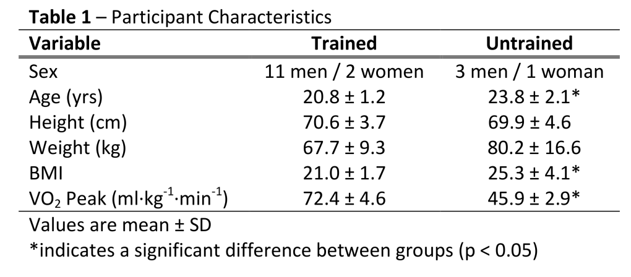

Baseline Pressure Pain Threshold: Trained vs. Untrained
In order to assess differences in PPT at the VL and BR sites between the trained and untrained participants, the pre-exercise assessments on the handgrip and running exercise days were averaged and compared across the groups. In the VL, baseline PPT was significantly higher (p = 0.02) in the untrained groups compared to the trained groups (909 ± 278 kPa vs. 712 ± 202 kPa; Figure 1). Similarly, baseline PPT in the BR was also significantly higher (p = 0.05) in the untrained group compared to the trained group (608 ± 194 kPa vs. 517 ± 147 kPa; Figure 1).
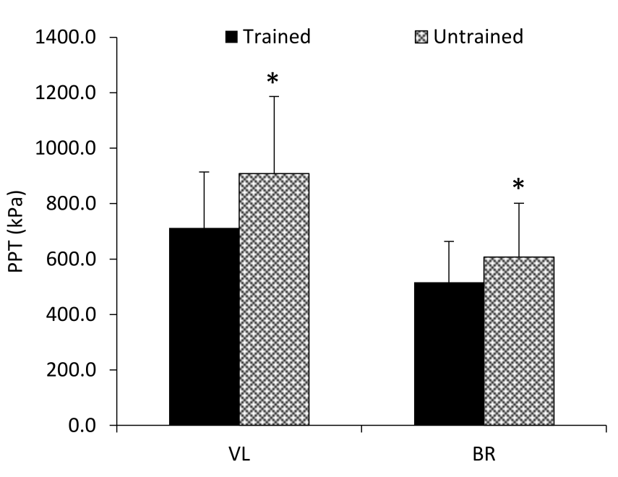

Figure 1 – Baseline pressure pain thresholds of the vastus lateralis in trained versus untrained groups. * indicates a significant difference from trained. Values are mean ± SD.

Body weight/mass was found to be significant predictor of baseline PPT in the VL (p = 0.002) yielding an R² value of 0.49 (Figure 2A). VO₂ peak neither correlated with (r = -0.34; p = 0.18) nor was a predictor of baseline PPT in the VL (R² = 0.12; p = 0.18). Similar findings were observed in the BR with body weight/mass being a significant predictor of baseline PPT in the BR (R² = 0.51; p = 0.001; Figure 2B). VO₂ peak neither correlated with (r = -0.20; p = 0.44) nor was a predictor of baseline PPT in the BR (R² = 0.05; p = 0.44).
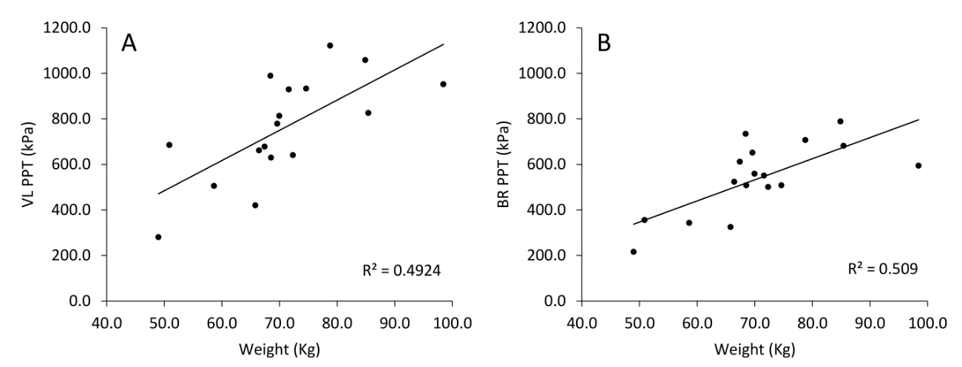

Figure 2 – A: Baseline vastus lateralis PPT plotted against body mass (kg) B: Baseline brachioradialis PPT plotted against body mass (kg). R² values for both were significant (p < 0.05).

Exercise-Induced Hypoalgesia: Trained vs. Untrained
In the VL, there was not a significant group x time interaction (p = 0.43) when comparing PPT between the trained and untrained group before and after 30-min of treadmill running exercise. Nor was there a main effect for group membership (marginal means of 831 ± 258 kPa vs. 1044 ± 233 kPa for the trained and untrained groups, respectively; p = 0.19). A significant main effect for time (pre vs. post exercise) was found (p = 0.002; Figure 3A) with VL PPT’s increasing from 812 ± 251 kPa to 929 ± 291 kPa for Pre and Post exercise, respectively.
In the BR there was not a significant group x time interaction (p = 0.62) when comparing PPT between the trained and untrained group before and after 30-min of treadmill running exercise. There was a significant main effect for group membership (marginal means of 517 ± 163 kPa vs. 678 ± 254 kPa for the trained and untrained groups, respectively; p = 0.02; Figure 3B). The main effect for time (pre vs. post exercise) was not significant (marginal means of 578 ± 250 kPa vs 618 ± 212 kPa for Pre and Post exercise, respectively; p = 0.24).

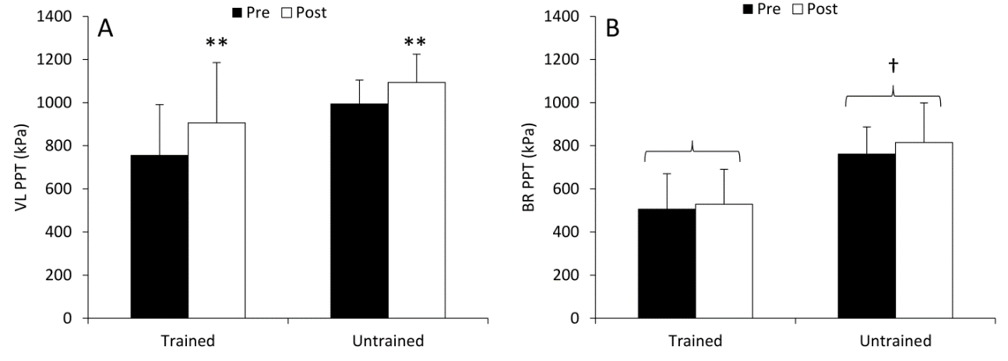

Figure 3 – A: Pre and post 30 minute running vastus lateralis PPT in trained and untrained groups. B: Pre and post 30 minute running brachioradialis PPT in trained and untrained groups. **indicates a significant main effect for exercise (p < 0.05). † indicates a significant main effect for group (p < 0.05). Values are mean ± SD.

In the VL, there was not a significant group x time interaction (p = 0.69) when comparing PPT between the trained and untrained group before and after isometric handgrip exercise to fatigue. Nor was there a main effect for group membership (marginal means of 717 ± 228 kPa vs. 986 ± 254 kPa for the trained and untrained groups, respectively; p = 0.06). A significant main effect for time (pre vs. post exercise) was found (p = 0.009; Figure 4A) with VL PPT’s increasing from 808 ± 254 kPa to 895 ± 227 kPa for Pre and Post exercise, respectively.
In the BR, there was not a significant group x time interaction (p = 0.45) when comparing PPT between the trained and untrained group before and after isometric handgrip exercise to fatigue. Nor was there a main effect for group membership (marginal means of 595 ± 210 kPa vs. 669 ± 227 kPa for the trained and untrained groups, respectively; Figure 4B). The main effect for time (pre vs. post exercise) was significant (p = 0.002) with values increasing after exercise (marginal means of 546 ± 172 kPa vs 719 ± 265 kPa for Pre and Post exercise, respectively; Figure 4B).
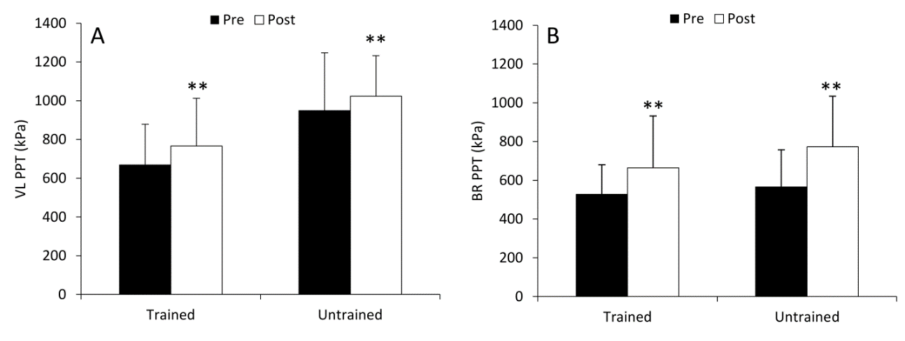

Figure 4 – A: Pre and post isometric handgrip exercise vastus lateralis PPT in trained and untrained groups. B: Pre and post isometric handgrip exercise brachioradialis PPT in trained and untrained groups. **indicates a significant main effect for exercise (p < 0.05). Values are mean ± SD.

In order to compare EIH among the two participant groups and across the two muscles and the two exercise protocols that were used, the percent change in PPT rather than the absolute values for PPT were examined. The 3-way interaction among group, muscles, and exercise type was not significant (p = 0.89). The 2-way interaction for muscle x group was also not significant (p = 0.11). The 2-way interaction for muscle x exercise type was significant (p = 0.04; Figure 5A). Further analysis was performed by collapsing the trained and untrained groups together to examine the effects of muscle and exercise type. When examined in this manner, the percent change in PPT in the VL was found to not differ between the VL following handgrip exercise (18.2% ± 15.7% vs. 15.0% ± 15.4%; p = 0.59; Figure 5B) and the BR following handgrip exercise (18.2% ± 15.7% vs. 27.5% ± 27.0%; p = 0.26; Figure 5B). The change in PPT in the VL was significantly larger than the change in PPT in the BR following running (18.2% ± 15.7% vs. 7.2% ± 16.0%; p = 0.04; Figure 5B). The change in VL PPT following handgrip exercise did not differ from the change in BR PPT following running (15.0% ± 15.4% vs. 7.2% ± 16.0%; p = 0.15; Figure 5B) or in the BR following handgrip exercise (15.0% ± 15.4% vs. 27.5% ± 27.0%; p = 0.13; Figure 5B). The change in PPT following running was significantly reduced compared to the change following handgrip exercise (7.2% ± 16.0% vs. 27.5% ± 27.0%; p = 0.01; Figure 5B) 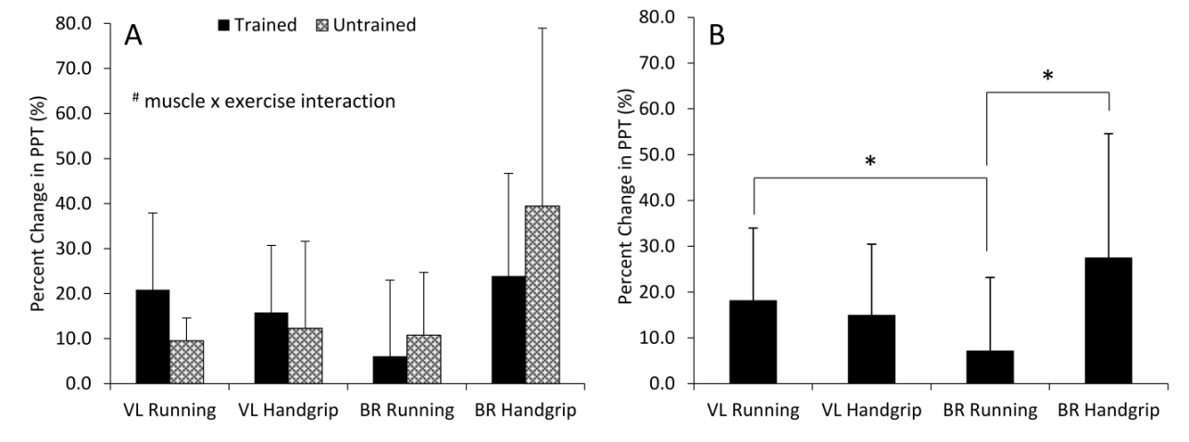

Figure 5 – A: Mean percent change in PPT (%) from pre and post running and handgrip exercise in the VL and BR. B: Mean percent change in PPT (%) collapsed across both trained and untrained participants following running and handgrip exercise in the VL and BR. # indicates a significant two-way interaction for muscle and exercise (p < 0.05). * indicates significant differences from BR running (p < 0.05). Values are mean ± SD.

Chapter V: Discussion

There is an established body of evidence that exercise-induced hypoalgesia manifests in several ways over several different exercise modalities [5]. EIH occurs across the spectrum of noxious stimuli—heat, electrical, biochemical, and pressure with the largest and most consistent effects occurring with pressure stimuli [5]. This study examined resting pain sensitivity to noxious pressure between highly aerobically trained athletes and untrained controls and examined whether the magnitude of EIH was affected by performing exercise that was “familiar” compared to exercise that was “unfamiliar”. The primary findings of this study were 1) trained participants exhibited lower resting PPT in both the VL and BR compared to untrained participants, 2) trained and untrained participants did not differ in the magnitude of EIH experienced following both familiar and unfamiliar exercise, and 3) that handgrip exercise elicited a hypoalgesic response in both the local exercising muscle and in the remote, non-exercising muscle while running only elicited EIH in the local exercising muscle.
A common belief is that athletes are less sensitive to pain than non-athletes, and that this decreased pain sensitivity may play some role in their ability to perform at high levels in a particular sport. Scientific evidence on differences in pain sensitivity between athletes and non-athletes is limited and appears to vary based upon the noxious stimulus applied (pressure, heat, etc.) and potentially the sport in which the athletes engage (endurance, strength, etc.) [30]. To our knowledge only 3 studies [31-33]have examined pain sensitivity between athletes and non-athletes using a pressure stimulus, and only Granges and Littlejohn [32] examined PPT. Unlike the present study, where athletes exhibited lower PPT values than non-athletes, Granges and Littlejohn [32] found that athletes were less sensitive to pain and exhibited higher PPTs. It is possible the disparate results were due to differences in PPT assessment sites or participant gender as the present study tested mostly males while Granges and Littlejohn tested mostly females [32, 34]. However, it is worth noting that a recent study from our lab, Black et al [34]found that females who had greater day-to-day physical activity, especially endurance exercise, exhibited lower PPT values at the BR. An interesting aspect of the present study was our finding that PPT’s in both the VL and BR were correlated with body weight. The higher weight in the non-athletes, who also exhibited a significantly higher BMI, is likely due to increased fat mass. It is plausible that a significantly increased amount of subcutaneous adipose tissue would provide “padding” over the underlying nocicpetors and would require greater force to be applied to active the pain receptors.
The second major purpose of this study was to determine if pain sensitivity changed in a similar manner in trained and untrained individuals following exercise with which they were familiar and unfamiliar. Little evidence exists comparing the EIH response between athletes and non-athletes. Athletes have been shown to exhibit both an augmented [35]and attenuated [36]conditioned pain modulation (CPM) response whereby individuals are given an initial “painful” stimulus, often a cold pressor test, followed by a painful ‘test” stimulus. The initial stimulus should evoke a reduction in sensitivity to the second, “test” stimulus. The CPM response has been shown to correlate with the EIH response [13] (greater CPM is associated with greater EIH) and individuals who experience attenuated CPM and EIH responses are known to be at a greater risk of developing chronic pain conditions [36]. In the present study, we found no differences in the EIH response between our trained and untrained individuals to either 30-min of treadmill running or isometric handgrip exercise to fatigue in either the VL or BR. While these are likely the first data comparing collegiate distance athletes to untrained college students, our findings agree with several previous studies [34, 37] which found no differences in the EIH response between physically active (e.g. those meeting the ACSM daily activity guidelines) individuals and sedentary individuals. As such, we will accept the null hypothesis that trained and untrained participants would not differ in their EIH response and conclude, at least in our participants, that no differences exist.
In regards to whether the performance of “familiar” exercise would lead to a different magnitude of EIH compared to a more “novel”, especially in highly trained running athletes we also found no differences between groups. Run training has been shown to reduce resting pain sensitivity [38] therefore, we were curious as to whether the EIH response might be in some way influenced by performing an exercise that was similar to how individuals trained. While no differences were found between the groups, the type of exercise performed, the type of exercise performed did influence EIH differently at the two testing sites. Handgrip exercise lead to EIH of a similar magnitude in the site local to exercise, the BR, and at a site distant to exercise, the VL. Conversely, running lead to EIH in the VL, but not in the BR. This finding is consistent with those of Micalos and Arendt-Nielsen [26],that found an increase in PPT of the local exercising muscle after aerobic exercise at 70% of VO₂ max levels but did not observe changes in muscles remote those used during exercise. A recent study [27] from our lab also demonstrated EIH local to the exercising muscle, but not in the contralateral muscle following isometric quadriceps exercise. However, in contrast to our findings from running exercise some studies show both localized and generalized EIH following exercise [8, 13, 17, 39].
Perhaps the most interesting aspect of our findings was that the shorter exercise bout (isometric handgrip) that engaged a smaller relative muscle mass resulted in a larger generalized change in pain sensitivity. Previous research has demonstrated clear dose-response effects for exercise intensity on EIH [7, 8] with higher intensity exercise producing larger EIH effects, and that isometric exercise appears to lead to larger EIH responses than dynamic resistance exercise or endurance type exercise [5]. Our findings may indicate differential activation of local and generalized endogenous pain inhibitory pathways based upon the type and intensity of exercise.
Because the exact mechanisms of EIH are still not fully understood, we cannot be certain what why EIH occurred in local sites following both types of exercise, but only following handgrip in remote exercising muscle sites. However, based upon our findings, we can make several suggestions for the application of exercise as a pain treatment for the general population. EIH in local exercising muscle may be applied to chronic pain patients by having them exercise a painful muscle/limb—potentially providing some pain relief. Many clinical populations that suffer from chronic pain, also exhibit a reduced ability to complete activities of daily living, and worsening overall quality of life [11, 15]. Exercising their painful muscles/limbs could not only improve their pain symptoms, but also lead to better mobility and improve the quality of life. Additionally, our findings from isometric handgrip to failure could be implemented in chronic pain populations who are unable, either due to too much pain and/or limb mobility issues, to try and provide some level of pain relief due to the activation of generalized pain inhibitory pathways.
This study has several limitations/experimental considerations. First our sample was small, especially in the untrained group, and within a small age range. More research would be needed to ensure that these findings could be applicable to a larger population. Additionally, only distance (running) athletes were tested. Expanding testing to athletes who compete in contact and/or strength sports would aid in determining if type of athletes exhibit similar EIH to untrained individuals.

Conclusion
The purpose of this study was to observe the effect of training status (highly trained using running vs. sedentary) on resting pain sensitivity to pressure stimuli prior to and following exercise using a “familiar” modality and intensity (running) and an “unfamiliar” modality (hand-grip). Pressure pain thresholds were measured using a handheld algometer in the vastus lateralis and the brachioradialis muscles. By sampling pain thresholds at local and remote exercising muscle sites, it allowed for an examination of the local and generalized EIH effects of exercise. We found a significant difference between pre and post PPT thresholds in the vastus lateralis for running for 30 minutes at 110% of the participants’ GET, and isometric handgrip exercise to volitional exhaustion. Additionally, we found a significant difference between pre and post PPT in the brachioradialis following isometric handgrip exercise, but did not find a difference during the 30 minute run.

References

1. Black, C.D., Muscle Pain During and Following Exercise. The Oxford Handbook of Exercise Psychology, 2012: p. 144.

2. O'Connor, P.J. and D.B. Cook, Exercise and Pain: The Neurobiology, Measurement, and Laboratory Study of Pain in Relation to Exercise in Humans. Exercise and Sport Sciences Reviews, 1999. 27(1): p. 119-166.

3. Koltyn, K.F., Analgesia following exercise: a review. Sports Med, 2000. 29(2): p. 85-98.

4. Koltyn, K.F., Exercise-induced hypoalgesia and intensity of exercise. Sports Med, 2002. 32(8): p. 477-87.

5. Naugle, K.M., R.B. Fillingim, and J.L. Riley, 3rd, A meta-analytic review of the hypoalgesic effects of exercise. J Pain, 2012. 13(12): p. 1139-50.

6. Hoffman, M.D., et al., Intensity and duration threshold for aerobic exercise-induced analgesia to pressure pain. Arch Phys Med Rehabil, 2004. 85(7): p. 1183-7.

7. Naugle, K.M., et al., Intensity thresholds for aerobic exercise-induced hypoalgesia. Med Sci Sports Exerc, 2014. 46(4): p. 817-25.

8. Hoeger Bement, M.K., et al., Dose response of isometric contractions on pain perception in healthy adults. Med Sci Sports Exerc, 2008. 40(11): p. 1880-9.

9. Melzack, R. and P.D. Wall, Pain mechanisms: a new theory. Science, 1965. 150(3699): p. 971-9.

10. Borg, G.A., Psychophysical bases of perceived exertion. Med Sci Sports Exerc, 1982. 14(5): p. 377-81.

11. Caudill-Slosberg, M.A., L.M. Schwartz, and S. Woloshin, Office visits and analgesic prescriptions for musculoskeletal pain in US: 1980 vs. 2000. Pain, 2004. 109(3): p. 514-9.

12. Ellingson, L.D., et al., Does exercise induce hypoalgesia through conditioned pain modulation? Psychophysiology, 2014. 51(3): p. 267-76.

13. Lemley, K.J., S.K. Hunter, and M.K. Bement, Conditioned pain modulation predicts exercise-induced hypoalgesia in healthy adults. Med Sci Sports Exerc, 2015. 47(1): p. 176-84.

14. Naugle, K.M., et al., Age-related differences in conditioned pain modulation of sensitizing and desensitizing trends during response dependent stimulation. Behav Brain Res, 2015. 289: p. 61-8.

15. Fillingim, R.B., et al., Sex, Gender, and Pain: A Review of Recent Clinical and Experimental Findings. The Journal of Pain, 2009. 10(5): p. 447-485.

16. Staud, R., M.E. Robinson, and D.D. Price, Isometric exercise has opposite effects on central pain mechanisms in fibromyalgia patients compared to normal controls. Pain, 2005. 118(1-2): p. 176-84.

17. Burrows, N.J., et al., Acute resistance exercise and pressure pain sensitivity in knee osteoarthritis: a randomised crossover trial. Osteoarthritis Cartilage, 2014. 22(3): p. 407-14.

18. Lannersten, L. and E. Kosek, Dysfunction of endogenous pain inhibition during exercise with painful muscles in patients with shoulder myalgia and fibromyalgia. Pain, 2010. 151(1): p. 77-86.

19. Kosek, E., J. Ekholm, and P. Hansson, Increased pressure pain sensibility in fibromyalgia patients is located deep to the skin but not restricted to muscle tissue. Pain, 1995. 63(3): p. 335-9.

20. Janal, M.N., et al., Are runners stoical? An examination of pain sensitivity in habitual runners and normally active controls. Pain, 1994. 58(1): p. 109-116.

21. Drury, D.G., et al., Changes in pain perception in women during and following an exhaustive incremental cycling exercise. J Sports Sci Med, 2005. 4(3): p. 215-22.

22. Koltyn, K.F., et al., Perception of pain following aerobic exercise. Med Sci Sports Exerc, 1996. 28(11): p. 1418-21.

23. Kodesh, E. and I. Weissman-Fogel, Exercise-induced hypoalgesia - interval versus continuous mode. Appl Physiol Nutr Metab, 2014. 39(7): p. 829-34.

24. Koltyn, K.F. and R.W. Arbogast, Perception of pain after resistance exercise. Br J Sports Med, 1998. 32(1): p. 20-4.

25. Umeda, M., L.W. Newcomb, and K.F. Koltyn, Influence of blood pressure elevations by isometric exercise on pain perception in women. Int J Psychophysiol, 2009. 74(1): p. 45-52.

26. Micalos, P.S. and L. Arendt-Nielsen, Differential pain response at local and remote muscle sites following aerobic cycling exercise at mild and moderate intensity. Springerplus, 2016. 5: p. 91.

27. Black, C.D., et al., Local and Generalized Endogenous Pain Modulation in Healthy Men: Effects of Exercise and Exercise-Induced Muscle Damage. Pain Med, 2016.

28. Park, I. and R.W. Schutz, "Quick and easy" forumulae for approximating statistical power in repeated measures ANOVA. Meas Phys Educ Exerc Sci, 1999. 3: p. 249-270.

29. Black, C.D., et al., Time-course of recovery of peak oxygen uptake after exercise-induced muscle damage. Respir Physiol Neurobiol, 2015. 216: p. 70-75.

30. Tesarz, J., et al., Pain perception in athletes compared to normally active controls: a systematic review with meta-analysis. Pain, 2012. 153(6): p. 1253-62.

31. Eitter, T., Pain tolerance training applied to the athletic environment Diss Abstr Int, 1980. 41: p. 2005-2006.

32. Granges, G. and G.O. Littlejohn, A comparative study of clinical signs in fibromyalgia/fibrositis syndrome, healthy and exercising subjects. J Rheumatol, 1993. 20(2): p. 344-51.

33. Ryan, E.D. and C.R. Kovacic, Pain Tolerance and Athletic Participation. Perceptual and Motor Skills, 1966. 22(2): p. 383-7.

34. Black, C.D., et al., Exercise-Induced Hypoalgesia Is Not Influenced by Physical Activity Type and Amount. Med Sci Sports Exerc, 2017. 49(5): p. 975-982.

35. Geva, N. and R. Defrin, Enhanced pain modulation among triathletes: a possible explanation for their exceptional capabilities. Pain, 2013. 154(11): p. 2317-23.

36. Tesarz, J., et al., Alterations in endogenous pain modulation in endurance athletes: an experimental study using quantitative sensory testing and the cold-pressor task. Pain, 2013. 154(7): p. 1022-9.

37. Vaegter, H.B., G. Handberg, and T. Graven-Nielsen, Hypoalgesia After Exercise and the Cold Pressor Test is Reduced in Chronic Musculoskeletal Pain Patients With High Pain Sensitivity. Clinical Journal of Pain, 2016. 32(1): p. 58-69.

38. Jones, M.D., et al., Aerobic Training Increases Pain Tolerance in Healthy Individuals. Medicine & Science in Sports & Exercise, 2014. 46(8): p. 1640-1647.

39. Pertovaara, A., P. Kemppainen, and H. Leppanen, Lowered cutaneous sensitivity to nonpainful electrical stimulation during isometric exercise in humans. Exp Brain Res, 1992. 89(2): p. 447-52.

Appendix A: IRB Approval Letter
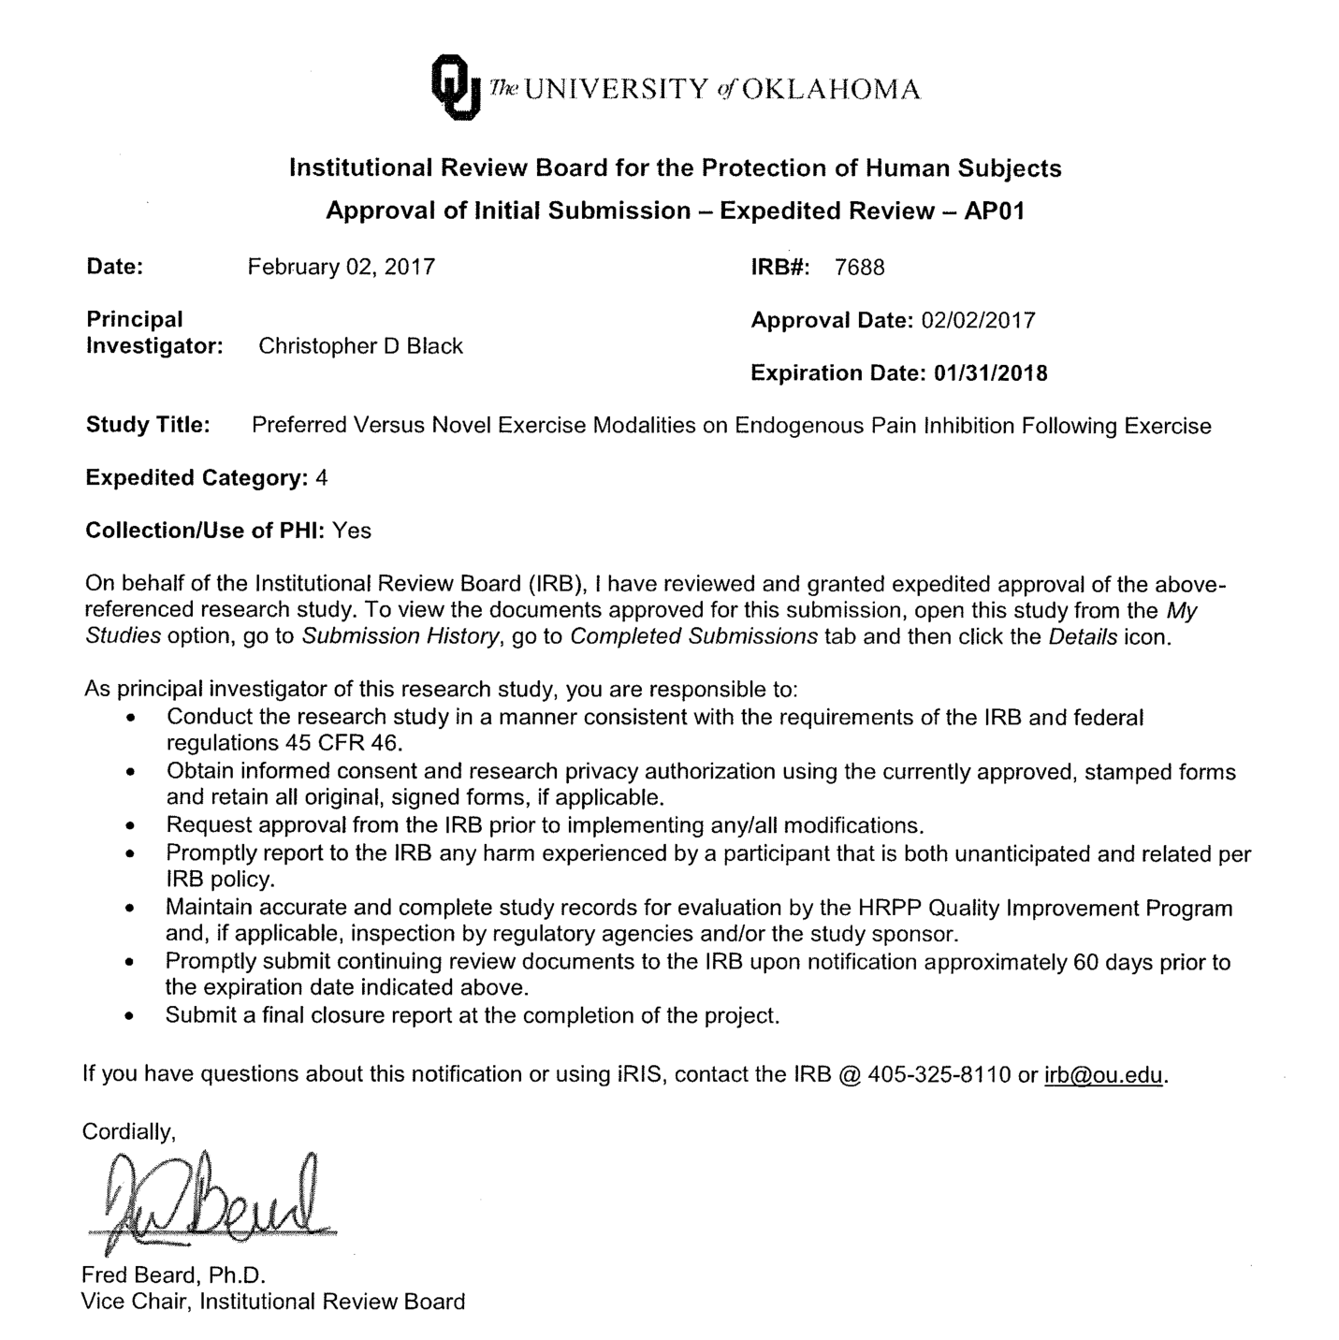:

Appendix B: Informed Consent Form
University of Oklahoma
Institutional Review Board
Informed Consent to Participate in a Research Study
Project Title: | Preferred Versus Novel Exercise Modalities on Endogenous Pain Inhibition Following Exercise
Principal Investigator: | Daniel Schubert
Department: | Health and Exercise Science
You are being asked to volunteer for this research study. This study is being conducted at the University of Oklahoma Sensory and Muscle Function Laboratory. You were selected as a possible participant because you fit the criteria to participate in this study (you are aged 18-25, do not chronically take pain medication, and do not take medication for a diagnosed psychological condition).
Please read this form and ask any questions that you may have before agreeing to take part in this study.
Purpose of the Research Study
The purpose of this study is to observe the effect of endurance exercise training status (highly trained using running vs. sedentary) on resting pain sensitivity to pressure stimuli and following exercise using a “familiar” modality and intensity (running) and an “unfamiliar” modality (hand-grip).
Number of Participants
Approximately 34 people will take part in this study including 17 men or women in each of the following 2 categories: untrained, sedentary participants and highly aerobically trained.
Procedures
If you agree to participate in this study, you will be asked to participate in 5 visits (including this one) to the laboratory. The first visit will consist of completing questionnaires about your physical activity over the past week, current pain level, menstrual and drug use history, a general health questionnaire, a mood assessment (i.e. how you have been “feeling” over the last week), an assessment of your current and general feelings of anxiety/worry, and an assessment of your attitudes towards pain. This should take approximately 45 minutes. You will then be familiarized with how we will assess your sensitivity to thermal (heat) pain, your sensitivity to pain by the application of pressure over a muscle (on your forearm and on your thigh), how to perform handgrip exercise (where you squeeze and hold at a certain force level), and how it feels to place your foot in a very cold ice water bath.
Your sensitivity to thermal pain will be assessed by placing a small, square probe on the palm of your left hand below your thumb. The probe heats up and cools off very quickly (in about 2 seconds). You will be presented with 7 different “hot” temperatures ranging from 109.4-120.2° F for 15 seconds each (110°F represents hot bath water while 135°F represents the approximate temperature of a bowl of soup from a buffet line). Each temperature will be presented to you twice in a random order (14 total stimuli will be applied to your hand). After application of each temperature, you be asked to rate the pain intensity (how much it hurt) and pain unpleasantness (how bothersome it was) of each temperature. You may find some temperatures to not be painful or bothersome while other temperatures may be very painful and very bothersome.
Pressure pain sensitivity will be assessed using a probe with a 1 cm diameter rubber tip which will be placed to over the muscles of the forearm on your dominant arm and over the thigh on your dominant leg. The probe will be pressed down into your muscle and when the pressure begins to hurt you will push a button and the pressure will be immediately removed.
Handgrip exercise will be performed in your dominant hand. Your maximal grip strength will be determined by having you squeeze a dynamometer as forcefully as possible. After several minutes of rest you will squeeze the dynamometer to generate 50% of your maximal strength for as long as possible.
The ice water bath will contain very cold water ~4° C. You will place the foot on your dominant leg into the bath and will be asked to leave it in the water for 3 minutes. If the pain or discomfort of having your foot in the bath is too great you may remove your foot at any time.
Your second visit to the lab will last approximately 50 minutes. It will consist of pre-exercising measures of pressure pain thresholds. The same methods will be used that were used in visit 1. Next, you will complete a running VO₂ max test on a treadmill. You will be fitted with a strap-on heart rate monitor and a breathing mask. You will then begin the test with a 5 minute warm-up at a slow jogging pace that you will choose. You will then self-select a running speed that you find comfortable. This speed will remain constant throughout the test. You will run at this speed and every two minutes the incline on the treadmill will be increased by 2% to make running more difficult. You will be asked to run as long as you can during the test.
Visit 3 will last approximately 45-60 minutes. Your pressure pain thresholds will be determined in your forearm and thigh. You will then squeeze a handgrip dynamometer as hard as you can 3 times to determine your maximal strength. After several minutes of rest you will squeeze the dynamometer to generate 50% of your maximal strength and then hold that level for as long as possible. Pressure pain thresholds will then be re-assessed immediately after completion of the exercise.
Visit 4 will also last approximately 45-60 minutes. Your pressure pain thresholds will be determined in your forearm and thigh. You will then be fitted with a strap-on heart rate monitor and a breathing mask. Next you will run on the treadmill for 30 minutes at a speed that will approximate a brisk jog. During the 30 minutes, the speed may be adjusted in order to keep you at the targeted exercise intensity. Pressure pain thresholds will then be re-assessed immediately after completion of the exercise.
Visit 5 will last approximately 20-30 minutes. Your pressure pain thresholds will be determined in your forearm and thigh. You will then place your foot in the ice water bath. After your foot has been in the bath for 1 minute, you will rate how painful it is. Your pressure pain thresholds will then be re-assessed at each site while your foot remains in the ice bath.
Length of Participation
Each visit will last between 30 minutes and approximately 1 hour for a total of approximately 4-5 hours total over your 5 visits. The 5 visits may take place over a 1-2 week period. Participation may be terminated by the Investigator without regard to the participant’s consent if you do not comply with instructions for all testing protocols, drug consumption during the study, failure to show up for your scheduled testing day(s) and time(s).
Risks of being in the study are
Risks and side effects of pressure and thermal pain testing include: feelings of pain and discomfort at the testing sites (forearm and leg), slight bruising, and minor skin tenderness. Five minutes of exposure to the “hottest” thermal temperature, 120.2° F, would be required for 2nd or 3rd degree burns to occur. It will only be applied for a maximum of 15 seconds in this study. It will take only 2 seconds for any of the thermal stimuli to be discontinued and return to a cool temperature if you wish for the temperature to be removed. If you ask for any the stimuli (thermal or pressure) to be discontinued, for any reason, you may choose to withdraw from the study immediately.
You will also be asked questions regarding your drug use, anxiety levels, mood, overall health, and attitudes related to pain. It is possible some questions may make you uncomfortable.
Risks and side effects of undergoing a maximal aerobic (VO2 max) test include: feelings of nausea and light headedness. The researchers will monitor you during and after the test to check for these symptoms and you will be allowed to stop the test at any point if you wish.

There are no other known risks associated with the protocols outlined in the proposal. Exercise testing of apparently healthy subjects under laboratory supervision is safe. According to recent American College of Sports Medicine’s Guidelines for Exercise Testing, the exercise tests described above can be safely performed in individuals who meet this studies inclusion criterion.

For more information about risks and side effects, ask the researcher if you have questions at any time.

Benefits of being in the study are
There are no direct benefits from participating in this study. We hope the information learned from this study will benefit clinical and athletic populations with regards to their sensitivity to certain painful stimuli.

Compensation
All participants who complete the study will not receive compensation for participation in this study. Per departmental policy, if you are part of the Health and Exercise Science department you will receive no extra credit for participating in research studies.
Injury
In case of injury or illness resulting from this study, emergency medical treatment is available. However, you or your insurance company will be expected to pay the usual charge from this treatment. The University of Oklahoma Norman Campus has set aside no funds to compensate you in the event of injury.
The current study involves low risk; however, there is always the possibility of a problem during exercise. Therefore, in case of a medical emergency the phone numbers for campus police (405-325-2864), Goddard Health Center (405-325-4611), Norman police (911), ambulance (911), and fire department (911) are posted in the testing room and research laboratory suite. Medical professionals are within minutes of the testing labs. All investigators are CPR, and Automated External Defibrillator certified. The P.I. will be present at each experimental visit or immediately available if needed.

Confidentiality
In published reports, there will be no information included that will make it possible to identify you. Research records will be stored securely and only approved researchers will have access to the records.
There are organizations that may inspect and/or copy your research records for quality assurance and data analysis. These organizations include the OU Institutional Review Board.
Voluntary Nature of the Study
Participation in this study is voluntary. If you withdraw or decline participation, you will not be penalized or lose benefits or services unrelated to the study. If you decide to participate, you may decline to answer any question and may choose to withdraw at any time.

You have the right to access the research data that has been collected about you as a part of this research study. However, you may not have access to this information until the entire research study has completely finished and you consent to this temporary restriction.
Photographing of Study Participants/Activities
In order to preserve an image related to the research, photographs may be taken of participants. You have the right to refuse to allow photographs to be taken without penalty. Please select one of the following options:
I consent to photographs. ___ Yes ___ No

Future Communications
The researcher would like to contact you again to recruit you into this study or to gather additional information.

_____ I give my permission for the researcher to contact me in the future.

_____ I do not wish to be contacted by the researcher again.
Contacts and Questions
If you have concerns or complaints about the research, the researcher(s) conducting this study can be contacted at cblack@ou.edu (405)-325-7668 or (706)-255-3750. Contact the researcher(s) if you have questions, or if you have experienced a research-related injury.

If you have any questions about your rights as a research participant, concerns, or complaints about the research and wish to talk to someone other than individuals on the research team or if you cannot reach the research team, you may contact the University of Oklahoma – Norman Campus Institutional Review Board (OU-NC IRB) at 405-325-8110 or irb@ou.edu.
You will be given a copy of this information to keep for your records. If you are not given a copy of this consent form, please request one.
Statement of Consent
I have read the above information. I have asked questions and have received satisfactory answers. I consent to participate in the study.

Participant Signature Print Name | Date
Signature of Person Obtaining Consent Date
Print Name of Person Obtaining Consent

Signature of Witness | Date
Print Name of Witness | Date

Appendix C: Signed Consent To Participate In Research

Signed Consent to Participate in Research

Would you like to be involved in research at the University of Oklahoma?
I am Dan Schubert from the Department of Health and Exercise Science and I invite you to participate in my research project entitled Preferred Versus Novel Exercise Modalities on Endogenous Pain Inhibition Following Exercise This research is being conducted at Sensory and Muscle function Laboratory. You were selected as a possible participant because you are aged 18-25, do not chronically take pain medication, are either sedentary and untrained, or highly trained aerobically. You must be at least 18 years of age to participate in this study.
Please read this document and contact me to ask any questions that you may have BEFORE agreeing to take part in my research.
What is the purpose of this research? The purpose of this research is to observe the effect of training status (highly trained using running vs. sedentary) on resting pain sensitivity to pressure stimuli and following exercise using a “familiar” modality and intensity (running) and an “unfamiliar” modality (hand-grip).
How many participants will be in this research? About 34 people will take part in this study including 17 men or women in each of the following 2 categories: untrained, sedentary participants and highly aerobically trained.
What will I be asked to do? If you agree to be in this research, you will be asked to participate in 4 visits (including this one) to the laboratory. The first visit will consist of completing questionnaires about your physical activity over the past week, current pain level, menstrual and drug use history, a general health questionnaire, a mood assessment (i.e. how you have been “feeling” over the last week), an assessment of your current and general feelings of anxiety/worry, and an assessment of your attitudes towards pain. This should take approximately 45 minutes. You will then be familiarized with how we will assess your pressure pain thresholds in both the vastus lateralis muscle and the brachioradialis muscle.
Your threshold to pressure pain will be assessed through the use of a handheld algometer equipped with a 1 cm diameter rubber tip which will be placed over the muscles on your dominant leg and forearm. Testing sites in the participant’s dominant vastus lateralis and brachioradialis will be marked by the investigator. You will be presented with pressure from the algometer three (3) separate times in each muscle site. The probe will be pressed down into your muscle and when the pressure begins to hurt you will push a button and the pressure will be immediately removed.
Your second visit to the lab will last approximately 50 minutes. It will consist of pre-exercising measures of pressure pain thresholds. The same methods will be used in this visit that were used in visit 1. Next, you will complete a running VO₂ max test on the Woodway treadmill. The VO₂ Max testing protocol will be as follows: Participants will start the test with a 5 minute warm-up at a slow jogging pace. Participants will then self-select a comfortable running speed, which will remain constant throughout the test. The grade on the treadmill will initially be set at 0% and every two minutes, the treadmill grade will be increased 2%. This will continue until the participant reaches volitional exhaustion. Strong verbal encouragement will be provided throughout the test. V̇O₂ max will be defined by a plateau in V̇O₂ (change of <2.1 ml·kg⁻¹·min⁻¹) with an increase in work rate or the attainment of three of the following criteria: RER ≥ 1.1, peak HR within 10 bpm of age-predicted maximum, and an RPE of ≥ 18. A 5-10 minute walking cool down will be provided after completion of the test.
Expired gases will be collected via open-circuit spirometry using a Parvomedics metabolic cart. V_{E}, V̇O₂, V̇CO₂, and RER will be averaged over 15 second epochs. Oxygen and carbon dioxide analyzers will be calibrated before each test with known gas concentrations and a flow meter calibration will be performed using a 3-L syringe. V̇O₂ and V̇CO₂ will be standardized to standard temperature and pressure dry (STPD). Heart rate (HR) will be measured continuously during the test using a heart rate monitor.
During Visits 3, isometric handgrip exercise will be performed in your dominant hand. You will be seated in a comfortable chair with your dominant hand resting on the arm of the chair. You will perform three (3) maximal efforts separated by 3 minutes of rest. Your maximal grip strength will be determined by your highest value. After several minutes of rest you will squeeze the dynamometer to generate 50% of your maximal voluntary contraction for as long as possible. Prior to and immediately following exercise, pressure pain thresholds will once again be evaluated in the vastus lateralis and brachioradialis.
Visit 4 will require a running test on a Woodway treadmill. Prior to running at a speed that elicits 110% of gas exchange threshold (determined from the VO2 max test on visit 2) for 30 minutes, the subject will have their pressure pain threshold measured in the vastus lateralis and brachioradialis muscle sites. The subject will then complete the running trial on the Woodway treadmill. In order to determine your speed at 110% of gas exchange threshold, the ACSM calculation will be used: Speed=(((VO₂-3.5)/.2)/26.8)*X). During this test, the subject’s expired gases will be collected via open-circuit spirometry using a Parvomedics metabolic cart. V_{E}, V̇O₂, V̇CO₂, and RER will be averaged over 15 second epochs. Oxygen and carbon dioxide analyzers will be calibrated before each test with known gas concentrations and a flow meter calibration will be performed using a 3-L syringe. V̇O₂ and V̇CO₂ will be standardized to standard temperature and pressure dry (STPD). Heart rate (HR) will be measured continuously during the test using a heart rate monitor. Explain all the tasks/procedures the participant will complete during the research, frequency of procedures, etc. Also, describe any procedures that are experimental).
How long will this take? Each visit will last between 45 minutes and approximately 1 hour for a total of approximately 3.5 hours total over your 4 visits. The 4 visits may take place over a 1-2 week period. Participation may be terminated by the Investigator without regard to the participant’s consent if you do not comply with instructions for all testing protocols, drug consumption during the study, failure to show up for your scheduled testing day(s) and time(s).

What are the risks and/or benefits if I participate? “There are no risks and no benefits from being in this research.”
What do I do if I am injured? If you are injured during your participation, report this to a researcher immediately. Emergency medical treatment is available. However, you or your insurance company will be expected to pay the usual charge from this treatment. The University of Oklahoma Norman Campus has set aside no funds to compensate you in the event of injury.
Will I be compensated for participating? You will not be reimbursed for your time and participation in this research. Per departmental policy, if you are part of the Health and Exercise Science department you will receive no extra credit for participating in research studies.

Who will see my information? In research reports, there will be no information that will make it possible to identify you (if applicable, add without your permission). (If you want to report names or use direct quotes or attribution to individuals, retain contact information, you must include all appropriate check-offs under Waivers of Elements of Confidentiality). Research records will be stored securely and only approved researchers and the OU Institutional Review Board will have access to the records. (Delete this sentence if not applicable) In addition, the (Insert the name of the sponsor that is funding your research if funding is dependent on the organization having access to research data. Do not list your faculty sponsor, dissertation committee or department name) will have access to the research records.
You have the right to access the research data that has been collected about you as a part of this research. However, you may not have access to this information until the entire research has completely finished and you consent to this temporary restriction.
Do I have to participate? No. If you do not participate, you will not be penalized or lose benefits or services unrelated to the research. If you decide to participate, you don’t have to answer any question and can stop participating at any time.
Will my identity be anonymous or confidential? (Delete this section if not applicable) Your name will not be retained or linked with your responses unless you specifically agree to be identified. The data you provide will be (enter either destroyed OR retained in anonymous form) unless you specifically agree for data retention or retention of contact information at the end of the research. Please check all of the options that you agree to:
I agree to being quoted directly. ___ Yes ___ No
I agree to have my name reported with quoted material. ___Yes ___ No
I agree for the researcher to use my data in future studies. ___Yes ___ No
Will my personal records be accessed? (Delete this section if not applicable) If you approve, your confidential records will be used as data for this research. The records that will be used include (list, by name, the specific confidential data that will be collected). These records will be used for the following purpose(s): (describe how data will be used in the research)
I agree for my records to be accessed and used for research purposes. ___Yes ___ No
Photographing of Research Participants/Activities In order to preserve an image related to the research, photographs may be taken of participants. You have the right to refuse to allow photographs to be taken without penalty. (Or you may wish to use this language – “If you do not agree to photography, you cannot participate in this research.”) Please select one of the following options:
I consent to photographs. ___ Yes ___ No
Will I be contacted again? The researcher would like to contact you again to recruit you into this research or to gather additional information.
_____ I give my permission for the researcher to contact me in the future.
_____ I do not wish to be contacted by the researcher again.
Who do I contact with questions, concerns or complaints? If you have questions, concerns or complaints about the research or have experienced a research-related injury, contact me at (920-915-8799 or danschubert@ou.edu or my advisor, Dr. Chris Black at (706-255-3750 or cblack@ou.edu)
You can also contact the University of Oklahoma – Norman Campus Institutional Review Board (OU-NC IRB) at 405-325-8110 or irb@ou.edu if you have questions about your rights as a research participant, concerns, or complaints about the research and wish to talk to someone other than the researcher(s) or if you cannot reach the researcher(s).
You will be given a copy of this document for your records. By providing information to the researcher(s), I am agreeing to participate in this research.
Participant Signature | Print Name | Date
Signature of Researcher Obtaining Consent | Print Name | Date
Signature of Witness (if applicable) | Print Name | Date

Appendix D: HIPAA
UNIVERSITY OF OKLAHOMA – NORMAN CAMPUS
INSTITUTIONAL REVIEW BOARD

AUTHORIZATION TO USE or DISCLOSE
PROTECTED HEALTH INFORMATION FOR RESEARCH

Title for Research Project: Preferred Versus Novel Exercise Modalities on Endogenous Pain Inhibition Following Exercise

Principal Investigator: Christopher Black, PhD
IRB Number: 7688

Address: 1401 Asp Ave., Norman, OK 73019

Phone Number: 706-255-3750 (cell) and 405-325-7668

If you decide to join this research project, University of Oklahoma (OU) researchers may use or share (disclose) information about you that is considered to be protected health information for their research. Protected health information will be called private information in this Authorization.

Private information To be Used or Shared. Federal law required that researchers get your permission (authorization) to use or share your private information. If you give permission, the researches may use or share with the people identified in this Authorization any private information related to this research from your medical records and from any test results. Information, used or shared, may include all information relating to any tests, procedures surveys, or interviews as outlined in the consent form, medical records and charts, name, address, telephone number, date of birth, race and government-issued identification number.

Purposes for Using or Sharing Private Information. If you give permission, the researchers may use your private information to determine if you meet the eligibility criteria for participation in this study.

Other Use and Sharing of Private Information. If you give permission, the researchers may also use your private information to develop new procedures or commercial products. They may share your private information with the research sponsor, the OU Institutional Review Board, auditors and inspectors who check the research, and government agencies such as the Department of Health and Human Services (HHS). The researchers may also share your private information with your physician and/or a university physician in the event of a serious health risk
.

Confidentiality. Although the research may report their findings in scientific journals or meetings, they will not identify you in their reports. The researchers will try to keep your information confidential, but confidentiality is not guaranteed. Any person or organization receiving the information based on this authorization could re-release the information to others and federal law would not longer protect it.

YOU MUST UNDERSTAND THAT YOUR PROTECTED HEALTH INFORMATION MAY INCLUDE INFORMATION REGARDING ANY CONDITIONS CONSIRDED AS A COMMUNICABLE OR VENEREAL DISEASE WHICH MY INLUDE, BUT ARE NOT LIMITED TO, DISEASES SUCH AS HEPATITIS, SYPHILIS, GONORRHEA, AND HUMAN IMMUNODEFICIDNCY VIRUS ALSO KNOWN AS ACQUIRED IMMUNE DEFICIENCY SYNDROME (AIDS).

Voluntary Choice. The choice to give OU researchers permission to use or share your private information for their research is voluntary. It is completely up to you. No one can force you to give permission. However, you must give permission for OU researchers to use or share your private health information if you want to participate in the research and if you revoke your authorization, you can no longer participate in this study.

Refusing to give permission will not affect your ability to get routine treatment or health care from OU.

Revoking Permission. If you give OU researchers permission to use or share your private information, you have a right to revoke your permission whenever you want. However, revoking your permission will not apply to information that the researchers have already used, relied on, or shared.

End of Permission. Unless you revoke it, permission for OU researchers to use or share your private information for their research will never end. You may revoke your permission at any time by writing to:
Privacy Official
University of Oklahoma
1000 Stanton L. Young Blvd., STE 221
Oklahoma City, OK 731117
If you have questions, call (405) 271-2033

Giving Permission. By signing this form, you give OU and OU’s researchers led by Dr. Chris Black, permission to share your private information for the research project called “The Relationship Between Physical Activity Levels and Activity Type and Thermal Pain Sensitivity and Pressure Pain Sensitivity in health College Aged Females.”

Subject Name:

_______________________________ ____________________
Signature of Subject Date
Or parent if Subject is a Child

Or

_______________________________ ____________________
Signature of Legal Representative** Date

**If signed by a legal Representative of the Subject, provide a description of the relationship to the Subject and the Authority to Act as Legal Representative:

___________________________________________________________

OU may ask you to produce evidence of your relationship.

A signed copy of this form must be give to the Subject or the Legal Representative at the time this signed form is provided to the researcher or his representative.

Appendix E: Health Status Questionnaire

Health Status Questionnaire

Part 1. Information about the individual

1. ____________________________________
Date

2. _________________________________________
Legal Name

3. _________________________________________ ________________________
Mailing Address Phone #
________________________
________________________________________ Email

4. _______________________________________ ______________________
Primary Physician Physician Phone#

_______________________________________
Date of Last Physical Examination

5. _______________________________________ ______________________
Person to contact in emergency Phone

6. Gender (circle one) Female Male

7. Age ________ Date of Birth _______/________/________

8. Height ____________ Weight___________

9. Do you smoke? Yes No

10. If you are a smoker, indicate number smoked per day:
Cigarettes: 40 or more 20-39 10-19 1-9
Cigars or pipes only: 5 or more or any inhaled Less than 5, none inhaled

11. Are you currently taking prescription or over-the-counter medication(s)? If so, please list the medication, daily dose, and why you are taking it.

12. Are you currently taking any vitamins or nutritional supplements? If so, please list the vitamin/supplement, the daily dose, and why you are taking it.

Part 2. Medical History

You have had or currently have any of the following:

History
___ A heart attack
___ Heart surgery
___ Cardiac catheterization
___ Coronary angioplasty (PTCA)
___ Pacemaker-implantable cardiac defibrillatory/ rhythm disturbance
___ Heart valve disease
___ Heart failure
___ Heart transplantation
___ Congenital heart disease
___ Peripheral arterial disease
___ Stoke

Signs/Symptoms
___ You experience discomfort and/or pain with exertion in the chest, neck, jaw, arms
___ You experience unreasonable breathlessness at rest or with mild exertion
___ You experience dizziness, fainting, or blackouts
___ You experience ankle edema
___ You experience heart palpitations or tachycardia (unpleasant awareness of force or rapid heart beats)
___ You have or experience intermittent claudication (muscle pain due to ischemia)
___ You have a heart murmur
___ You take medication(s) for ANY type of heart condition or high blood pressure

Other health issues
___ You have diabetes
___ You have a thyroid disorder
___ You have a renal (kidney) disorder
___ You have liver disease (e.g. cirrhosis)
___ You have COPD, asthma, cystic fibrosis or other lung disease
___ You have burning or cramping sensation in your lower legs when walking short distances
___ You have musculoskeletal problems that limit your physical activity (arthritis, etc.)
___ You are pregnant
Part III: Cardiovascular Risk Factors

Age
___ You are a man older than 45 years
___ You are a woman older than 55 years, have had a hysterectomy, or are postmenopausal

Medical/Lifestyle
___ You smoke, or quit smoking within the previous 6 months

___ A physician has ever said have high blood pressure (>140/90)?

___ A physician has said you have high cholesterol (Total >200 mg/dl or LDL cholesterol is >130 mg/dl)

___ You have a close blood relative who had a heart attack or heart surgery before age 55 (father or brother) or age 65 (mother or sister)

___ You are physically inactive (i.e., you get <30 minutes of physical activity 3 days per week)

___ You have impaired fasting glucose (> 100mg/dl) that has been confirmed by a doctor on two separate occasions

___ Your BMI is >30 BMI___________

I understand my signature signifies that I have read and understand all the information on the questionnaire, that I have truthfully answered all the questions, and that any questions/concerns I may have had have been addressed to my complete satisfaction.

Name (please print)_________________________________________________________________

Signature ________________________________________Date _________________

Appendix F: Physical Activity Readiness Questionnaire

PAR-Q & YOU
(A Questionnaire for People Aged 15 to 69)
Regular physical activity is fun and healthy, and increasingly more people are starting to become more active every day. Being more active is very safe for most people. However, some people should check with their doctor before starting to become much more physically active.
If you are planning to become much more physically active than you are now, start by answering the seven questions in the box below. If you are between the ages of 15 and 69, the PAR-Q will tell you if you should check with your doctor before you start. If you are over 69 years of age, and you are not used to being very active, check with your doctor.
Common sense is your best guide when you answer these questions. Please read the questions carefully and answer each one honestly: check YES or NO.
YES NO
1. Has your doctor ever said that you have a heart condition and that you should only do physical activity recommended by your doctor?
2. Do you feel pain in your chest when you do physical activity?
3. In the past month, have you had chest pain when you were not doing physical activity?
4. Do you lose your balance because of dizziness or do you ever lose consciousness?
5. Do you have a bone or joint problem (for example, back, knee or hip) that could be made worse by a change in your physical activity?
6. Is your doctor currently prescribing drugs (for example, water pills) for your blood pressure or heart condition?
7. Do you know of any other reason why you should not do physical activity?

If  you  answered | YES to one or more questions
If  you  answered | Talk to your doctor by phone or in person BEFORE you start becoming much more physically active or BEFORE you have a fitness appraisal. Tell your doctor about the PAR-Q and which questions you answered YES.  - You may able to any activity you want – as long as you start slowly and build up gradually. Or, you may need to restrict your activities to those which are safe for you. Talk with your doctor about the kinds of activities you wish to participate in and follow his/her advice.  - Find out which community programs are safe and helpful to you.
NO to all questions |  |  | DELAY BECOMING MUCH MORE ACTIVE:
If you answered NO honestly to all PAR-Q questions, you can be reasonably sure that you can:  - start becoming much more physically active – begin slowly and build up gradually. This is the safest and easiest way to go.  - Take part in a fitness appraisal – this is an excellent way to determine your basic fitness so that you can plan the best way for you to live actively. It is also highly recommended that you have your blood pressure evaluated. If your reading is over 144/94, talk with your doctor before you start becoming much more physically active. |  |  | - If you are not feeling well because of a temporary illness such as a cold or a fever – wait until you feel better; or  - If you are or may be pregnant – talk to your doctor before you start becoming more active.
 |  | PLEASE NOTE: If your health changes so that you then answer YES to any of the above questions, tell your fitness or health professional. Ask whether you should change your physical activity plan.
Informed use of the PAR-Q: The Canadian Society for Exercise Physiology, Health Canada, and their agents assume no liability for persons who undertake physical activity, and if in doubt after completing this questionnaire, consult your doctor prior to physical activity.
No changes permitted. You are encouraged to photocopy the PAR-Q but only if you use the entire form.
NOTE: If the PAR-Q is being given to a person before he or she participates in a physical activity program or a fitness appraisal, this section may be used for legal or administrative purposes.
“I have read, understood and completed this questionnaire. Any questions I had were answered to my full satisfaction.”
NAME
SIGNATURE DATE
SIGNATURE OF PARENT WITNESS
Or GUARDIAN (for participants under the age of majority)
Note: This physical activity clearance is valid for a maximum of 12 months from the date it is completed and becomes invalid if your condition changes so that you would answer YES to any of the seven questions.

