UNIVERSITY OF OKLAHOMA
GRADUATE COLLEGE

THE INFLUENCE OF IRON DEFICIENCY ON DECLARATIVE, PROCEDURAL, AND WORKING MEMORY

A DISSERTATION
SUBMITTED TO THE GRADUATE FACULTY
in partial fulfillment of the requirements for the
Degree of
DOCTOR OF PHILOSOPHY

By
STEPHANIE E. RHOTEN
Norman, Oklahoma
2018

THE INFLUENCE OF IRON DEFICIENCY ON DECLARATIVE, PROCEDURAL, AND WORKING MEMORY

A DISSERTATION APPROVED FOR THE
DEPARTMENT OF PSYCHOLOGY

BY

Dr. Michael Wenger, Chair
Dr. Lei Ding
Dr. Scott Gronlund
Dr. Robert Terry
Dr. Hairong Song

© Copyright by STEPHANIE E. RHOTEN 2018
All Rights Reserved.

Table of Contents
Abbreviations vi
Abstract viii
1 Introduction 1
1.1 Behavioral and Neurophysiological Effects of ID 2
1.2 Declarative and Procedural Memory 7
1.3 Working Memory 9
1.4 Summary 11
2 Methods 12
2.1 Participants 12
2.2 Design 13
2.3 Materials 13
2.4 Procedure 14
2.5 Data Analysis 16
2.5.1 Category Task Performance 16
2.5.2 Category Decision Models 17
2.5.3 Category Dual Task Performance 18
2.5.4 Working Memory Performance 19
3 Results 21
3.1 Category Task Performance 21
3.1.1 Category Task Performance Results 21
3.1.2 Category Task Performance Results by Task Order 23
3.1.3 Linear Estimates of Change Across Time 25
3.1.4 Correlations 27
3.1.5 Category Decision Strategy Results 28
3.2 Dual Task Category Performance 29
3.2.1 Dual Task Category Performance Results 29
3.2.2 Dual Task Comparisons between RB and II Performance 31
3.3 Working Memory Performance 32
3.3.1 Dual Task SMS Results 32
3.3.2 SMS Results 34
3.3.3 Working Memory Performance between SMS Dual and Alone Tasks 35
3.3.4 Operation Span Results 35
4 Discussion 36
4.1 Effects of Iron Status on Declarative and Procedural Learning 36
4.2 Effects of Iron Status on Working Memory 38
4.3 Effects of Iron Status on Dual-Task Performance 39
4.4 Implications 39
4.5 Strengths and Weaknesses 40
4.6 Conclusions 41
5 Acknowledgements 42
6 References 43
7 Tables and Figures 57
7.1 Methods 57
7.2 Participant Characteristics 65
7.3 Category Task Performance 66
7.4 Dual Category Task Performance 78
7.5 Working Memory Task Performance 81
8 Appendix 91
8.1 Category Task Performance 91
8.2 Dual Category Task Performance 97
8.3 Working Memory Task Performance 98

Abbreviations
Abbreviation | Description
ANOVA | Analysis of variance
ANT | Attention network task
BMI | Body mass index
CRP | C-reactive protein
CRT | Cued recognition task
EEG | Electroencephalogram
ERP | Event-related potential
GNG | Go/No-Go task
Hb | Hemoglobin
HCT | Hematocrit
ID | Iron deficient
IDA | Iron deficiency anemia
IDNA | Iron deficient nonanemic
IES | Inverse efficiency score
II | Information-integration
IS | Iron sufficient
MCH | Mean corpuscular hemoglobin
MCHC | Mean corpuscular hemoglobin concentration
MCV | Mean corpuscular volume
MRL | Medial temporal lobe
ms | Millisecond
OS | Operation Span
OU HSC | The University of Oklahoma Health Sciences Center
PD | Parkinson's Disease
RB | Rule-based
RBC | Red blood cell count
RDW | Red blood cell distribution width
RT | Reaction time
SD | Standard deviations
SE | Standard error
SEM | Structural equation modeling
sFt | Serum ferritin
SMS | Sternberg memory scanning
sTfR | Soluble transferrin receptor
TOL | Tower of London
TSAT | Transferrin saturation
VEP | Visual evoked potential
VTA | Ventral tegmental area
WBC | White blood cell count
WMC | Working memory capacity

Abstract
Previous research has found that iron deficiency (ID) is associated with deficits in cognition, including aspects of memory. However, little has been done to identify specific aspects of memory that are negatively affected, mainly because most studies have not selected measures that are sensitive to changes in brain regions that are differentially dependent on iron. This study examined the influence of iron status on the learning of two types of memory (declarative and procedural memory) as well as the role of working memory. A total of 42 healthy female participants (ages 19-27 years), 22 iron deficient and non-anemic (IDNA) and 20 iron sufficient (IS), completed the memory tasks over separate days. IDNA participants had low iron stores (serum ferritin; sFt < 16 µg/L) and normal hemoglobin levels (Hb ≥ 12 g/L) and were matched with IS participants who had both normal iron stores and normal Hb (sFt > 16 µg/L). The declarative and procedural memory tasks involved learning to categorize simple stimuli based on two distinct categorical structures. These tasks were selected based on evidence that they (a) recruit brain regions with high reliance on iron and (b) differentially support the two types of memory. In addition, the working memory task was chosen based on previous findings demonstrating performance variations as a function of iron status and was also completed in a dual-task phase with the other memory tasks. The strongest results for group differences in learning and performance were for the declarative memory task, with some notable differences in response speeds for the procedural memory task. Significant correlations between performance and continuous iron status measures as well as group differences on the working memory task also provided evidence of the effect of ID on cognition. Behavioral performance was most sensitive to variations in iron status on the declarative task, with smaller but detectable impacts on the procedural and working memory tasks. The impacts of ID on memory, especially for declarative memory, are discussed with respect to general cognitive functioning and specific to a college-aged population.

Introduction
Iron deficiency (ID) and iron deficiency anemia (IDA) have been shown to result in negative effects on cognition in adults with improvements after repletion. ID is an extremely prevalent micronutrient deficiency that affects women of reproductive age as well as children born to ID mothers. The World Health Organization estimates IDA, a more severe form of iron deficiency, affects approximately 41.8% of pregnant women and 30.2% of non-pregnant women worldwide, with twice as many women having ID without anemia (Benoist, McLean, Egll, & Cogswell, 2008). Prevalence rates for women in the United States are 9-16% (Cogswell et al., 2009) and are suggested to be higher in college women (Hawk, Englehardt, & Small, 2012).
In adults, ID leads to declines in attention, learning, and memory. However, several of the measures used in previous findings do not specifically characterize which aspects of memory are negatively influenced. In addition, the memory tasks utilized have not been selected based on neurophysiological evidence of specific brain regions supporting functioning of these networks. With the greatest amount of brain iron concentrated in the basal ganglia (Beard, Connor, & Jones, 1993), diminished functioning of these regions would be expected within the context of ID. Previous research indicates the importance of the basal ganglia in support of both declarative and procedural memory (Ashby, Alfonso-Reese, Turken, & Waldron, 1998). These regions are particularly important for learning and selecting motor responses associated with different stimuli types (Seger, 2008) as well as information processing and storing relevant information related to the task and feedback (McNab & Klingber, 2008; Nakano, 2000). Declarative and procedural learning also rely on aspects of working memory (the intersection between memory and attention) and their overlapping neural substrates. Previous research findings also lend support to the role of working memory on memory task performance (Lewandowsky, 2011; Lewandowsky, Yang, Newell, & Kalish, 2012; Waldron & Ashby, 2001). Selecting memory tasks on the basis of the underlying neurophysiology potentially increases the precision of characterizing the effects of ID on aspects of memory.
To our knowledge, previous research has not examined the influence of ID on declarative and procedural memory systems. Although general memory impairments of memory due to ID are well established, this evidence is limited by the fact that most studies have relied on very general measures of memory rather than using measures that differentiate among memory systems. The goal of this research is to examine the influence of iron status on declarative and procedural memory, and performance on concurrent memory tasks with increasing working memory demands. After reviewing previous findings on the effects of ID on memory, the distinction between declarative and procedural memory is discussed as well as the importance of considering working memory performance.

Behavioral and Neurophysiological Effects of ID
Many researchers report decreased behavioral performance on tasks measuring several aspects of cognition. One study even found adverse effects on subjective mood ratings of vigor in a study of ID female soldiers during military training (McClung et al., 2009). Performance on cognitive measures is usually compared between groups of participants that have ID, IDA, and/or are iron sufficient (IS), many of which include female participants. One measure of iron status, specifically hemoglobin (Hb), was found to positively correlate with performance on a sustained attention task in dieting women (Kretsch, Fong, Green, & Johnson, 1998). In a study involving college women, positive relationships were found between several body iron measures and planning time on a measure of working memory (Tower of London; Blanton, Green, & Kretsch, 2013). Individuals with higher body iron had quicker planning times than the participants with lower body iron levels. Blanton (2014) investigated changes in iron status and cognitive functioning over time in a group of college women consuming beef or non-beef protein lunches over several months. Results showed improvements in iron status for both groups, with the participants consuming beef lunches having greater improvements compared to the group consuming non-beef lunches. The participants with significant increases in ferritin, a measure of stored iron (Gibson, 2005), also showed greater improvements in measures of planning speed, spatial working memory strategy, and attention compared to the participants that did not show improvements in sFt.
Recent findings comparing performance on several tasks measuring aspects of executive function and memory between iron status groups reported similar impacts. Scott and Murray-Kolb (2015) compared ID and iron-sufficient group performance on several cognitive tasks including a Go/No-Go task (GNG), the attention network task (ANT; Fan, McCandliss, Sommer, Raz, & Posner, 2002), a Sternberg memory search task (SMS), and the Tower of London (TOL) task. Although there were no reliable group differences in task performance, except for the SMS task, there was a significant relationship between continuous iron status measures and performance on the GNG, ANT, SMS, and TOL. Quicker reaction times (RTs) on the GNG were related to increases in TSAT. On the ANT, faster orienting RTs were associated with lower sTfR (or improved iron status) and higher TSAT. Working memory capacity (WMC) based on SMS performance was positively associated with sTfR and lower TBI. Lastly, planning time on the TOL was negatively related to sFt.
Similar relationships between iron status and measures of cognition have also been found in research involving both males and females. Tucker and colleagues (1984), in one of the earliest studies on iron status and cognitive performance in humans, showed that performance on four working memory tasks was related sFt levels for both male and female participants. Khedr and colleagues (2008) also reported recoveries in cognitive function in IDA men and women after iron repletion using supplements.
Longitudinal, double-blind study designs with treatment and placebo conditions provide additional evidence in support of the reversible negative effects of ID on cognition. A randomized controlled double-blind intervention study involving anemic mothers found improvements in digit symbol scores after iron repletion (Beard et al., 2005). Murry-Kolb and Beard (2007) demonstrated that receiving an iron supplement resulted in improvements in iron status measures of attention and memory tasks. More recent findings by Murray-Kolb and colleagues (2017) found similar functional relationships between changes in blood iron biomarkers and behavioral measures of memory retrieval, memory search, and selective attention.
Research on the neurophysiological effects of ID in human is much more limited and has largely involved using electroencephalographic (EEG) measures. In the work by Tucker and colleagues (1984), iron levels in adults were associated with greater EEG activation of the left hemisphere compared to the right hemisphere, which they suggested was possibly be due to disruption in neurotransmitter signaling. Khedr et al. (2008) looked at changes in event-related potential (ERP) amplitude between IDA and control groups consisting of males and females in an auditory discrimination task. Initially, significant differences in P200 and P300 amplitudes (components related to stimulus categorization) were found between the IDA and control groups. After iron repletion, P200 and P300 amplitudes significantly increased and were no longer different between IDA and control groups. Although amplitude differences between the groups were observed, there were no differences in ERP latencies. However, there is some suggestion that ID influences both ERP latencies and amplitudes in adults. Kececi and Degirmenci (2008) found latency and amplitude improvements after iron repletion in a study with IDA adult men and women. Significant increases in N1, P2, and P3 ERP amplitudes during an oddball task were observed after the participants were iron replete. Wenger and colleagues (2018, in press) acquired concurrent EEG from a subsample of the participants described in Murray-Kolb and colleagues (2017). Results showed larger changes or improvements in N1 component for the participants who consumed iron-biofortified beans relative to those who consumed a comparison bean. These results suggest that IDA in adults negatively influences ERP amplitudes and latencies, with improvements observed after repletion.
Reductions in ERP amplitudes and delayed latencies have also been found in research with infant and children participants. One study examined ERPs on an auditory oddball task and found delayed P300 latencies in children 7-12 years old with IDA compared to a control group (Shi, Yu, Huang, Ma, & Zhu, 1999). After iron supplementation, the participants in the IDA group showed significant improvements in Hb as well as shorter P300 latencies, which were no longer reliably different from the control P300 latencies. Shi and colleagues (1999) also found significant increases in IQ scores for the IDA treatment group compared to the IDA placebo and control groups. Otero and colleagues (2004) measured ERPs in oddball paradigm in children ages 8-10 years old. Results showed a P300 amplitude deficit in central and parietal electrode regions for ID children. For behavioral task measures, there were significant differences in task accuracies between the ID and control groups but no differences in RTs. After repletion, there were no longer P300 amplitude and accuracy differences between the groups. Otero and colleagues (2004) suggested that the differences observed between ID and control groups prior to iron repletion was due to altered neurotransmission.
Several other researchers report similar EEG findings in infants. IDA infants exhibited reduced attentional responses and updating of information compared to IS infants at 9 months of age (Burden et al., 2011). Visual evoked potential (VEP) latencies were examined for 6-24-month-old anemic and iron replete infants (Monga, Walia, Chandra, & Sharma, 2010). ID infants had longer N1, P1, and N2 latencies compared to IS infants. In addition, they reported a negative correlation between Hb levels and VEP latencies suggesting that infants with lower Hb levels also had longer latencies. Lastly, Roncagliolo, Garrido, Walter, Peirano, and Lozoff (1998) found longer latencies in auditory brainstem responses in infants with IDA. Reports of longer latencies of evoked potentials were suggested to be due to reduced myelination in iron deficient and anemic children.
There is also evidence that the negative neurophysiological effects of ID in infancy persist long after repletion. Algarín, Nelson, Peirano, Westerlund, Reyes, and Lozoff (2013) reported that children with IDA during infancy and tested at 10 years of age showed longer N2 latencies and lower P300 amplitudes on a GNG task compared to a group that was not anemic as infants. The participants with IDA during infancy had slower responses compared to the control group. The authors discussed IDA during infancy as potentially leading to altered prefrontal-striatal circuits in which dopamine is needed. Dopamine functioning was further investigated using spontaneous eye-blink rates in infants 9-10 months old and found similar results. Lower eye-blink rates were observed for IDA compared to ID and iron-sufficient groups (Lozoff, Armony-Sivan, Kaciroti, Jing, Golub, & Jacobson, 2010). After all the infants were given iron drops, only the IDA group showed significant increases in Hb as well as reliable changes in blink rate.

Declarative and Procedural Memory
The distinction between declarative and procedural memory systems is well established within memory research (Cohen & Eichenbaum, 1993). Declarative, or explicit, memory includes knowledge for associations and events. Procedural memory is characterized by the acquisition of stimulus-response associations in which information is implicitly learned without awareness of the information (Ashby, Ell, & Waldron, 2003; Ashby & Waldron, 1999) and can become automatic with repetition or practice (Cohen, Eichenbaum, Deacedo, & Corkin, 1985; Hélie, Waldschmidt, & Ashby, 2010).
Basal ganglia circuits play important and differential roles in declarative and procedural memory. The basal ganglia consist of several regions important for both declarative and procedural memory (Ashby, Alfonso-Reese, Turken, & Waldron, 1998; Ashby & Ennis, 2006; Packard, & Knowlton, 2002). The basal ganglia include direct inputs from the cortex as well as areas that project back to the cortex. The input structures include the caudate, putamen, and ventral striatum. The globus pallidus, substantia nigra pars reticulata, and ventral pallidum are the output structures which send information back to the cortex through projections from the thalamus (Middleton & Strick, 2000). These circuits form several cortical-striatal loops which are important for memory. One important loop includes the “motor” circuit from the putamen to motor cortex (Alexander, DeLong, & Strick, 1986), as well as the “executive” loop from dorsolateral prefrontal areas to the caudate (Hélie, Roeder, & Ashby, 2010).
Evidence from neuroimaging research suggests a role of the dorsolateral prefrontal and medial temporal lobe (MTL) interacting with the caudate during declarative memory tasks (Poldrack et al., 2001; Nomura et al., 2007), which then projects back to the cortex through the globus pallidus, substantia nigra pars reticulate, and thalamus (Middleton & Strick, 2000; Hélie, Roeder, & Ashby, 2010). During procedural memory tasks, activity in the caudate and frontal cortex is increased as well as in the caudate and ventral striatum after receiving positive feedback (O'Doherty, Dayan, Schultz, Deichmann, Friston, & Dolan, 2004; Seger & Cincotta, 2005, 2006). Procedural memory performance is also negatively influenced by the timing of trial-level feedback which is related to dopamine signaling in the substantia nigra and ventral tegmental area (VTA; Maddox, Bohil, & Ashby, 2003).
Ashby, Alfonso-Reese, Turken, and Waldron (1998) proposed a neurophysiological model to account for separate declarative and procedural systems. Separate systems are modeled by parallel connections to different regions of the basal ganglia and cortex. The procedural system involves circuits between the tail of the caudate, which implicitly learns associations between stimuli and responses, and the inferotemporal cortex which is relates to visual representations of stimuli. The caudate activates the cortex for one response via the globus pallidus and thalamus. The declarative memory system involves the anterior cingulate, caudate (right/head), and prefrontal cortex which learn explicit rules (Ashby & Elle, 2001). The anterior cingulate mediates selecting and switching between rules in the verbal system through dopaminergic connections with the prefrontal cortex (Ashby, Alfonso-Reese, Turken, & Waldron, 1998; Hong & Hikosaka, 2011). Patients with Parkinson’s disease (PD), a neurodegenerative disease that results in reduced striatal dopamine and cell death, perform as well as matched controls on simple declarative memory tasks (Maddox & Filoteo; 2001) but significantly worse than controls on procedural memory tasks (Ashby & O’Brien, 2005; Cools, Altamirano, & D’Esposito, 2006; Frank, Seeberger, & O'Reilly, 2004; Filoteo, Maddox, Salmon, & Song, 2005). However, another study found contrary results in which PD patients performed worse than controls on the declarative but not the procedural memory tasks (Ashby, Noble, Filoteo, Waldron, & Ell, 2003).
The effects of ID on neural functioning have several implications related to declarative and procedural memory. Iron is highly concentrated in the basal ganglia and is essential for neuronal energy production as well as neurotransmitter synthesis and regulation (Beard, Connor, & Jones, 1993; Maguiera, Daviesa, Dallmanb, & Packera, 1982). Reductions in dopamine metabolism alter the function of brain areas in which dopamine is crucial. Elevated extracellular dopamine in the basal ganglia (caudate and putamen) and nucleus accumbens, as well as decreases of D1 and D2 receptors, were found within animal models of ID (Erikson, Jones, Hess, & Beard, 2001) and results in disruption of the necessary reward signal in procedural memory tasks (Hong & Hokosaka, 2011; Yin, Ostlund, & Balleine, 2008). Dopamine signaling to the caudate from the substantia nigra and VTA provide reward-feedback for procedural memory (Maddox, Bohil, & Ashby, 2003). Within the context of ID, dopamine dysfunction in these regions suggests disruption of the reward signal during procedural memory acquisition. This would result in delayed skill acquisition or learning for individuals with ID.

Working Memory
Working memory involves actively maintaining and manipulating memory information (Miyake & Shah, 1999) and, as such, relates to constructs of attentional control and executive attention (Engle, 2002; McCabe, Roediger, McDaniel, Balota, & Hambrick, 2010). Working memory plays an active role in declarative and procedural memory acquisition tasks which includes the maintenance of task goals, storing relevant information including feedback, ignoring distractors, and retrieving competing information from memory (McNab & Klingber, 2008; Nakano, 2000; Zeithamova & Maddox, 2007).
Visual working memory relies on interactions between the prefrontal cortex and the basal ganglia (Voytek & Knight, 2010). Specifically, activity in the globus pallidus, a basal ganglia structure that projects to the cortex, was found to relate to individual differences in WMC and was associated with selection of information for storage (McNab & Klingberg, 2008). The caudate was also shown to support working memory maintenance and retrieval (Lewis, Dove, Robbins, Barker, & Owen, 2004). Findings from stroke patients with basal ganglia (putamen) lesions suggest this region is important in ignoring irrelevant distractors (Baier, Karnath, Dieterich, Birklein, Heinze, & Müller, 2010). Dopamine in the basal ganglia is additionally involved in working memory maintenance and updating. In PD patients, depleted striatal dopamine in was associated with reduced performance on spatial working memory tasks (Moustafa, Sherman, & Frank, 2008).
Working memory differentially interacts with the declarative and procedural memory systems via the caudate and globus pallidus. Zeithamova and Maddox (2007) examined the relationship between visuospatial and verbal working memory performance with declarative and procedural memory task performance. Results showed selective influence of working memory on declarative but not procedural task performance. Similar results were reported by DeCaro, Thomas, and Beilock (2008) with working memory performance positively relating to declarative memory acquisition; however, working memory performance was negatively related with procedural memory acquisition. The authors suggested that the negative relationship between working and procedural memory performance could possibly be related to individuals with higher working memory incorrectly using explicit, or declarative strategies. Measures of working memory storage have also been shown to positively relate to declarative memory, and set shifting was positively related to acquisition as well (Wang et al., 2015). Lastly, WMC has been reliably used to predict declarative memory task performance using SEM (Hoffmann, von Helversen, & Rieskamp, 2014).

Summary
The overall predictions for memory task performance related to the negative effects of ID on memory, which is well established with support from both behavioral and neurophysiological measures. We expected to find significant group differences in declarative and procedural memory performance as a function of practice, with IS participants having significantly better performance on both the declarative and procedural memory tasks compared to IDNA participants. In addition, we expected the IDNA participants would perform worse on the II task relative to the RB task. For concurrent declarative and procedural memory performance, we similarly expected the dual memory task would have a larger negative impact on performance for the IDNA participants compared to the IS participants, and there would be a larger impact on performance for the declarative memory dual task than the procedural memory dual task. Lastly, working memory performance overall was also expected to be worse for the IDNA participants than the IS participants.

Methods

Participants
Female students enrolled at the University of Oklahoma were recruited using printed flyers and email advertisements. A total of 266 participants (see Figure 7.1.1a) completed a phone screening containing questions for inclusion criteria which included: ages 18-35 years, not currently pregnant or lactating, self-reported height and weight, self-reported normal menstrual cycle, no previous cardiovascular conditions or physical injury, English proficiency, and normal or corrected-to-normal vision. BMI (kg/m²) was calculated from the potential participants’ self-reported height and weight and participants were included if the BMI was between 18 and 30. A total of 247 participants that met the initial criteria were invited for an in-person screening, which 203 participants completed. During the in-person screening (Visit 1), informed consent was obtained, anthropometric measurements were evaluated (height, weight, and mid-upper-arm circumference), and four questionnaires were completed. The questionnaires included information asking about their handedness, parents’ occupation, parents’ education level, the first day of their most recent menstrual period, physical activity, food frequency, as well as use of oral contraceptives, dietary supplements, medications, and cigarettes.
After the in-person screening, participants were referred to the University of Oklahoma Health Sciences Center (OU HSC) laboratory to provide a blood sample (Visit 2). A total of 149 participants completed the OU HSC laboratory visit. Blood measures included a complete blood count which determines Hb, HCT, WBC, RBC, MCV, MCH, MCHC, and RDW. In addition, sFt was assessed as a measure of storage iron and CRP was measured to assess the presence of inflammation, which can mask ID by elevating sFt.
Participants were classified as either IS (control) or IDNA and matched on age, ethnicity, education, and subjective reports of physical activity. A total of 42 participants were recruited with 22 women enrolled in the IDNA group and 20 women in the IS group. We were unable to recruit matched IS participants for two of the IDNA participants based on ethnicity. ID was defined as Hb concentrations ≥ 120 g/L as well as having at least one deficient biomarker, which included sFt ≤ 16 μg/L or RBC distribution width ≥ 15%. Women with Hb < 120 g/L were excluded from the study.

Design
The category learning task was a 2 (iron status: IS, IDNA) x 2 (task type: declarative, procedural) factorial design, with iron status being a between-subjects variable and memory task type being within-subjects variables. For the dual task phase, the design was a 2 (iron status) x 2 (task type) x 2 (task phase: alone, dual) design, with iron status as the between-subject variable and task type and phase as the within-subjects variables. The working memory task design was a 2 (iron status) x 2 (test item: old, new) x 3 (set size: 1, 3, 7) factorial design. The Operation Span task design (Foster et al., 2015) included varying math-letter trials of three to seven. One additional task—the Iowa Gambling task (Cauffman et al., 2010)—were included for purposes outside the scope of the present project.

Materials
Participants completed the declarative, procedural, and working memory tasks over five separate testing days. The declarative and procedural memory tasks included rule-based (RB) and information integration (II) tasks (Ashby, Ell, & Waldron, 2003; Hélie, Waldschmidt, & Ashby, 2010; Lewandowsky, Yang, Newell, & Kalish, 2012; Maddox, Bohil, & Ashby, 2003). The stimuli consisted of Gabor patches varying in spatial frequency and orientation, or varying in contrast and orientation (see Figure 7.1.2) with the category structures shown in Figure 7.1.3. A total of 800 stimuli were generated using MATLAB, with 200 stimuli for each category. Each category was be defined by a bivariate normal distribution with equal variances on both dimensions within a stimulus space (see Figure 7.1.4). The stimuli for each category were generated by obtaining random samples from each of the dimensional distributions (Ashby, Ell, & Waldron, 2003; Maddox, Pacheco, Reeves, Zhu, & Schnyer, 2010). In both the RB and II tasks, the spatial frequency or contrast and orientation dimensions had to be simultaneously integrated into a decision. An important aspect of the II task to note is that the decision rules were implicit and not easily described with a verbal rule. In contrast, in the RB task, both spatial frequency or contract and orientation needed to be considered, but the rule was easy to verbalize.

Procedure
After providing blood samples, participants completed the two categorization tasks and SMS task on a computer. Each task was practiced on two separate study days within two weeks of the blood collection (see Figure 7.1.1b). The memory task order (RB and II) was counterbalanced, and the SMS and Operation Span tasks were completed between the two memory task sessions on a separate testing day (Study Day 3). Concurrent EEG was recorded using an Electrical Geodesics system 128 channel electrode net (Eugene, OR). After the five testing sessions, participants were paid for their participation. Participants were paid $25 for screening (in-person screening Visit 1 and OU HSC Visit 2) and an additional $80 for completing the entire protocol.
Category Task Phase. The first task session (see Figure 7.1.5) consisted of two blocks of categorization trials with each block having 400 trials. Each trial was initiated by the participant and began with a fixation cross, presented for a randomly valued time between 350 and 1350 ms with the actual value on each trial drawn from an exponential distribution with an expected value of 500 ms. A 200 ms delay followed the fixation cross to equate trial timings across all task phases. The test stimulus was then presented for 200 ms, and the participant responded with a category using a four-button response box. Immediate feedback for 200 ms was given using a high tone (880 Hz) for a correct response and a low tone (440 Hz) for an incorrect response. The second study day consisted of an additional block consisting of 400 trials.
Prior to the beginning of each session, participants were fitted with a 128-channel electrode net for the collection of EEG data. Accuracy for each block (i.e., after each 400 trials) was displayed for 15 seconds prior to a three-minute break between trial blocks during which EEG impedances were corrected as needed to keep all impedances below 75 kΩ.
Working Memory Tasks. A visual SMS task (Sternberg, 1966) was used as a measure of processing and working memory search speed (Jensen, 1987; Vinkhuyzen, van der Sluis, Boomsma, de Geus, & Posthuma, 2010). Participants self-initiated each trial after which a fixation cross was displayed (between 350 and 1350 ms) followed by a set of randomly selected set of 1, 3, or 7 graphical symbols for 200 ms each (see Figure 7.1.6). The were 20 trials for set size one and 18 trials each for set sizes three and seven. After each symbol, a delay and fixation cross were presented to maintain matched trial timings to the categorization trials (see Figure 7.1.8). The participant’s median category response RT were also calculated and added to the delay. This accounted for each participant’s average response times to the categorization stimuli for the dual task phase described below. After a delay, the participants were presented with either an old or new symbol and then indicated if they remembered the test stimulus from the previous set of symbols. Mean RTs on correct trials and accuracies as a function of set size were used as a dependent measure of working memory.
The Operation Span task (Foster et al., 2015) was completed after the SMS task alone and required participants to remember varying sets of letters (i.e., 3 to 7) while concurrently completing simple math problems as a distractor. After each sequence, the participants were asked to recall the letters in order. Scores were calculated as the total number of letters correctly indicated in the correct order.
Dual Category Task Phase. After completing the 400 trials of the categorization task during the second session (days 2 and 5), participants categorized the stimuli while simultaneously completing a visual SMS task (see Figure 7.1.7). This task consisted of 56 dual task SMS test trials using the same methods described above. After each category assignment and feedback, participants were instructed to remember graphical symbol(s). After varying set sizes, participants were presented with either a previously shown (old) or new symbol and indicated if they remembered the test stimulus from the previous set of symbols. The dual task phase incorporated additional working memory load by requiring participants to hold the symbols in memory and recall them after making several category decisions (Waldron & Ashby, 2001).

Data Analysis

Category Task Performance
Group differences between the dependent measures of category task performance were examined using mixed-models with repeated measures and fixed effects. Mixed models were chosen for these analyses in order to make comparisons of results including missing data, and to treat the repeated measure as of time as continuous. The first set of comparisons were conducted separately for the declarative and procedural memory tasks (RB and II, respectively) and examined differences between iron status groups as a function practice (or trial block) included as fixed effects. This comparison sought to provide evidence for the negative influence of ID on both declarative and procedural memory acquisition. Accuracy, RT, and IES (calculated as RT/accuracy; see Bruyer & Brysbaert, 2011; Townsend & Ashby, 1978) were used as dependent measures of performance. For both tasks, we predicted significant interactions between iron status and trial block with the IS participants performing better than the IDNA participants. We also expected the IDNA participants would perform worse on the II task compared to the RB task due to the role of dopamine in feedback signaling. After reviewing the initial mixed model results, additional analyses were conducted to examine learning transfer and summarize the overall relationship between the category performance estimates and blood biomarkers. Additional mixed-models with repeated measures were examined separately for each category task and order.
In order to summarize the change in performance as a function of practice, linear regression was performed to estimate the intercept and slope for each participant on each task. The intercept represented initial performance, and the slope was a measure of learning, or the change in performance as a function of practice. The linear regression estimates were also compared between groups as well as examined for associations with the continuous iron status measures using correlations.

Category Decision Models
Analysis of individual participants' decision strategies used the identification/confusion matrixes for each of the four stimuli categories on the RB and II tasks calculated for three sessions of 400 trial blocks (sessions 1-3). Five models were specified as possibilities. The first two represented rule-based decision-making, assuming linear decision bounds parallel to the two coordinate axes in the space of the two dimensions of the stimuli (see Figure 7.1.3). This corresponds to preservation of decisional separability in general recognition theory (Ashby & Townsend, 1986), with the first of these models assuming preservation of perceptual separability and perceptual independence, and the second assuming only a preservation of perceptual independence. The remaining three models represented possible information integration decision strategies and allowed for violations of decisional separability. The first of these assumed violations of perceptual separability, while the third assumed violations of independence. Each of the models were fit to identification/confusion matrixes of each participant performing each task using the SDT tools (Macho, 2010) in R. The fit of the first RB model served as the standard, with the other models compared to it using a likelihood ratio test with degrees of freedom equal to the difference in the number of free parameters. When either of the first two RB models provided the best account of the data, an RB strategy was inferred. When any of the three II models provided the best account of the data, an II strategy was inferred. The strategies used for each task were examined for differences between iron status groups using chi-square tests. Differences in the proportions of participants learning the correct strategy overall and by session were assessed for the declarative and procedural memory tasks. A second set of comparisons also examined group differences in proportions between groups learning the correct rules on both tasks.

Category Dual Task Performance
The second group of analyses examined the relationship between iron status (IS, IDNA), and category task concurrency phase (expression, dual) separate for the II and RB tasks using a repeated-measures ANOVA. This analysis allowed us to compare differential impacts of iron status on dual task memory performance (accuracy, RTs, and IES) as well as a group by task phase interaction. The last 400 trials of the second category learning session was used as a measure of performance after practice (i.e., expression phase) and was compared to performance during the dual category task (i.e., dual task phase). Because the participants learned the category associations during the first category session, we did not expect group performance differences for the category expression phase and predicted that task concurrency would have a larger negative impact on performance for the IDNA participants compared to the IS participants. In addition, we predicted an interaction where the IDNA participants had greater impacts on RB dual task performance compared to the II task, both of which would also be larger (or greater negative impact) than for the IS group.
After finding no significant group differences in dual task performance, follow-up analyses compared RB and II dual task performance collapsed over iron status groups. These analyses investigated differences in performance between the declarative and procedural memory tasks as well as the interaction, with the RB dual task predicted to have greater impacts than II dual task. Correlations between differences dual and expression phase task performance and continuous iron status measures were also conducted.

Working Memory Performance
Group differences in working memory performance (accuracies and RTs) were assessed for the dual category SMS task, SMS task alone, and Operation Span task using ANOVAs. For the dual task SMS performance, the first set of comparisons were conducted separately for the RB and II category dual tasks as well as the old and new test items. These analyses examined differences between iron status groups (IS, IDNA) as a function task order (RB first, II first), set size (1, 3, 7), as well as the associated interactions. In addition, SMS dual task performance was summarized by estimating each participants’ intercept and slope estimates for old and new test items using linear regression. These performance estimates were also compared using a ANOVAs with main effects for group (IS, IDNA), task type (RB, II), and a group by task type interaction. Lastly, correlations were examined between the dual task SMS linear regression estimates and continuous iron status measures.
The next set of analyses examined SMS task performance. Differences in SMS performance (accuracies and RTs) were examined in separate ANOVAs for old and new test items and included main effects for group and set size as well as the interaction. Next, the participants’ intercept and slope were estimated and compared between iron status groups, and correlations were conducted. Overall, both dual task SMS performance and SMS performance alone were expected to be lower or worse for the IDNA group compared to the IS group.
The last set of analyses for the SMS tasks compared old and new test item performance between the dual and alone working memory tasks. ANOVAs included main effects for iron status groups (IS, IDNA) and category task type (RB, II) as well as an interaction. Performance differences in accuracy and RTs were calculated (SMS dual task – SMS alone) only for set size of seven in which we expected the largest demand for working memory and greatest impact of iron status. These analyses sought to investigate differential impacts of dual task performance compared to alone SMS task performance as a function of iron status groups.
Finally, scores on the Operation Span task were compared between groups using an ANOVA as well as examined for associations (i.e., correlations) between the continuous iron status measures.

Results
The participant characteristics are shown in Table 7.2.1. None of the participants were anemic (Hb < 120 g/L), and the IS (n = 20) and IDNA (n = 22) groups did not differ in mean Hb levels. Mild inflammation (CRP between 5 and 7 mg/L) was present in 12% of the participants (IDNA n = 3; IS n = 2), and there were no differences in CRP found between the iron status groups. CRP is a measure of inflammation and is used with along with other measures (e.g., Hb, sFt, sTfR, BIS, MCHC) for diagnosing iron deficiency anemia (Cook, 2005). CRP greater than 10 mg/L has been used for differentiating between iron deficiency anemia and anemia of chronic disease (Zimmerman & Hurrell, 2007). As expected, the IDNA group had significantly worse iron status compared to the IS group. IDNA participants had lower (worse) sFt, MCH, and MCHC as well as elevated (worse) RDW. RDW greater than 15% as well as MCH and MCHC are also often used to classify iron deficiency anemia and increases early detection of mild to moderate ID (Bessman, Gilmer, & Gardner, 1983; Thompson, Meola, & Lipkin, 1988).
As expected, based on the matched iron status groups, there were no differences in demographic characteristics found between the groups (see Table 7.2.2). Most of the participants had either completed 1-3 years of college (64%) or had a college degree (21%), were not Hispanic or Latino (95%), and were primarily Caucasian (69%). Most exercised weekly (91%) including once per week, multiple times per week, or every day.

Category Task Performance

Category Task Performance Results
Category task learning and performance was assessed using separate mixed models for the declarative (RB) and procedural (II) memory tasks in 2 (condition: IS, IDNA) x 24 (learning trial block: 1-24 with 50 trials per block) repeated-measures analyses. The dependent variables for task performance included fixed effects for accuracy, RTs (median speed of correct responses), and IES (calculated as RT/accuracy; Townsend & Ashby, 1978). We predicted the IS participants would have significantly better performance on both the RB and II tasks compared to the IDNA participants during the initial learning trial blocks (i.e., acquisition) and similar performance on the last on the second session day after learning the category structures.
Descriptive statistics (i.e., LS means and SE) are shown for each iron status group, category task, task order, and trial block for accuracy, RT, and IES scores in Figure 7.3.1. The descriptive statistics are also provided in Appendix Table 8.1.1, Table 8.1.2, and Table 8.1.3 for accuracy, RT, and IES, respectively. Separate mixed effects models were fit to assess the influence of iron status on category task performance across the learning trial blocks. Model results are shown in Table 7.3.1. In the separate models examining the RB and II tasks, a consistent main effect for trial block was observed for all dependent variables (accuracy, RT, and IES). This suggests that all participants successfully learned to categorize the task stimuli as demonstrated by significant increases in accuracy as well as reductions in RT and IES across the trial blocks.
For the RB category task, there were also significant interactions between group, task order, and trial block for RT and IES, as well as a trend for accuracy, suggesting differential transfer across the category tasks between the iron status groups as a function of practice (see Figure 7.3.1a, Figure 7.3.1b, and Figure 7.3.1c, respectively). To further investigate the interactions involving task order and learning transfer between the category tasks, separate mixed effects models were also examined by task order and described below.
On the II category task, a significant group by trial block interaction was found only for the RTs. On the initial trial blocks, the IS group had quicker responses compared to the IDNA group, and the IDNA group had greater reductions in RT across the trial blocks (see Figure 7.3.1e). Accuracy and IES scores were similar between the groups and were consistent in terms of increasing accuracy and decreasing IES (see Figure 7.3.1d and Figure 7.3.1f, respectively). Although there was no transfer suggested on the II category task (i.e., performance was consistent across task order) and RT was the only performance measure that varied between iron status groups, separate mixed effects models were fit for both the RB and II category tasks to further examine transfer and performance differences between groups as a function of task order. Overall, these results indicate that the participants successfully learned both category structures and iron status affects RB task performance to a greater extent than II task performance.

Category Task Performance Results by Task Order
After finding significant transfer for the RB category task, separate mixed effects models were examined for each task order (i.e., Task 1 and Task 2). As task order main effects were not expected for the category learning tasks, these post hoc analyses did not have a priori predictions except for the group differences found for the results described above. Descriptive statistics (i.e., LS means and SE) are graphically shown for each RB and II category task order by iron status group and trial block in Figure 7.3.2 and Figure 7.3.3, respectively. Separate mixed model results are provided in Table 7.3.2 for the RB task and Table 7.3.3 for the II task. These analyses examined performance differences between groups across trial blocks as well as included a group by trial block interaction. As noted above, consistent significant learning for all measures on each category task and task order (Task 1 and Task 2) were found. Accuracy, RTs, and IES significantly improved with each trial block or with practice, although notable differences in learning as a function of group are described below.
When the participants learned the RB category structure first, there were significant interactions between iron status group and trial block for accuracy and IES (see Table 7.3.2). Accuracy was significantly lower for the IDNA group compared to the IS group, and the IDNA group showed greater improvements over the trial blocks than the IS group as a result of lower accuracy on the initial learning trials (see Figure 7.3.2a). Similarly, IES was lower for the IS group compared to the IDNA group and were similar between the groups on the last trial blocks (see Figure 7.3.2c). Lastly, there was a main effect trend for RTs suggesting the IS group had quicker responses than the IDNA group (see Figure 7.3.2b). When the participants learned the RB category structures first, the IS group performed significantly better in terms of accuracy and IES across the trial blocks compared to the IDNA group as well as had marginally quicker response times. These results suggest that initial RB category performance is negatively influenced by iron deficiency resulting in reduced initial learning with practice as well as response speed.
Transfer to the RB category structure also varied by iron status group (see Table 7.3.2). When the participants learned the RB category structures second, significant interactions for RTs were found between the iron status groups and trial blocks. RTs for the IS group were much faster on the initial learning blocks (i.e., the first 400 trials) compared to the IDNA group and were similar after trial block eight (see Figure 7.3.2e). Although there were no significant group differences found for accuracy and IES (see Figure 7.3.2d and Figure 7.3.2f, respectively), the IDNA group had higher accuracies across the trial blocks than the IS group. The performance differences between iron status group in RB task learning transfer may possibly be a result of different strategies being used during the initial trial blocks (see Section 3.1.5 below).
Comparable results were found for the II models examining performance collapsed and separate by task order (see Table 7.3.1 and Table 7.3.3). When participants learned to categorize the II stimuli first, no differences were found in accuracy, RTs, and IES. Accuracies by group were comparable and increased similarly across the II trial blocks (see Figure 7.3.3a). Although no reliable differences were found for RTs and IES, the IS group had faster responses and lower IES compared to the IDNA group (see Figure 7.3.3b and Figure 7.3.3c, respectively). Similar results were also found for accuracy and IES when participants learned the II category structures second (see Figure 7.3.3d and Figure 7.3.3, respectively). Although not reliably different, the RT group comparisons show the IS group had quicker response times on the first trial blocks and were more like the IDNA group after the initial session or first 400 trials (see Figure 7.3.3e).

Linear Estimates of Change Across Time
Further ad hoc analyses examined group differences in the intercept and slope for individual participants’ performance (accuracy, RT, and IES) as a function of block, as estimated using linear regression. The intercept represented initial performance and the slope estimated the rate of learning. The descriptive statistics for the intercept and slope estimates are shown in Figure 7.3.4 for the RB and II category task as well as by task order and iron status group. The descriptive statistics are also provided in Appendix Table 8.1.4. Summary performance estimates were compared using separate ANOVAs for the RB and II category tasks in 2 (condition: IS, IDNA) x 2 (task order: RB first, II first) repeated-measures analyses (see Table 7.3.4).
For the RB category task, group differences were found for accuracy and RT, but there were no differences in IES except for task order main effects. Like the previous results for RB accuracy, a task order main effect for the intercept and a trend for a group by task order interaction was found (see Figure 7.3.4a). The accuracy intercept for the IS group was consistent regardless of the task order, but the intercept for IDNA group varied depending on the category structure that was initially learned. Accuracy for IDNA participants was very low when learning the RB category structures first and had significant learning transfer from the II category task to the RB task. A significant interaction between iron status group and task order was also found for the slope of accuracy across the trial blocks (see Figure 7.3.4b). The accuracy slope estimates for the IS group were, again, relatively consistent across the task orders. However, the IDNA group had a much higher slope when learning the RB category structures first (i.e., greater learning rate related to a lower intercept) and lower slope during transfer, which was related to a higher intercept. In terms of RTs, group differences were found for the intercept as well as a group by task order interaction for the slope estimates (see Figure 7.3.4c and Figure 7.3.4d, respectively). Initial RTs for the iron status groups were significantly different with the IS group responding faster compared to the IDNA group. Changes in RTs over the trial blocks (i.e., slope) for both groups were very similar when the RB categories were learned first, but during transfer, the IDNA group had greater RT reductions as a function of practice compared to the IS group. This is a result of the IDNA participants having slower initial RTs during the first trial blocks (i.e., high RT intercepts) compared to the IS participants. The IS participants performance’ was less impacted to by task order and was consistent in terms of the accuracy and RT intercept and slopes estimates. But, the IDNA participants’ performance varied much more as a function of task order and initial impacts to performance related to greater improvements with practice (i.e., large slope).
The performance estimates for the II category task were relatively consistent with the mixed model results described above and did not show any group differences in performance, with the exception that the regression performance estimates were not different between task order. Overall, these results suggest that iron deficiency has a greater negative impact on initial declarative memory learning and improvements in performance with practice compared to procedural memory and suggest that these differences may be related to the decision strategies used on each task.

Correlations
Correlations collapsed across iron status group and task order were estimated between the category performance measures (intercept and slope) and the blood biomarkers. These analyses were conducted to examine associations between performance and continuous iron status measures. The correlations are presented in Table 7.3.5 separately for the RB and II category tasks. The only reliable associations were found between the RT intercept and sFt on the RB and II category tasks and reliable relationships between RT slope and sFt on both tasks as well. Initial RTs on both tasks were negatively associated with sFt indicating quicker responses for participants with higher sFt during initial category learning (see Figure 7.3.5a for RB and Figure 7.3.5c for II). The positive trend found between sFt and RT slopes also suggests that lower sFt is associated with greater reductions in RT as a function of practice (see Figure 7.3.5b for RB and Figure 7.3.5d for II). Consistent with the group differences found between the performance estimates, the participants with lower sFt (greater deficiency) had slower RTs on initial learning blocks (higher intercepts), and as a result, showed greater reductions in RTs with practice compared to the participants with higher sFt.

Category Decision Strategy Results
Decision models for the RB and II category tasks were fit to each participant’s category response confusion matrices calculated over sessions of 400 trials (i.e., sessions 1-3; see Section 2.5.2). These analyses sought to explain the group differences in performance found by task order on the RB task and, contrary to predictions, potentially the lack of group differences found on the II task, excluding the RTs on Task 2. We predicted that the task order effects found on the RB task could possibly be related to the IDNA subjects learning an incorrect declarative or RB decision strategy when initially learning the II task, and then correctly continuing to use the same strategy on the second RB task.
The first set of comparisons examined differences in the proportions of participants learning the correct category structures between the iron status groups (see Table 7.3.6). Overall on the RB task, many of the participants learned the correct strategy, or the category rule, and the proportions did not significantly vary between the IDNA and IS groups (96% and 95%, respectively). However, contrary results were found for the II task. A significantly higher proportion of IS participants (85%) learned the correct category structure compared to the IDNA groups (55%). Although II performance differences between iron status groups were not found for the mixed models, there were differences in the proportions of IDNA participants learning the II category structure. And conversely for the RB task, we found significant differences in performance but no reliable differences in the number of participants that learned the correct strategy based on iron status. These results provide insight into the possibility that IDNA participants often learned the RB strategy during the II task and accounts for increased transfer to the RB task.
Follow up analyses examining group differences by session also suggested that the IS participants had greater increases in number of participants learning the correct II strategy by session 3 than the IDNA group (see Table 7.3.7). The cumulative proportion of participants learning the correct strategy by session by iron status are also shown in Figure 7.3.6. These decision model results are suggestive that the IDNA group potentially did not learn the II category structure initially, and the RB category structure was incorrectly learned on the initial task and then transferred to the second task, which resulted in higher, although not significant, accuracies on RB Task 2. These results are intriguing as they provide possible explanations for the IDNA group having higher accuracies on RB Task 2 compared to the IS participants. Another notable finding was that more IS participants correctly learned the II category structure, but accuracy was similar between groups regardless of task order. This discrepancy could be related to overlap in accuracies regardless of strategy used and is a potential area for follow up research.
The second set of comparisons evaluated changes in decision strategies as a function of task order. This was conducted by examining proportions of the participants having the correct learning strategy on the first task, and if they correctly learned the second category task structure. However, no differences were found between groups in the proportion of participants using the correct strategy on Task 1 and then learning, or switching, to the correct strategy on Task 2 (see Table 7.3.8). It is important to note these were analyses and are limited by sample size when task order is considered.

Dual Task Category Performance

Dual Task Category Performance Results

The dual task category phase required participants to categorize the Gabor stimuli while simultaneously performing a visual SMS task (see Figure 7.1.7; Waldron & Ashby, 2001). Category task learning and performance was assessed using separate mixed models for the declarative (rule-based; RB) and procedural (information-integration; II) memory tasks in 2 (condition: IS, IDNA) x 2 (task phase: expression and dual task) repeated-measures analyses with fixed effects. Identical category task performance measures were accuracy, RT, and IES. We predicted that the IDNA group would have lower performance on the dual task phase compared to the IS group as well as the dual task phase should have lower performance than the expression phase. In addition, we expected that the IDNA group would have larger decreases in performance on the RD task compared to the II task, related to the greater role of working memory on declarative compared to procedural working memory tasks.
The first set of analyses assessed group differences in learning after practicing with the category structures (the 400 trials completed during the second category learning session) compared to dual category task performance. Model results are shown in Table 7.4.1 and examined main effects for group (IDNA, IS) and phase (expression, dual task) as well as a group by phase interaction. Descriptive statistics (i.e., LS means and SE) are shown for each category task by iron status group and task phase in Figure 7.4.1 and provided in Appendix Table 8.2.1. Because no task order differences were found in performance for the task phases, task order effects were excluded from the analyses.
A consistent main effect for task phase was observed for all measures of performance; however, no significant differences were found between the iron status groups (see Table 7.4.1). Accuracy declined during the dual task phase as predicted for the II task but decreased much more than predicted for the RB task (see Figure 7.4.1a and Figure 7.4.1d). RTs were slower (see Figure 7.4.1b and Figure 7.4.1e) and IES also increased during the dual task phase compared to the expression phase (see Figure 7.4.1c and Figure 7.4.1f). Overall, iron status did not negatively influence performance on the dual task phase as we predicted, although performance decreased on the dual task compared to single task categorization.

Dual Task Comparisons between RB and II Performance
Because iron status did not influence performance on the dual category tasks as predicted, the next analyses compared performance between the RB and II tasks as well as the expression and dual task phases. Descriptive statistics (i.e., LS means and SE) are shown for each category task and task phase in Figure 7.4.2 and Appendix Table 8.2.2. Main effects for task phase (expression, dual task) were found for each measure of performance, which is consistent with above results in terms of expression phase performance being higher than the dual task phase. In addition, main effects of task type (RB, II) were found for each measure of performance and a task type by phase interaction for IES. Accuracy and RTs for the RB category task were higher compared to the II category task (see Figure 7.4.2a and Figure 7.4.2b, respectively). IES for the expression phase was very similar for the RB and II tasks, whereas IES was much higher for the RB dual task phase than the II dual task phase. The category performance results from the dual task phase suggest that the concurrent task condition and the increase in working memory demand did not differentially influence performance as a function of iron status. Correlations between the regression estimates and continuous iron status measures also suggested similar relationships (see Appendix Table 8.2.3). Also, performance decreases on the dual category task in terms of accuracy and RTs was consistent between the RB and II tasks, which was contrary to our predictions. Although we expected the dual task phase to negatively impact performance, we expected larger impacts for the RB task than the II task. However, the phase by task type interaction for IES scores may suggest potential differences in the speed-accuracy tradeoff between the RB and II dual task category performance.

Working Memory Performance

Dual Task SMS Results
Accuracy and RTs on the working memory trials of the SMS task completed during the dual category tasks were initially examined in separate RB and II task analyses that included main effects for group, task order, and set size as well as the associated interactions (see Table 7.5.1). These comparisons were performed for new and old SMS test items separately. The objective of these analyses was to examine interactions between iron status group in set size, with the expectation that the IDNA group would have lower performance with larger set sizes compared to the IS group. Mean performance is shown for each category task by iron status group and task phase in Figure 7.5.1. As predicted, there were significant main effects for set size for all outcomes (new and old test items) on the SMS task; however, performance did not differ between the groups (see Figure 7.5.1a, Figure 7.5.1b, Figure 7.5.1e, and Figure 7.5.1f). Dual task SMS accuracy declined for all participants as the number of encoded symbols increased during both category dual tasks. Results for RTs were also similar in terms of slower responses as the number of items to be encoded increased. Lastly, SMS RTs on the both category tasks were influenced by task order for new and old test items (see Figure 7.5.1c, Figure 7.5.1d, Figure 7.5.1g, and Figure 7.5.1h). RTs were quicker when making SMS responses during the second task suggesting some transfer between the dual category task SMS performance.
The next set of comparisons examined group differences in the intercept and slope for dual task SMS performance, again using separate models for new and old test items. Linear regression on the participants’ SMS accuracy and RTs were estimated and compared between the RB and II tasks (see Table 7.5.2). The IDNA and IS groups had similar performance for all outcomes and test items (old and new), except for a trend for a group difference in RT slope on RB new test items (see Figure 7.5.2). Overall, the RT slope for the IS group was marginally lower than the IDNA group suggesting the IDNA had slower responses to new test items with larger set sizes. We predicted overall the IDNA group would have worse performance overall on the dual tasks compared to the IS participants, which was only suggestive of the analyses comparing groups.
The influence of iron status was supported by the correlations between the dual SMS task regression performance estimates and the continuous iron status measures (see Table 7.5.3). Contrary to the performance estimates correlating with sFt on the category tasks, performance on the dual SMS task was associated with Hb, and the largest associations were for the old test items on the concurrent RB task and for new test items on the concurrent II category task. During the dual RB task, SMS dual task RT slope on old test items was negatively related to Hb and HCT. Larger slopes, or slower RTs with increases in set size, were related to worse iron status (see Figure 7.5.3a). During the dual II task, however, SMS dual task performance was associated more with new test item accuracy. The both accuracy intercept and slope estimates for new test items were negatively associated with Hb, HCT, MCV, and MCH (see Figure 7.5.3). RTs on old test items during the II SMS task were negatively correlated with RTs. Overall, dual task SMS performance was related to Hb on both the RB and II category tasks, and the relationships were for RT slope on new test items for the II task and RT slope for old test items on the RB task. The correlation results were more supportive of the relationship between iron status than the group comparisons. SMS dual task performance, which was designed to a higher demand on working memory, is related more to Hb. Mild to moderate ID without anemia may have negative expression on behavior in terms of the speed of response on old items and accuracy for new items, but this is only revealed when collapsing across iron status groups.

SMS Results
Using a similar approach as the dual SMS task analyses, mixed models with repeated measures for old and new test items were used to compare group performance on the SMS task alone across increasing set sizes. Contrary to our predictions, no group differences were found for accuracies and RTs on new and old test items (see Table 7.5.4 and Figure 7.5.4). However, a trend for differences was found between groups for RTs on new test items (see Figure 7.5.4b). The IS participants had quicker RTs for new test items compared to the IDNA participants. Further inspection of the repeated measures suggested the RTs on new test items were significantly quicker for the IS group on set sizes of one and seven compared to the IDNA group (see Figure 7.5.4b).
Further analyses examined group differences in the SMS task intercept and slope for individual participants’ accuracies and RTs estimated using linear regression. Similarly, no differences between groups were found for the regression estimates (intercept and slope). Overall, performance on the SMS task alone did not differ between the iron status groups. Correlations between regression estimates and continuous blood iron biomarkers also did not find significant relationships, except for a trend for a negative relationship between RT intercept for old test items and sFt (see Table 7.5.5). Although the IS group also had marginally quicker RTs for new test items compared to the IDNA group, this difference was only reliable for the largest set size. This suggests that mild to moderate iron deficiency may only influence working memory performance on tasks with increasing difficulty.

Working Memory Performance between SMS Dual and Alone Tasks
Performance on old and new SMS test items between the dual and alone working memory tasks were compared by calculating the difference in performance on each task (i.e., RB SMS dual compared to SMS alone and II SMS dual compared to SMS alone). Group differences were compared only for set sizes of seven (see Table 8.3.4), as our predictions were that the SMS trial with the largest demand on working memory would have the largest group differences. These ANOVAs included main effects for group and task type as well as a group by task type interactions. No group or task type main effects, or the associated interactions, were found in for differences between accuracies and RTs. These results suggest that working memory performance was not differentially impacted at the highest levels of demand by the RB and II tasks as well as not negatively influenced by iron status. Overall, working memory performance was consistent between all the SMS tasks and was not impacted differently by the type of concurrent category task assignments being made after practice.

Operation Span Results
There were no group differences found for Operation Span task performance (see Table 8.3.5 and Table 8.3.6) and no significant relationships between performance and the blood iron biomarkers (see Table 8.3.7).

Discussion
This study is the first to examine the relationship between iron status and declarative and procedural memory learning in women of reproductive age; as such, it extends previous work on the effects of ID on memory (Blanton, 2014; Blanton, Green, & Kretsch, 2013; Murry-Kolb & Beard, 2007; Scott & Murray-Kolb, 2015; Tucker, Sandstead, Penland, Dawson, & Milne, 1984). I begin with a consideration of the major findings with respect to each of the measures of performance, and then consider general implications.

Effects of Iron Status on Declarative and Procedural Learning
Significant performance differences were observed between the iron status groups on the declarative memory task, in terms of initial performance and improvement as a function of practice. Declarative memory response times for the IDNA participants were consistently longer than those of the IS participants, and the IDNA group had lower initial accuracy than the IS group. In addition, declarative memory performance was heavily influenced by task order, and there was a substantial amount of transfer in terms of accuracy for the IDNA participants when they learned the declarative task second. Although there was an unexpected amount of learning transfer for the IDNA participants, RTs continued to be reliably slower than the IS participants regardless of task order. These results support our initial predictions of the deficits in declarative memory associated with ID, which were developed based on the negative impact of ID on working memory as well as neurophysiological evidence of specific brain regions supporting functioning of declarative memory.
Differences were also found between iron status groups on the procedural memory task but to a lesser amount than was true for the declarative memory task. RTs for the IDNA participants were longer than for the IS participants but were not influenced by task order. Accuracy and IES were comparable between the groups and did not suggest transfer effects. These results were contrary to our predictions in which we expected to find larger deficits in performance, including accuracy, for the IDNA participants. In contrast however, these findings are consistent with previous research on ID demonstrating reductions in RTs on memory tasks within the context of ID (Blanton, 2014; Murray-Kolb et. al., 2017).
With respect to transfer between the tasks (i.e., performance as a function of task order), we found fewer IDNA than IS participants learned the correct procedural response rule, and that there were no differences between groups learning the correct declarative rule. Since iron status only accounted for the differences in learning for the procedural rule, this suggests that IDNA participants may have been using an incorrect RB rule on the II task. This hypothesis could possibly account for ordinally increased transfer to the RB task as measured by accuracy, and the continued longer RTs as a function of iron status. In addition, use of the incorrect rule on the II task may have artificially increased the IDNA participants accuracies and provide insight into the lack of differences found for accuracies on the II task.
The group differences in learning the correct category decision strategy are suggestive of an inability to incorporate feedback due to dopamine dysregulation (Hélie, Paul, & Ashby, 2012). Research on patients with Parkinson’s disease (PD) found that, generally, PD patients performed significantly worse on procedural memory than on rule-based tasks (Filoteo, Maddox, Salmon, & Song, 2005; Knowlton, Mangels, & Squire, 1996; Maddox & Filoteo, 2001). However, Ashby and colleagues (2003) reported that medicated PD patients’ learning rates on the procedural memory task were not different from those of aged controls, but were impaired on the declarative memory task, consistent with the outcomes observed here. Taken together, these results highlight an initial delay in declarative learning associated with ID as demonstrated by the mixed-model based group comparisons, an overall association between measures of continuous iron status and memory performance (declarative and procedural), as well as evidence for differential impacts of learning transfer, which was related to if the correct rule was learned during each memory task.

Effects of Iron Status on Working Memory
With respect to performance on the SMS alone task, IDNA participants had higher slopes than IS participants for new test items. These findings were additionally supported by the fact that IDNA participants were slower than the IS participants on the new test trials having the largest set size. These results are consistent with other reports of the negative influence of ID on working memory as measured by RTs (Blanton, Green, & Kretsch, 2013; Blanton, 2014; Miyake & Shah, 1999). More recent findings using the same SMS task reported a causal link between improvements in iron status and working memory as measured using similar behavioral outcomes (i.e., RT intercept and slopes; Murray-Kolb et. al., 2017; Wenger et. al., 2018, in press), and the current study further corroborated these relationships for new test items. Although there were no differences in SMS performance during the dual-task condition, this could potentially be related to be related to limitations in power as well as differences overall category learning, transfer, and strategy. In addition, the dual-task condition may not have been difficult enough to show any effects as a result of iron status. This is supported by no group differences found during both the dual category and Operation Span tasks. The marginal trend for the overall comparison on the SMS task alone and reliable difference for the largest sets size may also be related to the age and education level of participants (Salthouse, 1996; Salthouse, Babcock, & Shaw, 1991). Future work may need to use measures that are more cognitively demanding in order to be sensitive enough to detect reliable behavioral differences as a function of iron status.

Effects of Iron Status on Dual-Task Performance
No differences as a function of iron status or associations with any of the iron biomarkers were found for dual task category performance. After practice, iron status did not reliably influence performance and reductions in performance relative to single-task performance were similar between groups. This was contrary to the initial predictions that ID should negatively influence performance on both dual memory tasks (i.e., as a result of the higher demand on working memory, the IDNA participants would perform worse than the IS participants). However, these results were consistent with previous research reporting relationships between working memory and declarative dual task performance (see Waldron & Ashby, 2001) and are consistent with some conclusions for procedural dual task performance. Specifically, Lewandowsky and colleagues (2012) found consistent associations between working memory and learning performance on both RB and II tasks, but the tasks were completed separately. Waldron and Ashby (2001), however, found that a concurrent task did not impact procedural learning. Even considering no reliable differences were found as a result of iron status on the dual memory tasks in the present study, these results suggest that working memory may have a larger impact on procedural memory than previously suggested as demonstrated by similar deficits in performance across the tasks.

Implications
The present study provides additional evidence of the negative impact of ID absent anemia on aspects of memory and extended these implications to declarative and procedural memory specifically. The selection of memory tasks based on neurophysiological evidence of specific brain regions supporting functioning of these networks that are also differentially dependent on iron has increased the specificity with which the effects of ID on cognition are understood. This suggests the importance of refining the set of behavioral measures that are used when studying the functional consequences of ID, including measures of brain structure and function. Although beyond the scope of the present report, this study also incorporated concurrent EEG measures. EEG has been shown to be sensitive to differences and changes in iron status (Otero, Pliego-Rivero, Contreras, Ricardo, & Fernández, 2004; Wenger et al., 2018) and, in the future, will provide another lens for which to frame behavioral results.
Impacts on declarative, procedural, and working memory extend to several aspects of daily life, especially given many of the participants in the current study were college-aged students. Considering 36% of the participants who were screened for this study were ID (sFt < 16 µg/L) and 12% were also anemic (Hb < 12 g/L) the prevalence of ID found in this study was similar to prevalence rates found for this population in other studies (e.g., Scott & Murray-Kolb (2016), though is much higher than estimated prevalence for the United States by the World Health Organization (Benoist, McLean, Egll, & Cogswell, 2008). Optimal functioning of these memory systems is critical for women in academic settings, with the critical impacts suggested for declarative memory (e.g., the learning of complex facts). Indeed, a recent study suggests that ID among college women can result in significant reductions in overall grade point average (Scott, De Souza, Koehler, & Murray-Kolb, 2016). All of this suggests a need for college-aged women to be screened for both Hb and sFt, in order to address potential latent ID.

Strengths and Weaknesses
The strengths of this research include the biologically-motivated use of different measures of learning, both alone and in combination. This approach is unique within the context of ID research. All participants completed the procedural and declarative memory tasks, whereas, previous research designs tended to limit participants’ learning to one task and none to date have included a dual-task condition. This allowed us to examine learning, transfer, as well as the impact of working memory in a concurrent task. One prominent weakness concerns the unexpected transfer effects, which could not adequately be analyzed due to limitations in sample size, which themselves were dictated by the limits on funding. The transfer effects may also be a function of the test stimuli being overly similar. Future work that incorporates both tasks should focus on using completely distinct stimuli and increasing the sample size in order to be able to analyze the sources of the transfer effects.

Conclusions
In conclusion, these results reinforce the negative relationship between ID and cognition and expand these understandings to declarative and procedural memory. These effects are most likely related to the effects of ID on portions of the cortico-basal ganglia circuits. The strongest results for group differences were for the declarative memory task, with notable differences in response speeds for the procedural and working memory tasks as well. These effects on college-aged women hold implications for the academic success of college-aged women and emphasize the need for researchers to fully understand the effects of iron status on different types of memory. Further exploration of the neurophysiological data will provide additional support and support for the impacts of ID on brain function and cognition.

Acknowledgements
I sincerely thank Tory Worth, project manager and research lead, for assistance with overall project management and team leadership; Lisa De Stefano, Ph.D. Candidate, for assistance in developing the stimuli and setting up this study on the University of Oklahoma campus; Daniel Pham, Armeen Namjou, Marielle Crowell, and Rachel Sharp for assistance with data collection and study management; Kelsey Martyn-Farewell, department administrator, for assistance with operations management; the University of Oklahoma Office of the Vice President for Research for providing funding; and the several University of Oklahoma Visual Neuroscience Laboratory undergraduate research assistants for assistance in screening and data collection. I would also like to express my deepest appreciation to my committee members for their invaluable contributions and guidance.

References
Alexander, G. E., DeLong, M. R., & Strick, P. L. (1986). Parallel organization of functionally
segregated circuits linking basal ganglia and cortex. Annual Review of Neuroscience, 9, 357-381.
Algarín, C., Nelson, C. A., Peirano, P., Westerlund, A., Reyes, S., & Lozoff, B. (2013). Iron-
deficiency anemia in infancy and poorer cognitive inhibitory control at age 10 years. Developmental Medicine & Child Neurology, 55, 453-458.
Ashby, F. G., Alfonso-Reese, L. A., Turken, U., & Waldron, E. M. (1998). A
neuropsychological theory of multiple systems in category learning. Psychological Review, 105, 442-481.
Ashby, F. G., & Ell, S. W. (2001). The neurobiology of human category learning. Trends in
Cognitive Sciences, 5, 204-210.
Ashby, F. G., Ell, S. W., & Waldron, E. M. (2003). Procedural learning in perceptual
categorization. Memory & Cognition, 31, 1114-1125.
Ashby, F. G., & Ennis, J. M. (2006). The role of the basal ganglia in category learning.
Psychology of Learning and Motivation, 46, 1-36.
Ashby, F. G., Noble, S., Filoteo, J. V., Waldron, E. M., & Ell, S. W. (2003). Category learning
deficits in Parkinson's disease. Neuropsychology, 17, 115-124.
Ashby, F. G., & O'Brien, J. B. (2005). Category learning and multiple memory systems. Trends
in Cognitive Sciences, 9, 83-89.
Ashby, F. G., & Townsend, J. T. (1986). Varieties of perceptual independence. Psychological Review, 93, 154-179.
Ashby, F. G., & Waldron, E. M. (1999). On the nature of implicit categorization. Psychonomic
Bulletin & Review, 6, 363-378.
Badaracco, M. E., Siri, M. V. R., & Pasquini, J. M. (2010). Oligodendrogenesis: The role of iron.
Biofactors, 36, 98-102.
Baier, B., Karnath, H. O., Dieterich, M., Birklein, F., Heinze, C., & Müller, N. G. (2010).
Keeping memory clear and stable—the contribution of human basal ganglia and prefrontal cortex to working memory. The Journal of Neuroscience, 30, 9788-9792.
Beard, J. (2003). Iron deficiency alters brain development and functioning. The Journal of
Nutrition, 133, 1468S-1472S.
Beard, J. L., & Connor, J. R. (2003). Iron status and neural functioning. Annual Review of
Nutrition, 23, 41-58.
Beard, J. L., Connor, J. R., & Jones, B. C. (1993). Iron in the brain. Nutrition Reviews, 51, 157-
170.
Beard, J. L., Hendricks, M. K., Perez, E. M., Murray-Kolb, L. E., Berg, A., Vernon-Feagans, L.,
Irlam, J., Isaacs, W., Sive, A., & Tomlinson, M. (2005). Maternal iron deficiency anemia affects postpartum emotions and cognition. The Journal of Nutrition, 135, 267-272.
Benoist, B. D., McLean, E., Egll, I., & Cogswell, M. (2008). Worldwide prevalence of anaemia
1993-2005: Who global database on anaemia. World Health Organization.
Bessman, J. D., Gilmer JR, P. R., & Gardner, F. H. (1983). Improved classification of anemias by MCV and RDW. American Journal of Clinical Pathology, 80, 322-326.
Blanton, C. (2014). Improvements in iron status and cognitive function in young women
consuming beef or non-beef lunches. Nutrients, 6, 90-110.
Blanton, C. A., Green, M. W., & Kretsch, M. J. (2013). Body iron is associated with cognitive
executive planning function in college women. British Journal of Nutrition, 109, 906-913.
Bruyer, R., & Brysbaert, M. (2011). Combining speed and accuracy in cognitive psychology: Is the inverse efficiency score (IES) a better dependent variable than the mean reaction time (RT) and the percentage of errors (PE)?. Psychologica Belgica, 51, 5-13.
Burden, M. J., Westerlund, A. J., Armony-Sivan, R., Nelson, C. A., Jacobson, S. W., Lozoff, B.,
Angelilli, M. L., & Jacobson, J. L. (2011). An event-related potential study of attention and recognition memory in infants with iron-deficiency anemia. Pediatrics, 120, 336-345.
Carlson, E. S., Stead, J. D., Neal, C. R., Petryk, A., & Georgieff, M. K. (2007). Perinatal iron
deficiency results in altered developmental expression of genes mediating energy metabolism and neuronal morphogenesis in hippocampus. Hippocampus, 17, 679-691.
Carlson, E. S., Tkac, I., Magid, R., O’Connor, M. B., Andrews, N. C., Schallert, T., Gunshin, H.,
Georgieff, M. K., & Petryk, A. (2009). Iron is essential for neuron development and memory function in mouse hippocampus. Journal of Nutrition, 139, 672-679.
Cauffman, E., Shulman, E. P., Steinberg, L., Claus, E., Banich, M. T., Graham, S., & Woolard, J. (2010). Age differences in affective decision making as indexed by performance on the Iowa Gambling Task. Developmental Psychology, 46, 193-207.
Cogswell, M. E., Looker, A. C., Pfeiffer, C. M., Cook, J. D., Lacher, D. A., Beard, J. L., Lynch,
S. R., & Grummer-Strawn, L. M. (2009). Assessment of iron deficiency in US preschool children and nonpregnant females of childbearing age: National Health and Nutrition Examination Survey 2003–2006. The American Journal of Clinical Nutrition, 89, 1334-1342.
Cohen, N. J., & Eichenbaum, H. (1993). Memory, amnesia, and the hippocampal system. MIT
press.
Cohen, N. J., Eichenbaum, H., Deacedo, B. S., & Corkin, S. (1985). Different Memory Systems
Underlying Acquisition of Procedural and Declarative Knowledge. Annals of the New York Academy of Sciences, 444, 54-71.
Cook, J. D. (1999). Defining optimal body iron. Proceedings of the Nutrition Society, 58, 489-
495.
Cook, J. D. (2005). Diagnosis and management of iron-deficiency anaemia. Best Practice & Research Clinical Haematology, 18(2), 319-332.
Cools, R., Altamirano, L., & D’Esposito, M. (2006). Reversal learning in Parkinson's disease
depends on medication status and outcome valence. Neuropsychologia, 44, 1663-1673.
DeCaro, M. S., Thomas, R. D., & Beilock, S. L. (2008). Individual differences in category
learning: Sometimes less working memory capacity is better than more. Cognition, 107, 284-294.
Engle, R. W. (2002). Working memory capacity as executive attention. Current Directions in
Psychological Science, 11, 19-23.
Erikson, K. M., Jones, B. C., Hess, E. J., Zhang, Q., & Beard, J. L. (2001). Iron deficiency
decreases dopamine D₁ and D₂ receptors in rat brain. Pharmacology Biochemistry and Behavior, 69, 409-418.
Erikson, K. M., Pinero, D. J., Connor, J. R., & Beard, J. L. (1997). Regional brain iron, ferritin
and transferrin concentrations during iron deficiency and iron repletion in developing rats. The Journal of Nutrition, 127, 2030-2038.
Estrada, J. A., Contreras, I., Pliego-Rivero, F. B., & Otero, G. A. (2014). Molecular mechanisms
of cognitive impairment in iron deficiency: Alterations in brain-derived neurotrophic factor and insulin-like growth factor expression and function in the central nervous system. Nutritional Neuroscience, 17, 193-206.
Fan, J., McCandliss, B. D., Sommer, T., Raz, A., & Posner, M. I. (2002). Testing the efficiency
and independence of attentional networks. Journal of Cognitive Neuroscience, 14, 340-347.
Felt, B. T., Beard, J. L., Schallert, T., Shao, J., Aldridge, J. W., Connor, J. R., Georgieff, M. K.,
& Lozoff, B. (2006). Persistent neurochemical and behavioral abnormalities in adulthood despite early iron supplementation for perinatal iron deficiency anemia in rats. Behavioural Brain Research, 171, 261-270.
Filoteo, J. V., Maddox, W. T., & Davis, J. D. (2001). A possible role of the striatum in linear and
nonlinear category learning: Evidence from patients with Hungtington's disease. Behavioral Neuroscience, 115, 786-798.
Filoteo, J. V., Maddox, W. T., Salmon, D. P., & Song, D. D. (2005). Information-integration
category learning in patients with striatal dysfunction. Neuropsychology, 19, 212-222.
Foster, J. L., Shipstead, Z., Harrison, T. L., Hicks, K. L., Redick, T. S., & Engle, R. W. (2015). Shortened complex span tasks can reliably measure working memory capacity. Memory & Cognition, 43, 226-236.
Frank, M. J., Seeberger, L. C., & O'Reilly, R. C. (2004). By carrot or by stick: Cognitive
reinforcement learning in parkinsonism. Science, 306, 1940-1943.
Fretham, S. J. B., Carlson, E. S., & Georgieff, M. K. (2011). The role of iron in learning and
memory. Advances in Nutrition, 2, 112-121.
Fretham, S. J., Carlson, E. S., & Georgieff, M. K. (2013). Neuronal-specific iron deficiency
dysregulates mammalian target of rapamycin signaling during hippocampal development in nonanemic genetic mouse models. The Journal of Nutrition, 143, 260-266.
Hall, J., Thomas, K. L., & Everitt, B. J. (2000). Rapid and selective induction of BDNF
expression in the hippocampus during contextual learning. Nature Neuroscience, 3, 533-535.
Hawk, S. N., Englehardt, K. G., Small, C. (2012). Risks of iron deficiency among vegetarian
college women. Health, 4, 113-119.
Hélie, S., Paul, E. J., & Ashby, F. G. (2012). Simulating the effects of dopamine imbalance on
cognition: From positive affect to Parkinson’s disease. Neural Networks, 32, 74-85.
Hélie, S., Roeder, J. L., & Ashby, F. G. (2010). Evidence for cortical automaticity in rule-based
categorization. The Journal of Neuroscience, 30, 14225-14234.
Hélie, S., Waldschmidt, J. G., & Ashby, F. G. (2010). Automaticity in rule-based and
information-integration categorization. Attention, Perception, & Psychophysics, 72, 1013-1031.
Hoffmann, J. A., von Helversen, B., & Rieskamp, J. (2014). Pillars of judgment: How memory
abilities affect performance in rule-based and exemplar-based judgments. Journal of Experimental Psychology: General, 143, 2242-2261.
Hong, S., & Hikosaka, O. (2011). Dopamine-mediated learning and switching in cortico-striatal
circuit explain behavioral changes in reinforcement learning. Frontiers in Behavioral Neuroscience, 5, 15.
Jensen, A. R. (1987). Process differences and individual differences in some cognitive tasks.
Intelligence, 11, 107-136.
Jorgenson, L. A., Wobken, J. D., & Georgieff, M. K. (2003). Perinatal iron deficiency alters
apical dendritic growth in hippocampal CA1 pyramidal neurons. Developmental Neuroscience, 25, 412-420.
Kececi, H., & Degirmenci, Y. (2008). Quantitative EEG and cognitive evoked potentials in
anemia. Neurophysiologie Clinique/Clinical Neurophysiology, 38, 137-143.
Khedr, E., Hamed, S. A., Elbeih, E., El-Shereef, H., Ahmad, Y., & Ahmed, S. (2008). Iron states
and cognitive abilities in young adults: Neuropsychological and neurophysiological assessment. European Archives of Psychiatry and Clinical Neuroscience, 258, 489-496.
Knowlton, B. J., Mangels, J. A., & Squire, L. R. (1996). A neostriatal habit learning system in humans. Science, 273, 1399-1402.
Kretsch, M. J., Fong, A. K. H., Green, M. W., & Johnson, H. L. (1998). Cognitive function, iron
status, and hemoglobin concentration in obese dieting women. European Journal of Clinical Nutrition, 52, 512-518.
Lewandowsky, S., Oberauer, K., Yang, L. X., & Ecker, U. K. (2010). A working memory test
battery for MATLAB. Behavior Research Methods, 42, 571-585.
Lewandowsky, S. (2011). Working memory capacity and categorization: Individual differences
and modeling. Journal of Experimental Psychology: Learning, Memory, and Cognition, 37, 720-738.
Lewandowsky, S., Yang, L. X., Newell, B. R., & Kalish, M. L. (2012). Working memory does
not dissociate between different perceptual categorization tasks. Journal of Experimental Psychology: Learning, Memory, and Cognition, 38, 881-904.
Lewis, S. J., Dove, A., Robbins, T. W., Barker, R. A., & Owen, A. M. (2003). Cognitive
impairments in early Parkinson's disease are accompanied by reductions in activity in frontostriatal neural circuitry. The Journal of Neuroscience, 23, 6351-6356.
Lewis, S. J., Dove, A., Robbins, T. W., Barker, R. A., & Owen, A. M. (2004). Striatal
contributions to working memory: a functional magnetic resonance imaging study in humans. European Journal of Neuroscience, 19, 755-760.
Lozoff, B., Armony-Sivan, R., Kaciroti, N., Jing, Y., Golub, M., & Jacobson, S. W. (2010). Eye-
blinking rates are slower in infants with iron-deficiency anemia than in nonanemic iron-deficient or iron-sufficient infants. The Journal of Nutrition, 140, 1057-1061.
Lozoff, B., Beard, J., Connor, J., Barbara, F., Georgieff, M., & Schallert, T. (2006). Long-lasting
neural and behavioral effects of iron deficiency in infancy. Nutrition Reviews, 64, 34-43.
Macho, S. (2010). Documentation of R-Code for fitting Signal Detection Models. (tech report)
Maddox, W. T., & Ashby, F. G. (2004). Dissociating explicit and procedural-learning based
systems of perceptual category learning. Behavioural Processes, 66, 309-332.
Maddox, W. T., Ashby, F. G., & Bohil, C. J. (2003). Delayed feedback effects on rule-based and
information-integration category learning. Journal of experimental psychology: Learning, memory, and cognition, 29, 650-662.
Maddox, W. T., & Filoteo, J. V. (2001). Striatal contributions to category learning: Quantitative
modeling of simple linear and complex nonlinear rule learning in patients with Parkinson's disease. Journal of the International Neuropsychological Society, 7, 710-727.
Maddox, W. T., Pacheco, J., Reeves, M., Zhu, B., & Schnyer, D. M. (2010). Rule-based and information-integration category learning in normal aging. Neuropsychologia, 48(10), 2998-3008.
Maguiera, J. J., Daviesa, K. J. A., Dallmanb, P. R., & Packera, L. (1982). Effects of dietary iron
deficiency on iron-sulfur proteins and bioenergetic functions of skeletal muscle mitochondria. Biochim Biopsys Acta, 679, 210-220.
McCabe, D. P., Roediger III, H. L., McDaniel, M. A., Balota, D. A., & Hambrick, D. Z. (2010).
The relationship between working memory capacity and executive functioning: Evidence for a common executive attention construct. Neuropsychology, 24, 222-243.
McClung, J. P., Karl, J. P., Cable, S. J., Williams, K. W., Nindl, B. C., Young, A. J., &
Lieberman, H. R. (2009). Randomized, double-blind, placebo-controlled trial of iron supplementation in female soldiers during military training: effects on iron status, physical performance, and mood. The American Journal of Clinical Nutrition, 90, 124-131.
McNab, F., & Klingberg, T. (2008). Prefrontal cortex and basal ganglia control access to
working memory. Nature Neuroscience, 11, 103-107.
Middleton, F. A., & Strick, P. L. (2000). Basal ganglia output and cognition: Evidence from
anatomical, behavioral, and clinical studies. Brain and Cognition, 42, 183-200.
Miyake, A., & Shah, P. (1999). Models of working memory: Mechanisms of active maintenance
and executive control. Cambridge University Press.
Monga, M., Walia, V., Chandra, J., & Sharma, S. (2010). Effect of iron deficiency anemia on
visual evoked potential of growing children. Brain & Development, 32, 213-216.
Moustafa, A. A., Sherman, S. J., & Frank, M. J. (2008). A dopaminergic basis for working
memory, learning and attentional shifting in Parkinsonism. Neuropsychologia, 46, 3144-3156.
Murray-Kolb, L. E. & Beard, J. L. (2007). Iron treatment normalizes cognitive functioning in
young women. The American Journal of Clinical Nutrition, 85, 778-787.
Murray-Kolb, L. E., Wenger, M. J., Scott, S. P., Rhoten, S. E., Lung'aho, M. G., & Haas, J. D. (2017). Consumption of iron-biofortified beans positively affects cognitive performance in 18-to 27-year-old Rwandan female college students in an 18-week randomized controlled efficacy trial. The Journal of Nutrition, 147, 2109-2117.
Nakano, K. (2000). Neural circuits and topographic organization of the basal ganglia and related
regions. Brain and Development, 22, 5-16.
Nelson, C., Erikson, K., Pinero, D., & Beard, J. L. (1997). Alterations in dopamine metabolism
in iron deficient rats. Journal of Nutrition, 12, 2282-2288.
Nomura, E. M., Maddox, W. T., Filoteo, J. V., Ing, A. D., Gitelman, D. R., Parrish, T. B.,
Mesulam, M. M, & Reber, P. J. (2007). Neural correlates of rule-based and information-integration visual category learning. Cerebral Cortex, 17, 37-43.
Oberauer, K., Süß, H. M., Schulze, R., Wilhelm, O., & Wittmann, W. W. (2000). Working
memory capacity—facets of a cognitive ability construct. Personality and Individual Differences, 29, 1017-1045.
O'Doherty, J., Dayan, P., Schultz, J., Deichmann, R., Friston, K., & Dolan, R. J. (2004).
Dissociable roles of ventral and dorsal striatum in instrumental conditioning. Science, 304, 452-454.
Otero, G. A., Pliego-Rivero, F. B., Contreras, G., Ricardo, J., & Fernández, T. (2004). Iron
supplementation brings up a lacking P300 in iron deficient children. Clinical Neurophysiology, 115, 2259-2266.
Otero, G. A., Pliego-Rivero, F. B., Porcayo-Mercado, R., & Mendieta-Alcántara, G. (2008).
Working memory impairment and recovery in iron deficient children. Clinical Neurophysiology, 119, 1739-1746.
Packard, M. G., & Knowlton, B. J. (2002). Learning and memory functions of the basal ganglia.
Annual Review of Neuroscience, 25, 563-593.
Patalano, A. L., Smith, E. E., Jonides, J., & Koeppe, R. A. (2001). PET evidence for multiple
strategies of categorization. Cognitive, Affective, & Behavioral Neuroscience, 1, 360-370.
Poldrack, R. A., Clark, J., Pare-Blagoev, E. J., Shohamy, D., Moyano, J. C., Myers, C., & Gluck,
M. A. (2001). Interactive memory systems in the human brain. Nature, 414, 546-550.
Rao, R., Tkac, I., Townsend, E. L., Gruetter, R., & Georgieff, M. K. (2003). Perinatal iron
deficiency alters the neurochemical profile of the developing rat hippocampus. The Journal of Nutrition, 133, 3215-3221.
Roncagliolo, M., Garrido, M., Walter, T., Peirano, P., & Lozoff, B. (1998). Evidence of altered
central nervous system development in infants with iron deficiency anemia at 6 mo: Delayed maturation of auditory brainstem responses. The American Journal of Clinical Nutrition, 68, 683-690.
Salthouse, T. A., Babcock, R. L., & Shaw, R. J. (1991). Effects of adult age on structural and operational capacities in working memory. Psychology and Aging, 6, 118-127.
Salthouse, T. A. (1996). The processing-speed theory of adult age differences in cognition. Psychological Review, 103, 403-428.
Scott, S. P., De Souza, M. J., Koehler, K., & Murray-Kolb, L. E. (2016). Combined iron deficiency and low aerobic fitness doubly burden academic performance among women attending university. The Journal of Nutrition, 147, 104-109.
Scott, S. P., & Murray-Kolb, L. E. (2015). Iron Status Is Associated with Performance on Executive Functioning Tasks in Nonanemic Young Women, 2. The Journal of Nutrition, 146, 30-37.
Seger, C. A. (2008). How do the basal ganglia contribute to categorization? Their roles in
generalization, response selection, and learning via feedback. Neuroscience and Biobehavioral Reviews, 32, 265-278.
Seger, C. A., & Cincotta, C. M. (2005). The roles of the caudate nucleus in human classification
learning. The Journal of Neuroscience, 25, 2941-2951.
Seger, C. A., & Cincotta, C. M. (2006). Dynamics of frontal, striatal, and hippocampal systems
during rule learning. Cerebral Cortex, 16, 1546-1555.
Shi, T. H., Yu, L. F., Huang, L. Z., Ma, X. H., & Zhu, Q. H. (1999). A pilot study on the changes
of event-related potentials in school-aged children with iron deficiency anaemia. Asia Pacific Journal of Clinical Nutrition, 8, 91-95.
Soto, F. A., Zheng, E., & Ashby, F. G. (2017). Testing separability and independence of perceptual dimensions with general recognition theory: A tutorial and new R package (grtools). Frontiers in Psychology, 8, 696.
Sternberg, S. (1966). High-speed scanning in human memory. Science, 153, 652-654.
Thompson, W. G., Meola, T., Lipkin, M., & Freedman, M. L. (1988). Red cell distribution width, mean corpuscular volume, and transferrin saturation in the diagnosis of iron deficiency. Archives of Internal Medicine, 148, 2128-2130.
Townsend, J. T., & Ashby, F. G. (1978). Methods of modeling capacity in simple processing systems. Cognitive Theory, 3, 200-239.
Tran, P. V., Carlson, E. S., Fretham, S. J., & Georgieff, M. K. (2008). Early-life iron deficiency
anemia alters neurotrophic factor expression and hippocampal neuron differentiation in male rats. The Journal of Nutrition, 138, 2495-2501.
Tucker, D. M., Sandstead, H. H., Penland, J. G., Dawson, S. L., & Milne, D. B. (1984). Iron
status and brain function: Serum ferritin levels associated with asymmetries of cortical electrophysiology and cognitive performance. The American Journal of Clinical Nutrition, 39, 105-113.
Turner, M. L., & Engle, R. W. (1989). Is working memory capacity task dependent? Journal of
Memory and Language, 28, 127-154.
Vinkhuyzen, A. A., van der Sluis, S., Boomsma, D. I., de Geus, E. J., & Posthuma, D. (2010).
Individual differences in processing speed and working memory speed as assessed with the Sternberg memory scanning task. Behavior Genetics, 40, 315-326.
Vogel, E. K., Woodman, G. F., & Luck, S. J. (2001). Storage of features, conjunctions, and
objects in visual working memory. Journal of Experimental Psychology: Human Perception and Performance, 27, 92-114.
Voytek, B., & Knight, R. T. (2010). Prefrontal cortex and basal ganglia contributions to visual
working memory. Proceedings of the National Academy of Sciences, 107, 18167-18172.
Waldron, E. M., & Ashby, F. G. (2001) The effects of concurrent task interference on category
learning: Evidence for multiple category learning systems. Psychonomic Bulletin & Review, 8, 168-176.
Wang, T., Ren, X., & Schweizer, K. (2015). The contribution of temporary storage and executive
processes to category learning. Acta psychologica, 160, 88-94.
Wenger, M. J., Rhoten, S. E., Murray-Kolb, L. E., Scott, S. P., Boy, E., Gahutu, J., & Haas, J. D. (2018). Changes in iron status are related to changes in brain activity and behavior in Rwandan female university students: Results from a randomized controlled efficacy trial involving iron-biofortified beans. The Journal of Nutrition. Manuscript submitted for publication.
Yin, H. H., Ostlund, S. B., & Balleine, B. W. (2008). Reward-guided learning beyond
dopamine in the nucleus accumbens: The integrative functions of cortico-basal ganglia networks. European Journal of Neuroscience, 28, 1437-1448.
Zeithamova, D., & Maddox, W. T. (2007). The role of visuospatial and verbal working memory
in perceptual category learning. Memory & Cognition, 35, 1380-1398.
Zimmermann, M. B., & Hurrell, R. F. (2007). Nutritional iron deficiency. The Lancet, 370 (9586), 511-520.

Tables and Figures

Methods
Figure 7.1.1. (a) Diagram of the screening and selection processes for the study; (b) diagram of the study procedure.
(a) 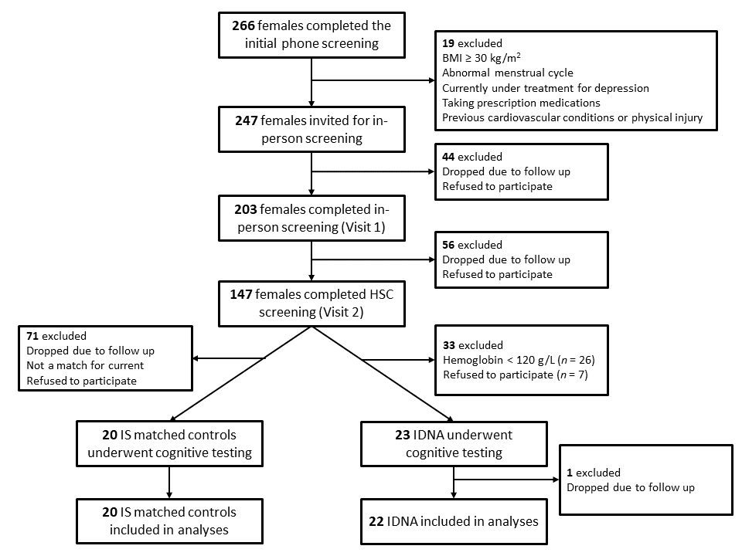
(b) 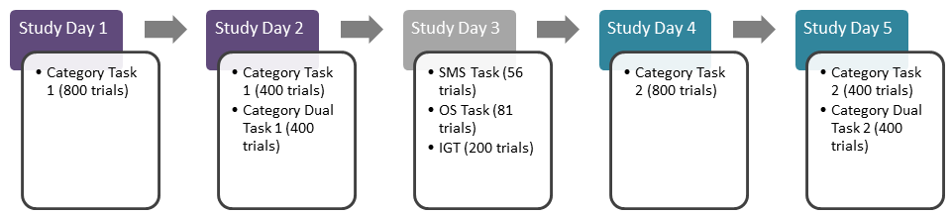
Figure 7.1.2. Example of Gabor test stimuli; a) Examples of contrast varying stimuli; b) examples of spatial frequency varying stimuli.
(a) (b)
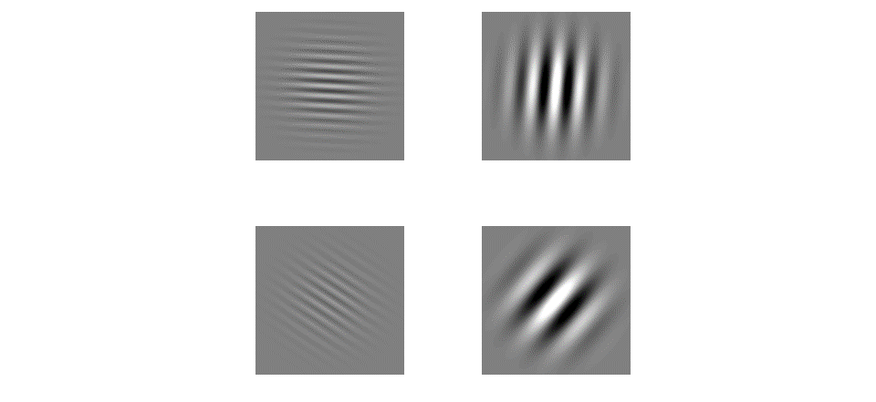

Figure 7.1.3. The optimal decision bound is shown differentiating rule-based and information-integration stimuli.
(a) (b)
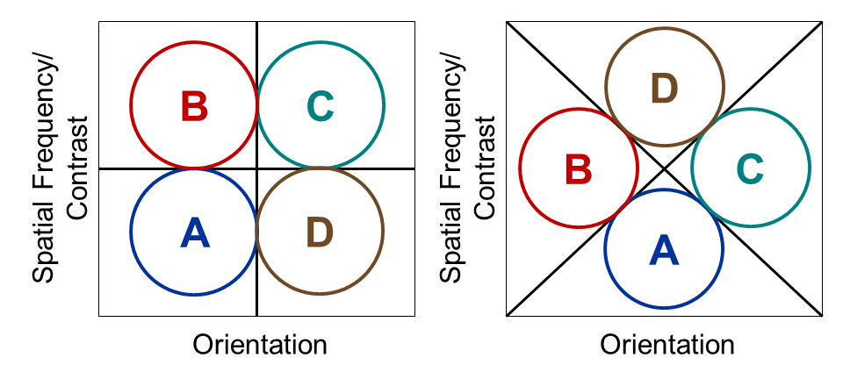

Figure 7.1.4. (a) Rule-based spatial frequency; (b) rule-based contrast; (c) information-integration spatial frequency; and (d) information-integration contrast stimuli category structures representing varying orientation and frequencies of Gabor pattern stimuli.
(a)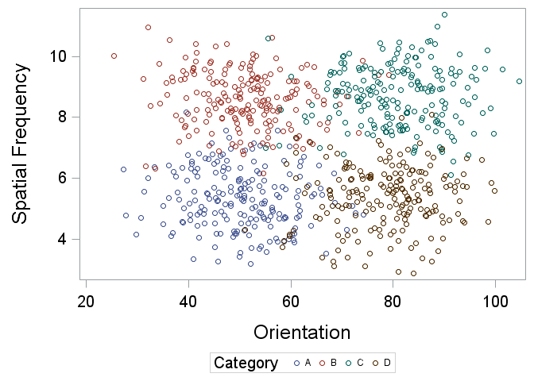 | (c) 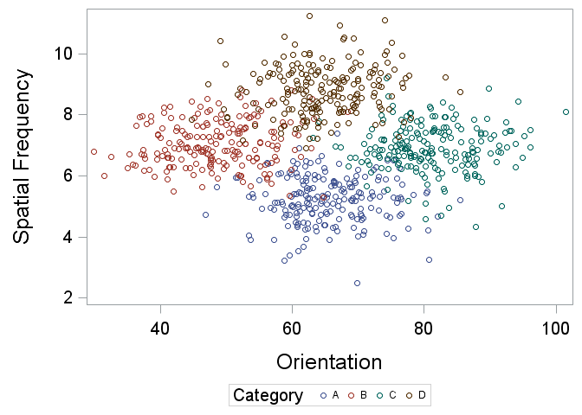
(b) 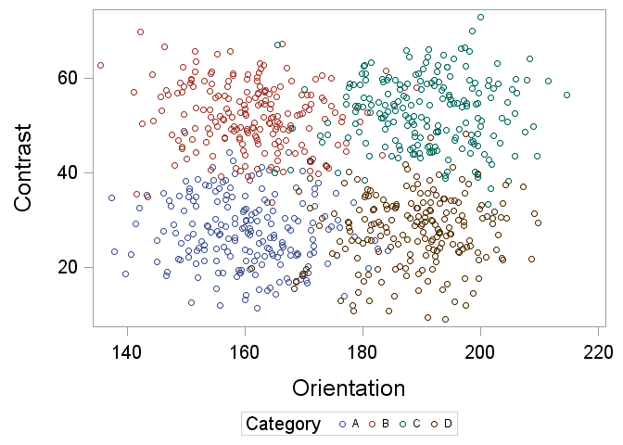 | (d)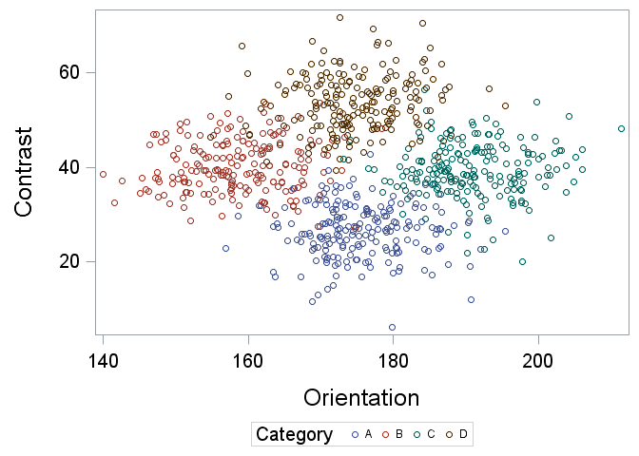

Figure 7.1.5. Category learning task trial for RB and II tasks during with auditory feedback.
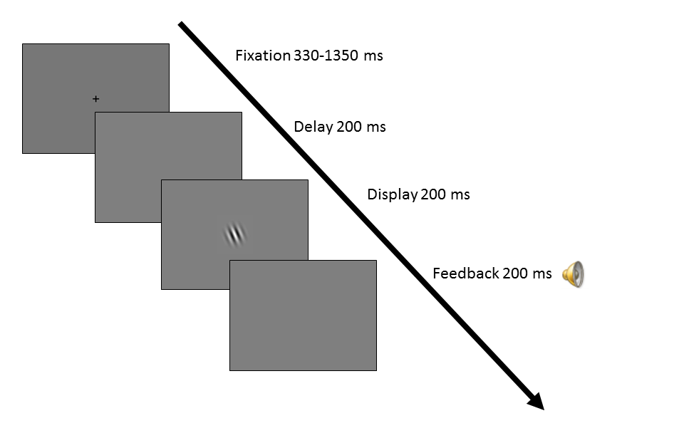

Figure 7.1.6. Sternberg memory scanning task trial procedure.
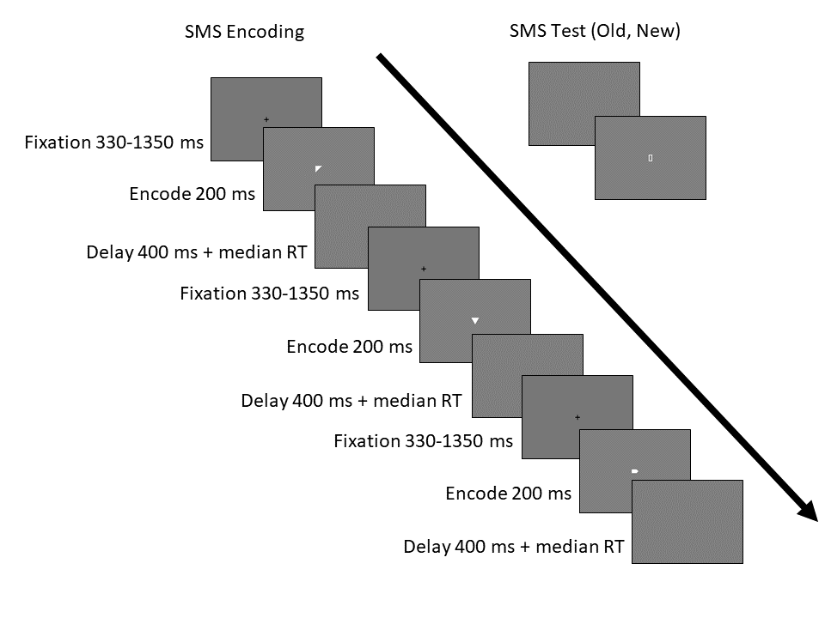

Figure 7.1.7. Dual task category learning task trial for RB and II tasks with auditory feedback.
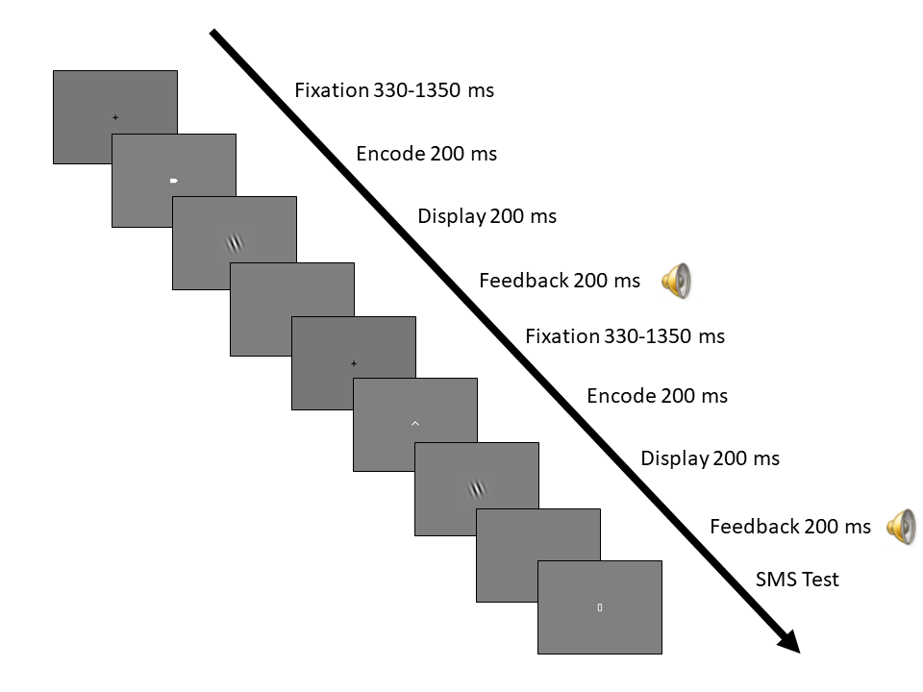

Figure 7.1.8. Trial timings equated across memory task phases.
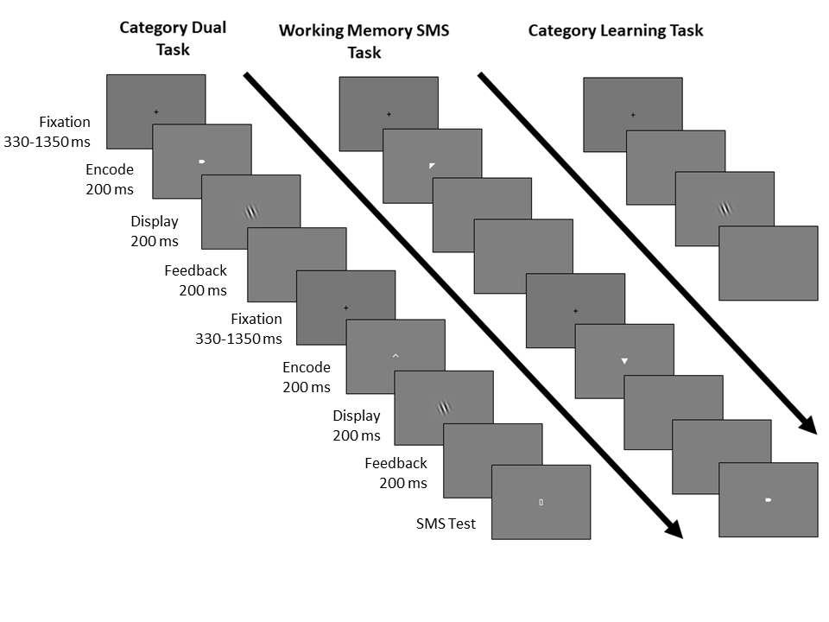

Participant Characteristics
Table 7.2.1. Demographic characteristics and prevalence of iron deficiency without anemia and inflammation for all participants and separate by each iron status subgroup
Measure | Total Mean (SD)  [n = 42] | IDNA Mean (SD)  [n = 22] | IS Mean (SD)  [n = 20] | t-test
Age, years | 20.95 (2.11) | 20.91 (2.18) | 21.00 (2.08) | -0.14
Height, m | 1.64 (0.07) | 1.65 (0.07) | 1.62 (0.06) | 1.22
Weight, kg | 62.58 (10.90) | 63.4 (9.42) | 61.64 (12.57) | 0.52
BMI, kb/m² | 23.45 (3.41) | 23.30 (2.62) | 23.62 (4.18) | -0.30
Iron Status Biomarkers
Hb, g/dLª | 13.24 (0.90) | 13.13 (0.83) | 13.36 (0.98) | -0.81
sFt, μg/L | 17.63 (7.41) | 12.21 (4.25) | 23.59 (5.22) | -7.77***
HCT, % | 40.02 (2.60) | 40.09 (2.26) | 39.95 (2.99) | 0.17
MCV, fL | 89.18 (3.94) | 88.10 (3.52) | 90.38 (4.10) | -1.94⁺
MCH, pg | 29.50 (1.84) | 28.88 (1.73) | 30.17 (1.74) | -2.42*
MCHC, g/dL | 33.05 (0.90) | 32.76 (0.92) | 33.36 (0.78) | -2.26*
RDW, % | 13.04 (1.12) | 13.59 (1.20) | 12.44 (0.63) | 3.85***
WBC, K/mm3 | 6.32 (1.67) | 5.91 (1.49) | 6.78 (1.76) | -1.74⁺
RBC, M/mm3 | 4.49 (0.31) | 4.56 (0.28) | 4.43 (0.34) | 1.36
CRP, mg/L | 1.65 (1.99) | 1.40 (1.84) | 1.92 (2.16) | -0.85
⁺ p < 0.1; * p < 0.05; ** p < 0.01; *** p < 0.0001.
ª Anemia defined as Hb < 12.0 g/dL or 120.0 g/L

Table 7.2.2. Education, ethnicity, race, and physical activity response frequencies and percentages for all participants and separate by each iron status subgroup
Item  Response | Total n (%)  [n = 42] | IDNA n (%)  [n = 22] | IS n (%)  [n = 20]
Education
High School | 4 (9.5) | 4 (18.2) | 0 (0.0)
1-3 y college | 27 (64.3) | 11 (50.0) | 16 (80.0)
College degree | 9 (21.4) | 6 (27.3) | 3 (15.0)
Graduate degree | 2 (4.8) | 1 (4.6) | 1 (5.0)
Ethnicity
Hispanic or Latino | 2 (4.8) | 1 (4.5) | 1 (5.0)
Not Hispanic or Latino | 40 (95.2) | 21 (95.5) | 19 (95.0)
Race
American Indian/Alaskan Native | 0 (0.0) | 0 (0.0) | 0 (0.0)
Asian | 8 (19.1) | 4 (18.2) | 4 (20.0)
Black or African American | 3 (7.1) | 2 (9.1) | 1 (5.0)
White | 29 (69.1) | 15 (68.2) | 14 (70.0)
Hawaiian/Pacific Islander | 0 (0.0) | 0 (0.0) | 0 (0.0)
Missing | 2 (4.8) | 1 (4.5) | 1 (5.0)
Physical Activity
Once per week/Multiple per week/Every day | 38 (90.5) | 20 (90.9) | 18 (90.0)
Once every few weeks/Once per month/Never | 3 (7.1) | 1 (4.5) | 2 (10.0)
Missing | 1 (2.4) | 1 (4.5) | 0 (0.0)
Note: The IDNA and IS groups were not significantly different in terms of education, race, ethnicity, and physical activity.

Category Task Performance
Table 7.3.1. Summary of rule-based and information-integration category task performance by iron status group, task order, and trial block [n = 42]
Dependent Variable  Effect | Rule-Based Task |  | Information-Integration Task
Dependent Variable  Effect | DF | F | DF | F
Accuracy
Group (G) | 1 | 0.35 | 1 | 0.07
Task Order (TO) | 1 | 0.47 | 1 | 0.27
Trial Block (TB) | 23 | 27.15*** | 23 | 24.06***
G x TO | 1 | 2.30 | 1 | 0.01
G x TB | 23 | 1.14 | 23 | 0.77
TO x TB | 23 | 5.25*** | 23 | 0.51
G x TO x TB | 23 | 1.49⁺ | 23 | 0.88
RT
Group (G) | 1 | 2.56 | 1 | 1.44
Task Order (TO) | 1 | 0.03 | 1 | 0.01
Trial Block (TB) | 23 | 9.99*** | 23 | 11.71***
G x TO | 1 | 0.27 | 1 | 0.85
G x TB | 23 | 1.23 | 23 | 1.64*
TO x TB | 23 | 0.90 | 23 | 1.30
G x TO x TB | 23 | 3.54*** | 23 | 0.85
IES
Group (G) | 1 | 0.65 | 1 | 0.54
Task Order (TO) | 1 | 0.53 | 1 | 0.09
Trial Block (TB) | 23 | 29.84*** | 23 | 26.07***
G x TO | 1 | 2.97⁺ | 1 | 0.58
G x TB | 23 | 2.49*** | 23 | 0.78
TO x TB | 23 | 4.99*** | 23 | 0.52
G x TO x TB | 23 | 1.74* | 23 | 0.63
⁺ p < 0.1; * p < 0.05; ** p < 0.01; *** p < 0.0001.

Figure 7.3.1. Rule-based and information-integration category task performance (LS means and SE bars) by iron status group, task order, and trial block [n = 42]
Rule-Based Task | Information-Integration Task
(a)  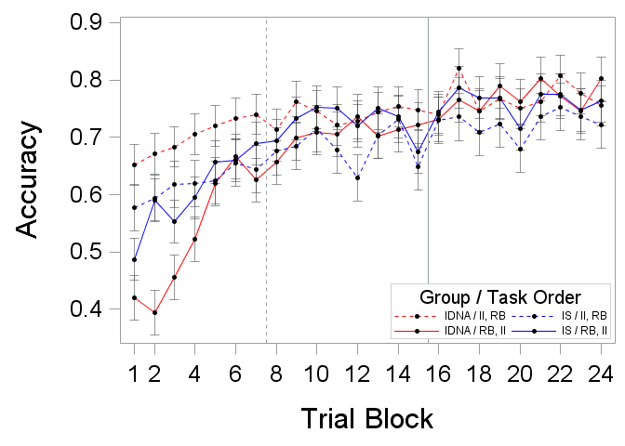 | (d)  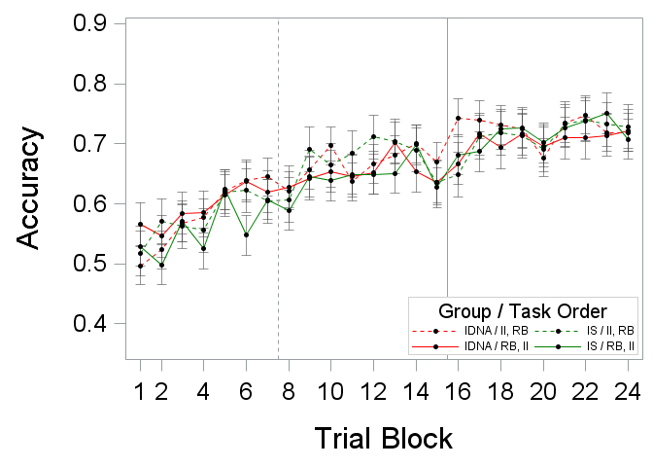
(b) 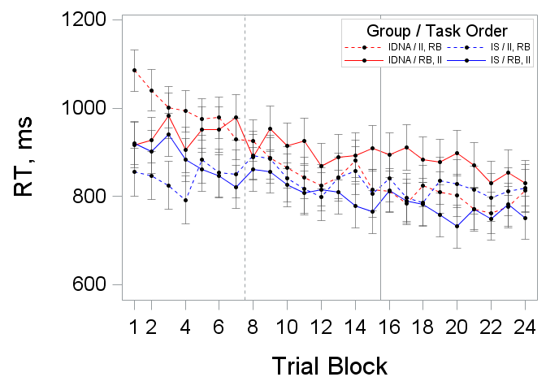 | (e)  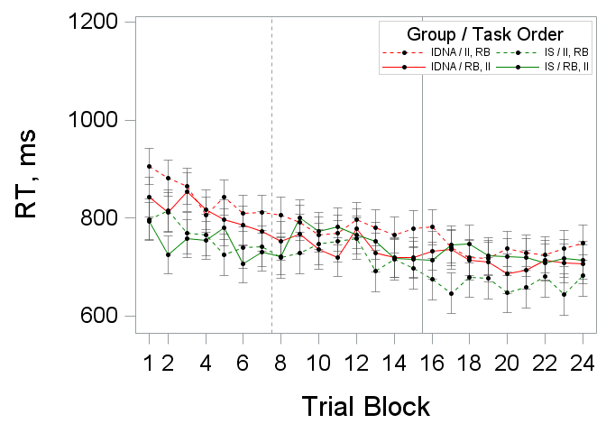
(c)  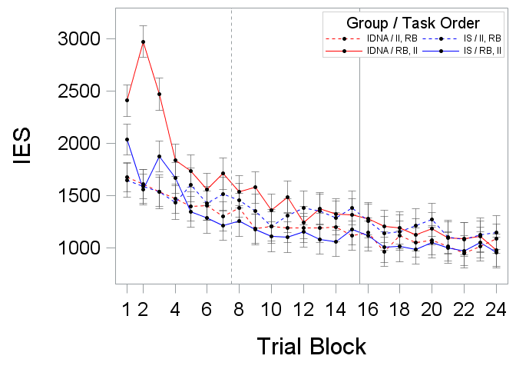 | (f)  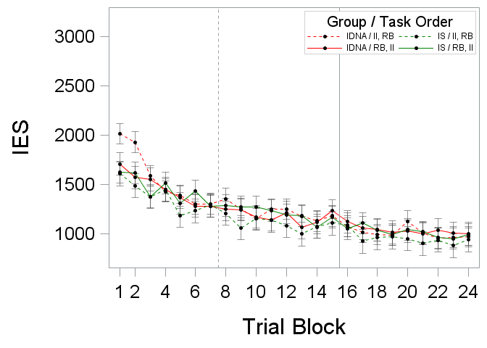

Table 7.3.2. Summary of rule-based category task performance model results by iron status group and trial block, separate by task order
Dependent Variable  Effect | Rule-Based Task 1 [n = 21] |  | Rule-Based Task 2 [n = 21]
Dependent Variable  Effect | DF | F | DF | F
Accuracy
Group (G) | 1 | 0.61 | 1 | 1.71
Trial Block (TB) | 23 | 25.11*** | 23 | 5.85***
G x TB | 23 | 1.93** | 23 | 0.60
RT
Group (G) | 1 | 3.23⁺ | 1 | 0.45
Trial Block (TB) | 23 | 4.36*** | 23 | 6.47***
G x TB | 23 | 1.05 | 23 | 3.65***
IES
Group (G) | 1 | 3.36⁺ | 1 | 0.40
Trial Block (TB) | 23 | 18.85*** | 23 | 13.35***
G x TB | 23 | 2.58*** | 23 | 0.76
⁺ p < 0.1; * p < 0.05; ** p < 0.01; *** p < 0.0001.

Figure 7.3.2. Rule-based category task performance (LS means and SE bars) results by iron status group and trial block, separate by task order
Task 1 | Task 2
(a)  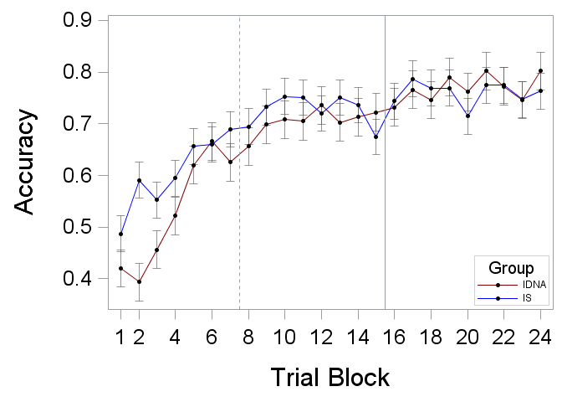 | (d) 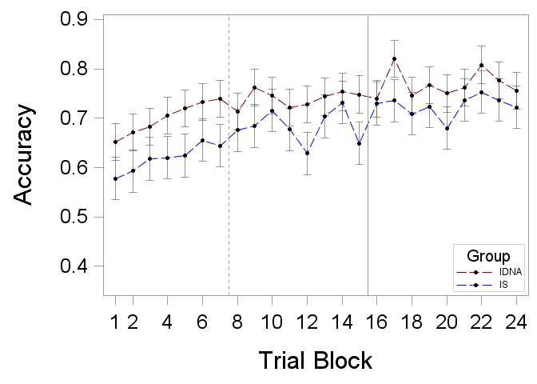
(b)  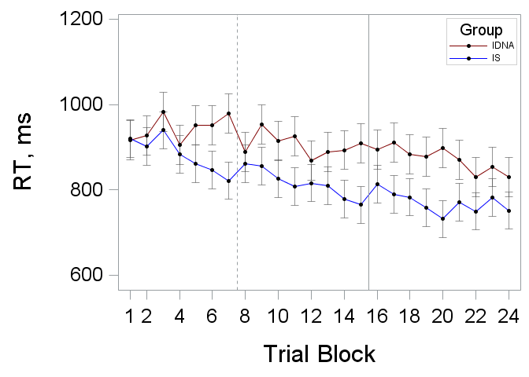 | (e)  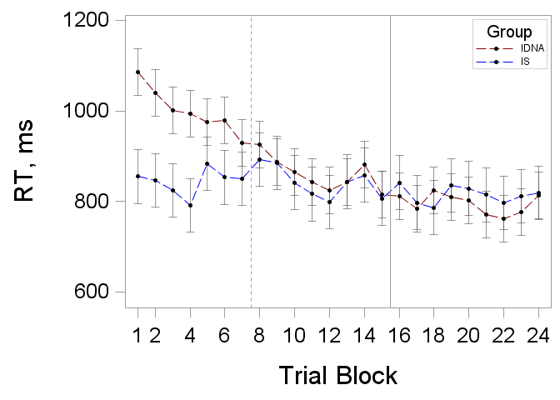
(c) 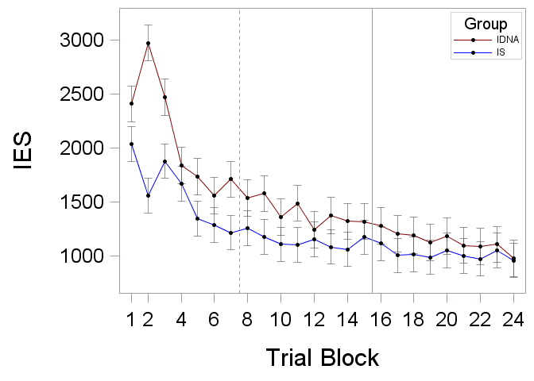 | (f)  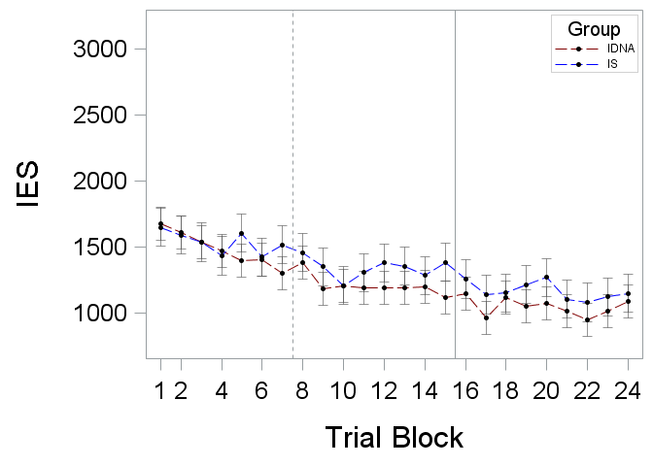

Table 7.3.3. Summary of information-integration category task performance model results by iron status group and trial block, separate by task order
Dependent Variable  Effect | Information-Integration Task 1 [n = 21] |  | Information-Integration Task 2 [n = 21]
Dependent Variable  Effect | DF | F | DF | F
Accuracy
Group (G) | 1 | 0.01 | 1 | 0.07
Trial Block (TB) | 23 | 13.45*** | 23 | 11.18***
G x TB | 23 | 0.83 | 23 | 0.82
RT
Group (G) | 1 | 2.00 | 1 | 0.04
Trial Block (TB) | 23 | 7.68*** | 23 | 4.93***
G x TB | 23 | 0.66 | 23 | 2.01**
IES
Group (G) | 1 | 1.12 | 1 | 0.00
Trial Block (TB) | 23 | 14.45*** | 23 | 11.90***
G x TB | 23 | 0.93 | 23 | 0.44
⁺ p < 0.1; * p < 0.05; ** p < 0.01; *** p < 0.0001.

Figure 7.3.3. Information-integration category task performance (LS means and SE bars) results by iron status group and trial block, separate by task order
Task 1 | Task 2
(a)  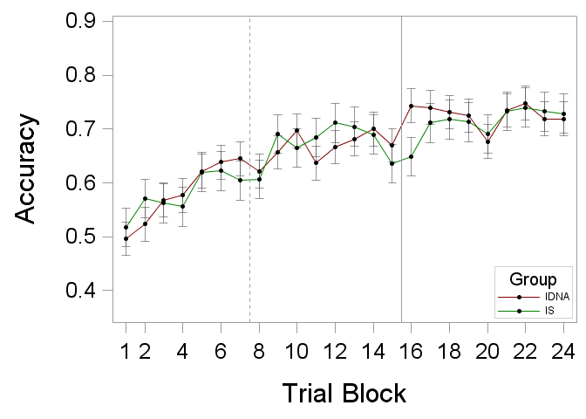 | (d)  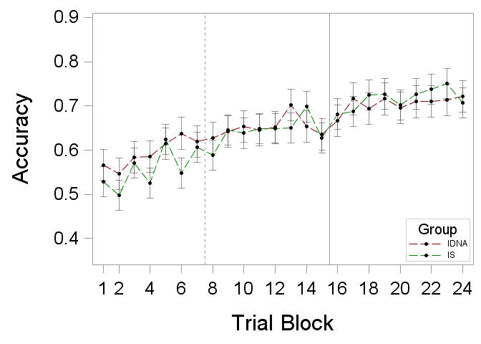
(b)  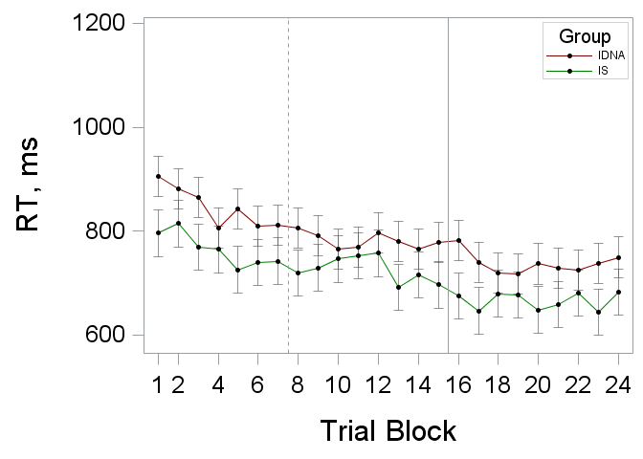 | (e) 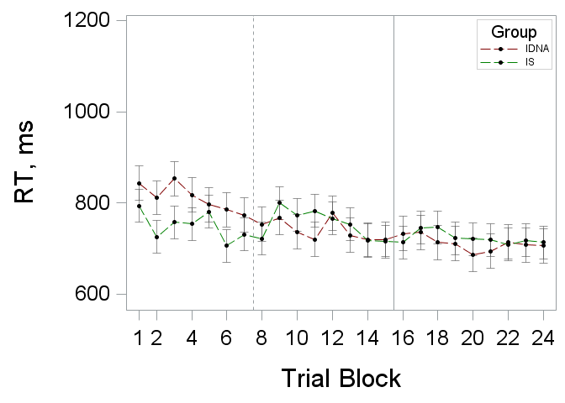
(c)  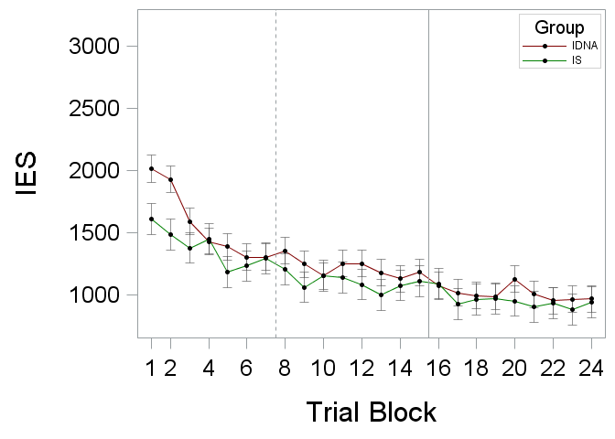 | (f) 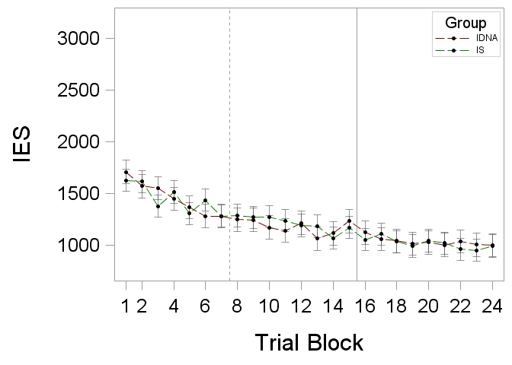

Table 7.3.4. Summary of category task performance subject regression estimates by iron status group [n = 24]
Variable  Effect | Rule-Based Task |  |  | Information-Integration Task
Variable  Effect | DFª | F | MSE | DFª | F | MSE
Accuracy^{b}
Intercept, Model Estimates | 3/38 | 2.79⁺ |  | 3/38 | 0.33
Group (G) | 1 | 0.02 | 0.0004 | 1 | 0.36 | 0.004
Task Order (TO) | 1 | 4.49* | 0.11 | 1 | 0.08 | 0.001
G x TO | 1 | 3.48⁺ | 0.08 | 1 | 0.52 | 0.01
Slope, Model Estimates | 3/36 | 7.93*** |  | 3/38 | 0.63
Group (G) | 1 | 0.07 | 0.000002 | 1 | 0.56 | 0.00001
Task Order (TO) | 1 | 13.49*** | 0.0004 | 1 | 0.02 | 0.0000004
G x TO | 1 | 8.87** | 0.0003 | 1 | 1.30 | 0.00003
RT^{c}
Intercept, Model Estimates | 3/38 | 2.45⁺ |  | 3/38 | 1.02
Group (G) | 1 | 5.87* | 107635.45 | 1 | 2.29 | 45985.67
Task Order (TO) | 1 | 0.00 | 0.40 | 1 | 0.48 | 9738.00
G x TO | 1 | 1.47 | 26887.16 | 1 | 0.04 | 802.50
Slope, Model Estimates | 3/38 | 2.79⁺ |  | 3/38 | 1.48
Group (G) | 1 | 3.31⁺ | 126.64 | 1 | 1.65 | 50.38
Task Order (TO) | 1 | 0.55 | 20.89 | 1 | 1.58 | 48.32
G x TO | 1 | 4.09⁺ | 156.49 | 1 | 0.98 | 29.79
IES^{d}
Intercept, Model Estimates | 3/38 | 2.40⁺ |  | 3/38 | 0.52
Group (G) | 1 | 1.84 | 825831.89 | 1 | 0.64 | 115261.22
Task Order (TO) | 1 | 3.01⁺ | 1349909.95 | 1 | 0.04 | 6658.87
G x TO | 1 | 2.46 | 1105563.76 | 1 | 0.82 | 147499.74
Slope, Model Estimates | 3/38 | 3.53* |  | 3/38 | 0.55
Group (G) | 1 | 3.06⁺ | 2403.62 | 1 | 0.42 | 156.79
Task Order (TO) | 1 | 6.53* | 5126.12 | 1 | 0.43 | 158.62
G x TO | 1 | 1.45 | 1134.83 | 1 | 0.66 | 243.44
⁺ p < 0.1; * p < 0.05; ** p < 0.01; *** p < 0.0001.
ª Model/Error DF
^{b} Proportion of correct category responses on the first learning block (intercept) or change in accuracy for each trial block (slope).
^{c} Median RT on the first learning block (intercept) or change in RT for each trial block (slope).
^{d} IES on the first learning block (intercept) or change in IES for each trial block (slope).

Figure 7.3.4. Rule-based and information-integration category task subject regression performance estimates (means and SE bars) by iron status group and task order [n = 42]
Rule-Based Task | Information-Integration Task
(a)  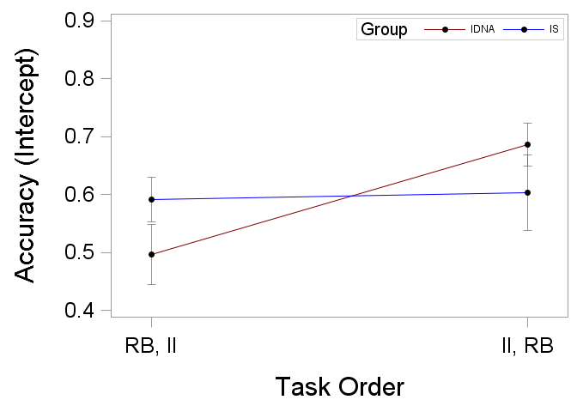 | (g)  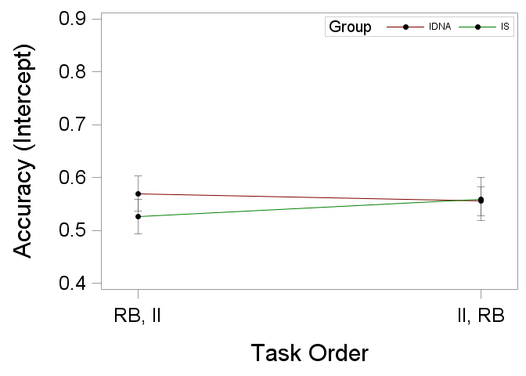
(b)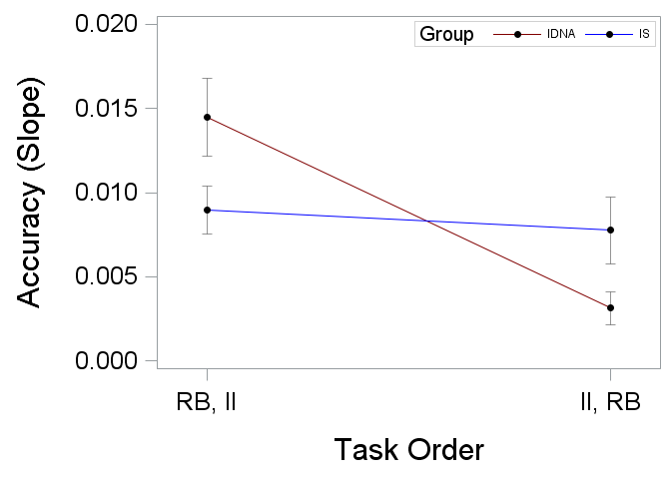 | (h) 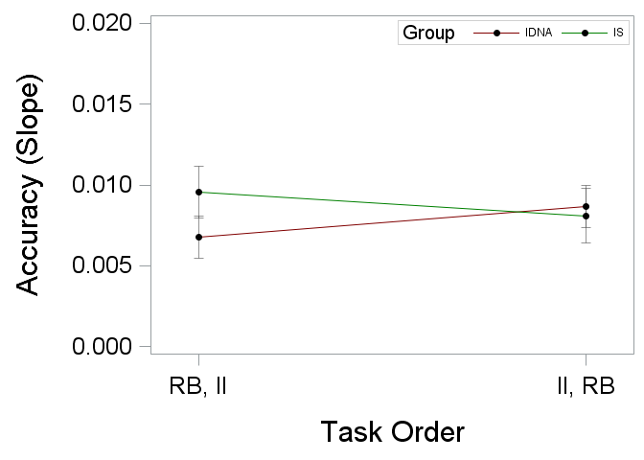
(c)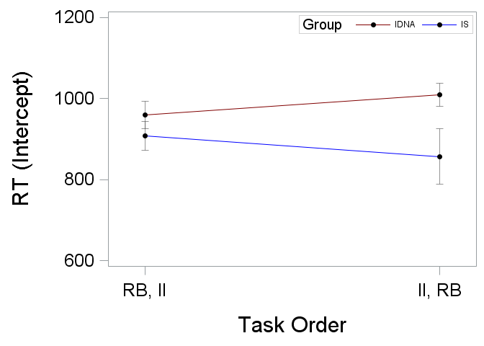 | (i)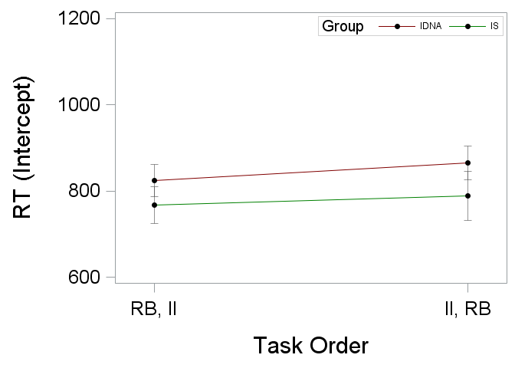
(d) 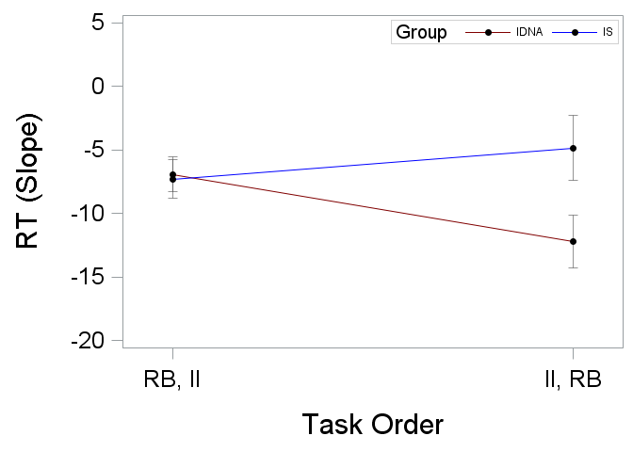 | (j)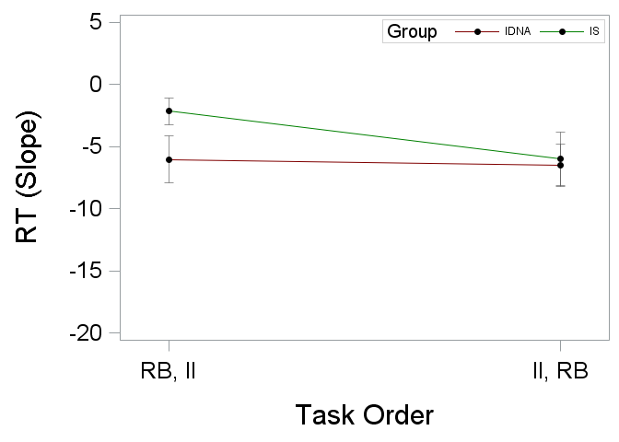
(e)  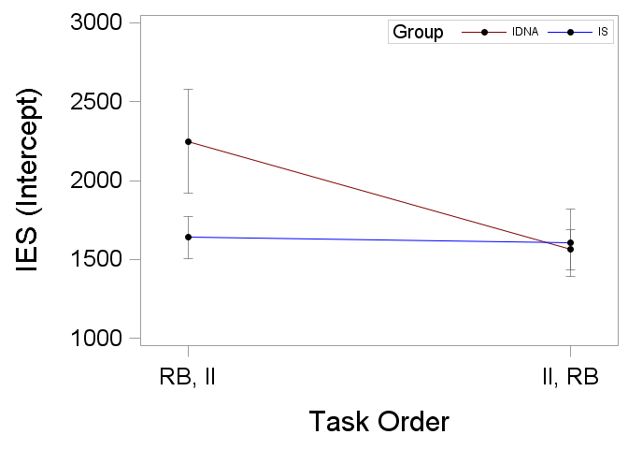 | (k)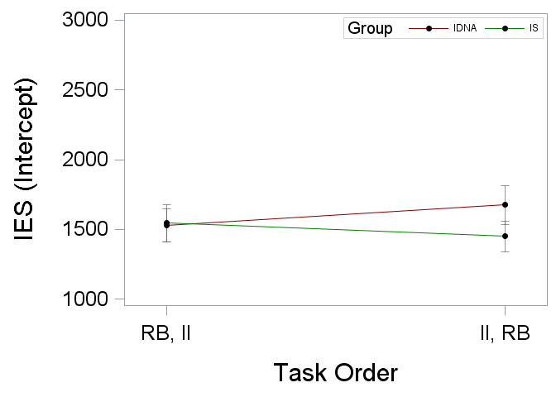
(f)  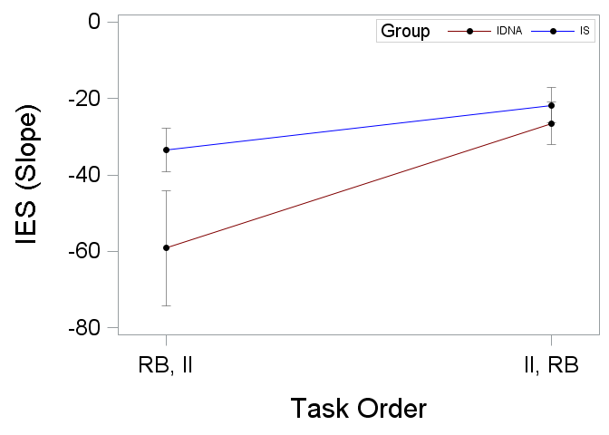 | (l)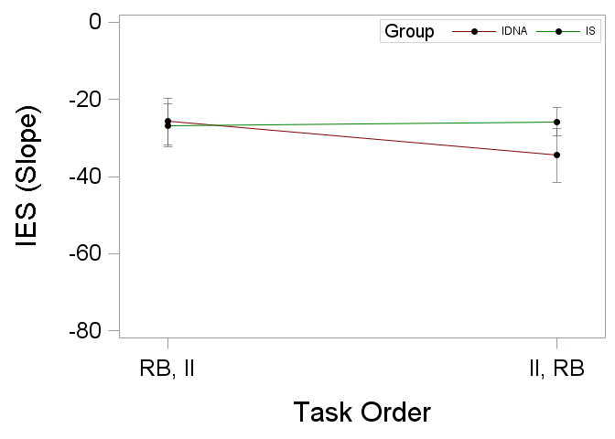

Table 7.3.5. Correlations between category task performance subject regression estimates and iron status measures [n = 42]
Task  Measure | Hb | sFt | HCT | MCV | MCH | MCHC | RDW | WBC | RBC | CRP
Rule-Based Task
Accuracyª
Intercept | -0.02 | 0.01 | -0.05 | 0.16 | 0.11 | 0.01 | 0.10 | -0.12 | -0.15 | 0.12
Slope | 0.09 | -0.07 | 0.11 | -0.09 | -0.05 | 0.01 | -0.14 | 0.08 | 0.19 | -0.14
RT^{b}
Intercept | -0.11 | -0.44** | -0.13 | -0.06 | -0.04 | 0.01 | 0.09 | -0.01 | -0.10 | -0.10
Slope | -0.00 | 0.28⁺ | 0.04 | -0.02 | -0.05 | -0.11 | -0.12 | 0.14 | 0.07 | 0.13
IES^{c}
Intercept | 0.06 | -0.20 | 0.06 | -0.06 | -0.02 | 0.04 | -0.07 | 0.00 | 0.10 | -0.16
Slope | -0.10 | 0.25 | -0.12 | 0.05 | 0.03 | -0.01 | 0.02 | 0.05 | -0.15 | 0.17
Information-Integration Task
Accuracyª
Intercept | -0.00 | -0.18 | 0.01 | -0.07 | -0.07 | -0.06 | 0.06 | -0.05 | 0.06 | -0.14
Slope | -0.07 | 0.23 | -0.04 | -0.06 | -0.07 | -0.03 | 0.11 | 0.05 | 0.00 | 0.06
RT^{b}
Intercept | -0.22 | -0.32* | -0.25 | -0.06 | -0.02 | 0.04 | 0.22 | -0.10 | -0.20 | -0.08
Slope | 0.22 | 0.30⁺ | 0.22 | 0.01 | 0.01 | 0.01 | -0.19 | 0.03 | 0.20 | 0.09
IES^{c}
Intercept | -0.13 | -0.13 | -0.16 | 0.01 | 0.04 | 0.08 | 0.20 | -0.04 | -0.16 | -0.01
Slope | 0.15 | 0.10 | 0.16 | 0.02 | 0.00 | -0.03 | -0.29⁺ | 0.02 | 0.14 | 0.06
⁺ p < 0.1; * p < 0.05; ** p < 0.01; *** p < 0.0001.
ª Proportion of correct category responses on the first learning block (intercept) or change in accuracy for each trial block (slope).
^{b} Median RT on the first learning block (intercept) or change in RT for each trial block (slope).
^{c} IES on the first learning block (intercept) or change in IES for each trial block (slope).

Figure 7.3.5. Rule-based and information-integration task correlations between subject RT regression estimates and sFt [n = 42]
Rule-Based Task | Information-Integration Task
(a)  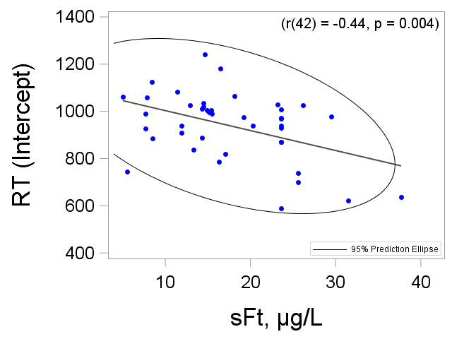 | (c)  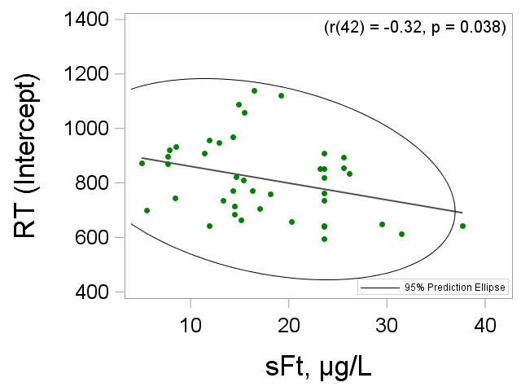
(b)  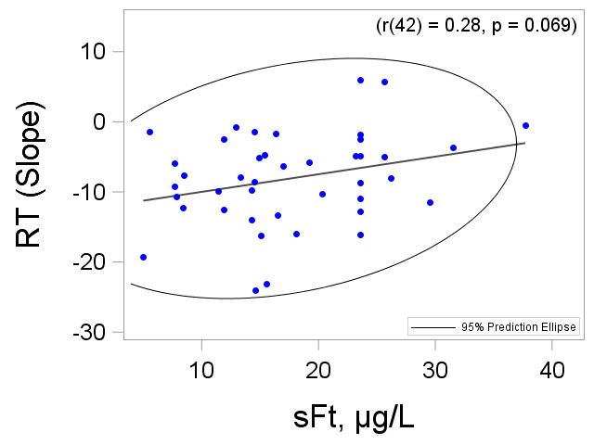 | (d)  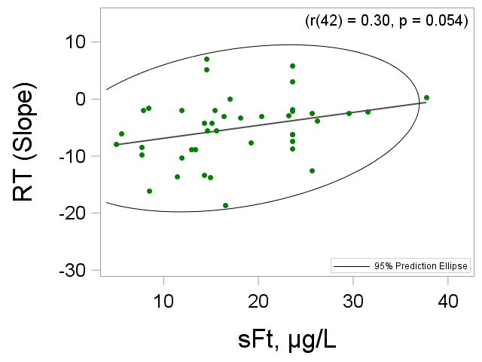

Table 7.3.6. Proportions of participants learning the correct category structure by iron status group [n = 42]
Task  Group | n | % | χ²
Rule-Based Task
IDNA | 21 | 95.5 | 0.005
IS | 19 | 95.0
Information-Integration Task
IDNA | 12 | 54.6 | 4.55*
IS | 17 | 85.0
⁺ p < 0.1; * p < 0.05; ** p < 0.01; *** p < 0.0001.

Table 7.3.7. Proportions of participants learning the correct category structure by session and iron status group [n = 42]
Task  Group | Category Structure Not Learnedª | Session 1 | Session 2 | Session 3 | χ²
Rule-Based Task, n (%)
IDNA | 1 (4.5) | 17 (77.3) | 2 (9.1) | 2 (9.1) | 4.45
IS | 1 (5.0) | 13 (65.0) | 6 (30.0) | 0 (0.0)
Information-Integration Task, n (%)
IDNA | 10 (45.5) | 5 (22.7) | 4 (18.2) | 3 (13.6) | 6.86⁺
IS | 3 (15.0) | 3 (15.0) | 6 (30.0) | 8 (40.0)
⁺ p < 0.1; * p < 0.05; ** p < 0.01; *** p < 0.0001.
ª The correct category structure was not learned on sessions 1, 2 or 3.

Figure 7.3.6. Cumulative proportion of participants learning the correct category structure by session and iron status group [n = 42]
Rule-Based Task | Information-Integration Task
(a) 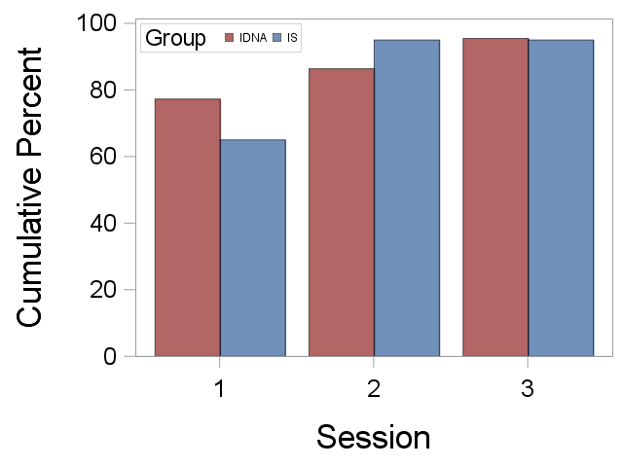 | (b)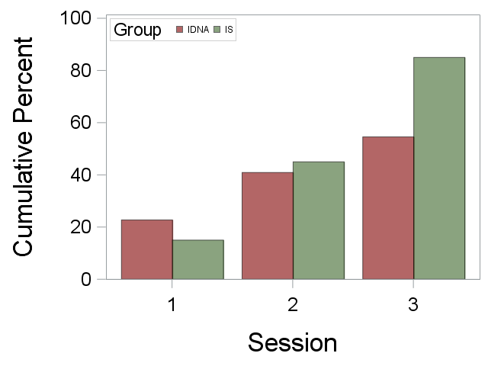

Table 7.3.8. Proportions of participants learning both category structures by iron status group [n = 42]
Group | Incorrect Strategies Tasks 1 and 2ª | Correct Task 1, Incorrect Task 2^{b} | Correct Strategies Tasks 1 and 2^{c} | χ²
IDNA, n (%) | 6 (27.3) | 7 (31.8) | 9 (40.9) | 0.24
IS, n (%) | 6 (30.0) | 5 (25.0) | 9 (45.0)
⁺ p < 0.1; * p < 0.05; ** p < 0.01; *** p < 0.0001.
ª The correct category structure was not learned by Task 1 session 3.
^{b} The correct category structure was learned on Task 1 but not Task 2.
^{c} The correct category structure was learned on both Task 1 and Task 2.

Dual Category Task Performance
Table 7.4.1. Summary of rule-based and information-integration category task performance during the expressionª and dual task phases by iron status group [n = 42]
Dependent Variable  Effect | Rule-Based Task |  | Information-Integration Task
Dependent Variable  Effect | DF | F | DF | F
Accuracy
Group (G) | 40 | 1.75 | 40 | 0.01
Phase (P) | 40 | 38.94*** | 40 | 16.79***
G x P | 40 | 0.12 | 40 | 0.13
RT
Group (G) | 40 | 0.54 | 40 | 0.40
Phase (P) | 40 | 67.28*** | 40 | 74.93***
G x P | 40 | 0.04 | 40 | 1.59
IES
Group (G) | 40 | 0.03 | 40 | 0.03
Phase (P) | 40 | 71.66*** | 40 | 91.17***
G x P | 40 | 2.05 | 40 | 0.07
⁺ p < 0.1; * p < 0.05; ** p < 0.01; *** p < 0.0001.
ª Expression phase performance was calculated over the 400 trials of the second category learning session.

Figure 7.4.1. Rule-based and information-integration category task performance (LS means and SE bars) during the expression and dual task phases by iron status group [n = 42]
Rule-Based Task | Information-Integration Task
(a)  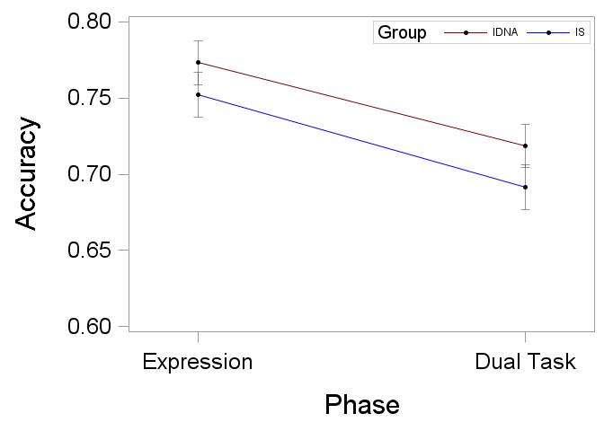 | (d) 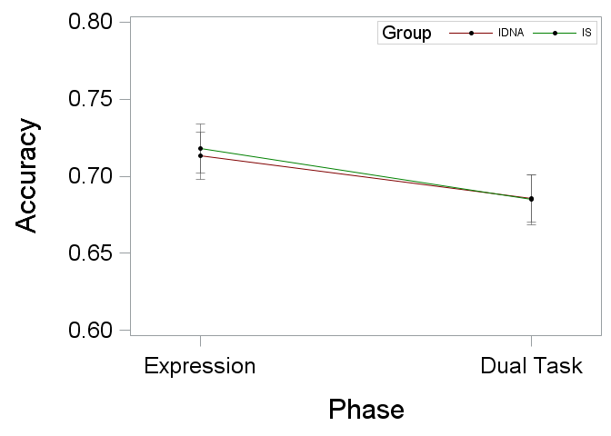
(b) 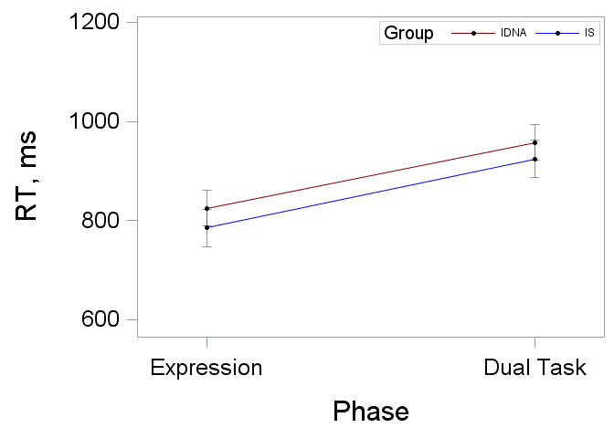 | (e)  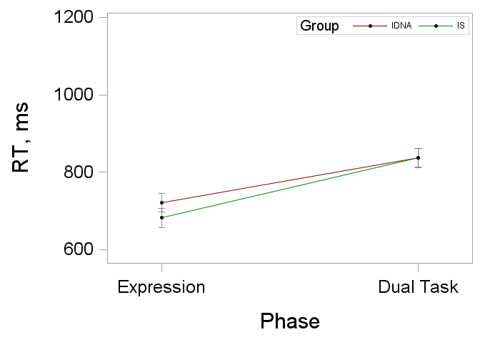
(c) 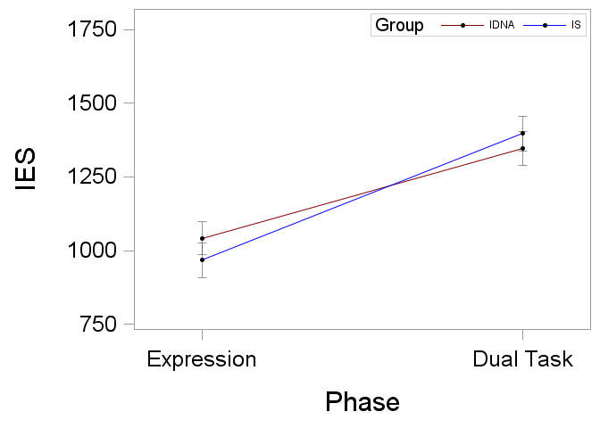 | (f)  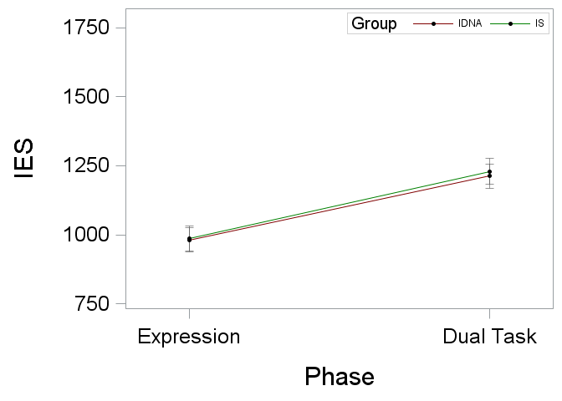

Table 7.4.2. Summary of rule-based and information-integration category task performance during the expressionª and dual task phases for all participants [n = 42]
Dependent Variable  Effect | DF | F
Accuracy
Task Type (TT) | 41 | 17.07***
Phase (P) | 41 | 28.12***
TT x P | 41 | 2.65
RT
Task Type (TT) | 41 | 52.51***
Phase (P) | 41 | 88.19***
TT x P | 41 | 0.01
IES
Task Type (TT) | 41 | 10.72***
Phase (P) | 41 | 129.40***
TT x P | 41 | 5.80*
* p < .05; ** p < .01; *** p < .001
ª Expression phase performance was calculated over the 400 trials of the second category learning session.
Figure 7.4.2. Rule-based and information-integration category task performance (LS means and SE bars) during the expression and dual task phases for all participants [n = 42]
(a)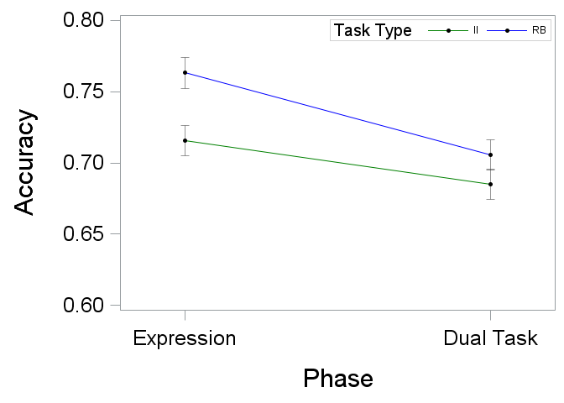 | (c)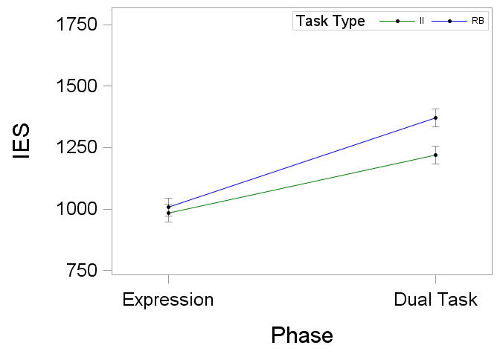
(b)
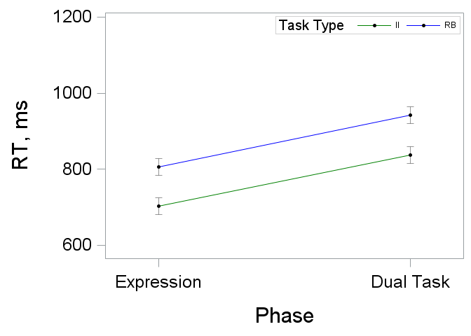

Working Memory Task Performance
Table 7.5.1. Summary of dual phase SMS task performance separate for task type, test type, and iron status group [n = 42]
Dependent Variable  Effect | Rule-Based Task |  | Information-Integration Task
Dependent Variable  Effect | DF | F | DF | F
Accuracy
New Test Items
Group (G) | 76 | 0.49 | 76 | 0.02
Task Order (TO) | 76 | 0.00 | 76 | 3.12⁺
Set Size (SS) | 76 | 17.82*** | 76 | 26.44***
G x TO | 76 | 1.25 | 76 | 1.17
G x SS | 76 | 0.67 | 76 | 0.68
G x TO x SS | 76 | 0.46 | 76 | 0.70
Old Test Items
Group (G) | 76 | 0.08 | 76 | 0.21
Task Order (TO) | 76 | 4.79* | 76 | 0.14
Set Size (SS) | 76 | 34.23*** | 76 | 36.09***
G x TO | 76 | 0.22 | 76 | 0.43
G x SS | 76 | 0.28 | 76 | 0.47
G x TO x SS | 76 | 0.67 | 76 | 0.35
RT
New Test Items
Group (G) | 76 | 0.41 | 76 | 0.50
Task Order (TO) | 76 | 3.94⁺ | 76 | 12.38***
Set Size (SS) | 76 | 21.74*** | 76 | 19.62***
G x TO | 76 | 0.03 | 76 | 0.00
G x SS | 76 | 1.94 | 76 | 0.44
G x TO x SS | 76 | 1.05 | 76 | 0.95
Old Test Items
Group (G) | 76 | 1.06 | 76 | 0.47
Task Order (TO) | 76 | 4.78* | 76 | 8.29**
Set Size (SS) | 76 | 34.03*** | 76 | 28.53***
G x TO | 76 | 0.90 | 76 | 0.08
G x SS | 76 | 0.01 | 76 | 2.23
G x TO x SS | 76 | 1.47 | 76 | 0.77
⁺ p < 0.1; * p < 0.05; ** p < 0.01; *** p < 0.0001.

Figure 7.5.1. Rule-based and information-integration dual phase SMS task performance (LS means and SE bars) separate for task type, test item type, and iron status group [n = 42]
(a) 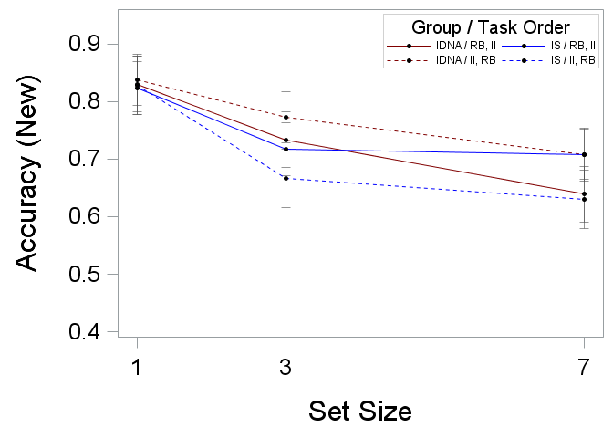 | (e)  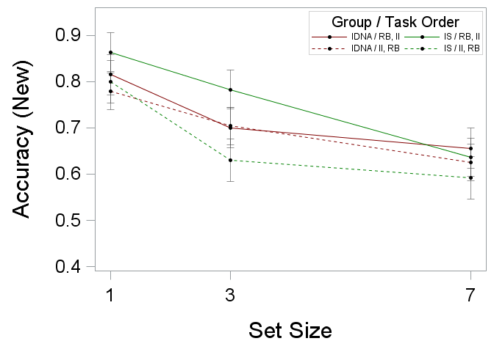
(b) 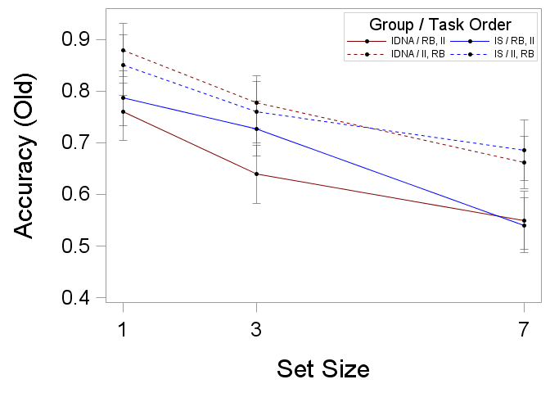 | (f)  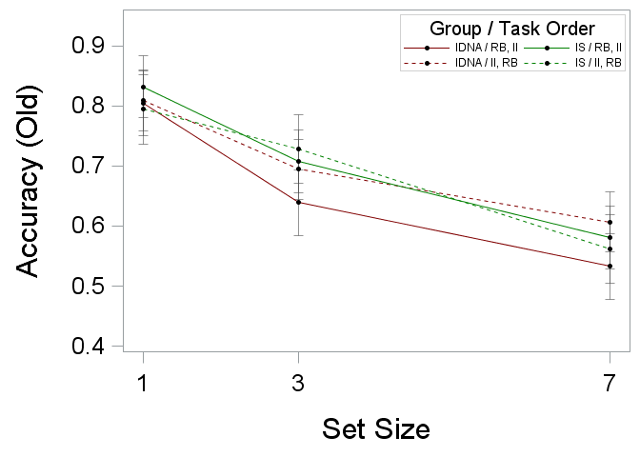
(c) 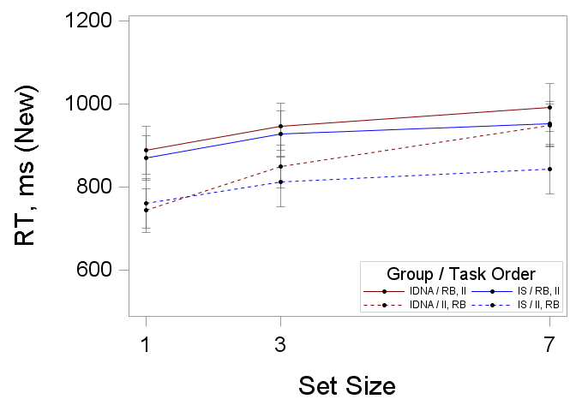 | (g)  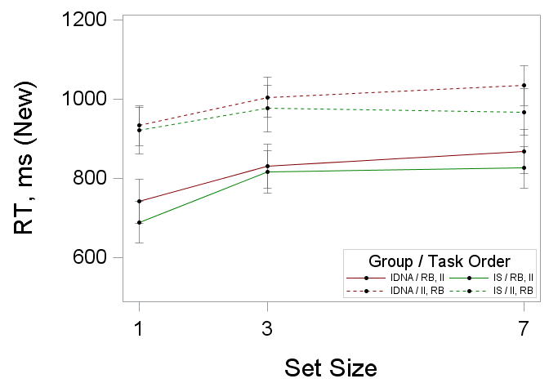
(d) 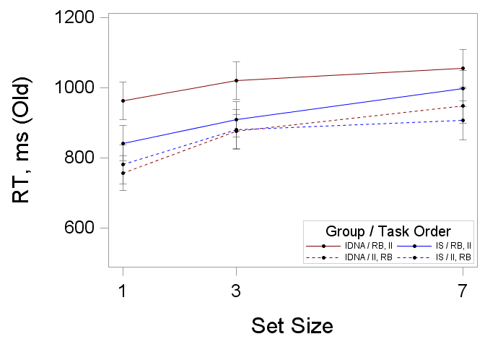 | (h)  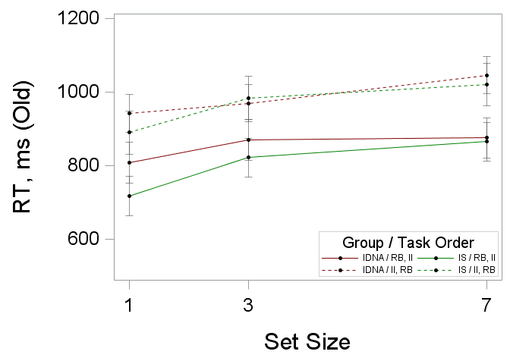

Table 7.5.2. Summary of dual SMS task performance regression estimates by task type and iron status group [n = 42]
Outcome  Effect | New Test Items |  |  | Old Test items
Outcome  Effect | DFª | F | MSE | DFª | F | MSE
Accuracy, Intercept^{b} | 3/80 | 0.58 |  | 3/80 | 0.19
Group (G) | 1 | 0.04 | 0.001 | 1 | 0.29 | 0.01
Task Type (TT) | 1 | 0.03 | 0.001 | 1 | 0.15 | 0.003
G x TT | 1 | 1.65 | 0.03 | 1 | 0.13 | 0.003
Accuracy, Slope^{b} | 3/80 | 0.64 |  | 3/80 | 0.16
Group (G) | 1 | 0.32 | 0.0003 | 1 | 0.08 | 0.0001
Task Type (TT) | 1 | 0.75 | 0.001 | 1 | 0.38 | 0.0003
G x TT | 1 | 0.93 | 0.001 | 1 | 0.04 | 0.00003
RT, Intercept^{c} | 3/80 | 0.26 |  | 3/80 | 0.81
Group (G) | 1 | 0.05 | 1761.69 | 1 | 2.12 | 70790.58
Task Type (TT) | 1 | 0.17 | 6767.89 | 1 | 0.05 | 1616.67
G x TT | 1 | 0.52 | 20293.46 | 1 | 0.24 | 7993.07
RT, Slope^{c} | 3/80 | 1.56 |  | 3/80 | 1.09
Group (G) | 1 | 3.03⁺ | 1300.42 | 1 | 0.74 | 266.30
Task Type (TT) | 1 | 0.58 | 250.06 | 1 | 1.48 | 534.71
G x TT | 1 | 0.99 | 426.44 | 1 | 0.94 | 338.17
⁺ p < 0.1; * p < 0.05; ** p < 0.01; *** p < 0.0001.
ª Model/Error DF
^{b} Proportion of correct category responses on the first learning block (intercept) or change in accuracy for each trial block (slope).
^{c} Median RT on the first learning block (intercept) or change in RT for each trial block (slope).

Figure 7.5.2. Summary of dual SMS task performance regression estimates (means and SE bars) by task type and iron status group [n = 42]
New Test Items | Old Test Items
(a) 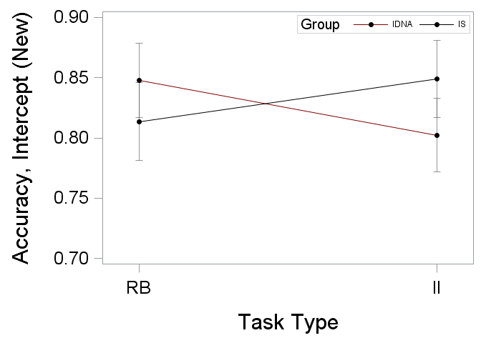 | (e) 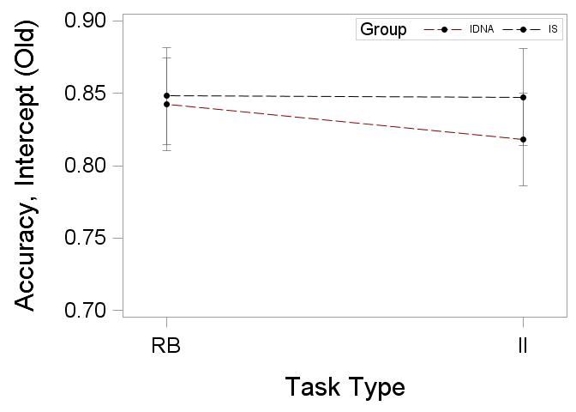
(b) 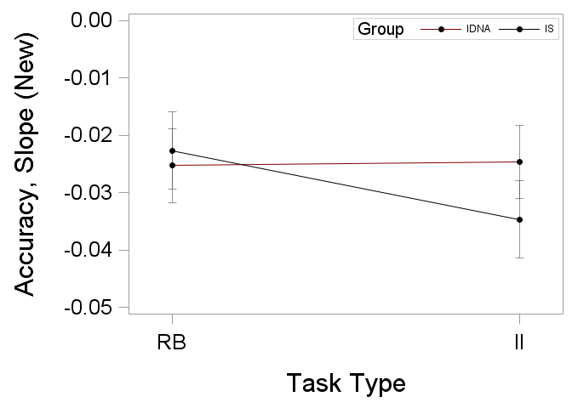 | (f) 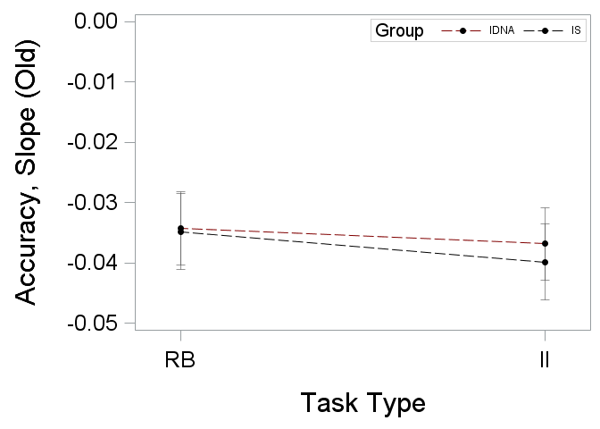
(c) 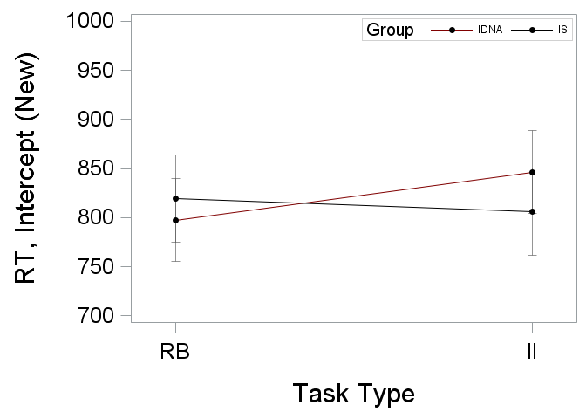 | (g) 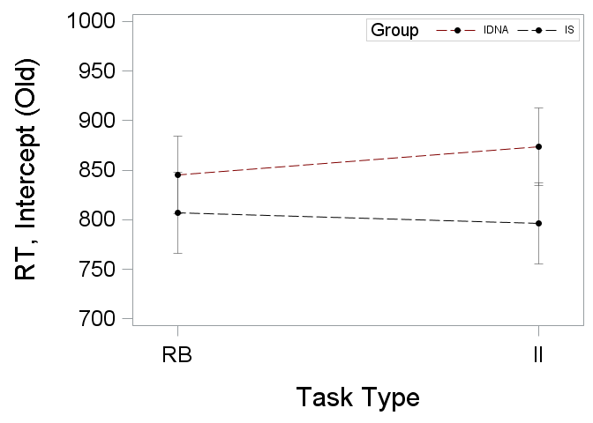
(d) 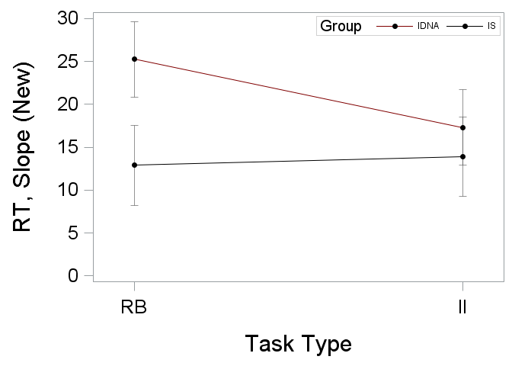 | (h) 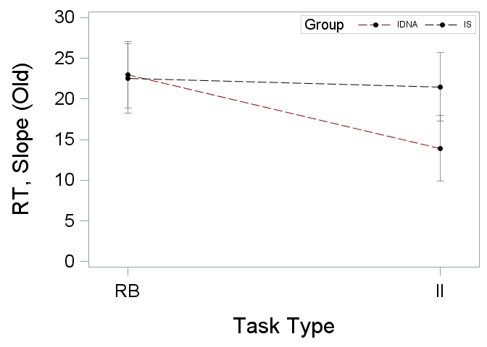

Table 7.5.3. Correlations between SMS dual task performance subject regression estimates and iron status measures [n = 42]
Outcome  Test Item  Measure | Hb | sFt | HCT | MCV | MCH | MCHC | RDW | WBC | RBC | CRP
Rule-Based Task
Accuracyª
Old
Intercept | 0.07 | 0.12 | 0.11 | -0.03 | -0.04 | -0.03 | 0.06 | 0.16 | 0.12 | -0.15
Slope | 0.13 | -0.15 | -0.02 | 0.32 | 0.35 | 0.27 | -0.33 | -0.19 | -0.23 | -0.09
New
Intercept | 0.11 | -0.18 | 0.20 | -0.05 | -0.12 | -0.19 | 0.06 | 0.10 | 0.21 | 0.18
Slope | -0.12 | 0.14 | -0.18 | -0.11 | -0.02 | 0.14 | 0.002 | -0.18 | -0.10 | -0.05
RT^{b}
Old
Intercept | 0.04 | -0.27⁺ | 0.001 | -0.01 | 0.03 | 0.06 | -0.04 | -0.07 | 0.01 | -0.16
Slope | -0.47** | 0.13 | -0.46** | -0.20 | -0.18 | -0.10 | 0.28⁺ | -0.08 | -0.30⁺ | 0.09
New
Intercept | -0.06 | -0.02 | -0.06 | 0.05 | 0.02 | -0.05 | 0.04 | 0.03 | -0.08 | -0.08
Slope | 0.03 | -0.25 | -0.01 | 0.002 | 0.03 | 0.08 | 0.005 | -0.18 | -0.01 | -0.13
Information-Integration Task
Accuracyª
Old
Intercept | 0.32* | 0.16 | 0.26⁺ | 0.02 | 0.11 | 0.23 | -0.16 | 0.14 | 0.23 | 0.13
Slope | -0.10 | -0.19 | -0.03 | 0.22 | 0.09 | -0.16 | 0.03 | 0.01 | -0.17 | -0.19
New
Intercept | 0.33* | 0.06 | 0.36* | 0.11 | 0.07 | -0.02 | 0.04 | 0.09 | 0.26⁺ | -0.04
Slope | -0.48** | -0.17 | -0.43** | -0.38* | -0.34* | -0.17 | 0.25 | -0.12 | -0.17 | 0.05
RT^{b}
Old
Intercept | -0.16 | -0.32* | -0.21 | -0.02 | 0.02 | 0.07 | 0.13 | -0.12 | -0.19 | -0.21
Slope | 0.06 | 0.21 | 0.05 | 0.08 | 0.07 | 0.03 | -0.03 | -0.02 | 0.004 | -0.12
New
Intercept | -0.11 | -0.22 | -0.14 | 0.14 | 0.13 | 0.05 | 0.01 | -0.08 | -0.22 | -0.28⁺
Slope | 0.27⁺ | 0.001 | 0.19 | 0.13 | 0.17 | 0.18 | 0.005 | -0.15 | 0.09 | 0.22
⁺ p < 0.1; * p < 0.05; ** p < 0.01; *** p < 0.0001.
ª Proportion of correct category responses on lowest set size (intercept) or change in accuracy for each increase in set size (slope).
^{b} Median RT on the lowest set size (intercept) or change in RT for each increase in set size (slope).

Figure 7.5.3. Dual Task Correlations [n = 42]
New Test Items | Old Test Items
(a) 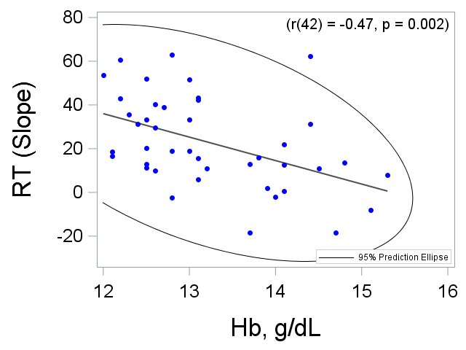 | (d) 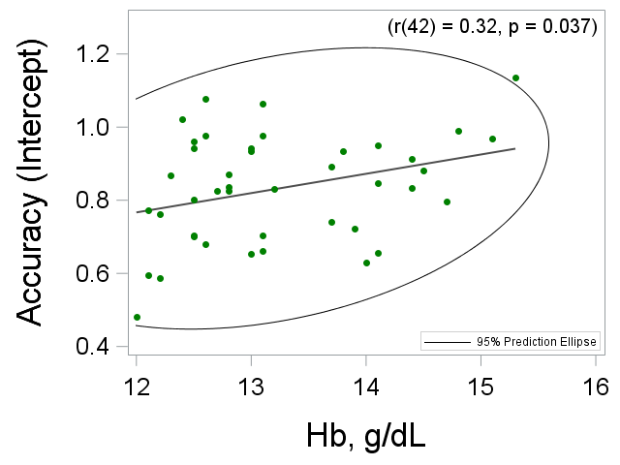
(b) 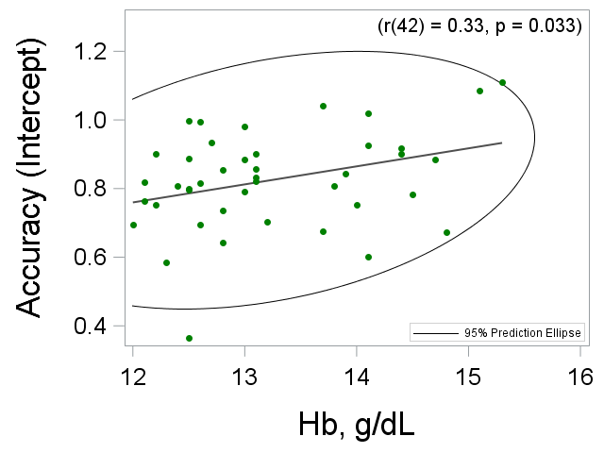 | (e) 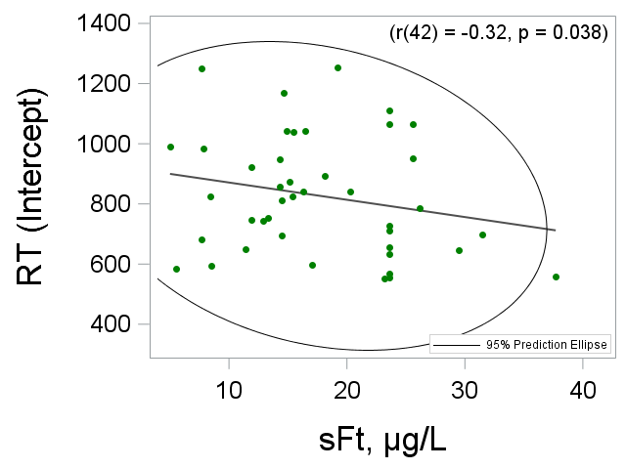
(c) 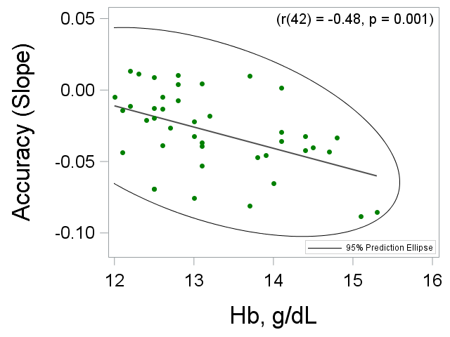

Table 7.5.4. Summary of SMS task performance by iron status group [n = 42]
Dependent Variable  Effect | New Test Items |  | Old Test Items
Dependent Variable  Effect | DF | F | DF | F
Accuracy
Group (G) | 80 | 0.44 | 80 | 0.81
Set Size (SS) | 80 | 16.42*** | 80 | 17.09***
G x SS | 80 | 1.04 | 80 | 0.20
RT
Group (G) | 80 | 2.97⁺ | 80 | 1.56
Set Size (SS) | 80 | 79.97*** | 80 | 63.83***
G x SS | 80 | 1.36 | 80 | 0.45
⁺ p < 0.1; * p < 0.05; ** p < 0.01; *** p < 0.0001.

Figure 7.5.4. Summary of SMS task performance (means and SE bars) by iron status group [n = 42]
New Test Items | Old Test Items
(a) 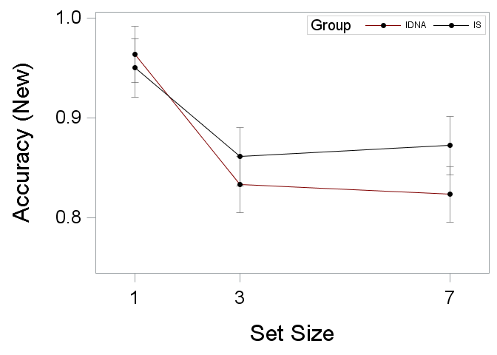 | (c) 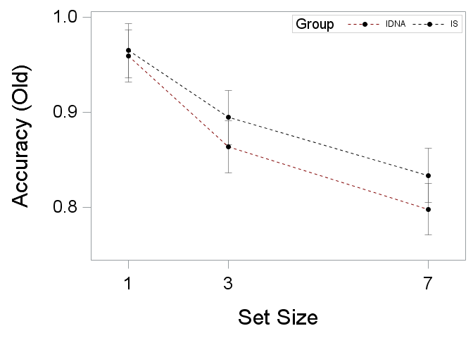
(b) 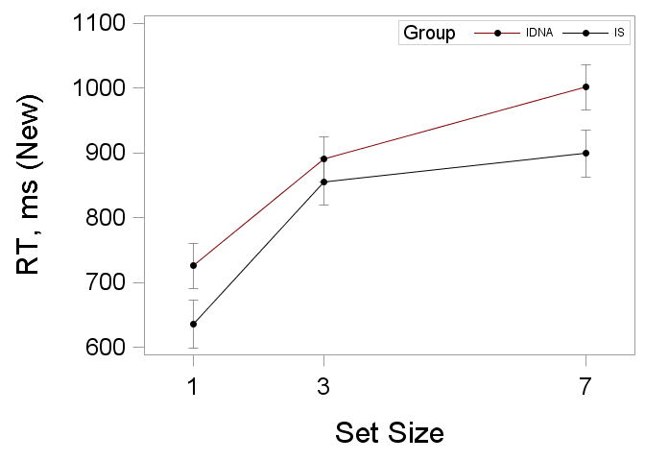 | (d) 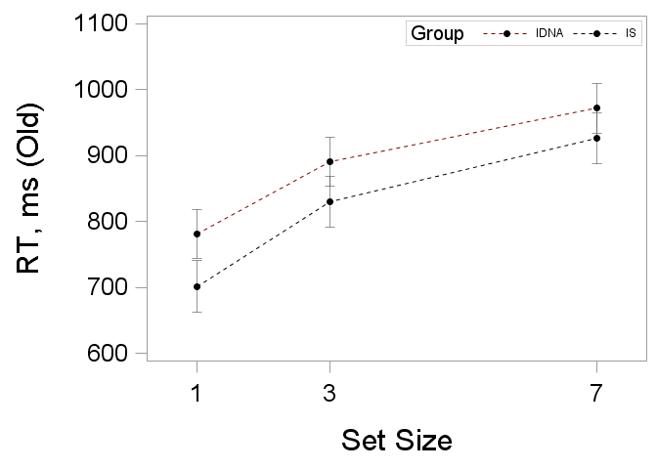

Table 7.5.5. Summary of SMS task performance regression estimates iron status group main effects [n = 42]
Outcome | New Test Items |  | Old Test Items
Outcome | DF | F | DFª | F
Accuracyª
Intercept | 1/40 | 0.17 | 1/40 | 0.08
Slope | 1/40 | 2.23 | 1/40 | 0.32
RT^{b}
Intercept | 1/40 | 0.91 | 1/40 | 2.13
Slope | 1/40 | 0.23 | 1/40 | 1.50
ª Proportion of correct category responses on the first learning block (intercept) or change in accuracy for each trial block (slope).
^{b} Median RT on the first learning block (intercept) or change in RT for each trial block (slope).

Appendix

Category Task Performance
Table 8.1.1. Summary of rule-based and information-integration category task accuracy by iron status group, task order, and trial block (n = 50 trials)
Trial Block | Rule-Based Task  Accuracy Mean (SD) |  |  |  | Information-Integration Task  Accuracy Mean (SD)
Trial Block | IDNA [n = 22] |  | IS [n = 20] |  | IDNA [n = 22] |  | IS [n = 20]
Trial Block | Task 1 | Task 2 | Task 1 | Task 2 | Task 1 | Task 2 | Task 1 | Task 2
N | 10 | 12 | 11 | 9 | 12 | 10 | 9 | 11
Block 1 | 0.42 (0.15) | 0.65 (0.11) | 0.49 (0.18) | 0.58 (0.17) | 0.57 (0.17) | 0.50 (0.14) | 0.53 (0.11) | 0.52 (0.20)
Block 2 | 0.39 (0.18) | 0.67 (0.11) | 0.59 (0.13) | 0.59 (0.18) | 0.55 (0.12) | 0.52 (0.15) | 0.50 (0.15) | 0.57 (0.14)
Block 3 | 0.46 (0.15) | 0.68 (0.13) | 0.55 (0.16) | 0.62 (0.20) | 0.58 (0.15) | 0.57 (0.12) | 0.57 (0.12) | 0.56 (0.10)
Block 4 | 0.52 (0.15) | 0.71 (0.15) | 0.59 (0.18) | 0.62 (0.22) | 0.59 (0.11) | 0.58 (0.11) | 0.53 (0.15) | 0.56 (0.14)
Block 5 | 0.62 (0.20) | 0.72 (0.11) | 0.66 (0.12) | 0.62 (0.20) | 0.61 (0.15) | 0.62 (0.10) | 0.62 (0.14) | 0.62 (0.09)
Block 6 | 0.67 (0.17) | 0.73 (0.13) | 0.66 (0.09) | 0.66 (0.18) | 0.64 (0.11) | 0.64 (0.10) | 0.55 (0.13) | 0.62 (0.11)
Block 7 | 0.63 (0.14) | 0.74 (0.13) | 0.69 (0.12) | 0.64 (0.19) | 0.62 (0.10) | 0.65 (0.11) | 0.61 (0.12) | 0.60 (0.14)
Block 8 | 0.66 (0.17) | 0.71 (0.17) | 0.69 (0.09) | 0.68 (0.18) | 0.63 (0.12) | 0.62 (0.12) | 0.59 (0.14) | 0.61 (0.10)
Block 9 | 0.70 (0.12) | 0.76 (0.09) | 0.73 (0.08) | 0.68 (0.16) | 0.64 (0.10) | 0.66 (0.09) | 0.65 (0.10) | 0.69 (0.11)
Block 10 | 0.71 (0.11) | 0.75 (0.10) | 0.75 (0.09) | 0.72 (0.10) | 0.65 (0.13) | 0.70 (0.14) | 0.64 (0.11) | 0.66 (0.12)
Block 11 | 0.71 (0.13) | 0.72 (0.10) | 0.75 (0.09) | 0.68 (0.17) | 0.65 (0.12) | 0.64 (0.12) | 0.65 (0.10) | 0.68 (0.13)
Block 12 | 0.74 (0.13) | 0.73 (0.14) | 0.72 (0.12) | 0.63 (0.16) | 0.65 (0.10) | 0.67 (0.13) | 0.65 (0.06) | 0.71 (0.10)
Block 13 | 0.70 (0.12) | 0.74 (0.08) | 0.75 (0.07) | 0.70 (0.14) | 0.70 (0.14) | 0.68 (0.10) | 0.65 (0.08) | 0.70 (0.12)
Block 14 | 0.71 (0.09) | 0.75 (0.11) | 0.74 (0.07) | 0.73 (0.13) | 0.65 (0.08) | 0.70 (0.13) | 0.70 (0.10) | 0.69 (0.10)
Block 15 | 0.72 (0.14) | 0.75 (0.12) | 0.67 (0.13) | 0.65 (0.16) | 0.64 (0.15) | 0.67 (0.07) | 0.63 (0.10) | 0.64 (0.09)
Block 16 | 0.73 (0.09) | 0.74 (0.10) | 0.74 (0.08) | 0.73 (0.13) | 0.67 (0.11) | 0.74 (0.08) | 0.68 (0.08) | 0.65 (0.12)
Block 17 | 0.77 (0.08) | 0.82 (0.07) | 0.79 (0.08) | 0.74 (0.11) | 0.72 (0.11) | 0.74 (0.09) | 0.69 (0.10) | 0.71 (0.10)
Block 18 | 0.75 (0.06) | 0.75 (0.10) | 0.77 (0.06) | 0.71 (0.12) | 0.69 (0.08) | 0.73 (0.08) | 0.72 (0.09) | 0.72 (0.09)
Block 19 | 0.79 (0.07) | 0.77 (0.06) | 0.77 (0.09) | 0.72 (0.12) | 0.72 (0.10) | 0.73 (0.07) | 0.73 (0.09) | 0.71 (0.09)
Block 20 | 0.76 (0.06) | 0.75 (0.08) | 0.71 (0.10) | 0.68 (0.11) | 0.70 (0.14) | 0.68 (0.11) | 0.70 (0.10) | 0.69 (0.08)
Block 21 | 0.80 (0.11) | 0.76 (0.08) | 0.77 (0.07) | 0.74 (0.10) | 0.71 (0.10) | 0.73 (0.08) | 0.73 (0.10) | 0.73 (0.07)
Block 22 | 0.77 (0.07) | 0.81 (0.07) | 0.77 (0.06) | 0.75 (0.13) | 0.71 (0.10) | 0.75 (0.11) | 0.74 (0.10) | 0.74 (0.09)
Block 23 | 0.75 (0.08) | 0.78 (0.11) | 0.75 (0.06) | 0.74 (0.11) | 0.71 (0.08) | 0.72 (0.05) | 0.75 (0.10) | 0.73 (0.06)
Block 24 | 0.80 (0.07) | 0.76 (0.09) | 0.76 (0.07) | 0.72 (0.10) | 0.72 (0.10) | 0.72 (0.07) | 0.71 (0.09) | 0.73 (0.06)

Table 8.1.2. Summary of rule-based and information-integration category task RT by iron status group, task order, and trial block (n = 50 trials)
Trial Block | Rule-Based Task  RT Mean (SD) |  |  |  | Information-Integration Task  RT Mean (SD)
Trial Block | IDNA [n = 22] |  | IS [n = 20] |  | IDNA [n = 22] |  | IS [n = 20]
Trial Block | Task 1 | Task 2 | Task 1 | Task 2 | Task 1 | Task 2 | Task 1 | Task 2
N | 10 | 12 | 11 | 9 | 12 | 10 | 9 | 11
Block 1 | 916 (179) | 1085 (180) | 920 (145) | 855 (171) | 843 (117) | 905 (181) | 794 (145) | 796 (163)
Block 2 | 927 (178) | 1041 (190) | 901 (181) | 846 (143) | 811 (107) | 881 (142) | 725 (128) | 814 (201)
Block 3 | 983 (188) | 1001 (185) | 939 (173) | 824 (195) | 853 (138) | 864 (128) | 758 (172) | 769 (207)
Block 4 | 905 (150) | 993 (145) | 883 (149) | 791 (199) | 817 (136) | 806 (136) | 754 (161) | 764 (157)
Block 5 | 952 (156) | 975 (168) | 861 (143) | 883 (217) | 796 (125) | 842 (129) | 781 (155) | 725 (159)
Block 6 | 951 (193) | 979 (162) | 846 (130) | 853 (242) | 785 (137) | 810 (127) | 706 (151) | 740 (167)
Block 7 | 979 (141) | 930 (162) | 821 (140) | 850 (205) | 773 (91) | 810 (136) | 730 (151) | 742 (164)
Block 8 | 888 (99) | 926 (153) | 861 (139) | 893 (260) | 753 (71) | 806 (150) | 722 (150) | 719 (78)
Block 9 | 954 (123) | 886 (171) | 856 (147) | 885 (233) | 767 (99) | 790 (144) | 799 (110) | 729 (158)
Block 10 | 914 (112) | 865 (139) | 826 (115) | 841 (168) | 736 (90) | 766 (121) | 773 (126) | 746 (134)
Block 11 | 926 (141) | 842 (137) | 808 (173) | 816 (196) | 720 (86) | 768 (112) | 782 (105) | 752 (165)
Block 12 | 869 (100) | 825 (113) | 816 (148) | 799 (196) | 778 (127) | 796 (154) | 766 (136) | 757 (181)
Block 13 | 889 (104) | 842 (133) | 809 (99) | 843 (203) | 729 (100) | 780 (144) | 753 (138) | 691 (123)
Block 14 | 893 (129) | 880 (137) | 778 (104) | 858 (201) | 719 (99) | 765 (136) | 717 (116) | 715 (105)
Block 15 | 909 (163) | 814 (128) | 765 (110) | 806 (193) | 720 (104) | 779 (149) | 715 (116) | 696 (84)
Block 16 | 893 (152) | 810 (128) | 813 (119) | 841 (203) | 733 (121) | 781 (154) | 713 (130) | 675 (97)
Block 17 | 911 (178) | 783 (163) | 789 (129) | 797 (226) | 735 (83) | 739 (126) | 746 (103) | 646 (96)
Block 18 | 883 (136) | 823 (145) | 783 (141) | 786 (231) | 713 (85) | 719 (98) | 746 (144) | 680 (99)
Block 19 | 878 (229) | 809 (145) | 758 (140) | 835 (216) | 710 (74) | 718 (127) | 722 (117) | 677 (84)
Block 20 | 898 (131) | 802 (143) | 731 (133) | 829 (247) | 686 (91) | 737 (133) | 720 (95) | 648 (85)
Block 21 | 870 (149) | 771 (141) | 770 (144) | 814 (238) | 694 (94) | 729 (129) | 719 (143) | 659 (86)
Block 22 | 829 (124) | 762 (143) | 749 (118) | 797 (212) | 714 (101) | 725 (128) | 709 (112) | 681 (93)
Block 23 | 854 (169) | 776 (133) | 781 (149) | 811 (218) | 707 (92) | 738 (112) | 718 (101) | 644 (64)
Block 24 | 830 (161) | 813 (148) | 751 (128) | 818 (212) | 706 (63) | 750 (107) | 713 (117) | 682 (93)
Table 8.1.3. Summary of rule-based and information-integration category task IES by iron status group, task order, and trial block (n = 50 trials)
Trial Block | Rule-Based Task  IES Mean (SD) |  |  |  | Information-Integration Task  IES Mean (SD)
Trial Block | IDNA [n = 22] |  | IS [n = 20] |  | IDNA [n = 22] |  | IS [n = 20]
Trial Block | Task 1 | Task 2 | Task 1 | Task 2 | Task 1 | Task 2 | Task 1 | Task 2
N | 10 | 12 | 11 | 9 | 12 | 10 | 9 | 11
Block 1 | 2410 (960) | 1676 (343) | 2039 (759) | 1650 (722) | 1710 (949) | 2016 (1035) | 1628 (519) | 1611 (492)
Block 2 | 2974 (1930) | 1612 (502) | 1562 (356) | 1592 (632) | 1572 (496) | 1930 (1017) | 1617 (666) | 1489 (428)
Block 3 | 2473 (1192) | 1540 (529) | 1879 (851) | 1538 (655) | 1554 (465) | 1591 (427) | 1379 (437) | 1380 (333)
Block 4 | 1839 (549) | 1476 (384) | 1669 (784) | 1437 (582) | 1449 (387) | 1431 (268) | 1517 (468) | 1454 (436)
Block 5 | 1738 (770) | 1400 (418) | 1347 (274) | 1607 (731) | 1371 (404) | 1390 (328) | 1310 (395) | 1188 (243)
Block 6 | 1562 (711) | 1407 (446) | 1289 (175) | 1427 (540) | 1284 (400) | 1304 (331) | 1439 (388) | 1235 (334)
Block 7 | 1712 (744) | 1307 (392) | 1219 (258) | 1518 (742) | 1284 (299) | 1305 (360) | 1284 (427) | 1296 (442)
Block 8 | 1538 (619) | 1385 (470) | 1258 (256) | 1460 (702) | 1251 (317) | 1359 (390) | 1290 (389) | 1209 (196)
Block 9 | 1580 (690) | 1189 (322) | 1181 (247) | 1352 (532) | 1247 (282) | 1249 (329) | 1274 (287) | 1065 (204)
Block 10 | 1360 (368) | 1208 (302) | 1109 (184) | 1210 (331) | 1175 (318) | 1153 (325) | 1275 (338) | 1157 (291)
Block 11 | 1491 (615) | 1190 (263) | 1104 (343) | 1308 (480) | 1145 (210) | 1254 (338) | 1239 (274) | 1141 (348)
Block 12 | 1244 (437) | 1191 (322) | 1159 (247) | 1383 (557) | 1219 (266) | 1253 (410) | 1194 (268) | 1087 (303)
Block 13 | 1378 (486) | 1194 (253) | 1087 (167) | 1358 (494) | 1067 (218) | 1183 (328) | 1187 (320) | 1001 (198)
Block 14 | 1322 (404) | 1202 (305) | 1064 (160) | 1287 (433) | 1118 (219) | 1133 (334) | 1070 (285) | 1079 (229)
Block 15 | 1322 (412) | 1119 (288) | 1176 (281) | 1387 (580) | 1235 (534) | 1184 (298) | 1174 (289) | 1112 (187)
Block 16 | 1283 (364) | 1148 (324) | 1117 (266) | 1260 (463) | 1125 (297) | 1079 (317) | 1056 (207) | 1092 (220)
Block 17 | 1208 (324) | 968 (246) | 1008 (180) | 1142 (484) | 1062 (260) | 1019 (247) | 1110 (244) | 928 (205)
Block 18 | 1193 (218) | 1121 (257) | 1016 (153) | 1155 (453) | 1044 (201) | 997 (196) | 1038 (218) | 964 (201)
Block 19 | 1128 (348) | 1053 (148) | 992 (195) | 1218 (494) | 1017 (231) | 989 (206) | 996 (223) | 970 (193)
Block 20 | 1187 (212) | 1074 (184) | 1053 (304) | 1271 (577) | 1029 (272) | 1131 (340) | 1046 (201) | 954 (191)
Block 21 | 1101 (229) | 1016 (179) | 1003 (213) | 1108 (373) | 1006 (226) | 1008 (248) | 1021 (318) | 907 (156)
Block 22 | 1089 (246) | 950 (206) | 977 (189) | 1083 (370) | 1040 (300) | 956 (277) | 963 (208) | 937 (199)
Block 23 | 1110 (191) | 1015 (232) | 1053 (216) | 1124 (382) | 1007 (214) | 969 (216) | 955 (173) | 884 (145)
Block 24 | 980 (103) | 1094 (267) | 961 (209) | 1152 (353) | 1002 (210) | 972 (266) | 995 (222) | 942 (159)

Table 8.1.4. Summary of rule-based and information-integration category task performance regression estimates by iron status group and task order
Outcome  Statistic | Rule-Based Task Mean (SD) |  |  |  | Information-Integration Task Mean (SD)
Outcome  Statistic | IDNA [n = 22] |  | IS [n = 20] |  | IDNA [n = 22] |  | IS [n = 20]
Outcome  Statistic | Task 1 | Task 2 | Task 1 | Task 2 | Task 1 | Task 2 | Task 1 | Task 2
Accuracyª
Intercept | 0.50 (0.16) | 0.69 (0.13) | 0.59 (0.13) | 0.60 (0.20) | 0.57 (0.10) | 0.56 (0.09) | 0.53 (0.11) | 0.56 (0.12)
Slope | 0.01 (0.01) | 0.00 (0.00) | 0.01 (0.00) | 0.01 (0.01) | 0.01 (0.00) | 0.01 (0.00) | 0.01 (0.01) | 0.01 (0.01)
RT^{b}
Intercept | 959 (108) | 1010 (98) | 908 (120) | 857 (207) | 825 (118) | 865 (135) | 768 (143) | 789 (171)
Slope | -7 (4) | -12 (7) | -7 (5) | -5 (8) | -6 (6) | -7 (6) | -2 (4) | -6 (6)
IES^{c}
Intercept | 2249 (1034) | 1562 (450) | 1640 (446) | 1606 (634) | 1531 (378) | 1675 (489) | 1544 (446) | 1451 (333)
Slope | -59 (48) | -26 (20) | -33 (19) | -22 (14) | -26 (19) | -34 (24) | -27 (19) | -26 (11)
ª Proportion of correct category responses on the first learning block (intercept) or change in accuracy for each trial block (slope).
^{b} Median RT on the first learning block (intercept) or change in RT for each trial block (slope).
^{c} IES on the first learning block (intercept) or change in IES for each trial block (slope).

Dual Category Task Performance
Table 8.2.1. Summary of rule-based and information-integration category task performance by task phase (n = 400 trials) and iron status group
Task Type  Outcome | IDNA [n = 22] |  | IS [n = 20]
Task Type  Outcome | Expression Phaseª  Mean (SD) | Dual Task Phase  Mean (SD) | Expression Phaseª  Mean (SD) | Dual Task Phase  Mean (SD)
Rule-Based Task
Accuracy | 0.77 (0.05) | 0.72 (0.06) | 0.74 (0.09) | 0.68 (0.10)
RT | 824 (143) | 957 (153) | 785 (175) | 924 (202)
IES | 1071 (207) | 1347 (275) | 1099 (367) | 1396 (399)
Information-Integration Task
Accuracy | 0.71 (0.10) | 0.69 (0.08) | 0.72 (0.07) | 0.68 (0.06)
RT | 721 (100) | 862 (185) | 698 (107) | 836 (122)
IES | 1030 (221) | 1279 (328) | 986 (203) | 1230 (207)
ª Expression phase performance was calculated over the 400 trials of the second category learning session.

Table 8.2.2. Summary of rule-based and information-integration category task performance by task phase (n = 400 trials)
Outcome [n = 42] | Rule-Based Task Mean (SD) |  | Information-Integration Task Mean (SD)
Outcome [n = 42] | Expression Phaseª | Dual Task Phase | Expression Phaseª | Dual Task Phase
Accuracy | 0.76 (0.07) | 0.70 (0.08) | 0.72 (0.08) | 0.69 (0.07)
RT | 805 (159) | 942 (176) | 710 (103) | 850 (156)
IES | 1084 (291) | 1370 (337) | 1009 (211) | 1255 (275)
ª Expression phase performance was calculated over the 400 trials of the second category learning session.

Table 8.2.3. Correlations between differences in expressionª and dual category task performance subject regression estimates and iron status measures [n = 42]
Task Type  Measure^{b} | Hb | sFt | HCT | MCV | MCH | MCHC | RDW | WBC | RBC | CRP
Rule-Based Task
Accuracy | 0.09 | -0.05 | 0012 | -0.24 | -0.20 | -0.05 | 0.01 | 0.39* | 0.26⁺ | -0.09
RT | 0.09 | 0.07 | 0.08 | -0.07 | -0.06 | -0.03 | 0.06 | -0.07 | 0.77 | 0.002
IES | -0.04 | 0-10 | -0.09 | 0.08 | 0.08 | 0.04 | 0.03 | -0.29⁺ | -0.14 | 0.06
Information-Integration Task
Accuracy | 0.05 | -0.12 | 0.11 | 0.03 | -0.03 | -0.11 | 0.08 | 0.26⁺ | 0.08 | 0.03
RT | 0.17 | 0.09 | 0.17 | 0.17 | 0.12 | 0.01 | -0.07 | -0.02 | 0.05 | -0.30⁺
IES | 0.13 | 0.10 | 0.11 | 0.15 | 0.14 | 0.07 | -0.11 | 0.13 | -0.01 | -0.23
⁺ p < 0.1; * p < 0.05; ** p < 0.01; *** p < 0.0001.
ª Expression phase performance was calculated over the 400 trials of the second category learning session.
^{b} Calculated as dual task performance estimate – expression phase performance estimate.

Working Memory Task Performance
Table 8.3.1. Summary of dual category SMS task performance regression estimates by task type and iron status group
Outcome  Statistic  SMS Test Type | SMS Performance on Rule-Based Task  Mean (SD) |  | SMS Performance on Information-  Integration Task Mean (SD)
Outcome  Statistic  SMS Test Type | IDNA [n = 22] | IS [n = 20] | IDNA [n = 22] | IS [n = 20]
Accuracyª
Intercept
New | 0.85 (0.10) | 0.81 (0.18) | 0.80 (0.16) | 0.85 (0.12)
Old | 0.84 (0.15) | 0.85 (0.15) | 0.82 (0.12) | 0.85 (0.13)
Slope
New | -0.03 (0.03) | -0.02 (0.02) | -0.02 (0.03) | -0.03 (0.03)
Old | -0.02 (0.04) | -0.03 (0.03) | -0.04 (0.03) | -0.04 (0.03)
RT^{b}
Intercept
New | 797 (118) | 819 (217) | 847 (182) | 806 (215)
Old | 845 (182) | 807 (181) | 873 (186) | 796 (192)
Slope
New | 25 (18) | 13 (25) | 17 (17) | 14 (23)
Old | 23 (21) | 23 (21) | 14 (16) | 22 (18)
ª Proportion of correct SMS responses for set size=1 (intercept) or change in accuracy for each increase in set size (slope).
^{b} Median RT on SMS responses for set size=1 (intercept) or change in RT for each increase in set size (slope).

Table 8.3.2. Summary of SMS task performance regression estimates by test type and iron status group [n = 42]
Outcome | New Test Items |  | Old Test Items
Outcome | IDNA [n = 22] | IS [n = 20] | IDNA [n = 22] | IS [n = 20]
Accuracyª
Intercept | 0.95 (0.11) | 0.93 (0.12) | 0.97 (0.10) | 0.97 (0.09)
Slope | -0.02 (0.02) | -0.01 (0.02) | -0.03 (0.03) | -0.02 (0.02)
RT^{b}
Intercept | 722 (192) | 665 (194) | 776 (213) | 689 (168)
Slope | 42 (30) | 38 (18) | 27 (25) | 36 (17)
ª Proportion of correct SMS responses for set size=1 (intercept) or change in accuracy for each increase in set size (slope).
^{b} Median RT on SMS responses for set size=1 (intercept) or change in RT for each increase in set size (slope).

Table 8.3.3. Correlations between SMS alone task performance subject regression estimates and iron status measures [n = 42]
Measure  Test Item | Hb | sFt | HCT | MCV | MCH | MCHC | RDW | WBC | RBC | CRP
Accuracyª
Old
Intercept | -0.13 | -0.06 | -0.13 | -0.19 | -0.14 | -0.02 | -0.17 | 0.02 | 0.01 | -0.07
Slope | 0.01 | 0.15 | -0.08 | 0.15 | 0.19 | 0.21 | -0.15 | -0.03 | -0.18 | -0.22
New
Intercept | -0.10 | -0.19 | -0.13 | -0.17 | -0.06 | 0.12 | 0.15 | -0.11 | -0.01 | -0.08
Slope | -0.003 | 0.24 | 0.01 | 0.03 | -0.02 | -0.10 | 0.07 | 0.17 | -0.01 | 0.09
RT^{b}
Old
Intercept | -0.10 | -0.27⁺ | -0.06 | -0.08 | -0.10 | -0.13 | 0.18 | -0.06 | 0.00 | -0.12
Slope | 0.07 | 0.21 | 0.05 | 0.22 | 0.18 | 0.06 | -0.09 | 0.03 | -0.09 | -0.09
New
Intercept | -0.05 | -0.20 | -0.02 | 0.13 | 0.06 | -0.09 | 0.05 | 0.07 | -0.10 | -0.03
Slope | -0.11 | -0.06 | -0.15 | -0.18 | -1.11 | 0.07 | 0.15 | -0.27⁺ | -0.02 | -0.001
⁺ p < 0.1; * p < 0.05; ** p < 0.01; *** p < 0.0001.
ª Proportion of correct category responses on lowest set size (intercept) or change in accuracy for each increase in set size (slope).
^{b} Median RT on the lowest set size (intercept) or change in RT for each increase in set size (slope).

Table 8.3.4. Summary of SMS dual and alone task performance on set sizes of 7 by task type and iron status group, separately for old and new test items [n = 42]
Outcome  Effect | New Test Items |  |  | Old Test items
Outcome  Effect | DFª | F | MSE | DFª | F | MSE
Accuracy | 3/80 | 1.11 |  | 3/80 | 0.43
Group (G) | 1 | 2.11 | 0.08 | 1 | 0.70 | 0.03
Task Type (TT) | 1 | 1.19 | 0.04 | 1 | 0.59 | 0.03
G x TT | 1 | 0.04 | 0.002 | 1 | 0.00 | 0.0001
RT | 3/80 | 0.23 |  | 3/80 | 0.22
Group (G) | 1 | 0.60 | 14917.04 | 1 | 0.00 | 114.51
Task Type (TT) | 1 | 0.10 | 2551.29 | 1 | 0.63 | 15344.01
G x TT | 1 | 0.00 | 89.11 | 1 | 0.02 | 596.89
⁺ p < 0.1; * p < 0.05; ** p < 0.01; *** p < 0.0001.

Table 8.3.5. Summary of Operation Span task performance differences by iron status group [n = 42]
Outcome | DFª | F | MSE
OS Score | 1/40 | 0.25
Group | 1 | 0.25 | 118.24
⁺ p < 0.1; * p < 0.05; ** p < 0.01; *** p < 0.0001.

Table 8.3.6. Summary of Operation Span task performance differences by iron status group [n = 42]
Outcome | IDNA Mean (SD)  [n = 22] | IS Mean (SD)  [n = 20]
OS Score | 35.19 (22.65) | 38.55 (20.44)

Table 8.3.7. Correlations between Operation Span task performance and iron status measures [n = 42]
Measure | Hb | sFt | HCT | MCV | MCH | MCHC | RDW | WBC | RBC | CRP
OS Score | -0.08 | 0.07 | -0.02 | -0.14 | -0.16 | -0.12 | 0.05 | 0.24 | 0.08 | 0.04
⁺ p < 0.1; * p < 0.05; ** p < 0.01; *** p < 0.0001.

Results for sensitivity analyses conducted with the matched sample (n=40) data were consistent with the results found for the total sample (n=42).
All analyses were conducted in SAS 9.4 except where otherwise specified.
While a violation of decisional separability is a hallmark characteristic of any II decision model, the set of models here is not exhaustive with respect to all possible II models.
Results consistent with those reported were found when examining 1-12 learning trial blocks with 100 trials per block.

