University of Oklahoma

Graduate College

A framework for developing proposals by social entrepreneur for development of rural india

A thesis

submitted to the Graduate Faculty

in partial fulfillment of the requirements for the

Degree of

Master of Science

By

abhishek yadav
Norman, Oklahoma
2018

A framework for developing proposals by social entrepreneur for development of rural india

A thesis approved for the
School of Industrial and Systems Engineering

By

______________________________
Dr. Farrokh Mistree, Chair

______________________________
Dr. Janet K. Allen

______________________________
Dr. Edward Sankowski

______________________________
Dr. Randa L. Shehab

© Copyright by ABHISHEK YADAV 2018
All Rights Reserved.

GururBrahma GururVishnu Gururdevo Maheswarah
Guruh Saakshaat ParaBrahma Tasmai Sri Gurve Namah

The Teacher is the Lord Brahma because they create the knowledge inside us. The Teachers are the Lord Vishnu because they preserve and operates the knowledge in our mind on to the right path. The Teacher is Lord Mahesh or Shiva because they destroy the wrong thoughts and transforms us with the right kind of knowledge. Thus, The Teacher or The Guru is the live supreme God, and we salute and bow to our teacher.

Acknowledgments

Working towards my Master’s Thesis has been a great learning experience. There are many people who have been a support system in fulfilling this journey, and I am grateful to each one of them.
I give my sincere appreciation to my co-advisors (my Academic Parents) Professor Janet K. Allen and Professor Farrokh Mistree for giving me an opportunity to work with them. Their constant guidance, encouragement, push for me to rise to my full potential is exceptional. This thesis would not have been possible without their professional care and personal involvement in understanding me.
Along with my co-advisors, Dr. Ashok Das, Dr. Ram Babu Roy, Archana Chatterjee, Souvik Barat and Dr. Vinay Kulkarni has helped me shape my work towards a desired and insightful path, and I thank them from my heart for their constant guidance, inputs, and mentorship.
The insightful comments and encouragement, along with the hard question by my committee members, Professor Edward Sankowski and Professor Randa L. Shehab have incented me to widen my research from various perspectives.
The constant support from my parents Savitri Yadav and Bhudev Kumar Yadav, my sister has been the biggest reassurance in myself. Without their confidence, believe in me, my abilities, unfailing support and continuous encouragement throughout my years of study and through the process of this masters and writing this thesis.
I sincerely thank my academic sibling (Lin Guo, Reza Alizadeh, Gehendra Sharma, Ali Shahbazi) in Systems Realization Laboratory for the stimulating discussions. I appreciate all help, support, and understanding from other members of my SRL family. A special thanks to Anand Balu Nellippallil for guiding me to look at work from a different perspective and constantly motivating me by sharing his experiences of research. I am also grateful to Pranav Mohan for his support in Systems Realization Laboratory.
Throughout the work towards this thesis, I have worked with four Honors Undergraduate Researchers at University of Oklahoma. Their enthusiasm to learn new things has motivated me to push myself. Work towards Village Level Baseline Sustainability Index would not have been possible without Megan Harju and Emilly Vittitow. The new insight towards Village Level System Dynamic Model is possible due to work done by Samantha Potts and Tholoana Seetsa. The contribution made by each of the Honors Undergraduate Researcher has improved the work in this thesis.
Finally, I would like to thank my roommates and friends, Arun Balakrishna, Saptarshi Mandal and Sreeram Ganesan, they have given me great help in this work with their continuous constructive criticism that helped me improve my work.
A special thanks to my parents, my sister, Arun, Saptarshi, Anand and Sneha Maheshwary for supporting my decision to pursue my Ph.D further.
This Thesis is a dedication to my parents for their constant support. I also dedicate this thesis to all the social entrepreneurs who are doing their bit for improving the lives of poor.
Table of Contents

Acknowledgments iv
Table of Contents vi
List of Tables xii
List of Figures xiv
Abstract xviii
1 CHAPTER 1 1
SUSTAINABLE SOCIAL ENTERPRISES: A TOOL FOR RURAL DEVELOPMENT 1
1.1 BACKGROUND AND MOTIVATION FOR RURAL DEVELOPMENT 3
1.1.1 Rural Population and Poverty 3
1.1.2 The Need for Rural Development 4
1.1.3 Social Enterprises and Their Positive Impacts 5
1.2 FOUNDATION OF SUSTAINABLE DEVELOPMENT 8
1.2.1 Sustainable Development Background and Goals 8
1.2.2 Need for Sustainable Development 10
1.3 THESIS QUESTION AND OUTCOMES 11
1.3.1 Proposed Hypothesis for the Primary Question and its Verification 15
1.3.2 Secondary Questions to be Answered 17
1.3.3 The Objective in the Thesis 21
1.4 VALIDATION STRATEGY – VALIDATION SQUARE 22
1.4.1 Structural Validation – A Qualitative Process 24
1.4.2 Performance Validation – A Quantitative Process 26
1.5 THEORETICAL STRUCTURAL VALIDITY – FRAMEWORK 29
1.6 ORGANIZATION OF THE THESIS 30
1.7 SYNOPSIS OF CHAPTER 1 33
2 CHAPTER 2 36
SUSTAINABLE RURAL DEVELOPMENT 36
2.1 SOCIAL VS. BUSINESS ENTREPRENEUR 36
2.2 BASELINE ASSESSMENT INDEX – CONSTRUCT 1 OF THE FRAMEWORK 40
2.2.1 Background on Baseline Assessment 41
2.2.2 Proposed Hypothesis for Question 2 (Sustainability Assessment Index) 44
2.3 CREATING VALUE PROPOSITION FOR SOCIAL DEVELOPMENT – CONSTRUCT 2 OF THE FRAMEWORK 47
2.3.1 Background on Value Proposition Development 47
2.3.2 Proposed Hypothesis for Question 3 (Dilemma Triangle) 51
2.4 SOCIAL IMPACT ASSESSMENT 54
2.4.1 Background on Social Impact Assessment 55
2.4.2 Hypothesis for Secondary Question Q4 61
2.5 THEORETICAL STRUCTURAL VALIDITY 62
2.6 SYNOPSIS OF CHAPTER 2 64
3 CHAPTER 3 68
VILLAGE LEVEL BASELINE SUSTAINABILITY INDEX 68
3.1 VILLAGE LEVEL BASELINE SUSTAINABILITY INDEX (VLBSI) 68
3.1.1 Introduction: Current Sustainability Indices 69
3.1.2 The Need of Village Level Baseline Sustainability Index 71
3.1.3 Proposed Village Level Sustainability Index 73
3.1.4 Indicator Weights 74
3.1.5 Social Driver Sub-Indicators 78
3.1.6 Environment Driver Sub-Indicators 84
3.1.7 Economic Driver Sub-Indicators 95
3.1.8 Graphical Depictions 100
3.2 IMPLEMENTATION OF VLBSI 101
3.2.1 VLBSI - Social Driver for the Selected Village 102
3.2.2 Hypothesis Verification: Village Level Baseline Sustainability Index 118
3.3 SYNOPSIS OF CHAPTER 3 120
4 CHAPTER 4 122
THE DILEMMA TRIANGLE CONSTRUCT 122
4.1 THE DILEMMA TRIANGLE METHOD FOR DEVELOPING VALUE PROPOSITION 122
4.1.1 Method to Identify Dilemmas 124
4.1.2 Part 1 – Identify Dilemmas in the System 125
4.1.3 Part 2 – Develop Value Proposition 128
4.2 IMPLEMENTATION OF THE DILEMMA TRIANGLE METHOD 130
4.2.1 Village Description for implementing Dilemma Triangle method 130
4.2.2 Implementation of Part 1 – Identifying dilemmas 132
4.2.3 Implementation of Method - Develop Value Proposition 139
4.2.4 Hypothesis Verification: Dilemma Triangle Construct 143
4.3 SYNOPSIS OF CHAPTER 4 144
5 CHAPTER 5 148
SYSTEMS DYNAMICS: USE IN IMPACT ASSESSMENT 148
5.1 INTRODUCTION TO SYSTEMS DYNAMICS 148
5.1.1 Causal Loops in System Dynamics 150
5.1.2 Stock and Flow models in System Dynamics 152
5.1.3 Proposed Method to Use System Dynamics as Impact Assessment Tool 153
5.2 VILLAGE LEVEL SYSTEM DYNAMIC MODEL – GENERAL 156
5.3 IMPLEMENTATION OF VLSD 170
5.3.1 Education Vignette in Surwara Village 171
5.3.2 Health Care Vignette in Bariar Chak Village 180
5.3.3 Electricity Vignette in Janisahi Village 187
5.3.4 Hypothesis Verification: Village Level System Dynamic Model 191
5.4 EMPIRICAL STRUCTURAL AND PERFORMANCE VALIDITY 192
5.5 SYNOPSIS OF CHAPTER 5 194
6 CHAPTER 6 197
COMPOSITE VILLAGE 197
6.1 COMPOSITE VILLAGE DESCRIPTION AND DATA 198
6.2 SYNOPSIS OF CHAPTER 6 206
7 CHAPTER 7 208
IMPLEMENTATION OF FRAMEWORK 208
7.1 A WORKING EXAMPLE: BASELINE SUSTAINABILITY INDEX 208
7.1.1 Value of Social Driver for the Composite Village 209
7.1.2 Environmental Driver for the Composite Village 216
7.1.3 Economic Driver for the Composite Village 224
7.1.4 Overall Baseline Sustainability Index for Composite Village - Discussion 229
7.2 IMPLEMENTATION OF THE DILEMMA TRIANGLE CONSTRUCT 240
7.2.1 Implementation of Dilemma Triangle Construct– Identifying dilemmas 241
7.2.2 Discussion for Dilemma Triangle 251
7.3 IMPLEMENTATION OF VILLAGE LEVEL SYSTEM DYNAMIC MODEL 252
7.3.1 Evaluation of Hypothesis and Value proposition from Dilemma Triangle 253
7.3.2 Hypothesis Verification: Computational Framework 261
7.4 EMPIRICAL PERFORMANCE VALIDITY 262
7.5 SYNOPSIS OF CHAPTER 7 263
8 CHAPTER 8 266
CLOSURE: CONTRIBUTIONS AND Ph.D. PROPOSAL 266
8.1 A SUMMARY OF THE THESIS 266
8.2 ANSWERING THE QUESTIONS AND VALIDATING THE HYPOTHESES 269
8.3 CONTRIBUTION ASSUMPTIONS AND LIMITATION OF THE FRAMEWORK 274
8.4 FUTURE WORK - Ph.D. PROPOSAL 277
8.5 SYNOPSIS OF CHAPTER 8 282
REFERENCES 283
APPENDIX A: Village Data for Chapter 3 289
APPENDIX B: Village Data for Chapter 4 294

List of Tables

Table 1.1: Relevant Sections for Investigating Thesis Questions 18
Table 2.1: Business vs. Social Entrepreneur – Cisco – Business of Social Entrepreneurship 37
Table 2.2: Organization of Thesis Questions 41
Table 2.3: Organization of Thesis Questions 46
Table 2.4: Organization of Thesis Questions 53
Table 3.1: Index Calculation for Social Driver 75
Table 3.2: Index Calculation for Social Driver with Added Indicator 76
Table 3.3: Indicators for Environment and Economic Driver 77
Table 3.4: Color Code for the Social Driver Cells 78
Table 3.5: Social Driver Sub-Indicators 80
Table 3.6: Color Code for Environmental Driver 85
Table 3.7: Environment Driver Sub-Indicators 85
Table 3.8: Data Collection Sheet for Economic Indicator 2.2 95
Table 3.9: Economic Driver Sub-indicators 96
Table 3.10: Social Data of the Village 103
Table 3.11: SOC1 - Education Sub-Indicator 106
Table 3.12: Modified Education Sub-Indicators 107
Table 3.13: SOC 2 Electricity Sub-Indicator 109
Table 3.14: Modified Electricity Sub-Indicators 110
Table 3.15: SOC 3: Health Indicator 112
Table 3.16: Social Indicators (SOC 4 - SOC 6) 113
Table 3.17: Value of Social Indicators 115
Table 3.18 : Village Data Collection Sheet 117
Table 6.1: Composite Village Data 200
Table 7.1: Value of Social Driver Index for the Composite Village 210
Table 7.2: Overview of Social Indicator Values for the Composite Village 215
Table 7.3: Environment Driver Indicator Values for the Composite Village 216
Table 7.4: Overview of Environment Driver Indicator Values for the Composite Village 223
Table 7.5: Economic Driver Value for the Composite Village 225
Table 7.6: Overview of Economic Driver Value for the Composite Village 228
Table 7.7: Values Related to Population Added in VLSD Model 256
Table 8.1: Organization of Thesis Questions 273
List of Figures

Figure 1.1: Three E's for Socio Economic Development 2
Figure 1.2: The Spheres of Sustainability 10
Figure 1.3 Requirements for Sustainable Rural Development 14
Figure 1.4 Proposed Framework of Value Proposition Development and Impact Evaluation Model (VPIEM) 17
Figure 1.5: The Validation Square (Pedersen, Emblemsvag and co-authors, 2000) 24
Figure 1.6: Validation Strategy for the Thesis 28
Figure 1.7: Information Flow in the Framework - Theoretical Structural Validity 29
Figure 1.8: A Roadmap and Overview of the Thesis 32
Figure 1.9: Organization of the Thesis – Presented and Next Chapter 35
Figure 2.1: Validation Strategy for the Thesis 63
Figure 2.2: Organization of the Thesis – Presented and Next Chapter 66
Figure 3.1: Classification of Sustainable Development Indices (SDI) 71
Figure 3.2: Spider Diagram for Social Driver 100
Figure 3.3: Graph of Overall Sustainability 101
Figure 3.4: Social Indicator Spider Diagram 116
Figure 3.5: Organization of the Thesis – Presented and Next Chapter 121
Figure 4.1: The Dilemma Triangle 124
Figure 4.2: Steps to Identify Dilemmas 125
Figure 4.3: Focus and Issues in a Dilemma Triangle 126
Figure 4.4: Comparison of the Issues Between Each Driver 127
Figure 4.5: The Tension Matrix for Dilemma Triangle 127
Figure 4.6: The Sustainability Triangle 129
Figure 4.7: Dilemma Triangle of Village/Villagers Perspective 133
Figure 4.8: Tension Matrix for Village/Villagers Perspective 136
Figure 4.9: Organization of the Thesis – Presented and Next Chapter 146
Figure 5.1: Population-Birth rate 150
Figure 5.2: Population-Death Rate 151
Figure 5.3: Population Causal Loop Diagram 152
Figure 5.4: Simple Stock n Flow Population Model 153
Figure 5.5: Calculating the Impact of a Value Proposition 156
Figure 5.6: General Village Level System Dynamic Model-1 157
Figure 5.7: General Village Level System Dynamic Model-2 158
Figure 5.8: Village Demographics Loop 1 159
Figure 5.9: Village Demographics Loop 2 162
Figure 5.10: Village Demographics Loop 3 162
Figure 5.11: Education Loop: Primary Schooling 164
Figure 5.12: Education Loop: Secondary Schooling 166
Figure 5.13: Health Care Loop: Malnutrition Rate 167
Figure 5.14: Health Care Loop: Low-Risk Diseases 168
Figure 5.15: Electricity Loop 170
Figure 5.16: Education Intervention-1 173
Figure 5.17: Enrollment Rate of Girls After Intervention-1 175
Figure 5.18: Number of Girls Dropping School After Intervention-1 175
Figure 5.19: Total Enrollment of Girls After Intervention-1 175
Figure 5.20: Girls Enrollment: Social Discussion Intervention 177
Figure 5.21: Enrollment Rate for School Girls: Intervention 2 178
Figure 5.22: Total Enrollment of Girls in School: Intervention 2 179
Figure 5.23: Health Care: Intervention 2a 183
Figure 5.24: Evaluation of the Number of Session on Water Quality and Food Quality for Intervention 2a 184
Figure 5.25: Effect of Number of Session on Malnutrition Rate for Intervention 2a 184
Figure 5.26: Evaluation of Number of Session on Water Quality and Food Quality for Intervention 2a and 100 Employed Families 185
Figure 5.27: Effect of Number of Session on Malnutrition Rate for Intervention 2a and 100 Employed Families 186
Figure 5.28: Cost of Kerosene in the Village 188
Figure 5.29: Possible Impacts of Micro Grid 190
Figure 5.30: Validation Strategy for the Thesis 194
Figure 5.31: Organization of the Thesis – Presented and Next Chapter 196
Figure 6.1: Angul District, Odisha State Map 199
Figure 6.2: Framework Overview with Construct Information Flow 206
Figure 6.3: Organization of the Thesis – Presented and Next Chapter 207
Figure 7.1: Social Driver Spider Diagram for Composite Village 215
Figure 7.2: Environment Driver Spider Diagram for Composite Village 224
Figure 7.3: Economic Driver Spider Diagram for Composite Village 229
Figure 7.4: Overall Sustainability Index Value for Composite Village 230
Figure 7.5: Graphical Presentation of Social Driver Value for Composite Village 233
Figure 7.6: Graphical Presentation of Environment Driver Indicators for Composite Village 237
Figure 7.7: Graphical Presentation of Economic Driver Indicator Value for Composite village 239
Figure 7.8: Information Flow in the Framework 240
Figure 7.9: Dilemma Triangle from Social Entrepreneurs Perspective 244
Figure 7.10: Tension Matrix for Social Entrepreneur Perspective 247
Figure 7.11: Information Flow in the Framework 252
Figure 7.12: Population Growth VLSD Model 257
Figure 7.13: Female Skill Development Model 258
Figure 7.14: Number of Females Joining Training Based on Training Time 259
Figure 7.15: Impact of the Tradeoff Between Skill Training and Enrollment Increase 260
Figure 7.16: Validation Strategy for the Thesis 263
Figure 7.17: Organization of the Thesis – Presented and Next Chapter 264
Figure 8.1: Framework Overview with Construct Information Flow 269
Figure 8.2: A Roadmap and Overview of the Thesis 272
Figure 8.3: Proposed Community Catalysts Interventions Model 279
Figure 8.4: Higher Conceptual Level Society Decision Flow 280
Figure 8.5: Framework for Micro Socio-Techno-Eco-Systems 281
Abstract
Billions of people in developing and underdeveloped countries currently lack access to basic services and are living in poverty. One of the main reasons is unavailability or limited basic resource (economic, technology, social) in geographical locations where people live. Added with this are the environmental issues such as natural resource depletion, yearlong droughts, climate change that world is currently facing. Combined, these two issues lead to dropping socio-economic development in many rural communities. One way to improve the socio-economic development in rural areas is by the development of social enterprises. Social enterprises developed at the grass root level have significant effects on improving the quality of living of the people in terms of socio-economic standards. There is potential growth possible in social entrepreneurship, however number of social enterprises in developing countries is very low. Lack of social entrepreneurs in developing and underdeveloped countries is seen due to lack of access to funds and knowledge that is required to develop social enterprises anchored in the socio-economic improvement of the communities. Other stakeholders in socio-economic development for people living in poverty are, Corporate Social Responsibility (CSR) investors and philanthropists. However, they lack access to information required for the development of value propositions that are needed at the ground level to improve quality of life. Both stakeholder (social entrepreneur and investors) involved in social development can partner with each other to boost rural development.

The partnership between social entrepreneur and CSR investors, philanthropist can be useful in rural areas of developing countries to improve their socio-economic level by providing opportunities to each individual. Millions of people living in rural areas with limited resources can be empowered with enterprises developed social entrepreneurs and funded by CSR investors. However, they currently lack access to tools needed to facilitate this partnership. Social entrepreneurs lack a tool to develop value propositions for specific rural areas and have information about the village in quantitative form. CSR investors, philanthropist, on the other hand, require quantitative information along with impact evaluation of the value proposition before investing.

In this thesis, this problem is studied from a system engineering perspective. A framework is developed that can be used by people who aspire to become social entrepreneurs, willing to work for the development of rural communities. Social entrepreneurs also need to take into account the environmental issues that these communities face by managing the problem in terms of sustainable development to have a positive impact on the communities. For CSR investors and philanthropist, an evaluation tool is developed as a part of the framework to compare and analyze different value propositions.

In this thesis, the framework developed is modified and integrated with different constructs that are available in literature currently. The framework proposed in this thesis is developed in generic form, the framework is adaptable, robust and can be used in different social and environmental conditions. The social entrepreneurs and the users of this framework can modify the framework based on their needs.

CHAPTER 1
SUSTAINABLE SOCIAL ENTERPRISES: A TOOL FOR RURAL DEVELOPMENT

700 million people in the world live in acute poverty based on World Bank data (Mundial, 2016). The major concentration of people living in poverty (80 percent) is in rural areas. The World Bank plans to decrease acute poverty to below 3 percent worldwide by 2030 (Mundial, 2016) . They estimate that to reduce overall poverty to 3 percent by 2030; world inequity must be reduced at twice the current rate (Mundial, 2016). With the eradication of poverty ranking first in World Bank goals of 2030 and Sustainable Development Goals (SDG), national governments have refocused themselves to take care of the rural population.
One of the solutions for poverty eradication in rural areas is to focus on three E’s in the village; Employment, Education, and Empowerment, in that order. Employment of current generation in different fields, so that next generation can be educated and thereby empowered to increase the socio economic conditions, as presented in Figure 1.1. One way to focus on three E’s is by the development of Small and Micro Enterprises (SME) in rural areas. Enterprises and Industries in the past have played a crucial role in improving the quality of life of the people around the industries (Inkeles, 1993). In 20th and 21st-century multinational companies were able to increase the GDP of countries drastically. The same process of enterprise development at small and micro scale, nearby rural communities can improve the economic standards. Thousands of SME’s can empower millions of people and thereby improve the lives of thousands of families. However, the idea of the sustainable approach is the key for the SME’s.
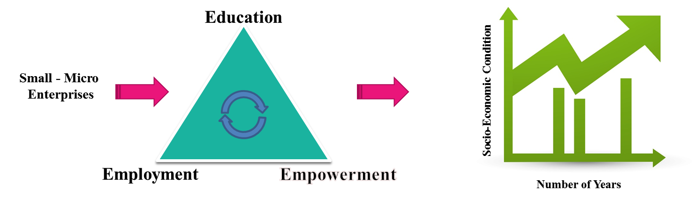
Figure 1.1: Three E's for Socio Economic Development
Currently, there are two stakeholders involved in rural development, Social Entrepreneurs, and Corporate Social Responsibility Investors. The goal in this thesis is to look at social entrepreneurship, rural development anchored in sustainability from a systems perspective. The primary question answered in this thesis is,
What tools are needed to support the decision making of social entrepreneurs, investors, and philanthropist working to develop solutions for sustainable rural development?
In this chapter, the foundation for the thesis is laid by providing the background and motivation for rural development and need of anchoring it with sustainable development. In Section 1.1, present and future state of rural areas in the world is discussed. Later in the section, the motivation for this thesis is provided, that is, need for rural development and how social enterprises can be the key to rural development. In Section 1.2, the foundation for sustainable development is provided along with the discussion of why sustainable development is required. In Section 1.3, the boundary for the work presented in this thesis is discussed, the questions answered in the thesis are posed. In section 1.4, the proposed solution (framework) is defined and explained. In Section 1.5, the validation strategy is discussed along with an overview of the thesis.

BACKGROUND AND MOTIVATION FOR RURAL DEVELOPMENT
Rural areas around the globe consist of approximately half of the current population. In most of developing countries and all the underdeveloped countries, the speed of development is slower in rural areas compared to urban areas. The focus must be on increasing the development rate in rural areas in order to increase overall development and decrease the poverty to below 3 percent by the year 2030. In this section of the thesis, the background of the current situation on rural development and motivation on the need for rural development is presented. In Section 1.1.1, the estimates of the rural areas in the world are discussed, followed by the need for rural development in Section 1.1.2. In Section 1.1.3, the role of social enterprises in rural development is discussed.

Rural Population and Poverty
3.39 billion people in the world currently live in rural areas . Rural areas compromise 80 percent of the population under poverty, 44% of poor are below the age of 14 years and poorly educated (Mundial, 2016). For many years countries have focused on the development of urban areas. This has led to a huge disparity in quality of life, a socio-economic status between people living in urban areas and rural areas. In developing countries, major population under poverty resides in rural parts of the country, and it is estimated that by 2050 there will still be 3.1 billion people in rural areas ("Rural Population Data,").
In India, one of the fastest developing country, 800 million people live in rural areas, of that 270 million live in poverty (Oecd Economic Surveys, 2017). Lack of proper education, health care, housing, sanitation, electricity, and constant droughts, floods continue to be the blockades for development in rural areas.
In India every year thousands of farmers lose their agricultural yield due to droughts or heavy rains. This pushes the farmer families towards poverty, in the past year's many cases have been registered on farmer suicides, clearly indicating poverty as the main cause (Carleton, 2017). Whereas in the communities focused on fishing, there is seen a decline in the income due to depletion of fish stock in the river and coastal regions. Fishermen take loans to buy/repair boats and are then unable to pay due to low productivity. This pushes more families below poverty line. With the current growth estimate, there will still be 8 percent of people below the acute poverty line by 2030 (Mundial, 2016). To decrease the population below poverty line, the focus should be on decreasing rural poor. In next section, the discussion of why rural development is needed is provided.

The Need for Rural Development
Poverty is one the biggest challenges in the world. Though the percentage of the people under poverty is decreasing, a number of people are still rising. Human right violation is maximum in poverty-ridden communities. The issues that arise with poverty are not confined to these communities alone. The rise in poverty also slows down the growth of countries. With the increase in population, pressure on urban areas increases, as people living in poor rural communities migrate to urban areas for better jobs. This leads to decreases in the number of people in agriculture, fishing and other types of employment, creating a gap in food products supply and demand.
In developing countries, improvement in rural areas would mean that a higher number of people will be able to contribute to the economy of the country and thereby reducing the burden on the government to support millions of people. Rural development in the countries, therefore, leads to countries development. On another hand, if rural development is not focused in a country, the population will migrate to cities, thereby increasing pressure on urban areas. As people migrate to cities, agriculture output of the country reduces, this leads to increase in imports, this leads to increase in the inflation rate in the country. With the majority of poor in rural areas, it is evident that people cannot rely only on agriculture and fishing or any local activity for the economic opportunities. Therefore, there is a need for the governments of different countries to replicate the economic development similar to the industrial revolution and global market access. This economic development expected to will boost rural development at twice the rate in order to reach the goal of no poverty by 2030. However, the strategies such as industrial revolution and globalization for rural development are complex due to the nature of rural areas and are difficult to implement. To boost the development in rural areas, a modified approach of creating enterprises with social conscious is required. This modified approach of creating enterprises with social conscious is called as social entrepreneurship, in next section, the social enterprises and their positive impacts on social development are discussed.

Social Enterprises and Their Positive Impacts
The term social entrepreneurship was first used in 1980 by Bill Drayton (Suchet Kumar and Gupta, 2013). Drayton defines social entrepreneurship as a model for bringing social change in a community by an individual or group of individuals having a goal to tackle socio-economic needs of the society (Suchet Kumar and Gupta, 2013). Researchers have provided validation that the concept of social enterprise is central to the social mission. Researchers have also developed characteristics that define a social enterprise (Suchet Kumar and Gupta, 2013). In this section, a few examples of social enterprises are mentioned to provide context.
Vinoba Bhave, in early 1960 ’s walked across India to persuade many individuals to legally gift their lands to him. Bhave then redistributed the land to the people that were considered untouchables in 1960’s and other landless people equally, thereby helping communities empower themselves (Suchet Kumar and Gupta, 2013). Muhammad Yunus in 1976 started Grameen Bank in Bangladesh. Grameen Bank currently is used by many people living in poor communities to obtain micro-finance at very low-interest rates (Yunus, Moingeon and co-authors, 2010). Families living in poverty, in the communities use micro-finance to either clear up loan taken by money lenders or start their own micro-enterprises, thereby empowering themselves. Grammen group, today has a total of 30 other sister organizations. Grameen Bank has lent money to over 7.5 million poor people, and 97 percent of these people are women (Yunus, Moingeon and co-authors, 2010). The latest project by Grameen group is to provide the Grameen phone with cheap phone services, so that rural area can be connected to urban areas (Yunus, Moingeon and co-authors, 2010).
Another social enterprise is SELCO Solar. SELCO Solar was established with the mission to provide a low-cost solar solution in low-income communities for lightning and water pumping. SELCO continued to provide a complete package of products, service and consumer financing combining with Grameen Banks and micro-loans. With electricity access, the communities improved in education and agricultural yield (Subramanian, 2015).
Small and Micro Enterprises (SME) in rural areas have been able to make a positive impact on rural development. Even though SME’s come under business enterprises category, they are able to create high social value in rural areas by increasing the economic growth of a particular community (Anigbogu, Onwuteaka and co-authors, 2014). SME’s help to create employment in the local capital and are viewed as one of the most promising ways to achieve equitable and sustainable industrial diversification (Anigbogu, Onwuteaka and co-authors, 2014).
Small and micro enterprises developed for creating social value can have a huge impact on eradicating poverty and catalyzing rural development. Social, small-micro enterprises are crucial for rural development, but this socio-economic development can take a toll on the environment and therefore it must be anchored in sustainable development. To increase initiatives from social enterprises and social entrepreneurs, governments are working towards creating public-private partnerships. In such partnership, different private entities and public entities can come together and develop a solution for social development. The solution that is developed for social development or rural development must be anchored in sustainability. In Section 1.2, the foundation of sustainable development is laid, followed by a discussion on why social entrepreneurs need to take into account all the drivers of sustainability before developing solution.

FOUNDATION OF SUSTAINABLE DEVELOPMENT
Sustainable development term was first coined in 1987 in the report of Brundtland Commission (Parmova, Lapka and co-authors, 2014). Multiple definitions are used to define sustainable development since it was published in Brundtland report.
In this section of the thesis, the foundation of sustainable development based on the Brundtland report and our understanding is provided. In Section 1.2.1, the definition of sustainable development as per Brundtland report is quoted and articulated from a different perspective. The context of sustainable development based on United Nations is provided in this section. The emphasis on the need for sustainable development and the approach to be taken is discussed in this section. In Section 1.2.2, the emphasis on the need for sustainable development on the approach to be adopted is discussed.

Sustainable Development Background and Goals
Sustainable development, as defined in Brundtland report, 1987 by World Commission on Environment and Development (WCED) is, “To meet the needs of the present without compromising the ability of future generation to meet their needs.”
Based on this definition the focus through sustainable development should be on meeting the economic needs of people so that they improve their social needs by utilizing the resource of the planet consciously and without comprising the ability of future generation to meet their needs.
In sustainable development, the focus is on improving the basic human well being without damaging social and environmental aspects of the world: development that provides an improvement in the quality of life and also conserves the ecosystem of the earth (Flint, 2013). Sustainable development is anchored to take into account three aspects of human ecosystem (a) People (social, community, individuals), (b) Planet (ecosystem, environment), and (c) Profit (economic, cost) and use these aspects to drive sustainable development. Sustainability is a balance between the three drivers, that is an “Equitable way to supply human needs economically while preserving the Eco-System for today and future generation” (Emanuel, Dickens and co-authors, 2011). Since the initiation of sustainable development in 1987, researchers have used the concept of spheres of sustainability to implement and develop sustainable solutions (Yadav, Das and co-authors, 2017). The spheres of sustainability as shown in Figure 1.2, is a representation of balance between the three drivers of sustainability, mapping as one cohesive unit (Emanuel, Dickens and co-authors, 2011).
In the year 2015, United Nations established the agenda for 2030. One of the main focus for them was the establishment of Sustainable Development Goals (SDGs) to succeed Millenium Development Goals (Sachs, 2012). SDGs are a crucial idea that on adoption can move countries to a sustainable trajectory. The SDGs are an outline of 17 goals and 169 targets across social, economic and environmental areas of sustainable development (Nino, 2015). Members of United Nations realize the need for developing goals that reduce global inequity by taking into account all the driver of sustainability into account using SDGs. Discussion pertaining to the need for sustainable development presented in Section 1.2.2.
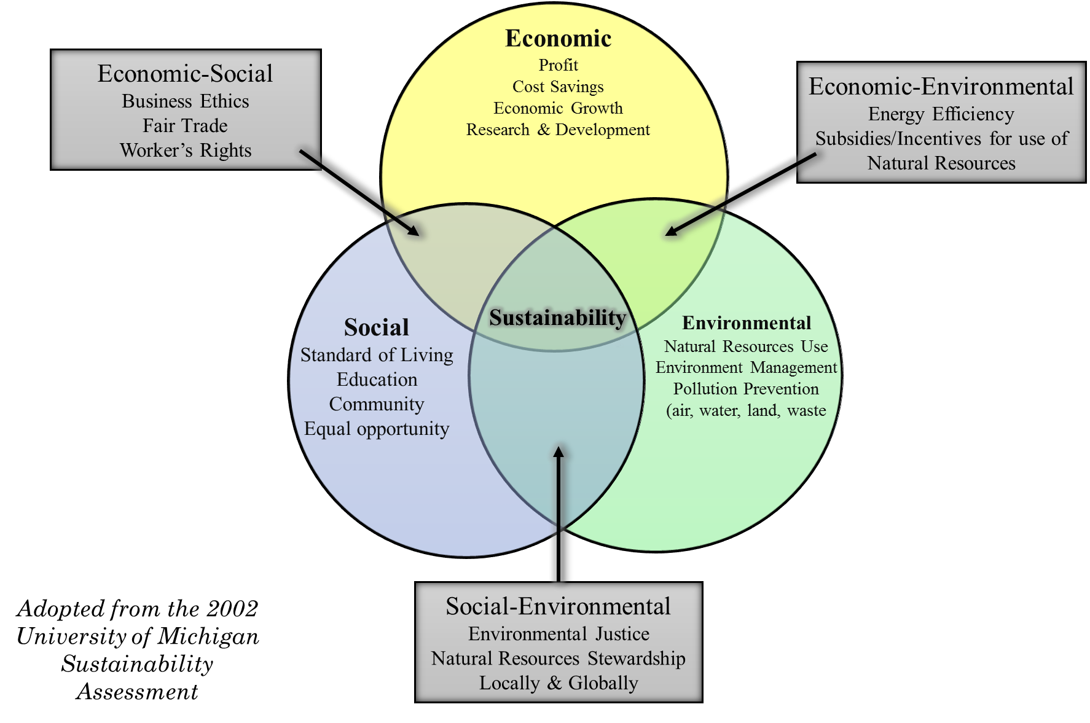
Figure 1.2: The Spheres of Sustainability

Need for Sustainable Development
The idea of Sustainable Development was quickly adopted by the entire world due to the growing urgency of sustainable development (Sachs, 2012). Most of the world societies understand the need to combine economic development by taking into account environment and social aspects. This understanding of world leaders arises as human activities have become threatening to the ecosystem of the planet. The world population is currently above 7 billion and is expected to reach 8 billion by 2024 (Scherbov, Lutz and co-authors, 2011). In last 20 years, the focus has been only on economic development, and in this process, the human development has put extreme pressure on natural resources and eco-system at the local and global level, and this development is yet to reach 50 percent of the people. The World Bank and United Nations have established a goal to eradicate poverty by 2030 (Burt, Hughes and co-authors, 2014). Based on the World Bank report, this is possible if the countries increase their economic growth at twice the current rate(Lakner, Negre and co-authors, 2014).
If the economic growth is increased by twice the today's rate without taking into account the ecosystem, then the effects of this could be catastrophic. It is therefore crucial that economic development for poor be taken by taking into account sustainable development and creating solutions that develop a vital balance between humanity and the human habitat.
In Sections 1.1 and 1.2 the motivation for the work reported on in this thesis is presented. The outcome from this discussion is that it is important to focus on rural development to eradicate poverty, and the solution must be anchored in sustainable development for continuous growth. Based on these two conditions, the work for this thesis is presented and discussed in subsequent section. In next section, the questions addressed for this thesis are discussed along with the expected outcomes.

THESIS QUESTION AND OUTCOMES
In previous Sections 1 and 2, two different concepts of development are presented, one anchored in rural development and the second one anchored in sustainable development. To reduce poverty and inequality in a country, it is needed that government is focused on rural development and in developing policies that empower people in rural areas. On another hand, based on the understanding of sustainable development, it is crucial that the future development around the globe be anchored in sustainability, that is, by taking into account all the three drivers of sustainable development (People, Planet, and Profit) together. The connection between these two concepts of development is required for established of Small and Micro Social Enterprises (SMSE’s). SMSE’s are focused on rural development and are the backbone of rural economies in developing countries. For a country to be sustainable, it is important that the local economy is also anchored in sustainability.
Weerawardena and co-authors in their paper, express the need for sustainability in social enterprises to have long-term survival and growth (Weerawardena and Mort, 2006). According to these authors “the role of the social mission goes hand in hand with the sustainability of the organization. Sustainability resulting from a balance of the entrepreneurial drivers of innovativeness, proactiveness and risk management is not seen as an end in itself, but sustainability is focused on ensuring the continuation of the organization because of its social mission.” (Weerawardena and Mort, 2006).
Rural small and micro enterprises started by the people in the community lack knowledge of business and management. Often the challenges that SME entrepreneurs face are lack of marketing and management knowledge. Added to this are issues in acquiring funds and getting human resources to perform the task (Saxena, 2012). Whereas the literature on social entrepreneurship has grown significantly over last two decades, it still remains fragmented. It is identified by Sullivan and co-authors, that a clear conceptual construct is missing in the theory of social entrepreneurship (Sullivan Mort, Weerawardena and co-authors, 2003).
Unlike business entrepreneurs, social and rural entrepreneurs lack experience, conceptual theory, and framework that can be used to create successful social enterprises. Added to this is the increase in complexity to connecting rural social entrepreneurship with sustainable development.
The objective in this thesis is to look at Sustainable Rural Development in India and to identify tools that can be helpful for social entrepreneurs to be successful. According to India’s latest census report, 67 percent of the Indian population resides in rural areas (Chandramouli and General, 2011). Nearly 270 million people are below the poverty line, 74 percent of India’s rural population, constituting the majority of India’s poor, is not fully integrated into the national economy ("Economic Survey of India," 2017). Two major challenges are geographical accessibility and lack of resources. It is difficult for the government alone to undertake the task of rural development. To overcome these challenges the government is pulling in private organizations in the development of societies through corporate social responsibility (CSR) bill (Singh and Verma, 2014). The Indian government is also focused on bringing social entrepreneurs in rural areas to develop small and micro enterprises. India is a country of varying culture and geographically distributed rural areas. Based on India’s geographical location, there is the difference between the resources, opportunities, and culture within rural communities. The tools therefore needed by social entrepreneurs must be adaptable and reusable based on the condition of the rural community.
From the literature review, the requirement is identified in the basic development theory for small and micro enterprises that are anchored in social entrepreneurship and sustainable rural development. For this thesis, the focus is on identifying the tools that connect the concept of rural development, sustainable development, small and micro social enterprises from a systems perspective. The social enterprise must be sustainable, and this requires the development of enterprise by connecting three drivers of sustainability as presented in Figure 1.3. Based on the information presented in Figure 1.3, to develop a social enterprise anchored in sustainable, need is to develop a sustainable value proposition for the enterprise. Once the value proposition is developed with a sustaining business model and partnership with various public-private organizations social value can be created.
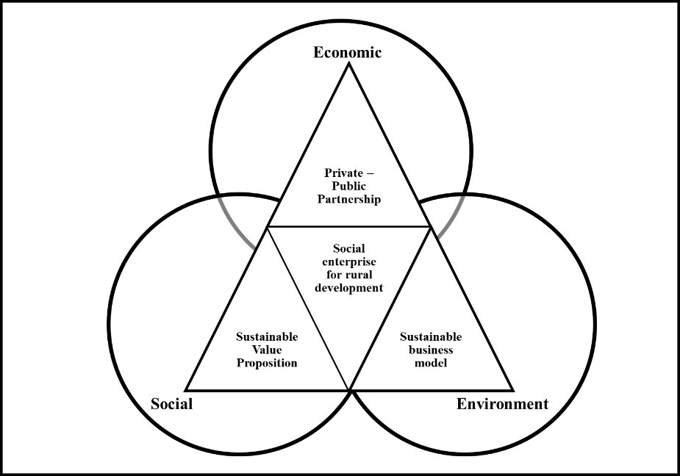
Figure 1.3 Requirements for Sustainable Rural Development

Based on the requirements presented in this section and Figure 1.4, the need is identified to develop an overall support system for social entrepreneurs in rural areas to develop small and micro enterprises anchored in sustainable development. Therefore, the primary question that is later subdivided into three secondary questions is;
What form of support system a social entrepreneur needs in defining the value propositions for development of the rural area that is sustainable with respect to the planet, profit and people involved?
The proposed hypothesis for the primary question is presented in next section, based on the hypothesis proposed, the primary question is subdivided into three questions in the later section.

Proposed Hypothesis for the Primary Question and its Verification
For a social enterprise to be successful, it is important to develop a value proposition that is sustainable and anchored in rural development. For a social enterprise to be sustainable one of important aspect is acquiring funding from investors. Currently, there is no tool available to develop a value proposition anchored in sustainable development or to acquire funding from investors. Social entrepreneurs rely only on their instincts and understanding to come up with value propositions. Due to variability and complexity of rural areas, it becomes difficult to make informed decisions. Sustainable development represents a multidimensional way of thinking (Flint, 2013). Added with sustainable development is a rural development that makes it a complex system for a social entrepreneur to understand. The work presented in this thesis is to understand this complex socio-techno system from a systems perspective. The support system that the social entrepreneurs need is systematic thinking to make decisions to develop a social enterprise. The proposed hypothesis therefore for the primary question is,
Hypothesis: By developing a decision support framework that embodies different constructs of systems thinking that are useful to support the decision made by social entrepreneur using systems perspective.
Based on the hypothesis stated, a framework is proposed and presented in Figure 1.4. The framework is anchored in providing a systematic step by step process for social entrepreneurs to develop a value proposition and evaluate its impact. Since there is no literature available on how social enterprise creates a value proposition, validation square is used in this thesis to validate the framework.
The framework proposed that is presented in Figure 1.4 includes different constructs that would be needed by social entrepreneurs to develop a value proposition for rural development. The flow of information in the framework is as follows. First, the social entrepreneur performs a baseline assessment of the village where she/he wants to start a social enterprise; see Loop 1. The baseline assessment is anchored in sustainable development. Based on the assessment, social entrepreneurs identify the area of inequity present in the village. In the second step, the social entrepreneur evaluates this inequity from different perspectives to identify a dilemma that leads to the development of a value proposition (Loop 2) (Yadav, Das and co-authors, 2017). Once the social entrepreneurs develop the value proposition, the next step is to identify the sustainability of the value proposition in terms of social, environmental and economic aspects of the village. In the third step, social entrepreneurs calculate the impact that a value proposition will have on the village (Loop 3). On satisfaction, the social entrepreneur proposes this proposition to investors who then compares and selects the value proposition that has maximum impact on the people. The framework consists of three constructs that are currently not available in the literature. Each of these constructs is developed in this thesis and is associated with one secondary question presented in the next section
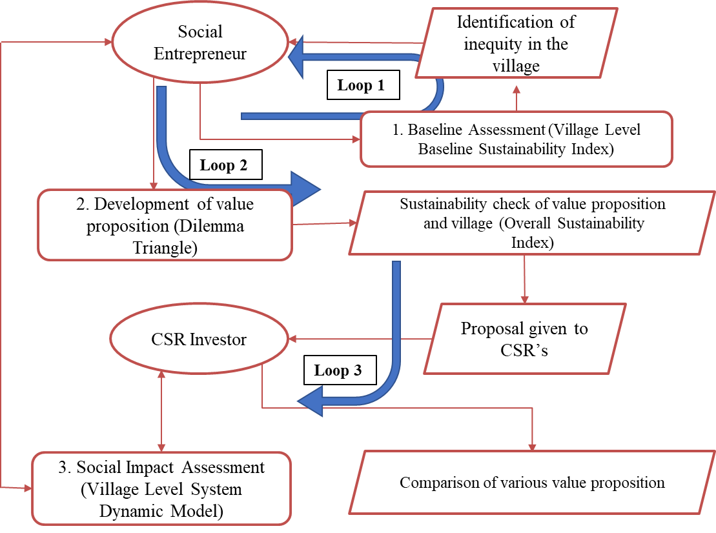
Figure 1.4 Proposed Framework of Value Proposition Development and Impact Evaluation Model (VPIEM)

Secondary Questions to be Answered
The framework proposed in Figure 1.4 is a step by step process that social entrepreneurs can use to develop a value proposition and assess the impact of the value proposition developed. The framework consists of three constructs that are currently not available in the literature. Unavailability of these constructs leads to secondary questions (one for each construct) for the work presented in this thesis. For each secondary question, a hypothesis is proposed, based on it the construct is developed. In Table 1.1, the questions answered in this thesis (primary and secondary) are presented along with associated sections in each chapter. The three secondary questions associated with three constructs are presented below along with the reason associated. The hypothesis for each of the questions is presented in Chapter 2 after the review of the literature.
Table 1.1: Relevant Sections for Investigating Thesis Questions
8 | 8.1 | √
7 | 7.3 | √ |  |  | √
7 | 7.2 | √ |  | √
7 | 7.1 | √ | √
5 | 5.2 |  |  |  | √
5 | 5.1 |  |  |  | √
4 | 4.2 |  |  | √
4 | 4.1 |  |  | √
3 | 3.2 |  | √
3 | 3.1 |  | √
2 | 2.4 |  |  |  | √
2 | 2.3 |  |  | √
2 | 2.2 |  | √
1 | 1.1 | √
1 | 1.2 | √
1 | 1.3 | √ | √ | √ | √
Chapters  Thesis Questions |  | What form of support system a social entrepreneur needs in defining the value propositions for development of the rural area that is sustainable with respect to the planet, profit and people involved? | What information is needed to identify current sustainability status of the village? | What method can be used as a tool to develop value proposition? | What tools are needed in the framework to identify impact assessment?
 |  | Q1 | Q2 | Q3 | Q4
 |  | Primary Question | Secondary Questions

The first secondary question referred as Q2 (of the thesis) from hereafter is presented below, followed by second secondary question referred as Q3 (of the thesis) and third secondary question referred as Q4 (of the thesis) respectively.
Q2: What information (qualitative and quantitative) must be collected from a rural area to evaluate its current status in terms of social, environment and economy? What method will be needed to evaluate this information and how can this information be used to develop a sustainable value proposition?
The information that is needed for a social entrepreneur to assess the baseline of the focused village is unknown. Most of the information that can be collected from rural areas is qualitative, and some of the information is in quantitative form. Based on this information social entrepreneurs should make decisions. The construct developed based on this question is used to collect relevant information and calculations are provided to evaluate this information for baseline assessment. The literature review to propose the construct is presented in Section 2.2 and the construct developed is discussed in Chapter 3 of the thesis. An example problem solved using the construct is presented in Section 3.2.
Once the baseline assessment of the village, next step is to create a value proposition, the construct required to develop a sustainable value proposition is currently not available. Therefore the secondary question associated is;
Q3: What method can be used to develop the value propositions for development of the rural area that is sustainable with respect to the planet, profit, and people involved?
By using baseline assessment, the social entrepreneurs direct their attention towards major inequities that can be observed on evaluation. The value proposition for a social enterprise is developed after understanding various perspectives, and to be sustainable the value proposition must be created by anchoring it people, planet and profit drivers. The literature review to propose the construct is presented in Section 2.3 and the method developed is presented in Chapter 4 of the thesis. An example problem solved using the construct is presented in Section 4.2.

The next step for a social entrepreneur is to evaluate the impact of their value proposition in the rural village. The value created by the social enterprise is social and qualitative. Therefore, the third secondary question for this thesis is,

Q4: What are the characteristics of the framework that will be used by social entrepreneurs and investors to evaluate the impact of the value proposition on various stakeholders?
The value created by the social entrepreneur is social and qualitative, without the impact evaluation it is difficult for social entrepreneurs to acquire funding from investors. Impact evaluation is also helpful in comparing different value propositions. Social entrepreneurs and investors can choose to develop, improve, and modify the value propositions further based on the impact analysis of each of the propositions. The literature review to propose the construct is presented in Section 2.4 and the construct developed is discussed in Chapter 5 of the thesis. Three vignettes (related to education, healthcare, electricity) are presented to show the utility of the construct in Section 5.3. The relevant sections for each secondary question are outlined in Table 1.1 above.
The proposed framework and associated constructs are developed from the perspective of the complex engineered system, where the information available is qualitative, and output is social. The social entrepreneurs are decision makers of this social complex system; the framework is decision support tool for social entrepreneurs and investor. In following chapters and section, each construct of the framework is discussed in detail. Discussion on each construct in following chapters provides a better understanding of the framework along with the philosophy behind taking a system thinking approach. Before the constructs are discussed, the objective in the thesis must be clearly stated.

The Objective in the Thesis
The outcome of the work done towards this thesis is a computational framework that can be used by social entrepreneurs, non-governmental organization, social workers to identify and develop value propositions that empower people living in poor communities. Social entrepreneurship and sustainable development are complex systems that merge in the field of poverty eradication and rural development. The framework developed for this thesis enables stakeholder of this complex system to have a systems perspective. The framework developed consists of constructs that can be used separately or together to support the decision making for the stakeholders. Work done in this thesis is to provide the method of using the framework and not to provide the results for rural development. The work is method oriented since each community, and social enterprise is different from another. That is, if all constructs including the framework are kept same, it may result in different outcomes by two different entrepreneurs in the same community. Therefore, the framework should be used only to direct attention towards issues and areas that are usually missed while making a decision in a complex system as under consideration.
Due to the characteristics of the system under consideration, the primary requirements for the framework are (a) it must be robust, (b) must be adaptable and (c) framework must be reusable in different communities and by different stakeholders. All this is done to provide a framework to support the designer in the process of decision making. The framework developed in this thesis is anchored in method design. To validate and verify a method, Validation Square is adapted and discussed in the next section.

VALIDATION STRATEGY – VALIDATION SQUARE
The work presented in the thesis is anchored in combining work from different fields together. At one end the discussion is on developing a framework anchored in creating a sustainable solution for rural development. At another end, due to high variability in characteristics of one rural area to other, the requirement for the framework is to be modifiable, adaptable and reusable. To validate a framework that is developed to bring multiple stakeholders together, and involves subjective elements in decision making using formal, quantitative validation becomes problematic (Dellinger and Leech, 2007). Validation of the frameworks such as one presented in this thesis, where there is no unique answer, the need is to build confidence in the utility of framework. In this thesis, Validation Square is used to build confidence in the framework with internal consistency and external relevance. The validation square is used in engineering design research to determine the usefulness of a design method; that is, to identify whether the method provides correct design solutions (effectiveness of the method); and whether design method provides solutions that are efficient and have acceptable operational performance (efficiency of the method).
The validation square consists of two main constructs: structural validity and performance validity. Both structural and performance validity is further divided into theoretical and empirical validity which leads to the four quadrants. This is presented in Figure 1.5.
The validation square presents the process of validation as presented in Figure 1.5, and the validation quadrants are;
Quadrant 1: Theoretical Structural Validity – examine the structural/ logical validity and overall consistency of the proposed method.
Quadrant 2: Empirical Structural Validity – includes building the confidence of the example problems chosen to verify elements of the proposed design method.
Quadrant 3: Empirical Performance Validity – is used to build confidence in the applicability of a method for the comprehensive examples that are chosen.
Quadrant 4: Theoretical Performance Validity – is building confidence in the general use of the method and determining is it useful for other problems beyond the example problems.
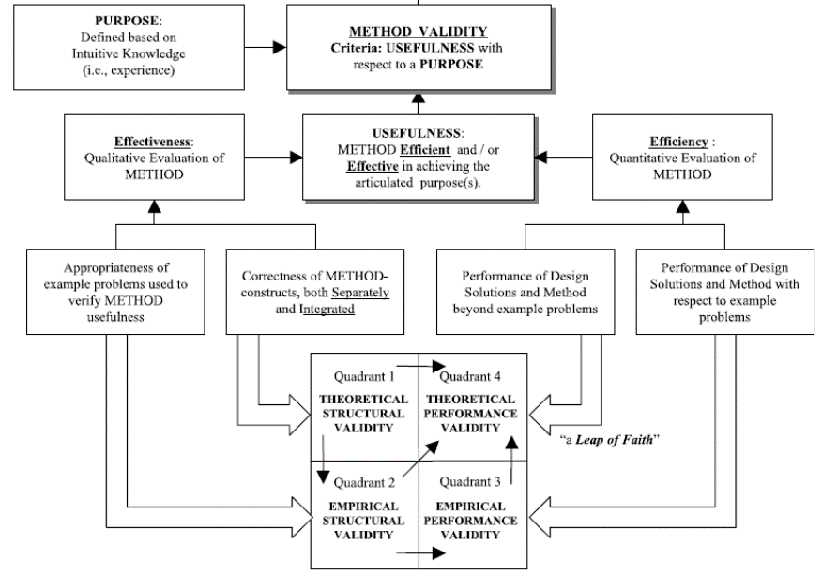
Figure 1.5: The Validation Square (Pedersen, Emblemsvag and co-authors, 2000)

Structural Validation – A Qualitative Process
Being effective implies three steps. It implies: Step (1) accepting the individual constructs constituting the method; Step (2) accepting the internal consistency of the way the constructs are put together in the method, and Step (3) accepting the appropriateness of the example problems that will be used to verify the performance of the method.
Quadrant 1: Theoretical Structural Validity
Theoretical structural validity involves Steps (1) and (2): accepting the individual constructs constituting the method and accepting the internal consistency of the way the constructs are put together in the method. This can be achieved by searching and referencing to literature related to the single constructs, which are already validated elsewhere. Furthermore, the correctness of the information flow throughout the entire design method needs to be demonstrated. For this step, a flowchart may be useful. To ease the comparison of the theoretical structure and the expected outcomes to the intended properties of the design method, a requirements list should be formulated.
In this thesis, the theoretical structural validity is related to Chapters 1, 2. In Chapter 1, the proposed framework is presented. Based on the framework, the requirement for each construct is identified. Overall, critical review of literature is presented for the primary question of the thesis and gap is identified. To fill the gap a framework. Theoretical Structural Validity for the framework is presented in Section 1.5 by discussing the internal consistency of the way the constructs are put together in the method (Step (2) of Theoretical Structural Validity). The flow of information from one construct to other construct is presented in Figure 1.7, building confidence in the overall framework.
In Chapter 2, need for individual constructs of the framework is presented. Literature review and opportunity to develop, add to available construct is presented. The justification that three hypotheses are logically formulated to fill the gap is discussed. In Section 2.5, Theoretical Structural Validity of the constructs is discussed by discussing the acceptance of the individual constructs constituting the method based on literature review (Step (1) of Theoretical Structural Validity).
Quadrant 2: Empirical Structural Validity
Empirical structural validity involves Step (3) accepting the appropriateness of the example problems that will be used to verify the performance of the method. This means, it must be shown that the example is good representations of the design problem, for which the method is designed and that the associated data can be used to support a conclusion.
In this thesis, the empirical structural validity is illustrated in Chapter 3, 4, 5 and 6, In Chapter 3, first example village is selected, and baseline assessment is calculated using Village Level Baseline Sustainability Index that is developed. In Chapter 4, another example village is selected to show the implementation of Dilemma Triangle construct for development of sustainable value proposition. In Chapter 5, one vignette from each, Education, Health Care and Electricity aspects of different is selected, the impact of various value propositions is evaluated using Village Level System Dynamic model. The proposed framework is developed to be useful in any rural area and any rural development project, the examples selected in Chapters 3, 4 and 5 for each construct build confidence on the utility of framework individually. In Chapter 6, a composite village is presented constituting data from various villages. The appropriateness of the composite village is presented in Chapter 6. In Chapter 7, the composite village is used as an example village to show the utility of the framework. Empirical Structural Validity of the framework is discussed in Sections 3.3, 4.3, 5.4 and 6.2 by discussing the acceptance of the appropriateness of the example problems that are used to verify the performance of the method

Performance Validation – A Quantitative Process
Efficiency (performance validation) implies three steps. It implies Step (4) accepting that the outcome of the method is useful with respect to the initial purpose of some chosen example problem(s); Step (5) accepting that the achieved usefulness is linked to applying the method; and Step (6) accepting that the usefulness of the method is beyond the case studies.
Quadrant 3: Empirical Performance Validity
Empirical performance validity is about showing the usefulness of the method for solving the example problems which includes Steps (4) and (5): accepting that the outcome of the method is useful with respect to the initial purpose for some chosen example problem(s); accepting that the achieved usefulness is linked to applying the method. The results achieved using the design method need to be analyzed and assessed. The analysis should also include assessment of data regarding internal consistency, for example, multiple starting points and convergence in optimization exercises.
In this thesis, the empirical performance validity is shown in Chapters 3, 4, 5 and 7 by implementing the steps proposed in the method and discussing the outcome for each construct. In Chapter 3, the empirical performance validity is shown for Village Level Baseline Sustainability Index. In Chapter 4, the utility of the Dilemma Triangle construct is shown in Section 4.2 and discussed in Section 4.3. In Chapter 5, the empirical performance validity of Village Level System Dynamic model is presented by using three vignettes.
Empirical performance validity of the overall computational framework is presented in Chapter 7, wherein a composite village is taken as an example and step by step each construct is connected as proposed in the framework.

Quadrant 4: Theoretical Performance Validity
Theoretical performance validity involves Step (6) accepting that the usefulness of the method is beyond the case studies; a “leap of faith” from the usefulness of the design method for the chosen example problems to the general validity of the method, which means building confidence in the generality of the method and accepting that the method is useful beyond the example problems. This can be supported by showing that the example problems are representative for a general class of design problems as well as a final critical analysis of the entire validation process.
In this thesis, the theoretical performance validity is presented in Chapter 8, in which the general usefulness of the framework presented in Chapters 3, 4, 5 and 7 is discussed. The hypothesis proposed for all the questions are validated. In Figure 1.6, the validation strategy of all 4 Quadrants is presented
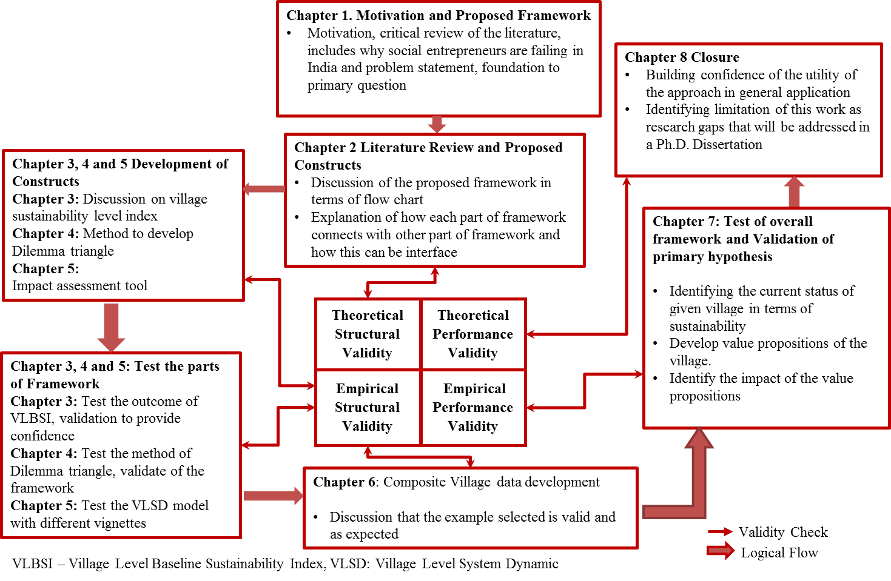
Figure 1.6: Validation Strategy for the Thesis

THEORETICAL STRUCTURAL VALIDITY – FRAMEWORK
The framework proposed to develop a value proposition for rural India is presented in Figure 1.4. The flow of information from one construct to other construct is discussed in Section 1.3. The theoretical structural validation of the framework is presented by validating Step (2) of Structural validation that is, discussing the internal consistency of the framework and how the constructs are put together. The internal consistency is discussing by presenting an information flow diagram from one construct to another in Figure 1.7 from one construct to next.
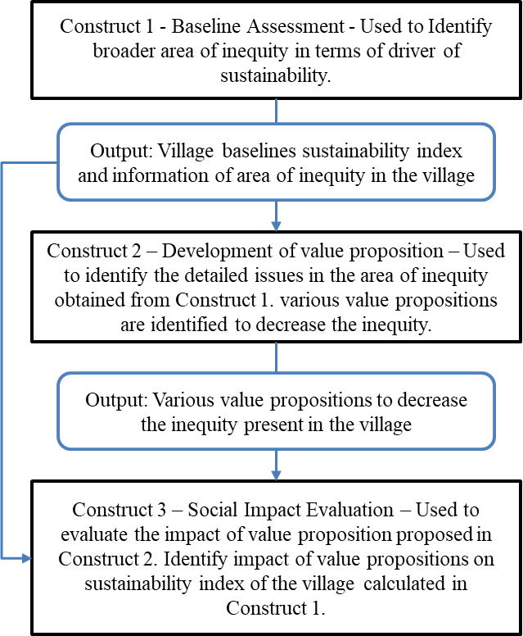
Figure 1.7: Information Flow in the Framework - Theoretical Structural Validity

ORGANIZATION OF THE THESIS
A roadmap of the thesis is presented in Figure 1.8 to provide an overview. In Chapter 1 is presented as an introduction to the need of a computational framework for the development of sustainable value proposition in rural India. The intent in this chapter to provide motivation for the rural development anchored in sustainable development by increasing number of sustainable small and micro enterprises in the rural communities. The primary focus in this thesis is to provide a theory to design sustainable social enterprises that are anchored in the improvement of the quality of life in rural communities. The background related to rural development is provided in Section 1.1. In Section 1.2, the foundational literature on sustainable development is discussed. In Section 1.3, the primary question for the thesis is presented along with the proposed framework and secondary questions for the thesis. In Section 2.1, a discussion on the difference between a social entrepreneur and business entrepreneur is presented. The literature review, hypothesis for each secondary question is discussed in different sections of Chapter 2. In Section 2.2, Thesis Question Q2 (refer Table 1.1) for the thesis is discussed, the gap in the literature is presented along with the hypothesis to fill this gap. In Section 2.3, Thesis Question Q3 is discussed, and in Section 2.4, Thesis Question Q4 is discussed.
The constructs and the method to develop constructs of the framework is presented in Chapters 3, 4 and 5. In Chapter 3, the Village Level Baseline Sustainability Index is presented. Literature evaluation on currently available baselines assessment tools is presented in Section 3.1. In Section 3.2, the baseline value in terms of sustainability driver is calculated using Village Level Baseline Sustainability Index. The output of the index is validated with the hypothesis proposed, and empirical structural validity of the VLBSI is discussed in Sections 3.3 and 3.4 respectively.

In Chapter 4, the method of Dilemma Triangle construct is introduced, and steps to use the construct are presented in Section 4.1. In Section 4.2, the method is applied on a village data and value propositions are developed. A discussion is presented on the evaluation of the sustainability of the value proposition.

In Chapter 5, a case is made to develop a Village Level System Dynamic model to evaluate the value propositions proposed for rural community development. A brief discussion is provided for different aspects of the System Dynamics. In Section 5.2, the Village Level System Dynamic model developed as part of this thesis is discussed in detail. In Section 5.3, three different vignettes are used to show the utility of Village Level System Dynamic model. The VLSD model presented in this thesis is developed to be reused in different communities for different aspects of the community. For this thesis, the boundary for the model is drawn around education, healthcare and electricity aspects of the community. Three different vignettes (one from education, healthcare, and electricity) of three different villages are presented in Section 5.3. The outcome from each of the vignettes shows the utility of the constructs and builds confidence, this is discussed in Section 5.4.
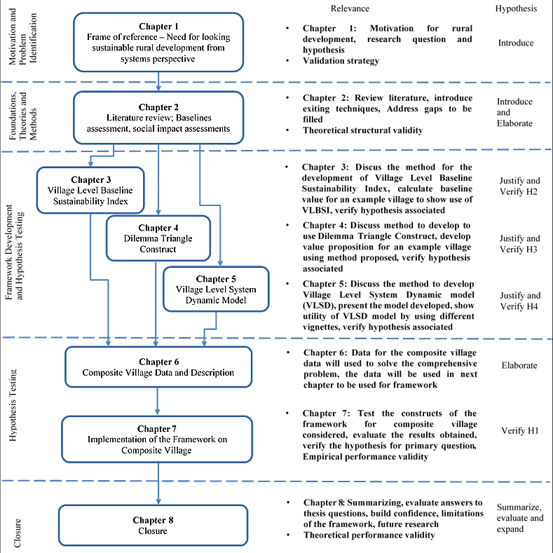
Figure 1.8: A Roadmap and Overview of the Thesis
In Chapter 6, data for a composite village is presented and discussed in detail. The composite village is developed by taking data from the different village across India to create a generic village. Some missing data is added in the composite village, this data is required for the framework and must be collected by social entrepreneur/user of the framework. The composite village is taken as an example to show the working of the framework.
In Chapter 7, the information from the composite village is taken as the input data for Village Level Baseline Sustainability Index; the index is presented in Section 7.1. The information obtained from the index is used as an input in Dilemma Triangle construct to identify dilemma for the composite village in Section 7.2. The hypothesis to convert dilemmas (zero-sum solutions) to positive solutions are discussed in Section 7.2. Once the selected hypothesis is converted to a value proposition, the value proposition is evaluated using Village Level System Dynamic (VLSD) model. The output from the framework is discussed in Section 7.3. Empirical performance validity of the framework is provided in Section 7.4

In Chapter 8, the summary of the thesis followed by research questions and validation of the hypothesis is presented. The framework for developing value proposition is discussed to summarize the work for this thesis. Limitations of the current framework are discussed. In Section 8.4, tentative Ph.D. research is discussed. In Figure 1.8, thesis organization and the road diagram is presented.

SYNOPSIS OF CHAPTER 1
In this chapter, a need for a computation framework for the development of sustainable value proposition for the rural development is presented. The framework proposed is a step by step process constituent of different constructs that are useful for social entrepreneurs to develop value proposition in poor rural areas of developing countries. In this chapter, first, the current situation of poor people living in rural areas in developing countries is presented in Section 1.1. With rural poor continuing to rise, the need to invest in rural development by providing a boost to social entrepreneurship in rural communities is discussed in Sections 1.1. However, with the effect of current economic trends destroying the environment, need is to work towards sustainable development. The work for social entrepreneurs, therefore, must be tied to sustainable development based on the discussion presented in Section 1.2. The background related to rural development is provided in Section 1.1. In Section 1.2, the foundational literature on sustainable development is discussed. In Section 1.3, the primary question for the thesis is presented along with the proposed framework and secondary questions for the thesis. In Section 1.4, verification and validation strategy is presented. A guideline for validation of the methods in this thesis is presented in Figure 1.6. In Section 1.5, the theoretical structural validity of the framework is presented by building the confidence on the flow of information from one step to another; this is presented in Figure 1.7. Further, in Section 1.6 the structure of this thesis is discussed and presented in Figure 1.8. Evaluation of the structural soundness of the thesis and answer research questions are performed by revisiting this chapter. In Figure 1.9, the organization of thesis is presented to show what is presented so far and what is to come next.
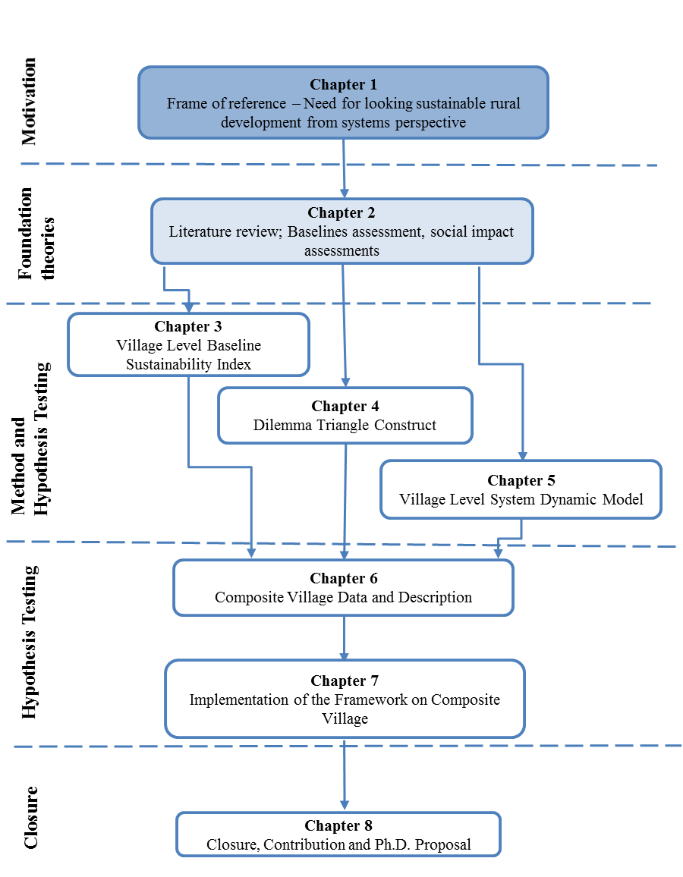
Figure 1.9: Organization of the Thesis – Presented and Next Chapter
In Chapter 2, the first the difference between social and business entrepreneur is presented. Later in the chapter review of the literature with respect to the required constructs of the framework is presented. For each construct, the gap is identified in the literature with respect to the requirements of the framework. For each construct, a secondary question is posed, and the hypothesis is proposed.

CHAPTER 2
SUSTAINABLE RURAL DEVELOPMENT
In Chapter 1, the background for considering rural development combined with sustainable development is presented. The requirement of a framework to support sustainable rural development with the constructs of the framework is discussed as well. In this chapter, the literature available with respect to each construct is presented. The gap identified in the literature is discussed, and secondary questions are presented along with the hypothesis for each of the question.
In Section 2.1, the difference between a social entrepreneur and business entrepreneur is presented. The literature that is available for developing ideas for both types of enterprises is also presented in Section 2.1. In Section 2.2, the literature available on baseline assessments is discussed. The gap presents in literature for baseline assessment followed by a proposed solution to fill this gap is presented. Similarly, in Sections 2.3 and 2.4, the review of literature for value proposition development and impact assessment that is currently present for business and social enterprises is discussed respectively. The gap for each construct is defined in sections along with the proposed constructs to fill the gaps.

SOCIAL VS. BUSINESS ENTREPRENEUR
Entrepreneurship is one of the key factors for the economic development in the world. With each entrepreneur creating a different product and following a different method to develop these products, there is a huge amount of literature on how to develop a value proposition from different sources. A social enterprise plays a key role in uplifting the condition of the poor and facilitating community development (Weerawardena and Mort, 2006). The focus in this thesis is on social entrepreneurs, as they provide appropriate leadership that results in achieving a sustainable advantage, thereby achieving their social mission (Weerawardena and Mort, 2006). Theory on entrepreneurship is available from the 19th century, and therefore it is crucial to understand the difference between social and business entrepreneurship and, how theories of one can or cannot be applied to other. In this section, the comparison between both entrepreneurship is discussed. In Table 2.1, developed by Cisco IBSG, 2011, the basic differences between a business and social entrepreneur are represented. Information presented in Table 2.1, is used to provide an overview of the difference between business and social entrepreneurs.
Table 2.1: Business vs. Social Entrepreneur – Cisco – Business of Social Entrepreneurship
 | Business Entrepreneurs | Social Entrepreneurs
Goal | Capture a market securely | Fill a market gap; change the world
Objective | Build a business; earn profits | Create sustainable solutions for social change
Profit motive | Maximize shareholder value; profit as an end | Advance social aims; profit as a means to financial sustainability
Risk | Basic business risk | Basic business risk plus social aspect
Link to social problems | Indirect | Direct
Feedback | Established consumer and market information sources | Need to creative in obtaining market and responses
Competition | Win" for one business over others in a market | Exists because no one else is adequately solving problem, "win" for society
Growth | Competitive for one company | Collaborative for societal impact
Capital | Benefit from robust financial managerial services | Contend with unpredictable and fragmented financing

Social entrepreneurship is defined as one of the ways to address the social needs by creating solutions that have social value (Austin, Stevenson and co-authors, 2006; Dees, 2017). Social entrepreneurs are the people who create an innovative not-for-profit solution that solves a social need or issue. These entrepreneurs identify most effective methods to solve social cause (Dees, 2017).Sometimes the solution developed needs to take into account different drivers of the world together (Cabrido Jr and Anosan, 1989). In social entrepreneurship, the wealth creation takes the last seat. The first goal is to solve the social issue, the second goal is to sustain the enterprise, and final goal is to make the profit.
The social entrepreneur’s fundamental objective is to work on the social mission. Usually, they strive to develop systematic changes and sustainable growths. Some of these enterprises are developed to act on local grounds and have potential to simulate global improvements with long-term social return on investment and need of sustaining the impact (Dees, 2017).
Business enterprises, on the other hand, are developed to create wealth and make a profit. Wealth created is used to measure the value created by a business entrepreneur (Dees, 2017). The main goal here is to satisfy customer needs and provide growth to shareholders by expanding the influence of business (Weerawardena and Mort, 2006). In business enterprises, the value is created when customers pay more for the product or services willingly than the cost of its production.
In the literature, some scholars have pointed out that business entrepreneurs also create social value and help solve social problems by identifying solutions for various inequities. Business entrepreneurs create jobs that help in improving the standard of living for many people and communities (Mair and Marti, 2006). Scholars continue to point out that, at even extreme ends of both social and business entrepreneurship, there are elements of each other. That is, activities of social behavior reflect economic aspects and profit product also generates social value (Austin, Stevenson and co-authors, 2006). For the work done in this thesis, the difference is considered due to one main governing reason, that is, the ‘motive of the entrepreneurs.’ For social entrepreneurs, the motive is social change and creating social value. For business entrepreneurs, the motive is to make a profit, and in this process, if they create social value, it becomes an added advantage. The difference is between the goals that each of the entrepreneurs have for their enterprises, the growth path they choose and the profit motives they have. For this thesis, the focus, therefore, is on social entrepreneurs rather than the business entrepreneurs.
A social entrepreneur is motivated to have a reasonable cash flow that will be required by him/her to sustain the enterprise and help society, and improve people’s standards of living, whereas, business entrepreneur strives to maximize his/her profit. Social entrepreneurs strive to develop a win-win solution that is anchored in identifying the requirements of each stakeholder and work towards developing solution wherein everyone wins. From the information available in Table 2.1 and literature review presented on different goals, aspiration, and market of the social entrepreneurs and business entrepreneurs, it is deductible that theory of business entrepreneurship is not useful for social entrepreneurship. With the given understanding of the difference between social entrepreneurs and business entrepreneurs, in the next section, the literature on the first construct (baseline assessments) of the framework (presented in Section 1.3, Figure 1.4) is discussed. The gap in baseline assessment theory for social entrepreneurship is discussed. From the gap identified, the hypothesis for the first secondary questions is proposed. In this chapter, review of literature is presented for each of the constructs. For understanding the breakup of the thesis with respect to thesis questions, visualization purposes, in Table 2.2, all the thesis questions along with the hypothesis proposed are presented with chapter and sections associated to each question. In Chapter 1, the primary question is introduced, and the hypothesis is elaborated. In next section (Section 2.2) Thesis Question Q2 and hypothesis related to it is introduced and elaborated.

BASELINE ASSESSMENT INDEX – CONSTRUCT 1 OF THE FRAMEWORK
In Section 1.3, the need for identifying the current status of a village to develop value propositions is discussed for the framework. For social entrepreneurs working on providing sustainable social value, the information gathering must be anchored in terms of drivers of sustainability. A social entrepreneur similar to business entrepreneur needs to evaluate the current condition of her/his target stakeholders. In entrepreneurial term, this is called as the baseline assessment. While conducting the baseline assessment, the main goal is to identify the present status of the villages or market. Based on the information gathered and evaluated, the area of focus is identified. In this section, the literature available on baseline assessments is discussed and secondary question restated.

In Section 2.2.1, the literature available on the baseline assessment method at a village level is discussed. Based on the literature review, the gap is identified in the field of social entrepreneurship. Later in the section, the first secondary question for this thesis is presented and discussed. In Section 2.2.2, the hypothesis of developing a sustainability assessment method to fill the gap is presented.
Table 2.2: Organization of Thesis Questions

 |  | Questions posed in this Thesis | Hypothesis | Introduced in | Elaborated in | Verified in
Primary Question | Q1 | What form of support system a social entrepreneur needs in defining the value propositions for development of the rural area that is sustainable with respect to the planet, profit and people involved? | By developing a decision support framework that embodies different constructs of systems thinking that are useful to support the decision made by social entrepreneur using systems perspective. | Chapter 1, Section 1.3 | Chapter 1, Section 1.3 | Chapter 7, Chapter 8
Secondary Question | Q2 | What information is needed to identify current sustainability status of the village? | By developing a village level baseline sustainability index that includes social, environment and socio-economic aspects of a village. The index will include various aspects and questions on the status of social, environment and socio-economic aspects. On calculating, identifying the values of these aspects and answers to the question will give the current sustainability value of the village, thereby giving insight on the perspectives which social entrepreneurs can concentrate while developing a value proposition. | Section 2.2 | Chapter 3 | Chapter 3, Chapter 7
Secondary Question | Q3 | What method can be used as a tool to develop value proposition? | By developing a method that embodies construct of Dilemma Triangle to understand various perspectives for developing a value proposition and will be used in identifying various dilemmas which could arise in rural development thereby giving an insight on what should be the value created by the value proposition for the development of the village | Section 2.3 | Chapter 4 | Chapter 4, Chapter 7
Secondary Question | Q4 | What tools are needed in the framework to identify impact assessment? | By developing a method containing different concepts of System Dynamics tool embodied in the framework to recognize various sectors which will have an impact on quality of life of villagers. | Section 2.4 | Chapter 5 | Chapter 5, Chapter 7

Background on Baseline Assessment
Social programs all over the globe continue to use baseline assessments on interested target groups to measure the impact of the program after implementation (Freudenthal and Narrowe, 1992). Initially, before project implementation, an assessment of various variables is conducted on the target group to calculate the baseline values. Later, post project implementation, increases or decrease of the variables is used to determine the impact of the projects (Khandker, Samad and co-authors, 2012; Wallace, 2017). The process of conducting the baseline assessment is done by collecting the data in terms of indicators or benchmarks from different sources to describe the socio-economic condition of a particular target group, village or community (Freudenthal and Narrowe, 1992).
Conducting the baseline assessment has many uses for the program coordinators as well. Baseline assessments are used to calculate whether a project is effective or not, they are used by coordinators to understand large and complex social systems. The baseline assessment is also used in deciding when and what kind of interventions are needed for the target group (Khandker, Samad and co-authors, 2012). All these uses are as relevant to the social entrepreneurs as they are to business entrepreneurs. However, an additional characteristic of baseline assessment that is very useful for a social entrepreneur is identifying the area of inequity in a community or a village (Freudenthal and Narrowe, 1992). Also, the challenges for social entrepreneurs working in rural areas are, to collect information that is correct, easy to evaluate and is understood by all the stakeholders; to acquire data in a quantitative format and evaluate it to calculate the baseline assessment; and, to create a baseline assessment for every village he/she visits due the varying characteristics of each village. To overcome last challenge, a general framework is useful that is modifiable and reusable.

Freudenthal and Narrowe in ‘Baseline Study Handbook’(Freudenthal and Narrowe, 1992), present a general framework for baseline assessment; they define a various condition for conducting the assessment and identify the user groups that can use the assessment. Other authors also provided a step by step guide to creating different baseline assessment tools. The framework presented in the literature is generic and is adaptable by a different organization and stakeholders of baselines assessment. However, for the work done in this thesis, the goal is to develop a baseline assessment at the village level that is generic and modifiable, this is absent in work done by Freudenthal and Narrowe (Freudenthal and Narrowe, 1992). Therefore, the work done in literature is considered as starting point for the development of baselines assessment index at village or community level.
The available literature on baseline assessment in entrepreneurship is limited. Though the assessment tools are developed, the gap is identified in the use of these assessment tools in the field of social entrepreneurship. The baseline assessments are conducted for social projects. However, they have not been used as a tool to direct attention on inequities in a village. Wallace (Wallace, 2017) in the literature suggests that finding inequity in a community helps in highlighting specific issues and identifying the area of focus. The work done on baseline assessment is helpful in identifying these inequities. These assessments can be used to identify the broader areas of focus that social entrepreneurs can investigate further using the Dilemma Triangle construct presented in Section 2.3 in this chapter. Baselines assessments can be useful in villages to identify the inequities in terms of sustainable development. Baseline assessments can be used by social entrepreneurs to also evaluate the impact of their interventions. However, with lack of available assessment tools anchored in sustainable development for rural villages in India and challenges of information unavailability, reusability, modifiability creates a requirement to develop a baseline assessment tool that is useful for social entrepreneurs to overcome these gaps.
Based on the challenges identified, the Thesis Question Q2 proposed (also presented in Section 1.3) and addressed in this thesis is,
Thesis Question Q2: “What information (qualitative and quantitative) must be collected from a rural area to evaluate its present status in terms of social, environment and economy? What method will be needed to evaluate this information and how can this information be used to develop a sustainable value proposition.”

Proposed Hypothesis for Question 2 (Sustainability Assessment Index)
The proposed hypothesis for Question 2 posed is anchored in the concept of reusability and modularity. To fill the gap identified in the literature of baseline basement, in this thesis, the focus is to understand the theory of indices and indicators. In past indices and indicators have been used to measure various international, national, local aspects related to social, economy or environment aspects (Rajewski, 1994; Rep, 2006; Romer, 1989). Indices are used to rank countries in terms of their annual growth, unemployment rate, environmental degradation, etc. United Nations also uses indices and indicators to calculate sustainable development progress at international and national levels (Kates, Parris and co-authors, 2005).

Indicators, indices are very popular in the field of decision making and policy evaluation (Hammond, Adriannse and co-authors, 1995). With the use of indicators, the information is collected, evaluated and calculated in a simple form. Indicators are also used to quantify qualitative information using different scales, ranking methods. Indices can be developed for different levels – community, sectoral, national and international. Same indices are reused in different communities, countries with minimum changes.

Social entrepreneurs usually deal with word problems and qualitative information. These entrepreneurs need to process this information and identify the inequities anchored in social, environmental and economic drivers of a community. The hypothesis therefore proposed for Question 2 is,

The hypothesis for Q2: “By developing a village level baseline sustainability index that includes social, environment and socio-economic aspects of a village. The index will include various aspects and questions on the status of social, environment and socio-economic aspects. On calculating, identifying the values of these aspects and answers to the question will give the current sustainability value of the village, thereby giving insight on the perspectives which social entrepreneurs can concentrate while developing a value proposition.”
Based on the hypothesis proposed, a Village Level Baseline Sustainability Index (construct 1) is developed. In Chapter 3, the Village Level Baseline Sustainability Index (VLBSI) is discussed in detail. After assessing the baseline value, the next step is to develop a value proposition for social development. In next section, Thesis Question Q3 of the framework is presented, and a hypothesis is proposed to answer the question is presented in Table 2.3.
Table 2.3: Organization of Thesis Questions

 |  | Questions posed in this Thesis | Hypothesis | Introduced in | Elaborated in | Verified in
Primary Question | Q1 | What form of support system a social entrepreneur needs in defining the value propositions for development of the rural area that is sustainable with respect to the planet, profit and people involved? | By developing a decision support framework that embodies different constructs of systems thinking that are useful to support the decision made by social entrepreneur using systems perspective. | Chapter 1, Section 1.3 | Chapter 1, Section 1.3 | Chapter 7, Chapter 8
Secondary Question | Q2 | What information is needed to identify current sustainability status of the village? | By developing a village level baseline sustainability index that includes social, environment and socio-economic aspects of a village. The index will include various aspects and questions on the status of social, environment and socio-economic aspects. On calculating, identifying the values of these aspects and answers to the question will give the current sustainability value of the village, thereby giving insight on the perspectives which social entrepreneurs can concentrate while developing a value proposition. | Section 2.2 | Chapter 3 | Chapter 3, Chapter 7
Secondary Question | Q3 | What method can be used as a tool to develop value proposition? | By developing a method that embodies construct of Dilemma Triangle to understand various perspectives for developing a value proposition and will be used in identifying various dilemmas which could arise in rural development thereby giving an insight on what should be the value created by the value proposition for the development of the village | Section 2.3 | Chapter 4 | Chapter 4, Chapter 7
Secondary Question | Q4 | What tools are needed in the framework to identify impact assessment? | By developing a method containing different concepts of System Dynamics tool embodied in the framework to recognize various sectors which will have an impact on quality of life of villagers. | Section 2.4 | Chapter 5 | Chapter 5, Chapter 7
In this section the baseline assessment to identify the broader area of inequity in terms of the driver. In the framework, the output from baseline assessment is used as input to value proposition development and social impact evaluation.

CREATING VALUE PROPOSITION FOR SOCIAL DEVELOPMENT – CONSTRUCT 2 OF THE FRAMEWORK
To develop a value proposition for a social enterprise, the entrepreneur needs to identify the focus area. In the previous section, the literature on baselines assessment construct is discussed, the construct developed based on the previous section is presented in Chapter 3 and can be used by social entrepreneurs to identify the focus area of a particular village. Once the area of focus is identified, next step is to create the value proposition for the stakeholders. In Section 2.3.1, the literature on how to create a value proposition for social enterprises is discussed. The gap in the literature is identified, and secondary Question 3 for this thesis is posed. In Section 2.3.2, the proposed hypothesis to use Dilemma Triangle construct is discussed.

Background on Value Proposition Development
To start an enterprise, the first step for an entrepreneur is to identify the value that he/she wants to provide to the stakeholders and/or their customers. This value created by entrepreneur becomes the value proposition for the enterprise. The field of entrepreneurship, in general, contains literature available from the field of business and management schools on how to develop the value propositions that are successful. In this section, the literature available to create a value proposition for business and social entrepreneurs is discussed and need for a method that is generic and adaptable for social entrepreneurs is discussed.

The current literature on social entrepreneurship ranges widely based on different context and phenomenon (Lehner, 2011). A social entrepreneur takes either top-down approach, wherein people with higher degrees and connections solve a social problem affecting a large population. Whereas the bottom-up approach is taken by people at the bottom of the pyramid starting enterprises to help themselves, and fellow community members, to improve their quality of life. Focus for this thesis is on the latter (Prahalad, 2006). There are different methods used by entrepreneurs that have become an entrepreneurial theory, some of them are discussed below.
“Opportunity recognition (OR)” is a method used in entrepreneurial literature to identify opportunities in the given space (Lehner, 2011). Many authors state OR as an integral part of venture creation. Some scholars go beyond that statement and define it as the basis for entrepreneurship. However, most of the work done in OR is specific to business entrepreneurship, and very few connections are available for OR in social entrepreneur context (Lehner, 2011).
The second term that is used in entrepreneurship literature is “Entrepreneurial thinking (ET).” ET is divided into two categories: Causal reasoning and Effectual reasoning. Causal reasoning is ‘Given that the goal is known how well someone can identify the means to achieve this goal.’ Whereas, effectual reasoning is based on “Given the means how well can someone identify the goal that can be achieved” (Prahalad, 2006). The approach of effectual reasoning is built on the identification of the market that is unknown and the problem that is unknown. Most of the literature on OR and ET is based for business entrepreneurs. The framework that can be adopted by social entrepreneurs (especially) using bottom-up approach is not available.
The work in this thesis is based on distinguishing that social entrepreneur opportunities are different from for-profit ventures (see Section 2.1). The area where social enterprises are established is different from business enterprises based on their orientations and social aspects (Lehner, 2011). Therefore, the tools for social enterprises must also be developed accordingly. Social enterprises are placed in civil society and require collective action of multiple actors working together to create social value.
The scholars in social entrepreneurship have also contributed in defining various theories, concepts, and models to help social entrepreneurs in the process of creating social value. Weerawardena and co-authors in their paper investigate the same for social entrepreneurship (Weerawardena and Mort, 2006). They use grounded theory to discover the concept of social entrepreneurship. In this process, they define seven propositions that are observed in a social entrepreneur. Weerawardena and co-authors continue to develop a bounded multi-dimension model that includes three factors of entrepreneurship (risk management, proactiveness, and innovativeness) bounded by the environment, sustainability and social mission. They contribute to the theory of social entrepreneurship in terms of including sustainability, social mission but do not provide a method to create this multi-dimensional model.
Patalaa and co-authors on another hand in their paper (Patalaa, Jalkalaa and co-authors, 2013), propose a framework for developing a sustainable value proposition anchored for an industrial product service system. In this work, a framework to demonstrate the value of a product service industry in terms of social, economic and environmental aspect is presented. The steps of the framework anchored in drivers of sustainability are also discussed. Patalaa and co-authors develop the framework to improve an already established industry in terms of social and environmental aspect. However, in their work do not define a method or a process on achieving each step of the framework.
Unlike business enterprises, social enterprises create social value. One of the characteristics a social entrepreneur must poses is the ability to identify the social value creating opportunity (Sullivan Mort, Weerawardena and co-authors, 2003). Business entrepreneurs identify a gap in the market and exploit it to gain profit. Whereas social entrepreneurs need to identify the inequities present in social, environmental and economic aspects of the community and propose value proposition that is used to remove the inequity.
On another hand, the relationship conflicts and task conflicts are common in enterprises (D’Mello, Kushev and co-authors, 2012). Solving relationship conflicts can keep the backing of stakeholders intact. Solving task conflicts helps the entrepreneurs working towards their goals. For social entrepreneurs, along with these conflicts, there are also conflicts involving the drivers of sustainability.
Sometimes these conflicts become dilemmas leading to zero-sum solutions. Due to dilemmas, either stakeholder withdraws their support from enterprise or enterprises shut down thereby resulting in a loss for the people involved (Santos, 2012). Whereas, social entrepreneurs who are able to solve these dilemmas are successful in sustaining their enterprises and continue to have a positive impact on the people and societies (Santos, 2012). Identifying and managing these dilemmas can help social entrepreneurs in developing the value they can offer to the people and also the support they need from various stakeholders.
Tough the business entrepreneurship is one of the oldest areas of research. Social entrepreneurship is comparatively new with literature available for only a decade and a half (Martin and Osberg, 2007). The area of social enterprises, the value it must provide, and the definition of social entrepreneur has a huge disparity. Various researchers in the field of entrepreneurship are working on defining what a social enterprise is and what value it must provide. Due to this disparity of definitions of social enterprises, few have focused on how these entrepreneurs can create the value proposition that is anchored in improving the quality of life. The framework that is needed must be reusable for a large set of social entrepreneurs and take into account the conflicts that arise between various stakeholders. In Summary, based on the literature available, the gap is identified in a method to develop the value propositions that can be used by social entrepreneurs anchored in sustainable development. The Thesis Question Q3 based on this gap is,
Thesis Question Q3: What method can be used to develop the value propositions for development of the rural area that is sustainable with respect to the planet, profit, and people involved?
In next section, the hypothesis to fill the gap is presented to develop a win-win solution for all the stakeholders and achieve sustainable development.

Proposed Hypothesis for Question 3 (Dilemma Triangle)
Based on the literature review in the previous section, the gap in social entrepreneur theory is identified in two areas. One is, how to develop value propositions that can be used to remove the inequity and creates social value. Second, how to identify and remove the conflict between stakeholders who don’t have an economic return on investment. Inequity can also be seen as a conflict or a zero-sum process, where one side continues to win and thereby creating inequity in the system. This aspect is seen in both, stakeholder conflict and value proposition development.

The proposed Dilemma Triangle construct saw its roots in the identifying new knowledge by Master’s and Ph.D. students (Khosrojerdi, Rezapour and co-authors, 2014). Khorsrojerdi and co-authors in their paper (Khosrojerdi, Rezapour and co-authors, 2014), developed the basis of Dilemma Triangle for identifying the knowledge between any three drivers as an initial step for drawing the boundary for their research. For this thesis, the work is elaborated on Dilemma Triangle to identify the gap that needs to be filled by a social entrepreneur in society for the development of people. The hypothesis proposed to answer Question 3 is,
The hypothesis for Q3: “By developing a method that embodies construct of Dilemma Triangle to understand various perspectives for developing a value proposition and will be used in identifying various dilemmas which could arise in rural development thereby giving an insight on what should be the value created by the value proposition for the development of the village.”.
The connection between Dilemma Triangle associated with three drivers and sustainable development established on the three pillars of sustainability is proposed. For this thesis, the use of Dilemma Triangle construct along with the concept of spheres of sustainability to present a method that social entrepreneurs can use to develop a value proposition establishing a balance between the three pillars of sustainable development is proposed.

Table 2.4: Organization of Thesis Questions

 |  | Questions posed in this Thesis | Hypothesis | Introduced in | Elaborated in | Verified in
Primary Question | Q1 | What form of support system a social entrepreneur needs in defining the value propositions for development of the rural area that is sustainable with respect to the planet, profit and people involved? | By developing a decision support framework that embodies different constructs of systems thinking that are useful to support the decision made by social entrepreneur using systems perspective. | Chapter 1, Section 1.3 | Chapter 1, Section 1.3 | Chapter 7, Chapter 8
Secondary Question | Q2 | What information is needed to identify current sustainability status of the village? | By developing a village level baseline sustainability index that includes social, environment and socio-economic aspects of a village. The index will include various aspects and questions on the status of social, environment and socio-economic aspects. On calculating, identifying the values of these aspects and answers to the question will give the current sustainability value of the village, thereby giving insight on the perspectives which social entrepreneurs can concentrate while developing a value proposition. | Section 2.2 | Chapter 3 | Chapter 3, Chapter 7
Secondary Question | Q3 | What method can be used as a tool to develop value proposition? | By developing a method that embodies construct of Dilemma Triangle to understand various perspectives for developing a value proposition and will be used in identifying various dilemmas which could arise in rural development thereby giving an insight on what should be the value created by the value proposition for the development of the village | Section 2.3 | Chapter 4 | Chapter 4, Chapter 7
Secondary Question | Q4 | What tools are needed in the framework to identify impact assessment? | By developing a method containing different concepts of System Dynamics tool embodied in the framework to recognize various sectors which will have an impact on quality of life of villagers. | Section 2.4 | Chapter 5 | Chapter 5, Chapter 7

The method of the construct of Dilemma Triangle and sustainability triangle is presented in Chapter Section 4.1. Example problem using the dilemma construct is solved and presented in Section 4.2. The Dilemma Triangle construct developed is generic, and it can be used as an attention-directing tool for all the social entrepreneur and all the entrepreneurs focus on sustainable development as well. The proposed method is qualitative and can be used as an attention-directing tool to be used for a social entrepreneur to identify the conflicts between multiple stakeholders and inequities.

Once a value proposition is developed, the next step is to evaluate the impact of this value proposition on the village under consideration. Calculating proposed social value created is important in a social enterprise. Social value is a critical measure for social enterprises, similar to economic growth for business entrepreneurship. In Section 2.4, the literature for the need of impact evaluation for an enterprise is presented. Thesis Question Q4 and a hypothesis is proposed to answer the question is presented in Table 2.4.

SOCIAL IMPACT ASSESSMENT
The final aspect of the framework proposed is to evaluate the possible impact of the value proposition that is proposed for a given village. The impact is defined as ‘any effect of the service [or of an event or initiative] on an individual or group’ (Streatfield and Markless, 2009). A basic aspect of impact is the change in an individual, community, group or organization due to the implementation of a service, process or addition of a product in the market. Impact assessment for an enterprise or a program can be divided into two phases a) forecast impact assessment and b) real-time impact assessment. For social entrepreneurs both phases of impact assessments are crucial. Impact of the value proposition created by entrepreneurs is helpful in approaching investors by defining the social value the social enterprise could provide.
In this section, the focus is on presenting the literature available on impact assessment and the gap that is currently available in the literature for social entrepreneurship. In Section 2.4.1, the literature on impact assessment that is available is discussed. In Section 2.4.2, the gap in the current literature is defined, and Question 4 for the thesis is stated. In Section 2.4.3, proposed solution to fill the gap leading to the hypothesis is proposed.

Background on Social Impact Assessment
Social impact assessment (SIA) was first formalized at the beginning of 1970’s to predict the socio-economic impact of large-scale projects. Initiated in the U.S., under the National Environmental Policy Act (NEPA), 1969, the use of SIA is changed and expanded (Streatfield and Markless, 2009).
Social impact assessments are conducted with the perception that decision makers will make better decisions if they understand the consequences of their decisions. An accurate social impact assessment will help decision makers in answering various questions such as: “What will happen if a proposed action were to be implemented –why, when, and where? Who is being affected? Who benefits and who loses? What will change under different alternatives? How can adverse impacts be avoided or mitigated, and benefits enhanced?” (Burdge, 2004).
With the increase in the number of social enterprises around the globe, the demand of methods and tools to calculate their social impact is rising (Kroeger and Weber, 2014). The measurement of social impact helps entrepreneurs in making decisions and monitoring the effectiveness of their value creation (Potma, 2016). The nature of social enterprises and value that is created by them is complex and understanding this value for the enterprises, and all the stakeholders become crucial (OECD, 2015). Social Impact assessment is also been used in comparing different social initiatives (Kroeger and Weber, 2014). It also helps in discovering ways to maximize the impact of social enterprise (Potma, 2016).
Lisa Potma in her thesis (Potma, 2016), reviews the work by authors focused on adapting performance measuring tools of business enterprise to social enterprises. Besides the difference in business and social enterprises mentioned in Section 2.1, other reasons for not using the same method is the way business enterprises measure performance. Business enterprises measure the performance based on return on investment and are quantitative due to nature of calculation in the single monetary term. Comparatively, though social enterprises have finance as an important aspect for sustainment, the real performance is the social value created, that is qualitative, intangible and highly difficult to measure (Potma, 2016).
Various researcher and organizations so far have worked on social impact assessment and have developed different measurement tools and methods (Potma, 2016). This adds an additional challenge for social entrepreneurs to select the right assessment tools for their enterprise and the value they create (Maas and Liket, 2011). In the following paragraphs, a brief overview of few selected social impact assessment tools available is discussed. The gap in each of the assessments along with the shortcomings are discussed. Selection of these tools is based on the work done by Lisa Potma for her Master’s thesis (Potma, 2016).
Some impact assessment measurement methods available in the literature are Social Return on Investment (SROI), Poverty Social Impact Assessment (PSIA), and Social Costs-Benefits Analysis (SCBA). A brief description is provided for each one of these tools in following paragraphs.
- Social Return on Investment (SROI) is used for organizations that have both social and market goals (Rosenzweig, 2004). To calculate the SROI, the monetary value of social impact is projected and compared to the inputs (Maas and Liket, 2011). SROI is credible and is used by many organization to calculate the value they create towards social and environmental drivers and converts in monetary or economic aspect. Therefore, SROI could be used to measure the impact for enterprises that provides a monetary return on investment to its stakeholders but not suitable for social entrepreneurs.
- Poverty and Social Impact Assessment (PSIA) is developed by World Bank to assess the social and distributional impact of policies on various groups in society. In this method the emphasis on identifying the program assumptions, institutional structures and the stakeholders involved in the analysis. The time frame is dependent on the people involved and is mostly time-consuming. On another hand, the PSIA works at the country level. Using PSIA, World Bank counselors and countries assess the policies affect a large part of the population.
- Social Costs-Benefit Analysis (SCBA) is developed to measure the social return of the investment to specific groups, such as investors and taxpayers. This method also calculates the social impact in monetary terms. The value is calculated using one of the three measures: benefit-cost ratio, net present value and internal rate of return (Rosenzweig, 2004). This analysis is time-consuming and requires a lot of resources and therefore not possible for social entrepreneurs working for rural development (Potma, 2016).
The tools and method discussed to provide an overview of the current process in evaluating the social impact of social initiatives. Most of the tools are used to calculate the social impact in monetary terms. Many governments, institution, and entrepreneurs are hesitant to carry out the impact evaluations because the tools are expensive (in terms of resources allocated for evaluation), time-consuming and technically complex (Lee, 2002). Some of the evaluation techniques have been disapproved as the output that comes is too late and requires proper understanding of analytical aspects (Lee, 2002). Use of Social Impact Assessment tools in enterprise development and management is a comparatively new area of research. The tools that are currently present for enterprises development depend highly on both effectiveness of the process and quality of data (Lee, 2002).
One of the most important aspects of a social impact assessment is comparing two social initiatives (Kroeger and Weber, 2014). The comparison is needed for investors, non-profit government organizations, and different governments to identify the impact of various social programs and rank them in terms of either priority or maximum impact. The institutes can then select one or more programs to support. Challenge, as described by Kroeger and Weber in (Kroeger and Weber, 2014) for comparing social value, are (1) heterogeneity of social interventions, and (2) the social aspect of each community.
The heterogeneity of social intervention calls for a uniform social value construct that meets the need of different social enterprises in measuring social intervention. On another hand, each community differs in their cultural aspect along with the resources they have and opportunities that can be provided using these resources. Methods or tools to calculate social value of the program specific for each community cannot be developed due to the difference in characteristics of each community. The need, therefore, is to create a single measurement tool that can be used in different communities having different cultures and different resources. To fill this gap, Kroeger and Weber proposed a conceptual framework for comparing social value creation (Kroeger and Weber, 2014).
The framework developed is used to calculate a single unit of measurement, that is, the Social Value Created (SVC). Social Value Created is “the positive change in the social well-being (SWB) for a disadvantaged individual, caused by a social intervention” (Kroeger and Weber, 2014). In this framework, the Life Satisfaction (LS) indicator is used to calculate the SVC by a social enterprise or initiative. It is defined as “the deviation of an individual’s achieved level of need from the aspired level of need” (Kroeger and Weber, 2014). Life Satisfaction is calculated at a personal level and can be aggregated to group, community or country level. In the framework proposed by Kroger and Weber, Life Satisfaction index is calculated for each individual at time t=0 and t=1 to calculate the difference that individuals achieve in the level of life satisfaction. This index is then aggregated at the community level and based on the change in LS, the degree of social value created (SVC) is calculated. However, the method is also highly adaptable and can be reused in different communities. The gap identified in this framework is in the process and the way the process is followed. Life satisfaction index is used by asking each individual a set of questions at time t=0, t=1, t=2 and so on to calculate the social value created (SVC). The framework is useful only after implementing an initiative and then analyzing survey data to see the progress.
For the social entrepreneurs that need to acquire funding first requirement is to propose the expected social impact. The social entrepreneurs lack resources and time to survey individuals before and after (at t=0, t=1 and so on) the implementation of the value proposition. Also, the impact of a social initiative is always both positive and negative. By understanding both positive and negative impacts of an initiative, a social entrepreneur, investor, policymaker can make informed decisions by facilitating likely trade-offs and synergies (Lee, 2002). Kroger and Weber in their framework state that this negative aspect can be found out if ‘social value created’ becomes negative at t=1 (Kroeger and Weber, 2014). However, the framework is not useful to identify why or how the value becomes negative and is therefore not useful for a reality check or to understand the system.
Kroger and Weber provide a starting point for impact assessment of social initiatives and also provide the process for the measurement of the social value that occurs due to value propositions and social initiatives. However, the requirement for social entrepreneurs to forecast the impact of a social intervention and present it in the quantitative form in order to be able to talk to CSR investors is not available in the literature. The work done by Kroger and Weber is useful in providing the requirements list for the method that is needed to calculate the value created in a single unit of measurement. In addition, there is a requirement to understand and identify all the positive and negative impacts of a value proposition, and ease of use. The work in this thesis is to develop methods that can be reused, are adaptable and modular. Based on the gap identified the Thesis Question Q4 for the thesis is;
Thesis Question Q4: “What are the characteristics of the tool which will be used by social entrepreneurs and CSR investors to forecast the impact of the value proposition on various stakeholders? What should be the output of evaluation tool in order to compare and rank different value proposition for a particular community?”

Hypothesis for Secondary Question Q4
Each village has different aspects, and the growth in a particular village depends highly on the behavior of these aspects. To measure the growth in any village requires calculation of the impact on each of these aspects. Some of these aspects increase and some decrease based on the value proposition. To understand how each of these aspects interacts with each other, there is a need to look at the village from a systems perspective. Another aspect of the social value proposition is that impact occurs over the period of time and is long term. To look at the interaction from a systems perspective in a social system over the period of time, the tool being used in this thesis is Systems Dynamics.
System dynamics tool developed in 1959 by Jay Forrester was initially used as an inventory control simulation model (Forrester, 1994). From 1959, the use of system dynamics is done in policy evaluation, business modeling and decision making (Angerhofer and Angelides, 2000; Naill, 1992). The use of system dynamics is in the field where the process has feedback and effects occur over a long period of time. The use of system dynamics is also been to understand a complex system where variables interact with each other from a systems perspective. Another characteristic of system dynamics that is useful in answering the question is a combination of qualitative and quantitative data. By using systems dynamics, researchers have integrated qualitative and quantitative data of a process with ease. System dynamics is a very powerful tool to understand systems perspective and model it. Based on the information presented in this section, the hypothesis proposed for Question 4 posed in Section 2.3.2 is,
The hypothesis for Question 4: By developing a method containing different concepts of System Dynamics tool embodied in the framework to recognize various sectors which will have an impact on quality of life of villagers.
Though system dynamics is used in various policy evaluation projects, the models are not reusable. For this thesis, the model proposed is Village Level System Dynamic (VLSD) model. VLSD model can be reused in different communities and villages with minimum changes to the model.

THEORETICAL STRUCTURAL VALIDITY
Theoretical structural validity is the first quadrant in validation square, as it presented in Figure 2.1, to check the internal consistency of design method, i.e., the logical soundness of its constructs both individually and integrated. Validation and verification of this thesis is presented in Chapter 1, Section 1.5. In this section, the theoretical structural validity of the proposed constructs of the framework is checked. Confidence in the soundness of the proposed approach construct is established.

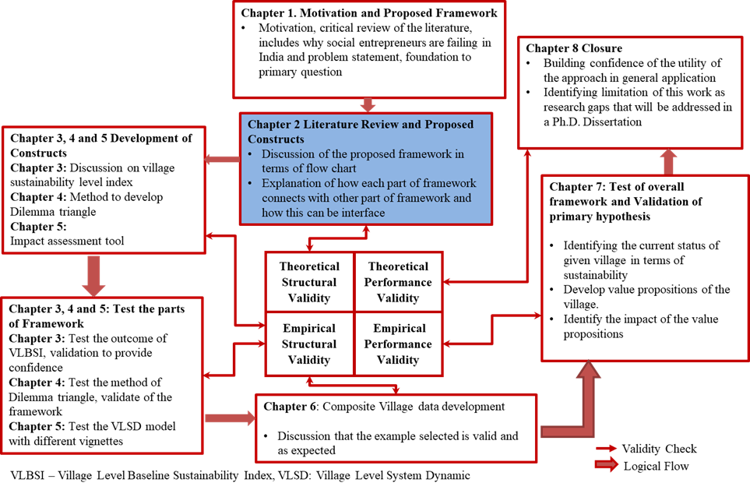
Figure 2.1: Validation Strategy for the Thesis
Chapters 1 and Chapter 2 fall in quadrant one of validation square as presented in Figure 2.1. In Chapter 2, following topics are considered;
- Based on the framework proposed in Section 1.3, the constructs of the framework are identified.
- For each construct the, gaps in literature are identified in terms of sustainable rural development. In Section 2.2, the gap is identified for baseline assessment, in Section 2.3, the gaps are identified for sustainable value proposition development, and in Section 2.4, and gaps are identified for social impact assessment.
- From the gaps identified, thesis questions are derived respectively in Sections 2.2, 2.3 and 2.4.
- Discussion on the flow of information from one construct to another is discussed in Section 1.4 and Section 2.1.
- The hypothesis for each of the question is proposed in the related sections of each construct.

SYNOPSIS OF CHAPTER 2
In this chapter, the difference between social entrepreneur and business entrepreneur is presented in Section 2.1. Social entrepreneurship is anchored in creating solutions that solve a social issue (Austin, Stevenson, and Wei‐Skillern, 2006; Dees, 2017). Social development and community development are priority for social entrepreneurs. Business entrepreneurs on other hand are focused to create wealth and make profit for shareholders and themselves. The difference between business entrepreneurship and social entrepreneurship drives the work presented in this thesis. In Section 2.2, literature on baseline assessment tools and indices is presented. Baseline assessment are used to identify the current state of any given system. A general framework for baselines assessment is developed by Freudenthal and Narrowe (Freudenthal and Narrowe, 1992). For the framework presented in this thesis, the focus is on developing village level baseline sustainability index. In literature available on baseline assessment, the work is anchored in using the assessment for business enterprises and social projects. Baseline assessment are helpful in identifying the inequity according to Wallace (Wallace, 2017).
The first secondary question in this thesis is presented in Section 2.2. The hypothesis for this secondary question is anchored in the work done by Freudenthal and Narrowe in developing a general framework for baseline assessments and Wallace in using baseline assessment to identify the inequities in the community. Based on the literature review, hypothesis to develop a generic baselines index is presented in the same section. In Section 2.3, the literature on value proposition development is reviewed. In this section, methods and tools available to develop value propositions in field of business enterprises is presented. For social entrepreneurs, the task of creating social value anchored in sustainable development are more important than making profit for themselves. This distinction between social and business entrepreneurs is restated in this section. The distinction identified drives the need to develop the method of creating value proposition for social entrepreneurship. In the same section, gap in social entrepreneur theory is discussed in two areas, that is, to develop value proposition that can be used to remove the inequity and also remove conflicts between stakeholders. The hypothesis presented to remove these gaps is anchored in using Dilemma Triangle construct. In Section 2.4, literature of social impact assessment tools that are currently available is reviewed. The basic requirement for social impact assessment tools must be to compare to different social initiatives. As the social intervention and social communities continue change, the tools change. Based on literature review, need to develop a uniform social value construct for comparing different social enterprises and measuring their social intervention is discussed. Kroeger and Weber’s work to compare social value by calculating a positive change in the social well-being (SWB) is used to identify and develop requirements list for the proposed method (Kroeger and Weber, 2014). The gap identified in social impact assessment is presented in Section 2.4. What is presented so far and what is to come next is presented in Figure 2.2
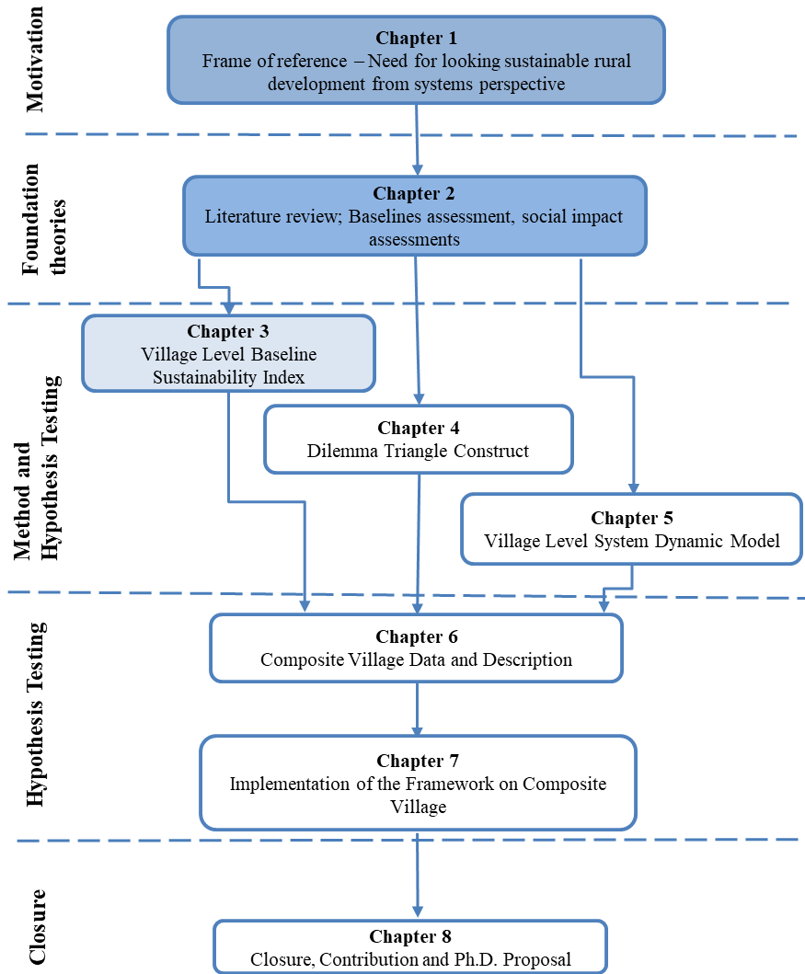
Figure 2.2: Organization of the Thesis – Presented and Next Chapter

In Chapter 3, the first construct (discussed in Section 2.2) of the framework, Village Level Baseline Sustainability Index (VLBSI) is presented. In Section 3.1, the method to develop is presented. Later in Section 3.2, an example village is taken to show the working VLBSI. In Section 3.3, the hypothesis for the secondary question is proposed is verified. In Chapter 4, the second construct (discussed in Section 2.3) of the framework, Dilemma Triangle construct to develop value proposition is discussed. In Section 4.1, method to develop a value proposition using Dilemma Triangle is used. In Section 4.2 method is implemented on a village to show the utility of method and build confidence on Dilemma Triangle construct. In Chapter 5, the last construct (discussed in Section 2.4) of the framework, Village Level System Dynamic model is presented.

CHAPTER 3
VILLAGE LEVEL BASELINE SUSTAINABILITY INDEX

In Chapter 1, the foundation to look at rural development along with sustainable development from system perspective is discussed. A framework with three constructs based on system perspective is presented. In Chapter 2, available literature for each construct is presented leading to questions for the thesis. In Chapter 2, for each question, proposed hypothesis is also discussed. In following chapters, work on each construct is presented. In this chapter, the work done towards Village Level Baseline Sustainability Index is presented. In Section 3.1, background on available indices in the literature is provided, and requirements list for VLBSI is presented to assess the sustainability baseline of a village. In Section 3.2, VLBSI is calculated for a village to show the utility of the index. Based on the data available, how an index can be modified is also presented. Dilemma Triangle construct is presented that can be used to identify the value proposition for a social enterprise. In Section 3.3, Village Level System Dynamic (VLSD) model is presented to evaluate the impact of any value proposition on a village (or community). In Chapter 4, the example problem for each of the construct is discussed.

VILLAGE LEVEL BASELINE SUSTAINABILITY INDEX (VLBSI)
For social entrepreneurs, identification of the disadvantaged people in a community, inequity in society can be viewed as identification of his/her customer based in business entrepreneurship. For business entrepreneurs identifying customer base is useful for product development, the same concept is useful in social entrepreneurship. In Chapter 1 of the thesis, the discussion is made to anchor social entrepreneurship with sustainable development. In Chapter 2, the hypothesis for the development of a village level baseline tool that is useful for the social entrepreneur is discussed.
The proposed tool must be designed to collect information from all the three aspects of sustainability. Challenges for evaluating baseline value anchored in sustainability are (a) the information available in villages is both qualitative and quantitative and (b) Most of the information is not available in the same unit. To overcome these challenges, the theory of indicators and indices is considered as a possible solution.
Indicators are useful to quantify qualitative information and compare aspects with different units, based on these two factors, indicators and indices are selected to evaluate the baseline assessment of the village. The current section is presented as follows, in this section, Village Level Baseline Sustainability Index developed (first construct of the framework) is presented. VLBSI is useful for social entrepreneurs to evaluate a village in terms of drivers of sustainability. In Section 3.1.1, previous work where indicators and indices are used is presented for different fields. In Section 3.1.2, need for VLBSI is explained followed by Village Level Baseline Sustainability Index. The method to develop the VLBSI is discussed in Sections 3.1.3 through 3.1.5.

Introduction: Current Sustainability Indices
Indicators and indices are popular in the field of decision making and policy evaluation (Hammond, Adriannse and co-authors, 1995). With the use of indicators, the information is calculated in a simple form; they are used to quantify qualitative information. Indices, developed by a combination of multiple indicators are developed at different levels – community level, sectoral level, national level and international level. Indices are developed to be reused in different communities, countries with minimum changes. Indices and indicators that are used for sustainability assessment can be categorized into non-integrated indicators and integrated indicators and indices (Ness, Urbel-Piirsalu and co-authors, 2007).
Non-integrated indicators do not aggregate or combine different drivers of sustainability and are developed to focus only of one of the dimensions at a time (Ness, Urbel-Piirsalu and co-authors, 2007). Integrated indices were therefore developed to overcome the challenge of being unable to aggregate the drivers of sustainability. Current integrated indicators and indices are being used at various levels to calculate sustainable development. At the international level, these are developed to compare one country to other, such as Wellbeing Index, Environmental Sustainability Index (ESI) and Human Development Index (HDI), etc., each providing a different measurement for sustainable development. To measure sustainable development at nation level few indices that are developed are, Sustainable National Income (SNI), Adjusted Net Saving (ANS).
There is also another set of sustainability assessment index that are developed very specific to an organization, process or area and cannot be reused in other areas. All the indices that are developed so far are either at the macro level (international, national, urban level), or at the micro level (single project specific – urban and rural) as presented in Figure 3.1.
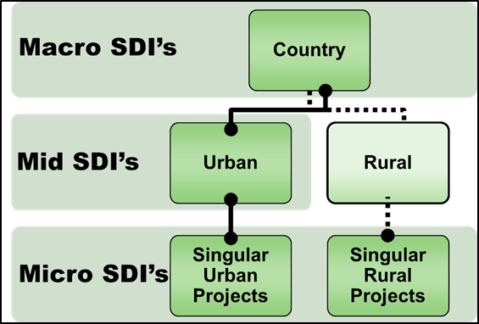
Figure 3.1: Classification of Sustainable Development Indices (SDI)

The Need of Village Level Baseline Sustainability Index
The sustainable assessment indices and indicators at international, national level are developed with a top-down approach, these indicators used at the macro level are different from the indicators that can be used at the local level. Tough urban and rural areas are considered local, urban level indicators are mostly a representation of national level indices. Rural areas, however, are distinct from urban areas in terms of economy generation, the standard of living, social interactions and environmental variables (Hofferth and Iceland, 1998; Sahn and Stifel, 2003). To assess a rural area in terms of sustainable development, there is a need to develop indices for rural areas with a bottom-up approach.

Challenges involved in the development of a village level sustainability index are; first, to identify variables that affect the sustainability of a village and also adds value to national sustainability. The second challenge is based on the variability of different villages within same state and country. Each village is different from other village and developing one sustainability index that can be reused by social entrepreneurs is critical.

Harger and Meyer (Harger and Meyer, 1996) suggest some characteristics of a good indicator, the indicators must be simple, must be quantifiable and must be sensitive to change. Added to this, based on the characteristics of the proposed framework secondary requirements are added for village level sustainability index and presented below.

- Village level sustainability index must be adaptable so that a large breadth of diverse data can be used as input into the index and standardized.
- Village level sustainability index must be modifiable so that social entrepreneurs can add or delete individual indicators/sub-indicators based on the demographics of a village and still calculate a true sustainability score for the particular village.
- Village level sustainability index must be easily applied and understood, so that social entrepreneur can apply the index to a village with minimum difficulty and make sense of the result.
To make the results from the index easy to understand, the result from index are presented on a 0-10 scale, with 0 being the least desirable and 10 being the most desirable. The range of the scale is arbitrary and could be changed to 0-5 or 0-100 as desired by social entrepreneurs. The index must be based on the data that social entrepreneurs will collect when surveying a village. The data must not be difficult to collect: for example, it should not require a social entrepreneur to spend extensive time with each household in the village. Work for this thesis is not focused on developing the survey to be used for data collection, but to provide a method of developing an index for village level. Based on the requirements and lack of a village level index, in next section, the proposed village level sustainability index for the work in this thesis is discussed.

Proposed Village Level Sustainability Index
The proposed index developed for villages includes all the three dimensions of sustainability: social, economic, and environmental. Within each dimension, there are indicators. The number of indicators varies between the dimensions and can be changed by the social entrepreneur depending on the needs of the village. The indicators are divided in sub-indicators, and these can also be modified depending on the needs of the village.

The index is presented on an excel file with programmed calculations imbedded in the sheets. To use the index, the social entrepreneur must have the file saved on their computer. Social entrepreneurs need to plug in the data from the village into the file to calculate the village’s sustainability value. There are four “layers” of calculations; sub-indicators, indicators, dimensions, and total sustainability. Below are the basic equations of the village level sustainability index.
Basic Equations
The equations 3.1, 3.2, 3.3 and 3.4 provide the basic premise for our calculation
- SOC = Social Indicators
- ENV = Environmental Indicators
- ECO = Economic Indicators
- a = total number of social indicators
- b = total number of environmental indicators
- c = total number of economic indicators

Eq 3.1
$$\frac{SOC1+SOC2+…+SOCa}{a}=SOC$$
$$\frac{ENV1+ENV2+…+ENVb}{b}=ENV$$
Eq 3.2

Eq 3.3
$$\frac{ECO1+ECO2+…+ECOc}{c}=ECO$$

The preceding equations are averages of the indicators for each dimension of sustainability. The social entrepreneur can choose to weigh all indicators in each dimension equally or unequally.
$\frac{SOC+ENV+ECO}{3}=Y$ Eq 3.4
Where Y = Total Sustainability Value
In next section, a weighing system for the village level sustainability index is discussed.

Indicator Weights
The equations mentioned in the previous section are guidelines that illustrate the basic process of calculating this index. In the proposed index, the social entrepreneurs need to assign weights to each indicator and sub-indicator based on the significance of a particular village towards sustainability. For example, let’s assume that social driver comprises of 6 indicators in a particular village. Currently, these indicators have some arbitrary value on a scale of 0-10, presented in Table 3.1. The “Weight” column in Table 3.1 is where the social entrepreneur can adjust the weight for each indicator. That is, social entrepreneur, for example, can assign comparatively higher weight to Education indicator of 0.25 and lower weight to Electricity and Food/Water indicator (0.16 and 0.13). Observe that, the weights are given as a fraction of 1, and the only rule that must be followed while assigning the weights to indicators or sub-indicators is that the total weight must add up to 1.
Table 3.1: Index Calculation for Social Driver
Column (C) | C1 | C2 | C3 | C4
Indicator Number | Social Driver Indicators | 0-10 Scale Value* | Weight | Value for each Indicator (C2 x C3)
SOC 1 | Education | 5.60 | 0.25 | 1.40
SOC 2 | Electricity | 2.00 | 0.16 | 0.32
SOC 3 | Food/Water | 5.00 | 0.13 | 0.65
SOC 4 | Sanitation | 4.00 | 0.18 | 0.72
SOC 5 | Health | 6.50 | 0.18 | 1.18
SOC 6 | Communication | 5.60 | 0.10 | 0.56
 | Total |  | 1 ** | 4.83 = Social Score
 | * These are example values that can be used to represent the values of a rural village
 | ** This column must add up to 1

Similar to the social driver, the weights for indicators and sub-indicators for environment driver and the economic driver must be assigned by the social entrepreneurs. Another aspect of the Village index is that it must be modifiable based on the characteristics of the village. For example, for the social driver in one village, there might need to add Crime indicator, in such case Table 3.1 is modified by adding additional indicator SOC 7 – Crime as presented in Table 3.2. Observe that the weights for each indicator must be changed to keep the total equal to 1.

Table 3.2: Index Calculation for Social Driver with Added Indicator
Column (C) | C1 | C2 | C3 | C4
Indicator Number | Social Driver Indicators | 0-10 Scale Value* | Weight | Value for each Indicator (C2 x C3)
SOC 1 | Education | 5.60 | 0.18 | 1.00
SOC 2 | Electricity | 2.00 | 0.16 | 0.32
SOC 3 | Food/Water | 5.00 | 0.14 | 0.75
SOC 4 | Sanitation | 4.00 | 0.16 | 0.64
SOC 5 | Health | 6.50 | 0.16 | 1.04
SOC 6 | Communication | 5.56 | 0.10 | 0.56
SOC 7 | Crime | 6.6 | 0.10 | 0.66
 | Total |  | 1 ** | 4.97 = Social Score
 | ** This column must add up to 1

The question then arises, what is the utility of such index that does not provide a consistent value or consistent indicators? The utility of such index is adaptability and use of the index to capture an understanding of different stakeholders and different perspectives. That is, a single individual can choose based on her/his understanding the weights that must be allotted to a sub-indicator or indicator consciously and add or remove indicators/sub-indicators based on their understanding. For example, a social entrepreneur, corporate social responsibility investor or a social organization involved only in improving primary education might want to focus on primary education and assign a higher value to sub-indicators that are connected to primary education. On other hand organization focused on overall education could assign weights differently to identify the area of focus.
The focus of developing this index is not towards comparison of different communities and ranking them in terms of sustainability. The focus is on using this index in a community is in identifying the focus of investment (that is possible) based on user’s perspective and then comparing the change in value for each of these indicators post implementation of the value proposition to understand and calculate the growth due to the implementation of the value proposition. The indicators for environment driver and economic driver selected for VLSBI for the work in this thesis is presented in Table 3.3.
Table 3.3: Indicators for Environment and Economic Driver
Indicator Number | Environmental Indicators |  | Indicator Number | Economic Indicators
ENV 1 | Agriculture |  | ECO 1 | Income Stability
ENV 2 | Animal Husbandry |  | ECO 2 | Income Disparity
ENV 3 | Aquaculture |  | ECO 3 | Economy Structure
ENV 4 | Energy Usage |  | ECO 4 | Employment Structure
ENV 5 | Environmental Quality
ENV 6 | Environmental Degradation
ENV 6 | Natural/Human Disaster

The indicators presented in Table 3.1 and Table 3.3 are the indicators that are developed in this thesis for each driver of sustainability (Social, Environment, and Economic) in the Village Level Baseline Sustainability Index. For a village, there can be many indicators that represent social, environmental and economic values. For this thesis, the indicators mentioned in Table 3.1 and Table 3.3 are only considered. These indicators were selected as they can be used to get the maximum data (in terms of sustainability) for a given community. Based on the proposed hypothesis, the framework and each construct that is developed must be modular, adaptable and modifiable. The work in this thesis is to propose the working principle for each construct including Village Level Baseline Sustainability Index and test the construct with village data. Therefore, more indicators can be added for each of the driver based on the community. In next three sections, the sub-indicators associated with each indicator for village level sustainability index are presented for social, environmental and economic drivers respectively. No data is added to each indicator.

Social Driver Sub-Indicators
For the Village Level Baseline Sustainability Index discussed in this thesis, the social driver consists of six indicators that are mentioned in Table 3.1. Weights for each of these indicators are assigned by the social entrepreneur or the user of the index. Each indicator consists of multiple sub-indicators. In Table 3.5, the indicators and their corresponding sub-indicators are presented for the social driver. Similar to indicators, the sub-indicator for the index are selected and developed to collect maximum information and can be modified by the social entrepreneur or user based on the data available. The Village Level Baseline Sustainability Index is color coded for easy understanding. The color-coded scheme is presented in Table 3.4, all the cells with color code CC1 (grey) are the cells for input of sub-indicator data that must be entered by the user. CC2 (magenta) color-coded cells are calculation cells and should not be modified by the user. CC3 (green) color-coded are the target values for the sub-indicators, these must be entered by the user as well. CC4 and CC5 coded cells are calculation cells and shouldn’t be modified by the user of the index. CC5 cell consists of final value for indicator and driver as well.
Table 3.4: Color Code for the Social Driver Cells
Key
Color of Cell | Data in the Cell | Comment
CC1 | Example input data | Must be entered by the user
CC2 | Calculations | Shouldn’t be modified
CC3 | Target Values | Must be entered by the user
CC4 | Automatic Calculations | Shouldn’t be modified
CC5 | Final value (Total value) | Final Value

Each indicator in Table 3.5 has sub-indicators assigned on each row and each column C1 through C7, C8 is the value that is associated with each indicator. Column C1 through C7, C8 are color-coded based on colors presented in Table 3.4. The last row for each indicator of the driver is the value of that indicator and is color coded as CC5 as presented in Table 3.4. The value for each indicator is obtained based on the sub-indicators associated with it. The output from each sub-indicator is based on the weight each of the sub-indicator is assigned by the user of the index.
For example, in Table 3.5, the first indicator is education (‘SOC 1: Education’), this indicator contains 8 sub-indicators (rows 1.1 to 1.8) and 7 values associated to each sub-indicator (Column C1 to C7). For each sub-indicator, the user needs to input the value in Column C1 and C2 (color-coded grey CC1, as presented in Table 3.4). Based on the information entered in C1 and C2, the value in C3 (color-coded magenta CC2, as presented in Table 3.4) is calculated based on the formula. The user is again required to enter the target value in Column C4 (color-coded green CC3, as presented in Table 3.4). Based on this information the value in Column C5 is calculated. In Column C6, the user is required to enter the weight associated with the sub-indicators. Similar to the assigning principle of the indicator weights discussed in Section 3.1.4, the combined weights for all the sub-indicator must be equal to 1. The value for each indicator changes based on the weights assigned to each sub-indicator. Finally, in Column C7 (color-coded dark grey CC4) is the value associated to each sub-indicator that adds up to be the value of the indicator.

Table 3.5: Social Driver Sub-Indicators
SOC 1: Education |  | C1 | C2 | C3 | C4 | C5 |  | C6 | C7
Sub-Indicators |  | Number of children attending school | Total number of boys/girls in the village for each sub-indicator | The current percentage of children attending school [(C1)/(C2) *100] | Target percentage of children attending school | Conversion to scale of 0-10 (C3)/(C4) *10 |  | Each sub-indicator weight | Value of sub-indicator toward Indicator [(C5) *(C6)]
1.1 | Boys of age 6-13 attending primary school | 0 | 0 | 0 | 0 | 0 |  | 0 | 0
1.2 | Girls of age 6-13 attending primary school | 0 | 0 | 0 | 0 | 0 |  | 0 | 0
1.3 | Boys of age 14-16 attending secondary school | 0 | 0 | 0 | 0 | 0 |  | 0 | 0
1.4 | Girls of age 14-16 attending secondary school | 0 | 0 | 0 | 0 | 0 |  | 0 | 0
1.5 | Boys of age 17-19 attending senior secondary school | 0 | 0 | 0 | 0 | 0 |  | 0 | 0
1.6 | Girls of age 17-19 attending senior secondary school | 0 | 0 | 0 | 0 | 0 |  | 0 | 0
1.7 | Boys of age 18-24 who pursue higher education | 0 | 0 | 0 | 0 | 0 |  | 0 | 0
1.8 | Girls of age 18-24 who pursue higher education | 0 | 0 | 0 | 0 | 0 |  | 0 | 0
 | Total people between (6-24) | 0 | 0 |  | Total Indicator Weight (Must be 1) |  |  | 1.00
 |  |  |  | SOC1 Indicator Value: |  |  | 0

SOC 2: Electricity |  |  | C1 | C2 | C3 | C4 | C5 | C6 | C7 | C8
Sub-Indicators |  |  | Enter required data based on Sub-Indicators | Average number of Hours (Not including 6-10 PM) | Average number of Hours (6-10PM) | Target percentage/hours | [(C2) + 2(C3)]/(C4) | Conversion to scale of 0-10 (C5) *10 | Each sub-indicator weightage | Value of sub-indicator toward Indicator [(C6) *(C7)]
2.10 |  | Does village have a source of electricity? | Yes/No
 |  | Total Number of Households | 0
2.1.1 |  | Number of households having electricity |  | 0.00 |  | 0.00 | 0.00 | 0.00 | 0.00 | 0.00
2.1.2 |  | Average hours of electricity provided per household per day (Hours) |  | 0.00 | 0.00 | 0.00 | 0.00 | 0.00 | 0.00 | 0.00
2.1.3 |  | Average hours of electricity provided to SME's (Average work day = 8 hours) |  | 0.00 | 0.00 | 0.00 | 0.00 | 0.00 | 0.00 | 0.00
2.1.4 |  | Average hours of electricity provided to stores |  | 0.00 | 0.00 | 0.00 | 0.00 | 0.00 | 0.00 | 0.00
2.20 |  | Is the source of electricity renewable? | Yes/No |  |  |  |  | 0.00 | 0.00 | 0.00
2.30 |  | Is the source of electricity reliable? | Yes/No |  |  |  |  | 0.00 | 0.00 | 0.00
 |  |  |  |  | Total Indicator Weight (Must be 1) |  |  |  | 1.00
 |  |  |  |  | SOC2 Indicator Value: |  |  |  | 7.48

SOC 3: Food and Water |  |  | C1 | C2 | C3 | C4 | C5 | C6 | C7
Sub-Indicators |  |  | Current Value of Sub-Indicator | Total number of households/children/ people for Sub-Indicator | Current percentage | Target percentage | Conversion to scale of 0-10 (C3)/(C4) *10 | Each sub-indicator weightage | Value of sub-indicator toward Indicator [(C5) *(C6)]
3.10 | Food security and quality
3.1.1 | Number of households having resources to have 3- meals a day (This includes all the members of family) |  | 0.00 | 0.00 | 0.00 | 0.00 | 0.00 | 0.00 | 0.00
3.20 | Drinking water security and quality
3.2.1 | Number of households having access to drinking water everyday |  | 0.00 | 0.00 | 0.00 | 0.00 | 0.00 | 0.00 | 0.00
 |  |  |  |  |  | Total Indicator Weight (Must be 1) |  | 1.00
 |  |  |  |  |  | SOC3 Indicator Value: |  |  | 0.00

SOC 4: Sanitation and Hygiene
Sub-Indicators |  | Current Value of Sub-Indicator | Total number of households/children/ people for Sub-Indicator | Current percentage | Target percentage | Conversion to scale of 0-10 (C3)/(C4) *10 | Each sub-indicator weightage | Value of sub-indicator toward Indicator [(C5) *(C6)]
4.20 | Availability of sanitation facilities
4.2.1 | Number of households having working toilets and are using it. | 0.00 | 0.00 | 0.00 | 0.00 | 0.00 | 0.00 | 0.00
4.2.2 | Number of households having resources to maintain basic hygienic conditions | 0.00 | 0.00 | 0.00 | 0.00 | 0.00 | 0.00 | 0.00
 |  |  | Total Indicator Weight (Must be 1) |  |  |  | 1.00
 |  |  |  |  | SOC4 Indicator Value: |  |  | 0.00

SOC 5: Health
Sub-Indicators |  | Current Value of Sub-Indicator | Total number of households/children/ people for Sub-Indicator | Current percentage | Target value/ percentage |  | Conversion to scale of 0-10 (C3)/(C4) *10 | Each sub-indicator weightage | Value of sub-indicator toward Indicator [(C5) *(C6)]
5.1 | The distance of nearest clinic and medical dispensary from the village | 0.00 |  |  | 0.00 | 0.00 |  | 0.00 | 0.00
5.2 | Number of infant mortalities in last two years | N/A | 0.00 | 0.00 | 0.00 | 0.00 |  | 0.00 | 0.00
5.3 | Number of children who got polio drops in last 6 Months | N/A | 0.00 | 0.00 | 0.00 | 0.00 |  | 0.00 | 0.00
5.4 | Number of child mortalities during pregnancy in last two years | N/A | 0.00 | 0.00 | 0.00 | 0.00 |  | 0.00 | 0.00
5.5 | Number of children with un treated diseases (Age: 0-16) | N/A | 0.00 | 0.00 | 0.00 | 0.00 |  | 0.00 | 0.00
5.6 | Number of adults with untreated diseases (Age: 16+) | N/A | 0.00 | 0.00 | 0.00 | 0.00 |  | 0.00 | 0.00
5.7 | Number of Adults with informed HIV issues (Age 18+) | N/A | 0.00 | 0.00 | 0.00 | 0.00 |  | 0.00 | 0.00
 |  |  | Total Indicator Weight (Must be 1) |  |  |  |  | 1.00
 |  |  |  |  | SOC5 Indicator Value: |  |  |  | 0.00

SOC 6: Communication
Sub-Indicators |  | Current Value of Sub-Indicator | Total number of households/children/ people for Sub-Indicator | Current percentage | Target percentage | Conversion to scale of 0-10 (C3)/(C4) *10 | Each sub-indicator weightage | Value of sub-indicator toward Indicator [(C5) *(C6)]
6.1 | Number of households having mobile/landline connection | 0.00 | 0.00 | 0.00 | 0.00 | 0.00 | 0.00 | 0.00
6.2 | Number of households having television sets with cable connection | 0.00 | 0.00 | 0.00 | 0.00 | 0.00 | 0.00 | 0.00
 |  |  |  |  | Total Indicator Weight (Must be 1) |  | 1.00
 |  |  |  |  | SOC6 Indicator Value: |  |  | 0.00

A working example for the index is presented in later part of the chapter by taking an example village. In next section, the sub-indicators of the environment driver are presented.

Environment Driver Sub-Indicators
Presented in Table 3.3 are the indicators associated to environment driver in this thesis. The sub-indicators associated with each of the seven indicators of environment driver are presented in Table 3.7. For environment driver, one more cell is added in color coding scheme; this is depicted in Table 3.6 last row (Cell CC 6). The cells with a color code of CC6 are fixed before using the index, the values in these are taken from different standard assigned by local, national or international organizations. The user must verify the standard value and fixed them in these cells.

Table 3.6: Color Code for Environmental Driver
Key
Color of Cell | Data in the Cell | Comment
CC1 | Example input data | Must be entered by the user
CC2 | Calculations | Shouldn’t be modified
CC3 | Target Values | Must be entered by the user
CC4 | Automatic Calculations | Shouldn’t be modified
CC5 | Final value (Total value) | Final Value
CC6 | Fixed | Must be verified for each village
The cells that have fixed value with color code CC6 are associated with Aquaculture and Water Quality indicators in Table 3.7.
Table 3.7: Environment Driver Sub-Indicators
ENV 1: Agriculture |  | C1 | C2 | C3 | C4 | C5 | C6 | C7
Sub-Indicators |  | Value of sub-indicator | Percentage of Sub-Indicators | Target percentage value of sub-indicators | (C2)/(C3) | Conversion to scale of 0-10 (C4) *10 | Each sub-indicator weightage | Value of sub-indicator toward Indicator [(C4) *(C5)]
1.1 | Total agricultural households (Owners not daily labors) | 0.00
1.1.1 | Number of households practicing drip/sprinkler irrigation | 0.00 | 0.00 | 0.00 | 0.00 | 0.00 | 0.00 | 0.00
1.1.2 | Number of households not using synthetic pesticides? | 0.00 | 0.00 | 0.00 | 0.00 | 0.00 | 0.00 | 0.00
1.1.3 | Number of households not using nitrogen fertilizer? | 0.00 | 0.00 | 0.00 | 0.00 | 0.00 | 0.00 | 0.00
1.1.4 | Number of farmer’s not practicing slash and burn practices? | 0.00 | 0.00 | 0.00 | 0.00 | 0.00 | 0.00 | 0.00
1.1.5 | Average area of crop (Quantiles)/land (Acre) yield for agriculture? | 0.00 | 0.00 | 0.00 | 0.00 | 0.00 | 0.00 | 0.00
 |  |  |  | Total Indicator weight (Must be 1) |  |  | 1.00
 |  |  |  |  | ENV1 Indicator Value: |  |  | 0.00

ENV 2: Animal Husbandry |  | C1 | C2 | C3 | C4 | C5 | C6 | C7
Sub-Indicators |  | Current Value of Sub-Indicator | Percentage of Sub-Indicators | Target percentage value of sub-indicators | (C2)/(C3) | Conversion to scale of 0-10 (C4) *10 | Each sub-indicator weightage | Value of sub-indicator toward Indicator [(C4) *(C5)]
2.1 | Animal Husbandry
2.1.1 | Number of households having Cow/Goat/Camel and or other household animals | 0.00
2.1.2 | Number of households using medicines to increase milk production | 0.00 | 0.00 | 0.00 | 0.00 | 0.00 | 0.00 | 0.00
2.1.3 | Number of animals in the village | 0.00
2.1.3 | What is the average number of animals lost due to disease each year? | 0.00 | 0.00 | 0.00 | 0.00 | 0.00 | 0.00 | 0.00
 |  |  |  | Total Indicator weight (Must be 1) |  |  | 1.00
 |  |  |  |  | ENV2 Indicator Value: |  |  | 0.00

ENV 3: Aquaculture |  | C1 | C2 |  | C3 | C4 | C5 | C6
Sub-Indicators |  | Value of sub-indicator | Percentage of Sub-Indicators | Target percentage value of sub-indicators | (C2)/(C3) | Conversion to scale of 0-10 (C4) *10 | Each sub-indicator weightage | Value of sub-indicator toward Indicator [(C4) *(C5)]
 | Aquaculture
3.1.0 | Total aquaculture households (Owners not daily labors) | 0.00
3.1.1 | Number of households having License for farming | 0.00 | 0.00 | 0.00 | 0.00 | 0.00 | 0.00 | 0.00
3.1.2 | Is there a designated zone assigned by local authorities?
3.1.3 | If Yes, Number of Farms situated within the zone | 0.00 | 0.00 | 0.00 | 0.00 | 0.00 | 0.00 | 0.00
3.1.4 | Number of Farms that were created by destroying mangroves, forest land, or coral reefs | 0.00 | 0.00 | 0.00 | 0.00 | 0.00 | 0.00 | 0.00
3.1.5 | Water Quality Parameter for Shrimp Aquaculture | Value of sub indicator | The target value of sub indicators |  | (C1)/(C2) | Conversion to scale of 0-10 (C4) *10 | Each sub-indicator weightage | Value of sub-indicator toward Indicator [(C4) *(C5)]
 |  |  | Min | Max
3.1.5.1 | Depth (cm) | 0.00 | 80.00 | 100.00 | 0.00 | 0.00 | 0.00 | 0.00
3.1.5.2 | Transparency (cm) | 0.00 | 25.00 | 30.00 | 0.00 | 0.00 | 0.00 | 0.00
3.1.5.3 | Salinity (ppt) | 0.00 | 8.00 | - | 0.00 | 0.00 | 0.00 | 0.00
3.1.5.4 | pH | 0.00 | 7.50 | 8.50 | 0.00 | 0.00 | 0.00 | 0.00
3.1.5.5 | Dissolved Oxygen (mg/l) | 0.00 | 5.00 | - | 0.00 | 0.00 | 0.00 | 0.00
3.1.5.6 | Biological Oxygen Demand (mg/l) | 0.00 | 0.00 | 5.00 | 0.00 | 0.00 | 0.00 | 0.00
3.1.5.7 | Total Dissolved Solids (gm/l) | 0.00 | 5.00 | 15.00 | 0.00 | 0.00 | 0.00 | 0.00
3.1.6 | Soil Quality Parameter for Shrimp Aquaculture | Value of sub indicator | The target value of sub indicators |  | (C1)/(C2) | Conversion to scale of 0-10 (C4) *10 | Each sub-indicator weightage | Value of sub-indicator toward Indicator [(C4) *(C5)]
 |  |  | Min | Max
3.1.6.1 | pH | 0.00 | 6.00 | 7.50 | 0.00 | 0.00 | 0.00 | 0.00
3.1.6.2 | Electricity Conductivity (EC), (ds/m) | 0.00 | 8.00 | 12.00 | 0.00 | 0.00 | 0.00 | 0.00
3.1.6.3 | Organic Matter (OM), (%) | 0.00 | 1.00 | 3.50 | 0.00 | 0.00 | 0.00 | 0.00
3.1.6.4 | Total Nitrogen (%) | 0.00 | 0.18 | 0.45 | 0.00 | 0.00 | 0.00 | 0.00
3.1.6.5 | Phosphorus (μg/gm soil) | 0.00 | 13.00 | 25.00 | 0.00 | 0.00 | 0.00 | 0.00
3.1.6.6 | Potassium (meq /100gm) | 0.00 | 0.21 | 40.00 | 0.00 | 0.00 | 0.00 | 0.00
 |  |  |  | Total Indicator weight (Must be 1) |  |  | 1.00
 |  |  |  | ENV3 Indicator Value: |  |  |  | 0.00

ENV 4: Energy Usage |  | C1 | C2 |  | C3 | C4 | C5 | C6
Sub-Indicators |  | Value of sub indicator | Percentage of Sub-Indicators | Target percentage value of sub indicators | (C2)/(C3) | Conversion to scale of 0-10 (C4) *10 | Each sub-indicator weightage | Value of sub-indicator toward Indicator [(C4) *(C5)]
 | Total Number of Households | 0.00
4.1 | Number of households using Coal and/or Kerosene for cooking and heating? | 0.00 | 0.00 | 0.00 | 0.00 | 0.00 | 0.00 | 0.00
4.2 | Number of households using materials from their environment? (Wood, Bamboo, Grass, etc.) | 0.00 | 0.00 | 0.00 | 0.00 | 0.00 | 0.00 | 0.00
4.3 | Number of households using renewable energy? (Solar, Wind, Hydro, etc.) | 0.00 | 0.00 | 0.00 | 0.00 | 0.00 | 0.00 | 0.00
 |  |  |  | Total Indicator weight (Must be 1) |  |  | 1.00
 |  |  |  | ENV4 Indicator Value: |  |  |  | 0.00

ENV 5: Environmental Quality |  | C1 | C2 |  | C3 | C4 | C5 | C6
Sub-Indicators |  | Value of sub indicator | The target value of sub indicators |  | (C1)/(C2) | Conversion to scale of 0-10 (C3) *10 | Each sub-indicator weightage | Value of sub-indicator toward Indicator [(C4) *(C5)]
 |  |  | Min | Max
Water Quality
Is same water source used for Drinking, Irrigation, for wildlife? If yes, compare with Drinking water targets
5.1.1 | Drinking Water
5.1.1.1 | Total Coliforms Organism MPN/100ml | 0.00 | 0.00 | 0.00 | 0.00 | 0.00 | 0.00 | 0.00
5.1.1.2 | pH | 0.00 | 0.00 | 0.00 | 0.00 | 0.00 | 0.00 | 0.00
5.1.1.3 | Dissolved Oxygen/liter (mg) | 0.00 | 0.00 | 0.00 | 0.00 | 0.00 | 0.00 | 0.00
 |  |  | Desirable Limit | Permissible Limit
5.1.1.4 | Turbidity, NTU | 0.00 | 0.00 | 0.00 | 0.00 | 0.00 | 0.00 | 0.00
5.1.1.5 | Total Hardness (as CaCo3), mg/l | 0.00 | 0.00 | 0.00 | 0.00 | 0.00 | 0.00 | 0.00
5.1.1.6 | Iron (as Fe), mg/l | 0.00 | 0.00 | 0.00 | 0.00 | 0.00 | 0.00 | 0.00
5.1.1.7 | Chlorides (as CI), mg/l | 0.00 | 0.00 | 0.00 | 0.00 | 0.00 | 0.00 | 0.00
5.1.1.8 | Residual free chlorine, mg/l | 0.00 | 0.00 | 0.00 | 0.00 | 0.00 | 0.00 | 0.00
5.1.1.9 | Dissolved solids, mg/l, Max | 0.00 | 500.00 | 2000.00 | 0.00 | 0.00 | 0.00 | 0.00
5.1.1.10 | Calcium as (Ca), mg/l, Max | 0.00 | 75.00 | 200.00 | 0.00 | 0.00 | 0.00 | 0.00
5.1.1.11 | Magnesium (as Mg), mg/l, Max | 0.00 | 30.00 | 75.00 | 0.00 | 0.00 | 0.00 | 0.00
5.1.1.12 | Copper (as Cu), mg/l, Max | 0.00 | 0.05 | 1.50 | 0.00 | 0.00 | 0.00 | 0.00
5.1.1.13 | Manganese (as Mn), mg/l, Max | 0.00 | 0.10 | 0.30 | 0.00 | 0.00 | 0.00 | 0.00
5.1.1.14 | Sulphate (as So₄), mg/l, Max | 0.00 | 200.00 | 400.00 | 0.00 | 0.00 | 0.00 | 0.00
5.1.1.15 | Nitrate (as No₃), mg/l, Max | 0.00 | 45.00 | 100.00 | 0.00 | 0.00 | 0.00 | 0.00
5.1.1.16 | Fluoride (as F0, mg/l, Max | 0.00 | 1.00 | 1.50 | 0.00 | 0.00 | 0.00 | 0.00
5.1.1.17 | Phenolic compounds (as C₆H₅OH), mg/l, Max | 0.00 | 0.00 | 0.00 | 0.00 | 0.00 | 0.00 | 0.00
5.1.1.18 | Mercury (as Hg), mg/l, Max | 0.00 | 0.00 | 0.00 | 0.00 | 0.00 | 0.00 | 0.00
5.1.1.19 | Cadmium (as Cd), mg/l, Max | 0.00 | 0.01 | - | 0.00 | 0.00 | 0.00 | 0.00
5.1.1.20 | Selenium (as Se), mg/l, Max | 0.00 | 0.01 | - | 0.00 | 0.00 | 0.00 | 0.00
5.1.1.21 | Arsenic (as As), mg/l, Max | 0.00 | 0.05 | - | 0.00 | 0.00 | 0.00 | 0.00
5.1.1.22 | Cyanide (as CN), mg/l, Max | 0.00 | 0.05 |  | 0.00 | 0.00 | 0.00 | 0.00
5.1.1.23 | Lead (as Pb), mg/l, Max | 0.00 | 0.05 | - | 0.00 | 0.00 | 0.00 | 0.00
5.1.1.24 | Anionic detergents (as MBAS), mg/l, Max | 0.00 | 0.02 | 1.00 | 0.00 | 0.00 | 0.00 | 0.00
5.1.1.25 | Chromium (as Cr⁶⁺), mg/l, Max | 0.00 | 0.05 | - | 0.00 | 0.00 | 0.00 | 0.00
5.1.1.26 | PAH, mg/l, Max | 0.00 | - | - | 0.00 | 0.00 | 0.00 | 0.00
5.1.1.27 | Mineral oil, mg/l, Max | 0.00 | 0.01 | 0.03 | 0.00 | 0.00 | 0.00 | 0.00
5.1.1.28 | Pesticides, mg/l, MAX | 0.00 | Absent | 0.00 | 0.00 | 0.00 | 0.00 | 0.00
5.1.1.29 | Alkalinity, mg/l, Max | 0.00 | 200.00 | 600.00 | 0.00 | 0.00 | 0.00 | 0.00
5.1.1.30 | Aluminum (as Al), mg/l, Max | 0.00 | 0.03 | 0.20 | 0.00 | 0.00 | 0.00 | 0.00
5.1.1.31 | Boron, mg/l, Max |  | 1.00 | 5.00 | 0.00 | 0.00 | 0.00 | 0.00
5.1.2 | Irrigation Water
5.1.2.1 | pH | 0.00 | 6.00 | 8.50 | 0.00 | 0.00 | 0.00 | 0.00
5.1.2.2 | Electrical Conductivity at 25-degree Celsius micro mhos/cm | 0.00 | - | 2250.00 | 0.00 | 0.00 | 0.00 | 0.00
5.1.2.3 | Sodium absorption ratio | 0.00 | - | 26.00 | 0.00 | 0.00 | 0.00 | 0.00
5.1.2.4 | Chlorides (as CU), mg/l | 0.00 | - | 600.00 | 0.00 | 0.00 | 0.00 | 0.00
5.1.2.5 | Boron (mg/l) | 0.00 | - | 2.00 | 0.00 | 0.00 | 0.00 | 0.00
Air Quality
 | What is the Air Quality Index of the Village? AQI Value | 0.00 |  |  | 0.00 | 0.00 | 0.00 | 0.00
 |  |  |  | Total Indicator weight (Must be 1) |  |  | 1.00
 |  |  |  | ENV5 Indicator Value: |  |  |  | 0.00

ENV 6: Environmental Degradation |  | C1 | C2 |  | C3 | C4 | C5 | C6
Sub-Indicators |  | Value of sub indicator | The target value of sub indicators |  | (C1)/(C2) | Conversion to scale of 0-10 (C3) *10 | Each sub-indicator weightage | Value of sub-indicator toward Indicator [(C4) *(C5)]
Scale from 5 to 1 (5 Being lowest degradation)
6.1.1 | Rank Land Degradation | 0.00 | 0.00 |  | 0.00 | 0.00 | 0.00 | 0.00
6.1.2 | Rank Forest Degradation | 0.00 | 0.00 |  | 0.00 | 0.00 | 0.00 | 0.00
6.1.3 | Rank Soil Degradation | 0.00 | 0.00 |  | 0.00 | 0.00 | 0.00 | 0.00
6.1.4 | Rank Water Body Degradation | 0.00 | 0.00 |  | 0.00 | 0.00 | 0.00 | 0.00
6.1.5 | Rank Underground Water Level Degradation | 0.00 | 0.00 |  | 0.00 | 0.00 | 0.00 | 0.00
6.1.6 | Rank Wildlife Degradation | 0.00 | 0.00 |  | 0.00 | 0.00 | 0.00 | 0.00
6.1.7 | Rank Fishery Degradation | 0.00 | 0.00 |  | 0.00 | 0.00 | 0.00 | 0.00
 |  |  |  | Total Indicator weight (Must be 1) |  |  | 1.00
 |  |  |  | ENV6 Indicator Value: |  |  |  | 0.00

ENV 7: Natural/Human Disaster |  | C1 | C2 |  | C3 | C4 | C5 | C6
Sub-Indicators |  | Value of sub indicator | The target value of sub indicators |  | (C1)/(C2) | Conversion to scale of 0-10 (C3) *10 | Each sub-indicator weightage | Value of sub-indicator toward Indicator [(C4) *(C5)]
7.1.1 | Has there been any Natural or Human disaster in Last Six Months | Yes/No |  |  | 0.00 | 0.00 | 0.00 | 0.00
7.1.2 | Has there been any Natural or Human disaster between Last Six Months - One Year | Yes/No |  |  | 0.00 | 0.00 | 0.00 | 0.00
7.1.3 | Has there been any Natural or Human disaster between One year and Two years | Yes/No |  |  | 0.00 | 0.00 | 0.00 | 0.00
7.1.4 | Village recovery from the disaster in percentage | 0.00 |  |  | 0.00 | 0.00 | 0.00 | 0.00
 |  |  |  | Total Indicator weight (Must be 1) |  |  | 1.00
 |  |  |  |  | ENV7 Indicator Value |  |  | 0.00

The value for environment driver is calculated similarly to the social driver value for most of its indicators. That is, the user needs to provide input in grey cells, enter target value in green cells and finally provide weight for each sub-indicator in grey cells. However, for few indicators such as water quality and aquaculture, few sub-indicators have a standard predetermined value. For such sub-indicators, the target value is not decided by the user and must be fixed before entering the input values. In next section, the economic driver indicators are presented.

Economic Driver Sub-Indicators
For the economic driver, there are four indicators that are selected in this thesis. All the four indicators are presented in Table 3.3. Collecting data for economic indicators is difficult in developing countries, as people in rural communities are not open about their income and economy is not structured like developed countries. The data therefore is calculated in a different way. In Table 3.8, an example table is presented that can be used to collect data, the information from this table is later used to calculate the value of income disparity indicator (ECO 2: Income Disparity). The sub-indicators associated with the indicator for the economic driver are presented in Table 3.9.
Table 3.8: Data Collection Sheet for Economic Indicator 2.2
 | Mark 1 for YES and 0 for NO
 | Do the households have
Household Number | Number of people employed in the family | Television | Invertor |  | Solar Panels | Smart Phone/  Additional Phone |  |  |  |  | Motorcycle |  |  | Car |  |  | Total Appliances per household
 |  |  |  |  |  |  |  |  | More Rows Can be Added |  |  |  |  |  |  |  | 0
 |  |  |  |  |  |  |  |  |  |  |  |  |  |  |  |  | 0
 |  |  |  |  |  |  |  |  |  |  |  |  |  |  |  |  | 0
 |  |  |  |  |  |  |  |  |  |  |  |  |  |  |  |  | 0
 |  |  |  |  |  |  |  |  |  |  |  |  |  |  |  |  | 0
 |  |  |  |  |  |  |  |  |  |  |  |  |  |  |  |  | 0
 |  |  |  |  |  |  |  |  |  |  |  |  |  |  |  |  | 0

Table 3.9: Economic Driver Sub-indicators
ECO1: Income Stability |  | C1 | C2 |  | C4 | C5 | C6 | C7 | C8
Sub-Indicators |  | Average monthly income in dry season | Average monthly income in wet season | Percentage difference (dry-wet)/(wet) | Target percentage difference | Real difference (Observed - target) | Conversion to scale value = 10-(10* Real Difference) | Each sub-indicator weightage | Value of total indicator
Seasonal Income by household
1.1.1 | Top 10% of village | 0 | 0 | 0 | 0 | 0 | 0 | 0 | 0
1.1.2 | Middle 60% of village | 0 | 0 | 0 | 0 | 0 | 0 | 0 | 0
1.1.3 | Bottom 30% of village | 0 | 0 | 0 | 0 | 0 | 0 | 0 | 0
 |  |  |  |  | Total Indicator weight (Must be 1) |  |  | 1.00
 |  |  |  |  |  | ECO1 Indicator Value: |  |  | 0.00

Seasonal Income by household |  | Current Value of Indicator | Percentage of Current Value | Conversion to scale of 0-10 (C4)/(C3) *10 | Each sub-indicator weightage | Value of sub-indicator
 | Total Number of Households | 0.00
1.1.1 | Number of households earning 12 months a year | 0.00 | 0.00 | 0.00 | 0.00 | 0.00 | For the sub-indicators in this part, the weights of combined sub-indicators in Column C4 CAN be more than 1. The only rule is that weight for a single column cannot be more than 1.
1.1.2 | Number of households earning between 9-11 months a year | 0.00 | 0.00 | 0.00 | 0.00 | 0.00
1.1.3 | Number of households earning between 6-8 months a year | 0.00 | 0.00 | 0.00 | 0.00 | 0.00
1.1.4 | Number of households earning between 3-5 months a year | 0.00 | 0.00 | 0.00 | 0.00 | 0.00
1.1.5 | Number of households earning less than 3 months a year | 0.00 | 0.00 | 0.00 | 0.00 | 0.00
 |  | ECO2 Indicator Value: |  |  |  | 0.00

ECO2: Income Disparity |  | C1 | C2 | C3 | C4 | C5 | C6 | C7 | C8
Class income disparity (If People are open to talk about their income) |  | Income 1 (Yearly) | Income 2 (Yearly) | Percentage difference (Income 1- Income 2)/Income 1 | Target percentage difference | Real difference (Observed - target) | Conversion value = 10-(10* Real Difference) | Each sub-indicator weightage | Value of sub-indicator
2.1.1 | Top 10% (Income 1) to middle 60% (Income 2) | 0 | 0 | 0 | 0 | 0 | 0 | 0 | 0
2.1.2 | Top 10% (Income 1) to bottom 30% (Income 2) | 0 | 0 | 0 | 0 | 0 | 0 | 0 | 0
2.1.3 | Middle 60% (Income 1) to bottom 30% (Income 2) | 0 | 0 | 0 | 0 | 0 | 0 | 0 | 0
 |  |  |  |  |  | Total Indicator weight (Must be 1) |  | 1.00
 |  |  |  |  |  | ECO2 Indicator Value: |  |  | 0.0

2.1 | Class income disparity (If people are not opening to talk about their income) |  | Current Value of Indicator | Percentage of Current Value | Conversion to scale of 0-10 (C4)/(C3) *10 | Each sub-indicator weightage | Value of sub-indicator
 |  | Total Number of Households | 0 |  |  |  |  | For the sub-indicators in this part, the weights of combined sub-indicators in Column C4 CAN be more than 1. Only rule is that weight for a single column cannot be more than 1.
 |  | Number of households having their own homes | 0 | 0 | 0 | 0 | 0
2.2 | Household appliances |  |  |  |  |  | 0
 | 2.2.1 | Number of households having home appliances: 6 TO 4 | 0 | 0 | 0 | 0 | 0
 | 2.2.2 | Number of households having home appliances: 4 TO 2 | 0 | 0 | 0 | 0 | 0
 | 2.2.3 | Number of households having home appliances: 1 TO 0 | 0 | 0 | 0 | 0 | 0
2.3
 | 2.3.1 | Number of households having more than 1 automobile | 0 | 0 | 0 | 0 | 0
 | 2.3.2 | Number of households having 1 automobile | 0 | 0 | 0 | 0 | 0
 | 2.3.3 | Number of households having no automobile | 0 | 0 | 0 | 0 | 0
 |  |  | Total Indicator weight (Must be 1) |  |  | 1.88
 |  |  | ECO2 Indicator Value: |  |  |  | 0

ECO3: Economy Structure |  | C1 | C2 | C3 | C4 | C5 | C6 | C7
Sub-Indicator |  | Value of indicators | Current percentage of children attending school [(C1)/(C2) *100] | Target households | Target percentage of children attending school | Conversion to scale of 0-10 (C2)/(C4) *10 | Each sub-indicator weightage | Value of sub-indicator toward Indicator [(C5) *(C6)]
Number of Household Involved in
 | Total Number of Households | 0 |  | 0
3.1 | Farming | 0 | 0 | 0 | 0 | 0 | 0 | 0
3.2 | Farming Labor | 0 | 0 | 0 | 0 | 0 | 0 | 0
3.3 | Daily Labors | 0 | 0 | 0 | 0 | 0 | 0 | 0
3.4 | SME | 0 | 0 | 0 | 0 | 0 | 0 | 0
3.5 | Worker in SME (Employed) | 0 | 0 | 0 | 0 | 0 | 0 | 0
3.6 | Fishing | 0 | 0 | 0 | 0 | 0 | 0 | 0
3.7 | Fishing Labor | 0 | 0 | 0 | 0 | 0 | 0 | 0
3.8 | Government Employees | 0 | 0 | 0 | 0 | 0 | 0 | 0
3.9 | Unemployment | 0 | 0 | 0 | 0 | 0 | 0 | 0
 | Total values must be 1 = |  | 1.00 | 0 | 1.00 |  | 1.00
 |  |  |  |  |  | ECO3 Indicator Value: |  | 0

ECO4: Employment Structure |  | C1 | C2 | C3 | C4 | C5 | C6 | C7
Sub-Indicator |  | Value of indicators | Proposition of Village (C2)/C1 | Target households | Target percentage of children attending school | Conversion to scale of 0-10 (C2)/(C4) *10 | Each sub-indicator weightage | Value of sub-indicator toward Indicator [(C5) *(C6)]
Number of Household Involved in
 | Total Number of Households | 0 |  | 0
4.1 | Fully Employed | 0 | 0 | 0 | 0 | 0 | 0 | 0
4.2 | Seasonally Employed | 0 | 0 | 0 | 0 | 0 | 0 | 0
4.3 | Child Labor Households (Children below 14, Not attending school) | 0 | 0 | 0 | 0 | 0 | 0 | 0
4.4 | Unemployed | 0 | 0 | 0 | 0 | 0 | 0 | 0
4.5 | Long-term unemployed (More than a year) | 0 | 0 | 0 | 0 | 0 | 0 | 0
 | Total values must be 1 |  | 1.00 | 0 | 1.00 |  | 1.00
 |  |  |  |  |  | ECO4 Indicator Value: |  | 0

In Table 3.9, the sub-indicators associated with each indicator of the economic driver are presented. The working principle for most of the indicators is similar to social and environmental indicators. For ECO 1 and ECO 2 indicators, two sets of sub-indicators are proposed. Based on the data available user can select one set of sub-indicators.
Once the value for indicators is calculated, the results for each driver must be presented in easy to read and understand format. In the proposed village level sustainability index, the output of the driver and overall index is presented in a graphical format as well as tabular format. In next section, the graphical depiction of the output is presented.

Graphical Depictions
In preceding parts of section 3.1, a method is presented to measure the value of each sub-indicator, indicator, driver, and overall sustainability on the standardized scale of 0-10. The best way to analyze and compare many values on the same scale as this is by utilizing spider diagrams. The value of each social indicator in Table 3.1 above is represented in Figure 3.2. Likewise, the spider diagram for the environment and the economic driver is presented in the index. In Figure 3.3, a graphical representation of the overall sustainability of the village is presented. In Figure 3.5, each side of the triangle represented the value of one drive (social, economic, environment) on a scale of 10. In Table 3.1, the ‘Total’ value in the last row (4.83 = Social Score) is the social drivers used in Figure 3.3. Similarly, value for economic and environment driver is calculated, in Figure 3.3, the values for the two drivers is arbitrary and for representation only.

Figure 3.2: Spider Diagram for Social Driver

Figure 3.3: Graph of Overall Sustainability

In this section of the chapter, the method developed for evaluating VLBSI is discussed, indicators and sub-indicators associated to each driver (social, environmental and economic) are presented as well. In next section, data of a village is presented, and overall baselines sustainability index value is calculated for the example village using VLBSI.

IMPLEMENTATION OF VLBSI
In the previous section, a method is presented to measure baseline sustainability (anchored in social, environmental and economic) value for villages in India. In this section, the method is implemented for a village data that was collected from census and other websites. The data is used to calculate a value for each driver of VLBSI and overall sustainability index. However, the data collected from various websites is not similar to the information required for each indicator. As VLBSI is developed to be modifiable and adaptable, lack of information and/or lack of information in required format provides an opportunity to display the features of VLBSI. The section is divided as follows, in Section 3.2.1, the social data of the village is presented in Table 3.10 followed by the VLBSI- Social aspect. In Section 3.2.2 and Section 3.2.3 similar to section 3.2.1 first the data is presented for environment driver and the economic driver followed by VLBSI- Environment aspect and Economic aspect respectively.
Village Description: The village is in the Odisha state, Balasore District. It has a population of 1000 people with an almost even distribution of males and females. The village has no form of electricity and only 80% of households have proper housing. There is a tribal school in the village although only about 14% of children attend, since most children work in family farms, businesses, or as laborers. Furthermore, there is not a hospital in the village. The area suffers from high land degradation and medium water pollution due to a large established mining industry. Farming is a large source of income for households both as farm owners and farm hands, followed by laborers outside the village.

VLBSI - Social Driver for the Selected Village
The data related to social aspects collected from a census of India and other website is presented in Table 3.10. The second column in the table is the category of the data. The category is similar to indicators in VLBSI. The second column is sub-category (sub-indicators), the third column is the data related to sub-category/category of the village. Column four is ‘comments,’ additional information regarding a particular category is presented in this column. Based on the data presented in Table 3.10, the value of the social driver is calculated.

Table 3.10: Social Data of the Village
# | Category | Sub-Category | Value/Yes/No | Comments
SOCIAL STATUS
1 | Population
 |  | Total Population | 1000
 |  | Number of households | 216
 |  | Male | 540
 |  | Female | 460
 |  | Youth (14-25) | 250
 |  | Children (Below 14) | 160
2 | Electricity
 |  | Is there electricity in the village | No | Only 8 houses
 |  | Source of electricity | Renewable/Non-Renewable
 |  | Number of houses having electricity | 8
3 | Education
 |  | Is there a school present in the village | Yes, primary grade school
 |  | Is there a school present in nearby villages | Yes
 |  | Number of children going to school | 100
 |  | Is there higher education in the village or nearby villages | No
4 | Communication/  Entertainment
 |  | Is there connectivity in the village (mobile/landline) | No
 |  | Number of people having a connection | 0
 |  | Number of households having TV connection | 0
5 | Food/Water
 |  | Number of households having food scarcity | 66
 |  | Number of households having water scarcity | 46
 |  | Is there any action taken to decrease food scarcity | No
 |  | Is there any action taken to decrease water scarcity | Yes | Travel to other sources
6 | Housing
 |  | Number of families having proper housing | 200
7 | Sanitation
 |  | Number of households having proper sanitation | 170
8 | Equality
 |  | Is there caste equality in the village | No
 |  | Is there gender equality in the village | No | Higher literacy rates for men, more opportunities for jobs for men
9 | Health
 |  | Is there a hospital in the village | No
10 | Cooking
 |  | Number of households using firewood, kerosene stoves, and LPG in the village | 198 | 75% use firewood

As previously stated, the data available in Table 3.10 is not descriptive as per the requirements of the sub-indicators of each driver. Therefore, the first two indicators (Education and Electricity) are presented separately as a way of example to show how the VLSB index can be modified based on the available data. Remaining indicators are presented directly with modified sub-indicators.

SOC 1: Education Indicator
The first indicator of the social driver in VLBSI is education (refer to Section 3.1.5). The sub-indicators for education indicator are presented again in Table 3.11. Recall that, Rows 1.1 through 1.8 in Table 3.11 represent various sub-indicators for education indicator.

Table 3.11: SOC1 - Education Sub-Indicator
Education |  | C1 | C2 | C3 | C4 | C5 | C6 | C7
Sub-Indicators |  | Number of children attending school | Total number of boys/girls in the village for each sub-indicator | Current percentage of children attending school [(C1)/(C2) *100] | Target percentage of children attending school | Conversion to scale of 0-10 (C3)/(C4) *10 | Each sub-indicator weightage | Value of sub-indicator toward Indicator [(C5) *(C6)]
1.1 | Boys of age 6-13 attending primary school | 0 | 0 | 0.00 | 100.00 | 0.00 | 0.12 | 0.00
1.2 | Girls of age 6-13 attending primary school | 0 | 0 | 0.00 | 100.00 | 0.00 | 0.13 | 0.00
1.3 | Boys of age 14-16 attending secondary school | 0 | 0 | 0.00 | 100.00 | 0.00 | 0.12 | 0.00
1.4 | Girls of age 14-16 attending secondary school | 0 | 0 | 0.00 | 100.00 | 0.00 | 0.13 | 0.00
1.5 | Boys of age 17-19 attending senior secondary school | 0 | 0 | 0.00 | 100.00 | 0.00 | 0.12 | 0.00
1.6 | Girls of age 17-19 attending senior secondary school | 0 | 0 | 0.00 | 100.00 | 0.00 | 0.13 | 0.00
1.7 | Boys of age 18-24 who pursue higher education | 0 | 0 | 0.00 | 50.00 | 0.00 | 0.12 | 0.00
1.8 | Girls of age 18-24 who pursue higher education | 0 | 0 | 0.00 | 50.00 | 0.00 | 0.13 | 0.00
 | Total People between (6-24) | 0 | 0 |  | Total Indicator Weight (Must be 1) |  | 1.00
 |  |  |  |  | SOC1 Indicator Value: |  |  | 0.00

From the information presented in Table 3.10, it is known that the village has a total population of 1000 people, with 250 individuals in youth (age 14-25) category and 160 individuals in children (below 14) category. Village has a primary school and 100 children attend the school; there is one school nearby to the village (but the distance to school is not known). The data in Table 3.10 on education and population aspect of the village is not organized either in age categories or in boys to girl’s ratio, that is, the data is not organized as per the sub-indicators presented in Table 3.11. In cases where data is not available in the required format, the VLBSI is modifiable based on the data available. As the data in the current scenario is not divided in age category the sub-indicators of education indicator are modified, the modified indicators are presented in Table 3.12. The columns of the indicator are same as Table 3.11, however the rows (sub-indicators) are modified. In the Table 3.12, there are two sub-indicators and information in columns (C1 – C7) is added from Table 3.10 above, that is, ‘number of children attending school (below 14)’ is 100 of 160 and ‘number of children youth attending school (14-25)’ is 0 of 250.
Table 3.12: Modified Education Sub-Indicators
Education |  | C1 | C2 | C3 | C4 | C5 | C6 | C7
Sub-Indicators |  | Number of children attending school | Total number of boys/girls in the village for each sub-indicator | Current percentage of children attending school [(C1)/(C2) *100] | Target percentage of children attending school | Conversion to scale of 0-10 (C3)/(C4) *10 | Each sub-indicator weightage | Value of sub-indicator toward Indicator [(C5) *(C6)]
1.1 | Number of children attending school (below 14) | 100 | 160 | 62.5 | 100.00 | 6.25 | 0.5 | 3.12
1.2 | Number of youth attending school (14-25) | 0 | 250 | 0.00 | 100.00 | 0.00 | 0.5 | 0.00
 | Total People between (6-24) | 100 | 410 | Total Indicator Weight (Must be 1) |  |  | 1.00
 |  |  |  |  | SOC1 Indicator Value: |  |  | 3.12

For illustration purpose, in Column C4, the target percentage is arbitrarily kept as 100%, and both sub-indicators are allotted the same weightage in Column C6. Based on these inputs, the value for education driver for the current village is ‘3.12’ on a scale of 0-10, 10 being the best value for education in the village. The value will be different if weights were different for each sub-indicator, for the available data and weights assigned the value of education indicator for village selected is 3.12. Similarly, the indicators for electricity are presented below.
SOC 2: Electricity Indicator
The second indicator in the social driver is electricity. The initially developed sub-indicators of this indicator are presented in Table 3.13. In Table 3.13, rows 2.1 through 2.3 represent sub-indicators. Column C1, C2, and C3 are input columns. In Column C1, the inputs for Row 2.1, 2.2, 2.3 is Yes or No. In Column C2 and C3, the user is required to enter an average number of hours electricity is available for sub-indicators 2.1.1 through 2.1.4. In Column C4, the user must enter the target percentage and average target hours of electricity for each sub-indicator. Column C5 and C6 are the calculation of input on a scale of 0-10. In Column C7, the user must enter weights for each sub-indicator. Based on the values of Column C6 and C7, the value of Column C8 is calculated.

Table 3.13: SOC 2 Electricity Sub-Indicator
Electricity |  | C1 | C2 | C3 | C4 | C5 | C6 | C7 | C8
Sub-Indicators |  | Enter required data based on Sub-Indicators | Average number of Hours (Not including 6-10 PM) | Average number of Hours (6-10PM) | Target percentage  /Target hours | [(C2) + 2(C3)]/(C4) | Conversion to scale of 0-10 (C5) *10 | Each sub-indicator weightage | Value of sub-indicator toward Indicator [(C6) *(C7)]
2.1 | Does village have a source of electricity?
 | Total Number of Households
2.1.1 | Number of households having electricity |  |  |  | 100.00 | 0.00 | 0.00 | 0.30 | 0.00
2.1.2 | Average hours of electricity provided per household per day (Hours) |  |  |  | 12.00 | 0.00 | 0.00 | 0.20 | 0.00
2.1.3 | Average hours of electricity provided to SME's (Average workday = 8 hours) |  |  |  | 8.00 | 0.00 | 0.00 | 0.20 | 0.00
2.1.4 | Average hours of electricity provided to stores |  |  |  | 12.00 | 0.00 | 0.00 | 0.20 | 0.00
2.2 | Is the source of electricity renewable? |  |  |  |  |  | 0.00 | 0.05 | 0.00
2.3 | Is the source of electricity reliable? |  |  |  |  |  | 0.00 | 0.05 | 0.00
 |  |  |  |  | Total Indicator Weight (Must be 1) |  |  | 1.00
 |  |  |  |  |  | SOC2 Indicator Value: |  |  | 0.00
The information available in Table 3.10 compared to sub-indicators is very limited. Tough the output obtained from the modified sub-indicators is not as informative as required, it is still useful. The village has electricity in 8 households, and source of electricity is renewable. The information provided in Table 3.10 does not have information regarding an average number of hours of electricity is provided, neither it is known if SME’s have the electricity. Therefore, based on the available information, Table 3.11 includes modified indicators along with the data from Table 3.10 added and the indicator value is calculated.
Table 3.14: Modified Electricity Sub-Indicators
Electricity |  | C1 | C2 | C3 | C4 | C5 | C6 | C7 | C8
Sub-Indicators |  | Enter required data based on Sub-Indicators | Average number of Hours (Not including 6-10 PM) | Average number of Hours (6-10PM) | Target percentage/ Target hours | [(C2) + 2(C3)]/(C4) | Conversion to scale of 0-10 (C5) *10 | Each sub-indicator weightage | Value of sub-indicator toward Indicator [(C6) *(C7)]
2.10 | Does village have a source of electricity? | Yes
 | Total Number of Households | 216
2.1.1 | Number of households having electricity | 8 |  |  | 100.00 | 0.37 | 3.7 | 0.33 | 1.22
2.20 | Is the source of electricity renewable? | Yes |  |  |  |  | 10.00 | 0.33 | 3.33
2.30 | Is the source of electricity reliable? | Yes |  |  |  |  | 10.00 | 0.33 | 3.33
 |  |  |  |  | Total Indicator Weight (Must be 1) |  |  | 1.00
 |  |  |  |  |  | SOC2 Indicator Value |  |  | 7.88

As the average number of hours that each household gets electricity is unknown, the only known value is the number of households having electricity. The value of the indicator is 7.88 on a scale of 0-10 based on the data taken from Table 3.10. The high value of electricity indicator of 7.88 out of 10 must is only for 8 households that have electricity. Given that only 8 households of 216 have electricity in the village, this sub-indicator 2.1.1 – Number of households having electricity must be assigned highest weight compared to other sub-indicators.
Similar to education and electricity indicators, the remaining indicators of the social driver are also modified based on the data available. The explanation for each of these indicators is not provided, only the changed sub-indicator with values from Table 3.10 is presented for remaining indicators of the social driver.
SOC 3: Health Indicator
The next indicator in the social driver is health. The sub-indicators for this indicator are developed in order to identify the distance of the nearest hospital from the village, to identify a number of people suffering from major health issues. Table 3.15, list of sub-indicators is presented. Rows 5.1.1 through 5.1.7 are sub-indicators.
The data on health is also not available for the village. In such case, the indicator value is set to zero or not applicable. Health is an important indicator of the social driver; therefore, it is important to collect the information about health. As the data is not available, the value calculated in VLBSI for health indicator is assigned as zero.

Table 3.15: SOC 3: Health Indicator
Health |  | C1 | C2 | C3 | C4 | C5 | C6 | C7
Sub-Indicators |  | Current value of sub-indicator | Total number of households/children/ people for sub-indicator | Current percentage | Target value/ percentage | Conversion to scale of 0-10 (C3)/(C4) *10 | Each sub indicator weightage | Value of sub-indicator toward indicator [(C5) *(C6)]
5.1
5.1.1 | Distance of nearest clinic and medical dispensary from village | 0.00 |  |  | 0.00 | 0.00 | 0.10 | 0.00
5.1.2 | Number of infant mortalities in last two years | N/A | 0.00 | 0.00 | 0.00 | 0.00 | 0.15 | 0.00
5.1.3 | Number of children who got polio drops in last 6 Months | N/A | 0.00 | 0.00 | 0.00 | 0.00 | 0.10 | 0.00
5.1.4 | Number of child mortalities during pregnancy in last two years | N/A | 0.00 | 0.00 | 0.00 | 0.00 | 0.15 | 0.00
5.1.5 | Number of children with un treated diseases (Age: 0-16) | N/A | 0.00 | 0.00 | 0.00 | 0.00 | 0.20 | 0.00
5.1.6 | Number of adults with untreated diseases (Age: 16+) | N/A | 0.00 | 0.00 | 0.00 | 0.00 | 0.25 | 0.00
5.1.7 | Number of Adults with informed HIV issues (Age 18+) | N/A | 0.00 | 0.00 | 0.00 | 0.00 | 0.05 | 0.00
 |  |  |  | Total Indicator Weight (Must be 1) |  |  | 1.00
 |  |  |  |  | SOC3 Indicator Value: |  |  | 0.00

Social Indicators (SOC 4 – SOC 6)
The other indicators of the social driver are; ‘food and water,’ ‘sanitation and hygiene,’ and ‘communication.’ For reference on the sub-indicators developed, please refer to Section 3.1.5. In Table 3.16, the value for all the remaining indicators for the social driver is calculated based on the data available. Some of the sub-indicators in Table 3.16 are modified based on data available in Table 3.10, similar to Table 3.12 and Table 3.14.
Table 3.16: Social Indicators (SOC 4 - SOC 6)
SOC 4: Food and Water |  | C1 | C2 | C3 | C4 | C5 | C6 | C7
Sub-Indicators |  | Current Value of Sub-Indicator | Total number of households/children/ people for Sub-Indicator | Current percentage | Target Percentage | Conversion to scale of 0-10 (C3)/(C4) *10 | Each sub-indicator weightage | Value of sub-indicator toward Indicator [(C5) *(C6)]
3.1 | Food security and quality
3.1.1 | Number of households having resources to have 3- meals a day (This includes all the members of the family) | 150 | 216 | 69.40 | 100.00 | 6.94 | 0.50 | 3.47
3.2 | Drinking water security and quality
3.2.1 | Number of households having access to drinking water every day | 170 | 216 | 78.7 | 100.00 | 7.87 | 0.50 | 3.93
 |  |  |  | Total Indicator Weight (Must be 1) |  |  | 1.00
 |  |  |  |  | SOC3 Indicator Value |  |  | 7.4

SOC 5: Sanitation and Hygiene
Sub-Indicators |  | Current Value of Sub-Indicator | Total number of households/children/ people for Sub-Indicator | Current percentage | Target percentage | Conversion to scale of 0-10 (C3)/(C4) *10 | Each sub-indicator weightage | Value of sub-indicator toward Indicator [(C5) *(C6)]
4.2 | Availability of sanitation facilities
4.2.1 | Number of households having working toilets and are using it. | 170 | 216 | 78.73 | 100.00 | 7.87 | 0.50 | 3.93
4.2.2 | Number of households having resources to maintain basic hygienic conditions | 170 | 216 | 78.73 | 100.00 | 7.87 | 0.50 | 3.93
 |  |  |  | Total Indicator Weight (Must be 1) |  |  | 1.00
 |  |  |  |  | SOC4 Indicator Value |  |  | 7.86

SOC 6: Communication
Sub-Indicators |  | Current Value of Sub-Indicator | Total number of households/children/ people for Sub-Indicator | Current percentage | Target percentage | Conversion to scale of 0-10 (C3)/(C4) *10 | Each sub-indicator weightage | Value of sub-indicator toward Indicator [(C5) *(C6)]
6.1 | Number of households having mobile/landline connection | 0 | 216 | 0 | 100.00 | 0 | 0.50 | 0
6.2 | Number of households having television sets with cable connection | 0 | 216 | 0 | 100.00 | 0 | 0.50 | 0
 |  |  | Total Indicator Weight (Must be 1) |  |  |  | 1.00
 |  |  |  |  | SOC6 Indicator Value |  |  | 0

Social Driver Value
Once the value for each indicator is calculated from sub-indicators, the next step is to assign weight to each indicator to calculate the total value of social driver on a scale of 0-10. In Table 3.17, the value for each indicator from Table 3.12 through Table 3.16 is presented in Row R2. In Row R3, the user is required to enter the weight for each indicator. Similar to weights for sub-indicators, the sum of weights for all the indicators combined for a single driver must be equal to one. Row R4 is a calculation row, based on the weight assigned, the value of the social driver is calculated and presented in ‘Total’ column of Row R4. In Table 3.17, the value for the social driver is calculated for the selected village. In Figure 3.4, indicator values are presented as a spider diagram to present in easy to understand format. This Pictorial representation of indicator value is on a scale of 0-10, which is similar to the value of each indicator in Row R2 of Table 3.17.
Table 3.17: Value of Social Indicators
Overview of social indicators
 |  | SOC 1 | SOC 2 | SOC 3 | SOC 4 | SOC 5 | SOC 6 | Total
R1 | Indicators | Education | Electricity | Health | Food and Water | Sanitation and Hygiene | Communication
R2 | Indicator Value | 3.12 | 7.86 | 0.00 | 7.4 | 7.86 | 0.00 | 26.24
R3 | Weight for each Indicator | 0.18 | 0.18 | 0.18 | 0.18 | 0.18 | 0.10 | 1.00
R4 | Conversion scale of 0-10 [(R2) * (R3)] | 0.56 | 1.42 | 0.00 | 1.33 | 1.42 | 0.00 | 4.73

In Figure 3.4, collection of values of social driver, indicator is presented to provide an overview of the indicator values that are calculated using the index. The figure can be used by social entrepreneurs to present her/his case to corporate social responsibility investors, philanthropist. The data from the figure can be used to identify the area of focus, priority, or area of social aspect in the village that needs attention.

Figure 3.4: Social Indicator Spider Diagram

In this section, the social driver is calculated using the data that is available from Table 3.10. As mentioned previously, the use of this index is to support human decision making and direct attention towards a critical issue that might be missed. For environmental and economic aspects, the information available with census and other websites is not sufficient to be provided as input to VLBSI. If VLBSI is modified based on the available data for the environment and economic driver, then the output of VLBSI obtained is not useful. The value for VLBSI is therefore not calculated for the environment and economic driver in this chapter (More information on the village is provided in, Appendix Table A.1. 1.). To gather the maximum amount of information from each household and a village, a data collection sheet is developed based on the indicators of VLBSI. In Table 3.18, the data sheet is presented.

Table 3.18 : Village Data Collection Sheet
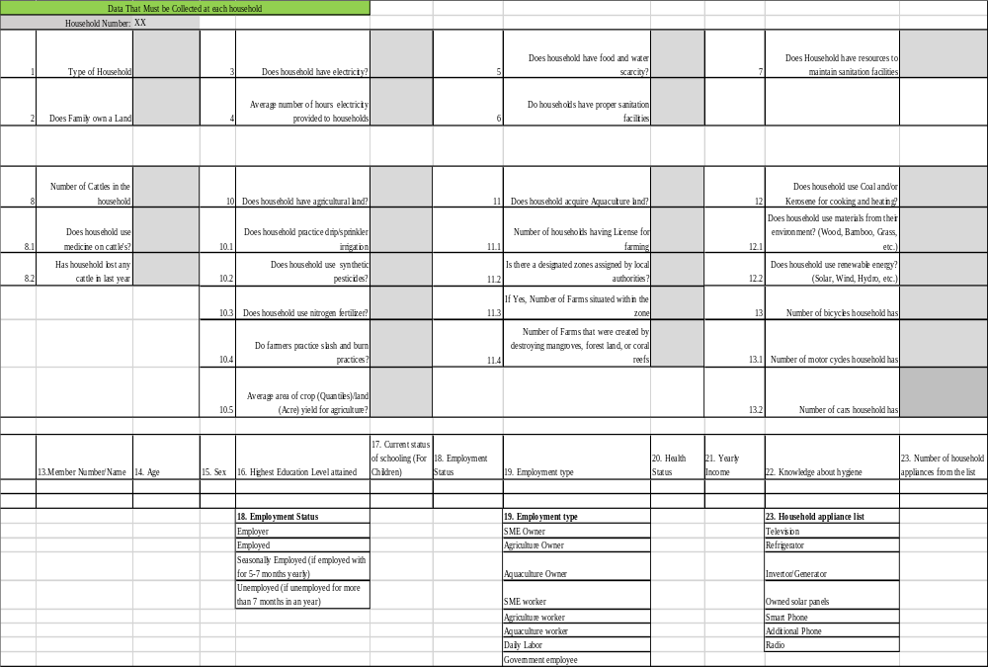
Overall in the current section, the motive is to show the working of VLBSI (that is, how to assign weights to each indicator and sub-indicators) and to present how an index can be modified if the data is not available or is not in the required format for the sub-indicators that are developed for each indicator initially. In this section, the information collection data sheet is also provided for social entrepreneurs that can be useful in collecting the data from each household and village and better evaluate the baseline status of the village.

Hypothesis Verification: Village Level Baseline Sustainability Index
Village Level Baseline Sustainability Index is developed as the first construct for the framework proposed in Section 1.3. The secondary question (Thesis Question Q2) associated with VLBSI is restated along with the hypothesis below, the hypothesis proposed is then verified based on the outcomes of VLBSI from the example village.
Q2: “What information (qualitative and quantitative) must be collected from a rural area to evaluate its present status in terms of social, environment and economy? What method will be needed to evaluate this information and how can this information be used to develop a sustainable value proposition.”
Hypothesis for Q2: “By developing a village level baseline sustainability index that includes social, environment and socio-economic aspects of a village. The index will include various aspects and questions on the status of social, environment and socio-economic aspects. On calculating, identifying the values of these aspects and answers to the question will give the current sustainability value of the village, thereby giving insight on the perspectives which social entrepreneurs can concentrate while developing a value proposition.”
The index developed based on the hypothesis is presented in this chapter. The index proposed requires input of information from different aspects of each driver (presented in Section 3.1), Social (education, health, electricity, sanitation, food/water, communication, etc.), environment (agriculture, animal husbandry, aquaculture, energy usage, environmental degradation, etc.) and economic (income stability, income disparity, economy structure, employment structure, etc.). Scales and weights to each aspect (indicators, sub-indicators) are assigned by the social entrepreneur/user of the index to get the current sustainability value for any given village. The value obtained from Village Level Baseline Sustainability Index provides an insight on the area that social entrepreneur / user can concentrate. VLBSI also can be modified, changed to adapt the information available and reused (presented in Section 3.2), thereby fulfilling the requirements of the primary and secondary question presented in this thesis. For the scenario as presented in Section 3.2, where information is not adequate, a table is provided to collect information from households (Table 3.18). In this chapter, for this construct the method is verified as per the requirements presented in hypothesis and overall framework, due to lack of data for the village selected, the verification of output is presented in Chapter 7 (where the data is present for all the three drivers). The information obtained using the baseline assessment index can be directly used to make decisions in an area of the composite village. Information can also be used for the next tool (Dilemma Triangle) developed for the framework that is presented in this thesis. In next section, the outcome for the sustainability baselines assessment index is discussed.

SYNOPSIS OF CHAPTER 3
In Chapter 3, one of the three constructs, Village Level Baseline Sustainability Index is introduced. As the information in villages is available in both qualitative and quantitative form, the index is developed to collect both forms of information. Indicators are being used to calculate sustainable development at different levels (country, urban and project specific levels) as presented in Section 3.1.1. However, no index is present at rural level. For village level index, the requirements are as set by the framework, to be adaptable, modifiable and reusable. Based on the requirements and gap, proposed village level index is presented in Section 3.1.2. The index includes at highest level three drivers (social, environment, and economic) of sustainability. The drivers are divided into various indicators and each indicator is then divided in sub-indicators. From bottom-up the sub-indicators feed the value to indicators and all indicators combined for a particular driver feed the value to that particular driver. In section 3.1.2, discussion is made on how to assign weights to each of the indicators, sub-indicators. In same section, each of the indicators and sub-indicators for all the drivers is presented, an explanation is provided on how to use the index with respect to input values and weights. In Section 3.2, data for a village is taken from census and other websites to show the working of proposed index. For Social driver, as the data available was not in same format as the indicators developed, the indicators are modified to use the data. Same was not possible for environment and economic driver, and therefore at the end of Section 3.2 a table is provided (Table 3.18) that can be used to collect required information from households and village under consideration. In this chapter, the index and working of one of the driver is presented, In Chapter 7, overall index is used and presented.
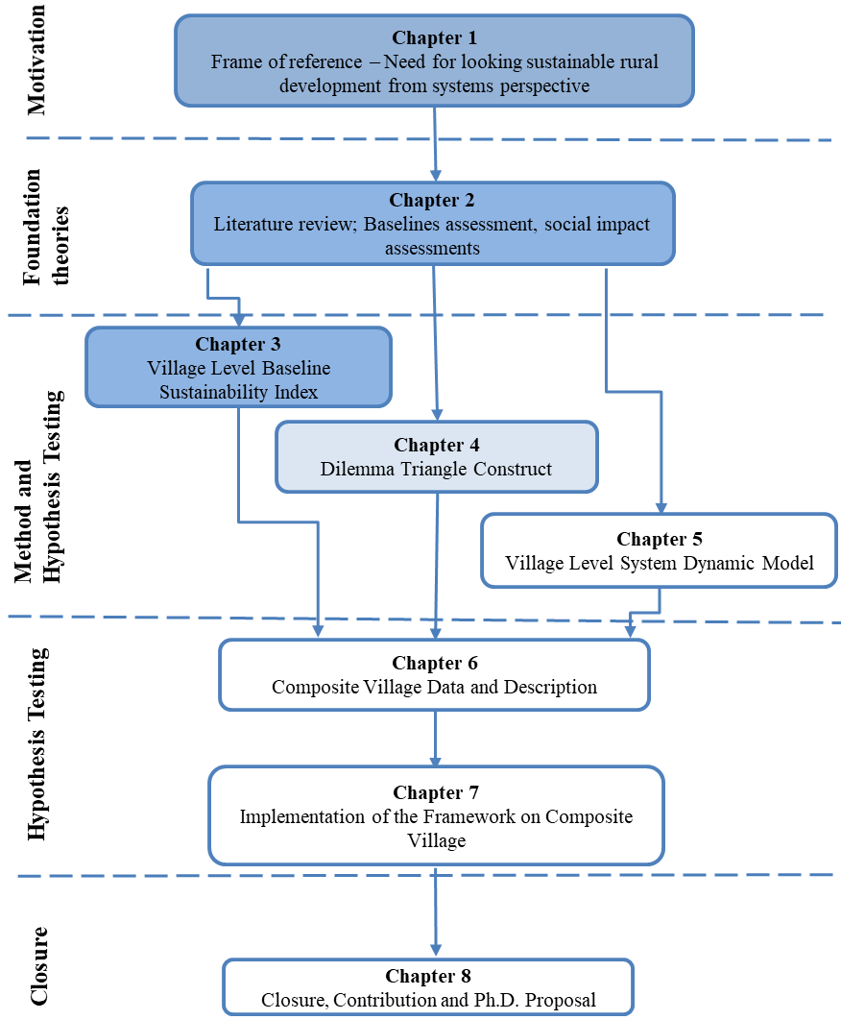
Figure 3.5: Organization of the Thesis – Presented and Next Chapter
In Chapter 4, next construct of the framework, Dilemma Triangle is introduced as presented in Figure 3.5. Introduction to the method of Dilemma Triangle followed by implementation of the method in Section 4.1 and Section 4.2 respectively is presented in next chapter.

CHAPTER 4
THE DILEMMA TRIANGLE CONSTRUCT
In Chapter 3, the first construct of the framework is presented along with an example problem to show the working of VLBSI. A method is discussed to modify the indicators based on available data to identify an area of focus. In the framework, the data is collected for VLBSI and based on the identified focused area; Dilemma Triangle construct is used. This is presented in Chapter 7 of the thesis. In this Chapter, a method to use Dilemma Triangle construct for developing value proposition is presented in Section 4.1. Later in Section 4.2, the method is applied to a village data, and sustainable value propositions are developed.

THE DILEMMA TRIANGLE METHOD FOR DEVELOPING VALUE PROPOSITION
A dilemma is a difficult choice from two options, each of which is (or appears) unacceptable or unfavorable. A dilemma represents a zero-sum outcome. It can be expressed as a choice among
– Two unfavorable options one of which must be chosen, OR
– Two favorable options, only one of which is possible at this time.
In Chapter 2, Section 2.3 a brief discussion is presented how sometimes inequity in a system, stakeholder conflict and value proposition developed can be a zero-sum game. To develop a sustainable value proposition, it is essential to identify and manage these dilemmas before implementing the solution/system.
The Dilemma Triangle construct is developed to identify a dilemma in a complex system that has three drivers (or stakeholders) with three or more goals. By using the construct, a designer can identify dilemmas that can arise in a system, and then work towards managing these dilemmas. In Figure 4.1, the concept with three drivers is presented and termed as Dilemma Triangle. The three drivers in Figure 4.1 drive the solutions, the focus states the boundary of the problem user is solving, and issues are the challenges that can occur in each driver to reach the desired goal. Previously, the Dilemma Triangle construct is used for identifying and managing dilemmas in a dynamically changing workplace environment of the 21st century (Ahmed, Xiao and co-authors, 2012). In this thesis, the concept is expanded and particularized from the method presented in (Ahmed, Xiao and co-authors, 2012) to create a value proposition for sustainable development of rural areas. Dilemma Triangle is particularized by replacing the three drivers of the complex system the pillars of sustainable development (economic, environmental and social) to establish the context of sustainability. A value proposition is developed after gap identification in the market (Ardichvili, Cardozo and co-authors, 2003; Robinson, 2006), in context of this thesis, the market is anchored in the drivers of sustainability. The dilemmas that arise within these drivers are the gaps that are required to be filled by the social entrepreneurs to sustain their enterprises. In detail, the method developed to use Dilemma Triangle is discussed in Section 4.1.1. Each step presented in Section 4.1.1 is defined clearly to state the requirements and thereby reducing the ambiguity from the method of misinterpretation.
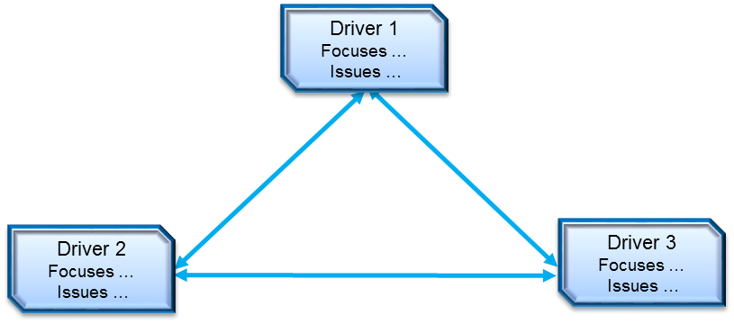
Figure 4.1: The Dilemma Triangle

Method to Identify Dilemmas
The method of Dilemma Triangle is divided into two parts, the first part is generic and can be used for all the complex systems, the second part of the method is specific to the context of this thesis, wherein the combination of concepts from spheres of sustainability with the construct of Dilemma Triangle is presented. For all the complex systems that are anchored in the sustainable development, both the parts of this method can be used. In Figure 4.2, the steps of the method are presented, in Sections 4.1.2, ‘Part 1 – to identify dilemma’ is discussed and in 4.1.3, ‘Part 2 – to develop sustainable value proposition’ is discussed. Before this method can be applied, a social entrepreneur must define the problem in the form of a problem statement together with the data that characterizes the village. In the proposed framework the problem statement is identified based on the output gathered from VLBSI presented in Chapter 3. In this Chapter, the focus is on the use of individual construct (Dilemma Triangle). Therefore a problem statement along with a data characterizing the village will be presented in Section 4.2 to show the working of the method proposed. In Chapter 7, however, the working of each construct of the framework in association with other one is presented as shown in Figure 1.7.
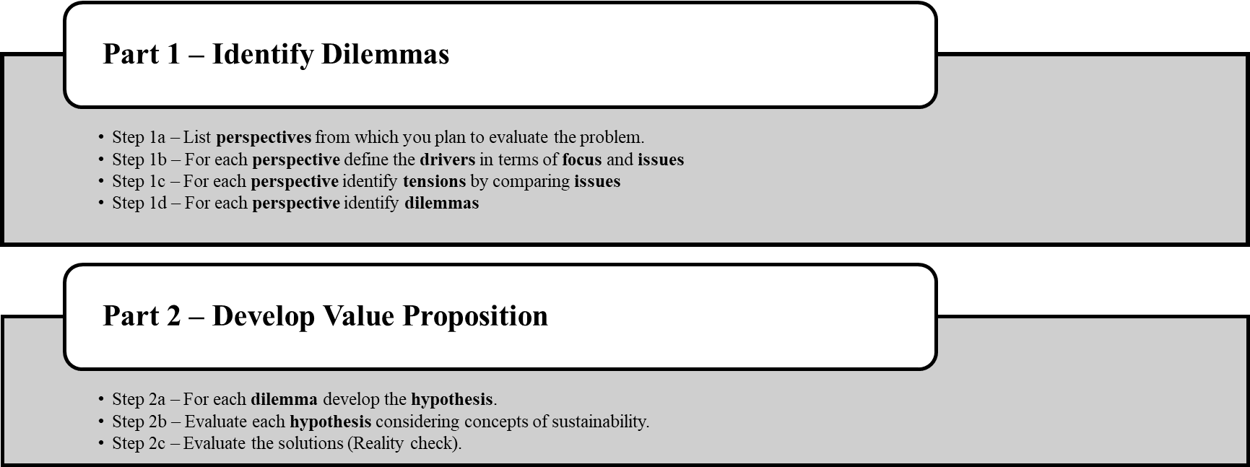
Figure 4.2: Steps to Identify Dilemmas

Part 1 – Identify Dilemmas in the System
As discussed in the section above and presented in Figure 4.2 the method is divided into two parts, the first part that is applicable to all the complex system is;
Step 1a – List the perspectives from which user plans to evaluate the problem.
- To solve a problem in a complex system, it is necessary to draw boundary before the problem can be solved. In Dilemma Triangle construct, various perspectives of stakeholders are used to define the boundary of the problem. Based on the perspectives, the dilemmas are identified for each of the perspectives.
- If the boundary around a problem is drawn is too small, then there is likely to be no dilemma. On another hand if we draw the boundary around a problem that is too large, then the outcome is likely to be in action.
Step 1b – For each perspective, define the drivers in terms of focus and issues
- Once the boundary is defined by identifying the perspectives that are to be explored; the next step is to define the drivers for each of these perspectives.
- The focus for each driver must be written as a sentence that drives the solution, as presented in Figure 4.3.
- The focus can also be seen as the goal that user wants to achieve for the selected perspective.

- The issues are factors that are embodied in the drivers. Issues are hindrances in achieving the focus (goal). Typically, words or verb/noun combination.
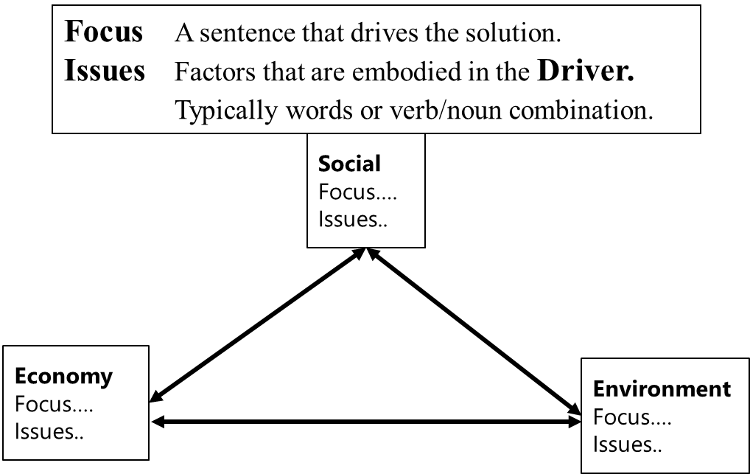
Figure 4.3: Focus and Issues in a Dilemma Triangle

Step 1c – For each perspective, identify the tensions by comparing issues.
- Tensions are potential dilemmas, tensions between two drivers are determined by comparing a pair of issues (one from each driver), see Figure 4.4.
- To identify tensions in each perspective, one issue of one driver is compared to all the other issues in other two drivers. This process is repeated for all the issues. In Figure 4.5, a tensions matrix is presented that is used to compare the issues.
- For a given perspective there may be no tensions. Hence, there is no dilemma.
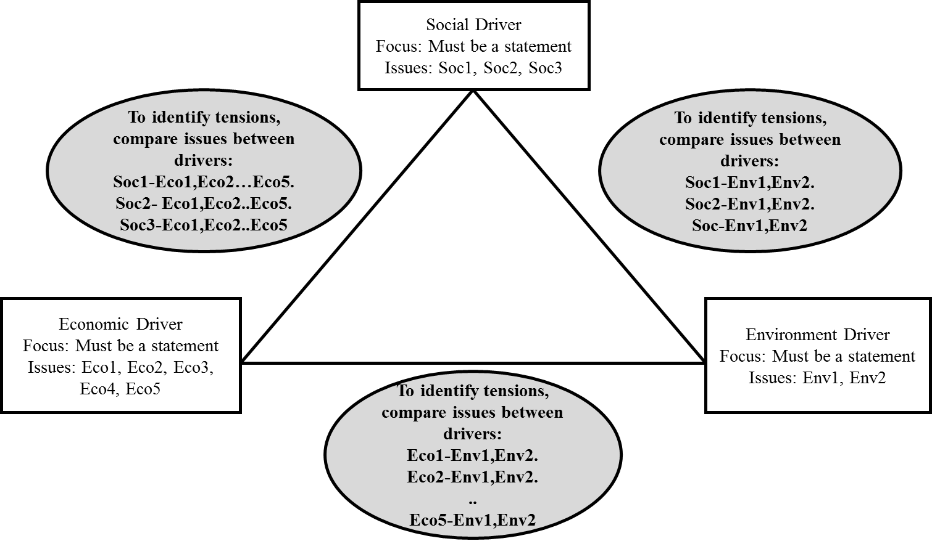
Figure 4.4: Comparison of the Issues Between Each Driver

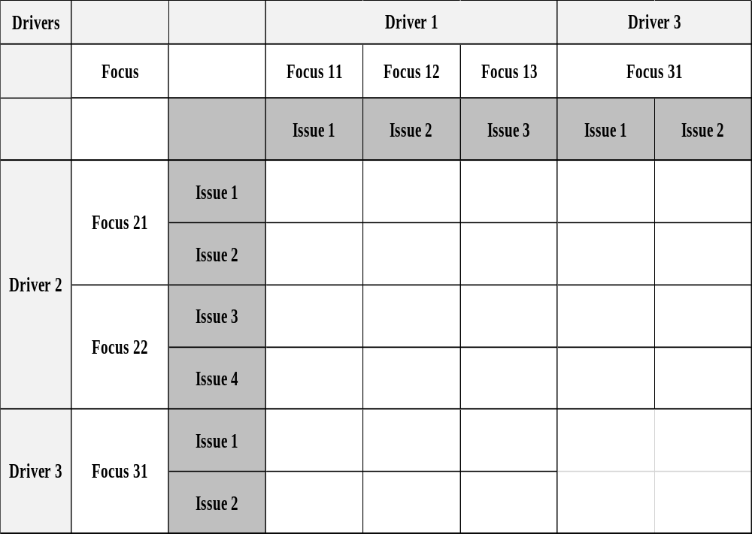
Figure 4.5: The Tension Matrix for Dilemma Triangle

Step 1d – For each perspective, identify dilemmas.
- To identify the dilemmas, the first step is to prioritize the tensions and analyze them one by one.
- If tension can be resolved by adopting a policy or buying / installing something, then there is NO dilemma.
- If tensions cannot be resolved by adopting a policy or buying installing something, then there is a dilemma.
- A dilemma involves two drivers and embodies a zero-sum solution. A hypothesis must be proposed to transform the zero-sum solution into a positive-sum solution.
The dilemmas identified are the gaps, inequities in the system that are needed to be considered for the selected system to function. In Part 2 of the method, steps are presented in order to anchor the value proposition to be developed in sustainable development.

Part 2 – Develop Value Proposition
The second part of the method (presented in Figure 4.2) is developed for value propositions anchored in sustainable development. To develop a value proposition for socioeconomic development that is sustainable and has a long-term impact, it is necessary that the proposition is created by considering the three drivers of sustainability. To achieve sustainability, it is necessary that the solutions be bearable, equitable and viable. This concept of sustainable development is adopted and combined with the construct of Dilemma Triangle.
The solution to the dilemmas that a social entrepreneur will encounter in rural development must be bearable if the dilemma is between social and environment driver, equitable if the dilemma is between the social and economic driver, and viable if the dilemma is between environment and economic. This is presented in Figure 4.6 - The Sustainability Triangle. The steps are;
Step 2a – For each dilemma, develop the hypothesis.
- In this case, the dilemma would be between any two drivers of sustainability and would embody a zero-sum solution. To transform the zero-sum solution into a positive-sum solution user needs to come up with a hypothesis for the same.

Step 2b – Evaluate each hypothesis considering concepts of sustainability.
- Positive sum solutions that are developed to have a win-win solution MUST satisfy the test that the outcomes are Bearable, Viable and Equitable for it to be a sustainable solution (Figure 4.6).
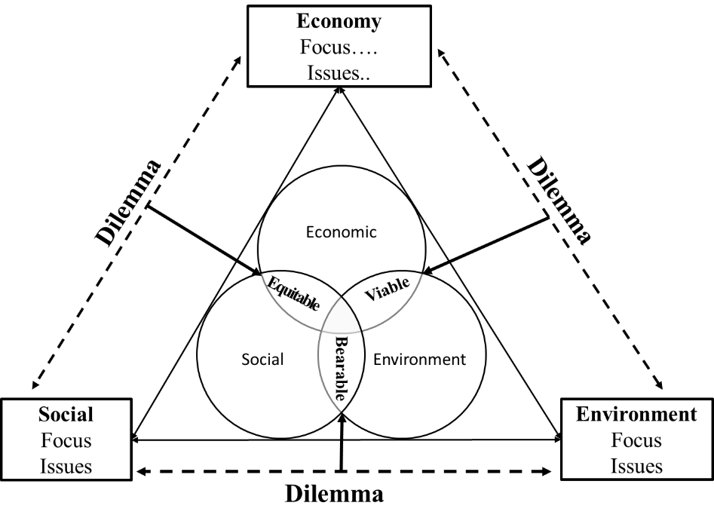
Figure 4.6: The Sustainability Triangle

Step 2c – Critically evaluate the solutions (Reality check).
- In the process of designing and developing a new solution for complex systems, it is always important to do a reality check on whether the solution is probable based on the resources available.
- Similar to the complex systems, solutions created for rural development must also go through a set of reality check based on the resources available.
- If the solution is not possible, the social entrepreneur must develop other value proposition that is possible and sustainable.

The method developed for identifying dilemmas and creating value propositions for rural parts of India is generic, reusable and can be used in villages with different characteristics. In next section, data from one village is taken and the method proposed is implemented on the village data.

IMPLEMENTATION OF THE DILEMMA TRIANGLE METHOD
In the previous section, a step by step method is presented to use Dilemma Triangle construct for developing value propositions anchored in sustainable development. To show the working of this method in this section the steps are applied to a village data and value proposition for it is developed. In Section 4.2.1, the data of village is briefly discussed. In Section 4.2.2 and 4.2.3 method is used.

Village Description for implementing Dilemma Triangle method
The total population of the village is 2000, 50% of which are under the age of 25. The primary source of income is farming with 75% of households involved in some part of the farming process. There is a school in the village for primary education for children up to the age of 12, but only one-third of the children under the age of 12 are able to attend school. There is discrimination due to the caste system and gender. This is part of the cause of our three distinct classes which are upper (consisting of 50 households), middle (consisting of 300 households), and lower (consisting of 50 households). There are a significant number of the lower class households that have a food shortage and don’t have proper housing. Only 50 households of the upper class have proper sanitation facilities and electricity which is generated from fossil fuels and nonrenewable resources. There is high caste and gender inequality. The village also currently lacks healthcare facilities. Surrounding the village and farmland is an environmentally sensitive forest with subtle animal habitats and plant life.”

Among many issues, the village lacks access to electricity. For this example, providing electricity in the village is taken as a task for the social entrepreneur. Electricity plays a very important role in any community if a community has electricity, small and micro enterprises can be established in the community, children can study more, and villagers can work till late in the evening to increase their economic standards. Therefore, considering the social entrepreneur has to provide electricity access to the people of the village we move forward.

The method of Dilemma Triangle is implemented from the standpoint of a social entrepreneur who is working towards the development of a sustainable value proposition. For a social entrepreneur, the first step is to collect data of the target village. In Appendix Table A.2. 1 the data of the village to understand the social, environmental and economic condition is presented.

Once the data is collected for the village, next step is to find various perspective for the social entrepreneur to identify dilemmas in the village. In Section 4.2.2, implementation of Part 1 of the method (presented in Section 4.1.1) is presented. In Section 4.2.3, implementation of Part 2 of the method is presented.

Implementation of Part 1 – Identifying dilemmas
Step 1a: List the perspectives from which user plans to evaluate the problem.
Perspectives must be selected based on the goal a social entrepreneur wants to achieve in a scenario. Here one perspective is selected to show the implementation of the method.
- Village/Villagers: The perspective selected is of village/villagers to identify their requirements and the issues that could arise within the community. By taking village/villagers as perspective, the gap in the market can be identified and used to develop the value proposition.
Step 1b: For the perspective (village/villagers), focus and issues are defined in term of drivers. This is represented in Figure 4.7.
The focus for a driver must be a sentence that drives a solution of the goal social entrepreneur wants to achieve in selected perspective.
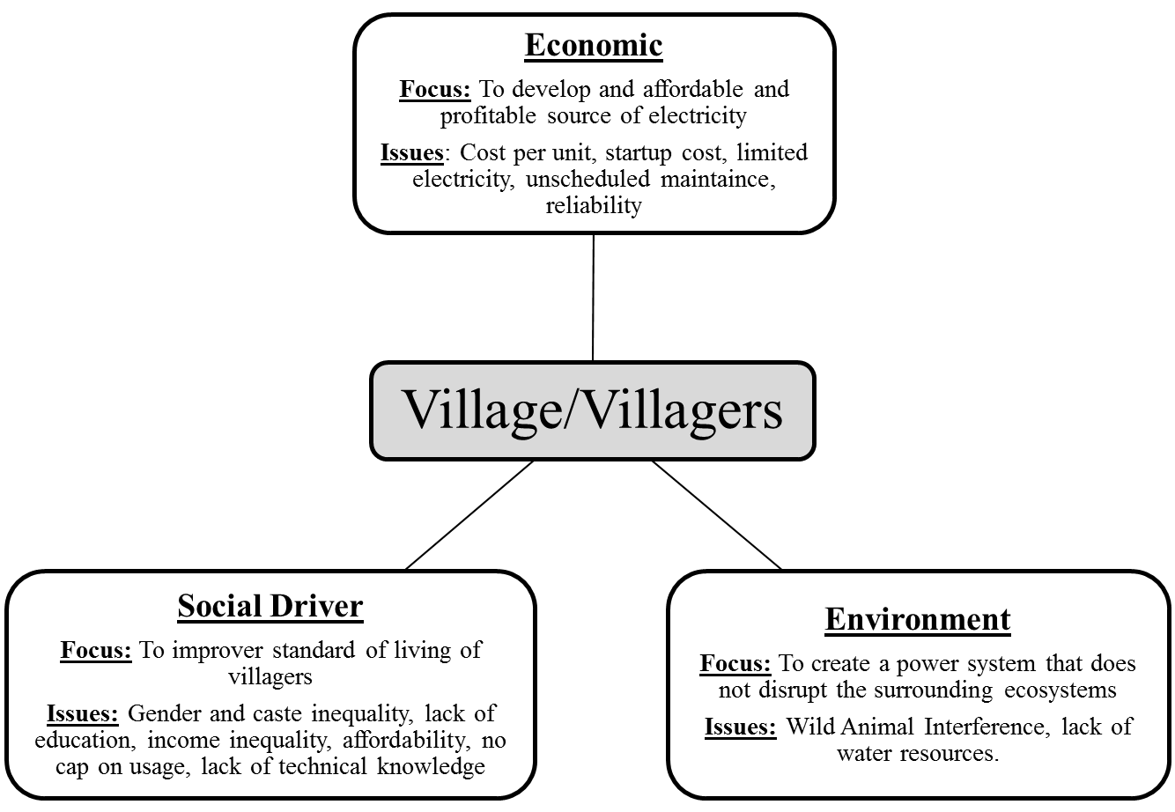
Figure 4.7: Dilemma Triangle of Village/Villagers Perspective

Driver: Social
In this example, from social aspect, the focus is on improving the standard of living for all the villagers. There are many issues and challenges in this village that will hinder social entrepreneur in achieving this goal, that is;
Focus: To Improve the standard of living for the villagers.
Issues
- Gender and caste inequality – In the village women are discouraged from holding jobs and primarily work with handcrafts and are homemakers. A hierarchy exists in the village based on old customs where villagers in the upper class of our village are seen as superior to the villagers in the lower class.
- Lack of education – The village contains a primary school, and only 30% of children attend it. There are no opportunities for most of the children to continue education after primary school.
- Income inequality – The caste system exists, where the upper class, consisting of 50 households, controls most of the wealth.
- Affordability – The electricity provided by the entrepreneur must be affordable to the people.
- Lack of technical knowledge – Due to the lack of education in the village, no technical knowledge exists among the villagers.
Driver: Environmental
Similar to the social driver, focus for the environment and economic driver the focus followed by issues are presented.
Focus: To create a power system that does not disrupt the surrounding ecosystems.
Issues
- Wild animal interference – From the surrounding forest, many animals walk in the village at night, destroying crops.
- Lack of water resources – As mentioned in description of the village (Appendix Table A.2. 1), there is seasonal water scarcity.
- Weather/Natural disasters – Monsoons and cyclones affect or damage the equipment used to generate power.
- Village’s farmland – Villagers will not allow the plant to be set up in the village farmland that is nearby to the village.

Driver: Economic
Focus: To develop a microgrid that is a profitable enterprise to sustain and grow.
Issues
- Cost per unit – For the enterprise to sustain and grow cost per unit must increase with time.
- Startup cost – The cost required to start the social enterprise will be high, the more expensive the startup cost, fewer villagers will be able to afford it. However, if inferior components are used to minimize startup cost, the quality and reliability of the product will suffer.
- Managing demand – Micro-grid can only provide a constant amount of electricity per/day. In order to grow gradually and sustain it is necessary to manage the demand efficiently in a way that gives maximum output.
- Unscheduled maintenance – In order to sustain and keep the micro-grid running, it is important that unscheduled maintenance is taken care of properly.
- Reliability – The less reliable the product, the more expensive the maintenance will be, resulting in higher cost of electricity and lower consumer satisfaction.
Step 1c – For each perspective, identify tensions by comparing issues.
Tensions are the conflicts that might arise between two issues. This will create an obstruction in achieving the focus for a particular driver in the selected the perspective. In Figure 4.8, all the tensions for the village/villager’s perspective of this example are presented. Each tension identified is explained below.
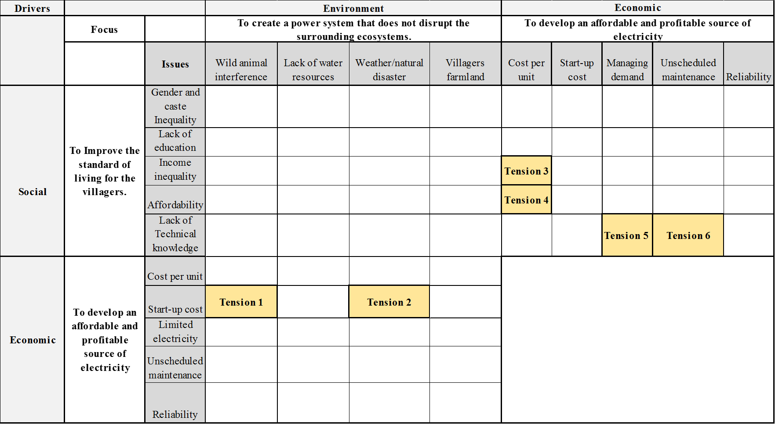
Figure 4.8: Tension Matrix for Village/Villagers Perspective

Tension 1 - Between high startup cost (economic driver, Issue 2) and wild animal interference in the village (environmental driver, Issue 1): Cost of equipment is very high for micro-grids. If wild animals enter the village near grid area, they might damage the equipment or destroy the whole grid. This becomes a tension as repairing grid is not a feasible solution, and since the village is in forest area, alarming away wild animals is not possible.
Tension 2 - Between high startup cost (economic driver, Issue 2) and natural disaster (environmental driver, Issue 3): Similar to Tension 1, the village is situated in disaster-prone area, and precautionary measures must be taken to protect the grid from getting damaged. To increase the safety of grid from natural calamities designing the grid might be costly. The tension here is to choose between the additional cost for designing safe grid or repairing the grid when it gets damaged.
Tension 3 and Tension 4 - Between cost per unit of electricity, income inequality (social driver, Issue 3, Issue 4) and affordability of the villagers (economic driver, Issue 1): These two tensions are interconnected, and solution to one of the tension can solve the other tension simultaneously. In order to sustain the grid enterprise, a minimum cost per unit must be charged to each household and business, but most of the lower income household cannot afford the cost of electricity. The tension here is to either go in loss initially or provide electricity to lower income people or to grow the enterprise and not give growth opportunities to lower income households.
Tension 5 - Between managing demand (economic driver, Issue 3), and lack of technically skilled villagers (social driver, Issue 5): Microgrids when installed, will have limited capacity, as the demand increase, need of managing demand becomes important. To manage demand, we need technically skilled labor in the village to evaluate and manage the supply. The tension here is either to lose the unmet demand and improperly manage the supply of electricity produced or to hire skilled labor to stay and manage the demand.
Tension 6 - Between unscheduled maintenance (economic driver, Issue 4) and lack of technically skilled villagers (social driver, Issue 5): There could arise a situation when urgent maintenance is required in the enterprise. The social entrepreneur cannot be available 24x7 on the ground, and there is a lack of technically skilled labors. The tension here is whether to let the unscheduled repair decrease reliability of the grid or to hire an experienced skill person in village 24x7.

Step 1d – For each perspective, we identify dilemmas.
To identify the dilemmas, need is to prioritize all tensions and evaluate each of them to find if tension can be resolved by adopting a policy or buying / installing product. In this example, prioritization of the tensions is based on the path of development of the micro-grid, that is, which tension needs to be resolved first in order to establish the micro-grid. On this basis, prioritization and evaluation of the tensions are conducted.
1. Tension 1 and Tension 2: These tensions are a priority as these tensions need to be resolved in the planning phase of the enterprise. Both the tensions are related to high startup cost and can be resolved by using a proper alarm system and proper plant layout respectively. Both the solutions will increase the startup cost but are useful in the long run.
2. Tension 3 and Tension 4: These tensions arise in the next phase of development; here social entrepreneur must establish the cost per unit of electricity based on the estimated break-even point. If the cost per unit is not affordable for the villagers, then either the project must be scraped, or lower cost per unit must be charged. For a social enterprise to sustain both the choices are unfavorable, and this tension cannot be resolved by implementing a policy or solutions. Therefore, this becomes the first dilemma.
3. Tension 5 and Tension 6: Both of these tensions can be solved by hiring an experienced person in the village. Another solution is to teach the villagers all the technical details, but this might not solve the problem as unscheduled maintenance might require expertise. Since these tensions cannot be resolved with the policy or solution present currently, it becomes the second dilemma.
Once the dilemmas are identified, next step is to resolve them. Different users can take different approach in resolving these dilemmas, as a part of the method, steps are proposed to resolve the dilemmas by taking into account drivers of sustainable development and in this process develop a value proposition for rural India. The implementation of these steps is presented in next section for the two dilemmas identified.

Implementation of Method - Develop Value Proposition
Step 2a –For each dilemma develop the hypothesis.
The dilemma would be between any two drivers of sustainability and would embody a zero-sum solution. For each dilemma, user needs to propose hypotheses that will allow the user to transform the zero-sum solution into a positive-sum solution. Each dilemma can have multiple hypotheses. Further evaluation of these hypotheses will determine the most sustainable hypothesis.
In this part, hypotheses to transform the dilemma into positive-sum solution are proposed for both the dilemmas.
Hypothesis 1 for Dilemma 1: To develop ideas for small and micro enterprises within the village that were not possible due to lack of access to electricity to improve economic standards of villagers thereby increasing the number households that can afford the electricity.
Hypothesis 2 for Dilemma 1: To charge a different cost per unit of electricity for each household based on their income and standard of living.
Dilemma 1: The dilemma is between the social and economic drivers. Here dilemma is to choose between people’s affordability and enterprise’s economic sustainability. Villagers cannot afford to pay for the electricity as their economic status is low. If we provide electricity in developing the infrastructure and small business in the village, then the economic standard might increase for the villagers, and they can pay for the subsidized electricity.
Hypothesis 1 for Dilemma 2: To have a social entrepreneur visit the village more frequently than required and to scheduled maintenance more frequently than required respectively.
Hypothesis 2 for Dilemma 2: To make the micro-grid connected with the cloud computing in order to manage all the essential function online, such as online control of the distribution of electricity. By keeping the sensor at all important locations in the micro-grid, experienced technicians can identify the source of any problem (if it occurs) and can help inexperienced technician in the village to perform the necessary task.
Dilemma 2: The dilemma is between social and economic driver. Here the plant established is in off-grid location and availability of experienced technician is not possible if not planned. In such cases, the reliability and efficiency of the enterprise and its services decrease.
Step 2b – Evaluate each hypothesis considering concepts of sustainability.
- Each hypothesis that is developed to have a positive sum solution MUST satisfy the test that the outcomes are Bearable, Viable and Equitable for it to be a sustainable solution.
Hypothesis 1 for Dilemma 1: To develop ideas for small and micro enterprises within the village that were not possible due to lack of access to electricity to improve economic standards of villagers thereby increasing the number households that can afford the electricity.
Evaluation: The dilemma is between social and economic drivers, and therefore the hypothesis must be equitable. Based on this hypothesis the small and micro enterprises must be developed within the village that was not possible due to lack of access to electricity. From social driver, this will help villagers in improving their standards of living as the development of enterprises increases the flow of resources and is fair for the villagers and social focus when compared to economic focus. From economic driver, improvement in the standard of living will help villagers in paying the cost of electricity that is desired by the entrepreneur; this will help entrepreneurs in sustaining the enterprise for the long run. Therefore, we consider this as a solution that is equitable.
Hypothesis 2 for Dilemma 1: To charge a different cost per unit of electricity for each household based on their income and standard of living.
Evaluation: Based on this hypothesis the social entrepreneur should charge a different cost per unit for the households with different income levels. From the economic driver, this is affordable for the people and is also helpful for sustaining the enterprise. From the social driver, this hypothesis is not fair or equal to the focus of economic driver, as the cost per unit is not consistent. Therefore, this solution is not equitable and cannot be adopted.
Hypothesis 1 for Dilemma 2: To have a social entrepreneur visit the village more frequently than required and to scheduled maintenance more frequently than required respectively.
Evaluation: The dilemma is between the social and economic driver and must be equitable. From the social aspect, this hypothesis is possible as a frequent visit to the village will help in the smooth process of the enterprise. From an economic aspect, this is not a feasible hypothesis. Therefore this hypothesis cannot be adopted.
Hypothesis 2 for Dilemma 2: To make the micro-grid connected with the cloud computing in order to manage all the essential action online, such as online control of the distribution of electricity.
Evaluation: This hypothesis requires the development of new technology and will help the entrepreneur in managing the access to electricity online. This will help villagers improving their efficiency in different occupations. This hypothesis is fair as the investment done on technology will be useful in increasing the efficiency of another process in the village, and as the time progresses, there will be a return on investment in terms of sustainable development and preservation of natural resources. Development of technology will also implement sustainability in all the processes of the enterprise. Therefore this is considered as an equitable solution.
Step 2c – Evaluate the solutions (Reality check).
- In the process of designing and developing a new solution for complex systems, it is always important to do a reality check on whether the solution is probable based on the resources available.
- Similar to complex systems, solutions created for rural development must also go through a set of reality check based on the resources available. If the solution is not possible, the social entrepreneur must develop other value proposition that is possible and sustainable.
In the framework proposed, the reality check for hypothesis selected and value proposition derived from the accepted hypothesis is evaluated using Village Level System Dynamics model (discussed in Chapter 5). In this chapter, the focus is one presenting the method of Dilemma Triangle construct and implementation of the method on solving a small example. In next section, the empirical structural validity of the construct is presented.

Hypothesis Verification: Dilemma Triangle Construct
Dilemma Triangle Construct is used to develop a value proposition for the social entrepreneur’s (second construct for the framework). Dilemma Triangle previously has been used to identify conflicts between three drivers. In this thesis, Dilemma Triangle is extended to be used with three drivers of sustainability, and a step by step method is developed to convert the dilemmas or conflicts between stakeholders, drivers in possible value proportions. Dilemma Triangle construct is proposed as a method and verification of this cannot be in terms of results obtained. However, the verification is possible by showing the utility of the construct based on the hypothesis proposed. The Thesis Question Q3 and hypothesis associated with Dilemma Triangle construct are restated below;
Q3: What method can be used to develop the value propositions for development of the rural area that is sustainable with respect to the planet, profit, and people involved?

Hypothesis for Q3: “By developing a method that embodies construct of Dilemma Triangle to understand various perspectives for developing a value proposition and will be used in identifying various dilemmas which could arise in rural development thereby giving an insight on what should be the value created by the value proposition for the development of the village.”
As Dilemma Triangle construct used is a method to develop the value propositions, to verify the method and hypothesis, validation square is used in this thesis. In Chapter 2 Section 2.3, the literature reviewed on available value proposition tools is discussed. Gap identified is anchored in need for considering the drivers of sustainability together. To fill this gap, Dilemma Triangle construct is proposed to be useful. Based on this hypothesis, a method is developed and presented in Section 4.1. An example test problem is solved using the proposed method in Section 4.2. The method proposed is developed to be used for any village or a community. The construct is used to direct decision makers attention at different aspects and provide a systems perspective. The utility to identify issues and dilemmas is presented with the example village. For the example village selected in Section 4.2, use of Dilemma Triangle construct provides insight on creating micro-grid with cloud computing and connecting with internet for sustainable operations. This insight might not have occurred otherwise. Based on the outcome for the given example, the construct is structurally validated, that is the steps proposed for the construct are systematic and lead to useful results.

SYNOPSIS OF CHAPTER 4
In this chapter, the second construct of the framework, Dilemma Triangle Construct is introduced. Once the focus area is identified, next step is to develop a value proposition in that selected focus area. In order to improve the overall quality of life of the villagers, social entrepreneurs must focus on issues and challenges in the community that become blockade in this improvement. Once the issues are identified, social entrepreneur’s task is to come up with a value proposition that can be used to overcome the issues and improve the quality of life. Dilemma Triangle construct is useful in identifying such issues. In Section 4.1, the proposed method is the integration of Dilemma Triangle construct developed by (Ahmed, Xiao and co-authors, 2012)and sustainable development. The method proposed is divided into two parts, first part includes four steps to identify dilemmas in the selected system with three drivers (in this case, social, environment and economic). In the second part of the method, three steps are discussed to develop a value proposition that converts a dilemma (zero-sum solution) to positive-sum solution, anchored in sustainable development.
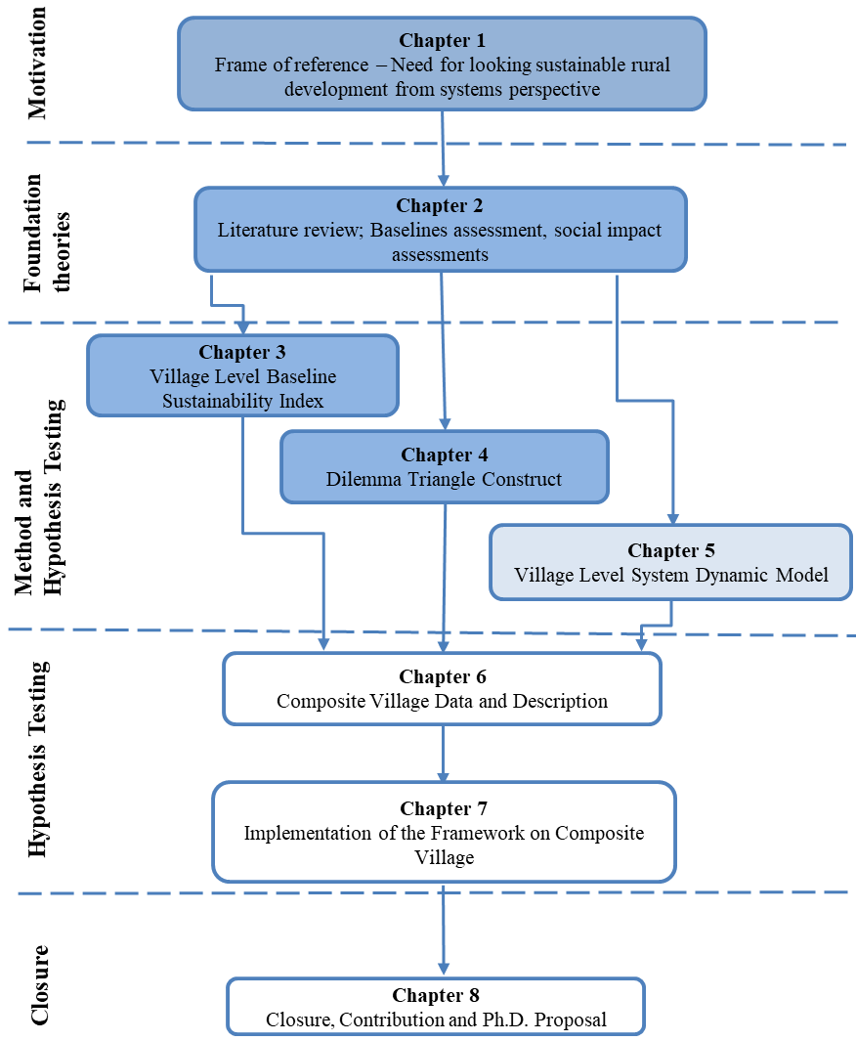
Figure 4.9: Organization of the Thesis – Presented and Next Chapter
In Section 4.2, the method presented is implemented on a village data. The focus in this village is on providing electricity to each household. Based on this, the perspective of villagers is selected to identify the issues, tensions, and dilemmas associated. The method is used to develop value proposition and evaluate the sustainability of this value proposition.
In Chapter 5, the last construct of the framework, Village Level System Dynamic is introduced as presented in Figure 4.9. For the proposed framework, the information from first two constructs feeds into VLSD to evaluate the impact (positive and negative) of the value proposition. In Section 5.1, the introduction of system dynamics is provided, the concept of causal loops and stock and flow are introduced. In Section 5.2, the VLSD model developed as a part of this thesis is discussed in detail and validation of demographic part is provided. In Section 5.3, three village vignettes are used as examples to show the utility of the model developed.

CHAPTER 5
SYSTEMS DYNAMICS: USE IN IMPACT ASSESSMENT

Once the baseline data for a village is collected and baseline assessment is done for a village, the next step is to identify the value proposition that is needed for a particular village to improve their standards of living. Once the value proposition is identified, next step is to evaluate the value proposition and assess its impact on various aspects of the village. The impact assessed can be by social entrepreneur or by CSR investors in order to select the most impactful value proposition and to identify changes of improvement. In this chapter, the last proposed construct of the framework is discussed, Village Level System Dynamic (VLSD) model. VLSD is developed as an impact assessment tool to be used to evaluate the value proposition developed for rural India. A method is presented in this chapter to extend the Systems Dynamic model for different village and communities. In Section 5.1, a brief introduction is provided for Systems Dynamics, use of Systems Dynamics as an assessment tool and method to develop VLSD model. In Section 5.2, the VLSD model developed for this thesis is discussed in detail. In Section 5.3, example problems are solved to show the utility of VLSD. In Section 5.4, the empirical structural validity for the three constructs is presented

INTRODUCTION TO SYSTEMS DYNAMICS
Systems Dynamics (SD) is used to simulate a complex system to understand the behavior of the system over a period. SD modeling is a combination of various stock and flow diagrams having feedback loops, table functions and time delays. For this thesis, System Dynamics is used to evaluate the impact of different value proportions on a community. Following the requirements of the framework proposed, the system dynamic model that is developed for this thesis is also anchored in adaptability and reusability. For this thesis, the System Dynamic model is developed in Vensim Software (Eberlein and Peterson, 1992). System dynamics was developed by Jay Forrester in 1959 as an inventory control system simulation model (Forrester, 1994). System dynamics since then is applied to various fields that involve understanding of the dynamics of complex systems. System dynamics approach is used in policy-making at the national level, in making decision for businesses. System dynamics is also been used to evaluate the effect of social policy on a given community (Ghaffarzadegan, Lyneis and co-authors, 2011). There is a huge amount of literature on sustainability and use of system dynamics to simulate the sustainable systems and decisions that must be taken to keep a system sustainable. Systems dynamics is also being used is in construction organizations to demonstrate how civil contracting can be improved (Ogunlana, Li and co-authors, 2003).
Systems dynamic model is developed in two stages (Walters, Archer and co-authors, 2016): qualitative modeling and quantitative modeling. In qualitative modeling, the goal is to develop causal loop diagrams (CLD) that represent the interaction between the variable in a story form. In quantitative part, the goal is to develop stock and flow models for simulating the effects on the system. Most of the time Stock and Flow model is not possible without casual loop diagrams.
To design a Systems Dynamic model, the first step is to develop systems thinking and understand how a system works and how each node in that system interacts with other nodes. Next step will be to develop causal loop diagram and then stock and flow diagram.

Causal Loops in System Dynamics
Causal loop diagrams are developed by system designers to understand the problem conceptually. Designers use Causal loops to develop feedback loops in a system. By creating these loops, designers can conceptually answer what-if scenarios of the system and identify how the solution could affect the whole systems and each node of the system (Cavana and Mares, 2004).
While developing Causal loops, it is necessary for the designer to understand all the perspectives of the system. Causal loop diagrams (CLDs) are an important tool for representing the feedback structure of systems. A causal diagram consists of variables connected by arrows denoting the causal influences among the variables. The important feedback loops are also identified in the diagram.
For example, in Figure 5.1, the population of a specific community is presented.
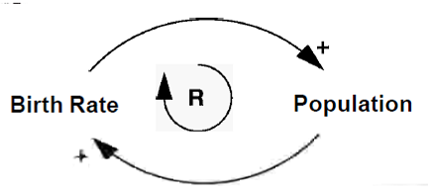
Figure 5.1: Population-Birth rate
Based on the causal loop diagram presented in Figure 5.1, it can be said that: as birth rate increases (Observe the + polarity on arrow going from Birth Rate to Population), the population of the community increases. Reaction to this action is, as the population increases, there will be more people in the community, more people can give birth, and therefore birth rate increases (Observe the + polarity on arrow going from Population to Birth Rate).
This is a Reinforcing Loop (R), as represented in Figure 5.1, (R) is a positive loop that will continue to increase and thereby to reinforce the “action <--> reaction.”
The loop presented in Figure 5.1 is not the complete picture of the population in a community. As the population of a community also depends on death rate. This is presented in Figure 5.2.
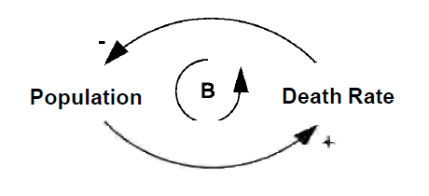
Figure 5.2: Population-Death Rate
In Figure 5.2, the causal loop diagram presented the following: as the population increases (Observe the + polarity on arrow going from Population to Death Rate), the death rate increases because more people become old in population, more people have diseases and therefore more deaths (this is + arrow). On another hand, if death rate increases, there will be more deaths in the community and that will lead to low population in the community (Observe the – Polarity on arrow going from Death rate to Population).
This is a Balancing Loop (B), as represented in Figure 5.2, (B) is a negative loop, that is, as population increases death rate increases, as death rate increases population decreases, and this leads to the decreased death rate. As in this scenario death rate increase leading to decreased population thereby decreasing death rate. It is called a Balancing loop.
Combining the above two figure we get total community’s population that is it depends on both birth rate and death rate; we represent this in Figure 5.3. Here we have both reinforcing and balancing loops.
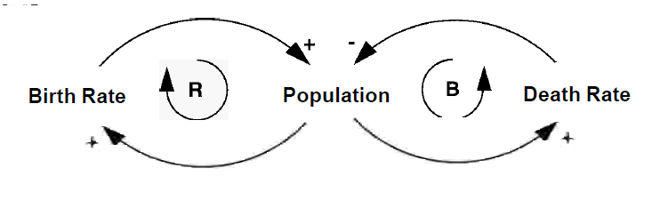
Figure 5.3: Population Causal Loop Diagram
Casual loops that are developed for a system feed into Stock and Flow diagrams to design the dynamic model of it.

Stock and Flow models in System Dynamics
Stock and flow models are used to simulate the system and identify critical points for each node over the time frame. Causal loops feed into stock and flow model as by using Causal loops designers can discover all the nodes that must be used in the simulation of stock and flow diagram. Once the model is developed, designers can add various policies in the system and simulate how the system will behave and deduct whether a specific policy will work or not.
Stock and Flow models are mathematical models of Causal loops. These models are deterministic, and designer can use statistic and probability to simulate various effects in a system(Sterman, 2000).
In Stock and Flow models, accumulation of variables is called the stock and is represented as a box, while the rate of change affecting the stocks are represented as pipes and are called as flows. The clouds at the beginning and end of the flow represent an infinite source of sinks. In Figure 5.4, a simple stock and flow model is presented for population (similar to Figure 5.3).
In Figure 5.4, the ‘Current Population’ is the accumulation of population stock at any given time. ‘Number of Births’ is the inflow that adds to population stock. ‘Number of Deaths’ is the outflow that subtracts from population stock. ‘Birth Rate’ and ‘Death Rate’ are the variables that affect the population. Both ‘Birth Rate’ and ‘Death Rate’ here can be constant values. The arrows represent a relationship and dependency between variables. ‘Number of Birth’ in Figure 5.4 depends on ‘Birth Rate and ‘Current Population.’ Similarly, ‘Number of Deaths’ depends on ‘Death Rate’ and ‘Current Population.’
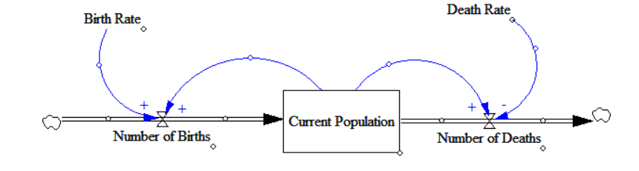
Figure 5.4: Simple Stock n Flow Population Model
Using Stock and Flow model, designers can get quantitative values of the effects of decisions they take. Causal Loops are useful in communication different view qualitatively, whereas Stock and Flow models are used for analyzing systems and its variables.

Proposed Method to Use System Dynamics as Impact Assessment Tool
System Dynamics is used in many fields for decisions support and policy analysis. Starting from inventory control by Jay Forrester in 1959 to social system analysis (Angerhofer and Angelides, 2000; Forrester, 1994; Naill, 1992; Ogunlana, Li and co-authors, 2003). System Dynamics modeling is used to understand the complex systems and simulate the process over a time period. Researchers have developed city level models to speculate about the future state of these cities. Similar to Village Level Baseline Sustainability Index, a huge amount of literature and work is done from the perspectives of world, country, and organizations for decision support and policy evaluation using Systems Dynamics. There are examples in the literature where systems dynamics was used by social entrepreneurs to evaluate policies, such as education, agriculture, and social behavior anchored in the sustainability of these policies (Saysel, Barlas and co-authors, 2002). The gap identified in the literature is on reusability of the model. In this framework, the model proposed is Village Level System Dynamic (VLSD) model that can be reused, modified based on different communities and villages with minimum changes to the model. In this part of the thesis, a method that can be used by social entrepreneurs to develop a Village Level System Dynamic model is presented. In this thesis, a base level VLSD model is developed using the method discussed. Social entrepreneurs can use the same method to build on the model provided.
After selection of System Dynamics as the tool for measuring social impact, next step is to develop a single unit measurement that can be used to compare different value proposition. Kroeger and Weber present a conceptual framework for calculating the social value creation (Kroeger and Weber, 2014). They use a single unit of measurement, that is, the Social Value Created (SVC) using the Life Satisfaction (LS) Indicator. However, Life satisfaction is a variable that is highly dependent on individual and therefore is not reliable. Approach taken for this work is similar to that of Kroger and Weber.
In the proposed framework, the village is modeled in terms of the sustainability indicators using VLBSI. Therefore, the impact of a value proposition is evaluated by calculating the change in the value of sustainability drivers (social, economy and environment) due to change in the value of indicators. The current value for each driver is calculated by the social entrepreneur using first construct (Village Level Baseline Sustainability Index, presented in Chapter 3) of the framework. In Village Level System Dynamic Model, each indicator can be modeled and expected change is then evaluated on indicator on the implementation of a specific value proposition.
In Figure 5.5, the concept of impact calculation using VLBSI is presented. On the left side of Figure 5.5, the current sustainability index value is presented (Same as Figure 3.3). The change in the value of indicators will lead to change in the value of the drivers. On the right side of the Figure 5.5, is the expected change in the index on the implementation of value proposition. As social entrepreneurs will already have data on current status from Village Level Baseline Sustainability Index, modeling indicators in VLSD will be easy to understand.
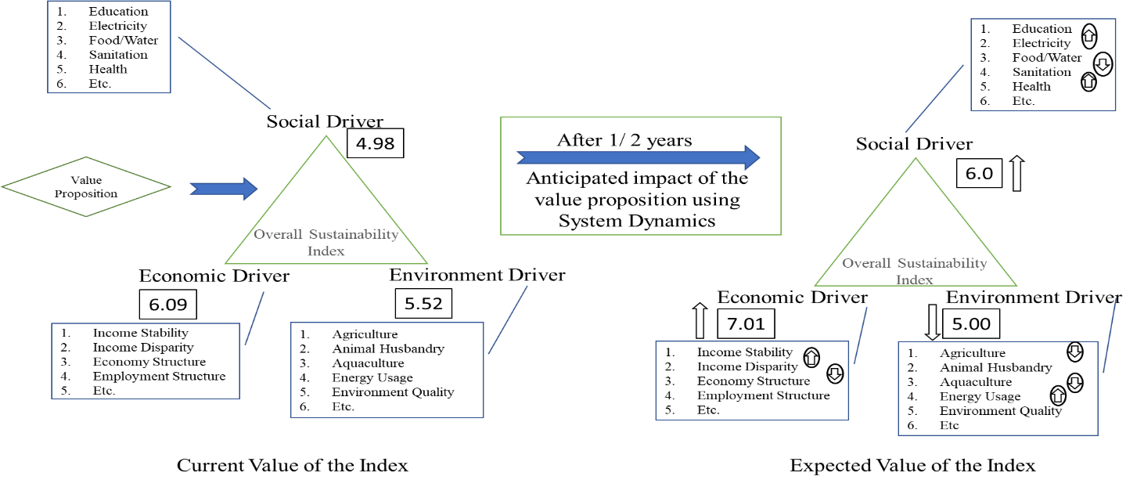
Figure 5.5: Calculating the Impact of a Value Proposition
In this thesis, the boundary for VLSD model is drawn around three aspects of the village, Education, Healthcare and Electricity. In literature, authors have described various methods to develop a system dynamic model for a given problem (Chaker, El Manouar and co-authors, 2015; Martinez‐Moyano and Richardson, 2013; Ogunlana, Li and co-authors, 2003; Walters, Archer and co-authors, 2016), and any of these methods can be used to further develop the model for other aspects of the model. User can follow any method to develop remaining aspects of the village in VLSD. In next section the general VLSD model developed as a part of this thesis is presented. For the three aspects (education, healthcare and electricity) this model is useful for any village.

VILLAGE LEVEL SYSTEM DYNAMIC MODEL – GENERAL
The VLSD model developed for the thesis is categorized into four sub-models (Village Demographics Loop, Education Loop, Health Loop and Electricity Loop), with each sub-model used for one aspect of the village. The division of the model is only visual and to make the model easy to understand. The users will run a single system dynamic model as information flows from one part of the model to other (similar to flow of information, data and products in a large system). In Figure 5.6, and Figure 5.7, the general model developed for this thesis is presented. Figure 5.6 and Figure 5.7 are not clear and lack detail as they are presented as an overview of the total system dynamic model. Later in the section, all the four sub-models are presented in detail.
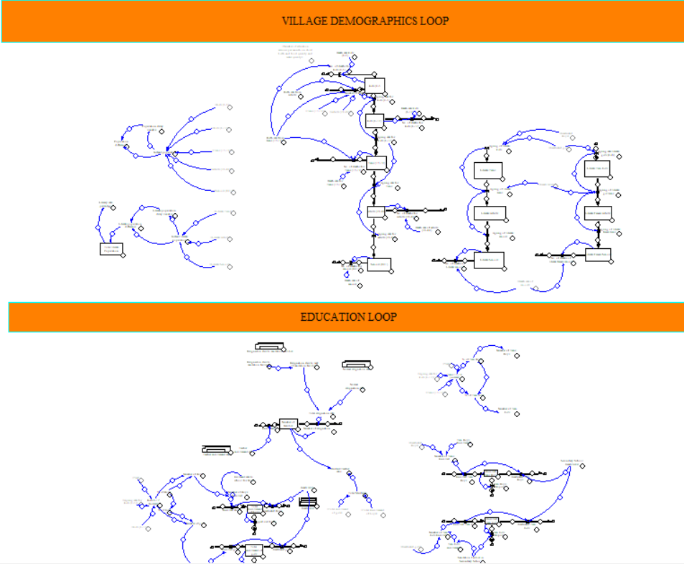
Figure 5.6: General Village Level System Dynamic Model-1

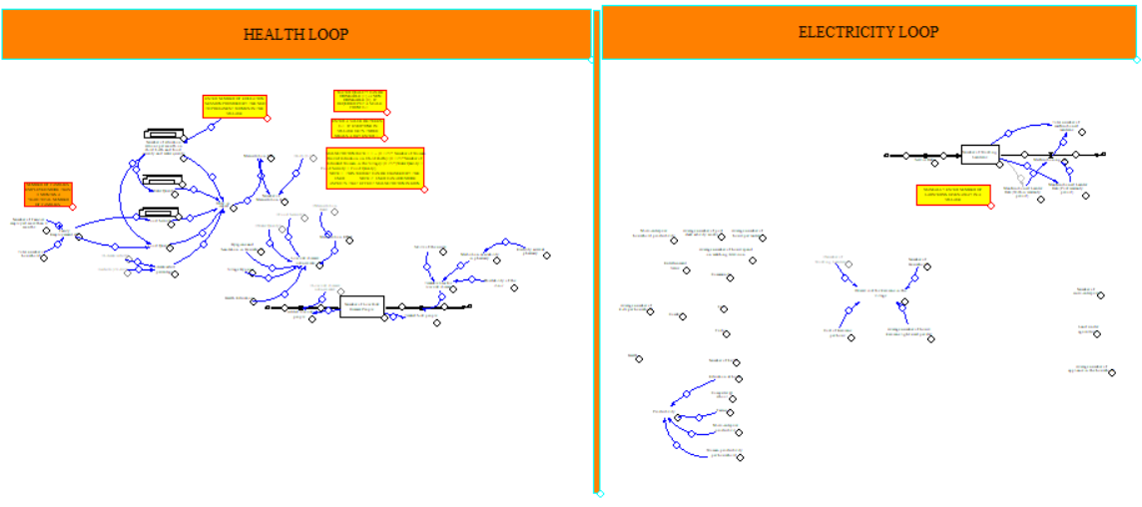
Figure 5.7: General Village Level System Dynamic Model-2
Village Demographics Loop
To evaluate the impact of a value proposition on a community, first thing is to project the population growth of the community in the coming years. This growth data of population is available with World Bank for all the countries, also, census of each country maintains record of projected growth in different states. However, the projection of population done at country and state level is not useful for a village, as the projections made are only in overall population increase. For evaluating the value proposition that are specific for a age category, a simple projection of population is not ideal. In village demographics sub-model, the projection of population in done at 5 age categories, Kids(0-5), Kids (6-12), Teens (13-19), Adults (20-49), and Seniors (49+) . The village demographics loop is expanded from Figure 5.6. Total village demographics sub-model is presented in three figures (Figure 5.8, Figure 5.9, and Figure 5.10)
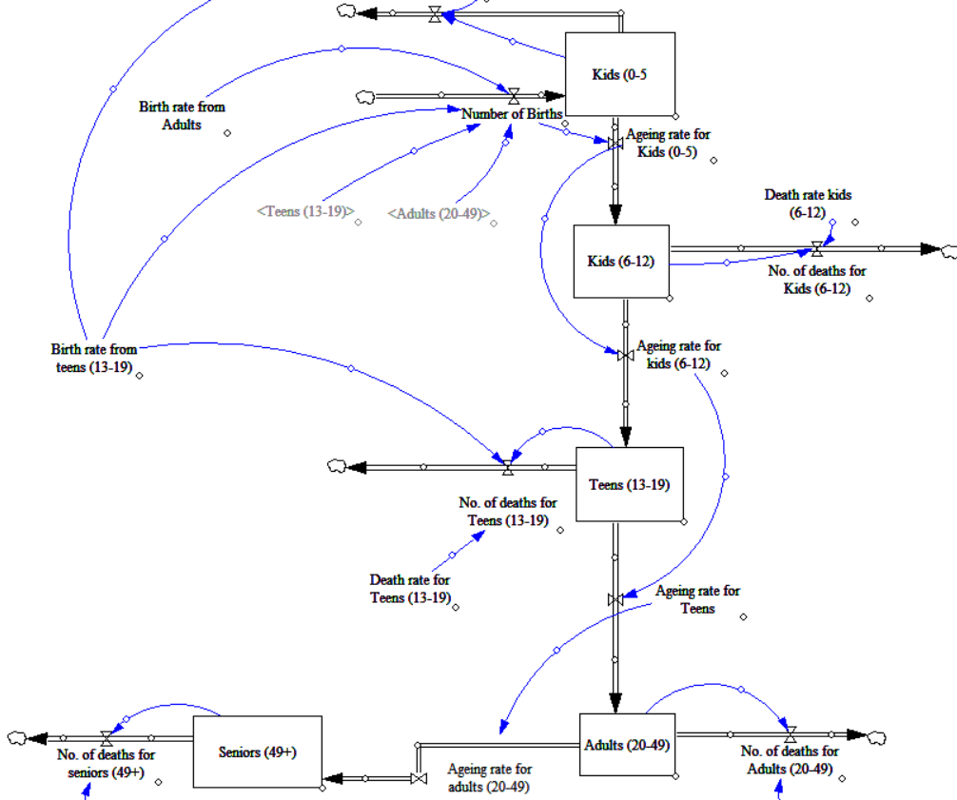
Figure 5.8: Village Demographics Loop 1
In Figure 5.8, flow of the population from one age category to other age category in the model is presented. Each stock in Figure 5.8 represents number of people in that age category. The data from a community is collected for each category and is added as initial value for stocks of the particular age category. On simulating this part of the model, users can get approximate data of population breakdown in different age categories for years to come if the birth and death rate of the community are close to real values. In Figure 5.8, flow of information is as flows;
‘Number of births’ in a rural community is a function of ‘birth rate’ and ‘adults’. In some rural communities, families get teenagers married and that also contributes to the number of births in the community. To make it a general model, the number of birth in this model is a function of birth rate from adults and teens. In communities, where teens do not contribute to population increase can change ‘Birth rate from teens (13-19) =0’. The “number of births” in one simulation round adds X amount of value to “Kids (0-5)” , that is number of kids born are added in this age category.
Use of ‘Ageing rate’ variables in VLSD is to move stocks from one age category to another as Time T changes in the model. For example; if a stock is added (child born) at time T=0 in ‘Kids (0-5)’ stock, at T=6 this stock should move from ‘Kids (0-5)’ to ‘Kids (6-12) stock, this movement of stock is modeled using ‘ageing rate for kids (0-5)’. Similarly, for each stock (age category) in Figure 5.8, ‘aging rate’ function is used to model the flow of population.
For each age category of the stock, “Number of deaths” is also modeled. This variable removes X amount of people from a given stock. In a community “Number of deaths” depends on various reasons and not each aspect can be modeled. In this model “death rate” for each age category a static value is assigned, this can be changed by a user based on different variables. For example; the user can model ‘death rate’ to be a function of the health system of the community. The user can also model “birth rate” in the community as a function of “literate adults (presented in Figure 5.9)”, that is, as the number of literate adults in the community increase, ‘birth rate from teens (13-18)’ decreases drastically and ‘birth rate from adults’ decreases slowly.
The population breakdown model is useful in developing the remaining model; for example, given that user knows kid’s population in the age category of 6-12 years, the plan to improve enrollment on the primary school can be done efficiently. Similarly, for age category of ‘Teens (13-18),’ the planning can be done on secondary schooling and employment opportunities.
The education submodel is discussed in later part of the section, the value from “Kids (6-12)” and “Teens (13-18)” is taken and education sub-model is developed. Based on the value obtained from education sub-model, literacy part of village demographics sub-model is developed. This submodel is presented in Figure 5.9. In Figure 5.9, the part of the model that is used to calculate the literacy of the community is presented. Since there is a different impact of female literacy on education, birth rate and health of the family, the model is developed to calculate “female literacy” separately. The general model can be used to evaluate value propositions that are developed to improve female literacy.
The design of model presented in Figure 5.9 is similar to Figure 5.8. The stock of literate teens moves to literate adults and literate seniors as time progresses. The value of population and the literate population is also calculated in the model. In Figure 5.10, the part of village demographics sub-model developed to calculate the population value is presented.
To verify whether models calculate the correct value for the population, the user can take data from last two censuses any community and model the community using older data. After running the model till next census, the user can verify if the values obtained for the population are approximately close. If the values are approximately close, next step is to model the education loop sub-model.
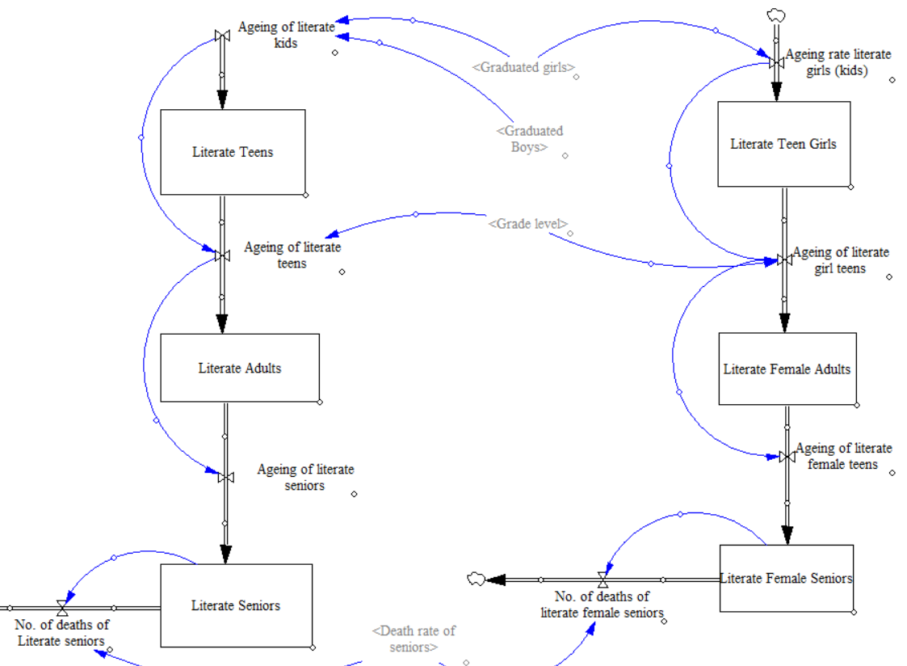
Figure 5.9: Village Demographics Loop 2

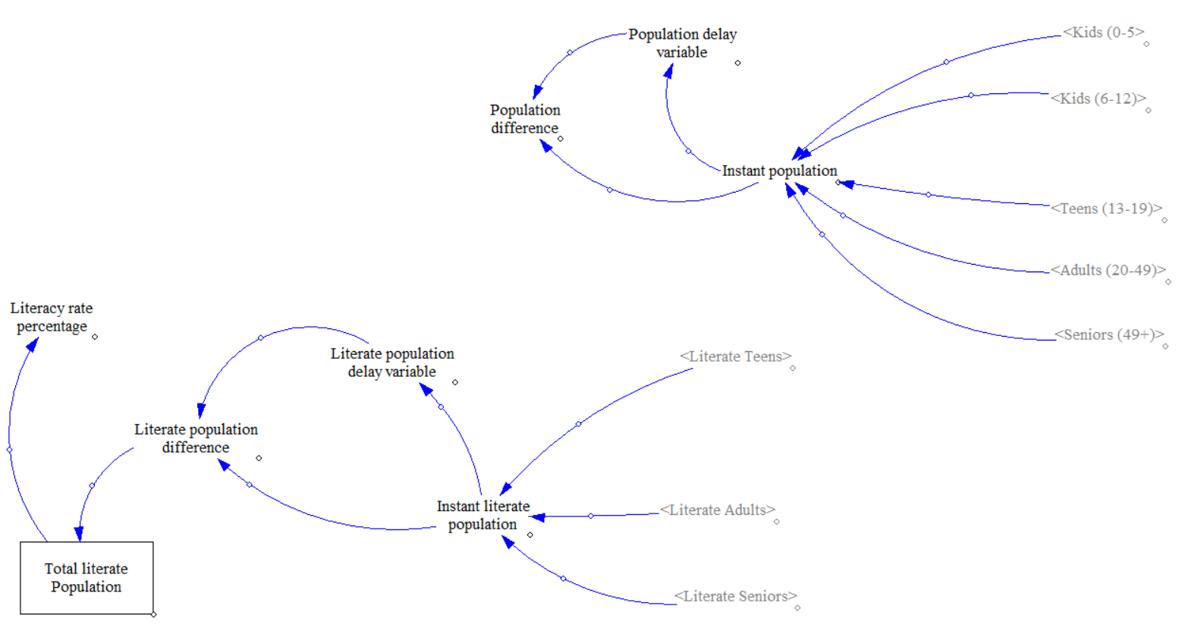
Figure 5.10: Village Demographics Loop 3

EDUCATION LOOP
The education sub-model of VLSD is presented in Figure 5.11 and Figure 5.12. In Figure 5.11, the primary school loop is presented. In primary education loop, “Kids (6-12)” stock is taken from village demographics loop (presented in Figure 5.8) and divided in ‘number of boys’ and ‘number of girls.’ Percentage of boys and girls can be added as input based on the collected data from the community. To evaluate the impact of value proposition developed to improve the life of a particular gender the division between boys and girls becomes critical. In rural communities, girl education is comparatively low and therefore in VLSD model girl’s enrollment is developed separately. The elements of education loop presented in Figure 5.11 is as follows (from the left side to right side of the figure);
- ‘Kids 6-12 (increase)’ is a function of “Kids (6-12)” stock and “aging rate for kids (0-5)”. At any given time ‘t,’ the variable will have a value of kids between ages 6-12.
- ‘Kids 6-12 (increase)’ is divided into ‘Number of boys’ and ‘Number of girls.’ The division to boys is girls is calculated by ‘% of Boys’ and ‘% of Girls’ variables respectively.
- ‘Number of boys’ and “Number of girls’ variable are input to ‘Number of boys enrolled’ and ‘Number of girls enrolled’ respectively.
- ‘Number of girls enrolled’ and ‘Number of boys enrolled’ is calculated by multiplying the ‘enrollment rate in primary school’ for boys and girls to a number of boys and girls in the community.
- The ‘Number of girl enrolled’ and ‘Number of boys enrolled’ are input to the stock ‘Total enrollment of girls’ and ‘Total enrollment of boys’ respectively.
- The stocks ‘‘Total enrollment of girls’ and ‘Total enrollment of boys’ hold the value of total boys and girls enrolled in the school.
- The stock ‘‘Total enrollment of boys’ is a function of ‘Enrolled boys’ (in-flow; added to the stock in each iteration), ‘Graduate boys’ (out-flow; removed from the stock in each iteration) and ‘dropped out boys’ (out-flow; removed from the stock in each iteration). Similarly, ‘Total enrollment of girls’ is calculated.
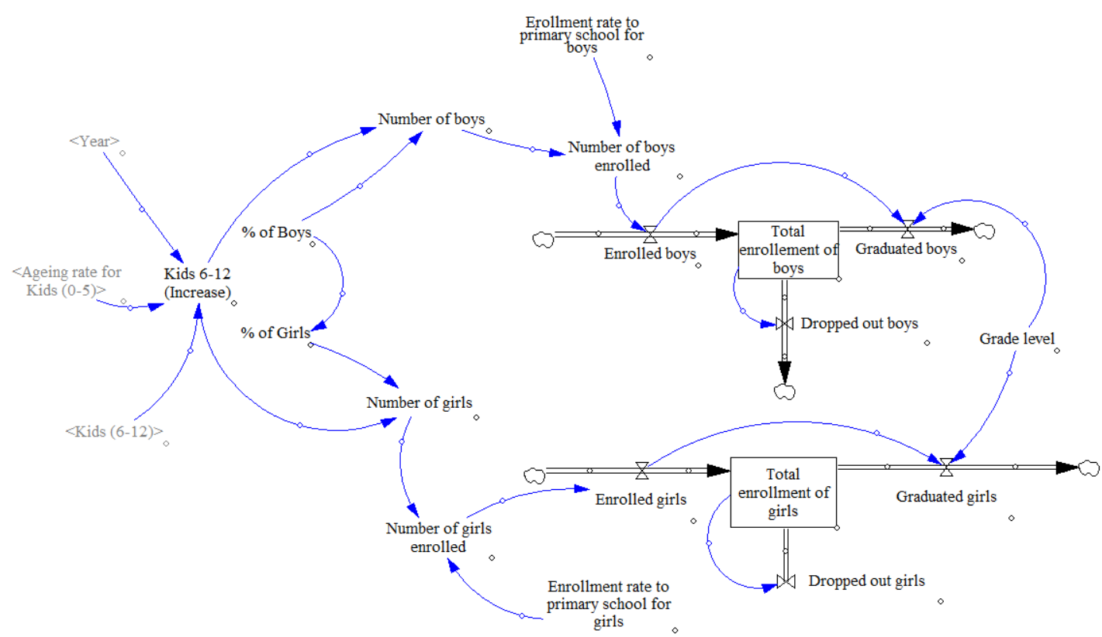
Figure 5.11: Education Loop: Primary Schooling

- “Graduated boys’ and ‘Graduate girls’ are a function of ‘Grade level’ in the school. ‘Grade level’ is the highest-grade thought in the school. The ‘Grade level’ is based on the community and highest grade that is thought in school.
- Value of ‘Grade level’ variable is used to calculate the number of years for enrolled kids to graduate. For example; Kids entering school at Time T=1 year of the model will graduate from school based on the ‘Grade level’ value. If ‘Grade level’ is 5 (highest grade being 5th grade in the school), then kids that enter school at Time T=1 will graduate at Time T=6th year of the model.
- ‘Dropped out boys’ and ‘Dropped out girls’ are a number of kids dropping out of schooling each year.
In most of the rural communities, the kids do not go to school before they are 6 years old, but the user can model input for primary school with kids from 4 years old.
The next part of education loop (secondary schooling) is presented in Figure 5.12. Similar to primary school, the stock on total enrollment is divided into girls and boys. The input to secondary schooling loop is the number of girls, and boys graduated from the primary school, that is ‘Graduated boys’ and ‘Graduated girls’ as presented the on the left side of Figure 5.12. The input is only ‘Graduated boys,’ and ‘Graduated girls’ for this loop and not a number of teens or kids is because of the requirement of secondary schooling. Kids who have not finished primary schooling are not eligible for secondary schooling and therefore cannot be enrolled in secondary schooling. Remaining model is similar to the model presented in Figure 5.11. The output from secondary schooling model is ‘Graduated teen boys’ and ‘Graduated teen girls.’
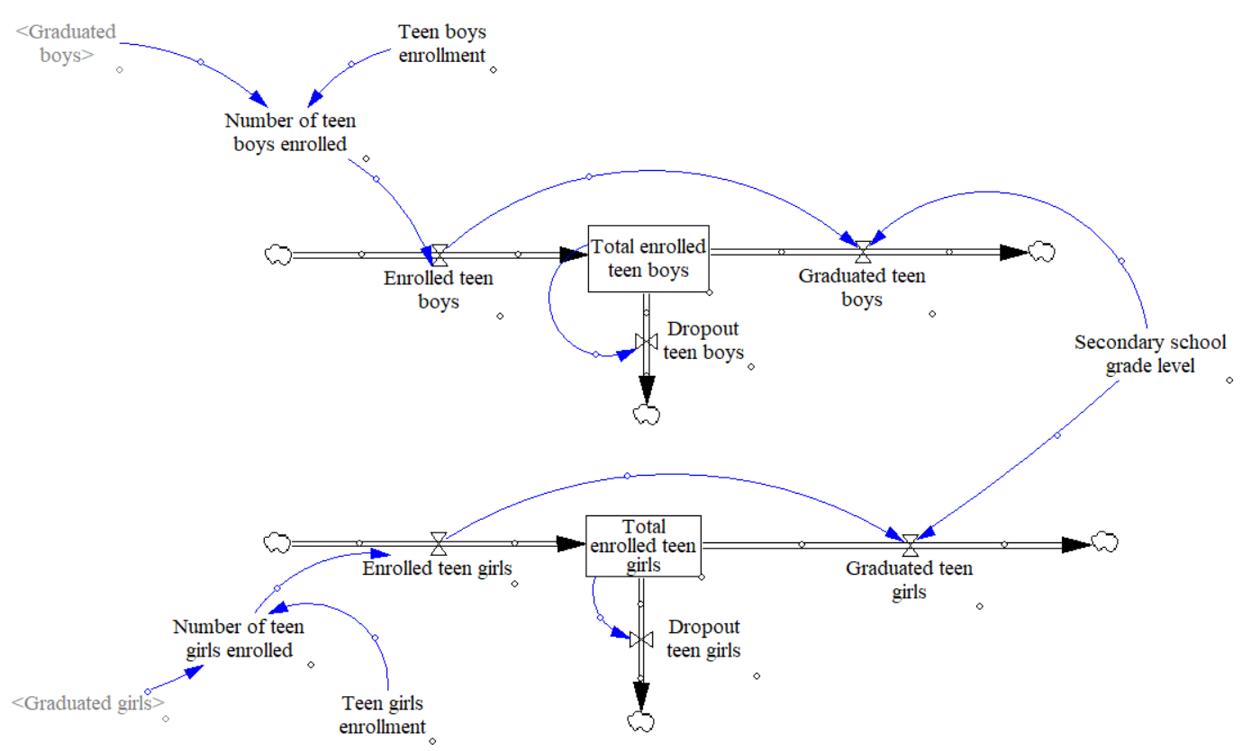
Figure 5.12: Education Loop: Secondary Schooling

The value obtained from Figure 5.11 (‘Graduated boys’ and ‘Graduated girls’) and Figure 5.12 (‘Graduated teen boys’ and ‘Graduated teen girls’) are input to different parts of VLSD model. The literacy loop presented in Figure 5.9 collect the variables from education loop (Graduated kids and teens) to calculate a number of literate adults (and females separately). The female literacy is also input to sub-model: Health Loop that is discussed in next.
HEALTH CARE LOOP
For the VLSD modeled developed for this thesis, the boundary drawn around health care model is to consider malnutrition rate in kids between 0 and 5 years of age (Figure 5.13) and low-risk diseases (Figure 5.14). In most of the rural communities, these are the two aspects of health care that are of high concerns. There other aspects of health care such as ‘high-risk diseases’ can be added by users to improve VLSD model.
In Figure 5.13, the malnutrition rate part of VLSD healthcare model is presented. In most of the low economic communities’ malnutrition is one of the major issues in child health care. Malnutrition is a direct function of water and food consumed by the pregnant women and kid’s initial years. ‘Food quality’ and ‘Food Security,’ both have a huge impact on the health of mother and child. If families are employed they can afford three meals a day and provide quality food, there in this model, the ‘employment rate’ of the villagers is added to contribute to malnutrition rate. Also, higher the adult literacy rate, better is understanding of water, food quality and what precautions must be taken by the mothers. All the above-mentioned factors affect the malnutrition rate in a community and are included in the model.
‘Delay in impact’ variable is added to include the effect of all the variables. If interventions are implemented today, the effect will be seen in later years.
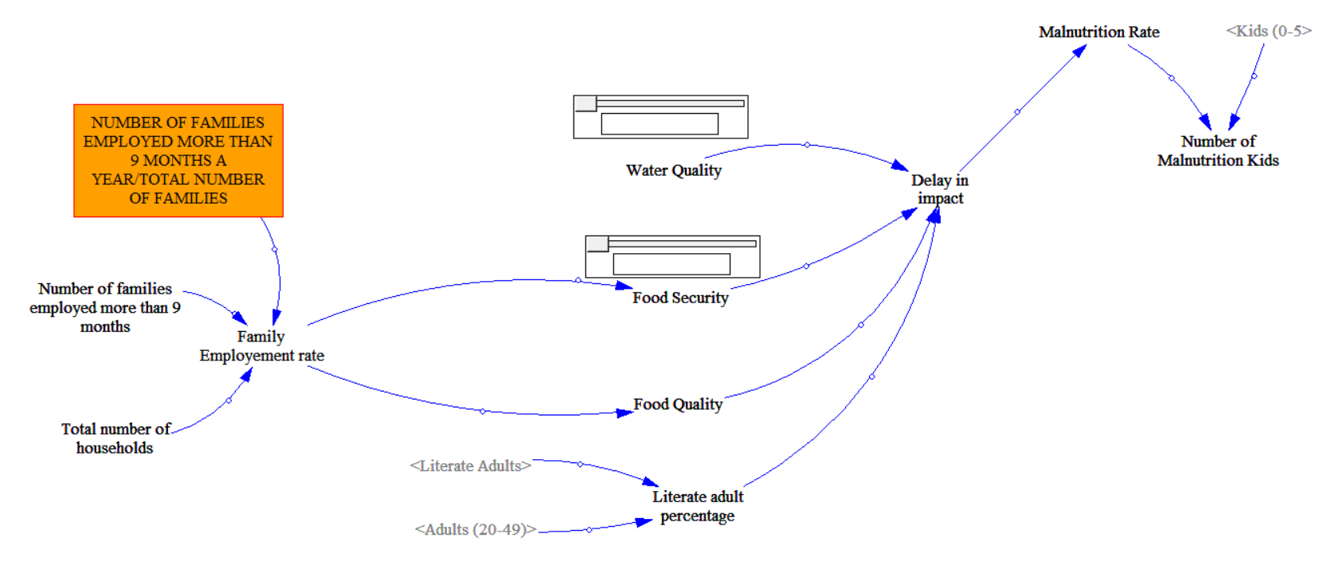
Figure 5.13: Health Care Loop: Malnutrition Rate

The next part of health care sub-model is ‘Low-risk disease rate’ loop presented in Figure 5.14. The low-risk diseases are the diseases that are not life threatening and can be treated with minimum medical requirements (such as flu, diarrhea, fever, headache, and dizziness). If the low-risk diseases are not treated in time, then diseases transform to high-risk diseases (or life threatening). In most of the rural communities, the diseases are caused by community surrounding and unhygienic routines that families continue to maintain. In Figure 5.14, on the left side of the figure, ‘Low-risk diseases sickness rate’ variable is modeled. All the factors affecting ‘low-risk diseases sickness rate’ are inversely proportional to sickness rate besides ‘malnutrition rate’, that is if ‘Health Education’, ‘Village Hygiene’, Hygiene and Sanitation in household’, ‘Water Quality’ and ‘Food Security’ increase, ‘Low-risk diseases sickness rate’ will decrease. The values for each of these variables initially will have user input. The impact of another variable such a literacy rate can impact variables in this model, such as ‘Hygiene and Sanitation in household’ and ‘Water Quality.’
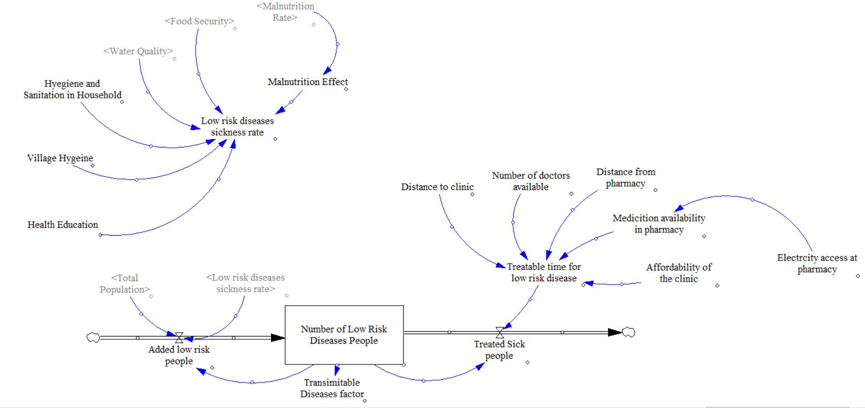
Figure 5.14: Health Care Loop: Low-Risk Diseases
The value of ‘Low-risk diseases sickness rate’ is then added as an input to the stock ‘Number of low-risk diseases people.’ The value of this stock is calculated by ‘Added low-risk people’ (inflow: added to stock) and ‘Treated sick people’ (outflow: removed from the stock).
‘Treated sick people’ is a function of ‘Treatable time for low-risk disease’ and ‘Number of low-Risk Diseases People (Stock).’ Whereas ‘Treatable time for low-risk disease’ similar to sickness rate is a function of various variables. Major aspects that effects ‘treatable time’ are ‘Distance to clinic,’ ‘Medication availability at pharmacy’ and ‘affordability of the clinic.’
As the distance to clinic increase, the treatable time increases, thereby reducing the number of sick people treated. Similarly, if the cost of the clinic is high less number of people will visit the hospital. The medication available at the pharmacy is also important to have low treatable time. If the pharmacy has electricity access, more medicines can be stored in cold storage. Access to electricity in a community has a huge impact, and the electricity loop for VLSD model is presented next
ELECTRICITY LOOP
The electricity loop in VLSD is different from the rest of the loops. Unlike, other aspects of the VLSD model, electricity is a service provided to the community that impacts most of the aspects of the community. The sub-model developed in this case is to identify the different aspects of the community. In Figure 5.15, the electricity loop developed under VLSD is presented. ‘Electricity Tier’ variable is the amount of electricity provided/available in a community. The amount of electricity (Electricity Tier) provided in a community drives different aspects of the community; for example, a single solar lamp for each household falls in Tier 1 electricity, providing a solar lamp will only affect “Household productivity’ and ‘Microenterprise working hours.’ On another hand, a microgrid could affect all the aspects of the community presented in Figure 5.15. The VLSD model is a general model, and therefore electricity loop developed in this is connects most of the aspects of the community. Users can delete add different aspects (variable) based on the Electricity Tier.
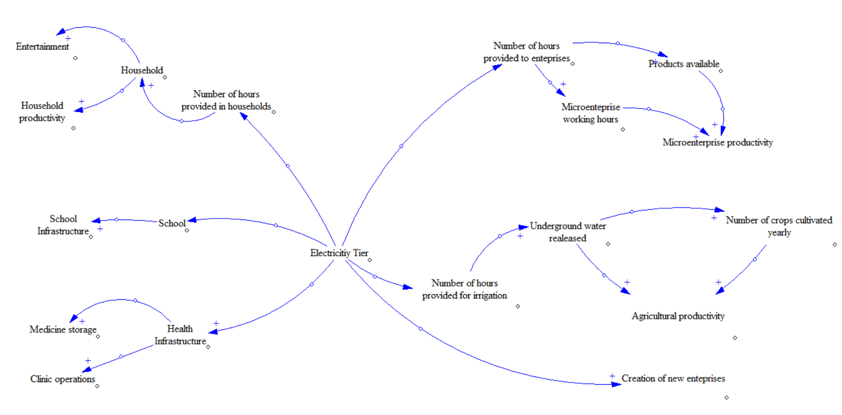
Figure 5.15: Electricity Loop
Each part of the community that is impacted with electricity can further be developed similar to education loop (presented in Figure 5.11) and health care loop (presented in Figure 5.14). The next step is to show the utility of the construct. As VLSD model comprises of different aspects of the village, in next section different vignettes are used to show the utility of the construct for an aspect. In the following section, the vignettes are used to show the utility of VLSD, followed by the verification and validation of VLSD model and hypothesis is discussed.

IMPLEMENTATION OF VLSD
In Section 2 of the chapter, working of general VLSD model is presented. In this section, the implementation of VLSD model three social aspects of the community (i) Education, (ii) Healthcare and (iii) Electricity is presented. Each section presents a single vignette for each category. In Section 5.3.1, the education vignette is discussed. In Section 5.3.2, the healthcare vignette is discussed. Each vignette is associated with a village, details, and description of the issue is presented in each section followed by implementation of VLSD model. For each vignette, first the census report of the village is presented, followed by the issue current occurring the village. Post explanation, the VLSD model is developed and used to evaluate policies in the selected village.

Education Vignette in Surwara Village
Census report
Surwara is a medium size village situated in Milkipur sub-district, Faizabad district, Uttar Pradesh. The total population of the village from 2011 census was 1369. The total population is distributed in 220 households. The population is almost equally divided with 687 males and 682 females as per Population census 2011.
The population in Surwara village is divided into the following age categories. The population of children with age 0-5 is 193; There are 224 children between the age of 6-12 and 126 between the age of 12-18. A total number of adults is 626 and senior’s age category (above age 50+) consist of 200 people.
Demographics
Most of the population depends on agriculture. With nearest primary school in neighboring village, children walk 4 kilometers every day. The literacy level in the village is low. Only a few families that have access to motored vehicles send their girl kids to primary school. From Surwara, only 5 girls currently attend primary school for first few years. On the other hand, 80% of boys attend primary schooling. Nearest secondary school is 12 kilometers away, this school admits students from nearby towns and villages. However, none of the kids attend this school for secondary education from the village under consideration.
As a part of CSR initiative, one of the small detergent manufacturing enterprises from a nearby town is involved in increasing the school enrollment. With “Beti Bachao Beti Padhao (Save a girl child, educate a girl child)” initiative taken by India government in 2015 (Abbas, 2014), the CSR initiative from this firm is focused on increasing girl enrollment in both the schools. The CSR represent of the enterprise plans to invest in Surwara village for next two fiscal years. As a part of CSR initiative, they are ready to partner with various social entrepreneurs, nonprofit organizations within the area and invest in their interventions if proven effective.
Recently one of the social entrepreneurs contacted the enterprises CSR representative to partner with. The social entrepreneur is focused on overall improvement of education. To understand the reasons for low enrollment for girls and identifying the overall quality of education, representative of CSR initiative and social entrepreneurs contacted the households. Following were the major responses on why families do not send their girl kids to school
- Lack of sanitation facilities in the school
- Distance to nearby school
- Lack of secondary education (this is also valid for boys)
- Use of girl education in the world
Based on the gathered data, an intervention is suggested by CSR investors and social entrepreneurs, this intervention is divided into two parts and implemented together.
Intervention 1
Part 1. Build sanitation facility in the primary school.
Part 2. Donate a school van to pick-up and drop students from the primary school.
On implementation of Intervention 1, there was a rise in enrollment for girls in first three months, and then the numbers started to drop. Use of VLSD model can be useful to understand the failure of this intervention and be used to identify potential interventions.
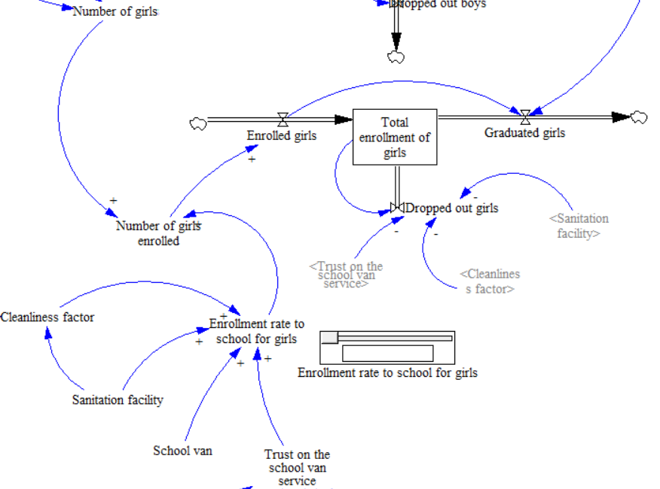
Figure 5.16: Education Intervention-1
In Figure 5.16, the part of VLSD model focused on Intervention 1 is presented. The full VLSD model is not shown in Figure 5.16. Based on the survey, the establishment of a sanitation facility in the school increased girl enrollment initially. This was because girls could use the sanitation facility when needed. This initiative would not have the same effect if a school van was not provided to pick up children from the Surwara village to the school. Combination of both the intervention gave hope to enthusiastic families and the girls. The increase in enrollment of girls was therefore due to both, the decrease in travel time and availability of sanitation facility.
The increase in enrollment post-implementation of Intervention 1 is presented in Figure 5.17. At Time T=1 Month, the enrollment is increased from 20% to 55%. This enrollment rate continues until Time T=3 Months. At T=4th Month, the enrollment drops drastically to less than 10% (In reality, the decrease in enrollment rate is more periodic).
The decrease in enrollment rate is due to two major reasons. Though the sanitation facility intervention was developed efficiently, the facility in school was not maintained. The sanitation facility became unusable after a period of time. Another reason was the loss of trust on school van program. Since the intervention of school van was not developed as a micro-enterprise, the person in charge of picking up children and dropping them back to home did not show up many times in initial months. Added to this, when the person showed up, the van broke down. This decreased the parents trust in a school van, and they stopped sending the children to school. It can be assumed that the decrease in the number of children going to school post failure of intervention should be less than or equal to the rise in the enrollment post implementation. This is not the case, more students and families dropped out school program as presented in Figure 5.18. The reason for this drop is due to the fact that people get used to a facility. Before the Intervention 1 was implemented, it required high motivation for families to send their kids to school. Once families and girls got used to the facility, on lack of facility, the motivation decreased drastically. The variable used for sanitation facilities cleanliness in the model is ‘Cleanliness factor,’ and variable for trust in school van intervention is ‘Trust on the school van service’ presented in Figure 5.20.
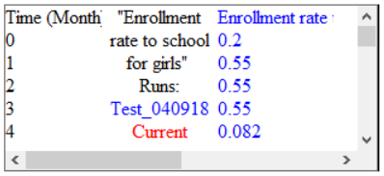
Figure 5.17: Enrollment Rate of Girls After Intervention-1
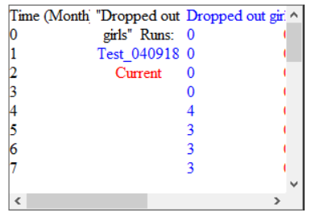
Figure 5.18: Number of Girls Dropping School After Intervention-1
In Figure 5.19, the total number of girls enrolled in the school over next few months post implementation of Intervention 1 is presented based on the model. Note that value in Figure 5.19 are not integer, but modelers can change it to integer values.
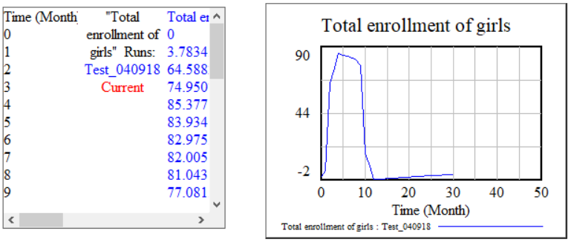
Figure 5.19: Total Enrollment of Girls After Intervention-1
The growth associated with Intervention 1 was substantial but was not sustainable. To have sustainable growth, a system perspective is needed to identify the issues in the current system and proposed system as well. From the data obtained from the village level system, the dynamic model behavior of the system can be understood, gaps in proposed intervention can also be identified.
At the start of the Intervention 1, the enrollment rate for girls increased by 30%, reaching 55% of total girl’s enrollment (presented in Figure 5.17). To sustain this growth the CSR investors and social entrepreneur should focus on two major areas (i) to keep the sanitation facilities clean in school and (ii) to improve the reliability of school van project.
- To keep sanitation facilities clean, a janitor can be appointed. Cleaning of the sanitation facilities is also the responsibility of individuals. The students must be educated regarding hygiene and how to keep facility clean along with water saving tutoring.

- To improve the reliability of school van project, investments can be made to make it as a micro-enterprise. People from the village can buy-in in the micro-enterprise and start their own school van services. The micro-enterprise can then be extended to secondary school picking up students from various nearby villages and dropping them at secondary school 12 kilometers away.
By setting the school van service that is already established trust in the village will help in creating ‘word of mouth’ and thereby increase the number of families sending their kids (girls and boys) to the school. To make school van service enterprise sustainable, various business ideas can be evaluated using the Village Level System Dynamic model. For this thesis, the aim is to show the use in different areas, and sustainability of this intervention is not discussed.
For remaining 45% gap still observed in girl’s enrollment, the major blockade is perspective of elders of the families (seniors and grandparents). To fill this gap, the social discussion can be initiated for seniors and parents. The impact of these social discussions can lead to social pressure and community imitation for seniors of the village. To evaluate social discussion aspect, VLSD model is used. Figure 5.16 is updated with an added loop on the social discussion in Figure 5.20.
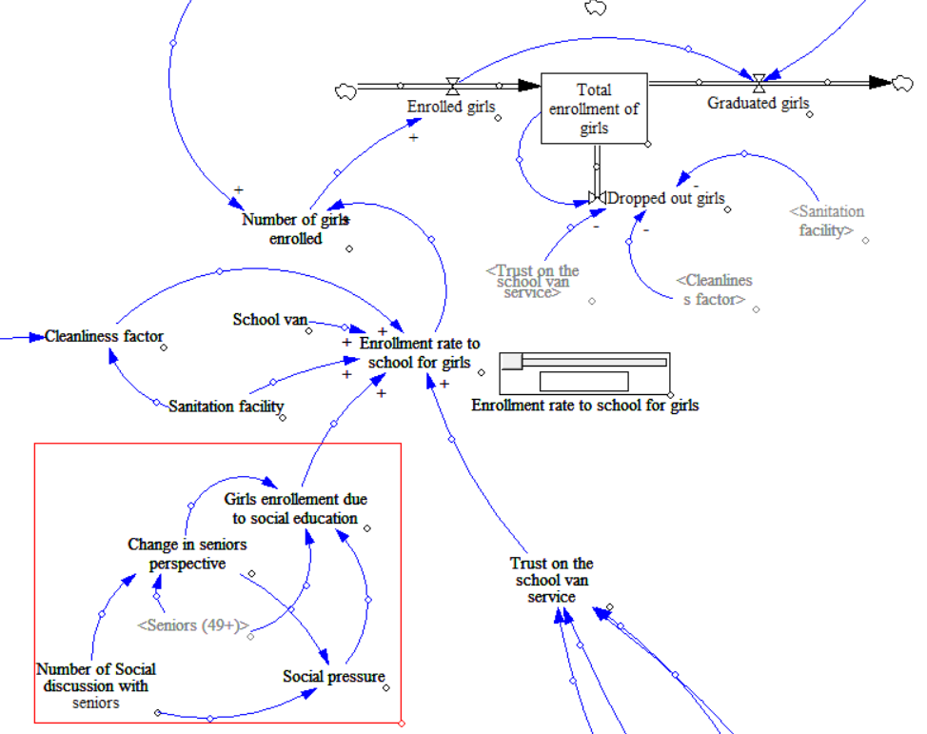
Figure 5.20: Girls Enrollment: Social Discussion Intervention
The loop of social discussion is presented in Figure 5.20 in the red box. The number of social discussion with seniors in communities is directly proportional to change in perspective of the seniors. The change in perspective leads to increase in girl’s enrollment and also creates a social pressure for other seniors and households. The increase in social pressure leads to increase in girl’s enrollment as well.
With the setup of social discussion, clean sanitation facilities and school van service there is an increase in enrollment of girls in the school in the model for this village. The change in perspective of seniors and families will depend on a number of discussions that are held in the community. To evaluate the impact of number of social discussions, the model is run with a number of different sets of social discussion. The output from the model is presented in Figure 5.21 and Figure 5.22. In Figure 5.21, the increase in enrollment rate over 30 months is presented with varying number of social discussion.
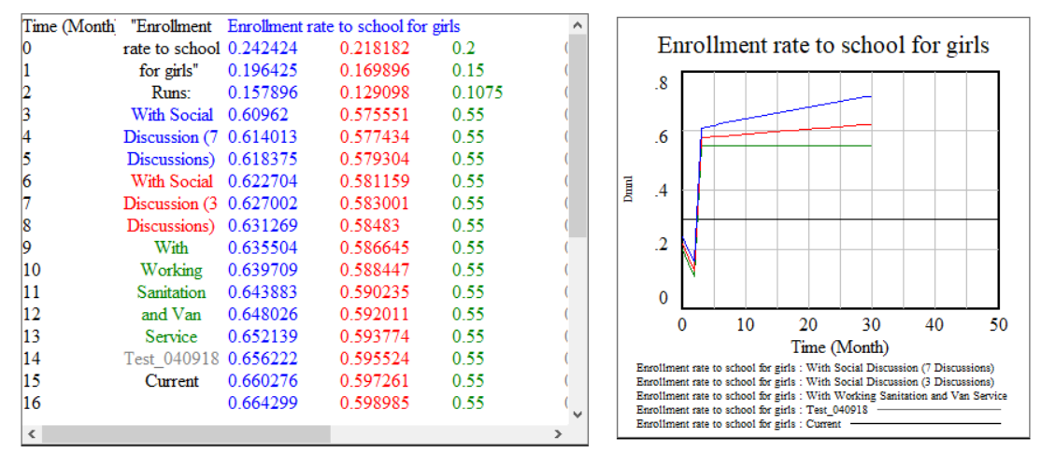
Figure 5.21: Enrollment Rate for School Girls: Intervention 2
In Figure 5.22, the total girls enrolled over the period of time is presented. The decrease in girls enrolled after 10 months is because of decrease in the number of kids in that particular age category. This decrease is also due to the fact the enrollment is majorly for the new kids (kids moving from age 0-5) and not the kids that are already of that age. Overall the decrease is proportional to the population growth.
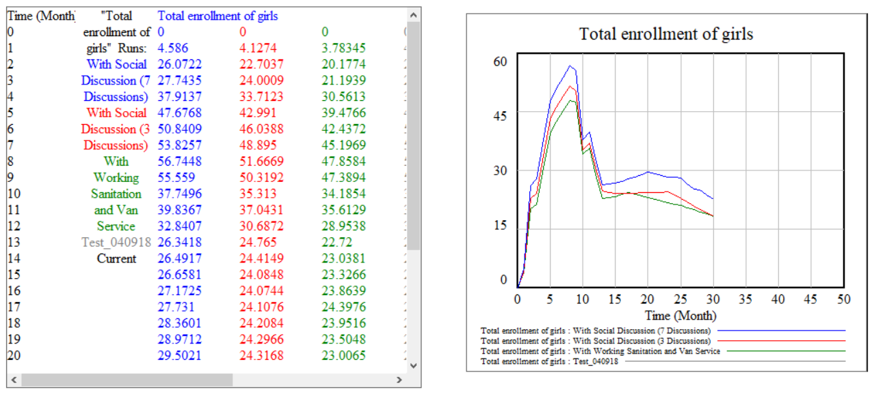
Figure 5.22: Total Enrollment of Girls in School: Intervention 2
Based on the output presented in Figure 5.21 and Figure 5.22, the CSR representation and social entrepreneurs can select the interventions appropriately.
In this section, the overall improvement due to increase in girl’s enrollment is not presented. As the enrollment for girls increases, the literacy of the village overall on long-term increases. The effect is integrated into the VLSD (though not presented in this section). The increase in literacy of girls will have a huge impact later on female education and that effects overall health of the families. As more female will get educated, there will be an increase in general awareness and can result in an increase in a number of micro-enterprises that female entrepreneurs can develop. The impact of education on overall improvement of community is integrated into Village Level Sysmte Dynamic model.
The value obtained on using VLSD model
On using the VLSD model for this community, the value is obtained in identifying the issues that were reasons for the failure of initially proposed interventions. Use of VLSD model was helpful to focus on systems perspective while evaluating the interventions. The value for this vignette is identified to be in conducting social discussions with seniors of the village to increase girl’s enrollment. Once the social discussion intervention is proposed, the next step is to identify the number of social discussions that should be conducted each month.
Another important value that is observed by using VLSD in this scenario is that the social discussion might not have the same result in next village. This reinforces the main basis of this thesis, that is, each village has varying characteristics, and one solution cannot fit all.
In this current education model, the discussion is not made on the quality of education in the primary and or secondary school. It can be added to the current model and different interventions related to the quality of education can also be evaluated.
In next section, health part of the model is discussed. Similar to education part of the model, the purpose in this chapter is to show the utility of VLSD in different aspects of community and also to show how VLSD can be modified for different communities.

Health Care Vignette in Bariar Chak Village
Census report
Bariar Chak is a medium sized village located in Sonepur sub-district, Saran district, Bihar. The total population of the village is residing in 208 with a total population of 1250 in 2011. In Briar Chak village, the number of males is 673 (53 percent) while 577 (47 percent) are females. A total of 289 kids are between the age of 0-5 years. 209 kids are between the age of 6-12 years. The village does not have any population between the age of 12-18. A total number of adults in the village are 654 and 98 seniors (49+ years).
Demographics
Bariar Chak village is called an island village. Surrounded by a stream of river Ganges, the village becomes an island for six months and is accessible through the river bed for next six months. The village does not have any health care clinic; nearest clinic is 5 kilometers away when the stream is dry. While the stream flows, the distance between the village and clinic increase to 15 kilometers. Majority of families depend on stream water fishing, possible only when the stream is flowing.
Currently, the challenge faced by almost all the families in Bariar Chak is malnutrition. As the village is not easily accessible for six months of the year, food scarcity and water scarcity is high. This leads to improper nutrition for mothers bearing a child and lack of nutrition for the children between the age of 0-5. Another challenge for the village is access to basic health care. With no clinic in the village, the families rely on the male nurse from the village that works in the healthcare clinic in the nearby village. The male nurse checks the symptoms of the villagers in the morning before visiting the clinic. He then discusses these symptoms with a doctor and based on the recommendation from the doctor takes medicine back to the village in the evening after his shift ends at the clinic and provides these medicines to the villagers. In the six months when the village is accessible through a temporary path made on the dry river bed, the accessibility increases as some villagers who keep moving in the day carry the medicines to the families with the instructions to use them. Other six months the accessibility is not possible, and they have to rely on male nurse and his shift timings.
One of the Non-Government Organization’s (NGO) involved in health care from Bihar has recently adopted the current village. Their plan is to implement interventions that can improve the quality of health with a focus on reducing malnutrition. The representative of the NGO wants to know what impact their proposed intervention will have over time based on the village. Village Level System Dynamic model can be useful in this case to understand the impact of the various intervention. Intervention suggested by NGO representatives is visit village and educate women on food and water quality maintenance while carrying a child. The intervention is evaluated on the village data using VLSD.
The intervention is developed on the idea of educating women regarding the food and water standards that they should maintain for a healthy pregnancy. To have a substantial impact of this intervention, two aspects are to be considered. First, the education content and how NGO representative will approach the women. Second, it will also depend on the number of the visit that NGO representatives take to the village in a given period of the time. As representative visit more number of times, they can assert the need of water and food quality, can gather feedback and reach a number of people.
The impact of this intervention can be simulated using the Village Level System Dynamic model. In Figure 5.23, the malnutrition model from VLSD is presented with the addition of educational intervention. The focus through this intervention is to educate pregnant women to drink and eat healthy.

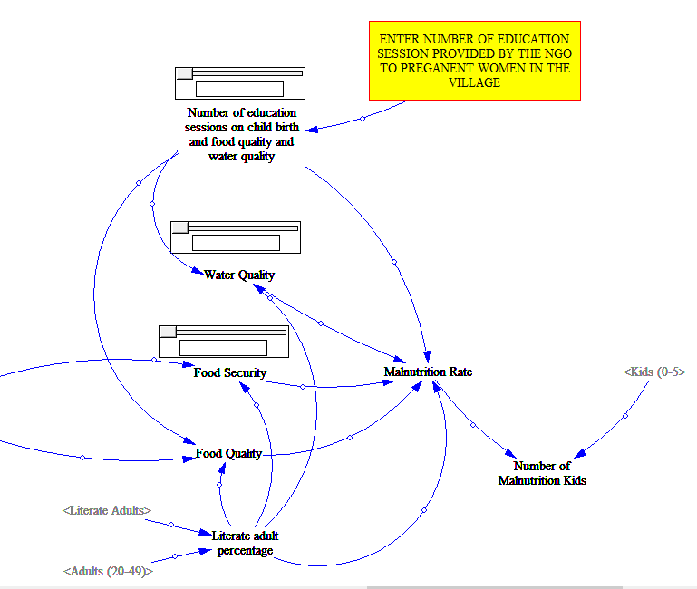
Figure 5.23: Health Care: Intervention 2a
The VLSD model is simulated with a set of a different number of sessions that are to be conducted each month for education. The results of this model are presented in Figure 5.24 and Figure 5.25. In Figure 5.24, the impact of education sessions is presented on water quality and food quality improvement. In Figure 5.25, the impact of education sessions is presented on malnutrition rate (on the left hand side of Figure 5.25) and the number of malnutrition kids (graph on the right side of Figure 5.25). Each color in Figure 5.24 and Figure 5.25 is associated with a different number of education sessions; for example, the green color is used to present the impact of three education sessions, the red color is used to present the impact of five education sessions. From the data presented in Figure 5.24 and Figure 5.25, the impact of this intervention is only observed on water quality, contrary to the presumed impact on both water and food quality.

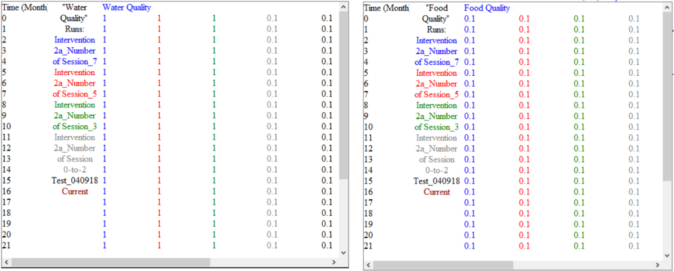
Figure 5.24: Evaluation of the Number of Session on Water Quality and Food Quality for Intervention 2a

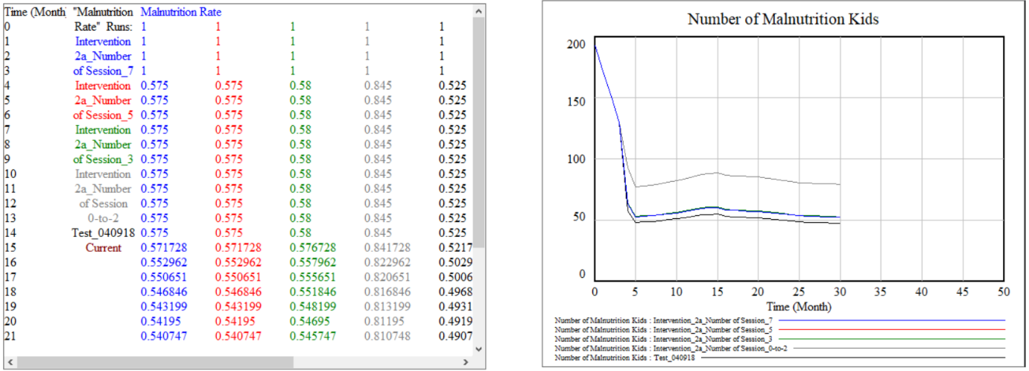
Figure 5.25: Effect of Number of Session on Malnutrition Rate for Intervention 2a
This behavior of the system can be explained as follows; As NGO representative increase number of visits in a month, the education on drinking clean water and eating healthy food increases among the women of the village. Over the period, women start boiling water and thereby increase the intake of clean water. For food quality, even though the education is provided to eat healthily, the quality of food for a family depends on the economic stability of the family. Economic stability is directed dependent on the employment opportunity. In the current village, the number of families with more than 9 months of employment is less than 50, as the majority of families depend on stream water fishing. Therefore, the impact of this intervention on the current state of the village will be only on water quality increase.
On evaluating the current intervention using VLSD model, it can be observed that to decrease malnutrition rate in this village, the focus must be to increase the food quality and food security in the village. Since the NGO cannot provide food for family members. The focus must be on providing economic opportunities. The impact of economic opportunities on food quality and water quality can be modeled using VLSD. The malnutrition part of the model is evaluated by changing the employment rate from 50 to 100 households and evaluating the effect of Intervention 2a (education sessions). The possible impact of improved employment rate for 100 families on malnutrition is presented in Figure 5.27 and Figure 5.28.
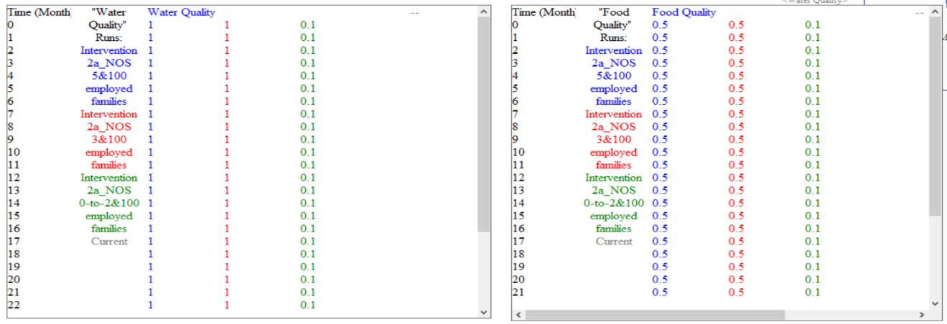
Figure 5.26: Evaluation of Number of Session on Water Quality and Food Quality for Intervention 2a and 100 Employed Families

From Figure 5.26 it can be observed that the food quality is improved when employment rate increases for 100 families to earn on an average for 9 months. In Figure 5.27 and Figure 5.28, improvement is observed only after providing a minimum of 3 education session. Similar to Figure 5.21 and Figure 5.22, each color in Figure 5.27 and Figure 5.28 are used to present a different number of education sessions and their corresponding impact.
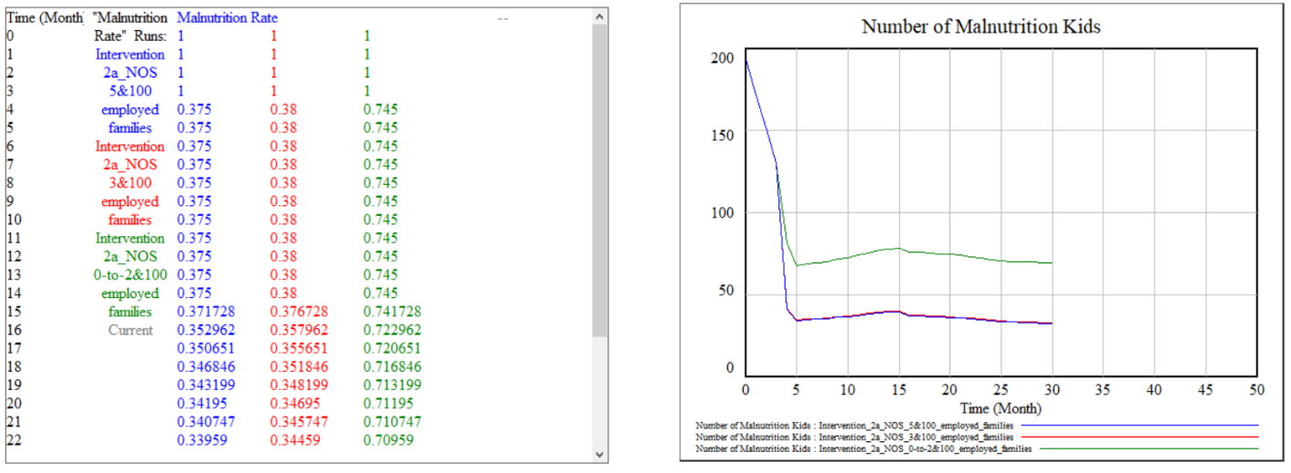
Figure 5.27: Effect of Number of Session on Malnutrition Rate for Intervention 2a and 100 Employed Families

The value obtained on using VLSD model
The value obtained from the model for malnutrition rate is due to a combination of education from NGO and increase in the employment rate together. The increase in employment rate can be achieved by providing different opportunities. The NGO can focus on providing skills to women. The impact to different skills on empowerment can also be modeled using the Village Level System Dynamic model by adding a set of variables.
In next section, VLSD model is used to evaluate the electricity aspects for a village. The intervention proposed is to provide solar lanterns in each household to increase overall productivity.

Electricity Vignette in Janisahi Village
Census report
Janisahi is a small village located in Dasapalla sub-district, Nayagarh district, Orissa. The Janisahi village has a population of 707 of which 357 are males while 350 are females as per Population Census 2011.
Demographics
Janisahi a village 160 kilometer away from the capital of the state has 159 households. Most of the families in this village rely on seasonal agriculture in the rainy season. There is one micro-grocery store in the village.
One of the CSR investors is planning to partner with an enterprise to distribute solar lanterns to each household in the village and to the micro-enterprise as well. The motive for CSR investor is to reduce the cost of energy and increase the productivity for each household. CSR investors want to analyze the impact of this intervention on the lives of families.
The direct impact of solar lantern project on the lives of families living in off-grid has been previously published in the literature (Gharib, 2015; Lemaire, 2018). The use of the Village Level System Dynamic model in this scenario is not needed to evaluate the direct impact. Though, on evaluating this project from systems perspective can clarify indirect impacts of the project.
Solar lanterns are categorized under Tier-1 energy systems. Each solar lantern is required to be charged under the sun for 5-6 hours in general and provides light for 3-4 hours on average in the night. In most of the communities, after dark, kerosene lamps are used to light the household. On providing the household with solar lanterns, the cost of energy for the household is dropped to zero. Authors in some of the reports have also suggested that supplying solar lanterns have increased the productive hours for households up to two hours (Gharib, 2015; Günther, 2017; Kudo, Shonchoy and co-authors, 2017; Lemaire, 2018)). Micro-enterprises can run for extra three hours post dark on average. However, there are two biggest challenges associated with solar lanterns that are usually overlooked in providing a community with energy systems.
First, the maintenance of solar lanterns is difficult in off-grid villages. The average warranty period for solar lanterns is 2 years. As solar lanterns continue to fail, lack of lantern repairing service makes families throw away the lanterns. This leads to families start moving back to reliable but costly and inefficient system of energy (kerosene lamps), bringing net effectivity of the intervention to zero. This scenario is modeled in the VLSD, and overall cost of kerosene for the village is calculated for 159 households. In Figure 5.28, the data for the total cost of kerosene is presented for 159 households combined.
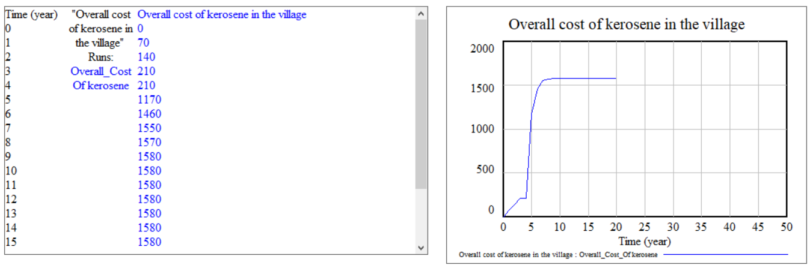
Figure 5.28: Cost of Kerosene in the Village
After the solar lanterns are distributed in the village, the cost of kerosene is dropped to zero, the VLSD part is modeled from the distribution day and therefore starts at zero cost. The cost presented in Figure 5.28 for each year is the average cost per day per family. As the number of solar lanterns continue to fail the average cost increases for the households. Post warranty period the failure of solar lanterns increases exponentially, and therefore a sudden increase in cost is observed as presented in Figure 5.28.
The second challenge in providing solar lanterns or Tier-1 energy system is lack of long term impact, lack of capability of improving socio-economic development of the families. Solar lanterns provide light in each household that increases the productivity of the households, but cannot power the micro-enterprises, agricultural farms, health clinics or schools. Solar lanterns cannot be used to power a television as well. On another hand, a micro-grid can be used to power agricultural farms, thereby increasing the number of crops in a year per farm. Micro-grid can also provide electricity to increase the productivity of micro-enterprise such as grocery stores by increasing the types of products that can be stored in the refrigerator. Micro-grid also acts as a catalyst in creating more micro-enterprises in the village, such as wheat grinding, welding, document printing. For health care clinic, the micro grid can be useful for patients to come in late in the night for the check-up. Also, with refrigerator accessibility patients do not have to wait for medications that are needed to be stored in the cold areas. In schools, with the availability of electricity provides an opportunity to set up computer and internet, providing an opportunity to learn from educational videos. Currently, the data is not available of socio-economic growth due to development of reliable micro grid. In Figure 5.29, the part of village level model is presenting the areas that can be impacted by micro-grid compared to the solar lantern. For this vignette, the causal loop diagram is used to identify the areas of impact. Next step will be to collect the data and develop a VLSD model.
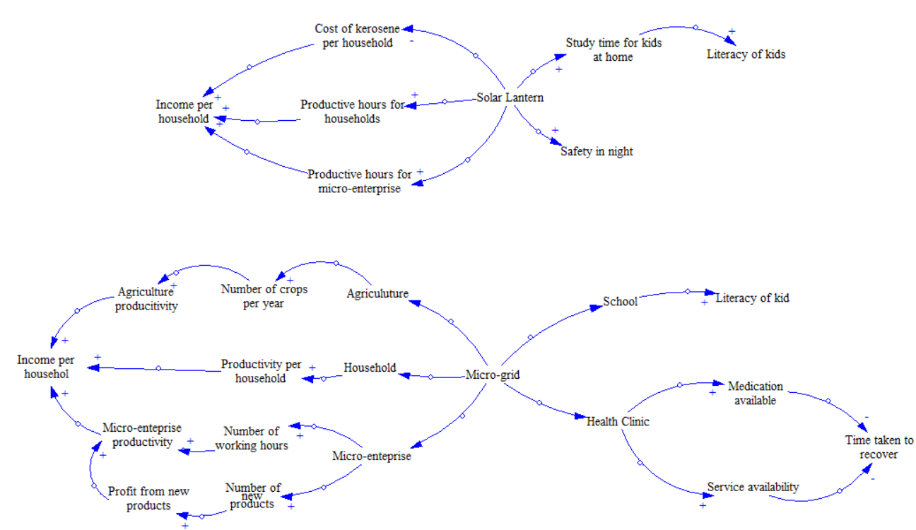
Figure 5.29: Possible Impacts of Micro Grid
The value obtained on using VLSD model
In this vignette, the value is obtained in understanding the productivity impact of solar lanterns initiative. On evaluating the impact of the intervention, it is identified that there is a direct impact of solar lanterns on the amount spent by each household on kerosene. Therefore initially, the productivity increases for the households. However, as time passes by solar lanterns fail, due to this cost of kerosene starts to increase again, and overall impact of this intervention is short term. To have long term impact, need is to provide a sustainable source of electricity that impacts commercial productivity.

Overall, the VLSD model in this thesis is developed only for three aspects of the village. In Chapter 3, a method is presented to extend the model for different aspects of the village.

Hypothesis Verification: Village Level System Dynamic Model
Village Level System Dynamic model is developed as the third construct of the overall framework. The VLSD model is used to evaluate different value propositions that are developed using Dilemma Triangle for the framework. VLSD model can be used separately without the other constructs of the framework as well. The value calculated for the framework is in terms of baseline index. If VLSD is used separately, the outcome is still valid. The Thesis Question Q4 and hypothesis related to VLSD is restated below. Justification to verify the hypothesis is presented later in the section.
Q4: “What are the characteristics of the tool which will be used by social entrepreneurs and CSR investors to forecast the impact of the value proposition on various stakeholders? What should be the output of evaluation tool in order to compare and rank different value proposition for a particular community?”
Hypothesis for Q4: By developing a method containing different concepts of System Dynamics tool embodied in the framework to recognize various sectors (education, health care, and electricity) which will have an impact on quality of life of villagers.
The requirement for the proposed construct is to forecast the impact of the different value proposition of the rural community and rank them on a given scale. The construct must be easy to use and develop further. The VLSD model that is developed can be used to evaluate different value propositions; this is presented in Section 4.3. The scale used to rank different value proposition for the framework is Village Level Baseline Sustainability Index, this is anchored in reusability of the construct. The general VLSD model developed is presented in Section 5.2. The VLSD model is also anchored in the requirements developed based on the primary question.
In Chapters 3, 4 and 5, the constructs of the framework are presented separately, using each construct one example is solved. The next step is to present empirical structural validity for validation of the framework and its constructs. In next section, the empirical structural validity of the three construct is presented.

EMPIRICAL STRUCTURAL AND PERFORMANCE VALIDITY
Empirical structural validity is the second quadrant in validation square. Empirical structure of the design method is validated by accepting the appropriateness of the example problem selected. That is, it is required to select an example that is a good representation of design problem. In this thesis, the design problem is the development of a value proposition for a rural community in India. Another design aspect is that the value proposition developed must be anchored in sustainability. The proposed computational framework is presented in Figure 1.4. The framework is divided into three parts, each part constituting of the construct that is not available in the literature. Based on the identified gap the three constructs are developed for the framework and presented in Chapters 3, 4 and 5 respectively. For each of the construct, one example village is taken, data is collected, and construct is used to get output for the selected village. Verification for the hypothesis for each of the construct is provided at the end of respective chapters.
Chapter 3, 4 and 5 fall under quadrant two of the validation square, as presented in Figure 5.30, where the following topics were considered;
- The first construct of the framework (VLBSI) is developed and presented in Section 3.1,
- To show the working of VLBSI, data from a village is selected, and VLBSI is used to get baseline value in Section 3.2,
- The VLBSI, as per the requirements is modified based on the data. Verification of the hypothesis is presented in Section 3.2.
- A method to use the second construct of the framework (Dilemma Triangle) is presented in Section 4.1,
- Village data is collected, as explained in Section 4.2. One perspective is selected to show the implementation of the proposed method to use Dilemma Triangle in Section 4.2.
- The output obtained with the use of the method is as per the hypothesis proposed, the hypothesis is verified in Section 4.2.
- The last construct of the framework (VLSD) is presented in Chapter 5,
- Background of System dynamics is provided in Section 5.1; general VLSD model is presented in Section 5.2,
- Three vignettes are selected from three different villages to evaluate value propositions in the selected systems; this is presented in Section 5.3,
- Verification of hypothesis is presented in Section 5.3.
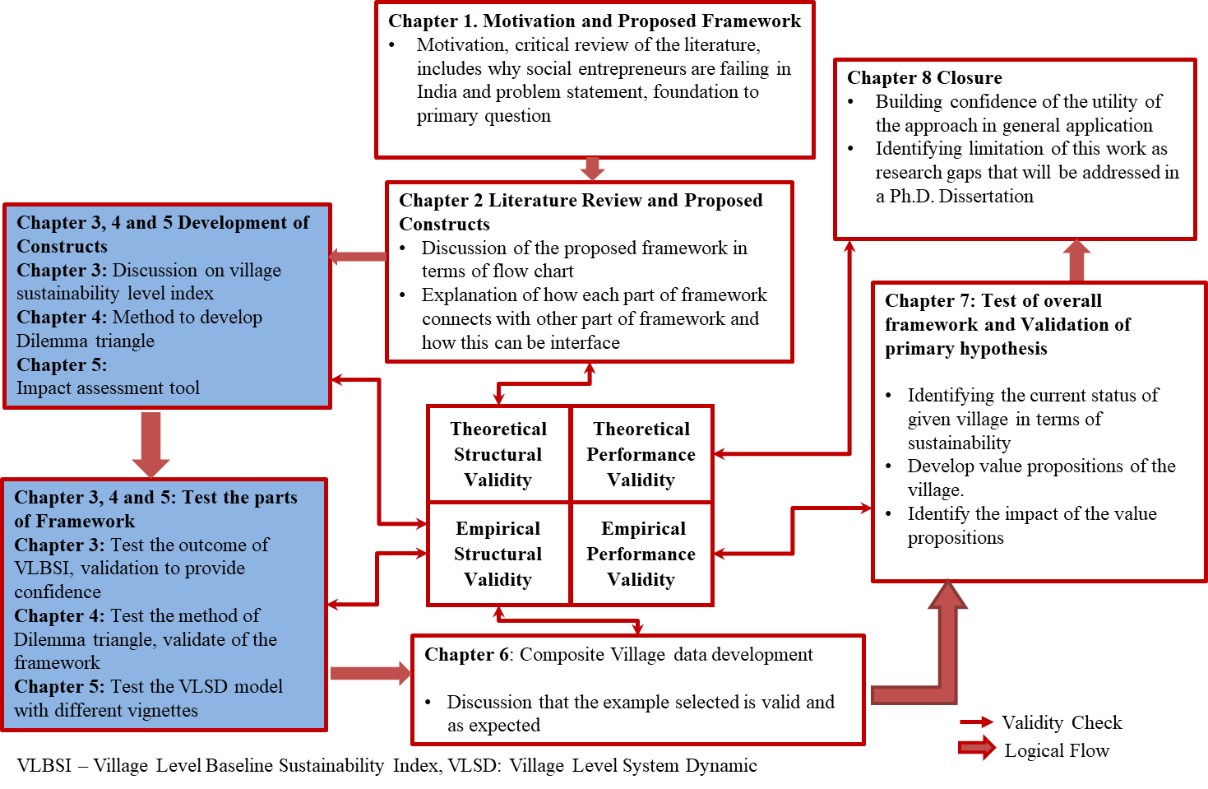
Figure 5.30: Validation Strategy for the Thesis

SYNOPSIS OF CHAPTER 5
In this chapter, the last construct of the framework (Village Level System Dynamics) is introduced. The construct VLSD is developed as a System Dynamics model useful to evaluate value proposition and presented in this chapter. In Section 5.1, background on system dynamics is provided Different aspects of system dynamics are discussed in this section. A Village Level System Dynamic model is proposed to be used to evaluate the impact of different value propositions. The VLSD model developed is the structure of system representing overall characteristics of any village (population, education, healthcare) with changing the internal interaction between each of the sub-systems based on the village. In Section 5.2 the VLSD structure model is presented, working for different sectors of the model (demographics, education, healthcare, and electricity) is discussed. VLSD model developed as a part of this thesis can be useful in evaluating different government policies and helps users have a systems perspective while developing a value proposition, interventions, policies for rural development. In Section 5.3, the extent of VLSD model based on changing villages and scenarios is presented. Three vignettes on this basis are presented. First, the education part of a village in Uttar Pradesh, India is presented. In this village, to increase the enrollment of girl education, need is to provide and maintain clean sanitation facilities in school and have a school van service developed (as a micro-enterprise). In the second village the challenge is anchored in the healthcare system. With high malnutrition rate, the value proposition that is impactful is identified to develop employment opportunities in and near the village for all the households. Last vignettes is anchored in solar lantern intervention. Impact of intervention is evaluated base don increase in productivity using VLSD model. The impact of solar lanterns is observed to be short term.
In Chapter 6, data of a composite village is presented in detail as presented in Figure 5.31. The composite village data will be used in Chapter 7 to show the utility of overall framework.
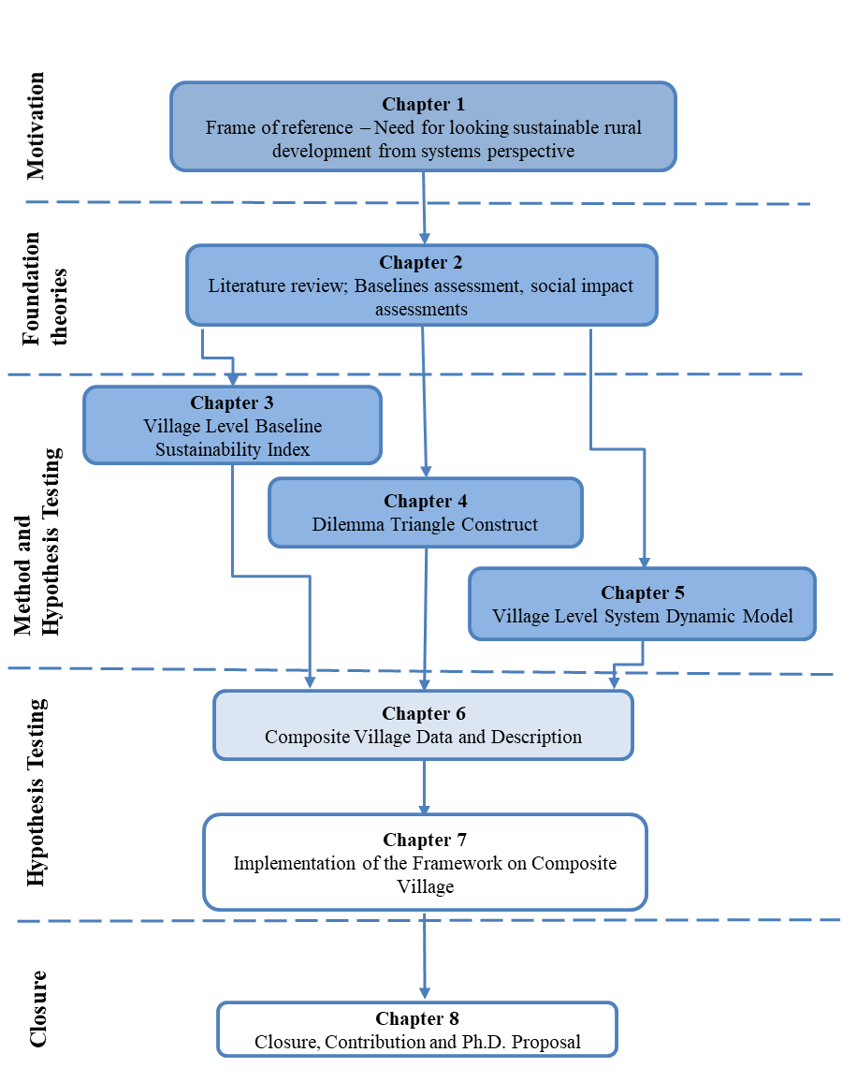
Figure 5.31: Organization of the Thesis – Presented and Next Chapter

CHAPTER 6
COMPOSITE VILLAGE

In Chapter 3, Chapter 4 and Chapter 5, the three constructs of the proposed framework are presented respectively. The method to develop and steps to run/calculate the value from each construct is also discussed in each chapter. For empirical structural and performance validity of each construct separately, an example problem for each construct is solved in the respective chapters. Given that the outcome from each construct is as expected, the next step is to show the working of the overall framework and how information from one construct is connected to other (that is, to build confidence on the outcome achieved from framework and flow of information from one construct to another). The utility and working of any design method the need is to take a comprehensive example problem and solve it using the framework. In this case, the framework is developed to be helpful for social entrepreneurs and CSR investors in developing and evaluating value proposition for rural village in India, therefore the comprehensive example, in this case, will be a detailed data of a village. In this chapter, the data of a composite village is presented and explained. A composite village is developed by collecting data from multiple villages to show the implementation of the framework. The composite village used in this thesis involves complex issues taken from multiple villages, using the composite village will be useful in presenting the utility of framework in terms of modifiability, adaptability, and reusability. In Chapter 7, the data from the composite village will be used in the framework to show the utility of framework and verify the hypothesis.

COMPOSITE VILLAGE DESCRIPTION AND DATA
Justification of the composite village selected as an example: The framework for the development of rural communities in India is proposed as a general framework that can be used for rural development in India. The composite village is developed by combing different characteristics of different rural communities of India and therefore is a suitable representation of a general village. The framework is used to develop and evaluate value proposition for the composite village as an example in this chapter.
Description of the composite village
The village under consideration is situated in the Odisha state, Angul District, shown in Figure 6.1. It has a population of 600 people with an almost even distribution of males and females. The village has a solar powered microgrid providing electricity to all 140 households. There is a tribal primary school in the village although only about 40 of 260 children attend since most children work in family farms, businesses, or as laborers. Furthermore, there is not a hospital in the village.
The nearest hospital is 10 kilometers away. The area suffers from land degradation and medium water pollution due to aquaculture and agriculturally focused households. Farming is a large source of income for households both as farm owners and farm hands, followed by laborers outside the village.
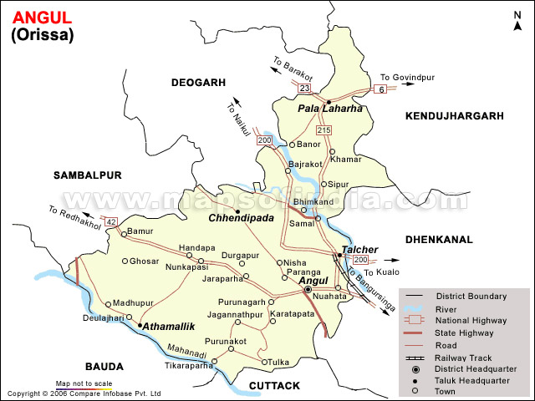
Figure 6.1: Angul District, Odisha State Map

The data presented in Table 6.1 is taken from different sources available on the internet (the source of data is presented in the right most column in Table 6.1. For example, the population for the composite village is considered to be same as a village in Orissa state called as Chhotkei, whereas a number of families owning farming land is average taken based on the Angul district (Composite of different characteristics of the different village). The use of such data is fitting as the work presented in this thesis is not focused on the specific requirement of data available but on the constructs developed. The Village Level Baseline Sustainability Index construct is developed to be used for any data available with social entrepreneur, however, with better data, better decision can be made be a social entrepreneur based on the output. In the baseline assessment process, users of the index can use the sheet mentioned in Table 3.18 to collect the information for better data collection.
Table 6.1: Composite Village Data
Driver |  | Value | Source of Data / Comments (Justification)
Social Status
Population
 | Total Population | 600 | Information Provided on Chhotkei Census
 | Number of households | 140 | Information Provided on Chhotkei Census
 | Male | 288 | From the census data (IndiKosh.com), there is a 48% male population and 52% female population.
 | Female | 312
 | Youth (20-24) | 100 (70 Boys, 30 Girls)
 | Teens (14-19) | 100 (60 Boys, 40 Girls)
 | Children (Below 13) | 60 (40 Boys, 20 Girls)
Electricity
 | Is there electricity in this village? | Yes | 30 kW. Eco Resort has Solar and Generator power
 | Source of Electricity | Solar
 | Number of houses having electricity | 100 | The Smart Villages Initiative: Findings 2014-2017
 | Hours of electricity in each household on average | 6 - 7 Hours | Mostly in the day time when solar plant is running
 | Is electricity provided to small enterprises? | Yes
 | Number of productive hours of electricity obtained in small enterprises | 6 - 8 hours
Education
 | Is there a school present in the village | Yes | Tribal School up to grade 7
 | Is there a school present in nearby villages? | No | This is a remote village, and there is no other village nearby
 | Number of Children going to school | 40
 | Is there higher education in the village or nearby villages village and there is | No | This is a remote no other village nearby
Communication and Entertainment
 | Is there connectivity in the village? (Mobile/Landline) | Yes* | *Power plant monitors and billing
 | Number of people having a connection (Mobile/Landline) | 20
 | Number of Households having a Television connection | 5
 | Number of households informed about current affairs | 50
Food and Water
 | Number of households having food scarcity | 70 | Average depends on the season
 | Number of households having water scarcity | 50 | Average depends on the season
 | Is there any action taken to decrease food scarcity /What level | - | No Data
 | Is there any action taken to decrease water scarcity / What Level | - | No Data
Housing
 | Number of families having proper housing | 80
Sanitation
 | Issues with open deification known by households | 30
 | Type of sewer system | Closed
 | Number of Households having proper Sanitation Conditions | 20
Equality
 | Is there Caste equality in the village | No | As the majority of the population of the village is not well educated, they lack modern thinking, and so inequality exists
 | Is there Gender equality in the village | No
Health
 | Number of malnutrition kids in village | 30
 | Healthy pregnancy in a year | 3
 | Percentage of children received polio drops | 100% | The village is poorly educated and does not have the means to run a hospital. 10km to the nearest health center.
 | People suffering from water-borne diseases | 200
 | Is there a hospital in the village | No
 | Children's with untreated disease | 50
 | Adults with untreated disease | 20
 | Technology present in the hospital, mention in comments | N/A
Cooking
 | Number of households using firewood, kerosene stoves, and LPG in Village | 100 | As firewood is easily available and affordable, it is used by many villagers.
Environmental Status
Pollution - Water
 | Accessibility to drinking water | 90 Households
 | Human contamination of the water body | FALSE
 | Quality of drinking water | Usable | Based on BIS standard (10500)
 | Quality of irrigation water | Not up to the standards
 | Quality of water for shrimp farming
Pollution - Soil
 | Quality of soil for agriculture | Usable
 | Quality of soil for shrimp farming | As per standards
Pollution - Air
 | Air Quality Index of the village | 51-100
Degradation
 | Land Degradation | Low | The village is a farming community with the low yield from fields due to no irrigation.
 | Soil Degradation | Medium
 | Forest Degradation | Medium
 | Underground Water Level Degradation | High | Rivers are the primary source of water.
 | Wildlife Degradation | Low | Eco Resort major employer causing the careful use of wildlife resources
 | Fishery Degradation | Low | The village is landlocked, and there is no nearby natural lake or pond for our villagers to fish in
Animal Husbandry
 | Households with animals in the village | 50
 | Animals died due to diseases | 30
 | Households with domestic animals | 30
 | Households using illegal medicines on animals | 30
Socio-Economic Status
 | Current GDP of the village | - | Data Not Available
 | Ratio of (GDP of village/GDP of State in which village is present) | - | Data Not Available
 | Number of Households which are below the half of total village's GDP value. | - | Data Not Available
Agriculture
 | Number of households involved in farming | 45* | *Seasonal involvement.
 | Number of households having their own farms | 25 | Estimate based on Anugul district
 | Number of households working as daily labors in farm | 20 | Estimate based on Anugul district
 | Households using drip/sprinklers | 17
 | Households using pesticides | 8
 | Households using nitrogen fertilizer | 8
 | Household using old practices of burning | 17
 | Number of crops in a year | 1
 | Average Income per household
Aquaculture
 | Number of households involved in Aquaculture | 40
 | Number of households with their own farms | 15
 | Number of households that have license for shrimp farming | 5
 | Number of farms situated is designated zone | 5
Small Business
 | Number of Households involved in Business | 2
 | Number of Households involved in Handlooms and Handicrafts | N/A
 | Number of Households involved in Family business (High-income households) | -
 | Average Income per household | - | Income varies based on business, and the average will not give an adequate description
Labor
 | Number of households working as laborers | 45 | Most of the available jobs are as laborers who are low education and very low-income job
 | Number of people working as laborers | 60
 | Number of children working as child labors (Not attending schools) | 5
 | Average income of Labors
Fishing
 | Number of households involved in fishery | 40 | In Land Fishing
 | Number of households having their own fishery farms/tanks | 15
 | Number of households involved as labors for fishery | 25
 | Average income of fishery | 0
Government Employment |  | 5
 | Number of Households involved in Government Employment
 | Average Income | ₹13,000
Employment Type
 | Fully Employed | 9
 | Seasonally Employed | 100
 | Unemployed (Short term) | 11
 | Unemployed (Long term) | 15 | Unemployed more than a year
 | Child Labor | 5
Based on the available data presented in Table 6.1 and description of the village, in Chapter 7, the framework is used to develop and evaluate the value proposition for the selected village. As presented in Figure 6.2, first the data from Table 6.1 is used to calculate Village Level Baseline Sustainability Index (Chapter 3). The VLBSI value obtained is then used to identify the driver (social, economic and environment) with least value in the sustainability index, and in each driver, the indicator that has least value. Based on this, the next step is to use Dilemma Triangle construct to identify dilemmas and develop value proposition (Chapter 4). Different value propositions developed will then be further evaluated using Village Level System Dynamic model (Chapter 5). Impact of each value proposition is calculated by comparing the possible increase in baseline value of indicators obtained from VLBSI.
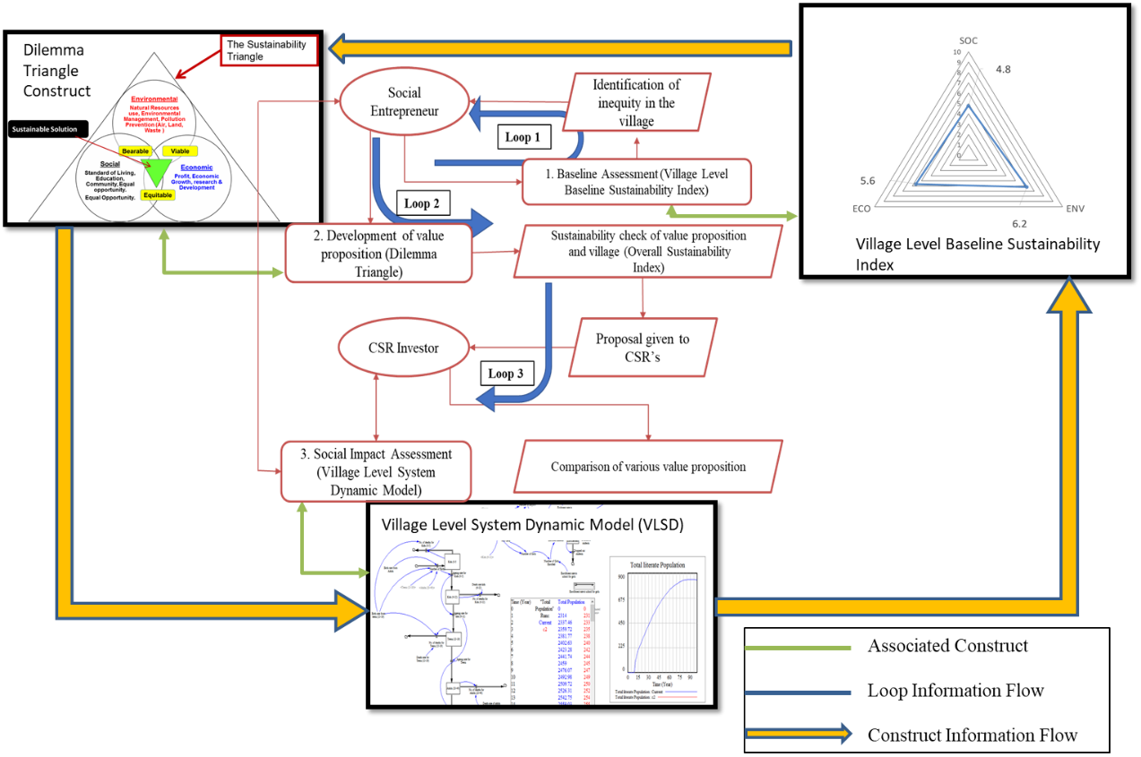
Figure 6.2: Framework Overview with Construct Information Flow

The flow of information and data presented in this chapter will be discussed in Chapter 7 in detail. The composite village is a combination of data from multiple sources. In Chapter 7, discussion on building the confidence on the outcome of the framework for the composite village to verify the hypothesis is also presented.

SYNOPSIS OF CHAPTER 6
In this chapter, the data of a composite village that will is used as an example of the overall framework is presented. The composite village is developed by collecting information from multiple villages and survey collected. Information on the village in this chapter is presented in terms of social, environment and economic driver. Later in the section, the flow of information from one construct to other is developed.
In Chapter 7, the data of composite village is used to show the working of the overall framework and verifying the hypothesis associated with thr primary question of the thesis.
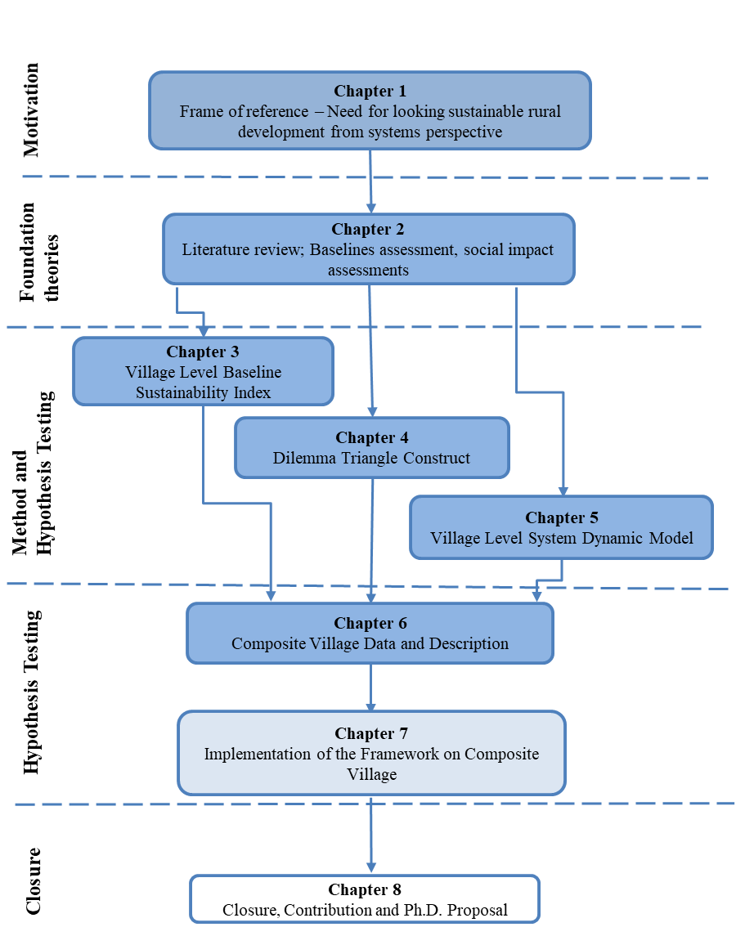
Figure 6.3: Organization of the Thesis – Presented and Next Chapter

CHAPTER 7
IMPLEMENTATION OF FRAMEWORK

In previous Chapters (3, 4 and 5), the utility of each construct of the framework (VLBSI, Dilemma Triangle, and VLSD) is discussed separately and verified. In this chapter, the utility of overall framework is discussed. The example selected is a composite village presented in Chapter 6, data for it was developed by collecting information from multiple villages in India. The data of composite village taken as in input Section 7.1, here the baseline value of the composite village is calculated using VLBSI in terms of sustainability drivers (socio, economic and environment). The value obtained from VLBSI is used to draw the boundary for Dilemma Triangle construct to develop value propositions for the composite village in Section 7.2. These value propositions are evaluated using the VLSD model in Section 7.3. The framework proposed is a decision support tool and not a black box wherein on providing input, the output is calculated. The framework must be seen as attention directing tool and output from each construct, and overall framework must be evaluated before implementation.

A WORKING EXAMPLE: BASELINE SUSTAINABILITY INDEX
In this section, the calculation of the overall sustainability index is presented for the composite village. Working of VLBSI is presented in Chapter 3 in detail. In this section, the values from Chapter 6 are fed in VLBSI and value is calculated. In Section 7.1.1, the value for the social driver of the VLBSI is calculated, In Section 7.1.2 and 7.1.3, the value for environment driver and the economic driver is calculated respectively. In Section 7.1.4, the results from each driver are presented, and graphical description of the indicators of each driver is presented along with overall sustainability index.

Value of Social Driver for the Composite Village
Based on the data available in Chapter 6, the value of social driver of VLBSI is presented in this section. In Section 3.2, all the indicators for each driver are presented, and discussion on how indicators are selected is made. In this section, the value of social driver for the composite village is presented. The value for each of the indicators is presented in Table 7.1. The weights assigned to most of the indicators/sub-indicators are equal. In this section, the Table 7.1 is presented with all the input data for each of the indicators. Table 7.1 includes all the indicators of the social driver and their calculated value. In Table 7.2, the total value of social driver index is calculated, in Figure 7.1 the spider diagram is presented for each indicator based on the data calculated in Table 7.2 Row R2.

Table 7.1: Value of Social Driver Index for the Composite Village
SOC 1: Education |  | C1 | C2 | C3 | C4 | C5 | C6 | C7
Sub-Indicators |  | Number of children attending school | Total number of boys/girls in the village for each sub-indicator | Current percentage of children attending school [(C1)/(C2) *100] | Target percentage of children attending school | Conversion to scale of 0-10 (C3)/(C4) *10 | Each sub-indicator weightage | Value of sub-indicator toward Indicator [(C5) *(C6)]
1.1 | Boys of age 6-13 attending primary school | 30 | 40 | 75.00 | 100.00 | 7.50 | 0.12 | 0.90
1.2 | Girls of age 6-13 attending primary school | 10 | 20 | 50.00 | 100.00 | 5.00 | 0.13 | 0.65
1.3 | Boys of age 14-16 attending secondary school | 0 | 45 | 0.00 | 100.00 | 0.00 | 0.12 | 0.00
1.4 | Girls of age 14-16 attending secondary school | 0 | 35 | 0.00 | 100.00 | 0.00 | 0.13 | 0.00
1.5 | Boys of age 17-19 attending senior secondary school | 0 | 15 | 0.00 | 100.00 | 0.00 | 0.12 | 0.00
1.6 | Girls of age 17-19 attending senior secondary school | 0 | 5 | 0.00 | 100.00 | 0.00 | 0.13 | 0.00
1.7 | Boys of age 20-24 who pursue higher education | 0 | 70 | 0.00 | 50.00 | 0.00 | 0.12 | 0.00
1.8 | Girls of age 20-24 who pursue higher education | 0 | 30 | 0.00 | 50.00 | 0.00 | 0.13 | 0.00
 | Total People between (6-24) | 40 | 260 | Total Indicator weight (Must be 1) |  |  | 1.00
 |  |  |  | SOC1 Indicator Value |  |  |  | 1.55

SOC 2: Electricity |  | C1 | C2 | C3 | C4 | C5 | C6 | C7 | C8
Sub-Indicators |  | Enter required data based on Sub-Indicators | Average number of Hours (Not including 6-10 PM) | Average number of Hours (6-10PM) | Target percentage/hours | [(C2) + 2(C3)]/(C4) | Conversion to scale of 0-10 (C5) *10 | Each sub-indicator weightage | Value of sub-indicator toward Indicator [(C6) *(C7)]
2.1 | Does village have a source of electricity? | Yes
 | Total Number of Households | 140
2.1.1 | Number of households having electricity |  | 100 |  | 100.00 | 0.71 | 7.14 | 0.30 | 2.14
2.1.2 | Average hours of electricity provided per household per day (Hours) |  | 5.00 | 1.00 | 12.00 | 0.58 | 5.83 | 0.20 | 1.17
2.1.3 | Average hours of electricity provided to SME's (Average work day = 8 hours) |  | 6.00 | 0.00 | 8.00 | 0.75 | 7.50 | 0.20 | 1.50
2.1.4 | Average hours of electricity provided to stores |  | 6.00 | 2.00 | 12.00 | 0.83 | 8.33 | 0.20 | 1.67
2.20 | Is the source of electricity renewable? | Yes |  |  |  |  | 1.00 | 0.05 | 0.05
2.30 | Is the source of electricity reliable? | Yes |  |  |  |  | 1.00 | 0.05 | 0.05
 |  |  | Total Indicator weight (Must be 1) |  |  |  |  | 1.00
 |  |  |  |  | SOC2 Indicator Value |  |  |  | 6.58

Food and Water |  | C1 | C2 | C3 | C4 | C5 | C6 | C7
Sub-Indicators |  | Current Value of Sub-Indicator | Total number of households/children/ people for Sub-Indicator | Current percentage | Target Percentage | Conversion to scale of 0-10 (C3)/(C4) *10 | Each sub-indicator weightage | Value of sub-indicator toward Indicator [(C5) *(C6)]
3.10 | Food security and quality
3.1.1 | Number of households having resources to have 3- meals a day (This includes all the members of family) | 70 | 140 | 50.00 | 100.00 | 5.00 | 0.20 | 1.00
3.1.2 | Number of children suffering from malnutrition (Age: 0-10) | 30 | 100 | 30.00 | 0.00 | 7.00 | 0.20 | 1.40
3.1.3 | Number of healthy pregnancy in last year | 3 | 5 | 60.00 | 100.00 | 6.00 | 0.10 | 0.60
3.20 | Drinking water security and quality
3.2.1 | Number of households having access to drinking water everyday | 90 | 140 | 64.29 | 100.00 | 6.43 | 0.20 | 1.29
3.30 | Quality of water
3.3.1 | Number of people suffering from water borne diseases | 200 | 600 | 33.33 | 0.00 | 6.67 | 0.10 | 0.67
3.3.2 | Is water quality as per the standards based on BIS standard (10500) | Yes |  |  |  | 10.00 | 0.05 | 0.50
3.3.3 | Is water body free from human contamination? | Yes |  |  |  | 10.00 | 0.10 | 1.00
3.3.4 | Distance of water source from households (in Kms) | 5.00 |  |  | 6.00 | 10.00 | 0.05 | 0.50
 |  |  | Total Indicator weight (Must be 1) |  |  |  | 1.00
 |  |  |  | SOC3 Indicator Value: |  |  |  | 6.95

SOC 4: Sanitation and Hygiene
Sub-Indicators |  | Current Value of Sub-Indicator | Total number of households/children/ people for Sub-Indicator | Current percentage | Target percentage | Conversion to scale of 0-10 (C3)/(C4) *10 | Each sub-indicator weightage | Value of sub-indicator toward Indicator [(C5) *(C6)]
4.1 | Knowledge about sanitation and hygiene
4.1.1 | Number of households that have knowledge about issues with open deification | 30 | 140 | 21.43 | 100.00 | 2.14 | 0.25 | 0.54
4.1.2 | Number of households that have knowledge about hygienic process | 30 | 140 | 21.43 | 0.00 | 7.86 | 0.25 | 1.96
4.2 | Availability of sanitation facilities
4.2.1 | Number of households having working toilets and are using it. | 20 | 140 | 14.29 | 100.00 | 1.43 | 0.25 | 0.36
4.2.2 | Number of households having resources to maintain basic hygienic conditions | 20 | 140 | 14.29 | 100.00 | 1.43 | 0.15 | 0.21
4.2.3 | Does village have a proper sewer system? | Yes |  |  |  | 10.00 | 0.10 | 1.00
 |  |  | Total Indicator weight (Must be 1) |  |  |  | 1.00
 |  |  | SOC4 Indicator Value: |  |  |  |  | 4.07

SOC 5: Health
Sub-Indicators |  | Current Value of Sub-Indicator | Total number of households/children/ people for Sub-Indicator | Current percentage | Target percentage | Conversion to scale of 0-10 (C3)/(C4) *10 | Each sub-indicator weightage | Value of sub-indicator toward Indicator [(C5) *(C6)]
5.1 | Distance of nearest clinic and medical dispensary from village | 10.00 |  |  | 8.00 | 0.00 | 0.10 | 0.00
5.2 | Number of infant mortalities in last two years | 2.00 | 10.00 | 20.00 | 0.00 | 8.00 | 0.15 | 1.20
5.3 | Number of children who got polio drops in last 6 Months | 30.00 | 30.00 | 100.00 | 100.00 | 10.00 | 0.10 | 1.00
5.4 | Number of child mortalities during pregnancy in last two years | 1.00 | 10.00 | 10.00 | 0.00 | 9.00 | 0.15 | 1.35
5.5 | Number of children with un treated diseases ( Age: 0-16) | 50.00 | 180.00 | 27.78 | 0.00 | 7.22 | 0.20 | 1.44
5.6 | Number of adults with untreated diseases (Age: 16+) | 20.00 | 420.00 | 4.76 | 0.00 | 9.52 | 0.25 | 2.38
5.7 | Number of Adults with informed HIV issues (Age 18+) | 100.00 | 400.00 | 25.00 | 100.00 | 2.50 | 0.05 | 0.13
 |  |  | Total Indicator weight (Must be 1) |  |  |  | 1.00
 |  |  |  |  | SOC5 Indicator Value: |  |  | 7.50

SOC 6: Communication
Sub-Indicators |  | Current Value of Sub-Indicator | Total number of households/children/ people for Sub-Indicator | Current percentage |  | Target percentage | Conversion to scale of 0-10 (C3)/(C4) *10 | Each sub-indicator weightage | Value of sub-indicator toward Indicator [(C5) *(C6)]
6.1 | Number of households having mobile/landline connection | 20.00 | 140.00 | 14.29 |  | 100.00 | 1.43 | 0.34 | 0.49
6.2 | Number of households having television sets with cable connection | 5.00 | 140.00 | 3.57 |  | 100.00 | 0.36 | 0.33 | 0.12
6.3 | Number of households are informed of current affairs, subsidies provided for them | 50.00 | 140.00 | 35.71 |  | 100.00 | 3.57 | 0.33 | 1.18
 |  |  | Total Indicator weight (Must be 1) |  |  |  |  | 1.00
 |  |  |  |  | SOC6 Indicator Value: |  |  |  | 1.78
Once the value for each indicator is calculated, the next step is to calculate the value of social driver. In Table 7.2, the total value of the social driver is presented corresponding to the indicator values calculated in Table 7.1. The value of the indicators presented in Table 7.2 Row R2 is presented in Figure 7.1 as a spider diagram, similar to Table 3.17 and Figure 3.4 respectively.
Table 7.2: Overview of Social Indicator Values for the Composite Village
Overview of social indicators
R1 | Indicators | SOC 1 | SOC 2 | SOC 3 | SOC 4 | SOC 5 | SOC 6 | Total
 |  | Education | Electricity | Food and Water | Sanitation and Hygiene | Health | Communication
R2 | Indicator Value | 1.55 | 6.58 | 6.95 | 4.07 | 7.50 | 1.78 | 28.43
R3 | Weight for each Indicator | 0.18 | 0.18 | 0.18 | 0.18 | 0.18 | 0.10 | 1.00
R4 | Conversion scale of 0-10 [(R2) * (R3)] | 0.28 | 1.18 | 1.25 | 0.73 | 1.35 | 0.18 | 4.98

Figure 7.1: Social Driver Spider Diagram for Composite Village

In Figure 7.1, the pictorial description of the data presented in Table 7.2 is presented. Based on the information presented in Figure 7.1, it can be inferred that ‘education’ indicator has the lowest value. Social entrepreneurs, corporate social responsibility investors can now choose to invest in education. The word ‘choose’ is used intentionally as the index is developed to support the human decision and not to make decisions for humans. In next section, the value for environment driver is calculated for the composite village followed by economic aspect.

Environmental Driver for the Composite Village
In this section, the value for environment driver is calculated. The value of the driver will feed into overall sustainability index of the village discussed in later section. The values for environment driver indicators are presented in Table 7.3.
Table 7.3: Environment Driver Indicator Values for the Composite Village
ENV 1: Agriculture |  | C1 | C2 | C3 | C4 | C5 | C6 | C7
Sub-Indicators |  | Value of sub-indicator | Percentage of Sub-Indicators | Target percentage value of sub-indicators | (C2)/(C3) | Conversion to scale of 0-10 (C4) *10 | Each sub-indicator weightage | Value of sub-indicator toward Indicator [(C4) *(C5)]
1.1.0 | Total agricultural households (Owners not daily labors) | 25.00
1.1.1 | Number of households practicing drip/sprinkler irrigation | 17.00 | 66.67 | 100.00 | 0.67 | 6.67 | 0.20 | 1.33
1.1.3 | Number of households not using synthetic pesticides? | 17.00 | 66.67 | 100.00 | 0.67 | 6.67 | 0.20 | 1.33
1.1.4 | Number of households not using nitrogen fertilizer? | 17.00 | 66.67 | 100.00 | 0.67 | 6.67 | 0.20 | 1.33
1.1.5 | Number of farmer’s not practicing slash and burn practices? | 8.00 | 33.33 | 100.00 | 0.33 | 3.33 | 0.20 | 0.67
1.1.6 | Average area of crop (Quantiles)/land (Acre) yield for agriculture? | 300.00 | - | 500.00 | 0.60 | 6.00 | 0.20 | 1.20
 |  | Total Indicator weight (Must be 1) |  |  |  |  | 1.00
 |  |  |  | ENV1 Indicator Value: |  |  |  | 4.67
ENV 2: Animal Husbandry |  | C1 | C2 | C3 | C4 | C5 | C6 | C7
Sub-Indicators |  | Current Value of Sub-Indicator | Percentage of Sub-Indicators | Target percentage value of sub indicators | (C2)/(C3) | Conversion to scale of 0-10 (C4) *10 | Each sub-indicator weightage | Value of sub-indicator toward Indicator [(C4) *(C5)]
 | Animal Husbandry
2.1.1 | Number of households having Cow/Goat/Camel and or other household animals | 30.00
2.1.2 | Number of households using medicines to increase milk production | 30.00 | 100.00 | 0.00 | 0.00 | 0.00 | 0.50 | 0.00
2.1.3 | Number of animals in the village | 50.00
2.1.3 | What is the average number of animals lost due to disease each year? | 30.00 | 60.00 | 0.00 | 0.40 | 4.00 | 0.50 | 2.00
 |  |  | Total Indicator weight (Must be 1) |  |  |  | 1.00
 |  |  |  | ENV2 Indicator Value: |  |  |  | 2.00

ENV 3: Aquaculture |  | C1 | C2 |  | C3 | C4 | C5 | C6
Sub-Indicators |  | Value of sub indicator | Percentage of Sub-Indicators | Target percentage value of sub indicators | (C2)/(C3) | Conversion to scale of 0-10 (C4) *10 | Each sub-indicator weightage | Value of sub-indicator toward Indicator [(C4) *(C5)]
 | Aquaculture
3.1.0 | Total aquaculture households (Owners not daily labors) | 15.00
3.1.1 | Number of households having License for farming | 5.00 | 33.33 | 100.00 | 0.33 | 3.33 | 0.10 | 0.33
3.1.2 | Is there a designated zone assigned by local authorities?
3.1.3 | If Yes, Number of Farms situated within the zone | 5.00 | 33.33 | 100.00 | 0.33 | 3.33 | 0.20 | 0.67
3.1.4 | Number of Farms that were created by destroying mangroves, forest land, or coral reefs | 10.00 | 66.67 | 0.00 | 0.33 | 3.33 | 0.30 | 1.00
3.1.5 | Water Quality Parameter for Shrimp Aquaculture | Value of sub indicator | Target value of sub indicators |  | (C1)/(C2) | Conversion to scale of 0-10 (C4) *10 | Each sub-indicator weightage | Value of sub-indicator toward Indicator [(C4) *(C5)]
 |  |  | Min | Max
3.1.5.1 | Depth (cm) | 100.00 | 80.00 | 100.00 | 1.00 | 10.00 | 0.03 | 0.29
3.1.5.2 | Transparency (cm) | 20.00 | 25.00 | 30.00 | 0.00 | 0.00 | 0.03 | 0.00
3.1.5.3 | Salinity (ppt) | 8.00 | 8.00 | - | 1.00 | 10.00 | 0.03 | 0.29
3.1.5.4 | pH | 8.00 | 7.50 | 8.50 | 1.00 | 10.00 | 0.03 | 0.29
3.1.5.5 | Dissolved Oxygen (mg/l) | 4.00 | 5.00 | - | 0.00 | 0.00 | 0.03 | 0.00
3.1.5.6 | Biological Oxygen Demand (mg/l) | 5.00 | 0.00 | 5.00 | 1.00 | 10.00 | 0.03 | 0.29
3.1.5.7 | Total Dissolved Solids (gm/l) | 10.00 | 5.00 | 15.00 | 1.00 | 10.00 | 0.03 | 0.29
3.1.6 | Soil Quality Parameter for Shrimp Aquaculture | Value of sub indicator | Target value of sub indicators |  | (C1)/(C2) | Conversion to scale of 0-5 (C3) *5 | Each sub-indicator weightage | Value of sub-indicator toward Indicator [(C4)*(C5)]
 |  |  | Min | Max
3.1.6.1 | pH | 7.00 | 6.00 | 7.50 | 1.00 | 10.00 | 0.03 | 0.33
3.1.6.2 | Electricity Conductivity (EC) , (ds/m) | 10.00 | 8.00 | 12.00 | 1.00 | 10.00 | 0.03 | 0.33
3.1.6.3 | Organic Matter (OM), (%) | 2.00 | 1.00 | 3.50 | 1.00 | 10.00 | 0.03 | 0.33
3.1.6.4 | Total Nitrogen (%) | 0.40 | 0.18 | 0.45 | 1.00 | 10.00 | 0.03 | 0.33
3.1.6.5 | Phosphorus (μg/gm soil) | 15.00 | 13.00 | 25.00 | 1.00 | 10.00 | 0.03 | 0.33
3.1.6.6 | Potassium (meq /100gm) | 10.00 | 0.21 | 40.00 | 1.00 | 10.00 | 0.03 | 0.33
 |  |  |  | Total Indicator weight (Must be 1) |  |  | 1.00
 |  |  |  | ENV3 Indicator Value: |  |  |  | 5.43

ENV 4: Energy Usage |  | C1 | C2 |  | C3 | C4 | C5 | C6
Sub-Indicators |  | Value of sub indicator | Percentage of Sub-Indicators | Target percentage value of sub indicators | (C2)/(C3) | Conversion to scale of 0-10 (C4) *10 | Each sub-indicator weightage | Value of sub-indicator toward Indicator [(C4) *(C5)]
 | Total Number of Households | 140.00
4.10 | Number of households using Coal and/or Kerosene for cooking and heating? | 100.00 | 71.43 | 0.00 | 0.71 | 7.14 | 0.33 | 2.38
4.10 | Number of households using materials from their environment? (Wood, Bamboo, Grass, etc.) | 100.00 | 71.43 | 0.00 | 0.71 | 7.14 | 0.33 | 2.38
4.10 | Number of households using renewable energy? (Solar, Wind, Hydro, etc.) | 40.00 | 28.57 | 100.00 | 0.29 | 2.86 | 0.33 | 0.95
 |  |  | Total Indicator weight (Must be 1) |  |  |  | 1.00
 |  |  |  | ENV4 Indicator Value: |  |  |  | 5.71

ENV 5: Environmental Quality |  | C1 | C2 |  | C3 | C4 | C5 | C6
Sub-Indicators |  | Value of sub indicator | Target value of sub indicators |  | (C1)/(C2) | Conversion to scale of 0-10 (C3) *10 | Each sub-indicator weightage | Value of sub-indicator toward Indicator [(C4) *(C5)]
 |  |  | Min | Max
Water Quality
Is same water source used for Drinking, Irrigation, for wildlife? If yes, compare with Drinking water targets
5.1.1 | Drinking Water
5.1.1.1 | Total Coliforms Organism MPN/100ml | 5.00 | 0.00 | 50.00 | 1.00 | 10.00 | 0.05 | 0.50
5.1.1.2 | pH | 7.00 | 6.50 | 8.50 | 1.00 | 10.00 | 0.05 | 0.50
5.1.1.3 | Dissolved Oxygen/liter (mg) | 6.00 | 6.00 | 100.00 | 1.00 | 10.00 | 0.05 | 0.50
 |  |  | Desirable Limit | Permissible Limit |  |  |  | 0.00
5.1.1.4 | Turbidity, NTU | 6.00 | 5.00 | 10.00 | 1.00 | 10.00 | 0.05 | 0.50
5.1.1.5 | Total Hardness (as CaCo3), mg/l | 600.00 | 300.00 | 600.00 | 1.00 | 10.00 | 0.05 | 0.50
5.1.1.6 | Iron (as Fe), mg/l | 0.80 | 0.30 | 1.00 | 1.00 | 10.00 | 0.05 | 0.50
5.1.1.7 | Chlorides (as CI), mg/l | 500.00 | 250.00 | 1000.00 | 1.00 | 10.00 | 0.05 | 0.50
5.1.1.8 | Residual free chlorine, mg/l | 0.25 | 0.20 | - | 1.00 | 10.00 | 0.05 | 0.50
5.1.1.9 | Dissolved solids, mg/l, Max | 1000.00 | 500.00 | 2000.00 | 1.00 | 10.00 | 0.01 | 0.09
5.1.1.10 | Calcium as (Ca), mg/l, Max | 75.00 | 75.00 | 200.00 | 1.00 | 10.00 | 0.01 | 0.09
5.1.1.11 | Magnesium (as Mg), mg/l, Max | 30.00 | 30.00 | 75.00 | 1.00 | 10.00 | 0.01 | 0.09
5.1.1.12 | Copper (as Cu), mg/l, Max | 0.05 | 0.05 | 1.50 | 1.00 | 10.00 | 0.01 | 0.09
5.1.1.13 | Manganese (as Mn), mg/l, Max | 0.10 | 0.10 | 0.30 | 1.00 | 10.00 | 0.01 | 0.09
5.1.1.14 | Sulphate (as So₄), mg/l, Max | 200.00 | 200.00 | 400.00 | 1.00 | 10.00 | 0.01 | 0.09
5.1.1.15 | Nitrate (as No₃), mg/l, Max | 45.00 | 45.00 | 100.00 | 1.00 | 10.00 | 0.01 | 0.09
5.1.1.16 | Fluoride (as F0, mg/l, Max | 1.00 | 1.00 | 1.50 | 1.00 | 10.00 | 0.01 | 0.09
5.1.1.17 | Phenolic compounds (as C₆H₅OH), mg/l, Max | 0.00 | 0.00 | 0.00 | 1.00 | 10.00 | 0.01 | 0.09
5.1.1.18 | Mercury (as Hg), mg/l, Max | 0.00 | 0.00 | 0.00 | 1.00 | 10.00 | 0.01 | 0.09
5.1.1.19 | Cadmium (as Cd), mg/l, Max | 0.00 | 0.01 | - | 1.00 | 10.00 | 0.01 | 0.09
5.1.1.20 | Selenium (as Se), mg/l, Max | 0.00 | 0.01 | - | 1.00 | 10.00 | 0.01 | 0.09
5.1.1.21 | Arsenic (as As), mg/l, Max | 0.00 | 0.05 | - | 1.00 | 10.00 | 0.01 | 0.09
5.1.1.22 | Cyanide (as CN), mg/l, Max | 0.00 | 0.05 |  | 1.00 | 10.00 | 0.01 | 0.09
5.1.1.23 | Lead (as Pb), mg/l, Max | 0.00 | 0.05 | - | 1.00 | 10.00 | 0.01 | 0.09
5.1.1.24 | Anionic detergents (as MBAS), mg/l, Max | 0.00 | 0.02 | 1.00 | 1.00 | 10.00 | 0.01 | 0.09
5.1.1.25 | Chromium (as Cr⁶⁺), mg/l, Max | 0.00 | 0.05 | - | 1.00 | 10.00 | 0.01 | 0.09
5.1.1.26 | PAH, mg/l, Max | 0.00 | - | - | 1.00 | 10.00 | 0.01 | 0.09
5.1.1.27 | Mineral oil, mg/l, Max |  | 0.01 | 0.03 | 1.00 | 10.00 | 0.01 | 0.09
5.1.1.28 | Pesticides, mg/l, MAX |  | Absent | 0.00 | 1.00 | 10.00 | 0.01 | 0.09
5.1.1.29 | Alkalinity, mg/l, Max |  | 200.00 | 600.00 | 1.00 | 10.00 | 0.01 | 0.09
5.1.1.30 | Aluminum (as Al), mg/l, Max |  | 0.03 | 0.20 | 1.00 | 10.00 | 0.01 | 0.09
5.1.1.31 | Boron, mg/l, Max |  | 1.00 | 5.00 | 1.00 | 10.00 | 0.01 | 0.09
5.1.2 | Irrigation Water
5.1.2.1 | pH | 8.00 | 6.00 | 8.50 | 1.00 | 10.00 | 0.02 | 0.20
5.1.2.2 | Electrical Conductivity at 25-degree Celsius micro mhos/cm | 3000.00 | - | 2250.00 | 0.00 | 0.00 | 0.02 | 0.00
5.1.2.3 | Sodium absorption ratio | 30.00 | - | 26.00 | 0.00 | 0.00 | 0.02 | 0.00
5.1.2.4 | Chlorides (as CU), mg/l | 700.00 | - | 600.00 | 0.00 | 0.00 | 0.02 | 0.00
5.1.2.5 | Boron (mg/l) | 3.00 | - | 2.00 | 0.00 | 0.00 | 0.02 | 0.00
Air Quality
 | What is the Air Quality Index of the Village? AQI Value | 51-100 |  |  | 0.80 | 8.00 | 0.30 | 2.40
 |  |  |  | Total Indicator weight (Must be 1) |  |  | 1.00
 |  |  |  | ENV5 Indicator Value: |  |  |  | 8.60

ENV 6: Environmental Degradation |  | C1 | C2 |  | C3 | C4 | C5 | C6
Sub-Indicators |  | Value of sub indicator | Target value of sub indicators |  | (C1)/(C2) | Conversion to scale of 0-10 (C3) *10 | Each sub-indicator weightage | Value of sub-indicator toward Indicator [(C4) *(C5)]
Scale from 5 to 1 (5 Being lowest degradation)
6.1.1 | Rank Land Degradation | 5.00 | 5.00 |  | 1.00 | 10.00 | 0.14 | 1.43
6.1.2 | Rank Forest Degradation | 3.00 | 5.00 |  | 0.60 | 6.00 | 0.14 | 0.86
6.1.3 | Rank Soil Degradation | 2.00 | 5.00 |  | 0.40 | 4.00 | 0.14 | 0.57
6.1.4 | Rank Water Body Degradation | 1.00 | 5.00 |  | 0.20 | 2.00 | 0.14 | 0.29
6.1.5 | Rank Underground Water Level Degradation | 0.00 | 5.00 |  | 0.00 | 0.00 | 0.14 | 0.00
6.1.6 | Rank Wildlife Degradation | 5.00 | 5.00 |  | 1.00 | 10.00 | 0.14 | 1.43
6.1.7 | Rank Fishery Degradation | 4.00 | 5.00 |  | 0.80 | 8.00 | 0.14 | 1.14
 |  | Total Indicator weight (Must be 1) |  |  |  |  | 1.00
 |  |  |  | ENV6 Indicator Value: |  |  |  | 5.71

ENV 7: Natural/Human Disaster |  | C1 | C2 |  | C3 | C4 | C5 | C6
Sub-Indicators |  | Value of sub indicator | Target value of sub indicators |  |  | Conversion to scale of 0-10 (C3) *10 | Each sub-indicator weightage | Value of sub-indicator toward Indicator [(C4) *(C5)]
7.1.1 | Has there been any Natural or Human disaster in Last Six Months | Yes |  |  | 0.00 | 0.00 | 0.20 | 0.00
7.1.2 | Has there been any Natural or Human disaster between Last Six Months - One Year | Yes |  |  | 0.00 | 0.00 | 0.15 | 0.00
7.1.3 | Has there been any Natural or Human disaster between One year and Two years | No |  |  | 1.00 | 10.00 | 0.05 | 0.50
7.1.4 | Village recovery from the disaster in percentage | 1.00 |  |  | 1.00 | 10.00 | 0.60 | 6.00
 |  |  |  | Total Indicator weight (Must be 1) |  |  | 1.00
 |  |  |  | ENV7 Indicator Value: |  |  |  | 6.50

Environment Driver Value
Similar to the social driver the weight for each sub-indicator is assigned arbitrarily while calculating the value for each indicator. The weights can be changed by the user of the index. In the current composite village both aquaculture and agriculture are available as economic opportunities, and therefore the effect of each of these is calculated on environment driver in this case. In villages that do not have a specific aspect, one can remove that indicator from the list by assigning the weight to the indicator as zero. In Table 7.3, environment indicator 5 (ENV 5) is ‘environmental quality,’ this indicator includes water and air quality as indicators, for water quality, the sub-indicators are taken from Bureau of Indian Standards. The user can choose to modify the sub-indicators in different ways, one way to measure quality qualitatively. Based on the data available the sub-indicators can be modified. The total value of environment driver is calculated and presented in Table 7.4; spider diagram is presented in Figure 7.2 with values of each indicator of environment driver on a scale of 10.
Table 7.4: Overview of Environment Driver Indicator Values for the Composite Village
R1 | Indicators | ENV 1 | ENV 2 | ENV 3 | ENV 4 | ENV 5 | ENV 6 | ENV 7 | Total
 |  | Agriculture | Animal Husbandry | Aquaculture | Energy Usage | Environmental Quality | Environmental Degradation | Natural/Human Disaster
R2 | Indicator Value | 4.67 | 2.00 | 5.43 | 5.71 | 8.60 | 5.71 | 6.50 | 38.62
R3 | Weight for each Indicator | 0.14 | 0.14 | 0.14 | 0.14 | 0.14 | 0.14 | 0.14 | 1.00
R4 | Conversion scale of 0-10 [(R2) *(R3)] | 0.67 | 0.29 | 0.78 | 0.82 | 1.23 | 0.82 | 0.93 | 5.52

From Figure 7.2 it can be observed that for the given composite village and assigned weights to sub-indicators the value of ‘animal husbandry’ indicator is lowest and ‘environmental quality’ indicator is highest.
For the current composite village, the weights are assigned equally to all the indicators in Table 7.4. If a community is in disaster-prone area or is geographically located in the polluted area, the weights to corresponding indicators can be changed. Only one requirement for the indicators in all three drivers must be met, that sum of the weight of all the indicators must be equal to 1. The next step is to calculate the value of economic driver, presented in next section.

Figure 7.2: Environment Driver Spider Diagram for Composite Village

Economic Driver for the Composite Village
In previous sections of this chapter, the value for the social and environmental driver has been calculated. In this section, the value of the economic driver is calculated for the composite village. As discussed in Chapter 3, there are two sets of sub-indicators that are developed for ‘ECO 1: income stability’ indicator and ‘ECO2: income disparity’. In Table 7.5, both sets of sub-indicators are presented, but only one of the two is used to calculate the value for the indicators.

Table 7.5: Economic Driver Value for the Composite Village
ECO1: Income Stability |  | C1 | C2 |  | C4 | C5 | C6 | C7 | C8
Sub-Indicators |  | Average monthly income in dry season | Average monthly income in wet season | Percentage difference (dry-wet)/(wet) | Target percentage difference | Real difference (Observed - target) | Conversion to scale value = 10-(10* Real Difference) | Each sub-indicator weightage | Value of total indicator
Seasonal Income by household
1.1 | Top 10% of village | 0 | 0 | #DIV/0! | 0% | #DIV/0! | #DIV/0! | 0.100 | #DIV/0!
1.2 | Middle 60% of village | 0 | 0 | #DIV/0! | 10% | #DIV/0! | #DIV/0! | 0.600 | #DIV/0!
1.3 | Bottom 30% of village | 0 | 0 | #DIV/0! | 0% | #DIV/0! | #DIV/0! | 0.300 | #DIV/0!
 |  |  |  | Total Indicator weight (Must be 1) |  |  |  | 1.00
 |  |  |  |  |  |  | ECO1 Indicator Value: |  | 0.00

 |  | C1 | C2 | C3 |  | C4 | C5
Seasonal Income by household |  | Current Value of Indicator | Percentage of Current Value |  | Conversion to scale of 0-10 (C4)/(C3) *10 | Each sub-indicator weightage | Value of sub-indicator
 | Total Number of Households | 140 |  |  |  |  |  | For the sub-indicators in this part, the weights of combined sub-indicators in Column C4 CAN be more than 1. Only rule is that weight for a single column cannot be more than 1.
1.1 | Number of households earning 12 months a year | 30.00 | 0.21 |  | 2.14 | 1.0 | 2.14
1.2 | Number of households earning between 9-11 months a year | 30.00 | 0.21 |  | 2.14 | 0.8 | 1.71
1.3 | Number of households earning between 6-8 months a year | 60.00 | 0.43 |  | 4.29 | 0.5 | 2.14
1.4 | Number of households earning between 3-5 months a year | 15.00 | 0.11 |  | 1.07 | 0.2 | 0.21
1.5 | Number of households earning less than 3 months a year | 5.00 | 0.04 |  | 0.36 | 0.0 | 0
 |  |  | ECO2 Indicator Value: |  |  |  | 6.21

ECO2: Income Disparity |  | C1 | C2 | C3 | C4 | C5 | C6 | C7 | C8
Class income disparity (If People are open to talk about their income) |  | Income 1 (Yearly) | Income 2 (Yearly) | Percentage difference (Income 1- Income 2)/Income 1 | Target percentage difference | Real difference (Observed - target) | Conversion value = 10-(10* Real Difference) | Each sub-indicator weightage | Value of sub-indicator
2.1.1 | Top 10% (Income 1) to middle 60% (Income 2) | 0 | 0 | #DIV/0! | 0% | #DIV/0! | #DIV/0! | 0.5 | #DIV/0!
2.1.2 | Top 10% (Income 1) to bottom 30% (Income 2) | 0 | 0 | #DIV/0! | 0% | #DIV/0! | #DIV/0! | 0.3 | #DIV/0!
2.1.3 | Middle 60% (Income 1) to bottom 30% (Income 2) | 0 | 0 | #DIV/0! | 0% | #DIV/0! | #DIV/0! | 0.2 | #DIV/0!
 |  |  |  | Total Indicator weight (Must be 1) |  |  |  | 1.00
 |  |  |  |  |  |  | ECO2 Indicator Value: |  | 0.00

Class income disparity (If people are not open to talking about their income) |  | Current Value of Indicator | Percentage of Current Value | Conversion to scale of 0-10 (C4)/(C3) *10 | Each sub-indicator weightage | Value of sub-indicator
 | Total Number of Households | 140
2.2.1 | Number of households having their own homes | 80.00 | 0.57 | 5.71 | 0.5 | 2.85
2.2.2 | Number of households having home appliances: 6 TO 4 | 50.00 | 0.36 | 3.57 | 0.1 | 0.29
2.2.3 | Number of households having home appliances: 4 TO 2 | 20.00 | 0.14 | 1.43 | 0.1 | 0.12
2.2.4 | Number of households having home appliances: 1 TO 0 | 30.00 | 0.21 | 2.14 | 0.1 | 0.18
2.2.5 | Number of households having more than 1 automobile | 40.00 | 0.29 | 2.86 | 0.1 | 0.24
2.2.6 | Number of households having 1 automobile | 0.00 | 0.00 | 0.00 | 0.1 | 0
2.2.7 | Number of households having no automobile | 0.00 | 0.00 | 0.00 | 0.1 | 0
 |  | Total Indicator weight (Must be 1) |  |  | 1.00
 |  |  | ECO2 Indicator Value |  |  | 3.69

ECO3: Economy Structure |  | C1 | C2 | C3 | C4 | C5 | C6 | C7
 | Sub-Indicator | Value of indicators | Current percentage of children attending school [(C1)/(C2) *100] | Target households | Target percentage of children attending school | Conversion to scale of 0-10 (C2)/(C4) *10 | Each sub-indicator weightage | Value of sub-indicator toward Indicator [(C5) *(C6)]
Number of Household Involved in
 | Total Number of Households | 140 |  | 140
2.1.1 | Farming | 25 | 0.18 | 40.00 | 0.29 | 6.25 | 0.11 | 0.69
2.1.2 | Farming Labor | 20 | 0.14 | 15.00 | 0.11 | 7.50 | 0.11 | 0.83
2.1.3 | Daily Labors | 20 | 0.14 | 5.00 | 0.04 | 2.50 | 0.11 | 0.28
2.1.4 | SME | 2 | 0.01 | 10.00 | 0.07 | 2.00 | 0.11 | 0.22
2.1.5 | Worker in SME (Employed) | 2 | 0.01 | 40.00 | 0.29 | 0.50 | 0.11 | 0.06
2.1.6 | Fishing | 15 | 0.11 | 10.00 | 0.07 | 6.67 | 0.11 | 0.74
2.1.7 | Fishing Labor | 25 | 0.18 | 5.00 | 0.04 | 2.00 | 0.11 | 0.22
2.1.8 | Government Employees | 5 | 0.04 | 15.00 | 0.11 | 3.33 | 0.11 | 0.37
2.1.9 | Unemployment | 26 | 0.19 | 0.00 | 0.00 | 8.14 | 0.11 | 0.90
 | Total values must be |  | 1.00 | 140.00 | 1.00 |  | 1.00
 |  |  |  | ECO3 Indicator Value: |  |  | 4.32

ECO4: Employment Structure |  | C1 | C2 | C3 | C4 | C5 | C6 | C7
Sub-Indicator |  | Value of indicators | Proposition of Village (C2)/C1 | Target households | Target percentage of children attending school | Conversion to scale of 0-10 (C2)/(C4) *10 | Each sub-indicator weightage | Value of sub-indicator toward Indicator [(C5) *(C6)]
Number of Household Involved in
 | Total Number of Households | 140 |  | 140.00
3.1.1 | Fully Employed | 9 | 0.06 | 90.00 | 0.64 | 1.00 | 0.20 | 0.20
3.1.2 | Seasonally Employed | 100 | 0.71 | 50.00 | 0.36 | 5.00 | 0.20 | 1.00
3.1.3 | Child Labor Households (Children below 14, Not attending school) | 5 | 0.04 | 0.00 | 0.00 | 9.64 | 0.20 | 1.93
3.1.4 | Unemployed | 11 | 0.08 | 0.00 | 0.00 | 9.21 | 0.20 | 1.84
3.1.5 | Long-term unemployed (More than a year) | 15 | 0.11 | 0.00 | 0.00 | 8.93 | 0.20 | 1.79
 | Total values must be 1 |  | 1.00 | 280.00 | 1.00 |  | 1.00
 |  |  |  |  |  | ECO4 Indicator Value: |  | 6.76

Economic Driver Value
In this part, the value of the economic driver is presented similar to social and environment driver. Table 7.6 is used to calculate the total value of economic driver. Figure 7.3 is a pictorial representation of the data presented in Table 7.6.
Table 7.6: Overview of Economic Driver Value for the Composite Village
R1 | Indicators | ECO 1 | ECO 2 | ECO 3 | ECO 4 | Total
 |  | Income Stability | Income Disparity | Economy Structure | Employment Structure
R2 | Indicator Value | 6.21 | 7.05 | 4.32 | 6.76 | 24.34
R3 | Weight for each Indicator | 0.25 | 0.25 | 0.25 | 0.25 | 1.00
R4 | Conversion scale of 0-10 [(R2) *(R3)] | 1.55 | 1.76 | 1.08 | 1.69 | 6.09

The value of each driver presented in Table 7.6 and Figure 7.3 are on a scale of 10. Once the value for each of the drivers is calculated, the next step is to present the final values of each driver and present various aspects of the index in output and easy to understand format. In next section, the outcome of the index is discussed.

Figure 7.3: Economic Driver Spider Diagram for Composite Village

Overall Baseline Sustainability Index for Composite Village - Discussion
In Section 7.1.1, 7.1.2 and 7.1.3, value for each of the driver of sustainability are presented for the composite village. The output of these drivers is displayed together in a triangular diagram presented in Figure 7.4 below. The output values of each driver (social, environment and economy) are presented in Table 7.2, Table 7.4, and Table 7.6 respectively on a scale of 10. The same values are put together and presented in the single triangular chart presented in Figure 7.4. Each vertex of the triangle in Figure 7.4 is used to denote the output value of one of the three drivers of sustainability (social, environment and economic) on a scale of 10. Based on the data collected, indicators selected, and weights assigned to each indicator, sub-indicator for the composite village these values are calculated. In Figure 7.4, the value of 4.98 below ‘social driver’ is the calculated value of composite village for social driver, same way the value adjacent to ‘economic driver’, that is, 6.09 and ‘environment driver’, that is, 5.52 are the calculated value of composite village for economic driver and environment driver respectively.

Figure 7.4: Overall Sustainability Index Value for Composite Village

Based on the information presented in Figure 7.4 alone, the decision makers can select their area of focus. However, to be more descriptive, in the output section of the VLBSI developed, target values and current values of various sub-indicators of each driver are presented using charts. The decision maker can use this information to pinpoint their focus and select different areas of the village where they want to focus. In Figure 7.5, Figure 7.6, and Figure 7.7, the values of sub-indicators from social, economic and environment driver for the composite village are presented using various graph charts respectively.

Social Driver
In Figure 7.5, the first chart is the spider diagram with all the values of the social indicator. This chart is same Figure 7.4 In the output tab, the decision makers and the user can look at the spider diagram to know the value of each indicator. All the indicators of the social driver are graphically represented after the spider diagram.
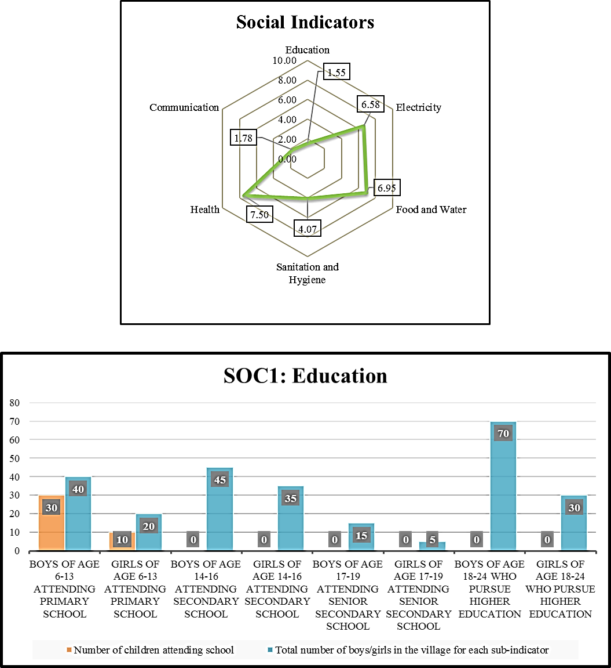

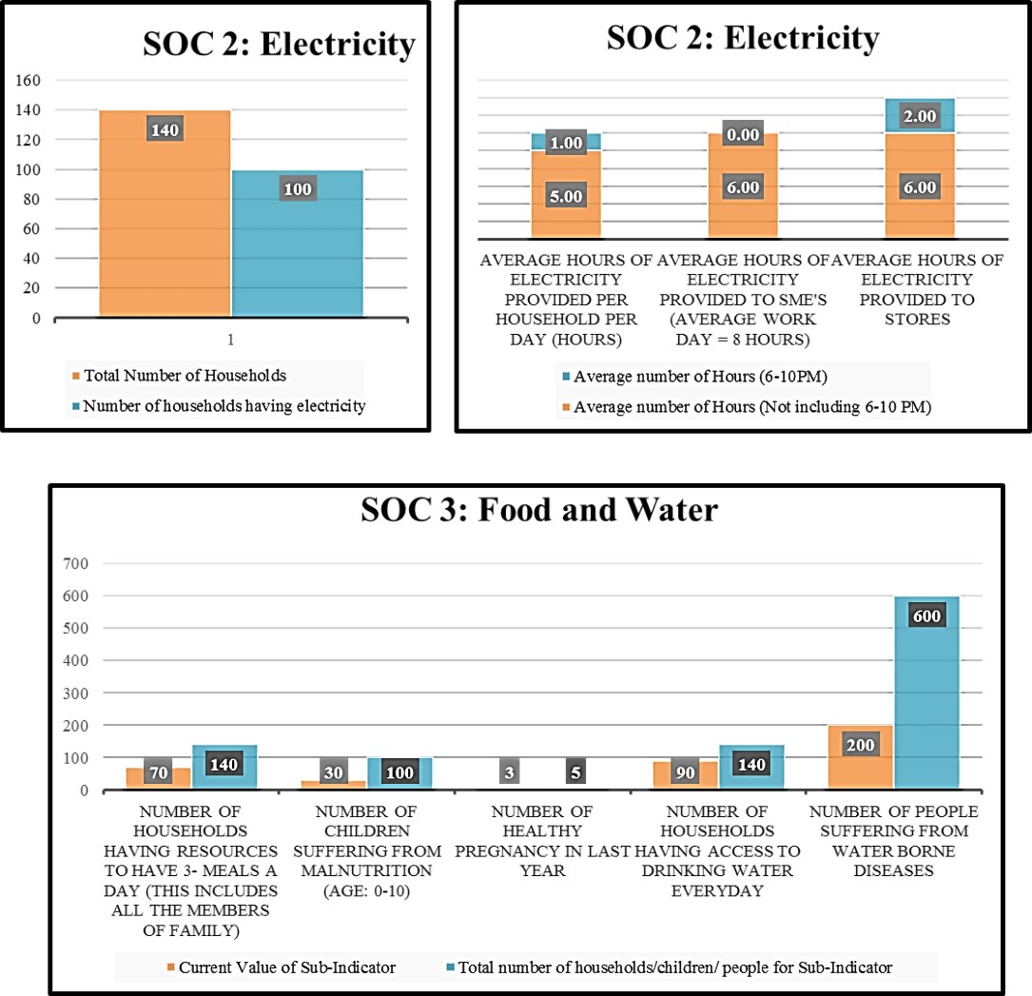
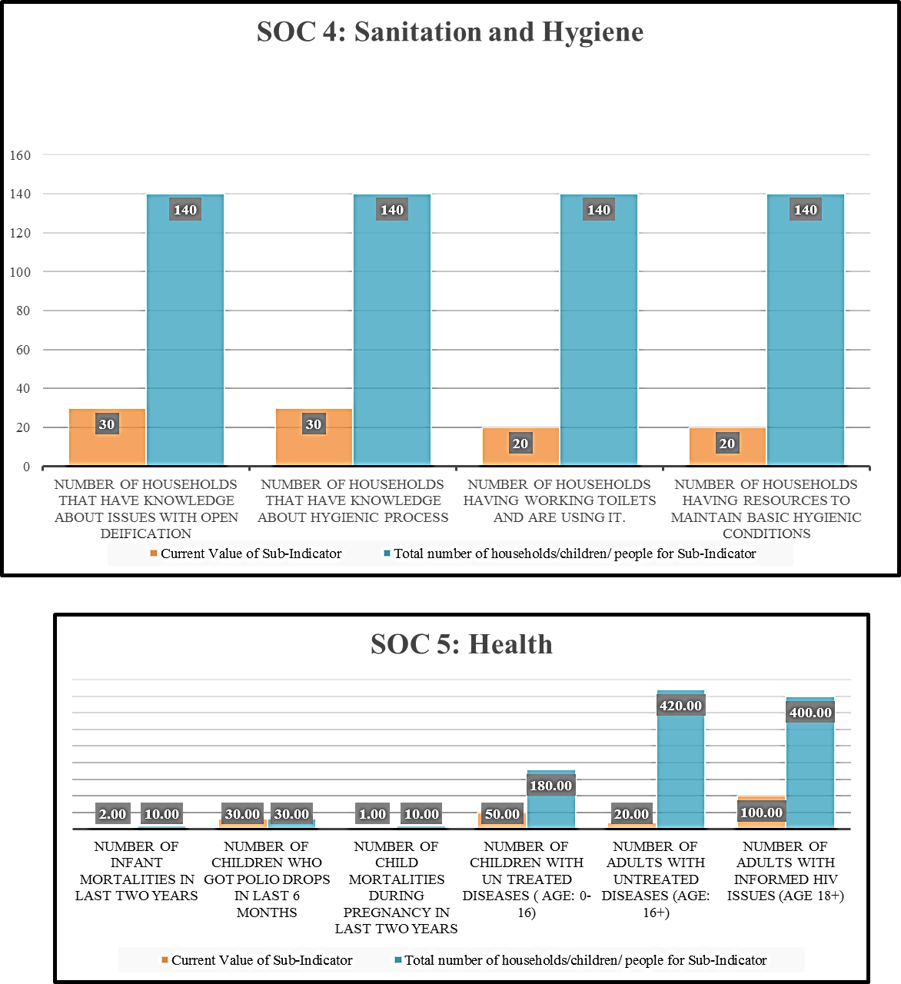

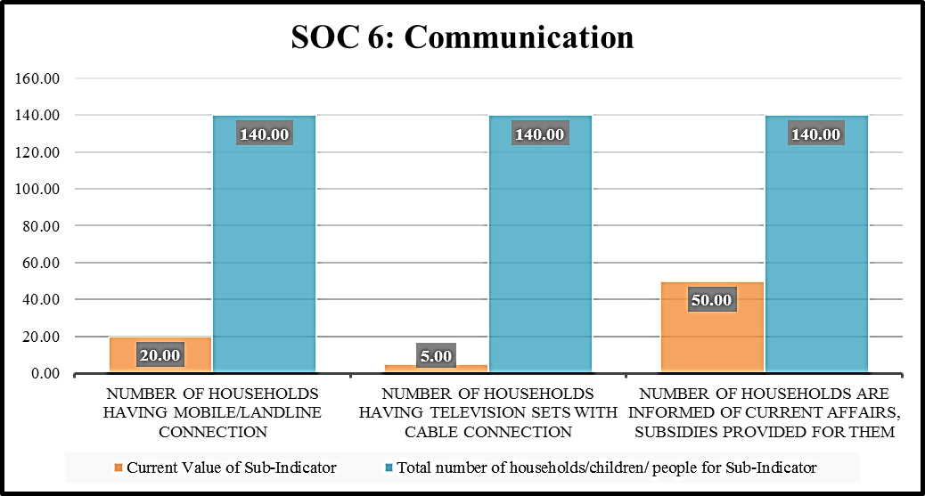
Figure 7.5: Graphical Presentation of Social Driver Value for Composite Village

The idea of including graphical presentation of all the indicators is useful in presenting the information to decision makers and is also helpful in directing the attention on a particular indicator/sub-indicator. That is, based on the information presented on spider diagram, user can select the indicator with lowest value and then look up at the graphically presentation of sub-indicators associated with that indicator. For example, in the spider diagram presented in Figure 7.5, the lowest value is seen for ‘SOC1: Education Indicator’. Once this is identified, then user or decision maker can look at graphical chart of the sub indicators of ‘SOC1: Education Indicator’. In this case, it is observed that all the sub-indicators have zero value except primary education, for primary education also the number of girls attending school is low. From this information, decision makers can choose to invest in girl education or education if desired. On other hand, if interested the decision makers can also invest in communication aspect of the village. The value obtained are based on input data and weights, therefore it is important that user and decision makers communicate their perspectives to each other. For this composite village the values of each of these indicators is presented in Figure 7.4 and Figure 7.5. The value for each indicator is also on a scale of 10. Education scores lowest value of 1.55/10 having only 40 kids (30 boys, 10 girls) going to school out of 260 children. The low value is also associated to the school or grade level available in the school. Whereas, the ‘SOC 5: Health indicator’ scores highest value of 7.5/10. The value of health indicator depends on the number of death in the village due to lack of health services available in the community, other aspect that is important for healthcare in a village is how many villagers have knowledge about various disease currently affecting majority of population in India. Communication indicator has second lowest value (1.78/10) in social driver for the composite village. The communication indicator is calculated based on the number households having a landline or cellular connection, television sets and number of households are informed about current affairs happening in the country. Composite village has a value of 4.39/10 for sanitation and hygiene. The other two indicators electricity, food and water have value close to each other, that is 6.58/10 and 6.95/10 respectively. Based on this information the area of focus can be selected to be education, communication and sanitation and hygiene.
Environment Driver
In Figure 7.6, the spider diagram for the indicators of environment indicator is presented. Similar to Figure 7.5 presented previously, Figure 7.6 is used to present values of various indicators of the environment driver. For the composite village considered in this thesis, the lowest value obtained for an environmental indicator is for animal husbandry indicator, 2/10. The ‘animal husbandry’ indicator value depends on a number of households that have cattle’s use of medicine to increase the production and number of cattle’s that die in a year due to diseases. The highest value is calculated for the environmental quality indicator, 8.60/10. Environment quality indicator is for this framework is only dependent on water and air, it can be extended to soil, land quality as well. Second, lowest value indicator is agriculture scoring 4.67/10, the sub-indicators associated for agriculture are anchored towards sustainable and conservative practices of agriculture, such as, the percentage of households prating drip/sprinkle irrigation, number of households that use pesticides and fertilizer harmful for the environment. Aquaculture and energy usage indicators obtain a score of 5.43/10 and 5.71 respectively. Environmental degradation indicator similar to energy usage is calculated to be 5.71/10. Lastly, natural/human disaster indicator is used to consider the effect of the disaster on the environment. The score of this indicator for the environmental indicator is 6.50/10.
In Figure 7.6 not all the indicators of environment driver are presented in graphical format. The challenge is to develop comparable charts for some indicators that cannot be presented in the graphical format without changing the sub-indicators and therefore are not included in final output tab.
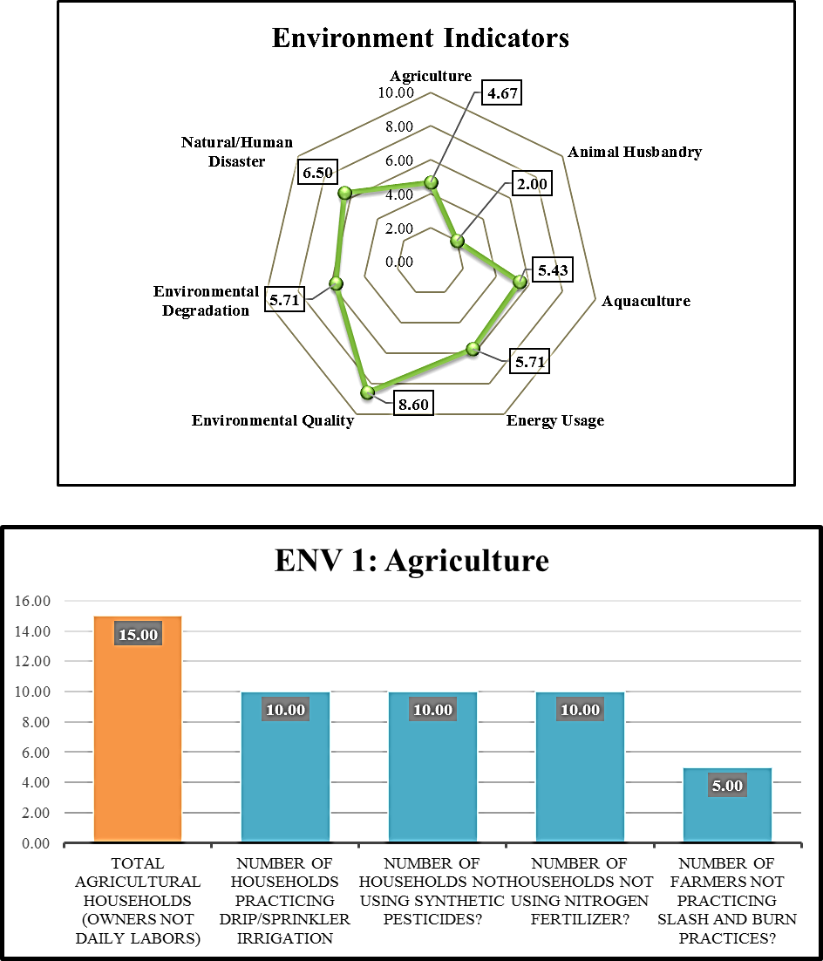

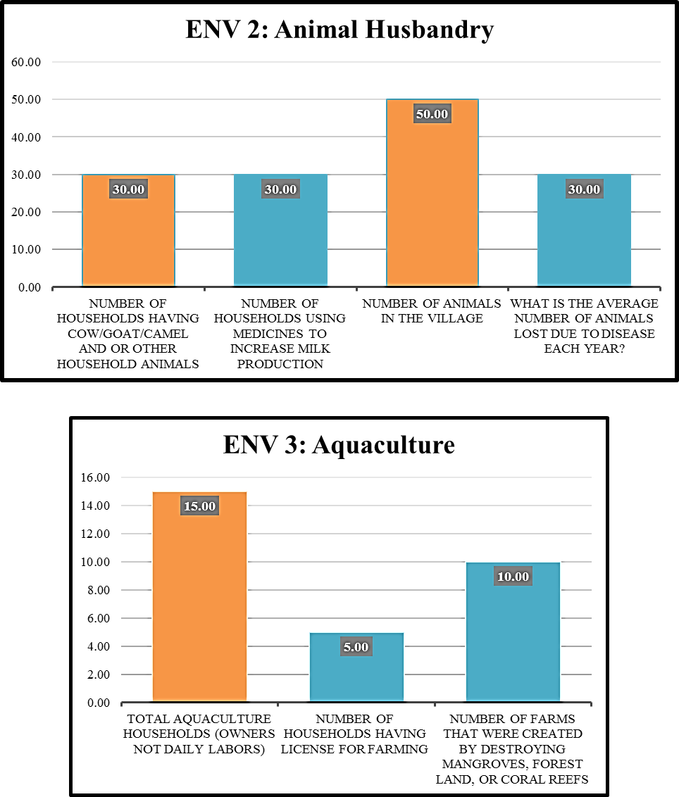
Figure 7.6: Graphical Presentation of Environment Driver Indicators for Composite Village

Economic Driver
Collection of data for the economic indicator is difficult as the economy in rural communities is not structured or planned and is dependent on different factors. The four indicators of the economic driver for this thesis work are income stability, income disparity, economic structure and employment structure. In Figure 7.7, collective information of the economic driver is presented.
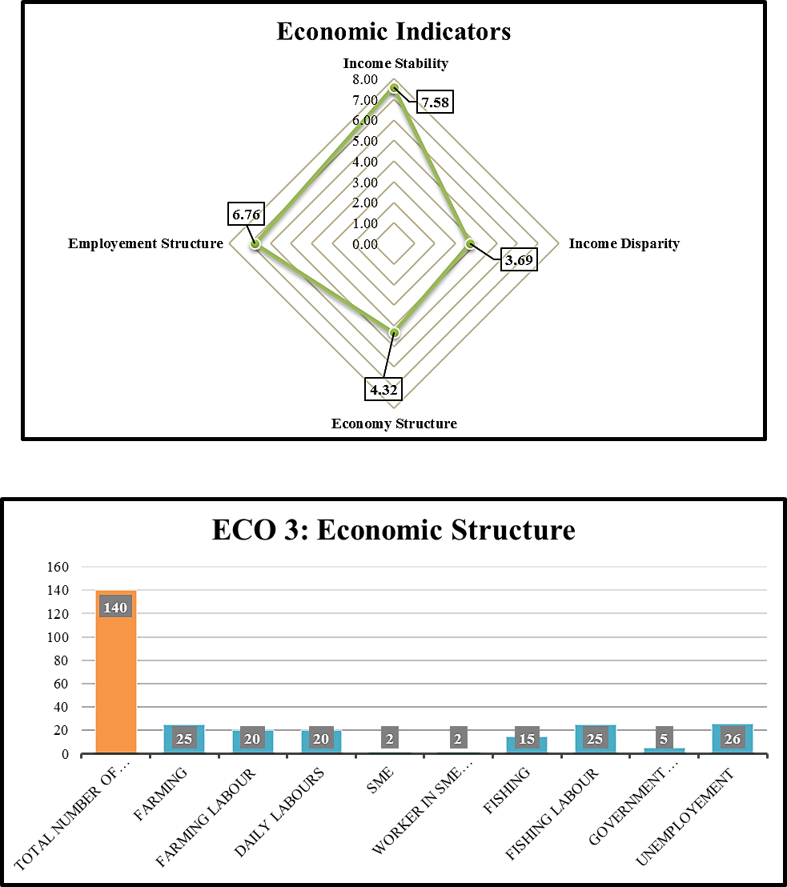

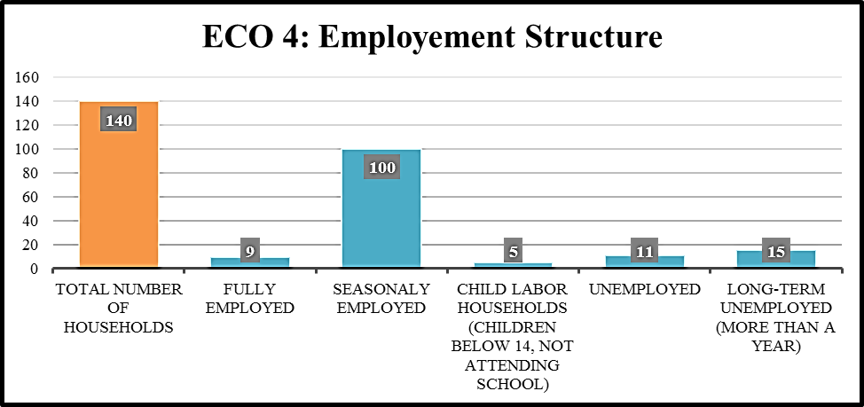
Figure 7.7: Graphical Presentation of Economic Driver Indicator Value for Composite village
The value for each indicator of the economic driver is, the lowest value is assigned to income disparity indicator, 3.69/10. The lower value for income disparity translates to higher inequality in the village. To calculate income disparity for a composite village, two sets of sub-indicators are developed. One set of sub-indicators is used when the income for people is known, another set of sub-indicators calculates the number of home appliances, and entertainment appliances to segregate people in different income ranges. The highest value is for income stability indicator, 7.58/10. The value for this indicator can also be calculated using two different set of indicators, one based on the income, second based on the number of months each household earn in a year. Second highest value is for employment structure indicator, 6.76/10, calculated by identifying households that have seasonally employed people, unemployed and fully employed. The last indicator is the economic structure with a value of 4.32/10, calculate by collecting data on types of economic activities (farming, fishing, labor, the government employed) in the village. In Figure 7.7 the value of the two indicators for the economic driver presented in the graphical chart is economic structure and employment.
The overall sustainability index and value of each driver is used as an input for next construct to identify the broader focus area of inequity. The area identified is further evaluated in detail using Dilemma Triangle construct as presented in Figure 7.8.
Figure 7.8: Information Flow in the Framework

IMPLEMENTATION OF THE DILEMMA TRIANGLE CONSTRUCT
After the data is collected from the village and baseline value for the data is calculated. From the baseline value collected, broader areas of inequity are identified. Next step in the framework is to develop a value proposition to remove the inequity in the village. Construct proposed in this framework to develop value propositions is Dilemma Triangle. The method to use Dilemma Triangle is presented in Chapter 4. In this section, use of Dilemma Triangle construct is presented for the composite village taken into consideration as an example (Chapter 6). The method implement is from the perspective of a social entrepreneur who is working towards the development of a sustainable value proposition. In this section, the steps presented in Chapter 4 are implemented for the composite village. In Section 7.2.1, the implementation steps are presented, tensions, dilemmas are identified, and value propositions to convert these dilemmas positive-sum solution is proposed. In Section 7.2.2, the overview of this section is provided along the output that is evaluated is next section.

Implementation of Dilemma Triangle Construct– Identifying dilemmas
Step 1a: List the perspectives from which user plans to evaluate the problem.
There are different perspectives that can be selected for any given village. Different stakeholders can be considered as different perspectives and their ideas and understanding change how a social entrepreneur should proceed. Perspectives can also be selected based on a scenario. For this thesis, one of the main perspectives is used to show the implementation of the method. The enterprise to be developed must be based on the value that entrepreneur can provide. Therefore, one of the perspectives to look at is the social entrepreneur. The value proposition that must be developed to improve quality of life for these villagers must be decided, by understanding different social, economic and environmental issues. In the example village that is selected and is used in this chapter, one of the scenarios of improvement based on the data processed in baseline assessment is seen to be in education of the community. Current perspective is based on both the stakeholder (social entrepreneur) and scenario (low education).
Step 1b: For the perspective selected, define the drivers in terms of focus and issues. Also represented in Figure 7.9.
The focus for a driver must be a sentence that drives a solution or a goal that user wants to achieve in each driver. In the current perspective, the goal is to increase education in the village and therefore, the focus for each driver (social, environment and economy) will be anchored in looking at school education from these drivers.
As mentioned previously, the method is built of reusability, adaptability and is modifiable. Example of this is, readers could also change their perspective within education to “increasing girl education in the village.” In this thesis for implementation purpose, the focus is on overall education. The focus, issues for each driver, are presented in Figure 7.9.
Driver: Social
Focus: To maximize enrollment in school.
Issues
- Unavailability of secondary school – In the village under consideration, the schooling available is only primary. Most of the children in the village are over 12 years of age. Therefore, to maximize enrollment, need is to add a secondary school.
- Need of children in fields – As most of the families are daily wagers, they tend to bring their kids to fields instead of sending them to schools.
- Believe that education is not important (especially for girls) – Being uneducated, most of the parents and villagers don’t see the need for education. For a girl child, this belief system is even stronger.
- Unavailability of proper facilities for girls – Some of the families that do send girls to school do not continuously invest in schooling because of lack of proper sanitation facilities in the school
- Lack of incentive for education – Given that villagers don’t understand the need for education, incentives (such as mid-day meals) are not available in this village.

Driver: Environmental
Focus: To have an eco-friendly approach to school infrastructure development.
Issues
- High initial cost of green technology – the Initial cost of implementing solar energy, water harvesting, and other green technologies is costly.
- High cost of maintenance due to unavailable of technicians in the off-grid village.
- High waiting time for maintenance, due to unavailability of technicians.

Driver: Economic
Focus: To keep education viable for villages and social entrepreneurs.
Issues
- High temporarily employed families – Most of the families are temporarily employed, this hinders them to send children to school, thereby decreasing chances of viable education.
- Low child population in the village – To keep education viable one of the ways is to have more kids enroll in school. In this village the child population is low, therefore creating an issue towards the viability of the education system.
- High build and maintenance cost for school infrastructure – Building and maintaining school infrastructure is economically costly. With the high cost of building infrastructure, the cost per student also increases.
- Lack of teachers in the village and in nearby villages – To have students enrolled in the school, it is important to have teachers/ lecturers available. Since the village is away from the city, there is lack of teachers in the village and also in the nearby village.
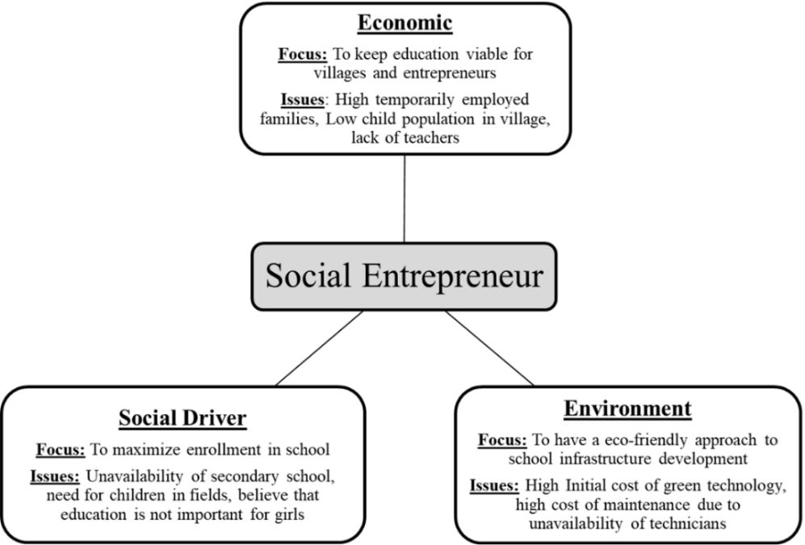
Figure 7.9: Dilemma Triangle from Social Entrepreneurs Perspective

Step 1c – For each perspective, we identify tensions by comparing issues.
Tensions are the conflicts that might arise between two issues. Tensions will create an obstruction in achieving the focus for the perspective. In Figure 7.10, all the tensions associated to current perspective (social entrepreneur) is presented.
Tension 1 - Between ‘high temporarily employed families’ (Economic Driver: Issue 1) and ‘unavailability of secondary school’ (Social Driver: Issue 1): The tension, in this case, is anchored in reinforcement. That is since there are no secondary school’s families believe that there is no need for primary education as well. On another hand, since most of the families in the village rely on temporary employment, they believe they won’t be able to support the education for children throughout the year and therefore do not progress further. This reinforces lack of demand for secondary school.
Tension 2 - Between ‘low child population’ (Economic Driver: Issue 3) and ‘unavailability of secondary school’ (Social Driver: Issue 1): Similar to tension 1, in this tension, the number of children is low for the village to set up a secondary school. This reinforces villagers not to send their children to schools. The tension here is to set up a secondary school that will not be viable for entrepreneur and villagers as there is a lack in the number of people.
Tension 3 - Between ‘need for children to work in fields’ (Social Driver: Issue 2) and ‘high build and maintenance cost for school infrastructure’ (Economic Driver: Issue 4): As families want their children to work in fields this would mean that enrollment for children in the school will be low. Given that there is a high cost associated to building and maintaining infrastructure for school, this would lead to comparatively high cost per student to keep the school viable to continue to run. This becomes a negative aspect for the families who are in the decision phase. As they will prefer generating income rather than sending kids to school has a comparatively high cost per student.
Tension 4 - Between ‘believe that education is not important for girls’ (Social Driver and Issue 3) and ‘high temporarily employed families’ (Economic Driver Issue 1): The tension here is again reinforcing, as villagers don’t consider girl education to be important and also there is temporary employment in majority of households, the decisions are negative. This decrease both the viability of education and also acts in hindrance to the social focus of maximizing the total enrollment for school.
Tension 5: Between ‘lack of proper sanitation facilities’ (Social Driver Issue 4) and ‘lack of teachers in and nearby villages’ (Economic Driver: Issue 5) This tension arises in a reinforcing manner, as there are no sanitation facilities, the teachers that may come will also not come to the village. This decrease both the viability of education and hinders in social focus.
Step 1d – For each perspective, we identify dilemmas.
To identify the dilemmas, the first step is to prioritize all the tensions and evaluate each of them to find if tension can be resolved by adopting a policy or buying / installing product.
Tension 1: This tension is a three-part problem, lack of permanent employment, in this case, acts as a catalyst in not sending kids to school. The issue of unavailability of secondary school comes into play only after kids have attended primary school (approximately after 5 years). The bigger problem is affordability of the schooling and lack of permanent employment. If a family does not have employment, then education is a secondary concern for the family. This tension is a potential dilemma (Dilemma 1), as lack of permanent employment and school enrollment cannot be solved by employing technology or available policy.
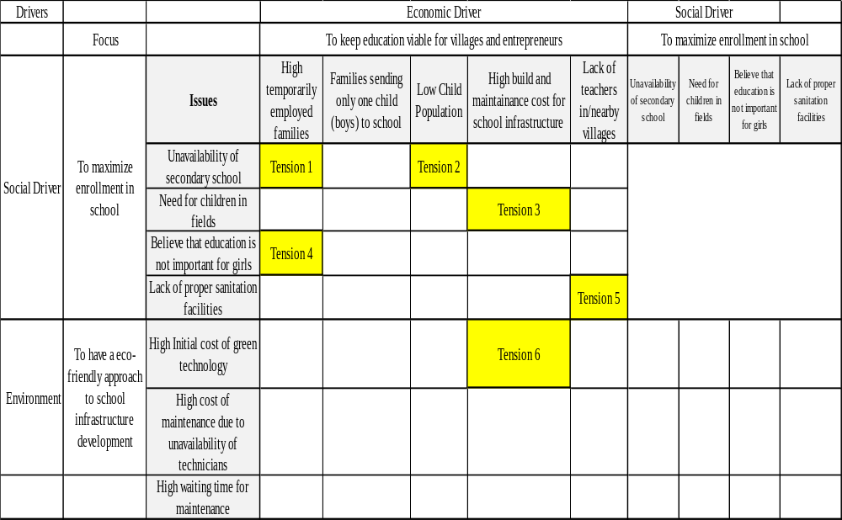
Figure 7.10: Tension Matrix for Social Entrepreneur Perspective

Tension 2: Tension 2 is a reinforcing tension, as there is less population of kids in the village, developing a secondary school in the current village is not viable. This tension can only be solved by developing a secondary school viable. There are various options that can be adapted to make the secondary school viable. This option can be evaluated using Village Level System Dynamic model.
Tension 3: The tension between ‘children working in fields’ and ‘high build and maintenance cost for school infrastructure’ is difficult to solve. This tension is tied to Tension 1, need of children to work in fields arises due to temporary employment of the families in the village. As the employment is temporary, need is to maximize the output of temporary employment. On the other hand, even if families agree to send their kids to secondary school, the cost of schooling is high. The choice of losing viability of school or losing the children coming from temporarily employed families to secondary school cannot be solved by employing technology and therefore becomes a dilemma (Dilemma 2).
Tension 4: The tension of believing ‘that girl’s education is not important’ and ‘huge number of temporarily employed families is connected’ to Dilemma 1 (associated with Tension 1). In Dilemma 1 focus is on employment of the families. This does not solve the issue of girl education. To improve girl’s education, social discussions can be conducted; this does not ensure the rate at which people’s perspective will change. In this thesis, this tension is considered as dilemma (Dilemma 3) for further evaluation to solve the issues of girl’s education.
Tension 5: The effect of lack of proper sanitation facility in school is directly related to girl enrollment, this issue also affects a number of teachers in the school. In the current scenario, where there is already lack of teachers, the issue of lack of sanitation will add to the lack of teachers that apply to school. This tension can be solved by constructing a sanitation facility in the school and maintaining the facility. Therefore, this tension does not lead to a dilemma.
Step 2a –For each dilemma develop the hypothesis.
The dilemma would be between any two drivers of sustainability and would embody a zero-sum solution. The hypothesis must be developed that can be developed to transform the zero-sum solution into a positive-sum solution.
In this section, the hypothesis for each dilemma is presented. A single dilemma can have multiple hypotheses that convert zero-sum to positive-sum solution.
Hypothesis 1 for Dilemma 1: To provide skills for employment for all the families that have temporary employment. To provide job opportunities to the families that send their kids to school.
Dilemma 1: The dilemma is between the social and economic drivers. Here dilemma is in the choice of how to increase the enrollment of kids in school and improve employment opportunities for the families so they continue to send their kids to school.
Hypothesis 1 for Dilemma 2: To decrease the cost of schooling by bringing children from nearby school and charging less per family and charging a fixed amount every month that is enough for maintaining the school infrastructure.
Dilemma 2: The dilemma is between social and economic driver. Here the cost of schooling per family is high as the number of children are less. Families cannot pay for the schooling as employment opportunities are low.
Hypothesis 1 for Dilemma 3: To provide incentives for girl education to the families and set up social discussions that are anchored in changing the perspective of girl’s education.
Step 2b – Evaluate each hypothesis considering concepts of sustainability.
- Each hypothesis that is developed to have a positive sum solution MUST satisfy the test that the outcomes are Bearable, Viable and Equitable for it to be a sustainable solution.
Hypothesis for Dilemma 1: To provide skills for employment for all the families that have temporary employment. To provide job opportunities to the families that send their kids to school.
Evaluation: The dilemma is between social and economic drivers, and therefore the hypothesis must be equitable. Based on this hypothesis training must be provided to family members to improve their skill sets. This will help family members get stable income. The training will be accessible to the families that are willing to send their kids to school. Thereby making the hypothesis equitable for villagers and social entrepreneur in terms of increasing the enrollment for kids. From economic driver, improvement in the skill set will increase the chances of employment for the family members and eventually improve the quality of living.
Hypothesis for Dilemma 2: To decrease the cost of schooling by bringing children from nearby school and charging less per family and charging a fixed amount every month that is enough for maintaining the school infrastructure.
Evaluation: Based on this hypothesis, the school should be made accessible to children for nearby villages, thereby decreasing the cost of education per student. The next step is to charge minimal fixed amount of fees for boys and free enrollment for girls. The hypothesis is equitable as each household will be charged same fixed amount of fees.
Hypothesis for Dilemma 3: To provide incentives for girl education to the families to increase the enrollment.
Evaluation: In hypothesis for Dilemma 2, the incentive provided is free education for girls. In hypothesis for Dilemma 1, the incentive for family members to learn a new skill set. From the social aspect, the incentives provided will increase the quality of life and girl education in the society. From the economic aspect, this is not a feasible hypothesis as providing incentives while there is the high cost of maintenance will not be sustainable. This hypothesis will be equitable if an investor is ready to fund the school for initial years.

Discussion for Dilemma Triangle
The hypothesis developed for converting zero-sum solution to positive solution are not the only aspects to be considered for improving the quality of life for the community. Sometimes dilemmas cannot be solved because critical issues with the solution known are not implemented or are not effective. Therefore, it is necessary to look at all the tensions and dilemmas to prioritize the tasks for achieving the goal. Once the hypothesis is developed (for dilemmas) and intervention is identified (based on hypothesis or tensions), the next step is to evaluate the impact of this intervention and/or hypothesis on the community. The output obtained at the end of Dilemma Triangle construct is then used as input in the Village Level System Dynamic model to evaluate the effect of hypothesis and intervention on the village as presented in Figure 7.11
Figure 7.11: Information Flow in the Framework

IMPLEMENTATION OF VILLAGE LEVEL SYSTEM DYNAMIC MODEL
In this section, the last construct of the framework (Village Level System Dynamic model) is presented. In Section 7.1, baseline value using VLBSI is calculated and the area of focus to improve the quality of life in the village is identified. In Section 7.2, the issues affecting the area of focus anchored in sustainable drivers are identified using Dilemma Triangle construct. From the Dilemma Triangle construct, the output achieved is a set of hypotheses and interventions that can be possible value propositions for improvement of the quality of life. Once the value propositions are identified, developed, next step is to evaluate them on the community. To evaluate the value proposition, VLSD is used. In this section, the hypothesis developed using Dilemma Triangle are evaluated. The model is modified and adapted for the composite village under consideration and hypothesis presented in previous section (Section 7.2).

Evaluation of Hypothesis and Value proposition from Dilemma Triangle
The Village Level System Dynamic model in this thesis is developed as a part of the framework to evaluate the impact of a value proposition developed by social entrepreneurs. The VLSD model can be used directly without following the parts of the framework (Presented in Chapter 5).
In this section, the information obtained from Dilemma Triangle construct (Section 7.2) is used as input to the VLSD model. The information obtained is a hypothesis to convert a dilemma (zero-sum solution) to a positive-sum solution. The hypothesis developed are;
Hypothesis for Dilemma 1 (associated with Tension 1): To provide skills for employment for all the families that have temporary employment. To provide job opportunities to the families that send their kids to school.
Dilemma 1: The dilemma is between the social and economic drivers. Here dilemma is in the choice of how to increase the enrollment of kids in school and improve employment opportunities for the families, so they continue to send their kids to school.
Hypothesis for Dilemma 2 (associated with Tension 3): To decrease the cost of schooling by bringing children from nearby school and charging less per family and charging a fixed amount every month that is enough for maintaining the school infrastructure.
Dilemma 2: The dilemma is between social and economic driver. Here the cost of schooling per family is high as a number of children are less. Families cannot pay for the schooling as employment opportunities are low.
Hypothesis for Dilemma 3 (associated with Tension 4): To provide incentives for girl education to the families to improve girl education.
Dilemma 3: The dilemma is between girl’s education and a huge number of temporarily employed families.

In the current scenario, the hypothesis proposed by using Dilemma Triangle are generic. However, the hypothesis can also be specific leading directly to a single value proposition. In the case when the hypothesis is general, each hypothesis can have different value propositions. In the current example, following are the value propositions proposed based on each hypothesis;
Hypothesis for Dilemma 1 (associated with Tension 1): To provide skills for employment for all the families that have temporary employment. To provide job opportunities to the families that send their kids to school.
Based on this hypothesis, social entrepreneurs will teach skills to adults of families that come under the category of temporary employed and/or unemployed. The skills to be thought must be easy to learn and should have job opportunities to work. In return for teaching skills to adults, family members must send their kids (boys and girls) to primary school in the village. This hypothesis can be used to create different sets of value propositions, for example;
- Value Proposition 1: Provide welding, painting, carpentry, etc. skills to males of the family, so that they can go work in the city while unemployed from the temporary job.
- Value Proposition 2: Provide skills to women of the household in knitting, grinding, packaging, clay pot making, leaf pressing. The work can be done within the village, and one person can create a supply chain to nearest city/town.
For both the cases, the tradeoff is to send kids to school and in return attend the skill school. Since maintaining both skill school and primary education will not be feasible without funding from an investor, philanthropist.
Hypothesis for Dilemma 2 (associated with Tension 3): To decrease the cost of schooling by bringing children from nearby school and charging less per family and charging a fixed amount every month that is enough for maintaining the school infrastructure.
The hypothesis proposed for this dilemma is an example of a hypothesis that is specific and converts directly to a value proposition. For this hypothesis, the value proposition is same as the hypothesis.
- Value proposition 3: To decrease the cost of schooling by bringing children from nearby school and charging less per family and charging a fixed amount every month that is enough for maintaining the school infrastructure.
Hypothesis for Dilemma 3 (associated with Tension 4): To provide incentives for girl education to the families to improve girl education.
For this hypothesis, again there can be many value propositions. To provide incentives in a given community, the requirement is to talk to villagers and provide an equitable incentive to trade off for sending girls to school. In the current scenario, the data is not available for providing the incentive. Also, Value Proposition 1 and 2 can be considered an incentive for time to show the utility of the framework and VLSD model.
Once, the value propositions are identified, next step is to evaluate these value proposition using VLSD. Prior to the evaluation of value propositions, first, the population model of the village must be simulated (presented in Figure 5.8) and verify if the model projects correct value for the population. In Table 7.7 the initial values of population entered in VLSD model are presented. The model is run from time T=0 (current time, with population 600) to time T=10 years. The value obtained by running the population model is presented in Figure 7.12. The population rise is as expected, for a low population the growth is low, and this is represented in VLSD model for the composite village.
Table 7.7: Values Related to Population Added in VLSD Model
Age category | Population
Kids (0-5) | 60
Kids (6-12) | 60
Teens | 100
Adults | 320
Seniors | 60
Total | 600

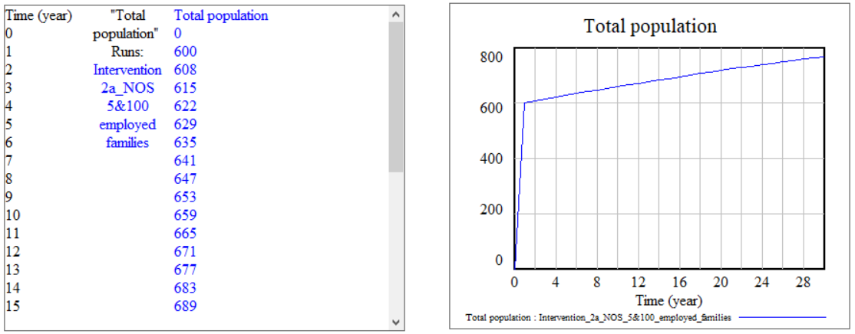
Figure 7.12: Population Growth VLSD Model

Given that the model is verified for the population part, next step is to run value propositions on the remaining model and evaluate the outcome of the selected value proposition. In this thesis, the value propositions under consideration are;
- Value Proposition 1: Provide welding, painting, carpentry, etc. skills to males of the family, so that they can go work in the city while unemployed from the temporary job.
- Value Proposition 2: Provide skills to women of the household in knitting, grinding, packaging, clay pot making, leaf pressing. The work can be done within the village, and one person can create a supply chain to nearest city/town.

Value Proposition 1: First value proposition will not be sustainable for various reasons. Some of the reasons are;
- Cost of primary infrastructure needed for skill training is high.
- To get employed based on the known skills, all the skilled members must travel to city/town. The current village is not connected to city or town with the proper transportation system and therefore will not be accessible by everyone.
- Most of the skills provided need personal equipment to work in the field. The personal kit is usually costly to acquire.
Value Proposition 2: Given that social entrepreneur can find right skill set for the females of the village, females can work from within the village and produce the products that can be sold by a social entrepreneur or one person from within the village. The Indian government has incentives to push female entrepreneurship and skill development in rural communities. These incentives will provide social entrepreneur funding for skill development. The tradeoff is to send kids to primary school. Based on the input from villagers the model is developed for Value Proposition 2.
The current population of the village is approximately divided at 33% female and 67% females. The total number of adult females is 130. A sub-model to represent skill development training was developed in VLSD model. The female skill development model is presented in Figure 7.13.
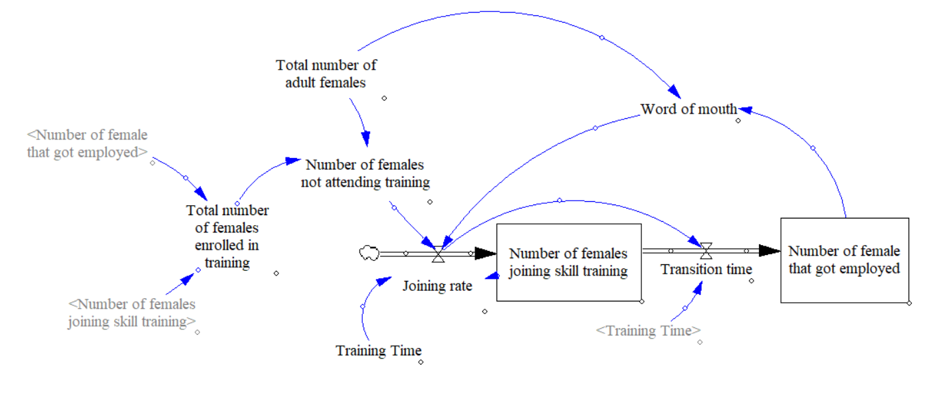
Figure 7.13: Female Skill Development Model

In the Figure 7.13, two stocks are used to calculate the value of ‘Number of females joining skill training’ at any given time and ‘number of females that got employed’ after receiving training. Assuming that almost all the females who go through training get employed, the ‘Joining rate’ for training is dependent on ‘Training Time’ and ‘Word of mouth.’ If ‘Training Time’ is high, fewer women would be willing to join. In general, initially, the number of women joining will be low as there will be uncertainty regarding employment. As more and more females get employed, more untrained women will believe in skill development (captured in ‘word of mouth’ variable), and more women will join the training program. In Figure 7.14, the effect of two different ‘Training Time’ is presented on ‘Number of females joining skill training.’ This value can be calculated by collecting a survey from the women on best training time.
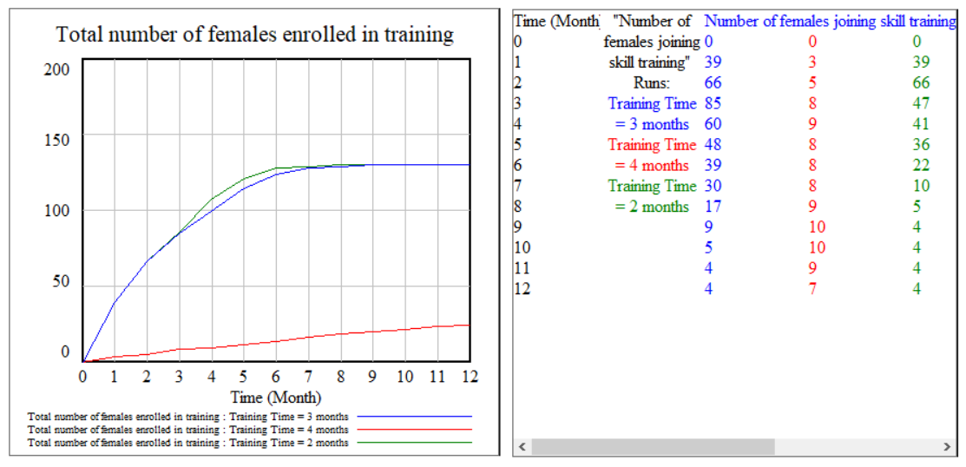
Figure 7.14: Number of Females Joining Training Based on Training Time

Since the value proposition developed is to increase the enrollment rate for kids as a tradeoff for providing training skills. VLSD education loop was modified to include the impact of skill training and employment on enrollment rate and dropout rate respectively. The output obtained is presented in Figure 7.15. On the left side of Figure 7.15 a graph is used to present the ‘enrollment rate for girls’, as the number of women joining skill training continues to increase (presented in Figure 7.14), the enrollment of girl and boys (not shown in the figure) continues to increase reaching the maximum value of 0.9. At time T=7 (for ‘Training Time’ = 2 months) and time T=8 (for ‘Training Time’ = 3 months), the highest enrollment rate is achieved; at the same time ‘Total number of females enrolled for skill training’ (Figure 7.14) reaches a maximum value of 130. This increase in enrollment rate is due to the deal that is part of the value proposition. On right-hand side of Figure 7.15, ‘Number of girls dropped out’ is presented. The value for a number of girls dropping out continues to increase as well till time T=8 and Time = 9. This is due to the fact that, as soon as women get employed after attaining training, the families force back kids to drop out from school and help in the new employment.
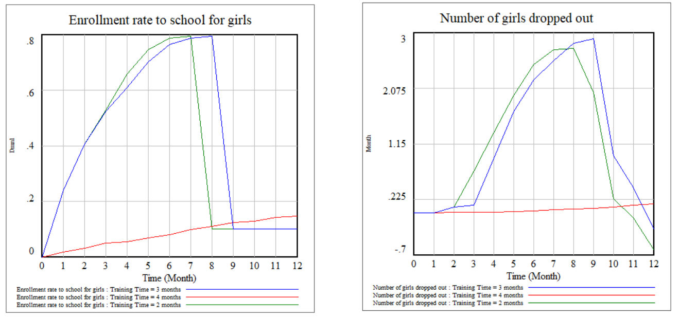
Figure 7.15: Impact of the Tradeoff Between Skill Training and Enrollment Increase

Based on the evaluation of value proposition using VLSD and applying systems thinking, it is identified that there are loopholes in the proposed value proposition. Now user can go back to blackboard and modify the value proposition and re-evaluate using the framework proposed in this thesis. The output obtained from the framework and parts of the framework that is baseline index, Dilemma Triangle and VLSD are user perspective oriented. Therefore, it is important to capture the behavior of all the stakeholders involved, especially from the members of the community on which the value proposition is going to implement.

Hypothesis Verification: Computational Framework
The overall computational framework of Value Proposition development and Impact Evaluation Model (VPIEM) is proposed in this thesis to look at sustainable rural development from a systems perspective. The framework is divided into three constructs and is discussed in detail separately in Chapter 3, 4 and 5, and together as a framework in this chapter. The proposed framework is associated with Thesis Question 1 (primary question) in this thesis. The Thesis Question 1 and hypothesis related to the framework is restated below.
Q1: “What form of support system a social entrepreneur needs in defining the value propositions for development of the rural area that is sustainable with respect to the planet, profit and people involved?”
Hypothesis for Q1: By developing a decision support framework that embodies different constructs of systems thinking that are useful to support the decision made by social entrepreneur using systems perspective.
Verification of the hypothesis is presented in next section (Section 7.4) using empirical performance validity.

EMPIRICAL PERFORMANCE VALIDITY
Empirical performance validity falls under the third quadrant of validation square. Empirical performance validity is to show the usefulness of the method for solving the example problem. Empirical performance is validated by accepting that the outcome of the method is useful with respect to the initial purpose for chosen example and the achieved usefulness is linked to the use of applying method (in this case, use of applying framework). In this thesis, it is discussed in Chapter 7 as presented in Figure 7.16. The framework proposed for the social entrepreneur and CSR investors constitutes of three constructs. The working of these three indicators separately is presented in Chapters 3, 4 and 5. The outcome from each construct is verified with the desired outcome and justified in the respective chapters. In this chapter, the usefulness of overall framework (by combining the three indicators) and taking the output from one construct to next one is presented. The usefulness of the framework as proposed in the hypothesis is by being a decision support tool to social entrepreneurs and CSR investors from a systems perspective to come up with possible value propositions for rural development. In Chapter 3, 4 and 5, the discussion on how user drivers the construct is presented. In Chapter 7, the same case is presented for overall framework, therefore becoming a decision support tool. The outcome of each construct follows a systematic path, and user of the framework knows how each value is obtained, that is framework as presented is not a black box where users feed in the data and outcome is received, thereby providing confidence in the framework as a decision support tool. Usefulness of the output obtained from each construct is discussed in respective sections.
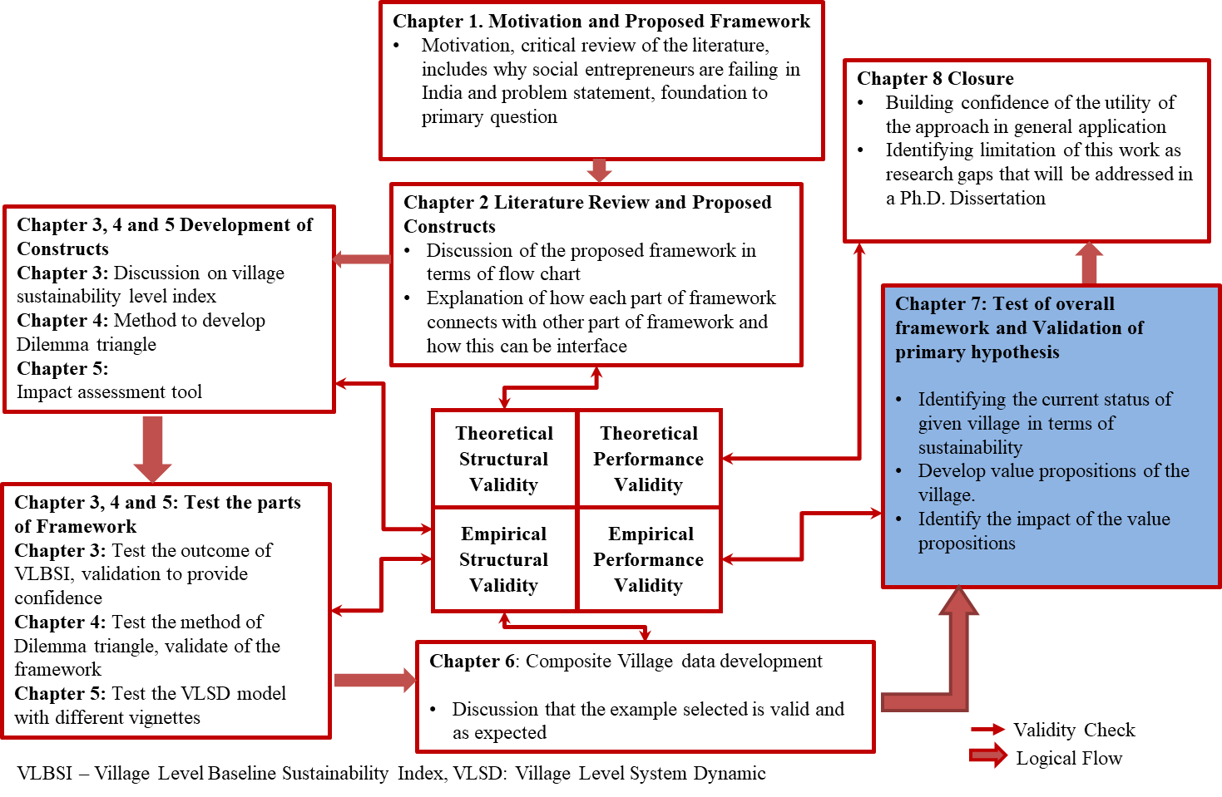
Figure 7.16: Validation Strategy for the Thesis

SYNOPSIS OF CHAPTER 7
The framework proposed in Chapter 1 of this thesis is implemented on a composite village in Chapter 7. The working of the framework proposed is presented in Chapter 7. The framework can be seen as a method that social entrepreneurs and CSR investor can use to follow a systems perspective to develop and evaluate value propositions for socio-economic improvement of rural areas in India. The constructs are introduced and implemented using example village separately. In this chapter, the intent to present the overall working of the framework. In Section 7.1, the data from the composite village is collected and used to find the baseline sustainability index value of the village. The social driver value for the composite village is calculated to be 4.98 on a scale of 10, the value of the economic driver is calculated as 6.09 on a scale of 10, and environment driver is calculated to be 5.52 on a scale of 10. Based on these values, the focus is selected to be on a social driver having lowest value. For the social driver, the lowest value calculated is for education and communication indicators. The information of all three drivers and their indicators is used in Section 7.2 for Dilemma Triangle construct. In Section 7.2, the Dilemma Triangle construct’s method is used to identify focus, issues, tensions, and dilemmas between different drivers with a focus on education aspect of the village. The proposed method of Dilemma Triangle construct used to identify dilemmas and propose various hypothesis to overcome these dilemmas is discussed in Section 7.2. In Section 7.3, the value proposition is derived from hypothesis and evaluated using Village Level System Dynamic model. The outcome for different value propositions is presented in Section 7.3. In Section 7.4, the empirical performance validity of the framework is discussed.
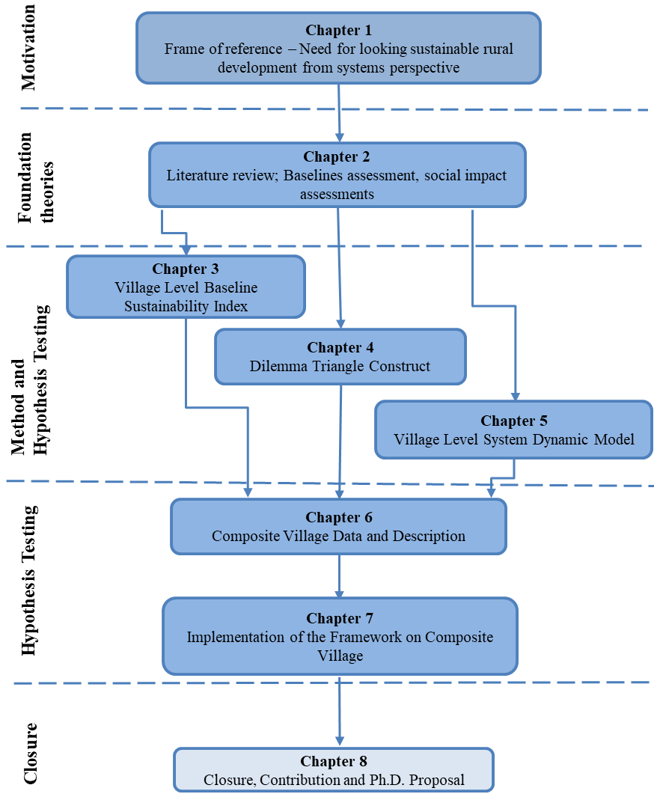
Figure 7.17: Organization of the Thesis – Presented and Next Chapter
In Chapter 8, a summary of the thesis is presented, the questions of the thesis are answered, extracting relevant contributions from work presented in this thesis. Tentative Ph.D. proposal based on the work done in this thesis is discussed, as presented in Figure 7.17.

CHAPTER 8
CLOSURE: CONTRIBUTIONS AND Ph.D. PROPOSAL

The work in this thesis is focused on the development of a framework that can be used by social entrepreneurs, CSR investors and philanthropist to develop and evaluate value propositions that can catalyze development (sustainable) in rural communities in India. This framework is anchored in systems thinking and developed as a decision support tool. Furthermore, the primary motivation in this thesis is to frame the problem, identify research gaps in this thesis and define research questions that will be further addressed in a Ph.D. research.
In this chapter, a summary of this thesis is presented in Section 8.1, the questions and hypothesis posed in Chapters 1 and 2 are revised and critically evaluated with emphasis on the validity of the research hypothesis in Section 8.2. Further, based on the summary and critical review, the achievements and research contributions reported in this thesis are presented in Section 8.3. Furthermore, the motivation for future research, research gaps and research questions that will be addressed in Ph.D. research, and dissertation outline is proposed in Section 8.4, where the contribution will be new knowledge.

A SUMMARY OF THE THESIS
The biggest challenges for developing value proposition and interventions for rural development are the diverse culture and limited resource availability in each rural community (Ellis, 2000). Each of these communities can be considered as a complex system with varying characteristics and system variables. Though the goal for each system might be same (to improve the quality of life), the solution to achieve this goal is not; The solution for rural development, from scholarly perspective is not to provide a specific single point solution that fits all, but to provide a step by step process that social entrepreneurs/ CSR investors other users on ground can follow to develop proposition tailor-made for each rural community. Therefore, the framework developed in this thesis must be considered as a decision support tool for social entrepreneurs and investors, that is, this framework must not be considered as a decision making a black box, where data goes in, and output comes out. The output and result for each user of this framework will be different. The framework can be used to direct the attention of decision maker to issues and challenges that are usually ignored/missed while solving a complex problem.
Three constructs are developed as a part of the framework and are presented in Chapters 3, 4, 5 and 7. The constructs as proposed in the framework contribute to a bottom-up approach in the development of the value proposition. The first construct in the framework is Village Level Baseline Sustainability Index, presented in Chapters 3 and 7, is used to assess the communities’ current sustainability value (baselines assessment) on three drivers of sustainable development (social, environmental and economic) on a scale of 0 to 10. The values calculated are based on weights assigned by the user to each indicator. After the focus area (indicator with the lowest value) is identified, detailed evaluation of issues and challenges is performed using Dilemma Triangle Construct (Construct 2 of the framework), presented in Chapters 4 and 7. The process of identifying dilemmas is useful in identifying key challenges associated with slow development in a particular community. The outcome of Dilemma Triangle construct is a set of value propositions and intervention that might be useful in improving the development in rural communities. To evaluate the impact of each of these value propositions, Village Level System Dynamic Model (Construct 3 of the framework), presented in Chapters 5 and 7 is used. The value propositions are modeled in system dynamics and change in sustainability value (baselines assessment value) obtained from Village Level Baseline Sustainability Index (Construct 1 of the framework) is calculated. The flow of information from one construct to another is presented in Figure 8.1.
For social entrepreneurs, the framework provides a step by step construct to assess the current status (baseline) of a given village/community. This construct is used to identify the inequities using Village Level Baseline Sustainability Index). The framework includes a construct that takes into account different stakeholders and their perspective to create value proposition (Yadav, Das and co-authors, 2017). The value proposition developed is for rural development and is anchored in three pillars of sustainability (social, environment and economy) (Yadav, Das and co-authors, 2017). After a value proposition is developed/decided, the framework is used to assess the impact of the value proposition on the village using Village Level System Dynamic model. VLSD model is also useful for investors and philanthropist who want to know the impact of their investment. VLSD is also useful in comparing two different value propositions for the same village/ community. In next section, verification of all the thesis questions is represented.

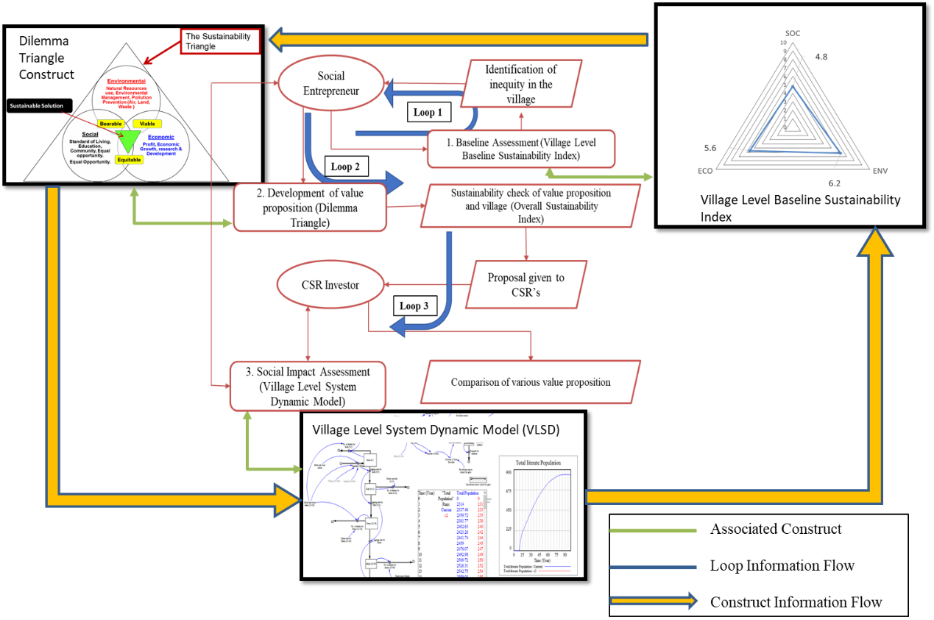
Figure 8.1: Framework Overview with Construct Information Flow

ANSWERING THE QUESTIONS AND VALIDATING THE HYPOTHESES
The framework developed in this thesis is provided as a decision support tool for social entrepreneur’s and investors to develop and evaluate the value proposition for rural development in India. The need for an overall decision support system is presented in Chapter 1. The primary question for this thesis is presented in Chapter 1, Section 1.3.
Primary Question (Thesis Question Q1)
What form of support system a social entrepreneur needs in defining the value propositions for development of the rural area that is sustainable with respect to the planet, profit and people involved?

Hypothesis for the Primary Question (Thesis Question Q1)
By developing a decision support framework that embodies different constructs of systems thinking that are useful to support the decision made by social entrepreneur using systems perspective.
Primary research question presented is further divided into three secondary question, where each question is developed for one construct of the framework. Secondary Question 1 (Thesis Question Q2) addresses the baseline assessment tool needed to evaluate current value of village in terms of drivers of sustainability. Secondary Question 2 (Thesis Question Q3) addresses the need for a method to develop value propositions for rural development. Finally, Secondary Question 3 (Thesis Question Q4) addresses the need of impact evaluation method for the value proposition of rural development. Further, Thesis Questions Q1, Q2, and Q3 are anchored in the overall development of the framework.
Secondary Question 1 (Thesis Question Q2)
What information (qualitative and quantitative) must be collected from a rural area to evaluate its current status in terms of social, environment and economy? What method will be needed to evaluate this information and how can this information be used to develop a sustainable value proposition?
Hypothesis for the Secondary Question 1 (Thesis Question Q2)
By developing a village level baseline sustainability index that includes social, environment and socio-economic aspects of a village. The index will include various aspects and questions on the status of social, environment and socio-economic aspects. On calculating, identifying the values of these aspects and answers to the question will give the current sustainability value of the village, thereby giving insight on the perspectives which social entrepreneurs can concentrate while developing a value proposition.
Secondary Question 2 (Thesis Question Q3)
What method can be used to develop the value propositions for development of the rural area that is sustainable with respect to the planet, profit, and people involved?
Hypothesis for the Secondary Question 2 (Thesis Question Q3)
By developing a method that embodies construct of Dilemma Triangle to understand various perspectives for developing a value proposition and will be used in identifying various dilemmas which could arise in rural development thereby giving an insight on what should be the value created by the value proposition for the development of the village.
Secondary Question 3 (Thesis Question Q4)
What are the characteristics of the framework that will be used by social entrepreneurs and investors to evaluate the impact of the value proposition on various stakeholders?
Hypothesis for the Secondary Question 2 (Thesis Question Q3)
By developing a method containing different concepts of System Dynamics tool embodied in the framework to recognize various sectors which will have an impact on quality of life of villagers.
Hypotheses are identified to answer the secondary question and support primary question of this thesis. Validation of the hypothesis for answering the secondary questions is discussed in detail in each chapter according to validation roadmap presented in Chapter 1, Section 1.5. However, an overview for each chapter, associated quadrant and hypothesis are presented in Figure 8.2 and Table 8.1.
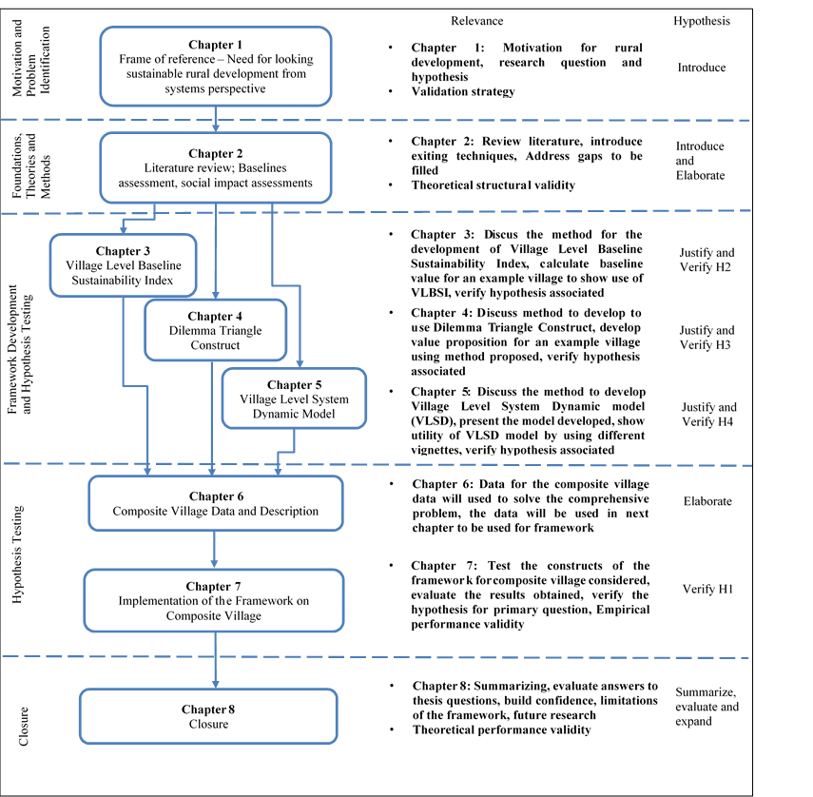
Figure 8.2: A Roadmap and Overview of the Thesis

Table 8.1: Organization of Thesis Questions
 |  | Questions posed in this Thesis | Hypothesis | Introduced in | Elaborated in | Verified in
Primary Question | Q1 | What form of support system a social entrepreneur needs in defining the value propositions for development of the rural area that is sustainable with respect to the planet, profit and people involved? | By developing a decision support framework that embodies different constructs of systems thinking that are useful to support the decision made by social entrepreneur using systems perspective. | Chapter 1, Section 1.3 | Chapter 1, Section 1.3 | Chapter 7, Chapter 8
Secondary Question | Q2 | What information is needed to identify current sustainability status of the village? | By developing a village level baseline sustainability index that includes social, environment and socio-economic aspects of a village. The index will include various aspects and questions on the status of social, environment and socio-economic aspects. On calculating, identifying the values of these aspects and answers to the question will give the current sustainability value of the village, thereby giving insight on the perspectives which social entrepreneurs can concentrate while developing a value proposition. | Section 2.2 | Chapter 3 | Chapter 3, Chapter 7
Secondary Question | Q3 | What method can be used as a tool to develop value proposition? | By developing a method that embodies construct of Dilemma Triangle to understand various perspectives for developing a value proposition and will be used in identifying various dilemmas which could arise in rural development thereby giving an insight on what should be the value created by the value proposition for the development of the village | Section 2.3 | Chapter 4 | Chapter 4, Chapter 7
Secondary Question | Q4 | What tools are needed in the framework to identify impact assessment? | By developing a method containing different concepts of System Dynamics tool embodied in the framework to recognize various sectors which will have an impact on quality of life of villagers. | Section 2.4 | Chapter 5 | Chapter 5, Chapter 7

CONTRIBUTION ASSUMPTIONS AND LIMITATION OF THE FRAMEWORK
One of the ways to improve rural development and eradicate poverty is by the creation of Small and Micro Social Enterprises (SMSE) in and around rural communities. Thousands of SMSEs can empower millions of people and improve their quality of life. However, to have successful SMSE’s, there are two major requirements;
- To find the right value proposition for a given community.
- To find the right stakeholders that are ready to invest in the value proposition identified.
To fulfill these requirements, need is to look at this problem from a systems perspective and provide a platform that can be used by social entrepreneurs to find the right value propositions, and various stakeholders (entrepreneurs, investors, local governments) to find right partners.
The framework developed for this thesis is a contribution towards this platform. The framework is designed to be used for by various social entrepreneurs, working in different aspects of societal improvement as a decision support tool that is anchored in a bottom-up approach. For other stakeholders (CSR investors, philanthropist and local government bodies) a construct of the framework (VLSD) is useful in identifying the impact of value proposition and their investment in the communities. This framework enables different stakeholder to initiate dialogue with each other and identify potential partnership.
LIMITATION AND ASSUMPTIONS
The framework is developed from the perspective of being used to support the decisions that a social entrepreneur takes while creating a social enterprise. Social entrepreneurs and involved stakeholder, therefore need a conscious input. The outcome for each stakeholder (including social entrepreneur) is different as each stakeholder has a different perspective of the problem at hand. This is both limitation and advantage of the framework. Limitation is that for the same problem no two solutions will be same. Whereas, it advantageous in being able to provide stakeholders an insight to understand the problem from different perspectives.
In Village Level Baseline Sustainability Index, weights of each indicator and sub-indicators are user-oriented. That is, among two stakeholders calculating baseline index value for the same village may have different values for same indicators or drivers. This is possible, as they may weigh the same indicator, sub-indicators differently. Therefore, it will be misleading if the index is considered to be a decision-making construct.
Another limitation of this Index is anchored in characteristics of it, for a given community, a social entrepreneur can add as many indicators as possible until the rule of keeping the total weight of indicators combined is kept as 1. This will make the index complex, and it will be difficult to calculate the values of drivers towards sustainability. As values change from one stakeholder to another stakeholder, validating the data or the output is not possible.
One assumption that we are considering for VLBSI is that no two indicators are related to each other. That is, change in one indicator will not affect another indicator. This is not true in the real world, as all the indicators affect each other. This gap is filled in Village Level System Dynamic model, wherein different indicator interact with each other.
One of the biggest challenges for VLSD model is the validation of this model. As there is no previous data available on many villages, validating the expected outcome becomes difficult. To overcome this challenge, the model is simulated for a village/community that has data available from past. Based on the outcome, the internal consistency of the model is checked. Once satisfied with the output for known data, the model is simulated for unknown data to anticipate the future state. The anticipated outcome from the model is based on the assumed growth given a value proposition. This assumed growth is calculated based on the qualitative information collected from the villages/communities and data available from previous studies.
However, most of the limitation and assumption of the framework are due to the requirements that are defined while creating the framework (reusable, modifiable, adaptable models). Whenever a framework is used in wide range of problems, it cannot be used to capture the specifics of the problems being solved. On another hand if a framework is developed to capture specifics of a given problem, it cannot be applied to a bigger set of problems. Since, the focus in this thesis is to provide a framework that can be used by various stakeholders, in varying demographics and change culture, the trade-off is between generic and specific framework is recognized choosing the former; that is, to develop framework that is generic to provide decision support to social entrepreneurs and other stakeholders.

FUTURE WORK - Ph.D. PROPOSAL
MOTIVATION
The framework presented in this thesis is anchored is decision support for social entrepreneur and investors. The framework is limited to the extent of being used to identify an inequity, propose a value proposition for the inequity and evaluate its impact. Though, the framework answers the question posed for this thesis;
What tools are needed to support the decision making of social entrepreneurs, investors, and philanthropist working to develop solutions for sustainable rural development?
Development of solutions that empower people to reduce inequity in a community or decision taken in/for social systems are mostly based on human intuitions. Data science and data visualization in recent years is used in understanding human trends from a consumer perspective in the world of internet. A similar approach is required to simulate individual behaviors in a community setting and community behaviors reaction on individual human being to answer various questions in a community context. The next question that needs to be answered at a community level is how to efficiently use the resources available in a particular community for the value proposition to be effective. This step is anchored in identifying the limited resources in an off-grid community and provide support tools to villagers so that they use the resources and the value proposition together effectively for improvement of their own quality of life. The research question that is to be answered in Ph.D. is based on the computational framework presented in this thesis. The primary research question to be addressed in Ph.D. is;
“How can limited resources (money, technology, human) be used to empower people living in off-grid communities in India to continue improving their quality of life by addressing the inequities associated with the nexus of the three drivers of sustainable development, namely, people, plant, and profit?”
The answer to this question will be helpful for social entrepreneurs, investors and policymakers to make informed decisions. The focus here is to simulate the current state of a community and evaluate a different intervention that can improve the socio-economic conditions in a community as presented in Figure 8.3.
For each community the impact of any intervention (or value proposition) will be dependent of resources available in the community, how each individual reacts to the intervention, resources available and how the community reacts to the intervention. Overall, a community simulation model is needed to evaluate intervention based on the community characteristics and resources available. To start, a community model at highest conceptual level is driven by two aspects;
- Decisions the individual take in community settings that changes the way a community behaves.
- Behaviors individuals have while making the decision.

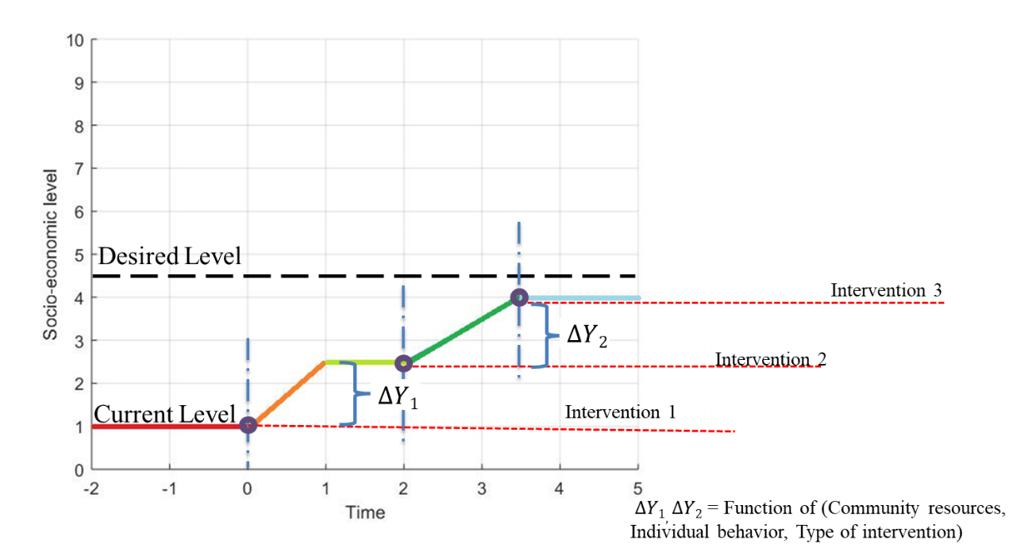
Figure 8.3: Proposed Community Catalysts Interventions Model

Both of these aspects provide feedback to each other and enhance each other at the individual, household, community, organizations and also country level. The hypothesis for the community model is that a decision made in a society is based on the behavior of society and behavior provides feedback to the decisions taken. At the highest level of abstraction, there are only two types of decision a human makes, either a Selection or Compromise (Mistree, Smith and co-authors, 1993; Mistree, Smith and co-authors, 1991), and at same abstraction level, there are only two kinds of behaviors for an individual, either an Action or Reaction.
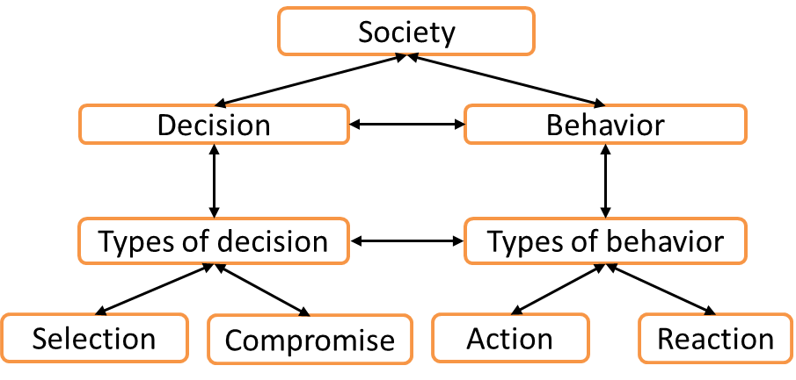
Figure 8.4: Higher Conceptual Level Society Decision Flow

The hypothesize proposed for the model is that “an individual or a community either acts or reacts to any situation by making a decision that is a selection or a compromise and reacts to the decision taken.”
Therefore two simulate the community behavior, it is essential that these two aspects are studied in details, that is;
- How individuals take a decision in a community setting while sharing the common resources and working towards the common goal of socio-economic development? And,
- How decision taken by an individual are effect by the behavior of individual/community and vice versa.
At a community level in rural areas, the information and data is not always available at individual or community level. Therefore the development of a simulation tool requires a systematic design on different scenarios. Systems thinking is proposed for the work in Ph.D. in terms of a framework that will be anchored in reconfiguration and data-based learning and iteration. The proposed framework for Ph.D. research to identify the answer to research questions posed is presented in Figure 8.5. The framework proposed is Realization of Sustainable Micro-Socio-Techno-Eco Systems. In the framework, the first step is to design the initial characteristics of community simulation tool. To model the behavior of individual and community, the choice is to look at available literature is the system behavior is known, if the behavior is not known, then based on surveys and qualitative data the prediction based design approach is selected. Based on the approach selected, a simulation model will be developed, and validation of model will feedback to Step 1. After the model is validated, the next step is to evaluate the impact of various interventions. In the implementation phase, the behavior observed will provide feedback to Step 2 and improve the next iteration of the simulation model.
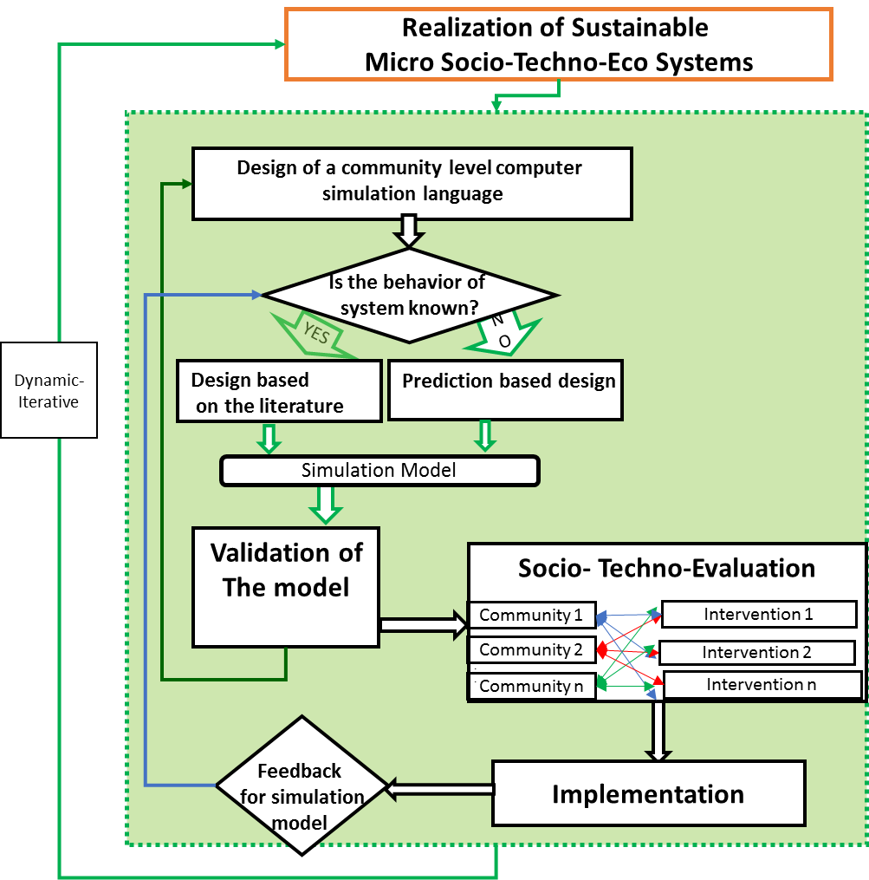
Figure 8.5: Framework for Micro Socio-Techno-Eco-Systems
Overall the hypothesis that will be verified in Ph.D. dissertation anchored in primary research questions posed for Ph.D. is;
To develop a computational framework anchored in micro-socio-techno-eco systems that will incorporate society simulation model to capture the behavior of individual and community based on decisions taken at different levels in the socio-techno ecosystem. The minimum resource flow will depend on the community behavior and decisions; this can be understood using society model.

SYNOPSIS OF CHAPTER 8
In Section 8.1, the summary of the work presented in this thesis is presented. The challenges faced by social entrepreneurs in developing value proposition are discussed. Overview of the framework proposed and flow of information from one construct to the other construct is discussed. In Section 8.2, the thesis questions are restated along with the hypothesis to each question, In Table 8.1, the overview of questions with respect to chapter and sections is presented in Section 8.2. In Section 8.3, the contribution, assumption, and limitation of the framework are discussed in detail.
In Section 8.4, a possible extension of the thesis is presented as tentative Ph.D. proposal. The primary research question for the future work is discussed, and a framework anchored in community simulation is presented in this section. Overview of the framework is presented in Figure 8.5.

REFERENCES
Abbas, A. (2014). "Beti Bachao, Beti Padhao: A Boon for the Girl Child". Niti Central.
Ahmed, S., Xiao, M., Panchal, J. H., Allen, J. K., and Mistree, F. (2012). "Managing Dilemmas Embodied in 21st Century Engineering". Paper presented at the ASME 2012 International Design Engineering Technical Conferences and Computers and Information in Engineering Conference, Chicago, IL, Paper Number DETC2012-71168.
Angerhofer, B. J., and Angelides, M. C. (2000). "System Dynamics Modelling in Supply Chain Management: Research Review". Paper presented at the IEEE.
Anigbogu, T. U., Onwuteaka, C. I., Edoko, T. D., and Okoli, M. I. (2014). "Roles of Small and Medium Scale Enterprises in Community Development: Evidence from Anambra South Senatorial Zone, Anambra State". International Journal of Academic Research in Business and Social Sciences, 4(8), 302.
Ardichvili, A., Cardozo, R., and Ray, S. (2003). "A Theory of Entrepreneurial Opportunity Identification and Development". Journal of Business Venturing, 18(1), 105-123.
Austin, J., Stevenson, H., and Wei‐Skillern, J. (2006). "Social and Commercial Entrepreneurship: Same, Different, or Both?". Entrepreneurship Theory and Practice, 30(1), 1-22.
Burdge, R. J. (2004). "The Concepts, Process and Methods of Social Impact Assessment": Social Ecology.
Burt, A., Hughes, B., and Milante, G. (2014). "Eradicating Poverty in Fragile States: Prospects of Reaching the High-Hanging Fruit by 2030". Policy Research Working Paper No. 7002. , Washington, DC.
Cabrido Jr, C. A., and Anosan, R. A. P. (1989). "Population, Natural Resources and Environment: Present Crisis and Alternative Paths to Sustainable Development": PSSC.
Carleton, T. A. (2017). "Crop-Damaging Temperatures Increase Suicide Rates in India". Proceedings of the National Academy of Sciences, 201701354.
Cavana, R. Y., and Mares, E. D. (2004). "Integrating Critical Thinking and Systems Thinking: From Premises to Causal Loops". System Dynamics Review, 20(3), 223-235.
Chaker, F., El Manouar, A., and Idrissi, M. A. J. (2015). "Towards a Systems Dynamic Modeling Method Based on Dematel". International Journal of Computer Science & Information Technology, 7(2), 27.
Chandramouli, C., and General, R. (2011). "Census of India 2011". Provisional Population Totals. New Delhi: Government of India.
D’Mello, J., Kushev, T., and Mattingly, E. S. (2012). "Explaining Conflicts among Stakeholders in Social Enterprises (Interactive Paper)". Frontiers of Entrepreneurship Research, 32(19), 14.
Dees, J. G. (2017). "The Meaning of Social Entrepreneurship" "Case Studies in Social Entrepreneurship and Sustainability" (pp. 34-42): Routledge.
Dellinger, A. B., and Leech, N. L. (2007). "Toward a Unified Validation Framework in Mixed Methods Research". Journal of Mixed Methods Research, 1(4), 309-332.
Eberlein, R. L., and Peterson, D. W. (1992). "Understanding Models with Vensim™". European Journal of Operational Research, 59(1), 216-219.
Economic Survey of India. (2017). "Overview of the Economic Survey of India." Retrieved from http://www.oecd.org/eco/surveys/economic-survey-india.htm
Ellis, F. (2000). "Rural Livelihoods and Diversity in Developing Countries.," Oxford University Press.
Emanuel, W., Dickens, C., Hunter, J., and Dawson Jr, M. E. (2011). "Clarifying Societies Need for Understanding Sustainable Systems". Journal of Applied Global Research, 4(9).
Flint, R. W. (2013). "Basics of Sustainable Development: Practice of Sustainable Community Development" (pp. 25-54): Springer.
Forrester, J. W. (1994). "System Dynamics, Systems Thinking, and Soft Or". System Dynamics Review, 10(2‐3), 245-256.
Freudenthal, S., and Narrowe, J. (1992). "Baseline Study Handbook: Focus on the Field": Sida.
Ghaffarzadegan, N., Lyneis, J., and Richardson, G. P. (2011). "How Small System Dynamics Models Can Help the Public Policy Process". System Dynamics Review, 27(1), 22-44.
Gharib, R. (2015). "Solar Lamps Shed Light in Rural Communities". Retrieved from https://blog.usaid.gov/2015/07/solar-lamps-shed-light-in-rural-communities/
Günther, I. (2017). "The Impact of Solar Lighting in Rural Kenya Energy." Retrieved from https://www.ethz.ch/en/news-and-events/eth-news/news/2017/07/benefit-of-solar-lights.html

Hammond, A., Adriannse, A., Rodenburg, E., Bryant, D., and Woodward, R. (1995). "A Systematic Approach to Measuring and Reporting on Environmental Policy Performance in the Context of Sustainable Development". World Resources Institute, Washington, DC, USA.
Harger, J., and Meyer, F.-M. (1996). "Definition of Indicators for Environmentally Sustainable Development". Chemosphere, 33(9), 1749-1775.
Hofferth, S. L., and Iceland, J. (1998). "Social Capital in Rural and Urban Communities". Rural Sociology, 63(4), 574-598.
Kates, R. W., Parris, T. M., and Leiserowitz, A. A. (2005). "What Is Sustainable Development? Goals, Indicators, Values, and Practice". Environment Science, Washington DC, 47(3), 8-21.
Khandker, S. R., Samad, H. A., Ali, R., and Barnes, D. F. (2012). "Who Benefits Most from Rural Electrification? Evidence in India". Agricultural & Applied Economics Association, Seattle, Washington.
Khosrojerdi, A., Rezapour, S., Allen, J. K., and Mistree, F. (2014). "Five Steps for Crafting a Doctoral Research Proposal in Engineering Design". Paper presented at the ASME 2014 International Design Engineering Technical Conferences and Computers and Information in Engineering Conference, Buffalo; New York.
Kroeger, A., and Weber, C. (2014). "Developing a Conceptual Framework for Comparing Social Value Creation". Academy of Management Review, 39(4), 513-540.
Kudo, Y., Shonchoy, A. S., and Takahashi, K. (2017). "Can Solar Lanterns Improve Youth Academic Performance? Experimental Evidence from Bangladesh". The World Bank Economic Review.
Lakner, C., Negre, M., and Prydz, E. B. (2014). "Twinning the Goals: How Can Promoting Shared Prosperity Help to Reduce Global Poverty?". World Bank.
Lee, N. (2002). "Strategic Impact Assessment and Enterprise Development". Institute for Development Policy and Management, University of Manchester.
Lehner, O. M. (2011). "Social Entrepreneurship Perspectives: Triangulated Approaches to Hybridity".University of Jyväskylä
Lemaire, X. (2018). "Solar Home Systems and Solar Lanterns in Rural Areas of the Global South: What Impact?". Wiley Interdisciplinary Reviews: Energy and Environment.
Maas, K., and Liket, K. (2011). "Social Impact Measurement: Classification of Methods" "Environmental Management Accounting and Supply Chain Management" (pp. 171-202): Springer.
Mair, J., and Marti, I. (2006). "Social Entrepreneurship Research: A Source of Explanation, Prediction, and Delight". Journal of World Business, 41(1), 36-44.
Martin, R. L., and Osberg, S. (2007). "Social Entrepreneurship: The Case for Definition" (Vol. 5): Stanford Social Innovation Review Stanford.
Martinez‐Moyano, I. J., and Richardson, G. P. (2013). "Best Practices in System Dynamics Modeling". System Dynamics Review, 29(2), 102-123.
Mistree, F., Smith, W., and Bras, B. (1993). "A Decision-Based Approach to Concurrent Engineering". New York: Chapman & Hall.
Mistree, F., Smith, W., Kamal, S., and Bras, B. (1991). "Designing Decisions: Axioms, Models and Marine Applications". Paper presented at the Fourth International Marine Systems Design Conference, Kobe, Japan.
Mundial, B. (2016). "Poverty and Shared Prosperity 2016: Taking on Inequality". Washington DC: Banco Mundial, 10, 978-971.
Naill, R. F. (1992). "A System Dynamics Model for National Energy Policy Planning". System Dynamics Review, 8(1), 1-19.
Ness, B., Urbel-Piirsalu, E., Anderberg, S., and Olsson, L. (2007). "Categorising Tools for Sustainability Assessment". Ecological Economics, 60(3), 498-508.
Nino, F. S. (2015). "Sustainable Development Goals—United Nations". Retrieved from. UN Sustain. Dev. http://www. un. org/sustainabledevelopment/sustainable-development-goals.
OECD. (2015). Policy Brief on Social Impact Measurement for Social Enterprises. Retrieved from https://www.oecd.org/social/PB-SIM-Web_FINAL.pdf
OECD Economic Surveys. (2017). Retrieved from https://www.oecd.org/eco/surveys/INDIA-2017-OECD-economic-survey-overview.pdf
Ogunlana, S. O., Li, H., and Sukhera, F. A. (2003). "System Dynamics Approach to Exploring Performance Enhancement in a Construction Organization". Journal of Construction Engineering and Management, 129(5), 528-536.
Parmova, D. S., Lapka, M., and Líšková, Z. D. (2014). "Complaints Management Strategies in Greek Hotel Units". Acta Universitatis Carolinae. Philosophica et Historica, 2013(2), 9-33.
Patalaa, S., Jalkalaa, A., Keränena, J., Väisänenb, S., Tuominenc, V., and Soukkab, R. (2013). "A Framework for Developing Sustainable Value Propositions for Industrial Product-Service Systems". 29th IMP - 2013, Atlanta.

Pedersen, K., Emblemsvag, J., Bailey, R., Allen, J. K., and Mistree, F. (2000). "The ‘Validation Square’ – Validating Design Methods". Paper presented at the ASME Design Engineering Technical Conferences, New York: ASME, 2000. ASME DETC2000/DTM-14579.
Potma, L. (2016). "Social Impact Measurement Methods Important Indicators, Strengths, Weaknesses and Value Placed on Comparing Impact". University of Amsterdam.
Prahalad, C. K. (2006). "The Fortune at the Bottom of the Pyramid": Pearson Education India.
Rajewski, Z. (1994). "Gross Domestic Product". Eastern European Economics, 32(4), 71-80.
Rep, D. (2006). "Human Development Report 2003" "Human Development Index": UNDP.
Robinson, J. (2006). "Navigating Social and Institutional Barriers to Markets: How Social Entrepreneurs Identify and Evaluate Opportunities" "Social Entrepreneurship" (pp. 95-120): Springer.
Romer, C. D. (1989). "The Prewar Business Cycle Reconsidered: New Estimates of Gross National Product, 1869-1908". Journal of Political Economy, 97(1), 1-37.
Rosenzweig, W. (2004). "Double Bottom Line Project Report:Assessing Social Impact in Double Bottom Line Ventures". UC Berkley.
Sachs, J. D. (2012). "From Millennium Development Goals to Sustainable Development Goals". The Lancet, 379(9832), 2206-2211.
Sahn, D. E., and Stifel, D. C. (2003). "Urban–Rural Inequality in Living Standards in Africa". Journal of African Economies, 12(4), 564-597.
Santos, F. M. (2012). "A Positive Theory of Social Entrepreneurship". Journal of Business Ethics, 111(3), 335-351.
Saxena, S. (2012). "Problems Faced by Rural Entrepreneurs and Remedies to Solve It". Journal of Business and Management, 3(1), 23-29.
Saysel, A. K., Barlas, Y., and Yenigün, O. (2002). "Environmental Sustainability in an Agricultural Development Project: A System Dynamics Approach". Journal of Environmental Management, 64(3), 247-260.
Scherbov, S., Lutz, W., and Sanderson, W. C. (2011). "The Uncertain Timing of Reaching 8 Billion, Peak World Population, and Other Demographic Milestones". Population and Development Review, 37(3), 571-578.
Singh, A., and Verma, P. (2014). "Csr@ 2%: A New Model of Corporate Social Responsibility in India".
Sterman, J. D. (2000). "Business Dynamics: Systems Thinking and Modeling for a Complex World". McGraw-Hill, Boston.
Streatfield, D., and Markless, S. (2009). "What Is Impact Assessment and Why Is It Important?". Performance Measurement and Metrics, 10(2), 134-141.
Subramanian, R. (2015). "Selco Solar Light Private Limited: A Social Enterprise’s Scaling up Challenge". Asian Journal of Management Cases, 12(2), 172-182.
Suchet Kumar, S., and Gupta, K. (2013). "Social Entrepreneurship: A Conceptual Framework". International Journal of Management and Social Sciences Research (IJMSSR), 2(8), 2319.
Sullivan Mort, G., Weerawardena, J., and Carnegie, K. (2003). "Social Entrepreneurship: Towards Conceptualisation". International Journal of Nonprofit And Voluntary Sector Marketing, 8(1), 76-88.
Wallace, I. (2017). Baseline Assesment - Overview. Retrieved from http://www.oxfordreference.com/view/10.1093/oi/authority.20110803095449856
Walters, J. P., Archer, D. W., Sassenrath, G. F., Hendrickson, J. R., Hanson, J. D., Halloran, J. M., . . . Alarcon, V. J. (2016). "Exploring Agricultural Production Systems and Their Fundamental Components with System Dynamics Modelling". Ecological Modelling, 333, 51-65.
Weerawardena, J., and Mort, G. S. (2006). "Investigating Social Entrepreneurship: A Multidimensional Model". Journal of World business, 41(1), 21-35.
Yadav, A., Das, A. K., Roy, R. B., Chatterjee, A., Allen, J. K., and Mistree, F. (2017). "Identifying and Managing Dilemmas for Sustainable Development of Rural India". Paper presented at the ASME 2017 International Design Engineering Technical Conferences and Computers and Information in Engineering Conference, Cleveland, Ohio.
Yunus, M., Moingeon, B., and Lehmann-Ortega, L. (2010). "Building Social Business Models: Lessons from the Grameen Experience". Long Range Planning, 43(2-3), 308-325.

APPENDIX A: Village Data for Chapter 3
The data provided in the table below is the collection of various aspects of a village. Data from this table is used in Section 3.2 as a description of the village to provide context to the reader about the village for the Village Level Baseline Sustainability Index method implementation in Section 3.2.
Table A.1. 1: Village data for Chapter 3
# | Category |  | Value | Yes/No | Comments
SOCIAL STATUS
1 | Population
 |  | Total Population | 1000
 |  | Number of household | 216
 |  | Male | 540
 |  | Female | 460
 |  | Youth (14-25) | 250
 |  | Children (Below 14) | 160
 |  | Total Area and Density | 6.2 sq km
2 | Electricity
 |  | Is there electricity in the village |  | No | Only 8 houses
 |  | Source of electricity | Renewable/Non-Renewable
 |  | Number of houses having electricity | 8
3 | Education
 |  | Is there a school present in village |  | Yes, grade school
 |  | Is there a school present in nearby villages |  | Yes
 |  | Number of children going to school | 100
 |  | Is there higher education in village or nearby villages |  | No
4 | Communication/
4 | Entertainment
 |  | Is there connectivity in the village (mobile/landline) |  | No
 |  | Number of people having connection | 0
 |  | Number of households having TV connection | 0
5 | Food/Water
 |  | Number of households having food scarcity | 20
 |  | Number of households having water scarcity | 20
 |  | Is there any action taken to decrease food scarcity |  | No
 |  | Is there any action taken to decrease water scarcity |  | Yes | Travel to other sources
6 | Housing
 |  | Number of families having proper housing | 200
7 | Sanitation
 |  | Number of households having proper sanitation | 170
8 | Equality
 |  | Is there caste equality in village |  | No
 |  | Is there gender equality in village |  | No | Higher literacy rates for men, more opportunities for jobs for men
9 | Health
 |  | Is there a hospital in village |  | No
10 | Cooking
 |  | Number of households using firewood, kerosene stoves, and LPG in village | 198 |  | 75% use firewood
ENVIRONMENTAL STATUS
1 | Pollution
 |  | Level of air pollution | Some
 |  | Level of water pollution | Polluted
 |  | Level of soil pollution | Very little
2 | Degradation
 |  | Land degradation | Very little
 |  | Soil degradation | Very little
 |  | Forest degradation | Some |  | Effected by development
 |  | Underground water level degradation | Very little
 |  | Water body level degradation | Very little
 |  | Wildlife degradation | Some |  | Effected by development and Forest degradation
 |  | Fishery degradation | Yes starting to occur
3 | Wildlife
 |  | Birds |  |  | Government focused on protecting bird population due to recent decreasing numbers.
 |  | Fish | Fished abundant and developed fishing industry present
 |  | Local species | Wildlife in nearby National Park |  | Sometimes big animals from the nearby park stroll into the village
SOCIO-ECONOMIC STATUS
1 | Agriculture
 |  | Number of households involved in farming | 160
 |  | Number of households having their own farms | 60
 |  | Number of households working as daily labors in farm | 100
 |  | Number of crops in a year
 |  | Average income per household | Rs 15000/-
2 | Small business
 |  | Number of households involved in business | 10
 |  | Number of households involved in handlooms and handcrafts | 40
 |  | Number of households involved in family business (high income households) | 12
 |  | Average income per household | Rs 20000/-
3 | Labor
 |  | Number of households working as laborers | 141
 |  | Number of people working as laborers | 600
 |  | Number of children working as child laborers (not in school) | 70
 |  | Average income of laborers | 450
4 | Fishing
 |  | Number of households involved in fishery | 41
 |  | Number of households having their own fishery | 0
 |  | Number of households involved as laborers for fishery | 31
 |  | Average income of fishery | Rs 12000/-
5 | Government employment
 |  | Number of households involved in government employment | 5
 |  | Average income | Rs. 25000/-
6 | Employment credibility of youth
 |  | Skill and education of youth | Little opportunities
7 | Workers/Non-workers
 |  | Main workers | 428
 |  | Marginal workers | 97
 |  | Non-workers | 150
8 | Category of workers
 |  | Cultivators | 275
 |  | Agricultural laborers | 405
 |  | Workers in household industry | 69
 |  | Other workers | 255

APPENDIX B: Village Data for Chapter 4
The data provided in the table below is the collection of various aspects of a village. Data from this table is used in Section 4.2 as a description of the village to provide context to the reader about the village for the Dilemma Triangle method implementation in Section 4.2.
Table A.2. 1: Village data for Chapter 4
Village Data
Social Status
 |  | Value | Comments (Justification)
Population
 | Total Population | 2000
 | Number of households | 400 | 5 people per household on average
 | Male | 1030 | From the census data there is a 51.5% male population and 48.5% female population.
 | Female | 970
 | Youth (14-25) | 400 | From the census data 20% of the population is youth (14-25) and 30% are children (Below 14).
 | Children (Below 14) | 600
Electricity
 | Is there Electricity in this Villages | Yes | Some of the villagers have diesel generators.
 | Source of Electricity | Non-Renewable | Some of the villagers have diesel generators.
 | Number of houses having electricity | 50 | Some of the villagers have diesel generators.
Education
 | Is there a school present in village | Yes | Primary
 | Is there a school present in nearby villages? | No | This is a remote village and there is no other village nearby
 | Number of Children going to school | 200 | Mostly those coming from upper-class families with a few coming from middle-class families
 | Is there higher education in village or nearby villages | No | This is a remote village and there is no other village nearby
Communication and Entertainment
 | Is there connectivity in the village? (Mobile/Landline) | No
 | Number of people having connection (Mobile/Landline) | N/A
 | Number of Households having Television connection | 25 | Only the rich villagers can afford to have television sets in their homes.
Food and Water
 | Number of households having food scarcity | 20 | Average depends on season
 | Number of households having water scarcity | 20 | Average depends on season
 | Is there any action taken to decrease food scarcity /What level | Yes | Food sharing program
 | Is there any action taken to decrease water scarcity / What Level | Yes | H20 organization gave straws to village
Housing
 | Number of families having proper housing | 350 | Many villagers in among the lower class have insufficient housing
Sanitation
 | Number of Households having proper Sanitation Conditions | 50 | The lower class families who have insufficient housing also do not have proper sanitation conditions
Equality
 | Is there Caste equality in village | No | As majority of the population of the village is not well educated, they lack modern thinking and so inequality exists
 | Is there Gender equality in village | No
Health
 | Is there a hospital in village | No | The village is poorly educated and does not have the means to run a hospital
 | Technology present in hospital, mention in comments | N/A
Cooking
 | Number of households using firewood, kerosene stoves and LPG in Village | 50 – LPG | As firewood is easily available and affordable, it is used by many villagers.
Environmental Status
Pollution
 | Level of Air pollution | low | Pollution is not a problem in this small remote village
 | Level of Water pollution | medium | Pollution is not a problem in this small remote village
 | Level of Soil Pollution | low | Pollution is not a problem in this small remote village
Degradation
 | Land Degradation | low | The village is a farming community
 | Soil Degradation | low | The village is a farming community
 | Forest Degradation | medium
 | Underground Water Level Degradation | medium | The underground water is the main source of drinking water our village has
 | Water Body level degradation | N/A | The village is landlocked and there is no nearby lake or pond
 | Wildlife Degradation | medium
 | Fishery Degradation | N/A | The village is landlocked and there is no nearby lake or pond for our villagers to fish in
Socio-Economic Status
 | Current GDP of the village | - | Data Not Available
 | Ratio of (GDP of village/GDP of State in which village is present) | - | Data Not Available
 | Number of Households which are below the half of total village's GDP value. | - | Data Not Available
Agriculture
 | Number of households involved in farming | 300 | This village is a farming village and 75% of households are involved in farming, half of the households own their own farm while the rest work as laborers.
 | Number of households having their own farms | 200
 | Number of households working as daily labors in farm | 100
 | Number of crops in a year | 2
 | Average Income per household | Rs. 13,000 ($200.00)
Small Business
 | Number of Households involved in Business | 10
 | Number of Households involved in Handlooms and Handicrafts | N/A
 | Number of Households involved in Family business (High-income households) | 50 | This contains the entirety of our upper class
 | Average Income per household | Income varies based on business and the average will not give an adequate description
Labor
 | Number of households working as laborers | 150 | Most of the available jobs are as laborers which are a low education and very low-income job
 | Number of people working as laborers | 300
 | Number of children working as child labors (Not attending schools) | 75
 | Average income of Labors | ₹5,000 (<$100.00)
Fishing
 | Number of households involved in fishery | 0 | The geographic location of the village does not support a fishing industry
 | Number of households having their own fishery farms/tanks | 0
 | Number of households involved as labors for fishery | 0
 | Average income of fishery | 0
Government Employment
 | Number of Households involved in Government Employment | 3 | Being a remote village, many facilities for the same are available at district headquarters.
 | Average Income | ₹13,000
Employment Credibility of Youth
 | Skill and Education of Youth | 20% of youth have the opportunity to of primary school in the village but 5% have the ability to continue education outside of the village. Most youths have skills in farming or handicrafts.

