UNIVERSITY OF OKLAHOMA
GRADUATE COLLEGE

INVESTIGATING AI CHATBOT INTEGRATION IN ACADEMIC LIBRARIES
: A CASE STUDY

A DISSERTATION

SUBMITTED TO THE GRADUATE FACULTY

in partial fulfillment of the requirements for the
Degree of
DOCTOR OF PHILOSOPHY

By
YOUNG A LEE
Norman, Oklahoma
2024

INVESTIGATING AI CHATBOT INTEGRATION IN ACADEMIC LIBRARIES
: A CASE STUDY
A DISSERTATION APPROVED FOR THE
SCHOOL OF LIBRARY AND INFORMATION STUDIES
BY THE COMMITTEE CONSISTING OF

Dr. Susan K. Burke, Chair
Dr. Yong-Mi Kim
Dr. Kun Lu

Dr. Doo Hun Lim

© Copyright by YOUNG A LEE 2024
All Rights Reserved.

ACKNOWLEDGMENTS
I would like to first express my sincere gratitude to my advisor, Dr. Susan K. Burke, for her invaluable advice, insightful ideas, and uplifting encouragement. This work would not have been achievable without her support. I am deeply thankful to Dr. Yong-Mi Kim, Dr. Kun Lu, and Dr. Doo Hun Lim for their presence on my committee and the time they devoted to reviewing my dissertation and offering enlightening guidance. I would also like to thank the faculty of the School of Library and Information Studies at the University of Oklahoma for their passion for teaching which provided me with a diverse foundation of knowledge. I am grateful for the encouragement and friendship of my fellow Ph.D. students, who helped me overcome difficulties and move forward. I truly appreciate the support of both current and former members of the Web Services at the University of Oklahoma Libraries. It has been a great pleasure working with them over the past five years. I learned not only how to work efficiently using a variety of technologies, but also how to collaborate based on respect and consideration.

My heartfelt thanks go to my mother, in-laws, brother’s family, husband, Youngjae, and my wonderful son, David, and daughter, Grace for their unwavering love and support while pursuing my doctoral degree. I want to extend special thanks to my late father, Haeng Boo Lee, who recently passed away. I will forever remember his love and cherish his kind and encouraging words. I would like to offer my sincere appreciation to Pastor Yang and the members of Norman Korean Baptist Church, and Pastor Lee and the members of Jayang Church, for their prayers.
Finally, thank you, Lord, for always loving me, giving me new life, and guiding me thus far.
“I bless the Lord who gives me counsel;
in the night also my heart instructs me.
I have set the Lord always before me;
because he is at my right hand, I shall not be shaken.”
Psalm 16: 7-8

TABLE OF CONTENTS
ACKNOWLEDGMENTS iv
LIST OF TABLES viii
LIST OF FIGURES ix
ABSTRACT x
CHAPTER 1: INTRODUCTION 1
1.1 Background 1
1.2 Problem Statement 3
1.3 Purpose Statements and Research Questions 3
1.4 Significance of the Research 4
CHAPTER 2: LITERATURE REVIEW 6
2.1 History of Chatbots 6
2.2 Chatbots in Libraries and Higher Education 7
2.3 Advancements in AI Chatbots 11
CHAPTER 3: METHODOLOGY 13
3.1 Introduction 13
3.1.1 Case Study Setting 13
3.1.2 OU Libraries’ AI Chatbot Implementation as a Single Case Study 14
3.1.3 Limitations 14
3.2 Data Collection Methods 15
3.2.1 Interview 15
3.2.2 Chatbot Log Data 16
3.3 Data Analysis 23
3.3.1 Descriptive Analysis of Interview Data 24
3.3.2 Statistical Analysis of Chatbot Log Data 24
3.4 Ethical Considerations 26
CHAPTER 4: FINDINGS 28
4.1 RQ1: How Has the AI Chatbot been Implemented at OU Libraries? 28
4.2 RQ2: What Are the Usage Patterns of the OU Libraries’ AI Chatbot? 44
4.2.1 Total Number of Conversations throughout the Day 44
4.2.2 Total Number of Conversations throughout the Week 45
4.2.3 Monthly Trends in Total Number of Conversations by Year 47
4.2.4 Total Number of Conversations by Chat Length 48
4.2.5 Total Number of Conversations by the Number of Messages to Chatbot 50
4.2.6 Devices Used for the Chatbot 51
4.3 RQ3: How Do Users of the OU Libraries’ AI Chatbot Evaluate Its Performance? 52
4.3.1 Descriptive Statistics of Dataset 52
4.3.2 Regression Tree Analysis of Important Factors Affecting Chatbot Evaluation 57
4.3.3 Unanswered Questions 60
4.3.4 Users’ Comments 65
CHAPTER 5: DISCUSSION 72
5.1 Implementation of AI Chatbot 72
5.1.1 Two Types of Chatbots: Original and Ivy.ai 72
5.1.2 Benefits of AI Chatbots 76
5.2 Usage Patterns of AI Chatbot 78
5.2.1 General Usage Patterns 78
5.2.2 Impact of COVID-19 80
5.3 Users’ Evaluation of AI Chatbot 83
5.3.1 Issues with the Ivy.ai Chatbot 83
CHAPTER 6: CONCLUSIONS 85
6.1 Recommendations for Practice 85
6.2 Future Research 87
REFERENCES 89
APPENDIX A: Interview Questions 95
APPENDIX B: Informed Consent Form 96
APPENDIX C: Approval of OU Libraries Chatbot Data Usage 98
APPENDIX D: Approval of IRB for the Protection of Human Subjects 99

LIST OF TABLES
Table 1. Examples of Chatbots in US Academic Libraries 10
Table 2. Variables with Definitions 18
Table 3. Category Based on Topic of Questions Asked by Users to the Chatbot 19
Table 4. Help Desk Variable 20
Table 5. COVID-19 Variable 21
Table 6. Vacation Variable 22
Table 7. Weekend Variable 22
Table 8. List of Research Questions, Data Collection Methods, and Analysis 26
Table 9. Summary of Frequencies for Categorical Variables in Chatbot Data with User Conversation Ratings 53
Table 10. Summary of Common Statistical Measurements for Numeric Variables in Chatbot Dataset with User Conversation Ratings 54
Table 11. Average and Frequency of Chatbot Conversation Ratings by Category 55
Table 12. Users’ Chatbot Conversation Rating 57
Table 13. Users’ Rating Who Left Comments 65

LIST OF FIGURES
Figure 1. Total Number of Conversations throughout the Day 45
Figure 2. Total Number of Conversations throughout the Week 46
Figure 3. Monthly Trends in Total Number of Conversations by Year 47
Figure 4. Total Number of Conversations by Chat Length: 1-300 seconds 48
Figure 5. Total Number of Conversations by Chat Length: 1-30 seconds 49
Figure 6. Total Number of Conversations by the Number of Messages Sent to the Chatbot 50
Figure 7. Devices Used for the Chatbot by Year 51
Figure 8. Ratio of Questions by Category 56
Figure 9. Regression Tree Analysis of Factors Affecting Chatbot Evaluation 59
Figure 10. Bar Plot Diagram of Frequency Terms from InboxZero Questions 60
Figure 11. Best Topic by Coherence Score 61
Figure 12. Eleven Topics Using Latent Dirichlet Allocation 62
Figure 13. Cluster Dendrogram 62
Figure 14. Number of InboxZero Questions per Year 64
Figure 15. Chat Transcripts of the User who Left the Comment ① 66
Figure 16. Chat Transcripts of the User who Left the Comment ② 67
Figure 17. Chat Transcripts of the User who Left the Comment ③ 68
Figure 18. Chat Transcripts of the User who Left the Comment ④ 69
Figure 19. Part of Chat Window with the Language Selecting Button 69
Figure 20. Chat Transcripts in Arabic and English 70
Figure 21. Chat Transcripts of the User who Left the Comment ⑦ 71
Figure 22. Collaboration in Creating OU Libraries’ AI Chatbot 74
Figure 23. Greeting from OU Libraries Chatbot, Bizzy 75
Figure 24. COVID-19 Banner on Chatbot Window 82

ABSTRACT
AI chatbots have recently received great attention due to the advancement of large language models, such as OpenAI's GPT series and Google's Gemini, which have shown excellent performance and applicability. Therefore, many academic libraries endeavor to integrate AI chatbots into their services. The University of Oklahoma (OU) Libraries started an AI chatbot project in 2017, ahead of most other academic libraries, and developed an original AI chatbot. In July 2019, OU Libraries launched an AI chatbot service using Ivy.ai, which utilized cutting-edge technology at the time. The chatbot service, launched before COVID-19, continued to operate even when the OU Libraries was closed due to the pandemic and remained operational until recently, providing valuable log data recording interactions between users and AI chatbots over the past few years. This study used mixed methods to investigates (a) how the AI chatbot has been implemented at the OU Libraries, (b) the usage patterns of OU Libraries’ AI chatbot, and (c) how users of OU Libraries’ AI chatbot evaluate its performance by exploring the important factors influencing users’ chatbot evaluation and questions the chatbot was unable to provide answers. The study provides practical recommendations for institutions planning to implement AI chatbots, and also lays the foundation for future research on AI chatbot technology to improve library services.

CHAPTER 1: INTRODUCTION

1.1 Background
The rapid development of artificial intelligence (AI) in recent years is creating innovations across various industries and fields where AI is applied. AI has fundamentally transformed the way we approach and solve problems. Academic libraries are also seeking to improve library services by applying AI in various ways.
Cox et al. (2019) state that AI has the potential to influence numerous facets of libraries, including search and recommendation systems, customization, text and data analysis. Gujral et al. (2019) mention the use of AI within academic libraries such as data curation for collection management, digital preservation, and the exploration of a new information field to gain a deeper understanding of scholarly communication. Lund et al. (2020) suggest that librarians express keen interest in integrating AI into cataloging and library search. Wang et al. (2023) mention that the potential influence of AI on academic libraries transcends mere patron assistance and it holds promise in streamlining the library's day-to-day functions through the automation of mundane activities like cataloging, shelving, and book sorting, enhancing efficiency. In addition, AI can facilitate the digitization of library collections, and strengthen the precision and expediency of retrieval processes resulting in conserving resources and time and mitigating the necessity for physical storage space and manual labor involved in organizing and upholding collections.
AI has brought about a revolution in the long-standing domain of reference services, which has traditionally been the exclusive realm of librarians. Mellon (2015) states that the primary objective of librarianship is to connect people with relevant information. However, with the introduction of AI chatbots, this domain has begun to undergo significant transformations.
The adoption of chatbots has brought numerous benefits. Chatbots provide 24-hour non-staffed service options (Nawaz & Saldeen, 2020). They could free library staff from basic or repetitive questions to focus on more challenging inquiries and tasks, and they support backup information services in case of staff shortage, which is important in instances when numerous inquiries flood the chat simultaneously (Allison, 2012; Ehrenpreis & DeLooper, 2022; McNeal & Newyear, 2013). Additionally, library patrons can get reference services at their own convenience using chatbots. Chatbots offer users relief from information overload on library websites by providing concise answers (Allison, 2012; Mckie & Narayan, 2019), and they facilitate searches, particularly benefiting inexperienced users (McPherson, 2015). Moreover, chatbots can offer personalized support to students, faculty, and staff (Alexander et al., 2019; Cox et al., 2019).
In the last few years, with the onset of COVID-19 and increased reliance on virtual services, libraries have been seeing a surge of interest in chatbots as a tool to enhance services during non-staffed hours (Rodriguez & Mune, 2022). While chatbots received significant attention during the COVID-19 period, the OU Libraries initiated an AI chatbot project in 2017, preceding most academic libraries. The rationale for investigating AI chatbot implementation in OU Libraries is as follows: 1) In the case of the Ivy.ai chatbot, the most advanced technology of AI chatbot was applied at the time of the launch at OU Libraries in July 2019, 2) the chatbot service was launched before COVID-19 and continued to operate even during the OU libraries’ full lockdown due to the COVID-19 pandemic. 3) Due to the sustained service provision until relatively recently, abundant and continuous data has been accumulated. As a result, the service was still active and heavily utilized even after the pandemic, and the accumulation of log data facilitated the identification of usage patterns and user interactions with the chatbot.

1.2 Problem Statement
In today's rapidly evolving information landscape, academic libraries confront the ongoing challenge of cultivating user-centric environments that meet users' evolving expectations. Insofar as security is ensured, the integration of AI chatbots emerges as a promising avenue to streamline library operations, enhance services, and elevate user satisfaction levels. Notably, the introduction of ChatGPT, a new generative artificial intelligence chatbot, in late 2022, has sparked heightened interest in AI chatbot services, resulting in a surge of research activity on this subject (Aithal & Aithal, 2023; Lund & Wang, 2023). However, there exists a paucity of literature that delves into the analysis of log data by user interactions with chatbots, alongside exploration of AI chatbots through an in-depth interview with a library staff actively involved in chatbot development and implementation.
Jansen (2006) emphasizes the critical importance of analyzing collected data to derive actionable insights. Failure to analyze such data may render it ineffective in informing service improvements within libraries. Thus, a case study of OU Libraries’ AI chatbot, leveraging the user interaction data, promises invaluable insights into the implementation processes, maintenance protocols, utilization patterns, and support mechanisms for AI chatbots, while also elucidating associated challenges. From a library service standpoint, the accumulation of valuable log data since the introduction of the AI chatbot in 2019 underscores the necessity of comprehensive analysis to drive service improvements.

1.3 Purpose Statements and Research Questions
The purpose of the study is to investigate the AI chatbot implementation, usage patterns, and user evaluations of the AI chatbot in OU Libraries. This study reveals the chatbot implementation process at the OU Libraries through an interview, provides insights into usage patterns, and examines questions the chatbot could not provide answers, and important factors influencing user evaluation of the chatbot performance by analyzing log data of user-chatbot interactions. The following research questions direct this study.
RQ1. How has the AI chatbot been implemented at OU Libraries?
RQ2. What are the usage patterns of the OU Libraries’ AI chatbot?
RQ3. How do users of the OU Libraries’ AI chatbot evaluate its performance?
- What are the important factors that affect the users’ evaluation of the chatbot performance?
- What are the unanswered questions of the chatbot?

1.4 Significance of the Research
This study investigated the AI chatbot integration in OU Libraries using mixed methods.
By analyzing the chatbot log data, accumulated for 3 years and 9 months covering the COVID-19 pandemic period, this study contributes to the deeper understanding the usage patterns of the chatbot, important factors affecting the evaluation of the chatbot, and questions that the chatbot could not answers. Through the interview with former Head of Web Services and Artificial Intelligence who was involved in the development of OU Libraries’ original AI chatbot and implementation of an Ivy.ai chatbot, this study offers the perspective of library staff on the AI chatbot implementation, focusing on how OU Libraries overcame challenges through a variety of collaborative efforts involving library team, faculty, and students.
The findings of the study provide practical guidelines to academic libraries and other institutions interested in implementing AI chatbots. By understanding the challenges of the chatbot implementation, library administrators can prepare for them in advance and plan the process accordingly. The specific chatbot management practices suggested in this study would also help organizations currently providing chatbot services to manage chatbots more efficiently. Furthermore, this study paves the way for future research on AI chatbot technology to improve library services.

CHAPTER 2: LITERATURE REVIEW

2.1 History of Chatbots
In 1950, a renowned computer scientist and mathematician Alan Turing posed the question, “Can machines think?”, proposing a test, “Imitation Game” (Turing, 1950). Turing tested if machine could think by distinguishing the person and machine, and this simple test is widely known as the original idea of chatbots. In 1966, Joseph Weizenbaum created a simple chatbot called ELIZA, which could provide answers to sentences from users, simulating a psychotherapist (Weizenbaum, 1966). Subsequently, numerous other chatbots were developed. Initially limited to mainframe systems, chatbots transitioned to desktop computers and were predominantly accessible as cloud-based applications on websites (Ehrenpreis & DeLooper, 2022). In 1995, chatbot ALICE was created and won the Loebner Prize, an annual Turing Test, in 2000, 2001, and 2004. ALICE became the first computer to be recognized as the “most human computer” (Wallace, 2009). ALICE operated using a straightforward pattern-matching algorithm, with its underlying intelligence grounded in the Artificial Intelligence Markup Language (AIML) (Marietto et al., 2013).
A chatbot system could be created utilizing programmed scripts and the natural language processing approach (Pereira & Díaz, 2018). The scripted approach operated within a rule-based framework, resulting in a conversational scope that was somewhat restricted. Conversely, the natural language processing approach employed artificial intelligence principles to mimic human-based behavior, purportedly encompassing a wider range of conversational topics (Rivolli et al., 2019). Thus, chatbots aimed to emulate human conversation with end users, which was achieved through natural language processing, an AI technology that gave computers the ability to understand text and spoken language in similar way that humans could (McNeal & Newyear, 2013).

2.2 Chatbots in Libraries and Higher Education
European countries led the implementation of chatbots in their libraries, and Stella was the first library chatbot developed in 2004 at Bibliothekssystem Universität Hamburg (Allison, 2012). Other chatbots in European libraries included Askademicus which began to support users on the library’s website at the Technische Universität Dortmund around the same time, INA which has been in operation on the Bücherhallen Hamburg website since 2006, and Kornelia, the first public library chatbot, which has been at the Kornhaus Bibliotheken in Bern, Switzerland since 2010 as a virtual assistant (Ehrenpreis & DeLooper, 2022; McNeal & Newyear, 2013).
In US libraries, Lillian, Chatbot 2.0 was introduced at OCLC in 2006, but it was in the prototype stage for building other chatbots and whether Lillian was accessible to the public was not clear (Christensen, 2007; McNeal & Newyear, 2013). The Mentor Public Library in Mentor, Ohio, USA, provided an AIML-based chatbot service from 2009 to 2012. The chatbot, named Emma the cat, was well received by library staff and patrons. Emma answered general questions and searched library catalogs, other databases and websites, and eventually won the Public Library Association’s Polaris Innovation in Technology John Iliff Award in 2011 (McNeal & Newyear, 2013).
It took a relatively long time for academic libraries in the US to adopt chatbots. The first chatbot, Pixel, was developed in 2010 at the University of Nebraska-Lincoln. Pixel provided answers to questions written in natural language. It generated answers by matching keywords and their combinations in the AIML categories database. The categories gave answers to specific questions, and sent questions that could not be answered right away to library staff. The key difference between Pixel and existing tools was that Pixel provided an interactive experience that simulated a reference interview, and gave immediate answers based on the syntax of the query that could bring library resources together (Allison, 2012).
The University of California, Irvine (UCI) developed its library chatbot in 2014 using Program-O due to the features such as spell check, bot personality setting, SRAI lookup feature, and the ability to easily add and edit botmaster accounts (Kane, 2016). Its statistics on the resources and services that patrons requested from the chatbot provided useful resource information for library staff. In addition, chatbot programmers could continue to grow the system by analyzing how library users interacted with the chatbot.
The University of Oklahoma (OU) Libraries’ chatbot, Bizzy, went live in July 2019 using Ivy software (University of Oklahoma Libraries, n.d.). Bizzy could process natural language and conduct conversations in a natural way because natural language processing was driven by a human-supervised deep learning algorithm. Using a vast and highly curated set of training data, Bizzy could predict what users were asking for and got the answers (Ivy.ai., n.d.).
City University of New York Lehman College's Leonard Lief Library initiated their chatbot implementation in 2019 by participating in the Ivy chatbot software pilot with the college’s Information Technology (IT) department. They prepared to install Ivy, the same software used by OU Libraries, during the fall semester of 2019, and the chatbot was launched in November 2019. The name of the chatbot was Lehman Lightning Bot, and it was active 24 hours a day (Ehrenpreis & DeLooper, 2022).
Both San Jose State University and Penn State University Libraries started the utilization of chatbots. In September 2020, San Jose State University released Kingbot, which was created with Kommunicate, a proprietary software, utilizing Google’s Dialogflow. Kingbot was active from 7 PM to 9AM on weekdays and from 5 PM to 1 PM on weekends (Rodriguez & Mune, 2021; Rodriguez & Mune, 2022). In February 2023, Penn State University Libraries launched its library chatbot, which utilized Springshare, and the chatbot was active when a live operator is not online (Reinsfelder & O’Hara-Krebs, 2023) (see Table 1).

Table 1. Examples of Chatbots in US Academic Libraries
Year/  Month | Library | Chatbot Name | Tool | Service Hour | Location | Author, Publication Year
2011 | University of Nebraska-Lincoln | Pixel | Program-O | 24 hours | Nebraska, US | Allison, 2012
2014 | University of California, Irvine (UCI) Library | Ask a Librarian | Program-O | 24 hours | California, US | Kane, 2016
2019/11 | Lehman College's Leonard Lief Library  (City University of New York) | Lehman Lightning Bot | Ivy.ai | 24 hours | New York, US | Ehrenpreis & DeLooper, 2022
2020/9 | San Jose State University Library | Kingbot | Kommunicate utilizing Google’s Dialogflow | Weekdays: 7 PM-9 AM  Weekends: 5 PM-1 PM | California, US | Rodriguez & Mune, 2022
2023/2 | Penn State University Libraries | Penn State University Libraries chatbot | Springshare | Only active when a live operator (library employee) is not online. | Pennsylvania, US | Reinsfelder & O’Hara-Krebs, 2023

2.3 Advancements in AI Chatbots
Panda and Chakravarty (2022) state that chatbots hold promise for introducing a novel facet to virtual reference services, presenting libraries a reliable option to provide assistance to their users. Adetayo (2023) suggests that one solution can be ChatGPT because of its ability to generate vivid and various answers to user input and to provide relevant and interesting answers to user questions. ChatGPT represents a machine learning system capable of autonomously learning from data and generating advanced, intelligent writing following training on an extensive dataset of text (Van Dis et al., 2023). This sophisticated technology serves as a versatile conversational agent, rendering it highly desirable for customer service, chatbots, and various other applications (Gilson et al., 2022). These have become possible because the advent of large language models has revolutionized natural language processing (NLP) over the past few years and has achieved success in tasks such as summarization, question answering, and text classification (Levy, 2023).
ChatGPT has the potential to be an invaluable resource for students visiting academic libraries, providing problem solving, essay writing, and feedback on their work (Adetayo, 2023). Therefore, the capacity to generate narrative responses to user queries introduces novel possibilities, such as operating as a simulated reference librarian during reference interactions. According to Friedman, (2022), the response of ChatGPT has been overwhelmingly favorable, with an increasing number of experts foreseeing that the technology will eventually supplant Google.
Aithal and Aithal (2023) suggest that the integration of AI-based ChatGPT technology within higher education libraries yields both advantageous and detrimental outcomes. Positively, ChatGPT enables prompt and precise responses to student inquiries, thereby liberating staff resources for more intricate tasks. Furthermore, its utilization extends the library's accessibility to students beyond conventional operating hours, broadening its outreach. Nonetheless, the implementation also raises concerns, including potential workforce displacement among library staff and apprehensions regarding privacy and security in AI-driven systems. Moreover, the inability of ChatGPT to deliver personalized assistance at the same level as human counterparts may impinge upon the overall quality of the student experience.
In conclusion, this chapter briefly covered the literature of chatbot history including Alan Turing's “Imitation Game” in 1950, Joseph Weizenbaum's ELIZA in 1966, ALICE in 1995. Next, the developments in chatbots in libraries and higher education were examined. Stella, Askademicus, INA, Kornelia were some of the names of chatbots developed in European countries. Academic libraries in the US were relatively slow to adopt chatbots. Pixel, the first chatbot, was developed in 2010 at the University of Nebraska-Lincoln. Subsequently, the University of California, Irvine Library, University of Oklahoma Libraries, Lehman College's Leonard Lief Library, San Jose State University Library, and Penn State University Libraries participated in chatbot development. Over the past few years, the advent of large language models in natural language processing (NLP), such as ChatGPT, have revolutionized the functionality of chatbots. This study investigated the implementation of an AI chatbot in OU Libraries, which adopted the latest technology available at the time of implementation.

CHAPTER 3: METHODOLOGY

3.1 Introduction
This study examined how an AI chatbot service was integrated into the OU libraries through a mixed methods case study. Qualitative data was collected in the form of an interview, whereas quantitative data was acquired from chatbot log data. The interview was conducted to address RQ1: How has the AI chatbot been implemented at OU Libraries? Chatbot log data was utilized to answer RQ2: What are the usage patterns of the OU Libraries’ AI chatbot? and RQ3: How do users of the OU Libraries’ AI chatbot evaluate its performance? Descriptive analysis was applied to the interview data, while statistical analysis, including descriptive statistics, regression tree analysis, and Latent Dirichlet Allocation (LDA) were employed for the chatbot log data.

3.1.1 Case Study Setting
Since 1890, the University of Oklahoma has been the state's flagship institution offering more than 170 degree programs in Norman, Tulsa and Oklahoma City campuses. The OU Libraries serves more than 2,600 full-time faculty members and 31,000 students, who are enrolled in 20 colleges offering a variety of bachelor's, master's, doctoral, and professional degrees, as well as multiple graduate certificates (The University of Oklahoma, 2023). In the year 2023, the library website was used by 225,345 individuals in 637,177 sessions, resulting in a total of 1,375,702 page views (The University of Oklahoma Libraries, 2023).

3.1.2 OU Libraries’ AI Chatbot Implementation as a Single Case Study
The scope of this case study is OU Libraries’ AI chatbot implementation and its use. In accordance with Yin (2018)'s terminology, this study has common, revelatory and longitudinal features. First, it can be considered a typical case implementing and utilizing AI chatbots among many organizations, particularly academic libraries. Second, due to recent breakthroughs in AI chatbots, the availability of data generated through AI chatbots is limited. Therefore, it is a revelatory case that enables the study of user interactions with the AI chatbot in OU Libraries, which was previously inaccessible. Lastly, this study effectively demonstrates longitudinal characteristics by observing and comparing how the users utilize the chatbot over time through the log data they leave behind. Through an in-depth analysis of various data and analytical methods pertaining to the AI chatbot of a particular institution, OU Libraries, this study seeks to contribute to a comprehensive understanding of an unstudied area.

3.1.3 Limitations
The scope of this case study is limited to the experience of a single academic library, OU Libraries, implying that results may vary in other libraries with different user demographics. The interview for this study was conducted seven years after the initiation of the chatbot project at OU Libraries in 2017, thus the study was limited by dependence on the interviewee's recollection. Additionally, due to limited availability of individuals who were involved in the implementation process, only one interview could be conducted.
Regarding the chatbot log data, personally identifiable information was not collected in the chatbot log data to ensure privacy protection. Consequently, user data was not tracked, making it impossible to distinguish between new users and recurring users. To maintain data consistency, this study used chatbot data from Ivy.ai 1.0 from July 1, 2019, to March 31, 2023, and did not consider the upgraded IvyQuantum leveraging OpenAI's advanced GPT-4 models.
For RQ3, only the chatbot rating data of 501 users was used for analysis. Compared to the total number of conversations of 10,397, 501 represents a relatively small size. Hence, it may be challenging to generalize these ratings to the entire user population. Additionally, among the 501 users who rated the chatbot, only 35 provided comments on its performance. Therefore, it is also difficult to view the opinions of these 35 users as representative of the entire library user population.

3.2 Data Collection Methods
To address the research questions, mixed methods were employed, incorporating both qualitative and quantitative data. Qualitative data was collected through an interview, and quantitative data was obtained from chatbot log data downloaded from the administrative portal of Ivy.ai.

3.2.1 Interview
The interview strategy used for RQ1 of this study was semi-structured, open-ended questions, which allowed the use of both prepared interview questions and questions that evolved through the interview process, and allowed more freedom to ask follow-up questions when further clarification was needed. With limited time available for Zoom interview, prepared questions were helpful in keeping the researcher focused on the topics to be covered. As a result, the interview data allowed the researcher to capture the vivid voice and perspective of the individual who actively participated in the past process of implementing an AI chatbot in OU Libraries. Throughout the interview process, interview questions (Appendix A) were used. These questions were structured with the following components: origins for implementing the AI chatbot; implementation progress; and future considerations and recommendations.
The former Head of the Web Services and Artificial Intelligence at OU Libraries was contacted via email to be recruited as an interview participant. This person was regarded as the most suitable interview candidate based on their extensive experience as a practitioner who has been working involved in the development and implementation of the OU Libraries’ AI chatbot since 2017, when AI chatbots were not widely available. After receiving confirmation of the individual's willingness to participate, an interview was conducted for approximately one hour via Zoom on January 18, 2024. The entire interview was recorded using Zoom with the intention of utilizing its transcription feature. However, the transcription function of Zoom failed to work. Fortunately, for backup purposes, the interview was also recorded using the Naver Clover app, and a transcript was generated through it, which was reviewed and utilized.

3.2.2 Chatbot Log Data
In this study, server-sided chatbot log data was used for RQ2 and RQ3. The OU Libraries’ chatbot log data was downloaded from the administrative portal of Ivy.ai, a third-party AI chatbot company that OU Libraries has been working with since 2018. The chatbot log data contains information on users’ interactions with the chatbot including chat start day, chat start time, chat end time, chat length, transcript, number of messages sent to bot, number of bot responses, tickets submitted, ticket subject, ticket messages, ticket submit time, device, conversation rating, and InboxZero questions. InboxZero questions refer to questions that users asked a chatbot, but for which the chatbot was unable to provide answers.
The study period was from July 1, 2019, to March 31, 2023. The Ivy.ai chatbot was implemented on the OU Libraries Website on October 1, 2018, at which point the chatbot had been available internally for 9 months. After conducting internal testing within the library to provide more accurate information for users, the chatbot service was launched for general users on July 1, 2019, and research data was collected from this date. March 31, 2023 was chosen as the last date of data collection because Ivy.ai was upgraded from the existing Ivy 1.0 to IvyQuantum starting April 3, 2023. In Ivy.ai 1.0, the Ivy chatbot utilized retrieval-based AI, driven by a multi-label classification algorithm. However, IvyQuantum chatbot leverages OpenAI’s GPT-4 models to generate responses using information obtained from Ivy’s AI-powered semantic search engine (Generative Chatbots for Higher Education, Healthcare and Government, n.d.). To maintain data consistency, this study only used chatbot data from Ivy.ai 1.0 up to March 31, 2023, before the upgrade to IvyQuantum. From July 1, 2019, to March 8, 2020, the chatbot was only active between 7 PM and 10 AM, when OU Libraries was closed, and it was difficult to get help from library staff. However, starting March 9, 2020, the chatbot was available 24/7.

3.2.2.1 Description of Variables for Usage Patterns of the Chatbot
Table 2 presents a list of variables and their definitions.

Table 2. Variables with Definitions
Variable | Definition
Conversation | Engaging in conversation with the chatbot from initiation to termination is considered as a conversation
Chat Length | Chatbot usage time, which is calculated by subtracting chat start time from chat end time
Messages to Chatbot | Number of messages sent to the chatbot by users to interact with the chatbot within a conversation
Device | Device used for chatting with the chatbot (e.g.: desktop, mobile, other)

3.2.2.2 Description of Variables for Users’ Chatbot Evaluation
To identify factors influencing chatbot evaluation, the downloaded chatbot log data was utilized either in its original form, processed, or supplemented with additional variables. Variables are divided into two types based on whether they are categorical variables or numeric variables, and both types of variables were used in this study. Categorical variables, which are capable of being grouped, include category of questions, availability of helpdesk, library closure period due to COVID-19, vacation, and weekend. Numeric variables, which are quantifiable and describable using numerical values, encompass chat usage length, messages to chatbot, tickets submitted, and conversation rating, which will be explained sequentially.
Category
Ivy.ai provides “cluster analysis” of the questions users ask the chatbot in the administrative portal, creating clusters that group similar questions together. A total of 751 clusters were identified, and a detailed list of specific inquiries made by users could be found. The researcher reviewed the questions of 751 question clusters and assigned specific related categories, resulting in a total of 6 categories, as illustrated in Table 3.
In cases involving multiple questions in a conversation, efforts were made to align with the user's intention by comprehending the overall context of the conversation. In instances where specific intentions could not be easily identified, the category with the highest frequency among the various questions was designated as the appropriate category.
Table 3. Category Based on the Topic of Questions Asked by Users to the Chatbot
Category | Topic of Question
Research | Research assistance and library resources: finding books, articles, dissertations, library streaming services, and online resources
Usage | Library information: library facilities, location, hour, and policy  Library usage guide: borrowing and renewing books, using interlibrary loan and sooner express, and contacting staff (except for technology items)
Space | Study room and space reservation: reserving study rooms, room availability, and booking spaces within the library
Technology | Technology and equipment services: technology lending, accessing computers, using specific software, login issue, and chatbot function
Citation | Citation and referencing help: citation styles, formatting, referencing tools, and citation management software
Other | Other information
Help Desk
Help desk is a variable added to observe the relationship between whether a user can get help directly from a librarian at the library help desk and the chatbot user's conversation rating. 24 hours are divided into six 4-hour intervals, corresponding to the user's Chat Start Time. The hours are categorized into periods when the library help desk is available (Help desk: on) and periods when help desk is unavailable (Help desk: off), as illustrated in the table below.
Table 4. Help Desk Variable
Help desk | Hours
Help desk: on (Regular Hours) | 8:00 AM – 7:59 PM
Help desk: off (After-Hours) | 8:00 PM – 7:59 AM

Library Closure Period due to COVID-19
OU Libraries was physically closed due to COVID-19. Its lock down began from March 14, 2020, and reponed on August 2, 2020 during the COVID-19 period. Library closure period due to COVID-19 was added as a variable to investigate whether users' access to the library chatbot during that period was related to the chatbot conversation rating.

Table 5. COVID-19 Variable
Library Closure Period  due to COVID-19 | Dates
COVID-19 period  (Library Closed) | 03-14-2020 – 08-02-2020
Non-COVID-19 period  (Library Open) | 07-01-2019 - 03-13-2020 and  08-03-2020 – 03-31-2023

Vacation
The vacation variable is added to represent the vacation periods from July 1, 2019, to March 31, 2023. Table 6 shows the summer vacation, winter break, and spring break during this period. Cases where chatbots were used during the vacation period were marked as vacation in the table, and other periods were marked as non-vacation. In particular, an exceptional situation occurred in the spring semester of 2021 due to concerns about the spread of COVID-19. Namely, to minimize the spread of COVID-19 due to student travel during spring break, the University of Oklahoma postponed the start of the spring semester by a week and canceled the spring break.

Table 6. Vacation Variable
Vacation | 2019 | 2020 | 2021 | 2022 | 2023
Spring Break |  | Mar. 14, 2020 - Mar. 22, 2020 | Cancelled due to COVID-19 | Mar. 12, 2022 - Mar. 20, 2022 | Mar. 11, 2023 – Mar. 19, 2023
Summer Vacation |  | May 2, 2020 - Aug. 23, 2020 | May 15, 2021 – Aug. 22, 2021 | May 7, 2022 – Aug. 21, 2022
Winter Break | Dec.7, 2019 -  Jan. 12, 2020 | Dec. 12, 2020 - Jan. 24, 2021 | Dec. 11, 2021 – Jan. 17, 2022 | Dec. 10, 2022 – Jan. 16, 2023

Weekend
The Weekend variable includes Saturday and Sunday, and weekday variable includes Monday, Tuesday, Wednesday, Thursday, and Friday.

Table 7. Weekend Variable
Week | Days
Weekend | Saturday and Sunday
Weekday | Monday, Tuesday, Wednesday, Thursday, and Friday

Chat Length
The Chat Length variable is derived from the downloaded raw data and is calculated by subtracting the chat start time from the chat end time and converting the result to seconds.
Messages to Chatbot
The Messages to Chatbot variable is taken from the downloaded data and represents the number of messages the user sent to the chatbot.
Tickets Submitted
The Tickets Submitted variable indicates the number of tickets issued by users when they are dissatisfied with the responses provided by the chatbot and seek assistance from library staff. This value is downloaded from chatbot data.
Conversation Rating
The "Conversation Rating" variable, obtained from chatbot data, represents the rating users assign to their interactions with the chatbot. Users rate their satisfaction levels on a scale from 1 to 5, with 1 indicating the lowest level of satisfaction and 5 indicating the highest level of satisfaction with the chatbot's performance.

3.3 Data Analysis
Descriptive analysis was used for the interview data, and statistical analysis was used for the chatbot log data specifically using descriptive statistics, regression tree analysis, and Latent Dirichlet Allocation (LDA) topic modeling.

3.3.1 Descriptive Analysis of Interview Data
The researcher watched the recorded Zoom interview video repeatedly to review the transcript created in the Naver Clover app, and made necessary corrections if errors were found. Then, the data was organized to facilitate easier understanding of the interview content. Unlike typical interviews, the interview conducted for this study involved only one participant. Therefore, coding was not used for analyzing the interview. Descriptive analysis, incorporating a question-and-answer format including excerpts and summaries of the interview content, was utilized.

3.3.2 Statistical Analysis of Chatbot Log Data
Data cleaning and preparation are important steps in transaction log research. Two important activities which are performed during the data cleaning process are deleting corrupted and irrelevant data and processing raw data files to acquire secondary datasets according to the selected unit of analysis (Choemprayon & Wildemuth, 2017).
For the data cleaning process in this study, out of a total of 24,375 chat conversations among the data collected from July 1, 2019, to March 31, 2023, 10,397 chat conversations were used, excluding conversations with the chat length of 0 for this study. Descriptive statistics and regression tree analysis were employed for the analysis of the chatbot log data. In addition, Latent Dirichlet Allocation (LDA) was used for the analysis of unanswered questions.

3.3.2.1 Descriptive Statistics
In this study, to address RQ2, which aims to understand the usage patterns of the chatbot, descriptive statistics was used on the chatbot log data. Additionally, in analyzing important factors influencing the users’ evaluation, the first sub-question of RQ3, descriptive statistics as well as regression tree analysis were employed.

3.3.2.2 Regression Tree Analysis
The first sub-question of RQ 3 was investigated using regression tree analysis, with the programming language R 4.3.2 utilized for the examination of log data and presentation of the outcomes. The versatility of regression trees analysis is notable in that it can be used for a variety of applications. Furthermore, the main advantage lies in the transparency and interpretability of regression trees, where each node signifies a simple if-then condition, and the path from the root to a leaf node represents a clear decision rule (Breiman et al., 1984).

3.3.2.3 Latent Dirichlet Allocation (LDA)
Topic modeling is an unsupervised machine learning technique that discovers hidden themes for sets of words or documents. These themes provide insights into the fundamental topics or subjects embedded within the data. In this study, the LDA model was used to examine the topics of the questions to which the chatbot failed to provide responses. LDA model is a probabilistic model that assigns a probability score to the topic to which a word is most likely to potentially belong. The process of LDA will be described in section 4.3.3. Table 8 presents the data collection methods and analyses corresponding to the research questions.
Table 8. List of Research Questions, Data Collection Methods, and Analysis
Research Questions | Data Collection Methods | Analysis
RQ1. How has the AI chatbot been implemented at OU Libraries? | Interview | Descriptive analysis
RQ2. What are the usage patterns of the OU Libraries’ AI chatbot? | Chatbot log data | Statistical analysis | Descriptive statistics
RQ3. How do users of the OU Libraries’ AI chatbot evaluate its performance?  - What are the important factors that affect the users’ evaluation of the chatbot performance?  - What are the unanswered questions of the chatbot? | Chatbot log data | Statistical analysis | - Descriptive statistics and regression tree analysis  - Latent Dirichlet Allocation (LDA)

3.4 Ethical Considerations
The researcher obtained an approval of the Institutional Review Board (IRB) for the Protection of Human Subjects at the University of Oklahoma (Appendix D) with an OU Libraries' chatbot data usage approval form (Appendix C) and an informed consent form (Appendix B). The Dean of the OU Libraries authorized the release of the specified data to the researcher for research purposes. The consent form for the interview participant introduced the purpose of the study, asked for voluntary participation, explained benefits and risks of the study, sought consent for audio and video recording, and provided the contact information of the researcher and IRB. Furthermore, since it was an oral consent form, the researcher read the entire content thoroughly from beginning to end before asking the interview questions. Whenever a participant's response was required, the researcher received the participant's verbal consent before proceeding further.
To comply with ethical guidelines, all personally identifiable information (PII) and sensitive data were unchecked and excluded before the chatbot log data was downloaded and extracted. If any PII and sensitive data were identified in the chatbot transcript or interview transcript, they were promptly removed. Therefore, all PII and sensitive data were kept confidential, with interview and chatbot log data securely protected, accessible only to the researcher through password. The data will be retained for a duration of ten years, after which it will be permanently deleted.

CHAPTER 4: FINDINGS
This chapter presents an analysis of the data collected through the methods delineated earlier, organized in accordance with the research questions. It includes a descriptive analysis of the interview, followed by an examination of the usage patterns and performance evaluation of the chatbot based on the log data.

4.1 RQ1: How Has the AI Chatbot been Implemented at OU Libraries?
The interview findings are presented below in a question-and-answer format, organized according to the following content: origins for implementing AI chatbot; implementation progress; and future considerations and recommendations. The questions provided below are both predetermined questions (see Appendix A) and additional follow-up questions to explore new topics during the interview.
Origins for Implementing AI Chatbot
- When did the idea of implementing an AI chatbot in the OU Libraries begin?
"I can't remember dates or anything…But at the time, we wanted something that everybody could participate in whether they were doing research at two o'clock in the afternoon or two o'clock in the morning, they would still have access to those answers. So, we decided that a chatbot would be able to answer those questions 24/7. That's where it started.”
(CLOVA Note 17:01)

The idea originated from the recognition of limitations in the existing live chat, which operated only during the research librarians’ working hours. They sought a solution that would provide access to assistance for students, staff, and faculty around the clock, regardless of the time they were conducting research or seeking support. Consequently, the decision to explore the implementation of a chatbot stemmed from the desire to address the time constraints inherent in live chat by providing a service that users can access at any time.
2. Whose idea was it to first introduce an AI chatbot at the OU Libraries?
"Interim Dean had the first idea of this chatbot implementation. He was very innovative, and his predecessor was also very innovative. And so, the whole library had been recently renovated and modernized and made into a place that wasn't just books on a shelf. It was more of a center that you could go for research or help and it was more human focused. And so, we wanted to carry along those kinds of the same guidelines and to see what we could do to take the next step. So, we did a bunch of brainstorming in some meetings and the chatbot was one of the ideas that came up.” (CLOVA Note 18:05)

“Now you can get a chatbot on any kind of website you want with any kind of company, but they didn't really exist. And libraries at the time, there weren't any university libraries that we could find that had this solution. So, it was put forward that we create one. Basically, we started from scratch.”
(CLOVA Note 18:20)

The idea originated from the former Interim Dean, who demonstrated a forward-thinking approach to library services. During collaborative brainstorming sessions aimed at exploring innovative solutions, inspired by the library's recent renovation and modernization efforts, the concept of integrating chatbot emerged as a progressive step in enhancing user engagement and support. Because of the novelty of chatbot technology at that time and the absence of similar solutions in university libraries, the team decided to pursue the development of their own chatbot. Previously, the library utilized LibChat, a platform where research librarians and help desk staff answered questions that came in, which demonstrated a precedent for interactive support services within the institution.

3. What were the goals of implementing AI chatbot in the libraries?
"There were a couple. One was definitely to provide the service to people that didn't follow the normal working hours…The other was that not everybody felt comfortable asking questions to a human. Maybe they were embarrassed, or they just didn't want to ask their questions out loud to another human…So to help them feel more comfortable or just provide the service to them.” (CLOVA Note 21:20)

The implementation of the chatbot aimed to address several key objectives within the academic library context. Firstly, the chatbot sought to provide services to individuals who need assistance outside conventional library operating hours, particularly those who are up studying late and need timely responses to their questions or research needs. Additionally, the chatbot served as a solution for users who may have felt uncomfortable or hesitant to ask questions directly to human staff members. This anonymity provided by the chatbot allowed users to seek assistance without fear of judgment or embarrassment, facilitating a more inclusive and accessible support environment. Moreover, by offering this alternative avenue for inquiries, the chatbot aimed to mitigate potential barriers that may have deterred users from engaging with library staff through traditional communication channels. In essence, the introduction of the chatbot was driven by a commitment to enhancing user experience, fostering a supportive atmosphere, and extending library services to accommodate diverse user preferences and needs.
Implementation Progress
4. How long did it take to implement the chatbot?
"It took about 8 months and not all of that was technical building…I think the technical part of it probably took about 6 months. There was a lot of building that went into it because there wasn't an out of the box solution. There wasn't something that was already built for us. So, we had to build it from the ground up. There were some tools that we used to help us do it, but we couldn’t just buy something.” (CLOVA Note 21:20)

The implementation process of the chatbot spanned approximately 8 months, with ongoing enhancements following its initial launch. The technical development phase, which comprised the primary construction of the chatbot, consumed around 6 months of this period. Notably, the endeavor involved substantial building efforts due to the absence of pre-existing solutions. Consequently, the team embarked on a ground-up development approach, leveraging certain tools to facilitate the process.
5. Could you provide a more detailed explanation about the decision-making process
for adopting AI chatbot?
"There was hesitation and there was some feedback. One of them was during the middle of this, there was a conference ALA Midwinter which was in Denver, Colorado that year. The Head of Web Services at that time and I gave a presentation at ALA Midwinter about artificial intelligence in libraries. It covered more than just the chatbot but the chatbot was part of that. There was a lot of feedback and a lot of negative feedback on social media and things about that presentation and that got around to other workers at OU specifically. Since it was a nationwide conference at ALA, there were people from all over other universities, other places, other libraries. So, that's where some of this negative feedback came from and some of the apprehension for bringing the artificial intelligence. That caused a little bit more hesitation at the University of Oklahoma once they started receiving that feedback.” (CLOVA Note 24:43)

The presentation on the future of AI in libraries at ALA Midwinter in 2018 brought negative views of AI to employees at OU Libraries, such as fears of job loss due to AI implementation. To ensure everyone was on board, a series of meetings were held with librarians, employees involved, and those affected. Some meetings focused on the basics of the AI chatbot—what it entails and what it doesn't. Discussions also covered the type of information or data the chatbot would gather about users, as well as the limitations on the data collection process.
"We ended up restricting some of that data and not using it. There were some things that we could have done with the questions, more customized answers or customized responses and follow-up questions, things like that. We didn't implement just because we didn't gather certain data. We gathered the bare minimum, and we didn't save any personally identifiable information. Basically, all we ended up saving in the database was the question and the answer.” (CLOVA Note 26:22)

Every step was taken making sure that everyone was on board with the implementation process. They wanted to explain what the chatbot was going to do and assure individuals that no jobs would be lost. During this period, a series of meetings took place. These meetings varied in format, ranging from one-on-one sessions with specific individuals to group gatherings aimed at discussing details. The topics covered in the meetings were diverse. They even discussed what to name the chatbot, and senior management of the library ended up voting on the name Bizzy. There were polls taken regarding the acceptability of collecting certain types of data, appropriate questions and answers for various scenarios, and how to handle certain situations. After going through this process, everyone eventually agreed on adopting the AI chatbot, which improved library services without losing any jobs.

6. How was the budget for the chatbot implementation covered?
"Well, we didn't have one to begin with. So, it was just basically we worked in our hours so, our salaries that was what was powering. When it came to Ivy.ai…it was taken out of the library's budget, which was the library's technology budget.” (CLOVA Note 41:25)

Initially, no additional budget was needed during the development phase of their own AI chatbot. However, the decision to adopt the Ivy.ai chatbot resulted in funds being allocated from the library’s technology budget.
7. Who was involved in this chatbot project and what were the responsibilities for
maintaining it?
"Basically, it was my pet project when it first started. So, I took responsibility for the implementation and getting it formed and structured and everything. So, it took a lot of my time but of course there was a lot of input from other people. But then once it was launched, it was running smoothly and the whole web services department basically had a job there.”
(CLOVA Note 42:40)

The people who participated in this project consisted of six people, including the Interim Dean and CTO, who was always the spearhead, the Head of the Web Services at the time, the interviewee, a developer, a library staff, and the researcher. The entire Web Services Department had a role in it, and everybody helped to manage it. Some of the chatbot maintenance duties are getting the new questions, monitoring whether questions are being answered properly, and just spot checking.
8. Could you explain the original AI chatbot before implementing Ivy.ai chatbot?
"When we built AI chatbot, we built it ourselves. Ivy.ai came on later. So,
the first, I believe, a year and a half, we used our own chatbot, and I used what was called API.AI and it was a platform that gave a base. Later, API.AI got purchased and acquired by Google and got renamed to Dialogflow, but at that time, API.AI was a platform that we could use to get us started. We built it basically from the ground up using api.ai. So, it wasn't a third party or anything. It was all in house. We made our own backlog. In fact, we seeded it with three years of the LibChat transcriptions, in other words, we fed three years’ worth of chat with the humans, the questions that were asked and the answers that were given. We fed that data as a base to build the responses in this first chatbot. It was pretty successful.”
(CLOVA Note 30:47)

The team first built its own AI chatbot using API.AI and used it for about a year and a
half. It was fed with three years' worth of LibChat transcriptions, encompassing both questions posed to and answers provided by the librarians at OU. However, there were no precedents, particularly within university libraries, making it challenging to adopt existing models. As a result, they had to establish guidelines and ethical considerations independently, which was a complex task given the absence of established norms. While the technology was available, determining the appropriate course of action remained uncertain. Therefore, extensive research was necessary to define rules, restrictions, and capabilities. Adjustments were made continuously based on new insights into best practices. Prior to public launch, the chatbot operated for approximately six months within a staging environment accessible only to librarians and staff, undergoing continuous improvement and testing.
9. Why did you choose Ivy.ai. over other chatbots?
"The Interim Dean found Ivy.ai and they were a startup at that time they were just getting started and so we worked with them to kind of form a chatbot. Ivy.ai had a lot of work done. They hadn't done a library before. They have since then done many university libraries and I believe we were their second customer at the very beginning. So, we chose them because one, they took a lot of our input, a lot of our suggestions and requests and they would change things on their end to fit what we needed. Being an early adopter of their platform, we were able to make some changes to fit something specifically for us. Of course, the downside was it cost money, but the upside was we could kind of take more of a hands-off approach going forward. Now we would still go into the back-end, and we would adjust things but we didn't have to pay quite so much attention as we did when we had built our own chatbot. Ivy.ai was just starting. They had a lot of good things. They had a great format for how they did things. And we were

impressed by the privacy. Privacy was so important to the libraries. And Ivy.ai offered us a solution that we could keep the same requirements as far as regarding how much data was being collected. Ultimately, all those things and the customization that we could get from Ivy.ai were why we chose it.”
(CLOVA Note 34:05)

The team had to maintain the original chatbot on a weekly, sometimes on a daily basis as new questions came in. They went through if there were questions that weren't getting answered properly, and then they would adjust some of the data so that in the future those types of questions could get answered. Namely, they would take that information and go through there to restructure some of the answers to fit what was actually being asked. It was sustainable, but it did take time. Consequently, they began exploring third-party solutions, especially as more libraries were beginning to adopt chatbots at that time.
In summary, they chose Ivy.ai because they were responsive to OU Libraries’ suggestions and could tailor their platform to meet their specific needs. Despite the cost involved, the advantage of a more hands-off approach in the long run outweighed the downside. In addition, Ivy.ai offered a solution that aligned with OU Libraries’ privacy requirements regarding data collection.

10. What were the challenges for implementing the AI chatbot?
“There was some. it was first, a University of Oklahoma Library chatbot and then secondary, it was a normal conversation natural language processing chatbot.” (CLOVA Note 46:30)

When they began the chatbot project, they had access to a small database for natural language processing, primarily for basic conversational interactions like hi and how are you? They got that from the API.AI platform, providing a foundation. However, what they lacked was content specific to libraries and specific to the University of Oklahoma Libraries, which was a challenge. They tried to seed it with questions. Then, they came up with the idea that they had all this historical data from LibChat and they had it available. So, part of the challenge was just figuring out how to get that data into the brain of the chatbot. Luckily, they were able to reformat it into a proper JSON file structure and they were able to add that to the natural language processing database that existed, and they were able to weigh those questions, those three years of historical transcriptions. They were able to weigh that higher-than-normal conversation in NLP that they already had been using.
"Humans come in all different variations and there's not one solution that will fit all. I think a university's place is to be a home for all. A university should serve as a welcoming space for everyone, removing as many obstacles as possible. I think chatbots and automated interactions play a role in achieving this goal.” (CLOVA Note 54:24)
11. What positive aspects are associated with the adoption of a chatbot?
Not everyone considers themselves extroverted or finds it easy to get along with others. For many people, the appeal of chatbots lies in their ability to provide information, resolve inquiries, and facilitate transactions without direct human interaction. This aspect of chatbots offers substantial benefits, especially to individuals who prioritize efficiency and autonomy in their interactions. Chatbots improve user experience and satisfaction by adapting to different communication styles and preferences by allowing users to independently ask questions, receive answers, and proceed with tasks. Moreover, the fact that chatbots are available 24 hours a day further highlights their usefulness in accommodating users’ diverse needs and schedules. Therefore, recognizing the different comfort levels and communication preferences between individuals and integrating chatbots into conversational platforms presents a practical solution for optimizing accessibility and user engagement in technology-driven environments.

Future Considerations and Recommendations
12. Were there any additional features or expansions you were considering for the
future?
"Yeah, there were some things that we never got around to that we really wanted to do. One of the things was because all the freshmen residing in the dorms had an Alexa put into the dorms, we wrote an Alexa skill that integrated with the chatbot so that they could just download that skill and they could ask the chatbot through Alexa. It did work and we had it on a trial basis but that was one of the privacy things that we decided not to go with.”
(CLOVA Note 47:25)
One of the future projects for the Web Services was voice search. The team had undertaken the development of an Alexa skill designed to enable users to explore diverse platforms such as Primo and LibGuides. By using natural language processing, the Alexa skill converts verbal search requests into intents capable of accessing vendor search APIs and return results. The pilot project received highly favorable feedback during its evaluation with a student group. However, due to some concerns over the Alexa in general, even though they were already in the dorm rooms, the library decided not to be a part of it and put that on the shelf.
"The other thing that we wanted to do was we wanted chatbot to be able to reserve one of the physical rooms at the library, or reserve books that people could come and check out later, or have them delivered through OU Libraries' delivery service, Sooner Express. So, we wanted to implement that, and we started to, but we were a small group. We were a small department of 5 and so, we just couldn't get around to it.”
(CLOVA Note 48:32)
The second project they aimed to achieve involved implementing a chatbot for reserving library resources such as rooms, books, and technology equipment. Considering that they had already built reservations features on the library website and had the chatbot on that website, it wouldn't have taken much time to integrate them into the chatbot. However, something else came up and they had to move on to other things, such as rebuilding the library website.

13. What are your thoughts on the future of the AI chatbot in OU Libraries?
Different generations have different preferences for accessing information. Previous generations often relied on encyclopedias and library resources for information retrieval. As technology advanced, search engines became prevalent, allowing users to input queries and sift through search results. However, younger generations increasingly favor voice-based searches, employing natural language queries. This shift towards voice search is underscored by its accessibility and convenience, as evidenced by examples like children using voice assistants to find information before they can even type. Voice search has emerged as a noteworthy and growing method for information retrieval, reflecting changing user behaviors and technological advancements.
"I think there are a lot of possibilities. One of the things that we had talked about in AI in libraries and the future of search was voice integration. And that's part of where the Alexa skill started coming from…I believe voice search is going to be pretty important.” (CLOVA Note 50:06)
" OU Libraries could utilize things like GPT if they wanted to get even more humanistic and more natural language returns on those questions that they ask.” (CLOVA Note 52:04)
Although ChatGPT, Dolly, Gemini, and similar technologies are not flawless, there is the potential to integrate them into OU AI chatbot to enable responses that are more human-like and natural.
"I think in the future, video is really big. Seeing video search returns that's huge, especially in the age of social media, now that the video is the highest-ranking types of content and so people become accustomed to seeing those sorts of responses.” (CLOVA Note 53:22)
In the future, video is expected to play a much more important role, especially with the prevalence of social media. Video search returns are substantial, with video being the highest-ranking content type. As a result, people are getting used to seeing such responses. There seem to be certain capabilities available, perhaps not extensively within a university library, but there appears to be potential for varied and contemporary responses, as well as the conversational language patterns that are becoming more familiar to people.
14. Do you have any advice for organizations looking to implement chatbots?
“I would say for any advice for those doing it, take your time, make it specific to where you are, to your needs…I would say get the experts, the people with the subject matter and the institutional knowledge, get their opinions and get their input on what they have seen in the past, what they've seen recently any kind of trend, changes in questions or responses and feed that into a chatbot.” (CLOVA Note 56:02)

Organizations considering implementing a chatbot are encouraged to do careful review and tailor the development process to fit their specific organizational needs. It is recommended to work with experts with subject matter expertise and institutional knowledge to gather insights into historical trends, recent developments, and evolving user inquiries. By integrating perspectives, organizations can improve the capabilities of chatbots to better address user needs and adapt to changing trends over time.
15. Do you have any final thoughts you want to share?
“It was a fun project. It really made us all feel like we were doing something good. There were some apprehensions from others, but once everybody was on board, it made everybody feel good. It made us feel like we were helping those that weren't being helped.” (CLOVA Note 56:49)
“When we got it done, we weren't sure how much it was going to get used but it did and that was kind of that validation that we didn't just waste all our time because it got used a lot. I think it was really successful and I'm glad we did it and I'm glad we did it early when we did it.” (CLOVA Note 57:50)
“We met with many other libraries, university libraries and public libraries, to help them get started. We started and then others asked us how we did it, and we walked them through it, and we helped them get their own off the ground. So, I think we have more than just OU, I think we helped other universities in the long run.” (CLOVA Note 58:13)

This has been a project that has helped many people in need. Although there were doubts about its usability at first, the chatbot has shown a lot of use since its launch, which brought satisfaction to the team members. Moreover, the impact of the project extended beyond its immediate scope as the team provided guidance to other libraries, both academic and public, in implementing similar initiatives and contributed to the wider community.

4.2 RQ2: What Are the Usage Patterns of the OU Libraries’ AI Chatbot?
A total of 24,375 conversations occurred with the AI chatbot during the study period from July 1, 2019, to March 31, 2023. Only data with chat length exceeding 0 were used for analysis; thus, the results were based on data from 10,397 conversations. Features representing the usage patterns of the chatbot include total number of conversations throughout the day, total number of conversations throughout the week, monthly trends of total number of conversations by year, total number of conversations by chat length, total number of conversations by the number of messages to chatbot, and devices used for the chatbot by year.

4.2.1 Total Number of Conversations throughout the Day
Figure 1 shows the total number of user conversations with the chatbot across hours of the day. User interactions took place at all hours of the day, peaking during 8:00 AM-10:59 PM and decreasing from 11:00 PM-7:59 AM. The highest total number of conversations occurred between 9:00 AM and 10:00 AM, totaling 753. The total number of conversations between 12:00 PM and 1:00 PM was 743. There was another peak in the late afternoon, occurring between 2:00 PM and 4:00 PM. Overall, chatbot usage gradually decreased from 11:00 PM to 7:59 AM with the lowest total number of conversations occurring between 2 AM and 3 AM, with a total of just 109 conversations (see Figure 1).
Figure 1. Total Number of Conversations throughout the Day

4.2.2 Total Number of Conversations throughout the Week
Figure 2 reveals the total number of conversations by day of the week during the study periods. Monday to Thursday generally showed higher numbers compared to Friday, Saturday, and Sunday, suggesting that chatbot use was greater on weekdays, particularly at the beginning of the week. The total number of chatbot conversations dropped notably during the weekend, with the lowest on Saturday at 812 and slightly higher on Sunday at 1203.
Figure 2. Total Number of Conversations throughout the Week

4.2.3 Monthly Trends in Total Number of Conversations by Year
Figure 3. Monthly Trends in Total Number of Conversations by Year
Note. The data for 2019 and 2023 are only available from July to December and from January to March, respectively.

Figure 3 provides monthly trends in total number of conversations by year. In 2019, data for the chatbot was available starting from its official launch on July 1st. The months of September showed the highest volume in total number of conversations in all years, subsequently followed by a decline in usage throughout October, November and December. In 2020, the total number of conversations in January and February started relatively low, with 167 and 180, respectively. In Figure 3, the sharpest spike occurred between 180 in February 2020 and 391 in March 2020. The total number of chatbot conversations decreased in 2022 compared to previous years. Overall monthly usage patterns was found to be influenced by the academic calendar.
The chatbot usage rate tended to be low during the summer in June and July, but gradually increased as school started in August. Chatbot usage was typically highest in September and gradually declined in December as the winter break approached.

4.2.4 Total Number of Conversations by Chat Length
Figure 4. Total Number of Conversations by Chat Length: 1-300 seconds

Figure 4 indicates the total number of conversations for chat length from 1 second to 300 seconds. Chat length was calculated by subtracting chat start time from chat end time. In the log data, the longest recorded chat duration was 258,688 seconds, which was approximately 72 hours. However, this was presumed to be a case where the chatbot was left unattended for an extended period of time without any actual conversation taking place after the chat was initiated. To eliminate instances where the chatbot was left idle for extended periods of time, only approximately 95% (9898) of all conversations where the chatbot was actively engaged in chat sessions were considered. These chat sessions were limited to 300 seconds or 5 minutes of chat length.
Figure 5. Total Number of Conversations by Chat Length: 1-30 seconds

Figure 5 shows that 5416 conversations, or 52% of the total 10397 conversations, occurred within 30 seconds. The number of conversations with the chatbot started with low for short chat length of 1-5 seconds, and gradually increased as the chat length extended. There was a peak in total number of conversations around the 10-16 seconds of chat length, indicating that these were the most common among the recorded data. After the peak, the total number of conversations fluctuated around certain values, with occasional plateaus. For example, the total number of conversations around 20-25 seconds showed fluctuations but generally maintained a relatively consistent. Beyond 25 seconds, the total number of conversations started to decrease gradually.

4.2.5 Total Number of Conversations by the Number of Messages to Chatbot
Figure 6. Total Number of Conversations by the Number of Messages Sent to the Chatbot

Figure 6 shows the total number of conversations according to the number of messages sent to the chatbot. The data revealed that 7236, or approximately 70% of the total number of conversations, sent only one message to the chatbot. Subsequently, approximately 18% of the total number of conversations sent two messages, around 5.3% sent three messages, approximately 2.3% sent four messages, and about 1% sent five messages. Therefore, it can be concluded that 96.6% of the messages sent to the chatbot were between 1 and 5 messages.

4.2.6 Devices Used for the Chatbot
Figure 7. Devices Used for the Chatbot by Year
Note. The data for 2019 and 2023 are only available from July to December and from January to March, respectively.
Accessing the chatbot via desktop has been the most common way to access a chatbot over the past few years, representing approximately 92% of the total number of conversations. There was a notable increase of desktop usage from 2019 to 2020, with a peak during 2020 even considering the data for 2019 was only available for partial periods, which was from July to December. Subsequently, chatbot access via desktops showed a decline from year to year. Accessing chatbots through mobile devices showed notably lower compared to desktop access, yet the trend has remained relatively steady over the years. Other methods of accessing chatbots showed minimal usage (see Figure 7).

4.3 RQ3: How Do Users of the OU Libraries’ AI Chatbot Evaluate Its Performance?
The Ivy.ai chatbot provides users with rating options at the end of the conversation with the chatbot. However, most users left the chat without rating, and only 506 users submitted the ratings. To be exact, out of 10,397 conversations with the OU Libraries AI chatbot between July 1, 2019, and March 31, 2023, 506 ratings were submitted. The evaluation form has a five-star rating from 1 (very dissatisfied) to 5 (very satisfied) and also includes the option to input comments. Data from users who both typed something into the chatbot and provided ratings were used. Five instances where users provided ratings without typing anything into the chatbot were excluded from the analysis. Therefore, a total of 501 ratings were analyzed.

4.3.1 Descriptive Statistics of Dataset
Summary of Chatbot Dataset for Chatbot Evaluation
Chatbot dataset summary tables for conversation evaluation are divided into two types depending on whether the variables are categorical or numeric. Categorical variables, which can be divided into groups, are category of question, availability of help desk, library closure period due to COVID-19, vacation and weekend. Numeric variables, which can be measured and described using numbers, are chat length, number of messages to chatbot, tickets submitted, and conversation rating. Table 9 shows the frequencies for categorical variables in chatbot data with user conversation ratings. Table 10 summarizes the common statistical measures - minimum, 1st quartile, median, mean, 3rd quartile, and maximum - to describe numeric variables in chatbot data with user conversation ratings. Subsequently, a sequential description of the chatbot data for each variable in Tables 9 and 10 will be provided.
Table 9. Summary of Frequencies for Categorical Variables in Chatbot Data with User Conversation Ratings
 | Category | Help Desk | Library Closure Period due to COVID-19 |  | Vacation | Weekend
Frequ-ency | Research: 208 | Help desk off: 135 | Non-COVID-19 period  (Library Open): 438 |  | Non-vacation: 350 | Weekday: 387
Frequ-ency | Usage: 138 | Help desk on: 366 | COVID-19 period  (Library Closed): 63 |  | Vacation: 151 | Weekend: 114
Frequ-ency | Space: 8
Frequ-ency | Technology: 83
Frequ-ency | Citation: 8
Frequ-ency | Other: 56

Table 10. Summary of Common Statistical Measurements for Numeric Variables in Chatbot Dataset with User Conversation Ratings
 | Chat Length  (sec) | Messages to  Chatbot | Tickets  Submitted | Conversation Rating
Minimum | 5 | 1 | 1 | 1
1st Quartile | 20 | 1 | 1 | 1
Median | 37 | 1 | 1 | 2
Mean | 114.2 | 1.83 | 1.333 | 2.75
3rd Quartile | 83 | 2 | 1 | 5
Maximum | 9132 | 13 | 3 | 5
NA |  |  | 456

Category
Category refers to the types of questions users ask the chatbot. These questions, described in Table 3, were divided into six categories based on the topic of user questions. Table 11 shows the analysis of the category which had conversation rating. Out of 501 ratings, 41% of questions were pertaining to “Research” category, such as research assistance and library resources (208/501, 41%), more than a quarter of questions were asked of “Usage” category, such as library information & library usage guide (138/501, 27%). More than a tenth of questions were related to “Technology” category, such as technology and equipment services (83/501, 17%) and “Other” category (56/501, 11%). 2% of questions were asked of “Space” category, such as study room and space reservation (8/501, 2%) and “Citation” category, such as citation and referencing help (8/501, 2%).

Table 11. Average and Frequency of Chatbot Conversation Ratings by Category
Category | Research | Usage | Space | Technology | Citation | Other | Total
Average of Conversation  Rating | 2.66 | 3.34 | 3.13 | 1.89 | 3.38 | 2.77 | 2.75
Frequency | 208 | 138 | 8 | 83 | 8 | 56 | 501

The ratio of questions by category shows that the most common type of questions asked by users was the “Research” category (41%), followed by “Usage” category (27%). The least common types of questions asked by users were “Space” category (2%) and “Citation” category (2%). Figure 8 presents the ratio of questions by category.
Figure 8. Ratio of Questions by Category

Users’ Chatbot Conversation Rating
Table 12 shows the frequency of conversation ratings of chatbot users who typed something to interact with the chatbot and rated the chatbot performance. A five-star rating was used, ranging from 1 (Very dissatisfied) to 5 (Very satisfied). The highest frequency rating was 1 (Very dissatisfied) with 193 occurrences, followed by 5 (Satisfied) with 140 occurrences. Subsequently, the frequencies followed the order of 2 (Dissatisfied), 3 (Neutral), and 4 (Satisfied) with 68, 51, and 49 occurrences, respectively.
Table 12. Users’ Chatbot Conversation Rating
Rating | 1  (Very dissatisfied) | 2  (Dissatisfied) | 3  (Neutral) | 4  (Satisfied) | 5  (Very Satisfied) | Total
Frequency | 193 | 68 | 51 | 49 | 140 |  | 501

4.3.2 Regression Tree Analysis of Important Factors Affecting Chatbot Evaluation
Regression tree analysis using R 4.3.2 offered valuable insights into the factors influencing user chatbot evaluation (see Figure 9). The tree, constructed from a dataset of 501 observations, employed recursive partitioning to segment the data based on predictor variables. At the root node, encompassing all observations, the average conversation rating by users was 2.8. From here, the tree branched out into distinct nodes, each representing a subset of observations characterized by specific conditions.
The first split occurred based on the category variable, which classified support requests into “Research”, “Technology”, “Other” categories and “Usage”, “Space”, “Citation” categories. This split divided the dataset into two primary branches. The first branch, containing 347 observations, exhibited an average conversation rating of 2.5, while the second branch, consisting of 154 observations, displayed an average conversation rating of 3.3. This initial split indicated that the category of the question significantly impacted the conversation evaluation. For example, if a chatbot user asks a simple question such as library hours under the “Usage” category, the chatbot can provide the correct answer relatively easily and accurately, so users tend to give it a high rating. On the contrary, if a chatbot user asks a specific question related to their research in the “Research” category, the chatbot must search database related to that topic to provide a specific answer, a complex process that may not provide a satisfactory answer. Therefore, chatbot evaluation results tend to be low.
Further down the tree, additional splits refined the prediction process based on other variables. For instance, within the branch characterized as “Research”, “Technology”, “Other”, a split occurred based on the number of messages sent to the chatbot. If the number of messages was less than 4, the chatbot evaluation tended to be lower, with an average of 2.4. Conversely, if the number of messages was 4 or more, the rating increased substantially to an average of 3.6. This split highlighted the role of user interaction volume with the chatbot in determining conversation evaluation.
Within each branch, further splits based on the operational status of the help desk refined the predictions. For example, in the branch where “Research” or “Other” categories were combined with a help desk being operational, the average chatbot conversation rating was 2.4, whereas if the help desk was not operating, the average conversation rating increased to 3. These findings suggest that the availability of the help desk significantly impacted the evaluation of the chatbot. This trend is also evident in the "Usage”, “Space”, “Citation” categories, as illustrated by the right split in Figure 9. Specifically, when the help desk was operational, the average chatbot evaluation score was 3.1. Conversely, when the help desk was not operational, the average conversation rating increased to 3.9.

Figure 9. Regression Tree Analysis of Factors Affecting Chatbot Evaluation
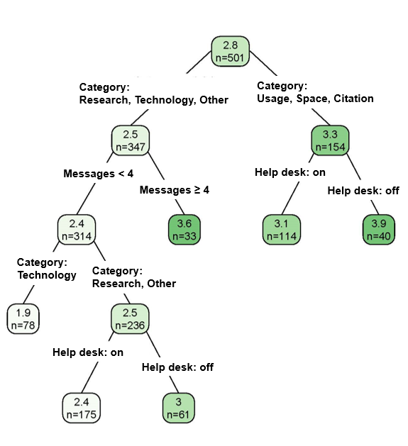
Note. The darker the green color of the node branch, the higher the user's rating of the chatbot

4.3.3 Unanswered Questions
InboxZero questions refer to a set of inquiries that users submitted to the chatbot but for which the chatbot was unable to provide answers. During the study period from July 1, 2019, to March 31, 2023, a total of 3,254 questions remained unanswered. Figure 10 illustrates a bar plot diagram depicting the frequency of terms in InboxZero questions
Figure 10. Bar Plot Diagram of Frequency Terms from InboxZero Questions
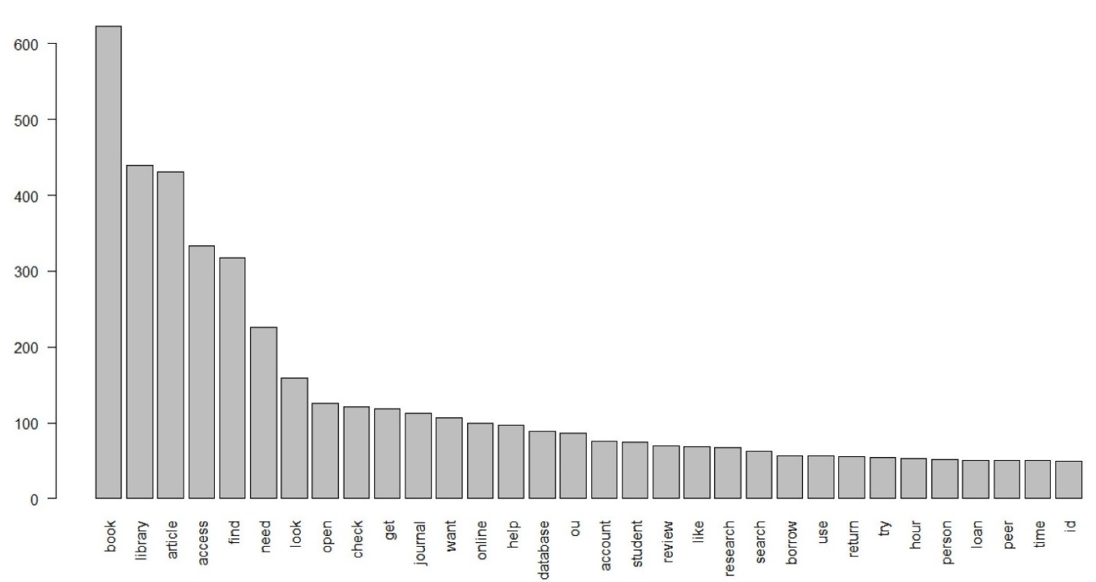
A topic modeling analysis was conducted using Latent Dirichlet Allocation (LDA) with R to identify the topics of these unanswered questions. Unanswered questions of 3,254 were prepared and loaded into R. Punctuation, stop words (and, the, etc.) and numbers were removed during the pre-processing stage. Document term matrix (DTM) was created and used for LDA. In the course of LDA, the parameter denoting the number of topics, k, was determined to be 11 based on coherence scores. The highest coherence score was 18, but the resulting number of topics was considered excessive. Therefore, the second highest coherence score of 11 was chosen (see Figure 11).
Figure 11. Best Topic by Coherence Score
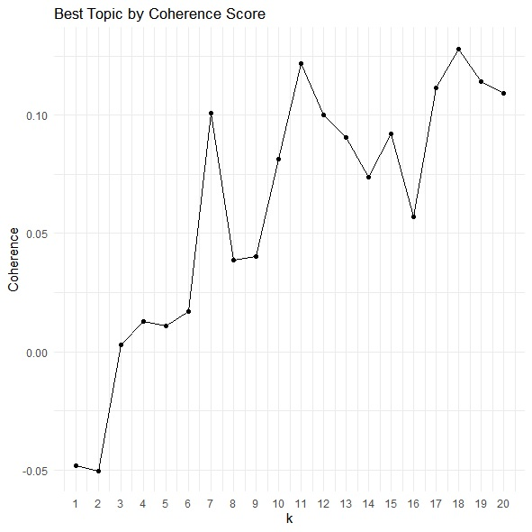
After running LDA, the top 20 terms were presented which described what the topic was about for each topic (see Figure12).
Figure 12. Eleven Topics Using Latent Dirichlet Allocation
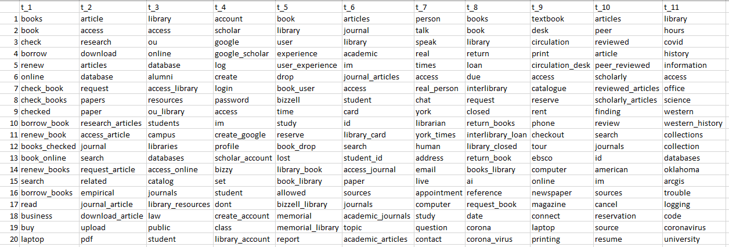

The Dendrogram shows which topics were close to each other in the meaning (see Figure 13)

Figure 13. Cluster Dendrogram
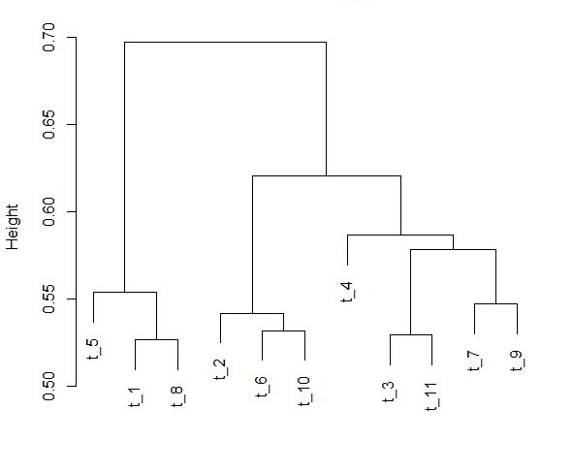

As shown in Figure 13, examining topics in the Dendrogram from left to right, the following order is observed:
t_5: Experiences related to the Bizzell Memorial Library (Bizzell Memorial Library, study, user experience, allowed)
t_1: Library operations and patron interactions (borrow books, check out books, renew books)
t_8: Library services, operations, and environmental factors (request book, interlibrary loan, corona, corona virus, library closed)
t_2: Academic research and scholarly publication using databases or journals (research, database, journal, article, download article)
t_6: Library access and services for academic journals (articles, id, library card, student id, access journal, academic articles)
t_10: Library services and resources for textbooks (textbook, circulation desk, reserve, rent, phone)
t_4: Account management and access (account, create, login, password, access, library account)
t_3: Library access and resources at OU campus (OU, online, alumni, access library, resources,
OU library)
t_11: Access of Western History Collections and technical issues (hours, access, office, western history, trouble, logging, code)
t_7: Interactions with a human librarian (person, talk, speak, real, real person, human, appointment, contact)
t_9: Library services provided by the circulation desk (textbook, circulation desk, reserve, rent, computer, laptop, printing)
Figure 14 shows the number of InboxZero questions per year. After the implementation of the chatbot on July 1, 2019, the year 2020 experienced the highest number of unanswered questions as OU Libraries was closed due to COVID-19. Afterwards, the number of unanswered questions was observed to decrease each year.
Figure 14. Number of InboxZero Questions per Year

Note. The data for 2019 and 2023 are only available from July to December and from January to March, respectively.

4.3.4 Users’ Comments
As Table 13 shows, chatbot users provided more negative than positive comments about chatbot performance. Comments are reviewed with negative feedback first, followed by positive feedback.
Table 13. Users’ Rating Who Left Comments
Rating | 1  (Very dissatisfied) | 2  (Dissatisfied) | 3  (Neutral) | 4  (Satisfied) | 5  (Very Satisfied) | Total
Frequency | 17 | 9 | 4 | 1 | 4 | 35

A total of 35 users left comments about the chatbot among those who rated the chatbot conversation. The most frequently occurring rating is 1 (Very dissatisfied), observed 17 times, followed by 2 (Dissatisfied) with 9 instances. Next in sequence, 3 (Neutral) and 5 (Very Satisfied) both have 4 occurrences each, while the rating with the lowest frequency is 4 (Satisfied) with 1 instance (see Table 13).
Comments with Negative Ratings
Inability to Provide the Desired Response to Users' Questions
When the chatbot failed to provide the desired responses, four users rated it with 1 star and three users rated it with 2 stars. Consequently, they expressed their disappointment by leaving the following comments;
①: “I said that I was having difficulties accessing database files but it just told me
where to find them.” (Apr 5, 2020, 4:38 PM EST)
Figure 15 shows that the chatbot failed to recognize the user's real issue, which was having difficulties in accessing the database but the chatbot only provided guidance on finding the database.
Figure 15. Chat Transcripts of the User who Left the Comment ①
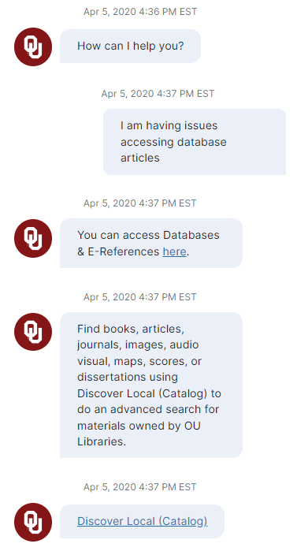

②: “Bizzy did not know if there was a laminating machine in the library.”
(May 13, 2022, 8:42 AM EST)
Figure 16 shows the chatbot could not provide the information on “laminating machine” in the library but provided links to several other library resources instead. In such cases, some individuals requested succinct and to-the-point responses.

Figure 16. Chat Transcripts of the User who Left the Comment ②
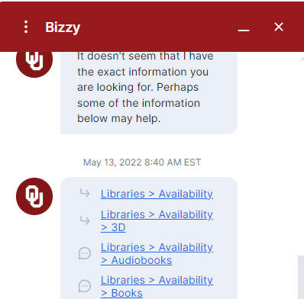
Failure to Provide Updated Information
Two people commented that the information provided by the chatbot was out of date and had not been updated, so they both gave the chatbot 2-star rating.
③: "The help links suggested by the AI led to pages that could not be accessed."
(Jan 24, 2020, 7:10 PM EST)
The e-books link in Figure 17 is currently functioning properly after being updated, but on January 24, 2020, the link was broken and could not be accessed.

Figure 17. Chat Transcripts of the User who Left the Comment ③
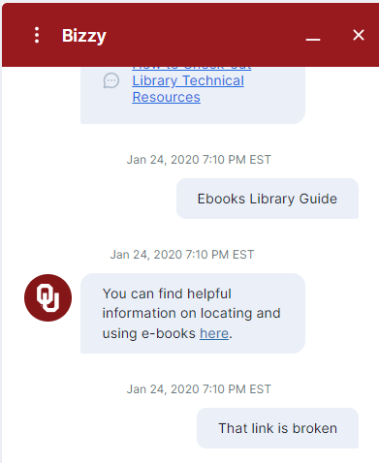

Users Seeking Assistance from a Real Person
④: “I would like to be directed from here to a way to contact a person, since the bot
could not answer my question.” (Oct 3, 2021, 6:04 PM EST)

Figure 18. Chat Transcripts of the User who Left the Comment ④
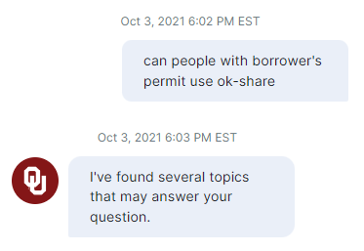
Comments with Positive Ratings
Multilingual Support
The chatbot’s multilingual support enables users to access information easily in their preferred language by selecting languages on the right side of the chat window (see Figure 19). Figure 20 shows the transcript of chatting in Arabic and English. The users rated the chatbot with 5 stars, and left the following comment:
⑤: “Awesome! I loved the multilingual support.” (Jul 25, 2019, 10:01 AM EST)
Figure 19. Part of Chat Window with the Language Selecting Button
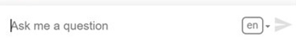
If users wish to chat with the chatbot only in the language of their choice, they can change their language settings by clicking the language button on the right side of the chat window and selecting their preferred language (see Figure 19).
Figure 20. Chat Transcripts in Arabic and English
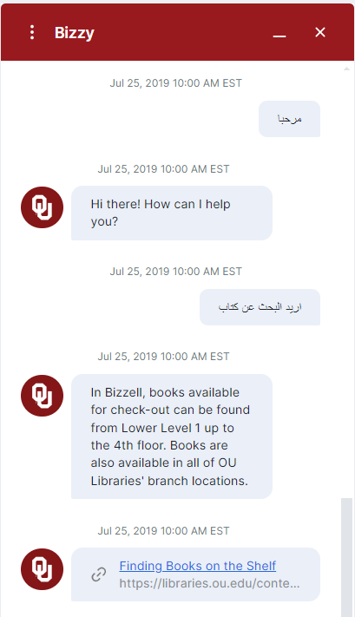
In Figure 20, the first Arabic phrase "مرحب" translates to "Welcome" in English, while the second phrase "اريد البحث عن كتاب" translates to "I want to search for a book."
Efficient Search
Some users were very satisfied with the chatbot’s performance and left following comments:
⑥: “Quick and efficient. Provided a link, which was helpful.”(Jul 25, 2019, 10:00 AM EST)
⑦: “Gave me exactly what I need (with a link).” (Jun 24, 2020, 3:53 PM EST)
The chat transcript in Figure 21 shows that chatbot efficiently provided users with the information, eliminating the need to navigate through the entire library website.
Figure 21. Chat Transcripts of the User who Left the Comment ⑦
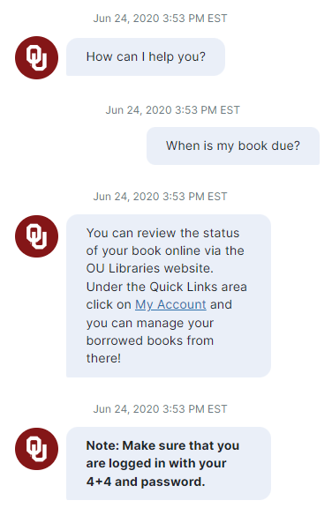

CHAPTER 5: DISCUSSION

5.1 Implementation of AI Chatbot

5.1.1 Two Types of Chatbots: Original and Ivy.ai
Unknown to many, OU Libraries developed its own AI chatbot using API.AI, applying natural language processing, even before using the Ivy.ai chatbot. It took approximately 8 months in total to develop and implement the original chatbot, with the technical part taking about 6 months. OU Libraries had to build one from scratch because there was not an out-of-the-box solution available, something already built for them. They started building a chatbot using API.AI. After being acquired by Google, API.AI was renamed Dialogflow in October 2017, subsequently integrated into the Google Cloud Platform in November 2017 (Dialogflow Release Notes, n.d.). The current Google Cloud Website describes Dialogflow as “a natural language understanding platform that makes it easy to design and integrate a conversational user interface into the mobile app, web application, device, bot, interactive voice response system, and so on” (Dialogflow Documentation, n.d.).
Unlike other University Libraries that used Dialogflow (Reinsfelder & O’Hara-Krebs, 2023; Rodriguez & Mune, 2021), OU Libraries had to build a chatbot from the ground up. When they began this project, they had some resources for natural language processing, including a small database from API.AI, enabling basic conversation functionalities like greetings. However, they lacked resources specifically tailored to the needs of OU Libraries. As a solution, what they came up with was to utilize LibChat transcription, which consists of questions asked by users of OU Libraries to library staff or reference librarians. They utilized historical data obtained from LibChat over the preceding three years, readily accessible for their use. Part of the challenge was figuring out how to integrate the data into the brain of the chatbot, and they successfully reformatted the data into a JSON file structure and seamlessly integrated it into the existing natural language processing database.
The AI chatbot was developed in collaboration with faculty, students, and the library team of the OU School of Library and Information Studies (SLIS). In courses for master's students, the library Web Services team came over to explain and demonstrate an AI chatbot under development, showcasing how AI technology is being utilized in library settings. These courses prompted SLIS master's students to participate in chatbot training sessions, where they posed various questions to the chatbot, helping it build new knowledge. Furthermore, collaboration with SLIS faculty facilitated the enhancement of the chatbot's reference services by incorporating the knowledge from faculty. Figure 22 illustrates the reciprocal collaboration between Web Services and reference services at OU Libraries, and SLIS faculty and students in developing the chatbot.

Figure 22. Collaboration in Creating OU Libraries’ AI Chatbot
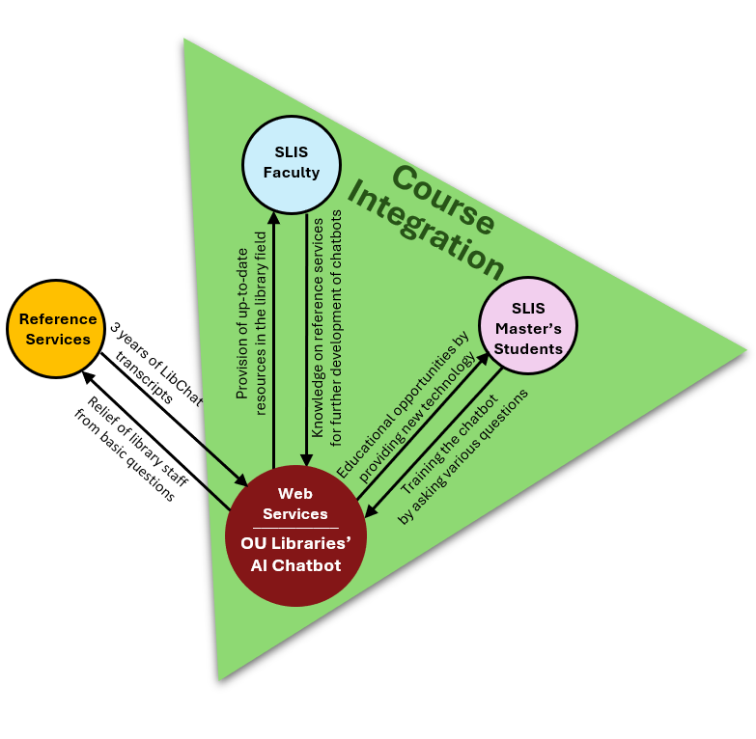
Other libraries utilized various resources to train their chatbots. SJSU used the library’s LibAnswer frequently asked questions (FAQ) pages, reference email interactions, chat reference and circulation desk transcripts, website and LibGuides analytics for frequently accessed pages and search terms (Rodriguez & Mune, 2022). Penn State University Libraries used a complete review of more than 200 FAQs in preparation for integrating the current chatbot by removing obsolete items, including additional keywords, and assigning topics to published FAQs (Reinsfelder & O’Hara-Krebs, 2023).
OU Libraries decided not to collect any personally identifiable information for the original chatbot, and to not use certain data to protect the privacy of library users. Despite possibilities for more tailored responses and follow-up questions, they chose not to implement them due to limited data collection. Furthermore, they developed an Alexa skill to integrate with the chatbot, allowing freshmen to interact with the chatbot via Alexa devices installed in their dorms. Although it was functional and initially tested, concerns about privacy led the libraries not to proceed with this integration. Despite the existing presence of Alexa devices in dorm rooms, the libraries discontinued this project.
Lehman College's Leonard Lief Library was drawn to Ivy's sophisticated design and anticipated ease of maintenance (Ehrenpreis & DeLooper, 2022). Likewise, OU Libraries chose Ivy.ai chatbot because of its expected minimal maintenance requirements, and the libraries was able to save a considerable amount of time after utilizing the Ivy.ai chatbot.
Figure 23. Greeting from OU Libraries Chatbot, Bizzy
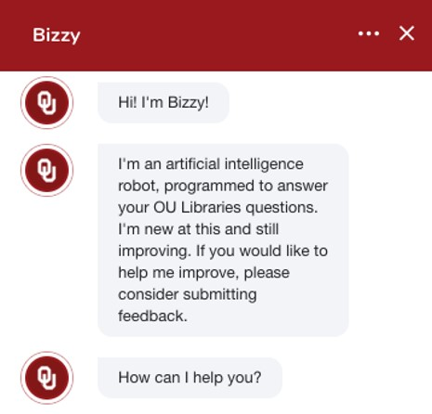
Institutions employing Ivy.ai have the ability to tailor their chatbots to embody a mascot or concept that resonates with the identity of the institution (Ehrenpreis & DeLooper, 2022). Bizzy uses the white OU logo within a crimson-colored circle, representing the University of Oklahoma's colors (see Figure 23). “Bizzy,” the name of the chatbot, came from students’ nickname for the university's main library, Bizzell Memorial Library, and the final decision was made by the libraries' senior management voting on the name Bizzy.

5.1.2 Benefits of AI Chatbots
The integration of chatbots into libraries offers numerous advantages. In the case of OU Libraries, the idea of implementing a chatbot originated from recognizing the limitations of the existing live chat, which only operated during research librarians' working hours. For the purpose of providing services to people in need at any time, OU Libraries implemented a chatbot on the library website. The chatbot's 24/7 availability improves the user experience by answering questions after hours or when the librarian is not available (Ehrenpreis & DeLooper, 2022; McNeal & Newyear , 2013).
“The chatbot would provide that anonymity that they could be anonymous, and they didn't have to ask a real-life person, they didn't have to feel judged, or they could just asking as many as they wanted and never feel like they are burdening a person or taking their time while they are at work.” (CLOVA Note 21:10)
What was mentioned above by the interviewee was well reflected in Mellon (2015)’s study on students who experience some “library anxiety”. “I’m shy and afraid to ask questions.” wrote a student, while another explained, “I didn’t want to bother anyone. I also didn’t want them to think I was stupid.” Thus, chatbots can provide anonymity to individuals who find it difficult to ask questions and share their concerns with others, enabling them to feel more comfortable and freely ask questions without any pressure. Rodriguez and Mune (2022) state San Jose State University Library chatbot enables patrons to connect with the library comfortably and anonymously. These studies also align well with the finding that more college students prefer online to face-to-face professional help (Lungu & Sun, 2016).
According to International Student Services (2024), the total number of enrolled international students at the University of Oklahoma for Spring 2024 is 1,564. These international students often face challenges when using OU Libraries. Butcher and McGrath (2004) address the various barriers and educational needs faced by international students, including language skills, completing assignments, and conducting research. Chatbots provide a means for international students to obtain information quickly and efficiently, allowing them to maximize their learning potential and continue their studies without having to meet a live person due to language or cultural barriers (Wang et al., 2023). Bizzy offers multilingual support, so users can communicate with the chatbot in their own language. This helps them alleviate the stress of not being understood due to difficulties with English pronunciation when meeting with a librarian in person to seek assistance.
Patrons can benefit from chatbot functionality that relieves the information overload experienced on library websites and provides short, direct answers to users (Allison, 2012; Mckie & Narayan, 2019). Searching for library resources using a chatbot can provide substantial benefits to users, especially those who are inexperienced and unfamiliar with online catalogs and databases (McPherson, 2015). In addition, a chatbot’s usage of approachable non-professional, non-jargon language could be more appealing to younger individuals or those who are less familiar with library resources (Nawaz & Saldeen, 2020). Chatbots also have the potential to provide personalized support and tailored services to students, faculty, and staff (Alexander et al., 2019; Cox et al., 2019).

5.2 Usage Patterns of AI Chatbot
The duration of this study spans from July 1, 2019, to March 31, 2023, covering the COVID-19 pandemic period. As such, the annual records reflecting the impact of COVID-19 on the chatbot usage patterns, including monthly trends in the total number of conversations by year and devices used for the chatbot by year, will be discussed separately in Section 5.2.2 Impact of COVID-19. The other usage patterns will be addressed in Section 5.2.1.

5.2.1 General Usage Patterns
The chatbot usage pattern of the total number of conversations throughout the day showed fluctuations. Peak usage was between 9:00 AM and 12:00 PM. After 12:00 PM, usage gradually decreased, with a slight increase observed again between 15:00 and 16:00 before tapering off in the evening and night hours. This result reflected the greater need for support during certain times of the day. While the total number of conversations remained modest in comparison to the that of operational hours of the library, it was evident that users sought assistance by engaging with the chatbot when the library was closed, and direct assistance from librarians was unavailable. This underscores a notable advantage of integrating chatbots within library services, as chatbots can offer 24/7 accessibility, when in-person service is not feasible (McNeal & Newyear , 2013). This aligns with the findings of section 4.3.2 Regression Tree Analysis of Important Factors Affecting Chatbot Evaluation in this study. Specifically, utilizing the chatbot during times when the help desk is unavailable resulted in higher ratings of the chatbot across most categories of the questions (“Usage”, “Space” and “Other” categories of questions; “Research” and “Other” categories of questions with fewer than 4 messages), compared to using the chatbot during times when the help desk was available (see Figure 1).
In examining the total number of conversations for the week, it is evident that there was typically a greater number of conversations occurred from Monday through Thursday in comparison to Friday, Saturday, and Sunday. The total number of conversations notably declined during weekends, with Saturday recording the lowest figure at 812 and Sunday marginally higher at 1203. This sharp decline in the total number of conversations on weekends suggests that people were less likely to engage in academic-related activities using chatbot during weekends compared to weekdays (see Figure 2).
Chat length is determined by the time difference between the start and end of each chat. To exclude instances of prolonged chatbot idleness, approximately 95% (9898) of all conversations in which the chatbot actively participated were considered, limited to chat sessions lasting up to 300 seconds or 5 minutes (see Figure 4). Of the 10,397 total conversations, 5,416 (52%) occurred within 30 seconds. The total number of conversations decreased as the duration increased up to around 13 seconds, where it peaked at 302. Afterward, the total number of conversations gradually decreased, with some fluctuations, until it stabilized at around 144 for durations of 30 seconds (see Figure 5).
The total number of conversations based on the number of messages sent to the chatbot indicates that the majority, approximately 70% (7236 counts), consisted of only one message. Following this, approximately 18%, 5.3%, 2.3%, and 1% involve two, three, four, and five messages, respectively. Thus approximately 96.6% of the total number of conversations consists of sending 1 to 5 messages to the chatbot (see Figure 6).

5.2.2 Impact of COVID-19
In the line graph in Figure 3, which shows monthly trends in the total number of conversations by year, the sharpest spike occurred between 180 in February 2020 and 391 in March 2020. The primary reason for this increase appeared to be the spread of the COVID-19. OU Libraries closed all library buildings and transitioned all services online, starting from Monday, March 23, 2020, following OU's spring break (Eddlemon, 2020). During the COVID-19 pandemic, social distancing was a key public health policy intervention to reduce the spread of the virus (Williams et al., 2020). Huang and Kao (2021) find that as customers perceive chatbot services as useful for maintaining social distancing measures, their propensity to engage with the chatbot increased during times of pandemic. Another contributing factor to the sharp rise in chatbot conversations would be the operational hours of the chatbot. From July 1, 2019, to March 8, 2020, the chatbot operated only between 7 PM and 10 AM. However, starting from March 9, 2020, the chatbot service has been available 24/7, leading to a rapid increase in the total number of conversations.
The total number of chatbot conversations decreased in 2022 compared to previous years, which appears to be related to the end of the COVID-19 pandemic. Many classes shifted online due to the pandemic, but in 2022, library services, along with nearly all classes, reverted to in-person instruction, leading to more students seeking direct assistance from library staff. Other academic libraries' data also show a decrease in chatbot usage following the transition of library services to in-person after the COVID-19 period. From March 14, 2020, to March 14, 2021, the chatbot at City University of New York Lehman College's Leonard Lief Library recorded a total of 3,699 sessions, recorded a total of 3,699 sessions, with a daily mean of 10.1, during a period when classes were entirely online. Subsequently, from March 15, 2021, to March 15, 2022, chat sessions decreased to 2,810, with a daily mean of 7.7. Monthly distributions over these time periods (Ehrenpreis & DeLooper, 2022). In addition, the chatbot of San Jose State University Library showed a 24% decrease in usage as the campus resumed in-person classes (Rodriguez & Mune, 2022).
The usage patterns by month were likely to be influenced by the academic calendar. Chatbot activity tended to be low during the summer months of June and July, but gradually increased as the fall semester began in August. Chatbot usage typically peaked in September and gradually declined through December as the winter break approached.
Over the past few years, accessing chatbots via desktop computers accounted for approximately 92% of the total usage, surpassing mobile or other methods. There is a noticeable rise of chatbot usage via desktop computer from 2019 to 2020, with a peak observed during 2020, even considering the data for 2019 only being available for partial periods (July to December). This surge coincides with the rapid increase in chatbot usage following the closure of OU Libraries during the COVID-19 pandemic. However, desktop access to chatbots showed a decline in subsequent years (see Figure 7).
Consequently, as face-to-face library services were suspended during the COVID-19 pandemic, the use of chatbots that serve as alternative information providers has increased significantly. In the meantime, the spread of misinformation about the new Coronavirus has caused considerable confusion and anxiety among the public. To address this issue, OU Libraries took action by first feeding the chatbot with accurate COVID-19 related information, then placed a banner linking directly to reliable COVID-19 information at the top of the chatbot interface so that people can easily access the information about the COVID-19 (see Figure 24).
Figure 24. COVID-19 Banner on Chatbot Window
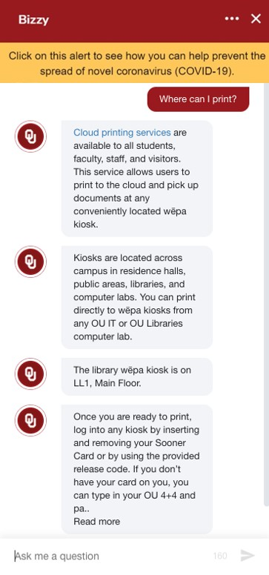

5.3 Users’ Evaluation of AI Chatbot

5.3.1 Issues with the Ivy.ai Chatbot
Words have many different meanings. However, Ivy.ai 1.0 sometimes does not properly understand the context of user questions and provides incorrect answers to users. For example, a library user wanted to find out the information for the “fine” for overdue books, but the chatbot provided information about “fine art”. The library’s fine information for the overdue books are one of the frequently asked questions (FAQ), which content can be manually added easily. In these cases, it is important to add the content of questions asked by users. It is also advisable to thoroughly review the library's FAQ list to ensure that no important information has been missing, updates have been implemented, and to be prepared to proactively respond to potential questions.
When a chatbot cannot provide an accurate answer to a question, the chatbot often provides information and links on similar topics. However, in the case of Ivy.1.0, in many cases, this information is insufficient and does not always provide relevant information. It is recommended to establish connections to receive human assistance as quickly as possible for problem-solving. Additionally, the results of this study suggest that chatbots should be designed more elaborately to accurately reflect user intentions, as chatbot satisfaction tends to increase as user intervention becomes more active depending on the type of question.
According to the upgraded IvyQuantum (Ai Web Crawler, n.d.), the chatbot crawls and syncs the web properties on a daily basis to make sure that the chatbot reflects website updates accurately. However, in the event of a large-scale update, such as website reconstruction, substantial challenges arise. For the previous website, library staff handled user inquiries by manually creating numerous “custom responses” to questions the chatbot could not answer with links to the website for more information. However, when “custom responses” are applied to a newly built website, “custom responses” always take precedence over new information crawled by the chatbot. Consequently, since numerous link changes are likely to occur during the website reconstruction, the chatbot will potentially lead users to error pages with old links that have not been updated. In these cases, it is recommended to completely remove the existing “custom responses” and selectively reapply them after updating the links and content.

CHAPTER 6: CONCLUSIONS
This study investigated the AI chatbot integration at OU Libraries through mixed methods. The implementation of the OU Libraries' chatbot was achieved by overcoming difficulties through various collaborations between staff, faculty, and students. The total number of monthly chatbot conversations tended to be influenced by the overall academic calendar of OU, while the total number of daily and weekly chatbot conversations appeared to be influenced by the users' life patterns. The evaluation of chatbot performance by users was found to be affected by question category, number of messages sent to the chatbot, and whether the help desk was in operation. Based on the results of the study, this chapter provides recommendations that can benefit academic libraries and other organizations planning to implement AI chatbots, as well as directions for future research.

6.1 Recommendations for Practice
This study suggests the following recommendations for organizations considering the implementation of AI chatbots. First, it would be most desirable to form a dedicated chatbot implementation team, consisting of developers, information studies majors, library staff who can continuously monitor interactions between the chatbots and users, and senior management. In particular, information studies majors who are experts on library circumstances including library organization, culture, and rules, will greatly contribute to enhancing the chatbot's capabilities and resolving user requirements more effectively. In the early stages of implementing a chatbot, there may be numerous unanswered questions, and it may take more time to prepare answers. Therefore, it is particularly important to have a person who can devote their time to the chatbot so that they can continuously monitor and handle inquiries. Additionally, it is essential for senior management on the board to continue to collaborate within or communicate with the team. This ensures that the team has support from across the organization and that work moves forward rapidly.
Second, it is necessary to design and manage a system so that users can swiftly receive answers to questions that chatbots could not provide answers to. If a chatbot is unable to answer the question or a user requests human assistance, it is important to respond quickly and minimize user’s waiting time. To facilitate this process, a system is required to designate a person in charge based on the content of the inquiry and automatically send the user’s questions to the person in charge. If the responsible person is not assigned or unclear, a chatbot manager should report the problem in a team meeting so that the team members can work together to find solutions. Additionally, the chatbot manager need to monitor who is responsible for unanswered questions, how much progress has been made, and build the workflows associated with these questions and contacts so that this process can be done effectively.
Third, chatbot managers are encouraged to promptly handle user requests for tasks of low complexity, leveraging the fast acquisition of user feedback facilitated by chatbots. For example, OU Libraries received numerous complaints about the pop-up feature of the chatbot at the beginning of chatbot implementation, because the default settings caused pop-ups to continue appearing, which bothered users from freely navigating the library website. Accordingly, the chatbot manager quickly changed the setting so that users can activate the chatbot when needed.
Fourth, it is recommended to actively utilize the content of the chatbot’s questions. Not only can chatbots provide good guidance on frequently asked questions, but they can also be used to rearrange content on an organization's website so that users can easily access information they want. The content of questions that the chatbot cannot provide answers to is also very useful. If there is no existing content on the website or chatbot, new content should be created to enhance the chatbot functionality and optimize its utilization.
Lastly, following the COVID-19 pandemic, there has been a rapid increase in the number of international students pursuing higher education in the United States. However, many international students are unaware of the convenient multilingual support features offered by chatbots, thus are unable to utilize them. Therefore, it is recommended to include and promote this feature on the chatbot’s welcome screen to inform users and encourage its utilization.

6.2 Future Research
AI is rapidly evolving, and the landscape is changing extremely fast. This study utilized chatbot log data from Ivy.ai 1.0, a retrieval-based AI system driven by a multi-label classification algorithm, contributing to knowledge about the early stages of AI chatbot development before applying generative AI techniques. Starting April 3, 2023, Ivy.ai introduced the upgraded IvyQuantum chatbot, which leveraged OpenAI’s GPT-4 models to generate responses by integrating the data from Ivy’s AI-powered semantic search engine. Several suggestions for future research directions can be started here.
The upgraded Ivy.ai can be further investigated through user surveys as well as chatbot log data. The survey results will provide the user experiences on the upgraded chatbot system including users’ evaluations of the chatbot performance. The research on chatbot usage in library environments across diverse user demographics, including age groups, fields of study, undergraduate students, master's and doctoral students, faculty, and library staff, will provide insight into the experiences of different chatbot usage according to various purposes and needs.

This study examined 501 chatbot transcripts for those with user ratings and 3,254 unanswered questions. However, there is a much larger volume of transcripts available, which needs to be explored. A comprehensive investigation of this data is expected to provide deeper understanding of user interactions, preferences, and needs that can be leveraged to improve user experience. Furthermore, transcript analysis can be a valuable asset in improving library operational efficiency, influencing decision-making processes and service delivery.
As AI chatbots continue to develop, they will be integrated with various technologies such as voice search, Internet of Things (IoT), providing users with more convenient and personalized services. Therefore, research related to ethical considerations including privacy protection and algorithmic bias becomes increasingly important. The future of AI chatbots in libraries will present substantial opportunities to transform library services only if research and development continue, while considering the limitations of these AI chatbots.

REFERENCES
Adetayo, A. J. (2023). ChatGPT and librarians for reference consultations. Internet Reference Services Quarterly, 27(3), 131-147. https://doi.org/10.1080/10875301.2023.2203681
Ivy.ai. (n.d.). AI web crawler. https://ivy.ai/ai-web-crawler
Aithal, S., & Aithal, P. S. (2023). Effects of AI-based ChatGPT on higher education libraries.
International Journal of Management, Technology, and Social Sciences, 8(2), 95-108. https://doi.org/10.2139/ssrn.4453581
Alexander, B., Ashford-Rowe, K., Barajas-Murphy, N., Dobbin, G., Knott, J., McCormack, M., Pomerantz, J., Seilhamer, R., & Weber, N. (2019). EDUCAUSE Horizon Report: 2019 Higher Education Edition. EDUCAUSE. https://www.learntechlib.org/p/208644/
Allison, D. (2012). Chatbots in the library: Is it time? Library Hi Tech, 30(1), 95–107. https://doi-org.ezproxy.lib.ou.edu/10.1108/07378831211213238
Breiman, L., Friedman, J., Stone, C. J., & Olshen, R. A. (1984). Classification and regression trees. CRC Press.
Butcher, A., & McGrath, T. (2004). International students in New Zealand: Needs and responses. International Education Journal, 5(4), 540-551.
Sheble, L., Wildemuth, B. M., & Brennan, K. (2017). Transaction Logs. In B. M. Wildemuth
(Ed.), Applications of social research methods to questions in information and library
science, (2nd ed., pp. 185-197). Libraries Unlimited.
Christensen, A. (2008, November 5). A trend from Germany: Library chatbots in electronic reference. https://www.slideshare.net/xenzen/a-trend-from-germany-library-chatbots-in-electronic-reference-presentation
Cox, A. M., Pinfield, S., & Rutter, S. (2019). The intelligent library: Thought leaders’ views on the likely impact of artificial intelligence on academic libraries. Library Hi Tech, 37(3), 418-435. https://doi.org/10.1108/LHT-08-2018-0105
Google Cloud. (n.d.). Dialogflow Documentation. https://cloud.google.com/dialogflow/docs
Google Cloud. (n.d.). Dialogflow release notes. https://cloud.google.com/dialogflow/docs/
release-notes
Eddlemon, E. (2020, March 24). OU Libraries expand virtual services following COVID-19 closures. OU Daily. https://www.oudaily.com/culture/ou-libraries-expand-virtual-services-following-covid-19-closures/article_9558469e-6e0f-11ea-ba36-7b054245b0a3.html
Ehrenpreis, M., & DeLooper, J. (2022). Implementing a chatbot on a library website. Journal of Web Librarianship, 16(2), 120-142.
Friedman, A. (2022, December 6). AI chatbot predicted to replace Google in a couple of years. https://www.phonearena.com/news/ai-chatbot-could-replace-google-soon_id144120
Generative chatbots for higher education, healthcare and government. (n.d.). Ivy.ai. Retrieved May 1, 2024, https://ivy.ai/generative-chatbot
Gilson, A., Safranek, C., Huang, T., Socrates, V., Chi, L., Taylor, R. A., & Chartash, D. (2022). How does ChatGPT perform on the medical licensing exams? The implications of large language models for medical education and knowledge assessment. MedRxiv, 2022-12. https://doi.org/10.1101/2022.12.23.22283901
Gujral, G., Shivarama, J., & Choukimath, P. A. (2019). Perceptions and prospects of artificial intelligence technologies for academic libraries: An overview of global trends. 12th International Caliber, 79-88.
Huang, Y. S., & Kao, W. K. (2021). Chatbot service usage during a pandemic: Fear and social
distancing. The Service Industries Journal, 41(13-14), 964-984.
International Student Services. (2024, March 11). International student statistics. http://www.ou.edu/cis/iss/students/about/international-student-statistics.html
Chatbots features. (n.d.). Ivy.ai. Retrieved April 24, 2021, from https://ivy.ai/features/chatbot
Jansen, B. J. (2006). Search log analysis: What it is, what’s been done, how to do it. Library & Information Science Research, 28(3), 407-432.
Kane, D. (2016). The role of chatbots in teaching and learning. E-Learning and the Academic Library: Essays on Innovative Initiatives, 131.
Levy, S. (2023). Responsible AI via responsible large language models, University of California, Santa Barbara.
Lund, B. D., Omame, I., Tijani, S., & Agbaji, D. (2020). Perceptions toward artificial intelligence among academic library employees and alignment with the diffusion of innovations’ adopter categories. College & Research Libraries, 81(5), 865-882. https://doi.org/10.5860/crl.81.5.865
Lund, B. D., & Wang, T. (2023). Chatting about ChatGPT: How may AI and GPT impact academia and libraries? Library Hi Tech News, 40(3), 26-29. https://doi.org/10.1108/LHTN-01-2023-0009
Lungu, A., & Sun, M. (2016). Time for a change: College students’ preference for technology-mediated versus face-to-face help for emotional distress implementation progress. Telemedicine and E-Health, 22(12), 991-1000. https://doi.org/10.1089/tmj.2015.0214
Marietto, M. das G. B., de Aguiar, R. V., Barbosa, G. de O., Botelho, W. T., Pimentel, E., Franca, R. dos S., & da Silva, V. L. (2013). Artificial intelligence markup language: A brief tutorial. arXiv Preprint arXiv:1307.3091. https://doi.org/10.48550/arXiv.1307.3091
Mckie, I. A. S., & Narayan, B. (2019). Enhancing the academic library experience with chatbots: An exploration of research and implications for practice. Journal of the Australian Library and Information Association, 68(3), 268-277.
McNeal, M. L., & Newyear, D. (2013). Introducing chatbots in libraries. Library Technology Reports, 49(8), 5-10.
McPherson, M. (2015). Library anxiety among university students: A survey. IFLA journal, 41(4), 317-325.
Mellon, C. A. (2015). Library anxiety: A grounded theory and its development. College & Research Libraries, 76(3), 276-282.
Nawaz, N., & Saldeen, M. A. (2020). Artificial intelligence chatbots for library reference services. Journal of Management Information and Decision Sciences, 23, 442-449.
Panda, S., & Chakravarty, R. (2022). Adapting intelligent information services in libraries: A case of smart AI chatbots. Library Hi Tech News, 39(1), 12-15.
Pereira, J., & Díaz, Ó. (2018). Chatbot dimensions that matter: Lessons from the Trenches. In T. Mikkonen, R. Klamma, & J. Hernández (Eds.), Web Engineering (Vol. 10845, pp. 129-135). Springer International Publishing. https://doi.org/10.1007/978-3-319-91662-0_9
Reinsfelder, T. L., & O’Hara-Krebs, K. (2023). Implementing a rules-based chatbot for reference service at a large university library. Journal of Web Librarianship, 17(4), 95-109. https://doi.org/10.1080/19322909.2023.2268832
Rivolli, A., Amaral, C., Guardão, L., De Sá, C. R., & Soares, C. (2019). KnowBots: Discovering relevant patterns in chatbot dialogues. In P. Kralj Novak, T. Šmuc, & S. Džeroski (Eds.), Discovery Science (Vol. 11828, pp. 481–492). Springer International Publishing. https://doi.org/10.1007/978-3-030-33778-0_36
Rodriguez, S., & Mune, C. (2021). Library chatbots: Easier than you think. Computers in Libraries, 41(8), 29-32.
Rodriguez, S., & Mune, C. (2022). Uncoding library chatbots: Deploying a new virtual reference tool at the San Jose State University library. Reference Services Review, 50(3-4), 392-405. https://doi.org/10.1108/RSR-05-2022-0020
The University of Oklahoma. (2023, February 23). History. The University of Oklahoma. http://www.ou.edu/about/history
The University of Oklahoma Libraries. (2023). Impact Report 2022-2023. https://libraries.ou.edu /sites /default/files/2023-12/Annual%20Report%20FY%202023.pdf
Turing, A. M. (1950). Computing machinery and intelligence. http://human-nature.pbworks.com /f/Turing,+Computing+Machinery+and+Intelligence.pdf
University of Oklahoma Libraries. (n.d.). Introducing “Bizzy.” Retrieved January 30, 2023, from https://libraries.ou.edu/content/introducing-bizzy
Van Dis, E. A., Bollen, J., Zuidema, W., Van Rooij, R., & Bockting, C. L. (2023). ChatGPT: Five priorities for research. Nature, 614, 224-226.
Wallace, R. S. (2009). The anatomy of A.L.I.C.E. In R. Epstein, G. Roberts, & G. Beber (Eds.), Parsing the Turing Test: Philosophical and methodological issues in the quest for the thinking computer (pp. 181-210). Springer Netherlands. https://doi.org/10.1007/978-1-4020-6710-5_13
Wang, T., Lund, B. D., Marengo, A., Pagano, A., Mannuru, N. R., Teel, Z. A., & Pange, J. (2023). Exploring the potential impact of artificial intelligence (AI) on international students in higher education: Generative AI, chatbots, analytics, and international student success. Applied Sciences, 13(11), 6716. https://doi.org/10.3390/app13116716
Weizenbaum, J. (1966). ELIZA-a computer program for the study of natural language communication between man and machine. Communications of the ACM, 9(1), 36-45.
Williams, S. N., Armitage, C. J., Tampe, T., & Dienes, K. (2020). Public perceptions and
experiences of social distancing and social isolation during the COVID-19 pandemic: A UK-based focus group study. BMJ Open, 10(7), e039334.
Yin, R. K. (2018). Case study research and applications: Design and method (6th ed.). Sage Thousand Oaks.

APPENDIX A: Interview Questions
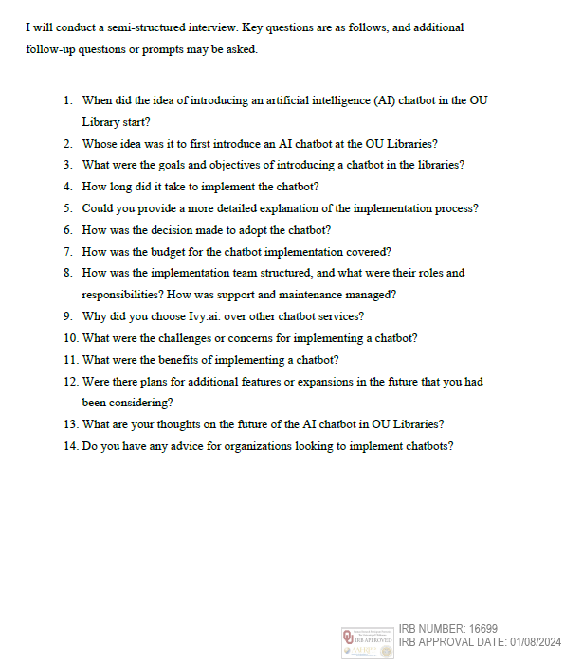

APPENDIX B: Informed Consent Form
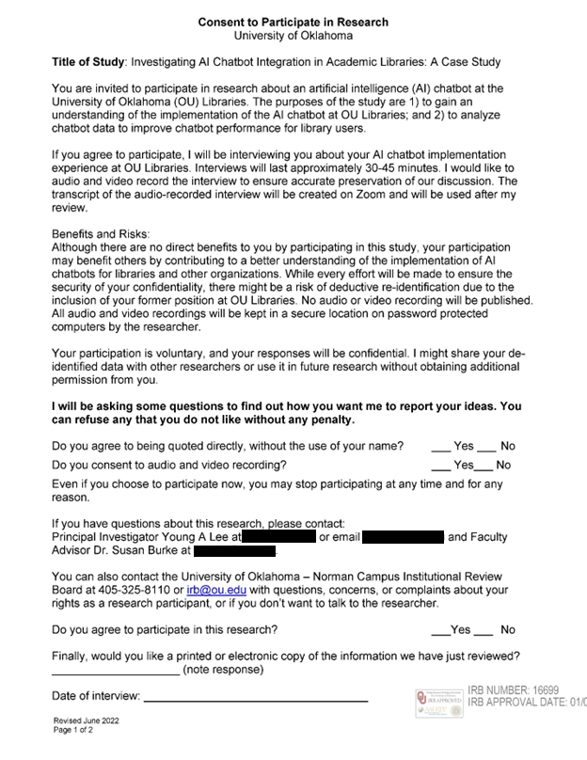
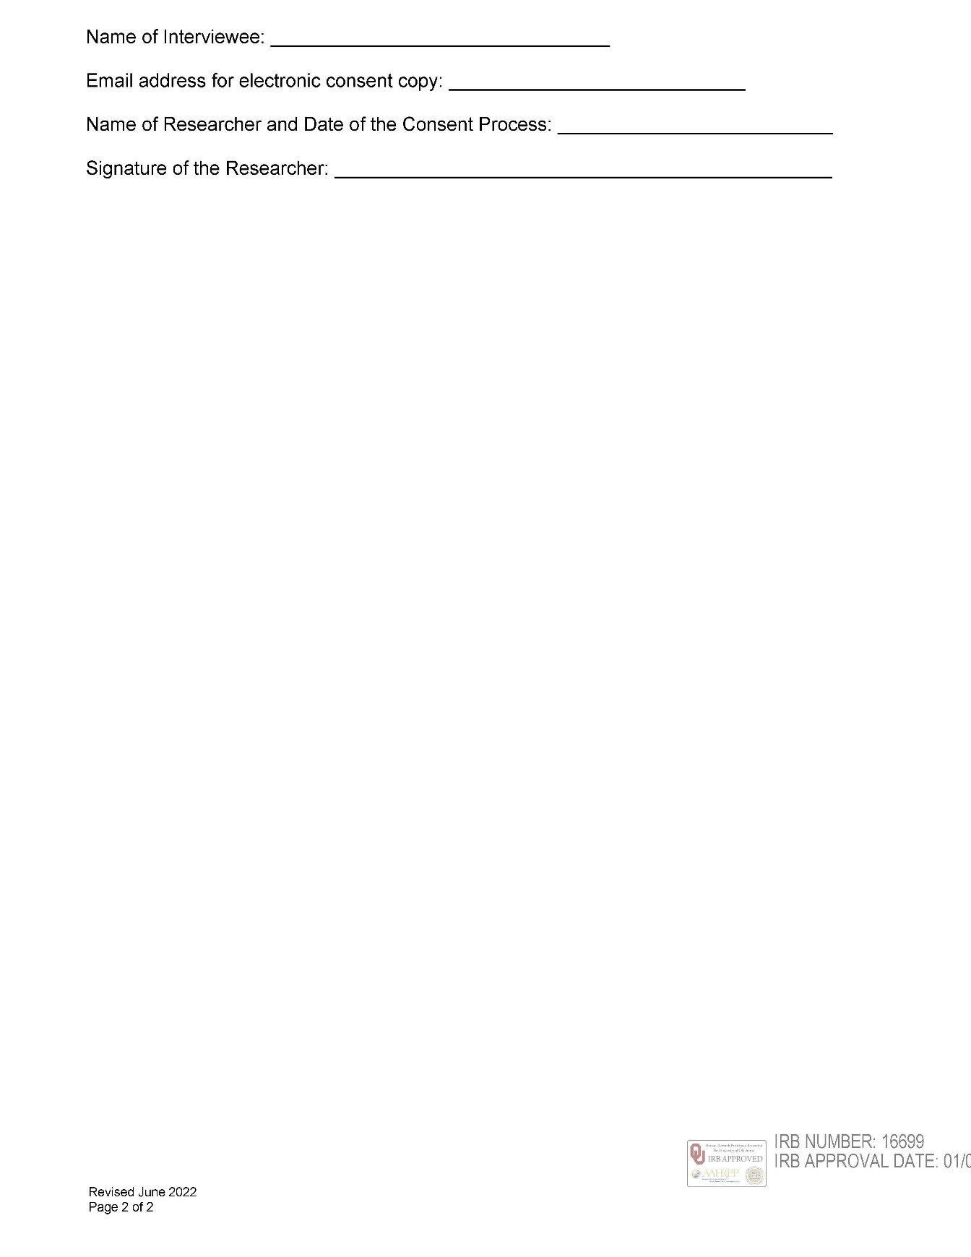

APPENDIX C: Approval of OU Libraries Chatbot Data Usage
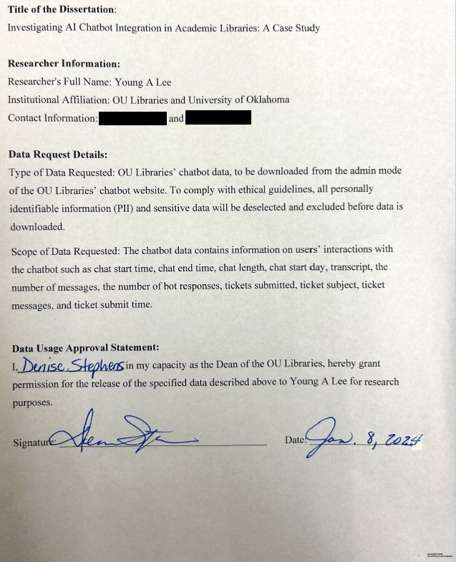

APPENDIX D:
Approval of IRB for the Protection of Human Subjects
