University of Oklahoma

Graduate College

THE ACUTE SKELETAL MUSCLE RESPONSE TO LOWER BODY RESISTANCE TRAINING WITH AND WITHOUT BLOOD FLOW RESTRICTION IN PHYSICALLY ACTIVE MALES BETWEEN THE AGES OF 18-35

A Dissertation

submitted to the Graduate Faculty

in partial fulfillment of the requirements for the

Degree of

Doctor of Philosophy

By

JEREMY PAUL LOENNEKE
Norman, Oklahoma
2014

THE ACUTE SKELETAL MUSCLE RESPONSE TO LOWER BODY RESISTANCE TRAINING WITH AND WITHOUT BLOOD FLOW RESTRICTION IN PHYSICALLY ACTIVE MALES BETWEEN THE AGES OF 18-35

A Dissertation approved for the
Department of Health and Exercise Science

By

______________________________
Dr. Michael G. Bemben, Chair

______________________________
Dr. Travis W. Beck

______________________________
Dr. Rebecca D. Larson

______________________________
Dr. Debra A. Bemben

______________________________
Dr. Rosemary Knapp

© Copyright by jeremy paul loenneke 2014
All Rights Reserved.

Acknowledgements
This dissertation would not have been possible without the help and support of several important people over the years. There is not enough time or space for me to acknowledge everyone, but I will give it my best effort.

Chris Fahs and Lindy Rossow (my surrogate parents), you are two of the most important people in my life. When I met you at the University of Illinois, I had no idea that you would have such a positive impact on me as a person. I feel lucky to have worked with two of my best friends for 3 years. Thank you for everything that you do and continue to do.

Dr. Mike Bemben, thank you for bringing me into the program and providing me with the tools necessary to be successful. Thank you for your continuous support and mentorship.

Dr. Takashi Abe (the greatest scientist to ever live), words can’t describe how much you mean to me. Thank you so much for all of your help, guidance, and friendship over the past few years. I have had a blast working with you and look forward to continuing our work in the future. Your quote “I understand your story…but need less talk…more write” will forever be my motto and constant reminder to keep moving forward.

To Boss Nasty (legally known as Robert Thiebaud (for now)); it has been a pleasure to get to know you over the past four years. I threw a semicolon in that last sentence just for you (let me know if I used it correctly). It’s been quite an adventure for us since 2010, but I feel fortunate to have met you. Your friendship and perspective on life and academics has really helped me to grow and I thank you for that. I’m going to miss having lunch with you every day at 11:01 am and milk time at 3:01 pm (or whenever is convenient for me, I am a diva like that). Let’s not forget our infamous “toss soda can’s into the recycle bin” daily challenge. I’m going to miss those things brother, but I look forward to our continued domination of the research world in the near future.

To Ryan Kloeppel (AKA Redford), thank you so much for being my friend, mentor and my counselor for the better part of the last decade. It’s hard telling where I would have ended up without your guidance and subtle hints on what I should be doing with myself. You are one of the few who stuck it out through the bad and the good with me and I am forever grateful.

To Dr. Layne Norton, thank you for your friendship and mentorship over the years. I would not have done my doctorate if it wasn’t for you. Thank you for opening up several doors for me and giving me the opportunity to do things that I could’ve only dreamed of doing 10 years ago. I am honored to be traveling the world with you spreading the science of training and nutrition. I tried to take it upon myself to ‘be better than I was supposed to be’. Thank you for everything and know that you have helped me out more than you could ever know.

To Dr. Joe Pujol and Dr. Jeremy Barnes, thank you for your all of your help over the years and your continued mentorship. The skills you gave me at Southeast Missouri State have been essential to any success I have had. Oh yeah, how could I forget…BOOMER SOONER.

To Kaelin Young, Chris Poole, Steve “WARRIOR MAN” Ferguson, and Kyle Sunderland; I had an absolute blast hanging out and learning from you my first 2-3 years in Oklahoma. Let’s not forget the most amazing tailgates in the history of football.

To my main man Daeyeol Kim. This dissertation would have never been completed it if wasn’t for you putting in an enormous amount of hours with me. Thank you so much for all of your help. It’s been a blast working with you in the lab and teaching with you over the past 4 years. P.S. nobody sings “I believe I can fly” quite as well as we can.

Igor Manfro (Brobeano AKA the Original Broboski), it was a pleasure to get to know you over the past couple of years. I enjoyed all of our long conversations about critical thinking, unicorns, flying spaghetti monsters, and I appreciate your constant support. Munich Wolverines 4-life.

To the rest of the Broboski’s (Johnny Cubed (AKA John Farrell) and Praying Lantis (AKA David Lantis)); I’m going to miss the pure awesomeness of everything that is downstairs (the people upstairs will never understand). It’s been a blast rocking out with you guys and I appreciate all of your support. It’s a shame a complete picture of the Broboski’s was never taken. I suppose the world couldn’t handle it anyway. SNAP CITY!!!!!

To Kirsten Allen (the greatest softball player in the world), it has been awesome working with you over the past year. I appreciate all of your help and support. P.S. it’s also pretty cool that we are pretty much the same height!

To Grant Mouser, it’s been a pleasure having desks right next to you and talking science on a daily basis. I know it isn’t always easy sharing a space with a crazy person, but it’s been a blast. Please play “O Come, O Come Emmanuel” at least once a week next year when I’m gone.

To the Wilson brothers (Jacob and Gabe), I want thank you for putting me on the right track with writing/research. I can only imagine how awful my early manuscript drafts and research ideas were when they came across your desk several years ago. Thank you for working so closely with me until I got the hang of it.

To Monica Kearney, thank you for all of your friendship and support during the first part of my Masters. Our long talks about science and research were always fun and productive. Let us also remember the great race which I only bring up because I was lucky enough to win. Thanks for everything Monica.

To Big Xin Ye, thank you for setting up and helping me analyze all of my EMG data. If it were not for you, I would still be in the lab analyzing. Keep up your great work and never forget that the stronger you are, the better you are.

To Austin “Stone Cold” Thrower, I appreciate your friendship and support over the years. Let us not forget the HOURS upon HOURS we spent collecting all of that initial data on practical BFR. To this day I still can’t watch Superbad or the Hangover.

To Tyler “Hollywood” Halterman, the man who told me to take my school as seriously as I took my training. You gave me this advice about 8 or so years ago and I thank you every single day for it. Hard to imagine where I would be if those words had not sunk in. Thank you.

To Dr. Kimberly Huey and Dr. Ben Meador, thank you for giving me the initial opportunity to do research at the University of Illinois. It was there that I learned what science was about and how to go about thinking critically. Thank you for all of your guidance and help while I was there.

To Glen Harter and Richard Harter, thank you for providing me with my first and only job I have had outside of academia. The ice company taught me many things, some things that are best left out of an acknowledgments section. The most important thing it taught me was how to work really hard every single day, every single week, and every single year. Those skills carried over quite nicely to academia. Thank you both for everything.

To the greatest person I have ever known, Herman Zschille Jr. (AKA Papa). Thank you for all of your guidance and love throughout the years. I think about you every single day. I love you so much and I will honor you with massive success. RIP 1927-2014.

To my committee, thank you very much for helping me with this dissertation from its inception to its completion.

Table of Contents
Acknowledgements iv
List of Tables xiv
List of Figures xvi
Abstract xix
Chapter 1: Introduction 1
Purpose 5
Research Question 6
Hypotheses 6
First Subquestion 7
First Subhypotheses 7
Second Subquestion 7
Second Subhypotheses 8
Significance of Study 8
Assumptions 9
Delimitations 9
Limitations 10
Operational Definitions 10
Chapter 2: Literature Review 12
History of Blood Flow Restricted Exercise 12
Blood Flow Restricted Resistance Training 12
Mechanisms of Blood Flow Restricted Exercise 14
Application of the Blood Flow Restriction Stimulus 17
Pressure Recommendations 18
Acute Fatigability 20
Whole Blood Lactate 23
Electromyography 24
Perceptual Responses 25
Low Load Resistance Exercise to Failure 26
Chapter III: Methodology 30
Participants 30
Inclusion Criteria 30
Exclusion Criteria 31
Experimental Design 32
Standing Height and Body Mass 34
Brachial Blood Pressure 34
Ankle Brachial Index 35
Thigh Circumference (33% and 50%) 35
One Repetition Maximum (1RM) 35
Maximal Voluntary Isometric Contraction 36
Whole Blood Lactate (WBL) 36
Hematocrit (HCT) 37
Muscle Thickness (MTH) 37
Electromyography (EMG) 38
Ratings of Perceived Exertion (RPE) 38
Ratings of Discomfort 39
Blood Flow Restriction 39
Resistance Exercise Protocols 40
Metronome 40
Statistical Analyses 40
CHAPTER IV: Results 43
Participant Characteristics 43
Exercise Volume 45
Maximal Voluntary Contraction 53
Thigh Circumference 58
Muscle Thickness 68
Plasma Volume 78
Whole Blood Lactate 82
Surface Electromyography 87
Effect Sizes 120
Chapter V: Discussion 122
Main Findings 122
Exercise Volume 123
Maximal Voluntary Contraction 131
Muscle Cell Swelling 135
Whole Blood Lactate 140
Normalized Electromyography Amplitude 144
Normalized Electromyography Mean Power Frequency 150
Ratings of Perceived Exertion 155
Ratings of Discomfort 158
Chapter VI: Conclusions 163
Hypotheses 163
First Subquestion 165
First Subhypotheses 165
Second Subquestion 167
Second Subhypotheses 167
Significance 170
Future Research 171
References 172
Appendix A: Descriptive, Torque, Swelling, Lactate, and Volume Data 188
Appendix B: Electromyography Data 208
Appendix C: Perceptual Response Data 234

List of Tables
Table 1. Exercise Protocols 33
Table 2. Measurements within each protocol 34
Table 3. Estimated Arterial Occlusion Pressure 40
Table 4 Participant Characteristics 44
Table 5. Group A Repetitions 47
Table 6. Group B Repetitions 50
Table 7. Group C Repetitions 53
Table 8. Maximal Voluntary Contractions across each group 54
Table 9. Thigh Circumference at the 33% site across each group 59
Table 10. Thigh Circumference at the 50% site across each group 60
Table 11. Anterior Muscle Thickness across each group 69
Table 12. Lateral Muscle Thickness across each group 70
Table 13. Plasma Volume changes across each group 79
Table 14. Whole Blood Lactate changes across each group 83
Table 15. Group A Concentric Amplitude of the First 3 Reps 88
Table 16. Group A Concentric Amplitude of the Last 3 Reps 89
Table 17. Group A Eccentric Amplitude of the First 3 Reps 90
Table 18. Group A Eccentric Amplitude of the Last 3 Reps 91
Table 19. Group A Concentric Mean Power Frequency of the First 3 Reps 91
Table 20. Group A Concentric Mean Power Frequency of the Last 3 Reps 92
Table 21. Group A Eccentric Mean Power Frequency of the First 3 Reps 92
Table 22. Group A Eccentric Mean Power Frequency of the Last 3 Reps 93
Table 23. Group B Concentric Amplitude of the First 3 Reps 95
Table 24. Group B Concentric Amplitude of the Last 3 Reps 96
Table 25. Group B Eccentric Amplitude of the First 3 Reps 98
Table 26. Group B Eccentric Amplitude of the Last 3 Reps 99
Table 27. Group B Concentric Mean Power Frequency of the First 3 Reps 99
Table 28. Group B Concentric Mean Power Frequency of the Last 3 Reps 100
Table 29. Group B Eccentric Mean Power Frequency of the First 3 Reps 100
Table 30. Group B Eccentric Mean Power Frequency of the Last 3 Reps 101
Table 31. Group C Concentric Amplitude of the First 3 Reps 103
Table 32. Group C Concentric Amplitude of the Last 3 Reps 105
Table 33. Group C Eccentric Amplitude of the First 3 Reps 106
Table 34. Group C Eccentric Amplitude of the Last 3 Reps 107
Table 35. Group C Concentric Mean Power Frequency of the First 3 Reps 107
Table 36. Group C Concentric Mean Power Frequency of the Last 3 Reps 108
Table 37. Group C Eccentric Mean Power Frequency of the First 3 Reps 108
Table 38. Group C Eccentric Mean Power Frequency of the Last 3 Reps 109
Table 39. Group A Ratings of Perceived Exertion 111
Table 40. Group A Ratings of Discomfort 112
Table 41. Group B Ratings of Perceived Exertion 114
Table 42. Group B Ratings of Discomfort 116
Table 43. Group C Ratings of Perceived Exertion 118
Table 44. Group C Ratings of Discomfort 119
Table 45. Effect Sizes 121

List of Figures
Figure 1 Group A Exercise Volume 45
Figure 2. Group B Exercise Volume 48
Figure 3. Group C Exercise Volume 51
Figure 4. Group A Maximal Voluntary Contraction 55
Figure 5. Group B Maximal Voluntary Contraction 57
Figure 6. Group C Maximal Voluntary Contraction 58
Figure 7. Group A Thigh Circumference at the 33% Site 61
Figure 8. Group A Thigh Circumference at the 50% Site 62
Figure 9. Group B Thigh Circumference at the 33% Site 64
Figure 10. Group B Thigh Circumference at the 50% Site 65
Figure 11. Group C Thigh Circumference at the 33% Site 67
Figure 12. Group C Thigh Circumference at the 50% Site 68
Figure 13. Group A Anterior Muscle Thickness 71
Figure 14. Group A Lateral Muscle Thickness 73
Figure 15. Group B Anterior Muscle Thickness 74
Figure 16. Group B Lateral Muscle Thickness 75
Figure 17. Group C Anterior Muscle Thickness 77
Figure 18. Group C Lateral Muscle Thickness 78
Figure 19. Group A Plasma Volume 80
Figure 20. Group B Plasma Volume 81
Figure 21. Group C Plasma Volume 82
Figure 22. Group A Whole Blood Lactate 84
Figure 23. Group B Whole Blood Lactate 85
Figure 24. Group C Whole Blood Lactate 87
Figure 25. Exercise Volume Completed Across All Conditions 124
Figure 26. Exercise Repetitions Completed Across 20%1RM BFR Conditions 125
Figure 27. Exercise Repetitions Completed Across 30%1RM BFR Conditions 126
Figure 28. Exercise Repetitions Completed Across non-BFR Conditions 127
Figure 29. Repetitions Completed (Adapted from Cook et al. 2007) 129
Figure 30. Maximal Voluntary Contraction Effect Sizes 132
Figure 31. Maximal Voluntary Contraction Mean Differences 133
Figure 32. Thigh Circumference Effect Sizes at the 33% site 136
Figure 33. Anterior Muscle Thickness Effect Sizes 137
Figure 34. Anterior Muscle Thickness Mean Differences 138
Figure 35. Whole Blood Lactate Effect Sizes 141
Figure 36. Whole Blood Lactate Mean Differences 142
Figure 37. Concentric EMG Amplitude of the 20% 1RM Conditions 145
Figure 38. Concentric EMG Amplitude of the 30% 1RM Conditions 146
Figure 39. Eccentric EMG Amplitude of the 20% 1RM Conditions 147
Figure 40. Eccentric EMG Amplitude of the 30% 1RM Conditions 148
Figure 41. Concentric EMG Mean Power Frequency of the 20% 1RM Conditions 151
Figure 42. Concentric EMG Mean Power Frequency of the 30% 1RM Conditions 152
Figure 43. Eccentric EMG Mean Power Frequency of the 20% 1RM Conditions 153
Figure 44. Eccentric EMG Mean Power Frequency of the 30% 1RM Conditions 154
Figure 45. Median Ratings of Perceived Exertion of the 20% 1RM BFR Conditions 156
Figure 46. Median Ratings of Perceived Exertion of the 30% 1RM BFR Conditions 157
Figure 47. Median Ratings of Perceived Exertion of the non-BFR Conditions 157
Figure 48. Median Ratings of Discomfort of the 20% 1RM BFR Conditions 160
Figure 49. Median Ratings of Discomfort of the 30% 1RM BFR Conditions 160
Figure 50. Median Ratings of Discomfort of the non-BFR Conditions 161

Abstract
Blood flow restriction (BFR) in combination with exercise has been shown to result in favorable effects on skeletal muscle mass and function. However, most protocols have used an arbitrary pressure or they have based the restrictive pressure off of brachial systolic blood pressure, which is not a valid predictor of arterial occlusion in the lower body. This study sought to determine the most effective low load protocol with and without different degrees of BFR (determined based on limb circumference) and determine how it compares to higher load (HL) resistance exercise. PURPOSE: The purpose of this study was to compare acute skeletal muscle changes following differing resistance exercise protocols. In addition, the perceptual response to each of those protocols was investigated. METHODS: Participants completed five separate visits. On the first visit, participants: 1) completed paperwork; 2) were screened further for eligibility (Blood Pressure; BMI); 3) completed one repetition maximum testing on the knee extension; and 4) were familiarized with the BFR stimulus. Following the first visit, participants were randomly assigned to either group A, group B, or group C. Within each group, the participants were further randomized into which condition they completed first, second, third, and fourth. The conditions included three exercise conditions and one control condition. During each visit, participants had their muscle thickness and circumferences measured on their non-dominant leg. Following this, their dominant leg was prepped for electromyography (EMG). Participants completed a maximal voluntary contraction (MVC) with their dominant leg, rested for five minutes, and then completed the protocol designated for that day. The protocols within Group A included HL exercise at 70% 1RM, exercise at 20% 1RM with 40% estimated arterial occlusion (20%/40 BFR), exercise at 30% 1RM with 40% estimated arterial occlusion (30%/40 BFR), and a non-exercise control (CON). The protocols within Group B included exercise to failure at 30% 1RM, exercise at 20% 1RM with 50% estimated arterial occlusion (20%/50 BFR), exercise at 30% 1RM with 50% estimated arterial occlusion (30%/50 BFR), and a non-exercise CON. The protocols within Group C included exercise to failure at 20% 1RM, exercise at 20% 1RM with 60% estimated arterial occlusion (20%/60 BFR), exercise at 30% 1RM with 60% estimated arterial occlusion (30%/60 BFR), and a non-exercise CON. The 70% 1RM protocol was completed with one minute rest between sets. All other protocols were separated by 30s rest. In addition, after every set of exercise, RPE and discomfort were quantified. During the CON conditions, participants sat in the knee extension device for ~5.5 minutes to mimic the estimated time to complete a normal exercise bout. A comparison across groups was plotted and visually examined to descriptively compare conditions when effect sizes were unable to be calculated (i.e. EMG, perceptual responses). RESULTS: Forty-five physically active males passed initial screening and gave informed consent to participate in the study. Of those initial 45 participants, only 40 completed all of the testing sessions. Within the BFR conditions, increasing the load from 20% to 30% 1RM significantly increased the exercise volume, regardless of the pressure applied. Although not examined statistically, plotting the exercise volumes together (i.e. across groups) suggests that the 20% to failure condition results in the greatest volume lifted, followed by 30% to failure and HL conditions, which had similar volumes. The decrease in torque was statistically similar between the exercise conditions within each group, except for the 20%/40 BFR condition whose decrease did not exceed the error of the measurement. When examining the magnitude of the change across groups for each load, the effect sizes were slightly higher in the 30% 1RM BFR conditions compared to the 20% 1RM BFR conditions. In addition, increasing the applied pressure from 40% BFR to 50% BFR increased the magnitude of the effect; however, increasing the pressure up to 60% BFR reduced the effect size in the 30% 1RM BFR conditions. For non-BFR conditions, the effect sizes were similar, but with 20% to failure having the largest effect. With respect to muscle cell swelling, the acute changes in muscle size appeared fairly similar across all exercise conditions within each group regardless of load and pressure. The increase in lactate was similar between the exercise conditions within each group, except for the 20% 1RM BFR conditions, whose increases were always significantly less than those of the other exercise conditions. When examining the magnitude of the change across groups for each load, the effect sizes were higher in the 30% 1RM BFR conditions compared to the 20% 1RM BFR conditions. Increasing the applied pressure from 40% BFR to 50% BFR increased the magnitude of the effect; however, increasing the applied pressure up to 60% BFR reduced the effect size. For the non-BFR conditions, the effect sizes were highest in the HL and 30% to failure conditions, with 20% to failure having the smallest effect. The increase in concentric EMG amplitude was augmented when the load was increased from 20%1RM to 30% 1RM within each group. In addition, the 30%/50 BFR conditions concentric EMG amplitude was statistically similar to the 30% to failure condition. Increasing the applied pressure from 40% BFR to 50% BFR increased concentric EMG amplitude independent of load; however, increasing the applied pressure up to 60% BFR did not appear to augment the response. The HL condition had the highest concentric amplitudes throughout. The increase in eccentric EMG amplitude was augmented when the load was increased from 20%1RM to 30% 1RM within each group except for Group C. In Group C, there was no difference between 20%/60 BFR and 30%/60 BFR for eccentric EMG amplitude of the last three repetitions. In addition, the 30%/50 BFR conditions eccentric EMG amplitude was statistically similar to the 30% to failure condition. Increasing the applied pressure from 40% BFR to 50% BFR increased concentric EMG amplitude independent of load; however, increasing the applied pressure up to 60% BFR did not appear to augment the response. The HL condition had the highest eccentric amplitudes throughout. Concentric EMG mean power frequency increased from set 1 to set 3 within Group A for the last three repetitions, but no differences were observed at any time point within Group B or Group C. Increasing the pressure or the load did not appear to change concentric mean power frequency. Eccentric EMG mean power frequency of the first three repetitions decreased from set 1 to set 2, set 3, and set 4 for each condition within each group. For the last three repetitions, there were differential responses within each group. Increasing the pressure or the load did not appear to change eccentric mean power frequency. The ratings of perceived exertion (RPE) increased within each group. In Group A, 20%/40 BFR had the lowest overall RPE while 30%/40 BFR and HL training had ratings similar to each other. In Group B, 20%/50 BFR had the lowest overall RPE while 30%/50 BFR and 30% to failure were similar to each other. In Group C, there were minor differences in set 1, otherwise the ratings were similar throughout. When examining the change in RPE across groups for each load, the ratings were similar in the 20% 1RM BFR conditions compared to the 30% 1RM BFR conditions. In addition, increasing the applied pressure from 40% BFR to 50% BFR increased RPE at 20% 1RM; however, increasing the applied pressure up to 60% BFR did not lead to a higher RPE. With 30% 1RM, RPE did not appear different across pressures. For the non-BFR conditions, the HL condition had the lowest RPE, while the ratings were similar between 20% and 30% 1RM to failure. The ratings of discomfort increased within each group. In Group A, the 20%/40 BFR had the lowest overall ratings of discomfort while the 30%/40 BFR condition had the highest. Neither group differed from the HL condition, except for set 3 where the 30%/40 BFR condition had higher ratings. In Groups B C, ratings of discomfort were similar throughout except for set 1 in Group B. When examining the change in discomfort across groups for each load, the ratings were lower in the 20% 1RM BFR conditions compared to the 30% 1RM BFR conditions. In addition, increasing the applied pressure from 40% BFR to 50% BFR increased ratings of discomfort at 20% 1RM, and there was a further increase in the rating when the applied pressure was increased to 60% BFR. For 30% 1RM, the ratings of discomfort descriptively differed across each set. In set 1, the ratings of discomfort were highest for 40% BFR and lowest with 60% BFR. In set 2, the ratings of discomfort were similar across conditions. For sets 3 and 4, the ratings of discomfort were higher with 40 and 60% BFR and lower with 50% BFR. For the non-BFR conditions, the HL condition had the lowest ratings of discomfort, while the ratings were highest with the 20% 1RM to failure condition. CONCLUSIONS: This study found that knee extension exercise at 30% 1RM in combination with BFR at an estimated arterial occlusion pressure of 50% resulted in changes similar to those seen with HL exercise. In addition, 30% 1RM to failure also produced changes similar to HL exercise, albeit at a higher exercise volume. However, it is noted that the EMG amplitude of the lower loads never reached that observed with HL exercise. Since similar changes have been observed previously in chronic training studies, these findings suggest that other mechanisms may be playing a more prominent role with lower loads.

Chapter 1: Introduction
Skeletal muscle is a highly plastic tissue capable of responding to an appropriate stimulus by signaling growth and strength increases. Metabolically, skeletal muscle functions as the largest disposal site of ingested glucose (Holloszy, 2005), plays an essential role in lipid oxidation (Helge, Biba, Galbo, Gaster, & Donsmark, 2006; Sahlin, Mogensen, Bagger, Fernstrom, & Pedersen, 2007), and is one of the largest modifiable contributors to the resting metabolic rate (Bosy-Westphal et al., 2004), highlighting the importance of maintaining skeletal muscle quantity and quality. In contrast, physical inactivity leads to muscle atrophy which itself is associated with numerous adverse health effects. Physical inactivity caused by an unloading of body weight can lead to measurable changes in both the quantity and quality of muscle and bone, a reduced exercise capacity, an impaired immune system, and a decreased sensitivity to insulin (Booth, Chakravarthy, Gordon, & Spangenburg, 2002). These periods of reduced physical activity are common following surgery or injury, and a recent hypothesis suggests that these short term periods of inactivity may actually accelerate the development of sarcopenia (English & Paddon-Jones, 2010). Interestingly, a recent bed rest study suggested that seven days of physical inactivity induced unfavorable changes in skeletal muscle metabolic capacity and negatively affected the exercise-induced gene expression response, which may ultimately interfere with the ability of the muscle to adapt to an exercise stimulus (Ringholm et al., 2011). Thus, it is functionally and metabolically important to maintain or increase skeletal muscle mass throughout a lifetime.

It is commonly thought that one must repeatedly lift high loads of at least 70% of their concentric one repetition maximum (1RM) to see significant changes in skeletal muscle hypertrophy (ACSM, 2009). Many of these recommendations have been largely based on research that investigated the acute systemic hormone response to resistance training (Goto, Ishii, Kizuka, & Takamatsu, 2005). However, recent studies have shown that the acute systemic hormone response to resistance exercise plays a minimal role if any with respect to changes in adult muscle mass (Birzniece, Nelson, & Ho, 2010; Boesen et al., 2013; Doessing et al., 2010; Spangenburg, Le Roith, Ward, & Bodine, 2008; West et al., 2010; West & Phillips, 2012; Wilkinson, Tarnopolsky, Grant, Correia, & Phillips, 2006). In fact, the majority of recent research highlights the importance of volume, rather than intensity per se, for increasing skeletal muscle hypertrophy (Loenneke, 2012; Loenneke, Fahs, Wilson, & Bemben, 2011). To illustrate, when resistance exercise is combined with blood flow restriction (BFR), skeletal muscle hypertrophy, measured at the whole muscle (G. C. Laurentino et al., 2012) or fiber level (Nielsen et al., 2012), can be increased significantly to levels similar to higher load resistance training with loads as low as 20-30% of the concentric 1RM (Loenneke, Wilson, Marin, Zourdos, & Bemben, 2012). BFR is typically induced through a pneumatic cuff or elastic wrap, with the intent to restrict arterial blood flow into the muscle of interest and occlude venous outflow of that muscle (Fahs, Loenneke, Rossow, Thiebaud, & Bemben, 2012). Recent research also suggests that low load exercise to failure with 30% of the concentric 1RM, without BFR, results in significant muscle hypertrophy, also comparable to higher load resistance training (Mitchell et al., 2012). All of these findings together suggest that current recommendations for skeletal muscle hypertrophy being dependent upon external load per se are not founded on current science.
Although low load resistance exercise to failure may result in similar skeletal muscle hypertrophy as higher load exercise (Mitchell, et al., 2012), it does not necessarily mean the response is similar to that observed with low load exercise in combination with BFR. First, it is noted that when using low loads in the absence of BFR, the exercise volume that needs to be completed is significantly greater than if that exercise was performed in combination with BFR (Loenneke, Balapur, Thrower, Barnes, & Pujol, 2011, 2012; Loenneke, Wilson, et al., 2012; Wernbom, Augustsson, & Thomee, 2006; Wernbom, Jarrebring, Andreasson, & Augustsson, 2009). In addition, the benefits of BFR extend to “aerobic type” exercises that do not result in skeletal muscle hypertrophy without the application of BFR (Abe, Fujita, et al., 2010; Abe, Kearns, & Sato, 2006). For example, it is not feasible, nor does it make physiological sense, to have a person walk on a treadmill or cycle at low speeds to failure, however the application of BFR has been shown to increase skeletal muscle hypertrophy in as little as 15 minutes a session (Abe, et al., 2006). Furthermore, the application of BFR in the absence of exercise has also been shown to exert an attenuating effect on muscle and strength loss during periods of disuse (Kubota, Sakuraba, Koh, Ogura, & Tamura, 2011; Kubota, Sakuraba, Sawaki, Sumide, & Tamura, 2008; Takarada, Takazawa, & Ishii, 2000). The application of BFR may also be beneficial for improving bone health (Loenneke, Young, et al., 2012; Loenneke, Young, Wilson, & Andersen, 2012), despite the exercise being performed at a low loads. This would not be expected to occur with low load exercise to failure (Loenneke, Young, Fahs, et al., 2012). Therefore, although the skeletal muscle hypertrophic benefits of BFR in combination with resistance training may be similar to those observed with low load resistance training to failure (Mitchell, et al., 2012), it does not replicate completely the physiologic stimulus.
Research has recently been completed which suggests that the pressures used during BFR exercise should be individualized to the person (Loenneke, Fahs, Rossow, et al., 2012; Loenneke, Fahs, et al., 2013), instead of just arbitrarily applying the same pressure to each person or basing that pressure on brachial systolic blood pressure. Additionally, it has been recently suggested that the pressures for the lower body should largely be based on thigh circumference (Loenneke, Fahs, Rossow, Sherk, et al., 2012). The individualization of the pressure should, in theory, allow for the implementation of a more optimal application of BFR. In also ensures that the participant will have restricted, but continuous, blood flow throughout the exercise session, avoiding complete arterial occlusion. Recently, Laurentino et al. (2012) used an individualized pressure protocol based on 80% of each participant’s lower leg arterial occlusion pressure and saw equivalent changes in skeletal muscle hypertrophy and strength as higher load resistance training. Although this is likely an effective way to set the pressure with the wide cuffs used in the aforementioned study, this method becomes more difficult when using a narrow cuff. This is because greater pressures are required to cut off arterial flow when using a narrow cuff and many participants with bigger thighs will still have arterial flow at greater than 300 mmHg (Loenneke, Fahs, Rossow, Sherk, et al., 2012). Therefore, using previously published data investigating arterial occlusion with narrow cuffs in a supine position, recent studies have implemented estimates of arterial occlusion pressure based on thigh circumference (Loenneke, Fahs, Thiebaud, et al., 2012a; Loenneke, Fahs, Thiebaud, et al., 2012b). Although only an estimate, it provides a method to ensure that the participant has blood flow throughout the exercise bout. In also provides a practical method to individualize the pressure using the variable which has been observed to be most predictive of arterial occlusion (Loenneke, Fahs, Rossow, Sherk, et al., 2012).
The central methodological issue that needs to be addressed with resistance training combined with BFR is to determine what percentage of estimated arterial occlusion pressure provides the most robust muscular response (e.g., muscle swelling, torque, lactate, and muscle activity), and ultimately compare it to the effects observed with higher load resistance training. In conjunction with restrictive pressure, investigating the effect that exercise load plays on those variables is also important to better determine whether exercise load or applied restrictive pressure is having the greatest impact on those aforementioned variables (i.e. muscle swelling, torque, lactate, and muscle activity). In addition, comparing those responses observed with low load exercise combined with BFR to those observed with low load resistance exercise to failure without BFR is important as both protocols have been shown to result in favorable skeletal muscle adaptations (Loenneke, Wilson, Marin, et al., 2012; Mitchell, et al., 2012). Understanding the differences in the muscular response between protocols may help with designing more optimal studies in the future.

Purpose
The purpose of this study was to compare the acute skeletal muscle changes (e.g., muscle swelling, torque, lactate, and muscle activity) following differing resistance exercise protocols. In addition, the participants’ perceptual response to each one of those protocols was also investigated.

Research Question
Which low load resistance exercise protocol with or without blood flow restriction produces acute skeletal muscle changes most similar to those of higher load resistance exercise?

Hypotheses
- It was hypothesized that all low load resistance exercise protocols would produce significant increases in fatigue, whole blood lactate, muscle thickness, and muscle activity. In addition, all groups would experience significant decreases in plasma volume.
- It was hypothesized that participants performing low load resistance exercise with a blood flow restriction pressure set at 50% of the estimated arterial occlusion pressure would see similar changes as with higher load resistance exercise with respect to fatigue, whole blood lactate, plasma volume, muscle thickness, and muscle activity, irrespective of whether it was completed at 20 or 30% of the concentric one repetition maximum.
- It was hypothesized that participants completing low load resistance exercise completed at 20 or 30% of their concentric one repetition maximum without blood flow restriction to concentric failure would see similar changes as with higher load resistance exercise with respect to fatigue, whole blood lactate, plasma volume, muscle thickness, and muscle activity, albeit at a higher overall exercise volume.

First Subquestion
What effect will estimated arterial occlusion pressure and/or the resistance exercise load have on overall exercise volume, fatigue, whole blood lactate, plasma volume, muscle thickness, and muscle activity?

First Subhypotheses
- It was hypothesized that most participants performing low load resistance exercise with a blood flow restriction pressure set at 60% of the estimated arterial occlusion pressure would be unable to complete the pre-determined set amount of repetitions for each set, which would reduce the overall exercise volume as well as the changes associated with resistance exercise (i.e. fatigue, whole blood lactate, plasma volume, muscle thickness, and muscle activity), irrespective of whether the exercise was completed at 20 or 30% of the concentric one repetition maximum.
- It was hypothesized that most participants performing low load resistance exercise with blood flow restriction pressure set at 40 and 50% of the estimated arterial occlusion pressure would be able to complete the non-failure ‘standard’ blood flow restriction repetition protocol, irrespective of whether the exercise was completed at 20 or 30% of the concentric one repetition maximum.

Second Subquestion
What effect will low load resistance exercise with or without blood flow restriction have on the acute perceptual response to resistance exercise?

Second Subhypotheses
- It was hypothesized that participants performing low load resistance exercise with a blood flow restriction pressure set at 60% of the estimated arterial occlusion pressure would report the highest ratings of discomfort and perceived exertion (RPE), irrespective of whether the exercise was completed at 20 or 30% of the concentric one repetition maximum.
- It was hypothesized that participants performing low load resistance exercise with a blood flow restriction pressure set at 40% of the estimated arterial occlusion pressure would report the lowest ratings of discomfort and RPE, irrespective of whether the exercise was completed at 20 or 30% of the concentric one repetition maximum.
- It was hypothesized that participants completing low load resistance exercise to failure and those completing low load resistance exercise with a blood flow restriction pressure set at 50% of the estimated arterial occlusion pressure would report ratings of perceived exertion similar to those observed with higher load resistance training, irrespective of whether the exercise was completed at 20 or 30% of the concentric one repetition maximum.

Significance of Study
For a person to remain functionally independent and healthy, an important factor to consider is the maintenance of skeletal muscle mass. Blood flow restriction by itself or in combination with exercise has been shown to result in favorable effects on maintaining or increasing skeletal muscle mass and function. However, most of the protocols have used an arbitrary pressure for each participant or they have based the restrictive pressure off of brachial systolic blood pressure, which is not a valid predictor of arterial occlusion in the lower body. This study sought to determine the most effective low load protocol with and without different degrees of blood flow restriction (i.e. based on estimated arterial occlusion pressure) and determine how it compares to higher load resistance exercise. The findings from this study may have important implications for designing an optimal protocol for each individual participant who may be limited to performing low load resistance training due to injury or perhaps during a deloading period in between periodized blocks of training.

Assumptions
- Participants gave maximal effort for all muscular fitness testing.
- Participants complied with directions prior to testing including refraining from exercise and caffeine.
- Participants maintained their current level out of outside physical activity and diet during the study.
- Participants answered all questionnaires truthfully.
- Thigh circumference acted as a valid surrogate estimate of arterial occlusion pressure in this sample.
- Ultrasound-measured muscle thickness, thigh circumference, and plasma volume derived from hematocrit provided a valid estimate of muscle cell swelling.

Delimitations
- The findings of this study are only applicable to physically active men between the ages of 18-35 years.
- The participants were willing volunteers and do not represent a true random sample.

Limitations
- The mechanisms behind fatigue were not directly measured in this study.
- Ultrasound measured muscle thickness and plasma volume derived from hematocrit do not provide a direct measurement of muscle cell swelling.
- The degree of blood flow restriction for each participant was not measured.
- A comparison across groups was completed descriptively when effect sizes were unable to be calculated (i.e. EMG, perceptual responses).
- Acute changes in predictors of muscle hypertrophy do not necessarily translate into muscle adaptation.

Operational Definitions
- Blood flow restricted (BFR) resistance exercise - Resistance exercise performed while wearing a pneumatic restrictive cuff placed proximal to the exercising muscle.
- Maximal voluntary contraction (MVC) - The peak torque produced by a muscle as it contracts while pushing against an immovable object.
- Torque - The measure of a force’s tendency to produce torsion and rotation about an axis.
- Whole blood lactate (WBL) - An end product of glucose metabolism in the glycolytic pathway; formed in conditions of inadequate oxygen and in muscle fibers with few mitochondria.
- Hematocrit - A measure of the packed cell volume of red cells, expressed as a percentage of the total blood volume. The normal range is between 43% and 49% in men.
- Muscle thickness (MTH) - An estimate of muscle volume in a one dimensional space determined as the distance from the adipose tissue-muscle interface to the inter-muscular interface.
- Electromyography - A technique for evaluating and recording the electrical activity produced by skeletal muscles.
- Rating of Perceived Exertion (RPE) - A rating of how heavy and strenuous the exercise feels to the participant on a scale of 6-20. The perception of exertion rating depends mainly on the strain and fatigue in the muscles (Hollander et al., 2010).
- Rating of Discomfort- A rating from 0-10+ of how uncomfortable a participant is, anchored off of their previously ranked worst discomfort (Hollander, et al., 2010).

Chapter 2: Literature Review

History of Blood Flow Restricted Exercise
The application of blood flow restriction (BFR) for skeletal muscle hypertrophy is credited to Yoshiaki Sato who started developing this method of training in the fall of 1966 after he noticed some numbness in his calf from kneeling at a Buddhist ceremony (Sato, 2005). Sato realized that this was a similar feeling as to what he received following heavy calf-raise resistance exercise and theorized that this muscle swelling and altered sensation was associated with reduced blood flow to the muscle. Following this, he set out to develop equipment, which was initially bicycle tubing, to test his initial theory that this stimulus could effectively produce favorable skeletal muscle adaptation. Following numerous modifications, he completed the basic training manual for BFR approximately four years following his initial idea. Numerous laboratories across the world have researched this method of training and found it to be very useful for increasing skeletal muscle size and function (Sato, 2005).

Blood Flow Restricted Resistance Training
BFR alone or in combination with exercise has been shown to result in favorable chronic adaptations (e.g. strength, muscle mass) across a variety of populations, including the elderly (Abe, Sakamaki, et al., 2010; Karabulut, Abe, Sato, & Bemben, 2010; Patterson & Ferguson, 2011), highly trained athletes (Takarada, Sato, & Ishii, 2002; Yamanaka, Farley, & Caputo, 2012), those recovering from injuries (e.g. ACL, osteochondral fracture) (Loenneke, Young, Wilson, et al., 2012; Takarada, Takazawa, & Ishii, 2000), as well as a patient diagnosed with an idiopathic inflammatory myopathy (Gualano et al., 2010). These changes have all occurred despite exercise being completed at low intensities/loads. To illustrate, Laurentino et al. (2012) recently found that 8 weeks of knee extensor exercise completed at 20% 1RM resulted in similar changes in muscle mass and strength as a group resistance training with 80% 1RM. In addition, Nielsen et al. (2012) found that performing 23 sessions of low load BFR (20% 1RM) exercise within 19 days resulted in significant increases in muscular strength and muscle fiber cross sectional area when measured more than three days post training. These changes in muscle mass and strength were not observed in the work-matched control group, suggesting that the application of BFR provides a substantial augmentation in the skeletal muscle adaptation to resistance training.
With respect to safety, a comprehensive review of the literature suggests that the application of BFR can be performed safely, across a variety of populations when performed correctly (Loenneke, Wilson, Wilson, Pujol, & Bemben, 2011). A common concern with this mode of training is the perceived risk of activating the coagulation system through the restriction of venous return; however, this system has not been shown to be activated with BFR in combination with resistance exercise in the healthy (Clark et al., 2011) or those with ischemic heart disease (Madarame, Kurano, Fukumura, Fukuda, & Nakajima, 2012). In contrast, fibrinolytic activity is actually increased during BFR resistance exercise (Clark, et al., 2011). However, it is unknown if the fibrinolytic response is due to the resistance exercise, the BFR stimulus, or a combination of both. This is because vascular compressions, independent of exercise, have been associated with an increase in fibrinolytic activity without increased activity of the coagulation cascade (Holemans, 1963; Robertson, Pandolfi, & Nilsson, 1972; Shaper, Marsh, Patel, & Kater, 1975; Stegnar & Pentek, 1993).

Mechanisms of Blood Flow Restricted Exercise
Resistance exercise in combination with BFR stimulates the mechanistic target of rapamycin complex 1 (mTORC1) and leads to increases in muscle protein synthesis (MPS) (Fry et al., 2010; Fujita et al., 2007; Gundermann et al., 2012), however, little is known about the exact cellular mechanisms associated with these changes in muscle protein turnover. Previous investigations have found that low load resistance exercise with BFR results in concurrent activation of the mitogen activated protein kinase (MAPK) signaling pathway (Fry, et al., 2010; Gundermann, et al., 2012), suggesting that both mTORC1 and MAPK may be needed to induce a maximal muscle protein synthetic response following resistance exercise in combination with BFR. In addition, Fry et al. (2010) found an increase in an indirect marker of muscle cell swelling (thigh circumference) and hypothesized that muscle cell swelling may have played a potential role with the increase in protein synthesis. Similar acute changes in muscle swelling, estimated by ultrasound, have been observed following BFR in the absence of muscle contraction (Loenneke, Fahs, Thiebaud, et al., 2012b) and BFR in combination with slow walking (Ogawa et al., 2012). To illustrate, following a bout of inflations and deflations (venous restriction maintained throughout) without exercise, significant increases in muscle thickness were observed in the rectus fermoris and vastus lateralis, in conjunction with a significant decrease in plasma volume (Loenneke, Fahs, Thiebaud, et al., 2012b). The authors concluded that brief applications of BFR (in the absence of exercise) may have been mediated through an acute fluid shift-induced increase in muscle size. This is supported by the finding that the changes in muscle thickness were maintained even after the cuffs had been removed. Ogawa et al. (2012) found that the muscle size acutely increased following walking with BFR; however this occurred independent of measurable fatigue. Therefore, the researchers concluded that the acute muscle swelling may be playing an important role in the BFR induced skeletal muscle hypertrophic response.
It has been suggested that low load resistance exercise combined with BFR produces a metabolic “overload” (i.e. depletion of phosphocreatine stores and decreases in muscle pH) normally only associated with higher muscle activations found with higher load resistance exercise (Suga et al., 2010; Takarada, Takazawa, et al., 2000). In addition, it has been recently observed that the benefits of BFR resistance exercise may, in part, be related to the concomitant decrease in the gene expression of E3-ligases such as MURF-1 (eight hour post decrease (Manini et al., 2011), three hour post increase (Gundermann, et al., 2012)), FOXO3 (Manini, et al., 2011), atrogin (Manini, et al., 2011), myostatin (G. C. Laurentino, et al., 2012), and increases in gene expression of the follistatin isoforms (G. C. Laurentino, et al., 2012).
Recent research also suggests that proliferation of myogenic stem cells may be an additional mechanism involved in the rapid muscle hypertrophic response to high frequency low load resistance exercise with BFR (Nielsen, et al., 2012; Wernbom et al., 2013). Interestingly, the muscle fiber results observed by Nielsen et al. (2012) appear to be consistent with a recent cell swelling hypothesis for BFR (Loenneke, Fahs, Rossow, Abe, & Bemben, 2012). To illustrate, Nielsen et al. (2012) observed transient increases in muscle fiber cross sectional area following five days of the intervention in both groups; however this was thought to be due to exercise-induced cell swelling and not a reflection of true skeletal muscle growth. These results may indicate that cell swelling is a requisite for growth, but in and of itself is not enough of a stimulus. This possibility is supported by the post-training data that indicated increases in muscle size and strength only in the BFR group, while the work-matched control group’s fiber cross sectional area was equivalent to baseline levels. These positive muscular adaptations in the group exercising with BFR were accompanied by a substantial up-regulation in myogenic stem cells, resulting in nuclear additions to the exercised muscle fiber. Although debatable whether or not it is required for short term muscle hypertrophy (McCarthy et al., 2011), the increased proliferation of myogenic stem cells and subsequent myonuclear donation is thought to be required for substantial long-term increases in human muscle fiber cross sectional area (Petrella, Kim, Mayhew, Cross, & Bamman, 2008).
In conclusion, when BFR is combined with low load resistance exercise the effects on both muscle hypertrophy and strength are likely augmented over BFR in the absence of exercise (Takarada, Takazawa, & Ishii, 2000) or when combined with low intensity aerobic exercise (Loenneke, Wilson, Marin, et al., 2012), because the mechanisms may be additive across resistance training modes (Loenneke, Abe, et al., 2012). To illustrate, BFR may attenuate muscle atrophy in the absence of exercise through an increase in muscle swelling. In addition, muscle cell swelling may be the main mechanism involved with the small increase in muscle mass with BFR walking. An explanation for why this mode of exercise results in an increase in muscle mass may lie in an increase in intramuscular metabolites. For example, although metabolites are not significantly increased in the blood with slow walking (Loenneke, Thrower, Balapur, Barnes, & Pujol, 2012), it is probable that with BFR walking there are greater amounts of metabolites produced inside the muscle, which may promote a greater fluid shift. Another explanation may be an increase in cardiac output or blood volume during BFR walking exercise, which causes a greater accumulation of blood in the working muscle (venous pooling), possibly allowing a greater fluid shift into the muscle cell. With respect to resistance training, it is likely that an increase in muscle size is occurring along with previously mentioned mechanisms (e.g. fiber type recruitment, proliferation of myogenic stem cells, etc.).

Application of the Blood Flow Restriction Stimulus
Across the literature, a variety of devices have been used to restrict blood flow during exercise including elastic knee wraps (Loenneke, Kearney, Thrower, Collins, & Pujol, 2010; Yamanaka, et al., 2012), elastic cuffs with a pneumatic bag inside (Fahs et al., 2011), nylon pneumatic cuffs (Cook, Clark, & Ploutz-Snyder, 2007; Manini, et al., 2011), or a traditional blood pressure cuff (G. Laurentino et al., 2008; Teramoto & Golding, 2006). The actual device for restricting blood flow is likely of less importance for muscle adaptation than the actual degree of BFR and the exercise with which BFR is combined. For example, positive muscular adaptations have been observed with the use of all of the aforementioned methods of BFR. However, the narrow elastic cuffs with pneumatic bags inside are the most extensively studied method for producing skeletal muscle hypertrophy. These belts are regulated by pressure sensors throughout the inflation period to account for changes in muscular pressure during contraction. However, from a physiological standpoint, the magnitude of reductions in arterial and venous blood flow appears important, but not necessarily the device used to restrict blood flow.

Pressure Recommendations
A majority of the acute and chronic studies investigating the effects of BFR have used an arbitrary pressure for all participants (Wernbom, Paulsen, Nilsen, Hisdal, & Raastad, 2012) or they have based it on brachial systolic blood pressure (Cook, et al., 2007). In addition, the cuff width used in previous studies was often not mentioned, which is problematic in that the degree of restriction is affected by the size of the cuff (Loenneke, Fahs, et al., 2013). For example, a recent study investigated two commonly used cuffs in BFR research to determine differences in arterial occlusion pressure between them (Loenneke, Fahs, Rossow, Sherk, et al., 2012). The wide cuff (13.5 cm) cut off arterial flow at a lower pressure (~90 mmHg lower) than the narrow cuff (5 cm). Therefore, when studies using a wide cuff based their pressure on previous research using a narrow cuff, it was likely a much different stimulus than had been used in the paper they cited. In fact, a recent study observed significant differences between cuffs (13.5 cm vs.5 cm) with respect to the acute cardiovascular response during knee extension exercise combined with BFR (Rossow et al., 2012). To illustrate, both groups completed the same exercise protocol with similar pressure, with the only difference being the size of the cuff. Interestingly, some participants were unable to complete the goal amount of repetitions (30-15-15-15) with the wide cuffs. Despite this discrepancy in exercise volume, the cardiovascular demand and perceptual response was much greater for participants exercising with the wide cuffs compared to the narrow cuff condition. This study reinforces the idea that the BFR pressure used should to some degree be based on the size of the cuff used. However, it was unknown from that study whether or not the cuff material played a role with the differential responses. For example, the aforementioned study compared a wide nylon cuff to a narrow elastic cuff. It was hypothesized that the elasticity of the nylon cuff may produce a different stimulus than the nylon. However, a recent study has led to the conclusion that cuffs of different material, but similar width, produce similar arterial occlusion pressures at rest (Loenneke, Thiebaud, et al., 2013c) and similar fatigue during exercise (Loenneke, Thiebaud, et al., 2013b).
Although it is clear that the size of the cuff should be accounted for when performing BFR, it is also important to individualize the pressure to the person (Loenneke, Fahs, et al., 2013). Individualizing the pressure, should result, in theory, in a more optimal stimulus for each participant because arbitrary pressures are unlikely to result in similar degrees of restriction across participants. A common method in the literature used to individualize the stimulus is to base the pressure on brachial systolic blood pressure. However, until recently, it was not clear which variable was important to account for (e.g. brachial systolic blood pressure, muscle mass, fat mass, etc.) when setting the pressure and whether or not brachial systolic blood pressure was even predictive of arterial occlusion in the lower body. To gain more insight into what factors should be considered when applying the BFR stimulus, a recent study compared two different models to determine which variable accounted for most of the variance (Loenneke, Fahs, Rossow, Sherk, et al., 2012). One was a laboratory model consisting of muscle and fat cross sectional area (estimated by pQCT), brachial systolic and diastolic blood pressure, and ankle systolic blood pressure. The other was a field method that consisted of thigh circumference (33% distal to the inguinal crease), brachial systolic and diastolic blood pressure, and ankle systolic blood pressure. Interestingly, the field method explained as much variance as the laboratory method, with thigh circumference being the most significant predictor. Furthermore, brachial systolic blood pressure did not significantly predict any variance in the model, which raises questions about its continued use for setting lower body BFR pressures. These results are, however, specific to the lower body and it is currently unknown if the same response would be observed in the upper body.
A number of recent studies have sought to individualize the pressure. Laurentino et al. (2012) used 80% of the arterial occlusion pressure for the lower body. Although this appears valid, it is more difficult to cause arterial occlusion when using more narrow cuffs. Therefore, some studies have used percentages based on an estimated arterial occlusion measurement determined from thigh circumference (Loenneke, Fahs, Thiebaud, et al., 2012a; Loenneke, Fahs, Thiebaud, et al., 2012b). Although it is unlikely that these methods result in identical degrees of BFR for each person, they nevertheless account for significant variance between individuals. Furthermore, it ensures that all individuals receive venous but not arterial occlusion during the exercise. Collectively, the literature suggests that the BFR pressure should be individualized to the person and should not be based simply on pressures used previously by other studies. The BFR pressure will also be largely determined by the width of the cuff.

Acute Fatigability
The acute fatigability of different resistance exercise loads and pressures with and without BFR has been investigated twice before. However, numerous questions have been raised with both of these studies (Cook, et al., 2007; Cook, Murphy, & Labarbera, 2013). To illustrate, Cook et al. (2007) investigated nine separate protocols, each consisting of three sets of knee extension exercise to failure at a four second cadence (two second concentric, two second eccentric). One protocol was high load exercise at 80% MVC with no BFR and the other eight were completed with BFR at different exercise intensities (20 or 40% MVC), BFR pressure (partial≈160 mmHg, complete=300 mmHg), and BFR duration (intermittent or continuous. The results indicated that 20% MVC with continuous partial BFR resulted in a greater decrease in MVC compared with the higher load protocol (80% MVC). All of the other acute declines in MVC were similar to the higher load condition, likely due to each protocol being completed to muscular failure. While interesting, the pressure used was based on brachial systolic blood pressure which has not been found to be predictive of the arterial occlusion pressure (Loenneke, Fahs, Rossow, Sherk, et al., 2012). Therefore, it is unlikely to represent an individualized pressure because it does not take into account the size of the limb, which is a significant predictor of arterial occlusion. In addition, the use of a six-cm cuff means that some of the participants likely still had blood flow, particularly with exercise, at 300 mmHg. The other major concern with this study is the number of repetitions completed under BFR. For example, the 20% MVC group with continuous “partial” restriction completed a mean of 182 repetitions over three sets at a four-second cadence. In addition, with “complete” restriction at the same intensity, they completed a mean of 140 repetitions. The number of repetitions completed in this study and the one discussed next are substantially higher than any other previously published report. This discrepancy in repetitions will be addressed later in this subsection.

Recently, Cook et al. (2013) again investigated the acute fatigability to different protocols, including a low load protocol to failure without BFR. Their study investigated three sets of knee extension exercise to failure under three separate conditions. One condition was a high load group (70% peak torque) and the other two were low load resistance exercise to failure (20% peak torque) with and without BFR to a four second cadence (two second concentric, two second eccentric). Consistent with the previous study, no significant differences were found post exercise with respect to decrements in torque. However, the repetitions completed in the low load groups were significantly higher than what has been reported previously. It was reported that the participants completed 272 repetitions in the low load group without BFR and 183 repetitions with BFR. The authors concluded that the similar torque decrements following all bouts of exercise was a result of each condition going to muscular failure. It should also be noted that the BFR pressure was arbitrary, with 180 mmHg being applied to all participants.
The amount of repetitions reported in the aforementioned studies is substantially higher than what has been reported previously in the literature. To illustrate, Wernbom et al. (2009) investigated three sets and they only summed to 55 repetitions. In addition, Loenneke et al. (2012) applied BFR with knee wraps, therefore it might not be a fair comparison since it is impossible to know the exact pressure used, but participants only completed 26 repetitions for one set; even if subjects could have maintained that rep count for three sets, they would still be 105 repetitions fewer than the mean reported in the Cook et al. (2013) study. When looking at low loads without BFR, Cook et al. (2013) reported a mean of 272 repetitions completed over three sets of exercise with a four-second cadence. It is important to recognize the cadence used during exercise, since Cook et al. (Cook, et al., 2007; Cook, et al., 2013) used a four-second cadence, which is much slower than most other investigations. This should theoretically make the exercise more difficult, however that has not been observed in either investigation (Cook, et al., 2007; Cook, et al., 2013). For example, Burd et al. (2010) completed an average of 24 repetitions per set for four sets at 30% 1RM with a two second cadence. Assuming they kept 24 repetitions constant over four sets, which is unlikely, the participants would still have completed 176 repetitions fewer than the low load group in the Cook et al. (2013) investigation. Furthermore, the participants in the Cook et al. (2013) study completed 197 more repetitions than the low load group without BFR in the Wernbom et al. (2009) investigation. The reason for the discrepancy is thought to be, in part, related to the constant resistance dynamometer used in the Cook et al. studies (Cook, et al., 2007; Cook, et al., 2013), however, equipment is unlikely to account for a large part of the observed discrepancy in repetitions.

Whole Blood Lactate
The accumulation of lactate has been shown to increase significantly in response to low load resistance exercise with blood flow restriction (Fujita, et al., 2007; Takano et al., 2005; Takarada, Nakamura, et al., 2000) when compared to a work matched control. When low load resistance training is taken to failure with and without BFR, whole blood lactate (WBL) levels have been observed to be significantly higher immediately post exercise but only in the group without BFR (Loenneke, Balapur, et al., 2012; Loenneke, Wilson, Balapur, et al., 2012). This is because the immediate post measurement was taken while the blood flow to the lower body still under restriction. This lack of change confirms the restriction of blood flow because the WBL levels were measured from the fingertip. Once the BFR stimulus was removed, there were no longer significant differences between conditions, despite the greater volume of work completed in the low load group without BFR (Loenneke, Balapur, et al., 2012; Loenneke, Wilson, Balapur, et al., 2012). Lactate accumulation is significant as it may lead to increased fiber recruitment as well as increases in circulating growth hormone (Loenneke, Wilson, & Wilson, 2010). Although the exercise induced increase is not thought to be anabolic for skeletal muscle, it may help stimulate collagen synthesis (Boesen, et al., 2013; Doessing, et al., 2010). This stimulation of collagen synthesis may provide a protective effect by transferring force from skeletal muscle externally and thus protect against ruptures (Ehrnborg & Rosen, 2008).

Electromyography
Low load resistance exercise with BFR for the lower body has been previously shown to increase electromyographic (EMG) activity similar to that observed with higher load exercise (Takarada, Takazawa, Sato, et al., 2000). Furthermore, Suga et al. (2010) found increased inorganic phosphate splitting with low load resistance exercise combined with BFR, which is representative of fast twitch fiber recruitment. It is thought that resistance exercise combined with BFR produces a metabolic “overload” (i.e. depletion of phosphocreatine stores and decreases in muscle pH) which is normally only observed with high load resistance exercise (Suga, et al., 2010). A reduction in oxygen and subsequent metabolic accumulation can increase fiber recruitment, mechanistically speaking, through a stimulation of the group III and IV afferents which may cause inhibition of the alpha motorneuron, resulting in an increased fiber recruitment to maintain force and protect against conduction failure (Yasuda et al., 2010). However, when low load resistance exercise without BFR is completed to failure, the differences in muscle activation appear to disappear. To illustrate, an acute study by Wernbom et al. (2009) had 11 trained participants complete 3 sets of unilateral knee extension exercise to muscular failure at 30% 1RM with and without BFR. There was high EMG activity in both groups, with no differences between them for the concentric phase. However, EMG activity was statistically higher following the third set of exercise in the eccentric phase for the low load group not under BFR. This increased recruitment may be reflective of the greater volume of exercise completed for the group performing normal low load exercise.

Perceptual Responses
The perceptual responses to low load resistance exercise with and without BFR has been investigated previously. The perceptual response to exercise is of importance because EMG activity has been shown to parallel the perceived workload (Lagally et al., 2002). It is often observed that the perceptual response is higher with BFR, despite the participants completing a lower volume of work. For example, when participants completed two sets of low load (30% 1RM) knee extension exercise to failure with and without BFR from knee wraps, the ratings of perceived exertion (RPE) were higher following both sets of resistance exercise with BFR. In addition, the rating of discomfort was similar following the first set but was significantly elevated following the second with BFR. These differences were observed despite the low load group without BFR completing significantly more work. This study was in in agreement with that of Hollander et al. (2010) who demonstrated low loads (30%1RM) combined with BFR altered perceptual changes similarly to those observed with higher intensity exercise (70%1RM).
Not all studies, however, have observed a significant perceptual difference between low load resistance exercise to failure with and without BFR. To illustrate, Wernbom et al. (2006), reported no differences between low load BFR resistance training with and without BFR for RPE. However, significant perceptual elevations in discomfort were noted with 30% 1RM for the BFR group compared to the group without BFR. In a later study, the authors found no difference between groups for either RPE or discomfort (Wernbom, et al., 2009). The disparity could be due to the pressure applied to the upper thigh, because the earlier study that reported differences used 200 mmHg whereas the latter study only used 100 mmHg.

Low Load Resistance Exercise to Failure
Low load resistance exercise is typically thought to be ineffective for stimulating significant skeletal muscle hypertrophy (Willardson, 2007). However, research suggests that skeletal muscle hypertrophy, at the whole muscle and fiber level, can occur if the low load resistance exercise is taken to muscular failure (Loenneke, 2012). Campos et al. (2002) is the only known study where exercise was performed to muscular failure which did not result in skeletal muscle hypertrophy. In that study, participants were placed into three groups and performed lower body resistance training with either low (4 x 3-5RM), medium (3 x 9-11RM), or high (2 x 20-28RM) repetitions. The low and medium repetition groups experienced significant increases in Type 1, IIA, and IIB fiber cross sectional area, however, no significant increases were observed in the higher rep group. This study has been universally cited as evidence that low load resistance exercise does not produce favorable changes in muscle mass. It is interesting to note that a different study using the same protocol was unable to replicate the findings from the earlier Campos et al. (2002) study. To illustrate, Leger et al. (2006) reported significant increases in skeletal muscle hypertrophy at the whole muscle level, independent of the load. A possible reason for the different results may be that changes in skeletal muscle hypertrophy measured at the whole muscle level do not necessarily reflect changes at the fiber level. Another potential reason may include the older age of the participants in the Leger et al. (2006) study (36 vs. 22 yrs.). Although the age discrepancy is not large, it may be enough to capture the typically observed decrease in physical activity with age (Caspersen, Pereira, & Curran, 2000). It is possible that two sets to failure was not enough volume for the younger, more active subjects; but for the older, less active subjects it provided enough exercise volume to reach a hypothetical volume threshold for stimulating skeletal muscle growth (Loenneke, Fahs, et al., 2011).
Mitchell et al. (2012) recently investigated low load resistance exercise to failure to determine if a higher volume of exercise (three sets) could produce increases in muscle mass comparable to what is observed with higher load resistance exercise. Using a within subject design, 18 participants completed three sets of unilateral knee extension exercise with their leg lifting at either three sets of 30% 1RM to failure, one set of 80% 1RM to failure, or three sets of 80% 1RM to failure (12 legs in each condition). Skeletal muscle hypertrophy was significantly increased (MRI and fiber cross sectional area) in all conditions with the percent changes tending to be greatest for the 30% 1RM to failure and three sets of 80% 1RM to failure (Mitchell, et al., 2012). These findings have since been confirmed in older adults, where low load loads to failure elicited muscular responses similar to that observed with higher loads (Van Roie, Delecluse, Coudyzer, Boonen, & Bautmans, 2013). These studies suggest that a volume threshold may exist and that if a great enough volume of exercise is completed, significant muscle hypertrophy can occur, independent of the external load lifted.
The aforementioned studies (Leger, et al., 2006; Mitchell, et al., 2012; Van Roie, et al., 2013) appear to confirm an earlier acute study which showed low load resistance exercise to failure produced a significant increase in muscle protein synthesis (MPS) which was sustained for a greater duration than the response was for higher load resistance training (Burd, et al., 2010). To illustrate, trained subjects completed unilateral knee extension at either 90% 1RM to failure, 30% 1RM work matched to 90% 1RM, or 30% 1RM to failure. The groups exercising to failure produced similar MPS responses at 4 hours post exercise, however the group that was work-matched to 90% 1RM (non-failure) did not increase MPS. Interestingly, at 24 hours post exercise the 30% 1RM group still had significantly elevated MPS, however the 90% 1RM group had returned to basal levels. To gain better insight into the signaling cascades responsible for the increase in MPS, the phosphorylation states of several anabolic signaling molecules were also investigated. It is noted that the phosphorylated states of anabolic signaling molecules are not always related to the muscle anabolic response (Greenhaff et al., 2008; Moore et al., 2009), however they may still give valuable insight into the time course of events. Researchers found that the phosphorylated state of mTORC1 was increased in all three groups at four hours; however its downstream effector p70S6k was only phosphorylated in the 30% 1RM to failure group (Burd, et al., 2010). The MAPK signaling molecule ERK 1/2 was significantly elevated only in the 30% 1RM to failure group, which in combination with the mTOR signaling pathway may ultimately be important for maximally stimulating the MPS response to resistance exercise (Fry, et al., 2010). These findings support data from Kumar et al. (2009) and suggest that if groups are matched for exercise volume, the lower resistance exercise load group is unlikely to maximize the MPS response because they will not be able to complete enough volume to stimulate a positive change in protein turnover. However, if groups are allowed to complete an adequate number of sets to failure, the MPS response will be similar, regardless of the external load lifted.

Chapter III: Methodology

Participants
Forty-five physically active men aged 18-35 years from Norman, OK and the surrounding areas were recruited to participate in this study. Of those initial 45, only 40 completed all of the testing sessions. Two participants were excluded following the initial visit because they had resting supine blood pressures ≥ 140/90 mmHg. One participant sustained a knee injury prior to Visits 2-5 and was involuntarily excluded from further participation by the primary researcher. One participant sustained a hamstring injury following Visit 2 and withdrew from further participation. Both of these injuries occurred outside of the laboratory and were not related to this research study. One participant completed the first three visits but was unable to schedule the fourth within the required 5-10 day window. Thus, he was involuntarily excluded from further participation by the primary researcher. The sample size justification for 15 was based on previous published literature using a similar sample size that showed significant changes in post MVC measurements (Cook, et al., 2007; Cook, et al., 2013; Loenneke, Thiebaud, et al., 2013a; Umbel et al., 2009; Wernbom, et al., 2012).

Inclusion Criteria
- Male.
- Between the ages of 18-35 years.
- Physically active three or more days per week with a whole body resistance training component two or more days per week for at least the last three months.
- Participants were ambulatory and had no disabilities or hemodynamic disorders preventing them from sustaining short bouts of limb compression.
- No orthopedic problems preventing strength testing/exercise.
- Non-smokers or those who had quit ≥6 months prior to participation.
- Normotensive.
- Free of overt clinical disease as determined from a health history questionnaire.

Exclusion Criteria
- Outside the age range of 18-35 years.
- Physically inactive.
- Not resistance trained.
- Regular use of tobacco products (cigarettes, cigars, chew/snuff, etc.).
- Having more than one risk factor for thromboembolisms (Motykie et al., 2000):
  - Classified as obese based on a Body Mass Index of > 30 kg/m²;
  - Diagnosed Crohns or Inflammatory Bowel Disease;
  - Past fracture of a hip, pelvis, or femur;
  - Major surgery within the last 6 months;
  - Varicose veins; or
  - Family history of deep vein thrombosis or pulmonary embolism.
- Hypertensive (>140/90 mmHg).
- Ankle Brachial Index of <0.9.

Experimental Design
During the initial screening visit, participants had their height and body mass measured to calculate body mass index (BMI). If a participant had a BMI equal to or greater than 30 kg/m² along with another risk factor for thromboembolism, that participant was excluded. Next, blood pressure and ankle brachial index were measured to exclude those who may be hypertensive or those who had indications of peripheral vascular disease. Following this, thigh circumference was measured on the non-dominant leg to determine the pressure that would be used during the resistance exercise bouts with BFR. Participants were then tested for their bilateral concentric one repetition maximum (1RM) on the knee extension machine. After recording a successful 1RM attempt, participants were familiarized with the metronome and completed two submaximal (30% 1RM, 2 sets of 10) sets under BFR to familiarize them with the stimulus. Finally, participants were placed into and familiarized with the isokinetic dynamometer. Participants were asked to give three submaximal knee extension efforts followed by two maximal efforts with their dominant leg. Participants were then scheduled for their first of four visits within their respective group (three exercise conditions, one control, Table 1) with a minimum of five and a maximum of 10 days between visits. Participant placement within each group and the order they completed the exercise protocols was decided through random assignment from a random number generator (Random.org). To set group order, a sequence generator was used where the smallest value was one and largest value was three. For the purposes of group randomization: one was Group A; two was Group B; and three was Group C. The sequence randomly generated 2, 3, and 1, therefore participant one was placed into Group B, participant two was placed into Group C, and participant three was placed into Group A. This same order was continued throughout recruiting. To set condition order, a sequence generator was used where the smallest value was one and the largest value was four (corresponding to group number). This was generated for each participant. The measurements taken during each visit are found in Table 2.
Table 1. Exercise Protocols
 | % 1RM | % Arterial Occ. | Protocol
Group A
(n=12-15)
Condition1 | 70 | 0 | 4 x 10
Condition 2 | 20 | 40 | 30-15-15-15
Condition 3 | 30 | 40 | 30-15-15-15
Condition 4 | 0 | 0 | 0
Group B
(n=12-15)
Condition1 | 30 | 0 | 4 x Failure
Condition 2 | 20 | 50 | 30-15-15-15
Condition 3 | 30 | 50 | 30-15-15-15
Condition 4 | 0 | 0 | 0
Group C
(n=12-15)
Condition1 | 20 | 0 | 4 x Failure
Condition 2 | 20 | 60 | 30-15-15-15
Condition 3 | 30 | 60 | 30-15-15-15
Condition 4 | 0 | 0 | 0
%1RM= percentage of one repetition maximum; %Arterial Occ. = percentage of estimated arterial occlusion

Table 2. Measurements taken within each protocol
 | Pre | During | Post
MVC | x |  | x
WBL | x |  | x
HCT | x |  | x
MTH | x |  | x
EMG | x | x
RPE | x | x
Discomfort | x | x
MVC=maximal voluntary contraction (Nm); WBL=whole blood lactate (mmol/L); HCT=hematocrit (%); MTH=muscle thickness (mm); EMG=electromyography (% baseline MVC); RPE=rating of perceived exertion.

Standing Height and Body Mass

Height was measured to the nearest 0.5 cm using a calibrated stadiometer; body mass was measured using a calibrated clinical scale to the nearest 0.1 kg with participants wearing minimal clothing such as a t-shirt and shorts.

Brachial Blood Pressure
Participants rested in a supine position for 10 minutes. Brachial blood pressure was determined using an automatic blood pressure cuff (Omron, Model HEM-773). Blood pressure was taken twice and the value was averaged. If the measurements were not within 5 mmHg, a third measurement was taken and the closest two were averaged for analysis.

Ankle Brachial Index
A blood pressure cuff was placed on the participant’s left arm and blood flow through the brachial artery was determined by Doppler (Hokanson, Inc). The Doppler probe detected blood flow as the arm cuff was slowly deflated; the highest pressure at which blood flow was present defined brachial blood pressure. This measurement was repeated on the right arm. Next, a blood pressure cuff was placed around the participant’s left ankle and inflated. The Doppler probe measured posterior tibial blood flow as the ankle pressure was slowly decreased; the pressure at which blood flow was present defined ankle blood pressure. This measurement was repeated on the right ankle. The ankle brachial index was calculated by dividing the higher ankle pressure by the higher brachial pressure.

Thigh Circumference (33% and 50%)
The circumference of the non-dominant thigh was measured with a tape measure at the 33% and 50% sites between the top of the patella (knee cap) and the inguinal crease. The 33% site was measured on the initial visit to determine the inflation pressure. In the subsequent visits, both the 33% and 50% sites were measured before and after resistance exercise.

One Repetition Maximum (1RM)
The maximum load that could be lifted through a full range of motion with proper form was assessed and recorded as the concentric 1RM. The bilateral knee extension 1RM was assessed using standard 1RM procedures recommended by Baechle and Earle (2000). The participant completed a warm-up of eight-10 repetitions with 50% of their estimated 1RM followed by a second warm-up using approximately 75% of their estimated 1RM for three to five repetitions. The participant then completed one repetition using 95% of their estimated 1RM and then the weight was increased or decreased on subsequent attempts depending on whethe the participant successfully lifted the load. All 1RMs were determined within five attempts and approximately one min rest was allotted between attempts.

Maximal Voluntary Isometric Contraction

The maximal voluntary isometric contraction (MVC) of the dominant knee extensor was performed on an isokinetic dynamometer (Biodex System 3) pre and post exercise to determine isometric strength. Knee extension was performed with the lever arm of the machine fixed at an angle corresponding to 90 degree of knee flexion. The pre exercise MVC began with a warm up of three submaximal contractions followed by two maximal contractions. The immediately post MVC involved only two maximal contractions. Each contraction was held for three seconds with 30 seconds rest between each contraction (Wernbom, et al., 2012). The MVC value analyzed was the highest MVC torque (Nm) value observed for a respective time point. Participants were familiarized with the MVC testing during their initial screening visit.

Whole Blood Lactate (WBL)

WBL (mmol/L) was indirectly measured using a handheld analyzer (Lactate Plus, Nova Biomedical Corporation, Waltham, MA, USA). Fingertip blood samples were collected before and after resistance exercise by the same investigator. The participants’ finger was cleaned with alcohol solution prior to testing. Fingertips were pricked with a lancet. The finger was lightly squeezed to form a drop of blood (approximately 0.7µL by volume) which was collected for determining lactate.

Hematocrit (HCT)
Prior to and following the exercise bouts, a drop of blood was also drawn up into a capillary tube following the finger sticks for whole blood lactate. These samples were centrifuged with CritSpin Microhematocrit Centrifuge (StatSpin, Norwood, MA, USA), and read on a CritSpin Digital Reader (StatSpin, Norwood, MA, USA). Percent changes in plasma volume (%∆PV) were determined with the following equation %∆PV = (100/(100 − Hct Pre) × 100 ((Hct Pre − Hct Post)/Hct Post) (Sherk, Sherk, Kim, Young, & Bemben, 2011; Van Beaumont, 1972).

Muscle Thickness (MTH)
B-mode ultrasound measurements of muscle thickness (MTH) were made at 2 anatomical sites on the non-dominant thigh: on the lateral and anterior surface of the thigh at a distance of 50% between the lateral condyle of the femur and the greater trochanter. Distances between bony landmarks were measured with a tape measure and marked with a pen. All ultrasound measurements were made using a Fukuda Denshi UF-750XT (Tokyo, Japan) ultrasound unit and a 5 MHz linear probe. The probe was coated with transmission gel and placed perpendicular to the tissue interface at the marked sites without depressing the skin. MTH (mm) was determined as the distance from the adipose tissue-muscle interface to muscle-bone interface. Three measurements of MTH were obtained at each site, printed for analysis, and then averaged. All muscle thickness measurements were taken with the participant standing with their arms and legs relaxed and fully extended (Abe, Kondo, Kawakami, & Fukunaga, 1994). In addition, the investigator was blinded to the condition and time point for the analysis of each one of the MTH images.

Electromyography (EMG)
Electromyographic (EMG) signals were recorded from the vastus lateralis (VL) of the dominant leg during exercise. A mark was place on the muscle belly of the VL 66% of the distance between the anterior-superior iliac crest and the lateral epicondyle. At the site, the skin was shaved, abraded, and cleaned with alcohol wipes. Bipolar electrodes were placed over the muscle belly with an inter-electrode distance of 20 mm. The ground electrode was placed on the 7th cervical vertebrae at the neck. The surface electrodes were connected to an amplifier and digitized (Biopac System, Inc. Goleta, CA). The signal was filtered (low-pass filter 500Hz; high-pass filter 10 Hz), amplified (1000x) and sampled at a rate of 1 KHz. Before the exercise bout, the participant performed two MVCs with the knee extensors at a joint angle of 90° with 30 seconds rest between MVCs on an isokinetic dynamometer (Biodex System 3). The EMG was recorded continuously from the vastus lateralis during each exercise bout. The computer software Labview 7.1 (National Instrument Corporation, Austin, TX) was used to analyze the data. EMG amplitude (root mean square, RMS) and mean power frequency (MPF) were analyzed for the first three and last three repetitions for each set and expressed relative to the highest pre exercise MVC (%MVC). In addition, the amplitude and MPF was further separated by muscle action (Concentric vs. Eccentric).

Ratings of Perceived Exertion (RPE)
A rating of perceived exertion (RPE) was taken before each exercise bout and following each set using the standard 6-20 scale with methods similar to that of Hollander et al. (2003). Participants were instructed on how to rate RPE prior at the beginning of each exercise visit. Participants were told, “We want you to rate your perception of exertion, that is, how heavy and strenuous the exercise feels to you. The perception of exertion depends mainly on the strain and fatigue in your muscles. We want you to use this scale from 6-20, where 6 means ‘no exertion at all’ and 20 means ‘maximal exertion’; any questions?” Participants confirmed that they fully understood how to rate RPE prior to actual testing.

Ratings of Discomfort
A rating of discomfort was taken before each exercise bout and following each set using the Borg Discomfort scale (CR-10+) with methods similar to that of Hollander et al. (2003). Participants were asked, “What are your worst experiences of discomfort? ‘Maximum discomfort (rating of 10)’ is your main point of reference; it is anchored by your previously experienced worst discomfort. The worst discomfort that you have ever experienced, the ‘Maximum discomfort’ may not be the highest possible level of discomfort. There may be a level of discomfort that is still stronger than your 10; if this is the case, you will say 11 or 12. If the discomfort is much stronger, for example, 1.5 times ‘Maximum Discomfort’ you will say 15; any questions?” Participants confirmed that they fully understood how to rate discomfort prior to actual testing.

Blood Flow Restriction
With the participants in a seated position the blood flow restriction cuffs (5 cm, Hokanson, Inc.) were applied to the most proximal portion of each thigh. The cuff was inflated to 50 mmHg for 30 seconds and then deflated for 10 seconds. The cuff was then inflated to 120 mmHg for 30 seconds and then deflated for 10 seconds. The cycle of cuff inflation/deflation was repeated with the cuff pressure increasing in increments of 40 mmHg until the target inflation pressure was reached. The cuff was inflated to the target inflation pressure prior to the first set of exercise and then deflated and immediately removed following the final set of exercise. The final pressure was set to a percentage of arterial occlusion estimated from thigh circumference (Table 3).
Table 3. Estimated Arterial Occlusion Pressure
Thigh Circ. | Estimated Arterial Occ. Pressure | Pressure used (60%) | Pressure used (50%) | Pressure Used (40%)
<45-50 cm | 200 mmHg | 120 mmHg | 100 mmHg | 80 mmHg
51-55 cm | 250 mmHg | 150 mmHg | 130 mmHg | 100 mmHg
56-59 cm | 300 mmHg | 180 mmHg | 150 mmHg | 120 mmHg
>60 cm | 350 mmHg | 210 mmHg | 180 mmHg | 140 mmHg
Circ=circumference; Arterial Occ=Arterial Occlusion.

Resistance Exercise Protocols
Participants were randomly assigned to one of three groups. Once assigned, participants completed all of the exercise protocols in random order within that group (four in total, including control). The protocols were comparing exercise load, differing degrees of BFR, and exercise volume. The 70% 1RM protocol was completed with one minute rest between sets. All other protocols were separated by 30 second rest periods between sets. During the control conditions, participants rested in the knee extension device but did not exercise. The protocols within each group are found in Table 1.

Metronome
A metronome was used to ensure that the participants held the cadence of one second for the concentric muscle action and one second for the eccentric muscle action during the bilateral knee extension exercises.

Statistical Analyses
All data were analyzed using the SPSS 18.0 statistical software package (SPSS Inc., Chicago, IL) with variability presented as standard deviation (SD) unless otherwise stated. A baseline one way analysis of variance (ANOVA) was completed across all baseline values for the variables MVC, WBL, MTH, and circumference to show similarity of the measurements. In addition, a one-way ANOVA was completed for exercise volume and plasma volumes to determine if differences existed between conditions.
For MVC, WBL, MTH, and circumference a 4 (visit) x 2 (time) repeated measures ANOVA was conducted. A significant result from the repeated measures ANOVA was followed up with a paired sample t-test to determine where the difference existed across time within each visit. In addition, a one way ANOVA determined where differences occurred within each time point across visits. A 3 (visit) x 4 (time) repeated measures ANOVA was used for EMG and repetitions completed. A significant result from the repeated measures ANOVA was followed up with a one way ANOVA to determine where the difference occurred across time within each visit and within each time point across visits. Statistical significance was set at an alpha level of 0.05. All post-hoc comparisons maintained the error rate by Bonferroni correcting the p value.
To compare difference in the perceptual responses (RPE and Discomfort), the Friedman non-parametric ANOVA was used to determine if differences existed between conditions at different time points (Pre, 1st set, 2nd set, 3rd set, 4th set). If significant differences existed, Wilcoxon related samples non-parametric tests were used to determine where the difference occurred. Statistical significance for this test was set at an alpha level of 0.05. All post-hoc comparisons maintained the error rate by Bonferroni correcting the p value.

Reliability for MVC, WBL, HCT, MTH, and circumference was determined from the pre and post data from the control visit within each group. Those measurements were used to determine the intra-class correlations (ICC _{3,1}), which were used in the calculation of the standard error of the measurement (SEM) (SEM= SD$\sqrt{1-ICC}$. The minimal difference (MD) needed to be considered a real change was calculated from the SEM (MD= SEM x 1.96 x $\sqrt{2}$). Anything exceeding this MD would considered a real change that exceeded the error of the measurement (Weir, 2005).
The magnitude of change between conditions within each group and across groups was determined using Cohen’s d according to Rhea (2004). Cohen’s D was calculated using the following equation; (Experimental mean- Control mean)/Control SD.

CHAPTER IV: Results

Participant Characteristics
Forty-five physically active males passed initial screening and gave informed consent to participate in the study. Of those initial 45, only 40 completed all of the testing sessions. Two participants were excluded following the initial visit because they had resting supine blood pressures ≥ 140/90 mmHg. One participant sustained a knee injury prior to Visit 2 and was involuntarily excluded from further participation by the primary researcher. One participant sustained a hamstring injury following Visit 2 and withdrew from further participation. Both of these injuries occurred outside of the laboratory and were not related to this research study. One participant completed the first 3 visits but was unable to schedule the fourth within the 5-10 day window required. Thus, he was involuntarily excluded from further participation by the primary researcher. Any data collected on those five participants were excluded from all analyses. Participant characteristics from each group can be found in Table 4.

Table 4 Participant Characteristics
Mean (SD) | Group A (n=14) | Group B (n=14) | Group C (n=12)
Age | 23 (4) | 23 (4) | 21 (3)
Height (cm) | 176 (6) | 175 (7) | 179 (6)
Body Mass (Kg) | 81.0 (13.6) | 78.9 (14) | 85.8 (12)
BMI (Kg/m²) | 25.9 (3.2) | 25.7 (3.9) | 26.5 (3.8)
SBP (mmHg)† | 124 (8) | 114 (12) | 123 (11)
DBP (mmHg) | 69 (5) | 68 (6) | 68 (8)
ABI† | 1.0 (0.1)ª | 1.0 (0.1)^{ab} | 0.99 (0.1)^{b}
1RM (Kg) | 76.4 (13) | 77.6 (17.7) | 81 (17.1)
33% Thigh Circ. (cm) | 59.4 (6.1) | 57.6 (5.5) | 60.5 (6.5)
<45-50 cm* | 1 | 0 | 1
51-55 cm* | 2 | 6 | 2
56-59 cm* | 4 | 2 | 3
≥60 cm* | 7 | 6 | 6
BMI=body mass index; SBP=systolic blood pressure; DBP=diastolic blood pressure; ABI=ankle brachial index; 1RM=one repetition maximum; Thigh Circ. =thigh circumference. † denotes significant differences between groups. Conditions with different letters represent significant differences between conditions (p≤0.05). Variability represented as standard deviations. *denotes number of participants within each thigh circumference range.

The groups were statistically similar for most variables (Age: p=0.279; Height: 0.165; Body Mass: p=0.423; BMI: p=0.837; DBP: p=0.965; 1RM: p=0.759; and Thigh Circumference: p=0.482). However, a one-way ANOVA found a significant difference in both SBP (p=0.047) and ABI (p=0.024). Post-hoc differences were not found between groups for SBP (Group A vs. Group B, p=0.087; Group A vs. Group C, p=0.999; and Group B vs. Group C, p=0.114). Post-hoc differences were found for ABI, with Group A having a significantly higher ABI than Group C (p=0.024). ABI did not differ between Group A and Group B (p=0.999) or Group B vs. Group C (p=0.15). Although the number of participants within each thigh circumference range was not statistically quantified, descriptively there were similar numbers of participants in every range except for 51-55cm where Group B had 6 participants compared to Group A and Group C which each had only 2 participants. This difference is unlikely to affect the results because the BFR pressure used was applied relative to limb size. Thus, larger limbs received higher pressures than smaller limbs.

Exercise Volume

Group A
A one-way ANOVA revealed that the total exercise volume was significantly different between conditions (Figure 1, p<0.001). Pairwise comparisons found that exercise volume was highest in the high load condition compared to the 20%/40 BFR (p=0.003) and 30%/40 BFR conditions (p=0.003). In addition, the 30%/40 BFR condition completed a higher volume of work than the 20%/40 BFR condition (p=0.003).
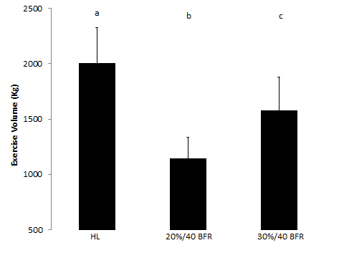
Figure 1 Group A Exercise Volume
HL=high load (70% maximal effort); 20%/40 BFR= 20% maximal effort at an estimated 40% arterial occlusion pressure; 30%/40 BFR=30% maximal effort at an estimated 40% arterial occlusion pressure. Conditions with different letters represent significant differences between conditions (p≤0.05). Variability is represented as standard deviations.

A 3 x 4 repeated measures ANOVA revealed a significant condition x time interaction with the number of repetitions successfully completed (Table 5, p<0.001). A one-way ANOVA across conditions for set 1 found significant differences between conditions (p<0.001). Pairwise comparisons found that 20%/40 BFR (p=0.003) and 30%/40 BFR (p=0.003) completed significantly more repetitions than the HL condition. There was no significant difference between 20%/40 BFR and 30%/40 BFR (p=0.999) A one-way ANOVA across conditions for set 2 revealed significant differences between conditions (p<0.001). Pairwise comparisons showed that the 20%/40 BFR (p=0.003) and 30%/40 BFR (p=0.003) conditions completed significantly more repetitions than the HL condition. There was no significant difference between 20%/40 BFR and 30%/40 BFR (p=0.507). A one-way ANOVA across conditions for set 3 revealed significant differences between conditions (p<0.001). Pairwise comparisons showed that 20%/40 BFR (p=0.003) and 30%/40 BFR (p=0.003) completed significantly more repetitions than the HL condition. There was no significant difference between 20%/40 BFR and 30%/40 BFR (p=0.141). A one-way ANOVA across conditions for set 4 revealed significant differences between conditions (p<0.001). Pairwise comparisons showed that 20%/40 BFR (p=0.003) and 30%/40 BFR (p=0.003) conditions completed significantly more repetitions than the HL condition. In addition, the 20%/40 BFR condition completed significantly more repetitions than the 30%/40 BFR condition (p=0.027). A one-way ANOVA across time in the HL condition revealed significant differences between time points (p=0.016). However, post-hoc pairwise comparisons were unable to detect a significant difference between time points (Set 1 vs. Set 2, p=0.999; vs. Set 3, p=0.24; vs. Set 4, p=0.108. Set 2 vs. Set 3, p=0.24; vs. Set 4, p=0.108. Set 3 vs. Set 4, p=0.186). A one-way ANOVA across time for the 20%/40 BFR condition revealed significant differences between time points (p<0.001). Post hoc comparisons showed that significantly more repetitions were completed in the first set than set 2 (p=0.006), set 3 (p=0.006), or set 4 (p=0.006). There were no other significant pairwise differences (Set 2 vs. Set 3, p=0.999; vs. Set 4, p=0.999. Set 3 vs. Set 4, p=0.999). A one-way ANOVA across time in the 30%/40 BFR condition revealed significant differences between time points (p<0.001). Post hoc comparisons showed that significantly more repetitions were completed in the first set than set 2 (p=0.006), set 3 (p=0.006), or set 4 (p=0.006). There were no other significant pairwise differences (Set 2 vs. Set 3, p=0.522; vs. Set 4, p=0.114. Set 3 vs. Set 4, p=0.504).
Table 5. Group A Repetitions
 | Repetitions
Group A† | Set 1 | Set 2 | Set 3 | Set 4
HL | 10 (0) | 10 (0) | 9 (1) | 8 (2)
20%/40 BFR | 30 (0) | 14 (1) | 14 (1) | 14 (1)
30%/40 BFR | 29 (2) | 14 (1) | 13 (2) | 12 (3)
HL=high load (70% maximal effort); 20%/40 BFR= 20% maximal effort at an estimated 40% arterial occlusion pressure; 30%/40 BFR=30% maximal effort at an estimated 40% arterial occlusion pressure. † denotes a significant condition by time interaction (p≤0.05). Variability represented as standard deviations.

Group B
A one-way ANOVA revealed that the total exercise volume was significantly different between conditions (Figure 2, p=0.025). Pairwise comparisons showed that exercise volume was highest in the 30% to failure condition compared to the 20%/50 BFR (p=0.003) and 30%/50 BFR conditions (p=0.003). In addition, the 30%/50 BFR condition completed a higher volume of work than the 20%/50 BFR condition (p=0.003).
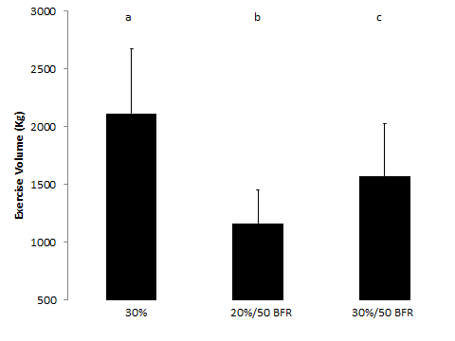
Figure 2. Group B Exercise Volume
30%=30% maximal effort to failure; 20%/50 BFR= 20% maximal effort at an estimated 50% arterial occlusion pressure; 30%/50 BFR=30% maximal effort at an estimated 50% arterial occlusion pressure. Conditions with different letters indicate significant differences between conditions (p≤0.05). Variability represented as standard deviations.

A 3 x 4 repeated measures ANOVA found a significant condition x time interaction for the number of repetitions successfully completed (Table 6, p=0.004). A one-way ANOVA across conditions for set 1 revealed significant differences between conditions (p<0.001). Pairwise comparisons showed that 20%/50 BFR (p=0.006) and 30%/50 BFR (p=0.006) completed significantly less repetitions than the 30% to failure condition. There was no significant difference between the 20%/50 BFR and 30%/50 BFR (p=0.999) conditions. A one-way ANOVA across conditions for set 2 revealed significant differences between conditions (p<0.001). Pairwise comparisons showed that the 20%/50 BFR (p=0.003) and 30%/50 BFR (p=0.003) conditions completed significantly less repetitions than the 30% to failure condition. There was no significant difference between the 20%/50 BFR and 30%/50 BFR (p=0.315) conditions. A one-way ANOVA across conditions for set 3 revealed a similar number of repetitions completed between conditions (p<0.072). A one-way ANOVA across conditions for set 4 showed significant differences between conditions (p=0.021). However, post-hoc pairwise comparisons were unable to detect a difference between conditions (30% to failure vs. 20%/50 BFR, p=0.999; vs. 30%/50 BFR, p=0.153. 20%/50 BFR vs. 30%/50 BFR, p=0.057). A one-way ANOVA across time in the 30% to failure condition revealed significant differences between time points (p<0.001). Post hoc comparisons showed that significantly more repetitions were completed in the first set than set 2 (p=0.006), set 3 (p=0.006), or set 4 (p=0.006). In addition, significantly more repetitions were completed in the second set vs. set 3 (p=0.006) and set 4 (p=0.006). There were no significant differences between set 3 and set 4 (p=0.93). A one-way ANOVA across time in the 20%/50 BFR condition revealed significant differences between time points (p<0.001). Post hoc comparisons showed that significantly more repetitions were completed in the first set than set 2 (p=0.006), set 3 (p=0.006), or set 4 (p=0.006). There were no other significant pairwise differences (Set 2 vs. Set 3, p=0.999; vs. Set 4, p=0.999. Set 3 vs. Set 4, p=0.999). A one-way ANOVA across time in the 30%/50 BFR condition revealed significant differences between time points (p<0.001). Post hoc comparisons showed that significantly more repetitions were completed in the first set than set 2 (p=0.006), set 3 (p=0.006), or set 4 (p=0.006). There were no other significant pairwise differences (Set 2 vs. Set 3, p=0.564; vs. Set 4, p=0.222. Set 3 vs. Set 4, p=0.954).

Table 6. Group B Repetitions
 | Repetitions
Group B† | Set 1 | Set 2 | Set 3 | Set 4
30% | 40 (10) | 22 (16) | 15 (4) | 13 (4)
20%/50 BFR | 30 (0) | 15 (0) | 14 (1) | 14 (1)
30%/50 BFR | 30 (0) | 13 (2) | 12 (3) | 10 (5)
30%=30% maximal effort to failure; 20%/50 BFR= 20% maximal effort at an estimated 50% arterial occlusion pressure; 30%/50 BFR=30% maximal effort at an estimated 50% arterial occlusion pressure. † denotes a significant condition by time interaction (p≤0.05). Variability represented as standard deviations.

Group C
A one-way ANOVA revealed that the total exercise volume was significantly different between conditions (Figure 3, p=0.008). Pairwise comparisons showed that exercise volume was highest in the 20% to failure condition compared to the 20%/60 BFR (p=0.003) and 30%/60 BFR conditions (p=0.003). In addition, the 30%/60 BFR condition completed a higher volume of work than the 20%/60 BFR condition (p=0.003).

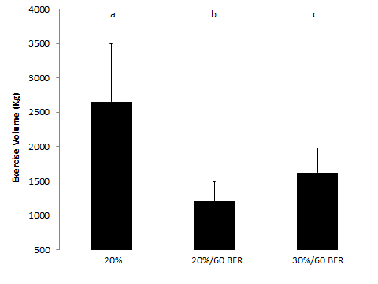
Figure 3. Group C Exercise Volume
20%=20% maximal effort to failure; 20%/60 BFR= 20% maximal effort at an estimated 60% arterial occlusion pressure; 30%/60 BFR=30% maximal effort at an estimated 60% arterial occlusion pressure. Conditions with different letters indicate significant differences between conditions (p≤0.05). Variability represented as standard deviations.

A 3 x 4 repeated measures ANOVA revealed a significant condition x time interaction with the number of repetitions successfully completed (Table 7, p<0.001). A one-way ANOVA across conditions for set 1 showed significant differences between conditions (p<0.001). Pairwise comparisons showed that the 20%/60 BFR (p=0.003) and 30%/60 BFR (p=0.003) conditions completed significantly less repetitions than the 20% to failure condition. There was no significant difference between 20%/50 BFR and 30%/50 BFR (p=0.999). A one-way ANOVA across conditions for set 2 showed significant differences between conditions (p<0.001). Pairwise comparisons showed that the 20%/60 BFR (p=0.003) and 30%/60 BFR (p=0.003) conditions completed significantly less repetitions than the 20% to failure condition. There was no significant difference between 20%/60 BFR and 30%/60 BFR (p=0.999) conditions. A one-way ANOVA across conditions for set 3 revealed significant differences between conditions (p=0.001). Pairwise comparisons showed that the 20%/60 BFR (p=0.021) and 30%/60 BFR (p=0.006) conditions completed significantly less repetitions than the 20% to failure condition. There was no significant difference between 20%/60 BFR and 30%/60 BFR (p=0.108). A one-way ANOVA across conditions for set 4 revealed significant differences between conditions (p=0.009). Pairwise comparisons showed that significantly more repetitions were completed in the 20% to failure condition compared to the 30%/60 BFR condition (p=0.018). However, the difference between the 20% to failure condition and the 20%/60 BFR condition did not reach statistical significance (p=0.189). There was no statistical difference between the 20%/60 BFR and 30%/60 BFR conditions in number of repetitions completed (p=0.06). A one-way ANOVA across time in the 20% to failure condition revealed significant differences between time points (p<0.001). Post hoc comparisons showed that significantly more repetitions were completed in set 1 than set 2 (p=0.006), set 3 (p=0.006), or set 4 (p=0.006). In addition, significantly more repetitions were completed in set 2 vs. set 3 (p=0.048) and set 4 (p=0.024). There were no significant differences between set 3 and set 4 (p=0.30).
A one-way ANOVA across time in the 20%/60 BFR condition revealed significant differences between time points (p<0.001). Post hoc comparisons showed that significantly more repetitions were completed in set 1 than set 2 (p=0.006), set 3 (p=0.006), or set 4 (p=0.006). There were no other significant pairwise differences (Set 2 vs. Set 3, p=0.999; vs. Set 4, p=0.999. Set 3 vs. Set 4, p=0.999). A one-way ANOVA across time in the 30%/60 BFR condition revealed significant differences between time points (p<0.001). Post hoc comparisons showed that significantly more repetitions were completed in set 1 than in set 2 (p=0.006), set 3 (p=0.006), or set 4 (p=0.006). There were no other significant pairwise differences (Set 2 vs. Set 3, p=0.342; vs. Set 4, p=0.114. Set 3 vs. Set 4, p=0.234).
Table 7. Group C Repetitions
 | Repetitions
Group C† | Set 1 | Set 2 | Set 3 | Set 4
20% | 93 (39) | 29 (7) | 22 (8) | 20 (9)
20%/60 BFR | 30 (0) | 14 (1) | 14 (1) | 14 (1)
30%/60 BFR | 29 (1) | 14 (2) | 12 (3) | 11 (4)
20%=20% maximal effort to failure; 20%/60 BFR= 20% maximal effort at an estimated 60% arterial occlusion pressure; 30%/60 BFR=30% maximal effort at an estimated 60% arterial occlusion pressure. † denotes a significant condition by time interaction (p≤0.05). Variability represented as standard deviations.

Maximal Voluntary Contraction
The maximal isometric voluntary contractions (MVC) of the dominant leg for each group are found in Table 8. The minimal difference of this measurement was estimated at 50.4 Nm, meaning the mean difference between Pre and Post would have to exceed this estimate to be considered a real change.

Table 8. Maximal Voluntary Contractions across each group
Maximal Voluntary Contraction (Nm)
Group A† | Pre | Post | Mean Difference
HL^{ac} | 271.4 (55) | 216.8 (49.4)* | -54.6
20%/40 BFR^{ab} | 284.6 (66.3) | 243.2 (59.3)* | -41.4
30%/40 BFR^{c} | 281.2 (64.4) | 213 (55.7)* | -68.2
CON^{d} | 279.1 (66.7) | 276.1 (69.9) | -3
Group B† | Pre | Post | Mean Difference
30%ª | 280.3 (70.7) | 211.7 (72.7)* | -68.6
20%/50 BFRª | 289.2 (74.1) | 224 (85.7)* | -65.2
30%/50 BFRª | 286.8 (69) | 199 (66.4)* | -87.8
CON^{b} | 274.6 (69.6) | 278.6 (77.4) | 4
Group C† | Pre | Post | Mean Difference
20%ª | 318.8 (105.1) | 208.8 (70.2)* | -110
20%/60 BFRª | 314 (106.4) | 235.6 (62.5)* | -78.4
30%/60 BFRª | 311.8 (105.1) | 220.5 (63)* | -91.3
CON^{b} | 320.2 (106.3) | 319.2 (83.6)* | -1
20% 1RM=20% maximal effort; 30% 1RM=30% maximal effort; 40 BFR=40% arterial occlusion pressure; 50 BFR=50% arterial occlusion pressure; 60 BFR=60% arterial occlusion pressure; non-BFR=non blood flow restriction conditions; HL=high load (70% maximal effort); 20%=20% maximal effort (no BFR); 30%=30% maximal effort (no BFR); CON=control Variability represented as standard deviations. † denotes a significant condition x time interaction (p≤0.05). Conditions with different letters represent significant differences between conditions (p≤0.05). * denotes significant difference between pre and post (p≤0.05).

Group A
A 4 x 2 repeated measures ANOVA revealed a significant condition x time interaction with MVC (p<0.001). A one-way ANOVA across the pre values showed no statistical difference between conditions (p=0.400). However, a one-way ANOVA did show significant differences across conditions for the post values (Figure 4, p<0.001). Pairwise comparisons showed that post MVC was significantly less in the HL condition compared to the control condition (p<0.006), however, differences were not found when the HL condition was compared with the 20%/40 BFR (p=0.12) and 30%/40 BFR (p=0.999) conditions. The 20%/40 BFR post MVC was significantly less than the control condition (p=0.012) but was significantly greater than the 30%/40 BFR (p=0.042). In addition, the 30%/40 BFR post MVC was significantly less than the control condition (p=0.006). Paired sample t-tests showed significant pre-post differences in all conditions (p=0.004) except for the control condition (p=0.999). Although the 20%/40 BFR condition was statistically less than baseline (p=0.004), the value did not exceed the error of the measurement (Minimal Difference=50.4 Nm). Thus, only the HL and 30%/40 BFR conditions meaningfully decreased MVC from baseline.
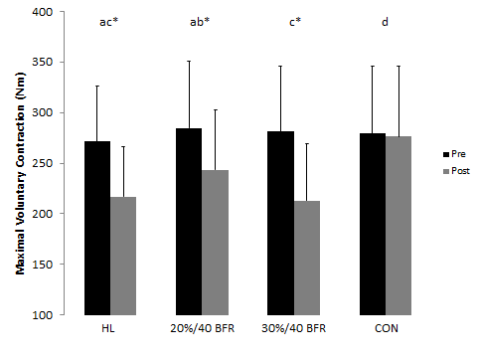
Figure 4. Group A Maximal Voluntary Contraction
HL=high load (70% maximal effort); 20%/40 BFR= 20% maximal effort at an estimated 40% arterial occlusion pressure; 30%/40 BFR=30% maximal effort at an estimated 40% arterial occlusion pressure; CON=control. Conditions with different letters represent significant differences between conditions (p≤0.05).*denotes a significant difference from pre to post (p≤0.05). Variability represented as standard deviations.

Group B
A 4 x 2 repeated measures ANOVA revealed a significant condition x time interaction for MVC (p<0.001). A one-way ANOVA across the pre values detected no statistical difference between conditions (p=0.253). However, a one-way ANOVA did show significant differences across conditions in the post values (Figure 5, p<0.001). Pairwise comparisons showed that the post MVC was significantly less in the 30% to failure condition compared to the control condition (p<0.006); however, differences were not found when the 30% to failure condition was compared with the 20%/50 BFR (p=0.999) and 30%/50 BFR (p=0.498) conditions. The 20%/50 BFR post MVC was significantly less than that of the control condition (p=0.024) but was not different from the 30%/50 BFR (p=0.720) condition. In addition, the 30%/50 BFR post MVC was significantly less than the control condition (p=0.006). Paired sample t-tests revealed significant pre-post differences in all conditions (p=0.004) except for the control condition (p=0.999).
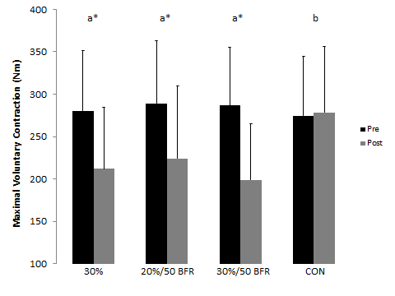
Figure 5. Group B Maximal Voluntary Contraction
30%=30% maximal effort to failure; 20%/50 BFR= 20% maximal effort at an estimated 50% arterial occlusion pressure; 30%/50 BFR=30% maximal effort at an estimated 50% arterial occlusion pressure; CON=control. Conditions with different letters represent significant differences between conditions (p≤0.05).*denotes a significant difference from pre to post (p≤0.05). Variability represented as standard deviations.

Group C
A 4 x 2 repeated measures ANOVA revealed a significant condition x time interaction for MVC (p<0.001). A one-way ANOVA across the pre values showed no statistical difference between conditions (p=0.562). However, a one-way ANOVA did reveal significant differences across conditions in the post values (Figure 6, p<0.001). Pairwise comparisons revealed that the post MVC was significantly less in the 20% to failure condition compared to the control condition (p<0.006), however, differences were not found when the 20% to failure condition was compared with the 20%/60 BFR (p=0.498) and 30%/60 BFR (p=0.999) conditions. The 20%/60 BFR post MVC was significantly less than the control condition (p=0.006) but was not different from the 30%/60 BFR (p=0.528) condition. In addition, the 30%/60 BFR post MVC was significantly less than the control condition (p=0.006). Paired sample t-tests showed significant pre-post differences in all conditions (p=0.004) except for the control condition (p=0.999).
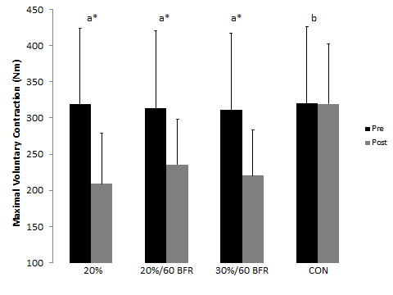
Figure 6. Group C Maximal Voluntary Contraction
20%=20% maximal effort to failure; 20%/60 BFR= 20% maximal effort at an estimated 60% arterial occlusion pressure; 30%/60 BFR=30% maximal effort at an estimated 60% arterial occlusion pressure; CON=control. Conditions with different letters represent significant differences between conditions (p≤0.05).*denotes a significant difference from pre to post (p≤0.05). Variability represented as standard deviations.

Thigh Circumference
The thigh circumference at the 33% and 50% sites of the non-dominant leg from each group are found in Tables 9 and 10, respectively. The minimal difference of this measurement was estimated at 0.7 cm for the 33% site and 1.2 cm for the 50% site, meaning the mean difference between pre and post would have to exceed this estimate to be considered a real change.
Table 9. Thigh Circumference at the 33% site across each group
Thigh Circumference at the 33% site (cm)
Group A | Pre | Post* | Mean Difference
HL | 61.2 (6.8) | 61.7 (6.3) | 0.5
20%/40 BFR | 61 (6) | 61.7 (6.4) | 0.7
30%/40 BFR | 60.6 (6) | 61.4 (5.9) | 0.5
CON | 60.7 (6.6) | 60.6 (6.4) | -0.1
Group B† | Pre | Post | Mean Difference
30%ª | 59.9 (5.9) | 60.8 (5.9)* | 0.9
20%/50 BFRª | 59.7 (5.4) | 60.4 (5.8)* | 0.7
30%/50 BFRª | 59.2 (5.4) | 60.4 (5.7)* | 1.2
CON^{b} | 59.3 (5.8) | 59.2 (5.8) | 0.1
Group C† | Pre | Post | Mean Difference
20%ª | 62 (6.1) | 63 (6.3)* | 1
20%/60 BFRª | 62 (6.3) | 62.6 (6.1) | 0.6
30%/60 BFRª | 61.9 (6.5) | 63 (6.6)* | 1.1
CON^{b} | 61.9 (6.3) | 61.7 (6.4) | -0.2
20% 1RM=20% maximal effort; 30% 1RM=30% maximal effort; 40 BFR=40% arterial occlusion pressure; 50 BFR=50% arterial occlusion pressure; 60 BFR=60% arterial occlusion pressure; non-BFR=non blood flow restriction conditions; HL=high load (70% maximal effort); 20%=20% maximal effort (no BFR); 30%=30% maximal effort (no BFR); CON=control Variability represented as standard deviations. † denotes a significant condition x time interaction (p≤0.05). Conditions with different letters represent significant differences between conditions (p≤0.05). * denotes significant difference between pre and post (p≤0.05).

Table 10. Thigh Circumference at the 50% site across each group
Thigh Circumference at the 50% site (cm)
Group A† | Pre | Post | Mean Difference
HLª | 58.3 (5.4) | 59.2 (5.6)* | 0.9
20%/40 BFRª | 58.7 (5.4) | 59 (5.2)* | 0.3
30%/40 BFRª | 58.3 (5.1) | 58.9 (5.1)* | 0.6
CON^{b} | 58.4 (5.4) | 58.3 (5.3) | -0.1
Group B† | Pre | Post | Mean Difference
30%ª | 57.1 (5.5) | 57.9 (5.5)* | 0.8
20%/50 BFRª | 56.8 (5.3) | 57.4 (5.3)* | 0.6
30%/50 BFRª | 56.8 (5.5) | 57.9 (5.4)* | 1.1
CON^{b} | 56.7 (5.8) | 56.3 (6.2) | -0.4
Group C† | Pre | Post | Mean Difference
20%ª | 59.1 (5.3) | 60 (5.1)* | 0.9
20%/60 BFRª | 59.1 (5.4) | 59.9 (5.5)* | 0.8
30%/60 BFRª | 59.3 (5.5) | 60.1 (5.5)* | 0.8
CON^{b} | 59.1 (5.8) | 58.9 (5.6) | -0.2
20% 1RM=20% maximal effort; 30% 1RM=30% maximal effort; 40 BFR=40% arterial occlusion pressure; 50 BFR=50% arterial occlusion pressure; 60 BFR=60% arterial occlusion pressure; non-BFR=non blood flow restriction conditions; HL=high load (70% maximal effort); 20%=20% maximal effort (no BFR); 30%=30% maximal effort (no BFR); CON=control Variability represented as standard deviations. † denotes a significant condition x time interaction (p≤0.05). Conditions with different letters represent significant differences between conditions (p≤0.05). * denotes significant difference between pre and post (p≤0.05).

Group A
A 4 x 2 repeated measures ANOVA did not reveal a significant condition x time interaction for thigh circumference at the 33% site (Figure 7, p=0.189). In addition, there was no significant main effect of condition (p=0.120) but there was a main effect of time (p=0.001). Thus, when collapsed across groups there was a significant increase in thigh circumference at the 33% site from pre-post (Pre: 60.9 SE 1.7 vs. Post 61.4 SE 1.6, p=0.001). Although there was a main effect for thigh circumference increasing across time, the value did not exceed the error of the measurement (Minimal Difference=0.7 cm).
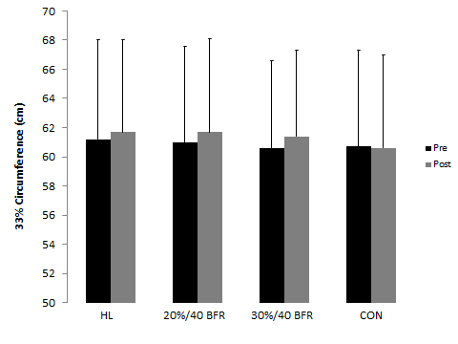
Figure 7. Group A Thigh Circumference at the 33% Site
HL=high load (70% maximal effort); 20%/40 BFR= 20% maximal effort at an estimated 40% arterial occlusion pressure; 30%/40 BFR=30% maximal effort at an estimated 40% arterial occlusion pressure; CON=control. Variability represented as standard deviations.

A 4 x 2 repeated measures ANOVA revealed a significant condition x time interaction for thigh circumference at the 50% site (p<0.001). A one-way ANOVA across the pre values showed no statistical difference between conditions (p=0.317). However, a one-way ANOVA did reveal significant differences across conditions for the post values (Figure 8, p<0.001). Pairwise comparisons showed that the post thigh circumference at the 50% site was significantly greater in the HL condition compared to the control condition (p<0.006), however, differences were not detected when the HL condition was compared with the 20%/40 BFR (p=0.999) and 30%/40 BFR (p=0.876) conditions. The 20%/40 BFR and 30%/40 BFR conditions’ post thigh circumferences at the 50% site were significantly greater than the control condition (p=0.018) but the 20%/40 BFR and 30%/40 BFR conditions did not differ from each other (p=0.999). Paired sample t-tests revealed significant increases in thigh circumference at the 50% site from pre-post in all conditions (p<0.028) except for the control condition (p=0.999). Although there were statistically significant increases in thigh circumference across time, the value did not exceed the error of the measurement (Minimal Difference=1.2 cm) for any condition.
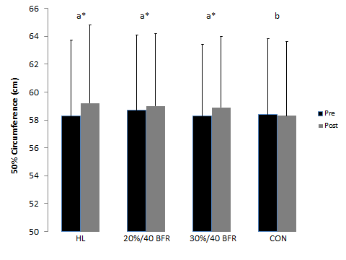
Figure 8. Group A Thigh Circumference at the 50% Site
HL=high load (70% maximal effort); 20%/40 BFR= 20% maximal effort at an estimated 40% arterial occlusion pressure; 30%/40 BFR=30% maximal effort at an estimated 40% arterial occlusion pressure; CON=control. Conditions with different letters represent significant differences between conditions (p≤0.05).*denotes a significant difference from pre to post (p≤0.05). Variability represented as standard deviations.

Group B
A 4 x 2 repeated measures ANOVA revealed a significant condition x time interaction for thigh circumference at the 33% site (p<0.001). A one-way ANOVA across the pre values found no statistical difference between conditions (p=0.123). However, a one-way ANOVA did show significant differences across conditions for the post values (Figure 9, p<0.001). Pairwise comparisons showed the post thigh circumference at the 33% site was significantly greater in the 30% to failure condition compared to the control condition (p=0.006), however, differences were not seen when the 30% to failure condition was compared with the 20%/50 BFR (p=0.999) and 30%/50 BFR (p=0.450) conditions. The 20%/50 BFR and 30%/50 BFR conditions post thigh circumferences at the 33% site were significantly greater for the control condition (p=0.006) but the 20%/50 BFR and 30%/50 BFR conditions did not differ from each other (p=0.999). Paired sample t-tests revealed significant increases in thigh circumference at the 33% site from pre-post in all conditions (p≤0.02) except for the control condition (p=0.999). Although there was a statistically significant increase in thigh circumference across time for the 20%/50 BFR condition, the value did not exceed the error of the measurement (Minimal Difference=0.7 cm). Thus, only the 30% to failure and 30%/50 BFR conditions had meaningful increases in thigh circumference from baseline.
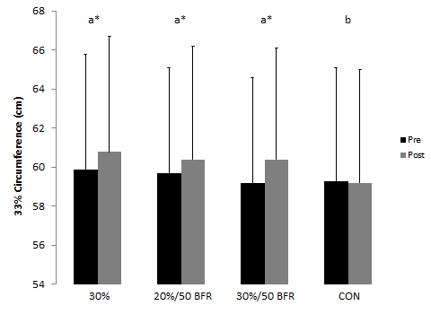
Figure 9. Group B Thigh Circumference at the 33% Site
30%=30% maximal effort to failure; 20%/50 BFR= 20% maximal effort at an estimated 50% arterial occlusion pressure; 30%/50 BFR=30% maximal effort at an estimated 50% arterial occlusion pressure; CON=control. Conditions with different letters represent significant differences between conditions (p≤0.05).*denotes a significant difference from pre to post (p≤0.05). Variability represented as standard deviations.

A 4 x 2 repeated measures ANOVA revealed a significant condition x time interaction for thigh circumference at the 50% site (p<0.001). A one-way ANOVA across the pre values showed no statistical difference between conditions (p=0.252). However, a one-way ANOVA did reveal significant differences across conditions in the post values (Figure 10, p<0.001). Pairwise comparisons showed that the post thigh circumference at the 50% site was significantly greater in the 30% to failure condition compared to the control condition (p=0.006), however, differences were not found when the 30% to failure condition was compared with the 20%/50 BFR (p=0.198) and 30%/50 BFR (p=0.999) conditions. The 20%/50 BFR and 30%/50 BFR conditions post thigh circumferences at the 50% site were significantly greater than the control condition (p≤0.042) but the 20%/50 BFR and 30%/50 BFR conditions did not differ (p=0.24). Paired sample t-tests revealed significant increases in thigh circumference at the 50% site from pre-post in all conditions (p≤0.028) except for the control condition (p=0.624). Although there were significant increases in thigh circumference across time for the 30% to failure, 20%/50 BFR, and 30%/50 BFR conditions, the values did not exceed the error of the measurement (Minimal Difference=1.2 cm) for any condition.
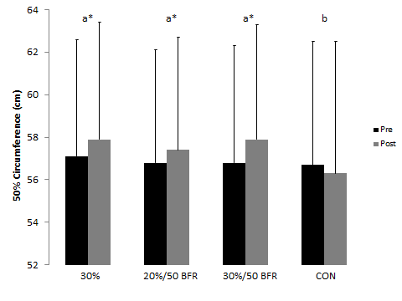
Figure 10. Group B Thigh Circumference at the 50% Site
30%=30% maximal effort to failure; 20%/50 BFR= 20% maximal effort at an estimated 50% arterial occlusion pressure; 30%/50 BFR=30% maximal effort at an estimated 50% arterial occlusion pressure; CON=control. Conditions with different letters represent significant differences between conditions (p≤0.05).*denotes a significant difference from pre to post (p≤0.05). Variability represented as standard deviations.

Group C
A 4 x 2 repeated measures ANOVA revealed a significant condition x time interaction for thigh circumference at the 33% site (p<0.001). A one-way ANOVA across the pre values showed no statistical difference between conditions (p=0.958). However, a one-way ANOVA did reveal significant differences across conditions for the post values (Figure 11, p<0.001). Pairwise comparisons showed that the post thigh circumference at the 33% site was significantly greater in the 20% to failure condition compared to the control condition (p=0.006), however, differences were not detected when the 20% to failure condition was compared with the 20%/60 BFR (p=0.15) and 30%/60 BFR (p=0.999) conditions. The 20%/60 BFR and 30%/60 BFR conditions’ post thigh circumferences at the 33% site were significantly greater than the control condition (p≤0.042) but the 20%/60 BFR and 30%/60 BFR conditions did not differ (p=0.894). Paired sample t-tests revealed significant increases in thigh circumference at the 33% site from pre-post in the 20% to failure and 30%/60 BFR conditions (p≤0.008).There were no significant differences pre-post in thigh circumference at the 33% site for the 20%/60 BFR or the control condition (p≥0.10).

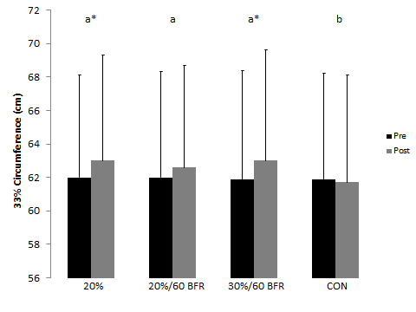
Figure 11. Group C Thigh Circumference at the 33% Site
20%=20% maximal effort to failure; 20%/60 BFR= 20% maximal effort at an estimated 60% arterial occlusion pressure; 30%/60 BFR=30% maximal effort at an estimated 60% arterial occlusion pressure; CON=control. Conditions with different letters represent significant differences between conditions (p≤0.05).*denotes a significant difference from pre to post (p≤0.05). Variability represented as standard deviations.

A 4 x 2 repeated measures ANOVA revealed a significant condition x time interaction for thigh circumference at the 50% site (p<0.001). A one-way ANOVA across the pre values showed no statistical difference between conditions (p=0.861). However, a one-way ANOVA did show significant differences across conditions for the post values (Figure 12, p<0.001). Pairwise comparisons revealed that the post thigh circumference at the 50% site was significantly greater in the 20% to failure condition compared to the control condition (p=0.048), however, differences were not detected when the 20% to failure condition was compared with the 20%/60 BFR (p=0.999) and 30%/60 BFR (p=0.999) conditions. The 20%/60 BFR and 30%/60 BFR conditions post thigh circumferences at the 50% site were significantly greater than the control condition (p≤0.018) but the 20%/60 BFR and 30%/60 BFR conditions did not differ (p=0.999). Paired sample t-tests found revealed significant increases in thigh circumference at the 50% site from pre-post in all conditions (p≤0.004) except for the control condition (p=0.796). Although there were significant increases in thigh circumference across time for the 20% to failure, 20%/60 BFR, and 30%/60 BFR conditions, the values did not exceed the error of the measurement (Minimal Difference=1.2 cm) for any condition.
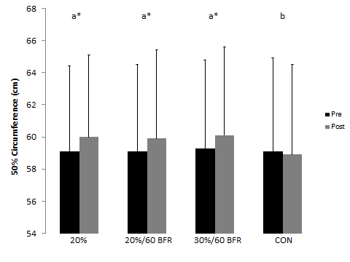
Figure 12. Group C Thigh Circumference at the 50% Site
20%=20% maximal effort to failure; 20%/60 BFR= 20% maximal effort at an estimated 60% arterial occlusion pressure; 30%/60 BFR=30% maximal effort at an estimated 60% arterial occlusion pressure; CON=control. Conditions with different letters represent significant differences between conditions (p≤0.05).*denotes a significant difference from pre to post (p≤0.05). Variability represented as standard deviations.

Muscle Thickness
The muscle thickness (MTH) at the anterior and lateral sites of the non-dominant leg from each group is found in Tables 11 and 12, respectively. The minimal difference of this measurement was estimated at 4 mm for the anterior site and 2 mm for the lateral site, meaning the mean difference between pre and post would have to exceed this estimate to be considered a real change.
Table 11. Anterior Muscle Thickness across each group
Anterior Muscle Thickness (mm)
Group A† | Pre | Post | Mean Difference
HLª | 60 (8) | 63 (8)* | 3
20%/40 BFRª | 59 (8) | 63 (8)* | 4
30%/40 BFRª | 60 (7) | 63 (8)* | 3
CON^{b} | 59 (8) | 59 (8) | 0
Group B† | Pre | Post | Mean Difference
30%ª | 56 (11) | 61 (10)* | 5
20%/50 BFRª | 55 (10) | 61 (10)* | 6
30%/50 BFRª | 57 (11) | 62 (9)* | 5
CON^{b} | 56 (10) | 57 (11) | 1
Group C† | Pre | Post | Mean Difference
20%^{ab} | 61 (8) | 66 (8)* | 5
20%/60 BFR^{ac} | 59 (7) | 64 (6)* | 5
30%/60 BFR^{b} | 61 (7) | 65 (7)* | 4
CON^{c} | 61 (7) | 62 (7) | 1
20% 1RM=20% maximal effort; 30% 1RM=30% maximal effort; 40 BFR=40% arterial occlusion pressure; 50 BFR=50% arterial occlusion pressure; 60 BFR=60% arterial occlusion pressure; non-BFR=non blood flow restriction conditions; HL=high load (70% maximal effort); 20%=20% maximal effort (no BFR); 30%=30% maximal effort (no BFR); CON=control Variability represented as standard deviations. † denotes a significant condition x time interaction (p≤0.05). Conditions with different letters represent significant differences between conditions (p≤0.05). * denotes significant difference between pre and post (p≤0.05).

Table 12. Lateral Muscle Thickness across each group
Lateral Muscle Thickness (mm)
Group A† | Pre | Post | Mean Difference
HLª | 47 (5) | 49 (5)* | 2
20%/40 BFR^{ab} | 46 (5) | 48 (5)* | 2
30%/40 BFR^{ab} | 47 (5) | 49 (6)* | 2
CON^{b} | 46 (5) | 46 (5) | 0
Group B† | Pre | Post | Mean Difference
30%ª | 44 (4) | 47 (4)* | 3
20%/50 BFR^{ab} | 45 (5) | 46 (5)* | 1
30%/50 BFR^{ab} | 44 (5) | 46 (4)* | 2
CON^{b} | 44 (5) | 44 (5) | 0
Group C† | Pre | Post | Mean Difference
20%ª | 47 (5) | 49 (5) | 2
20%/60 BFRª | 47 (6) | 47 (6) | 0
30%/60 BFRª | 46 (6) | 48 (6)* | 2
CON^{b} | 46 (6) | 45 (6) | -1
20% 1RM=20% maximal effort; 30% 1RM=30% maximal effort; 40 BFR=40% arterial occlusion pressure; 50 BFR=50% arterial occlusion pressure; 60 BFR=60% arterial occlusion pressure; non-BFR=non blood flow restriction conditions; HL=high load (70% maximal effort); 20%=20% maximal effort (no BFR); 30%=30% maximal effort (no BFR); CON=control Variability represented as standard deviations. † denotes a significant condition x time interaction (p≤0.05). Conditions with different letters represent significant differences between conditions (p≤0.05). * denotes significant difference between pre and post (p≤0.05).

Group A
A 4 x 2 repeated measures ANOVA revealed a significant condition x time interaction for MTH at the anterior site (p=0.002). A one-way ANOVA across the pre values showed no statistical difference between conditions (p=0.590). However, a one-way ANOVA did reveal find significant differences across conditions in the post values (Figure 13, p<0.001). Pairwise comparisons showed that the post MTH at the anterior site was significantly greater in the HL condition compared to the control condition (p=0.006), however, differences were not detected when the HL condition was compared with the 20%/40 BFR (p=0.999) and 30%/40 BFR (p=0.999) conditions. The 20%/40 BFR and 30%/40 BFR conditions’ post MTHs at the anterior site were significantly greater than the control condition (p=0.006) but the 20%/40 BFR and 30%/40 BFR conditions did not differ (p=0.999). Paired sample t-tests revealed significant increases in MTH at the anterior site from pre-post in all conditions (p≤0.004) except for the control condition (p=0.999). Although there were significant increases in MTH across time for the HL, 20%/40 BFR, and 30%/40 BFR conditions, the values did not exceed the error of the measurement (Minimal Difference=4 mm) for any condition.
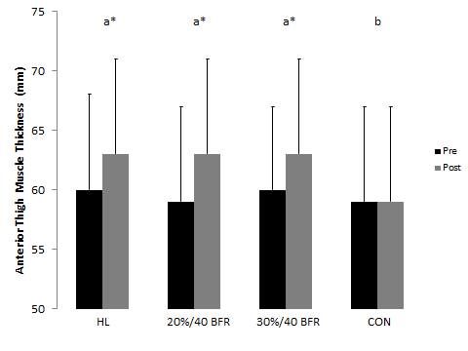
Figure 13. Group A Anterior Muscle Thickness
HL=high load (70% maximal effort); 20%/40 BFR= 20% maximal effort at an estimated 40% arterial occlusion pressure; 30%/40 BFR=30% maximal effort at an estimated 40% arterial occlusion pressure; CON=control. Conditions with different letters represent significant differences between conditions (p≤0.05).*denotes a significant difference from pre to post (p≤0.05). Variability represented as standard deviations.

A 4 x 2 repeated measures ANOVA revealed a significant condition x time interaction for MTH at the lateral site (p=0.01). A one-way ANOVA across the pre values showed no statistical difference between conditions (p=0.420). However, a one-way ANOVA did reveal significant differences across conditions for the post values (Figure 14, p<0.001). Pairwise comparisons showed that the post MTH at the lateral site was significantly greater in the HL condition compared to the control condition (p=0.006), however, differences were not found when the HL condition was compared with the 20%/40 BFR (p=0.54) and 30%/40 BFR (p=0.999) conditions. The 20%/40 BFR and 30%/40 BFR conditions’ post MTHs at the lateral site were not significantly different than the control condition (p≥0.078). In addition, the 20%/40 BFR and 30%/40 BFR conditions were not different from each other (p=0.999). Paired sample t-tests revealed significant increases in MTH at the lateral site from pre-post in all conditions (p≤0.036) except for the control condition (p=0.999). Although there were significant increases in MTH across time for the HL, 20%/40 BFR, and 30%/40 BFR conditions, the values did not exceed the error of the measurement (Minimal Difference=2 mm) for any condition.

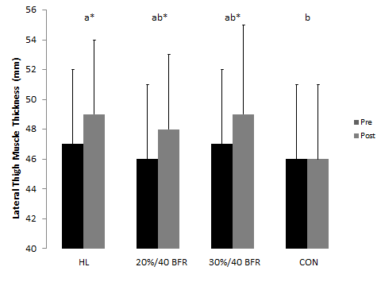
Figure 14. Group A Lateral Muscle Thickness
HL=high load (70% maximal effort); 20%/40 BFR= 20% maximal effort at an estimated 40% arterial occlusion pressure; 30%/40 BFR=30% maximal effort at an estimated 40% arterial occlusion pressure; CON=control. Conditions with different letters represent significant differences between conditions (p≤0.05).*denotes a significant difference from pre to post (p≤0.05). Variability represented as standard deviations.

Group B
A 4 x 2 repeated measures ANOVA revealed a significant condition x time interaction for MTH at the anterior site (p=0.001). A one-way ANOVA across the pre values showed no statistical difference between conditions (p=0.324). However, a one-way ANOVA did reveal significant differences across conditions for the post values (Figure 15, p<0.001). Pairwise comparisons showed that the post MTH at the anterior site was significantly greater in the 30% to failure condition compared to the control condition (p=0.012), however, differences were not found when the 30% to failure condition was compared with the 20%/50 BFR (p=0.999) and 30%/50 BFR (p=0.999) conditions. The 20%/50 BFR and 30%/50 BFR conditions post MTH at the anterior site were significantly greater than the control condition (p=0.006) but the 20%/50 BFR and 30%/50 BFR conditions did not differ (p=0.648). Paired sample t-tests showed significant increases in MTH at the anterior site from pre-post in all conditions (p=0.004) except for the control condition (p=0.42).
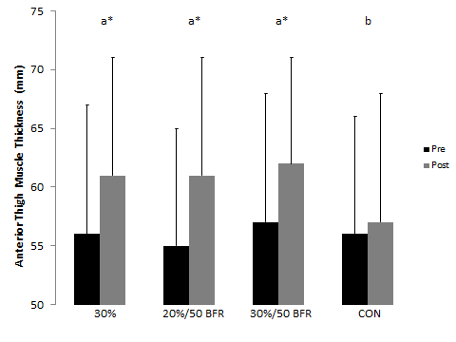
Figure 15. Group B Anterior Muscle Thickness
30%=30% maximal effort to failure; 20%/50 BFR= 20% maximal effort at an estimated 50% arterial occlusion pressure; 30%/50 BFR=30% maximal effort at an estimated 50% arterial occlusion pressure; CON=control. Conditions with different letters represent significant differences between conditions (p≤0.05).*denotes a significant difference from pre to post (p≤0.05). Variability represented as standard deviations.

A 4 x 2 repeated measures ANOVA revealed a significant condition x time interaction for MTH at the lateral site (p<0.001). A one-way ANOVA across the pre values showed no statistical difference between conditions (p=0.850). However, a one-way ANOVA did reveal significant differences across conditions for the post values (Figure 16, p<0.001). Pairwise comparisons showed that the post MTH at the lateral site was significantly greater in the 30% to failure condition compared to the control condition (p=0.006), however, differences were not found when the 30% to failure condition was compared with the 20%/50 BFR (p=0.288) and 30%/50 BFR (p=0.999) conditions. The 20%/50 BFR and 30%/50 BFR conditions’ post MTHs at the lateral site were significantly greater than the control condition (p=0.006) but the 20%/50 BFR and 30%/50 BFR conditions did not differ (p=0.999). Paired sample t-tests revealed significant increases in MTH at the lateral site from pre-post in all conditions (p≤0.02) except for the control condition (p=0.999). Although there were significant increases in MTH across time for the 20%/50 BFR and 30%/50 BFR conditions, the values did not exceed the error of the measurement (Minimal Difference=2 mm).
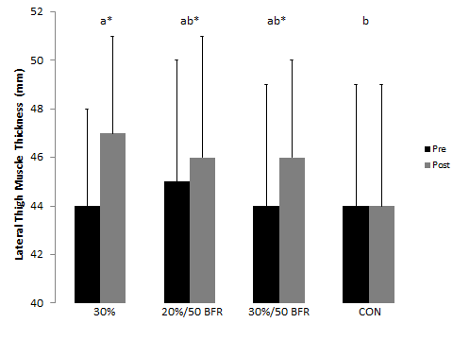
Figure 16. Group B Lateral Muscle Thickness
30%=30% maximal effort to failure; 20%/50 BFR= 20% maximal effort at an estimated 50% arterial occlusion pressure; 30%/50 BFR=30% maximal effort at an estimated 50% arterial occlusion pressure; CON=control. Conditions with different letters represent significant differences between conditions (p≤0.05).*denotes a significant difference from pre to post (p≤0.05). Variability represented as standard deviations.

Group C
A 4 x 2 repeated measures ANOVA revealed a significant condition x time interaction for MTH at the anterior site (p=0.009). A one-way ANOVA across the pre values showed no statistical difference between conditions (p=0.218). However, a one-way ANOVA did reveal significant differences across conditions for the post values (Figure 17, p<0.001). Pairwise comparisons showed that the post MTH at the anterior site was significantly greater in the 20% to failure condition compared to the control condition (p=0.006), however, differences were not found when the 20% to failure condition was compared with the 20%/60 BFR (p=0.276) and 30%/60 BFR (p=0.999) conditions. The post MTH at the anterior site for the 20%/60 BFR condition was significantly less than the 30%/60 BFR (p=0.024) condition, but was not significantly different than the control condition (p=0.15). In addition, the 30%/60 BFR post MTH at the anterior site was greater than the post measurement taken during the control condition (p=0.006). Paired sample t-tests revealed significant increases in MTH at the anterior site from pre-post in all conditions (p=0.004) except for the control condition (p=0.772). Although there was a significant increase in MTH at the anterior site across time for the 30%/60 BFR condition, the value did not exceed the error of the measurement (Minimal Difference=4 mm). Thus, only the 20% to failure and 20%/60 BFR conditions meaningfully increased MTH at the anterior site from baseline.
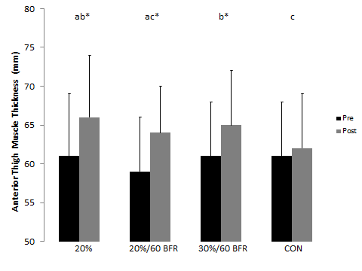
Figure 17. Group C Anterior Muscle Thickness
20%=20% maximal effort to failure; 20%/60 BFR= 20% maximal effort at an estimated 60% arterial occlusion pressure; 30%/60 BFR=30% maximal effort at an estimated 60% arterial occlusion pressure; CON=control. Conditions with different letters represent significant differences between conditions (p≤0.05).*denotes a significant difference from pre to post (p≤0.05). Variability represented as standard deviations.

A 4 x 2 repeated measures ANOVA revealed a significant condition x time interaction for MTH at the lateral site (p=0.002). A one-way ANOVA across the pre values showed no statistical difference between conditions (p=0.253). However, a one-way ANOVA did reveal significant differences across conditions in the post values (Figure 18, p<0.001). Pairwise comparisons showed that the post MTH at the lateral site was significantly greater in the 20% to failure condition compared to the control condition (p=0.006), however, differences were not detected when the 20% to failure condition was compared with the 20%/60 BFR (p=0.456) and 30%/60 BFR (p=0.999) conditions. The 20%/60 BFR and 30%/60 BFR conditions’ post MTHs at the lateral site were significantly greater than the control condition (p≤0.042) but the 20%/60 BFR and 30%/60 BFR conditions did not differ (p=0.150). Paired sample t-tests revealed significant increases in MTH at the lateral site from pre-post in the 30%/60 BFR (p=0.009) condition, however no other significant pre-post differences were observed (p≥0.172).Although there were significant increases in MTH across time for the 30%/60 BFR condition, the value did not exceed the error of the measurement (Minimal Difference=2 mm).
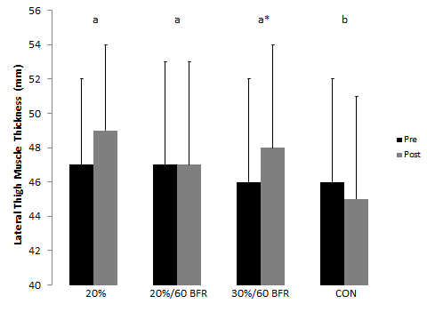
Figure 18. Group C Lateral Muscle Thickness
20%=20% maximal effort to failure; 20%/60 BFR= 20% maximal effort at an estimated 60% arterial occlusion pressure; 30%/60 BFR=30% maximal effort at an estimated 60% arterial occlusion pressure; CON=control. Conditions with different letters represent significant differences between conditions (p≤0.05).*denotes a significant difference from pre to post (p≤0.05). Variability represented as standard deviations.

Plasma Volume
The plasma volume changes for each group are found in Table 13. Percent changes in plasma volume (%∆PV) was determined using the following equation %∆PV = (100/(100 − Hct Pre) × 100 ((Hct Pre − Hct Post)/Hct Post) (Sherk, et al., 2011; Van Beaumont, 1972).
Table 13. Plasma Volume changes across each group
Plasma Volume Changes (%)
Group A | Pre-Post
HLª | -11 (5)
20%/40 BFRª | -10 (5)
30%/40 BFRª | -14 (6)
CON^{b} | -1 (1)
Group B | Pre-Post
30%ª | -13 (6)
20%/50 BFRª | -11 (5)
30%/50 BFRª | -15 (5)
CON^{b} | -1 (3)
Group C | Pre-Post
20%ª | -12 (11)
20%/60 BFRª | -15 (6)
30%/60 BFRª | -17 (3)
CON^{b} | 0 (4)
20% 1RM=20% maximal effort; 30% 1RM=30% maximal effort; 40 BFR=40% arterial occlusion pressure; 50 BFR=50% arterial occlusion pressure; 60 BFR=60% arterial occlusion pressure; non-BFR=non blood flow restriction conditions; HL=high load (70% maximal effort); 20%=20% maximal effort (no BFR); 30%=30% maximal effort (no BFR); CON=control Variability represented as standard deviations. Conditions with different letters represent significant differences between conditions (p≤0.05).

Group A
A one-way ANOVA revealed significant differences in plasma volume (Figure 19, p<0.001) across conditions. Pairwise comparisons showed that plasma volume was significantly decreased in the HL condition compared to the control condition (p=0.006), however, differences were not found when the HL condition was compared with the 20%/40 BFR (p=0.999) and 30%/40 BFR (p=0.330) conditions. The 20%/40 BFR and 30%/40 BFR conditions’ plasma volumes were significantly less than the control condition (p=0.006) but the 20%/40 BFR and 30%/40 BFR conditions did not differ (p=0.096).
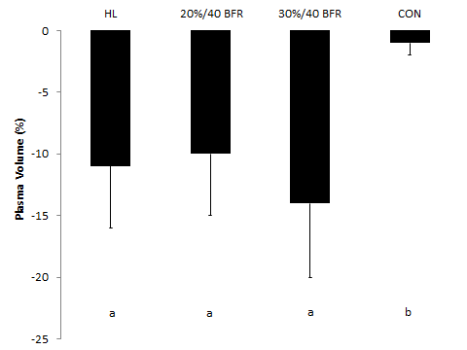
Figure 19. Group A Plasma Volume
HL=high load (70% maximal effort); 20%/40 BFR= 20% maximal effort at an estimated 40% arterial occlusion pressure; 30%/40 BFR=30% maximal effort at an estimated 40% arterial occlusion pressure; CON=control. Conditions with different letters represent significant differences between conditions (p≤0.05). Variability represented as standard deviations.

Group B
A one-way ANOVA revealed significant differences in plasma volume (Figure 20, p<0.001) across conditions. Pairwise comparisons found that plasma volume was significantly decreased in the 30% to failure condition compared to the control condition (p=0.006), however, differences were not found when the 30% to failure condition was compared with the 20%/50 BFR (p=0.999) and 30%/50 BFR (p=0.999) conditions. The 20%/50 BFR and 30%/50 BFR conditions’ plasma volumes were significantly less than the control condition (p=0.006) but the 20%/50 BFR and 30%/50 BFR conditions did not differ (p=0.999).
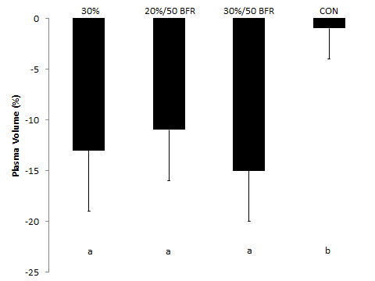
Figure 20. Group B Plasma Volume
30%=30% maximal effort to failure; 20%/50 BFR= 20% maximal effort at an estimated 50% arterial occlusion pressure; 30%/50 BFR=30% maximal effort at an estimated 50% arterial occlusion pressure; CON=control. Conditions with different letters represent significant differences between conditions (p≤0.05). Variability represented as standard deviations.

Group C
A one-way ANOVA revealed significant differences in plasma volume (Figure 21, p<0.001) across conditions. Pairwise comparisons showed that plasma volume was significantly decreased in the 20% to failure condition compared to the control condition (p=0.012), however, differences were not found when the 20% to failure condition was compared with the 20%/60 BFR (p=0.999) and 30%/60 BFR (p=0.999) conditions. The 20%/60 BFR and 30%/60 BFR conditions’ plasma volumes were significantly less than the control condition (p=0.006) but the 20%/60 BFR and 30%/60 BFR conditions did not differ (p=0.999).
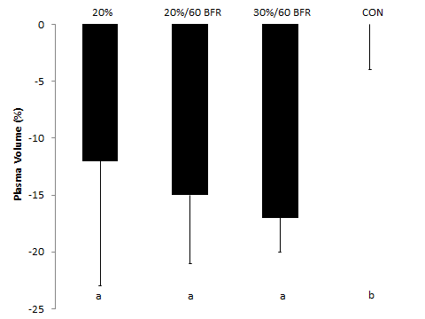
Figure 21. Group C Plasma Volume
20%=20% maximal effort to failure; 20%/60 BFR= 20% maximal effort at an estimated 60% arterial occlusion pressure; 30%/60 BFR=30% maximal effort at an estimated 60% arterial occlusion pressure; CON=control. Conditions with different letters represent significant differences between conditions (p≤0.05). Variability represented as standard deviations.

Whole Blood Lactate
The whole blood lactate responses for each group are found in Table 14. The minimal difference of this measurement was estimated at 0.5 mmol/L, meaning the mean difference between pre and post would have to exceed this estimate to be considered a real change.

Table 14. Whole Blood Lactate changes across each group
Whole Blood Lactate (mmol/L)
Group A† | Pre | Post | Mean Difference
HLª | 0.9 (0.2) | 6.5 (1.2)* | 5.6
20%/40 BFR^{b} | 1 (0.3) | 4.2 (1.4)* | 3.2
30%/40 BFRª | 1.2 (0.3) | 6.3 (1.7)* | 5.1
CON^{c} | 1.1 (0.3) | 1.2 (0.3) | 0.1
Group B† | Pre | Post | Mean Difference
30%ª | 1 (0.3) | 6.8 (0.9)* | 5.8
20%/50 BFR^{b} | 1 (0.3) | 4.9 (1.2)* | 3.9
30%/50 BFRª | 1.1 (0.5) | 6.8 (0.9)* | 5.7
CON^{c} | 1 (0.3) | 1.1 (0.4) | 0.1
Group C† | Pre | Post | Mean Difference
20%ª | 1.4 (0.5) | 7.5 (2.2)* | 6.1
20%/60 BFR^{b} | 1.3 (0.4) | 5.4 (1.5)* | 4.1
30%/60 BFRª | 1.3 (0.5) | 7.2 (1.9)* | 5.9
CON^{c} | 1.1 (0.5) | 1.3 (0.5) | 0.2
20% 1RM=20% maximal effort; 30% 1RM=30% maximal effort; 40 BFR=40% arterial occlusion pressure; 50 BFR=50% arterial occlusion pressure; 60 BFR=60% arterial occlusion pressure; non-BFR=non blood flow restriction conditions; HL=high load (70% maximal effort); 20%=20% maximal effort (no BFR); 30%=30% maximal effort (no BFR); CON=control Variability represented as standard deviations. † denotes a significant condition x time interaction (p≤0.05). Conditions with different letters represent significant differences between conditions (p≤0.05). * denotes significant difference between pre and post (p≤0.05).

Group A
A 4 x 2 repeated measures ANOVA revealed a significant condition x time interaction for WBL (p<0.001). A one-way ANOVA for the pre values showed no statistical difference across conditions (p=0.174). However, a one-way ANOVA did show significant differences across conditions for the post values (Figure 22, p<0.001). Pairwise comparisons revealed post WBL to be significantly higher in the HL condition compared to the 20%/40 BFR (p=0.006) and control conditions (p<0.006). There was no significant difference in WBL between the HL condition and the 30%/40 BFR condition (p=0.999). The 20%/40 BFR condition’s post WBL was significantly less than the 30%/40 BFR (p=0.006) condition, but was significantly greater than the control condition (p=0.006). In addition, the 30%/40 BFR condition had significantly greater post WBL levels than the control condition (p=0.006). Paired sample t-tests showed significant increases in WBL from pre-post in all conditions (p=0.004) except for the control condition (p=0.724).
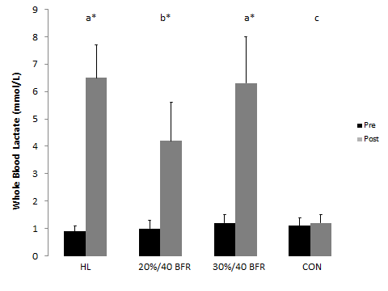
Figure 22. Group A Whole Blood Lactate
HL=high load (70% maximal effort); 20%/40 BFR= 20% maximal effort at an estimated 40% arterial occlusion pressure; 30%/40 BFR=30% maximal effort at an estimated 40% arterial occlusion pressure; CON=control. Conditions with different letters represent significant differences between conditions (p≤0.05).*denotes a significant difference from pre to post (p≤0.05). Variability represented as standard deviations.

Group B
A 4 x 2 repeated measures ANOVA revealed a significant condition x time interaction for WBL (p<0.001). A one-way ANOVA across the pre values showed no statistical difference between conditions (p=0.735). However, a one-way ANOVA did reveal significant differences across conditions for the post values (Figure 23, p<0.001). Pairwise comparisons revealed post WBL to be significantly higher in the 30% to failure condition compared to the 20%/50 BFR (p=0.006) and control conditions (p<0.006). There was no significant difference in WBL between the 30% to failure condition and the 30%/50 BFR condition (p=0.999). The 20%/50 BFR condition’s post WBL was significantly less than the 30%/50 BFR (p=0.006) condition, but was significantly greater than the control condition (p=0.006). In addition, the 30%/50 BFR condition had significantly greater post WBL levels than the control condition (p=0.006). Paired sample t-tests showed significant increases in WBL from pre-post in all conditions (p=0.004) except for the control condition (p=0.999).
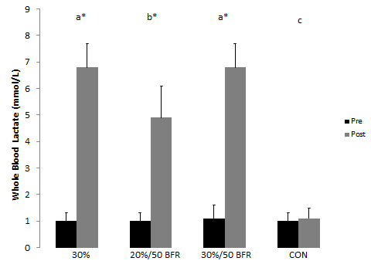
Figure 23. Group B Whole Blood Lactate
30%=30% maximal effort to failure; 20%/50 BFR= 20% maximal effort at an estimated 50% arterial occlusion pressure; 30%/50 BFR=30% maximal effort at an estimated 50% arterial occlusion pressure; CON=control. Conditions with different letters represent significant differences between conditions (p≤0.05).*denotes a significant difference from pre to post (p≤0.05). Variability represented as standard deviations.

Group C
A 4 x 2 repeated measures ANOVA revealed a significant condition x time interaction for WBL (p<0.001). A one-way ANOVA for the pre values found no statistical difference across conditions (p=0.548). However, a one-way ANOVA did reveal significant differences across conditions for the post values (Figure 24, p<0.001). Pairwise comparisons showed post WBL to be significantly higher in the 20% to failure condition compared to the 20%/60 BFR (p=0.012) and control conditions (p<0.006). There was no significant difference in WBL between the 20% to failure condition and the 30%/60 BFR condition (p=0.999). The 20%/60 BFR conditions post WBL was significantly less than the 30%/60 BFR (p=0.006) condition but was significantly greater than the control condition (p=0.006). In addition, the 30%/60 BFR condition had significantly greater post WBL levels than the control condition (p=0.006). Paired sample t-tests revealed significant increases in WBL from pre-post in all conditions (p=0.004) except for the control condition (p=0.392).
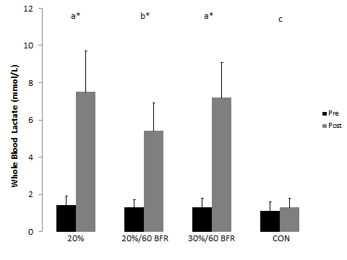
Figure 24. Group C Whole Blood Lactate
20%=20% maximal effort to failure; 20%/60 BFR= 20% maximal effort at an estimated 60% arterial occlusion pressure; 30%/60 BFR=30% maximal effort at an estimated 60% arterial occlusion pressure; CON=control. Conditions with different letters represent significant differences between conditions (p≤0.05).*denotes a significant difference from pre to post (p≤0.05). Variability represented as standard deviations.

Surface Electromyography
Surface electromyography is defined as the algebraic sum of the muscle action potentials that pass within the recording area of the electrodes. The amplitude of the surface electromyography signal is proportional to the force produced by the muscle (Stock, Beck, Defreitas, & Dillon, 2010). Mean power frequency is derived from the Fourier transformation and indicates which frequencies dominate the electromyography signal. It is mostly related to the conduction velocity (Mortimer, Magnusson, & Petersen, 1970), which is the speed at which the electrochemical signal propagates down a neural pathway. It is also related to the shape of the action potential (Lindstrom, Magnusson, & Petersen, 1970) and to a lesser extent, the discharge rate of the motor units (De Luca, 1979). All values are normalized as a percentage of the value obtained during the baseline MVC.
Group A
A 3 x 4 repeated measures ANOVA did not detect a significant interaction with concentric amplitude of the first three contractions (Table 15, p=0.078). However, there were significant main effects for condition (p<0.001) and time (p=0.008). A one-way ANOVA across conditions showed that the HL condition had significantly greater concentric amplitude than 20%/40 BFR (78 SE 5% vs. 34 SE 2%, p=0.003) and 30%/40 BFR (78 SE 5% vs. 49 SE 3%, p=0.003) conditions. In addition, concentric amplitude was significantly greater in the 30%/40 BFR condition compared to the 20%/40 BFR (49 SE 3% vs. 34 SE 2%, p=0.003) condition. A one-way ANOVA across time revealed that amplitude significantly increased from set 2 to set 4 (52 SE 3% vs. 58 SE 4%, p=0.024). There were no other significant differences across time (p≥0.066).
Table 15. Group A Concentric Amplitude of the First 3 Reps
 | Concentric Amplitude First 3 Reps (%MVC)
Group A | Set 1^{ac} | Set 2^{ab} | Set 3^{ac} | Set 4^{c}
HLª | 73 (17) | 73 (19) | 81 (22) | 85 (25)
20%/40 BFR^{b} | 33 (10) | 32 (8) | 34 (10) | 36 (10)
30%/40 BFR^{c} | 43 (12) | 50 (16) | 51 (15) | 53 (17)
%MVC= percentage of baseline maximal voluntary contraction; HL=high load (70% maximal effort); 20%/40 BFR= 20% maximal effort at an estimated 40% arterial occlusion pressure; 30%/40 BFR=30% maximal effort at an estimated 40% arterial occlusion pressure; CON=control. Sets with different letters represent significant differences between sets (p≤0.05). Conditions with different letters represent significant differences between conditions (p≤0.05). Variability represented as standard deviations.

A 3 x 4 repeated measures ANOVA did not reveal a significant interaction with concentric amplitude of the last three contractions (Table 16, p=0.668). However, there were significant main effects for condition (p<0.001) and time (p=0.001). A one-way ANOVA across conditions showed that the HL condition had significantly greater concentric amplitude than 20%/40 BFR (93 SE 6% vs. 44 SE 3%, p=0.003) and 30%/40 BFR (93 SE 6% vs. 62 SE 4%, p=0.003) conditions. In addition, concentric amplitude was significantly greater in the 30%/40 BFR condition compared to the 20%/40 BFR (62 SE 4% vs. 44 SE 3%, p=0.003) condition. A one-way ANOVA across time showed a significant increase in concentric amplitude during the last three contractions from set 1 (60 SE 4%) to set 2 (66 SE 4%, p=0.024), to set 3 (70 SE 5%, p=0.012), to set 4 (70 SE 4%, p=0.018). There were no significant differences from set 2 to set 3 (66 SE 4% vs. 70 SE 5%, p=0.216) or from set 2 to set 4 (66 SE 4% vs. 70 SE 4%, p=0.096). In addition, there were no significant differences in concentric amplitude for the last three reps from set 3 to set 4 (70 SE 5% vs. 70 SE 4%, p=0.999).
Table 16. Group A Concentric Amplitude of the Last 3 Reps
 | Concentric Amplitude Last 3 Reps (%MVC)
Group A | Set 1ª | Set 2^{b} | Set 3^{b} | Set 4^{b}
HLª | 85 (24) | 92 (24) | 98 (28) | 97 (27)
20%/40 BFR^{b} | 40 (12) | 43 (12) | 46 (14) | 48 (15)
30%/40 BFR^{c} | 56 (14) | 62 (19) | 65 (22) | 66 (21)
%MVC= percentage of baseline maximal voluntary contraction; HL=high load (70% maximal effort); 20%/40 BFR= 20% maximal effort at an estimated 40% arterial occlusion pressure; 30%/40 BFR=30% maximal effort at an estimated 40% arterial occlusion pressure; CON=control. Sets with different letters represent significant differences between sets (p≤0.05). Conditions with different letters represent significant differences between conditions (p≤0.05). Variability represented as standard deviations.

A 3 x 4 repeated measures ANOVA did not reveal a significant interaction with eccentric amplitude of the first three contractions (Table 17, p=0.121). However, there were significant main effects for condition (p<0.001) and time (p=0.001). A one-way ANOVA across conditions showed that the HL condition had significantly greater eccentric amplitude than 20%/40 BFR (34 SE 2% vs. 15 SE 1%, p=0.003) and 30%/40 BFR (34 SE 6% vs. 19 SE 1%, p=0.003) conditions. In addition, eccentric amplitude was significantly greater in the 30%/40 BFR condition compared to the 20%/40 BFR (19 SE 1% vs. 15 SE 1%, p=0.003) condition. A one-way ANOVA across time showed a significant decrease in eccentric amplitude of the first 3 contractions from set 1 to set 2 (24 SE 1% vs. 21 SE 1%, p=0.006). There were no other significant differences from set 1 (p≥0.258). Eccentric amplitude significantly increased from set 2 (21 SE 1%) to set 3 (22 SE 1%, p=0.042) to set 4 (23 SE 1%, p=0.006). In addition, eccentric amplitude significantly increased from set 3 (22 SE 1%) to set 4 (23 SE 1%, p=0.006).
Table 17. Group A Eccentric Amplitude of the First 3 Reps
 | Eccentric Amplitude First 3 Reps (%MVC)
Group A | Set 1ª | Set 2^{b} | Set 3ª | Set 4^{c}
HLª | 36 (7) | 32 (9) | 33 (8) | 34 (9)
20%/40 BFR^{b} | 15 (4) | 13 (3) | 14 (5) | 16 (5)
30%/40 BFR^{c} | 20 (4) | 17 (3) | 19 (3) | 20 (4)
%MVC= percentage of baseline maximal voluntary contraction; HL=high load (70% maximal effort); 20%/40 BFR= 20% maximal effort at an estimated 40% arterial occlusion pressure; 30%/40 BFR=30% maximal effort at an estimated 40% arterial occlusion pressure; CON=control. Sets with different letters represent significant differences between sets (p≤0.05). Conditions with different letters represent significant differences between conditions (p≤0.05). Variability represented as standard deviations.

A 3 x 4 repeated measures ANOVA did not reveal a significant interaction with eccentric amplitude of the last three contractions (Table 18, p=0.283). However, there were significant main effects for condition (p<0.001) and time (p=0.007). A one-way ANOVA across conditions showed that the HL condition had significantly greater eccentric amplitude than 20%/40 BFR (40 SE 2% vs. 24 SE 2%, p=0.003) and 30%/40 BFR (40 SE 2% vs. 30 SE 2%, p=0.003) conditions. In addition, eccentric amplitude was significantly greater in the 30%/40 BFR condition compared to the 20%/40 BFR (30 SE 2% vs. 24 SE 2%, p=0.003) condition. Eccentric amplitudes were similar between the 30%/40 BFR and 20%/40 BFR (34 SE 3% vs. 24 SE 2%, p=0.087) conditions. A one-way ANOVA across time revealed a significant increase in eccentric amplitude of the last three contractions from set 1 to set 3 (27 SE 1% vs. 33 SE 2%, p=0.006) to set 4 (27 SE 1% vs. 35 SE 2%, p=0.006). There were no significant differences between any other time points (p≥0.816).
Table 18. Group A Eccentric Amplitude of the Last 3 Reps
 | Eccentric Amplitude Last 3 Reps (%MVC)
Group A | Set 1ª | Set 2^{ab} | Set 3^{b} | Set 4^{b}
HLª | 38 (11) | 37 (13) | 41 (9) | 44 (12)
20%/40 BFR^{b} | 20 (7) | 23 (10) | 26 (11) | 28 (12)
30%/40 BFR^{c} | 24 (5) | 31 (11) | 33 (12) | 32 (10)
%MVC= percentage of baseline maximal voluntary contraction; HL=high load (70% maximal effort); 20%/40 BFR= 20% maximal effort at an estimated 40% arterial occlusion pressure; 30%/40 BFR=30% maximal effort at an estimated 40% arterial occlusion pressure; CON=control. Conditions with different letters represent significant differences between conditions (p≤0.05). Variability represented as standard deviations.

A 3 x 4 repeated measures ANOVA did not reveal a significant interaction with concentric mean power frequency of the first 3 contractions (Table 19, p=0.450). In addition, there was no significant main effect for condition (p=0.993) or time (p=0.251).
Table 19. Group A Concentric Mean Power Frequency of the First 3 Reps
 | Concentric Mean Power Frequency First 3 Reps (%MVC)
Group A | Set 1 | Set 2 | Set 3 | Set 4
HL | 93 (10) | 91 (10) | 94 (12) | 93 (14)
20%/40 BFR | 93 (15) | 92 (13) | 93 (15) | 92 (13)
30%/40 BFR | 96 (17) | 92 (16) | 92 (13) | 91 (14)
%MVC= percentage of baseline maximal voluntary contraction; HL=high load (70% maximal effort); 20%/40 BFR= 20% maximal effort at an estimated 40% arterial occlusion pressure; 30%/40 BFR=30% maximal effort at an estimated 40% arterial occlusion pressure; CON=control. Variability represented as standard deviations.

A 3 x 4 repeated measures ANOVA did not reveal a significant interaction with concentric mean power frequency of the last three contractions (Table 20, p=0.847). There was no significant main effect for condition (p=0.993) but there was for time (p=0.009). There was a significant increase in concentric mean power frequency from set 1 (92 SE 3%) to set 3 (95 SE 3%, p=0.03). There were no other significant differences from set 1 (p≥0.072) or between any other time point (p≥0.522).
Table 20. Group A Concentric Mean Power Frequency of the Last 3 Reps
 | Concentric Mean Power Frequency Last 3 Reps (%MVC)
Group A | Set 1ª | Set 2^{ab} | Set 3^{b} | Set 4^{ab}
HL | 92 (11) | 93 (13) | 95 (11) | 95 (11)
20%/40 BFR | 92 (16) | 95 (13) | 96 (12) | 97 (13)
30%/40 BFR | 93 (17) | 94 (13) | 94 (18) | 95 (15)
%MVC= percentage of baseline maximal voluntary contraction; HL=high load (70% maximal effort); 20%/40 BFR= 20% maximal effort at an estimated 40% arterial occlusion pressure; 30%/40 BFR=30% maximal effort at an estimated 40% arterial occlusion pressure; CON=control. Sets with different letters represent significant differences between sets (p≤0.05). Variability represented as standard deviations.

A 3 x 4 repeated measures ANOVA did not reveal a significant interaction with eccentric mean power frequency of the first three contractions (Table 21, p=0.307). There was no significant main effect for condition (p=0.688) but there was for time (p<0.001). There were significant decreases in eccentric mean power frequency from set 1 (103 SE 3%) to set 2 (100 SE 3%, p=0.018) to set 3 (99 SE 3%, p=0.012) to set 4 (99 SE 3%, p=0.03). There were no other significant differences between any other time points (p=0.999).
Table 21. Group A Eccentric Mean Power Frequency of the First 3 Reps
 | Eccentric Mean Power Frequency First 3 Reps (%MVC)
Group A | Set 1ª | Set 2^{b} | Set 3^{b} | Set 4^{b}
HL | 104 (12) | 104 (13) | 100 (13) | 101 (11)
20%/40 BFR | 102 (18) | 98 (19) | 98 (16) | 99 (19)
30%/40 BFR | 104 (19) | 98 (18) | 99 (18) | 97 (18)
%MVC= percentage of baseline maximal voluntary contraction; HL=high load (70% maximal effort); 20%/40 BFR= 20% maximal effort at an estimated 40% arterial occlusion pressure; 30%/40 BFR=30% maximal effort at an estimated 40% arterial occlusion pressure; CON=control. Sets with different letters represent significant differences between sets (p≤0.05). Variability represented as standard deviations.

A 3 x 4 repeated measures ANOVA revealed a significant interaction with eccentric mean power frequency of the last three contractions (Table 22, p=0.045). A one-way ANOVA was unable to detect a significant difference between conditions for set 1 (p=0.999), set 2 (p=0.999), set 3 (p=0.999), or set 4 (p=0.183). In addition, there was no significant difference across time for eccentric mean power frequency in the HL condition (p=0.917) or the 30%/40 BFR condition (p=0.099). There was a significant difference across time in the 20%/40 BFR group, with set 4 having significantly greater eccentric mean power frequency than set 1 (p=0.006). There were no other significant differences from set 1 (p=0.33). Eccentric mean power frequency was significantly lower in set 2 compared to set 4 (p=0.03) but was not different from set 3 (p=0.999). In addition, there were no significant eccentric mean power frequency differences between set 3 and set 4 (p=0.438).
Table 22. Group A Eccentric Mean Power Frequency of the Last 3 Reps
 | Eccentric Mean Power Frequency Last 3 Reps (%MVC)
Group A† | Set 1 | Set 2 | Set 3 | Set 4
HL | 98 (10) | 99 (11) | 97 (13) | 97 (11)
20%/40 BFR | 98 (19) | 100 (16) | 102 (15) | 105 (16)
30%/40 BFR | 96 (18) | 98 (18) | 101 (16) | 98 (15)
%MVC= percentage of baseline maximal voluntary contraction; HL=high load (70% maximal effort); 20%/40 BFR= 20% maximal effort at an estimated 40% arterial occlusion pressure; 30%/40 BFR=30% maximal effort at an estimated 40% arterial occlusion pressure; CON=control. † denotes a significant condition x time interaction, that is decomposed in the text (p≤0.05). Variability represented as standard deviations.

Group B
A 3 x 4 repeated measures ANOVA revealed a significant interaction with concentric amplitude of the first three contractions (Table 23, p<0.001). A one-way ANOVA across set 1 showed significant differences (p=0.009) between conditions. Pairwise comparisons showed that concentric amplitude was significantly higher in the 30%/50 BFR condition compared to the 20%/50 BFR condition (p=0.006). There were no other differences between conditions for set 1 (p≥0.246). A one-way ANOVA across set 2 showed significant differences (p=0.023) between conditions. Pairwise comparisons revealed that concentric amplitude was significantly higher in the 30%/50 BFR condition compared to the 20%/50 BFR condition (p=0.009). There were no other differences between conditions for set 2 (p≥0.075). A one-way ANOVA across set 3 revealed significant differences (p<0.001) between conditions. Pairwise comparisons showed that concentric amplitude was significantly higher in the 30% to failure condition compared to the 20%/50 BFR condition (p=0.003) but was not different from the 30%/50 BFR condition (p=0.999). In addition, the concentric amplitude was significantly higher in the 30%/50 BFR condition compared to the 20%/50 BFR condition (p=0.003). A one-way ANOVA across set 4 showed significant differences (p<0.001) between conditions. Pairwise comparisons showed that concentric amplitude was significantly higher in the 30% to failure condition compared to 20%/50 BFR (p=0.003), but was not different from the 30%/50 BFR condition (p=0.999). In addition, the concentric amplitude was significantly higher in the 30%/50 BFR condition compared to the 20%/50 BFR condition (p=0.003). A one-way ANOVA across time for the 30% to failure condition found significant concentric amplitude differences between sets (p<0.001). Pairwise comparisons found that concentric amplitude increased from set 1 to set 2 (p=0.006) to set 3 (p=0.006) to set 4 (p=0.006). Concentric amplitude increased significantly from set 2 to set 3 (p=0.012) to set 4 (p=0.006). There was no significant difference from set 3 to set 4 (p=0.246). A one-way ANOVA across time for the 20%/50 BFR condition showed significant concentric amplitude differences between sets (p<0.001). Pairwise comparisons found that concentric amplitude increased from set 1 to set 3 (0.048) to set 4 (p=0.006). There was no significant difference between set 1 and set 2 (p=0.60). Concentric amplitude increased from set 2 to set 3 (p=0.006) to set 4 (p=0.018). There was no significant difference from set 3 to set 4 (p=0.12). A one-way ANOVA across time for the 30%/50 BFR condition revealed significant concentric amplitude differences between sets (p<0.001). Pairwise comparisons showed that concentric amplitude increased from set 1 to set 2 (p=0.036) to set 3 (p=0.006) to set 4 (p=0.006). Concentric amplitude increased from set 2 to set 3 (p=0.006) to set 4 (p=0.006). There was no significant difference from set 3 to set 4 (p=0.408).
Table 23. Group B Concentric Amplitude of the First 3 Reps
 | Concentric Amplitude First 3 Reps (%MVC)
Group B† | Set 1 | Set 2 | Set 3 | Set 4
30% | 39 (8) | 53 (12) | 65 (16) | 69 (15)
20%/50 BFR | 33 (10) | 37 (16) | 41 (16) | 45 (16)
30%/50 BFR | 43 (13) | 54 (22) | 65 (27) | 70 (24)
%MVC= percentage of baseline maximal voluntary contraction; 30%=30% maximal effort to failure; 20%/50 BFR= 20% maximal effort at an estimated 50% arterial occlusion pressure; 30%/50 BFR=30% maximal effort at an estimated 50% arterial occlusion pressure; CON=control. † denotes a significant condition x time interaction, that is decomposed in the text (p≤0.05). Variability represented as standard deviations.

A 3 x 4 repeated measures ANOVA did not reveal a significant interaction with concentric amplitude of the last three contractions (Table 24, p=0.101). However, there were significant main effects for condition (p<0.001) and time (p<0.001). A one-way ANOVA across conditions showed that the 30% to failure condition had significantly greater concentric amplitude than 20%/50 BFR condition (77 SE 5% vs. 55 SE 5%, p=0.003) but not 30%/50 BFR (77 SE 5% vs. 77 SE 6%, p=0.999) condition. Concentric amplitudes were significantly higher in the 30%/50 BFR condition compared to the 20%/50 BFR (77 SE 6% vs. 55 SE 5%, p=0.003) condition. A one-way ANOVA across time showed a significant increase in concentric amplitude of the last 3 contractions from set 1 (59 SE 3%) to set 2 (69 SE 4%, p=0.006), to set 3 (74 SE 6%, p=0.006), to set 4 (76 SE 6%, p=0.006). There were no significant differences from set 2 to set 3 (69 SE 4% vs. 74 SE 6%, p=0.999) or from set 2 to set 4 (69 SE 4% vs. 76 SE 6%, p=0.162). In addition, there was no significant difference in concentric amplitude for the last 3 reps from set 3 to set 4 (74 SE 6% vs. 76 SE 6%, p=0.999).
Table 24. Group B Concentric Amplitude of the Last 3 Reps
 | Concentric Amplitude Last 3 Reps (%MVC)
Group B | Set 1ª | Set 2^{b} | Set 3^{b} | Set 4^{b}
30%ª | 67 (13) | 77 (15) | 82 (23) | 82 (27)
20%/50 BFR^{b} | 47 (15) | 54 (17) | 57 (22) | 60 (23)
30%/50 BFRª | 63 (19) | 77 (22) | 83 (26) | 87 (27)
%MVC= percentage of baseline maximal voluntary contraction; 30%=30% maximal effort to failure; 20%/50 BFR= 20% maximal effort at an estimated 50% arterial occlusion pressure; 30%/50 BFR=30% maximal effort at an estimated 50% arterial occlusion pressure; CON=control. Sets with different letters represent significant differences between sets (p≤0.05). Conditions with different letters represent significant differences between conditions (p≤0.05). Variability represented as standard deviations.

A 3 x 4 repeated measures ANOVA revealed a significant interaction with eccentric amplitude of the first three contractions (Table 25, p=0.039). A one-way ANOVA across set 1 showed significant differences (p=0.008) between conditions. Pairwise comparisons showed that the 30% to failure conditions eccentric amplitude was not statistically different from the 20%/50 BFR (p=0.081) or 30%/50 BFR (p=0.999) conditions. In addition, no significant differences were detected between the 20%/50 BFR and 30%/50 BFR conditions in eccentric amplitude (p=0.096). A one-way ANOVA across set 2 revealed significant differences (p=0.018) between conditions. Pairwise comparisons found that eccentric amplitude was significantly higher in the 30% to failure condition compared to 20%/50 BFR (p=0.012), but was not statistically different from the 30%/50 BFR condition (p=0.999). No significant differences were found between the 20%/50 BFR and 30%/50 BFR conditions in eccentric amplitude (p=0.153). A one-way ANOVA across set 3 showed significant differences (p=0.009) between conditions. Pairwise comparisons showed that eccentric amplitude was significantly higher in the 30% to failure condition compared to 20%/50 BFR (p=0.018) condition, but was not statistically different from the 30%/50 BFR condition (p=0.999). No significant differences were found between the 20%/50 BFR and 30%/50 BFR conditions in eccentric amplitude (p=0.141). A one-way ANOVA across set 4 revealed significant differences (p=0.002) between conditions. Pairwise comparisons found that eccentric amplitude was significantly higher in the 30% to failure condition compared to 20%/50 BFR (p=0.003) condition, but was not statistically different from the 30%/50 BFR condition (p=0.999). In addition, eccentric amplitude was significantly higher with 30%/50 BFR compared to 20%/50 BFR (p=0.048). A one-way ANOVA across time for the 30% to failure condition showed significant eccentric amplitude differences between sets (p=0.001). Pairwise comparisons showed that eccentric amplitude increased from set 1 to set 4 (p=0.006), but no other time points were significantly different from set 1 (p≥0.216). Eccentric amplitude increased significantly from set 2 to set 4 (p=0.006), but there was no significant difference between set 2 and set 3 (p=0.09). In addition, there was no significant difference from set 3 to set 4 (p=0.999). A one-way ANOVA across time for the 20%/50 BFR condition revealed significant eccentric amplitude differences between sets (p=0.001). Pairwise comparisons showed that eccentric amplitude was not different from set 1 to set 2 (p=0.45) to set 3 (p=0.999) to set 4 (p=0.45). Eccentric amplitude increased from set 2 to set 4 (p=0.012), but there were no significant differences between set 2 and set 3 (p=0.258). In addition, eccentric amplitude increased from set 3 to set 4 (p=0.03). A one-way ANOVA across time for the 30%/50 BFR condition revealed significant eccentric amplitude differences between sets (p=0.039). Pairwise comparisons showed that eccentric amplitude was not different from set 1 to set 2 (p=0.999) to set 3 (p=0.999) to set 4 (p=0.21). Eccentric amplitude increased from set 2 to set 4 (p=0.006), but there was no significant difference between set 2 and set 3 (p=0.15). In addition, there was no difference between set 3 and set 4 for eccentric amplitude (p=0.642).
 | Eccentric Amplitude First 3 Reps (%MVC
Group B† | Set 1 | Set 2 | Set 3 | Set 4
30% | 21 (5) | 22 (6) | 29 (12) | 33 (8)
20%/50 BFR | 18 (5) | 16 (4) | 17 (4) | 20 (5)
30%/50 BFR | 22 (6) | 21 (10) | 28 (18) | 30 (15)
Table 25. Group B Eccentric Amplitude of the First 3 Reps
%MVC= percentage of baseline maximal voluntary contraction; 30%=30% maximal effort to failure; 20%/50 BFR= 20% maximal effort at an estimated 50% arterial occlusion pressure; 30%/50 BFR=30% maximal effort at an estimated 50% arterial occlusion pressure; CON=control. † denotes a significant condition x time interaction, that is decomposed in the text (p≤0.05). Variability represented as standard deviations.

A 3 x 4 repeated measures ANOVA did not reveal a significant interaction with eccentric amplitude of the last three contractions (Table 26, p=0.445). However, there were significant main effects for condition (p=0.001) and time (p<0.001). A one-way ANOVA across conditions showed that the 30% to failure condition had significantly greater eccentric amplitude than 20%/50 BFR (41 SE 2% vs. 29 SE 1%, p=0.003) but not 30%/50 BFR (41 SE 2% vs. 38 SE 4%, p=0.999). Eccentric amplitudes were significantly higher in the 30%/50 BFR condition compared to the 20%/50 BFR (38 SE 4% vs. 29 SE 1%, p=0.024) condition. A one-way ANOVA across time revealed a significant increase in eccentric amplitude of the last 3 contractions from set 1 (27 SE 1%) to set 2 (35 SE 2%, p=0.006), to set 3 (38 SE 2%, p=0.006), to set 4 (43 SE 3%, p=0.006). There was no significant difference from set 2 to set 3 (35 SE 2% vs. 38 SE 2%, p=0.162), but there was a significant increase from set 2 to set 4 (35 SE 2% vs. 43 SE 3%, p=0.006). In addition there was a significant increase in eccentric amplitude for the last 3 contractions from set 3 to set 4 (38 SE 2% vs. 43 SE 3%, p=0.03).
Table 26. Group B Eccentric Amplitude of the Last 3 Reps
 | Eccentric Amplitude Last 3 Reps (%MVC)
Group B | Set 1ª | Set 2^{bc} | Set 3^{c} | Set 4^{d}
30%ª | 31 (8) | 40 (9) | 43 (14) | 50 (15)
20%/50 BFR^{b} | 22 (5) | 27 (5) | 30 (5) | 35 (7)
30%/50 BFRª | 27 (7) | 39 (17) | 42 (15) | 46 (21)
%MVC= percentage of baseline maximal voluntary contraction; 30%=30% maximal effort to failure; 20%/50 BFR= 20% maximal effort at an estimated 50% arterial occlusion pressure; 30%/50 BFR=30% maximal effort at an estimated 50% arterial occlusion pressure; CON=control. Sets with different letters represent significant differences between sets (p≤0.05). Conditions with different letters represent significant differences between conditions (p≤0.05). Variability represented as standard deviations.

A 3 x 4 repeated measures ANOVA did not reveal a significant interaction with concentric mean power frequency of the first three contractions (Table 27, p=0.252). In addition, there was no significant main effect for condition (p=0.333) or time (p=0.061).
 | Concentric Mean Power Frequency First 3 Reps (%MVC)
Group B | Set 1 | Set 2 | Set 3 | Set 4
30% | 99 (13) | 93 (10) | 96 (9) | 95 (9)
20%/50 BFR | 93 (11) | 92 (8) | 93 (10) | 93 (10)
30%/50 BFR | 93 (9) | 89 (8) | 90 (9) | 89 (7)
Table 27. Group B Concentric Mean Power Frequency of the First 3 Reps
%MVC= percentage of baseline maximal voluntary contraction; 30%=30% maximal effort to failure; 20%/50 BFR= 20% maximal effort at an estimated 50% arterial occlusion pressure; 30%/50 BFR=30% maximal effort at an estimated 50% arterial occlusion pressure; CON=control. Variability represented as standard deviations.

A 3 x 4 repeated measures ANOVA did not reveal a significant interaction with concentric mean power frequency of the last three contractions (Table 28, p=0.445). In addition, there was no significant main effect for condition (p=0.682) or time (p=0.08).

Table 28. Group B Concentric Mean Power Frequency of the Last 3 Reps
 | Concentric Mean Power Frequency Last 3 Reps (%MVC)
Group B | Set 1 | Set 2 | Set 3 | Set 4
30% | 92 (14) | 93 (15) | 96 (13) | 96 (14)
20%/50 BFR | 94 (9) | 95 (9) | 96 (10) | 94 (10)
30%/50 BFR | 91 (10) | 91 (7) | 92 (8) | 93 (9)
%MVC= percentage of baseline maximal voluntary contraction; 30%=30% maximal effort to failure; 20%/50 BFR= 20% maximal effort at an estimated 50% arterial occlusion pressure; 30%/50 BFR=30% maximal effort at an estimated 50% arterial occlusion pressure; CON=control. Variability represented as standard deviations.

A 3 x 4 repeated measures ANOVA did not reveal a significant interaction with eccentric mean power frequency of the first three contractions (Table 29, p=0.759). However, there was a significant main effect for time (p<0.001) but not condition (p=0.205). A one-way ANOVA across time showed a significant decrease in eccentric mean power frequency of the first three contractions from set 1 (106 SE 2%) to set 2 (100 SE 3%, p=0.018), to set 3 (98 SE 2%, p=0.012), to set 4 (98 SE 2%, p=0.018). There were no other significant differences between sets (p=0.999).
 | Eccentric Mean Power Frequency First 3 Reps (% MVC)
Group B | Set 1ª | Set 2^{b} | Set 3^{b} | Set 4^{b}
30% | 110 (15) | 104 (16) | 103 (15) | 105 (15)
20%/50 BFR | 106 (12) | 98 (15) | 96 (12) | 96 (11)
30%/50 BFR | 102 (15) | 97 (18) | 96 (15) | 94 (12)
Table 29. Group B Eccentric Mean Power Frequency of the First 3 Reps
%MVC= percentage of baseline maximal voluntary contraction; 30%=30% maximal effort to failure; 20%/50 BFR= 20% maximal effort at an estimated 50% arterial occlusion pressure; 30%/50 BFR=30% maximal effort at an estimated 50% arterial occlusion pressure; CON=control. Sets with different letters represent significant differences between sets (p≤0.05). Variability represented as standard deviations.

A 3 x 4 repeated measures ANOVA revealed a significant interaction with eccentric mean power frequency of the last three contractions (Table 30, p=0.01). One-way ANOVAs across sets 1 (p=0.399), 2 (p=0.558), and 3 (p=0.074) revealed no significant differences between conditions. A one-way ANOVA across set 4 did show a significant difference between conditions (p=0.027), however post-hoc comparisons revealed no significant pairwise differences (p≥0.057). A one-way ANOVA across time for the 30% to failure condition showed significant eccentric mean power frequency differences between sets (p=0.001). Pairwise comparisons revealed that eccentric mean power frequency increased significantly from set 1 to set 3 (p=0.006) to set 4 (p=0.024). There was no significant difference between set 1 and set 2 (p=0.912). Eccentric mean power frequency increased from set 2 to set 4 (p=0.048), but there were no significant differences between set 2 and set 3 (p=0.054). In addition, there were no significant differences from set 3 to set 4 (p=0.999). A one-way ANOVA across time for 20%/50 BFR (p=0.339) and 30%/50 BFR (p=0.156) did not show significant differences between sets for eccentric mean power frequency.
Table 30. Group B Eccentric Mean Power Frequency of the Last 3 Reps
 | Eccentric Mean Power Frequency Last 3 Reps (%MVC)
Group B† | Set 1 | Set 2 | Set 3 | Set 4
30% | 95 (12) | 98 (15) | 103 (15) | 103 (16)
20%/50 BFR | 94 (12) | 97 (12) | 97 (13) | 98 (12)
30%/50 BFR | 89 (13) | 93 (15) | 93 (13) | 91 (13)
%MVC= percentage of baseline maximal voluntary contraction; 30%=30% maximal effort to failure; 20%/50 BFR= 20% maximal effort at an estimated 50% arterial occlusion pressure; 30%/50 BFR=30% maximal effort at an estimated 50% arterial occlusion pressure; CON=control. † denotes a significant condition x time interaction, that is decomposed in the text (p≤0.05). Variability represented as standard deviations.

Group C
A 3 x 4 repeated measures ANOVA revealed a significant interaction with concentric amplitude of the first three contractions (Table 31, p<0.001). A one-way ANOVA across set 1 showed significant differences (p=0.021) between conditions. However, pairwise comparisons detected no significant differences between conditions for set 1 (p≥0.078). A one-way ANOVA across set 2 revealed significant differences (p=0.047) between conditions. Pairwise comparisons showed that concentric amplitude was significantly higher in the 30%/60 BFR condition compared to the 20%/60 BFR condition (p=0.003). There were no other significant differences between conditions (p≥0.207). A one-way ANOVA across set 3 revealed significant differences (p=0.003) between conditions. Pairwise comparisons showed that concentric amplitude was significantly higher in the 30%/60 BFR condition compared to the 20%/60 BFR condition (p=0.003). There were no other significant differences between conditions (p≥0.222). A one-way ANOVA across set 4 revealed significant differences (p<0.001) between conditions. Concentric amplitude was significantly higher in the 30%/60 BFR condition compared to the 20% to failure (p=0.024) and the 20%/60 BFR (p=0.007) conditions. There was no difference between the 20% to failure and the 20%/60 BFR condition (p=0.273). A one-way ANOVA across time for the 20% to failure condition revealed significant concentric amplitude differences between sets (p<0.001). Pairwise comparisons showed that concentric amplitude increased from set 1 to set 2 (p=0.012) to set 3 (p=0.006) to set 4 (p=0.006). There were no other significant differences between sets (p≥0.594). A one-way ANOVA across time for the 20%/60 BFR condition revealed significant concentric amplitude differences between sets (p=0.001). Pairwise comparisons showed that concentric amplitude increased from set 1 to set 3 (p=0.012) to set 4 (p=0.018). There was no significant difference in concentric amplitude between set 1 and set 2 (p=0.348). Concentric amplitude significantly increased from set 2 to set 3 (p=0.018) to set 4 (p=0.006), but there was no significant difference between set 3 and set 4 (p=0.27). A one-way ANOVA across time for the 20%/60 BFR condition revealed significant concentric amplitude differences between sets (p<0.001). Pairwise comparisons showed that concentric amplitude increased from set 1 to set 2 (p=0.03) to set 3 (p=0.006) to set 4 (p=0.006). In addition, concentric amplitude increased from set 2 to set 3 (p=0.006) to set 4 (p=0.006), but there was no significant difference between set 3 and set 4 (p=0.072).
Table 31. Group C Concentric Amplitude of the First 3 Reps
 | Concentric Amplitude First 3 Reps (%MVC)
Group C† | Set 1 | Set 2 | Set 3 | Set 4
20% | 28 (12) | 43 (17) | 45 (17) | 48 (17)
20%/60 BFR | 28 (11) | 32 (13) | 37 (14) | 40 (16)
30%/60 BFR | 35 (14) | 44 (12) | 54 (13) | 60 (17)
%MVC= percentage of baseline maximal voluntary contraction; 20%=20% maximal effort to failure; 20%/60 BFR= 20% maximal effort at an estimated 60% arterial occlusion pressure; 30%/60 BFR=30% maximal effort at an estimated 60% arterial occlusion pressure; CON=control. † denotes a significant condition x time interaction, that is decomposed in the text (p≤0.05). Variability represented as standard deviations.

A 3 x 4 repeated measures ANOVA revealed a significant interaction with concentric amplitude of the last three contractions (Table 32, p<0.001). A one-way ANOVA across set 1 revealed significant differences (p=0.021) between conditions. Pairwise comparisons showed that concentric amplitude was significantly higher in the 30%/60 BFR condition compared to the 20%/60 BFR condition (p=0.015). There were no other significant differences between conditions (p≥0.087). A one-way ANOVA across set 2 found significant differences (p=0.042) between conditions. Pairwise comparisons found that concentric amplitude was significantly higher in the 30%/60 BFR condition compared to the 20%/60 BFR condition (p=0.006). There were no other significant differences between conditions (p≥0.309). A one-way ANOVA across set 3 revealed significant differences (p=0.004) between conditions. Pairwise comparisons showed that concentric amplitude was significantly higher in the 30%/60 BFR condition compared to the 20%/60 BFR condition (p=0.012). There were no other significant differences between conditions (p≥0.165). A one-way ANOVA across set 4 revealed significant differences (p=0.002) between conditions. Pairwise comparisons found that concentric amplitude was significantly higher in the 30%/60 BFR condition compared to the 20%/60 BFR condition (p=0.012) and the 20% to failure condition (p=0.033). There were no significant differences between the 20% to failure and the 20%/60 BFR conditions (p=0.864). A one-way ANOVA across time for the 20% to failure condition did not reveal significant differences (p=0.585) between sets. A one-way ANOVA across time for the 20%/60 BFR condition did not reveal significant differences (p=0.585) between sets. A one-way ANOVA across time for the 20%/60 BFR condition detected significant concentric amplitude differences between sets (p=0.001). Pairwise comparisons showed that concentric amplitude increased from set 1 to set 2 (p=0.012) to set 3 (p=0.006) to set 4 (p=0.006). In addition, concentric amplitude increased from set 2 to set 3 (p=0.03) to set 4 (p=0.03), but there was no significant difference between set 3 and set 4 (p=0.348). A one-way ANOVA across time for the 30%/60 BFR condition revealed significant concentric amplitude differences between sets (p=0.001). Pairwise comparisons showed that concentric amplitude increased from set 1 to set 2 (p=0.006) to set 3 (p=0.006) to set 4 (p=0.006). Concentric amplitude increased from set 2 to set 4 (p=0.024), but there was no difference from set 2 to set 3 (p=0.09). In addition, concentric amplitude increased from set 3 to set 4 (p=0.024).

Table 32. Group C Concentric Amplitude of the Last 3 Reps
 | Concentric Amplitude Last 3 Reps (%MVC)
Group C† | Set 1 | Set 2 | Set 3 | Set 4
20% | 55 (21) | 56 (24) | 60 (21) | 58 (20)
20%/60 BFR | 38 (14) | 43 (17) | 47 (17) | 51 (19)
30%/60 BFR | 53 (16) | 60 (16) | 70 (24) | 77 (28)
%MVC= percentage of baseline maximal voluntary contraction; 20%=20% maximal effort to failure; 20%/60 BFR= 20% maximal effort at an estimated 60% arterial occlusion pressure; 30%/60 BFR=30% maximal effort at an estimated 60% arterial occlusion pressure; CON=control. † denotes a significant condition x time interaction, that is decomposed in the text (p≤0.05). Variability represented as standard deviations.

A 3 x 4 repeated measures ANOVA did not reveal a significant interaction with eccentric amplitude of the first three contractions (Table 33, p=0.166). However, there were significant main effects for both condition (p=0.02) and time (p=0.002). A one-way ANOVA across conditions showed that the 30%/60 BFR condition had significantly greater eccentric amplitude than the 20%/60 BFR condition (20 SE 1% vs. 14 SE 1%, p=0.045). There were no other significant differences between conditions (p≥0.198). A one-way ANOVA across time revealed a significant increase in eccentric amplitude of the first 3 contractions from set 1 (16 SE 1%) to set 4 (21 SE 1%, p=0.03). There were no significant differences from set 1 to set 2 (16 SE 1%, p=0.999) to set 3 (18 SE 1%, p=0.999). Eccentric amplitude increased from set 2 (16 SE 1%) to set 4 (21 SE 1%, p=0.006), but did not differ from set 3 (18 SE 1%, p=0.552). In addition, eccentric amplitude increased from set 3 (18 SE 1%) to set 4 (21 SE 1%, p=0.006).

Table 33. Group C Eccentric Amplitude of the First 3 Reps
 | Eccentric Amplitude First 3 Reps (%MVC)
Group C | Set 1ª | Set 2ª | Set 3ª | Set 4^{b}
20%^{ab} | 16 (6) | 18 (9) | 20 (6) | 24 (9)
20%/60 BFRª | 13 (6) | 13 (5) | 14 (5) | 16 (7)
30%/60 BFR^{b} | 19 (6) | 18 (5) | 20 (7) | 23 (6)
%MVC= percentage of baseline maximal voluntary contraction; 20%=20% maximal effort to failure; 20%/60 BFR= 20% maximal effort at an estimated 60% arterial occlusion pressure; 30%/60 BFR=30% maximal effort at an estimated 60% arterial occlusion pressure; CON=control. Sets with different letters represent significant differences between sets (p≤0.05). Conditions with different letters represent significant differences between conditions (p≤0.05). Variability represented as standard deviations.

A 3 x 4 repeated measures ANOVA did not reveal a significant interaction with eccentric amplitude of the last three contractions (Table 34, p=0.116). However, there were significant main effects for condition (p=0.002) and time (p<0.001). A one-way ANOVA across conditions showed that the 20% to failure condition had significantly greater eccentric amplitude than the 20%/60 BFR condition (37 SE 3% vs. 22 SE 2%, p=0.024). There were no other significant differences between conditions (p≥0.063). A one-way ANOVA across time revealed significant increases in eccentric amplitude of the last 3 contractions from set 1 (25 SE 2%) to set 2 (30 SE 2%, p=0.012) to set 3 (32 SE 3%, p=0.006) to set 4 (34 SE 3%, p=0.006). There was a significant increase from set 2 (30 SE 2%) to set 4 (34 SE 3%, p=0.036), but there were no other eccentric amplitude differences between sets (p≥0.084).

Table 34. Group C Eccentric Amplitude of the Last 3 Reps
 | Eccentric Amplitude Last 3 Reps (%MVC)
Group C | Set 1ª | Set 2^{bc} | Set 3^{cd} | Set 4^{d}
20%ª | 34 (19) | 35 (13) | 40 (15) | 39 (12)
20%/60 BFR^{b} | 17 (6) | 23 (8) | 22 (11) | 27 (12)
30%/60 BFR^{ab} | 23 (7) | 32 (12) | 34 (14) | 37 (16)
%MVC= percentage of baseline maximal voluntary contraction; 20%=20% maximal effort to failure; 20%/60 BFR= 20% maximal effort at an estimated 60% arterial occlusion pressure; 30%/60 BFR=30% maximal effort at an estimated 60% arterial occlusion pressure; CON=control. Sets with different letters represent significant differences between sets (p≤0.05). Conditions with different letters represent significant differences between conditions (p≤0.05). Variability represented as standard deviations.

A 3 x 4 repeated measures ANOVA did not reveal a significant interaction with concentric mean power frequency of the first three contractions (Table 35, p=0.319). In addition, there was no significant main effect for condition (p=0.632) or time (p=0.083).
Table 35. Group C Concentric Mean Power Frequency of the First 3 Reps
 | Concentric Mean Power Frequency First 3 Reps (%MVC)
Group C | Set 1 | Set 2 | Set 3 | Set 4
20% | 100 (14) | 93 (14) | 92 (10) | 96 (13)
20%/60 BFR | 92 (10) | 92 (10) | 90 (10) | 93 (8)
30%/60 BFR | 96 (11) | 94 (11) | 94 (10) | 94 (12)
%MVC= percentage of baseline maximal voluntary contraction; 20%=20% maximal effort to failure; 20%/60 BFR= 20% maximal effort at an estimated 60% arterial occlusion pressure; 30%/60 BFR=30% maximal effort at an estimated 60% arterial occlusion pressure; CON=control. Variability represented as standard deviations.

A 3 x 4 repeated measures ANOVA did not reveal a significant interaction with concentric mean power frequency of the last three contractions (Table 36, p=0.388). In addition, there was no significant main effect for condition (p=0.678) or time (p=0.312).

Table 36. Group C Concentric Mean Power Frequency of the Last 3 Reps
 | Concentric Mean Power Frequency Last 3 Reps (%MVC)
Group C | Set 1 | Set 2 | Set 3 | Set 4
20% | 96 (20) | 97 (15) | 98 (17) | 99 (17)
20%/60 BFR | 93 (11) | 94 (10) | 93 (11) | 93 (13)
30%/60 BFR | 94 (11) | 96 (12) | 95 (9) | 93 (13)
%MVC= percentage of baseline maximal voluntary contraction; 20%=20% maximal effort to failure; 20%/60 BFR= 20% maximal effort at an estimated 60% arterial occlusion pressure; 30%/60 BFR=30% maximal effort at an estimated 60% arterial occlusion pressure; CON=control. Variability represented as standard deviations.

A 3 x 4 repeated measures ANOVA did not reveal a significant interaction with eccentric mean power frequency of the first three contractions (Table 37, p=0.113). However, there was a significant main effect for time (p=0.001) but not condition (p=0.352). A one-way ANOVA across time showed significant decreases in eccentric mean power frequency of the first three contractions from set 1 (103 SE 25) to set 2 (96 SE 2%, p=0.006), to set 3 (97 SE 2%, p=0.042), to set 4 (96 SE 2%, p=0.018). There were no other significant differences between sets (p≥0.960).
Table 37. Group C Eccentric Mean Power Frequency of the First 3 Reps
 | Eccentric Mean Power Frequency First 3 Reps (%MVC)
Group C | Set 1ª | Set 2^{b} | Set 3^{b} | Set 4^{b}
20% | 110 (17) | 99 (14) | 99 (15) | 99 (16)
20%/60 BFR | 99 (13) | 94 (13) | 94 (14) | 94 (14)
30%/60 BFR | 101 (15) | 97 (9) | 98 (10) | 94 (10)
%MVC= percentage of baseline maximal voluntary contraction; 20%=20% maximal effort to failure; 20%/60 BFR= 20% maximal effort at an estimated 60% arterial occlusion pressure; 30%/60 BFR=30% maximal effort at an estimated 60% arterial occlusion pressure; CON=control. Sets with different letters represent significant differences between sets (p≤0.05). Variability represented as standard deviations.

A 3 x 4 repeated measures ANOVA did not reveal a significant interaction with eccentric mean power frequency of the last three contractions (Table 38, p=0.146). There was no significant main effect for condition (p=0.422) but there was for time (p=0.036). A one-way ANOVA across time revealed a significant decrease in eccentric mean power frequency of the last 3 contractions from set 2 (96 SE 3%) to set 4 (93 SE 3%, p=0.048). There were no other eccentric mean power frequency differences between sets (p≥0.450).
Table 38. Group C Eccentric Mean Power Frequency of the Last 3 Reps
 | Eccentric Mean Power Frequency Last 3 Reps (%MVC)
Group C | Set 1^{ab} | Set 2^{b} | Set 3^{ab} | Set 4ª
20% | 96 (21) | 99 (23) | 99 (20) | 100 (17)
20%/60 BFR | 93 (11) | 95 (15) | 94 (16) | 91 (15)
30%/60 BFR | 94 (8) | 95 (12) | 91 (9) | 89 (10)
%MVC= percentage of baseline maximal voluntary contraction; 20%=20% maximal effort to failure; 20%/60 BFR= 20% maximal effort at an estimated 60% arterial occlusion pressure; 30%/60 BFR=30% maximal effort at an estimated 60% arterial occlusion pressure; CON=control. Variability represented as standard deviations.

Perceptual Responses
Group A
A Friedman non-parametric test revealed no significant differences between conditions for baseline RPE (Table 39, p=0.999). However, a significant difference was found between conditions for set 1 (p<0.001), 2 (p<0.001), 3 (p<0.001), and 4 (p<0.001). For set 1, a Wilcoxon related samples non-parametric test revealed significantly higher RPE in the HL condition compared to the control condition (p=0.006), but no other differences from the HL condition were detected (p≥0.246). RPE was significantly higher in the 20%/40 BFR condition compared to the control condition (p=0.006), but no other differences from the 20%/40 BFR condition were detected (p≥0.06). In addition, RPE was significantly higher in the 30%/40 BFR condition compared to the control condition (p=0.006). For set 2, a Wilcoxon related samples non-parametric test showed significantly higher RPE in the HL condition compared to the control condition (p=0.006), but no other differences from the HL condition were detected (p≥0.300). RPE was significantly higher in the 20%/40 BFR condition compared to the control condition (p=0.006), but was significantly less than the 30%/40 BFR condition (p=0.018). In addition, RPE was significantly higher in the 30%/40 BFR condition compared to the control condition (p=0.006). For set 3, a Wilcoxon related samples non-parametric test showed significantly higher RPE in the HL condition compared to the 20%/40 BFR condition (p=0.012) and the control condition (p=0.006), but no difference was detected between the HL condition and the 30%/40 BFR condition (p=0.195). RPE was significantly higher in the 20%/40 BFR condition compared to the control condition (p=0.006), but was significantly less than the 30%/40 BFR condition (p=0.006). In addition, RPE was significantly higher in the 30%/40 BFR condition compared to the control condition (p=0.006). For set 4, a Wilcoxon related samples non-parametric test revaled significantly higher RPE in the HL condition compared to the 20%/40 BFR condition (p=0.036) and the control condition (p=0.006), but no difference was observed between the HL condition and the 30%/40 BFR condition (p=0.600). RPE was significantly higher in the 20%/40 BFR condition compared to the control condition (p=0.006), but was significantly less than the 30%/40 BFR condition (p=0.006). In addition, RPE was significantly higher in the 30%/40 BFR condition compared to the control condition (p=0.006).

Table 39. Group A Ratings of Perceived Exertion
RPE | Pre | Set 1 | Set 2 | Set 3 | Set 4
Group A
HL | 6 (6-6) | 12 (8-13)ª | 14 (11-15)^{ab} | 15 (12-16)ª | 15 (13-17)ª
20%/40 BFR | 6 (6-6) | 7 (11-13)ª | 13 (9-15)ª | 13 (10-15)^{b} | 13 (11-15)^{b}
30%/40 BFR | 6 (6-6) | 13 (10-15)ª | 14 (13-17)^{b} | 15 (14-17)ª | 17 (13-18)ª
CON | 6 (6-6) | 6 (6-6)^{b} | 6 (6-6)^{c} | 6 (6-6)^{c} | 6 (6-6)^{c}
RPE=rating of perceived exertion; HL=high load (70% maximal effort); 20%/40 BFR= 20% maximal effort at an estimated 40% arterial occlusion pressure; 30%/40 BFR=30% maximal effort at an estimated 40% arterial occlusion pressure; CON=control. Sets with different letters represent significant differences between conditions (p≤0.05). Values represented as 50th percentile (25th-75th) percentiles.

A Friedman non-parametric test revealed no significant differences between conditions for baseline ratings of discomfort (Table 40, p=0.999). However, a significant difference was found between conditions for set 1 (p<0.001), 2 (p<0.001), 3 (p<0.001), and 4 (p<0.001). For set 1, a Wilcoxon related samples non-parametric test revealed significantly higher discomfort in the HL condition compared to the control condition (p=0.006), but no other differences from the HL condition were found (p≥0.072). Discomfort was significantly higher in the 20%/40 BFR condition compared to the control condition (p=0.006), but was significantly less than the 30%/40 BFR condition (p=0.018). In addition, discomfort was significantly higher in the 30%/40 BFR condition compared to the control condition (p=0.006). For set 2, a Wilcoxon related samples non-parametric test showed significantly higher discomfort in the HL condition compared to the control condition (p=0.006), but no other differences from the HL condition were found (p≥0.054). Discomfort was significantly higher in the 20%/40 BFR condition compared to the control condition (p=0.006), but was significantly less than the 30%/40 BFR condition (p=0.018). In addition, discomfort was significantly higher in the 30%/40 BFR condition compared to the control condition (p=0.006). For set 3, a Wilcoxon related samples non-parametric test revealed significantly higher discomfort in the HL condition compared to the control condition (p=0.006), but no difference was observed between the HL condition and the 20%/40 BFR condition (p=0.084). However, the HL condition rated discomfort significantly less than 30%/40 BFR condition (p=0.03). Discomfort was significantly higher in the 20%/40 BFR condition compared to the control condition (p=0.006), but was significantly less than the 30%/40 BFR condition (p=0.006). In addition, discomfort was significantly higher in the 30%/40 BFR condition compared to the control condition (p=0.006). For set 4, a Wilcoxon related samples non-parametric test revealed significantly higher discomfort in the HL condition compared to the control condition (p=0.006), but no other differences from the HL condition were found (p≥0.084). Discomfort was significantly higher in the 20%/40 BFR condition compared to the control condition (p=0.006), but was significantly less than the 30%/40 BFR condition (p=0.018). In addition, discomfort was significantly higher in the 30%/40 BFR condition compared to the control condition (p=0.006).
Table 40. Group A Ratings of Discomfort
Discomfort | Pre | Set 1 | Set 2 | Set 3 | Set 4
Group A
HL | 0 (0-0) | 2 (0.8-3.2)^{ab} | 3 (1.7-6)^{ab} | 3.5 (2.7-7)ª | 5.5 (3.7-7.2)^{ab}
20%/40 BFR | 0 (0-0) | 1 (0.5-3.2)ª | 2.7 (1.3-5)ª | 3 (2.2-5.1)ª | 4 (2.7-6)ª
30%/40 BFR | 0 (0-0) | 4 (2.2-6)^{b} | 5.5 (2.5-8)^{b} | 7 (3.6-8.2)^{b} | 7.5 (4.5-9)^{b}
CON | 0 (0-0) | 0 (0-0)^{c} | 0 (0-0)^{c} | 0 (0-0)^{c} | 0 (0-0)^{c}
HL=high load (70% maximal effort); 20%/40 BFR= 20% maximal effort at an estimated 40% arterial occlusion pressure; 30%/40 BFR=30% maximal effort at an estimated 40% arterial occlusion pressure; CON=control. Sets with different letters represent significant differences between conditions (p≤0.05). Values represented as 50th percentile (25th-75th) percentiles.
Group B
A Friedman non-parametric test revealed no significant differences between conditions for baseline RPE (Table 41, p=0.999). However, a significant difference was found between conditions for set 1 (p<0.001), 2 (p<0.001), 3 (p<0.001), and 4 (p<0.001). For set 1, a Wilcoxon related samples non-parametric test showed significantly higher RPE in the 30% to failure condition compared to the 20%/50 BFR (p=0.006) condition and the control condition (p=0.006), but no difference was observed between the 30% to failure condition and the 30%/50 BFR condition (p=0.294). RPE was significantly higher in the 20%/50 BFR condition compared to the control condition (p=0.006), but no differences were observed between the 20%/50 BFR condition and the 30%/50 BFR condition (p=0.054). In addition, RPE was significantly higher in the 30%/50 BFR condition compared to the control condition (p=0.006). For set 2, a Wilcoxon related samples non-parametric test showed significantly higher RPE in the 30% to failure condition compared to the 20%/50 BFR (p=0.018) condition and the control condition (p=0.006), but no difference was observed between the 30% to failure condition and the 30%/50 BFR condition (p=.690). RPE was significantly higher in the 20%/50 BFR condition compared to the control condition (p=0.006), but RPE was significantly less in the 20%/50 BFR condition compared to the 30%/50 BFR condition (p=0.042). In addition, RPE was significantly higher in the 30%/50 BFR condition compared to the control condition (p=0.006). For set 3, a Wilcoxon related samples non-parametric test revealed significantly higher RPE in the 30% to failure condition compared to the 20%/50 BFR (p=0.012) condition and the control condition (p=0.006), but no difference was observed between the 30% to failure condition and the 30%/50 BFR condition (p=.900). RPE was significantly higher in the 20%/50 BFR condition compared to the control condition (p=0.006), but RPE was significantly less in the 20%/50 BFR condition compared to the 30%/50 BFR condition (p=0.03). In addition, RPE was significantly higher in the 30%/50 BFR condition compared to the control condition (p=0.006). For set 4, a Wilcoxon related samples non-parametric test revealed significantly higher RPE in the 30% to failure condition compared to the 20%/50 BFR (p=0.036) condition and the control condition (p=0.006), but no difference was observed between the 30% to failure condition and the 30%/50 BFR condition (p=.999). RPE was significantly higher in the 20%/50 BFR condition compared to the control condition (p=0.006), but no difference was observed between the 20%/50 BFR condition and the 30%/50 BFR condition (p=0.066). In addition, RPE was significantly higher in the 30%/50 BFR condition compared to the control condition (p=0.006).
Table 41. Group B Ratings of Perceived Exertion
RPE | Pre | 1st | 2nd | 3rd | 4th
Group B
30% | 6 (6-6) | 14 (13-16)ª | 16 (14-17)ª | 17 (14-17)ª | 18 (15-19)ª
20%/50 BFR | 6 (6-6) | 11 (9-13)^{b} | 14 (11-14)^{b} | 15 (14-15)^{b} | 16 (14-17)^{b}
30%/50 BFR | 6 (6-6) | 12 (10-15)ª | 14 (12-17)ª | 15 (14-17)ª | 16 (15-19)^{ab}
CON | 6 (6-6) | 6 (6-6)^{c} | 6 (6-6)^{c} | 6 (6-6)^{c} | 6 (6-6)^{c}
RPE=rating of perceived exertion; 30%=30% maximal effort to failure; 20%/50 BFR= 20% maximal effort at an estimated 50% arterial occlusion pressure; 30%/50 BFR=30% maximal effort at an estimated 50% arterial occlusion pressure; CON=control. Sets with different letters represent significant differences between conditions (p≤0.05). Values represented as 50th percentile (25th-75th) percentiles.

A Friedman non-parametric test revealed no significant differences between conditions for baseline ratings of discomfort (Table 42, p=0.999). However, a significant difference was found between conditions for set 1 (p<0.001), 2 (p<0.001), 3 (p<0.001), and 4 (p<0.001). For set 1, a Wilcoxon related samples non-parametric test showed significantly higher ratings of discomfort in the 30% to failure condition compared to the 20%/50 BFR (p=0.030) condition and the control condition (p=0.006), but no difference was observed between the 30% to failure condition and the 30%/50 BFR condition (p=.999). Discomfort was significantly higher in the 20%/50 BFR condition compared to the control condition (p=0.006), but no differences were observed between the 20%/50 BFR condition and the 30%/50 BFR condition (p=0.084). In addition, discomfort was significantly higher in the 30%/50 BFR condition compared to the control condition (p=0.006). For set 2, a Wilcoxon related samples non-parametric test revealed significantly higher ratings of discomfort in the 30% to failure condition compared to the control condition (p=0.012), but no other differences from the 30% to failure condition were found (p≥0.096). Discomfort was significantly higher in the 20%/50 BFR condition compared to the control condition (p=0.012), but no difference was observed between the 20%/50 BFR condition and the 30%/50 BFR condition (p=0.192). In addition, discomfort was significantly higher in the 30%/50 BFR condition compared to the control condition (p=0.012). For set 3, a Wilcoxon related samples non-parametric test revealed significantly higher ratings of discomfort in the 30% to failure condition compared to the control condition (p=0.006), but no other differences from the 30% to failure condition were found (p≥0.480). Discomfort was significantly higher in the 20%/50 BFR condition compared to the control condition (p=0.012), but no difference was observed between the 20%/50 BFR condition and the 30%/50 BFR condition (p=0.480). In addition, discomfort was significantly higher in the 30%/50 BFR condition compared to the control condition (p=0.006). For set 4, a Wilcoxon related samples non-parametric test revealed significantly higher ratings of discomfort in the 30% to failure condition compared to the control condition (p=0.006), but no other differences from the 30% to failure condition were found (p=0.999). Discomfort was significantly higher in the 20%/50 BFR condition compared to the control condition (p=0.006), but no difference was observed between the 20%/50 BFR condition and the 30%/50 BFR condition (p=0.999). In addition, discomfort was significantly higher in the 30%/50 BFR condition compared to the control condition (p=0.006).
Table 42. Group B Ratings of Discomfort
Discomfort | Pre | Set 1 | Set 2 | Set 3 | Set 4
Group B
30% | 0 (0-0) | 3 (2.2-4.5)ª | 3.5 (3-7)ª | 5 (3.5-7)ª | 6 (3.5-8)ª
20%/50 BFR | 0 (0-0) | 2 (0.8-3)^{b} | 3 (2.1-5)ª | 5 (2.7-6)ª | 6 (3.5-7)ª
30%/50 BFR | 0 (0-0) | 3 (1.7-6)^{ab} | 5 (2.2-6.5)ª | 5 (3-7.5)ª | 6 (3.5-8.2)ª
CON | 0 (0-0) | 0 (0-0)^{c} | 0 (0-0)^{b} | 0 (0-0)^{b} | 0 (0-0)^{b}
30%=30% maximal effort to failure; 20%/50 BFR= 20% maximal effort at an estimated 50% arterial occlusion pressure; 30%/50 BFR=30% maximal effort at an estimated 50% arterial occlusion pressure; CON=control. Sets with different letters represent significant differences between conditions (p≤0.05). Values represented as 50th percentile (25th-75th) percentiles.
Group C
A Friedman non-parametric test revealed no significant differences between conditions for baseline RPE (Table 43, p=0.999). However, a significant difference was detected between conditions for set 1 (p<0.001), 2 (p<0.001), 3 (p<0.001), and 4 (p<0.001). For set 1, a Wilcoxon related samples non-parametric test revealed significantly higher RPE in the 20% to failure condition compared to the 20%/50 BFR (p=0.048) condition and the control condition (p=0.012), but no difference was observed between the 20% to failure condition and the 30%/60 BFR condition (p=0.999). RPE was significantly higher in the 20%/60 BFR condition compared to the control condition (p=0.012), but no difference was observed between the 20%/60 BFR condition and the 30%/60 BFR condition (p=0.999). In addition, RPE was significantly higher in the 30%/60 BFR condition compared to the control condition (p=0.012). For set 2, a Wilcoxon related samples non-parametric test revealed significantly higher RPE in the 20% to failure condition compared to the control condition (p=0.006), but no differences were observed between the 20% to failure condition and any other condition (p≥0.102). RPE was significantly higher in the 20%/60 BFR condition compared to the control condition (p=0.012), but was not significantly different from the 30%/60 BFR condition (p=0.816). In addition, RPE was significantly higher in the 30%/60 BFR condition compared to the control condition (p=0.012). For set 3, a Wilcoxon related samples non-parametric test revealed significantly higher RPE in the 20% to failure condition compared to the control condition (p=0.012), but no differences were observed between the 20% to failure condition and any other condition (p≥0.792). RPE was significantly higher in the 20%/60 BFR condition compared to the control condition (p=0.012), but was not significantly different from the 30%/60 BFR condition (p=0.999). In addition, RPE was significantly higher in the 30%/60 BFR condition compared to the control condition (p=0.012). For set 4, a Wilcoxon related samples non-parametric test revealed significantly higher RPE in the 20% to failure condition compared to the control condition (p=0.012), but no differences were observed between the 20% to failure condition and any other condition (p=0.999). RPE was significantly higher in the 20%/60 BFR condition compared to the control condition (p=0.012), but was not significantly different from the 30%/60 BFR condition (p=0.999). In addition, RPE was significantly higher in the 30%/60 BFR condition compared to the control condition (p=0.012).

Table 43. Group C Ratings of Perceived Exertion
RPE | Pre | Set 1 | Set 2 | Set 3 | Set 4
Group C
20% | 6 (6-6) | 14 (13-15)ª | 16 (15-17)ª | 17 (15-18)ª | 18 (15-19)ª
20%/60 BFR | 6 (6-6) | 11 (10-13)^{b} | 13 (13-15)ª | 15 (14-17)ª | 16 (15-18)ª
30%/60 BFR | 6 (6-6) | 13 (10-14)^{ab} | 13 (15-16)ª | 16 (14-17)ª | 16 (14-19)ª
CON | 6 (6-6) | 6 (6-6)^{c} | 6 (6-6)^{b} | 6 (6-6)^{b} | 6 (6-6)^{b}
RPE=rating of perceived exertion; 20%=20% maximal effort to failure; 20%/60 BFR= 20% maximal effort at an estimated 60% arterial occlusion pressure; 30%/60 BFR=30% maximal effort at an estimated 60% arterial occlusion pressure; CON=control. Sets with different letters represent significant differences between conditions (p≤0.05). Values represented as 50th percentile (25th-75th) percentiles.

A Friedman non-parametric test yielded no significant differences between conditions for baseline ratings of discomfort (Table 44, p=0.999). However, a significant difference was detected between conditions for set 1 (p<0.001), 2 (p<0.001), 3 (p<0.001), and 4 (p<0.001). For set 1, a Wilcoxon related samples non-parametric test revealed significantly higher ratings of discomfort in the 20% to failure condition compared to the control condition (p=0.018), but no differences were observed between the 20% to failure condition and any other condition (p≥0.258). Discomfort was significantly higher in the 20%/60 BFR condition compared to the control condition (p=0.018), but was not significantly different from the 30%/60 BFR condition (p=0.999). In addition, discomfort was significantly higher in the 30%/60 BFR condition compared to the control condition (p=0.018). For set 2, a Wilcoxon related samples non-parametric test revealed significantly higher ratings of discomfort in the 20% to failure condition compared to the control condition (p=0.018), but no differences were observed between the 20% to failure condition and any other condition (p≥0.240). Discomfort was significantly higher in the 20%/60 BFR condition compared to the control condition (p=0.018), but was not significantly different from the 30%/60 BFR condition (p=0.999). In addition, discomfort was significantly higher in the 30%/60 BFR condition compared to the control condition (p=0.018). For set 3, a Wilcoxon related samples non-parametric test showed significantly higher ratings of discomfort in the 20% to failure condition compared to the control condition (p=0.018), but no differences were observed between the 20% to failure condition and any other condition (p=0.999). Discomfort was significantly higher in the 20%/60 BFR condition compared to the control condition (p=0.018), but was not significantly different from the 30%/60 BFR condition (p=0.999). In addition, discomfort was significantly higher in the 30%/60 BFR condition compared to the control condition (p=0.018). For set 4, a Wilcoxon related samples non-parametric test revealed significantly higher ratings of discomfort in the 20% to failure condition compared to the control condition (p=0.018), but no differences were observed between the 20% to failure condition and any other condition (p=0.999). Discomfort was significantly higher in the 20%/60 BFR condition compared to the control condition (p=0.018), but was not significantly different from the 30%/60 BFR condition (p=0.999). In addition, discomfort was significantly higher in the 30%/60 BFR condition compared to the control condition (p=0.018).
Table 44. Group C Ratings of Discomfort
Discomfort | Pre | Set 1 | Set 2 | Set 3 | Set 4
Group C
20% | 0 (0-0) | 4 (2.5-5.7)ª | 5 (3.2-7)ª | 6 (4-7.7)ª | 7 (4.2-8.7)ª
20%/60 BFR | 0 (0-0) | 3 (2-3)ª | 4 (3.1-5.7)ª | 5.5 (4-7.7)ª | 7 (5-9)ª
30%/60 BFR | 0 (0-0) | 2 (1.2-4)ª | 5 (4-7)ª | 7 (5.2-8)ª | 8 (5.2-9)ª
CON | 0 (0-0) | 0 (0-0)^{b} | 0 (0-0)^{b} | 0 (0-0)^{b} | 0 (0-0)^{b}
20%=20% maximal effort to failure; 20%/60 BFR= 20% maximal effort at an estimated 60% arterial occlusion pressure; 30%/60 BFR=30% maximal effort at an estimated 60% arterial occlusion pressure; CON=control. Sets with different letters represent significant differences between conditions (p≤0.05). Values represented as 50th percentile (25th-75th) percentiles.

Effect Sizes
Cohen’s d represents the magnitude of effect for each variable within each condition, allowing comparison across conditions (Table 45). With respect to MVC, all conditions except for 20%/40 BFR and 20%/60 BFR had magnitude declines in torque similar to or greater than the HL condition. The largest magnitude decline in torque was observed in the 30%/50 BFR condition. The 20%/40 BFR condition’s decline in torque was within the error of the measurement, thus the effect size was not calculated. For thigh circumference at the 33% site, the magnitude of increase was similar between the 20% to failure, 30% to failure, and 30%/60 BFR conditions. In addition, the 20% and 30% to failure conditions had the lowest effect sizes while the 30%/50 BFR condition had the highest effect size. The HL, 20%/40 BFR, 30%/40 BFR, and 20%/50 BFR conditions had increases in thigh circumference at the 33% site within the error of the measurement, thus the effect size was not calculated. For thigh circumference at the 50% site, the increases were within the error of the measurement, thus the effect size was not calculated. For WBL, the magnitude increases were similar between the HL, 30% to failure, 30%/40 BFR, and 30%/50 BFR conditions. The largest magnitude increases were in the 30% to failure and 30%/50 BFR conditions. The lowest effect on WBL was observed in the 20%/60 BFR condition. The magnitude increase in anterior muscle thickness was greatest in the 20% to failure and 20%/60 BFR conditions. The effect size for anterior muscle thickness was similar between the 20%/50 BFR, 30% to failure, and 30%/50 BFR conditions. The HL, 20%/40 BFR, 30%/40 BFR, and 30%/60 BFR increases were within the error of the measurement, thus the effect size was not calculated. For muscle thickness at the lateral site, only the 30% to failure condition had increases that were outside the error of the measurement thus the effect size was not calculated for the other conditions.
Table 45. Effect Sizes
 | MVC | 33% | 50% | WBL | Anterior | Lateral
HL | -0.93 | --- | --- | 18.00 | --- | ---
20% | -1.04 | 0.17 | --- | 12.8 | 0.71 | ---
20%/40 BFR | --- | --- | --- | 10.33 | --- | ---
20%/50 BFR | -0.72 | --- | --- | 13.00 | 0.50 | ---
20%/60 BFR | -0.79 | --- | --- | 8.60 | 0.42 | ---
30% | -0.90 | 0.25 | --- | 19.33 | 0.50 | 0.60
30%/40 BFR | -0.99 | --- | --- | 17.33 | --- | ---
30%/50 BFR | -1.08 | 0.18 | --- | 19.33 | 0.60 | ---
30%/60 BFR | -0.93 | 0.17 | --- | 12.2 | --- | ---
HL=high load (70% maximal effort); 20%/40 BFR= 20% maximal effort at an estimated 40% arterial occlusion pressure; 30%/40 BFR=30% maximal effort at an estimated 40% arterial occlusion pressure; 30%=30% maximal effort to failure; 20%/50 BFR= 20% maximal effort at an estimated 50% arterial occlusion pressure; 30%/50 BFR=30% maximal effort at an estimated 50% arterial occlusion pressure; 20%=20% maximal effort to failure; 20%/60 BFR= 20% maximal effort at an estimated 60% arterial occlusion pressure; 30%/60 BFR=30% maximal effort at an estimated 60% arterial occlusion pressure; MVC=maximal voluntary contraction; 33%=thigh circumference at the 33% site, 50%=thigh circumference at the 50% site; WBL=whole blood lactate, Anterior=muscle thickness on anterior portion of thigh, lateral=muscle thickness on lateral portion of thigh. Cells with “---“are those where the value was within the error of the measurement and thus the effect size was not calculated.

Chapter V: Discussion
This study showed that knee extension exercise at 30% 1RM in combination with BFR at an estimated arterial occlusion pressure of 50% resulted in similar changes as HL exercise. In addition, 30% 1RM to failure (no BFR) also produced changes similar to HL exercise, albeit at a higher exercise volume. However, it should be noted that the EMG amplitude of the lower loads never reached that observed with HL exercise. Since similar changes have been observed previously in chronic training studies, this finding suggests that other mechanisms may be playing a more prominent role with lower loads.

Main Findings
- The BFR conditions yielded lower exercise volumes compared to the non-BFR exercise conditions.
- The 30%/50 BFR condition resulted in the greatest magnitude decrease in MVC.
- The 30% to failure condition resulted in the greatest magnitude increase in thigh circumference at the 33% site.
- The 20% to failure condition resulted in the greatest magnitude increase in anterior muscle thickness. However, mean change values were similar between each exercise condition within each group.
- The HL, 30% to failure and 30%/50 BFR conditions resulted in the greatest magnitude increase in WBL.
- The external load and pressure both augment EMG amplitude to a point. However, raising the pressure from 50% to 60% estimated arterial occlusion pressure did not lead to a further increase in EMG amplitude.
- The application of BFR did not augment RPE within each group compared to the non-BFR exercise conditions.
- The application of BFR did not augment ratings of discomfort within each group when compared to the 20% or 30% to failure conditions. The 30%/40 BFR condition did increase discomfort in the third set when compared to the HL condition, but no other differences were observed between the HL and BFR conditions.

Exercise Volume
The exercise volume completed within each group was significantly greater in the non-BFR conditions, regardless of the exercise load (Figure 25). Within the BFR conditions, increasing the load from 20% to 30% 1RM significantly increased the exercise volume, regardless of the pressure applied. Although not statistically examined, when exercise volumes are plotted together (i.e. across groups) the plot suggests that the 20% to failure condition results in the greatest volume lifted, followed by 30% to failure and HL conditions, which had similar exercise volumes.
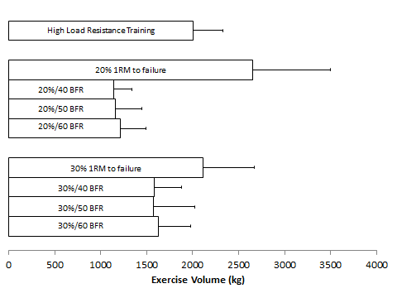
Figure 25. Exercise Volume Completed Across All Conditions
1RM=one repetition maximum; 20%/40 BFR= 20% maximal effort at an estimated 40% arterial occlusion pressure; 30%/40 BFR=30% maximal effort at an estimated 40% arterial occlusion pressure; 30%=30% maximal effort to failure; 20%/50 BFR= 20% maximal effort at an estimated 50% arterial occlusion pressure; 30%/50 BFR=30% maximal effort at an estimated 50% arterial occlusion pressure; 20%=20% maximal effort to failure; 20%/60 BFR= 20% maximal effort at an estimated 60% arterial occlusion pressure; 30%/60 BFR=30% maximal effort at an estimated 60% arterial occlusion pressure. Variability represented as standard deviations.

The repetitions completed across the BFR groups lifting an external load of 20% 1RM are shown in Figure 26. The pressure applied did not appear to have a large influence on the repetitions completed within each set when the external load was held constant.
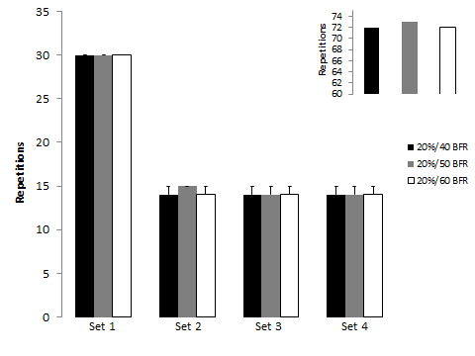
Figure 26. Exercise Repetitions Completed Across 20%1RM BFR Conditions
20%/40 BFR= 20% maximal effort at an estimated 40% arterial occlusion pressure; 20%/50 BFR= 20% maximal effort at an estimated 50% arterial occlusion pressure; 20%/60 BFR= 20% maximal effort at an estimated 60% arterial occlusion pressure; Variability represented as standard deviations. The graph in the top right is the sum of repetitions completed across all sets.

The repetitions completed across the BFR groups lifting an external load of 30% 1RM are shown in Figure 27. The pressure applied did not appear to have an influence on the repetitions completed within each set when the external load was held constant. The total repetitions completed at 30% 1RM were descriptively less (~6 repetitions averaged across groups) than 20% 1RM, although this difference was only observed to be significant between loads within one time point of Group A. Thus, if there was a mean difference in repetitions between loads, it was minimal. Regardless, this finding demonstrated that the increased exercise volumes observed in the 30%/BFR conditions were due to the heavier load lifted.
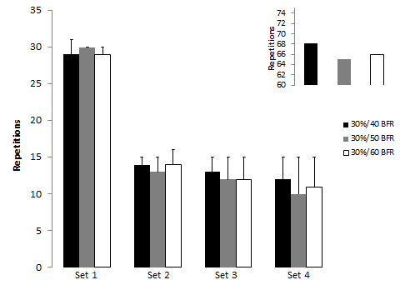
Figure 27. Exercise Repetitions Completed Across 30%1RM BFR Conditions
30%/40 BFR= 20% maximal effort at an estimated 40% arterial occlusion pressure; 30%/50 BFR= 20% maximal effort at an estimated 50% arterial occlusion pressure; 30%/60 BFR= 20% maximal effort at an estimated 60% arterial occlusion pressure; Variability represented as standard deviations. The graph in the top right is the sum of repetitions completed across all sets.

The repetitions completed across the non-BFR groups are descriptively shown in Figure 28. The 20% to failure condition completed 88 and 152 more repetitions than the 30% to failure and HL condition, respectively. This large difference in repetitions between the 20% and 30% to failure conditions appears to be largely driven by the repetitions completed during the first set of exercise. Thus, the high exercise volume in the low load groups was driven predominately by number of repetitions completed, whereas external load was the primary determinant of exercise volume in the HL condition.
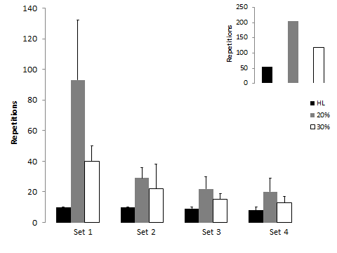
Figure 28. Exercise Repetitions Completed Across non-BFR Conditions
HL=high load (70% maximal effort); 30%=30% maximal effort to failure; 20%=20% maximal effort to failure. Variability represented as standard deviations. The graph in the top right is the sum of repetitions completed across all sets.

The differences in repetition and exercise volume across protocols observed in this study similar to what was observed by Cook et al. (2007). In that study, participants completed different protocols, each consisting of three sets of knee extension exercise to failure (Figure 29). Not surprising, and in agreement with the current results, the HL condition completed the fewest repetitions. In addition, Cook et al. (2007) found that the exercise load decreased total repetitions but changes in the applied pressure did not. Although the repetition differences within the 20% MVC condition were not statistically different, there was a mean difference of 42 repetitions between the applied pressure conditions. However, when examining the 40% MVC condition, the mean difference was only 10 repetitions, which may be due to elevated intramuscular pressure associated with heavier loads. A key difference between studies is that the current study was not designed to go to failure on every set, although many participants were unable to complete all 15 repetitions on the final three sets of exercise. Taken together, these results differ from those of Cook et al. (2007), as the current findings suggest that there are not large differences in repetitions completed when the load is increased from 20% 1RM to 30% 1RM. It may be that the repetition difference between loads only becomes apparent during exercise to failure and that the current protocol consisting of a pre-determined set of goal repetitions for each set would be unable to detect intrinsic differences due to load. It may also be that the difference in external loading in the current study was not large enough to see the difference observed in the aforementioned study (10% 1RM difference vs. 20% MVC difference). However, both studies do suggest that applied pressure may not be having a large effect on repetitions completed, although this was only descriptively shown in the current study.

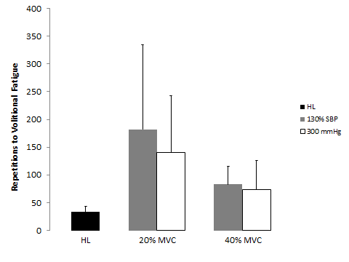
Figure 29. Repetitions Completed (Adapted from Cook et al. 2007)
MVC=maximal voluntary contraction; HL=high load (80% of MVC); 130% SBP=pressure applied equals 130% resting brachial blood pressure. Variability represented as standard deviations.

When examining total exercise volume, Cook et al. (2007) found that the HL condition (80% MVC) completed the lowest total exercise volume, and that this was significantly lower in comparison to what was observed with the 40% MVC/BFR conditions in the present study. The current study also found significantly greater exercise volumes in the BFR conditions completed at 30% 1RM as compared to 20% 1RM. However, the HL condition in the current study had a significantly greater exercise volume compared to the 20%/40 BFR and 30%/40 BFR conditions. The difference in results between studies is likely due to the current study’s protocol consisting of a pre-determined set of goal repetitions.
Independent of load, the non-BFR conditions to failure completed significantly more repetitions than the BFR conditions. This is not surprising considering the BFR conditions in the current study were not designed to go to failure. Regardless, the literature clearly demonstrates that when both groups do go to failure, the application of BFR always reduces endurance performance within each set compared to non-BFR conditions (Cook, et al., 2013; Labarbera, Murphy, Laroche, & Cook, 2013; Loenneke, Balapur, et al., 2011, 2012; Loenneke, Wilson, Balapur, et al., 2012; Wernbom, et al., 2006; Wernbom, et al., 2009). This decrease in repetitions from the application of BFR has been observed at 20% 1RM, 30% 1RM, and 40% 1RM. However, no differences have been observed at 50% 1RM (Wernbom, et al., 2006), which may be due to changes in intramuscular pressure that may have resulted in similar perturbations to blood flow between conditions. It must be acknowledged that this finding at 50% 1RM was observed with pressure applied through 13.5 cm wide cuffs, thus it is currently unknown whether this also occurs with the use of narrower cuffs.
The literature is less clear when comparing exercise volumes between HL and low load conditions to failure. Although the present study did not have sufficient statistical power to detect differences across groups, the results when plotted together suggest that the highest volume is completed in the 20% to failure condition, followed by similar exercise volumes in the 30% to failure and HL condition. Recently, Cook et al. (2013) found that exercise volumes were statistically similar between HL (70% peak torque) and low load to failure conditions (20% peak torque). However, this lack of statistical difference (p=0.07) was most certainly due to variability, as the mean volume of the low load to failure condition was over twice that of the HL condition. It seems reasonable to suggest that there were meaningful volume differences between conditions in that study, which also seems to be in agreement with the 20% to failure condition of the current study. In seeming disagreement with current findings is the Burd et al. (2010) investigation which found significant volume differences on the order of a 363kg difference between 30% 1RM to failure and 90% 1RM to failure. The current study descriptively found difference of 107kg between 30% 1RM to failure and 70% 1RM conditions. It is unknown if this is a significant or meaningful difference, but it is markedly lower than that observed in the Burd et al. (2010) investigation. Reasons for the difference are unclear but may be due to using 90% 1RM rather than the 70% 1RM used in the current study, which may have affected the total number of repetitions completed, ultimately affecting total volume.

Maximal Voluntary Contraction
The decrease in torque was statistically similar between the exercise conditions within each group, except for the 20%/40 BFR condition whose decrease did not exceed the error of the measurement. When examining the magnitude of the change across groups for each load, the effect sizes were slightly higher in the 30% 1RM BFR conditions compared to the 20% 1RM BFR conditions (Figure 30). The physiological relevance of this small difference is currently unknown. Interestingly, increasing the applied pressure from 40% BFR to 50% BFR increased the magnitude of the effect. However, increasing the applied pressure up to 60% BFR reduced the effect size in the 30% 1RM BFR conditions. For the non-BFR conditions, the effect sizes were similar, with 20% to failure having the largest effect. However, the physiological importance of this small difference is currently unknown.
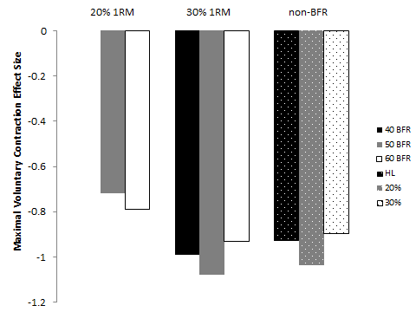
Figure 30. Maximal Voluntary Contraction Effect Sizes
20% 1RM=20% maximal effort; 30% 1RM=30% maximal effort; 40 BFR=40% arterial occlusion pressure; 50 BFR=50% arterial occlusion pressure; 60 BFR=60% arterial occlusion pressure; non-BFR=non blood flow restriction conditions; HL=high load (70% maximal effort); 20%=20% maximal effort (no BFR); 30%=30% maximal effort (no BFR).

Since effect sizes are calculated using the mean difference divided by the pre standard deviation of the control group, larger baseline variability within Group C provides an explanation for the decrease in effect size. Regardless, the mean declines between the 50 and 60% BFR groups are descriptively similar across both loads (Figure 31). Taken together, the results suggest that increasing the applied pressure from 50% to 60% BFR does not augment the effect on torque. For the non-BFR conditions, the 20% to failure condition descriptively had the largest mean decrease in MVC, however the greater variability within Group C provides an explanation for why the effect size was tempered in that condition. Overall, the magnitude of effect was similar between the non-BFR conditions.
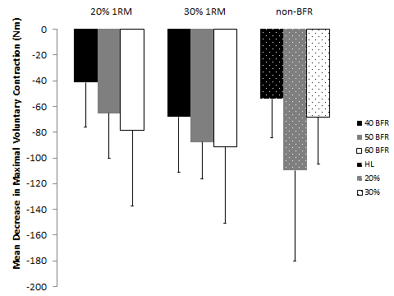
Figure 31. Maximal Voluntary Contraction Mean Differences
20% 1RM=20% maximal effort; 30% 1RM=30% maximal effort; 40 BFR=40% arterial occlusion pressure; 50 BFR=50% arterial occlusion pressure; 60 BFR=60% arterial occlusion pressure; non-BFR=non blood flow restriction conditions; HL=high load (70% maximal effort); 20%=20% maximal effort (no BFR); 30%=30% maximal effort (no BFR). Variability represented as standard deviations.

A number of studies have reported large acute declines in torque following low load resistance exercise in combination with BFR (Cook, et al., 2007; Cook, et al., 2013; Labarbera, et al., 2013; Loenneke, Thiebaud, et al., 2013a; Thiebaud, Yasuda, Loenneke, & Abe, 2013; Umbel, et al., 2009; Wernbom, et al., 2012; Yasuda et al., 2009). This large acute decline immediately post exercise appears to be evidence of fatigue, not muscle damage. This increased fatigability is thought to provide at least part of the mechanistic basis for BFR inducing skeletal muscle hypertrophy when it is combined with resistance exercise (Loenneke, Wilson, et al., 2010). The mechanisms of fatigue were not investigated in the current study, however, muscle fatigue may have been due to an increase in intramuscular inorganic phosphate concentration, as this has been previously observed to occur following resistance exercise in combination with BFR (Suga, et al., 2010; Suga et al., 2009; Suga et al., 2012; Sugaya, Yasuda, Suga, Okita, & Abe, 2011). This accumulation of inorganic phosphate may lead to a decline in the amplitude of the calcium transient and an inhibition of the cross-bridge cycle (Fitts, 2008). Of those studies investigating the acute decline in torque following BFR in combination with lower body resistance exercise, only one has investigated those changes across different loads (20% MVC vs. 40% MVC) and pressures (130% SBP vs. 300 mmHg). In that study, participants completed three sets of knee extension exercise to failure with each load (20% MVC vs. 40% MVC) and pressure (130% SBP vs. 300 mmHg) (Cook, et al., 2007). The results indicated that 20% MVC with a pressure of 130% SBP (~160 mmHg) resulted in a greater percentage decrease in MVC compared with the high load (80% MVC) condition without BFR. There were no other significant differences between conditions. Due to reporting only percent changes in MVC from baseline, the acute torque data from that study should be interpreted with caution, since percent change does not allow one to determine the actual magnitude of the effect (Rhea, 2004). Thus, the results of the present study cannot be appropriately compared with earlier findings.
The large acute decline in MVC from the non-BFR conditions also likely reflects fatigue. There is the possibility for prolonged decrements in torque with the high mechanical loads used in the HL condition, which would be indicative of muscle damage. However, because of the repeated bout effect observed with consistent training (Black & McCully, 2008), it is unlikely that muscle damage played any role in the decrease in torque. Cook et al. (2013) found similar declines in torque following knee extension exercise in HL (70% peak torque) and LL (20% peak torque) conditions taken to muscular failure. The effect sizes for the current study found slightly higher effects for the 20% 1RM condition taken to failure compared to the HL condition. This possible difference between conditions may be explained by the higher volume of work completed in the 20% 1RM to failure condition.

Muscle Cell Swelling
The increase in thigh circumference at the 33% site was statistically similar between the exercise conditions within each group, except for Group A where the changes were not statistically different from baseline. In addition the increases observed in the 20%/50 BFR and 20%/60 BFR conditions did not exceed the error of the measurement therefore the effect sizes from these conditions will not be discussed further. Further, there were no meaningful changes observed in thigh circumference at the 50% site. When examining the magnitude of the change across pressures completed at 30% 1RM, the effect size was slightly larger in the 50% BFR condition compared to the 60% BFR condition (Figure 32). The physiological meaningfulness of this small difference is currently unknown. For the non-BFR conditions, the effect size was slightly larger in the 30% 1RM to failure condition (Figure 32).

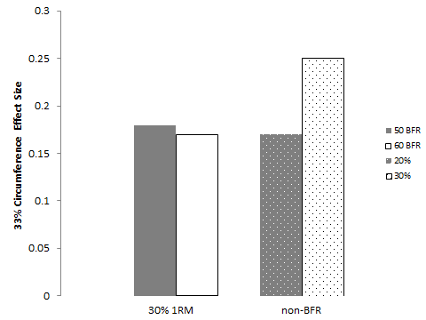
Figure 32. Thigh Circumference Effect Sizes at the 33% site

30% 1RM=30% maximal effort; 50 BFR=50% arterial occlusion pressure; 60 BFR=60% arterial occlusion pressure; non-BFR=non blood flow restriction conditions; 20%=20% maximal effort (no BFR); 30%=30% maximal effort (no BFR).

The increase in anterior muscle thickness was statistically similar between the exercise conditions within each group, except the HL, 20%/40 BFR, 30%/40 BFR, and 30%/60 BFR conditions, whose increase did not exceed the error of the measurement. In addition, only the 30% to failure condition had a meaningful change in muscle thickness at the lateral site. The effect sizes were similar between conditions when examining the magnitude of the change across groups for each load and pressure, however, the 20% to failure condition had the largest effects (Figure 33).
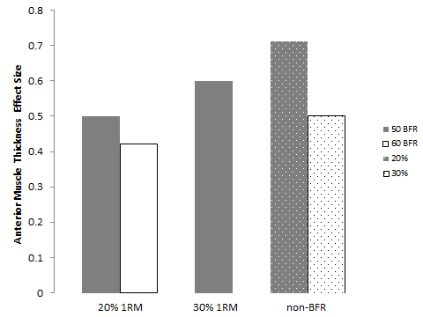
Figure 33. Anterior Muscle Thickness Effect Sizes
20% 1RM=20% maximal effort; 30% 1RM=30% maximal effort; 50 BFR=50% arterial occlusion pressure; 60 BFR=60% arterial occlusion pressure; non-BFR=non blood flow restriction conditions; 20%=20% maximal effort (no BFR); 30%=30% maximal effort (no BFR).

The difference in effect size is unlikely to be physiologically relevant. For example, effect sizes are calculated using the mean difference divided by the pre standard deviation of the control group. Hence, the smaller baseline variability within Group C may provide an explanation for the larger effect sizes observed in the 20% to failure condition, since the mean differences from baseline were similar (Figure 34).

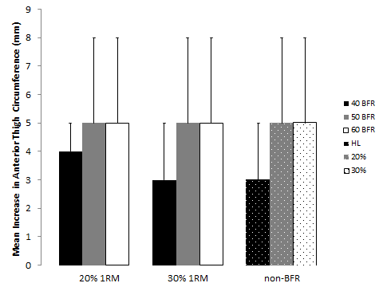
Figure 34. Anterior Muscle Thickness Mean Differences
20% 1RM=20% maximal effort; 30% 1RM=30% maximal effort; 40 BFR=40% arterial occlusion pressure; 50 BFR=50% arterial occlusion pressure; 60 BFR=60% arterial occlusion pressure; non-BFR=non blood flow restriction conditions; HL=high load (70% maximal effort); 20%=20% maximal effort (no BFR); 30%=30% maximal effort (no BFR). Variability represented as standard deviations.

An interesting finding is that the changes in muscle size appeared fairly similar across all exercise conditions within each group. This result may indicate that muscle cell swelling is a requisite for skeletal muscle growth, but in itself is not sufficient since it is not augmented by different exercise loads and pressures. A number of studies have observed acute increases in markers of muscle swelling following the application of BFR (Fry, et al., 2010; Loenneke, Fahs, Thiebaud, et al., 2012b; Martin-Hernandez, Marin, Menendez, Loenneke, et al., 2013; Ogawa, et al., 2012; Thiebaud, et al., 2013; Wilson, Lowery, Joy, Loenneke, & Naimo, 2013; Yasuda, Brechue, Fujita, Sato, & Abe, 2008; Yasuda, Loenneke, Thiebaud, & Abe, 2012) and regular resistance exercise in the absence of BFR (Ploutz-Snyder, Convertino, & Dudley, 1995; Sjogaard, Adams, & Saltin, 1985). This muscle cell swelling has been hypothesized previously to be the foundational mechanism behind the application of BFR, because it is observed even in the absence of exercise (Loenneke, Abe, Wilson, Ugrinowitsch, & Bemben, 2012; Loenneke, Fahs, Thiebaud, et al., 2012b). The acute increase in muscle thickness coupled with the decrease in plasma volume suggests that fluid may have shifted from the plasma to inside the muscle cell. For example, if the acute change in muscle thickness was due solely to venous pooling, the muscle thickness value would have likely returned to baseline in the BFR conditions following the removal of the cuff. However, it should be noted that this study cannot definitively determine whether or not the fluid was shifted into the actual muscle cell. The theory behind the cell swelling induced changes in protein balance was introduced by Haussinger et al. (1993). Based on Haussinger’s hypothetical model for hepatocyte cell swelling (Haussinger, 1996), it has been theorized that BFR induced muscle cell swelling is detected by an intrinsic volume sensor. The activation of this volume sensor may lead to an activation of the mechanistic target of rapamycin (mTOR) and mitogen-activated protein-kinase (MAPK) pathways (Loenneke, Fahs, Rossow, Abe, et al., 2012). These pathways are activated with BFR and exercise; however it is unknown whether these pathways are activated in the absence of exercise (Loenneke, Abe, Wilson, Ugrinowitsch, et al., 2012). Although not measured in the current study, several possibilities exist for how the application of BFR may induce an increase in muscle cell swelling. BFR may increase the hydrostatic pressure gradient thereby increasing the intracellular water flux. Also, some research indicates that BFR in combination with resistance exercise results in an increase in venous carbon dioxide (Yasuda, et al., 2010). This increase in carbon dioxide may occur as a consequence of a slight decrease in intracellular pH which would lead to an increased production of hydrogen ions. Interestingly, pH-regulating transporters working in parallel with each other have previously been shown to mediate cell volume changes (Hoffmann, Lambert, & Pedersen, 2009). For example, the sodium/hydrogen exchanger exports hydrogen out of the cell where it would combine with bicarbonate which would be exported out of the cell by the chloride/bicarbonate exchanger. Outside of the cell carbon dioxide would be produced and removed and the intracellular sodium chloride would pull additional water into the cell (Adler, Roy, & Relman, 1965; Sperelakis, 2012). Furthermore, there is evidence that suggests these exchangers may work in concert with the Na⁺-K⁺-2Cl⁻ cotransporter whose gradient is largely determined by the sodium/potassium pump (Gosmanov, Lindinger, & Thomason, 2003; Lang et al., 2007). Together, these exchangers/cotransporters may cause the muscle cell to swell with BFR. It should be noted that these proposed mechanisms for BFR induced muscle cell swelling are currently only conjecture and future cellular studies are needed to 1) confirm that the fluid shift resulted in an actual increase in muscle cell size and not just an increase in interstitial fluid and 2) if true, to determine the mechanisms behind the increase in acute muscle cell size.

Whole Blood Lactate
The increase in whole blood lactate was statistically similar between the exercise conditions within each group, except the 20% 1RM BFR conditions whose increases were always significantly less than the other exercise conditions. When examining the magnitude of the change across groups for each load, the effect sizes were larger in the 30% 1RM BFR conditions compared to the 20% 1RM BFR conditions (Figure 35). The physiological meaningfulness of this difference is currently unknown. Interestingly, increasing the applied pressure from 40% BFR to 50% BFR increases the magnitude of the effect. However, increasing the applied pressure up to 60% BFR reduces the effect size. For the non-BFR conditions, the effect sizes were largest in the HL and 30% to failure conditions, with 20% to failure having the smallest effect. However, the physiological meaningfulness of this difference is currently unknown.
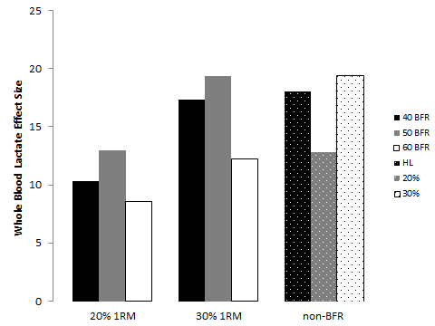
Figure 35. Whole Blood Lactate Effect Sizes
20% 1RM=20% maximal effort; 30% 1RM=30% maximal effort; 40 BFR=40% arterial occlusion pressure; 50 BFR=50% arterial occlusion pressure; 60 BFR=60% arterial occlusion pressure; non-BFR=non blood flow restriction conditions; HL=high load (70% maximal effort); 20%=20% maximal effort (no BFR); 30%=30% maximal effort (no BFR).

Since effect sizes are calculated using the mean difference divided by the pre standard deviation of the control group, larger baseline variability within Group C provides explanation for the decrease in effect size. Regardless, the mean increase between the 50 and 60% BFR groups are descriptively similar across both loads (Figure 36). Taken together, the results suggest that increasing the applied pressure from 50% to 60% BFR does not augment the effect on whole blood lactate. For the non-BFR conditions, the 20% to failure condition descriptively had the largest mean increase in whole blood lactate, however the larger variability within Group C provides explanation for why the effect size was tempered in that condition.
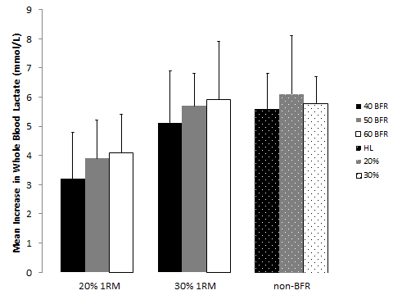
Figure 36. Whole Blood Lactate Mean Differences
20% 1RM=20% maximal effort; 30% 1RM=30% maximal effort; 40 BFR=40% arterial occlusion pressure; 50 BFR=50% arterial occlusion pressure; 60 BFR=60% arterial occlusion pressure; non-BFR=non blood flow restriction conditions; HL=high load (70% maximal effort); 20%=20% maximal effort (no BFR); 30%=30% maximal effort (no BFR). Variability represented as standard deviations.

A number of studies have reported increases in whole blood lactate following low load resistance exercise in combination with BFR (Fujita, et al., 2007; Labarbera, et al., 2013; Loenneke, Balapur, et al., 2012; Loenneke, Wilson, Balapur, et al., 2012; Takano, et al., 2005; Takarada, Nakamura, et al., 2000; Wilson, et al., 2013; Yasuda, et al., 2010). The increase in whole blood lactate occurs due to fast glycolysis and the accumulation of this lactate along with other metabolites has been hypothesized to play an important role in skeletal muscle adaptation through increased muscle fiber recruitment (Loenneke, Fahs, et al., 2011; Schoenfeld, 2013). This increase in lactate may also facilitate the increase in growth hormone observed following resistance exercise with BFR (Takarada, Nakamura, et al., 2000), although the skeletal muscle anabolic effect of growth hormone in adults is largely unfounded (Birzniece, et al., 2010; Boesen, et al., 2013; Rennie, Wackerhage, Spangenburg, & Booth, 2004). Of those studies investigating the acute increases in lactate following BFR in combination with resistance exercise, only one has investigated those changes across different pressures (100 mmHg vs. 160 mmHg) and it was completed in the upper body. Yasuda et al. (2010) investigated unilateral elbow flexion muscle contractions completed at 20% 1RM (30 repetitions, followed by three sets of 15) and 70% 1RM (three sets to failure). The 160 mmHg condition had a larger increase in lactate than the 100 mmHg condition, but the non-BFR 70% 1RM condition had the largest increase in lactate. The augmentation of lactate with increasing pressure agrees with the findings of the current study, as the effect size was larger with 50% BFR compared to 40% BFR. The current study also supports the Yasuda et al. (2010) finding that 70% 1RM leads to a greater change in lactate than 20% 1RM with BFR. These authors suggested that this difference is unlikely due to differences in tissue oxygenation levels since venous oxygen partial pressure and venous oxygen saturation were similar between all exercise conditions. Instead, it seems more likely that 70% 1RM requires a greater dependence on oxygen-independent metabolism than muscle contractions performed at 20% 1RM, indicating a greater energetic demand with higher loads. Interestingly, when the current study increased the load from 20% to 30% 1RM, the magnitude of change in lactate was similar to that observed with the HL condition. This was especially observed with the 30%/50 BFR condition, suggesting that this intensity/pressure combination may produce an intramuscular stress similar to HL exercise.
The acute increase in lactate from the non-BFR conditions also reflects an increased energetic demand. The 20% and 30% to failure conditions produced similar increases in lactate as the HL condition. This is not surprising as these low load conditions should result in similar metabolic responses if exercise is continued to true muscular failure. To illustrate, post exercise lactate levels are similar between BFR and non-BFR conditions despite significant differences in exercise volume (Labarbera, et al., 2013; Loenneke, Balapur, et al., 2012; Loenneke, Wilson, Balapur, et al., 2012).

Normalized Electromyography Amplitude
The increase in concentric EMG amplitude was augmented when the load was increased from 20%1RM to 30% 1RM within each group. Interestingly, the 30%/50 BFR conditions concentric EMG amplitude was statistically similar to the 30% to failure condition despite differences in exercise volume. Increasing the applied pressure from 40% BFR to 50% BFR descriptively increased concentric EMG amplitude independent of load (Figure 37, Figure 38). However, increasing the applied pressure up to 60% BFR did not appear to augment the response. The HL condition descriptively had the highest concentric amplitudes throughout.
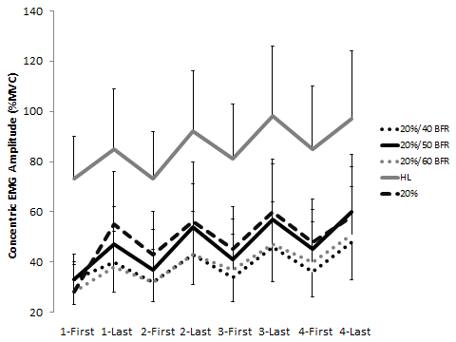
Figure 37. Concentric EMG Amplitude of the 20% 1RM Conditions
20% 1RM=20% maximal effort; 40 BFR=40% arterial occlusion pressure; 50 BFR=50% arterial occlusion pressure; 60 BFR=60% arterial occlusion pressure; non-BFR=non blood flow restriction conditions; HL=high load (70% maximal effort); 20%=20% maximal effort (no BFR); 1-First=first 3 contractions of set 1; 1-Last=last 3 contractions of set 1; 2-First=first 3 contractions of set 2; 2-Last=last 3 contractions of set 2; 3-First=first 3 contractions of set 3; 3-Last=last 3 contractions of set 3; 4-First=first 3 contractions of set 4; 4-last=last 3 contractions of set 4. Variability represented as standard deviations.

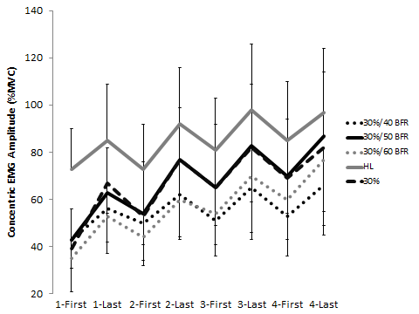
Figure 38. Concentric EMG Amplitude of the 30% 1RM Conditions
30% 1RM=30% maximal effort; 40 BFR=40% arterial occlusion pressure; 50 BFR=50% arterial occlusion pressure; 60 BFR=60% arterial occlusion pressure; non-BFR=non blood flow restriction conditions; HL=high load (70% maximal effort); 30%=30% maximal effort (no BFR); 1-First=first 3 contractions of set 1; 1-Last=last 3 contractions of set 1; 2-First=first 3 contractions of set 2; 2-Last=last 3 contractions of set 2; 3-First=first 3 contractions of set 3; 3-Last=last 3 contractions of set 3; 4-First=first 3 contractions of set 4; 4-last=last 3 contractions of set 4. Variability represented as standard deviations.

The increase in eccentric EMG amplitude was augmented when the load was increased from 20%1RM to 30% 1RM within each group except for Group C. In Group C, there was no significant difference between 20%/60 BFR and 30%/60 BFR for eccentric EMG amplitude of the last three repetitions. Interestingly, the 30%/50 BFR conditions eccentric EMG amplitude was statistically similar to the 30% to failure condition despite differences in exercise volume. Increasing the applied pressure from 40% BFR to 50% BFR descriptively increased eccentric EMG amplitude independent of load (Figure 39, Figure 40). However, increasing the applied pressure up to 60% BFR did not appear to augment the response. The HL condition descriptively had the highest eccentric amplitudes throughout.
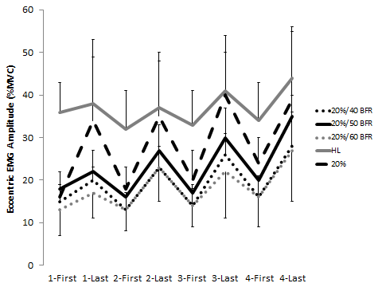
Figure 39. Eccentric EMG Amplitude of the 20% 1RM Conditions
20% 1RM=20% maximal effort; 40 BFR=40% arterial occlusion pressure; 50 BFR=50% arterial occlusion pressure; 60 BFR=60% arterial occlusion pressure; non-BFR=non blood flow restriction conditions; HL=high load (70% maximal effort); 20%=20% maximal effort (no BFR); 1-First=first 3 contractions of set 1; 1-Last=last 3 contractions of set 1; 2-First=first 3 contractions of set 2; 2-Last=last 3 contractions of set 2; 3-First=first 3 contractions of set 3; 3-Last=last 3 contractions of set 3; 4-First=first 3 contractions of set 4; 4-last=last 3 contractions of set 4. Variability represented as standard deviations.
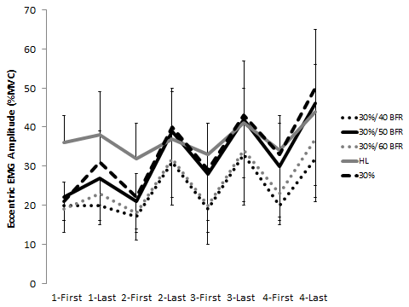
Figure 40. Eccentric EMG Amplitude of the 30% 1RM Conditions
30% 1RM=30% maximal effort; 40 BFR=40% arterial occlusion pressure; 50 BFR=50% arterial occlusion pressure; 60 BFR=60% arterial occlusion pressure; non-BFR=non blood flow restriction conditions; HL=high load (70% maximal effort); 30%=30% maximal effort (no BFR); 1-First=first 3 contractions of set 1; 1-Last=last 3 contractions of set 1; 2-First=first 3 contractions of set 2; 2-Last=last 3 contractions of set 2; 3-First=first 3 contractions of set 3; 3-Last=last 3 contractions of set 3; 4-First=first 3 contractions of set 4; 4-last=last 3 contractions of set 4. Variability represented as standard deviations.

A number of studies have reported increases in EMG amplitude during low load resistance exercise with and without BFR (Cook, et al., 2013; Labarbera, et al., 2013; Manini, et al., 2011; Takarada, Takazawa, Sato, et al., 2000; Wernbom, et al., 2009; Wilson, et al., 2013; Yamada et al., 2004; Yasuda, et al., 2008; Yasuda, et al., 2009; Yasuda, Loenneke, et al., 2012). In addition, this increase in EMG amplitude was descriptively greater across time during the concentric compared to the eccentric portion of each condition which demonstrates that more muscle activation was required to lift the load than to lower the load. The increase in EMG amplitude may be due to a metabolic “overload” (i.e. depletion of phosphocreatine stores and decrease in muscle pH) within the muscle (Suga, et al., 2010). To illustrate, the reduction in oxygen and subsequent metabolic accumulation with muscle contraction and/or BFR may increase fiber recruitment through a stimulation of the group III and IV afferents which may cause an inhibition of the alpha motorneuron, resulting in an increased fiber recruitment to maintain force and protect against conduction failure (Yasuda, et al., 2010). Of those studies investigating the acute increases in EMG amplitude following BFR in combination with resistance exercise, only one has investigated those changes across different pressures (80%, 100%, and 120% of bSBP) and it was completed in the upper body (Yasuda, et al., 2008). Following cuff inflation, participants performed four sets of dumbbell elbow flexion exercise with 30 seconds rest between each set. The first set consisted of 30 repetitions followed by three sets of 15 at 20% 1RM. The researchers found that integrated EMG increased progressively during the contraction bout in all groups. However, they found that amplitude was greater with 120% bSBP than a work matched non-BFR condition from the end of 30 repetitive contracts to the end of the second set of 15 contractions. The current study descriptively suggests that EMG amplitude is augmented from 40% to 50% BFR but that no further increase is observed when the pressure is increased to 60% BFR. In the aforementioned upper body study (Yasuda, et al., 2008), it is possible that large differences in EMG amplitude were not observed between pressures because the pressure was too low to affect energy supply. It may also be that there are intrinsic differences between the biceps brachii used in the upper body study and the vastus lateralis used in the current study. However, the descriptive differences observed with increasing pressure in the current study should be interpreted with caution until direct comparisons are made in future work.
The acute increase in EMG amplitude from the non-BFR conditions reflects an increase in muscle activation. The 20% and 30% to failure conditions produced significant increases in muscle activation, but those increases were descriptively higher in the 30% to failure condition. Large EMG amplitudes (≥~70% MVC) have been observed previously with low load exercise to muscular failure (Cook, et al., 2013; Labarbera, et al., 2013; Wernbom, et al., 2009). Although these low loads substantially increase muscle activation, the current study and previous works suggests that this level is still less than what is observed with traditional HL resistance exercise (Cook, et al., 2013). Despite this apparent difference in muscle activation, resistance exercise in combination with BFR (G. C. Laurentino, et al., 2012; Martin-Hernandez, Marin, Menendez, Ferrero, et al., 2013) and low load exercise to failure (Leger, et al., 2006; Mitchell, et al., 2012; Van Roie, et al., 2013) have produced similar changes in muscle mass and strength suggesting that other factors may be playing important mechanistic roles in low load training.

Normalized Electromyography Mean Power Frequency
Concentric EMG mean power frequency was statistically increased from set 1 to set 3 within Group A for the last three repetitions, but no differences were observed at any time point within Group B or Group C. Increasing the pressure or the load did not appear to descriptively change concentric mean power frequency to a large degree (Figure 41 and Figure 42).
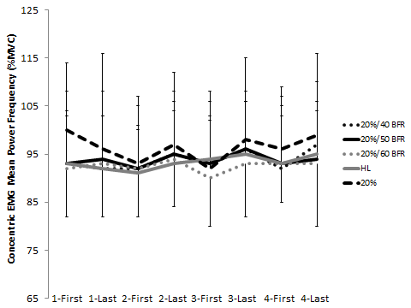
Figure 41. Concentric EMG Mean Power Frequency of the 20% 1RM Conditions
20% 1RM=20% maximal effort; 40 BFR=40% arterial occlusion pressure; 50 BFR=50% arterial occlusion pressure; 60 BFR=60% arterial occlusion pressure; non-BFR=non blood flow restriction conditions; HL=high load (70% maximal effort); 20%=20% maximal effort (no BFR); 1-First=first 3 contractions of set 1; 1-Last=last 3 contractions of set 1; 2-First=first 3 contractions of set 2; 2-Last=last 3 contractions of set 2; 3-First=first 3 contractions of set 3; 3-Last=last 3 contractions of set 3; 4-First=first 3 contractions of set 4; 4-last=last 3 contractions of set 4. Variability represented as standard deviations.
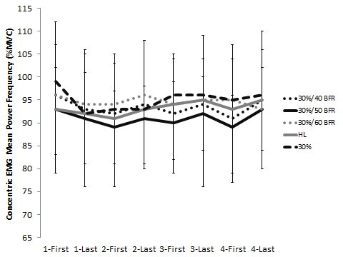
Figure 42. Concentric EMG Mean Power Frequency of the 30% 1RM Conditions
30% 1RM=30% maximal effort; 40 BFR=40% arterial occlusion pressure; 50 BFR=50% arterial occlusion pressure; 60 BFR=60% arterial occlusion pressure; non-BFR=non blood flow restriction conditions; HL=high load (70% maximal effort); 30%=30% maximal effort (no BFR); 1-First=first 3 contractions of set 1; 1-Last=last 3 contractions of set 1; 2-First=first 3 contractions of set 2; 2-Last=last 3 contractions of set 2; 3-First=first 3 contractions of set 3; 3-Last=last 3 contractions of set 3; 4-First=first 3 contractions of set 4; 4-last=last 3 contractions of set 4. Variability represented as standard deviations.

Eccentric EMG mean power frequency of the first three repetitions was statistically decreased from set 1 to set 2, set 3, and set 4 for each condition within each group. For the last three repetitions, there were differential responses within each group. In Group A and Group B, there was an increase in mean power frequency across time in the 20%/40 BFR condition and 30% to failure condition, respectively. However, in Group C, there was a decrease in mean power frequency from set 2 to set 4 in all conditions.
Increasing the pressure or the load did not appear to descriptively change eccentric mean power frequency to a large degree (Figure 43 and Figure 44).
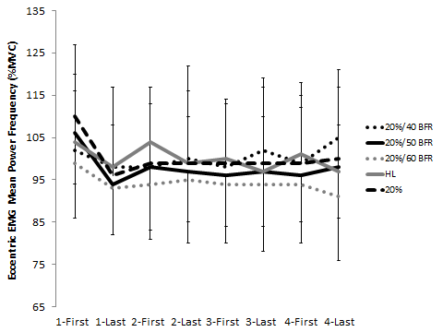
Figure 43. Eccentric EMG Mean Power Frequency of the 20% 1RM Conditions
20% 1RM=20% maximal effort; 40 BFR=40% arterial occlusion pressure; 50 BFR=50% arterial occlusion pressure; 60 BFR=60% arterial occlusion pressure; non-BFR=non blood flow restriction conditions; HL=high load (70% maximal effort); 20%=20% maximal effort (no BFR); 1-First=first 3 contractions of set 1; 1-Last=last 3 contractions of set 1; 2-First=first 3 contractions of set 2; 2-Last=last 3 contractions of set 2; 3-First=first 3 contractions of set 3; 3-Last=last 3 contractions of set 3; 4-First=first 3 contractions of set 4; 4-last=last 3 contractions of set 4. Variability represented as standard deviations.
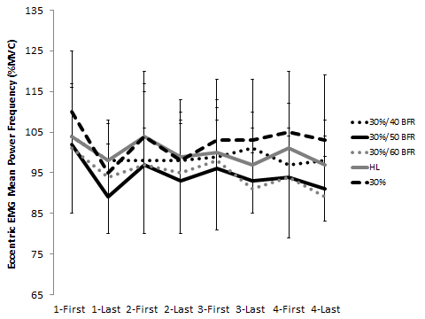
Figure 44. Eccentric EMG Mean Power Frequency of the 30% 1RM Conditions
30% 1RM=30% maximal effort; 40 BFR=40% arterial occlusion pressure; 50 BFR=50% arterial occlusion pressure; 60 BFR=60% arterial occlusion pressure; non-BFR=non blood flow restriction conditions; HL=high load (70% maximal effort); 30%=30% maximal effort (no BFR); 1-First=first 3 contractions of set 1; 1-Last=last 3 contractions of set 1; 2-First=first 3 contractions of set 2; 2-Last=last 3 contractions of set 2; 3-First=first 3 contractions of set 3; 3-Last=last 3 contractions of set 3; 4-First=first 3 contractions of set 4; 4-last=last 3 contractions of set 4. Variability represented as standard deviations.

To date, only two studies have investigated changes in mean power frequency with the application of BFR (Yamada, et al., 2004; Yasuda, et al., 2009) in combination with resistance exercise. Yasuda et al. (2009) inflated a cuff to 160 mmHg and had participants complete 30 repetitions at 20% 1RM followed by 3 sets of 15 with 30 seconds rest between each set. Mean power frequency decreased after the second set of 15 repetitions as well as post exercise compared to baseline. Mean power frequency is influenced by many factors, specifically, muscle fiber conduction velocity. The decrease in mean power frequency observed during that investigation is consistent with other literature that suggests that fatigue will cause a decrease in muscle fiber conduction velocity manifested by a decrease in mean power frequency (Komi & Tesch, 1979; Tesch, Dudley, Duvoisin, Hather, & Harris, 1990). Changes in mean power frequency have also been indicated as a measure of muscle fiber type recruitment (Agergaard et al., 2013; Borrani et al., 2001; Kupa, Roy, Kandarian, & De Luca, 1995; Yamada, et al., 2004), although not all reports agree (Aagaard et al., 2000). Yamada et al. had participants perform isometric knee extension exercise at 30%, 50%, and 70% MVC with a pressure cuff inflated to 100 mmHg. Each participant completed one 10 second isometric contraction with each load. They demonstrated a significant increase in mean power frequency at a low intensity of 30% and 50% MVC, which the researchers interpreted as perhaps suggesting an increase in the recruitment of higher threshold motor units during BFR exercise. The mean power frequency data from the current study are difficult to interpret. Future research may benefit from visually investigating the power spectrum instead of only evaluating a single quantitative value (Beck, Stock, & Defreitas, 2013). For example, the power spectrum could shift to lower frequencies indicating fatigue, but theoretically still maintain the same quantitative value for mean power frequency. To illustrate, outside of the 20%/40 BFR condition, all other exercise conditions significantly decreased torque production immediately post exercise. Despite this indication of fatigue, there were not necessarily corresponding changes in mean power frequency.

Ratings of Perceived Exertion
The ratings of perceived exertion (RPE) increased within each group. In Group A, 20%/40 BFR had the lowest overall RPE while 30%/40 BFR and HL training had similar ratings. In Group B, 20%/50 BFR had the lowest overall RPE while 30%/50 BFR and 30% to failure had similar ratings. In Group C, there were minor differences in set 1, otherwise the ratings were similar throughout. When descriptively examining the change in RPE across groups for each load, the ratings were similar in the 20% 1RM BFR conditions (Figure 45) compared to the 30% 1RM BFR conditions (Figure 46). The main differences seemed to occur with the application of 40% BFR. In addition, increasing the applied pressure from 40% BFR to 50% BFR descriptively increased RPE at 20% 1RM. However, increasing the applied pressure up to 60% BFR did not descriptively lead to a higher RPE. With 30% 1RM, RPE did not appear descriptively different across pressures. For the non-BFR conditions, the HL condition descriptively had the lowest RPE, while the ratings were similar between 20% and 30% 1RM to failure (Figure 47).
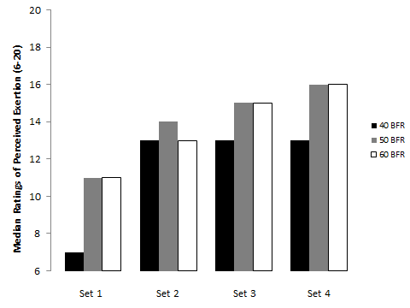
Figure 45. Median Ratings of Perceived Exertion of the 20% 1RM BFR Conditions
40 BFR=40% arterial occlusion pressure; 50 BFR=50% arterial occlusion pressure; 60 BFR=60% arterial occlusion pressure.
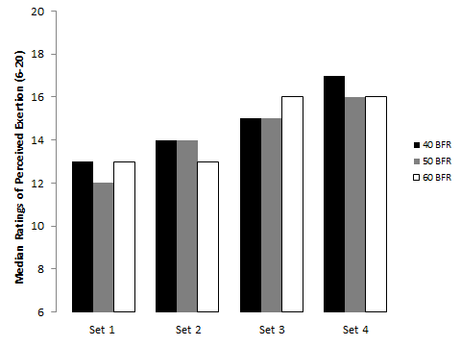
Figure 46. Median Ratings of Perceived Exertion of the 30% 1RM BFR Conditions
40 BFR=40% arterial occlusion pressure; 50 BFR=50% arterial occlusion pressure; 60 BFR=60% arterial occlusion pressure.

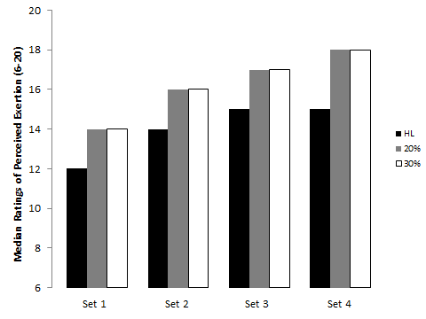
Figure 47. Median Ratings of Perceived Exertion of the non-BFR Conditions
HL=high load (70% maximal effort); 20%=20% maximal effort (no BFR); 30%=30% maximal effort (no BFR).
A number of studies have reported increases in RPE with low load resistance exercise with and without BFR (Hollander, et al., 2010; Labarbera, et al., 2013; Loenneke, Balapur, et al., 2011, 2012; Loenneke, Kearney, et al., 2010; Loenneke, Thiebaud, et al., 2013a; Loenneke, Wilson, Balapur, et al., 2012; Manini et al., 2012; Rossow, et al., 2012; Wernbom, et al., 2006; Wernbom, et al., 2009; Yasuda, et al., 2010; Yasuda, et al., 2008; Yasuda, et al., 2009; Yasuda et al., 2012; Yasuda, Loenneke, et al., 2012). Of those studies investigating RPE following BFR in combination with resistance exercise, only one has investigated those changes across different pressures (100 mmHg vs. 160 mmHg) and compared it to HL training. Yasuda et al. (2010) investigated unilateral elbow flexion muscle contractions completed at 20% 1RM (30 repetitions, followed by three sets of 15) and 70% 1RM (three sets to failure). The 160 mmHg condition had higher RPE than the 100 mmHg condition, but the non-BFR 70% 1RM condition had the highest ratings. These results are consistent with the findings from the 20% 1RM BFR conditions of the current study, where RPE was affected by increasing pressure from 40% to 50% BFR. This did not appear to happen in the 30% 1RM BFR conditions or the higher restriction pressures in the 20% 1RM conditions, suggesting that the load may be playing a more important role in augmenting RPE at lower restriction pressures. The similar RPE between 20% and 30% 1RM to failure is not surprising considering that both conditions taken to muscular failure for all four sets.

Ratings of Discomfort
The ratings of discomfort increased within each group. In Group A, the 20%/40 BFR had the lowest overall ratings of discomfort while the 30%/40 BFR condition had the highest. Neither condition differed from the HL condition, except for set 3 when the 30%/40 BFR condition had higher ratings. In Group B and Group C, the ratings of discomfort were similar throughout except for set 1 in Group B. When descriptively examining the change in discomfort across groups for each load, the ratings were lower in the 20% 1RM BFR conditions (Figure 48) compared to the 30% 1RM BFR conditions (Figure 49). In addition, increasing the applied pressure from 40% BFR to 50% BFR descriptively increased ratings of discomfort at 20% 1RM. There was a further descriptive increase in the rating when increasing the applied pressure to 60% BFR; however, the meaningfulness of this small increase is unknown. For 30% 1RM, the ratings of discomfort descriptively differed across each set. In set 1, the ratings of discomfort were highest for 40% BFR and lowest for 60% BFR. In set 2, the ratings of discomfort were descriptively similar across conditions. For set 3 and 4, the ratings were descriptively higher with 40% and 60% BFR and lower with 50% BFR. The reason for the descriptive difference in ratings between loads is unknown. For the non-BFR conditions, the HL condition descriptively had the lowest ratings of discomfort, while the ratings were highest with the 20% 1RM to failure condition (Figure 50). The difference in discomfort between the failure conditions was likely due to differences in exercise volume.
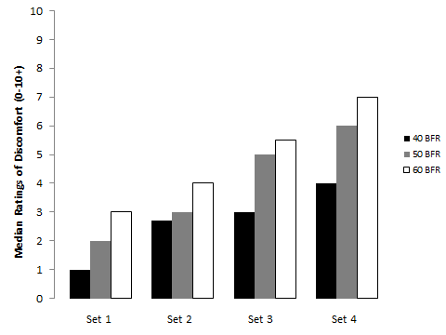
Figure 48. Median Ratings of Discomfort of the 20% 1RM BFR Conditions
40 BFR=40% arterial occlusion pressure; 50 BFR=50% arterial occlusion pressure; 60 BFR=60% arterial occlusion pressure.

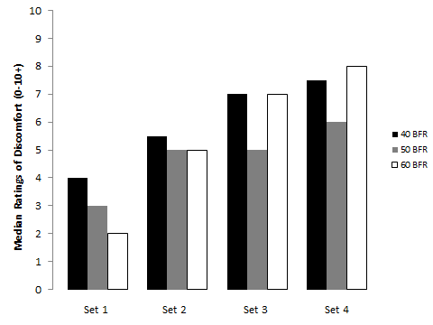
Figure 49. Median Ratings of Discomfort of the 30% 1RM BFR Conditions
40 BFR=40% arterial occlusion pressure; 50 BFR=50% arterial occlusion pressure; 60 BFR=60% arterial occlusion pressure.
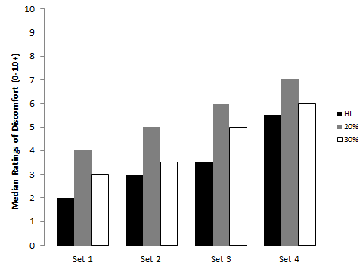
Figure 50. Median Ratings of Discomfort of the non-BFR Conditions
HL=high load (70% maximal effort); 20%=20% maximal effort (no BFR); 30%=30% maximal effort (no BFR).

A number of studies have reported increases in ratings of discomfort with low load resistance exercise with and without BFR (Hollander, et al., 2010; Labarbera, et al., 2013; Loenneke, Balapur, et al., 2011; Loenneke, Thiebaud, et al., 2013a; Rossow, et al., 2012; Wernbom, et al., 2009). Of these studies, none have investigated the response across different loads or pressures. Two of the studies found no difference in ratings of discomfort between low load resistance exercise to failure with or without BFR (Labarbera, et al., 2013; Wernbom, et al., 2009). In contrast, Loenneke et al. (2011) reported higher ratings of discomfort with BFR to failure compared to the non-BFR condition to failure. The meaningfulness of this small difference is unknown. When it comes to more traditional resistance training, Hollander et al. (2003) reported similar ratings of discomfort between blood flow restricted exercise to failure and HL resistance exercise to failure. Thus, the majority of the studies suggest that ratings of discomfort are similar between exercise to failure with and without BFR. The ratings may, however, be increased when compared to a HL condition not going to failure as in this study, or when compared to a repetition matched non-BFR control (Loenneke, Thiebaud, et al., 2013a).

Chapter VI: Conclusions
The purpose of this study was to compare some acute skeletal muscle changes (e.g. muscle swelling, torque, lactate, and muscle activity) following differing resistance training protocols. In addition, the perceptual response to each one of those protocols was investigated. The main research question for this study was which low load resistance training protocol with or without blood flow restriction produces acute skeletal muscle changes most similar to those following higher load resistance training?

Hypotheses
- All low load resistance training protocols will produce significant increases in fatigue, whole blood lactate, muscle thickness, and muscle activity. In addition, all groups will produce significant decreases in plasma volume.
This hypothesis was partially supported by the data. All groups significantly increased whole blood lactate, muscle thickness, and muscle activity. The increase in fatigue was observed as acute decreases in torque in every condition except for the 20%/40 BFR condition. This condition saw significant increases in fatigue, but the change was within the error of the measurement.

- Participants performing low load resistance training with a blood flow restriction pressure set at 50% of the estimated arterial occlusion pressure will see similar changes as higher load resistance training with respect to fatigue, whole blood lactate, plasma volume, muscle thickness, and muscle activity irrespective of whether it is completed at 20% or 30% of the concentric one repetition maximum.
This hypothesis was partially supported by the data. A blood flow restriction pressure set at 50% of estimated arterial occlusion yielded the largest increase in fatigue; however, the magnitude of the effect was largest with 30% 1RM. The magnitude of this effect was greater than what was observed with HL exercise. A load of 30% 1RM and a blood flow restriction pressure set at 50% of estimated arterial occlusion yielded increases in whole blood lactate similar to that of HL exercise. Changes in plasma volume appeared similar across all exercise conditions. A blood flow restriction pressure set at 50% or 60% of estimated arterial occlusion resulted in similar changes in muscle thickness, irrespective of whether it was completed at 20% or 30% 1RM. This change was greater than that observed with HL exercise. A blood flow restriction pressure set at 50% of estimated arterial occlusion produced the largest increase in muscle activation. However, the magnitude of the effect was largest with 30% 1RM, although it was descriptively less than that observed with HL exercise.

- Participants completing low load resistance training completed at 20% or 30% of their concentric one repetition maximum without blood flow restriction to concentric failure will see similar changes as higher load resistance training with respect to fatigue, whole blood lactate, plasma volume, muscle thickness, and muscle activity, albeit at a higher overall exercise volume.
This hypothesis was partially supported by the data. Loads of 20% and 30% 1RM resulted in similar increases in fatigue, the magnitude of which was greater than what was observed with HL exercise in the 20% 1RM to failure condition. All non-BFR conditions saw similar changes in whole blood lactate from pre to post exercise. Muscle thickness increased to a similar degree in the 20% and 30% to failure conditions, but the increase with HL exercise did not exceed the error of the measurement. Muscle activity was descriptively higher with 30% compared to 20% 1RM despite completing a lower exercise volume. However, this increase was descriptively less than that observed with HL exercise.

First Subquestion
What effect will estimated arterial occlusion pressure and/or the resistance training load have on overall exercise volume, fatigue, whole blood lactate, plasma volume, muscle thickness, and muscle activity?

First Subhypotheses
- Most participants performing low load resistance training with a blood flow restriction pressure set at 60% of the estimated arterial occlusion pressure will be unable to complete the pre-determined set amount of repetitions for each set, which will reduce the overall exercise volume as well as the changes associated with resistance exercise (i.e. fatigue, whole blood lactate, plasma volume, muscle thickness, and muscle activity), irrespective of whether it is completed at 20% or 30% of the concentric one repetition maximum.
This hypothesis was partially supported by the data. Exercising with BFR at an estimated arterial occlusion pressure of 60% did prevent some participants from completing the pre-determined set amount of repetitions for each set. However, 99% of participants completed the set repetitions in the 20%/60 BFR condition, whereas only 90% of participants completed the set repetitions in the 30%/60 BFR condition. Thus there was a volume difference across loads but there did not appear to be a descriptive difference across pressures.

- Most participants performing low load resistance training with blood flow restriction pressure set at 40% and 50% of the estimated arterial occlusion pressure will be able to complete the non-failure ‘standard’ blood flow restriction repetition protocol, irrespective of whether it is completed at 20% or 30% of the concentric one repetition maximum.
This hypothesis was partially supported by the data. Exercising with BFR at an estimated arterial occlusion pressure of 40% did prevent some participants from completing the pre-determined set amount of repetitions for each set. However, 99% of participants completed the set repetitions in the 20%/40 BFR condition, whereas only 92% of participants completed the set repetitions in the 30%/40 BFR condition. In addition, exercising with BFR at an estimated arterial occlusion pressure of 50% did prevent some participants from completing the pre-determined set amount of repetitions for each set. However, 99% of participants completed the set repetitions in the 20%/50 BFR condition, whereas only 90% of participants completed the set repetitions in the 30%/50 BFR condition. Thus there was a volume difference across loads but there did not appear to be a descriptive difference across pressures.

Second Subquestion
What effect will low load resistance training with and without blood flow restriction have on the acute perceptual response to resistance exercise?

Second Subhypotheses
- Participants performing low load resistance training with a blood flow restriction pressure set at 60% of the estimated arterial occlusion pressure will report the highest ratings of discomfort and RPE, irrespective of whether the exercise is completed at 20% or 30% of the concentric one repetition maximum.
This hypothesis was partially supported by the data. Increasing the applied pressure from 40% BFR to 50% BFR descriptively increased RPE at 20% 1RM. However, increasing the applied pressure up to 60% BFR did not descriptively lead to a higher RPE. With 30% 1RM, RPE did not appear to descriptively differ across pressures. When descriptively examining the change in RPE across groups for each load, the ratings appeared similar in the 20% 1RM BFR conditions compared to the 30% 1RM BFR conditions. The main differences seemed to occur with the application of 40% BFR. In addition, increasing the applied pressure from 40% BFR to 50% BFR to 60% BFR descriptively increaseds ratings of discomfort across pressures at 20% 1RM. For 30% 1RM, the ratings of discomfort descriptively differed across each set. In set 1, the ratings of discomfort were highest with 40% BFR and lowest with 60% BFR. In set 2, the ratings of discomfort were descriptively similar across conditions. For set 3 and 4, the ratings were descriptively higher with 40% and 60% BFR and lower with 50% BFR.

- Participants performing low load resistance training with a blood flow restriction pressure set at 40% of the estimated arterial occlusion pressure will report the lowest ratings of discomfort and RPE, irrespective of whether it is completed at 20% or 30% of the concentric one repetition maximum.
This hypothesis was partially supported by the data. In Group A, 20%/40 BFR had the lowest overall RPE while 30%/40 BFR and HL training had similar ratings. In Group B, 20%/50 BFR had the lowest overall RPE. In Group C, there were minor differences in set 1, otherwise the ratings were similar throughout. When descriptively examining the change in RPE across groups for each load, the ratings were similar in the 20% 1RM BFR conditions compared to the 30% 1RM BFR conditions. The main differences seemed to occur with the application of 40% BFR, with descriptively lower RPE at a load of 20% 1RM. With 30% 1RM, RPE did not appear descriptively different across pressures. For discomfort, in Group A, the 20%/40 BFR condition had the lowest overall ratings while the 30%/40 BFR condition had the highest. In Group B and Group C, the ratings of discomfort were similar throughout except for set 1 in Group B. When descriptively examining the change in discomfort across groups for each load, the ratings were lower in the 20% 1RM BFR conditions compared to the 30% 1RM BFR conditions. For 30% 1RM, the ratings of discomfort descriptively differed across each set. In set 1, the ratings of discomfort were highest for 40% BFR and lowest for 60% BFR. In set 2, the ratings of discomfort were descriptively similar across conditions. For set 3 and 4, the ratings were descriptively higher with 40% and 60% BFR and lower with 50% BFR.

- Participants completing low load resistance training to failure and those completing low load resistance training with a blood flow restriction pressure set at 50% of the estimated arterial occlusion pressure will produce ratings or perceived exertion similar to that observed with higher load resistance training, irrespective of whether the exercise is completed at 20% or 30% of the concentric one repetition maximum.
This hypothesis was partially supported by the data. For the non-BFR conditions, the HL condition descriptively had the lowest RPE, while the ratings were similar between 20% and 30% 1RM to failure. In addition, the 20% and 30% 1RM to failure conditions had RPE values descriptively higher than that observed with either load completed at 50% of the estimated arterial occlusion pressure. However, the BFR conditions yielded RPE values similar to those observed with HL exercise. For ratings of discomfort, the HL condition descriptively resulted in the lowest ratings of discomfort, while the ratings were highest with the 20% 1RM to failure condition. The ratings of discomfort were similar between both loads completed at 50% of the estimated arterial occlusion pressure, and those ratings were not different from 30% 1RM to failure. However, the ratings were descriptively less than those observed with 20% 1RM to failure.

Significance
To remain functionally independent and healthy, an important factor to consider is the maintenance of skeletal muscle mass. Blood flow restriction by itself or in combination with exercise has been shown to result in favorable effects on maintaining or increasing skeletal muscle mass and function. However, most of the protocols to date have used an arbitrary pressure for each participant or they have based the restrictive pressure off of brachial systolic blood pressure, which is not a valid predictor of arterial occlusion in the lower body. The present study showed that knee extension exercise at 30% 1RM in combination with BFR at an estimated arterial occlusion pressure of 50% resulted in similar changes as HL exercise. In addition, 30% 1RM to failure also produced changes similar to HL exercise, albeit at a higher exercise volume. However, the EMG amplitude of the lower loads never reached that observed with HL exercise. Since similar changes have been observed previously in chronic training studies, this finding suggests that other mechanisms may be playing a more prominent role with lower loads. These findings have important implications for designing an optimal protocol for each individual participant who may be: 1) limited to performing low load resistance training due to injury; 2) an individual looking to maximize frequency of training for each body part; or 3) during a deloading period between periodized blocks of training.

Future Research
The data from this study, while interesting, need to be followed up by chronic training studies to determine if the acute markers used here actually predict chronic adaptions. In addition, these conditions should be tested in women to determine if sex influences any of the acute markers of skeletal muscle growth. Other potential studies could include an investigation into the molecular changes occurring within each condition to determine if and how they differ.

References

Aagaard, P., Simonsen, E. B., Andersen, J. L., Magnusson, S. P., Halkjaer-Kristensen, J., & Dyhre-Poulsen, P. (2000). Neural inhibition during maximal eccentric and concentric quadriceps contraction: effects of resistance training. J Appl Physiol, 89(6), 2249-2257.

Abe, T., Fujita, S., Nakajima, T., Sakamaki, M., Ozaki, H., Ogasawara, R., et al. (2010). Effects of low-intensity cycle training with restricted leg blood flow on thigh muscle volume and VO2max in youg men. J Sports Sci Med, 9, 452-458.

Abe, T., Kearns, C. F., & Sato, Y. (2006). Muscle size and strength are increased following walk training with restricted venous blood flow from the leg muscle, Kaatsu-walk training. J Appl Physiol, 100(5), 1460-1466.

Abe, T., Kondo, M., Kawakami, Y., & Fukunaga, T. (1994). Prediction Equations for Body Composition of Japanese Adults by B-Mode Ultrasound. Am J Hum Biol, 6, 161-170.

Abe, T., Sakamaki, M., Fujita, S., Ozaki, H., Sugaya, M., Sato, Y., et al. (2010). Effects of low-intensity walk training with restricted leg blood flow on muscle strength and aerobic capacity in older adults. J Geriatr Phys Ther, 33(1), 34-40.

ACSM. (2009). American College of Sports Medicine position stand. Progression models in resistance training for healthy adults. Med Sci Sports Exerc, 41(3), 687-708.

Adler, S., Roy, A., & Relman, A. S. (1965). Intracellular Acid-Base Regulation. I. The Response of Muscle Cells to Changes in Co2 Tension or Extracellular Bicarbonate Concentration. J Clin Invest, 44, 8-20.

Agergaard, J., Reitelseder, S., Pedersen, T. G., Doessing, S., Schjerling, P., Langberg, H., et al. (2013). Myogenic, matrix, and growth factor mRNA expression in human skeletal muscle: effect of contraction intensity and feeding. Muscle Nerve, 47(5), 748-759.

Baechle, T. R., & Earle, R. W. (2000). Essentials of Strength Training and Conditioning (2nd ed.). Champaign: Human Kinetics.

Beck, T. W., Stock, M. S., & Defreitas, J. M. (2013). Shifts in Emg Spectral Power during Fatiguing Dynamic Contractions. Muscle Nerve. doi: 10.1002/mus.24098

Birzniece, V., Nelson, A. E., & Ho, K. K. (2010). Growth hormone administration: is it safe and effective for athletic performance. Endocrinol Metab Clin North Am, 39(1), 11-23, vii.

Black, C. D., & McCully, K. K. (2008). Muscle injury after repeated bouts of voluntary and electrically stimulated exercise. Med Sci Sports Exerc, 40(9), 1605-1615.

Boesen, A. P., Dideriksen, K., Couppe, C., Magnusson, P., Schjerling, P., Boesen, M., et al. (2013). Tendon and skeletal muscle matrix gene expression and functional responses to immobilisation and rehabilitation in young males: Effect of growth hormone administration. J Physiol, 591(Pt 23), 6039-6052.

Booth, F. W., Chakravarthy, M. V., Gordon, S. E., & Spangenburg, E. E. (2002). Waging war on physical inactivity: using modern molecular ammunition against an ancient enemy. J Appl Physiol, 93(1), 3-30.

Borrani, F., Candau, R., Millet, G. Y., Perrey, S., Fuchslocher, J., & Rouillon, J. D. (2001). Is the VO2 slow component dependent on progressive recruitment of fast-twitch fibers in trained runners? J Appl Physiol, 90(6), 2212-2220.

Bosy-Westphal, A., Reinecke, U., Schlorke, T., Illner, K., Kutzner, D., Heller, M., et al. (2004). Effect of organ and tissue masses on resting energy expenditure in underweight, normal weight and obese adults. Int J Obes Relat Metab Disord, 28(1), 72-79.

Burd, N. A., West, D. W., Staples, A. W., Atherton, P., Baker, J. M., Moore, D. R., et al. (2010). Low-load high volume resistance exercise stimulates muscle protein synthesis more than high-load low volume resistance exercise in young men. PLoS ONE, 5.

Campos, G. E., Luecke, T. J., Wendeln, H. K., Toma, K., Hagerman, F. C., Murray, T. F., et al. (2002). Muscular adaptations in response to three different resistance-training regimens: specificity of repetition maximum training zones. Eur J Appl Physiol, 88(1-2), 50-60.

Caspersen, C. J., Pereira, M. A., & Curran, K. M. (2000). Changes in physical activity patterns in the United States, by sex and cross-sectional age. Med Sci Sports Exerc, 32(9), 1601-1609.

Clark, B. C., Manini, T. M., Hoffman, R. L., Williams, P. S., Guiler, M. K., Knutson, M. J., et al. (2011). Relative safety of 4 weeks of blood flow-restricted resistance exercise in young, healthy adults. Scand J Med Sci Sports, 21(5), 653-662.

Cook, S. B., Clark, B. C., & Ploutz-Snyder, L. L. (2007). Effects of exercise load and blood-flow restriction on skeletal muscle function. Med Sci Sports Exerc, 39(10), 1708-1713.

Cook, S. B., Murphy, B. G., & Labarbera, K. E. (2013). Neuromuscular Function following a Bout of Low-Load Blood Flow Restricted Exercise. Med Sci Sports Exerc, 45, 67-74.

De Luca, C. J. (1979). Physiology and mathematics of myoelectric signals. IEEE Trans Biomed Eng, 26(6), 313-325.

Doessing, S., Heinemeier, K. M., Holm, L., Mackey, A. L., Schjerling, P., Rennie, M., et al. (2010). Growth hormone stimulates the collagen synthesis in human tendon and skeletal muscle without affecting myofibrillar protein synthesis. J Physiol, 588(Pt 2), 341-351.

Ehrnborg, C., & Rosen, T. (2008). Physiological and pharmacological basis for the ergogenic effects of growth hormone in elite sports. Asian J Androl, 10(3), 373-383.

English, K. L., & Paddon-Jones, D. (2010). Protecting muscle mass and function in older adults during bed rest. Curr Opin Clin Nutr Metab Care, 13(1), 34-39.

Fahs, C. A., Loenneke, J. P., Rossow, L. M., Thiebaud, R. S., & Bemben, M. G. (2012). Methodological considerations for blood flow restricted resistance exercise. J Trainology, 1(1), 14-22.

Fahs, C. A., Rossow, L. M., Seo, D. I., Loenneke, J. P., Sherk, V. D., Kim, E., et al. (2011). Effect of different types of resistance exercise on arterial compliance and calf blood flow. Eur J Appl Physiol, 111(12), 2969-75

Fitts, R. H. (2008). The cross-bridge cycle and skeletal muscle fatigue. J Appl Physiol, 104(2), 551-558.

Fry, C. S., Glynn, E. L., Drummond, M. J., Timmerman, K. L., Fujita, S., Abe, T., et al. (2010). Blood flow restriction exercise stimulates mTORC1 signaling and muscle protein synthesis in older men. J Appl Physiol, 108(5), 1199-1209.

Fujita, S., Abe, T., Drummond, M. J., Cadenas, J. G., Dreyer, H. C., Sato, Y., et al. (2007). Blood flow restriction during low-intensity resistance exercise increases S6K1 phosphorylation and muscle protein synthesis. J Appl Physiol, 103(3), 903-910.

Gosmanov, A. R., Lindinger, M. I., & Thomason, D. B. (2003). Riding the tides: K+ concentration and volume regulation by muscle Na+-K+-2Cl- cotransport activity. News Physiol Sci, 18, 196-200.

Goto, K., Ishii, N., Kizuka, T., & Takamatsu, K. (2005). The impact of metabolic stress on hormonal responses and muscular adaptations. Med Sci Sports Exerc, 37(6), 955-963.

Greenhaff, P. L., Karagounis, L. G., Peirce, N., Simpson, E. J., Hazell, M., Layfield, R., et al. (2008). Disassociation between the effects of amino acids and insulin on signaling, ubiquitin ligases, and protein turnover in human muscle. Am J Physiol Endocrinol Metab, 295(3), E595-604.

Gualano, B., Neves, M., Jr., Lima, F. R., Pinto, A. L., Laurentino, G., Borges, C., et al. (2010). Resistance training with vascular occlusion in inclusion body myositis: a case study. Med Sci Sports Exerc, 42(2), 250-254.

Gundermann, D. M., Fry, C. S., Dickinson, J. M., Walker, D. K., Timmerman, K. L., Drummond, M. J., et al. (2012). Reactive hyperemia is not responsible for stimulating muscle protein synthesis following blood flow restriction exercise. J Appl Physiol, 112(9), 1520-1528.

Haussinger, D. (1996). The role of cellular hydration in the regulation of cell function. Biochem J, 313 ( Pt 3), 697-710.

Haussinger, D., Roth, E., Lang, F., & Gerok, W. (1993). Cellular hydration state: an important determinant of protein catabolism in health and disease. Lancet, 341(8856), 1330-1332.

Helge, J. W., Biba, T. O., Galbo, H., Gaster, M., & Donsmark, M. (2006). Muscle triacylglycerol and hormone-sensitive lipase activity in untrained and trained human muscles. Eur J Appl Physiol, 97(5), 566-572.

Hoffmann, E. K., Lambert, I. H., & Pedersen, S. F. (2009). Physiology of cell volume regulation in vertebrates. Physiol Rev, 89(1), 193-277.

Holemans, R. (1963). Increase in Fibrinolytic Activity by Venous Occlusion. J Appl Physiol, 18, 1123-1129.

Hollander, D. B., Durand, R. J., Trynicki, J. L., Larock, D., Castracane, V. D., Hebert, E. P., et al. (2003). RPE, pain, and physiological adjustment to concentric and eccentric contractions. Med Sci Sports Exerc, 35(6), 1017-1025.

Hollander, D. B., Reeves, G. V., Clavier, J. D., Francois, M. R., Thomas, C., & Kraemer, R. R. (2010). Partial occlusion during resistance exercise alters effort sense and pain. J Strength Cond Res, 24(1), 235-243.

Holloszy, J. O. (2005). Exercise-induced increase in muscle insulin sensitivity. J Appl Physiol, 99(1), 338-343.

Karabulut, M., Abe, T., Sato, Y., & Bemben, M. G. (2010). The effects of low-intensity resistance training with vascular restriction on leg muscle strength in older men. Eur J Appl Physiol, 108(1), 147-155.

Komi, P. V., & Tesch, P. (1979). EMG frequency spectrum, muscle structure, and fatigue during dynamic contractions in man. Eur J Appl Physiol Occup Physiol, 42(1), 41-50.

Kubota, A., Sakuraba, K., Koh, S., Ogura, Y., & Tamura, Y. (2011). Blood flow restriction by low compressive force prevents disuse muscular weakness. J Sci Med Sport, 14(2), 95-99.

Kubota, A., Sakuraba, K., Sawaki, K., Sumide, T., & Tamura, Y. (2008). Prevention of disuse muscular weakness by restriction of blood flow. Med Sci Sports Exerc, 40(3), 529-534.

Kumar, V., Selby, A., Rankin, D., Patel, R., Atherton, P., Hildebrandt, W., et al. (2009). Age-related differences in the dose-response relationship of muscle protein synthesis to resistance exercise in young and old men. J Physiol, 587(Pt 1), 211-217.

Kupa, E. J., Roy, S. H., Kandarian, S. C., & De Luca, C. J. (1995). Effects of muscle fiber type and size on EMG median frequency and conduction velocity. J Appl Physiol, 79(1), 23-32.

Labarbera, K. E., Murphy, B. G., Laroche, D. P., & Cook, S. B. (2013). Sex differences in blood flow restricted isotonic knee extensions to fatigue. J Sports Med Phys Fitness, 53(4), 444-452.

Lagally, K. M., Robertson, R. J., Gallagher, K. I., Goss, F. L., Jakicic, J. M., Lephart, S. M., et al. (2002). Perceived exertion, electromyography, and blood lactate during acute bouts of resistance exercise. Med Sci Sports Exerc, 34(3), 552-559; discussion 560.

Lang, F., Foller, M., Lang, K., Lang, P., Ritter, M., Vereninov, A., et al. (2007). Cell volume regulatory ion channels in cell proliferation and cell death. Methods Enzymol, 428, 209-225.

Laurentino, G., Ugrinowitsch, C., Aihara, A. Y., Fernandes, A. R., Parcell, A. C., Ricard, M., et al. (2008). Effects of strength training and vascular occlusion. Int J Sports Med, 29(8), 664-667.

Laurentino, G. C., Ugrinowitsch, C., Roschel, H., Aoki, M. S., Soares, A. G., Neves, M., Jr., et al. (2012). Strength Training with Blood Flow Restriction Diminishes Myostatin Gene Expression. Med Sci Sports Exerc, 44(3), 406-412.

Leger, B., Cartoni, R., Praz, M., Lamon, S., Deriaz, O., Crettenand, A., et al. (2006). Akt signalling through GSK-3beta, mTOR and Foxo1 is involved in human skeletal muscle hypertrophy and atrophy. J Physiol, 576(Pt 3), 923-933.

Lindstrom, L., Magnusson, R., & Petersen, I. (1970). Muscular fatigue and action potential conduction velocity changes studied with frequency analysis of EMG signals. Electromyography, 10(4), 341-356.

Loenneke, J. P. (2012). Skeletal Muscle Hypertrophy: How important is Exercise Intensity? J Trainology, 1, 28-31.

Loenneke, J. P., Abe, T., Wilson, J. M., Thiebaud, R. S., Fahs, C. A., Rossow, L. M., et al. (2012). Blood Flow Restriction: An Evidence Based Progressive Model. Acta Physiol Hung, 99(3), 235-250.

Loenneke, J. P., Abe, T., Wilson, J. M., Ugrinowitsch, C., & Bemben, M. G. (2012). Blood flow restriction: how does it work? Front Physiol, 3, 392.

Loenneke, J. P., Balapur, A., Thrower, A. D., Barnes, J. T., & Pujol, T. J. (2011). The perceptual responses to occluded exercise. Int J Sports Med, 32(3), 181-184.

Loenneke, J. P., Balapur, A., Thrower, A. D., Barnes, J. T., & Pujol, T. J. (2012). Blood flow restriction reduces time to muscular failure. Eur J of Sport Sci, 12(3), 238-243.

Loenneke, J. P., Fahs, C. A., Rossow, L. M., Abe, T., & Bemben, M. G. (2012). The anabolic benefits of venous blood flow restriction training may be induced by muscle cell swelling. Med Hypotheses, 78(1), 151-154.

Loenneke, J. P., Fahs, C. A., Rossow, L. M., Sherk, V. D., Thiebaud, R. S., Abe, T., et al. (2012). Effects of cuff width on arterial occlusion: implications for blood flow restricted exercise. Eur J Appl Physiol, 112(8), 2903-2912.

Loenneke, J. P., Fahs, C. A., Rossow, L. M., Thiebaud, R. S., Mattocks, K. T., Abe, T., et al. (2013). Blood flow restriction pressure recommendations: a tale of two cuffs. Front Physiol, 4, 249.

Loenneke, J. P., Fahs, C. A., Thiebaud, R. S., Rossow, L. M., Abe, T., Ye, X., et al. (2012a). The acute hemodynamic effects of blood flow restriction in the absence of exercise. Clin Physiol Funct Imaging, doi: 10.1111/j.1475-097X.2012.01157.x.

Loenneke, J. P., Fahs, C. A., Thiebaud, R. S., Rossow, L. M., Abe, T., Ye, X., et al. (2012b). The acute muscle swelling effects of blood flow restriction Acta Physiol Hung, 99(4), 400-410.

Loenneke, J. P., Fahs, C. A., Wilson, J. M., & Bemben, M. G. (2011). Blood flow restriction: the metabolite/volume threshold theory. Med Hypotheses, 77(5), 748-752.

Loenneke, J. P., Kearney, M. L., Thrower, A. D., Collins, S., & Pujol, T. J. (2010). The acute response of practical occlusion in the knee extensors. J Strength Cond Res, 24(10), 2831-2834.

Loenneke, J. P., Thiebaud, R. S., Fahs, C. A., Rossow, L. M., Abe, T., & Bemben, M. G. (2013a). Blood flow restriction does not result in prolonged decrements in torque. Eur J Appl Physiol, 113(4), 923-931.

Loenneke, J. P., Thiebaud, R. S., Fahs, C. A., Rossow, L. M., Abe, T., & Bemben, M. G. (2013b). Blood Flow Restriction: Effects of Cuff Type on Fatigue and Perceptual Responses to Resistance Exercise. Acta Physiol Hung, (In Press).

Loenneke, J. P., Thiebaud, R. S., Fahs, C. A., Rossow, L. M., Abe, T., & Bemben, M. G. (2013c). Effect of cuff type on arterial occlusion. Clin Physiol Funct Imaging, 33(4), 325-327.

Loenneke, J. P., Thrower, A. D., Balapur, A., Barnes, J. T., & Pujol, T. J. (2012). Blood flow-restricted walking does not result in an accumlation of metabolites. Clin Physiol Funct Imaging, 32, 80-82.

Loenneke, J. P., Wilson, G. J., & Wilson, J. M. (2010). A Mechanistic Approach to Blood Flow Occlusion. Int J Sports Med, 31(1), 1-4.

Loenneke, J. P., Wilson, J. M., Balapur, A., Thrower, A. D., Barnes, J. T., & Pujol, T. J. (2012). Time under tension decreased with blood flow-restricted exercise. Clin Physiol Funct Imaging, 32(4), 268-273.

Loenneke, J. P., Wilson, J. M., Marin, P. J., Zourdos, M. C., & Bemben, M. G. (2012). Low intensity blood flow restriction training: a meta-analysis. Eur J Appl Physiol, 112, 1849-1859.

Loenneke, J. P., Wilson, J. M., Wilson, G. J., Pujol, T. J., & Bemben, M. G. (2011). Potential safety issues with blood flow restriction training. Scand J Med Sci Sports, 21(4), 510-518.

Loenneke, J. P., Young, K. C., Fahs, C. A., Rossow, L. M., Bemben, D. A., & Bemben, M. G. (2012). Blood flow restriction: Rationale for improving bone. Med Hypotheses, 78(4), 523-527.

Loenneke, J. P., Young, K. C., Wilson, J. M., & Andersen, J. C. (2012). Rehabilitation of an osteochondral fracture using blood flow restricted exercise: A case review. J Bodyw Mov Ther. doi: 10.1016/j.jbmt.2012.04.006.

Madarame, H., Kurano, M., Fukumura, K., Fukuda, T., & Nakajima, T. (2012). Haemostatic and inflammatory responses to blood flow-restricted exercise in patients with ischaemic heart disease: a pilot study. Clin Physiol Funct Imaging. doi: 10.1111/j.1475-097X.2012.01158.x.

Manini, T. M., Vincent, K. R., Leeuwenburgh, C. L., Lees, H. A., Kavazis, A. N., Borst, S. E., et al. (2011). Myogenic and proteolytic mRNA expression following blood flow restricted exercise. Acta Physiol (Oxf), 201(2), 255-263.

Manini, T. M., Yarrow, J. F., Buford, T. W., Clark, B. C., Conover, C. F., & Borst, S. E. (2012). Growth hormone responses to acute resistance exercise with vascular restriction in young and old men. Growth Horm IGF Res, 22(5), 167-172.

Martin-Hernandez, J., Marin, P. J., Menendez, H., Ferrero, C., Loenneke, J. P., & Herrero, A. J. (2013). Muscular adaptations after two different volumes of blood flow-restricted training. Scand J Med Sci Sports, 23(2), e114-120.

Martin-Hernandez, J., Marin, P. J., Menendez, H., Loenneke, J. P., Coelho, E. S. M. J., Garcia-Lopez, D., et al. (2013). Changes in muscle architecture induced by low load blood flow restricted training. Acta Physiol Hung, 1-8.

McCarthy, J. J., Mula, J., Miyazaki, M., Erfani, R., Garrison, K., Farooqui, A. B., et al. (2011). Effective fiber hypertrophy in satellite cell-depleted skeletal muscle. Development, 138(17), 3657-3666.

Mitchell, C. J., Churchward-Venne, T. A., West, D. W., Burd, N. A., Breen, L., Baker, S. K., et al. (2012). Resistance exercise load does not determine training-mediated hypertrophic gains in young men. J Appl Physiol, 113(1), 71-77.

Moore, D. R., Robinson, M. J., Fry, J. L., Tang, J. E., Glover, E. I., Wilkinson, S. B., et al. (2009). Ingested protein dose response of muscle and albumin protein synthesis after resistance exercise in young men. Am J Clin Nutr, 89(1), 161-168.

Mortimer, J. T., Magnusson, R., & Petersen, I. (1970). Conduction velocity in ischemic muscle: effect on EMG frequency spectrum. Am J Physiol, 219(5), 1324-1329.

Motykie, G. D., Zebala, L. P., Caprini, J. A., Lee, C. E., Arcelus, J. I., Reyna, J., et al. (2000). A guide to venous thromboembolism risk factor assessment. J Thromb Thrombolysis, 9(3), 253-262.

Nielsen, J. L., Aagaard, P., Bech, R. D., Nygaard, T., Hvid, L. G., Wernbom, M., et al. (2012). Proliferation of myogenic stem cells in human skeletal muscle in response to low-load resistance training with blood flow restriction. J Physiol, 590(Pt 17), 4351-4361.

Ogawa, M., Loenneke, J. P., Yasuda, T., Fahs, C. A., Rossow, L. M., Thiebaud, R. S., et al. (2012). Time course changes in muscle size and fatigue during walking with restricted leg blood flow in young men. JPESM, 3(1), 14-19.

Patterson, S. D., & Ferguson, R. A. (2011). Enhancing strength and postocclusive calf blood flow in older people with training with blood-flow restriction. J Aging Phys Act, 19(3), 201-213.

Petrella, J. K., Kim, J. S., Mayhew, D. L., Cross, J. M., & Bamman, M. M. (2008). Potent myofiber hypertrophy during resistance training in humans is associated with satellite cell-mediated myonuclear addition: a cluster analysis. J Appl Physiol, 104(6), 1736-1742.

Ploutz-Snyder, L. L., Convertino, V. A., & Dudley, G. A. (1995). Resistance exercise-induced fluid shifts: change in active muscle size and plasma volume. Am J Physiol, 269(3 Pt 2), R536-543.

Rennie, M. J., Wackerhage, H., Spangenburg, E. E., & Booth, F. W. (2004). Control of the size of the human muscle mass. Annu Rev Physiol, 66, 799-828.

Rhea, M. R. (2004). Determining the magnitude of treatment effects in strength training research through the use of the effect size. J Strength Cond Res, 18(4), 918-920.

Ringholm, S., Bienso, R. S., Kiilerich, K., Guadalupe-Grau, A., Aachmann-Andersen, N. J., Saltin, B., et al. (2011). Bed rest reduces metabolic protein content and abolishes exercise-induced mRNA responses in human skeletal muscle. Am J Physiol Endocrinol Metab, 301(4), E649-658.

Robertson, B. R., Pandolfi, M., & Nilsson, I. M. (1972). "Fibrinolytic capacity" in healthy volunteers as estimated from effect of venous occlusion of arms. Acta Chir Scand, 138(5), 429-436.

Rossow, L. M., Fahs, C. A., Loenneke, J. P., Thiebaud, R. S., Sherk, V. D., Abe, T., et al. (2012). Cardiovascular and perceptual responses to blood-flow-restricted resistance exercise with differing restrictive cuffs. Clin Physiol Funct Imaging, 32(5), 331-337.

Sahlin, K., Mogensen, M., Bagger, M., Fernstrom, M., & Pedersen, P. K. (2007). The potential for mitochondrial fat oxidation in human skeletal muscle influences whole body fat oxidation during low-intensity exercise. Am J Physiol Endocrinol Metab, 292(1), E223-230.

Sato, Y. (2005). The history and future of KAATSU Training. Int J KAATSU Train Res, 1, 1-5.

Schoenfeld, B. J. (2013). Potential mechanisms for a role of metabolic stress in hypertrophic adaptations to resistance training. Sports Med, 43(3), 179-194.

Shaper, A. G., Marsh, N. A., Patel, I., & Kater, F. (1975). Response of fibrinolytic activity to venous occlusion. Br Med J, 3(5983), 571-573.

Sherk, V. D., Sherk, K. A., Kim, S., Young, K. C., & Bemben, D. A. (2011). Hormone responses to a continuous bout of rock climbing in men. Eur J Appl Physiol, 111(4), 687-693.

Sjogaard, G., Adams, R. P., & Saltin, B. (1985). Water and ion shifts in skeletal muscle of humans with intense dynamic knee extension. Am J Physiol, 248(2 Pt 2), R190-196.

Spangenburg, E. E., Le Roith, D., Ward, C. W., & Bodine, S. C. (2008). A functional insulin-like growth factor receptor is not necessary for load-induced skeletal muscle hypertrophy. J Physiol, 586(1), 283-291.

Sperelakis, N. (2012). Cell Physiology Source Book: Essentials of Membrane Biophysics (Fourth ed. Vol. 268): Academic Press.

Stegnar, M., & Pentek, M. (1993). Fibrinolytic response to venous occlusion in healthy subjects: relationship to age, gender, body weight, blood lipids and insulin. Thromb Res, 69(1), 81-92.

Stock, M. S., Beck, T. W., Defreitas, J. M., & Dillon, M. A. (2010). An examination of the linearity and reliability of the electromyographic amplitude versus dynamic constant external resistance relationships using monopolar and bipolar recording methods. J Neurosci Methods, 194(1), 94-101.

Suga, T., Okita, K., Morita, N., Yokota, T., Hirabayashi, K., Horiuchi, M., et al. (2010). Dose effect on intramuscular metabolic stress during low-intensity resistance exercise with blood flow restriction. J Appl Physiol, 108(6), 1563-1567.

Suga, T., Okita, K., Morita, N., Yokota, T., Hirabayashi, K., Horiuchi, M., et al. (2009). Intramuscular metabolism during low-intensity resistance exercise with blood flow restriction. J Appl Physiol, 106(4), 1119-1124.

Suga, T., Okita, K., Takada, S., Omokawa, M., Kadoguchi, T., Yokota, T., et al. (2012). Effect of multiple set on intramuscular metabolic stress during low-intensity resistance exercise with blood flow restriction. Eur J Appl Physiol, 112(11), 3915-3920.

Sugaya, M., Yasuda, T., Suga, T., Okita, K., & Abe, T. (2011). Change in intramuscular inorganic phosphate during multiple sets of blood flow-restricted low-intensity exercise. Clin Physiol Funct Imaging, 31(5), 411-413.

Takano, H., Morita, T., Iida, H., Asada, K., Kato, M., Uno, K., et al. (2005). Hemodynamic and hormonal responses to a short-term low-intensity resistance exercise with the reduction of muscle blood flow. Eur J Appl Physiol, 95(1), 65-73.

Takarada, Y., Nakamura, Y., Aruga, S., Onda, T., Miyazaki, S., & Ishii, N. (2000). Rapid increase in plasma growth hormone after low-intensity resistance exercise with vascular occlusion. J Appl Physiol, 88(1), 61-65.

Takarada, Y., Sato, Y., & Ishii, N. (2002). Effects of resistance exercise combined with vascular occlusion on muscle function in athletes. Eur J Appl Physiol, 86(4), 308-314.

Takarada, Y., Takazawa, H., & Ishii, N. (2000). Applications of vascular occlusion diminish disuse atrophy of knee extensor muscles. Med Sci Sports Exerc, 32(12), 2035-2039.

Takarada, Y., Takazawa, H., Sato, Y., Takebayashi, S., Tanaka, Y., & Ishii, N. (2000). Effects of resistance exercise combined with moderate vascular occlusion on muscular function in humans. J Appl Physiol, 88(6), 2097-2106.

Teramoto, M., & Golding, L. A. (2006). Low-intensity exercise, vascular occlusion, and muscular adaptations. Res Sports Med, 14(4), 259-271.

Tesch, P. A., Dudley, G. A., Duvoisin, M. R., Hather, B. M., & Harris, R. T. (1990). Force and EMG signal patterns during repeated bouts of concentric or eccentric muscle actions. Acta Physiol Scand, 138(3), 263-271.

Thiebaud, R. S., Yasuda, T., Loenneke, J. P., & Abe, T. (2013). Effects of low-intensity concentric and eccentric exercise combined with blood flow restriction on indices of exercise-induced muscle damage. Interv Med Appl Sci, 5, 53-59.

Umbel, J. D., Hoffman, R. L., Dearth, D. J., Chleboun, G. S., Manini, T. M., & Clark, B. C. (2009). Delayed-onset muscle soreness induced by low-load blood flow-restricted exercise. Eur J Appl Physiol, 107(6), 687-695.

Van Beaumont, W. (1972). Evaluation of hemoconcentration from hematocrit measurements. J Appl Physiol, 32(5), 712-713.

Van Roie, E., Delecluse, C., Coudyzer, W., Boonen, S., & Bautmans, I. (2013). Strength training at high versus low external resistance in older adults: Effects on muscle volume, muscle strength, and force-velocity characteristics. Exp Gerontol, 48(11), 1351-1361.

Weir, J. P. (2005). Quantifying test-retest reliability using the intraclass correlation coefficient and the SEM. J Strength Cond Res, 19(1), 231-240.

Wernbom, M., Apro, W., Paulsen, G., Nilsen, T. S., Blomstrand, E., & Raastad, T. (2013). Acute low-load resistance exercise with and without blood flow restriction increased protein signalling and number of satellite cells in human skeletal muscle. Eur J Appl Physiol. 113(12), 2953-2965.

Wernbom, M., Augustsson, J., & Thomee, R. (2006). Effects of vascular occlusion on muscular endurance in dynamic knee extension exercise at different submaximal loads. J Strength Cond Res, 20(2), 372-377.

Wernbom, M., Jarrebring, R., Andreasson, M. A., & Augustsson, J. (2009). Acute effects of blood flow restriction on muscle activity and endurance during fatiguing dynamic knee extensions at low load. J Strength Cond Res, 23(8), 2389-2395.

Wernbom, M., Paulsen, G., Nilsen, T. S., Hisdal, J., & Raastad, T. (2012). Contractile function and sarcolemmal permeability after acute low-load resistance exercise with blood flow restriction. Eur J Appl Physiol, 112(6), 2051-2063.

West, D. W., Burd, N. A., Tang, J. E., Moore, D. R., Staples, A. W., Holwerda, A. M., et al. (2010). Elevations in ostensibly anabolic hormones with resistance exercise enhance neither training-induced muscle hypertrophy nor strength of the elbow flexors. J Appl Physiol, 108(1), 60-67.

West, D. W., & Phillips, S. M. (2012). Associations of exercise-induced hormone profiles and gains in strength and hypertrophy in a large cohort after weight training. Eur J Appl Physiol, 112(7), 2693-2702.

Wilkinson, S. B., Tarnopolsky, M. A., Grant, E. J., Correia, C. E., & Phillips, S. M. (2006). Hypertrophy with unilateral resistance exercise occurs without increases in endogenous anabolic hormone concentration. Eur J Appl Physiol, 98(6), 546-555.

Willardson, J. M. (2007). The application of training to failure in periodized multiple-set resistance exercise programs. J Strength Cond Res, 21(2), 628-631.

Wilson, J. M., Lowery, R. P., Joy, J. M., Loenneke, J. P., & Naimo, M. A. (2013). Practical Blood Flow Restriction Training Increases Acute Determinants of Hypertrophy Without Increasing Indices of Muscle Damage. J Strength Cond Res. 27(11), 3068-3075.

Yamada, E., Kusaka, T., Tanaka, S., Mori, S., Norimatsu, H., & Itoh, S. (2004). Effects of vascular occlusion on surface electromyography and muscle oxygenation during isometric contraction. J Sport Rehabil, 13(4), 287-299.

Yamanaka, T., Farley, R. S., & Caputo, J. L. (2012). Occlusion training increases muscular strength in division IA football players. J Strength Cond Res, 26(9), 2523-2529.

Yasuda, T., Abe, T., Brechue, W. F., Iida, H., Takano, H., Meguro, K., et al. (2010). Venous blood gas and metabolite response to low-intensity muscle contractions with external limb compression. Metabolism, 59(10), 1510-1519.

Yasuda, T., Brechue, W. F., Fujita, T., Sato, Y., & Abe, T. (2008). Muscle activation during low-intensity muscle contractions with varying levels of external limb compression. J Sports Sci Med, 7, 467-474.

Yasuda, T., Brechue, W. F., Fujita, T., Shirakawa, J., Sato, Y., & Abe, T. (2009). Muscle activation during low-intensity muscle contractions with restricted blood flow. J Sports Sci, 27(5), 479-489.

Yasuda, T., Fukumura, K., Fukuda, T., Iida, H., Imuta, H., Sato, Y., et al. (2012). Effects of low-intensity, elastic band resistance exercise combined with blood flow restriction on muscle activation. Scand J Med Sci Sports, doi: 10.1111/j.1600-0838.2012.01489.x.

Yasuda, T., Loenneke, J. P., Thiebaud, R. S., & Abe, T. (2012). Effects of blood flow restricted low-intensity concentric or eccentric training on muscle size and strength. PLoS One, 7(12), e52843.

Appendix A: Descriptive, Torque, Swelling, Lactate, and Volume Data

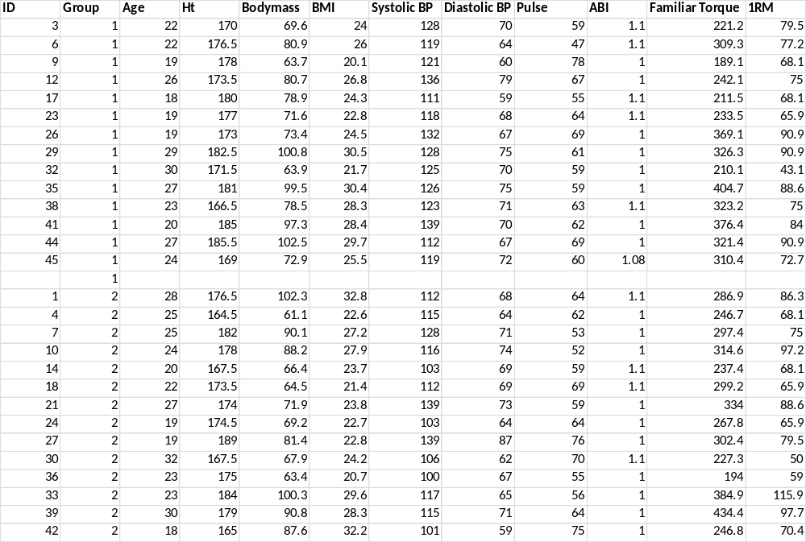
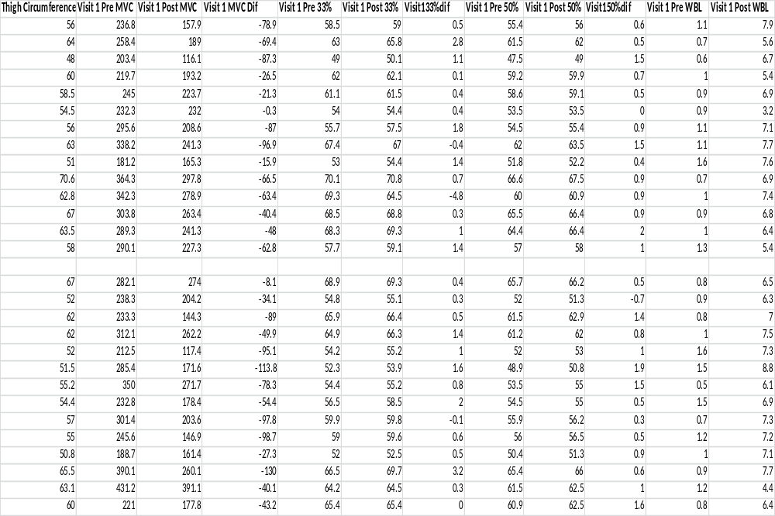

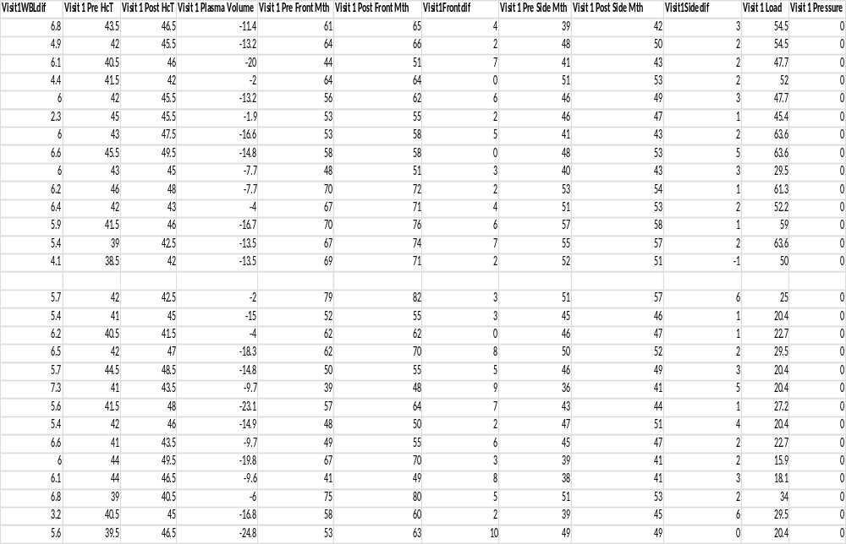
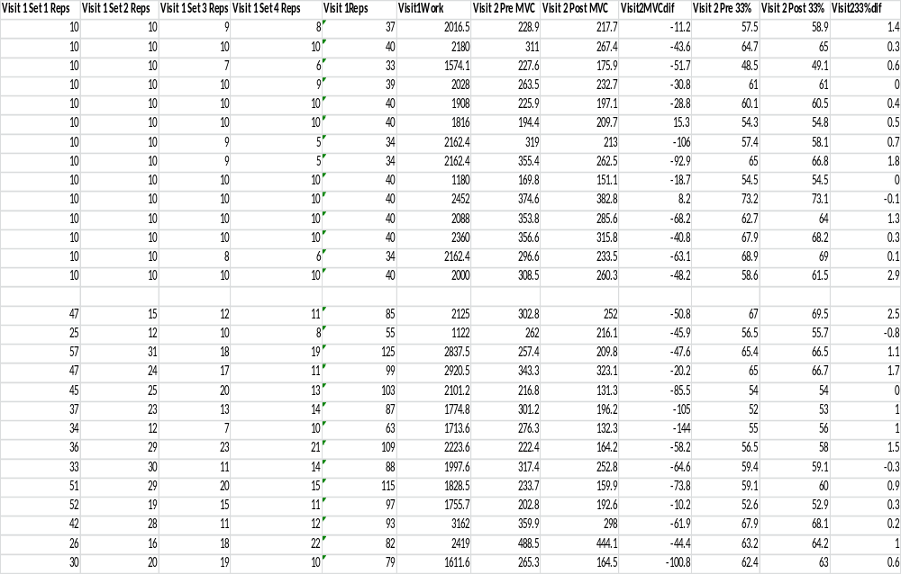
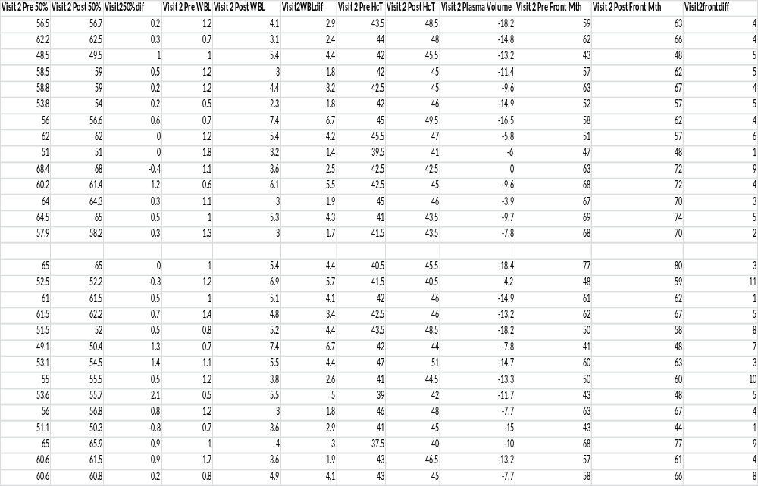
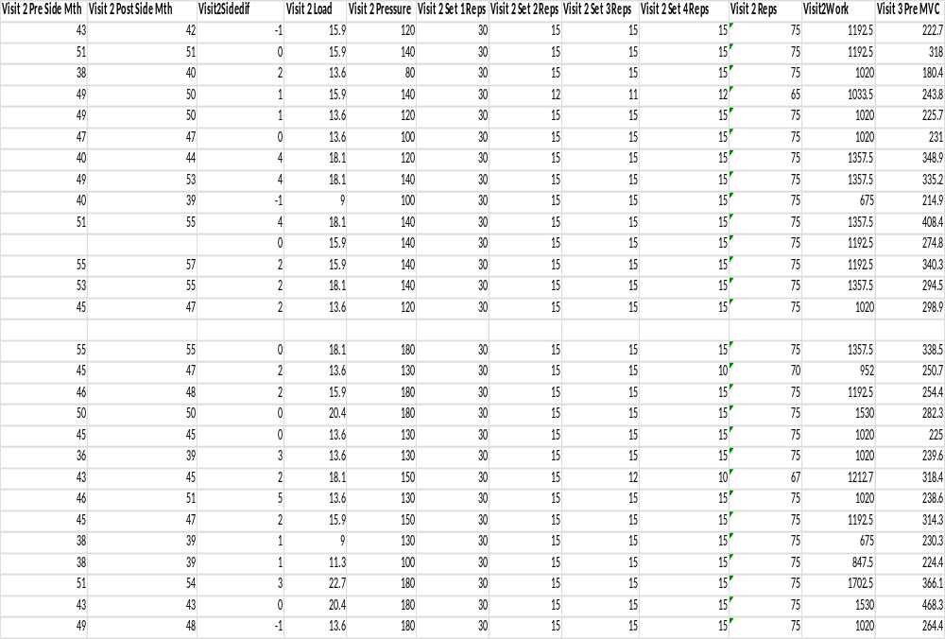

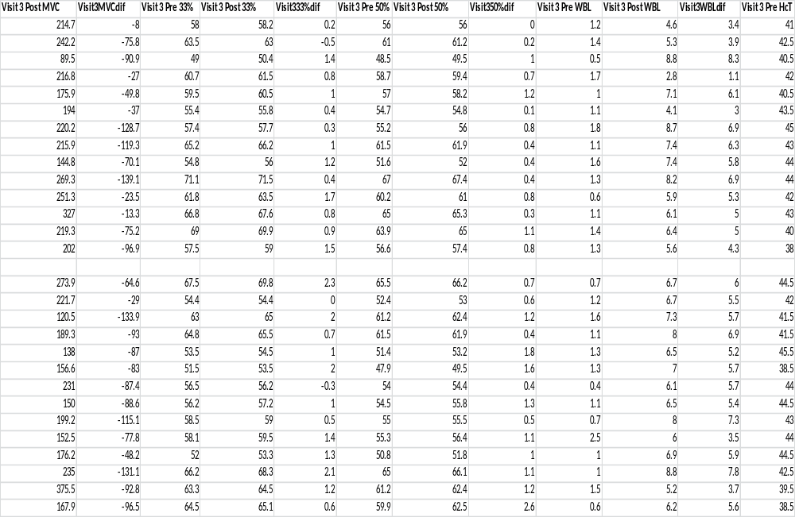
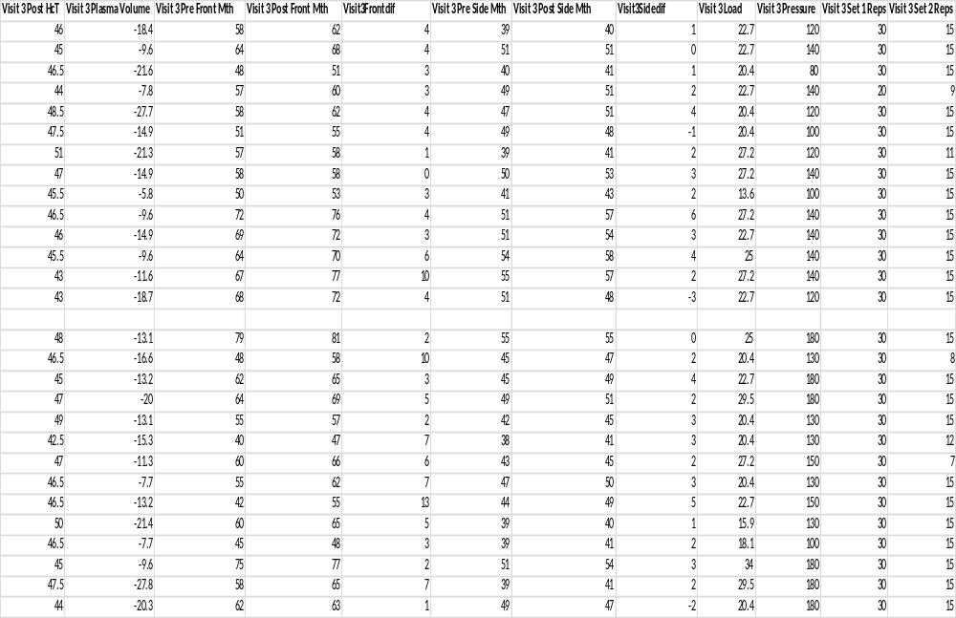
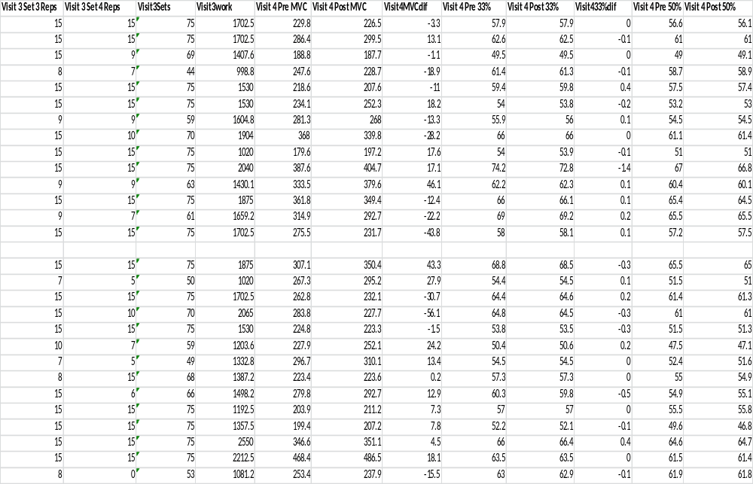
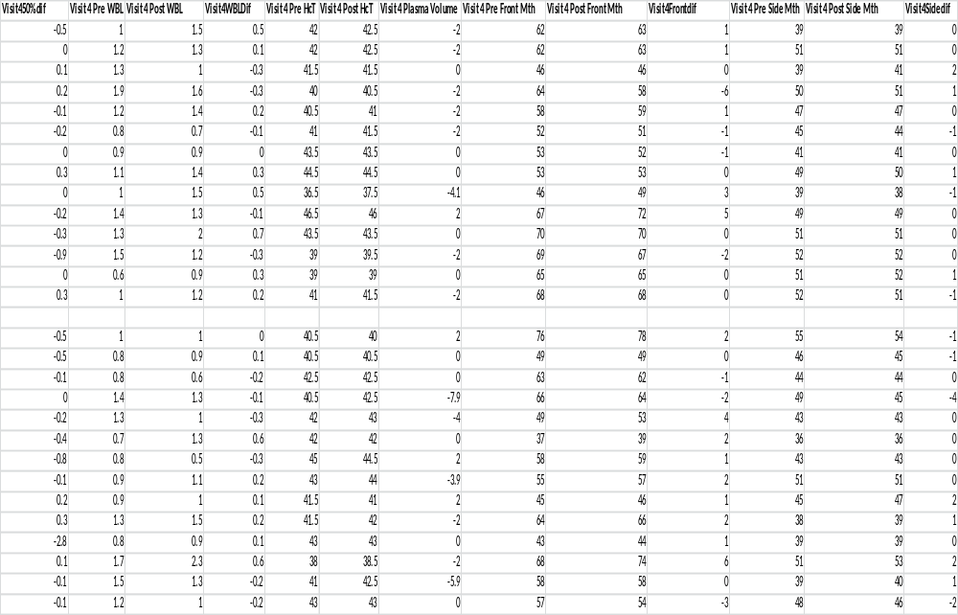

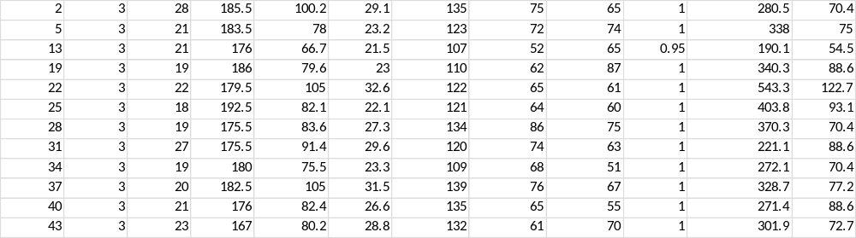

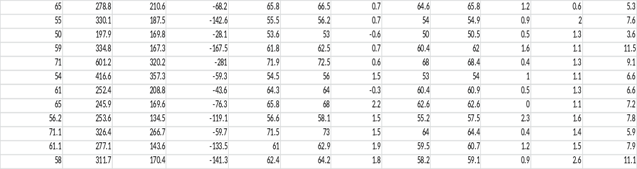

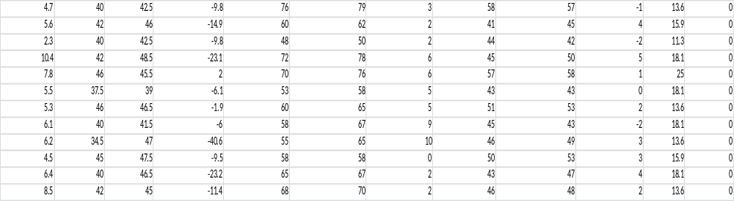

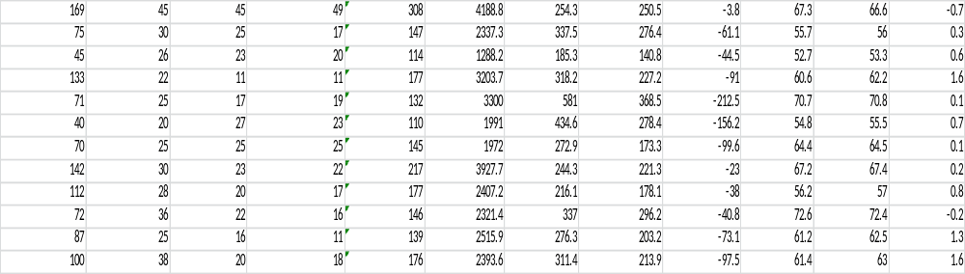

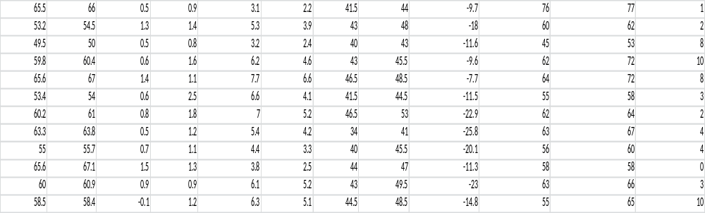

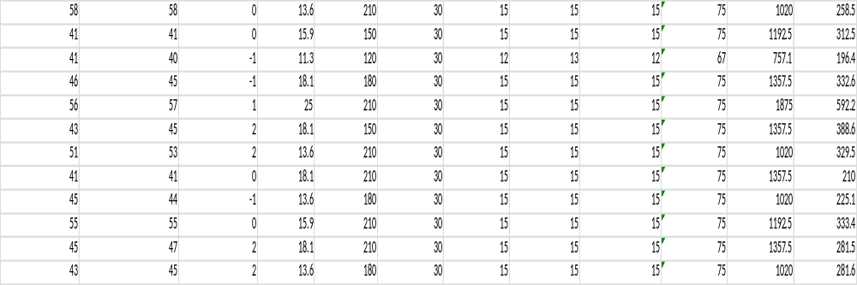

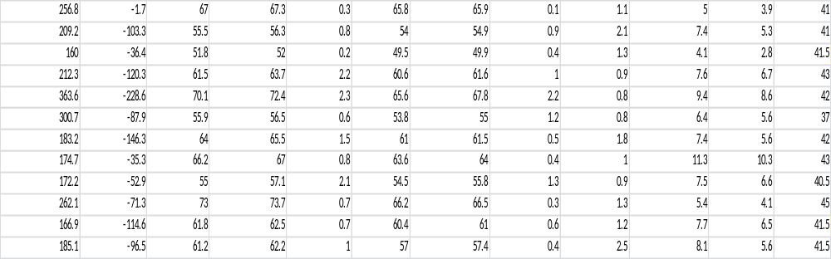

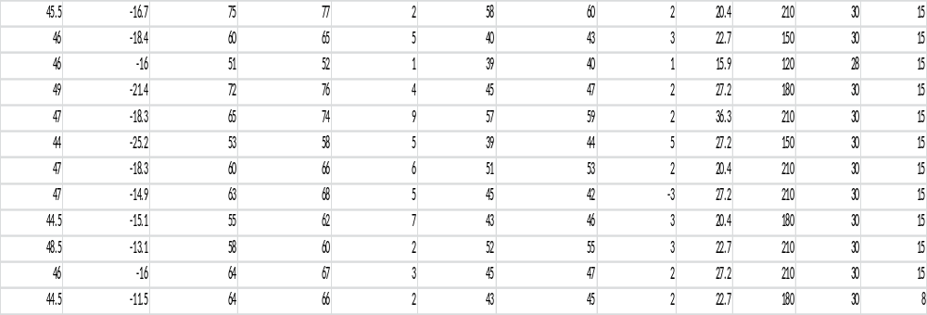

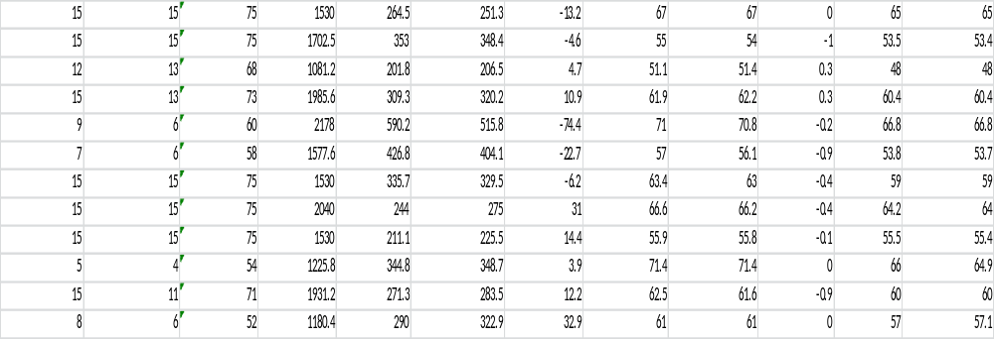

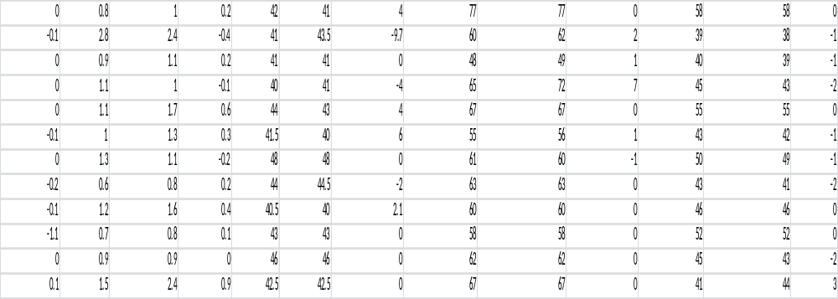

Appendix B: Electromyography Data
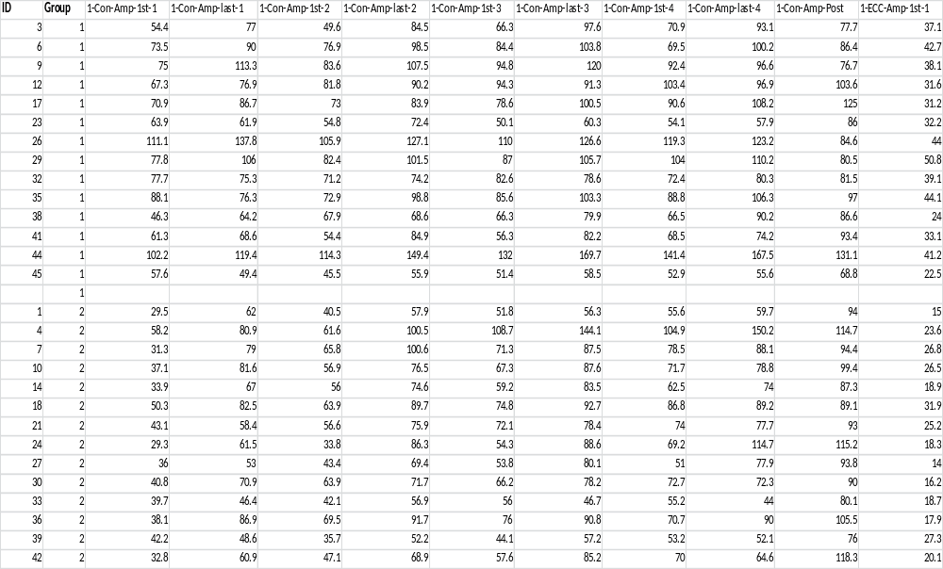
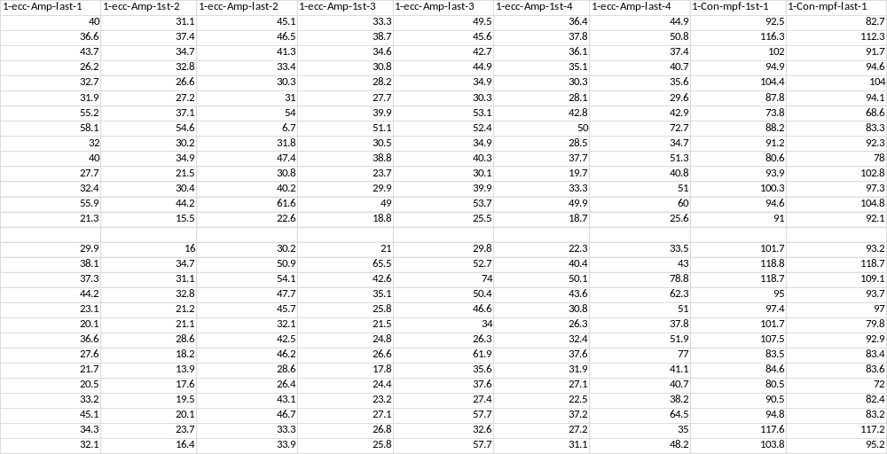
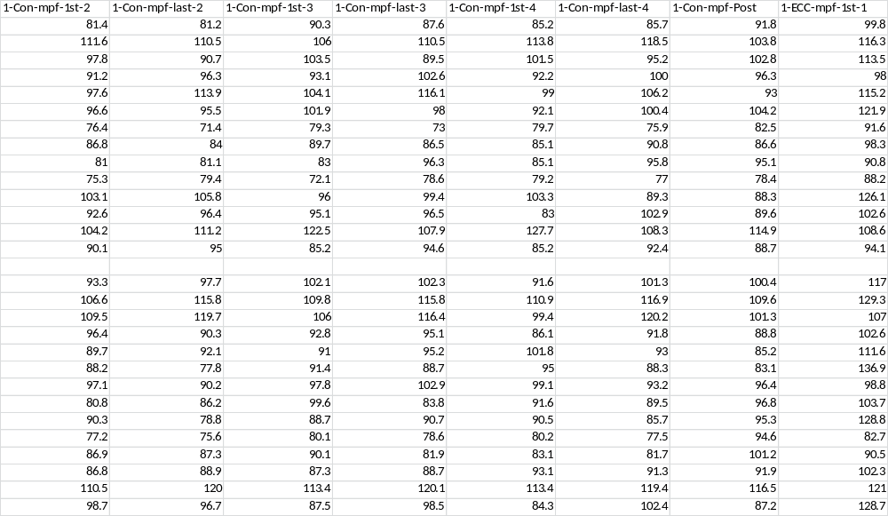

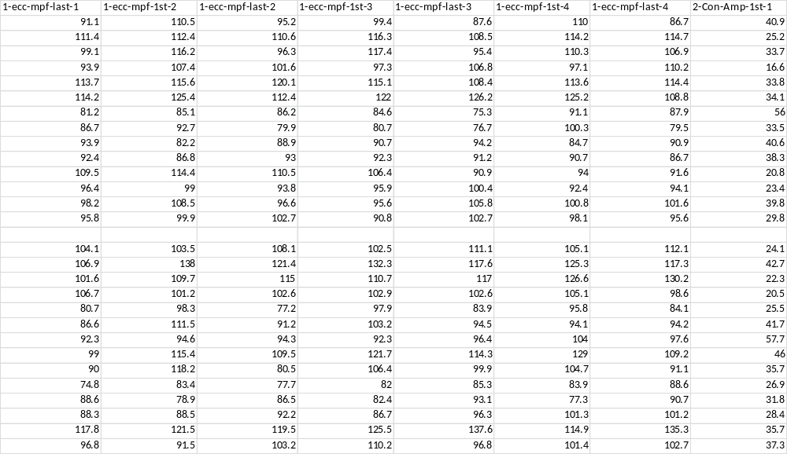

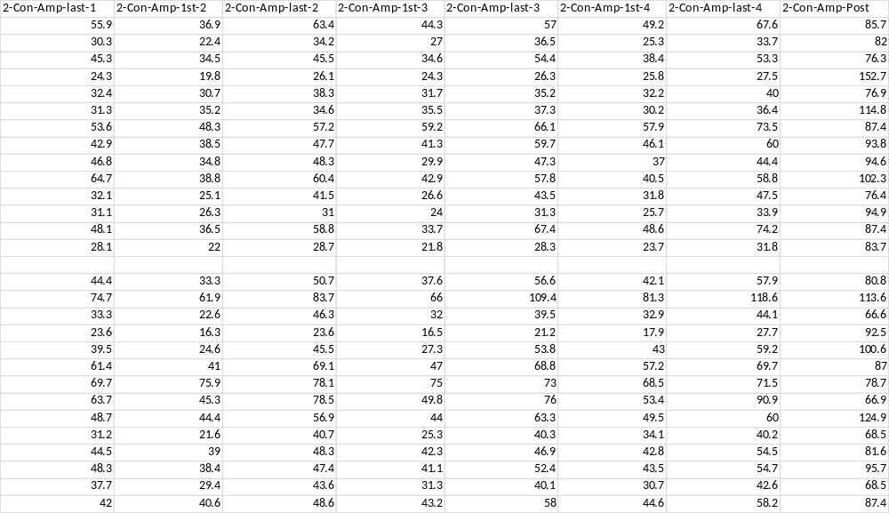

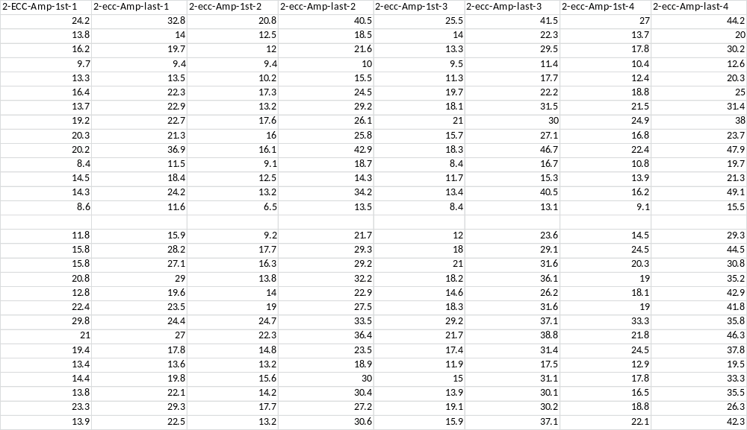

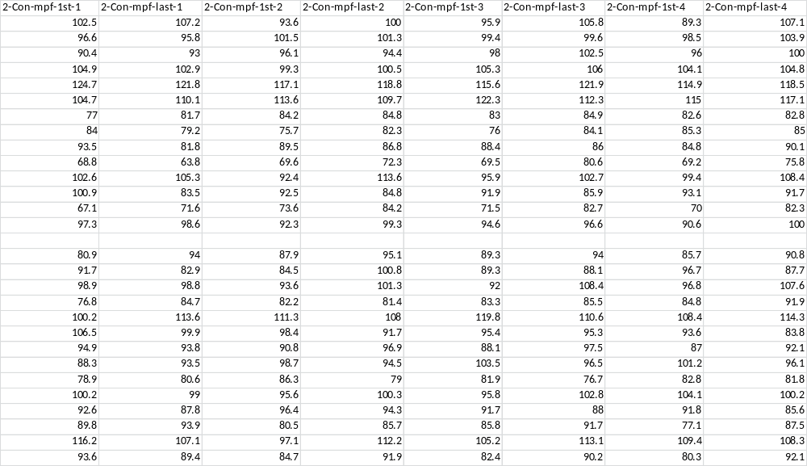

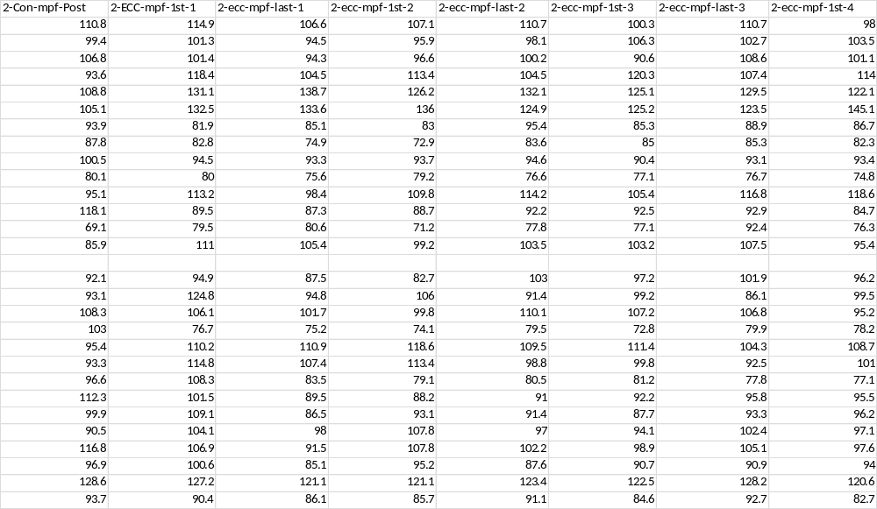

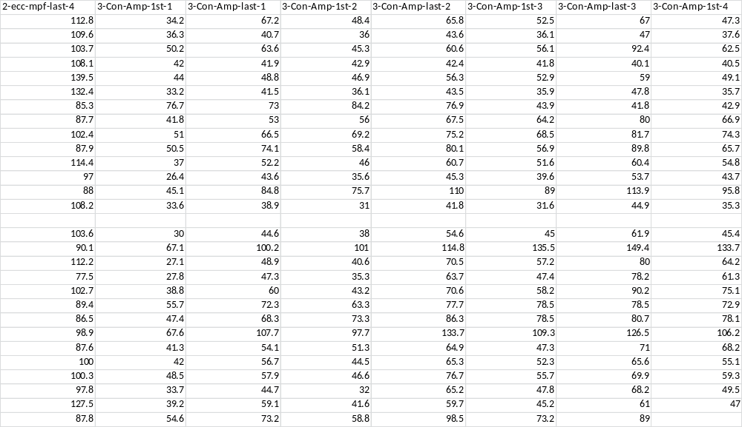

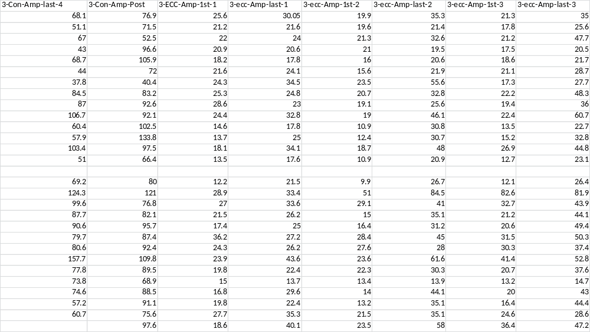
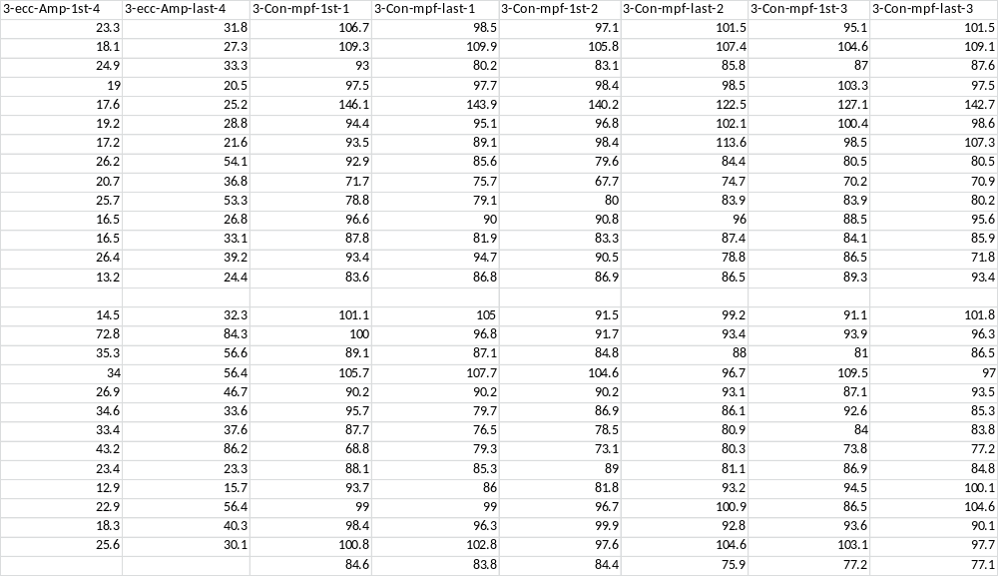

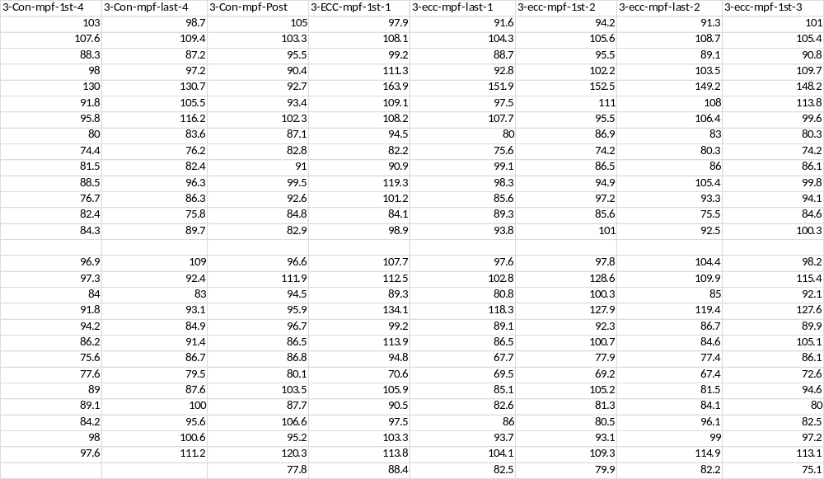

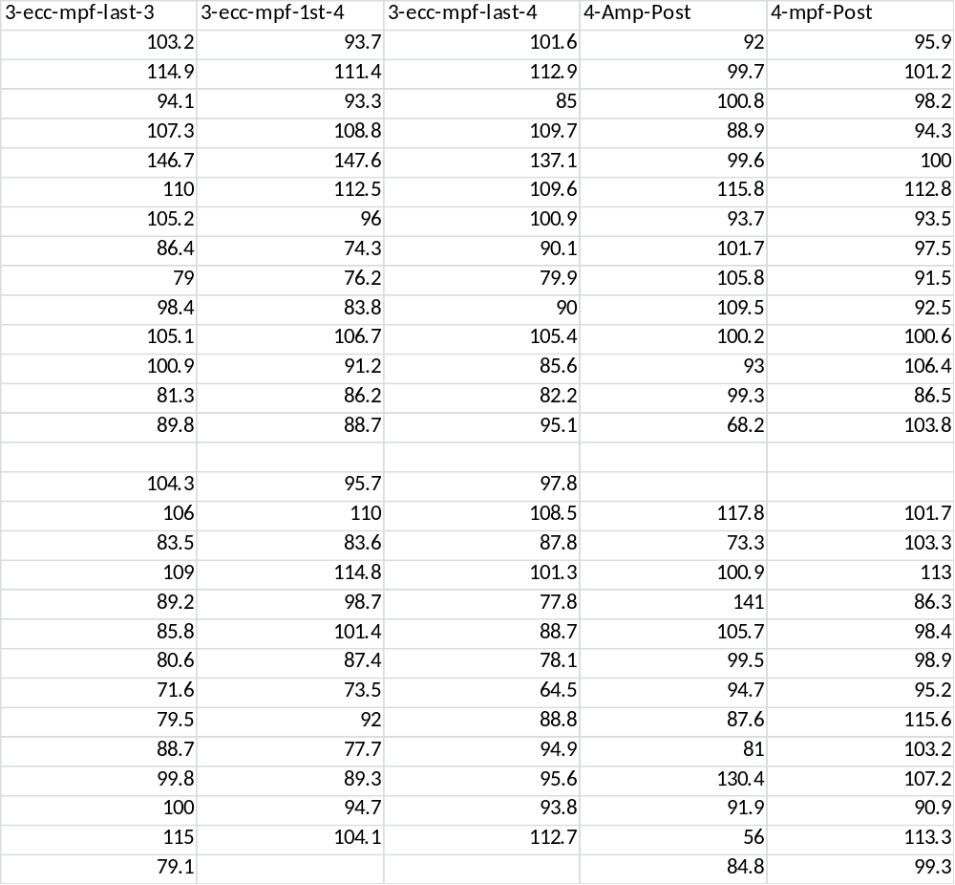

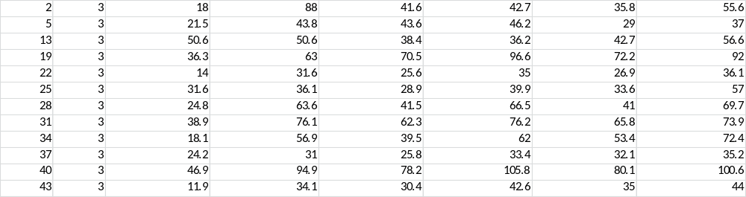

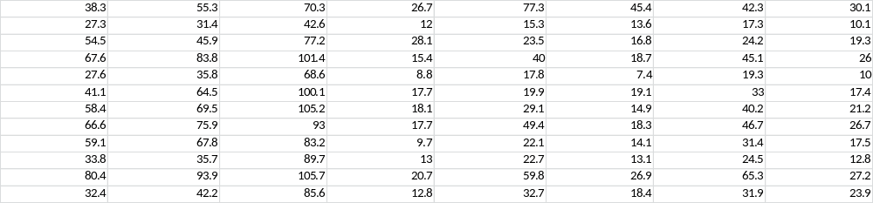
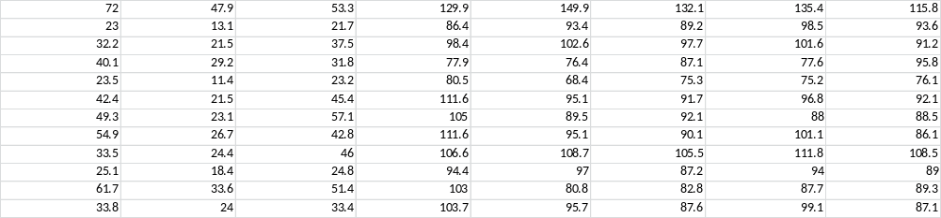
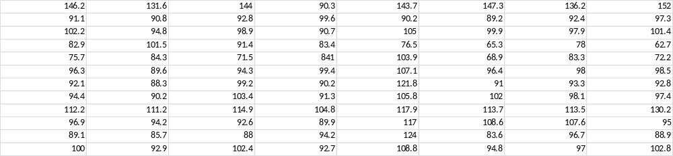
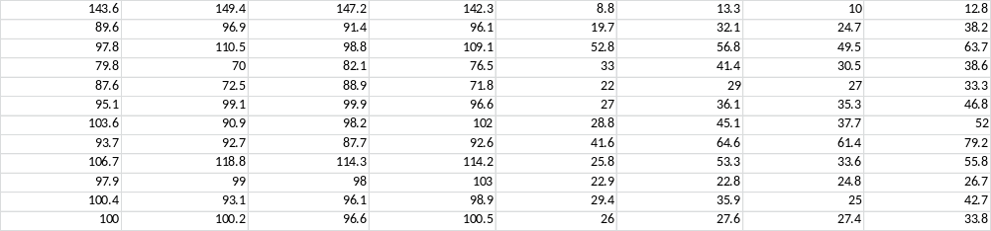
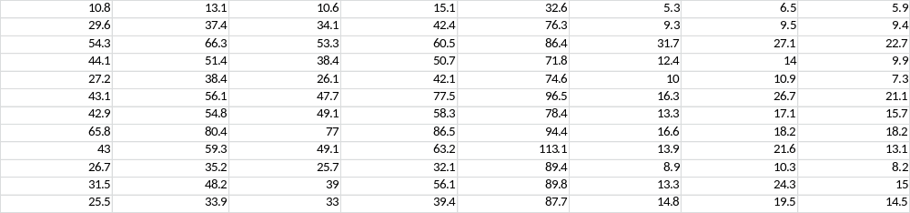
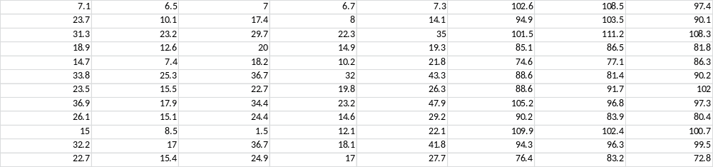
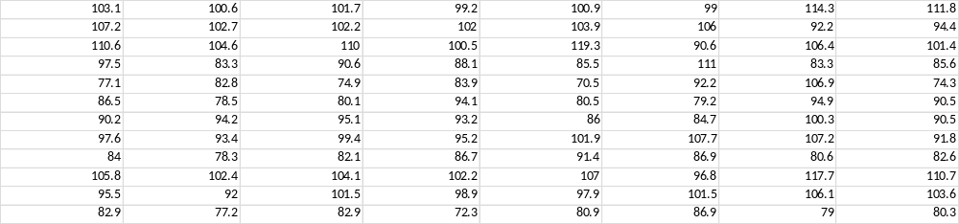
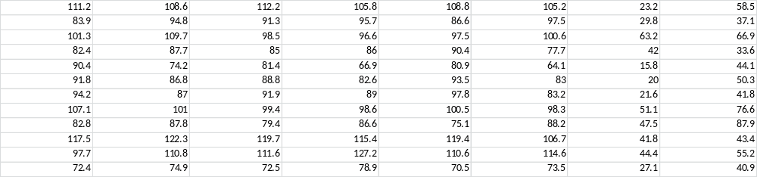
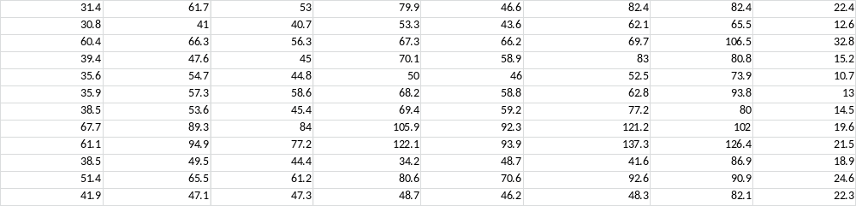
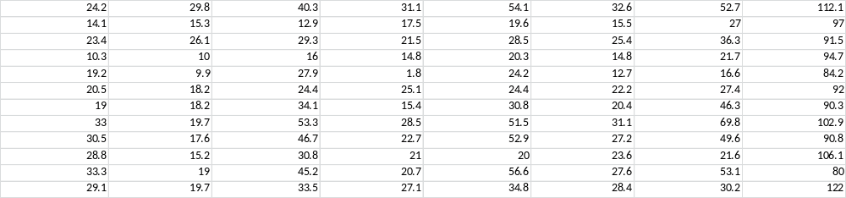
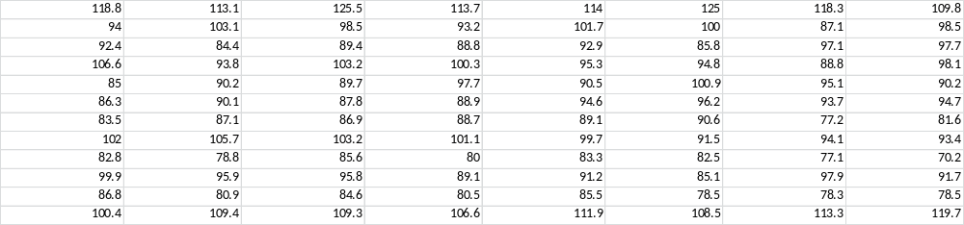
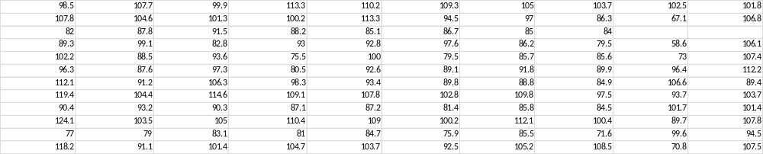

Appendix C: Perceptual Response Data
