University of Oklahoma

Graduate College

using invest to evaluate the performance of urban growth management strategies in conserving ecosystem services in the city of corvallis, oregon

A Dissertation

submitted to the Graduate Faculty

in partial fulfillment of the requirements for the

Degree of

Doctor of Philosophy

By

long zhou
Norman, Oklahoma
2016

using invest to evaluate the performance of urban growth management strategies in conserving ecosystem services in the city of corvallis, oregon

A DISSERTATION APPROVED FOR THE
College of architecture

By

______________________________
Dr. Tom Woodfin, Chair

______________________________
Dr. Charles Warnken, Co-Chair

______________________________
Dr. Guoqiang Shen

______________________________
Dr. Darren Purcell

______________________________
Mr. Leehu Loon

© Copyright by LONG ZHOU 2016
All Rights Reserved.

Acknowledgements
The author wishes to express hearty thanks to Dr. Tom Woodfin, Dr. Guoqiang Shen, Dr. Charles Warnken, Prof. Leehu Loon and Dr. Darren Purcell whose encouragement, guidance and support from the initial to the final level enabled me to develop this dissertation. The dissertation would never have been completed without the support of the College of Architecture, University of Oklahoma.

Table of Contents

Acknowledgements ii
List of Tables ii
List of Figures ii
Abstract x
Chapter 1: Introduction 2
Inextricable Urbanization Process and its Environmental Effects 2
Urban Growth Management 6
Chapter 2: Literature Review 9
Urbanization and Impervious Surface Impacts on Environmental Quality 10
Urban Growth Management’s Efforts in Environmental Conservation 13
Urban Growth Management’s Impacts on Property Values 15
The Framework of Ecosystem Services in Urban Planning 16
Limitations to Previous Studies 25
Chapter 3: The City of Corvallis, OR and Research Objectives 27
The City of Corvallis, Oregon 28
Corvallis’ Urban Growth Management 31
Research Objectives 35
Chapter 4: Research Methodology 39
Biophysical Models and Ecological-Economic Conversion Models 41
Data Collection 48
Scenarios Design 50
Chapter 5: Results and Discussion 53
Urbanizations Impacts on Environment 54
Ecosystem Service Conservation and Values 68
Modified Comprehensive Plan 81
Chapter 6: Conclusion 91
Reference 95

List of Tables
Table 1. Goals of Land Use Policy Proposed by the Land Conservation Act 8
Table 2. Land Use and Land Cover within the Watershed of Corvallis in 2000 30
Table 3. Projected Land Use in 2020 38
Table 4. Data Collection, Formatting and Manipulation 49
Table 5. Projected Land Use and Land Cover Change 56
Table 6. Projected Land Use Change in Urban Fringe 57
Table 7. Urbanization’s Impacts on Environment in 2000 and 2020 58
Table 8. Urbanization’s Impacts on Environment in the Historical Periods 61
Table 9. Urbanization’s Impacts on Environment for Subwatersheds in 2013 64
Table 10. Ecosystem Service Provided by Different Areas in 2000 68
Table 11. Ecosystem Service in Zoning Categories in 2000 73
Table 12. Ecosystem Service Provided by Different Areas in 2000 and 2020 74
Table 13. Ecosystem Service Valuation for Each Subwatershed 76
Table 14. Comparison of the Conservation Areas in Providing Ecosystem Services 81
Table 15. Projected Future Land Use Size and Impervious Percentage 85
Table 16. Urbanized and Conserved Parcels in Revised Comprehensive Plan 88

List of Figures
Figure 1. Urban and Rural Population of the World, 1950 – 2050 2
Figure 2. Degrees of Imperviousness and its Effects on Stormwater Runoff 3
Figure 3. Portland’s Current Urban Growth Boundary in 2009 6
Figure 4. City of Corvallis, Oregon and Subwatersheds 28
Figure 5. Comprehensive Plan, Corvallis Oregon Source 31
Figure 6. The Urban Growth Boundary, City Limit, Watershed and Land Cover 33
Figure 7. Proposed Land Use Percentage in Urban Fringe in 2020 34
Figure 8. Water Yield in InVEST 42
Figure 9. Carbon Cycle in InVEST 46
Figure 10. Research Flow Chart 50
Figure 11. Projected Land Use Changes 54
Figure 12 The City’s Urbanization History from 1853 to 1998 60
Figure 13. Urbanization Impacts Change through History 62
Figure 14. Land Use and Impervious Surface in 2013 63
Figure 15. Relationship between Impervious Surface and Urbanization’s Impacts 65
Figure 16. Nitrogen Retention on the Parcel Level 70
Figure 17. Phosphorus Retention on the Parcel Level 71
Figure 18. Carbon Storage on the Parcel Level 72
Figure 19. Correlation between Impervious Surface and Ecological Monetary Value 77
Figure 20. Explanation of Ecological Value Gradient on Subwatershed Level 78
Figure 21. Global Morans I Test on Subwatershed 80
Figure 22. New Proposed Conservation 82
Figure 23. Current Comprehensive Plan (2014) 84
Figure 24. Ecological Value on the Parcel Level 86
Figure 25. Revised Comprehensive Plan 87
Figure 26. Urban Forest Los Angeles 90

Abstract
The world is undergoing a sustained wave of urbanization and through changing landuse and land cover, urbanization has been posing threats to “eco-environments” at various scales (Wang et al 2002). Urban growth management strategies including comprehensive plan with an urban growth boundary have been widely applied at both local and regional scales in the United States to control urban growth and conserve natural resources (Bengston et al 2003). Scholars have studied the performance of Urban Growth Management in environmental conservation, with the results varying due to different scales and research perspectives (Frenkel, 2004; Nelson 1992; Gordon, et al, 2009; Cathcart, et al 2006; Robinson, et al 2005; Kline and Alig, 1999). Through reviewing relevant literature, the author found that few studies explore this issue based on ecosystem service quantification, which could directly act as an indicator of the effectiveness of environmental conservation under different planning policies (Heldal and Baszka 2012).
The InVEST (Integrated Value of Ecosystem Services Tradeoffs) modeling program developed by the Natural Capital Project at Stanford University quantifies various ecosystem services under different planning scenarios. This research uses InVEST 3.2.0 on the parcel level to evaluate the City of Corvallis’s current Comprehensive Plan in terms of alleviating future urbanization’s impacts on environmental quality and conserving ecosystem services in purifying stormwater and storing carbon. Through spatial and temporal comparisons, the conclusion is made that the City’s current Urban Growth Management conserves the land of high ecological value in carbon storage, but does not protect the land of high ecological value in stormwater purification. Using ecological unit monetary values from previous studies and the ecosystem service quantification results generated from InVEST, ecological values of each parcel are converted into a monetary value. Based on these monetized values, this research proposes a revised comprehensive plan for the City. The new plan directs future urbanization into the lands with least ecological values and conserves the lands with most ecological values while still matching the City’s estimated demand for developable land for different land uses.

Chapter 1

Introduction

- Inextricable Urbanization Process and its Environmental Effects

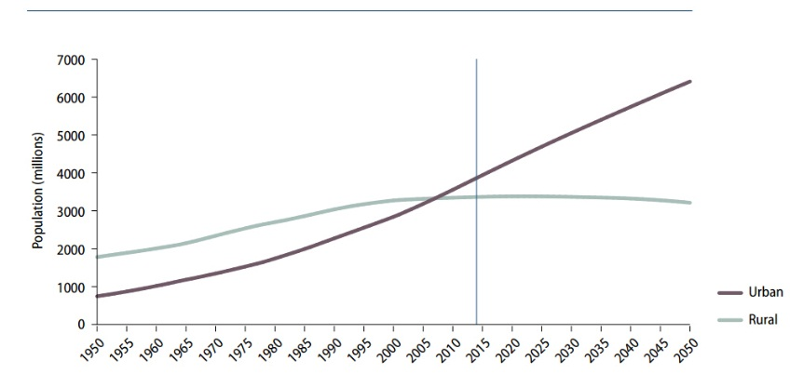
Urbanization has been rapidly spreading in both developing and developed countries. Global urban population has risen rapidly since the 1950s from less than eight hundred million in 1950 to nearly four billion in 2014 (United Nations 2014). Due to the advantages in modernization, industrialization and the sociological process of rationalization during which traditional thinking ways were replaced by the analyses addressing social control, urbanization will be inextricable from development in the coming decades (Wang et al 2002). The 2014 World Urbanization Prospects predicts that the urban population could reach to 6.5 billion in 2050, accounting for sixty-six percent of the world’s total population (United Nations 2014).
Figure 1. Urban and Rural Population of the World, 1950 – 2050. Source: United Nations, 2014. Department of Economic and Social Affairs, Population Division World Urbanization Prospects: The 2014 Revision, Highlights.
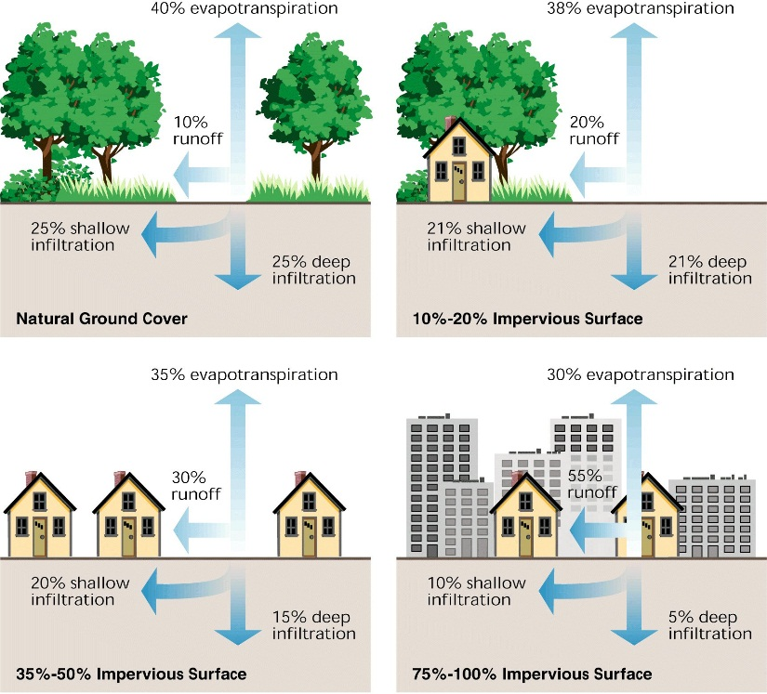
Urbanization has brought substantial social and economic development to our world resulting in more job opportunities and more efficient ways of using resources (United Nations Population Fund 2015). However, through land use and land cover change, urbanization has been posing negative impacts on “eco-environments” at multiple scales (Wang et al 2002). For example, Faulkner (2004) found that urbanization in the southern United States has damaged forest and wetland ecosystems through fragmenting wildlife habitat, reducing biodiversity and disturbing biotic community functionality. Through collecting emission inventory data and building the population exposure spatial model in Chinese cities, Han, et al. (2004) found that rapid urbanization results in high concentrations of airborne fine particles which lead to the urban haze and does deadly damage to human respiratory system. As urbanization proceeds, a substantial amount of carbon stored in terrestrial natural ecosystems is released into the air (Conte et al 2011). For example, Gibbs et al (2007) found that more than two thirds of total carbon emissions come from deforestation because of urban sprawl in the Africa from 1990 to 2000.
Figure 2. Degrees of Imperviousness and its Effects on Stormwater Runoff. By the Federal Interagency Stream Restoration Working Group (FISRWG).
Urbanization has been proven to impact the hydrological cycle. In urban areas, the natural pervious ground surface is replaced by impervious pavement. An increased percentage of impervious surface in urban watersheds results in less water evapotranspiration, less stormwater retention and more flash flooding during intensive precipitation events (Brilly et al 2006). For example, Rose and Peters (2001) documented stream flow in twenty-five streams in Georgia for forty years and their research showed that the peak flow in the urban area is 30% - 100% higher than in rural areas. Nirupama and Simonovic (2006) explored the correlation between the size of urban areas and flow discharges in the Thames River basin and drew the conclusion that because of the progressive upstream urbanization, the flooding risk has been significantly increased for the City of London, Ontario, Canada. Urbanization has also proven to be a factor affecting surface water quality and the levels of heavy metals, total phosphorous and total nitrogen in urban storm water are typically above standards (Bratieres et al 2007, Goonetilleke et al 2005). Through analyzing data from twelve stream sites located in a rural stream, a suburban stream and an urban stream, Mallin et al (2009) found that urban streams carry more phosphorus, biochemical oxygen demand (BOD), total suspended sediment (TSS) and surfactant concentrations than rural streams and suburban streams. While the environmental effects of urbanization have long been known, modern tools enable a better understanding of urbanization and its effects on ecological processes.

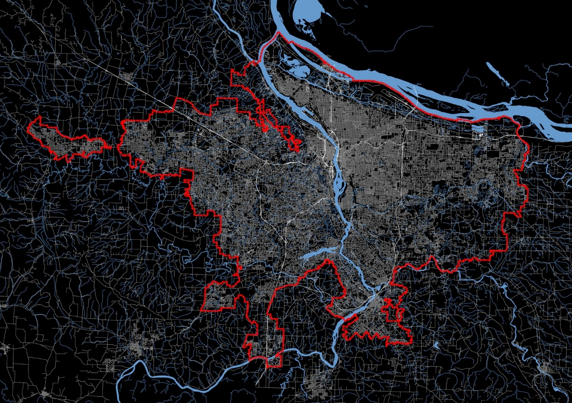
- Urban Growth Management
Figure 3. Portland’s Current Urban Growth Boundary in 2009 (Source: Urban Grids, Free Association Design).
Urban growth management strategies refer to the planning tools and policies applied in managing where urbanization should occur, when urbanization happens, the appropriate percentage and its impacts (Pollock 2008). It includes but is not limited to:
(1) conservation easements (2) purchase of development rights (PDR) (3) transfer of development rights (TDR) (4) zoning ordinances, agricultural zoning districts (5) urban growth boundaries (UGB) (6) urban service boundaries (7) subdivision regulations (8) riparian buffers (9) comprehensive plans and phased growth regulations (Porter 1997).
Urban growth management strategies have been widely applied at both local and regional scales in the United States to control urban growth (Bengston et al 2003). A number of states have incorporated growth management strategies into their statewide planning programs. Oregon’s planning system is considered to be the most successful one in the United States by planners and policy-makers in terms of directing urban growth into urban growth boundaries, making exurban development compatible with land conservation and restricting “resource lands to resource activities” (Nelson and Moore 1993, Knaap and Nelson 1992, Brody, 1991, Dempsey and Andrew 2013). The State of Oregon implements arguably the most restrictive set of urban growth regulations on urban sprawl in the United States. Population is inevitably growing in Oregon and the State’s growth management program has been playing an important role in maintaining a balance between natural landscape preservation and urban development (Howe, 1991). In 1973, Oregon passed its statewide Land Conservation Act (LCA) to respond to the rapid urbanization. The Land Conservation Act set up nineteen planning goals to implement the state’s land use policy. Those nineteen goals are summarized in Table 1.
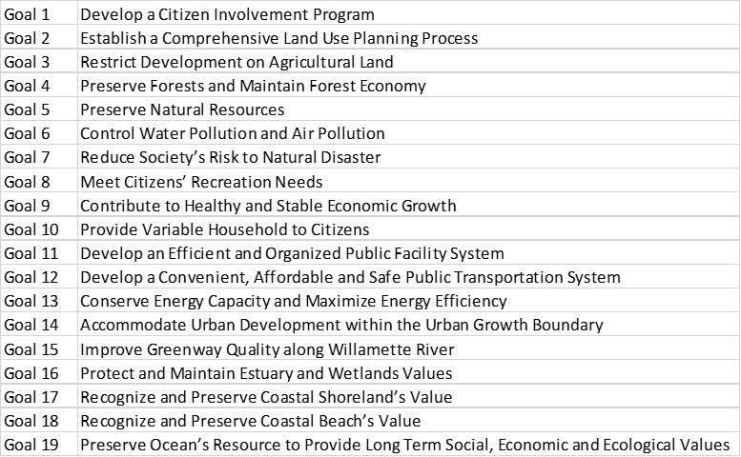
As the main strategy to implement the urban growth management policy in Oregon, every city and county is required to create a comprehensive plan and update it every five years. The comprehensive plan must be reviewed and approved by the State Department of Land Conservation and Development Commission (LCDC). The local comprehensive plan should be consistent with the statewide goals and once acknowledged by LCDC, land zoning regulations and subdivision ordinances are adjusted and applied to put a community’s comprehensive plan into practice (Oregon Department of Land Conservation and Development 2010). If a local city or county is not able to get its comprehensive plan approved by LCDC, the state may file sanctions to withhold its revenues and grants.
Table 1. Goals of Land Use Policy Proposed by the Land Conservation Act (Oregon Department of Land Conservation and Development 2010)

Chapter 2

Literature Review

- Urbanization and Impervious Surface Impacts on Environmental Quality
Through quantifying emergy, measurement of provisions of biosphere to urban systems and as an indicator of environmental quality and urbanization over time from 1990 to 2006, Mellino (2007) finds urban sprawl significantly decreases environmental quality in an inverse relationship. Previous studies have demonstrated the conversion of pervious surface to impervious surface from urbanization has been threatening environmental quality in multiple dimensions (Foley et al. 2005) such as urban hydrology (Sun and Lockaby 2012), water quality (Johnston 1991), wildlife habitat (Gardiner et al. 2013) and land surface temperature (Van et al. 2011). Hao et al (2015) investigated the change of stream flow and evapotranspiration because of urbanization in a southern China watershed. The results show that from 1986 to 2013 stream flow increased by 58% and land cover conversion to impervious surface contributed more than 80% of the stream flow increase. Lepeška (2016) demonstrates the crucial impacts of impervious surface on the City of Banská Bistrica’s downstream ecosystem. His research shows that urbanization dominated by impervious surface yields 64 times more runoff than the natural watershed dominated by undeveloped lands. Buildings, roads and parking lots contribute 40%, 31% and 25% to the total urban runoff respectively. Schneider et al (2012) uses the U.S. National Land Cover Database and models ecosystem services provision under three urbanized areas of different impervious surface percentage and turf grass percentage in the Agro-IBIS Ecosystem Model. The results show that urban sprawl decreases the city’s ability to regulate flooding and the residential area expansion results in 15-48% more urban runoff. Wu et al (2013) builds the Storm Water Management Model using stream flow monitoring data for five watersheds with different impervious surface percentages. Based on this model, three scenarios are designed to quantify the impacts of impervious surface and climate change on stream hydrology represented by peak discharge, flashiness (R−B Index; Richards–Baker Index), and runoff ratio. The results show that increased impervious surface percentages from 5.2% to 17.1% result in large increases for all these three indicators by 49.5%, 39.3% and 73.9% respectively.
Urbanization also degrades stormwater quality. Through applying a single-factor analysis of variance statistic model (ANOVA) to analyze impervious surface percentages and water samples collected in the city of Lubbock, TX., Heintzman et al (2015) concluded that impervious cover percentage is positively related with polycyclic aromatic hydrocarbons (PAHs - the toxic organic pollutants in stormwater) and suggests that in urban stormwater management, streams surrounded by more pervious buffers should have less PAH pollution. Applying the same methods and statistical model to a riparian wetland, Hogan and Walbridge (2007) found a significantly nonlinear correlation between phosphorus concentrations with impervious surface percentage and, as urbanization proceeds, a riparian wetland’s ability to provide ecosystem services is negatively affected as nutrients are redirected from riparian wetlands to streams. Through the collection of empirical data, applying the Soil Conservation Service Curve and comparing dissolved silica export from two watersheds distinguished by impervious surface percentage, it is found that impervious surface limits short-term dissolved silica concentration in precipitation events and decreases long-term dissolved silica export into aquatic ecosystems (Loucaides et al 2007). With the ion concentration sample data and land cover data from different sources (e.g. Federal Census Bureau 2006 TIGER line files, the Puerto Rico Municipal Revenue Center and American Forests), Ramirez et al (2014) used stepwise multiple regressions to analyze how land cover variables are related with major ion concentrations in Puerto Rico. This research finds a strong linear regression among chemical concentration, impervious surface, building density, road density and drainage pipe density.
Land cover conversion into impervious surface results in carbon storage loss. Yan et al (2016) employs Landsat TM images to analyze land cover change and quantifies carbon storage with data from field survey and literature reviews in the period of 1990 to 2010 in the largest dryland city in Urumqi, China. The results show that cropland and desert conversion into impervious surface results in ecosystem carbon loss up to 82%. Until now in the urban area, carbon storage in the soil under capped surfaces has not been characterized clearly and assessment of impervious surface sprawl impacts on soil carbon storage varies (Wei et al 2014a). For example, Raciti et al (2012) suggest that the soil organic carbon storage under capped surfaces is apparently lower than in the open soil. But Edmondson et al (2012) explores the carbon storage in the urban environment in a mid-sized British city and assesses the carbon storage under impacts of different impervious types including roads, pavements, footpaths and patios. Contrasting with general understanding that urbanization is degrading ecosystem services, this research reports that urban soil stores more carbon than rural soil with same soil depth and there is no significant change between the soil under impervious surface and the soil under unsealed surface.

- Urban Growth Management’s Efforts in Environmental Conservation
One of the original goals of the Urban Growth Management policy is to restrain urban sprawl and preserve natural resources. Scholars have studied the performance of urban growth management in environment conservation. Frenkel (2004a) researched the role of growth management policies in concentrating urban development and environmental conservation at the national level in Israel. Through running the Land-Consumption model (Frenkel 2004b) and a comparison of different planning scenarios, Frenkel predicted that the urban growth management policy taking place from 1995 to 2020 reduced unprotected open space loss from 8.2% to 6.5% and dropped farmland loss from 11.1% to 8.7%. Similarly, Nelson (1992) demonstrated that Oregon’s planning policies including urban growth management, urban growth boundaries, and exurban development separation play an important role in conserving productive farmland and forest. Gordon et al (2009) indicated that the urban growth management in the City of Melbourne, Australia could be an effective planning tool in protecting threatened species habitat. Cathcart et al (2006) drew the conclusion that through directing urban development into the urban growth boundary, the natural resources preserved by Oregon’s planning program could potentially capture substantial carbon dioxide up to 15 million tons in the future ten years. However the adverse effects of urban growth management policy are also pointed out by some scholars. Robinson et al (2005) argued that under the urban growth management, urban density within the urban growth boundary did increase in the past 25 years in the Seattle region. However low-density development has been increasingly sprawling in natural areas outside the boundary. Based on the database and plant community inventory collected by United States Department of Agriculture, Kline and Alig (1999) drew the similar conclusion that in Oregon, development under the urban growth management is tending to be more intensive within the urban growth boundary but it is not clear that the tendency of development within forest and farmland is decreased outside of the boundary.

- Urban Growth Management’s Impacts on Property Values
Many scholars have studied the relationship between urban growth management and land prices. Lillydahl (1987) notes that the urban growth management policy has the potential to dampen development by increasing land and housing prices. Knapp and Nelson (1988) argue that the urban growth management policy can increase property prices because it restrains the supply of developable urban land. In addition, the urban growth management enhances the environmental quality of land parcels that are inside but close to the urban growth boundary. These parcels might enjoy the open space and the expansive views provided by the low-density development outside the boundary. Some research has demonstrated that the property price rises because of environmental amenities improvement (Cho et al., 2008; Seo and von Rabenau, 2011).
However, Dawkins (2002) argues that, similar with other commercial goods, whether or not the urban growth management policy is impacting property values ultimately depends on the relationship of demand and supply elasticity. Urban growth management policy may not increase the house prices if the flexible land supply can mitigate the inflationary pressure on land prices by bringing in new supply. This might explain Mathur’s (2013) finding that the property values around the urban growth boundary is slightly decreasing in King County, Washington.

- The Framework of Ecosystem Services in Urban Planning
Ecosystem services refer to the benefits provided by ecosystems for humans and are categorized into provisioning services, regulating services, supporting services and cultural services (Millennium Ecosystem Assessment 2005). Provisioning ecosystem services are the material or energy generated from the ecosystems, including food, raw materials, water and medical materials. Regulating services indicate the benefits provided by ecosystems in the way of regulating ecological processes, for example regulating qualities of water, air and soil. Supporting services are the necessary conditions created by the ecosystem to provide other services, for example, soil formation and nutrient recycling. Cultural services denote the nonmaterial benefits humans gain from ecosystems through experiences, such as cultural heritage, landscape aesthetics and outdoor recreation (The Economics of Ecosystems and Biodiversity 2008). Ecosystem services are vital for humans and provide invaluable and innumerable benefits. Without ecosystem services, humans do not have food, living conditions or wilderness to enjoy. For example, the global population is projected to be more than 9 billion by the middle of 21th century. Since humans depend on agricultural products for food, our ecosystems will need to supply and regulate 10⁹ hectares more agricultural land for food production (Goldman 2010).
Urbanization has brought substantial social and economic development to our world, and it has been widely recognized that through land use and land cover change, urbanization has inevitably impacted the environmental quality at multiple scales. The ecological-social ecosystem service trade-offs as a framework is a powerful approach to analyze and pursue the three pillars of sustainability (ecological sustainability, economic sustainability and social sustainability) (Cavender-Bares et al 2015). The public welfare depends significantly on the “quality, quantity and diversity” of the ecosystem services and urban planners play a significant role in organizing cities’ process and enhancing the public welfare (McPhearson et al 2014 and Hansen et al., 2015). However there is little research on how the urban planning process or research relates to and addresses different aspects of ecosystem services (Erixon et al., 2014). This dissertation reviewed the framework of ecosystem services in urban planning by asking the question: “how is the ecosystem services framework applied by urban planners and designers in making spatial interventions?”
Niemela et al (2010) reviewed the application of the ecosystem service approach in land-use planning at the regional scale. He identifies the three main services provided by the urban ecosystem as provisioning services, regulating services and cultural services. Through interviewing of planners, Niemela summarizes the advantage and disadvantages of the concept of ecosystem service and concludes with the challenge of its application in spatial planning. Similarly through reviewing previous studies in Europe and United States, Gómez-Baggethun and Barton (2013) describe and categorize most provisioning ecosystem services and regulating services, and summarize the methods to convert the biophysical ecological value to economic value. Gómez-Baggethun and Barton propose four methods to evaluate the cultural values of ecosystem services (hedonic pricing, travel cost, avoided cost and stated preference methods) and indicate that compared with the ecological values, the knowledge for how to quantify cultural ecosystem services is limited. Gaston et al (2013) reviews the relevant studies in the United Kingdom and addresses the challenges for urban planners in managing urban ecosystem services. Gaston suggests that high resolution data from remote sensing technology, applied ecology principles and systematic planning processes could assist planners in conserving ecosystem services from urbanization. Kabisch (2014) examines to what extent the framework of ecosystem services is utilized in spatial planning by reviewing Berlin’s planning context and interviewing local land owners. This review draws the conclusion that some types of ecosystem services are addressed in most of Berlin’s planning documents, but the comprehensive framework of the ecosystem services, especially the tradeoffs among ecosystem services, is barely considered. Kabisch concluded that financial constraints, lack of professional expertise and less awareness of ecological benefits are the main challenges in comprehensively applying the framework of ecosystem service. Geneletti and Zardo (2016) addressed the importance of the framework of Ecosystem-based Adaptation (EbA), a measurement of ecosystem service, including EbA classification and the scoring system, and reviewed how this framework is applied in three European cities’ climate adaptation plans. Cavan et al (2014) classified the land cover of two African cities into 35 and 43 Urban Morphology Types (UMTs) respectively, and demonstrated that UMTs could be applied in assessing ecosystem services in regulating land surface temperature.
Grêt-Regamey (2013) ranks three vegetation composition styles’ efficiency in cooling temperature and providing habitat using indicators of shadow area and suitable area. Furthermore, Grêt-Regamey embeds this analysis process into three-dimensional GIS-based modeling, and through this model, decision-makers could deal with the tradeoffs among the ecosystem services’ biophysical, economic and esthetic values. Lakes and Kim (2012) analyze the advantages and disadvantages of using biotype area ratio as indicators to assess regulating ecosystem services in Seoul and Berlin at a city scale. The results indicate that with the assistance of high-resolution remote sensing data, biotype area ratio is a successful indicator and could be applied by planners to assess urban regulating ecosystem services. Lee et al (2015) analyzed the ecosystem services changing trend from 1970 to 2006 in Taiwan by quantifying paddy rice field coverage percentage as an indicator for provisioning services, percentage of pervious surface as an indicator for regulating services and the rice field patches as an indicator for cultural services. This study shows an example that landscape metric and configuration analysis could inform planners in prioritizing agricultural fields for conservation. Huang et al (2011) quantified the ecological energetic difference for each land use and land cover, though this provisioning ecosystem service and regulating ecosystem service changes were evaluated from 1971 to 2006 in Taiwan. Martinico et al (2014) assessed the urban ecosystem service under the City of Catania in Italy through using the amount of new urban farmlands as the indicator for provisioning ecosystem services, the amount of new greenspace in resource zones as the indicator for regulating ecosystem services and greenspace connectivity as the indicator for cultural ecosystem services (recreational services).
Three methods frequently used to qualitatively analyze urban ecosystem services could be summarized as through (1) the green infrastructure or pervious surface percentage, (2) the landscape metrics quantification, i.e. green patch size and connectivity, and (3) ecological energetic analysis.
Some studies have quantified ecosystem services. Dupras et al (2015) pointed out that due to the lack understanding of natural capital and ecosystem services, planning policy may have unknowingly been contributing to the degradation of the environment. Dupras maps the total non-market values of biodiversity in the Greater Montreal area in Canada and through mapping the distributions of the values of ecosystem services, decision-makers are able to make more effective land planning policies. In Dupras’ study, the methodology to quantify the ecological values provided by forests, woodlands and urban wetlands is by calculating the areal amount of those three land covers in ArcGIS and using the secondary data regarding the economic values of the ecosystem services provided by the Environmental Valuation Reference Inventory database (Dupras et al 2015). Larondelle et al (2014) quantifies and maps ecosystem services in regulating urban temperature and storing carbon for 300 European cities using the land use high-resolution data from Urban Atlas Dataset combined with the f-evapotranspiration and carbon storage values for each land use type from previous research. Derkzen et al (2015) quantified five regulating ecosystem services (air purification, stormwater retention, surface temperature regulation, noise reduction and carbon storage) and the ecosystem service for recreation in Rotterdam, Netherlands through using high-resolution urban land use and land cover data with eight categories and unit values of each category in providing ecosystem service retrieved from previous studies. All this research indicates that planners could and should pay more attention to the urban planning culture that is crucial for conserving urban regulating ecosystem services. A similar method was used by Zhou et al (2014) in quantifying the relationship between the ongoing processes of urbanization and the corresponding loss of ecological values in the City of Wuhan, China. Zhou explores the influences of three developing urban patterns on the ecological values by quantifying the urbanization patterns, determining the changes in ecosystem services and attempting to build the Pearson Correlation between those two factors. The method to quantify the ecosystem services changes in this case was to quantify the landscape patterns in the process of urbanization and use the secondary data provided by the Ecosystem Service Valuation Coefficients for China, as developed by Xie et al. (2003). The weakness of this method is that it assumes the same land use land cover type provides the exactly same ecological values regardless of the different locations, various climate and biophysical situations (for example, the different soil conditions), and different structural components (for example, the different plant components of urban forests and urban wetlands).
Liu and Li (2012) quantify the carbon sequestration and storage by the urban forest in the City of Shenyang, China. The improvement in their method is that rather than using the same general ecosystem services valuation index for all types of urban forests, Liu and Li used the satellite images and the field survey to document the plant species in the urban forests. Then the Biomass Equation was applied to quantify the carbon storage of each type of species. This study also demonstrates that the ability to store carbon varies among different urban forest types with different “species composition and age structure” (Liu and Li 2012). However this study still does not take into consideration various biophysical conditions.
Jansson and Colding (2007) used the Transport, Retention, Kallfordelling (TRK) model (a hydrological model) to quantify the nitrogen loading to the Baltic Sea from Stockholm County both under the present scenario and two alternative future development scenarios predicted by the county’s planning department. Schaffler and Swilling (2012) used the same method to calculate the size of the vegetation components and quantified the ecosystem services provided by the urban green infrastructure in Johannesburg, South Africa. Compared to the methodologies mentioned earlier, these methods are more accurate by using the local data instead of the ecosystem services quantification reference index. But this method requires extensive field surveys to create accurate localized standard values.
InVEST (Integrated Valuation of Ecosystem Services and Tradeoffs) was developed by the Natural Capital Project at Stanford University to quantify the ecosystem services under different planning scenarios and assess how the ability to provide ecosystem services could be affected by alternative plans (Mckenzie, et al 2011). With the assistance of InVEST, Tao et al (2015) quantify a Chinese City’s ability to provide ecosystem service in storing carbon from 1986 to 2011, and find the carbon storage decreasing from the urban edge to the urban core. Bai et al (2012) applies InVEST to quantify an urban watershed’s ability to provide ecosystem services in producing agriculture, generating hydropower and improving water quality, and analyzes the tradeoffs among them under five alternative urban planning scenarios in the City of Baiyangdian, China. Based on the ecosystem services qualification results, the author argues that areas with high ecological values could be located for conservation in further study (Bai et al. 2012). This has been demonstrated by Liu et al (2013) who used InVEST to identify the areas with high ecological values in storing carbon, producing timber, generating hydropower, improving water quality and retaining sediment in Fuzhou, China. After generating the ecosystem services quantification results, this paper applied the “ordered weighted averaging (OWA)” methodology to create the conservation planning scenarios that address the tradeoffs of the ecosystem services (Liu et al. 2013). Converting the ecological values into economic values is another way to balance ecosystem services tradeoffs. For example, Lee et al (2014) applied the Least-Cost Path Methods to delineate the landscape corridors based on estimation of the monetary value of ecosystem services provided by different land use typologies.
Ecosystem service quantification in the human built environment is crucial for further alleviating urbanization’s negative influence on natural resources (Jansson and Colding 2007). But through the literature review, few studies were found to incorporate ecosystem service quantification into environmental conservation and land use decision-making. Through reviewing the application of ecosystem services modeling in urban planning, three methods and their limitations are summarized to quantify the ecological values as follows:
• Simple Biomass Equation: Area Size times General Ecosystem Service Index.
This method has advantages in estimating ecosystem services ranges in the condition that available local datasets were limited. The weakness of this method is that it assumes the same land use land cover type provides the exactly same ecological values regardless of the different locations, various climate and biophysical situations (for example, the different soil conditions), and different structural components (for example, the different plant components of urban forests and urban wetlands).
• Advanced Biomass Equation: Area times Local Ecosystem Service Index (More land cover pattern, local data and field survey).
Compared to the above one, this method is more accurate by using the local data instead of the ecosystem services quantification reference index. But this method requires extensive field surveys to create accurate localized standard values.
•Biophysical Models: Advanced Biomass Equation in Various Biophysical Conditions.
This method is more accurate than the previous two, but the weakness of this one is that it is a complex process to adjust the data and it requires planners to have a science background (for example, hydrology) and understand the model principles in building the model. These studies barely attract the policy maker’s attention because they cannot transfer the ecological values into the economic values at a local community or neighborhood scale. People would appreciate the environment benefits more if they have an understanding of what an important role their community or neighborhood is playing in providing ecosystem services. Therefore it is strongly recommended that new methodologies and models that can address both the local lands’ ecological values and economic values are developed to assist in exploring the effects of the land use policy, for example, on the urban growth management.

- Limitations to Previous Studies
Through the literature review, it was noted that although there are some studies evaluating the performance of urban growth management in environmental conservation, the results vary due to different scales and research perspectives. Few studies explore this question based on ecosystem service quantification, as a comprehensive framework exploring the relationship between nature and society by the extent of environmental conservation under different planning scenarios (Heldak and Raszka 2012). Most of these studies exploring urbanization’s impacts on environmental quality are completed utilizing a single environmental quality indicator data from field sample surveys and impervious surface percentage data from remote sensing data (e.g. National Land Cover Database) with limited urban land use categories on the regional watershed scale. However urbanization and impervious surface environmental impacts at a local land use scale generates more information for urban planners. Land owners may not regulate environment change drivers on the regional scale but they are able to alleviate urbanization’s impact on environmental quality through controlling local impervious coverage (Nelson et al 2009).
The following key points found in the literature review are summarized as follows:
• While the environmental effects of urbanization have long been known, modern tools applicable to local scales that enable a better understanding of urbanization and its effects on ecological processes are needed.
• Ecosystem service quantification in the human built environment is crucial for further alleviating urbanization’s negative influence on natural resources (Jansson and Colding 2007).
• Limited studies were found to incorporate ecosystem service quantification into environmental conservation and land use decision-making.
• Few studies used the ecological models to quantify the ecosystem services provided either by the rural landscape or urban landscape. These studies rarely attract the policy maker’s attention because they cannot transfer the ecological values into the economic values at a local community or neighborhood scale.

Chapter 3

The City of Corvallis, Oregon and Research Objectives

- The City of Corvallis, Oregon.
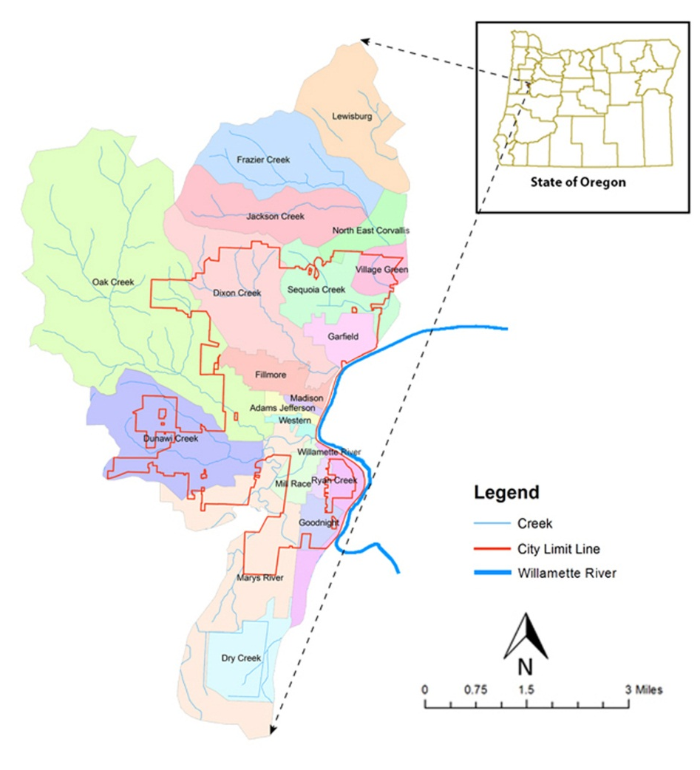
The City of Corvallis is in Benton County, Oregon. It is located near the middle of the Willamette Valley (City of Corvallis 2002). The City is within 90 minutes’ drive of the Portland Metropolitan area. The City’s population grew from 44,816 in 1990 to 54,953 in 2013. The City has a total area of 14.40 square miles, of which 0.17 square miles is water and 14.23 square miles is land (U.S. Census Bureau 2011). According to the National Land Cover database from the Pacific Northwest Ecosystem Research Consortium, the city had 54 land use and land cover categories in 2000 (see Table 2)
Figure 4. City of Corvallis, Oregon and Subwatersheds
The City is located in a drainage basin that intersects with the Willamette River Watershed (HUC 1709000306) and Marys River Watershed (HUC 1709000302) in central western Oregon, and encompasses twenty subwatersheds (see Figure. 4). Table 2 shows the land use and land cover in this stormwater basin. The Willamette River does not meet the water quality standard established by EPA’s Clean Water Act and the City developed the Total Maximum Daily Loads (TMDL) model for the Willamette Basin in 2006. According to the Willamette Basin TMDL model, it requires at least 20 years and $100 million to meet the water quality standard. The City’s waste water treatment plant discharges into the Willamette River and urban stormwater has negatively impacted the water quality in urban streams and the Willamette River (City of Corvallis 2007).
Table 2. Land Use and Land Cover within the Watershed of Corvallis in 2000

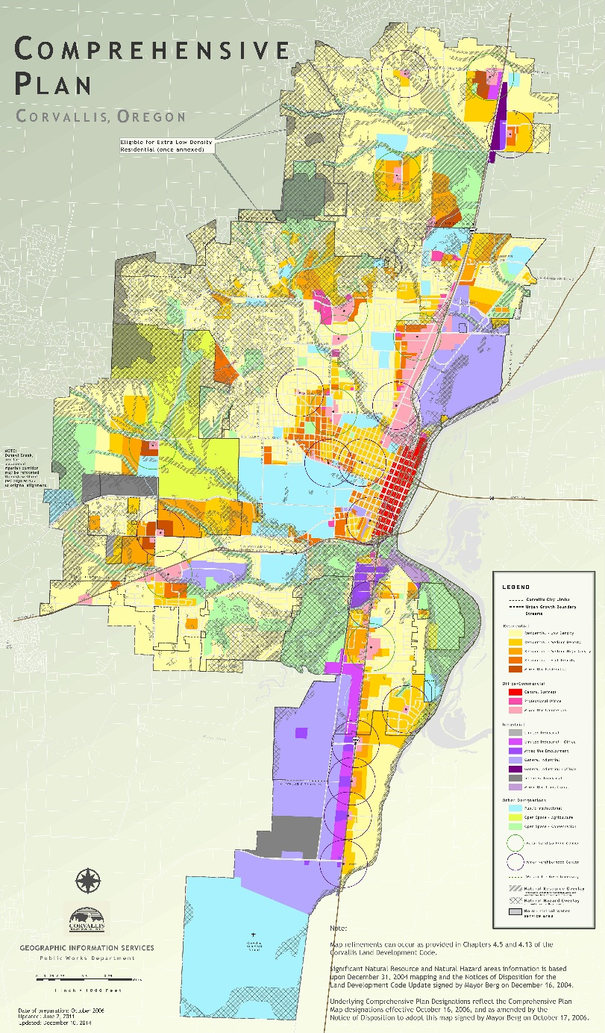
- Corvallis’ Urban Growth Management
Figure 5. Comprehensive Plan, Corvallis Oregon Source (City of Corvallis, updated December 2014)

The City implemented its first comprehensive plan in 1980. It was updated in 1990 and 1998 in the periodic reviews (City of Corvallis, 2006). The comprehensive plan currently used by the city was developed by the city’s planning division in 1998 and was acknowledged by Oregon Land Conservation and Development Commission on June 26, 2000. On December 31, 2006 it was officially approved and implemented by the City Council. The most recent update was in 2014 (see Figure 5).
The current Comprehensive Plan Statement is in conformance with Oregon Statewide Goals and Envisions in 2020, the city is going to be:
· A Compact City with Population Ranging from 57,500 to 63,500;
· The Economic, Cultural and Political Center of Benton County;
· An Environmental-friendly Community with Beautiful and Functional Natural Landscape;
· An Integrated City with Stable and Clean Economy;
· A Community Filled with Arts and Recreation;
· A Community in Support for its Kids and Families;
· A City Applying Local Standards to Assess its Development Progress in Area such as Life Quality, Housing Vitality and Environment Quality;
· A Community in Support of High Education Quality;
· A City Providing Comprehensive Services for Elderly People and Disabled People;
· A Regional Transportation Center Connecting Benton County, Linn County and Rail System;
· A City Involving its Citizens in Policy and Decision Making;
· Various Communities without prejudice and Discrimination (City of Corvallis 1998).
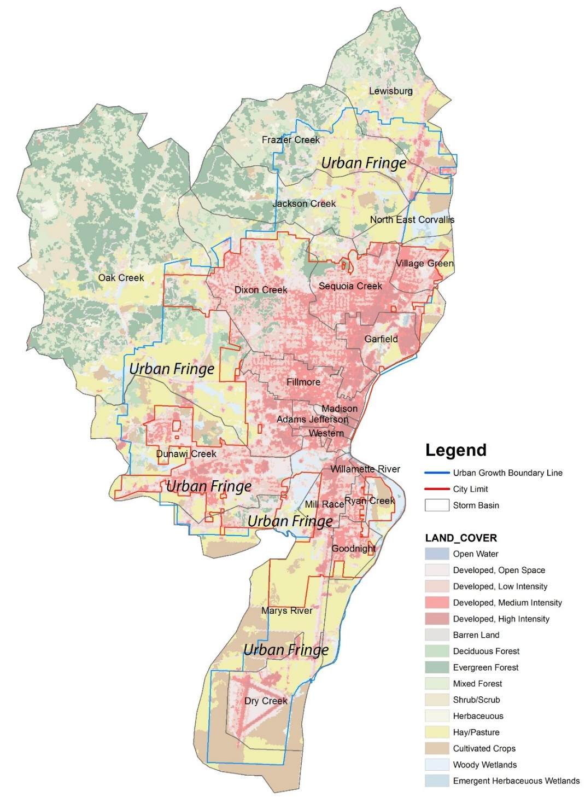
Figure 6. The City’s Urban Growth Boundary, City Limit, Watershed and Land Cover in 2000.
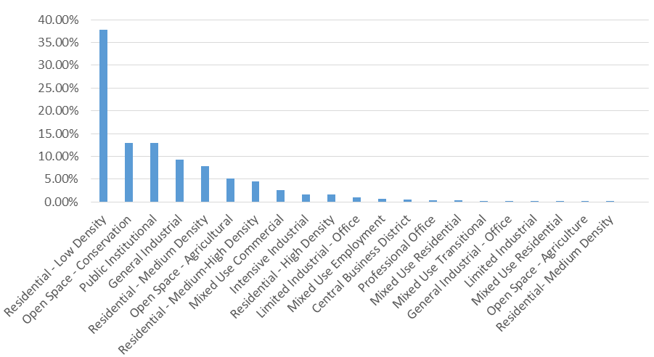
According to the City’s 2014 updated Comprehensive Plan, the current Corvallis city limit encompasses 14.4 square miles and the area circumscribed by the Urban Growth Boundary (UGB) is 28.1 square miles (see Figure 6). Therefore the area within the Urban Growth Boundary but outside the city limit, which is referred to as Urban Fringe, is nearly 14 square miles. In 2000, these areas were mainly covered with forest and pasture. According to the City of Corvallis’s Land Development Code, this Urban Fringe zone is going to be filled mostly with general industry, residential neighborhoods, public institutes and open space.
Figure 7. Proposed Land Use Percentage in Urban Fringe in 2020.
Figure 7 describes the proposed land use coverage percentage in 2020 within the Urban Growth Boundary based on the current comprehensive plan. More details of the land use changes from 2000 to 2020 are described in Chapter 5.

- Research Objectives
One of the original goals of urban growth management is to restrain urban sprawl and thereby preserve natural resources. Scholars have studied the performance of urban growth management in environment conservation (Frenkel, 2004; Nelson 1993; Gordon, et al, 2009; Cathcart, et al 2007; Robinson, et al 2005; Kline and Alig, 1999). Through the literature review, the author found that there is not yet anyone exploring this issue based on ecosystem service quantification, which could directly act as an indicator of the extent of environmental conservation under different planning scenarios (Heldak and Raszka 2012). Enacting a locally-appropriate urban growth management program requires a full understanding of different variables affecting urban growth and spatial distribution. The Comprehensive Plan and Urban Growth Boundary are commonly used to apply the urban growth management policy. However, in practice, planners used to make the comprehensive plan and delineate urban growth boundaries based on their hypothesis with scant supporting data and evidence. This lack of baseline data affects whether the Urban Growth Management program’s performance in restricting urbanization and conserving natural landscape can be quantified (Anderson 1999).
This research uses InVEST (Integrated Value of Ecosystem Service Tradeoffs) to quantify the ecosystem services under the City of Corvallis’s current comprehensive plan, and analyzes the results to show how the city’s planning policy performs in environmental conservation, especially in the Urban Fringe zone. The value of providing ecosystem services is not comprehensively captured by current commercial markets for land valuation (Costanza et al 1997). Some studies have found that neighborhoods surrounding the urban growth boundary are spreading partly due to the undervalued land market price. This research also puts forward a new land property value system for the City of Corvallis that combines its market prices and the anticipated monetary value in providing ecosystem services. The result could be used by the city to adjust the development fees for the urban fringe areas. The methodology used in this study could be utilized by Oregon Land Conservation and Development Commission (OLDC) to evaluate the performance of each cities’ Urban Growth Management strategies in environmental conservation.

3.1 Objective 1: Environmental Quality Quantification through Time and Space
The current Corvallis city limit encompasses 14.4 square miles and the area circumscribed by the urban growth boundary is 28.1 square miles (City of Corvallis, 2006). Therefore the area within the urban growth boundary (UGB) but outside the city limit, which is referred to as Urban Fringe, is nearly 14 square miles. According to the City of Corvallis’s Land Development Code, this Urban Fringe zone is going to be filled mostly with general industry, residential neighborhoods, public institutes and open space (see Figure 5). There are five Urban Fringe zones in the comprehensive plan: one on the north of the City, two on the west of the City and two on the south of the City (see Figure 5). During the process of urbanization, the ecosystem services provided by the Urban Fringe are likely to be compromised and possibly depleted in the coming decades. The first objective of this research is to model future urbanization’s impacts on ecological quality using indicators of nitrogen export, phosphorus export and carbon storage from the current situation and to the projected future. This research also quantifies the ecosystem service provision by the urbanization area (the area within the City Limit and the Urban Fringe Area) and the conservation area (the area outside the Urban Growth Boundary) based on the Comprehensive Plan. Comparisons of the ecological quality through time and the ecosystem services through space create the analytic metric by which to evaluate the performance of the City’s Urban Growth Management program in conserving natural resources.

  - Objective 2: Ecological Monetary Value Conversion and Its Relationship with Impervious Surface
According to the Corvallis 2000 Land Development Code, almost half of the Urban Fringe is planned as residential neighborhood (see Figure 7). The citizens’ preference of residential development land in the urban fringe area is partly due to the fact that the land price does not capture its value in providing ecosystem services and makes residences more affordable in the urban edge area rather than around the city’s center. The second objective of this study is to calculate the ecological monetary value based on the ecosystem service quantification results for each parcel modelled in InVEST and to analyze the relationship between impervious surfaces with the ecological monetary values at the subwatershed level.

  - Revised Comprehensive Plan Proposed for Future Urbanization and Conservation
As approaches for growth management, comprehensive plans and urban growth boundaries have been widely used in United States. The delineation of an appropriate urban growth boundary requires full understanding of different variables affecting urban growth and spatial distribution. However, in practice, planners typically draw the UGB limits based on their unsupported hypotheses with few supporting scientific data and evidence. Urban growth management’s performance in restricting urbanization and conserving natural landscape is thereby difficult to quantify (Anderson 1999). Too few models developed for comprehensive plan and urban growth boundary fully consider ecological factors. The third objective of this study is to explore how to develop a comprehensive plan in ArcGIS that accommodates the city’s development and theoretically preserves most ecological values in storm water purification and carbon sequestration for the city of Corvallis.
Table 3. Projected Land Use in 2020
According to the current Comprehensive Plan, the City needs 15 land use categories, and the urban growth boundary encompasses 25.17 square miles lands for urban development with the remainder of the land for conservation (see Table 3 - Open Space - Conservation). This research quantifies the ecological value for each one of the City’s parcels and proposes a revised comprehensive plan that conserves the most ecological value while still meeting the City’s land demands for urbanization.

Chapter 4

Research Methodology

The research methodology in this study could be briefly described as generating planning scenarios based on research objectives in ArcGIS 10.2.2, collecting secondary data and running InVEST 3.0 biophysical models with the land use and land cover data. Based on the ecosystem service quantification results generated from InVEST, the ecological monetary value could be estimated by the unit value in providing ecosystem service and the number of units.
(Costanza et al 1997)
More specifically, conceivable costs for stormwater purification and carbon storage are considered using data from relevant case studies in the literature, including direct costs and avoidance costs (Gómez-Baggethun and Barton 2013).

- Biophysical Models and Ecological-Economic Conversion Models
Ecosystems provide a flow of services that are significant to humans including the production of goods (e.g., food), life-support processes (e.g., water purification), and life-fulfilling conditions (e.g., beauty, recreation opportunities), and the conservation of options (e.g., genetic diversity for future use) (The Economics of Ecosystems and Biodiversity 2008). InVEST and ARIES are the most commonly used modeling tools in ecosystem services quantification. InVEST (Integrated Valuation of Ecosystem Services and Tradeoffs) consists of a set of models dependent on ArcGIS to quantify the ecosystem services under different planning scenarios (Mckenzie et al 2011). ARIES (Artificial Intelligence for Ecosystem Services), developed by the University of Vermont, quantifies ecosystem services in a way that “acknowledges dynamic complexity and its consequences” while keeping the model simple enough to be tractable (Villa et al 2014). InVEST is more suitable in a situation in which the undergoing ecological processes are well understood; and ARIES is more suitable in a situation of data inaccessibility (Vigerstol and Aukema, 2011). In this study, InVEST is applied to quantify ecosystem services of stormwater purification and carbon storage for the following two reasons. First, the required data to run InVEST for the City of Corvallis, Oregon are accessible through different sources (see Table 4). Second, InVEST was developed and calibrated by Stanford University using data collected from the Willamette Valley Watershed, within which Corvallis is located.
The specific models used in this study are the InVEST stormwater yield model, the InVEST purification model and the InVEST carbon storage model.

1.1 InVEST Water Yield Model
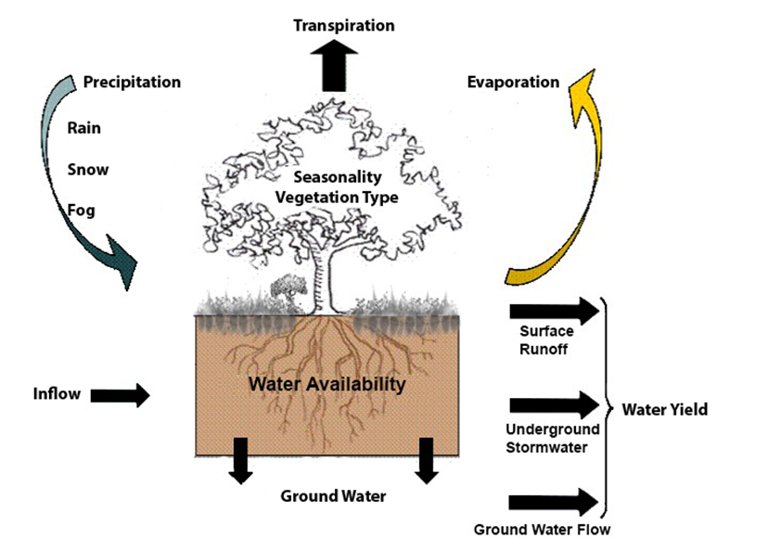
The InVEST water yield model calculates the amount of storm water yield contributed by various landscape surfaces. The storm water referred to in InVEST is the water generated on the ground during precipitation events that is neither evaporating nor transpiring including storm water flowing both on and under the surface (see Figure 8). The model runs on raster GIS and the grid size depends on the available data’s resolution. The first step in running the model is to distinguish the grid that actually generates runoff and the grid on which potential evapotranspiration is more than actual precipitation. Then the model determines the amount of storm water produced by each one of the grids that actually yields storm water. The last step is to accumulate the water yield result of each pixel into sub watershed levels and watershed levels (Mendoza et al 2011).
Figure 8. Water Yield in InVEST
The water yield model is based on Budyko Curve and the annual average precipitation, which is described as the following equation:
(Budyko Curve)
In the Budyko Curve, AET (x) is the annual actual evapotranspiration for grid cell x and P (x) is the annual precipitation on grid cell x. For the urban impervious surface, annual AET (x) is the same with evaporation and for the area covered by vegetation, actual evapotranspiration could be determined by a model put forward by Zhang in 2004:
=
PET (x) is the potential evapotranspiration which equals reference evapotranspiration of each grid cell (ET₀(x)) times a plant evapotranspiration factor (K_{c} (l_{x})). ET₀ (x) is determined by site climatic conditions based on the hypothesis that the field is fully covered by vegetation and there is enough available water in the soil. The equation is described as follows:
In the urban area, K_{c} (l_{x}) could be simply calculated according to a model proposed by Allen (Allen et al 1998):
where f is the percentage of impervious cover in the built environments. The natural soil properties are characterized byand calculated in the following way:
(Donohue et al 2012)
AWC (x) represents the amount of water in the soil that could be used by vegetation. Z is the empirical factor that reflects the local precipitation characteristics (Sharp et al 2014).

1.2 InVEST Nutrient Retention Model
The InVEST nutrient retention model also runs on raster GIS. It calculates the amount of nutrients trapped by the ground surface. The first step is to estimate average water yield produced by each pixel, which is the same process of running the InVEST water yield model. This process is automatically operated as the first step of InVEST nutrients retention model. The second step is to calculate the amount of nutrients that could be captured by each pixel and the amount of nutrients that are transported out of each pixel based on the concept of export factor proposed by Reckhow (1980). Export factor refers to nutrient flux developed from different ground surfaces. Because this factor is an average flux, the InVEST model applies a hydrology-sensitive coefficient number that takes into consideration the variance between the situation of the measured site and the situation on which the model is applied. The equation is described as following:
In this equation, ALV_{x} is the calibrated loading value on grid cell x. HSS_{x} is the hydrologic sensitivity score at grid cell x. pol_{x} is the pollutant loading coefficient based on land use and land cover at grid cell x. HSS_{x} could be estimated by the flowing equation:
In this equation, Ave (Rw) means the average of storm water flow coefficient of the watershed. R_{x} is the storm water flow coefficient on grid cell x, which could be estimated as:
R_{x} = log (SUM (Yu))
In this equation, SUM (Yu) is the accumulation of storm water of grids along the flowing route over grid cell x.
With the results of ALV_{X}, the amount of nutrients retained by grid cell x is calculated by:
In this equation, Ret_{x} is the amount of nutrients retained by grid cell x. E is the vegetation nutrients filtering value (removal efficient) of the pixel based on its land use and land cover type.
Based on results of nutrient retention at each grid, the amount of nutrition retained and exported by all grids along the route could be estimated since storm water eventually transports the nutrients to the stream. The model then calculates the cumulative loading contributed by each grid cell up to sub-watershed level.

1.3 InVEST Carbon Storage Model
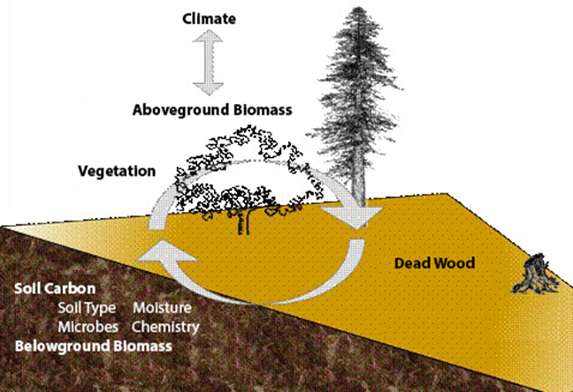
The InVEST Carbon Storage and Sequestration model quantifies the carbon storage in each category of landuse and land cover by aggregating the amount carbon captured in four carbon pools: above surface vegetation components, soil, under surface biomass and dead organic matter. The model is operating on raster GIS too, in which each pixel is representing a landuse unit in urban areas or a land cover unit in rural areas. The information of the amount of carbon stored by four carbon pools for each landuse and land cover category in Oregon can be found in the biophysical table attached with the model. Then the model quantifies the amount of carbon stored in different landscape categories such as wetlands, forests, and neighborhoods by accumulating the results for each pixel.
Figure 9. Carbon Cycle in InVEST

1.4 Monetization Model
Any discussion of sustainability barely attracts land owners’ awareness without converting the ecological values into economic values. In general, the value of ecosystem service could be estimated by the unit value in providing ecosystem service and the number of units:
(Costanza et al 1997)
In this research, the amount of ecosystem services in stormwater purification and carbon storage are modeled in InVEST biophysical models. The conceivable monetary value of ecosystem services in purifying stormwater and storing carbon are estimated by the following equations:
wp_value_{x} is the value of watershed x in providing ecosystem services of water purification. cost (p) is the amount of money in need to treat one kilogram of pollutant. retained_{x} is the amount of nutrition retained by watershed x. cs_value_{x} is the value of watershed x in providing ecosystem services of carbon storage. price (c) is the price of carbon per ton in carbon exchanged market. carbon_storage_{x} is the amount of carbon stored by watershed x. Previous studies reported that the average cost for the municipal stormwater treatment to remove one pound nitrogen and phosphorous are $8.255 and $55.225 respectively in 2007 (EPA 2007). The nitrogen and phosphorous retained by the ecosystem saves the City’s stormwater treatment operation cost in purifying urban runoff. The monetary value of a ton of carbon storage equals the social damage avoided by not releasing the carbon into the air (Stern 2007). Computation of the carbon’s social cost are controversial and complicated (Weitzman 2007 and Nordhaus 2007b). But Nordhaus (2007a) and Stern (2007) estimate the average value of carbon storage is $345 per ton.
- Data Collection
According to the modelling requirements of the InVEST water yield model, nutrition retention model and carbon storage and sequestration model, four categories of data are required to be collected and adjusted before running the model: climate data, geographic data, planning data and the biophysical attributes (see Table 4).
Climate data includes the city’s annual precipitation and annual reference evapotranspiration from NOAA Climate Prediction Center. Geographic data includes the area of the stormwater basin, the digital elevation model (DEM) from USGS National Elevation Dataset, and the original land cover data. Planning data from the City of Corvallis Planning Department includes the raster data of land use and land cover in 2000, the predicted land use and land cover in 2020, the data showing the location of impervious surface (building footprint, road & driveway, sidewalk & path and parking lot) and parcel data. Biophysical data from InVEST Basic Data Package includes the evapotranspiration coefficient, nitrogen and phosphorus loading coefficient, nitrogen and phosphorus filtering coefficient, the amount of carbon stored in aboveground biomass, the amount of carbon stored in belowground biomass, the amount of carbon stored in soil and the amount of carbon stored in the dead organic body for each land use and land cover category. The land use and land cover data for the condition in 2000 is generated by overlaying the year 2000 zoning data from the City’s planning department on the top of the 1990 land cover data provided by Pacific Northwest Ecosystem Research Consortium. The land use and land cover for the future condition is generated by overlaying the Comprehensive Plan with the 1990 original land cover data.
Table 4. Data Collection, Formatting and Manipulation
- Scenarios Design
Based on the City’s Comprehensive Plan, the entire stormwater basin is divided into three zones: the area within the City Limit; the area between the City Limit and the Urban Growth Boundary (Urban Fringe); and the area outside the Urban Growth Boundary (see Figure 4). This research quantifies these three zones’ ability to provide ecosystem services in stormwater purification and carbon storage in both the years of 2000 and 2020 under the City’s current planning policy. There are six results generated from the model showing how many nutrients in stormwater are retained and how much carbon is stored in these three areas in 2000 and 2020. The scenario of the year of 2000 is based on the land use and land cover data as the baseline. The scenario of the year of 2020 is projected results from the InVEST model based on the proposed future land use and land cover in the Comprehensive Plan. 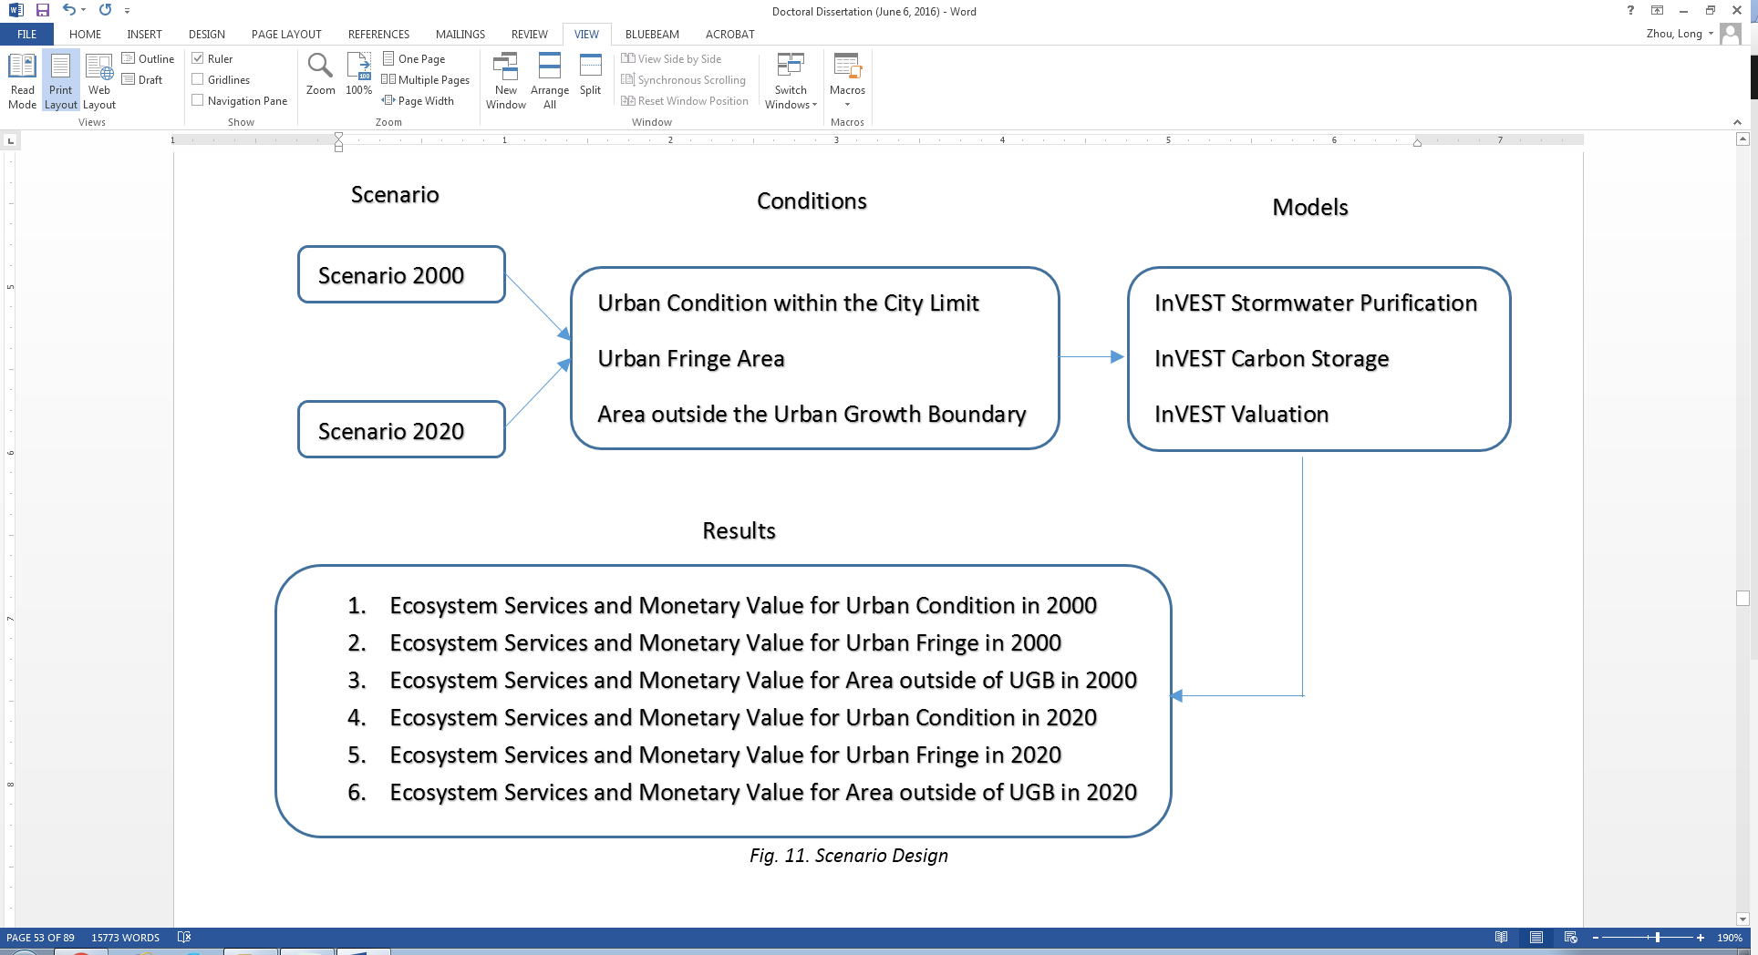
Figure 10. Research Flow Chart
Figure 10 shows the research processes. Result 1 and Result 4 are used to compare the city’s overall ability to provide urban ecosystem services respectively in 2000 and 2020. If Result 4 is bigger than Result 1, it indicates that Corvallis’s development under the urban growth management plan from 2000 to 2020 enables the city to provide more urban ecosystem services in stormwater purification and carbon storage in 2020. Otherwise, the current urban growth management policy needs to be revised and more urban green space is necessary in terms of providing more ecosystem services to the city. Besides, with the assistance of the city’s impervious surface data, Result 1 is used to explore the correlations between the ecological monetary value and the size of different impervious surfaces. Result 2 and Result 5 are used to calculate the ecosystem services of stormwater purification and carbon storage provided by the urban fringe area in 2000 and 2020. The results show how much ecosystem services would be depleted from 2000 to 2020 because of the city’s sprawl. Comparison of the ecosystem service depletion from 2000 to 2020 with the city’s historical periods indicate whether or not the current planning policy slows the ecosystem service loss trend. Result 3 and Result 6 quantify the ecosystem services provided by the area outside urban growth boundary but within the stormwater basin. An effective urban growth boundary conserves the land of high ecological values and directs urbanization into the land of low ecological value. Comparing Result 2 with Result 3, if the ecosystem service per unit (ESPU) of urban fringe area under the Comprehensive Plan is higher than the ESPU of the area outside urban growth boundary but within the stormwater basin, it indicates that the urban growth boundary encompasses the land that has high ecological values into the area to be developed in future. Therefore the urban growth boundary is not performing well in environmental conservation and a new one needs to be delineated.

Chapter 5
Results and Discussion

- Urbanization Impacts on Environment.

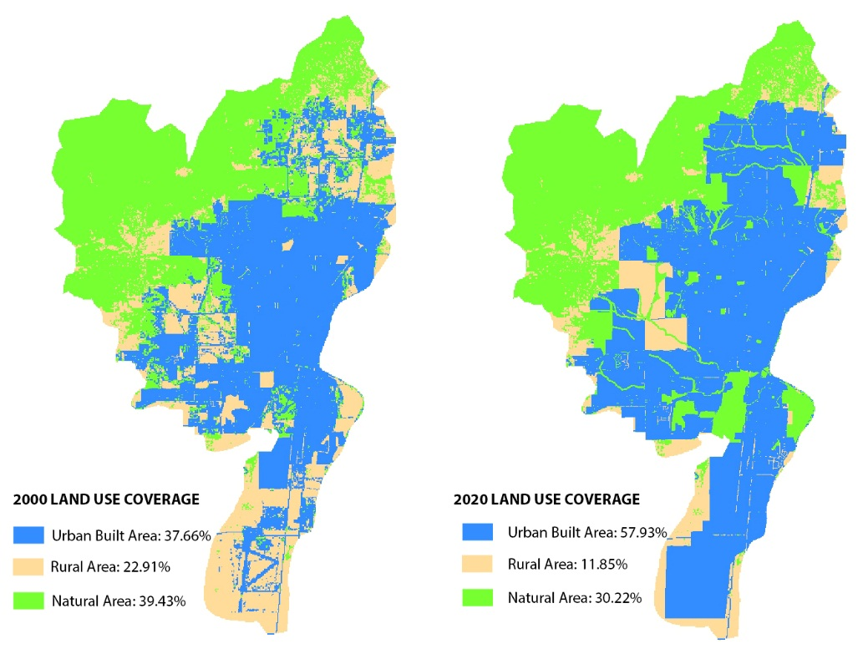
  - Land use and Land Cover Changes
Figure 11. Projected Land Use Changes
Figure 11 shows the land use coverage changes from 2000 to 2020. All the land use and land cover are reorganized and summarized into the categories of the urban built area, the rural area and the natural area. Based on the current Comprehensive Plan, the total built area coverage increases from 37.66% to 57.93%. The rural area drops from 22.91% to 11.85% and the natural area drops from 39.43% to 30.22%. The rural land is urbanized faster than the natural land due to its proximity to the city limit and compactness in the urban fringe areas.
Table 5 shows the land use and land cover change from 2000 to 2020 in detail. The total built area increases by nearly 60%, while the rural area and the natural area drop by 45% and 24% respectively in the period of 2000 to 2020. In the urban built area, the mix-used of residential and commercial area increases by nearly 300% followed by the high density residential area (Residential area > 16DU/AC) increasing by more than 200%. In the rural area the double cropping area and the bare/fallow decrease most over 90%. In the natural area, turfgrass and marsh decrease most by 73.73% and 58.37% respectively.
From the above analysis, it is apparent that during the urbanization process, rural area and natural area are converted into urban built area. Most of the urbanization from 2000 to 2020 are planned in the Urban Fringe. Table 6 shows the land use and land cover changes in Urban Fringe. In 2000, the urbanization’s coverage in Urban Fringe is 36.04%, which is lower than the average urbanization in the entire watershed. However, the urbanization in 2020 is predicted to be more than 76.88%, which is much higher than the predicted urbanization percentage across the entire watershed. Correspondingly, in 2020 the rural area’s coverage decreases from 38.64% to 12.11% and the natural area’s coverage decreases from 25.32% to 11.01%. In the new urban built area, the residential area accounts for 68.40%; the commercial area accounts for 23.81%; and the industrial area accounts for 18.75%.
Table 5. Projected Land Use and Land Cover Change
Table 6. Projected Land Use Change in Urban Fringe
  - Environmental Impacts
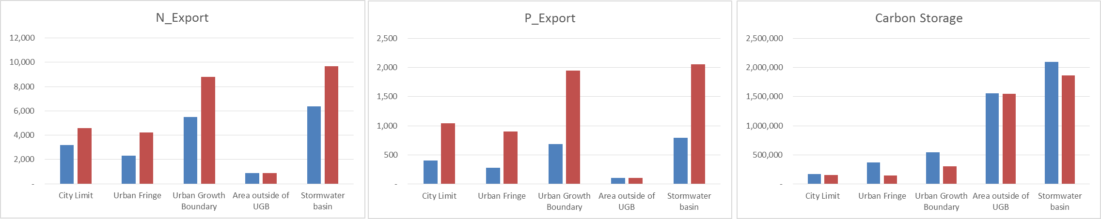
Table 7. Urbanization’s Impacts on Environment in 2000 and 2020

Note: N_Export: Nitrogen Export; P_Export: Phosphorus Export
City Limit Results are from Model Result 1 and 4; Urban Growth Boundary Results are from Model Result 2 and 5; Area Outside of UGB results are from Model Result 3 and 6.

Table 7 shows the urbanization’s environmental impacts in the InVEST model. From 2000 to 2020, the City exports 52.05% more nitrogen and 158.55% phosphorous in stormwater, and stores 11.33% less carbon. The area within the City Limits exports 43.54% more nitrogen, 156.53% more phosphorous and 8.82% less carbon. All of these indicators are less than the average difference across the entire stormwater basin, which implies that urbanization process within the city limit tends to be slower from 2000 to 2020. However, in the Urban Fringe, 83.23% more nitrogen and 221.36% more phosphorous are exported into stormwater, and 59.61% less carbon are stored in this area. All of these three indicators are much higher than the average difference across the entire watershed and implies that the urbanization in Urban Fringe has more impacts on the environmental quality from 2000 to 2020.
According to the current Comprehensive Plan, 8,768 acres land are under urbanization, due to which, the entire storm basin is projected to export 3,312kg more nitrogen and 1,260kg more phosphorous, and store 237,719Mg less carbon. On average, one acre more urbanization results in 0.38kg more nitrogen, 0.14kg more phosphorous in the urban runoff, and 27.11Mg less carbon stored in the watershed. In order to render those numbers more meaningful, this research models the City’s historical urbanization process and the corresponding environmental impacts (see Figure 12). The first parcel was built in 1853, and until 1998, there had been 14,885 parcels with the total area size of 9,229 acres. The map series divide the City’s growth history into 10 periods of 16 years each and quantifies the City’s impacts on stormwater quality and carbon storage from 1853 to 1988. Table 8 and Figure 13 describe urbanization’s impact on stormwater quality and carbon storage in each period.

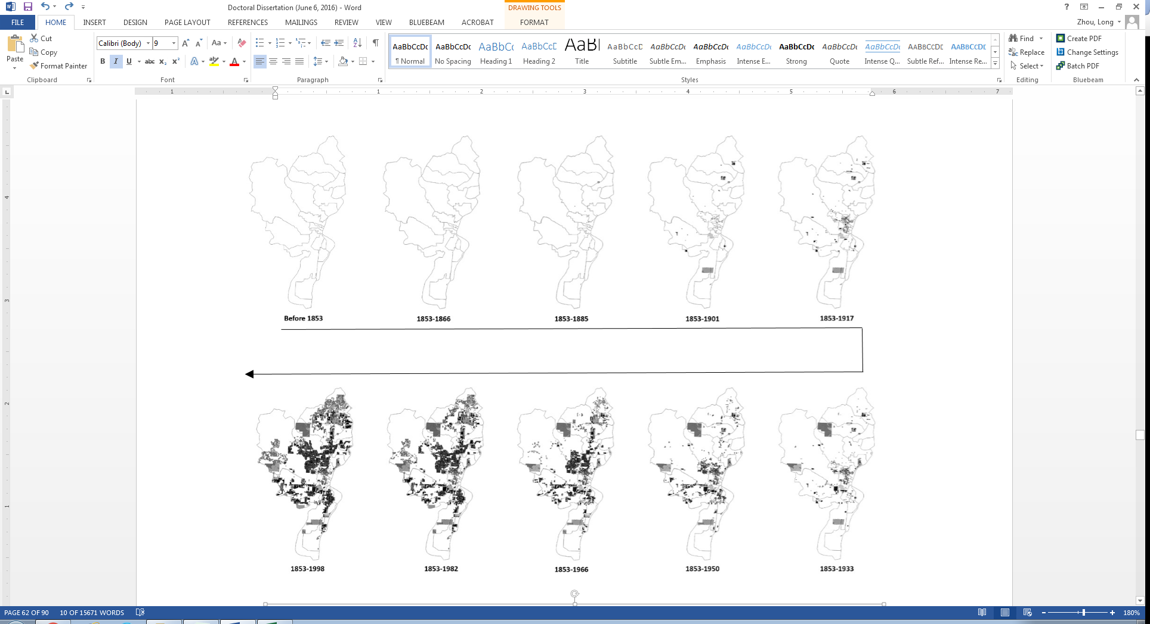
Figure 12. The City’s Urbanization History from 1853 to 1998
Table 8. Urbanization’s Impacts on Environment in the Historical Periods
Note: N_Export_Difference: Nitrogen Export Difference with the Previous Period; P_Export_Difference: Phosphorus Export Difference with the Previous Period; N_Export: Nitrogen Export; P_Export: Phosphorus Export.
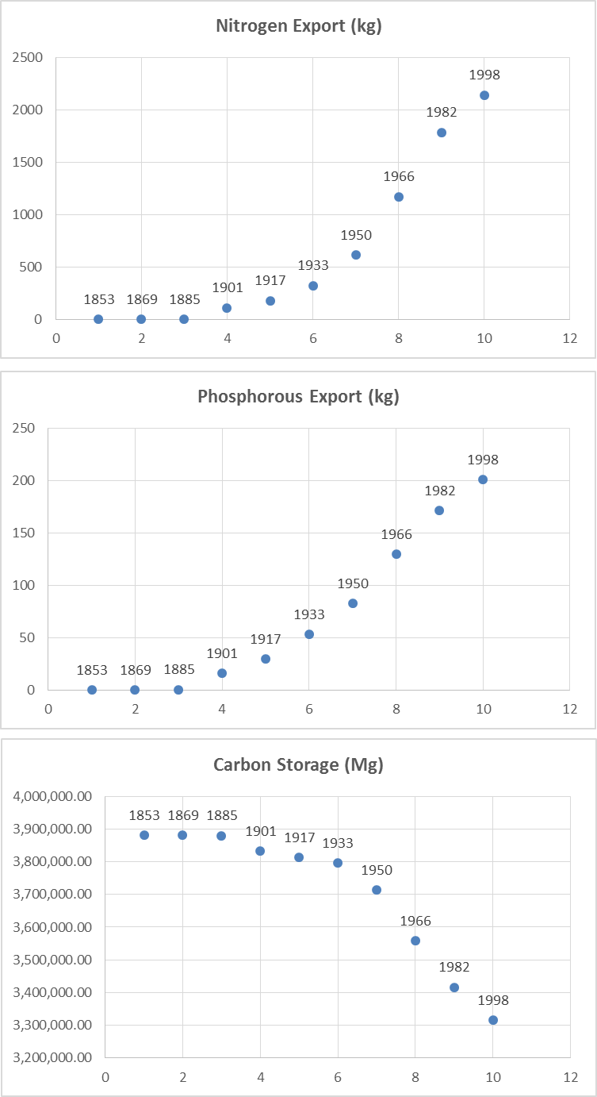
Figure 13. Urbanization Impacts Change through History
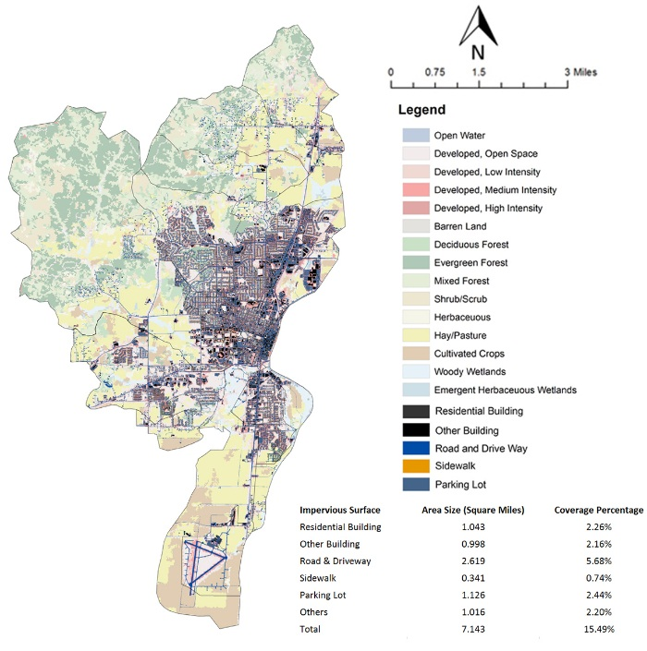
Comparing the results of the 2000-2020 period and the historical periods, it is apparent that the urbanization speed from 2000 to 2020 is faster than any previous historical period. Under the current urban growth management strategies, the carbon storage loss is 1.36 Mg/acre per year, which is lower than the historical mean and median. However, the nitrogen export and the phosphorous export rates are 0.019 kg/acre per year and 0.012kg/acre per year respectively, both of which are higher than the historical mean and median. Based on this point, it is indicated that the current urban growth management strategies are effective in conserving the watershed’s capacity in storing carbon, but it does not restrain the City’s trend in exporting more nitrogen and phosphorus through stormwater.
Figure 14. Land Use and Impervious Surface in 2013
By 2013, the impervious surface had covered 15% of the total watershed (see Figure 14). Table 9 quantifies the urbanization in each of the urban subwatersheds and the impacts on stormwater quality and carbon storage.
Table 9. Urbanization’s Impacts on Environment for Subwatersheds in 2013

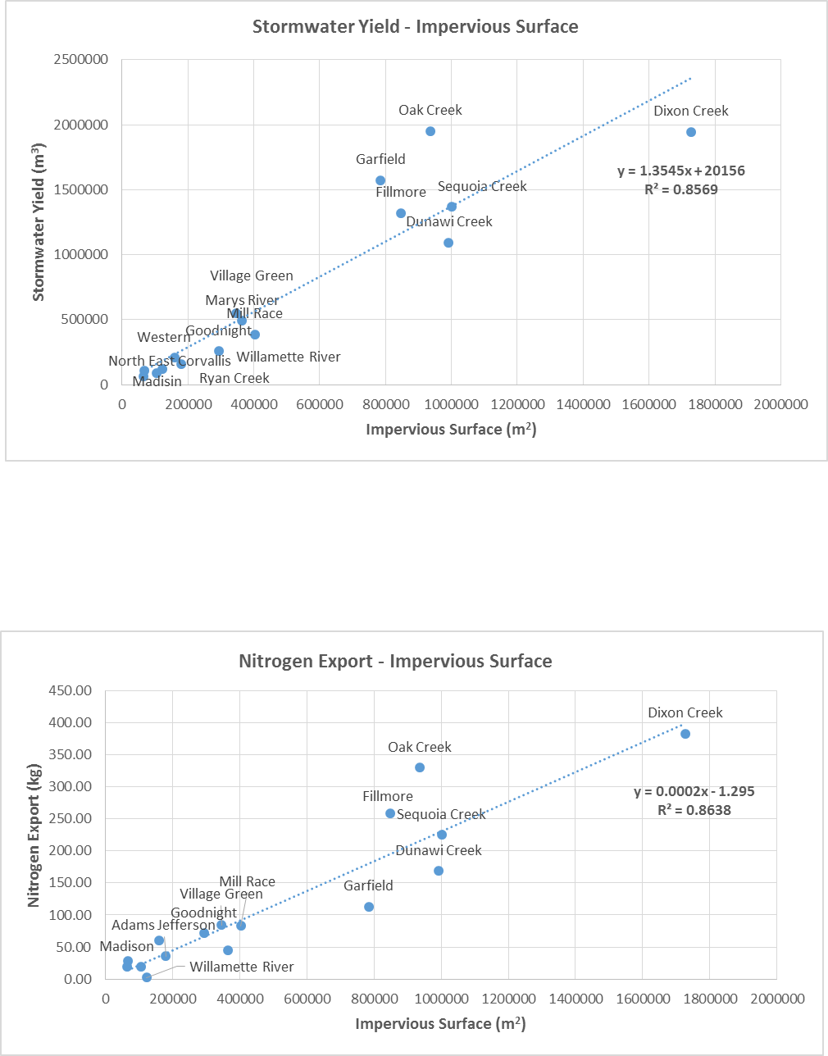
Continues on the next page

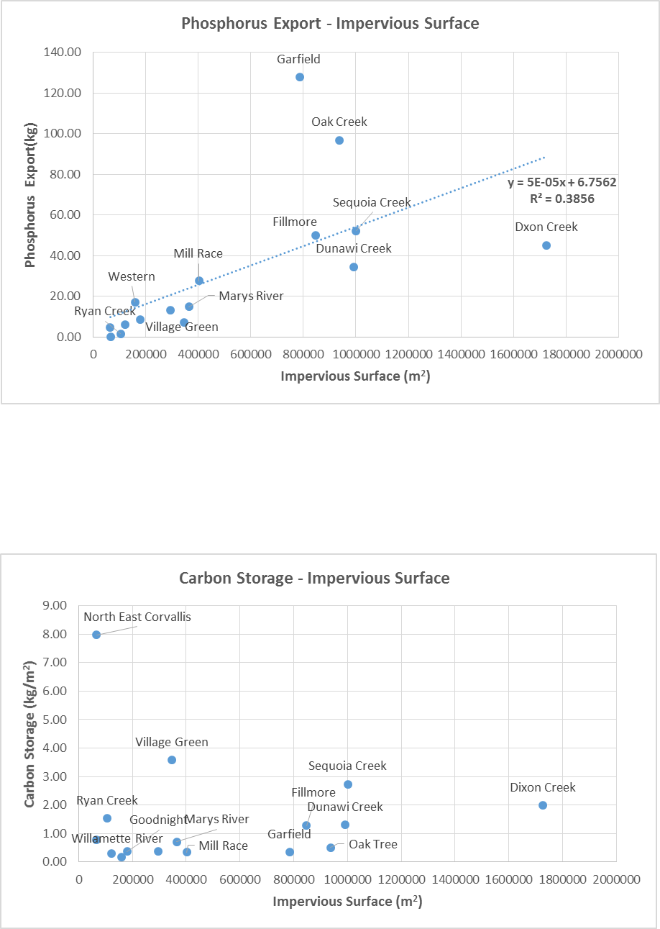
Figure 15. Relationship between Impervious Surface and Urbanization Impacts on Environment in 2013
Through statistical analysis, it is found that urban water yield and nitrogen export are strongly related to the extent of impervious surface. The phosphorus export is also related to impervious extent, but it is not as strong as urban water yield and nitrogen. There is no evident relationship existing between carbon storage and impervious surface (see Figure 15).

- Ecosystem Service Conservation and Values
2.1 Ecosystem Service Conservation
The ecosystem services provided by the different zones in the entire stormwater basin in purifying stormwater and storing carbon in 2000 are given in Table 10. According to the Land Conservation Act (LCA), a sustainable urban growth plan should conserve the land providing high ecosystem services and direct urban development onto the land that provides less ecosystem services. Therefore an efficient urban growth management strategy for environmental conservation should conserve the land providing high ecosystem services outside an urban growth boundary and delineate the land providing least ecosystem services within the urban fringe area for future urban development (ODLCD 2010).
Table 10. Ecosystem Service Provided by Different Zones in 2000
Note: N_Retention (Kg): Nitrogen Retention (Kg); P_Retention (Kg): Phosphorus Retention (Kg); N_R_Rate (g/m²): Nitrogen Retention Rate (g/m²); P_R_Rate (g/m²): Phosphorus Retention Rate (g/m²); C_R_Rate (kg/m²): Carbon Storage Rate (kg/m²).
The City’s current urban growth management divides into the zone within the City Limit, the Urban Fringe area between the City Limit and the UGB, and the zone outside of the UGB. The zone within the City Limit is where urbanization had been happening since 2000. The Urban Fringe is the zone projected to receive most of the urbanization from 2000 to 2020. The zone outside the UGB is where the current urban growth management policy attempts to conserve ecosystem services. After quantifying the ecosystem services provided by those three different zones, it is found that the zone outside the UGB has a greater efficacy in storing carbon than the Urban Fringe. However the Urban Fringe zone has a higher ecological value in purifying stormwater than the zone outside the UGB (see Table 10 and Figure 16 to 18). Based on this analysis, a conclusion is drawn that the current urban growth management strategy conserves the land of high ecological value in carbon storage, but does not protect the land of high ecological value for stormwater purification.
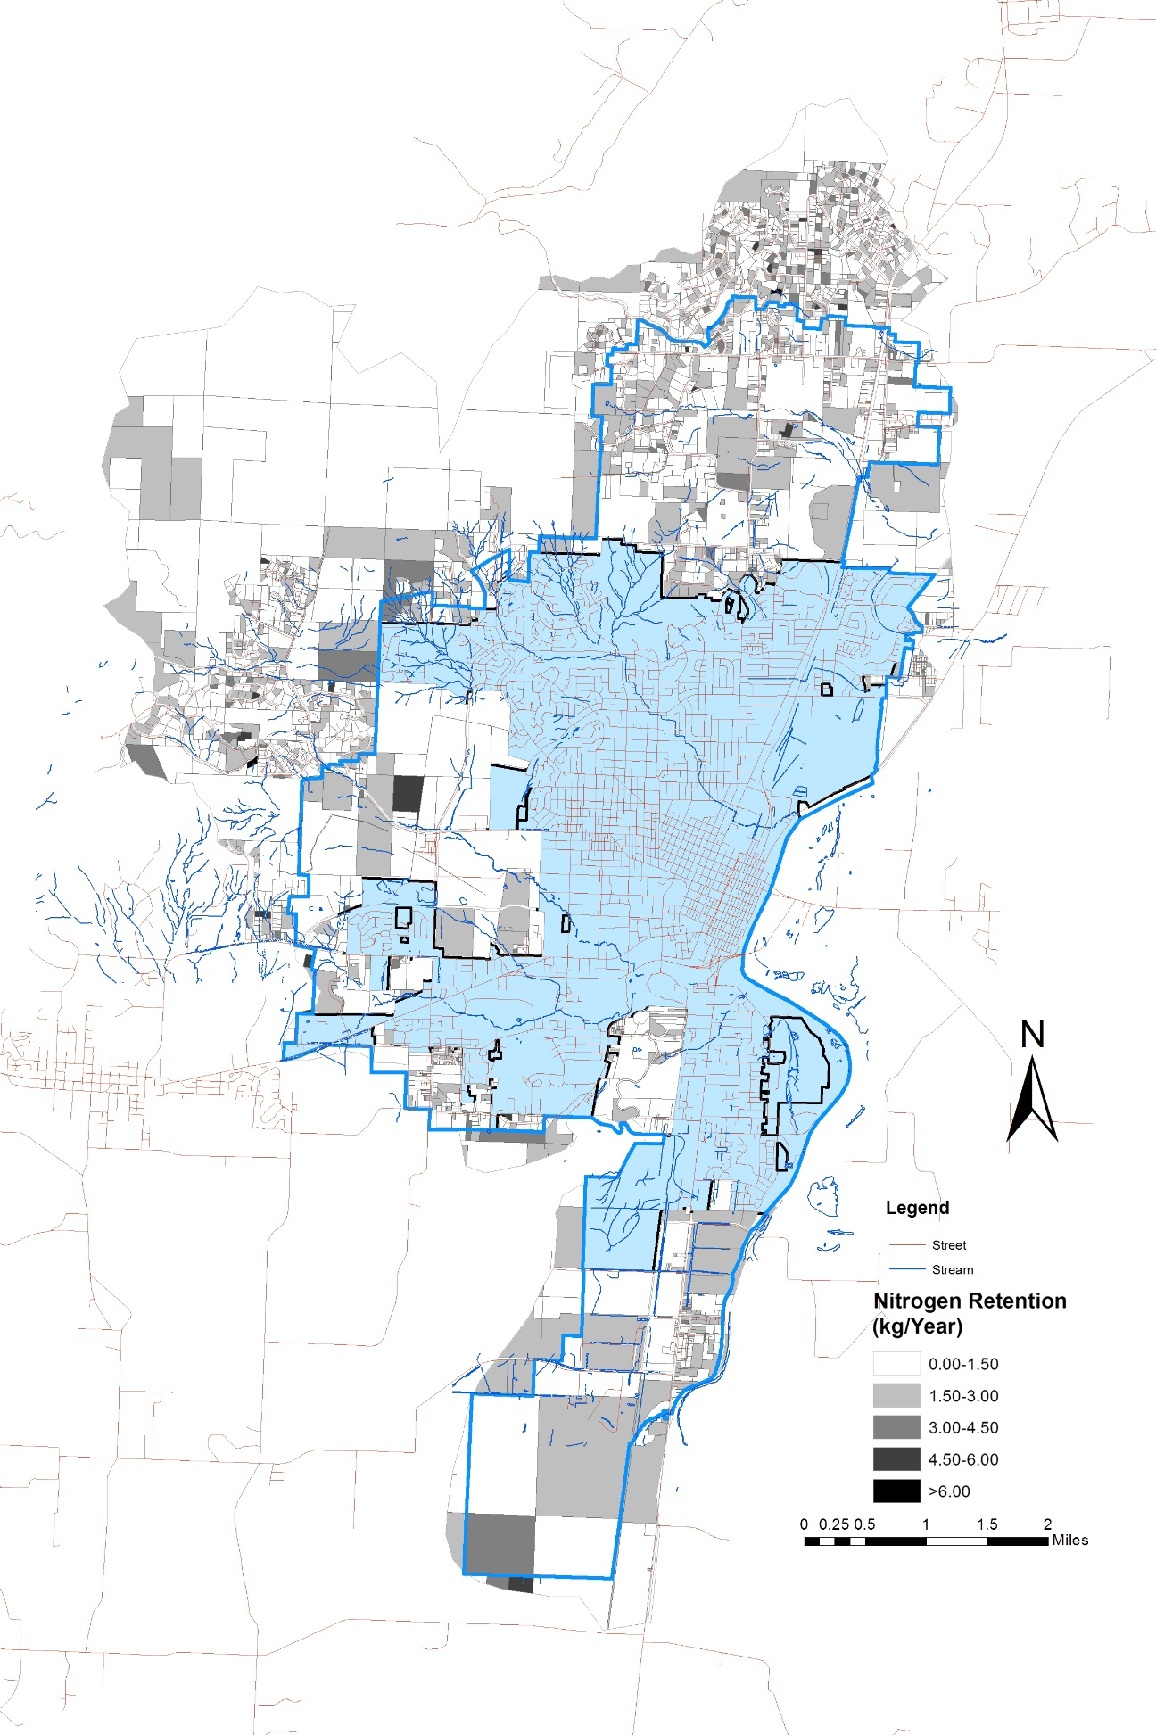
Figure 16. Nitrogen Retention on the Parcel Level

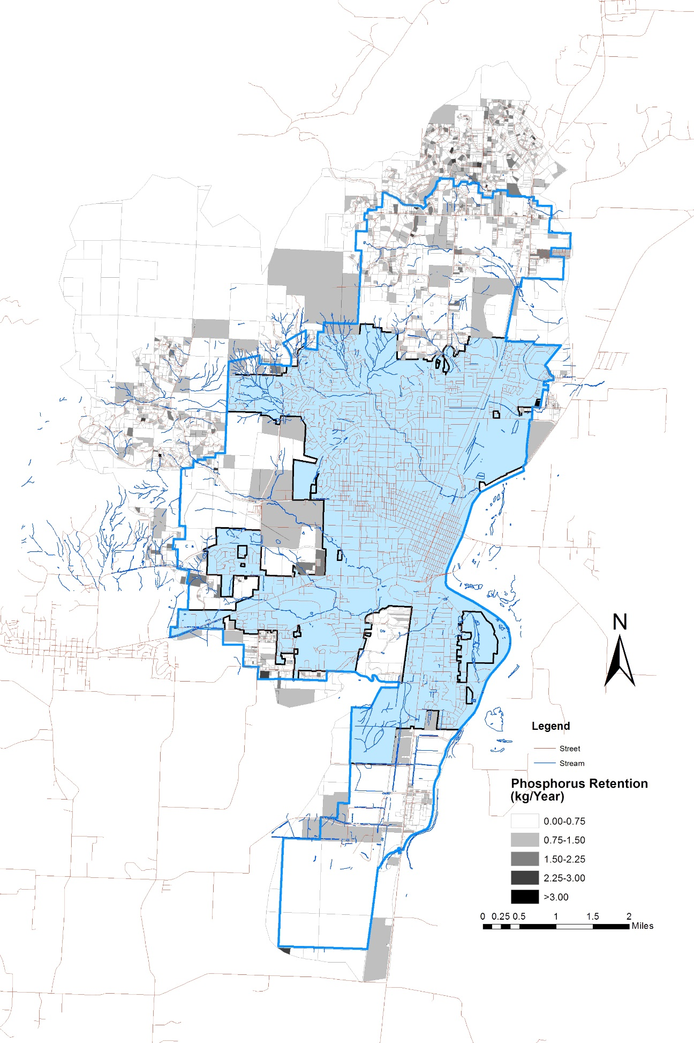
Figure 17. Phosphorus Retention on the Parcel Level

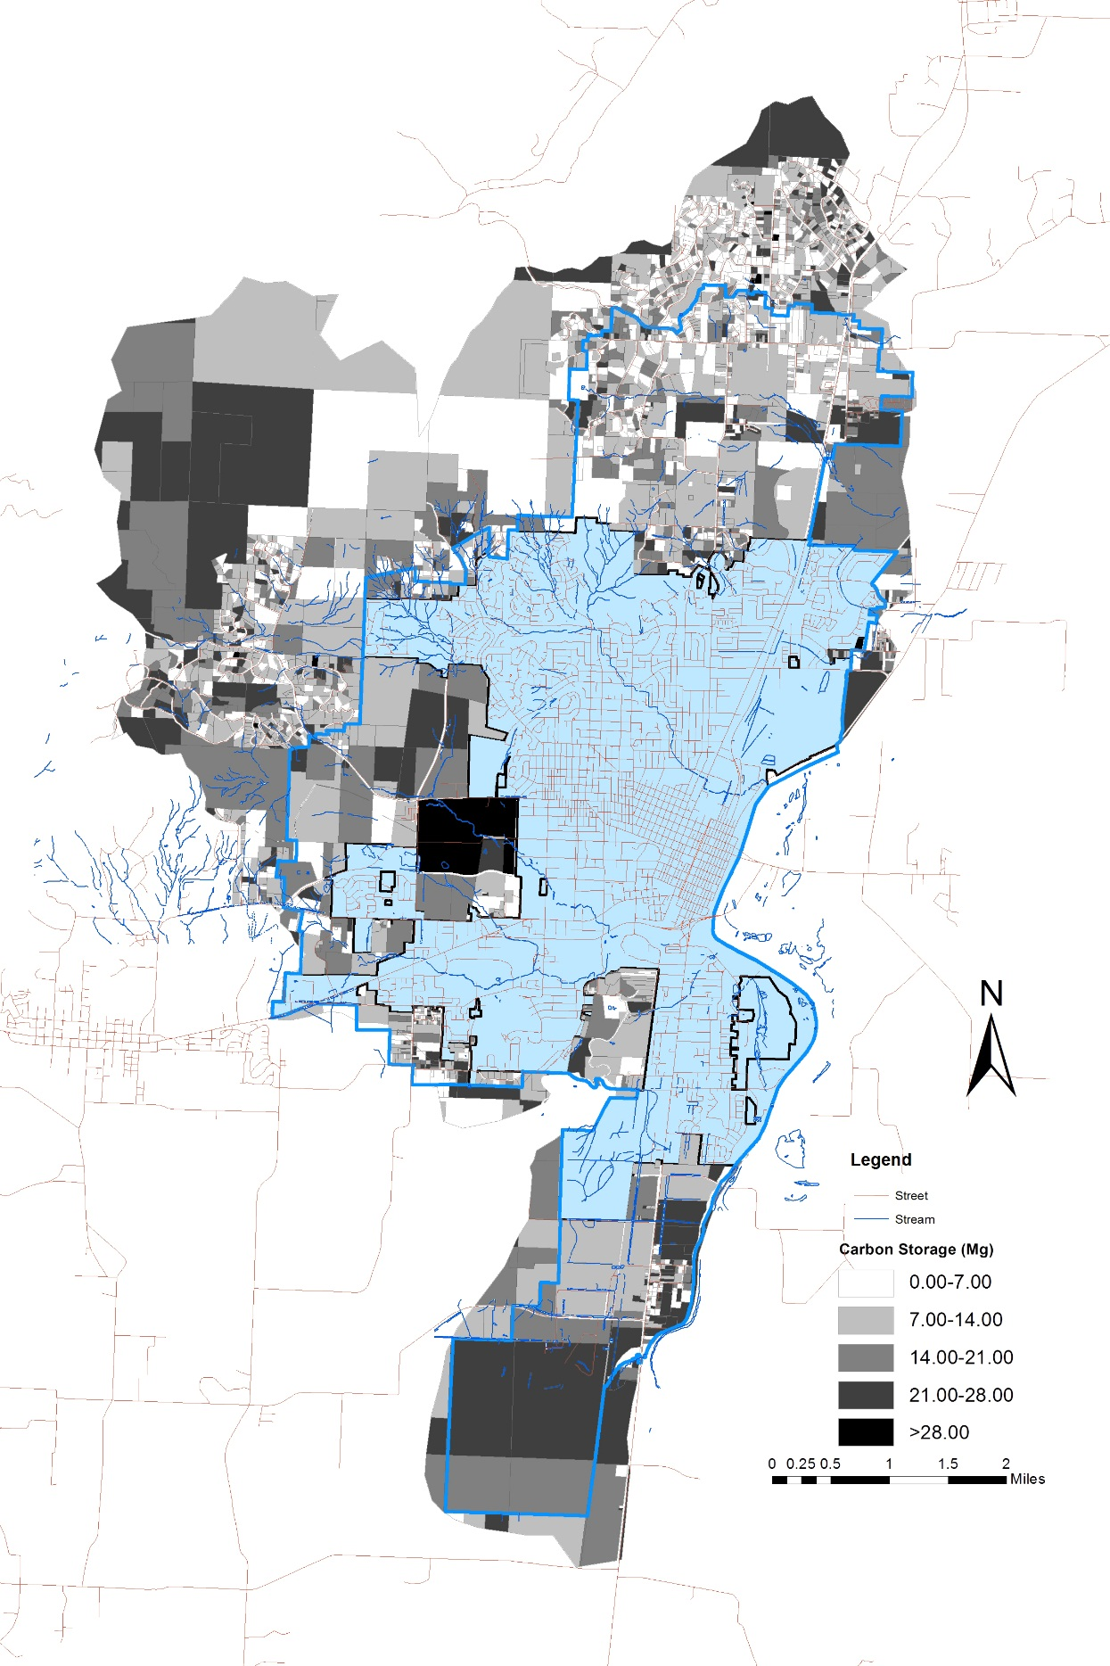
Figure 18. Carbon Storage on the Parcel Level
Table 11 shows the ecosystem services and efficiency provided by different zoning and land use in 2000. The Residential Area stores the most carbon and retains most nitrogen, and the Industrial Area retains the most phosphorous. The Agriculture-Open Area and the Residential Area have the most efficiency in storing carbon per unit. The Oregon State University campus and the Agriculture-Open Space are most efficient in retaining nitrogen. The Industrial Area is most efficient in filtering out phosphorous in stormwater.
Table 11. Ecosystem Service in Municipal Zoning Categories in 2000
Note: C_Storage (Mg): Carbon Storage (Mg); N_Retention (kg): Nitrogen Retention (kg); ); P_Retention (kg): Phosphorus Retention (kg); C_S_R (kg/m²): Carbon Storage Rate (kg/m²); N_R_R (g/m²): Nitrogen Retention Rate (g/m²); N_R_R (g/m²): Nitrogen Retention Rate (g/m²); P_R_R (g/m²): Phosphorus Retention Rate (g/m²).
The urban area sprawls from less than 40 million square meters to more than 70 million square meters. Table 12 describes the ecosystem services provided by different subwatersheds in stormwater purification (nitrogen filtration and phosphorous filtration) and storing carbon. Apparently the urban area may have more ability to store carbon in 2020. However, the urban ecosystem service in filtering nitrogen and phosphorous in 2020 is less than it in 2000, which indicates that stormwater quality is still an issue in 2020 under this comprehensive plan and more green infrastructure is needed in 2020 to purify urban stormwater.
Table 12. Ecosystem Service Provided by Different Areas in 2000 and 2020
Note: N_Filtration: Nitrogen Filtration; P_Filtration: Phosphorus Filtration; Carbon_S_R (Kg/m²): Carbon Storage Rate (Kg/m²).

  - Ecosystem Service Valuation
The most recent available parcel data is from the 2014 Tax Lot Dataset (City of Corvallis 2014). This research quantifies the ecosystem service for each parcel on the entire stormwater basin in 2014 and converts the ecological values in retaining nitrogen and phosphorous, and storing carbon into monetary value. Previous studies reported the average costs for the municipal stormwater treatment to remove one pound nitrogen and phosphorous at $8.255 and $55.225 respectively in 2007 (EPA 2007). Therefore, if the ecosystem retains one more pound of nitrogen and phosphorus, it creates $8.255 and $55.225 values respectively for the City. Although computing carbon storage monetary value is controversial and complex (Nordhaus 2007b), the range from $9.55 to $84.55 per metric ton of CO2 has been suggested by Nordhaus (2007a) and Stern (2007). Based on these data, all the City’s ecological values are converted to the monetary values in 2014 with a 3% annual discount rate.
Note: S_P_Value ($): Stormwater Purification Economic Value ($); E_Value ($): Ecological Economic Value ($); E_V ($/m²): Ecological Economic Value per Square Meter.

Table 13. Ecosystem Service Valuation for Each Subwatershed
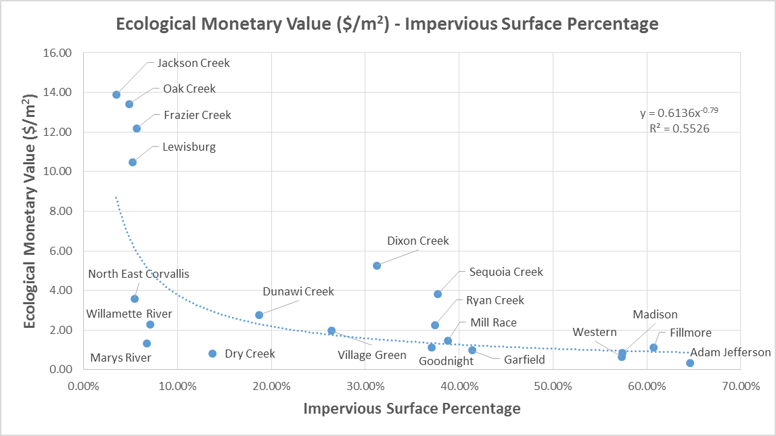
The entire stormwater basin’s monetary value of ecosystem service provision for the year of 2014 including nitrogen retention, phosphorus retention and carbon storage is $889,307,847. The ecological monetary value for each subwatersheds is listed in the Table 13. A strong power regression relationship at the subwatershed level is found between the total ecological monetary value per unit and the impervious surface percentage with correlation coefficient as 0.74 (see Figure 19), which indicates that the percentage of impervious surface could be used for ecological monetary values prediction.
Figure 19. Correlation between Impervious Surface Percentage and Ecological Monetary Value
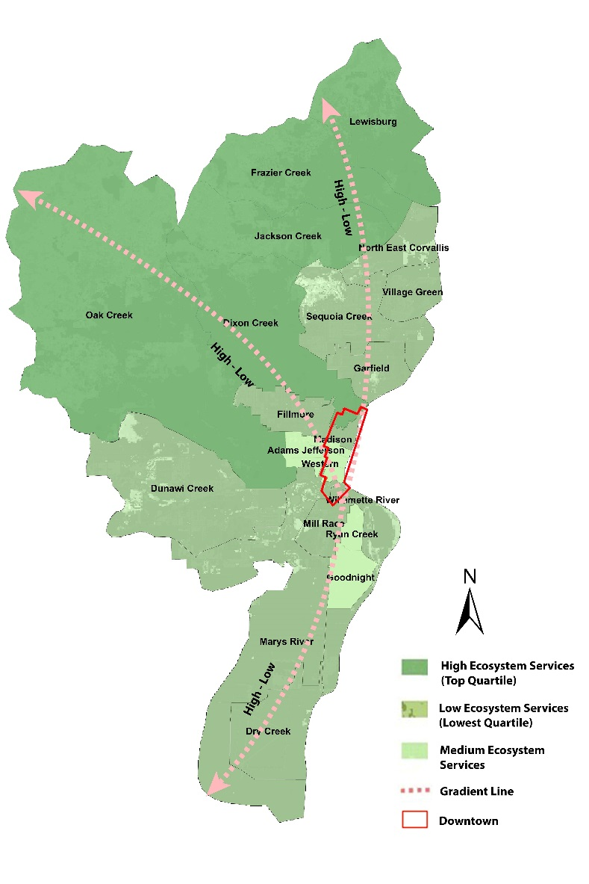
The five subwatersheds in the top quartile with highest ecological monetary value are Oak Creek, Jackson Creek, Frazier Creek, Lewisburg and Dixon Creek. They are all located on the undeveloped northwest edge of the watershed. The five subwatersheds in the lowest quartile with lowest ecological monetary value are Madison, Adams Jefferson, Western, Ryan Creek and Goodnight. All those subwatersheds with less ecological values are around the Downtown of the city (see Figure 20). Therefore there exists a gradient in providing ecosystem services from the city’s center to the undeveloped subwatersheds. In order to confirm this gradient in a quantitative way, spatial autocorrelation of the ecological monetary value was tested on both the subwatershed and parcel levels. The results are shown in next section.
Figure 20. Qualitative Explanation of Ecological Monetary Value Gradient on Subwatershed Level
Note: This map is made based on Table 13-Ecological Economic Value

  - Spatial Autocorrelation Analysis
This research, first of all, explores what unit of analysis should be applied in proposing a new Comprehensive Plan. The previous analysis of the ecological monetary value for each subwatershed has demonstrated that there exists a gradient in providing ecosystem services from the urbanized center to the watershed edges. The research quantified the ecological monetary value for each parcel and the Global Morans I test for the ecological monetary values are used on both subwatershed and parcel levels in ArcGIS 10.2. The results show that both of the z-scores are bigger than 1.96 which indicates that there exists spatial autocorrelation on both the subwatershed and parcel level. However the autocorrelation on the parcel level is much stronger than it is on the subwatershed level (see Figure 21). Therefore this research probes how to revise the comprehensive plan to conserve more ecological values using unit of analysis on the parcel level in next section.

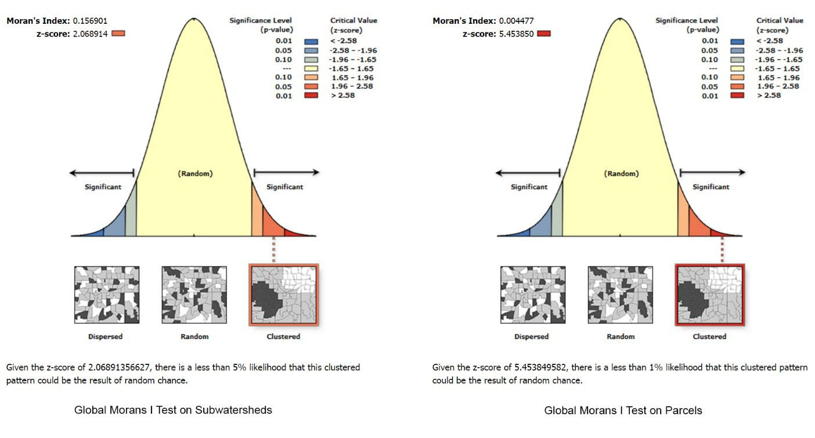
Figure 21. Global Morans I Test on Subwatershed and Parcels
- Comprehensive Plan Revision
3.1 New Conservation Area
To create a revised comprehensive plan that reflects ecosystem services values a parcel-level analysis was utilized as explained in Section 2.3. All the parcels are ranked from low to high based on their ecological monetary values, then the parcels’ size are kept aggregated starting from the first one with least ecological monetary values until the total size is bigger than 28 square miles, which is required in the City’s current Comprehensive Plan to meet the City’s land needs for future urbanization. The revised comprehensive map (see Figure 22) is generated by this principle, with green areas representing lands of higher ecological monetary values to be conserved and the red area representing lands of lower ecological monetary values for urbanization. Based on this conservation plan, the conservation area stores 1,847,725 ton carbon and retains 30,522 kg nitrogen and 4,533 kg phosphorus annually. The comparison of the proposed conservation plan with the City’s existing comprehensive plan is shown in the Table 14. The revised comprehensive retains 103% more nitrogen, 270% more phosphorus and stores 19% more carbon than the comprehensive plan made by the City (see Table 14).
Table 14. Comparison of the Conservation Areas in Providing Ecosystem Services

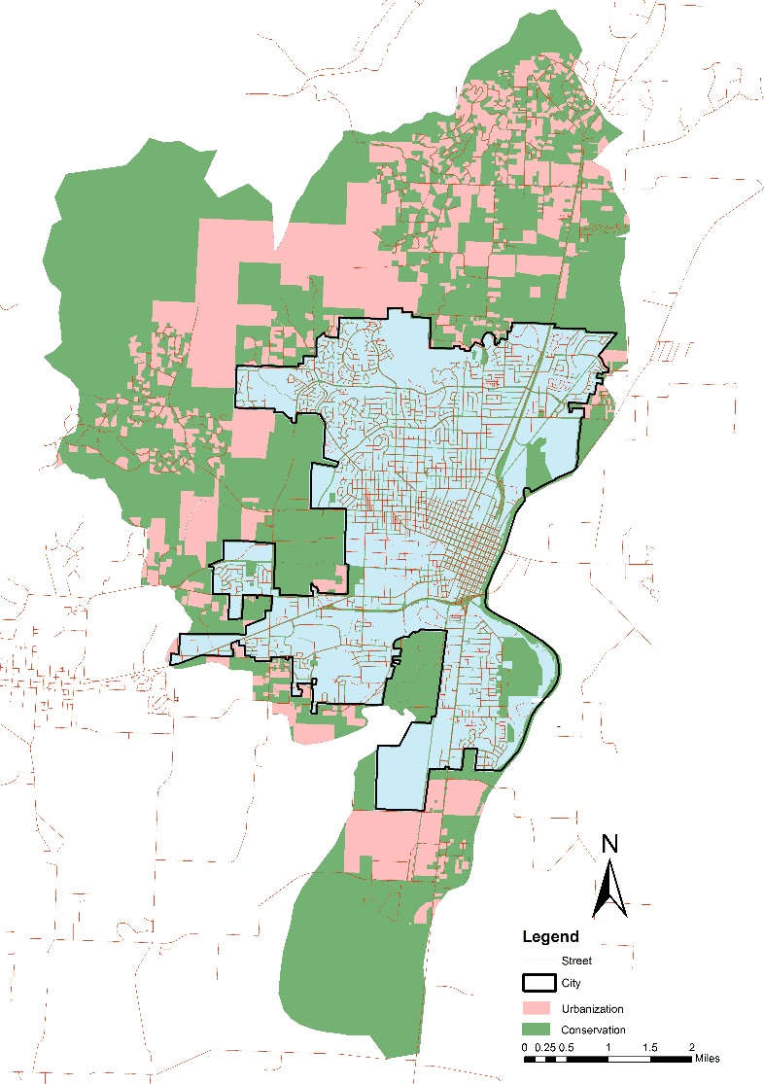
Figure 22. New Proposed Conservation Plan

3.2 Modified Comprehensive Plan
According to the Comprehensive Plan proposed by the City, the City needs 12.65 square miles land outside the current City Limit and eleven main land use categories to meet future urbanization demands (see Figure 23). I propose a revision to the comprehensive plan with the goal of accommodating these eleven land use categories and conserving most ecological values. It is assumed that there is no land use change within the City Limit. Outside the City Limit, the method to develop such a comprehensive plan is based on the principle that the land use category affecting ecological values most should be developed on the land of lowest ecological values, therefore the lands with most ecological values could be conserved from the City’s future sprawl.
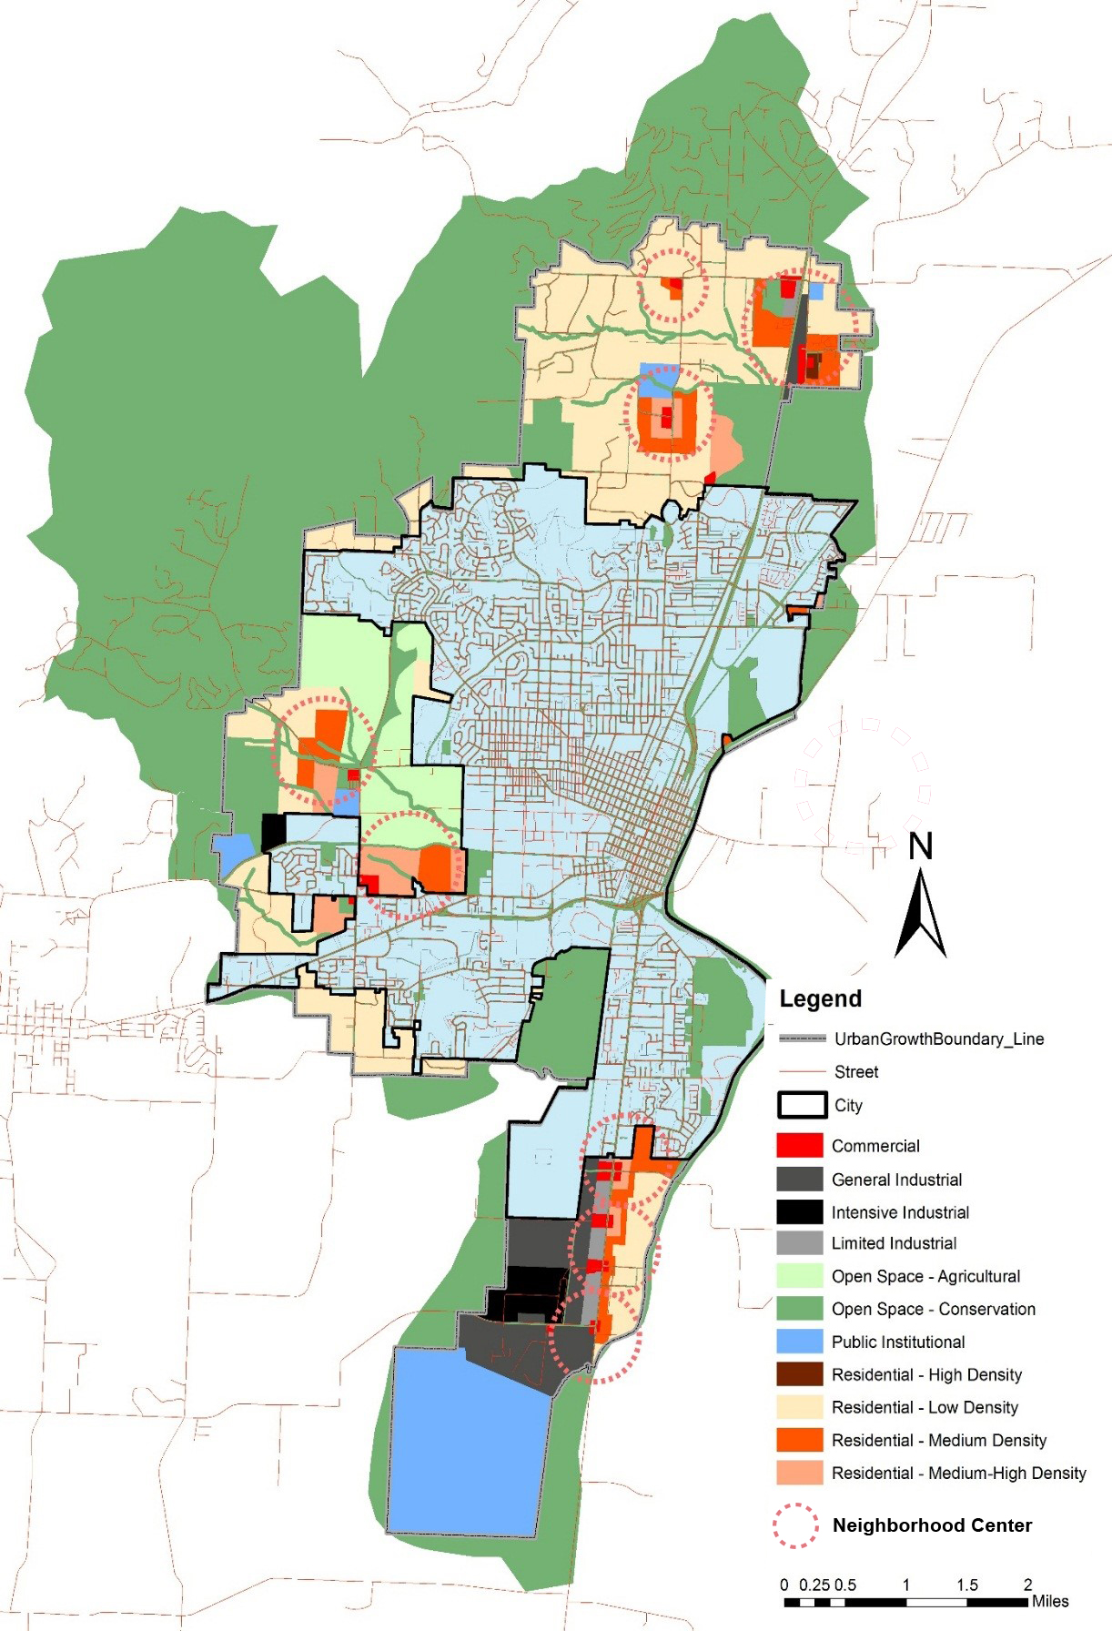
Figure 23. Current Comprehensive Plan (2014)
Table 15. Projected Future Land Use Size and Impervious Percentage
As analyzed in the previous section, there exists a negative power correlation between the percentage of impervious surface including building, roads and driveways, parking lots, and sidewalks and paths. Therefore the more impervious percentage of a land use, the more impacts it has on ecological quality and should be zoned for land uses with lower ecological value. It is assumed that the same land use category will have the same impervious percentage as it had in 2000. According to the comprehensive plan proposed by the City (see Figure 23), Table 15 summarizes the future land use categories, the projected size and the impervious percentage. All the parcels within the proposed urbanized area generated in the new conservation plan are ranked based on their ecological values from low to high (see Figure 24). Then the parcel size is kept aggregated from the first one until the total size is higher than the proposed land use size. For example, the City needs 438,296 square meters of land planned as commercial land use and the commercial area has the impervious surface percentage as high as 76.80%. So the first group of parcels with total size as 438,296 square meters in the low-high ecological value ranking list should be delineated as commercial land use. Following the same steps, all other eleven land uses for the future urbanization are delineated and the revised comprehensive plan is proposed (see Figure 25).
Figure 21. Currently-Used Comprehensive Plan
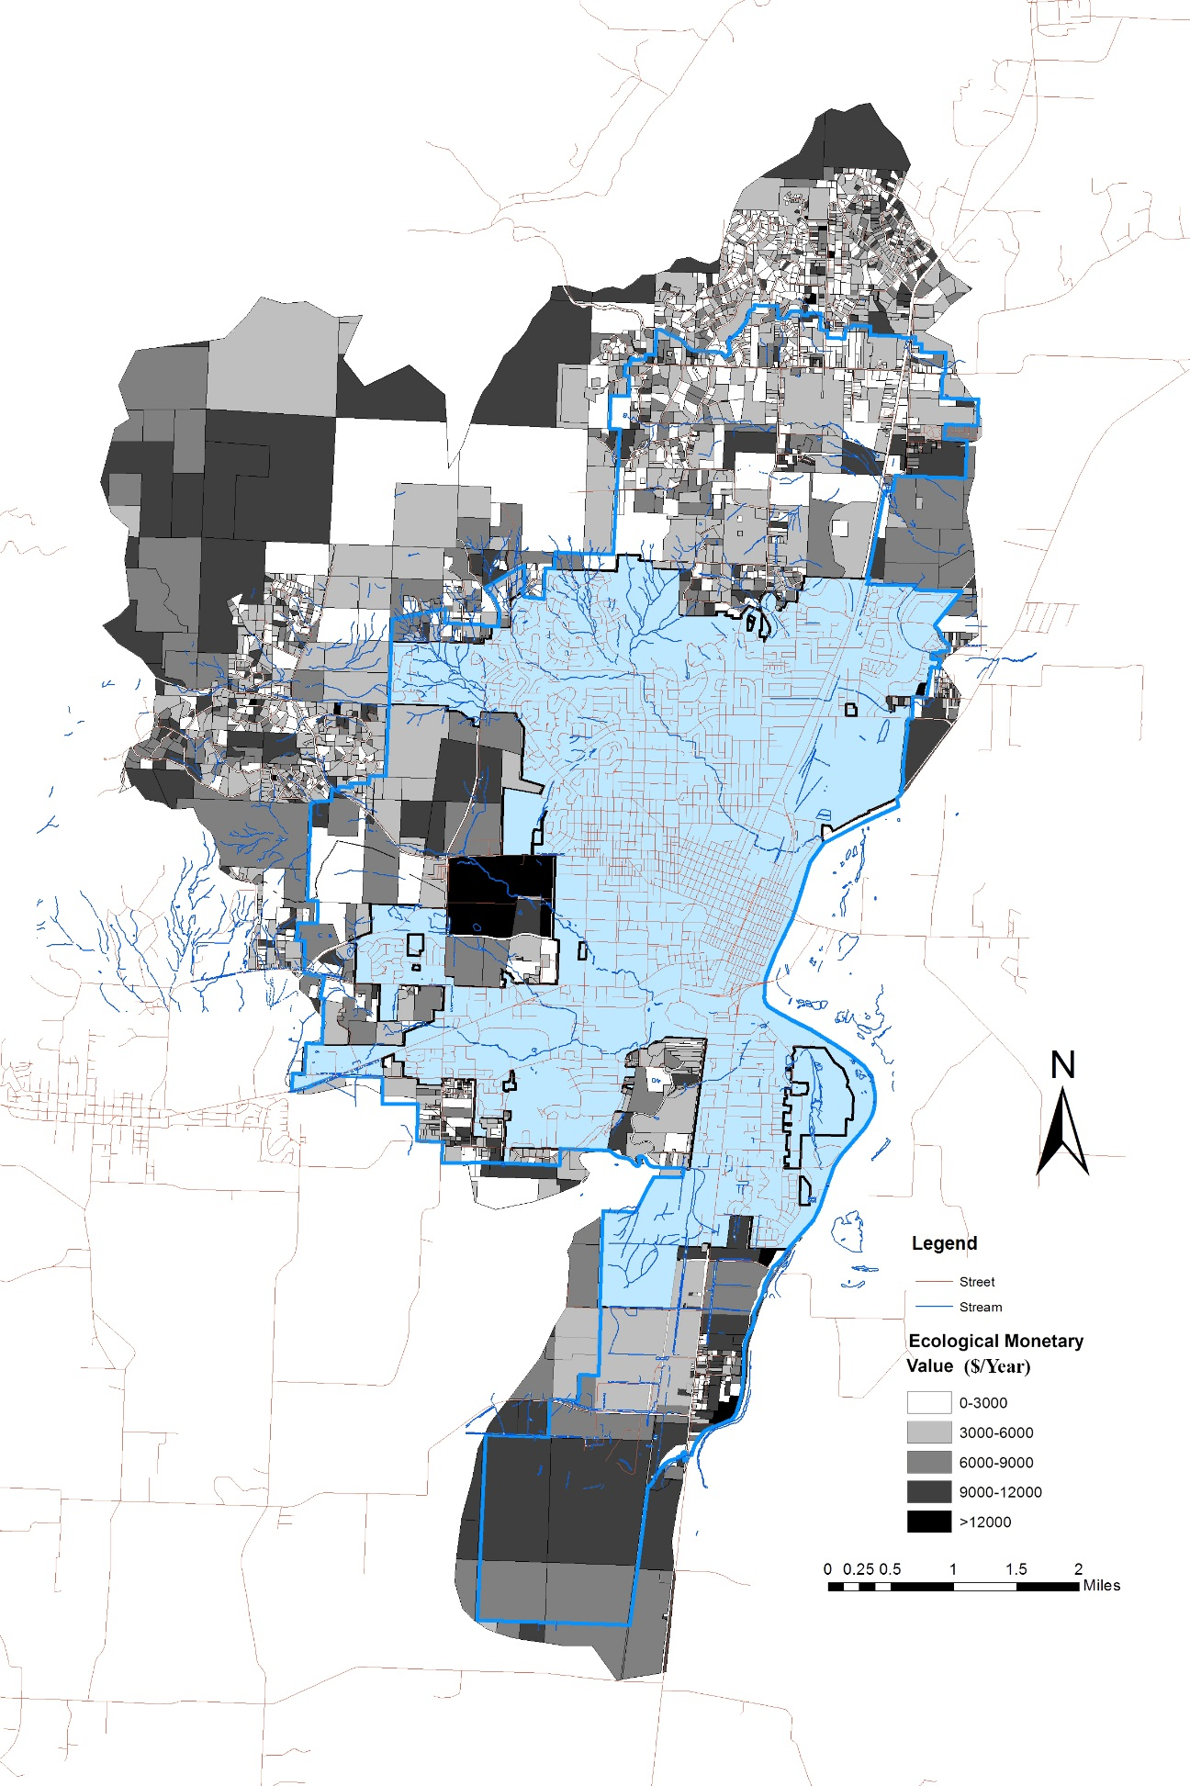
Figure 24. Ecological Value on the Parcel Level
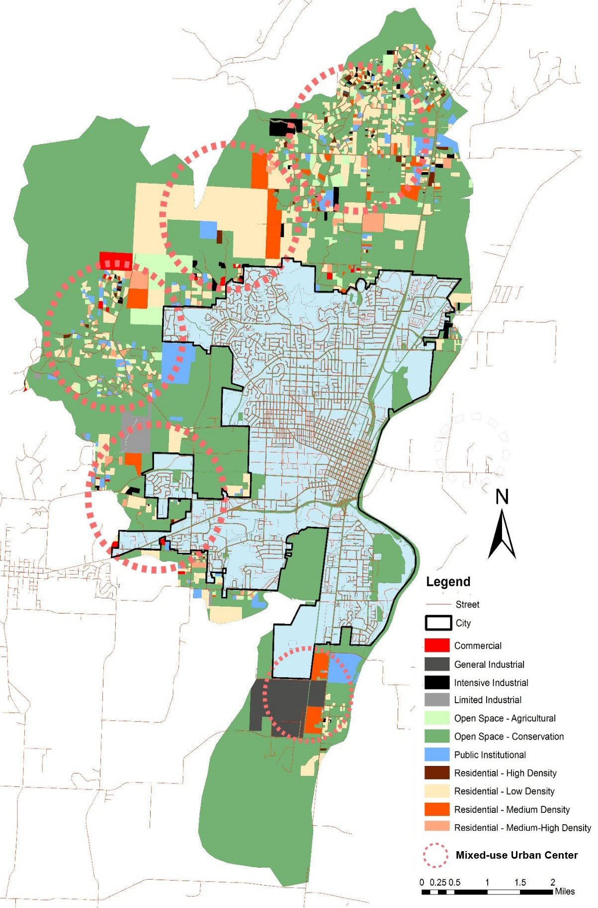
Figure 25. Revised Comprehensive Plan

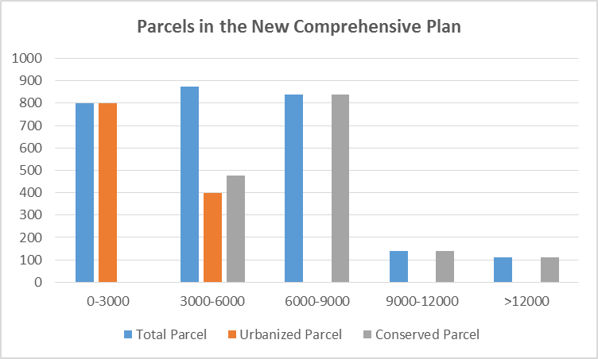
Compared with the City’s current Comprehensive Plan with several compact neighborhood centers in the Urban Fringes, the revised comprehensive plan proposes five mixed-use urban centers (see Figure 23 and Figure 25). Similar with the city’s current Comprehensive Plan, new industrial areas are mainly located on the south edge of the city limit. However, different residential types, commercial-use land and new public institutions are evenly distributed outside the city limit.
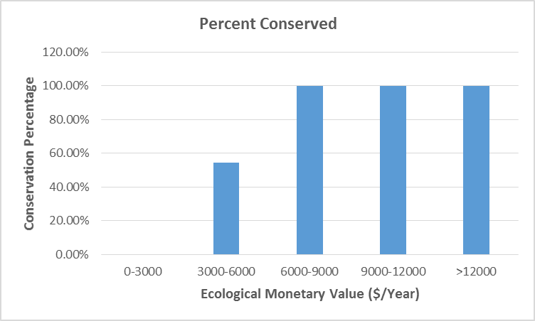
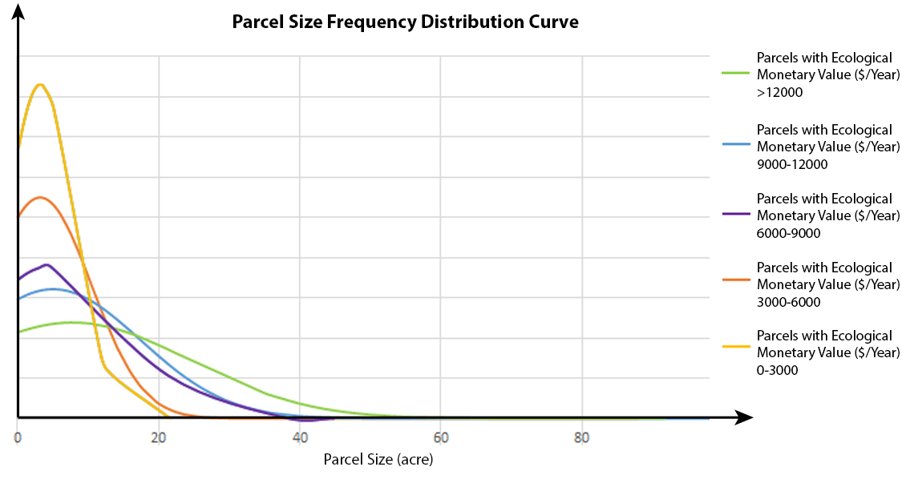
Table 16.Urbanized and Conserved Parcels in Revised Proposed Comprehensive Plan
In the new comprehensive pan, all the parcels that have the ecological monetary value higher than 6,000 $/Year and 54.51% of parcels that has the ecological monetary value ranging from 3,000 to 6,000 are conserved (see Table 16). Compared with the compact development proposed in the City’s current Comprehensive Plan, the new comprehensive plan with spreading mixed-use developments would cost more money in urban infrastructure construction (e.g. streets, drainage pipe, power line) (see Figure 23 and Figure 25). Therefore, the new proposed comprehensive plan, by no means, is the most practical development plan for the City’s future urbanization. However, as demonstrated by landscape ecologists, the natural lands setting among the spreading urbanization function as ecological stepping stones and corridors to strengthen local biodiversity (Dramstad et al 1996). The mixed-use urbanization spreading embedded in forests is favored by some landscape architects as well due to its less interruptions to the natural ecosystem and more recreational accessibility to people. For example, Mia Lehrer Associates responded to the lack of city action in Los Angeles in their City Tree-planting programs by intertwining forests and urbanization (Hough 2013). The forests provide more recreational opportunities to residents and alleviate some urbanization impacts, for example urban heat island effects (see Figure 26). It is necessary to comprehensively analyze the tradeoffs and to explore the feasibility in practice in future.

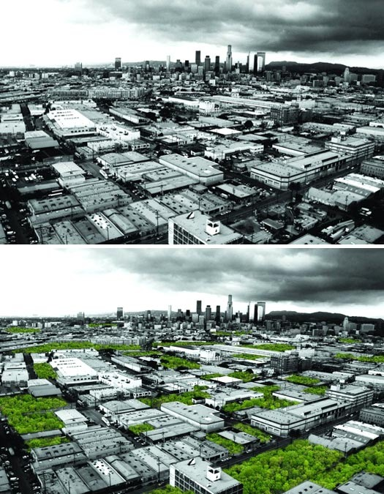
Figure 26. Urban Forest Los Angeles, before and after, a proposal by Mia Lehrer Associates. Source: Mark Hough, Champion Trees and Urban Forests. https://placesjournal.org/article/champion-trees-and-urban-forests/.

Chapter 6

Conclusion

Through land use and land cover change, urbanization has been posing threats to environmental quality at multiple scales. Urban growth management has been widely applied in managing urban growth and conserving natural resources. Enacting a locally appropriate urban growth management program requires a full understanding of different variables affecting urban growth and spatial distribution. However, in practice, planners used to make the comprehensive plan and delineate urban growth boundaries based on their hypothesis with scant supporting data and evidence.
As required by the State Land Conservation Act, the City of Corvallis implemented its first comprehensive plan in 1980 and it was updated in 1990, 1998, 2006 and 2014. Based on this Comprehensive Plan, the 14 square mile Urban Fringe zone is going to be filled with various industry, residential neighborhoods, and public institutions. This research models the urbanization impacts on environmental quality using indicators of nitrogen export, phosphorus export and carbon storage lost under the City’s current Comprehensive Plan. Comparing the results with the City’s development history from 1853 to 1998, we find that the current urban growth management strategy is effective in conserving the watershed’s capacity in storing carbon, but it does not restrain the city’s trend in increasingly exporting more nitrogen and phosphorus into urban runoff. We quantified the urbanization in each of the urban subwatersheds and the impacts on stormwater quality and carbon storage. Through statistical analysis, it is found that urban water yield and nitrogen export is strongly linearly-related with impervious surface size. The phosphorus export is also linear related with the impervious size, but it is not as strong as urban water yield and nitrogen export. There is no linear relationship existing between carbon storage and impervious surface size. This could be explained by the fact that most of the carbon in the urban watershed is stored in the soil and is less affected by the surface pavement.
Finally, this research quantifies the ecosystem services in purifying stormwater and storing carbon provided by each parcel within different zones (the area within the City Limit, Urban Fringe and the area outside the Urban Growth Boundary) under the City’s current Comprehensive Plan. Compared with ecosystem services provided by the different areas on the entire watershed, it is found that the current urban growth management strategy conserves the land of high ecological value in carbon storage, but does not protect the land of high ecological value in stormwater purification. Using ecological unit monetary value from previous studies and the ecosystem service quantification result generated from InVEST, we monetized ecological values in retaining nitrogen and phosphorous, and storing carbon, and find a strong negative power regression relationship between the ecological monetary value per unit and the impervious surface percentage on the subwatershed level with a correlation coefficient as high as 0.74. The methodology used in this process could be applied to evaluate the performance of other cities’ planning policy in preserving natural resources.
Based on the ecological monetary value for each parcel and demonstrated autocorrelation of the ecological monetary value on the parcel level, we propose a new conservation plan for the City. The new conservation plan directs future urbanization into the lands with least total ecological values and conserves the lands with most total ecological values. Finally this research proposes a new comprehensive plan retaining 103% more nitrogen, 270% more phosphorus and storing 19% more carbon than the city’s current Comprehensive Plan. The new proposed comprehensive plan argues for spreading mix-used development types, which results in more overall higher ecological values and recreational opportunities, but more urban infrastructure construction cost. How to balance the tradeoffs and apply it into practice calls for further research.

References
Allen, R. et al, 1998. Crop evapotranspiration. Guidelines for computing crop water requirements.” FAO Irrigation and Drainage Paper 56. Food and Agriculture Organization of the United Nations, Rome, Italy.
Brody. S, 1991. Review of Growth Management Strategies Used in Other States. Prepared for Oregon Department of Land Conservation and Development.
Bai, Yang, Hua Zheng, Zhiyun Ouyang, Changwei Zhuang, and Bo Jiang. 2013. "Modeling hydrological ecosystem services and tradeoffs: a case study in Baiyangdian watershed, China." Environmental Earth Sciences 70 (2):709-718. doi: 10.1007/s12665-012-2154-5.
Bengston, D. N., J. O. Fletcher, and K. C. Nelson. 2004. "Public policies for managing urban growth and protecting open space: policy instruments and lessons learned in the United States." Landscape and Urban Planning 69 (2-3):271-286. doi: 10.1016/j.landurbplan.2003.08.007.
Bratieres, K., T. D. Fletcher, A. Deletic, and Y. Zinger. 2008. "Nutrient and sediment removal by stormwater biofilters: A large-scale design optimisation study." Water Research 42 (14):3930-3940. doi: 10.1016/j.watres.2008.06.009.
Brilly, Mitja, Simon Rusian, and Andrej Vidmar. 2006. "Monitoring the impact of urbanisation on the Glinscica stream." Physics and Chemistry of the Earth 31 (17):1089-1096. doi: 10.1016/j.pce.2006.07.005.
Cathcart, James F., Jeffrey D. Kline, Matt Delaney, and Mark Tilton. 2007. "Carbon storage and Oregon's land-use planning program." Journal of Forestry 105 (4):167-172.
Cavan, G., S. Lindley, F. Jalayer, K. Yeshitela, S. Pauleit, F. Renner, S. Gill, P. Capuano, A. Nebebe, T. Woldegerima, D. Kibassa, and R. Shemdoe. 2014. "Urban morphological determinants of temperature regulating ecosystem services in two African cities." Ecological Indicators 42:43-57. doi: 10.1016/j.ecolind.2014.01.025.
Cavender-Bares, Jeannine, Patricia Balvanera, Elizabeth King, and Stephen Polasky. 2015. "Ecosystem service trade-offs across global contexts and scales." Ecology and Society 20 (1). doi: 10.5751/es-07137-200122.
Cho, Seong-Hoon, Neelam C. Poudyal, and Roland K. Roberts. 2008. "Spatial analysis of the amenity value of green open space." Ecological Economics 66 (2-3):403-416. doi: 10.1016/j.ecolecon.2007.10.012.
City of Corvallis, 1998. The Corvallis 2020 Vision Statement.
City of Corvallis, 2002. Stormwater Master Plan.
City of Corvallis, 2006. City of Corvallis Land Development Code.
City of Corvallis. 2007. "NPDES Phase II Storm Water Management Program Plan." Accessed October 15, 2015, http://www.corvallisoregon.gov/modules/showdocument.aspx?documentid=4427.
City of Corvallis. 2014. "GIS Data Download." Accessed September 6, 2014, http://www.corvallisoregon.gov/index.aspx?page=163.
Conte, Marc, Erik Nelson, Karen Carney, Cinzia Fissore, Nasser Olwero, Andrew J. Plantinga, Bill Stanley, and Taylor Ricketts. 2011. "Terrestrial carbon sequestration and storage." In Natural Capital: Theory & Practice of Mapping Ecosystem Services, edited by P. Kareiva, H. Tallis, T. H. Ricketts, G. C. Daily and S. Polasky, 111-128. Oxford Univ Press, 198 Madison Avenue, New York, Ny 10016 USA.
Costanza, R., R. d'Arge, R. de Groot, S. Farber, M. Grasso, B. Hannon, K. Limburg, S. Naeem, R. V. O'Neill, J. Paruelo, R. G. Raskin, P. Sutton, and M. van den Belt. 1998. "The value of the world's ecosystem services and natural capital (Reprinted from Nature, vol 387, pg 253, 1997)." Ecological Economics 25 (1):3-15. doi: 10.1016/s0921-8009(98)00020-2.
Dawkins, C. J., and A. C. Nelson. 2002. "Urban containment policies and housing prices: an international comparison with implications for future research." Land Use Policy 19 (1):1-12. doi: 10.1016/s0264-8377(01)00038-2.
Dempsey, Judith A., and Andrew J. Plantinga. 2013. "How well do urban growth boundaries contain development? Results for Oregon using a difference-in-difference estimator." Regional Science and Urban Economics 43 (6):996-1007. doi: 10.1016/j.regsciurbeco.2013.10.002.
Derkzen, M. L., A. J. A. van Teeffelen, and P. H. Verburg. 2015. "REVIEW quantifying urban ecosystem services based on high-resolution data of urban green space: an assessment for Rotterdam, the Netherlands." Journal of Applied Ecology 52 (4):1020-1032. doi: 10.1111/1365-2664.12469.
Donohue, Randall J., Michael L. Roderick, and Tim R. McVicar. 2012. "Roots, storms and soil pores: Incorporating key ecohydrological processes into Budyko's hydrological model." Journal of Hydrology 436:35-50. doi: 10.1016/j.jhydrol.2012.02.033.
Dramstad, Wenche E., James D. Olson and Richard T. T. Forman. 1996. Landscape Ecology Principles in Landscape Architecture and Land-Use Planning. Island Press, Washingto D. C., 1996.
Edmondson, Jill L., Zoe G. Davies, Nicola McHugh, Kevin J. Gaston, and Jonathan R. Leake. 2012. "Organic carbon hidden in urban ecosystems." Scientific Reports 2. doi: 10.1038/srep00963.
EPA. 2007. "Water Quality Trading Toolkit for Permit Writers." Accessed Nov 8, 2015. https://www.uky.edu/WaterResources/FF/EPA%20Water%20Quality%20Trading.pdf.
Erixon, H., Borgström, S., Andersson, E., 2014. Challenging dichotomies—exploring
resilience as an integrative and operative conceptual framework for large-scale
urban green structures. Plann. Theory Pract. 3, 349–372. http://dx.doi.org/
10.1080/14649357.2013.813960
Faulkner, Stephen. 2004. "Urbanization impacts on the structure and function of forested wetlands." Urban Ecosystems 7 (2):89-106. doi: 10.1023/b:ueco.0000036269.56249.66.
Federal Interagency Stream Restoration Working Group, Stream Corridor Restoration: Principles, Processes, and Practices. http://www.nrcs.usda.gov/wps/portal/nrcs/detail/national/water/manage/restoration/?cid=stelprdb1044678.
Foley, J. A., DeFries, R., Asner, G. P., Barford, C., Bonan, G., Carpenter, S. R., Chapin, F. S., Coe, M. T., Daily, G. C., Gibbs, H. K., Helkowski, J. H., Holloway, T., Howard, E. A., Kucharik, C. J., Monfreda, C., Patz, J. A., Prentice, I. C., Ramankutty, N., and Snyder, P. K. 2005. Global consequences of land use, Science, 309, 570–574, doi:10.1126/science.1111772
Free Association Design, 2009. Urban Grids #3: Rare Views of the Distinct Edge. https://freeassociationdesign.wordpress.com/2009/11/25/urban-grids-3-rare-views-of-the-distict-edge/.
Frenkel, A. 2004a. "The potential effect of national growth-management policy on urban sprawl and the depletion of open spaces and farmland." Land Use Policy 21 (4):357-369. doi: 10.1016/j.landusepol.2003.12.001.
Frenkel, A., 2004b. "A Land-Consumption Model Its Application to Israel's Future Spatial Development." Journal of the American Planning Association 70 (4): 453-469. doi: 10.1080/01944360408976394
Gardiner, Tim, Michelle Pye, Robin Field, and Julian Hill. 2002. "The influence of sward height and vegetation composition in determining the habitat preferences of three Chorthippus species (Orthoptera: Acrididae) in Chelmsford, Essex, UK." Journal of Orthoptera Research 11 (2):207-213. doi: 10.1665/1082-6467(2002)011[0207:tiosha]2.0.co;2.
Gaston, K. J., M. L. Avila-Jimenez, and J. L. Edmondson. 2013. "REVIEW: Managing urban ecosystems for goods and services." Journal of Applied Ecology 50 (4):830-840. doi: 10.1111/1365-2664.12087.
Geneletti, D., and L. Zardo. 2016. "Ecosystem-based adaptation in cities: An analysis of European urban climate adaptation plans." Land Use Policy 50:38-47. doi: 10.1016/j.landusepol.2015.09.003.
Gibbs, Holly K., Sandra Brown, John O. Niles, and Jonathan A. Foley. 2007. "Monitoring and estimating tropical forest carbon stocks: making REDD a reality." Environmental Research Letters 2 (4). doi: 10.1088/1748-9326/2/4/045023.
Goldman, R., 2010 Ecosystem Service: How People Benefit from Nature. http://alyxia.umd.edu/teaching/files/Goldman_2010.pdf.
Gomez-Baggethun, E., and D. N. Barton. 2013. "Classifying and valuing ecosystem services for urban planning." Ecological Economics 86:235-245. doi: 10.1016/j.ecolecon.2012.08.019.
Goonetilleke, A., E. Thomas, S. Ginn, and D. Gilbert. 2005. "Understanding the role of land use in urban stormwater quality management." Journal of Environmental Management 74 (1):31-42. doi: 10.1016/j.jenvman.2004.08.006.
Gordon, Ascelin, David Simondson, Matt White, Atte Moilanen, and Sarah Adine Bekessy. 2009. "Integrating conservation planning and landuse planning in urban landscapes." Landscape and Urban Planning 91 (4):183-194. doi: 10.1016/j.landurbplan.2008.12.011.
Gret-Regamey, A., E. Celio, T. M. Klein, and U. W. Hayek. 2013. "Understanding ecosystem services trade-offs with interactive procedural modeling for sustainable urban planning." Landscape and Urban Planning 109 (1):107-116. doi: 10.1016/j.landurbplan.2012.10.011.
Han, Lijian, Weiqi Zhou, and Weifeng Li. 2015. "Increasing impact of urban fine particles (PM2.5) on areas surrounding Chinese cities." Scientific Reports 5. doi: 10.1038/srep12467.
Hansen, Rieke, Niki Frantzeskaki, Timon McPhearson, Emily Rall, Nadja Kabisch, Anna Kaczorowska, Jaan-Henrik Kain, Martina Artmann, and Stephan Pauleit. 2015. "The uptake of the ecosystem services concept in planning discourses of European and American cities." Ecosystem Services 12:228-246. doi: 10.1016/j.ecoser.2014.11.013.
Hao, L., G. Sun, Y. Liu, J. Wan, M. Qin, H. Qian, C. Liu, J. Zheng, R. John, P. Fan, and J. Chen. 2015. "Urbanization dramatically altered the water balances of a paddy field-dominated basin in southern China." Hydrology and Earth System Sciences 19 (7):3319-3331. doi: 10.5194/hess-19-3319-2015.
Heintzman, Lucas J., Todd A. Anderson, Deborah L. Carr, and Nancy E. McIntyre. 2015. "Local and landscape influences on PAH contamination in urban stormwater." Landscape and Urban Planning 142:29-37. doi: 10.1016/j.landurbplan.2015.05.009.
Heldak, Maria, and Beata Raszka. 2013. "Evaluation of the Spatial Policy of a Commune with Regard to Planned Land Use." Polish Journal of Environmental Studies 22 (1):125-130.
Hogan, Dianna M., and Mark R. Walbridge. 2007. "Urbanization and nutrient retention in freshwater riparian wetlands." Ecological Applications 17 (4):1142-1155. doi: 10.1890/06-0185.
Hough, M. 2013. "Champion Trees and Urban Forests Personal epiphanies, urban forests, and a plan to save the planet." Places, September 2013. Accessed Aug 7, 2016. https://placesjournal.org/article/champion-trees-and-urban-forests/.
Howe, D., 1991. Review of Growth Management Strategies Used in Other States. Prepared for Oregon Department of Land Conservation and Development.
Huang, Shu-Li, Yu-Hwa Chen, Fei-Yu Kuo, and Szu-Hua Wang. 2011. "Emergy-based evaluation of pen-urban ecosystem services." Ecological Complexity 8 (1):38-50. doi: 10.1016/j.ecocom.2010.12.002.
Jansson, Asa, and Johan Colding. 2007. "Tradeoffs between environmental goals and urban development: The case nitrogen load from the Stockholm country to the Batlic sea." Ambio 36 (8):650-656. doi: 10.1579/0044-7447(2007)36[650:tbegau]2.0.co;2.
Johnston, C. A. 1991. "Sediment and natural retention by fresh-water wetlands-effects on surface-water quality." Critical Reviews in Environmental Control 21 (5-6):491-565.
Kabisch, N. 2015. "Ecosystem service implementation and governance challenges in urban green space planning-The case of Berlin, Germany." Land Use Policy 42:557-567. doi: 10.1016/j.landusepol.2014.09.005.
Kline, J. D., and R. J. Alig. 1999. "Does land use planning slow the conversion of forest and farm lands?" Growth and Change 30 (1):3-22. doi: 10.1111/0017-4815.00102.
Knaap. G. and Nelson. A., 1988. The Effects of Regional Land Use Control in Oregon: A Theoretical and Empirical Review. The Review of Regional Studies 18(2). pp. 37-46.
Lakes, T., and H. O. Kim. 2012. "The urban environmental indicator "Biotope Area Ratio"-An enhanced approach to assess and manage the urban ecosystem services using high resolution remote-sensing." Ecological Indicators 13 (1):93-103. doi: 10.1016/j.ecolind.2011.05.016.
Lee, J. A., J. Chon, and C. Ahn. 2014. "Planning landscape corridors in ecological infrastructure using least-cost path methods based on the value of ecosystem services." Sustainability 6 (11):7564-7585. doi: 10.3390/su6117564.
Lepeska, Tomas. 2016. "The Impact of Impervious Surfaces on Ecohydrology and Health in Urban Ecosystems of Banska Bystrica (Slovakia)." Soil and Water Research 11 (1):29-36.
Lillydahl, H. and Singell, D., 1987. The effects of growth management on the housing market: A review of the theoretical and empirical evidence. Journal of Urban Affairs 9(1) pp. 63-77.
Liu, Changfu, and Xiaoma Li. 2012. "Carbon storage and sequestration by urban forests in Shenyang, China." Urban Forestry & Urban Greening 11 (2):121-128. doi: 10.1016/j.ufug.2011.03.002.
Liu, Y., H. Zhang, X. Y. Yang, Y. X. Wang, X. R. Wang, and Y. B. Cai. 2013. "IDENTIFYING PRIORITY AREAS FOR THE CONSERVATION OF ECOSYSTEM SERVICES USING GIS-BASED MULTICRITERIA EVALUATION." Polish Journal of Ecology 61 (3):415-430.
Loucaides, Socratis, Lawrence B. Cahoon, and Eric J. Henry. 2007. "Effects of watershed impervious cover on dissolved silica loading in storm flow." Journal of the American Water Resources Association 43 (4):841-849. doi: 10.1111/j.1752-1688.2007.00072.x.
Millennium Ecosystem Assessment, 2005. Ecosystems and Human Well-being: Synthesis Island Press, Washington D.C.
Mallin, Michael A., Virginia L. Johnson, and Scott H. Ensign. 2009. "Comparative impacts of stormwater runoff on water quality of an urban, a suburban, and a rural stream." Environmental Monitoring and Assessment 159 (1-4):475-491. doi: 10.1007/s10661-008-0644-4.
Mathur, Shishir. 2014. "Impact of Urban Growth Boundary on Housing and Land Prices: Evidence from King County, Washington." Housing Studies 29 (1):128-148. doi: 10.1080/02673037.2013.825695.
Mckenzie, E. et al. 2011, Incorporating ecosystemservices in decisions. Natural capital: Theory and practice of mapping ecosystem services. Oxford University Press, Oxford. 2011.
McPhearson, T., Z. A. Hamstead, and P. Kremer. 2014. "Urban Ecosystem Services for Resilience Planning and Management in New York City." Ambio 43 (4):502-515. doi: 10.1007/s13280-014-0509-8.
Mellino, S., and S. Ulgiati. 2015. "Mapping the evolution of impervious surfaces to investigate landscape metabolism: An Emergy-GIS monitoring application." Ecological Informatics 26:50-59. doi: 10.1016/j.ecoinf.2014.03.003.
Mendoza, G. et al, 2011. Water supply as an ecosystem service for hydropower and irrigation. Natural capital: Theory and practice of mapping ecosystem services. Oxford University Press, Oxford. 2011.
Nelson, A. C., and T. Moore. 1993. "ASSESSING URBAN-GROWTH MANAGEMENT - THE CASE OF PORTLAND, OREGON, THE USAS LARGEST URBAN-GROWTH BOUNDARY." Land Use Policy 10 (4):293-302. doi: 10.1016/0264-8377(93)90039-d.
Nelson, Karen C., Margaret A. Palmer, James E. Pizzuto, Glenn E. Moglen, Paul L. Angermeier, Robert H. Hilderbrand, Michael Dettinger, and Katharine Hayhoe. 2009. "Forecasting the combined effects of urbanization and climate change on stream ecosystems: from impacts to management options." Journal of Applied Ecology 46 (1):154-163. doi: 10.1111/j.1365-2664.2008.01599.x.
Niemela, J., S. R. Saarela, T. Soderman, L. Kopperoinen, V. Yli-Pelkonen, S. Vare, and D. J. Kotze. 2010. "Using the ecosystem services approach for better planning and conservation of urban green spaces: a Finland case study." Biodiversity and Conservation 19 (11):3225-3243. doi: 10.1007/s10531-010-9888-8.
Nirupama, N., and Slobodan P. Simonovic. 2007. "Increase of flood risk due to urbanisation: A canadian example." Natural Hazards 40 (1):25-41. doi: 10.1007/s11069-006-0003-0.
Nordhaus, William. 2007a. "Critical assumptions in the stern review on climate change." Science 317 (5835):201-202. doi: 10.1126/science.1137316.
Nordhaus, William D. 2007b. "A review of the Stern Review on the Economics of Climate Change." Journal of Economic Literature 45 (3):686-702. doi: 10.1257/jel.45.3.686.
Oregon Department of Land Conservation and Development. 2010. Oregon’s
Statewide Planning Goals & Guidelines, Accessed Nov 3, 2014. https://www.oregon.gov/LCD/docs/goals/compilation_of_statewide_planning_goals.pdf.
Pollock. P, 2008. Urban Growth Management Strategies, Sustainable Community Development Code Research Monologue Series Urban Form, Transportation, the Rocky Mountain Land Use Institute.
Raciti, Steve M., Lucy R. Hutyra, and Adrien C. Finzi. 2012. "Depleted soil carbon and nitrogen pools beneath impervious surfaces." Environmental Pollution 164:248-251. doi: 10.1016/j.envpol.2012.01.046.
Ramirez, Alonso, Keysa G. Rosas, Ariel E. Lugo, and Olga M. Ramos-Gonzalez. 2014. "Spatio-temporal variation in stream water chemistry in a tropical urban watershed." Ecology and Society 19 (2). doi: 10.5751/es-06481-190245.
Robinson, L., J. P. Newell, and J. A. Marzluff. 2005. "Twenty-five years of sprawl in the Seattle region: growth management responses and implications for conservation." Landscape and Urban Planning 71 (1):51-72. doi: 10.1016/j.landurbplan.2004.02.005.
Rose, S., and N. E. Peters. 2001. "Effects of urbanization on streamflow in the Atlanta area (Georgia, USA): a comparative hydrological approach." Hydrological Processes 15 (8):1441-1457. doi: 10.1002/hyp.218.
Schaeffler, Alexis, and Mark Swilling. 2013. "Valuing green infrastructure in an urban environment under pressure - The Johannesburg case." Ecological Economics 86:246-257. doi: 10.1016/j.ecolecon.2012.05.008.
Seo, Wonseok, and Burkhard von Rabenau. 2011. "Spatial Impacts of Microneighborhood Physical Disorder on Property Resale Values in Columbus, Ohio." Journal of Urban Planning and Development-Asce 137 (3):337-345. doi: 10.1061/(asce)up.1943-5444.0000067.
Sharp, R., et al 2014. InVEST tip user’s guide: intergrated valuation of environmental services and tradeoffs.
Stern, N. 2007. The Economics of Climate Change: the Stern Review. Cambridge and New York: Cambridge University Press.
Sun, Ge, and B. Graeme Lockaby. 2012. "Water Quantity and Quality at the Urban-Rural Interface." Urban-Rural Interfaces: Linking People and Nature: 29-48. doi: 10.2136/2012.urban-rural.c3.
Tao, Y., F. Li, X. S. Liu, D. Zhao, X. Sun, and L. F. Xu. 2015. "Variation in ecosystem services across an urbanization gradient: A study of terrestrial carbon stocks from Changzhou, China." Ecological Modelling 318:210-216. doi: 10.1016/j.ecolmodel.2015.04.027.
The Economics of Ecosystems and Biodiversity, 2008. An interim report. European Commission, Brussels. http://ec.europa.eu/environment/nature/biodiversity/economics/pdf/teeb_report.pdf
United Nations, 2014. Department of Economic and Social Affairs, Population Division World Urbanization Prospects: The 2014 Revision, Highlights. http://esa.un.org/unpd/wup/Publications/Files/WUP2014-Highlights.pdf.
United Nations Population Fund, 2015. Urbanization Overview. http://www.unfpa.org/urbanization.
Urbanity, by Randall Facts & Views on Living Spaces, UGBs (Urban growth boundaries): Against Nature and Humanity. https://randscot.wordpress.com/2010/10/26/ugbs-urban-growth-boundaries-against-nature-and-humanity/.
U.S. Census Bureau, 2011. 2010 Census Redistricting Data U.S. Fact Finder.
van Leeuwen, Thijs T., Andrew J. Frank, Yufang Jin, Padhraic Smyth, Michael L. Goulden, Guido R. van der Werf, and James T. Randerson. 2011. "Optimal use of land surface temperature data to detect changes in tropical forest cover." Journal of Geophysical Research-Biogeosciences 116. doi: 10.1029/2010jg001488.
Wang, Shi-jun, Dan Wang, and Xiang-hua Yang. 2002. "URBANIZATION AND ITS IMPACTS ON WATER ENVIRONMENT IN TUMEN RIVER BASIN." Chinese Geographical Science 12 (3):273-281. doi: 10.1007/s11769-002-0014-z.
Wei, Zongqiang, Shaohua Wu, Xiao Yan, and Shenglu Zhou. 2014. "Density and STableility of Soil Organic Carbon beneath Impervious Surfaces in Urban Areas." Plos One 9 (10). doi: 10.1371/journal.pone.0109380.
Weitzman, Martin L. 2007. "A review of the Stern Review on the Economics of Climate Change." Journal of Economic Literature 45 (3):703-724. doi: 10.1257/jel.45.3.703.
Wu, J. Y., J. R. Thompson, R. K. Kolka, K. J. Franz, and T. W. Stewart. 2013. "Using the Storm Water Management Model to predict urban headwater stream hydrological response to climate and land cover change." Hydrology and Earth System Sciences 17 (12):4743-4758. doi: 10.5194/hess-17-4743-2013.
Xie et al., 2003 G. Xie, C. Lu, Y. Leng, D. Zheng, S. Li Ecological assets valuation of the Tibetan Plateau Journal of Natural Resources, 18 (2003), pp. 189–196
Yan, Y., C. Zhang, Y. F. Hu, and W. H. Kuang. 2016. "Urban Land-Cover Change and Its Impact on the Ecosystem Carbon Storage in a Dryland City." Remote Sensing 8 (1):18. doi: 10.3390/rs8010006.
Zhang, L., K. Hickel, W. R. Dawes, F. H. S. Chiew, A. W. Western, and P. R. Briggs. 2004. "A rational function approach for estimating mean annual evapotranspiration." Water Resources Research 40 (2). doi: 10.1029/2003wr002710.
Zhou, Kehao, Yaolin Liu, Ronghui Tan, and Yan Song. 2014. "Urban dynamics, landscape ecological security, and policy implications: A case study from the Wuhan area of central China." Cities 41:141-153. doi: 10.1016/j.cities.2014.06.010.

