UNIVERSITY OF OKLAHOMA
GRADUATE COLLEGE

EXPERIMENTAL INVESTIGATION OF SHALE-DRILLING FLUID INTERACTION AND ITS IMPLICATIONS ON DRILLING EFFICIENCY

A THESIS
SUBMITTED TO THE GRADUATE FACULTY
in partial fulfillment of the requirements for the
Degree of
MASTER OF SCIENCE

By
NABE KONATE
Norman, Oklahoma
2020

EXPERIMENTAL INVESTIGATION OF SHALE-DRILLING FLUID INTERACTION AND ITS IMPLICATIONS ON DRILLING EFFICIENCY

A THESIS APPROVED FOR THE
MEWBOURNE SCHOOL OF PETROLEUM AND GEOLOGICAL ENGINEERING

BY THE COMMITTEE CONSISTING OF

Dr. Saeed Salehi, Chair

Dr. Catalin Teodoriu

Dr. Ahmed Ramadan

© Copyright by NABE KONATE 2020
All Rights Reserved.

Acknowledgements
I would like to thank my Research advisor and mentor Dr. Saeed Salehi for sacrificing your precious time, finances and energy during my years as a student. Your devotion to seeing me mature and improve in both my research and academic life has been nothing short of undeserving favor. You took me under your supervision since day one and exposed me to various and educated projects to help me develop as a student and a researcher. It has been a great honor working with you and learning from you through our discussions and talks about life. I am truly grateful and will forever be in your debt.
I would also like to give a special thanks to all my committee members for their unwavering support. Both Dr. Catalin Teodoriu and Dr. Ahmed Ramadan have been great professors and advisors for the University of Oklahoma and the department of Mewbourne School of Petroleum and Geological engineering with whom I have the great chance of working with both as Undergraduate and graduate student. Your support and comment on my work have been greatly appreciated.
My deepest gratitude goes to all those service companies including Sinomine Specialty Fluids for their support in providing the drilling fluids required for this graduate work. This research work was partially supported by the Department of Energy (D.O.E) National Energy Technology Laboratory under Award Number DE- FE0031575 (Tuscaloosa Marine Shale Laboratory). A special thanks goes to the TMSL team at the University of Louisiana for providing the core samples in order to complete my research objectives.
It was a great honor to have worked with Jeff McCaskill at the OU Well Construction and Technology Center (WCTC). His great support during the experiments and with all the equipment in the laboratory. His expertise in this domain was unbelievable. My gratitude goes also to Gary Stowe for providing the coring bit and helping with all work that was required to be done in the main laboratory of Integrated Core Characterization Center (ICCC). I would also like to thank Dr. Chinedum Ezeakacha for his help with my set-up and helping me becoming a better technical writer.
Lastly, I would like to thank my family, parents and all my brothers and sisters, and all my friends at OU and WCTC for their unconditional love, prayers and respect for me in my journey in this life.

Table of contents

Acknowledgements iv
Table of contents vi
List of tables viii
List of figures ix
Abstract x
1. Introduction 1
1.1. Research motivation and Research Hypothesis 1
1.2. Research Objectives 6
1.3. Research Outline and scope of Study 6
2. Literature Review 8
2.1. Introduction 8
2.2. Wellbore Instability 8
2.3. Bit Balling 13
2.4. Lost Circulation 16
2.5. Clays Characterization 19
2.5.1. Clay Structure 20
2.5.2. Clay Mineral Classification 22
2.6. Drilling Fluids 25
2.6.1. Water-Based Mud Systems 28
2.6.2. Oil-Based Mud Systems 29
2.6.3. Synthetic-Based Mud Systems 30
2.6.4. Formate Fluids 30
2.6.5. Amine-based fluid systems 32
2.6.6. Glycol-based fluid systems 33
2.6.7. Aluminum-based fluid systems 33
2.6.8. Silicate-based fluid systems 34
2.6.9. Nano-based fluid systems 35
3. Laboratory Experimental Methods 36
3.1. Overview 36
3.2. Drilling Fluid Design 36
3.3. Drilling Fluid Rheology 37
3.4. Mineralogy Testing 38
3.5. Laboratory Swelling Testing 40
3.6. Cutting Dispersion Testing 42
3.7. Dynamic Drilling Simulation Testing 43
3.8. Dynamic Fracture Sealing Testing 46
4. Experimental Results and Discussions 48
4.1. Overview 48
4.2. Mineralogy Characterization 48
4.3. Drilling Fluid Characterization and Rheology 50
4.4. Wellbore Stability Analysis 52
4.4.1. Linear Swelling Characterization 53
4.4.2. Cutting Dispersion Analysis 56
4.4.3. Wellbore Strengthening 58
4.5. Drilling Performance 60
4.5.1. Torque and Friction Factor During Drilling 60
4.5.2. Rate of Penetration (ROP) Optimization 63
4.5.3. Mechanical Energy (MSE) Optimization 64
5. Summary and Conclusions 67
6. Recommendations and Future Work 69
7. Nomenclature and Acronyms 70
References 72
Appendix A: Additional Procedures 78
Core samples preparation 78
Linear swell meter 79
Appendix B: Additional Results 80
Cation suction time (CST) 80
Temperature effect on torque 81
Drilling fluid compatibility in Eagle Ford shale formation 82

List of tables
Table 1-Direct and indirect indicators of wellbore instability (Mohiuddin et al. 2001) 9
Table 2- Causes of wellbore instability (Samuel et al. (2001), Mohiuddin et al. (2001), Pasic et al. (2007), Chen et al. (1998)) 11
Table 3- Lost circulation classification based on volumetric rate (Frates et al. 2014) 17
Table 4-Problematic shale classification according to their characteristics and clay mineralogy (after O’Brien and Chenevert, 1973) 20
Table 5- Summary of some properties of the most common clay minerals and their effect on reservoir (Tiab et al. 2004, Civan 2000). 25
Table 6-Summary of major drilling fluid systems and their pros and cons (Konate et al. 2019, Gilbert et al. 2007). 35
Table 7-Conventional water-based mud formulation 36
Table 8-Required input parameters and their values 44
Table 9- Cutting recovery percent for the tested drilling fluid systems 56

List of figures
Figure 1- Natural gas production from major shale plays in the US from 2004 to 2018 (EIA 2018) 2
Figure 2- Trajectory profile of well A drilled into the Tuscaloosa Marine Shale (TMS) 4
Figure 3- Tuscaloosa Marine Shale deposit showing the total acres of the formation (Shale Experts 2016) 5
Figure 4- Illustration of wellbore instability in naturally fractured formation with presence of overgauge (Pasic et al. 2007) 9
Figure 5- Record of non-productive time from well A drilled into TMS 13
Figure 6- Relationship between bit balling and water content (Van Oort 1997) 14
Figure 7- Illustration of classification of common lost circulations 16
Figure 8- Most common lost circulation treatment actions (Ezeakacha 2019, Konate et al. 2019, Frates et al. 2014) 18
Figure 9-Octahedral sheet of a clay (Murray, 2007) 21
Figure 10- Tetrahedral sheet of a clay mineral (Murray, 2007) 21
Figure 11- Scanning electron microscopic illustration of common clay minerals (Tovey 1971) 24
Figure 12- Primary and secondary function of an effective drilling fluid 28
Figure 13- different range of density covered by formate brine fluids (Howard, Formate Technical Manual) 31
Figure 14- Automatic M3600 viscometer 38
Figure 15- FTIR spectrometer for mineralogy testing 39
Figure 16- Illustration of swelling testing procedure using a graduated cylinder (a) initial state and (b) final state after a specified period of time 42
Figure 17- Vertical cylindrical core samples prepared from well A for drilling operations 44
Figure 18- Schematic of the dynamic drilling simulation setup 45
Figure 19- Workflow of the dynamic drilling simulation setup 46
Figure 20- Fracture samples: from left to right is 1x1000 μm vertical, 1x horizontal 1000 μm, and 2x500 μm vertical fracture samples. 47
Figure 21-Mineralogy composition of the TMS obtained using FTIR analysis. 49
Figure 22- Rheological profile of the tested drilling fluid systems 51
Figure 23- Apparent viscosity profile of the drilling fluid systems tested in this study 52
Figure 24- Swelling index profile of the drilling fluid systems tested in this study with freshwater as reference fluid. 54
Figure 25- Swelling index profile of the drilling fluid systems tested in this study with freshwater as reference fluid for different exposure times 55
Figure 26- Cutting recovery rate of different drilling fluid systems used in this study. 57
Figure 27- Cumulative dynamic fluid loss for different fracture widths as function of cedar concentration. 58
Figure 28- Cumulative dynamic fluid loss as function of fracture orientation for one fracture width of 1000 µm. 59
Figure 29- Effect of the tested drilling fluid systems on torque during drilling. 62
Figure 30- Effect of the tested drilling fluid systems on friction factor during drilling 62
Figure 31- ROP profile of the tested drilling fluid systems 64
Figure 32- The mechanical specific energy profile for the tested drilling fluid systems. 65

Abstract
The United States (US) energy consumption is growing at an amazing rate. The high demand in oil and gas has created a surge in shale exploration, drilling, and production. Shale formations have become a source of attraction because of their huge potential. Some major shale plays such as the Tuscaloosa Marine Shale (TMS) have reserve estimated to be more than seven (7) billion barrels. Despite their huge potential, shale formations present major drilling concerns for drilling operators due to their high rate of alteration and incompatibility when exposed to inappropriate drilling or completion fluid systems. Shale instability and low drilling rate represent some of primary drilling concerns encountered in most shale formations.
Wellbore instability is caused by the radical change in the mechanical strength as well as chemical and physical alterations when exposed to drilling fluids. A set of unexpected events associated with wellbore instability in shales account for more than 10% of drilling cost, which is estimated to one billion dollars per annum. Understanding shale-drilling fluid interaction plays a key role in minimizing drilling problems in unconventional resources. Drilling operators are moving away from conventional water-based mud systems because of the concerns associated with it. Therefore, the need for an alternative drilling fluid system for drilling operations in unconventional resources is growing. Oil-based mud systems have been widely used, but stringent environmental regulations and cost limit their effectiveness, therefore the introduction of inhibitive mud systems for shale operations. The introduction of inhibitive mud systems in shale drilling provide a means of controlling instability and improving drilling efficiency. The shale fluid interaction is mainly influenced by both the shale properties (mineralogy, shale strength, porosity, and permeability), and the drilling fluid properties (rheology, cutting removal abilities, and drilling effectiveness).
The novelty in this research includes the use of an innovative high-pressure high-temperature drilling simulator set up to investigate both the drilling performance and the compatibility of a set of inhibitive mud systems used in shale drilling. The effectiveness of these inhibitive mud systems in improve shale drilling operation was investigating in the Tuscaloosa Marine Shale (TMS). The tested mud systems included KCl based fluid, formate brine, and conventional water-based mud (WBM). Cylindrical cores, used to mimic vertical wellbore, were drilled and drilling parameters such as torque, friction factor, rate of penetration (ROP), and mechanical specific energy (MSE) were recorded and analyzed.

Introduction

Research motivation and Research Hypothesis
In recent years, tight oil and shale gas resources have become the center of attention for the US oil and gas market. Most shale plays are characterized by their huge potential in oil and gas, leading to a surge in their production. This surge in production has completely increased the contribution of tight oil and shale gas resources in the US production. US Energy Information Administration (EIA) reported in 2018 that tight oil resources or plays accounted for 65 billion cubic feet per day (Bcf/d) of natural gas (accounting for 70% of total US dry gas) and 7 million barrel per day (bbl/d) of crude oil (60% of total US oil). Their report revealed that tight oil resources only accounted for 16 % of US total gas and 12% of total oil respectively in 2008. This increase in tight oil and shale gas production over the past decade in the United States can be associated to the increased technological emphasis on production from unconventional reservoirs and improvement in drilling operations and practices. The production of shale gas and tight oil come from various shale plays including Haynesville, Barnett Shale and others. The natural gas production from these major fields is shown in Figure 1 (EIA 2018).
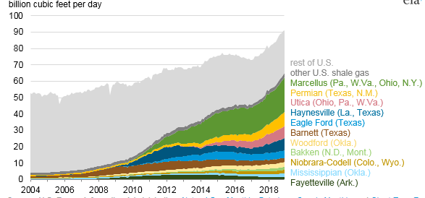
Figure 1- Natural gas production from major shale plays in the US from 2004 to 2018 (EIA 2018)
Despite the continuous increase in shale production, there are still major concerns over drilling practices in these shale plays. There continue to be an increasing focus on efficient drilling of deep and tight shale formations. Despite their huge potential, shale drilling continues to be challenging for operators and usually lead to excessive expenses because of all the possible drilling problems encountered. Serious drilling problems continues to be associated with shale drilling especially in deep and high-pressure wells. Some common problems include bit balling, wellbore instability, and low drilling rates, all correlating to excessive drilling costs. Currently, drilling with polycrystalline diamond compact (PDC) bits and oil- or synthetic mud systems constitute the best practices for shale operations. However, stringent environmental regulations and high operating cost associated with using oil-based mud (OBM) systems limit the effectiveness of these systems. As a result, continuing investigations are still ongoing in industry to find ways to minimize these shale drilling problems and therefore the introduction of inhibitive muds and high-performance water-based muds (HPWBM).
These shale drilling concerns are highly encountered in the Tuscaloosa Marine Shale (TMS). An intensive analysis of drilling reports obtained from wells such as well A, a well drilled into the Tuscaloosa Marine Shale revealed that problems such as pipe sticking, lost circulation, low drilling rate, excessive torque and drag, and hole cleaning were encountered during drilling. Figure 2 shows well A well profile. Analysis of the well profile and the drilling and mud reports from the well revealed drilling concerns such as mud loss, swelling and gumbo zone, pipe sticking, and hole cleaning issues. The TMS extends from North-east Louisiana into South-west Mississippi (Figure 3). The TMS presents a huge potential evaluated around 7 billion barrels of oil. This formation can be the next major shale producer if the appropriate drilling practices are undertaken to minimize the excessive cost of operations in the formation.

Figure 2- Trajectory profile of well A drilled into the Tuscaloosa Marine Shale (TMS)
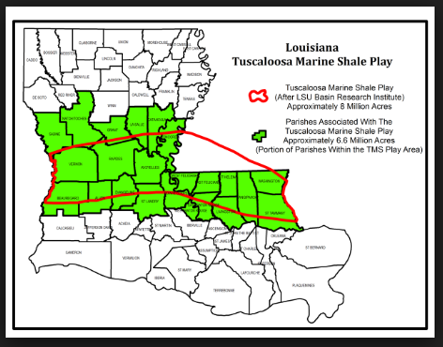
Figure 3- Tuscaloosa Marine Shale deposit showing the total acres of the formation (Shale Experts 2016)
The major drilling fluid related issues encountered in the Tuscaloosa Marine Shale (TMS) include wellbore instability, bit balling, high operating cost due to use of oil-based mud systems. These issues limited the effectiveness of the drilling fluid systems. With the forgoing assessment of the drilling fluid effectiveness in the TMS, the following hypotheses have been developed for this research:
- The drilling fluid performance is highly influenced by the formation characteristics such as mineralogy
- The drilling fluid performance is directly related to the compatibility between the fluid systems and the formation.
- Inhibitive mud systems are highly effective is shale drilling operations.

Research Objectives
In the design and development of drilling fluids, laboratory investigation of drilling fluid performance was carried out at consistent testing conditions to maintain consistency throughout the research. The objective was to devise an economical, efficient, and more compatible mud systems as alternative to oil-based mud that can drill the deep high-pressure high-temperature (HPHT) Tuscaloosa Marine Shale formation. The major objectives of this research are reported below:
- Investigate the effect of inhibitive mud systems on shale swelling and dispersion during drilling
- Characterize the compatibility between different drilling fluids and shale formations
- Investigate the impact of drilling inhibitive drilling fluid systems on shale drilling performance
- Develop a more suitable drilling fluid system that provide better economic and performance for TMS drilling operations
- Design an effective lost circulation mud for controlling and treating fluid loss in the formation

Research Outline and scope of Study
The scope of this research focused on conducting experimental investigation on drilling fluid systems such as conventional water-based mud (WBM), cesium formate brine, and KCl based mud systems for compatibility and performance purpose. The experiments conducted using the innovative high-pressure high-temperature (HPHT) drilling simulator were performed under dynamic conditions while the swelling tests were run at ambient condition.
To better conduct this research, a concise and well-developed outline was followed. The research outline used is classified below.
- Theoretical study: An extensive and in-depth literature review on shale drilling and drilling fluid activity was performed. The review process included but not limited to analysis of journal articles, conference proceedings, field drilling and mud reports from well A, and related technical publications.
- Laboratory experiments: The experimental methods used in this research include drilling fluid formulation, rheological and mineralogy characterization, swelling test, and drilling simulation tests. The purpose of the experiments was to fully comprehend to compatibility between the tested drilling fluids and the TMS formation and evaluate their performances in term of drilling.
- Post experimental analysis: After testing, drilling and swelling data were recorded using a data acquisition system (DAQ). The data were analyzed for correlation and trend purpose between drilling parameters. An in-depth analysis of the recorded data helped in evaluating the performance of each drilling fluid systems and choosing the most appropriate and effective drilling fluid system for TMS drilling.

Literature Review

Introduction
To effectively enhance drilling efficiency in shale, an extensive and in-depth background study of shale drilling and fluid compatibility is required. This chapter describes the drilling concerns and factors that contribute to low drilling rate. This chapter also gives an insight of the shale-drilling fluid interaction mechanisms. This first section of this chapter focuses on shale wellbore instability by analyzing the causes, consequences, and possible remediation methods. The second section introduces the concept of bit-balling, which is another detrimental drilling concern for shale. The characteristics of some detrimental clays is also discussed. The last section focuses on drilling fluids, their application, properties, and environmental concerns

Wellbore Instability
Wellbore instability constitutes the most common problem associated with unconventional shale drilling. Chenevert et al. (2001) reported that wellbore instability accounts for almost 90% of shale drilling concerns and continues to pose major economic burden for drilling operators. Awal et al. (2001) reported in their study that wellbore instability has an estimated economic loss of approximately eight (8) billion US dollar per annual. Wellbore instability can be defined as the variation between the hole diameter and the bit size. It can also be characterized as when the wellbore loses its integrity. Undergauged wellbore, overgauged wellbore, and hole sloughing are prime example of wellbore instability in shale drilling. Figure 4 shows a case of wellbore instability in a naturally fractured formation.
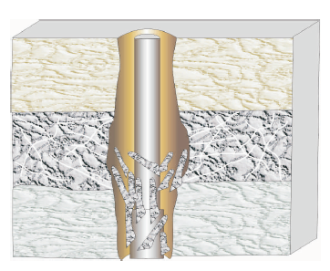
Bit diameter
Hole diameter
Figure 4- Illustration of wellbore instability in naturally fractured formation with presence of overgauge (Pasic et al. 2007)

Indicators of Wellbore Instability
Identifying wellbore instability at early stage of the drilling operation is major component of controlling it and minimizing its impact on non-productive time (NPT), therefore saving on the drilling cost. There are various indicators of wellbore instability during a drilling operation. Mohiuddin et al. (2001) and Pasic et al. (2007) reported that the indicators of wellbore instability can be classified in two major groups. The first group consists of direct indicators of wellbore instability. This group includes indicators such as oversize hole, undergauge hole, excessive volume of cuttings, excessive volume of cavings, size and shape of caving at the surface, hole fill after tripping, and excess cement volume required. The second group consists of indirect indicators including but not limited to high torque and drag, increased in circulating pressure, stuck pipe, excessive vibrations, poor logging response, keyhole seating, and excessive dogleg. Table 1 shows the list of indicators of wellbore instability.
Table 1-Direct and indirect indicators of wellbore instability (Mohiuddin et al. 2001)
Indicators of wellbore instability
Direct Indicators | Indirect Indicators
Oversize hole | High torque and drag (friction)
Undergauge hole | Hanging up of drillstring, casing, or coiled tubing
Excessive volume of cutting | Increased circulating pressure
Excessive volume of caving | Stuck pipe
Caving at the surface | Excessive drillstring vibrations
Hole fill after tripping | Drillstring failure
Excess cement volume required | Deviation control problems
 | Inability to run logs
 | Poor logging response
 | Annular get leakage due to poor cement
 | Keyhole seating
 | Excessive dogleg

Causes of Wellbore Instability
Wellbore instability is one of the most common drilling concerns encountered when drilling most unconventional shale formations. There are various causes of the wellbore instability. According to Samuel et al. (2001), Chenevert et al. (2001), and Konate et al. (2020) the causes of wellbore instability can be grouped under three (3) major interrelated headings. The first heading refers to mechanical wellbore instability. The mechanical instability is associated with stress and rock strength variation around the wellbore. The causes are related to the rock type, rock strength, rock stresses, and wellbore geometry such as inclination and azimuth. Mechanical failure occurs when the wellbore stresses concentration exceeds the rock strength. Samuel et al. (2001), Chenevert et al. (2001), and Van Oort et al. (2003) reported that wellbore stress concentration of wellbore results from drilling into pre-stressed rock, excessive wellbore pressure, and drillstring vibration. The second major heading is the chemical-rock interaction instability. This refers to the sensitivity of shale formations to their chemical environment. Incompatibility between drilling fluid systems and shale formation constitute one of the primary and most concerning cause of wellbore instability as cause a reaction. This reaction is characterized by the swelling, disintegration, and dispersion of the wellbore and eventually lead to the collapse of the wellbore. Finally, the last heading refers to the man-made wellbore instability. The man-made instability mostly involves the lack of inadequate well planning. Poor well trajectory selection, selection of wrong inclination and azimuth angle, selection of the wrong drilling fluid system, and poor mud weight selection. All these major headings consist of causes that can be classified into two groups: uncontrollable causes referring to natural factors that cannot be adjusted and the controllable causes where the operators can take actions to limit their impact. Table 2 reveals the list of uncontrollable and controllable causes of wellbore stability. All aspects of wellbore instability (mechanical, chemical etc.) need to be considered when analyzing instability. Salehi et al. (2010) in their work to develop a numerical model to simulate the mechanical aspect of wellbore instability, suggested that a combination of both chemical and mechanical instability should be considered.
Table 2- Causes of wellbore instability (Samuel et al. (2001), Mohiuddin et al. (2001), Pasic et al. (2007), Chen et al. (1998))
Causes of wellbore instability
Uncontrollable (natural) factors | Controllable factors
Naturally fractured or faulty formations | Bottom-hole pressure (mud density)
Tectonically stressed formations | Well inclination and azimuth
High in-situ stresses | Transient pore pressure
Unconsolidated formations | Physio-chemical rock-fluid interaction
Naturally over-pressure shale collapse | Drillstring vibration
Mobile formation | Erosion
Induced overpressure shale collapse | Temperature

Consequences of Wellbore Instability
Wellbore instability in shale and unconventional drilling continues to have major consequences for the drilling operators, with the most relevant consequences being the increase in non-productive time (NPT) and therefore an increase in drilling cost. The major consequences of wellbore instability according to (Samuel et al. (2001), Santarelli et al. (1992), Chenevert et al. (2001), Salehi et al. (2011)) include but not limited to:
- Reduction in drilling performance (slow drilling rate)
- Stuck bottomhole assembly (BHA) and downhole tools
- Loss of equipment and sidetracking
- Excessive trip time and reaming time
- Poor hole logging, inability to land casing and poor cementing conditions and cement jobs
- Total collapse and loss of hole
- Fracture generation and propagation.
- Loss circulation
All these consequences create a huge economic burden for the operators because of the increase in drilling cost due to the excessive non-productive time. Figure 5 reveals that about of 57 % of the non-productive time encountered in well A of the TMS can be attributed to wellbore instability. The wellbore instability NPT comes from sources such as lost circulation, pipe sticking, and loss of equipment. The other source of NPT such as tools replacement and wait on weather accounted for 32%, while the wait on cement (WOC) accounted for 11 % of the total NPT in well A. This indicates the impact of wellbore instability in the TMS formation.

Figure 5- Record of non-productive time from well A drilled into TMS

Bit Balling
The slow drilling rate in shale is one of the major consequences of wellbore instability. The low rate of penetration (ROP) is a major drilling concern for all drilling operators because of its implications on drilling time and costs. A primary contributing factor to low ROP in shale is known as the bit-balling. Bit-balling is a very common phenomenon in high reactive and water sensitive shales. According to Van Oort (1997), bit balling refers to the tendency of drilled cuttings to adhere to the bit surface, as a result forming a cushion between the formation and the bit. The sticky cuttings occupy spaces between drill bit teeth therefore preventing the drill bit cutters from effectively contacting the formation. Consequently, this phenomenon of poor contact between the drill bit cutters and the formation lower the rate of penetration (ROP). Dupriest and Koederitz (2005) and Remmert et al. (2007) reported that bit balling is qualified as a major limiter to ROP. Bit balling and cutting accretion are highly affected by shale hydration process. Van Oort (1997) reported that the tendency of shale cuttings to stick to the bit is a function of the water content of the cutting and the used drilling fluid system. The initial water content is also dependent on the shale type and its clay content. In a study performed in 1997, Van Oort evaluated the correlation between the water content and the clay stickiness. He identified three major zones in his study. A dry zone where the shale is in its initial state. In this zone, the shale is too dry to stick to the bit. It is qualified as a safe zone where there is no chance of bit balling. Continuous hydration of the shale leads to a transition from the dry zone to a more plastic zone. In this zone, shales highly hydrated and very sticky. As a result, the probability of bit balling occurring is very high, making the zone very problematic. The last zone refers to the liquid zone, which is obtained by continuous hydration of the plastic zone. In this zone, shales are too dispersed which limits their ability to stick on the bit. This zone there is an effective wash off of the drill bit cutter. Therefore, this zone presents no risk of bit balling. Figure 6 shows the relationship between the clay stickiness and the water content.
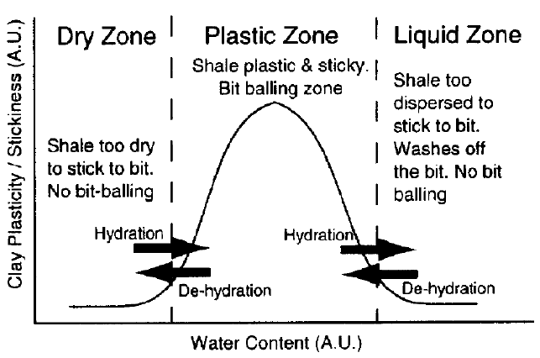
Figure 6- Relationship between bit balling and water content (Van Oort 1997)
Bit balling ranges from slight to severe with an uninhibited water-based mud. Invert emulsion oil-based muds are reported to have no bit balling issues. The ratio of bit torque to weight-on-bit (WOB) is a reliable indicator of the degree of severity of the bit balling. Bit balling and cutting accretion results in reduced drilling rate, excessive non-drilling time (NDT), and expensive remediation.
Bit balling can be significantly reduced by maintaining a low water content of the shale, selection of appropriate drilling fluid system, and drill bit optimization. Most formations including high-reactive shale formations rely on polycrystalline diamond compact (PDC) bit. However, the use of shear cutting principle by the PDC bit makes it very vulnerable to bit balling due to its ability to generate cutting chips. Several studies have been undertaken to understand and develop method of optimizing PDC bit. Since bit balling is mostly initiated by the generation of small cuttings, Zijsling et al. (1993) suggested the use of larger cutter standoff distance in a PDC design to ensure the production of larger cuttings that can be efficiently transported and reducing the contact with the bit body. This method provides improvement in minimizing bit balling; however, it greatly weakens the bit strength. Thus, this method is only effective for a range of drilling parameters and certain formations to avoid rapid wear and fatigue of the bit. Additionally, Smith et al. (1995) suggested smoothening the surface finish of a PDC cutter in order to reduce the friction coefficient of the cutter and produce long thin cuttings that are easily evacuated. They claimed that the evacuation of rock cutting is highly affected by the thickness of the cuttings and the friction generated. The idea of smoothening the cutter of PDC bit led to the introduction of polished cutter. Van Oort et al. (2000) suggested that the use of polished cutters minimize bit-balling and improve the bit life.

Lost Circulation
Lost circulation is another major consequence of wellbore instability in shales and natural fractured reservoirs. Lost circulation refers to continuous loss of drilling fluids into a fracture wellbore. Lost circulation is one of the main contributors of non-productive time (NPT) is most shale operations. Analysis of previous drilling report from well A revealed that lost circulation accounted for more than 40% of the NPT in this well. Lost circulations in mostly common in loose/depleted reservoir, shale formations, fractured reservoirs, highly permeable formations etc. (Figure 7). A study performed by Ezeakacha (2018) revealed that shale formations and loose and depleted sand account for about 29% of the NPT among different lithologies.
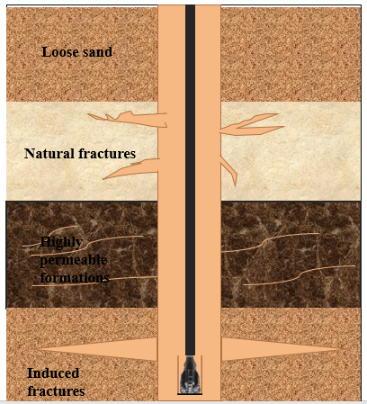
Figure 7- Illustration of classification of common lost circulations
In addition to the increase in NPT, lost circulation presents some other major consequences for shale drilling operations. According to Ezeakacha et al. (2019) and Salehi et al. (2016), some major consequences of lost circulation include but not limited to excessive non-drilling time (NDT), formation damage, and stuck pipe. The severity of the loss is highly correlated with the consequences. The severity of the loss is dependent of the formation type and the lithology. Ezeakacha et al. (2017) reported that fluid loss is more pronounced in more porous rocks. According to Frates et al. 2014), as the severity of the loss increases, the financial losses also increase to eventually match the cost for additional drilling fluid, lost circulation treatment, rig time, and delays in drilling operations. There are four common types of lost circulation classified based on volumetric rate. Table 3 illustrates the different types of losses.
Table 3- Lost circulation classification based on volumetric rate (Frates et al. 2014)
Type of Loss | Severity of Loss
Seepage | Less than 1.6 m³/h [10 bbl/h]
Partial | 1.6 to 16 m³/h [10 to 100 bbl/h]
Severe | More than 16 m³/h
Total | No fluid return to the surface

Due to the high cost implications of lost circulation, it is crucial to take preventive and remedial actions to control the losses. Although it is preferable to complete stop lost circulation during drilling, it is not always possible or required. Lost circulations are much easier to prevent than cure. An advanced controlled of the lost circulation, allows the drilling operation to continue while maintaining a full wellbore and preventing gas influx. There two major types of treatment: a remedial treatment, which refers to actions taken to cure loss when it has already occurred and preventive treatment that refers to taking actions when a loss zone is anticipated. Figure 8 illustrates some potential lost circulation treatment methods.
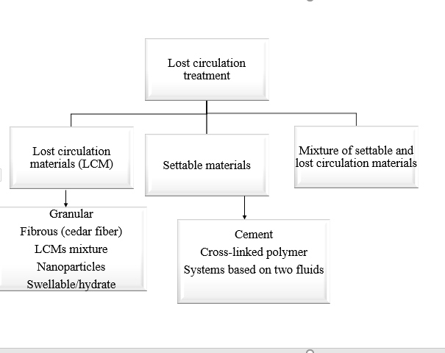
Figure 8- Most common lost circulation treatment actions (Ezeakacha 2019, Konate et al. 2019, Frates et al. 2014, Magzoub et al. 2019)
Three of the most common treatment methods include: the use of lost circulation materials, settable materials, and a combination of the previous two. Lost circulation materials include but not limited to fibrous fiber, nanoparticles, and swellable materials. Fibrous fiber (cedar fiber) remains one of the most used lost circulation materials in fractured shale formations due their stability at high temperature. Settable materials consist of slurry systems that set at a desired location. These materials generate a solid seal in the target zone where there is a chance of loss. Some of the most common settable materials include but not limited to cement and cross-linked polymers. Magzoub et al. (2019) evaluated the effectiveness of cross-linked polymer in sealing fractured zones. Their study showed that cross-linked polymers are very effective in sealing wide fractures and where temperature varies a lot making them suitable for shale formations. One primary requirement for settable materials is that their slurries must be easily pumpable.

Clays Characterization
Understanding clay characterization plays a major role in controlling wellbore instability in most reactive shales. There is a high correlation between the clay type and the wellbore instability.it is generally reported that the nature or type of clay minerals in shale formations is a primary cause of instability. Currently, the volume expansion (swelling) of most reactive clays is considered as one of the leading causes of instability. O’Brien and Chenevert (1973) were some of the first researchers to study the relationship between wellbore instability and clay mineral composition. They characterized clay mineral in term of hardness, tendency to hydrate, swelling tendency, and dispersion tendency. Their study revealed that the most active clay minerals in causing wellbore instability include smectite, illite, and mixed clay (illite + smectite). Both kaolinite and chlorite were given a secondary importance, implying their inactivity in wellbore instability. Their study revealed five (5) classes of shales (Table 4). Class 1 shale is mostly dominated by smectite and present the highest affinity and shows high swelling and dispersion tendency. Class 2 shale is reported to be fairly dispersive with low swelling tendency due to a combination of high illite fairly high smectite. Shale dominated by mixed layer clay and chlorite (class 3) less dispersive shows lower swelling tendency. Hard shales (class 4 and 5) shows very low to little dispersion

Table 4-Problematic shale classification according to their characteristics and clay mineralogy (after O’Brien and Chenevert, 1973)
class | Characteristics | Clay minerals
1 | Soft, highly dispersive (gumbo). Mud making | High smectite, some illite
2 | Soft, fairly dispersive. Mud making | High illite, fairly high smectite
3 | Medium hard, moderately dispersive, sloughing | High in mixed layer, illite, chlorite
4 | Hard, little dispersion, sloughing | Moderate illite, moderate chlorite
5 | Very hard, brittle, no dispersion, caving | High illite, moderate chlorite

Clay Structure
All clay minerals are in general crystalline dominated in nature. These crystals determine the main properties of the clays. Clays are characterized to have a flaky, mica-type structure, where the flakes are composed of a number of crystal platelets that are stacked face to face. Each of the platelet represents a unit layer, and the surface of the unit layer is referred to as basal surface. A clay unit layer is composed of multiple sheets. The most common sheets include the octahedral and the tetrahedral sheet. The octahedral sheet is mainly composed of either aluminum (Al) or magnesium (Mg) atoms that are octahedrally coordinated with oxygen (O) and hydroxyl (OH) at the edges. The oxygen and hydroxyl group represent the anion groups which share the edges of the sheet with coordinating cation groups such as aluminum, or magnesium as reported by (Murray, 2007). The aluminum and magnesium ions that make up the octahedral layers can be replaced by other well-known ions such as Fe^{3+,} Fe²⁺, Cr²⁺, Zn²⁺, Ni²⁺, and many others. The replacement of Al³⁺ by Fe³⁺ and Mg²⁺ by Fe²⁺ is the most common substitution encountered. Figure 9 shows an octahedral sheet with a combination of aluminum and oxygen atoms
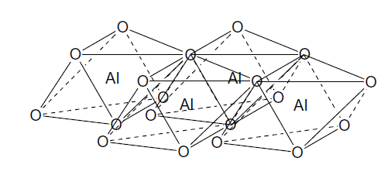
Figure 9-Octahedral sheet of a clay (Murray, 2007)
Another most common sheet includes the tetrahedral sheet. This sheet is mainly composed of silicon (Si) atoms that are tetrahedrally coordinated with oxygen atoms. Each silicon atom is coordinated with four (4) oxygen or hydroxyl groups. Tetrahedra are arranged in sheet in a form of hexagonal network, where oxygen atoms share the basal corners of the tetrahedra. In most tetrahedral sheet of clay mineral, the silicon ion (Si⁴⁺) can be replaced by aluminum ion (Al³⁺) or iron ion (Fe³⁺) (Murray, 2007). Figure 10 illustrates a tetrahedral sheet with combination of silicon and oxygen atoms
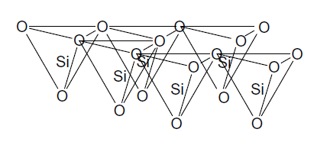
Figure 10- Tetrahedral sheet of a clay mineral (Murray, 2007)
Different sheets such as octahedral and tetrahedral sheet of a unit layer can be connected together by the sharing of oxygen atoms. In case of the linking one octahedral and one tetrahedral sheet, one basal surface has exposed oxygen atoms, while the other basal surface has exposed hydroxyl groups. The linking of one octahedral and one tetrahedral sheet constitutes a 1:1 layer. Another common connection between sheets includes the linking of two tetrahedral sheets and one octahedral sheet by the sharing of oxygen atoms. In this case, both basal surfaces of the unit have exposed oxygen atoms. This 2:1-layer results in a structure known as the Hoffmann structure where the octahedral sheet is sandwiched by two tetrahedral sheets (Hoffmann and Lipscomb, 1962).

Clay Mineral Classification
The arrangement of clay sheets plays a major role in classifying clay minerals. The number and arrangement of the tetrahedral and octahedral sheets determine the type of layer. There are three common type of layers including the 1:1, 2:1, and 2:1:1 clay mineral.
- 1:1 clay mineral
The 1:1-layer clay mineral consists of the linking of one tetrahedral and one octahedral sheet in the structural unit. The most common two-sheets mineral type is the kaolin group. The kaolin group is represented by a general formula of Al₂Si₂O₅(OH)₄. The most common mineral of this group is known as kaolinite (Figure 11a). This mineral has a coordination of Al³⁺ octahedral and Si⁴⁺ tetrahedral. The two sheets are bonded together by the well-known Van der Walls bond between the oxygen of the tetrahedral sheet and the hydroxyls of the octahedral sheet. The layers of this type of mineral are held together using hydrogen bonding, which limits the expansion and restricts the reactivity of the external surface area (Barton and Karathanasis, 2002). Clay minerals from the kaolin group are highly stable with a relatively small surface area of 15 (m²/gm). The kaolinite mineral is also non-swelling and has a very low absorptive capacity. These properties make the kaolinite clay mineral less detrimental to shale drilling operations.
- 2:1 clay mineral
The sandwiching of one octahedral sheet by two tetrahedral sheets creates a three-sheet clay mineral type, usually called 2:1 clay mineral. The mica and smectite group are the most common 2:1 clay mineral. The first group, mica consists of mineral such illite. Illite (Figure 11b) intermediates between kaolinite and the smectite. It has a general formula of (K_{1-1,5}Al₄[Si₇₋₆,₅Al_{1-1,5}O₂₀] (OH)₄). The illite mineral has layers that are tightly bonded together by Van der Waals bonds. The 2:1 illite presents low absorptive and swelling/shrinking capacity. This also has a surface area of 30 (m²/gm) and is very dispersive. The other group of the 2:1 clay mineral is the expandable group known as smectite (Figure 11c). This mineral has charges that derive from the substitution of Mg²⁺ and Al³⁺ (Barton and Karathanasis, 2002). Like most of the clay minerals, the 2:1 smectite consists of layers that are held together by the Van der Waals bonds. In addition to these bonds, the layers in this mineral are also held together by a weak cation-oxygen link. The smectite group is represented by a general formula given by (1/2 Ca, Na)_{0,7}(Al, Mg, Fe)₄[(Si, Al)₈O₂₀]. nH₂O. The presence exchangeable cation such as Al³⁺ and Mg²⁺ between water molecules makes the smectite group highly expandable. This mineral also has high swelling and shrinking potential, and adsorptive capacity. This mineral unlike others, has a very high surface area of 800 (m²/gm) (Tiab et al. 2004).
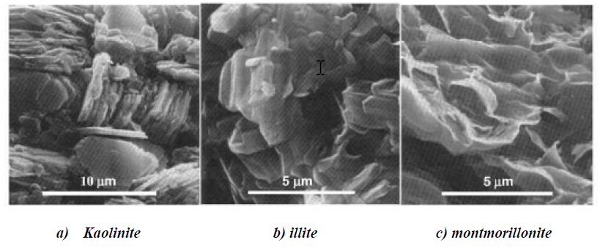
Figure 11- Scanning electron microscopic illustration of common clay minerals (Tovey 1971)
- 2:1:1 clay mineral
The 2:1:1 clay mineral is a combination of the basic 2:1-layer structure and an additional interlayer like sheet. The interlayer sheet is generated due to the isomorphic substitution that occurs within the 2:1-layer structure. The most common group of the 2:1:1 clay mineral is the chlorite. This mineral has a general formula given by (Mg, Al, Fe)₁₂[Si, Al)₈O₂₀] (OH)₁₆. This mineral has no adsorption capacity, which makes it non expansive. The chlorite has a surface area of 15 (m²/gm) (Tiab et al. 2004).
- Mixed-layer clay mineral
In addition to the basic clay mineral discussed, there exist mixed-clay minerals. These minerals are formed from a combination the basic minerals. The most common mixed-layer clay minerals include the illite-smectite and the chlorite-smectite combination. Theirs properties and characteristics are similar to that their basic minerals that they originate from.
The clay minerals are important components of most shale reservoirs. The presence of clay minerals strongly affects the physical and chemical properties of most unconventional shale operations. Table 5 summarizes some properties of most common clay minerals.
Table 5- Summary of some properties of the most common clay minerals and their effect on reservoir (Tiab et al. 2004, Civan 2000).
Minerals | Surface area (m2/gm) | Cation exchange capacity (meq/100 gm) | Major reservoir concerns
Kaolinite | 15 | 1-10 | Breaks apart, migrates and  concentrates at the pore throat  causing severe plugging and loss  of permeability
Chlorite | 15 | <10 | Extremely sensitive to acid and  oxygenated waters. Will  precipitate gelatinous Fe (OH)₃  which will not pass through pore  throats.
Illite | 30 | 10-40 | Plugs pore throats with other  migrating fines. Leaching of  potassium ions will change it to  expandable clay.
Smectite (Mont) | 800 | 80-150 | Water sensitive, 100%  expandable. Causes loss of  microporosity and permeability.

Drilling Fluids
Drilling fluid refers to any fluid that is circulated or pumped from surface to drillstring through the drill bit and back to the surface by means of the annulus. The drilling fluid governs the success and failure rate of all drilling operations. Drilling fluid is as important for all drilling operations as the blood in a human body. It is at the heart of all drilling operations. Poor drilling fluid design and selection can a source of major issues including but not limited to:
- Poor drilling performance and therefore a high cost of drilling operations
- Failure to deliver quality geological and reservoir data
- Failure to optimize reservoir production, etc.
Drilling fluids have a variety of functions that can be classified into primary and secondary functions. The primary functions of drilling fluids focus on cutting removal, formation pressure, and borehole stability. The primary functions include:
- Transporting and removing cuttings from wells
- Controlling of formation pressure during drilling
- Maintaining borehole stability
In addition to these primary functions, drilling fluids provide additional functions known as secondary functions. The secondary functions are as important as the primary functions for the success of any drilling operations. The secondary functions of drilling fluids include:
- Sealing of permeable formation to minimize risk of kick and blowout
- Suspending of cutting under static conditions
- Cooling and lubricating of drill bit and bottom-hole assembly (BHA)
- Minimizing loss of fluid to formation
- Providing hydraulic horsepower to the bit.
An effective drilling fluid accomplishes all primary functions and some secondary functions depending on the formation. Figure 12 illustrates the main functions of a drilling fluid. Many key factors affect the performance of drilling fluid. Some of the major factor include:
- Fluid rheology
- Change in drilling fluid viscosity
- Change in drilling fluid density
- Change of mud pH
- Corrosion or fatigue of the drillstring
- Thermal stability of the drilling fluid
- Differential sticking
There are many types of drilling fluid available in the industry. The selection of the appropriate type of drilling fluid system is governed by factors such as formation type, drilling performance, relative cost, and disposal cost. The major types of drilling fluid systems are discussed below.
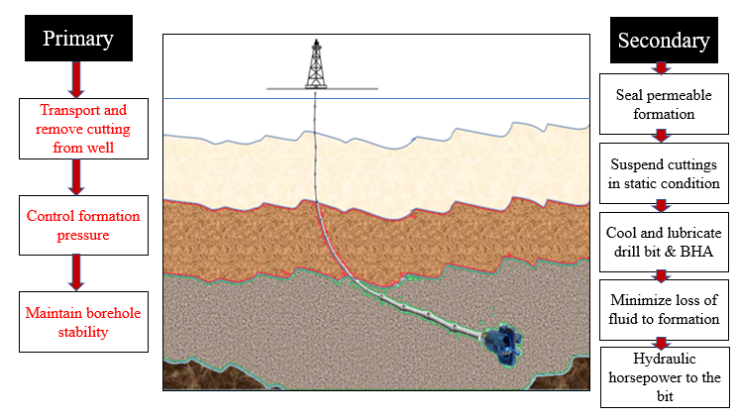
Figure 12- Primary and secondary function of an effective drilling fluid

Water-Based Mud Systems
The water-based mud (WBM) system represents the most common fluid system used around the world. According to Ryen Caenn 2015, water-based mud account for approximately 60% of worldwide application. WBM is a fluid system where the water represents the continuous phase of the mixture. WBM consists of a combination of a base fluid (freshwater, seawater), clay (bentonite), and chemical or additives. There are variety of WBM systems. The simplest water-based mud is designed with based fluid such as freshwater or saltwater. This type of WBM is widely used in competent and non-reactive formations. It can be both dispersive (freshwater) or non-dispersive (saltwater). Some major advantages of using the simplest WBM include its low cost, low toxicity, and low disposal and waste management costs. However, this version of WBM is greatly limited by its performance, stability issues, and poor temperature stability.
Another major type of water-based mud is the high-performance water-based mud (HPWBM). The HPWBM systems were introduced to overcome the limitations of the simplest WBM. This version of WBM is designed using a unique salt such as potassium chlorite, sodium chlorite, or calcium chlorite. These salts provide shale inhibition as opposed to the simplest WBM. The pros of using HPWBM systems for drilling include the reduction in chemical interaction between drilling mud and a water-sensitive formation (reduction in hydration, swelling of clays), improved rheology, improve hole and temperature stability, and increase drilling performance. However, their application is limited by their relative cost, disposal cost, and restriction on waste management (Mario and Mike, 2017).

Oil-Based Mud Systems
Oil-based mud (OBM) system is another major type drilling fluid system with a wide range of use in the industry. OBM is drilling fluid system mainly composed of a base oil (diesel, low toxic mineral), water, additives and chemicals. The base oil represents the continuous phase of the system. OBM systems provide an improvement to the WBM systems and help overcome their limitations. This drilling fluid is highly effective in drilling of (1) highly reactive shale formations, (2) evaporite formations, (3) extended reach wells, (4) deep, high pressure, high temperature (HPHT) wells (Konate et al. 2019). OBM systems are used for reasons including improved lubricity, enhanced shale inhibition, improve rock-fluid interaction (swelling and hydration), greater cleaning ability due to low viscosity, and stability at high temperature. However, as reported by Konate et al. (2019), the effectiveness of OBM systems is greatly limited by the associated high cost, strict environmental regulations, elevated disposal cost, waste management concerns, and logging difficulties.

Synthetic-Based Mud Systems
Synthetic-based mud (SMB) represents an improved version of the OBM. It is commonly known as low toxicity oil-based mud and is designed using synthetic oil such as ester, or paraffins instead of diesel or mineral oil. SBM systems have similar properties as the OBM with a minimum toxicity. These fluid systems provide improved performance with minimal environmental impact. The primary goal of these systems is to provide similar inhibitive properties and advantages as the OBM while limiting toxicity. SBM presents similar cost concerns as the OBM but with minimum environmental restriction.

Formate Fluids
Formate brines are a set of drilling fluid systems designed using high-density brines. The high-density brines are obtained as a combination of dissolved aqueous solution of metal salt of formic acid with water. The most common formate brines include the sodium formate, potassium formate, and cesium formate. The molecular structures of these formate brines are reported below:
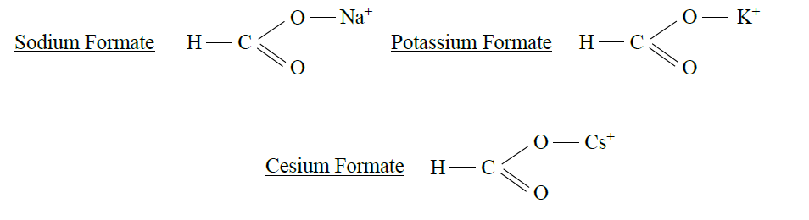
According to the formate brine manual from Cabot, these drilling fluid systems consist of physical and chemical properties that suggest better compatibility and interaction with different high clay shale formations. Some of the most important properties of formate fluids are reported below:
- Formate brine systems provide a wide range of density that cover range normally required in drilling and completion operation. The range of density for formate fluids varies from 8.3 lb/gal to 19.2 lb/gal. Figure 13 shows the different range of density for formate fluids.
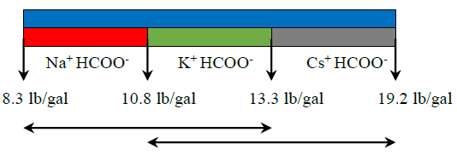
Figure 13- different range of density covered by formate brine fluids (Howard, Formate Technical Manual)
- Formate brine systems show adequate compatibility with most water-based drilling fluids with the exception of halides and barite. A contact between formate ions and barite or halides usually generate precipitates that can be problematic and limit the effectiveness of the formate fluids.
- The formate brine are also reported to have the ideal characteristics for low solid drilling, deep drilling, and slim hole drilling.
The formate brines are highly attracted due to their numerous advantages. While their use is still limited by their excessive cost, formate brines provide major benefices to reactive shale drilling. Some of the advantages as reported by Konate et al. (2019), konate et al. (2020), Gilbert et al. (2007), Van Oort et al. (2015), and John Downs (2018) include:
- Maintenance of solids carrying capabilities at high temperature
- Improved fluid-rock interaction (swelling, hydration)
- Elimination of solid sag at high temperature
- Minimal circulating pressure losses
- Low potential of differential sticking (very thin filter cake)
- Better hole cleaning
- Good lubricity
- Low equivalent circulating density (ECDs) in low/narrow boreholes
- Maximum power transmission to mud motors and bits
- Non-hazardous
- Environmentally responsible and readily biodegradable
An extensive environmental assessment conducted in 2003 by the environmental Consultancy Metoc provided major supportive ground the environmental compatibility of the formate brine. Their study revealed that a large scale of accidental spills of formate brine do not cause any major environmental damage. Table 6 provides a summary of the most common drilling fluids in the industry.

Amine-based fluid systems
The amine-based systems represent a variation of the high-performance water-based muds (HPWBM). These systems were introduced in the market in the late 1980’s (Beihoffer, 1990). These drilling fluid systems have the potential to improve shale stability. According to Patel et al. (2007), these fluids systems have improved ability to suppress clay hydration and prevent hydratable clays from swelling and expanding during drilling because of the ability of the amine molecule to easily enter the clay structure. The amine-based fluid systems display the ability to control clays with high absorption capacity such as smectite. They are highly compatible with most drilling fluids additives which can be used to improve their formulation. These fluid systems show low marine toxicity making them suitable for offshore drilling applications. One major limitation of these fluid systems is their limited performance for formation with high concentration of reactive clays. Additionally, Patel et al. (2007) reported that amine systems experience difficulties to disperse or dehydrate clay particles that are already hydrated making them less appropriate for drilling shale formations with low cation exchange capacity (CEC).

Glycol-based fluid systems
Glycol-based systems are commonly used today in the industry for shale drilling. These systems are another variation of the HPWBM. These drilling fluid systems generate precipitate and displace the water; therefore, blocking shale pores and limit fluid invasion during drilling. The phenomenon tends to stabilize the wellbore wall. A major advantage of glycol systems is their ability to reduce pore pressure transmission leading to a stable wellbore (M.S. Aston & Elliot, 1994). These systems have the tendency of coating the drilled cuttings; therefore, reducing their dispersion. The high salt-dependency of these fluid systems makes them impractical in term of fluid and cutting disposal. Additionally, the irreversible pore blocking mechanism of these fluid systems make them less desirable for some unconventional shale as they increase formation damage (M.S. Aston & Elliot, 1994).

Aluminum-based fluid systems
The aluminum-based fluid systems are based on a complex mixture of aluminum salt soluble in water. These systems are a variation of HPWBM. These systems are characterized to have higher pH. Therefore, when they encounter a solution of lower pH such as connate water, they tend to generate precipitate known as aluminum hydroxide in the form of crystalline mineral. The generated precipitate has the ability of blocking shale pores which eventually reduces the pore transmission. This mechanism leads to an increase in shale strength and prevent the wellbore from experiencing swelling or wellbore collapse (Benaissa, (1997), Omojuwa et al. (2011)). These systems are highly effective in improving the overall performance covering reactive clays due to their pore blocking ability and cation exchange capacity (CEC) potential. According to Van Oort et al. (1996), a major limitation of these systems is their high dependency on pH, which can lead to sudden precipitation due to sudden change in pH. The sudden precipitation can lead to excessive torque and drag and bit-balling. Field case studies in the Chonta shale (Soriano et al. 2015) and the brittle shale formation of Viletta shale (Ramirez et al. 2015) showed that the aluminum-based systems have adequate performance in term of shale stability. These studies showed that the aluminum hydroxide precipitate effectively reduces pore pressure transmission during drilling. Additionally, Ramirez et al. (2005) reported 75% reduction in shale hydration when aluminum-based fluid system is used to drill the Villeta shale compared to conventional water-based mud.

Silicate-based fluid systems
The silicate-based systems were first introduced in early 1940s. The initial application proved impractical due to high rheology problems encountered during drilling (Ward 1999). Since the1960s, the silicates systems were reintroduced with low concentration and in combination salt such as KCl and NaCl. The combination of silicate and salt proved to be very effective in stabilizing shale formations and controlling cutting dispersion. These systems provide shale pore plugging potential due to the generation of precipitates; therefore, minimizing pressure transmission. These systems minimize fluid invasion into shale matrix and produce shale dehydration due to formation hardening mechanism. According to Ward (1999), the high concentration of salt required for achieving good performance with these systems poses cost and environmental concerns.

Nano-based fluid systems
The nano-based fluid system is classified as a smart fluid system obtained by using nano particle with size ranging from 1 to 100 nm as additives in water-based systems. The nano particles are customized for achieving single or multiple functionalities when mixed in the drilling fluid. The nano particles are reported to have high surface area, which increases their reactivity. Therefore, it is recommended to use minimum amount of nano particles. Subhash et. al (2010) reported that nano-based fluid systems generate thin layer of non-erodible and impermeable nano particle around the wellbore which prevent drilling concerns such as shale swelling and excessive torque and drag. These fluid systems are very effective in tackling drilling concerns such as fluid invasion, pressure transmission, and cutting dispersion (Cia 2012).
Table 6-Summary of major drilling fluid systems and their pros and cons (Konate et al. 2019, Gilbert et al. 2007).
 | Water-Based Mud |  |  | Oil-based mud | Synthetic-based mud/ Formate brine
Application worldwide | 60% |  |  | 20% | 20%
Type/base | HPWBM | Non-dispersed | dispersed | Diesel or mineral oil | Ester, paraffins/ cesium, potassium, sodium
Key reasons for selection | - Improved rheology  - Well/hole stability  - Moderate temperature | - Inhibition issues  - Logistic challenges | - Tophole drilling  - Low cost and simple  - Spud mud | - High temperature  - Well/hole stability  - Torque and drag  - Better lubrication  - Increase ROP | - High temperature  - Well stability  - Torque and drag  - Better lubrication  - Increase ROP
Cost | Medium to high | Low | Low | high | high
Drilling efficiency | Medium to high | Low to medium | Low to medium | high | high
Rate of penetration (ROP) | Medium to high | Low | Low | high | high
Wellbore stability | Medium to high | Low to medium | Low | high | high
Environmental concerns | Low to medium | Low | Low | high | Medium to high
Disposal cost | Low to medium | Low | Low | Very high | Medium to high

Laboratory Experimental Methods

Overview
This section provides an extensive discussion of the testing procedures, materials used, experimental equipment and operating procedures. The section mainly focuses on drilling fluid design, swelling testing procedure, mineralogy characterization, and drilling simulation tests.

Drilling Fluid Design
Drilling fluid systems are at the heart of the success of all drilling operations. They play major functions. The impact of drilling design and selection is more pronounced in unconventional operations such shale drilling as compared to conventional. In this research, four (4) drilling fluid systems are selected in order to understand their impact on shale drilling. The drilling fluid systems consisted of three (3) inhibitive mud systems (1 wt% and 2 wt% KCl-based muds, and cesium formate brine) and one (1) conventional water-based mud that is used as reference mud. The cesium formate brine system was obtained from service company while the remaining of fluid systems are designed in the laboratory. The drilling fluid systems were mixed according to a practical procedure. The order of the mixing was as followed: water or KCl solution, bentonite, caustic, lignite, desco, and barite. The different components were mixed using a laboratory mud mixer. The different concentrations of mud materials are based on three (3) laboratory barrels. The formulation for the conventional WBM is reported in Table 7.

Table 7-Conventional water-based mud formulation
Products | Lb/bbl | % by weight | % by volume
Water | 306 | 66.084 | 87.46
Gel | 20.0 | 4.32 | 2.38
Caustic Soda | 0.5 | 0.108 | 0.094
Lignite | 4.0 | 0.8635 | 0.762
Desco | 4.0 | 0.8635 | 0.714
Barite | 128.6 | 27.76 | 8.58
The formulation procedure for the two KCl based systems was similar to that of the conventional WBM. The main difference was replacing the water in the conventional WBM with the KCl solution. Same concentration of gel, caustic, lignite, and barite was used for all two KCl mud systems. After the designing phase of the drilling fluids, a mud balance is used to determine the mud weight. The conventional water-based mud (WBM) has a density of 11 lb/gal, both KCl based fluids have similar mud density of 11 lb/gal. The cesium formate brine on the other hand is kept as received from the provider.

Drilling Fluid Rheology
Drilling fluid rheology is an important parameter for characterizing all fluid systems. The rheological properties can provide an insight on the drilling fluid performance in term of fluid loss, filtration (Ezeakacha et al. 2018), and solid and cutting transport ability. The drilling fluid systems were designed by appropriately mixing the required components such water, bentonite, barite, lignite, and others as discussed previously. After mixing, an extensive rheological investigation was performed in accordance with the API practice (API 13 B-1 2003) using the M3600 automatic viscometer (Figure 14). The viscometer is programmed to profile the drilling fluid rheology parameters including shear stress, shear rate, and apparent viscosity every 30 seconds at a set temperature. In this study, the temperature was set to 120 ºF, while the automatic viscometer has a maximum operating temperature of 220 ºF. Rheological properties such as shear stress, apparent viscosity, and yield point are major indication of the carrying and hole cleaning capability of all drilling fluid during drilling operations. Drilling fluid rheology is greatly impacted by the operating temperature and the drilling fluid composition. The rheological investigation was performed for the inhibitive mud systems (1 wt% KCl, 2 wt% KCl, cesium formate) and the conventional WBM. The automatic viscometer is connected to a data acquisition system (DAQ) that get digital reading that are stored in a computer.
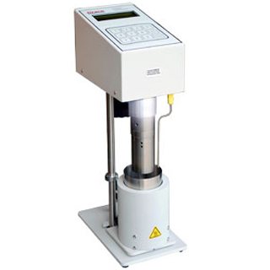
Temperature sensor
Bob
Cup
Heating jacket
Figure 14- Automatic M3600 viscometer

Mineralogy Testing
Mineralogy is a major factor that governs drilling fluids performance and their interaction with shale formations. Most clay minerals display different reaction when in contact with different drilling fluids. Minerals such as smectite and illite are highly sensitive to water and some types of drilling fluid. Smectite mineral is characterized by high hydration potential, while illite is more dispersive. In this study, the fourier-transform infrared spectroscopy (FTIR) is used to quantify the mineralogy of the formation of interest. FTIR is a technique that relies on infrared spectrum. It uses a mathematical process to convert raw data into an actual spectrum that is then converted into weight distribution of different minerals. Sample obtained from well A is crushed and finely grinded into powder. The grinded sample is then dried out for 24 hours using a 100 ºC oven. 0.05 g of the dried sample is added to 0.3 g of a salt known as potassium bromide (KBr) to generate a disk that is then put in the FTIR spectrometer (Figure 15) to visualize the spectrum. The obtained spectrum is then converted into distribution of the different minerals.
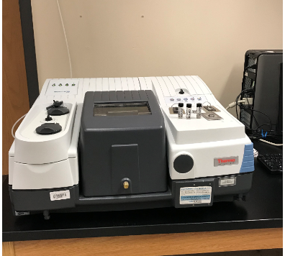
Figure 15- FTIR spectrometer for mineralogy testing
The spectrometer uses an infrared light source to measure the cumulative absorption. The generated disk containing the sample and the KBr is then exposed to different wavelength of infrared light and the spectrometer measures which measures which wavelength is absorbed. The raw absorption data is then converted into an absorption spectrum using the mathematical process known as Fourier Transform. The resulting spectrum is then compared to a library of spectra to find a match.

Laboratory Swelling Testing
Clay dominated shale formations such as TMS are composed of clays such as smectite, illite, and kaolinite that are detrimental to shale drilling when an incompatible or a more inappropriate drilling fluid system is used. The clays present swelling and hydration potential that need to be minimized during drilling operations. The swelling of clay during drilling is a major source of concern for shale drilling operators because of the potential setbacks that can be associated with it. The swelling test was carried out to investigate the impact of the inhibitive drilling fluid systems on shale swelling. The test was performed on the set of inhibitive mud systems (1 wt% KCl, 2 wt% KCl, cesium formate), conventional WBM, and freshwater, which was used as reference fluid. Shale swelling is highly dependent on shale type, temperature, pressure, and duration of compaction. Various testing procedures are avalaible for quantifying the swelling index, however, the most commonly used in the linear swell tester. This testing relies on a dynamic swell meter to simultaneously test different fluid systems for extended period of time at various temperatures up to 180 ºF. In this study, a more simpler testing procedure that relies on graduated cylinder is used due to absence of a dynamic swell meter. This method is based on the American Society of Testing Material (ASTM) standard section D 5890. This testing procedure is very common for testing bentonite and soil swelling. It is a very simple and fast testing procedure commonly used by mudloggers on the field to test for reactivity of drilled cuttings. To perform these tests, a 2g sample of dried and finely grinded shale sample is dispersed into a 100 ml graduated cylinder in 0.1g increments. The grinded sample may come from two sources: intact core sample and drilled cutting. If using drilled cuttings for sample preparation, they must be clean to remove any residual mud, then dried in a 220 ºF (105 ºC) oven before the grinding process. The grinded shale samples must be able to pass through the 200-mesh sieve. A minimum of 10 minutes must pass between additions to allow for full settlement of the clay to the bottom of the cylinder. These steps are followed until the entire 2g sample has been added to the cylinder. The sample must be added slowly because rapid addition results in macrovoids, which represent presence of air and/or fluid pockets in the hydrated layers. The sample is then covered and protected from disturbances for a period of 16 - 24 hours, at which time the level of the settled and swollen clay is recorded to the nearest 0.05 ml. Despite its effectiveness and low cost, this testing procedure presents some limitations that include:
- Minimizing the effect of pressure and temperature as the test is conducted at atmospheric temperature (68 ºF) and pressure (14.7 psia)
- Minimum confining, which is not the case downhole as most formations are exposed to confining pressure
- Presence of macrovoids could make reading in some case very complex
Figure 16 illustrates the testing procedure using a graduated cylinder with the initial stage where the initial volume is recorded and the final stage where the final volume is obtained. The swelling index is based on the change in volume between the two stages.
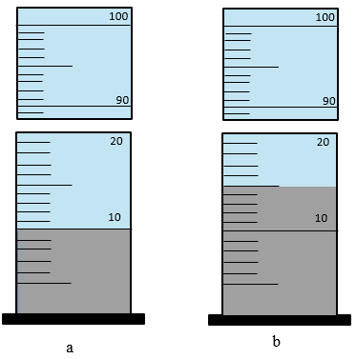
Figure 16- Illustration of swelling testing procedure using a graduated cylinder (a) initial state and (b) final state after a specified period of time

Cutting Dispersion Testing
The cutting dispersion test is a very useful test for investigating the interaction between drilling fluid systems and different shale formations. This test is mainly designed to investigate the effectiveness of different drilling fluid systems in maintaining the integrity of the cuttings and minimizing the interaction of fluids with shale formations during drilling or completion operations. Most reactive shale formations characterized by high to fairly amount of smectite and moderate content of illite are very suitable for this test. Cuttings generated using oil-based mud (OBM) are more effective for this test than those drilled with WBM as the cuttings may have already dispersed and reacted prior to the test. For this test, no cuttings were obtained from well A, therefore, cuttings were generated by breaking of core samples into smaller size up to 20 mesh. The procedure involved exposing the cuttings to a drilling fluid. The mixture is then rolled homogenously and heated for 16 hours using a heating oven. The heating oven was used due to the lack of roller oven, which is mostly used for the test. The cuttings are then retrieved, washed, weighted, and dried out in an overnight oven. After drying the cuttings, they are then re-weighted to determine the percent recovery. The effectiveness of the drilling fluid is based on the percent recovery. A more compatible drilling fluid is characterized by high percent recovery of the shale cutting.

Dynamic Drilling Simulation Testing
An innovative high-pressure high-temperature (HPHT) drilling simulator was used to conduct the required experiments to investigate the effectiveness of the designed drilling fluid systems (WBM, KCl, cesium formate) in drilling TMS formation. This innovative drilling simulator provides a great opportunity to simulate real-time drilling operation under actual downhole drilling conditions. The innovative HPHT simulator is a multi-purpose simulator. The equipment allows for testing of dynamic lubricity, filtration, and drilling. The dynamic lubricity testing of this innovative equipment provides an improvement over the more traditional static tester. The drilling simulator is connected to a data acquisition (DAQ) system which record the real-time drilling parameters such as torque, friction factor, lubricity, and rate of penetration (ROP) for post-experiment analysis. The drilling operation required materials such as a drilling fluid, a vertical cylindrical core sample, and some input drilling parameter. The vertical core sample used for the drilling operation in this research are prepared from core plugs obtained from the field case well located in the TMS. The core plugs are obtained from the most troublesome zone at depth ranging from 12181.3 ft to 12181.6 ft. The zone presents the highest risks of wellbore instability and slow drilling rates. The vertical cylindrical (Figure 17) core plugs prepared have required dimensions of 1.5 in diameter and 1.1 in length.
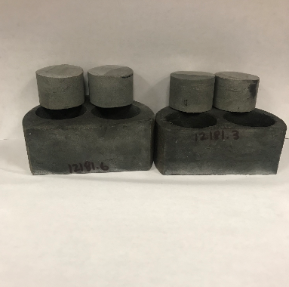
Figure 17- Vertical cylindrical core samples prepared from well A for drilling operations
Drilling operations are conducted for the four (4) selected drilling fluids which include WBM, 1 and 2% KCl, and cesium formate. A volume of 350 mL of the drilling fluid is required for the drilling test. The required volume is measured and poured into the core holder with the core. A 1-inch polycrystalline diamond compound (PDC) drill bit is used to fully drill to core sample. The required input parameters for the drilling experiments in this research are mostly based on analysis of previous drilling reports in the well A. Table 8 shows the input drilling parameters used in this study.

Table 8-Required input parameters and their values
Input parameters | Values
Temperature (ºF) | 120 +/- 5
Rotary speed (RPM) | 75
Back pressure (psi) | 100
Cell pressure (psi) | 200
Drilling fluid volume (mL) | 350
The testing procedure is divided into three main stages. The initial stage consists of heating up the system to the desired temperature. During this stage the drilling depth is set to zero (0), and the same cell and back pressure is applied using the regulators creating a differential pressure of zero (0). This is to prevent the drilling fluid from boiling in case its boiling temperature is reached. The second stage represent the drilling stage. In this stage, different weights on bit (WOB) are applied and cell and back pressure are set to their required values. In this research, the WOBs selected are 0, 50, and 100 lbs due to the limitation on the simulator. The normal loading system is equipped with a moving piston which applied the different WOBs during the drilling operations. The final stage consists of stopping and cooling down the system to room temperature. The dynamic drilling simulator has a maximum operating temperature and pressure of 500 ºF and 2000 psi respectively. Figure 18 shows a schematic of the drilling simulation setup and Figure 19 shows the workflow of the drilling simulation setup.
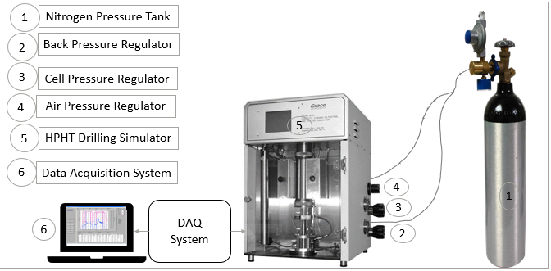
Figure 18- Schematic of the dynamic drilling simulation setup
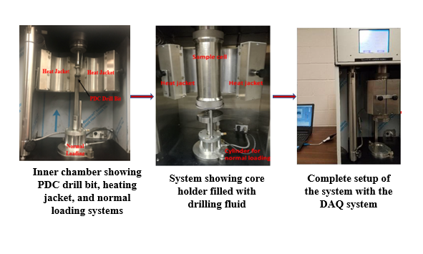
Figure 19- Workflow of the dynamic drilling simulation setup
The output drilling parameters are recorded using the DAQ system. The parameters include torque, friction factor, drilling rate, lubricity coefficient, drilling depth, fluid loss

Dynamic Fracture Sealing Testing
Another major wellbore stability issue in well A is the excessive losses encountered in different sections. This section focuses on the testing procedure for evaluating the effectiveness of some designed lost circulation materials (LCMs) in minimizing losses during drilling. Three set of LCMs are designed using cedar fiber. Cedar fiber is used as LCMs for the formation because its previous success in the neighborhood formation. The concentrations include 5 lb/bbl, 10 lb/bbl, and 20 lb/bbl. Three set of fracture slots of vertical openings are used in this study. The openings include 1000 µm, 2000 µm, and two 500 µm vertical fracture openings and a 1000 µm horizontal fracture opening. The fracture slots used in this study are custom-made from stainless steel in two parts. The primary top part has no opening while the bottom part has a fracture opening of with outer diameter of 1.5 inches, inner diameter of 1.0 inch, and a height of 1.1 inches as reported by Ezeakacha et al. (2019). The fracture sealing tests are conducted using the HPHT drilling simulator. The tests are all conducted at temperature of 120 ºF. Figure 20 shows the steel-based fracture slot used for the fracture sealing test.
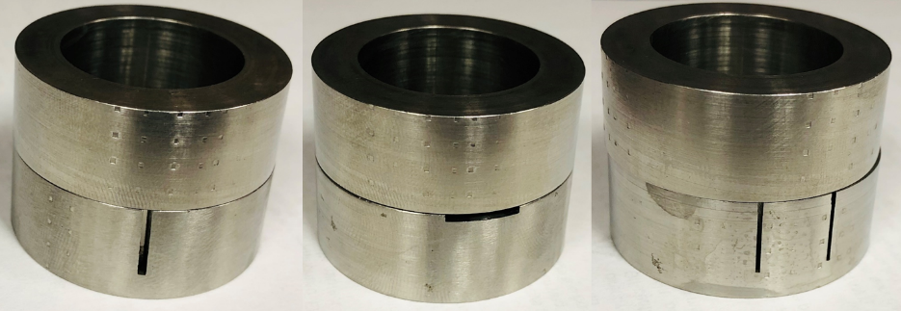
Figure 20- Fracture samples: from left to right is 1x1000 μm vertical, 1x horizontal 1000 μm, and 2x500 μm vertical fracture samples.

Experimental Results and Discussions

Overview
This section discusses the important findings of this research. The section provides an insight into the mineralogy of well A, the rheological characterization of the designed drilling fluids. The compatibility between drilling fluid and formation is evaluated in term of swelling and cutting recovery rate. The effect of some designed drilling fluids on drilling performance in the formation is also evaluated. The outcomes from this section provide an insight into the shale formation-drilling fluid interaction.

Mineralogy Characterization
The mineralogy in the Tuscaloosa Marine Shale (TMS) is highly dominated by clay, phyllosilicate mineral, quartz, and calcite. The formation is reported to be highly heterogeneous in term of mineralogy as function of depth. Mineralogy plays a major role in shale drilling fluid design and selection. Clay is one the most important mineral to consider when designing and selecting the appropriate drilling fluid systems for shale operation.
The Tuscaloosa Marine Shale (TMS) is characterized by its high concentration in clays. The FITR analysis revealed a clay content as high as 51 % in well A. The most common clays type include kaolinite, illite, and chlorite. These clays are highly detrimental to drilling due to their sensitivity to water. TMS formation is highly heterogeneous, which is reflected by the variation in mineralogy across the formation and at different depth. Borrok et al. (2019) in their study of mineralogy heterogeneity in Tuscaloosa Marine Shale, reported that concentration of most mineral tends to variate from the base TMS to higher elevation. Their study revealed that the transition from the lower Tuscaloosa to the TMS is defined by a decrease in quartz content, an increase in calcite, and finally a slight increase in total clay content. This trend was also experienced with the wells analyzed as quartz, calcite, and total clay content show both decreasing and increasing concentration as elevation increases. Their study showed an average clay content of more than 40 wt% from all the wells analyzed and the most dominant clays consisted of illite, kaolinite, chlorite, and smectite. These different concentrations were confirmed by the FTIR analysis in this study. Figure 21 shows the FTIR analysis of a core samples obtained from Well A.
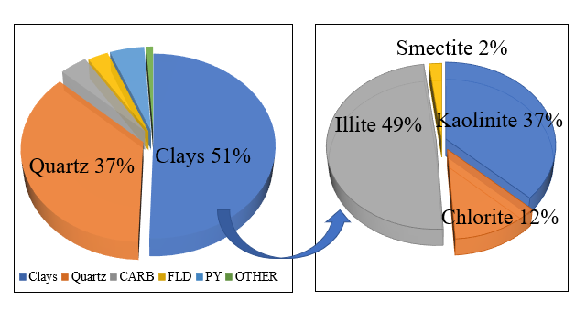
Figure 21-Mineralogy composition of the TMS obtained using FTIR analysis.
These clays exhibit a common characteristic of hydration swelling or dispersion when exposed to water depending on their sensitivities. Smectite exhibits colloidal expansion potential due to its high surface area, which could cause wellbore and mud control problems. Kaolinite and illite on the other end are highly dispersive and could cause hole cleaning problems and bit-balling issues. Uncontrolled disintegration of illite and kaolinite during drilling operation leads to excessive cuttings and improper hole cleaning. The compatibility issue between drilling fluid and the TMS formation limit the drilling activities in the plays

Drilling Fluid Characterization and Rheology
Drilling fluid is a major component of all drilling operations. The main functions of drilling fluid include providing stable wellbore, improving hydraulic, and controlling solid removal. The importance of selecting appropriate drilling fluid systems is much more crucial when dealing with clay dominated shale formations such TMS due incompatibility issues between the fluid and the formation. The rheological profiles of the tested fluids are shown in Figure 22 and Figure 23. Figure 22 shows the shear stress vs. shear rate plot of the tested drilling fluid systems at temperature of 120 ºF. All the plots were fitted with a power law equation where the consistency indices and flow behavior indices were reported. The rheological profile for all tested fluid systems showed an increase in shear stress as shear rate increases. This suggested a shear thinning process for all drilling fluid tested. A decrease of more than 60 % is realized in the shear stress when the inhibitive drilling fluid systems (1 wt% & 2 wt% KCl, cesium formate) are used instead of the conventional WBM. The rheological properties can be correlated to the interaction between the fluid system and the formation. The fluid rheological properties such as shear stress can give an indication of the fluid ability to control cutting erosion and integrity.

Figure 22- Rheological profile of the tested drilling fluid systems
Another important rheological property of drilling fluid that affect its performance is the apparent viscosity. The apparent viscosity characterized the viscosity at a given shear rate. Figure 23 shows the apparent viscosity profiles for the drilling fluid systems tested in this study. The plots show a decreasing correlation between the apparent viscosity and the shear rate. The decrease in the apparent viscosity can be explained by the molecule tendency of aligning with each other at high shear rate to allow easier flow (Peter et al. 2017). The conventional WBM displayed higher apparent viscosity, more than 50 % compared to the inhibitive mud systems (1 wt% & 2 wt% KCl, cesium formate). The low apparent viscosity realized with the inhibitive mud systems indicated easier flow compared to the conventional WBM. The shear thinning process (i.e. apparent viscosity decreases as the shear rate decreases) reported to be desirable in drilling fluids. According to Guven et al. 1988, The presence potassium ion (K⁺) and cesium ion (Cs⁺) forms strong bond between the smectite layers which leads to clay aggregate and therefore reduction in viscosity. This provides supporting ground to the low apparent viscosity obtained with the KCl based fluid systems and the cesium formate.

Figure 23- Apparent viscosity profile of the drilling fluid systems tested in this study

Wellbore Stability Analysis
Wellbore stability issues represent some of the major concerns associated with shale drilling. One of most important contributor of shale wellbore instability is the shale-fluid interaction. This section focuses on the impact of the designed drilling fluid systems on shale-fluid interaction. The results mainly focus on the impact of the drilling fluid systems on linear swelling index and cutting dispersion rate. The section also evaluates the effectiveness of LCMs in treating losses during drilling.

Linear Swelling Characterization
Clay dominated shale formations such as TMS are characterized by high concentration of detrimental clays including smectite, illite, and kaolinite that present both hydration and dispersion potential. Both hydrational swelling and dispersion constitute major concern for drilling operators. Shale swelling is an important parameter to evaluate when characterizing the shale-fluid interaction. The linear swelling is used to quantify the linear expansion of clay when exposed to drilling fluid systems. Shale swelling is very common in clay dominated formations such TMS and Eagle Ford. Shale swelling is very detrimental for drilling operations due all the concerns it engenders. Some related consequences of shale swelling include collapse, hole caving, and hole cleaning. The level of swelling is both influenced by the shale formation and the used drilling fluid system. The swelling index profile shows the effect of different drilling fluid systems on clay expansion during drilling operations. In this study, the swelling index was computed based on the change in volume after a certain period of time. It was obtained from the equation below.
$σ=\frac{H_{1}-H_{0}}{H_{0}}*100$………………………………………………………………….……… (1)
Where $H_{0} represents the initial volume, H_{1} the final volume, and σ the shale swelling index$
The swelling index was obtained for all four (4) drilling fluid systems tested in this study for TMS while using freshwater as reference fluid. Figure 24 displays the different swelling indices obtained for twenty-four (24) hours. The profile revealed that freshwater displayed the highest swelling index in TMS while cesium formate showed the lowest, which was more than 80% lower than conventional WBM. Freshwater showed higher swelling index due to presence of water sensitive clay (illite, kaolinite, and smectite) in the formation. Among the drilling fluid, the conventional WBM showed the highest swelling index followed by the 1 wt% KCl, the 2 wt% KCl, and then the cesium formate. These results showed the impact that inhibitive mud systems have in controlling swelling of shale during drilling. The inhibitive mud systems showed the ability to minimize shale swelling therefore providing improved shale-fluid interaction as a result ensure better drilling performance by minimizing the drilling concerns such as hole cleaning, stuck pipe, borehole collapse, and therefore reducing the non-drilling time (NDT).

Figure 24- Swelling index profile of the drilling fluid systems tested in this study with freshwater as reference fluid.
Shale swelling is highly impacted by the time of exposure to the drilling fluid systems. Figure 25 shows the impact of exposure time on swelling indices for the tested drilling fluid systems. The profile shows an increase in swelling index as time increases for all fluid systems. This trend was confirmed by Al-Awad and Smart (1996) as their study also revealed an increasing trend between the linear swelling index and the exposure time. The cesium formate and 2% KCl show the lowest increase in linear swelling index from 1 day to seven (7) days.

Figure 25- Swelling index profile of the drilling fluid systems tested in this study with freshwater as reference fluid for different exposure times
The swelling index results show that better shale-fluid interaction is obtained using the inhibitive mud systems especially the cesium formate and the 2% KCl. The low shale swelling obtained with these drilling fluids implies a decrease in capillary pressure, an increase in pore pressure, and a frictional reduction. These results are based on crushed shale sample. Therefore, swelling rate may be different if an intact shale sample is used. According to a study performed by Al-Awad and Smart (1996), intact shales have low swelling ability compared to crushed samples due to the destruction of bonds between clay platelets during the crushing process.

Cutting Dispersion Analysis
Cuttings and cavings play a major role in understanding wellbore instability. Cutting volume, shape, and size are major indicators of wellbore instability in shale. Cuttings greatly influence hole cleaning and bit-balling behavior. Hole cleaning and bit-balling are major consequences of wellbore instability and greatly influence drilling performance. Cuttings dispersion test is important for investigating cutting stability and bit-balling behavior. Shale dispersibility into drilling fluid systems is greatly influenced by factors such as shale particle size (exposed surface area), rheological properties such as viscosity, shale compaction, and temperature. Cutting recovery is based on the following equation:
$CR=\frac{Wf}{Wi}*100$………………………………………………………………….……… (2)
Where $W_{i} represents the initial cutting weight, W_{f} the final weight, and CR the shale swelling index$
Table 9 shows the data collected from the dispersibility test including the calculated cutting recovery based on equation 2.
Table 9- Cutting recovery percent for the tested drilling fluid systems
Drilling Fluids | Initial Weight(g) | Recovered weight(g) | Recovery (%)
Freshwater | 12 | 7.8 | 65
WBM | 12 | 9 | 75
1% KCl | 12 | 9.8 | 82
2% KCl | 12 | 10.1 | 84.5
Cesium formate | 12 | 10.3 | 85.7

The cutting recovery profile (Figure 26) shows that the highest recovery rate is obtained using the cesium formate and 2% KCl with a recovery of 85.7% and 84.5% respectively. On the other hand, freshwater and WBM show the lowest cutting recovery with 65% and 75% respectively. These results imply better cutting stability with the inhibitive muds as opposed to the conventional WBM. The low dispersibility realized with the inhibitive mud systems show beter cuttings integrity. The cutting recovery profile indicates that lower bit-balling is more likely to be achieved with the inhibitive mud systems as opposed to the conventional WBM. This is due to the low dispersibility and improved cutting integrity when exposed to the inhibitive drilling fluid systems. A combination of low cutting dispersibility and improved cutting integrity correlated to low bit-balling as the reduce the cuttings tendency to stick to the bit as their removal is much easier.

Figure 26- Cutting recovery rate of different drilling fluid systems used in this study.

Wellbore Strengthening
Lost circulation during drilling is one of the major consequences of wellbore instability in shale. Previous drilling reports suggested that excessive lost circulation accounts for more than 40% of the total NPT in well A. The losses in the well are mostly due to the presence of both natural and induced fractures. The fractures have both vertical and horizontal orientation. Strengthening the wellbore by sealing existing fractures helps improve drilling efficiency and save on drilling cost. According to Ezeakacha et al. (2019), Lost circulation is mostly influenced by fracture width and orientation. Figure 27 shows the effect of fracture width on cumulative dynamic fluid loss for different cedar fiber concentrations. Cedar fiber is used in this study due to its previous success in the formation.

Figure 27- Cumulative dynamic fluid loss for different fracture widths as function of cedar concentration.
The results show an increase in the cumulative dynamic fluid loss as the fracture width increases. This implies that lost circulation is more pronounced for wellbore with larger fracture openings. This supported by a similar study performed by Ezeakacha et al. (2019). Additionally, the cumulative fluid loss profile indicates that the lowest losses are obtained using the concentration of 20 lb/bbl cedar Fiber. This implies that this concentration will be effective in strengthening the wellbore and minimizing lost circulation. Higher concentration of cedar fiber (>20 lb/bbl) was not used in this study because of pumpability issues. A mud engineer from Goodrich (a major operator in the TMS) confirmed that most of the wells drilled by his company used a 20 lb/bbl concentration, which was effective in treating losses.
Additionally, lost circulation is greatly influenced by fracture orientation and number of fractures. Figure 28 shows the impact of fracture orientation and number of fractures on dynamic fluid loss. All the fracture slots have the same total fracture width of 1000 µm.

Figure 28- Cumulative dynamic fluid loss as function of fracture orientation for one fracture width of 1000 µm.
The results show that the fracture slot with two 500 µm openings had lower dynamic loss compared to one fracture opening of 1000 µm. Since both fracture slots have the same fracture width, they are expected to yield similar dynamic losses. However, two openings of 500 µm are much easier to sealed as opposed to a 1000 µm opening resulting in lower dynamic loss. Furthermore, the results show low dynamic losses with the horizontal fracture opening compared to vertical fracture. Similar conclusion was reached by Ezeakacha et al. (2019). The low dynamic losses with the horizontal fracture can be attributed to two main factors: the variation in volume and the wellbore orientation. Despite having similar total fracture widths, the horizontal fracture has lower height compared to vertical fracture resulting in lower overall fracture volume. A vertical wellbore is used in study, so the LCM mud flows vertically which results in faster sealing time for horizontal fractures. This study indicates that fracture positioning and orientation greatly impact dynamic fluid loss during drilling. Overall, treatment of loss circulation in this formation is highly dependent the type and concentration of LCM, the temperature, and fracture width. This is also supported by studies performed by Ezeakacha et al. (2017) and Ezeakacha et al. (2019) which suggested that factors such as LCM type, temperature, and lithology impact the rate of dynamic loss.

Drilling Performance
In order to effectively evaluate the performance of drilling fluid systems, it is crucial to analyze their impact on drilling parameters such as torque, friction factor, rate of penetration (ROP), and the mechanical specific energy (MSE).

Torque and Friction Factor During Drilling
Excessive torque and friction factor during drilling constitute a major concern for all drilling operators. Excessive torque and friction factor during drilling could be an indication of possible pipe sticking, which is one cause of wellbore instability. High torque and drag forces, and friction factor constitute major limitations in extended reach, direction wells, and deep wells as they prevent operators from reaching target or increase the total drilling time. Drilling performance can be improved by minimizing both torque and friction factor during drilling. In this work, the effect of inhibitive mud systems on torque and friction factor during shale drilling was evaluated in the TMS. Figure 29 and Figure 30 show the torque and friction factor profiles respectively. The profiles revealed an increasing relationship between both the torque and the friction factor and the weight on bit (WOB). Among the drilling fluid systems tested, the conventional WBM showed the highest torque and friction factor while the cesium formate showed the minimum. The inhibitive mud systems showed a reduction of more than 50% in both torque and friction factor at higher WOB. This indicates that all three inhibitive mud systems tested in this study provide better drilling performance as opposed to conventional WBM. The comparative analysis of the performance of all four drilling fluid systems was performed on samples from Well drilled into the TMS. The low torque and friction factor realized with the inhibitive mud systems show the positive impact they have on shale drilling performance. Among the inhibitive mud systems, the cesium formate brine provided the lowest friction factor and torque, which indicated better drilling performance compared to the KCl based systems.

Figure 29- Effect of the tested drilling fluid systems on torque during drilling.

Figure 30- Effect of the tested drilling fluid systems on friction factor during drilling

Rate of Penetration (ROP) Optimization
The rate of penetration (ROP) constitutes one of the most important parameters to evaluate when analyzing drilling performance. The ROP refers to how fast we can drill. Most shale formations such as the TMS and the Eagle Ford are characterized by low drilling rate. This issue is mostly due to factors such as bit-balling, pipe hole sloughing that are caused by the incompatibility between the inappropriate fluid system and the formation. In this study, the effect of inhibitive mud systems (1 wt% & 2 wt% KCl, cesium formate), and the conventional WBM on the drilling rate was evaluated in the TMS. The rate of penetration is characterized as a dependent parameter that can be predicted using independent parameters such as weight on bit (WOB), and rotary speed. The drilling conditions were consistent and all the same for drilling tests in order to fully evaluated the effect of drilling fluid systems. Figure 31 shows the ROP profile of the drilling fluid systems tested on TMS core samples.

Figure 31- ROP profile of the tested drilling fluid systems
The results show an increasing correlation between the ROP and the WOB for all drilling fluid systems. Based on the ROP profile, conventional WBM showed the lowest ROP at various weight on bit (WOB) among the drilling fluid systems tested. This result was an indication of the incompatibility issues associated with WBM. Among the inhibitive mud systems tested, the cesium formate showed the highest rates followed by the 2 wt% KCl, and finally the 1 wt% KCl. This analysis indicates that cesium formate could constitute the most appropriate drilling fluid systems for reactive shale formations due to its elevated rate of penetration. However, due to the high cost of cesium formate and the closeness in drilling performance between the cesium formate and the 2% KCl fluid system, the use of KCl fluid systems will be more suitable as it will be cost effective and simultaneously solve the issue of low drilling rate in reactive shales These results were also supported by the swelling indices obtained in both formations for the tested drilling fluid systems. These ROP results can change as the temperature changes across the formation. Zhang et al. (2014) suggested that temperature differential at the rock surface reduces the rock’s resistance to drill. This suggests an increase in ROP as the temperature differential increases.

Mechanical Energy (MSE) Optimization
Another major parameter for measuring drilling efficiency is the mechanical specific energy (MSE). The MSE is defined as the amount of energy required for removing a unit of volume rock. The MSE is highly dependent on factors such as torque, weight on bit (WOB), rate of penetration (ROP), and rotary speed (RPM). Pessier et al. (1992) reported that drilling efficiency can be improved by optimizing the controllable factors that will eventually lead to minimum MSE. In this study, the MSE was computed using the controllable factors including torque, rate of penetration, rotary speed, and WOB obtained during drilling operations. The calculation of the MSE was done using the equation below with a mechanical efficiency of 0.125. The mechanical efficiency is both bit and formation specific. It varies greatly from bit to bit and from formation to formation. Amadi reported that the mechanical efficiency for directional and horizontal drilling is assumed to be 12.5%.
$MSE=E_{f}*\left(\frac{WOB}{A_{B}}+\frac{120*π*RPM*T}{ROP*A_{B}}\right)…………………………………………………………(3)$ The effect of the four (4) drilling fluid systems (conventional WBM, and 3 inhibitive mud systems) was evaluated for TMS core samples. Figure 32 shows the MSE profile at various WOB for the tested drilling fluid systems in TMS.

Figure 32- The mechanical specific energy profile for the tested drilling fluid systems.
The profile revealed that the highest MSE was realized with the conventional WBM, followed by the 1 wt% KCl, then the 2 wt% KCl, and finally the cesium formate. The MSE realized with conventional WBM was 80% higher than that of the inhibitive mud systems (1 wt%, 2 wt% KCl, cesium formate). This implies that the inhibitive mud systems will be highly efficient for drilling clay-concentrated shale formations than the WBM. This is supported by study conducted by Xuyue et al. (2018) which revealed that the drilling efficiency is indirectly proportional to the MSE. This implies that as the MSE decreases, the drilling efficiency increases. Among the inhibitive mud systems, the cesium formate provided the highest performance as it required less energy to drill a volume of rock.

Summary and Conclusions
This research addresses the wellbore stability issue in shale drilling by evaluating the compatibility between shale and drilling fluid systems. It provides an insight into shale-drilling fluid interaction in term of hydration (swelling) and cutting dispersion. It also evaluates the impact of inhibitive fluid systems on shale drilling performance. A combination of three inhibitive mud systems (cesium formate, 1 wt%, 2wt % KCl based fluids) and a convention WBM are used in this study. The following conclusions were drawn based on the results and findings of this work:
- Well A of TMS is clay dominated with a clay content of 51%. The primary clays include illite, chlorite, kaolinite, and smectite. These reactive clays need to be considered when selecting compatible drilling fluid systems for the formation
- Rock-fluid interaction is greatly impacted by the rock properties such as mineralogy and fluid composition and formulation.
- Cesium formate and KCl based fluid systems showed the lowest linear swelling index showing compatibility with the formation.
- Cesium formate and KCl based fluid systems lowest increase in linear swelling as time increases. These fluid systems can be used for extending period of time with minimum compatibility issues.
- The inhibitive mud systems show minimum dispersibility with a cutting recovery of more than 80%.
- Cesium formate and KCl based fluid systems are effective in maintaining a stable wellbore due to their low hydration (swelling) and dispersion.
- Cesium formate and KCl based fluid systems maintain the cutting integrity during drilling. Therefore, facilitating their removal and minimize bit-balling during drilling.
- Lost circulation is greatly impacted by the fracture width, positioning, and orientation. Horizontal fracture has lower dynamic losses compared to vertical fracture for all concentrations of cedar fiber.
- A concentration of 20 lb/bbl of cedar fiber is effective in treating lost circulation in Well A drilled into TMS.
- The inhibitive mud systems show the lowest torque and friction factor during drilling indicating better drilling performance.
- The highest rate of penetration during drilling was realized with cesium formate, followed by the 2% KCl mud, while the lowest was associated with the conventional WBM. No major difference in ROP was realized between the cesium formate and the KCl systems. The KCl mud systems can be an alternative to cesium formate to save cost.
- A minimum mechanical specific energy was realized with the cesium formate and the 2% KCl mud system, while the conventional WBM showed the maximum MSE which was 80% higher than that of the inhibitive mud systems (1% and 2% KCl, and cesium formate).

Recommendations and Future Work
Despite the in-depth work done in this study, improvements can still be made. Following are the recommendations to further investigate the impact of inhibitive mud systems on shale stability and drilling performance.
- The ASTM standard section D 5890 for swelling testing is still valid and effective for characterizing swelling index. However, the innovative linear swell meter should be used to account for confining pressure and temperature.
- This work focuses only on formate brine and KCl based fluids as inhibitive fluids. However, the effectiveness of other inhibitive systems such as silicate and glycol based inhibitive mud systems should be evaluated.
- Enhanced nano-drilling fluid systems should be investigated for shale applications
- Future work could involve conducting additional shale- fluid compatibility tests such as cation suction test (CST), cation exchange capacity (CEC), and shale water activity determination to firmly confirmed the compatibility between the fluids systems used and TMS formation.
- A cost-effective analysis should be conducted before selection of appropriate drilling fluid systems for shale operations.
- Work in future can focus on testing the fluid systems at higher temperature in the range of 300 ºF to 400 ºF to evaluate application for deep wells and geothermal wells.
- The work can also be extended to the neighborhood shale formations such as Eagle ford shale.

Nomenclature and Acronyms
A_{B}: Cross-sectional area
DAQ: Data Acquisition System
Ef: Mechanical efficiency
HPHT: High-Pressure High-Temperature
Lb/bbl: Pounds per Barrel
MSE: Mechanical specific energy
NDT: Non-Drilling Time
NPT: Non-Productive Time
OBM: Oil-Based Mud
ROP: Rate of penetration
RPM: Rotary speed
T: Torque
TMS: Tuscaloosa Marine Shale
WBM: Water-Based Mud
WOB: Weight on bit
LCM: Lost circulation materials
PDC: Polycrystalline diamond compact
EIA: Energy information administration
HPWBM: High-performance water-based mud
WOC: Wait on cement
Al: Aluminum
O: Oxygen
OH: Hydroxyl
Mg: Magnesium
Fe: Iron
Si: Silicate
BHA: Bottom hole assembly
ECD: Equivalent circulating density
FTIR: Fourier-transform infrared spectroscopy
ASTM: American society of testing material

References
Abrams, A. 1997. Mud Design to Minimize Rock Impairment Due to Particle Invasion. Journal of Petroleum Technology. SPE-5713-PA. http://dx.doi.org/10.2118/5713-PA

Ahmed A. E., Mohammed S. F., Eric W. T., Mohammed K., 2016. A Study of Friction Factor Model for Directional Wells. Egyptian of Journal of Petroleum. Suez, Egypt, July 4. assigned to Halliburton Co.; 1989.

Arambulo, V. H. S., Colque, J. N. P., Alban, E. D. A., & Ahmed, R. M. (2015, September 28). Case Studies Validate the Effectiveness of Aluminum-based HPWBM in Stabilizing Micro-Fractured Shale Formations: Field Experience in the Peruvian Amazon. Society of Petroleum Engineers. doi:10.2118/174854-MS
Aston, M. S., & Elliott, G. P. (1994). Water-based glycol drilling muds: Shale inhibition mechanisms. European Petroleum Conference, (1/-), 107–113.

Awal, M. R., Khan, M. S., Mohiuddin, M. A., Abdulraheem, A., & Azeemuddin, M. 2001. A New Approach to Borehole Trajectory Optimization for Increased Hole Stability. Society of Petroleum Engineers. http://dx.doi.org/10.2118/68092-MS.

Beihoffer. (1990). The Development of an Inhibitive Cationic Drilling Fluid for Slimhole Coring Applications.

Benaissa, S. (1997). Oil Field Applications of Aluminum Chemistry and Experience with Aluminum-Based Drilling Fluid Additive.

Borrok, D. M., Wan, Y., Wei, M., Mokhtari, M., 2019. Heterogeneity of the Mineralogy and Organic Content of the Tuscaloosa Marine Shale. Marine and Petroleum Geology 109 (2019) 717-731.

C.P. Ezeakacha, S. Salehi. 2018. Experimental and statistical investigation of drilling fluids loss in porous media-Part 1. J. Nat. Gas Sci. Eng., 51 (2018), pp. 104-115

C. Peter Ezeakacha, S. Salehi. 2019. Experimental and statistical investigation of drilling fluid loss in porous media: Part 2 (Fractures). J. Nat. Gas Sci. Eng., 65 (2019), pp. 257 266, 10.1016/j.jngse.2019.03.007
Chenevert, M. E. 1970. Shale Control with Balanced-Activity Oil-Continuous Muds. Society of Petroleum Engineers. http://dx.doi.org/10.2118/2559-PA.
Chenevert, M. E., 1970. Shale Control with Balanced Activity Oil-Continuous Muds. J. Pet. Tech. 1309-1319.

Cai, J., Chenevert, M. E., Sharma, M. M., & Friedheim, J. E. (2012). Decreasing Water Invasion into Atoka Shale Using Nonmodified Silica Nanoparticles. SPE Drilling & Completion, 27(1), 103–112. https://doi.org/10.2118/146979-PA.

Civan, Faruk; Mechanism of Clay Swelling from Reservoir Formation Damage - Fundamentals,

Denney, C., 2018, Drilling Overview of Tuscaloosa Marine Shale. Presented at the Tuscaloosa Marine Shale Consortium, Lafayette, Louisiana, 6-7 September.

Dennis, E. O., Chenevert, M. E.,1973. Stabilizing Sensitive Shales with Inhibited, Potassium-Based Drilling Fluids. Journal of Petroleum Technology. September. SPE- 4232-PA. http://dx.doi.org/10.2118/4232-PA

Deville, J.P., Fritz,B., Jarrett, M., 2011. Development of Water-Based Drilling Fluids Customized for Shale Reservoirs. SPE International Symposium on Oilfield Chemistry, 11-13 April, The Woodlands, Texas. SPE-140868-MS https://doi-org.ezproxy.lib.ou.edu/10.2118/140868-MS

Downs, J. D. (2006). Drilling and Completing Difficult HPHT Wells with the Aid of Cesium Formate Brines – A Performance Review. Society of Petroleum Engineers. http://dx.doi.org/10.2118/99068-MS.
Downs, J. D. (2010). A Review of the Impact of the Use of Formate Brines on the Economics of Deep Gas Field Development Projects. Society of Petroleum Engineers. http://dx.doi.org/10.2118/130376-MS.
Dupriest, F. E., and Koederitz, W. L. 2005. Maximizing Drill Rates with Real-Time Surveillance of Mechanical Specific Energy. Society of Petroleum Engineers. http://dx.doi.org/10.2118/92194-MS.
Ezeakacha C. P. 2018. Dynamic Drilling Fluid Loss and Filtration: Impact of Dynamic Wellbore Conditions and Wellbore Strengthening Implications PhD Dissertation, The University of Oklahoma, Norman, Oklahoma (December 2018). https://hdl.handle.net/11244/316304
Guven N, Panfl DJ, Carney LL (1988) Comparative rheology of water-based drilling fluids with various clays. Paper presented at the international meeting on petroleum engineering
H. Zhang, D. Gao, S. Salehi, B. Guo. 2014. Effect of fluid temperature on rock failure in borehole drilling. ASCE J. Eng. Mech., 140 (1), pp. 82-90

Hackley, P., Celeste, D.L., Brett, J.V., Frank, T.D., 2017. Preliminary Regional Characterization Update of the Tuscaloosa Marine Shale in Southern Mississippi: Implications for CO2 Sequestration. Geological Society of America Conference, Richmond, Virginia. http://dx.doi.org/10.1130/abs/2017SE-291206

Himes, R, E., Vinson, E, F. Stabilizing clay-containing formations. EP patent 308 138, http://dx.doi.org/ 10.2118/59181-MS.

Irawan, S., Kinif, B. I., Bayuaji, R., 2017. Maximizing Drilling Performance Through Enhanced Solid Control. Material Science and Engineering 267 (2017) 012038. doi:10.1088/1757-899X/267/1/012038

John, C.J., Moncrief, J.E., Jones, B.L., Harder, B.J., Bourgeois. 1997. Regional Extent and Hydrocarbon Potential of the Tuscaloosa Marine Shale, United States Gulf Coast. Gulf Coast Association of Geological Societies. V. 47, pp. 395-402

Junhao, Z., and Shawn, L. 2017. Evaluation of Measurement Techniques for Fluid Lubricity in the Laboratory. 2017 AADE National Technical Conference and Exhibition, Houston, Texas, 11-12 April. AADE-17-NTCE-100.

Konate, N., Ezeakacha, C, P., Salehi, S., and Mokhtari, M. 2019. Application of an Innovative Drilling Simulator Set Up to Test Inhibitive Mud Systems for Drilling Shales. Presented at SPE Oklahoma City Oil and Gas Symposium, Oklahoma City, Oklahoma, 9-10 April, SPE-195189-MS. http://dx.doi.org/10.2118/195189-MS

Konate, N., Magzoub, M., Salehi, S., Ghalambor, A., & Mokhtari, M. 2020. Laboratory Evaluation of Mud Systems for Drilling High Clay Shales in Dynamic Conditions: Comparison of Inhibitive Systems. Society of Petroleum Engineers. https://doi.org/10.2118/199316-MS.

Lijun, Y., Yili, K., Zhangxin, C., Qiang, C., and Bin, Y. 2014. Wellbore Instability in Shale Gas Wells Drilled by Oil-Based Fluids. International Journal of Rock Mechanics & Mining Sciences (72) 294-299. https://doi.org/10.1016/j.ijrmms.2014.08.017

Omojuwa, E. O., Osisanya, S. O., & Ahmed, R. (2011, January 1). Properties of Salt Formations Essential for Modeling Instabilities While Drilling. Society of Petroleum Engineers. doi:10.2118/150801-MS

M.E. Chenevert, V. Pernot, 1998. Control of Shale Swelling Pressures Using Inhibitive Water Based Muds, SPE 49263 presented at the SPE Annual Technical Conference and Exhibition, New Orleans, September 27–30.
Magzoub, M. I., Salehi, S., Hussein, I.A., and Nasser, M. 2019. Loss circulation in drilling and well construction: The significance of applications of crosslinked polymers in wellbore strengthening: A review. Journal of Petroleum Science and Engineering.
Mancini, E.A. and Puckett, T.M. 2002. Transgressive-Regressive Cycles: Application to Petroleum Exploration for Hydrocarbons Associated with Cretaceous Shelf Carbonates and Coastal and Fluvial-Deltaic Siliciclastics, Northeastern Gulf of Mexico. SEPM Foundation, pp. 173-199.
Mario Z., Mike S., 2017. Drilling Fluids. Halliburton PWC_Book. Last visited February 24, 2020. https://www.halliburton.com/content/dam/ps/premium/common/PWC_Book/PWC05.PDF
Ming, L., Hongjuan, O., Zaoyuan, L., Tao, G., Honghua, L., and Xiaoyang, G. 2015. Contamination of Cement Slurries with Diesel-based Drilling Fluids in Shale Gas Wells. Journal of Natural Gas Science and Engineering 27, 1312-1320. Modeling, Assessment, and Mitigation; Elsevier; 2000.

Mohiuddin, M. A., Awal, M. R., Abdulraheem, A., & Khan, K. (2001, January 1). A New Diagnostic Approach to Identify the Causes of Borehole Instability Problems in an Offshore Arabian Field. Society of Petroleum Engineers. http://dx.doi.org/10.2118/68095-MS.

Mullen, J., 2010. Petrophysical Characterization of the Eagle Ford Shale in South Texas. Presented at the Canadian Unconventional Resources and International Petroleum Conference, Calgary, Alberta, CSUG/SPE-13814-MS. http://dx.doi.org/10.2118/138145-MS.

Murray, H. H., 2007. Applied Clay Mineralogy: Occurrences, Processing, and Application of Kaolins, Bentonites, Palygorskite-Seniolite, and Common Clays, Vol 2. Elsevier, Amsterdam.
Pasic B, Gaurina-Meðimurec N, Matanovic D. 2007. Wellbore instability: causes and consequences. Rudarsko-geolosko-naftni zbornik Volume 19. Issue 1. PP 87-98.

Patel, A., Stamatakis, S., Young, S., & Friedheim, J. (2007). Advances in Inhibitive Water-Based Drilling Fluids—Can They Replace Oil-Based Muds? International Symposium on Oilfield Chemistry. https://doi.org/10.2118/106476-MS.

Ramirez, M. A., Sanchez, G., Preciado Sarmiento, O. E., Santamaria, J., & Luna, E. 2005. Aluminum-Based HPWBM Successfully Replaces Oil-Based Mud To Drill Exploratory Wells in an Environmentally Sensitive Area. Society of Petroleum Engineers. doi:10.2118/94437-MS
Remmert, S. M., Witt, J. W., and Dupriest, F. E. 2007. Implementation of ROP Management Process in Qatar North Field. Society of Petroleum Engineers. http://dx.doi.org/10.2118/105521-MS.
Salehi, S., and Kiran, R. 2016. Integrated Experimental and Analytical Wellbore Strengthening Solutions by Mud Plastering Effects. ASME. J. Energy Resources. Technol.138(3):032904-032904-7. http://dx.doi.org/10.1115/1.4032236

Salehi, S., Ghalambor, A., Saleh, F., K. et al. 2015. Study of Filtrate and Mud Cake Characterization in HPHT: Implications for Formation Damage Control. SPE European Formation Damage Conference and Exhibition, Budapest, Hungary, 3-5 June. SPE 174273-MS. http://dx.doi.org/10.2118/174273-MS.

Salehi, S. 2012. Numerical simulations of Fracture Propagation and Sealing: Implications for Wellbore Strengthening. PhD Dissertation. Missouri University of Science and Technology, Rolla, Missouri USA

Salehi, S., R. Nygaard. 2011. Numerical study of fracture initiation, propagation, sealing to enhance wellbore fracture gradient. 45th US Rock Mechanics/Geomechanics Symposium, San Francisco California. 26-29 June. ARMA 11–186

Samuel, O, O., 2011. Practical Approach to Solving Wellbore Instability Problems. Presented at the Distinguished Lecture Program, Norman, Oklahoma. www.spe.org/dl.

Santarelli, F. J., Chenevert, M. E., & Osisanya, S. O. 1992. On the Stability of Shales and Its Consequences in Terms of Swelling and Wellbore Stability. SPE/IADC drilling Conference, Louisiana, New Orleans, 18-21 February. SPE-23886-MS http://dx.doi.org/10.2118/23886-MS

Sawhney, B., L., 1970. Potassium and Cesium Ion Selectivity in Relation to Clay Mineral Structure. Clay and Clay Minerals 18, 47-52.

Shah, S.N., Shanker, N.H., Ogugbue, C.C., 2010. Future Challenges of Drilling Fluids and Their Rheological Measurements. AADE Fluids Conference and Exhibition, Houston, TX.

Shaughnessy, M. and Locke, A. 2000. 20-plus years of Tuscaloosa drilling: Continuously optimizing deep HTHP wells. Presented at SPE Drilling Conference, Louisiana, New Orleans, 23-25 February. SPE -59181-MS.

Smith, R. H., Lund, J. B., Anderson, M., & Baxter, R. (1995). Drilling Plastic Formations Using Highly Polished PDC Cutters. Society of Petroleum Engineers. http://dx.doi.org/10.2118/30476-MS.
Tovey, N.K. A selection of scanning electron micrographs of clays, University of Cambridge,
Van Oort, E. (2003). On the physical and chemical stability of shales. Journal of Petroleum Science and Engineering, 38(3-4), 213-235
U.S. Energy Information Administration (EIA). Visited February 20, 2020.
https://www.eia.gov/todayinenergy/detail.php?id=38372

Van Oort, E. 1997. Physio-Chemical Stabilization of Shales. SPE Oilfield Chem. International Symposium, Houston, Texas, SPE-37263-MS. http://dx.doi.org/10.2118/37263-MS.

Van Oort, E., Bland, R., & Pessier, R. (2000). Drilling More Stable Wells Faster and Cheaper with PDC Bits and Water Based Muds. Society of Petroleum Engineers. http://dx.doi.org/10.2118/59192-MS.
Van Oort, E., Hale, A. H., and Mody, F. K. (1995). Manipulation of Coupled Osmotic Flows for Stabilization of Shales Exposed to Water-Based Drilling Fluids. Society of Petroleum Engineers. http://dx.doi.org/10.2118/30499-MS.
Van Oort, E., Ripley, D., Ward, I., Chapman, J. W., Williamson, R., & Aston, M. (1996). Silicate-Based Drilling Fluids: Competent, Cost-effective and Benign Solutions to Wellbore Stability Problems. SPE/IADC Drilling Conference. https://doi.org/10.2118/35059-MS.
Ward, I., Chapman, J. W., & Williamson, R. (1999). Silicate Based Muds: Chemical Optimization Based on Field Experience. SPE Drilling & Completion, 14(1), 57–63. https://doi.org/10.2118/55054-PA.
Zijsling, D. H., and Illerhaus, R. (1993). Eggbeater PDC Drillbit Design Eliminates Balling in Water-Based Drilling Fluids. Society of Petroleum Engineers. http://dx.doi.org/10.2118/21933-PA.
Zuvo, M., Bjornbom, E., Ellingsen, B., Downs, J. C., Kelley, A., and Trannum, H. C. (2005). High-Resolution Environmental Survey Around an Exploration Well Drilled 106

Appendix A: Additional Procedures

Core samples preparation
The innovative drilling simulator uses cylindrical core samples. The core samples have dimensions of 1.1 inch in height and 1.5 inch in diameter. The core samples are prepared using a coring machine (Figure A1).
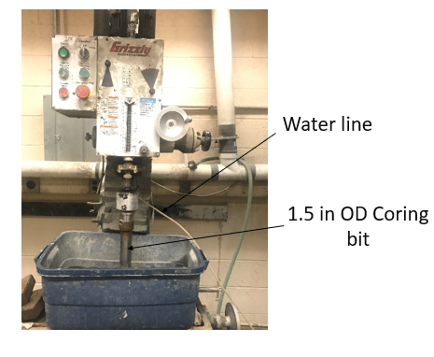
Figure A1: Coring machine
A coring bit with an inner diameter of 1.5 in is used for coring the smaples. The coring bit is securely attached to the coring machine. The machine is equipped with a water line to to lubricate the coring bit and facilitate the coring process. The secured coring bit is slowly lowered to make to fully drilled the core block. After coring, the samples are cut to the required height and the surfaces are fully polished for a flat surface.

Linear swell meter
In this research, the swelling index is quantified using the ASTM standard D 5890 which relies on the used of graduated cylinder. Despite the effectiveness of this test, it still presents some major limitations regarding temperature, and confining pressure. The linear swell meter (Figure A2) is one of the most effective swelling testing equipment that overcome the limitations of our testing procedure.
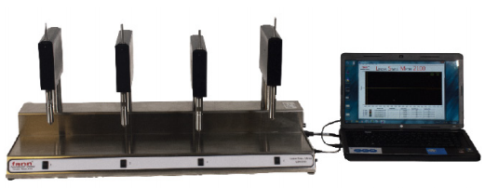
Figure A2: Linear swell meter attached to a data acquisition system
This equipment has an operating temperature of 120 ºF (49 ºC) and allow testing at different confining pressure. The swell tester measures the swelling on both reconstituted and intact shale core samples.

Appendix B: Additional Results

Cation suction time (CST)
Cation suction time (CST) is another important method for evaluating the compatibility between drilling fluid systems and shale formation. This method mainly measures the time required for a mud filtrate to travel a distance through a porous media. It simulates the manner in which free water from drilling fluid systems penetrates into the formation under the capillary suction pressure. This test characterizes the inhibition abilities of different drilling fluid systems. Figure B1 shows the cation suction time of some fluid systems tested by Goodrich Petroleum Inc.
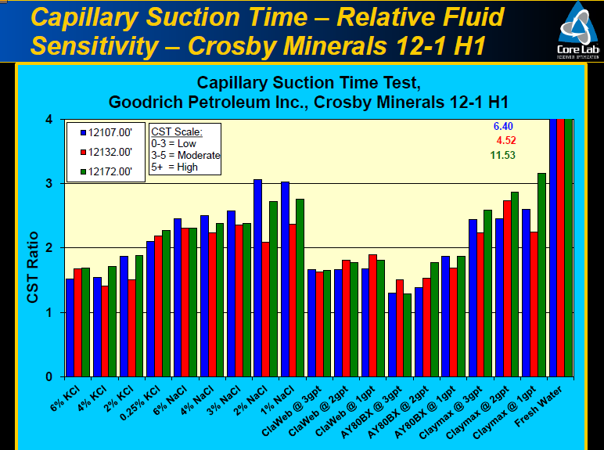
Figure B1: Cation suction time of different drilling fluid systems well A. (Goodrich Petroleum, 2017)
The study revealed that KCl based fluids show some of the lowest cation suction times. All KCl based fluid systems displayed a CST ratio less than 2, indicating better inhibition abilities. This support the results presented in this work which suggests a better compatibility between KCl based fluid systems and the TMS.

Temperature effect on torque
Temperature greatly impact the rheological properties of all drilling fluid systems. The TMS formation is characterized to have high temperature. The impact of temperature on drilling parameters such as torque during drilling is evaluated. Figure B2 shows the effect that an increase in temperature has on torque for cesium formate (a) and 2% KCl (b).
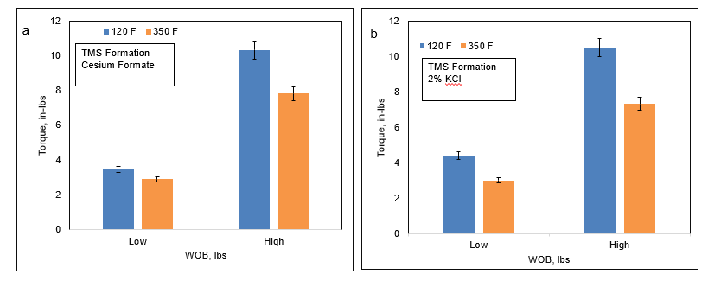
Figure B2: Effect of temperature on torque during drilling using cesium formate (a) and 2% KCl (b).
The results show that as temperature increases from 120 ºF to 350 ºF, the torque during drilling decreases. The trend is similar for both drilling fluid systems. The decrease in the torque as the temperature increases can be correlated to the effect of temperature of rheological properties. As temperature increases, the viscosity of most drilling fluid systems tends to decrease. This results in generation of thinner filter cake, therefore lower torque during drilling.

Drilling fluid compatibility in Eagle Ford shale formation
The Eagle ford shale formation is one of the neighborhood shale formation to the TMS. Due to the success of the inhibitive mud systems in TMS, they were tested in Eagle ford shale. Unlike the TMS where clay account for 51% of the mineralogy, Eagle ford shale only has 20% of clay. This implies that drilling fluid compatibility issues in less pronounced in Eagle ford unlike TMS. Figure B3 shows the swelling index in both TMS and Eagle ford shale.

Figure B3: Swelling index in TMS and Eagle ford shale formations for different drilling fluid systems
The profile shows lower swelling rate in the Eagle ford as opposed to the TMS for all tested drilling fluid systems. This indicates that the use of inhibitive mud systems should more critical in TMS as compared to Eagle ford. In both formations, the study revealed the impact of the inhibitive mud systems in minimizing swelling during drilling. Thus, providing better drilling performance by minimizing the drilling concerns such as hole cleaning, stuck pipe, borehole collapse etc. and reducing the non-drilling time (NDT).

