University of Oklahoma

Graduate College

PLAYING FOR KEEPS: A PSYCHOLOGICAL MEASURE OF THE PROBABILITY OF RETAINING A FREE AGENT IN PROFESSIONAL BASKETBALL

A Dissertation

submitted to the Graduate Faculty

in partial fulfillment of the requirements for the

Degree of

DOCTOR OF philosophy

By

Melanie Lewis
Norman, Oklahoma
2018

PLAYING FOR KEEPS: A PSYCHOLOGICAL MEASURE OF THE PROBABILITY OF RETAINING A FREE AGENT IN PROFESSIONAL BASKETBALL

A Dissertation approved for the
Department of Psychology

By

______________________________
Dr. Robert Terry, Chair

______________________________
Dr. Hairong Song

______________________________
Dr. Michael Mumford

______________________________
Dr. Edward Cokely

______________________________
Dr. Maeghan Hennessey

© Copyright by Melanie lewis 2018
All Rights Reserved.

Acknowledgements
To my parents – as Kevin Durant put it, “you da real MVP.” Without your love and support I would never have made it this far. I could fill a book trying to describe how much I appreciate all that you’ve done for me – it would be as long as War and Peace and even in so many pages would fail to do justice to how much love and gratitude I have for you both.
My advisor, Dr. Robert Terry – You taught me the things that matter most: how to use what I’ve learned to make a meaningful impact and how to better communicate numbers through words, visuals or even jokes. Thank you for giving me the opportunity to learn from the same person who taught Michael Jordan all he knows about stats and for allowing me to pursue all of my crazy ideas.
The rest of my committee – Dr. Hairong Song, thank you for taking a chance on me and offering me the opportunity to attend OU, you’re a great teacher and I appreciate your patience helping me to navigate my first years in this field. Dr. Ed Cokely, thank you for encouraging me to think bigger and giving me the bravery to pursue challenges I would have thought impossible. Dr. Michael Mumford, your presence on my committee motivated me to work to a higher standard, thank you for giving so much thoughtful and useful advice for navigating my future career path.
Dr. Nicole Campbell, Dr. George Bogaski and the rest of the retention research group – thank you for giving me the opportunity to be a part of such an incredible, inspiring team. What you do is so important and it was an honor to work with you and witness the positive impact you have on so many students’ lives.
Cassidy Krantz and Joe Westlin –This project would not have happened without you and I appreciate you both so much. Your effort and willpower to rate so many videos in such a short time was incredible. Thank you for lending me your brilliance and your time.
Thank you to Darren Ziegler and OJ Avworo for reading through the early versions of this project, giving such thorough feedback and inspiring me to make it better.

Table of Contents

Acknowledgements iv
List of Tables viii
List of Figures ix
Abstract x
Introduction 1
Theoretical Explanations for Voluntary Turnover 2
Job Satisfaction 3
Job Embeddedness 4
Leader-Member Exchange 5
Bringing the (Big) Three Concepts Together 7
Methods 7
Sample 7
Measures 8
Analysis 8
Study One 10
Measures 10
Job Satisfaction 10
Job Embeddedness 10
Leader-Member Exchange 12
Results 12
Hypothesis One 12
Hypothesis Two 13
Hypothesis Three 14
Discussion 14
Limitations 16
Study Two 16
Post-Game Interview Videos 18
Content Coding 18
Job Satisfaction 19
Job Embeddedness 19
Leader-Member Exchange 20
Social Media 20
Data Pre-Processing 21
Text Frequency 22
Text Sentiment 23
Development of Content Dictionary 24
Job Satisfaction 25
Job Embeddedness 26
Leader-Member Exchange 30
Measures 33
Job Satisfaction 33
Job Embeddedness 33
Leader-Member Exchange 34
Results 35
Hypothesis One 36
Hypothesis Two 36
Hypothesis Three 38
Discussion 40
Limitations 42
Conclusions 43
Comparison of Study One and Study Two 43
Implications 46
References 59
Appendix A: Sample Social Media Scraping Code 66
Appendix B: Content Dictionary Category Examples 67

List of Tables

Table 1. Modified Multidimensional LMX Scale 48
Table 2. ROC Contrast Testing Results 49
Table 3. Post-Game Interview Video Variables and Interrater Agreement 49
Table 4. Social Media Variables and Intraclass Correlation Coefficient 50
Table 5. Average Within-Individual Content Score by Source 50
Table 6. Correlations of Constructs between Studies 51

List of Figures
Figure 1. Hypothesized Model of Voluntary Turnover for Professional Athletes 52
Figure 2. Job Satisfaction Measurement Model (Study One) 52
Figure 3. Job Embeddedness Measurement Model (Study One) 53
Figure 4. Leader-Member Exchange Measurement Model (Study One) 53
Figure 5. Mediational Model JS-LMX-Turnover (Study One) 54
Figure 6. Job Satisfaction Measurement Model (Study Two) 54
Figure 7. Organizational Job Embeddedness Measurement Model (Study Two) 55
Figure 8. Community Job Embeddedness Measurement Model (Study Two) 55
Figure 9. Leader-Member Exchange Measurement Model (Study Two) 56
Figure 10. Mediational Model JS-LMX-Turnover (Study Two) 56
Figure 11. Moderating Influence of Community Fit on JS-Hygiene 57
Figure 12. Moderating Influence of Organizational Links on JS-Motivation 57
Figure 13. Moderating Influence of Community Sacrifice on JS-Motivation 58

Abstract
Existing research has provided insights into what drives individuals to voluntarily leave a job and join a different organization. This framework for understanding voluntary turnover has never been tested in the context of professional sports. Furthermore, the inability to retain talent has a negative financial impact on these organizations and has been shown to reduce team performance. Study one focuses on using archival data and the wisdom of the crowd to assess professional basketball players’ levels of job satisfaction, job embeddedness and leader-member exchange. Study two focuses on historic data directly provided by these athletes via post-game interview videos and public social media activity to assess the same psychological attributes. Results suggest that these three concepts successfully discriminate between which players choose to stay or leave. Comparisons of the different measurement approaches and relative predictive power provided by each attribute are also discussed.
Keywords: Voluntary Turnover, Free Agency, Professional Sports

Introduction
The Cleveland Cavaliers finished the 2009-10 season with a league-best record of 61 wins and 21 losses. In the season that followed, they won only 19 games. The team did not achieve a winning record again until the 2014-15 season. What happened between 2010 and 2014? In the summer of 2010, LeBron James announced that he would be taking his talents to the Miami Heat (“LeBron James’ decision,” 2010), and in 2014 he returned. Although very few professional athletes have the power to influence organizational outcomes to such an extreme, it remains crucial for organizations to manage talent and reduce voluntary turnover as the inability to do so can lead to losses on and off the basketball court.
Beyond the anecdotal evidence of reduced team performance due to turnover, research suggests similar detrimental effects of turnover on performance. Using data from the National Basketball Association (NBA), one study showed that higher team familiarity and longer team leader tenure is associated with fewer team coordination errors (Sieweke & Zhao, 2015). An alternative study found that turnover on professional football teams led to reduced performance, independent of task interdependence (L. Davis, Fodor, E. Pfahl, & Stoner, 2014). Finally, athletes who switched teams showed declines in their individual performance, unless multiple players from the same team moved together (Campbell, Saxton, & Banerjee, 2014). These studies suggest that turnover inhibits teams’ and individuals’ abilities to achieve goals, but from a business point of view, the effects of turnover extend beyond wins and losses.
After “The Decision,” and James’ exodus, the Cavaliers franchise value dropped by 26%, or 121 million dollars, and after his return the value increased by 78%, or $400 million (“Cleveland Cavaliers on the Forbes NBA Team Valuations List,” 2016). Retaining talent has a financial impact not only on the organization, but on the surrounding community. Hotel tax collections increased by 8.6% and local bars and restaurants saw increases in revenue from 30% to 200% following James’ return to Cleveland (Vardon, 2015). Further, the arenas that host sporting events are expensive and many of the facilities are funded in part by the team ownership and in part by local taxes. When talented players leave, game attendance declines and the ticket admission tax revenues are reduced, leaving the cities and their taxpayers feeling betrayed (“If Dwight Howard leaves Orlando, city should sue Magic, NBA,” 2011). Given the importance of retaining talent for team performance and potential financial impacts, the goal of this study is to identify the important factors that influence professional athletes’ decisions to stay or leave their current team and develop a measurement tool to estimate the probability of retaining a free agent.

Theoretical Explanations for Voluntary Turnover
Organizational research has identified an abundance of antecedents for employee turnover, and this research has also made important distinctions between models of voluntary and involuntary turnover. The current study focuses on three concepts in applying voluntary turnover theory to free agency in professional basketball: job satisfaction (JS), job embeddedness (JE) and leader-member exchange (LMX).

Job Satisfaction
The concept of job satisfaction has been defined in multiple ways. One such definition states that job satisfaction is an affective reaction influenced by a comparison of actual and desired outcomes (Cranny, Smith, & Stone, 1992); another considers job satisfaction to be an attitude about one’s job (Miner, 1992). Research on attitudinal job satisfaction identifies three factors that explain differences in job satisfaction: individual disposition, culture and work situation characteristics (Saari & Judge, 2004). Work situation characteristics include factors such as pay, supervision, coworkers, the nature of the work itself and promotion opportunities.
Meta-analytic evidence supports that higher levels of job satisfaction are associated with lower turnover rates (Griffeth, 2000). Exploring voluntary turnover for high performers, one study (Nyberg, 2010) found that pay growth was more important than global job satisfaction (measures that do not differentiate between different work situation dimensions). Another study found that the average skill level of free agents who decide to join a given team is negatively associated with the income tax rate of the state in which the organization resides (Kopkin, 2012), though the effect was not large. These findings would suggest that satisfaction with pay is a potentially important factor in retaining talent. While other work characteristics, such as promotion opportunities, do not directly translate to this context, a player’s role on the team and the competitive rank of the team might be alternative factors that influence job satisfaction.
One approach through which these characteristics of job satisfaction can be modeled and measured is the two-factor theory (Herzberg, 1974). Sometimes referred to as the motivation-hygiene model of job satisfaction, this theory is the proposed factor structure for the current study due to the unique characteristics of professional athletes relative to the typical job incumbents with whom this theory has been tested (Hulin & Smith, 1967). The hygiene factor represents treatment conditions or contextual factors (e.g., pay, role and relationships with coworkers), that if absent may lead to dissatisfaction. Elements related to job content that produce satisfaction (e.g., team success, individual achievements, etc.) constitute the motivation factor.

Job Embeddedness
Satisfaction alone cannot fully explain why people stay or leave their jobs. Theory on job embeddedness takes a more holistic view of the decision and defines the construct of embeddedness as a web of connections – both at work and in the community – in which a person becomes stuck (Mitchell, Holtom, Lee, Sablynski, & Erez, 2001). The literature on this theory distinguishes the construct from similar work attitudes such as job satisfaction and organizational commitment. Embeddedness differs from satisfaction and commitment in that these constructs exclusively relate to on-the-job satisfaction or commitment whereas embeddedness includes forces outside of the workplace. While there might be some overlap, divergence is expected between the two constructs (Crossley, Bennett, Jex, & Burnfield, 2007).
Research supports that measures of job embeddedness improve the prediction of voluntary turnover above and beyond the variance in turnover already explained by job satisfaction and organizational commitment (Mitchell et al., 2001). Similarly, another study showed that a global measure of job embeddedness predicted turnover even controlling for job satisfaction, perceived alternatives, intentions to search and intentions to quit (Crossley et al., 2007). Further, the study conducted by Crossley et al. (2007), suggested that individuals lacking job embeddedness had higher search intentions independent of their level of job satisfaction. The influence of job embeddedness to moderate job search behaviors was also found in a study showing that individuals high in job embeddedness were less likely to engage in job search behaviors regardless of their level of organizational commitment (Welty Peachey, J. Burton, & E. Wells, 2014).
There are three important dimensions to a measurement model of job embeddedness: links, fit and sacrifice (Mitchell et al., 2001). Links are formal or informal connections that may be social, psychological or financial in nature. Fit is the compatibility of the individual’s values and goals with the organization and/or community. Sacrifice relates to the psychological or materialistic losses that individuals believe will occur if they leave their jobs. These dimensions are applied to both the organization and to the community and while it is possible that they arise from unrelated sources, the sum of these factors contribute to an overall level of embeddedness.

Leader-Member Exchange
Neither satisfaction nor embeddedness directly tap into the potential influence that interpersonal relationships might have on voluntary turnover decisions. The quality of the relationship between subordinates and supervisors is what measures of leader-member exchange seek to quantify. In the context of professional sports, identifying a single leader is somewhat complicated – the leader might be the team captain, the team coach, the general manager or team ownership. For the athletes, low quality LMX with any of these individuals may have negative consequences. The current study focused specifically on the quality of the player-coach relationship.
Meta-analytic studies found LMX to have one of the strongest relationships with turnover amongst the variables studied (Griffeth, 2000). In addition to the direct effect of LMX on turnover, there are an array of studies exploring the exact nature of the LMX-turnover relationship and potential mediating variables. One study suggests that the direct relationship between LMX and turnover is non-linear in nature, with moderate LMX being optimal (Morrow, Suzuki, Crum, Ruben, & Pautsch, 2005). Another study found that the relationship between LMX and turnover intentions was partially mediated by perceived organizational support and organizational commitment (Ahmed, Ismail, Amin, & Ramzan, 2013). Job satisfaction was found to completely mediate the LMX-turnover relationship with a sample of nurses (Han G & Jekel M, 2011). Alternatively, others suggested that organizational job embeddedness mediates the LMX-turnover and LMX-job satisfaction relationships (Harris, Wheeler, & Kacmar, 2011).
Measurement models of leader-member exchange assess the quality of the relationship along four dimensions: professional respect, affect, contribution and loyalty (Liden & Maslyn, 1998). In terms of the context of this study, professional respect relates to the degree to which the player considers his coach to be competent and knowledgeable about his job. The affect dimension assesses the extent to which the player likes his coach on a personal rather than professional level. Contribution is the willingness to exert as much effort as is necessary to achieve the coach’s goals. Finally, loyalty represents the extent to which the player perceives that his coach would publically support his goals, character and actions. These dimensions each contribute to an overall estimate of the quality of the relationship between a player and his coach.

Bringing the (Big) Three Concepts Together
When studied in isolation, the empirical evidence suggests that job satisfaction, embeddedness and LMX each contribute explanatory power to turnover outcomes. From the LMX research, the three concepts appear to serve as members of a team, and the sum of the forces ultimately contribute to individual decisions to stay or leave an organization. Given the existing research on these concepts, the following hypotheses were proposed:
H1: LMX mediates the relationship between job satisfaction and voluntary turnover.
H2: The relationship between job satisfaction and voluntary turnover is moderated by job embeddedness.
H3: Job satisfaction, job embeddedness and LMX each provide unique contributions explaining variance in voluntary turnover.

Methods

Sample
Voluntary turnover is limited to those athletes who are in the final year of their contract – free agents – or those who have an option to opt out of the remainder of the contract. The sample included n = 100 players who met this criteria during the 2016-17 NBA season, from which 32% (n = 32) remained with their current team and 68% (n = 68) did not. Any players who were restricted free agents at the start of the 2016-17 season and/or did not sign an offer sheet by another team were excluded.

Measures
Rather than administering the common questionnaires directly, two studies with different approaches of psychological measurement were conducted. The first study identified quantitative, observable proxies using secondary sources or archival data and the second study used qualitative historic source material – post-game interview videos and social media text – to assess the constructs of interest. Reliability of the indicators used for each construct was assessed using Cronbach’s alpha, interrater agreement ($r_{wg(j)}^{*}$) and the intraclass correlation coefficient (ICC) when applicable. A value of .70 or above is considered adequate reliability for any of these measures. Additionally, confirmatory factor analysis was conducted to assess if the proposed indicators related to the underlying constructs in order to provide evidence of construct validity for the proposed measures. The specific indicators and data collection procedures are described in greater detail later.

Analysis
The proposed hypotheses are represented by the path diagram shown in Figure 1. The hypothesized model, estimating the “keep score,” or the probability of retaining a free agent, is represented by the following equations:
 | $${LMX}_{x}= b_{0xLMX}+b_{1xy}\left({JS}_{y}\right)+ e_{xyLMX}$$ | (1)
where $b_{0xLMX}$ is the expected value of LMX – dimension x when JS – dimension y is equal to zero, $b_{1xy}$ is the effect of JS – dimension y on LMX – dimension x, and $e_{xyLMX}$ is the residual variance.
$$Keep=b_{0}+b_{2x}\left({LMX}_{x}\right)+b_{3y}\left(JS_{y}\right)+b_{4z}\left(JE_{z}\right)+b_{5yz}\left(JS_{y}*JE_{z}\right)+ e$$
where $b_{0}$ is the intercept, or expected probability of keeping a free agent when all dimensions of LMX, JS and JE are zero; $b_{2x}$ is the direct effect of LMX – dimension x, $b_{3y}$ is the direct effect of JS – dimension y and $b_{4z}$ is the direct effect of JE – dimension z on the keep score, holding all other effects constant; $b_{5yz}$ represents the interaction effect between JS – dimension y and JE – dimension z; and $e$ is the residual variance.
To test the first hypothesis, the significance of the mediation effect was tested using the bootstrapping approach (Preacher & Hayes, 2008) and the effects of JE ($b_{4z}$and $b_{5yz}$) were excluded from the model. A mediated relationship would indicate that the total effect of JS on turnover is accounted for either partially or completely via its relationship with LMX. For the mediational hypothesis to be supported the product of $b_{1xy}$ and $b_{2x}$must be statistically significant. Partial mediation is indicated if $b_{3y}$ remains statistically significant after controlling for the indirect effect of JS through its influence on LMX. Complete mediation is supported if the direct effect of JS is no longer significant after controlling for LMX.
Hypothesis two concerns whether or not the strength of the relationship between JS and the keep score depends on an individual’s level of JE. In order to evaluate this hypothesis, $b_{2y}$ was dropped from Eq. 2. Support of the moderation hypothesis requires that $b_{5yz}$ be statistically significant.
The third hypothesis was tested using receiver operating curve (ROC) contrast testing to determine if there existed statistically significant difference in discrimination of outcomes, as represented by the area under the curve (AUC), between the full and reduced models. For the third hypothesis to be supported, removal of $b_{2}$, $b_{3}$, or $b_{4}$must cause a statistically significant reduction in AUC. This would suggest that JS, JE and LMX each explain unique variance in free agency decisions.

Study One

Measures

Job Satisfaction
The variables used to represent JS-hygiene (α = 0.67) included average usage rate, number of games started out of total games played and pay (represented as the ratio of an individual’s actual salary to his maximum allowable salary). Usage rate and games started represent satisfaction with one’s role on the team and salary represents satisfaction with pay. JS-motivation (α = 0.73) is represented by coach tenure, championship potential and team conference rank. Coach tenure is included in the motivation factor due to its established association with team performance in existing research (Giambatista, 2004; Sieweke & Zhao, 2015). Championship potential is quantified using Elo ratings (Silver & Fischer-Baum, 2015). Elo ratings are updated game-by-game and are summary statistics capturing long-term information related to wins and losses, the margin of victory and home court advantage. Per this system, the average team has a rating of 1500, with a standard deviation of 100 points, leaving 90% of teams with Elo scores between 1300 and 1700. The measurement model is represented by Figure 2. Confirmatory factor analysis supported the two-factor latent structure of job satisfaction (𝜒²= 2.28, 𝑝 = 0.97; 𝑅𝑀𝑆𝐸𝐴 = 0, 𝐶𝐹𝐼 = 0.99).

Job Embeddedness
Conceptually, embeddedness was defined along three dimensions – links, fit and sacrifice – as they relate to both the organization and the community. JE-sacrifice was operationalized as the percentage difference between the maximum salary that can be offered by their current team relative to the maximum salary that the player is eligible to receive. Given the uncertainty in available cap space prior to finalizing the team roster, this value was quantified in two different ways. Controlling for the number of free agents on the team, one indicator used the projected cap space and the other used the maximum potential cap space should the team cut all eligible players (Smith, n.d.). Due to the minimum requirement of three indicators per latent factor, JE-sacrifice and JE-links were treated as a single factor (α = 0.65). Variables representing JE-links included average home game attendance relative to the capacity of the arena, the individual’s tenure with the current team, a binary variable indicating whether the current team drafted the player and the average tenure of the roster. JE-fit (α = 0.90) was represented by the number of players on the current team from the same hometown (or country) and college and the distance in miles from each. The measurement model for JE is represented by Figure 3.A two-factor latent model was sufficient to explain the covariance in the aforementioned variables (𝜒² = 35.57, 𝑝 = 0.22; 𝑅𝑀𝑆𝐸𝐴 = 0.037, 𝐶𝐹𝐼 = 0.91). Obtaining adequate model fit required some correlated residual terms. Specifically, the two salary terms were correlated because both were estimated based on projections of the team based on current roster and total free agents on the roster. Additionally, miles from hometown had correlated error terms with the number of players from the same hometown and school, this is likely explained by the international players in the sample who would have much greater distances and fewer teammates of a like background. Tenure had correlated residuals with the draft indicator due to the longer-term contract to which rookies are signed.

Leader-Member Exchange
LMX was measured using the existing multidimensional scale created by Liden and Maslyn (Liden & Maslyn, 1998) (α = 0.93), with items modified as necessary to reflect third-person responding (see Table 1 for all survey items and descriptive statistics). Using Qualtrics, the survey was distributed to members of the sports media and NBA fans. Participants were asked to select the team with which they were familiar and respond to the survey for eligible players from that team’s roster. A total of n = 308 surveys were completed resulting in responses for n = 111 players. For those players with multiple survey responses (n = 70), interrater agreement was assessed ($r_{wg(j)}^{*}=0.87)$ with a value above 0.7 indicating adequate agreement to support aggregation (Biemann, Cole, & Voelpel, 2012). The measurement model for LMX is represented by Figure 4. The four-factor latent model supported the construct validity of the survey scores (𝜒² = 60.03, 𝑝 = 0.07; 𝑅𝑀𝑆𝐸𝐴 = 0.06, 𝐶𝐹𝐼 = 0.99).

Results

Hypothesis One
When examined in isolation, logistic regression analysis indicated that a unit increase in JS-motivation improved the probability of the player staying with his current team by 70.5% ($χ^{2}=10.09$, p = 0.0015). JS-motivation also explains approximately 20% of variance in LMX scores aggregated across all dimensions, with a unit increase in JS-motivation associated with an increase of $b_{1m}$= 1.7 in LMX scores ($t =4.528,$p < 0.0001). The chances of remaining with the current team is increased by approximately 60% ($b_{2}$ = 0.4047, z = 3.616, p = 0.0003) for a one-point increase in LMX, holding JS-motivation constant. The mean mediation effect over 3,000 bootstrapped samples was 0.6738 (95% CI: 0.2632 – 1.3617), supporting hypothesis one. After controlling for LMX, the direct effect of JS-motivation ($b_{3m})$ on turnover is no longer statistically significant, indicating that LMX completely mediates this relationship. These results are illustrated by Figure 5. There was no evidence of a mediated relationship between JS-hygiene and LMX.

Hypothesis Two
Four different tests of moderated multiple logistic regression were conducted in order to assess if JS-hygiene or JS-motivation was dependent on JE-fit or JE-links/sacrifice. Results of the first moderated multiple logistic regression modified Eq. 2 as follows:
$$Keep=-0.856+0.301\left(JS_{H}\right)+0.158\left(JE_{LS}\right)+0.228\left({JS}_{H}*{JE}_{F}\right)+e$$
The main effects for JS-hygiene and JE-fit were not significant, nor was the interaction term. Similarly, when testing for moderation between JS-hygiene and JE-links/sacrifice, the main effect for JS-hygiene was not significant, nor was the interaction term, but JE-links sacrifice increased the probability of a player staying with his current team by 69% ($b_{4LS}=0.802;z=2.4594, p=0.0139)$. JE-fit did not produce a statistically significant main effect nor did it moderate the relationship between JS-motivation and keeping a player, but the main effect of JS-motivation was statistically significant ($b_{3M}=0.862;z=3.0199, p=0.0025)$. Similarly, JE-links/sacrifice did not moderate the relationship between JS-motivation and keeping a player, but when tested with JS-motivation, the effect of JE-links/sacrifice was no longer statistically significant. The main effect of JS-motivation remained statistically significant, increasing the probability of player staying with his team by 66.1% $(z=2.0553, p=0.0309)$. Hypothesis two regarding the plausibility of a JS-JE interaction was not supported.

Hypothesis Three
A logistic regression model was fit with all direct effects (AUC = 0.8613 ± 0.0423) and compared to models fit with only two or only one of the constructs. The model modified Eq. 2 to estimate the probability of retaining a free agent as follows:
$$Keep=-3.7251+0.3617\left({LMX}_{PR}\right)+ 0.3702\left({LMX}_{A}\right)+0.3126\left({LMX}_{L}\right)+0.6216\left({LMX}_{C}\right)+0.5098\left(JS_{H}\right)+0.3230\left(JS_{M}\right)+0.1965\left(JE_{F}\right)+0.0198\left(JE_{LS}\right)+e$$
The full model AUC is compared with all potential reduced models and all contrast testing results can be seen in Table 2. The contrast testing results indicated that the LMX-only model (AUC = 0.8343 ± 0.047) did not significantly reduce the discrimination of outcomes compared to the full model (𝜒² =1.1736, p = 0.2787). This suggests that free agency decisions can be sufficiently predicted by assessment of the quality of the player-coach relationship, not supporting hypothesis 3.

Discussion
When Gordon Hayward announced his decision to leave the Utah Jazz and join the Boston Celtics (Hayward, 2017), a majority of his essay detailed his love and gratitude for Salt Lake City and the Jazz organization. Only in the last few paragraphs did he articulate his reasons for choosing the Celtics, a list which concluded saying the following:
“And of course, there was Coach Stevens: Not just for the relationship that we’ve built off the court — but also for the one that we started building on the court, all of those years ago, in Indiana.”
Gordon Hayward’s decision and emphasis on the importance of his relationship with the coach whose team he chose to join is only a single piece of anecdotal evidence, but this example is corroborated by the findings of this study – the most important factor in free agency decisions is the quality of the player-coach relationship.
The results suggest that the relationship between job satisfaction and free agency decisions is an indirect one – individuals highly satisfied with their jobs are more likely to stay because said satisfaction is associated with higher quality relationships with leaders. To say that winning, satisfaction with one’s role and ties to the organization and community do not matter would be misleading, given that they appear to matter when tested in isolation. Rather, as measured currently, these concepts do not explain any unique variance in free agency decisions beyond what is explained by assessment of the player-coach relationship.
Worth noting is that the quality of the player-coach relationship can be assessed using the wisdom of the crowd (Surowiecki, 2005). High levels of interrater agreement suggest that these interpersonal relationships can be reliably evaluated by fans and media. On the other hand, some facets of satisfaction and embeddedness produced suboptimal reliability and it is possible that improved measurement might clarify the nature of the relationships between these constructs and free agency decisions. Specifically, improving the measure of JE to better reflect embeddedness in the community might yield greater explanation of free agency decisions and more accurately reflect this concept as it was theoretically defined.
Due to the overlap in job satisfaction, embeddedness and leader-member exchange as well as the meta-analytic evidence supporting LMX as one of the strongest antecedents of turnover (Griffeth, 2000) the results of this study are unsurprising from a theoretical point of view. From the sports business perspective, efforts in retaining talent tend to focus largely on offering athletes more money or convincing them of the championship potential of a team. While these efforts are not in vain, the results from this study suggest that the largest returns could be gained from focusing on interpersonal relationships. Given the degree of uncertainty in the draft process, one recommendation is to pay greater attention to selecting athletes with whom coaches and other leadership figures could establish high quality relationships as such relationships appear to yield loyalty to the team. Future research should investigate what psychosocial attributes in coaches and athletes contribute to the development of high quality relationships.

Limitations
Free agency is not a perfect parallel to voluntary turnover. Teams do not want to retain all of their free agents and the current study cannot account for those players that teams prefer to let go. Furthermore, in highlighting the effect of leader-member exchange, it is important to note that there are many hierarchies within an organization and other leadership figures might matter as much or more than the head coach. When external sources are used to assess the quality of the player-coach relationship, we are limited to the quality of the public relationship and there may be much that goes on behind closed doors that is unknown.

Study Two
The data collected for study two included primary, qualitative material – specifically, post-game interview videos and public social media posts from Twitter and Instagram. Following a historiometric approach (Parry, Mumford, Bower, & Watts, 2014), this qualitative material was quantitatively analyzed by creating content dictionaries that indicated how the constructs of job satisfaction, job embeddedness and leader-member exchange manifested in the context of these sources. Given the lack of control over the content of both social media postings and interviews, not all variables may receive a score in each post or video. The processes for defining and coding interview videos and social media content differed and are described in greater detail in the sections that follow.
All source material was limited to videos and posts from between July 1, 2016 to July 1, 2017. If a player was traded mid-season, only source material from after the date of the trade was used. Source controls for post-game interviews included the following: the total number and duration of videos for a given player, interview location (locker room, on-court or press conference), the outcome of the game, whether the player was interviewed alone or with others and whether it was a home or away game. All videos were obtained through publicly available content via YouTube or NBA.com. Social media source controls included the total number of posts and whether or not English is the first language of the player. Social media content was limited to players with public profiles and was obtained using Python scripts to automate the data retrieval (Arcega, 2013/2018; Taspinar, 2016/2018). See Appendix A for an outline of the data scraping process. Control variables applicable to both source materials include the player’s age and years of experience.

Post-Game Interview Videos

Content Coding
Content coding for the post-game interviews was conducted by two doctoral students following a 10 hour frame of reference training program (Bernardin & Buckley, 1981) during which they were familiarized with the materials, variables of interest, benchmark rating scales and potential rating errors. All ratings were made on a 7-point Likert scale ranging from -3 to 3, with 0 indicating a neutral score. Benchmark rating scales provided exemplar videos corresponding to high, low and neutral responses on the variables of interest. Following training, raters practiced coding on post-game interviews with players not included in the current study until sufficient interrater agreement was achieved (Biemann et al., 2012).
Final interrater agreement and descriptive statistics on the variables of interest is shown in Table 3. A total of n = 580 videos were rated for n = 58 different individuals. No post-game interview video content was available for n = 42 individuals. Of these videos, n = 372 (64.14%) followed a win and the remaining n =208 followed a loss; n = 404 (69.66%) were conducted in the locker room, n = 138 (23.79%) were in a press conference setting, and n = 38 were on the court; n = 373 (64.31%) followed a home-game and n = 207 (35.69%) followed an away game; n = 52 (8.97%) were conducted as group interviews with teammates and n = 528 (91.03%) were conducted alone; and n = 12 (2.07%) videos were conducted with members of the player’s family present and the remaining n = 568 (91.03%) were conducted without family visibly present.

Job Satisfaction
As with study one, job satisfaction was rated for hygiene and motivation factors. Raters were presented with benchmark rating scales that explained how athletes low or high in hygiene and motivation might express such attitudes in an interview context. Examples of hygiene markers include comments related to his role or his teammates and motivation markers included responses related to the importance of winning and dwelling on the outcome of that game. Interrater agreement for JS-hygiene was $r_{wg(j)}^{*}=0.98$ and for JS-motivation, $r_{wg(j)}^{*}=0.93$.

Job Embeddedness
In order to address one of the weaknesses in the first study, raters were trained to code for job embeddedness along six dimensions – organization-specific links, fit and sacrifice and community-specific links, fit and sacrifice. Potential markers for embeddedness were drawn from existing survey measures (Mitchell et al., 2001; Ramesh, 2007) and translated into the current context. Examples of organization-specific links ($r_{wg(j)}^{*}=0.80)$ included comments related to socializing and interacting with teammates or staff, fit ($r_{wg(j)}^{*}=0.96)$ was represented by comments related to compatibility of personal-organizational goals and relationships with teammates and sacrifice ($r_{wg(j)}^{*}=0.89)$ content included comments suggesting it would be difficult to leave the organization. Community-specific links ($r_{wg(j)}^{*}=0.98)$ were represented by comments related to personal connections, family presence and involvement in the community, fit ($r_{wg(j)}^{*}=1.00)$ included comments regarding positive attitudes and feeling at home in the community and sacrifice ($r_{wg(j)}^{*}=1.00)$ was represented by comments suggesting it would be difficult to leave the community.

Leader-Member Exchange
The first study suggested high levels of interrater agreement when people outside of the player-coach relationship assessed its quality, but whether or not outside perception converges with the perception of the player is unclear. The professional respect ($r_{wg(j)}^{*}=0.98)$ dimension of LMX was represented by comments related to in-game coaching decisions and game strategy. Affect was represented by non-professional attitudes of the coach ($r_{wg(j)}^{*}=0.98)$. Loyalty manifested through comments suggesting that the player feels his coach would defend him against outside criticism or perceived unfair officiating ($r_{wg(j)}^{*}=1.00)$. Expressed attitudes related to personal- or team-effort represented the contribution ($r_{wg(j)}^{*}=0.91)$ dimension.

Social Media
Unlike post-game interview videos, where content is dictated by the questions asked by the media, social media content provides the advantage of individual control of the content. Social media data content coding was conducted using key word in context analysis. Rather than using raters, a content dictionary was developed using computer software described in the sections that follow and an automated scoring process was developed. Existing research has shown that this process produces acceptable reliability and validation evidence while eliminating the labor-intensive process of manual ratings (Spangler, Gupta, Kim, & Nazarian, 2012). The dictionary identifies phrases, words or other forms of text (e.g., hashtags, emojis, geographic location tags) common to social media that represented the variables of interest. These frequent words or text are classified as high, low or neutral based on the theoretical definition of each variable. The computer program automatically analyzes each social media posting and assigns a score based on the rules created in the content dictionary. Each post was scored along the same -3 to 3 scale as was used in video ratings.

Data Pre-Processing
Data retrieval provided data structured in JavaScript Object Notation (JSON) and was converted to comma-separated values (CSV) using an additional Python script (Dolan, 2012/2018). The data from Instagram that was used included the caption text string, the time stamp, location geo-tag and usernames that were mapped to the individual. Twitter data included the text, time stamp and username mapped to the individual. The time stamps for both social media sources were used in order to limit posts to the specific range. In total, 7,153 Instagram posts and 20,002 tweets were used in the development of the content dictionary. Once in CSV format, all data analysis was conducted using RStudio version 1.1.419 (R Core Team, 2017) using the quanteda package (Benoit, 2012/2018).
Preparing the text data for analysis required several data cleaning steps and followed recommended best practices (Banks, Woznyj, Wesslen, & Ross, 2018). First, the content of an individual text post was tokenized, or separated into individual words. Common English words that do not contribute to the overall meaning of the text being analyzed, referred to as stop words, were removed. Example stop words include “the,” “of”, “to,” etc.
Additionally, any social media posts that were in a language other than English were excluded. In the sample there were 23 individuals for whom English was not a first language and many of these individuals are fluent in multiple languages. For example, one caption included English, French, Spanish and Lingala:
“Who did this?? qui a fait ca?? Quien a hecho esto?? Nani a sali oyo?? 😂😂😂 Lol!! #Mafuzzi #Mr_avecclasse #mafuzzi #mr_avecclasse”
Primary languages included French, Spanish, German, Italian, Portuguese, Croatian, Turkish, Georgian, Lithuanian, Hebrew, Slovenian, Swedish and Ukrainian. To classify the language of the text, the ‘textcat’ package (Hornik et al., 2013) and the ‘cld2’ package (Ooms, 2017/2017) were used. Due to the colloquial nature of social media postings and in order to avoid misclassification, language analysis was limited to the 23 players identified as non-native English speakers. If both programs identified the text as being a language other than English, the post was removed from the dataset. This led to the removal of 408 posts from Instagram and 812 posts from Twitter.

Text Frequency
Prior to creating a content dictionary, the frequency of individual words was obtained, both as a total count and as a proportion of the count relative to the number of posts that the word appeared in. In addition to individual words, the frequencies of various n-grams, or combinations of n-words, were obtained for up to 3-word combinations. Thus, while both the words “happy” and “birthday” might commonly appear, parsing out the frequency of the phrase “happy birthday” from the frequency of the word “happy” provides more meaningful information. Frequent words from Instagram included “game,” “great,” “mood,” and “time;” examples of common bi-grams were “thank you,” “game day” and “proud of;” and common tri-grams included “great win tonight” and “let’s get it.” Examination of frequent words enabled identification of key words to begin the formation of the content dictionary.
Social media provides content that is unique from typical texts used in a content analytic framework such as hashtags, user-specific mentions, geo-tags and emojis. The most common hashtags on Twitter amongst these free agents were “#gospursgo,” “#dubnation,” “#rio2016,” “#truetoatlanta” and “#tbt.” On Instagram, the most common hashtags were “#blessed,” “#gospursgo,” “#dubnation,” “#warriors,” and “#tbt.” The most commonly tagged locations included Los Angeles, New York, Phoenix, Chicago and ranged in use from team arenas and practice facilities to specific local restaurants, entertainment venues and apartment complexes. All geotags were linked to the closest specific organizations and cities, where applicable. Some geo-tags used during the off-season, such as those from the 2016 Summer Olympics in Rio, Brazil and various hometowns not located near any organizations were excluded. User-specific mentions on social media follow the format of “@username” and common mentions on both platforms included @nba, @nbpa and mentions of specific NBA teams, individual players as well as various college teams, NFL teams and businesses. For each team, a list of usernames was compiled in order to identify when, and how frequently mentions were directed to teammates. Finally, emojis are not only symbols of sentiment in social media content, but additionally, with the expansion of emojis to include various animals, objects in nature and modes of travel, specific emojis have become affiliated with team mascots (e.g., a lightning bolt with the Oklahoma City Thunder; a rocket ship with the Houston Rockets; a deer with the Milwaukee Bucks, etc.).

Text Sentiment
There are a multitude of existing content dictionaries designed to score text for sentiment. Given the number of potential sentiment dictionaries and the different methods and sources used to build each, this study scored sentiment by calculating sentiment from three different dictionaries and taking the average. The ‘quanteda’ (Benoit, 2012/2018) package includes a built-in sentiment dictionary that quantifies sentiment based on word patterns deemed positive (including double negatives) and negative (including positive words preceded by negation) (Young & Soroka, 2012). The R package ‘syuzhet’ (Jockers, 2017) was used for the two other sentiment scores. The second dictionary used provides an overall sentiment score and was chosen because it was built based on analysis of online text (Liu, Hu, & Cheng, 2005). The final dictionary chosen provides scores for positive and negative affect as well as scores across eight emotions: anger, anticipation, disgust, fear, joy, sadness, surprise and trust (Mohammad & Turney, 2010). Specific emotions were not included in text sentiment scores but were included in scoring other variables of interest.

Development of Content Dictionary
In order to automate a content coding process, the frequent terms were tied to the theoretical definitions of the variables of interest. Hashtags, usernames, emojis and geo-tags were organized according to specific teams or communities as indicators of the links dimension of job embeddedness. Other categories within the dictionary included team unity (TP), playoffs (TC), home (CF), fans or community support (FC), expressions of gratitude (G), expressions of feeling blessed or humbled by opportunity (H), mention of basketball or games (C), mention of recognition for achievements (R), expressions of feeling underrated or disrespected (U), content related to effort or hard work (W) and specific word flags including mentions of a coach, respect, preparation or trust. Additionally, emojis indicative of positive and negative sentiment were listed – these were added to the ‘quanteda’ (Benoit, 2012/2018) sentiment dictionary. Examples from each category in the content dictionary are provided in Appendix B. The specific use of these categories as they relate to the measures of interest is described in the sections that follow. The scoring system was developed to be as consistent as possible with the markers and exemplar videos provided for the video ratings. At times, the same content was not available and, in such circumstances, the scoring rules identified indicators consistent with the theoretical definitions of each construct. Descriptive statistics and intraclass correlation coefficients for the measures can be found in Table 4.

Job Satisfaction
Hygiene. The first indicator of JS-H was text content that directly mentions a teammate or the organization. Any mention of a basketball game, regardless of the outcome was the second indicator. The final piece of information used to score content for JS-H was the positive and negative sentiment scores and emotion content scores for joy, anger and disgust. The scoring rules for JS-H are as follows:
$$JS-H= \left\{\begin{aligned}\begin{matrix}3, TL>0, OL>0, C>0,P>0 \\ 2, \left(TL>0,OL>0,C>0\right) or (TL>0,OL>0,P>0)\end{matrix} \\ \begin{matrix}1, \left(TL>0,OL>0\right) or\left(TL>0,C>0\right) or(OL>0,C>0) \\ 0, TL=0,OL=0 ,C=0\end{matrix} \\ \begin{matrix}-1, \left(TL=0,OL=0\right) or \left(C>0,TL=0\right) or (C>0,OL=0) \\ \begin{matrix}-2, \left(TL=0,OL=0,C>0\right) or \left(TL=0,OL=0,D>0\right) \\ -3, TL=0,OL=0, C>0,D>0\end{matrix}\end{matrix}\end{aligned}\right.$$
where TL represents teammate mentions, OL represents organization-specific text, C represents game or competition content, P represents positive sentiment or joy and D represents negative sentiment, disgust or anger. The average ICC was 0.88 with a 95% confidence interval from 0.877 to 0.883 suggesting good reliability of the measure.
Motivation. Any content that mentioned the sport, games or working were the first indicator of JS-M. Another indicator for motivation was text related to achievement and recognition, or a lack thereof. Mentions of teammates or the organization were also included in the scoring rules. Finally, negative emotion content scores for sadness, anger or disgust were included. The scoring rules for JS-M are shown below.
$$JS-M= \left\{\begin{aligned} \begin{matrix}3^{a}, TL>0, OL>0, (C\left|W\right|R>0) \\ 2^{a}, \left(TL>0,(C\left|W\right|R>0)\right) or (OL>0,(C\left|W\right|R>0))\end{matrix} \\ \begin{matrix} 1^{b}, \left(Sad=0,L>0\right) or (T>0,G>0, P>0) \\ 0, C=0,W=0 ,R=0\end{matrix} \\ \begin{matrix}-1^{c}, (D>0,(C|W>0)) \\ \begin{matrix}-2^{c}, \left(Sad>0, \left(C | W>0\right)\right) or \left(Sad>0,L>0\right) \\ -3^{c}, U>0, (C|W>0)\end{matrix}\end{matrix}\end{aligned}\right.$$
ª –OL & -TL = 0; ^{b} Also includes conditions for 2 without the prior restriction; ^{c} Excludes posts that mention winning.

where TL represents teammate mentions, OL represents organization-specific text, C|W represents game, competition or work content, R represents recognition for achievement, L represents mention of a loss, T represents inclusion of the word ‘team,’ G represents inclusion of the word ‘game,’ P represents positive sentiment or joy, D represents negative sentiment, disgust or anger, and U represents underdog text. The average ICC was 0.88 (95% CI: 0.877 – 0.883).

Job Embeddedness
Organizational Links. For each organization, the content dictionary included a list of geo-tags for the team arena or practice facility, as well as all usernames and hashtags affiliated with the organization. Usernames of teammates were listed separately to the official organization list. The usernames for players who were traded mid-season were affiliated with the team with which they concluded the season. For a given post to have a positive score on organizational links, it must not include a link that is affiliated to a different organization. The scoring rules for organizational links are shown in the equation below.
$$Org Links=\left\{\begin{aligned}\begin{matrix}3^{a}, OL>0, TL>0, S>0 \\ 2^{a}, \left(OL>0,TL>0\right) or \left(OL>0,S>0\right) or \left(TL>0,S>0\right)\end{matrix} \\ \begin{matrix} 1^{a}, OL>0 or TL>0 or S>0 \\ 0, OL=0, TL=0\end{matrix} \\ \begin{matrix}-1, -OL>0 or -TL>0 \\ \begin{matrix}-2, \left(-OL>0,-TL>0\right) or \left(-OL>0,S>0\right) or \left(-TL>0,S>0\right) \\ -3, -OL>0,- TL>0, S>0\end{matrix}\end{matrix}\end{aligned}\right.$$
ª –OL & -TL = 0
where OL represents organization-specific text, TL represents teammate mentions, -OL represents text specific to other organizations, -TL represents mentions of individuals on different teams, and S represents sentiment. The average ICC was 0.85 with a 95% confidence interval from 0.846 to 0.854suggesting good reliability of the measure.
Community Links. Geo-tags within specific cities, mentions of other local sports teams, businesses or popular figures and city-specific hashtags were used as indicators of community links. Additionally, the content dictionary included a list of terms used to identify family-related content in a post. As with organizational-links, a positive community links score first required that the post not include links that are affiliated with communities in which other organizations reside (excluding comparisons between the Los Angeles Lakers and Los Angeles Clippers). The scoring rules for community links are shown in the equation below.
$$Comm Links= \left\{\begin{aligned} \begin{matrix}3^{a}, CL>0, F>0, S>0 \\ 2^{a}, \left(CL>0,F>0\right) or \left(CL>0,S>0\right) or\left(F>0,S>0\right)\end{matrix} \\ \begin{matrix}1^{a}, CL>0 or F>0 or S>0 \\ 0, CL=0, F=0\end{matrix} \\ \begin{matrix}-1, -CL>0 \\ \begin{matrix}-2, \left(-CL>0,F>0\right) or \left(-CL>0,S>0\right) \\ -3, -CL>0, F>0, S>0\end{matrix}\end{matrix}\end{aligned}\right.$$
ª –CL = 0
where CL represents community links, -CL represents links to a different organization’s city, F represents family and S represents sentiment. The average ICC was 0.80 (95% CI: 0.795 – 0.805) indicating good reliability of the measure.
Organizational Fit. Text content related to the team, coaching staff or organization was the first indicator of organizational fit. This content was separated based on neutral terms versus positive terms. Social media also is a common outlet for players to express feelings of gratitude, humility or blessings and the presence of any of these terms contributed to higher scores of organizational fit. The ‘underdog’ theme in social media text contributed to lower organizational fit. The scoring rules for organizational fit are presented by the following:
$$Org Fit=\left\{\begin{aligned} \begin{matrix}{ 3}^{a}, TP>0, H>0, G>0 \\ { 2}^{a}, \left(TP>0,H>0\right) or \left(TP>0,G>0\right) or \left(H>0,G>0\right)\end{matrix} \\ \begin{matrix} { 1}^{a}, TP>0 or H>0 or G>0 \\ 0^{a}, TP=0, H=0,G=0\end{matrix} \\ \begin{matrix}-1, U>0 \\ \begin{matrix}-2, \left(TN>0,U>0\right) or \left(TN>0,G=0\right) or \left(U>0,G=0\right) \\ -3, TN>0,U>0, G=0\end{matrix}\end{matrix}\end{aligned}\right.$$
ª U = 0
where TP represents team-positive text, TN represents team-neutral text, G represents gratitude, H represents humility and U represents underdog text. The average ICC was 0.92 with a 95% confidence interval from 0.918 to 0.922 suggesting good reliability of the measure.
Community Fit. As with organizational fit, gratitude, humility or blessings and ‘underdog’ themes were included in the scoring rules for community fit. Text content specific to community fit included terms related to a sense of home or simple mentions of the city or community.
$$Comm Fit=\left\{\begin{aligned} \begin{matrix}{ 3}^{a}, CF>0, H>0, G>0 \\ { 2}^{a}, \left(CF>0,H>0\right) or \left(CF>0,G>0\right) or \left(H>0,G>0\right)\end{matrix} \\ \begin{matrix} { 1}^{a}, CF>0 or H>0 or G>0 \\ 0^{a}, CF=0, H=0,G=0\end{matrix} \\ \begin{matrix} -1, U>0 \\ \begin{matrix} -2, \left(CF>0,U>0\right) or \left(CF>0,G=0\right) or \left(U>0,G=0\right) \\ -3, CF>0,U>0, G=0\end{matrix}\end{matrix}\end{aligned}\right.$$
ª U = 0
where CF represents the text associated with community fit, G represents gratitude, H represents humility and U represents underdog content. The average ICC was 0.86 with a 95% confidence interval from 0.856 to 0.864 suggesting good reliability of the measure.
Organizational Sacrifice. The first indicator of organizational sacrifice was text content relating to the team competing at a high level. Further, sacrifice considers not only practical losses, but also perceived psychological ones (Mitchell et al., 2001), suggesting that psychological attachment styles may be a potentially relevant consideration. Thus, an individual with an anxious attachment style might perceive greater sacrifice than someone with a secure style who is confident that the benefits of the current organization can be recreated elsewhere. To account for this, anxiety was calculated as the sum of emotion content scores for anticipation and fear. Additionally, emotion scores for disgust and anger were summed and associated with lower sacrifice scores. Scores for links and fit were also included in the rating rules for sacrifice.
$$Org Sacrifice=\left\{\begin{aligned}\begin{matrix}3, F|L>0, TC>0, A>0 \\ 2, \left(F|L>0,TC>0\right) or \left(F|L>0,A>0\right) or \left(TC>0,A>0\right)\end{matrix} \\ \begin{matrix}1, F|L>0 \left| TC>0\right|A>0 \\ 0, F|L=0, TC=0,A=0\end{matrix} \\ \begin{matrix}-1, F|L<0 or TC=0 or D>0 \\ \begin{matrix} -2, \left(F|L<0,D>0\right) or \left(F|L<0,TC=0\right) or \left(D>0,TC=0\right) \\ -3, F|L<0,D>0, TC=0\end{matrix}\end{matrix}\end{aligned}\right.$$
where F|L represents fit or links, TC represents team competitiveness, A represents anxiety and D represents disgust or anger. The average ICC was 0.85 with a 95% confidence interval from 0.846 to 0.854 suggesting good reliability of the measure.
Community Sacrifice. Text content related to the fans was the first indicator of community sacrifice. As with organizational sacrifice, the emotional content scores for anticipation, fear, disgust and anger were also used.
$$Comm Sacrifice=\left\{\begin{aligned} \begin{matrix}3, F|L>0, FC>0, A>0 \\ 2, \left(F|L>0,FC>0\right) or \left(F|L>0,A>0\right) or \left(FC>0,A>0\right)\end{matrix} \\ \begin{matrix} 1, F|L>0 or FC>0 or A>0 \\ 0, F|L=0, FC=0,A=0\end{matrix} \\ \begin{matrix}-1, F|L<0 or FC=0 or D>0 \\ \begin{matrix}-2, \left(F|L<0,D>0\right) or \left(F|L<0,FC=0\right) or \left(D>0,FC=0\right) \\ -3, F|L<0,D>0, FC=0\end{matrix}\end{matrix}\end{aligned}\right.$$
where F|L represents fit or links, FC represents fan or community text, A represents anxiety and D represents disgust or anger. The average ICC was 0.85 with a 95% confidence interval from 0.846 to 0.854 suggesting good reliability of the measure.

Leader-Member Exchange
Professional Respect. Text content mentioning the coach or other organizational links was the first indicator of LMX-PR. Whether the post included content related to respect or praise of preparation was used to indicate higher LMX-PR and inclusion of ‘underdog’ content was indicative of lower LMX-PR. Any mention of a basketball game was used as the final indicator and was a requirement for all scores except for a zero. The scoring rules for LMX-PR are shown below.
$$LMX-PR= \left\{\begin{aligned}\begin{matrix} 3, PR>0, OL|L>0, U=0 \\ 2, \left(OL|L>0,PR>0\right) or ( OL|L>0,U=0)\end{matrix} \\ \begin{matrix} 1, \left(OL | L>0\right) or PR>0 \\ 0, OL|L=0, C=0\end{matrix} \\ \begin{matrix}-1, PR=0 or U>0 \\ \begin{matrix}-2, \left(PR=0,U>0\right) or \left(OL|L=0,U>0\right) \\ -3, (\left(-OL>0,PR>0\right) or \left(OL | L=0,PR=0\right)),U>0\end{matrix}\end{matrix}\end{aligned}\right.$$
where PR represents content with praise or respect, OL|L represents mention of the coach or organization-specific references, U represents underdog content, C represents game or competition content and –OL represents references to a different team. The average ICC was 0.89 with a 95% confidence interval from 0.887 to 0.893 suggesting good reliability of the measure.
Affect. In order to score social media for the affect dimension of LMX, the first indicator was mention of the coach or organization. Team-positive text, underdog content, overall sentiment scores and emotion content scores for disgust and anger were the other indicators used in scoring LMX-A. The scoring rules are shown below.
$$LMX-A= \left\{\begin{aligned} \begin{matrix}3, S>0, TP>0, U|D=0 \\ 2, \left(S>0,TP>0\right) or \left(S>0,U | D=0\right)or (TP>0,U|D=0)\end{matrix} \\ \begin{matrix}1, S>0 or TP>0 or U|D=0 \\ 0, OL|L=0\end{matrix} \\ \begin{matrix}-1, S<0 or U |D>0 \\ \begin{matrix}-2, \left(S<0,U|D>0\right) or \left(TP=0,U|D>0\right) \\ -3, S<0, TP=0,U|D>0\end{matrix}\end{matrix}\end{aligned}\right.$$
where S represents sentiment, TP represents team positive text, U|D represents underdog content or emotional content scores for disgust or anger and OL|L represents mention of the coach or organization. The average ICC was 0.84 with a 95% confidence interval from 0.836 to 0.844 suggesting good reliability of the measure.
Loyalty. Mention of the coach or organization was the first indicator for scoring LMX-L. Use of the word ‘trust’ or ‘support’ was the second indicator. Additional indicators used in scoring were mention of game or competition in the social media text content as well as the emotional content scores for disgust or anger. The scoring rules for LMX-L are shown below.
$$LMX-L= \left\{\begin{aligned}\begin{matrix} 3, LT>0, OL|L>0, D=0,C>0 \\ 2, \left(OL|L>0,LT>0\right) or ( LT>0,C>0)\end{matrix} \\ \begin{matrix} 1, D=0, (OL|L>0 or C>0) \\ 0, OL|L=0, C=0\end{matrix} \\ \begin{matrix}-1, C>0,(LT=0 or D>0) \\ \begin{matrix}-2, OL|L>0,(LT=0 or D>0) \\ -3, LT=0, OL|L>0,D>0,C>0\end{matrix}\end{matrix}\end{aligned}\right.$$
where LT represents inclusion of the words ‘trust’ or ‘support,’ OL|L represents coach or organization content, D represents emotion content scores for anger or disgust and C represents game or competition content. The average ICC was 0.86 with a 95% confidence interval from 0.856 to 0.864 suggesting good reliability of the measure.
Contribution. As with other LMX dimensions, the first indicator for LMX-C was content that mentioned the coach or other organizational links. Whether or not the post included content related to effort or hard work was the second indicator and was required for all positive scores, but was allowed to be zero or positive for negative scores. Game or competition content and emotional content scores for disgust and anger were the other indicators used in the scoring rules, which are shown below.
$$LMX-C= \left\{\begin{aligned}\begin{matrix}{ 3}^{a}, C>0, OL|L>0, D=0 \\ { 2}^{a}, \left(OL|L>0,C>0\right) or \left(OL | L>0,D=0\right) or (C>0,D=0)\end{matrix} \\ \begin{matrix}1^{a}, \left(OL|L>0\right) or C>0 or D=0 \\ 0, OL|L=0, C=0,W=0\end{matrix} \\ \begin{matrix}-1, D>0 \\ \begin{matrix}-2, \left(OL | L>0,D>0\right) or (C>0,D>0) \\ -3, OL|L>0, C>0,D>0\end{matrix}\end{matrix}\end{aligned}\right.$$
ª W > 0
where C represents game or competition content, (OL|L) represents mention of the coach or organization, D represents disgust or anger and W represents work or effort. The average ICC was 0.83 with a 95% confidence interval from 0.825 to 0.835 suggesting good reliability of the measure.

Measures
The average within-player content scores for both social media and post-game interview videos is shown in Table 5.

Job Satisfaction
The indicators used for JS-hygiene (α = 0.80) were the average social media JS-H score, the average video score for JS-H following a loss, the average difference between JS-H scores following a win versus a loss, and the average video score for JS-H when the interview was conducted in the locker room. The same three criteria from videos (loss, difference, locker room) and the social media content score were used to represent JS-motivation (α = 0.79). The measurement model is represented by Figure 7. Correlated residuals in this model are representative of source effects. Confirmatory factor analysis supported the two-factor latent structure of job satisfaction (𝜒²= 8.10, 𝑝 = 0.84; 𝑅𝑀𝑆𝐸𝐴 = 0, 𝐶𝐹𝐼 = 0.96).

Job Embeddedness
Organizational Embeddedness. Four indicators represented the links (α = 0.76) dimension of JE: reverse-coded social media content scores, video ratings for organizational links following a win, video ratings from home games, and from interviews conducted without teammates. Organizational fit (α = 0.76) was represented by reverse-coded social media content scores and the same three criteria from videos (wins, home games, interviewed alone). Finally, the sacrifice (α = 0.73) dimension was represented by the social media content score, video ratings following a loss, ratings from interviews conducted in the locker room and from interviews conducted without teammates. This measurement model is shown in Figure 8. Confirmatory factor analysis supported a three-factor latent structure of organizational job embeddedness (𝜒²= 43.38, 𝑝 = 0.30; 𝑅𝑀𝑆𝐸𝐴 = 0.05, 𝐶𝐹𝐼 = 0.84).
Community Embeddedness. Links to the community (α = 0.75) were represented by the social media content score, video ratings for community links following a loss, video ratings for community links from interviews conducted during away games and video ratings for community links from interviews conducted without teammates. Community fit (α = 0.79) was represented by social media content scores, video ratings following a win, video ratings from interviews conducted in the locker room and from interviews conducted without teammates. The sacrifice (α = 0.83) dimension was represented by social media content scores, video ratings from interviews conducted following home games, video ratings from locker room interviews and video ratings from interviews conducted without teammates. The measurement model for community embeddedness is shown in Figure 9. Confirmatory factor analysis provided mixed support for the three-factor latent structure of community job embeddedness (𝜒²= 58.23, 𝑝 = 0.17; 𝑅𝑀𝑆𝐸𝐴 = 0.07, 𝐶𝐹𝐼 = 0.84).

Leader-Member Exchange
The indicators used to represent the professional respect (α = 0.76) dimension of LMX included the social media content score, the video rating from interviews conducted following a win, the video rating for home game interviews, and the video rating for interviews conducted without teammates. Affect (α = 0.79) was represented by the social media content score, video ratings following a win, video ratings from home games and video ratings from interviews conducted without teammates. The loyalty (α = 0.74) dimension was represented by social media content scores, video ratings following a win, video ratings from home games and video ratings from interviews conducted without teammates. Finally, contribution (α = 0.80) was represented by the social media content score, video ratings following a win, video ratings from home games and video ratings from interviews conducted without teammates. Confirmatory factor analysis failed to support the four-dimension latent structure of LMX (𝜒²= 123.35, 𝑝 > 0.05; 𝑅𝑀𝑆𝐸𝐴 = 0.10, 𝐶𝐹𝐼 = 0.80) and the measurement model is shown in Figure 9.

Results
First, analyses were conducted using the estimated factor scores produced by the confirmatory factor models. This resulted in JS scores for n = 43 individuals, organizational JE scores for n = 40 individuals, community JE scores for n = 38 individuals and LMX scores for n = 51 individuals. Following these analyses, the tests were repeated using only social media content scores, for which JS scores were available for n = 100 individuals, organizational and community JE scores for n = 90 individuals and LMX scores for n = 100 individuals. Given the time-consuming nature of video ratings, the comparison was conducted to determine if similar effects are produced using social media content alone, or if the addition of video content improves discrimination of outcomes.

Hypothesis One
As was the case in Study 1, the mediational hypothesis is not supported for the hygiene factor of job satisfaction. When evaluating the impact of JS-Motivation in isolation, the effect on free agency decisions was not statistically significant. Furthermore, the mean mediation effect produced a confidence interval that included zero, not supporting hypothesis one.
On the other hand, when social media scores for JS-motivation are tested, the probability of a player staying with his current team increases by 95.8% ($χ^{2}=5.4262$, p = 0.0198). Furthermore, JS-motivation social media scores explained 45.14% of variance in LMX social media scores, with a unit increase in JS-motivation being associated with a 0.34 point increase in LMX ($t =8.8417,$p < 0.0001). The chances of remaining with the current team are increased by 99.96% ($b_{2}$ = 7.7095, z = 2.1087, p = 0.0350) for a one point increase in LMX, holding JS-motivation constant. The mean mediation effect over 3,000 bootstrapped samples was 2.5943 (95% CI: 0.2868 – 7.1366), supporting hypothesis one. After controlling for LMX, the direct effect of JS-motivation ($b_{3m})$ on turnover is no longer statistically significant, indicating that LMX completely mediates this relationship.

Hypothesis Two
Using the estimated factor scores from the combination of video and social media ratings, 12 different tests of moderation were conducted assessing if the relationship between JS-hygiene or JS-motivation was dependent on the level of any of the six different dimensions of JE. Of these 12 analyses, only one relationship produced support for the second hypothesis – the effect of JS-hygiene on the probability of keeping a player depended on his level of community fit (n = 38), modifying Equation 2 as follows:
$$Keep=-0.4194+1.7331\left(JS_{H}\right)-1.4092\left(JE_{C-F}\right)+3.5829\left({JS}_{H}*{JE}_{C-F}\right)+e$$
Both of the main effects for community fit $(z=-1.9983, p=0.0457)$ and JS-hygiene $(z=2.0007, p=0.0454)$ were statistically significant, as well as the interaction term $(z=2.0776, p=0.0377)$. As levels of community fit increase, the effect of JS-hygiene becomes stronger. Examination of the conditional effects of JS-Hygiene at three levels of community fit (mean ± one standard deviation) indicate that when community fit is one SD below average, the slope of JS-hygiene is not significantly different from zero $(b=-1.4437, z=-1.5541, p=0.1202)$ and only produces a positive effect on the probability of keeping a player at the mean $(b=1.7331, z=2.0007, p=0.0454)$ and one SD above average $(b=5.2562,z=2.1292, p=0.0332)$. See Figure 11 for a graph of the simple slopes.
Using only social media content scores (n = 97) for the same analyses, evidence of moderation was found in two of the 12 tests. First, the effect of JS-motivation was found to depend on the level of organizational links, modifying Equation 2 as follows.
$$Keep=-2.5893+16.6688\left(JS_{M}\right)+3.3816\left(JE_{O-L}\right)-19.8192\left({JS}_{M}*{JE}_{O-L}\right)+e$$
Both of the main effects for organizational links $(z=2.0484, p=0.0405)$ and JS-motivation $(z=2.4555, p=0.0141)$ were statistically significant, as was the interaction term $(z=-2.2397, p=0.0251)$. As a player’s organizational links increases, the effect of JS-motivation on his probability of staying decreases. Examination of the conditional effects of JS-motivation at three levels of organizational links (mean ± one standard deviation) suggests that the slope of JS-motivation is significantly different from zero at one SD below average $(b=25.5423, z=2.3972, p=0.0165)$ and at the mean $(b=9.8663, z=2.4953, p=0.0126)$, but not at one SD above average $(b=-5.8097, z=-1.4657, p=0.1427)$. See Figure 12 for a graph of the simple slopes.
The data from social media also suggested that the effect of JS-motivation on the likelihood of keeping a player depended on the level of community sacrifice, producing the following equation:$$Keep=-1.610+5.2971\left(JS_{M}\right)+1.2071\left(JE_{C-S}\right)-6.9120\left({JS}_{M}*{JE}_{C-S}\right)+e$$
As with the other results, both main effects were statistically significant ($JS-M: z=2.3476, p=0.0189;JE-C,S:z=2.4339, p=0.0149)$ as was the interaction term $(z=-2.1599, p=0.0308)$, suggesting that with higher perceived community sacrifice, the effect of JS-motivation decreases. The conditional effects suggest that the effect of JS-motivation is only significantly different from zero when perceived community sacrifice is one SD below average $(b=8.2176, z=2.4855, p=0.0129)$ and at the mean $(b=4.0857, z=2.2230, p=0.0347)$, but not at one SD above average $(b=-0.0463, z=-0.0235, p=0.9812)$. See Figure 13 for a graph of these simple slopes. These results indicate that only some dimensions of job embeddedness and job satisfaction provide support for hypothesis two.

Hypothesis Three
A logistic regression model was fit to the n = 38 individuals with complete data using all direct effects as well as the interaction term between JS-hygiene and community fit (AUC = 0.9076 ± 0.0491) and compared to models fit with only two or only one of the constructs. The model modified Eq. 2 to estimate the probability of retaining a free agent as follows:$$Keep=-1.4153+3.1484\left({LMX}_{PR}\right)- 0.2728\left({LMX}_{A}\right)-2.4714\left({LMX}_{L}\right)+0.3364\left({LMX}_{C}\right)+6.1267\left(JS_{H}\right)-2.2886\left(JS_{M}\right)-1.4505\left(JE_{O-L}\right)+0.7643\left(JE_{O-F}\right)+1.4505\left(JE_{O-S}\right)-1.4117\left(JE_{C-L}\right)+0.3717\left(JE_{C-F}\right)+0.3717\left(JE_{C-S}\right)+8.0933(JS_{H}*JE_{C-F})+e$$
The results for the contrast testing comparing the full model AUC to all potential reduced models can be seen in Table 2. All single construct models led to a statistically significant reduction in AUC. The simplest model that did not significantly reduce the discrimination of outcomes compared to the full model (𝜒² = 2.6385, p = 0.1043) was the model using LMX and organizational JE (AUC = 0.8123 ± 0.0725). Alternatively, the model using JS and both forms of JE (AUC = 0.8263 ± 0.0688) was also sufficient to discriminate between outcomes as well as the full model (𝜒² = 2.2043, p = 0.1376), but this model includes 9 parameters whereas the LMX-Organizational JE model contains only 7. As was the case in study one, hypothesis 3 is not supported.
Using social media content scores only for the n = 88 individuals with complete data, all direct effects and the two interaction terms produced an AUC = 0.7832 (± 0.0501) and modified Eq. 2 as follows:
$$Keep=-7.2612+1.2097\left({LMX}_{PR}\right)+ 5.3448\left({LMX}_{A}\right)+4.0982\left({LMX}_{L}\right)+1.1424\left({LMX}_{C}\right)-1.7541\left(JS_{H}\right)+8.6657\left(JS_{M}\right)+1.3507\left(JE_{O-L}\right)-1.6369\left(JE_{O-F}\right)+5.6506\left(JE_{O-S}\right)+1.3576\left(JE_{C-L}\right)+1.5274\left(JE_{C-F}\right)-2.8938\left(JE_{C-S}\right)-16.1689\left(JS_{M}*JE_{O-L}\right)-3.1807\left(JS_{M}*JE_{C-S}\right)+e$$
Comparisons between the full model AUC and all potential reduced models can be seen in Table 2. The contrast testing results indicated that the LMX-only model (AUC = 0.7012 ± 0.0583) did not significantly reduce the discrimination of outcomes compared to the full model (𝜒² =3.4295, p = 0.0640), not supporting hypothesis 3.

Discussion
The relationship between psychological traits and outcomes in the context of professional sports is largely unknown because of the practical challenges of administering and validating survey measures. This study attempted to map the common surveys used to assess job satisfaction, job embeddedness and leader-member exchange to the responses common to post-game interviews and content available on social media platforms. Although the content coding process for post-game interview content is labor intensive and these videos further reduced an already limited sample, the results suggested that using the full model, free agency decisions could be correctly predicted 9 times out of 10. Using social media data alone, the predictability of free agency decisions falls to between 7 or 8 correct classifications out of 10. Considering the importance of retaining talent both for team performance and the financial health of the organization, these results suggest that free agency decisions can be explained and better understood based on differences in job satisfaction, embeddedness and the quality of relationships between players and coaches or other leadership figures.
Across the two sources, these constructs did not necessarily manifest in equivalent ways and these differences are likely what contributed to different conclusions across the hypotheses depending on which data source was used. For example, in post-game interviews a common indicator of JS-hygiene was responses to questions about the individual’s role on the team or minutes played, but players never discuss such things on social media, rather, JS-hygiene was focused entirely on their relationships with teammates. The content for JS-motivation was similar across sources, but post-game interviews take place immediately following the game (required availability is within 45 minutes of the end of the game) whereas social media content can be delayed. One common trend in both sources was the rarity of the availability of content directly discussing relationships with coaches. In particular, drawing meaningful information about the affect and loyalty dimensions of LMX as both interview and social media content rarely enabled anything but a neutral content score. The lack of meaningful content on this topic may have contributed to the inability to support the construct validity of a well-established model of LMX.
In addition to JS and LMX, interview content related to community embeddedness was largely indicated by comments about the fans, but social media content provided a greater depth of insight to the individual’s time spent exploring and enjoying the community. Similarly, organizational embeddedness manifested in interview content primarily through attitudinal responses, but social media more directly revealed how many teammates an individual interacts with or spends time with and can directly compare this to how frequently that individual interacts with players on other teams.
Overall, which specific psychological trait matters the most depends on the source from which it is measured – based on social media data alone, LMX is sufficient to explain who stays and who leaves, but using social media and video ratings, no single construct is sufficient to explain free agency decisions. The motivational component of job satisfaction is completely mediated by LMX when scores from social media are analyzed, but job satisfaction is unrelated to LMX when factor scores that consider both sources are used. The reason for the lack of mediation can be explained by which video ratings were used in the measurement model of LMX. As a control variable, the game outcome had a huge influence on all dimensions of LMX and as a result, only the average rating for a player following a win was used in the measurement model. This control enabled the influence of JS-motivation to be separated from the estimation of the quality of the player-coach relationship.
Using both sources, the importance of the JS-hygiene on free agency decisions depends on the extent to which the player feels that he fits in the community – when community fit is poor, JS-hygiene is unrelated to decisions. This result suggests that when a player does not feel that he fits in the community, the extent to which he is satisfied with his role or his relationships with his teammates is less relevant in his decision to stay or leave the team. Using social media alone, when organizational links are strong or perceived community sacrifice is high, JS-motivation has no effect on free agency decisions. That suggests that winning matters more when ties to the organization are low or the player feels he would not be making a personal sacrifice if he were to leave the community.

Limitations
Inability to control the content of the sources from which measurement and inferences were drawn is the primary limitation of this study. Unlike surveys where the full content domain of a construct is covered, these sources provided limited coverage of the domain that is theoretically covered by JS, JE and LMX. Differences in how a construct manifests in a given source might mask or distort the true nature of the relationships being studied. With limited overlap in how these constructs manifest across sources, convergent validity cannot be supported. Furthermore, the content coding process for post-game interview videos is costly and variability in ratings for some constructs was relatively low. On the other hand, the content dictionary from social media must be updated on a season-by-season basis to maintain up-to-date identification of team-links. In addition to this, it cannot be assumed that the categories and scoring system will generalize to future samples and should be tested to see if the content codes validate on independent samples.

Conclusions

Comparison of Study One and Study Two
The predicted probabilities for study one produced a moderate positive correlation with the predicted probabilities based on the factor scores in study two (r = 0.54; n = 33) and a weak positive correlation with the predicted probabilities based on social media content scores (r = 0.30; n = 75). There was a weak positive correlation between the predicted probabilities for the study two factor scores and the predicted probabilities produced by social media content scores (r = 0.43; n = 38). Correlation coefficients comparing measures across studies can be found in Table 6.
In spite of the fact that study two did not produce a well-fitting measurement model for LMX, the importance of the quality of the relationship between players and leadership figures was consistently the one construct best able to explain free agency decisions. The loyalty and affect dimensions produced inconsistent relationships with the chances of keeping a free agent when interview video source data was used, but across all sources, higher levels of professional respect and contribution increased the probability of a free agent staying with his current team. Higher levels of loyalty and affect led to increased chances of keeping a free agent in study one and when only social media scores were considered. Both social media data and study one suggested that winning improves the quality of the player-coach relationship and the nature of post-game interview data enabled better separation of these two constructs by being able to assess LMX post-win versus post-loss. Consistently across studies, the relationship between JS-hygiene and free agency decisions was not mediated by LMX.
Study one was unable to account for all of the theorized dimensions of job embeddedness and produced a measurement model that suggested that fit was unrelated to links/sacrifice. Higher levels of both fit and links/sacrifice were associated with better chances of retaining a free agent in the first study, but in study two, the direction of the effects was inconsistent and even differed depending on which source was used. Social media scores produced effects that were consistent with study one, but the factor scores produced by video ratings and social media did not. In study two, adequate reliability required that social media content scores for organizational links and fit be reverse-coded suggesting that these ratings were negatively correlated to video ratings following wins. Why this occurs is unclear – it could be that the immediacy of the post-game interview influences the players responses related to organizational embeddedness or players self-monitor for professionalism in their responses more in this setting, leading to inflated ratings. Additionally, the significance of the interaction term between organizational links and JS-motivation using social media data suggests that this effect is not independent of other factors in the model. As such, collapsing organizational links and sacrifice into a single factor in the first study might have interfered with the ability to account for this dependence.
Community embeddedness was not considered in the first study, and the measurement model suggested that links and fit to the community were unrelated to community sacrifice. The factor scores for the measurement model were primarily influenced by the video ratings, with very weak factor loadings from the social media data, suggesting that the content scores from social media are not well correlated with those produced by the interviews. This is likely explained by the difference in the way the constructs were represented in each source. As a result, the factor scores and social media scores produced inconsistent relationships with free agency decisions as well as identifying different interaction terms.
In the first study, the motivation and hygiene components of job satisfaction were uncorrelated, but higher levels of each were associated with increased chances of retaining a free agent. The video ratings used in the measurement model for the second study are based on JS ratings following a loss, as such, the estimated effects between study one and the factor scores from study two should be opposites. This holds for JS-motivation, suggesting that higher levels of JS-motivation increase the chances of keeping a free agent. With social media scores, the main effect for JS-motivation depends on levels of organizational links and community sacrifice, but still appears to be consistent with other results. Comparing main effects for JS-hygiene between study one and social media scores is unlikely to be meaningful given that study one based JS-hygiene off of average usage rate, games started and pay while social media content scored JS-hygiene based on relationships with teammates. The main effect of JS-hygiene based on the factor scores from study two is dependent on levels of community fit.

Implications
When it comes down to it, like any other decision-making process free agency decisions are complex and highly individual value judgments. There are a number of potential influences at play. No single source or method is perfect and with any model the goal is not to perfectly explain a single case, but to find a simplified model that generalizes to as many cases as possible. The purpose of this study was to shed some light on the psychological factors that lead some athletes to stay and others to leave by attempting different methods of measuring psychological attributes without the ability to directly administer surveys.
So – what can organizations do to improve the likelihood of retaining their free agents? In sports, winning matters, but unless an organization can retain its talent, it can be hard to develop a winning franchise. The influence of winning can be reduced by improving organizational links or increasing perceived community sacrifice. For that reason, one suggestion is for teams to create a culture of embeddedness by promoting ties within the team and between players and the community. Group outings to forge bonds between players that are non-work related and planning events and experiences that bring the community and the organization closer may make it more difficult for a player to leave. In this same vein, players who fit within the community are less influenced by whether they are satisfied with the role they play or the relationships they have with their teammates. Above all, the most important focus for organizations should be to promote high quality relationships between players and leadership figures, whether coaches, front office staff or team ownership. High quality leader-member exchange is both professional and personal. Organizations should identify and seek out players that are compatible with leadership.

Table 1. Modified Multidimensional LMX Scale
Dimension | Item | Mean | SD | Range
Professional Respect  α=0.90 | He respects his coach’s knowledge of and competence on the job | 1.842 | 0.874 | -1 to 3
Professional Respect  α=0.90 | He admires his coach’s professional skills. | 1.523 | 0.962 | -1 to 3
Professional Respect  α=0.90 | He is impressed with his coach’s knowledge of his job. | 1.5 | 0.993 | -1 to 3
Loyalty  α=0.85 | His coach would defend him to others in the org. if he made an honest mistake. | 1.856 | 0.985 | -1 to 3
Loyalty  α=0.85 | His coach would come to his defense if he were “attacked” by others. | 1.892 | 0.925 | -0.5 to 3
Loyalty  α=0.85 | His coach defends (would defend) his actions, even without complete knowledge of the issue in question. | 1.086 | 1.14 | -1 to 3
Affect  α=0.84 | His coach is the kind of person one would like to have as a friend. | 1.572 | 1.087 | -1 to 3
Affect  α=0.84 | He likes his coach very much as a person. | 1.324 | 1.055 | -0.5 to 3
Affect  α=0.84 | His coach is a lot of fun to work with. | 1.135 | 1.355 | -2 to 3
Contribution  α=0.95 | He does not mind working his hardest for his coach. | 1.757 | 1.146 | -2 to 3
Contribution  α=0.95 | He does work for his coach that goes beyond what is expected. | 1.225 | 1.272 | -2 to 3
Contribution  α=0.95 | He is willing to apply extra efforts, beyond those normally required, to meet his coach’s goals. | 1.311 | 1.267 | -2 to 3
All items on a -3 to 3 Likert rating scale.

Table 2. ROC Contrast Testing Results
Model | Study 1  (n = 82) | Study 2  (n = 38) | Study 2 – SM  (n = 88)
Full | - | 0.9076 ± 0.049 | 0.7832 ± 0.050
LMX + JS + JE orgª | 0.8613 ± 0.042 | 0.8487 ± 0.064^{b} | 0.7759 ± 0.049^{b}
LMX + JS + JE comm | - | 0.8796 ± 0.056^{b} | 0.7504 ± 0.054^{b}
LMX + JS | 0.8633 ± 0.041^{b} | 0.7703 ± 0.077 | 0.6933 ± 0.060^{b}
LMX + JE org + JE comm | - | 0.8655 ± 0.063^{b} | 0.7425 ± 0.055^{b}
LMX + JE org | 0.8404 ± 0.047^{b} | 0.8123 ± 0.073^{b} | 0.7227 ± 0.055^{b}
LMX + JE comm | - | 0.7311 ± 0.083 | 0.7306 ± 0.057^{b}
JS + JE org + JE comm | - | 0.8263 ± 0.069^{b} | 0.7589 ± 0.053^{b}
JS + JE org | 0.7582 ± 0.060 | 0.7787 ± 0.077 | 0.7493 ± 0.052^{b}
JS + JE comm | - | 0.7927 ± 0.073 | 0.6938 ± 0.060^{b}
JE org + JE comm | - | 0.7339 ± 0.084 | 0.6825 ± 0.059
JE org | 0.6848 ± 0.064 | 0.7143 ± 0.085 | 0.6367 ± 0.062
JE comm | - | 0.7115 ± 0.087 | 0.5806 ± 0.066
JS | 0.7414 ± 0.059 | 0.6919 ± 0.087 | 0.6163 ± 0.065
LMX | 0.8343 ± 0.047^{b} | 0.6947 ± 0.087 | 0.7012 ± 0.058^{b}
ªFull model for study one.
^{b}Reduction in AUC compared to the full model was not statistically significant (p > 0.05). Bold values indicate the simplest model with n.s. reduction in AUC.

Table 3. Post-Game Interview Video Variables and Interrater Agreement
Variable | n | Mean | SD | Range | $$r_{wg(j)}^{*}$$
JS – Hygiene | 580 | 1.26 | 1.61 | -3 to 3 | 0.98
JS - Motivation | 580 | 0.77 | 1.56 | -3 to 3 | 0.93
JE – Links (Org) | 580 | 0.90 | 1.29 | -3 to 3 | 0.80
JE – Fit (Org) | 580 | 0.90 | 1.08 | -3 to 3 | 0.96
JE – Sacrifice (Org) | 580 | 0.46 | 0.83 | -3 to 3 | 0.89
JE – Links (Comm) | 580 | 0.11 | 0.48 | -2 to 3 | 0.98
JE – Fit (Comm) | 580 | 0.10 | 0.42 | 0 to 3 | 1.00
JE – Sacrifice (Comm) | 580 | 0.02 | 0.22 | -2 to 3 | 1.00
LMX – Professional Respect | 580 | 0.31 | 0.90 | -3 to 3 | 0.98
LMX - Affect | 580 | 0.11 | 0.46 | -2 to 3 | 0.98
LMX – Loyalty | 580 | 0.05 | 0.31 | -1 to 3 | 1.00
LMX - Contribution | 580 | 0.39 | 0.99 | -3 to 3 | 0.91

Table 4. Social Media Variables and Intraclass Correlation Coefficient
Variable | n | Mean | SD | Range | ICC
JS – Hygiene | 12,381 | -0.94 | 0.84 | -2 to 3 | 0.88
JS - Motivation | 12,381 | 0.04 | 0.52 | -3 to 3 | 0.88
JE – Links (Org) | 12,381 | 0.59 | 0.73 | -3 to 3 | 0.85
JE – Fit (Org) | 12,357 | 0.14 | 0.44 | -3 to 3 | 0.92
JE – Sacrifice (Org) | 12,381 | 0.95 | 0.85 | -3 to 3 | 0.85
JE – Links (Comm) | 12,381 | 0.55 | 0.71 | -3 to 3 | 0.80
JE – Fit (Comm) | 12,357 | -0.76 | 0.69 | -3 to 3 | 0.86
JE – Sacrifice (Comm) | 12,381 | 0.27 | 1.69 | -3 to 3 | 0.85
LMX – Professional Respect | 12,381 | 0.03 | 0.55 | -3 to 3 | 0.89
LMX - Affect | 12,381 | 0.10 | 0.53 | -3 to 3 | 0.84
LMX – Loyalty | 12,381 | 0.12 | 0.76 | -3 to 3 | 0.86
LMX - Contribution | 12,381 | -0.29 | 0.66 | -3 to 3 | 0.83

Table 5. Average Within-Individual Content Score by Source
 | Social Media |  |  |  | Post-Game Interviews
Variable | n | Mean | SD |  | n | Mean | SD
JS – Hygiene | 100 | -0.81 | 0.38 |  | 58 | 1.33 | 0.86
JS - Motivation | 100 | 0.04 | 0.18 |  | 58 | 0.81 | 0.80
JE – Links (Org) | 100 | 0.33 | 0.82 |  | 58 | 1.01 | 0.66
JE – Fit (Org) | 90 | 0.18 | 0.17 |  | 58 | 0.88 | 0.62
JE – Sacrifice (Org) | 100 | 0.75 | 0.63 |  | 58 | 0.45 | 0.46
JE – Links (Comm) | 100 | 0.39 | 0.50 |  | 58 | 0.10 | 0.21
JE – Fit (Comm) | 90 | -0.70 | 0.27 |  | 58 | 0.09 | 0.22
JE – Sacrifice (Comm) | 100 | 0.17 | 0.60 |  | 58 | 0.02 | 0.06
LMX – Professional Respect | 100 | 0.03 | 0.18 |  | 58 | 0.38 | 0.44
LMX - Affect | 100 | 0.10 | 0.19 |  | 58 | 0.13 | 0.21
LMX – Loyalty | 100 | 0.12 | 0.26 |  | 58 | 0.09 | 0.28
LMX - Contribution | 100 | -0.27 | 0.21 |  | 58 | 0.44 | 0.51
Total Posts/Videos |  | 168.94 | 206.50 |  |  | 10.00 | 8.39
Following a Loss |  | - | - |  |  | 3.59 | 3.50
Locker Room |  |  |  |  |  | 6.97 | 7.30
Home Game |  |  |  |  |  | 6.43 | 6.08
Interviewed Solo |  |  |  |  |  | 9.10 | 7.81
*Bold values indicate significant differences in ratings due to differences in the covariate.

Table 6. Correlations of Constructs between Studies
JS | JS-H 1 |  | JS-H 2 |  | JS-H SM |  |  | JS-M 1 |  | JS-M 2 |  |  | JS-M SM
H 1 | 1 |  | -0.43ª |  | -0.16 |  |  | 0.09 |  | -0.37ª |  |  | -0.05
H 2 |  |  | 1 |  | 0.42ª |  |  | -0.02 |  | 0.93ª |  |  | 0.20
H SM |  |  |  |  | 1 |  |  | 0.10 |  | 0.41ª |  |  | 0.53ª
M 1 |  |  |  |  |  |  |  | 1 |  | -0.08 |  |  | 0.24ª
M 2 |  |  |  |  |  |  |  |  |  | 1 |  |  | 0.24
M SM |  |  |  |  |  |  |  |  |  |  |  |  | 1
Org. JE | L+S 1 | L 2 |  | L SM |  | S 2 |  | S SM | F 1 |  |  | F 2 |  | F SM
L+S 1 | 1 | 0.34ª |  | 0.16 |  | 0.32ª |  | 0.19 | 0.07 |  |  | 0.23 |  | 0.07
L 2 |  | 1 |  | 0.68ª |  | 0.81ª |  | 0.32ª | -0.04 |  |  | 0.93ª |  | -0.14
L SM |  |  |  | 1 |  | 0.48ª |  | 0.97ª | 0.22ª |  |  | 0.54ª |  | 0.21ª
S 2 |  |  |  |  |  | 1 |  | 0.39ª | 0.09 |  |  | 0.91ª |  | -0.12
S SM |  |  |  |  |  |  |  | 1 | 0.22ª |  |  | 0.28 |  | 0.32ª
F 1 |  |  |  |  |  |  |  |  | 1 |  |  | -0.03 |  | 0.11
F 2 |  |  |  |  |  |  |  |  |  |  |  | 1 |  | -0.10
F SM |  |  |  |  |  |  |  |  |  |  |  |  |  | 1
Comm. JE | L 2 |  | L SM |  | S 2 |  |  | S SM |  | F 2 |  |  | F SM
L 2 | 1 |  | 0.03 |  | 0.09 |  |  | 0.20 |  | 0.91ª |  |  | 0.09
Links L |  |  | 1 |  | -0.07 |  |  | 0.82ª |  | 0.05 |  |  | 0.38ª
S. 2 |  |  |  |  | 1 |  |  | 0.18 |  | 0.07 |  |  | 0.21
S SM |  |  |  |  |  |  |  | 1 |  | 0.21 |  |  | 0.58ª
F 2 |  |  |  |  |  |  |  |  |  | 1 |  |  | 0.14
F SM |  |  |  |  |  |  |  |  |  |  |  |  | 1
LMX | Study 1 |  |  |  |  |  | Study 2 |  |  |  | Social Media
Study 1 | 1 |  |  |  |  |  | 0.13 |  |  |  | 0.13
Study 2 |  |  |  |  |  |  | 1 |  |  |  | -0.04
SM |  |  |  |  |  |  |  |  |  |  | 1
ªIndicates p < 0.05.

Figure 1. Hypothesized Model of Voluntary Turnover for Professional Athletes
Job Embeddedness

Voluntary Turnover
Job Satisfaction

Leader-Member Exchange

Figure 2. Job Satisfaction Measurement Model (Study One)
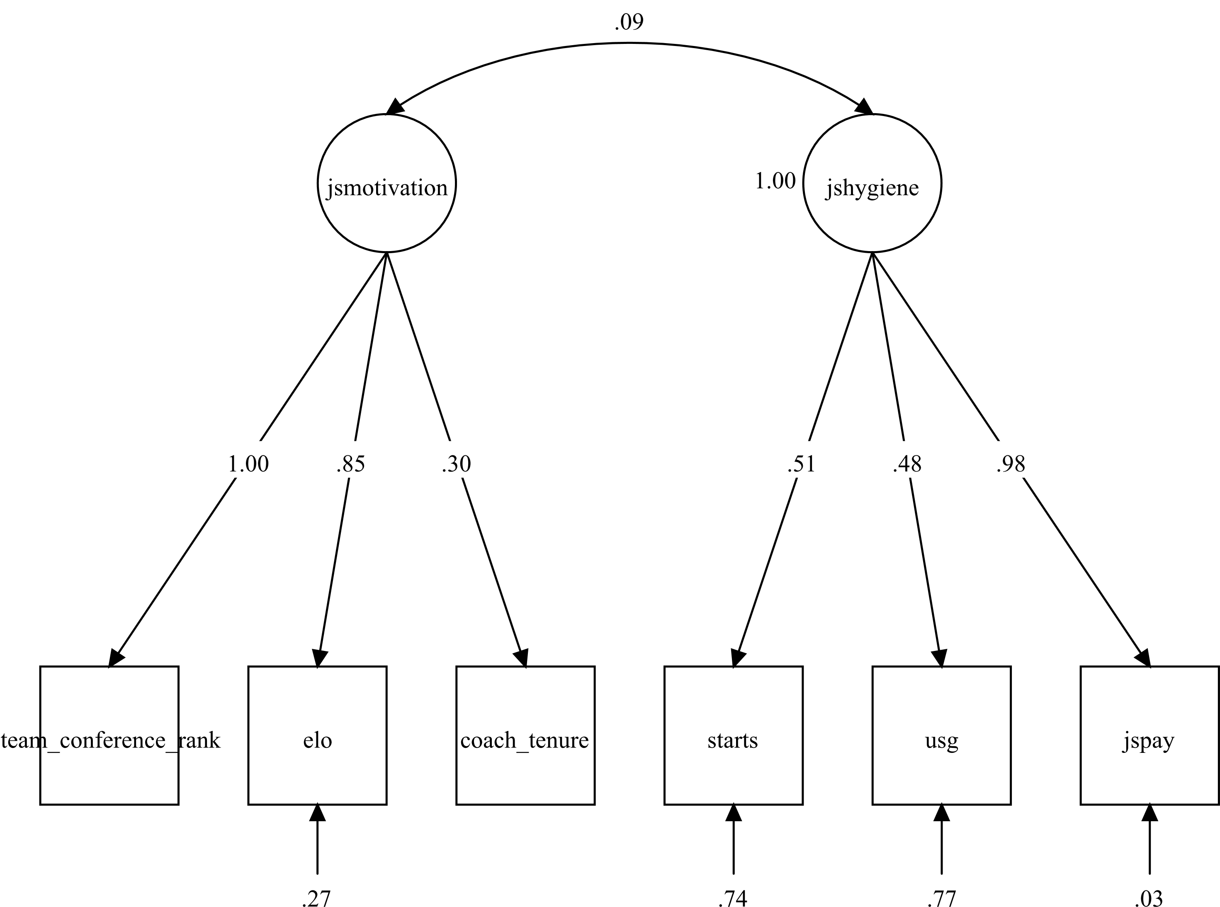

Figure 3. Job Embeddedness Measurement Model (Study One)
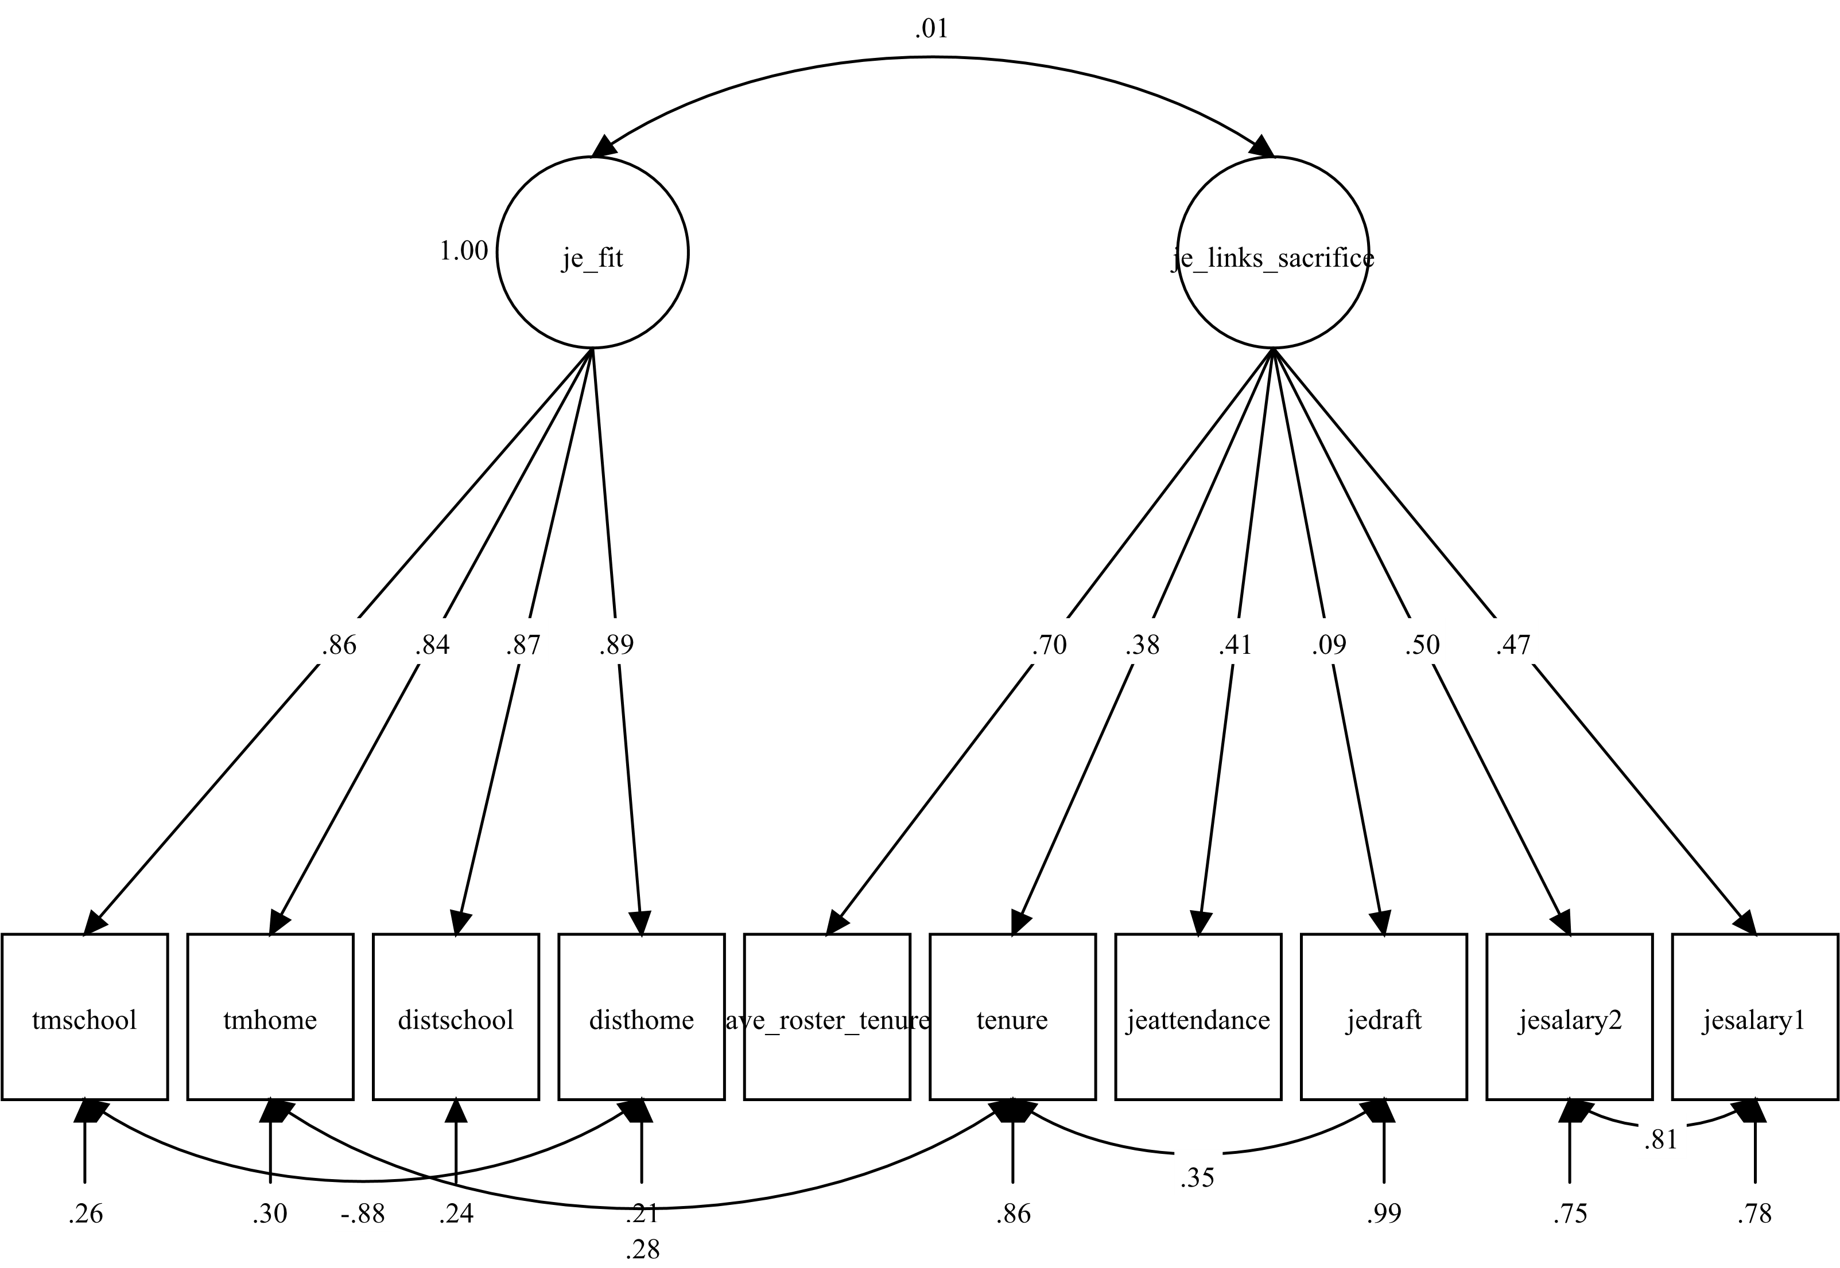
Figure 4. Leader-Member Exchange Measurement Model (Study One)
Figure 5. Mediational Model JS-LMX-Turnover (Study One)
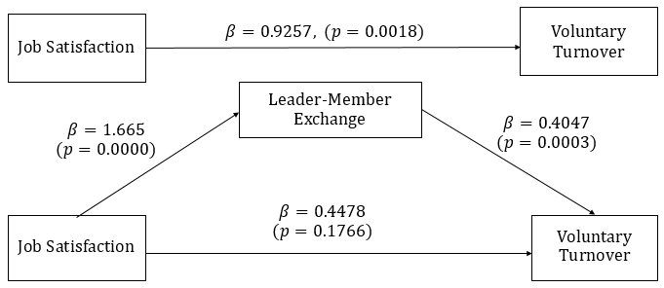

Figure 6. Job Satisfaction Measurement Model (Study Two)
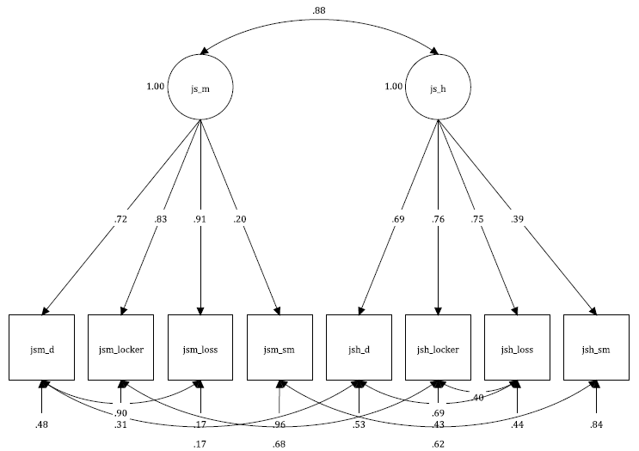

Figure 7. Organizational Job Embeddedness Measurement Model (Study Two)
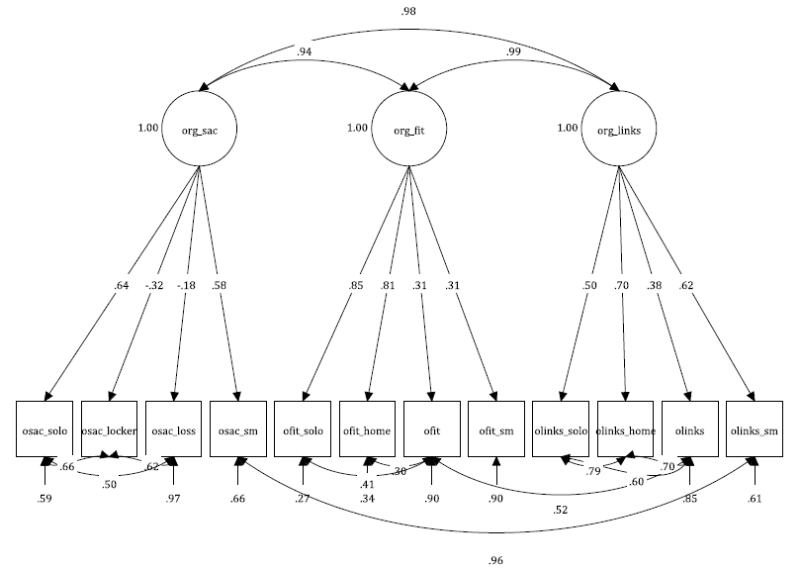
Figure 8. Community Job Embeddedness Measurement Model (Study Two)
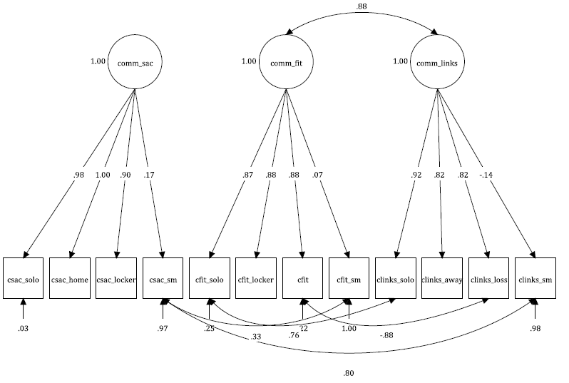

Figure 9. Leader-Member Exchange Measurement Model (Study Two)
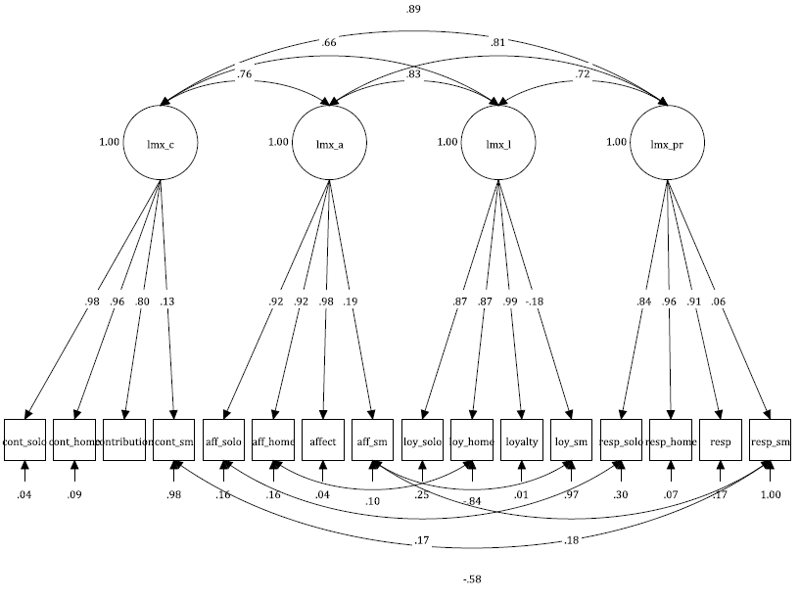
Figure 10. Mediational Model JS-LMX-Turnover (Study Two)
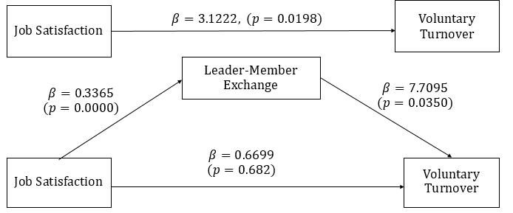

Figure 11. Moderating Influence of Community Fit on JS-Hygiene
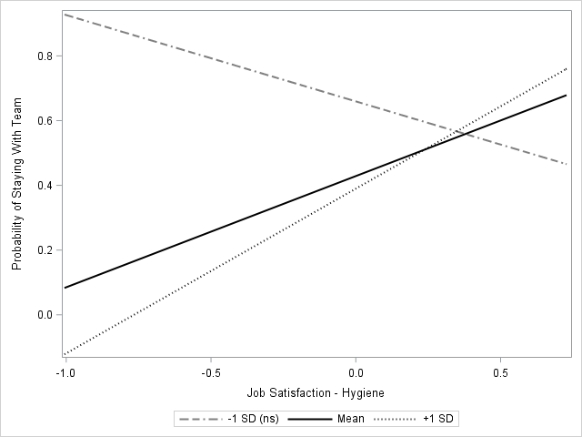

Figure 12. Moderating Influence of Organizational Links on JS-Motivation
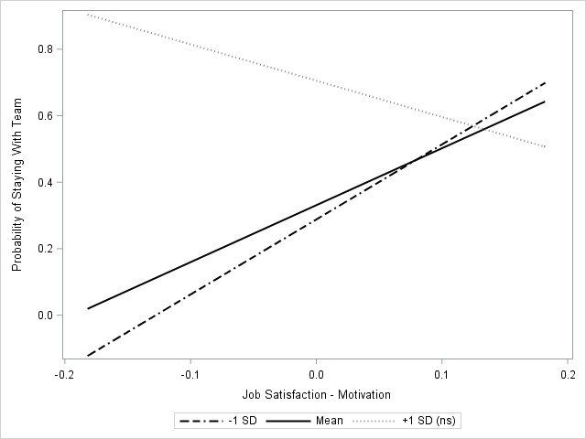
Figure 13. Moderating Influence of Community Sacrifice on JS-Motivation
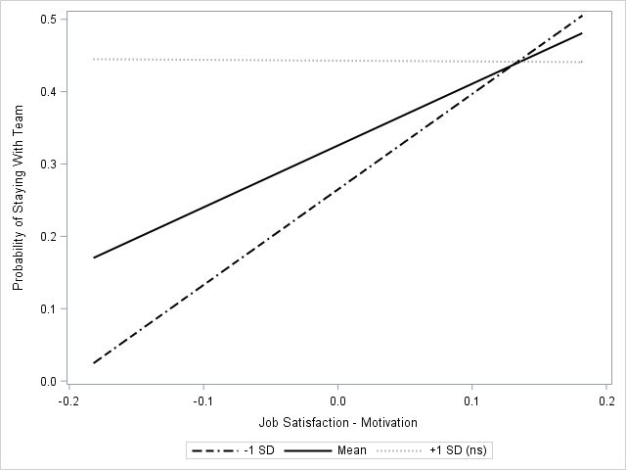

References
Ahmed, I., Ismail, W. K. W., Amin, S. M., & Ramzan, M. (2013). Influence of Relationship of POS, LMX and Organizational Commitment on Turnover Intentions. Organization Development Journal, 31(1), 55–68.
Arcega, R. (2018). instagram-scraper: Scrapes an instagram user’s photos and videos. Python. Retrieved from https://github.com/rarcega/instagram-scraper (Original work published 2013)
Banks, G. C., Woznyj, H. M., Wesslen, R. S., & Ross, R. L. (2018). A Review of Best Practice Recommendations for Text Analysis in R (and a User-Friendly App). Journal of Business and Psychology, 1–15. https://doi.org/10.1007/s10869-017-9528-3
Benoit, K. (2018). quanteda: An R package for the Quantitative Analysis of Textual Data. R, Quanteda Initiative. Retrieved from https://github.com/quanteda/quanteda (Original work published 2012)
Bernardin, H. J., & Buckley, M. R. (1981). Strategies in Rater Training. The Academy of Management Review, 6(2), 205–212. https://doi.org/10.2307/257876
Biemann, T., Cole, M. S., & Voelpel, S. (2012). Within-group agreement: On the use (and misuse) of rWG and rWG(J) in leadership research and some best practice guidelines. The Leadership Quarterly, 23(1), 66–80. https://doi.org/10.1016/j.leaqua.2011.11.006
Campbell, B. A., Saxton, B. M., & Banerjee, P. M. (2014). Resetting the Shot Clock: The Effect of Comobility on Human Capital. Journal of Management, 40(2), 531–556. https://doi.org/10.1177/0149206313516679
Cleveland Cavaliers on the Forbes NBA Team Valuations List. (2016). Retrieved November 28, 2016, from http://www.forbes.com/teams/cleveland-cavaliers/
Cranny, C. J., Smith, P. C., & Stone, E. F. (Eds.). (1992). Job satisfaction: how people feel about their jobs and how it affects their performance. New York : Toronto : New York: Lexington Books ; Maxwell Macmillan Canada ; Maxwell Macmillan International.
Crossley, C. D., Bennett, R. J., Jex, S. M., & Burnfield, J. L. (2007). Development of a global measure of job embeddedness and integration into a traditional model of voluntary turnover. Journal of Applied Psychology, 92(4), 1031–1042. https://doi.org/10.1037/0021-9010.92.4.1031
Dolan, S. (2018). jq: Command-line JSON processor. C. Retrieved from https://github.com/stedolan/jq (Original work published 2012)
Giambatista, R. C. (2004). Jumping through hoops: A longitudinal study of leader life cycles in the NBA. The Leadership Quarterly, 15(5), 607–624. https://doi.org/10.1016/j.leaqua.2004.07.002
Griffeth, R. W. (2000). A Meta-Analysis of Antecedents and Correlates of Employee Turnover: Update, Moderator Tests, and Research Implications for the Next Millennium. Journal of Management, 26(3), 463–488. https://doi.org/10.1177/014920630002600305
Han G, & Jekel M. (2011). The mediating role of job satisfaction between leader-member exchange and turnover intentions. Journal of Nursing Management, 19(1), 41–49. https://doi.org/10.1111/j.1365-2834.2010.01184.x
Harris, K. J., Wheeler, A. R., & Kacmar, K. M. (2011). The mediating role of organizational job embeddedness in the LMX–outcomes relationships. The Leadership Quarterly, 22(2), 271–281. https://doi.org/10.1016/j.leaqua.2011.02.003
Hayward, G. (2017, July 4). Thank You, Utah. Retrieved November 20, 2017, from https://www.theplayerstribune.com/gordon-hayward-decision-free-agency-nba/
Herzberg, F. (1974). Motivation-hygiene profiles: Pinpointing what ails the organization. Organizational Dynamics, 3(2), 18–29. https://doi.org/10.1016/0090-2616(74)90007-2
Hornik, K., Mair, P., Rauch, J., Geiger, W., Buchta, C., & Feinerer, I. (2013). The textcat Package for n -Gram Based Text Categorization in R. Journal of Statistical Software, 52(6). https://doi.org/10.18637/jss.v052.i06
Hulin, C. L., & Smith, P. A. (1967). An empirical investigation of two implications of the two-factor theory of job satisfaction. Journal of Applied Psychology, 51(5, Pt.1), 396–402. https://doi.org/10.1037/h0025094
If Dwight Howard leaves Orlando, city should sue Magic, NBA. (2011). Retrieved November 27, 2016, from http://articles.orlandosentinel.com/2011-01-18/sports/os-bianchi-dwight-howard-magic-0119-20110118_1_franchise-tag-dwight-howard-magic-gm-otis-smith
Jockers, M. (2017). syuzhet: Extracts Sentiment and Sentiment-Derived Plot Arcs from Text. Retrieved from https://CRAN.R-project.org/package=syuzhet
Kopkin, N. (2012). Tax Avoidance: How Income Tax Rates Affect the Labor Migration Decisions of NBA Free Agents. Journal of Sports Economics, 13(6), 571–602. https://doi.org/10.1177/1527002511412194
L. Davis, J., Fodor, A., E. Pfahl, M., & Stoner, J. (2014). Team interdependence and turnover: evidence from the NFL. American Journal of Business, 29(3/4), 276–292. https://doi.org/10.1108/AJB-02-2014-0009
LeBron James’ decision: the transcript. (2010, July 9). Retrieved November 26, 2016, from http://www.espn.com/blog/truehoop/post/_/id/17853
Liden, R. C., & Maslyn, J. M. (1998). Multidimensionality of leader-member exchange: An empirical assessment through scale development. Journal of Management, 24(1), 43–72. https://doi.org/10.1016/S0149-2063(99)80053-1
Liu, B., Hu, M., & Cheng, J. (2005). Opinion Observer: Analyzing and Comparing Opinions on the Web. In Proceedings of the 14th International Conference on World Wide Web (pp. 342–351). New York, NY, USA: ACM. https://doi.org/10.1145/1060745.1060797
Miner, J. B. (1992). Industrial-organizational psychology. New York: McGraw-Hill.
Mitchell, T. R., Holtom, B. C., Lee, T. W., Sablynski, C. J., & Erez, M. (2001). WHY PEOPLE STAY: USING JOB EMBEDDEDNESS TO PREDICT VOLUNTARY TURNOVER. Academy of Management Journal, 44(6), 1102–1121. https://doi.org/10.2307/3069391
Mohammad, S. M., & Turney, P. D. (2010). Emotions Evoked by Common Words and Phrases: Using Mechanical Turk to Create an Emotion Lexicon. In Proceedings of the NAACL HLT 2010 Workshop on Computational Approaches to Analysis and Generation of Emotion in Text (pp. 26–34). Stroudsburg, PA, USA: Association for Computational Linguistics. Retrieved from http://dl.acm.org/citation.cfm?id=1860631.1860635
Morrow, P. C., Suzuki, Y., Crum, M. R., Ruben, R., & Pautsch, G. (2005). The role of leader‐member exchange in high turnover work environments. Journal of Managerial Psychology, 20(8), 681–694. https://doi.org/10.1108/02683940510631444
Nyberg, A. (2010). Retaining your high performers: Moderators of the performance–job satisfaction–voluntary turnover relationship. Journal of Applied Psychology, 95(3), 440–453. https://doi.org/10.1037/a0018869
Ooms, J. (2017). cld2: R Wrapper for Google’s Compact Language Detector 2. C++, rOpenSci. Retrieved from https://github.com/ropensci/cld2 (Original work published 2017)
Parry, K., Mumford, M. D., Bower, I., & Watts, L. L. (2014). Qualitative and historiometric methods in leadership research: A review of the first 25years of The Leadership Quarterly. The Leadership Quarterly, 25(1), 132–151. https://doi.org/10.1016/j.leaqua.2013.11.006
Preacher, K. J., & Hayes, A. F. (2008). Asymptotic and resampling strategies for assessing and comparing indirect effects in multiple mediator models. Behavior Research Methods, 40(3), 879–891. https://doi.org/10.3758/BRM.40.3.879
R Core Team. (2017). R: A Language and Environment for Statistical Computing. Vienna, Austria: R Foundation for Statistical Computing. Retrieved from https://www.R-project.org/
Ramesh, A. (2007). Replicating and Extending Job Embeddedness Across Cultures: Employee Turnover in India and the United States. University of Maryland, College Park.
Saari, L. M., & Judge, T. A. (2004). Employee attitudes and job satisfaction. Human Resource Management, 43(4), 395–407. https://doi.org/10.1002/hrm.20032
Sieweke, J., & Zhao, B. (2015). The impact of team familiarity and team leader experience on team coordination errors: A panel analysis of professional basketball teams: TEAM COORDINATION ERRORS. Journal of Organizational Behavior, 36(3), 382–402. https://doi.org/10.1002/job.1993
Silver, N., & Fischer-Baum, R. (2015, May 21). How We Calculate NBA Elo Ratings. Retrieved November 29, 2016, from http://fivethirtyeight.com/features/how-we-calculate-nba-elo-ratings/
Smith, K., P. (n.d.). NBA Salary & Roster Sheets. Retrieved from https://docs.google.com/spreadsheets/d/1T2Eg_zvqNqQD_5TpE4Ns6xhElatXdLpYG1roZtRLyvE/edit#gid=247796302
Spangler, W. D., Gupta, A., Kim, D. H., & Nazarian, S. (2012). Developing and validating historiometric measures of leader individual differences by computerized content analysis of documents. The Leadership Quarterly, 23(6), 1152–1172. https://doi.org/10.1016/j.leaqua.2012.11.002
Surowiecki, J. (2005). The wisdom of crowds (1. ed). New York, NY: Anchor Books.
Taspinar, A. (2018). twitterscraper: Scrape Twitter for Tweets. Python. Retrieved from https://github.com/taspinar/twitterscraper (Original work published 2016)
Vardon, J. (2015). LeConomics: Is the economic impact of LeBron James’ return to Cleveland more than a feeling? Retrieved November 28, 2016, from http://www.cleveland.com/cavs/index.ssf/2015/02/lebron_james_cleveland_economi.html
Welty Peachey, J., J. Burton, L., & E. Wells, J. (2014). Examining the influence of transformational leadership, organizational commitment, job embeddedness, and job search behaviors on turnover intentions in intercollegiate athletics. Leadership & Organization Development Journal, 35(8), 740–755. https://doi.org/10.1108/LODJ-10-2012-0128
Young, L., & Soroka, S. (2012). Affective News: The Automated Coding of Sentiment in Political Texts. Political Communication, 29(2), 205–231. https://doi.org/10.1080/10584609.2012.671234

Appendix A: Sample Social Media Scraping Code
Requires use of Python programming language and basic library (available for free at https://www.python.org). This code is formatted to be run through the command line.

To download the necessary scripts:

$ pip install twitterscraper
$ pip install instagram-scraper
$ pip install jq

To scrape data from a specific twitter user between the specified dates:

$ twitterscraper from:[USER-NAME] -bd 2016-07-01 -ed 2017-07-01 -o [FILE NAME].json

To change the Twitter JSON file to a CSV:

$ cat [FILE NAME].json | jq -r '(map(keys) | add | unique) as $cols | map(. as $row | $cols | map($row[.])) as $rows | $cols, $rows[] | @csv'>> [FILE NAME].csv

Instagram scraping code downloads all photo and video posts – additional options available online (Arcega, 2013/2018) and removal by date range was completed during data pre-processing in R. To scrape data, including meta-data:

$ instagram-scraper [USER-NAME] --include-location
To change the Instagram JSON file to a CSV that includes the number of likes, captions, geo-tags and timestamps:

$ cat [USER-NAME].json | jq -r '.[] | [.edge_media_preview_like.count, .edge_media_to_caption.edges[].node.text, .location.name, .taken_at_timestamp] | @csv’ >>[FILE NAME].csv

Appendix B: Content Dictionary Category Examples
Category |  | Examples
Organization Links  (OL) | Atlanta Hawks | ‘@atlhawks’ ‘@philipsarena’ ‘#gohawks’
Organization Links  (OL) | Houston Rockets | 🚀 ‘Houston Toyota Center’ ‘@houstonrockets’
Organization Links  (OL) | ...
Organization Links  (OL) | Washington Wizards | ‘@washwizards’ ‘#wizards’ ‘Capital One Arena’
Team Links (TL) | Atlanta Hawks | ‘@24baze’ ‘@taureanprince’ ‘@mikescottva’
Team Links (TL) | Houston Rockets | ‘@capelaclint’ ‘@jharden13’ ‘@officialeg10’
Team Links (TL) | ...
Team Links (TL) | Washington Wizards | ‘@bradbeal3’ ‘@johnwall’ ‘@mgortat13’
Community Links  (CL) | Atlanta, Georgia | ‘@atlantafalcons’ ‘Georgia Dome’ ‘#atl’
Community Links  (CL) | Houston, Texas | ‘@astros’ ‘NASA – Johnson Space Center’
Community Links  (CL) | ...
Community Links  (CL) | Washington D.C. | ‘@topgolfdc’ ‘#httr’ ‘World War II Memorial’
Game or Competition (C) |  | ‘*game*’ ‘*win*’ ‘*loss*’
Family (F) |  | ‘*family*’ ‘#fatherfirst’ ‘#mommasboy’
Team-Positive (TP) |  | ‘#lovemyteam’ ‘#theidealteamplayer’
Team-Neutral (TN) |  | ‘*team*’ ‘*game*’
Gratitude (G) |  | ‘#grateful’ ‘*thankful*’
Humility (H) |  | ‘#trulyblessed’ ‘#allgod’ ‘#stayhumble’
Underdog (U) |  | ‘#undrafted’ ‘#underrated’ ‘#proveemwrong’
Home or Community Fit (CF) |  | ‘#home’ ‘#putonformycity’ ‘#placewhereibelong’
Team Competitiveness (TC) |  | ‘playoffs’ ‘#easternconferencechamps’
Fans or Community (FC) |  | ‘fans’ ‘#bestfansinthenba’
Work (W) |  | ‘*work*’ ‘#nodaysoff’ ‘#summergrind’
Recognition (R) |  | ‘*allstar*’ ‘*risingstars*’ ‘*career’

