University of Oklahoma
Graduate College

Exploring the Spatiotemporal relationships among population, land use, and water use in the united StaTes portion of the Rio Grande River Basin

A Thesis
Submitted to the graduate faculty
In partial fulfillment of the requirements of the
Degree of
MASTER OF SCIENCE
Geography and Environmental Sustainability (Geospatial Technologies)

By
David Conn
Norman, Oklahoma
2022
Exploring the spatiotemporal relationships among population, land use, and water use in the united states portion of the Rio Grande River Basin

A Thesis Approved for the
Department of Geography and Environmental Sustainability

By the Committee Consisting of

Dr. Jennifer Koch
Dr. Bryce Lowery
Dr. Xin Feng

© Copyright by David Conn 2022
All Rights Reserved.

Acknowledgements

I would like to thank my advisor, Dr. Jennifer Koch for guiding me patiently along the journey of having close to no knowledge of Geospatial Information Systems all the way through to the completion of this thesis. You have been incredibly helpful and understanding throughout the entire process and made sure that I enjoyed it and got the most out of it.
I would also like to thank my wife, Jenny. Without her unwavering support and patience, I would never have been able to make it through this endeavor. Thank you for always believing in me and pushing me to be the best that I possibly can be.
Table of Contents
Acknowledgements iv
List of Tables vii
List of Figures viii
Abstract x
Chapter 1: Introduction 1
Chapter 2: Literature Review 4
2.1 Water Use 4
2.2 Population Growth 6
2.3 Land Use Change 7
2.4 Research Gap 8
Chapter 3: Data and Methods 10
3.1 Study Area 10
3.2 Data Input 11
3.3 Addressing Incongruent Time Steps for Data on Land Cover, Population, and Water Use 13
3.4 Data Processing 14
3.5 Data Analysis 19
3.6 Categorical Land Cover Change Maps 21
3.7 Case Study Counties 21
Chapter 4: Results 23
4.1 Population and Water Use 23
4.2 Land Cover 25
4.3 Statistical Analysis 26
4.4 Case Study Counties 34
4.4.1 Bernalillo County, New Mexico 34
4.4.2 Hidalgo County, Texas 37
4.4.3 Rio Grande County, Colorado 40
4.4 Case Study County Comparison 43
Chapter 5: Discussion 46
5.1 Water Use Decline in the Rio Grande Basin 46
5.2 Temporal Dynamics of Water Use Drivers 47
5.3 Spatial Analysis of Land Cover Influence on Water Use 49
5.4 Study Limitations and Next Steps 50
Chapter 6: Conclusion 52
Literature Cited 54

List of Tables
Table 1: Example of data compiled for each county…………………………………….19
Table 2: Land cover change in the Rio Grande Basin…………..………………………26
Table 3: Results of Statistical analysis in R……………………………...………………29
Table 4: Land cover change in Bernalillo County, New Mexico.……………..………...36
Table 5: Land cover change in Hidalgo County, Texas……………………………..….39
Table 6: Land cover change in Rio Grande County, Colorado……………….…..…….42
Table 7: R² values resulting from geographically weighted regression…….…………..46
Table 8: Population regression coefficients resulting from geographically weighted regression……………………………………………………………………………..….46
Table 9: Developed land cover regression coefficients resulting from geographically weighted regression…………...…………………………………………………………47
Table 10: Agricultural land cover regression coefficients resulting from geographically weighted regression…………………………………...…………………………………47

List of Figures
Figure 1: Overview of the Rio Grande Basin location………………………………..…11
Figure 2: Rio Grande Basin overlaid study area counties…………………...…………..13
Figure 3: Example of National Land Cover Dataset…………………………………….14
Figure 4: Study region……………………...………………………………..…..………15
Figure 5: Re-categorization of National Land Cover Dataset categories…………..……17
Figure 6: Example of re-classified land cover type used for analysis……………..…….17
Figure 7: Re-categorization of United States Geological Survey Water Data...……...…17
Figure 8: Case study counties within study region…………………...…………….……23
Figure 9: Population and water use change in the Rio Grande Basin………..….………24
Figure 10: Developed and agricultural water use in the Rio Grande Basin…..…………25
Figure 11: Water use change and population change in the Rio Grande Basin………..25
Figure 12: Land cover composition of the Rio Grande Basin……..……………….……26
Figure 13: Land cover change in the Rio Grande Basin………..………….……………27
Figure 14: Local R² values for the study region resulting from geographically weighted regression…………………………………………………………………...……………30
Figure 15: Regression coefficient values for the influence of population on water use....31
Figure 16: Regression coefficient values for the influence of developed land cover on water use…………………………………………………………………………………32
Figure 17: Regression coefficient values for the influence of agricultural land cover on water use………………………….……………………..……………………………….33
Figure18: Population and water use change in Bernalillo County, New Mexico……..…35
Figure 19: Developed and Agricultural water use in Bernalillo County, New Mexico....35
Figure 20: Land cover composition of Bernalillo County, New Mexico………...………36
Figure 21: Land cover change in Bernalillo County, New Mexico……………………...37
Figure 22: Population and water use change in Hidalgo County, Texas………………..38
Figure 23: Developed and agricultural water use in Hidalgo County, Texas…………...38
Figure 24: Land cover composition of Hidalgo County, Texas…………………………39
Figure 25: Land cover change in Hidalgo County, Texas……………………………….40
Figure 26: Population and water use change in Rio Grande County, Colorado………….41
Figure 27: Developed and agricultural water use in Rio Grande County, Colorado…...41
Figure 28: Land cover composition of Rio Grande County, Colorado…………….……42
Figure 29: Land cover change in Rio Grande County, Colorado……………………….43

Abstract
Water use in the United States is uncertain as our climate warms and our population continues to grow. As such, it is imperative that we understand the drivers of water use in order to better plan for this future. The Rio Grande Basin (RGB) in the Southwestern United States presents an opportunity to study these drivers and the spatiotemporal relationships among them as it is a region experiencing rapid population growth in addition to being spatially heterogeneous. In this study, I use statistical analysis in R and ArcGIS Pro to examine the relationship between population, developed land cover, and agricultural land cover on water use in the RGB and how these relationships have changed from 1990 - 2015. The results of this analysis indicate that these relationships are changing both over space and time. While my work here shows a decline in water use in the Rio Grande Basin over the study period, this is attributed to only a handful of counties that experienced a steep decline in agricultural water use. This decrease in agricultural water use likely will not continue to offset the inevitable increase in domestic water use that I begin to see at the end of the study period due to growing populations in the basin. This study reveals that the relationships among population, land use and cover, and water use are dynamic, changing over both time and space, and highlights the need to look deeper into what drives water use in order to address the water needs of a rapidly expanding population.

Chapter 1: Introduction

The Rio Grande Basin (RGB) is a region facing an uncertain water sustainability future. Most of the water from the Rio Grande is being diverted to support agricultural efforts and a rapidly growing population in an environment that is experiencing less rain and higher temperatures than in previous decades (Blanc et al., 2014; Brown et al., 2019). Over the last ten years, population growth in the United States has been concentrated in the South and West, accounting for 20% of total national population growth (U.S. Census Bureau, 2020). A growing population impacts not only the amount of water used but also the way it is used. As population in an area grows, the economy tends to shift from agricultural to industrial, changing how water is allocated (Rister et al., 2011). Rapid population growth is leading to substantial changes in the landscape of the RGB because of expansion of developed urban areas and thereby an increase in the amount of water used for domestic and public supply (Sanchez et al., 2018; Bounoua et al., 2018). In some cases, land previously used for irrigated agriculture is converted to urban area, therefore decreasing agricultural water use (Alig et al., 2004). Climate change compounds the impacts of population growth and shifts in water use in the region by causing more frequent and intense droughts and less frequent precipitation (Brown et al., 2019; Cook et al., 2014; Dai, 2013; Strzepeck, 2010). The purpose of this research is to understand the relationship between the rapidly growing population and land use and cover change in the U.S. portion of the RGB and how this impacts water use in the region.
Much of the research on water use in the U.S. has been done at the national, state, or local level not capturing the regional dynamics of water use (e.g. Das et al., 2018; Brown et al., 2013; Brown et al., 2019; Blanc et al., 2014). Research regarding the relationship between land use and water use often focuses on either the ways that urban development or agricultural activities impact water use, but typically does not consider competition between agrarian and developed uses or conversion between these land cover types, despite the fact that irrigation for agriculture accounts for the majority of consumptive water use (e.g. Sanchez et al., 2018; United States Geological Survey [U.S.G.S.]a, 2005; U.S.G.S.b, 2010; U.S.G.S.c, 2015; Koch et al., 2018). Population projections often account for where people will settle based on past trends and land suitability, but fall short of recognizing the way that population allocation impacts and is impacted by land use change and the subsequent change this has on resource management (Jones and O’Neil, 2013; McKee et al., 2015). This research seeks to answer the following questions through spatiotemporal analysis:
- How and where is the population of the RGB growing?
- What are the spatiotemporal relationships among changes in population, land use and cover, and water use?
Understanding water use is integral to maintaining sustainable water resources in the basin, since 75% of the Rio Grande’s waters are already diverted for agricultural and municipal uses (Blanc et al., 2014; Koch et al., 2019). Therefore, it is important to seek answers that will inform future water use policy in to improve sustainability in this region. Attempts have been made to govern the water resources in the basin more carefully, such as Senate Bill 1 passed by the 75th Texas Legislature which divided Texas into 16 different regions for water resource planning (Rister et al., 2011). In the central and lower Rio Grande, multiple entities such as the North American Development Bank, the U.S. Bureau of Reclamation, the Texas Water Development Board, and others have worked on projects to save on water used for irrigation (Rister et al., 2011). Taking a proactive approach, rather than a reactive one, is especially important as the region is likely to face more frequent and more intense drought events due to a changing climate (Dai, 2013).

Chapter 2: Literature Review

2.1 Water Use
Often viewed as an unlimited resource, water is becoming increasingly strained as demand grows due to population growth. Although efforts have been made to increase demand side water use efficiency, such as more efficient irrigation, transport methods, and appliances, construction of water retention elements such as reservoirs has been declining since the 1960’s (Brown et al., 2019). This is in part due to suitable sites for these reservoirs becoming more scarce (Brown et al., 2019). As such, it is increasingly important that we understand how and where we are using our water resources before we exhaust our efficiency and storage efforts.
Water use in the United States is projected to increase by 2% to 42% of 2005 levels by 2060 (Brown et al., 2013). This wide range of potential water futures highlights the level of uncertainty in our water situation and the crucial need to better understand and manage our water resources. Brown et al. (2013) break the U.S. down into the 18 Water Resource Regions delineated by the U.S. Water Resources Council and project future water use. While providing information on the general trends, this scale is too coarse to account for regional subtleties. Smaller scales, such as the climate division level, are more accurate when modeling water use (Das et al., 2018). Brown et al. (2019) show that the situation around water scarcity has become more dire, with some regions in the U.S. expected to encounter serious water shortages in the late 21st century. Despite increases in water use efficiency and plateauing population, climate change largely negates water use offsets, leading to an increase in withdrawals overall (Brown et al., 2013; Brown et al., 2019; Blanc et al., 2014).
Water use in the Southwestern U.S. is expected to come under particularly profound stress, even without considerations for climate change (Blanc et al., 2014). Brown et al. (2013) found water use in the Western United States to be particularly difficult to predict due to fluctuations in domestic and public water use. However, they do find that water use overall is likely to decrease as irrigated areas demand less water. The Rio Grande is already an over-exploited water resource, with 75% of the river’s flow being diverted for agriculture, industry, and domestic use (Blanc et al., 2014; Koch et al., 2019). Areas of the river have experienced extensive human manipulation through hydraulic infrastructure, river straightening, and other means by which the river has been modified to reduce flood risk and increase water conveyance (Sandoval-Solis et al., 2022). As a result, the Rio Grande is listed as one of the most at risk river sin the world (Sandoval-Solis et al., 2022). Through evaporation alone, the river loses more water than is replaced by precipitation (Gomez et al., 2007). There are stretches of the river that are regularly dry due to these intense withdrawals within the basin (Koch et al., 2019). Water used for agriculture accounts for 31% of withdrawals on average in the U.S., but accounts for 85% of the water withdrawals in the RGB despite farmland accounting for just 3.5% of the basin’s area (Koch et al., 2019). Brown et al. (2013) found that in the absence of climate factors, national water use from 2005 to 2060 would increase by only 3%, but when evapotranspiration was considered, this jumped significantly to around 20%.

2.2 Population Growth
U.S. population is predicted to increase by1.8 to 2.1 million people annually through 2060, surpassing 400 million (Colby & Ortman, 2015). Jones and O’neil (2013) recognize the need to better understand where these populations will be settling in light of increasing strain on resources and climate change. Their study projects spatially explicit population growth scenarios for the next 100 years. While this study and others like it increase our understanding what type of population growth will occur (Urban or Rural) and where it will take place, they stop short of examining the implications of what this population growth means for resource management (Jones and O’Neil, 2013; McKee et al., 2015). Population growth has a complicated relationship with water use. Individual water use is what drives domestic water use levels, implying that urban development would result in greater water use overall (Bounoua et al., 2018; Sanchez et al., 2018). However, this relationship depends on where this urban development is taking place and water use efficiency. If urban development is taking place on previously unused land, this would increase water use in a region (Sanchez et al., 2018). If urban development is the result of agricultural land being converted and developed, the water use may decrease (Rister et al., 2011; Brown et al., 2013; Brown et al., 2019). This highlights the need to understand not only where population growth is occurring, but also the land use change patterns underlying population growth.
Brown et al. (2013) noted that public and domestic water use in the Western U.S. has been particularly difficult to model because of intense fluctuation, which is likely due to the unique population growth trends of this region. The RGB is experiencing more rapid population growth than other areas of the country (U.S. Census Bureau, 2020). The U.S. Census Bureau found that small towns in the West and South saw the most significant growth between 2010 and 2020, accounting for a fifth of total U.S. population growth. This is leading to a greater concentration of people in this region overall. The county level rate of population growth in this region is surpassing 24% annually, much higher than the national average of 9.7% (Rister et al., 2011).

2.3 Land Use Change
Bounoua et al. (2018) analyzed the relationship between population growth and land use change, and found that cities tend to grow the fastest both in terms of population and land use area, leading to a snowball effect of larger cities begetting larger populations leading to larger cities and so on. This study also found that cities in the South are experiencing the greatest increase in population and fastest increase in impervious surface area (Bounoua et al., 2018). One of the key findings of Bounoua et al. (2018) is that despite having similar population growth characteristics, cities may experience different patterns of development. While some cities may account for their increasing populations by infill, others may experience expansion and subsequent increases in impervious surface area (Bounoua et al., 2018). Most of this land use expansion happens on croplands and forests, because the features that make land suitable for farming and forests (slope, proximity to water, etc.) also make land suitable for municipal use (Alig et al., 2004). The RGB region is characterized by its inordinate use of water for irrigation compared to the rest of the country despite the small amount of land that is being used for agriculture (3.5%) (Koch et al., 2019). Because the majority of the land in the basin is grassland and scrubland, it is possible that despite a growing population, we may not see a substantial decrease in agricultural land use. Brown et al. (2013) project that the amount of irrigated land in the U.S. will peak in 2040 and then gradually decrease, likely due to growing urban centers. This decline in irrigated area is already happening in the West and has been since 1980 (Brown et al., 2013).
The effect of this is twofold due to the ways water rights work in the RGB. Since 2005, there has been a marked increase in farmers selling their land to cities, industries, and domestic users (Brown et al., 2013). This is in part due to incentive programs in the basin to take land out of agricultural production to address water shortage issues (Brown et al., 2013). Water rights are often linked to the land, therefore when agricultural land is bought or leased for other uses, the water rights are also transferred (Rister et al., 2011). With the competing interests of agricultural and domestic uses coming to a head in the RGB, it is important to understand how land use has been impacted by population growth and how these factors combined will change water use trends for the region overall.

2.4 Research Gap
The RGB is an area that is already under considerable water stress, with most of the water from the river being diverted for agricultural uses, a rapidly growing population, and an environment that is experiencing less rain and higher temperatures. This region is undergoing changes to its land use due to rapid population growth and therefore will also likely see rapid changes to its water use. Much of the existing research looks at either the national scale (e.g. Brown et al., 2013; Brown et al., 2019; Cook et al., 2014) or focuses only on urban areas ( e.g. Bounoua et al., 2018; Sanchez et al., 2018) and therefore fails to capture the regionality of variables such as population and land use change and subsequent impact on water use. While many population studies allocate populations spatially, (e.g. Jones and O’neil, 2013) they fall short of examining the ways that these changes in population impact land use type, which in turn impacts water use. The need to understand these relationships at a deeper level, and at a more regional scale, is paramount as our climate continues to change. Little research has been done that connects all of these variables the regional scale in the RGB, and any research looking at these variables individually does so at the national or local level. The RGB area exemplifies all of these issues and is an opportunity to better understand these relationships. Furthermore, the basin’s large geographic area and the various spatial scales at which it can be analyzed (state, region, climate division, etc.) provide an opportunity to examine these processes and their rich spatiotemporal heterogeneity.

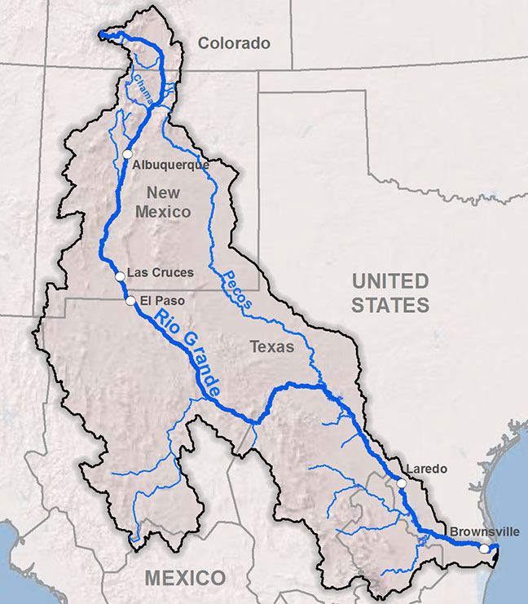
Chapter 3: Data and Methods
Figure 1. Overview of Rio Grande Basin location.Only the United States Portion of the basin is examined in this study. Source: The Wild Earth Guardians Organization, 2017.

3.1 Study Area
The Rio Grande River has its headwaters in the San Juan Mountains of Southern Colorado and is primarily fueled by seasonal snowmelt, which peaks in the months of May and June (Brand, 2020; Koch et al., 2019) (Figure 1). From here, the river flows South through Colorado, into New Mexico, and then travels Southeasterly, forming the border between Texas and the Mexican states of Chihuahua, Coahuila, Nueva León, and Tamaulipas, finally emptying into the Gulf of Mexico (Brand, 2020; Koch et al., 2019). The Rio Grande flows over an expansive 3,060 Km, crossing a wide range of ecosystem types. The headwaters are at a higher, cooler elevation with heavy vegetation. However, as the river enters New Mexico, elevation drops rapidly, and the river enters a region of increasing aridity and temperature where it remains for the majority of its run (Brand, 2020; Koch et al., 2019). The river is refreshed by several tributaries from both the U.S. and Mexico as it makes its way Southward (Brand, 2020; Koch et al., 2019).
The RGB encompasses roughly 552,382km² over the aforementioned states in the United States and Mexico (Koch et al., 2019). About half of this area is in the United States (International Boundary & Water Commission, n.d.). The majority of the basin is scrubland and grassland due to its arid climate. The basin is also home to several large cities that rely on the Rio Grande including Alamosa in Colorado, Albuquerque in New Mexico, and El Paso in Texas.
Because I will be using U.S. Census Bureau data regarding populations, the U.S. based National Land Cover Database (NLCD), and water use data from the United States Geological Survey (USGS), my work will focus only on the portions of the RGB that fall within the U.S.

3.2 Data Input
The boundaries of the Rio Grande Basin have been delineated by the U.S. Environmental Protection Agency (EPA) as part of their National Hydrography Dataset Plus (NHDPlus) product (United States Environmental Protection Agency [EPA], 2020),(Figure 2). NHDPlus is used by scientists working with water resources as it combines the National Hydrography, Watershed Boundary, and National Elevation datasets. This dataset divides the water resources of the U.S. into 22 areas based on water drainage. The RGB is represented by region 13. For this study, I used the watershed boundaries to define my region of interest (Figure 2). I used TIGER/Line shapefile datasets from the U.S. Census Bureau for county line data as these are considered to be highly reliable and up to date (United States Census Bureau [U.S. Census Bureau], 2020), (Figure 2).
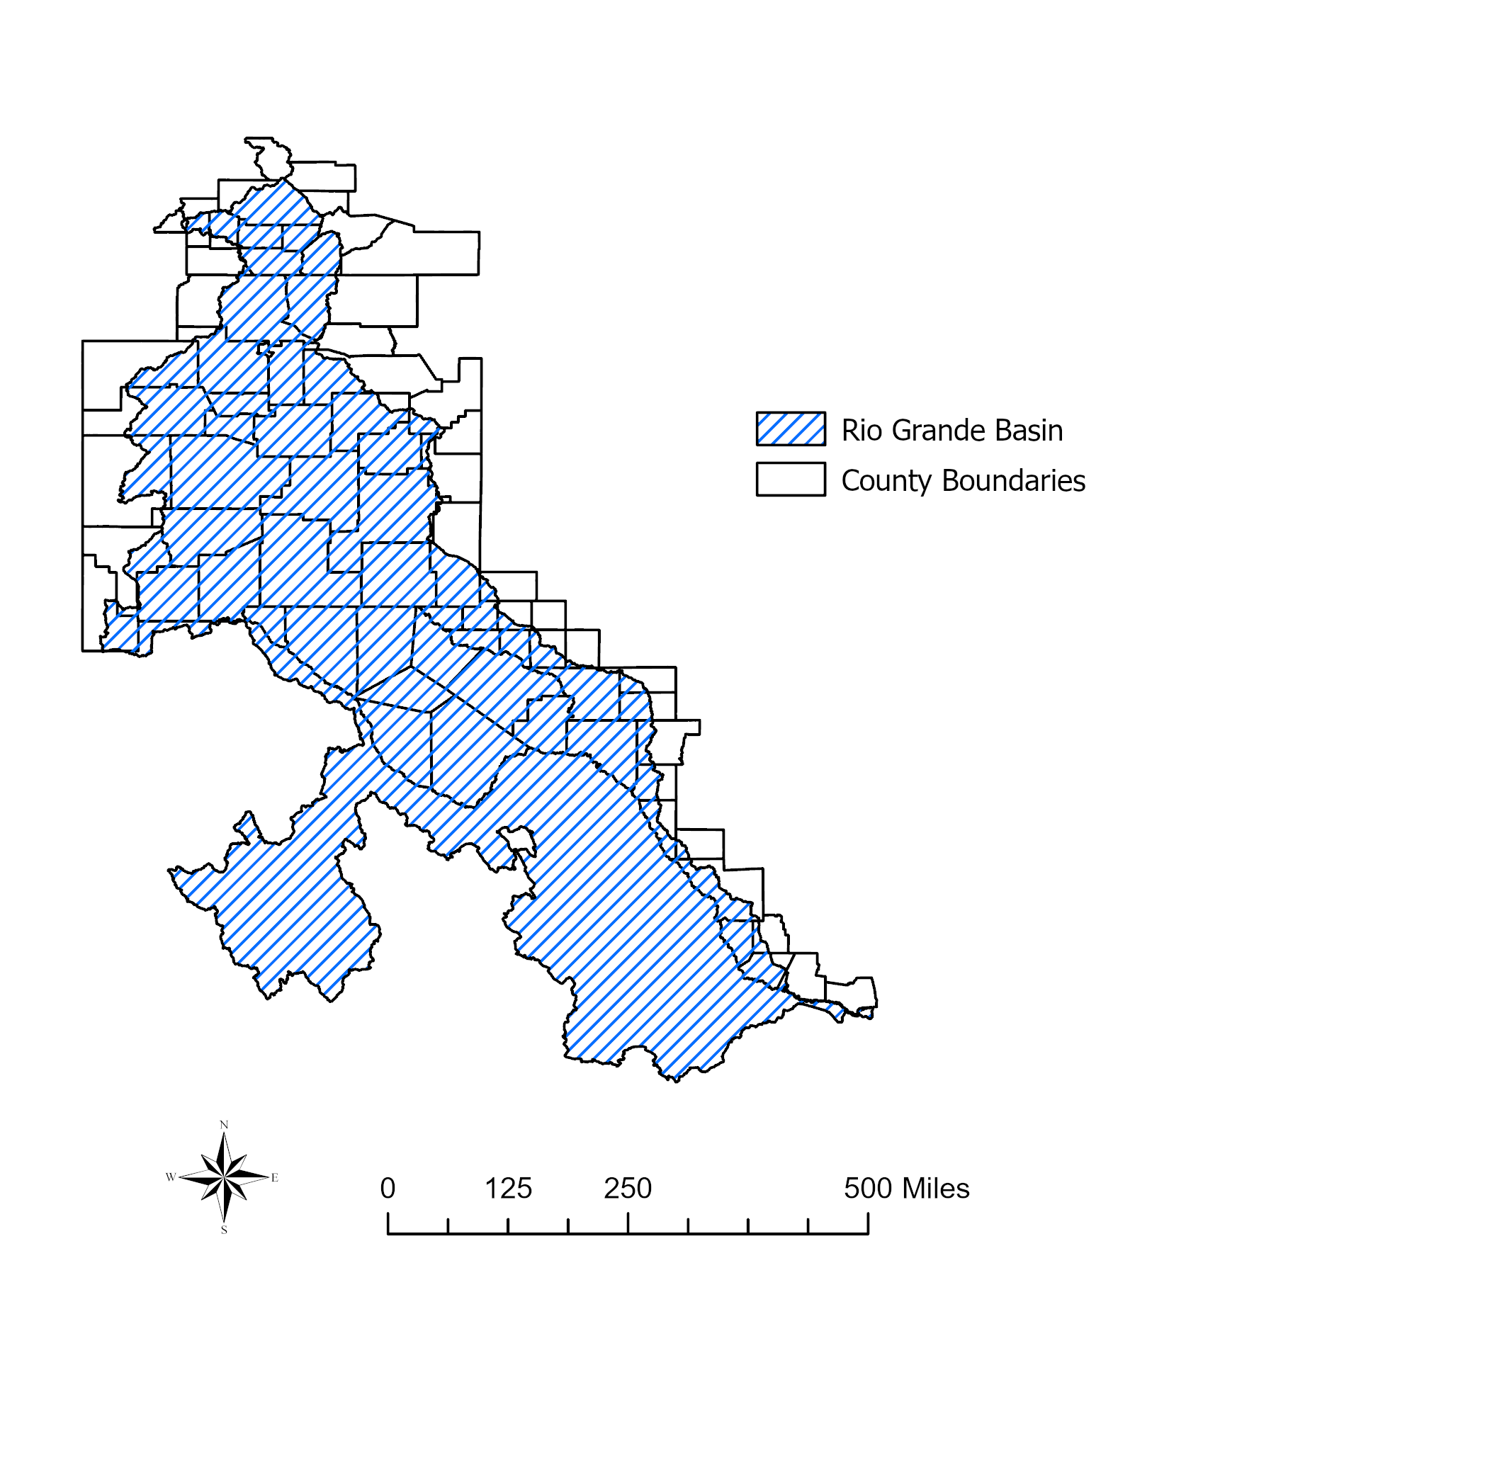
I gathered population data from several sources. For the state of Colorado, I collected data for the years 1990-2010 from the U.S. Census Bureau, and population estimates for the years 2010-2050 from the Colorado Department of Local affairs (U.S. Census Bureau, 2000a; U.S. Census Bureau 2020b; U.S. Census Bureau 2000c; U.S. Census 2012; Colorado Department of Local Affairs State Demography Office, n.d.) . Similarly, I gathered population estimates for 1990 and 1995 for New Mexico from the U.S. Census Bureau and data for 2000 to 2040 from the University of New Mexico (U.S. Census Bureau, 2000a; U.S. Census Bureau, 2000b; The University of New Mexico, n.d.). Finally, I sourced population data for Texas from the Texas Demography Center, The Texas State Library and Archives Commission, and the U.S. Census Bureau (Texas State Library and Commissions Office [TSL], 2013a; TSL, 2013b; TSL, 2013c; TSL, 2013d; TSL, 2018; U.S. Census Bureau, 2012). This provided population data for all three states for the years 1990 to 2040, and on to 2050 for Texas and Colorado, at the county scale.
Figure 2. The Rio Grande Basin overlaid the counties of the study area. Source: The Environmental Protection Agency, 2021; U.S. Census Bureau, 2022.
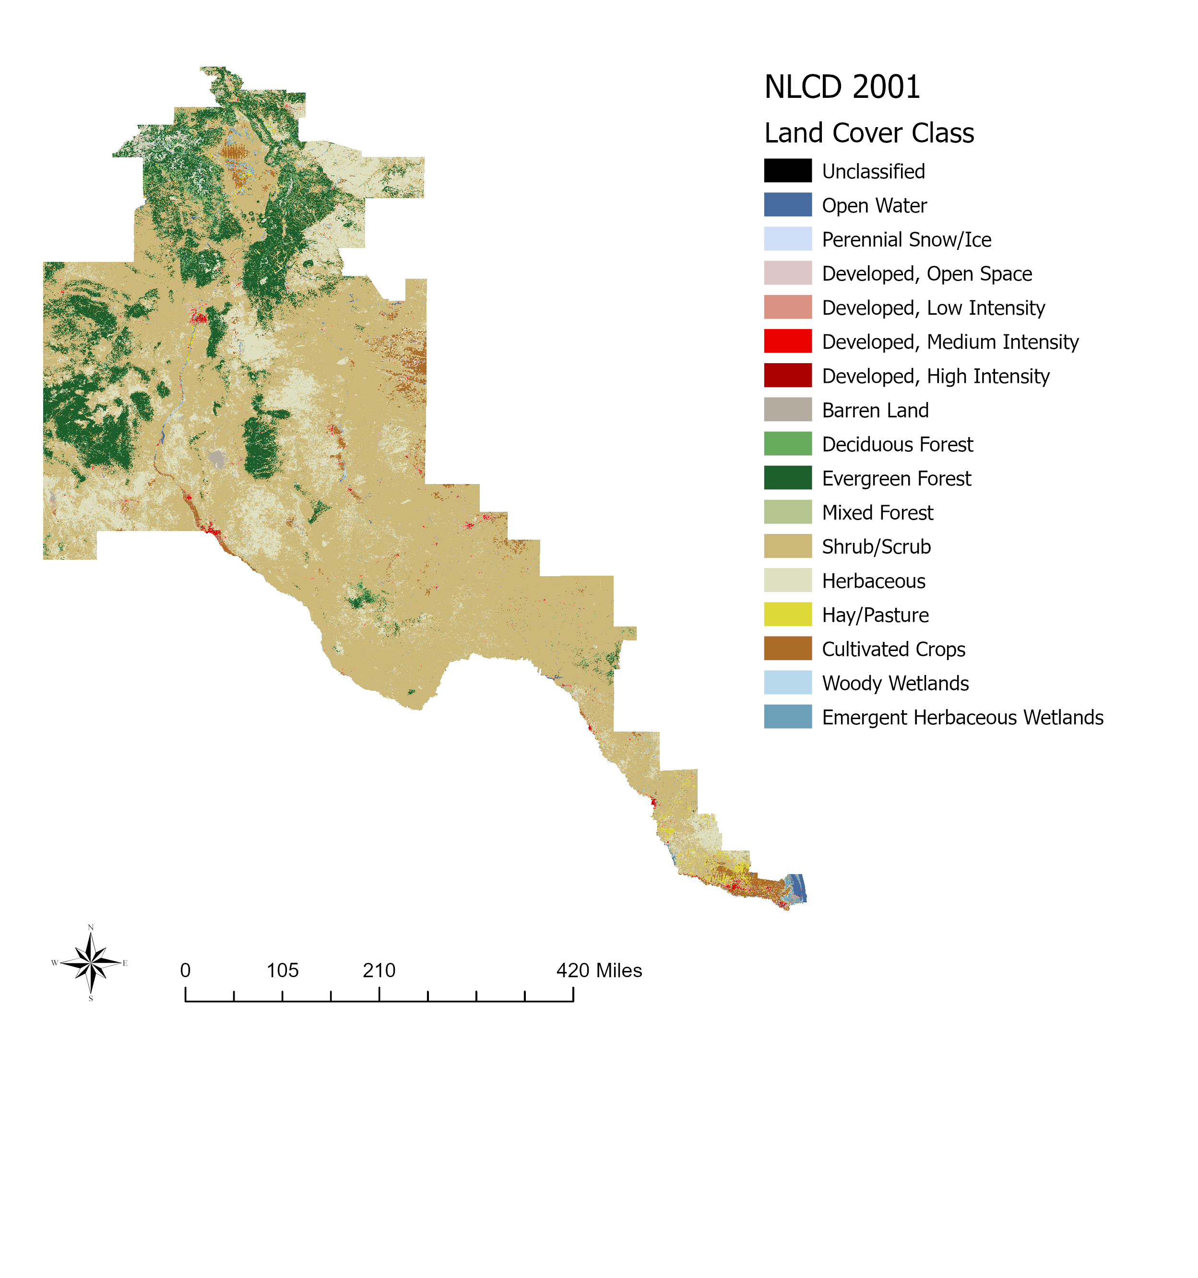
I used land cover data from the NLCD provided by the USGS (Homer et al., 2020). These datasets consist of 30m x 30m rasters categorizing land cover into 16 different classes for the years 1992, 2001, 2006, 2011, 2016, and 2019 for the contiguous U.S. (eg. Figure 3). This is the standard land use dataset used by state and federal entities as well as non-governmental organizations. For this study, I used NLCD rasters for the years 1992, 2001, 2006, 2011, and 2016.
Figure 3. Example of National Land Cover Data. Source: U.S. Geological Survey, 2021.
I assembled water use data from the USGS for the years 1990-2015 at 5 year increments (U.S. Geological Survey [USGS], n.d.a; USGS, n.d.b; USGS, n.d.c). These data break down water withdrawals into saltwater and freshwater, and into the different use categories. These data are available at the county level for all of the U.S.

3.3 Addressing Incongruent Time Steps for Data on Land Cover, Population, and Water Use
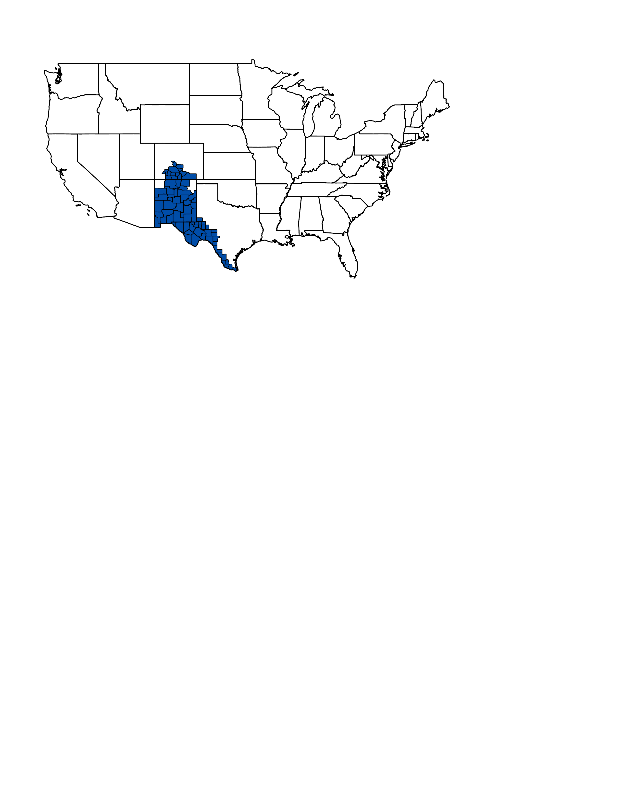
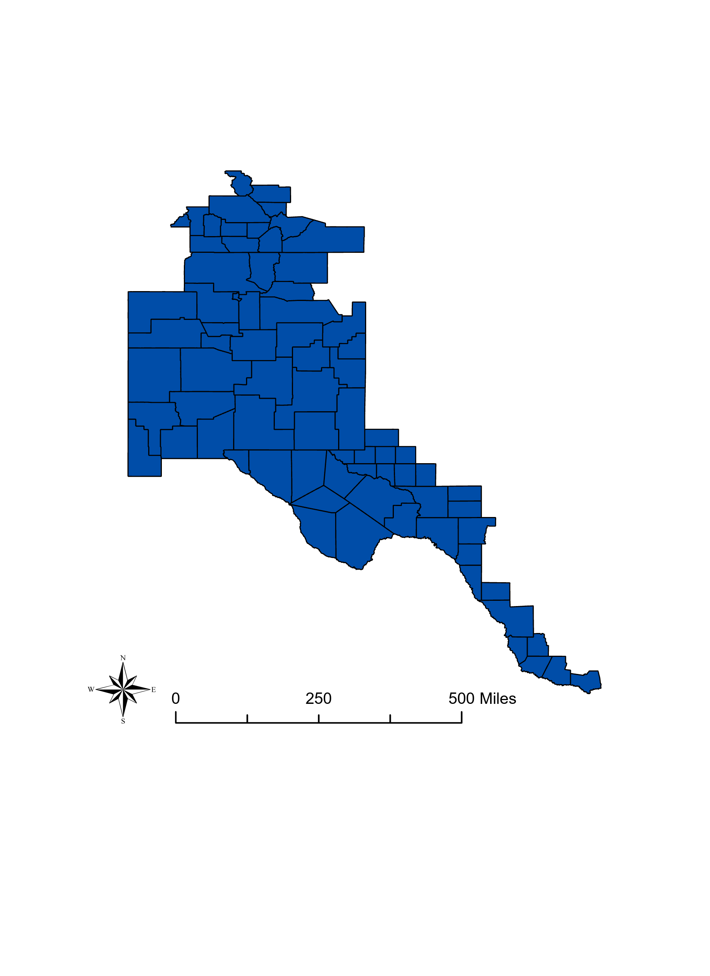
Land Cover data is available for the years 1992, 2001, 2004, 2006, 2008, 2011, 2013, 2016, and 2019. Population and water use data are available at 5 year increments from 1990 - 2015. To address the incongruence between these datasets, I used the land cover raster closest to and greater than the water use and population data. I chose to use land cover datasets proceeding the water and population datasets for consistency, as there are no land cover datasets preceding 1990.
Figure 4. Overview of the study area. Source: U.S. Census Bureau, 2022.

3.4 Data Processing
I selected the counties of interest for the study area using ArcGIS Pro version 2.8 and the TIGER/Line data in tandem with the EPA watershed boundary data. I selected counties that intersected with any part of the watershed and used this selection to create a new layer defining the study area (Figure 2, Figure 4).
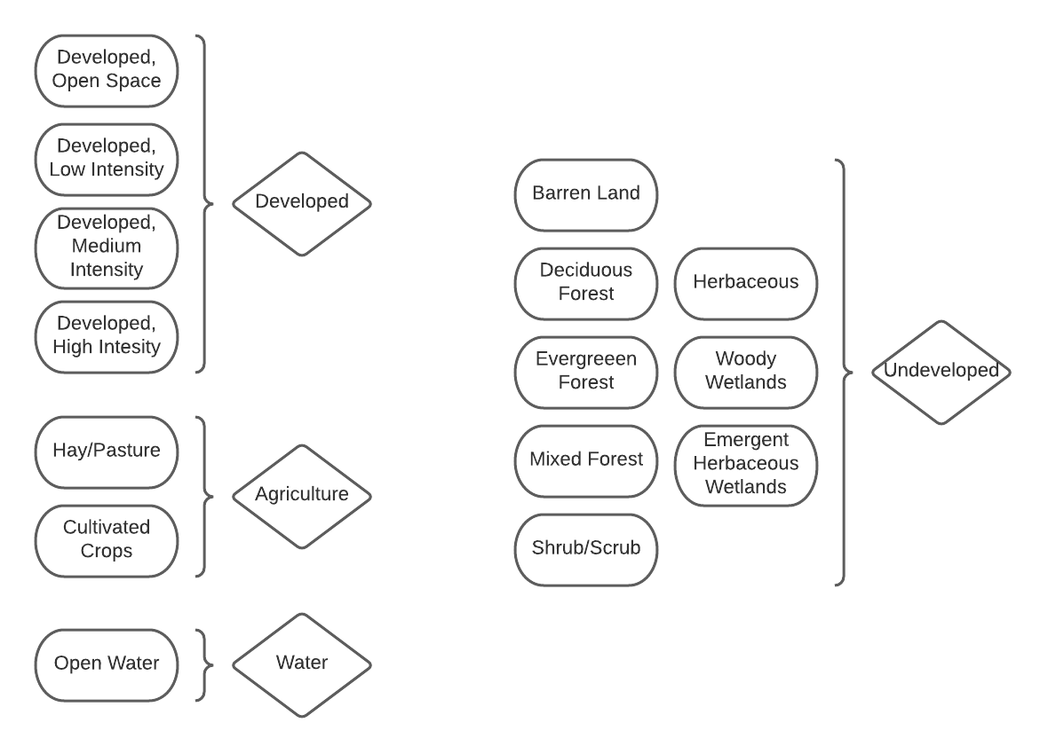
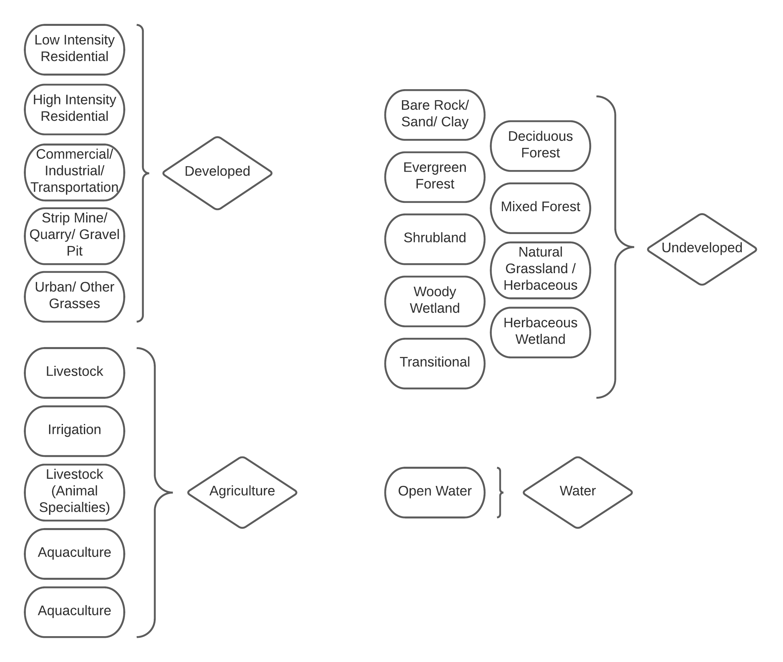
Once I created the study area layer, I used it to extract the NLCD rasters to this region. Using the ArcPy package in Python, I automated the extraction of NLCD rasters to the region of interest for NLCDs 2001 to 2016. The script then reclassified the extracted NLCDs into four categories: Developed, Undeveloped, Agriculture, and Water (Figure 6). The same process was used to reclassify the 1992 NLCD raster, but was done separately using ArcGIS Pro as the classes used for the 1992 NLCD differ from other years (Figure 5). Once I generated the reclassified rasters, I used the tabulate area tool to extract the area of the four new categories to each county (Figure 5).
Figure 5. Re-categorization of National Land Cover Cover Data categories into simplified categories 1992 (Left) and 2001 - 2016 (Right). Source: U.S. Geological Survey.
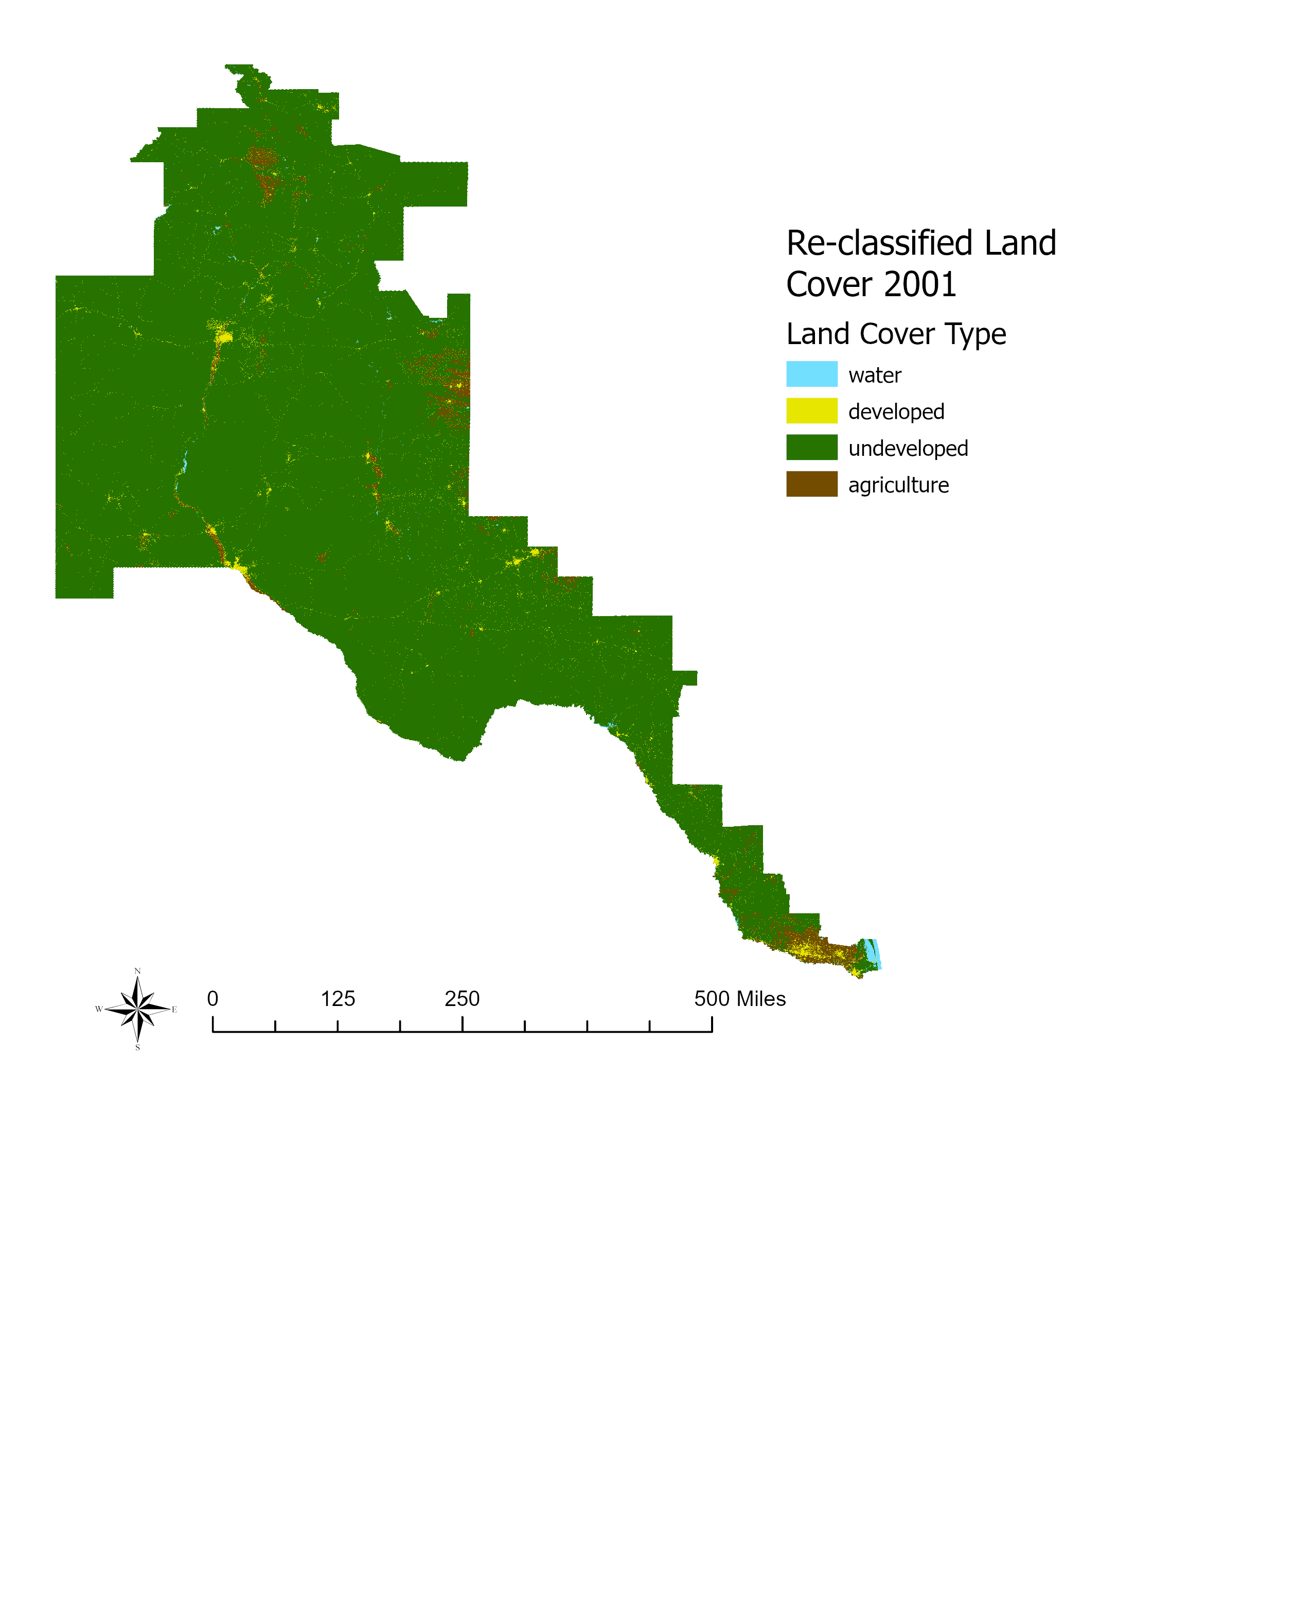
Water use from 1990 to 2015, measured in million gallons per day (MGal/day), from USGS is categorized in slightly different ways over the study period. The category of “Aquaculture” came into use in 2000 and was not in use for the prior years 1990 and 1995. Instead, this type of water is categorized as “Livestock (Animal Specialties)” for 1990 and 1995. This water use type describes water used for plants and animals that live in water. Similarly, the category “Livestock” came into use in 2000 and was not in use for the years 1990 and 1995. Instead, this type of water is categorized as “Livestock (Stock)” for 1990 and 1995. Livestock water use refers to water used for feed lots, dairy production, and other uses that do not pertain to fish and aquatic plants. The categories Livestock (Animal Specialties) and Livestock (Stock) represent their equivalents (aquaculture and Livestock respectively) for years 2000-2015 (USGS 2018). The category “Irrigation” was consistent over the entire study period. I only accounted for freshwater use in this study as saltwater withdrawals only took place in a handful of counties, and in those counties accounted for a fraction of overall water use. I organized water use data into categories that matched the land cover categories I previously created, Developed and Agricultural, so that the relationship between water use and land cover type could be more easily analyzed (Figure 7). This resulted in water use in each county for developed and agricultural purposes, as well as total water use in each county for each year that water data was available, the years 1990 - 2015 at 5 year increments.
Figure 6. Example of re-classified land cover type used for analysis.
Finally, I created a master table that contained population estimates for the years 1990 to 2040 at 5 year increments for all study area counties, land cover makeup for all study area counties for the years 2001, 2006, 2011, and 2016, and water use by type for each study area county from 1990 to 2015 at 5 year increments (Table 1).
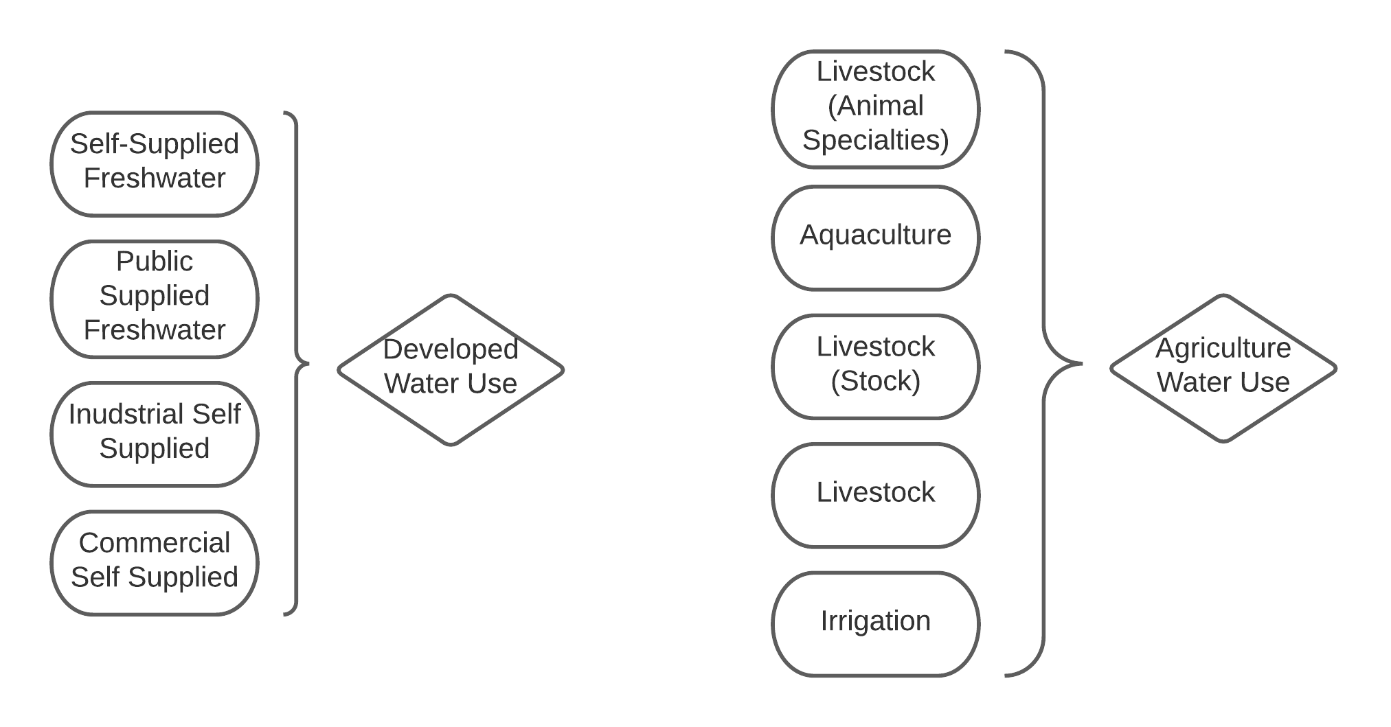
Figure 7. Re-categorization of United States Geological Survey Water Data 1990 - 2015. Source: U.S. Geological Survey, 2021.

Population | Total  [People] | Land Cover  [Category] | Area  [Miles²] | Water Use Type | Amount  ]Mgal/Day]
Population 1990 | 480,577 | Water Cover 1992 | 3.00 | Developed Water Use 1990 | 118.8
Population 1995 | 522,195 | Developed Cover 1992 | 110.80 | Agricultural Water Use 1990 | 70.07
Population 2000 | 556,678 | Agricultural Cover 1992 | 12.26 | Developed Water Use 1995 | 126.94
Population 2005 | 615,320 | Undeveloped Cover 1992 | 1041.31 | Agricultural Water Use 1995 | 62.44
Population 2010 | 662,564 | Water Cover 2001 | 2.82 | Developed Water Use 2000 | 111.03
Population 2015 | 679,810 | Developed Cover 2001 | 157.86 | Agricultural Water Use 2000 | 58.94
 |  | Agricultural Cover 2001 | 22.51 | Developed Water Use 2005 | 108.81
 |  | Undeveloped Cover 2001 | 984.18 | Agricultural Water Use 2005 | 39.75
 |  | Water Cover 2006 | 2.51 | Developed Water Use 2010 | 101.29
 |  | Developed Cover 2006 | 175.89 | Agricultural Water Use 2010 | 46.61
 |  | Agricultural Cover 2006 | 21.18 | Developed Water Use 2015 | 88.84
 |  | Undeveloped Cover 2006 | 967.79 | Agricultural Water Use 2016 | 39.36
 |  | Water Cover 2011 | 2.09
 |  | Developed Cover 2011 | 181.65
 |  | Agricultural Cover 2011 | 20.28
 |  | Undeveloped Cover 2011 | 963.35
 |  | Water Cover 2016 | 1.97
 |  | Developed Cover 2016 | 184.65
 |  | Agricultural Cover 2016 | 19.90
 |  | Undeveloped Cover 2016 | 960.85

Table 1. Example of data compiled for each county. Values pertain to Bernalillo County, New Mexico.

3.5 Data Analysis
I conducted spatial analysis using R version 4.1.2 in RStudio 2021.09.1. First, I created a global linear regression model (Ordinary Least Squares (OLS) model) to test the relationship between the dependent variable (total water use) at each time step in the region with the independent variables (population, developed land cover, and agricultural land cover) at the matching time step. The residuals of this model were then mapped to visualize spatial autocorrelation and justify the creation of a geographically weighted regression (GWR) model that would instead create separate models for each county to explain water use.
Next, I defined neighboring counties using queen’s adjacency, where neighboring counties are defined as any counties that share a side or corner with one another. I chose this instead of rook’s adjacency, in which only counties that share sides are considered neighbors, due to the oblong shape of the study region impacting the amount of neighbors some counties in the region would have under rook’s adjacency. Once I had defined neighbors, I generated a weighted list of the lagged means of the residual values of the global model, i.e., the average of each county’s surrounding counties residuals. Using this lagged means as the dependent variable and the residuals of the original model as the explanatory variable gives insight into how well the global model fits the measured water use in each county. The residuals and the weighted lists were then used to calculate Moran’s I value of spatial autocorrelation generated from 999 Monte Carlo Simulations.
In the global linear model, the coefficient(s) (β) describing the impact of each independent variable (x) on the dependent variable (y) is(are) held constant over the entire study region (i). Uncertainty in the model (ε) is the measured difference between the mean value generated by the model and the observation of the dependent variable (Páez & Wheeler, 2009). For example, in equation (1), β₁ represents the coefficient by which population, represented by x_{1i}, is multiplied to explain water use for the study region, represented by y_{i}. The same would be true of developed land cover and agricultural land cover. Cumulatively, these explain water use for the entire region. What is important to note in the global linear model is that the coefficients are constant for each county in the study area.

y_{i} = β₀ + β₁x_{1i} + β₂x_{2i} + … + β_{κ}x_{κi} + ε_{i}

[1]
In a geographically weighted regression model (equation(2)), the coefficient describing the impact of each independent variable on water use differs between each county (i), generating a separate model for each county for a better model fit overall ( Páez & Wheeler, 2009). The variability of the coefficient values at the county level allows the model to more accurately predict water use in each county and therefore in the entire study area. This type of modeling is much more resource intensive than the global linear model and therefore I made sure to justify it through analysis of the residuals of the global linear model.

y_{i} = β_{0i} + β_{1i}x_{i,1} + β_{2i}x_{2i} + … + β_{κi}x_{κi} + ε_{i}

[2]
I determined the bandwidth of the GWR model using the internal function gwr.sel within the R package “spgwr” (v.0.6-34). I then generated maps to depict the value of each variable as well as its regression coefficient in each county (Figure 14-17).

3.6 Categorical Land Cover Change Maps
Using the re-categorized maps, I was able to calculate the amount of change between two or more time steps and compare this to the change in water use either categorically ( in general between agricultural and developed use) or in total as it relates to land cover changes. Using the categorical change tool in ArcGIS Pro, I input two of the reclassified rasters and generate a new raster showing any land that was converted from one type to another. This categorical change analysis ignores water as water is considered to be a stationary land cover type.

3.7 Case Study Counties
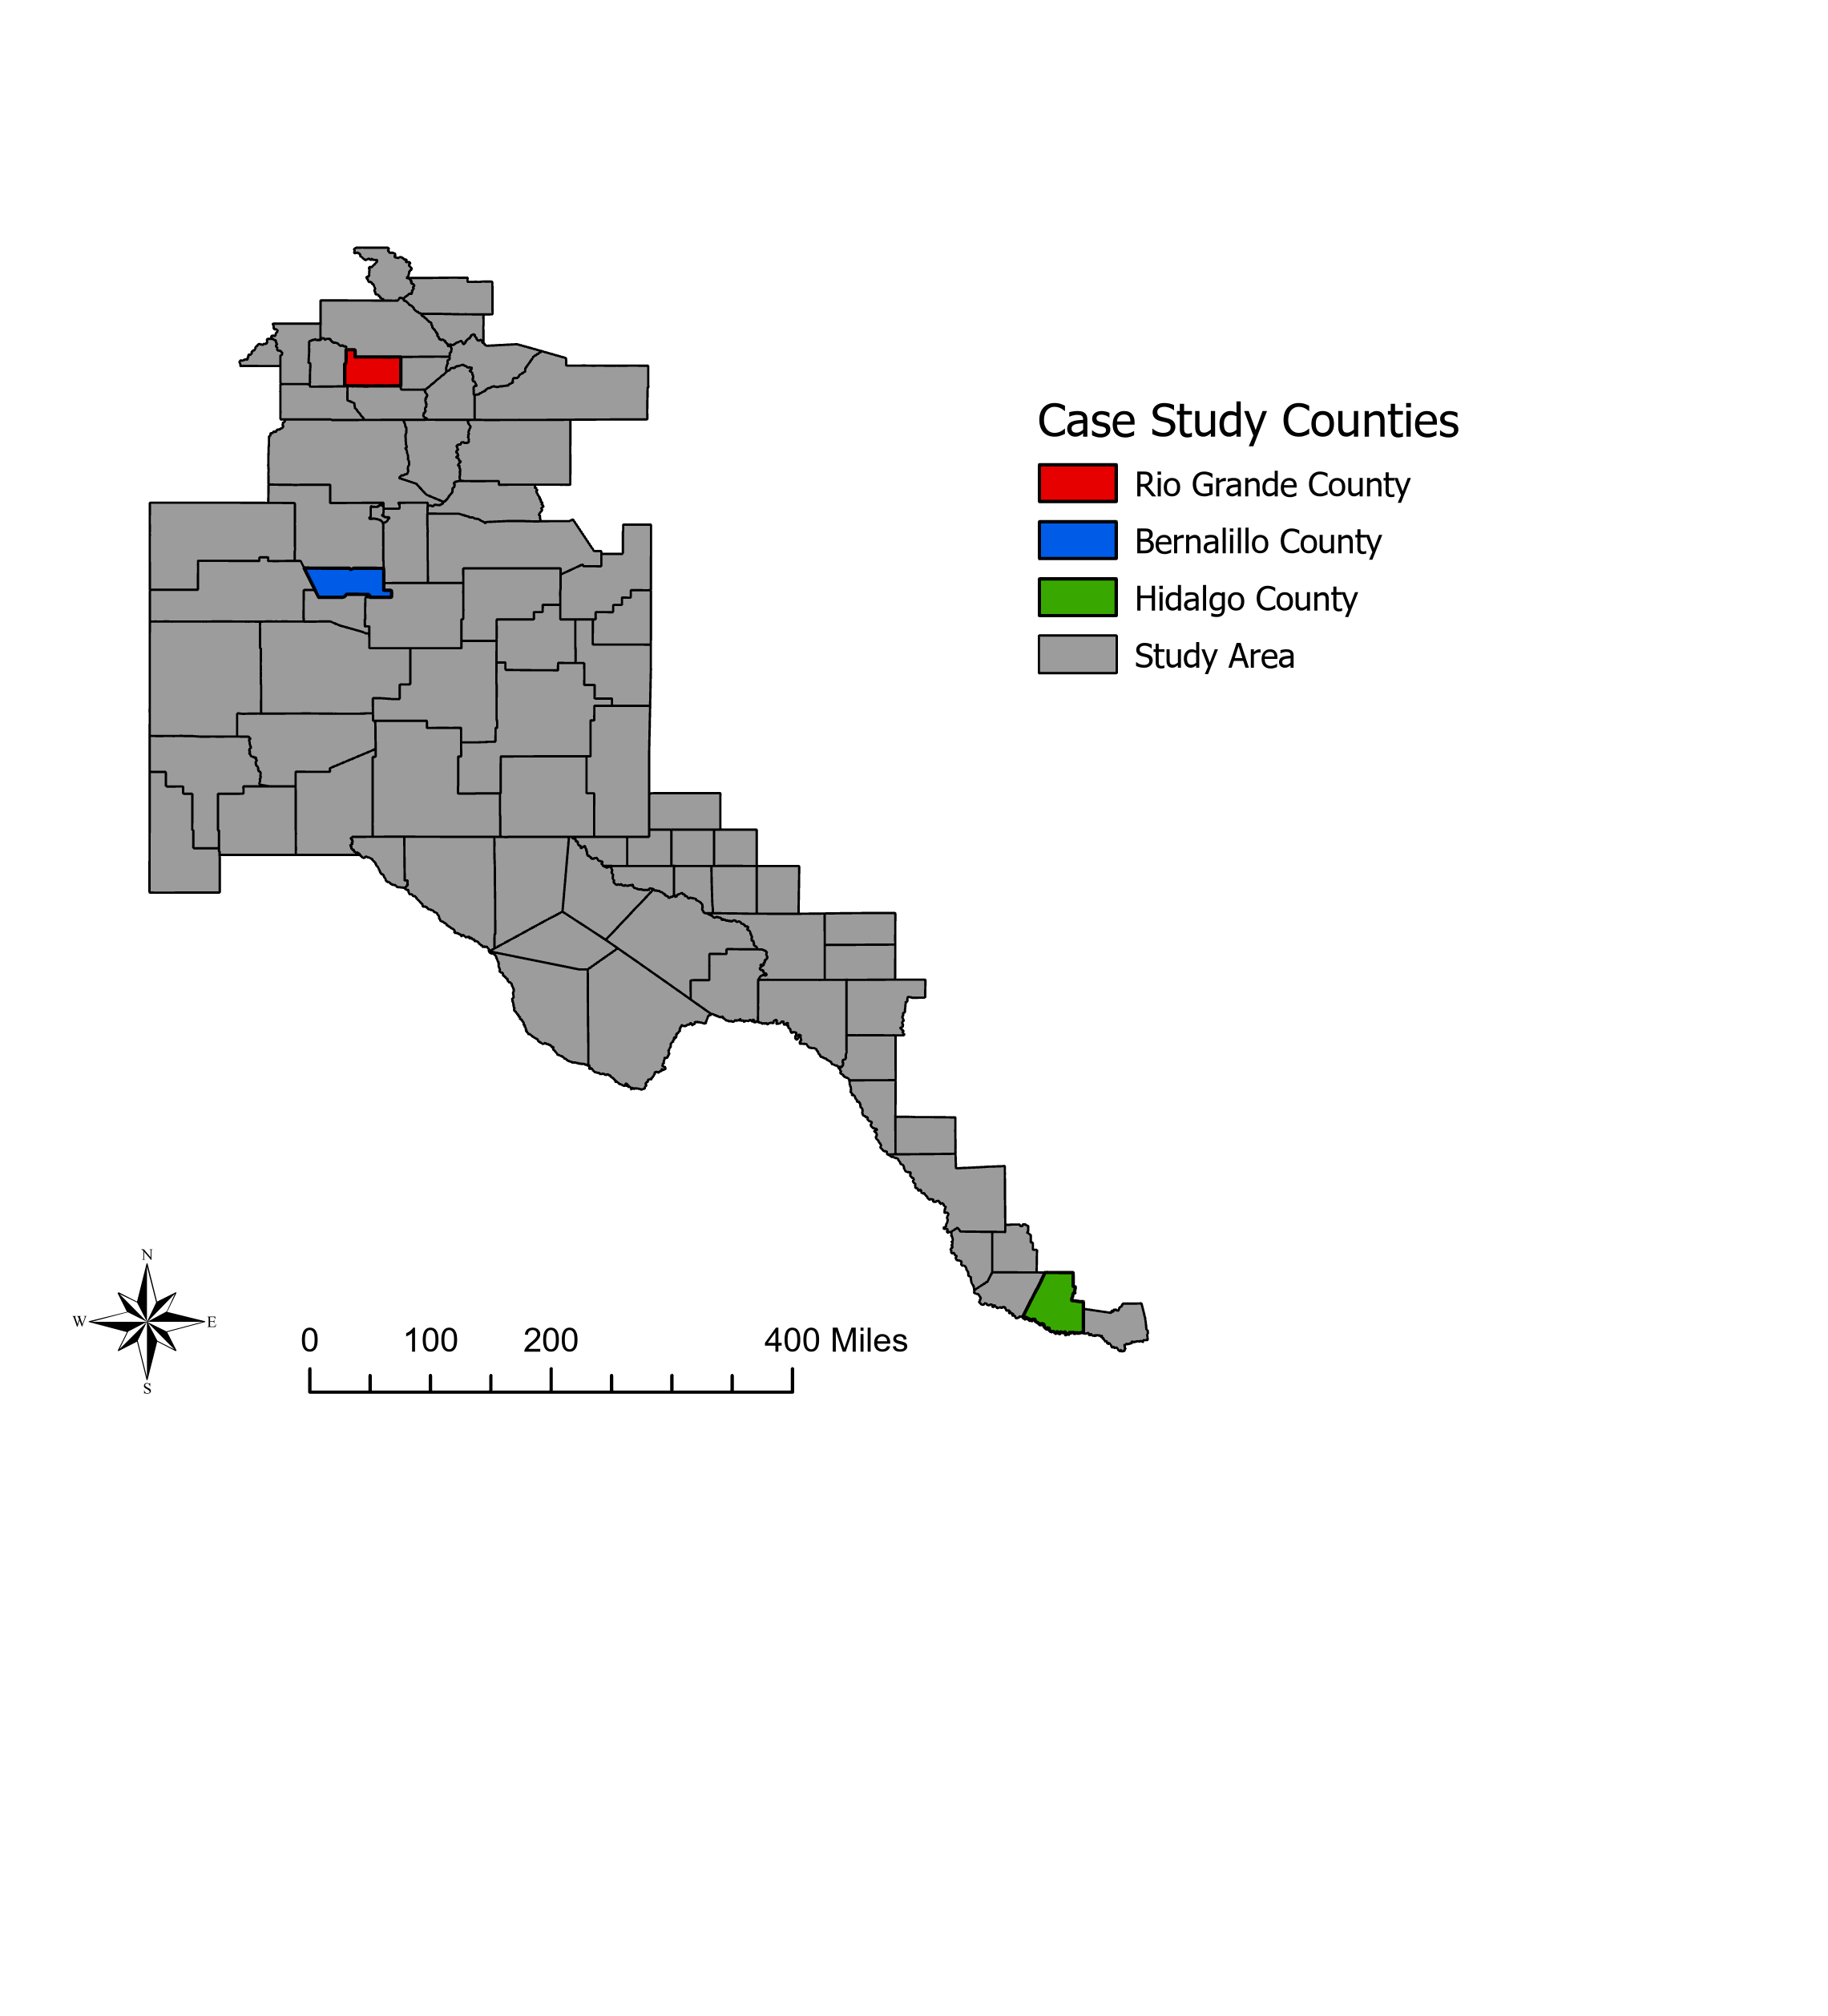
I chose three counties of interest for closer examination of their land cover, population, and water use trends and the relationships therein: Bernalillo County in New Mexico, Hidalgo County in Texas, and Rio Grande County in Colorado (Figure 8). Bernalillo County (Figure 8) is the most populous county in New Mexico and is mostly made up of the state’s most populous city, Albuquerque (Data Commons, n.d.). Preliminary data shows that Bernalillo County experienced a decrease in water use despite an increase in population, developed land cover, and agricultural land cover, therefore I chose it as a case study county. Hidalgo County (Figure 8) is one of the fastest growing counties in the nation, the 8th most populous county in Texas, and the second most populous in the RGB at the time of this study (Texas Demographics Center, 2018). Despite this rapid growth, Hidalgo County experienced the greatest drop in water use in the region. For these reasons, I chose it for closer examination. Rio Grande County (Figure 8) is the smallest of the three case study counties by area, and also has the lowest population of the three case study counties. I chose this county because preliminary data shows that despite its small size and small population, it experienced the largest increase in water use of any county in the basin.
Figure 8. Location of case study counties within the study region.

Chapter 4: Results

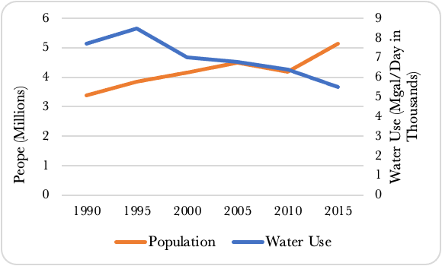
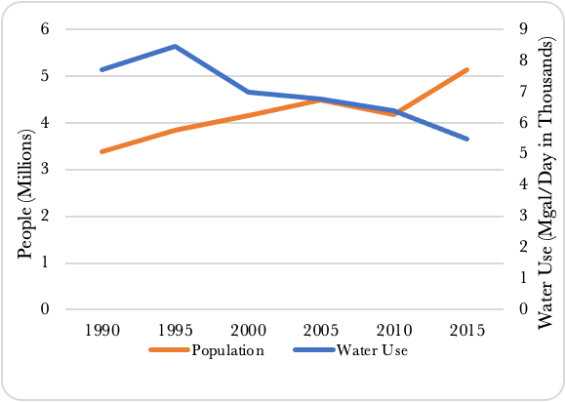
4.1 Population and Water Use
Figure 9. Population and water use change in the Rio Grande Basin from 1990 to 2015. Source: U.S. Geological Survey, 2021; U.S. Census Bureau, 2021, The University of New Mexico, 2021; The Colorado Department of Demography, 2021; The Texas Demography Center, 2021; Texas Library and Archives Commission, 2021.
At the basin level population has increased while water use overall has decreased (Figure 9). Changes in population and water use are most dramatic in only a handful of counties, such as those chosen as case study counties (Figure 8), while other county’s populations remained relatively stable.
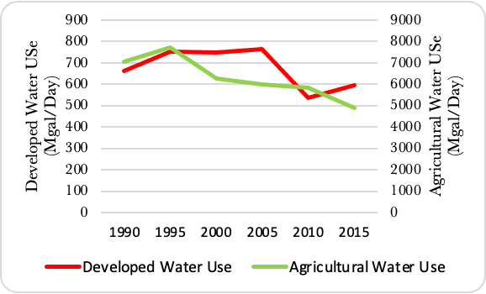
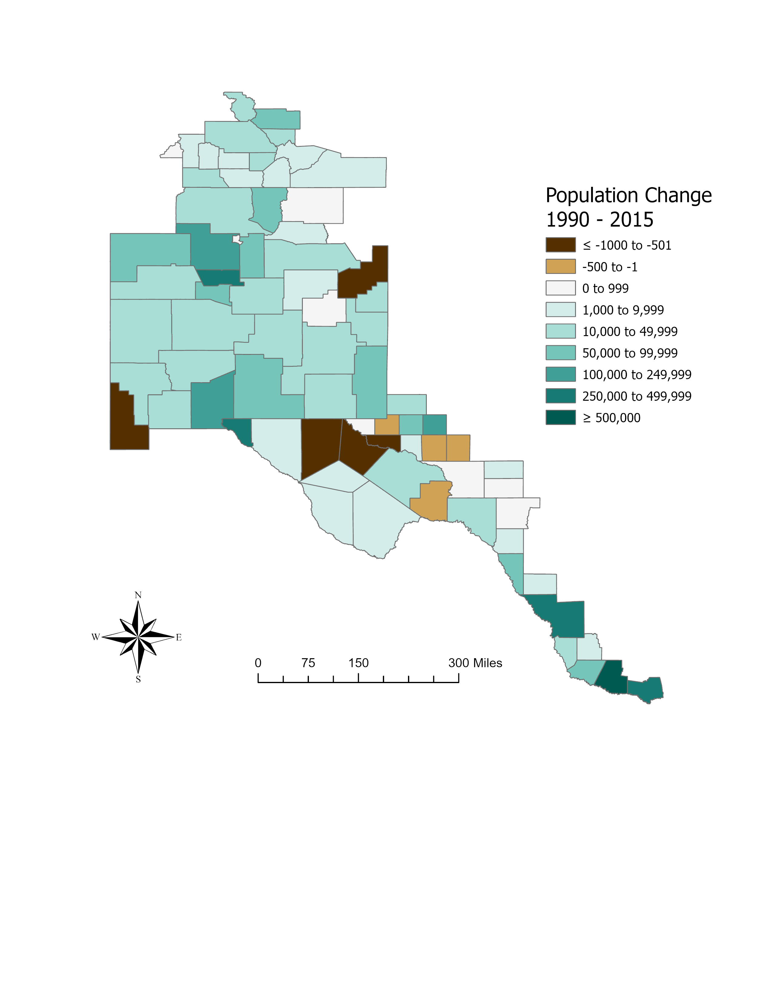
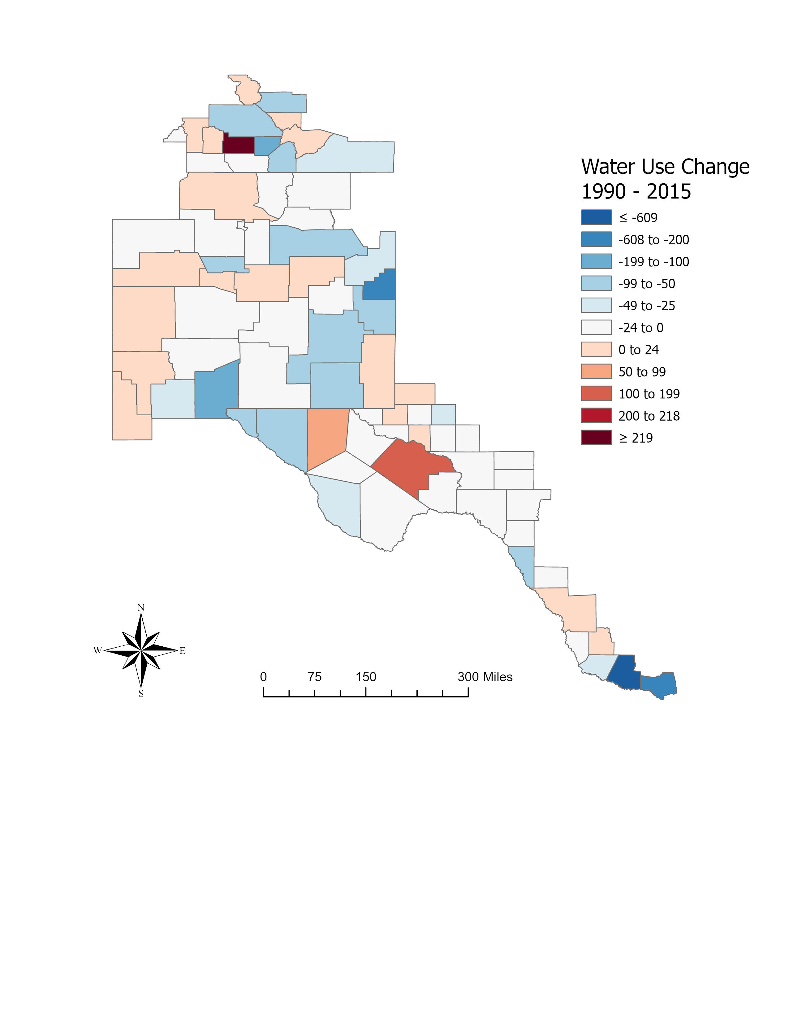
54 of 76 counties in the study area experienced a decrease in water use. Most experience only a slight decrease of up to 50 Mgal/day. Hidalgo County in Texas is an outlier among counties that experienced a decrease of water use, decreasing its use by over 600 Mgal/day. Of the counties that did experience an increase in water use, only three experienced an increase greater than 25 Mgal/day: Rio Grande County in Colorado, Pecos County in Texas, and Culbertson County in Texas. Of these, Rio Grande County in Colorado experienced an increase of over 200 Mgal/Day. 59 of 76 counties experienced an increase in population (Figure 11). In 41 of these counties, this increase was less than 10,000 people and in 13 of these counties the increase was less than 500 people. Hidalgo County, Texas and Bernalillo County, New Mexico showed especially high population increases of 119.4% and 41.5% respectively. Comparing changes in population to water use, there is no obvious spatial association (Figure 11).
Figure 10. Developed and agricultural water use in the Rio Grande Basin. Source: U.S. Geological Survey.
Figure 11. Water use change (left) and population change (right) in the Rio Grande Basin. Source: U.S. Geological Survey; U.S. Census Bureau; The Colorado Department of Demography; the University of New Mexico; the Texas Library and Archives Commission; The Texas Department of Demography.

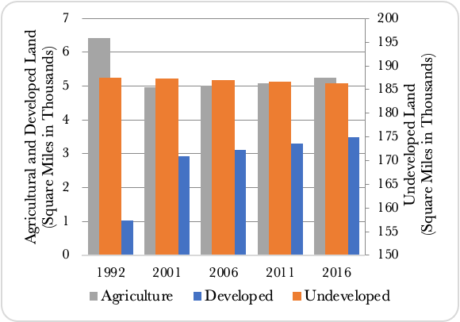
4.2 Land Cover
Figure 12. Change in land cover composition of the Rio Grande Basin.
Categorical land cover change within the basin from 1992 to 2016 revealed that the majority of landcover remained unchanged, and that this land cover was primarily undeveloped (Figure 12).
Land Cover Change  (1992 to 2016) | Composition  (%) | Contribution to  Development  (%)
Developed to Undeveloped | 0.14 | -
Developed to Agriculture | 0.01 | -
Undeveloped to Developed | 1.21 | 85.62
Undeveloped to Agriculture | 0.83 | -
Agriculture to Developed | 0.20 | 14.38
Agriculture to Undeveloped | 1.25 | -
Water | 0.48 | -
No Change | 95.87 | -
Total Developed | 1.41 | -

Table 2. Land cover change in the Rio Grande River Basin. Land cover data sourced from the Unites States Geological Survey.
Across the basin, developed land cover increased by 238.7%, agricultural land cover decreased by 18.4% (Figure. 12). The above analysis shows that the majority of land that was developed between 1992 and 2016, 85.6%, was previously undeveloped, while 14.4% was agricultural (Table 2).

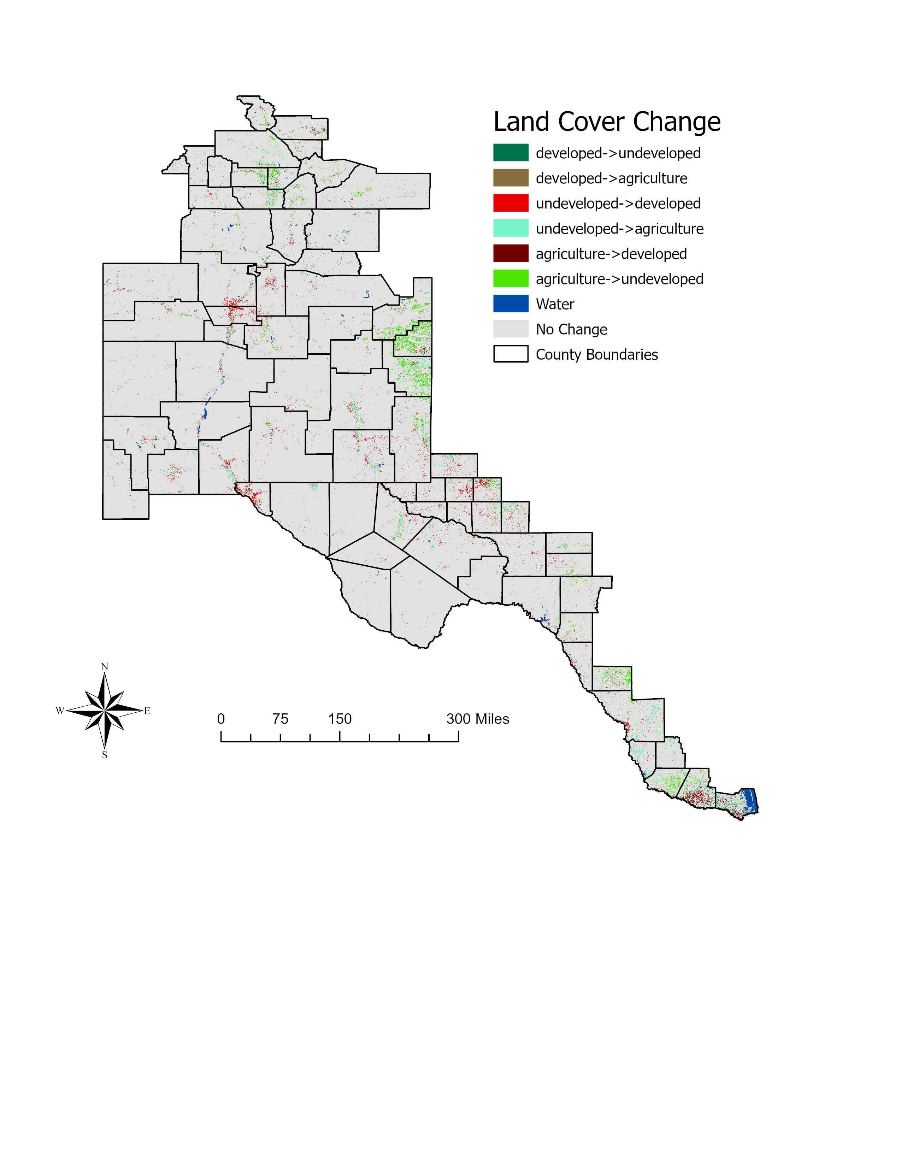
There are regional differences in land cover change; such as in the Northern and Central-Eastern areas of the basin, large areas where agricultural changed to undeveloped (Figure 13) This includes counties such as Rio Grande, Alamosa, and Conejos counties in Colorado as well as Quay, Curry, and Roosevelt counties in New Mexico. I also noted some areas of heavy development, such as in Bernalillo County in New Mexico, and in El Paso, Hidalgo, and Cameron counties in Texas (Figure 13).
Figure 13. Land cover change in the Rio Grande Basin.

4.3 Statistical Analysis
The basin-wide global linear regression models for each time step resulted in low R² values as well as small p-values across all time steps (Table 3), implying that a global model cannot accurately model water use (dependent variable), in the basin as explained by population and land cover type (independent variables). Moran’s I analysis of these models shows that there are detectable levels of spatial autocorrelation within the basin (Table 3). Taken together this justifies creating a geographically weighted regression (GWR) model for the RGB in which a different model is generated for each county, allowing the independent variables of land cover and population to have varying levels of influence on each county’s water use.
The GWR model has significantly higher R² values for each time step compared to the global models (Table 3). This indicates that the geographically weighted model has significantly better explanatory power than the global model. The local R² maps show the explanatory power of the GWR model in each county (Figure 14). Figures 15 - 17 show the regression coefficients of each explanatory variable at each time step.

Table 3. Results of statistical analysis in R showcasing justification for geographically weighted regression model.
Water Use Year / Land Cover Year | Global R² | Global p-Value | Global Moran’s I Range | Global Moran’s I Value | Moran’s I p-Value | Geographically Weighted Regression Model R²
1990/01992 | 0.07595 | 0.009154 | -0.854512- 1 | 0.20435 | 0.003 | 0.7981111
1995/1992 | 0.1363 | 0.0006066 | -0.854512- 1 | 0.25427 | 0.002 | 0.8046889
2000/2001 | 0.08026 | 0.007552 | -0.854512- 1 | 0.229229505 | 0.0004495 | 0.7502483
2005/2006 | 0.2811 | 5.03E-07 | -0.854512- 1 | 0.365102873 | 3.19E-07 | 0.8072279
2010/2011 | 0.1709 | 0.0001221 | -0.854512- 1 | 0.26859 | 0.003 | 0.8348156
2015/2016 | 0.1711 | 0.0001205 | -0.854512- 1 | 0.274125095 | 4.62E-05 | 0.7173021

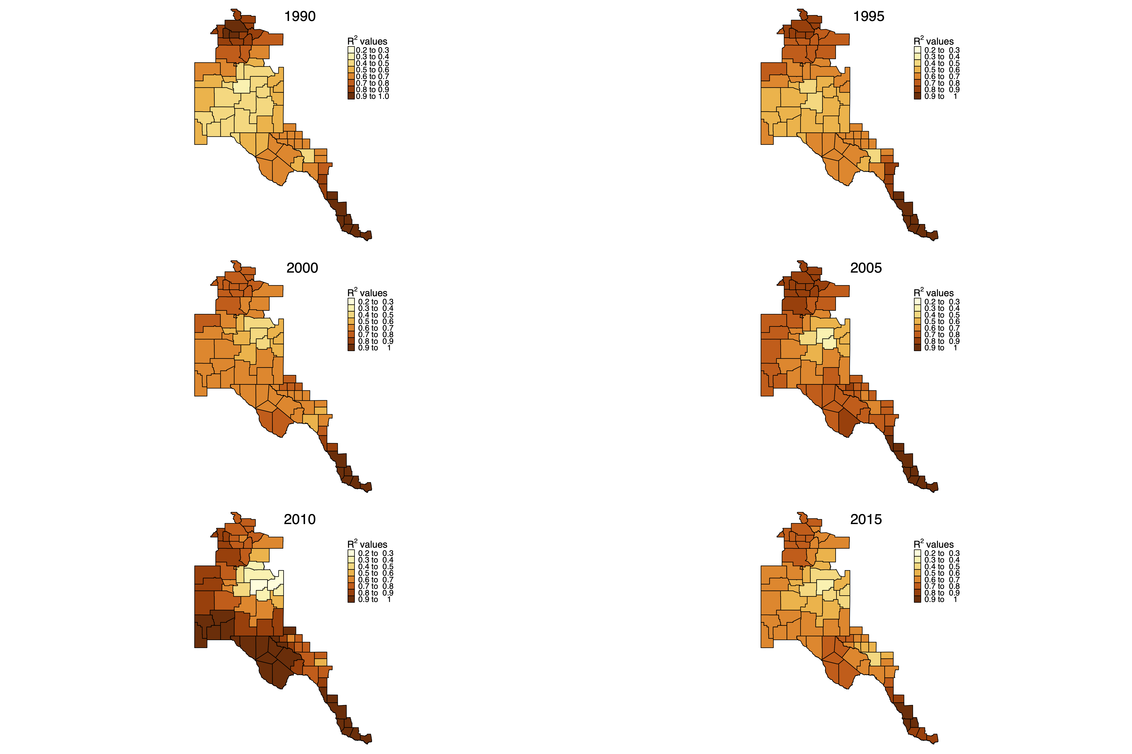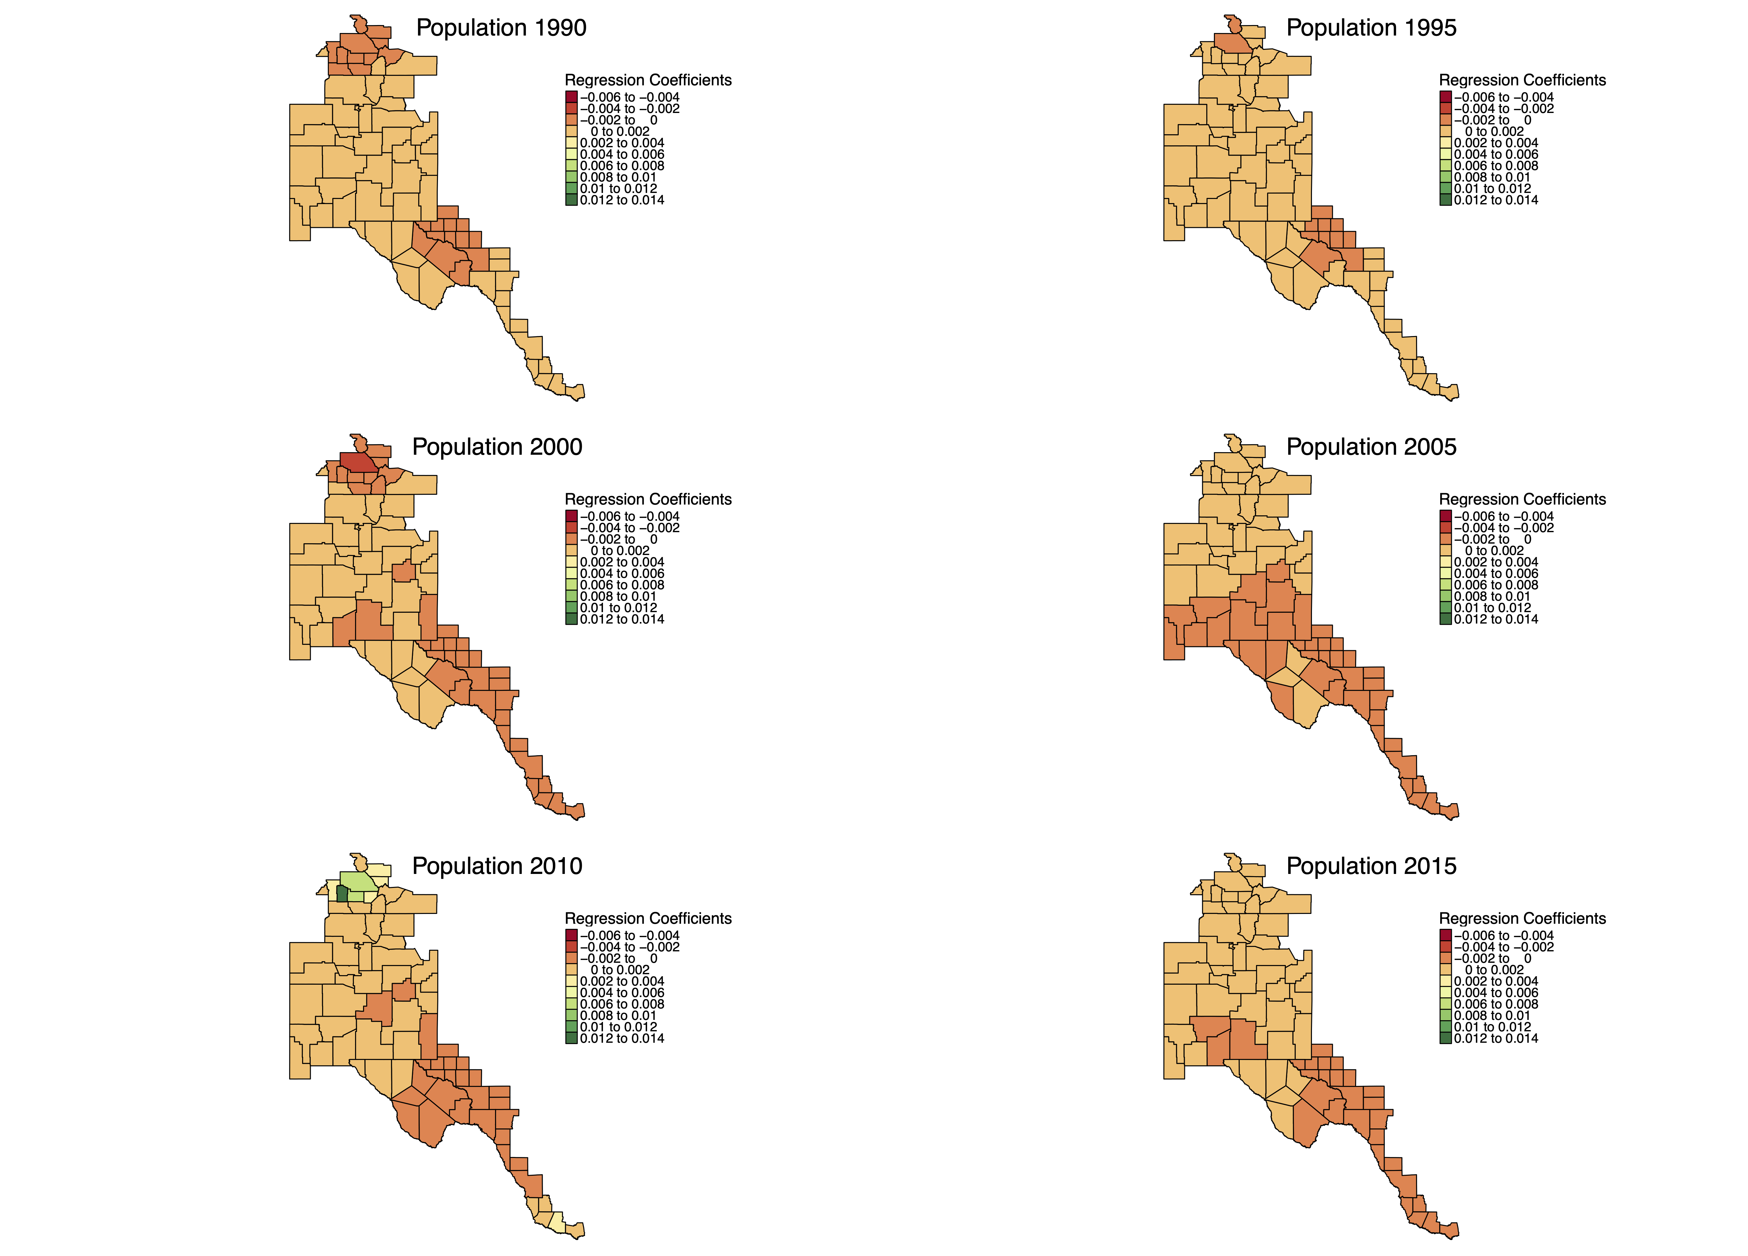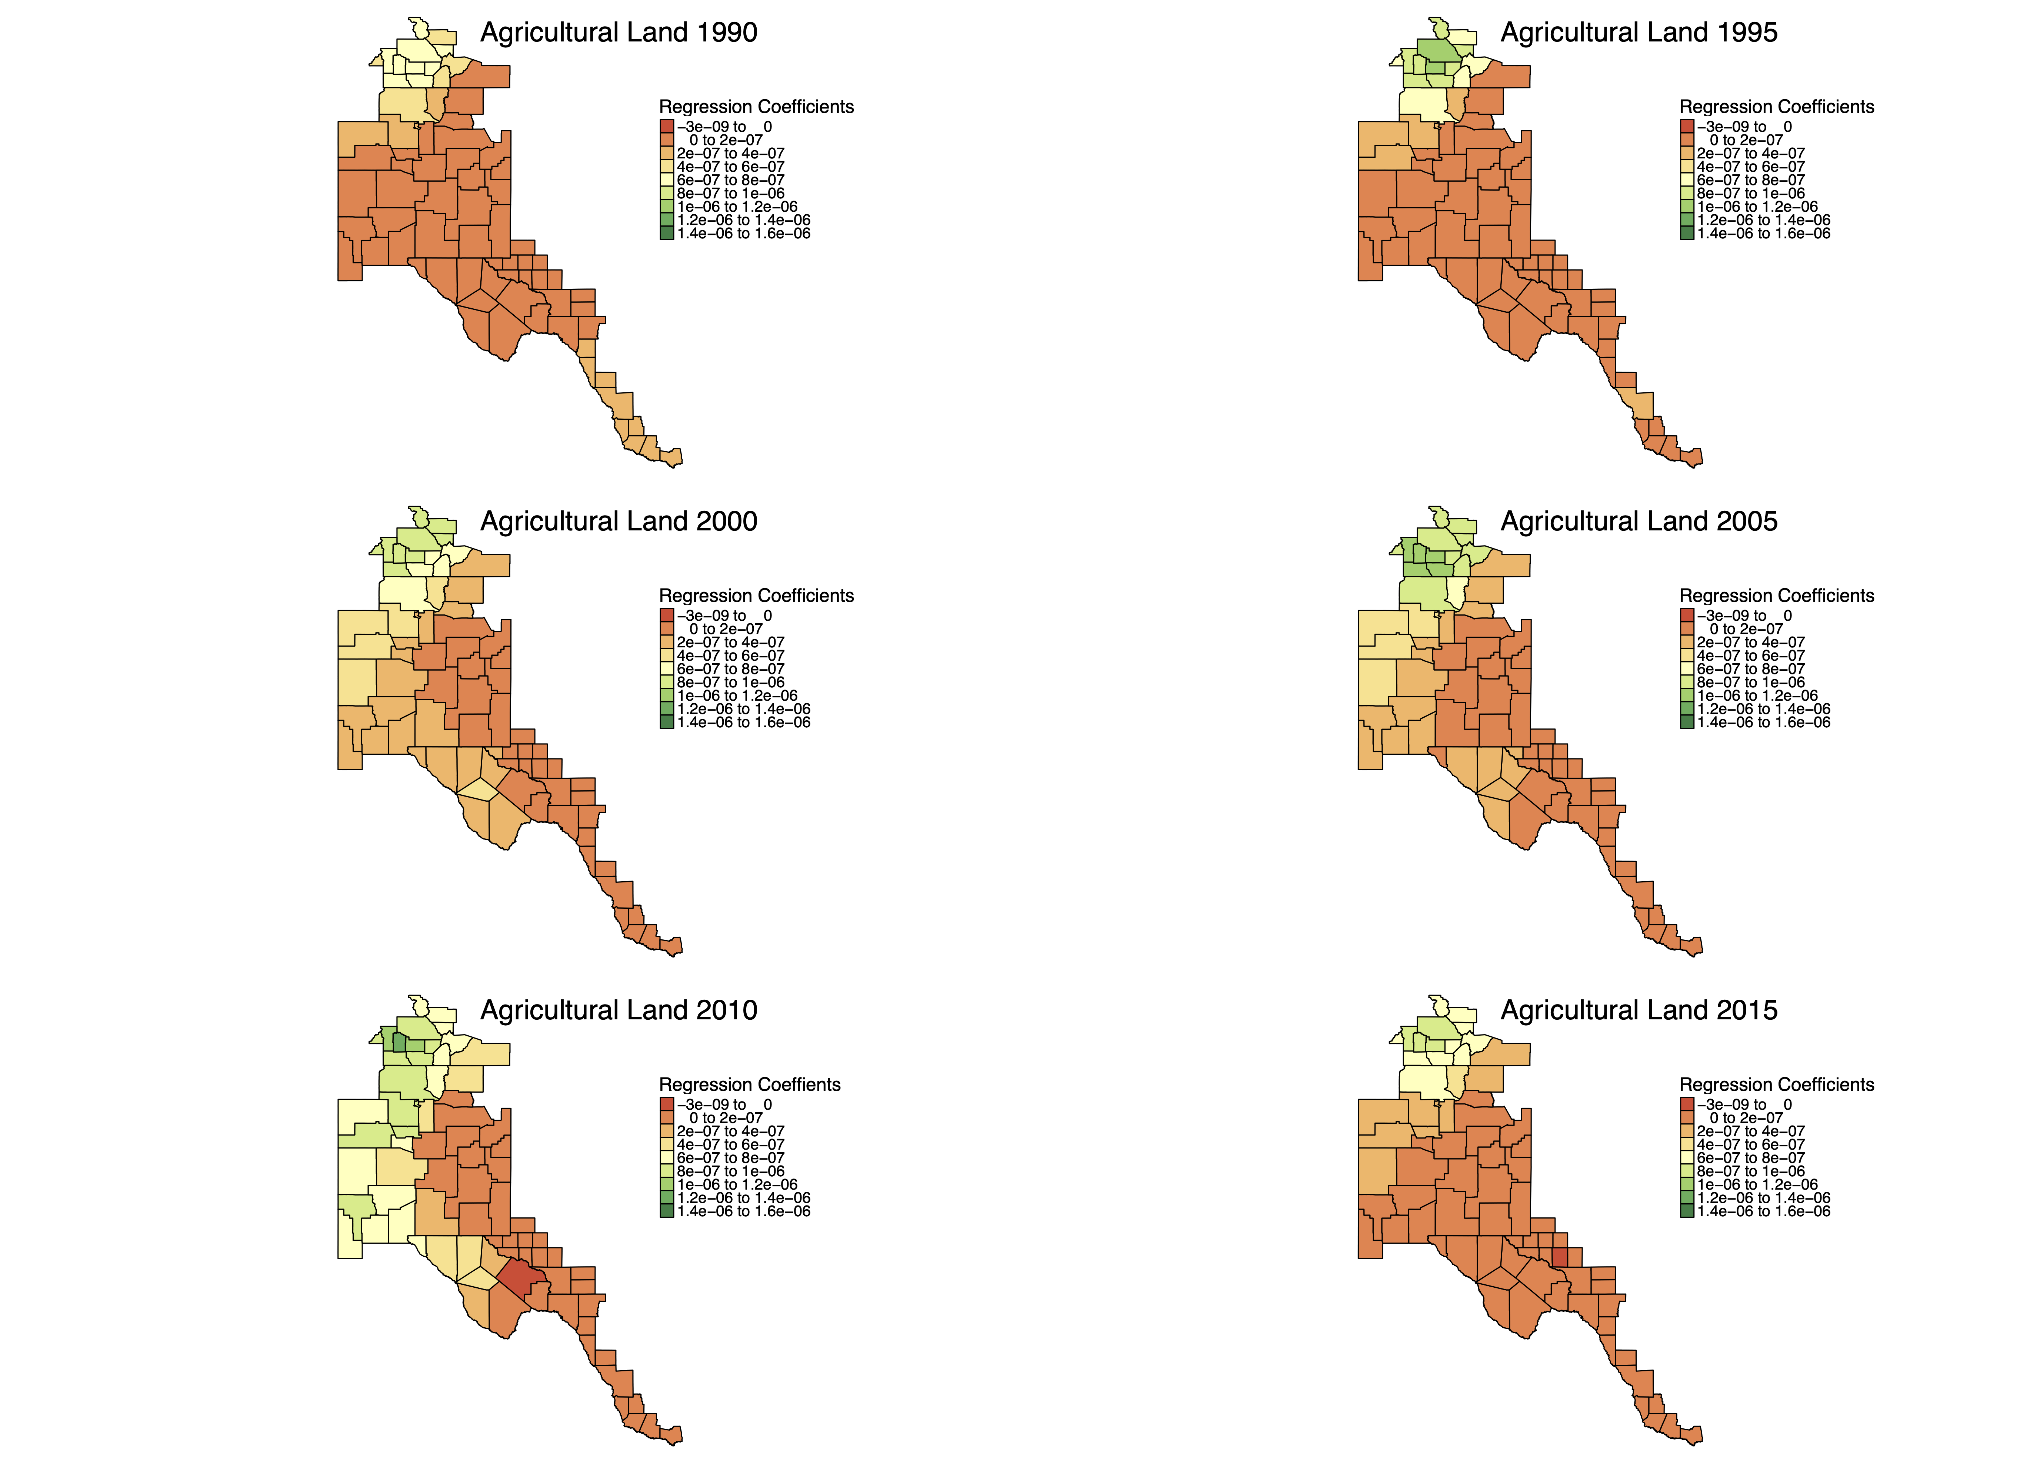
Figure 14. Local R² values for the study region resulting from the geographically weighted regression model.
Figure 15. Regression coefficient values for the influence of population on water use in the Rio Grande Basin resulting from geographically weighted regression.
Figure 17. Regression coefficient values for the influence of agricultural land cover on water use in the Rio Grande Basin resulting from geographically weighted regression.
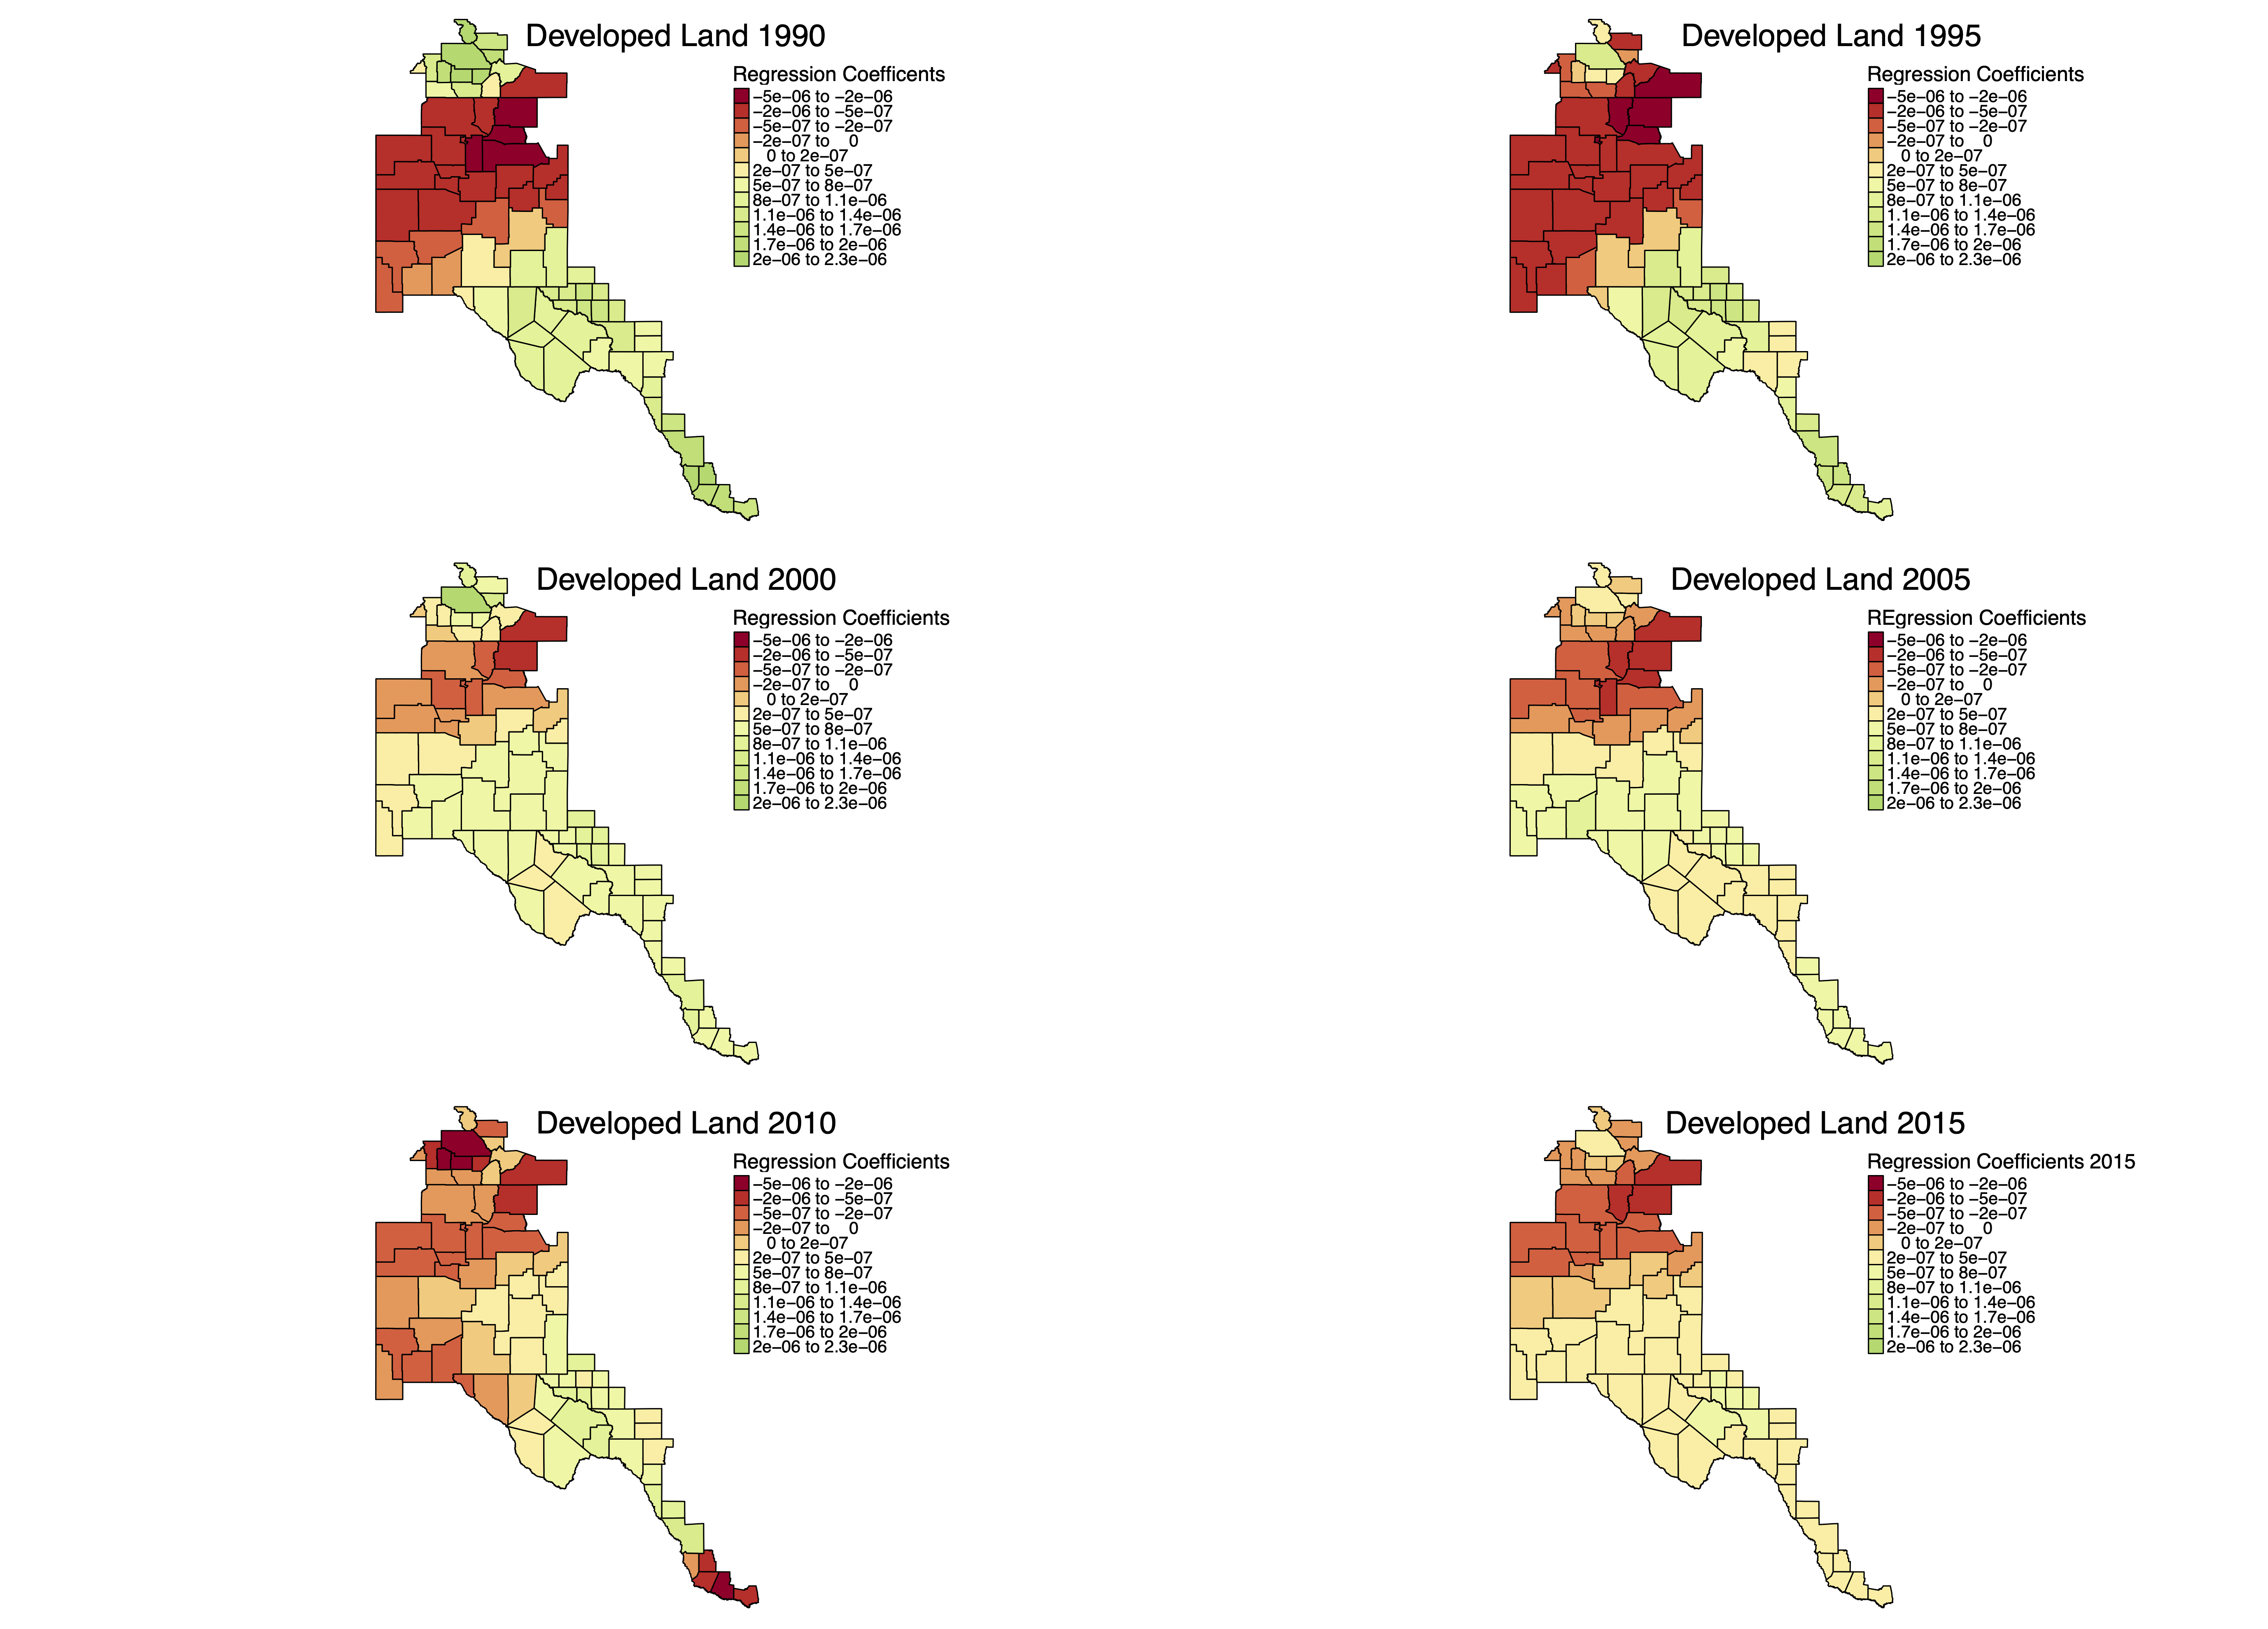
Figure 16. Regression coefficient values for the influence of developed land cover on water use in the Rio Grande Basin resulting from geographically weighted regression.
When I examined the maps of local R² values (Figure. 14), I noticed that the model performed consistently better in the Southern and Northern reaches of the basin compared to the center region. The higher R² values were consistent in the South, and fluctuated slightly in the North (Figure 14). 2010 is the year for which the model is most successful at predicting water use over the majority of the basin (Figure 14). The influence of population on water use was consistently low for the entire region, with the exception of 2010 (Figure 15). In this year, a handful of counties in the north’s population influenced water use more than in other years. Developed land cover is positively correlated with water use in the Southern regions of the basin for most of the study period, and in the year 2000 had this relationship with water use in a handful of counties in the Northern region of the basin (Figure 16). I noticed that developed land cover actually has an inverse relationship with water use in much of the central and northern ares of the basin (Figure 13). This means that an increase in developed land cover was associated with a decrease in water use in those areas. Any water use increase in these areas instead was possibly driven by population and/or agricultural land cover. Agricultural land cover is consistently more influential in the northern regions of the basin for the entire study (Figure 17).

4.4 Case Study Counties

4.4.1 Bernalillo County, New Mexico
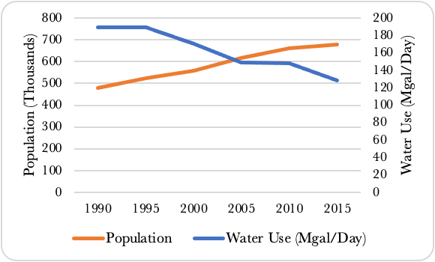
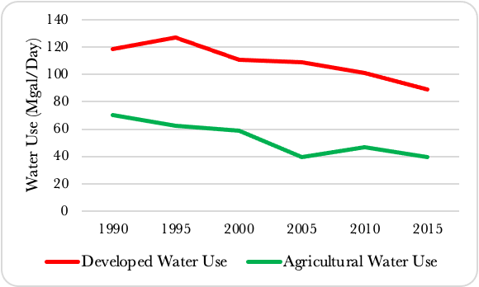
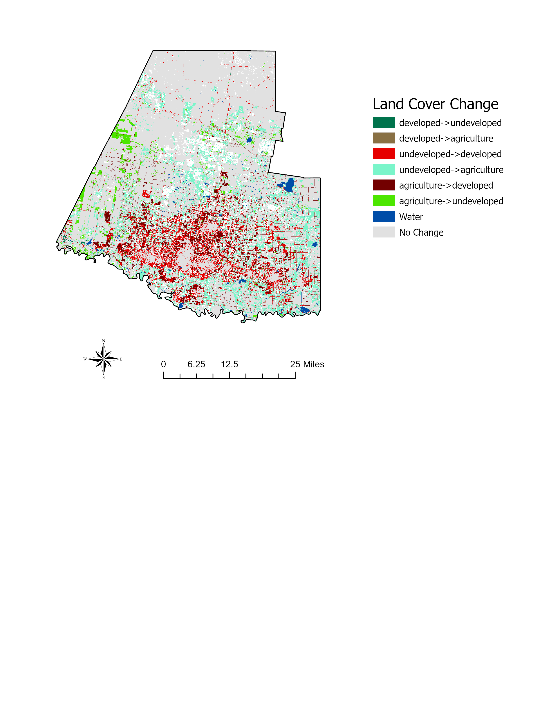
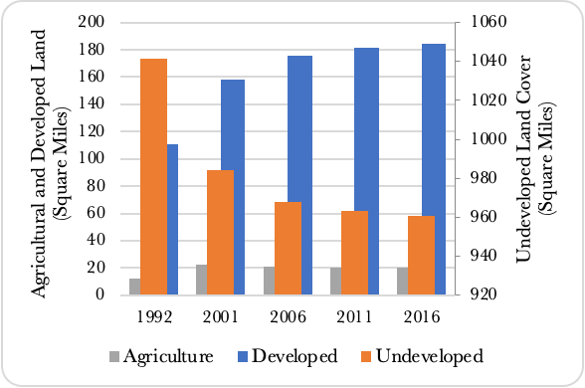
Bernalillo County’s population, amount of developed land, and amount of agricultural land increased over the study period, while water use decreased (Figure 18, 19). Population in the county rose steadily (Figure 18). In 1990, the population was just under 484,577 people and reached 679,810 by 2015, representing an increase of 41.5%. Over this time, the regression coefficient relating population to water use increased from 9.47E -04 to 2.61E -04, indicating that population’s influence on water use increased over the study period (Table 8). Water use in Bernalillo County decreased by approximately 60 Mgal/day (Figure 18). In 1990, the county used 188.87 Mgal/day, but by 2015 this had decreased to 128.2 Mgal/day a decrease of 32.12% (Figure. 18). This decrease in water use was driven both by a decrease in developed and agricultural water use (Figure 19).
Figure 18. Population and water use change in Bernalillo County, New Mexico. Source: U.S. States Census Bureau, 2021; The University of New Mexico, 2021; U.S. Geological Survey, 2021.
Figure 19. Developed and agricultural water use in Bernalillo County, New Mexico over the study period. Source: U.S. Geological Survey.
Figure X. Table X. Land cover change in Hidalgo County, Texas.
Figure 20. Changes in land cover composition of Bernalillo County, New Mexico.
Land Cover Change  (1992 to 2016) | Composition  (%) | Contribution to  Development  (%)
Developed to Undeveloped | 0.66 | -
Developed to Agriculture | 0.50 | -
Undeveloped to Developed | 7.24 | 96.88
Undeveloped to Agriculture | 0.49 | -
Agriculture to Developed | 0.23 | 3.12
Agriculture to Undeveloped | 0.10 | -
Water | 0.28 | -
No Change | 90.50 | -
Total Developed | 7.47 | -

Table 4. Land cover change in Bernalillo County, New Mexico. Source: U.S. Geological Survey.
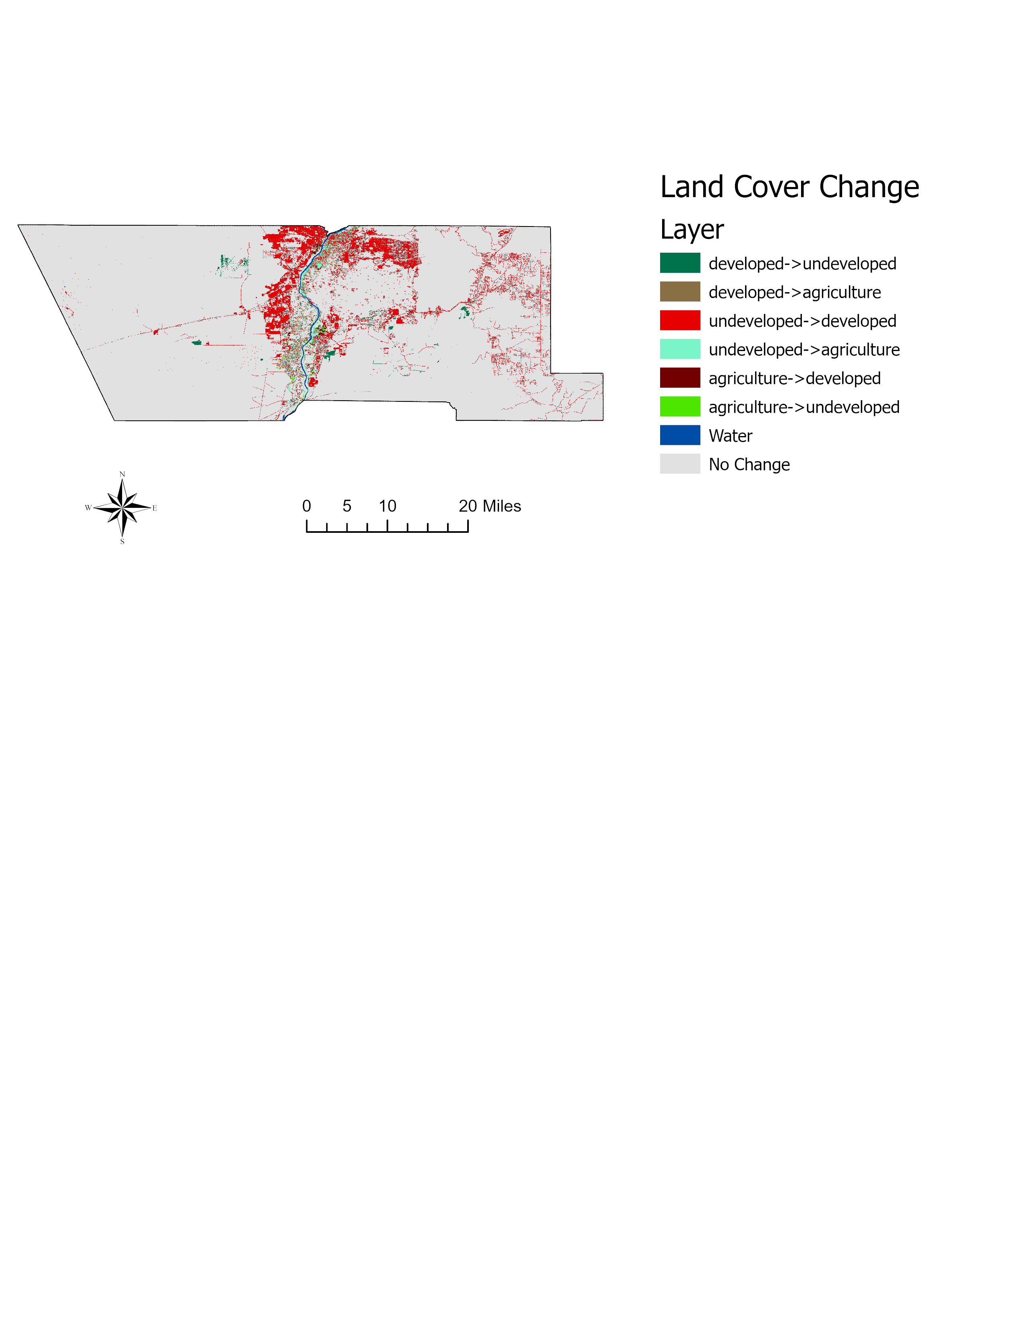
Land cover change between 1992 to 2016, shows that developed land increased by 66.7% compared to a basin-wide increase of 238.7% (Figure 20, Figure 12). This change in developed land cover is larger than the population increase, which may indicate an increase in land demand per capita (Figure 18). Almost all of the newly developed land (96.9%), is located on previously undeveloped land, with just 3.1% located on formerly agricultural land (Table 4, Figure 21). The amount of agricultural land also increased by only 62.3%. While developed land showed a steady increase, agricultural land cover peaked in 2006 and declined afterward (Figure 20). Figure 20 shows a 7.7% decrease in undeveloped land cover over the study period. Over the study period, the coefficient describing the influence of developed land cover on water use increased from -1.2E-06 to -2.49E-07, this relationship remained negative, meaning that an increase in developed land was related to a decrease in water use (Table 9). The coefficient describing the influence of agricultural land cover steadily increased from 1990 to 2005 (1.46E-07 to 3.19E-07), then more than doubled to 8.40E-07 in 2010 before dropping back to 2.10E-07 in 2015 (Table 10).
Figure 21. Land cover change in Bernalillo County, New Mexico 1992 to 2016.

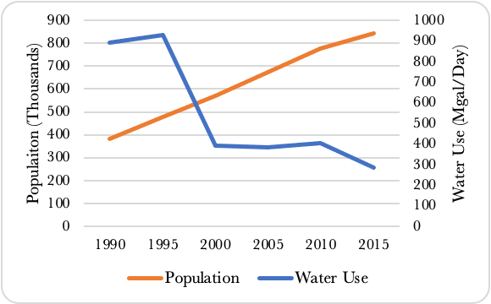
4.4.2 Hidalgo County, Texas
Figure 22. Population and water use change in Hidalgo county, Texas. Source: U.S. Census Bureau, 2021; The Texas Demography Center, 2021; Texas Library and Archives Commission, 2021.
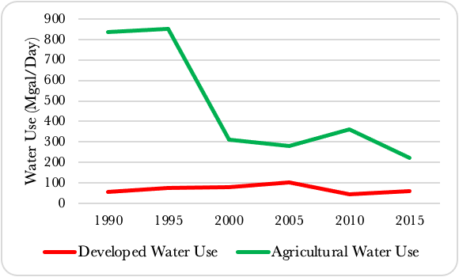
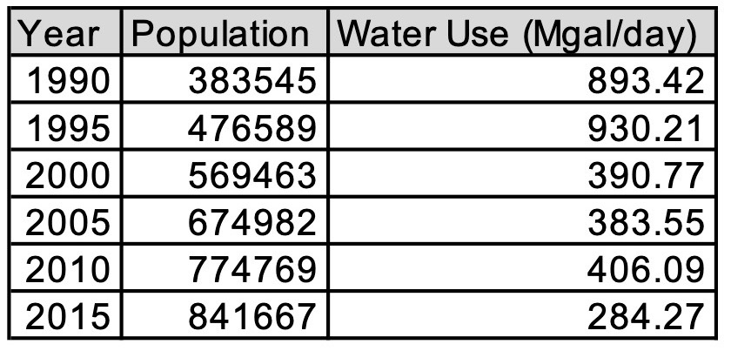
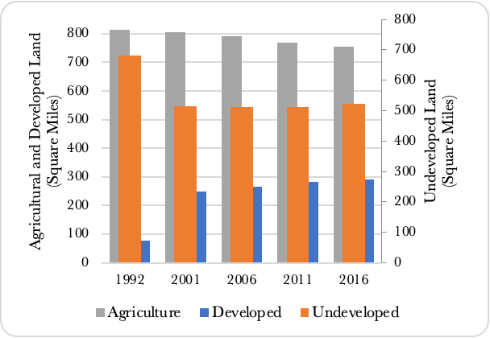
This county’s population and developed land cover, while agricultural land cover and water use decreased. Unlike Bernalillo County, the GWR model performed well at all time steps in Hidalgo County. Hidalgo County experienced both the greatest population growth and greatest reduction in water use over the study period (Figure 22). Population in this county was 383,545 people in 1990 and increased by 119.4% by 2015 to 841,667 (Figure 22). The regression coefficient describing the influence of population on water use in Hidalgo County varied greatly over the study period from a low of -4.97E-05 in 2015, to a high of 2.93E-03 in 2010 (Table 8). Around the same time there is a drop in agricultural land cover, water use also declines (Figure 22 - 24). Water use peaks in 1995 at 930 Mgal/day and dropped substantially down to just 390.8 Mgal/day, by 2000, and by 2015 had dropped to 284.3 Mgal/day, (30.6% of peak levels), (Figure 22). Water use in Hidalgo County is driven by a decline in agricultural water use (Figure 23). Developed water use stays relatively steady over the study period despite the population more than doubling.
Figure 23. Developed and agricultural water use in Hidalgo County, Texas over the study period. Source: U.S. Geological Survey, 2021.
Figure 24. Land cover composition of Hidalgo County, Texas.
Land Cover Change  (1992 to 2016) | Composition  (%) | Contribution to  Development  (%)
Developed to Undeveloped | 0.19 | -
Developed to Agriculture | 0.17 | -
Undeveloped to Developed | 5.45 | 39.10
Undeveloped to Agriculture | 10.25 | -
Agriculture to Developed | 8.49 | 60.90
Agriculture to Undeveloped | 5.57 | -
Water | 1.09 | -
No Change | 68.79 | -
Total Developed | 13.93 | -

Table 5. Land cover change in Hidalgo County, Texas. Source: U.S. Geological Survey.
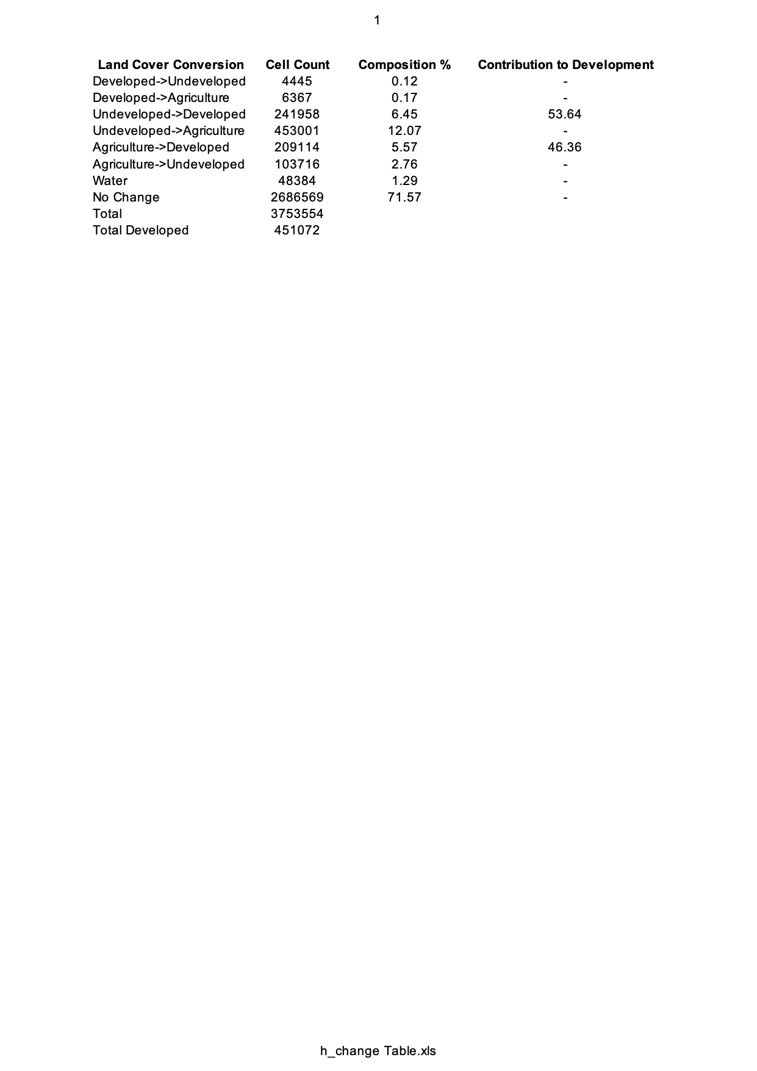
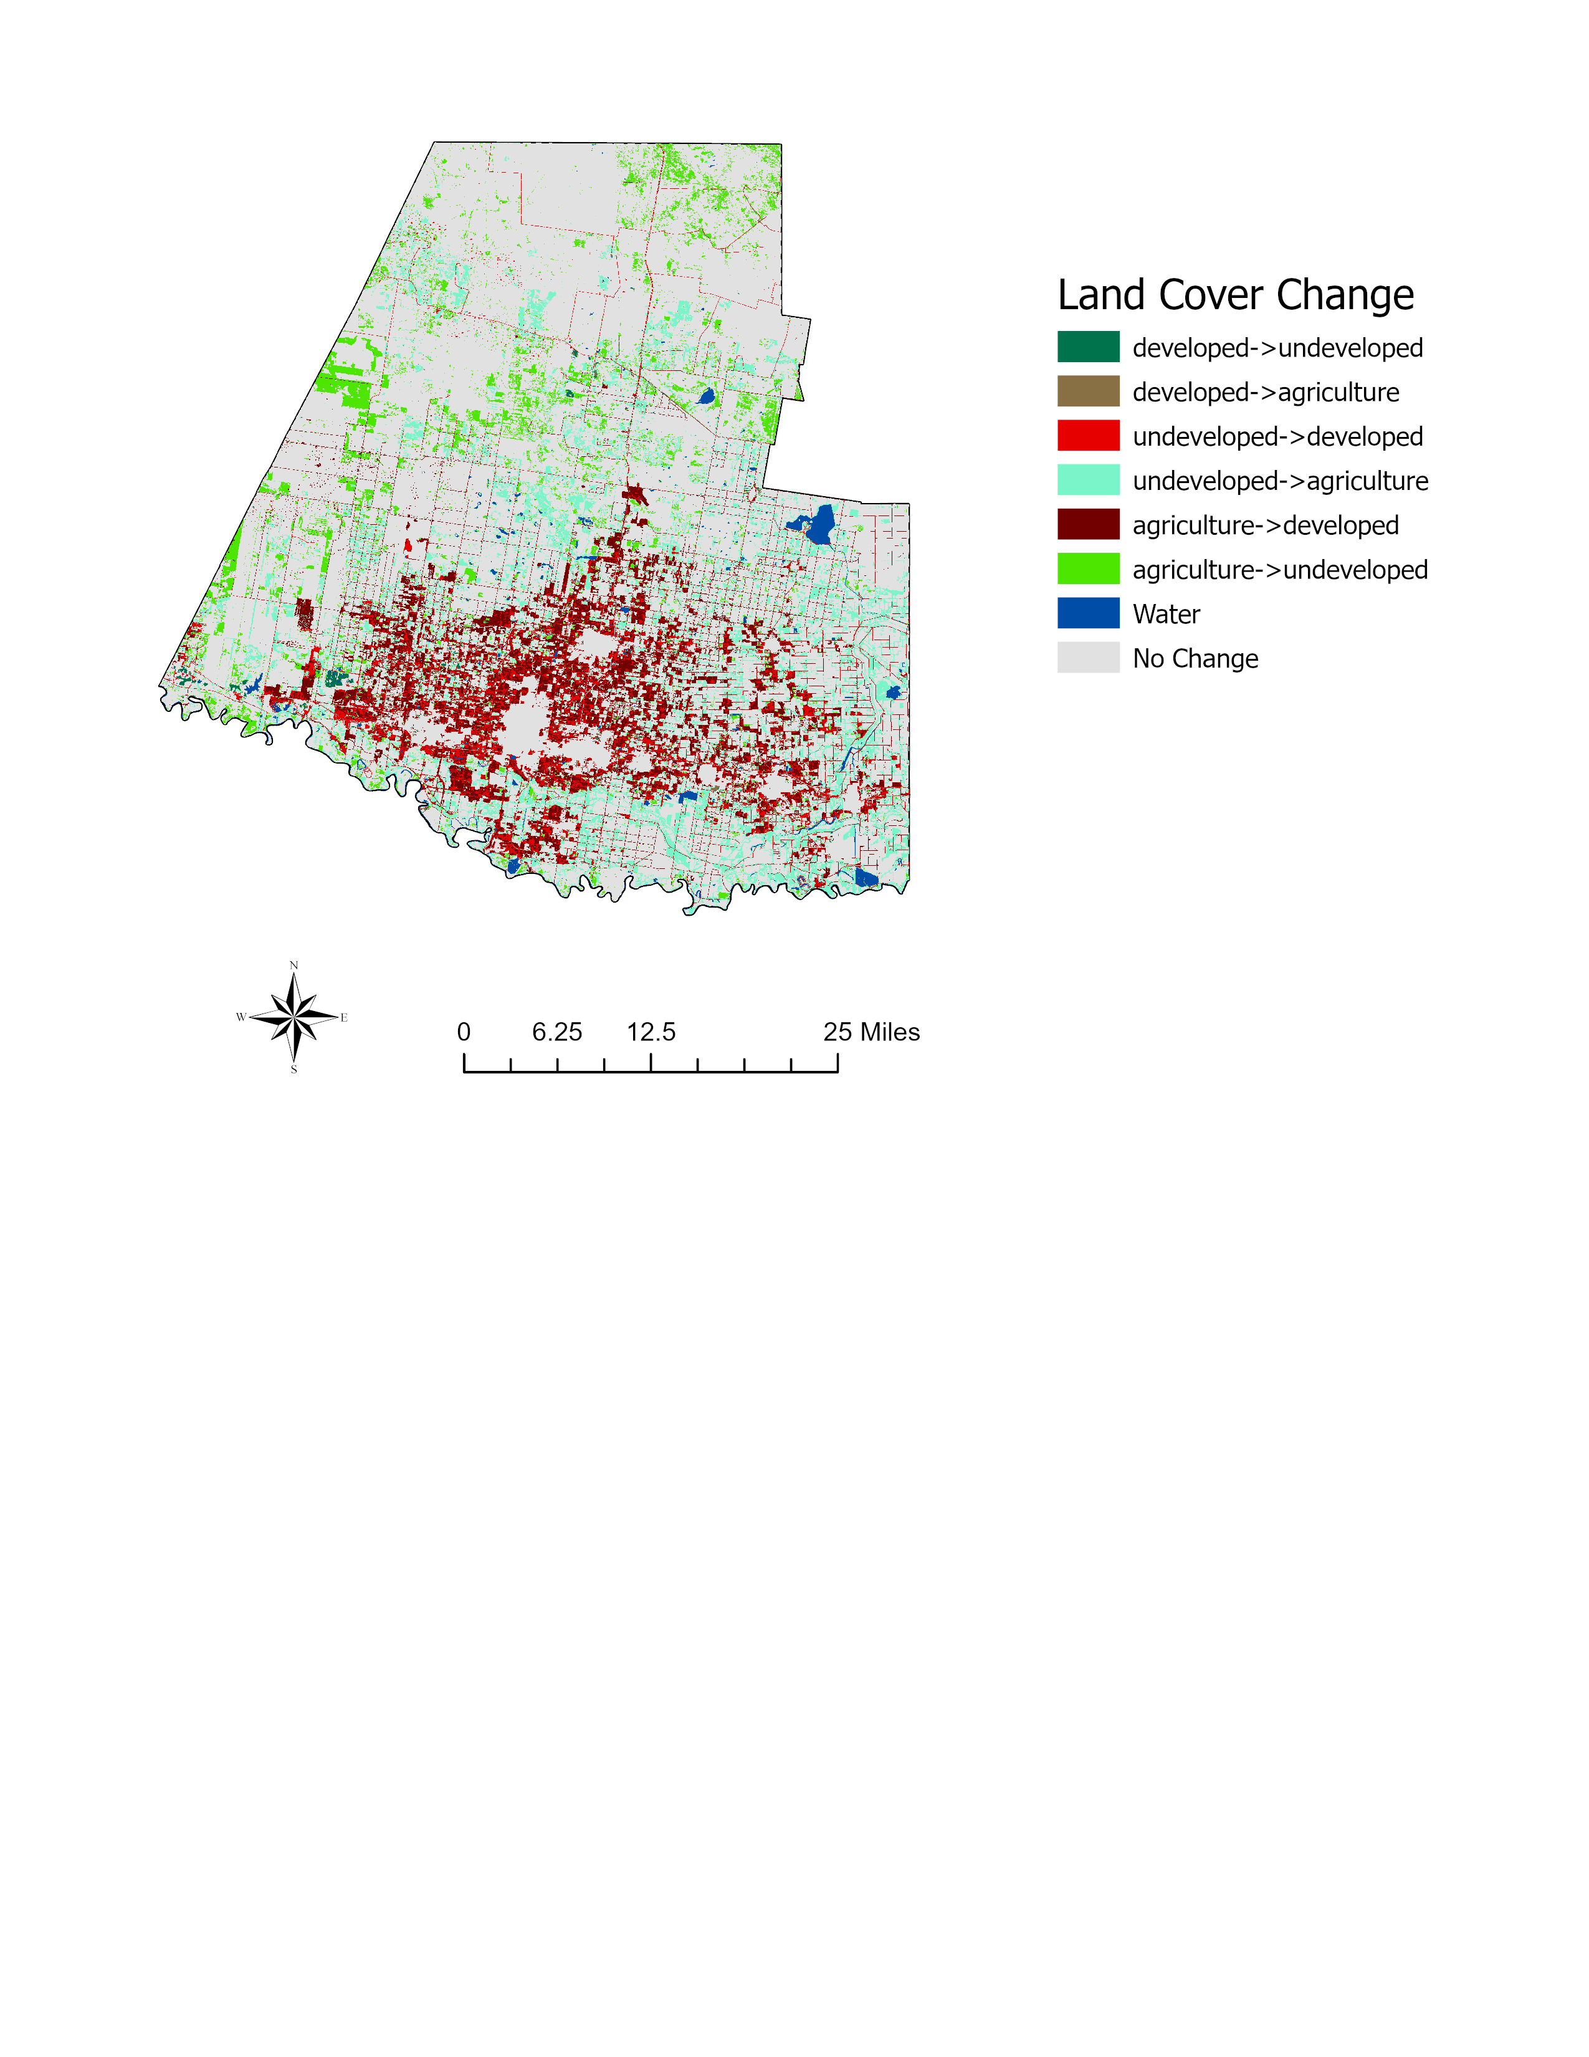
Over the study period, developed land in Hidalgo County increases by 282.6% (Figure 24). This increase is higher than the basin increase overall and is more than double the proportional increase in population. The influence of developed land cover on water use is clear in Hidalgo County for the majority of the study period, with the exception of 2010 (Table 9). This coincides with the plateauing of developed land by 2011 (Figure 24). 60.9% of the development is located on formerly agricultural land, while 39.1% is located on formerly undeveloped land (Table 5, Figure 25). Agricultural land cover decreased by 7.1% (Figure 24). The influence of agricultural land cover on water use declined over the study period from a regression coefficient of 2.16E-07 in 1995 to 4.19E-08 in 2015 (Table 10).
Figure 25. Land cover change in Hidalgo County, Texas 1992 to 2016.

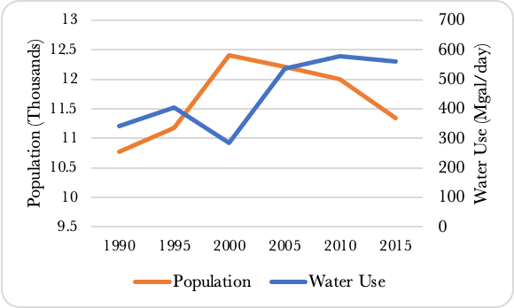
4.4.3 Rio Grande County, Colorado
Figure 26. Population and water use change in Rio Grande County, Colorado. Source: from the U.S. Census Bureau, 2021; The Colorado Department of Demography, 2021; U.S. Geological Survey, 2021.
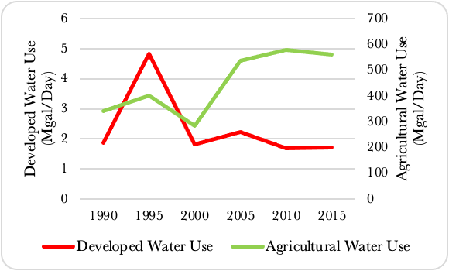
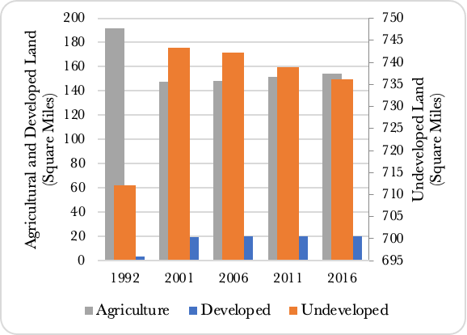
Rio Grande County in Colorado is the smallest of the three case study counties by area, has the lowest population of the three case study counties, but is the county in the study area that has experienced the greatest increase in water use. Located in the northern region of the basin (Figure 8), the effectiveness of the GWR model at predicting water use in this region fluctuates over time (Figure 14). Population in this county in 1990 was 10,770 people, increases through the year 2000, then decreases to 11,336 by 2015 (Figure. 26). This represents an overall increase in population of just 566 people, or 5.3%. Although the population changed very little, at the beginning of the study period the regression coefficient describing the influence of population on water use was -1.08E-3, but increased to 1.03E-4 by 2015 (Table 8). While population overall does not change significantly, its relation to water use does. At its lowest point in 2000, water use was at 285.65 Mgal/day, and at its highest point in 2010 water use was at 579.13 Mgal/day (Figure. 26). Even at its lowest, and despite its smaller geographic area, smaller population, and lower proportion of agricultural land cover, water use in this county has never been less than that of Hidalgo County which is larger in area. In 1990, water use in the county is 341.96 Mgal/day. The majority of water use in this county is attributed to agriculture, while just a fraction is used for development (Figure 27).
Figure 27. Developed and agricultural water use in Rio Grande County, Colorado over the study period. Source: U.S. Geological Survey, 2021.
Figure 28. Land cover composition of Rio Grande County, Colorado
Land Cover Change  (1992 to 2016) | Composition  (%) | Contribution to  Development  (%)
Developed to Undeveloped | 0.04 | -
Developed to Agriculture | 0.02 | -
Undeveloped to Developed | 0.94 | 50.98
Undeveloped to Agriculture | 2.17 | -
Agriculture to Developed | 0.90 | 49.02
Agriculture to Undeveloped | 5.34 | -
Water | 0.64 | -
No Change | 89.94 | -
Total Developed | 1.84 | -

Table 6. Land cover change in Rio Grande County, Colorado. Source: U.S. Geological Survey.
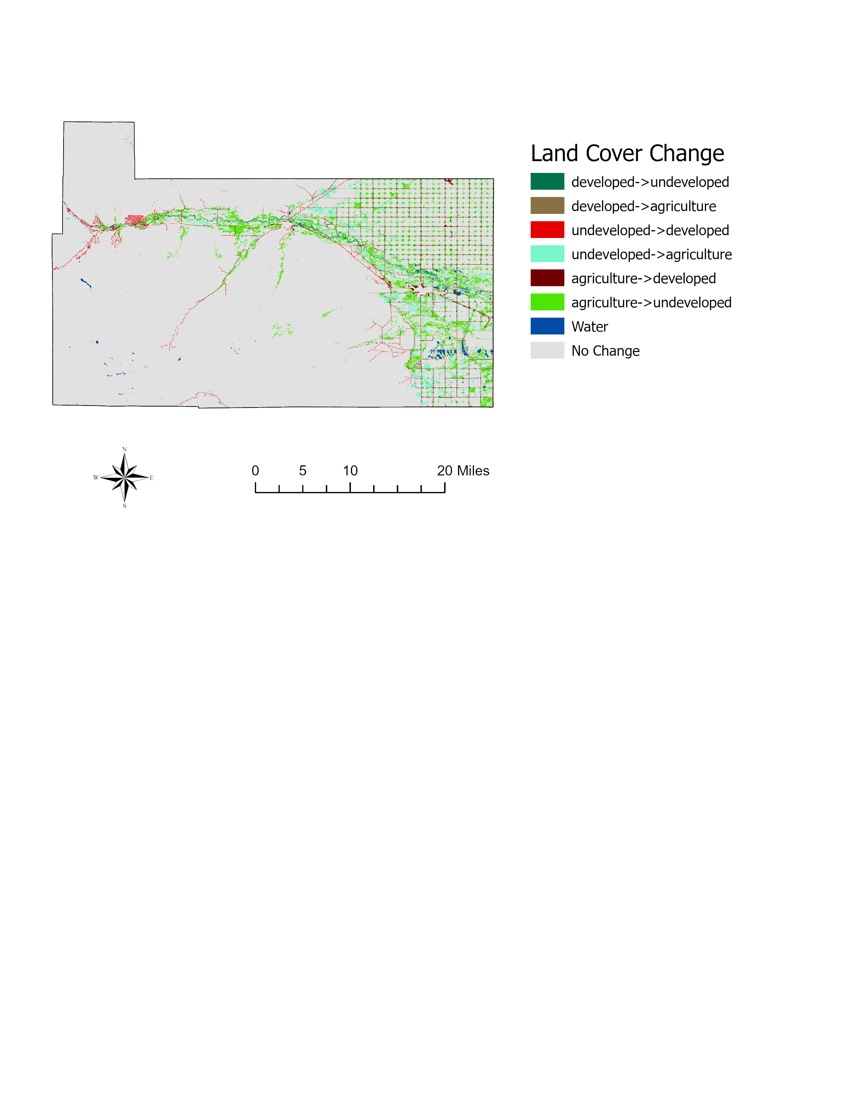
Developed area in Rio Grande County increases by 443.8% during the study period (Figure 28). The majority of this development occurs between 1992 and 2001. This is also the time period during which developed land cover has the greatest influence on water use, ranging from 3.71E-07 to 2.27E-06 (Table 9). Additionally, this the time period is when population peaks (Figure 26). Developed land is located on a mixture of undeveloped land and agricultural land (Table 6), with 49% of the developed land located on formerly agricultural land, and 50.1% located on formerly undeveloped land (Table 6) (Figure 29). There was a decrease of 19.3% of agricultural land in the county over the time period (Table 6). Most of this decrease occurred between the years 1992 and 2001. Like other counties in the norther region of the basin, agricultural land cover is more influential on water use here than it was in other regions of the basin (Table 10).
Figure 29. Land cover change in Rio Grande County, Colorado 1992 to 2016.

4.4 Case Study County Comparison
Each of these counties exhibits different spatial and temporal relationships among population, developed land cover, agricultural land cover, and water use. In Bernalillo County in New Mexico, population, developed land cover, and agricultural land cover all increase, while water use for both developed and agricultural uses decreases (Figure 18, Figure 19, Figure 20). Hidalgo County, Texas exhibits an increase in population and developed land cover similar to Bernalillo County, however, agricultural land cover decreases in Hidalgo while it increases in Bernalillo. (Figure 22, Figure 23, Figure 24) . In Hidalgo, agricultural water in turn use falls drastically while developed water use holds relatively constant (Figure 23). Rio Grande County in Colorado experiences an overall increase in developed land cover, population, and water use, and a decline in agricultural land cover (Figure 26, Figure 28). Despite this decline in agricultural land cover, agricultural water use in the country rises substantially over the study period (Figure 27).
Bernalillo’s R² values are consistently lower than those for Hidalgo and Rio Grande County (Table 7). Population in Bernalillo County has a consistency directly related with water use over the study period, while the relationship between population and water use in Hidalgo County and Rio Grande County fluctuates between direct and inverse over the study period (Table 8). The relationship between developed land cover and water use in Bernalillo County is inversely correlated for the entire study period (Table 9). Hidalgo and Rio Grande County’s water use has a directly correlated relationship with developed land cover for all years examined with the exception of 2010 (Table 9). All three counties experience a direct relationship between their water use and agricultural land cover (Table 10).
County | Population Regression Coefficient
 | 1990 | 1995 | 2000 | 2005 | 2010 | 2015
Bernalillo | 9.47E-04 | 9.33E-04 | 2.97E-04 | 3.43E-04 | 3.5E-04 | 2.61E-04
Hidalgo | 6.78E-05 | 4.21E-04 | -1.42E-04 | -1.81E-04 | 2.93E-03 | -4.97E-05
Rio Grande | -1.98E-03 | 4.79E-05 | -5.21E-04 | 1.18E-04 | 7.8E-03 | 1.03E-04

Table 8. Population regression coefficients resulting from geographically weighted regression.
County | R² Values
 | 1990 | 1995 | 2000 | 2005 | 2010 | 2015
Bernalillo | 0.52 | 0.61 | 0.59 | 0.66 | 0.68 | 0.57
Hidalgo | 0.92 | 0.92 | 0.94 | 0.95 | 0.99 | 0.88
Rio Grande | 0.91 | 0.81 | 0.74 | 0.89 | 0.76 | 0.73

Table 7. R² values resulting from geographically weighted regression.
County | Agricultural Land Cover Coefficient
 | 1990 | 1995 | 2000 | 2005 | 2010 | 2015
Bernalillo | 1.46E-07 | 1.55E-07 | 3.11E-07 | 3.19E-07 | 8.40E-07 | 2.10E-07
Hidalgo | 2.16E-07 | 1.97E-07 | 3.44E-07 | 4.16E-08 | 1.08E-07 | 4.19E-08
Rio Grande | 7.55E-07 | 1.02E-06 | 8.23E-07 | 1.00E-06 | 1.10E-06 | 8.25E-07

Table 10. Agricultural land cover regression coefficients resulting from geographically weighted regression.
County | Developed Land Cover Coefficient
 | 1990 | 1995 | 2000 | 2005 | 2010 | 2015
Bernalillo | -1.20E-06 | -1.38E-06 | -1.53E-07 | -3.31E-07 | -3.73E-07 | -2.49E-07
Hidalgo | 1.87E-06 | 1.20E-06 | 6.66E-07 | 6.38E-07 | -2.96E-06 | 3.6E-07
Rio Grande | 2.27E-06 | 3.71E-07 | 6.70E-07 | 9.42E-08 | -3.15E-06 | 1.52E-08

Table 9. Developed land cover regression coefficients resulting from geographically weighted regression.

Chapter 5: Discussion

5.1 Water Use Decline in the Rio Grande Basin
Despite an increasing population, overall water use in the U.S. portion of the Rio Grande Basin is decreasing (Figure 6). This counters other studies showing a linkage between growing populations and water use (Sanchez et al., 2018; Dettinger et al., 2015). This decline in water use is driven by a steady decline in water used for agricultural purposes (Figure 7). Although we see a substantial increase in population over the study period, other literature (e.g., Brown et al., 2019; Brown, 2000) states that even in the context of a growing population, we may not see a proportional increase in water use. Developed water use stays relatively steady at the begging of the study period, then drops substantially from 2005 to 2010, and is rising again by 2015. This rise may indicate that despite efforts to carefully plan water use policy to address growing populations (Rister et al., 2011), and increases in water use efficiency (Brown, 2000; Brown et al., 2019), this growth is happening at such a rate that it is negating these efforts. The decline of water used for agriculture is supported by Brown et al. (2013) who stated that irrigation efficiency in the Western U.S. is driving some of this decline and further supported by Rister et al.(2011) who state that as population increases, the economy will shift from agrarian to industrial and service based.
The overall decline in water use in the U.S. portion of the basin is driven mostly by a handful of counties, such as Hidalgo County, where there is a substantial increase in developed land cover and population (Figure 11). Bernalillo County saw an increase in developed area, agricultural area, and population, but a decline in water use (Figure 22, 24) . This supports the findings from Rister et al. (2011) that population growth in the region is leading to a shift in the economy to be more service and manufacturing based, with less water used for agricultural purposes.
Research by Brown (2000) and Rister et al. (2011) also shows the drop in water use in counties like Hidalgo and Bernalillo is in part driven by farmers selling their land to expanding cities, therefore removing it from agricultural production. However, while these populated counties are generally experiencing a decrease in water use, counties with lower, more stable populations, stable levels of developed land cover, and higher levels of agricultural land cover are experiencing a gradual increase in water use.
Although water use has decreased in the basin over the study period, this decrease may not be sustainable as developed land cover and population continue to rise, demanding more water. This demand may outpace the reductions in agricultural water use. This calls for future research in mitigating the increase of water used for developed areas rather than assuming that decreases in agricultural water use will continue to offset these increases.

5.2 Temporal Dynamics of Water Use Drivers
Over time, agricultural land use becomes less of a driver of water use as population becomes more of a driver in the Southern reaches of the basin. This is in line with the findings of Rister et al. (2011) that describe an increase in population and an economic shift from agricultural to industry and service based.
Data for the Northern most regions of the basin, show fluctuation in the way population is related to water use. In the years 1990 and 1995, population is the strongest determinant of water use. However, in the year 2000, and only for this time step, developed land becomes the strongest determinant of water use. In the following years population is once again the driver (Figure 16). One explanation for this dynamic behavior is that population was growing quickly in 1990 and 1995 (Figure 9), and to accommodate this there was a substantial increase in developed land that outpaced the population growth briefly in 2000 (Figure 12).
The central region of the basin do not display a clear temporal trend (Figure 11-14). While agricultural land cover has some influence on water use in much of this area of the basin, it is never the primary driver. Instead, the GWR models suggest that population and the amount of developed land cover are the best indicators of water use, although their influence is not as strong as it is in the Northern and Southern regions of the basin (Figure 15, Figure16). This observation correlates with the local R² values for the geographically weighted regression models overall (Figure 11). In the Northern and Southern reaches of the basin, where the drivers of water use are steady, the predictive power of the model is greater than in the central region of the basin where the drivers of water display stronger fluctuation (Figure 11).
Overall, the ways that population, developed land cover, and agricultural land cover impact water use in the basin exhibits spatial as well as temporal heterogeneity, highlighting the need for localized water governance as no set of overarching regulations can accommodate the different patters and processes driving changes in water use within the basin. Plassin et al (2021) explain the spatial heterogeneity of this region, highlighting the fact that the Rio Grande Basin includes nine level III ecoregion with vastly different water needs.

5.3 Spatial Analysis of Land Cover Influence on Water Use
From 1990 to 2015, we see the influence of agricultural and developed land cover on water use concentrate into different regions of the basin (Figure 16, Figure 17). Figure 17 shows that in 1990, the amount of agricultural land cover in a county is positively correlated with water use in all counties in the study area, especially so in the Northwestern most counties and in the counties along the U.S./Mexico border. Over the study period, the influence of agricultural land cover gradually lessens along the border, but increases in the Northwest. By 2015, agricultural land cover displays its strongest influence in the Northwestern region and, to a lesser extent, along the western border of the study area. The 2015 water use in the central and Southern counties of the study area is no longer as strongly correlated with the amount of agricultural land cover as in earlier years.
The analysis of developed land cover shows a similar trend, albeit in different regions of the basin (Figure 16). The influence of developed land cover on water use in the basin is most pronounced in the central and Southern regions of the basin. This influence stays relatively stable from 1990 - 2015. However, the influence of developed land cover on water use declines in the Northern regions while the influence of agricultural land cover increases. By 2010 and 2015, developed land cover is inversely correlated with water use in the Northern regions of the basin. This could indicate that developed land cover is decreasing or remaining the same, while water use rises as agricultural water use increases.

5.4 Study Limitations and Next Steps
One of the biggest limitations of this study is the mis-matching of land cover dataset collection dates and of water use reporting dates. As stated above, I used USGS water use data for the period 1990 to 2015 at five year intervals to analyze relationships between this water use and land cover. NLCD for the years 1992, 2001, 2006, 2011, and 2016. While these years are relatively close to those of the water use data, there is still a considerable gap in the land cover dataset between 1992 and 2001. This gap could hinder finding important land use trends that improve the understanding of water use in the basin going forward. Future studies could use the Landsat land cover data instead as this data is collected at the same rate as the USGS reports water data. For example, Mubako et al. (2018) used Landsat data in their study looking at a subregion of the basin. Using this data, however, is much more time and resource consuming than using the NLCD data as it requires extensive preparation and correction, especially given the large area covered by this study.
Another limitation of this study is the spatial resolution used for analysis. I chose county level resolution rather than census tract level analysis as water use and population data is readily available at the county level and this made drawing relationships between the two much more straightforward. However, looking at a finer resolution such as census tracts (e.g., Sanchez et al., 2018) may reveal spatial patterns of water use dynamics that are not apparent in my analysis. A higher spatial resolution would also allow for more robust spatial statistical analysis, such as Getis-Ord hotspot analysis.
Overall, the GWR model performed least successfully in the central regions of the basin, in New Mexico. An important influence on water use that I do not consider in this study and that is not represented in my model is water use policy and education in the basin, especially in the more arid regions of New Mexico. For example, in both Santa Fe and Albuquerque. Albuquerque is New Mexico’s largest city by population, and Santa Fe is the 4th most populous in the state (New Mexico Cities by Population, 2022). Both of these cities have strict watering restrictions, limiting watering times to early mornings and late evenings for more than half of the year (City of Santa Fe, 2022; Albuquerque Water Authority, 2022). These cities also have public websites encouraging water conservation, setting conservation goals, and discussing more sustainable practices such as xeriscaping (Albuquerque Water Authority, 2022; City of Santa Fe, 2022). Additionally, cities like these incentivize more sustainable water use by way of rebates for water efficient appliances, irrigation systems, and water flow monitoring systems (Albuquerque Water Authority, 2022). Similar restrictions are in place for El Paso in Texas (El Paso Water, 2022) and Alamosa in Colorado (The City of Alamosa, 2022). A model that considers the way that incentivizing water conservation and dis-incentivizing water waste may be more successful in modeling water use in the RGB, especially in the central regions of the basin.
Another way to build on this study would be to combine the findings with simulations of the Future Urban-Regional Environment Simulation (FUTURES) model to project potential future water use in counties that see strong correlation between developed land cover and water use (Meentemeyer et al. 2013). The FUTURES model simulates urban development of a region based on a number of drivers of development such as population growth and per capita area demand, and locates these developments in the landscape based on proxies such as road density, slope, distance to water, and changes to land cover composition that have already occurred (Dorning et al., 2014; Koch et al., 2018).

Chapter 6: Conclusion
The future of water use in the Southwestern United States is uncertain in light of a rapidly increasing population and corresponding urban expansion. Water use has declined over the study period examined here, but is beginning to rise again. The decrease in water use is characteristic of the population growth in the region pushing a transition from an agriculturally based economy to a more industrially and service based one. This has decreased agricultural water use substantially, but water use will likely increase in developed areas and offset the reductions in agricultural water use. Therefore it is imperative that water policies are put in place to encourage sustainable use of water resources in the RGB. This study shows the changing spatial relationships that population and land use/cover type have on water use, highlighting the need to understand and monitor the processes driving these changes in order to manage water use in a sustainable manner.
While water use in the U.S. portion of the Rio Grande Basin is decreasing, this is primarily driven by decreases in only a handful of counties that are experiencing explosive population growth and therefore presumably a transition from a more agriculturally based economy to a more industrialized one. Water use in counties with smaller populations, less developed land cover, and greater agricultural activity are continuing to steadily use more water. It is unclear whether in regions that are experiencing a decline in water use with their population booms will continue to see this trend, or if there will be a tipping point where a continuation of population growth will exceed the former water used for agricultural production.
It is evident that the basin is settling into stable regional differences in its drivers of water use. Agricultural land use is most influential in the Northern regions of the basin, while development is more influential on water use in the central and Southern regions of the basin. This spatial heterogeneity at the regional scale presents an opportunity to theorize regional water use plans for the basin and to explore what is driving this regionality in the first place.
Overall, this work highlights the changing spatiotemporal relationship between water use, population, and land use and land cover. Water use drivers in the basin have changed substantially over the last 25 years and will likely continue to change. As such, it is paramount that water resource managers continue to analyze the drivers of water use in their areas so that the Rio Grande Basin’s resources are managed in a sustainable manner.

Literature Cited

About the Rio Grande. U.S. Internation Boundary & Water Commission. (n.d.). Retrieved April 30, 2022, from https://www.ibwc.gov/crp/riogrande.htm
Alig, R. J., Kline, J. D., & Lichtenstein, M. (2004). Urbanization on the US landscape: Looking ahead in the 21st century. Landscape and Urban Planning, 69(2–3), 219– 234. https://doi.org/10.1016/j.landurbplan.2003.07.004
Albuquerque Water Authority. (2021, May 20). Conservation & rebates-overview. Albuquerque Bernalillo County Water Utility Authority. Retrieved May 3, 2022, from https://www.abcwua.org/conservation-rebates-overview/
Blanc, E., Strzepek, K., Schlosser, A., Jacoby, H., Gueneau, A., Fant, C., Rausch, S., & Reilly, J. (2014). Modeling U.S. water resources under climate change. Earth’s Future, 2(4), 197–224. https://doi.org/10.1002/2013EF000214
Bounoua, L., Nigro, J., Zhang, P., Thome, K., & Lachir, A. (2018). Mapping urbanization in the United States from 2001 to 2011. Applied Geography, 90, 123–133. https://doi.org/10.1016/j.apgeog.2017.12.002
Brand, Donald Dilworth and Schmidt, Robert H.. "Rio Grande". Encyclopedia Britannica, 20 Feb. 2020, https://www-britannica-com.ezproxy.lib.ou.edu/place/ Rio-Grande-river-United-States-Mexico. Accessed 19 March 2022.
Brown, T. C. (2000). Projecting U.S. freshwater withdrawals. Water Resources Research, 36(3), 769–780. https://doi.org/10.1029/1999WR900284

Brown, T. C., Foti, R., & Ramirez, J. A. (2013). Projected freshwater withdrawals in the United States under a changing climate: PROJECTED FUTURE WATER USE IN THE UNITED STATES. Water Resources Research, 49(3), 1259–1276. https://doi.org/10.1002/wrcr.20076
Brown, T. C., Mahat, V., & Ramirez, J. A. (2019). Adaptation to Future Water Shortages in the United States Caused by Population Growth and Climate Change. Earth’s Future, 7(3), 219–234. https://doi.org/10.1029/2018EF001091
The City of Alamosa. (n.d.). Water smarts. The City of Alamosa. Retrieved May 3, 2022, from https://cityofalamosa.org/water-smarts/
City of San Fe. (n.d.). Water use restrictions. Water Use Restrictions | City of Santa Fe, New Mexico. Retrieved May 3, 2022, from
https://www.santafenm.gov/water_use_restrictions
Colby, S. L., & Ortman, J. M. (2015). Projections of the Size and Composition of the U.S. Population: 2014 to 2060. United States Census Bureau. U.S. Department of Commerce. Retrieved from census.gov.
Colorado Department of Local Affairs State Demography Office. (n.d.). Colorado Department of Affairs. Retrieved November 2020, from
https://demography.dola.colorado.gov/assets/html/population.html
Cook, B. I., Smerdon, J. E., Seager, R., & Coats, S. (2014). Global warming and 21st century drying. 21.
Dai, A. (2013). Increasing drought under global warming in observations and models. Nature Climate Change, 3(1), 52–58. https://doi.org/10.1038/nclimate1633
Das, P., Patskoski, J., & Sankarasubramanian, A. (2018). Modeling the Irrigation Withdrawals Over the Coterminous US Using a Hierarchical Modeling Approach. Water Resources Research, 54(6), 3769–3787.
https://doi.org/ 10.1029/2017WR021723
Data Commons. (n.d.). Albuquerque. Albuquerque - Place Explorer - Data Commons. Retrieved March 18, 2022, from
https://datacommons.org/place/geoId/3502000
Data Commons. (n.d.). Bernalillo County. Bernalillo County - Place Explorer - Data Commons. Retrieved March 18, 2022, from https://datacommons.org/place/ geoId/35001?utm_medium=explore&mprop=count&popt=Person&hl=en
Dettinger, M., Udall, B., & Georgakakos, A. (2015). Western water and climate change. Ecological Applications, 25(8), 2069–2093. https://doi.org/10.1890/15-0938.1
Dorning, M. A., Koch, J., Shoemaker, D. A., & Meentemeyer, R. K. (2015). Simulating urbanization scenarios reveals tradeoffs between conservation planning strategies. Landscape and Urban Planning, 136, 28–39. https://doi.org/10.1016/j.landurbplan.2014.11.011
El Paso Water. (n.d.). Watering schedule. El Paso Water. Retrieved May 3, 2022, from https://www.epwater.org/conservation/watering_schedule
Homer, C., Dewitz, J., Jin, S., Xian, G., Costello, C., Danielson, P., Gass, L., Funk, M., Wickham, J., Stehman, S., Auch, R., & Riitters, K. (2020). Conterminous United States land cover change patterns 2001–2016 from the 2016 National Land Cover Database. ISPRS Journal of Photogrammetry and Remote Sensing, 162, 184–199. https://doi.org/10.1016/j.isprsjprs.2020.02.019
Jin, S., Homer, C., Yang, L., Danielson, P., Dewitz, J., Li, C., Zhu, Z., Xian, G., & Howard, D. (2019). Overall Methodology Design for the United States National Land Cover Database 2016 Products. Remote Sensing, 11(24), 2971.
https:// doi.org/10.3390/rs11242971
Jones, B., & O’Neill, B. C. (2013). Historically grounded spatial population projections for the continental United States. Environ. Res. Lett., 12.
Koch, J., Dorning, M. A., Van Berkel, D. B., Beck, S. M., Sanchez, G. M., Shashidharan, A., Smart, L. S., Zhang, Q., Smith, J. W., & Meentemeyer, R. K. (2019). Modeling landowner interactions and development patterns at the urban fringe. Landscape and Urban Planning, 182, 101–113. https://doi.org/10.1016/j.landurbplan.2018.09.023
Koch, J., Friedman, J. R., Paladino, S., Plassin, S., & Spencer, K. (2019). Conceptual modeling for improved understanding of the Rio Grande/Río Bravo socio-environmental system. Socio-Environmental Systems Modelling, 1, 16127. https://doi.org/10.18174/sesmo.2019a16127
McKee, J. J., Rose, A. N., Bright, E. A., Huynh, T., & Bhaduri, B. L. (2015). Locally adaptive, spatially explicit projection of US population for 2030 and 2050. Proceedings of the National Academy of Sciences, 112(5), 1344–1349.
https:// doi.org/10.1073/pnas.1405713112

Meentemeyer, R. K., Tang, W., Dorning, M. A., Vogler, J. B., Cunniffe, N. J., & Shoemaker, D. A. (2013). FUTURES: Multilevel Simulations of Emerging Urban–Rural Landscape Structure Using a Stochastic Patch-Growing Algorithm. Annals of the Association of American Geographers, 103(4), 785–807.
https://doi.org/10.1080/00045608.2012.707591
New Mexico cities by population. New Mexico Cities by Population. (n.d.). Retrieved May 3, 2022, from
https://www.newmexico-demographics.com/ cities_by_population
Páez, A., & Wheeler, D. C. (2009). Geographically weighted regression. International Encyclopedia of Human Geography, 407–414.
https://doi.org/10.1016/b978-008044910-4.00447-8
Patiño-Gomez, C., McKinney, D. C., Asce, M., Maidment, D. R., & Asce, M. (n.d.). Sharing Water Resources Data in the Binational Rio Grande/Bravo Basin. 11.
Plassin, S., Koch, J., Wilson, M., Neal, K., Friedman, J. R., Paladino, S., & Worden, J. (2021). Multi-scale fallow land dynamics in a water-scarce basin of the U.S. Southwest. Journal of Land Use Science, 16(3), 291–312.
https://doi.org/10.1080/1747423X.2021.1928310
Rister, M. E., Sturdivant, A. W., Lacewell, R. D., & Michelsen, A. M. (2011). Challenges and Opportunities for Water of the Rio Grande. Journal of Agricultural and
Applied Economics, 43(3), 367–378.
https://doi.org/10.1017/S1074070800004363

Sandoval-Solis, S., Paladino, S., Garza-Diaz, L. E., Nava, L. F., Friedman, J. R., Ortiz- Partida, J. P., Plassin, S., Gomez-Quiroga, G., Koch, J., Fleming, J., Lane, B. A., Wineland, S., Mirchi, A., Saiz-Rodriguez, R., & Neeson, T. M. (2022). Environmental flows in the rio grande - rio bravo basin. Ecology and Society, 27(1). https://doi.org/10.5751/es-12944-270120
Sanchez, G. M., Smith, J. W., Terando, A., Sun, G., & Meentemeyer, R. K. (2018). Spatial Patterns of Development Drive Water Use. Water Resources Research, 54(3), 1633–1649. https://doi.org/10.1002/2017WR021730
Strzepek, K., Yohe, G., Neumann, J., & Boehlert, B. (2010). Characterizing changes in drought risk for the United States from climate change. Environmental Research Letters, 5(4), 044012. https://doi.org/10.1088/1748-9326/5/4/044012
Texas Demographics Center. (2018). Retrieved November 2020, from demographics.texas.gov: https://demographics.texas.gov/Data/TPEPP/ Projections/Report.aspx?id=0afa8e83417948a9b53b7b76976bd035
Texas State Library and Archives Commission. (2013, May 21). 2000 Census: Population of Texas Counties, Arranged in Alphabetical Order. Retrieved September 2021, from https://www.tsl.texas.gov/ref/abouttx/popcnty12000.html
Texas State Library and Archives Commission. (2013, May 21). 2010 Census: Population of Texas Counties, Arranged in Alphabetical Order . Retrieved October 2021, from https://www.tsl.texas.gov/ref/abouttx/popcnty12010.html
Texas State Library and Archives Commission. (2013, May 21). Population Estimates of Texas Counties, 1990-99, Arranged in Alphabetical Order. Retrieved September 2021, from https://www.tsl.texas.gov/ref/abouttx/popcnty2.html
Texas State Library and Commissions Office. (2013, May 21). 1990 Census: Population of Texas Counties, Arranged in Alphabetical Order. Retrieved September 2021, from https://www.tsl.texas.gov/ref/abouttx/popcnty1.html
The Rio Grande: Rethinking Rivers in the 21st Century. wildearthguardians.org. (2017, February). Retrieved from http://pdf.wildearthguardians.org/site/DocServer/ The%20Rio%20Grande%20Rethinking%20Rivers%20Report.pdf
The University of New Mexico. (n.d.). Geospatial and Population Studies. Retrieved November 2020, from Population Projections:
https://gps.unm.edu/pru/projections
U.S. Census Bureau. (2020, November 11). Retrieved from Tiger/Line Shapefiles: https://www.census.gov/cgi-bin/geo/shapefiles/index.php
United States Census Bureau. (2000, August 30). Retrieved February 2021, from (CO-99-13) Population Estimates for Counties by Age Group: July 1, 1995: https://www2.census.gov/programs-surveys/popest/tables/1990-2000/counties/ asrh/caco95.txt
United States Census Bureau. (2000, August 30). Retrieved from (CO-99-13) Population of Counties by Age Group: April 1, 1990: https://www2.census.gov/programs- surveys/popest/tables/1990-2000/counties/asrh/cacomars.txt
United States Census Bureau. (2000, August 30). Retrieved March 2021, from (CO-99-13) Population Estimates for Counties by Age Group: July 1, 1995: https://www2.census.gov/programs-surveys/popest/tables/1990-2000/counties/ asrh/canm95.txt
United States Census Bureau. (2000, August 30). (CO-99-13) Population of Counties by Age Group: April 1, 1990 . Retrieved March 2021, from https:// www2.census.gov/programs-surveys/popest/tables/1990-2000/counties/asrh/ canmmars.txt
United States Census Bureau. (2000). data.census.gov. Retrieved March 2021, from Total Population [1]: https://www2.census.gov/programs-surveys/popest/tables/ 1990-2000/counties/asrh/caco95.txt
United States Census Bureau. (2012, October). County Intercensal Tables: 2000-2010. Retrieved January 2021, from census.gov: https://www.census.gov/data/tables/ time-series/demo/popest/intercensal-2000-2010-counties.html
United States Census Bureau. (2020). Southern and Western Regions Experienced Rapid Growth This Decade. 8.
United States Census Bureau. (2020, May 21). Southern and Western Regions Expereinced Rapid Growth This Decade. Retrieved from Population Milestones Since 2010.
United States Environmental Protection Agency. (2020, December 17). NHDPlus Rio Grande Data (Vector Processing Unit 13). Retrieved from https://www.epa.gov/ waterdata/nhdplus-rio-grande-data-vector-processing-unit-13

United States Geological Survey. (n.d.). Water Use Data for Colorado. Retrieved March 2022, from National Water Information System: Web Interface:https:// waterdata.usgs.gov/co/nwis/water_use?wu_year=1990&wu_year =1995&wu_year=2000&wu_year=2005&wu_year=2010&wu_year =2015&wu_area=County&wu_county=ALL&wu_category=PS&wu_ category=DO&wu_category=CO&wu_category=IN&wu_category=LI&wu _category=LS&wu_category=L
United States Geological Survey. (n.d.). Water Use Data for New Mexico. Retrieved March 2022, from National Water Information System: Web Interface: https:// waterdata.usgs.gov/nm/nwis/water_use?wu_year=1990&wu_year=1995 &wu_year=2000&wu_year=2005&wu_year=2010&wu_year=2015&wu_area= County&wu_county=ALL&wu_category=PS&wu_category=DO&wu_category =CO&wu_category=IN&wu_category=LI&wu_category=LS&wu_category=L
United States Geological Survey. (n.d.). Water Use Data for Texas. Retrieved March 2022, from National Water Information System: Web Interface: https:// waterdata.usgs.gov/tx/nwis/water_use?wu_year=1990&wu_year=1995&wu_yea r=2000&wu_year=2005&wu_year=2010&wu_year=2015&wu_area= County&wu_county=ALL&wu_category=PS&wu_category =DO&wu_category=CO&wu_category=IN&wu_category= LI&wu_category=LS&wu_category=
United States Geological Survey. (2018, June 15). Dictionary of water terms. Dictionary of Water Terms. Retrieved 2021, from https://www.usgs.gov/special-topics/ water-science-school/science/dictionary-water-terms#overview
United States Geological Survey. (n.d.). Summary of Estimated Water Use in the United States in 2005. Retrieved April 7, 2021, from
https://pubs.usgs.gov/fs/2009/3098/pdf/2009-3098.pdf
United States Geological Survey. (n.d.). Summary of Estimated Water Use in the United States in 2010. Retrieved April 7, 2021, from https://www.kyfb.com/federation/ water/resources/usgs-summary-of-est-water-use-in-the-u-s-in-2010/
United States Geological Survey. (n.d.). Summary of Estimated Water Use in the United States in 2015. Retrieved April 7, 2021.

