University of Oklahoma

Graduate College

Physiological responses to a single bout of resistance exercise: practical vs controlled blood flow restriction

A thesis

submitted to the Graduate Faculty

in partial fulfillment of the requirements for the

Degree of

Master of Science

By

bianca alvarenga rambo galletti
Norman, Oklahoma
2018

Physiological responses to a single bout of resistance exercise: practical vs controlled blood flow restriction

A thesis approved for the
Department of Health and Exercise Science

By

______________________________
Dr. Michael Bemben, Chair

______________________________
Dr. Debra Bemben

______________________________
Dr. Christopher Black

© Copyright by bianca alvarenga rambo galletti 2018
All Rights Reserved.

Acknowledgements

First of all, as a good Brazilian, I thank God for putting this opportunity in my way and giving me the courage to finish it the best way I could. I am indebted with my family too, who understood me when I left them behind to pursue a dream. But I am especially grateful for my mom, who believed me when I did not, and supported me in every way she could even being thousands of miles away. I also thank my aunt Mônica for not letting me give up when I wanted to, and for showing me that there is more in life than I would have imagined.

I am deeply grateful for that summer day when I met Dr. Mike to participate in one of his PhD Student’s study. I was a scared girl who did not believe I had a potential for becoming a master. But he believed me, and he gave me the chance to prove to myself that I could be better than that scared girl. Thank you, Dr. Mike, for always being a great leader and for guiding me so patiently through this process. Thank you for this life changing opportunity.
I would like to thank my committee members, Dr. Black and Dr. Deb, who helped me with my project even though I wasn’t their student. Thank you for teaching me so patiently and kindly. You are that kind of professors that a student never forgets.
I am indebted with my girlfriend Blair, who supported me emotionally, professionally, and financially throughout this big adventure. She is the sweetest thing in my life and I am very happy to have her. She understood every night that I stayed up late studying for a test or writing my thesis. She took me away to trips or to dinners to take my mind away from all the stress when I needed to. She calmed me down when I was mad, and she celebrated with me every little victory I’ve had. She was always there when I needed her the most. I love you, Blair Barnes, thank you.

Now, my friends. My dear lab friends (except Karolina, she is my colleague). Eduardo and Ryan, I own so much to you guys (i.e.: HelpStats)! I would clean the lab for you if I wasn’t allergic to dust. Thank you for all your help during stats, for all the Spanish (and English) lessons. I learned so many things with y’all, but the main one was how friendship is supposed feel like. Karolina, I consider you my friend even if you consider me your colleague, because we can’t go through all we went through and not connect. I mean, look at our cycles now. Jeez. I would like to thank you for being patient when I wasn’t, and remembering the things I forgot. Thank you again for analyzing most of the EMG data (I own you this forever), and for making our data collection less boring. Also, thanks for all the chocolates your shared with me (it’s your fault that I have 32% fat).
At last, I thank my Dad. He was the whole reason I started studying about exercise, and he is always going to be a huge part of my life. He taught me how to be brave and face my fears, and also how to be kind to others. He taught me that life is beautiful and dangerous at the same time. That we should enjoy every step of the way because we never know what will happen on the next day. He taught me to be grateful for the little things, like the sun rise and the people we meet. But most of all, thank you Dad, for teaching me to be a better person. I will always love you.

“Face your fears, and live your dreams.”

Table of Contents
Acknowledgements iv
List of Tables ix
List of Figures x
Abstract xi
Chapter I: Introduction 1
Purpose of the Study 4
First Research Question 4
First Research Hypothesis 4
Second Research Question 4
Second Research Hypothesis 5
Significance of The Study 5
Delimitations 7
Limitations 8
Assumptions 8
Operational Definitions 8
Chapter II: Literature Review 10
Methodological Considerations 10
Blood Flow Restriction Mechanisms and Physiology 13
Strength and Hypertrophy 19
Chapter III: Methodology 23
Participants 23
Experimental Design 25
Standing Height & Body Mass 26
Brachial Blood Pressure 27
Ankle Brachial Index 27
Arterial Occlusion Pressure Determination 27
One Repetition Maximum (1RM) 28
Resistance Exercise 29
Metronome 29
Thigh Circumference 30
Muscle Thickness 30
Lactate 30
Hematocrit 31
Electromyography (EMG) 31
Perceived Pressure Scale (PP) 32
OMNI-Resistance Exercise Scale (RPE) 32
Borg Discomfort Scale (RD) 32
Statistical Analyses 33
Chapter IV: Results and Discussion 34
Results 34
Subjects 34
Lactate 36
Hematocrit & Percent Plasma Volume Change 38
Thigh Circumference 41
Muscle Thickness 44
Muscle Activation (%1RM) 47
Rate of Perceived Exertion (RPE) 55
Ratings of Discomfort (RD) 57
Total Work Load (TWL) 59
Discussion 60
Muscle Swelling 60
Metabolic Stress 64
Muscle Activation 65
Perceptual Response 68
Limitations 68
Chapter V: Conclusion 70
Research Questions 70
Practical Significance 72
Future Research Directions 72
References 73
Appendix A: Study Documents 78
Appendix B: Raw Data 96

List of Tables

Table 1. Participant Characteristics 35
Table 2. Maximal Strength and Exercise Intensities 35
Table 3. Repetitions per Set and Exercise 36
Table 4. Lactate Changes 37
Table 5. Main Effects and Interactions for Lactate 37
Table 6. Hematocrit and Plasma Volume 39
Table 7. Main Effects and Interactions for Hematocrit and Plasma Volume 40
Table 8. Thigh Circumference 42
Table 9. Main Effects and Interactions for Thigh Circumference 42
Table 10. Muscle Thickness 45
Table 11. Main Effects and Interactions for Muscle Thickness 45
Table 12. Muscle Activation (leg press) 48
Table 13. Main Effects and Interactions for Muscle Activation (leg press) 49
Table 14. Muscle Activation (knee extension) 52
Table 15. Main Effects and Interactions for Muscle Activation (knee extension) 53
Table 16. Ratings of Perceived Exertion 57
Table 17. Ratings of Discomfort 59
Table 18. Percent Change Correlations 60

List of Figures
Figure 1. Lactate 38
Figure 2. Hematocrit 40
Figure 3. Plasma Volume Changes 41
Figure 4. Thigh Circumference (left leg) 43
Figure 5. Thigh Circumference (right leg) 44
Figure 6. Muscle Thickness (left leg) 46
Figure 7. Muscle Thickness (right leg) 47
Figure 8. Muscle Activation (leg press – left leg) 51
Figure 9. Muscle Activation (leg press – right leg) 51
Figure 10. Muscle Activation (knee extension – left leg) 54
Figure 11. Muscle Activation (knee extension – right leg) 55

Abstract
Blood flow restriction (BFR) exercise has been used to induce increases in muscle size and strength at relatively low exercise intensities. The technique requires the application of a restriction device to reduce blood flow to the exercising limb, which causes unique physiological responses. The technique can be done using an inflatable cuff or knee wraps. However, people are more likely to use the knee wraps compared to the inflatable cuffs on daily basis. PURPOSE: The aim of this study was to compare the effects of a single bout of practical blood flow restriction, controlled blood flow restriction, high intensity, and low-intensity with no blood flow restriction resistance exercise on muscle activation, muscle swelling, and lactate responses in college-aged females. Most studies have examined metabolic responses to BFR separately, and to our knowledge, no one has examined the issue of limb symmetry following controlled and practical implementation of blood flow restriction. METHODS: Fifteen recreationally active females (20.3 ± 1.6 years old) were recruited for this research. The participants performed 4 different exercising protocols in a random order: 1) low intensity with controlled blood flow restriction (cBFR): pressure set at 50% of total occlusion pressure, intensity set at 30% of 1RM, and 4 sets of 30-15-15-15 repetitions; 2) Practical blood flow restriction exercise (pBFR): pressure set at 7 based on a perceived pressure scale of 0 (no pressure, no pain) to 10 (extreme pressure with pain), intensity set at 30% of 1RM, and 4 sets of 30-15-15-15 repetitions; 3) High intensity (HI): intensity set at 80% of 1RM, with 3 sets of 10 repetitions, without any blood flow restriction; 4) Control (CON): intensity set at 30% of 1RM, 4 sets of 30-15-15-15 repetitions, without any blood flow restriction. Subjects had muscle thickness, thigh circumference, muscle activation (Electromyography [EMG]), blood lactate, and hematocrit assessed at rest, immediately post-exercise, and 5 and 15 min post-exercise. Strength was assessed using one maximum repetition (1RM) test for leg-press and knee extension. RESULTS: Muscle swelling significantly increased from pre-exercise measures to 15 post for all conditions, as represented by thigh circumference (p ≤ 0.05) and muscle thickness (p ≤ 0.05). Hematocrit decreased from pre-exercise to 15P (p ≤ 0.05) and percent of plasma volume changes (%PVC) increased from IP to 15P (p ≤ 0.05). No differences between conditions were reported among the variables associated to muscle swelling (p ≥ 0.05). Lactate increased over time for all testing conditions (p ≤ 0.05), with HI having higher levels than cBFR, and cBFR being higher than pBFR and LI (p ≤ 0.05). Muscle activation also significantly changed across time for all conditions with both exercises (p ≤ 0.05), where HI showed greater muscle activation than cBFR, and cBFR greater than pBFR and LI (p ≤ 0.05). CONCLUSION: Muscle swelling seems to increase overtime to a similar extent for HI, cBFR, pBFR, and LI. Increases in thigh circumference and muscle thickness were highly correlated between legs, demonstrating no asymmetrical responses. However, lactate and muscle activation demonstrated greater responses for HI and cBFR than pBFR and LI, leading to the conclusion that cBFR might induce greater muscular stress than pBFR, which can possibly promote larger adaptations.

Chapter I: Introduction
A relatively new method of training has shown positive results for promoting muscle hypertrophy and increasing strength. “Kaatsu” or blood flow restriction (BFR) training has been used to provide muscle adaptations at relatively low exercise intensities (20% to 50% of 1 maximum repetition [1RM]). These positive adaptations are equivalent to those observed with traditional resistance exercise at high intensity (65% to 85% of 1RM) (Loenneke, et al., 2009; Takarada et al., 2000). The process is based upon the application of a restriction device to reduce blood flow to an exercising limb, which can be done with an inflatable cuff (controlled blood flow restriction, cBFR) or knee wraps (practical blood flow restriction, pBFR) on the proximal area around the limb. In this way, there is a limitation on blood delivery to and from the working tissue (Loenneke et al., 2009).
Although all the mechanisms that determine the BFR physiological responses have not yet been completely understood, this method has been very effective with elderly (Yasuda et al., 2016), clinical populations, and even enhancing athletes’ performance (Scott et al., 2015; Luebbers et al., 2014; Takarada et al., 2002). Nevertheless, no consistent protocol has been defined for the use of BFR exercise, and the wrong application could have negative effects; like subcutaneous hemorrhage, and numbness. Blood flow restriction training is also not recommended for populations with vascular issues, such as peripheral artery disease. Therefore, the best way to implement this technique would be to follow scientifically-based protocols and instructions (Fahs et al., 2012).
Blood flow restriction promotes hypertrophy because it causes an ischemic muscle environment during training, which leads to responses such as an early fast twitch fiber recruitment and the accumulation of metabolites, like lactic acid, even with low load exercises (Loenneke et al., 2009). Cellular swelling is one of the proposed mechanisms linked to muscle hypertrophy when using BFR. This response is due to the plasma shift that occurs during exercise, which can influence cellular swelling and induce hypertrophy by stimulating protein synthesis (Freitas et al. 2017; Yasuda et al., 2015). Also, the unique muscular environment caused by BFR application has shown increases in type II fiber recruitment due to a metabolic “overload”, where the lack of oxygen and subsequent metabolic accumulation increases fiber recruitment (Loenneke et al., 2014; Yasuda et al., 2008; Wilson et al., 2013).
Wilson et al. (2013) demonstrated that pBFR influenced muscle swelling and muscle activation to a greater extent than a workload match control condition, which indicates that a bout of low-load pBFR might be effective in stimulating hypertrophy by cell swelling mechanism as well as type II fiber recruitment. Freitas et al. (2017) showed that muscle swelling lasts for approximately 75 min post exercise, similar to high intensity responses. Loenneke et al. (2012b) also investigated the effects of BFR on muscle swelling in the absence of exercise. Using inflatable cuffs, the study showed that there was an increase in muscle thickness after 3 min of 5 cycles of inflation/deflation without an addition of an exercise stimulus. This response indicates that BFR might influence muscle hypertrophy even in the absence of exercise, which may be important for some populations.
Loenneke et al. (2015) investigated the muscle activation of the vastus lateralis (dominant leg) using inflatable cuffs at different pressures. Electromyography (EMG) amplitude showed an augmentation at 40% and 50% of maximal occlusion, but no further increase was observed at 60%. Yasuda et al. (2008) also investigated muscle activation of the biceps brachii at different limb compression pressures, and reported that iEMG signals progressively increased and were significantly greater at 147 mmHg compression compared to other conditions. Although studies have shown increases in muscle activation for both pBFR and cBFR, there is a lack of information comparing the differences between the two devices.
Evidence has shown improvements in muscle size and strength with pneumatic cuffs (Abe et al.,2005; Luebbers et al., 2014; Takarada et al., 2002) as well as with knee wraps, also known as practical BFR training (pBFR) (Lowery et al., 2014; Yasuda et al., 2016; Takarada et al., 2000). The inflatable cuffs, such as Kaatsu and Hokanson, allow the practitioner to control the applied pressure, while the knee wraps are applied with a pressure according to the subject’s perception of discomfort. Based on practicality, people are much more likely to use the knee wraps compared to the inflatable cuffs on a daily basis. Although several studies have shown positive muscle adaptations with different types of cuff material (Abe et al.,2005; Lowery et al., 2014), knee wraps are difficult to quantify in terms of the pressure that is being applied, meaning that the pressure applied in one limb might not be the same in the other limb. This raises the concern that muscular activation and metabolic responses may not happen at the same degree for both limbs.

Purpose of the Study
The purpose of this study was to compare the effects of a single bout of practical blood flow restriction, controlled blood flow restriction, high intensity and low-intensity with no blood flow restriction resistance exercise on muscle activation, muscle swelling, and lactate responses in college-aged females. Most studies have examined metabolic responses to BFR separately, and to our knowledge, no one has examined the issue of limb symmetry following controlled and practical implementation of blood flow restriction.

First Research Question
Do the physiological responses differ from a bout of practical BFR, controlled BFR, high intensity and low-intensity with no blood flow restriction restriction resistance exercise?

First Research Hypothesis
High intensity and controlled BFR resistance exercise will promote greater muscle activation, muscle swelling, and lactate production in comparison to practical BFR exercise because the applied pressure is controlled and known to be equal on both limbs.

Second Research Question
Does controlled BFR produce more symmetrical responses between legs for muscle swelling, thigh circumference, and muscle activation than practical BFR?

Second Research Hypothesis
Controlled BFR resistance exercise will promote more symmetrical responses between legs for muscle swelling, thigh circumference, and muscle activation than practical BFR.

Significance of The Study
Studies have reported gains in muscle size and strength using blood flow restriction with different techniques (inflatable, knee wraps and elastic bands) (Abe et al.,2005; Lowery et al., 2014; Yasuda et al., 2016; Luebbers et al., 2014; Takarada et al., 2002; Takarada et al., 2000; Fujita et al., 2008), however, there are very few studies that compare physiological responses between a bout of controlled BFR and practical BFR resistance exercise.
Wilson et al. (2013) investigated the physiological responses to a bout of pBFR and found that there was an increase in muscle swelling and muscle activation without showing any muscle damage responses, while no response was identified in the workload match control group other than a lower muscle activation than pBFR. Blood lactate was also higher when compared to control. Loenneke et al. (2010) used practical BFR to evaluate whole-body lactate changes during and after a bout of resistance exercise. When compared to control, lactate did not have significantly higher responses, which might be related to the intermittent pBFR protocol. This suggests that pBFR might have similar responses as cBFR, but there is yet to be a comparison to evaluate whether cBFR promote greater adaptations.
Freitas et al. (2017) evaluated time-course changes in muscle swelling after a bout of resistance exercise using controlled blood flow restriction. The results showed that muscle thickness remained above baseline values until 30 min post exercise, while muscle cross-sectional area and thigh circumference were significantly higher until 75 min post exercise with BFR. Loenneke et al. (2012) investigated muscle swelling responses with controlled BFR in the absence of exercise. The study reported that after 5 bouts of inflation/deflation during rest, there was a significant muscle thickness increase when comparing 3 min post inflation/deflation periods with baseline values. However, there were no significant changes in blood lactate and muscle activation, which suggests that plasma volume changes and cellular swelling are strong determinants in muscle hypertrophy when using the blood flow restriction technique, since BFR training in the absence of exercise has shown to attenuate muscle atrophy (Kubota et al., 2008; Takarada et al., 2000).
Muscle activation was recorded at different pressures using cBFR by Yasuda et al. (2008) and Loenneke et al. (2015). Yasuda et al. (2008) investigated biceps brachii activation without BFR and with BFR at 98, 121, and 147 mmHg during a bout of unilateral elbow flexion, while Loenneke et al. (2015) compared the activation of the vastus lateralis at 50% and 60% of total occlusion pressures. Yasuda et al. (2008) registered peak muscle activation during 147 mmHg, and Loenneke et al. (2015) registered peak muscle activation at 50% of total occlusion. Loenneke et al. (2015) also demonstrated that at 60% occlusion there was no greater muscle activation when compared to 50%, suggesting that higher pressures are likely not needed to induce adaptations.
It is important to note that practical BFR and controlled BFR applications have provided increased physiological responses; however, no study has compared the difference between practical and controlled BFR exercise responses. Also, there has yet to be a study that has considered the possibility of practical BFR to be less effective than controlled. Additionally, considering that the applied pressure might be different between limbs for practical BFR, it is unclear whether or not the exercise would induce similar responses between legs. To the best of our knowledge, no study has compared the differences between the two BFR methods on limb symmetry following controlled and practical implementation of blood flow restriction. Therefore, the aim of this study is to investigate whether the physiological responses differ between practical BFR (pBFR) and controlled BFR (cBFR) resistance exercise in muscle swelling, lactate, and muscle activation in college-aged women.

Delimitations
The delimitations of this study are:
- Healthy females aged 18-30 years.
- People who are recreationally active.
- Participants with a Body Mass Index (BMI) ≤ 30 kg/m²
- Participants with an Ankle-Brachial Index ≥ 0.9 or ≤ 1.4.
- Participants with no knee or hip injuries or cardiovascular diseases that can compromise the study.
- Females taking hormonal contraceptives.
- Non-pregnant females.

Limitations
The limitations are:
- All subjects were asked to maintain their normal daily diet; however, this matter was not controlled by the study.
- The outcome variables might differ for different age groups and training status.

Assumptions
The assumptions are:
- All subjects performed maximal effort during testing sessions.
- All subjects provided true information about medical and health history.
- All subjects kept their daily diet normal.
- All subjects did not perform lower body resistance exercise prior to the tests.
- Ultrasound is a valid and reliable method to determine muscle thickness.
- Lactate Plus Analyzer is a valid and reliable method to determine lactate.

Operational Definitions
- Blood flow restriction (BFR): Technique based upon the application of a restriction device to reduce blood flow to an exercising limb, typically done with a pneumatic cuff or an elastic knee wrap (Loenneke et al., 2012b).
- Pneumatic cuff: Blood pressure-like device that allows an inflation of up to 300 mmHg (Loenneke et al., 2013).
- Controlled BFR (cBFR): Condition that used a pneumatic cuff to partially restrict blood flow during exercise (Loenneke et al., 2013).
- Practical BFR (pBFR): Condition that used an elastic knee wrap-like device to restrict blood flow during exercise (Loenneke et al., 2013).
- Hematocrit (Hct): Percentage of red blood cells in the blood (Plowman et al., 2013).
- Lactate (L): A product of glycolysis, which represents the cellular glucose metabolism (Plowman et al., 2013).
- One Maximum Repetition (1RM): Highest weight an individual can lift in one repetition (Plowman et al., 2013).
- Electromyography (EMG): Technique that involves the development, recording and analysis of muscular electrical activity (Plowman et al., 2013).
- Muscle Thickness: The distance between the tissue-muscle to the muscle bone tissue (Loenneke et al., 2012b).
- Ankle-Brachial Index (ABI): Noninvasive test to evaluate risk of peripheral artery disease (PAD) (Aboyans et al., 2012).

Chapter II: Literature Review
The purpose of this study was to investigate the different responses between practical, controlled blood flow restriction, high intensity, and low-intensity with no blood flow restriction resistance exercise on muscle activation, blood lactate, and muscle swelling. Additionally, to the best of our knowledge, this was the first study to compare the differences between the two BFR methods as well as examine the issue of limb symmetry following controlled and practical implementation of blood flow restriction. Therefore, this section talks about the physiological mechanisms of hypertrophy for blood flow restriction.

Methodological Considerations
Blood flow restriction training varies depending on several factors, such as cuff type and width, time under pressure, and applied pressure. Loenneke et al. (2013) examined the differences between similar sized elastic and nylon cuffs on repetitions to fatigue, perceptual ratings of exertion (RPE) and discomfort after 3 sets of BFR knee extension exercises. Sixteen males and females participated in a cross-over design using either elastic or nylon BFR devices. There were no differences between the cuffs for any of the variables, suggesting that elastic and nylon cuffs of the same width produce similar repetitions to fatigue, RPE and discomfort.
Rossow et al. (2012) investigated the cardiovascular responses to acute BFR resistance training and the influence of cuff type. In a cross-over design, 30 young men and women performed 4 sets of knee extension at 20% of 1RM wearing either a narrow elastic cuff (5.0 cm) or a wide nylon cuff (13.5 cm). Brachial and central blood pressures (BP) were measured using an automatic BP device and from radial BP waveforms using a generalized transfer function. Pulse wave velocity (PWV) was measured using applanation tonometry and a high-fidelity strain-gauge transducer. All measurements were taken before and after the restrictive cuffs were applied, after the second and fourth sets of resistance exercise, and 5 and 15 min after the last set. The results showed a greater increase in brachial and central BP, heart rate, perceived effort and pain for wider cuffs. Also, the augmentation index had a greater decrease during BFR exercise with the wide cuff when compared to the narrow ones. In summary, this study suggests that cuff width affects cardiovascular responses during resistance exercise.
Fifth-three males and 63 females were evaluated to test the differences in cuff pressure for two types of BFR cuffs and to determine the factors that influence the pressure prescription (Loenneke et al., 2012a). Mid-thigh muscle and fat cross-sectional (mCSA and fCSA, respectively) area of the right thigh were measured using a peripheral quantitative computed tomography (pQCT). Leg circumference, ankle-brachial index, and brachial blood pressure were measured using a standard tape measure, segmental cuff and bidirectional Doppler, and automatic blood pressure, respectively. The arterial occlusion pressure determination was assessed using two types of devices, the Hokanson 13.5cm x 83 cm cuff (wide cuff), and the Kaatsu Master 5cm x 135cm (narrow cuff). The authors observed differences between cuff types and arterial occlusion, while thigh circumference and mCSA/fCSA explained the most variance in the occlusion pressures. The results suggest that wide cuffs restrict arterial blood flow at a lower pressure than narrow cuffs, implying that further studies should take cuff width and limb circumference into consideration (Loenneke et al., 2012a).
Time under pressure (continuous or intermittent) also seems to influence BFR training responses. Fitschen et al. (2014) published an article describing two studies. For the first one, the investigators recruited 5 men and 6 women who had not performed resistance training 6 months prior to the study. The authors investigated the pain responses to a bout of resistance training for three conditions: (i) continuous BFR (maintain the pressure throughout all exercises and rest periods); (ii) intermittent BFR (releasing the pressure during rest periods); (iii) control (exercise without BFR). The subjects performed 4 sets to fatigue for the non-dominant knee extension exercise at 30% of 1RM with 90 seconds rest between sets. The pressure was set at a constant 160 mmHg and a Kaatsu Master cuff was used. Pain measurement was assessed with a scale of 1-10 (0 – no pain, 10 – extreme pain). The results found a significantly greater pain response to continuous BFR when compared to the intermittent protocol. This suggests that an acute bout of intermittent BFR produces the same muscle stress as continuous BFR, but with less pain.
Fitschen et al. (2014) also examined the strength and lean mass after 5 weeks of BFR training for (i) continuous BFR (maintain the pressure throughout all exercises); (ii) intermittent BFR (releasing the pressure during rest periods); (iii) control (exercise without BFR). Thirty subjects (5 males and 25 females) performed one set of 30 repetitions, two sets of 30 and 15 repetitions and four sets of 30-15-15-15 repetitions during the 3 training sessions, respectively. Weeks 4 and 5 were followed by four sets of 30-20-20-20. Leg press, leg extension, and seated hamstring curls were performed at 30% of 1RM with 1-minute rest between sets. Lean mass was measured using a dual energy X-ray absorptiometry (DXA) and strength with an isokinetic dynamometer. There were no significant differences for strength and lean mass between the groups, suggesting that intermittent and continuous BFR training increases muscle size and strength to a similar extent.

Blood Flow Restriction Mechanisms and Physiology
According to the American College of Sports and Medicine, muscular hypertrophy is more likely to happen at an intensity of at least 65% of 1 repetition maximum (1RM) for 6-12 repetitions (ACSM, 2010). However, blood flow restriction training has demonstrated increases in muscle size at intensities of 20%, 30%, and 50% of 1RM. Physiologically, this adaptation is due to the ischemic muscular environment provided by the vascular occlusion (Loenneke et al., 2009).
Muscle swelling is an important mechanism that influences protein synthesis, and therefore, muscle hypertrophy. Although the mechanisms that drive protein synthesis with BFR are not restricted to cell swelling, the plasma shifts seem to play an important role in the process to increase muscle mass. It is believed that venous blood flow restriction can increase the intracellular to extracellular pressure gradient, and increase the water flux into the cell. The hypoxic environment caused by BFR produces an increase in intracellular metabolites, which might lead the cell to increase its water volume to equilibrate the osmotic gradient and activate signaling cascades for protein synthesis. In addition, the activation of fluid shifts may lead to a G-protein-mediated activation, which might lead to an activation of mammalian target of rapamycin (mTOR), and mitogen-activated protein-kinase (MAPK) pathways, known as important networks regulating skeletal muscle growth (Loenneke et al., 2011).
Loenneke et al. (2012b) investigated the effects of blood flow restriction on muscle swelling in the absence of exercise. Ten subjects (5 females and 5 males) aged 25 ± 3 years were first asked to rest in a supine position for 10 min. This was followed by baseline measurements of muscle thickness (MTH), rating of discomfort (RD), whole body lactate (WBL), hematocrit (Hct), EMG, and heart rate (HR). Afterward, subjects were asked to rest for another 10 mintues (time-control) followed by another set of data collection. Then, five cycles of blood flow restriction were performed at the supine position. The cycles were characterized by inflating the cuffs for 5 min and deflating for 3 min. Then, EMG, HR, MTH, and RD were taken approximately 4 min following each inflation period and again 2 min following each deflation period. Lactate and Hct were taken 4 min into the 5th inflation period and again 3 min post BFR along with EMG, HR, MTH, and RD. There were no changes in muscle activation, lactate, and HR. However, significant changes were found for muscle thickness and plasma volume changes, suggesting that muscle swelling might be an important mechanism related to muscle hypertrophy and atrophy attenuation when applying a BFR protocol.
Blood flow restriction exercise has been shown to promote significant muscle swelling responses, similar to high intensity responses. Freitas et al. (2017) compared the time course change in muscle swelling in 10 male participants (22.1 ± 3.0 yrs). There were three conditions: 1) single bout of high intensity resistance exercise (3 sets of 8 to 10 reps at 80% of 1RM); 2) blood flow restriction (1 set of 30 reps, plus 3 sets of 15 reps at 20% of 1RM with occlusion set at 160 mmHg); 3) control (no exercise). The study measured muscle cross-sectional area (mCSA) using pQCT, muscle thickness (ultrasound), and thigh circumference. The exercise testing conditions included a two-leg press, knee extension, and knee flexion. Muscle thickness and plasma volume changes were measured at baseline, immediately post-exercise with the BFR device, and 30 min and 1 hour after exercise with the BFR device removed. Muscle cross-sectional area and thigh circumference were measured at baseline as well as 15 min, 75 min, 24h, 48h, 72h, and 96h after exercise. The results identified that the changes in muscle swelling are similar between high intensity and blood flow restriction, which tends to return to baseline after 75 min of rest.
Yasuda et al. (2015) compared muscle swelling between a bout of resistance exercise to fatigue with and without blood flow restriction. Ten males (27 ± 5 yrs) were recruited to perform 3 sets to fatigue at 20% of 1RM for the blood flow restriction protocol (Kaatsu master set at 160 mmHg), and the Non-BFR protocol (no pressure). The two protocols had different resting periods, 30s between sets for the BFR condition, and 3 min for Non-BFR. The study measured muscle thickness (ultrasound), eEMG, hematocrit (plasma volume changes), and lactate. The muscle thickness measurements were taken at rest, between sets during exercise, at 0, 15, 30, and 60 min post exercise. Blood samples were taken at rest, and 0, 15, 30, and 60 min post exercise. EMG and heart rate were recorded during exercise. The results did not express significant differences between groups for muscle swelling and muscle activation. Also, the time-course of muscle swelling response was similar between conditions, and the low-load resistance exercise to fatigue induced muscle swelling because of muscle damage and inflammation responses regardless of BFR. Therefore, exercising to fatigue seemed to be efficient even at low-loads.
Practical blood flow restriction has also been shown to induce muscle swelling responses. Wilson et al. (2013) investigated the effects of moderate pBFR on metabolic stress, muscle swelling, muscle activation, and indices of muscle damage. The researchers recruited twelve trained males (21 ± 3 yrs) to complete 4 sets of 30-15-15-15 repetitions at 30% of their 1RM wearing the knee wrap device (LI-BFR). The knee wrap tensions were set at 7 based on a scale of 0 (no pressure and no pain) to 10 (extreme pressure with pain). In the control trial, the wraps were applied without pressure. Muscle thickness was recorded at baseline, immediately post exercise with the device, immediately post exercise without the device, and 5 and 15 min post exercise without the wraps. Muscle activation was recorded during warm up and during the last 15 repetitions of the last set. Muscle thickness increased significantly immediately post exercise with wraps, and 5 min post exercise without the wraps. No changes were identified for the control trial. Also, LI-BFR had greater muscle activation when compared to the control. There was no time effect for muscle damage, which indicates that practical BFR increases muscle activation and muscle swelling without increasing indices of muscle damage.
Traditional resistance training protocols have been studied and reported to improve muscular size because of the metabolic stress caused by moderate-to-high intensity training (Wernbom, et al., 2007). This stress could be described as the depletion of phosphocreatine (PCr), increase in inorganic phosphate, decrease in muscle pH, and lactate accumulation. Suga et al. (2009) investigated the levels of intramuscular PCr, and deprotonated phosphate (H2PO4) as well as intramuscular pH at rest and during exercise. A P-magnetic resonance spectroscopy (MRS) was used to assess metabolite levels after a bout of resistance exercise with and without blood flow restriction. There were three groups, the low-intensity (20% 1RM) with blood flow restriction (LR), low-intensity without BFR (L) and high-intensity (H) (65% 1RM). All three groups performed the same exercise and protocol, which corresponds to 30 repetitions per minute of unilateral plantar flexion (2 min total). The results showed that LR metabolic accumulation was higher than L, but lower than H. This suggests that exercises with blood flow restriction may not have similar responses to high intensity resistance training. The authors discussed the possibility of a lack of consistency between BFR protocols, the muscle receiving occlusion, and gender differences (Suga et al., 2009).
On the other hand, Takarada et al. (2000) analyzed the acute changes on integrated electromyography (iEMG), vascular resistive index, and plasma lactate concentration following a single-arm dumbbell exercise, either at low-intensity (40% 1RM) without BFR, low intensity (40% 1RM) with BFR (~110 mmHg) or high intensity (80% 1RM) without BFR. The results demonstrated an elevated mean iEMG, post-exercise hyperemia, and plasma lactate concentration for all the conditions compared to baseline. However, low intensity without BFR demonstrated much lower responses when compared to the other conditions.
Blood flow restriction training studies have also shown to stimulate great hormonal responses after low-intensity training. Abe et al. (2005) investigated the effects of Kaatsu training on muscle size and circulating insulin-like factor-1 (IGF-1). The researchers recruited sixteen young men (23.6±6.5 yrs) and divided them into two groups: low-intensity Kaatsu (LIT-Kaatsu) and low-intensity (LIT) (20% 1RM). The subjects trained two times a day, six days a week for 2 weeks. Squat and leg curl exercises were performed. Muscle CSA and volume was measured by magnetic resonance imaging (MRI) at baseline and 3 days after the last training session. Serum IGF-1 concentration was measured at baseline, mid-post and post testing. The study showed that there was a significant gradual increase in circulating IGF-1 for LIT-Kaatsu after 2 weeks of training, while LIT group had no significant changes. The increase in this hormone is an indication of potential muscle hypertrophy because it stimulates muscle protein synthesis.
Takano et al. (2005) examined the hemodynamic and hormonal responses to BFR training. The investigators examined the serum concentrations of growth hormone (GH), vascular endothelial growth factor (VEGF), noradrenaline (NE), IGF-1, ghrelin, and lactate. Eleven untrained men (34±6 yrs) performed a bout of bilateral leg extension at low-intensity (20% 1RM) with BFR (4 sets of 30-failure-failure-failure repetitions with 20 seconds of rest). Nine men came back for a second visit after 2-4 weeks to perform the same exercise and intensity without BFR. The results showed a significant increase in GH, IGF-1, and VEGF in the groups with BFR when compared to the control condition. These hormones are strongly related to hypertrophy responses, indicating that low-intensity Kaatsu training can induce muscle growth. The authors also suggest that the stimulation of these substances and the reduction of cardiac preload could make Kaatsu training a unique technique to support patients with cardiovascular diseases.
Mammalian target of rapamycin complex 1 (mTORC1) is also a molecular signal that induce protein synthesis, which also contributes to the process of muscle hypertrophy. Fry et al. (2010) studied the mTORC1 and protein synthesis (MPS) responses to blood flow restriction exercise in seven older men (70±2 yrs) before and after exercise. The subjects were submitted to bilateral leg extension exercise in two sessions: low-intensity (20% 1RM) with and without blood flow restriction. MPS and phosphorylation of signaling proteins were determined through muscle biopsies. The results showed an increase of 56% in MPS from baseline for BFR exercise, while there were no changes for the control condition. In addition, mTORC1, ribosomal S6 kinase 1 (S6K1) phosphorylation and ribosomal protein S6 (rpS6) phosphorylation had a significant increase following BFR exercise when compared to low-intensity without the occlusion pressure. Therefore, the study concluded that resistance exercise with BFR enhances mTORC1 and MPS in older men, providing possible stimulus for muscle hypertrophy even in older populations.
Nielsen et al. (2012) investigated the effects of BFR training on proliferation of myogenic stem cells (MSC) after 23 training sessions. The study included 18 male participants, of which 10 (22.8±2.3 yrs) performed four sets of knee extensor exercises (20% 1RM) to concentric failure with blood flow restriction, and 8 (21.9±3.0 yrs) work-matched controls that trained without BFR. Muscle biopsies were used to analyze changes in the myofiber area (MFA), MSC and myonuclei number. A muscle biopsy sample was collected at baseline (pre), after 8 days of intervention (mid8) and 3 (post3) and 10 days (post10) post training. The results indicated a significant increase in type I and II MFA of 38% (Mid8), 35-37% (post3) and 31-32% (post10) for the BFR condition. Also, MSC per myofiber increased significantly from pre to mid8, post3 and post 10. Myonuclei per myofiber increased from pre to mid8, post 3 and post 10 when compared to the control.

Strength and Hypertrophy
Several studies have shown positive adaptations to resistance training with occlusion using knee wraps and elastic bands as an alternative to the pneumatic cuffs used to induce blood flow occlusion. For example, Luebbers et al. (2014) investigated the effects of practical BFR training in American college football athletes. The study design had four groups, which consisted of one group that performed traditional high-intensity training and supplemental 1RM lifting protocols (H/S/R) with BFR; one that performed only high-intensity training (H); another one with high-intensity and supplemental 1RM lifting without BFR (H/S); and a modified training program (M/S/R), which also had supplemental 1RM lifting with BFR. The purpose was to examine the effects of 7-weeks of training in muscular size and strength. The dependent variables were analyzed using the arm, chest and thigh circumferences for muscle size, and bench press and squat 1 RM pre-and post-test to assess strength. Significant differences were found for the squat 1RM test, indicating an increase in strength for all groups. However, H/S/R group experienced greater gains, suggesting that high-intensity training with a supplemental bout of pBFR exercise can improve strength (Luebbers et al., 2014).
Another study examined the effects of a periodized program of pBFR resistance training on muscle hypertrophy in twenty college-aged males. The program consisted of 8 weeks of training, with two groups either applying occlusion with knee wraps in the first 4 weeks or in the second 4 weeks. The subjects performed biceps training twice a week. Directed ultrasound was used to determine muscle thickness and was assessed at the end of weeks 0, 4 and 8. The training protocol during pBFR period included three sets of 30 repetitions with 30% 1RM, while the traditional resistance training without pBFR included 3 sets of 15 repetitions at 60% of 1RM. The results showed that both groups increased muscle thickness after 4 and 8 weeks, suggesting that pBFR is as effective for increasing thickness as traditional resistance training (Lowery et al., 2014).
Resistance training can also be applied with other instruments besides dumbbells and machines. In a 2016 study, Yasuda et al. (2016) submitted 30 older women to 12 weeks of elastic band training. They were divided into three groups: low-intensity elastic band training with BFR (BFR-Tr); middle-to high intensity elastic band training (MH-Tr), and no training (Ctrl). Cross-sectional area at mid-thigh was measured with MRI, while maximum voluntary contractions (1RM) for knee extensions was measured with a dynamometer machine (Biodex). The results demonstrated a significant increase in muscle CSA of 6.9% and strength of 13.7% in BFR-Tr, but not for MH-Tr and Ctrl groups. This investigation presented muscle adaptations to cBFR after a different type of resistance training, implying that blood flow occlusion can be beneficial for different kinds of resistance training modalities.
Controlled BFR training is known as the application of a pneumatic cuff on the exercising limb to restrict blood flow. This method allows the practitioner to set and control and maintain the desired pressure. Takarada et al. (2000) also analyzed the long-term effects of cBFR. The sample was composed of 24 older women. There was a 16-week training of elbow flexion at low-intensity (50-30% 1RM) using occlusion pressures around 110 mmHg (LIO), low-intensity without occlusion (LI), and high-to medium intensity (80-50% 1RM) without occlusion (HI). Muscular strength and muscular hypertrophy were assessed with isokinetic dynamometer and magnetic resonance imaging (MRI), respectively.
Each protocol resulted in significant increase in muscle cross-sectional area (CSA). LIO had a significant larger CSA increase than LI. Although not significant, LIO showed a tendency of greater adaptation than HI. Strength responses also increased in all groups, where LIO had a significant higher improvement than LI. This investigation suggests that exercises at low intensities can induce gains in muscle size and strength similar to high intensity without occlusion when controlled blood flow restriction is applied (Takarada et al., 2000).
Another study by Takarada et al. (2002) had a similar approach applied to seventeen elite rugby athletes. There were three groups: low-intensity (50% 1RM) with occlusion (200 mmHg) (LIO); low-intensity without occlusion (LI) and control group (no exercise training). Improvements in knee extensors CSA and strength were analyzed using MRI, and an isokinetic dynamometer, respectively. LIO increased muscle CSA by about 15% compared to pretest values, indicating that controlled BFR training could enhance muscle size, strength and endurance even in highly trained athletes (Takarada, et al., 2002).
In summary, BFR training is an overall safe method to improve muscle strength and promote hypertrophy. Also, different approaches have shown to induce positive muscular adaptations, whether performed with inflatable cuffs or elastic wraps.

Chapter III: Methodology
The aim of this study was to compare the effects of a single bout of practical blood flow restriction, controlled blood flow restriction, high intensity and low-intensity with no restriction resistance exercise on muscle activation, muscle swelling, and lactate responses in college-aged females. Additionally, to the best of our knowledge, this was the first study to compare the differences between the two BFR methods as well as examine the issue of limb symmetry following controlled and practical implementation of blood flow restriction.

Participants
An a priori sample size calculation using G-power (version 3.1.9.2) indicated that a sample of 15 participants would be required, based on a repeated measures Analysis of Variance (ANOVA) crossover design and an alpha α = 0.05, ß = 0.8, and an effect size = 0.3. Sixteen recreationally active females were recruited from the University of Oklahoma, and surrounding areas to participate in this study. Out of the initial participants, fifteen completed the study (20.3 ± 1.6 years old). All females met the inclusion criteria, which includes being 18 to 30 years old, having a body mass index (BMI) less than 30 kg/m², and Ankle-Brachial Index (ABI) higher than 0.9 and lower than 1.4. Also, the subjects declared themselves physically active through the PAR-Q and health status questionnaire. No knee or hip injuries as well as no cardiovascular diseases were reported. Each subject performed four different protocols: 1) Controlled blood flow restriction exercise (cBFR): pressure set at 50% of total occlusion pressure, intensity set at 30% of 1RM, and 4 sets of 30-15-15-15 repetitions; 2) Practical blood flow restriction exercise (pBFR): pressure set at 7 based on a perceived pressure scale of 0 (no pressure, no pain) to 10 (extreme pressure with pain), intensity set at 30% of 1RM, and 4 sets of 30-15-15-15 repetitions; 3) High intensity (HI): intensity set at 80% of 1RM, with 3 sets of 8 to 10 repetitions, without any blood flow restriction; 4) Control (CON): intensity set at 30% of 1RM, 4 sets of 30-15-15-15 repetitions, without any blood flow restriction. The conditions were performed in a random order for each subject and were at least 3 days apart.
Inclusion Criteria
- Females aged between 18-30 years old.
- Ankle Brachial Index > 0.9 and <1.4.
- Recreationally active females.
- Normotensive.
- Participants taking hormonal contraceptive.
- Healthy and able to participate in the study according to the consent forms, such as Health Insurance Portability and Accountability act (HIPAA) form, physical activity readiness questionnaire (PAR-Q), health status questionnaire, and menstrual history questionnaire.
Exclusion Criteria
- Subjects with Body Mass Index (BMI) above 30 kg/m².
- Females who are not recreationally active.
- Pregnant females.
- Females with cardiovascular or metabolic diseases.
- Females with hip or knee injuries from the past 6 months.
- Participants with high blood pressure (>140/90mm Hg).
- Ankle Brachial Index < 0.9 or > 1.4.

Experimental Design
Sixteen recreationally active females were recruited from the University of Oklahoma, and surrounding areas to participate in this study. Out of the initial participants, fifteen completed the study (20.3 ± 1.6 years old). In a crossover design, subjects performed 4 different exercise protocols in random order. The protocols were: 1) low intensity with controlled blood flow restriction (cBFR): pressure set at 50% of total occlusion pressure, intensity set at 30% of 1RM, and 4 sets of 30-15-15-15 repetitions; 2) Practical blood flow restriction exercise (pBFR): pressure set at 7 based on a perceived pressure scale of 0 (no pressure, no pain) to 10 (extreme pressure with pain), intensity set at 30% of 1RM, and 4 sets of 30-15-15-15 repetitions; 3) High intensity (HI): intensity set at 80% of 1RM, with 3 sets of 8 to 10 repetitions, without any blood flow restriction; 4) Low Intensity (LI): intensity set at 30% of 1RM, 4 sets of 30-15-15-15 repetitions, without any blood flow restriction. The study included 6 visits total for all the participants. On the first visit (approximately 1 hour), all participants completed the consent form, health insurance portability and accountability act (HIPAA) form, physical activity readiness questionnaire (PAR-Q), health status questionnaire, and a menstrual questionnaire. Also, height, weight, brachial blood pressure, and ankle-brachial index were measured. Finally, the participants participated in a 1 maximum repetition (1RM) familiarization with the two-leg press and knee extension exercises. On the second visit (approximately 1.5 hour), the total occlusion pressure was measured, and the participants were tested for the 1RM on two-leg press and knee extension (Clayton et al., 2015). After finding their 1RM, subjects were familiarized with exercising while wearing the BFR devices (2 sets of 15 and 10 reps for each exercise: two-leg press and knee extension). The 3rd, 4th, 5th, and 6th visits consisted of 4 different exercise sessions (approximately 1 hour each). At the beginning of each session, the EMG and muscle thickness site were marked, and the EMG electrodes were placed on the surface of the vastus lateralis. The participants performed 10 repetitions at 50% of their 1RM in order to warm up, then they performed 1 lift of their previously determined 1RM for the two-leg press and knee extension in order to record the reference EMG signal that was used to normalize EMG activity. After collecting the EMG activity at 1RM, the participants rested for 5 min before the baseline measurements of lactate, hematocrit, muscle thickness, and thigh circumference were obtained. Subjects then completed one of the four possible exercise bouts. Immediately post exercise, 5 min post exercise, and 15 min post exercise the measurements for muscle thickness, thigh circumference, hematocrit, and blood lactate were again assessed. Muscle activation was recorded during each set of each exercise protocol. EMG signals were measured from the Vastus Lateralis (VL) for both legs. Each testing visit were at least 3 days apart.

Standing Height & Body Mass
Standing height was measured with a calibrated stadiometer (Stadiometer, Novel Products, Inc., Rockton, Illinois, USA), where the subject was standing straight against the stadiometer, keeping both ankles together. Body mass was assessed with a calibrated scale (Tanita, Digital Scale, Model BWB-800A, Japan). Height and weight were registered as the nearest 0.5 cm, and 1 kg, respectively. The subjects were asked to wear the minimum amount of clothing to participate in both assessments.

Brachial Blood Pressure
The participant was asked to rest in the supine position for 5 min before the measurements. Blood pressure was assessed with an automatic blood pressure cuff (Omron Healthcare Inc. Vernon Hills, IL, Model HEM-773). There were measurements and the average was used. The measurements should not be more than 5 mmHg different, if so, a third measure was performed.

Ankle Brachial Index
According to the American Heart Association (2013), ankle-brachial index is the ratio resulted by the division of the highest blood pressure in the ankle by the highest blood pressure in the arms for both sides of the body. Subjects rested in the supine position for 5 min. Left brachial blood pressure was assessed with a MV10 segmental cuff and the blood flow with a hand-held bidirectional Doppler (MD4, Hokanson, Bellevue, WA). The Doppler was placed at a 45-60-degree angle on the brachial artery and the cuff was placed on the left arm. The cuff was inflated until the Doppler signal disappears, then deflated slowly until the first sound was heard. The first sound was recorded as the systolic blood pressure. The procedure was repeated for the right arm. To assess the ankle systolic blood pressure, the cuff was placed 2 cm above the malleoli and the Doppler on the posterior tibial artery. The same procedure was repeated on the right ankle. The ABI was calculated dividing the highest systolic blood pressure in the ankles by the highest systolic blood pressure in the arms (Lambert, M., 2013).

Arterial Occlusion Pressure Determination
To determine the arterial occlusion pressure, the Hokanson (13.5cm x 84cm Hokanson, SC12, Bellevue, WA) was used with a Doppler probe to assess the blood flow at the anterior tibial artery. The cuff was placed on the most proximal portion of the thigh. The protocol consisted in inflating the cuff progressively until the blood flow signal could not be detected through the probe. The first increase on the cuffs pressure was to 50mm Hg and it lasted for 30s, then it was deflated for 10s. The pressures values were monitored on the equipment’s screen. Next, the cuff was inflated to the participants’ systolic pressure for 30s, and deflated for 10s. Then, following the same time frame of inflation/deflation, incremental increases of 40 mmHg were done until the complete occlusion was reached. After finding the occlusion pressure by verifying no pulse signal coming from the Doppler, the pressure was decreased to the nearest 10mm HG until the signal reappeared. Arterial occlusion was determined as the lowest pressure where the pulse was not detected. The process was done for both right and left legs. The pressure was not increased above 300 mmHg. The same device was used during the controlled BFR exercise session, where the pressure was set at 50% of the average of the total occlusion pressure.

One Repetition Maximum (1RM)
Each participant warmed-up on each exercise machine with a load that allowed the individual to perform easily 8 to 10 repetitions. Participants were asked to evaluate their ratings of perceived effort (RPE) through a 0 (no effort) to 10 (maximum effort) scale after each set during the test, allowing the tester to estimate the next load. After 1-minute rest, the load was increased to an estimated resistance (around 1.5 or 2 plates) that allowed the participant to perform 3 to 5 repetitions. Then, the load was increased following 2-4 min rest until the subject could attempt to one maximum repetition. If the subject was successful, another rest period was given and the load was increased (1.5 or 2 plates). If the subject failed, small load decreases were made until 1RM was reached, spaced out by 2-4 min resting periods. The test was performed on a two-leg press and knee extension machine (Clayton et al., 2015).

Resistance Exercise
At first, the participants performed 10 repetitions at 50% of their previously found 1RM in order to warm up. Following the warm up, exercises were performed in the following order for all protocols: two-leg press and knee extension (Cybex International Inc., Medway, MA, USA). The conditions consisted of: 1) low intensity with controlled blood flow restriction (cBFR): pressure set at 50% of total occlusion pressure, intensity set at 30% of 1RM, and 4 sets of 30-15-15-15 repetitions; 2) Practical blood flow restriction exercise (pBFR): pressure set at 7 based on a perceived pressure scale of 0 (no pressure, no pain) to 10 (extreme pressure with pain), intensity set at 30% of 1RM, and 4 sets of 30-15-15-15 repetitions; 3) High intensity (HI): intensity set at 80% of 1RM, with 3 sets of 8 to 10 repetitions, without any blood flow restriction; 4) Low Intensity (LI): intensity set at 30% of 1RM, 4 sets of 30-15-15-15 repetitions, without any blood flow restriction. All sessions had 1 min resting period between sets and 3 min between exercises. The BFR pressure was released between exercises. Each testing visit was at least 3 days apart.

Metronome
A digital metronome (SEIKO DM-11) was used to ensure that the subjects kept a contraction cadence of one and half seconds for the concentric and eccentric phases during all exercises.

Thigh Circumference
Femur length was measured as the distance between the greater trochanter and the femoral condyle with a standard measuring tape, where 50% was calculated and marked. Limb circumference was measured at the 50% site after 5 min of seated rest, immediately post, 5 and 15 min post exercise without the BFR device.

Muscle Thickness
An ultrasound machine (Fukuda Denshi UF-4500, Tokyo, Japan) and a 5 MHz linear probe was used to assess muscle thickness on both legs. The probe surface was covered with transmission gel and gently placed perpendicular to the tissue on the 50% mark of femur length. The measurement was done with the subject in the standing position with feet apart. They were asked to maintain equal weight distribution between legs and keep the arms relaxed. The distance between the tissue-muscle to the muscle-bone tissue was determined as the muscle thickness. The site was measured after 5 min of seated rest prior to exercise, immediately post, 5 and 15 min post exercise without the BFR device. The ultrasound machine accounts on in vivo precision (CV%) for right and left leg, respectively, of 4.28% and 4.10% for muscle.

Lactate
A reliable and valid (Hart et al., 2013) Lactate Plus analyzer (Nova Biomedical) was used to collect lactate measurements. Two solutions (control 1 – low and control 2 – high) were utilized to calibrate the analyzer, comparing the results to the solution’s label. If the results did not match the values on control solution vial, the procedure was repeated. Lactate samples were taken through finger prick after 5 min of seated rest prior to the exercise, immediately post, 5 and 15 min post exercise without the BFR device. The fingertip was wiped with alcohol, punctured with a lancet device, and the first drop of blood was discarded.

Hematocrit
Hematocrits (Hct) was collected after 5 min of seated rest prior to exercise, immediately post, 5 and 15 min post exercise without the BFR device in the same lactate puncture point, collected with capillary tube, then analyzed with a CritSpin (micro-hematocrit centrifuge) that was centrifuged for 120 seconds. Hematocrits were taken in duplicate and the values were read with a micro-capillary reader (Damon /IEC Division). The average was taken and the plasma volume change was calculated with the formula below (Van Beaumont et al., 1972):
% Change Plasma Volume = (100/(100 – Hct pre)) * 100 ((Hct pre – Hct post) / Hct post)

Electromyography (EMG)
Electromyography (EMG) signals using bipolar electrodes placed 20mm apart were recorded from the vastus lateralis (VL) of both right and left legs. The electrodes were placed at 66% on the line from anterior spina iliaca superior to the lateral side of the patella (SENIAM). The skin was market at the site with a permanent marker to avoid variability. The ground electrode was placed on the left patella. The electrodes were connected to an amplifier and digitized (Biopac System, Inc. Goleta, CA). The signal was filtered (low-pass filter 500 Hz; high-pass filter 10 Hz), amplified (1000x) and sampled at a rate of 1 KHz. The EMG was registered continuously from both right and left Vastus Lateralis during each set of two-leg press and knee extension protocols using the AcqKnowlege software (version 3.8.1). EMG amplitude (root mean square, RMS) and mean power frequency (MPF) were analyzed for the 3 lasts concentric contractions of each set of each exercise. The highest RMS of the concentric portion of the last 3 repetitions were averaged for each set. The highest RMS of EMG signal within half of a second (0.5s) during the 1RM replication was used as reference to normalize the EMG activity for each set of each exercise (%1RM).

Perceived Pressure Scale (PP)
On the pBFR condition, the occlusion pressure was based on a Perceived Pressure Scale that ranges from 0, meaning no pressure, to 10, meaning extreme pressure with pain. The subject was asked to tighten the elastic wrap around the proximal area of the thigh at a perceived pressure scale of 7, meaning moderate pressure with no pain (Wilson et al., 2013).

OMNI-Resistance Exercise Scale (RPE)
OMNI-Resistance Exercise Scale (RPE) is based on a scale of 0-10, where 0 means extremely easy, and 10 extreme hard. The OMNI was used to measure the perceived intensity of each condition. RPE was recorded before exercise, and after each set of each exercise (Robertson et al., 2003).

Borg Discomfort Scale (RD)
Rating of discomfort (RD) was assessed with the Borg Discomfort Scale of 0-10, where 0 means no discomfort, and 10 as the worst discomfort experienced by the participant (Hollander et al., 2003). If the discomfort related to the exercise was higher than 10, the subject was instructed to evaluated as 11 or 12. If the discomfort is extremely higher than its worst discomfort, the participant was instructed to say 15. Ranting of Discomfort was taken before exercise, and after each set of each exercise.

Statistical Analyses
Data analyses were performed using IBM SPSS Statistics 23 software and a level of significance of p ≤ 0.05 was set. A within-within two-way [condition (cBFR, pBFR, HI, and LI) x time (pre, immediately, 5 and 15-minutes post)] repeated measures analysis of variance (ANOVA) with Bonferroni post hoc correction was used to compare main effects and interactions for lactate, hematocrit and plasma volume change. Also, a within-within [condition (cBFR, pBFR, HI, and LI) x time (pre, immediately, 5 and 15-minutes post) x legs (Right and left legs)] 3-way repeated measures ANOVA with Bonferroni post hoc correction was used to compare main effects and interactions for muscle thickness, thigh circumference, and muscle activation. If there were a significant condition by time, condition by leg, time by leg interaction, individual one-way ANOVAs were used to decompose the model and test for simple effects. Also, Pearson's correlation coefficients were used to correlate both legs for muscle swelling, thigh circumference, and muscle activation for each condition. For the effort and discomfort evaluations, a Friedmans’s non-parametric test was used to analyze the responses across condition and time. For the pairwise comparisons, a paired Wilcoxon non-parametric tests with Bonferroni correction were used. Mean ± standard deviation [SD] was used to present the data, unless otherwise indicated.

Chapter IV: Results and Discussion

Results
The purpose of this study was to compare the effects of a single bout of controlled blood flow restriction (cBFR), practical blood flow restriction (pBFR), high intensity (HI) and low intensity (LI) with no restriction resistance exercise on muscle activation, muscle swelling, and lactate responses in college-aged females. Also, assuming that controlled BFR provides an exact applied pressure and practical BFR relies on the participants’ perception of pressure, this study aims to evaluate the symmetry between right and left legs on muscle swelling and muscle activation.

Subjects
Sixteen recreationally active females were recruited from the University of Oklahoma, and surrounding areas to participate in this study. Out of the initial participants, 15 completed the study (20.3 ± 1.6 years old). The participant’s characteristics are described in Table 1 (Mean ± Standard Deviation [SD]). All females met the inclusion criteria, which includes being within 18 to 30 years of age, having a body mass index (BMI) less than 30 kg/m², and an Ankle-Brachial Index (ABI) within the range of 0.9 to 1.4. Also, the subjects declared themselves physically active through the PAR-Q and health status questionnaire. Fourteen participants were self-described right leg dominant. No knee or hip injury as well as no cardiovascular diseases were reported.

Table 1. Participant Characteristics (n = 15) (Mean ± SD).
Variable | Mean ± SD
Age (y) | 20.3 ± 1.6
Weight (kg) | 63.7 ± 7.5
Height (cm) | 1.6 ± 0.1
BMI (kg/m²) | 23.4 ± 2
SBP (mmHg) | 113.7 ± 8.8
DBP (mmHg) | 70.6 ± 7.3
ABI | 1.1 ± 0.1
TOP (mmHg) | 135 ± 14.5
50% TOP (mmHg) | 67.7 ± 7.3
BMI = Body Mass Index; SBP = Systolic Blood Pressure; DBP = Diastolic Blood Pressure; ABI = Ankle-Brachial Index; TOP = Total Occlusion Pressure;

Table 2 includes the results of the maximal strength tests and the intensities used for both exercise conditions.
Table 2. Maximal strength and exercise intensities (n = 15) (Mean ± SD).
Exercise | 1RM (kg) | 30% 1RM | 80% 1RM
Leg Press | 117.3 ± 23.2 | 35.2 ± 7 | 93.8 ± 18.6
Knee Extension | 64.2 ± 2 | 19.3 ± 3.8 | 51.4 ± 10.2
1RM = One Maximum Repetition.
Table 3 presents the mean ± SD for the number of repetitions performed on each set during leg press and knee extension. Additionally, the total work load (TWL) for each condition and exercise (leg press and knee extension) was also calculated and it was determined that the HI condition resulted in a significantly greater TWL being lifted compared to the other 3 conditions (cBFR, pBFR, and LI) for leg press. However, TWL lifted for HI was significantly lower than the other 3 conditions for knee extension.

Table 3. Repetitions per set and exercise, and total work load (n = 15)(Mean ± SD).
 |  | Condition
Time | Exercise | cBFR | pBFR | HI | LI
Set 1 | Leg Press | 30 ± 0.00 | 30 ± 0.00 | 10 ± 0.00 | 30 ± 0.00
Set 1 | Knee Extension | 29.6 ± 1.55 | 30 ± 0.00 | 8.87 ± 1.73 | 30 ± 0.00
Set 2 | Leg Press | 15 ± 0.00 | 15 ± 0.00 | 10 ± 0.00 | 15 ± 0.00
Set 2 | Knee Extension | 14.2 ± 2.24 | 15 ± 0.00 | 8.07 ± 1.67 | 15 ± 0.00
Set 3 | Leg Press | 15 ± 0.00 | 15 ± 0.00 | 10 ± 0.00 | 15 ± 0.00
Set 3 | Knee Extension | 14.6 ± 1.30 | 15 ± 0.00 | 7.53 ± 2.20 | 14.73 ± 0.63
Set 4 | Leg Press | 15 ± 0.00 | 15 ± 0.00 | N/A | 15 ± 0.00
Set 4 | Knee Extension | 14.67 ± 1.29 | 15 ± 0.00 |  | 14.8 ± 0.77
TWL | Leg Press | 2639.06 ± 522.4 | 2639.06 ± 522.4 | 2814.99 ± 557.23** | 2639.06 ± 522.4
TWL | Knee Extension | 1401.19 ± 260.99 | 1444.25 ± 287.95 | 1240.63 ± 213.82* | 1433.54 ± 279.79
TWL: Total work load (kg); cBFR: Controlled blood flow restriction; pBFR: Practical blood flow restriction; HI: High intensity; LI: Low Intensity. **p ≤ 0.01: significantly greater than cBFR, pBFR, and LI. *p ≤ 0.05: significantly lower than cBFR, pBFR, and LI.

Lactate
A 2-way repeated measures ANOVA (Condition [4] x Time [4]) analysis revealed significant condition (p ≤0.001), and time (p ≤0.001) main effects as well as a significant condition by time interaction (p ≤0.001) for total body lactate (Table 5).
As illustrated in Table 4 and Figure 1, lactate levels for the cBFR, pBFR, and LI conditions significantly increased from pre-exercise to immediately post-exercise (IP) (p ≤0.001), 5 min post-exercise (5P) (p ≤0.001), and 15 min post-exercise (15P) (p ≤0.001). Additionally, 5P measurements were significantly lower than IP (p ≤0.05). At 15P, lactate levels were significantly lower than 5P (p ≤0.001). HI showed significantly higher levels of lactate than pre-exercise at time points of IP (p ≤0.001), 5P (p ≤0.001), and 15P (p ≤0.001). IP lactate measures were also significantly higher than 15P (p ≤0.001), however, IP measures were not significantly different than 5P (p = 0.101).
No significant differences were observed across conditions for pre-exercise measures of lactate (p = 0.370). However, significantly greater lactate levels were observed for HI and cBFR when compared to pBFR and LI for measurements at IP, 5P, and 15P (p ≤0.001). Finally, pBFR lactate levels were significantly higher than LI at IP, 5P, and 15P (p ≤0.001).
Table 4. Lactate changes across the different testing conditions and time points (n = 15) (Mean ± SD).
 | cBFR | pBFR | HI | LI
Pre- Exercise | 1.45 ± 0.5 | 1.52 ± 0.74 | 1.24 ± 0.39 | 1.33 ± 0.5
IP | 5.93 ± 1.70^{a*} | 5.62 ± 1.97^{a†} | 7.74 ± 1.99^{a#*} | 5.85 ± 1.36ª
5P | 5.54 ± 1.81^{ab*} | 4.96 ± 2.31^{ab†} | 7.25 ± 1.96^{a#*} | 5.19 ± 1.67^{ab}
15P | 3.39 ± 1.21^{ac*} | 3.12 ± 1.36^{ac†} | 4.85 ± 1.56^{ab#*} | 3.15 ± 1.11^{ac}
Values are expressed in mmol/L. Pre: Baseline measurements, IP: Immediately post-exercise, 5P: 5 minutes post-exercise, 15P: 15 minutes post exercise; cBFR: Controlled blood flow restriction; pBFR: Practical blood flow restriction; HI: High intensity; LI: Low Intensity. a: significantly different than pre (p ≤ 0.001); b: significantly different than IP (p ≤ 0.001); c: significantly different than 5P (p ≤ 0.001); *significantly different than pBFR and LI (p ≤ 0.001); # significantly different than cBFR † significantly different than LI (p ≤ 0.001).

Table 5. Main Effects and interactions for lactate measurements (n = 15).
 | F | p | η2 | Power
**Condition | 13.001 | 0.001 | 0.482 | 1.000
**Time | 133.028 | 0.001 | 0.905 | 1.000
**Condition*Time | 14.084 | 0.001 | 0.502 | 1.000
F: Ratio of mean squares; p: Probability, *p ≤0.05 and **p ≤0.01 for statistical significance; η2: Eta Squared, effect Size.

Figure 1. Lactate changes across different testing conditions and time points.
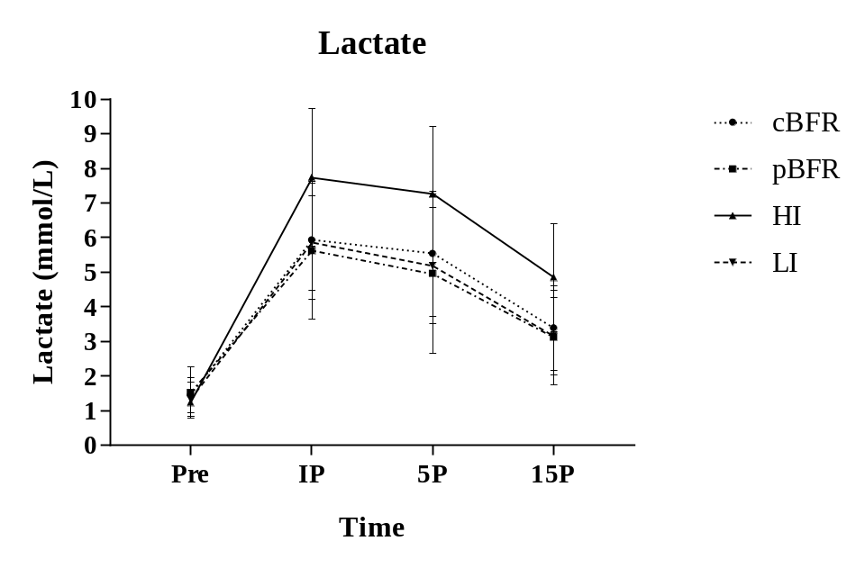
Pre: Baseline measurements, IP: Immediately post-exercise, 5P: 5 minutes post-exercise, 15P: 15 minutes post exercise; cBFR: Controlled blood flow restriction; pBFR: Practical blood flow restriction; HI: High intensity; LI: Low Intensity.

Hematocrit & Percent Plasma Volume Change
Table 6 demonstrates that hematocrit values generally increased from pre-exercise to IP and 5P, then returned to near pre-exercise values for each condition. While percent plasma volume changes (%PVC) generally decreased from pre-exercise to IP and 5P, but increased from pre-exercise to 15P. Statistical analysis for hematocrit values demonstrated that there was no significant condition main effect (p = 0.312) or condition by time interaction (p = 0.066); however, there was a significant time main effect (p ≤0.001), as illustrated on Table 7 and Figure 2. Post-hoc comparisons identified a significant difference between measurements at pre-exercise and 15P (p ≤0.001) as well as IP to 15P (p = 0.005), and 5P to 15P (p ≤0.001).

Table 6. Hematocrit values expressed as percent of blood volume and plasma volume percent changes expressed relative to baseline values. (n = 13) (Mean ± SD).
 | cBFR | pBFR | HI | LI
Hematocrit (%)
Pre- Exercise | 42.62 ± 2.11 | 41.62 ± 2.62 | 42.35 ± 2.9 | 42.7 ± 4.11
IP | 43.08 ± 2.75 | 42.31 ± 2.05 | 43.19 ± 2.95 | 41.89 ± 3.47
5P | 43.19 ± 2.12 | 42.12 ± 2.59 | 43.62 ± 2.98 | 42.69 ± 3.41
15P | 41.15 ± 2.59 ^{abc} | 41.12 ± 2.29 ^{abc} | 41.89 ± 3.06 ^{abc} | 41.12 ± 3.11 ^{abc}
%PVC
Pre to IP | -1.70 ± 5.31 | -2.62 ± 6.56 | -3.27 ± 5.53 | 3.47 ± 5.56
Pre to 5P | -2.17 ± 6.03 | -1.65 ± 8.86 | -4.89 ± 5.92 | 0.085 ± 5.54
Pre to 15P | 6.49 ± 7.81^{bc} | 0.66 ± 9.32^{bc} | 2.08 ± 5.93^{bc} | 6.89 ± 7.42^{bc}
Pre: Baseline measurements, IP: Immediately post-exercise, 5P: 5 minutes post-exercise, 15P: 15 minutes post exercise; cBFR: Controlled blood flow restriction; pBFR: Practical blood flow restriction; HI: High intensity; LI: Low Intensity. a: significantly different than pre (p ≤ 0.001); b: significantly different than IP (p ≤ 0.001); c: significantly different than 5P (p ≤ 0.001);

A 2-way ANOVA analysis revealed no significant condition main effect (p = 0.071) or condition by time interaction (p = 0.198) for plasma volume changes. However, Table 6 displays that there was a significant time main effect (p ≤0.001), where a post hoc comparison demonstrated that percent of plasma volume change (%PVC) from pre-exercise to IP was significantly different than changes from pre-exercise to 15P (p ≤0.001), as well as from pre-exercise to 5P and pre-exercise to 15P (p ≤0.001). However, no significant difference was observed between %PVC pre-exercise to IP and %PVC Pre to 5P (p = 0.781), as illustrated on Table 6 and Figure 3.

Table 7. Hematocrit and % Plasma Volume Change Main Effects (n = 13).
Hematocrit (%) | F | p | η2 | Power
Condition | 1.232 | 0.312 | 0.093 | 0.302
**Time | 14.618 | 0.001 | 0.549 | 1.000
Condition*Time | 1.861 | 0.066 | 0.134 | 0.796
%PVC
Condition | 2.545 | 0.071 | 0.175 | 0.579
**Time | 22.164 | 0.001 | 0.649 | 1.000
Condition*Time | 1.477 | 0.198 | 0.11 | 0.539
F: Ratio of mean squares; p: Probability, *p ≤0.05 and **p ≤0.01 for statistical significance; η2: Eta Squared, effect Size.

Figure 2. Hematocrit changes across different testing conditions and time points.
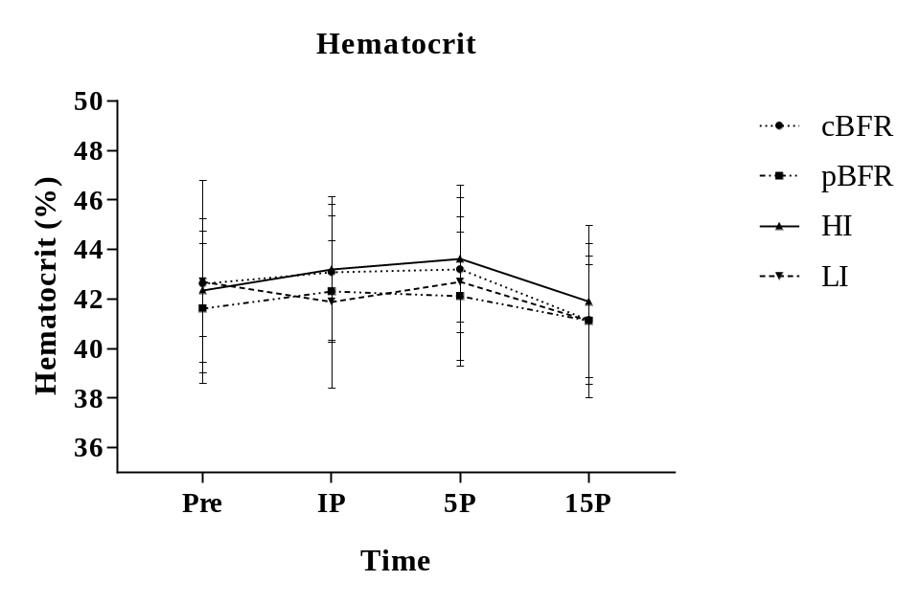
Pre: Baseline measurements, IP: Immediately post-exercise, 5P: 5 minutes post-exercise, 15P: 15 minutes post exercise; cBFR: Controlled blood flow restriction; pBFR: Practical blood flow restriction; HI: High intensity; LI: Low Intensity.

Figure 3. Percent of plasma volume change (%PVC) across different testing conditions and time points.
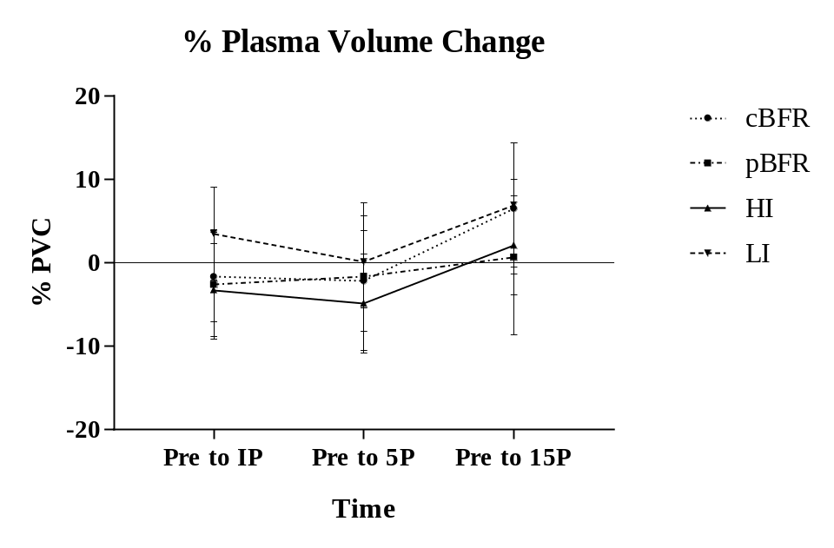
Pre: Baseline measurements, IP: Immediately post-exercise, 5P: 5 minutes post-exercise, 15P: 15 minutes post exercise; cBFR: Controlled blood flow restriction; pBFR: Practical blood flow restriction; HI: High intensity; LI: Low Intensity.

Thigh Circumference
As presented in Table 9, there were no significant condition (p = 0.746) or leg (p = 0.361) main effects, but there was a significant time main effect (p ≤0.001) for thigh circumference. Additionally, no significant condition by time (p = 0.725), condition by leg (p = 0.585), or time by leg (p = 0.112), or condition by time by leg (p = 0.603) interactions were observed.

Table 8. Thigh circumference changes across the different testing conditions and time points (n = 15) (Mean ± SD).
 |  | Condition
Time | Leg | cBFR | pBFR | HI |  | LI
Pre | Left | 54.06 ± 4.31 | 54.1 ± 4.49 |  | 54.13 ± 3.93 | 54 ± 4.24
Pre | Right | 54.08 ± 4.39 | 54.26 ± 4.64 |  | 54.19 ± 3.91 | 54.23 ± 4.05
IP | Left | 54.91 ± 4.4ª | 54.85 ± 4.49ª |  | 54.96 ± 4.31ª | 54.58 ± 4.35ª
IP | Right | 54.95 ± 4.46ª | 55.19 ± 4.89ª |  | 55.04 ± 4.17ª | 54.89 ± 4.11ª
5P | Left | 54.73 ± 4.29^{ab} | 54.68 ± 4.53^{ab} |  | 54.72 ± 4.31^{ab} | 54.48 ± 4.31^{ab}
5P | Right | 54.73 ± 4.32^{ab} | 54.95 ± 4.73^{ab} |  | 54.88 ± 4.07^{ab} | 54.79 ± 4.11^{ab}
15P | Left | 54.43 ± 4.25^{abc} | 54.53 ± 4.39^{abc} |  | 54.51 ± 4.29^{abc} | 54.3 ± 4.34^{abc}
15P | Right | 54.42 ± 4.30^{abc} | 54.61 ± 4.47^{abc} |  | 54.59 ± 4.01^{abc} | 54.47 ± 4.19^{abc}
Values are expressed in centimeters (cm). Pre: Baseline measurements, IP: Immediately post-exercise, 5P: 5 minutes post-exercise, 15P: 15 minutes post exercise; cBFR: Controlled blood flow restriction; pBFR: Practical blood flow restriction; HI: High intensity; LI: Low Intensity. a: significantly different than pre (p ≤ 0.001); b: significantly different than IP (p ≤ 0.001); c: significantly different than 5P (p ≤ 0.001);

The post hoc pairwise comparison showed that thigh circumference was significantly greater for IP (p ≤0.001), 5P (p ≤0.001), and 15P (p ≤0.001) than pre-exercise measures for all conditions, as presented on Table 8 and Figures 4 and 5. IP measurements also demonstrated higher values when compared to 5P (p = 0.017) and 15P (p ≤0.001) as well as 5P was significantly greater than 15P (p ≤0.001).
Table 9. Main effects and interactions for thigh circumference measurements (n = 15).
 | F | p | η2 | Power
Condition | 0.41 | 0.746 | 0.028 | 0.125
**Time | 72.94 | 0.001 | 0.839 | 1.000
Leg | 0.892 | 0.361 | 0.06 | 0.142
Condition*Time | 0.681 | 0.619 | 0.046 | 0.216
Condition*Leg | 0.653 | 0.585 | 0.045 | 0.175
Time*Leg | 2.12 | 0.112 | 0.132 | 0.503
Condition*Time*Leg | 0.721 | 0.603 | 0.049 | 0.239
F: Ratio of mean squares; p: Probability, *p ≤0.05 and **p ≤0.01 for statistical significance; η2: Eta Squared, effect Size.
Pearson’s correlation coefficients demonstrated that there was a strong positive correlation between left and right legs for thigh circumference at pre-exercise (p ≤0.001, r = 0.980), IP (p ≤0.001, r = 0.980), 5P (p ≤0.001, r = 0.979), and 15P measurements (p ≤0.001, r = 0.984) for the cBFR condition. The pBFR condition revealed a strong positive correlation for both legs at pre-exercise (p ≤0.001, r = 0.991), IP (p ≤0.001, r = 0.989), 5P (p ≤0.001, r = 0.989), and 15P (p ≤0.001, r = 0.994). The HI condition demonstrated a strong positive correlation between legs at pre-exercise (p ≤0.001, r = 0.984), IP (p ≤0.001, r = 0.976), 5P (p ≤0.001, r = 0.973), and 15P (p ≤0.001, r = 0.978). Also, LI showed a strong positive relationship between legs for pre-exercise (p ≤0.001, r = 0.982), IP (p ≤0.001, r = 0.989), 5P (p ≤0.001, r = 0.990), and 15P (p ≤0.001, r = 0.991).
Figure 4. Thigh circumference for left leg across different testing conditions and time points.
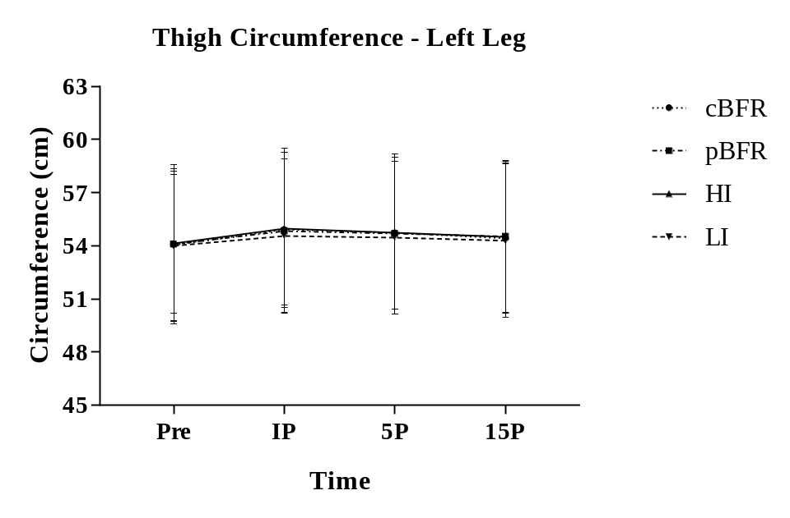
Pre: Baseline measurements, IP: Immediately post-exercise, 5P: 5 minutes post-exercise, 15P: 15 minutes post exercise; cBFR: Controlled blood flow restriction; pBFR: Practical blood flow restriction; HI: High intensity; LI: Low Intensity.

Figure 5. Thigh circumference for right leg across different testing conditions and time points.
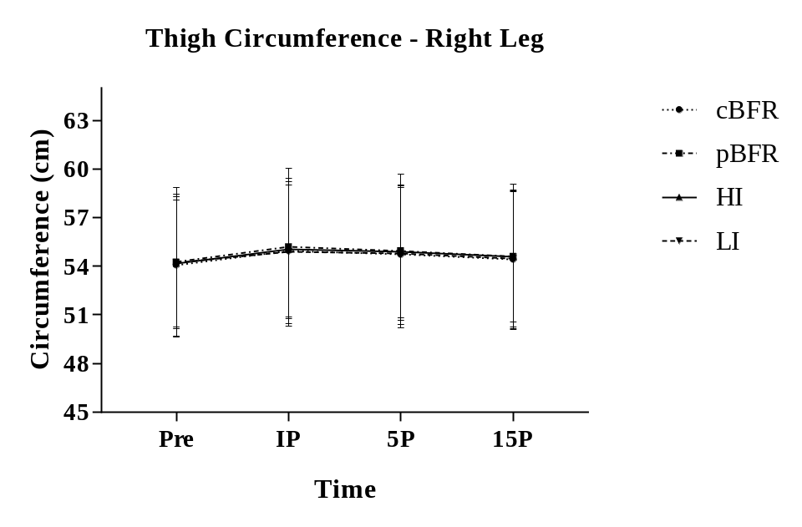
Pre: Baseline measurements, IP: Immediately post-exercise, 5P: 5 minutes post-exercise, 15P: 15 minutes post exercise; cBFR: Controlled blood flow restriction; pBFR: Practical blood flow restriction; HI: High intensity; LI: Low Intensity.

Muscle Thickness
As displayed in Table 11, a 3-way ANOVA revealed significant time (p ≤0.001) and leg (p ≤0.001) main effects, but no condition main effect (p = 0.161) for muscle thickness. No significant condition by time (p = 0.608), condition by leg (p = 0.279), or time by leg (p = 0.832), or condition by time by leg (p = 0.253) interaction were found.
The pairwise comparison for the time main effect demonstrated that muscle thickness was significantly different at IP (p ≤0.001), 5min post-exercise (p ≤0.001), and 15min post-exercise (p ≤0.001) when compared to pre-exercise measures for all conditions. IP measurements also demonstrated higher values when compared to 5P (p = 0.017) and 15P (p ≤0.001) as well as 5P was significantly greater than 15P (p ≤0.001) for muscle thickness. Additionally, as illustrated on Table 10, the comparison between legs revealed that right leg was significantly different than the left leg (p = 0.007).
Table 10. Muscle Thickness changes across the different testing conditions, time points, and right and left legs (n = 15) (Mean ± SD).
 |  | Condition
Time | Leg | cBFR | pBFR | HI | LI
Pre | Left | 4.73 ± 0.65 | 4.8 ± 0.66 | 4.91 ± 0.75 | 4.8 ± 0.61
Pre | Right | 4.91 ± 0.65* | 4.89 ± 0.67* | 5.03 ± 0.75* | 4.8 ± 0.64*
IP | Left | 5.06 ± 0.66ª | 5.08 ± 0.7ª | 5.25 ± 0.79ª | 5.07 ± 0.63ª
IP | Right | 5.19 ± 0.65^{a*} | 5.17 ± 0.68^{a*} | 5.33 ± 0.8^{a*} | 5.16 ± 0.66^{a*}
5P | Left | 4.97 ± 0.65^{ab} | 5.0 ± 0.71^{ab} | 5.21 ± 0.82^{ab} | 4.97 ± 0.65^{ab}
5P | Right | 5.13 ± 0.66^{ab*} | 5.12 ± 0.65^{ab*} | 5.27 ± 0.83^{ab*} | 5.11 ± 0.63^{ab*}
15P | Left | 4.96 ± 0.66^{abc} | 4.95 ± 0.69^{abc} | 5.12 ± 0.77^{abc} | 4.93 ± 0.65^{abc}
15P | Right | 5.09 ± 0.66^{abc*} | 5.04 ± 0.64^{abc*} | 5.23 ± 0.84^{abc*} | 5.03 ± 0.62^{abc*}
Values are expressed in centimeters (cm). Pre: Baseline measurements, IP: Immediately post-exercise, 5P: 5 minutes post-exercise, 15P: 15 minutes post exercise; cBFR: Controlled blood flow restriction; pBFR: Practical blood flow restriction; HI: High intensity; LI: Low Intensity. a: significantly different than pre (p ≤ 0.001); b: significantly different than IP (p ≤ 0.001); c: significantly different than 5P (p ≤ 0.001); *Significantly different than left leg (p ≤0.05).

Table 11. Main effects and interaction for muscle thickness measurements (n = 15).
 | F | p | η2 | Power
Condition | 1.804 | 0.2 | 0.114 | 0.248
**Time | 80.046 | 0.001 | 0.851 | 1.000
**Leg | 10.077 | 0.007 | 0.419 | 0.839
Condition*Time | 0.81 | 0.50 | 0.055 | 0.214
Condition*Leg | 1.324 | 0.279 | 0.086 | 0.327
Time*Leg | 0.29 | 0.832 | 0.02 | 0.101
Condition*Time*Leg | 1.282 | 0.253 | 0.084 | 0.605
F: Ratio of mean squares; p: Probability, *p ≤0.05 and **p ≤0.01 for statistical significance; η2: Eta Squared, effect Size.

Nevertheless, Pearson’s correlation coefficients demonstrated a strong positive correlation for cBFR when comparing right and left legs for pre-exercise (p ≤0.001, r = 0.969), IP (p ≤0.001, r = 0.969), 5min post-exercise (p ≤0.001, r = 0.974), and 15min post-exercise measurements (p ≤0.001, r = 0.971). For pBFR, there was a strong positive association between legs at pre-exercise (p ≤0.001, r = 0.986), IP (p ≤0.001, r = 0.965), 5P (p ≤0.001, r = 0.972), and 15P (p ≤0.001, r = 0.977). The HI condition demonstrated strong positive correlation between legs at pre-exercise (p ≤0.001, r = 0.983), IP (p ≤0.001, r = 0.971), 5P (p ≤0.001, r = 0.964), and 15P (p ≤0.001, r = 0.975). Also, LI showed a strong positive relationship between legs for pre-exercise (p ≤0.001, r = 0.951), IP (p ≤0.001, r = 0.969), 5P (p ≤0.001, r = 0.951), and 15P (p ≤0.001, r = 0.967).

Figure 6. Muscle thickness for left leg across different testing conditions and time points.
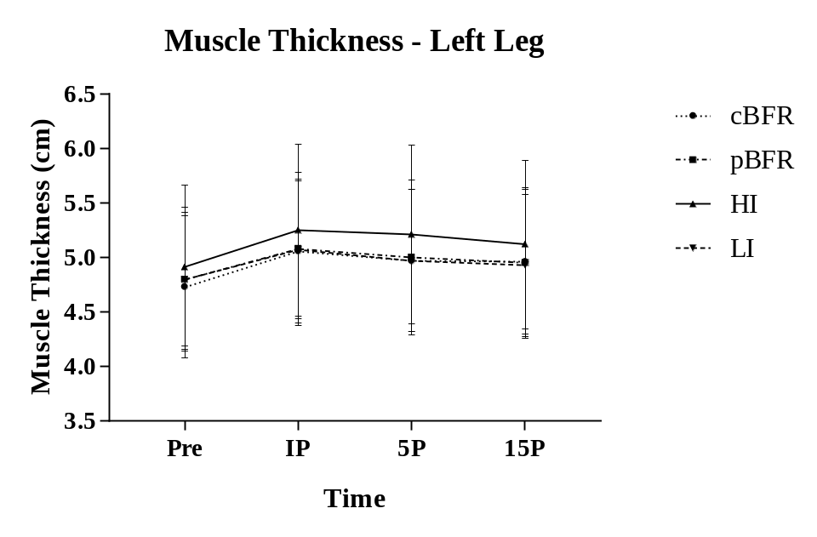
Pre: Baseline measurements, IP: Immediately post-exercise, 5P: 5 minutes post-exercise, 15P: 15 minutes post exercise; cBFR: Controlled blood flow restriction; pBFR: Practical blood flow restriction; HI: High intensity; LI: Low Intensity.

Figure 7. Muscle thickness for left leg across different testing conditions and time points.
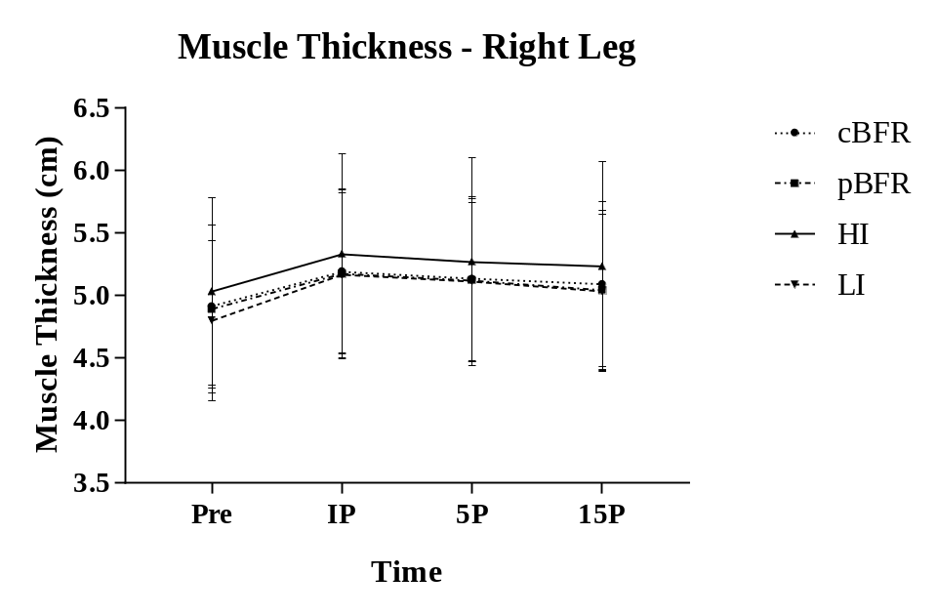
Pre: Baseline measurements, IP: Immediately post-exercise, 5P: 5 minutes post-exercise, 15P: 15 minutes post exercise; cBFR: Controlled blood flow restriction; pBFR: Practical blood flow restriction; HI: High intensity; LI: Low Intensity.

Muscle Activation (%Max-RMS)

Two-Leg Press
A 3-way ANOVA compared the first 3 sets of cBFR, pBFR, HI, and LI, and indicated a significant main effect for condition (p ≤0.001) and time (p ≤0.001), as well as a significant condition by time interaction (p = 0.039). However, no significant leg main effect was found (p = 0.481). Additionally, no significant condition by leg (p = 0.183) or time by leg (p = 0.325) or condition by time by leg (p = 0.664) interactions were reported for muscle activation on leg press (Table 13).

Table 12. Muscle activation changes across 4 sets, different testing conditions, and both right and left legs on two-leg press exercise (n = 15) (Mean ± SD).
 |  | Condition
Time | Leg | cBFR | pBFR | HI | LI
1st Set | Left | 35.8 ± 8.31 | 38.94 ± 24.2* | 88.74 ± 18.18*# | 33.5 ± 8.35
1st Set | Right | 33.13 ± 9.09 | 32.64 ± 8.31* | 93.65 ± 19.39*# | 30.96 ± 9.1
2nd Set | Left | 31.74 ± 9.34ª | 38.49 ± 23.88* | 86.68 ± 13.53*# | 33.13 ± 9.21
2nd Set | Right | 30.52 ± 9.9ª | 29.94 ± 8.69* | 90.26 ± 20.08*# | 28.94 ± 6.55
3rd Set | Left | 28.76 ± 7.43^{a†} | 37.7 ± 21.1* | 83.37 ± 14.4^{a#} | 33.56 ± 7.92
3rd Set | Right | 38.94 ± 10.37^{a†} | 30.82 ± 9.43* | 88.63 ± 16.73^{a#} | 30.05 ± 7.57
4th Set | Left | 29.56 ± 7.29ª | 36.68 ± 21.83ª | N/A | 34.14 ± 8.12
4th Set | Right | 28.54 ± 10.13ª | 30.41 ± 7.96ª | N/A | 29.57 ± 6.1
Values are expressed as %Max-RMS (percent of muscle activation relative to the highest RMS on 1RM). cBFR: Control blood flow restriction, pBFR: Practical blood flow restriction, HI: High intensity, LI: Low Intensity. a: significantly different than 1st set (p ≤ 0.001); b: significantly different than 2nd set (p ≤ 0.001); c: significantly different than 3rd set (p ≤ 0.001); *significantly different than cBFR and LI (p ≤ 0.001); # Significantly different than pBFR; † significantly different than LI (p ≤ 0.001).

Further analysis revealed that during cBFR, muscle activation was significantly greater during the 1st set when compared to 2nd and 3rd sets (p ≤0.001). However, no significant difference was observed between 2nd and 3rd sets (p = 0.053). Also, no significant difference was observed in muscle activation across the time points for the pBFR condition (p = 0.078). For the HI protocol, a significant increase in muscle activation was observed from 1st to 3rd set (p = 0.020), but no change occurred from first to the second set (p = 0.166), and second to third set (p = 0.293). Additionally, no significant changes were revealed across time for the LI protocol (p = 0.283). For the pairwise comparisons between time (set 1, set 2, and set 3), across conditions (cBFR, pBFR, HI, and LI), cBFR protocol displayed a significant lower muscle activation when compared to HI and pBFR (p ≤0.001) on 1st and 2nd set, while it showed a significantly higher muscle activation than LI on the 3rd set (p ≤0.001). HI demonstrated greater muscle activation compared to pBFR, cBFR, and LI for all sets (p ≤0.001). pBFR resulted in significantly higher muscle activation than cBFR and LI for all sets (p ≤0.001), and LI was significantly lower than cBFR, HI, and pBFR on 1st and 2nd sets, and significantly higher than cBFR on the 3rd set, as it shows on Table 12, and Figures 8 and 9.
Table 13. Main effects and interactions for muscle activation on Leg Press (n = 15).
3 Sets | F | p | η2 | Power
**Condition | 170.264 | 0.001 | 0.924 | 1.000
**Time | 13.457 | 0.001 | 0.49 | 0.995
Leg | 0.525 | 0.481 | 0.036 | 0.104
*Condition*Time | 2.338 | 0.039 | 0.143 | 0.779
Condition*Leg | 1.694 | 0.204 | 0.108 | 0.318
Time*Leg | 1.169 | 0.325 | 0.077 | 0.235
Condition*Time*Leg | 0.683 | 0.664 | 0.047 | 0.257
4 Sets
Condition | 1.204 | 0.302 | 0.079 | 0.195
**Time | 11.215 | 0.001 | 0.445 | 0.98
Leg | 2.791 | 0.117 | 0.166 | 0.344
**Condition*Time | 4.38 | 0.001 | 0.238 | 0.977
Condition*Leg | 0.558 | 0.488 | 0.038 | 0.111
Time*Leg | 0.698 | 0.521 | 0.047 | 0.163
Condition*Time*Leg | 1.231 | 0.299 | 0.081 | 0.459
F: Ratio of mean squares; p: Probability, *p ≤0.05 and **p ≤0.01 for statistical significance; η2: Eta Squared, effect Size.

Comparing all four sets of cBFR, pBFR, and LI on leg press, the analysis demonstrated that there was no significant main effect for condition (p = 0.302) or leg (p = 0.117). However, there was a significant time main effect (p ≤0.001) as well as a significant condition by time (p = 0.001) interaction. No condition by time by leg interaction was reported (p = 0.299) (Table 13).
Further analysis revealed that 1st set on cBFR was significantly greater than all sets (p ≤0.05). No significant change was found between the 2nd set, and 3rd (p = 0.107) and 4th sets (p = 0.429) as well as no significant difference was found between 3rd and 4th sets (p = 1.00). pBFR showed a significantly greater muscle activation for 1st set compared to the 4th set (p = 0.004). However, no differences were found between other sets (p > 0.05). No significant differences were found across sets for LI (p = 0.404). Looking at the pairwise comparisons between time (set 1, set 2, set 3, and set 4) across conditions (cBFR, pBFR, and LI), there was no significant differences between conditions across sets (p > 0.05).
Pearson’s coefficient correlations showed a significantly low positive correlation between right and left legs for cBFR on the first set (p = 0.019, r = 0.595), and 2nd set (p = 0.023, r = 0.580). However, there was no significant relationship between legs for 3rd (p = 0.348, r = 0.260), and 4th set (p = 0.132, r = 0.407). For pBFR, no significant correlations were found between legs for set 1 (p = 0.750, r = 0.090), set 2 (p = 0.814, r = 0.067), set 3 (p = 0.649, r = 0.128), and set 4 (p = 0.879, r = 0.043). Also, HI showed a significant low positive relationship between legs for set 1 (p = 0.035, r = 0.547), although no significant relationship between legs were found for set 2 (p = 0.144, r = 0.396), and set 3 (p = 0.393, r = 0.238).

Figure 8. Percent of muscle activation relative to the highest RMS on 1RM for left leg across different testing conditions and time points.
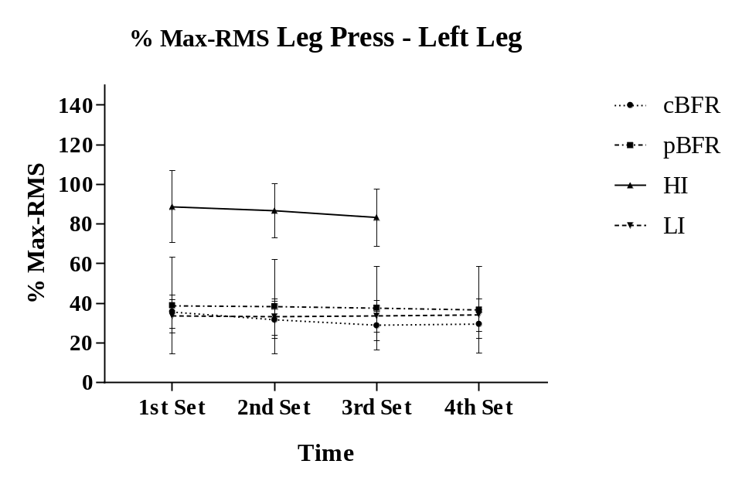
%Max-RMS: Percent of muscle activation relative to the highest RMS on 1RM. cBFR: Controlled blood flow restriction; pBFR: Practical blood flow restriction; HI: High intensity; LI: Low Intensity.

Figure 9. Percent of muscle activation relative to the highest RMS on 1RM for right leg across different testing conditions and time points.
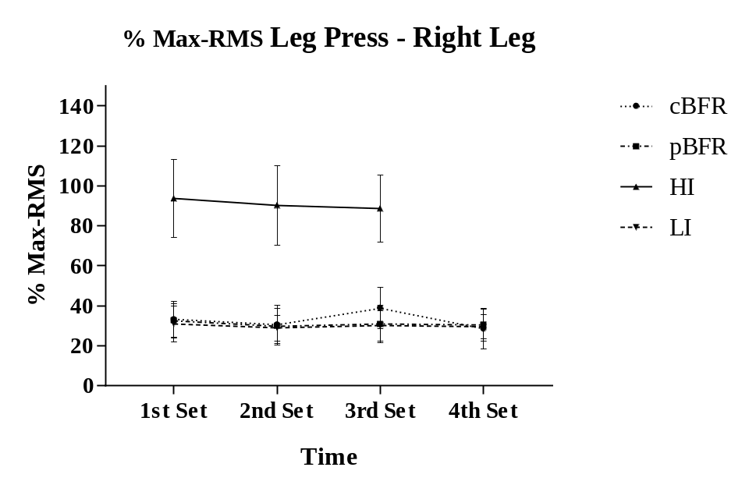
%Max-RMS: Percent of muscle activation relative to the highest RMS on 1RM. cBFR: Controlled blood flow restriction; pBFR: Practical blood flow restriction; HI: High intensity; LI: Low Intensity.

Knee Extension
The statistical analysis between the first 3 sets of cBFR, pBFR HI, and LI demonstrated no main effect for time (p = 0.852) or leg (p = 0.051). However, as presented on Table 15, a significant condition main effect detected (p ≤0.001), where cBFR showed a significantly higher muscle activation when compared to pBFR (p = 0.026) and LI (p = 0.002), and significantly lower than HI (p ≤0.001). pBFR muscle activation was significantly lower than HI (p ≤0.001) and did not show significant differences when compared to LI (p = 1.00). HI was significantly higher than all conditions (p ≤0.05), and LI was significantly lower than cBFR (p = 0.002) and HI (p ≤0.001). Table 14 and Figures 10 and 11 represents the results for muscle activation across sets and conditions on knee extension.
Table 14. Muscle Activation changes across sets, different testing conditions, and both right and left legs on knee extension exercise (n = 15) (Mean ± SD).
 |  | Condition
Time | Leg | cBFR | pBFR | HI | LI
1st Set | Left | 63.59 ± 12.76* | 53.02 ± 11.38 | 101.23 ± 23.01*# | 54.58 ± 10.35
1st Set | Right | 67.32 ± 20.4* | 60.3 ± 15.33 | 103.47 ± 30.55*# | 56.8 ± 15.01
2nd Set | Left | 63.31 ± 12.41* | 54.21 ± 11.98 | 103.71 ± 20.45*# | 54.16 ± 12.89
2nd Set | Right | 62.88 ± 12.41* | 57.74 ± 14.4 | 103.43 ± 27.21*# | 55.33± 11.13
3rd Set | Left | 67.56 ± 12.88* | 56.92 ± 13.38 | 97.18 ± 25.01*# | 52.83 ± 10.53
3rd Set | Right | 68.97 ± 14.2* | 61.21 ± 15.94 | 101.39 ± 23.41*# | 53.92 ± 11.14
4th Set | Left | 72 ± 12.03^{*bc} | 59.28 ± 17.98^{bc} | N/A | 58.63 ± 11.14^{bc}
4th Set | Right | 74.37 ± 16.34^{*bc} | 63.77 ± 17.98^{bc} | N/A | 57.75 ± 11.45^{bc}
Values are expressed as %Max-RMS (percent of muscle activation relative to the highest RMS on 1RM). cBFR: Control blood flow restriction, pBFR: Practical blood flow restriction, HI: High intensity, LI: Low Intensity. a: significantly different than 1st set (p ≤ 0.05); b: significantly different than 2nd set (p ≤ 0.05); c: significantly different than 3rd set (p ≤ 0.05); *Significantly different than pBFR and LI (p ≤ 0.001); # Significantly different than pBFR (p ≤ 0.001); † significantly different than LI (p ≤ 0.001).

When comparing all four sets of cBFR, pBFR, and LI, a significant condition main effect was found (p ≤0.001), as well as a time main effect (p = 0.004). However, there was no leg main effect (p = 0.372). No condition by time (p = 0.148), condition by leg (p = 0.462), and time by leg (p = 0.126) interactions were found. The post hoc pairwise comparison demonstrated that cBFR had a significantly different muscle activation when compared to pBFR (p = 0.002), and LI (p = 0.001). Also, pBFR was not significantly different than LI (p = 1.00). Studying the time points, pairwise comparisons showed that muscle activation was not significantly different between the 1st set and 2nd, 3rd, and 4th sets (p > 0.05). However, the 2nd set showed a significantly different muscle activation when compared to 4th set (p = 0.009), although no differences were found between 2nd set and 3rd set (p > 0.05). The 3rd set demonstrated a significantly different muscle activation when compared to the 4th set (p = 0.002).

Table 15. Main Effects and Interaction for muscle activation on Knee Extension (n = 15).
3 Sets | F | p | η2 | Power
**Condition | 47.648 | 0.001 | 0.773 | 1.00
Time | 0.093 | 0.852 | 0.007 | 0.061
Leg | 0.745 | 0.402 | 0.051 | 0.127
Condition*Time | 2.022 | 0.127 | 0.126 | 0.475
Condition*Leg | 0.25 | 0.750 | 0.018 | 0.083
Time*Leg | 2.078 | 0.144 | 0.129 | 0.391
Condition*Time*Leg | 0.428 | 0.858 | 0.03 | 0.169
4 Sets
**Condition | 10.291 | 0.002 | 0.424 | 0.927
*Time | 0.15 | 0.016 | 0.269 | 0.744
Leg | 0.85 | 0.372 | 0.057 | 0.850
Condition*Time | 1.909 | 0.148 | 0.12 | 0.437
Condition*Leg | 0.794 | 0.462 | 0.054 | 0.172
Time*Leg | 2.021 | 0.126 | 0.126 | 0.482
Condition*Time*Leg | 0.394 | 0.792 | 0.027 | 0.09
F: Ratio of mean squares; p: Probability, *p ≤0.05 and **p ≤0.01 for statistical significance; η2: Eta Squared, effect Size.

Pearson’s correlations coefficient showed a significantly low positive relationship between legs for cBFR at the 2nd set (p = 0.022, r = 0.587). However, no significant correlation was found between legs for set 1 (p = 0.187, r = 0.361), set 3 (p = 0.169, r = 0.374), and set 4 (p = 0.106, r = 0.434). For pBFR, a significant moderate positive relationship was found between legs for 1st (p = 0.002, r = 0.743) and 2nd sets (p = 0.004, r = 0.690). On the other hand, no significant correlation between legs were revealed for 3rd (p = 0.083, r = 0.461) and 4th sets (p = 0.075, r = 0.473). For HI, a significant moderate positive relationship between legs was found for the 1st (p = 0.040, r = 0.534) and 3rd sets (p = 0.030, r = 0.561). However, no significant relationship was identified for the 2nd set (p = 0.078, r = 0.468). LI did not show any significant correlation between legs for set 1 (p = 0.136, r = 0.403), set 2 (p = 0.135, r = 0.405), set 3 (p = 0.109, r = 0.431), and set 4 (p = 0.182, r = 0.364).
Figure 10. Percent of muscle activation relative to the highest RMS on 1RM for left leg across different testing conditions and time points.
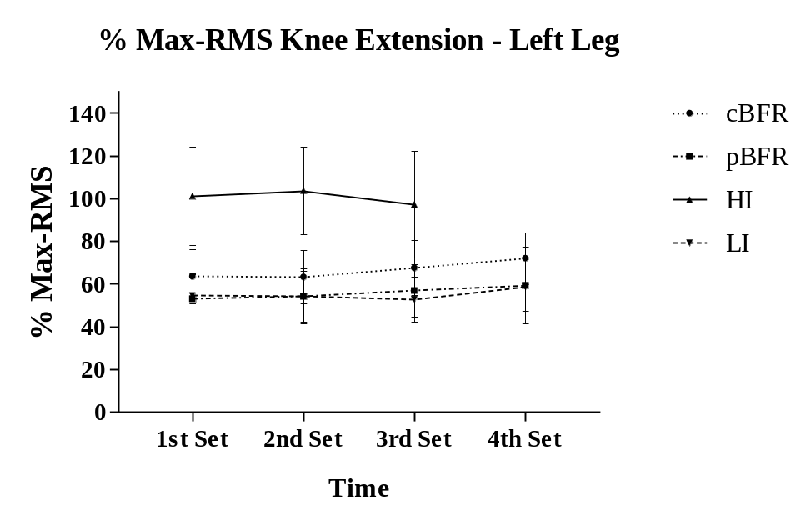
%Max-RMS: Percent of muscle activation relative to the highest RMS on 1RM. cBFR: Controlled blood flow restriction; pBFR: Practical blood flow restriction; HI: High intensity; LI: Low Intensity.

Figure 11. Percent of muscle activation relative to the highest RMS on 1RM for right leg across different testing conditions and time points.
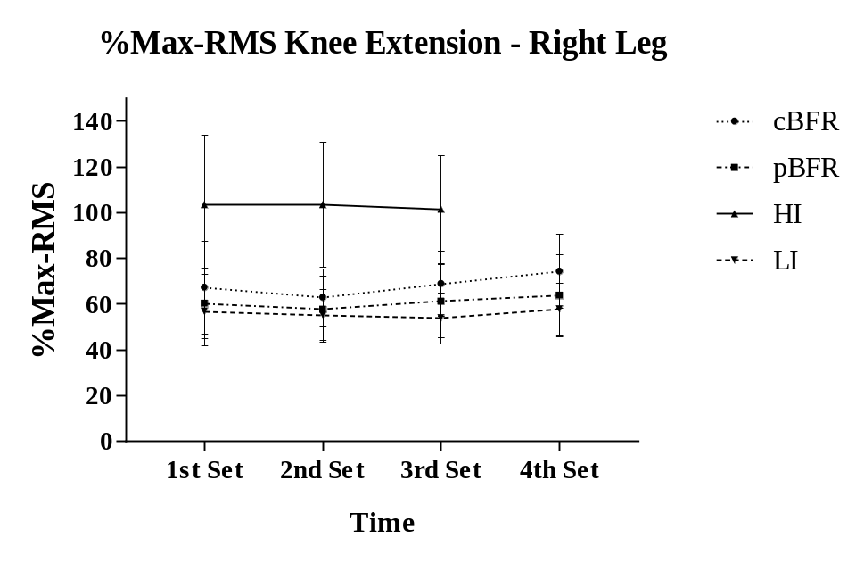
%Max-RMS: Percent of muscle activation relative to the highest RMS on 1RM. cBFR: Controlled blood flow restriction; pBFR: Practical blood flow restriction; HI: High intensity; LI: Low Intensity.

Rate of Perceived Exertion (RPE)
Leg Press
A Friedman’s non-parametric test revealed a significant RPE increase over time for all 4 conditions (cBFR, pBFR, HI, LI) on leg press (p ≤0.001). For cBFR, all sets demonstrated an increase when compared to the 1st set (p ≤0.005), although no difference was found from the 2nd set to the 4th set (p > 0.005). For pBFR, there was no difference between the 1st set to the 4th set (p > 0.005). HI demonstrated a significant increase from pre-exercise to all sets, as well as from 1st set to 3rd set (p ≤0.008). Additionally, no difference was reported between sets for LI (p > 0.005).
A Wilcoxon’s correction revealed that there was no significant difference between conditions for pre-exercise value (p > 0.05), although a significant difference between conditions was reported for all sets (p ≤0.05). For the 1st and 2nd sets, HI demonstrated higher RPE ratings when compared to pBFR (p ≤0.005), and LI (p ≤0.005), as well as cBFR was greater than LI (p ≤0.005). No significant difference was reported between cBFR and pBFR, as well as between pBFR and LI for the first 2 sets (p > 0.005). However, HI had significantly greater RPE ratings than cBFR, pBFR, and LI for the 3rd set (p ≤0.005). Additionally, cBFR demonstrated higher RPE rating than pBFR and LI (p = 0.001), although no difference was reported between pBFR and LI (p = 0.023). On the 4th set, cBFR was significantly greater than pBFR and LI (p = 0.001), but pBFR was not significantly different than LI (p = 0.011).
Knee Extension
A Friedman’s non-parametric test showed a significant increase of RPE across time for cBFR, pBFR, and HI on knee extension (p ≤0.05), although no significant difference was reported for LI across time (p = 0.292). As illustrated on Table 16, further analysis revealed that no significant time changes were observed for cBFR and pBFR (p > 0.005). However, HI demonstrated a significant increase from 1st set to 3rd set (p = 0.002), and from 2nd to 3rd set (p = 0.002). Analyzing the differences between conditions over time, HI demonstrated significantly higher RPE than pBFR and LI on the 1st set. No differences were reported across other conditions on the 1st set (p > 0.008). For the 2nd and 3rd sets, HI indicated a significantly greater RPE than cBFR, pBFR, and LI (p ≤0.008). However, no differences were found between other conditions (p > 0.008). Additionally, no significant difference was observed on the 4th set across conditions (cBFR, pBFR, and LI).

Table 16. Ratings of perceived exertion (RPE) across the different testing conditions and time points (n = 15) (Mean ± SD).
 | cBFR | pBFR | HI | LI
Leg Press
Rest | 0.00 ± 0.00 | 0.00 ± 0.00 | 0.00 ± 0.00 | 0.00 ± 0.00
Set 1 | 3.80 ± 1.61^{a†} | 3.00 ± 1.20ª | 5.07 ± 1.79^{a*} | 2.13 ± 0.92
Set 2 | 4.90 ± 1.56^{a†} | 3.00 ± 1.00ª | 6.00 ± 1.25^{a*} | 2.13 ± 1.19
Set 3 | 5.30 ± 1.67^{a*} | 3.33 ± 1.29ª | 6.93 ± 1.22^{a*#} | 2.33 ± 1.18
Set 4 | 5.57 ± 1.80^{a*} | 3.60 ± 1.76ª |  | 2.40 ± 1.24
Knee Extension
Set 1 | 5.93 ± 1.83 | 5.53 ± 1.85 | 7.33 ± 1.40* | 5.60 ± 1.76
Set 2 | 6.37 ± 1.82 | 5.63 ± 1.91 | 8.00 ± 1.07*# | 5.33 ± 1.50
Set 3 | 6.67 ± 1.95 | 5.93 ± 2.09 | 8.87 ± 1.23^{bc*#} | 5.73 ± 1.98
Set 4 | 7.13 ± 2.26 | 6.33 ± 2.23 |  | 5.90 ± 2.14
cBFR: Controlled blood flow restriction; pBFR: Practical blood flow restriction; HI: High intensity; LI: Low Intensity. a: significantly different than pre-exercise (p ≤ 0.005); b: significantly different than 1st set (p ≤ 0.005); c: significantly different than 2nd set (p ≤ 0.005); d: significantly different than 3rd set (p ≤ 0.005); *significantly different than pBFR and LI (p ≤ 0.005); # Significantly different than cBFR (p ≤ 0.005); † significantly different than LI (p ≤ 0.005).

Ratings of Discomfort (RD)
Leg Press
A Friedman’s non-parametric test indicated that ratings of discomfort significantly increased across time for all conditions (p ≤0.05) when compared to baseline values for leg press. Further analysis revealed that there was a significant difference between sets 1 and 2, 1 and 3, and 1 and 4 for cBFR (p ≤0.005). Also, the RD was significantly different from 2nd and 3rd sets, as well as 2nd and 4th sets (p ≤0.005). However, no difference was reported between 3rd and 4th sets (p = 0.022). For pBFR, there was a significant increase in RD from the 2nd to 3rd set (p ≤0.005), although no differences were identified between other sets (p > 0.005). For HI, RD was significantly greater for the 3rd set than the 1st and 2nd sets (p ≤0.008), as well as the 2nd set was significantly greater than 1st set (p = 0.003). Additionally, no significant difference was identified between sets for LI (p > 0.005).
Examining the differences between conditions across time, a Friedman’s analysis demonstrated a significant difference at pre-exercise, where cBFR had a significantly higher RD at rest when compared to HI and LI (p ≤0.008). No differences were identified across other conditions at rest (p > 0.008). On the 1st, 2nd, and 3rd sets, cBFR and pBFR demonstrated significantly greater RD when compared to LI (p ≤0.008). Although no significant differences were reported across other conditions for the 1st set (p > 0.008), HI was significantly higher than LI on the 2nd and 3rd sets (p = 0.005). Comparing cBFR, pBFR, and LI on the 4th set, cBFR RD was significantly greater than pBFR and LI (p = 0.001) as well as pBFR was significantly higher than LI (p = 0.001).
Knee Extension
For knee extension RD, a Friedman’s test revealed a significantly increase from the 1st set to all sets for cBFR, pBFR, and HI (p ≤0.05), although no significant difference was reported between sets for LI (p = 0.379). However, further analyses indicated that there was no significant difference between sets for cBFR and LI (p > 0.008). For pBFR, there was a significant increase in RD from 2nd to 3rd set, and 2nd to 4th set (p ≤0.008), while no differences were reported between other sets for cBFR, HI, and LI (p > 0.008). HI demonstrated significantly greater RD for the 3rd set when compared to 1st and 2nd sets (p ≤0.008), as well as 2nd set RD was significantly higher than 1st set (p = 0.002) as illustrated on Table 17.
No differences between conditions across time were reported on the 1st set of knee extension (p = 0.226). cBFR demonstrated significantly greater RD than pBFR and LI (p ≤0.008) for the 2nd set, 3rd, and 4th sets. However, no other significant difference was reported between conditions within sets (p > 0.008).
Table 17. Ratings of discomfort across the different testing conditions and time points (n = 15) (Mean ± SD).
 | cBFR | pBFR | HI | LI
Leg Press
Rest | 0.73 ± 0.75*† | 0.49 ± 0.70 | 0.00 ± 0.00 | 0.00 ± 0.00
Set 1 | 2.13 ± 1.23^{a†} | 1.44 ± 0.87^{a†} | 1.73 ± 2.06ª | 0.62 ± 0.53
Set 2 | 3.09 ± 1.57^{a†} | 1.32 ± 1.02^{a†} | 2.47 ± 2.10^{a†} | 0.63 ± 0.51
Set 3 | 3.79 ± 2.02^{ac†} | 1.71 ± 1.32^{ac†} | 3.22 ± 2.38^{ac†} | 0.73 ± 0.68
Set 4 | 4.39 ± 2.26^{ac*} | 2.01 ± 1.59^{a†} |  | 0.86 ± 0.94
Knee Extension
Set 1 | 4.09 ± 2.42 | 3.07 ± 1.56 | 2.92 ± 2.54 | 2.87 ± 1.51
Set 2 | 4.75 ± 2.45 | 3.20 ± 1.97^{b} | 4.10 ± 2.92^{bc} | 2.69 ± 1.34
Set 3 | 4.95 ± 2.51 | 3.77 ± 2.37^{bc} | 4.89 ± 2.99^{b} | 3.14 ± 1.88
Set 4 | 5.62 ± 2.86 | 4.17 ± 2.81^{bc} |  | 3.47 ± 2.34
cBFR: Controlled blood flow restriction; pBFR: Practical blood flow restriction; HI: High intensity; LI: Low Intensity. a: significantly different than pre-exercise (p ≤ 0.005); b: significantly different than 1st set (p ≤ 0.005); c: significantly different than 2nd set (p ≤ 0.005); d: significantly different than 3rd set (p ≤ 0.005); *significantly different than pBFR and LI (p ≤ 0.005); # Significantly different than HI (p ≤ 0.005); † significantly different than LI (p ≤ 0.005).

Total Work Load (TWL)

Analyzing the differences between total workload (TWL) across conditions on leg press exercise, an ANOVA demonstrated a significant time main effect (p < 0.001), where pairwise comparisons indicated that HI TWL on leg press was significantly greater than cBFR, pBFR, and LI. However, no significant difference was observed between cBFR, pBFR, and LI on leg press (p ≥ 0.05). Comparing the TWL across conditions on knee extension exercise, a significant time main effect was found (p < 0.001), where HI demonstrated lower TWL than cBFR, pBFR, and LI (p < 0.001). However, no significant differences were observed between cBFR, pBFR, and LI on knee extension (p ≥ 0.05). Total work load values are expressed as kilograms (kg) on Table 3.
A Pearson’s correlation coefficient was used to analyze the relationship between TWL on both exercises and percent change for thigh circumference, muscle thickness, lactate, hematocrit, and muscle activation (set 1). Percent changes were calculated as ((IP – pre)/pre) *100. Table 18 express the r values identified in the correlations between TWL and the percent changes.

Table 18. Correlations between total work load (kg) and percent changes (n = 15).
 |  | Condition
Variable | Exercise | cBFR | pBFR | HI | LI
%TC | Leg Press | -0.058 | 0.487 | 0.316 | -0.05
%TC | Knee Extension | 0.236 | 0.736** | 0.449 | 0.077
%MT | Leg Press | -0.045 | -0.346 | -0.502 | -0.284
%MT | Knee Extension | -0.028 | -0.121 | -0.479 | -0.103
%LA | Leg Press | 0.031 | 0.659** | 0.368 | 0.54*
%LA | Knee Extension | 0.078 | 0.708** | 0.478 | 0.457
%Hct | Leg Press | -0.055 | 0.618* | 0.165 | 0.304
%Hct | Knee Extension | 0.217 | 0.547* | 0.347 | 0.348
%MA | Leg Press | 0.144 | -0.418 | -0.17 | 0.15
%MA | Knee Extension | 0.43 | 0.412 | -0.014 | 0.525*
Values expressed as absolute r values. **p ≤ 0.01; *p ≤ 0.05. cBFR: Controlled blood flow restriction; pBFR: Practical blood flow restriction; HI: High intensity; LI: Low Intensity; %TC: Percent change from pre to immediately post exercise for thigh circumference on right leg; %MT: Percent change from pre to immediately post exercise for muscle thickness on right leg; %LA: Percent change from pre to immediately post exercise for lactate; %Hct: Percent change from pre to immediately post exercise for hematocrit; %MA: Percent of muscle activation on set 1.

Discussion
The purpose of this study was to compare the effects of a single bout of controlled blood flow restriction (cBFR), practical blood flow restriction (pBFR), high intensity (HI), and low-intensity (LI) with no restriction resistance exercise on muscle swelling, and lactate responses, and muscle activation in college-aged females. To the best of our knowledge, this was the first study to compare the differences between the two BFR methods as well as examine the issue of limb symmetry following controlled and practical implementation of blood flow restriction.

Muscle Swelling
The results of this study demonstrated an increase in muscle swelling after exercise, based on thigh circumference and muscle thickness for all testing conditions. There was no difference between conditions for muscle swelling, hematocrit, and %PVC, which partially contradicted our original hypothesis that high intensity (HI) and controlled blood flow restriction (cBFR) would stimulate greater physiological responses than practical blood flow restriction (pBFR) and low-intensity (LI). However, it is important to noticed that percent changes in muscle thickness were greater the coefficients of variation (4.28% for right leg) for all conditions, implying true increases in muscle swelling.
Although no differences were reported between conditions, the results are in agreement with Freitas et al. (2017), which indicated that exercising with blood flow restriction stimulates an increase in muscle swelling for up to 15 min post-exercise for both cBFR and HI conditions in males. Since no differences between HI and cBFR were reported in the present study and for Freitas et al. (2017), it can be implied that both exercise protocols are capable of inducing similar physiological responses that ultimately lead to muscle swelling to a similar extent. Practical BFR also showed a similar muscle swelling responses as HI in the present study, which was also demonstrated by Wilson et al. (2013). Using a similar protocol, the authors observed that after pBFR exercise, muscle thickness remained higher than baseline values for about 15 min post-exercise. However, in contrast to the present investigation, Wilson et al. (2013) observed greater muscle swelling during the pBFR protocol than the control trial. Differences in findings may be explained by variations in protocol, where the present study protocol implemented two exercises and Wilson et al. (2013) only one.
The low-intensity (LI) protocol demonstrated similar muscle swelling response as the HI and both BFR protocols. This result could be related to muscle fatigue. Although no restriction was applied for this condition, the exercise volume might have been enough to cause a muscular stress equivalent to those observed in the HI and BFR conditions, as demonstrated by increased lactate levels. Yasuda et al. (2015) analyzed the differences between BFR and non-BFR LI exercise to volitional fatigue and reported that BFR exercise achieved the same metabolic responses as LI, but at a much lower volume.
Hematocrit levels did not increase over time and, consequently, %PVC did not decrease over time in this study. Blood flow restriction exercise is known to induce muscle swelling, which is commonly associated with increased hematocrit levels and decreased percent plasma volume change. These responses have been generally associated with an acute accumulation of metabolites and a reduced oxygen availability within the muscle, leading to a change in the pressure gradient and a fluid shit from the extracellular to the intracellular space (Freitas et al, 2017; Loenneke et al., 2012b; Wilson et al., 2013; Yasuda et al., 2015; Suda et al., 2009).
The responses of hematocrit and %PVC in the current research might be related to the fact that subjects had a variety of posture changes over the exercise session and during post exercise data collection. Leg press exercise was performed in the supine position whereas knee extension was performed in the seated position, and the post measurements were taken while participants were standing, unless feeling faint and allowed to sit between post-exercise measures. Therefore, changes in posture may have impacted hematocrit variables, leading to a misrepresentation of plasma volume shifts, since significant increases in thigh circumference and muscle thickness were reported (Jacob et al., 2005). Additionally, it is important to notice that some of our participants demonstrated pre-exercise hematocrit values higher (51%) than the expected average for females, which normally range between 35% to 45% (Zeng et al., 2001). Above average hematocrit levels might be related to the fact that some of the participants might have been dehydrated during the study or due to possible errors in measurements.
Loenneke et al. (2012b) hypothesized that as the muscle cells increase water volume and equilibrate the osmotic gradient, they may potentially activate molecular signaling pathways that may ultimately induce protein synthesis and consequent muscle hypertrophy. These mechanisms involving fluid shifts within the muscle cells might stimulate the activation of a G-protein, leading to an activation of mammalian target of rapamycin (mTOR), and mitogen-activated protein-kinase (MAPK) pathways, known to play a key role in the regulation of muscle growth (Fry et al., 2010).
In the present investigation, the right leg demonstrated greater muscle thickness than the left leg at all-time points. The majority of the participants (93%) in this study declared themselves right leg dominant and no limb differences in muscle thickness were found across all testing conditions. Therefore, the variations in limb size might be related to the fact that dominant leg knee extensors were stronger than the ones in the non-dominant leg in females, potentially indicating differences in muscle size (Lanshammar et al., 2011). Even though a difference was reported between legs, muscle swelling appears to happen to the same extent in both legs, as indicated by the Person’s coefficient correlation. The results demonstrated that the right and left legs were highly correlated at all-time points for muscle thickness and thigh circumference, indicating that they responded in a similar fashion across all time points.

Metabolic Stress
According to the results of this research, lactate responses were larger for HI and cBFR when compared to pBFR and LI conditions, with HI inducing greater increases than all conditions. Also, statistical analysis demonstrated that for HI, lactate levels decreased at a much slower rate, as it did not show differences from IP to 5P (Figure 1). The lactate responses in this study are not in agreement with the results from Takarada et al. (2000b), which observed greater lactate levels with cBFR exercise than for HI exercise. The authors speculated that this response was due to the fact that BFR exercise usually involves greater volumes (about 75 repetitions) in comparison to HI exercise (about 30 repetitions).
Additionally, Loenneke et al. (2010) showed that lactate levels were similar between pBFR and LI protocols, while in this study, pBFR demonstrated higher lactate levels than the LI condition. These discrepancies might be related to the fact that lactate might have been diffused more efficiently during the LI, since no blood flow restriction was applied. On the other hand, congruent with this study, Kim et al. (2014) demonstrated significantly higher lactate levels for a traditional high intensity exercise compared to cBFR in young women. The authors intentionally developed a protocol that allowed HI to have a greater total work load (TWL) than cBFR, therefore explaining the greater lactate levels. In the current research, TWL was significantly higher for HI on leg press, but significantly lower on knee extension, when compared to cBFR, pBFR, and LI. The lower TWL for HI on knee extension could be related to the fact that the subjects might have not finished all the repetitions due to the greater muscular stress as demonstrated by the higher lactate levels and increased RPE.
Previously literature suggested that blood flow restriction exercise caused a slower lactate diffusion from the exercising muscles into the bloodstream (Loenneke et al., 2010), which along with other metabolites, might stimulate Insulin Growth Factor-1 (IGF-1) synthesis and secretion. Abe et al. (2005) demonstrated that after 2 weeks of BFR training, serum IGF-1 concentration showed a significant gradual increase, whereas no differences were found for LI. Additionally, Takano et al. (2005) reported that after a single bout of BFR exercise, levels of growth hormone (GH), IGF-1, and vascular endothelial growth factor (VEGF) significantly increased when compared to the control condition. Kim et al. (2014) indicated that GH levels increased to a similar extent for cBFR and HI after a bout of leg press and knee extension exercise, using similar protocols as this study. Although the hormonal responses to exercise are not the only mechanism that accounts for stimulating muscle hypertrophy, it is well documented that these hormones are strongly related to increases in muscle size (Spiering et al., 2008). In this study, cBFR tended to induce greater lactate responses than pBFR, which could potentially lead to greater hormonal responses, ultimately resulting in a greater muscular hypertrophy.

Muscle Activation
Analyzing the electromyography (EMG) results for leg press, HI demonstrated a higher muscle activation than cBFR, pBFR, and LI. This study indicated that muscle activation was higher at set 1 than at any other set for all conditions on leg press, and that there was a trend to decrease for the subsequent sets. For knee extension exercise, no differences across time on the 3 first sets and all 4 conditions were identified, indicating that muscle activation remained similar throughout the exercise. While comparing the 4 sets between cBFR, pBFR, and LI, set 4 demonstrated a greater muscle activation than the previous sets.
The decrease in muscle activation from the 1st to the last set on leg press might be related to the fact that set 1 involved a greater number of repetitions, which could have caused greater increases in lactate levels as well as the decrease in intramuscular pH and decline of phosphocreatine availability, known as factors that may influence early recruitment of fast-twitch fibers (Yasuda et al., 2010; Wernbom et al., 2007). An additional speculation regarding the lower muscle activation during leg press following the first set could be related to the fact that absolute 1RM weights could have been too low to induce muscular fatigue. Additionally, hips and ankle extensor are known to be activated during leg press, potentially leading to a lower activation of vastus lateralis (VL) (Alkner et al., 2000).
When comparing across all 4 conditions, pBFR and HI demonstrated greater muscle activation than cBFR and LI for leg press exercise. However, when comparing cBFR, pBFR, and LI, no differences among conditions were reported. Nevertheless, on the knee extension exercise, HI and cBFR presented a greater overall muscle activation than pBFR and LI, where pBFR had no differences when compared to LI. Practical and controlled BFR have shown to increase muscle activation to greater levels than LI, by inducing neural adaptations to produce greater motor unit recruitment and synchronization after 8 weeks of training (Wilson et al., 2013; Takarada et al., 2000; Yasuda et al., 2015; Yasuda et al., 2008; Takarada et al., 2002).
Congruent with the present data, Wilson et al. (2013) reported that pBFR induced a greater muscle activation than LI after a bout of 4 sets of 30-15-15-15 repetitions on leg press exercise. Yasuda et al. (2008) tested the changes in muscle activation at different cBFR pressure levels and verified that EMG activity progressively increased throughout the contraction bout at a similar protocol as the present study, demonstrating greater muscle activation at 147mmHg. Yasuda et al. (2015) had subjects perform cBFR exercise to fatigue, showing increases in muscle activation as well. Although these studies demonstrated similarities to the current study, it is important to notice that Yasuda et al. (2015) and Yasuda et al. (2008) performed the cBFR protocols for elbow flexors instead of the quadriceps.
Both BFR conditions demonstrated significant increases in muscle activation during knee extension only, but cBFR appeared to be more effective. Exercising with BFR alters the relationship between energy supply and demand during contractions, where the lack of oxygen, glucose, and free fatty acids caused by the restricted blood flow seems to induce a compensation mechanism, in which additional muscle fibers are recruited (Yasuda et al., 2015). However, cBFR demonstrated a higher blood lactate concentration than pBFR, which could partially explain a greater energy mismatch, therefore increasing the recruitment of type II fibers as well as stimulating group III and IV afferent fibers (Yasuda et al., 2010). Another probable reason could be related to the differences in occlusion pressure during exercise. Finally, differences in cuff size might have also influenced the outcome variables. Loenneke et al. (2012a) demonstrated that wider cuffs (13.5 x 83 cm) restrict arterial blood flow at a lower pressure than narrow cuffs (5 x 135 cm). However, cBFR and pBFR appeareds to indicate similar ratings of exertion (RPE) and ratings of discomfort (RD), which can potentially indicate that pBFR was effective at mimicking the occlusion pressure applied on cBFR. It is important to notice that both BFR devices used by Loenneke et al. (2012a) were inflatable, which was not the case for the current research. It has been reported that difering levels of compression may alter the metabolite accumulation, and therefore induced greater muscle activation (Yasuda et al., 2008).

Perceptual Response
Overall, rating of perceived exertion (RPE) and rating of discomfort (RD) increased overtime for all testing conditions and exercises. HI demonstrated higher ratings than cBFR, pBFR and LI, especially on knee extension. Although non-parametric analysis was performed separately for leg press and knee extension RPE and RD, knee extension seems to cause greater ratings than leg press. These findings might be a result of the increases in muscle activation and accumulation of metabolites reported in this study, which are known to cause perceived discomfort (Rossow et al., 2012; Wilson et al., 2013). Additionally, an application of a restrictive device may have caused more discomfort during exercise when compared to LI, as demonstrated by higher ratings for cBFR and pBFR. Finally, it is important to mention that the participants in this study seemed to prefer the narrow elastic cuff (pBFR) when compared to the wide inflated cuff (cBFR).

Limitations
This study has several limitations. First, although the participants were instructed to avoid heavy exercises 24h prior to the testing visits, as well as caffeine, alcohol intake 6h prior, and stay hydrated before testing, there is no guarantee these guidelines were followed. Also, even though the technicians strictly followed the 1RM familiarization and testing protocol, participants might have provided poor effort during tests, which could have directly affected exercises intensities and muscle activation readings. Likewise, strength tests and exercises should be performed unilaterally in order to provide true symmetrical comparisons.
In the present study, leg press and knee extension exercises were used, which are supine and seated exercises, respectively. Posture may have affected some of the collected variables, such as lactate and hematocrit. Another limiting factor involve the contraction time, where some subjects were not able to follow the metronome for their contraction times perfectly. Additionally, perhaps a fixed time frame between testing visits would have provided a more consistent and reliable intensity, by avoiding neurological adaptations on strength, and enhancing the quality of our measurements. The results of this study can only be applied to college-aged recreationally trained females for leg press and knee extension machines. Gender differences in BFR exercise are yet to be investigated. At last, the pBFR device was based upon a perceived pressure, therefore we did not have precise control of the pressure that was being applied to each individual participant.

Chapter V: Conclusion
A single bout of controlled blood flow restriction (cBFR), practical blood flow restriction (pBFR), high intensity (HI), and low-intensity (LI) resistance exercise demonstrated significant increases in muscle swelling, lactate levels, and muscle activation overtime. However, the overall magnitude of these responses was higher for HI and cBFR than pBFR and LI in females. Muscle swelling increased to a similar extent for all conditions, therefore, muscle swelling seems to occur regardless of condition. On the other hand, lactate levels showed higher values for HI and cBFR, demonstrating a possible greater muscular stress than pBFR and LI. Muscle activation was also higher for HI and cBFR on both exercises, indicating that cBFR might be more effective than pBFR on inducing greater fiber recruitment during exercise.
Regarding the symmetrical issue, the exercising condition did not interfere the differences found between legs, which leads to the conclusion that muscle swelling and muscle activation happen to a similar extent for both legs. Therefore, this investigation concluded that HI and cBFR are more likely to induce greater physiological responses when compared to pBFR and LI in college-aged females.

Research Questions
First Research Question
Do the physiological responses differ from a bout of practical BFR, controlled BFR, and no restriction resistance exercise?
Muscle thickness, thigh circumference, hematocrit, and percent of plasma volume changes (%PVC) did not differ between conditions. However, lactate levels and muscle activation were greater for HI and cBFR.
First Hypothesis
Controlled BFR resistance exercise will promote greater muscle activation, muscle swelling, and lactate production in comparison to practical BFR exercise because the applied pressure is controlled and known to be equal on both limbs.
Controlled BFR promoted greater muscle activation and lactate levels than pBFR, however muscle swelling did not differ between conditions, therefore this hypothesis was partially accepted.
Second Research Question
Does controlled BFR produce more symmetrical responses between legs for muscle swelling, thigh circumference, and muscle activation than practical BFR?
No differences were reported between the right and left legs for any of the conditions on thigh circumference and muscle activation. However, muscle swelling demonstrated greater values for left leg regardless of conditions.
Second Hypothesis
Controlled BFR resistance exercise will promote more symmetrical responses between legs for muscle swelling, thigh circumference, and muscle activation than practical BFR.
No differences were observed between legs for thigh circumference and muscle activation. Greater muscle thickness was reported for the right leg at all-time points, although no differences were identified between conditions. Therefore, this hypothesis was not accepted.

Practical Significance
The purpose of this study was to compare the physiological differences of a single bout of cBFR, pBFR, HI, and LI resistance exercise on muscle swelling, lactate, and muscle activation. Along with the main goal of this study, investigators addressed that because of the differences in the pressure application on cBFR and pBFR conditions, there was a potential for an asymmetrical response between legs for muscle swelling and muscle activation. This study demonstrated that the conditions did not influence asymmetrical responses between legs. In practice, this result indicates that BFR application during exercise will provide similar adaptations between limbs.
Additionally, this investigation enforces that cBFR, pBFR, and HI produce similar muscle swelling responses, which could possibly induce muscle hypertrophy. This finding could be beneficial to people with limitations, such as elderly and patients in a rehabilitation process, who are not capable of exercising at high intensity levels. However, it is important to noticed that although pBFR might offer a better practicability on a daily setting, cBFR is more likely to promote greater muscle adaptations as demonstrated by higher lactate levels and muscle activation.

Future Research Directions
Future research should investigate the symmetrical question by analyzing strength and muscle activation at unilateral exercises. Another study should also make comparisons between cBFR and pBFR on males, since males tend to demonstrate higher physiological responses than females. At last, future studies should compare physiological responses between cBFR and pBFR using similar cuff size, as the size might affect the magnitude of the outcome variables.

References
Abe, T., Yasuda, T., Midorikawa, T., Sato, Y., Kearns, C. F., Inoue, K., ... & Ishii, N. (2005). Skeletal muscle size and circulating IGF-1 are increased after two weeks of twice daily “KAATSU” resistance training. International Journal of KAATSU Training Research, 1(1), 6-12.

Aboyans, V., Criqui, M. H., Abraham, P., Allison, M. A., Creager, M. A., Diehm, C., ... & Marin, B. (2012). Measurement and interpretation of the ankle-brachial index: a scientific statement from the American Heart Association. Circulation, 126(24), 2890-2909.

Alkner, B. A., Tesch, P. A., & Berg, H. E. (2000). Quadriceps EMG/force relationship in knee extension and leg press. Medicine and Science in Sports & Exercise, 32(2), 459.

American College of Sports Medicine. ACSM's guidelines for exercise testing and prescription. Lippincott Williams & Wilkins, 2013.

Armstrong, L. E., Pumerantz, A. C., Fiala, K. A., Roti, M. W., Kavouras, S. A., Casa, D. J., & Maresh, C. M. (2010). Human hydration indices: acute and longitudinal reference values. International journal of sport nutrition and exercise metabolism, 20(2), 145-153.

Borg, G. A. (1982). Psychophysical bases of perceived exertion. Medicine & Science in Sports Exercise, 14(5), 377-381.

Clayton, N., Drake, J., Larkin, S., Linkul, R., Martino, M., Nutting, M., & Tumminello, N. (2015). Foundations of Fitness Programming. Colorado Springs, CO: National Strength and Conditioning Association.

Fahs, C. A., Loenneke, J. P., Rossow, L. M., Tiebaud, R. S., & Bemben, M. G. (2012). Methodological considerations for blood flow restricted resistance exercise. Journal of Trainology, 1(1), 14-22.

Fitschen, P. J., Kistler, B. M., Jeong, J. H., Chung, H. R., Wu, P. T., Walsh, M. J., & Wilund, K. R. (2014). Perceptual effects and efficacy of intermittent or continuous blood flow restriction resistance training. Clinical Physiology and Functional Imaging, 34(5), 356-363.

Fujita, T., Brechue, W. F., Kurita, K., Sato, Y., & Abe, T. (2008). Increased muscle volume and strength following six days of low-intensity resistance training with restricted muscle blood flow. International Journal of KAATSU Training Research, 4(1), 1-8.

Freitas, E. D., Poole, C., Miller, R. M., Heishman, A. D., Kaur, J., Bemben, D. A., & Bemben, M. (2017). Time Course Change in Muscle Swelling: High-Intensity vs. Blood Flow Restriction Exercise. International Journal of Sports Medicine, 38(13), 1009-1016.

Fry, C. S., Glynn, E. L., Drummond, M. J., Timmerman, K. L., Fujita, S., Abe, T., ... & Rasmussen, B. B. (2010). Blood flow restriction exercise stimulates mTORC1 signaling and muscle protein synthesis in older men. Journal of Applied Physiology, 108(5), 1199-1209.

Hollander, D. B., Durand, R. J., Trynicki, J. L., Larock, D., Castracane, V. D., Hebert, E. P., & Kraemer, R. R. (2003). RPE, pain, and physiological adjustment to concentric and eccentric contractions. Medicine and Science in Sports and Exercise, 35(6), 1017-1025.

Hart, S., Drevets, K., Alford, M., Salacinski, A., Hunt, B. E. A method-comparison study regarding the validity and reliability of the Lactate Plus analyzer. BMJ Open. 2013; 3.

Heymsfield, S. B., Pietrobelli, A., Wang, Z., & Saris, W. H. (2005). The end of body composition methodology research? Current Opinion in Clinical Nutrition & Metabolic Care, 8(6), 591-594.

Jacob, G., Raj, S. R., Ketch, T., Pavlin, B., Biaggioni, I., Ertl, A. C., & Robertson, D. (2005, May). Postural pseudoanemia: posture-dependent change in hematocrit. In Mayo Clinic Proceedings (Vol. 80, No. 5, pp. 611-614).

Kim, E., Gregg, L. D., Kim, L., Sherk, V. D., Bemben, M. G., & Bemben, D. A. (2014). Hormone responses to an acute bout of low intensity blood flow restricted resistance exercise in college-aged females. Journal of sports science & medicine, 13(1), 91.

Lambert, M. (2013). AHA Releases Recommendation on Ankle-Brachial Index Measurement and Interpretation. American Family Physician, 88(12), 866.

Lanshammar, K., & Ribom, E. L. (2011). Differences in muscle strength in dominant and non-dominant leg in females aged 20–39 years–A population-based study. Physical Therapy in Sport, 12(2), 76-79.

Loenneke, J. P., & Pujol, T. J. (2009). The use of occlusion training to produce muscle hypertrophy. Strength & Conditioning Journal, 31(3), 77-84.

a.Loenneke, J. P., Fahs, C. A., Rossow, L. M., Sherk, V. D., Thiebaud, R. S., Abe, T., ... & Bemben, M. G. (2012). Effects of cuff width on arterial occlusion: implications for blood flow restricted exercise. European Journal of Applied Physiology, 112(8), 2903-2912.

b.Loenneke, J., Fahs, C., Thiebaud, R., Rossow, L., Abe, T., Ye, X., ... & Bemben, M. (2012). The acute muscle swelling effects of blood flow restriction. Acta Physiologica Hungarica, 99(4), 400-410.

Loenneke, J., Thiebaud, R. S., Fahs, C. A., Rossow, L. M., Abe, T., & Bemben, M. G. (2014). Blood flow restriction: effects of cuff type on fatigue and perceptual responses to resistance exercise. Acta Physiologica Hungarica, 101(2), 158-166.

Loenneke, J. P., Allen, K. M., Mouser, J. G., Thiebaud, R. S., Kim, D., Abe, T., & Bemben, M. G. (2015). Blood flow restriction in the upper and lower limbs is predicted by limb circumference and systolic blood pressure. European Journal of Applied Physiology, 115(2), 397-405.

Lowery, R. P., Joy, J. M., Loenneke, J. P., Souza, E. O., Machado, M., Dudeck, J. E., & Wilson, J. M. (2014). Practical blood flow restriction training increases muscle hypertrophy during a periodized resistance training programme. Clinical Physiology and Functional Imaging, 34(4), 317-321.

Luebbers, P. E., Fry, A. C., Kriley, L. M., & Butler, M. S. (2014). The effects of a 7-week practical blood flow restriction program on well-trained collegiate athletes. The Journal of Strength & Conditioning Research, 28(8), 2270-2280.

Nielsen, J. L., Aagaard, P., Bech, R. D., Nygaard, T., Hvid, L. G., Wernbom, M., ... & Frandsen, U. (2012). Proliferation of myogenic stem cells in human skeletal muscle in response to low‐load resistance training with blood flow restriction. The Journal of Physiology, 590(17), 4351-4361.

Plowman, S. A., & Smith, D. L. (2013). Exercise physiology for health fitness and performance. Lippincott Williams & Wilkins.

Rantalainen, T., Nikander, R., Heinonen, A., Daly, R. M., & Sievänen, H. (2011). An open source approach for regional cortical bone mineral density analysis. Journal of Musculoskeletal & Neuronal Interactions, 11(3), 243-248.

Robertson, R. J., Goss, F. L., Rutkowski, J., Lenz, B., Dixon, C., Timmer, J., ... & Andreacci, J. (2003). Concurrent validation of the OMNI perceived exertion scale for resistance exercise. Medicine & Science in Sports & Exercise, 35(2), 333-341.

Rossow, L. M., Fahs, C. A., Loenneke, J. P., Thiebaud, R. S., Sherk, V. D., Abe, T., & Bemben, M. G. (2012). Cardiovascular and perceptual responses to blood‐flow‐restricted resistance exercise with differing restrictive cuffs. Clinical Physiology and Functional Imaging, 32(5), 331-337.

Sato, Y. (2005). The history and future of KAATSU training. International Journal of KAATSU Training Research, 1(1), 1-5.

Suga, T., Okita, K., Morita, N., Yokota, T., Hirabayashi, K., Horiuchi, M., ... & Tsutsui, H. (2009). Intramuscular metabolism during low-intensity resistance exercise with blood flow restriction. Journal of Applied Physiology, 106(4), 1119-1124.

Scott, B. R., Loenneke, J. P., Slattery, K. M., & Dascombe, B. J. (2015). Exercise with blood flow restriction: an updated evidence-based approach for enhanced muscular development. Sports Medicine, 45(3), 313-325.

Spiering, B. A., Kraemer, W. J., Anderson, J. M., Armstrong, L. E., Nindl, B. C., Volek, J. S., & Maresh, C. M. (2008). Resistance exercise biology. Sports Medicine, 38(7), 527-540.

Takano, H., Morita, T., Iida, H., Asada, K. I., Kato, M., Uno, K., ... & Eto, F. (2005). Hemodynamic and hormonal responses to a short-term low-intensity resistance exercise with the reduction of muscle blood flow. European Journal of Applied Physiology, 95(1), 65-73.

a.Takarada, Y., Nakamura, Y., Aruga, S., Onda, T., Miyazaki, S., & Ishii, N. (2000). Rapid increase in plasma growth hormone after low-intensity resistance exercise with vascular occlusion. Journal of Applied Physiology, 88(1), 61-65.

b.Takarada, Y., Takazawa, H., Sato, Y., Takebayashi, S., Tanaka, Y., & Ishii, N. (2000). Effects of resistance exercise combined with moderate vascular occlusion on muscular function in humans. Journal of Applied Physiology, 88(6), 2097-2106.

Takarada, Y., Sato, Y., & Ishii, N. (2002). Effects of resistance exercise combined with vascular occlusion on muscle function in athletes. European Journal of Applied Physiology, 86(4), 308-314.

Van Beaumont, W., Greenleaf, J. E., & Juhos, L. (1972). Disproportional changes in hematocrit, plasma volume, and proteins during exercise and bed rest. Journal of Applied Physiology, 33(1), 55-61.

Wernbom, M., Augustsson, J., & Thomeé, R. (2007). The influence of frequency, intensity, volume and mode of strength training on whole muscle cross-sectional area in humans. Sports Medicine, 37(3), 225-264.

Wernbom, M., Paulsen, G., Nilsen, T. S., Hisdal, J., & Raastad, T. (2012). Contractile function and sarcolemmal permeability after acute low-load resistance exercise with blood flow restriction. European Journal of Applied Physiology, 112(6), 2051-2063.

Wilson, J. M., Lowery, R. P., Joy, J. M., Loenneke, J. P., & Naimo, M. A. (2013). Practical blood flow restriction training increases acute determinants of hypertrophy without increasing indices of muscle damage. The Journal of Strength & Conditioning Research, 27(11), 3068-3075.

Yasuda, T., Fukumura, K., Tomaru, T., & Nakajima, T. (2016). Thigh muscle size and vascular function after blood flow-restricted elastic band training in older women. Oncotarget, 7(23), 33595.

Zeng, S. M., Yankowitz, J., Widness, J. A., & Strauss, R. G. (2001). Etiology of differences in hematocrit between males and females: sequence-based polymorphisms in erythropoietin and its receptor. The journal of gender-specific medicine: JGSM: the official journal of the Partnership for Women's Health at Columbia, 4(1), 35-40.

Appendix A: Study Documents


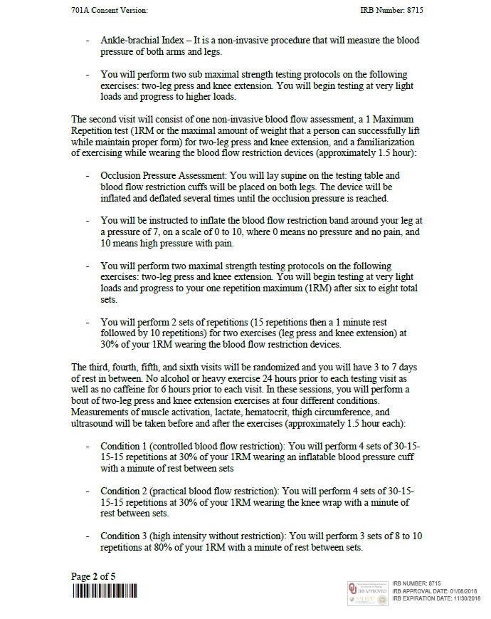





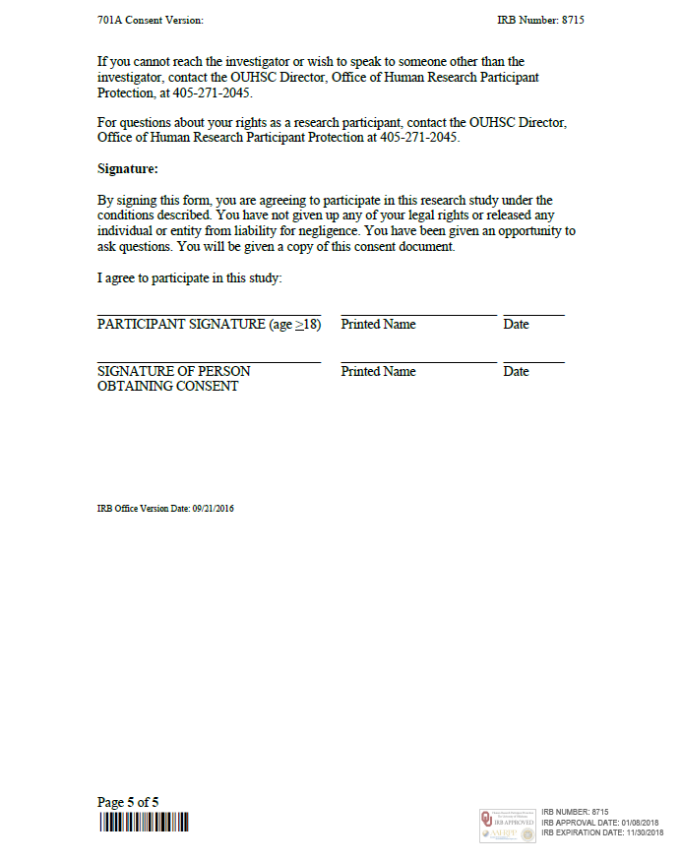





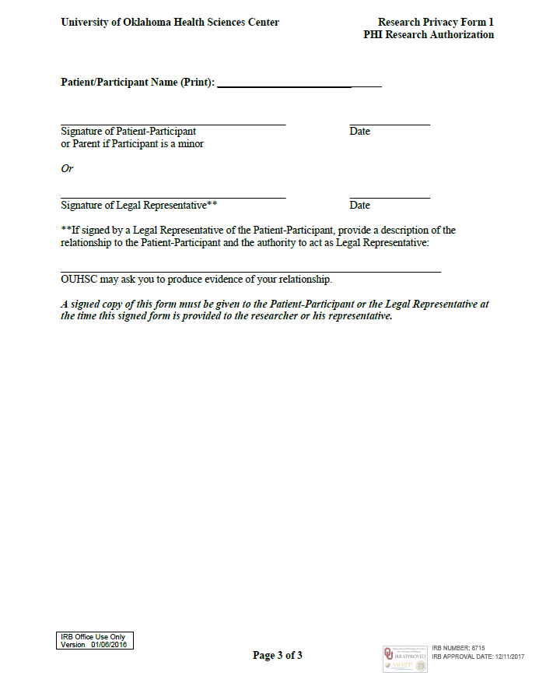

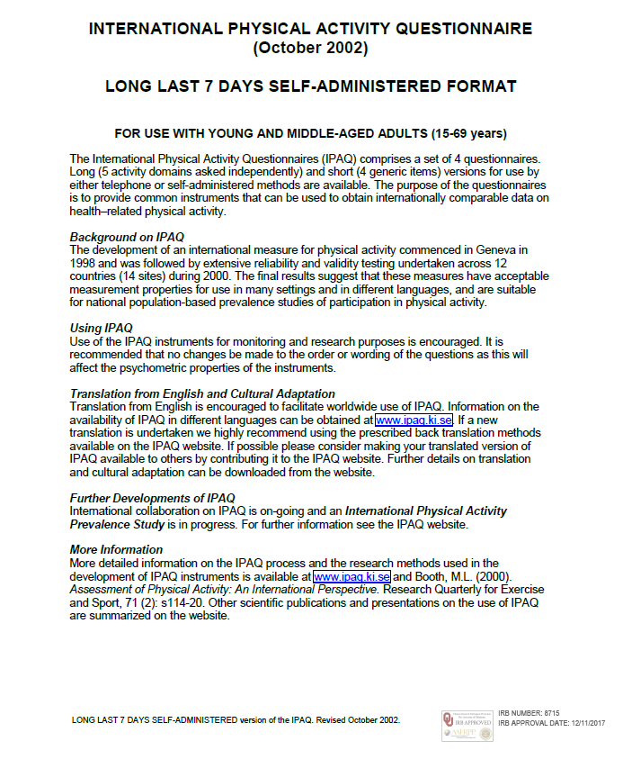
















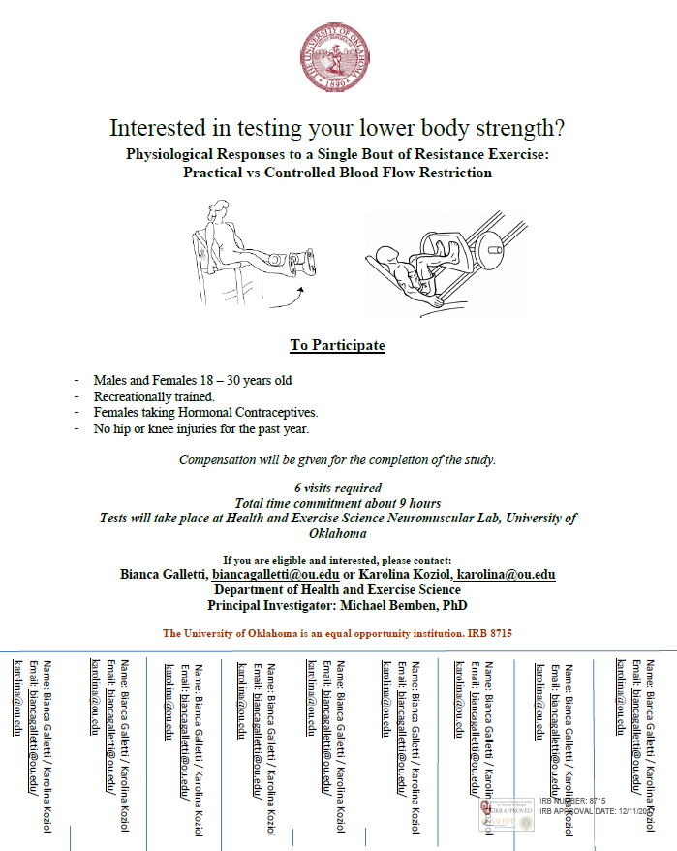

Appendix B: Raw Data
