UNIVERSITY OF OKLAHOMA

GRADUATE COLLEGE

DESIGN AND CONSTRUCTION TECHNOLOGY IN MEXICAN SOCIAL HOUSING AT THE END OF THE 20th CENTURY.

A THESIS

SUBMITTED TO THE GRADUATE FACULTY

in partial fulfillment of the requirements for the

Degree of

MASTER OF SCIENCE

By

RENÉ PERALTA
Norman, Oklahoma
2022

DESIGN AND CONSTRUCTION TECHNOLOGY IN MEXICAN SOCIAL HOUSING AT THE END OF THE 20th CENTURY.

A THESIS APPROVED FOR THE
CHRISTOPHER C. GIBBS COLLEGE OF ARCHITECTURE

BY THE COMMITTEE CONSISTING OF

Dr. Stephanie Pilat, Chair

Dr. Francesco Cianfarani

Dr. Peter Soppelsa

© Copyright by RENE PERALTA 2022
All Rights Reserved.

Contents

Introduction 1
Literature Review and Research Methods 5
Historical Overview of Housing Policy and Financing in México 1940-2020 8
1940-1980 8
1980-2000 15
Social Housing Design and Construction Systems 17
Construction manuals 21
Holcim® México. Manual de Autoconstrucción, 2016 22
Fundación Esperanza de México. Manual de Construcción y Mantenimiento de Vivienda 2018 24
Manual de Autoconstrucción. Secretaria de Desarrollo Agrario, Territorial y Urbano, 2020 27
The URBI case and the Meccano system 31
Case Study: URBI’s Villas. 40
Villa Fontana 40
URBI Villa del Prado 46
Conclusions 53
References 56

List of Figures

Figure 1 Unfinished Low-income Houses in Tijuana, Mexico. 1
Figure 2 Site preparation for low-income housing construction in the east of Tijuana. 2008 3
Figure 3 Meccano concrete panel system 6
Figure 4 Image from Drone Footage of Villa Fontana, Tijuana 2022 7
Figure 5 Centro Urbano Presidente Aleman (CUPA).1949 10
Figure 6 Villa Radieuse. 1930. 11
Figure 7 Centro Urbano Presidente Alemán (CUPA). Street and Interior Views 12
Figure 8 INFONAVIT Housing typology document from 1983. Scan Document 13
Figure 9 Informal Housing in Tijuana 2005 16
Figure 10 Informal Housing in Tijuana 2005 18
Figure 11 Developer tract homes in former ejido land. Tijuana 2006 19
Figure 12 Villa Fontana XVI, 32.5 m² tract homes. Tijuana 2008 20
Figure 13 Holcim Construction Manual (cover and interior) 23
Figure 14 FEM Construction Manual (cover) 26
Figure 15 SEDATU Construction Manual (cover) 27
Figure 16 Meccano concrete panel system – Building process 33
Figure 17 Street names in Villa Fontana XVI, Tijuana. 36
Figure 18 Housing development transformation by users 37
Figure 19 Map of Tijuana and URBI developments 41
Figure 20 Figure Ground Map of Villa Fontana I 42
Figure 21 Villa Fontana House of Alejandro Ruiz. Original Plan. 45
Figure 22 Figure Ground Map of URBI Villa del Prado 46
Figure 23 Figure 22 Still Image from El Hogar al Revés. Scene overlooking Villa del Prado 47
Figure 24 Still Image from El Hogar al Revés. Interior 49
Figure 25 Still Image from El Hogar al Revés. Street Vendor. 50

Abstract

DESIGN AND CONSTRUCTION TECHNOLOGY IN MEXICAN SOCIAL HOUSING AT THE END OF THE 20th CENTURY.

This paper examines the role of construction systems in the success and failure of the Mexican government and the private sector in providing housing for the working class at the end of the 20th century. In this study, construction systems are examined that enabled developers to build thousands of housing units with significant sociocultural impacts on urban development in Mexican cities.

Based on evidence collected from governmental housing policy, interviews with individuals, technical manuals, and documentary film, this study demonstrates that construction technology at the end of the 20th century produced low-income neighborhoods as material assemblages that interacted with human desires during the global economic challenges of the period.

Keywords: Social housing, Mexico, monolithic construction technology, assemblage theory

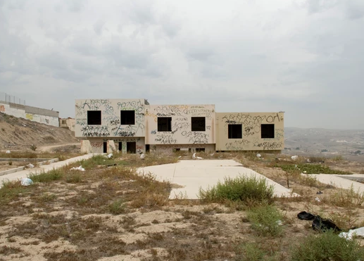
Figure 1 Unfinished Low-income Houses in Tijuana, Mexico.
Note. From the series “Des-interes Social”, by M. Arreola, Digital Photograph
(https://www.monicaarreola.com/desinteres-social). Copyright 2022 by Monica Arreola.

Introduction

This photograph hides nothing (see Figure 1). The photograph makes visible the absence of a home. Three rectangular structures of derelict or still-borne houses are centered in the frame, each with two dark square openings like eyes staring back at the viewer. In the foreground, a landscape of dead lawn patches and a few invasive foliage establish a ground for the aborted homes. In the background, the city crouches on distant hills, dissipating under a gray mist of a cold morning. There is no sign or gasp of human life. The landscape is desolate. The only fragment of urbanity is a semi-finished perimeter wall of an adjacent gated community displaying several insipid graffiti tags. The camera angle frames a one-point perspective, an architectural graphic device, and a virtual view of the world, unlike how we see with our own eyes.

There is no accurate way to be in a place. Examining the image, we do not know why Arreola selected that point of view. However, we cannot seem to divert our attention from the writing on the walls—graffiti tags outlined in black and others in faint orange that resemble urban Codexis. The words emerge with no apparent order, widespread on the surface producing the aesthetic mood of the objects. The sky also has fluffy clouds.

Arreola’s work draws our attention to the attempts and failures of the Mexican government's plans to house its working class. Her photographs expose abandoned areas and incomplete structures in various peripheral locations around Tijuana, where most morbid constructions remain intact. As Arreola suggests, this shell construction, obra-negra, provokes the viewer's imagination to explore "a series of critical dialogs on modernity, urban models and failed architecture, silent and violent imagined worlds" (Arreola, 2022).

As the dream of a home was envisioned, construction work began, and the failure of promises captured by Monica Arreola's camera raises the question: what went wrong? How could the dream of a home be so carefully designed, every window size and location accurately planned, every room meticulously drawn, to be abandoned halfway through?

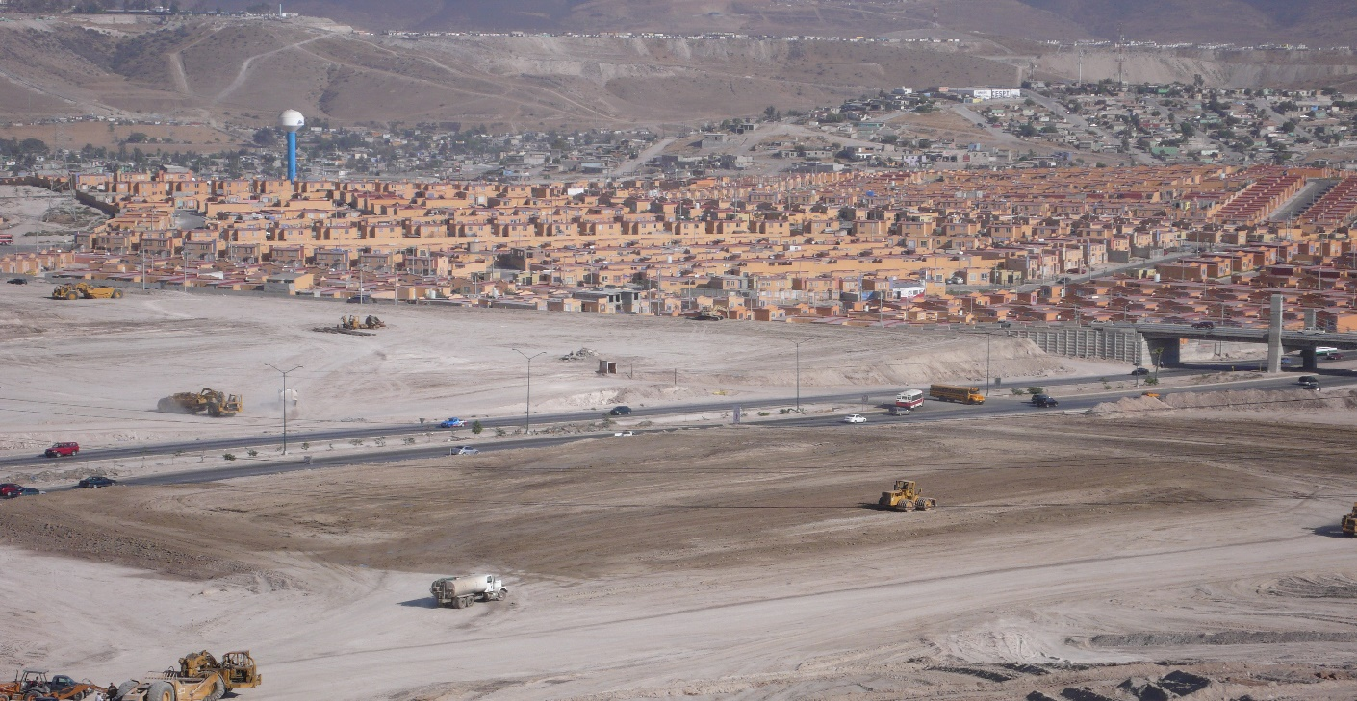
Figure 2 Site preparation for low-income housing construction in the east of Tijuana. 2008

This paper examines the successes and failures of the Mexican government along with the private sector in providing housing for the working class in the late 20th century. This study examines construction systems for housing and their sociocultural implications for urban development in México. Humanities qualitative research methods that consider subjectivity and multiple perspectives and do not avoid political agendas (O'Leary, 2017) integrate with assembly theory to understand urban housing as a complex object of multiple possibilities, sociotechnical networks, and hybrid collectives (Farias, 2010).

Since the 1980s, digital design and construction management technology have played an increasingly important role in social housing production. During the following three decades, government institutions, building material manufacturers, and housing developers increased unit volume, speed, and scope through technological changes in mass production and customization of building construction (Davies, 2005). However, as Arreola’s photograph reminds us, these experiments were not always successful. Computer-aided drafting (CAD) and modular component systems have enabled the construction of buildings more efficiently than ever before. Developers can rapidly standardize the production and supervision of residential developments in ways that have never been seen in national social housing history (see Figure 2). Implementing new construction methods, housing policy changes, communal land privatization, and construction administration automation have increased building activity in Mexico. Private developers constructed approximately 10 million new homes between 2000 and 2015. Among these, 64% were low-income units (Gonzalez-Ochoa, 2022).

This paper will first briefly introduce Mexican social housing policy and its history. It then examines self-building construction manuals to determine how competencies and knowledge are transmitted to non-skilled individuals. An analysis of two "Villas" developments in Tijuana is provided as a case study of URBI, a housing developer incorporated in 1981 in Mexicali, Mexico. A study of URBI's low-income housing developments illustrates how technology influences residential neighborhoods' social life and urban planning at the end of the 20th century.

This research aims not to describe technology but to examine how it operates (Biagioli, 1999). Based on a constructivist approach to technology studies that look for the complexity of views to construct meaning through interpretative flows of personal, cultural, and historical experiences (Creswell & Creswell, 2018), this paper examines how technology enabled the production of hundreds of thousands of houses between the 1990s and the early 2000s. Building production efficiencies transformed the manufacturing of houses into a sociotechnical assembly, establishing functional relationships with other components of the network, including the socio-political climate of Mexican housing initiatives and the development of computer-aided design at the end of the 20th century. As a result, we are presented with a narrative that emphasizes the efficiency of construction and the financialization of affordable housing access rather than a narrative based on social and ethical principles. Since the 1990s, housing in Mexico has become a commodity (Garcia Peralta, 2010).

Literature Review and Research Methods

Recent research on Mexican social housing programs has focused on changing institutional housing policies from a welfare state top-down system to a state-financed mortgage approach involving building by a private developer (Valenzuela Aguilera, 2017; Velazquez Leyer, 2015; Garcia Peralta, 2010). Other critical studies have qualitatively examined the urban planning implications of large tract home developments in México and Latin America, including some of URBI’s developments across the country (Libertum de Duren, 2018; Alegria & Ordoñez, 2016; Monkkonen, 2009). These studies also evaluate the quality of the urban infrastructure and the social implications of low-rise, high-density housing and compare suburban communities with central core city projects. Other studies employ a quantitative approach that measures economies of scale and analyzes housing location as it correlates to market land prices (Gonzalez-Ochoa, 2022; Ochoa, Guerrero, & Velasco, 2016).

Few scholars consider how architecture design and building technology are sociotechnical systems that influence social housing environments in México. However, in most cases, when mentioning construction technologies such as modular concrete panel wall systems or prefabricated construction methods, they are associated with sprawling development and failed state housing policies. This paper analyzes the impact of technology on Mexican housing policy, social space, and construction methods and intends to go beyond a purely economic and labor-based structural critique of housing and urban planning. This analysis acknowledges reason and rationality in Mexican architectural functionalism during the beginning of the 20th century. However, it theoretically evades stepping into its counterpart discourse of phenomenological criticism that it argues for an inherent value in architecture and building through efficiency and mathematical logic (Pérez Gomez, 2000). Social housing is examined from a hybrid perspective of architecture, science-technology, and heterogeneous actors - human and non-human (Yiannoudes, 2015).

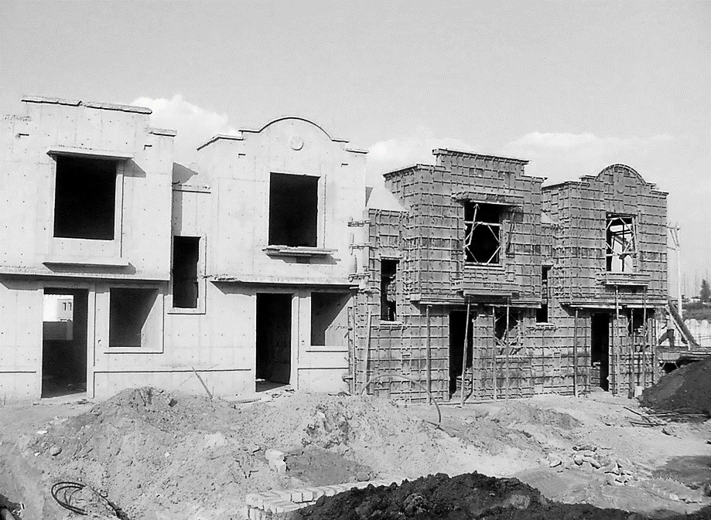
The first phase of this research included a literature review of state policy and its implications on social housing construction and periphery land planning in México, including summaries of México's serialized, developer-driven housing units during the last three decades. In an interview with a former URBI construction project manager and Tijuana architect Miguel Escobar, technical documents, including concrete panel system configuration and structural criteria, were reviewed (see Figure 3). The purpose of this first phase was to gain a better understanding of how construction systems are deployed. In the second phase, field research was conducted in the Villa Fontana development, one of URBI's first housing developments built in 1995 in Tijuana. Figure 4 shows photographic documentation and drone footage used to explore the formal and spatial changes that have incrementally taken place within the Villa Fontana.
Figure 3 Meccano concrete panel system
Note. From Image: Vivienda unifamiliar – Modelo total, by Meccano (https://www.meccano.mx/copy-of-proceso-tradimecc). Copyright by Meccano de Mexico, S.A. De C.V.

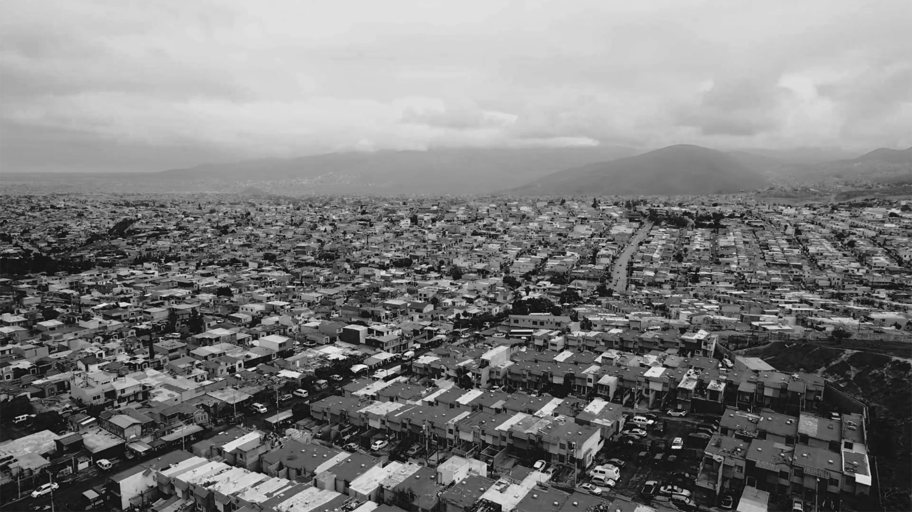
Figure 4 Image from Drone Footage of Villa Fontana, Tijuana 2022

The third phase of the study focuses on the sociocultural impacts of URBI housing in the development of Villa del Prado through an analysis of the 2014 documentary film El Hogar al Revés (The Upside-Down Home) directed and produced by a local filmmaker, Itzel Martinez del Cañizo. In this study, the perspective and social interactions of adolescents with their house and neighborhood are examined. Additionally, this part of the study included documentation of the house of an individual resident of Villa Fontana and desires to modify the structure following the resident's needs.

Historical Overview of Housing Policy and Financing in México 1940-2020

1940-1980

In order to understand how technology played an integral role in the construction and idealization of Mexican social housing, it is necessary to recall critical developments in federal housing policy and highlight the unique characteristics of Mexican construction and building design. During the past 80 years, México has created numerous public institutions and initiatives to support home construction and renovation. The initial objective of these programs was to promote the welfare state and house its working class. Subsequently, the government’s interest shifted to promote the construction industry and national economic development. In the period known as the Mexican Miracle (1940-1970), construction played a significant role in stimulating the Mexican economy. From 1954-1970 the national economy grew 4% annually, and the per capita gross domestic product was 3.4% (Tello, 2010). During these times, the country's construction workers built infrastructure financed by the government, making construction the country's largest employer (Tello).

It is imperative to note that the positive outlook of the Mexican economy during the period of the "economic development miracle" was not without its detractors. From 1971-1976, nine industrial cities and 32 industrial parks were created, most financed by public capital, including Ciudad Industrial Nueva Tijuana (Garza Villareal, 1989). In terms of construction, the data showed increased activity and employment. The outlook during this prosperous period is sometimes attributed to myths about how capitalism operates in México propagated by the dominant class and as Neo-Keynesian economics (Carmona, Montaño, & Aguilar, 1970).

While a significant amount of capital was invested in public infrastructure, most were in high-income areas and of higher quality than working-class districts. However, most private investments were used to construct middle-class housing, shopping centers, stadiums, and hotels. There were changes in housing policy during this period and new urban social housing projects, but these changes were insufficient. In 1970, there was still a deficit of 1.9 million houses nationwide (Carmona, Montaño, & Aguilar).

In 1942, a decree was implemented to control the rents of apartment units in major Mexican cities. However, due to urbanization in the following decades, the measure was insufficient and hindered new investments in housing for rent. In the 1950s, the federal government created a savings and loan initiative for residential mortgages. The initiative ultimately failed due to high-interest rates and the fact that predominantly middle-class consumers used these loans. By the end of the 1960s, the government created exclusive institutions and programs rather than sporadic initiatives to finance the construction of affordable housing for sale. In 1963, the Fondo de Operación y Financiamiento Bancario a la Vivienda (Bank Operating and Housing Financing Fund – FOVI) was created as public trust through the Secretaría de Hacienda y Crédito Público (Ministry of Finance and Public Credit at the Bank of México – SHCP). Its purpose is to grant financial support and guarantees for the construction and purchase of low-income housing, channeling resources through financial intermediaries such as banks or companies in the mortgage and real estate sector (FOVI, 1999). This is precisely when low-income housing is defined as Vivienda de Interes Social (social interest housing – VIS) destined for a population sector that makes enough money to pay their monthly rent in the long run. This type of housing still bears that name and concept (Puebla, 2002).

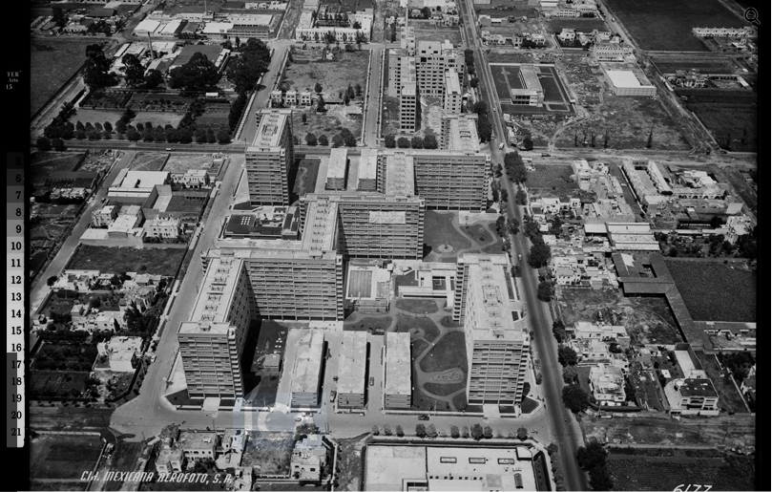
The construction of multifamily buildings revolutionized construction systems and techniques incorporating advanced technologies and materials of the time based on reinforced concrete lattice structures that allowed the construction of large-scale and high-rise housing. The state built many housing blocks from the 1940s through the 1970s with rental units, similar to European projects. In major cities experiencing rapid urbanization, rent control regulations enabled working-class citizens to afford urban living (Puebla, 2002). During this period, renowned architect Mario Pani Darqui (1911-1993) designed several notable housing projects in México City, including the acclaimed Centro Urbano Presidente Aleman (President Aleman Urban Center – CUPA), which was inaugurated in 1949 (see Figure 5). The first multifamily building to be developed in México and Latin America (Porter, 2016). The complex administration was under the General Office of Civilian Benefits and Retirement Pensions, created in 1925 and today known as the Instituto de Seguridad y Servicios Sociales de Los Trabajadores del Estado (Institute of Security and Social Services of State Workers – ISSSTE). CUPA was the first project built by Ingenieros Civiles Asociados (ICA), which would later become one of Latin America's largest construction firms. (Porter, 2016).
Figure 5 Centro Urbano Presidente Aleman (CUPA).1949
Note. Aerial view Centro Urbano Presidente Aleman, by ICA, 1949, (http://www.fundacion-ica.org.mx/colecciones_digitalizadas). Copyright by Fundacion ICA.

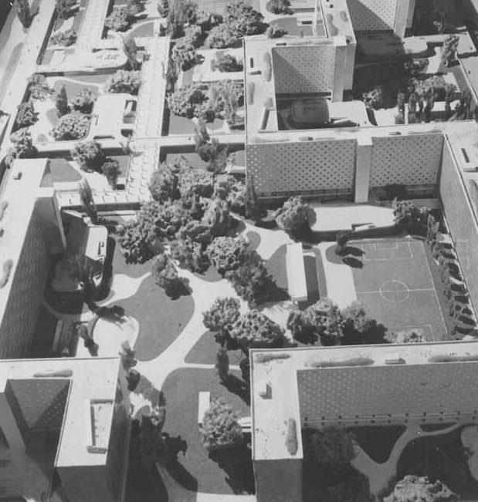
After studying architecture in Paris, Pani became influenced by the ideas of Swiss architect Le Corbusier (1887-1965), most notably by his design and theories behind the Ville Radieuse (Radiant City) project of 1930 (see Figure 6). CUPA consists of a series of super blocks with 1080 units for rent and 212 commercial spaces. Like in Le Corbusier’s “Unité d' Habitation de Marseille” (1945-1953), CUPA apartments are organized in two levels, with the entrance on every third floor providing privacy to the sleeping spaces of the units. The master plan for the complex includes a nursery, laundromat, a school for 600 students, a semi-Olympic pool, gardens, and public recreation spaces (Noelle, 2021).
Note. Ville Radieuse, Not located, 1930 (http://www.fondationlecorbusier.fr/corbucache/900x720_2049_1981.jpg?r=0). Copyright by ADAGP – FLC
Figure 6 Villa Radieuse. 1930.
Architect: Le Corbusier

CUPA transformed how large concrete structures were constructed in México and revolutionized construction management practices. The large building site of 40,000 square meters allowed for the construction of workshops and production areas, including a brick-making facility. Many components, such as stairs, doors, cabinets, and ironworks, were assembled onsite in temporary workshops. As a result, freight costs were reduced, and construction efficiency was increased. The concrete structure of the building was well-designed and efficiently constructed. Considering that the building was constructed on prime soil conditions, the depth of the foundation did not exceed 2.5 meters. However, its economic efficiency did not hinder its structural efficiency. CUPA could withstand two major earthquakes without sustaining significant damage, one in 1957 of magnitude 7.9 and the other in 1985 of magnitude 8.1 (Porter, 2016).
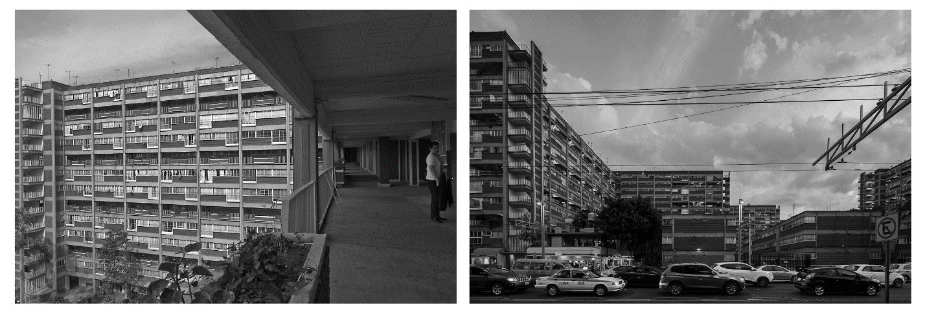
Figure 7 Centro Urbano Presidente Alemán (CUPA). Street and Interior Views
Note. El primer multifamiliar moderno [photograph]. By Onnis Luque 2017 (https://onnisluque.com/archivo/el-primer-multifamiliar-moderno/). Copyright by Onnis Luque

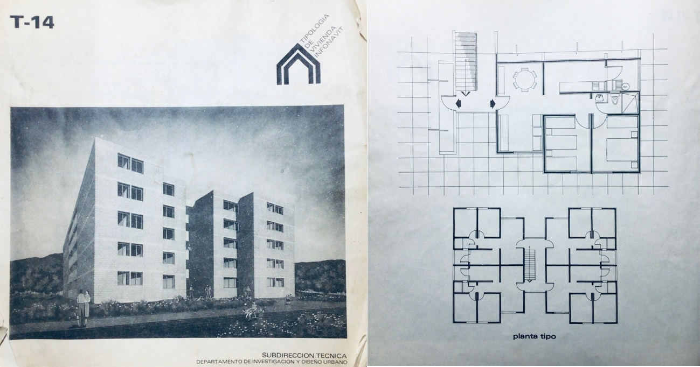
CUPA represented a meaningful change in social housing policy. In one sense, the Mexican revolution of 1910 - 1920 was a call to hold the state accountable to the populace by providing dignified and hygienic social housing in urban areas, especially growing city centers. Mario Pani desired to create a modern urban project, like Le Corbusier’s but adapted to México's economic and social circumstances (see Figure 7). In his view, housing was not solely driven by financial considerations but was part of a larger social responsibility plan. It was his vision that communities would be integrated into urban networks. Pani was aware of the dispersed, monolithic housing developments that would emerge at the end of the 20th century, as he noted in an interview for the magazine Arquitectura Mexicana in 1949; “It is necessary to bring together and not to disperse; to relate problems and not to separate them: to launch towards a single goal all the reality of savings and the credit power it represents. To make it a single work, not thousands of isolated attempts” (Mayorga, 1949).
Figure 8 INFONAVIT Housing typology document from 1983. Scan Document

In 1972, the state established new affordable housing legislation and a national institution, the Instituto del Fondo Nacional de la Vivienda para Los Trabajadores (National Workers' Housing Fund — INFONAVIT). INFONAVIT became an important accomplishment for the government, and in collaboration with private sector construction companies, built multifamily apartment blocks across the country (see Figure 9). Through INFONAVIT, the state requires companies to contribute 5% towards a workers' housing fund to satisfy the national housing demand. In 1991, INFONAVIT had built 1,043,663 housing units but only served 13% of its beneficiaries (Garcia Peralta, 2010).

Over the next three decades, the World Bank and other international organizations supported neoliberal development strategies in México and Latin America. By the 1970s, most housing programs were re-directed to middle-class families. With its public housing programs, the significance of the guidelines dictated by the World Bank has increased. The guidelines today have such a weight that they can be considered decisive, especially regarding national housing policies. A significant requirement from the World Bank was that state housing and credit agencies should make a profit via interest rates on their loans and operate on the same terms as private lenders. The Mexican population had an income poverty rate of 72% in 1970. (Boltvinik, 2000),

Moreover, it hindered the opportunity of getting loans for new homes or existing modifications for low-income workers who did not fit the financial scheme to maintain profit margins. International monetary institutions pressured governments in developing countries to design housing policies to strengthen the market. Therefore, private developers become the drivers of housing construction projects, with the state creating the conditions for their success (Boils, 2004).

México's national housing policies underwent a major transformation in the 1980s. The United Nations Human Settlements Program and the World Bank have significantly impacted state policies and social housing institutions. Consequently, they moved from building and providing housing to focusing exclusively on enabling access to housing. This paradigm shift resulted in housing being integrated into the financial markets and professional services sectors (Puebla, 2002).

1980-2000

There was significant growth in the housing sector during the administration of President Miguel de la Madrid Hurtado (1982–1988), which was characterized by neoliberal tendencies. In 1983, the Federal Housing Law was swiftly enacted and stipulated that Mexican families have the right to dignified housing, establishing the mechanisms necessary to achieve this goal by providing housing access to lower-income urban residents and rural dwellers. From 1981 to 1990, there was a national increase of 45% in social housing production (Garcia-Peralta, 2010).

As a result of the 1980s recession, INFONAVIT was almost bankrupt and shifted to financing developer-built housing instead of construction. In the 1990s, INFONAVIT was a facilitator for private developers rather than an actual builder per World Bank guidelines. As a result of ten years of gradual growth in northern México, the North American Free Trade Agreement (NAFTA) was signed in 1994. In addition, due to attractive employment opportunities in the manufacturing industry, social housing demand increased favorably for the private sector. This sector could now capitalize on state policies, financial assistance, and technological advancements to satisfy this need (Monkkonen, 2009).

In retrospect, there were three critical stages in developing national housing policy in the 20th century. The first stage (1940-1980) established a strong state capable of building homes and implemented rent control protocols for accessibility. The state included housing production and financial systems in the second stage (1980-2000). In the third stage, starting in the late 1990s, private developers were invited to participate in housing construction (Puebla, 2002).

Unfortunately, in the end, even with these programs, low-income families could not benefit from the state-sponsored housing market. Non-salaried workers in the informal economy did not have access to a housing savings fund, unlike those working for a formal employer. As a result, many families working in the informal sector acquired land through squatting practices and built their own homes. It was not until 1981 that the government established the National Fund for Popular Housing (FONAPO) to mobilize housing support for the informal sector population (Gutierrez, Mujica, & Izaguirre, 2010). Government housing policy changes were enacted during the economic crisis of the 1990s, the industrialization of the northern territory, and the negotiation and adaptation of NAFTA. The Mexican housing policy should be part of efforts to reform the entire Mexican government (Monkkonen, 2009).
Figure 9 Informal Housing in Tijuana 2005
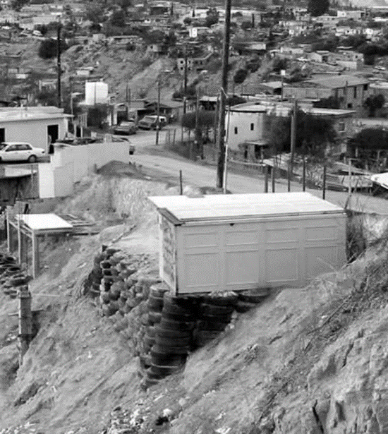
At the beginning of the 21st century, México experienced a housing boom and an economic depression, which was exacerbated by the global economic crisis of 2008. The recession in the United States negatively affected México's export demand since 80 % of the country's exports are to the U.S. After the financial crisis there was an oversupply of housing, and both government and private developers faced financial difficulties, some of which resulted in bankruptcy and more than five million abandoned houses across the country due to defaulted loans and unconcluded projects (Valenzuela & Tsenkova, 2019).

Social Housing Design and Construction Systems

“México is a country of architects: Every Mexican is a creator in the depths of his being and history.” Ricardo Legorreta

Research on social housing projects and programs in México has primarily focused on the effects of housing on land value and urban context (Alegria & Ordoñez, 2016). Social housing scholarship tends to focus on the relationship between land value and spatial distance and the costs of deployment of material goods and labor (Gonzalez-Ochoa, 2022). In research studies, it has been shown, for example, that social housing projects located on the outskirts of a city employ a more significant amount of labor and materials. Developers had to establish trust with the government by securing a steady flow of mortgages. INFONAVIT offered developers 50% of future home sales after completing 65% of the projects, and land use changes for their land reserves were negotiated (Gonzalez-Ochoa).

In México and Latin America, informal settlement communities house the working-class population, and in most cases, an informal settlement is an illegal land possession that, through time, becomes a neighborhood through legal channels and political pressure. Nevertheless, it takes years for the government to legalize lots and provide residents with the necessary essential services. Most houses in informal communities are constructed by their occupants on unstable land and with precarious materials, such as recycled wood and used tires for soil retention (see Figures 9 and 10). In order to alleviate these precarious housing conditions, FONAHPO provides subsidies to workers who do not participate in the formal economy or make less than the minimum wage to purchase a two-bedroom starter house of at least 45-50 square meters.

Additionally, this fund facilitates the improvement of existing homes. On August 22, 2022, the federal government announced the program's cancellation, and the National Housing Commission (CONAVI) will now serve that segment of the population. (FONAHPO, 2022).
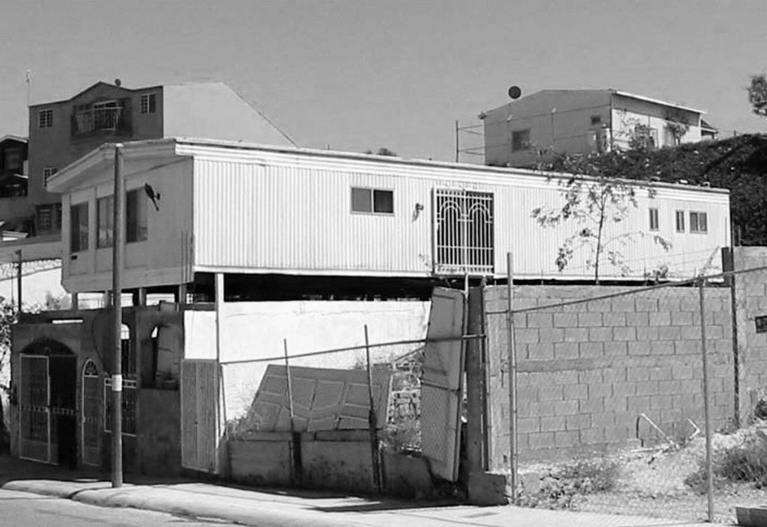
Figure 10 Informal Housing in Tijuana 2005

Informal settlements begin as illegal land holdings that grow into neighborhoods, and it takes the government years to legalize these properties and provide residents with all the necessary services. Moreover, in México, developers find it much more profitable to build middle-income housing near the city center. The poor, however, could not afford to purchase developer-built homes and returned to the practice of self-construction (Alegria, 2008). Many residents have returned to building incremental assemblies and hybridized dwellings by employing more haphazard and tactile construction materials.

In 1992, the federal government revised article 27 of the federal constitution to allow the privatization of ejidos (see Figure 11 ). The land was previously part of a peasant communal parcel system without property rights (Gonzalez-Ochoa, 2022). Consequently, developers purchase this cheap land in rural areas, encouraging ejido communes to obtain land rent income and benefit from urban infrastructure that would follow the regularization of occupied areas (Alegria & Ordoñez, 2016).

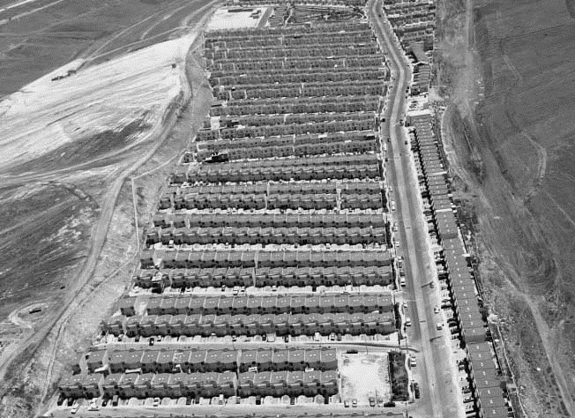
México's accelerated urban growth has been adversely affected by global economic challenges. In the 20th century, urbanization and industrialization led to a large wave of rural migration. To meet the needs of low-income households, federal housing institutions had to provide more mortgages for new and used housing. In turn, this has resulted in a reshaping of the conditions of international monetary assistance. Having been influenced by the World Bank, housing institutions have attempted to simplify construction permits, legalize land, and integrate all states into housing accessibility programs (Boils, 2004).
Figure 11 Developer tract homes in former ejido land. Tijuana 2006

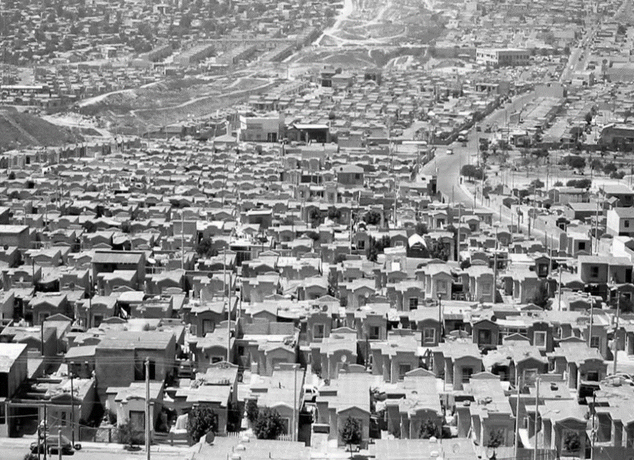
A wide range of issues have been raised concerning housing in its institutional, economic, and social dimensions. Despite this, very few studies have examined construction practices in greater depth, emphasizing the particularities of projects, their designs, and their architects. However, in recent decades, government attention has focused on energy efficiency and construction systems. Since 2001, CONAVI, the government council on housing programs in México, and the National Council of Science and Technology (CONACYT) have published a series of academic reports regarding structural construction systems for social housing (SEDATU, CONAVI, CONACYT, 2016). The reports include research in material science, energy-efficient materials, and alternative construction methods and are viewed as a means for promoting sustainable environmental practices that benefit individual housebuilders. The institutional goal is to propose alternative construction methods for reducing greenhouse gas emissions (SEDATU, CONAVI, CONACYT). As a result of these eco-technologies, INFONAVIT has launched a "green" mortgage program estimated to reduce CO2 emissions by 100 kilograms per household per month (Ochoa, Guerrero, & Velasco, 2016).
Figure 12 Villa Fontana XVI, 32.5 m² tract homes. Tijuana 2008

Understanding the particulars of home design and building traditions in México is critical to understand technology’s influence and adaptability in the housing sector. In most research studies on social housing, the architectural spaces are inadequately sized for typical Mexican families (see Figure 11). Under the Mexican constitution, each state and municipality is entitled to establish its housing regulations, including the minimum dwelling size. The federal government provides a series of guidelines for the decision-making process that include recommended size and heights of rooms but do not state a total area for the complete house. (SEDATU, CONAVI, 2017). Therefore, the size of many units varies from state to state. In 2017, there were one million one-bedroom units in México, as small as 32.5 square meters like the ones shown in Figure 12 (Marosi, 2017).

Despite this, an analysis of social housing rarely considers its architectural design since, in the government's view, the problem is neither technical nor architectural. To address the housing need in México is impossible without a clear understanding of the regional and local processes for design and construction, including local laws and regulatory framework.

Construction manuals

A large percentage of households in México builds their own homes. According to the 2020 census, 57.3% of México’s housing stock was built by its owners (INEGI, 2020). This reality creates a need for the government to communicate best practices for owner-built home design and construction to citizens. For much of the population who build their own homes, the government and private industry intend to influence home design and construction through publications illustrating building techniques. Technical design and construction manuals and house construction authored by government agencies and construction material manufacturers are just as important as the materials themselves. These manuals illustrate low-skill techniques using traditional materials such as concrete blocks and clay bricks for which no specialized equipment is required. In addition, the documents offer information regarding the site planning and permitting process for a house, as well as other protocols that add value to the property, such as the house registration with the local authorities for construction licensing purposes. (Flores, 2012).

Non-profit organizations, government agencies, and the construction materials industry offer a variety of instructions on how to erect a house for individuals with little or no construction experience. In this study, we will analyze three housing design and construction manuals—one by a building materials manufacturer, another by a housing non-profit, and finally, one by a government organization—illustrating how technology, design, and low-skill construction are combined.

Holcim® México. Manual de Autoconstrucción, 2016

Holcim®, a Swiss cement company, has manufactured cement and its derivatives in México since 1928. The company also runs the Mexican School of Construction in partnership with Universidad Autónoma de México (UNAM), Benemérita Universidad Autónoma de Puebla (BUAP), and Universidad Autónoma del Estado de México (UAEM), promoting the professionalization of construction workers, site supervisors, and masons. The curriculum includes theoretical and practical training to perform construction tasks effectively and safely. At the end of the course, the student receives an official certificate from the public education secretariat in home construction (Holcim, 2022).
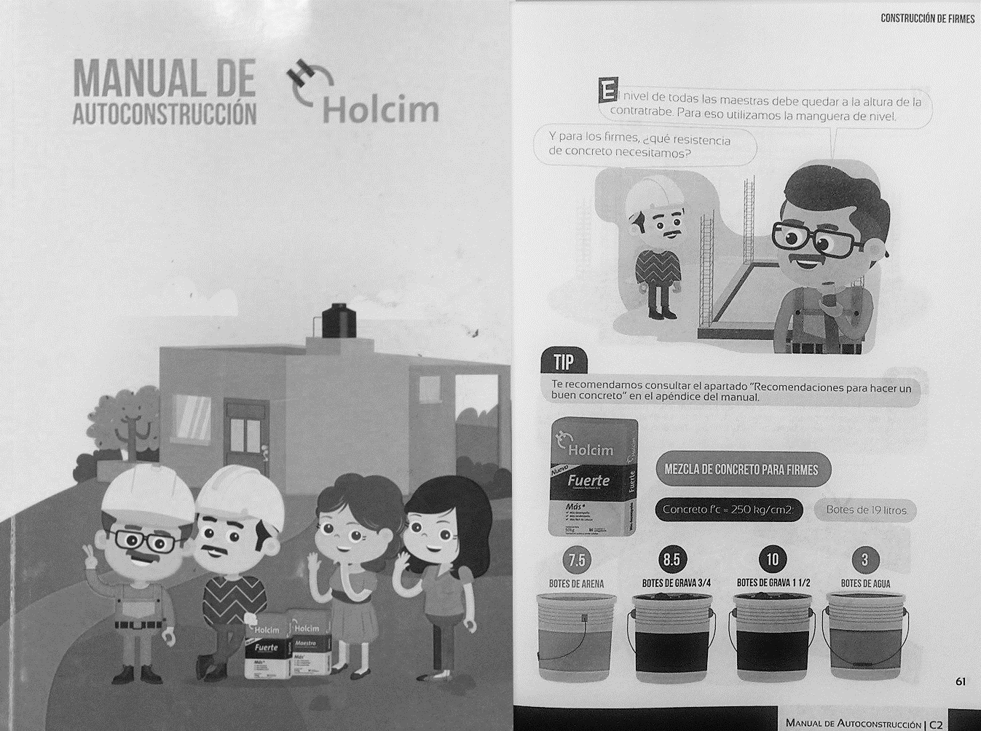
Note. From MANUAL DE AUTOCONSTRUCCION, by Holcim® 2016.
Copyright by Holcim de México S.A de C.V.
Figure 13 Holcim Construction Manual (cover and interior)

Most self-built homes in México are constructed in collaboration with a local mason who has learned the trade through empirical techniques. The Holcim® “Manual De Autoconstrucción” (Manual of Self-construction) is part of its educational framework to support the self-built process for experienced masons and non-technical persons (see Figure 13). The 240-page illustrative booklet narrates the story of a typical working-class family who will build their first house with the help of the husband's father. The publication's entire process of building a house is documented as a colorful graphic novel, with caricature depictions of the family members and isometric illustrations of the building stages. However, in many stages of construction, Holcim® finds the opportunity for product placement of its various materials available throughout neighborhood building material vendors.

From the beginning, the Holcim® manual emphasizes the importance of legal construction processes and advises the builder to complete all necessary forms and permits at their local building department. After the builder elaborates the preliminary plans with dimensions, the manual provides examples of positioning the house onsite to take advantage of natural cross ventilation and optimal sun exposure for the different interior spaces. Soil load capacity is verified by using a shovel to "feel" the hardness of the ground before deciding which of three foundation systems (slab on grade, continuous footings, or isolated footings) should be used (Holcim Mexico, 2016) In the remaining chapters of the manual, the user is guided through the process of completing the house, regardless of whether they intend to build it in stages. Finally, the manual concludes with a glossary of standard construction terms and a section on physical safety on the construction site. Holcim® has made a simple-to-understand booklet illustrating all phases of a construction project. However, some tasks require specialized or experienced labor to complete the project, such as electrical wiring and plumbing connections. In addition to integrating the user's desire for a custom and self-built home, the manual serves as a marketing brochure for Holcim® products.

Fundación Esperanza de México. Manual de Construcción y Mantenimiento de Vivienda 2018

Fundación Esperanza de México, A.C. (FEM) is a nationally recognized non-profit organization in Tijuana that has been promoting community development programs and self-built housing initiatives for over 30 years. FEM promotes its housing program to families in peripheral city communities. It is similar to the government program that incentivizes using local materials and labor to build homes, with participating families and international volunteers. Through FEM’s community development program, they provide technical support to its program participants with assistance from its in-house registered architect, who aids with the design, construction documentation, and permit processing phases (Peralta, 2022).

The production building material is part of the program and preparation for construction activities. During construction workshops, FEM distributes a construction manual that explains the community funding strategy and other requirements families must meet to succeed in the program (see Figure 14). FEM’s concrete block-making technique is explained in the booklet's subsequent sections. Families must be certified by the organization before receiving a block-making machine to produce approximately 2000 cement blocks for their homes. The blocks have a specific shape similar to a Lego® piece allowing them to be assembled as an interlocking system without using mortar cement. FEM’s mortar-less building system and the organization's technical supervision allow volunteers and families to erect walls effortlessly. The manual also explains how the organization technical team will continually accompany the family during the different stages of construction to ensure that the house is being built correctly and on budget (Fundacion Esperanza de Mexico, 2018).

The 32-page manual, “Manual de Construcción y Mantenimiento de Vivienda” (Construction and Maintenance Housing Manual), like the one by Holcim®, utilizes caricature depictions of family members and isometric illustrations of the building stages. The illustrations introduce the different sections, while most of the instructions are in written form. In the final section, the manual describes the maintenance of the new house and damage prevention of its electrical and water systems (Fundacion Esperanza de Mexico, 2018). Product placement is irrelevant in this publication since FEM does not have ties to a particular materials company. FEM analyzes the comparative prices of building materials in the neighborhoods to reduce the cost of freight (Peralta, 2022).

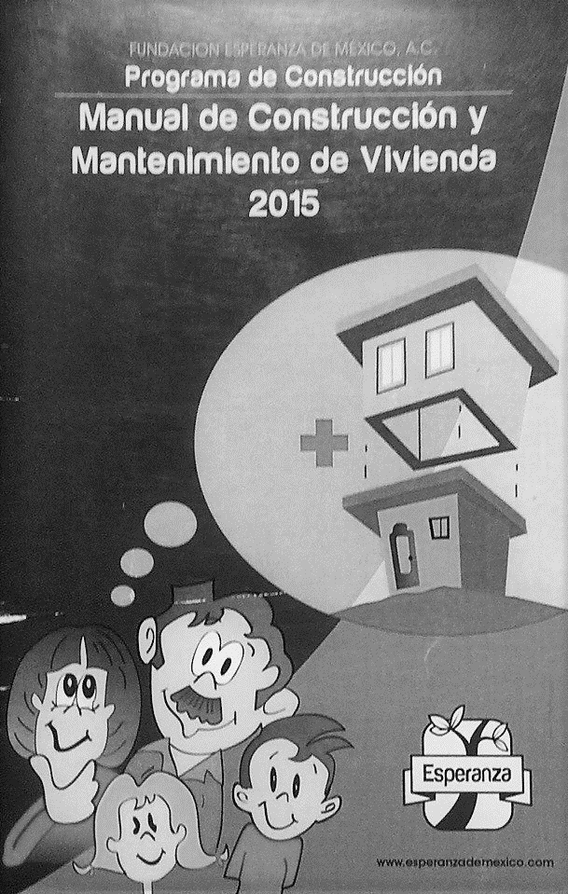
The manuals are printed in color at a local print shop reducing the cost of a professional printing method. The organization revises and publishes the manual every 2-3 years depending on new building techniques, updated permit processing procedures, and other factors that might change how homes are built. As in the Holcim® example, the manual emphasizes a structurally sound foundation system, building in phases, and overall safety in the work site for participating families and volunteers. However, FEM requires community participation in constructing neighboring houses (Fundacion Esperanza de Mexico, 2018). The incremental nature of the house's design and the participatory building process makes the building process slower than typical construction. However, this slower building form allows for sociocultural interchange between different groups from diverse cultural and economic backgrounds (Peralta, 2022).
Figure 14 FEM Construction Manual (cover)

Note. From Manual de Construcción y Mantenimiento de Vivienda. 2015, BY Fundación Esperanza de México. Copyright: Fundación Esperanza de México A. C.

Manual de Autoconstrucción. Secretaria de Desarrollo Agrario, Territorial y Urbano, 2020

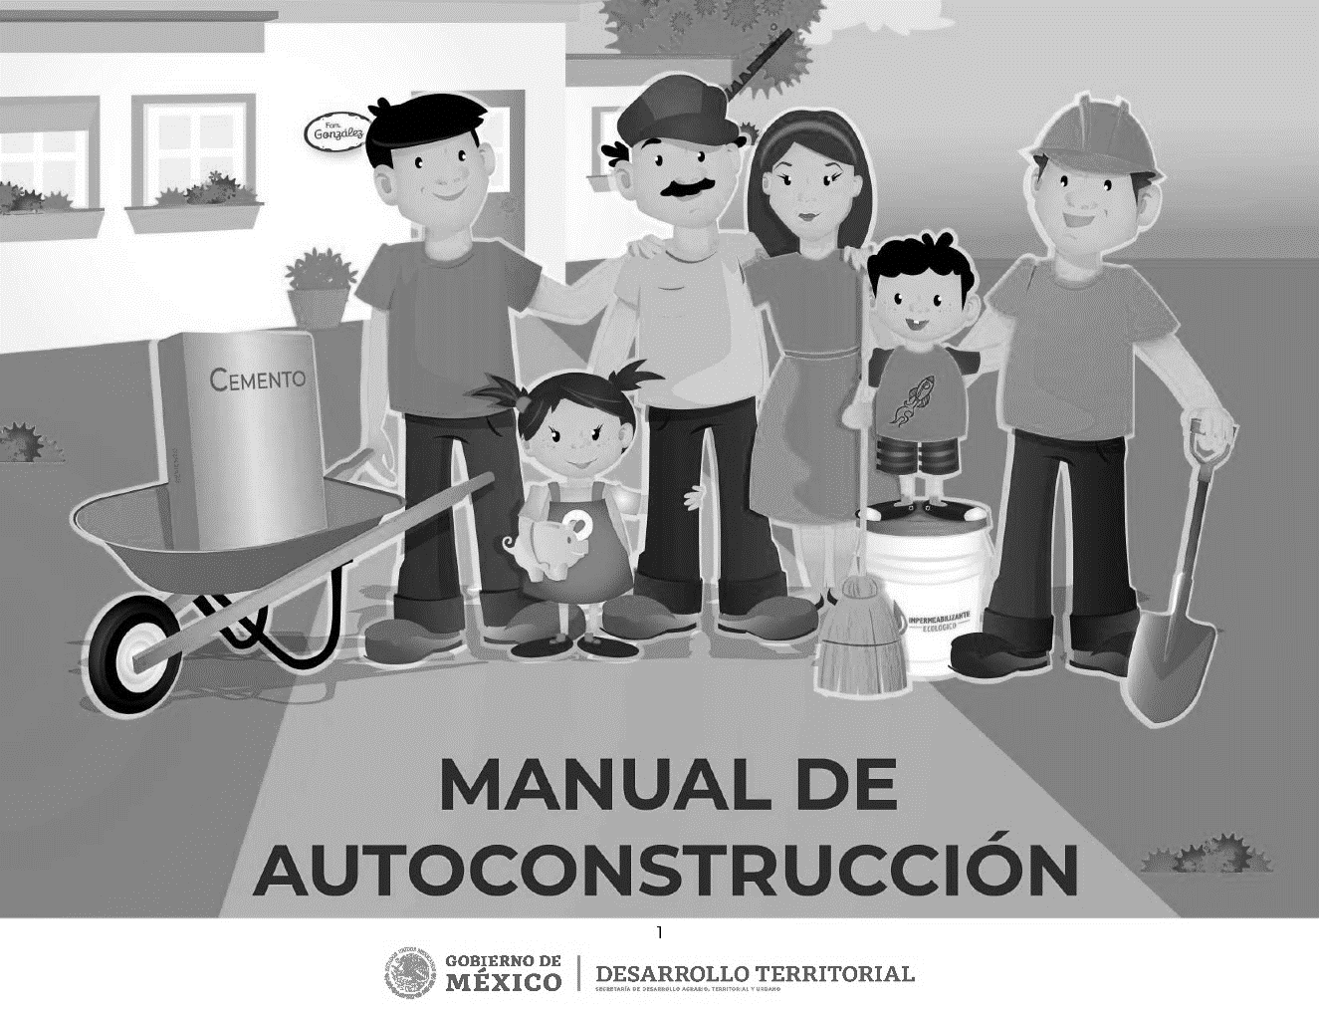
Currently, the Mexican Federal Government oversees a self-built housing program allowing working-class citizens to build their own houses. Using direct credit from the government, citizens can access construction subsidies to build a house on their property. This program requires an assistance component where a licensed construction professional is part of the project's development phases (SEDATU, 2021).
Note. From Manual de Autoconstrucción, by SEDATU
Copyright: Secretaria de Desarrollo Agrario, Territorial y Urbano.
Figure 15 SEDATU Construction Manual (cover)

To support the government's initiatives dedicated to self-built housing, Cementos Mexicanos (CEMEX), one of the world's largest cement manufacturers, and the Technological University of Monterrey have teamed up to produce a self-construction manual. The online document explains, step-by-step and straightforwardly, the complete construction process of building a house according to sustainable standards (SEDATU, 2021). In the same graphic manner as the Holcim® and the FEM manuals, the book illustrates caricatures of a nuclear family with the adult male performing construction tasks (see Figure 15). The first chapter introduces sustainable design concepts, such as natural lighting, ventilation techniques, and construction standards for various climatic conditions. One recommendation that forms part of the sustainable design tools absent from the other manuals is building a green roof based on wood planks and potted plants rather than the traditional and more costly system with soil (SEDATU, 2021).

While this manual illustrates every phase of planning and building a house, it also emphasizes building techniques for an incremental house. The first stage consists of building modules which include a living area and a space for the plumbing system. This modular construction process is like the housing FEM provides its participants. It is not uncommon for the complete construction of the house to occur over a significant period, in some cases up to twenty years. The factors that determine this period are the economic flow and growth of the family (SEDATU, 2021).

In this SEDATU manual and those produced by FEM and Holcim®, the site location of the future house is a critical topic. The house site plan is determined by daylight, ventilation, and planning for its future growth. However, sites with slopes greater than 45% and those located near or on flood plains are deemed non-buildable. The document concludes with a glossary of construction terms and definitions of "Eco-Tecnias," or eco-friendly building techniques (SEDATU, 2021).

Incremental housing developments are not new. Communities have been formed through this method throughout history, and some consider it ideal for creating a town or city. This building model resonates with architects' past attempts to produce fair and dignified housing worldwide, such as Austrian social scientist Otto Neurath and his work in the slums of Vienna and the institutionalization of settlement movements during the First World War. As Hochhaeusl explains, "Neurath was not instrumental in increasing the association's size. He was mainly responsible for restructuring the settlers' organization into one united, cooperative association" (Hochhaeusl, 2010). Neurath also developed a graphic picture language to represent social-scientific facts to the working-class population with very little formal education. He would name the system ISOTYPE (International System of Typographic Picture Education). With the picture language that illustrated social and political concepts and mass housing, Neurath believed that architecture could produce new forms of socialized urban living (Blau, 2006).

In Berkley, Christopher Alexander experimented with self-built construction systems and community organizations in the 1970s. Alexander believes that housing is a coherent system with rules, habits, and laws requiring bonds of associations between people and families, and they must be able to express their uniqueness to retain human dignity (Alexander & Davis, 1985). These concepts were put into practice in a project Alexander and his Berkley students realized in Mexicali, the state capital of Baja California and a couple of hours' drive east of Tijuana. In 1976, based on his ideas of a pattern language, Alexander organized a group of families to participate in the design of self-built houses, which included the fabrication of building blocks for their construction and the organization of the site's shared public spaces (Peralta, 2022).

The three manuals previously mentioned discuss the consideration of housing construction practices already used in working-class neighborhoods in México. Generally, houses in informal neighborhoods and squatter settlements are constructed through self-construction. Mainly, these houses were constructed in stages and required cash funds rather than credit to purchase building materials. Based on the economic conditions and family size, the head of the household can build the house with the help of a mason. Additionally, these houses are built with lower-quality materials that deteriorate quickly and lack basic services such as water or sanitation infrastructure (Alegria & Ordoñez, 2016).

The British architect John FC Turner, who has written extensively on housing in Latin America, believes that informal communities resolve more problems than they cause and emerge due to the failure of the market and government to provide the necessary protocols for community development. In Turner's view, state design and planning is a bureaucratized process where non-profits serve as mediators in successful state agency negotiations. Most of the time, ordinary citizens have lost their participation in local development processes (Turner J. F., 1986). Turner's ideas are still being incorporated into contemporary architectural practices in Latin America, such as in the work of Tatiana Bilbao in México City, Alejandro Aravena’s in Chile, and Teddy Cruz-Fonna Forman in Tijuana, which incorporate incremental and participatory design processes (Meninato, 2022).

Currently, the Mexican government prefers to fund progressive housing, as it offers more benefits to families than purchasing a home built by a developer on the periphery. (SEDATU, 2021). These incentives are economic and social since housing agencies work in areas already established as communities and assist in improving the settlements. Families can avoid rent and credit, allowing them to save for building, and reducing tensions within communities and the government. Thus, building instruction production is a low-cost investment that substantially affects working-class families and their communities. Supporting self-building is perceived as a much better investment than building social housing that nobody wants. In Tijuana, according to a study from 2015, there were 124-thousand abandoned houses built by the private sector for the working class (Blas, 2015). A close look at the private development firm URBI and its construction systems illustrates the challenges of developer-built housing projects.

The URBI case and the Meccano system

Cuauhtémoc Pérez Román and a group of college friends founded Desarrollos Urbanos SAB de CV (URBI) in 1981. URBI began as a housing developer who aspired to provide Mexican workers with their version of the American dream. The plan was to revolutionize the Mexican social housing sector by deploying a rapid and advanced construction technique and increasing investor financial profit. Changes in housing policy during the 1990s and the deregulation of ejidos, communal lands, permitted the company to acquire large plots on the city's outskirts to build working-class communities. The company became one of México's top three residential developers, along with Casa GEO and Homex. Moreover, in 2004, the company raised $183 million in an IPO that was four times oversubscribed. Besides being listed on the Bolsa Mexicana de Valores (BMV), México's stock exchange, this offering was also made in the United States and Europe. This was the first initial Mexican public stock offering internationally distributed since 2000 (Encyclopedia.com, 2019).

URBI wanted to demonstrate that profits could be achieved with financial resources at market prices in the social housing sector. As part of its growing operations, URBI revolutionized the Mexican social housing sector by introducing a rapid and advanced construction system. URBI’s implementation of its housing development strategy at the end of the 20th century is well documented (BMV, 2015; Herzog, 2015; Rodriguez & Mendez, 2008). Beginning in the north of the country, it soon spread to other cities. Most studies examine the effects of these settlements on the peripheral urbanization of Mexican cities. In addition, the desires of URBI’s founders, including the housing residents, provide fundamental properties to the material assemblage (Buchanan, 2021).

URBI's success could be accounted for by resources that were not available a decade before its inception. The company used innovative design and management and computer-aided drafting (CAD) software for large-scale projects, mainly AutoCAD®, developed by Autodesk in 1982. The first generations of CAD systems began in the automotive industry in the mid-1960s with General Motors DAC (Design Automated by Computer) and later Ford Motor Co. Product Design Graphic System (PDGS). However, CAD systems were unavailable beyond Unix systems until Microsoft released its first 32-bit operating system in 1994 (Monaco, 2010). Miguel Escobar, former project manager for URBI, explained that the company implemented CAD systems early in its process, enabling more housing production than at any other time in history (Escobar, 2022). URBI constructed ten houses per day using a monolithic concrete panel system known as Meccano® (see Figure 16).
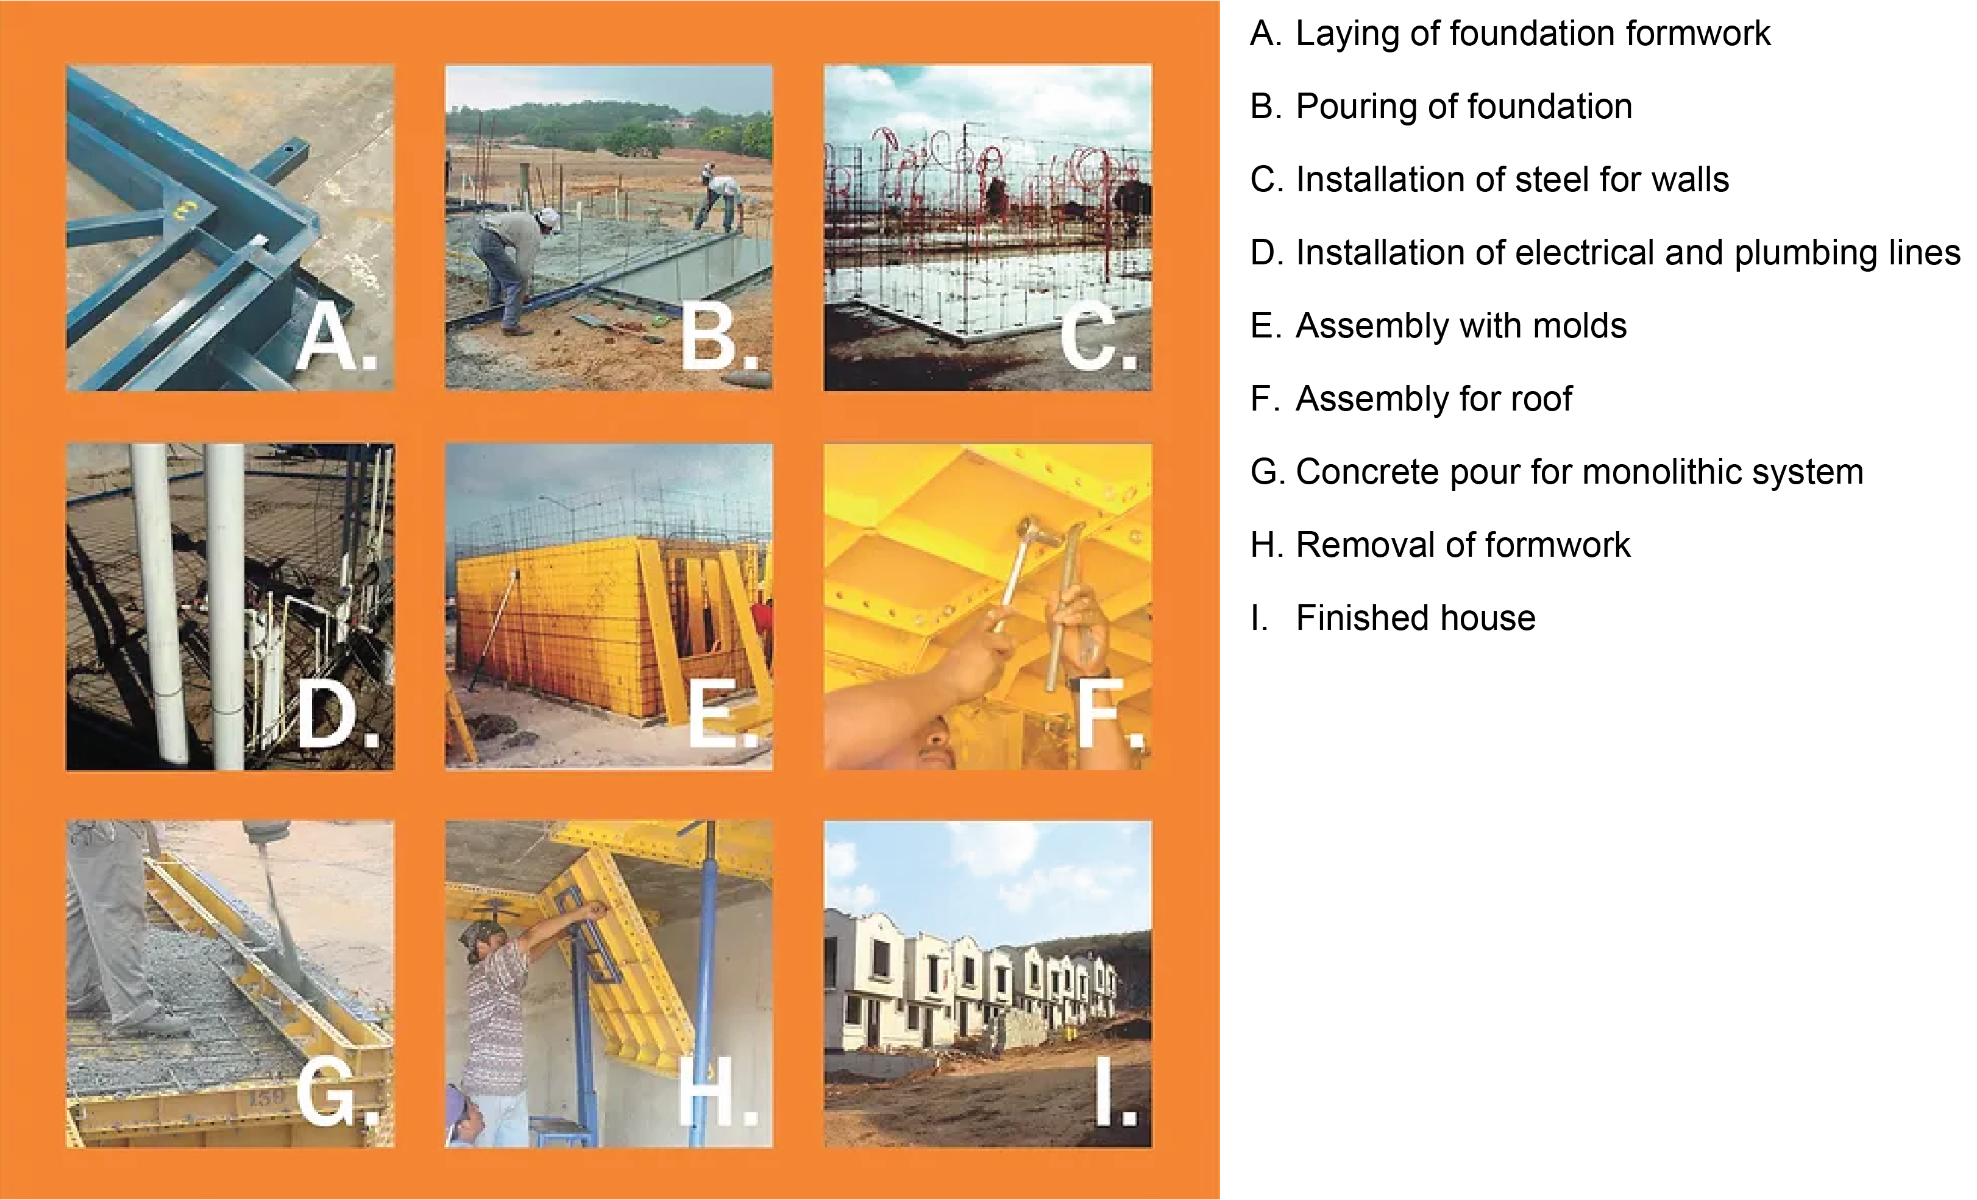
Note. Adapted from: Proceso Constructivo — Modelo Total, by Meccano (https://www.meccano.mx/copy-of-proceso-tradimecc). Copyright by Meccano de Mexico, S.A. De C.V.

Figure 16 Meccano concrete panel system – Building process

Meccano, founded in 1982, is a Mexican company that supplies equipment and technology to the housing construction industry. The company's patented metal formwork is used in various parts of the world, and it is fabricated to meet the client's specific design and size requirements (Meccano de México, n.d.) URBI has utilized the Meccano monolithic concrete formwork in many housing developments.
In the first phase of construction, metal panels are installed to delimit the area for the foundation slab. The metal reinforcing mesh is erected as soon as the concrete slab is poured and dry. Electrical or plumbing lines that need to be embedded in the wall are installed. During the second phase, panels are installed on all interior walls and prepared with a release agent to facilitate dismantling. This phase also involves placing the metal window frames between the molds, which creates an area for the windows. Unlike openings, such as doors, which use unique edge panels, this type of opening does not use any edge panels. Following, exterior panels are installed, along with accessories that ensure walls are aligned and have the correct dimensions. The third phase involves the installation of panels for the finished roof slab or second-floor slab if the structure is multi-level. While installing the roof slab panels, studs provide temporary support. Before pouring concrete, a metal reinforcing mesh is installed on the exterior of the roof panels, along with other mechanical and plumbing connections. Concrete is delivered in a revolving drum by a cement mixer and poured with a telescoping boom concrete pump. URBI partnered with the national cement company Cemex to develop accelerated-strength concrete that can be used for walls and slabs. A house can be constructed with concrete-finished walls and a concrete slab for the roof in one operation. Upon releasing the formwork, the monolithic shell of the house is ready for detailing and finishing. Different trades follow the de-molding process of the house by the "molderos," as they are referred to colloquially. This stage involves the installation of doors and windows, interior tiles, bathroom accessories, and plaster or paints according to the design of the house (Escobar, 2022).

The work site is a large outdoor industrial plant where houses are constructed through an assembly line process. A system such as Meccano, deployed to build thousands of homes, has been a developer's dream since the invention of the balloon frame in Chicago in 1833. The first onsite fabricated wall system made of timber studs was described to architects in Sigfried Giedion's Space, Time and Architecture, published in 1941 (Davies, 2005). However, URBI's founder Cuauhtémoc Pérez Román was inspired by the assembly process of manufacturing plants installed along the border, including in his native city of Mexicali. By the late 1980s, the manufacturing industry in the border cities of Tijuana and Juarez concentrated 47% of all maquila workers (Garcia de Fuentes, Morales, & Perez, n.d.)

From 1981 to 2016, URBI constructed 431,000 homes in regions across México, spanning from the state of México in the south to Tijuana in the north (BMV, 2015). It is estimated that approximately 1,760,000 Mexicans live in URBI homes today (Gonzalez-Ochoa, 2022). Nevertheless, as Arreola's photograph illustrates, URBI's history is not solely one of success. Despite the significant investment in technology, associations with private industry, and global capital, they have been unable to overcome constant changes in state housing policies. This is due to inadequate urban planning strategies that have been unsuccessful in facilitating community resilience and providing stability against housing market crises.

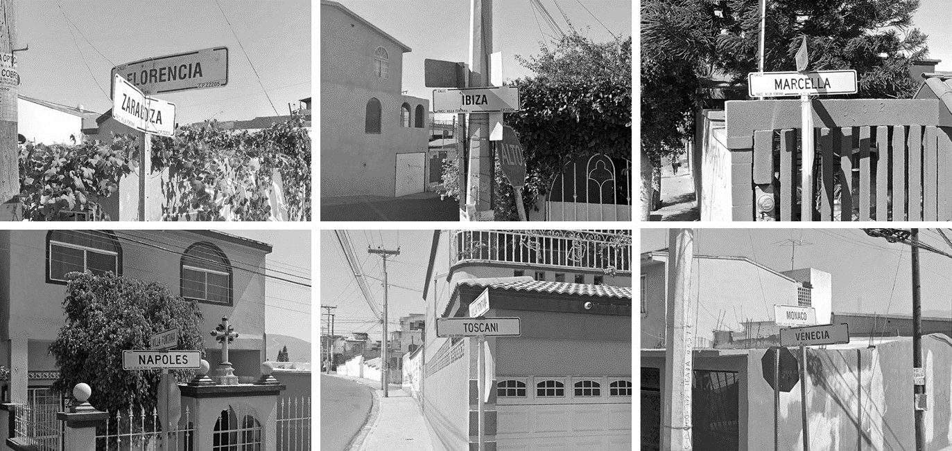
URBI’s production system was inspired by the in-line production processes of the region's manufacturing industry and the North American housing market. In Tijuana, they built tiny houses with miniature front lawns framing their small facades on lots no wider than 6.5 meters, adorned with polystyrene architectural molding on the front façades of the tiny, repetitive houses reminiscent of Spanish-style California bungalows. URBI housing developments consist of hundreds of units clustered on narrow streets with names reminiscent of Mediterranean towns such as Venice, Naples, Marseille, Florence, Ibiza, and many other European towns and cities (see Figure 17). Residents must envision an unknown and faraway place to perceive a local sense of place. Furthermore, houses are relatively small and need to be completed by the imagination of their owners since there is not enough space to accommodate everyone's desires.
Google Earth Pro Images. (11/17/2016). 32d 30’ 05.27” N 116d 51’ 28.70” W.
Accessed, 11/18/2022
Figure 17 Street names in Villa Fontana XVI, Tijuana.

As illustrated in Figure 18, houses in URBI developments underwent a physical transformation as residents constructed room additions over the initial monolithic blocks, incrementally creating socio-material assemblages. Due to the absence of access to the metal panel systems from which the houses were constructed, the newly expanded areas require different types of materials to be transformed into structural partitions, such as concrete blocks, metal studs covered in cement boards, or second-hand wood from the USA. Once the upper-level section is completed, an exterior staircase connects it to the existing building. Even though additions are built incrementally and with different materials, they require a city building permit if they exceed 60 square meters. In this sense, incremental housing is not always informal. In incremental architecture, labor and material accretion provides the framework for assembly (McFarlane, 2011).
Figure 18 Housing development transformation by users

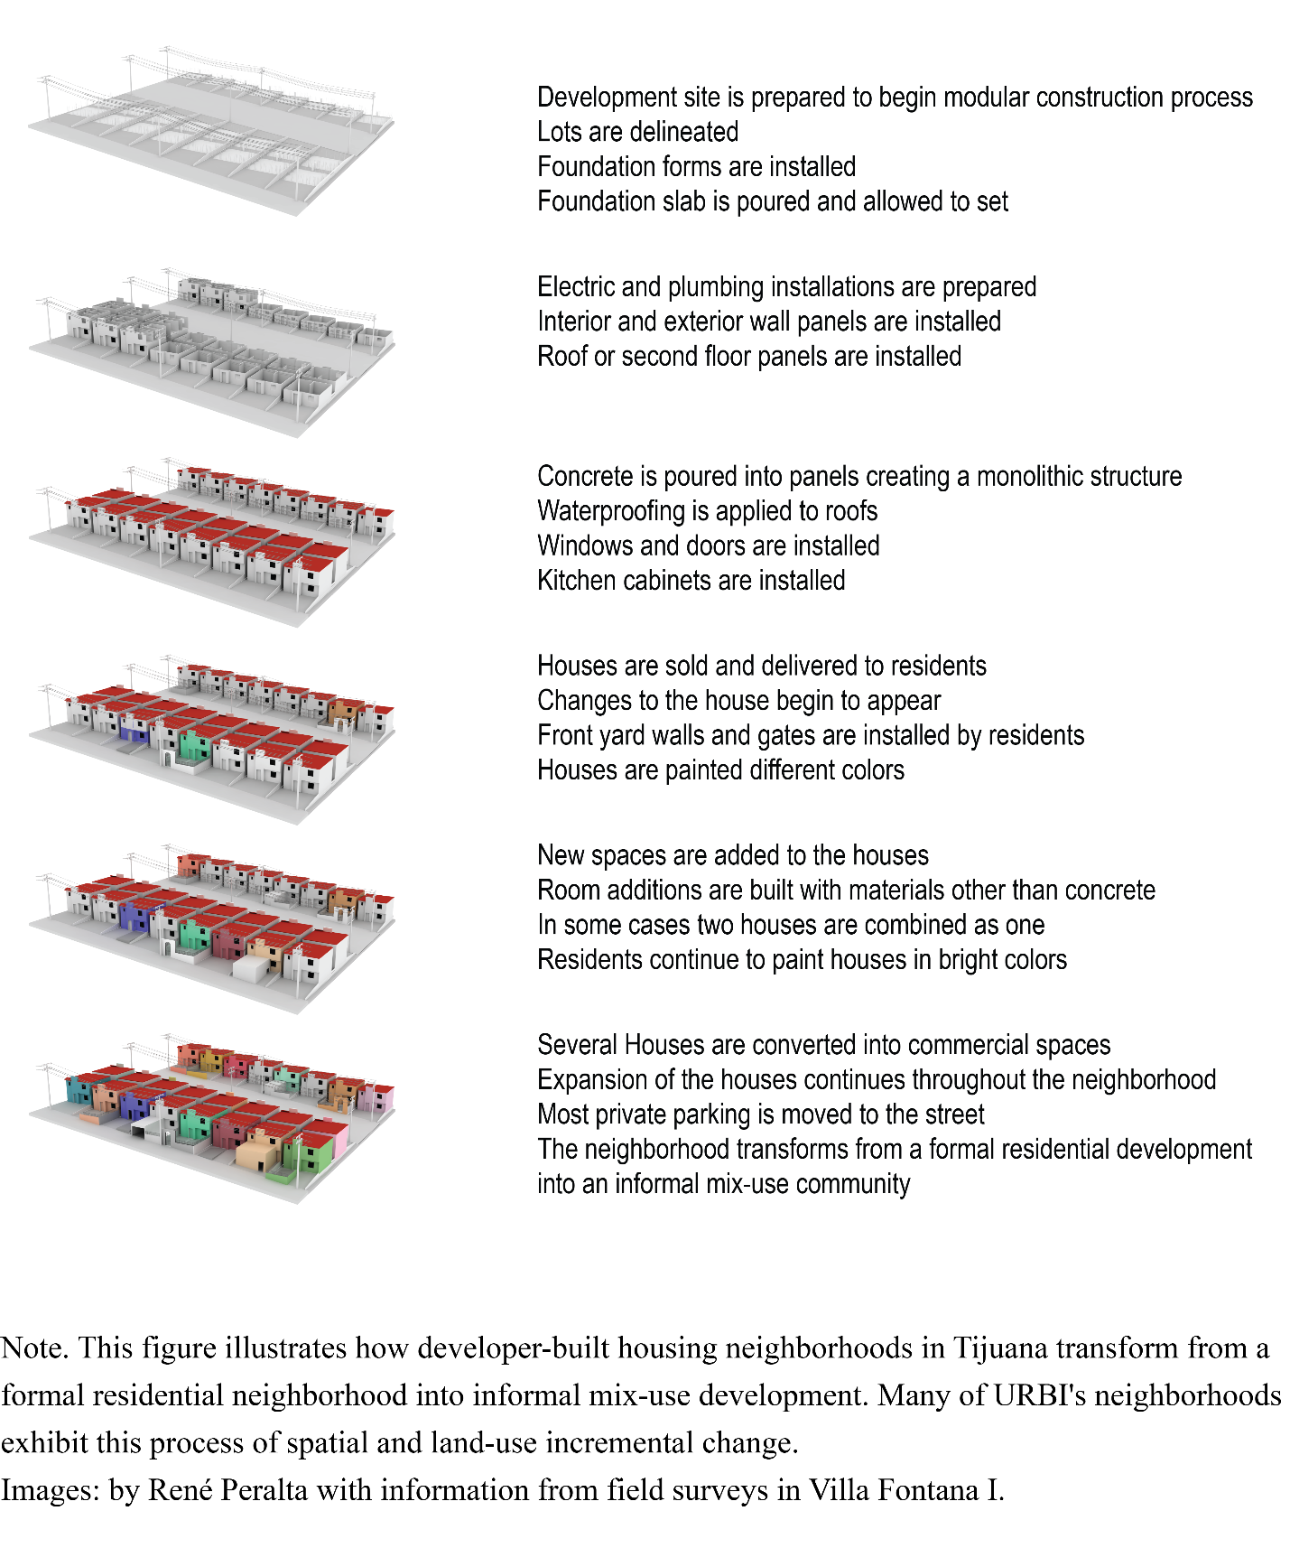

Research literature regarding URBI does not typically discuss the technology involved in the production of houses, or their operation management, administration, marketing studies, or sales strategies. It is, however, interesting to note that URBI formed significant alliances with global corporations. For example, in a partnership with Hewlett Packard, URBI developed an intranet system and a method to predict changes in the tastes and needs of the housing market. The company continued to explore other technologies, such as I.T. environments that optimize land operations processes, database administration, and cloud optimization applications (Softek, n.d.).

In 2007, URBI sent a newsletter announcing an alliance with the French firm Outinord to promote the company’s industrialized housing construction system. Outinord has facilities in Florida and is a construction formwork designer, manufacturer, and supplier with over 12 million dwellings built worldwide. Outinord collaborated with URBI in 2004 on the Santa Fe Villas project in Tijuana, Baja, California (URBI, Urbi and French Firm Outinord Ratify Productive Alliance, 2007). Before this alliance with Outinord, URBI had used the Meccano system and was awarded the XIII Obras Cemex Award in the category of Affordable Housing Construction System (Meccano, n.d.).

Urban planning researcher Dinora Gonzalez Ochoa, who has studied URBI’s social housing projects in Tijuana, has determined that the Meccano system offers significant advantages over traditional construction methods because it shortens the construction time of a housing unit from one week to only one day. In her work, Gonzalez Ochoa analyzes social housing construction in the context of the urban environment from an urban development perspective and is one of the few researchers who have written about URBI comprehensively. Gonzalez-Ochoa employs a quantitative approach to measure economies of scale and, secondly, to evaluate housing location decisions regarding land prices (Gonzalez-Ochoa, 2022).

In the construction of URBI housing, no skills or crafts are being used. All the components of the house are made from concrete panels. Due to this, trades such as carpenters are not required because roofs are no longer made from wood, and everything else, such as doors, kitchens, and bathroom furniture is available off-the-shelf. Construction sites at URBI are primarily staffed by laborers who assemble. The URBI building system has lost the haptic experience of building your own house. John Turner used to say “housing” should be treated as an activity, as a verb (Turner & Fichter, 1972). Gaston Bachelard's idea of the house as an individual universe (Bachelard, 1994) is replaced with a spreadsheet perspective of an accountant, who views the house as a market commodity that generates economic or financial value for investors and political gains for the government through the use of industrialized construction methods.

Most studies regarding URBI identify the problems generated at an urban scale by the serialized homes constructed for other developments in Mexican cities, particularly in Tijuana. However, there is little research on technology and its impacts, such as a comparative analysis of construction systems in other countries or the potential of the technology to produce different housing typologies. To better understand the successes and failures of URBI and how its story intersects with the history of technology and national culture, it is helpful to examine one URBI project in additional detail, such as Villa Fontana.

Case Study: URBI’s Villas.

Villa Fontana

Developed in Tijuana between 1995 and 1996, Villa Fontana is URBI's first significant development in México. Constructed on land designated for agricultural use in 1915, the area formed part of the federal communal land system of ejidos. The area was later zoned for industrial parks and manufacturing industries in the second half of the 20th century. Only 10 km east of the city center, this area was destined for future growth in the 1990s. By the turn of the century, the area had grown considerably and housed half of the city's working-class population. The land in Villa Fontana was inexpensive compared to the rest of the city since it was where most of the informal communities settled before private developers and industrial parks acquired large plots of land in the area. Today, only 35 %t of Tijuana’s land remains in ejidos. (IMPLAN, 2021). The Tijuana municipality built a six-lane boulevard to connect the URBI Villas to the rest of the city and a second international entry point for private, commercial, and industrial freight crossings.

Since the 1970s, Tijuana has evolved from a tourism-based economy to an industrial one, with population growth linked to manufacturing activity. Initially, manufacturing plants only assembled products; therefore, the economic contribution to the region was limited. By 1994, after the signing of NAFTA, manufacturing evolved into a more specialized assembly method and became the city’s most important economic sector. During the 1990s, Tijuana was recognized as the world production capital of televisions. In the 2000s, it maintained its lead in electronic manufacturing by adopting digital technologies and creating significant industrial clusters of private companies (Carrillo, 2016).

Villa Fontana I was built in the 1990s on approximately 38 hectares and consists of approximately 1340 houses. By 2016, URBI had constructed 19 communities named Villa Fontana (I - XIV), Villa Real, and Villa del Sol on the east side of Tijuana, with approximately 20,000 homes for 60,000 residents (see Figure 19). It is important to note that all developments were designed with essential services such as water, sewage, paved roads, and sidewalks.
Figure 19 Map of Tijuana and URBI developments
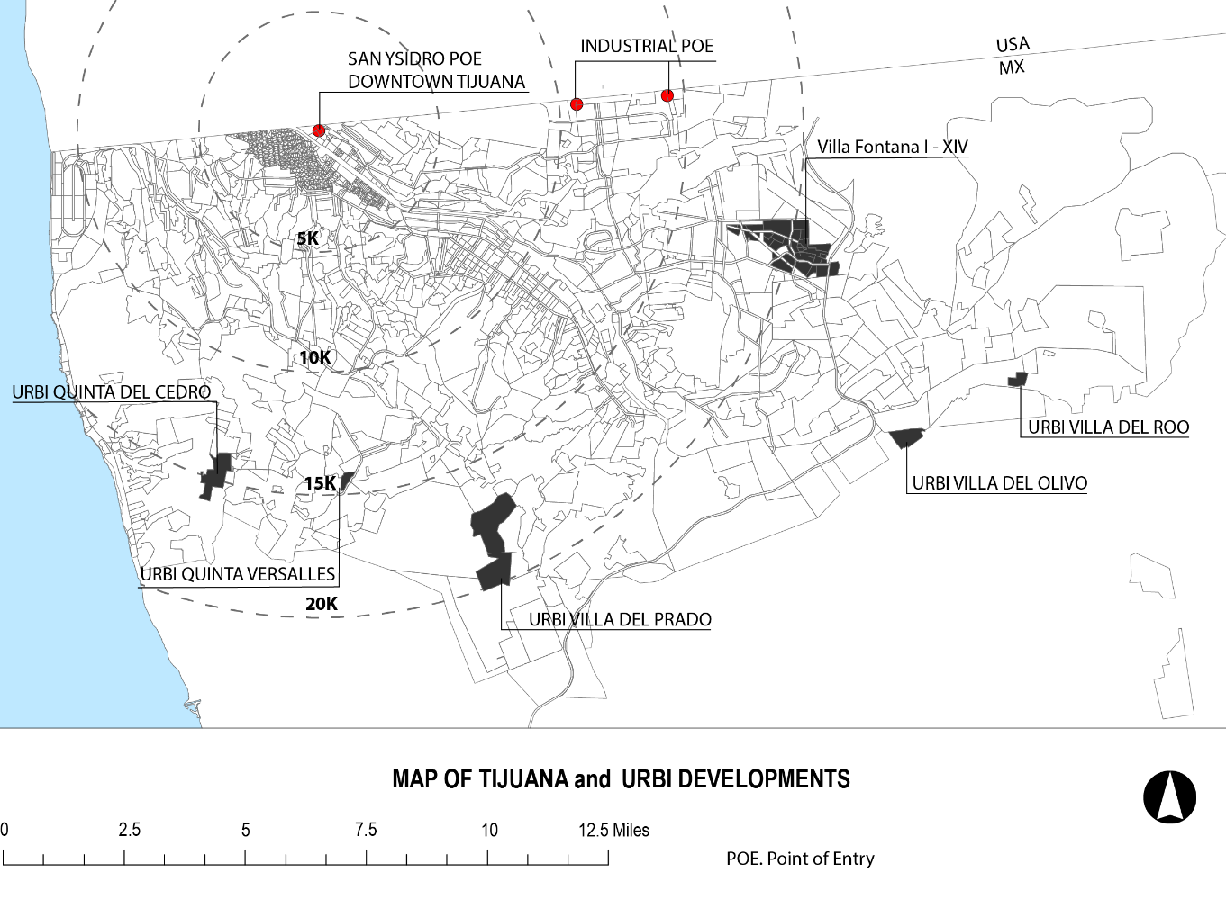

Note. Elaborated by Rene Peralta with information from the Municipal Planning Institute of Tijuana (2022).
In addition to these services, most have a small park and an elementary school. However, due to limited commercial uses near the developments, houses were converted into shops, nurseries, and other spaces for community services (IMPLAN, 2021).
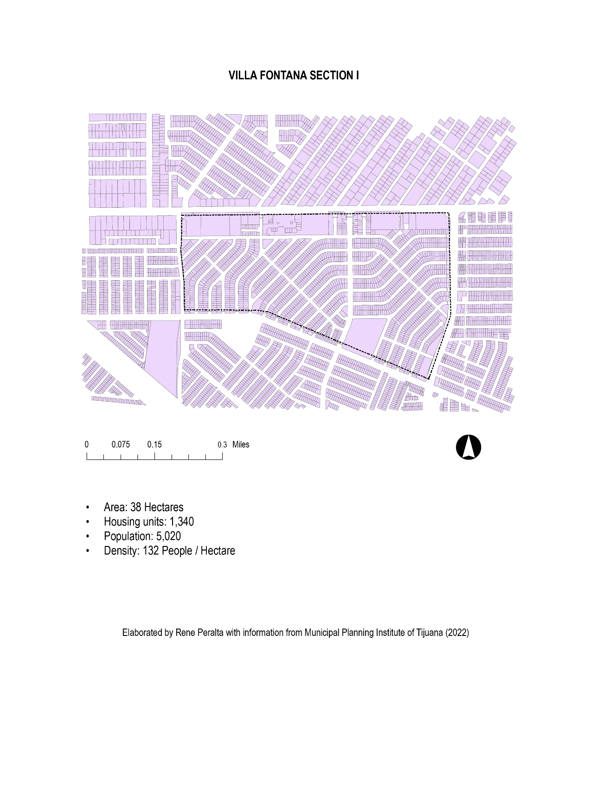
Figure 20 Figure Ground Map of Villa Fontana I

As soon as a house is purchased, its owners modify it to accommodate the needs of a typical Mexican family of four. The Villa Fontana houses have a built area of 46m² on one level and are constructed from poured-in-place concrete panel systems. The interior includes a small kitchen, an integrated dining room, and living room, one bathroom, and two small bedrooms. The additions are first made at ground level, taking over the one-car parking spaces left for each house; residents choose to park their cars on the street to maximize interior space. In proportion to the resident's income, the house also grows vertically.

The second floors are constructed on top of the original concrete roof slabs using light gauge metal studs or wood framing to minimize the load on the existing structure. Using lighter materials than masonry, the construction process is expedited, and less debris is produced, which minimizes trips to the city landfill. Most Villa Fontana residents have transformed their houses into two-story residences revealing their distinctive design tastes. The architectural styles of some houses include a version of the California Colonial aesthetic and more eclectic variations. Many materials are used to re-construct these houses, from exposed brick to stucco surfaces painted in bright colors, like the houses in southern Mexican towns.

Villa Fontana's former resident Alejandro Ruiz emigrated with his family from Mexico City at five years of age and was one of the original families in the development. He remembers the tiny house that had to suffice for a family of four. His parents slept in the living room, allowing the two sons to have their bedrooms. His two-bedroom house had an area of 46m2 (see Figure 21). The lot was also small (110m2) with just one parking space, and Ruiz remembers that he and his friends would climb to the roofs of the houses on his streets to play, hopping from one roof to another. He still dreams of playing with friends on the roof as an adult.

By the time he started college to study architecture, the neighborhood had begun to change. Many houses became markets, daycares, and doctor’s offices, among other functions. Neighbors built room additions in their parking areas and parked their vehicles on the street, leaving it very narrow for cars to pass. The street is 12 meters wide, with 1.5 meters of sidewalk on each side and 9 meters for the roadway.

Ruiz remembers there was very little social cohesion between neighbors. Social interactions happen outside the community or as needed for economic reasons. Many children travel to other city areas to continue their education after elementary school. However, he hopes young residents can participate more actively in their community. If they decide to stay and there is room for them.

Alejandro Ruiz graduated from architecture school and obtained a master's degree in urban planning. He attributes his desire to become an architect to the experience of growing up in a tiny home in Villa Fontana. From 2018 to 2019, he was the director of the Instituto Municipal de Planeacion (Municipal Planning Institute of Tijuana – IMPLAN), the city’s planning agency that oversees research and strategic urban development and projects.

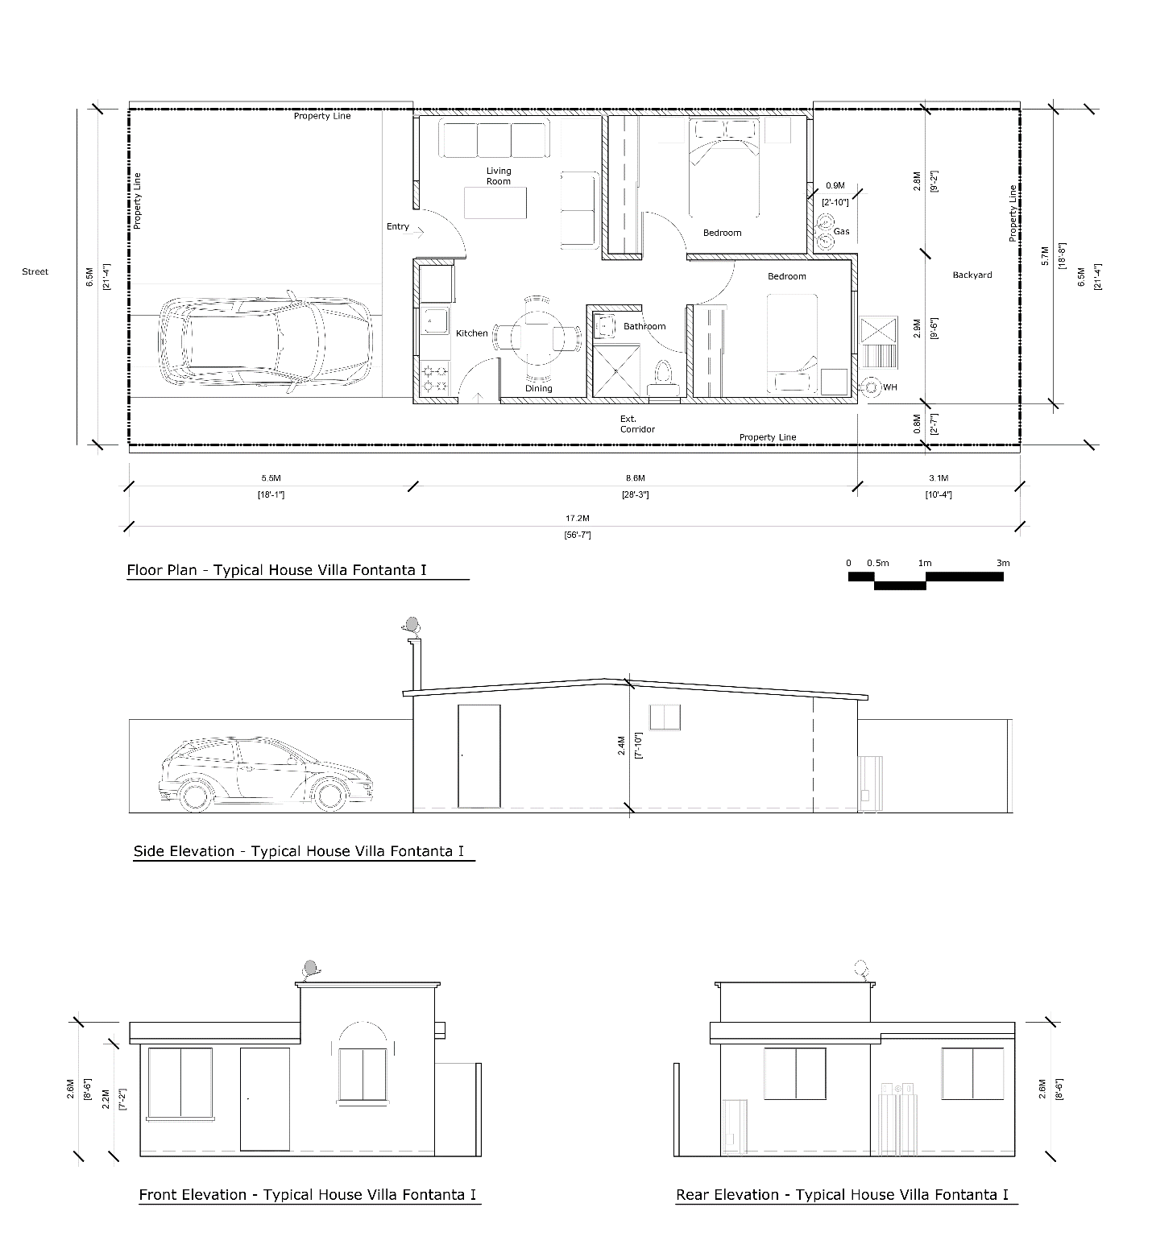
Note. Plans drawn by Rene Peralta with information from Alejandro Ruiz. 2022
Figure 21 Villa Fontana House of Alejandro Ruiz. Original Plan.

URBI Villa del Prado
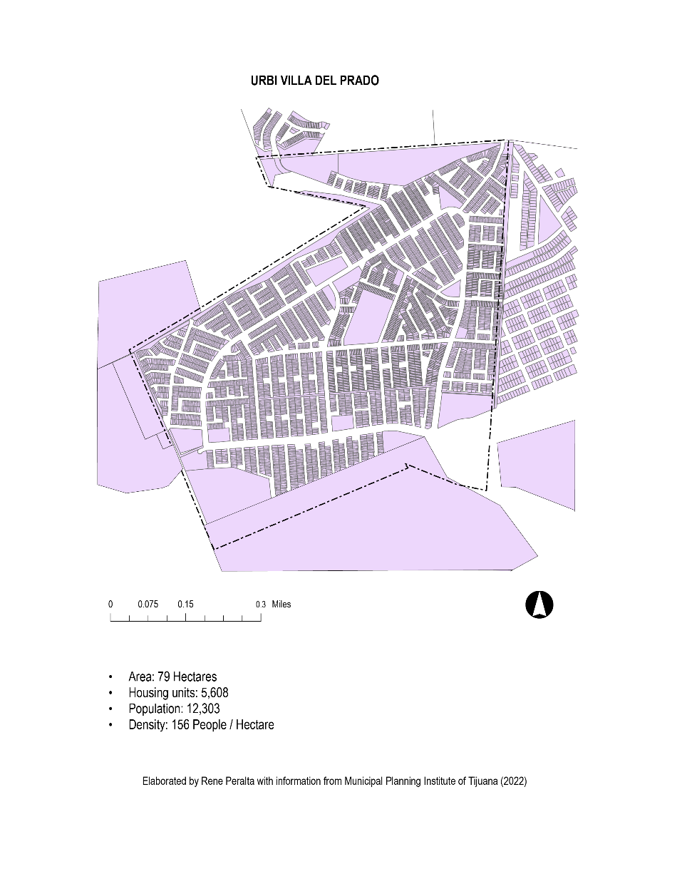
Figure 22 Figure Ground Map of URBI Villa del Prado
What kind of life unfolds in the homes of URBI in Tijuana? How do the urban design, the architecture, and the interiors designed and constructed by URBI influence the communities that grow from these places? In what ways do global capitalism and new technology surface in these communities and homes? The 2014 film El Hogar al Revés (Upside-Down Home) provides a glimpse into the lives of three adolescent boys who call the URBI Villa del Prado development home.

Directed by Itzel Martinez del Cañizo, El Hogar al Revés documents the hardships and dreams of Santos, Gerardo, and Omar, teenagers living in URBI Villa del Prado, a low-income housing development in the southwest region of Tijuana. Besides their deep friendship, the three boys share a deep sense of emptiness as their mothers work all day in nearby factories. Their ways of coping with monotony, loneliness, and an empty home are distinctive and personal. However, they find solace in their friendship. El Hogar al Revés is a story of real life and juvenile illusions in the context of hardships and absences, where dreams meet unexpected consequences.
Figure 23 Figure 22 Still Image from El Hogar al Revés. Scene overlooking Villa del Prado
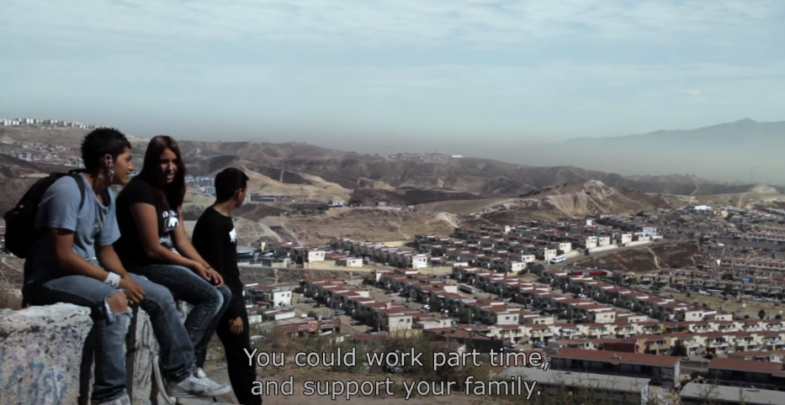
URBI Villa del Prado is a development built in the mid-2000 with an estimated population of 12,000 (see Figure 22). Like other URBI communities, it was constructed in the city's outer ring. An area of rugged topography once regarded as a natural reserve or potential development site. Meanwhile, affluent neighborhoods were built in the flatter areas near the border. Major private developers have developed many working-class communities in México and share similar geographical and architectural characteristics. A lack of integration between these developments with the urban core contributes to the "ruralization of the city" (Herzog, 2015).
Note. From El Hogar al Revés. By Itzel Martinez del Cañizo, 2014. Copyright Polen Audiovisual.

The URBI Villa del Prado is predominantly a working-class development marketed to migrants from southern states searching for employment in the Tijuana manufacturing sector. However, El Hogar al Revés does not reflect this reality's complete picture. The documentary does not contain images of factories or scenes with the parents of the three main characters. Nevertheless, hundreds of single-family detached homes sharing perimeter walls without setbacks or lateral separations are evident in the film.

Santos, Gerardo, and Omar, the three main characters of the documentary, attend a local government junior high school and are about to graduate. They will then decide whether to continue their education in high school, seek employment in nearby manufacturing plants, or start a family. It is a crucial period in their lives, especially since the average Mexican male only attends school for 9.84 years (INEGI 2020).

There are two significant settings in the film where scenes take place. One of these spaces is within the small house where the characters share rooms with their younger siblings and carry out chores while the mother is away at work. Their daily lives are limited by the few activities that can be carried out inside the tiny house. Cooking, eating, and watching anime on bootleg DVDs obtained from the local street market are all done in the same area. As if the house were merely a container for temporary living, the appliances and furniture in the two-bedroom house appear provisional. The cooktop is similar in size to a camping stove, while the T.V. and sofas are only large enough to allow circulation to the kitchen and bathroom. The interiors have not aged well. The light sockets in the ceiling hang from their wires, the concrete floors are bare without any finish or carpet, and most windows and doors are secured with bars. However, it appears that the concrete shell of the wall has retained its structural integrity. Fortunately, they continue to have access to a roof over their heads. After becoming bored and suffocated by the confined residential space, the young characters venture out to the street to meet with friends and hike up the barren hills that developers deem unsuitable or economically unviable for constructing new homes (see Figure 23).
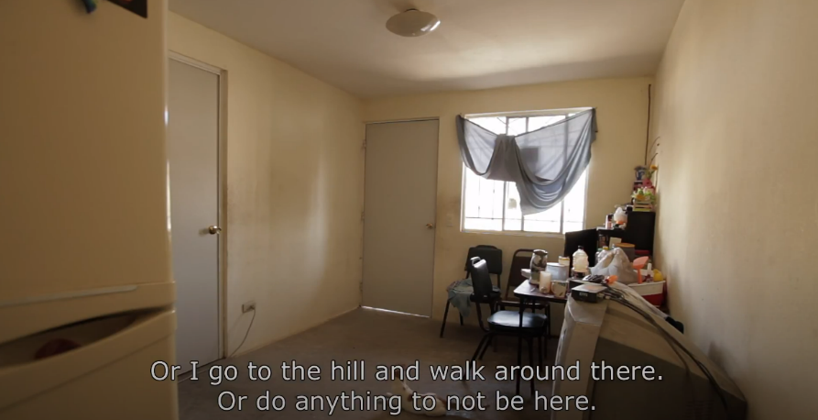
Figure 24 Still Image from El Hogar al Revés. Interior
Technology and social media play an essential role in the life of the young characters of the documentary. Cell phones are an escape, a way to socialize with friends, and how challenges, joys, and dreams are shared. Cable television or telephone landlines are not an option. As Omar mentions in the film, his mother’s salary in the manufacturing plant, 254 dollars a month at the exchange rate in 2014, is mainly used to pay the house mortgage and purchase food. Therefore, cable or satellite tv, telephone, and residential internet are luxuries they cannot afford. According to México’s Federal Institute of Telecommunication, there are 88.2 million cell phone users in the country, representing 75% of the population, and 90% of internet users are between the ages of 12 to 17 (IFT, 2021).
Note. From El Hogar al Revés. By Itzel Martinez del Cañizo, 2014. Copyright 2014 by Polen Audiovisual.

URBI Villa del Prado has transformed from a development of houses to an urban community through the desires and needs of its citizens. In the film, we see many tiny homes converted into convivence stores, daycare facilities, beauty salons, and other commercial functions that typically support an urban community. Numerous commercial spaces are also built provisionally and set up instantly along the streets. On the sidewalks, food stalls equipped with small tables, ice chests, and 5-gallon water containers are set up under tarps with four metal poles to provide workers with food on the go. Hand-painted signs promote the menu and prices to workers going to the manufacturing plants in the morning to students walking home from school in the afternoon. Everything is quickly built and can be dismantled to fit in a small car and move to another location as needed.

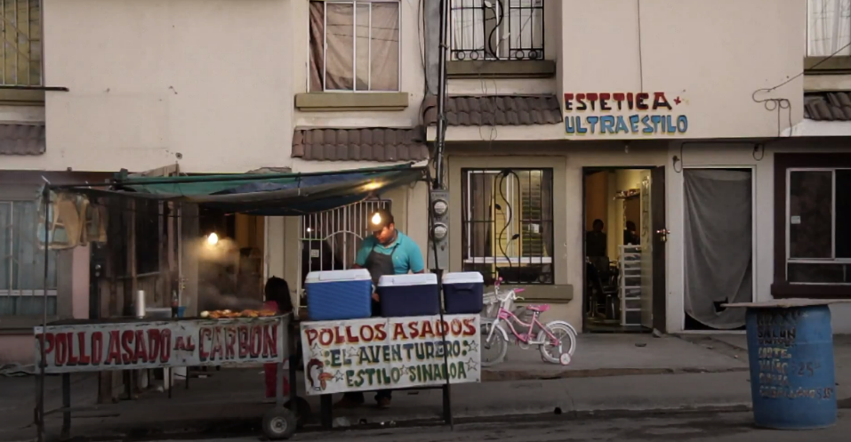
Everyday Santos, Gerardo, and Omar, along with a few close friends, walk up a hill to attend the Escuela Secundaria General #22, one of three schools in the area. As they are filmed walking to school, you can see the concrete facades of the URBI homes, and a few apartment-type residences built with the same concrete panel system. The walls do not have a coat of plaster since the structural concrete was the finished surface. The concrete roughness is visible under a coat of beige paint, a perfect surface for graffiti or urban murals designed and painted by community members.
Note. From El Hogar al Revés. By Itzel Martinez del Cañizo, 2014. Copyright 2014 by Polen Audiovisual.

Figure 25 Still Image from El Hogar al Revés. Street Vendor.

In the early 21st century, URBI Villa del Prado represents an experiment in construction technology, housing typologies, and policy restructuring. The URBI development model reflects the influence of global capitalism and how a functioning neighborhood emerges from the serialized production of houses. Manufacturing (maquiladoras) has significantly changed the economic environment of Tijuana, which has increased population since the 1960s. As more Mexicans migrated north, searching for employment, the city's housing demand increased. While cities like Tijuana become neo-industrial zones for capital, the citizens of Villa del Prado play a role not only as the city's labor class but also as part of the national globalization project.

Historically, the Mexican house has always been an integral part of the land on which it stands. The architecture of México has a rich history rooted in the principles of permanence, solidity, and grounding. The home has historically been a symbol of economic, material, and cultural value. Towards the end of the 20th century, the development of social housing projects in México was primarily driven by construction expediency with little consideration for the historical and cultural significance of the house and its neighborhood. México imported what Lawrence Herzog calls “global suburbs,” commodified spaces and low-density suburban landscapes from its neighbor to the north. (Herzog 2015).

In the documentary’s first scene, a large crowd gathered in a small park in the development, listening to the voice of a community activist on a megaphone explaining how the government conspired with developers against the working class to create substandard housing:

URBI, Geo Ara Houses, or whatever their name is, came and bought cheaply here. The money they use to build does not come from their pockets. Do you know who lends it to them? The government! They do not charge them interest. It is almost a gift. They charge no interest because INFONAVIT is a federal housing fund. Once they make these birdcages, no offense to the people living here. They come and sell them as if they were residences in the United States. Because over 30 years, you will pay almost two million pesos. If you want to sell them, even if they are paid off, do you know when you will return your investment? Never! (Martinez, 2014).

On a nearby concrete bench, Santos, Gerardo, and Omar are listening to this megaphone voice of despair and jokingly comment that they do their part by keeping their house clean and disposing of trash. As the protest continues, they initiate a breakdance session. The boys understand that the community’s situation extends beyond tiny houses and mortgages. Villa del Prado is a place for life’s interaction; they are aware they are part of a network of relations rather than victims of a system.

El Hogar al Revés concludes with the three young boys contemplating their uncertain futures as they roam the different spaces of Villa del Prado and witness intricate details of daily life unfold in its urban assemblage. In the film, none criticize their house for being low-quality construction and small or for their development as a low-income area. Under the possibilities available in their environment, Santos, Gerardo, and Omar live and act in the present. According to Manuel DeLanda, subjects or actors can retain their autonomy and maintain awareness of interactions outside their spatial environment when they enter into possibilities or constantly change around them as relations of exteriority (DeLanda 2016). A person inhabits an assembly and lives through the possibilities it opens (exteriorities) that may not be related directly to it (McFarlane, 2011).

Architect and scholar Fernanda Canales reconsiders the concept of memory in the context of the earthquake that struck México City in 2017. Canales explains that after the earthquake, reconstruction immediately took place without regard to the rituals of everyday life of citizens, projects absent of memory (Canales, 2020). Canales reminds us that historic housing stock is already filled with memories that cannot be preserved or replaced with serialized mass-produced homes. Canales questions the Vitruvian ideal of structural “fitness” in contemporary terms and then explores the phenomenological concept of memory in 70 canonical works of architecture. She writes, “This hasty building strategy has forgotten what I attempt to address in this book: the importance of understanding the house as the space where personal histories are interwoven with the histories of a place and culture” (Canales, 2020).

Martinez del Cañizo’s documentary of life in a URBI development deepens this critique by taking us inside its homes, where we witness the making of memories by the three boys. However, the filmmakers also portray a relationship between people and places distinct from that related to historic urban sites in Mexico. In the URBI developments, the building foundations are shallower, the walls slenderer, and the rooted quality of habitation is absent. The permanence of historic Mexican urban areas has been replaced with an impermanent form of human settlement.

Conclusions

The end of the 20th century was marked by profound changes in many sectors, including the production of houses, digital design technologies, mediated social platforms, and other systems offering a new zeitgeist to reconcile the problems of modernity never resolved. Driven by technology and global capital, new practices in architecture and construction inspired new dreams for housing the masses. As Monica Areola’s photograph of an abandoned social housing project on the outskirts of Tijuana reminds us, technological instruments played a crucial role in fueling the imagination and desires of housing developers in the 21st century and their failures.
Technology, housing, and national identity are closely linked phenomena, which can be analyzed by putting together what DeLanda calls an assembly of exteriority or actors who are not part of any specific identity project but intervene depending on how strongly their intensities are emphasized (DeLanda, 2016). For example, computational systems began to emerge in the 1990s and enabled the digital operability of construction tasks with the capacity for serial component management (cad drawing documents, specific details, and modular design software). These technologies made possible the creation of a company like (URBI) that can build thousands of homes in a relatively short period as products manufactured on the open field, similar to other commodities are assembled in a low-wage manufacturing plant on the border This task had never before been achieved in México. Ultimately, an assembly is also a flat ontology where human and non-human actors interact through human desire, which gives the assembly its purpose. A desire on the part of the user or state representing a complex network of possibilities (Buchanan, 2021).
What also emerged is a normative (business of usual) condition continuing to promote regional and national economic development within the capitalist system above the welfare of citizens. A system of new technologies aimed at producing more consumer goods, the housing being one of them and failing to create the social and urban condition for communities to thrive. Jones-Imhotep has advocated for distinguishing between failing and failed technologies. Failing technologies are those we may critique and find frustrating but still use. Failed technologies are those no longer in use. While many scholars and critics have dismissed URBI as a failure, in Jones Imhotep’s framing, we can more clearly understand it as failing, a techno-politics of failure, still very much in use (Jones-Imhotep, 2017). Thousands of Mexicans continue to call URBI houses home each day.
Despite URBI's clever and innovative construction technologies, many of these projects failed to be completed. Ultimately, the problem was not strictly a design and construction challenge. As Tito Alegría argues, “The housing problems in Tijuana are due less to a deficit of architectural proposals and more to a shortage of low cost or subsidized financing, urban planning, land supply, nearby jobs, and public services” (Alegria, 2008).
As Benedict Anderson implies, contemporary México is a nation whose “future looms out of an immemorial past” (Anderson, 1983). Two distinct imaginaries have been interwoven in México’s housing history and policy. On the one hand, the state has produced a political system designed to foster a compliant working class in a nation that corresponds to political mandates and visions of social democracy while simultaneously creating an economy in the image of global capitalism. On the other hand, a segment of society seeking emancipation since the Revolution of 1911 continues to be suppressed even as it is forced to move from a rural to an urban environment. This subjugation is possibly due to the rapid deployment of technology that builds housing encampments overnight.

References

(n.d.). Obtenido de Urbi Desarrollos Urbanos, S.A. de C.V. | Encyclopedia.com: https://www.encyclopedia.com/books/politics-and-business-magazines/urbi-desarrollos-urbanos-sa-de-cv
Alegria, T. (2008). The Solution is Not Architectural. Housing Problems of the Poor in Tijuana. Harvard Design Magazine, 64-66.
Alegria, T., & Ordoñez, G. (2016). Legalizing the City: Informal Settlements and Regularization Process in Tijuana. Tijuana: El Colegio de la Frontera Norte.
Alexander, C., & Davis, H. (1985). The Production of houses. New York: Oxford University Press.
Anderson, B. (1983). Imagined Communities. New York: Verso.
Arreola, M. (2013). Desinteres social. Recuperado el 2022, de Monica Arreola: https://www.monicaarreola.com/desinteres-social
Arreola, M. (May de 2022). Valle San Pedro. Obtenido de Monica Arreola: https://www.monicaarreola.com/valle-san-pedro
Bachelard, G. (1994). The Poetics of Space (reprint ed.). Boston: Beacon Press.
Biagioli, M. (1999). Introduction. En M. Biagioli, The Science Studies Reader (págs. XI-XVIII). New York: Routledge.
Blas, P. (July de 2015). LAS RUINAS QUE DEJÓ EL BOOM DE LA VIVIENDA POPULAR EN MÉXICO. (I. T. (ITESO), Editor) Recuperado el 2022, de Magis: Profesiones + Inovacion + Cultura: https://magis.iteso.mx/nota/las-ruinas-que-dejo-el-boom-de-la-vivienda-popular-en-mexico/
Blau, E. (2006). Isotype and Architecture in Red Vienna: The Modern Projects of Otto Neurath and Josef Frank. Modern Humanities Research Association, 227-259.
BMV, G. (2015). Perfil. Urbi desarrollos urbanos. Recuperado el 2022, de Grupo BMV: https://www.bmv.com.mx/es/emisoras/perfil/URBI-6089
Boils, G. (2004). El Banco Mundial y la politica de vivienda en Mexico. Revisata Mexciana de Sociologia, 345-367.
Boltvinik, J. (2000). Evolucion de las diversas formas de pobreza en Mexico. El Desarrollo Socioeconomico en Mexico: Perspectiva para el Siglo XXI (págs. 72-82). Morelia: COLMEX.
Buchanan, I. (2021). Assembly Theory and Method. London: Bloomsbury Academic.
Canales, F. (2020). Shared Structures. Private Spaces: Housing in Mexico. Barcelona: Actar.
Carmona, F., Montaño, G., & Aguilar, J. C. (1970). El Milagro Mexicano. Mexico D. F.: Editorial Nuestro Tiempo.
Creswell, J. W., & Creswell, D. J. (2018). Research Design: Qualitative, Quantitative, and Mixed Methods Approaches. Thousand Oaks: SAGE.
Davies, C. (2005). The Prefabrocated Home. London: Reaktion Books.
DeLanda, M. (2016). Assemblage Theory. Edinburgh University Press.
Encyclopedia.com. (2019). Urbi Desarrollos Urbanos, S.A. de C.V. . Recuperado el 23 de October de 2022, de International Directory of Company Histories.: https://www.encyclopedia.com/books/politics-and-business-magazines/urbi-desarrollos-urbanos-sa-de-cv
Escobar, M. (10 de Jan de 2022). Urbi Construction System. (R. Peralta, Entrevistador)
Farias, I. (2010). Introduction: Decentering the Object of Urban Studies. En I. Farias, & T. Bender, Urban Assemblages: How Actor-Network Theory Changes Urban Studies (págs. 1-24). New York: Routledge.
Flores, E. O. (2012). Produccion Social de la Vivienda y el Habitat. Mexico City: Habitat International Coalition.
FONAHPO. (29 de August de 2022). Gobirno de Mexico. Obtenido de Fondo Nacional de Habitaciones Populares: https://www.gob.mx/fonhapo/prensa/sedatu-anuncia-extincion-del-fideicomiso-fondo-nacional-de-habitaciones-populares-312932
FOVI. (January de 1999). FOVI. Obtenido de Fondo de Operacion Y Financiamiento Bancario de la Vivienda: https://www.fovi.gob.mx/inicio.htm
Fundacion Esperanza de Mexico. (2015). Manual de Construccion y Mantenimiento de Vivienda. Tijuana: FEM.
Fundacion Esperanza de Mexico, F. (2018). Manual de Construccion y Mantenimiento de VIvienda 2018. Tijuana, Baja California, Mexico: FEM.
Garcia de Fuentes, A., Morales, J., & Perez, S. (n.d.). IMPACTO TERRITORIAL Y ESPECIALIZACIÓN PRODUCTIVA DE LAS MAQUILADORAS EN MEXICO. Globalizacion y regionalizacion economica de Mexico.
Garcia Peralta, B. (2010). Vivienda Social en Mexico (1940-1999): actores publicos, economicos y sociales. Cuadernos de Vivienda y Urbanismo, 34-49.
Garza Villareal, G. (1989). Una década de planeación urbano-regional en México, 1978-1988. Mexico City: El Colegio de México.
Gonzalez-Ochoa, D. J. (2022). Policy Induced Suburbanization: Mass-Produced Housing and LocationChoices in Tijuana, Mexico. Housing Policy Debatge, 2-18.
Gutierrez, R. S., Mujica, J. A., & Izaguirre, V. M. (2010). Manual normativo para el desarrollo de vivienda sustentable de interes social en Mexico. Mexico CIty: Plaza y Valdez.
Harman, G. (2014). Bruno Latour Reassembling the Political. London: Pluto Press.
Herzog, L. (2015). Global Suburbs; Urban Sprawl from the Rio Grande to Rio de Janeiro. New York: Routledge.
Hochhaeusl, S. (2010). Otto Neurath - The OtherModern: Proposing A Socio-Political Map for Urbanism. Master Thesis. Ithaca, New York: Cornell University.
Holcim. (2022). Escuela Mexicana de la Construccion. Obtenido de Holcim, Mexico: https://www.holcim.com.mx/escuela-mexicana-de-la-construccion
Holcim Mexico. (2016). Manual de Construccion. Mexico DF: Holcim.
IMPLAN. (2021). PLan Municipla de Desarrollo 2020-21. Obtenido de https://implan.tijuana.gob.mx/pdf/PMD_2020-2021.pdf
Jones-Imhotep, E. (2017). The Unreliable Nation: Hostile Nature and Technological Faulure in the Cold War. Cambridge: MIT Press.
Libertum de Duren, N. R. (2018). Why there? Delevopers' rationale for building social housing in the urban periphery in Latin America. Cities, 411-420.
Marosi, R. (26 de November de 2017). A Failed Vision. Obtenido de The Los Angeles Times: https://www.latimes.com/projects/la-me-mexico-housing/
Martinez, I. (Dirección). (2014). El Hogar al Reves [Película].
Mayorga, M. G. (April de 1949). El Problema de la Habitacion en Mexico: Reaidad de su Solucion. Revista Arquitectura Mexico, 67-74.
McFarlane, C. (2011). The City as assemblage: dwelling and urban space. Environment and Planning D: Society and Space., 649-671.
Meccano de México, S. d. (s.f.). Historia. Obtenido de Meccano Web site: https://www.meccano.mx/historia
Meninato, P. (2022). Everything but Housing. En G. Marinic, & P. Meninato, Informality and the City: Theories, Actions and Interventions (págs. 3-19). Cham: Springer Nature Switzerland.
Monaco, S. T. (2010). The Future and Evolution of CAD. 14th International Research/Expert Conference. "Trens in the Development of Machinery and Associated Technology", (págs. 1-18). TMT Mediterranean Cruise.
Monkkonen, P. H. (2009). The Housing Transition in Mexico: Local Impact of National Policy. Berkeley, California: UC Berkeley.
More, T. (1972). Utopia. Baltimore: Penguin Books.
Noelle, L. (2021). President Alemán Urban Housing Project. docomomo journal, (65, 17-21.
Ochoa, R., Guerrero, T., & Velasco, G. (2016). Housing manufacturing in Mexico: Building efficient houses in inefficient locations? 14th Global Conference on Sustainable Manufacturing (págs. 89-95). Stellenbosch: Science Direct.
O'Leary, Z. (2017). The Essential Guide to DOING YOUR RESEARCH PROJECT. Los Angeles: SAGE.
Peralta, R. (2022). Lesson of Hope: A Case Study on Self-built Homes in the Informal Neighborhoods of Tijuana. En Informality and the City (págs. 275-287). Cham: Springer.
Pérez Gomez, A. (2000). Introduction to Architecture and the Crisis of Modern Science. En M. K. Hays, Architecture Theory since 1968 (págs. 465-475). Boston: MIT Press.
Porter, P. F. (2016). La construcción de los multifamiliares de Mario Pani: historia, problemas y retos actuales. Boletín De Monumentos Históricos, (36), 159–173.
Puebla, C. (2002). From state interventionism to facilitating strategies: Change in housing policy in Mexico. Mexico City: El Colegio de Mexico.
Rodriguez, I., & Mendez, E. (2008). Paisajes y arquitecturas de las nuevas tendencias inmobiliarias fronterizas: EL caso de Tijuana. En P. C. Pererira, & R. HIdalgo, Produccion inmobiliaria y restructudacion metropolitana en America Latina (págs. 211-230). Santiago: Pontifica Universidad Catolica de CHila.
SEDATU. (2021). Autoproduccion de Vivienda adecuada en Mexico. GIZ.
SEDATU, CONAVI. (2017). Guía De Implementación Del Codigo De Edificacion De Vivienda. Mexico: CONAVI.
SEDATU, CONAVI, CONACYT. (2016). Tercer Encuentro Academico. Mexico City: Fondo de Desarrollo Cientifico y Tecnologico.
Soederberg, S. (2015). Subprime Housing Goes South: COnstruction Securitized Mortgages for the Poor in Mexico. Antipode, 481-499.
Softek. (s.f.). Articles. Recuperado el 16 de May de 2020, de Inteligra.com.br: https://www.inteligra.com.br/component/content/article?id=4738&Itemid=178
Tello, C. (July-September de 2010). Notas sobre el Desarrollo Estabilizador. Economia Informa, 66-71.
Turner, J. F. (1986). Future Directions in Housing Policies. Habitat Intl. Vol. 10 No. 3, 7-25.
Turner, J., & Fichter, R. (1972). Houising as Verb. En J. Turner, & R. Fichter, Freedom to Build (págs. 148-175). New York: Collier Macmillan.
URBI. (2004). Informe Anual 2004. Mexicali: Urbi.
URBI. (2 de October de 2007). Obtenido de Urbi and French Firm Outinord Ratify Productive Alliance: http://media.corporate-ir.net/media_files/irol/18/187928/news/productiva_Eng.pdf
Valenzuela Aguilera, A. (2017). Failed Markets: The Crisis in the Private Production of Social Housing in Mexico. Latin American Perspectives, 44(2), 38-51.
Velazquez Leyer, R. (2015). The Development of Housing in Mexico: A welfare regime approach. Social Policy and Society, 523-539.
Yiannoudes, S. (2015). Actor-networKs in Le Corbusier's housing project at Pessac. Fusion Journal, 1-14.

