UNIVERSITY OF OKLAHOMA
GRADUATE COLLEGE

UNBRANDING: DISENFRANCHISING TERRORISM AND DISENCHANTING TERRORISTS

A DISSERTATION
SUBMITTED TO THE GRADUATE FACULTY
in partial fulfillment of the requirements for the
Degree of

DOCTOR OF PHILOSOPHY

By
DAVID WATERMAN
Norman, Oklahoma
2022

UNBRANDING: DISENFRANCHISING TERRORISM AND DISENCHANTING TERRORISTS

A DISSERTATION APPROVED FOR THE
GAYLORD COLLEGE OF JOURNALISM AND MASS COMMUNICATION

BY THE COMMITTEE CONSISTING OF

Dr. James L. Regens, Chair
Dr. David Craig
Dr. Elanie Steyn
Dr. Justin Reedy

© Copyright by David Waterman 2022
All Rights Reserved

Acknowledgements
I’m extremely grateful to my Committee Chair, Dr. James L. Regens, for his invaluable patience and feedback. I also could not have undertaken this journey without my committee members, Dr. David Craig, Dr. Elanie Steyn, and Dr. Justin Reedy, who generously provided knowledge and expertise. Additionally, this endeavor would not have been possible without the generous support from a University of Oklahoma Graduate College Robberson Research Grant, who helped finance my research. I am especially thankful for my parents, Larry and Judy (may she rest in peace) Waterman. Their belief in me always kept my spirits and motivation high throughout all the trials and tribulations of life and were a key source of inspiration for this dissertation. They have been, and always will be, the strong and steady lighthouse beacon in both the brightest of days and the darkest of nights.

Abstract
This research addresses the perceived problem that past and current VEO engagement programs have been ineffective in achieving their original goals. It introduces a new approach to disenchant extremism and disenfranchise VEOs – Unbranding, defined here as the application of coordinated and synchronized powers to transform a name brand into a generic brand. A study of the history of the Irish Republican Army (IRA) and Islamic State (IS) illustrates the premise that the brand is the center of gravity of the organization. A potential explanation of how and when VEOs expand is tentatively explored. Regarded by the author as a robust pilot study, an empirical study demonstrates how a stakeholder’s personality can be a predictor of generic or name brand choices. For this study, a statistical model was specified to explain the correlation with stakeholder personality and generic or name brand selection. Regression and Path Analysis explored the relationships between the latent variables Intensity, Activity, Personality, and Resonance. Structural Equation Modelling (SEM) was used to identify the strength of relationships between structural components in the model. The study illustrates that stakeholders with a lower personality score may demonstrate low resonance and may not be moved to action for a VEO name brand. As such, a reduction in brand value and equity, as well as the resulting drop in categorical performance and standing, will weaken the organization’s ability to recruit or generate stakeholders who are willing to increase personal risk for the sake of the organization. (249)

List of Tables
Table 1. Respondent sociodemographic
Table 2. Study factor matrix
Table 3. PERSONALITY regressed on RESONANCE summary output
Table 4. INTENSITY and ACTIVITY regressed on RESONANCE summary output
Table 5. PERSONALITY, INTENSITY, and ACTIVITY regressed on RESONANCE summary output
Table 6. PROCESS output for study model
Table 7. Path Model Fit summary
Table 8. Regression and covariance for the path model
Table 9. Model Fit summary
Table 10. Standardized Regression Weights
Table 11. Re-specified Model Standardized Regression Weights
Table 12. Re-specified Model Covariances
Table 13. Model Fit Summary
Table 14. The brand’s leadership are a significant part of my decision-making process to buy [Q2].
Table 15. How likely are you to reallocate your budget or go into debt to get your (preferred brand)?
Table 16. How much of a premium would you pay to get your brand?
Table 17. Personality regressed on leadership, ideology, and strategy

List of Figures
Figure 1. Center of Gravity (CG) illustration
Figure 2. Center of Gravity Limits (CGL) in motion
Figure 3. A brand in equilibrium
Figure 4. Building a brand
Figure 5. Unbranding a brand
Figure 6. Three types of approaches
Figure 7. A complex approach illustrated
Figure 8. Freeman’s (1984), Mitchel et al.’s (1989), and Pinos and Radil’s (2020) models combined
Figure 9. A proposed stakeholder map from the VEO point of view
Figure 10. Most common areas of battle damage
Figure 11. The generic violent extremist
Figure 12. Percentage of VEO duration by ideology
Figure 13. List of ideologies by type
Figure 14. IS brand iterations listed by attributed attacks and franchises
Figure 15. IRA brand iterations listed by attributed attacks and franchises
Figure 16. Franchising lifecycle
Figure 17. IS Franchising lifecycle
Figure 18. IS Franchising and Attacks per year
Figure 19. Power matrix for brand and personality type
Figure 20. Study conceptual diagram
Figure 21. Study path diagram
Figure 22. The study structural mode and related hypotheses
Figure 23. The study measurement model
Figure 24. The study measurement model with standardized scores
Figure 25. Final re-specified standardized measurement model
Figure 26. Exploratory model with three variables for PERSONALITY

List of Acronyms
AQI Al-Qa’ida in Iraq
BMA Business Model Appropriability
BMD Business Model Design
CAIN Conflict Archive on the Internet
CBBE Customer-Based Brand Equity
CFA Confirmatory Factor Analysis
CG Center of Gravity
CGL Center of Gravity Limit
CIE Countering Islamic Extremism
CIRA Continuity IRA
COIN Counter Insurgency
CRS Congressional Research Service
CSIS Center for Strategic and International Studies
CT Counter Terrorism
CVE Counter Violent Extremism
DOD Department of Defense
DV Dependent Variable
ECOT Effective Control Over Territory
EO Engaging Organization
FARC-EP Fuerzas Armadas Revolucionarias de Colombia (Revolutionary Armed Forces of Colombia)
FSA Free Syrian Army
GAO Government Accountability Office
GTD Global Terrorism Database
IFA International Franchise Association
INLA Irish National Liberation Army
IPLO Irish People’s Liberation Organization
IRA Irish Republican Army
IRLA Irish Republican Liberation Army
IS Islamic State
ISI Islamic State of Iraq
ISIL Islamic State of Iraq and the Levant
ISIS Islamic State of Iraq and Syria
ISIS-K Islamic State of Khorasan Province
ISWAP Islamic State West Africa Province
IV Independent Variable
JAS Jama’tu Ahlis Sunna Lidda’awati wal-Jihad
NATO North Atlantic Treaty Organization
NDAA National Defense Authorization Act
NIRA New IRA
ODNI Office of the Director of National Intelligence
OIRA Original IRA
OFAC Office of Foreign Assets Control
PA Path Analysis
PIRA Provisional IRA
REMVE Racially or Ethnically Motivated Violent Extremism
rIRA Real IRA
SCORE Service Corps of Retired Executives
SCOT Sovereignty Claims Over Territory
SEM Structural Equation Modelling
SRG Statistical Research Group
TBR Theory of Brand Reduction
TO Target Organization
TRAC Terrorism Research & Analysis Consortium
U.K. United Kingdom
U.N. United Nations
U.S. United States
UM University of Maryland
VEO Violent Extremist Organization

Table of Contents
Introduction 1
Chapter One: Theoretical Foundation 8
The Brand 9
Franchises 12
Brandjacking 18
Brand Dynamics 19
Building a Brand 24
Chapter Two: Stakeholders of Terrorism 32
Stakeholders 32
Stakeholder Territory 33
The Hidden Stakeholder 33
Counter-X: An Absence of Success 40
Obvious Logic 42
Branding and Politics 45
A New Approach 48
Chapter Three: VEOs as organizations 52
Leadership 55
Strategy 61
Ideology 62
Chapter Four: Foundational Premises, a Proposition, and Hypotheses 70
Premises 71
Proposition 71
Hypotheses 71
Chapter Five: A case comparison study: The IRA and IS 73
Research Question and Proposition 73
Data and Logic 74
Methodology 74
The Cases 75
The Irish Republican Army (IRA) 76
The Islamic State (IS) 80
Results 87
Chapter Six: Personality Type and Brand Affinity 96
Data 97
Method 102
Regression Analysis 103
Multiple Linear Regression 105
PROCESS 107
Path Analysis 112
Statistical Equation Modelling 113
Step One: Specify the model. 114
Step Two: Evaluate model identification 115
Step Three: Select the measures 118
Step Four: Estimate the model 131
Step Five: Re-specify the model 139
Step Six: Report the results 146
Chapter Seven: Discussion 155
The Brand as the Center of Gravity 157
Personality and brand affinity 160
Ethics of Unbranding 162
Chapter Eight: Conclusion 166
Recommendations 166
Limitations 169
Broader implications 169
References 171
APPENDIX A: Case study database. 218
APPENDIX B: OU IRB Application of Study Description 220
APPENDIX C: Online survey instrument 222
APPENDIX D: SurveyMonkey data. 229

Introduction
This dissertation empirically examines the Theory of Brand Reduction (TBR), hereafter referred to as “unbranding,” which identifies the brand as the Center of Gravity (CG) of the organization. As such, and contrary to historical and ongoing practice, the primary engagement of Violent Extremist Organization (VEOs) should be the brand, with information power as the primary instrument of engagement. This research asserts that a brand can exist with, or without, leadership, strategy, and ideology, but leadership, strategy, and ideology cannot exist without a brand.
Unbranding is defined as the application of coordinated and synchronized powers to transform a targeted name brand into a generic brand. Generic is defined as reduced differentiation, i.e., not standing out from competitors in the same brand category. With reduced differentiation between brands – characterized as more points of parity and fewer points of difference – stakeholders must engage in slower, rational, and deliberate decision-making processes rather than quicker, reactive, and emotionally driven decision making when choosing between brands (Kahneman, 2011; Stanovich & West, 2000). This research demonstrates how the personality of a stakeholder – defined by five personality traits (Rammstedt & John, 2006), plus levels of dogmatism (Rokeach, 1956; Shearman & Levine, 2006) – are predictors of generic or name brand choices.
The dissertation introduces a new approach to studying extremism (of which terrorism is a subset) to disenchant extremism and disenfranchise VEOs. Disenchanting extremism means to reduce or diminish stakeholder motivation to engage with VEO brands, by freeing them from the illusion of organizational success. Disenfranchising extremists means depriving VEOs of the opportunity to develop or franchise a successful organization, by reducing their differentiation between competing organizations. As an alternative research approach, this dissertation regards extremists as humans subject to psychological phenomena and proposes VEOs are no different than other organizations that depend on stakeholders to survive and grow.
Extremism research has extensively explored radicalization and violent extremist organizations (Asal & Rethemeyer, 2008a, 2008b; Jung & Lee, 2015; Ligon et al., 2015; Logan et al., 2017; Mendelsohn, 2016, Regens et al., 2016, Shapiro, 2013; Springer et al., 2009). VEOs have been studied as secretive organizations with hidden networks operating clandestinely (Shapiro, 2013; Velásquez et al., 2021), as groups (Horgan, 2005; MacNab, 2020; Reedy & Gabby, 2013; Sageman, 2008), as collective chemistry (Velásquez et al., 2021) and generalized gelation theory (van Dongen & Ernst, 1987). Researchers have examined ways potential recruits are selected by VEOs. For example, in a 2013 investigation into 260 Saudi Arabian members of al-Qa’ida in the early 2000s, Hegghammer (2013) refers to the Manchester Manual, an al-Qaida manual outlining the qualities of an effective jihadi recruit. This document lists 14 different qualities desirable in a prospective jihadi member including, but not limited to, intelligence, truthfulness, ability to observe, ability to conceal oneself, maturity, and willingness to sacrifice. Hunter et al. (2017) found that VEO decision makers can determine the qualities needed to perform a role or job effectively by extrapolating the knowledge, skills, abilities, and other characteristics (e.g., personality, beliefs, attitudes) required for the position. Like most organizations faced with increasing competition and growing external pressures, extremist organizations must evolve to meet emerging challenges. As noted by Hunter et al. (2017):
The current iteration of violent extremist organizations (VEOs), such as the Islamic State of Iraq and the Levant (ISIL), Al-Shabaab, and al-Qaida in the Arabian Peninsula (AQAP) have been particularly successful at perpetuating violence and spreading fear through innovative means such as the utilization of social media and Web-based platforms. (p. 242)
Researchers, such as Forest (2005), Gerwehr and Daly (2006), Hegghammer (2013), Ligon et al. (2013), Moghaddam (2005), and Weinstein (2005) studied how VEOs recruit individuals. Most of these studies focused on the viewpoint of the VEO selecting a recruit, and not necessarily how or why a recruit may ultimately choose a VEO.
There are a limited number of academic studies that directly address VEOs as brands. This is a crucial nuance as a brand is ultimately owned by individual stakeholder perceptions. Only the desired organizational image is owned by the organization. The former can control the latter, but the latter can only influence the former. These concepts are explored further in this research. This research considers some of the existing studies on VEOs as brands (Breazeale et al., 2015; Davis, 2019; Ligon et al., 2015; Merriam & Kotler, 2020) in the literature review. For example, Merriam and Kotler (2020) discussed the concept of weaponized marketing by Jihadist VEOs, stating that “bombings, knifings, and truck attacks are more than acts of violence; they are a form of marketing communication. Islamic jihadists are better at marketing than murder” (p. 1). Breazeale et al. (2015) noted that beheading videos released by extremists, “are not that different from more traditional branding efforts employed by much-loved consumer brands” (p. 295). Using information power – and viewed objectively – an organization uses knowledge of its target audience to generate an event, with the resulting video released and spread virally by the audience (Breazeale et al., 2015).
Following the literature review, the author-perceived systemic failure of United States (U.S.)-led Western tactics to use counter-narrative or counterterrorism to effectively degrade or diminish strategic VEO narratives, is discussed. This research asserts VEOs have utilized the information environment as a primary engagement method to accomplish organizational goals for years. U.S. efforts to engage VEOs focus on hard power, lack any coordinated and synchronized strategy, and continue to focus on understanding – rather than engaging – VEOs.
Most existing U.S. extremism research and operational approaches rely on analysis conducted through the lens and worldview of the Western observer - no different than Ptolemaeus of Alexandria and his Almagest (150 BCE.). Almagest is viewed as one of the most influential scientific texts in history and was accepted as fact for over 1,200 years (Toomer, 1999). Almagest captured the concept of movement of the skies – but was fundamentally flawed. It used the assumed (a reference to obvious logic discussed later in this research), and enforced, geocentric worldview that Earth was the center of the cosmos. VEOs are studied, researched, and engaged in a similar manner, through a worldview which requires a timeline-driven, hard power-focused method of engagement and a resource-exhausting goal of eradication. With an enduring penchant for hard power as the primary instrument of state power against extremists, and with strategic objectives changing with each iteration of partisan leadership, Western state actors continue to bring the proverbial knife to an ongoing gunfight.
Entrenched institutional worldviews are hard to change (Kant, 2000). A worldview is the set of beliefs about fundamental aspects of reality that ground and influence all of one's perceiving, thinking, knowing, and doing. Kuhn’s (1962) paradigm is the fundamental approach or underlying assumptions in the way science is done. For context, a worldview influences a paradigm. Kuhn’s (1962) account of the development of science held that science enjoys periods of stable growth punctuated by revisionary revolutions (Bird, 2018). Kuhn introduced the concept of the paradigm shift, and how science changes over time. Kuhn described great works as paradigms, including Ptolemy’s Almagest, Lavoisier’s Traité élémentaire de chimie, and Newton’s Principia Mathematica and Opticks. According to Bird (2018), “Such texts contain not only the key theories and laws, but also – and this is what makes them paradigms – the applications of those theories in the solution of important problems, along with the new experimental or mathematical employed in those applications” (para 3).
For example, in a time when heliocentric views were sacrilegious, Aristarchus of Samos (230 BCE) noted that not only did Earth rotate on its axis, but it was also possible that the Sun’s apparent movement across the sky might be an illusion. However, the existing institutional worldview of the time would not permit such views to flourish. 1,500 years later, when Copernicus (1543) wrote De revolutionibus orbium coelestium and argued that the Sun’s motion was the result of Earth spinning on its axis and that celestial bodies do not revolve around a single point, the heliocentric model and paradigm shift occurred. This research asserts a needed change from the traditional, worldview of resource-exhausting, attrition-based, complex approach to a new, direct, center of gravity approach to the brand.
VEOs are explored here as organizations, with a focus on brands, leadership, strategy, and ideology. This research introduces three premises of unbranding. These include: (1) the brand is the center of gravity of an organization, (2) stakeholders generally select a brand, not its leadership, ideology, or strategy when initially engaging an organization, and (3) a four-step brand building process commonly used in marketing can be applied to VEOs. Two studies are conducted as part of this research.
The first study was a case comparison study of the Irish Republican Army (IRA) and the Islamic State (IS). This comparison explores the research question: is the brand the enduring element of successful VEOs with the proposed proposition that while the leadership, ideology, or strategy of a VEO may change over time, the single element of an enduring VEO is the brand. As such, the brand is the center of gravity of an organization. The case comparison study uses attributed attacks as the measure of brand value and franchises (if any) as the measure of brand equity. This comparison consists of five components of qualitative case study research: (1) a case study’s question, (2) its propositions, (3) its cases, (4) the logic linking the data to the propositions, and (5) the criteria for interpreting the findings. It uses a cross-case synthesis approach to the selected cases. To provide manageable boundaries, this comparison is concerned with organizational theory – a macro view of the organization itself – and not organizational structures, tactics, techniques, or procedures.
The second study explored five hypotheses based on a proposed model specified to explicate the relationship between stakeholder personality and generic or name brand selection. This study asserts passive stakeholders are not inclined to show high levels of commitment nor are they inclined to be motivated to action outside of established personal comfort levels. As such, for any organization which requires high levels of commitment from their stakeholders – such as VEOs – a loss of brand value, resulting in less differentiation from its competitors, directly impacts organizational access to critical resources such as stakeholders, finances, legitimacy, and credibility. Regression and Path Analysis (PA) is used to explore the relationships between Intensity, Activity, Personality, and Resonance (and their indicators). Structural Equation Modelling (SEM) is used to identify the strength of the relationship between structural components in the model.
A discussion and conclusion section completes the research. This body of work directly contributes to Western and Coalition governments utilizing hard and soft power as primary instruments to engage extremism. For academe, it broadens the aperture on how to research extremism and VEOs. For governments and military entities, the work presents a fresh alternative to disenchanting extremism and disenfranchising VEOs.

Chapter One: Theoretical Foundation
This chapter provides the theoretical foundation of unbranding and looks at what is a brand, introduces the concept of brand dynamics, and explores how brands are built. Brand dynamics looks at the brand as the CG of an organization, addresses the CG Limits (CGLs) of a brand, and explains how exceeding CGLs can lead to the genericization of the brand.
Observing Euclid’s fifth common notion, “the whole is greater than the part” (Heath, 1908), this research states the brand is greater than the individual organizational elements of leadership, strategy, and ideology. Brands have been present since early civilization and have been studied extensively as evidenced by Moore and Reid’s (2008) historical review of research topics on branding (pp. 27-33). There are studies on how VEOs brand themselves (Breazeale et al., 2015; Ligon et al., 2015; Merriam & Kotler, 2020); about violent propaganda and extremism in the online environment (Dauber & Winkler, 2014); how ISIS brands itself (Greaver, 2016; Simons, 2018); how marketing and branding may shape Halal into a brand (Wilson & Liu, 2010); and measuring resonance of Da’esh propaganda (Marcellino et al., 2017). Ligon et al. (2015) examined the leadership, influence, performance, and cyber capabilities of VEOs from the point of view of the brand. Ligon et al. (2015) posed the question:
The success of ISIS over the past year highlights a critical aspect of performance in violent extremist organizations (VEO) that has yet to be empirically examined: Do marketing and branding frameworks that illustrate successful strategies in conventional organizations apply to VEOs? (p. 27)
Ligon et al. (2015) applied marketing strategies of conventional, for-profit organizations to examine the impact of VEO reputation and legitimacy on VEO performance. Their study coded tactics used by VEOs to establish a strong brand reputation and examined the relationship between branding strategies and markers of performance (recruitment and fundraising) using a sample of 60 historically notable VEOs spanning a variety of ideologies, cultures, and periods of peak performance (Ligon et al., 2015). According to Ligon et al. (2015), “the primary contribution of studying such a diverse sample of VEOs is the identification of how branding strategies can predict recruitment of talented personnel, financial sources, and organizational capacity for violence” (p. 26). Ligon et al. (2015) stopped short in identifying the brand as the central element of a VEO but did illustrate how VEOs share the same characteristics as conventional organizations, particularly within their core leadership and top members (McCauley & Moskalenko, 2008).

The Brand
A brand is defined as a “name, term, sign, symbol, or design, or a combination of them, intended to identify the goods and services of one seller or group of sellers and to differentiate them from those of competition” (Keller & Swaminathan, 2020, p. 32). Brands are the most valuable asset of a company (Aaker, 1991; Keller & Swaminathan, 2020; Kohli et al., 2005; Kohli & LaBahn, 1997) and can be powerful and emotional. A brand is a perceptual entity rooted in reality – it reflects the perceptions and the idiosyncrasies of stakeholders (Keller & Swaminathan, 2020). Brands can influence perceptions and change behavior. They can be rational and tangible but can also be symbolic, emotional, and intangible. Stakeholders seek brands that resonate with their schema, preferences, or perceptions. Brand schemas can include attributes, beliefs, attitudes, or experiences connected to the brand name in memory and form the meaning of the brand for the stakeholder (Dahlén & Rosengren, 2005; Keller & Swaminathan, 2020). These are constructed realities in the minds of stakeholders (Dahlén & Rosengren, 2005; Keller & Swaminathan, 2020) and the cost and/or value of products are based on brand value and brand equity (Akbar & Azhar, 2011; Kapferer, 2008; Keller & Swaminathan, 2020). For example, Haigh (2022) ranked Apple as the world’s most valuable brand, with a valuation at more than US$355B of Apple’s US$3T company market valuation. They state that, “Apple knows the importance of being in tune with its customers for maintaining brand equity. Privacy and the environment are salient topics, and Apple bolstered its credentials on both fronts” (Haigh, 2022, para 4). Google also saw a similar brand value growth of 38% to US$263.4B, while TikTok entered the global 500 ranking for the first time with a brand valuation up from US$18.7B in 2021 to US$59B for 2022 (Haigh, 2022). This shows that brand names are critical to organizational success and growth.
Given that brands are perceptions held by individual stakeholders, the brand is perceived through the worldview of each stakeholder. A successful brand establishes resonance with stakeholders through brand value and brand equity, the two elements of resonance. Resonance is dependent on individual stakeholder perceptions of the brand as a whole. An organization may seek to generate a desired stakeholder perception but ultimately cannot control how the individual stakeholder actually perceives the organization. For example, one stakeholder’s religious unity is another’s oppressed view or the cost of national independence for one stakeholder may be valued quite differently by another. As another example, a potential target or a local resident living under the control of the IRA in Belfast or IS in Damascus will have a different worldview of the organization compared to a recruit or the leader of either organization, as would a consumer, a competitor, an investor, and a board member of a commercial brand. Brand perceptions vary according to the stakeholder’s worldview.
Brands create powerful perceived identities in stakeholders. President George W. Bush (2001) and Secretary of Defense Lloyd Austin (2021) used VEO brand names as reference for speeches and congressional testimony to create effect and outcome. Without a name to use, both the 2001 speech and 2021 testimony would be ineffective in delivery and intent. Names matter and depending on the competitive category, such as VEOs, “the name alone can represent the primary reason for the brand’s success” (Ries & Trout, 2004, p. 5). It should be noted that a brand can also carry with it negative perceptions. For example, traditional broadcast media outlets such as Warner Bros, NBC, and CBS were ranked the fastest-falling brands in 2022 (Haigh, 2022). Warner Bros brand dropped 40% to US$6.8B, NBC dropped 38% to US$9.4B, and CBS dropped 36% to US$7.4B. (Haigh, 2022). These traditional television-based brands are being overtaken by more relevant streaming media brands such as Disney, up 11% at US$57B, Netflix, up 18% at US$29B, YouTube, up 38% at US$23B, and Spotify, up 13% at US$6.3B (Haigh, 2022).
The evolution of brands is directly linked to the evolution of technology, adding critical information elements such as power, value, personality, individuality, and even human characteristics as technology permits. Brands have followed the same path as species, with new species being created by the divergence of an existing or past species (Ries & Trout, 2004). In the case of VEOs, the origin of the Taliban is an example of a divergence in power from traditional Afghan warlords of the time. With a platform of Afghan solidarity, the Taliban promised security and religious foundations of rule and government. Taking control of Kabul in 1996, the Taliban quickly gained control over most of the country until NATO (North Atlantic Treaty Organization) entered the country after the 9/11 attacks on the United States. After 20 years of war with NATO and countless international resources expended in attempts to remove them, the Taliban stepped back into control of Afghanistan in mid-August 2021.
Branding, in its earliest form, dates back to around 2000 BCE and was used as a conveyer of information and a conveyor of image or meaning (Moore & Reid, 2008). Farmers would brand their cattle to make them stand out from other livestock, and craftsmen would imprint symbols onto their goods to signify their origins. Pottery makers from China, India, Greece, Rome, and Mesopotamia (now Iraq) used different engravings to identify ceramic goods and the types of materials used and where the goods were produced (Rajaram & Shelly, 2012). Some of the earliest known marked Chinese pottery dates back circa 2000 to 3000 BCE (Rajaram & Shelly, 2012). As time progressed, branding became a way for companies to market themselves and establish a bond of trust with potential consumers. Trout and Ries’ (1981) Positioning: The Battle for Your Mind and Ries and Trout’s (1998) The 22 Immutable Laws of Branding emerged as significant works for marketing professionals. Trout and Ries (1981) centered their strategy around getting inside the consumer’s mind and understanding message and product position from the consumer’s perspective, not from the organizational perspective as the producer or seller of the product. Ries and Trout’s (1998) core premise is that the only way to stand out in today's marketplace is to build a product or service into a brand.
Franchises
Franchises are brand force-multipliers and enable an economy-of-resource approach to be used. As noted by Forbes (Beagelman, 2022), the franchising industry is growing every day. The International Franchise Association (n.d.) defines a franchise as:
A method of distributing products or services involving a franchisor, who establishes the brand’s trademark or trade name and a business system, and a franchisee, who pays a royalty and often an initial fee for the right to do business under the franchisor’s name and system. The practice of creating and distributing the brand and franchise system is most often referred to as franchising. (para 1)
Franchises include such popular names as Kentucky Fried Chicken (KFC), McDonald's, 7-Eleven, Body Shop, Tie Rack, Pizza Hut, and Jiffy Lube (Helms, 2022). These franchise operations have well-established brands. According to Helms (2022), “the best franchises provide a strong brand or trademark of the concept, a proven business system, extensive training and product development, along with a number of initial and on-going managerial support services” (Helms, 2022, para 4). Some franchises help the franchisee secure funding and offer benefits, including discounted supplies. Typically, a franchised business is less risky than other forms of new venture creation because the business idea has been tested (Helms, 2022). There are mutual advantages to both parties to the agreement. As noted by Helms (2022):
The Service Corps of Retired Executives (SCORE), a volunteer group involved in counseling would-be entrepreneurs, report franchises are safer than other business forms and report less than a 5 percent failure rate compared to an 80 percent five-year failure rate for independent businesses and a 90 percent failure rate from independent restaurants. Banks are also supportive of the franchising business model and many will offer up to 70 percent of the initial capital costs. (para 4)
Franchising allows a business to rapidly expand beyond its original owners. The franchisee pursues a new business opportunity, experiences the advantages of running their own business and being their own boss, and can gain wealth through a proven business idea (Helms, 2022). By becoming a VEO franchisee, smaller VEOs can generate the perception of operating in more than one country or simply appearing bigger than they really are. The benefits of a being a franchisee allows a new VEO to capitalize on the brand name to help promote its objectives while still maintaining its independent leadership structure. In some cases, VEOs seek to use a specific VEO’s brand name to capitalize on the latter’s popularity to save resources that would need to be spent on establishing the name and use them for operational goals or objectives. For example, the Salafist Group for Preaching and Fighting changed its name to al-Qaida in the Lands of the Islamic Maghreb (Davis, 2019), subscribing to the al-Qaida brand.
The Theory of Franchising (Mishra, 2015) looks at organization-specific and location-specific conditions that explain when and why organizations (identified as “firms” in the 2015 study) franchise. In the early stage of franchising, a franchisor invests in owned prototype units and develops a franchise competence (Mishra, 2015) regarded in this study as a specialty in a competitive category. For the competitive category of VEOs, competence can be regarded as an established performance track record –performance capital – through violence and terror and measured as attributed attacks to the brand name. Performance capital contributes to brand value and equity, which further equates to stakeholder resonance. The franchisor must wait until sufficient performance capital is developed before engaging in franchising (Mishra, 2015). This equates to the first and second steps of building a brand – building identity and meaning – covered later in this research. Franchising too early may cause the franchise system to fail (Mishra, 2015). Franchise competence (performance capital) signals the franchisor’s ability to sustain unit profitability and the concept’s growth potential. In addition, the franchisor must demonstrate that they can manage the units under diverse market conditions. In the case of VEOs, this is credibility established by engaging opposition – such as a non-state competitor, a state actor such as the local government, or external governments – and building the perception, or reality, of the ability to succeed and endure. During this second step of brand building – meaning – a VEO’s goal during this stage is to generate points of parity and difference, making their brand stand out amongst categorical competitors. It may take a few years to develop performance capital. In early stages many franchisors may fail, especially those who choose to franchise too early (Mishra, 2015). This research suggests examples of VEO brand failures include Jama’at al-Tawhid wal-Jihad, al-Qa’ida in Iraq, and Islamic State of Iraq and Sham, all of which failed to generate enough performance capital to allow for franchises or attract investment capital. In the formative stages of the organization, capital may or may not be available. According to Mishra (2015):
The franchisor may seek venture capital to develop franchise competence. Venture capital is expensive and does not provide flexibility. Investors impose stringent guidelines and require milestones leading to investor exit in three to five years. However, an affiliation with an established venture capitalist and their active involvement in developing franchise competence provides the young franchisor the industry expertise and the credibility to attract franchisees. (p. 50)
As noted by Mishra (2015), the affiliation with a venture capital firm, regarded here as non-state and state actors who support the goals of the new organization, enhances the likelihood of the franchisor’s survival. Arguably, when first starting out, IS was low on capital. With increased performance capital, IS was able to generate its own capital as well as garner venture capital from state stakeholders such as Indonesia, Syria, and Turkey (Department of the Treasury, 2022). To overcome the franchisor’s underinvestment problem when high growth opportunities are present, the franchisor develops and signals their performance capital sufficiently to obtain franchisee capital (Mishra, 2015). This happens during the second stage of brand building, where performance and imagery are used to help define meaning. Franchising also helps with the third step of branding – generating positive, accessible judgements and feelings from stakeholders. This can be a delicate stage as this is now a period where brand perception ownership is moving towards stakeholders, and desired brand perception is the only thing organizations can control in the third and fourth stages of branding development.
An overinvestment problem may result when the franchisor does not have high growth opportunities (Mishra, 2015) or setbacks in performance capital. For VEOs, overaggressive attacks, spurious events, or grandiose expansion plans exhaust available capital and/or generate negative support from key stakeholders. For example, in his 2004 paper Global Islamic Resistance Call, Nasar (2004) states he did not agree with the 9/11 attacks sponsored by al-Qa’ida and says the attacks had a “catastrophic effect” on the jihadi movement. Another example would be in a 2005 letter to Abu Mus’ab al-Zarqawi, al-Zawahiri worries about overenthusiastic recruits, sectarianism, desire for direct U.S. engagement as a means for motivating the masses, a disapproval of Muslim-on-Muslim violence, and the concern with maintaining popular support. Al-Zawahiri (2005) wrote, “I say to you: that we are in a battle, and that more than half of this battle is taking place in the battlefield of the media. And that we in a media battle in a race for the hearts and minds of our umma” (p. 10).
After the early stage of generating venture capital and establishing performance capital, and when performance capital is available, the Business Model Appropriability (BMA) conditions determine the franchisor’s potential rate of franchising (Mishra, 2015). BMA is defined here as brand value and equity. BMA is the indicator of what the franchisee is willing to pay (finances, personal commitment) to become part of the franchise. A VEO must create resonance with stakeholders to increase willingness to invest in, or pay for, being part of the organization. There is a cost attached to being part of an organization marked as an extremist group by state actors or targeted by rival extremist competitors. Similar to declaring loyalty to a gang or a political party – there are consequences based on the organizational category. Risk is significantly increased when declaring loyalty to a brand that requires performance based on perceived and real violence and terror. A high risk brand requires stakeholders with high resonance, as is explored later in this research.
Location-specific conditions include the geographic dispersion of the franchisor’s outlets in a region, the locational demand variability, and the demand externality in the region (Mishra, 2015). The greater the dispersion is of the franchisor’s outlets in the region, or the more distant the outlets are from the regional headquarters, the more likely the outlets are to be franchised, as is the case with IS. Furthermore, the greater the demand variability in a region, the greater the rate of franchising (Mishra, 2015). As noted by Davis (2019), this practice is evident with IS, with 23 known franchises using the IS brand name.
The franchisor benefits by the partnership and gains economy of resource advantages as more franchises are established (Helms, 2022). VEO franchisors become more established in categorical competition based on the number of franchises and affiliates it possesses. National or international advertising becomes possible, and the franchisor can more easily expand business locations with the help and capital from the franchisee. The franchisee helps to build brand awareness through categorical proliferation. Brand value and equity increase, and a VEOs notoriety and popularity rise as a result of a perceived expanded reach and attacks conducted under the brand name. The brand is a franchise’s most valuable asset as stakeholders decide which organization to engage with based on what they know, or think they know, about the brand. According to the International Franchise Association (n.d.):
To a certain extent consumers really don’t care who owns the business so long as their brand expectations are met. But first and foremost, they have trust in the brand to meet their expectations, and the franchisor and the other franchisees in the system rely upon [the franchisee] to meet those expectations. (para 4)
Franchising provides an entrepreneurial mechanism that enhances the value appropriation when the value appropriability is uncertain (Mishra, 2015). The franchisor’s Business Model Design (BMD) determines if they choose to franchise, and if so, their rate of franchising (Mishra, 2015).
Later in this research, the IRA and the IS are explored as brands and franchises. While IS invested heavily in franchises, the IRA business model does not appear to explore franchising and is more a series of brandjacking. This is evident in six iterations of the IRA brand – the original and first 1919 IRA, the Original IRA (OIRA), Provisional IRA (PIRA), Continuity IRA (CIRA), Real IRA (rIRA), the New IRA (NIRA), and the current version of the original IRA. Most of the splinter groups within the IRA brand family internally fought over the IRA brand for its cultural and historical brand value and equity.
Brandjacking
Brandjacking, coined by Hesseldahl (2007), occurs when an organization uses the identity of another for the purposes of using the second organization’s brand value and equity. Thota (2020) specifically looks at how brandjacking can be used to damage or highlight another brand and presumes the act of brandjacking to have negative intent. For example, while it relies on franchises to support its brand name, IS brandjacked and weaponized Islam as a strategy to achieve organizational goals and achieve political objectives. IS presents itself as the self-appointed representative and enforcer of their version of jihad and Islam. IS brandjacked and reengineered 6th century Islam into an extreme 21st century version of jihad for its own political aspirations.
While brands can be strong and enduring, they are also fragile and exist at the behest of the stakeholder. Every organization in a competitive category must maintain a balance of critical elements to keep a stable and trusted brand that resonates with stakeholders. The dynamics of a brand are explored next.

Brand Dynamics
A ship, a vehicle, a person, or an aircraft all have a center of gravity where the object is in equilibrium if suspended by the singular point of the center of gravity. Every entity has a singular point (Figure 1) within itself, where there is a stable state of all the elements of that entity (Davidovits, 2019).

Figure 1
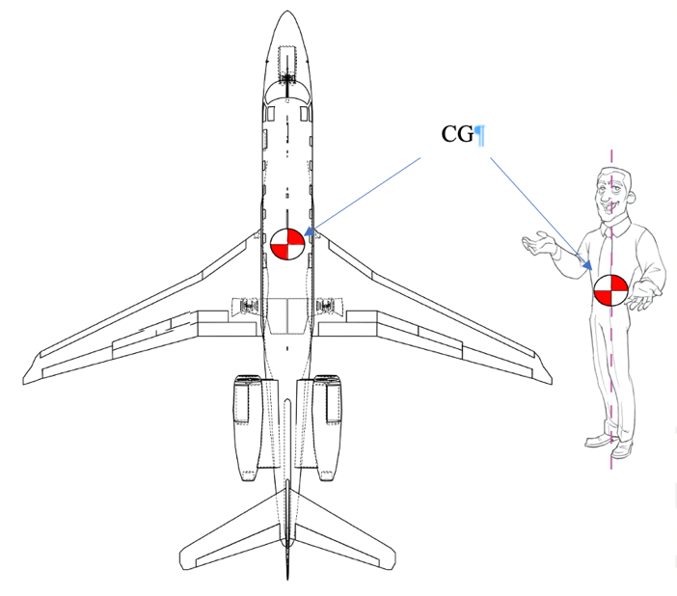
Center of Gravity (CG) illustration

Source: Plane illustration 111575022/Blueprint© Cherezoff | Dreamstime.com. Copyright 2022 by Dreamstime.com. Figure illustration by C. Fleming. (2011). Animation Physics – Balance & Weight shift. http://www.algarcia.org/AnimationPhysics/BalanceTutorial.pdf.

Unbranding is based on the concept that an organization has a similar, and singular, center of gravity (CG) operating under the science of mechanics. That CG is the brand of the organization. An object cannot have more than one CG, but it does have CGLs which describe the expected distance the CG can move, or be moved, without creating its own momentum. CGLs permit the CG to move to accommodate different expected loads and anticipated variations. Figure 2 illustrates CGLs in motion.
Figure 2
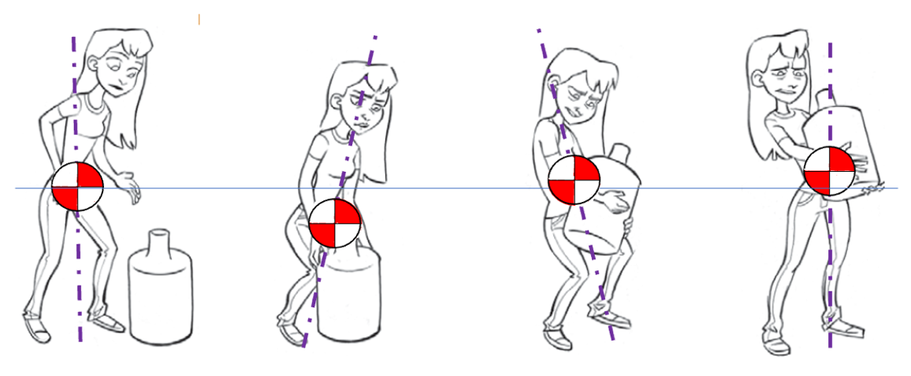
CGLs in motion
CGL
CGL
CGL
CGL
CGL
Source: Adapted from illustration by C. Fleming. (2011). Animation Physics – Balance & Weight shift. http://www.algarcia.org/AnimationPhysics/BalanceTutorial.pdf

For example, if the illustrative CG moves out of its CGLs in Figure 2, the character would not be able to achieve the objective of picking up the object. The character could lose stability at some point of the exercise, dropping the water jug or injuring themselves. This research asserts the dynamics of the CG and CGLs of a brand are based on elements of brand value and equity. Value elements can include emotional, rational, operational, personality, and utility measures. Equity elements can include awareness, reputation, differentiation, performance, relevance, and loyalty. To be stable, the brand must maintain equilibrium between brand value and brand equity. Brand value and equity can be studied through kinetics, the analysis of forces that cause motion.
Figure 3 uses a free body diagram to illustrate forces acting on the elements of brand value and brand equity.
Figure 3
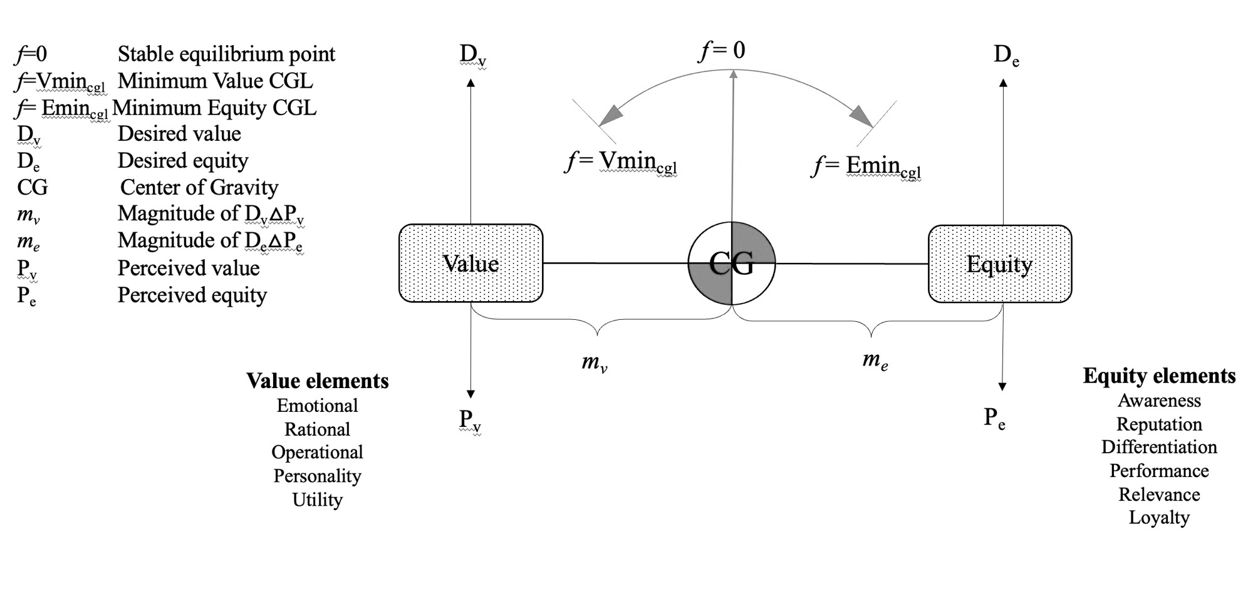
A brand in equilibrium
Note: Original work.
Referring to Figure 3, any change in desired value (D_{v}), desired equity (D_{e}), perceived value (P_{v}), or perceived equity (P_{e}) will change f. Depending on the magnitude of the difference between the impacted elements (m_{v} or m_{e}), and the number of impacted elements, the shift in f may be significant enough to move value or equity past theoretical CGLs (f =Vmin_{cgl} or f =Emin_{cgl}), creating a situation that is now out of planned responses or available resources. A large enough change in magnitude in m_{v} or m_{e} will ultimately energize f to move under its own momentum without any further inputs. In nautical terms, this is the righting moment (Rawson & Tupper, 2001) of a vessel or ship. A simple analogy would be that of a kayaker rocking a kayak from side to side by shifting weight from left to right. The kayak will continue to try and keep itself upright until it comes to a point of no return – an f=min_{cgl} – where the kayak will flip over no matter the efforts to stop it. The point of no return gets smaller if the center of gravity of the shifting weight is further (m) from the kayak’s center of gravity (CG) e.g., the kayaker is standing up in the kayak. The body weight of the kayaker remains the same, but it has more effect the further away it is from the center of gravity of the kayak. Add another kayaker to the same kayak, and the effect becomes even more significant.
It is worth noting that desired value and equity are measurable from the organization point of view and the perceived brand perception are measurable from the stakeholder point of view. In essence, when a brand is in equilibrium, the desired organizational brand image equals stakeholder perceived brand image. The current research offers that personality, activity, and intensity are variables that impact resonance and can be used as indicators to predict f=min_{cgl}. Future research from the author will explore what f=min_{cgl} may be for organizations; if it varies by category of organization, and if some elements of value and/or equity should be weighted more than others.
In summary, a brand is in equilibrium when both brand value and brand equity are within GCLs of the brand. When a purposeful force is exerted on one or more of the elements of either value or equity, it can create a kinetic movement, potentially moving the brand out of equilibrium. A strong force, or series of force inputs, can move the brand out of CGLs, requiring unplanned response and reaction to regain stability and equilibrium. Maintaining the imbalance and/or increasing the force will eventually reach a resource tipping point where the brand itself creates its own kinetic change, unable to resist the momentum of the growing imbalance.

Building a Brand
Building a brand relies on four main steps, with each of the steps contingent on successfully achieving the objectives of the previous step (Keller & Swaminathan, 2020). Figure 4 illustrates the steps in building brand resonance.
Figure 4
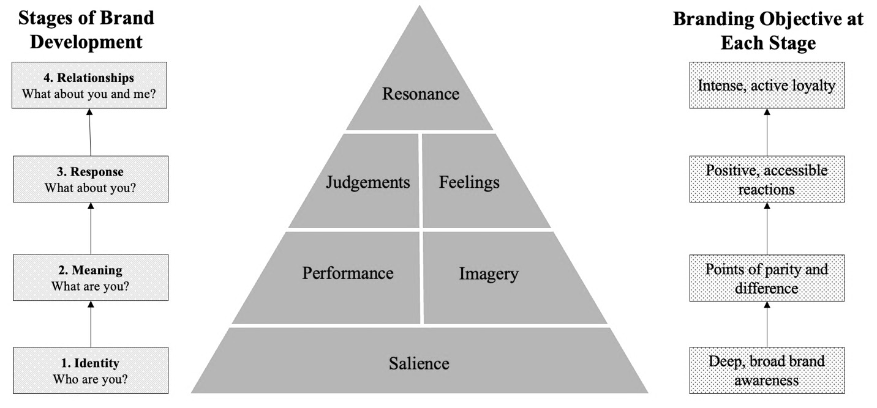
Building a Brand
Source: Building a strong brand. Keller and Swaminathan (2020).

These steps include:
- Identity: Ensure identification of the brand with stakeholders and an association of the brand in stakeholders’ minds with a specific product class, product benefit, or stakeholder need.
- Meaning: Firmly establish the totality of the brand meaning in the minds of stakeholders by strategically linking a host of tangible and intangible brand associations.
- Response: Elicit the proper stakeholder responses to the brand.
- Relationship: Convert brands response to create brand resonance and an intense, active loyalty relationship between stakeholders and the brand.
Step one creates brand salience with stakeholders. Brand salience “measures various aspects of the awareness of the brand and how easily and often the brand is evoked under various situations or circumstances” (Keller & Swaminathan, 2020, p. 107). To create salience, organizations need to identify themselves to potential stakeholders through brand awareness and category structure (Keller & Swaminathan, 2020, pp. 108-110). Brand awareness can be distinguished in terms of two key dimensions – depth and breadth. Depth of brand awareness refers to how easily stakeholders can recall or recognize the brand. Breadth of brand awareness refers to the range of purchase and consumption situations in which the brand comes to mind. The organization of the category hierarchy that prevails in stakeholder memory plays an important role in brand awareness, brand consideration, and consumer decision-making (Keller & Swaminathan, 2020). In a category hierarchy, category structures function to distinguish brands in ways that are useful for subsequent decision making (Cohen & Basu, 1987; Medin & Smith, 1981). The categorization of brands results in organizing brand information into groups, or subcategories. For instance, one of the ways in which information about brand names (e.g., McDonalds, Pizza Hut) in a category (fast-food outlet) may be structured is by organizing the information into product subcategories (burger places, pizza places) (Nedungadi et al., 2001, p. 192). According to Nedungadi et al. (2001) several studies have shown that the use of some type of structure during retrieval enhances information accessibility. Category structure can function as an organized retrieval plan (Raaijmakers & Shiffrin, 1981) and can provide retrieval cues, which provide access to subcategories and facilitate recall of member brands (Alba & Hutchinson, 1987).
Step two – performance and imagery – determines how well products or the brand meet stakeholders needs. According to Keller’s (1993) Customer-Based Brand Equity (CBBE) model, performance consists of five categories: (1) primary characteristics and features; (2) product reliability, durability, and serviceability; (3) service effectiveness, efficiency, and empathy; (4) style and design; and (5) price. Imagery refers to how well the brand meets stakeholder needs on a social and psychological level. This can be done directly, from a stakeholder’s own experience with a product; or indirectly, through various marketing strategies and tactics.
Step three – judgement and feelings – is determined by several elements: quality, credibility, uniqueness, and superiority. Judgement is based on actual and perceived quality. Stakeholders assess credibility using three dimensions: expertise (which includes innovation), trustworthiness, and likability. Stakeholders assess how relevant the brand is to their unique needs, and how superior the brand is in comparison with competitor brands. The brand can evoke feelings directly, but customers will also respond emotionally to how a brand makes them feel about themselves. According to Keller (1993), there are six positive brand feelings stakeholders can get from a product or service they use: warmth, fun, excitement, security, social approval, and self-respect.
Brand resonance represents the highest level of stakeholder-based brand equity, the value added to a product (whether goods or a service), because of its association with a particular brand (Keller, 1993; Keller, 2003). Resonance is the focus of this research. Brand resonance describes the extent to which consumers feel they are in sync with the brand and, most importantly, what they will actually do for the brand. According to Keller and Swaminathan (2020), resonance is characterized “in terms of intensity, or the depth of the psychological bond consumers have with the brand, as well as the level of activity engendered by this loyalty” (p. 120). To create resonance, a sense of community and behavioral loyalty must be generated. Active engagement and attitudinal attachment (Keller & Swaminathan, 2020) must also exist.
A sense of community is developed when consumers “feel a kinship or affiliation with other people associated with the brand, whether fellow brand users or consumers, or employees or representatives of the company” (Keller & Swaminathan, 2020, p. 120). Behavioral loyalty, as suggested by Keller and Swaminathan (2020), is viewed in terms of repeat purchases and the amount or share of category volume attributed to the brand. Active engagement occurs when stakeholders are willing to invest time, energy, money, and in the case of extremism, their lives, into the brand. Attitudinal attachment is when stakeholders “go beyond having a positive attitude to view the brand as something special in a broader context” (Keller & Swaminathan, 2020, p. 120) and is posited in this study as a stakeholder willing to commit their personal reputation and/or life to the brand of their choice. These four elements of resonance - a sense of community, behavioral loyalty, active engagement, and attitudinal attachment - are the focus of this research.
When considering choosing between a name brand or generic product, there is a value exchange involved - an associated cost balanced by a perceived, or calculated, return to the stakeholder. Value exchange is based on exchange theory (Homans, 1961). Value motivates people to engage in a specific behavior. Motivation describes the wants or needs that direct behavior toward a goal. Together with emotion, motivation is part of the psychological phenomenon referred to as an affect. It is distinct from cognitive processes that are rational and calm because motivation and emotion involve physiological arousal. When a decision is made, experience and opinion may inform it, but the actual decision is influenced by the current motivational state (Murayama, 2018). The situation that a person finds themselves in plays a major role in how they react. However, in most cases, people offer responses that are consistent with their underlying personality traits and opinions (Srivastava & Owens, 2010). Action on the decision, characterized as behavior, is based on emotions at the time of the decision and the personality of the stakeholder. Park et al. (2010) found that the more stakeholders are attached to a brand, the more willing they are to forsake personal resources to maintain an ongoing relationship with that brand, “thus, they are willing to express an intent to engage in difficult behaviors - those that require investments of time, money, energy, and reputation - to maintain (or deepen) a brand relationship” (Park et al., 2010, p. 14).
Unbranding reverse engineers the brand building process. However, contrary to the linear process of building the brand, each level can be addressed independently at any time and in any order. One or more can be addressed together or all four can be addressed in a synchronized and coordinated manner. To address each building block, the complimenting power is used. Harkening back to Nye’s three powers, hard, soft, and informational, each has its own set of instruments, guidelines, implementation, and measurement methods. Information power can impact, and manipulate, perceptions. VEOs have demonstrated skill in utilizing information power as a force-multiplier to engineer opponent hubris and emotion to their benefit as force-multipliers and recruiting instruments. Two examples of information power are provided here for context.
The 9/11 attacks provide an example of information power in action starting at 8:46 a.m. on September 11, 2001. After the initial impact, anyone looking at the first stricken World Trade Center tower in New York City’s lower Manhattan would have noted that it was on fire with little indication of what caused the smoke. The second airplane strike in combination with the second attacks on Washington, DC was planned to hit after international and national media outlets were covering the stricken first tower – as well as allowing first responders to report to the scene, but not too late as to avoid any airspace shutdowns – which was the anticipated response from the Federal Aviation Administration (FAA). The timing of the attacks was maximized for depth and reach of coverage, such that the strikes would be seen during the morning news hours in the U.S. and the afternoon news hours in Europe – with the second airplane strike on the World Trade Center planed Washington attacks (only the Pentagon strike succeeded) broadcast live through global network affiliates. An information power strategy drove these hard power tactics.
The U.S. military observed that adversaries leveraged disinformation to influence sympathizers and undermine military actions (GAO, 2022). An example of information power in Iraq occurred during Operation Valhalla (U.S. Army Combined Arms Center, 2009). In March 2006, a combined battalion of U.S. and Iraqi Special Forces engaged in a firefight with a Jaish al-Mahdi death squad at one of its compounds. According to the GAO (2022):
During the engagement, the U.S. and Iraqi soldiers destroyed a weapons cache and rescued a badly beaten hostage. However, by the time the soldiers had returned to their base—less than an hour later—someone had returned to the scene, removed the weapons from the bodies of the death squad members, and rearranged the bodies to make it look as if they had been murdered while in the middle of prayer. They then took pictures, uploaded them into the web, and issued a press release explaining that U.S. soldiers had entered a mosque and killed men peacefully at prayer. As a result of this disinformation activity, this special operations unit was not allowed to conduct any military operations for 30 days while the Army conducted an internal investigation. (p. 8)
Information power took a highly trained, specialized combat asset off the battlefield with a press release, a camera, and a web post. This was not a select, or rare, instance. This type of information power was wielded deftly and often by VEOs.
When it comes to unbranding, information power can be applied to all four levels. Hard and soft power can be applied to level two (meaning) and level three (response). The key here is that hard and soft power are unable to address the individual psychological stages of salience and resonance by themselves. Hard and soft power can impact performance, imagery, judgement, and feelings, but salience and resonance are purely founded on information as perceived by the individual stakeholder. Figure 5 illustrates the potential outcomes of unbranding efforts.
Figure 5
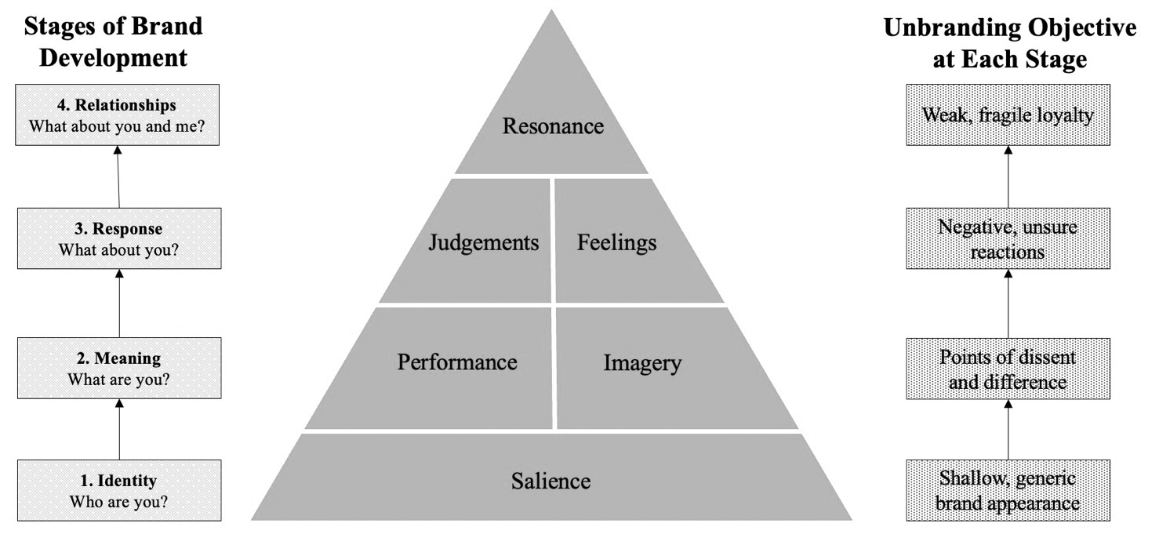
Unbranding a brand
Source: Adapted from Keller and Swaminathan (2020).
In summary, this chapter explicates what a brand is, the dynamics of a brand, how to build a brand, and how to conceptually use unbranding to genericize a brand. The next chapter presents the concept of stakeholders, explores an absence of success with traditional VEO engagement programs, presents the concept of obvious logic, and asserts a change is needed in VEO engagement. The next chapter discusses the concepts of stakeholders, three different types of approaches, obvious logic, and brands and politics.

Chapter Two: Stakeholders of Terrorism
Throughout this research, stakeholders are mentioned as the key element of brands. Brands are owned by stakeholder perceptions. This chapter explores the concept of stakeholders and looks at a model of stakeholders as potentially viewed by Violent Extremist Organizations (VEOs). It also explores the concept of hidden stakeholders and how they can be engaged. The chapter then explores how stakeholders are currently approached or engaged by the U.S. and then looks at three types of approaches underpinned by the concept of economy of force. It critically explores how engagement of VEOs is based on long-standing worldviews, identified as obvious logic, rather than evolving with VEO strategies. It concludes by discussing the value of a new approach for engaging VEOs.

Stakeholders
A stakeholder can be a group or individual who is affected by, or can affect, the success of an organization (Freeman, 1984). There is extensive literature - and debate - on the definition of stakeholders, with many definitions originating from the worldview of the individual defining the term. For example, Friedman (1970) introduced the stockholder theory - a normative theory of business which holds that an organization’s sole responsibility is to its shareholders. Mitchell et al. (1997) proposed a theory of stakeholder identification which includes the concepts of power, legitimacy, and urgency. Power is “a relationship among social actors in which one social actor, A, can get another social actor, B, to do something that B would not have otherwise done” (Mitchell et al., 1997, p. 869). Legitimacy refers to the actions of an organization that are desirable and appropriate according to the norms, beliefs, and values of society. Urgency is the concept that refers to stakeholders’ call for immediate attention. Mitchell et al. (1997) further theorized seven types of stakeholders, defined according to the attributes (power, legitimacy, urgency) they possess. Latent stakeholders have only one attribute. These types are the dormant stakeholder, who has power, but not legitimacy or urgency; the discretionary stakeholder has legitimacy, but not power or urgency; the demanding stakeholder has urgency but not power or legitimacy. Expectant stakeholders have two attributes. Dominant stakeholders have both power and legitimacy, but not urgency; dependent stakeholders have both legitimacy and urgency but not power; dangerous stakeholders have both power and urgency, but not legitimacy. Definitive stakeholders have all three attributes.
Stakeholder Territory
Stakeholders can also be categorized by territory. Pinos and Radil (2020) use two different perspectives on territory, Effective Control Over Territory (ECOT) and Sovereignty Claims Over Territory (SCOT). ECOT is the spatial extent of an organization’s practical political control over the settings and sites in which it is present (Pinos & Radil, 2020). ECOT is related to the capabilities of an organization to control digital or physical territory. SCOT is based on a group’s stated territorial goals or ambitions, particularly in relation to the existing territorial arrangements that they operate within or in opposition to (Pinos & Radil, 2020). De la Calle and Sánchez-Cuenca (2015) assert control of territory has great implications for VEOs because it opens a wide range of possibilities in terms of tactics, allowing them to diversify their strategies and, for instance, engage in guerrilla-oriented actions, propagating ideologies, or online recruitment of stakeholders. Two examples of SCOT include Hamas, the militant Palestinian nationalist and Islamist movement in the West Bank and Gaza Strip, and the Taliban’s return to power and control of Afghanistan.
The Hidden Stakeholder
Existing and past VEO engagement strategies only target known stakeholders, in contrast to hidden stakeholders. Hidden stakeholders are “a subset of the general population whose membership is not readily distinguished or enumerated based on existing knowledge and/or sampling capabilities” (Wiebel, 1990, p. 6). Hidden stakeholders are challenging to engage with directly by their very nature. Consider the number of stakeholders who are still deciding between brands or who have not yet acted out for a brand. Hidden stakeholders also include those who intend to be out of sight, thus out of reach, of traditional hard and soft power engagement. This research contends that hidden stakeholders are more akin to the submerged part of an iceberg, with known stakeholders being the visible part. It may take a long time to overturn the iceberg, but when it does, the larger, new set of stakeholders emerges, potentially overwhelming the capacity and capability of existing state engagement programs. An example of this would be the 2011 Arab Spring.
Estimating the size of hidden, stigmatized, or hard-to-reach populations such as homeless people, sex workers, human trafficking victims, drug users, or terrorists and extremists, is an important part of epidemiological, demographic, and security research (Wiebel, 1990). Engagement of hidden stakeholders is possible, but this research contends not with existing programs and strategies. A direct approach, versus the current indirect and complex approach, is the only way to address hidden stakeholders. To better illustrate this, consider route a in Figure 6 as the interaction between all stakeholders (S) and the Target Organization (TO). Route b is the interaction between known stakeholders and the Engaging Organization (EO). Route c is the interaction between the TO and the EO.

Figure 6
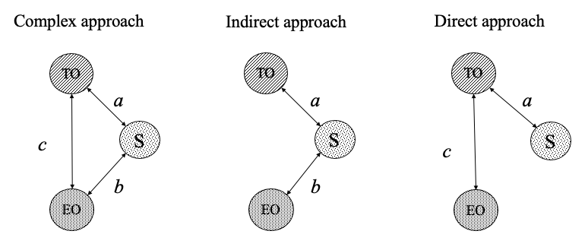
Three types of approaches
Note: Original work
In a complex approach the EO chooses to engage all the elements and products of the TO and known S. The unknown S remains unengaged. Using available means the EO must engage on two fronts (TO and S) at the same time, whilst managing three sets of perceptions: (1) the perceptions of itself among the TO and S, (2) the perceptions of S of TO, and (3) the perceptions of the TO of S. A complex approach is the most resource-intensive level of effort, lacks focus, and requires the highest expenditure of resources to affect changes in the TO. Figure 7 provides an illustrative example of a complex approach.

Figure 7
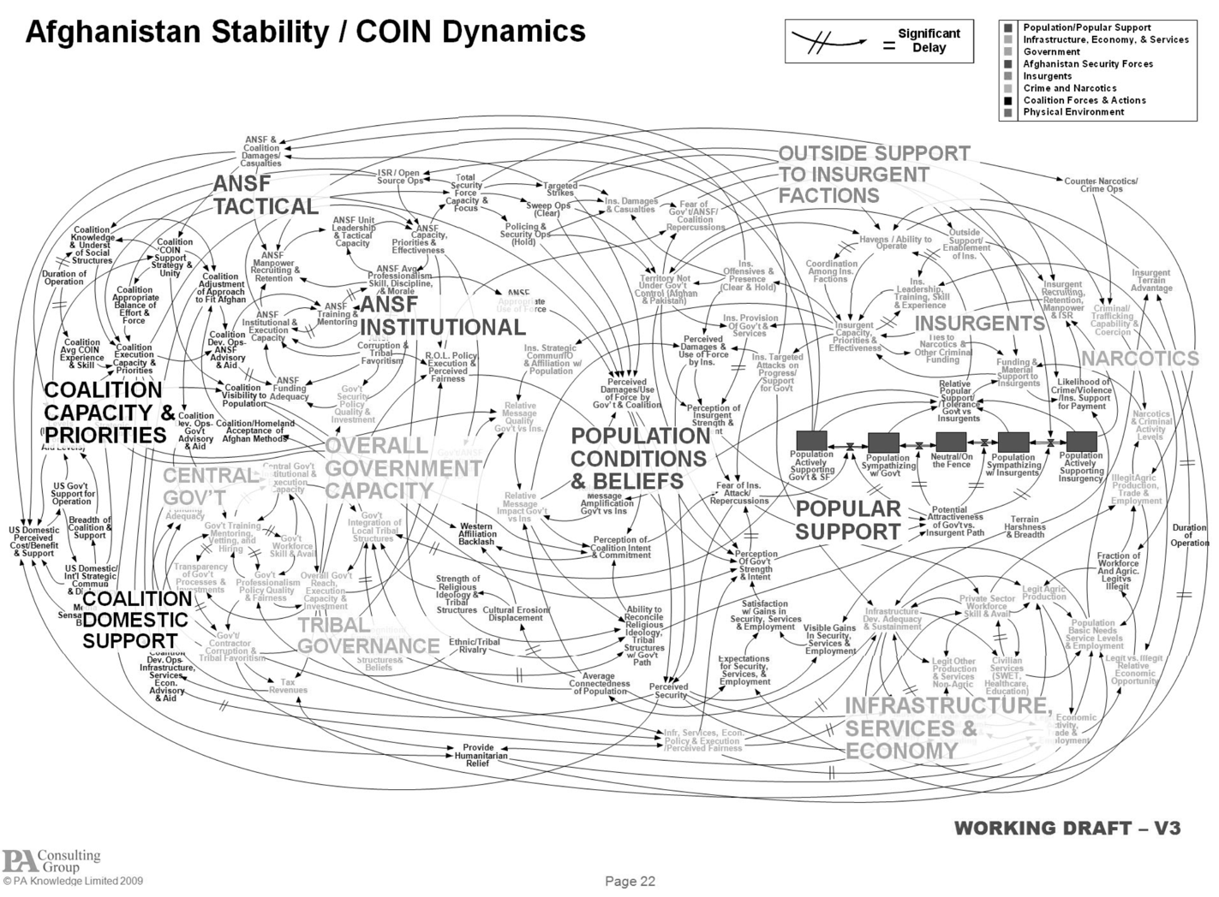
A complex approach illustrated
Source: From Discuss: Powerpoint is the enemy? Flowingdata.com. April 27, 2010. (https://flowingdata.com/2010/04/27/discuss-powerpoint-is-the-enemy)

An indirect approach is less resource intensive. The TO directly engages known S and manages two sets of perceptions, that of itself from the known S and the perception the TO has of the known S. This focuses only on known stakeholders. In the direct approach, the EO’s primary maneuver directly engages the brand of the TO and is only concerned with the perception of the TO. The direct approach avoids primary engagement with S, thus eliminating the possibility of self-inflicted damage or manipulation by the TO. The direct approach also enables all S, known and unknown to the EO, to self-determine their engagement with the TO, based on brand value and equity. This helps avoid a sudden emergence of a hidden majority of stakeholders. The direct approach focuses EO resources on the singular task of unbranding the TO’s brand. A direct approach has yet to be used in counter-terrorism programs or studied in academic research on extremism. This study asserts that the direct approach is the most effective and the most resource-efficient of the three. Using Freeman’s (1984), Mitchel et al.’s (1989), and Pinos and Radil’s (2020) studies as a foundation, Figure 8 illustrates the combined models.
Figure 8
Freeman’s (1984), Mitchel et al.’s (1989), and Pinos and Radil’s (2020) models combined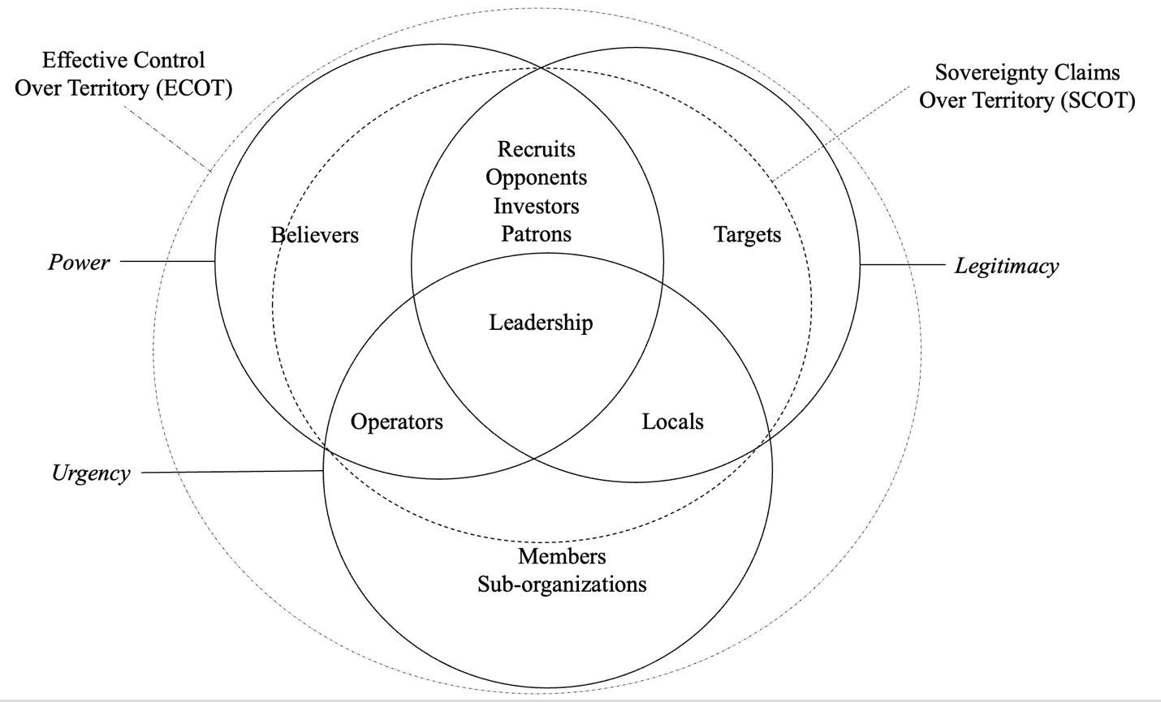
Note: Adapted from Freeman (1984), Mitchel et al. (1999), and Pinos and Radil (2020).

Using Figure 8 as reference, an invested stakeholder has control of the organization. Examples include Prabhakaran (Liberation Tigers of Tamil Ealam), bin Laden (al-Qa’ida), Shahab al-Muhajir (ISIS-K), Abu Bakr al-Baghdadi (Islamic State of Iraq and the Levant), and Shoko Asahara (Aum Shinrikyo).
A contributing stakeholder is one whose participation is required to sustain the organization. This would be sponsors, patrons, recruits, and governments. Examples include potential recruits being sourced, either online or through recruitment methods; the U.S. positioned as the “evil arch enemy,” or the Euskadi ta Askatasuna, (ETA, Basque Liberty & Freedom) unilateral peace process, where the Spanish government is not involved, but the process is endorsed by internationally prominent figures such as former United Nations (U.N.) Secretary General Kofi Annan, former British PM Tony Blair, and former U.S. President Jimmy Carter (Pinos & Radil, 2020).
An observer stakeholder is one whose acceptance or compliance is required to sustain the organization. These are individuals living in ECOT and/or SCOT. For example, in 2012, FARC-EP (Fuerzas Armadas Revolucionarias de Colombia)(Revolutionary Armed Forces of Columbia) began discussing a peace process with the Colombian government, which led to the signing a formal peace treaty in 2016 and is now reportedly in the process of surrendering its arms in exchange for guarantees to enter the political system in Colombia (Pinos & Radil, 2020). Other examples would include populations living in areas of Afghanistan, the Lake Chad Basin region in North-West Africa, Somalia, Kenya, regions of Iraq or Syria, or virtual and social media domains targeted by VEOs.
An end user is one who uses the output/product (terror, violence, or threat of violence) of the organization. These are individuals who carry out, or create, the impression of terror, violence, or threat of violence in the name of the organization. Examples include the ministers of Aum Shinrikyo and the March 1995 attack on the Tokyo subway; the October 1970, Front de Libération du Québec’s Liberation Cell, and the Chenier Cell kidnappings; and al-Qa‘ida’s Hamburg Cell and the 9/11 attacks.
A consumer is one who receives some value from the organization. This includes members of the organization, also known as internal stakeholders. This could also be sub-organizations or splinter factions who use their parent brand’s value and equity as a foundation of credibility, such as ISIS-K, a splintered group of the Taliban; the Continuity IRA, the Óglaigh na hÉireann, or the Real IRA, all splinter factions of the IRA; Boko Haram splinter groups including the Islamic State West Africa Province (ISWAP); ISI, formed by surviving members of Al-Qa’ida in Iraq (AQI) and disaffected former members of the US-trained Sons of Iraq that supported U.S. operations to dismantle AQI; and ISIL, which emerged in 2014 when Abu Bakr al-Baghdadi declared an Islamic Caliphate in parts of Iraq and Syria.
An output consumer is one who is a recipient of the output (products and/or services) of the organization. In the instance of VEOs, the output is violence and terror. Viewed objectively and from the VEO perspective of demonstrating performance, these stakeholders include the 2,977 killed and 6,000 injured in the 9/11 attacks in the U.S. (Plumer, 2013); the August 26, 2021, attack in Kabul, Afghanistan, that killed 13 U.S. service members and at least 170 Afghans (Council on Foreign Relations, n.d.a); or the 2019 suicide bombing in Darkheynley, Mogadishu, where 83 people were killed and 148 injured (Global Terrorism Database¹, n.d.). As noted by Springer et al., (2009), “Jihadists have quite clearly identified their enemies as legitimate targets of violence” (p. 3). Recognizing the tragedy and loss of lives, from the viewpoint of the VEO, without these stakeholders there is no way to operationalize or achieve organizational goals to demonstrate performance.
Finally, an outcome consumer is one who receives the outcomes of the organization. This includes the believers of the organizational goals and/or ideology, as well as the investors and patrons who realize a return on their investment through the VEO’s organizational definition of success.
Figure 9 illustrates stakeholders from the potential viewpoint of a VEO and addresses the questions, “Who can enable me (power)? Who can provide me with legitimacy (legitimacy)? And who can help me achieve my goals the quickest (urgency)?”
Figure 9
A proposed stakeholder map from the VEO point of view
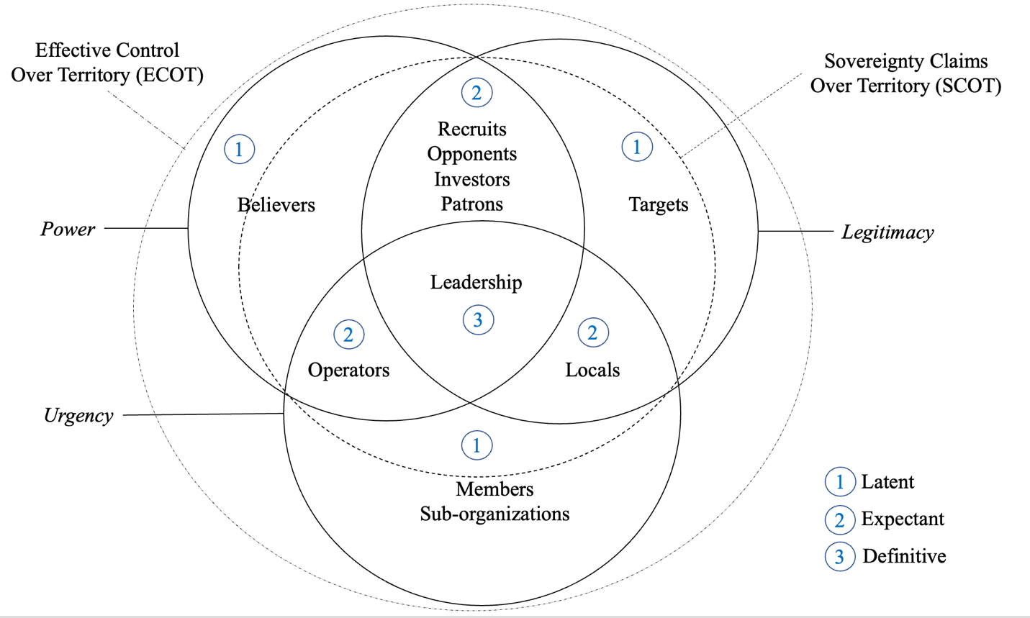
Source: Adapted from Freeman (1984), Mitchel et al. (1999), and Pinos and Radil (2020).

Counter-X: An Absence of Success
In an address to a Joint session of Congress on September 20, 2001, President George W. Bush expanded on his proclamation of war on terrorism: “Our war on terror begins with al Qaeda, but it does not end there. It will not end until every terrorist group of global reach has been found, stopped, and defeated” (Bush, 2001). Twenty years later, on August 30, 2021, the U.S. withdrew from Afghanistan, leaving it under Taliban rule again (Council on Foreign Relations, n.d.a.). This research postulates past approaches such as Counter Terrorism (CT), Counter Insurgency (COIN), Counter Violent Extremism (CVE), Countering Islamic Extremism (CIE), and Racially or Ethnically Motivated Violent Extremism (REMVE) were systematically ineffective in degrading terrorism or extremism. With the best of intentions in mind, these programs had marginal impact compared to their cost in resources.
The 2021 withdrawal of NATO from Afghanistan stands as the most recent example of ineffective CT and COIN efforts. Several years earlier, the Unites States Government Accountability Office (GAO) identified that the federal government did not have a cohesive strategy or process for assessing the overall CVE effort (Government Accountability Office, 2017, highlights), a criticism that has been consistent of most conflicts and crises of the past. In 2006, then-U.S. Secretary of Defense Donald Rumsfeld stated:
Our enemies have skillfully adapted to fighting wars in today’s media age, but for the most part we, our country, our government, has not adapted. Consider that the violent extremists have established media relations committees – these are terrorists, and they have media relations committees that meet and talk about strategy, not with bullets but with words. They’ve proven to be highly successful at manipulating the opinion of elites of the world. They plan and design their headline-grabbing attacks using every means of communication to intimidate and break the collective will of the free people. (para 13)
CVE, CIE, and REMVE programs have also received criticism as discriminatory in practice and stigmatizing, divisive, and destructive to the communities they target (American Civil Liberties Union, n.d.; American Civil Liberties Union - Massachusetts, n.d., Barbari, 2019; Brennan Center for Justice, 2019; Roberts, 2020; Wilson, 2021). Such studies assert that programs have targeted almost exclusively Muslims and employ stereotypical criteria, such as religiosity and political activism and vague feelings of alienation, as proxies for violent tendencies. Part of failed strategy and biased tendencies arise from the concept of obvious logic.

Obvious Logic
Obvious logic is defined here as addressing a problem at its face value using only the worldview of the problem solver. Obvious logic uses superficial information to arrive at a conclusion convenient to the problem solver’s worldview. This is not to say obvious logic is irresponsible or the easy way out. It could be considered human nature when decisions are being formulated under pressure or time constraints. Holsti's (1972) analysis of documents from heads of state prior to WWI, revealed that some of their crucial decisions had been based on a narrow time perspective and on the weighing of immediate dangers rather than the long-range consequences of alternative courses of action. These examples suggest that individuals under stress often fail to adhere to rational-choice models that assume that decisions are based on the weighing of the utilities and probabilities associated with all available courses of action (Miller & Star, 1967; Raiffa, 1968). The effects of uncertainty in decision-making can be found in decision theory (Steele & Stefansson, 2015), normative and descriptive decision theory (MacCrimmon, 1968), game theory (Myerson, 1991), complex decisions and bounded rationality (Simon, 1991), and directly relates to choice under uncertainty (Schoemaker, 1982) and heuristics (Bobadilla-Suarex, 2018; Chuang et al., 2012). To illustrate obvious logic, consider the case of Wald (1943) and the World War II study on increasing the survivability of Allied bombers.
During World War II, military designers sought to increase the survivability of Allied aircraft. Significant losses were occurring, especially in bomber aircraft, during missions over Europe. The question was how to reinforce bomber aircraft to increase their survivability from attacks by enemy fighters. The challenge was that adding armor to aircraft increased weight, degraded maneuverability, and consumed more fuel. Military designers sought an optimum solution. They noted the damage to aircraft wasn’t uniformly distributed across the aircraft on planes returning from engagements over Europe. There were more bullet holes in the fuselage, but not so many in the engines or forward part of the aircraft (Figure 10).
Figure 10
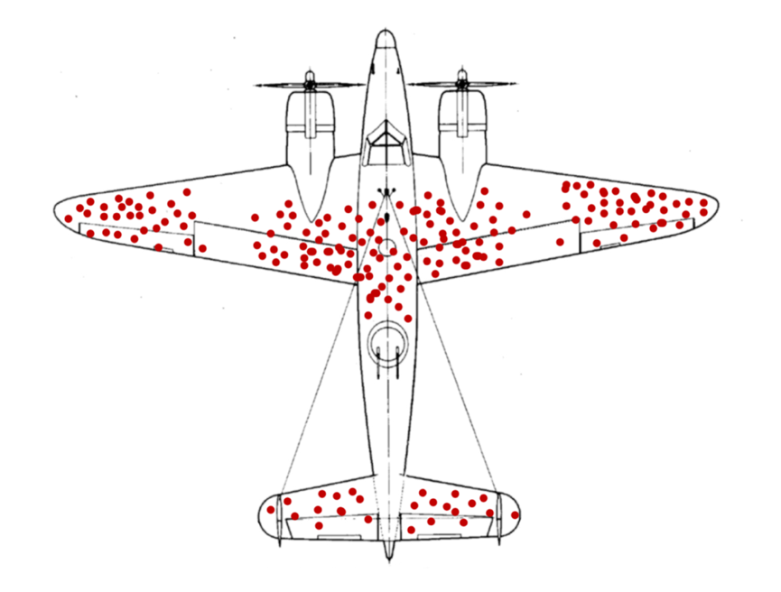
Most common areas of battle damage
Source: From Illustration of hypothetical damage pattern on a WW2 bomber, by Crandjean and McGeddon, (2021), commons.wikimedia.org. https://commons.wikimedia.org/wiki/File:Survivorship-bias.svg

Military designers reasoned more protection could be provided with less armor by concentrating on the areas of obvious need - where the planes were getting hit the most. They went to the Statistical Research Group (SRG) to help determine how much armor was needed. Wald, a statistician employed by the SRG, examined the problem, and focused on the areas that did not have dots. Those areas included the engine, cockpit, and fuselage between the tail and main body of the aircraft. Wald reasoned that if the damage had been spread equally all over the plane, the missing bullet holes would be on missing planes - the ones that did not make it back to their airfields. Those planes were the ones that sustained fatal damage. The correct answer, according to Wald, was to place reinforcement or armor where there were no red dots. An unexpected answer to an obvious problem but from a very different worldview. This study offers that the unexpected solution to the problem of extremism is not addressing the most obvious solution– extremists – but the cockpit and engines of extremism – the brand itself.
An example of obvious logic is the oft-used concept of countering the VEO narrative or message. Such approaches sustain the VEO brand by drawing attention to its narratives or ideologies by repeating them in efforts to counter them. Counter narrative is defined here as a message which offers a positive alternative to extremist propaganda, or alternatively aims to deconstruct or delegitimize extremist narratives. By design, to engage in counter narrative the originator must introduce a counter argument – defined here as acknowledging points that go against the originator’s desires and then re-affirming those desires through rhetoric and publicity. This is typically done by stating the opposing side’s argument, and then presenting an argument supporting the originator as the most logical solution. In the case of VEO narratives, the counter narrative must be reiterated or referenced as juxtapose to the originator’s viewpoint. By doing so, the VEO narrative or message is further propagated and can be seen by VEO stakeholders as an endorsement of the effectiveness of the VEO. Based on knowledge of their opponent, VEOs anticipate, manipulate, and engineer hubris. They plan on patriotic emotions, the sensationalized mass media, and social media, as force multipliers to encourage and generate counter-messaging. One of the strongest enablers of VEO goals is their opponent’s communication strategies and engagement programs.

Branding and Politics
While the concept of unbranding is new, it should be noted that looking at an organization through the lens of branding is not new or exclusive to VEOs. Politicians rely on political party brand names for their election and follow-on elections. A political party contains established reputations and images. When the party label is identified, it activates the voter’s memory to retrieve information associated with the party (Downs, 1957; Kiewiet & McCubbins, 1991). Researchers on voting behavior recognize that party identity – the brand – is one of the most decisive factors that explain an individual’s voting decision (Campbell et al., 1960; Sniderman, 2000; Sniderman & Stiglitz, 2012; Torres-Spelliscy, 2019). Researchers focused on the importance of party labels in the electoral market (Lupe, 2013; Needham, 2005, 2006; Nielsen & Larsen, 2014; Neiheisel & Niebler, 2013; Pope & Woon, 2009; Woon & Pope, 2008). Politics is becoming more emotional, polarized, and controversial, with the goal of control rather than representation. The U.S. political system is a prime example of branding in action – with brand differentiation being anything that furthers the distance from the opposing parties and with the goal to earn as many votes as possible.
Stakeholder interest comes from the perceived credibility of performance and is associated with the brand of the politician and associated memories of that party. Because it is entirely impossible for anyone to directly experience all things they know, people learn and experience events in a pseudo environment. An individual’s pseudo environment is an environment created by another individual or entity, such that whatever is believed or perceived to be a true environment, is acted upon as the real environment itself (Lippmann, 1922). Thus, the phrase perception is reality was born. For example, an established politician may introduce a new politician and endorse them as a member of party x, framing the new politician in a known context. Similarly, a new, unknown extremist can be introduced and endorsed by a powerful figure. For example, on September 20, 2001, President George W. Bush delivered the following remarks in a speech:
On September the 11th, enemies of freedom committed an act of war against our country. Americans have known wars – but for the past 136 years, they have been wars on foreign soil, except for one Sunday in 1941… …Americans have many questions tonight. Americans are asking: Who attacked our country? The evidence we have gathered all points to a collection of loosely affiliated terrorist organizations known as al Qa’ida [emphasis added]. They are the same murderers indicted for bombing American embassies in Tanzania and Kenya, and responsible for bombing the USS Cole. Al Qa’ida is to terror what the Mafia is to crime [emphasis added]. But its goal is not making money; its goal is remaking the world – and imposing its radical beliefs on people everywhere. The terrorists practice a fringe form of Islam extremism that has been rejected by Muslim scholars and the vast majority of Muslim clerics – a fringe movement that perverts the peaceful teachings of Islam… …This group and its leader – a person named Osama bin Laden [emphasis added] are linked to many other organizations in different countries, including the Egyptian Islamic Jihad and the Islamic Movement of Uzbekistan. There are thousands of these terrorists in more than 60 countries. They are recruited from their own nations and neighborhoods and brought to camps in places like Afghanistan, where they are trained in the tactics of terror. They are sent back to their homes or sent to hide in countries around the world to plot evil and destruction. The leadership of Al Qa’ida has great influence in Afghanistan and supports the Taliban regime in controlling most of that country. In Afghanistan, we see al-Qa’ida’s vision for the world.
In this globally broadcast speech, Bush introduced and legitimized al-Qa’ida as a credible organization, a physical group to be feared and fought, and bin Laden as a legitimate and credible terrorist (Waterman, 2010). In addition to his own description of them, Bush compared al-Qa’ida, an unknown entity to the public, with a known entity, the Mafia, using existing perceptions of the Mafia to frame al-Qa’ida (Waterman, 2010). With the rhetorical goal of stimulating the American and international communities into desired states of response, Bush unwittingly promoted and educated audiences on al-Qa’ida’s ideology. The brand was legitimized as an effective organization by emphasizing the number of global connections shared with known entities. The brand’s ability to recruit and train thousands of terrorists from over 60 countries was acknowledged and legitimized. In the eyes of its stakeholders, the brand became legitimate and credible in part because the President of the United States said so (Waterman, 2010).
Brands provide a simplified way to convey attribution about capabilities and strengths thereby fostering emotional appeals to the brand’s stakeholders. Without a brand there can be no attribution of the brand; no reference of endorsement about the capabilities and strengths of the organization; and no inference of brand equity or brand value. Without a brand, there is nothing to focus emotional appeal to stakeholders. Salience is limited, performance and imagery are constrained, judgement and feelings are impacted, and resonance cannot be achieved. Figure 11 illustrates what a generic VEO brand may look like.

Figure 11

The generic extremist

Note: Adapted photograph by Finbarr O’Reilly/Reuters. Theguardian.com
https://www.theguardian.com/world/2010/jul/25/green-on-green-afghan-war-logs

With no brand, no group identity, no location identity, no performance reports, no endorsements, no gender or ethnic indicators, no ideological information, no known objectives or goals, a potential stakeholder has very little information, if any, to assess interest in becoming part of, or contributing to, the organization.

A New Approach
A new approach to how VEOs are studied – and engaged – has been long overdue. In 2008, the Center for Strategic and International Studies (CSIS) (2008) reported:
There is a lack of clear understanding or consensus on what motivates an individual to become a terrorist and to engage in violent acts. Without such an understanding, we are limited in our ability to employ appropriate strategies and tools for preempting terrorism. (p. 1)
As long as extremists are able to effectively communicate and use opposition communication campaigns as a force multiplier in their communication goals, VEOs will continue to successfully endure overwhelming military odds as they have throughout history. The purpose of unbranding is to change approaches from resource-exhausting operations to a focused, economy of force. After a thorough analysis of IS operations, Regens et al. (2016) observe that “the weight of evidence suggests that the military and political window has closed dramatically for unilateral action by a US-led coalition to defeat IS in Syria and Iraq” (p. 75). Regens et al. (2016) concluded with four observations:
First, rhetoric is not a substitute for strategy. Second, strategy can guide actions to achieve an end state but does not constitute an end state per se. Third, counterterrorism and counterinsurgency are not synonyms even when some of the tactical responses to both are identical. Fourth, and perhaps most critically, the commitment of adequate resources and sustained political will to apply those resources to execute strategy is essential to the prospects for success of campaigns designed to counter terrorism or insurgency, especially when a terrorist and/or insurgent group emerges within broader social movements. (p. 76)
With resource management in mind, unbranding avoids the exhausting modus operandi of response and reaction to avoid playing into VEO expectations of over-reaction, hubris, and unfocused effort resulting in an eventual loss of political will and public patience. While VEOs need only expend minimal costs to maintain a perception of success, generate enough resources to endure, outlast opponent political will, and degrade opponent public patience, opponents such as NATO or the United States must demonstrate progress and create perceived success to justify costs – both in lives and resources– to governments and publics alike. According to the Office of the Director of National Intelligence (ODNI) (2016):
The United States government spends billions of dollars each year to understand, communicate with, and engage various audiences, but its efforts in countering extremist propaganda remains fractured, uncoordinated, and inefficient. (p. 2)
During his 2021 confirmation hearings, Secretary of Defense Lloyd Austin (2021) noted that several reviews are ongoing, to include an update to the 2016 Strategy for Operations in the Information Environment and an information operations posture review as required by the 2020 National Defense Authorization Act (NDAA):
Although the al-Qa’ida brand [emphasis added] has suffered over the past 20 years, due in large part to efforts by DoD, there remains a dedicated network of al-Qa’ida and its associated forces providing a population-centered counter to U.S. interests across Africa, the Middle East, and Southeast Asia. (p. 64)
The first U.S. Department of Defense document to formally address the need to jointly engage in the Information Environment, Joint Concept for Operating in the Information Environment, was issued 17 years after the U.S. entered the War in Afghanistan (Department of Defense, 2018). A 2021 report published in USA Today (Shesgreen, 2021) from The Watson Institute at Brown University estimates the U.S. spent “$5.8 trillion in reaction to the 9/11 attacks” (Crawford, 2021). In September 2022, Joint Publication 3-04, Information in Joint Operations (Department of Defense, 2022), was reportedly published.
In summary of this chapter, NATO and the United States were pulled into a conflict in Afghanistan by design – a conflict it engaged in with a lack of cohesive, consistent strategy. NATO and the United States withdrew from Afghanistan after being exhausted of resources, public patience, and political will. VEOs were able to skillfully leverage the lack of any well-defined end state and coherent mission combined with continual failure to communicate with intent by political leadership and senior commanders. As a result, non-state actors endured a 20-year engagement with the largest military state actor force in recent history. The time for a new approach is long overdue.

Chapter Three: VEOs as Organizations
This chapter looks at organizations and the organizational elements of brand, leadership, ideology, and strategy. Examples of how each apply to VEOs are discussed.
An organization is “a consciously coordinated social entity, with a relatively identifiable boundary, that functions on a relatively continuous basis to achieve a common goal or set of goals” (Robbins, 1999, p. 4). An organization can also be described as “a bounded entity whose behavior and outcomes are influenced, and sometimes controlled, by other bounded entities and by forces active in the environment that affect all the entities it contains” (Hatch, 2018, p. 67). This research is not concerned with organizational structures, but organizational theory (behavior of the organization) combined with open systems theory. The research utilizes Robbin’s definition of organization. Open systems theory views an organization as a complex set of dynamically intertwined and interconnected elements, including its inputs, processes, outputs, and feedback loops, and the environment in which it operates and continually interacts (Katz & Kahn, 1966; von Bertalanffy, 1950, 1968). Robbins (1999) wrote, “a system is a set of interrelated and inter-dependent parts arranged in a manner that produces a unified whole” (p. 13). As a system, organizations are not static, but are in constantly shifting states of dynamic equilibrium. They are adaptive systems that are integral parts of their environments (Drucker, 2001; Robbins, 1999). Just like other organizations, VEOs adapt to their environment through changes of leadership, ideologies, or strategy – but very few change their brand once established.
An organization seeks to keep a balance of maintenance and adaptive activities (Robbins, 1999). Maintenance activities keep the various subsystems of the organization in balance and in accord with its environment. Such activities prevent rapid change that may unbalance the system (Robbins, 1999). Examples of maintenance activities include recruitment and training, and established regulations and procedures. Adaptive activities help the system adjust over time to evolving demands, either internally or externally. Examples of adaptive activities include planning, research, new product development, and new tactics, techniques, and procedures (Robbins, 1999). The author asserts very rarely do any of these activities involve changing the brand of the organization.
VEOs can be classified by organizational features such as hierarchy, formalization, and centralization, as well as performance such as financing, recruitment opportunities, and innovation (Ligon et al., 2015, Springer et al., 2009). The brand is central to all these elements. Crafting a successful brand via media coverage and innovation can lead to third-party endorsements, which build a strong reputation for the organization (Bean & Buikema, 2015; Fombrun & Shanley, 1990). Organization reputation and legitimacy garnered through third-party endorsements results in sustainable funding lines with banks and investors, access to desirable markets and opportunities to co-brand with other notable organizations (Ligon et al., 2015). Branding is achieved through engaging in innovative marketing campaigns and strategic actions that attract media attention, publicizing the organization’s mission and success, and differentiating them from competitors (Rindova et al., 2007). Ligon et al. (2015) concluded VEOs market and differentiate themselves via malevolently innovative attacks and even negatively toned media coverage is related to their long-term fundraising viability. Using an al-Qa’ida propaganda video of the beheading of a reporter as an example, Breazeale et al. (2015) noted:
Viewed objectively, such tactics to promote the brand of global jihad are not that different from more traditional branding efforts employed by much-loved consumer brands. An organization had used its knowledge of its target market to stage a promotion that would resonate with them, filmed the event, released the video, and then allowed its own costumers to spread the message virally. (p. 295)
Breazeale et al. (2015) conclude that “branding relationship strategies are not limited to traditional commercialized firms” (p. 305). The author agrees that these studies are important contributions to the growing study of VEOs as brands. This study argues existing research and strategies, including those using counter-messaging and counternarratives, have been systematically ineffective and provide predictable engagement models. VEOs are able to re-engineer these programs in support of their own objectives and to achieve their desired end states. With very few exceptions, existing VEO research and engagement strategies have focused on one or more elements of the organization (leadership, ideology, strategy), or products of the organization (terror, control, violence, chaos), but not the brand itself.
Davis (2019) studied how to determine which of the 1,393 VEOs included in her working dataset may have disbanded, merged, or reformed since their initial emergence. Davis (2019) found, “little to no information is readily available on disbandment dates and there is no ready broadly based information on VEOs merging or reemerging under new names” (Davis, 2019, p. 51) (Figure 12). However, of the 1,393 VEOs in the dataset, 34% within the Global Terror Database (GTD) or Terrorism Research & Analysis Consortium (TRAC) appear to be inactive and given the classification of “disbanded.” Left-wing VEOs had the highest rate of disbandment at 61%, followed by right-wing VEOs at 44%, nationalist at 31%, and religious at 24%. Of those, 73% of left-wing VEOs ended within the first year of formation, followed by religious at 70%, nationalist at 56%, and rightwing at 50%. The relatively high percentages of VEOs disbanding within the first year across all four ideology types is likely attributable to the lack of available resources to maintain and support the VEOs’ objectives (Davis, 2019). Further, these VEOs failed to achieve BMA and were arguably unable to establish a structured brand building strategy that generated enough salience to continue to step two, three, and four of the brand building process. In short, they were not able to generate a brand that resonated with stakeholders. It appears that of the four types of ideologies, the majority of VEOs used a nationalist ideology, followed by a right-wing ideology, followed by a left-wing ideology, with religious ideology being the least used by VEOs who have endured over five years.
Figure 12
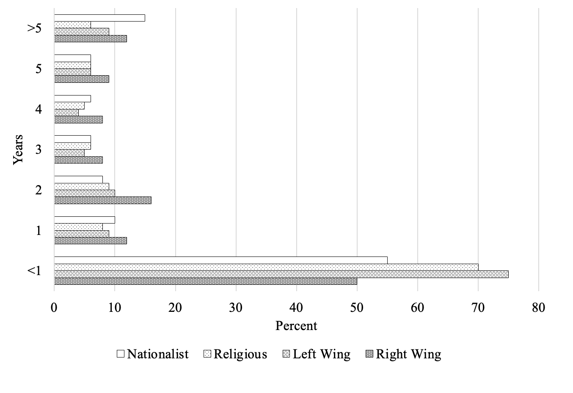
Percentage of VEO duration by ideology
Note. The basis for the disbandment estimates is the lack of documented activity for the past 10 years in the GTD or receiving the classification of inactive by the TRAC. Source: Davis (2019, p. 51).

Leadership
Of the many types of leadership styles possible (transformational, command and control, bureaucratic, servant, transactional, autocratic, democratic, laissez faire, etc.), charismatic leaders dominate organizations that are based on ideology and change (Williams, 2019). According to Weber (1947), followers of charismatic leaders perceive their leaders to be gifted and to possess unique abilities that allow them to perform feats that are beyond the capacity of average individuals. The key to success for charismatic leaders lies solely in the extent to which their followers perceive them to be gifted (Weber, 1947, 1968). If followers fail to conclude their leaders have charisma, then the charismatic influence mechanism breaks down and leaders can no longer exert their influence (Williams, 2019). Shamir et al. (1993) note that charismatic leaders motivate followers by increasing the intrinsic valence of effort, increasing effort-accomplishment expectancies, increasing the intrinsic valence of goal accomplishment, instilling a better future, and creating personal commitment. A charismatic leader’s performance cultivates trust, affection, and loyalty among stakeholders who experience a high sense of involvement and self-worth because they identify with the leader’s value system, ideology, and ambitions (House, 1977; Northouse, 2007). The charismatic leader reinforces and enhances social identification through artefacts of organizational life, including symbols, slogans, rituals, ceremonies, and stories of heroism and past glories (Salzer-Mörling, 1998; Schein, 1985; Yukl, 2006). One researcher states, “the institutional leader, then, is primarily an expert in the promotion and protection of values” (Selznick, 1957, p. 28). However, due to its idiosyncratic nature and lack of formal definition, charismatic authority depends on the perceived legitimacy of the authority. As such, the charismatic leader’s reign is ephemeral (Reeve, 2015; Williams, 2019) and is not central to an organization’s existence.
Further, some stakeholders may not be aware of organizational leadership but may choose to engage that organization based on their perception of the brand. For example, it is possible that most stakeholders of Patagonia do not know Yvon Chouinard. Finally, it is possible that most stakeholders of Apple do not buy Apple products because of Tim Cook or Steve Jobs. And it is possible most stakeholders of Google do not know Sergey Brin or Larry Page. But it is also very possible that all stakeholders are aware of the brand itself – Patagonia, Apple, or Google – when they choose to involve themselves with the organization. In the category of VEOs, in 2004 Hamas (Harakat al-Muqawama al-Islamiyya)(Islamic Resistance Movement), a Palestinian nationalist VEO brand, lost key leadership to attacks but reclaimed victory in the Palestinian elections in 2006 (Pina, 2006). Internal dissent does generate VEO splits, such as with the Islamic State Western African Province (ISWAP) and Jama’tu Ahlis Sunna Lidda’awati wal-Jihad (JAS), both splitting from Boko Haram (Foucher, 2020). Although the IS’s takfiri ideas and actions emerged partly from al-Qa‘ida, the group’s rigidity divides the two groups. As the analyst Hassan states, “[The Islamic State’s] refusal to bend creates a culture of takfirism within takfirism” (Hassan, 2016). All splits in the IS and the IRA were borne of internal disagreements amongst leadership.
When it comes to removing leadership, or decapitating the leader, there are mixed opinions in the literature. While there is some benefit to eliminating leadership from VEOs, most organized VEOs have a system of succession in place. In many cases, targeting a group’s leadership actually lowers its rate of decline. Cronin (2006), Carson (2017), and Abrahms and Mierau (2017) found similar outcomes. Jordan (2009) looked at: (1) what conditions does leadership decapitation result in the dissolution of a terrorist organization, (2) does leadership decapitation increase the likelihood of organizational collapse beyond the baseline rate of collapse for groups over time; and (3) in cases where decapitation does not result in group collapse, to what extent does it result in organizational degradation and hinder a group’s ability to carry about terrorist attacks. Jordan’s (2009) data show that as an organization grows and ages, it is much more likely to withstand the removal of its leadership. Ideological organizations are most likely to experience a cessation of activity following the removal of a leader, while religious organizations are highly resistant to leadership decapitation (Jordan, 2009). Jordan (2009) further demonstrated that decapitation does not increase the likelihood of organizational collapse beyond a baseline rate of collapse for groups over time. Organizations that have not had their leaders removed are more likely to fall apart than those that have undergone a loss of leadership. The marginal utility of decapitation is negative for many groups, particularly for larger, older, religious, and separatist organizations (Jordan, 2009).
In contrast to Jordan (2009), Johnston (2012) puts forth the argument “that neutralizing insurgent leaders has a substantively large and statistically significant effect on numerous metrics of counter-militancy effectiveness” (p. 77). Price (2012), Johnston (2012), and Morehouse (2014) also assert that leadership decapitations are mostly positive. Johnston (2012) noted that there is “a relatively insignificant relationship between successful decapitation Islamist insurgencies and counterinsurgency victory” (p. 73). Johnston (2012) limits his analysis to insurgencies and does not appear to explore extremists or terrorists as part of the study. Johnston (2012) elaborates:
It should be reiterated that these results are not directly applicable for predicting the effect of successful high value targeting in Afghanistan or Pakistan. Rather, they provide general information on the average effect of leadership decapitation in counter-insurgency campaigns across a large number of cases since the 1970s. (pp. 74-75)
In a review of Boko Haram’s operational dynamics and leadership, Regens et al. (2016) found that despite leadership changes, Boko Haram increased their frequency of attacks, gained international media attention, and continue to pose a serious threat to security in West Africa. Regens et al. (2016) also note, “IS has been able to maintain group cohesion, stage attacks, and control territory despite three leadership transitions stemming from targeted assassinations” (p. 54). Regens et al. (2016) conclude:
Boko Haram was able to complete a leadership succession and achieve this success after its initial defeat despite internal and external factors that have undermined prior terrorist campaigns. Consequently, unless the internal and/or external dynamics are altered, Boko Haram is likely to continue to conduct attacks and remain a serious threat to Nigeria and to the security of adjoining countries in West Africa. (p. 44)
Andersson (2017) found that the level of operations does not influence the change in activity following a leadership decapitation. Andersson (2017) states, “likely, there are other factors that terrorist organizations across the spectrum may display regardless of the level they operate at which explains how well they can adapt to leadership decapitations” (p. 25). Joosse (2007), Sageman (2008), Dobratz and Waldner (2012), and Spaaij and Hamm (2015) note that VEOs need only be an inspiration for some stakeholders to act out, either as an independent or under the VEO brand. Joosse (2007) identifies leaderless resistance as “a strategy of opposition that brings individuals and small groups to engage in acts of violence without leadership or hierarchical support” (p. 351). In their study on continuity and change in the operational dynamics of the Islamic State, Regens et al. (2016) noted:
The process of Islamic radicalization has a fundamentally political valence albeit one grounded in religious ideology. As a result, although eliminating leadership per se has proven sufficient as a counterterrorism measure to defeat terrorist group lacking a broader base for support, the IS experience calls into question the assumption that decapitation is sufficient as a counterterrorism measure to defeat what essentially is a social movement using terrorism as a tactic to advance its agenda. (p. 72)
This research supports that an individual leader is not necessary to incite action on behalf of the brand. Further, a bad or good leader may impact the productivity of the organization but may not change stakeholder perceptions of the organization. An argument can be made for cult leadership, such as Jim Jones and the People’s Temple or Marshall Applewhite of the Heaven’s Gate cults, where leadership was key to an organizational outcome. However, cults are not an organization, nor is their violence (if any) designed with an external goal. Some would argue that Aum Shinrikyo, a Japanese cult led by Chizuo Matsumoto, would challenge this assertion. That might be the case if Aum Shinrikyo wasn’t classified by governments as an extremist organization. Another challenge would be L. Ron Hubbard and the Church of Scientology, which has been identified as both a cult and a religion. Yet, aside from being labelled as a dangerous cult by the French Government and anti-government by the German Government, the organization is not listed as an extremist organization.
Two common examples of charismatic leadership are Adolf Hitler of the Nazi Party and Mao Zedong of the People’s Republic of China (Rosenthal & Pittinsky, 2006; Glad, 2002; Hogan et al., 1990). Both are examples of the darker side of charismatic leadership. Hitler, along with Mao and Joseph Stalin, Dictator of the Soviet Union from 1929 to 1953, stands out as one of the most impactful among all the dictators of the 19th and 20th centuries (Bullock et al., 2022; History, n.d.; Hughes & Ryode-Smith, 2022; Vergun, 2020). While political parties are brands unto themselves, sitting government figures who wield state powers for personal gain are outside this study. Arguably, commercial organizational leadership examples such as Marissa Mayer of Yahoo or Tony Hayward of British Petroleum (BP), are evidence that leadership can negatively impact an organization – yet the organization endures today.

Strategy
Strategy is used to attain an organizational goal or outcome. According to Drucker (1954), “Strategy is analyzing the present situation and changing it if necessary. Incorporated in this is finding out what one’s resources are or what they should be” (p. 17). Chandler (1962) stated a strategy is “the determination of the basic long-term goals and objectives of an enterprise, and the adoption of courses of action and the allocation of resources necessary for carrying out these goals” (p. 13). Ackoff (1974) wrote, “strategy is concerned with long-range objectives and ways of pursuing them that affect the system as a whole” (p. 29). McNichols (1977) stated, “strategy is embedded in policy formulation: it comprises a series of decisions reflecting the determination of basic business objectives and the utilization of skills and resources to attain these goals” (p. 9).
According to Chaffee (1985), there are three basic types of strategy: linear, adaptive, and interpretive. These types of strategy are interdependent, interrelated, and applicable to the overall operation and ultimate success of the organization. Linear strategy focuses on planning in such a way that goals, and the means of achieving them, are the results of strategic management. In linear strategy, leaders of the organization plan how they will deal with competitors to achieve their organization’s goals. Adaptive strategy corresponds to the notion of incrementalism. One researcher states, “strategy is concerned with the development of a viable match between the opportunities and the risks present in the external environment and the organization’s capabilities and resources for exploiting these opportunities” (Hofer, 1973, p. 3). In adaptive strategy, the organization and its parts change proactively or reactively, in order to be aligned with consumer preferences. Interpretive strategy sees the organization and its environment clearly related. In interpretive strategy, organizational representatives convey meanings that are intended to motivate stakeholders in ways that favor the organization (Chaffee, 1985).
Gagliardi (1986) believed that an organization’s primary strategy is “the maintenance of its cultural identity” (p. 1). The more distinctive the culture, the more aggressive the primary strategy is pursued (Gagliardi, 1986). The more deeply embedded the assumptions and core values are in the primary strategy, the more change-resistant the organization is likely to be. This is evident in VEO reliance on cultural underpinnings, political views, or religious convictions, as justification for their existence and operations. Secondary strategies concern the choice of territory and methods of competition. The adaptation of secondary strategies – leading to significant changes in behavior, beliefs, technology, language, and symbols – comes from the need to preserve and improve instrumental or expressive effectiveness in relation to the organization’s basic values, i.e., the ability to ensure that the organization’s cultural identity is preserved (Gagliardi, 1986). Both strategies may be oriented toward the internal or external environment of the organization (Gagliardi, 1986), but are not central to the existence of the VEO as an organization nor do they alter the brand.
For the purpose of this research, primary strategy is assessed as either linear, adaptive, or interpretive. Given that the organizations under study are violent extremist organizations, the category of primary strategy is impugned as using interpretive extremism to accomplish the organizational goal. Future iterations of this research will assess secondary strategies.

Ideology
An ideology underpins a strategy. It is the why of the organizational strategy and is the legitimization and rationale for organizational actions taken to achieve organizational goals. Ideology manifests itself as basic myths or assumptions and are organizational long-term memories (Clark, 1972) and express an organization’s meta-logic (Beer & Huse, 1972) from which strategies are derived. Geertz (1964) describes ideologies as “maps of problematic social reality and matrices for the creation of collective conscience” (p. 64). Wilson (1973), a sociologist, defines ideologies as cognitive maps of shared values and expectations delineating standards and expectations, thus serving both as a “clue to understanding and as a guide to action” (pp. 91-92). Abravanel (1983) defines organizational ideology as “a set of fundamental ideas and operative consequences linked together into a dominant belief system often producing contradictions but serving to define and maintain the organization” (p. 274). Hamilton (1987) conducted a study of 27 definitional components of ideology and defined ideology as:
A system of collective held normative and reputedly factual ideas and beliefs and attitudes advocating a particular pattern of social relationships and arrangements, and/or aimed at justifying a particular pattern of conduct, which its proponents seek to promote, realize, pursue, or maintain. (p. 38)
In most disciplines that study them, identity and ideology are seen as essentially overlapping, though not identical (Huddy, 2001). Freeden (2007) noted ideologies constituted “imaginative maps [that are] collectively produced and collectively consumed in unpredictable ways” (p. 18). Springer et al. (2009) define ideology as “a set of structured cognitive and affective attitudes that form a belief system for an individual or group” (p. 5), further noting religion is not the main focal point of all jihadist ideology. Holbrook and Horgan (2019) wrote, “for some stakeholders, ideological components may be especially salient, while for others they may add meaning in other ways” (p. 10). Youngman (2019) adds, “We should not expect all actors within a movement to have an equal interest in articulating and debating positions on problematic aspects of social and political topics, even if they share the underlying beliefs” (p. 13). According to Holbrook and Horgan (2019):
Ideology is thus something that is fluid, not rigid, and not something that either ‘does or does not’ impact individuals, depending on their substantive engagement with its content. Ideology is not something they either possess or do not possess and its impact can best be understood by virtue of the way in which the perception of their environment is shaped. (p. 3)
Borum (2011) notes, “most people who hold radical ideas do not engage in terrorism, and many terrorists – even those who lay claim to a cause – are not deeply ideological and may not radicalize in any traditional sense” (p. 38). While not all individuals may be radicalized, the first step for radicalization is identifying a grievance (Borum, 2011), unfair treatment (Moghaddam, 2005), or highlighting existing frustrations with lives, society, or government (Precht, 2007). However, an assumption that alignment with extremist organizations can be explained by radical ideology is contradicted by the fact that most people holding radical ideas do not actually engage in terrorism and many terrorists are not completely radicalized (Bjørgo, 2011). Radicalization does not inevitably lead to violence and terrorism, even though it can facilitate both (Bjørgo & Horgan, 2009). Research shows that attending religious services is a more powerful predictor of support for suicide attacks than religious devotion (Ginges et al., 2009). As such, radical worldviews are only one among many potential causes of joining violent extremist groups (Kruglanski & Fishman, 2009; Springer et al., 2009).
This study used the GTD as a primary source of data on ideology. The GTD has six ideological categories and seven sub-categories. The six ideological categories include: (1) environmental, (2) left-wing, (3) right-wing, (4) religious, (5) nationalist/separatist, and (6) single issue extremism.
Environmental extremism is characterized by the belief that the earth and/or animals are in imminent danger, that the government and parts of society such as corporations are responsible for this danger, that this danger will ultimately result in the destruction of the modern environment and/or whole species, and that the political system is incapable and/or unwilling to take action to preserve the environment and/or support biological diversity (Miller, 2017a).
Left-wing extremism typically indicates progressivism, radicalism, and the revolutionary overthrow of the established order (Ostrowski, 2022). Left-wing extremism supports social, political, and economic change in the greater name of freedom, power, welfare, and comfort for the people (Ostrowski, 2022). Left-wing extremists aim to overthrow capitalist systems, eliminate class distinctions, and occur as activism against the current ruling government (Aubrey, 2004; Moghadam, 2006). Left-wing extremism is support of a revolutionary socialist agenda and the view that one is a protector of the populace. This is characterized with a disdain for capitalism, imperialism, and colonialism, and by a Marxist political focus and pro-communist/socialist beliefs, or support for a decentralized, non-hierarchical sociopolitical system (Miller, 2017b).
Right-wing extremists aim to overthrow governments and replace them with nationalist and/or fascist regimes (Aubrey, 2004). Right-wing typically indicates support of the established order, opposing social equality and extensive political reform, and support for traditional ideas, practices, policies, and attitudes (Ostrowski, 2022). Right-wing extremism is the belief that personal and/or the national way of life is under attack and is either already lost or that the threat is imminent. Characterized by anti-globalism, racial or ethnic supremacy or nationalism, suspicion of centralized federal authority, reverence for individual liberty, and/or belief in conspiracy theories that involve grave threat to national sovereignty and/or personal liberty.
Religion-based organizations such as Boko Haram, Hezbollah, ISIL, or Jalialat believe in a version of Jihadism (Aslan, 2009). Religious extremism is support of a specific faith-based belief system and its corresponding cultural practices and views, sometimes in opposition to competing belief systems. Characterized by opposition to purported enemies of God, nonbelievers, or perceived evildoers striving to forcibly insert religion into the political or social sphere through the imposition of strict religious tenets or laws and/or bring about end times (Miller, 2017b).
Nationalism is arguably one of the most powerful ideologies (Hutchinson & Smith, 1994). Nationalist/separatist extremism is support of ethnic or geo-political self-determination. Nationalism is characterized by regional concentration and a history of organized political autonomy, traditional rule, or regional government, and a commitment to gaining or regaining political independence. Nationalism brings together the need for autonomy and self-government, for unity and autarchy, and for authentic identify (Kemiläinen, 1964).
As an ideology, “nationalism presents as an official state ideology or a popular non-state movement and may be expressed along civic, ethnic, cultural, language, religious or ideological lines” (Harrison & Boyd, 2018, p. 155). Nationalism is not necessarily a geographical or bordered concept. While the concept of the nation is traditionally viewed as a territorial, borderless states and leaderless organizations are challenging the nation-state – but not the concept of nationalism. For instance, according to Harrison and Boyd (2018):
Nationalism is used in a very broad sense to support the claims of ‘identity’ politics. Political claims are asserted by groups acutely aware of their identity – but an identity that falls short of being a nation as measured by the usual criteria. (p. 171)
For example, when it comes to VEOs, the issues of justice and community are arguments supporting nationalism as an ideology. When discussing nationalism, according to Harrison and Boyd (2018), “the nation can satisfy people’s basic psychological needs to identify with and belong to a group, to be part of something greater than oneself, to take part in something that lifts one out of the ordinary” (p. 164).
Nationalism includes ethical principles such as the moral duties of individuals to fellow members of the nation override those to non-members. Nationalism claims that national loyalty, in case of conflict, overrides local loyalties, and including loyalties to family, friends, profession, religion, or class. According to Harrison and Boyd (2018):
Nationalism not only creates a sense of national identity. It presents the state as the most important form of political organization for a people. Nationalism encourages the view that “nations” should be governed by a “state” made up of members of that nation. (p. 165)
Arguments for intrinsic value, identity, right to collective self-determination, the right to self-defense, and to redress past injustices support a VEO nationalist point of view, albeit through extremism as a strategy of action and violence as a means to the end.
Scholars of nationalism, such as Armstrong (1982), Connor (1994), and Smith (1991) contend that nations have been built around ethnic communities. Gellner (1983) wrote “a homogeneity imposed by objective, inescapable imperative eventually appears on the surface in the form of nationalism” (p. 39). Smith (1991) notes that an ethnie is, “a named human population with myths of common ancestry, shared historical memories and one or more common elements of culture, including an association with a homeland, and some degree of solidarity, at least among elites” (p. 13). Smith (2002) also defined a nation as “a named community possessing an historic territory, shared myths and memories, a common public culture and common laws and customs” (p. 15). Walt (2011), a columnist at Foreign Policy and the Robert and Renée Belfer professor of International Relations at Harvard University, opined that nationalism is the strongest force in the world. Walt (2019) further amplified this point:
In any case, nationalism ain’t going away. The challenge, therefore, is to acknowledge its value and limit its vices. That is, of course, easier said than done. At the very least, its power and persistence needs to be recognized and respected. Among other things, a healthy respect for nationalism’s power would discourage powerful states from thinking they can remake the world according to their own particular designs and help us avoid the hubristic fantasies that have caused so much harm in recent years. (para 9)
Finally, single issue extremism advances a specific cause (Miller, 2017b). Miller (2017a) developed an ideology-based dataset of the GTD to list the plausible ideological motivations of extremism in the United States. Figure 13 illustrates the totals in each category out of 2,795 cases studied that occurred in the U.S. from 1970 to 2016 (Miller, 2017a). Note that this is not a global accounting of VEO attacks.
Figure 13
List of ideologies by type
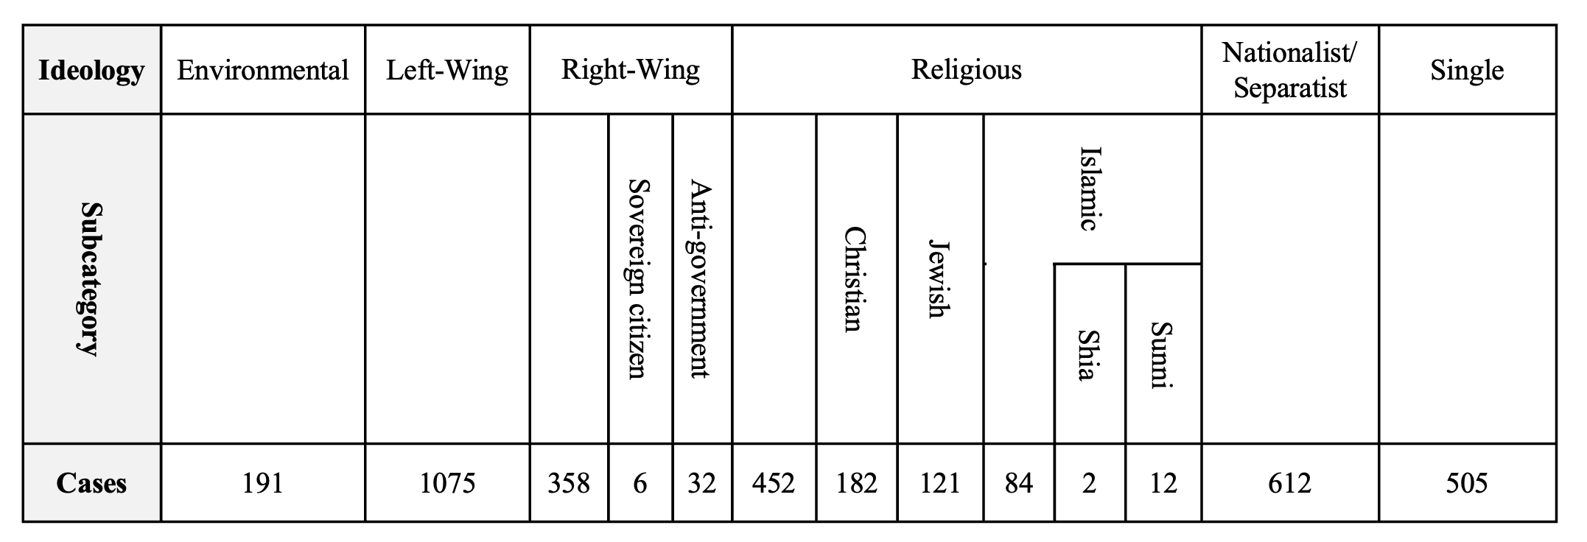
Source: Miller (2017).

For the purpose of this research, four categories of ideologies – nationalist, religious, left-wing, and right-wing – are used as other identified ideologies are typically not under the primary domain of U.S. national security-focused organizations which engage VEOs (Davis, 2019).
In summary of this chapter, VEOs are organizations. They can be classified by organizational features such as hierarchy, formalization, and centralization, as well as in terms of performance such as financing, recruitment opportunities, and innovation. VEOs adapt to their environment through changes of leadership, ideologies, or strategy – but very few change their brand once established. VEOs are inclined to have charismatic leaders but given the ephemeral nature of charisma and studies that find decapitation of organizational leadership is ineffective, leadership is not central to a brands existence. Strategy is required for any organization to function and grow. Given the organizations under study are violent extremist organizations, the category of primary strategy is impugned as interpretive extremism to accomplish the organizational goal and is a constant for all VEOs. Ideology is important to VEOs as it established the underpinning tones to strategy and operations. However, radical worldviews are only one among many potential causes of joining violent extremist groups (Kruglanski & Fishman, 2009; Springer et al., 2009). Therefore, ideology alone is not the primary organizational element for VEOs.

Chapter Four: Foundational Premises, a Proposition, and Hypotheses
An organization with a strong identity can differentiate itself within its category and stand out to stakeholders. This research asserts that this applies to any organization that is stakeholder-based. For example, the processes of brand building and radicalization identify potential stakeholders, seeking to gain stakeholder attention and generate commitment. They require consecutive steps to accomplish the end state. Both are multi-dimensional, meaning they are driven and sustained by multiple causes rather than a single cause. They rely on cognitive processes with an emphasis on emotion, which has a strong influence on attention, especially modulating the selectivity of attention as well as motivating action and behavior (Tyng et al., 2017). Springer et al. (2009) highlight a five-step process used for extremist recruitment, similar to processes used by intelligence services to recruit agents and the four-step process of building brands (Keller & Swaminathan, 2020). These processes all share the goal of creating resonance with the potential member such that they will engage in action for the brand. This is no different than a potential recruit choosing between the Army, Navy, Air Force, Marines, or Coast Guard. Arguably, all Services require the commitment to accomplish missions and goals supporting democracy and the defense of freedom. Yet the recruit must choose one. This research asserts the decision point for a recruit in most cases is the brand, or in this case, the Service, itself. The same challenges face the VEO recruiter – how to attract qualified candidates, usually for specific jobs, to the specific brand among competing categorical brands from a limited pool of resources.
As noted previously, this research asserts the brand is the center of gravity of any stakeholder-dependent organization. Leadership, ideology, and strategy may be factors of an organization, but are not the center of gravity of the organization. A popular four-step brand building process (Keller & Swaminathan, 2020) is directly applicable to VEOs as organizations, as explained earlier in this research. Knowing how a brand is engineered provides the ability to reverse-engineer it, using the same tactics, techniques and procedures used to build it. This research explored and explicated three premises, a proposition, and five hypotheses. They include:

Premises
P1. The brand is the Center of Gravity (CG) of an organization.
P2. Stakeholders declare commitment primarily to a brand.
P3. The four-step branding process applies to VEOs.

Proposition
While the leadership, ideology, or strategy of a VEO may change over time, the single element of an enduring VEO is the brand.

Hypotheses
H1: PERSONALITY is positively related to INTENSITY.
H2: PERSONALITY is positively related to ACTIVITY.
H3. PERSONALITY is positively related RESONANCE.
H4. INTENSITY is positively related to RESONANCE.
H5. ACTIVITY is positively related to RESONANCE.
To support this research, two separate studies were conducted. Study 1 asked the research question, is the brand the enduring element of successful VEOs with the proposed proposition that while the leadership, ideology, or strategy of a VEO may change over time, the single element of an enduring VEO is the brand. A case study of the IRA and the IS examined each organization’s timeline from origin to mid-2022. Each brand iteration was analyzed using five elements – brand, leadership, ideology, strategy, and franchises – using publicly available information gathered from common information sources. The metric of assessment is the number of attributed attacks found in the GTD. Study 2 looked at the dynamics of stakeholders regarding generic and name brands to explore how generic brands may have a more passive stakeholder community than would a name brand community. Study 2 was not about VEO recruiting methods and recruitment. Instead, study 2 explored the attraction of brands and types of personalities that may be inclined towards generic brands or name brands. The intent of study 2 was to explicate that a generic brand does not attract the same type of personality that a name brand does and if a brand is not competitive in its category, it can be labelled as generic. This research posits that a generic brand has stakeholders who lack the level of emotional commitment necessary to increase personal risk or take affirmative action in support of the brand. As such, for any organization, which requires high levels of commitment from their stakeholders – such as VEOs – a loss of brand value that results in less differentiation from its competitors will directly impact the organization’s stakeholders. A model was specified to explain the correlation with stakeholder personality and generic or name brand selection. Regression and Path Analysis explored the relationships between Intensity, Activity, Personality, and Resonance (and their indicators). Structural Equation Modelling (SEM) was used to identify the strength of relationships between structural components in the model.

Chapter Five: A Case Comparison Study - The IRA and IS
The essence of a case study is to illuminate a decision or set of decisions: why they were taken, how they were implemented, and with what result (Schramm, 1971). A case study investigates a contemporary phenomenon in depth and within its real-world context, especially when the boundaries between phenomenon and context may not be clear (Yin, 2018). To do this, a case study presents a logic of design, data collection techniques and specific approach to data analysis (Yin, 2018). Yin’s (2018) five components of qualitative case study research were used for this study. These steps include: (1) a case study’s question, (2) its propositions, (3) its cases, (4) the logic linking the data to the propositions, and (5) the criteria for interpreting the findings. This study used a cross-case synthesis approach to the selected cases. A cross-case synthesis approach contrasts with data aggregation approaches, which usually aim to reach conclusions about variables, but not about the cases (Yin, 2018). A cross-case synthesis study’s goal “is to retain the integrity of the entire case and then to compare or synthesize any within-case patterns across the cases” (Yin, 2018, p. 196). According to Yin (2018), “if you can do even a two-case study, your chances of doing a good case study will be better than using a single-case study” (p. 61). Cross-case synthesis is recommended when using only two cases (Yin, 2018).

Research Question and Proposition
This study asked in what way the brand impacts a VEO. Following the premises of this research, this particular study proposed that the center of gravity of a VEO is the brand itself. A brand may be successful right from the beginning, be franchised, or be brandjacked from its origins for new organizational purposes. Control of a brand may be fought over within an organization or brands may be permissively franchised out. In all instances, this study asserted that the action is taken with the goal of using the existing equity and value of the brand to attract stakeholders.

Data and Logic
Data for this study was obtained from existing, open-source documents, collected from peer-reviewed journals, and academic books, published government documents, professional organizations and publications, professional news sources, and publicly available internet sources. To provide data continuity, attributed attack information comes from the GTD. The GTD includes systematic data on domestic as well as transnational and international terrorist incidents that have occurred during this period and now includes more than 200,000 cases. Statistical information contained in the GTD is based on reports from a variety of open media sources. The National Consortium for the Study of Terrorism and Responses to Terrorism (START) makes the GTD available in an effort to increase understanding of terrorist violence so that it can be more readily studied and defeated. More than 4,000,000 news articles and 25,000 news sources were reviewed to collect incident data from 1970 to 2020 for the GTD. To build a historical view of each case, as well as strength triangulation (Yin, 2018), sources such as Wilson Center timeline (Cameron et al., 2019) and the Ulster University Conflict Archive on the Internet (CAIN) (Melaugh, 2022.) were used. The analytic strategy of this case study was founded in the premises of this research, built around a descriptive framework, and examining plausible (but not all) rival explanations (Yin, 2018). Five main criteria were assessed – brand, leadership, ideology, strategy, and franchises – from organizational origin to the date of publication, using attributed attacks as the metric of study.

Methodology
This research examined existing information to explore the premise that the brand is the center of gravity of an organization – especially a VEO that requires high brand value and equity to exist and endure. A brief history of both organizations was presented. The known organizational history and brand iterations were listed in a database (Appendix A) generated for this study. The organization start and end date was noted in the database. The number of attributed attacks in the GTD was conducted using the upper- and lower-case, long name of the organization name, and the associated acronym. For example, search terms included Al-Qa’ida in Iraq, al-qa’ida in iraq, and AQI or Irish Republican Army, irish republican army, and IRA. The larger number found was applied. If applicable, the organization is noted as a franchisor, franchisee, and/or brandjacking another brand. A franchise is indicated by the permissive and agreed use of an existing brand. For example, the Islamic State in Libya is a franchisee of the Islamic State. Brandjacking (Hesseldahl, 2007) occurs when an emerging organization uses the identity of another for the purposes of using an existing organization’s brand value and equity. For example, the Original IRA and the Provisional IRA were contrary in purpose and mission, yet each “claimed” to be the de facto continuation of the original IRA. The IRA brand is a result of a series of internal disagreements and brandjacking throughout its history, as will be covered later in this study.
Known leader(s) of the organization were listed by the known dates of leadership in the specific organization. If unknown, the entry was left blank. The study then looked at the number of leaders of the strongest brand iteration (identified as the one with the most affiliated attacks) and assessed any impacts of leadership to the brand. Ideology of the strongest brand iteration was assessed using the four types of ideology in this study and the primary strategy was impugned as interpretive extremism for both organizations and their brand iterations.

The Cases
The IRA and IS were selected as well-known VEO brands with an abundant amount of available open-source information and published research. Other extremist organizations such as Hamas, Boko Haram, and the Proud Boys were considered, but IRA and IS were selected as representative cases of VEOs with ample public information available for review. According to Yin (2018), with two cases, “you have the possibility of direct replication. Analytic conclusions independently arising from two cases, as with two experiments, will be more powerful than those coming from a single case (or single experiment) alone” (p. 61). Both the IRA and IS use violence targeted at civilians, government officials, and security services. They seek a polity of their own design and claim to represent a closely defined population. Both have different goals, stakeholders, methods, motives, and targets and both have enduring and iconic brands. They have waxed and waned in strength and popularity, yet both brands exist to this day while other splinter organizations have disappeared.
The Irish Republican Army (IRA)
The IRA is an Irish Republican paramilitary organization spanning from 1916 to present day with origins in the Fenian Brotherhood in 1858. The IRA is a name used by various groups throughout the 20th and 21st centuries. Organizations by this name have been dedicated to a policy of advocating the restoration to a country of any territory formerly belonging to it through Irish republicanism. They believe that all of Ireland should be an independent republic free from British rule (Connolly, 2008). The IRA Green Book states that “the position of the Irish Republican Army since its foundation in 1916 has been one of sustained resistance and implacable hostility to the forces of imperialism” (Melaugh, 2022b, para 13). According to the two volumes of the Green Book, a democratic socialist state, in which every individual has a right to make their thoughts known on items that affect them, is promised (Melaugh, 2022b). The book also states that they wish to restore Gaelic to its rightful glory, as well as the use of warfare only, when all other methods of recourse fail (Melaugh, 2022b). The Green Book states (Melaugh, 2022b):
The moral position of the Irish Republican Army, its right to engage in warfare, is based on a) The right to resist foreign aggression, b) The right to revolt against tyranny and oppression, and c) the direct lineal succession with the Provisional Government of 1916, the first Dail of 1919 and the second Dail of 1921. (para 15)
Origins for the brand name “Irish Republican Army” date to the Fenian Brotherhood of America, a revolutionary movement founded around 1858 in the industrial cities of the north-eastern United States. The Irish Republican Army came to global prominence in the 19th century with several attempted invasions of British-administered Canada between the years 1866 and 1871. Staged by rival factions of the Fenian organization, the objective of the expeditions was the establishment of an Irish Republic in Exile on the North America continent by exploiting the simmering post-Civil War tensions between Washington and London (senior members of both the White House and U.S. Congress initially encouraged the Fenian plans). Though the strategy failed, the abbreviation “IRA” was added to the lexicon of Irish and international politics. Some 50 years later, when the Fenian movement began in Ireland, the Irish Republican Brotherhood (IRB) orchestrated an insurrection against British colonial rule in the country by bringing together several existing paramilitary organizations under one banner. These included the Irish Volunteers, Irish Citizen Army, and Hibernian Rifles which in the Easter Rising of 1916 assumed the collective title of the Army of the Irish Republic, known as the Irish Republican Army. This IRA was the army of the revolutionary Irish Republic as declared by its parliament, Dáil Éireann, in 1919.
The Irish Republican Army (1919–1922) was recognized by the first meeting of the unicameral parliament of the revolutionary Irish Republic (First Dáil) as the legitimate army of the Irish Republic in April 1921. On ratification of the 1921 Anglo-Irish Treaty by the Dáil, the legitimate army of the Irish Republic split into pro-Treaty forces (the National Army or regulars) and anti-Treaty forces (Republicans, Irregulars, or Executive forces). The National Army became known as the Irish Defense Forces with supporters becoming members of the Fine Gael Party, the third largest party in the Republic of Ireland. The Irish Republican Army (1922–1969), the anti-treaty IRA, which fought and lost the civil war and thereafter refused to recognize either the Irish Free State or Northern Ireland.
The following period of conflict, known as “the Troubles,” reflected a struggle between different national, cultural, and religious identities (Archick, 2022). Protestants in Northern Ireland (48% of the population) largely defined themselves as British and support Northern Ireland’s continued incorporation in the UK (unionists) (Archick, 2022). Most Catholics in Northern Ireland (45% of the population) considered themselves Irish, and many Catholics desired a united Ireland (nationalists) (Archick, 2022). In the past, more militant unionists (loyalists) and more militant nationalists (republicans) were willing to use force and resort to violence to achieve their goals (Archick, 2022).
In 1969, the IRA split into the Official IRA (OIRA) (a Marxist based political party following the Irish Sinn Fein political party), and the Provisional IRA (PIRA), which believed that violence was a continued necessity for independence. By 1970, the PIRA went on the offensive with bombings, ambushes, and assassinations (Cowell-Meyers & Arthur, 2015), operating mostly in Northern Ireland, using violence against the Royal Ulster Constabulary, the British Army, British institutions, and economic targets. After OIRA’s 1972 ceasefire, it and Sinn Féin suffered a split in 1974 leading to the formation of the far-left Irish National Liberation Army (INLA) and Irish Republican Socialist Party (IRSP). The INLA was known for a series of internal feuds and some of the more sectarian killings by Irish nationalists. In 1985, the Anglo-Irish Agreement was put into effect. This agreement gave Ireland a legal recourse to deal with the affairs of Northern Ireland. In 1986, the Continuity IRA split from the Provisional IRA, with CIRA members wanting to keep up the violence, seeing it as the only way that Ireland would become whole. Later that same year the Irish People’s Liberation Organization (IPLO) split from the INLA.
In 1992, the Workers’ Party suffered a split when a majority faction failed to secure changes. They left and formed the Democratic Left. Ultimately, the Democratic Left merged into the Labor Party. By 1997, the PIRA entered another set of cease-fire negotiations with Unionists, resulting in yet another splinter group, the Real IRA (rIRA). The rIRA opposed the 1997 ceasefire and Northern Ireland peace process and its objective is a united Ireland by forcing the end of British sovereignty over Northern Ireland using physical force.
In 2006, the Irish Republican Liberation Army, Óglaigh na hÉireann, and Saoirse na hÉireann split from the Continuity IRA. By 2009, Óglaigh na hÉireann split from the rIRA. Two years later, in April 2011, former members of the Provisional IRA announced a resumption of hostilities, and that “they had now taken on the mantle of the mainstream IRA.” They further claimed: “We continue to do so under the name of the Irish Republican Army. We are the IRA” (Breen, 2011, para 4), and insisted that they “were entirely separate from the Real IRA, Óglaigh na hÉireann (ONH) and the Continuity IRA.” (Breen, 2011, para 10). They claimed responsibility for the April assassination of Police Service of Northern Ireland constable Ronan Kerr as well as responsibility for other attacks that had previously been claimed by the rIRA and ONH. In 2012, the rIRA merged with other republican groups including the Republican Action Against Drugs (RAAD) to form the New IRA.
A 2015 United Kingdom (UK) government report determined that all the main paramilitary groups operating during the Troubles still exist, “however, the most serious current terrorist threat in NI [Northern Ireland] is not posed by these groups but by dissident republicans (DRs) - paramilitary groups not on ceasefire and who reject the 1998 Belfast Agreement (the so-called ‘new’ IRA, Oglaigh na hEireann and the Continuity IRA)” (Villiers, 2015, p. 1). January 2018, ÓNH declared itself on cease-fire, although a small splinter group formed in opposition to the cease-fire. The other groups remain active, and authorities warn the threat posed by the New IRA in particular is severe (MI5.gov, n. d.). A 2022 Congressional Research Service (CRS) report (Archick, 2022) notes that dissident groups do not have the same capacity to mount a sustained terror campaign as the IRA did between the 1970s and the 1990s but continue to exist. There are currently four main dissident republican groups: the Continuity IRA (CIRA); Óglaigh na hÉireann (ÓNH); Arm na Poblacht (ANP), and the New IRA (Archick, 2022; MI5.gov, n.d.).
The IRA used a nationalist ideology (to form a nation), based on republicanism (freedom from external rule), implemented through the strategic use of extremism (coercion and force) to attain organizational goals (a unified and independent Ireland). The original IRA brand was fought over by different branches and versions of the original group, because of its cultural value and equity. The IRA aspires to reclaim an existing, geographical republic occupied by an external government force.
The Islamic State (IS)
IS known by several names, including ISIS (Islamic State of Iraq and Syria) and ISIL (Islamic State of Iraq and the Levant) (Tharoor, 2014), or the Arabic acronym Da’esh (Filipec, 2020; Guthrie, 2015; Schwartz, 2014). De’esh can be a literal translation of al-dowla al-islaamiyya fii-il-i’raaq wa-ash-shaam, but depending on how it is conjugated in Arabic, the word can mean to trample down and crush and can also mean a bigot (Garrity, 2015; Filipec, 2020). IS a Sunni jihadist brand with a particular penchant for shocking violence, even for extremists, identifying itself as a caliphate claiming global religious authority over all Muslims. IS has been studied as a theocratic proto-state (Dyer, 2015) and a Salafi jihadist group (Bunzel, 2015; Crooke, 2017; Meleagrou-Hitchens et al., 2014). IS’s ideology has been described as being a hybrid of Qutbism (Manne, 2016, 2017; Poljarevic, 2021), Takfirism (Badra & Nagata, 2017; Bunzel, 2015; Poljarevic, 2021); Salafism (Meleagrou-Hitchens et al., 2021; Saltman & Winter, 2014) Salafi jihadism (Bunzel, 2015; Crooke, 2017; Meleagrou-Hitchens et al., 2021; Saltman & Winter, 2014), Wahhabism (Bunzel, 2015; Meleagrou-Hitchens et al., 2021; Saltman & Winter, 2014), and Sunni Islamist fundamentalism (Armstrong, 2014; Crooke, 2017).
IS has gone through four main iterations, with its origins in a group called Jama‘at al-Tawhid wal-Jihad founded by Abu Musab al-Zarqawi in the 1990s. The first iteration is called the Zarqawi prelude (2002–2006), the period of jihadism’s initial rise in Iraq under the leadership of Abu Mus‘ab al-Zarqawi (Bunzel, 2015; Springer at al., 2009). The group aligned with al-Qa‘ida in October 2004, forming al-Qa‘ida in Iraq (AQI) short for the actual name it adopted, The Organization of the Base of Jihad in Mesopotamia (Bunzel, 2015). The U.S. Department of State designated AQI as a terrorist organization in 2004 (Department of State, 2012). In January 2006, AQI organized the formation of an umbrella group called the Mujahideen Shura Council (MSC). Further emphasizing the significance of brand names, members of the newly formed MSC ceased claiming responsibility for attacks under their original group names, “opting instead to use the name of the Mujahidin Shura Council” (Springer et al., 2009, p. 119). The first iteration of IS emerged at a time when Iraq’s Sunni insurgency was fast losing momentum and was a dismal failure (Bunzel, 2015).
The second iteration occurred in 2006 when the MSC declared the establishment of the Islamic State of Iraq (ISI) (2006-2013) and after AQI separated from al Qa’ida when al-Zarqawi was killed (Bunzel, 2015; Springer et al., 2009). From mid-2007 through 2011, ISI was on the defensive and near defeat. During that period, its top leaders were killed, and territories lost. But even as late as 2011, some analysts noted that the group’s structure and ability to generate local funding and recruits could keep it as an effective fighting force (Johnston et al., 2019). In 2013, ISI established a presence in Syria and the leadership renamed the group the Islamic State in Iraq and Syria (ISIS; also known as the Islamic State in Iraq and al-Sham, or the Islamic State in Iraq and the Levant [ISIL]). (Stern & Berger, 2016). Conventional wisdom, both in the Middle East and the West, held that al-Qaeda in Iraq had merely changed its name in October 2006 to the Islamic State of Iraq (Bunzel, 2015). Springer et al., (2009) noted, “this declaration was intended to convey the impression that it actually has a functioning bureaucracy and is not simply a collection of insurgents” (p. 121). According to the Brookings Institute and Bunzel (2015):
The significance of the “name change” was much greater than was appreciated at the time. It signaled the start of an ambitious political project: the founding of a state in Iraq – a proto-caliphate – that would ultimately expand across the region, proclaim itself the full- fledged caliphate, and go on to conquer the rest of the world. The extent of these ambitions went largely unnoticed. (p. 4)
The third iteration is that of the Islamic State of Iraq and Sham (2013–2014). On June 29, 2014, ISIS leader Abu Bakr al Baghdadi announced the formation of a caliphate stretching from Aleppo, Syria to Diyala, Iraq and renamed the group the Islamic State (IS) (Cameron et al., 2019). Abu Bakr al-Baghdadi was named the IS first caliph, the Caliph Ibrahim. Shortly thereafter, in 2014, al-Qa‘ida disavowed a relationship with ISIS due to its brutal tactics and targeting of Muslim and non-Muslims alike (Bunzel, 2015). During this period, the 2014-2015 Report Card on International Cooperation, produced by the Council of Councils, ranked combatting transnational terrorism as the third highest priority global challenge for 2015 (Council on Foreign Relations, 2015). The report noted the emergence of IS highlighted the difficulty inherent in preventing terrorism (Regens et al., 2016).
The fourth iteration is as the self-acclaimed caliphate (2014–present) (Bunzel, 2015). Following a series of organizational failures and name changes, the IS ultimately established itself in June 2014, declaring itself a caliphate and deserving of the loyalty of all Muslims worldwide (Liebl, 2019). After three failures at establishing itself, a brand that resonated with stakeholders was established – founded on an engineered and weaponized version of Islam.
IS, or ad-Dawlah al-Islāmiyah, considers itself an eschatological (end of the world) vanguard, seeking to fight against al-Dajjal (the Anti-Christ) and bring about the end times when a much winnowed (and purified) Islamic ummah attains the global caliphate (Liebl, 2019). The IS driven by the Tawhid (oneness of God), uses declaration of takfir to eliminate false Muslims and hypocrites, and espouses the doctrine of al-Wala’ wa-l-Bara (loyalty and disavowal) (Liebl, 2019). IS generates resonance by using the al-Wala’ wa-l-Bara doctrine established by Muhammad before his death. IS adheres rigorously to the Tawhid and is focused on reviving “originalist” Islam – thus the adoption of the name ‘Abu Bakr’ by the IS caliph, which for all Muslims harkens back to the Ridda Wars when a post-Muhammad Islam was disintegrating, Arab tribes were falling away or pursuing their own tribal ‘prophets,’ and the first caliph, Abu Bakr, brought them back to the fold of the faithful or had them killed (Khan, 2020). Thus, the desired IS organizational brand image is a nationalist movement in accord with previous movements trying to cleanse Islam of bida and accretions, establish a global Ummah, and getting back to what is viewed as original Islam. Of the four identified ideologies used in this study, IS arguably sees itself as a nationalist organization – albeit a transnational actor without state borders – employing an interpretive extremist strategy to achieve a political end.
The cultural need for a nation is strong in Islam and resonates with many Muslims. Several terrorist organizations previously tried to exploit the desire for the unity of Muslims. For example, in 1953, Taqiuddin al-Nabhani (1909–79), established the Hizbut-Tahrir (Party of Liberation) to revitalize the institution of caliphate but did not succeed (Dogan, 2015). According to Dogan (2015), “in 1996, Taliban leader Mullah Mohammed Omar announced himself as the Commander of the Believers (Amir al-Mu’minin) and tried to revitalize the caliphate. His attempt was recognized by Osama bin-Laden as the legitimate ruler of the state of Afghanistan” (Dogan, 2015, para 20). In mid-2006, al-Qa’ida declared that the Iraqi city of Ramadi was to be the capital of a new Islamic caliphate. And in 2014, IS declared a caliphate in an area straddling Iraq and Syria and announced its leader, Abu Bakr al-Baghdadi, as the caliph (Dogan, 2015).
After conducting interviews with over 200 individuals involved with IS, Speckhard and Ellenberg (2020) found that many described joining the organization based on an underlying longing for an Islamic Caliphate – the political-religious state consisting of the Muslim community and the lands and peoples under its dominion in the centuries following the death (632 CE) of the Prophet Muhammad (Bunzel, 2016). Interviewees were extremely moved by the declaration of the IS Caliphate, supported by the fact that IS had taken control of such significant swathes of land in both Syria and Iraq. For example, 44-year-old Havaz Hamadi Omar, one of the subjects interviewed in Speckhard and Ellenberg’s 2020 study, recalls:
I was in Sweden when Baghdadi declared his Caliphate. Since we were in our childhood, we are studying in our school that one day the Caliphate will come and it will be established, so when we saw it in Mosul, we think this day has come, and we have to go and join it. (p. 103)
Absent of ideology, fighters from Balkans, who traveled during the Syrian Civil War to fight Assad eventually joined IS for various reasons. In interviews, many foreign fighters spoke about becoming trapped in Syria as the Ahrar al Sham hunting foreign fighters, and the Turkish border being blocked (Speckhard & Ellenberg, 2020). They sought safety in IS territory where they were welcomed, but also forced to join and become fighters for the group (Speckhard & Ellenberg, 2020).
The RAND corporation (Johnston et al., 2019) predicted that “in a fluid security environment with limited ability or willingness to conduct the type of policing activities that would deter widespread criminality, Islamic State members will once again try to resuscitate a shadow economy in the rural Sunni heartlands” (p. xix ). It is IS’s self-sufficient financial foundation, and a knack for survival, that has some researchers speculating as recently as 2019 that the IS will almost certainly attempt a comeback. According to Johnston et al., (2019):
The Islamic State’s caliphate was never just territorial. It was always a caliphate of the mind, a vision of an Islamic state that the modern group’s leaders imagined to have existed in history and that, were it to exist in reality as its leaders envisioned, would be a regional menace to its neighboring states and a nightmare primarily for the world’s Muslims. (p. 101)
The Carnegie Endowment for International Peace (Al-Hajj, 2022) noted, “The fact that ISIS is turning into a non-spatial military body has enabled it to adapt to its new realities and show viability under adverse circumstances whilst also consolidating its large geographical presence.” (Al-Hajj, 2022, para 8). The 2022 Annual Threat Assessment of the U.S. Intelligence Community stated that “ISIS leaders remain committed to their vision of building a self-styled global caliphate headquartered in Iraq and Syria and are working to rebuild capabilities and wear down opponents until conditions are ripe for seizing and holding territory” (Office of the Director of National Intelligence, 2022, p. 26). A May 10, 2022, Congressional Research Report (Humud, 2022) notes a steady increase in U.S. budget requests for the Counter-ISIS Train and Equip Fund with Fiscal Year (FY) 2023 requesting $541M, up from $460M (FY 2021) and $500M (FY 2022) in nominal dollars (Humud, 2022, p. 2). According to Aljazeera (Gaopoulos, 2022):
ISIL and its affiliates have shown they are resilient to persistent attacks and are able to generate revenues. Battling both rival groups and governments, ISIL still manages to spread its franchise of affiliates, taking hold wherever there is weak state control, finding roots in local disaffected populations. (para 25)
With the goal of establishing a political order based on a specific worldview of religious law, the IS follows a nationalist ideology (to form a nation) based on their interpretation of Islam (brandjacking Islam), implemented through the strategic use of extremism (coercion and force) to attain organizational goals (purification and rule of all Muslims).This research challenges existing notions that IS operates under a religious ideology and argues that IS operates under a politically motivated nationalist ideology, with religion an underpinning element amongst many.
For VEOs such as IS, issues of justice and community are arguments supporting nationalism as an ideology. Nationalism includes ethical principles, such as the moral duties of individuals to fellow members of the nation, which override ethical principles of non-members. For IS, this would be allegiance to the notion of a physical caliphate govern by IS interpretation of Sharia and tenants off Islam. Nationalism claims that national loyalty – loyalty to the Ummah – in case of conflict, overrides all other loyalties. Arguments for intrinsic value, identity, right to collective self-determination, the right to self-defense and to redress past injustices support a VEO nationalist point of view, albeit through extremism as a strategy of action and violence as a means to the end.
A nationalist ideology is what arguably generated enough performance equity for IS to generate high enough levels of resonance to franchise and grow. A religious ideology stops short of establishing a real or perceived geographical entity with a political governing body. Nationalism can be an official state ideology or a popular non-state movement and may be expressed along civic, ethnic, cultural, language, religious, or ideological lines. In the instance of IS, the nation in question is the Ummah. In a digital world, and where challenges transcend physical boundaries, nationalism can exist with or without borders. For example, an individual can hold a British or German passport, but consider themselves a European nationalist. Within the framework of the IRA, and as Harrison and Boyd (2018) note, “Northern England shares a degree of resentment with the Celtic nations of the UK towards the economic, political, and cultural dominance of London and the South-East of England” (p. 171).
As seen in the three iteration failures before establishing IS, the organization does not have the physical or moral means to establish itself well enough to create any kind of local or international impact without a parent brand. IS brandjacked a popular and respected religion and engineered it into something else for the political benefit of the organization. IS aspires to create a borderless, but global nation and rule with its worldview and interpretations of Islam. With a potential following of 1.6 billion Muslims who believe in the Ummah, the organization that can harness a perception of control of the Ummah stands to be a powerful, global religious and political entity akin to the Roman Catholic Church and the Pope.

Results
This case study comparison looked at brands, leadership, ideology, and strategy, and the GTD was searched. Figure 14 notes the number of attacks by IS and Figure 15 notes the number of attacks by the IRA. Both are scaled logarithmically for attack numbers. The groups are listed by number of attacks, from left to right. The accuracy of the source data is not in question, nor arguably a concern. Whether or not the organization considers the number of attacks accurate is not a concern either. Recall that brand value and equity is in stakeholder perceptions and if an attack is logged under a particular group, that is how a specific stakeholder sees that organization. It is likely that a government agency has a different number of attacks using classified collecting procedures. It is also likely that the organization itself has a different accounting of attack numbers as they seek to create a specific perception of success. In an organizational category where violence is a measure of success and performance capital, these attributed attacks – perceived or real – are the currency of VEOs. As such, the brand with the highest number of attributed attacks and franchises can be assessed as the most valuable and equitable brand.
Figure 14
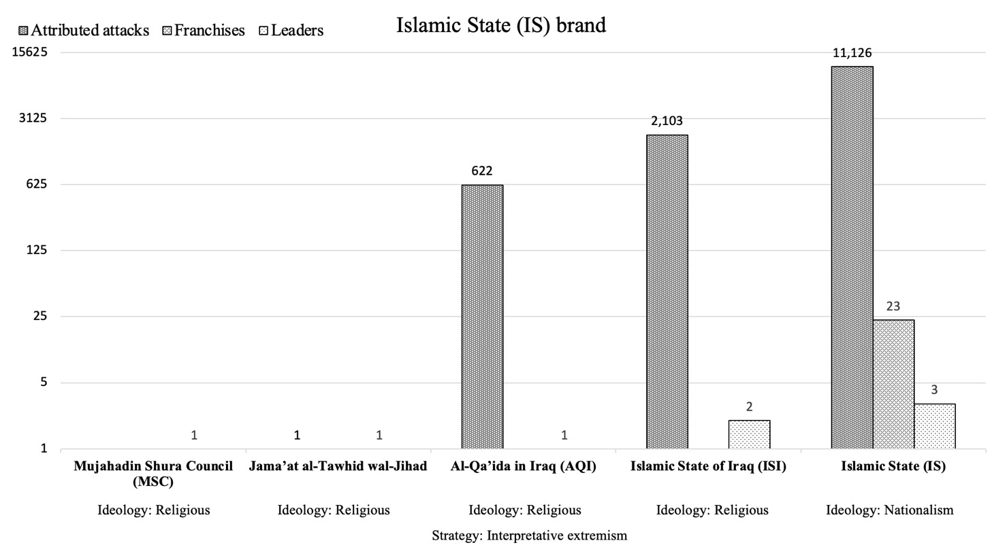
IS brand iterations listed by attributed attacks and franchises
Data source: Global Terrorism Database (2022).

Figure 15
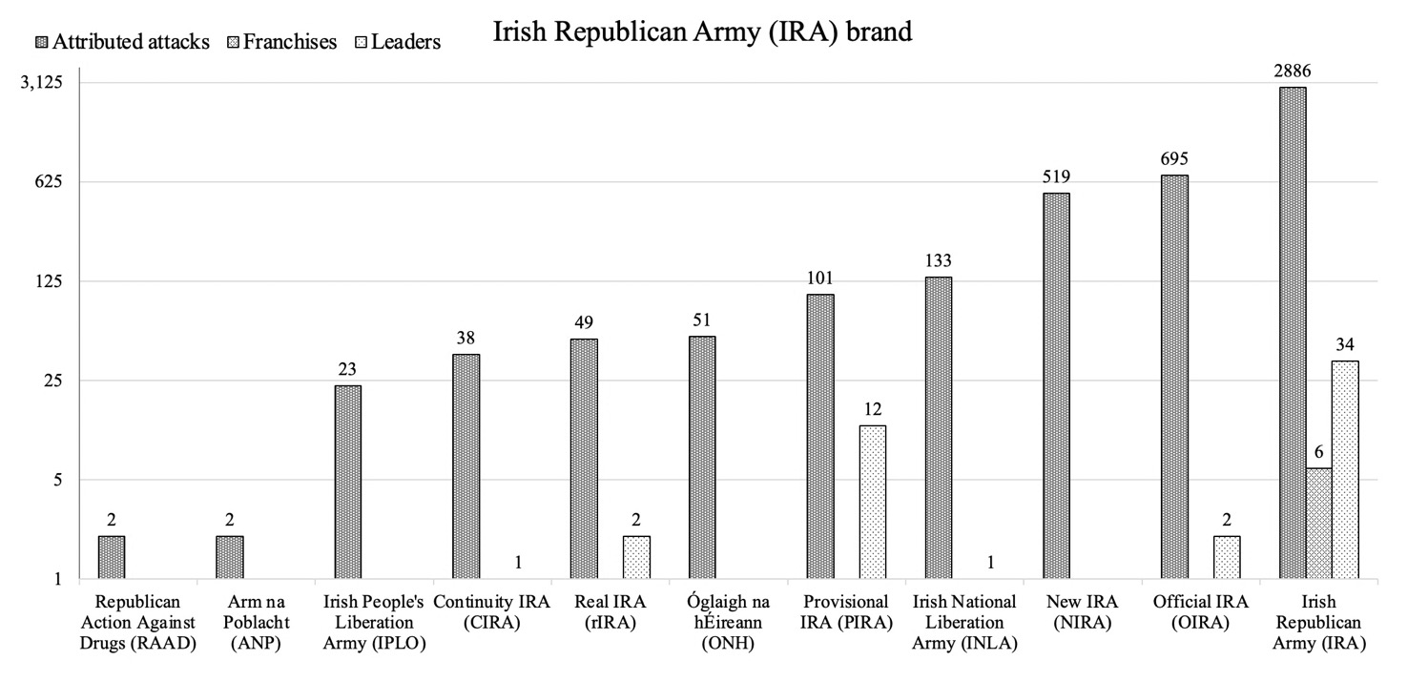
IRA brand iterations listed by attributed attacks and franchises
Data source: Global Terrorism Database (2022).
Using attributed attacks as the indicator of brand value and franchises as an indicator of equity, it is apparent that the successful brands are the IS and the IRA. Strategy for both organizations was imputed as interpretive extremism throughout the time span of each organization. Ideology remained constant throughout the life span of each brand, with the IRA and IS assessed by this study as being nationalist. IS was able to produce franchises when it adopted a nationalist ideology with prior brand iterations of the organization focused on religious extremism. Leadership changed numerous times throughout the time span of each organization, but the brand was not significantly impacted. For example, IS has had three leaders from 2013 to date and the IRA had about 35 leaders from 1919 to date. Given the strength of both brands, to date leadership changes can be assessed as having a negligible impact on the value and equity of the brand, with the only visible correlation being that highly attributed brands have more leaders.
Like some commercial organizations, VEOs can franchise as a cost-effective way to grow and achieve organizational goals. In the competitive category where violence is a measure of success, credibility, and effectiveness, the attributed attacks, perceived or real, and the ability to affect political outcomes are the currency of VEOs. Prior research indicates that the rate of franchising increases, then decreases as the franchisor matures (Mishra, 2015). Figure 16 shows the shape of the theoretical curve of franchising. Arguably, most VEOs do not have enough performance capital in the form of credible, attributable attacks to achieve enough BMA or have a BMD that enables or desires franchising. The VEO brand that earns enough BMA will cross over the low competition position/low geographic expansion into the low competition position/high geographic phase of franchising. Most VEOs will not make it past this point as they expand too fast, lack the capital to grow, or cannot maintain their BMA.
Figure 16
Franchising Lifecycle
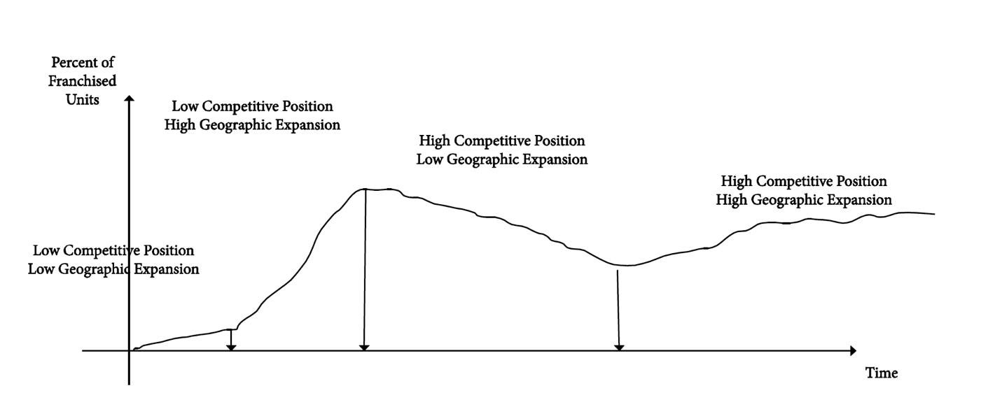
Source: Franchise Life Cycle, Mishra (2015, p. 26).

IS (Figure 17) is one of the few VEOs that is currently in the high competition position/high geographic expansion phase of its franchise. The earlier versions of the brand were not able to generate enough performance capital to grow and franchise, to achieve the second step of brand building. This research posits switching from a religious ideology to a nationalist ideology, reached stakeholders, generated needed performance capital, and crossed the threshold into the ability to franchise. It was followed by the sharp curve of success during the high competitive position/high geographic expansion period. The next anticipated step for IS would be expansion of organizational outlets (owned property), as well as maintaining franchises as venture capital becomes more plentiful and the leading position amongst competitors in the brand category is stabilized.

Figure 17
IS Franchising Lifecycle
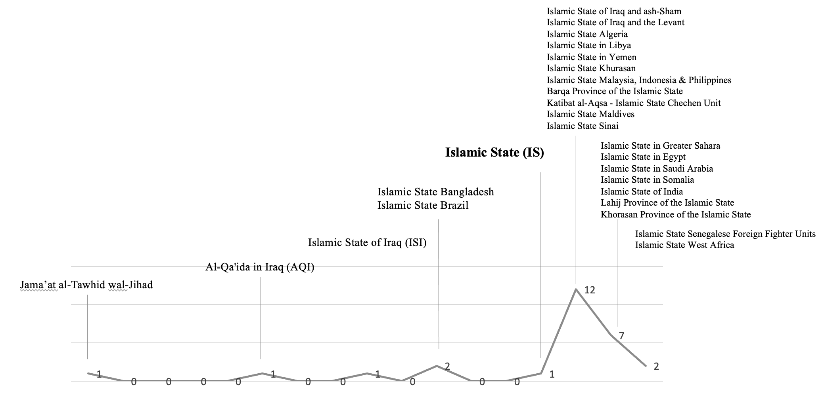
Source: Original data

Knowing when or by what metric stakeholders may consider a VEO as “established” can be a valuable variable to planners. In the case study of IRA and IS, it appears franchises seem to become possible after approximately 480 attacks, or .002 of total attacks. The ratio of attack-to-franchise for IS 483:1 and for IRA is 481:1. While further research is needed to support the observation, it is possible that the 480:1 ratio is a possible threshold to achieve a working level of performance capital and an acceptable BMA. As noted in Figure 18, it appears that the IS franchise life cycle accelerated significantly after this ratio was achieved. Franchise scales are not to scale with attacks in order to provide a visual comparison of the two. However, franchising (r = 0.3905) and attacks (r = 0.5745) are both positive, indicating that as one increases so does the other.

Figure 18
IS Franchises and Attacks per year
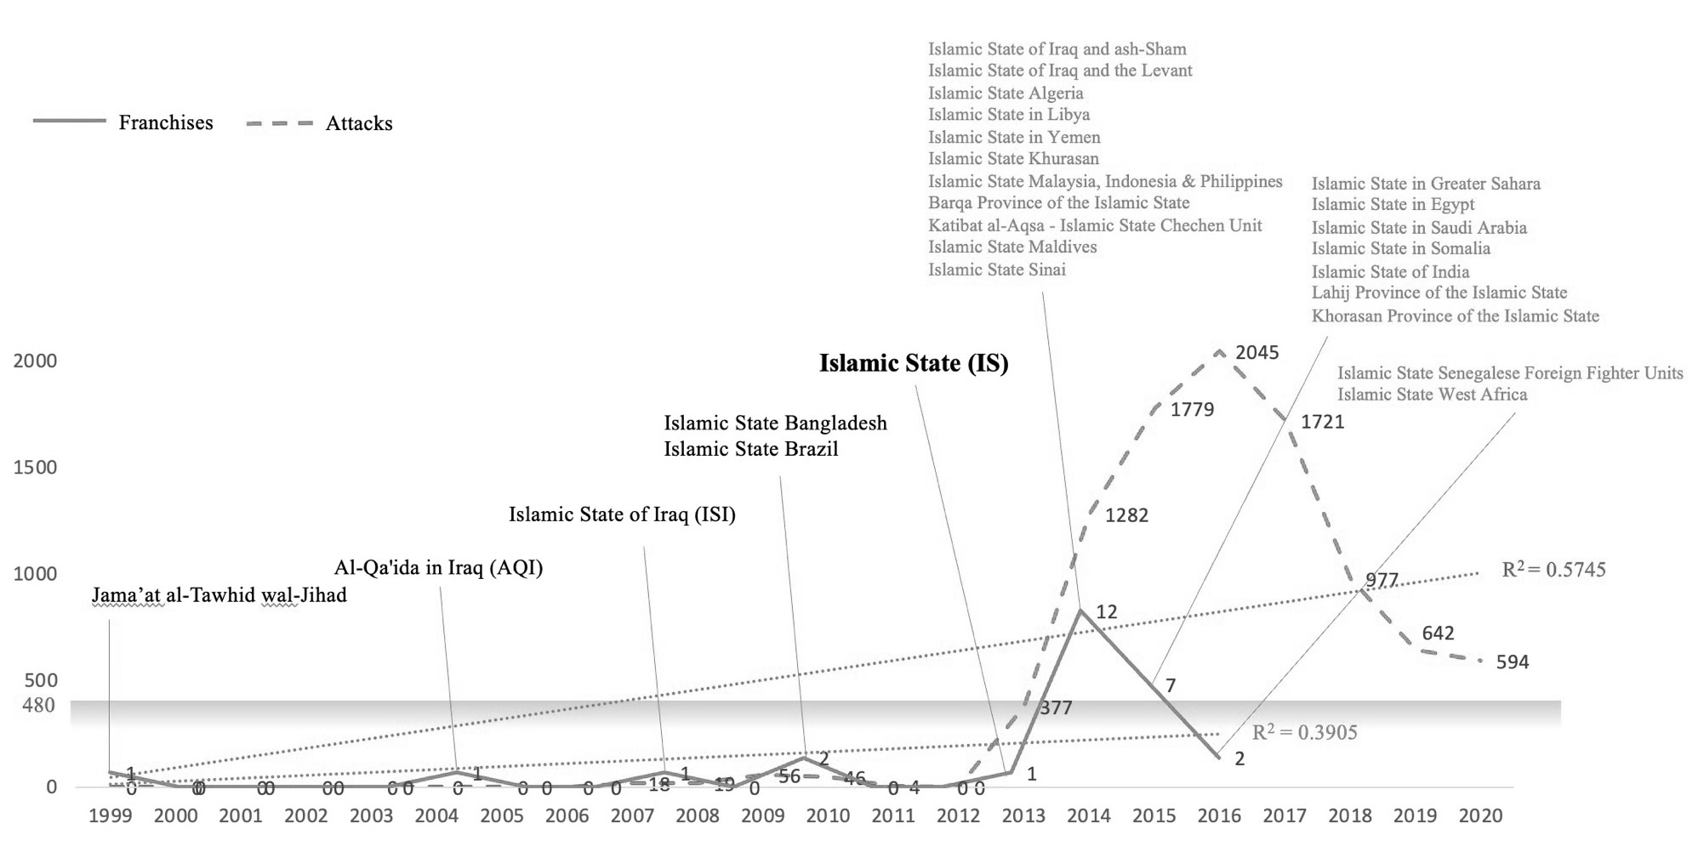
Source: UM GTD and original data.

There are, however, issues with this argument. For instance, ISI, OIRA, and the NIRA do not appear to have franchises. With 2,103 attributed attacks, ISI should have produced four franchises. It is possible, with 91,905 attacks in the GTD listed as “unknown group,” some groups are yet to be identified and could account for these potentially “missing” franchises. With 695 attacks for OIRA and 519 attacks for NIRA, each should have a franchise. It could be assessed that ISI, OIRA, and NIRA lacked sufficient BMD to seek franchises. Franchising may have not been a desired business growth model for these VEOs, or they overcommitted themselves or underperformed and failed to achieve the second and third step of brand building. Another alternative explanation is these groups have franchises but are not known or identified in publicly accessible literature.
In summary, with attributed attacks as the measure of brand value and franchises as the measure of brand equity, the brand that resonates the most with stakeholders endures. This study found that the elements of leadership, strategy, and ideology are still relevant, but secondary to the brand. These results support that a brand can exist with or without leadership, strategies, and ideologies, but that leadership, strategy and ideology cannot exist without a brand.
The significance of this chapter and study reinforces the research premise that the brand is the center of gravity of an organization. With a focus on genericizing the VEO within its organizational category, the brand should be the primary focus of engagement resources when the intent is to disenfranchise the organization.

Chapter Six: Personality Type and Brand Affinity
This chapter examined and assessed the impact of personality attributes on brand affinity hypothesizing that generic brand affinity is less intense than name brand affinity. To do this, the study looked at measures of personality, brand intensity and activity, and brand resonance. According to Keller and Swaminathan (2020), “brand resonance and the relationships consumers have with brands have two dimensions, intensity and activity” (p. 122). Intensity is a measure of attitudinal attachment and sense of community while activity is a measure of behavioral loyalty and active engagement. The study posited that the level of intensity and activity is related to a stakeholder’s personality traits or characteristics. This study proposed that stakeholders with high intensity and high activity will be passionate about the brand and will change personal habits or increase personal risk for a name brand, including acting out in support of the brand.
The study examines personality as a combination of extraversion, conscientiousness, neuroticism, openness to experience, agreeableness (McCrae & John, 2003, Rammstedt & John, 2007), and dogmatism (Rokeach, 1954). Intensity was examined as a combination of attitudinal attachment and sense of community (Keller & Swaminathan, 2020) and activity as a combination of behavior loyalty and active engagement (Keller & Swaminathan, 2020). All three independent variables are related to level of resonance, the dependent variable of this study. Resonance was examined as a combination of brand commitment, resistance to change (Srivastava & Owens, 2010), and willingness to pay (Brookshire et al., 1980). Adapted from Mendelow’s (1981) power matrix, Figure 19 posits that a high level of resonance is expected in active stakeholders and name brands, while a lower level of resonance is expected in passive stakeholders and generic (or store) brands.

Figure 19
Power matrix for brand and personality type
Source: Adapted from Mendelow (1981).

Figure 19 would indicate that stakeholders with high intensity, but low activity, are passionate about the brand, but are reluctant to act out at a significant level that benefits the organization. Stakeholders with low intensity and high activity lack the emotional attachment needed for high levels of commitment but will support the brand at their comfort level. Stakeholders with low intensity and low activity will not benefit a brand that exists on the perception of success and performance of violence and extremism, as those are not important traits to this group of stakeholders, i.e., the brand does not resonate with them.

Data
This research used an original survey instrument to capture self-reported personality traits while exploring different aspects of brand preferences in a short online survey. The survey instrument departed from common, product-based consumer survey formats. Most studies on brands or products tend to offer a small set of pre-selected brands from which the respondent must choose. For this study, respondents were directed to choose a brand, and then to self-identify if that brand was generic. The actual brand and brand status questions were designed to stimulate responses to brand-related questions. The corresponding survey instrument (Appendix C) questions include:
Q2. As noted in the introduction, this survey looks at brands and personalities. Some branding surveys provide a short list of brands from which to choose a reference brand, but this can be restrictive and such lists may not include a brand of preference to you. Such lists may also imply value judgements of one brand over another, again restricting open and candid responses.
This survey puts you in charge. Take a moment and reflect on a brand that resonates with you. This will be your reference brand for the remainder of this survey. Your responses are anonymous so please be honest and candid as this will contribute to the study's accuracy.
Ready? Let's begin.
Please enter the name of your brand here.
[text box]
Q3. Do you consider your selected brand to be a generic/store brand or a name brand? [select one]
- Generic/store brand
- Name brand
All but two survey questions required five-point Likert (1932) scale responses. Respondents were asked to enter their preferred reference brand via open text and the observed variable, willingness to pay (risk), was a sliding scale of 0–100%. Likert scales provide participants the ability to respond to a question with a level of agreement, disagreement, satisfaction, etc. Although technically ordinal, prior research has reported that Likert, or ordinal variables with five or more categories can often be used as continuous without any harm to the analysis (Johnson & Creech, 1983; Sullivan & Artino, 2013; Zumbo & Zimmerman, 1993). According to Sullivan and Artino (2013), “parametric tests are sufficiently robust to yield unbiased answers that are acceptably close to the truth when analyzing Likert scale responses” (p. 542). Norman (2010), notes parametric tests tend to be appropriate for hypothesis testing even when statistical assumptions – such as a normal distribution of data – are violated, even to an extreme degree.
The survey instrument was developed in English (Appendix C) and conducted on SurveyMonkey.com’s online platform. This survey instrument was submitted to the University of Oklahoma Institutional Review Board (IRB) and approved (OU IRB 14789, August 16, 2022). SurveyMonkey.com was used to collect data. The selected audience was defined by SurveyMonkey.com as consumer shoppers and the survey sample size was n=300. For Structural Equation Modelling (SEM), Kline (2011) recommends that each identified parameter have no less than five participants per estimated parameter with at least 200 – or five to 10 cases per parameter. Koran (2020), Muthén and Muthén (2002), Regens et al. (2019), and Wolf et al. (2013), use the Monte Carlo method to estimate sample sizes. Muthén and Muthén (2002) found that with no missing data, a sample size of 150 is acceptable for Confirmatory Factor Analysis (CFA). With missing data, 175 is an acceptable sample size (Muthén & Muthén, 2002).
The survey ran once from 1700, August 18, 2022, to 1600, August 19, 2022, to reach the desired n = 300, with 359 actual responses and a SurveyMonkey.com-reported margin of error of +/- 6%. The completion rate was 95% and typical time spent answering the 13 questions was five minutes and 28 seconds. The survey cost $1,995, with $1,000 being funded by the University of Oklahoma Graduate College Robberson Research Grant. The survey data was collected with the sociodemographic characteristics of participants reported in Table 1.
Table 1
Respondent sociodemographic
Gender
Male | 166 | 48.12%
Female | 179 | 51.88%
Age (years)
18-29 | 57 | 16.52%
30-44 | 107 | 31.01%
45-60 | 134 | 38.84%
60+ | 47 | 13.62%
Ethnicity
Asian | 25 | 7.42%
Black or African American | 32 | 9.50%
Hispanic or Latino | 27 | 8.01%
Middle Eastern or North African | 6 | 1.78%
Multiracial or Multiethnic | 11 | 3.26%
Native American or Alaska Native | 2 | 0.59%
Native Hawaiian or other Pacific Islander | 2 | 0.59%
White | 231 | 68.55%
Another race or ethnicity, please describe | 1 | 0.30%
Education
Did not attend | 0 | 0.00%
1st grade | 2 | 0.59%
2nd grade | 0 | 0.00%
3rd grade | 2 | 0.59%
4th grade | 0 | 0.00%
5th grade | 0 | 0.00%
6th grade | 4 | 1.19%
7th grade | 1 | 0.30%
8th grade | 2 | 0.59%
9th grade | 2 | 0.59%
10th grade | 2 | 0.59%
11th grade | 3 | 0.89%
High School Graduate | 41 | 12.17%
1 year of college | 25 | 7.42%
2 years of college | 42 | 12.46%
3 years of college | 16 | 4.75%
College Graduate | 92 | 27.30%
Graduate School | 19 | 5.64%
Completed Graduate School | 84 | 24.93%
Household income
$0-$9,999 | 29 | 8.41%
$10,000-$24,999 | 29 | 8.41%
$25,000-$49,999 | 66 | 19.13%
$50,000-$74,999 | 59 | 17.10%
$75,000-$99,999 | 28 | 8.12%
$100,000-$124,999 | 37 | 10.72%
$125,000-$149,999 | 25 | 7.25%
$150,000-$174,999 | 19 | 5.51%
$175,000-$199,999 | 13 | 3.77%
$200,000+ | 18 | 5.22%
Prefer not to answer | 22 | 6.38%
Source: SurveyMonkey.com survey data.

To collect the desired data, this research consisted of 15 survey questions derived from existing literature (Brookshire et al., 1980; Keller & Swaminathan, 2020; Rammstedt & John, 2006; Shearman & Levine, 2006; Srivastava & Owens, 2010). The DV (RESONANCE) and three IVs (INTENSITY, PERSONALITY, ACTIVITY) were broken down into factors as seen in Table 2.
Table 2
Study factor matrix
RESONANCE (DV) | INTENSITY (IV) | PERSONALITY (IV) | ACTIVITY (IV)
Brand Commitment¹ | Attitudinal Attachment² | Extraversion³ | Behavior Loyalty²
Resistance to Change¹ | Sense of Community² | Conscientiousness³ | Active Engagement²
Willingness to Pay⁵ |  | Openness to Experience³
 |  | Agreeableness³
 |  | Neuroticism³
 |  | Dogmatism⁴

1. Srivastava and Owens (2010). Brand Commitment Model.
2. Keller and Swaminathan (2020). Strategic Brand Measurement.
3. Rammstedt and John (2006). The BFI-10.
4. Shearman and Levine (2006). Dogmatism Updated: A scale revision and validation.
5. Brookshire et al. (1980). Valuing Increments and Decrements in Natural Resource Service Flows.
Note: Original work

Method
SPSS v28 and AMOS v28 were used for data analysis and data was viewed via SPSS. The original dataset included 359 respondents. Before any data was processed, non-study related data columns provided by Surveymonkey.com were permanently removed. Non-consents were also removed. Face-value outliers by case were then addressed. Non-serious and non-sensical brand inputs (e.g., “don’t know,” “None ya,” and “No entry”) and patterned responses (e.g., inspecting raw data in SPSS with responses of all “1” or a similar pattern from a single respondent) resulted in removal as an indicator of outliers. Respondents declaring education levels under high school graduate were removed as an indicator of outliers. This resulted in 302 cases remaining. Variables that required reverse coding were performed with SPSS’s Transform/Compute Variable function. String variables (income; WTPPAY=WTPPAY2) were also transformed to five-item scaled variables. Individual respondent responses were generated with SPSS Transform/Compute Variable, summing observed variables, and creating a new variable, IndX, where X was the variable label. This was the individual respondent score for each variable. The simple mediation conceptual diagram is shown in Figure 20.

Figure 20
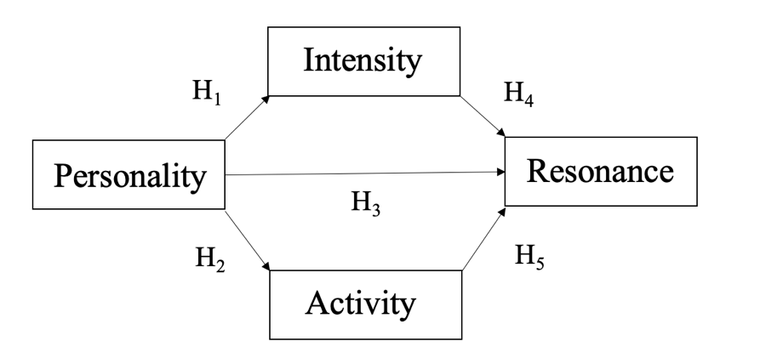
Study conceptual diagram
Source: Original data
The five study hypotheses include:
H1: PERSONALITY is positively related to INTENSITY.
H2: PERSONALITY is positively related to ACTIVITY.
H3. PERSONALITY is positively related RESONANCE.
H4. INTENSITY is positively related to RESONANCE.
H5. ACTIVITY is positively related to RESONANCE.
Regression Analysis
Regression analysis was used to examine the degree of relationship between the study variables PERSONALITY (IV), INTENSITY (IV), ACTIVITY (IV), and RESONANCE (DV) to create a log-linear combination of IVs to optimally predict category frequencies (Tabachnick & Fidell, 2007, p. 29). An Ordinary Least Squares (OLS) model was used, as it is “widely used by researchers because it is fairly easy to understand and describe, widely implemented in software that is readily available, and tends to do a good job approximating reality much of the time when used thoughtfully” (Hayes, 2022, p. 71). OLS also provides direct effects of predictors.
For this study the mean score for individual respondents was calculated for PERSONALITY, INTENSITY, ACTIVITY, and RESONANCE. Simple linear regression was used to test if PERSONALITY significantly predicted RESONANCE. The fitted regression model was RESONANCE=3.404+.640(PERSONALITY). A significant regression equation was found (F(1, 300) = 22.164, p. < .001), with an R² = .069. Adjusted R² = .066. It was found that PERSONALITY significantly predicted RESONANCE (β = .64, p. < .001) supporting hypothesis three (H3). Participant personality score increased .640 for each 1 unit increase in RESONANCE, as shown in Table 3.
Table 3
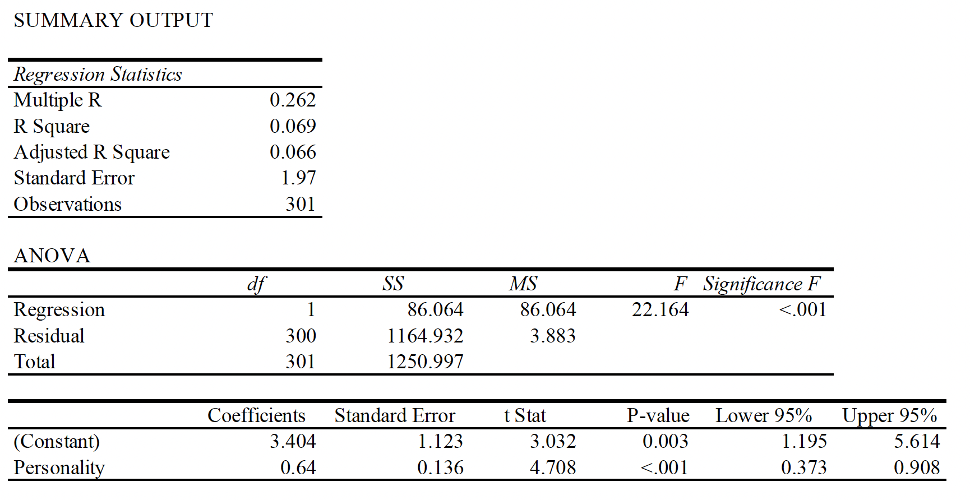
PERSONALITY regressed on RESONANCE summary output
Note: Generated with IBM SPSS 28.8.0. Source: Original data.

Multiple Linear Regression
Multiple linear regression was used to test if INTENSITY and ACTIVITY significantly predicted RESONANCE. The fitted regression model was RESONANCE = 5.493 + .261 (INTENSITY) + .135 (ACTIVITY). A significant regression equation was found (F(2, 300) = 58.941, p. < .001), with an R² = .283. Adjusted R² = .278. It was found that INTENSITY significantly predicted RESONANCE (β = .261, p.< .001), supporting hypothesis four (H4). Participant intensity increased .261 for each 1 unit increase in RESONANCE. It was found that ACTIVITY significantly predicted RESONANCE (β = .135, p. < .020), supporting hypothesis five (H5). Shown in Table 4. Participant activity increased .135 for each 1 unit increase in RESONANCE.
Table 4
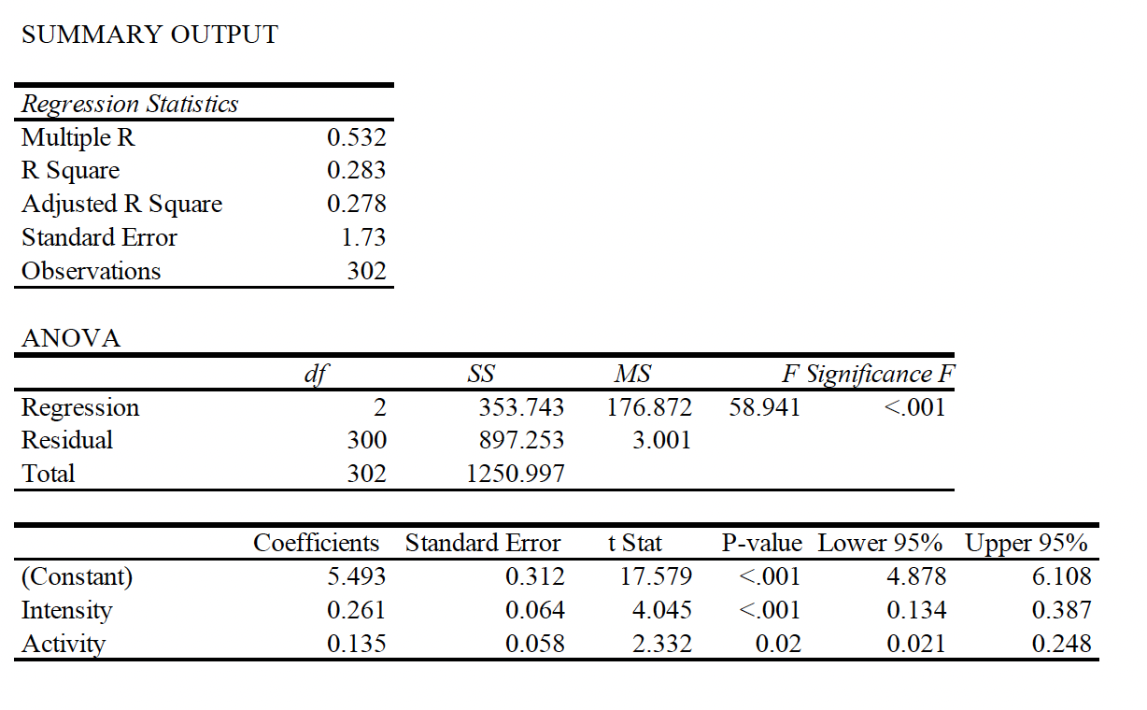
INTENSITY and ACTIVITY regressed on RESONANCE summary output
Source: Original data.
Multiple linear regression was used to test if PERSONALITY, INTENSITY and ACTIVITY significantly predicted RESONANCE. A significant regression equation was found (F(3, 298) = 39.392, p. < .001), with an R² = .287. Adjusted R² = .28. Contrary to hypothesis three (H3), it was found that PERSONALITY did not significantly predict RESONANCE (β = .1735, p. = .183; 95% CI = [-0.082, 0.427]) (Table 5). It was found that INTENSITY significantly predicted RESONANCE (β = .251, p. < .001), supporting hypothesis four (H4). Participant intensity increased .251 for each 1 unit increase in RESONANCE. It was found that ACTIVITY significantly predicted RESONANCE (β = .125, p. = .032), supporting hypothesis five (H5). Participant activity increased .125 for each 1 unit increase in RESONANCE.
Table 5
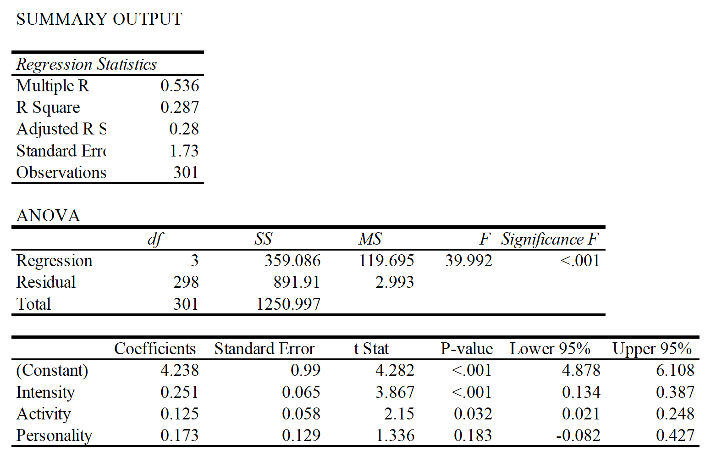
PERSONALITY, INTENSITY, and ACTIVITY regressed on RESONANCE summary output
Source: Original data.

PROCESS
As an additional source of analysis and to look for direct and indirect effects, Hayes’ (2022) PROCESS macro model number 4 (parallel mediation) was run to examine mediation effects from INTENSITY (INTENS) and ACTIVITY (ACTIVE) between PERSONALITY (PERSN) and RESONANCE (RESON). PROCESS estimates the regression coefficient in a simple mediation model, as well as in more complex model involving two or more mediators, while providing an estimate of the indirect effect and various inferential tests. According to Hayes (2022), “it can be used for moderation analysis and modeling that combines moderation and mediation” (p. 93).
Using the same study data set examined for regression, the path (direct effect) from PERSONALITY to INTENSITY was positive and statistically significant (b = 1.197, t(300) = 6.753, p. < .001), supporting hypothesis one (H1). The path (direct effect) from PERSONALITY to ACTIVITY was positive and statistically significant (b = 1.343, t(300) = 6.799, p. < .001), supporting hypothesis two (H2). Contrary to hypothesis three (H3), and consistent with previous regression results, the path (direct effect) from PERSONALITY to REASONANCE, was positive but not statistically significant (b = .173, t(298) = 4.282, p. = .183). The path (direct effect) from INTENSITY to RESONANCE was positive and statistically significant (b = .251, t(298) = 3.867, p.=.000), supporting hypothesis four (H4). The path (direct effect) from ACTIVITY to RESONANCE was positive and statistically significant (b = .125, t(298) = 2.151, p. = .032), supporting hypothesis five (H5).
The unstandardized indirect effect of PERSONALITY on RESONANCE through INTENSITY was positive and statistically significant (IE = .3; 95% CI = [.1055, .5321]) indicating indirect mediation by INTENSITY. The unstandardized indirect effect of PERSONALITY on RESONANCE through ACTIVITY, was positive, but not statistically significant (IE = .168; 95% CI = [-.0040, .3568]). At a 95% confidence interval, INTENSITY mediates PERSONALITY on RESONANCE, but ACTIVITY does not. However, at a 90% confidence interval, ACTIVITY is positive and becomes statistically significant (IE = .168; CI = [.0187, .3248]) indicating that ACTIVITY and INTENSITY mediate PERSONALITY on RESONANCE. The difference between path C (.641) and C¹ (.173) would support the presence of an indirect effect. As such, the .047 difference between C and C¹ can be explained by 30% of the indirect effect is explained by INTENSITY and potentially 17% of the indirect effect is explained by ACTIVITY(with a 90% confidence interval). Table 6 provides the PROCESS output for this study.

Table 6
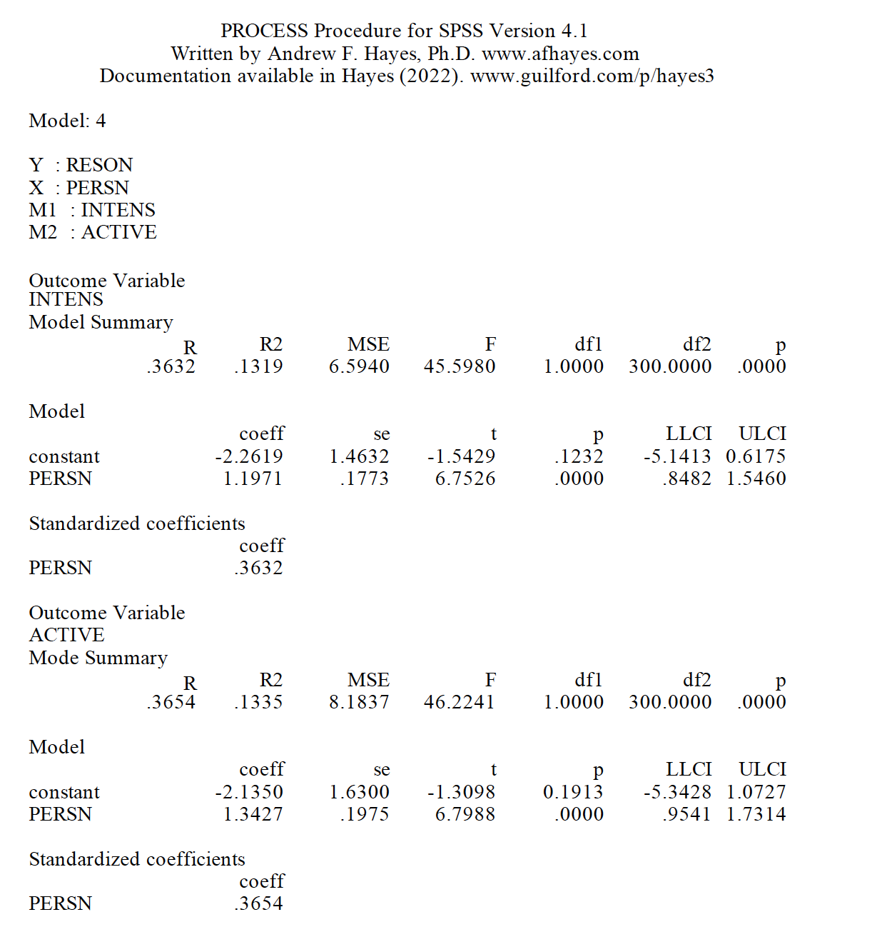
PROCESS output for study model
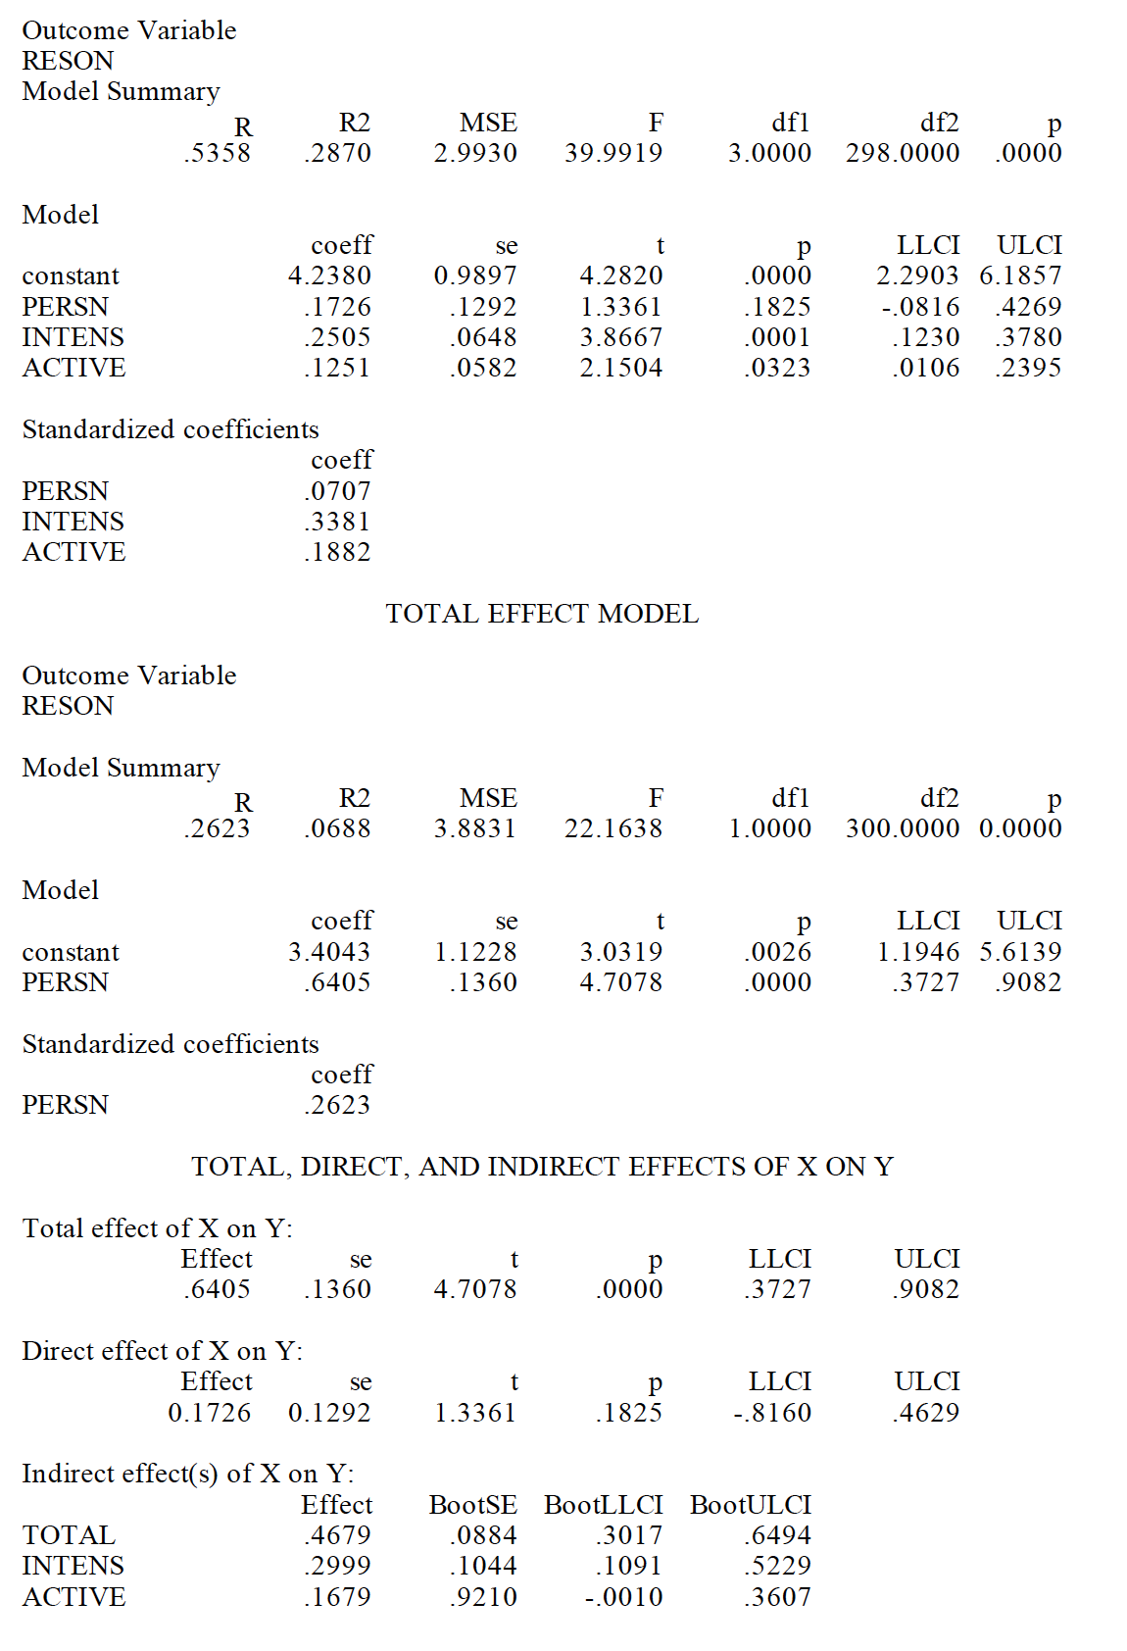
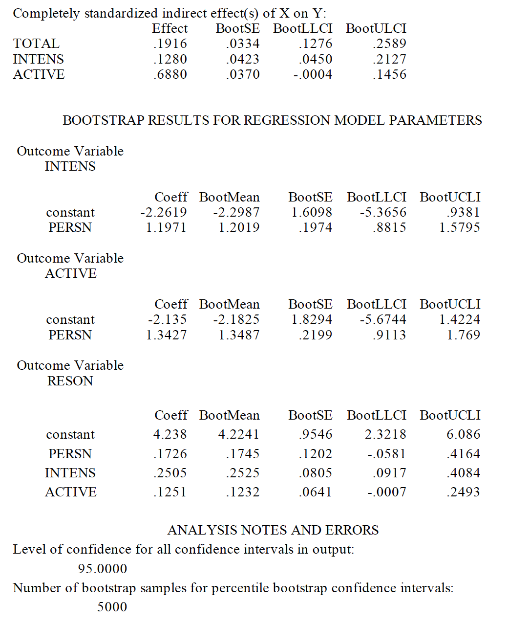
Note: Generated with IBM SPSS 28.8.0 + PROCESS v4.1 Source: Original data.
Path Analysis (PA) and Structural Equation Modeling (SEM) were used to examine relationships between variables and constructs in order to create linear combinations of observed and latent IVs to predict linear combinations of observed and latent DVs (Tabachnick & Fidell, 2007, p. 30).
Path Analysis
Path analysis is based on a closed system of nested relationships among variables that are represented statistically by a series of structured linear regression equations (Lleras, 2005). Variables are either exogenous, meaning their variance is not dependent on any other variable in the model, or endogenous, meaning their variance is determined by other variables in the model (Ullman, 2007). Exogenous variables may or may not be correlated with other exogenous variables. The pattern of relationships among variables is described by a path diagram. Variables are linked by straight arrows that indicate the directions of the causal relationships between them. Straight arrows may only point in one direction, as it is assumed that a variable cannot be both a cause and an effect of another variable, i.e., the model is recursive and there are no feedback loops (Ullman, 2007). Curved, double-headed arrows indicate correlation between exogenous variables. In path diagrams, causality flows through arrows pointing in the same direction or pointing away from each other but not when two arrowheads meet. In addition to the arrows between variables in the model, there are arrows pointing toward each endogenous variable from points outside the model, indicating variance contributed by error and any omitted variables (Ullman, 2007). Path analysis is based on a number of assumptions:
- The dependent variables for all equations must be approximately normally distributed and the relationships among the variables are assumed to be causal, linear, and additive. Logistic regression equations, implying multiplicative relationships, cannot be substituted. Other curvilinear relations or interactions are also prohibited.
- Residuals are not correlated with the variables that predict the outcome variables toward which they point.
- Causation flows in one direction; there are no feedback loops.
- The variables are measured without error.
- Predictor variables may be continuous, ordinal categorical, or dichotomous, but there may be no dummy variables.
- There is low multicollinearity among predictor variables in any of the linear regression equations.
While a path model may fit the data, this does not mean that the causal hypothesis depicted in the path diagram has been validated (Ullman, 2007). Although path diagrams are recursive, path models are based on correlations and cannot prove causation or even indicate the direction of a causal effect. The path diagram for this study is shown in Figure 21.
Figure 21
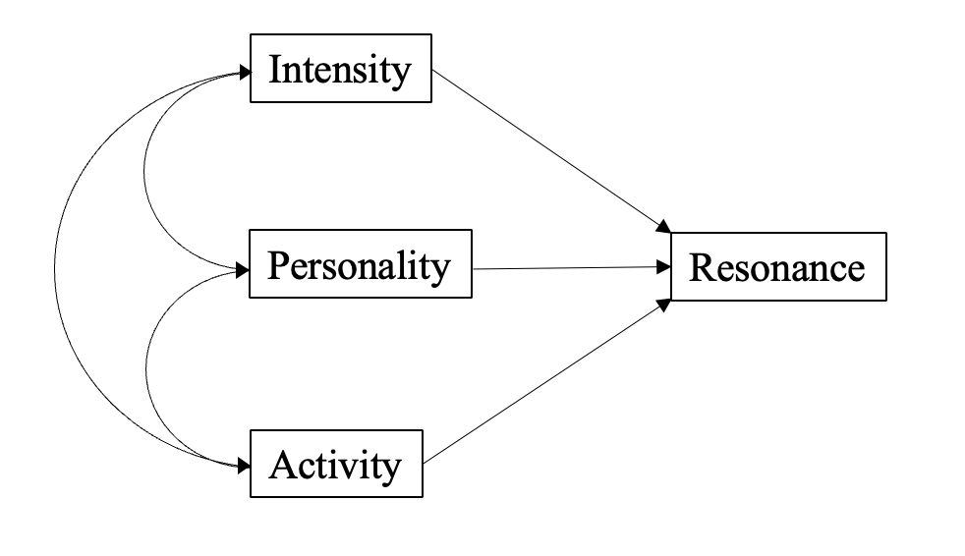
Study path diagram
Source: Original data
Statistical Equation Modelling
SEM is based on statistical theory and most often used to test a theory (Ullman, 2007). According to Kline (2016), “SEM does not designate a single statistical technique but refers to a family of related procedures” (p. 9) and “models analyzed in SEM generally assume probability causality, not deterministic causality” (p. 11). Ultimately, SEM seeks to attain three elements: 1) a clear theoretical rationale, 2) differentiation between what is known and what is unknown, and 3) setting conditions for posing new questions (Kline, 2016, p. 22). These elements underpin this study. The six steps needed to conduct a SEM (Kline, 2016) include:
- Specify the model.
- Evaluate model identification (if not identified, go back to step 1).
- Select the measures (operationalize the construct) and collect, prepare, and screen the data.
- Estimate the model.
  - Evaluate model fit. If poor, respecify the model, but only if doing so is justified; otherwise, retain no model.
  - Assuming model is retained, interpret the parameter estimates.
  - Consider equivalent or near-equivalent models.
- Respecify the model, which is assumed to now be identified.
- Report the results.

Step One: Specify the model.
According to Kline (2016), “researchers often express their hypotheses with graphical conceptual models, which provide a visual representation of theoretical variables of interest and expected relations among them” (p. 119). Specification is a critical step, as it presents the study hypotheses. Kline (2016) noted that researchers can change the initial model using theory or empirical results and that the development process is iterative. There is a set of structural equations in a structural model (Kenny, 2012; Kline, 2016). Causal variables are called exogenous variables and the effect variable is called the endogenous variable. Unexplained variation is referred to as disturbance, which can be indicated as e for error or as used here, d for disturbance. Figure 22 illustrates the specified recursive structural model based on the study latent variables INTENSITY, PERSONALITY, ACTIVITY, and RESONANCE with associated hypotheses.
Figure 22
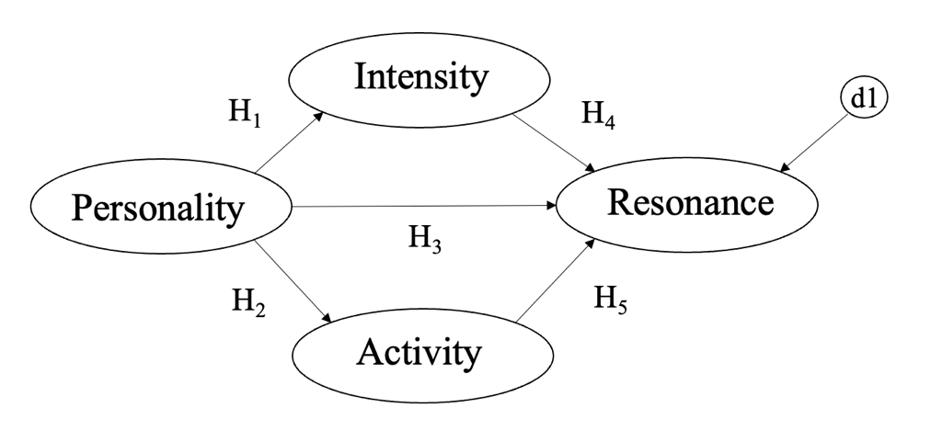
The study structural model and related hypotheses
H1: PERSONALITY is positively related to INTENSITY.
H2: PERSONALITY is positively related to ACTIVITY.
H3. PERSONALITY is positively related RESONANCE.
H4. INTENSITY is positively related to RESONANCE.
H5. ACTIVITY is positively related to RESONANCE.
Source: Original work

Step Two: Evaluate model identification
Identification of a model is to see “whether it is theoretically possible for the computer to derive a unique set of model parameter estimates” (Kline, 2022, p. 145). There are two necessary, but insufficient requirements for identifying any model in SEM (Kline, 2022). The model degrees of freedom must be at least zero and every latent variable, including disturbances or error terms, must be assigned a scale (Kline, 2022). There are also four conditions for measurement model identification:
- Because a latent variable is unmeasured, its units of measurement must be fixed by the researcher (Kenny, 2012). This condition concerns how the units of measurement of each latent variable are fixed. Each construct must have either:
  - One fixed nonzero loading (usually 1.0).
  - For causal factors, fixed factor variance (usually 1.0), or for factors that are caused, fixed factor disturbance variance (usually 1.0).
  - In some rare cases a fixed causal path (usually 1.0) leading into or out of the latent variable.
- For each of the constructs in the model, at least one of the following three conditions must hold (Kenny, 2012):
  - The construct has at least three indicators, whose errors are uncorrelated with each other.
  - The construct has at least two indicators, whose errors are uncorrelated or both the indicators of the construct correlate with a third indicator of another construct, but neither of the two indicators' errors is correlated with the error of that third indicator the two indicators' loadings are set equal to each other.
  - The construct has one indicator which meets either of the following conditions:
    - Its error variance is fixed to zero or some other a priori value (e.g., the quantity one minus the reliability times the indicator's variance).
    - There is a variable that can serve as an instrumental variable in the structural model and the error in the indicator is not correlated with that instrumental variable.
- For every pair of constructs either (Kenny, 2012):
  - There is at least one pair of indicators, one of loading on one construct and one loading on the other, that does not have correlated measurement error between them.
  - The correlation between the pair of constructs is specified to be zero (or some other a priori value).
- For every indicator, there must be at least one other indicator with which it does not share correlated measurement error (Kenny, 2012). If the preceding three conditions hold, then drop from the model all indicators that do not meet this condition and the model is still identified.
The data was tested in SPSS AMOS v28, and the original path and measurement models were over-identified. Model identification is used to check if the model is over-identified, just identified, or under-identified. A model is identified if it is theoretically possible for the computer to derive a unique estimate of every model parameter (Kline, 2016). According to Kline (2016), “the word theoretically emphasizes identification as a property of the model and not the data” (p. 119). Model identification is the definition of the structure and computation of its parameters best suited to mathematically describe the process underlying the data.

Step Three: Select the measures
The full study measurement model is provided in Figure 23.
Figure 23
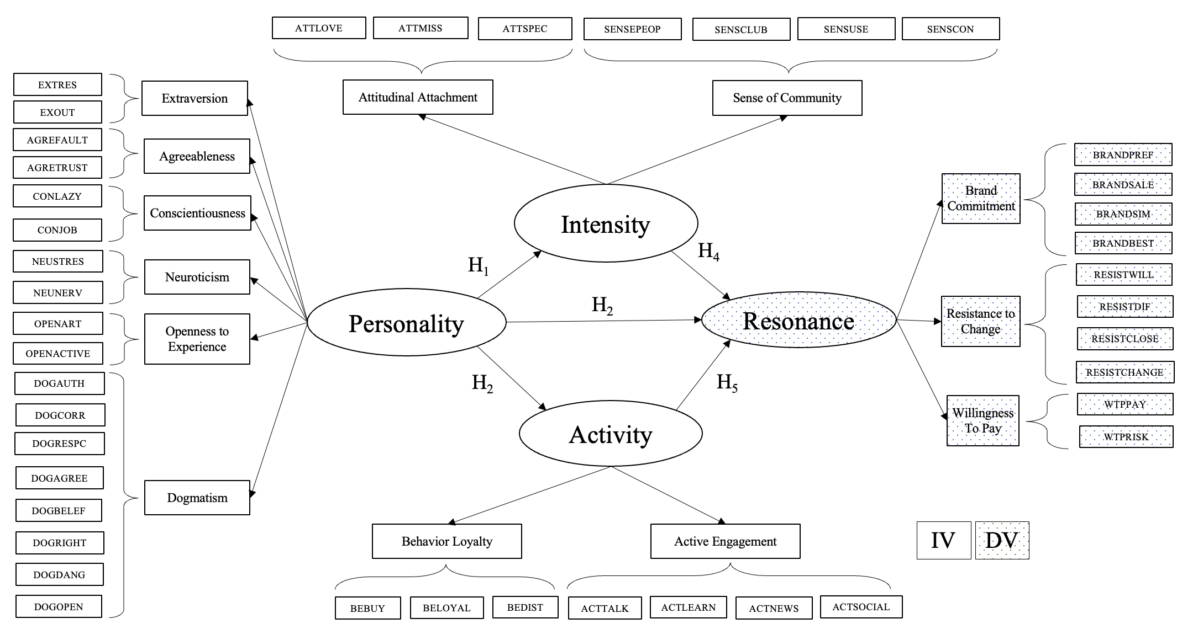
The study measurement model
Note: Original work

Dependent Variable.
RESONANCE is defined as a 10-item index, adapted from Srivastava and Owens (2010), and adding in Willingness to Pay (WTP) indicators. This measurement tool was used because the concepts dealt directly with the brand commitment, resistance to change, and willingness to pay. Brand commitment is an attitudinal construct (Dick & Basu, 1994) and is defined by Srivastava and Owens (2010) as “the degree to which the consumer is attitudinally loyal to a particular brand in a product class” (p. 17). It is the strength of the individual’s belief system toward a brand and is different from calculative commitment often observed in other relationship domains (Evanschitzky et al., 2006; Matilla, 2006; Srivastava & Owens, 2010). Psychologists defined commitment as decisions or cognitions that fix or bind an individual to a behavioral disposition (Kiesler, 1971).
Crosby and Taylor (1983) provide a definition of commitment as a stable preference that was bound by an attitude of resistance to change. The more strongly consumers identify with the values and images embodied by a particular brand, the greater their sense of resistance to change that preference (Pritchard et al., 1999; Srivastava & Owens, 2010). Commitment to a relationship is a relatively stable, strong, and intense psychological state or attitude toward maintaining the relationship (Chakraborty et al., 2007; Meyer & Allen, 1993; Srivastava & Owens, 2010). States of commitment may arise from different motivations (Geyskens et al., 1996; Srivastava & Owens, 2010). Affective commitment exists when one has the desire to maintain the relationship based on a generalized sense of positive regard for, a liking of, and an enjoyment of the relationship (Evanschitzky et al., 2006; Matilla, 2006; Srivastava & Owens, 2010). As a result, consumers’ commitment to the brand tends to be more affective than calculative (Evanschitzky et al., 2006; Matilla, 2006; Srivastava & Owens, 2010).
Willingness to pay (WTP) (Brookshire et al., 1980) is the maximum price a consumer is willing to pay for a product or service. WTP originated from studies in behavioral economics involving hedonic prices for goods and services – much of the early work was done in environmental economics – for example, using property values or hypothetical markets to input value (benefit) of reducing air, water pollution, or protecting scenic vistas. In economics, it is typically represented by a dollar figure or a price range. Willingness to pay can vary significantly from consumer to consumer. This variance is often caused by differences in the consumer population, typically classified as either extrinsic or intrinsic. Extrinsic differences are observable, such as age, gender, education, and income. Intrinsic differences are an individual’s directly unobservable characteristics or traits such as level of dogmatism, risk tolerance, desire to fit in with others, and level of passion about a given subject. It should be noted that a consumer’s willingness to pay a certain price for a product or service is not necessarily static. Numerous factors can cause WTP to vary.
As this dissertation posits, the brand itself is central to selection, so as WTP increases perceived brand resonance should increase (value of the brand). WTP may also increase with a leading brand, because of stakeholder-perceived brand value. Conversely, willingness to pay may decrease with a weak brand, because it doesn’t meet the WTP threshold of the individual. Two methods, contingent valuation (CV) (Ciriacy-Wantrup, 1947; Cumming et al., 1986; Mitchell & Carson, 1989; Thayer, 1981) and hedonic pricing (HP) (Lancaster, 1966; Rosen, 1974) are commonly used to measure WTP. Historically, studies use CV to value amenities, recreational, and other behaviors related to environment and natural resources. Survey respondents are directly asked hypothetical questions about their values for the environment. This contrasts with the HP method, where values are revealed by observable or actual performance. HP identifies the internal and external factors and characteristics that affect an item’s price in the market.
CV is applicable to ethereal intangibles created external to the stakeholder, such as the environment or an ideology, and regards HP applicable to material intangibles created by the stakeholder, such as perceptions of a property or a brand. HP is most often seen in the housing market since real estate prices are determined by the characteristics of the property itself and the neighborhood or environment within which it exists.
The ten items used to measure RESONANCE include: BRANDPREF, BRANDSALE, BRANDSIM, BRANDBEST, RESISTWILL, RESISTDIF, RESISTCLOSE, RESISTCHANGE, WTPPAY, and WTPRISK. The corresponding survey instrument (Appendix C) questions include:
Q4. Referencing [Q2], please indicate how strongly you agree or disagree with the following statements.
- If [Q2] were not available, it would make little difference to me if I had to choose another brand. (r) [BRANDPREF][recoded BRANDPREF2]
- When another brand is on sale, I will generally purchase it rather than [Q2]. (r) [BRANDSALE][recoded BRANDSALE2]
- To me, [Q2] is very similar to others in its category. (r) [BRANDSIM][recoded BRANDSIM2]
- I try to use [Q2] because it is the best choice for me. [BRANDBEST]
- My preference to use [Q2] would not willingly change. [RESISTWILL]
- It would be difficult to change my beliefs about [Q2]. [RESISTDIF]
- If close friends recommend another brand, my preference for [Q2] would change. (r) [RESISTCLOSE][recoded RESISTCLOSE2]\
- To change my preference from [Q2] would require major rethinking. [RESISTCHANGE]
All use a five-point strongly agree/strongly disagree Likert scale.

Independent Variables.
ACTIVITY is defined as an eight-item index, adopted from Keller and Swaminathan (2020). This measurement tool is appropriate for this study as the concepts deal directly with behavior loyalty and active engagement. For example, the frequency that consumers purchase a brand and how much they purchase of that brand is a measure of activity. For bottom-line profit results, the brand must generate sufficient purchase frequencies and volumes. The strongest affirmation of brand loyalty occurs when consumers are willing to invest time, energy, money, or other resources into the brand beyond those expended during purchase or consumption of the brand (Keller & Swaminathan, 2020). For example, consumers may choose to join a club centered on a brand, receive updates, and exchange correspondence with other brand users or formal/informal representatives of the brand itself. They may choose to visit brand-related websites, participate in chat rooms, engage other potential stakeholders about the brand, etc. In this case, consumers themselves become brand evangelists and ambassadors on behalf of the brand, communicate about the brand, and strengthen the brand ties of others.
The seven items used to measure ACTIVITY include: BELOYAL, BEBUY, BEDIST, ACTTALK, ACTLEARN, ACTNEWS, and ACTSOCIAL. The corresponding survey instrument (Appendix C) questions include:
Q6. Referencing [Q2], please indicate your agreement or disagreement with the following statements.
- I consider myself loyal to [Q2]. [BELOYAL]
- I buy [Q2] whenever I can. [BEBUY]
- If [Q2] were not available, it would be personally distressing. [BEDIST]
- I like to talk about [Q2] with others. [ACTTALK]
- I am interested in learning more about [Q2]. [ACTLEARN]
- I follow news about [Q2] closely. [ACTNEWS]
- I like to post comments about [Q2] on social media. [ACTSOCIAL]
All use a five-point strongly agree/strongly disagree Likert scale.
INTENSITY is defined as a seven-item index, adapted from Keller and Swaminathan (2020). This measurement tool was appropriate for this study as the concepts dealt directly with attitudinal attachment and sense of community. A strong personal attachment is necessary to create resonance. Consumers must go beyond simply having a positive attitude to view the brand as being something special in a broader context. For example, consumers with a great deal of attitudinal attachment to a brand may state that they ‘love’ the brand, describe it as one of their favorite possessions, or view it as a ‘little pleasure’ that they look forward to (Keller & Swaminathan, 2020). The brand may also take on broader meaning to the consumer in terms of sense of community (Keller & Swaminathan, 2020). Identification with a brand community may reflect an important social phenomenon whereby consumers feel a kinship or affiliation with other people associated with the brand. These connections may involve fellow brand users, consumers, employees, or representatives of the company.
The seven-items used to measure INTENSITY include: ATTLOVE, ATTMISS, ATTSPEC, SENSPEOP, SENSCLUB, SENSUSE, and SENSCON. The corresponding survey instruments questions include:
Q5. Referencing [Q2], please indicate how strongly you agree or disagree with the following statements.
- I love [Q2]. [ATTLOVE]
- I would miss [Q2] if it went away. [ATTMISS]
- [Q2] is special to me. [ATTSPEC]
- I identify with people who use [Q2]. [SENSPEOP]
- I feel as if I almost belong to a club with other users of [Q2]. [SENSCLUB]
- [Q2] is a brand used by people like me. [SENSUSE]
- I feel a deep connection with others who use [Q2]. [SENSCON]
All use a five-point strongly agree/strongly disagree Likert scale.
PERSONALITY is defined with a 10-item index (Rammstedt & John, 2007) personality scale and an eight-item dogmatism scale (Shearman & Levine, 2006). This 18-item measurement tool was appropriate for this study as the concepts dealt directly with measuring personality and dogmatism.
In 1936, Gordon Allport and Henry Odbert formed a list of 4,500 terms relating to personality traits (Vinney, 2018). Their work provided the foundation for other psychologists to begin determining the basic dimensions of personality. In the 1940s, Raymond Cattell and his colleagues used factor analysis to narrow down Allport’s list to sixteen traits. However, numerous psychologists examined Cattell’s list and found that it could be further reduced to five traits. McCrae and Costa expanded on Cattell’s work by confirming the model’s validity and providing the model used today: extraversion, openness, conscientiousness, agreeableness, and neuroticism. To provide a measure of the Big Five for context, in which participant time is severely limited, Rammstedt and John (2006) abbreviated the Big Five Inventory (BFI-44) to a 10-item version which is used in this study.
Extraversion is a personality trait characterized by excitability, sociability, talkativeness, assertiveness, and high amounts of emotional expressiveness. McCrea and John (1992) described the positive adjectives of an extravert as someone who is active, assertive, energetic, enthusiastic, outgoing, and talkative (p. 178). Extraverts possess high group visibility and assert themselves. Extraverted people may appear more dominant in social settings, as opposed to introverted people (Friedman, 2016). Introverts have lower social engagement and energy levels than extraverts. They tend to seem quiet, low-key, deliberate, and less involved in the social world. Their lack of social involvement should not be interpreted as shyness or depression; instead, they are more independent of their social world than extraverts. Introverts need less stimulation and more time alone than extraverts. This does not mean that they are unfriendly or antisocial; rather, they are reserved in social situations (Rothmann, 2003). A stakeholder scoring high as an extravert may indicate a person more willing to act out for a name brand.
Conscientiousness is related to the way in which people control, regulate, and direct their impulses as well as is one defined by high levels of thoughtfulness, good impulse control, and goal-directed behaviors. McCrae and John (1992) described someone with high conscientiousness as efficient, organized, planful, reliable, responsible, and thorough (p. 178). Conscientiousness is a tendency to display self-discipline, act dutifully, and strive for achievement against measures or outside expectations. High conscientiousness is often perceived as being stubborn and focused. High scores on conscientiousness indicate a preference for planned, rather than spontaneous behavior. Low conscientiousness is associated with flexibility and spontaneity but can also appear as sloppiness and lack of reliability (Toegel, 2012). A low-scoring conscientious stakeholder may be more inclined to become an active stakeholder, acting out for the brand.
Agreeable individuals value good relationships with others. McCrae and John (1992) described an agreeable person as appreciative, forgiving, generous, kind, sympathetic, and trusting (p. 178). According to Rothmann and Coetzer (2003):
An agreeable person is fundamentally altruistic, sympathetic to others and eager to help them, and in return believes that others will be equally helpful. The disagreeable/antagonistic person is egocentric, skeptical of others’ intentions, and competitive rather than co-operative. (p. 69)
They are generally considerate, helpful, and willing to compromise their interests with others. Agreeable people also have an optimistic view of human nature. Disagreeable individuals place self-interest above getting along with others. While disagreeable stakeholders may be more inclined to become active stakeholders and act out for the brand.
Neuroticism is the tendency to experience negative emotions, such as anger, anxiety, or depression. McCrae and John (1992) described a neurotic person as anxious, self-pitying, tense, touchy, unstable, and worrying (p 179). According to Rothmann and Coetzer (2003):
High scorers may be at risk of some kinds of psychiatric problems. A high neuroticism score indicates that a person is prone to having irrational ideas, being less able to control impulses, and coping poorly with stress. A low neuroticism score is indicative of emotional stability. (p. 69)
Such individuals are usually calm, even-tempered, relaxed, and able to face stressful situations without becoming upset (Hough et al., 1990). Someone with low neurotic score tends to be calm, emotionally stable, and free from persistent negative feelings. Someone who scores high, may be more susceptible to emotional appeals and have stronger reactions to threats against a name brand.
Openness to experience reflects the degree of intellectual curiosity, creativity, and a preference for novelty and variety in an individual. McCrae and John (1992) described someone open to experience as artistic, curious, imaginative, insightful, original, and wide interests (p. 179). People who are open to experience are intellectually curious, open to emotion, and willing to try new things. According to Rothmann and Coetzer (2003):
People scoring low on Openness tend to be conventional in behaviour and conservative in outlook. They prefer the familiar to the novel, and their emotional responses are somewhat muted. People scoring high on Openness tend to be unconventional, willing to question authority and prepared to entertain new ethical, social, and political ideas. Open individuals are curious about both inner and outer worlds, and their lives are experientially richer. They are willing to entertain novel ideas and unconventional values, and they experience both positive and negative emotions more keenly than do closed individuals. (p. 69)
Individuals with high openness pursue self-actualization specifically by seeking out intense, euphoric experiences. An individual with low openness may prefer routine, be pragmatic and data driven, perhaps even dogmatic and closed-minded. Someone scoring high open to experience may be more inclined to become an active stakeholder and act out for the brand.
Dogmatism, as conceptualized by Rokeach (1954, 1956, 1960), is a measure of individual difference in open versus closed belief systems. It is distinctly different to measures of openness, as dogmatism measures individual intolerance and general authoritarianism. Dogmatism is relevant for this study as it is a measure of how committed an individual is to a brand. Individuals high in dogmatism are characterized by their tendency to compartmentalize and isolate their beliefs and disbeliefs. Alternatively, individuals with more open belief systems are characterized by their willingness and readiness to be open to diverging beliefs. At one end of the dogma spectrum, a pragmatically inclined individual is potentially able to make more rational decisions based on clear logic and available information (which may not be complete) as opposed to other end of the spectrum, the dogmatic individual, who is prone to emotion-based decisions through pre-determined (or pre-programmed), quicker, decision cycles. Although some research shows that religious individuals, who identify strongly with their religious group, exhibit high levels of dogmatism (Altemeyer, 2002; Altemeyer & Hunsberger, 2004; Crowson, 2009).
For dogmatism, Rokeach’s (1954) defined dogmatism as a relatively closed cognitive system of beliefs about reality, organized around a central set of beliefs about absolute authority which then provides a framework for patterns of intolerance and qualified tolerances toward others. Rokeach (1960) identified three properties of dogmatism – isolation, differentiation, and comprehensiveness. Isolationism refers to “the extent that people are reluctant to see divergent beliefs systems are interrelated” (Shearman & Levine, 2006, p. 277). Differentiation refers to “the degrees of articulation and richness of information within a belief system” (Shearman & Levine, 2006, p. 277) and comprehensiveness refers to “the total range of disbelief subsystems represented within a given system” (Shearman & Levine, 2006, p. 277). Rokeach (1960) further identified that authority and temporal cognition are integral to dogmatic individuals, with highly dogmatic individuals tending to rely on authority rather easily or arbitrarily (rather than tentatively or rationally) and based on an emphasis of cause and achievement in the past or future (rather than the present).
Kleck and Wheaton (1967) found that dogmatic individuals demonstrate a significant preference for opinion-consistent information. Dogmatism affects persuasive effects. Dogmatic individuals tend to be influenced more by the identity of a message source than by message content, while the reverse is true for those lower in dogmatism (Bettinghaus et al., 1970; Powell, 1962). Blake et al. (1970) suggested that the relationship between a consumer's personality and acceptance of new products may depend upon which type of new product is involved, a novel or a recent one.
Dogmatism is positively associated with confrontational behavior in conflict situations (Jones & Melcher, 1982). When attempting to influence others, dogmatism is positively associated with the selection of anti-social compliance-gaining messages (Boster & Levine, 1988; Roloff & Barnicott, 1979). Palmer and Klain (1985) reported that dogmatic individuals attempt to avoid information that is inconsistent with their belief systems and react to such information by minimizing or ignoring it. This is also known as cognitive dissonance (Festinger et al., 1956; Festinger, 1957). Leone (1989) reported that as opportunities for reflection increase, dogmatic people are more likely to polarize their attitudes. They also hold more attitude-consistent beliefs and fewer attitude-inconsistent beliefs. Davies (1993) investigated the effect of dogmatism on the persistence of beliefs when facing discredited evidence. They also investigated the effect of dogmatism on belief formation and reported that high dogmatics produced more consistent reason generation than inconsistent reasons compared to low dogmatics (Davies, 1998). The Dogmatism Scale (Altemeyer, 2002) asks respondents to think about the certainty with which they hold their beliefs, their views about maintaining an open belief system, and the likelihood that their beliefs will change in the future. Crowson et al. (2009) provided several tests of the construct validity of Altemeyer’s (1996) DOG Scale using confirmatory factor analyses (CFA) on the instrument and tests of convergent, discriminant, and criterion related validity. According to Crowson et al. (2008):
Factor analyses suggested that the DOG Scale functions reasonably well as a unidimensional measure of dogmatism, although a two-factor model that incorporated method factors for positively and negatively worded items fit the data best. In terms of convergent and discriminant validity, the DOG Scale correlated in predictable ways with measures of need for closure, need for cognition, knowledge-related beliefs, and personal need for structure, among others. (p. 266)
For this study, eight items from Rokeach’s Dogmatism, Form E (1956), were selected that best related to brands and avoided charged topics such as freedom and politics. The 18 items used to measure PERSONALITY include: EXTRES, AGRETRUST, CONLAZY, NEUSTRES, OPENART, EXOUT, AGREFAULT, CONJOB, NEUNERV, OPENACTIVE, DOGRIGHT, DOGAGREE, DOGAUTH, DOGCORR, DOGRESPC, DOGBELEF, DOGDANG, and DOGOPEN. The corresponding survey instrument (Appendix C) questions include:
Q10. I see myself as someone who…
- Is reserved. (r) [EXTRES][recoded EXTRES2]
- Is trusting. [AGRETRUST]
- Tends to be lazy. (r) [CONLAZY][recoded CONLAZY2]
- Handles stress well. (r) [NEUSTRES][recoded NEUSTRES2]
- Has few artistic interests. (r) [OPENART][recoded OPENART2]
- Is outgoing. [EXOUT]
- Tends to find fault in others. (r) [AGREFAULT][recoded AGREFAULT2]
- Does a thorough job. [CONJOB]
- Gets nervous easily. [NEUNERV]
- Has an active imagination. [OPENACTIVE]
Q11. In general, I find that…
- There is a clear line between what is right and what is wrong. [DOGRIGHT]
- People who disagree with me are usually wrong. [DOGAGREE]
- I’m the type of person who questions authority. (r) [DOGAUTH][recoded DOGAUTH2]
- I am confident in the correctness of my beliefs. [DOGCORR]
- People should respect authority. [DOGRESPC]
- I am a person who is strongly committed to my beliefs. [DOGBELEF]
- People who are very different from us can be dangerous. [DOGDANG]
- I consider myself to be open-minded. (r) [DOGOPEN][recoded DOGOPEN2]
All use a five-point strongly agree/strongly disagree Likert scale.
For example, an extravert may be more inclined to become an active stakeholder and act out for the brand. Thus, a disagreeable extravert, open to experiences, who is not very conscientious and has a high level of neuroticism would score very high as someone who may be inclined to support a brand through a change of behavior or action. Such a stakeholder would also demonstrate high attitudinal attachment toward a name brand and an introverted, agreeable, conscientious stakeholder, who is not open to experience or has a low level of neuroticism, would demonstrate a low attitudinal attachment toward a name brand. Those high in dogmatism are characterized by a tendency to compartmentalize and isolate their beliefs and disbeliefs, whereas “individuals with more open belief systems, or with low dogmatism, are characterized by their willingness and readiness to make a linkage between divergent beliefs” (Shearman & Levine, 2006, p. 276). Thus, a highly dogmatic individual may be at odds with a newly introduced, unknown brand that is lacking any comparable information or endorsement by known authority figures. The same highly dogmatic individual may be more comfortable with a known brand that is new to them but is viewed positively by a recognized authority figure.

Step Four: Estimate the model fit
Estimating the model fit is a way to determine if the original model is suited to the data or there needs to an alternative model that better describes the researchers’ hypotheses. According to Kline (2022), “the choice between alternative models should be guided more by rationale than statistical considerations” (p. 262). Measures of fit help guide assessment of the original model or development of alternative models. Fit statistics can be divided into absolute and comparative fit indices. Absolute indices are often a function of the test statistic T, which quantifies fit to the population covariance structure. Comparative fit indices compare a candidate model against a baseline model, which is a minimal model containing only variances for observed endogenous variables, but not covariances among them. Thus, the baseline model represents the view that there are no meaningful relationships among variables. Comparative fit indices describe how much better the study model fits the data compared to this independence representation. According to Kenny (2020):
It should be noted that a good-fitting model is not necessarily a valid model. For instance, a model all of whose estimated parameters are not significantly different from zero is a "good-fitting" model. Conversely, it should be noted that a model all of whose parameters are statistically significant can be from a poor fitting model. Additionally, models with nonsensical results (e.g., paths that are clearly the wrong sign) and models with poor discriminant validity or Heywood cases can be “good-fitting” models. Parameter estimates must be carefully examined to determine if one has a reasonable model. Also, it is important to realize that one might obtain a good-fitting model, yet it is still possible to improve the model and remove specification error. Finally, having a good-fitting model does not prove that the model is correctly specified. (para 3)

Measures of Fit
In SEM, there are several measures of fit for a model. These include the Chi-Square (CMIN) test, Goodness of Fit (GFI) and Adjusted Goodness of Fit (AGFI), the Normed Fit Index (NFI), Relative fit index (RFI), Incremental fit index (IFI), Comparative fit index (CFI), and Tucker-Lewis Index (TLI). The Root Mean-Square Error of Approximation (RMSEA) is considered an absolute fit index. The Chi-Square (CMIN) goodness of fit test is used to evaluate whether a model departs significantly from one that fits exactly to the data (Kline, 2016). The DF is degrees of freedom, and the p-value is the significance level. Traditionally, if p ≤ .05, the null of an exact-fitting model is rejected. If the CMIN/DF value is ≤ 3 it indicates an acceptable fit (Kline, 1998). If the value is ≤ 5 it indicates a reasonable fit (Marsh & Hocevar, 1985). The Goodness of Fit (GFI) and Adjusted GFI (AGFI) range from 0 to 1. Values .90 or greater indicative an acceptable model fit (Pituch & Stevens, 2016). A value of 1 represents a perfect fit. A value ≥ 0.9 indicates a reasonable fit (Hu & Bentler, 1998). A value of ≥ 0.95 is considered an excellent fit (Kline, 2005). The Normed fit index (NFI), Relative fit index (RFI), Incremental fit index (IFI), Comparative fit index (CFI), and Tucker-Lewis Index (TLI); (also referred to as Non-normed fit index, or NNFI) are all incremental or comparative fit indices i.e., whereby they compare the fit of a model against that of a null or independence model (Byrne, 2010; Schumacker & Lomax, 2016). The RFI, IFI, NNFI, and CFI all account for model complexity/parsimony in their computations (to a greater or lesser degree). These indices generally range between 0 and 1 (although it is possible to have values slightly exceed 1 on some). Values ≥ .90 for these indices are treated as indicative of an acceptable fitting model (see Whittaker, 2016), although values ≥ .95 may be considered as evidence of more superior fit (Byrne, 2010, p. 79). Two of the more commonly reported comparative fit indices are the TLI and CFI. The Root Mean-Square Error of Approximation (RMSEA) is considered an absolute fit index. Values of .05 or below on the RMSEA, are generally considered indicative of a close-fitting model. Values up to .08 (Brown & Cudeck, 1993; Whittaker, 2016) or .10 (Hu & Bentler, 1995; Whittaker, 2016) are considered acceptable. A CFI value of ≥ 0.95 is considered an excellent fit for the model (West et al., 2012).
For the study path model (Figure 21) and using mean individual scores for each of the IVs and the DV, the GFI indicates χ²(1) = 1.798, p < .180; CMIN/DF = 1.798, indicating an acceptable fit. The path model is significant (p.=.180) and an excellent fit (GFI = .997; AGFI = .970). All study path measures were > .90, indicating an acceptable fitting model. The study, using RMSEA (.051), indicated an acceptable fit to the data (Table 7).

Table 7
Path Model Fit Summary
CMIN
Model | NPAR | CMIN | DF | P | CMIN/DF
Default model | 9 | 1.798 | 1 | .180 | 1.798
Saturated model | 10 | .000 | 0
Independence model | 4 | 494.751 | 6 | .000 | 82.458
RMR, GFI
Model | RMR | GFI | AGFI | PGFI
Default model | .032 | .997 | .970 | .100
Saturated model | .000 | 1.000
Independence model | 2.608 | .567 | .278 | .340
Baseline Comparisons
Model | NFI  Delta1 | RFI  rho1 | IFI  Delta2 | TLI  rho2 | CFI
Default model | .996 | .978 | .998 | .990 | .998
Saturated model | 1.000 |  | 1.000 |  | 1.000
Independence model | .000 | .000 | .000 | .000 | .000
Parsimony-Adjusted Measures
Model | PRATIO | PNFI | PCFI
Default model | .167 | .166 | .166
Saturated model | .000 | .000 | .000
Independence model | 1.000 | .000 | .000
RMSEA
Model | RMSEA | LO 90 | HI 90 | PCLOSE
Default model | .051 | .000 | .172 | .332
Independence model | .520 | .482 | .560 | .000
Source: Original data.
Regressions and covariances/correlations for path variables are show in Table 8. All are positive and significant, supporting study hypotheses.
Table 8
Regression and covariance for the path model
Number of distinct sample moments: | 10
Number of distinct parameters to be estimated: | 9
Degrees of freedom (10 - 9): | 1
Minimum was achieved
Chi-square = 1.798
Degrees of freedom = 1
Probability level = .180

Standardized Regression Weights
 |  |  | Estimate
RESON | <--- | INTENS | .352
RESON | <--- | ACTIVE | .203
Covariances
 |  |  | Estimate | S.E. | C.R. | P | Label
PERSN | <--> | ACTIVE | .933 | .157 | 5.954 | *** | par_1
PERSN | <--> | INTENS | .832 | .140 | 5.923 | *** | par_2
ACTIVE | <--> | INTENS | 6.953 | .629 | 11.051 | *** | par_3
Correlations
 |  |  | Estimate
PERSN | <--> | ACTIVE | .365
PERSN | <--> | INTENS | .363
ACTIVE | <--> | INTENS | .826
Source: Original data.
The original path model was over-identified. The study result for the GFI test indicates rejection of the null of an exact-fitting model, χ²(59) = 275.27, p < .000; CMIN/DF = 4.66, indicating a reasonable fit but not an acceptable fit. Analysis continued with the full study measurement model. Figure 24 shows the original study measurement model.

Figure 24
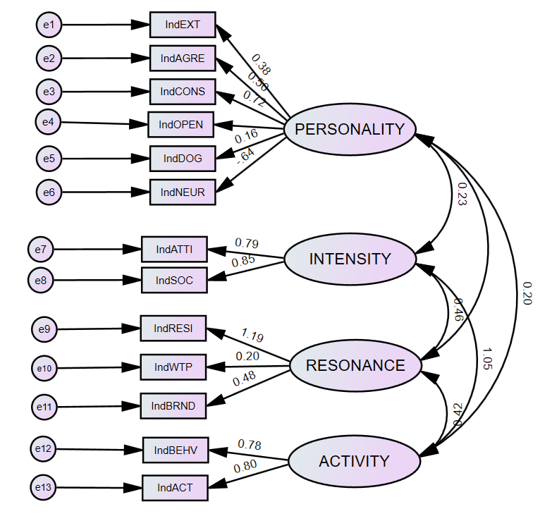
The study measurement model with standardized scores
Note: Generated with IBM AMOS 28.0. Source: Original work.

The measurement model (Table 9) resulted in a CMIN/DF = 8.045, a GF1 = .787, and AGFI = .671. The RMSEA (.153) also indicated a poor fit to the data.
Table 9
Model Fit Summary
Number of distinct sample moments: | 91
Number of distinct parameters to be estimated: | 32
Degrees of freedom (91 - 32): | 59
Minimum was achieved
Chi-square = 474.666
Degrees of freedom = 59
Probability level = .000

CMIN
Model | NPAR | CMIN | DF | P | CMIN/DF
Default model | 32 | 474.666 | 59 | .000 | 8.045
Saturated model | 91 | .000 | 0
Independence model | 13 | 1558.402 | 78 | .000 | 19.980
RMR, GFI
Model | RMR | GFI | AGFI | PGFI
Default model | 1.488 | .787 | .671 | .510
Saturated model | .000 | 1.000
Independence model | 2.627 | .471 | .383 | .404
Baseline Comparisons
Model | NFI  Delta1 | RFI  rho1 | IFI  Delta2 | TLI  rho2 | CFI
Default model | .695 | .597 | .723 | .629 | .719
Saturated model | 1.000 |  | 1.000 |  | 1.000
Independence model | .000 | .000 | .000 | .000 | .000
RMSEA
Model | RMSEA | LO 90 | HI 90 | PCLOSE
Default model | .153 | .140 | .166 | .000
Independence model | .251 | .240 | .262 | .000
Source: Original data.
These results indicated that the study model was not a good fit to the data, regardless of the factor weights. The model fit needs to be improved.

Step Five: Re-specify the model
Strategies for model re-specification include examining the correlation matrix and modification index and looking for low correlations or high indexes (Fawad, 2021). Looking at the standardized residual reveals any difference between predicted and observed covariance standardized (Fawad, 2021). Correlated items with small factor loading may be dropped and items with large factor loadings may include possible specification error or contain error variance (Fawad, 2021). Error variances that are too small or large should be inspected and a review of the factors can reveal if the model needs fewer or more factors (Fawad, 2021). A maximum likelihood exploratory factor analysis was used to test the number of factors. Standardized regression coefficients were examined and five variables under .50 were found (Table 10).
Table 10
Standardized Regression Weights
 |  |  | Estimate
IndSOC | <--- | INTENSITY | .848
IndATTI | <--- | INTENSITY | .788
IndRESI | <--- | RESONANCE | 1.190
IndACT | <--- | ACTIVITY | .799
IndBEHV | <--- | ACTIVITY | .781
IndWTP | <--- | RESONANCE | .200
IndBRND | <--- | RESONANCE | .480
IndNEUR | <--- | PERSONALITY | -.642
IndDOG | <--- | PERSONALITY | .159
IndCONS | <--- | PERSONALITY | .723
IndAGRE | <--- | PERSONALITY | .504
IndEXT | <--- | PERSONALITY | .381
IndOPEN | <--- | PERSONALITY | .058
Source: Original data.
Each item below .50 was explored independently. Dropping the lowest correlation, IndOPEN (.058) resulted in a higher CMIN/DF = 9.019 but a decrease in AGFI (.667) and an increase in RMSEA (.163). Dropping IndDOG (.159) resulted in a drop of CMIN/DF = 7.750, a GFI = .824, an AGFI = .713, and an RMSEA = .150. Dropping IndWTP (.200) resulted in an improved CMIN/DF = 5.736, a GFI = .860, an AGFI = .773, and an RMSEA = .125. Dropping IndEXT resulted in an increase of CMIN/DF = 9.387, a GFI = .781, an AGFI = .645, and an RMSEA = .167. Finally, dropping IndBRND (.480) resulted in a CMIN/DF = 5.930, a GFI = .859, an AGFI = .771, and RMSEA = .128. IndWTP was removed. A review of the new regression weights revealed four components under .50: IndEXT (.385), IndBRND (.352), IndDOG (.168), and IndOPEN (.048) (Table 11).
Table 11
Re-specified Model Standardized Regression Weights
 |  |  | Estimate
IndSOC | <--- | INTENSITY | .850
IndATTI | <--- | INTENSITY | .787
IndRESI | <--- | RESONANCE | 1.533
IndACT | <--- | ACTIVITY | .795
IndBEHV | <--- | ACTIVITY | .784
IndBRND | <--- | RESONANCE | .352
IndNEUR | <--- | PERSONALITY | -.652
IndDOG | <--- | PERSONALITY | .168
IndCONS | <--- | PERSONALITY | .708
IndAGRE | <--- | PERSONALITY | .506
IndEXT | <--- | PERSONALITY | .385
IndOPEN | <--- | PERSONALITY | .048
Source: Original data.
Removal of IndOPEN resulted in a decreased fit, with CMIN/DF= 6.152, GFI =. 873, AGFI = .780, and RMSEA = .131. Removal of IndDOG resulted in a better fit, with a CMIN/DF = 4.901, GFI = .889, AGFI = .807, and RMSEA = .114. Removal of IndBRND would result in a one-variable latent variable, so this was not considered. Removal of IndEXT resulted in a decreased fit, with CMIN/DF = 6.633, GFI = .861, AGFI = .758, and RMSEA = .137. To continue model improvement, modification indices were explored, with any covariances > 10.0 being considered. Table 12 shows the covariances.
Table 12
Re-specified Model Covariances
 |  |  | M.I. | Par Change
e12 | <--> | RESONANCE | 17.293 | .893
e13 | <--> | RESONANCE | 16.293 | -1.395
e9 | <--> | e12 | 13.016 | .698
e9 | <--> | e13 | 10.518 | -1.011
e7 | <--> | e3 | 10.496 | .356
e7 | <--> | e13 | 11.390 | -.780
e8 | <--> | e12 | 11.126 | -.678
e8 | <--> | e13 | 20.180 | 1.463
Source: Original data.
Correlating the highest covariance, e8 - e13, between ACTIVITY and INTENSITY, resulted in a good CMIN/DF = 3.354, GFI = .929, AGFI = .873, and RMSEA = .088 (Figure 25). The model fit summary is provided in Table 13.

Figure 25
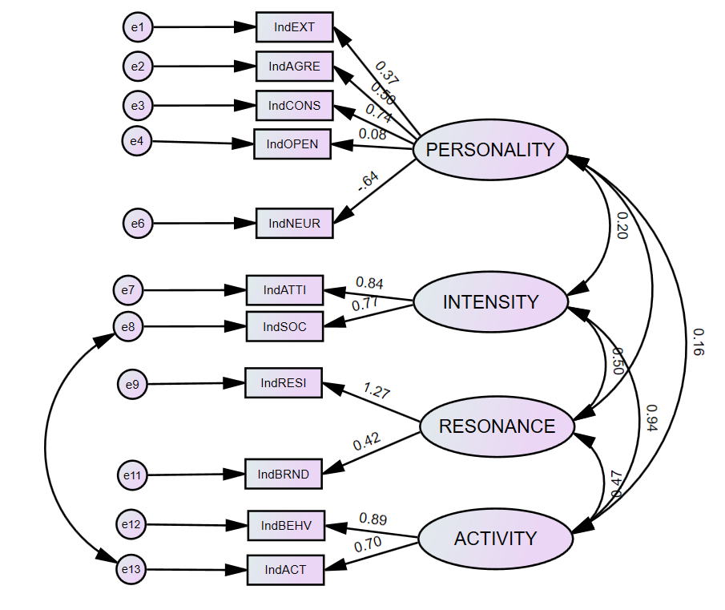
Final re-specified standardized measurement model
Source: Original data
Table 13
Model Fit Summary
Number of distinct sample moments: | 66
Number of distinct parameters to be estimated: | 29
Degrees of freedom (66 - 29): | 37
Minimum was achieved
Chi-square = 124.109
Degrees of freedom = 37
Probability level = .000

CMIN
Model | NPAR | CMIN | DF | P | CMIN/DF
Default model | 29 | 124.109 | 37 | .000 | 3.354
Saturated model | 66 | .000 | 0
Independence model | 11 | 1250.273 | 55 | .000 | 22.732
RMR, GFI
Model | RMR | GFI | AGFI | PGFI
Default model | .545 | .929 | .873 | .521
Saturated model | .000 | 1.000
Independence model | 2.501 | .522 | .427 | .435
Baseline Comparisons
Model | NFI  Delta1 | RFI  rho1 | IFI  Delta2 | TLI  rho2 | CFI
Default model | .901 | .852 | .928 | .892 | .927
Saturated model | 1.000 |  | 1.000 |  | 1.000
Independence model | .000 | .000 | .000 | .000 | .000
RMSEA
Model | RMSEA | LO 90 | HI 90 | PCLOSE
Default model | .088 | .072 | .106 | .000
Independence model | .269 | .256 | .282 | .000
Source: Original data.
As an exploratory effort, the 18 original observed variables of PERSONALITY were subjected to maximum likelihood exploratory analysis using SPSS version 28. Prior to performing EFA, the suitability of data for factor analysis was assessed. Inspection of the correlation matrix revealed the presence of several coefficients of .3 and above. The Kaiser-Meyer-Olkin value was .770, exceeding the recommended value of .6 (Kaiser, 1970, 1974) and Bartlett’s Test of Sphericity (Bartlett, 1954) reached statistical significance, supporting the factorability of the correlation matrix. PCA revealed the presence of five components with eigenvalues exceeding 1, explaining 21.22%, 15.40%, 7.83%, 6.86%, and 6.21% of the data respectively. Watkin’s Monte Carlo for parallel analysis supported four of these five components. An inspection of the scree plot indicated a sharp break at three components. Using Cattell’s (1966) Scree test, it was decided to retain three components for further investigation. The three components were then computed with SPSS Transform function into NEWDog, NEWNeur, and NEWExt. The exploratory model fit, after several modifications, resulted in a CMIN/DF = 5.691, GFI = .921; AGFI = .819; NFI = .893; TLI = .799; CFI = .908; and an RMSEA = .125. Figure 26 provides the model and model fit summary for the re-specified model. This model resulted in higher correlations between latent variables but was not adopted due to the number of indices modifications needed to reach model fit. This model would benefit from an expanded data set as would the final measurement model.

Figure 26
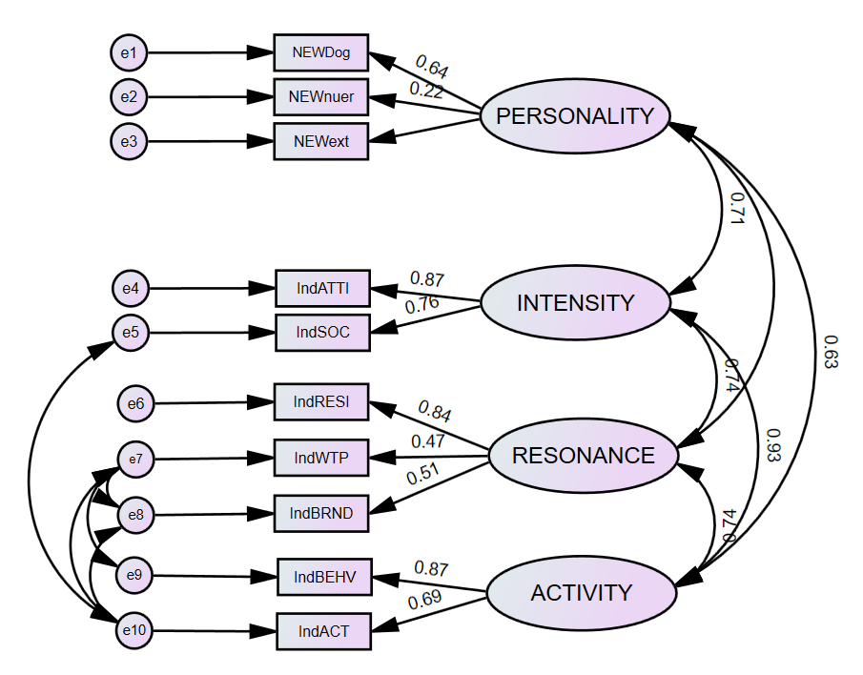
Exploratory model with three variables for PERSONALITY
Source: Original data

Step Six: Report the results
A confirmatory factor analysis, based on data from 302 U.S. consumer shoppers, was performed through SPSS AMOS on the four latent variables, PERSONALITY, ACTIVITY, INTENSITY, and RESONANCE. The hypothesized model was presented in Figure 20 where circles represent latent variables. Absence of a line connecting variables implied no hypothesized direct effect.
The hypothesized model examines the predictors of RESONANCE. PERSONALITY was characterized as a combination of extraversion, conscientiousness, neuroticism, openness to experience, agreeableness, and dogmatism. The hypothesis was that PERSONALITY directly predicted RESONANCE, characterized as brand commitment, resistance to change and willingness to pay. The study further hypotheses that INTENSITY, characterized as a combination of attitudinal attachment and sense of community, mediated PERSONALITY on RESONANCE. The study also hypotheses that ACTIVITY, characterized as a combination of behavior loyalty and active engagement, mediated PERSONALITY on RESONANCE. RESONANCE was characterized as brand commitment, resistance to change and willingness to pay.
Face-value outliers by case were then addressed. Non-serious and non-sensical brand inputs (e.g., “don’t know,” “None ya,” and “No entry”) and patterned responses (e.g., inspecting raw data in SPSS that looked like responses of all “1” or a similar pattern from a single respondent) resulted in removal as an indicator of outliers. At this point 302 cases remained. Variables that required reverse coding were performed with SPSS’s Transform/Compute Variable function. String variables (income; WTPPAY) were also transformed to five-item scaled variables. Individual respondent responses were generated with SPSS Transform/Compute Variable, summing observed variables, and creating a new variable, IndX, where X was the variable label. There were no missing data (n=302).
Maximum likelihood estimation was employed to estimate all models. A Chi-Square difference test indicated a significant improvement in fit between the independent model and hypothesized model. Post hoc model modifications were performed in an attempt to develop a better fitting and possibly more parsimonious model. Standardized regression coefficients of the original model were examined and five variables under .50 were found. Dropping willingness to pay (IndWTP) (.200), resulted in an improved CMIN/DF = 5.736, a GFI = .860, an AGFI = .773, and an RMSEA = .125. Standardized regression coefficients of the re-specified model were examined and four variables under .50 were found. Removal of dogmatism (IndDOG) resulted in a better fit, with a CMIN/DF = 4.901, GFI = .889, AGFI = .807, and RMSEA = .114. Correlating the highest covariance, e8-e13, between ACTIVITY and INTENSITY, resulted in a CMIN/DF = 3.354, GFI = .929, AGFI = .873, and RMSEA = .088. These measures met requirements for a reasonable and acceptable model fit. The modifications stopped at this point.
The 18 original observed variables of PERSONALITY were subjected to maximum likelihood exploratory analysis using SPSS v28. Prior to performing EFA, the suitability of data for factor analysis was assessed. Inspection of the correlation matrix revealed the presence of several coefficients of .3 and above. The Kaiser-Meyer-Olkin value was .770, exceeding the recommended value of .6 (Kaiser, 1970, 1974) and Bartlett’s Test of Sphericity (Bartlett, 1954) reached statistical significance, supporting the factorability of the correlation matrix. PCA revealed the presence of five components with eigenvalues exceeding 1, explaining 21.22%, 15.40%, 7.83%, 6.86%, and 6.21% respectively. Watkin’s Monte Carlo for parallel analysis supported four of these five components. An inspection of the scree plot indicated a sharp break at three components. Using Cattell’s (1966) scree test, three components were retained for further investigation. The three components were computed with the SPSS Transform function into NEWDog, NEWNeur, and NEWExt. The exploratory model fit, after several modifications, resulted in a CMIN/DF = 5.691, GFI = .921; AGFI = .819; NFI = .893; TLI = .799; CFI = .908; and an RMSEA = .125. Figure 23 provides the model and model fit summary for the re-specified model. This model resulted in higher correlations between latent variables but was not adopted due to the number of indices modifications needed to reach model fit.
Given that key study elements of dogmatism and willingness-to-pay were removed to achieve model fit, the author suggests that while still an acceptable model fit, the model needs continued improvement with a larger sample size and expanding the number of observed variables. The study survey was limited by available funding, which directly limited the number of questions used and the number of respondents to which the survey was distributed. The ability to expand the number of observed variables to include full measures of already-validated studies, would allow for more detail and granularity in support of the hypotheses. Having at least three – with five being even better – observed variables per latent variable would be a good start. To support the existing 13 latent variables would require a survey instrument with at least 65 observable variables. The current survey took an average of five minutes for 13 questions with 45 possible responses. A 65-item survey would still be far short of the recommended 20 minute limit for online surveys.
As part of the same online study, respondents were asked how important organizational leadership, ideology (phrased as values), and strategy (phrased as actions) were to them when considering their preferred brand. The survey instrument (Appendix C) included the following question (Five-point Likert scale; [Q2] was their preferred brand):
Q9. Please indicate how strongly you agree or disagree with the following statements.
• The brand’s leadership are a significant part of my decision-making process to buy [Q2].
• The brand’s values are a significant part of my decision-making process to buy [Q2].
• The brand’s actions are a significant part of my decision-making process to buy [Q2].
Regression analysis was used to test if age, education, ethnicity, or gender were significant predictors of importance placed in leadership (n = 295, (F(4, 291) = 3.930, p .= .021), ideology (n = 294, (F(4, 290) = .378, p. = .824), and strategy (n = 296, (F(4, 292) = 1.080, p. = .367). Only leadership had a statistically significant outcome with females (male = 1; female = 2) placing more significance in leadership than males, n = 295, (F(4, 291) = 2.934, p. = .021)(Table 14). Ethnicity, education, and age were not significant predictors of leadership being a factor in decision making.
Table 14
Q. The brand’s leadership are a significant part of my decision-making process to buy [Q2].
Regression Statistics
Multiple R | 0.197
R Square | 0.039
Adjusted R Square | 0.026
Standard Error | 1.157
Observations | 295
ANOVA
 | df | SS | MS | F | Significance F
Regression | 4 | 15.719 | 3.930 | 2.934 | 0.021
Residual | 291 | 389.795 | 1.340
Total | 295 | 405.514
 | Coefficients | Standard Error | t Stat | P-Value | Lower 95% | Upper 95%
Constant | 1.238 | 0.571 | 2.168 | 0.031 | 0.114 | 2.363
Ethnicity | 0.027 | 0.026 | 1.063 | 0.289 | -0.230 | 0.078
Education | 0.042 | 0.026 | 1.600 | 0.111 | -0.010 | 0.094
Gender | 0.407 | 0.136 | 2.990 | 0.003 | 0.139 | 0.675
Age | -0.050 | 0.073 | -0.682 | 0.496 | -0.194 | 0.094

Source: Original data.
Individual willingness to pay was a significant predictor of the importance of leadership and ideology of the organization, n = 274, (F(3, 271) = 28.917, p. < .001)(Table 15).
Table 15
Q. How likely are you to reallocate your budget or go into debt to get your (preferred brand)?
Regression Statistics
Multiple R | 0.492
R Square | 0.242
Adjusted R Square | 0.234
Standard Error | 1.24911
Observations | 274
ANOVA
 | df | SS | MS | F | Significance F
Regression | 3 | 135.358 | 45.119 | 28.917 | <.001
Residual | 271 | 422.838 | 1.56
Total | 274 | 558.196
 | Coefficients | Standard Error | t Stat | P-value | Lower 95% | Upper 95%
Intercept | 1.553 | 0.194 | 8.002 | <.001 | 1.171 | 1.935
Leadership | 0.413 | 0.108 | 3.824 | <.001 | 0.201 | 0.625
Ideology | 0.25 | 0.11 | 2.282 | 0.023 | 0.034 | 0.466
Strategy | -0.003 | 0.117 | -0.025 | 0.98 | -0.232 | 0.227

Source: Original data.
Further, individual willingness to take a risk was a significant negative predictor of the importance placed in leadership, n = 266, (F(3, 263) =9.294, p. < .001)(Table 16).
Table 16
Q. How much of a premium would you pay to get your brand?

Regression Statistics
Multiple R | 0.31
R Square | 0.096
Adjusted R Square | 0.086
Standard Error | 1.44318
Observations | 266
ANOVA
 | df | SS | MS | F | Significance F
Regression | 3 | 58.072 | 19.537 | 9.294 | <.001
Residual | 263 | 547.766 | 2.083
Total | 266 | 605.838
 | Coefficients | Standard Error | t Stat | P-value | Lower 95% | Upper 95%
Intercept | 3.902 | 0.228 | 17.144 | <.001 | 3.454 | 4.35
Leadership | -0.354 | 0.126 | -2.805 | 0.005 | -0.603 | -0.106
Ideology | -0.15 | 0.129 | -1.17 | 0.243 | -0.403 | 0.103
Strategy | 0.092 | 0.137 | 0.671 | 0.503 | -0.177 | 0.361

Source: Original data.

Finally, the mean score for individual personality was a significant positive predictor of the importance placed on organizational leadership, n = 274, (F(3, 271) = 22.398, p. < .001)(Table 17).
Table 17

Personality regressed on leadership, ideology, and strategy

Regression Statistics
Multiple R | 0.446
R Square | 0.199
Adjusted R Square | 0.19
Standard Error | 1.10274
Observations | 274
ANOVA
 | df | SS |  | MS |  | F |  | Significance F
Regression | 3 | 81.711 |  | 27.237 |  | 22.398 |  | <.001
Residual | 271 | 329.547 |  | 1.216
Total | 274 | 411.257
 | Coefficients | Standard Error |  | t Stat |  | P-value |  | Lower 95% | Upper 95%
Intercept | 6.393 | 0.171 |  | 37.309 |  | <.001 |  | 6.056 | 6.731
Leadership | 0.354 | 0.095 |  | 3.717 |  | <.001 |  | 0.166 | 0.541
Ideology | 0.036 | 0.097 |  | 0.368 |  | 0.713 |  | -0.155 | 0.226
Strategy | 0.111 | 0.103 |  | 1.084 |  | 0.279 |  | -0.091 | 0.314

Source: Original data.
It could be reasonably argued that leadership is a part of the decision-making process for females, and that ideology and strategy are not a significant part of decision-making process regarding a preferred brand. This should be examined further as it would provide valuable data to guide prioritization of resources when using unbranding.
In summary of this chapter, when examined through simple linear regression, hypothesis three (H3) was supported with PERSONALITY significantly predicting RESONANCE. When examined through multiple linear regression and introducing INTENSITY and ACTIVITY into the model, all hypotheses except hypothesis three (H3) were supported, indicating potential mediation from INTENSITY and ACTIVITY. When examined for mediation at 95% confidence, direct, and indirect effects with Hayes’ PROCESS, INTENSITY mediates PERSONALITY on RESONANCE, but ACTIVITY does not.
The unstandardized indirect effect of PERSONALITY on RESONANCE through INTENSITY was positive and statistically significant (IE = .3; 95%CI = [.1055, .5321]) indicating indirect mediation by INTENSITY. The unstandardized indirect effect of PERSONALITY on RESONANCE through ACTIVITY, was positive, but not statistically significant (IE = .168; 95% CI = [-.0040, .3568]). At a 95% confidence interval, INTENSITY mediates PERSONALITY on RESONANCE, but ACTIVITY does not. However, at a 90% confidence interval, ACTIVITY is positive and becomes statistically significant (IE = .168; CI = [.0187, .3248]) indicating that ACTIVITY and INTENSITY mediate PERSONALITY on RESONANCE at a 90% confidence interval. The difference between the mediation model path C (.641) and C¹ (.173) supports the presence of an indirect effect but given only 30% of the indirect effect is explained by INTENSITY, it is likely there is another unidentified mediator present. Path Analysis and Structural Equation Model provided positive support for study hypotheses.
The generalizability of the survey is good and established with a literature-supported sample size from a known, defined population. The response rate was high (95%), and responses were consistent throughout the period of the survey. The ability to replicate the data is high as the population was defined, the survey instrument is accessible, and the cleaning of data clearly described. This study is more fitting as a rigorous pilot study, with evidence supporting a need for continued research. The survey instrument can be further developed with additional observable variables, using the BFI-44 instead of the BFI-10, providing a better detailed set of data for SEM fitment.

Chapter Seven: Discussion
This research addresses the perceived problem that past and current Violent Extremist Organization (VEO) engagement programs have been ineffective in achieving their original goals. The research cites organization and government sources, in support of the problem statement, and asserts that VEOs use information power as their primary maneuver while Western state actors, specifically the United States, use hard power as their primary maneuver. Examples provided illustrate that information power is more effective, both in achieving desired effect and in use of resources, over hard power when used as the primary maneuver. This research also asserts that Counterterrorism (CT) programs, or programs labeled “counter x,” support and enable VEO objectives. Examples are provided to illustrate this position. The question asked by this research is: What new engagement method can be used to better engage and degrade VEOs?
This research provides several implications for literature and policy. It introduces a dynamic model of a brand, based on the concept the brand is the center of gravity of an organization, and is measurable through the elements of value and equity instead of traditional financial models. The dynamic model can help organizations assess their desired brand image in comparison to stakeholder-perceived brand image. It also helps assess how to address imbalances between brand value and brand equity and which tools to use to do so. This research also introduces a statistical model of brand resonance that represents how various aspects of brand resonance are thought to be causally structurally related to one another. With a statistical model, new data can be collected and used to empirically measure relationships between the latent (unobservable) variables personality, intensity, activity, and resonance. This research highlights the need for a new approach to engage VEOs and emphasizes the need to use Information Power as the primary maneuver. The research highlights the need to avoid using “counter x” programs and provides methods for better use of resources when engaging VEOs.
As part of the literature review, this research critically examines existing VEO engagement programs. The use of obvious logic – addressing a problem at face value from the worldview of the problem solver – is noted as a key weakness in past and current VEO engagement programs. Obvious logic is underpinned by hubris and emotion and is argued here as one of the strongest enablers of VEO objectives and goals. Programs labelled “counter x” are used as examples of obvious logic. These programs sustain the VEO brand by drawing attention to its narratives or ideologies, by repeating them in efforts to counter them.
This research introduces a new approach to disenchant extremism and disenfranchise VEOs – unbranding. Unbranding is defined here as the application of coordinated and synchronized powers to transform a name brand into a generic brand. “Disenchanting terrorism” means to reduce or diminish stakeholder motivation to engage with VEO brands, by freeing them from the illusion of organizational success. “Disenfranchising terrorists” means depriving VEOs of the opportunity to develop or franchise a successful organization by reducing their differentiation between competing organizations. Brands are perceptions held by individual stakeholders as a perceptual entity rooted in reality. An organization builds a brand through a linear process, described in the current research as a four step process, ultimately seeking to establish resonance with its stakeholders. An organization may seek to generate a desired perception of the brand, but ultimately cannot control how the individual stakeholder actually perceives the organization. The research demonstrates how the brand is the center of gravity of an organization, specifically a VEO, and how the personality of a stakeholder can be a predictor of generic or name brand choices.
A brand can be assessed through the concepts of brand value and brand equity. As noted in Chapter One, a balance of brand value and equity, as seen through the eyes of the organization and the eyes of stakeholders, is required to maintain the equilibrium of a stable brand. A stable brand is one that moves predictably through time and in the information environment, while maintaining a balance of value and equity. An organization, with a stable brand, can more efficiently manage resources needed for daily operations as well as contingencies. A stable brand also enables growth and expansion. However, in reality a perfect stability is hard to achieve. Understanding the physics of a brand, as introduced in this research, better illustrates the elements of stability that can be affected by either the organization or the stakeholder. A strong brand has high Center of Gravity Limits (CGLs), which provide the ability to resist and recover from large fluctuations in both organizational change and stakeholder perceptions. A strong brand has the ability to differentiate itself from categorical competitors and attract valued stakeholders. It has the ability to grow either through increasing owned property, adding franchises, or in some cases brandjacking another brand. Franchises enable a brand to expand with minimal cost, while increasing the brand value and equity. For a brand that seeks to franchise as part of its Business Model Design (BMD), increasing performance capital, through demonstrated ability to accomplish organizational objectives and goals, increases Business Model Appropriability (BMA). A high BMA is a direct indicator of brand value and equity expressed in a measure of stakeholder resonance.

The Brand as the Center of Gravity
A case study of the Irish Republican Army (IRA) and Islamic State (IS) illustrated the foundational premise that the brand is the center of gravity of the organization. Both the IRA and IS use violence targeted at civilians, government officials, and security services. They seek a polity of their own design and claim to represent a closely defined population. Both have different goals, stakeholders, methods, motives, and targets, and both have enduring and iconic brands. They have waxed and waned in strength and popularity, yet both brands exist to this day while other splinter organizations have disappeared.
Using attributed attacks as the indicator of brand value and using franchises as an indicator of brand equity, out of the brand names used throughout the history of each iteration of group, the study found the enduring brands to be the IRA and IS. This may not come as a surprise, given both names are well-known and easily recognizable, but each of the two brands had other brand names in their lineage, such as the Official IRA (OIRA), the Provisional IRA (PIRA), the real IRA (rIRA), and Jama‘at al-Tawhid wal-Jihad, Islamic State of Iraq (ISI), and Al-Qa’ida in Iraq (AQI). All these splinter groups have disappeared, either evolving into the parent brand or ceasing to exist at all.
The IRA brand was brandjacked for its cultural brand value and equity, with each split in the original organization. They did not have franchising as part of their organizational goals as the brand did not need to expand outside the territory it already operated. The IRA brand uses a nationalist ideology (to form a Gaelic nation), based on republicanism (freedom from external rule), implemented through the strategic use of extremism (coercion and force), to attain organizational goals (a unified and independent Ireland). The original IRA brand has endured from its origins but was brandjacked by different splinter groups of the original group, because of its cultural value and equity. The IRA aspires to reclaim an existing, geographical republic, occupied by an external government force.
The IS brand is heavily franchised as part of its organizational design. IS aspires to create a global, borderless Muslim nation and rule with its worldview and interpretations of Islam but cannot do so with its available resources. With the goal of establishing a political order based on a specific worldview of religious law, the IS brand follows a nationalist ideology (to establish the Ummah), based on their interpretation of Islam (brandjacking Islam), implemented through the strategic use of extremism (coercion and force) to attain organizational goals (purification and rule of all Muslims).
Both IRA and IS seek a political end state, but leverage the information environment through perception, coercion, and violence as force multipliers, given the state actor-sponsored capacity of their respective opponents. The strategy for both organizations was imputed as interpretive extremism throughout the time span of each organization. Ideology remained constant throughout the life span of each brand, with the IRA and IS assessed here as being nationalist. However, it appears that IS was able to produce franchises only when it adopted a nationalist ideology. Leadership changed numerous times throughout the time span of each organization, but the brand was not significantly impacted. For example, IS has had three known leaders from 2013 to December 2022, and the IRA had about 35 leaders from 1919 to December 2022. Given the strength of both brands to date, leadership can be assessed as having a negligible impact on the long-term value and equity of the brand, with the only visible correlation being that highly attributed brands have more leaders.
Like some commercial organizations, VEOs can franchise as a cost-effective way to grow and achieve organizational goals. In the competitive category of VEOs, where violence is a measure of success, credibility, and effectiveness, attributed attacks (perceived or real) have the ability to affect political outcomes are the currency of VEOs. It is interesting that – for the two cases reviewed in this research – franchises seem to become possible after approximately 480 attacks, or .002 of total attacks. The ratio of attack-to-brand name for IS 483:1 and for IRA is 481:1. Obviously, two cases do not provide sufficient support for causality, nor even a trend. However, the random similarity of a potential threshold of attacks is of interest and would benefit from future research.
This research explicated that a direct approach of the brand is the most efficient course of action to engage VEOs. Directly engaging the brand as the primary line of effort avoids trying to engage all stakeholders, including hidden stakeholders, and avoids focus on cultures, nations, or religions. Given the complexity and improbability of engaging all stakeholders of a brand, a direct approach of the brand is offered as the most efficient means to engage an organization.

Personality and Brand Affinity
Given the emphasis on brands, and with the desired effect of unbranding intended to degrade brand affinity, it is important to understand how a name brand, or a generic brand, is viewed by its stakeholders. Regarded by the author as a robust pilot study, given the study limitations (discussed in the next chapter), this study demonstrates how the personality of a stakeholder can be a predictor of generic or name brand choices. This research found that the types of personalities, that may be inclined towards generic brands, also lack the level of emotional commitment necessary to increase personal risk or take affirmative action in support of the brand. As such, for any organization which requires high levels of commitment from their stakeholders – such as VEOs – a loss of brand value that results in less differentiation from its competitors, will directly impact the composition of the organization’s stakeholders. This research asserts a generic brand does not attract the same type of personality that a name brand does and if a brand is not competitive in its category, it can be labelled as generic.
A model was specified to explain the correlation with stakeholder personality and generic or name brand selection. This study uses an original survey instrument to collect new data from 359 U.S. English-speaking consumer shoppers. The survey allows respondents to choose their preferred brand (instead of choosing from a short list of pre-selected brands) and self-categorize it as a name brand or generic brand. Brand preferences and personality measures were collected at the same time from the same respondents.
Path Analysis and Structural Equation Model provided positive support for study hypotheses. The model fit was acceptable but needs further refinement. In support of the five study hypotheses, personality was positively correlated with intensity and activity, both of which were positively correlated with resonance. As a stakeholder’s personality increases, for example becoming more extroverted and/or dogmatic, both intensity and activity increases, resulting in increased levels of resonance, measured as willingness to pay, resistance to change, and brand commitment.
When examined through simple linear regression, and at a 95% confidence interval, hypothesis three (H3) was supported with PERSONALITY significantly predicting RESONANCE. When examined through multiple linear regression and introducing INTENSITY and ACTIVITY into the model, all hypothesis except hypothesis three (H3) were supported. When examined for mediation and direct and indirect effects with Hayes’ PROCESS, INTENSITY mediates PERSONALITY on RESONANCE, but ACTIVITY does not. However, at a 90% confidence interval, ACTIVITY is positive and becomes statistically significant indicating that ACTIVITY and INTENSITY mediate PERSONALITY on RESONANCE.
As INTENSITY is a measure of magnitude of emotional attachment to a brand, it is logical that an individual who scores high on intensity measures is going to have predictably high resonance when it comes to their selected brand. The latent variable INTENSITY deals directly with attitudinal attachment and sense of community. A strong personal attachment is necessary to create resonance. Consumers who demonstrate repetitive purchases of a brand may demonstrate positive activity towards a brand, but that does not necessarily infer love or feelings of attachment to the brand. Stakeholders must go beyond simply having a positive attitude to view the brand as being something special in a broader context. Identification with a brand community may reflect an important social phenomenon whereby consumers feel a kinship or affiliation with other people associated with the brand. These connections may involve fellow brand user, or consumer, employees, or representatives of the company. This is important as VEOs require stakeholders with high brand resonance. Stakeholders with low intensity, equating to low resonance, may not be moved to action for a VEO name brand or any name brand. A lower personality score indicates a preference for generic brands in general. Therefore, a reduction in brand value and equity, as well as the resulting drop in categorical performance and standing, will weaken the organization’s ability to recruit or generate stakeholders who are willing to increase personal risk for the sake of the organization. Future research will focus on individual personality traits and how they impact brand preference.

Ethics of Unbranding
When it comes to unbranding, there will be challenges from several viewpoints. From within the academic communication community, which heavily favors harmony, positive contribution, and constructive theory. Unbranding may (rightfully) be seen as a framework to deconstruct organizational communication, specifically the brand. There is little published content in peer-reviewed journals that outlines explicitly how to degrade an organization’s communication efforts. There is, however, ample discussion regarding countering VEO communication (Aly et al., 2016; Bertram, 2016; Braddock & Horgan, 2016; Briggs & Feve, 2013; Cherney, 2016; Davies et al., 2016; Helmus, 2018; and Szmania & Fincher, 2017), propaganda (at times re-named or re-labelled as misinformation or disinformation) (Allport, 1935; Bernays, 1928; Black, 2008; Chomsky & Herman, 2002; Garber, 1942; Hovland et al., 1953; Jowett & O’Donnell, 1992; Katz and Lazarsfeld, 1955; Lasswell, 1927, 1971; Lazarsfeld et al., 1948; and O’Donnel & Kable, 1982), and how to cope or deal with information that may be propaganda (Benkler et al., 2018; Beutel et al., 2016; Braddock & Horgan, 2016; Edwards, 2021; Eerten & van Doosje, 2019; Ganesh & Bright 2020; Hemeleers at al., 2020; Hjorth & Adler-Nissen, 2019; Humprecht et al., 2020; Kapantai et al., 2021; Marwick & Lewis, 2017; Wardle & Derakhshan, 2017). However, after declaring a need for increased media literacy, more awareness of the issue, or suggesting coping skills, researchers stop short of suggesting how direct action can be taken against the propagandist to stop the propaganda.
Further challenges to unbranding will arise, most likely not because of its utility to degrade extremism, but regarding how it will (not if) be used against brands in general. The dark side of innovation has a checkered past, with items such as cigarettes, plastic, nuclear fission, gunpowder, and high-fructose corn syrup having best-of-intent origins, but sometimes resulting in two personalities, one for good and one for bad, with unintended (or intended) consequences in the field of science and humanity. Other items such as duct tape, undershirts, GPS, super glue, feminine hygiene products, the Internet, and Virtual Reality were innovations born out of military development projects and tend to be seen as contributory to society in general.
One possible way to view unbranding is through the lens of consequentialism, a normative ethical theory of action, and a proposed method for deciding how one should choose the right ethical act (Haines, 2003). Consequentialism is the view that normative properties depend only on consequences (Sinnott-Armstrong, 2019). Consequentialists would say that the consequences of an action are all that matter when taking an ethical decision to act. Arguably – aside from some disagreement from state and non-state actors, who rely on extremism for their purposes or objectives – removing extremism would result in less violence and terror in the world. In general, this is a good thing. Utilitarianism is by far the most widely known form of consequentialism. This belief states that actions are morally right, if and only if, they maximize the good or minimize the bad. Classic utilitarians, like Jeremy Bentham and John Stuart Mill, take the good to be pleasure or well-being. Thus, actions are morally right if they maximize pleasure, well-being, or minimize suffering (Driver, 2014). In this instance, reducing or removing extremism would reduce or minimize suffering.
Mill requires calculating what is truly good for the whole community – the aggregate good – or for all the people who can be identified as being affected by a particular action (Elliott, 2007). Mills requires the application of principles of justice before any utilitarian calculus is used. As Elliott (2007) states, “if causing harm is justified at all, it is justified on the basis that causing harm in those particular types of cases is good for the community, including the individual harmed” (pp. 100-101). Mill (1863) wrote:
The great majority of good actions are intended, not for the benefit of the world, but for that of individuals, of which the good of the world is made up; and the thoughts of the most virtuous man need not on these occasions travel beyond the particular persons concerned, except so far as is necessary to assure himself that in benefitting them he is not violating the rights – that is, the legitimate and authorized expectations – of anyone else. (p. 150)
Mill’s (1863) utilitarianism is underpinned by five principles of justice; (1) it is unjust to deprive people of that to which they have a legal right; (2) it is unjust to deprive people of that to which they have a moral right; (3) it is just to cause harm to wrongdoers who cause harm; (4) it is a matter of justice to give others what they have promised; and (5) treating people impartially is a matter of justice. In short, the aggregate good is right to pursue, because of its consistency with the principles of justice (Elliott, 2007). Elliott (2007) proposes a decision tree based on Mill’s principles.
- What is the intended action?
- Will it cause harm? No = no analysis needed; Yes = review principles of justice.
  - Is someone being denied legal rights? Yes = action is unjust.
  - Is someone being denied moral rights? Yes = action is unjust.
  - Is the person being harmed/helped getting what is deserved? Yes = action is just.
  - Has the person being harmed had a promise broken? Yes = action is unjust.
  - Has everyone in the calculus been treated impartially? Yes = action is just.
- How will harming the individual promote the overall good of the community?
- How will the community be harmed if the proposed action is not taken?
If exceptions to these rules are applied, Elliott (2007) notes, “it is essential to show how the exception will lead to the aggregate good and how following the rule will not lead to the greatest good for the whole group” (p. 111). Simply stated, according to consequentialism, “an action is right if and only if nothing the agent could do would have better results” (Shaw, 2016, p. 21). While Mill and Elliott may have agreed that unbranding is ethical, unbranding will undoubtably be contested, and hopefully debated, amongst communication and ethics scholars in future writings and discussions.

Chapter Eight: Conclusion
This research recommends approaching Violent Extremist Organizations (VEOs) from the viewpoint of the brand as the organizational Center of Gravity (CG) and using information power as the primary instrument of power for engagements. The study introduces a dynamic model of a brand and a statistical model of brand resonance. This research also offers a new approach via a plausible explanation and tentative metric on when VEOs may be able to expand in number and regions, either through increasing organization-owned property or adding organizational franchises, that can be adopted into planning cycles and strategies. The following recommendations are offered for consideration by organizations who are impacted by, or engage with, VEOs.

Recommendations
- VEOs do not need specialized or separate study or research on “what” they are. VEOs are organizations and can be engaged using existing and established organizational theory. What should be researched, are answers to the questions:
- How does the organization generate salience with potential stakeholders?
- What does the organization do to generate performance and imagery?
- What does the organization do to generate judgement and feelings?
- How does the organization generate resonance with stakeholders?
- Each question above should be addressed in a coordinated and synchronized fashion. Information power leads every question, with hard and soft power in support. This would require a major re-think by military leaders, as all operations, including existing Information Operations or Psychological Operations, are currently subsets of larger, hard-power focused lines of effort and desired effects.
- Refrain from programs that are labelled as “counter x,” as this is reactive and creates a continual position of imbalance and weakness. Countering an ideology has been argued here as ineffective. A better label would be “unbranding x” or “disenfranchising x.” These suggested titles do not create the inference of “reaction” and avoid the potential of being criticized as anti-religious or anti-ethnic, as previous CT programs have been in the past. These titles focus on the brand and would have to be countered by the brand owner – putting the VEO on the defensive, instead of the country, nation, or religion used by the VEO.
- Refrain from providing VEOs with predicable plans, hubris, feelings, and emotions. No different than one fighter getting into the head of the other to replace calculated effort with emotional response, U.S. leaders, both civilian and military, are easily provoked into emotional reactions by established VEOs. As argued here, emotional reactions are based on irrational decision making. Under constant provocation, one irrational response quickly leads to another resulting in obvious logic and predictable reactions and responses.
- Establish a single, coordinated U.S. government and military strategy. The proverbial golden unicorn, a unified coordinated strategy is required to coordinate a whole of government approach in engaging VEOs. There is currently no such strategy that is agreed on by all branches of government, civilian and military, is jointly funded, and operates from the head of government to boots on the ground. However, this recommendation is similar to academic research on how to combat propaganda from opponents – easier said than done. The oft-cited recommendation to protect citizens from propaganda (misinformation, disinformation, etc.) – increase media literacy – as simple as it is, rests on the same principles expressed here. Change requires the desire of those involved to address the problem and to want to make a change for the betterment of all.

Recommendations for future research
- Additional VEOs, as well as non-VEOs, need to be studied and compared to add depth to the discussion on the brand as the center of gravity of any organization. By adding case studies, more triangulation of data is possible, adding depth and definition to the available data. Some researchers may argue that all VEOs must be studied and analyzed to better understand unbranding. However, this approach is impractical. Having n=N is rare in any field, science or social, simply because there is always an unknown quality or quantity to any problem.
- Further research is needed to explicate the franchise lifecycle and how it may apply to VEOs. This research provides a foundational, but basic link between the theory of franchises and VEOs, with evidence to support this link. Determining how and when VEOs may grow or expand has the benefit of being able to disrupt and degrade that ability to grow.
- Further research is needed to explicate Business Model Appropriability (BMA) and Business Model Design (BMD) in the context of VEOs. As noted previously, BMD determines the franchisor’s potential rate of franchising and BMA is the indicator of what the franchisee is willing to pay. Understanding these two key concepts through the lens of VEOs may contribute to better understanding the threshold required for a VEO to successfully franchise.
- Further research is needed to explore the ability to identify what organizational elements (leadership, ideology, strategy) are important to which stakeholders. This may vary between types or categories of organizations and will most certainly vary between types of stakeholders. Knowing what is of priority to stakeholders will help prioritize lines of effort and resource allotment to those lines of effort in unbranding efforts.
- Future research is needed to further study personality traits and brands. Using the Big Five Inventory (BFI-44), additional observed variables can be collected, and each trait broken out in relation to brand responses. This would enable more precision in assessing if there is a dominant personality trait with regards to brand selection, or if there are specific combinations of traits that can be measured when it comes to brand selection.

Limitations
This study faced limitations. First, causality is not established for any assertation or hypothesis, nor could it be expected. With causality established only with temporal sequencing, non-spurious relationships, and elimination of alternate causes, the causality is elusive in any social science study. However, inferences have been made and arguments and facts have been presented here with evidence in support of assertions.
The survey instrument was limited by available funding, which directly limited the number of questions that could be used and the number of respondents to whom the survey could be distributed. V`ariables and constructs would benefit from a more comprehensive survey in number of observed measures and in respondents. The ability to expand the number of observed variables, using the BFI-44 instead of the BFI-10, would allow for more detail and granularity in support of the hypotheses.

Broader implications
Unbranding provides a novel approach to engaging brands and genericizing them, by reducing their categorical differentiation amongst competitors. Unbranding is intended to reduce extremist violence, unnecessary and/or prolonged combat in the name of extremism, and casualties of extremist violence. Unbranding avoids the temporal trap of deadlines and political decision cycles. A strategy, or tactic, based on time is weakened from the very beginning – if the opponent is aware of that timeline. If a VEO does not know how long it has to survive, or how long it has to create the perception of survival, they must adjust their strategy and resources for an indefinite period – a modern day siege response. In contrast, if they know that the military, security services, or the police will be withdrawn from VEO area of operations by a certain date, that is an entirely different calculus – and one that is potentially survivable, as seen most recently through the successes of Taliban and IS in Afghanistan.
In closing, a VEO that is perceived by its stakeholders as ineffective at violence is no longer a VEO that is marketable – nor competitive. It is something else, be that a failed organization or an organization which has transitioned to a new category, such as politics, but then it is no longer in the competitive category of VEOs. Unbranding is a new approach in dealing with extremism.

References
Aaker, D. A. (1991). Managing brand equity: Capitalizing on the value of a brand name. New York, NY: The Free Press.
Aaker, J. L. (1997). Dimensions of brand personality. Journal of Marketing Research, 34, 347-356.
Abrahms, M., & Mierau, J. (2017). Leadership matters: The effects of targeted killings on militant group tactics. Terrorism and Political Violence, 29(5), 830-851. https://doi.org/10.1080/09546553.2015.1069671
Abravanel, H. (1983). Mediatory myths in the service of organizational ideology. In L. R. Pondy (Ed.), Organizational Symbolism. Greenwich, CT: JAI Press.
Ackerman, C. (2017, June 23). Big five personality traits: The OCEAN model explained. PositivePsychology.com. https://positivepsychology.com/big-five-personality-theory
Ackoff, R. L. (1974). Redesigning the future: A systems approach to societal problems. New York, NY: John Wiley & Sons Inc.
Ailawadi, K. L., Lehmann, D. R., & Neslin, S. A. (2003). Revenue premium as an outcome measure of brand equity. Journal of Marketing, 67, 1-17.
Akbar, U. S., & Azhar, S. M. (2011). The drivers of brand equity: brand image, brand satisfaction and brand trust. Sukkur Institute of Business Administration, 45(2), 29-47.
Al-Hajj, T. (2022). The insurgency of ISIS in Syria. www.carnegieendowment.org. https://carnegieendowment.org/sada/86643
Al-Shahrastani, M. (1923). Kitāb al-milal wa al-nihal (Book of Religious and Philosophical Sects). London: The Society for the Publication of Oriental Texts.
Alba, J. W., & Hutchinson, J. W. (1987). Dimensions of consumer expertise. Journal of Consumer Research, 13(4), 411-454.
Alexander, L., & Moore, M. (2021). Deontological ethics. The Stanford Encyclopedia of Philosophy (Summer 2021 Edition), E. N. Zalta (Ed.), URL = https://plato.stanford.edu/archives/sum2021/entries/ethics-deontological/
Allport, G. W. (1935). Attitudes. In C. Murchison (Ed.), The Handbook of Social Psychology (pp. 798-884). Reading, MA: Clark University Press.
Altemeyer, B. (1996). The authoritarian specter. Cambridge, MA: Harvard University Press.
Altemeyer, B. (1998). The other authoritarian personality. Advances in Experimental Social Psychology, 30, 47–92. San Diego: Academic Press.
Altemeyer, B. (2002). Dogmatic behavior among students: Testing a new measure of dogmatism. Journal of Social Psychology, 142, 713-721.
Aly, A., MacDonald, S., Jarvis, L., & Chen, T. (2016). Violent extremism online: New perspectives on terrorism and the Internet. New York, NY: Routledge.
American Civil Liberties Union - Massachusetts. (n.d.). Countering violent extremism: A flawed approach to law enforcement. www.alcum.org. https://www.aclum.org/en/countering-violent-extremism-flawed-approach-law-enforcement
American Civil Liberties Union. (n.d.). The problems with violent extremism and violence prevention programs. www.aclu.org. https://www.aclu.org/other/problems-violent-extremism-and-violence-prevention-programs
Andersson, J. (2017). Cutting the head off the snake: Leadership decapitations against transnational and domestic terrorist organizations [Master’s Thesis, Uppsala University]. http://uu.diva-portal.org/smash/get/diva2:1179998/FULLTEXT01.pdf
Angus, T. (2003). Animals & Ethics: An overview of the philosophical debate. Peterborough, Ontario: Broadview Press.
Anscombe, G. E. M. (1958). Modern moral philosophy. Philosophy, 33(124), 1-19.
Archick, K. (2022). Northern Ireland’s 2022 assembly election: Outcome and implications. Congressional Research Service. https://crsreports.congress.gov/product/pdf/IN/IN11922/2
Armstrong, J. (1982). Nations before nationalism. Chapel Hill, NC: The University of North Carolina Press.
Armstrong, J. (1995). Towards a theory of nationalism: consensus and dissensus. In S. Periwal (Ed.), Notions of Nationalism (pp. 34-43). Budapest, Central European University Press.
Armstrong, K. (2014). Wahhabism to ISIS: how Saudi Arabia exported the main source of global terrorism. www.newstatesman.com. https://www.newstatesman.com/long-reads/2014/11/wahhabism-isis-how-saudi-arabia-exported-main-source-global-terrorism
Asal, V., & Rethemeyer, R. K. (2008a). Dilettantes, ideologues, and the weak: Terrorists who don’t kill. Conflict Management and Peace Studies, 25, 244–263.
Asal, V., & Rethemeyer, R. K. (2008b). The nature of the beast: Organizational structures and the lethality of terrorist attacks. The Journal of Politics, 70, 437-449. doi:10.1017/S0022381608080419
Aslan, R. (2009). How to win a cosmic war: God, globalization, and the end of the war on terror. New York, NY: Random House.
Aubrey, S. M. (2004). The new dimension of international terrorism. Zurich: vdf Hochschulverlag an der ETH.
Austin, L. J. (2021). Senate Armed Services Committee advance policy questions for Lloyd J. Austin, nominee for appointment to be Secretary of Defense. Armed Services Senate. https://www.armed-services.senate.gov/imo/media/doc/Austin_APQs_01-19-21.pdf
Badra, M., & Nagata b, M. (2017). Modern extremist groups and the division of the world: A critique from an Islamic perspective. Arab Law Quarterly, 31(4), 305-335.
Baier, A. (1985). Postures of the mind. Minneapolis, MN: University of Minnesota Press.
Barbari, N. (2018). Reconsidering CVE: The unintended consequences of countering violent extremism efforts in America [Master’s thesis, Naval Postgraduate School].
Barrios, E. (2018, August 7). New IRA ignites unrest in Northern Ireland. The American Spectator. https://spectator.org/new-ira-ignites-unrest-in-northern-ireland/
Beagelman, S. (2022). Three pillars of success for franchisors in franchise development. www.forbes.com. https://www.forbes.com/sites/stevenbeagelman/2022/05/20/three-pillars-of-success-for-franchisors-in-franchise-development/?sh=4007ca34532f
Bean, H., & Buikema, R. J. (2015). Deconstituting al-Qa’ida: CCO theory and the decline and dissolution of hidden organizations. Management Communication Quarterly, 29(4), 512-538.
Beer, M., & Huse, E. F. (1972). A systems approach to organization development. The Journal of Applied Behavioral Science, 8(1), 79-101. doi:10.1177/002188637200800107
Belanger-McMurdo, A. (2015). A fight for statehood? ISIS and its quest for political domination. www.e-ir.info. https://www.e-ir.info/2015/10/05/a-fight-for-statehood-isis-and-its-quest-for-political-domination/
Benkler, Y., Faris, R., & Roberts, H. (2018). Network propaganda: Manipulation, disinformation, and radicalization in American politics. Oxford University Press.
Benn, D. W. (1985). Soviet propaganda: the theory and the practice. The World Today, 41(6), 112-115.
Bensky, T., & Fisher, E. (Eds.) (2014). Internet and emotions. New York, NY: Routledge.
Bergsma, W., Croon, M. A., & Hagenaars, J. A. (2009). Marginal models: For dependent, clustered, and longitudinal categorical data. Springer Science & Business Media.
Bernays, E. L. (1928). Propaganda. New York, NY: H. Liveright.
Bertram, L. (2016). Terrorism, the Internet, and the social media advantage: Exploring how terrorist organizations exploit aspects of the Internet, social media and how these same platforms could be used to counter‐violent extremism. Journal for Deradicalization, 7, 225-252.
Bettencourt, L. (1997). Customer voluntary performance: Customer as partner in service delivery. Journal of Retailing, 73(3), 383-406.
Bettinghaus, E., Miller, F., & Steinfatt, T. (1970). Source evaluation, syllogistic content, and judgments of logical validity by high- and low-dogmatic persons. Journal of Personality and Social Psychology, 16, 238-244.
Beutel, A., Weine, S., Saeed, A., Mihajlovic, A., Stone, A., Beahrs, J., & Shanfield, S. (2016). Guiding principles for countering and displacing extremist narratives. Contemporary Voices: St Andrews Journal of International Relations, 7(3), 35.
Bird, A. (2018). Thomas Kuhn. In E. N. Zalta (Ed.), The Stanford Encyclopedia of Philosophy. https://plato.stanford.edu/entries/thomas-kuhn/
Bishop, P. D., Chertok, F., & Jason, L. A. (1997). Measuring sense of community: Beyond local boundaries. Journal of Primary Prevention, 18, 193-212.
Bjørgo T. (2011). Dreams and disillusionment: Engagement in and disengagement from militant extremist groups. Crime, Law, and Social Change, 55, 277-285.
Bjørgo T., & Horgan J. (Eds). (2009). Leaving Terrorism Behind: Individual and Collective Disengagement. Abingdon: Routledge.
Black, J. (2008). The ethics of propaganda and the propaganda of ethics. In L. Wilkins & C. G. Christians, (Eds.), The handbook of mass media ethics (pp. 144-162). Routledge.
Blake, B., Perloff, R., & Heslin, R. (1970). Dogmatism and acceptance of new products. Journal of Marketing Research, 22, 483-486.
Borum, R. (2012). Radicalization into violent extremism I: A review of social science theories. Journal of Strategic Security, 4(4), 7-36.
Boster, F. J., & Levine, T. (1988). Individual differences and compliance gaining message selection: The effects of verbal aggressiveness, argumentativeness, dogmatism, and negativism. Communication Research Reports, 5(2), 114-119.
Braddock, K., & Horgan, J. (2016). Towards a guide for constructing and disseminating counternarratives to reduce support for terrorism. Studies in Conflict & Terrorism, 39(5), 381-404.
Braun, V., & Clarke, V. (2006). Using thematic analysis in psychology. Qualitative Research in Psychology, 3, 77-101.
Breazeale, M., Pleggenkuhle-Miles, E. G., Ligon, G. S., & Harms, M. (2015). Branding terror: Building notoriety in violent extremist organizations. In S. Fournier, M. Breazeale, & J. Avery (Eds.), Strong brands, strong relationships (pp. 295–309). Routledge/Taylor & Francis Group.
Breen, S. (2011, April 22). Former Provos claim Kerr murder and vow more attacks. Belfast Telegraph.
Brennan Center for Justice. (2019). Why countering violent extremism programs are bad policy. www.brennancenter.org. https://www.brennancenter.org/our-work/research-reports/why-countering-violent-extremism-programs-are-bad-policy
Briggs, R., & Feve, S. (2013). Review of programs to counter narratives of violent extremism. London: Institute for Strategic Dialogue.
Brodsky, A. E., & Marx, C. M. (2001). Layers of identity: Multiple psychological senses of community within a community setting. Journal of Community Psychology, 29, 161-178.
Brookshire, D. S., Randall, A., & Stoll, J. R. (1980). Valuing increments and decrements in natural resource service flows. American Journal of Agricultural Economics, 62, 478-488.
Brown, M. W., & Cudeck, R. (1993). Alternative ways of assessing model fit. In K. A. Bollen & J. S. Long (Eds.), Testing structural equation models (pp. 136-163). Newbury Park, CA: Sage.
Brown, T. A. (2006). Confirmatory factor analysis for applied research. Guilford publications.
Bruscella, J. S. (2015). It's more than just a name: A theoretical approach to eradicating terrorism through propositions of organizational naming. Studies in Conflict & Terrorism, 38(9), 759-775.
Bruscella, J. S., & Bisel, R. S. (2018). Four flows theory and materiality: ISIL’s use of material resources in its communicative constitution. Communication Monographs, 85(3), 331-356.
Buckner, J. C. (1988). The development of an instrument to measure neighborhood cohesion. American Journal of Community Psychology, 16, 771-791.
Bulger, M. E. (2012). Measuring media literacy in a national context: Challenges of definition, method, and implementation. Media Studies, 3(6), 83-104.
Bullock, A. (1962). Hitler: A study in tyranny. Penguin Books.
Bunzel, C. (2015). From paper state to caliphate: The ideology of the Islamic State. The Brookings Project on U.S. Relations with the Islamic World. Washington, D.C. https://www.brookings.edu/wp-content/uploads/2016/06/The-ideology-of-the-Islamic-State.pdf
Bunzel, C. (2016). The Kingdom and the Caliphate: Duel of the Islamic States. The Carnegie Endowment for International Peace. Washington, D.C. https://carnegieendowment.org/2016/02/18/kingdom-and-caliphate-duel-of-islamic-states-pub-62810
Burroughs, S., Brocato, K., Hopper, P. F., & Sanders, A. (2009). Media literacy: A central component of democratic citizenship. The Educational Forum, 73(2), 154-167.
Bush, G. W. (2001). Address to a Joint Session of Congress and the American People. White House Archives. https://georgewbush-whitehouse.archives.gov/news/releases/2001/09/20010920-8.html
Butler, P., & Collins, N. (1994). Political marketing: Structure and process. European Journal of Marketing, 28(1), 19-34.
Byrne, B. M. (2010). Structural equation modeling with AMOS: Basic concepts, applications, and programming, Taylor & Francis Group. ProQuest Ebook Central: https://ebookcentral-proquest-com.ezproxy.lib.ou.edu/lib/ou/detail.action?docID=4556523
Cameron, G., Rowan, M., Caves, J., & Nada, G. (2019). Timeline: The rise, spread, and fall of the Islamic State. www.wilsoncenter.org. https://www.wilsoncenter.org/article/timeline-the-rise-spread-and-fall-the-islamic-state
Campbell, A., Converse, P. E., Miller, W. E., & Stokes, D. E. (1960). The American voter. Chicago, IL: University of Chicago Press.
Cantillon, D., Davidson, W. S., & Schweitzer, J. H. (2003). Measuring community social organization: Sense of community as a mediator in social disorganization theory. Journal of Criminal Justice, 31, 321-340.
Carson, J. V. (2017). Assessing the effectiveness of high-profile targeted killings in the war on terror: A quasi-experiment. Criminology & Public Policy, 16(1), 191-220. https://doi.org/10.1111/1745-9133.12274
Cattell, R. B. (1966). The scree test for the number of factors. Multivariate Behavioral Research, 1(2), 245-276.
Celso, A. N. (2014). Cycles of jihadist movements and the role of irrationality. Orbis, 58(2), 229-247.
Center for Strategic and International Studies. (2008). Overcoming extremism: Protecting civilians from terrorist violence. PCR Conference Report, March 2008. www.csis.org. https://www.csis.org/events/overcoming-extremism-protecting-civilians-terrorist-violence
Chaffee, E. E. (1985). Three models of strategy. The Academy of Management Review. 10(1), 89–98. https://doi.org/10.2307/258215
Chakraborty, G., Srivastava, P., & Marshall, F. (2007). Are drivers of customer satisfaction different for buyers/users from different functional areas? Journal of Business & Industrial Marketing, 22(1), 20-28.
Chaliand, G., & Blin, A. (2007). The history of terrorism: From antiquity to al-Qaeda. London: University of California Press, Ltd.
Chandler, A. D. (1962). Strategy and structure: Chapters in the history of the industrial empire. Cambridge, MA: MIT Press.
Cherney, A. (2016). Designing and implementing programmes to tackle radicalization and violent extremism: Lessons from criminology. Dynamics of Asymmetric Conflict, 9(1–3), 82–94.
Cherry, K. (2022, October 19). What are the big 5 personality traits? verywellmind.com. https://www.verywellmind.com/the-big-five-personality-dimensions-2795422
Chomsky, N., & Herman, E. (2002). Manufacturing consent: The political economy of the mass media (2nd ed). New York, NY: Pantheon Books.
Ciriacy-Wantrup, S. V. (1947). Capital returns from soil-conservation practices. Journal Farm Economics, 29, 1181-1196.
Clark, B. R. (1972). The organizational saga in higher education. Administrative Science Quarterly, 17(2), 178-184.
Cobb-Clark, D. A., & Schurer, S. (2012). The stability of big-five personality traits. Economic Letters. 115(2), 11-15.
Cohen, J. (1988). Statistical power analysis for the behavioral sciences. Hillsdale, NJ: Erlbaum.
Cohen, J. B., & Basu, K. (1987). Alternative models of categorization: Toward a contingent processing framework. Journal of Consumer Research, 13(4), 455-472.
Cohn, S. (2021). Twenty years after epic bankruptcy, Enron leaves a complex legacy. www.cnbc.com. https://www.cnbc.com/2021/12/02/twenty-years-after-epic-bankruptcy-enron-leaves-a-complex-legacy.html
Coleman, P. T., & Bartoli, A. (2003). Extremism. White Paper. New York, NY: The International Center for Cooperation and Conflict Resolution, Colombia University. http://www.tc.columbia.edu/i/a/document/9386_WhitePaper_2_Extremism_030809.pdf
Collins, H. (2010). Creative research: The theory and practice of research for the creative industries. AVA Publications.
Colombo, M., Mosso, C., & DePiccoli, N. (2001). Sense of community and participation in urban contexts. Journal of Community and Applied Social Psychology, 11, 457-464.
Connolly, S. J. (2008). Divided Kingdom; Ireland 1630-1800. Oxford University Press.
Connor, W. (1994). Ethnonationalism: The quest for understanding. Princeton University Press.
Coogan, T. P. (2000). The IRA. London: HarperCollins.
Copernicus, N. (1543). De revolutionibus orbium coelestium [On the Revolutions of the Heavenly Spheres]. Nuremberg.
Costa, P. T., & McCrae, R. R. (1992a). Neo PI-R professional manual. Odessa, FL: Psychological Assessment Resources.
Costa, P. T., & McCrae, R. R. (1992b). Four ways five factors are basic. Personality and individual differences, 13(6), 653-665.
Council on Foreign Relations. (n.d.a). The U.S. war in Afghanistan: 1999-2021. www.cfr.org. https://www.cfr.org/timeline/us-war-afghanistan
Council on Foreign Relations. (n.d.b). China’s approach to global governance. Council on Foreign Relations. https://www.cfr.org/china-global-governance/
Cowell-Meyers, K., & Arthur, P. (2022, August 22). Irish Republican Army. Encyclopedia Britannica. https://www.britannica.com/topic/Irish-Republican-Army
Cowman, S. E., Ferrari, J. R., & Liao-Troth, M. (2004). Mediating effects of social support on firefighters’ sense of community and perceptions of care. Journal of Community Psychology, 32, 121-126.
Crawford, N. C. (2021). The U.S. budgetary costs of the Post-9/11. Watson Institute International and Public Affairs. www.brown.edu. https://watson.brown.edu/costsofwar/files/cow/imce/papers/2021/Costs%20of%20War_U.S.%20Budgetary%20Costs%20of%20Post-9%2011%20Wars_9.1.21.pdf
Crenshaw, M. (1981). The causes of terrorism. Comparative Politics, 13(4), 379-399.
Cretu, A. E., & Brodie, R. J. (2007). The influence of brand image and company reputation where manufacturers market to small firms: A customer value perspective. Industrial Marketing Management, 36(2), 230-240.
Cronin, A. K. (2006). How Al-Qaida ends: The decline and demise of terrorist groups. International Security, 31(1), 7–48.
Crooke, A. (2014). You can’t understand ISIS if you don’t know the history of Wahhabism in Saudi Arabia. www.huffpost.com. https://www.huffpost.com/entry/isis-wahhabism-saudi-arabia_b_5717157
Crosby, L. A., & Taylor, J. R. (1983). Psychological commitment and its effects on post-decision evaluation and preference stability among voters. Journal of Consumer Research, 9(4), 413-431.
Crowson, H. M. (2009). Does the DOG scale measure dogmatism? Another look at construct validity. Journal of Social Psychology, 149, 365-383.
Crowson, H., DeBacker, T., & Davis, K. (2008). The DOG scale - A valid measure of dogmatism? Journal of Individual Differences, 29, 17-24.
Crowther, D., & Lancaster, G. (2008). Research methods: A concise introduction to research in management and business consultancy. Routledge.
Cummings, R. G., Brookshire, D. S., & Schulze, W. D. (1986). Valuing environmental goods: an assessment of the contingent valuation method. Rowman & Allanheld.
Cunningham, S. B. (2001). Responding to propaganda: An ethical enterprise. Journal of Mass Media Ethics, 16(2-3), 138-147.
Dahlén, M., & Rosengren, S. (2005). Brands affect slogans affect brands? Competitive interference, brand equity and the brand-slogan link. Journal of Brand Management, 12(3), 151-164.
Dauber, C. E., & Winkler, C. K. (2014). Visual propaganda and extremism in the online environment. PA: United States Army War College Press. https://www.hsdl.org/?view&did=756464
Davidovits, P. (2019). Static Forces. In P. Davidovits (Ed.), Physics in Biology and Medicine (5th Edition)(pp. 1-20). Academic Press.
Davidson, W. B., & Cotter, P. R. (1986). Measurement of sense of community within the sphere of city. Journal of Applied Social Psychology, 16, 608-619.
Davidson, W. B., & Cotter, P. R. (1993). Psychological sense of community and support for public school taxes. American Journal of Community Psychology, 21, 59-66.
Davies, G., Neudecker, C., Ouellet, M., Bouchard, M., & Ducol, B. (2016). Toward a framework understanding of online programs for countering violent extremism. Journal for Deradicalization, 0(6), 51-86.
Davies, M. F. (1993). Dogmatism and the persistence of discredited beliefs. Personality and Social Psychology Bulletin, 19, 692-699.
Davies, M. F. (1998). Dogmatism and belief formation: Output interference in the processing of supporting and contradictory cognitions. Journal of Personality and Social Psychology, 75(2), 456-466.
Davis, B. (2019). Violent extremist organizations. Journal of Strategic Security, 12(3), 37-156.
De la Calle, L., & Sánchez-Cuenca, I. (2015). How armed groups fight: Territorial control and violent tactics. Studies in Conflict & Terrorism, 38(10), 795-813.
Department of Defense. (2018). Joint Concept for Operating in the Information Environment (JCOIE). www.jcs.mil https://www.jcs.mil/Portals/36/Documents/Doctrine/concepts/joint_concepts_jcoie.pdf?ver=2018-08-01-142119-830
Department of Defense. (2020). Joint Publication 5-0. www.jcs.mil. https://www.jcs.mil/Portals/36/Documents/Doctrine/pubs/jp5_0.pdf?ver=us_fQ_pGS_u65ateysmAng%3d%3d
Department of Defense. (2022). Information in Joint Operations. (Joint Publication 3.04) www.jcs.mil
Department of the Treasury. (2022). Treasury designates facilitation network support ISIS member in Syria. https://home.treasury.gov/news/press-releases/jy0772
DeYoung, C. G., Hirsh, J. B., Shane, M. S., Papademetris, X., Rajeevan, N., & Gray, J. R. (2010). Testing predictions from personality neuroscience: Brain structure and the big five. Psychological Science, 21(6), 820-828
Dick, A. S., & Basu, K. (1994). Customer loyalty: Toward an integrated conceptual framework. Journal of the Academy of Marketing Science, 22(2), 99-113.
Dobratz, B., & Waldner, L. (2012). Repertoires of contention: White separatist views on the use of violence and leaderless resistance. Mobilization: An International Quarterly, 17(1), 49-66.
Dogan, R. (2015). Caliphate, a disputed concept, no longer has a hold over all Muslims. Theconversation.com. https://theconversation.com/caliphate-a-disputed-concept-no-longer-has-a-hold-over-all-muslims-41521
Doğan, S. (2015). Security challenges for Afghanistan: Is the international security governance failing or succeeding in Afghanistan? Caucasus International, 5(2), 163-176.
Dowding, K. (1995). Model or metaphor? A critical review of the policy of network approach. Political Studies, 45(1), 136-158.
Downs, A. (1957). An economic theory of Democracy. New York, NY: Harper.
Driver, J. (2014). The History of Utilitarianism. Stanford Encyclopedia of Philosophy. http://plato.stanford.edu/entries/utilitarianism-history/
Drucker, P. F. (1954). The Practice of Management. New York, NY: Harper & Row.
Drucker, P. F. (2001). The Essential Drucker. New Year, NY: HarperCollins.
Dudovskiy, J. (n.d.). Positivism Research Philosophy. Business Research Methodology. https://research-methodology.net/research-philosophy/positivism/
Dyer, C., & Tobey, M. (2015). The ISIS Crisis: What You Really Need to Know. Chicago, IL: Moody Publishers.
Edwards, L. (2021). Organized lying and professional legitimacy: Public relations accountability in the disinformation debate. European Journal of Communication, 36(2), 168-182.
Eerten, J. J., & van Doosje, B. (2019). Challenging extremist views on social media: Developing a counter‐messaging response. Abingdon: Routledge.
Elliott, D. (2007). Getting Mill right. Journal of Mass Media Ethics, 22(2/3), 100-112.
English, R. (2003). Armed struggle: The history of the IRA. Oxford: Oxford University Press.
Evan, W. (1976). An organization-set model of interorganizational relations. In W. Evan (Ed.), Interorganizational Relations (pp. 78-90). New York, NY: Penguin.
Evanschitzky, H., Iyer, G. R., Plassmann, H., Niessing, J., & Meffert, H. (2006). The relative strength of affective commitment in securing loyalty in service relationships. Journal of Business Research, 59(12), 1207-1213.
Fawad. (2021). Understanding, assessing, and improving model fit in AMOS. Research with Fawad. https://www.youtube.com/watch?v=3Y7dOXINV2E&t=0s
Haines, W. (2003). Consequentialism. In J. Feiser (Ed.), Internet Encyclopedia of Philosophy. https://iep.utm.edu/consequentialism-utilitarianism/
Festinger, L. (1957). A theory of cognitive dissonance. Stanford University Press.
Festinger, L., Riecken, H. W., & Schachter, S. (1964). When prophecy fails: A social and psychological study of a modern group that predicted the destruction of the world. Harper Torchbooks.
Filipec, O. (2020). The Islamic State: From terrorism to totalitarian insurgency. Routledge Taylor & Francis Group.
Fombrun, C., & Shanley, M. (1990). What’s in a name? Reputation building and corporate strategy. Academy of Management, 33(2), 233-258.
Forest, J. J. (2005). Exploring root causes of terrorism: An introduction. In J. J. Forest (Ed.), The making of a terrorist: Recruitment, training, and root causes (pp. 1-10). Westport, CT: Praeger.
Foucher, V. (2020). The Islamic State franchises in Africa: Lessons from Lake Chad. www.crisisgroup.org. https://www.crisisgroup.org/africa/west-africa/nigeria/islamic-state-franchises-africa-lessons-lake-chad
Freeden, M. (2007). Ideology and political theory. In M. Freeden (Ed.), The Meaning of Ideology: Cross-Disciplinary Perspectives (p. 18). London: Routledge.
Freeman, R. E. (1984). Strategic management: A stakeholder approach. Boston: Pitman.
Friedman, H., & Schustack, M. (2016). Personality: Classic theories and modern research (6th ed.). Pearson Education Inc.
Friedman, M. (1970). A Friedman doctrine: The social responsibility of business is to increase its profits. The New York Times Magazine. https://static1.squarespace.com/static/56b7a300356fb06478dcea5a/t/5fb99036957a3511df281e4a/1605996599044/A+Friedman+doctrine%E2%80%90-+The+Social+Responsibility+Of+Business+Is+to+Increase+Its+Profits+-+The+New+York+Times.pdf
Gagliardi, P. (1986). The creation and change of organizational cultures: A conceptual framework. Organization Studies, 7(2), 117-134.
Ganesh, B., & Bright, J. (2020). Countering extremists on social media: Challenges for strategic communication and content moderation. Policy & Internet, 12(1), 6-19.
Gaopoulos, A. (2022). ISIL 2.0: How the group became a franchise. www.aljazeera.com. https://www.aljazeera.com/features/2022/4/12/isil-20-how-the-group-became-a-franchise
Garber, W. (1942). Propaganda Analysis. To What Ends? American Journal of Sociology, 48(2), 240-245.
Garrity, P. (2015). Paris attacks: What does ‘Daesh’ mean and why does ISIS hate it? www.nbcnews.com. https://www.nbcnews.com/storyline/isis-terror/paris-attacks-what-does-daesh-mean-why-does-isis-hate-n463551
Geertz, C. (1964). Ideology as a cultural system. In D. Apter (Ed.) Ideology and Discontent (pp. 47-76). Clencoe, IL: The Free Press.
Gellner, E. (1983). Nations and nationalism. Oxford: Blackwell.
Gerges, F. A. (2022). ISIS: A history. Princeton, NJ: Princeton University Press.
Gerwehr, S., & Daly, S. (2006). Al-Qaida: Terrorist selection and recruitment. In D. G. Kamien (Ed.), The McGraw-Hill Homeland Security handbook (2nd ed.) (pp. 73-89). Dubuque, IA: McGraw-Hill. http://130.154.3.8/content/dam/rand/pubs/reprints/2006/ RAND_RP1214.pdf
Geyskens, I., Steenkamp, J. B. E., Scheer, L. K., & Kumar, N. (1996). The effects of trust and interdependence on relationship commitment: A trans-Atlantic study. International Journal of Research in Marketing, 13(4), 303-317.
Ginges J., Hansen I., & Norenzayan, A. (2009). Religion and support for suicide attacks. Psychological Science, 20(2), 224-30. DOI: 10.1111/j.1467-9280.2009.02270.x
Glad, B. (2002). Why tyrants go too far: Malignant narcissism and absolute power. Political Psychology, 23(1), 1-2. https://doi.org/10.1111/0162-895X.00268
Global Terrorism Database (GTD) (2022). Overview of the GTD. www.start.umd.edu. https://www.start.umd.edu/gtd/about/
Glynn, T. J. (1981). Psychological sense of community: Measurement and application. Human Relations, 34, 789-818.
Godfrey, J. T. (2021). Racially and ethnically motivated violent extremism: The transnational threat. Statement for the record to the House Homeland Security Committee. https://docs.house.gov/meetings/HM/HM05/20210429/112530/HHRG-117-HM05-Wstate-GodfreyJ-20210429.pdf
Goldstein, M. J. (1959). The relationship between coping and avoiding behavior and response to fear-arousing propaganda. The Journal of Abnormal and Social Psychology, 58(2), 247.
Gorsuch, R. (1983). Factor analysis. Hillsdale, NJ: Erlbaum.
Government Accountability Office. (2017). GAO-17-300. Countering violent extremism: Actions needed to define strategy and assess progress of Federal effort. GAO.gov. https://www.gao.gov/assets/gao-17-300.pdf
Government Accountability Office. (2021). GAO-21-507. Countering violent extremism: DHS can further enhance its strategic planning and data governance efforts. GAO.gov. https://www.gao.gov/assets/gao-21-507.pdf
Government Accountability Office. (2022). GAO-22-104714. Information Environment. GAO.gov. https://www.gao.gov/assets/gao-22-104714.pdf
Gray, A. J. (2011). Worldviews. International Psychiatry, 8(3), 58-60.
Greaver, B. S. (2016). Terrorist group brands: Understanding terrorist group strategies through brand exposure [Master’s thesis, Naval Postgraduate School Monterey United States].
Gregory, K. (2010, March 16). Provisional Irish Republican Army. CFR.org. http://www.cfr.org/separatist-terrorism/provisional-irish-republican-army-ira-aka- pira-provos-oglaigh-na-heireann-uk-separatists/p9240
Gurney, D. J., McKeown, S., Churchyard, J., & Howlett, N. (2013). Believe it or not: Exploring the relationship between dogmatism and openness within non-religious samples. Personality and Individual Differences, 55(8), 936-940.
Guthrie, A. (2015). Decoding Daesh: Why is the new name for ISIS so hard to understand? www.freewordcentre.com. www.freewordcentre.com/explore/daesh-isis-media-alice-guthrie.
Haigh, R. (2022). Brand Finance Global 500. Branddirectory.com. https://brandirectory.com/rankings/global/
Hamilton, M. B. (1987). The elements of the concept of ideology. Political Studies, 35(1), 18-38.
Harrison, K., & Boyd, T. (2018). Nationalism. In Kevin Harrison & T. Boyd (Eds), Understanding political ideas and movements: a guide for A2 politics students. Manchester University Press. https://doi.org/10.7765/9781526137951
Hassan, H. (2016). The sectarianism of the Islamic State: Ideological roots and political context. www.carnegieendowment.org. https://carnegieendowment.org/2016/06/13/sectarianism-of-islamic-state-ideological-roots-and-political-context-pub-63746
Hatch, M. J. (2018). Organization theory: Modern, symbolic, and postmodern perspectives (4th ed). New York, NY: Oxford University Press.
Hayes, A. F. (2022). Introduction to mediation, moderation, and conditional process analysis (3rd ed.). New York, NY: The Guilford Press.
Heath, T. L. (1908). The thirteen books of Euclid's elements, Vol. II, Books III-IX. Cambridge: Cambridge University Press.
Hegghammer, T. (2013). The recruiter’s dilemma: Signaling and rebel recruitment tactics. Journal of Peace Research, 50, 3-16. http://dx.doi .org/10.1177/0022343312452287
Helms, M. M. (2022). Franchising. Referenceforbusiness.com. https://www.referenceforbusiness.com/management/Ex-Gov/Franchising.html
Helmus, T. C. (2018). Russian social media influence: Understanding Russian propaganda in Eastern Europe. Santa Monica, CA: RAND Corporation.
Hemeleers, M., Power, T. E., van Der Meer, T. G. L. A., & Bos, L. (2020). A picture paints a thousand lies? The effects and mechanisms of multimodal disinformation and rebuttals disseminated via social media. Political Communication, 37, 281-301.
Hesseldahl, A. (2007). Brandjacking’ on the Web. www.bloomberg.com. https://www.bloomberg.com/news/articles/2007-05-01/brandjacking-on-the-webbusinessweek-business-news-stock-market-and-financial-advice
History.com (2020, January 17). Arab Spring. https://www.history.com/topics/middle-east/arab-spring
History.com (n.d.). World War II. https://www.history.com/topics/world-war-ii/world-war-ii-history
Hjorth, F., & Adler-Nissen, R. (2019). Ideological asymmetry in the reach of pro-Russian digital disinformation to the United States audiences. Journal of Communication, 69, 168-192.
Hobbs, R., & Frost, R. (2003). Measuring the acquisition of media‐literacy skills. Reading Research Quarterly, 38(3), 330-355.
Hobbs, R., & McGee, S. (2014). Teaching about propaganda: An examination of the historical roots of media literacy. Journal of Media Literacy Education, 6(2), 56-66.
Hodge, B. J., Anthony, W. P., & Gales, L. M. (2003). Organization theory: A strategic approach. Upper Saddle River, NJ: Pearson Education.
Hofer, C. W. (1973). Some preliminary research on patterns of strategic behavior. Academy of Management Proceedings, 1973(1), 46-59. https://doi.org/10.5465/ambpp.1973.4981180
Hogan, R., Raskin, R., & Fazzini, D. (1990). The dark side of charisma. In K. E. Clark & M. B. Clark (Eds.), Measures of leadership (pp. 343–354). Leadership Library of America.
Holbrook, D., & Horgan, J. (2019). Terrorism and ideology: Cracking the nut. Perspective on Terrorism, 13(6), 2-15.
Homans, G. C. (1961). Social behaviour: Its elementary forms. New York, NY: Harcourt, Brace & World.
Horgan, J. (2005). The psychology of terrorism. London, England: Routledge.
Hough, L. M., Eaton, N. K., Dunnette, M. D., Kamp, J. D., & McCloy, R. A. (1990). Criterion-related validities of personality constructs and the effect of response distortion on those validities. Journal of Applied Psychology, 75, 581-595.
House, R. J. (1977). A 1976 theory of charismatic leadership. In J. G. Hunt & L. L. Larson (Eds.), Leadership: The Cutting Edge (pp. 189–207). Carbondale: IL: University Press.
Hovland, C. I., Janis, I. L., & Kelly, H. H. (1953). Communication and persuasion: Psychological studies of opinion change. New Haven, CT. Yale University Press.
Hu, L. T., & Bentler, P. M. (1998). Fit indices in covariance structure modeling: Sensitivity to under parameterized model misspecification. Psychological Methods, 3(4), 424.
Huddy, L. (2001). From social to political identity: A critical examination of social identity theory. Political Psychology, 22(1), 127-156.
Hugh-Jones, S., & Laidlaw, J. (2000). The essential Edmund Leach. New Haven, London: New Haven.
Hughes, T. A., & Royde-Smith, J. G. (2022, August 30). World War II. Encyclopedia Britannica. https://www.britannica.com/event/World-War-II
Hughey, J., Speer, P. W., & Peterson, N. A. (1999). Sense of community in community organizations: Structure and evidence of validity. Journal of Community Psychology, 27, 97-113.
Humprecht, E., Esser, F., & van Aelst, P. (2020). Resilience to online disinformation: A framework for cross-national comparative research. The International Journal of Press/Politics, 25(3), 493-516.
Humud, C. E. (2022). Syria and U.S. Policy. Congressional Research Service. https://crsreports.congress.gov/product/details?prodcode=IF11930
Hunter, S. T., Shortland, N. D., Crayne, M. P., & Ligon, G. S. (2017). Recruitment and selection in violent extremist organizations: Exploring what industrial and organizational psychology might contribute. American Psychologist, 72(3), 242.
Hutchinson, J., & Smith, A. D. (Eds.). (1994). Nationalism. Oxford readers.
IBM. (2022). Adjusted R squared. www.ibm.com. https://www.ibm.com/docs/en/cognos-analytics/11.1.0?topic=terms-adjusted-r-squared
International Crisis Group (2016). Exploiting disorder: al-Qaeda and the Islamic State. www.crisisgroup.org. https://www.crisisgroup.org/global/exploiting-disorder-al-qaeda-and-islamic-state
International Franchise Association (n.d.). What is a franchise? www.franchise.org https://www.franchise.org/faqs/basics/what-is-a-franchise
Izard, C. E. (1993). Emotions. Irvington Publishers.
Izard, C. E. (1993). Four systems for emotion activation: Cognitive and noncognitive processes. Psychological Review, 100(1), 68.
John, O. P., & Srivastava, S. (1999). The Big-Five trait taxonomy: History, measurement, and theoretical perspectives. In L. A. Pervin & O. P. John (Eds.), Handbook of personality: Theory and research (Vol. 2, pp. 102-138). New York, NY: Guilford Press.
Johnson, D. R., & Creech, J. C. (1983). Ordinal measures in multiple indicator models: A simulation study of categorization error. American Sociological Review, 48, 398-407.
Johnston, P. B. (2012). Does decapitation work? Assessing the effectiveness of leadership targeting in counterinsurgency campaigns. International Security, 36(4), 47-79. https://doi.org/10.1162/ISEC_a_00076
Jones, R. E., & Melcher, B. H. (1982). Personality and the preference for modes of conflict resolution. Human Relations, 35(8), 649-658.
Jones, S. G. & Libicki, M. C. (2008). How terrorist groups end: Lessons for countering al Qa'ida, Santa Monica, CA: RAND Corporation. https://www.rand.org/pubs/monographs/MG741-1.htm
Joosse, P. (2007). Leaderless resistance and ideological inclusion: The case of the Earth Liberation Front. Terrorism and Political Violence, 19, 351-368.
Jordon, J. (2009) When heads roll: Assessing the effectiveness of leadership decapitation. Security Studies, 18(4), 719-755.
Jung, J. & Lee, J. (2015). Organizational behavior of terrorist groups. Journal of Public Administration and Governance, 5(2), 62-77.
Kahneman, D. (2011). Thinking, fast and slow. London: Penguin Books.
Kant, I. (2000). Critique of the power of judgment (Kritik der Urteilskraft) (P. Guyer & E. Matthews, Trans.). Cambridge: Cambridge University Press. (Original work published in 1790)
Kapantai, E., Christopoulou, A., Berberidis, C., & Peristeras, V. (2021). A systematic literature review on disinformation: Toward a unified taxonomical framework. New Media & Society, 23(5), 1301-1326.
Kapferer, J. N. (2020). The new strategic brand management: Advanced insights & strategic thinking, (5th ed.). Kogan Page Publishers.
Katz, D., & Kahn, R. L. (1966). The social psychology of organizations. Wiley.
Katz, E., & Lazarsfeld, P. (1955). Personal influence: The part played by people in mass communication. Glencoe, IL: Free Press.
Keller, K. L. (1993). Conceptualizing, measuring, and managing customer-based brand equity. Journal of Marketing, 57(1), 1-22.
Keller, K. L. (2003). Brand synthesis: The multidimensionality of brand knowledge. Journal of Consumer Research, 29, 595-600.
Keller, K. L. (2003). Strategic brand management: Building, measuring, and managing brand equity (2nd ed.). Upper Saddle River, NJ: Prentice-Hall.
Keller, K. L., & Swaminathan, V. (2020). Strategic brand management: Building, measuring, and managing brand equity (5th ed.). New York, NY: Pearson.
Keltner, D., & Gross, J. J. (1999). Functional accounts of emotions. Cognition and Emotion, 13(5), 467-480.
Kemiläinen, A. (1964): Nationalism: Problems concerning the word, the concept and classification. Jyväskylä: Studia Historica Jyväskyläensia.
Kenny, D. A. (2012). Identification. Davidakenny.net. https://davidakenny.net/cm/identify_formal.htm#B3b
Kenny, D. A. (2020). Measuring model fit. Davidakenny.net. http://www.davidakenny.net/cm/fit.htm
Khalidi, M. A. (2005). Medieval Islamic philosophical writings. Cambridge: Cambridge University Press.
Khan, H. (2015, February 18). Why countering extremism fails: Washington’s top-Down approach to prevention is flawed. Foreign Affairs. https://www.foreignaffairs.com/articles/united-states/2015-02-18/why-countering-extremism-fails
Kiesler, C. A. (1971). The psychology of commitment. New York, NY: Academic Press.
Kiewiet, D. R., & McCubbins, M. D. (1991). The logic of delegation: Congressional parties and the appropriations process. Chicago, IL: University of Chicago Press.
Kilcullen, D. (2009). The accidental guerrilla: Fighting small wars in the midst of a big one. New York, NY: Oxford.
Kim, Y. M. (2018). Beware: Disguised as your community, suspicious groups may target you right now for election interference later. (Memo). University of Wisconsin-Madison. https://journalism.wisc.edu/wp-content/blogs.dir/41/files/2018/08/nonwhite-recruitment-and-suppression.Russia.Kim_.v.3.080818.pdf
Kim, Y. M., Hsu, J., Neiman, D., Kou, C., Bankston, L., Kim, S. Y., Heinrich, R., Baragwanath, R., & Raskutti, G. (2018). The stealth media? Groups and targets behind divisive issue campaigns on Facebook. Political Communication, 35, 515-541.
King, G., Keohane, R. O., & Verba, S. (1994). Designing social inquiry. Princeton University Press.
Kleck, R. E., & Wheaton, J. (1967). Dogmatism and responses to opinion-consistent and opinion-inconsistent information. Journal of Personality and Social Psychology, 5(2), 249–252.
Kline, R. B. (2016). Principles and practice of structural equation modeling. Guilford publications.
Knox, S., & Walker, D. (2001) Measuring and managing brand loyalty. Journal of Strategic Marketing, 9(2), 111-128.
Kohli, C., & LaBahn, D. (1997). Creating effective brand names: A study of the naming process. Journal of Advertising Research, 37(1), 67-75.
Kohli, C., Harich, K., & Leuthesser, L. (2005). Creating brand identity: A study of evaluation of new brand names. Journal Business Research, 58(11), 1506-1515.
Koran, J. (2020). Indicators per factor in confirmatory factor analysis: More is not always better. Structural Equation Modeling: A Multidisciplinary Journal, 27(5), 765-772.
Kruglanski A. W., & Fishman S. (2009). Psychological factors in terrorism and counterterrorism: individual, group, and organizational levels of analysis. Social Issues and Policy Review, 3, 1-44.
Lancaster, K. J. (1966). A new approach to consumer theory. Journal of Political Economy, 74, 132-157.
Lang, K. L., Livesley, W. J., & Vemon, P. A. (1996). Heritability of the big five personality dimensions and their facets: A twin study. Journal of Personality, 64(3), 577-591.
Lasswell, H. D. (1927). The theory of political propaganda. American Political Science Review, 21(3), 627-631.
Lasswell, H. D. (1971). Propaganda technique in World War I. MIT press.
Lazarsfeld, P., Berelson, L., & Caudet, H. (1948). The people's choice: How the voter makes up his mind in a presidential campaign. New York, NY: Duell, Sloan, and Pearce.
Leahy, T. (2020). The intelligence war against the IRA. GB: University of Cambridge.
Leone, C. (1989). Self-generated attitude change: Some effects of thought and dogmatism on attitude polarization. Personality and Individual Differences, 10, 1243-1252.
Leuthesser, L., Kohli, C. S., & Harich, K. (1995). Brand equity: The halo effect measure. European Journal of Marketing, 29(4), 57-66. doi:10.1108/03090569510086657
Liebl, V. (2019). Violent extremist organizations (VEOs): The strategic importance of defining the enemy. U.S. Marine Corps Center for Advanced Operational Culture Learning. https://nsiteam.com/social/wp-content/uploads/2019/12/Liebl-IP-final-191211R.pdf
Ligon, G. S., Harms, M., & Derrick, D. C. (2015). Lethal brands: How VEOs build reputations. Journal of Strategic Security, 8(1), 27-42.
Ligon, G. S., Simi, P., Harms, M., & Harris, D. J. (2013). Putting the “O” in VEOs: What makes an organization? Dynamics of Asymmetric Conflict, 6, 110-134.
Likert, R. (1932). A technique for the measurement of attitudes. Archives of Psychology, 22(140), 55.
Lippmann, W. (1922). Public Opinion. New York, NY: Free Press.
Lleras, C. (2005). Path analysis. In K. Kempf-Leonard (Ed) Encyclopedia of Social Measurement (pp. 25-30). Elsevier.
Logan, M., Ligon, G., & Derrick, D. (2017). Applying an organizational framework to examine jihadi organizations as an industry. Homeland Security Affairs, 13(6). https://www.hsaj.org/articles/14097
Long, D. A., & Perkins, D. D. (2003). Confirmatory factor analysis of the sense of community index and development of a brief SCI. Journal of Community Psychology, 31, 279-296.
Lupe, Y. (2013). The informative power of treaty commitment: using the spatial model to address selection effects. American Journal of Political Science, 57(4), 912-925.
MacNab, J. J. (2020). Assessing the threat from accelerationists and militia extremists before the subcommittee on intelligence and counterterrorism committee on homeland security. https://web.archive.org/web/20200729031049/https://docs.house. gov/meetings/HM/HM05/20200716/110911/HMTG-116-HM05-Wstate-MacNabJ-20200716.pdf
Mahony, D. F., Madrigal, R., & Howard, D. (2000). Using the psychological commitment to team (PCT) scale to segment sport consumers based on loyalty. Sport Marketing Quarterly, 9, 15-25.
Manne, R. (2016). Sayyid Qutb: Father of Salafi Jihadism, Forerunner of the Islamic State. www.abc.net.au. https://www.abc.net.au/religion/sayyid-qutb-father-of-salafi-jihadism-forerunner-of-the-islamic-/10096380
Manne, R. (2017). Mind of the Islamic state: ISIS and the ideology of the caliphate. New York, NY: Prometheus Books.
Marcellino, W. M., Cragin, K., Mendelsohn, J., Cady, A. M., Magnuson, M., & Reedy, K. (2017). Measuring the popular resonance of Daesh’s propaganda. Journal of Strategic Security, 10(1), 32-52.
Marsh, H. W., & Hocevar, D. (1985). Application of confirmatory factor analysis to the study of self-concept: First- and higher order factor models and their invariance across groups. Psychological Bulletin, 97(3), 562–582.
Marsh, H. W., Nagengast, B., & Morin, A. J. S. (2013). Measurement invariance of big-five factors over the lifespan: ESEM tests of gender, age, plasticity, maturity, and la dolce vita effects. Developmental Psychology, 49(6),1194-1218.
Martin, J. L. (1982). Disinformation: An instrumentality in the propaganda arsenal. Political Communication, 2(1), 47-64.
Mason, L. E., Krutka, D., & Stoddard, J. (2018). Media literacy, democracy, and the challenge of fake news. Journal of Media Literacy Education, 10(2), 1-10.
Matilla, A. S. (2006), How affective commitment boosts guest loyalty (and promotes frequent-guest programs). Cornell Hotel and Restaurant Administration Quarterly, 47 (2), 174-181.
Maynard, J. L. (2015). Identity and ideology in political violence and conflict. St. Antony’s International Review, 10(2), 18-52.
McCants, W. F. (2016). The ISIS apocalypse: The history, strategy, and doomsday vision of the Islamic State. New York, NY: Picador.
McCauley, C., & Moskalenko, S. (2008). Mechanisms of political radicalization: Pathways toward terrorism. Terrorism and Political Violence, 20(3), 415-433.
McClain, A. J. (1996). Hierarchical analytic methods that yield different perspectives on dynamics: aids to interpretation. In B. Thompson (Ed.), Advances in social science methodology. Greenwich, CT: JAI Press.
McCrae, R. R. (1987). Creativity, divergent thinking, and openness to experience. Journal of Personality and Social Psychology, 52(6), 1258.
McCrae, R. R., & Terracciano, A. (2005). Personality profiles of cultures project. Universal features of personality traits from the observer's perspective: Data from 50 different cultures. Journal of Personality and Social Psychology, 88, 547-561.
McCrae, R. R., & Costa, P. T. (1987). Validation of the five-factor model of personality across instruments and observers. Journal of Personality and Social Psychology, 52(1), 81.
McCrae, R. R., & John, O. P. (1992). An introduction to the five‐factor model and its applications. Journal of Personality, 60(2), 175-215.
McDougall, J. (2019). Media literacy versus fake news: Critical thinking, resilience, and civic engagement. Media studies, 10(19), 29-45.
McGrath, S. K., & Whitty, S. J. (2015). Stakeholder defined. International Journal of Managing Projects in Business, 10(4), 721-748.
McMillan, D. W., & Chavis, D. M. (1986). Sense of community: A definition and theory. Journal of Community Psychology, 14, 6-23.
McNichols, T. J. (1977). Policy making and executive action (5th ed.). New York, NY: McGraw-Hill.
Medin, D. L., & Smith, E. E. (1981). Strategies and classification learning. Journal of Experimental Psychology: Human Learning and Memory, 7(4), 241.
Melaugh, M. (2022b). Text of Irish Republican Army (IRA) 'Green Book' (Book I and II). Ulster University. https://cain.ulster.ac.uk/othelem/organ/ira/ira_green_book.htm
Melaugh, M. (2022a). CAIN Archive. Ulster University. https://cain.ulster.ac.uk/index.html
Meleagrou-Hitchens, A., Hughes, S., & Clifford, B. (2021). The Ideologues. In A. Meleagrou-Hitchens, S. Hughes, B. Clifford (Eds.) Homegrown: ISIS in America (pp. 111–148). New York, NY: I.B. Tauris.
Mendelow, A. L. (1981). Environmental scanning: The impact of the stakeholder concept. Proceedings From the Second International Conference on Information Systems (pp. 407-418). Cambridge, MA.
Mendelsohn, B. (2016). The al-Qa’ida franchise: The expansion of al-Qa’ida and its consequences. New York, NY: Oxford University Press.
Merriam, L., & Kotler, M. (2020). Weaponized marketing: Defeating Islamic jihad with marketing that built the world’s top brands. MD: Rowman and Littlefield.
Meyer, J. P., Allen, N. J., & Smith, C. A. (1993). Commitment to organizations and occupations: Extension and test of a three-component conceptualization. Journal of Applied Psychology, 78(4), 538.
Mill, J. S. (1859). On liberty. London: Longman, Roberts, & Green.
Mill, J. S. (1863). Utilitarianism. London: Parker, Son, and Bourn.
Miller, E. (2017a). Global terrorism database ideological motivations of terrorism in the United States. National Consortium for the Study of Terrorism and Responses to Terrorism. www.dataverse.harvard.edu. https://dataverse.harvard.edu/dataset.xhtml?persistentId=doi:10.7910/DVN/SACQNK
Miller, E. (2017b). Ideological motivations of terrorism in the United States, 1970-2016. Background Report, National Consortium for the Study of Terrorism and Responses to Terrorism. https://www.start.umd.edu/pubs/START_IdeologicalMotivationsOfTerrorismInUS_Nov2017.pdf
Miller, G. R., & Bacon, P. (1971). Open- and closed-mindedness and the recognition of visual humor. Journal of Communication, 21, 150-159.
Mishra, C. S. (2017). The theory of Franchising. In C. S. Mishra (Ed.) Creating and sustaining competitive advantage: Management logics, business models, and entrepreneurial rent (pp. 307-355). Palgrave Macmillan, Cham.
Mitchell, R. C., & Carson, R. T. (1989). Using surveys to value public goods: The contingent valuation method. RFF Press.
Mitchell, R. K., Agle, B. R., & Wood, D. J. (1997). Toward a theory of stakeholder identification and salience: Defining the principle of who and what really counts. Academy of Management Review, 22(4), 853-886.
Moghadam, A. (2006). The roots of terrorism. New York, NY: Infobase Publishing.
Moghaddam, F. M. (2005). The staircase to terrorism: A psychological exploration. American Psychologist, 60, 161–169. http://dx.doi.org/10 .1037/0003-066X.60.2.161
Moore, K., & Reid, S. (2008). The birth of brand: 4000 years of branding history. McGill University. https://mpra.ub.uni-muenchen.de/10169/
Morehouse, M. (2014). It’s easier to decapitate a snake than it is a hydra: An analysis of Colombia’s targeted killing program. Studies in Conflict & Terrorism. 37(7), 541-566.
Mullins, W. A. (1972). On the concept of ideology in political science. American Political Science Review, 66(2), 498-510.
Muniz, M., Jr., & O’Guinn, T. (2001). Brand community. Journal of Consumer Research, 27(4), 412-433.
Murayama, K. (2018). The science of motivation. Psychological Science Agenda. https://www.apa.org/science/about/psa/2018/06/motivation
Muthén, L. K., & Muthén, B. O. (2002). How to use a Monte Carlo study to decide on sample size and determine power. Structural Equation Modeling, 9(4), 599-620. https://www.statmodel.com/download/FinalSEMsingle.pdf
Naji, A. B. (2004). The management of barbarianism. Translated by William McCants. http://www.wcfia.harvard.edu/olin/images/Management%20of%20Savagery%20-%2005-23-2006.pdf
Nedungadi, P., Chattopadhyay, A., & Muthukrishnan, A. V. (2001). Category structure, brand recall, and choice. International Journal of Research in Marketing, 18(3), 191-202.
Needham, C. (2005). Brand leaders: Clinton, Blair, and the limitations of the permanent campaign. Political Studies, 53(2), 343-361.
Needham, C. (2006). Brands and political loyalty. Journal of Brand Management, 13(3), 178-187.
Neiheisel, J. R., & Niebler, S. (2013). The use of party brand labels in congressional election campaigns. Legislative Studies Quarterly, 38(3), 377-403.
Nielsen, S. W., & Larsen, M. V. (2014). Party brands and voting. Electoral Studies, 33, 153-165.
Norman, G. (2010). Likert scales, levels of measurement and the laws of statistics. Advances in Health Sciences Education: Theory and Practice, 15(5), 625-632.
Northouse, P. G. (2007). Leadership: theory and practice (4th ed.). Thousand Oaks, CA: Sage.
Nye, J. S. (2004). Soft power: The means to success in world politics (1st ed.). New York, NY: Public Affairs.
Nye, J. S. (2011). The future of power (1st ed.). New York, NY: Public Affairs.
O'Donnell, V. & Kable. J. (1982). Persuasion: An interactive dependency approach. New York, NY: Random House.
Office of the Director of National Intelligence. (2022). 2022 Annual Threat Assessment of the U.S. Intelligence Community. www.dni.gov. https://www.dni.gov/files/ODNI/documents/assessments/ATA-2022-Unclassified-Report.pdf
Office of the Director of National Intelligence. (n.d.). Counter terrorism guide: Boko Haram. www.dni.gov. https://www.dni.gov/nctc/groups/boko_haram.html
Ostrowski, M. S. (2022). Ideology. John Wiley & Sons.
Palmer, D. L., & Klain, R. (1985). Dogmatic responses to belief dissimilarity in the bogus stranger paradigm. Journal of Personality and Social Psychology, 48, 171-179.
Park, C. W., MacInnis, D. J., Priester, J., Eisingerich, A. B., & Iacobucci, D. (2010). Brand attachment and brand attitude strength: Conceptual and empirical differentiation of two critical brand equity drivers. Journal of Marketing, 74(6), 1-17.
Park, J. K., & John, D. R. (2010). Got to get you into my life: Do brand personalities rub off on consumers? Journal of Consumer Research, 37(4), 655-669.
Parsons, T. (1976). Three levels in the hierarchical structure of organizations. In W. Evan (Ed.), Interorganizational Relations (pp. 69-78). New York, NY: Penguin.
Pearl, J. (2012). The mediation formula: A guide to the assessment of causal pathways in non-linear models. In C. Berzuini, P. Dawid and L. Bernardinelli (Eds.), Causality: Statistical Perspectives and Applications (pp. 151-179). Wiley and Sons.
Percy, W. H., Kostere, K., & Kostere, S. (2015). Generic qualitative research in psychology. The Qualitative Report, 20(2), 76-85.
Peterson, N., Speer, P., & McMillan, D. (2008). Validation of a brief sense of community scale: Confirmation of the principal theory of sense of community. Journal of Community Psychology, 36, 61-73.
Peterson, W., & Gist, N. (1951). Rumor and public opinion. American Journal of Sociology 57(2), 159-167.
Pew Research Center. (n.d.). About Pew Research center. www.pewresearch.org. https://www.pewresearch.org/about/
Pina, A. D. (2006). Palestinian elections. CRS Report for Congress. https://sgp.fas.org/crs/mideast/RL33269.pdf
Pinos, J. C., & Radil, S. M. (2020). The territorial contours of terrorism: A conceptual model of territory for non-state violence. Terrorism and Political Violence, 32(5), 1027-1046.
Pituch, K. A., & Stevens, J. P. (2015). Applied multivariate statistics for the social sciences: Analyses with SAS and IBM’s SPSS. Routledge.
Plaisance, P. L. (2021). Media ethics: Key principles for responsible practice (3rd ed.), San Diego, CA: Cognella.
Plumer, B. (2013, September 11). Nine facts about terrorism in the United States since 9/11. The Washington Post. https://www.washingtonpost.com/news/wonk/wp/2013/09/11/nine-facts-about-terrorism-in-the-united-states-since-911/
Poljarevic, E. (2021). Theology of violence-oriented Takfirism as a political theory: The case of the Islamic State in Iraq and Syria (ISIS). In M. A. Upal & C. M. Cusack (Eds.), Handbook of Islamic Sects and Movements (pp. 485-512). Boston: Brill Publishers.
Pope, J. C., & Woon, J. (2009). Measuring changes in American party reputations, 1939-2004. Political Research Quarterly, 62(4), 653-661.
Popper, K. R. (1989). Conjectures and refutations: The growth of scientific knowledge. London: Routledge.
Popper, K. R. (1983). Realism and the aim of science. London: Routledge.
Powell, F. A. (1962). Open- and closed-mindedness and the ability to differentiate message from source. Journal of Abnormal and Social Psychology, 65, 61-64.
Precht, T. (2007). Home grown terrorism and Islamist radicalization in Europe: From conversion to terrorism. Danish Ministry of Defense. www.justitsministeriet.dk/fileadmin/downloads/Forskning_og_dokumentation/Home_grown_terrorism_and_Islamist_radicalisation_in_Europe_an_assessment_of_influencing_factors__2_.pdf
Pretty, G. M. H., & McCarthy, M. (1991). Exploring psychological sense of community among women and men of the corporation. Journal of Community Psychology, 19, 351-361.
Price, B. C. (2012). Targeting top terrorists: How leadership decapitation contributes to counterterrorism. International Security, 36(4), 9–46.
Pritchard, M. P., Havitz, M. E., & Howard, D. R. (1999). Analyzing the commitment-loyalty link in service contexts. Journal of the Academy of Marketing Science, 27(3), 333-348.
Raaijmakers, J. G., & Shiffrin, R. M. (1981). Search of associative memory. Psychological Review, 88(2), 93.
Rajaram, S., & Shelly, C. S. (2012). History of branding. International Journal of Social Sciences & Interdisciplinary Research, 1(3), 100-104.
Rammstedt, B., & John, O. P. (2007). Measuring personality in one minute or less: A 10-item short version of the big five Inventory in English and German. Journal of Research in Personality, 41, 203-212.
RAND. (n.d.). The Islamic State (terrorist organization). https://www.rand.org/topics/the-islamic-state-terrorist-organization.html
Rawson, K. J., & Tupper, E. C. (2001). Stability. In K. J. Rawson & E. C. Tupper (Eds.), Basic Ship Theory (5th ed.). Butterworth-Heinemann
Ray, J. J. (1973). Dogmatism in relation to sub-types of conservatism: Some Australian data. European Journal of Social Psychology, 3, 221-232.
Reedy, J., Gastil, J., & Gabbay, M. (2013). Terrorism and small group: An analytical framework for group disruption. Small Group Research, 44, 599-626.
Reeve, J. (2015). Understanding motivation and emotion (6th ed.). Hoboken, NJ: Wiley.
Regens, J. L., & Mould, N. (2017), Continuity and change in the operational dynamics of Islamic State. Journal of Strategic Security, 10, 53-80.
Regens, J. L., Mould, N., & Foster, C. (2019). Predicting known terrorist events outcomes and the illusion of self-assessed expertise. Social Science Quarterly, 100, 965-974.
Regens, J. L., Mould, N., Vernon, E., & Montgomery, A. (2016). Operational dynamics of Boko Haram's terrorist campaign following leadership succession. Social Science Quarterly, 97(1), 44-52.
Ries, A., & Trout, J. (1998). The 22 immutable laws of branding: Violate them at your own risk. New York, NY: Harper Business Collins.
Rindova, V. P., Petkova, A. P., & Kotha, S. (2007). Standing out: How new firms in emerging markets build reputation. Strategic Organization, 5(1), 31-70.
Robbins, S. P. (1999). Organization theory: Structure, design, and applications (3rd ed.). Englewood Cliffs, NJ: Prentice Hall.
Robbins, S. P., & Judge, T. A. (2012). Organizational behavior (15th ed.). Upper Saddle River, NJ: Prentice Hall.
Roberts, K. M. (2020). Out, Out: The role of messaging in countering domestic violent extremism [Master’s thesis, Naval Postgraduate School].
Rokeach, M. (1954). The nature and meaning of dogmatism. Psychological Review, 61(3), 194-204.
Rokeach, M. (1956). The open and closed mind. New York, NY: BasicBooks.
Rokeach, M. (1960). The open and closed mind: investigations into the nature of belief systems and personality systems. New York, NY: Basic Books.
Roloff, M. E., & Barnicott, E. F., Jr. (1979). The influence of dogmatism on the situational use of pro- and anti- social compliance-gaining strategies. The Southern Speech Communication Journal, 45, 37-54.
Roper Center for Public Opinion Research (n.d.). About the center. ropercenter.cornell.edu. https://ropercenter.cornell.edu/about-us/about-center
Rosen, S. (1974). Hedonic prices and implicit markets: Product differentiation in pure competition. Journal of Political Economy, 82(1), 34-55.
Rosenthal, S. A., & Pittinsky, T. L. (2006). Narcissistic leadership. The Leadership Quarterly, 17(6), 617-633.
Rothmann, S., & Coetzer, E. P. (2003). The big five personality dimensions and job performance. Personnel Psychology, 44(1), 1-26.
Rumsfeld, D. (2006). New realities in the media age. Council on Foreign Relations. www.cfr.org. https://www.cfr.org/event/new-realities-media-age-0
Sageman, M. (2008). Leaderless jihad: Terror networks in the Twenty-First century. PA: University of Pennsylvania Press.
Saltman, E. M. (2016, November 4). The mind of Islamic State: More coherent and consistent than Nazism. www.theguardian.com. https://www.theguardian.com/world/2016/nov/04/the-mind-of-islamic-state-more-coherent-and-consistent-than-nazism
Saltman, E. M., & Winter, C. (2014). Islamic State: The changing face of modern jihadism. www.quilliamfoundation.org. www.quilliamfoundation.org/wp/wp-content/uploads/publications/free/islamic-state-the-changing-face-of-modern-jihadism
Salzer‐Mörling, M. (1998). As God created the earth... A sage that makes sense? In D. Grant, T. Keenoy & C. Oswixk (Eds.), Discourse and organization. (pp. 104-118). London: Sage.
Sawyer, R. D. (1993). The seven military classics of ancient China. New York, NY: Perseus Book Group.
Schein, E. H. (1985). Organizational culture and leadership. San Francisco, CA: Jossey-Bass Publishers.
Schlosser, M. (2019). Agency. In E. N. Zalta (Ed.), The Stanford Encyclopedia of Philosophy, https://plato.stanford.edu/entries/agency/
Schram, S. R. (2022, September 5). Mao Zedong. Encyclopedia Britannica. https://www.britannica.com/biography/Mao-Zedong
Schramm, W. (1971). Notes on case studies of instructional media projects. Stanford University, California Institution for Communication.
Schumacker, E., & Lomax, G. (2016). A beginner’s guide to structural equation modelling. (4th ed.). Routledge.
Schwartz, F. (2014). One more name for Islamic State: Daesh. www.wsj.com. https://www.wsj.com/articles/BL-WB-51747
Scott, C. (2013). Anonymous agencies, backstreet businesses, and covert collectives: Rethinking organizations in the 21st century. Stanford University Press.
Scott, J. (2000). Rational choice theory. In G. Browning, A. Halcli, & and F. Webster (Eds), Understanding contemporary society: Theories of the present (pp. 126-138). Sage. https://www.sisd.net/cms/lib/TX01001452/Centricity/Domain/170/Rational%20Choice%20Theory%20Reading.pdf
Security Service MI5 (n.d.). National security intelligence work in Northern Ireland. MI5.gov.uk. https://www.mi5.gov.uk/northern-ireland
Sells, M. (2016). Wahhabist ideology: What it is and why it's a problem. www.huffpost.com. https://www.huffpost.com/entry/wahhabist-ideology-what-it-is-and-why-its-a-problem_b_585991fce4b014e7c72ed86e?guccounter=1
Selznick, P. (1957). Leadership in administration: A sociological interpretation. New York, NY: Harper & Row.
Shamir, B., House, R. J., & Arthur, M. B. (1993). The motivational effects of charismatic leadership: A self-concept based theory. Organization Science, 4(4), 577-594.
Shapiro, J. N. (2013). Terrorist’s dilemma: Managing violent covert organizations. Princeton University Press.
Shaw, W. (2016). Utilitarianism and the ethics of war (1st ed.). Routledge.
Shaw, W. H. (2008). Business ethics. Australia: Thomson Wadsworth.
Shearman, S., & Levine, T. (2006). Dogmatism updated: A scale revision and validation. Communication Quarterly, 54, 275-291.
Shesgreen, D. (September 1, 2021). War rarely goes as planned: New report tallies trillions US spent in Afghanistan, Iraq. www.usatoday.com https://www.usatoday.com/story/news/politics/2021/09/01/how-much-did-war-afghanistan-cost-how-many-people-died/5669656001/
Show, W. H. (2016). Utilitarianism and the ethics of war. London: Routledge.
Silke, A. (Ed.) (2019). Routledge handbook of terrorism and counterterrorism. London and New York, NY: Routledge.
Simon, H. (1966). The logic of heuristic decision making. In N. Rescher (Ed.), The Logic of Decision and Action (pp. 154-175). University of Pittsburgh Press.
Simons, G. (2018). Brand ISIS: Interactions of the tangible and intangible environments. Journal of Political Marketing, 17(4), 322-353.
Sinnott-Armstrong, W. (2019). Consequentialism. The Stanford Encyclopedia of Philosophy https://plato.stanford.edu/entries/consequentialism/
Smith, A. (1776). An inquiry into the nature and causes of the wealth of nations. London: W. Strahan & Cadell.
Smith, A. D. (1983). Theories of nationalism. London: Duckworth.
Smith, A. D. (1991). National identity. London: Penguin.
Smith, A. D. (1991). The Nation: Invented, imagined, reconstructed? Millennium, 20(3), 353-368. https://doi.org/10.1177/03058298910200031001

Smith, A.D. (2002). The problem of perception. Cambridge, MA: Harvard University Press.
Smith, D. (2019). Coping with fake news and disinformation. The Rosen Publishing Group, Inc.
Smith, G., & French, A. (2009). The political brand: A consumer perspective. Marketing Theory, 9(2), 209-226.
Sniderman, P. & Stiglitz, E. (2012). The reputational premium. Princeton, NJ: Princeton University Press. http://scholar.google.nl/scholar?q=Sniderman+and+stiglitz+2012\&btnG=\&hl=en\&as\_sdt=0,5#0.
Sniderman, P. M. (2000). Taking sides: A fixed choice theory of political reasoning. In A. Lupia, M. D. McCubbins, & S. L. Popkin (Eds.), Elements of Reason: Cognition, Choice, and the Bounds of Rationality (pp. 67–84).New York, NY: Cambridge University Press.
Spaaij, R., & Hamm, M. S. (2015). Key issues and research agendas in lone wolf terrorism. Studies in Conflict & Terrorism, 38(3), 167-178.
Speckhard, A., & Ellenberg, M. D. (2020). ISIS in their own words: Recruitment history, motivations for joining, travel, experiences in ISIS, and disillusionment over time – Analysis of 220 in-depth interviews of ISIS returnees, defectors, and prisoners. Journal of Strategic Security, 13(1), 82-127.
Springer, D. R., Regens, J. L., & Edger, D. N. (2009). Islamic radicalism and global jihad. Washington, D.C.: Georgetown University Press.
Srivastava, P., & Owens, D. L. (2010). Personality traits and their effect on brand commitment: An empirical investigation. Marketing Management Journal, 20(2), 15-27.
Srivastava, S., John, O. P., Gosling, S. D., & Potter, J. (2003). Development of personality in early and middle adulthood: Set like plaster or persistent change? Journal of Personality and Social Psychology, 84(5), 1041-1053.
Stanovich, K. E., & West, R. F. (2000). Individual difference in reasoning: Implications for the rationality debate? Behavioral and Brain Sciences, 23(5), 645-726.
Stern, J., & Berger, J. M. (2016). ISIS: The state of terror. New York, NY: Ecco Press.
Sullivan, G. M., & Artino, A. R. Jr. (2013). Analyzing and interpreting data from Likert-type scales. Journal of Graduate Medical Education, 5(4), 541-542.
Sullivan, G. M., & Artino, A. R., Jr. (2013). Analyzing and interpreting data from Likert-type scales. Journal of Graduate Medical Education, 5(4), 541-542.
SurveyMonkey. (n.d.). 5 key metrics for measuring brand loyalty. Surveymonkey.com. https://www.surveymonkey.com/mp/5-key-metrics-measuring-brand-loyalty/
Szmania, S., & Fincher, P. (2017). Countering violent extremism online and offline. Criminology & Public Policy, 16(1), 119-125.
Tabachnick, B. G., Fidell, L. S., & Ullman, J. B. (2007). Using multivariate statistics (Vol. 5) (pp. 481-498). Boston, MA: Pearson.
Tharoor, I. (2014). ISIS or ISIL? The debate over what to call Iraq's terror group. www.washingtonpost.com. https://www.washingtonpost.com/news/worldviews/wp/2014/06/18/isis-or-isil-the-debate-over-what-to-call-iraqs-terror-group/
Thayer, M. A. (1981). Contingent valuation techniques for assessing environmental impacts: Further evidence. Journal of Environmental Economics and Management, 8, 27-44.
Thota, S. C. (2021). What is brandjacking? Origin, conceptualization, and effects of perceived dimensions of truth, mockery, and offensiveness. International Journal of Advertising. 40(2), 292-310.
Toegel, G., & Barsoux, J. L. (2012). How to become a better leader. MIT Sloan Management Review, 53(3), 51–60.
Toomer, G. (1999). Ptolemy's Almagest. Princeton, NJ: Princeton University Press.
Torres-Spelliscy, C. (2019). The power of branding in politics. Brennen Center for Justice. https://www.brennancenter.org/our-work/analysis-opinion/power-branding-politics
Tracy, S. J. (2010). Qualitative quality: Eight big tent criteria for excellent qualitative research. Qualitative Inquiry, 16(10), 837-851.
Troldhal, V. C., & Powell, F. A. (1965). A short-form dogmatism scale for use in field studies. Social Forces, 44, 211-214.
Trout, J., & Ries, A. (1981). Positioning: The battle for your mind. New York, NY: McGraw Hill.
Tucker, R. C. (2017). The theory of charismatic leadership. In A. Hooper (Ed.), Leadership Perspectives (pp. 499-524). Routledge.
Tulving, E., & Pearlstone, Z. (1966). Availability versus accessibility of information in memory for words. Journal of Verbal Learning and Verbal Behavior, 5, 381-391.
Tyng, C. M., Amin, H. U., Saad, M. N., & Malik, A. S. (2017). The influences of emotion on learning and memory. Frontiers in Psychology, 8(1454). https://www.frontiersin.org/articles/10.3389/fpsyg.2017.01454/full
U.S. Army Combined Arms Center (2009). The truth is out there: Responding to insurgent disinformation and deception operations. Military Review: The Professional Journal of the U.S. Army. Fort Leavenworth, KS. https://apps.dtic.mil/sti/pdfs/ADA499899.pdf
Ullman, J. B. (2007). Structural equation modeling. In B. G. Tabachnick & L. S. Fidell (Eds), Using multivariate statistics (5th ed.) (pp. 677–780). Boston, MA: Allyn & Bacon.
van der Linden, S. (2022). Misinformation: Susceptibility, spread, and interventions to immunize the public. Nature Medicine, 28(3), 460-467.
van Dongen, P. G. J., & Ernst, M. H. (1987). Generalized gelation theory describes human online aggregation in support of extremism. Journal of Statistical Physics, 49, 889-926.
Velásquez, N., Manrique, P., Sear, R., Leahy, R., Johnson Restrepo, N., Illari, L., Lupu, Y., & Johnson, N. F. (2021). Hidden order across online extremist movements can be disrupted by nudging collective chemistry. Scientific Reports, 11(9965). https://www.nature.com/articles/s41598-021-89349-3#citeas
Vergun, D. (2020). Significant events of World War II. U.S. Department of Defense. https://www.defense.gov/News/Feature-Stories/story/article/2293108/significant-events-of-world-war-ii/
Villiers, T. (2015). Paramilitary groups in Northern Ireland. Secretary of State for Northern Ireland. https://www.gov.uk/government/publications/assessment-on-paramilitary-groups-in-northern-ireland
Vinney, C. (2018). Understanding the big five personality traits. thoughtco.com https://www.thoughtco.com/big-five-personality-traits-4176097
von Bertalanffy, L. (1950). The theory of open systems in physics and biology. Science, 111(2872), 23–29.
von Bertalanffy, L. (1968). General system theory. New York, NY: George Braziller.
Wald, A. (1943). A method of estimating plane vulnerability based on damage of survivors. Statistical Research Group, Columbia University. Center for Naval Analysis Alexandria VA Operations Evaluation Group. https://apps.dtic.mil/sti/pdfs/ADA091073.pdf
Walt, S. M. (2011). The most powerful force in the world. Foreign Policy. https://foreignpolicy.com/2011/07/15/the-most-powerful-force-in-the-world/
Walt, S. M. (2019). You can’t defeat nationalism, so stop trying. Foreign Policy. https://foreignpolicy.com/2019/06/04/you-cant-defeat-nationalism-so-stop-trying/
Waterman, D. H. (2010). What’s in a name: Disenchanting terrorism and disenfranchising terrorists [Unpublished master’s thesis, National War college].
Waterman, D. H. (2021). Unbranding: Disenfranchising terrorism, disenchanting terror. Proceedings of the International Crisis and Risk Communication Conference. 4, 64-67. Orlando, Fl: Nicholson School of Communication and Media. https://doi.org/10.30658/icrcc.2021.16
Watson, G. (1990). On the primacy of character. In O. Flanagan, J. Owen, & A. Rorty (Eds), Identify, character, and morality: Essays in moral psychology, (pp. 449–483). Cambridge, MA: MIT Press.
Weber, M. A. (1922). On charisma and institution building. Chicago, IL: University of Chicago.
Weber, M. A. (1947). The theory of social and economic organization. New York, NY: Free Press.
Weber, M. A. (1958). The three types of legitimate rule. Berkeley Publications in Society and Institutions, 4(1), 7.
Weber, M. A. (1968). Max Weber on charisma and institutional building. Chicago, IL: The University of Chicago Press.
Weinstein, J. M. (2005). Resources and the information problem in rebel recruitment. The Journal of Conflict Resolution, 49, 598–624.
Wenzel, A. (2019). To verify or to disengage: Coping with “fake news” and ambiguity. International Journal of Communication, 13, 19.
Wiebel, W. W. (1990). Identifying and gaining access to hidden populations. NIDA Research Monograph, 98, 4-11.
Williams, R. (2019). Beware: The dark dide of charismatic leadership. www.raywilliams.ca. https://raywilliams.ca/beware-the-dark-side-of-charismatic-leadership/
Wilson, J. (1973). Introduction to social movements. New York, NY: Basic Books.
Wilson, J. A., & Liu, J. (2010). Shaping the halal into a brand? Journal of Islamic marketing. 1(2), 107-123. https://doi.org/10.1108/17590831011055851
Wilson, L. (2021). Gone to waste: The CVE industry after 9/11. www.newlinesmag.com. https://newlinesmag.com/argument/understanding-the-lure-of-islamism-is-more-complex-than-the-experts-would-have-you-believe/
Wolf, E. J., Harrington, K. M., Clark, S. L., & Miller, M. W. (2013). Sample size requirements for structural equation models an evaluation of power, bias, and solution propriety. Educational and Psychological Measurement, 73(6), 913-934.
Wood, G. (2015). What ISIS really wants. www.theatlantic.com. https://www.theatlantic.com/magazine/archive/2015/03/what-isis-really-wants/384980/
Woon, J., & Pope, J. C. (2008). Made in Congress? Testing the electoral implications of party ideological brand names. The Journal of Politics, 70(3), 823-836.
Yin, R. K. (2018). Case study research: Design and methods (6th ed.). Sage.
Youngman, M. (2019). Interpreting the ideological evolution of an insurgency: Lessons from the North Caucasus, 2007-2015 [Doctoral Thesis, University of Birmingham]. https://etheses.bham.ac.uk/id/eprint/9372/7/Youngman2019PhD.pdf
Yukl, G. (2006). Leadership in organizations (6th ed.). Upper Saddle River, NJ: Pearson Education.
Zawahiri, A. (October 11, 2005). Letter to Abu Musab al-Zarqawi [translated]. The Combating Terrorism Center at West Point. https://ctc.usma.edu/harmony-program/zawahiris-letter-to-zarqawi-original-language-2/
Zeithaml, V., Berry, L., & Parasuraman, A. (1996). The behavioral consequences of service quality. Journal of Marketing, 60, 31-46.
Zumbo, B. D., & Zimmerman, D. W. (1993). Is the selection of statistical methods governed by level of measurement? Canadian Psychology, 34, 390-400.

APPENDIX A: Case study database.

Irish Republican Army
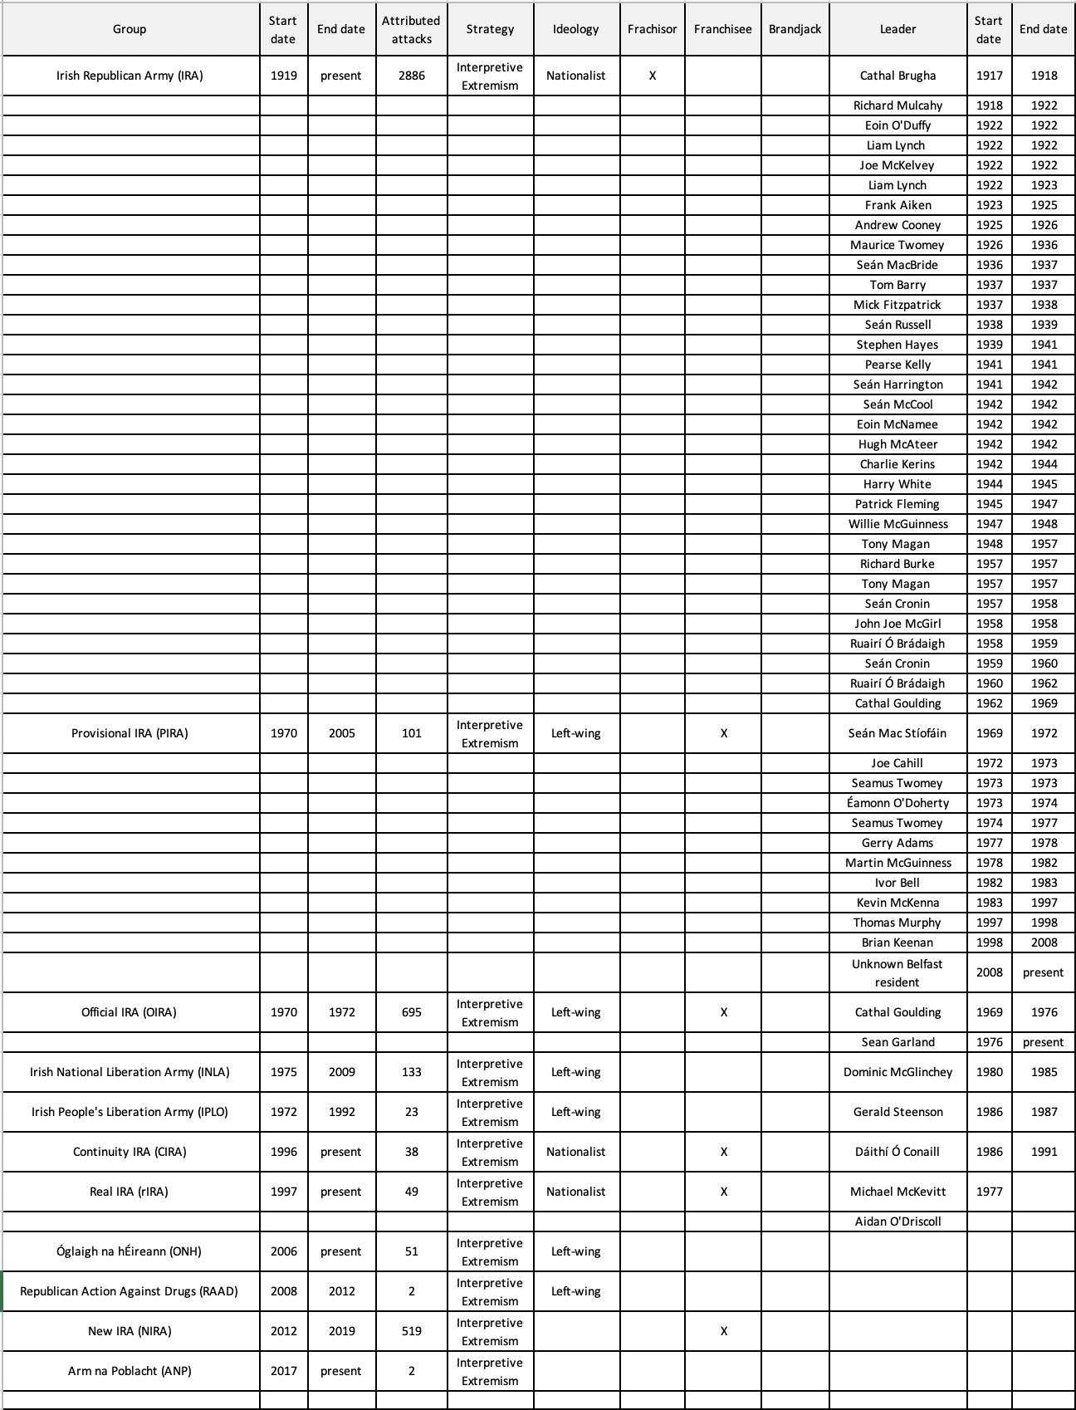
Islamic State
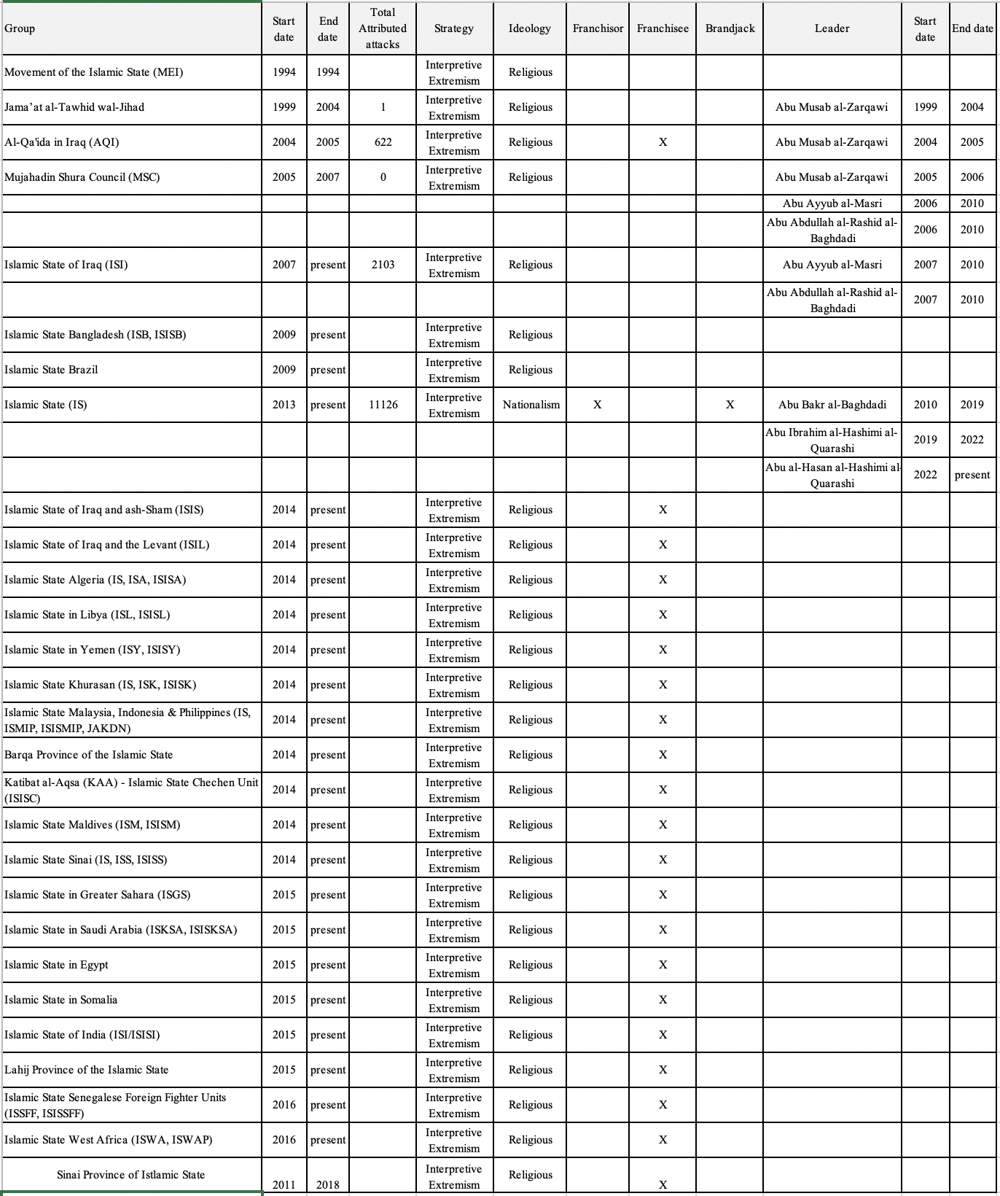

APPENDIX B: OU IRB Application of Study Description
This dissertation proposes to empirically examine the Theory of Brand Reduction (TBR), hereafter referred to as unbranding, and identifies the organization’s brand as its center of gravity (CG). Unbranding is defined as the application of coordinated and synchronized powers to transform a targeted name brand into an undifferentiated, or generic, brand. Generic is defined as reduced differentiation - not standing out from other brands in the same brand category.
The aim of this dissertation is to introduce a new approach to studying extremism - of which terrorism is a subset (with both referenced subsequently as extremism) - in order to disenchant extremism and disenfranchise Violent Extremist Organizations (VEOs).
As part of this dissertation, survey research is used to elucidate the dynamics of stakeholders regarding generic and name brands by examining whether generic brands have a more passive stakeholder community than a name brand. The study posits that a generic brand has stakeholders who have insufficient emotional commitment to the brand that prevents them from increasing personal risk or taking affirmative action in support of the brand. As such, for any organization which requires high levels of commitment from their stakeholders, such as VEOs, a loss of brand value that results in less differentiation between its competitors will directly impact its stakeholders.
A model is specified to explain the relationship between stakeholder personality and generic or name brand selection. Confirmatory Factor Analysis (CFA) is used to explore the relationships between Intensity, Activity, Personality, Dogmatism, and Resonance (and their indicators) and Structural Equation Modelling (SEM) is used to identify the strength of relationship between structural components in the model.
The instrument, a 15-question online survey through SurveyMonkey, explores 250 responses from a population of 2.5M consumers. A comprehensive literature review indicates this is the first survey instrument that simultaneously addresses brand preference and self-reported personality. The survey contains OU IRB-preferred wording and consent form as well as the exit and debrief wording.

APPENDIX C: Online survey instrument
Introduction
My name is David Waterman, a PhD candidate at the University of Oklahoma’s Gaylord College of Journalism and Mass Communication. I invite you to participate in my research project on brands and personalities.
Participation in this research, being conducted at the University of Oklahoma using an online survey via SurveyMonkey.com, is voluntary. You were selected as a possible participant because you are a consumer of various commercial products. You must be at least 18 years of age to participate. Please read this document and contact me at david.waterman@ou.edu if you have any questions before providing your consent to take part in this study.
What is the purpose of this research? The purpose of this research is to better understand the dynamics between brands and personalities.
How many participants will be in this research? 250 people will take part in this research.
What will I be asked to do? If you agree to participate in this research, you will take one online survey approved by the University of Oklahoma Institutional Review Board. There are 13 questions, including several matrix-style questions (these are questions within questions). Please note that questions in the survey require an answer in order to advance.
How long will this take? Your participation will take approximately eight minutes.
What are the risks and/or benefits if I participate? There are no risks from participating in this research. Benefits will be your valuable contribution to research about brands and personalities.
Will I be compensated for participating? SurveyMonkey.com will reimburse you for your time and participation in this research. The investigator will not provide you with any financial compensation.
Who will see my information? No information in research reports will make it possible to identify you. Research records will be stored securely, and only approved researchers and the University of Oklahoma Institutional Review Board will have access to the records. Data are collected via an online platform not hosted by the University of Oklahoma. This platform has its own privacy and security policies for keeping your information confidential.
What will happen to my data in the future? After removing all personal identifiers, we might share survey data with other researchers or use it in future research without obtaining additional consent from you.
Do I have to participate? No. If you do not participate, you are not penalized or lose benefits or services unrelated to the research. If you decide to not participate, you don’t have to answer any questions after question one (the consent question).
Who do I contact with questions, concerns, or complaints? If you have any questions about the study, please contact the Principal Investigator, David Waterman, at david.waterman@ou.edu. For questions about your rights as a participant, please contact the University of Oklahoma Norman Campus Institutional Review Board (OU-NC IRB) at 405-325-8110 or irb@ou.edu.
Please print this document for your records. By providing information to the researcher, I agree to participate in this research. This research has been approved by the University of Oklahoma, Norman Campus IRB. IRB Number: 14789 Approval date: August 16, 2022
Q1. Please indicate your consent to participate in this survey. [select one]
- I consent.
- I do not consent.
Questions
Q2. As noted in the introduction, this survey looks at brands and personalities.
Some branding surveys provide a short list of brands from which to choose a reference brand, but this can be restrictive and such lists may not include a brand of preference to you. Such lists may also imply value judgements of one brand over another, again restricting open and candid responses.
This survey puts you in charge. Take a moment and reflect on a brand that resonates with you. This will be your reference brand for the remainder of this survey. Your responses are anonymous so please be honest and candid as this will contribute to the study's accuracy.
Ready? Let's begin.
Please enter the name of your brand here. [text box]
Q3. Do you consider your selected brand to be a generic/store brand or a name brand? [select one]
- Generic/store brand
- Name brand
Q4. Referencing [Q2], please indicate how strongly you agree or disagree with the following statements. [Five-item Likert]
- If [Q2] were not available, it would make little difference to me if I had to choose another brand. (r) [BRANDPREF][recoded BRANDPREF2]
- When another brand is on sale, I will generally purchase it rather than [Q2]. (r) [BRANDSALE][recoded BRANDSALE2]
- To me, [Q2] is very similar to others in its category. (r) [BRANDSIM][recoded BRANDSIM2]
- I try to use [Q2] because it is the best choice for me. [BRANDBEST]
- My preference to use [Q2] would not willingly change. [RESISTWILL]
- It would be difficult to change my beliefs about [Q2]. [RESISTDIF]
- If close friends recommend another brand, my preference for [Q2] would change. (r) [RESISTCLOSE][recoded RESISTCLOSE2]
- To change my preference from [Q2] would require major rethinking. [RESISTCHANGE]
Q5. Referencing [Q2], please indicate how strongly you agree or disagree with the following statements. [Five-item Likert]
- c [ATTLOVE]
- I would miss [Q2] if it went away. [ATTMISS]
- [Q2] is special to me. [ATTSPEC]
- I identify with people who use [Q2]. [SENSPEOP]
- I feel as if I almost belong to a club with other users of [Q2]. [SENSCLUB]
- [Q2] is a brand used by people like me. [SENSUSE]
- I feel a deep connection with others who use [Q2]. [SENSCON]
Q6. Referencing [Q2], please indicate your agreement or disagreement with the following statements. [Five-item Likert]
- I consider myself loyal to [Q2]. [BELOYAL]
- I buy [Q2] whenever I can. [BEBUY]
- If [Q2] were not available, it would be personally distressing. [BEDIST]
- I like to talk about [Q2] with others. [ACTTALK]
- I am interested in learning more about t[Q2]. [ACTLEARN]
- I follow news about [Q2] closely. [ACTNEWS]
- I like to post comments about [Q2] on social media. [ACTSOCIAL]
Q7. How much of a premium would you pay to get [Q2]? [WTPPREM] Sliding scale [0%-100%][WTPPAY2][recoded to scale of 1-5]

Q8. How likely are you to reallocate your budget or go into debt to get [Q2]? [WTPRISK] [Five-item Likert]
Q9. Please indicate how strongly you agree or disagree with the following statements. [Five-item Likert]
- The brand’s leadership are a significant part of my decision-making process to buy [Q2]. [LEADER]
- The brand’s values are a significant part of my decision-making process to buy [Q2]. [IDEAL]
- The brand’s actions are a significant part of my decision-making process to buy [Q2]. [ACTION]
Q10. I see myself as someone who… [Five-item Likert
- Is reserved. (r) [EXTRES] [recoded EXTRES2]
- Is trusting. [AGRETRUST]
- Tends to be lazy. (r) [CONLAZY] [recoded CONLAZY2]
- Handles stress well. (r) [NEUSTRES] [recoded NEUSTRES2]
- Has few artistic interests. (r) [OPENART] [recoded OPENART2]
- Is outgoing. [EXOUT]
- Tends to find fault in others. (r) [AGREFAULT] [recoded AGREFAULT2]
- Does a thorough job. [CONJOB]
- Gets nervous easily. [NEUNERV]
- Has an active imagination. [OPENACTIVE]
Q11. In general, I find that… [Five-item Likert]

- There is a clear line between what is right and what is wrong. [DOGRIGHT]
- People who disagree with me are usually wrong. [DOGAGREE]
- I’m the type of person who questions authority. (r) [DOGAUTH] [recoded DOGAUTH2]
- I am confident in the correctness of my beliefs. [DOGCORR]
- People should respect authority. [DOGRESPC]
- I am a person who is strongly committed to my beliefs. [DOGBELEF]
- People who are very different from us can be dangerous. [DOGDANG]
- I consider myself to be open-minded. (r) [DOGOPEN] [recoded DOGOPEN2]
Q12. What is your race or ethnicity? [RACE] {SurveyMonkey preset}
- Asian
- Black or African American
- Hispanic or Latino
- Middle Eastern or North African
- Multiracial or Multiethnic
- Native American or Alaska Native
- Native Hawaiian or other Pacific Islander
- White
- Another race or ethnicity, please describe below [text]
Q13. What is the highest level of education you have completed? [EDUCATE] {SurveyMonkey preset}
- Did not attend school
- 1st grade
- 2nd grade
- 3rd grade
- 4th grade
- 5th grade
- 6th grade
- 7th grade
- 8th grade
- 9th grade
- 10th grade
- 11th grade
- Graduated from high school
- 1 year of college
- 2 years of college
- 3 years of college
- Graduated from college
- Some graduate school
- Completed graduate school
Debriefing
Thank you for participating in this research on brands and personality. Please keep a copy of this debriefing form for future reference and contact me at david.waterman@ou.edu if you have any questions or concerns about this study.

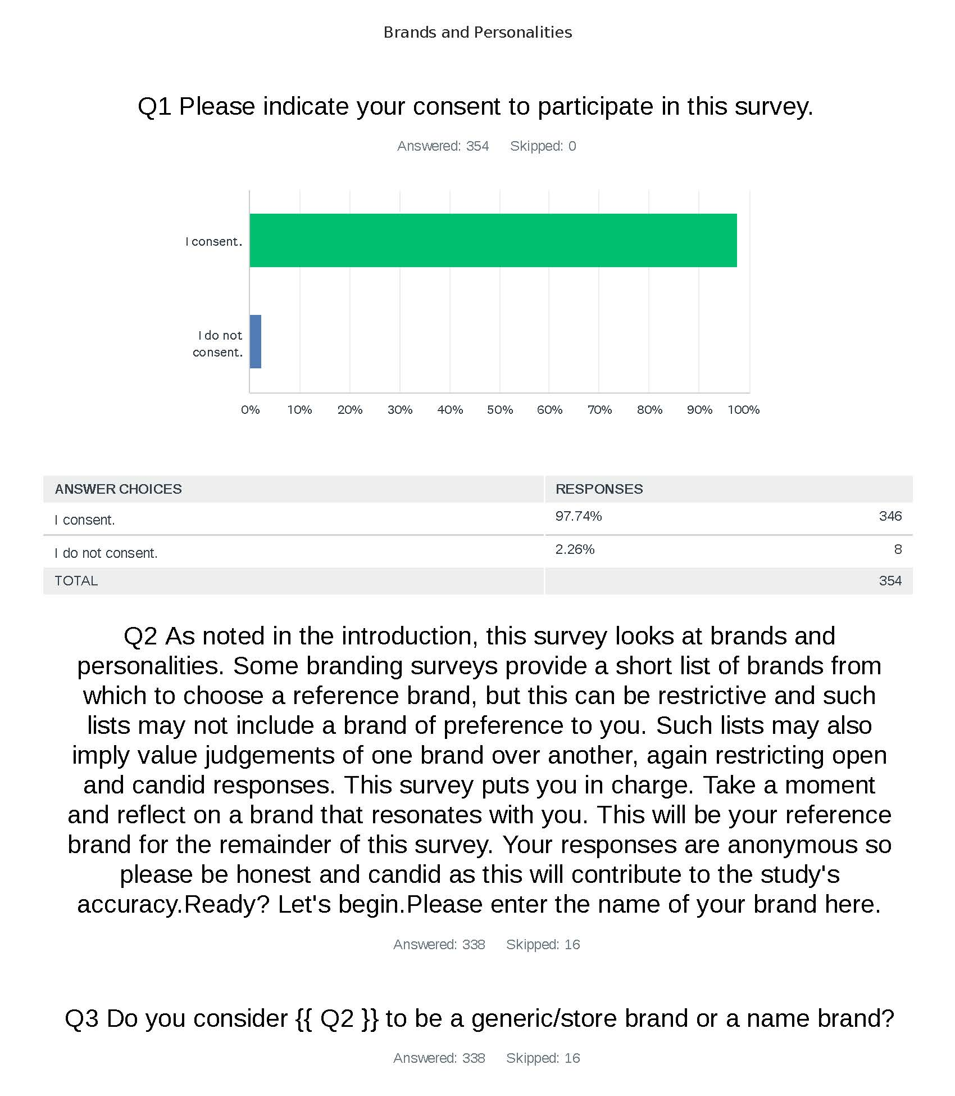
APPENDIX D: SurveyMonkey data.
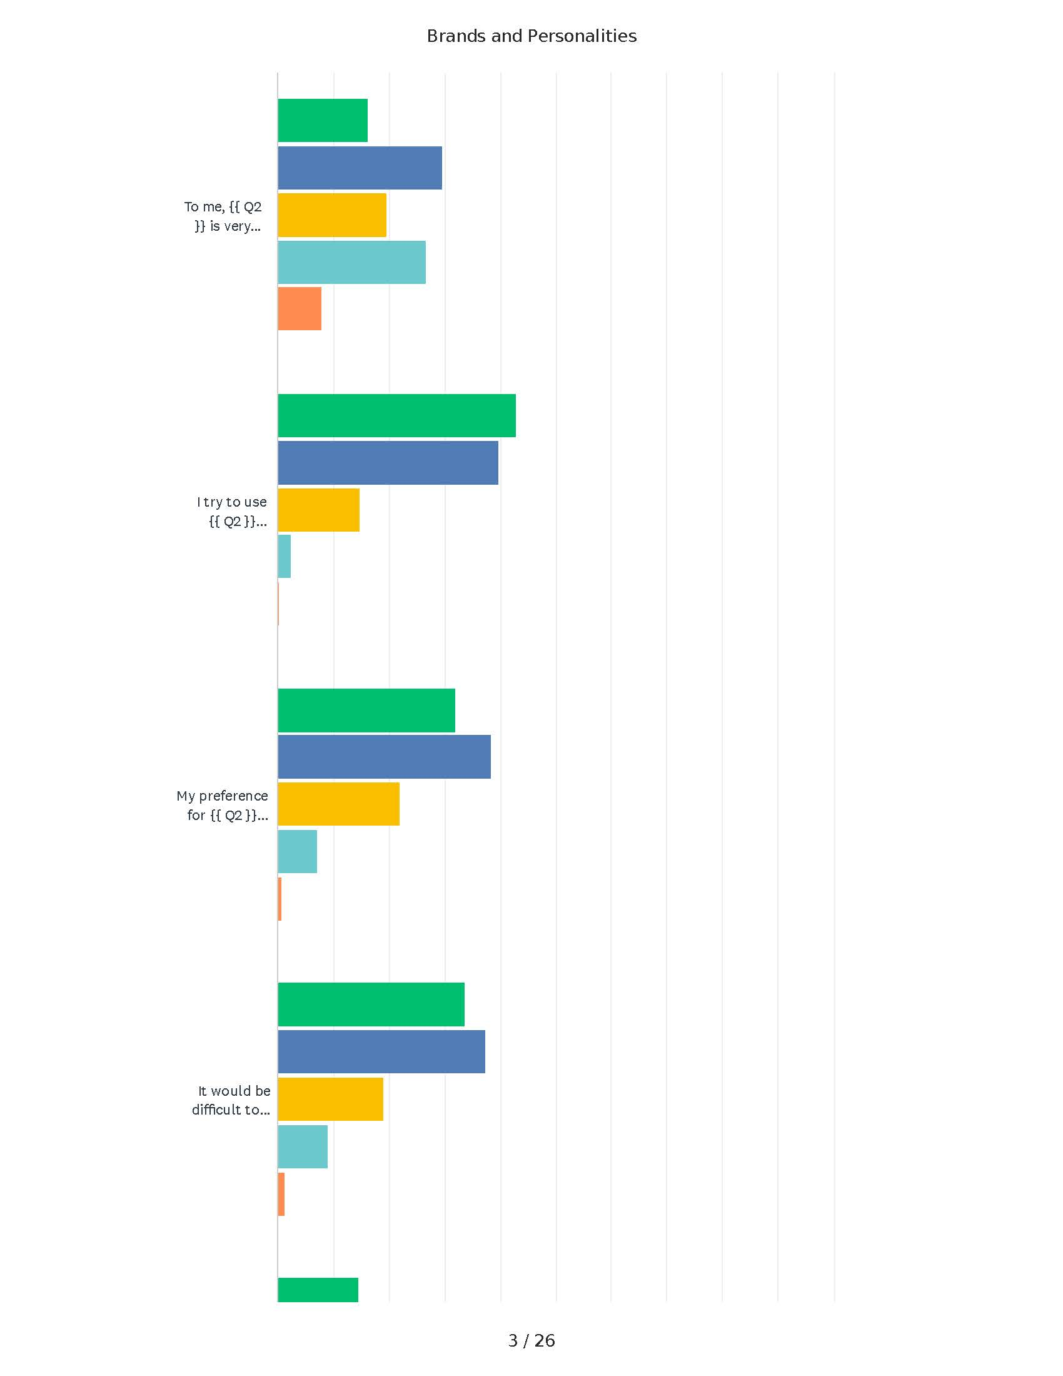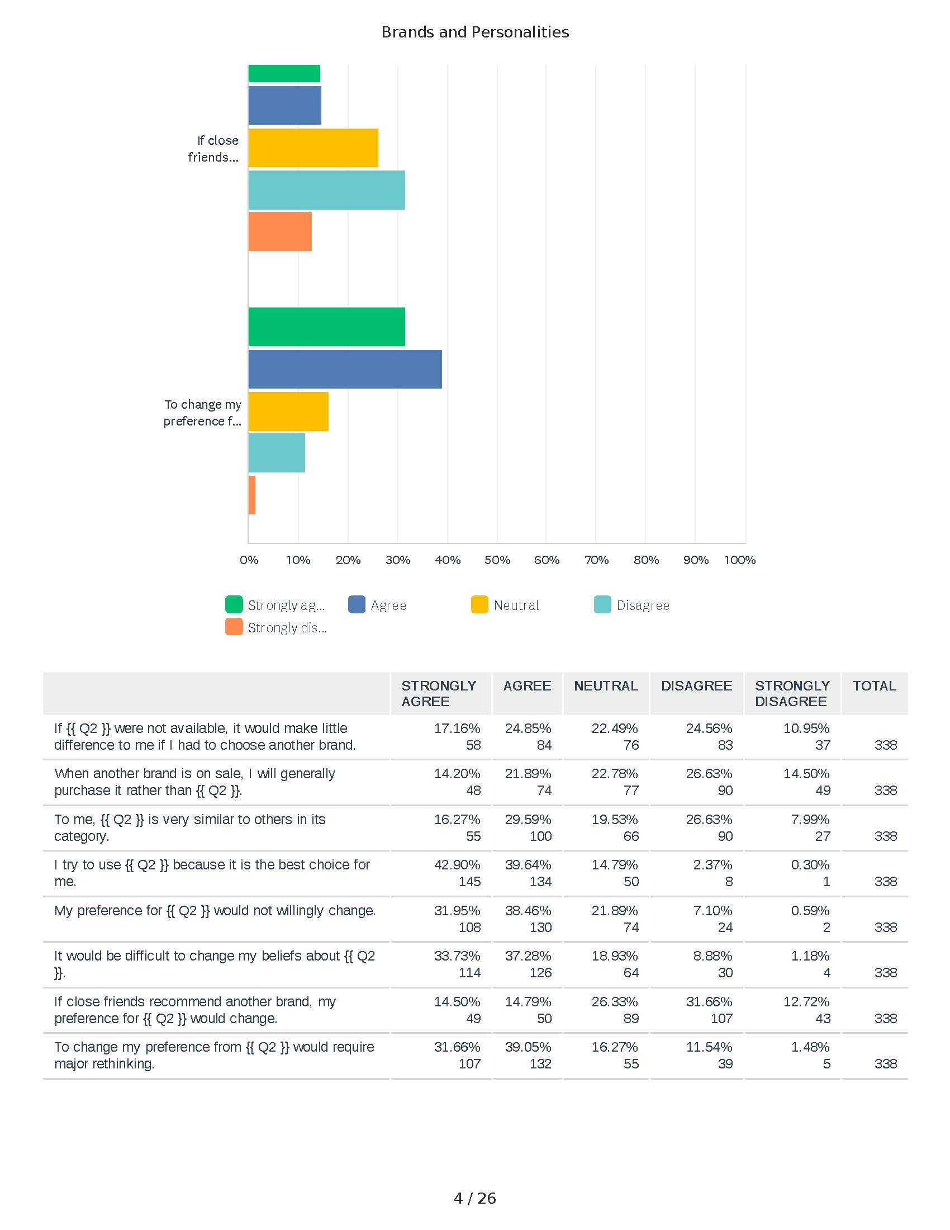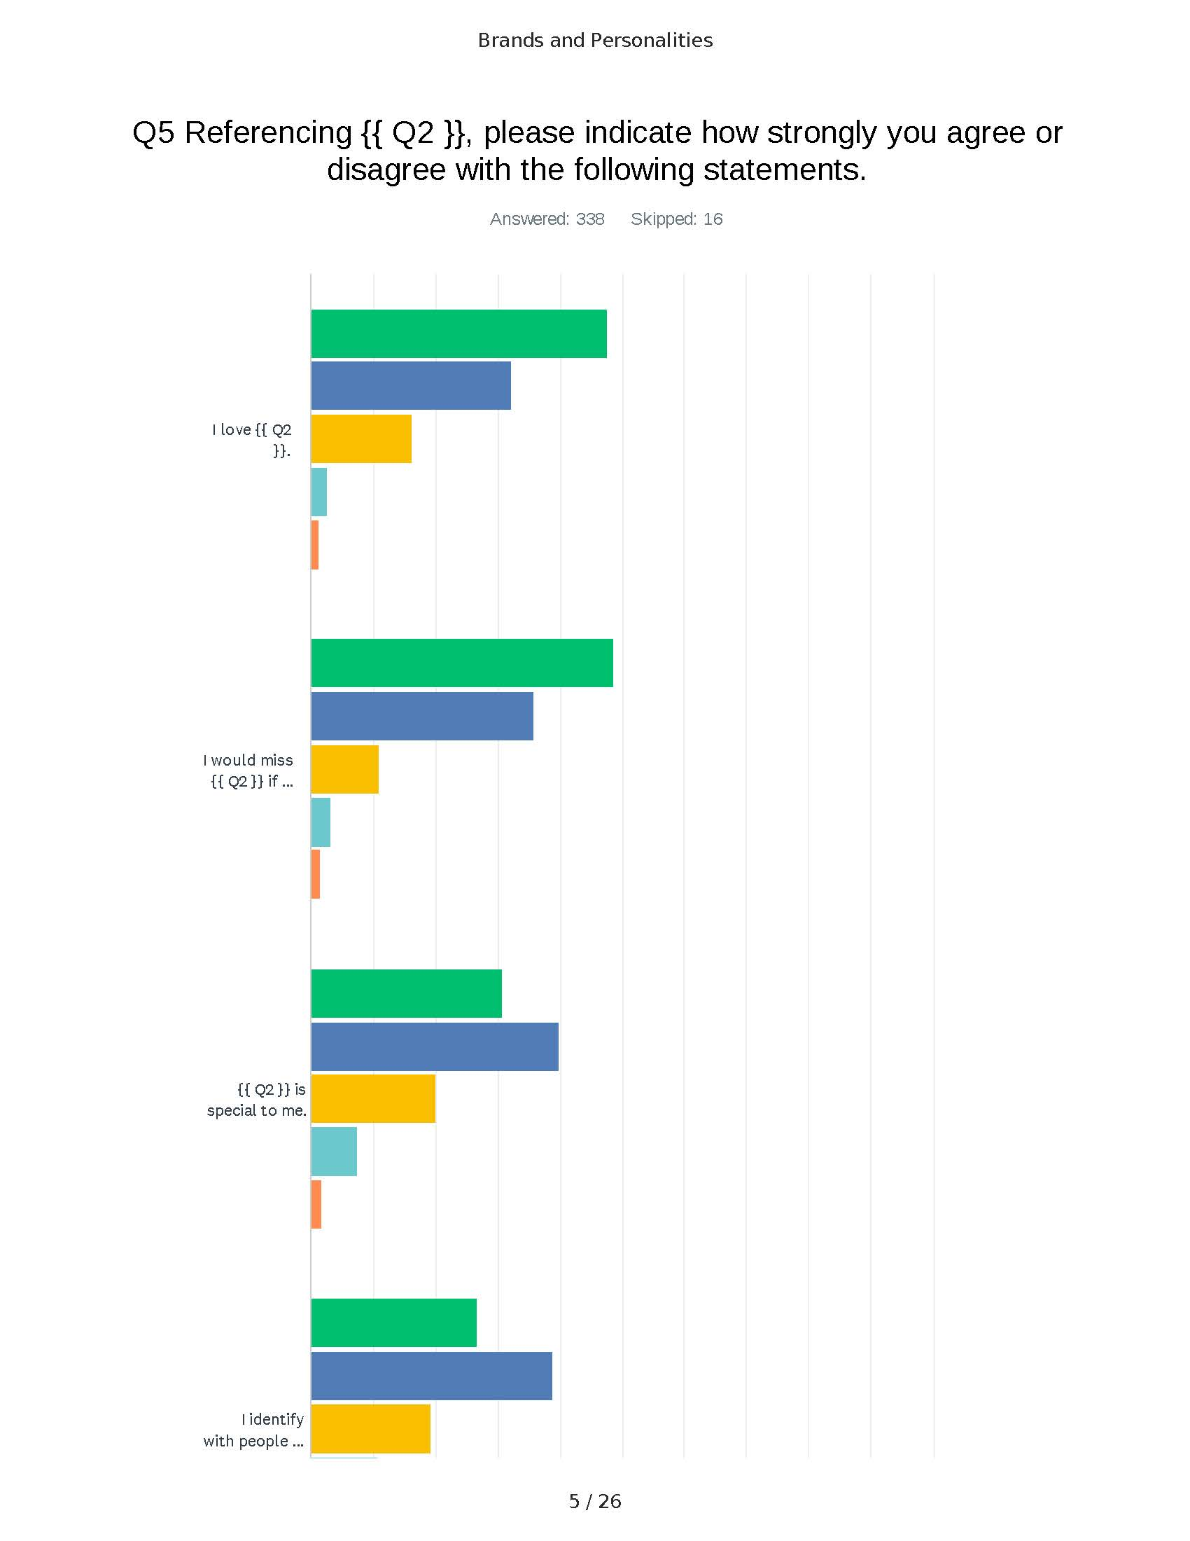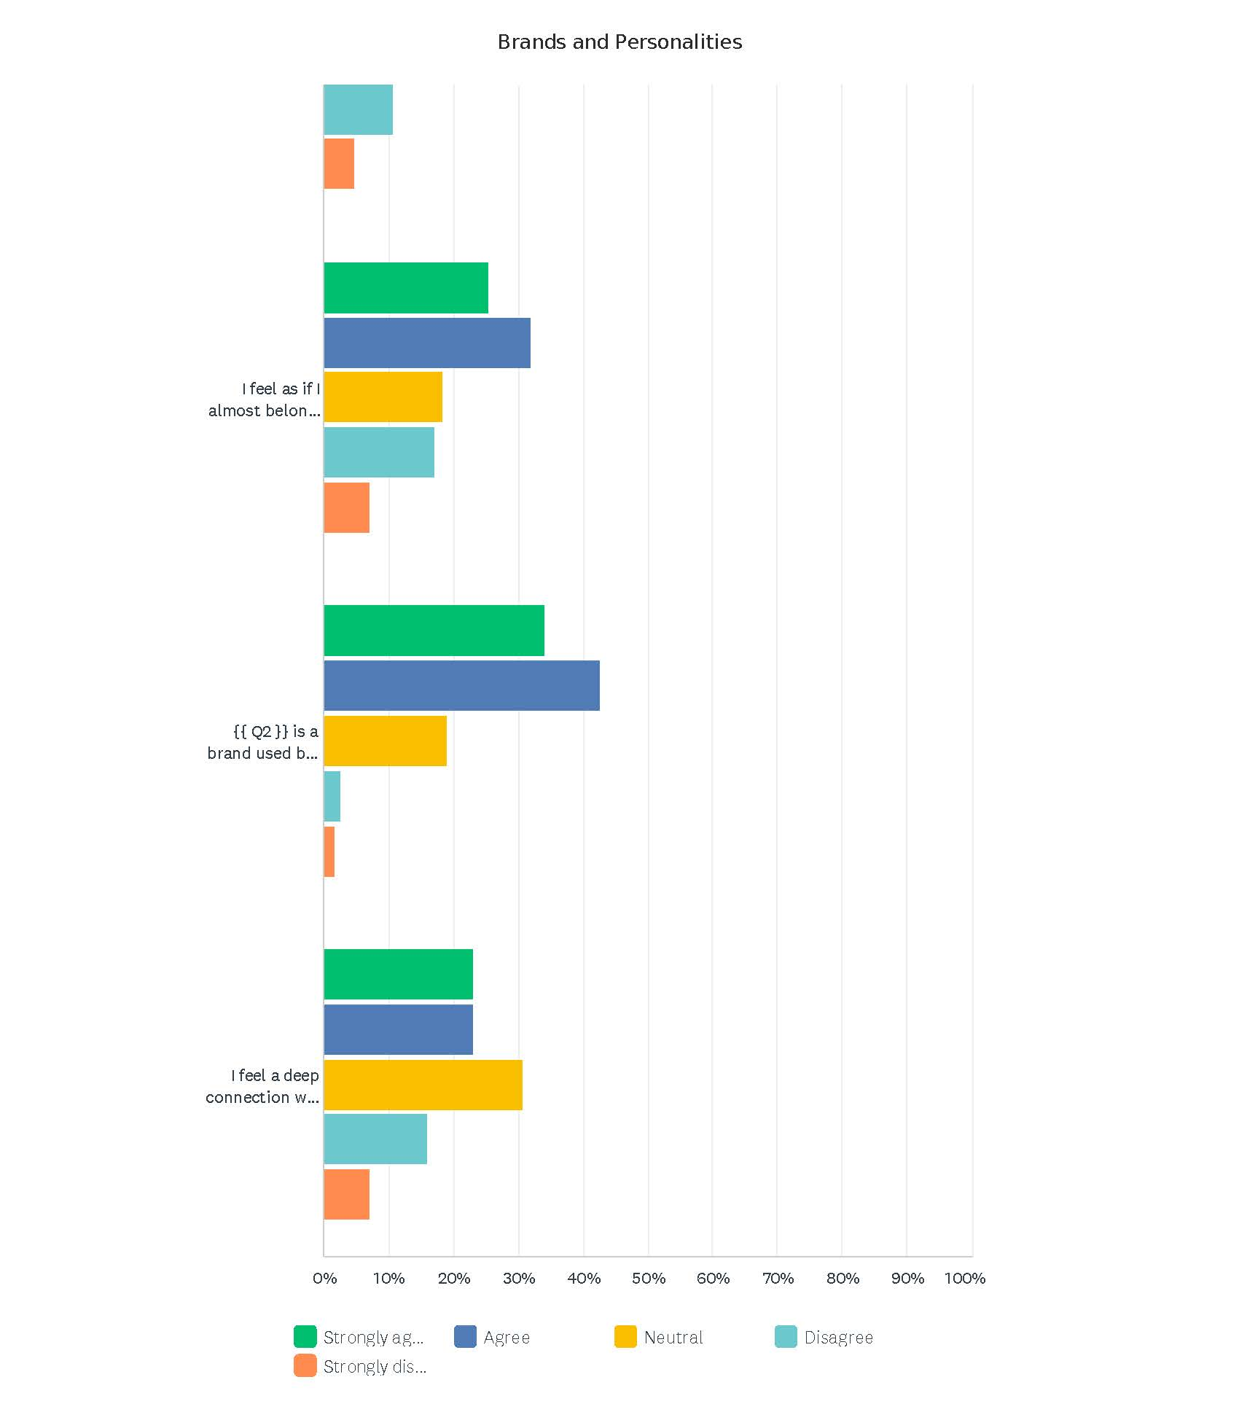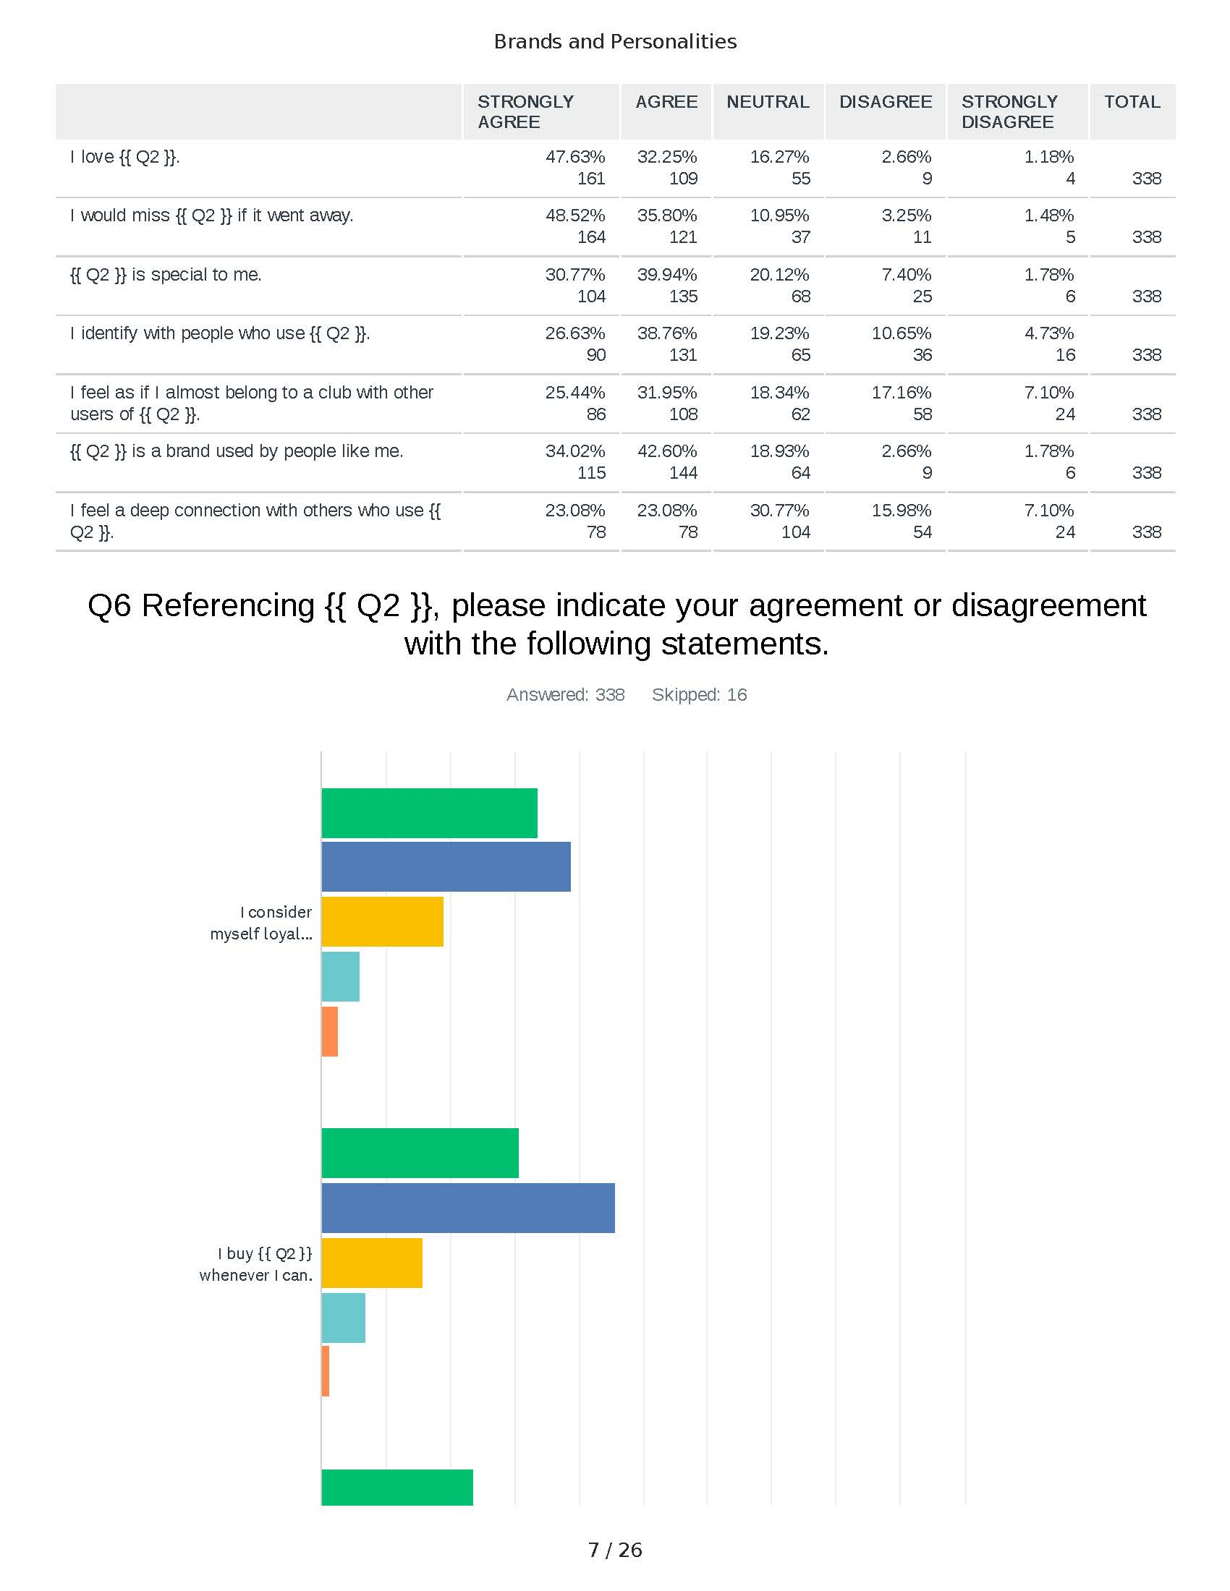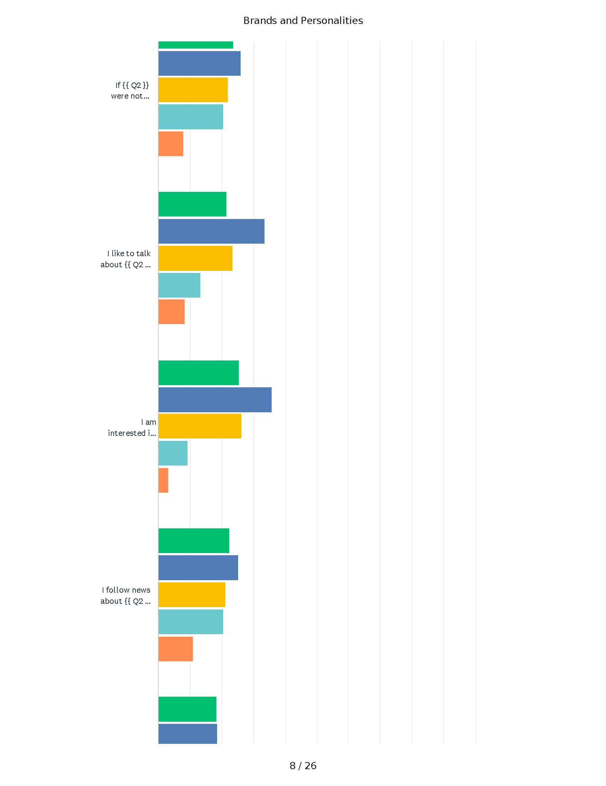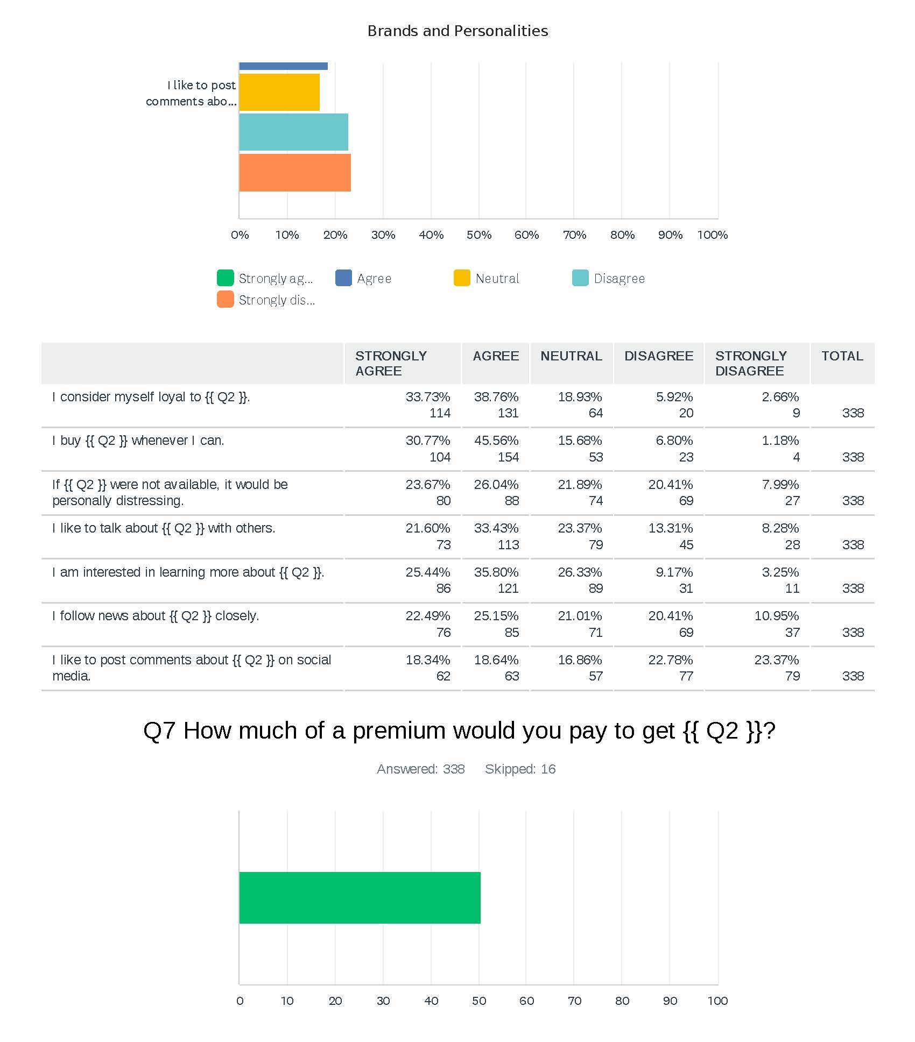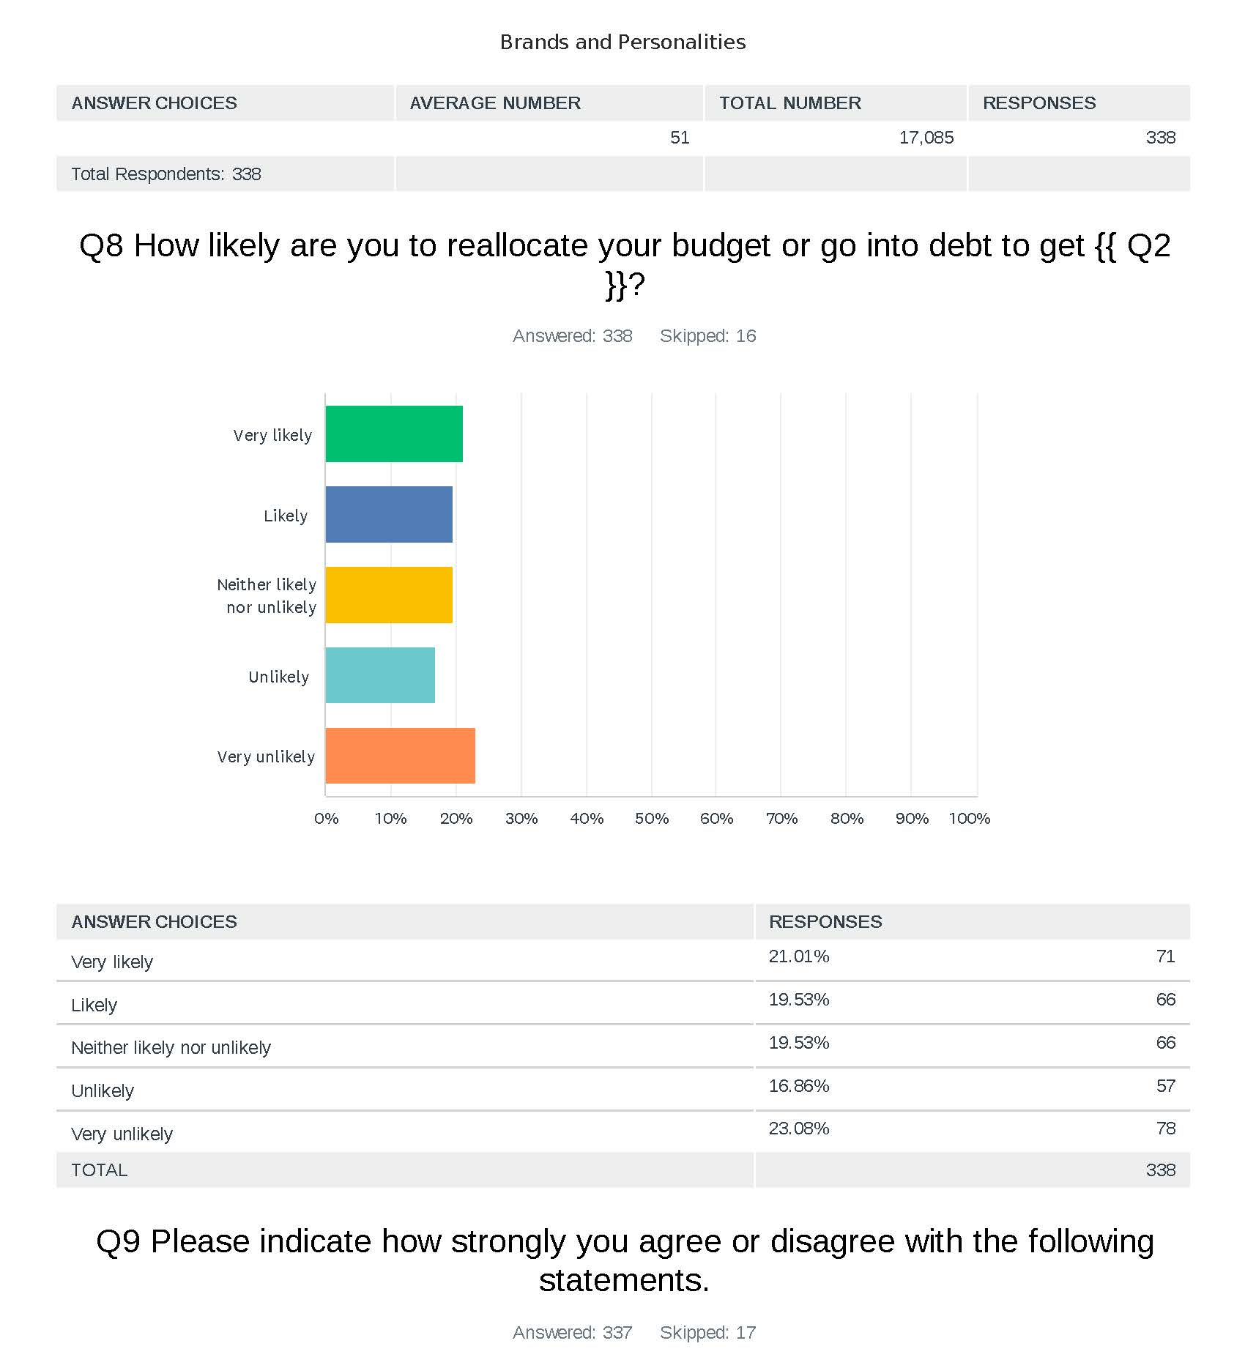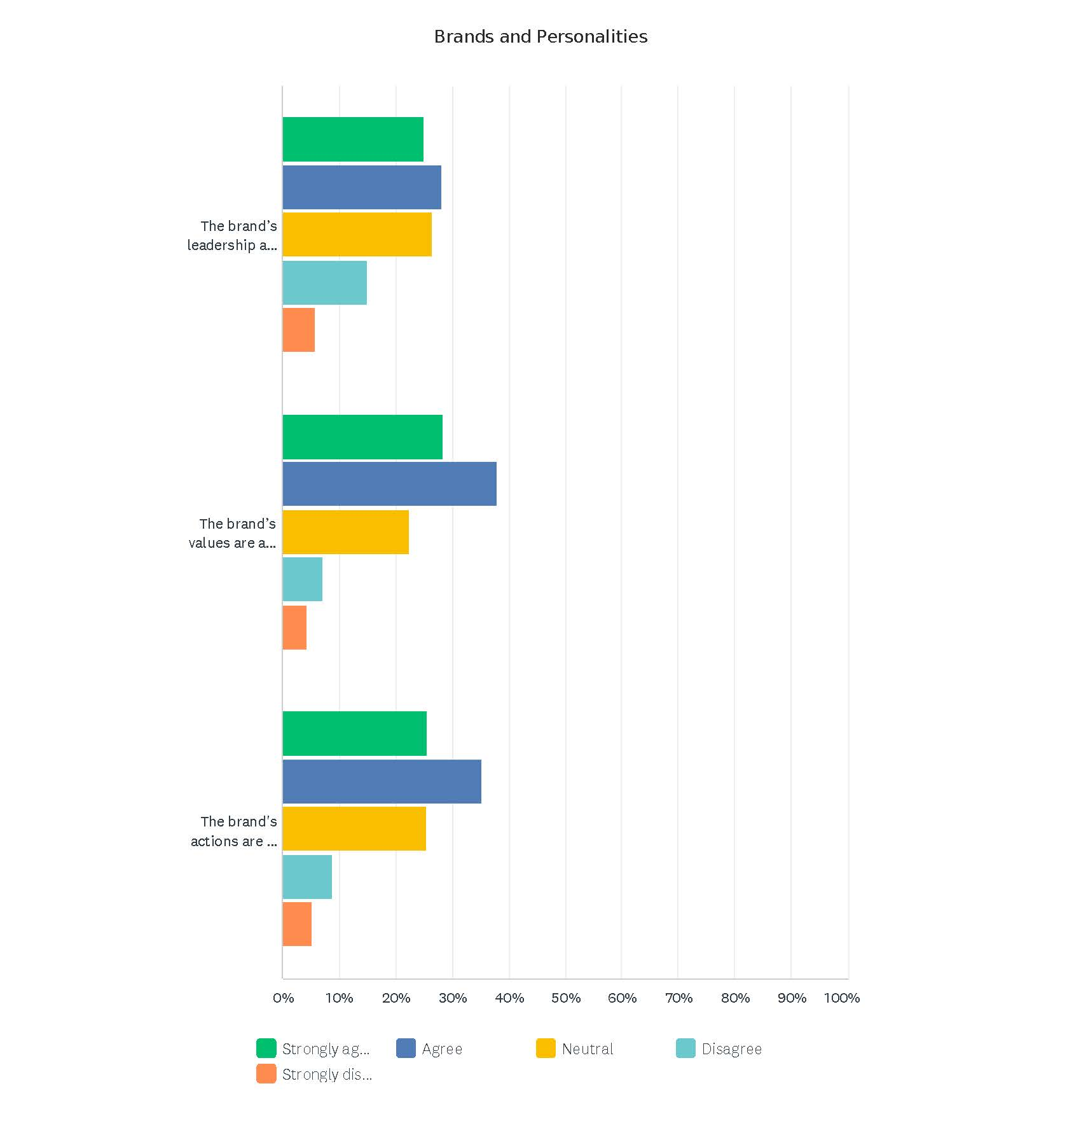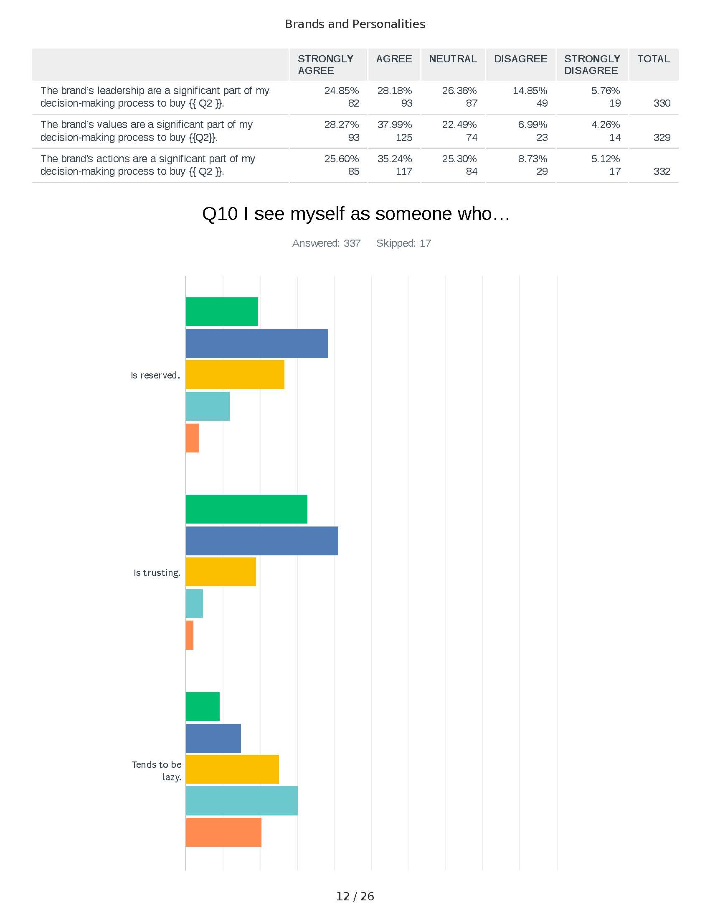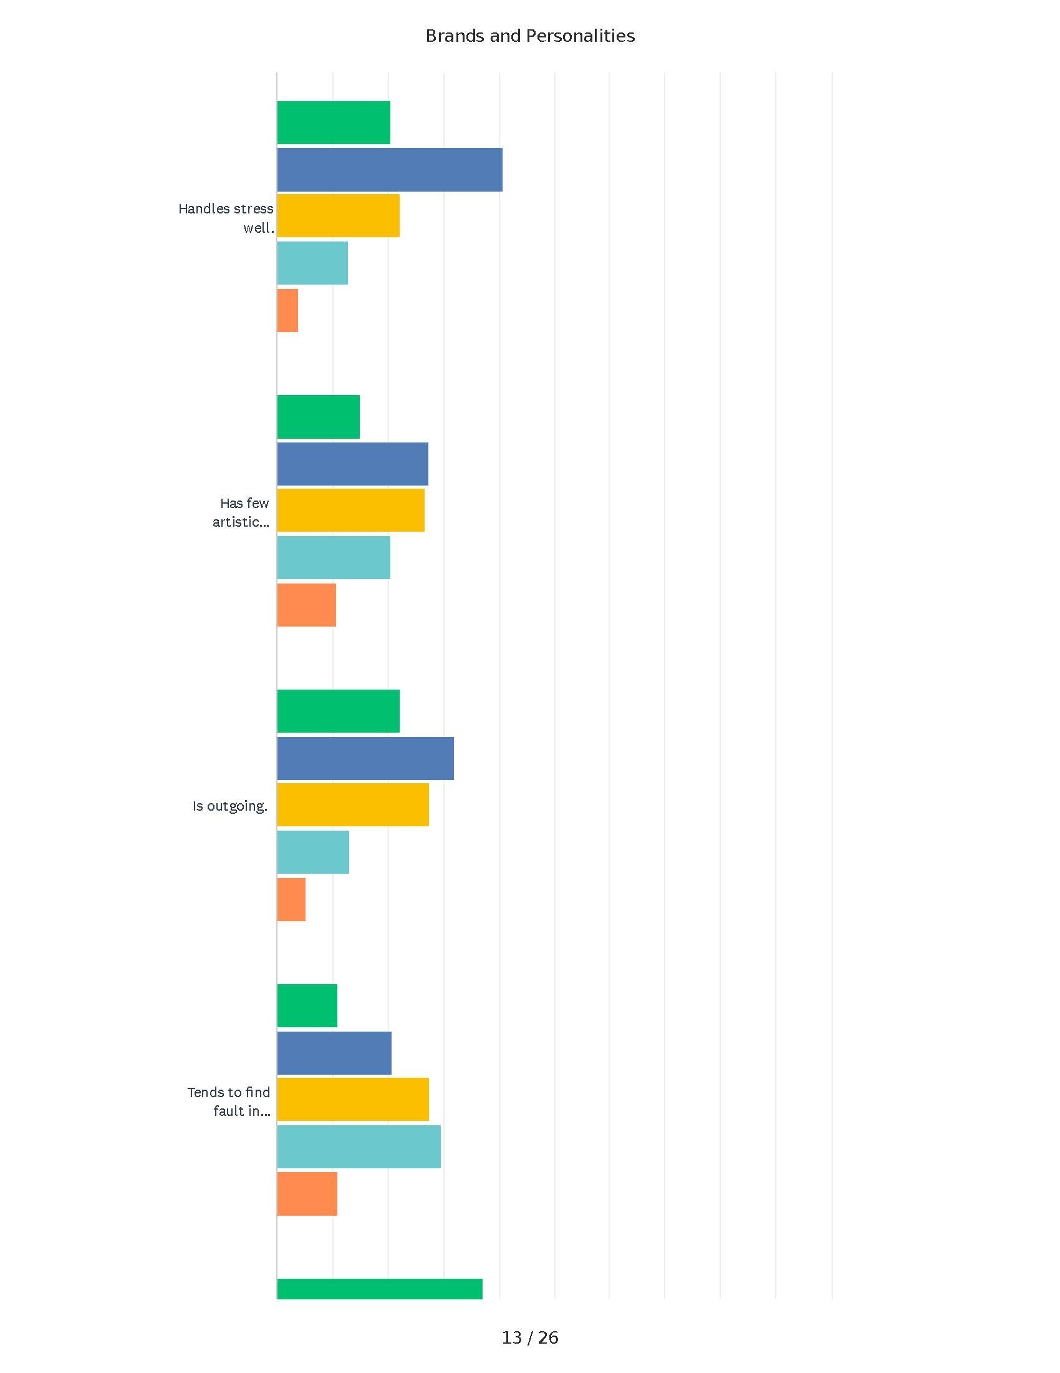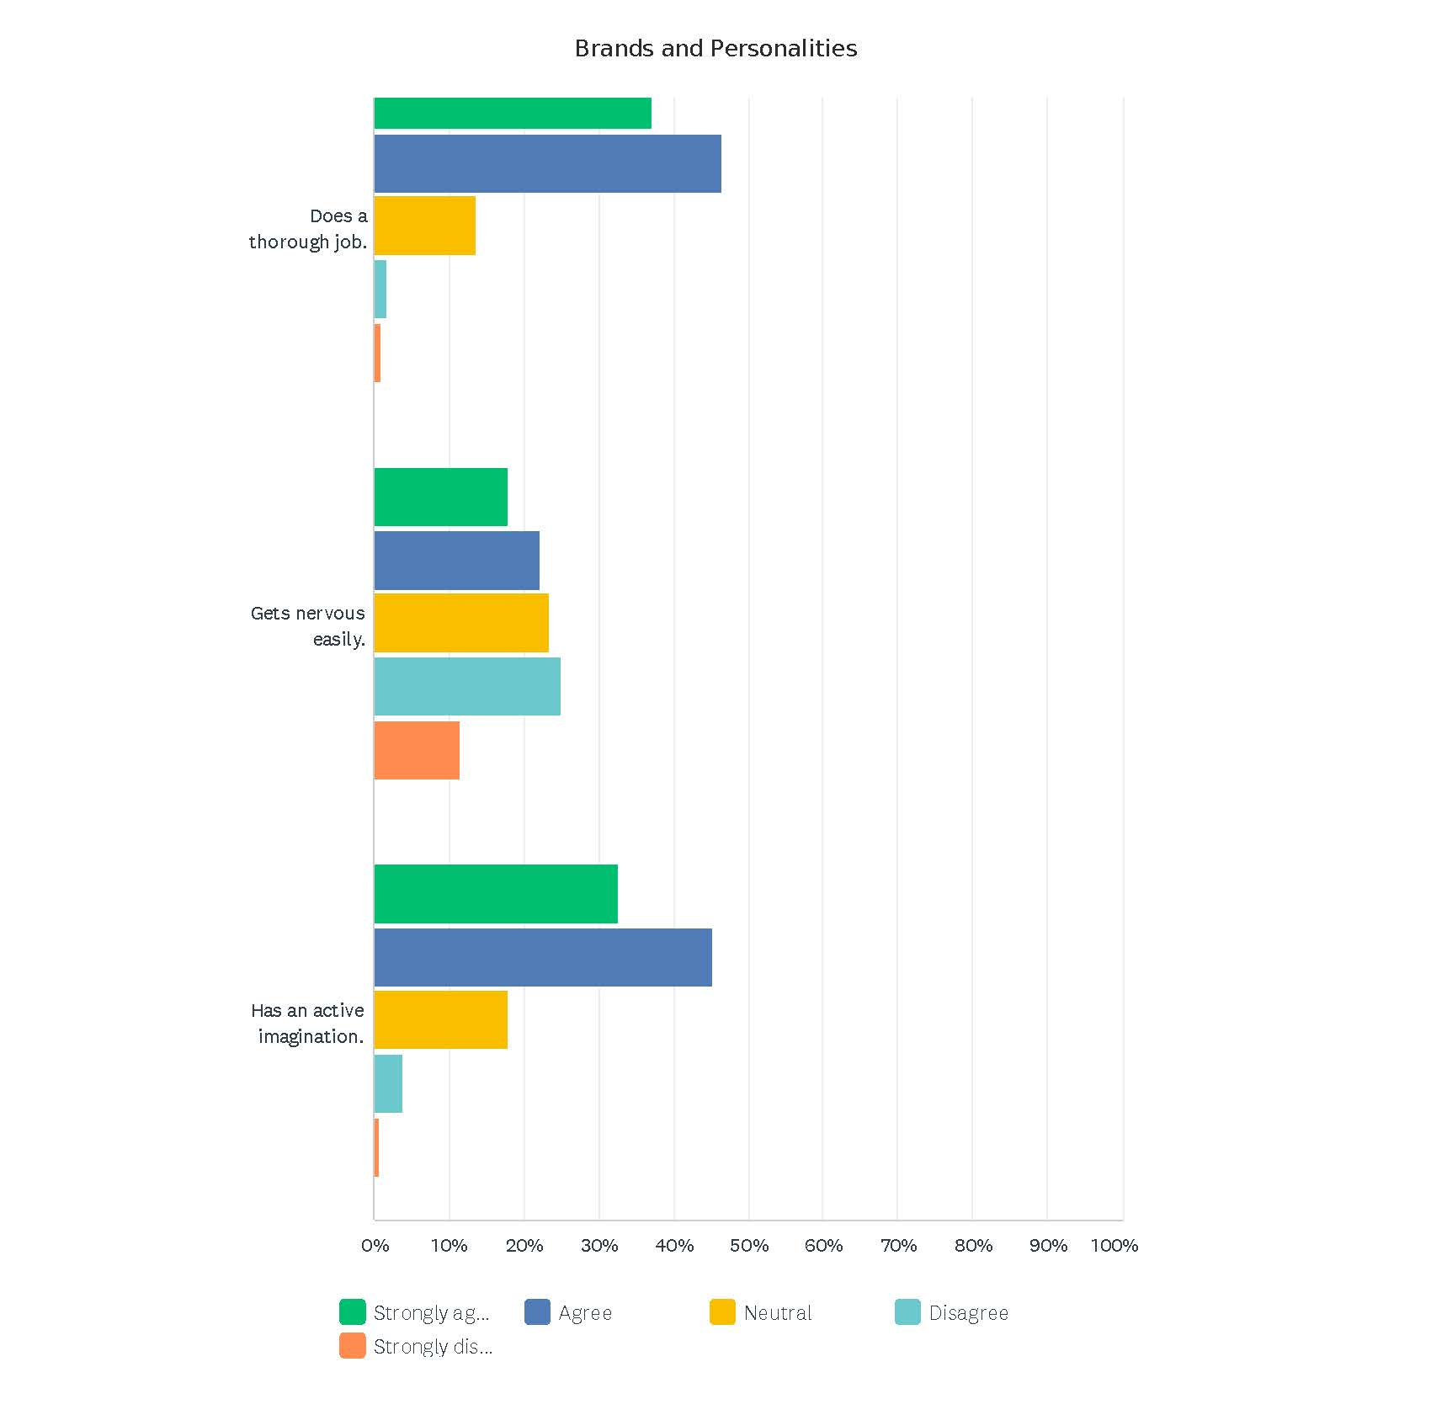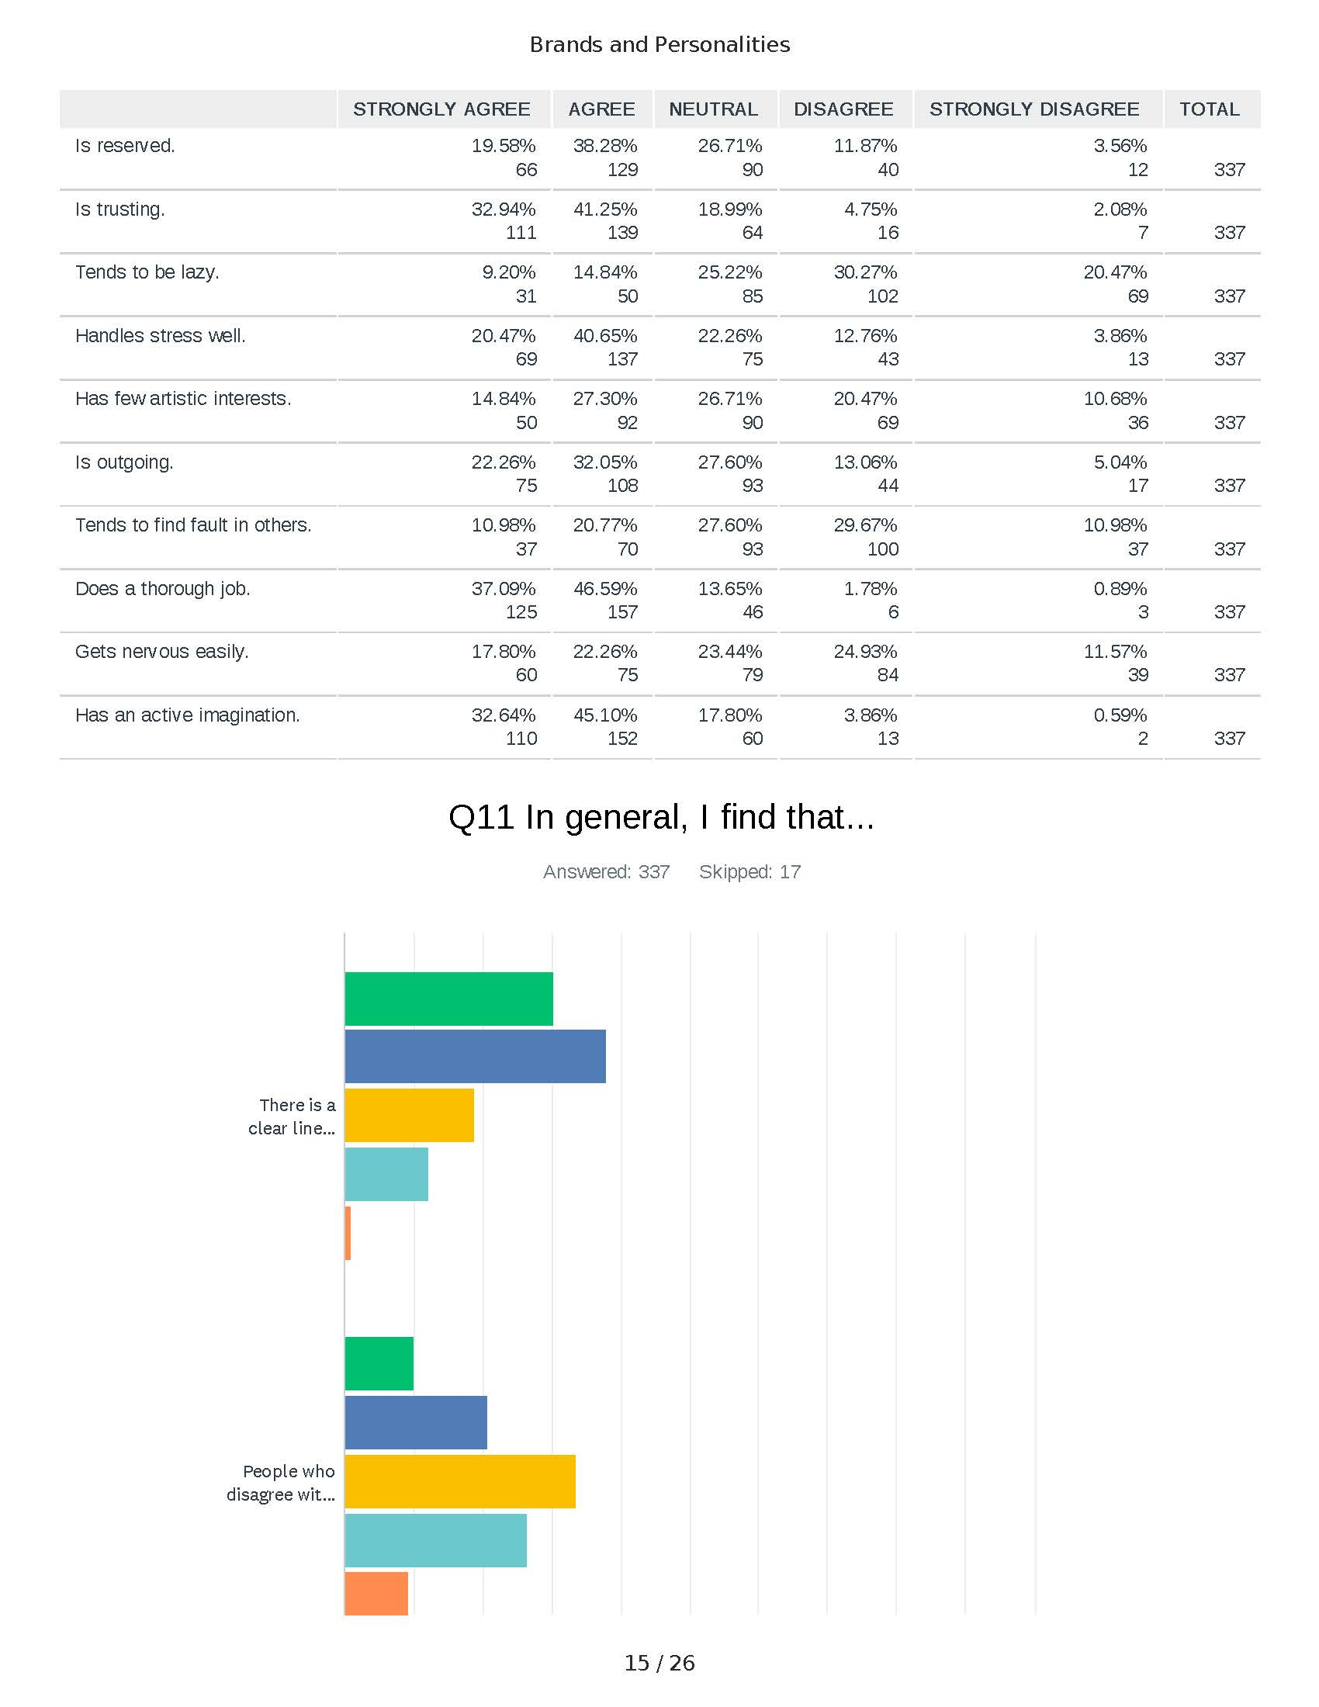
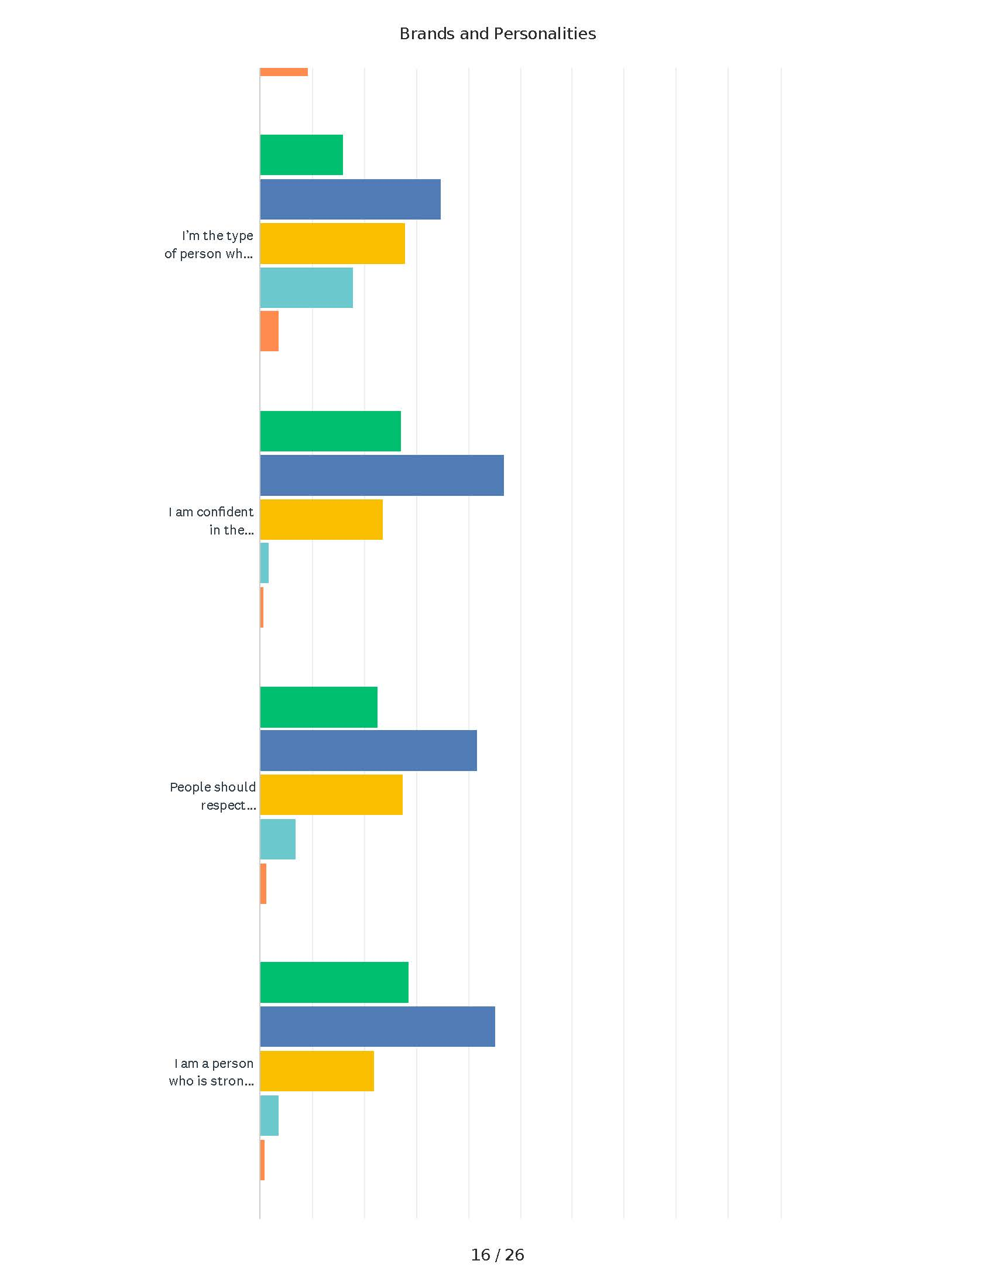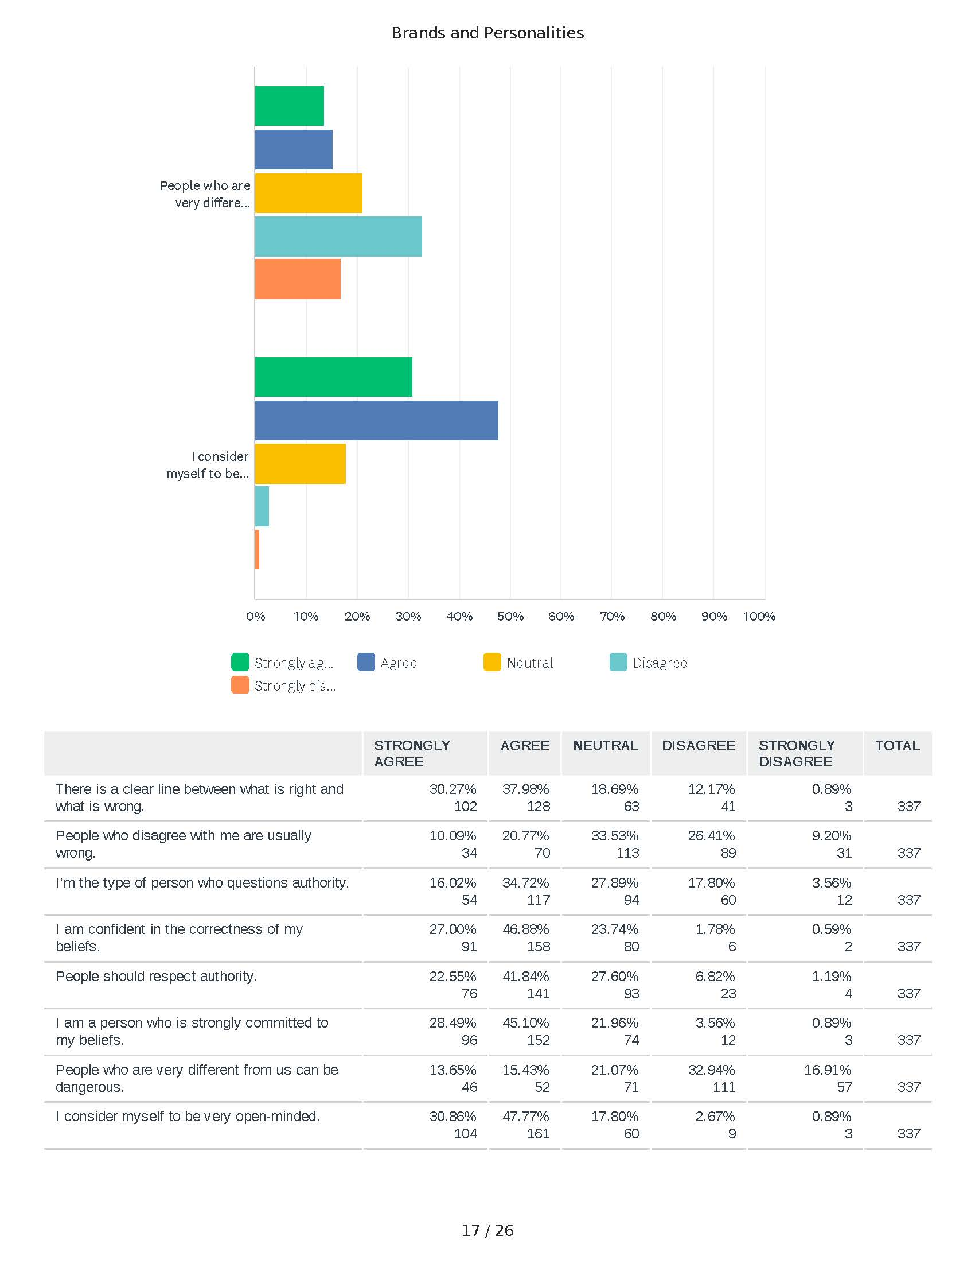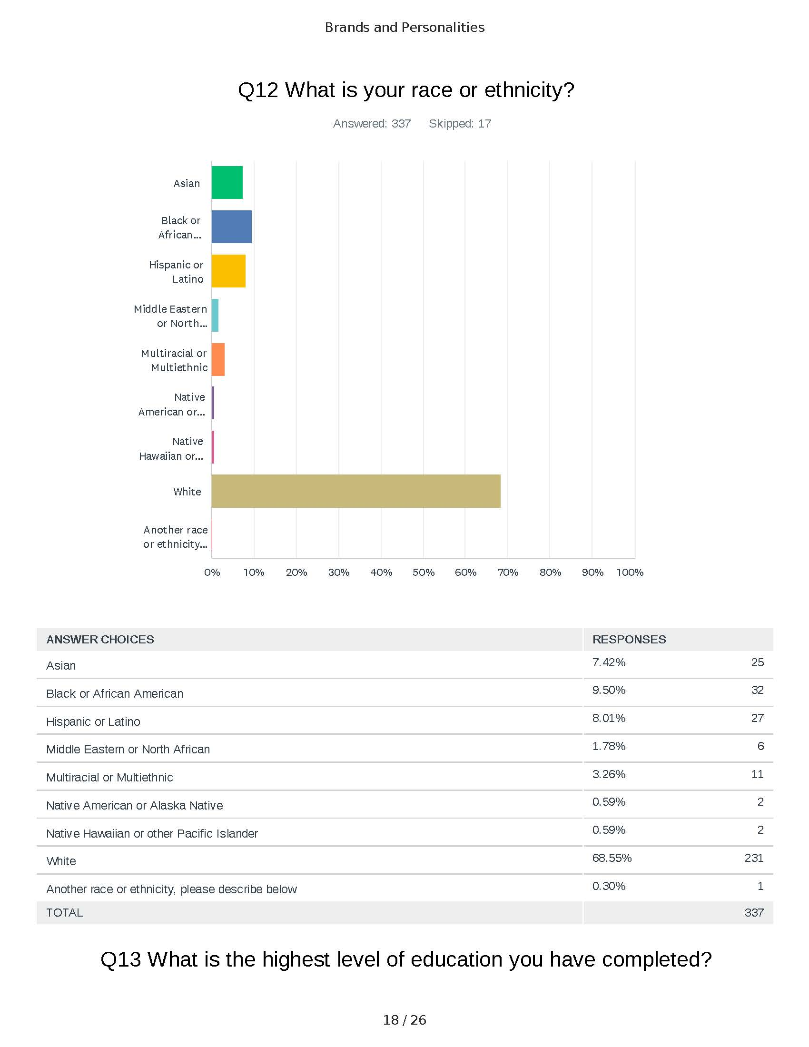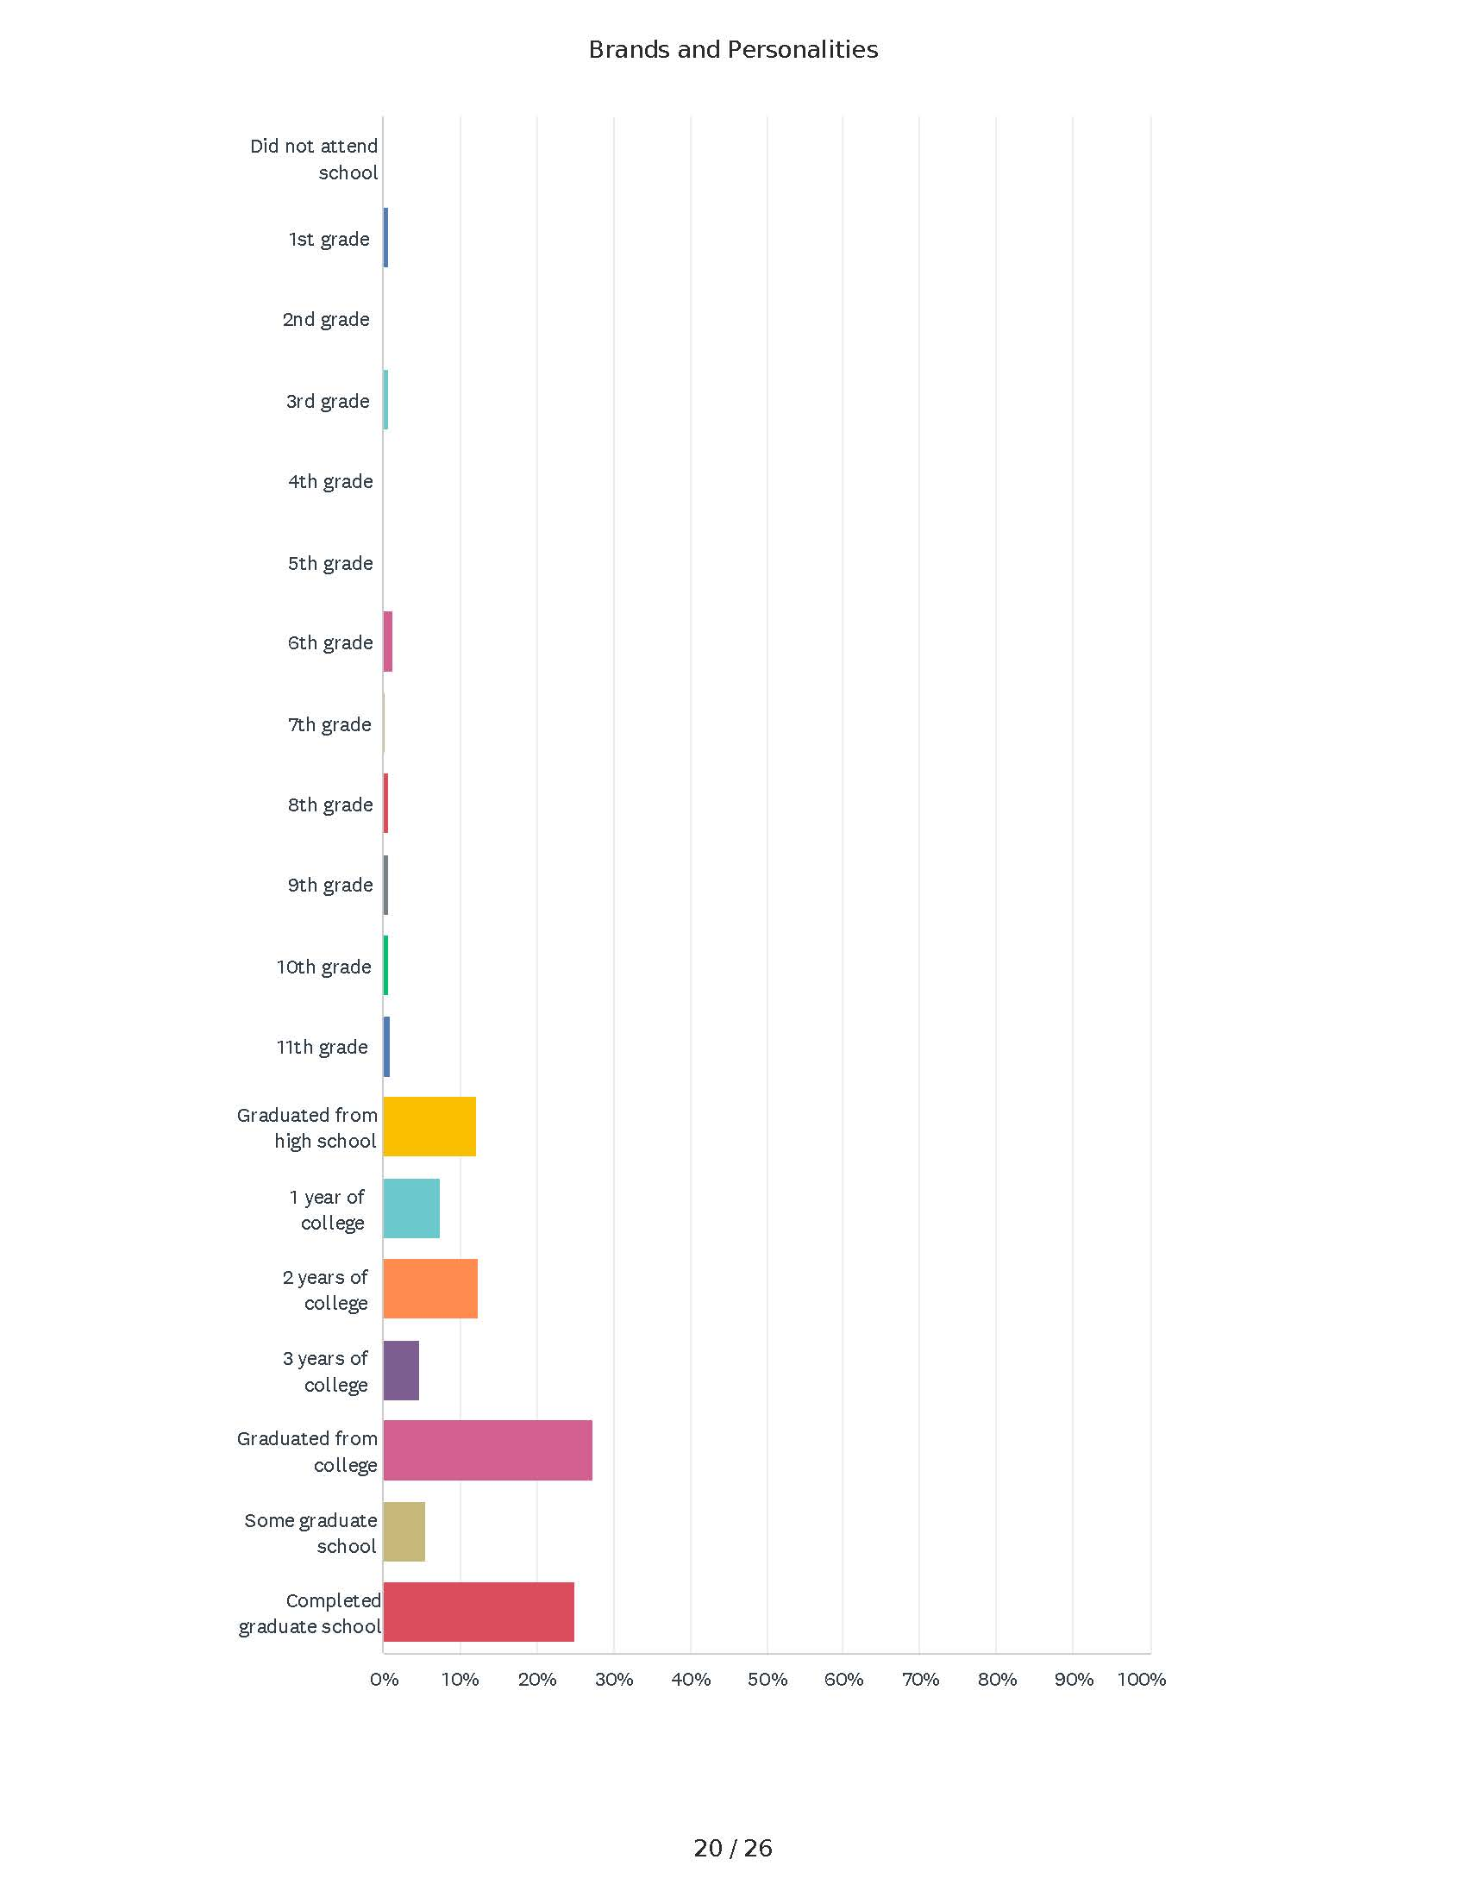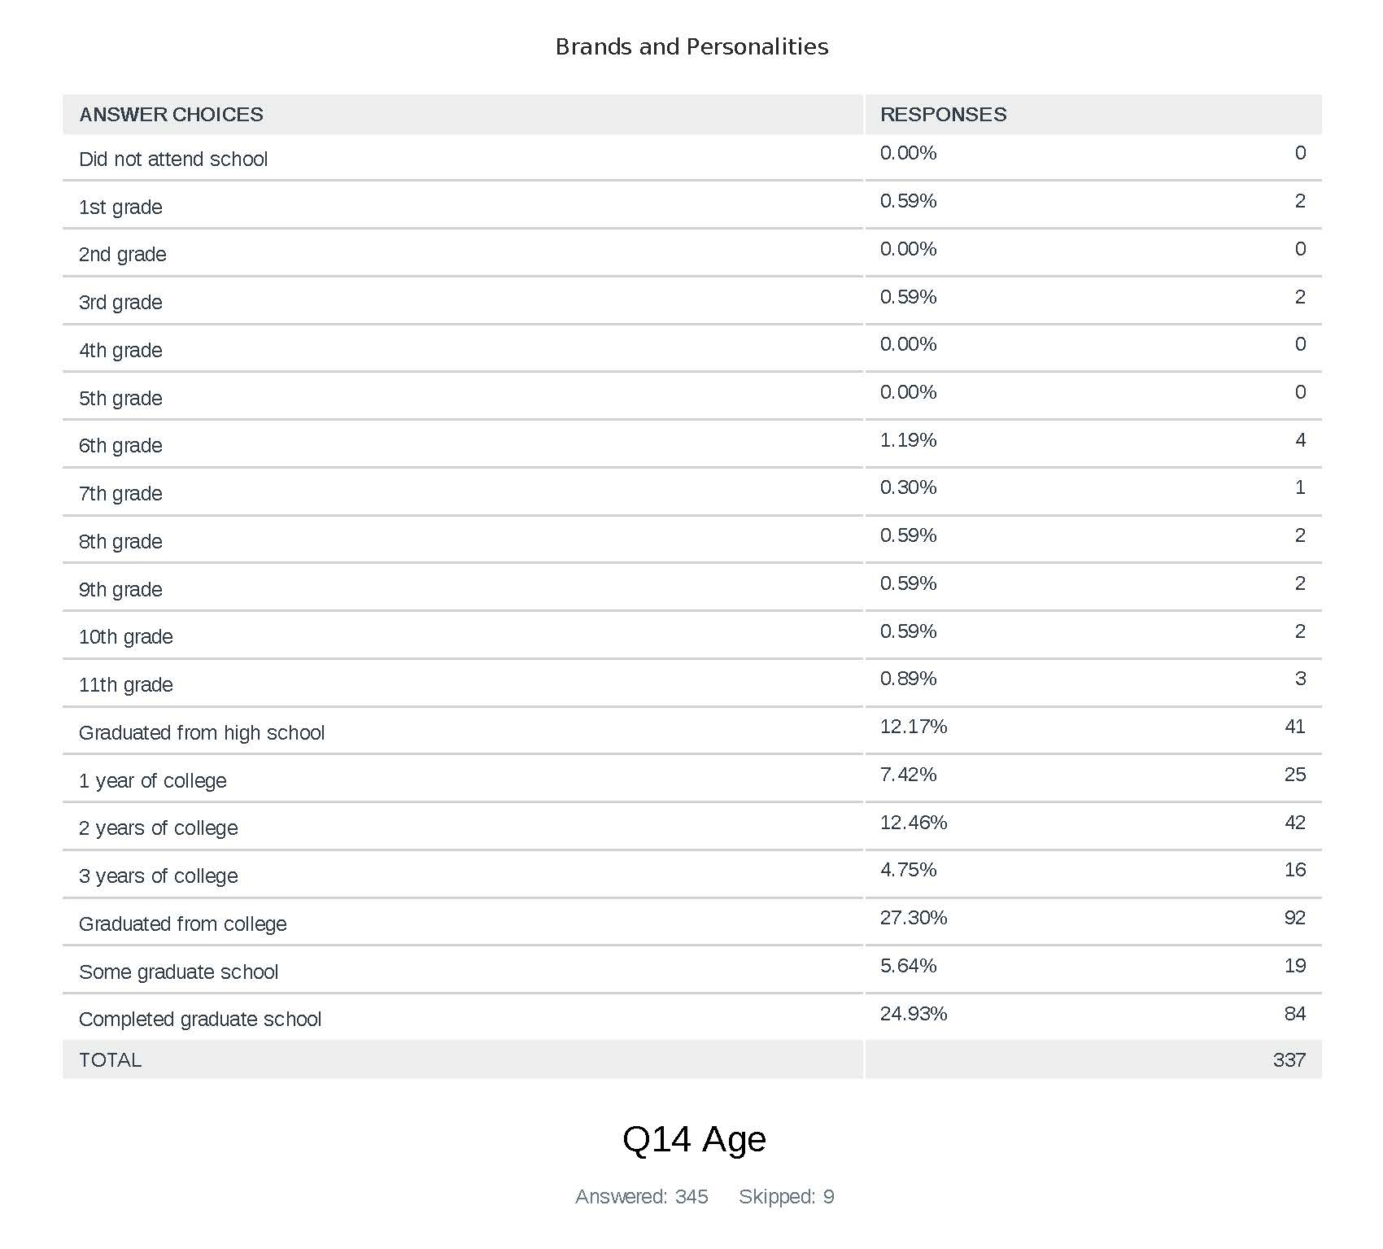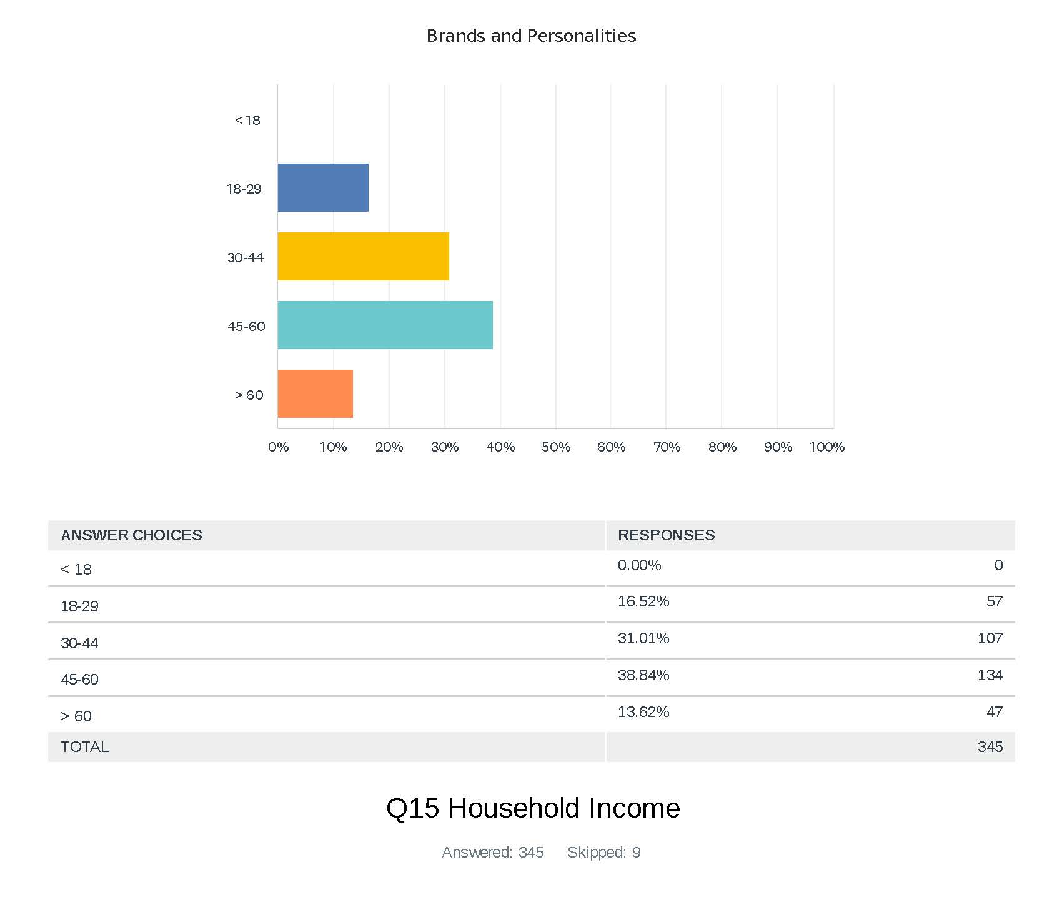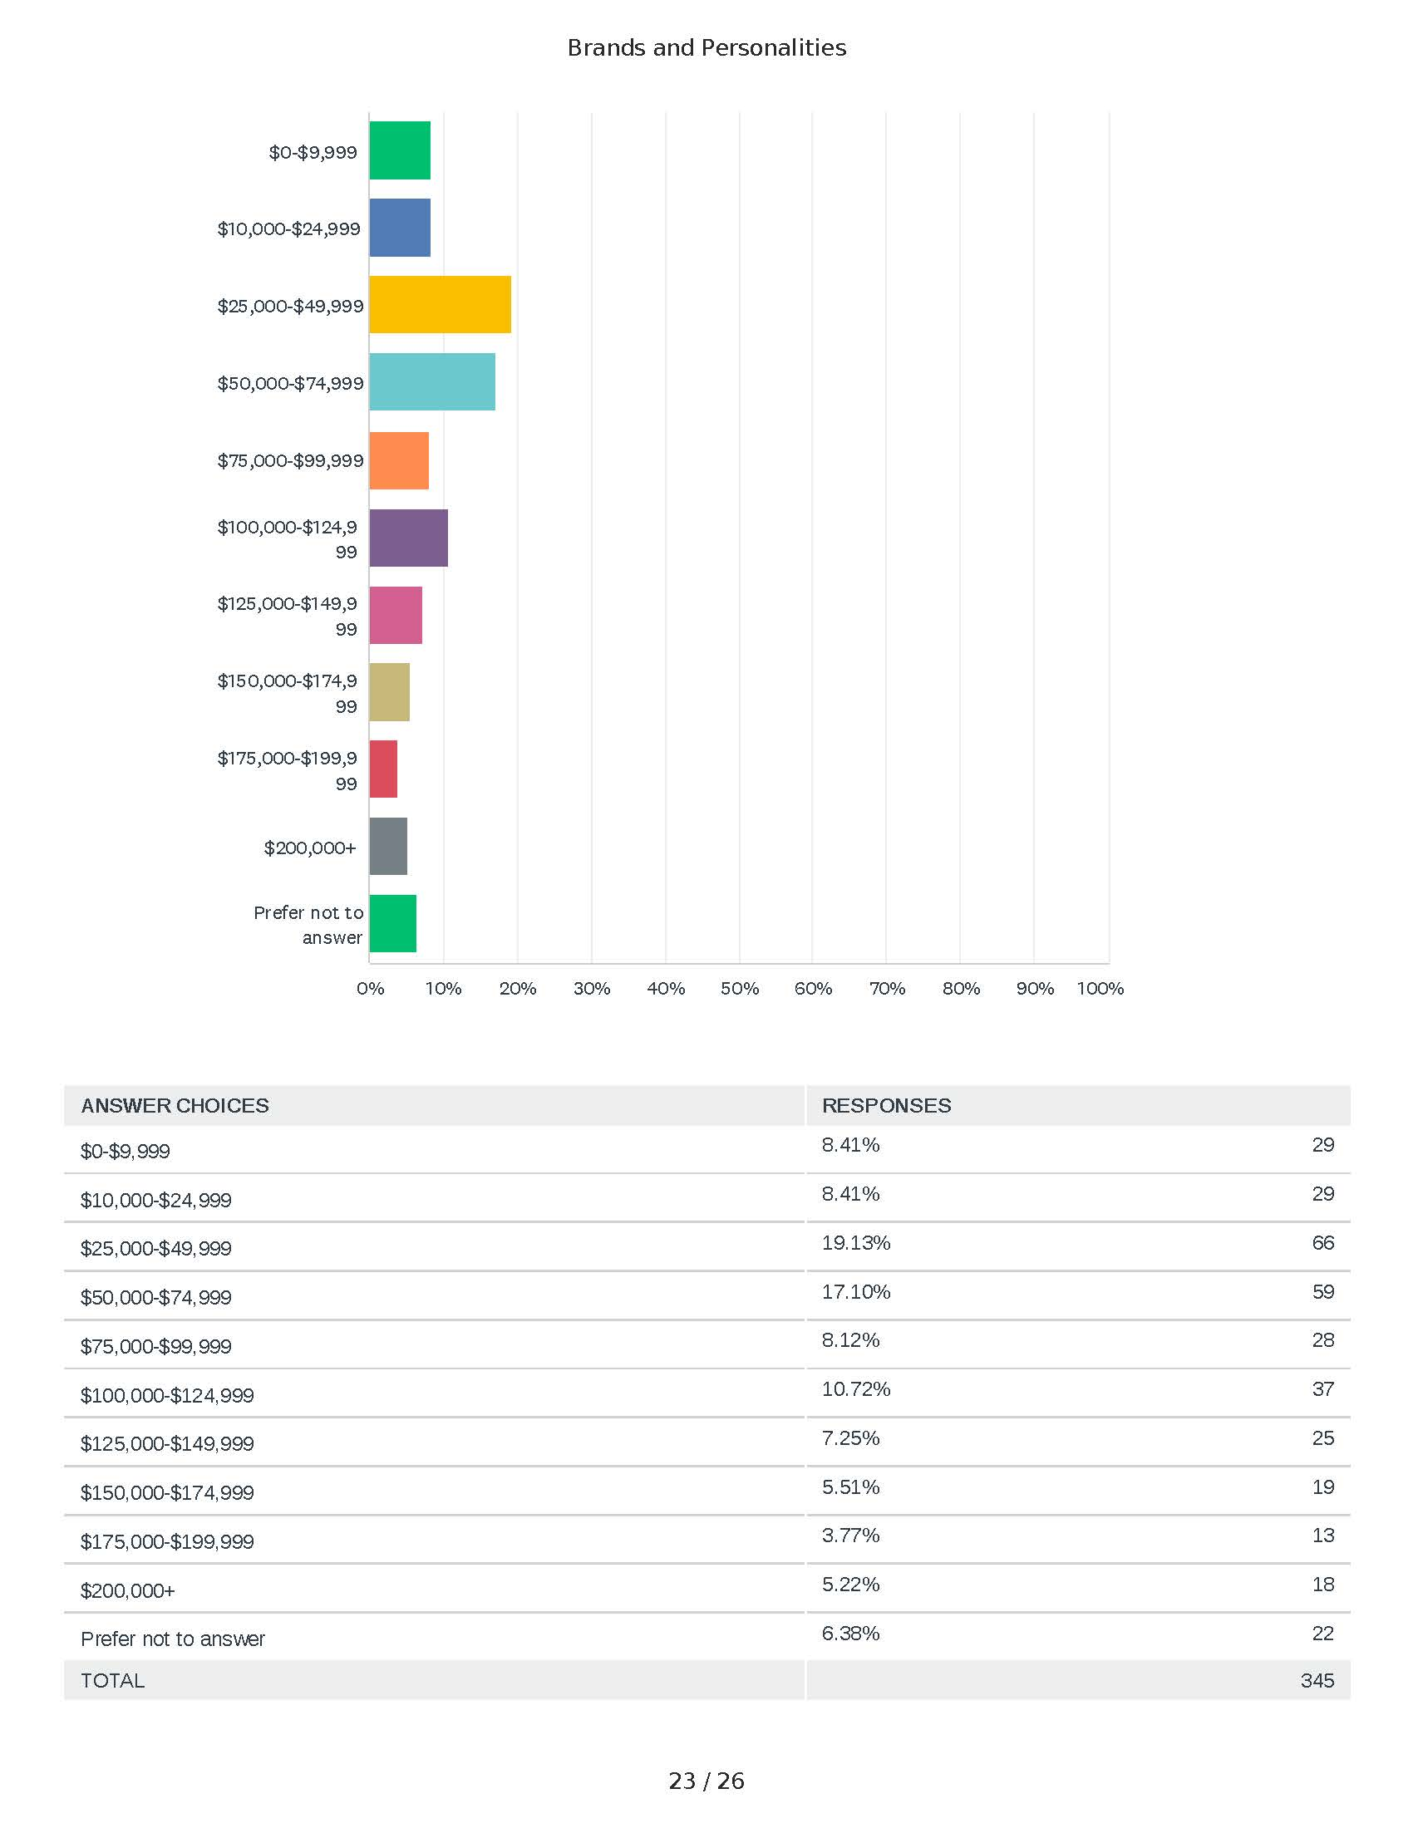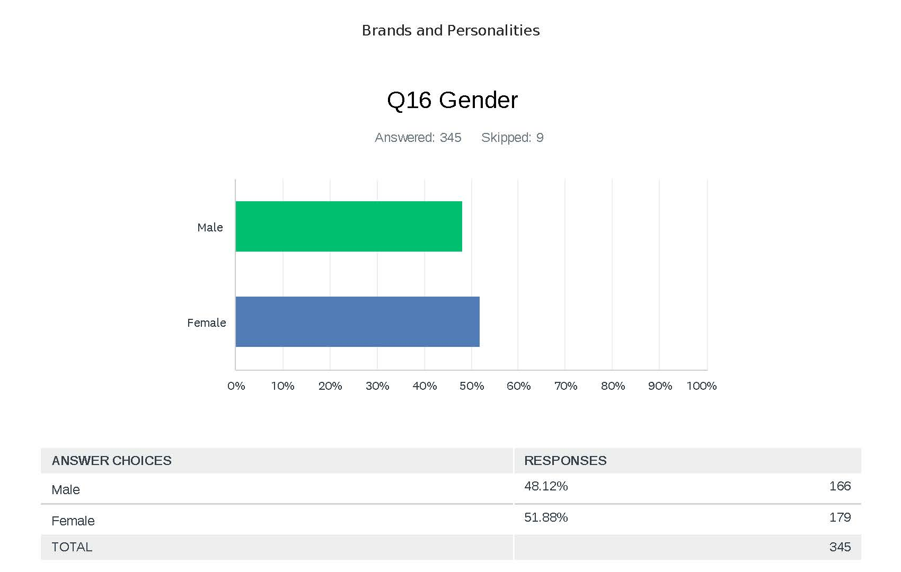

A name, term, sign, symbol, or design, or a combination thereof, intended to identify the goods and services of one seller or group of sellers and to differentiate them from the competition (Keller & Swaminathan, 2020, p. 32).
The source of power that provides moral and physical strength and freedom of action (Department of Defense, 2020, p. IV-22).
A VEO is a group of people that uses physical force to cause harm, damage, or kill/eradicate someone/something to achieve one or more political, religious, social, or economic objectives that the majority subjectively considers to be outside the scope of what is reasonable and acceptable behavior and norms (Davis, 2019, p. 38).
Power is the ability to affect others to obtain desired outcomes. Power may manifest itself in three different variants: hard (kinetic), soft (persuasion), and informational (perception) and each one requires different types of resources and responses (Nye, 2004, 2011).
The aspects of the product offering that are largely similar to the offerings of like competitors (Keller & Swaminathan, 2020).
The aspects of the product offering that are relatively distinct to the offerings of like competitors (Keller & Swaminathan, 2020).
Extremism is defined as “activities (beliefs, attitudes, feelings, actions, strategies) of a character far removed by the ordinary” (Coleman & Bartoli, 2003). At their core, extremists have a set of closed, fixed, and intolerant attitudes, usually impervious to change (Coleman & Bartoli, 2003). Terrorism is a form of extremism, with violence and terror, either real or perceived, the preferred tactics to achieve organizational goals.
The quality or state of being extreme or the advocacy of extreme measures or views (Merriam-Webster, n.d.). Extremism advocates, promotes, facilitates, or condones violence, to advance its primacy over alternative or competing views (Gibel, 2021).
The action or process of causing someone to adopt radical positions on political or social issues.
Any stakeholder who uses extremism to accomplish an end state.
A consciously coordinated social entity, with a relatively identifiable boundary, that functions on a relatively continuous basis to achieve a common goal or set of goals (Robbins, 1999, p. 4).
“A worldview is a collection of attitudes, values, stories and expectations about the world around us, which inform our every thought and action” (Gray, 2011).
Brand value is the monetary value of a brand if it was to be sold; a financial gauge of a brand’s worth (Aaker, 1991).
Brand equity is the value of stakeholder perceptions that result in stakeholder spend and loyalty (Aaker, 1991).
A cross-case synthesis study’s goal “is to retain the integrity of the entire case and then to compare or synthesize any within-case patterns across the cases” (Yin, 2018, p. 196). Cross-case synthesis is recommended when using only two cases (Yin, 2018).
Organizational theory is concerned with the relationship between organizations and their environments, with the organization itself as the unit of analysis (Robbins, 1990).
If no differences occur within the brand category, the brand name can be classified as generic and with a general identity (Aaker, 1991; Ailawadi et al., 2003; Keller, 2003; Leuthesser et al., 1995).
A stakeholder can be a group or individual, known, or unknown, who is affected by or can affect the success of an organization (Freeman, 1984).
BrandFinance uses a method of brand valuation known as the royalty relief method. “The method determines the value a company would be willing to pay to license its brand as if it did not own it. This approach involves estimating the future revenue attributable to a brand and calculating a royalty rate that would be charged for the use of the brand” (Brand Finance, 2022, p. 99).
Brand resonance occurs when stakeholders feel a deep, psychological bond with the brand (Keller & Swaminathan, 2020).
A force multiplier is a mechanism that can increase the leverage strength of an existing element. For example, a pulley system is a force multiplier, allowing all the elements working together to raise a much heavier load that a straight rope or a single pulley. The more pulleys added, the more leverage available. The more brand value and equity, the stronger and more capable the brand.
The ability to most efficiently use available resources to maximize return on effort.
Of note, there is a difference between a franchise and an affiliation. A franchisee seeks to use the brand name for its value and equity but must also follow brand policy and guidance. An affiliate works with a brand but retains its own brand to maintain independence and, in some cases, keep a strategic distance from the partnered brand.
Barqa Province of the Islamic State, Islamic State Algeria, Islamic State Bangladesh, Islamic State Brazil, Islamic State in Greater Sahara, Islamic State in Libya, Islamic State in Saudi Arabia, Islamic State in Somalia, Islamic State in Yemen, Islamic State Indonesia, Islamic State Khurasan, Islamic State Malaysia, Islamic State of India, Islamic State of Iraq, Islamic State of Iraq and ash-Sham, Islamic State of Iraq and the Levant, Islamic State of Lanao, Islamic State Philippines, Islamic State Maldives, Islamic State Senegalese Foreign, Fighter Units, Islamic State Sinai, Islamic State West Africa, Katibat al-Aqsa, Islamic State Chechen Unit, Khorasan Province of the Islamic State, Lahij Province of the Islamic State, Movement of the Islamic State.
Those familiar with Islam know the term jihadism, as utilized by VEOs, is a corrupt rendering of a centuries-old doctrine that, in any case, was never one of Islam’s principal tenets (International Crisis Group, 2016). In Arabic, jihad literally means struggle and is almost always followed in the Qur’an by the phrase in the way of God. Jihad implies a struggle against self, against one’s passions and instincts and the temptations that oppress the soul (Aslan, 2009). Jihadism, as used by VEOs, traces its historical roots not to the Prophet Muhammad but to the Arab anti-colonialists of the 20th century, such as Hasan al-Banna and Sayyid Qutb, and looks not to the Qur’an for its doctrinal basis but to the writings of the 13th century legal scholar Ahmad ibn Taymiyahh (Aslan, 2009).
The CG is defined as the source of power that provides moral and physical strength, freedom of action, or will to act (Department of Defense, 2020).
A free body diagram (FBD) consists of a diagrammatic representation of a single body, or a subsystem of bodies isolated from its surroundings showing all the forces acting on it. In physics and engineering it is a graphical illustration used to visualize the applied forces, moments, and resulting reactions on a body in a given condition. An FBD depicts a body or connected bodies with all the applied forces and moments, and reactions, which act on the body.
Max Weber constructed a concept of action around exchange theory. His ideas were taken up by Talcott Parsons and became a part of the sociological mainstream. The social anthropologists Bronislaw Malinowski and Marcel Mauss looked at how social exchange was embedded in structures of reciprocity and social obligation (Scott, 2000).
Motivation may be extrinsic when a stakeholder is inspired by outside forces, other people, or rewards. Motivation may be intrinsic, when the inspiration comes from within, such as the desire to improve at a certain activity.
Different from opinions, emotions are considered motivational states because they generate bursts of energy that get our attention and cause our reactions to significant events in our lives (Izard, 1993).
The Arab Spring was a loosely related group of protests which began in the Spring of 2011, which ultimately resulted in regime changes in countries such as Tunisia, Egypt, and Libya. Not all of the movements, however, were successful—at least if the end goal was increased democracy and cultural freedom. In fact, for many countries enveloped by the revolts of the Arab Spring, the period since has been hallmarked by increased instability and oppression (History.com, 2020, Jan 17).
The case of Wald and aircraft battle damage is often presented as survivorship or survival bias, a type of statistical bias introduced by the selection of individuals, groups, or data for analysis in such a way that proper randomization is not achieved, thereby failing to ensure that the sample obtained is representative of the population intended to be analyzed.
That which helps achieve an end state.
Charismatic leadership is found in a leader with extraordinary characteristics of individual, whose mission and vision inspire others. However, charismatic leadership is considered unstable as it is related to faith and belief, once these fade, the authority and leadership dissolve. the field of leadership. Weber uses charisma in a value-neutral manner. To be a charismatic leader is not necessarily to be an admirable individual. In Weber's own expression, the manic seizure and rage of the nordic beserker or the demagogic talents of a Cleon are just as much “charisma” as the qualities of a Napoleon, Jesus, or Pericles (Tucker, 2017).
The notion of takfīr (excommunication) was part of pre-modern heresiology that revolved around a range of conceptualizations of kufr (rejection of belief) and the conditions of belonging to a Muslim community (Al-Shahrastani, 1923; Poljarevic, 2021). Takfīr, therefore, entailed pronouncing judgment on Muslims for having exited a community of Muslims either through what was understood to be their “erroneous” beliefs and/or actions (Poljarevic, 2021). Such judgments have often had direct political consequences (Khalidi, 2005). Those who voluntarily had left Islam and, consequently, left a specific Muslim community, have traditionally been re-classified as murtaddīn (apostates) and/or kuffār (non-believers, kāfir) (Chaliand & Blin, 2007; Poljarevic, 2021).
Instrumental strategies enable adaptation to new and emerging external challenges as well as integration of internal challenges and issues, both of which result from efforts to realize the primary strategy. Such strategies are operational in nature, tending toward the attainment of specific, measurable objectives. Instrumental strategies reflect the organization’s knowledge. They enable group members to maintain a lively awareness of their collective identity. They are formulated, implemented, and continuously adapted to circumstances based on existing beliefs and available know-how (Gagliardi, 1986).
Expressive strategies operate in the symbolic field and meaning making. They seek to protect the stability and coherence of shared meanings. An expressive strategy enables the organization to offer a recognizable identity to the outside world (Gagliardi, 1986).
25 A leading foreign policy institute from around the world roughly tracking the composition of the G20.
To engineer something is to change the design of the product or system for a new purpose. To weaponize something is to adapt it for use as a weapon. In this instance, the core meaning of Islam is changed to suit and support the political goals of IS. The new meaning is then used to create kinetic and non-kinetic desired effects meant to achieve IS desired outcomes.
Ummah (Umm-ah) is an Arabic word meaning “community.” It is distinguished from Shaʻb which means a nation with common ancestry or geography (Filipec, 2020).
In regression, the higher the R², the better the model fits the data. R² tends to optimistically estimate the fit of the linear regression. It increases as the number of effects are included in the model. Adjusted R² is a corrected goodness-of-fit (model accuracy) measure for linear models. It identifies the percentage of variance in the target field that is explained by the input or inputs (IBM, 2022).
The standardized coefficient (β) is the change in Y, measured in units of its standard deviation, associated with a 1 standard deviation change in X. Unstandardized coefficients (b) are less useful for direct comparison when the measurement scales of the independent variables are different.
Probabilistic causality allows for changes to occur in outcomes at some probability < 1.0.
Deterministic causality means that given a chance in a causal variable, the same consequence in observed in all case on the outcome variable (Kline, 2016, p. 11).
Disturbances are uncorrelated and all causal effects are strictly unidirectional (Kline, 2016).
How much money individuals would be willing to pay for an incremental change in the provision of some specified public good using contingent markets (Regens, 1991).
The implicit prices of attributes and are revealed to economic agents from observed prices of differentiated products and the specific amounts of characteristics associated with them. They constitute the empirical magnitudes explained by the model (Rosen, 1974, p. 34).
A name, term, sign, symbol, or design, or a combination of them, intended to identify the goods and services of one seller or group of sellers and to differentiate them from the competition. (Keller & Swaminathan, 2020, p. 32).
The source of power that provides moral and physical strength and freedom of action (Department of Defense, 2020, p. IV-22)
Hard power, Soft Power, and Information Power (Nye, 1990, 2014).

