Survey of the Marine Corps as a Distinct Branch of the united states military – From 1775 to 1805

Abigail Terselic
HIST 1483-010: American History, 1492-1865
Derek Donwerth
27 November 2016

When the “shot heard ‘round the world” sparked the American War for Independence in 1775, the emerging American nation was rattled, but only for a moment. The iron will of the Colonial forces provided the foundation for unity against the British Crown. Initially, the Colonial militia did not compare to the British forces, which had a thriving mother nation backing them and a rich history in strong, successful warfare. However, as the Colonies matured in resolve, they gained support, personnel, supplies, and unity. In addition to increasing the size of the Continental army, the Continental Congress decided to create a completely new division of the armed forces, one with explicit purpose and manifest strength. Thus, two battalions of Marines originated as an elite arm of the Colonial militia. The Marines faced their first challenge in the War for Independence, as they demonstrated their unique training and abilities, fighting alongside the Continental forces. After the victorious American Revolution, the new nation maintained Marines as part of its general military force. Gradually, they were employed more and more, until they became an official branch of the United States military in 1798. A mere six years later, the Marines gained universal recognition and respect as a powerful, invaluable asset to the rising United States by their famous victory in the First Barbary War in 1805. From its first roots in 1775 to its famous victory in the First Barbary War in 1805, the US Marine Corps became known for selectivity of personnel, discipline within its ranks and the ranks of other forces, and effectiveness in eliminating enemies through amphibious assault and hand-to-hand combat, all of which set the Marine Corps apart in mission and effectiveness from every other branch of the United States armed forces.
After the American War for Independence began in April of 1775, it was only seven months later in November of 1775 that the Second Continental Congress convened and proposed the addition of Marines to the Continental forces. During deliberations, it was officially decided that “two Battalions of Marines be raised consisting of one Colonel, two Lieutenant Colonels, two Majors, and other officers as usual in other regiments; that they consist of five hundred privates each Battalion, exclusive of officers.” While every armed force was intentionally created with divisions of officers and enlisted to promote the distinction between leaders and followers, the Marines were designed differently – even if enlisted, every Marine was trained to be a leader. Selectivity in this creation of Marines was also apparent in Congress’ provision “That particular care be taken that no persons be appointed to office or enlisted into said Battalions but such as had actually served in the merchant service as seamen or so acquainted with maritime affairs.” Those accepted into the Marines were required to have sea experience, but these men had more than nautical skills. In his book The U.S. Marine Corps Story, Robert Moskin made a crucial point on this specific line from the proposal of Congress: “The Marines were not specialized sailors; they were a totally different breed of fighter.” Congress designed this assemblage to be selectively comprised of men with extensive experience and maturity, who could handle demands required of them at sea and on land.
In addition to the specific requirements of those recruited into the Marines, the commanding officers were chosen with great care. President of the Continental Congress John Hancock appointed Samuel Nicholas as the first Continental Marine officer. According to a record of his service, Nicholas, “in November 1775, entered in to the service of these United States in the capacity of Captain of Marines” and served in several capacities in the newly formed militia. Under the command of Nicholas, the Marines entered the American war effort united and with a purpose. Congress created the Marines to be “of the utmost service, being capable of serving either by sea or land.” George Clark, in his book on Marine battle history, explained how crucial the first battle was for the newly formed battalions of Marines: “The first action of the new year in 1776 was one of the most important insofar as the Marines were concerned. It established the force as an amphibious assault unit, yet it would only be utilized as such a small number of times during the eight years the war endured.” This first action of the Marines was on New Province Island in the British Bahamas. In the seizure of the British settlement, the Marines demonstrated their proficiency at sea on the naval vessels and on land in tactful maneuver and hand-to-hand combat. It was in this battle that the Marines obtained the name “leathernecks,” for the leather collars they wore around their necks to protect against enemy sword blades. The victory at New Province battle was the event that gave the Marines their first recognition as a useful division of the Continental forces. Their specialty in amphibious assault, including hand-to-hand combat, made them of limited but vital use, distinct from every other military branch. Also, when placed in other capacities with the Continental forces, the Marines provided stability and order as they enforced discipline within the ranks. As they were utilized more, Marines gained reputation and respect that carried with them past the end of the war. Through their exceptional performance in various functions in the War for Independence, the Marines proved themselves essential to the US forces.
Because of their invaluable contributions to the American victory in the War for Independence, the Marines were maintained for continued use and used in several capacities in the decade following the war. In 1793, Congress created “An Act to Provide Naval Armament,” which employed Marines, both officers and enlisted, on naval vessels. The Frigate Act of 1794 soon followed, which established a structured organization of US navy frigates including Marine detachments on each. Both acts used Marines in the same function: employed in addition to navy seamen, the Marines were placed on navy ships to provide structure and order for navy personnel and to further secure the ships from foreign enemies. Clark described that these Marines were “hired as part of the Navy’s shipboard complement” and that “the new Navy, and its Marines, were under the secretary of war, such only the Army had been provided for by the Congress.” Clark made the point that although they fell under the division of the navy in the US military, the Marines were more than sailors. They were essentially the police of the sea, guarding the ships internally from mutiny, uprisings of sailors, and externally from foreign vessels. Although they had maritime experience like navy sailors, the Marines were an elite addition to the US Navy, trained specifically to secure naval ships and provide the amphibious assault as part of naval expeditions. As the Marines were employed more and more over time, Congress decided they were essential to the United States military. In 1798, President John Adams approved the “Act for Establishing and Organizing a Marine Corps” which dictated that, “In addition to the present military establishment, there shall be raised and organized a corps of Marines.” The United States Marine Corps was thus formed, and following the official establishment, the branch grew in numbers, strength, and specialty.
Three years after its official creation, America’s newly formed Marines Corps was put to the test in the first large conflict following the War for Independence. In 1801, the First Barbary War started a fourteen-year-long conflict between America and the Barbary states. Although America became a free nation following the War for Independence, she lost the security of maritime commerce under Great Britain and thus came under attack of the pirates of the Barbary states – Algiers, Tunis, Morocco, and Tripoli. In addition to losing British protection, the United States gained another enemy in the British aiding the Barbary pirates. Moskin described the British hand the war: “The nub of the American troubles with Algiers was a treaty signed between the state and Portugal in 1793 allowing Algerian warships to operate in the Atlantic. This treaty, arranged by the British, meant that more American ships would be seized; and it led directly to the building of the first U.S. frigates and the creation of the permanent American navy.” Great Britain wanted nothing less than the destruction of the nation that dared to oppose her twenty years before. Despite growing odds against it, the United States accepted the challenge.
The naval acts of 1793 and 1794 and the creation of the Marine Corps in 1798 were all designed to combat the ensuing threat of the Barbary states. Four hundred Marines, which comprised over four-fifths of the enlisted Corps at the time, were the first to be deployed to the North African states. The war constantly shifted, from favoring American troops to favoring the Barbary pirates. Tragically, the Marines took several hard blows, one of which was detailed in an article in the Albany Gazette: “At half past three, one of our prize gun boats was blown up, by a hot shot from the enemy, which passed through her magazine. She had on board 28 officers, seamen and marines; 10 of whom were killed, and 6 wounded. Among the killed were James R. Caldwell, first lieutenant of the Syren, and midshipman John S. Dorsey, both excellent officers.” The article captured the Marines’ sacrifice throughout the conflict and recognized the costly loss experienced in the war. Nevertheless, led by William Eaton and First Lieutenant Presley O'Bannon, the Marines eventually captured Tripoli, a victory which launched the Marine Corps’ reputation worldwide. The famous Tripoli victory was immortalized in the Mameluke Sword carried by Marine officers and most famously in the Marines’ hymn: “From the Halls of Moctezuma to the shores of Tripoli; we fight our country's battles, in the air, on land, and sea.” (For Mameluke Sword see Image 1 on page 11) Although this victory was not the end of the American conflict with the Barbary states, it was the first time American Marines displayed their distinct strength and the power of their nation to the rest of the world.
From their start in 1775 to their famous victory on shores of Tripoli, the Marines were specifically placed at the forefront of the United States military. If the difference between the Marines and every other branch could be summed up in one phrase, it would be, “They leaned in.” Even before they were an official branch of the US military in 1775, Marines did more than stand their ground – they leaned in. From the American War for Independence to thirty years later in the victory in the First Barbary War, the Marines steadfast footing and fearless resolve set them apart from all other US armed forces. Thus, the United States Marine Corps remarkably grew from a mere two battalions into the distinct, irreplaceable division of the American military renown to this day.

Bibliography

Clark, George B. Battle History of the United States Marine Corps, 1775-1945. Jefferson:
McFarland & Company, Inc., Publishers, 2010.

“Copy of a letter from Commodore Proble, to the Secretary of the Navy.” Albany Gazette.
NewsBank/Readex, America's Historical Newspapers, SQN: 1323E9FB0BB102F0.
(Albany, NY). March 3, 1805.

Emmerson, Ralph Waldo. “Concord Hymn.” The Poetry Foundation. Web accessed November
24, 2016.

Ingersoll, Geoffrey. “Everybody Should Read General John Kelly's Speech About Two Marines
in the Path of a Truck Bomb.” Business Insider. Published June 3, 2013. Web accessed
November 24, 2016.

Journals of the Continental Congress, 1774-1789, Monday, October 1, 1781. The Papers of the
Continental Congress, No. 78, XXI, folio 133.

“Marine Corps Hymn.” Marines: The Official Website of the United States Marines. Web
accessed November 24, 2016.

Moskin, Robert J. The U.S. Marine Corps History. New York: McGraw-Hill Book Company,
1977.

Second Continental Congress, Letters of Delegates to Congress: Volume 2 September 1775 –
December 1775, Expedition to Nova Scotia. November 2-10, 1775.

United States Congress, Senate. “An Act for Establishing and Organizing a Marine Corps.”
Philadelphia, 5th Congress, 2nd Session, July 11, 1798.

United States Congress, Senate. “An Act to Provide a Naval Armament.” Philadelphia, 3rd
Congress, 1st Session, December 2, 1793.

Image 1: Mameluke Sword of Lt. Col. Terselic (my father).
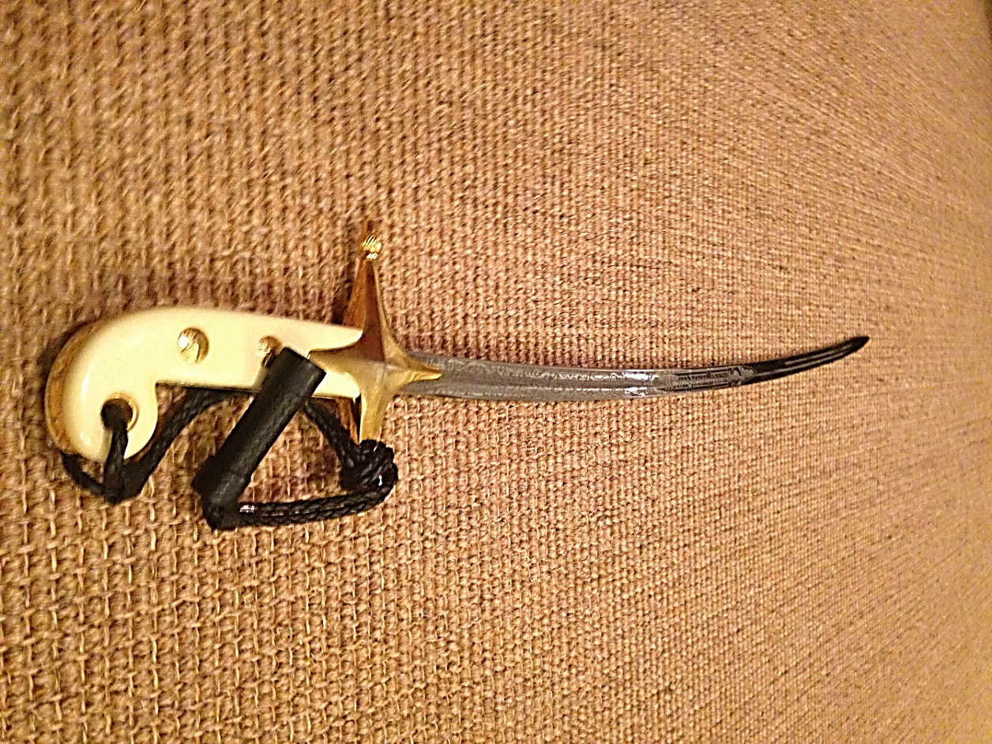

Emmerson, Ralph Waldo. “Concord Hymn.” The Poetry Foundation. Web accessed November 24, 2016.
Second Continental Congress, Letters of Delegates to Congress: Volume 2 September 1775 – December 1775, Expedition to Nova Scotia. November 2-10, 1775.
Second Continental Congress, Letters of Delegates to Congress: Volume 2 September 1775 – December 1775, Expedition to Nova Scotia. November 2-10, 1775.
Moskin, Robert J. The U.S. Marine Corps History. New York: McGraw-Hill Book Company, 1977. 12.
Journals of the Continental Congress, 1774-1789, Monday, October 1, 1781. The Papers of the Continental Congress, No. 78, XXI, folio 133.
Second Continental Congress, Letters of Delegates to Congress: Volume 2 September 1775 – December 1775, Expedition to Nova Scotia. November 2-10, 1775.
Clark, George B. Battle History of the United States Marine Corps, 1775-1945. Jefferson: McFarland & Company, Inc., Publishers, 2010. 13.
United States Congress, Senate. “An Act to Provide a Naval Armament.” Philadelphia, 3rd Congress, 1st Session, December 2, 1793.
Clark, George B. Battle History of the United States Marine Corps, 1775-1945. Jefferson: McFarland & Company, Inc., Publishers, 2010. 19.
United States Congress, Senate. “An Act for Establishing and Organizing a Marine Corps.” Philadelphia, 5th Congress, 2nd Session, July 11, 1798.
Moskin, Robert J. The U.S. Marine Corps History. New York: McGraw-Hill Book Company, 1977. 54.
“Copy of a letter from Commodore Proble, to the Secretary of the Navy.” Albany Gazette. NewsBank/Readex, America's Historical Newspapers, SQN: 1323E9FB0BB102F0. (Albany, NY). March 3, 1805.
“Marine Corps Hymn.” Marines: The Official Website of the United States Marines. Web accessed November 24, 2016.
Ingersoll, Geoffrey. “Everybody Should Read General John Kelly's Speech About Two Marines in The Path of a Truck Bomb.” Business Insider. Published June 3, 2013. Accessed November 24, 2016.

