UNIVERSITY OF OKLAHOMA
GRADUATE COLLEGE

WHY ARE THERE SO MANY BIRDS IN THE TROPICS: USING COMPARATIVE APPROACHES TO INVESTIGATE THE CONFLUENCE OF LANDSCAPE, ECOLOGY, AND GENOME IN THE GENERATION OF NEOTROPICAL AVIAN DIVERSITY

A DISSERTATION
SUBMITTED TO THE GRADUATE FACULTY
in partial fulfillment of the requirements for the
Degree of
DOCTOR OF PHILOSOPHY

By
JESSICA FOLEY MCLAUGHLIN
Norman, Oklahoma
2022

WHY ARE THERE SO MANY BIRDS IN THE TROPICS: USING COMPARATIVE APPROACHES TO INVESTIGATE THE CONFLUENCE OF LANDSCAPE, ECOLOGY, AND GENOME IN THE GENERATION OF NEOTROPICAL AVIAN DIVERSITY

A DISSERTATION APPROVED FOR THE

DEPARTMENT OF BIOLOGY

BY THE COMMITTEE CONSISTING OF

Dr. JP Masly, Chair
Dr. Dahiana Arcila
Dr. Hayley Lanier
Dr. Matthew J. Miller
Dr. Courtney Hofman

© Copyright by Jessica F. McLaughlin, 2022
All Rights Reserved.
Table of Contents
Abstract vi
Acknowledgements viii
General Introduction 1
Chapter 1: Comparative phylogeography reveals widespread cryptic diversity driven by ecology in Panamanian birds 7
Author Contributions 7
Abstract 8
Introduction 9
Materials and Methods 13
Results 17
Discussion 20
Conclusions 28
Acknowledgements 28
Tables 38
Chapter 2: Time in allopatry does not predict the outcome of secondary contact in lowland Panamanian birds 46
Author Contributions 46
Introduction 47
Methods 50
Results 55
Discussion 58
Conclusions 64
Tables: 71
Chapter 3: Genomic insights into rapid speciation in a clade of Andean hummingbirds (Aglaeactis) 77
Author Contributions 77
Abstract 77
Introduction 78
Methods 82
Results 89
Discussion 93
Acknowledgments 101
Figures 102
Tables 108
General Conclusions 116
References 120
Appendix 1: Supplementary Information for Chapter 1 177
Appendix to Chapter 2: Supplementary Tables and Figures 325
Appendix to Chapter 3: Supplementary Information 352
Supplemental methods 352

Abstract
The Neotropics are home to an astonishing level of avian diversity, and thus naturally a focus for the study of the generation of biodiversity. Studies of tropical speciation often focus on large-scale landscape changes, such as the impacts of Pleistocene climate change, the formation of the isthmus of Panama, or the uplift of the Andes. However, the full scope of Neotropical avian diversity is not yet wholly understood, and increasing evidence suggests that other processes beyond these geographical factors contribute to speciation in tropical birds. Here, I examine genetic data, from mitochondrial markers to whole genomes, in a diverse array of Neotropical birds, to better understand the interplay between landscape, genome, and ecology in the development of reproductive isolation. In my first chapter, I use mitochondrial barcodes from over 2,000 birds to detect potential cryptic species across Panama. I find that species-level splits occur in 19% of sampled species, suggesting avian diversity in Panama is substantially underestimated. These disproportionately occurred in species with ecological characteristics associated with low dispersal ability. This is reinforced by the next chapter, in which I use reduced-representation genomic data in ten taxa of lowland Panamanian birds to test whether time is the most important predictor of the outcomes of secondary contact. I find no evidence that time plays a role in determining hybrid zone width in these taxa, and only a partial role in the generation of genomic variation. Instead, diet, which is again linked to dispersal ability as well as demographic changes, is a much better predictor. Finally, I move my focus in Chapter 3 to the Andes, using low-coverage whole genomes to examine the speciation history of the hummingbird genus Aglaeactis. This rapid radiation has significant mitonuclear discord, with completely different phylogenies reconstructed from mitochondrial and nuclear markers. In the two clades defined in the nuclear data, each made of three taxa, I then examined how divergence was distributed across the genome. The three southern taxa, all of which are in allopatry, have overall higher genomic divergence, but it is spread evenly across the genome. In the northern clade, though, I find much lower divergence punctuated by outliers of elevated differentiation. These northern taxa do have contact zones between them, and it is likely that gene flow in that geographic scenario has had a hand in shaping the genomic landscape for the development of reproductive isolation. Taken together, each of these chapters explores how reproductive isolation is the outcome of multiple facets of an organism interacting, and sheds further light on how avian biodiversity is generated.

Acknowledgements

Completing a PhD is a daunting endeavor in the best of times. Completing one between 2017 and 2022 has been downright Herculean. I’ve spent these past four years dodging a seemingly never-ending parade of obstacles, and you can’t do that sort of thing alone. The completion of this dissertation is in large part a testament to the support and community I am blessed to be a part of. It may be cliched to say I couldn’t have done this without you all, but nevertheless: I couldn’t have done this without you all.

First, I must thank my committee. Matt, you have been an amazing mentor and scientific colleague these past four years. From long discussions and debates about study design, to marathon lab sessions trying out some new technique, to planning ornithology class while stuck in Panamanian traffic, your enthusiasm for science and energy have been key to my growth as a scientist. I hope you have a great time figuring out how to sequence bustard microbiomes. JP, I am incredibly grateful for your help getting this dissertation across the final hurdles. To the rest of my committee members-- thank you so much for your support during this process. You have both supported me and challenged me in ways that have made me grow as a scientist.

At its best, your cohort of fellow students is not a competitive threat, but a source for support and growth. The OU Biology grad students, past and present, really exemplify the best of this. There’s too many of you to list, but know that you all have my heartfelt thanks.

Being at home in a place means more than just strong roots in a single department, though. As a diehard extrovert, when I left Fairbanks, I worried I would never feel so welcomed again. I shouldn’t have worried, though. From my first arrival in Norman, I was quickly made to feel a part of the community through so many wonderful groups. I joined my voice with others in the Norman Singers community choir. I mentored the kids of the West Wind Unitarian Universalist Congregation as they grew and blossomed into amazing young adults. When the pandemic hit, I had only just begun attending Temple B’nai Israel in OKC, but they became a lifeline and so fully embraced me that I still feel amazed at how quickly they became yet another family for me. To them and all my other Oklahoma communities- thank you for being there throughout this wild ride.

Friends need not be just local, of course. Many of my Alaska friends are still among my closest-- sharing a 250 sq-ft cabin with no running water for a summer will do that for you-- and they have been among my loudest cheerleaders. Joining them in the stands have been my innumerable pocket friends-- the many people who I have often never met in person, but who I have been immensely privileged to cross paths with on social media. Whether it was the stunning generosity they showed in making both the removal of my wisdom teeth, my final two semesters of tuition, and the purchase of the laptop I’m writing this on possible, to the opportunities to share my work, to zoom co-working hours punctuated by obligatory showing off our pets and virtual Ghibli movie nights, they have been there throughout this journey. I can only hope that I may pay forward all your support as I move forward in my career.

Among my pocket friends, there’s the subgroup of my amazing Dungeons and Dragons parties. Whether we played only briefly together, or I’ve been throwing monsters and puzzles at you for years, getting to build these fantastic worlds together has given me the chance to grow as a storyteller and as a confident public speaker who can roll with the most unexpected shenanigans. Not only have you been a source of joy and escape, but you’ve also helped me build these skills in a way that has made me a better scientist. After all, “this is more of a comment than a question” is a walk in the park compared to improvising your way through the party’s monk accidentally turning themselves into a 14-foot-tall hamster (it’s a long story).

The unexpected coda to my time at OU to take this dissertation across the finish line has been one of the greatest challenges in my academic career. It would have been absolutely impossible without basically winning the lottery for a truly amazing postdoc lab. You all challenge me scientifically every day in a supportive and caring environment that’s more than I could have hoped for. Ian, Kinsey, Anusha, Erin, Anne, Dan—getting through these past few months wouldn’t have been possible without you, and you have my deepest thanks and gratitude.
Finally- even though a PhD is in and of itself a long journey, it’s not one that takes place outside of the context of one’s journey through life as a whole. To my family- never-ending thanks for your love and support, from letting me poke things with sticks on our hikes as a kid to encouraging me to travel the world (also still usually poking things with sticks) as I grew up. I am thankful you encouraged that love of science and nature, even when you weren’t exactly happy about whatever it was I was poking. Yes, I am bringing that home. No, it doesn’t really smell. Look, I’ll clean it myself, I swear-- wait, Mom, Dad, come back, I need help carrying it, wait-

General Introduction

“...whilst this planet has gone cycling on according to the fixed law of gravity, from so simple a beginning endless forms most beautiful and most wonderful have been, and are being, evolved.” (Darwin 1859)

From the beginning of the study of evolution, one of the questions at the very heart of biology has been how the myriad of species that exist and have existed have come to be (Darwin 1859; Mayr 1963; Otte and Endler 1989; Coyne and Orr 2004). Such an enormous question must be tackled from a variety of angles, from the role of ecological interactions in supporting diverse communities in organisms (Hutchinson 1959; Brown 1981) to the mechanisms by which genetic variation arises (Dobzhansky 1937). The increasing availability of high-throughput (HTS) or next-generation sequencing (NGS) has allowed for further investigation into even more questions: what exactly must happen in the genome for divergent lineages to become species? What factors of variation across the genome are associated with the development of reproductive isolation? What rules, if any, are there in determining why certain taxa speciate more frequently, and how? With the ability to cost-effectively sequence ever-larger portions of the genome in an array of species, comparative genomic studies can allow us to directly explore these questions more effectively (Wolf, Lindell, and Backström 2010; Seehausen et al. 2014; Termignoni-Garcia et al. 2022).

A major conceptual framework for studying the speciation process is the speciation continuum (Drès and Mallet 2002; Hendry et al. 2009; Merot et al. 2017; Stankowski and Ravinet 2021), particularly in comparative studies (Stankowski and Ravinet 2021). In these studies, each taxon pair represents one discrete point in the process of speciation, from the earliest stages of differentiation to complete reproductive isolation (Hendry et al. 2009; Stankowski and Ravinet 2021), and examination of common patterns amongst them or striking differences between them may reveal more general rules in how reproductive isolation develops in incipient species (Tollis et al. 2018; Gagnaire 2020). This is particularly useful for testing hypotheses that are not easily amenable to direct controlled experiments given the time scale of evolutionary processes, such as how long it takes for reproductive isolation to develop (Coyne and Orr 1989; Edmands 2002; Price and Bouvier 2002; Coyne and Orr 2004; Matute and Cooper 2021), the relative rates of development of pre- and post-zygotic isolation (Mendelson 2003; Charistianson, Swallow, and Wilkinson 2005; Moyle, Olson, and Tiffin 2004; Turissini et al. 2018; Rosser et al. 2019), and the relationship between introgression rates and genetic divergence (Wiens, Engstrom, and Chippindale 2006; Kronforst et al. 2013; Hamlin, Hibbins, and Moyle 2020; McLaughlin et al. 2020). However, as more and more studies have been conducted, it has become ever clearer that much variation exists in the answers to these questions (Matute and Cooper 2021; Stankowski and Ravinet 2021). This leads to the inevitable question: what causes such variation in the process exist, and what factors lead to particular outcomes in a given system?

Testing mechanisms of speciation in a species-rich area

While comparative approaches can be applied to other geographic regions, tropical regions, with their massive biodiversity, are of particular interest. An estimated 62% of global terrestrial vertebrate biodiversity occurs within the tropics (Pillay et al. 2021). The question of tropical biodiversity can be approached from multiple angles, but can be broadly broken into two main categories of mechanisms by which species diversity increases- either by accumulation of species, or as a generator of them (Stenseth 1984; Gaston and Blackburn 1996; McKenna and Farrell 2006). These are reflected in the classic framing of the tropics as either a cradle or museum of species (Stebbins 1974; Stenseth 1984); i.e., as a hotspot for creating new species, or as an area with lower extinction rates where older lineages are more likely to persist than at other latitudes (Stebbins 1974). While it is likely that this framing simplifies a more complex set of processes (Chown and Gaston 2000; McKenna and Farrell 2006; Arita and Vázquez-Domínguez 2008; Vasconcelos, O’Meara, and Beaulieu 2022), the evidence that the tropics likely have at least some elevated rates of speciation (McKenna and Farrell 2006; Moreau and Bell 2013) makes them of particular interest for the study of speciation.

With this overall biodiversity comes an especially notable level of avian diversity, with over 3000 estimated species in the Neotropics alone (Stotz et al. 1996). Many studies of avian speciation have focused on temperate regions, but the Neotropics, with their overwhelming diversity of species, are an obvious laboratory for understanding how species form. Studies of temperate zone birds suggest some general patterns – such as an average time to speciation between 1-2 million years (Weir and Schluter 2007; Price 2008) and that prezygotic barriers play a more important role than postzygotic isolation in forming species (Martin, Montgomerie, and Lougheed 2010; Weir and Wheatcroft 2011; Weir, Wheatcroft, and Price 2012). This may not be the case, however, in tropical systems. Many Neotropical bird species are older, between 2-4 million years old (Bates, Hackett, and Goerck 1999; Marks, Hackett, and Capparella 2002; González et al. 2003; Weir and Schluter 2007; Price 2008; Miller et al. 2008, 2011; Weir and Price 2011; Weir and Lawson 2015) and include notable levels of cryptic diversity (Hackett 1995; Hackett 1996; Bates, Hackett, and Goerck 1999; Aleixo 2002; Marks, Hackett, and Capparella 2002; González et al. 2003; Miller et al. 2011; Lopez et al. 2016; Pulido-Santacruz, Aleixo, and Weir 2018).

Gene flow has been found between sister taxa across splits far older than in comparable temperate cases (Weir and Price 2011; Weir et al. 2015; Pulido-Santacruz, Aleixo, and Weir 2018, 2020; Miranda, Prestes, and Aleixo 2021). These observations lead to a fundamental question of whether the balance of the many mechanisms that lead to reproductive isolation in birds is shifted in tropical systems-- whether key processes in the diversification of tropical bird species are those outweighed by other factors in temperate systems.

Models of Neotropical speciation center the landscape

Historically, the primary spotlight of the investigation of avian speciation has focused on the landscape. Ornithology has been particularly influenced by the work of Ernst Mayr (Cracraft 1983; McKitrick and Zink 1988; Haffer 1992; Zink and McKitrick 1995; Price 2008), and thus consideration of the speciation process has been firmly rooted in the biological species concept (Cracraft 1983; Price 2008). With this paradigm comes the primary role of allopatry in creating the perquisite isolation in at least some point in the process (Jordan 1905; Dobzhansky 1937, 1940; Mayr 1942, 1963; Rosenzweig 1995). This has been particularly true in studies of Neotropical avian diversity, which have tended to center specific landscape-based models in their investigations.

Initially, most studies tended to focus on how long-term changes in the landscape created allopatric splits. Examples of this are found in discussion of the uplift of the Andes (Burns and Naoki 2004); the formation of the isthmus of Panama (DaCosta and Klicka 2008; Cortés-Ortiz, Rylands, and Mittermeier 2015); and the competing “rocks, rivers, or refugia” hypotheses for diversification in the Amazon (Wallace 1853; Cracraft 1985; Nelson et al. 1990; Bush 1994; Haffer 1997; Hayes and Sewlal 2004; Hoorn et al. 2010; Cortés-Ortiz, Rylands, and Mittermeier 2015). In brief, these each emphasize the barriers created by large-scale geologic change (Burns and Naoki 2004; Naka et al. 2012), large rivers (Wallace 1853; Sick 1967; Capparella 1988; Gascon et al. 2000; Hayes and Sewlal 2004; Naka and Brumfield 2018), and encroaching grasslands which fragmented forest habitats during the periodic increased aridity during Pleistocene glaciation (Haffer 1969, 1985). These models remain highly influential, and in more recent work shifted to exploration of how such large-scale changes create the matrix shaping dispersal patterns and gene flow (Smith et al. 2014; Harvey and Brumfield 2015; Oswald et al. 2017). In most, though, the main focus remains on geography, even though the influence of landscape on organisms is only one facet shaping how species diversify. While geography can explain some patterns, there are often species in which these explanations fail (Smith et al. 2014) and focusing only on those taxa which fit these patterns ignores the key question of why specific taxa do not fit into these paradigms.

Speciation is driven by more than just landscape

Geographic isolation and its consequence, differentiation through drift and adaptation, do not act alone– it acts on the pre-existing landscape of variation and diversity across the genome of diverging populations. As diverging populations move along the speciation continuum (Hendry et al. 2009), the genome does not diverge uniformly (Harrison 1991; Turelli, Barton, and Coyne 2001; Nosil, Funk, and Ortiz-Barrientos 2009; Vijay et al. 2016, 2017). If geographic changes bring populations that have diverged in allopatry back together, the outcomes of secondary contact are likely to be different in a population pair that, for example, have relatively undifferentiated genomes with a few key loci with heightened divergence, compared to a similar pair that have overall higher divergence, but more evenly spread across the genome (Feder et al. 2013, 2014; Nosil et al. 2017). This has important implications for the formation and maintenance of reproductive barriers, and whether populations diverge into full-fledged species. Some of this genomic background will be shaped by intrinsic genomic factors (such as variation in recombination rate; Burri et al. 2015), but often neglected is how life history, demography, and ecology interact to generate and maintain genomic variation.

In this dissertation, I investigate the genomic mechanisms of speciation in two systems (Figure I.1). In Chapters 1 and 2, I focus on speciation in lowland Panama, where multiple species of birds show evidence of rapid turnover despite the lack of obvious geographic barriers, pointing to a stronger role for ecological and demographic factors in driving the development of reproductive isolation. In Chapter 3, I shift my focus to how geographic patterns of allopatry and parapatry can shape the landscape of divergence across the genome, using whole genomes to characterize the genomic landscape of speciation in a rapidly diverging group of Andean hummingbirds. These two systems, though they stand as mirrors of each other in respect to the pace of speciation, each create excellent natural laboratories to investigate how non-geographic factors drive speciation in the Neotropics.

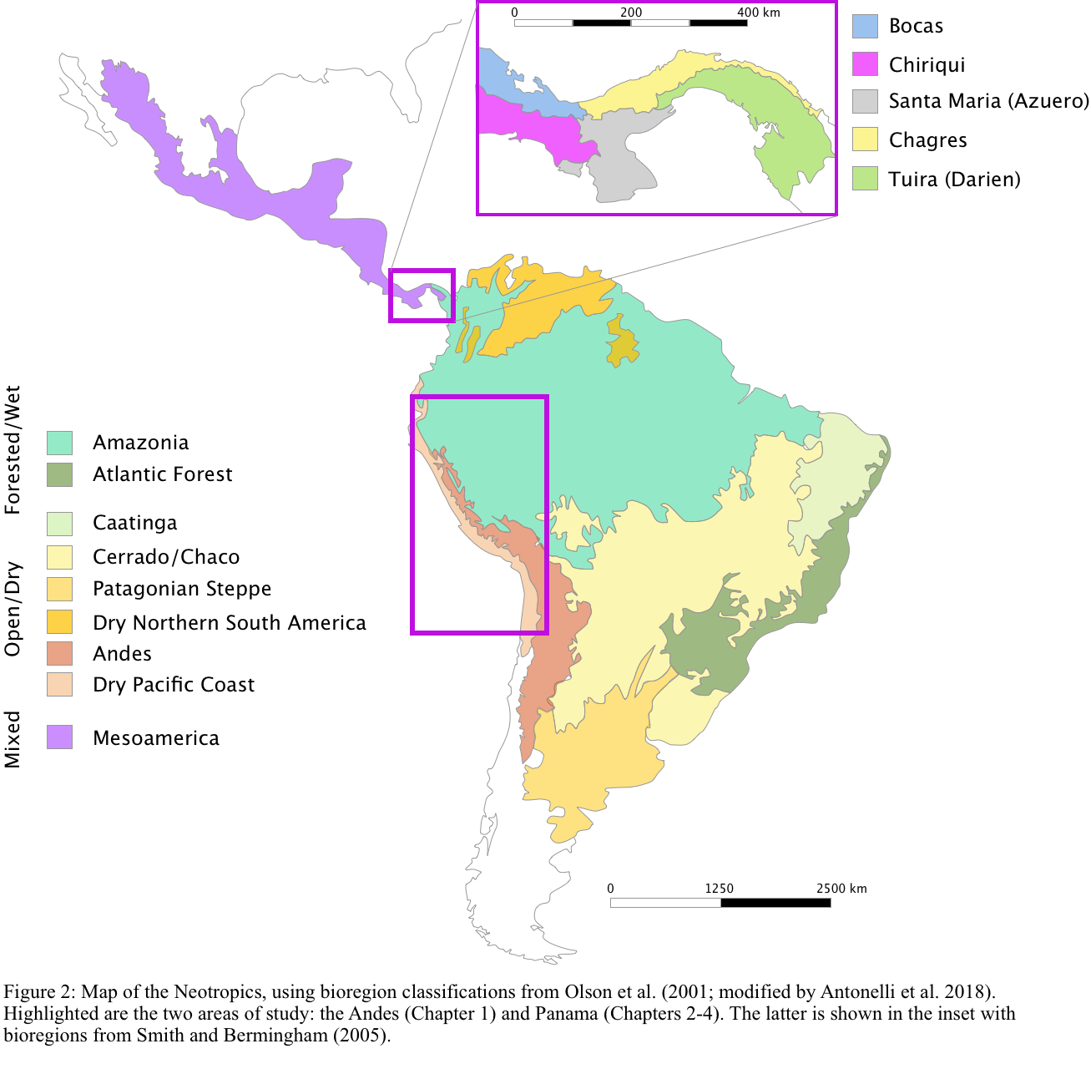
Figure I.1: Map of the Neotropics, using bioregion classifications from Olson et al. (2001; modified by Antonelli et al. 2018). Highlighted are my two areas of study: Panama (Chapters 1 and 2), shown in the inset with bioregions defined by Smith and Bermingham (2005); and the Andes (Chapter 3).

Chapter 1: Comparative phylogeography reveals widespread cryptic diversity driven by ecology in Panamanian birds
Jessica F. McLaughlin^{1,2,3}, Celestino Aguilar^{4,5}, Justin Bernstein⁷, Wayra G. Navia-Gine⁴, Luis E. Cueto-Aparicio¹, Ashleigh C. Alarcon¹, Brandon D. Alarcon¹, Rugger Collier¹, Anshule Takyar¹, Sidney J. Vong¹, Oscar G. López-Chong⁴, Robert Driver⁸, Jose R. Loaiza⁵, Luis De Leon^{4,5,6}, Kristin Saltonstall⁴, Sara Lipshutz⁹, Dahiana Arcila^{1,2}, Kinsey M. Brock³, and Matthew J. Miller^{1,2,4,10}

¹Department of Biology, University of Oklahoma, Norman, OK, USA
²Sam Noble Oklahoma Museum of Natural History Norman, OK, USA
³Department of Environmental Science, Policy, and Management, University of California Berkeley, Berkeley, CA, USA.
⁴ Smithsonian Tropical Research Institute, Panama City, Panama
⁵ Centre of Biodiversity. INDICASAT-AIP, Panama City, Panama
⁶Department of Biology, University of Massachusetts Boston, Boston, MA, USA
⁷Department of Biological Sciences, Rutgers University-Newark, Newark, NJ, USA
⁸Department of Biology, East Carolina University, Greenville, NC, USA
⁹Department of Biology, Loyola University, Chicago, IL, USA
¹⁰University of Alaska Museum, Fairbanks, AK, USA

Author Contributions

JFM and MJM conceived the study, based on the barcoding efforts initiated by MJM, KS, LDL, and OLC and with input from SL, RD, and JRL. JFM wrote the initial draft with input from MJM and drew all figures. All authors then contributed to later drafts. Sequencing was carried out by CA, WGN-G, Data processing and analysis was conducted by JFM, LCA, AA, BA, RC, AT, SJV, JB, KMB and MJM. Original illustrations created by JFM.

Abstract

Identifying cryptic species is important for conservation, and can also provide insights into the speciation process as they often represent phenotypically similar sister taxa that are of particular interest in studying the early stages of speciation. Here we identify potential cryptic species of Panamanian birds based on a comprehensive database of COI DNA barcodes from 2,333 birds from 429 species across Panama, representing 391 (59%) of the 659 resident landbird population of the country, as well as opportunistically sampled waterbirds. We then expanded this dataset using whole mitochondrial genomes from 20 taxa (species or species-complexes), allowing us to then supplement these data with publicly available mitochondrial sequences from other loci such as ND2 and cytochrome b, increasing our genetic sampling across Panama. Using BINS, which is a numerical taxonomic system that provides an unbiased estimate of potential species-level diversity, we find multiple mitochondrial barcode identification numbers (BINs), likely representing cryptic species, in 19% of landbird species with widespread geographic sampling, highlighting the hidden diversity in even the relatively well-described avifauna of Panama. While some of these splits corresponded with recognized geographic features, such as the Cordillera Central, that have served to isolate populations, the majority (74%) of lowland splits were between eastern and western populations. Timing of these splits did not coincide, making historical landscape change associated with the formation of the Isthmus of Panama or with potential habitat contraction during Pleistocene climatic cycles unlikely as the primary driver of diversification. However, strong trends in ecological characteristics were observed in species with mitochondrial splits, with forest species, understory species, insectivores, and strongly territorial species all more likely to have multiple BINs in Panama. Additionally, hand-wing index, a proxy for dispersal capability, was significantly lower in species with multiple BINs. Together these suggest that dispersal ability plays an important role in generating diversity in the Neotropical avifauna, and underscores the need for studies of the evolution of tropical bird communities to take ecological factors into account along with geographic explanations, as dispersal ability alone may drive differentiation even in the absence of obvious landscape barriers.

Introduction

A key part in understanding the development of biodiversity in a given region is simply knowing how many species occur there (Bickford et al. 2007; Allendorf and Luikart 2009; Pérez-Ponce de León and Nadler 2010). However, this is not always an easy task. Cryptic species, reproductively isolated and distinct taxa that are nevertheless not recognized as distinct species, are a well-known issue in both evolutionary (Bickford et al. 2007; Struck et al. 2018) and conservation biology (Fouquet et al. 2007; Crawford et al. 2013; Yan et al. 2018; Chenuil et al. 2019; Levy and Cox 2020). From a conservation perspective, it is rather intuitive that it is difficult to make decisions that protect an area’s biodiversity without accurately defining it (Bickford et al. 2007; Fouquet et al. 2007; Trontelj and Fišer 2009; Funk, Caminer, and Ron 2012). Also important, however, is how the occurrence of cryptic species may illuminate the evolutionary processes that generate this biodiversity (Campbell, Braile, and Winker 2016; Bickford et al. 2007; Struck et al. 2018). While cryptic species are often framed as an issue of not describing and cataloging variation (Pérez-Ponce de León and Nadler 2010; Korshunova et al. 2017), it is also worth considering them from the perspective of why some species diversify without being easily identifiable as distinct entities (Roux et al. 2016; Pulido-Santacruz, Aleixo, and Weir 2018). From this frame of reference, the question becomes less one of lack of thorough biodiversity survey effort, but one of what factors, such as geographical, historical, ecological, or any of the above in combination, are actually driving the generation of such variation (Bickford et al. 2007; Struck et al. 2018). This can then provide valuable insights into the mechanisms of speciation and diversification, informing not just conservation decision-making but also the study of evolutionary processes (Bickford et al. 2007; Saitoh et al. 2015; Campbell, Braile, and Winker 2016; Struck et al. 2018).

The Neotropics are home to incredible avian species diversity, with around 1 in 4 global bird species found in the region (Haffer 1985; Orme et al. 2005). However, despite that stunning richness, it is likely that even this is an underestimate (Tavares et al. 2011; Milá et al. 2012; Rheindt, Cuervo, and Brumfield 2013; Mendoza et al. 2016), as studies frequently find unrecognized species-level diversity within recognized species. This is particularly the case in “widespread” species, where closer examination often indicates that taxa reveal widespread variation characteristic not of single species but species complexes, such as Cantorchilus wrens (González et al. 2003), trogons (DaCosta and Klicka 2008), Cyanocompsa grosbeaks (Bryson et al. 2014), Mionectes (Miller et al. 2008) and Zimmerius flycatchers (Rheindt, Cuervo, and Brumfield 2013), Lepidothrix (Cheviron, Hackett, and Capparella 2005) and Manacus (Brumfield et al. 2008) manakins, Habia ant-tanagers (Lavinia et al. 2015; Ramírez-Barrera et al. 2018, 2019), Pachyramphus becards (Musher and Cracraft 2018), Malacoptila puffbirds (Ferreira et al. 2017), Arremon brush-finches (Cadena, Klicka, and Ricklefs 2007; Navarro-Sigüenza et al. 2008; Cadena and Cuervo 2010) and Phaeothlypis wood-warblers (Lovette 2004). Not only does this widespread underestimation of avian biodiversity across the Neotropics have practical implications for conservation (Bickford et al. 2007; Allendorf and Luikart 2009; Valentini, Pompanon, and Taberlet 2009; Lohman et al. 2010; Funk, Caminer, and Ron 2012; Crawford et al. 2013; Gonçalves et al. 2015; Mendoza et al. 2016), it also hampers our understanding of the evolutionary processes and biogeographic factors that have made the Neotropics such an engine of species diversification (Bickford et al. 2007). While there is some risk that the search for cryptic species may lead to oversplitting and taxonomic inflation which hamper our understanding of the evolutionary processes at play (Chaitra, Vasudevan, and Shanker 2004; Isaac, Mallet, and Mace 2004; Hundsdoerfer et al. 2019; Chan et al. 2020), the evidence in birds specifically suggests that the error is far more likely in the direction of underestimation (Sangster 2009; Barrowclough et al. 2016), and even if such taxa may not represent fully-fledged species in their own right, they still provide insight into the processes at play by providing examples of other potential outcomes.

Mitochondrial barcoding provides us with a powerful tool to further detect potential cryptic species (Arnot, Roper, and Bayoumi 1993; Floyd et al. 2002; Hebert, Ratnasingham, and deWaard 2003; Hebert and Gregory 2005; Kerr et al. 2009; Valentini, Pompanon, and Taberlet 2009; Milá et al. 2012). Previous efforts using mitochondrial markers have documented cryptic variation in multiple Panamanian birds (González et al. 2003; Miller et al. 2011; Bryson et al. 2014; Loaiza et al. 2016; Lopez et al. 2016). However, as useful as single-taxon studies are, they provide only snapshots into patterns of phylogeographic diversity of Panamanian birds. Mitochondrial barcoding, with its relative ease and low cost, provides a simple but powerful tool to build large scale comparative datasets (Kerr et al. 2007, 2009; Mendoza et al. 2016), using a single locus present in a wide range of taxa (Bronstein, Kroh, and Haring 2018). With such datasets, we can better estimate the occurrence of cryptic species in Panama, which in turn allows us to better document the avian diversity of the region.

Large-scale barcoding allows us to do more than simply catalog previous undescribed diversity. It allows us to investigate whether there are patterns in where such turnovers occur geographically (e.g., such as corresponding with known suture zones in other taxa) and what patterns of ecological factors are more common in taxa with cryptic variation (Bickford et al. 2007; Struck et al. 2018). Mitochondrial barcodes, while only a portion of the genome and thus only a window into a narrow portion of the evolutionary history, can be a powerful tool for this scale of study, allowing for the assembly of datasets with far more individuals than with multi-locus studies and by their relatively well understood rates of molecular change compared with other potential loci (Mendoza et al. 2016; Barreira, Lijtmaer, and Tubaro 2016). Again, the vast biodiversity of the Neotropics raises multiple questions that we can empirically test with large comparative phylogeographic datasets (Kerr et al. 2009; Tavares et al. 2011; Miller et al. 2021). Hypotheses on the origin of Neotropical diversity tend to fall into a few broad groups. First, there are biogeographic explanations that emphasize how the geologic and environmental history of the landscape itself have repeatedly created isolated populations that lead to diversification (Sick 1967; Haffer 1969, 1985, 1997; Bush 1994; Sedano and Burns 2010; Smith et al. 2014; Ferreira et al. 2017). In Panama, these are further grouped into those emphasizing the process of the formation of the Isthmus of Panama (DaCosta and Klicka 2008; Smith and Klicka 2010; Leigh, O’Dea, and Vermeij 2014), and those emphasizing paleoclimatic fluctuations driving a changing mosaic of forest and savannah (Smith, Amei, and Klicka 2012). Secondly, there are explanations which focus on the role of ecological assemblages driving competition and diversification, with the profusion of niches driving the diversification of species to fill them (Klopfer and MacArthur 1960, 1961; Emerson and Kolm 2005; Brown 2014; Moles and Ollerton 2016). While overall, both likely play roles in generating tropical biodiversity (Bush 1994; Smith et al. 2014), the question of which prevail in a given region and at finer scales remains unclear.

With widespread DNA barcoding, we can test hypotheses which fall under both of these categories. The Panamanian region is a topographically and ecologically diverse region, especially considering its small size (Ridgely and Gwynne 1992; Siegel and Olson 2008; Angehr and Dean 2010). With multiple islands and disjunct highlands (Figure 1.1A), we may expect that these will be home to a disproportionate number of cryptic species, as has been found elsewhere (Saitoh et al. 2015; Campbell, Braile, and Winker 2016). Both these populations and the more continuously distributed lowland taxa may also have been subject to historic isolation, especially by dispersal and then isolation prior to the final closure of the Isthmus of Panama approximately 2.7 to 4.2 million years ago (Leigh, O’Dea, and Vermeij 2014; O’Dea et al. 2016; Jaramillo et al. 2017), or by possible expansion of savannah habitats and formation of forest refugia during the Pleistocene (Smith, Amei, and Klicka 2012). In particular, lowland Panama has been recognized as a hotspot for species turnover- replacement of a given taxa with a sister taxa- in birds (Miller, Bermingham, and Ricklefs 2007; Miller et al. 2011; Loaiza et al. 2016; Lopez et al. 2016; McLaughlin, Garzón, et al. 2020), as well as in freshwater fish (Bermingham and Martin 1998; Martin and Bermingham 2000; Perdices et al. 2002; Smith and Bermingham 2005; Bagley and Johnson 2014), mammals (Cortés-Ortiz et al. 2003), herpetofauna (Crawford 2003; Crawford and Smith 2005; Bagley and Johnson 2014), insects (Bagley and Johnson 2014; Eskildsen et al. 2018), and plants (Dick, Abdul-Salim, and Bermingham 2003).We can investigate if this is an important factor in generating avian diversity by testing if breaks are broadly coincident in time (Naka and Brumfield 2018). Beyond biogeographic explanations, our diverse sampling (Figure 1.2) allows us to investigate whether specific ecological traits, such as habitat preference (Zhang et al. 2012; Berner and Thibert-Plante 2015; Harvey et al. 2017), dispersal ability (Claramunt et al. 2012; Weeks and Claramunt 2014; Crouch et al. 2019), territoriality (Tobias et al. 2016), and diet (Sheard et al. 2020; Miller et al. 2021) are overrepresented among taxa with mitochondrial splits.

We set out to investigate the connections between geography, ecology, and the occurrence of cryptic phylogeographic variation with a multifaceted mitochondrial dataset. First, we barcoded 429 species of birds, including 391 landbird species, which represents 59% of the documented 659 resident landbirds in the country. This allowed us to estimate the occurrence of mitochondrial breaks in the Panamanian avifauna, and to identify if certain ecological or phylogenetic patterns predicted the likelihood of such breaks. We found that specific ecological traits, including dispersal ability, territoriality, diet, and habitat, were significantly over-represented in taxa with mitochondrial breaks, suggesting these may strongly contribute to the diversification of Neotropical birds.

Materials and Methods

COI barcode survey of Panamanian birds

We developed a COI barcode dataset of 2333 birds from across Panama in 429 (as defined in the original taxon dataset from BOLD; Angehr and Dean 2010 define 484 by splitting several taxa that are not in the taxonomy used in BOLD) species as part of sequencing for the Barcode of Life Database (BOLD; Ratnasingham and Hebert 2007, 2013). The majority of these birds were sequenced through the Smithsonian Institution (SI)’s Barcode of Life initiative which provided funds for barcoding sequencing at the National Museum of Natural History (Schindel et al. 2011) and the Smithsonian Tropical Research Institute (original data presented here). With a few exceptions, every sequence in the SI barcoding datasets is represented by a museum voucher specimen (Table A1.1).

We determined whether a species had mitochondrial splits by using the barcode index number (BIN; (Ratnasingham and Hebert 2013) as implemented in BOLD (Ratnasingham and Hebert 2007). In brief, this numerical taxonomy method uses the mitochondrial barcode gap to define distinct units of evolutionary diversity, which are frequently used as indication of potential cryptic speciation (Ratnasingham and Hebert 2013). Mitochondrial COI sequences are aligned and then clustered, with individuals that are more than twice the distance of divergence within a cluster being taken as the start of a new cluster, followed by use of a Markovian analysis to refine clusters (Ratnasingham and Hebert 2013). Key benefits of this method are in the ease and low-cost of the method (Tavares et al. 2011; Milá et al. 2012), and the general relatively high reliability in assigning individuals to species in past studies (Yoo et al. 2006; Kerr et al. 2007). It does carry the standard limitations of any single-marker method of evaluating diversity, namely that a single locus may not be reflective of the total evolutionary history of a taxon. However, mitochondrial studies are still valuable where large-scale nuclear sequencing is not feasible, and are useful in determining where to focus with more in-depth sequencing efforts (see Chapter 2).

Improving geographic coverage through mitogenomic haplotyping

While covering over 2000 birds, our COI database does not fully capture available data on the distribution of mitochondrial diversity and structure in Panamanian birds that is available either as part of previously published studies, (e.g., Miller et al. 2010; Smith et al. 2014; Miller et al. 2021), or from our group’s unpublished non-COI mtDNA datasets. Because mitochondrial DNA is non-recombining, whole mitochondrial genomes can “connect” disparate mtDNA datasets into congruent haplogroups, functioning as a “Rosetta Stone” to leverage multiple mitochondrial loci into a large common dataset. For 20 bird taxa identified with distinct COI BINs in Panama that had whole genome data available, we mined whole mitogenomes from genomic datasets (e.g., do Amaral et al. 2015). We then harvested 215 additional mitochondrial sequences, including ND2, cytB, ND3, ATPase 8, and ATPase6, from NCBI (Table 1.1; details by individual in Table A1.1), increasing sampling density across Panama.

Mitogenome assembly, annotation, and analysis

As part of several long-term projects on the comparative genomics of Panamanian lowlands, we filtered mtDNA reads from whole genome shotgun sequencing for the above 20 taxa of resident lowland birds sampled in western (Bocas del Toro) and eastern (Darién) Panama. We sequenced two individuals from each of those populations, preparing genomic libraries with the NEB Ultra II protocol and sequencing them on an Illumina NovaSeq. We then used bbduk, a utility within the bbmap program (Bushnell 2014), to trim and perform initial quality control on reads.

Assembly of one individual per population was performed using NovoPlasty v. 3.4 (Dierckxsens, Mardulyn, and Smits 2017), using either COI or ND2 as the seed, depending on availability. In some individuals with a high number of reads, we subsampled the initial reads with BBSplit, a part of the BBMap package (Bushnell 2014), to increase computational efficiency by only including putative mitochondrial reads in our assembly inputs. Mitogenomes were then aligned and annotated with MitoAnnotator (Iwasaki et al. 2013), from which we calculated the pairwise K2P genetic distance for each of the protein-coding genes between eastern and western populations.

Generating trees

In order to determine as best as possible where mitochondrial breaks occur, we generated locus-specific sequence alignments of available mitochondrial sequences for the 34 taxa which had mitochondrial breaks. Sequences were downloaded from the BOLD and NCBI databases (Table A1.1). We then generated MUSCLE alignments (Edgar 2004) in MEGA7 (Kumar, Stecher, and Tamura 2016), using these to build neighbor-joining trees in PAUP* (Swofford 2001) or MEGA (Kumar, Stecher, and Tamura 2016) and ML trees in RAxML (Stamatakis 2014) using with the GTR substitution model with Lewis ascertainment bias correction for 100 bootstrap replicates. For the 21 taxa with multiple mitochondrial loci available (Table 1.1), the BOLD barcodes were used to define groups, and then additional individual sequences were aligned to the whole mitochondrial genomes for that taxon, which had already been assigned to BINs, and haplotyped accordingly.

Testing predictors of mitochondrial divergence
In order to test how ecological factors such as habitat openness, forest stratum, diet, and elevational distribution influenced the likelihood of mitochondrial splits, we compiled and scored these data for all 659 resident, breeding landbirds of Panama, using species accounts from The Handbook of the Birds of the World Online (Billerman et al. 2020) supplemented as needed from individual species accounts in Angehr and Dean (2010), Ridgely and Gwynne (1992), Stotz et al. (1996), and Wetmore (1965, 1968, 1972; 1984). Habitat was scored as forest, edge, or open (Figure 1.5C). Stratum was scored as ground (primarily terrestrial foraging, and/or prefers walking to flying), understory (forages primarily in undergrowth or directly above ground), midstory (primarily found in middle strata of forest, up to subcanopy), canopy (primarily found in the subcanopy and above), and aerial (forages above the forest canopy; almost exclusively swifts and swallows). We also included data on territoriality, hand-wing index (HWI), body size, and annual precipitation in range sourced from Sheard et al (2020). Finally, we identified whether each species had been sampled across multiple geographic regions of Panama (Figure 1.1A), to determine if sampling was geographically sufficient to actually identify variation across the region.

First, we tested for sampling biases in these three categories, comparing the total list and sampled subset by chi-squared tests to check if our 429 sampled taxa reflected the distribution of the above traits within the total Panamanian avifauna. Then we tested for whether those taxa which had been sampled across multiple geographic regions of Panama (Figure 1.1A) were likewise representative of the total Panamanian avifauna. Taxa were considered widespread enough for inclusion in these tests if they occurred in two or more of the defined geographic regions of Panama (Figure 1.1A), which yielded a total of 181 species.

Within the 181 species in our overall sample which had been widely sampled across Panama based on the above criteria, we then tested whether certain geographic, ecological, and morphological traits were over- or under-represented in species with two or more mitochondrial BINs. For each of the above traits (stratum, territoriality, diet, habitat, HWI, body size, and annual precipitation), we tested using either a chi-squared test or student’s t-test whether there were significant differences in the representation of traits between split and non-split taxa.

Testing timing of splits
To see whether splits were coincident in time, and thus likely to have been driven by the same biogeographic events, we estimated divergence time in BEAST v. 2.6.2 (Bouckaert et al. 2014) as implemented on CIPRES (Miller, Pfeiffer, and Schwartz 2011), for all COI barcodes, trimmed to no missing data. We used a strict clock rate of 1.8 % divergence per million years (Lavinia et al. 2016), gamma site model with JC69 substitution model, and five fossil calibration points (Table A1.3). We ran this model for 4 billion generations, sampling every 10,000 generations, and visualized results in Tracer v. 1.7.1 (Rambaut et al. 2018). We calculated the mean divergence time for each taxon using the rate of 1.8% divergence per million years previously found for avian COI (Lavinia et al. 2016), and compared this with the BEAST estimated means, and along with the 95% confidence intervals constructed in the latter, used them to establish whether divergence times were broadly coincident.

Results

Barcoding and data collection

We successfully barcoded 2,333 individuals from 429 species across Panama, 391 of which were resident landbird species. This sample was fairly representative of the general Panamanian avifauna, as similar proportions of highland and lowland birds were present in the whole as in our sample (𝜒² = 0, df= 1, p= 1) as well as similar proportions by diet (𝜒²=13.343, df= 9, p=0.148) and habitat (𝜒²=6.18, df= 3, p=0.103; Table 2). Of these 429 species, 181 were sampled across two or more geographic regions (Figure 1.1A) and were likewise representative of the whole population of resident landbirds (Table 2).

Thirty-four of these 181 taxa had more than 1 mitochondrial BIN, represented by a total of 419 individuals barcoded in BOLD. We then increased this to a total of 634 individuals by adding 215 additional sequences from NCBI (Table A1.1). Twenty-one species were able to be supplemented by this method, but the remainder did not have the required samples of both whole mitochondrial genomes to allow the building of a multi-locus data transect.

Mitochondrial splits

We characterized the geography of the thirty-four taxa with multiple BINs, plus two waterbirds (Laterallus albigularis and Jacana spinosa) not included in the prediction testing due to overall low sampling of waterbirds (Figure 1.3). Among landbirds, splits, as defined by BOLD’s barcode gap method (Ratnasingham and Hebert 2007) were observed in 20 families of the 37 widely sampled families (Figure 1.2), or 33% of the 61 resident landbird families documented in Panama. Seven taxa, all lowland, had three BINs in Panama (Figure 1.3). Overall, we found 41 splits across 34 landbird species, out of the 181 taxa with sufficient sampling across multiple geographic regions.

Geographically, we observed two primary patterns in the distribution of splits (Figure 1.3). The first, observed in seven species, was a break between southwest Panama, in particular the Burica peninsula (Chiriquí province) (Figure 1.1A), and the rest of Panama. This pattern was restricted to lowland taxa. The second primary pattern was one of splits between eastern and western Panama, observed in 35 splits (Figure 1.3). This included both highland taxa (4 splits) and lowland (31 splits). In highland taxa, these splits were between the Cordillera Central and the highland areas of the east. However, in lowland taxa, there were two general clusters of regions of rapid geographic replacement of BINs across multiple taxa. The first, involving 15 splits (48% of lowland taxa with east-west splits), was along the Caribbean versant in Veraguas province, extending into Colón province in some cases (Figure 1.1B). The second, involving seven splits, was roughly located along the border of Darién and Panama provinces (Figure 1.1B). Three lowland splits were in central Panama (Figure 1.4), and an additional three, while representing distinct BINs in extreme eastern and western Panama, lacked samples from between these that would allow us to locate the precise area of turnover (Figure 1.4). One predicted geographic pattern that was not observed was differentiation of island and mainland taxa, despite island samples being included in most species and preferentially including those taxa thought to include such distinct island groups (Table A1.1)

Prediction testing

While our overall dataset of 181 species may have been ecologically and geographically representative of resident landbird taxa (Table 1.2), there were marked differences for many of these in species where splits were observed. While insectivores made up 47% of non-split species, they accounted for significantly more (68%) of species with splits (𝜒²=17.27, df= 7, p=0.016; Figure 1.4B). Forest birds, while comprising the majority of non-split species, at 62%, had even greater representation among the split species, at 85% (𝜒²=6.488, df= 2, p=0.039; Figure 1.4C). When considering habitat stratum, we found that while on non-split species were evenly distributed throughout strata, with only 40% being classed as understory residents, in split taxa understory birds were the overwhelming majority, at 74% of species (𝜒²=14.04, df= 4, p=0.0072; Figure 1.4C). Hand-wing index (HWI) was significantly (t= -5.52, df- 154.29, p=1.43 × 10⁻⁷) lower in split species (Figure 1.4A). Finally, split taxa were far more likely to be strongly territorial, with 62% of split taxa versus 35% of non-split (𝜒²=12.038, df= 2, p=0.0024; Figure 1.4D).

Some traits, however, were represented at similar proportions in both split and non-split species (Table A1.2). Highland taxa were in both cases a minority of species, at 11% of non-split and 12% of split species (𝜒²=4.10 × 10⁻²⁹, df= 1, p=1). Annual precipitation was similar for both, at 2209 mm/yr in split and 2179 mm/yr in non-split (t= 0.28, df= 48.22, p=0.78). Finally, scaled body size was largely similar, with non-split species being very slightly larger, but not significantly so (t= 0, df=292, p=1).

Timing of splits
Depths of splits varied considerably. Pairwise differences in COI ranged from 1.24% to 8.49% for those defined as having multiple BINs by BOLD. Median pairwise divergence was 3.31%. These are equivalent to between 689 kya and 4.71 mya (Figure 1.5), with a median of 1.84 mya, using the rate of 1.8% divergence every million years observed for avian COI (Lavinia et al. 2016). The majority of the splits post-date the typical estimate of the formation of the Isthmus of Panama approximately 3 mya (Leigh, O’Dea, and Vermeij 2014). However, many of the dates are concentrated between one and three mya (Figure 1.5), which while contrary to assertions of a fully formed isthmus during the Pliocene, are congruent with more recent descriptions of this process being a gradual emergence of land (O’Dea et al. 2016). However, as our confidence intervals were frequently very wide (Figure 1.5), we cannot draw definitive conclusions about the role of the formation of the Isthmus in the broader patterns we see, instead focusing on the ecological factors above.

Discussion

Despite its small size, Panama is nevertheless home to remarkable avian diversity, with 1,000 currently recognized species occurring in the region (Wetmore 1965, 1968, 1972; Wetmore, Pasquier, and Olson 1984; Ridgely and Gwynne 1992; Angehr and Dean 2010). While some of this is likely due to its position as a literal bridge between North and South America (DaCosta and Klicka 2008; Smith and Klicka 2010; Leigh, O’Dea, and Vermeij 2014), the region itself plays an important role in generating biodiversity. The diverse elevational and climatic range of habitats across the isthmus provide opportunity for endemism (Stiles 1983; Barrantes 2009; Chavarría-Pizarro et al. 2010; Batista et al. 2020), but this alone may not be the only driving force behind avian diversity. Consistent with other recent work in the region (Miller et al. 2021), we find support for ecological factors strongly associated with cryptic diversity in lowland Panama in particular, emphasizing the need to look beyond biogeographic drivers of Neotropical biodiversity.

In this study, we find that the frequency of cryptic diversity in Panamanian resident landbirds is 18.8% (Table 1.2). This is higher than estimates from similar barcoding efforts, including the 2.7% of North American birds (Kerr et al. 2007), 11% of Korean birds (Yoo et al. 2006), 7.5% of Palearctic birds (Kerr et al. 2009), 3.3% of Argentinian birds (Kerr et al. 2009), and 3.6% of South American birds more generally (Tavares et al. 2011), although though due to variations in study designs, some caution is needed in directly comparing these without controlling for differences in sample size, taxonomic biases, and similar potential sources of variation between studies. The studies which found higher incidence of potential cryptic diversity tended to focus on narrow subsets of birds that may be particularly predisposed towards splits. For example, Milá et al. (2012) found evidence of interspecific-level variation within 33 of 40 forest understory birds in the Amazon, a habitat profile that we find to be significantly overrepresented in lineage with potential cryptic species in our study. However, many barcoding studies have tended to focus on large-scale questions of overall divergence, rather than explicitly examining whether specific ecological traits were over- or under-represented in taxa with potential splits (Yoo et al. 2006; Kerr et al. 2007, 2009; Kerr et al. 2009; Tavares et al. 2011).

Geographical patterns of cryptic diversity

We sampled widely across Panama and were able to test for the existence of several biogeographic patterns in cryptic diversity that have been previously proposed (Wetmore 1959; Summers et al. 1997; Anderson and Handley 2001; Miller et al. 2011; Kaviar, Shockey, and Sundberg 2012; Miller et al. 2015). Many of the taxa included samples from the various islands of Panama, including Isla Coiba in the Pacific and the Caribbean islands of San Cristobal, Bastimentos, Cayo Agua, and Escudo de Veraguas. Islands are a natural focus of investigation for undescribed biodiversity, and previous studies have found evidence for island endemics in both birds and other taxa in Panama (Summers et al. 1997; Anderson and Handley 2001; Kaviar, Shockey, and Sundberg 2012). Escudo, for example, has had four of its eight to ten resident breeding birds described as endemic subspecies (Wetmore 1959). The Escudo hummingbird (Amazilia (tzacatl) handleyi) is both phenotypically and genetically distinct from mainland populations (Miller et al. 2011) and is treated as a separate species by some (Wetmore 1968; Angehr and Dean 2010). However, it has also been observed that the islands of Panama, particularly in Bocas del Toro, are relatively close to the mainland (approximately 15 km for the furthest islands of Bocas del Toro, 20 km to Isla Escudo, and 25 km to Isla Coiba), and are likely to have been connected to it repeatedly due to Pleistocene sea level fluctuations (Miller et al. 2011). Escudo itself, as the furthest of the Caribbean islands, is estimated to have become isolated only around 9000 years ago (Summers et al. 1997; Miller et al. 2011). This lowers the probability of the development of distinctive island endemics (MacArthur and Wilson 2001; Mayr 1965). The majority of the island avifauna are also found on the mainland (Wetmore 1965, 1968, 1972; Wetmore, Pasquier, and Olson 1984; Ridgely and Gwynne 1989; Angehr and Dean 2010), suggesting that there has been a high degree of connectivity between them over time. Our findings are consistent with this, as only one taxon, Setophaga petechia, had a distinctive BIN on Isla Coiba, but this was likely an individual of the migratory subspecies rather than the resident, as both occur in Panama. While islands may be the source of haplotype diversity in some taxa (González et al. 2003), they are not sufficiently diverged to be split under the BIN system.

Another area with likely unrecognized diversity is the Pacific coast of Chiriquí, particularly the Burica Peninsula (Figure 1.1A). This region, separated from most of the rest of Panama by the Cordillera Central, receives markedly less precipitation than the rest of the country (Wetmore 1965), and is thus home to much more xeric ecosystems than the parts of the country subject to heavier rains from the Caribbean side (Blanco et al. 2013). In this case, we did find support for this region being a hotspot of unrecognized avian diversity, with six splits of the 41 being located in this relatively small area (Figure 1.3).

The final geographic pattern we observed, and by far the most common, was repeated differentiation between eastern and western Panama. These splits could be further subdivided into three general patterns: disjunct highland populations from the Cordillera Central and the highlands of eastern Panama, a suture zone in the Caribbean versant of Veraguas and Colón, and a second suture zone in Darién (Figure 1.1B).

The four highland splits are all between the two main highland regions of Panama (Figure 1.4). The predominant east-west split is consistent with the numerous species-pairs previously observed to follow this pattern (Wetmore 1965, 1968, 1972; Wetmore, Pasquier, and Olson 1984; Ridgely and Gwynne 1992; Angehr and Dean 2010). Likewise, the Azuero Peninsula has been previously noted for several potential endemic species (Miller et al. 2015). However, across our overall dataset, highland splits are very much in the minority of those observed, making up only 14.7% of splits.

This disproportionate representation of the lowlands in the taxa with cryptic species-level variation bears further examination. It is possible that this is an artifact of efforts to locate potential cryptic species tending to focus on taxa with disjunct ranges, so that most of the highland splits of equivalent depth to those we find in this study are more likely to already have been found and classified as separate species. Overall, few highland taxa met our geographic sampling criteria, representing only 15.1% of widely distributed species and 11.5% of those barcoded across multiple geographic regions when they make up more than 30% of the total avifauna (Table 1.2), lending some support to the hypothesis that this is potential due to bias in prior taxonomic description of variation. But while this may go some way towards explaining the discrepancy in the rates of splits in lowland and highland taxa, it does not explain what may generate that lowland variation in the first place.

Many of Panama’s lowland bird species are continuously distributed (Wetmore 1965, 1968, 1972; Wetmore, Pasquier, and Olson 1984; Ridgely and Gwynne 1992; Angehr and Dean 2010), unlike the largely disjunct ranges of highland species. This may not have historically been the case, though, as Pleistocene climate variation may have caused ranges to contract (Haffer 1969; Moritz et al. 2000; Weir, Bermingham, and Schluter 2009; Smith, Amei, and Klicka 2012; Lavinia et al. 2015). Most of the split bird species (85%) are forest birds (Table 1.2), and the increased aridity of the Pleistocene is thought to have caused widespread advancement of savannah into formerly forested areas throughout the tropics (Haffer 1985; Webb 1991) Thus, currently continuously distributed species may have not always been connected, and this climatic history may have driven the diversification of taxa across Panama. But it is unclear the extent to which forests actually contracted in Panama throughout the Pleistocene (Bush and Colinvaux 1990; Colinvaux, De Oliveira, and Bush 2000), and we find little support for the observed splits dating to even roughly similar time periods (Table 1.1). Clearly, while Panama’s diverse landscape has played a role in generating its rich avian diversity, simple biogeographic and historic factors alone cannot explain this high rate of cryptic variation and mitochondrial turnover in lowland Panamanian birds.

The lack of strongly convergent timing in the split species (Figure 1.5) casts further doubt on simple biogeographic models. Previous work in Panama and lower Central America (LCA) more broadly has focused on the timing of the emergence of the isthmus (Smith and Klicka 2010), and in the resulting biotic interchange between North and South America (DaCosta and Klicka 2008; Weir, Bermingham, and Schluter 2009). However, it is unlikely that dispersal following the formation of the isthmus is responsible for the patterns of turnovers we see in our taxa. Our oldest splits (~4 mya) predate the 3 mya date generally accepted for the formation of the isthmus (Leigh, O’Dea, and Vermeij 2014), while the youngest (< 1 mya) are well after this time. However, a more gradual emergence of the isthmus would possibly better explain some of the splits (O’Dea et al. 2016). In particular, we find a group of splits in the Veraguas/Colón suture zone around the Pleistocene-Pliocene boundary (Figure 1.5), which line up with a potential episode of seawater breaching the newly formed isthmus approximately 2.45 mya (Groeneveld et al. 2014; O’Dea et al. 2016). While overall our dates do not support a scenario of dispersal prior to the formation of the isthmus, followed in most lowland cases by secondary contact, a more gradual process in which a changing landscape of newly emerged land acted as a tenuous bridge for dispersal over a longer period may be likely.

Ecological predictors of mitochondrial turnover

If biogeographic explanations alone cannot explain the generation of diversity in lowland Panamanian birds, what does? Our results highlight that ecological traits alone have the potential to drive divergence, even in a landscape that has historically lacked obvious barriers to dispersal (Bush and Colinvaux 1990). The landscape alone is not the only potential source of dispersal barriers, and we find evidence that limitations to dispersal from traits such as habitat use, diet, and morphology can be effective in generating diversity. We found that the majority of taxa with mitochondrial splits in Panama disproportionately shared specific ecological traits. Insectivores (68% of sampled taxa with splits vs. 47% non-split taxa), forest birds (85% vs 62%), understory foragers (74% vs 40%), and strongly territorial species (62% vs. 35%) were all overrepresented in lineages with mitochondrial turnover (Figure 1.4).

A potential explanation for at least some of these factors, particularly habitat and stratum use, is that they are more likely to have undescribed avian diversity not because they are more likely to create diversity, but simply that denser habitats would make it more difficult for human observers to observe and document any differences. Therefore, we must consider the possibility that the apparent overabundance of cryptic types in understory forest birds is in fact a relative scarcity of human observations. Detectability has real ramifications for studying some groups, as has been covered particularly in the context of conservation (Clark and May 2002; Ducatez and Lefebvre 2014; McKenzie and Robertson 2015; Smith et al. 2020). This can also extend to taxonomic considerations, as more easily observed and “charismatic” organisms have been shown to be more likely to be oversplit (Pillon and Chase 2007). However, this does not explain all of the observed relationships, and the overall well-described nature of the Panamanian avifauna make it less likely than elsewhere in the Neotropics (Angehr and Dean 2010; Ridgely and Gwynne 1992; Wetmore 1965, 1968, 1972; Wetmore, Pasquier, and Olson 1984), and many splits within inconspicuous understory birds have been previously described (e.g., Saucier, Sánchez, and Carling 2015).

The traits observed to have a strong link to mitochondrial turnover share a common characteristic: they are all associated with low dispersal capability. This is most obvious in the much lower HWI of birds with mitochondrial splits. HWI is a well-recognized proxy of dispersal ability (Claramunt et al. 2012; Claramunt and Wright 2017; Sheard et al. 2020), as it describes wing shape and thus the ability for sustained flight (Kipp 1959; Lockwood, Swaddle, and Rayner 1998; White 2016; Claramunt and Wright 2017; Sheard et al. 2020), and the lower HWI of split species shows that lower dispersal ability is significantly associated with mitochondrial turnover.

This association of ecological factors linked to lower dispersal ability holds through other tested traits. Forest birds have much lower dispersal abilities than edge or open area species (Moore et al. 2008; Burney and Brumfield 2009; Weir, Bermingham, and Schluter 2009), especially those which primarily use the understory (Burney and Brumfield 2009; Woltmann and Sherry 2011). These species were disproportionately represented in the split taxa, demonstrating how these ecological factors can drive divergence. Likewise, strongly territorial species were overrepresented in the split taxa. As these species are less likely to disperse once they have established a territory (Greenwood 1980), this provides further weight to the role of dispersal.

Diet may at first glance seem less potentially linked with dispersal, but previous studies have found strong evidence that diet type, and especially the extent to which a given species relies on plant-based food sources, can shape dispersal and demography (Westcott and Graham 2000; Moore et al. 2008; Burney and Brumfield 2009; Miller et al. 2021). While both plant and animal food sources are typically available year-round in the tropics, seed, nectar, and fruit tend to be spatially and temporally clustered (Morton 1973; Levey and Stiles 1994). While insectivores in particular may reliably find arthropods in a given home range (Levey and Stiles 1992; Burney and Brumfield 2009), those feeding primarily on fruit, seeds, and nectar will by necessity need to travel more widely to seek out food sources throughout and between years (Westcott and Graham 2000). Furthermore, the relative availability of these resources varies between years to different extents. While arthropods are certainly subject to population cycles, they are usually less extreme (Jahn et al. 2010) than the fluctuations between mast years and lean years in fruit and seed-bearing species typically relied on for food by frugivorous and granivorous birds (Faaborg, Arendt, and Kaiser 1984; Wheelwright 1986; Levey, Moermond, and Denslow 1994; Brawn, Karr, and Nichols 1995; Ryder and Sillett 2016; Macario et al. 2017). As a result, birds which primarily feed on plants are more subject to boom-and-bust population dynamics (Faaborg, Arendt, and Kaiser 1984; Greenberg and Gradwohl 1986; Şekercioḡlu et al. 2002; Woltmann and Sherry 2011; Sherry et al. 2020), and during boom years will experience increased dispersal, potentially connecting populations more regularly and slowing the accumulation of divergence between them.

The importance of traits directly or indirectly tied to dispersal ability may be considered at first glance to be driving a simple isolation-by-distance (IBD) effect. Poor dispersers will develop greater divergence across a given space than better dispersers, so that further populations will be increasingly genetically differentiated (Wright 1943, 1946; Slatkin 1993). However, while that may play a part for some of the taxa in our study, it is unlikely for all the observed splits. While some taxa, such as Mionectes oleagineus and Baryphthengus martii, have repeated mitochondrial breaks with increasing divergence across Panama (Figure 1.4), others have sharp turnovers within Panama with equal or greater divergence estimates, yet these haplotypes are still found hundreds of kilometers away in Nicaragua (Arremon auraniirostris, Cyanocompsa cyanoides), Honduras (Arremon aurantiirostris), Belize (Cyanocompsa cyanoides), and Ecuador (Cantorchilus nigricapillus). Thus, it is likely that dispersal is the driver of divergence in concert with other ecological factors in many cases.

Conclusions

Panama is widely recognized as an area of high biodiversity; however, we find that avian diversity is significantly underestimated. Potential cryptic species are in some cases associated with landscape and geography, such as highland taxa and those in southwestern Chiriquí, but the bulk of the observed splits are in lowland taxa in the absence of geographic barriers. The varying ages of the observed splits, from approximately 0.75 - 4.2 mya, makes it unlikely that all the observed variation is driven by a single historical factor. We find instead strong correlations between dispersal ability, both directly (HWI) and indirectly (through ecological traits such as habitat, diet, and territoriality), and the occurrence of mitochondrial turnover. This sheds light on how intrinsic ecological and life history traits can be a major factor in driving species turnover and the accumulation of biodiversity in the tropics, and illustrates how examining cryptic species can provide insights into evolutionary processes that may be missed otherwise. The potential cryptic species we identify are good candidates for further sequencing across the nuclear genome, allowing us to explore the evolutionary processes more deeply in play. Overall, we demonstrate that barcode data is useful both for identifying drivers of divergence and in directing the focus of future genomic studies.

Acknowledgements

We thank the numerous collectors whose specimens were used in both this specific study and the broader Panama Barcoding Initiative, and the institutions at which these vouchers have been deposited. These include the Smithsonian Tropical Research Institute, the Smithsonian Museum of Natural History, the University of Alaska Museum, the University of Washington Burke Museum, the Louisiana State University Museum of Zoology, the Cornell Museum of Vertebrate Zoology, the Field Museum of Natural History, the Academy of Natural Sciences at Drexel University, and the University of Kansas Biodiversity Institute and Natural History Museum. Collection of specimens by JFM in Veraguas was funded by the Ornithology Department of the Sam Noble Museum and the Sutton Scholarship Fund at the University of Oklahoma with permits under MiAmbiente, who we thank for their support of scientific collecting. Thanks for feedback on the manuscript to Courtney Hofman, Hayley Lanier, and JP Masly.

Figures

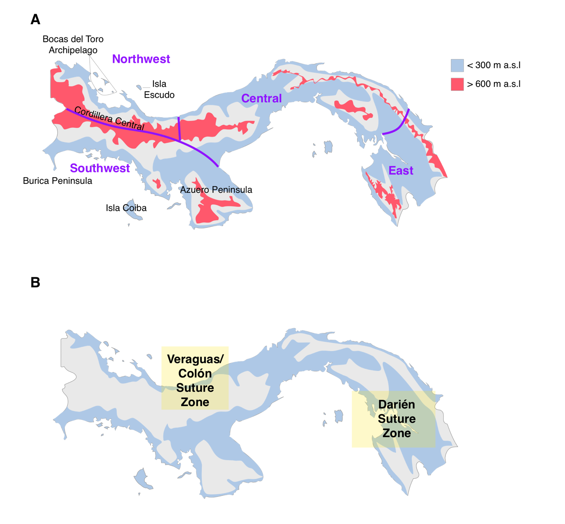

Figure 1.1: Map of Panama indicating major features considered in this study. A) Pink areas are highland regions with greater than 600 m.a.s.l elevation, while light blue show those with less than 300 m.a.s.l. Purple lines indicate the broad geographic areas used to define sampling, with names in purple. B) Lowland suture zones. Light yellow shading indicates general locations of suture zones described in this study.

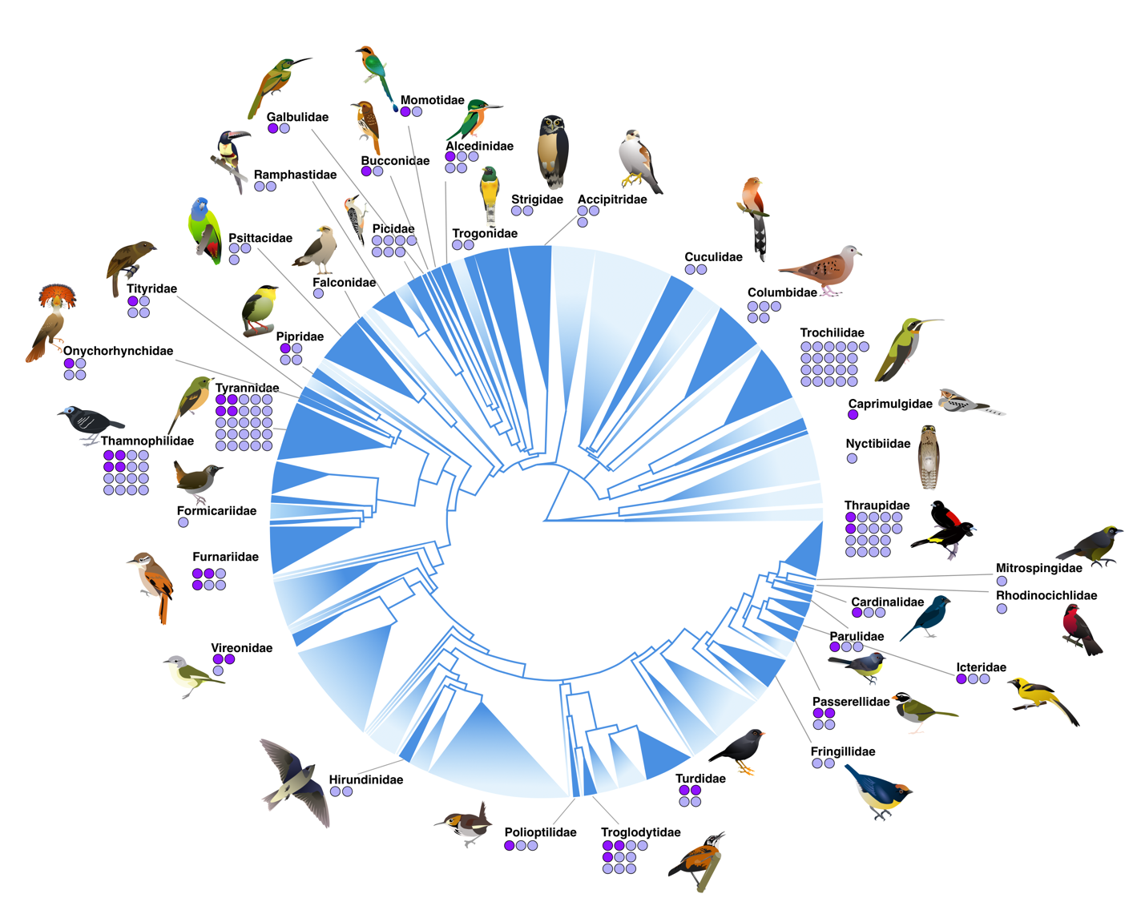Figure 1.2: Phylogenetic sampling, with overall avian tree of life modified from Jetz et al (2012). Sampled families are shown in dark blue, with unsampled lineages shown with topology collapsed and faded out, but all maintain scaling by number of species. For each sampled family, dots indicate the number of taxa sampled across multiple regions of Panama. Light purple dots indicate lineages with a single mitochondrial BIN; dark purple indicate those with two or more.

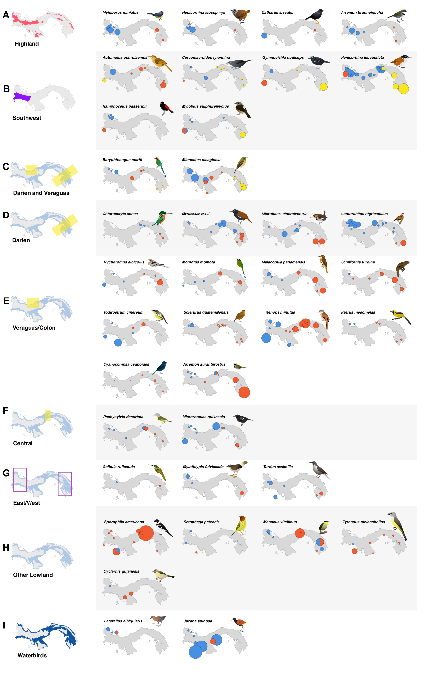

Figure 1.3: Maps of the distribution of haplotypes (defined initially by BIN for COI data, and then by sequence for additional markers) for all taxa with observed mitochondrial breaks, grouped by geographic region of splits. Highland species are separated from lowland birds (A), and lowland species are displayed by (B) southwest vs rest of Panama, with or without additional splits; (C) splits in both the Veraguas and Darién suture zones; (D) Darién suture zone splits; (E) Veraguas/Colón splits; (F) splits in central Panama, typically around Cerro Azul; (G) lowland taxa which have distinctive haplotypes in east and west, but lack sufficient sampling across the transect to determine the precise locality of the turnover; (H) taxa with idiosyncratic patterns that fit none of the above; and (I) waterbirds, which were generally excluded from analyses due to less consistent sampling. Dot colors indicate distinct BINs, size scaled by the number of samples from a given locality.

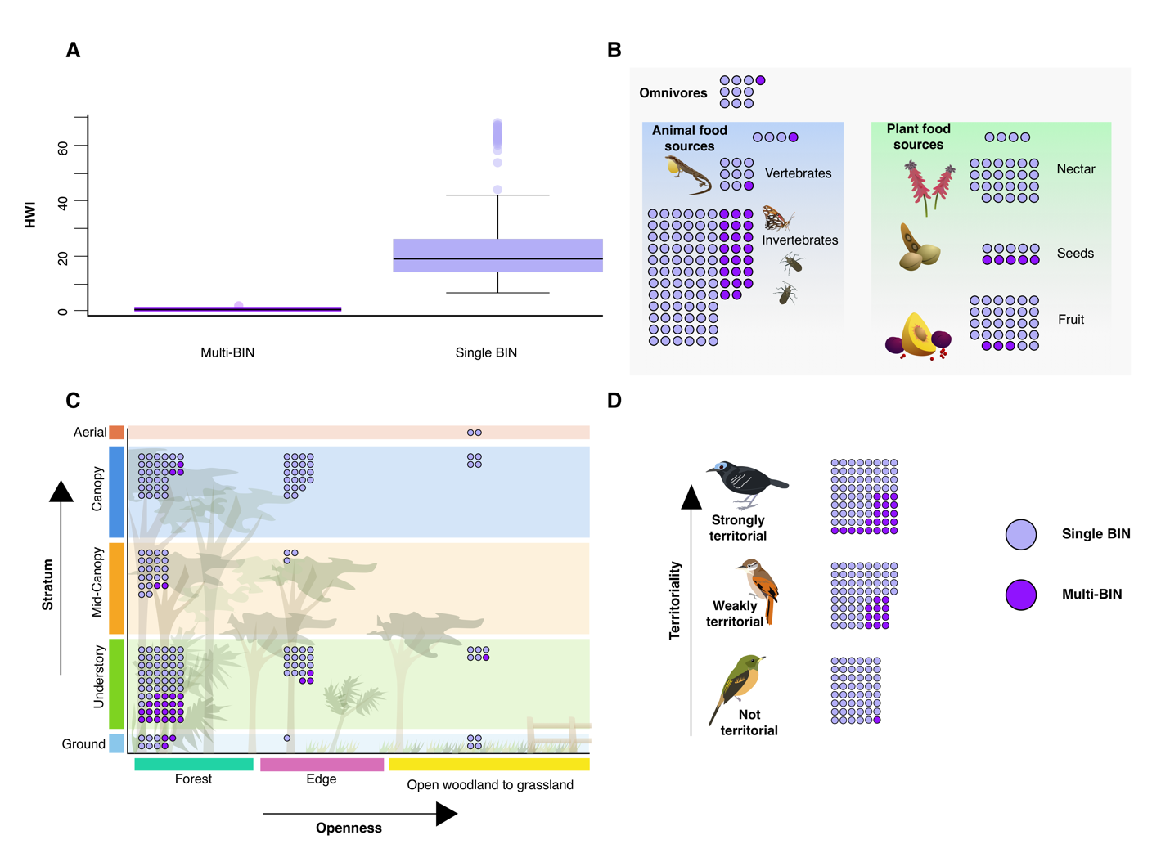

Figure 1.4: Associations of ecological traits with mitochondrial splits. Throughout the figure, dark purple circles represent taxa with two or more BINs, while light purple indicate those with only one. A) Hand wing index (HWI) is significantly lower in taxa with splits (t= -5.52, df- 154.29, p=1.43 × 10⁻⁷), indicating lower physical dispersal capability is associated with mitochondrial turnover. B) Primary diet, showing that insectivores are significantly overrepresented (𝜒²=17.27, df= 7, p=0.016) in taxa with splits. C) A visual representation of habitat use by split and non-split taxa, showing that habitat type as measured by openness (𝜒²=6.488, df= 2, p=0.039) and stratum (𝜒²=14.04, df= 4, p=0.0072) are associated with mitochondrial turnover, with it becoming increasingly likely in the closed forest understory. D) Despite the relatively even distribution of territoriality across our sample, strongly territorial taxa were overrepresented among those with mitochondrial turnover (𝜒²=12.038, df= 2, p=0.0024).

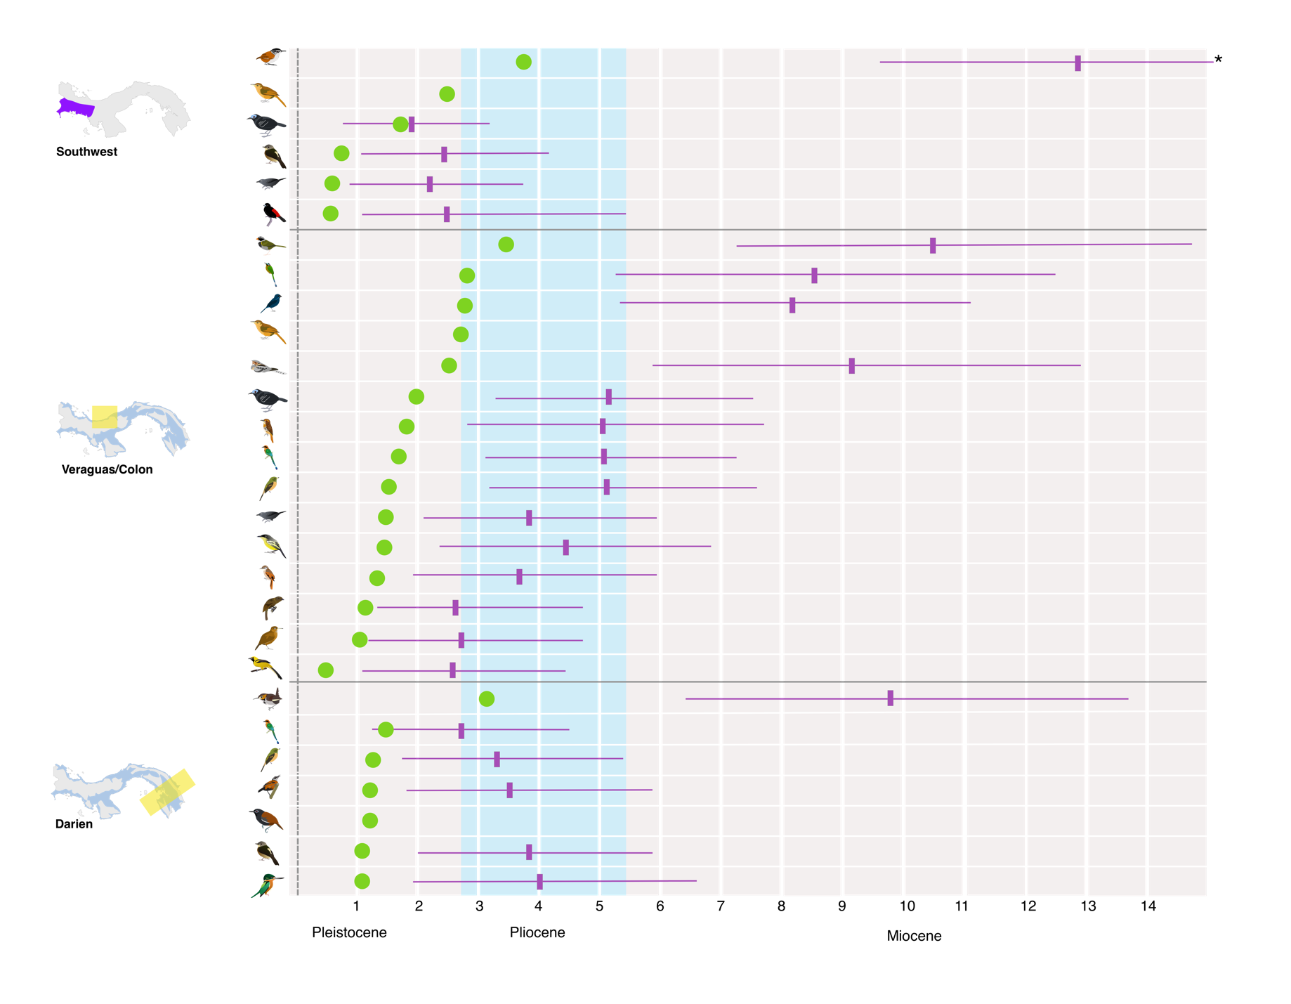
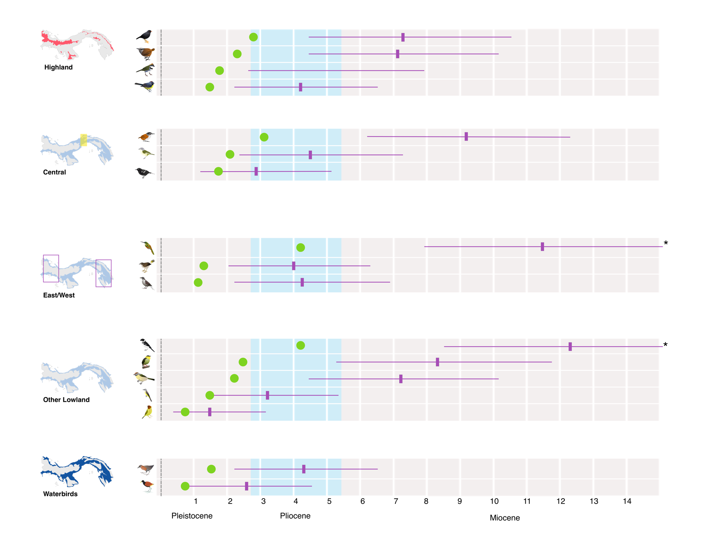

Figure 1.5: Timing of mitochondrial splits, with time calculated from pairwise COI divergence (green) and in BEAST2 (purple, shown with 95% confidence intervals). Splits are grouped by region as in Figure 1.3, with those taxa with multiple splits being shown for each. Some CIs are truncated due to space (indicated with asterisk); see Table 1.3 for full details.

Tables

Table 1.1: Species with COI splits defined as multiple BINs, with additional mitochondrial markers indicated. Distances calculated on BOLD-aligned sequences with K2P method. Species with more than two unique BIN assignments have pairwise COI divergence for all inter-BIN comparisons listed.

Species | Family | Pairwise COI divergence | Other included markers
Nyctidromus albicollis | Caprimulgidae | 5.16% | cytB, ND2, whole mitogenome
Laterallus albigularis | Rallidae | 3.20%
Jacana spinosa | Jacanidae | 1.72%
Chloroceryle aenea | Alcedinidae | 2.19% | ND2, whole mitogenome
Baryphthengus martii | Momotidae | 3.48%  3.31%  3.35% | Whole mitogenome
Momotus momota | Momotidae | 5.64% | Whole mitogenome
Malacoptila panamensis | Bucconidae | 3.84% | ND3, whole mitogenome
Galbula ruficauda | Galbulidae | 8.25% | cytB, whole mitogenome
Manacus vitellinus | Pipridae | 5.08%
Schiffornis turdina | Tityridae | 2.20% | Whole mitogenome
Myiobius sulphureipygius | Onychorhynchidae | 2.19%
Tyrannus melancholicus | Tyrannidae | 3.00%
Cercomacroides tyrannina | Thamnophilidae | 3.00%
Todirostrum cinereum | Tyrannidae | 2.87%
Microrhopias quixensis | Thamnophilidae | 2.51% | ND2, cytB, whole mitogenome
Gymnocichla nudiceps | Thamnophilidae | 3.99% | ND2, cytB, whole mitogenome
Myrmeciza exsul | Thamnophilidae |  | ND2, cytB, whole mitogenome
Automolus ochrolaemus | Furnariidae | 5.38% | cytB, whole mitogenome
Sclerurus guatemalensis | Furnariidae | 2.08% | ND2, whole mitogenome
Xenops minutus | Furnariidae | 2.77% | ND2, cytB, whole mitogenomes
Cyclarhis gujanensis | Vireonidae | 4.66%
Pachysylvia decurtata | Vireonidae | 4.20% | ND2, whole mitogenome
Microbates cinereiventris | Polioptilidae | 6.12% | ND2, whole mitogenome
Cantorchilus nigricapillus | Troglodytidae | 2.51% | cytB, ATPase 8 and 6, whole mitogenome
Henicorhina leucosticta | Troglodytidae | 6.13%  6.89%  7.61% | cytB, ATPase 8 and 6, ND2, whole mitogenome
Henicorhina leucophrys | Troglodytidae | 4.63%
Turdus assimilis | Turdidae | 2.52%
Catharus fuscater | Turdidae | 5.67%
Arremon aurantiirostris | Passerellidae | 6.92% | ND2, whole mitogenome
Arremon brunneinucha | Passerellidae | 3.49%
Myiothlypis fulvicauda | Parulidae | 2.86%
Setophaga petechia | Parulidae | 1.24%
Myioborus miniatus | Parulidae | 3.18%
Icterus mesomelas | Icteridae | 1.24%
Cyanocompsa cyanoides | Cardinalidae | 5.60% | ND2, cytB, whole mitogenome
Ramphocelus passerini | Thraupidae | 1.65% | Whole mitogenomes
Sporophila americana | Thraupidae | 8.49% | Whole mitogenomes

Table 1.2: Distribution of traits across Panamanian birds, showing across all 658 resident landbirds, those distributed across multiple regions, those barcoded (including both widespread and regional species), those resident landbirds with widespread distributions that were barcoded, and those within that last group found to have more than one BIN.

 | All species | Widely distributed | Barcoded (landbirds) | Sampled | Split
Total | 658 | 338 | 388 | 181 | 34
Highland | 199 (30.2%) | 55 (15.1%) | 105 (27.1%) | 20 (11.5%) | 4 (11.8%)
Habitat:  Forest  Edge  Open | 446 (67.8%)  132 (20.1%)  76 (11.5%) | 224 (66.3%)  70 (20.7%)  44 (13.0%) | 275 (70.9%)  74 (19.1%)  38 (9.80%) | 121 (66.8%)  44 (24.3%)  16 (8.84%) | 29 (85.3%)  4 (11.8%)  1 (2.94%)
Stratum:  Aerial  Canopy  Mid-canopy  Undergrowth  Ground | 25 (3.80%)  274 (41.6%)  82 (12.5%)  207 (31.5%)  69 (10.5%) | 17 (5.03%)  134 (39.6%)  47 (13.9%)  102 (30.2%)  38 (11.2%) | 6 (1.55%)  146 (37.6%)  47 (12.1%)  150 (38.6%)  38 (9.80%) | 2 (1.10%)  56 (30.9%)  25 (13.8%)  84 (46.4%)  14 (7.73%) | 0  4 (11.8%)  2 (5.89%)  25 (73.5%)  3 (8.82%)
Diet:  Omnivore | 49 (7.45%) | 18 (5.32%) | 36 (9.28%) | 10 (5.52%) | 1 (2.94%)
Plant-based:  General plant-based  Nectarivore  Granivore  Frugivore | 240 (36.5%)  26 (3.95%)  60 (9.12%)  41 (6.23%)  113 (17.2%) | 106 (31.4%)  11 (3.25%)  22 (6.51%)  18 (5.32%)  55 (16.3%) | 141 (36.3%)  15 (3.87%)  42 (10.3%)  20 (5.15%)  64 (16.5%) | 66 (36.5%)  4 (2.21%)  23 (12.7%)  10 (5.52%)  29 (16.0%) | 8 (23.5%)  0  0  5 (14.7%)  3 (8.82%)
Animal-based:  General animal-based  Insectivore  Vertebrates | 357 (54.3%)  32 (4.86%)  296 (45.0%)  29 (4.41%) | 207 (61.2%)  25 (7.40%)  154 (45.6%)  28 (8.28%) | 207 (53.3%)  13 (3.35%)  181 (46.6%)  13 (3.35%) | 105 (58.0%)  4 (2.21%)  92 (50.8%)  9 (4.97%) | 25 (73.5%)  1 (2.94%)  23 (67.6%)  1 (2.94%)

Table 1.3: Estimated divergence time as calculated in BEAST2 for the above 34 taxa.

Taxon | Median divergence time (My), fossil calibrated | 95% confidence interval (My), fossil calibrated
Nyctidromus albicollis | 9.10 | 5.72 – 12.97
Laterallus albigularis | 4.27 | 2.25 – 6.59
Jacana spinosa | 2.48 | 0.91 – 4.35
Chloroceryle aenea | 3.99 | 1.93 – 6.55
Baryphthengus martii | 2.76  5.05 | 1.36 – 4.44  3.03 – 7.39
Momotus momota | 9.44 | 6.01 – 13.40
Malacoptila panamensis | 5.07 | 2.77 – 7.82
Galbula ruficauda | 11.66 | 7.95 – 15.89
Manacus vitellinus | 8.28 | 5.20 – 11.71
Schiffornis turdina | 2.76 | 1.26 – 4.73
Myiobius sulphureipygius | 2.43  3.87 | 1.02 – 4.12  2.06 – 5.96
Mionectes oleagineus | 3.42  5.16 | 1.84 – 5.39  3.13 – 7.58
Tyrannus melancholicus | 3.22 | 1.50 – 5.37
Cercomacroides tyrannina | 2.15  3.88 | 0.86 – 3.72  2.07 – 6.11
Todirostrum cinereum | 4.44 | 2.37 – 6.93
Microrhopias quixensis | 2.92 | 1.25 – 5.11
Gymnocichla nudiceps | 1.97  5.14 | 0.82 – 3.37  3.15 – 7.59
Automolus ochrolaemus | 8.58 | 5.44 – 12.24
Sclerurus guatemalensis | 2.78 | 1.14 – 4.80
Xenops minutus | 3.72 | 1.89 – 5.99
Cyclarhis gujanensis | 7.14 | 4.44 – 10.33
Pachysylvia decurtata | 4.66 | 2.48 – 7.25
Microbates cinereiventris | 9.82 | 6.40 – 13.52
Cantorchilus nigricapillus | 3.58 | 1.79 – 5.93
Henicorhina leucosticta | 9.06  12.93 | 6.22 – 12.38  9.66 – 16.64
Henicorhina leucophrys | 7.09 | 4.42 – 10.13
Turdus assimilis | 4.32 | 2.14 – 6.90
Catharus fuscater | 7.27 | 4.43 – 10.46
Arremon aurantiirostris | 10.49 | 7.31 – 13.94
Arremon brunneinucha | 5.09 | 2.64 – 7.96
Myiothlypis fulvicauda | 3.99 | 2.01 – 6.33
Setophaga petechia | 1.64 | 0.53 – 3.15
Myioborus miniatus | 4.19 | 2.20 – 6.52
Icterus mesomelas | 2.61 | 1.10 – 4.49
Cyanocompsa cyanoides | 8.23 | 5.31 – 11.52
Ramphocelus passerini | 2.52 | 1.10 – 4.39
Sporophila americana | 12.21 | 8.52 – 16.20

Chapter 2: Time in allopatry does not predict the outcome of secondary contact in lowland Panamanian birds

Jessica F. Mclaughlin¹ and Matthew J. Miller²

¹Department of Biology, University of Oklahoma, and Sam Noble Oklahoma Museum of Natural History, Norman, OK, USA
²Conservation Genomics Department, Reneco Wildlife Consultants, Abu Dhabi, UAE

Author Contributions

JFM conceived the study in consultation with MJM. JFM generated genomic libraries to supplement the original dataset, conducted all analyses, created original illustrations, and wrote the initial draft, with feedback from MJM on subsequent drafts.

Data Accessibility

Scripts, input files, and other associated files for analysis are available at https://github.com/jfmclaughlin92/panama_uce. Sequence data has been uploaded to the NCBI Short read archive (SRA).

Abstract

Geographic speciation models assume that time in allopatry should predict the degree of reproductive isolation (RI) between populations, but this has rarely been tested. Here we test the prediction that greater time in allopatry results in greater RI using comparative ultraconserved element (UCE) data from ten bird lineages in secondary contact in Panama. The best-fit models for the proportion of fixed Z-linked and autosomal loci to our data includes a combination of both time (as measured by mtDNA divergence) and hand-wing index (HWI), emphasizing that the role of time is tempered by dispersal capability. Furthermore, time does not predict the extent of genome-wide introgression as measured by the median width of diagnostic loci clines or the degree of variation in cline centers or widths. These metrics of the outcome of secondary contact were best predicted by ecological and genomic factors, including diet, HWI, and genome-wide F_{ST} respectively, that are understood to serve as proxies for dispersal, the variability of population size, and overall genomic divergence. We find a primary role for ecological factors instead of isolation time in determining secondary contact outcomes for a lineage, highlighting how ecology shapes the development of RI.

Introduction

Historically, animal speciation has been understood to be driven in its early stages by population isolation in allopatry (Mayr 1942, 1963; Bush 1975; Lynch 1989; Otte and Endler 1989; Rosenzweig 1995; Barraclough and Vogler 2000; Coyne and Orr 2004). Mayr (1963) outlined the basic model of allopatric speciation that has remained largely unchanged for nearly 60 years, in which an ancestral species is divided into two allopatric populations by vicariance or dispersal, leading to isolation without gene flow. During their time in isolation, differences between the populations, phenotypic and genetic, accumulate. Subsequently, one or both populations experience range expansion, and the populations come into secondary contact, where speciation is completed. Later authors would expand on this, describing the outcome of secondary contact as a continuum (Wu 2001; Hey et al. 2003; Mallet et al. 2007; Nosil et al. 2009; Seehausen et al. 2014), from population fusion – also called reticulation or reverse speciation (Webb et al. 2011; Grant and Grant 2016; Kearns et al. 2018; Slager et al. 2020) – to complete reproductive isolation (RI) without any introgression (Cowles and Uy 2019; Merot et al. 2017). Intermediate along this continuum is the formation of a hybrid zone, with partial RI (Hendry et al. 2009). This current paradigm for animal speciation is the result of research demonstrating the pervasiveness of gene flow during the speciation process (Mallet 2005; Nosil 2008; Mallet and Dasmahapatra 2012; Martin et al. 2013; Seehausen et al. 2014; Ottenburghs et al. 2017; Palacios et al. 2019; McLaughlin et al. 2020a).

Implicit in both Mayr’s model and more modern interpretations that allow for gene flow is a central role for time in allopatry for driving differentiation and, eventually, speciation. As time increases, the likelihood of evolutionary changes occurring increases in parallel. Time allows for selection for local environmental conditions and stochastic changes through drift to take place (Orr 1995; Singhal and Moritz 2013). Orr and Turelli (2001) described the ‘speciation clock’ as the outcome of molecular evolution coupled with the accumulation of Dobzhansky-Muller incompatibilities. Genomic variations that arise and become fixed, such as chromosomal inversions (Bush et al. 1977), the mutations within them (Berdan et al. 2020), or mitonuclear incompatibilities (Hill 2016, 2017), occur at a largely consistent rate in similarly sized populations (Wright 1931), but as time in isolation passes, it becomes more likely that any one or more of them occur and accumulate. Over time, this accumulation would increase the likelihood of such changes leading to the development of RI. Experimental evidence demonstrates hybrid viability decreasing over time (Sasa et al. 1998; Tubaro and Lijtmaer 2002; Lijtmaer et al. 2003; Bolnick and Near 2005; Singhal and Moritz 2013; Dufresnes et al. 2015).

Time, therefore, makes intuitive sense as a predictor of where a lineage is in the process of speciation, and the expected extent of introgression in secondary contact. Indeed, there is some evidence from birds that supports this hypothesis. Studies of hybridization in birds have shown a relationship between time (measured by mitochondrial divergence) and the development of RI (Price and Bouvier 2002; Price 2008), with hybrid infertility and inviability becoming more likely with increased divergence time (Tubaro and Lijtmaer 2002; Lijtmaer et al.2003). Likewise, traits linked with prezygotic isolation also show this tendency (Winger and Bates 2015; Winger 2017), which is relevant given the general pattern in birds of prezygotic isolation arising before postzygotic (Edwards et al. 2005; Price 2008). From these observations, it is reasonable to predict that as time in isolation increases, so will RI from both pre- and postzygotic mechanisms. Thus, in the context of secondary contact, the extent of introgression will decrease in tandem.

However, many factors could decouple time from the outcome of secondary contact and the development of RI. Birds, which tend to have higher rates of hybridization than many vertebrates (Fitzpatrick 2004; Price 2008), have been a useful group to study these factors. However, in many cases it has proved difficult to detect a reduction in fitness of hybrids in wild populations, and introgression even appears to be selected for in some cases (Gee 2004; Lipshutz et al. 2019). Some of this propensity for hybridization possibly arises from the nature of bird genomes themselves (Ellegren 2013). Bird genomes are small compared to other tetrapods (Bachmann et al. 1972; Tiersch and Wachtel 1991), likely driven by the metabolic demands of flight (Wright et al. 2014; Kapusta et al. 2017; Gregory 2002). This is then compounded by the relatively conserved synteny of avian chromosomes (Shetty et al. 1999; Ellegren 2010). As a result of these attributes, there are fewer structural variants which lead to postzygotic barriers seen in other taxa (Ellegren 2010). This likely provides an explanation for the tendency of RI in birds to be maintained by prezygotic barriers (Edwards et al. 2005), but it simultaneously informs why these barriers may be less effective in perpetuating that isolation. Postzygotic barriers are far more effective in limiting hybridization than assortative mating (Irwin 2020), and prezygotic barriers can be eroded by environmental changes (Nemeth et al. 2013) or even by sexual selection in systems such as manakins (Parsons et al. 1993; Brumfield and Braun 2001; Stein and Uy 2006; Parchman et al. 2013), fairywrens (Baldassarre and Webster 2013; Baldassarre et al. 2014), and jacanas (Lipshutz et al. 2019), where the phenotype of the courtship-dominant sex in one taxon is actually preferred by the other. These factors all mean that time may not be a predictor of the outcome of secondary contact.

We investigated this question using loci linked to ultraconserved elements (UCEs) in ten lineages of birds in secondary contact spanning a range of divergence dates across Panama. We tested several predictions that arise from the time-in-allopatry hypothesis. Firstly, we predict that the varying depths of mitochondrial breaks, reflective of differing lengths of time in isolation, are correlated with the development of differentiation across the nuclear genome (Figure 1A). We expected that if this is the case, the proportion of loci fixed between the eastern and western Panama populations would be higher in taxa with a greater mitochondrial divergence. Lastly, in older taxa, the geographic extent of admixture will be reduced (Figure 1B), and that geographic clines should be narrower and more consistently located along the transect (Figure 1C).

Methods

Taxonomic and genetic sampling

The lowlands of Panama are an excellent system to test hypotheses about how time shapes the outcomes of secondary contact. Connected by largely continuous forest prior to the arrival of settler-colonial agricultural practices (Piperno et al. 1991; Bush et al. 1992) and lacking obvious geographic barriers, this region is nevertheless a notable suture zone where many sister taxa rapidly replace each other, with varying degrees of apparent hybridization (see Chapter 1). We focused on taxa that are found widely across this region and for which genetic resources from vouchered museum specimens were available (Table S1). We also considered preliminary data from mitochondrial barcoding (see Chapter 1) to include as wide a range of split depths as possible, along with diet, habitat, and family, to include an ecologically diverse sample of species. This resulted in a final dataset of ten lineages with mtDNA divergence between 2.75% and 9.83% (pairwise distance of all mt coding regions).

We examined loci associated with UCEs to measure clinal variation in secondary contact in hundreds or thousands of homologous loci, and to estimate the degree of genome-wide fixed variation between populations at terminal populations across transects. UCEs are useful for comparative studies, as they allow for robust sampling of directly comparable orthologous loci across large taxonomic divides (Faircloth et al. 2012; Smith et al. 2014; Harvey et al. 2016; McLaughlin et al. 2020a). For each of taxa, we attempted to sample 3-4 individuals per population from populations along an east-west transect across lowland Panama, but in several cases were only able to include one or two individuals from a locality, resulting in a dataset of 180 individuals (Table S1). Preliminary analyses suggested that two species— Cyanocompsa cyanoides and Arremon aurantiirostris—had signals of admixture in the westernmost population sampled in northwest Panama. Therefore, for these species we sampled added populations from Nicaragua and Honduras for both species, and Belize for Cy. cyanoides. Similarly, we added samples from Ecuador in Cantorchilus nigricapillus, ensuring that all 10 species had purely parental populations in the westernmost and easternmost terminal populations.

We extracted genomic DNA from muscle tissue samples from vouchered museum specimens (Table S1) and prepared UCE-enriched libraries following Faircloth et al. (2012) and Glenn et al. (2019). For a few individuals, UCEs were harvested from whole-genome shotgun sequenced libraries. In both cases, libraries were prepared following the NEB Ultra II protocol. For the UCE-enriched libraries, we then followed the protocol from Glenn et al (2019) using the 5k Tetrapod set v.1 of 5,060 probes (Faircloth et al. 2012), while non-enriched samples proceeded directly to sequencing (Table S1).

Bioinformatics

We used either Trimmomatic v. 0.32 (Bolger et al. 2014; implemented in Illumiprocessor, Faircloth 2013) or BBDuk (part of BBMap v. 37.93; Bushnell 2014) for quality checking and adapter-trimming in raw reads, with the former being used for UCE-only reads as part of the original UCE pipeline and the latter for our whole genome reads. We generated a UCE loci-only reference for each taxon with de novo assemblies using Trinity v. 2.5.1 (Grabherr et al. 2011), filtering the assembly contigs to ensure that they contained only single-copy UCE loci without capture bycatch with phyluce (Faircloth 2016). Read number is not necessarily predictive of enrichment quality, so we generated a UCE assembly for all individuals, and selected the assembly with the most recovered UCE loci as the reference for that taxon. However, for three taxa, we had no UCE-enriched libraries. Assuming that the number of total reads was proportional to UCE-derived reads in these samples, we selected the single individual with the greatest number of reads to generate a reference for that taxon. For that sample’s trimmed reads, we filtered the UCE-derived reads using BBSplit (part of BBMap) and a concatenated reference derived from a set of closely related taxa as the BBSplit mapping target. For Myrmeciza exsul and Schiffornis, the three closely related taxa were Xenops minutus, Henicorhina leucosticta, and Mionectes oleagineus (developed for separate project); for Ramphocelus, we used Pachysylvia decurtata, Cy. cyanoides, and A. aurantiirostris. Using the BBSplit reads, we generated a final reference pseudo-genome for each species, as above.

To recover diploid genotypes for all UCE loci for all individuals per species, we followed the Genome Analysis Toolkit (GATK; McKenna et al. 2010) best practices for resequencing, making an alignment using all reads mapped to the reference using BWA. The alignment was indexed and cleaned using Samtools v. 1.7 (Li et al. 2009) and Picard v. 2.18.0 (Broad Institute 2019). Genotypes were generated in GATK v. 4.0.12 using HaplotypeCaller and GenotypeGVCF, generating a variant file per taxon. Using VCFTools v. 0.1.13 (Danecek et al. 2011), the variants were filtered to include only variants with biallelic SNPs present in all individuals with a minimum GQ of 10 and mean coverage depth of 10. This filtered dataset was used for window-based analyses of nucleotide diversity and genome-wide F_{ST}. We further thinned this dataset to include one SNP per locus by using the thin function of VCFTools, retaining the first 5’ SNP for each locus. This became our canonical SNP dataset for each taxon for non-windowed analyses.

We also identified Z-linked loci to test how fixation rates differed between autosomal and sex-linked chromosomes. Z chromosome variants should be considered separately for three primary reasons. Firstly, its effective population size is only ¾ that of the autosomes, and thus under neutral conditions it will accumulate fixed differences at twice the rate of autosomes (Irwin 2018). Secondly, the Z chromosome has been indicated to disproportionately be the site of loci responsible for the development of reproductive barriers in many studies of avian speciation (Backström et al. 2010; Storchová et al. 2010; Ellegren 2013; Lavretsky et al. 2015, 2019), making separate consideration of them important. Finally, Z chromosomes are likely to be the sites of incompatibilities as predicted by Haldane’s rule -- if hybrid fitness is lower in one sex than the other, it will be in the heterogametic sex (Haldane 1922; Laurie 1997; Coyne and Orr 2004; Price 2008), possibly as incompatibilities arise between the different sex chromosomes (Coyne 1985), between the Z chromosome and autosomes (Johnson and Lachance 2012), or between the Z chromosome and mitochondrial genomes (Trier et al. 2014). The master UCE probe sequence list (Faircloth et al. 2012) was matched to the Taeniopygia guttata genome (GCA_008822105.2) with BLAST (Zhang et al. 2000) to generate a list of UCE loci located on the Z chromosome, as chromosomal synteny in birds is relatively conserved (Ellegren 2010; Shetty et al.1999; Ellegren 2013). This list was then used to reference against per-site F_{ST} to determine autosomal versus Z-linked fixation.

Determining the mitochondrial haplotype

We assembled mitochondrial genomes for both the eastern and western parental populations in each with NOVOplasty v. 3.4 (Dierckxsens et al. 2017). We then determined haplotype per individual as detailed in Chapter 1.

Population structure analyses

To verify that each species included just two parental genotypes across the study area, to ensure that each parental genotype was adequately sampled, and to provide an initial assessment of population structure, for each species we conducted PCA and DAPC in the R package adegenet v. 2.1.3 (Jombart and Ahmed 2011). We determined the number of clusters by minimizing the value of the Bayesian Information Criterion (BIC), and individuals were assigned to these clusters. We used STRUCTURE v2.3.4 (Pritchard et al. 2000) to provide an additional assessment of population structure, and to assign individuals as either the western or eastern parental genotypes or as admixed between the two We ran STRUCTURE for 30 replicates for each of K = 2–4. We combined all replicates for each K using CLUMPP v. 1.12 (Jakobsson and Rosenberg 2007). We confirmed the best value of K as 2 in STRUCTURE HARVESTER v. 0.6.94 (Earl and vonHoldt 2012) using the Evanno method (Evanno et al. 2005), and plotted results with distruct (Rosenberg et al. 2002).

Geographic cline width analysis

Variation in geographic cline width and center provides information about the permeability of genomes to introgression. More permeable genomes are expected to show greater cline width and have a wider span of cline centers; narrow cline width and tightly coincident cline centers are a signature of RI (Barton 1979; Szymura and Barton 1986; Richard G. Harrison 1990; Szymura and Barton 1991; Derryberry et al. 2014; Rieseberg et al. 1999). We generated geographic clines as follows: we filtered our SNP datasets to include only diagnostic loci (Lipshutz et al. 2019), defined as loci where the westernmost populations had a combined allele frequency for genotype p of at least 0.75, while the combined allele frequency in the easternmost populations was no more than 0.25 for p. We generated geographic clines for these diagnostic loci using the R package hzar (Derryberry et al. 2014), testing 3 cline models per locus using a custom script (https://github.com/jfmclaughlin92/panama_uce). Using the best-fit model for each locus, we calculated median cline center and width for each taxon, as well as the set of cline width and center values that represent 95% of the observed variation. We then plotted all best-fit clines together for each taxon, calculating the median width and the variance of the width and center across all loci.

Statistics and prediction testing

We obtained counts of fixed SNPs using VCFTOOLS, including across all loci, autosomal sites only, and Z-linked loci only, as determined by alignment of the UCE probe sequences to the zebra finch genome. We then constructed a general linear model for each response parameter. In addition to mitochondrial distance, we also included variables to test for how other factors contribute to shaping the outcomes of secondary contact. We included hand-wing index (HWI), a quantification of the aspect ratio of a bird’s wing that is an indicator of dispersal ability, a known driver of divergence in Neotropical birds (Claramunt et al. 2012). We additionally included diet, coded as plant-based (frugivores and granivores) or insectivorous. These diet types are linked to differing dispersal capabilities (Miller et al. 2021) and characteristic demographic patterns (Morton 1973; Karr 1976; Levey and Stiles 1994; Westcott and Graham 2000). Finally, weighted genome-wide F_{ST} was included as a generalized measurement of genomic differentiation, and π for overall nucleotide diversity. These were calculated from only the parental populations, and clines were not calculated from them in such a way to make them autocorrelated. For cline parameters (median width, variance in width, and variance in center), these were F_{ST}, mitochondrial distance, HWI (Sheard et al. 2020), and diet. For autosomal and Z-linked fixation rates, we excluded F_{ST}, as that would be auto-correlated with the response variables. We tested which error structure best described each dataset, and from there constructed generalized linear models (GLMs) using all combinations of the explanatory variables. From these models produced for each response variable, we then used AICc to select the best model.

Results

Sequencing results

We sequenced between 0.22 and 6.5 million reads for each UCE-enriched sample and between 40.4 and 229.6 million reads for WGS samples (Table S1). From this, we recovered between 1855 and 4292 loci per taxon, with an average coverage of 39.8× (Table S1). Overall, coverage from non-enriched and enriched libraries was similar, but slightly higher in non-enriched samples (48.2x vs 37.1x). However, several unenriched samples were dropped due to low numbers of recovered UCE loci (between 500-1000 loci), demonstrating that while UCEs can be recovered with ease from WGS reads when circumstances call for such an approach, it is less reliable.

Mitochondrial divergence and fixation rates

Pairwise divergence of all mitochondrial protein-coding regions ranged from 2.75% (X. minutus) to 9.83% (Schiffornis) (Table 1). F_{ST} of UCE-linked loci ranged from 0.265 (Cy. cyanoides) and 0.688 (Schiffornis), and nucleotide diversity (π) between 0.00195 (P. decurtata) and 0.00298 (H. leucosticta; Table 1). The total proportion of fixed SNPs in these loci was between 0.0126 (Ca. nigricapillus) and 0.226 (Schiffornis), with autosomal fixation ranging from 0.0105 (Ca. nigricapillus) to 0.220 (Schiffornis) and Z-linked fixation ranging from 0.0221 (P. decurtata) to 0.480 (Malacoptila panamensis; Table 1). While average divergence in insectivores was lower than in birds reliant on plant foods, 4.07% vs 5.92%, the difference was not significant (t = -1.50, df = 6.57, p = 0.180).

Population structure and admixture detection

In all taxa, the Evanno method indicated that K=2 provided the best fit for our STRUCTURE results. Individuals with admixture proportions greater than 1% were detected in seven of the ten taxa, including all taxa considered conspecific across Panama except Ma. panamensis (Figure 2). When observed, the geographic extent of admixture varied widely (Figure 2) from admixed individuals occurring across our sampling transect in Panama, such as in A. aurantiirostris, occurring across nearly 350 km, to being confined to a roughly 5 km span between Cerro Azul and Cerro Jefe in central Panama, as seen in H. leucosticta.

Mitochondrial and nuclear mismatch

Mismatch between mitochondrial haplotype and nuclear genotype –defined as having the mitochondrial haplotype of one parental population with a nuclear genotype above 50% derived from the other parental population – was limited to three lineages (Figure 2). In P. decurtata, two individuals near the median cline center for that lineage had haplotypes characteristic of the parental population that was less than 50% of the nuclear genome. In Ca. nigricapillus, samples that had nuclear genotypes almost completely assignable to the Darién group nevertheless had the western mitochondrial haplotype. Again, this occurred very close to the median clinal center, and at one locality included only two of the three birds from the location. Finally, the central Panama localities for A. aurantiirostris were admixed with the greater assignment probability to the eastern Darién population, but with one exception, had the western haplotype.

Cline analysis

For both geographic and genomic cline analyses, our reduced diagnostic-only SNP datasets-- SNPs with a frequency of one genotype of 0.75 or more in one parental population and of 0.25 or less in the other-- included between 72 (A. aurantiirostris) and 717 (Ma. panamensis) SNPs (Table 2). Median width varied from 2.4 km (Ma. panamensis) to 373.6 km (A. aurantiirostris; Table 2; Figure 2). Within each taxon, the widths best fit a Poisson distribution (Figure S1), with most cline widths very narrow and with a long tail of wider clines and the overall proportion of the loci in this tail varying across taxa. The median cline centers were likewise wide ranging (Figure 2C), but normally distributed (Figure S2). When distance in kilometers from the beginning of a taxon’s transect was converted back into degrees longitude, this estimate ranged between -78.22 and -81.63 degrees, corresponding approximately with the western edge of the Valiente Peninsula and the western edge of Darién province, respectively (Figure 2C). Within this area, two clusters of cline centers were observed. The first, including Schiffornis, My. exsul, and Ca. nigricapillus, occur near the border of Darién, with the three occurring very closely together. The other, less tightly clustered, group, occurs along the Caribbean coast of Veraguas, and includes Ramphocelus, Ma. panamensis, X. minutus, and Cy. cyanoides.

Prediction testing

The best-fit models for our five response variables (median cline width, variance in single-locus clinal width, clinal center variance, autosomal fixation rate, and Z-chromosome fixation rate) varied. When we fit models for Z-chromosome and autosomal fixation rates, we found that mitochondrial distance and HWI were the best predictors in both cases (Table 3). For the primary cline variable-- the median width of clines across all loci-- diet alone was the best predictor, with weaker support for other models (Table 3). This was a weakly statistically supported relationship (t = -2.2662, df = 5.3811, p = 0.06904; Figure 3C), likely due to the overall small number of taxa included, but it is enough to say with reasonable certainty that insectivores have smaller median cline widths (mean = 40.887 km) than birds reliant on plant diets (mean = 178.35 km). For variance in clinal center (i.e., spatial coincidence of the centers of hybrid zones), HWI was the best predictor, although moderate support was also found for the following predictors, in order of increasing delta AICc: F_{ST} alone, mitochondrial distance + HWI, mitochondrial distance alone, and π + HWI (Table 3). This relationship was moderately statistically supported (Adj R² = 0.2995, p = 0.05884; Figure 3A). For variance in clinal width (i.e., how much the spatial extent of hybridization varied), F_{ST} alone was the best predictor, with moderate support also found for π + F_{ST}. However, this was not significant, with weak support found for the linear relationship between the two (Adj R² = 0.0719, p = 0.3323; Figure 3B). While these results were weakly significantly significant, much of this is likely due to the small number of taxa included relative to the variation, and though not definitive, is still indicative of a biologically significant relationship between these variables that bears further investigation with more taxa.

Discussion

Time plays a role in predicting the accumulation of differentiation between populations. Yet time alone does not, in lowland Panama, tell the full story of how populations in secondary contact respond. Despite time often being implicitly assumed to play a key role in driving the development of RI in incipient species, our results show that time alone is not a predictor of these outcome of secondary contact in lowland Panama. It certainly plays a role in predicting the accumulation of fixed loci on both the autosomes and Z chromosome, supporting the mechanism of time allowing for the development of variation within isolated populations. Yet genomic differentiation alone does not necessarily indicate the development of RI, and for our most direct measure of the development of RI-- median cline width-- time played no role as a predictor, indicating a disconnect between the mere accumulation of genomic variation and the development of differences that could lead to speciation.

Predictors of geographic cline width and stability

Our most striking result was the robust recovery of diet alone as the best predictor of median cline width, placing ecological factors as key in determining the outcomes of secondary contact. Taxa that relied on plant-based foods, primarily seeds and/or fruit, had significantly wider clines than insectivores. Diet differences have been shown to be significantly linked with differences in dispersal ability in Neotropical birds (Westcott and Graham 2000; Moore et al. 2008). Seeds and fruit are available year-round, but not necessarily in the same place simultaneously (Morton 1973; Levey et al. 1994). This results in birds reliant on such resources needing to disperse more widely (Westcott and Graham 2000). Meanwhile, insectivores, especially the understory insectivores examined here, can generally rely on a steady supply of food items year-round within a small area, and consequently are much more sedentary (Levey and Stiles 1992; Burney and Brumfield 2009) and have smaller home ranges and are often very weak fliers (Moore et al. 2008).

However, this link to dispersal ability is unlikely to be the sole reason for the strong relationship observed between diet and cline width. HWI, which reflects the morphological constraints on flight ability (Lockwood et al. 1998; Kipp 1959) and more directly measures dispersal ability (Burney and Brumfield 2009; Claramunt et al. 2012; Weeks and Claramunt 2014; Kennedy et al. 2016; Chua et al. 2017; Claramunt and Wright 2017; Pigot et al. 2018; Sheard et al. 2020), was not a predictor, so we must consider other demographic traits associated with diet that may be more influential in determining cline width. Notably, birds reliant on fruits and seeds have much wider variation in population sizes. Availability of these resources varies not just across a single year, but between years, with individual trees varying in fruit and seed production across multiple years (Wheelwright 1986), driving more pronounced cycles in population highs and lows in birds dependent on them (Faaborg et al. 1984; Levey et al. 1994; Brawn et al. 1995; Ryder and Sillett 2016; Macario et al. 2017). While arthropods are also subject to declines, such cycles are generally relatively less drastic and usually specific to certain prey species (Jahn et al. 2010). Because of this, Neotropical understory insectivores are observed to have far less year-to-year demographic fluctuation (Greenberg and Gradwohl 1986; Faaborg et al. 1984; Şekercioḡlu et al. 2002; Woltmann and Sherry 2011; Sherry et al. 2020). Thus, possibly the differences in demography among birds dependent on plant-based foods and those that primarily subsist on arthropods drive these patterns, although the limitations with UCE-linked loci make it difficult to test directly for historical demographic fluctuations.

Cline width alone is not the only indicator of the outcomes of secondary contact examined here. The coincidence of clines, as measured by the variation in cline center and width, is a measure of how spatially consistent the geographic center and extent of turnover will be across loci. Again, this was not predicted by time. The variance in cline center was best predicted by HWI alone. This is of interest because while dispersal ability as measured via the most accepted proxy was not important in determining the width of the hybrid zone, it is the best predictor behind how geographically concentrated introgression is. However, variance in width-- or how much variation in how far a locus will introgress across the transect-- was predicted by neither time nor ecological factors, but by F_{ST}. This suggests that as overall genomic divergence between parental types increases, differential introgression of loci decreases, an observation corroborated by observations of decreased hybridization with greater genetic divergence in other systems (Montanari et al. 2014).

The development of RI is a key step in the process of speciation, but it can be difficult to disentangle outside of controlled model systems, making hybrid zones an important opportunity to gain insight into the strength of RI in non-model organisms (Barton and Hewitt 1985; Hewitt 1988; Mallet and Dasmahapatra 2012). Cline analyses can be powerful tools in gaining insight into how RI develops in the early stages of speciation (Szymura and Barton 1986, 1991; Derryberry et al. 2014). The geographic range of hybridization can be informative of the extent of RI in a pair of incipient species, as it reflects the extent to which introgressed loci are selected against (Szymura and Barton 1986; Derryberry et al. 2014). Thus, median cline width across loci is a key measurement of the extent of RI.

Geography of hybridization in lowland Panama

Of our ten taxa, seven of them had median cline centers in one of two narrow regions (Figure 2C). Three of the taxa-- Schiffornis, My. exsul, and Ca. nigricapillus-- had median cline centers estimated in western Darién, which also corresponded with where they experienced mitochondrial turnover. This corresponds to previous findings that this region represents a major suture zone between Central and South American taxa (Chapman 1917). The second cluster, consisting of the Ramphocelus tanagers, Ma. panamensis, X. minutus, and Cy. cyanoides, is located along the Caribbean coast of Veraguas. This region, whose avifauna has been much less well-documented than much of Panama (Wetmore 1965, 1968, 1972; Wetmore et al. 1984; Ridgely and Gwynne 1992; Siegel and Olson 2008; Angehr and Dean 2010), appears to be an important suture zone (McLaughlin et al. 2020b). In both cases, though, it is notable what they each lack: major biogeographic barriers that would easily explain the occurrence of such rapid turnover, a feature observed in other Neotropical lowland contact zones (Lovette 2004; Cheviron et al. 2005; Vázquez-Miranda et al. 2009; Miller et al. 2011; Milá et al. 2012; Miller et al. 2021). Because of the apparent absence of barriers, these suture zones provide promising windows into how Neotropical diversity is shaped not by the landscape alone, but by traits inherent to ecological characteristics of the taxa in contact.

Predictors of genomic differentiation

We found that time plays a role in generating variation across the genome, particularly the autosomes. This is consistent with predictions of neutral theory (Kimura 1968; Kimura 1983; Gillespie 2004), as most of the genome accumulates variation at a predictable rate (Kimura and Ota 1971; Bromham and Penny 2003). But just as there are fluctuations in the molecular clock that erode any simple link between the accumulation of mutations and time (Ohta 1992; Bromham and Penny 2003; Weir and Schluter 2008), the relationship between time and fixation rate is also less straightforward. While time was a significant predictor of autosomal fixation in our best-fit model, HWI was as well. The impact of time is clearly important-- in addition to being a predictor in our best-fit model, time alone was the second best-fit model for autosomal fixation rate (Table 3) -- but in this system, the relationship between the time and fixation is modulated by the dispersal capability. This is consistent with previous findings that high dispersal ability can hamper divergence in tropical birds (Claramunt et al. 2012; Weeks and Claramunt 2014) but shows that this also extends to the accumulation of neutral variation.

The Z-chromosome is often the focus of searches for loci driving the development of RI (Qvarnström and Bailey 2009; Backström et al. 2010; Storchová et al. 2010; Ellegren 2013; Irwin 2018). The accumulation of fixed differences on the sex chromosomes has implications for the development of RI (Wright 1933; Charlesworth et al. 1987; Ellegren 2013; Irwin 2018), as they can lead to incompatibilities (Ellegren 2013; Hooper et al. 2019) or be linked to traits involved in male-biased (in ZW systems) sexual selection or conflict (Rice 1987; Kaiser and Ellegren 2006; Storchová and Divina 2006). We found that while time was a predictor of Z-chromosome differentiation, it was not significant, while the other included predictor, HWI, was. Dispersal ability, of which HWI is a well-established proxy (Burney and Brumfield 2009; Claramunt et al. 2012; Sheard et al. 2020; Weeks and Claramunt 2014), then, appears to play a role in driving divergence in the specific portion of the genome most frequently implicated in speciation in birds (Irwin 2018; Lavretsky et al. 2015; Ellegren 2013). As dispersal ability has been previously shown to play a major role in shaping hybrid zone dynamics (McEntee et al. 2020), this is not unexpected. However, it is notable that this was the only response variable for which dispersal ability in itself, as measured with HWI, is a predictor.

Time drives the generation of variation, but not of RI

Our results confirm that time does play a role in the development of genomic differentiation, those differences do not necessarily indicate the development of RI. Disentangling how genomic variation, phenotypic differences, and reproductive barriers are intertwined can prove challenging. Previous work in birds, including wood-warblers (Toews et al. 2016), hummingbirds (Palacios et al. 2019), and seedeaters (Campagna et al. 2017) show that remarkably little genomic variation can nevertheless result in striking phenotypic variation. Yet most such examples recover evidence of substantial gene flow that indicate that such differences should not in and of themselves be taken as evidence for RI, which has been backed up in other systems where overall genetic differentiation has not necessarily been indicative of the extent of reproductive barriers (Edmands 2002; Hogner et al. 2012; but see Dufresnes et al. 2021 for counterexample).

Lessons from secondary contact on the formation of species

Hybrid zones have long been acknowledged as a powerful window into the evolutionary mechanisms driving speciation (Barton and Hewitt 1985; Hewitt 1988; Hewitt 2001; Barton and Hewitt 1989; Gompert et al. 2017). Regions like lowland Panama, where hybrid zones in multiple taxa co-occur, have even greater potential for investigation of broader questions about the speciation process. However, many such studies tend to focus on questions of how landscape factors across time have impacted divergence in large suites of organisms (McLaughlin et al. 2020a). Lowland Panama provides an important setting for a different set of questions. As the range of split times suggests no single historic factor and the region lacks the strong geographic barriers characteristic of other classic suture zones, the spotlight can instead be shifted onto the inherent traits of the organisms themselves. Our results drive home the necessity of considering ecological factors such as demographic stability and dispersal capability as key drivers of outcomes of contact between diverging populations.

Conclusions
Our findings provide strong evidence against time being the primary driver of the outcomes of secondary contact in lowland Panama, and indicate that instead ecological and genomic factors are better predictors of the development of reproductive isolation. We also find evidence of a high degree of cryptic variation in lowland Panama, which has implications for conservation. Lowland Panama is an excellent laboratory for understanding the early stages of speciation, and future work in this area will likely provide further insights into avian diversification.

Acknowledgements
This project was supported by the Ornithology Department of the Sam Noble Museum and the Sutton Scholarship Fund at the University of Oklahoma. Scientific collecting permits for birds collected for this study were obtained from MiAmbiente, who we thank for their support of scientific collecting. We thank the University of Alaska Museum, University of Washington Burke Museum, and Smithsonian Tropical Research Institute Bird Collection for providing tissue grants from museum specimens used in this study. We would like to thank Peggy Guitton-Mayerma and Jorge Luis Garzon for field work; Celestino Aguilar, Graham Wiley, and Kevin Hawkins for helping complete lab work; Sara Lipshutz, for generously sharing scripts for running hzar; and Dahiana Arcila, Hayley Lanier, Courtney Hofman, JP Masly, Kaiya Provost, Paige Byerly, Auriel Fournier, and Valentina Gomez for their feedback on earlier versions of the manuscript.
Figures

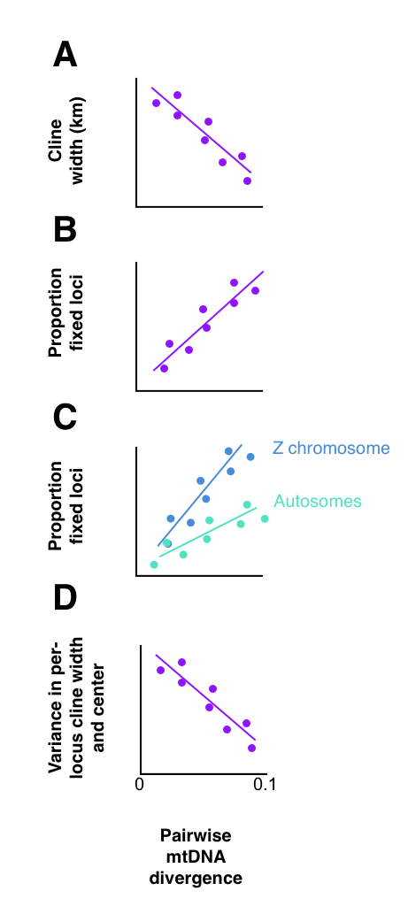

Figure 1: Predictions given time as the main driving factor in determining secondary contact outcomes. According to this hypothesis, A) median cline width should decrease with increasing mitochondrial distance, as hybrid zones narrow; B) the proportion of fixed loci will increase as isolated populations accumulate fixed differences independently of each over, either by drift or by adaptive pressures; C) the Z chromosome, with ¾ the effective population size, will accumulate these differences at approximately twice the rate in autosomes, and D) variance in the location of the cline center and the width across loci will decrease, as the hybrid zone stabilizes and narrows under selection pressures against hybrid offspring.

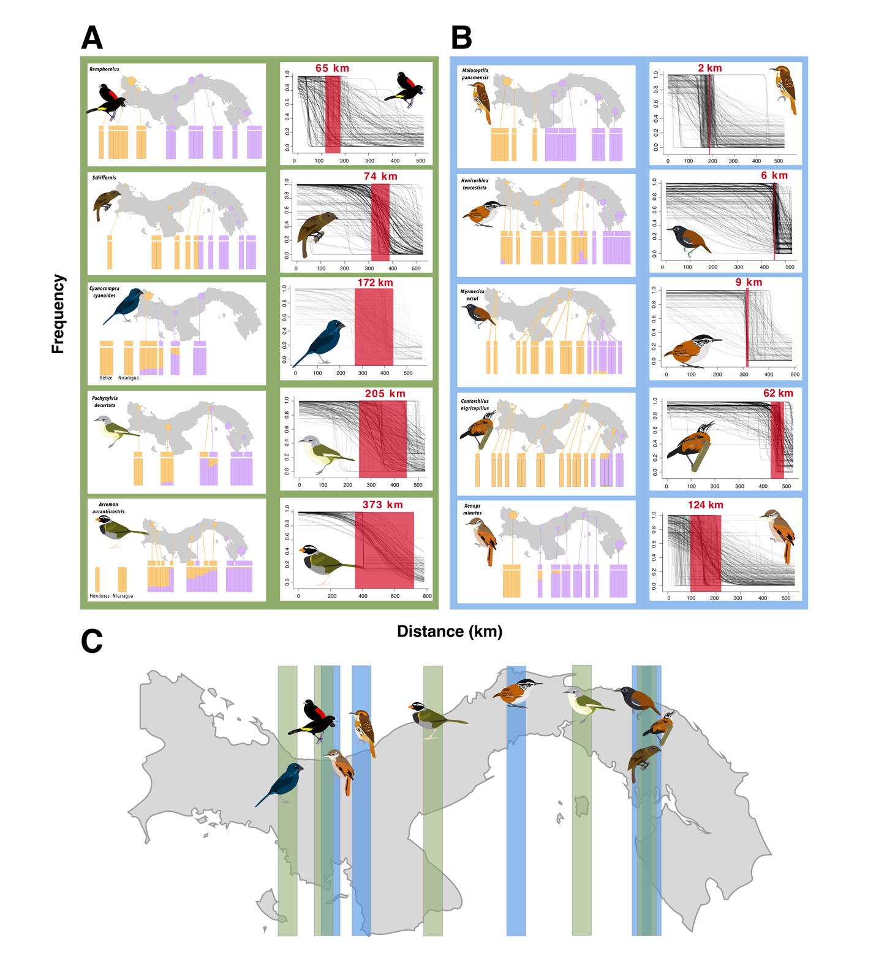

Figure 2: Genotypes of all birds, with points indicating locality, and cline results for the ten study taxa, group by diet guild with blue (A) indicating insectivores, and green (B) for granivores and frugivores. Structure plots in each taxon are grouped by locality, and bars on top indicate the mitochondrial haplotype of each individual. Genotypes for individuals from localities outside of Panama are labeled below each plot. Clines for each taxon are show per locus, with median clinal width highlighted in red. In C), approximate longitude of median cline centers for each taxon are mapped, with diet guild again indicated.
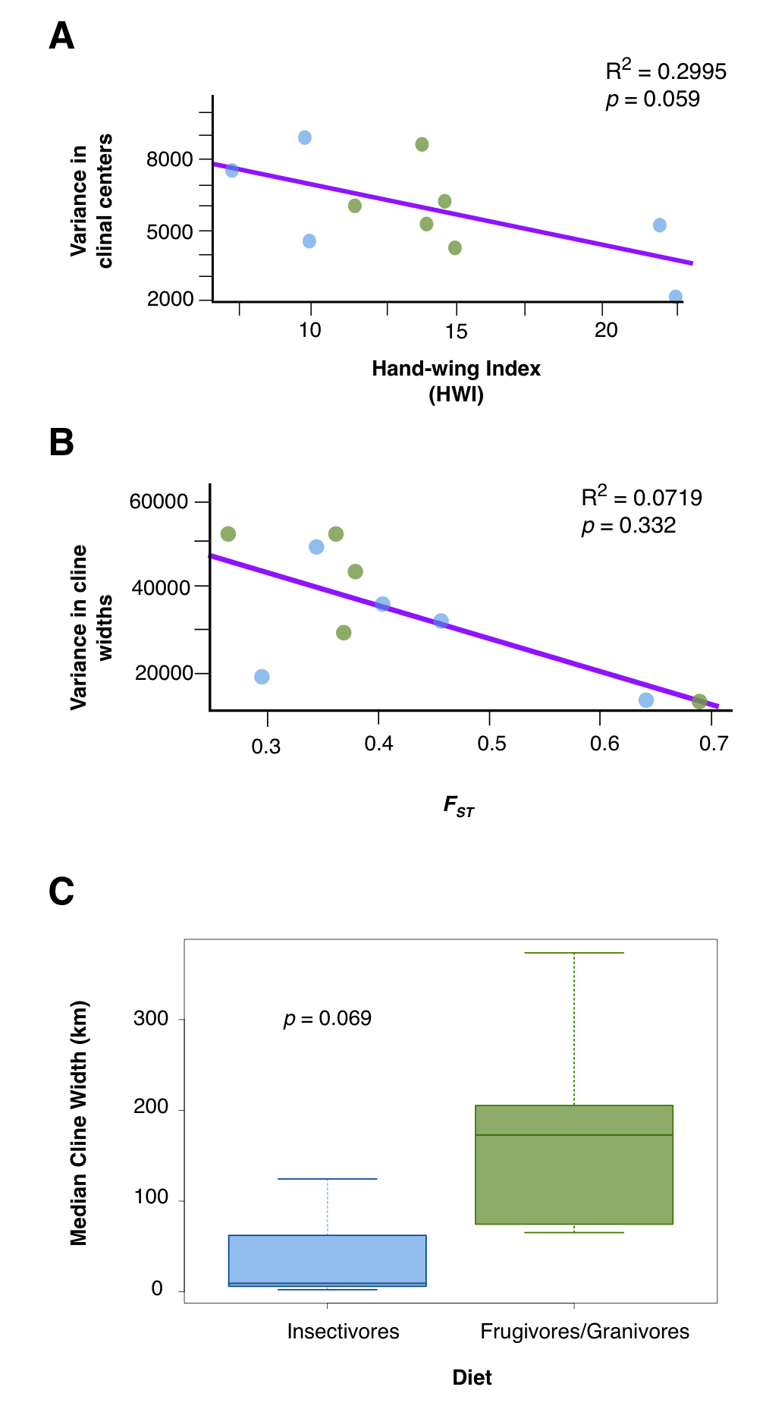

Figure 3: Best fit models for cline parameters. Plant-based diets indicated in green, insectivores in blue. A) For variance in cline center, HWI was the best fit, with a higher HWI corresponding with greater coincidence of the geographic center of clines (Adj R² = 0.2995, p = 0.05884). B) Variance in cline width was predicted instead by F_{ST} , with cline widths becoming more consistent as overall genome differentiation increased, although this relationship was weak and not statistically supported (Adj R² = 0.0719, p = 0.3323). C) Median cline width was best predicted by diet type, with frugivores and granivores having wider clines than insectivores (t = -2.2662, df = 5.3811, p = 0.06904).

Tables:

Table 2.1: Proportion of fixed SNPs by taxon, broken down by autosomal and sex chromosomes. mtDNA distance calculated as pairwise difference of all coding regions.

Taxon |  | mtDNA distance | Total proportion fixed SNPs | Proportion fixed autosomal SNPs | Proportion fixed Z-linked SNPs | Proportion Z vs autosomal fixed SNPs
Arremon aurantiirostris | Orange-billed Sparrow | 6.36% | 0.0202  (40/1979) | 0.0156  (29/1836) | 0.0887  (11/124) | 5.68
Cantorchilus nigricapillus | Bay Wren | 3.30% | 0.0126  (37/2935) | 0.0105  (29/2757) | 0.0449  (8/178) | 4.28
Cyanocompsa cyanoides | Blue-black Grosbeak | 5.01% | 0.0214  (85 / 3975) | 0.0172  (64 / 3718) | 0.0817  (21 / 257) | 4.75
Henicorhina leucosticta | White-breasted Wood-wren | 5.94% | 0.0151  (28 / 1855) | 0.0119  (21 / 1763) | 0.0761  (7 / 92) | 6.39
Malacoptila panamensis | White-whiskered Puffbird | 5.24% | 0.1224  (523 / 4271) | 0.0932  (368 / 3948) | 0.4799  (155 / 323) | 5.15
Myrmeciza exsul | Chestnut-backed Antbird | 3.14% | 0.0553 (202/ 3649) | 0.0553  (192/3475) | 0.0588  (10/170) | 1.06
Pachysylvia decurtata | Lesser Greenlet | 4.11% | 0.0310  (132 / 4257) | 0.0221  (87 / 3939) | 0.1415  (45 / 318) | 6.40
Ramphocelus passerinii/flammigeris | Scarlet-rumped/ Flame-rumped Tanager | 4.30% | 0.0270 (66/2444) | 0.0245 (57/2325) | 0.0756  (9/119) | 3.08
Schiffornis veraepacis/turdina | Northern/ Brown-winged Schiffornis | 9.83% | 0.2258 (499/2209) | 0.2205  (470/2132) | 0.3766  (29/77) | 1.72
Xenops minutus | Plain Xenops | 2.75% | 0.0510  (219 / 4292) | 0.0373  (148 / 3971) | 0.2212  (71 / 321) | 5.93

Table 2.2: Clinal characters of all taxa, including number of diagnostic loci for each set of analyses.

Taxon | Diagnostic loci | Median Cline Width (km) | Variance in Cline Width | Median cline center (degrees longitude) | Variance in Cline Center
Arremon aurantiirostris | 72 | 373 | 43502 | -80.27414 | 6009
Cantorchilus nigricapillus | 225 | 62.2 | 48930 | -78.22381 | 8955
Cyanocompsa cyanoides | 81 | 172 | 52274 | -81.63481 | 5207
Henicorhina leucosticta | 163 | 9.3 | 19116 | -79.53446 | 4566
Malacoptila panamensis | 717 | 2.4 | 14048 | -80.86800 | 2225
Myrmeciza exsul | 389 | 6.1 | 36187 | -78.30600 | 7573
Pachysylvia decurtata | 333 | 205 | 52330 | -78.98317 | 6285
Ramphocelus passerinii/flammigeris | 162 | 65.3 | 28828 | -81.27781 | 8638
Schiffornis veraepacis/turdina | 505 | 74.6 | 13165 | -78.30600 | 4254
Xenops minutus | 509 | 124 | 32521 | -81.15118 | 5287

Table 2.3: Delta AICc values for all tested GLMs. Model family for each response variable indicated. mt= pairwise mitochondrial divergence, diet= diet type, coded as insectivore or plant-based, HWI= hand-wing index, π = nucleotide diversity as measured between parental populations, and F_{ST} = F_{ST} as measured between parental populations.

Model | Width (km) | Variance in median cline center | Variance in median cline width | Proportion of fixed SNPs, Z chromosome | Proportion of fixed SNPs, autosomes
Family | Exponential | Normal | Normal | Lognormal | Lognormal
mt | 4.214 | 1.9394 | 3.8661 | 28.5584 | 4.2268
diet | 0 | 4.6538 | 6.1298 | 31.1308 | 18.8783
HWI | 4.3411 | 0 | 5.6552 | 22.5728 | 18.4172
mt+diet | 3.8852 | 5.9979 | 3.7498 | 33.106 | 9.3678
mt+HWI | 10.2074 | 1.1929 | 8.1912 | 0 | 0
mt+HWI+diet | 12.4882 | 7.0191 | 10.2497 | 8.211 | 8.9972
π | 4.1762 | 3.1347 | 3.5422 | 31.00977 | 16.8023
π+mt | 8.8498 | 7.9326 | 9.1347 | 27.5523 | 6.7076
π+diet | 5.4149 | 8.9702 | 8.0879 | 37.0029 | 58.2586
π+HWI | 10.1603 | 1.1956 | 6.5121 | 25.597 | 12.121
π+HWI+mt | 17.4404 | 9.3129 | 15.3711 | 7.3951 | 8.9506
π+HWI+diet | 13.6657 | 10.0002 | 13.7598 | 22.7699 | 11.3519
π+mt+diet | 11.5466 | 14.4985 | 12.6647 | 30.76086 | 10.1848
π+mt+diet+HWI | 26.4634 | 22.0105 | 25.1983 | 21.2965 | 23.9419
π+mt+diet+HWI+F_{ST} | 56.4637 | 47.9162 | 53.0133
F_{ST} | 3.4974 | 1.0662 | 0
π+F_{ST} | 9.3288 | 5.7325 | 1.6746
mt+F_{ST} | 8.4155 | 6.1728 | 5.3842
diet+F_{ST} | 5.2962 | 7.0185 | 4.8775
HWI+F_{ST} | 9.4568 | 4.8904 | 5.9269
π+mt+F_{ST} | 17.0978 | 14.7248 | 8.5747
π+diet+F_{ST} | 14.1625 | 14.6222 | 8.2292
π+HWI+F_{ST} | 18.1157 | 9.8913 | 10.5113
mt+diet+F_{ST} | 12.8778 | 14.1682 | 10.0004
mt+HWI+F_{ST} | 15.0016 | 10.1161 | 14.3831
diet+HWI+F_{ST} | 12.137 | 13.8501 | 13.7774
mt+diet+HWI+F_{ST} | 27.0654 | 19.9168 | 24.5132
π+diet+HWI+F_{ST} | 27.132 | 24.7173 | 23.0242
π+mt+HWI+F_{ST} | 28.9677 | 24.3128 | 23.5694
π+mt+diet+F_{ST} | 26.4895 | 29.1582 | 23.1425

Chapter 3: Genomic insights into rapid speciation in a clade of Andean hummingbirds (Aglaeactis)

Jessica F McLaughlin¹, Christopher C Witt², Dahiana Arcila¹, Matthew J Miller³

¹ Sam Noble Oklahoma Museum of Natural History and Department of Biology, University of Oklahoma, Norman, OK, USA
² Museum of Southwestern Biology and Department of Biology, University of New Mexico, Albuquerque, NM, USA
³ Conservation Genomics Department, Reneco Wildlife Consultants, Abu Dhabi, UAE

Author Contributions

JFM, CCW, and MJM conceived the study. CCW provided the samples. JFM generated the genomic libraries and modified the protocols in consultation with MJM. JFM performed the computational analyses and wrote the initial draft, with all authors contributing to the final draft. DA provided key feedback on analyses and the initial draft. Original illustrations created by JFM.

Data Accessibility

Scripts, input files, and other associated files for analysis are available at https://github.com/jfmclaughlin92/aglaeactis. Sequence data has been uploaded to the NCBI Short read archive (SRA).

Abstract

The high Andes are a geologically recent and challenging environment, with dynamic communities that have shifted, diversified, and adapted extensively since the Pleistocene. As such, they have provided a stage for multiple rapid radiations of organisms and serve as an excellent study system for how the physical and genomic landscapes interact to drive speciation. We used whole-genome re-sequencing and thorough geographic sampling to describe the speciation history and genomic landscape of divergence in a high-altitude hummingbird radiation, the sunbeams (genus Agleaeactis), sequencing 46 individuals of all six named taxa in the genus at low coverage. Mitochondrial and nuclear phylogenies indicate rapid, recent speciation with notable mitonuclear discordance, pointing to either lineages still in the process of sorting or a central role for gene flow in the diversification of the genus. Two broad groups were recovered in our nuclear phylogeny: A. cupripennis and the extremely range-restricted A. aliciae in one, and A. castelnaudii and A. pamela in the other. Overall, differentiation across the genome was extremely low, with a very small proportion of sites being fixed between taxa. However, while overall genome-wide differentiation was higher in the southern clade (F_{ST} > 0.20), where all taxa are in allopatry, this was evenly distributed across the genome, with no regions significantly elevated above the mean. Meanwhile, the northern clade, all of which come into some degree of contact with each other, had much lower overall differentiation (F_{ST} < 0.05), but in all pairwise comparisons between the three taxa in the clade we found regions with significantly elevated differentiation, despite filtering which accounted for this difference in the overall divergence levels in the comparisons. Demographic modeling recovered estimates of gene flow one to two orders of magnitude higher in the north than the south and a history of continuous recent gene flow that contrasts with the strong signature of isolation in the southern populations. We propose that this difference in gene flow, likely driven by the differing geographic patterns observed in northern and southern Aglaeactis, is responsible for the observed variation in divergence across the genome, and that future higher-coverage genome scans should focus on these regions in the search for loci likely under selection for incipient reproductive isolation. Our results illustrate that the differing ranges resulting from the diverse topography and climate of the Andes have had a key role in shaping the genomic landscape of divergence in Aglaeactis.

Introduction

One of the key questions in the study of speciation is what genomic mechanisms drive the development of reproductive isolation (Via 2012; Seehausen et al. 2014; Gante et al. 2016; Wolf and Ellegren 2017; Campbell, Poelstra, and Yoder 2018; Dong et al. 2019; Salisbury et al. 2020; Greenway et al. 2021). This is often combined with the search for loci that can be linked to traits implicated in either prezygotic (Saetre et al. 2003; Hermann et al. 2013; Brelsford, Toews, and Irwin 2017; Van Belleghem et al. 2017; Rosser et al. 2019) or postzygotic (Orr and Presgraves 2000; Sætre et al. 2003; Pulido-Santacruz et al. 2018) barriers. However, the landscape of variation in the genomes of incipient species can be shaped by multiple factors (Turner and Hahn 2010; Cruickshank and Hahn 2014), with selection for local adaptation (Rundle and Nosil 2005; Losos et al. 2006; Papadopulos et al. 2014; Soria-Carrasco et al. 2014; Malinsky et al. 2015; Han et al. 2017; Malinsky et al. 2018; Marchán et al. 2020), demographic variation (Quilodrán et al. 2020), and linked selection (Burri et al. 2015; Wang et al. 2016; Duranton et al. 2018) all having been supported as potential alternative drivers of “islands of speciation” (Nosil, Funk, and Ortiz-Barrientos 2009; Ellegren et al. 2012; Nadeau et al. 2012), or more generally, heterogeneous genomic divergence (Harrison 1991; Avise 2000; Via 2001; Mallet 2005; Noor and Feder 2006; Nosil, Funk, and Ortiz-Barrientos 2009; Mallet et al. 2007), as regions of heightened divergence are often interpreted as loci responsible for driving reproductive isolation (Turner et al. 2005; Malinsky et al. 2015; Wolf and Ellegren 2017; Han et al. 2017; Ma et al. 2018). One common prediction is that these genomic patterns are the outcome of speciation with gene flow that may be more likely in sympatry or parapatry than allopatry, as the former two are more likely to host the requisite gene flow for selection to act counter to (Turelli, Barton, and Coyne 2001), but evidence for geography predicting the occurrence of such islands is mixed at best (Michel et al. 2010; Renaut et al. 2013).

Mountain ranges, with their complex topography and climatic heterogeneity, are systems particularly suited to studies of the geography of speciation (Ruggiero and Hawkins 2008), as their topographic and climatic complexity create more opportunities for a wide array of allopatric, parapatric, and sympatric distributions among diverging lineages (Rahbek et al. 2019). Along the latitudinal axis of the Andes, habitats are less contiguous at higher elevations, a pattern thought to make the high Andean fauna more susceptible to range fragmentation due to physical dispersal barriers, with genetic drift and isolation then leading to speciation (Graves 1985). There is ample evidence of rapid speciation in high Andean taxa, including in birds (Benham and Witt 2016), herpetofauna (Hutter, Guayasamin, and Wiens 2013; Hutter, Lambert, and Wiens 2017), and plants (Lagomarsino et al. 2016; Pérez-Escobar et al. 2017; Nevado et al. 2018). The rich biodiversity of the Andes is often attributed to two main historical factors. First, the uplift of the range in the Miocene and Pliocene (Picard, Sempere, and Plantard 2008) contributed to vicariance events (Hughes and Eastwood 2006; Chaves et al. 2007; Chaves, Weir, and Smith 2011; Weir and Price 2011a). Second, more recent Pleistocene glacial cycles and associated climate change (Haselton, Hilley, and Strecker 2002; Martini et al. 2017; Zech et al. 2017) created opportunities for range shifts (Gentry 1982; Koscinski et al. 2008; Kolář, Dušková, and Sklenář 2016; Paz, González, and Crawford 2019) and refugia (Gentry 1982; Muellner et al. 2005; Zemlak et al. 2008; Vera-Escalona et al. 2012; Marín et al. 2013; Baker et al. 2020), while the often steep elevational gradients lead to strong selection for local adaptation (Lim et al. 2021).

However, an alternative framework for explaining the repeated occurrence of rapid, recent radiations in the high Andes is that its dynamic environment creates many opportunities for reproductive barriers to arise as a consequence of the interplay of genomic architecture and the environment. In this view, while environmental factors create the opportunity for speciation, whether speciation in fact occurs is determined by genomic and ecological factors intrinsic to the organisms themselves (Schluter 2001; Coyne and Orr 2004; Price 2008). Instead of the particulars of the landscape, such as the specifics of a bout of glaciation or a certain refugium, the focus of this hypothesis is on how the broad-scale patterns of change in the landscape interact with these ecological and genomic constraints to produce biodiversity.

A particularly promising group to test this interplay of landscape and genome are hummingbirds. Hummingbirds (Trochilidae) are an extremely species-rich avian family, its 349 currently recognized species surpassed only by the tyrant-flycatchers (Tyrannidae; 422) and tanagers (Thraupidae; 377) (Winkler, Billerman, and Lovette 2020). One of the notable features of their genomes are their small size, which at an average 1.03 Gbp are the smallest of any birds (Gregory et al. 2009). The role of genome size in speciation rate is still a topic of debate (Kraaijeveld 2010). On one hand, small genomes are usually proportionately denser in coding regions, so that a mutation would more likely result in phenotypic change that could be subject to selection (Gregory 2005; Kraaijeveld 2010). On the other hand, large genomes can contain many more transposable elements and gene duplications increasing the probability of genomic incompatibilities in hybridization (Gregory 2005; Kraaijeveld 2010). Overall, in most taxa it appears that smaller genomes are correlated with faster speciation (Kraaijeveld 2010), but this varies between taxa. This relationship suggests that hummingbirds would be a particularly useful group for studying how genome, landscape, and ecology interact in the early stages of speciation (Figure I.1); they may be already more likely to speciate, and the changes in question will be easier to spot on a smaller genome. Hummingbird diversity is particularly high in the Andes (Bleiweiss 1998; McGuire et al. 2007), containing approximately 40% of the species of the family (McGuire et al. 2014), providing ample opportunity for studying how these factors may influence speciation outcomes in a system that is particularly prone to landscape changes that lead to population separation and diversification.

Four species of Andean hummingbirds are currently recognized in the genus Aglaeactis (Figure 3.1). The most widespread, A. cupripennis, ranges from North Santander, Colombia, south to Cuzco, Peru (Schuchmann 1999). It is polytypic, with the nominate subspecies distributed in the northern portion of the range down through Huánuco, Peru, and A. c. caumatonota to the south (Schuchmann 1999). Aglaeactis castelnaudii has a disjunct distribution, with subspecies A. c. regalis in Junín, Huánuco, and Pasco, and the nominate in the higher elevations around Cuzco and Apurímac. Aglaeactis pamela is further restricted in range, distributed in the Cordillera Real in Bolivia, with no recorded range overlap with any of its congeners. Finally, the endangered (BirdLife International 2016) A. aliciae is restricted to a small area in the upper Marañón valley of La Libertad, Peru (Lambert and Angulo-Pratolongo 2007). As A. cupripennis caumatonota and A. castelnaudii have areas of range overlap, the potential for hybridization has been previously noted and likely hybrids described (Zimmer 1951), but questions remain as to whether these truly represent hybrids (Schuchmann 1999) and hybrids have not been reported between the other taxa (Schuchmann 1999). Aglaeactis provides a particularly intriguing group for studies of how the geographic context of divergence interacts with genomic architecture, because of both the general traits of hummingbird genomes and for the occurrence of both allopatric and parapatric distributions within the genus (Figure 3.1). These factors provide a fertile ground for testing hypotheses on the early speciation process.

Methods

We sampled frozen tissues from vouchered museum specimens that were collected as part of integrative site inventory work in the high Andes of Ecuador, Peru, and Bolivia. We extracted DNA from pectoral muscle in forty-six individuals in the genus Aglaeactis (Table 3.1), and one individual each from Ensifera ensifera and Coeligena coeligena as outgroups, using the Qiagen DNeasy protocol for blood and tissue.

We performed two rounds of library preparations, constructing two duplicate libraries using the SeqWell plexWell Library Preparation Kit which were then sequenced separately. Each DNA sample was diluted to 10 ng/µL and loaded into two wells of the 96-well plate, which contained well-specific barcodes, resulting in four independent sequencing events per individual between our two plates. After barcoding, samples were then pooled, purified with a 1:1 ratio of MAGwise beads, and barcoded with a plate-specific index. This was purified as above with MAGwise beads.

For each round of library preparation, we used different amplification and size selection protocols to determine the optimal method. In the first, we amplified the library using the following program: 72°C for 10 min, 95°C for 3 min; 12 cycles of 95°C for 30 sec, 64°C for 15 sec, and 72°C for 30 sec; and finally 72°C for 2 min. To size select, we then used a multi-stage bead cleanup, with sequential clean-up of 0.4X, 0.2X, and finally 1.0X AmpPure beads. For the second round, we adjusted this by amplifying as above, but splitting the library in half and amplifying each before repooling, to minimize the rate of PCR duplicates. We then used a simpler clean-up with 1.0X AmpPure, but first diluted the library to 205 μL in ddH₂O, using half of this diluted library for clean-up. The first library was sequenced on an Illumina HiSeq 3000, and the second on a NextSeq. Based on an expected sequencing yield of ~ 100 GB of sequence data, and an expected Aglaeactis genome size of 1.1 GB, we expected to recover on average 1.9X coverage across the genome per run.

Raw read processing

For each of the four pairs of read files generated above, we inspected raw reads using FastQC (Andrews 2010) for coverage, duplication rate, and base call quality. We trimmed low quality bases and removed adaptors using bbduk, which is part of the bbMAP package (Bushnell 2014). Next, we separated reads mapping to the mitochondrial genome of Heliodoxa aurescens (Genbank: KP853094) using the bbMap bbsplit package, creating a single mtDNA read file for each sample and a separate file of only nuclear reads.

Assembling mitochondrial genomes
We used NOVOplasty (Dierckxsens, Mardulyn, and Smits 2017) to assemble a whole mitochondrial genome using ND2 from Aglaeactis castelnaudii as an initial seed and a single high-coverage A. ca. castelnaudii individual (MSB:Birds:34095) as reads. We annotated the mito-assemblies using DOGMA (Wyman, Jansen, and Boore 2004). We then aligned for quality-filtered reads for all 48 samples to this reference with BWA-MEM (Li 2013) and created consensus sequences with samtools mpileup (Li et al. 2009; Li and Durbin 2009) followed by bcftools call (Li 2011) to identify variants.

Creating a reference

Because of the lack of a closely related hummingbird genome to use as a reference, we prepared a pseudo-reference of remapped Aglaeactis reads. We mapped high-coverage reads from Aglaeactis aliciae generated as part of another sequencing effort to a chromosome-level Calypte anna genome (Genbank GCA_003957555.2; used as it is the only chromosome-level hummingbird assembly available at the time of writing) with BWA-MEM, creating an alignment with an average 114X coverage (calculated in Qualimap v. 2.2.1; García-Alcalde et al. 2012). We then cleaned these bam files with picard (Broad Institute 2019) to remove duplicates and called SNPs with samtools mpileup and bcftools call, then output a FASTA of the consensus sequence with bcftools consensus. This created a chromosome-level assembly that was modified with Aglaeactis base calls to increase mapping rates and call variants with higher confidence. As chromosomal synteny is high in birds (Shetty, Griffin, and Graves 1999; Edwards et al. 2005; Ellegren 2010, 2013), we also used this to examine the chromosomal distribution of variation with reasonable confidence.

Remapping nuclear genomes

For each read file, we mapped non-mtDNA reads to our reference using BWA-MEM. We cleaned, marked read groups, and removed duplicates with picard (Broad Institute 2019), before merging the individual well alignments for each sampled bird in samtools (Li et al. 2009).

After merging, bam files were sorted with samtools, and variants were called with samtools mpileup function with default parameters, followed by bcftools call (Li 2011), using the multiallelic alternative caller and outputting only variants. Output files were filtered in bcftools to select only high-quality SNPs, using multiple filtering criteria based on GQ scores (10, 12, 15, and 20), Q scores (15, 20, and 30), and minimum coverage (1 and 2X), and then further filtered in vcftools (Danecek et al. 2011) to include only biallelic SNPs, and then were filtered at minimum mean DP thresholds of 2, 5, and 10 to select the best quality filter for analyses. Multiple datasets were constructed for downstream analyses based on the requirements, with either complete or 90% complete SNP tables and either all SNPs or one SNP per 2,000 bp.

Working with low-coverage data presents challenges for accuracy and confidence in variant calling (Lou et al. 2021; Zhang et al. 2019; Rustagi et al. 2017). Our primary concern was the false calling of variants, and particularly of heterozygotes (Yu and Sun 2013), as we found that the popular HaplotypeCaller tool in GATK created erroneous heterozygous SNPs when a sample was homozygous for the alternate allele relative to the reference (also observed by Lefouili and Nam 2022; see Appendix 3 for details). To minimize these, we evaluated our filtering schema (see above), and only selected positions with enough depth that this was less likely. Furthermore, we attempted to validate our analyses conducted with the samtools/bcftools pipeline by re-calling all data based on genotype likelihood scores obtained with the program ANGSD (Korneliussen, Albrechtsen, and Nielsen 2014). We called SNPs based on genotype likelihood scores using the samtools model, outputting to the BEAGLE file format for later conversion to VCF, and on allele frequencies calculated from with a fixed major, unknown minor frequency, and a uniform posterior prior inferred from the genotype likelihood. These were then restricted to sites with a p-value of less than or equal to 0.05, with at least 2X coverage and less than 50X coverage (to minimize impact of paralogs and repetitive regions), and only calling genotypes with at least 0.90 posterior probability. However, high proportions of missing data reduced both the number of variants available for analysis and the number of individuals able to be included, rendering the datasets of little value for validation through replication.
In general, error in low coverage datasets is introduced in two ways. First, very low coverage sites will not have the read depth to detect base-call errors, introducing false calls into the dataset. Several potential outcomes can result from this. First, a site that is truly homozygous for the ancestral allele (A/A) may be called with a variant, such as A/T, creating a false heterozygote for a derived alleles present in the population. Secondly, a truly variant allele may be called as the ancestral, replacing an A/T call with a A/A and reducing variation in the dataset. Similarly, a miscalled base to the ancestral allele on a derived homozygote T/T will inflate the heterozygosity of the sample as in the first example. Finally, any of these can happen with an allele not already present in the population, such as an A/T locus miscalled as C/T, falsely creating a variant site altogether (i.e., a truly monomorphic locus becomes polymorphic) or turning a biallelic site into a multiallelic one that is then removed from analyses that can assume biallelic sites. Errors can likewise be introduced on the high end of coverage, as reads that are associated with paralogs are mistakenly called as the same locus, likely creating false heterozygotes when two paralogs with slight differences are assumed to be the same site. For all the analyses described below, a brief description of which of these errors has the greatest impact on inferences is provided.
Generating a mitochondrial tree

We generated a phylip file with vcf2phylip v2.0 (Ortiz 2019) of complete mitochondrial sequences from all individuals. We then used this to build a maximum likelihood tree in MEGAX (Kumar, Stecher, and Tamura 2016), with Coeligena coeligena and Ensifera ensifera serving as outgroups (aligned to the same reference). We bootstrapped the analyses 500 times, and then viewed the results in FigTree (Rambaut 2009). As mitochondrial DNA is typically oversequenced relative to the nuclear genome (due to multiple copies being present per cell), corrections for low coverage were not relevant.

Generating nuclear phylogenies

We constructed maximum likelihood trees for all nuclear SNPs in IQ-TREE v. 1.3.11.1 (Nguyen et al. 2015), using 186,011 biallelic SNPs with minimum DP of 2 with 90% complete data under the GTR+I model with 1,000 bootstrap replicates, with Coeligena coeligena and Ensifera ensifera as the outgroups. Additionally, we ran the same analysis on 74,924 SNPs excluding A. aliciae to confirm the overall topology without potential rooting issues from the highly ambiguous signal from A. aliciae. The full analysis was also replicated in RAxML (Stamatakis 2014), using the GTR+GAMMA model with the rapid hill-climb algorithm and 100 bootstrap replicates on 68,541 unlinked nuclear SNPs with the Coeligena and Ensifera outgroups. Additionally, Splitstree v. 4.14.8 (Huson and Bryant 2006) was run on 71,515 biallelic unlinked SNPs, thinned to one SNP per 2,000 bp from the above dataset, from the 46 Aglaeactis individuals to generate an unrooted phylogeny, to provide an independent analysis to confirm the IQ-TREE and RAxML results. All tree methods are potentially sensitive to false heterozygotes, but as each of these methods is likely to be impacted to somewhat varying extents, use of all three together can help mitigate these impacts.

Population genomics

STRUCTURE v. 2.3.4 (Pritchard, Stephens, and Donnelly 2000) was run the dataset of 71,515 SNPs for the 46 Aglaeactis individuals, thinned to 1 SNP per 2 kbp to avoid the effects of linkage on inferences. Possible impacts of low coverage on this analysis are 1) base-call errors being creating nonexistent variants or obscuring a true variant, leading to either artificially inflated signals of divergence or obscured true signal of divergence and 2) increased likelihood and influence of paralogs in the dataset due to the strict missing data requirements. We ran a 100,000 iteration burn in, followed by 500,000 k iterations, bootstrapping each value of K from two to six 30 times. We determined the best value of K in STRUCTURE HARVESTER v. 0.6.94 (Earl and vonHoldt 2012) with the Evanno method (Evanno, Regnaut, and Goudet 2005). This was then repeated with both the cupripennis + aliciae and the castelnaudii + pamela groups.

For each taxon pair of interest, we measured per-site and windowed F_{ST} using vcftools. This analysis is potentially particularly sensitive to errors introduced by false base calls, especially in A. aliciae and A. pamela, with their small sample sizes making the frequency of an error appear to be relatively high. We used a non-overlapping sliding window of 50 kbp to calculate F_{ST} between each group of interest: first, a comparison between the northern and southern groups, followed by pairwise comparisons with each group’s three taxa (Table 2). This was done to determine at what scale of divergence outlier windows were most frequent, and if the two major groups of Aglaeactis were distinguished by any differentiated loci that were not strongly differentiated with these groups. We used a significance-based threshold to identify outliers rather than a single cut-off value to control for variation in the overall levels of differentiation in different comparisons (i.e., so that we would not miss outlier windows just because overall differentiation in a given comparison was lower or higher than other comparisons). D_{xy} was calculated with the same window sizes.

Detecting gene flow

To test the role of gene flow in the evolutionary history of Aglaeactis, we fit models of divergence for each pairwise comparison in δaδi v. 1.7.0 (Gutenkunst et al. 2009), following methods for pairwise demographic modeling from Everson et al. (2019). As low-frequency SNPs are less likely to be polymorphic in low-coverage data, the estimated site frequency spectrum (SFS) may be biased towards intermediate allele frequencies, losing many of the rare variants (Lou et al. 2022). We generated a vcf file with only the variable sites for each pair of taxa under investigation with vcftools and jvarkit v. 20200713 (Lindenbaum 2015) and then thinned these to one SNP per 1000 bp to minimize linkage effects, converting this to the specific δaδi input format with easySFS (Overcast 2017). We tested a variety of models both with and without gene flow (Figure A3.1). In brief, these included: a) “neutral”, in which populations were panmictic, b) “island”, a split between populations with no subsequent gene flow, accompanied by population growth, c) “IM”, a split between populations with population growth that includes gene flow, d) “split_nomig”, where populations split without growth, and do not experience gene flow, e) “split_1m”, a split with no growth and equal gene flow between populations, f) “split_2m”, a split with no growth and separate migration parameters that allow for the detection of asymmetric gene flow, g) “SC_1m”, a split with a period of no gene flow, followed by symmetric gene flow between populations to model secondary contact, and h) “SC_2m”, secondary contact as above but with asymmetric gene flow. These models were modified from those used in McLaughlin et al. (2020), with the secondary contact models originally based on those used in Rougemont et al (2017). Model optimization followed the procedure used in Mclaughlin et al. 2020, running all models and adjusting parameter bounds until estimates no longer approached the upper or lower bounds, and then the appropriate set of bounds was used to run that model fifteen times to ensure estimation was reliable. From there, the lowest maximum log composite likelihood score (MLCL) was recorded and used to calculate AICc. While two of our populations, aliciae and pamela, were only represented by two individuals each, δaδi parameter estimates are consistently calculated at that sample size (McLaughlin and Winker 2020), so our results are likely to be reliable for all comparisons. We interpreted these values using a mutation rate of 1.24x10⁻⁹ sites/year, calculated by comparing the reference A. aliciae genome against that of Calypte anna (GCA_003957555.2) and using a divergence date of 16.4 mya (McGuire et al. 2014), and a generation time of 4.2 years (BirdLife International 2021).

We also conducted ABBA-BABA tests for an independent method of testing for gene flow. The SNP dataset used for STRUCTURE analyses was converted to a SNP frequency table using the conStruct package (Bradburd, Coop, and Ralph 2018) and then ABBA-BABA tests were performed with an R script (available at https://github.com/jfmclaughlin92/aglaeactis). Because there was potential gene flow between all members of a given clade, the tests were performed with each potential arrangement of taxa, mirroring the pairwise set-up of the δaδi modeling.

Results

We generated over 1.2 billion reads in total. Read number per individual was between 10.0 and 37.8 million, with an average of 26.4 million (Table 3.1). PCR duplicates were higher than anticipated, with around 30% of reads being flagged as duplicates. This is likely due to use of PlexWell protocols that were still being refined for tetrapods at the time of sequencing, and there was both more even coverage and lower PCR duplicate rates (approximately 20%) in the second round of library preparation than the first after updating to the newer versions of the kits. Once initial quality control was completed, coverage was calculated as 0.98X to 3.28X, with an average of 2.35X (Table 3.1).

Phylogenetic estimation

Overall, our nuclear phylogenies reflect the current taxonomy of Aglaeactis, with the exception of A. aliciae (Figure 3.2B, C). Both A. aliciae individuals are outgroups relative to A. cupripennis sensu lato (100% and 99% bootstrap support), but do not form a clade themselves. The two A. cupripennis subspecies form a monophyletic group (100% bootstrap support), as do the two A. castelnaudii (100% support; Figure 3.2B, C). Overall, we recovered two clades: the “northern” clade of A. cupripennis sensu lato and A. aliciae, and the “southern” clade of A. castelnaudii sensu lato and A. pamela, named for their overall relative geographies. This result was robust and was still obtained when A. aliciae was excluded from the IQ-TREE analysis and when the tree was constructed with all taxa in Splitstree (Figure 3.3).

Our mitochondrial and nuclear trees varied substantially (Figure 3.2A). Most notably, we found that cupripennis sensu lato is non-monophyletic with 100% bootstrap support on the mitochondrial tree, contrasting with its monophyly on the nuclear tree. Meanwhile, the relationships of the clade of castelnaudii sensu lato + pamela remained largely consistent across the nuclear and mitochondrial trees (Figure 3.2). We found strong support (96% bootstrap support) that A. cu. caumatonota alone was the sister group of A. castelnaudii sensu lato + A. pamela. A. aliciae again did not form a monophyletic clade, with one individual resolved as part of the nominate cupripennis group and the other in caumatonota. Other individuals which had been placed within clades concordant with their taxonomic assignment in the nuclear phylogeny were recovered elsewhere in the mitochondrial, including a caumatonota from Huánuco as sister to nominate A. castelnaudii and one of each A. castelnaudii subspecies with A. cu. caumatonota (Figure 3.2A).

Population genomics

We found support for an overall value of K = 2 across all Aglaeactis, with little evidence for introgression between the two (Figure 3.4). These clusters consisted of on one hand the two A. cupripennis taxa and aliciae, and both A. castelnaudii taxa and pamela on the other, which matches the finding of a northern and southern clade from the nuclear phylogenies. When each of these groups was separately analyzed, we again found that K = 2 was the best supported value in each (Figure 3.4B, 3.4C). However, the distribution of admixed individuals differed substantially in these two groups. In the southern clade, we found that the two A. castelnaudii subspecies corresponded to the two clusters found by Structure. However, A. pamela was not found to be a distinct cluster, and instead both individuals had approximately 75% assignment probability to regalis and 25% to A. castelnaudii nominate (Figure 3.4C). This is particularly of note given the geographic distribution of the three taxa (Figure 3.1), as A. ca. regalis is the more distant of the two A. castelnaudii subspecies from the range of pamela.

In the northern clade, meanwhile, while caumatonota was, with a few individual exceptions, mostly entirely assigned to one of the clusters, the other group had no individuals assigned solely to it (Figure 3.4B), despite multiple attempted runs. It is possible this represents widespread admixture from A. cu. caumatonota into A. cupripennis nominate, as the assignment probabilities to the A. cu. caumatonota group are highest in the southern parts of the nominate range, particularly Cajamarca, where the two ranges come into contact (Figure 3.1). We found that, similarly to the ambiguous placement in our other analyses, A. aliciae once again was unclear in its assignment, with one individual almost entirely assigned to the same group as caumatonota and the other a having a 12% assignment probability to nominate A. cupripennis (Figure 3.4B).

Distribution of genomic differentiation

Overall weighted Weir and Cockerham F_{ST} between the northern (A. cu. cupripennis + A. cu. caumatonota + A. aliciae) and southern groups (A. ca. castelnaudii + A. ca. regalis + A. pamela) was 0.2197, calculated with 200,975 SNPs with sliding, non-overlapping 50 kbp windows. We found that there were no significant F_{ST} outlier windows between these two main clades (Figure 3.5A), and overall low differentiation across all chromosomes. This pattern of low differentiation was consistent across all comparisons (Figure 3.5; Table 3.2). In the three comparisons in the northern clade (Figure 3.5 B, C, D), only 0.11–0.20% of windows were elevated above genome-wide significance, spread widely across the genome. Only one of these windows in A. aliciae/A. cu. caumatonota (Figure 3.5B) and three in A. cupripennis nominate/A. cu. caumatonota were located on the Z chromosome, with the rest located across the autosomes. Meanwhile, in contrast to this even limited number of outlier windows, in comparisons between the three southern taxa, no significant outlier windows were found between A. pamela, nominate A. castelnaudii, or A. regalis (Figure 3.5 E, F, G). This is despite overall higher genomic divergence (F_{ST} > 0.20) in these comparisons, as opposed to the far lower overall F_{ST} in the northern comparisons (F_{ST} < 0.05).

Demographic modeling and tests of gene flow

Our demographic modeling with ẟaẟi further supported the finding of differing modes of divergence in the northern and southern clades (Table 3.3; see Figures S4-9 for site frequency spectrum (SFS) plots used for model-fitting process), with the signal of gene flow being far more pervasive between the three northern taxa. Best fit models varied among comparisons, with all recovering a single unambiguous best fit (Table 3.3). Split migration, in which gene flow occurs pervasively after the split but no population expansion occurs, was the best fit for two comparisons, caumatonota/cupripennis nominate and A. aliciae/A. cu. cupripennis, with the equal migration model being the best in both. In the comparisons between A. pamela and each of the A. castelnaudii subspecies, the secondary contact models provided a better fit, with gene flow only occurring after a discrete period of isolation. Effective population sizes were small and similar between all populations (Table 3.4).

Gene flow estimates were extremely different between the northern and southern clades. Best fit parameters were one to two orders of magnitude higher in the north (1.41–7.67 vs. 0.04--0.71). In the north, this was equivalent to 0.5 - 2 birds per generation-- or an estimated 1% of the effective population size in the most extreme case, which, as migration is calculated with the effective population sizes, is a proportion that holds even if the true effective population size is different than that we calculate (see above). This high level of gene flow is only observed in our three pairwise comparisons that occur in parapatry and have outliers of heightened genomic divergence. Time estimates, however, for A. aliciae/A. cu. cupripennis and A. cu. cupripennis/A. cu. caumatonota were extremely low (191 and 210 years, respectively), possibly as a result of multiple bouts of high gene flow obscuring the signal of the original split (McLaughlin et al 2020a). Meanwhile, while gene flow was detected in the south, it was far lower, equivalent to around 0.10 birds per generation, and occurred after a period of isolation approximately 85-170 kya (Table 3.4). These were broadly supported by the ABBA-BABA results, which found strong evidence for gene flow between A. aliciae and each of the A. cupripennis subspecies (D= 0.4568 and 0.465; Figure 3.6) and only weak support for gene flow in the southern clade (D=-0.147 – 0.120). The largest point of disagreement is in the presence of gene flow between the two A. cupripennis subspecies (D=0.002), which our demographic models indicated was subject to significant ongoing gene flow, but the ABBA-BABA test did not support.

Discussion

The dynamic geologic and climatic history of the Andes has been noted as driver of rapid speciation in multiple taxonomic groups (e.g., Hughes and Eastwood 2006; Hutter, Guayasamin, and Wiens 2013; Benham and Witt 2016; Lagomarsino et al. 2016; Hutter, Lambert, and Wiens 2017), due to both the relatively recent uplift of the range in the Miocene and Pliocene (Picard, Sempere, and Plantard 2008; Antonelli et al. 2009; Smith et al. 2014), and by the subsequent repeated cycles of habitat contraction and expansion during the Pleistocene (Ferreira et al. 2017). This complex topography and history have impacted the evolutionary history of Aglaeactis, as we find evidence of rapid diversification in the genus, discordant phylogenies likely caused by past gene flow, and a genomic landscape shaped by the geographic context of allopatry or parapatry and the prevalence of gene flow.

Phylogenetics of Aglaeactis

Our phylogeny of Aglaeactis reinforces the importance of several key biogeographic barriers in Andean speciation. Most notably, our phylogenies recovered clades that correspond to major valleys in Peru and Bolivia. The two A. cupripennis subspecies are found north and south of the Marañón Valley, and A. aliciae is endemic to the valley (Figure 1), which is in line with the Marañón’s known role as both a suture zone between taxa and as a hotspot of endemism (Särkinen et al. 2011; Guzman et al. 2021). Moving further south, the Apurímac Valley, previously noted for its role in shaping species distributions (Cracraft 1985; Hosner et al. 2015) separates the two castelnaudii clades, but interestingly does not correspond with either phylogenetic splits (Figure 2.A) or population structure (Figure 3) within A. cu. caumatonota. Finally, the dry inter-Andean valleys between southern Peru and Bolivia correspond with the break between A. castelnaudii and A. pamela, consistent with previous work (Guzman et al. 2021).

We recovered strongly discordant phylogenies for the Aglaeactis complex from mitochondrial and nuclear data. The most striking difference was in the placement of A. cu. caumatonota (Figure 3.2), as nuclear data recovered a topology in which it was in a monophyletic clade sister to nominate A. cupripennis, while mitochondrial markers consistently recovered nominate A. cupripennis as sister to all other Aglaeactis. While individuals other than aliciae formed clades with the rest of their taxa in the nuclear phylogeny, several individuals had discordant mitochondrial placements (Figure 3.2B). Such mitonuclear discord is relatively frequently observed (Linnen and Farrell 2007; Humphries and Winker 2011; Toews and Brelsford 2012; Pavlova et al. 2013; Kutschera et al. 2014; Peters et al. 2014; Toews et al. 2014; McLean et al. 2016; Sloan, Havird, and Sharbrough 2017; Després 2019; McLaughlin, Faircloth, et al. 2020; Marshall et al. 2021), but the mechanisms by which it might arise vary.

The two most prominent potential explanations at play for this mitonuclear discordance are incomplete lineage sorting and gene flow (Funk and Omland 2003; Kutschera et al. 2014; Mallet, Besansky, and Hahn 2016; Lavretsky et al. 2019), both of which are strong explanatory candidates in this rapidly diversifying group. Our demographic models recover a strong signal of gene flow in all comparisons investigated, particularly among the northern taxa. In northern Aglaeactis, the signal of gene flow was on the order of 1% of the effective population size in a given taxon, an amount which is highly likely to result in discordance as introgression repeatedly “shuffles” the genome. This is likely the reason for the strikingly low divergence dates observed in two of the comparisons, as multiple bouts of such high gene flow may erode the signal of earlier periods of isolation (McLaughlin et al. 2020a). Even in southern Aglaeactis, where gene flow is much less prominent in the demographic histories of each taxon, we find a consistent signal of introgression as a result of secondary contact. Although for the reasons discussed above the exact date of this secondary contact that we recovered may not be fully reliable, our tentative placement of this contact around 110 kya coincides with the beginning of the last Pleistocene glacial period (Martinson et al. 1987), suggesting that the current allopatry of the southern clade has been periodically disrupted by climate-driven range shifts.

Advantages and limitations of low-coverage data
Low coverage whole genomes, such as we use in this study (e.g., under 10X coverage), have become a relatively accessible option for studies of variant identification, population genetics, and evolutionary history (Rustagi et al. 2017, Homburger et al. 2019, Zhang et al. 2019, Lou et al. 2021). Our work here demonstrates some of the potential pitfalls of the technique, such as issues with bias from repetitive regions and issues with software not optimized for such datasets, as well as how meaningful evolutionary inference may still be gained despite these. While higher coverage will remain the gold-standard, practical realities of limited resources mean that for the vast majority of researchers, trade-offs between sampling scope (i.e., number of individuals) and number (McLaughlin et al. 2020b) and/or depth (Buerkle and Gompert 2013) of sequenced variants will remain key considerations for the foreseeable future.

Most importantly, extra care is needed when calling variants from low-coverage data (Yu and Sun 2013), as many SNP-calling algorithms are not optimized for these use cases and may produce specific major errors (Lefouili and Nam 2022). The most pressing of these errors are 1) bias introduced by a high proportion of orthologs and replicated regions in retained higher-coverage sites and 2) incorrect SNP calls from low-coverage regions. The former is likely to result in inferences skewed by the relationships in these parts of the genome, which may not reflect the true predominant evolutionary relationships, while the latter introduce false data that are completely unrelated to the relationships within taxa. The specific technical errors introduced by particular programs are discussed in more detail in Appendix 3, but overall mitigation factors will be summarized here. First, low coverage data will likely require more careful handling of all stages of bioinformatics processing, as the “black box” approach unfortunately common in many studies is usually optimized for higher coverage data and, if run as-is, will introduce errors that will likely go undetected. Secondly, rigorous filtering for depth of coverage (excluding both very low and very high coverage sites) alongside other standard filtering parameters (e.g., Q scores, GQ scores, and percent missing data is key to minimize the above biases. Finally, using a variety of analyses and drawing conclusions from consideration of all of them together becomes especially important, as the differing underlying methods (e.g., tree-based models of relationships vs. demographic models based on the site frequency spectrum vs. Bayesian clustering of allele frequencies) are not uniformly susceptible to these primary biases. While the challenges imposed by low coverage data require great care, with these general principles in mind such datasets can still provide a rich and detailed picture of a variety of evolutionary scenarios.

Patterns of genomic differentiation and the geography of speciation

Overall genomic differentiation was low in all comparisons, which is consistent with other speciation events associated with Pleistocene climate change across multiple ecoregions (Knowles 2000; Peterson and Nyári 2008; Hawlitschek et al. 2012; Winker, Glenn, and Faircloth 2018; Nevado et al. 2018), and with other hummingbirds (Judy 2018; Sornoza-Molina et al. 2018; Palacios et al. 2019; Battey 2020; Henderson and Brelsford 2020). However, while in the southern clade this was distributed evenly across the genome (Figure 3.5), in the northern clade, the genomic landscape was far more heterogeneous, with multiple outlier peaks across the genome.

The propensity of genomes of hybridizing taxa to develop islands of divergence has been widely observed (Turner, Hahn, and Nuzhdin 2005; Ellegren et al. 2012; Nadeau et al. 2012; Poelstra et al. 2014; Irwin et al. 2018) as whole genome sequencing has become more widely available in the past two decades. While many studies have found processes other than selection for reproductive barriers driving the development of such islands (Burri et al. 2015; Wolf and Ellegren 2017; Quilodrán et al. 2020), in some bird species these islands have been strongly implicated in leading to phenotypic differences that may function as reproductive barriers (Ruegg et al. 2014; Toews et al. 2016). This explanation is particularly compelling in Aglaeactis, as the cases for which gene flow rather than other mechanisms lead to these islands have strong phenotypic differences with very little genomic variation (Toews et al. 2016; Turbek et al. 2021). In these cases, premating isolation from assortative mating by phenotype is usually implicated as the causal mechanism (Turbek et al. 2021).

Overall relative genomic differentiation was higher in the southern clade, in which all taxa are allopatric. This is in line with classic thinking of the geography of speciation, which emphasizes that such divergence must necessarily occur in isolation, lest gene flow erode differences before they can lead to reproductive barriers (Mayr 1942, 1963; Coyne and Orr 2004; Price 2008). The striking difference in the distribution of outlier windows in the northern and southern clades may be related to their different range distributions, in line with these models of the geography of speciation. In the southern group, each of the three taxa (nominate A. castelnaudii, A. ca. regalis, and A. pamela) are distributed in relatively small areas not in direct contact with one another (Figure 3.1), with the only other Aglaeactis in direct range overlap being A. cu. caumatonota. Meanwhile, two of the northern taxa, A cu. cupripennis and A. cu. caumatonota, are far more widespread, and come into contact with both each other and A. aliciae (Figure 3.1). This difference in distributions and the potential for gene flow makes it possible that the predominant modes of speciation may differ radically in each clade, with a strictly allopatric model best describing the southern taxa while speciation with gene flow prevails in the parapatric north.

The overall lack of outlier windows on the Z chromosome is particularly striking. Sex chromosomes have repeatedly been implicated as the location of loci associated with the development of reproductive isolation (e.g., Carling and Brumfield 2009; Sætre and Sæther 2010; Storchová, Reif, and Nachman 2010; Ruegg et al. 2014; Lavretsky et al. 2015; Oyler-McCance et al. 2015; Battey 2020; Sendell-Price et al. 2020). It is possible that the lack of Z chromosome outliers is due to the low coverage of our genomes, which is more likely to impact the chromosome that is heterozygous in approximately half of our samples. This makes drawing conclusions from this result difficult, and reinforces that while low-coverage whole genomes can be a useful tool for addressing many issues in speciation genomics, it does come with its own limitations that need to be taken into account during study design. The lack of Z-linked outliers in rapidly diverging taxa is an intriguing possibility, given how it differs from typical observations in other avian systems, but with these data we cannot draw any specific conclusions.

Pervasive gene flow and a potential hybrid species

The finding of a far more heterogeneous pattern of genomic divergence in the north than the south suggests differing histories of gene flow. This hypothesis is supported by more detailed demographic modeling. In northern Aglaeactis, gene flow is far greater, and would create stronger selection for loci involved in reproductive isolation, either due to reducing the chance of mating, as in the case of plumage, or in reducing the fitness of hybrids in the specific local environment, as seen in ecological speciation.

Effective population sizes were small and similar between all populations (Table 3.4). While this was unsurprising in some of the taxa, particularly aliciae, which at last survey had an estimated census population size of 1,000–2,500 individuals (BirdLife International 2021), it is surprising in many of the others, which, while no population estimates are available, have larger ranges than the extremely range-restricted A. aliciae (Schuchmann 1985, 1999; BirdLife International 2021). However, this estimate is sensitive to error in the generation time, and the available estimate used in IUCN assessments of 4.2 years (BirdLife International 2021) may not be accurate due to the difficulties of determining survivorship and reproductive life history in hummingbirds that live in the high Andes. Overall, our effective population sizes are likely overly conservative due to this uncertainty in life history, but as the error in this estimation is the same across all six taxa (as all have similar ecological niches and likely have similar annual survival and generation time), they are still useful in examining whether there are disparities in population sizes that would be an alternative driver of the patterns of genomic divergence we observe. All of the estimated population sizes are quite similar, and as the error in estimating them comes from the uncertainty in factors that apply equally to all, this remains true even if the estimates change by revising the mutation rate or generation time.

When viewed in light of this nearly ubiquitous gene flow, the ambiguity of the placement of A. aliciae in both phylogenomic (Figure 3.2) and SNP-based clustering analyses (Figure 3.4) raises the intriguing possibility that the taxon itself may be the result of hybridization between the two A. cupripennis subspecies. Although at first blush the taxa in question would not appear to be particularly similar, the white coloration in the face and breast that is characteristic of A. aliciae is similar to the patterns of orange seen in particularly A. cu. caumatonota, and thus a simple change in one of the genes implicated in coloration in birds (e.g., ASIP, (Toews et al. 2016; Campagna et al. 2017; Stryjewski and Sorenson 2017; Abolins-Abols et al. 2018); MC1R, (Stryjewski and Sorenson 2017; Funk and Taylor 2019; Palacios et al. 2019); FST, (Toews et al. 2016; Toomey et al. 2018; Kim et al. 2019)) could be driving the observed phenotypic variation. We believe that a likely scenario of the history of aliciae would run as follows: both A. cu. cupripennis taxa, having diverged previously with or without gene flow, have a contact zone similar to today’s, but including the Marañón Valley. Climatic shifts then lead to the contraction of the two parent lineages’ ranges, isolating a mix of both types in the Marañón. In this small population, existing reproductive barriers would be more likely to break down due to drift (Hubbs 1955; Rhymer and Simberloff 1996; Grant and Grant 1997; McCracken and Wilson 2011; Klein, Lagache-Navarro, and Petit 2017), and once the plumage change arose, it could quickly become fixed due to either drift or selection. Finally, post-glacial range expansions to the current distributions of A. cu. cupripennis and A. cu. caumatonota occur, and the gene flow we detect between all three taxa resumes, potentially increasing sexual selection on the novel A. aliciae phenotype. This scenario would fit with the observed patterns of genomic and phenotypic divergence we observe, but much more in-depth sampling, likely augmented with spectrophotometric evaluation of the plumage phenotypes of all three northern clade taxa, would be needed to further test this hypothesized history.

Dynamic landscapes and the genomics of rapid speciation

The speciation process is a continuum of divergence states, but the continuum is not necessarily a smooth one. The accumulation of divergence and the development of reproductive isolation is shaped by factors such as the pace of landscape-level changes and genomic organization (Flaxman, Feder, and Nosil 2013; Flaxman et al. 2014; Nosil et al. 2017; Riesch et al. 2017; McLaughlin, Faircloth, et al. 2020), and in Aglaeactis we see how both of these factors are at play in the radiation of the genus. Dynamic landscapes such as the Andes promote diversification not only by creating opportunities for geographic isolation and ecological selection, but additionally by favoring the rapid development of reproductive barriers that preserve incipient diversification once the landscape changes again in ways that would otherwise erode those differences. Furthermore, we see how the landscape of genomic divergence is shaped by these differences in gene flow and geography, providing a road map for further investigation into which parts of the genome are responsible for creating and maintaining reproductive isolation against a backdrop of constant geographic change.

Speciation is a process shaped by the confluence of factors derived from the landscape on which an organism occurs, its ecological characteristics, and the intrinsic traits arising from the architecture of the genome. In Aglaeactis, these first and last factors are of particular importance, as the geographic situation of the northern versus the southern clades has played a key role in the development of the genomic landscape. Future work should examine whether genes potentially linked to phenotypic differences are located in these islands, and more comprehensively examine the patterns of discordant phylogenies across the genome. With our current low-coverage dataset, caution should be applied to our results and interpretation; however, we believe that the findings presented here illustrate the complexity of the evolutionary history of Aglaeactis and provide a starting point for further investigation.

Acknowledgments

Samples for this study were provided from vouchered museum specimens at the Museum of Southwestern Biology and the Louisiana State University Museum of Zoology. We thank Ariele Hanek and Chris Boggess for support and troubleshooting of library preparation. Graham Wiley provided further assistance with optimizing library protocols and sequencing. Guin Wogan, Teresa Pegan, and Kaiya Provost all provided immense assistance in running ANGSD. Thank you to Paige Byerly, Auriel Fournier, Courtney Hofmann, Hayley Lanier, JP Masly, and Kaiya Provost for feedback on an earlier version of this manuscript.

Figures

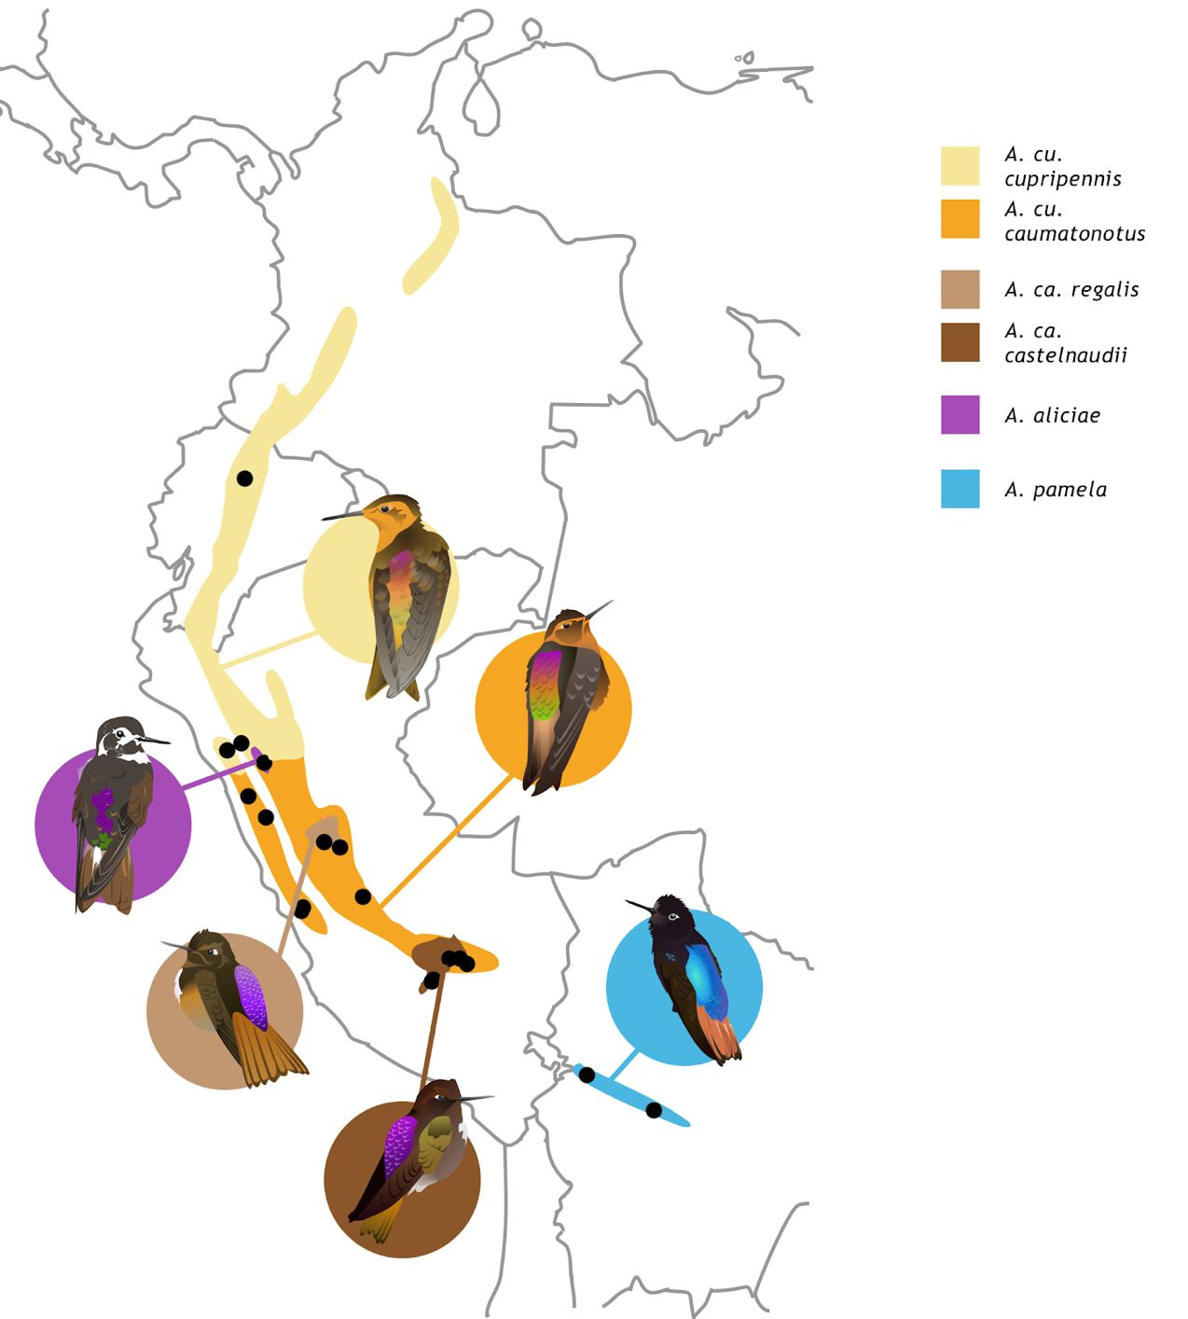
Figure 3.1: Ranges and collection localities of the six taxa in the genus Aglaeactis. Ranges sourced from Handbook of the Birds of the World (Schuchmann 1999).

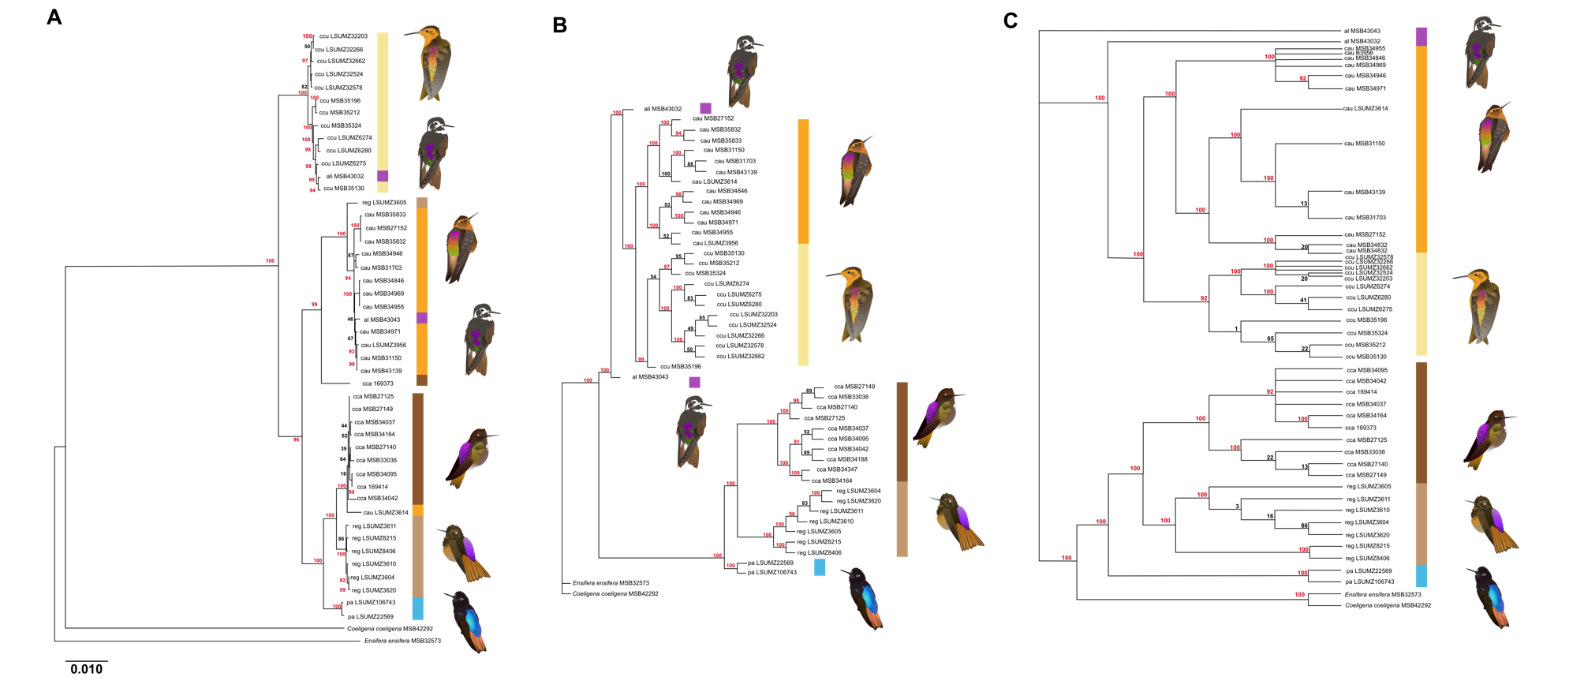

Figure 3.2: (A) Maximum-likelihood tree from whole mitogenomes, (B) ML tree generated in IQ-TREE with 186,011 nuclear SNPs, and (C) ML tree generated in RAxML with 68,541 nuclear SNPs, with taxa indicated by color-codes. Bootstrap values indicated on nodes, with values >90 in red. Colors and species as in Figure 3.1.

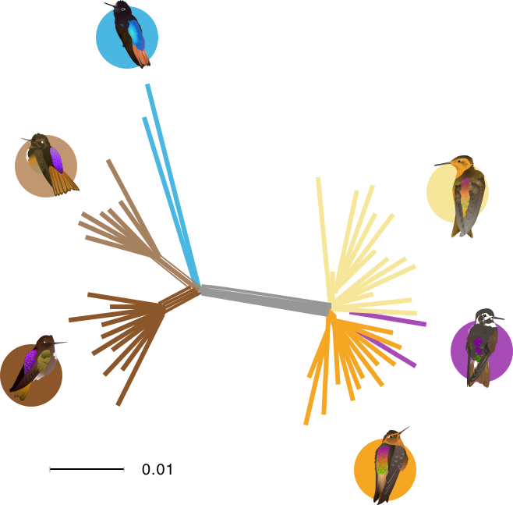
Figure 3.3: Splitstree phylogeny created from 71,505 SNPs. We find that in this unrooted tree, we recover the same clades as with our nuclear ML tree constructed in IQ-TREE, with the same northern and southern clades as seen above. Colors and species as in Figure 3.1.

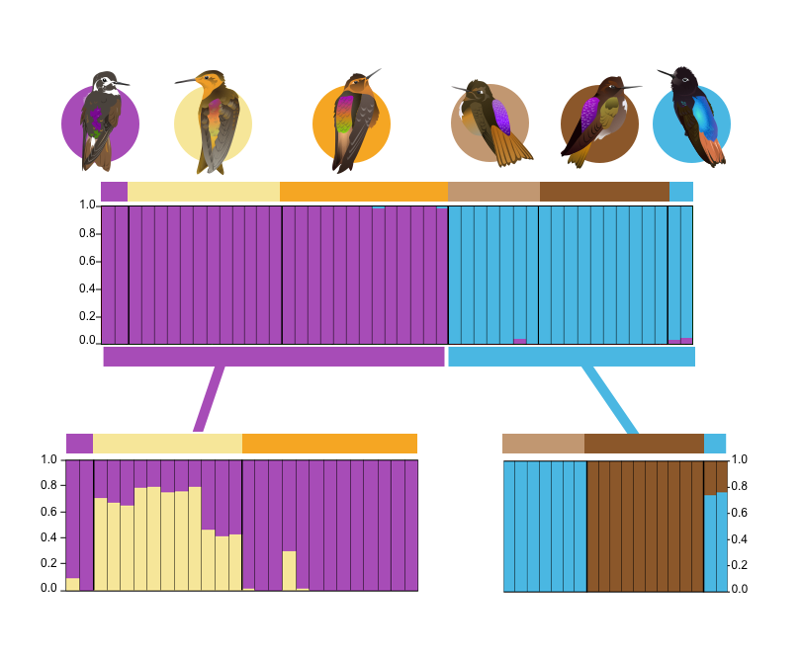

Figure 3.4: STRUCTURE analysis of 71,505 SNPs in 46 Aglaeactis individuals. Overall, the best fit value was K = 2, with clustering corresponding to northern (both cupripennis subspecies, oranges, and aliciae, purple) and southern (castelnaudii, browns, subspecies and pamela, blue) groups. When these two groups were analyzed separately, K = 2 was again found as the best fit, with aliciae and pamela not found to be distinctive clusters.
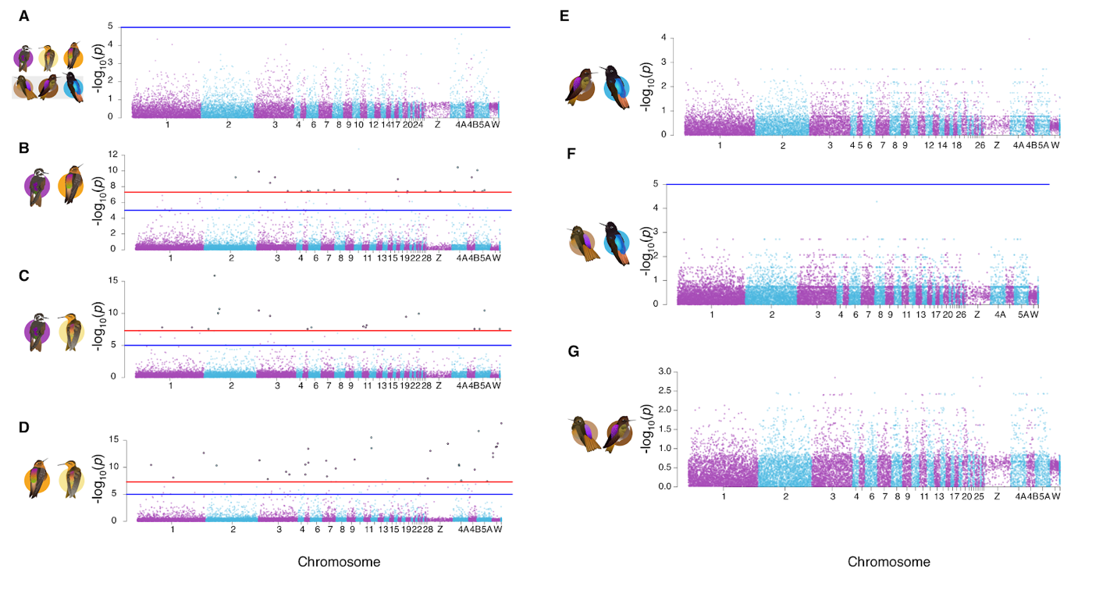
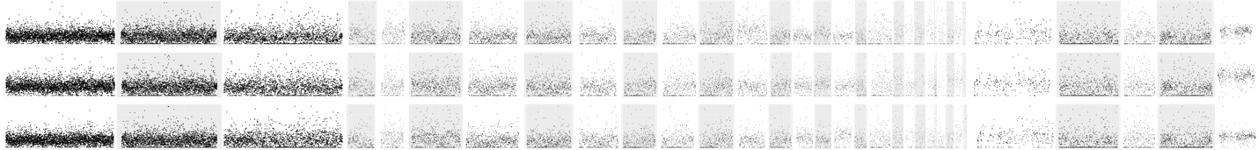
Figure 3.5: Distribution of F_{ST} by windows between (A) northern and southern Aglaeactis, (B) aliciae and caumatonota, (C) aliciae and nominate cupripennis, (D) nominate cupripennis and caumatonota, (E) nominate castelnaudii and pamela, (F) regalis and pamela, and (G) nominate castelnaudii and regalis. Colors and species as in Figure 1. Horizontal blue lines (shown on A, B, C, D, and F) indicate -log₁₀p(1 x 10⁻⁵), with windows in excess of that being potentially elevated, though not significantly so. Horizontal red lines (only shown on B, C, and D) indicate -log₁₀(5 x 10⁻⁸), with windows above that being significantly elevated above genome-wide F_{ST}. Panels lacking one or both lines did not have any windows in excess of either value. All comparisons are characterized by overall relative differentiation, with few outlier windows. In (H), Dxy across the genome is shown.

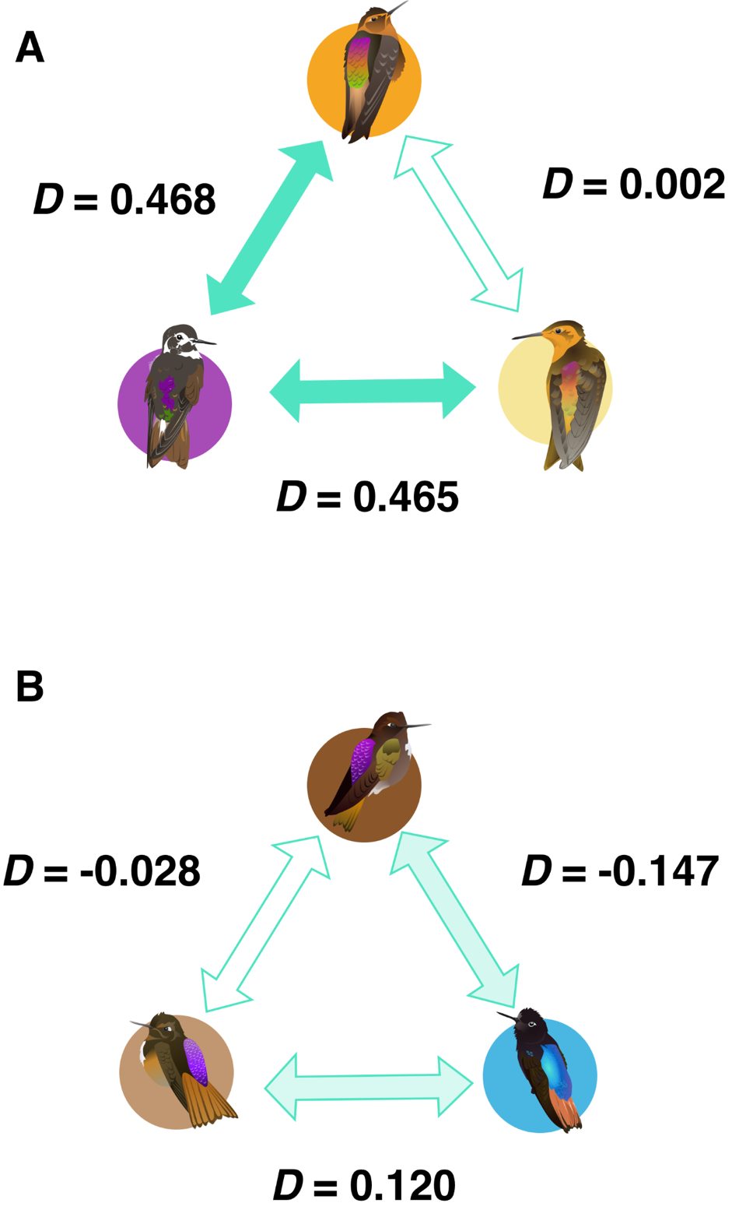

Figure 3.6: ABBA-BABA results for pairwise comparisons in the (A) northern and (B) southern clades. D values are shown for each pairwise comparison. Strong evidence of gene flow is indicated with fully colored-in arrows, weak evidence with lightly colored arrows, and no evidence with outlines only.

Tables

Table 3.1: Localities of specimens used in this study, with sequencing results and NCBI SRA numbers. Institution codes: Museum of Southwestern Biology (MSB), Louisiana State University Museum of Zoology (LSUMZ). Note that some individuals could not be assigned geographic coordinates. Reads are counted post-quality control, with coverage from aligned reads following duplicate removal.

Taxon | Locality | Catalog number | Reads (millions) | Coverage (average from aligned reads after duplicate removal) | SRA accession number
Aglaeactis aliciae | Peru: La Libertad, El Molino Viejo (-7.759, -77.765, 3543 m) | MSB:Birds:43032 | 21.3 | 1.88 | SAMN28788481
 | Peru: La Libertad, El Molino Viejo (-7.758, -77.764, 3551 m) | MSB:Birds:43043 | 32.9 | 2.89 | SAMN28788482
Aglaeactis ca. castelnaudii | Peru: Cuzco, Urubamba (-13.199, -72.16, 4330 m) | MSB:Birds:27125 | 33.9 | 2.90 | SAMN28788509
 | Peru: Cuzco, Urubamba (-13.199, -72.16, 4400 m) | MSB:Birds:27140 | 21.3 | 1.89 | SAMN28788510
 | Peru: Cuzco, Urubamba (-13.199, -72.16, 4470 m) | MSB:Birds:27149 | 25.6 | 2.21 | SAMN28788508
 | Peru: Cuzco, Urubamba (-13.188, -72.231, 4030 m) | MSB:Birds:33036 | 32.4 | 2.91 | SAMN28788511
 | Peru: Apurímac, Abancay (-14.059, -73.003, 4411 m) | MSB:Birds:34037 | 25.1 | 2.27 | SAMN28788512
 | Peru: Apurímac, Abancay (-14.060, -73.008, 4369 m) | MSB:Birds:34042 | 27.5 | 2.48 | SAMN28788513
 | Peru: Apurímac, Abancay (-14.060, -73.008, 4375 m) | MSB:Birds:34095 | 24.1 | 2.13 | SAMN28788514
 | Peru: Apurímac, Abancay (-14.069, -73.017, 4578 m) | MSB:Birds:34147 | 13.5 | 1.24 | SAMN28788515
 | Peru: Apurímac, Abancay (-14.059, -73.002, 4512 m) | MSB:Birds:34164 | 18.8 | 1.67 | SAMN28788516
 | Peru: Apurímac, Abancay (-14.058, -73.001, 4485 m) | MSB:Birds:34188 | 29.5 | 2.61 | SAMN28788517
Aglaeactis ca. regalis | Peru: Huánuco, Quebrada Shugush (-9.934, -76.453, 3100 m) | LSUMZ3604 | 24.6 | 2.91 | SAMN28788518
 | Peru: Huánuco, Quebrada Shugush (-9.934, -76.453, 3100 m) | LSUMZ3605 | 24.8 | 2.09 | SAMN28788519
 | Peru: Huánuco, Quebrada Shugush (-9.934, -76.453, 3100 m) | LSUMZ3610 | 21.1 | 1.75 | SAMN28788520
 | Peru: Huánuco, Quebrada Shugush (-9.934, -76.453, 3100 m) | LSUMZ3611 | 29.9 | 2.60 | SAMN28788521
 | Peru: Huánuco, Quebrada Shugush (-9.934, -76.453, 3100 m) | LSUMZ3620 | 37.7 | 3.23 | SAMN28788522
 | Peru: Pasco, Millpo (-9.9, -75.73, 3700 m) | LSUMZ8215 | 13.6 | 1.19 | SAMN28788523
 | Peru: Huánuco, Hurao (-9.867, -75.801, 3500 m) | LSUMZ8406 | 33.8 | 2.99 | SAMN28788524
Aglaeactis cu. caumatonota | Peru: Cuzco, Urubamba (-13.199, -72.16, 4300) | MSB:Birds:27152 | 33.4 | 2.99 | SAMN28788483
 | Peru: Junín, Puente Carrizales (-11.489, -74.896, 3520 m) | MSB:Birds:31150 | 37.8 | 3.28 | SAMN28788484
 | Peru: Lima, Carhuayumac (-11.762, -76.549, 3750 m) | MSB:Birds:31703 | 21.1 | 1.87 | SAMN28788485
 | Peru: Ancash, Macate (-8.755, -78.048, 2972 m) | MSB:Birds:34846 | 31.4 | 2.82 | SAMN28788486
 | Peru: Ancash, Carhuaz (-9.572, -77.847, 3439 m) | MSB:Birds:34946 | 18.3 | 1.65 | SAMN28788491
 | Peru: Ancash, Carhuaz (-9.572, -77.847, 3439 m) | MSB:Birds:34955 | 29.8 | 2.71 | SAMN28788487
 | Peru: Ancash, Carhuaz (-9.572, -77.847, 3439 m) | MSB:Birds:34971 | 27.8 | 2.53 | SAMN28788492
 | Peru: Ancash, Carhuaz (-9.572, -77.847, 3439 m) | MSB:Birds:34969 | 34.5 | 2.99 | SAMN28788488
 | Peru: Cuzco, Paucartambo (-13.178, -72.596, 3361 m) | MSB:Birds:35832 | 20.0 | 1.80 | SAMN28788496
 | Peru: Cuzco, Paucartambo (-13.178, -72.596, 3361 m) | MSB:Birds:35833 | 20.3 | 1.82 | SAMN28788497
 | Peru: Lima, Huarochiri (-11.925, -76.652, 937 m) | MSB:Birds:43139 | 25.5 | 2.27 | SAMN28788490
 | Peru: Huánuco, Quebrada Shugush (-9.934, -76.453, 3100 m) | LSUMZ3614 | 27.2 | 2.44 | SAMN28788507
 | Peru: Huánuco | LSUMZ3956 | 33.4 | 2.93 | SAMN28788498
Aglaeactis cu. cupripennis | Peru: Cajamarca, Contumaza (-7.398, -78.778, 2500 m) | MSB:Birds:35130 | 29.7 | 2.63 | SAMN28788489
 | Peru: Cajamarca, Contumaza (-7.398, -78.778, 2500 m) | MSB:Birds:35196 | 10.0 | 0.98 | SAMN28788493
 | Peru: Cajamarca, Contumaza (-7.398, -78.778, 2500 m) | MSB:Birds:35212 | 32.1 | 2.88 | SAMN28788494
 | Peru: Cajamarca, Contumaza (-7.398, -78.778, 2500 m) | MSB:Birds:35324 | 32.6 | 2.94 | SAMN28788495
 | Ecuador: Pichincha | LSUMZ6274 | 26.0 | 2.33 | SAMN28788499
 | Ecuador: Pichincha | LSUMZ6275 | 27.2 | 2.44 | SAMN28788500
 | Ecuador: Pichincha | LSUMZ6280 | 21.7 | 1.97 | SAMN28788501
 | Peru: Cajamarca | LSUMZ32203 | 21.4 | 1.84 | SAMN28788502
 | Peru: Cajamarca | LSUMZ32266 | 23.6 | 2.11 | SAMN28788503
 | Peru: Cajamarca | LSUMZ32524 | 27.3 | 2.45 | SAMN28788504
 | Peru: Cajamarca | LSUMZ32578 | 21.7 | 1.95 | SAMN28788505
 | Peru: Cajamarca | LSUMZ32662 | 21.1 | 1.89 | SAMN28788506
Aglaeactis pamela | Bolivia: La Paz | LSUMZ22569 | 32.0 | 2.82 | SAMN28788525
 | Bolivia: Cochabamba | LSUMZ106743 | 23.2 | 1.99 | SAMN28788526
Coeligena coeligena | Peru: Amazonas, Las Pinas (-6.049, -78.227, 2150 m) | MSB:Birds:42292 | 28.3 | 2.45 | SAMN28788527
Ensifera ensifera | Peru: Amazonas, Tullanya (-6.080, -78.325, 2937 m) | MSB:Birds:32573 | 37.4 | 3.26 | SAMN28788528

Table 3.2: Measures of genomic differentiation between A) northern and southern clades of Aglaeactis and B) pairwise comparisons of individual Aglaeactis taxa

Comparison |  | F_{ST} | Outlier windows
Northern clade (cupripennis nominate, caumatonota, aliciae) | Southern clade  (castelnaudii nominate, regalis, pamela) | 0.2197 | 0% (0/17,287)
aliciae | cupripennis | 0.0297 | 0.11% (18/16,563)
aliciae | caumatonota | 0.0274 | 0.15% (24/16,414)
cupripennis | caumatonota | 0.0484 | 0.20% (33/16,869)
pamela | castelnaudii | 0.2085 | 0% (0/16,086)
pamela | regalis | 0.2031 | 0% (0/15,944)
castelnaudii | regalis | 0.2486 | 0% (0/16,391)

Table 3.3: δaδi model fitting for each comparison. Maximum log composite likelihood (MLCL) for each is shown, followed by AICc weights in parentheses. Numbers in bold indicate best-fit models, with cases of partial support being italicized. Sample sizes correspond with the order of the names in the first column.

Comparison | Sample size | Neutral | IM | Island | Split (no migration) | Splitmig (equal migration) | Splitmig_2m | SC_1m | SC_2m
aliciae/caumatonota | 2: | -1176.13 | -3099.24 | -8207.71 | -8838.96 | -1075.74 | -1643.25 | -1109. | -722.38
aliciae/cupripennis nominate | 2: | -1779.25 (2.77 x 10⁻⁸⁵) | -2398.46  (0) | -6312.76  (0) | -11287.46  (0) | -1582.55  (1) | -2202.59  (1.9 x 10⁻²⁷⁰) | -1924.19  (1.6 x 10⁻¹⁴⁹) | -1645.84  (4.41 x 10⁻²⁹)
caumatonota/cupripennis nominate |  | -8419.19  (0) | -5983.23  (0) | -20405.42  (0) | -34029.45  (0) | -3563.93  (1) | -4509.98  (0) | -4749.79  (0) | -3762.66  (6.7 x 10⁻⁸⁸)
pamela/castelnaudii nominate | 2: | -7567.60 | -744.90 | -4818.24 | -5512.78 | -683.32 | -4064.88 |  | -176.65
pamela/ regalis | 2:7 | -6313.56  (0) | -696.52  (1.5x10⁻²⁶¹) | -5024.86  (0) | -3422.68  (0) | -521.62  (3.8x10⁻¹⁸⁵) | -669.41  (9.1x10⁻²⁵⁰) | -521.21  (7.7x10⁻¹⁸⁶) | -95.97  (1)
regalis/castelnaudii nominate | 7: | -39034.75 (0) | -4444.20  (0) | -9965.02  (0) | -15328.13 (0) | -2247.07  (2.5x10⁻²⁰⁷) | -5758.96  (0) | -1919.00  (7.9x10⁻⁶⁵) | -1770.40  (1)

Table 3.4: Estimated demographic variables from δaδi modeling, with raw parameters in parentheses. Included are estimates of effective population sizes (N_{e}) of each population, effective population size of the ancestral population (N_{ref}), time since divergence in years (T_{S}) and, for applicable models, time of secondary contact (T_{SC}), and migration rates, either total (M) or in each direction from population 1 to 2 (M₁₂) or vice versa (M₂₁).

Comparison | N_{e} first taxon (individuals) | N_{e} second taxon (individuals) | T_{S} | T_{SC} | M | M₁₂ | M₂₁ | N_{ref}  (individuals)
aliciae/caumatonota | 491.69  (1.0221) | 828.51  (1.7222) | 43,549  (10.7769) | 3,709  (0.9180) |  | 2.27  (4.4565) | 0.088  (0.1725) | 481.07  (4079.51)
aliciae/ cupripennis nominate | 201.85 (0.1211) | 873.12 (0.5238) | 191.24 (0.0137) |  | 2.01 (7.67) |  |  | 1,666.91  (13,033.70)
caumatonota/cupripennis nominate | 196.08 (0.1355) | 244.17 (0.1687) | 210.79 (0.0173) |  | 0.4934 (5.8491) |  |  | 1,447.47 (12,717.91)
pamela/castelnaudii nominate | 601.38  (0.9384) | 70.51  (0.1100) | 25,110.57  (4.6645) | 973.92  (0.1809) |  | 0.9280  (1.9779) | 0.3239  (5.8895) | 640.87  (5212.37
pamela/ regalis | 350.16 (0.1629) | 941.66 (0.4377) | 178,878.15 (9.896) | 101,203.52 (5.600) |  | 0.0098 (0.0449) | 0.1031 (0.4710) | 2,151.24 (14,555.62)
regalis/castelnaudii nominate | 589.95 (0.2432) | 486.30 (0.2007) | 85,266.92 (4.1888) | 55,886.21 (2.7454) |  | 0.0703 (0.7012) | 0.04198 (0.4184) | 2,423.38 (20,539.62)

General Conclusions

In studying the process of speciation, it is natural to be drawn to regions particularly rich in biodiversity to test hypotheses on the mechanisms that lead to the development and maintenance of reproductive isolation. Using genetic data from single COI barcodes to full genomes, I have tested several specific hypotheses on how intrinsic organismal traits shape the speciation process, and how they interact with the more commonly studied landscape history to generate the rich avifaunal diversity of the Neotropics.

Time does not predict reproductive isolation

One of my most striking findings is that time in allopatry does not predict the development of reproductive isolation, as observed in the context of secondary contact (Chapter 2). This is counter to both theoretical predictions and previous experimental evidence. In their foundational 1989 paper, Coyne and Orr state that “[t]he divergence time of taxa must obviously be correlated with the amount of reproductive isolation between them, because all species begin as populations that are not reproductively isolated.” While this has been supported by evidence of both increasing prezygotic (Coyne and Orr 1989, 1997; Turissini et al. 2018; Mendelson 2003; Tilley, Verrell, and Arnold 1990; Arnegard et al. 2010; P. A. Moran et al. 2020) and postzygotic isolation (Mendelson 2003; Charistianson, Swallow, and Wilkinson 2005; Scopece et al. 2007; Edmands 2002; Gourbière and Mallet 2010; Coughlan and Matute 2020), for other reproductive barriers, this prediction has not held up (Gleason and Ritchie 1998; Campagna et al. 2012; R. L. Moran et al. 2017). The probability of hybridization with increasing divergence has been examined less often (Matute and Cooper 2021), but it has generally been found to decrease as the age of the taxa split grows (Wiens, Engstrom, and Chippindale 2006; Kronforst et al. 2013; Hamlin, Hibbins, and Moyle 2020; Mallet 2007; Pereira, Monahan, and Wake 2011; Sánchez-Guillén et al. 2014).

I do not find evidence that time increases reproductive isolation in Panamanian birds, contrary to these predictions.

Ecology predicts diversification and reproductive isolation

I find strong evidence that in Panamanian birds, ecological traits linked to dispersal capability are linked to both the occurrence of species-level mitochondrial variation and to the outcomes of secondary contact. The role of ecology in driving the generation of species is of course foundational to the very study of biology, but often focuses on the particulars of a population’s adaptation to the environment and community in which it finds itself. By instead asking what ecological traits are associated with specific outcomes in the tempo and mode of speciation, we can build models of speciation that are less about the particulars of a landscape, and more about how the characteristics of an organism can predict its evolutionary trajectory.

The role of dispersal and gene flow in speciation

In all my chapters, I find that dispersal and gene flow are heavily intertwined in shaping the speciation process. In Panama, traits associated with lower dispersal ability (namely smaller HWI, strong territoriality, forest undergrowth habitats, and insectivory) were overrepresented in taxa with two or more mitochondrial BINs. This is in line with previous work that ties greater diversity to lower dispersal (Belliure et al. 2000; Miller et al. 2021).

Low dispersal capability is not only tied to the development of differentiation, but to the maintenance of it during secondary contact. Diet was the best predictor of median cline width, and HWI was, in combination with time, part of the best fit model for fixation rates on both the autosomes and Z chromosome. We see this key role in dispersal shaping the genomic landscape in early speciation again in Aglaeactis, where the distribution of heightened divergence is associated with higher levels of gene flow. This drives home how gene flow does not act as merely a destroyer of genetic differentiation, but can instead lead to a variety of outcomes as populations come into contact.

Future directions

A key piece that warrants further exploration in both study systems is the role of demography. In Panama, the best predictor of median cline width is diet. While diet is associated with dispersal ability in birds (Sheard et al. 2020), HWI is a much more direct proxy for this (Claramunt and Wright 2017; Sheard et al. 2020), and this was not recovered as a predictor of cline width. As there are striking differences in the demographic dynamics associated with diet type, disentangling their role in determining the outcomes of secondary contact is an important next step. Our ability to test this directly is limited by our current data, however, as loci linked to ultraconserved elements are, by nature of their linkage to highly conserved regions, likely to be biased conservatively in their ability to detect demographic changes (McLaughlin et al. 2020). Population demographic models with loci less likely to be under purifying selection are needed to properly address this question.
A more in-depth investigation of demographics is also warranted in the Aglaeactis system. Our low-coverage data, while adequate for the analyses performed in Chapter 3, is not robust enough for confident modeling of population changes over time beyond our relatively simple demographic models. As one travels back into the evolutionary history of a population pair, distinguishing between discrete periods of gene flow or multiple bouts of population expansion and contraction become increasingly difficult (Gutenkunst et al. 2009), and require more sites to be confidently called to come to a reliable answer. Greater sequencing coverage of at least some of the individuals in each population would provide the necessary data quality to make these inferences.

Final thoughts

The process by which a population becomes a species is one driven by the interactions of an untold myriad of factors, working in concert to generate the outcomes we can see in the rich array of life on Earth. Some of the threads in this dense web of forces will be thick and obvious; others will be the faintest thought of a fiber. It is easy to unpick the most obvious threads, but these subtler threads may reward investigation with a deeper understanding of the web as a whole. My dissertation is an exploration of some of these less prominent threads. Species arise not merely from passive organisms being acted upon by a landscape, but the combination of landscape, ecology, and the nature of the genome itself. By stepping back and considering all of these threads, we come closer to fully taking in, to quote Darwin, “the grandeur in this view of life.”

References
Abolins-Abols, Mikus, Etienne Kornobis, Paolo Ribeca, Kazumasa Wakamatsu, Mark P. Peterson, Ellen D. Ketterson, and Borja Milá. 2018. Differential gene regulation underlies variation in melanic plumage coloration in the dark-eyed junco (Junco hyemalis). Molecular Ecology 27 (22): 4501–15.
Aleixo, Alexandre. 2002. Molecular systematics and the role of the “várzea”- “terra-firme” ecotone in the diversification of Xiphorhynchus woodcreepers (Aves: Dendrocolaptidae).” The Auk 119(3): 621–40.
Allendorf, Fred W., and Gordon Luikart. 2009. Conservation and the Genetics of Populations. John Wiley & Sons.
Anderson, Robert P., and Charles O. Handley. 2001. A new species of three-toed sloth (Mammalia: Xenarthra) from Panamá, with a review of the genus Bradypus.” Proceedings of the Biological Society of Washington 114 (1): 1–33.
Andrews, Simon. 2010. FastQC: A Quality Control Tool for High Throughput Sequence Data. http://www.bioinformatics.babraham.ac.uk/projects/fastqc.
Angehr, George R., and Robert Dean. 2010. The Birds of Panama: A Field Guide. Ithaca, NY, USA: Cornell University Press.
Antonelli, Alexandre, Johan A. A. Nylander, Claes Persson, and Isabel Sanmartín. 2009. Tracing the impact of the Andean uplift on Neotropical plant evolution.” Proceedings of the National Academy of Sciences 106 (24): 9749–54.
Arita, Héctor T., and Ella Vázquez-Domínguez. 2008. The Tropics: Cradle, Museum or Casino? A Dynamic null model for latitudinal gradients of species diversity. Ecology Letters, 11 (7): 653–63.
Arnegard, Matthew E., Peter B. McIntyre, Luke J. Harmon, Miriam L. Zelditch, William G. R. Crampton, Justin K. Davis, John P. Sullivan, Sébastien Lavoué, and Carl D. Hopkins. 2010. Sexual signal evolution outpaces ecological divergence during electric fish species radiation. The American Naturalist, 176 (3): 335–56.
Arnot, David E., Caroline Roper, and Riad A.L. Bayoumi. 1993. Digital codes from hypervariable tandemly repeated DNA sequences in the plasmodium falciparum circumsporozoite gene can genetically barcode isolates. Molecular and Biochemical Parasitology 61 (1): 15–24.
Avise, John C. 2000. Phylogeography: The History and Formation of Species. Cambridge, MA, USA: Harvard University Press.
Bachmann, K., B. A. Harrington, and J. P. Craig. 1972. Genome size in birds. Chromosoma 37 (4): 405–16.
Backström, Niclas, Johan Lindell, Yu Zhang, Eleftheria Palkopoulou, Anna Qvarnström, Glenn-Peter Sætre, and Hans Ellegren. 2010. A high-density scan of the Z chromosome in Ficedula flycatchers reveals candidate loci for diversifying selection. Evolution 64 (12): 3461–75.
Bagley, Justin C., and Jerald B. Johnson. 2014. Phylogeography and biogeography of the lower Central American Neotropics: diversification between two Continents and between two seas. Biological Reviews of the Cambridge Philosophical Society 89 (4): 767–90.
Baker, Paul A., Sherilyn C. Fritz, David S. Battisti, Christopher W. Dick, Oscar M. Vargas, Gregory P. Asner, Roberta E. Martin, Alexander Wheatley, and Ivan Prates. 2020. Beyond refugia: new insights on Quaternary climate variation and the evolution of biotic diversity in tropical South America. In Neotropical Diversification: Patterns and Processes, edited by Valentí Rull and Ana Carolina Carnaval, 51–70. Cham: Springer International Publishing.
Baldassarre, Daniel T., and Michael S. Webster. 2013. Experimental evidence that extra-pair mating drives asymmetrical introgression of a sexual trait. Proceedings of The Royal Society B 280 (1771): 20132175.
Baldassarre, Daniel T., Thomas A. White, Jordan Karubian, and Michael S. Webster. 2014. Genomic and morphological analysis of a semipermeable avian hybrid zone suggests asymmetrical introgression of a sexual signal. Evolution 68 (9): 2644–57.
Barraclough, Timothy G., and Alfried P. Vogler. 2000. Detecting the geographical pattern of speciation from species-level phylogenies. The American Naturalist 155 (4): 419–34.
Barrantes, Gilbert. 2009. The role of historical and local factors in determining species composition of the highland avifauna of Costa Rica and Western Panamá. Revista de Biologia Tropical 57: 333–46.
Barreira, Ana S., Darío A. Lijtmaer, and Pablo L. Tubaro. 2016. The multiple applications of DNA barcodes in avian evolutionary studies. Genome 59 (11): 899–911.
Barrowclough, George F., Joel Cracraft, John Klicka, and Robert M. Zink. 2016. How many kinds of birds are there and why does it matter? PloS One 11 (11): e0166307.
Barton, N. H. 1979. Gene flow past a cline. Heredity 43 (3): 333–39.
Barton, N. H., and G. M. Hewitt. 1985. Analysis of hybrid zones. Annual Review of Ecology and Systematics 16: 113–48.
———. 1989. Adaptation, Speciation and Hybrid Zones. Nature 341 (6242): 497–503.
Bates, John M., Shannon J. Hackett, and Jaqueline M. Goerck. 1999. High levels of mitochondrial DNA differentiation in two lineages of antbirds (Drymophila and Hypocnemis). The Auk 116 (4): 1093–1106.
Batista, Abel, Konrad Mebert, Madian Miranda, Orlando Garces, Rogemif Fuentes, and Marcos Ponce. 2020. Endemism on a threatened sky island: new and rare species of herpetofauna from Cerro Chucantí, Eastern Panama. Amphibian & Reptile Conservation 14 (2): 27–46.
Battey, Christopher J. 2020. Evidence of linked selection on the Z chromosome of hybridizing hummingbirds. Evolution 74 (4): 725–39.
Belliure, J., G. Sorci, A. P. Møller, and J. Clobert. 2000. Dispersal distances predict subspecies richness in birds. Journal of Evolutionary Biology 13: 480-487.
Benham, Phred M., and Christopher C. Witt. 2016. The dual role of Andean topography in primary divergence: functional and neutral variation among populations of the hummingbird Metallura tyrianthina. BMC Evolutionary Biology 16: 22.
Berdan, Emma L., Alexandre Blanckaert, Roger K. Butlin, and Claudia Bank. 2021. Deleterious mutation accumulation and the long-term fate of chromosomal inversions. PLoS Genetics 17(3): e1009411.
Bermingham, E., and A. P. Martin. 1998. Comparative mtDNA phylogeography of Neotropical freshwater fishes: testing shared history to infer the evolutionary landscape of lower Central America. Molecular Ecology 7 (4): 499–517.
Berner, D., and X. Thibert-Plante. 2015. How mechanisms of habitat preference evolve and promote divergence with gene flow. Journal of Evolutionary Biology 28 (9): 1641–55.
Bickford, David, David J. Lohman, Navjot S. Sodhi, Peter K. L. Ng, Rudolf Meier, Kevin Winker, Krista K. Ingram, and Indraneil Das. 2007. Cryptic species as a window on diversity and conservation. Trends in Ecology & Evolution 22 (3): 148–55.
Billerman, S. M., B. K. Keeney, P. G. Rodewald, and T. S. Schulenberg, eds. 2020. Birds of the World Online. Ithaca, NY, USA: Cornell Laboratory of Ornithology.
BirdLife International. 2021. “IUCN Red List for Birds.” http://www.birdlife.org.
Blanco, Paula D., Rene R. Colditz, Gerardo López Saldaña, Leonardo A. Hardtke, Ricardo M. Llamas, Nicolás A. Mari, Angeles Fischer, Constanza Caride, Pablo G. Aceñolaza, Héctor F. del Valle, Mario Lillo-Saavedra, Fernando Coronato, Sergio A. Opazo, Fabiano Morelli, Jesús A. Anaya, Walter F. Sione, Pamela Zamboni, and Victor Barrena Arroyo. 2013. A land cover map of Latin America and the Caribbean in the framework of the SERENA project. Remote Sensing of Environment 132 (May): 13–31.
Bleiweiss, Robert. 1998. Origin of hummingbird faunas. Biological Journal of the Linnean Society 65 (1): 77–97.
Bolger, Anthony M., Marc Lohse, and Bjoern Usadel. 2014. Trimmomatic: a flexible trimmer for Illumina sequence data. Bioinformatics 30 (15): 2114–20.
Bolnick, Daniel I., and Thomas J. Near. 2005. Tempo of hybrid inviability in centrarchid fishes (Teleostei: Centrarchidae). Evolution 59 (8): 1754–67.
Bouckaert, Remco, Joseph Heled, Denise Kühnert, Tim Vaughan, Chieh-Hsi Wu, Dong Xie, Marc A. Suchard, Andrew Rambaut, and Alexei J. Drummond. 2014. BEAST 2: a software platform for Bayesian evolutionary analysis. PLoS Computational Biology 10 (4): e1003537.
Bradburd, Gideon S., Graham M. Coop, and Peter L. Ralph. 2018. Inferring continuous and discrete population genetic structure across space. Genetics 210 (1): 33–52.
Brawn, Jeffrey D., James R. Karr, and James D. Nichols. 1995. Demography of birds in a Neotropical forest: effects of allometry, taxonomy, and ecology. Ecology 76 (1): 41–51.
Brelsford, Alan, David P. L. Toews, and Darren E. Irwin. 2017. Admixture mapping in a hybrid zone reveals loci associated with avian feather coloration. Proceedings of The Royal Society B 284 (1866).
Broad Institute. 2019. Picard Toolkit. http://broadinstitute.github.io/picard/.
Bromham, Lindell, and David Penny. 2003. The modern molecular clock. Nature Reviews. Genetics 4 (3): 216–24.
Bronstein, Omri, Andreas Kroh, and Elisabeth Haring. 2018. Mind the gap! The mitochondrial control region and its power as a phylogenetic marker in echinoids. BMC Evolutionary Biology 18 (1): 80.
Brown, James H. 1981. Two decades of Homage to Santa Rosalia: toward a general theory of diversity. Integrative and Comparative Biology 21 (4): 877–88.
———. 2014. Why are there so many species in the tropics? Journal of Biogeography 41 (1): 8–22.
Brumfield, Robb T., and Michael J. Braun. 2001. Phylogenetic relationships in bearded manakins (Pipridae: Manacus) indicate that male plumage color is a misleading taxonomic marker. The Condor 103 (2): 248.
Brumfield, Robb T., Liang Liu, David E. Lum, and Scott V. Edwards. 2008. Comparison of species tree methods for reconstructing the phylogeny of bearded manakins (Aves: Pipridae, Manacus) from multilocus sequence data. Systematic Biology 57 (5): 719–31.
Bryson, Robert W., Jr, Jaime Chaves, Brian Tilston Smith, Matthew J. Miller, Kevin Winker, Jorge L. Pérez-Emán, and John Klicka. 2014. Diversification across the New World within the ‘blue’ Cardinalids (Aves: Cardinalidae). Journal of Biogeography 41 (3): 587–99.
Buerkle, C. Alex, and Zachariah Gompert. 2013. Population genomics based on low coverage sequencing: how low should we go? Molecular Ecology 22: 3028-3035.
Burney, Curtis W., and Robb T. Brumfield. 2009. Ecology predicts levels of genetic differentiation in Neotropical birds. The American Naturalist 174 (3): 358–68.
Burns, Kevin J., and Kazuya Naoki. 2004. Molecular phylogenetics and biogeography of Neotropical tanagers in the genus Tangara. Molecular Phylogenetics and Evolution 32 (3): 838–54.
Burri, Reto, Alexander Nater, Takeshi Kawakami, Carina F. Mugal, Pall I. Olason, Linnea Smeds, Alexander Suh, Ludovic Dutoit, Stanislav Bureš, Laszlo Z. Garamszegi, Silje Hogner, Juan Moreno, Anna Qvarnström, Milan Ružic, Stein-Are Sæther, Glenn-Peter Sætre, Janos Török, and Hans Ellegren. 2015. Linked selection and recombination rate variation drive the evolution of the genomic landscape of differentiation across the speciation continuum of Ficedula flycatchers. Genome Research 25: 1656-1665.
Bush, G. L. 1975. Modes of Animal Speciation. Annual Review of Ecology and Systematics 6 (1): 339–64.
Bush, G. L., S. M. Case, A. C. Wilson, and J. L. Patton. 1977. Rapid speciation and chromosomal evolution in mammals. Proceedings of the National Academy of 74 (9): 3942–46.
Bush, Mark B. 1994. Amazonian speciation: a necessarily complex model. Journal of Biogeography 21 (1): 5–17.
Bush, Mark B., and Paul A. Colinvaux. 1990. A pollen record of a complete glacial cycle from lowland Panama. Journal of Vegetation Science 1 (1): 105–18.
Bush, Mark B., Dolores R. Piperno, Paul A. Colinvaux, Paulo E. De Oliveira, Lawrence A. Krissek, Michael C. Miller, and William E. Rowe. 1992. A 14 300-yr paleoecological profile of a lowland tropical lake in Panama. Ecological Monographs 62 (2): 251–75.
Bushnell, Brian. 2014. BBMap: a fast, accurate, splice-aware aligner. LBNL-7065E. Lawrence Berkeley National Lab. (LBNL), Berkeley, CA (United States).
Cadena, Carlos Daniel, and Andrés M. Cuervo. 2010. Molecules, ecology, morphology, and songs in concert: how many species is Arremon torquatus (Aves: Emberizidae)? Biological Journal of the Linnean Society 99 (1): 152–76.
Cadena, Carlos Daniel, John Klicka, and Robert E. Ricklefs. 2007. Evolutionary differentiation in the Neotropical montane region: molecular phylogenetics and phylogeography of Buarremon brush-finches (Aves, Emberizidae). Molecular Phylogenetics and Evolution 44 (3): 993–1016.
Campagna, Leonardo, Pilar Benites, Stephen C. Lougheed, Darío A. Lijtmaer, Adrián S. Di Giacomo, Muir D. Eaton, and Pablo L. Tubaro. 2012. Rapid phenotypic evolution during incipient speciation in a continental avian radiation. Proceedings of The Royal Society B 279 (1734): 1847–56.
Campagna, Leonardo, Márcio Repenning, Luís Fábio Silveira, Carla Suertegaray Fontana, Pablo L. Tubaro, and Irby J. Lovette. 2017. Repeated divergent selection on pigmentation genes in a rapid finch radiation. Science Advances 3 (5): e1602404.
Campbell, C. Ryan, J. W. Poelstra, and Anne D. Yoder. 2018. What is speciation genomics? The roles of ecology, gene flow, and genomic architecture in the formation of species. Biological Journal of the Linnean Society 124 (4): 561–83.
Campbell, Kyle K., Thomas Braile, and Kevin Winker. 2016. Integration of genetic and phenotypic data in 48 lineages of Philippine birds shows heterogeneous divergence processes and numerous cryptic species. PloS One 11 (7): e0159325.
Capparella, A. P. 1988. Genetic variation in Neotropical birds: implications for the speciation process. Acta Congressus Internationalis Ornithologici 19: 1658–73.
Carling, Matthew D., and Robb T. Brumfield. 2009. Speciation in Passerina Buntings: introgression patterns of sex-linked loci identify a candidate gene region for reproductive isolation. Molecular Ecology 18 (5): 834–47.
Chaitra, M. S., Karthikeyan Vasudevan, and Kartik Shanker. 2004. The biodiversity bandwagon: the splitters have it. Current Science 86 (7): 897–99.
Chan, Kin O., Carl R. Hutter, Perry L. Wood Jr, L. L. Grismer. Indraneil Das, Rafe M. Brown. 2020. Gene flow creates a mirage of cryptic species in a Southeast Asian spotted stream frog complex. Molecular Ecology 29: 3970-3987.
Chapman, Frank M. 1917. The Distribution of Bird-Life in Colombia. New York City, NY, USA: American Museum of Natural History.
Charistianson, Sarah J., John G. Swallow, and Gerald S. Wilkinson. 2005. Rapid evolution of postzygotic reproductive isolation in stalk-eyed flies. Evolution 59 (4): 849–57.
Charlesworth, B., J. A. Coyne, and N. H. Barton. 1987. The relative rates of evolution of sex chromosomes and autosomes. The American Naturalist 130 (1): 113–46.
Chavarría-Pizarro, Tania, Gustavo Gutiérrez-Espeleta, Eric J. Fuchs, and Gilbert Barrantes. 2010. Genetic and morphological variation of the sooty-capped bush tanager (Chlorospingus pileatus), a highland endemic species from Costa Rica and western Panama. The Wilson Journal of Ornithology 122 (2): 279–87.
Chaves, Jaime A., John P. Pollinger, Thomas B. Smith, and Gretchen LeBuhn. 2007. The role of geography and ecology in shaping the phylogeography of the speckled hummingbird (Adelomyia melanogenys) in Ecuador. Molecular Phylogenetics and Evolution 43 (3): 795–807.
Chaves, Jaime A., Jason T. Weir, and Thomas B. Smith. 2011. Diversification in Adelomyia hummingbirds follows Andean uplift. Molecular Ecology 20 (21): 4564–76.
Chenuil, Anne, Abigail E. Cahill, Numa Délémontey, Elrick Du Salliant du Luc, and Hadrien Fanton. 2019. Problems and questions posed by cryptic species: a framework to guide future studies. In From Assessing to Conserving Biodiversity, 77–106. Springer, Cham.
Cheviron, Z. A., Shannon J. Hackett, and Angelo P. Capparella. 2005. Complex evolutionary history of a Neotropical lowland forest bird (Lepidothrix coronata) and its implications for historical hypotheses of the origin of Neotropical avian diversity. Molecular Phylogenetics and Evolution 36 (2): 338–57.
Chown, S. L., and K. J. Gaston. 2000. Areas, cradles, and museums: the latitudinal gradient in species richness. Trends in Ecology & Evolution 15 (8): 311–15.
Chua, Vivien L., Brian Tilston Smith, Ryan C. Burner, Mustafa Abdul Rahman, Maklarin Lakim, Dewi M. Prawiradilaga, Robert G. Moyle, and Frederick H. Sheldon. 2017. Evolutionary and ecological forces influencing population diversification in Bornean montane passerines. Molecular Phylogenetics and Evolution 113: 139–49.
Claramunt, Santiago, Elizabeth P. Derryberry, J. V. Remsen Jr, and Robb T. Brumfield. 2012. High dispersal ability inhibits speciation in a continental radiation of passerine birds. Proceedings of The Royal Society B 279 (1733): 1567–74.
Claramunt, Santiago, and Natalie A. Wright. 2017. Using museum specimens to study flight and dispersal. The Extended Specimen: Emerging Frontiers in Collections-Based Ornithological Research, 127–41.
Clark, J. Alan, and Robert M. May. 2002. Taxonomic bias in conservation research. Science 297 (5579): 191–92.
Colinvaux, P. A., P. E. De Oliveira, and M. B. Bush. 2000. Amazonian and Neotropical plant communities on glacial time-scales: the failure of the aridity and refuge hypotheses. Quaternary Science Reviews 19 (1): 141–69.
Cortés-Ortiz, L., E. Bermingham, C. Rico, E. Rodríguez-Luna, I. Sampaio, and M. Ruiz-García. 2003. Molecular systematics and biogeography of the Neotropical monkey genus, Alouatta. Molecular Phylogenetics and Evolution 26 (1): 64–81.
Cortés-Ortiz, Liliana, Anthony B. Rylands, and Russell A. Mittermeier. 2015. The taxonomy of howler monkeys: integrating old and new knowledge from morphological and genetic studies. In Howler Monkeys: Adaptive Radiation, Systematics, and Morphology, edited by Martín M. Kowalewski, Paul A. Garber, Liliana Cortés-Ortiz, Bernardo Urbani, and Dionisios Youlatos, 55–84. New York, NY: Springer New York.
Coughlan, Jenn M., and Daniel R. Matute. 2020. The importance of intrinsic postzygotic barriers throughout the speciation process. Philosophical Transactions of the Royal Society of London. Series B, Biological Sciences 375 (1806): 20190533.
Cowles, Sarah A., and J. Albert C. Uy. 2019. Rapid, complete reproductive isolation in two closely related Zosterops white-eye bird species despite broadly overlapping ranges. Evolution 73: 1647-1662.
Coyne, J. A. 1985. The genetic basis of Haldane’s Rule. Nature 314 (6013): 736–38.
Coyne, Jerry A., and H. Allen Orr. 1989. Patterns of speciation in Drosophila. Evolution 43 (2): 362–81.
———. 1997. ‘Patterns of Speciation in Drosophila’ Revisited. Evolution 51 (1): 295.
———. 2004. Speciation. Sunderland, MA, USA: Sinauer Associates, Inc.
Cracraft, Joel. 1983. Species concepts and speciation analysis. Current Ornithology, edited by Richard F. Johnston, 159–87. New York, NY: Springer US.
———. 1985. Historical biogeography and patterns of differentiation within the South American avifauna: area of endemism. Ornithological Monographs 36 (Neotropical Ornithology): 49–85.
Crawford, A. J. 2003. Huge populations and old species of Costa Rican and Panamanian dirt frogs inferred from mitochondrial and nuclear gene sequences. Molecular Ecology 12 (10): 2525–40.
Crawford, Andrew J., Catalina Cruz, Edgardo Griffith, Heidi Ross, Roberto Ibáñez, Karen R. Lips, Amy C. Driskell, Eldredge Bermingham, and Paul Crump. 2013. DNA barcoding applied to ex situ tropical amphibian conservation programme reveals cryptic diversity in captive populations. Molecular Ecology Resources 13 (6): 1005–18.
Crawford, Andrew J., and Eric N. Smith. 2005. Cenozoic biogeography and evolution in direct-developing frogs of Central America (Leptodactylidae: Eleutherodactylus) as inferred from a phylogenetic analysis of nuclear and mitochondrial Genes. Molecular Phylogenetics and Evolution 35 (3): 536–55.
Crouch, Nicholas M. A., João M. G. Capurucho, Shannon J. Hackett, and John M. Bates. 2019. Evaluating the contribution of dispersal to community structure in Neotropical passerine birds. Ecography 42 (2): 390–99.
Cruickshank, Tami E., and Matthew W. Hahn. 2014. Reanalysis suggests that genomic islands of speciation are due to reduced diversity, not reduced gene flow. Molecular Ecology 23 (13): 3133–57.
DaCosta, Jeffrey M., and John Klicka. 2008. The Great American Interchange in birds: a phylogenetic perspective with the genus Trogon. Molecular Ecology 17 (5): 1328–43.
Danecek, Petr, Adam Auton, Goncalo Abecasis, Cornelis A. Albers, Eric Banks, Mark A. DePristo, Robert E. Handsaker, Gerton Lunter, Gabor T. Marth, Stephen T. Sherry, Gilean McVean, Richard Durbin, and 1000 Genomes Project Analysis Group. 2011. The variant call format and VCFtools. Bioinformatics 27 (15): 2156–58.
Darwin, Charles. 1859. On the Origin of Species. London: John Murray.
Derryberry, Elizabeth P., Graham E. Derryberry, James M. Maley, and Robb T. Brumfield. 2014. HZAR: Hybrid zone analysis using an R software package. Molecular Ecology Resources 14 (3): 652–63.
Després, Laurence. 2019. One, two or more species? Mitonuclear discordance and species delimitation. Molecular Ecology 28: 3845-3847.
Dick, Christopher W., Kobinah Abdul-Salim, and Eldredge Bermingham. 2003. Molecular systematic analysis reveals cryptic Tertiary diversification of a widespread tropical rain forest tree. The American Naturalist 162 (6): 691–703.
Dierckxsens, Nicolas, Patrick Mardulyn, and Guillaume Smits. 2017. NOVOplasty: De novo assembly of organelle genomes from whole genome data. Nucleic Acids Research 45 (4): e18.
do Amaral, Fábio Raposo, Leandro G. Neves, Márcio F. R. Resende Jr, Flávia Mobili, Cristina Y. Miyaki, Katia C. M. Pellegrino, and Cibele Biondo. 2015. Ultraconserved elements sequencing as a low-cost source of complete mitochondrial genomes and microsatellite markers in non-model amniotes. PloS One 10 (9): e0138446.
Dobzhansky, Theodosius. 1937. Genetics and the Origin of Species. New York, NY, USA: Columbia University Press.
———. 1940. Speciation as a stage in evolutionary divergence. The American Naturalist 74 (753): 312–21.
Dong, Yibo, Shichao Chen, Shifeng Cheng, Wenbin Zhou, Qing Ma, Zhiduan Chen, Cheng-Xin Fu, Xin Liu, Yun-peng Zhao, Pamela S. Soltis, Gane Ka-Shu Wong, Douglas E. Soltis, Qiu-Yun (Jenny) Xiang. 2019. Natural selection and repeated patterns of molecular evolution following allopatric divergence. eLife 8: e45199.
Drès, M., and J. Mallet. 2002. Host races in plant–feeding insects and their importance in sympatric speciation. Philosophical Transactions of the Royal Society B 357: 471-492.
Drummond, Alexei J., and Andrew Rambaut. 2007. BEAST: Bayesian Evolutionary Analysis by Sampling Trees. BMC Evolutionary Biology 7 (November): 214.
Ducatez, Simon, and Louis Lefebvre. 2014. Patterns of research effort in birds. PloS One 9 (2): e89955.
Dufresnes, Christophe, Alan Brelsford, Jelka Crnobrnja-Isailović, Nikolay Tzankov, Petros Lymberakis, and Nicolas Perrin. 2015. Timeframe of speciation inferred from secondary contact zones in the European tree frog radiation (Hyla arborea group). BMC Evolutionary Biology 15 (August): 155.
Dufresnes, Christophe, Alan Brelsford, Daniel L. Jeffries, Glib Mazepa, Tomasz Suchan, Daniele Canestrelli, Alfredo Nicieza, Luca Fumagalli, Sylvain Dubey, Iñigo Martinez-Solano, Spartak N. Litvinchuk, Miguel Vences, Nicolas Perrin, and Pierre-André Crochet. 2021. Mass of genes rather than master genes underlie the genomic architecture of amphibian speciation. Proceedings of the National Academy of Sciences 118 (36): e2103963118.
Duranton, Maud, François Allal, Christelle Fraïsse, Nicolas Bierne, François Bonhomme, and Pierre-Alexandre Gagnaire. 2018. The origin and remolding of genomic islands of differentiation in the European sea bass. Nature Communications 9 (1): 2518.
Earl, Dent A., and Bridgett M. vonHoldt. 2012. STRUCTURE HARVESTER: A website and program for visualizing STRUCTURE output and implementing the Evanno method. Conservation Genetics Resources 4 (2): 359–61.
Edgar, Robert C. 2004. MUSCLE: Low-complexity multiple sequence alignment with T-Coffee accuracy. ISMB/ECCB, 1–3.
Edmands, Suzanne. 2002. Does parental divergence predict reproductive compatibility? Trends in Ecology & Evolution 17 (11): 520–27.
Edwards, Scott V., Sarah B. Kingan, Jennifer D. Calkins, Christopher N. Balakrishnan, W. Bryan Jennings, Willie J. Swanson, and Michael D. Sorenson. 2005. Speciation in birds: genes, geography, and sexual selection. Proceedings of the National Academy of Sciences 102: 6550–57.
Ellegren, Hans. 2010. Evolutionary stasis: the stable chromosomes of birds. Trends in Ecology & Evolution 25 (5): 283–91.
———. 2013. The evolutionary genomics of birds. Annual Review of Ecology, Evolution, and Systematics 44 (1): 239–59.
Ellegren, Hans, Linnéa Smeds, Reto Burri, Pall I. Olason, Niclas Backström, Takeshi Kawakami, Axel Künstner, Hannu Mäkinen, Krystyna Nadachowska-Brzyka, Anna Qvarnström, Severin Uebbing, and Jochen B. W. Wolf. 2012. The genomic landscape of species divergence in Ficedula flycatchers. Nature 491 (7426): 756–60.
Emerson, Brent C., and Niclas Kolm. 2005. Species diversity can drive speciation. Nature 434 (7036): 1015–17.
Eskildsen, Gilberto A., Jose R. Rovira, Octavio Smith, Matthew J. Miller, Kelly L. Bennett, W. Owen McMillan, and Jose Loaiza. 2018. Maternal invasion history of Aedes aegypti and Aedes albopictus into the Isthmus of Panama: implications for the control of emergent viral disease agents. PloS One 13 (3): e0194874.
Evanno, G., S. Regnaut, and J. Goudet. 2005. Detecting the number of clusters of individuals using the software STRUCTURE: a simulation study. Molecular Ecology 14 (8): 2611–20.
Everson, Kathryn M., Jessica F. McLaughlin, Iris A. Cato, Maryanne M. Evans, Angela R. Gastaldi, Kendall K. Mills, Katie G. Shink, Sara M. Wilbur, and Kevin Winker. 2019. Speciation, gene flow, and seasonal migration in Catharus thrushes (Aves: Turdidae). Molecular Phylogenetics and Evolution 139 (October): 106564.
Faaborg, John, Wayne J. Arendt, and Mark S. Kaiser. 1984. Rainfall correlates of bird population fluctuations in a Puerto Rican dry forest: a nine year study. The Wilson Bulletin 96 (4): 575–93.
Faircloth, B. C. 2013. Illumiprocessor: a Trimmomatic wrapper for parallel adapter and quality trimming. http://dx.doi.org/10. 6079/J9ILL
Faircloth, Brant C. 2016. PHYLUCE is a software package for the analysis of conserved genomic loci. Bioinformatics 32 (5): 786–88.
Faircloth, Brant C., John E. McCormack, Nicholas G. Crawford, Michael G. Harvey, Robb T. Brumfield, and Travis C. Glenn. 2012. Ultraconserved elements anchor thousands of genetic markers spanning multiple evolutionary timescales. Systematic Biology 61 (5): 717–26.
Feder, Jeffrey L., Samuel M. Flaxman, Scott P. Egan, Aaron A. Comeault, and Patrik Nosil. 2013. Geographic mode of speciation and genomic divergence. Annual Review of Ecology, Evolution, and Systematics 44 (1): 73–97.
Feder, Jeffrey L., Patrik Nosil, Aaron C. Wacholder, Scott P. Egan, Stewart H. Berlocher, and Samuel M. Flaxman. 2014. Genome-wide congealing and rapid transitions across the speciation continuum during speciation with gene flow. The Journal of Heredity 105: 810–20.
Ferreira, Mateus, Alexandre Aleixo, Camila Cherem Ribas, and Marcos Pérsio Dantas Santos. 2017. Biogeography of the Neotropical genus Malacoptila (Aves: Bucconidae): the influence of the Andean orogeny, Amazonian drainage evolution and palaeoclimate. Journal of Biogeography 44 (4): 748–59.
Fitzpatrick, Benjamin M. 2004. Rates of evolution of hybrid inviability in birds and mammals. Evolution 58 (8): 1865–70.
Flaxman, Samuel M., Jeffrey L. Feder, and Patrik Nosil. 2013. Genetic hitchhiking and the dynamic buildup of genomic divergence during speciation with gene flow. Evolution 67 (9): 2577–91.
Flaxman, Samuel M., Aaron C. Wacholder, Jeffrey L. Feder, and Patrik Nosil. 2014. Theoretical models of the influence of genomic architecture on the dynamics of speciation. Molecular Ecology 23 (16): 4074–88.
Floyd, Robin, Eyualem Abebe, Artemis Papert, and Mark Blaxter. 2002. Molecular barcodes for soil nematode identification. Molecular Ecology 11 (4): 839–50.
Fouquet, Antoine, André Gilles, Miguel Vences, Christian Marty, Michel Blanc, and Neil J. Gemmell. 2007. Underestimation of species richness in Neotropical frogs revealed by mtDNA analyses. PloS One 2 (10): e1109.
Funk, Daniel J., and Kevin E. Omland. 2003. Species-level paraphyly and polyphyly: frequency, causes, and consequences, with insights from animal mitochondrial DNA. Annual Review of Ecology, Evolution, and Systematics 34 (1): 397–423.
Funk, Erik R., and Scott A. Taylor. 2019. High-throughput sequencing is revealing genetic associations with avian plumage color. The Auk 136 (4): 1-7.
Funk, W. Chris, Marcel Caminer, and Santiago R. Ron. 2012. High levels of cryptic species diversity uncovered in Amazonian frogs. Proceedings of The Royal Society B 279 (1734): 1806–14.
Gagnaire, Pierre-Alexandre. 2020. Comparative genomics approach to evolutionary process connectivity. Evolutionary Applications 13 (6): 1320–34.
Gante, Hugo F., Michael Matschiner, Martin Malmstrøm, Kjetill S. Jakobsen, Sissel Jentoft, and Walter Salzburger. 2016. Genomics of speciation and introgression in princess cichlid fishes from Lake Tanganyika. Molecular Ecology 25 (24): 6143–61.
García-Alcalde, Fernando, Konstantin Okonechnikov, José Carbonell, Luis M. Cruz, Stefan Götz, Sonia Tarazona, Joaquín Dopazo, Thomas F. Meyer, and Ana Conesa. 2012. Qualimap: evaluating next-generation sequencing alignment data. Bioinformatics 28 (20): 2678–79.
Gascon, C., J. R. Malcolm, J. L. Patton, M. N. da Silva, J. P. Bogart, S. C. Lougheed, C. A. Peres, S. Neckel, and P. T. Boag. 2000. Riverine barriers and the geographic distribution of Amazonian species. Proceedings of the National Academy of Sciences 97 (25): 13672–77.
Gaston, Kevin J., and Tim M. Blackburn. 1996. The tropics as a museum of biological diversity: an analysis of the New World avifauna. Proceedings of the Royal Society B 263 (1366): 63–68.
Gee, Jennifer M. 2004. Gene Flow across a climatic barrier between hybridizing avian species, California and Gambel’s quail (Callipepla californica and C. gambelii). Evolution 58 (5): 1108–21.
Gentry, Alwyn H. 1982. Neotropical floristic diversity: phytogeographical connections between Central and South America, Pleistocene climatic fluctuations, or an accident of the Andean orogeny? Annals of the Missouri Botanical Garden 69 (3): 557–93.
Gillespie, John H. 2004. Population Genetics: A Concise Guide. JHU Press.
Gleason, Jennifer M., and Michael G. Ritchie. 1998. Evolution of courtship song and reproductive isolation in the Drosophila willistoni species complex: do sexual signals diverge the most quickly? Evolution 52 (5): 1493.
Glenn, Travis C., Roger Nilsen, Troy J. Kieran, Jon G. Sanders, Natalia J. Bayona-Vásquez, John W. Finger, Todd W. Pierson, Kerin E. Bentley, Sandra Hoffberg, Swarnali Louha, Francisco J. García-De León, Miguel Angel Del Rio Portilla, Kurt D. Reed, Jennifer L. Anderson, Jennifer K. Meece, Samuel E. Aggrey, Romdhane Rekaya, Magdy Alabady, Myriam Bélanger, Kevin Winker, and Brant C. Faircloth. 2019. Adapterama I: universal stubs and primers for 384 unique dual-indexed or 147,456 combinatorially-indexed Illumina libraries (iTru & iNext). PeerJ 7: e7755.
Gompert, Zachariah, Elizabeth G. Mandeville, and C. Alex Buerkle. 2017. Analysis of population genomic data from hybrid zones. Annual Review of Ecology, Evolution, and Systematics 48 (1): 207–29.
Gonçalves, Priscila F. M., Adriana R. Oliveira-Marques, Tania E. Matsumoto, and Cristina Y. Miyaki. 2015. DNA barcoding identifies illegal parrot trade The Journal of Heredity 106: 560–64.
González, Maribel A., Jessica R. Eberhard, Irby J. Lovette, Storrs L. Olson, and Eldredge Bermingham. 2003. Mitochondrial DNA phylogeography of the bay wren (Troglodytidae: Thryothorus nigricapillus) complex. The Condor 105 (2): 228–38.
Gourbière, Sébastien, and James Mallet. 2010. Are species real? The shape of the species boundary with exponential failure, reinforcement, and the ‘missing snowball.’ Evolution 64 (1): 1–24.
Grabherr, Manfred G., Brian J. Haas, Moran Yassour, Joshua Z. Levin, Dawn A. Thompson, Ido Amit, Xian Adiconis, Lin Fan, Raktima Raychowdhury, Qiandong Zeng, Zehua Chen, Evan Mauceli, Nir Hacohen, Andreas Gnirke, Nicolas Rhind, Federica di Palma, Bruce W. Birren, Chad Nusbaum, Kerstin Lindblad-Toh, Nir Friedman, and Aviv Regev. 2011. Full-length transcriptome assembly from RNA-Seq data without a reference genome. Nature Biotechnology 29 (7): 644–52.
Grant, Peter R., and B. Rosemary Grant. 1997. Hybridization, sexual imprinting, and Mate Choice.” The American Naturalist 149 (1): 1–28.
———. 2016. Introgressive hybridization and natural selection in Darwin’s finches.” Biological Journal of the Linnean Society 117 (4): 812–22.
Graves, Gary R. 1985. Elevational correlates of speciation and intraspecific geographic variation in plumage in Andean forest birds. The Auk 102 (3): 556–79.
Greenberg, Russell, and Judith Gradwohl. 1986. Constant density and stable territoriality in some tropical insectivorous birds. Oecologia 69 (4): 618–25.
Greenway, Ryan, Anthony P. Brown, Henry Camarillo, Cassandra Delich, Kerry L. McGowan, Joel Nelson, Lenin Arias-Rodriguez, Joanna L. Kelley, and Michael Tobler. 2021. Convergent adaptation and ecological speciation result from unique genomic mechanisms in sympatric extremophile fishes. bioRxiv. https://doi.org/10.1101/2021.06.28.450104.
Greenwood, Paul J. 1980. Mating systems, philopatry and dispersal in birds and mammals. Animal Behaviour 28 (4): 1140–62.
Gregory, T. Ryan. 2002. A bird’s-eye view of the C-value enigma: genome size, cell size, and metabolic rate in the class Aves. Evolution 56 (1): 121–30.
———. 2005. Chapter 1 - Genome size evolution in animals. In The Evolution of the Genome, edited by T. Ryan Gregory, 3–87. Burlington: Academic Press.
Gregory, T. Ryan, Chandler B. Andrews, Jimmy A. McGuire, and Christopher C. Witt. 2009. The smallest avian genomes are found in hummingbirds. Proceedings of the Royal Society B 276 (1674): 3753–57.
Groeneveld, J., E. C. Hathorne, S. Steinke, H. DeBey, A. Mackensen, and R. Tiedemann. 2014. Glacial induced closure of the Panamanian gateway during Marine Isotope Stages (MIS) 95–100 (∼2.5 Ma). Earth and Planetary Science Letters 404: 296–306.
Gutenkunst, Ryan N., Ryan D. Hernandez, Scott H. Williamson, and Carlos D. Bustamante. 2009. Inferring the joint demographic history of multiple populations from multidimensional SNP frequency data. PLoS Genetics 5 (10): e1000695.
Guzman, Betty K., Antonio García-Bravo, Elvis E. Allauja-Salazar, Iván A. Mejía, Cristóbal Torres Guzmán, and Manuel Oliva. 2021. Endemism of woody flora and tetrapod fauna, and conservation status of the inter-Andean seasonally dry tropical forests of the Marañón Valley. Global Ecology and Conservation 28 (e01639): e01639.
Hackett, Shannon J. 1995. Molecular systematics and zoogeography of flowerpiercers in the Diglossa baritula complex. The Auk 112 (1): 156–70.
Hackett, S. J. 1996. Molecular phylogenetics and biogeography of tanagers in the genus Ramphocelus (Aves). Molecular Phylogenetics and Evolution 5 (2): 368–82.
Haffer, Jürgen. 1969. Speciation in Amazonian forest birds. Science 165 (3889): 131–37.
———. 1985. Avian zoogeography of the Neotropical lowlands. Ornithological Monographs, no. 36: 113–46.
———. 1992. The history of species concepts and species limits in ornithology. Bulletin of the British Ornithology Club A 112: 107–58.
———. 1997. Contact zones between birds of southern Amazonia. Ornithological Monographs, no. 48: 281–305.
———. 1997. Alternative models of vertebrate speciation in Amazonia: an overview. Biodiversity & Conservation 6 (3): 451–76.
Haldane, J. B. S. 1922. Sex ratio and unisexual sterility in hybrid animals. Journal of Genetics 12 (2): 101–9.
Hamlin, Jennafer A. P., Mark S. Hibbins, and Leonie C. Moyle. 2020. Assessing biological factors affecting postspeciation introgression. Evolution Letters 4 (2): 137–54.
Han, Fan, Sangeet Lamichhaney, B. Rosemary Grant, Peter R. Grant, Leif Andersson, and Matthew T. Webster. 2017. Gene flow, ancient polymorphism, and ecological adaptation shape the genomic landscape of divergence among Darwin’s finches. Genome Research 27 (6): 1004–15.
Harrison, Richard G. 1990. Hybrid zones: windows on evolutionary process. Oxford Surveys in Evolutionary Biology 7: 69–128.
———. 1991. Molecular changes at speciation. Annual Review of Ecology and Systematics 22 (1): 281–308.

Harvey, Michael G., Alexandre Aleixo, Camila C. Ribas, and Robb T. Brumfield. 2017. Habitat association predicts genetic diversity and population divergence in Amazonian birds. The American Naturalist 190 (5): 631–48.
Harvey, Michael G., and Robb T. Brumfield. 2015. Genomic variation in a widespread Neotropical bird (Xenops minutus) reveals divergence, population expansion, and gene flow. Molecular Phylogenetics and Evolution 83: 305–16.
Harvey, Michael G., Brian Tilston Smith, Travis C. Glenn, Brant C. Faircloth, and Robb T. Brumfield. 2016. Sequence capture versus restriction site associated DNA sequencing for shallow systematics. Systematic Biology 65 (5): 910–24.
Haselton, Kirk, George Hilley, and Manfred R. Strecker. 2002. Average Pleistocene climatic patterns in the southern central Andes: controls on mountain glaciation and paleoclimate implications. The Journal of Geology 110 (2): 211–26.
Hawlitschek, Oliver, Lars Hendrich, Marianne Espeland, Emmanuel F. A. Toussaint, Martin J. Genner, and Michael Balke. 2012. Pleistocene climate change promoted rapid diversification of aquatic invertebrates in southeast Australia. BMC Evolutionary Biology 12: 142.
Hayes, Floyd E., and Jo-Anne N. Sewlal. 2004. The Amazon River as a dispersal barrier to passerine birds: effects of river width, habitat, and taxonomy. Journal of Biogeography 31 (11): 1809–18.
Hebert, Paul D. N., and T. Ryan Gregory. 2005. The promise of DNA barcoding for taxonomy. Systematic Biology 54 (5): 852–59.
Hebert, Paul D. N., Sujeevan Ratnasingham, and Jeremy R. deWaard. 2003. Barcoding animal life: cytochrome c oxidase subunit 1 divergences among closely related species. Proceedings of the Royal Society B 270 Suppl 1 (August): S96–99.
Henderson, Elisa C., and Alan Brelsford. 2020. Genomic differentiation across the speciation continuum in three hummingbird species pairs. BMC Evolutionary Biology 20 (1): 113.
Hendry, A. P., D. I. Bolnick, D. Berner, and C. L. Peichel. 2009. Along the speciation continuum in sticklebacks. Journal of Fish Biology 75 (8): 2000–2036.
Hermann, Katrin, Ulrich Klahre, Michel Moser, Hester Sheehan, Therese Mandel, and Cris Kuhlemeier. 2013. Tight genetic linkage of prezygotic barrier loci creates a multifunctional speciation island in Petunia. Current Biology: CB 23 (10): 873–77.
Hewitt, Godfrey M. 1988. Hybrid zones- natural laboratories for evolutionary studies. Trends in Ecology & Evolution 3 (7): 158–67.
———. 2001. Speciation, hybrid zones and phylogeography—or seeing genes in space and time. Molecular Ecology 10 (3): 537–49.
Hey, Jody, Robin S. Waples, Michael L. Arnold, Roger K. Butlin, and Richard G. Harrison. 2003. Understanding and confronting species uncertainty in biology and conservation. Trends in Ecology & Evolution 18 (11): 597–603.
Hill, Geoffrey E. 2016. Mitonuclear coevolution as the genesis of speciation and the mitochondrial DNA barcode gap. Ecology and Evolution 6 (16): 5831–42.
———. 2017. The mitonuclear compatibility species concept. The Auk 134 (2): 393–410.
Hogner, Silje, Terje Laskemoen, Jan T. Lifjeld, Jiri Porkert, Oddmund Kleven, Tamer Albayrak, Bekir Kabasakal, and Arild Johnsen. 2012. Deep sympatric mitochondrial divergence without reproductive isolation in the common redstart Phoenicurus phoenicurus. Ecology and Evolution 2 (12): 2974–88.
Homburger, Julian R., Cynthia L. Neben, Gilad Mishne, Alicia Y. Zhou, Sekar Kathiresan, and Amit V. Khera. 2019. Low coverage whole genome sequencing enables accurate assessment of common variants and calculation of genome-wide polygenic scores. Genome Medicine 11: 74.
Hooper, Daniel M., Simon C. Griffith, and Trevor D. Price. 2019. Sex chromosome inversions enforce reproductive isolation across an avian hybrid zone. Molecular Ecology 28 (6): 1246–62.
Hoorn, C., F. P. Wesselingh, H. ter Steege, M. A. Bermudez, A. Mora, J. Sevink, I. Sanmartín, A. Sanchez-Meseguer, C. L. Anderson, J. P. Figueiredo, C. Jaramillo, D. Riff, F. R. Negri, H. Hooghiemstra, J. Lundberg, T. Stadler, T. Särkinen, and A. Antonelli. 2010. Amazonia through time: Andean uplift, climate change, landscape evolution, and biodiversity. Science 330 (6006): 927–31.
Hosner, Peter A., Michael J. Andersen, Mark B. Robbins, Abraham Urbay-Tello, Luis Cueto-Aparicio, Karen Verde-Guerra, Luis A. Sánchez-González, Adolfo G. Navarro-Sigüenza, Roger L. Boyd, Jano Nuñez, Jorge Tiravanti, Mariela Combe, Hannah L. Owens, and A. Townsend Peterson. 2015. Avifaunal surveys of the Upper Apurímac River Valley, Ayacucho and Cuzco Departments, Peru: new distributional records and biogeographic, taxonomic, and conservation implications. The Wilson Journal of Ornithology 127 (4): 563.
Hubbs, Carl L. 1955. Hybridization between fish species in nature. Systematic Biology 4 (1): 1–20.
Hughes, Colin, and Ruth Eastwood. 2006. Island radiation on a continental scale: exceptional rates of plant diversification after uplift of the Andes. Proceedings of the National Academy of Sciences 103 (27): 10334–39.
Humphries, Elizabeth M., and Kevin Winker. 2011. Discord reigns among nuclear, mitochondrial, and phenotypic estimates of divergence in nine lineages of trans-Beringian birds. Molecular Ecology 20 (3): 573–83.
Hundsdoerfer, Anna K., Kyung Min Lee, Ian J. Kitching, and Marko Mutanen. 2019. Genome-wide SNP data reveal an overestimation of species diversity in a group of hawkmoths. Genome Biology and Evolution 11 (8): 2136–50.
Huson, Daniel H., and David Bryant. 2006. Application of phylogenetic networks in evolutionary studies. Molecular Biology and Evolution 23 (2): 254–67.
Hutchinson, G. E. 1959. Homage to Santa Rosalia or why are there so many kinds of animals? The American Naturalist 93 (870): 145–59.
Hutter, Carl R., Juan M. Guayasamin, and John J. Wiens. 2013. Explaining Andean megadiversity: the evolutionary and ecological causes of glassfrog elevational richness patterns. Ecology Letters 16 (9): 1135–44.
Hutter, Carl R., Shea M. Lambert, and John J. Wiens. 2017. Rapid diversification and time explain amphibian richness at different scales in the tropical Andes, Earth’s most biodiverse hotspot. The American Naturalist 190 (6): 828–43.
Irwin, Darren E. 2018. Sex chromosomes and speciation in birds and other ZW Systems. Molecular Ecology 27 (19): 3831–51.
———. 2020. Assortative mating in hybrid zones is remarkably ineffective in promoting speciation. The American Naturalist 195 (6): E150–67.
Irwin, Darren E., Borja Milá, David P. L. Toews, Alan Brelsford, Haley L. Kenyon, Alison N. Porter, Christine Grossen, Kira E. Delmore, Miguel Alcaide, and Jessica H. Irwin. 2018. A comparison of genomic islands of differentiation across three young avian species pairs. Molecular Ecology 27 (23): 4839–55.
Isaac, Nick J. B., James Mallet, and Georgina M. Mace. 2004. Taxonomic inflation: its influence on macroecology and conservation. Trends in Ecology & Evolution 19 (9): 464–69.
Iwasaki, Wataru, Tsukasa Fukunaga, Ryota Isagozawa, Koichiro Yamada, Yasunobu Maeda, Takashi P. Satoh, Tetsuya Sado, Kohji Mabuchi, Hirohiko Takeshima, Masaki Miya, and Mutsumi Nishida. 2013. MitoFish and MitoAnnotator: a mitochondrial genome database of fish with an accurate and automatic annotation pipeline. Molecular Biology and Evolution 30 (11): 2531–40.
Jahn, Alex E., Douglas J. Levey, Ana María Mamani, Mirtha Saldias, Angélica Alcoba, María Julieta Ledezma, Betty Flores, Julián Quillén Vidoz, and Fabián Hilarion. 2010. Seasonal differences in rainfall, food availability, and the foraging behavior of tropical kingbirds in the southern Amazon basin: foraging behavior of kingbirds in Amazonia. Journal of Field Ornithology 81 (4): 340–48.
Jakobsson, Mattias, and Noah A. Rosenberg. 2007. CLUMPP: a cluster matching and permutation program for Dealing with Label Switching and Multimodality in Analysis of Population Structure.” Bioinformatics 23 (14): 1801–6.
Jaramillo, Carlos, Camilo Montes, Agustín Cardona, Daniele Silvestro, Alexandre Antonelli, and Christine D. Bacon. 2017. Comment (1) on ‘Formation of the Isthmus of Panama’ by O’Dea et al. Science Advances 3 (6): e1602321.
Jetz, W., G. H. Thomas, J. B. Joy, K. Hartmann, and A. O. Mooers. 2012. The global diversity of birds in space and time. Nature 491 (7424): 444–48.
Johnson, Norman A., and Joseph Lachance. 2012. The genetics of sex chromosomes: evolution and implications for hybrid incompatibility. Annals of the New York Academy of Sciences 1256 (May): E1–22.
Jombart, Thibaut, and Ismaïl Ahmed. 2011. Adegenet 1.3-1: new tools for the analysis of genome-wide SNP data. Bioinformatics 27 (21): 3070–71.
Jordan, D. S. 1905. The origin of species through isolation. Science 22 (566): 545–62.
Judy, Caroline D. 2018. Speciation and hybridization in Jamaican-endemic streamertail hummingbirds (Trochilus polytmus and T. scitulus). Thesis. Louisiana State University.
Kaiser, Vera B., and Hans Ellegren. 2006. Nonrandom distribution of genes with sex-biased expression in the chicken genome. Evolution 60 (9): 1945–51.
Kapusta, Aurélie, Alexander Suh, and Cédric Feschotte. 2017. Dynamics of genome size evolution in birds and mammals. Proceedings of the National Academy of Sciences 114 (8): E1460–69.
Karr, James R. 1976. Seasonality, resource availability, and community diversity in tropical bird communities. The American Naturalist 110 (976): 973–94.
Kaviar, Sam, Jakob Shockey, and Peter Sundberg. 2012. Observations on the endemic pygmy three-toed sloth, Bradypus pygmaeus of Isla Escudo de Veraguas, Panamá. PloS One 7 (11): e49854.
Kearns, Anna M., Marco Restani, Ildiko Szabo, Audun Schrøder-Nielsen, Jin Ah Kim, Hayley M. Richardson, John M. Marzluff, Robert C. Fleischer, Arild Johnsen, and Kevin E. Omland. 2018. Genomic evidence of speciation reversal in ravens. Nature Communications 9 (1): 906.
Kennedy, Jonathan D., Michael K. Borregaard, Knud A. Jønsson, Petter Z. Marki, Jon Fjeldså, and Carsten Rahbek. 2016. The influence of wing morphology upon the dispersal, geographical distributions, and diversification of the corvides (Aves; Passeriformes). Proceedings of the Royal Society B 283: 20161922.
Kerr, Kevin C. R., Sharon M. Birks, Mikhail V. Kalyakin, Yaroslav A. Red’kin, Eugeny A. Koblik, and Paul D. N. Hebert. 2009. Filling the gap - COI barcode resolution in eastern Palearctic birds. Frontiers in Zoology 6 (December): 29.
Kerr, Kevin C. R., Darío A. Lijtmaer, Ana S. Barreira, Paul D. N. Hebert, and Pablo L. Tubaro. 2009. Probing evolutionary patterns in Neotropical birds through DNA barcodes. PloS One 4 (2): e4379.
Kerr, Kevin C. R., Mark Y. Stoeckle, Carla J. Dove, Lee A. Weigt, Charles M. Francis, and Paul D. N. Hebert. 2007. Comprehensive DNA barcode coverage of North American birds. Molecular Ecology Notes 7 (4): 535–43.
Kim, Kang-Wook, Benjamin C. Jackson, Hanyuan Zhang, David P. L. Toews, Scott A. Taylor, Emma I. Greig, Irby J. Lovette, Mengning M. Liu, Angus Davison, Simon C. Griffith, Kai Zeng, and Terry Burke. 2019. Genetics and evidence for balancing selection of a sex-linked colour polymorphism in a songbird. Nature Communications 10 (1): 1852.
Kimura, Motoo. 1968. Evolutionary rate at the molecular level. Nature 217 (5129): 624–26.
———. 1983. The Neutral Theory of Molecular Evolution. Cambridge University Press.
Kimura, M., and T. Ota. 1971. On the rate of molecular evolution. Journal of Molecular Evolution 1 (1): 1–17.
Kipp, Fr A. 1959. Der Handflügel-Index Als Flugbiologisches Maß. Die Vogelwarte 20 (2): 77–86.
Klein, Etienne K., Lélia Lagache-Navarro, and Rémy J. Petit. 2017. Demographic and spatial determinants of hybridization rate. The Journal of Ecology 105 (1): 29–38.
Klopfer, P. H., and R. H. MacArthur. 1960. Niche size and faunal diversity. The American Naturalist 94 (877): 293–300.
———. 1961. On the causes of tropical species diversity: niche overlap. The American Naturalist 95 (883): 223–26.
Knowles, L. L. 2000. Tests of Pleistocene speciation in montane grasshoppers (genus Melanoplus) from the sky islands of western North America. Evolution 54 (4): 1337–48.
Kolář, F., E. Dušková, and P. Sklenář. 2016. Niche shifts and range expansions along cordilleras drove diversification in a high‐elevation endemic plant genus in the tropical Andes. Molecular Ecology 25: 4593-4610.
Korneliussen, Thorfinn Sand, Anders Albrechtsen, and Rasmus Nielsen. 2014. ANGSD: Analysis of Next Generation Sequencing Data. BMC Bioinformatics 15: 356.
Korshunova, Tatiana, Alexander Martynov, Torkild Bakken, and Bernard Picton. 2017. External diversity is restrained by internal conservatism: new nudibranch mollusc contributes to the cryptic species problem. Zoologica Scripta 46 (6): 683–92.
Koscinski, D., P. Handford, P. L. Tubaro, and S. Sharp. 2008. Pleistocene climatic cycling and diversification of the Andean treefrog, Hypsiboas andinus. Molecular Ecology 17:2012-2025.
Kraaijeveld, Ken. 2010. Genome size and species diversification. Evolutionary Biology 37 (4): 227–33.
Kronforst, Marcus R., Matthew E. B. Hansen, Nicholas G. Crawford, Jason R. Gallant, Wei Zhang, Rob J. Kulathinal, Durrell D. Kapan, and Sean P. Mullen. 2013. Hybridization reveals the evolving genomic architecture of speciation. Cell Reports 5 (3): 666–77.
Kumar, Sudhir, Glen Stecher, and Koichiro Tamura. 2016. MEGA7: Molecular Evolutionary Genetics Analysis Version 7.0 for bigger datasets. Molecular Biology and Evolution 33 (7): 1870–74.
Kutschera, Verena E., Tobias Bidon, Frank Hailer, Julia L. Rodi, Steven R. Fain, and Axel Janke. 2014. Bears in a forest of gene trees: phylogenetic inference is complicated by incomplete lineage sorting and gene flow. Molecular Biology and Evolution 31 (8): 2004–17.
Lagomarsino, Laura P., Fabien L. Condamine, Alexandre Antonelli, Andreas Mulch, and Charles C. Davis. 2016. The abiotic and biotic drivers of rapid diversification in Andean bellflowers (Campanulaceae). The New Phytologist 210 (4): 1430–42.
Lambert, Frank R., and F. Angulo-Pratolongo. 2007. Distribution, status, and notes on the ecology of purple-backed sunbeam Aglaeactis aliciae in north Peru. Cotinga 28: 21–26.
Laurie, C. C. 1997. The weaker sex is heterogametic: 75 years of Haldane’s Rule. Genetics 147 (3): 937–51.
Lavinia, Pablo D., Patricia Escalante, Natalia C. García, Ana S. Barreira, Natalia Trujillo-Arias, Pablo L. Tubaro, Kazuya Naoki, Cristina Y. Miyaki, Fabrício R. Santos, and Darío A. Lijtmaer. 2015. Continental-scale analysis reveals deep diversification within the polytypic red-crowned ant tanager (Habia rubica, Cardinalidae). Molecular Phylogenetics and Evolution 89: 182–93.
Lavinia, Pablo D., Kevin C. R. Kerr, Pablo L. Tubaro, Paul D. N. Hebert, and Darío A. Lijtmaer. 2016. Calibrating the molecular clock beyond cytochrome b: assessing the evolutionary rate of COI in birds. Journal of Avian Biology 47 (1): 84–91.
Lavretsky, Philip, Jeffrey M. DaCosta, Blanca E. Hernández-Baños, Andrew Engilis Jr, Michael D. Sorenson, and Jeffrey L. Peters. 2015. Speciation genomics and a role for the Z chromosome in the early stages of divergence between Mexican ducks and mallards. Molecular Ecology 24 (21): 5364–78.
Lavretsky, Philip, Jeffrey M. DaCosta, Michael D. Sorenson, Kevin G. McCracken, and Jeffrey L. Peters. 2019. ddRAD-seq data reveal significant genome-wide population structure and divergent genomic regions that distinguish the mallard and close relatives in North America. Molecular Ecology 28: 2594-2609.
Lefouili, Messaoud, and Kiwoong Nam. 2022. The evaluation of Bcftools mpileup and GATK HaplotypeCaller for variant calling in non-human species. Scientific Reports 12: 11331.
Leigh, Egbert G., Aaron O’Dea, and Geerat J. Vermeij. 2014. Historical biogeography of the Isthmus of Panama. Biological Reviews of the Cambridge Philosophical Society 89 (1): 148–72.
Levey, Douglas J., Timothy C. Moermond, and Julie Sloan Denslow. 1994. Frugivory: an overview. In: La Selva: Ecology and Natural History of a Neotropical Rain Forest, 282–94.
Levey, Douglas J., and F. Gary Stiles. 1992. Evolutionary precursors of long-distance migration: resource availability and movement patterns in Neotropical landbirds. The American Naturalist 140 (3): 447–76.
———. 1994. Birds: ecology, behavior, and taxonomic affinities. In: La Selva: Ecology and History of a Neotropical Rainforest, 217–28.
Levy, Heather E., and James A. Cox. 2020. Variation in responses to interspecific vocalizations among sister taxa of the Sittidae: imminent extinction of a cryptic species on Grand Bahama Island? Avian Conservation and Ecology 15 (2).
Li, Heng. 2011. A statistical framework for SNP calling, mutation discovery, association mapping and population genetical parameter estimation from sequencing data. Bioinformatics 27 (21): 2987–93.
———. 2013. Aligning sequence reads, clone sequences and assembly contigs with BWA-MEM. arXiv [q-bio.GN]. arXiv. http://arxiv.org/abs/1303.3997.
Li, Heng, and Richard Durbin. 2009. Fast and accurate short read alignment with Burrows–Wheeler transform. Bioinformatics 25 (14): 1754–60.
Li, Heng, Bob Handsaker, Alec Wysoker, Tim Fennell, Jue Ruan, Nils Homer, Gabor Marth, Goncalo Abecasis, Richard Durbin, and 1000 Genome Project Data Processing Subgroup. 2009. The Sequence Alignment/Map Format and SAMtools. Bioinformatics 25 (16): 2078–79.
Lijtmaer, Darío A., Bettina Mahler, and Pablo L. Tubaro. 2003. Hybridization and postzygotic isolation patterns in pigeons and doves. Evolution 57 (6): 1411–18.
Lim, Marisa C. W., Ke Bi, Christopher C. Witt, Catherine H. Graham, and Liliana M. Dávalos. 2021. Pervasive genomic signatures of local adaptation to altitude across highland specialist Andean hummingbird populations. The Journal of Heredity 112: 229-240.
Linck, Ethan, and C. J. Battey. 2019. Minor allele frequency thresholds strongly affect population structure inference with genomic data sets. Molecular Ecology Resources 19: 639-647.
Lindenbaum, Pierre. 2015. JVarkit: Java-Based utilities for bioinformatics. https://doi.org/10.6084/m9.figshare.1425030.v1.
Linnen, Catherine R., and Brian D. Farrell. 2007. Mitonuclear discordance is caused by rampant mitochondrial introgression in Neodiprion (Hymenoptera: Diprionidae) sawflies. Evolution 61: 1417-1438.
Lipshutz, Sara E., Joana I. Meier, Graham E. Derryberry, Matthew J. Miller, Ole Seehausen, and Elizabeth P. Derryberry. 2019. Differential introgression of a female competitive trait in a hybrid zone between sex-role reversed species. Evolution 73: 188-201.
Loaiza, Jose R., Celestino Aguilar, Luis Fernando De León, W. Owen McMillan, and Matthew J. Miller. 2016. Mitochondrial genome organization of the ochre-bellied flycatcher, Mionectes oleagineus. Mitochondrial DNA. Part A, DNA Mapping, Sequencing, and Analysis 27 (2): 890–91.
Lockwood, Rowan, John P. Swaddle, and Jeremy M. V. Rayner. 1998. Avian wingtip shape reconsidered: wingtip shape indices and morphological adaptations to migration. Journal of Avian Biology 29 (3): 273–92.
Lohman, David J., Krista K. Ingram, Dewi M. Prawiradilaga, Kevin Winker, Frederick H. Sheldon, Robert G. Moyle, Peter K. L. Ng, Perry S. Ong, Luan Keng Wang, Thomas M. Braile, Dwi Astuti, and Rudolf Meier. 2010. Cryptic genetic diversity in ‘widespread’ Southeast Asian bird species suggests that Philippine avian endemism is gravely underestimated. Biological Conservation 143 (8): 1885–90.
Lopez, Krisangel, Cody Angeli, Celestino Aguilar, Jose R. Loaiza, Luis Fernando De León, W. Owen McMillan, and Matthew J. Miller. 2016. Extreme mitogenomic divergence between two syntopic specimens of Arremon aurantiirostris (Aves: Emberizidae) in central Panama suggests possible cryptic species. Mitochondrial DNA Part A 27 (5): 3451–53.
Losos, Jonathan B., Richard E. Glor, Jason J. Kolbe, and Kirsten Nicholson. 2006. Adaptation, speciation, and convergence: a hierarchical analysis of adaptive radiation in Caribbean Anolis lizards. Annals of the Missouri Botanical Garden 93 (1): 24–33.
Lou, Runyang Nicolas, Arne Jacobs, Aryn P. Wilder, and Nina Overgaard Therkildsen. 2021. A beginner’s guide to low-coverage whole genome sequencing for population genomics. Molecular Ecology 30 (23): 5966–93.
Lovette, Irby J. 2004. Molecular phylogeny and plumage signal evolution in a trans Andean and circum Amazonian avian species complex. Molecular Phylogenetics and Evolution 32 (2): 512–23.
Lynch, J. D. 1989. The gauge of speciation: on the frequency of modes of speciation. Speciation and Its Consequences.
Ma, Tao, Kun Wang, Quanjun Hu, Zhenxiang Xi, Dongshi Wan, Qian Wang, Jianju Feng, Denchu Jiang, Hamid Ahani, Richard J. Abbott, Martin Lascoux, Eviatar Nevo, and Jianquan Liu. 2018. Ancient polymorphisms and divergence hitchhiking contribute to genomic islands of divergence within a poplar species complex. Proceedings of the National Academy of Sciences 115 (2): E236–43.
Macario, Phoeve, Mauro Pichorim, Paul F. Doherty Jr, Guilherme S. Toledo-Lima, Tonny M. Oliveira-Júnior, Thanyria P. F. Câmara, Shirley Macjane Melo, João Lucas S. Silveira, Juliana C. Araújo, and Leonardo F. França. 2017. Apparent survival and cost of reproduction for white-lined tanager (Tachyphonus rufus, Thraupidae) in the northern Atlantic Rainforest, Brazil. PloS One 12 (10): e0185890.
MacArthur, Robert H., and Edward O. Wilson. 2001. The Theory of Island Biogeography. Princeton University Press.
Malinsky, Milan, Richard J. Challis, Alexandra M. Tyers, Stephan Schiffels, Yohey Terai, Benjamin P. Ngatunga, Eric A. Miska, Richard Durbin, Martin J. Genner, and George F. Turner. 2015. Genomic islands of speciation separate cichlid ecomorphs in an east African crater lake. Science 350 (6267): 1493–98.
Malinsky, Milan, Hannes Svardal, Alexandra M. Tyers, Eric A. Miska, Martin J. Genner, George F. Turner, and Richard Durbin. 2018. Whole-genome sequences of Malawi cichlids reveal multiple radiations interconnected by gene flow. Nature Ecology & Evolution 2 (12): 1940–55.
Mallet, James. 2005. Hybridization as an invasion of the genome. Trends in Ecology & Evolution 20 (5): 229–37.
———. 2007. Hybrid speciation. Nature 446 (7133): 279–83.
Mallet, James, Margarita Beltrán, Walter Neukirchen, and Mauricio Linares. 2007. Natural hybridization in heliconiine butterflies: the species boundary as a continuum. BMC Evolutionary Biology 7 (February): 28.
Mallet, James, Nora Besansky, and Matthew W. Hahn. 2016. How reticulated are species? BioEssays 38 (2): 140–49.
Mallet, James, and Kanchon K. Dasmahapatra. 2012. Hybrid zones and the speciation continuum in Heliconius butterflies. Molecular Ecology 21: 5643-5645.
Marchán, Daniel Fernández, Marta Novo, Nuria Sánchez, Jorge Domínguez, Darío J. Díaz Cosín, and Rosa Fernández. 2020. Local adaptation fuels cryptic speciation in terrestrial annelids. Molecular Phylogenetics and Evolution 146: 106767.
Marín, Juan C., Valeria Varas, Alejandro R. Vila, Rodrigo López, Pablo Orozco-terWengel, and Paulo Corti. 2013. Refugia in Patagonian fjords and the eastern Andes during the last glacial maximum revealed by huemul (Hippocamelus bisulcus) phylogeographical patterns and genetic diversity. Journal of Biogeography 40 (12): 2285–98.
Marks, Ben D., Shannon J. Hackett, and Angelo P. Capparella. 2002. Historical relationships among Neotropical lowland forest areas of endemism as determined by mitochondrial DNA sequence variation within the wedge-billed woodcreeper (Aves: Dendrocolaptidae: Glyphorynchus spirurus). Molecular Phylogenetics and Evolution 24 (1): 153–67.
Marshall, Thomas L., E. Anne Chambers, Mikhail V. Matz, and David M. Hillis. 2021. How mitonuclear discordance and geographic variation have confounded species boundaries in a widely studied snake. Molecular Phylogenetics and Evolution 162: 107194.
Martin, A. P., and E. Bermingham. 2000. Regional endemism and cryptic species revealed by molecular and morphological analysis of a widespread species of Neotropical catfish. Proceedings of the Royal Society B 267 (1448): 1135–41.
Martin, Paul R., Robert Montgomerie, and Stephen C. Lougheed. 2010. Rapid sympatry explains greater color pattern divergence in high latitude birds. Evolution 64 (2): 336–47.
Martin, Simon H., Kanchon K. Dasmahapatra, Nicola J. Nadeau, Camilo Salazar, James R. Walters, Fraser Simpson, Mark Blaxter, Andrea Manica, James Mallet, and Chris D. Jiggins. 2013. Genome-wide evidence for speciation with gene flow in Heliconius butterflies. Genome Research 23 (11): 1817–28.
Martini, Mateo A., Michael R. Kaplan, Jorge A. Strelin, Ricardo A. Astini, Joerg M. Schaefer, Marc W. Caffee, and Roseanne Schwartz. 2017. Late Pleistocene glacial fluctuations in Cordillera Oriental, subtropical Andes. Quaternary Science Reviews 171:245-259.
Martinson, Douglas G., Nicklas G. Pisias, James D. Hays, John Imbrie, Theodore C. Moore, and Nicholas J. Shackleton. 1987. Age dating and the orbital theory of the ice ages: development of a high-resolution 0 to 300,000-Year chronostratigraphy. Quaternary Research 27 (1): 1–29.
Matute, Daniel R., and Brandon S. Cooper. 2021. Comparative studies on speciation: 30 years since Coyne and Orr. Evolution 75 (4): 764–78.
Mayr, Ernst. 1942. Systematics and the Origin of Species, from the Viewpoint of a Zoologist. Cambridge, MA, USA: Harvard University Press.
———. 1963. Animal Species and Evolution. Cambridge, MA, USA: Harvard University Press.
———. 1965. Avifauna: turnover on islands. Science 150 (3703): 1587–88.
McCracken, Kevin G., and Robert E. Wilson. 2011. Gene flow and hybridization between numerically imbalanced populations of two duck species in the Falkland Islands. PloS One 6 (8): e23173.
McEntee, Jay P., J. Gordon Burleigh, and Sonal Singhal. 2020. Dispersal predicts hybrid zone widths across animal diversity: implications for species borders under incomplete reproductive isolation. The American Naturalist 196 (1): 9–28.
McGuire, Jimmy A., Christopher C. Witt, Douglas L. Altshuler, and J. V. Remsen Jr. 2007. Phylogenetic systematics and biogeography of hummingbirds: Bayesian and maximum likelihood analyses of partitioned data and selection of an appropriate partitioning strategy. Systematic Biology 56 (5): 837–56.
McGuire, Jimmy A., Christopher C. Witt, J. V. Remsen Jr, Ammon Corl, Daniel L. Rabosky, Douglas L. Altshuler, and Robert Dudley. 2014. Molecular phylogenetics and the diversification of hummingbirds. Current Biology: CB 24 (8): 910–16.
McKenna, Aaron, Matthew Hanna, Eric Banks, Andrey Sivachenko, Kristian Cibulskis, Andrew Kernytsky, Kiran Garimella, David Altshuler, Stacey Gabriel, Mark Daly, and Mark A. DePristo. 2010. The Genome Analysis Toolkit: a MapReduce framework for analyzing next-generation DNA sequencing data. Genome Research 20 (9): 1297–1303.
McKenna, Duane D., and Brian D. Farrell. 2006. Tropical forests are both evolutionary cradles and museums of leaf beetle diversity. Proceedings of the National Academy of Sciences 103 (29): 10947–51.
McKenzie, Ailsa J., and Peter A. Robertson. 2015. Which species are we researching and why? A case study of the ecology of British breeding birds. PloS One 10 (7): e0131004.
McKitrick, Mary C., and Robert M. Zink. 1988. Species concepts in ornithology. The Condor 90 (1): 1–14.
McLaughlin, Jessica F., Brant C. Faircloth, Travis C. Glenn, and Kevin Winker. 2020. Divergence, gene flow, and speciation in eight lineages of trans-Beringian birds. Molecular Ecology 29: 3526-3542.
McLaughlin, Jessica F., Jorge L. Garzón, Oscar G. López Ch, and Matthew J. Miller. 2020. A preliminary bird list from Río Luis, Veraguas Province, provides further insight into an avian suture zone in Caribbean Panama. Cotinga 42: 77–81.
McLaughlin, Jessica F., and Kevin Winker. 2020. An empirical examination of sample size effects on population demographic estimates in birds using single nucleotide polymorphism (SNP) Data. PeerJ 8 (September): e9939.
McLean, Bryan S., Donovan J. Jackson, and Joseph A. Cook. 2016. Rapid divergence and gene flow at high latitudes shape the history of Holarctic ground squirrels (Urocitellus). Molecular Phylogenetics and Evolution 102: 174-188.
Mendelson, Tamra C. 2003. Sexual isolation evolves faster than hybrid inviability in a diverse and sexually dimorphic genus of fish (Percidae: Etheostoma). Evolution 57 (2): 317–27.
Mendoza, Ángela María, María Fernanda Torres, Andrea Paz, Natalia Trujillo-Arias, Diana López-Alvarez, Socorro Sierra, Fernando Forero, and Mailyn A. Gonzalez. 2016. Cryptic diversity revealed by DNA barcoding in Colombian illegally traded bird species. Molecular Ecology Resources 16 (4): 862–73.
Merot, Claire, Camilo Salazar, Richard M. Merrill, Chris D. Jiggins, and Mathieu Joron. 2017. What shapes the continuum of reproductive isolation? Lessons from Heliconius butterflies. Proceedings of the Royal Society B 284 (1856): 20170335.
Michel, Andrew P., Sheina Sim, Thomas H. Q. Powell, Michael S. Taylor, Patrik Nosil, and Jeffrey L. Feder. 2010. Widespread genomic divergence during sympatric speciation. Proceedings of the National Academy of Sciences 107 (21): 9724–29.
Milá, Borja, Erika S. Tavares, Alberto Muñoz Saldaña, Jordan Karubian, Thomas B. Smith, and Allan J. Baker. 2012. A trans-Amazonian screening of mtDNA reveals deep intraspecific divergence in forest birds and suggests a vast underestimation of species diversity. PloS One 7 (7): e40541.
Miller, Mark A., Wayne Pfeiffer, and Terri Schwartz. 2011. The CIPRES Science Gateway: a community resource for phylogenetic analyses. In Proceedings of the 2011 TeraGrid Conference: Extreme Digital Discovery, 1–8. TG ’11 41. New York, NY, USA: Association for Computing Machinery.
Miller, Matthew J., George R. Angehr, Robert S. Ridgely, John Klicka, Oscar G. López. Ch, Jacobo Arauz, Euclides Campos C, and Daniel Buitrago-Rosas. 2015. Annotated checklist of the birds (Aves) of Cerro Hoya National Park, Azuero Peninsula, Panamá. Check List 11 (2): 1585.
Miller, Matthew J., Eldredge Bermingham, John Klicka, Patricia Escalante, Fabio S. Raposo do Amaral, Jason T. Weir, and Kevin Winker. 2008. Out of Amazonia again and again: episodic crossing of the Andes promotes diversification in a lowland forest flycatcher. Proceedings of the Royal Society B 275 (1639): 1133–42.
Miller, Matthew J., Eldredge Bermingham, John Klicka, Patricia Escalante, and Kevin Winker. 2010. Neotropical birds show a humped distribution of within-population genetic diversity along a latitudinal transect. Ecology Letters 13 (5): 576–86.
Miller, Matthew J., Eldredge Bermingham, and Robert E. Ricklefs. 2007. Historical biogeography of the New World solitaires (Myadestes spp.). The Auk 124 (3): 868–85.
Miller, Matthew J., Eldredge Bermingham, Benjamin L. Turner, Sara E. Lipshutz, Justin C. Touchon, Andrew B. Johnson, and Kevin Winker. 2021. Demographic consequences of foraging ecology explain genetic diversification in Neotropical bird species. Ecology Letters 24(4): 563-571.
Miller, Matthew J., Michael J. Lelevier, Eldredge Bermingham, John T. Klicka, Patricia Escalante, and Kevin Winker. 2011. Phylogeography of the rufous-tailed hummingbird (Amazilia tzacatl). The Condor 113 (4): 806–16.
Miranda, Leonardo S., Bernardo O. Prestes, and Alexandre Aleixo. 2021. Molecular systematics and phylogeography of a widespread Neotropical avian lineage: evidence for cryptic speciation with protracted gene flow throughout the Late Quaternary. Biological Journal of the Linnean Society 132 (2): 431–50.
Moles, Angela T., and Jeff Ollerton. 2016. Is the notion that species interactions are stronger and more specialized in the tropics a zombie idea? Biotropica 48 (2).
Montanari, Stefano R., Jean-Paul A. Hobbs, Morgan S. Pratchett, Line K. Bay, and Lynne Van Herwerden. 2014. Does genetic distance between parental species influence outcomes of hybridization among coral reef butterflyfishes? Molecular Ecology 23 (11): 2757–70.
Moore, R. P., W. D. Robinson, I. J. Lovette, and T. R. Robinson. 2008. Experimental evidence for extreme dispersal limitation in tropical forest birds. Ecology Letters 11 (9): 960–68.
Moran, Peter A., John Hunt, Christopher Mitchell, Michael G. Ritchie, and Nathan W. Bailey. 2020. Sexual selection and population divergence III: interspecific and intraspecific variation in mating signals. Journal of Evolutionary Biology 33 (7): 990–1005.
Moran, Rachel L., Muchu Zhou, Julian M. Catchen, and Rebecca C. Fuller. 2017. Male and female contributions to behavioral isolation in darters as a function of genetic distance and color distance. Evolution 71 (10): 2428–44.
Moreau, Corrie S., and Charles D. Bell. 2013. Testing the museum versus cradle tropical biological diversity hypothesis: phylogeny, diversification, and ancestral biogeographic range evolution of the ants. Evolution 67 (8): 2240–57.
Moritz, Craig, J. L. Patton, C. J. Schneider, and T. B. Smith. 2000. Diversification of rainforest faunas: an integrated molecular approach. Annual Review of Ecology and Systematics 31 (1): 533–63.
Morton, Eugene S. 1973. On the evolutionary advantages and disadvantages of fruit eating in tropical birds. The American Naturalist 107 (953): 8–22.
Moyle, Leonie C., Matthew S. Olson, and Peter Tiffin. 2004. Patterns of reproductive isolation in three angiosperm genera. Evolution 58 (6): 1195–1208.
Muellner, A. N., K. Tremetsberger, T. Stuessy, and C. M. Baeza. 2005. Pleistocene refugia and recolonization routes in the southern Andes: insights from Hypochaeris palustris (Asteraceae, Lactuceae). Molecular Ecology 14 (1): 203–12.
Musher, Lukas J., and Joel Cracraft. 2018. Phylogenomics and species delimitation of a complex radiation of Neotropical suboscine birds (Pachyramphus). Molecular Phylogenetics and Evolution 118: 204–21.
Nadeau, Nicola J., Annabel Whibley, Robert T. Jones, John W. Davey, Kanchon K. Dasmahapatra, Simon W. Baxter, Michael A. Quail, Matieu Joron, Richard H. ffrench-Constant, Mark L. Baxter, James Mallet, and Chris D. Jiggins. 2012. Genomic islands of divergence in hybridizing Heliconius butterflies identified by large-scale targeted sequencing. Philosophical Transactions of the Royal Society of London. Series B, Biological Sciences 367 (1587): 343–53.
Naka, Luciano N., Catherine L. Bechtoldt, L. Magalli Pinto Henriques, and Robb T. Brumfield. 2012. The role of physical barriers in the location of avian suture zones in the Guiana Shield, northern Amazonia. The American Naturalist 179 (4): E115–32.
Naka, Luciano N., and Robb T. Brumfield. 2018. The dual role of Amazonian rivers in the generation and maintenance of avian diversity. Science Advances 4 (8): eaar8575.
Navarro-Sigüenza, Adolfo G., A. Townsend Peterson, Arpád Nyári, Gabriela M. García-Deras, and Jaime García-Moreno. 2008. Phylogeography of the Buarremon brush-finch complex (Aves, Emberizidae) in Mesoamerica. Molecular Phylogenetics and Evolution 47 (1): 21–35.
Nazareno, Alison G., Jordan B. Bemmels, Christopher W. Dick, and Lúcia G. Lohmann. 2017. Minimum sample sizes for population genomics: an empirical study from an Amazonian plant species. Molecular Ecology Resources 17: 1136-1147.
Nelson, Bruce W., Carlos A. C. Ferreira, Marlene F. da Silva, and Maria L. Kawasaki. 1990. Endemism centres, refugia and botanical collection density in Brazilian Amazonia. Nature 345 (6277): 714–16.
Nemeth, Erwin, Nadia Pieretti, Sue Anne Zollinger, Nicole Geberzahn, Jesko Partecke, Ana Catarina Miranda, and Henrik Brumm. 2013. Bird song and anthropogenic noise: vocal constraints may explain why birds sing higher-frequency songs in cities. Proceedings of the Royal Society B 280 (1754): 20122798.
Nevado, Bruno, Natalia Contreras-Ortiz, Colin Hughes, and Dmitry A. Filatov. 2018. Pleistocene glacial cycles drive isolation, gene flow and speciation in the high-elevation Andes. The New Phytologist 219 (2): 779–93.
Nguyen, Lam-Tung, Heiko A. Schmidt, Arndt von Haeseler, and Bui Quang Minh. 2015. IQ-TREE: a fast and effective stochastic algorithm for estimating maximum-likelihood phylogenies. Molecular Biology and Evolution 32 (1): 268–74.
Noor, Mohamed A. F., and Jeffrey L. Feder. 2006. Speciation genetics: evolving approaches. Nature Reviews. Genetics 7 (11): 851–61.
Nosil, Patrik. 2008. Speciation with gene flow could be common. Molecular Ecology. Wiley Online Library.
Nosil, Patrik, Jeffrey L. Feder, Samuel M. Flaxman, and Zachariah Gompert. 2017. Tipping points in the dynamics of speciation. Nature Ecology & Evolution 1 (2): 1.
Nosil, Patrik, Daniel J. Funk, and Daniel Ortiz-Barrientos. 2009. Divergent selection and heterogeneous genomic divergence. Molecular Ecology 18 (3): 375–402.
O’Dea, Aaron, Harilaos A. Lessios, Anthony G. Coates, Ron I. Eytan, Sergio A. Restrepo-Moreno, Alberto L. Cione, Laurel S. Collins, Alan de Queiroz, David W. Farris, Richard D. Norris, Robert F. Stallard, Michael O. Woodburne, Orangel Aguilera, Marie-Pierre Aubry, William A. Berggren, Ann F. Budd, Mario A. Cozzuol, Simon E. Coppard, Herman Duque-Caro, Seth Finnegan, Germán M. Gasparini, Ethan L. Grossman, Kenneth G. Johnson, Lloyd D. Keigwin, Nancy Knowlton, Egbert G. Leigh, Jill S. Leonard-Pingel, Peter B. Marko, Nicholas D. Pyenson, Paola G. Rachello-Dolman, Esteban Soibelzon, Leopoldo Soibelzon, Jonathan A. Todd, Geerat J. Vermeij, and Jeremy B. C. Jackson. 2016. Formation of the Isthmus of Panama. Science Advances 2 (8): e1600883.
Ohta, T. 1992. The nearly neutral theory of molecular evolution. Annual Review of Ecology and Systematics 23 (1): 263–86.
O’Leary, Shannon J., Johnathan B. Puritz, Stuart C. Willis, Christopher M. Hollenbeck, and David S. Portnoy. 2018. These aren’t the loci you’re looking for: principles of effective SNP filtering for molecular ecologists. Molecular Ecology 27: 3193-3206.
Oliveros, Carl H., Daniel J. Field, Daniel T. Ksepka, F. Keith Barker, Alexandre Aleixo, Michael J. Andersen, Per Alström, Brett W. Benz, Edward L. Braun, Michael J. Braun, Gustavo A. Bravo, Robb T. Brumfield, R. Terry Chesser, Santiago Claramunt, Joel Cracraft, Andrés M. Cuervo, Elizabeth P. Derryberry, Travis C. Glenn, Michael G. Harvey, Peter A. Hosner, Leo Joseph, Rebecca T. Kimball, Andrew L. Mack, Colin M. Miskelly, A. Townsend Peterson, Mark B. Robbins, Fredrick H. Sheldon, Luís Fábio Silveira, Brian Tilston Smith, Noor D. White, Robert G. Moyle, and Brant C. Faircloth. 2019. Earth history and the passerine superradiation. Proceedings of the National Academy of Sciences 116 (16): 7916–25.
Orme, C. David L., Richard G. Davies, Malcolm Burgess, Felix Eigenbrod, Nicola Pickup, Valerie A. Olson, Andrea J. Webster, Tzung-Su Ding, Pamela C. Rasmussen, Robert S. Ridgely, Ali J. Stattersfield, Peter M. Bennett, Tim M. Blackburn, Kevin J. Gaston, and Ian P. F. Owens. 2005. Global hotspots of species richness are not congruent with endemism or threat. Nature 436 (7053): 1016–19.
Orr, H. A. 1995. The population genetics of speciation: the evolution of hybrid incompatibilities. Genetics 139 (4): 1805–13.
Orr, H. A., and D. C. Presgraves. 2000. Speciation by postzygotic isolation: forces, genes, and molecules. BioEssays 22 (12): 1085–94.
Orr, H. A., and M. Turelli. 2001. The evolution of postzygotic isolation: accumulating Dobzhansky-Muller incompatibilities. Evolution 55 (6): 1085–94.
Ortiz, Edgardo M. 2019. vcf2phylip v2.0: convert a VCF matrix into several matrix formats for phylogenetic analysis. DOI:10.5281/zenodo.2540861.
Oswald, Jessica A., Isaac Overcast, William M. Mauck III, Michael J. Andersen, and Brian Tilston Smith. 2017. Isolation with asymmetric gene flow during the nonsynchronous divergence of dry forest birds. Molecular Ecology 26 (5): 1386–1400.
Otte, Daniel, and John A. Endler. 1989. Speciation and Its Consequences. Sinauer.
Ottenburghs, Jente, Hendrik-Jan Megens, Robert H. S. Kraus, Pim van Hooft, Sipke E. van Wieren, Richard P. M. A. Crooijmans, Ronald C. Ydenberg, Martien A. M. Groenen, and Herbert H. T. Prins. 2017. A history of hybrids? Genomic patterns of introgression in the true geese. BMC Evolutionary Biology 17 (1): 201.
Overcast, Isaac. 2017. easySFS. Github. https://github.com/isaacovercast/easySFS.
Oyler-McCance, S. J., R. S. Cornman, K. L. Jones, and J. A. Fike. 2015. Z chromosome divergence, polymorphism, and relative effective population size in a genus of lekking birds. Heredity 115 (5): 452–59.
Päckert, Martin, Jochen Martens, Yue-Hua Sun, and Patrick Strutzenberger. 2016. The phylogenetic relationships of Przevalski’s Finch Urocynchramus pylzowi, the most ancient Tibetan endemic passerine known to date. The Ibis 158 (3): 530–40.
Palacios, Catalina, Silvana García-R, Juan Luis Parra, Andrés M. Cuervo, F. Gary Stiles, John E. McCormack, and Carlos Daniel Cadena. 2019. Shallow genetic divergence and distinct phenotypic differences between two Andean hummingbirds: speciation with gene flow? The Auk 136 (4): 1-21.
Papadopulos, Alexander S. T., Maria Kaye, Céline Devaux, Helen Hipperson, Jackie Lighten, Luke T. Dunning, Ian Hutton, William J. Baker, Roger K. Butlin, and Vincent Savolainen. 2014. Evaluation of genetic isolation within an island flora reveals unusually widespread local adaptation and supports sympatric speciation. Philosophical Transactions of the Royal Society of London. Series B, Biological Sciences 369: 20130342.
Parchman, T. L., Z. Gompert, M. J. Braun, R. T. Brumfield, D. B. McDonald, J. A. C. Uy, G. Zhang, E. D. Jarvis, B. A. Schlinger, and C. A. Buerkle. 2013. The genomic consequences of adaptive divergence and reproductive isolation between species of manakins. Molecular Ecology 22 (12): 3304–17.
Parsons, T. J., S. L. Olson, and M. J. Braun. 1993. Unidirectional spread of secondary sexual plumage traits across an avian hybrid zone. Science 260 (5114): 1643–46.
Pavlova, Alexandra, J. Nevil Amos, Leo Joseph, Kate Loynes, Jeremy J. Austin, J. Scott Keogh, Graham N. Stone, James A. Nicholls, and Paul Sunnucks. 2013. Perched at the mito-nuclear crossroads: divergent mitochondrial lineages correlate with environment in the face of ongoing nuclear gene flow in an Australian bird. Evolution 67 (12): 3412–28.
Paz, Andrea, Angélica González, and Andrew J. Crawford. 2019. Testing effects of Pleistocene climate change on the altitudinal and horizontal distributions of frogs from the Colombian Andes: a species distribution modeling approach. Frontiers of Biogeography 11 (1): e37055.
Perdices, Anabel, Eldredge Bermingham, Antonia Montilla, and Ignacio Doadrio. 2002. Evolutionary history of the genus Rhamdia (Teleostei: Pimelodidae) in Central America. Molecular Phylogenetics and Evolution 25 (1): 172–89.
Pérez-Escobar, Oscar Alejandro, Guillaume Chomicki, Fabien L. Condamine, Adam P. Karremans, Diego Bogarín, Nicholas J. Matzke, Daniele Silvestro, and Alexandre Antonelli. 2017. Recent origin and rapid speciation of Neotropical orchids in the world’s richest plant biodiversity hotspot. The New Phytologist 215 (2): 891–905.
Pérez-Ponce de León, Gerardo, and Steven A. Nadler. 2010. What we don’t recognize can hurt us: a plea for awareness about cryptic species. The Journal of Parasitology 96 (2): 453–64.

Pereira, Ricardo J., William B. Monahan, and David B. Wake. 2011. Predictors for reproductive isolation in a ring species complex following genetic and ecological divergence. BMC Evolutionary Biology 11 (1): 194.
Peters, Jeffrey L., Kevin Winker, Kendra C. Millam, Philip Lavretsky, Irina Kulikova, Robert E. Wilson, Yuri N. Zhuravlev, and Kevin G. McCracken. 2014. Mito-nuclear discord in six congeneric lineages of Holarctic ducks (genus Anas). Molecular Ecology 23 (12): 2961–74.
Peterson, A. Townsend, and Arpád S. Nyári. 2008. Ecological niche conservatism and Pleistocene refugia in the thrush-like mourner, Schiffornis sp., in the Neotropics. Evolution 62 (1): 173–83.
Picard, Damien, Thierry Sempere, and Olivier Plantard. 2008. Direction and timing of uplift propagation in the Peruvian Andes deduced from molecular phylogenetics of highland biotaxa. Earth and Planetary Science Letters 271 (1): 326–36.
Pickrell, J. K., and J. K. Pritchard. 2012. Inference of population splits and mixtures from genome-wide allele frequency data. PLoS Genetics 8(11): e1002967.
Pigot, Alex L., Walter Jetz, Catherine Sheard, and Joseph A. Tobias. 2018. The macroecological dynamics of species coexistence in birds. Nature Ecology & Evolution 2 (7): 1112–19.
Pillay, Rajeev, Michelle Venter, Jose Aragon-Osejo, Pamela González-del-Pliego, Andrew J. Hansen, James E. M. Watson, and Oscar Venter. 2021. Tropical forests are home to over half of the world’s vertebrate species. Frontiers in Ecology and the Environment 20 (1): 10-15.
Pillon, Yohan, and Mark W. Chase. 2007. Taxonomic exaggeration and its effects on orchid conservation. Conservation Biology 21 (1): 263–65.
Piperno, Dolores R., Mark B. Bush, and Paul A. Colinvaux. 1991. Paleoecological perspectives on human adaptation in Central Panama. II the Holocene. Geoarchaeology 6 (3): 227–50.
Poelstra, J. W., N. Vijay, C. M. Bossu, H. Lantz, B. Ryll, I. Müller, V. Baglione, P. Unneberg, M. Wikelsi, M. G. Grabherr, and J. B. W. Wolf. 2014. The genomic landscape underlying phenotypic integrity in the face of gene flow in crows. Science 344 (6190): 1410–14.
Price, Trevor. 2008. Speciation in Birds. Greenwood Village, CO, USA: Roberts and Company.
Price, Trevor D., and Michelle M. Bouvier. 2002. The evolution of F1 postzygotic incompatibilities in birds. Evolution 56 (10): 2083–89.
Pritchard, J. K., M. Stephens, and P. Donnelly. 2000. Inference of population structure using multilocus genotype data. Genetics 155 (2): 945–59.
Pulido-Santacruz, Paola, Alexandre Aleixo, and Jason T. Weir. 2018. “Morphologically Cryptic Amazonian Bird Species Pairs Exhibit Strong Postzygotic Reproductive Isolation.” Proceedings of the Royal Society B 285: 20172081.
———. 2020. Genomic data reveal a protracted window of introgression during the diversification of a Neotropical woodcreeper radiation. Evolution 74 (5): 842–58.
Quilodrán, Claudio S., Kristen Ruegg, Ashley T. Sendell‐Price, Eric C. Anderson, Tim Coulson, and Sonya M. Clegg. 2020. The multiple population genetic and demographic routes to islands of genomic divergence. Methods in Ecology and Evolution 11 (1): 6–21.
Qvarnström, A., and R. I. Bailey. 2009. Speciation through evolution of sex-linked genes. Heredity 102 (1): 4–15.
Rahbek, Carsten, Michael K. Borregaard, Alexandre Antonelli, Robert K. Colwell, Ben G. Holt, David Nogues-Bravo, Christian M. Ø. Rasmussen, Katherine Richardson, Minik T. Rosing, Robert J. Whittaker, Jon Fjeldså. 2019. Building mountain biodiversity: geological and evolutionary processes. Science 365 (6458): 1114–19.
Rambaut, Andrew. 2009. FigTree v1. 3.1. Http://tree. Bio. Ed. Ac. Uk/software/figtree/. https://ci.nii.ac.jp/naid/10030433668/.
Rambaut, Andrew, Alexei J. Drummond, Dong Xie, Guy Baele, and Marc A. Suchard. 2018. Posterior summarization in Bayesian phylogenetics using Tracer 1.7. Systematic Biology 67 (5): 901–4.
Ramírez-Barrera, Sandra M., Blanca E. Hernández-Baños, Juan P. Jaramillo-Correa, and John Klicka. 2018. Deep divergence of red-crowned ant tanager (Habia rubica: Cardinalidae), a multilocus phylogenetic analysis with emphasis in Mesoamerica. PeerJ 6 (September): e5496.
Ramírez-Barrera, Sandra M., Julián A. Velasco, Tania M. Orozco-Téllez, Alma M. Vázquez-López, and Blanca E. Hernández-Baños. 2019. What drives genetic and phenotypic divergence in the red-crowned ant tanager (Habia rubica, Aves: Cardinalidae), a polytypic species? Ecology and Evolution 9 (21): 12339–52.
Ratnasingham, Sujeevan, and Paul D. N. Hebert. 2007. “Bold: The Barcode of Life Data system (http://www.barcodinglife.org).” Molecular Ecology Notes 7 (3): 355–64.
———. 2013. A DNA-based registry for all animal species: the Barcode Index Number (BIN) system. PloS One 8 (7): e66213.
Renaut, S., C. J. Grassa, S. Yeaman, B. T. Moyers, Z. Lai, N. C. Kane, J. E. Bowers, J. M. Burke, and L. H. Rieseberg. 2013. Genomic islands of divergence are not affected by geography of speciation in sunflowers. Nature Communications 4: 1827.
Rheindt, Frank E., Andrés M. Cuervo, and Robb T. Brumfield. 2013. Rampant polyphyly indicates cryptic diversity in a clade of Neotropical flycatchers (Aves: Tyrannidae). Biological Journal of the Linnean Society 108 (4): 889–900.
Rhymer, Judith M., and Daniel Simberloff. 1996. Extinction by hybridization and introgression. Annual Review of Ecology and Systematics 27 (1): 83–109.
Rice, William R. 1987. The accumulation of sexually antagonistic genes as a selective agent promoting the evolution of reduced recombination between primitive sex chromosomes. Evolution 41 (4): 911–14.
Ridgely, Robert S., and John A. Gwynne. 1992. A Guide to the Birds of Panama, with Costa Rica, Nicaragua, and Honduras. 2nd ed. Princeton, NJ: Princeton University Press.
Riesch, Rüdiger, Moritz Muschick, Dorothea Lindtke, Romain Villoutreix, Aaron A. Comeault, Timothy E. Farkas, Kay Lucek, Elizabeth Hellen, Victor Soria-Carrasco, Stuart R. Dennis, Clarissa F. de Carvalho, Rebecca J. Safran, Cristina P. Sandoval, Jeff Feder, Regin Gries, Bernard J. Crespi, Gerhard Gries, Zach Gompert, and Patrik Nosil. 2017. Transitions between phases of genomic differentiation during stick-insect speciation. Nature Ecology & Evolution 1 (4): 82.
Rieseberg, L. H., J. Whitton, and K. Gardner. 1999. Hybrid zones and the genetic architecture of a barrier to gene flow between two sunflower species. Genetics 152 (2): 713–27.
Rosenberg, Noah A., Jonathan K. Pritchard, James L. Weber, Howard M. Cann, Kenneth K. Kidd, Lev A. Zhivotovsky, and Marcus W. Feldman. 2002. Genetic structure of human populations. Science 298 (5602): 2381–85.
Rosenzweig, Michael L. 1995. Species Diversity in Space and Time. Cambridge, UK: Cambridge University Press.
Rosser, Neil, Lucie M. Queste, Bruna Cama, Nathaniel B. Edelman, Florian Mann, Ronald Mori Pezo, Jake Morris, Carolina Segami, Patricia Velado, Stefan Schulz, James L. B. Mallet, and Kanchon K. Dasmahapatra. 2019. Geographic contrasts between pre‐ and postzygotic barriers are consistent with reinforcement in Heliconius butterflies. Evolution 73: 1821-1838.
Rougemont, Quentin, Pierre-Alexandre Gagnaire, Charles Perrier, Clémence Genthon, Anne-Laure Besnard, Sophie Launey, and Guillaume Evanno. 2017. Inferring the demographic history underlying parallel genomic divergence among pairs of parasitic and nonparasitic lamprey ecotypes. Molecular Ecology 26 (1): 142–62.
Roux, Camille, Christelle Fraïsse, Jonathan Romiguier, Yoann Anciaux, Nicolas Galtier, and Nicolas Bierne. 2016. Shedding light on the grey zone of speciation along a continuum of genomic divergence. PLoS Biology 14 (12): e2000234.
Ruegg, Kristen, Eric C. Anderson, Jason Boone, Jazz Pouls, and Thomas B. Smith. 2014. A role for migration-linked genes and genomic islands in divergence of a songbird. Molecular Ecology 23 (19): 4757–69.
Ruggiero, Adriana, and Bradford A. Hawkins. 2008. Why do mountains support so many species of birds? Ecography 31 (3): 306–15.
Rundle, Howard D., and Patrik Nosil. 2005. Ecological speciation. Ecology Letters 8 (3): 336–52.
Rustagi, Navin, Anbo Zhou, W. Scott Watkins, Erika Gedvilaite, Shuoguo Wang, Naveen Ramesh, Donna Muzny, Richard A. Gibbs, Lynn B. Jorde, Fuli Yu, and Jinchuan Xing. 2017. Extremely low-coverage whole genome sequencing in South Asians captures population genomics information. BMC Genomics 18 (1): 396.
Ryder, Thomas B., and T. Scott Sillett. 2016. Climate, demography and lek stability in an Amazonian bird. Proceedings of the Royal Society B 283: 20152314.
Sætre, Glenn-Peter, Thomas Borge, Katarina Lindroos, Jon Haavie, Ben C. Sheldon, Craig Primmer, and Ann-Christine Syvänen. 2003. Sex chromosome evolution and speciation in Ficedula flycatchers. Proceedings of the Royal Society B 270 (1510): 53–59.
Sætre, Glenn-Peter, and Stein Are Sæther. 2010. Ecology and genetics of speciation in Ficedula flycatchers. Molecular Ecology 19 (6): 1091–1106.
Saitoh, Takema, Norimasa Sugita, Sayaka Someya, Yasuko Iwami, Sayaka Kobayashi, Hiromi Kamigaichi, Aki Higuchi, Shigeki Asai, Yoshihiro Yamamoto, and Isao Nishiumi. 2015. DNA barcoding reveals 24 distinct lineages as cryptic bird species candidates in and around the Japanese archipelago. Molecular Ecology Resources 15 (1): 177–86.
Salisbury, Sarah J., Gregory R. McCracken, Robert Perry, Donald Keefe, Kara K. S. Layton, Tony Kess, Cameron M. Nugent, Jong S. Leong, Ian R. Bradbury, Ben F. Koop, Moira M. Ferguson, and Daniel E. Ruzzante. 2020. Limited genetic parallelism underlies recent, repeated incipient speciation in geographically proximate populations of an Arctic fish (Salvelinus alpinus). Molecular Ecology 29 (22): 4280–94.
Sánchez-Guillén, R. A., A. Córdoba-Aguilar, A. Cordero-Rivera, and M. Wellenreuther. 2014. Genetic divergence predicts reproductive isolation in damselflies. Journal of Evolutionary Biology 27 (1): 76–87.
Sangster, George. 2009. Increasing numbers of bird species result from taxonomic progress, not taxonomic inflation. Proceedings of the Royal Society B 276 (1670): 3185–91.
Särkinen, Tiina E., José Luis Marcelo-Peña, A. Daza Yomona, Marcelo F. Simon, R. Toby Pennington, and Colin E. Hughes. 2011. Underestimated endemic species diversity in the dry Inter-Andean valley of the Río Marañón, Northern Peru: an example from Mimosa (Leguminosae, Mimosoideae). Taxon 60 (1): 139–50.
Sasa, Mahmood M., Paul T. Chippindale, and Norman A. Johnson. 1998. Patterns of postzygotic isolation in frogs. Evolution 52 (6): 1811–20.
Saucier, Jacob R., César Sánchez, and Matthew D. Carling. 2015. Patterns of genetic and morphological divergence reveal a species complex in the plain wren (Cantorchilus modestus). The Auk 132 (4): 795–807.
Schindel, David E., Mark Y. Stoeckle, Chris Milensky, Michael Trizna, Brian Schmidt, Christina Gebhard, and Gary Graves. 2011. Project description: DNA barcodes of bird species in the National Museum of Natural History, Smithsonian Institution, USA. ZooKeys, no. 152 (December): 87–92.
Schluter, D. 2001. Ecology and the origin of species. Trends in Ecology & Evolution 16 (7): 372–80.
Schuchmann, K. L. 1985. Schillerkolibris (Aglaeactis sp.). Trochilus 6: 2–8.
———. 1999. Family Trochilidae (Hummingbirds). In Handbook of The Birds of the World, edited by J. del Hoyo, A. Elliot, and J. Sargatal, 5:468–680. Barcelona, Spain: Lynx Edicions.
Scopece, Giovanni, Aldo Musacchio, Alex Widmer, and Salvatore Cozzolino. 2007. Patterns of reproductive isolation in Mediterranean deceptive orchids. Evolution 61 (11): 2623–42.
Sedano, Raul E., and Kevin J. Burns. 2010. Are the northern Andes a species pump for Neotropical birds? Phylogenetics and biogeography of a clade of Neotropical tanagers (Aves: Thraupini). Journal of Biogeography 37 (2): 325–43.
Seehausen, Ole, Roger K. Butlin, Irene Keller, Catherine E. Wagner, Janette W. Boughman, Paul A. Hohenlohe, Catherine L. Peichel, Glenn-Peter Sætre, Claudia Bank, Åke Brännström, Alan Brelsford, Chris S. Clarkson, Fabrice Eroukhmanoff, Jeffrey L. Feder, Martin C. Fischer, Andrew D. Foote, Paolo Franchini, Chris D. Jiggins, Felicity C. Jones, Anna K. Lindholm, Kay Lucek, Martine Maan, David A. Marques, Simon H. Martin, Blake Matthews, Joana I. Meier, Markus Möst, Michael W. Nachman, Etsuko Nonaka, Dianna J. Rennison, Julia Schwarzer, Eric T. Watson, Anja M. Westram, and Alex Widmer. 2014. Genomics and the origin of species. Nature Reviews. Genetics 15 (3): 176–92.
Şekercioḡlu, Çaḡan H., Paul R. Ehrlich, Gretchen C. Daily, Deniz Aygen, David Goehring, and Randi F. Sandí. 2002. Disappearance of insectivorous birds from tropical forest fragments. Proceedings of the National Academy of Sciences 99 (1): 263–67.
Sendell-Price, Ashley T., Kristen C. Ruegg, Eric C. Anderson, Claudio S. Quilodrán, Benjamin M. Van Doren, Vinh L. Underwood, Tim Coulson, and Sonya M. Clegg. 2020. The genomic landscape of divergence across the speciation continuum in island-colonising silvereyes (Zosterops lateralis). G3 10 (9): 3147–63.
Shafer, Aaron B. A., Claire R Peart, Sergio Tusso, Inbar Maayan, Alan Brelsford, Christopher W. Wheat, and Jochen B. W. Wolf. 2017. Bioinformatic processing of RAD-seq data dramatically impacts downstream population genetic inference. Methods in Ecology and Evolution 8: 907-917.
Sheard, Catherine, Montague H. C. Neate-Clegg, Nico Alioravainen, Samuel E. I. Jones, Claire Vincent, Hannah E. A. MacGregor, Tom P. Bregman, Santiago Claramunt, and Joseph A. Tobias. 2020. Ecological drivers of global gradients in avian dispersal inferred from wing morphology Nature Communications 11 (1): 2463.
Sherry, Thomas W., Cody M. Kent, Natalie V. Sánchez, and Çaḡan H. Şekercioḡlu. 2020. Insectivorous birds in the Neotropics: ecological radiations, specialization, and coexistence in species-rich communities. The Auk 137 (4): ukaa049.
Shetty, S., D. K. Griffin, and J. A. Graves. 1999. Comparative painting reveals strong chromosome homology over 80 million years of bird evolution. Chromosome Research 7 (4): 289–95.
Sick, H. 1967. Rios E enchentes na Amazônia como obstáculo para a avifauna. In Atas Do Simpósio Sobre a Biota Amazônica, 5:495–520. Conselho de Pesquisas Rio de Janeiro, Brazil.
Siegel, Deborah C., and Storrs L. Olson. 2008. The Birds of the Republic of Panama, Part 5. Gazetteer and Bibliography. Vol. 5. Shipman, VA, USA: Buteo Books.
Singhal, Sonal, and Craig Moritz. 2013. Reproductive isolation between phylogeographic lineages scales with divergence. Proceedings of the Royal Society B 280 (1772): 20132246.
Slager, David L., Kevin L. Epperly, Renee R. Ha, Sievert Rohwer, Chris Wood, Caroline Van Hemert, and John Klicka. 2020. Cryptic and extensive hybridization between ancient lineages of American crows. Molecular Ecology 29 (5): 956–69.
Slatkin, Montgomery. 1993. Isolation by distance in equilibrium and non-equilibrium populations. Evolution 47 (1): 264–79.
Sloan, Daniel B., Justin C. Havird, and Joel Sharbrough. 2017. The on-again, off-again relationship between mitochondrial genomes and species boundaries. Molecular Ecology 26 (8): 2212–36.
Smith, Brian Tilston, Amei Amei, and John Klicka. 2012. Evaluating the role of contracting and expanding rainforest in initiating cycles of speciation across the Isthmus of Panama. Proceedings of the Royal Society B 279 (1742): 3520–26.
Smith, Brian Tilston, and John Klicka. 2010. The profound influence of the late Pliocene Panamanian uplift on the exchange, diversification, and distribution of New World birds. Ecography 33: 333-342.
Smith, Brian Tilston, John E. McCormack, Andrés M. Cuervo, Michael J. Hickerson, Alexandre Aleixo, Carlos Daniel Cadena, Jorge Pérez-Emán, Curtis W. Burney, Xiaoou Xie, Michael G. Harvey, Brant C. Faircloth, Travis C. Glenn, Elizabeth P. Derryberry, Jesse Prejean, Samantha Fields, and Robb T. Brumfield. 2014. The drivers of tropical speciation. Nature 515 (7527): 406–9.
Smith, David G., Anthony Truskinger, Paul Roe, and David M. Watson. 2020. Do acoustically detectable species reflect overall diversity? A case study from Australia’s arid zone. Remote Sensing in Ecology and Conservation, no. rse2.173 (July).
Smith, Scott A., and Eldredge Bermingham. 2005. The biogeography of lower Mesoamerican freshwater fishes. Journal of Biogeography 32 (10): 1835–54.
Soria-Carrasco, Víctor, Zachariah Gompert, Aaron A. Comeault, Timothy E. Farkas, Thomas L. Parchman, J. Spencer Johnston, C. Alex Buerkle, Jeffrey L. Feder, Jens Bast, Tanja Schwander, Scott P. Egan, Bernard J. Crespi, and Patrik Nosil. 2014. Stick insect genomes reveal natural selection’s role in parallel speciation. Science 344 (6185): 738–42.
Sornoza-Molina, Francisco, Juan F. Freile, Jonas Nilsson, Niels Krabbe, and Elisa Bonaccorso. 2018. A striking, critically endangered, new species of hillstar (Trochilidae: Oreotrochilus) from the southwestern Andes of Ecuador. The Auk: Ornithological Advances 135 (4): 1146–71.
Spaulding, Fern, Jessica F. McLaughlin, Travis C. Glenn, and Kevin Winker. 2022a. Estimating movement rates between Eurasian and North American birds that are vectors of avian influenza. Avian Diseases, 66: 155-164.
Spaulding, Fern, Jessica F. McLaughlin, Rebecca G. Cheek, Kevin G. McCracken, Travis C. Glenn, and Kevin Winker. 2022b. Population genomics indicate three modes of divergence and speciation with gene flow in the green-winged teal duck complex. In revisions, Molecular Phylogenetics and Evolution.
Stamatakis, Alexandros. 2014. RAxML Version 8: a tool for phylogenetic analysis and post-analysis of large phylogenies. Bioinformatics 30 (9): 1312–13.
Stankowski, Sean, and Mark Ravinet. 2021. Defining the speciation continuum. Evolution 75 (6): 1256–73.
Stebbins, G. Ledyard. 1974. Flowering plants: evolution above the species level. Cambridge, MA, USA: Harvard University Press.
Stenseth, Nils Chr. 1984. The tropics: cradle or museum? Oikos 43 (3): 417–20.
Stein, Adam C., and J. Albert C. Uy. 2006. Unidirectional introgression of a sexually selected trait across an avian hybrid zone: a role for female choice? Evolution 60 (7): 1476–85.
Stiles, F. Gary. 1983. Systematics of the southern forms of Selasphorus (Trochilidae). The Auk 100 (2): 311–25.
Storchová, Radka, and P. Divina. 2006. Nonrandom representation of sex-biased genes on chicken Z chromosome. Journal of Molecular Evolution 63 (5): 676–81.
Storchová, Radka, Jirí Reif, and Michael W. Nachman. 2010. Female heterogamety and speciation: reduced introgression of the Z chromosome between two species of nightingales. Evolution 64 (2): 456–71.
Stotz, Douglas F., John W. Fitzpatrick, Theodore A. Parker, and Debra K. Moskovits. 1996. Neotropical Birds: Ecology and Conservation. Chicago, IL, USA: The University of Chicago Press.
Struck, Torsten H., Jeffrey L. Feder, Mika Bendiksby, Siri Birkeland, José Cerca, Vladimir I. Gusarov, Sonja Kistenich, Karl-Henrik Larsson, Lee Hsiang Liow, Michael D. Nowak, Brita Stedje, Lutz Bachmann, and Dimitar Dimitrov. 2018. Finding evolutionary processes hidden in cryptic species. Trends in Ecology & Evolution 33 (3): 153–63.
Stryjewski, Katherine Faust, and Michael D. Sorenson. 2017. Mosaic genome evolution in a recent and rapid avian radiation. Nature Ecology & Evolution 1 (12): 1912–22.
Summers, K., E. Bermingham, L. Weigt, S. McCafferty, and L. Dahistrom. 1997. Phenotypic and genetic divergence in three species of dart-poison frogs with contrasting parental behavior. The Journal of Heredity 88 (1): 8–13.
Swofford, David L. 2001. “Paup*: Phylogenetic Analysis Using Parsimony (and Other Methods) 4.0. B5.” http://citeseerx.ist.psu.edu/viewdoc/summary?doi=10.1.1.458.6867.
Szymura, Jacek M., and Nicholas H. Barton. 1986. Genetic analysis of a hybrid zone between the fire-bellied toads, Bombina bombina and B. variegata, near Cracow in southern Poland. Evolution 40 (6): 1141–59.
———. 1991. The genetic structure of the hybrid zone between the fire-bellied toads Bombina bombina and B. variegata: comparisons between transects and between loci. Evolution 45 (2): 237–61.
Tavares, Erika Sendra, Priscila Gonçalves, Cristina Yumi Miyaki, and Allan J. Baker. 2011. DNA barcode detects high genetic structure within Neotropical bird species. PloS One 6 (12): e28543.
Termignoni-Garcia, Flavia, Jeremy J. Kirchman, Johnathan Clark, and Scott V. Edwards. 2022. Comparative population genomics of cryptic speciation and adaptive divergence in Bicknell’s and Gray-Cheeked Thrushes (Aves: Catharus bicknelli and Catharus minimus). Genome Biology and Evolution 14 (1): evab255.
Tiersch, T. R., and S. S. Wachtel. 1991. On the evolution of genome size of birds. The Journal of Heredity 82 (5): 363–68.
Tilley, S. G., P. A. Verrell, and S. J. Arnold. 1990. Correspondence between sexual isolation and allozyme differentiation: a test in the salamander Desmognathus ochrophaeus. Proceedings of the National Academy of Sciences 87 (7): 2715–19.
Tobias, Joseph A., Catherine Sheard, Nathalie Seddon, Andrew Meade, Alison J. Cotton, and Shinichi Nakagawa. 2016. Territoriality, social bonds, and the evolution of communal signaling in birds. Frontiers in Ecology and Evolution 4: 74.
Toews, David P. L., and Alan Brelsford. 2012. The biogeography of mitochondrial and nuclear discordance in animals. Molecular Ecology 21 (16): 3907–30.
Toews, David P. L., Milica Mandic, Jeffrey G. Richards, and Darren E. Irwin. 2014. Migration, mitochondria, and the yellow-rumped warbler. Evolution 68 (1): 241–55.
Toews, David P. L., Scott A. Taylor, Rachel Vallender, Alan Brelsford, Bronwyn G. Butcher, Philipp W. Messer, and Irby J. Lovette. 2016. Plumage genes and little else distinguish the genomes of hybridizing warblers. Current Biology 26 (17): 2313–18.
Tollis, Marc, Elizabeth D. Hutchins, Jessica Stapley, Shawn M. Rupp, Walter L. Eckalbar, Inbar Maayan, Eris Lasku, Carlos R. Infante, Stuart R. Dennis, Joel A. Robertson, Catherine M. May, Michael R. Crusoe, Eldredge Bermingham, Dale F. DeNardo, Shi-Tong Tonia Hsieh, Rob J. Kulathinal, William Owen McMillan, Douglas B. Menke, Stephan C. Pratt, Jefery Alan Rawls, Oris Sanjur, Jeanne Wilson-Rawls, Melissa A. Wilson Sayres, Rebecca E. Fisher, and Kenro Kusumi. 2018. Comparative genomics reveals accelerated evolution in conserved pathways during the diversification of anole lizards. Genome Biology and Evolution 10 (2): 489–506.
Toomey, Matthew B., Cristiana I. Marques, Pedro Andrade, Pedro M. Araújo, Stephen Sabatino, Małgorzata A. Gazda, Sandra Afonso, Ricardo J. Lopes, Joseph C. Corbo, and Miguel Carneiro. 2018. A non-coding region near follistatin controls head colour polymorphism in the Gouldian finch. Proceedings of the Royal Society B 285: 20181788.
Trier, Cassandra N., Jo S. Hermansen, Glenn-Peter Sætre, and Richard I. Bailey. 2014. Evidence for mito-nuclear and sex-linked reproductive barriers between the hybrid Italian sparrow and its parent species. PLoS Genetics 10 (1): e1004075.
Trontelj, Peter, and Cene Fišer. 2009. Perspectives: cryptic species diversity should not be trivialised. Systematics and Biodiversity 7 (1): 1–3.
Tubaro, Pablo L., and Dario A. Lijtmaer. 2002. Hybridization patterns and the evolution of reproductive isolation in ducks. Biological Journal of the Linnean Society 77 (2): 193–200.
Turbek, Sheela P., Melanie Browne, Adrián S. Di Giacomo, Cecilia Kopuchian, Wesley M. Hochachka, Cecilia Estalles, Darío A. Lijtmaer, Pablo L. Tubaro, Luís Fábio Silveira, Irby J. Lovette, Rebecca J. Safran, Scott A. Taylor, and Leonardo Campagna. 2021. Rapid speciation via the evolution of pre-mating isolation in the Iberá Seedeater. Science 371 (6536: abc0256.
Turelli, M., N. H. Barton, and J. A. Coyne. 2001. Theory and speciation. Trends in Ecology & Evolution 16 (7): 330–43.
Turissini, David A., Joseph A. McGirr, Sonali S. Patel, Jean R. David, and Daniel R. Matute. 2018. The rate of evolution of postmating-prezygotic reproductive isolation in Drosophila. Molecular Biology and Evolution 35 (2): 312–34.
Turner, Thomas L., and Matthew W. Hahn. 2010. Genomic islands of speciation or genomic islands and speciation? Molecular Ecology 19 (5): 848–50.
Turner, Thomas L., Matthew W. Hahn, and Sergey V. Nuzhdin. 2005. Genomic islands of speciation in Anopheles gambiae. PLoS Biology 3 (9): e285.
Valentini, Alice, François Pompanon, and Pierre Taberlet. 2009. DNA barcoding for ecologists. Trends in Ecology & Evolution 24 (2): 110–17.
Van Belleghem, Steven M., Pasi Rastas, Alexie Papanicolaou, Simon H. Martin, Carlos F. Arias, Megan A. Supple, Joseph J. Hanly, James Mallet, James J. Lewis, Heather M. Hines, Mayte Ruiz, Camilo Salazar, Mauricio Linares, Gilson R. P. Moreira, Chris D. Jiggins, Brian A. Couterman, W. Owen McMillan, and Riccardo Papa. 2017. Complex modular architecture around a simple toolkit of wing pattern genes. Nature Ecology & Evolution 1 (3): 52.
Vasconcelos, Thais, Brian C. O’Meara, and Jeremy M. Beaulieu. 2022. Retiring ‘cradles’ and ‘museums’ of biodiversity. The American Naturalist 199 (2): 194–205.
Vázquez-Miranda, Hernán, Adolfo G. Navarro-Sigüenza, and Kevin E. Omland. 2009. Phylogeography of the rufous-naped wren (Campylorhynchus rufinucha): speciation and hybridization in Mesoamerica. The Auk 126 (4): 765–78.
Vera-Escalona, Iván, Guillermo D’Elía, Nicolás Gouin, Frank M. Fontanella, Carla Muñoz-Mendoza, Jack W. Sites Jr, and Pedro F. Victoriano. 2012. Lizards on ice: evidence for multiple refugia in Liolaemus pictus (Liolaemidae) during the Last Glacial Maximum in the southern Andean beech forests. PloS One 7 (11): e48358.
Via, Sara. 2001. Sympatric speciation in animals: the ugly duckling grows up. Trends in Ecology & Evolution 16 (7): 381–90.
———. 2012. Divergence hitchhiking and the spread of genomic isolation during ecological speciation-with-gene-flow. Philosophical Transactions of the Royal Society of London. Series B, Biological Sciences 367 (1587): 451–60.
Vijay, Nagarjun, Christen M. Bossu, Jelmer W. Poelstra, Matthias H. Weissensteiner, Alexander Suh, Alexey P. Kryukov, and Jochen B. W. Wolf. 2016. Evolution of heterogeneous genome differentiation across multiple contact zones in a crow species complex. Nature Communications 7 (October): 13195.
Vijay, Nagarjun, Matthias Weissensteiner, Reto Burri, Takeshi Kawakami, Hans Ellegren, and Jochen B. W. Wolf. 2017. Genomewide patterns of variation in genetic diversity are shared among populations, species, and higher-order taxa. Molecular Ecology 26 (16): 4284–95.
Wallace, Alfred Russell. 1853. A Narrative of Travels on the Amazon and Rio Negro. London: Reeve and Co.
Wang, Jing, Nathaniel R. Street, Douglas G. Scofield, and Pär K. Ingvarsson. 2016. Variation in linked selection and recombination drive genomic divergence during allopatric speciation of European and American aspens. Molecular Biology and Evolution 33 (7): 1754–67.
Webb, S. David. 1991. Ecogeography and the Great American Interchange. Paleobiology 17 (3): 266–80.
Webb, William C., John M. Marzluff, and Kevin E. Omland. 2011. Random interbreeding between cryptic lineages of the common raven: evidence for speciation in reverse. Molecular Ecology 20 (11): 2390–2402.
Weeks, Brian C., and Santiago Claramunt. 2014. Dispersal has inhibited avian diversification in Australasian archipelagoes. Proceedings of the Royal Society B 281 (1791): 20141257.
Weir, Jason T., Eldredge Bermingham, and Dolph Schluter. 2009. The Great American Biotic Interchange in birds. Proceedings of the National Academy of Sciences 106 (51): 21737–42.
Weir, Jason T., Maya S. Faccio, Paola Pulido-Santacruz, Alfredo O. Barrera-Guzmán, and Alexandre Aleixo. 2015. Hybridization in headwater regions, and the role of rivers as drivers of speciation in Amazonian birds. Evolution 69 (7): 1823–34.
Weir, Jason T., and Adam Lawson. 2015. Evolutionary rates across gradients. Methods in Ecology and Evolution 6, 1278-1286.
Weir, Jason T., and Momoko Price. 2011a. Andean uplift promotes lowland speciation through vicariance and dispersal in Dendrocincla woodcreepers. Molecular Ecology 20 (21): 4550–63.
Weir, Jason T., and Trevor D. Price. 2011b. Limits to speciation inferred from times to secondary sympatry and ages of hybridizing species along a latitudinal gradient. The American Naturalist 177 (4): 462–69.
Weir, Jason T., and Dolph Schluter. 2007. The latitudinal gradient in recent speciation and extinction rates of birds and mammals. Science 315 (5818): 1574–76.
Weir, Jason T., and David Wheatcroft. 2011. A latitudinal gradient in rates of evolution of avian syllable diversity and song length. Proceedings of the Royal Society B 278 (1712): 1713–20.
Weir, Jason T., David J. Wheatcroft, and Trevor D. Price. 2012. The role of ecological constraint in driving the evolution of avian song frequency across a latitudinal gradient. Evolution 66 (9): 2773–83.
Weir, J. T., and D. Schluter. 2008. Calibrating the avian molecular clock. Molecular Ecology 17 (10): 2321–28.
Westcott, D. A., and D. L. Graham. 2000. Patterns of movement and seed dispersal of a tropical frugivore. Oecologia 122 (2): 249–57.
Wetmore, Alexander. 1959. “The Birds of Isla Escudo de Veraguas, Panamá.” Smithsonian Miscellaneous Collections.
———. 1965. The Birds of the Republic of Panama, Part 1. Tinamidae (Tinamous) to Rynchopidae (Skimmers). Vol. 1. Washington, DC, USA: Smithsonian Institution Press.
———. 1968. The Birds of the Republic of Panama, Part 2. Columbidae (Pigeons) to Picidae (Woodpeckers). Vol. 2. Washington, DC, USA: Smithsonian Institution Press.
———. 1972. The Birds of the Republic of Panama, Part 3. Passeriformes: Dendrocolaptidae (Woodcreepers) to Oxyruncidae (Sharpbills). Vol. 3. Washington, DC, USA: Smithsonian Institution Press.
Wetmore, Alexander, Roger F. Pasquier, and Storrs L. Olson. 1984. The Birds of the Republic of Panama, Part 4. Passeriformes: Hirundinidae (Swallows) to Frigillidae (Finches). Vol. 4. Washington DC: Smithsonian Institution Press.
Wheelwright, Nathaniel T. 1986. A seven-year study of individual variation in fruit production in tropical bird-dispersed tree species in the family Lauraceae. In Frugivores and Seed Dispersal, edited by Alejandro Estrada and Theodore H. Fleming, 19–35. Dordrecht: Springer Netherlands.
White, Alexander E. 2016. Geographical barriers and dispersal propensity interact to limit range expansions of Himalayan birds. The American Naturalist 188 (1): 99–112.
Wiens, John J., Tag N. Engstrom, and Paul T. Chippindale. 2006. Rapid diversification, incomplete isolation, and the ‘speciation clock’ in North American salamanders (Genus Plethodon): testing the hybrid swarm hypothesis of rapid radiation. Evolution 60 (12): 2585–2603.
Winger, Benjamin M. 2017. Consequences of divergence and introgression for speciation in Andean cloud forest birds. Evolution 71 (7): 1815-1831.
Winger, Benjamin M., and John M. Bates. 2015. The tempo of trait divergence in geographic isolation: avian speciation across the Marañón Valley of Peru. Evolution 69 (3): 772–87.
Winker, Kevin. 2021. An overview of speciation and species limits in birds. Ornithology 138: 1-27.
Winker, Kevin, Travis C. Glenn, and Brant C. Faircloth. 2018. Ultraconserved elements (UCEs) illuminate the population genomics of a recent, high-latitude avian speciation event. PeerJ 6 (October): e5735.
Winkler, David W., Shawn M. Billerman, and Irby J. Lovette. 2020. Hummingbirds (Trochilidae). Birds of the World, March. https://doi.org/10.2173/bow.trochi1.01.
Wolf, Jochen B. W., Johan Lindell, and Niclas Backström. 2010. Speciation genetics: current status and evolving approaches. Philosophical Transactions of the Royal Society of London B 365 (1547): 1717–33.
Wolf, Jochen B. W., and Hans Ellegren. 2017. Making sense of genomic islands of differentiation in light of speciation. Nature Reviews. Genetics 18 (2): 87–100.
Woltmann, Stefan, and Thomas W. Sherry. 2011. High apparent annual survival and stable territory dynamics of chestnut-backed antbird (Myrmeciza exsul) in a large Costa Rican rain forest preserve. The Wilson Journal of Ornithology 123 (1): 15–23.
Wright, Natalie A., T. Ryan Gregory, and Christopher C. Witt. 2014. Metabolic ‘engines’ of flight drive genome size reduction in birds. Proceedings of the Royal Society B 281 (1779): 20132780.
Wright, S. 1931. Evolution in Mendelian populations. Genetics 16 (2): 97–159.
———. 1933. Inbreeding and homozygosis. Proceedings of the National Academy of Sciences 19 (4): 411–20.
———. 1943. Isolation by distance. Genetics 28 (2): 114–38.
———. 1946. Isolation by distance under diverse systems of mating. Genetics 31 (January): 39–59.
Wu, Chung-I. 2001. The genic view of the process of speciation: genic view of the process of speciation. Journal of Evolutionary Biology 14 (6): 851–65.
Wyman, Stacia K., Robert K. Jansen, and Jeffrey L. Boore. 2004. Automatic annotation of organellar genomes with DOGMA. Bioinformatics 20 (17): 3252–55.
Yan, Fang, Jingcai Lü, Baolin Zhang, Zhiyong Yuan, Haipeng Zhao, Song Huang, Gang Wei, Xue Mi, Dahu Zou, Wei Zu, Shu Chen, Jie Wang, Feng Xie, Minyao Wu, Hanbin Xiao, Zhiqiang Liang, Jieqiong Jin, Shifang Wu, CunShuan Xu, Benjamin Tapley, Samuel T. Turvey, Theodore J. Papanfuss, Andrew A. Cunningham, Robert W. Murphy, Yaping Zhang, and Jing Che. 2018. The Chinese giant salamander exemplifies the hidden extinction of cryptic species. Current Biology: 28 (10): R590–92.
Yoo, Hye Sook, Jae-Yong Eah, Jong Soo Kim, Young-Jun Kim, Mi-Sook Min, Woon Kee Paek, Hang Lee, and Chang-Bae Kim. 2006. DNA barcoding Korean birds. Molecules and Cells 22 (3): 323–27.
Yu, Xiaoqing, and Shuying Sun. 2013. Comparing a few SNP calling algorithms using low-coverage sequencing data. BMC Bioinformatics 14 (September): 274.
Zech, J., C. M. Terrizzano, E. Garcia Morabito, and H. Veit. 2017. Timing and Extent of Late Pleistocene Glaciation in the Arid Central Andes of Argentina and Chile (22-41 S). Geographical Research Letters 43 (2): 697-718.
Zemlak, Tyler S., Evelyn M. Habit, Sandra J. Walde, Miguel A. Battini, Emily D. M. Adams, and Daniel E. Ruzzante. 2008. Across the southern Andes on fin: glacial refugia, drainage reversals and a secondary contact zone revealed by the phylogeographical signal of Galaxias platei in Patagonia. Molecular Ecology 17 (23): 5049–61.
Zhang, Feng, Yinhuan Ding, Chao-Dong Zhu, Xin Zhou, Michael C. Orr, Stefan Scheu, and Yun-Xia Luan. 2019. Phylogenomics from low‐coverage whole‐genome sequencing. Methods in Ecology and Evolution 10 (4): 507–17.
Zhang, Ruiying, Gang Song, Yanhua Qu, Per Alström, Raül Ramos, Xiaoying Xing, Per G. P. Ericson, Jon Fjeldså, Haitao Wang, Xiaojun Yang, Anton Kristin, Alexander M. Shestopalov, Jae Chun Choe, and Fumin Lei. 2012. Comparative phylogeography of two widespread magpies: importance of habitat preference and breeding behavior on genetic structure in China. Molecular Phylogenetics and Evolution 65 (2): 562–72.
Zhang, Z., S. Schwartz, L. Wagner, and W. Miller. 2000. A greedy algorithm for aligning DNA sequences. Journal of Computational Biology 7 (1-2): 203–14.
Zimmer, J. T. 1951. Studies of Peruvian Birds. No. 61. American Museum Novitates 1540.
Zink, Robert M., and Mary C. McKitrick. 1995. The debate over species concepts and its implications for ornithology. The Auk 112 (3): 701–19.

Appendix 1: Supplementary Information for Chapter 1
Table A1.1: Samples used in this study, including the individual museum catalog number, field catalog number(s) used to refer to the sample in BOLD, NCBI, or other public repositories, locality, sequence type, and accession information on NCBI or BOLD. Some samples, listed with no museum number, are available only as tissues in the STRI Bird Tissue collection under the provided field catalog number, unless otherwise noted. ANSP: Academy of Natural Sciences of Philadelphia, CUMV: Cornell University Museum of Vertebrates, FMNH: Field Museum of Natural History, KU:O: University of Kansas Ornithology Collection, LSUMZ: Louisiana State University Museum of Zoology, STRIBC: Smithsonian Tropical Research Institute Bird Collection, UAM: University of Alaska Museum, USNM: US National Museum, Smithsonian Institute, UWBM: University of Washington Burke Museum. In some cases, museum numbers were not available, and so the sample is only referred to by its label from either BOLD or NCBI.

Species | Museum Number | Other Associated Numbers | Locality | Type | Accession Numbers
Arremon aurantiirostris | USNM607183 | B00383 | Panama: Bocas del Toro, Isla San Cristobal | COI | BOLD:608287
Arremon aurantiirostris | USNM608001 | B01223 | Panama: Comarca Ngäbe-Buglé, Valiente Peninsula, Punta Alegre | COI | BOLD:1608286
Arremon aurantiirostris | USNM608246 | B01982 | Panama: Panama: Bocas del Toro, Chiriquí Grande | COI | BOLD:1608285
Arremon aurantiirostris | FMNH470778 | JMD671 | Panama: Panama, Chiman, Cerro Chucantí | COI | BOLD: 3741539
Arremon aurantiirostris | FMNH470779 | JMD675 | Panama: Panama, Chiman, Cerro Chucantí | COI | BOLD: 3741541
Arremon aurantiirostris | UWBM108617 | GMS996 | Panama: Veraguas, Santa Fé | COI | BOLD: 6288801
Arremon aurantiirostris | UAM22804 | JMM937 | Panama: Darién, Cana | COI | BOLD: 2616640
Arremon aurantiirostris | UAM22808 | JMM933 | Panama: Darién, Cana | COI | BOLD: 2616639
Arremon aurantiirostris | UAM28805 | JMM917 | Panama: Darién, Cana | COI | BOLD: 2616637
Arremon aurantiirostris |  | PA-AAR-PC5 | Panama: Panama: Colón, Achiote | COI | BOLD: 4567590
Arremon aurantiirostris | UAM22807 | PA-AAU2005  MJM2005 | Panama: Darién, Cana | COI  ND2 | BOLD: 603996  KR781507.1
Arremon aurantiirostris | CUMV51277 | PA-AAU67  IJL04-067 | Panama: Bocas del Toro, Chiriquí Grande, Rio La Gloria | COI | BOLD: 603990
Arremon aurantiirostris | FMNH470775 | PA-AAU672  JMD672 | Panama: Panama, Chiman, Cerro Chucantí | COI | BOLD: 3741540
Arremon aurantiirostris | UWBM106601 | GMS1179 | Panama: Colón, Achiote | Whole mitogenome | KR780063.1
Arremon aurantiirostris | UWBM111383 | JK04-303 | Panama: Colón, Achiote | ND2 | KR781504.1
Arremon aurantiirostris | UAM25730 | MJM1443 | Panama: Panama: Colón, 20 km west of Gatún | ND2 | KR781505.1
Arremon aurantiirostris | UWBM106577 | GMS1154 | Panama: Colón, Achiote | ND2 | KR781506.1
Arremon aurantiirostris | UAM25716 | MJM1931 | Panama: Darién, Cana | ND2 | KR781508.1
Arremon aurantiirostris | UAM22806 | MJM1948 | Panama: Darién, Cana | ND2 | KR781509.1
Arremon aurantiirostris | FMNH470780 | GMS2011 | Panama: Bocas del Toro, Bosque Protector de Palo Seco | ND2 | KR781510.1
Arremon aurantiirostris | UWBM123617 | JK06-229 | Panama: Bocas del Toro, Bosque Protector de Palo Seco | ND2 | KR781511.1
Arremon aurantiirostris | UWBM123533 | JK06-148 | Panama: Panama: Bocas del Toro, Bosque Protector de Palo Seco | ND2 | KR781512.1
Arremon brunneinucha | KU:O:87123 | B05474 | Panama: Chiriquí, Los Planes | COI | BOLD: 1608498
Arremon brunneinucha | KU:O:87102 | B05329 | Panama: Chiriquí, Los Planes | COI | BOLD: 1608281
Arremon brunneinucha | KU:O:87101 | B05407 | Panama: Chiriquí, Los Planes | COI | BOLD: 1608280
Arremon brunneinucha | UWBM108337 | JMD126 | Panama: Veraguas, Santa Fé | COI | BOLD: 6288803
Arremon brunneinucha | STRIBC3164 | MJM7675 | Panama: Comarca Ngäbe-Buglé, Nole Duima, Altos Las Nubes | COI | BOLD: 3741605
Arremon brunneinucha | STRIBC3165 | MJM7676 | Panama: Comarca Ngäbe-Buglé, Nole Duima, Altos Las Nubes | COI | BOLD: 3741606
Arremon brunneinucha | STRIBC2304 | MJM5982 | Panama: Chiriquí, Boquete | COI | BOLD: 3741562
Arremon brunneinucha | UWBM108891 | PA-BBR702 | Panama: Panama, Chiman, Cerro Chucantí | COI | BOLD: 603997
Arremon brunneinucha | UAM25737 | MJM1011 | Panama: Darién, Tropic Star Lodge | COI | BOLD: 2616651
Automolus ochrolaemus | UAM36650 | MJM2047 | Panama: Darién, Cana | COI | BOLD: 2616660
Automolus ochrolaemus | STRIBC3611 | MJM8066 | Panama: Coclé, La Pintada, El Copé | COI | BOLD: 3740856
Automolus ochrolaemus | UAM25368 | JMM957 | Panama: Darién, Cana | COI | BOLD: 3740858
Automolus ochrolaemus |  | PA-OCR155  JTW155 | Panama: Bocas del Toro, Chiriquí Grande | COI | BOLD: 4431395
Automolus ochrolaemus | USNM614009 | B1990 | Panama: Bocas del Toro, Chiriquí Grande | cytB | KM079758.1
Automolus ochrolaemus | LSU51424 |  | Panama: Chiriquí | cytB | KM079757.1
Automolus ochrolaemus |  | BAR15332 | Panama: Panamá, Cerro Jefe | cytB | KM079762.1
Automolus ochrolaemus | LSU2241 |  | Panama: Darién, Cana | cytB  ND3 | KM079763.1
Automolus ochrolaemus | LSU26528 |  | Panama: Colón, Gamboa | cytB  ND3 | KM079764.1
Automolus ochrolaemus | LSU26537 |  | Panama: Colón, Gamboa | cytB | KM079765.1
Automolus ochrolaemus | FMNH470676 | JMD874 | Panama: Chiriquí, Burica Peninsula | cytB | KM079760.1
Automolus ochrolaemus | FMNH470677 | JMD867 | Panama: Chiriquí, Burica Peninsula | cytB | KM079759.1
Baryphthengus martii | USNM606819 | B00285 | Panama: Bocas del Toro, Isla San Cristobal | COI | BOLD: 1641196
Baryphthengus martii | USNM613419 | B01306 | Panama: Comarca Ngäbe-Buglé, Valiente Peninsula, Punta Alegre | COI | BOLD: 1608120
Baryphthengus martii | USNM613420 | B01341 | Panama: Comarca Ngäbe-Buglé, Valiente Peninsula, Punta Alegre | COI | BOLD: 1608119
Baryphthengus martii | UAM20530 | MJM922 | Panama: Darién, Tropic Star Lodge | COI | BOLD: 2616795
Baryphthengus martii | STRIBC0477 | MJM3485 | Panama: Coclé, La Pintada, El Copé | COI | BOLD: 3740933
Baryphthengus martii | STRIBC0476 | MJM3511 | Panama: Coclé, La Pintada, El Copé | COI | BOLD: 3740934
Baryphthengus martii | CUMV50835 | IJL04-075  PA-BMR75 | Panama: Bocas del Toro, Chiriquí Grande, Rio La Gloria | COI | BOLD: 604041
Baryphthengus martii |  | MJM455 | Panama: Panamá, Cerro Azul | COI | BOLD: 604044
Baryphthengus martii | UAM24957 | JMM1056 | Panama: Darién, Cana | COI | BOLD: 604043
Baryphthengus martii | ANSP189174 | PA-BMR3781 | Panama: Colón, Gamboa | COI | BOLD: 604042
Cantorchilus leucotis | UAM34575 | JMM889  PA-TLU889 | Panama: Colón, Gamboa | COI | BOLD: 604773
Cantorchilus leucotis | STRIBC3442 | MJM7832 | Panama: Darién, Chepigana, Aruza Abajo | COI | BOLD: 2616752
Cantorchilus leucotis | STRIBC3520 | MJM7898 | Panama: Darién, Chepigana, Aruza Abajo | COI | BOLD: 2616776
Cantorchilus modestus | USNM613332 | B0103 | Panama: Chiriquí, Los Planes | COI | BOLD: 1608396
Cantorchilus modestus | KU:O:87012 | B05397 | Panama: Chiriquí, Los Planes | COI | BOLD: 1608395
Cantorchilus modestus | STRIBC1504 | MJM6741 | Panama: Colón, Achiote | COI | BOLD: 3741146
Cantorchilus modestus |  | GMS2174  PA-TMO2174 | Panama: Chiriquí, Burica Peninsula | COI | BOLD: 604776
Cantorchilus modestus |  | PA-TMO-PC95 | Panama: Colón, French Canal | COI | BOLD: 604777
Cantorchilus modestus |  | PA-TMO46466 | Panama: Bocas del Toro, Changuinola | COI | BOLD: 604775
Cantorchilus modestus | UAM26274 | MJM631  PA-TLU631 | Panama: Panamá, Cerro Azul | COI | BOLD: 604774
Cantorchilus nigricapillus | USNM607864 | B01007 | Panama: Bocas del Toro, Isla Escudo de Veraguas | COI | BOLD: 1608397
Cantorchilus nigricapillus | USNM607869 | B01102 | Panama: Bocas del Toro, Cayo Agua | COI | BOLD: 1608398
Cantorchilus nigricapillus | USNM605408 | B01745 | Panama: Bocas del Toro, Bastimentos Island | COI | BOLD: 853609
Cantorchilus nigricapillus | CUMV44260 | IJL04-038 | Panama: Bocas del Toro, Chiriquí Grande, Rio La Gloria | COI | BOLD: 604781
Cantorchilus nigricapillus | UWBM111237 | JK04-146 | Panama: Veraguas, Santa Fé | COI | BOLD: 604794
Cantorchilus nigricapillus | UWBM77020 | PA-TNI181  VGR181 | Panama: Panama, Panama City, confluence of Rios Chagres and Chagrecito | COI | BOLD: 604765
Cantorchilus nigricapillus |  | PA-TNI302 | Panama: Bocas del Toro, Isla San Cristobal | COI | BOLD: 604789
Cantorchilus nigricapillus | UWBM111384 | JK04-304 | Panama: Colón, Achiote | COI | BOLD: 604784
Cantorchilus nigricapillus | UAM25353 | MJM607 | Panama: Colón, Gamboa | COI | BOLD: 604785
Cantorchilus nigricapillus | UAM25350 | MJM647 | Panama: Panamá, Cerro Azul | COI | BOLD: 604790
Cantorchilus nigricapillus | UWBM101013 | JTW720 | Panama: Darién, Puerto Piña | COI | BOLD: 604787
Cantorchilus nigricapillus |  | PA-TNI1029 | Panama: Bocas del Toro, Isla Escudo de Veraguas | COI | BOLD: 604788
Cantorchilus nigricapillus |  | PA-TNI1249 | Panama: Comarca Ngäbe-Buglé, Valiente Peninsula, Punta Alegre | COI | BOLD: 604793
Cantorchilus nigricapillus | UWBM​​123299 | GMS1906 | Panama: Panama, Chiman, Cerro Chucantí | COI | BOLD: 604791
Cantorchilus nigricapillus |  | PA-TNI1986 | Panama: Bocas del Toro, Chiriquí Grande | COI | BOLD: 604779
Cantorchilus nigricapillus |  | PA-TNI2269 | Panama: Darién, Cana | COI | BOLD: 604791
Cantorchilus nigricapillus |  | PA-TNI2272 | Panama: Darién, Cana | COI | BOLD: 605554
Cantorchilus nigricapillus |  | PA-TNI26392 | Panama: Panamá, Serranía de San Blas, west end | COI | BOLD: 604795
Cantorchilus nigricapillus | N.A. (blood only) |  | Panama: Darién, Cana | cytB | DQ415701.1
Cantorchilus nigricapillus |  | PA-TNI1028 | Panama: Bocas del Toro, Isla Escudo de Veraguas | ATP8/6 | AY103277.1
Cantorchilus nigricapillus |  | PA-TNI1103 | Panama: Bocas del Toro, Cayo Agua |  | AY103279.1
Cantorchilus nigricapillus |  | PA-TNI1250 | Panama: Comarca Ngäbe-Buglé, Valiente Peninsula, Punta Alegre |  | AY103281.1
Cantorchilus nigricapillus |  | PA-TNI1762 | Panama: Bocas del Toro, Bastimentos Island |  | AY103283.1
Cantorchilus nigricapillus |  | PA-TNI28552 | Panama: Colón, Achiote |  | AY103285.1
Cantorchilus nigricapillus |  | PA-TNI28559 | Panama: Colón, Achiote |  | AY103286.1
Cantorchilus nigricapillus |  | PA-TNI305 | Panama: Bocas del Toro, Isla San Cristobal |  | AY103288.1
Cantorchilus nigricapillus |  | PA-TNI494 | Panama: Bocas del Toro, Tierra Oscura, Isla San Cristóbal |  | AY103289.1
Cantorchilus nigricapillus |  | PA-TNI26393 | Panama: Panamá, Chepo |  | AY103291.1
Catharus fuscater | USNM607615 | B01433 | Panama: Chiriquí, Gualaca | COI | BOLD: 1641287
Catharus fuscater | USNM607617 | B01537 | Panama: Chiriquí, Gualaca | COI | BOLD: 1608408
Catharus fuscater | KU:O:87033 | B05427 | Panama: Chiriquí, Los Planes | COI | BOLD: 1608409
Catharus fuscater | UWBM​​112249 | PA-CT62  JK06-062 | Panama: Panama, Chiman, Cerro Chucantí | COI | BOLD: 605109
Cercomacroides tyrannina | STRIBC2963 | MJM6937 | Panama: Veraguas, Santa Fé | COI | BOLD: 3741716
Cercomacroides tyrannina | STRIBC3901 | MJM7908 | Panama: Darién, Chepigana, Chucanaque, El Salto | COI | BOLD: 2616779
Cercomacroides tyrannina |  | PA-CTYPC10 | Panama: Colón, Achiote | COI | BOLD: 604269
Cercomacroides tyrannina | UWBM112249 | JMD143  PA-CTY143 | Panama: Veraguas, Santa Fé | COI | BOLD: 604269
Cercomacroides tyrannina | UWBM12372 | JK06-383  PA-CTY383 | Panama: Chiriquí, Burica Peninsula | COI | BOLD: 604268
Cercomacroides tyrannina | UAM36986 | JMM581  PA-CTY581 | Panama: Colón, Gamboa | COI | BOLD: 604270
Cercomacroides tyrannina | UAM39468 | MJM1905  PA-CTY1905 | Panama: Bocas del Toro, Isla Colón | COI | BOLD: 604267
Cercomacroides tyrannina | UAM31147 | KSW4805  PA-CTY4805 | Panama: Darién, Cana | COI | BOLD: 604267
Cercomacroides tyrannina |  | JMM222  PA-MSC222 | Panama: Panama, Panama City, confluence of Rios Chagres and Chagrecito | COI | BOLD: 604336
Chloroceryle aenea | STRIBC2909 | MJM6639 | Panama: Coclé, San Juan, Aguas Claras | COI | BOLD: 3726997
Chloroceryle aenea | STRIBC3197 | MJM7404 | Panama: Darién, Chepigana, Aruza Abajo | COI | BOLD: 2616729
Chloroceryle aenea |  | PA-CAE46523 | Panama: Panamá, Pacora | COI | BOLD: 603916
Chloroceryle aenea |  | PA-CAE46550 | Panama: Darién, Rancho Frío | COI | BOLD: 603919
Chloroceryle aenea |  | PA-CHI-PA115 | Panama: Colón, Gamboa | COI | BOLD: 603918
Chloroceryle aenea | UAM24686 | MJM1464 | Panama: Colón, 20 km west of Gatún | ND2 | FJ175782.1
Chloroceryle aenea |  | JMM572 | Panama: Colón, Gamboa | ND2 | FJ175783.1
Chloroceryle aenea | UAM24685 | JMM825 | Panama: Colón, Gamboa | ND2 | FJ175784.1
Cyanocompsa cyanoides |  | GMS1923 | Panama: Panama, Chiman, Cerro Chucantí | COI | BOLD: 3740657
Cyanocompsa cyanoides | UAM20470 | MJM377 | Panama: Coclé, Cerro Moreno | COI | BOLD: 3585518
Cyanocompsa cyanoides | UAM20491 | MJM406 | Panama: Panamá, Cerro Azul | COI | BOLD: 3585519
Cyanocompsa cyanoides | UAM20553 | MJM438 | Panama: Panamá, Cerro Azul | COI | BOLD: 3585517
Cyanocompsa cyanoides | UAM24022 | MJM2070 | Panama: Darién, Cana | COI | BOLD: 2616663
Cyanocompsa cyanoides | UWBM112219 | PA-CCY24  JK06-024 | Panama: Panama, Chiman, Cerro Chucantí | COI | BOLD: 3740681
Cyanocompsa cyanoides |  | PA-CCY263  JTW263 | Panama: Bocas del Toro, Chiriquí Grande | COI | BOLD: 4481331
Cyanocompsa cyanoides |  | PA-CCY304  JTW304 | Panama: Comarca Ngäbe-Buglé, Cerro Chalite | COI | BOLD: 603937
Cyanocompsa cyanoides | UAM25743 | PA-CCY927  JMM927 | Panama: Darién, Cana | COI | BOLD: 603940
Cyanocompsa cyanoides | UWBM107312 | PA-CCY1922  GMS1922 | Panama: Panama, Chiman, Cerro Chucantí | COI | BOLD: 603942
Cyanocompsa cyanoides | UAM20622 | MJM574 | Panama: Panamá, Cerro Azul | ND2 | FJ176191.1
Cyanocompsa cyanoides | UAM20594 | MJM515 | Panama: Panamá, Cerro Azul | ND2 | FJ176193.1
Cyanocompsa cyanoides | UAM20251 | MJM157 | Panama: Coclé, La Pintada, Coclesito | ND2 | FJ176194.1
Cyanocompsa cyanoides |  | MJM707 | Panama: Panamá, Cerro Azul | ND2 | FJ176195.1
Cyanocompsa cyanoides | UAM20309 | MJM215 | Panama: Coclé, La Pintada, Coclesito | ND2 | FJ176196.1
Cyanocompsa cyanoides | UAM19200 | MJM538 | Panama: Panamá, Cerro Azul | ND2 | FJ176197.1
Cyanocompsa cyanoides | UAM20602 | MJM531 | Panama: Panamá, Cerro Azul | ND2 | FJ176198.1
Cyanocompsa cyanoides | UAM20374 | MJM280 | Panama: Coclé, La Pintada, Coclesito | ND2 | FJ176199.1
Cyanocompsa cyanoides | UWBM76875 | RCF2010 | Panama: Panama, Panama City, confluence of Rios Chagres and Chagrecito | cytB | KU923785.1
Cyanocompsa cyanoides | UWBM76959 | SMB210 | Panama: Panama, Panama City, confluence of Rios Chagres and Chagrecito | cytB, COI | KU923785.1
Cyanocompsa cyanoides | UWBM76861 | GKD262 | Panama: Panamá, Panamá, Rio Esperanza Playa Grande | cytB, COI | KU923783.1
Cyanocompsa cyanoides | UWBM76869 | GKD270 | Panama: Panamá, Panamá, Rio Esperanza Playa Grande | cytB, COI
Cyclarhis gujanensis | STRIBC1426 | MJM5137 | Panama: Herrera, Parita, Herrera | COI | BOLD: 3741421
Cyclarhis gujanensis | STRIBC1425 | MJM5150 | Panama: Herrera, Parita, Herrera | COI | BOLD: 3741422
Cyclarhis gujanensis | STRIBC6689 | MJM6045 | Panama: Chiriquí, Boquete | COI | BOLD: 3741442
Cyclarhis gujanensis | UWBM123573 | JK06-421 PA-CGU421 | Panama: Veraguas, Golfo de Montijo | COI | BOLD: 605409
Cyclarhis gujanensis |  | JMD921  PA-CGU921 | Panama: Veraguas, Golfo de Montijo | COI | BOLD: 605410
Galbula ruficauda | STRIBC3624 | MJM7875 | Panama: Darién, Chepigana, Aruza Abajo | COI | BOLD: 2616767
Galbula ruficauda | PA-GRU283 | JTW283 | Panama: Comarca Ngäbe-Buglé, Cerro Chalite | COI | BOLD: 604024
Gymnocichla nudiceps | USNM612378 | B00448 | Panama: Bocas del Toro, Tierra Oscura, Isla San Cristóbal | COI | BOLD: 1608211
Gymnocichla nudiceps | USNM612379 | B00468 | Panama: Bocas del Toro, Tierra Oscura, Isla San Cristóbal | COI | BOLD: 1853520
Gymnocichla nudiceps | UAM31470 | MJM2002 | Panama: Darién, Cana | COI | BOLD: 2616658
Gymnocichla nudiceps |  | PA-GNU34 | Panama: Colón, Achiote | COI | BOLD: 604285
Gymnocichla nudiceps |  | JMD891  PA-GNU891 | Panama: Chiriquí, Burica Peninsula | COI | BOLD: 604284
Gymnocichla nudiceps | UAM25364 | JMM1013  PA-GNU1013 | Panama: Darién, Cana | COI | BOLD: 604287
Gymnocichla nudiceps | UAM20241 | MJM1029  PA-GNU1029 | Panama: Chiriquí, Burica Peninsula | COI | BOLD: 291383
Gymnocichla nudiceps | UAM31893 | MJM2075  PA-GNU2075 | Panama: Darién, Cana | COI | BOLD: 604286
Gymnocichla nudiceps |  | B2228 | Panama: Darién, Cana | cytB, ND2, ND3 | EF639948.1
Gymnocichla nudiceps | UWBM111372 | MBM14845  JK04-291 | Panama: Colón, Achiote | ND2 | FJ175911.1
Gymnocichla nudiceps | ​​ | JTW448 | Panama: Chiriquí, Burica Peninsula | cytB
Henicorhina leucophrys | KU:O:87013 | B05419 | Panama: Chiriquí, Los Planes | COI | BOLD: 1608391
Henicorhina leucophrys | KU:O:87015 | B05298 | Panama: Chiriquí, Los Planes | COI | BOLD: 1608390
Henicorhina leucophrys | USNM607610 | B01480 | Panama: Chiriquí, Los Planes | COI | BOLD: 1608389
Henicorhina leucophrys |  | GMS2114  PA-HLE2114GS | Panama: Comarca Ngäbe-Buglé, Nole Duima, Altos Las Nubes | COI | BOLD: 604745
Henicorhina leucophrys |  | GMS2024  PA-HLE2024 | Panama: Comarca Ngäbe-Buglé, Nole Duima, Altos Las Nubes | COI | BOLD: 4567597
Henicorhina leucophrys |  | JTW482  PA-HLC482 | Panama: Chiriquí, Bugaba, Volcán | COI | BOLD: 604746
Henicorhina leucophrys |  | JK06-058  PA-HLE58 | Panama: Panama, Chiman, Cerro Chucantí | COI | BOLD: 604748
Henicorhina leucophrys |  | JK06-284  PA-HLE284 | Panama: Bocas del Toro, Bosque Protector de Palo Seco | COI | BOLD: 604743
Henicorhina leucophrys |  | KSW4457  PA-HLC4457 | Panama: Chiriquí, Boquete | COI | BOLD: 4567595
Henicorhina leucosticta | UWBM120904 | GMS1913 | Panama: Panama, Chiman, Cerro Chucantí | COI | BOLD: 3741114
Henicorhina leucosticta | UWBM120908 | JMD657 | Panama: Panama, Chiman, Cerro Chucantí | COI | BOLD: 3741116
Henicorhina leucosticta | FMNH470759 | JMD664 | Panama: Panama, Chiman, Cerro Chucantí | COI | BOLD: 3741117
Henicorhina leucosticta | STRIBC1534 | MJM3373 | Panama: Coclé, La Pintada, El Copé | COI | BOLD: 3741122
Henicorhina leucosticta | STRIBC1536 | MJM4504 | Panama: Colón, Achiote | COI | BOLD: 3741125
Henicorhina leucosticta |  | GMS1107  PA-HLC1107 | Panama: Coclé, El Valle | COI | BOLD: 604747
Henicorhina leucosticta | UWBM120907 | GMS2165  PA-HLC2165 | Panama: Chiriquí, Bugaba, Volcán | COI | BOLD: 604754
Henicorhina leucosticta |  | JTW089  PA-HLE89 | Panama: Bocas del Toro, Chiriquí Grande | COI | BOLD: 4567593
Henicorhina leucosticta |  | JTW090  PA-HLE90 | Panama: Bocas del Toro, Chiriquí Grande | COI | BOLD: 604750
Henicorhina leucosticta | UWBM108349 | JMD138  PA-HLE138 | Panama: Veraguas, Santa Fé | COI | BOLD: 604759
Henicorhina leucosticta | CUMV50230 | JTW203  PA-HLE203 | Panama: Bocas del Toro, Chiriquí Grande | COI | BOLD: 4567594
Henicorhina leucosticta |  | JTW280  PA-HLE280 | Panama: Comarca Ngäbe-Buglé, Cerro Chalite | COI | BOLD: 604749
Henicorhina leucosticta |  | JTW332  PA-HLE332 | Panama: Panamá, Cerro Campana | COI | BOLD: 604752
Henicorhina leucosticta |  | JTW641  PA-HLE641 | Panama: Darién, Puerto Piña | COI | BOLD: 4567596
Henicorhina leucosticta | UAM22765 | MJM684  PA-HLE684 | Panama: Panamá, Cerro Azul | COI | BOLD: 604757
Henicorhina leucosticta | UAM22726 | MJM696  PA-HLE696 | Panama: Panamá, Cerro Jefe | COI | BOLD: 604758
Henicorhina leucosticta |  | JTW728  PA-HLE728 | Panama: Darién, Puerto Piña | COI | BOLD: 604751
Henicorhina leucosticta | UAM22762 | MJM2112  PA-HLE2112 | Panama: Darién, Cerro Pirre | COI | BOLD: 604756
Henicorhina leucosticta | UAM22769 | KSW4893  PA-HLE4893 | Panama: Darién, Cana | COI | BOLD: 604755
Henicorhina leucosticta |  | B28632 | Panama: Panamá, Paraiso | cytB | KM080565.1
Henicorhina leucosticta |  | B41623 | Panama: Bocas del Toro, Chiriquí Grande | cytB | KM080566.1
Henicorhina leucosticta |  | B28784 | Panama: Colón, Achiote | cytB | KM080567.1
Henicorhina leucosticta |  | B2236 | Panama: Darién, Cana | cytB | KM080573.1
Henicorhina leucosticta |  | B1357 | Panama: Darién, Cana | cytB | KM080574.1
Henicorhina leucosticta |  | B2097 | Panama: Darién, Cana | cytB | KM080575.1
Henicorhina leucosticta |  | PA-HLE319  JTW319 | Panama: Comarca Ngäbe-Buglé, Cerro Chalite | ND2 | EU983495.1
Henicorhina leucosticta |  | PA-HLC2007  GMS2007 | Panama: Bocas del Toro, Bosque Protector de Palo Seco | ND2 | EU983498.1
Henicorhina leucosticta | UWBM123642 | JK06-125 | Panama: Bocas del Toro, Bosque Protector de Palo Seco | ND2 | EU983499.1
Henicorhina leucosticta | UWBM123523 | JK06-130 | Panama: Bocas del Toro, Bosque Protector de Palo Seco | ND2 | EU983500.1
Henicorhina leucosticta | UWBM123380 | JMD754 | Panama: Bocas del Toro, Bosque Protector de Palo Seco | ND2 | EU983501.1
Henicorhina leucosticta | UWBM123646 | JK06-124 | Panama: Bocas del Toro, Bosque Protector de Palo Seco | ND2 | EU983503.1
Henicorhina leucosticta | STRIBC1525 | MJM4821 | Panama: Chiriquí, Bugaba, Volcán | ND2 | EU983504.1
Henicorhina leucosticta | STRIBC1524 | MJM4863 | Panama: Chiriquí, Bugaba, Volcán | ND2 | EU983505.1
Henicorhina leucosticta | UAM22765 | MJM684 | Panama: Panamá, Cerro Azul | ND2 | EU983508.1
Henicorhina leucosticta | UAM24661 | MJM1044 | Panama: Panamá, Lago Bayano | ND2 | EU983509.1
Henicorhina leucosticta | UAM22727 | MJM303 | Panama: Panamá, Lago Alajuela | ND2 | EU983510.1
Henicorhina leucosticta | UAM22728 | MJM1057 | Panama: Panamá, Cerro Jefe | ND2 | EU983511.1
Henicorhina leucosticta | UAM22726 | MJM696 | Panama: Panamá, Cerro Azul | ND2 | EU983512.1
Henicorhina leucosticta | UAM24580 | JMM907 | Panama: Panamá, Cerro Azul | ND2 | EU983513.1
Henicorhina leucosticta | UAM24660 | MJM1420 | Panama: Colón, 20 km west of Gatún | ND2 | EU983515.1
Henicorhina leucosticta | UAM24476 | MJL055 | Panama: Darién, Puerto Piña | ND2 | EU983518.1
Henicorhina leucosticta | UAM22768 | KSW4880 | Panama: Darién, Cana | ND2 | EU983519.1
Henicorhina leucosticta | UAM22770 | KSW4902 | Panama: Darién, Cana | ND2 | EU983520.1
Henicorhina leucosticta | UAM22762 | MJM2112 | Panama: Darién, Cana | ND2 | EU983521.1
Henicorhina leucosticta | UAM22767 | MJM2114 | Panama: Darién, Cana | ND2 | EU983522.1
Henicorhina leucosticta | UAM22766 | MJM2113 | Panama: Darién, Cana | ND2 | EU983523.1
Henicorhina leucosticta | UAM22761 | MJM1987 | Panama: Darién, Cana | ND2 | EU983524.1
Henicorhina leucosticta | UAM22769 | KSW4893 | Panama: Darién, Cana | ND2 | EU983525.1
Henicorhina leucosticta | UAM24008 | MJM2089 | Panama: Darién, Cana | ND2 | FJ231670.1
Henicorhina leucosticta |  | PA-HLE1  JTW001 | Panama: Coclé, La Pintada, El Copé | ATP8, ATP6 | AY304322.1
Henicorhina leucosticta |  | TR50111 | Panama: Panamá, Barro Colorado Island | ATP8, ATP6 | AY304326.1
Henicorhina leucosticta |  | TR50122 | Panama: Panamá, Barro Colorado Island | ATP8, ATP6 | AY304327.1
Henicorhina leucosticta |  | PA-HLE273  JTW273 | Panama: Bocas del Toro, Valle de Risco | ATP8, ATP6 | AY304328.1
Henicorhina leucosticta |  | PA-HLE222  JTW222 | Panama: Bocas del Toro, Valle de Risco | ATP8, ATP6 | AY304335.1
Henicorhina leucosticta | UWBM111260 | JK04-169 | Panama: Veraguas, Santa Fé | ATP8, ATP6 | MK014722.1
Pachysylvia decurtata | USNM612431 | B00429 | Panama: Bocas del Toro, Tierra Oscura, Isla San Cristóbal | COI | BOLD: 1608478
Pachysylvia decurtata |  | B17498 | Panama: Bocas del Toro, Changuinola | COI | BOLD: 3741413
Pachysylvia decurtata | UWBM111193 | JK04-100 | Panama: Panamá, Cerro Jefe | COI | BOLD: 3741418
Pachysylvia decurtata |  | JMM910 | Panama: Panamá, Cerro Azul | COI | BOLD: 3741420
Pachysylvia decurtata | STRIBC1422 | MJM6350 | Panama: Bocas del Toro, Changuinola | COI | BOLD: 3741443
Pachysylvia decurtata | UWBM111263 | JK04-172  PA-HDE172 | Panama: Veraguas, Santa Fé | COI | BOLD: 605417
Pachysylvia decurtata | UWBM108897 | JMD719  PA-HDE719 | Panama: Panama, Chiman, Cerro Chucantí | COI | BOLD: 605413
Pachysylvia decurtata | UWBM108154 | GMS983  PA-HDE983 | Panama: Panamá, Cerro Jefe | COI | BOLD: 605415
Pachysylvia decurtata |  | B46600  PA-HDE46600 | Panama: Darién, Rancho Frío | COI | BOLD: 605414
Pachysylvia decurtata | UWBM112234 | JK06-044  PA-HYD44 | Panama: Panama, Chiman, Cerro Chucantí | COI | BOLD: 605416
Pachysylvia decurtata | UWBM123479 | JK06-093 | Panama: Panamá, Cerro Azul | ND2 | FJ176019.1
Icterus mesomelas | USNM607085 | B00377 | Panama: Bocas del Toro, Isla San Cristobal | COI | BOLD: 1608127
Icterus mesomelas | USNM608015 | B01235 | Panama: Comarca Ngäbe-Buglé, Valiente Peninsula, Punta Alegre | COI | BOLD: 1641207
Icterus mesomelas |  | JX16068 | Panama: Darién | COI | BOLD: 3632767
Icterus mesomelas | UAM25193 | MJM995 | Panama: Darién, Tropic Star Lodge | COI | BOLD: 2616800
Icterus mesomelas | UWBM106614 | GMS1192  PA-IME1192 | Panama: Colón, Achiote | COI | BOLD: 604031
Icterus mesomelas |  | PA-IME-PC98 | Panama: Colón, French Canal | COI | BOLD: 265548
Icterus mesomelas | LSUMZ109279 |  | Panama: Darién | partial mt genome | JX516068.1
Jacana spinosa | USNM606725 | B00286 | Panama: Bocas del Toro, Isla San Cristobal | COI | BOLD: 1641205
Jacana spinosa | USNM613969 | B02002 | Panama: Bocas del Toro, Chiriquí Grande | COI | BOLD: 1608124
Jacana spinosa |  | B46451 | Panama: Bocas del Toro, Changuinola | COI | BOLD: 3022348
Jacana spinosa |  | JTW587 | Panama: Coclé, Rosario | COI | BOLD: 3022406
Jacana spinosa |  | JTW588 | Panama: Coclé, Rosario | COI | BOLD: 3022407
Jacana spinosa |  | JTW589 | Panama: Coclé, Rosario | COI | BOLD: 3022408
Jacana spinosa | STRIBC3121 | MJM7659 | Panama: Veraguas, Las Palmas | COI | BOLD: 3022350
Jacana spinosa | STRIBC3266 | MJM7661 | Panama: Veraguas, Las Palmas | COI | BOLD: 3022352
Jacana spinosa | STRIBC3170 | MJM7662 | Panama: Veraguas, Las Palmas | COI | BOLD: 3022353
Jacana spinosa | STRIBC3368 | MJM7666 | Panama: Veraguas, Las Palmas | COI | BOLD: 3022357
Jacana spinosa | STRIBC3316 | MJM7744 | Panama: Chiriquí, Río Tabasará | COI | BOLD: 3022359
Jacana spinosa | STRIBC3338 | MJM7758 | Panama: Veraguas, Las Palmas | COI | BOLD: 3022365
Jacana spinosa | STRIBC3335 | MJM7761 | Panama: Chiriquí, Río Tabasará | COI | BOLD: 3022367
Jacana spinosa | STRIBC3334 | MJM8237 | Panama: Chiriquí, Boca Chica, Playa Hermosa | COI | BOLD: 3022377
Jacana spinosa | STRIBC3325 | MJM8238 | Panama: Chiriquí, Boca Chica, Playa Hermosa | COI | BOLD: 3022378
Jacana spinosa | STRIBC3326 | MJM8245 | Panama: Chiriquí, Boca Chica, Playa Hermosa | COI | BOLD: 3022379
Jacana spinosa | STRIBC3333 | MJM8246 | Panama: Chiriquí, Boca Chica, Playa Hermosa | COI | BOLD: 3022380
Jacana spinosa | STRIBC3331 | MJM8247 | Panama: Chiriquí, Boca Chica, Playa Hermosa | COI | BOLD: 3022381
Jacana spinosa | STRIBC3332 | MJM8248 | Panama: Chiriquí, Boca Chica, Playa Hermosa | COI | BOLD: 3022382
Jacana spinosa | STRIBC3314 | MJM8249 | Panama: Chiriquí, Boca Chica, Playa Hermosa | COI | BOLD: 3022383
Jacana spinosa | STRIBC3315 | MJM8287 | Panama: Chiriquí, San Félix, Playa Las Lajas | COI | BOLD: 3022384
Jacana spinosa | STRIBC3317 | MJM8288 | Panama: Chiriquí, San Félix, Playa Las Lajas | COI | BOLD: 3022385
Jacana spinosa | STRIBC3319 | MJM8289 | Panama: Chiriquí, San Félix, Playa Las Lajas | COI | BOLD: 3022386
Jacana spinosa | STRIBC3328 | MJM8290 | Panama: Chiriquí, San Félix, Playa Las Lajas | COI | BOLD: 3022387
Jacana spinosa | STRIBC3366 | MJM8292 | Panama: Chiriquí, San Félix, Playa Las Lajas | COI | BOLD: 3022389
Jacana spinosa | STRIBC3318 | MJM8293 | Panama: Chiriquí, San Félix, Playa Las Lajas | COI | BOLD: 3022390
Jacana spinosa | STRIBC3370 | MJM8430 | Panama: Veraguas, Las Palmas | COI | BOLD: 3022394
Laterallus albigularis | USNM612271 | B00403 | Panama: Bocas del Toro, Isla San Cristobal | COI | BOLD: 1608030
Laterallus albigularis | USNM607646 | B01270 | Panama: Comarca Ngäbe-Buglé, Valiente Peninsula, Punta Alegre | COI | BOLD: 1608029
Laterallus albigularis | USNM607647 | B01389 | Panama: Comarca Ngäbe-Buglé, Valiente Peninsula, Punta Alegre | COI | BOLD: 1608028
Laterallus albigularis |  | MJM6328 | Panama: Bocas del Toro, Changuinola | COI | BOLD: 3732463
Laterallus albigularis |  | PA-LAL17501  B17501 | Panama: Bocas del Toro, Changuinola | COI | BOLD: 604248
Malacoptila panamensis | USNM612334 | B00441 | Panama: Bocas del Toro, Tierra Oscura, Isla San Cristóbal | COI | BOLD: 1608343
Malacoptila panamensis | USNM607732 | B01381 | Panama: Comarca Ngäbe-Buglé, Valiente Peninsula, Punta Alegre | COI | BOLD: 1608342
Malacoptila panamensis | STRIBC7888 | JFM074 | Panama: Veraguas, Río Luis | COI | BOLD: 10637102
Malacoptila panamensis | FMNH470657 | JMD695 | Panama: Panama, Chiman, Cerro Chucantí | COI | BOLD: 3740551
Malacoptila panamensis | FMNH470656 | JMD696 | Panama: Panama, Chiman, Cerro Chucantí | COI | BOLD: 3740552
Malacoptila panamensis | FMNH470655 | JMD697 | Panama: Panama, Chiman, Cerro Chucantí | COI | BOLD: 3740553
Malacoptila panamensis | UAM27609 | JMM1017 | Panama: Darién, Cana | COI | BOLD: 2616630
Malacoptila panamensis |  | JMM1057 | Panama: Darién, Cana | COI | BOLD: 2616632
Malacoptila panamensis | UAM28307 | MJM2098 | Panama: Darién, Cerro Pirre | COI | BOLD: 3740554
Malacoptila panamensis | STRIBC0500 | MJM3097 | Panama: Bocas del Toro, Changuinola | COI | BOLD: 3740555
Malacoptila panamensis | STRIBC2786 | MJM4298 | Panama: Bocas del Toro, Changuinola | COI | BOLD: 3740556
Malacoptila panamensis | STRIBC0501 | MJM4484 | Panama: Colón, Achiote | COI | BOLD: 3740557
Malacoptila panamensis | STRIBC0503 | MJM4485 | Panama: Colón, Achiote | COI | BOLD: 3740558
Malacoptila panamensis |  | MJM6314 | Panama: Darién, Rancho Frío | COI | BOLD: 2616674
Malacoptila panamensis |  | PA-MPN5 | Panama: Bocas del Toro, Chiriquí Grande, Rio La Gloria | COI | BOLD: 603927
Malacoptila panamensis |  | JTW671  PA-MPN671 | Panama: Darién, Puerto Piña | COI | BOLD: 603930
Malacoptila panamensis | LSU52944 |  | Panama: Darién, Puerto Piña | cytB, ND3 | KX769336.1
Malacoptila panamensis | LSU46564 |  | Panama: Darién, Cana | ND3 | KX773223.1
Manacus vitellinus | USNM608158 | B01896 | Panama: Bocas del Toro, Changuinola | COI
Manacus vitellinus | USNM608166 | B01907 | Panama: Bocas del Toro, Changuinola | COI
Manacus vitellinus | USNM608138 | B01966 | Panama: Bocas del Toro, Chiriquí Grande | COI
´Manacus vitellinus | UAM31178 | JMM976  PA-MVI976 | Panama: Darién, Cana | COI
Manacus vitellinus | STRIBC4367 | MJM7356 | Panama: Darién, Chepigana, Aruza Abajo | COI
Manacus vitellinus | STRIBC4184 | MJM7439 | Panama: Darién, Chepigana, Aruza Abajo | COI
Manacus vitellinus |  | JTW244  PA-MVI244 | Panama: Bocas del Toro, Valle de Risco | COI
Manacus vitellinus |  | IJL04-098  PA-MVI98 | Panama: Bocas del Toro, Chiriquí Grande, Rio La Gloria | COI
Manacus vitellinus | UAM27506 | MJM1938  PA-MVI1938 | Panama: Darién, Cana | COI
Manacus vitellinus |  | CDC078 | Panama: Coclé, San Juan, Aguas Claras | COI
Manacus vitellinus | STRIBC3306 | MJM7317 | Panama: Darién, Chepigana, Aruza Abajo | COI
Manacus vitellinus | UAM38584 | JMM776  PA-MVI776 | Panama: Colón, Gamboa | COI
Manacus vitellinus |  | JTW629  PA-MVI629 | Panama: Darién, Puerto Piña | COI
Manacus vitellinus |  | CDC058 | Panama: Coclé, San Juan, Aguas Claras | COI
Manacus vitellinus |  | CDC062 | Panama: Coclé, San Juan, Aguas Claras | COI
Manacus vitellinus | STRIBC3021 | MJM7318 | Panama: Darién, Chepigana, Aruza Abajo | COI
Manacus vitellinus |  | CDC075 | Panama: Coclé, San Juan, Aguas Claras | COI
Manacus vitellinus |  | CDC077 | Panama: Coclé, San Juan, Aguas Claras | COI
Microbates cinereiventris | UAM34036 | MJM2116 | Panama: Darién, Cana | COI | BOLD: 2616672
Microbates cinereiventris | STRIBC1588 | MJM6430 | Panama: Colón, Sherman Station | COI | BOLD: 3741102
Microbates cinereiventris | STRIBC4459 | MJM6619 | Panama: Colón, Río Mendoza | COI | BOLD: 3741102
Microbates cinereiventris | UWBM123649 | JK06-208  PA-MCI208 | Panama: Bocas del Toro, Bosque Protector de Palo Seco | COI | BOLD: 604252
Microbates cinereiventris |  | JTW339  PA-MCI339 | Panama: Panamá, Cerro Campana | COI | BOLD: 604201
Microbates cinereiventris |  | JTW340  PA-MCI340 | Panama: Panamá, Cerro Campana | COI | BOLD: 604202
Microbates cinereiventris |  | JTW636  PA-MCI636 | Panama: Darién, Puerto Piña | COI | BOLD: 604199
Microbates cinereiventris |  | JTW647  PA-MCI3647 | Panama: Darién, Puerto Piña | COI | BOLD: 604200
Microbates cinereiventris |  | B2175 | Panama: Darién, Cana | ND2 | MG902966.1
Microbates cinereiventris |  | B2282 | Panama: Darién, Cana | ND2 | MG902967.1
Microbates cinereiventris | UWBM100984 | BTS08-041 | Panama: Darién, Puerto Piña | ND2 | MG902968.1
Microbates cinereiventris | UWBM106546 | GMS1122 | Panama: Coclé, El Valle | ND2 | MG902978.1
Microbates cinereiventris | UWBM108334 | JMD123 | Panama: Veraguas, Santa Fé | ND2 | MG902981.1
Microbates cinereiventris | UWBM108333 | JMD122 | Panama: Veraguas, Santa Fé | ND2 | MG902980.1
Microbates cinereiventris | UWBM108157 | GMS986 | Panama: Veraguas, Santa Fé | ND2 | MG902979.1
Microrhopias quixensis | USNM607754 | B01232B | Panama: Comarca Ngäbe-Buglé, Valiente Peninsula, Punta Alegre | COI | BOLD: 1608198
Microrhopias quixensis | USNM606233 | B01813 | Panama: Bocas del Toro, Isla Colón | COI | BOLD: 1641221
Microrhopias quixensis |  | IJL04-083 | Panama: Bocas del Toro, Chiriquí Grande, Rio La Gloria | COI | BOLD: 3741667
Microrhopias quixensis |  | JTW733 | Panama: Darién, Puerto Piña | COI | BOLD: 2616645
Microrhopias quixensis | STRIBC0778 | MJM4502 | Panama: Colón, Achiote | COI | BOLD: 3741690
Microrhopias quixensis |  | JTW078  PA-MQU78 | Panama: Chiriquí, Burica Peninsula | COI | BOLD: 604303
Microrhopias quixensis |  | JTW301  PA-MQU301 | Panama: Comarca Ngäbe-Buglé, Cerro Chalite | COI | BOLD: 604302
Microrhopias quixensis | UWBM106569 | GMS1146  PA-MQU1146 | Panama: Colón, Achiote | COI | BOLD: 604307
Microrhopias quixensis |  | MJM1172  PA-MQU1172 | Panama: Panamá, Cerro Azul | COI | BOLD: 604308
Microrhopias quixensis |  | PA-MQU3773 | Panama: Colón, Gamboa | COI | BOLD: 604306
Microrhopias quixensis | UAM20400 | MJM307 | Panama: Coclé, Molejon, Finca Moreno | ND2 | FJ175883.1
Microrhopias quixensis | UWBM106592 | GMS1169 | Panama: Colón, Achiote | ND2 | FJ175886.1
Microrhopias quixensis | UWBM106591 | MBM14842  GMS1168 | Panama: Colón, Achiote | ND2 | FJ175887.1
Microrhopias quixensis |  | JTW422 | Panama: Chiriquí, Burica Peninsula | cytB | GU215241.1
Microrhopias quixensis |  | JTW724 | Panama: Darién, Puerto Piña | cytB | GU215243.1
Microrhopias quixensis |  | JTW423 | Panama: Chiriquí, Burica Peninsula | cytB | GU215242.1
Momotus momota | STRIBC3068 | MJM7364 | Panama: Darién, Chepigana, Aruza Abajo | COI | BOLD: 2616716
Momotus momota | STRIBC3069 | MJM7406 | Panama: Darién, Chepigana, Aruza Abajo | COI | BOLD: 2616730
Momotus momota | STRIBC3142 | MJM7684 | Panama: Comarca Ngäbe-Buglé, Nole Duima, Altos Las Nubes | COI | BOLD: 3740938
Momotus momota | UAM​​24928 | JMM660  PA-EPL660 | Panama: Colón, Gamboa | COI | BOLD: 604050
Momotus momota |  | JMM862  PA-EPL862 | Panama: Colón, Gamboa | COI | BOLD: 604051
Momotus momota |  | JTW386  PA-MMO386 | Panama: Chiriquí, Burica Peninsula | COI | BOLD: 604049
Momotus momota | UWBM108166 | GMS995  PA-MMO995 | Panama: Veraguas, Santa Fé | COI | BOLD: 604052
Myiobius sulphureipygius | USNM542846 | B01553 | Panama: Chiriquí, Burica Peninsula | COI | BOLD: 1608450
Myiobius sulphureipygius | USNM607592 | B01510 | Panama: Chiriquí, Burica Peninsula | COI | BOLD: 1608449
Myiobius sulphureipygius |  | JTW164  PA-MYB164 | Panama: Bocas del Toro, Chiriquí Grande | COI | BOLD: 605288
Myiobius sulphureipygius | UWBM123639 | JK06-133  PA-MYB133 | Panama: Bocas del Toro, Bosque Protector de Palo Seco | COI | BOLD: 605287
Myiobius sulphureipygius | UWBM108287 | JMD089  PA-MYB89 | Panama: Panamá, Cerro Jefe | COI | BOLD: 605292
Myiobius sulphureipygius | UWBM123390 | JMD807  PA-MYB807 | Panama: Chiriquí, Burica Peninsula | COI | BOLD: 605289
Myiobius sulphureipygius | UAM38488 | JMM1049  PA-MYB1049 | Panama: Darién, Cana | COI | BOLD: 605291
Myiobius sulphureipygius | UAM38740 | MJM2041  PA-MYB2041 | Panama: Darién, Cana | COI | BOLD: 605290
Myiobius sulphureipygius | UAM34054 | MJM2082 | Panama: Darién, Cana | COI | BOLD: 2616665
Myioborus miniatus | KU:O:87052 | B05337 | Panama: Chiriquí, Los Planes | COI | BOLD: 1608097
Myioborus miniatus | KU:O:87054 | B05386 | Panama: Chiriquí, Los Planes | COI | BOLD: 1608096
Myioborus miniatus | KU:O:87124 | B05475 | Panama: Chiriquí, Los Planes | COI | BOLD: 1608095
Myioborus miniatus |  | GU932120 | Panama: Chiriquí | COI | BOLD: 3590190
Myioborus miniatus | STRIBC4438 | MJM6105 | Panama: Chiriquí, Boquete | COI | BOLD: 3740973
Myioborus miniatus | STRIBC6742 | MJM6126 | Panama: Chiriquí, Boquete | COI | BOLD: 3740974
Myioborus miniatus | STRIBC1773 | MJM6165 | Panama: Chiriquí, Boquete | COI | BOLD: 3740975
Myioborus miniatus | STRIBC3408 | MJM7719 | Panama: Comarca Ngäbe-Buglé, Nole Duima, Altos Las Nubes | COI | BOLD: 3740988
Myioborus miniatus | STRIBC3698 | MJM7774 | Panama: Comarca Ngäbe-Buglé, Nole Duima, Altos Las Nubes | COI | BOLD: 3740990
Myioborus miniatus | STRIBC3701 | MJM7780 | Panama: Comarca Ngäbe-Buglé, Nole Duima, Altos Las Nubes | COI | BOLD: 3740991
Myioborus miniatus |  | JTW185  PA-MMN185 | Panama: Bocas del Toro, Chiriquí Grande | COI | BOLD: 604094
Myioborus miniatus | UWBM​​112334 | JK06-324  PA-MMN324 | Panama: Bocas del Toro, Bosque Protector de Palo Seco | COI | BOLD: 604086
Myioborus miniatus |  | JTW454  PA-MMN454 | Panama: Chiriquí, Volcan, Alto Chiquero | COI | BOLD: 604095
Myioborus miniatus | UWBM108895 | JMD709  PA-MMN709 | Panama: Panama, Chiman, Cerro Chucantí | COI | BOLD: 604089
Myioborus miniatus |  | PA-MMN1423  MJB606 | Panama: Darién, Cerro Pirre | COI | BOLD: 604088
Myioborus miniatus | UAM​​36354 | KSW4463  PA-MMN4463 | Panama: Chiriquí, Volcan, Alto Chiquero | COI | BOLD: 604087
Myioborus miniatus | UWBM116714 | GMS2149  PA-MYM2149 | Panama: Panama, Chiman, Cerro Chucantí | COI | BOLD: 605123
Myiothlypis fulvicauda | KU:O:87066 | B05341 | Panama: Chiriquí, Hornito, Fortuna Dam | COI | BOLD: 1608091
Myiothlypis fulvicauda |  | GU932065 | Panama: Darién, Cana | COI | BOLD: 3590270
Myiothlypis fulvicauda | STRIBC1819 | MJM2837 | Panama: Bocas del Toro, Changuinola | COI | BOLD: 3740958
Myiothlypis fulvicauda | STRIBC5543 | MJM2881 | Panama: Bocas del Toro, Changuinola | COI | BOLD: 3740959
Myiothlypis fulvicauda |  | IJL04-100  PA-BFU100 | Panama: Bocas del Toro, Chiriquí Grande, Rio La Gloria | COI | BOLD: 604058
Myiothlypis fulvicauda |  | PA-BFU2233  SML696 | Panama: Darién, Cerro Pirre | COI | BOLD: 604059
Myrmeciza exsul |  | B01106 | Panama: Bocas del Toro | COI | BOLD: 1608197
Myrmeciza exsul |  | B01405 | Panama: Bocas del Toro | COI | BOLD: 1608196
Myrmeciza exsul |  | B01789 | Panama: Bocas del Toro | COI | BOLD: 1641220
Myrmeciza exsul | STRIBC2962 | MJM7360 | Panama: Darién, Chepigana, Aruza Abajo | COI | BOLD: 2616714
Myrmeciza exsul |  | JK04-103  PA-MYE103 | Panama: Veraguas, Santa Fé | COI | BOLD: 604311
Myrmeciza exsul | UAM23995 | MJM1900  PA-MYE1900 | Panama: Bocas del Toro, Isla Colón | COI | BOLD: 604309
Myrmeciza exsul | UAM20240 | MJM167 | Panama: Coclé, Molejon, Finca Moreno | cytB, ND2 | EF639963.1
Myrmeciza exsul | UWBM112356 | JK06-366 | Panama: Chiriquí, Burica Peninsula | ND2 | FJ229379.1
Myrmeciza exsul |  | PA-MYE55  JTW055 | Panama: Chiriquí, Burica Peninsula | ND2 | FJ229380.1
Myrmeciza exsul | UWBM123891 | JMD890 | Panama: Chiriquí, Burica Peninsula | ND2 | FJ229381.1
Myrmeciza exsul | UWBM108956 | JMD877 | Panama: Chiriquí, Burica Peninsula | ND2 | FJ229382.1
Myrmeciza exsul |  | PA-MYE63  JTW063 | Panama: Chiriquí, Burica Peninsula | ND2 | FJ229383.1
Myrmeciza exsul |  | PA-MYE2179  GMS2179 | Panama: Chiriquí, Burica Peninsula | ND2 | FJ229384.1
Myrmeciza exsul |  | PA-MYE2191  GMS2191 | Panama: Chiriquí, Burica Peninsula | ND2 | FJ229385.1
Myrmeciza exsul | UWBM108952 | JMD872 | Panama: Chiriquí, Burica Peninsula | ND2 | FJ229386.1
Myrmeciza exsul |  | GMS2185 | Panama: Chiriquí, Burica Peninsula | ND2 | FJ229387.1
Myrmeciza exsul | UWBM107533 | GMS2184 | Panama: Chiriquí, Burica Peninsula | ND2 | FJ229388.1
Myrmeciza exsul | UWBM106472 | GMS1047 | Panama: Veraguas, Restingue, southwest tip of Azuero Peninsula | ND2 | FJ229389.1
Myrmeciza exsul | UWBM108363 | JMD152 | Panama: Veraguas, Restingue, southwest tip of Azuero Peninsula | ND2 | FJ229390.1
Myrmeciza exsul |  | PA-MYE10  IJL04-010 | Panama: Bocas del Toro, Chiriquí Grande, Rio La Gloria | ND2 | FJ229391.1
Myrmeciza exsul | CU44211 | IJL04-027 | Panama: Bocas del Toro, Chiriquí Grande, Rio La Gloria | ND2 | FJ229393.1
Myrmeciza exsul | CU50916 | IJL04-036 | Panama: Bocas del Toro, Chiriquí Grande, Rio La Gloria | ND2 | FJ229392.1
Myrmeciza exsul |  | IJL04-033 | Panama: Bocas del Toro, Chiriquí Grande, Rio La Gloria | ND2 | FJ229394.1
Myrmeciza exsul | CU50834 | IJL04-051 | Panama: Bocas del Toro, Chiriquí Grande, Rio La Gloria | ND2 | FJ229395.1
Myrmeciza exsul |  | IJL04-012 | Panama: Bocas del Toro, Chiriquí Grande, Rio La Gloria | ND2 | FJ229396.1
Myrmeciza exsul | UAM23991 | JTW323 | Panama: Comarca Ngäbe-Buglé, Cerro Chalite | ND2, cytB | FJ229397.1
Myrmeciza exsul | UAM23993 | JTW324 | Panama: Comarca Ngäbe-Buglé, Cerro Chalite | ND2, cytB | FJ229398.1
Myrmeciza exsul |  | JTW309 | Panama: Comarca Ngäbe-Buglé, Cerro Chalite | ND2, cytB | FJ229399.1
Myrmeciza exsul |  | JTW258 | Panama: Bocas del Toro, Valle de Risco | ND2, cytB | FJ229400.1
Myrmeciza exsul |  | JTW289 | Panama: Comarca Ngäbe-Buglé, Cerro Chalite | ND2, cytB | FJ229401.1
Myrmeciza exsul |  | JTW287 | Panama: Comarca Ngäbe-Buglé, Cerro Chalite | ND2 | FJ229402.1
Myrmeciza exsul |  | AWK3231 |  | ND2 | FJ229403.1
Myrmeciza exsul |  | AWK3301 |  | ND2 | FJ229404.1
Myrmeciza exsul | UWBM108351 | JMD140 | Panama: Veraguas, Santa Fé | ND2 | FJ229405.1
Myrmeciza exsul | UWBM108314 | JMD103 | Panama: Veraguas, Santa Fé | ND2 | FJ229406.1
Myrmeciza exsul | UWBM108315 | JMD104 | Panama: Veraguas, Santa Fé | ND2 | FJ229407.1
Myrmeciza exsul | UWBM106459 | GMS1032 | Panama: Veraguas, Santa Fé | ND2 | FJ229408.1
Myrmeciza exsul | UAM20446 | MJM353 | Panama: Coclé, Cerro Moreno | ND2 | FJ229409.1
Myrmeciza exsul | UAM20273 | MJM177 | Panama: Coclé, Molejon, Finca Moreno | ND2 | FJ229411.1
Myrmeciza exsul | UAM20404 | MJM311 | Panama: Coclé, Molejon, Finca Moreno | ND2 | FJ229412.1
Myrmeciza exsul | UAM20271 | MJM179 | Panama: Coclé, Molejon, Finca Moreno | ND2 | FJ229413.1
Myrmeciza exsul | UAM20276 | MJM182 | Panama: Coclé, Molejon, Finca Moreno | ND2 | FJ229414.1
Myrmeciza exsul |  | JTW596 | Panama: Coclé, La Pintada, El Copé | ND2 | FJ229415.1
Myrmeciza exsul |  | JTW595 | Panama: Coclé, La Pintada, El Copé | ND2 | FJ229416.1
Myrmeciza exsul |  | JK04-311 |  | ND2 | FJ229417.1
Myrmeciza exsul |  | PA-MYE17 |  | ND2 | FJ229418.1
Myrmeciza exsul | UWBM106567 | GMS1144 | Panama: Colón, Achiote | ND2 | FJ229419.1
Myrmeciza exsul | UWBM106566 | GMS1143 | Panama: Colón, Achiote | ND2 | FJ229420.1
Myrmeciza exsul | UWBM111350 | JK04-266 | Panama: Colón, Achiote | ND2 | FJ229421.1
Myrmeciza exsul | UWBM106568 | GMS1145 | Panama: Colón, Achiote | ND2 | FJ229422.1
Myrmeciza exsul | UWBM111360 | JK04-276 | Panama: Colón, Achiote | ND2 | FJ229423.1
Myrmeciza exsul | UWBM111396 | JK04-318 | Panama: Colón, Achiote | ND2 | FJ229424.1
Myrmeciza exsul | MJM1418 | MJM1418 | Panama: Colón, 20 km west of Gatún | ND2 | FJ229425.1
Myrmeciza exsul | MJM1446 | MJM1446 | Panama: Colón, 20 km west of Gatún | ND2 | FJ229426.1
Myrmeciza exsul | PA-MYE44 | PA-MYE44 | ? | ND2 | FJ229427.1
Myrmeciza exsul | UAM36677 | JMM666 | Panama: Colón, Gamboa | ND2 | FJ229428.1
Myrmeciza exsul | UAM20591 | MJM503 | Panama: Panamá, Cerro Azul | ND2 | FJ229429.1
Myrmeciza exsul | UWBM76896 | RCF2031 | Panama: Panama, Panama City, confluence of Rios Chagres and Chagrecito | ND2 | FJ229430.1
Myrmeciza exsul | UWBM76855 | GKD256 | Panama: Panamá, Panamá, Rio Esperanza Playa Grande | ND2 | FJ229431.1
Myrmeciza exsul | UWBM76972 | SMB223 | Panama: Panamá, Panamá, Rio Esperanza Playa Grande | ND2 | FJ229432.1
Myrmeciza exsul | UAM24573 | KSW4791 | Panama: Darién, Cana | ND2 | FJ229433.1
Myrmeciza exsul | UAM24683 | KSW4790 | Panama: Darién, Cana | ND2 | FJ229434.1
Myrmeciza exsul | UAM24689 | JMM1018 | Panama: Darién, Cana | ND2 | FJ229435.1
Myrmeciza exsul | UAM24574 | MJM2023 | Panama: Darién, Cana | ND2 | FJ229436.1
Myrmeciza exsul | UAM24473 | JMM946 | Panama: Darién, Cana | ND2 | FJ229437.1
Myrmeciza exsul |  | B46542 |  | ND2 | FJ229438.1
Myrmeciza exsul |  | B46551 |  | ND2 | FJ229439.1
Myrmeciza exsul |  | B46593 |  | ND2 | FJ229440.1
Myrmeciza exsul | UAM23992 | MJM985 | Panama: Darién, Tropic Star Lodge | ND2 | FJ229441.1
Myrmeciza exsul | UAM23994 | MJM937 | Panama: Darién, Tropic Star Lodge | ND2 | FJ229442.1
Myrmeciza exsul | UAM23994 | MJM938 | Panama: Darién, Tropic Star Lodge | ND2 | FJ229443.1
Myrmeciza exsul |  | JTW086 |  | cytB | GU215249.1
Nyctidromus albicollis | STRIBC4370 | MJM7945 | Chucanaque | COI | BOLD: 2616780
Nyctidromus albicollis | STRIBC3348 | MJM7982 | Panama: Darién, Chepigana, Aruza Abajo | COI | BOLD: 2616789
Nyctidromus albicollis | STRIBC3347 | MJM7983 | Panama: Darién, Chepigana, Aruza Abajo | COI | BOLD: 2616790
Nyctidromus albicollis | STRIBC3349 | MJM7984 | Panama: Darién, Chepigana, Aruza Abajo | COI | BOLD: 2616791
Nyctidromus albicollis |  | JTW412  PA-NAL412 | Panama: Chiriquí, Burica Peninsula | COI | BOLD: 603934
Nyctidromus albicollis | UWBM​​123402 | JMD851  PA-NAL851 | Panama: Chiriquí, Burica Peninsula | COI | BOLD: 603933
Nyctidromus albicollis | UWBM108165 | GMS994  PA-NAL994 | Panama: Veraguas, Santa Fé | COI | BOLD: 603936
Nyctidromus albicollis | UWBM123839 | GMS1869  PA-NAL1869 | Panama: Panamá, Higueronal | COI | BOLD: 603935
Nyctidromus albicollis | UWBM123431 | JMD734 | Felipillo Marsh | ND2 | FJ175723.1
Nyctidromus albicollis | USNM612300 |  | Panama: Bocas del Toro, Tierra Oscura, Isla San Cristóbal | CO1 | DQ433846.1
Ramphocelus flammigerus |  | B01238 | Panama: Bocas del Toro | COI | BOLD: 1608243
Ramphocelus flammigerus |  | B01267 | Panama: Bocas del Toro | COI | BOLD: 1608242
Ramphocelus flammigerus |  | B01275 | Panama: Bocas del Toro | COI | BOLD: 1608241
Ramphocelus flammigerus | UWBM106616 | GMS1194  PA-RFL1194 | Panama: Colón, Achiote | COI | BOLD: 604469
Ramphocelus flammigerus | STRIBC3822 | MJM6728 | Panama: Colón, Achiote | COI | BOLD: 3741821
Ramphocelus flammigerus | UAM34480 | KSW4857PA-RFL4857 | Panama: Darién, Cana | COI | BOLD: 604470
Ramphocelus flammigerus | STRIBC4385 | MJM6825 | Panama: Colón, Achiote | COI | BOLD: 3741831
Ramphocelus flammigerus |  | JTW711  PA-RIC711 | Panama: Darién, Puerto Piña | COI | BOLD: 604471
Ramphocelus passerinii |  | B01152 | Panama: Bocas del Toro, Cayo Agua | COI | BOLD: 1853532
Ramphocelus passerinii |  | B01183 | Panama: Bocas del Toro, Cayo Agua | COI | BOLD: 1853531
Ramphocelus passerinii |  | B02321 | Panama: Chiriquí, Burica Peninsula | COI | BOLD: 1608240
Ramphocelus passerinii |  | IJL04-015  PA-RCS15 | Panama: Bocas del Toro, Panama: Bocas del Toro, Chiriquí Grande, Rio La Gloria | COI | BOLD: 604462
Ramphocelus passerinii | UAM25722 | MJM1906  PA-RPA1906 | Panama: Bocas del Toro, Isla Colón | COI | BOLD: 604473
Ramphocelus passerinii | UWBM123507 | JK06-214  PA-RPA214 | Panama: Bocas del Toro, Chiriquí Grande, Punta Robalo | COI | BOLD: 604472
Ramphocelus passerinii | UWBM108975 | JMD912  PA-RPA912 | Panama: Chiriquí, Burica Peninsula | COI | BOLD: 604474
Schiffornis |  | B05457 |  | COI | BOLD: 1608066
Schiffornis |  | B05498 |  | COI | BOLD: 1608065
Schiffornis |  | B01421 |  | COI | BOLD: 1608064
Schiffornis | UWBM​​76978 | SMB229  PA-STU229 | Panama: Panamá, Panamá, Rio Esperanza Playa Grande | COI | BOLD: 605362
Schiffornis | UWBM108283 | JMD085  PA-STU85 | Panama: Panamá, Cerro Jefe | COI | BOLD: 605361
Schiffornis |  | JTW099 | Panama: Bocas del Toro, Chiriquí Grande | COI | BOLD: 3741171
Schiffornis | STRIBC3600 | MJM7878 | Panama: Darién, Chepigana, Aruza Abajo | COI | BOLD: 2616768
Schiffornis | UWBM​​123426 | JMD798  PA-SCT798 | Panama: Chiriquí, Gualaca | COI | BOLD: 605359
Sclerurus guatemalensis | USNM606856 | B00300 | Panama: Bocas del Toro, Isla San Cristobal | COI | BOLD: 1641212
Sclerurus guatemalensis | USNM606857 | B00309 | Panama: Bocas del Toro, Isla San Cristobal | COI | BOLD: 1608157
Sclerurus guatemalensis | UAM21890 | MJM946 | Panama: Darién, Tropic Star Lodge | COI | BOLD: 2616797
Sclerurus guatemalensis | STRIBC0548 | MJM3964 | Panama: Bocas del Toro, Changuinola | COI | BOLD: 3740824
Sclerurus guatemalensis | STRIBC0549 | MJM6433 | Panama: Colón, Sherman Station | COI | BOLD: 3740832
Sclerurus guatemalensis | UWBM108285 | MBM15326  JMD087 | Panama: Panamá, Cerro Jefe | ND2 | FJ175819.1
Sclerurus guatemalensis | UAM20498 | MJM418 | Panama: Panamá, Cerro Azul | ND2 | FJ175820.1
Sclerurus guatemalensis | PA-SGU23 | PA-SGU23 | Panama: Colón, Achiote | ND2 | FJ175821.1
Sclerurus guatemalensis |  | B26538 | Panama: Colón, Gamboa | ND2, cytB, ND3 | JF975131.1
Sclerurus guatemalensis |  | B46563 | Panama: Darién, Rancho Frío | ND2, cytB, ND3 | JQ903761.1
Sclerurus guatemalensis |  | B1393 | Panama: Darién, Cerro Pirre | ND2, cytB, ND3 | JQ903762.1
Setophaga petechia |  | MJM2296 | Panama: Veraguas, Isla Coiba | COI | BOLD: 3740957
Setophaga petechia |  | JK06-409  PA-DPE409 | Panama: Chiriquí, Alanje, Divalá | COI | BOLD: 604075
Setophaga petechia | UAM35673 | JMM652  PA-DPE652 | Panama: Bocas del Toro, Isla Colón | COI | BOLD: 604074
Todirostrum cinereum | USNM606985 | B00332 | Panama: Bocas del Toro, Isla San Cristobal | COI | BOLD: 1608474
Todirostrum cinereum |  | PA-TCI46723 | Panama: Veraguas, Isla Coiba | COI | BOLD: 3742059
Todirostrum cinereum | STRIBC1077 | MJM6542 | Panama: Panamá, Panama City, Albrook | COI | BOLD: 3741978
Todirostrum cinereum |  | B46771 | Panama: Veraguas, Isla Coiba | COI | BOLD: 3741880
Todirostrum cinereum |  | PA-TCI46760  B46760 | Panama: Veraguas, Isla Coiba | COI | BOLD: 3741876
Todirostrum cinereum |  | PA-TCI46747  B46747 | Panama: Veraguas, Isla Coiba | COI | BOLD: 3741873
Todirostrum cinereum | UAM20346 | MJM252  PA-TCI252 | Panama: Coclé, Molejon, Finca Moreno/Molejon | COI | BOLD: 605377
Todirostrum cinereum |  | JMD898  PA-TDC898 | Panama: Chiriquí, Burica Peninsula | COI | BOLD: 605377
Todirostrum cinereum |  | JTW453  PA-TOG453 | Panama: Chiriquí, Burica Peninsula | COI | BOLD: 605380
Todirostrum cinereum | UWBM123599 | JK06-078  PA-TDC78 | Felipillo Marsh | COI | BOLD: 605378
Todirostrum cinereum | STRIBC1070 | MJM5241 | Panama: Coclé, Penenomé | COI | BOLD: 3741939
Turdus assimilis |  | B46660 | Panama: Veraguas, Isla Coiba | COI | BOLD: 2616627
Turdus assimilis |  | B46669 | Panama: Veraguas, Isla Coiba | COI | BOLD: 2616628
Turdus assimilis | STRIBC6747 | MJM6134 | Panama: Chiriquí, Boquete | COI | BOLD: 3741385
Turdus assimilis | STRIBC1672 | MJM6251 | Panama: Chiriquí, Boquete | COI | BOLD: 3741390
Turdus assimilis |  | JTW672  PA-TAB672 | Panama: Darién, Puerto Piña | COI | BOLD: 605128
Turdus assimilis | UAM25334 | KSW4515  PA-TAB4515 | Panama: Chiriquí, Boquete | COI | BOLD: 605127
Turdus assimilis | UWBM111256 | JK04-165  PA-TAS165 | Panama: Veraguas, Santa Fé | COI | BOLD: 605131
Turdus assimilis | UAM​​30578 | JMM1002  PA-TAS1002 | Panama: Darién, Cana | COI | BOLD: 605130
Turdus assimilis | UAM​​36675 | KSW4826  PA-TAS4826 | Panama: Darién, Cana | COI | BOLD: 605129
Tyrannus melancholicus |  | PA-TML46705  B46705 | Panama: Veraguas, Isla Coiba | COI | BOLD: 3741861
Tyrannus melancholicus |  | B46765 | Panama: Veraguas, Isla Coiba | COI | BOLD: 3741877
Tyrannus melancholicus |  | PA-TML46774  B46774 | Panama: Veraguas, Isla Coiba | COI | BOLD: 4568008
Tyrannus melancholicus | STRIBC1215 | MJM5895 | Panama: Los Santos | COI | BOLD: 3741948
Tyrannus melancholicus | STRIBC3044 | MJM7386 | Panama: Darién, Chepigana, Aruza Abajo | COI | BOLD: 2616724
Tyrannus melancholicus | UWBM111181 | PA-TML88  JK04-088 | Felippio | COI | BOLD: 605402
Tyrannus melancholicus |  | GMS1872PA-TML1872 | Panama: Panamá, Chepo | COI | BOLD: 4568013
Tyrannus melancholicus | STRIBC1213 | MJM5221 | Panama: Coclé, Penenomé | COI | BOLD: 4568014
Tyrannus melancholicus | UAM36836 | MJM1883  TR-TML1883 | Panama: Chiriquí, Remedios | COI | BOLD: 605397
Xenops minutus |  | JFM012 | Panama: Veraguas, Río Luis | COI | BOLD: 10636702
Xenops minutus | STRIBC0576 | MJM2904 | Panama: Bocas del Toro, Changuinola | COI | BOLD: 3740816
Xenops minutus | STRIBC0577 | MJM3110 | Panama: Bocas del Toro, Changuinola | COI | BOLD: 3740820
Xenops minutus | STRIBC6928 | MJM6650 | Panama: Coclé, San Juan, Aguas Claras | COI | BOLD: 3740844
Xenops minutus | UAM19458 | MJM693  PA-XMI693 | Panama: Panamá, Cerro Azul | COI | BOLD: 604022
Xenops minutus | UAM22110 | MJM700  PA-XMI700 | Panama: Panamá, Cerro Jefe | COI | BOLD: 604023
Xenops minutus |  | JMD879  PA-XMI879 | Panama: Chiriquí, Burica Peninsula | COI | BOLD: 604018
Xenops minutus | UAM24576 | MJM2051  PA-XMI2051 | Panama: Darién, Cana | COI | BOLD: 604020
Xenops minutus |  | PA-XMI-PA21 | Panama: Colón, Gamboa | COI | BOLD: 604019
Xenops minutus | UAM20338 | MJM244 | Panama: Coclé, Molejon, Finca Moreno | ND2 | FJ175808.1
Xenops minutus | UAM20495 | MJM410 | Panama: Panamá, Cerro Azul | ND2 | FJ175809.1
Xenops minutus | UAM24684 | KSW4392 | Panama: Panamá, Cerro Azul | ND2 | FJ175810.1
Xenops minutus | UAM20326 | MJM232 | Panama: Coclé, Molejon, Finca Moreno | ND2 | FJ175811.1
Xenops minutus | UAM22111 | MJM407 | Panama: Panamá, Cerro Azul | ND2 | FJ175812.1
Xenops minutus | UAM20350 | MJM256 | Panama: Coclé, Molejon, Finca Moreno | ND2 | FJ175813.1
Xenops minutus | UAM24577 | MJM1462 | Panama: Colón, 20 km west of Gatún | ND2 | FJ175814.1
Xenops minutus | UAM22105 | MJM675 | Panama: Panamá, Cerro Azul | ND2 | FJ175815.1
Xenops minutus | UAM24578 | MJM1461 | Panama: Panamá, Lago Bayano | ND2 | FJ175817.1
Xenops minutus | UWBM107239 | GMS1842 | Panama: Panamá, Lago Bayano | cytB | KM081460.1
Xenops minutus | USNM1283 |  | Panama: Comarca Ngäbe-Buglé, Valiente Peninsula, Punta Alegre | cytB | KM081438.1
Xenops minutus | USNM1302 |  | Panama: Comarca Ngäbe-Buglé, Valiente Peninsula, Punta Alegre | cytB | KM081439.1
Xenops minutus | USNM1400 |  | Panama: Comarca Ngäbe-Buglé, Valiente Peninsula, Punta Alegre | cytB
Xenops minutus | LSUMZ28628 |  | Panama: Panamá, Paraiso | cytB | KM081443.1
Xenops minutus | LSUMZ28753 |  | Panama: Colón, 20 km west of Gatún | cytB | KM081455.1
Xenops minutus | LSUMZ26932 |  | Panama: Panamá, Paraiso | cytB | KM081456.1
Xenops minutus | UWBM​​108478 | JMD270 | Panama: Panama, Panama City, confluence of Rios Chagres and Chagrecito | cytB | KM081457.1
Xenops minutus | LSUMZ2209 |  | Panama: Darién, Cana | cytB | KM081461.1
Xenops minutus | LSUMZ26497 |  | Panama: Colón, Gamboa | cytB | KM081462.1
Xenops minutus |  | GMS2186 | Panama: Chiriquí, Burica Peninsula | cytB | KM081448.1
Xenops minutus | UWBM107485 | GMS2125 | Panama: Chiriquí, Bugaba, Volcán | cytB | KM081437.1
Xenops minutus | UWBM​​107189 | GMS1758 | Panama: Panamá, Lago Bayano | cytB | KM081458.1
Xenops minutus | CU50191 |  | Panama: Chiriquí, Burica Peninsula | cytB | KM081451.1
Xenops minutus | CU50738 |  | Panama: Coclé, La Pintada, El Copé | cytB | KM081444.1
Xenops minutus |  | GMS2187 | Panama: Chiriquí, Burica Peninsula | cytB | KM081449.1
Xenops minutus |  | GMS2192 | Panama: Chiriquí, Burica Peninsula | cytB | KM081450.1
Xenops minutus | CU51309 |  | Panama: Panamá, Cerro Campana | cytB | KM081445.1
Xenops minutus | UWBM111291 | JK04-203 | Panama: Veraguas, Restingue, southwest tip of Azuero Peninsula | cytB | KM081453.1
Xenops minutus | UWBM107199 | GMS1778 | Panama: Panamá, Lago Bayano | cytB | KM081459.1
Xenops minutus | ANSP7207 |  | Panama: Veraguas, Restingue, southwest tip of Azuero Peninsula | cytB | ?term=xenops+minutus+ANSP7207
Sporophila americana |  | B46772 | Panama: Veraguas, Isla Coiba | COI | BOLD: 3741517
Sporophila americana | UAM​​35704 | JMM635 | Panama: Bocas del Toro, Isla Colón | COI | BOLD: 603991
Sporophila americana | UWBM​​108980 | JMD917 | Panama: Chiriquí, Burica Peninsula | COI | BOLD: 603992
Sporophila americana | STRIBC6952 | MJM6736 | Panama: Colón, Achiote | COI | BOLD: 3741592
Sporophila americana | STRIBC2120 | MJM6574 | Panama: Panamá, Panama City, Albrook | COI | BOLD: 3741583
Sporophila americana |  | JTW265  PA-SAM265 | Panama: Bocas del Toro, Valle de Risco | COI | BOLD: 604482
Sporophila americana | STRIBC2117 | MJM6513 | Panama: Panamá, Panama City, Albrook | COI | BOLD: 3741576
Sporophila americana | STRIBC2119 | MJM6511 | Panama: Panamá, Panama City, Albrook | COI | BOLD: 3741575
Sporophila americana | STRIBC6855 | MJM6463 | Panama: Panamá, Panama City, Albrook | COI | BOLD: 3741570
Sporophila americana |  | CDC101 | Panama: Colón, Achiote | COI | BOLD: 3741531
Sporophila americana |  | CDC079 | Panama: Coclé, San Juan, Aguas Claras | COI | BOLD: 3741529
Sporophila americana |  | CDC063 | Panama: Coclé, San Juan, Aguas Claras | COI
Sporophila americana |  | CDC050 | Panama: Panamá, Panama City, Albrook | COI
Sporophila americana |  | CDC040 | Panama: Panamá, Panama City, Albrook | COI
Sporophila americana |  | CDC026 | Panama: Panamá, Panama City, Albrook | COI
Sporophila americana |  | B46750 | Panama: Veraguas, Isla Coiba | COI
Sporophila americana |  | B46749 | Panama: Veraguas, Isla Coiba | COI
Sporophila americana |  | B46735 | Panama: Veraguas, Isla Coiba | COI
Sporophila americana |  | JTW124  PA-SAM124 | Panama: Bocas del Toro, Chiriquí Grande | COI
Sporophila americana |  | JTW586  PA-SPO586 | Panama: Coclé, Rosario | COI
Sporophila americana |  | JTW688  PA-SAM688JW | Panama: Darién, Puerto Piña | COI
Sporophila americana | STRIBC2114 | MJM6515 | Panama: Panamá, Panama City, Albrook | COI

Table A1.2: Table of all barcoded taxa with ecological data for diet, stratum, habitat, and distribution. Diet: O, omnivore; P, plant generalist; N, nectarivore; G, granivore; F, frugivore; A, animal generalist; I, invertebrate diet; V, sourced compiled from Stotz et al. 1996, supplemented as needed from Angehr and Dean 2010.

English Name | Scientific Name | Family | Diet | Stratum | Habitat | Lowland/ Highland | Vagrant/ Introduced | Widespread? | Sampled E and W?
Little Tinamou | Crypturellus soui | Tinamidae | P | G | forest | L | N | Y | 0
Gray-headed Chachalaca | Ortalis cinereiceps | Cracidae | P | G | forest | L | N | Y | 0
Crested Guan | Penelope purpurascens | Cracidae | P | G | forest | L | N | Y | 0
Black Guan | Chamaepetes unicolor | Cracidae | P | G | forest | H | N | N | 0
Tawny-faced Quail | Rhynchortyx cinctus | Odontiphoridae | GI | G | forest | L | N | Y | 0
Black-breasted Wood-Quail | Odontophorus leucolaemus | Odontiphoridae | GI | G | forest | H | N | N | 0
Spotted Wood-Quail | Odontophorus guttatus | Odontiphoridae | GI | G | forest | H | N | N | 0
White-crowned Pigeon | Patagioenas leucocephala | Columbidae | F | C | forest | L | N | Y | 0
Band-tailed Pigeon | Patagioenas fasciata | Columbidae | F | C | forest | H | N | N | 0
Short-billed Pigeon | Patagioenas nigrirostris | Columbidae | F | C | forest | L | N | Y | 0
Ruddy Ground-Dove | Columbina talpacoti | Columbidae | G | G | open | L | N | Y | 1
Blue Ground-Dove | Claravis pretiosa | Columbidae | G | G | open | L | N | Y | 0
Maroon-chested Ground-Dove | Claravis mondetoura | Columbidae | G | U | forest | H | N | N | 0
Ruddy Quail-Dove | Geotrygon montana | Columbidae | F | G | forest | L | N | Y | 1
Violaceous Quail-Dove | Geotrygon violacea | Columbidae | F | U | forest | L | N | Y | 0
White-tipped Dove | Leptotila verreauxi | Columbidae | P | G | open | L | N | Y | 1
Gray-headed Dove | Leptotila plumbeiceps | Columbidae | G | U | forest | L | N | N | 0
Brown-backed Dove | Leptotila battyi | Columbidae | G | U | forest | L | N | N | 0
Gray-chested Dove | Leptotila cassinii | Columbidae | G | G | secondary | L | N | N | 1
Buff-fronted Quail-Dove | Zentrygon costaricensis | Columbidae | G | G | forest | H | N | N | 0
Chiriquí Quail-Dove | Zentrygon chiriquensis | Columbidae | P | G | forest | H | N | N | 0
Russet-crowned Quail-Dove | Zentrygon goldmani | Columbidae | G | G | forest | H | N | N | 0
Little Cuckoo | Coccycua minuta | Cuculidae | I | U | edge | L | N | N | 0
Squirrel Cuckoo | Piaya cayana | Cuculidae | I | M | forest | L | N | Y | 1
Mangrove Cuckoo | Coccyzus minor | Cuculidae | I |  | forest | L | N | N | 0
Greater Ani | Crotophaga major | Cuculidae | I | U | forest | L | N | N | 0
Smooth-billed Ani | Crotophaga ani | Cuculidae | I | C | open | L | N | Y | 1
Groove-billed Ani | Crotophaga sulcirostris | Cuculidae | I | G | open | L | N | Y | 0
Short-tailed Nighthawk | Lurocalis semitorquatus | Caprimulgidae | I | C | forest | L | N | Y | 0
Common Pauraque | Nyctidromus albicollis | Caprimulgidae | I | U | forest | L | N | Y | 1
Great Potoo | Nyctibius grandis | Nyctibiidae | I | C | edge | L | N | Y | 0
Common Potoo | Nyctibius griseus | Nyctibiidae | I | C | edge | L | N | Y | 1
White-necked Jacobin | Florisuga mellivora | Trochilidae | N | C | forest | L | N | Y | 1
White-tipped Sicklebill | Eutoxeres aquila | Trochilidae | N | U | forest | H | N | Y | 1
Bronzy Hermit | Glaucis aeneus | Trochilidae | N | U | edge | L | N | N | 1
Rufous-breasted Hermit | Glaucis hirsutus | Trochilidae | N | U | forest | L | N | N | 1
Band-tailed Barbthroat | Threnetes ruckeri | Trochilidae | N | U | forest | L | N | Y | 1
Green Hermit | Phaethornis guy | Trochilidae | N | U | forest | H | N | Y | 1
Long-billed Hermit | Phaethornis longirostris | Trochilidae | N | U | forest | L | N | Y | 1
Pale-bellied Hermit | Phaethornis anthophilus | Trochilidae | N | U | forest | L | N | N | 0
Stripe-throated Hermit | Phaethornis striigularis | Trochilidae | N | U | forest | L | N | Y | 1
Green-fronted Lancebill | Doryfera ludovicae | Trochilidae | N | M | forest | H | N | Y | 0
Purple-crowned Fairy | Heliothryx barroti | Trochilidae | N | C | edge | L | N | Y | 1
Green-breasted Mango | Anthracothorax prevostii | Trochilidae | N | U | open | L | N | N | 0
Black-throated Mango | Anthracothorax nigricollis | Trochilidae | N | U | open | L | N | Y | 0
Veraguan Mango | Anthracothorax veraguensis | Trochilidae | N | U | open | L | N | N | 0
Rufous-crested Coquette | Lophornis delattrei | Trochilidae | N | U | edge | L | N | Y | 0
Green-crowned Brilliant | Heliodoxa jacula | Trochilidae | N | U | forest | H | N | Y | 0
Fiery-throated Hummingbird | Panterpe insignis | Trochilidae | N | C | forest | H | N | N | 0
Long-billed Starthroat | Heliomaster longirostris | Trochilidae | N | U | edge | L | N | Y | 1
White-bellied Mountain-gem | Lampornis hemileucus | Trochilidae | N | C | forest | H | N | N | 0
Purple-throated Mountain-gem | Lampornis calolaemus | Trochilidae | N | C | forest | H | N | N | 0
White-throated Mountain-gem | Lampornis castaneoventris | Trochilidae | N | C | forest | H | N | N | 0
Magenta-throated Woodstar | Calliphlox bryantae | Trochilidae | N | M | edge | H | N | N | 0
Scintillant Hummingbird | Selasphorus scintilla | Trochilidae | N | U | edge | H | N | N | 0
Garden Emerald | Chlorostilbon assimilis | Trochilidae | N | U | edge | L | N | Y | 1
Scaly-breasted Hummingbird | Phaeochroa cuvierii | Trochilidae | N | C | edge | L | N | Y | 1
Violet Sabrewing | Campylopterus hemileucurus | Trochilidae | N | U | forest | H | N | N | 0
Stripe-tailed Hummingbird | Eupherusa eximia | Trochilidae | N | C | forest | H | N | N | 0
Black-bellied Hummingbird | Eupherusa nigriventris | Trochilidae | N | C | forest | H | N | N | 0
White-tailed Emerald | Elvira chionura | Trochilidae | N | C | forest | H | N | N | 1
Snowcap | Microchera albocoronata | Trochilidae | N | C | forest | L | N | N | 0
White-vented Plumeleteer | Chalybura buffonii | Trochilidae | N | C | forest | L | N | N | 1
Bronze-tailed Plumeleteer | Chalybura urochrysia | Trochilidae | N | U | forest | L | N | Y | 1
Violet-crowned Woodnymph | Thalurania colombica | Trochilidae | N | U | forest | L | N | N | 1
Blue-chested Hummingbird | Amazilia amabilis | Trochilidae | N | U | edge | L | N | Y | 1
Charming Hummingbird | Amazilia decora | Trochilidae | N | U | edge | L | N | N | 0
Snowy-bellied Hummingbird | Amazilia edward | Trochilidae | N | U | open | L | N | Y | 1
Rufous-tailed Hummingbird | Amazilia tzacatl | Trochilidae | N | U | edge | L | N | Y | 1
Violet-capped Hummingbird | Goldmania violiceps | Trochilidae | N | U | forest | H | N | N | 0
Sapphire-throated Hummingbird | Lepidopyga coeruleogularis | Trochilidae | N | U | edge | L | N | Y | 1
Violet-bellied Hummingbird | Juliamyia julie | Trochilidae | N | U | forest | L | N | N | 1
Blue-throated Goldentail | Hylocharis eliciae | Trochilidae | N | C | forest | L | N | N | 1
Black Vulture | Coragyps atratus | Cathartidae | V | A | open | L | N | Y | 0
Pearl Kite | Gampsonyx swainsonii | Accipitridae | V | C | open | L | N | Y | 1
White-tailed Kite | Elanus leucurus | Accipitridae | V | A | open | L | N | Y | 0
Hook-billed Kite | Chondrohierax uncinatus | Accipitridae | I | M | forest | L | N | Y | 0
Gray-headed Kite | Leptodon cayanensis | Accipitridae | A | C | forest | L | N | Y | 0
Double-toothed Kite | Harpagus bidentatus | Accipitridae | A | C | forest | L | N | Y | 0
Tiny Hawk | Accipiter superciliosus | Accipitridae | V | C | forest | L | N | Y | 0
Bicolored Hawk | Accipiter bicolor | Accipitridae | V | C | forest | L | N | Y | 0
Plumbeous Kite | Ictinia plumbea | Accipitridae | I | C | edge | L | N | Y | 0
Common Black Hawk | Buteogallus anthracinus | Accipitridae | A | C | open | L | N | Y | 1
Barred Hawk | Morphnarchus princeps | Accipitridae | A | C | forest | H | N | Y | 0
Roadside Hawk | Rupornis magnirostris | Accipitridae | A | U | edge | L | N | Y | 1
White Hawk | Pseudastur albicollis | Accipitridae | V | C | forest | L | N | Y | 0
Semiplumbeous Hawk | Leucopternis semiplumbeus | Accipitridae | A | M | forest | L | N | Y | 0
Zone-tailed Hawk | Buteo albonotatus | Accipitridae | V | A | open | L | N | Y | 0
Vermiculated Screech-Owl | Megascops guatemalae | Strigidae | A | M | forest | L | N | Y | 1
Bare-shanked Screech-Owl | Megascops clarkii | Strigidae | A | C | forest | H | N | N | 0
Spectacled Owl | Pulsatrix perspicillata | Strigidae | V | M | forest | L | N | Y | 1
Lattice-tailed Trogon | Trogon clathratus | Trogonidae | F | M | forest | L | N | N | 0
Slaty-tailed Trogon | Trogon massena | Trogonidae | F | C | forest | L | N | Y | 1
Black-throated Trogon | Trogon rufus | Trogonidae | F | M | forest | L | N | Y | 1
Tody Motmot | Hylomanes momotula | Momotidae | A | U | forest | L | N | N | 0
Rufous Motmot | Baryphthengus martii | Momotidae | A | U | forest | L | N | Y | 1
Broad-billed Motmot | Electron platyrhynchum | Momotidae | A | M | forest | L | N | Y | 1
Ringed Kingfisher | Megaceryle torquata | Alcedinidae | V | M | forest | H | N | Y | 1
Amazon Kingﬁsher | Chloroceryle amazona | Alcedinidae | V | M | forest | H | N | Y | 1
Green Kingﬁsher | Chloroceryle americana | Alcedinidae | V | M | forest | H | N | Y | 1
Green-and-rufous Kingﬁsher | Chloroceryle inda | Alcedinidae | V | M | forest | L | N | Y | 1
American Pygmy Kingﬁsher | Chloroceryle aenea | Alcedinidae | V | U | forest | L | N | Y | 1
Barred Puffbird | Nystalus radiatus | Bucconidae | I | M | forest | L | N | N | 0
Pied Puffbird | Notharchus tectus | Bucconidae | I | C | forest | L | N | Y | 1
White-whiskered Puffbird | Malacoptila panamensis | Bucconidae | I | U | forest | L | N | Y | 1
Gray-cheeked Nunlet | Nonnula frontalis | Bucconidae | I | U | forest | L | N | N | 0
White-fronted Nunbird | Monasa morphoeus | Bucconidae | I | C | forest | L | N | Y | 0
Rufous-tailed Jacamar | Galbula ruﬁcauda | Galbulidae | I | U | forest | L | N | Y | 1
Spot-crowned Barbet | Capito maculicoronatus | Capitonidae | O | C | forest | L | N | N | 0
Red-headed Barbet | Eubucco bourcierii | Capitonidae | O | C | forest | H | N | N | 0
Prong-billed Barbet | Semnornis frantzii | Semnornithidae | F | C | forest | H | N | N | 0
Blue-throated Toucanet | Aulacorhynchus caeruleogularis | Ramphastidae | O | C | forest | H | N | N | 0
Collared Aracari | Pteroglossus torquatus | Ramphastidae | F | C | forest | L | N | Y | 1
Yellow-eared Toucanet | Selenidera spectabilis | Ramphastidae | F | C | forest | L | N | Y | 0
Keel-billed Toucan | Ramphastos sulfuratus | Ramphastidae | F | C | forest | H | N | Y | 1
Yellow-throated Toucan | Ramphastos ambiguus | Ramphastidae | F | C | forest | H | N | Y | 0
Olivaceous Piculet | Picumnus olivaceus | Picidae | I | U | edge | L | N | Y | 0
Golden-naped Woodpecker | Melanerpes chrysauchen | Picidae | I | C | forest | L | N | N | 0
Black-cheeked Woodpecker | Melanerpes pucherani | Picidae | I | C | forest | L | N | Y | 1
Red-crowned Woodpecker | Melanerpes rubricapillus | Picidae | I | C | forest | L | N | Y | 1
Stripe-cheeked Woodpecker | Piculus callopterus | Picidae | I | U | forest | L | N | N | 0
Cinnamon Woodpecker | Celeus loricatus | Picidae | I | C | forest | L | N | Y | 1
Chestnut-colored Woodpecker | Celeus castaneus | Picidae | I | M | forest | L | N | N | 0
Lineated Woodpecker | Dryocopus lineatus | Picidae | I | C | edge | L | N | Y | 1
Crimson-bellied Woodpecker | Campephilus haematogaster | Picidae | I | U | forest | L | N | N | 1
Crimson-crested Woodpecker | Campephilus melanoleucos | Picidae | I | U | forest | L | N | Y | 1
Pale-billed Woodpecker | Campephilus guatemalensis | Picidae | I | U | forest | L | N | N | 1
Collared Forest-Falcon | Micrastur semitorquatus | Falconidae | V | M | forest | L | N | Y | 0
Crested Caracara | Caracara cheriway | Falconidae | A | G | open | L | N | N | 0
Yellow-headed Caracara | Milvago chimachima | Falconidae | A | G | open | L | N | Y | 1
Sulphur-winged Parakeet | Pyrrhura hoffmanni | Psittacidae | P | C | edge | H | N | N | 0
Olive-throated Parakeet | Eupsittula nana | Psittacidae | P | C | forest | L | N | N | 0
Orange-chinned Parakeet | Brotogeris jugularis | Psittacidae | P | C | edge | L | N | N | 1
Brown-hooded Parrot | Pyrilia haematotis | Psittacidae | P | C | forest | L | N | Y | 0
Blue-headed Parrot | Pionus menstruus | Psittacidae | P | C | forest | L | N | Y | 1
White-crowned Parrot | Pionus senilis | Psittacidae | P | C | forest | H | N | N | 0
Red-lored Parrot | Amazona autumnalis | Psittacidae | F | C | edge | L | N | Y | 1
Mealy Parrot | Amazona farinosa | Psittacidae | F | C | forest | L | N | Y | 0
Yellow-crowned Parrot | Amazona ochrocephala | Psittacidae | F | C | edge | L | N | Y | 0
Fasciated Antshrike | Cymbilaimus lineatus | Thamnophilidae | I | M | forest | L | N | Y | 1
Great Antshrike | Taraba major | Thamnophilidae | I | U | forest | L | N | Y | 0
Barred Antshrike | Thamnophilus doliatus | Thamnophilidae | I | U | forest | L | N | Y | 1
Black Antshrike | Thamnophilus nigriceps | Thamnophilidae | I | U | forest | L | N | N | 1
Black-hooded Antshrike | Thamnophilus bridgesi | Thamnophilidae | I | U | forest | L | N | N | 1
Black-crowned Antshrike | Thamnophilus atrinucha | Thamnophilidae | I | U | forest | L | N | Y | 1
Speckled Antshrike | Xenornis setifrons | Thamnophilidae | I | U | forest | L | N | N | 0
Russet Antshrike | Thamnistes anabatinus | Thamnophilidae | I | C | forest | L | N | Y | 0
Plain Antvireo | Dysithamnus mentalis | Thamnophilidae | I | U | forest | H | N | Y | 0
Spot-crowned Antvireo | Dysithamnus puncticeps | Thamnophilidae | I | U | forest | L | N | Y | 1
White-ﬂanked Antwren | Myrmotherula axillaris | Thamnophilidae | I | U | forest | L | N | Y | 1
Slaty Antwren | Myrmotherula schisticolor | Thamnophilidae | I | U | forest | H | N | Y | 1
Checker-throated Antwren | Epinecrophylla fulviventris | Thamnophilidae | I | U | forest | L | N | Y | 1
Dot-winged Antwren | Microrhopias quixensis | Thamnophilidae | I | M | forest | L | N | Y | 1
White-fringed Antwren | Formicivora grisea | Thamnophilidae | I | U | forest | L | N | N | 0
Rufous-rumped Antwren | Euchrepomis callinota | Thamnophilidae | I | C | forest | H | N | Y | 0
Dusky Antbird | Cercomacroides tyrannina | Thamnophilidae | I | U | forest | L | N | Y | 1
Jet Antbird | Cercomacra nigricans | Thamnophilidae | I | U | forest | L | N | N | 0
Bare-crowned Antbird | Gymnocichla nudiceps | Thamnophilidae | I | U | forest | L | N | Y | 1
White-bellied Antbird | Myrmeciza longipes | Thamnophilidae | I | G | forest | L | N | Y | 1
Chestnut-backed Antbird | Myrmeciza exsul | Thamnophilidae | I | G | forest | L | N | Y | 1
Spotted Antbird | Hylophylax naevioides | Thamnophilidae | I | G | forest | L | N | Y | 1
Bicolored Antbird | Gymnopithys bicolor | Thamnophilidae | I | U | forest | L | N | Y | 1
Ocellated Antbird | Phaenostictus mcleannani | Thamnophilidae | I | U | forest | L | N | Y | 0
Streak-chested Antpitta | Hylopezus perspicillatus | Grallariidae | I | G | forest | L | N | Y | 0
Thicket Antpitta | Hylopezus dives | Grallariidae | I | G | forest | L | N | Y | 0
Silvery-fronted Tapaculo | Scytalopus argentifrons | Rhinocryptidae | I | G | forest | H | N | N | 0
Black-faced Antthrush | Formicarius analis | Formicariidae | I | G | forest | L | N | Y | 1
Rufous-breasted Antthrush | Formicarius ruﬁpectus | Formicariidae | I | G | forest | H | N | Y | 0
Scaly-throated Leaftosser | Sclerurus guatemalensis | Furnariidae | I | G | forest | L | N | Y | 1
Long-tailed Woodcreeper | Deconychura longicauda | Furnariidae | I | U | forest | L | N | Y | 0
Ruddy Woodcreeper | Dendrocincla homochroa | Furnariidae | I | U | forest | L | N | Y | 0
Plain-brown Woodcreeper | Dendrocincla fuliginosa | Furnariidae | I | U | forest | L | N | Y | 1
Wedge-billed Woodcreeper | Glyphorynchus spirurus | Furnariidae | I | U | forest | L | N | Y | 1
Black-banded Woodcreeper | Dendrocolaptes picumnus | Furnariidae | I | U | forest | H | N | N | 0
Cocoa Woodcreeper | Xiphorhynchus susurrans | Furnariidae | I | M | forest | L | N | Y | 1
Black-striped Woodcreeper | Xiphorhynchus lachrymosus | Furnariidae | I | C | forest | L | N | Y | 0
Spotted Woodcreeper | Xiphorhynchus erythropygius | Furnariidae | I | C | forest | L | N | Y | 0
Red-billed Scythebill | Campylorhamphus trochilirostris | Furnariidae | I | U | forest | L | N | N | 0
Brown-billed Scythebill | Campylorhamphus pusillus | Furnariidae | I | U | forest | H | N | Y | 0
Streak-headed Woodcreeper | Lepidocolaptes souleyetii | Furnariidae | I | C | open | L | N | Y | 0
Spot-crowned Woodcreeper | Lepidocolaptes afﬁnis | Furnariidae | I | M | forest | H | N | N | 0
Plain Xenops | Xenops minutus | Furnariidae | I | M | forest | L | N | Y | 1
Slaty-winged Foliage-gleaner | Philydor fuscipenne | Furnariidae | I | U | forest | L | N | N | 0
Lineated Foliage-gleaner | Syndactyla subalaris | Furnariidae | I | U | forest | H | N | Y | 0
Streak-breasted Treehunter | Thripadectes rufobrunneus | Furnariidae | I | U | forest | H | N | N | 0
Buff-throated Foliage-gleaner | Automolus ochrolaemus | Furnariidae | I | U | forest | L | N | Y | 1
Chiriquí Foliage-gleaner | Automolus exsertus | Furnariidae | I | U | forest | L | N | N | 0
Spotted Barbtail | Premnoplex brunnescens | Furnariidae | I | U | forest | H | N | N | 0
Ruddy Treerunner | Margarornis rubiginosus | Furnariidae | I | C | forest | H | N | N | 0
Pale-breasted Spinetail | Synallaxis albescens | Furnariidae | I | U | open | L | N | Y | 0
Slaty Spinetail | Synallaxis brachyura | Furnariidae | I | U | edge | L | N | Y | 0
Lance-tailed Manakin | Chiroxiphia lanceolata | Pipridae | F | U | forest | L | N | Y | 1
White-ruffed Manakin | Corapipo altera | Pipridae | F | U | forest | L | N | Y | 1
Blue-crowned Manakin | Lepidothrix coronata | Pipridae | F | U | forest | L | N | Y | 1
White-collared Manakin | Manacus candei | Pipridae | F | U | forest | L | N | N | 0
Orange-collared Manakin | Manacus aurantiacus | Pipridae | F | U | forest | L | N | N | 0
Golden-collared Manakin | Manacus vitellinus | Pipridae | F | U | forest | L | N | Y | 1
White-crowned Manakin | Dixiphia pipra | Pipridae | F | U | forest | H | N | N | 0
Purple-throated Fruitcrow | Querula purpurata | Cotingidae | I | C | forest | L | N | Y | 0
Bare-necked Umbrellabird | Cephalopterus glabricollis | Cotingidae | F | M | forest | H | N | N | 0
Three-wattled Bellbird | Procnias tricarunculatus | Cotingidae | F | C | forest | H | N | N | 0
Northern Schiffornis | Schiffornis veraepacis | Tityridae | F | U | forest | L | N | N | 1
Russet-winged Schiffornis | Schiffornis stenorhyncha | Tityridae | F | U | forest | L | N | N | 0
Speckled Mourner | Laniocera rufescens | Tityridae | O | U | forest | L | N | Y | 0
Masked Tityra | Tityra semifasciata | Tityridae | F | C | forest | L | N | Y | 1
Black-crowned Tityra | Tityra inquisitor | Tityridae | F | C | forest | L | N | Y | 0
Cinnamon Becard | Pachyramphus cinnamomeus | Tityridae | I | C | edge | L | N | Y | 1
White-winged Becard | Pachyramphus polychopterus | Tityridae | I | C | forest | L | N | Y | 1
Black-and-white Becard | Pachyramphus albogriseus | Tityridae | I | C | forest | H | N | N | 0
Rose-throated Becard | Pachyramphus aglaiae | Tityridae | I | C | forest | H | N | N | 0
Royal Flycatcher | Onychorhynchus coronatus | Onychorhynchidae | I | M | forest | L | N | Y | 1
Ruddy-tailed Flycatcher | Terenotriccus erythrurus | Onychorhynchidae | I | M | forest | L | N | Y | 1
Sulphur-rumped Flycatcher | Myiobius sulphureipygius | Onychorhynchidae | I | U | forest | L | N | Y | 1
Black-tailed Flycatcher | Myiobius atricaudus | Onychorhynchidae | I | U | forest | L | N | Y | 1
Stub-tailed Spadebill | Platyrinchus cancrominus | Tyrannidae | I | U | forest | L | N | N | 0
White-throated Spadebill | Platyrinchus mystaceus | Tyrannidae | I | U | forest | H | N | Y | 0
Golden-crowned Spadebill | Platyrinchus coronatus | Tyrannidae | I | U | forest | L | N | Y | 1
Olive-striped Flycatcher | Mionectes olivaceus | Tyrannidae | F | U | forest | L | N | Y | 1
Ochre-bellied Flycatcher | Mionectes oleagineus | Tyrannidae | F | U | forest | L | N | Y | 1
Slaty-capped Flycatcher | Leptopogon superciliaris | Tyrannidae | I | M | forest | H | N | Y | 1
Rufous-browed Tyrannulet | Phylloscartes superciliaris | Tyrannidae | I | C | forest | H | N | Y | 0
Black-capped Pygmy-Tyrant | Myiornis atricapillus | Tyrannidae | I | U | forest | L | N | Y | 0
Scale-crested Pygmy-Tyrant | Lophotriccus pileatus | Tyrannidae | I | M | forest | H | N | Y | 1
Northern Bentbill | Oncostoma cinereigulare | Tyrannidae | I | U | forest | L | N | N | 0
Slate-headed Tody-Flycatcher | Poecilotriccus sylvia | Tyrannidae | I | U | edge | L | N | N | 1
Common Tody-Flycatcher | Todirostrum cinereum | Tyrannidae | I | U | forest | L | N | Y | 1
Black-headed Tody-Flycatcher | Todirostrum nigriceps | Tyrannidae | I | C | forest | L | N | Y | 1
Brownish Twistwing | Cnipodectes subbrunneus | Tyrannidae | I | U | forest | L | N | N | 1
Eye-ringed Flatbill | Rhynchocyclus brevirostris | Tyrannidae | I | C | forest | L | N | Y | 1
Olivaceous Flatbill | Rhynchocyclus olivaceus | Tyrannidae | I | M | forest | L | N | N | 1
Yellow-olive Flycatcher | Tolmomyias sulphurescens | Tyrannidae | I | M | forest | L | N | Y | 1
Yellow-margined Flycatcher | Tolmomyias assimilis | Tyrannidae | I | C | forest | L | N | Y | 1
Yellow-breasted Flycatcher | Tolmomyias ﬂaviventris | Tyrannidae | I | C | forest | L | N | N | 0
Brown-capped Tyrannulet | Ornithion brunneicapillus | Tyrannidae | I | C | forest | L | N | Y | 1
Yellow Tyrannulet | Capsiempis ﬂaveola | Tyrannidae | I | U | edge | L | N | Y | 0
Yellow-crowned Tyrannulet | Tyrannulus elatus | Tyrannidae | I | C | forest | L | N | Y | 0
Greenish Elaenia | Myiopagis viridicata | Tyrannidae | I | C | edge | L | N | Y | 1
Yellow-bellied Elaenia | Elaenia ﬂavogaster | Tyrannidae | F | C | edge | L | N | Y | 1
Lesser Elaenia | Elaenia chiriquensis | Tyrannidae | F | C | open | L | N | Y | 1
Mountain Elaenia | Elaenia frantzii | Tyrannidae | F | C | open | H | N | N | 0
Paltry Tyrannulet | Zimmerius vilissimus | Tyrannidae | F | C | edge | L | N | Y | 1
Bright-rumped Attila | Attila spadiceus | Tyrannidae | I | C | edge | L | N | Y | 1
Rufous Mourner | Rhytipterna holerythra | Tyrannidae | I | C | forest | L | N | Y | 1
Dusky-capped Flycatcher | Myiarchus tuberculifer | Tyrannidae | I | C | forest | L | N | Y | 1
Panama Flycatcher | Myiarchus panamensis | Tyrannidae | I | C | edge | L | N | Y | 0
Great Kiskadee | Pitangus sulphuratus | Tyrannidae | I | C | open | L | N | Y | 0
Rusty-margined Flycatcher | Myiozetetes cayanensis | Tyrannidae | I | C | edge | L | N | N | 0
Social Flycatcher | Myiozetetes similis | Tyrannidae | I | C | edge | L | N | Y | 1
Gray-capped Flycatcher | Myiozetetes granadensis | Tyrannidae | I | M | edge | L | N | Y | 0
Golden-bellied Flycatcher | Myiodynastes hemichrysus | Tyrannidae | I | C | forest | H | N | N | 0
Streaked Flycatcher | Myiodynastes maculatus | Tyrannidae | I | C | forest | L | N | Y | 0
Tropical Kingbird | Tyrannus melancholicus | Tyrannidae | I | C | edge | L | N | Y | 1
Bran-colored Flycatcher | Myiophobus fasciatus | Tyrannidae | I | M | forest | L | N | N | 0
Tufted Flycatcher | Mitrephanes phaeocercus | Tyrannidae | I | M | edge | H | N | Y | 0
Pied Water-Tyrant | Fluvicola pica | Tyrannidae | I | U | open | L | N | N | 1
Northern Scrub-Flycatcher | Sublegatus arenarum | Tyrannidae | I | U | edge | L | N | Y | 0
Long-tailed Tyrant | Colonia colonus | Tyrannidae | I | C | edge | L | N | Y | 1
Rufous-browed Peppershrike | Cyclarhis gujanensis | Vireonidae | I | C | forest | L | N | Y | 1
Scrub Greenlet | Hylophilus ﬂavipes | Vireonidae | I | U | edge | L | N | N | 0
Tawny-crowned Greenlet | Tunchiornis ochraceiceps | Vireonidae | I | U | forest | L | N | Y | 1
Lesser Greenlet | Pachysylvia decurtata | Vireonidae | G | C | forest | L | N | Y | 1
Yellow-winged Vireo | Vireo carmioli | Vireonidae | I | C | forest | H | N | N | 0
Brown-capped Vireo | Vireo leucophrys | Vireonidae | I | C | forest | H | N | N | 0
Azure-hooded Jay | Cyanolyca cucullata | Corvidae | O | C | forest | H | N | N | 0
Brown Jay | Psilorhinus morio | Corvidae | O | C | edge | L | N | N | 0
Black-chested Jay | Cyanocorax afﬁnis | Corvidae | O | C | forest | L | N | N | 0
Gray-breasted Martin | Progne chalybea | Hirundinidae | I | A | open | L | N | Y | 1
Mangrove Swallow | Tachycineta albilinea | Hirundinidae | I | A | open | L | N | Y | 0
Southern Rough-winged Swallow | Stelgidopteryx ruﬁcollis | Hirundinidae | I | A | open | L | N | Y | 1
Southern Nightingale-Wren | Microcerculus marginatus | Troglodytidae | I | G | forest | L | N | Y | 1
House Wren | Troglodytes aedon | Troglodytidae | I | U | open | L | N | Y | 1
Ochraceous Wren | Troglodytes ochraceus | Troglodytidae | I | M | forest | H | N | Y | 0
White-headed Wren | Campylorhynchus albobrunneus | Troglodytidae | I | M | forest | L | N | N | 1
Band-backed Wren | Campylorhynchus zonatus | Troglodytidae | I | C | edge | L | N | N | 0
Black-throated Wren | Pheugopedius atrogularis | Troglodytidae | I | U | forest | L | N | N | 0
Rufous-breasted Wren | Pheugopedius rutilus | Troglodytidae | I | M | edge | L | N | Y | 1
Black-bellied Wren | Pheugopedius fasciatoventris | Troglodytidae | I | C | edge | L | N | N | 1
Rufous-and-white Wren | Thryophilus rufalbus | Troglodytidae | I | U | edge | L | N | N | 1
Stripe-breasted Wren | Cantorchilus thoracicus | Troglodytidae | I | U | edge | L | N | N | 0
Bay Wren | Cantorchilus nigricapillus | Troglodytidae | I | U | forest | L | N | Y | 1
Riverside Wren | Cantorchilus semibadius | Troglodytidae | I | U | forest | L | N | N | 0
Buff-breasted Wren | Cantorchilus leucotis | Troglodytidae | I | U | edge | L | N | N | 1
White-breasted Wood-Wren | Henicorhina leucosticta | Troglodytidae | I | U | forest | L | N | Y | 1
Gray-breasted Wood-Wren | Henicorhina leucophrys | Troglodytidae | I | U | forest | H | N | Y | 1
Song Wren | Cyphorhinus phaeocephalus | Troglodytidae | I | U | forest | L | N | Y | 0
Tawny-faced Gnatwren | Microbates cinereiventris | Polioptilidae | I | U | forest | L | N | Y | 1
Long-billed Gnatwren | Ramphocaenus melanurus | Polioptilidae | I | M | forest | L | N | Y | 1
Tropical Gnatcatcher | Polioptila plumbea | Polioptilidae | I | C | edge | L | N | Y | 1
Slate-throated Gnatcatcher | Polioptila schistaceigula | Polioptilidae | I | C | forest | L | N | N | 0
Black-faced Solitaire | Myadestes melanops | Turdidae | F | C | forest | H | N | N | 0
Varied Solitaire | Myadestes coloratus | Turdidae | F | C | forest | H | N | N | 0
Black-billed Nightingale-Thrush | Catharus gracilirostris | Turdidae | I | G | forest | H | N | N | 0
Orange-billed Nightingale-Thrush | Catharus aurantiirostris | Turdidae | I | G | forest | H | N | N | 0
Slaty-backed Nightingale-Thrush | Catharus fuscater | Turdidae | I | U | forest | H | N | Y | 1
Ruddy-capped Nightingale-Thrush | Catharus frantzii | Turdidae | I | U | forest | H | N | N | 0
Mountain Thrush | Turdus plebejus | Turdidae | O | C | forest | H | N | N | 0
Pale-vented Thrush | Turdus obsoletus | Turdidae | O | M | forest | H | N | Y | 1
Clay-colored Thrush | Turdus grayi | Turdidae | O | G | forest | L | N | Y | 1
White-throated Thrush | Turdus assimilis | Turdidae | O | U | forest | L | N | Y | 1
Tropical Mockingbird | Mimus gilvus | Mimidae | O | U | open | L | I | N | 0
Black-and-yellow Silky-ﬂycatcher | Phainoptila melanoxantha | Ptiliogonatidae | F | M | forest | H | N | N | 0
Golden-browed Chlorophonia | Chlorophonia callophrys | Fringillidae | F | C | forest | H | N | N | 0
Yellow-crowned Euphonia | Euphonia luteicapilla | Fringillidae | F | C | edge | L | N | Y | 0
Thick-billed Euphonia | Euphonia laniirostris | Fringillidae | F | C | edge | L | N | Y | 1
Fulvous-vented Euphonia | Euphonia fulvicrissa | Fringillidae | F | C | forest | L | N | N | 0
Olive-backed Euphonia | Euphonia gouldi | Fringillidae | F | M | forest | L | N | N | 0
White-vented Euphonia | Euphonia minuta | Fringillidae | F | C | forest | L | N | Y | 0
Tawny-capped Euphonia | Euphonia anneae | Fringillidae | F | U | forest | H | N | Y | 1
Yellow-bellied Siskin | Spinus xanthogastrus | Fringillidae | G | C | edge | H | N | N | 0
Rosy Thrush-Tanager | Rhodinocichla rosea | Rhodinocichlidae | I | U | forest | L | N | N | 1
Yellow-green Finch | Pselliophorus luteoviridis | Passerellidae | O | U | forest | H | N | N | 0
Orange-billed Sparrow | Arremon aurantiirostris | Passerellidae | G | U | forest | L | N | Y | 1
Sooty-faced Finch | Arremon crassirostris | Passerellidae | O | U | forest | H | N | Y | 0
Chestnut-capped Brushﬁnch | Arremon brunneinucha | Passerellidae | G | U | forest | H | N | Y | 1
Black-striped Sparrow | Arremonops conirostris | Passerellidae | O | U | edge | L | N | Y | 1
White-naped Brushﬁnch | Atlapetes albinucha | Passerellidae | O | U | forest | H | N | N | 0
Rufous-collared Sparrow | Zonotrichia capensis | Passerellidae | G | G | open | H | N | N | 0
Common Chlorospingus | Chlorospingus ﬂavopectus | Passerellidae | O | M | forest | H | N | N | 0
Tacarcuna Chlorospingus | Chlorospingus tacarcunae | Passerellidae | O | M | forest | H | N | N | 0
Pirre Chlorospingus | Chlorospingus inornatus | Passerellidae | O | C | forest | H | N | N | 0
Sooty-capped Chlorospingus | Chlorospingus pileatus | Passerellidae | O | M | forest | H | N | N | 0
Yellow-throated Chlorospingus | Chlorospingus ﬂavigularis | Passerellidae | O | U | forest | H | N | N | 0
Wrenthrush | Zeledonia coronata | Zeledoniidae | I | G | forest | H | N | N | 0
Eastern Meadowlark | Sturnella magna | Icteridae | I | G | open | L | N | N | 0
Red-breasted Meadowlark | Leistes militaris | Icteridae | I | G | open | L | N | Y | 0
Yellow-billed Cacique | Amblycercus holosericeus | Icteridae | I | U | edge | L | N | N | 1
Montezuma Oropendola | Psarocolius montezuma | Icteridae | O | C | edge | L | N | N | 0
Scarlet-rumped Cacique | Cacicus uropygialis | Icteridae | O | C | forest | L | N | Y | 1
Black-cowled Oriole | Icterus prosthemelas | Icteridae | O | C | edge | L | N | N | 0
Yellow-backed Oriole | Icterus chrysater | Icteridae | O | C | edge | L | N | Y | 0
Orange-crowned Oriole | Icterus auricapillus | Icteridae | O | C | edge | L | N | N | 0
Yellow-tailed Oriole | Icterus mesomelas | Icteridae | I | U | edge | L | N | Y | 1
Bronzed Cowbird | Molothrus aeneus | Icteridae | O | G | open | L | N | N | 0
Giant Cowbird | Molothrus oryzivorus | Icteridae | P | C | open | L | N | Y | 0
Great-tailed Grackle | Quiscalus mexicanus | Icteridae | O | G | open | L | N | Y | 1
Flame-throated Warbler | Oreothlypis gutturalis | Parulidae | I | C | edge | H | N | N | 0
Olive-crowned Yellowthroat | Geothlypis semiﬂava | Parulidae | I | U | open | L | N | N | 0
Tropical Parula | Setophaga pitiayumi | Parulidae | I | C | edge | H | N | Y | 1
Yellow Warbler | Setophaga petechia | Parulidae | I | U | edge | L | N | Y | 1
Buff-rumped Warbler | Myiothlypis fulvicauda | Parulidae | I | G | forest | L | N | Y | 1
Rufous-capped Warbler | Basileuterus ruﬁfrons | Parulidae | I | M | edge | L | N | N | 1
Black-cheeked Warbler | Basileuterus melanogenys | Parulidae | I | U | forest | H | N | N | 0
Golden-crowned Warbler | Basileuterus culicivorus | Parulidae | I | U | forest | H | N | N | 1
Costa Rican Warbler | Basileuterus melanotis | Parulidae | I | U | forest | H | N | N
Slate-throated Redstart | Myioborus miniatus | Parulidae | I | C | forest | H | N | Y | 1
Collared Redstart | Myioborus torquatus | Parulidae | I | C | forest | H | N | N | 0
Dusky-faced Tanager | Mitrospingus cassinii | Mitrospingidae | O | U | edge | L | N | Y | 1
Flame-colored Tanager | Piranga bidentata | Cardinalidae | F | C | forest | H | N | N | 0
White-winged Tanager | Piranga leucoptera | Cardinalidae | F | C | forest | H | N | N | 0
Red-crowned Ant-Tanager | Habia rubica | Cardinalidae | I | U | forest | L | N | Y | 1
Red-throated Ant-Tanager | Habia fuscicauda | Cardinalidae | I | U | forest | L | N | Y | 1
Lemon-spectacled Tanager | Chlorothraupis olivacea | Cardinalidae | I | U | forest | H | N | N | 0
Black-faced Grosbeak | Caryothraustes poliogaster | Cardinalidae | O | C | forest | L | N | N | 0
Blue-black Grosbeak | Cyanocompsa cyanoides | Cardinalidae | G | U | forest | L | N | Y | 1
Blue-and-gold Tanager | Bangsia arcaei | Thraupidae | O | C | forest | H | N | N | 0
Blue-gray Tanager | Thraupis episcopus | Thraupidae | O | C | edge | L | N | Y | 1
Palm Tanager | Thraupis palmarum | Thraupidae | O | C | edge | L | N | Y | 1
Golden-hooded Tanager | Tangara larvata | Thraupidae | F | C | forest | L | N | Y | 1
Speckled Tanager | Tangara guttata | Thraupidae | F | C | forest | H | N | Y | 0
Green-naped Tanager | Tangara fucosa | Thraupidae | F | C | forest | H | N | N | 0
Spangle-cheeked Tanager | Tangara dowii | Thraupidae | F | M | forest | H | N | N | 0
Plain-colored Tanager | Tangara inornata | Thraupidae | F | C | forest | L | N | Y | 1
Bay-headed Tanager | Tangara gyrola | Thraupidae | F | C | forest | L | N | Y | 1
Silver-throated Tanager | Tangara icterocephala | Thraupidae | F | C | forest | H | N | Y | 1
White-eared Conebill | Conirostrum leucogenys | Thraupidae | O | C | edge | L | N | N | 0
Green Honeycreeper | Chlorophanes spiza | Thraupidae | F | C | forest | L | N | Y | 0
Black-and-yellow Tanager | Chrysothlypis chrysomelas | Thraupidae | F | C | forest | H | N | Y | 1
Sulphur-rumped Tanager | Heterospingus rubrifrons | Thraupidae | F | C | forest | L | N | Y | 0
Scarlet-browed Tanager | Heterospingus xanthopygius | Thraupidae | I | C | forest | L | N | N | 0
Blue-black Grassquit | Volatinia jacarina | Thraupidae | G | U | open | L | N | Y | 1
Gray-headed Tanager | Eucometis penicillata | Thraupidae | F | U | forest | L | N | Y | 1
White-shouldered Tanager | Tachyphonus luctuosus | Thraupidae | F | M | forest | L | N | Y | 0
Tawny-crested Tanager | Tachyphonus delatrii | Thraupidae | O | U | edge | L | N | Y | 1
White-throated Shrike-Tanager | Lanio leucothorax | Thraupidae | I | M | forest | H | N | N | 0
Scarlet-rumped Tanager | Ramphocelus passerinii | Thraupidae | F | U | edge | L | N | N | 1
Crimson-backed Tanager | Ramphocelus dimidiatus | Thraupidae | F | U | edge | L | N | N | 1
Shining Honeycreeper | Cyanerpes lucidus | Thraupidae | F | C | forest | L | N | Y | 0
Red-legged Honeycreeper | Cyanerpes cyaneus | Thraupidae | F | C | forest | L | N | Y | 1
Blue Dacnis | Dacnis cayana | Thraupidae | P | C | edge | L | N | Y | 1
Bananaquit | Coereba ﬂaveola | Thraupidae | N | C | edge | L | N | N | 1
Yellow-faced Grassquit | Tiaris olivaceus | Thraupidae | G | U | open | L | N | Y | 1
Slate-colored Seedeater | Sporophila schistacea | Thraupidae | G | U | edge | L | N | Y | 0
Ruddy-breasted Seedeater | Sporophila minuta | Thraupidae | G | U | open | L | N | Y | 0
Variable Seedeater | Sporophila americana | Thraupidae | G | U | open | L | N | Y | 1
Buff-throated Saltator | Saltator maximus | Thraupidae | F | M | edge | L | N | Y | 1
Slate-colored Grosbeak | Saltator grossus | Thraupidae | G | C | forest | L | N | Y | 0
Streaked Saltator | Saltator striatipectus | Thraupidae | O | U | edge | L | N | Y | 0

Table A1.3: Fossil calibration used for BEAST analysis.
Node | Date (Mya) | Priors (offset, mean, sd) | Source
Parulidae + Icteridae | 18-23 | 18, 1.0, 1.25 | (Päckert et al. 2016)
Cyanocompsa | 4.5-10 | 4.5, 1.0, 1.25 | (Päckert et al. 2016)
Oscines | 27.25-56.0 | 43.9, 1.0, 1.25 | (Oliveros et al. 2019)
Wrens | 17.2-56.0 | 25.5, 1.0, 1.25 | (Oliveros et al. 2019)
Passerines | 51.81-66.5 | 56.26, 1.0, 1.25 | (Oliveros et al. 2019)

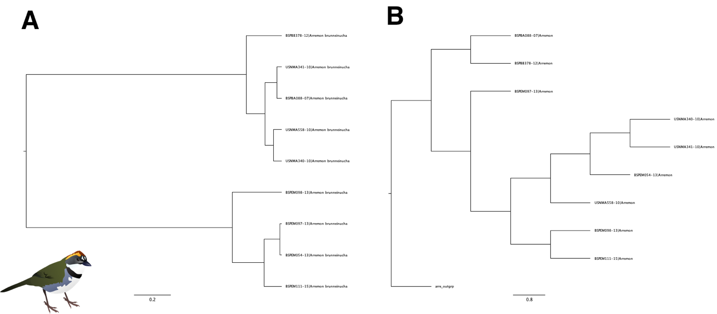
Figure A1.1: COI trees of Arremon brunneinucha, with both A) a NJ tree constructed in MEGA and B) a ML tree constructed in RaxML.

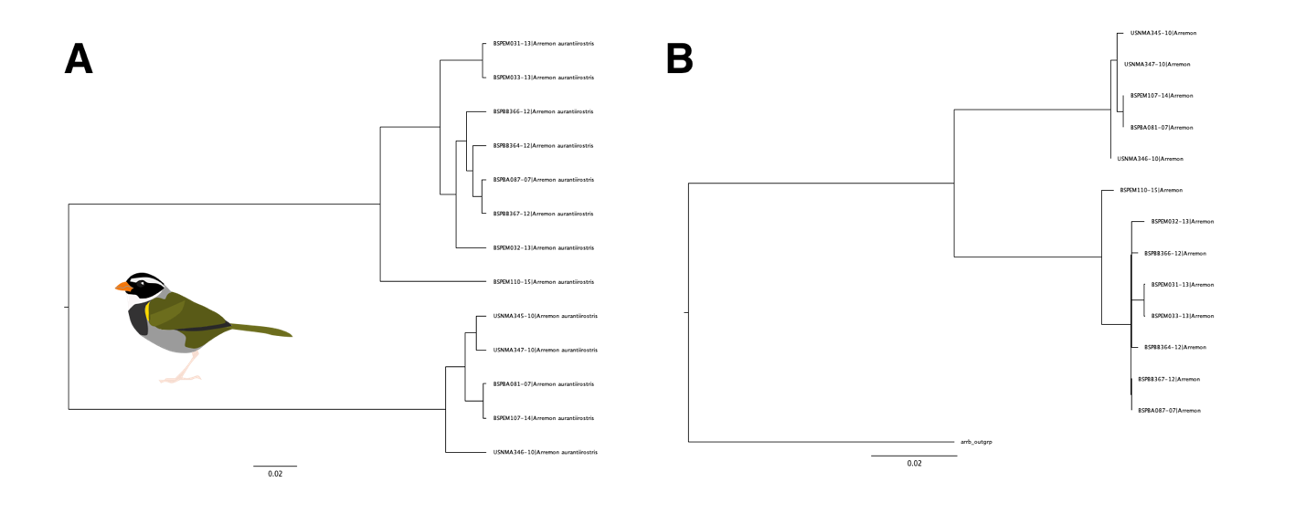

Figure A1.2: COI trees of Arremon aurantiirostris with both A) a NJ tree constructed in MEGA and B) a ML tree constructed in RaxML.
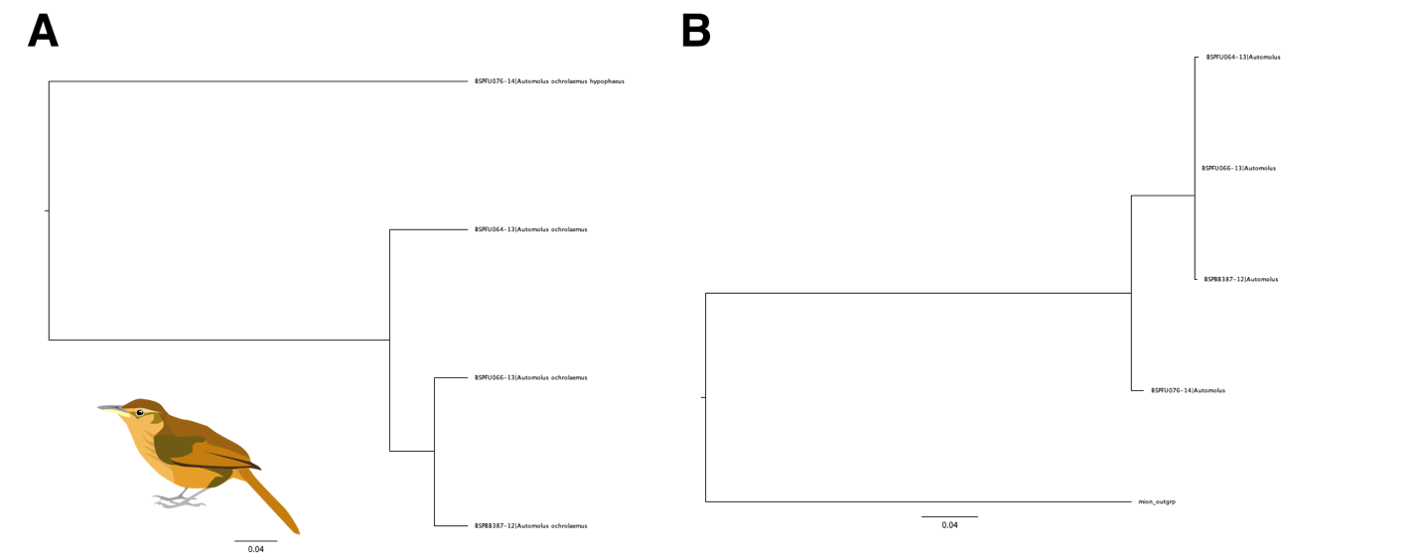

Figure A1.3: C COI trees of Automolus ochrolaemus with both A) a NJ tree constructed in MEGA and B) a ML tree constructed in RaxML.
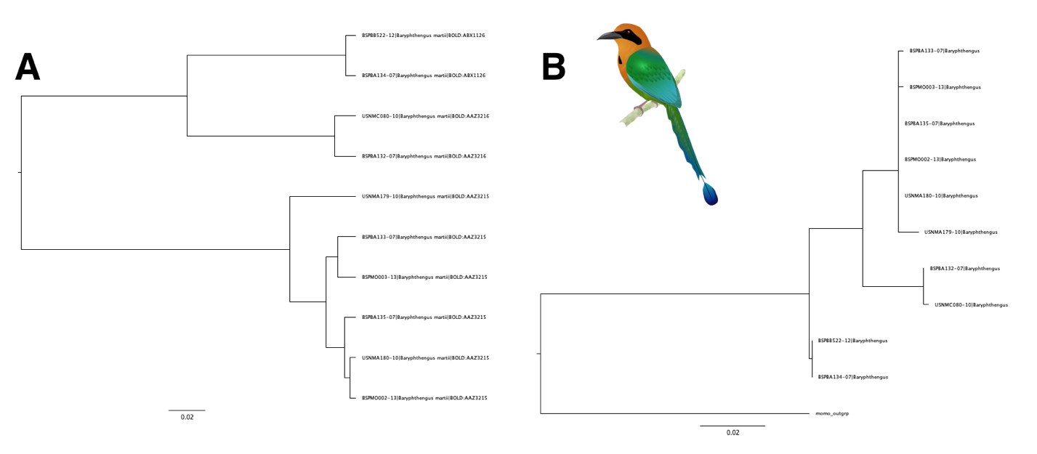

Figure A1.4: COI trees of Baryphthengus martii with both A) a NJ tree constructed in MEGA and B) a ML tree constructed in RaxML.

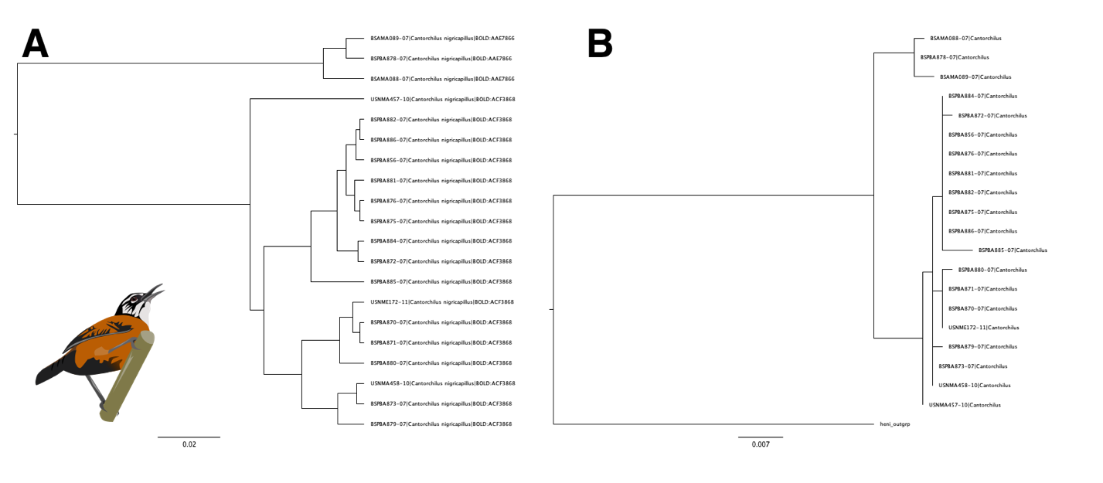

Figure A1.5: COI trees of Cantorchilus nigricapillus with both A) a NJ tree constructed in MEGA and B) a ML tree constructed in RaxML.

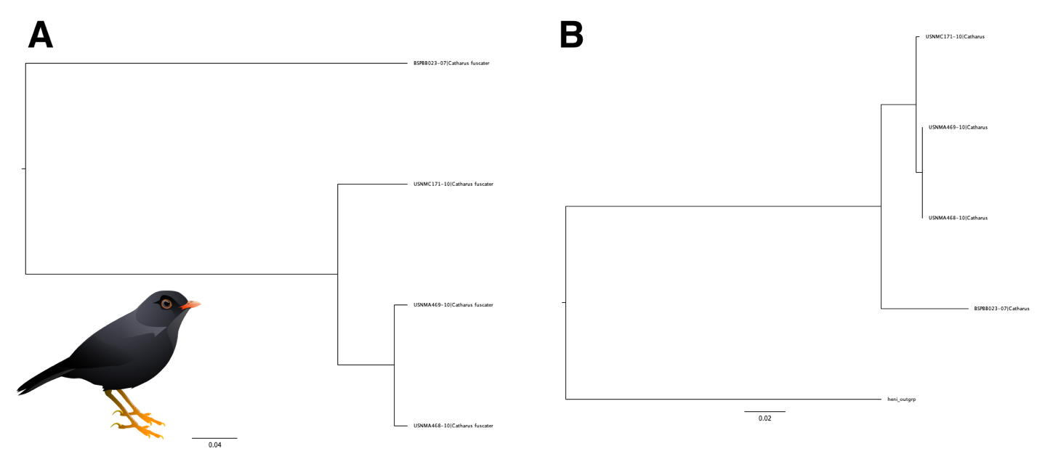
Figure A1.6: COI trees of Catharus fuscater with both A) a NJ tree constructed in MEGA and B) a ML tree constructed in RaxML.

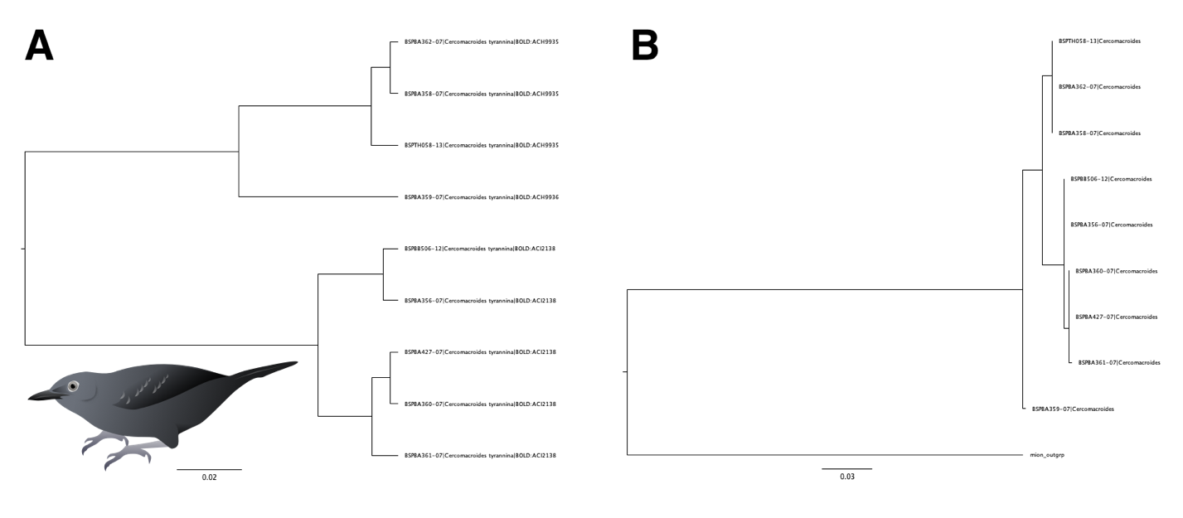
Figure A1.7: COI trees of Cercomacra tyrannina with both A) a NJ tree constructed in MEGA and B) a ML tree constructed in RaxML.
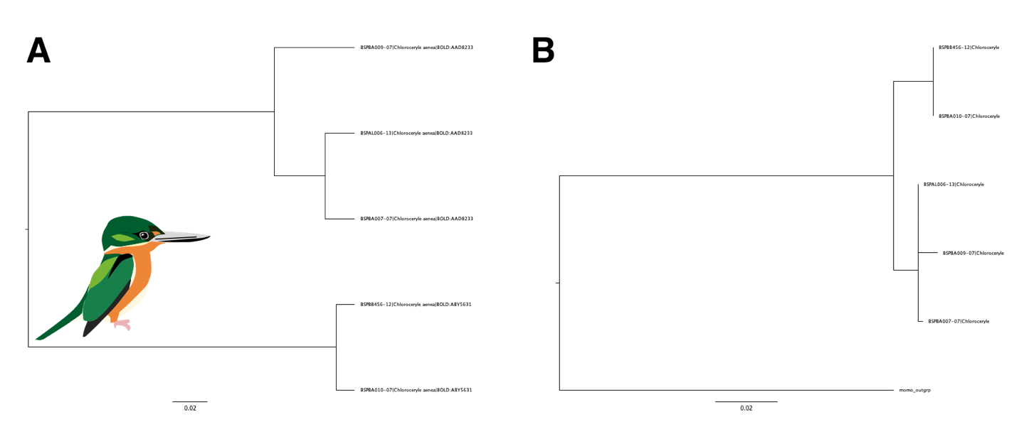

Figure A1.8: COI trees of Chloroceryle aenea with both A) a NJ tree constructed in MEGA and B) a ML tree constructed in RaxML.

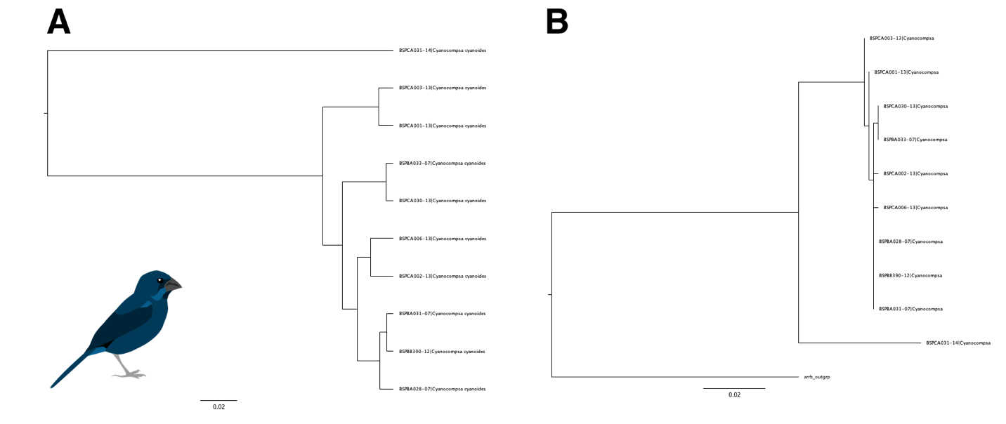
Figure A1.9: COI trees of Cyanocompsa cyanoides with both A) a NJ tree constructed in MEGA and B) a ML tree constructed in RaxML.

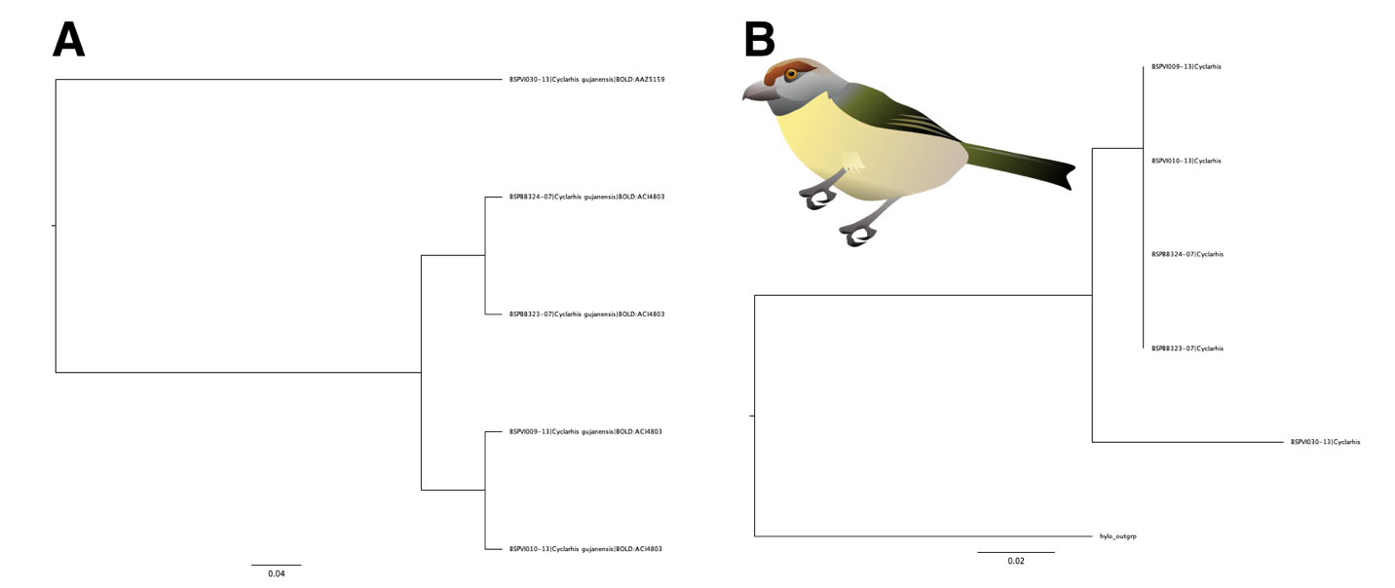
Figure A1.10: COI trees of Cyclarhis gujanensis with both A) a NJ tree constructed in MEGA and B) a ML tree constructed in RaxML.

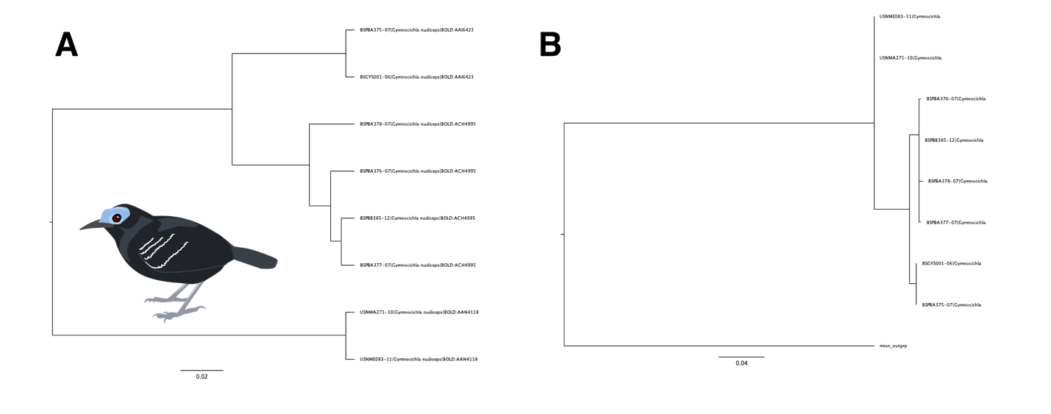
Figure A1.11: COI trees of Gymnocichla nudiceps with both A) a NJ tree constructed in MEGA and B) a ML tree constructed in RaxML.
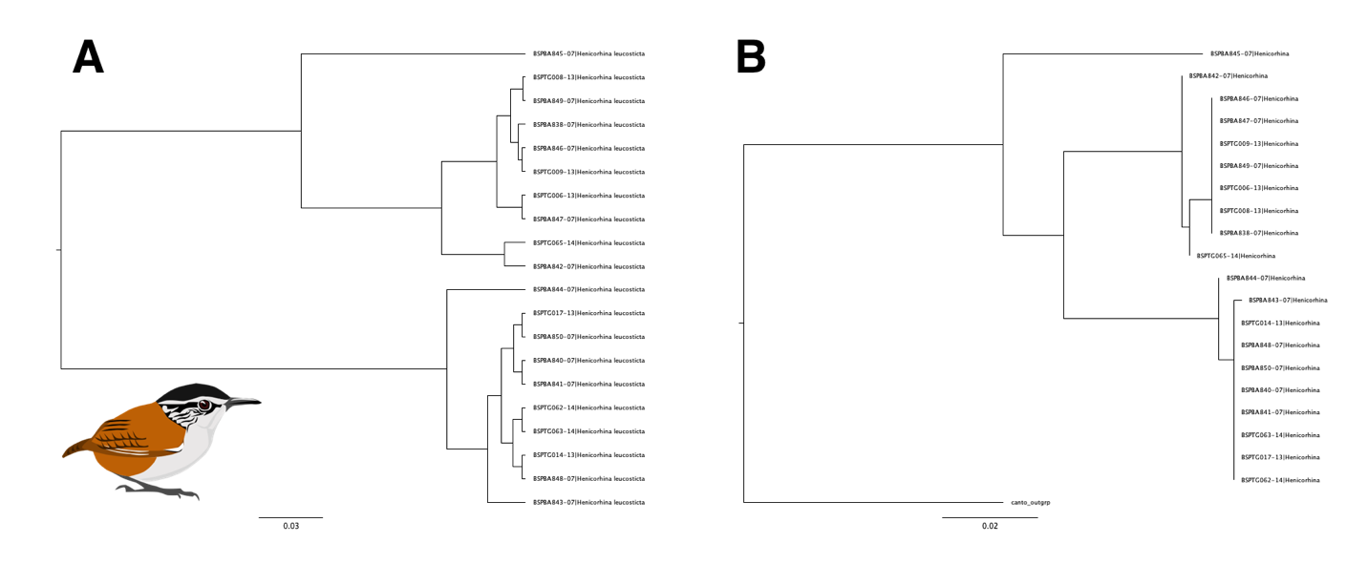
Figure A1.12: COI trees of Henicorhina leucosticte with both A) a NJ tree constructed in MEGA and B) a ML tree constructed in RaxML.
’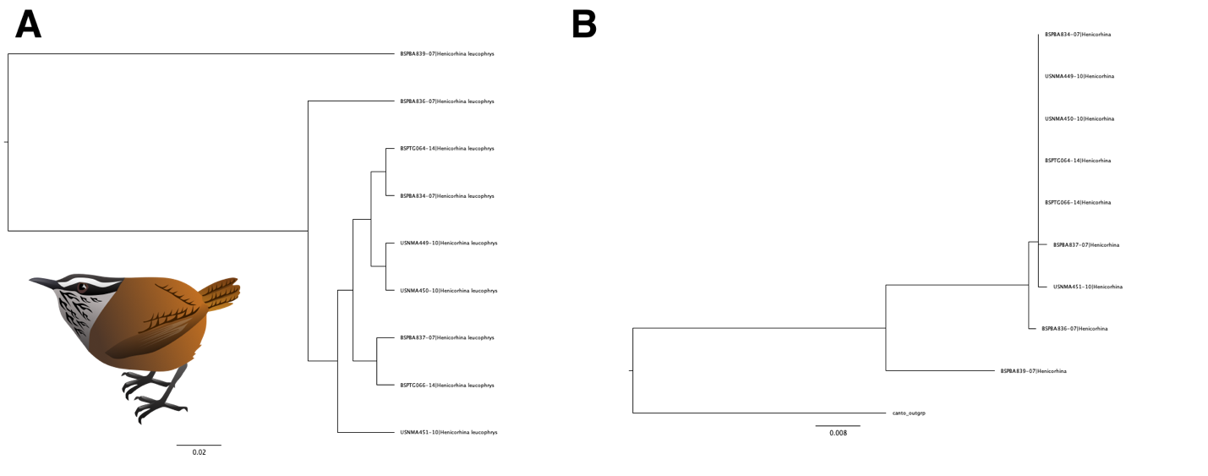
Figure A1.13: COI trees of Henicorhina leucophrys with both A) a NJ tree constructed in MEGA and B) a ML tree constructed in RaxML.
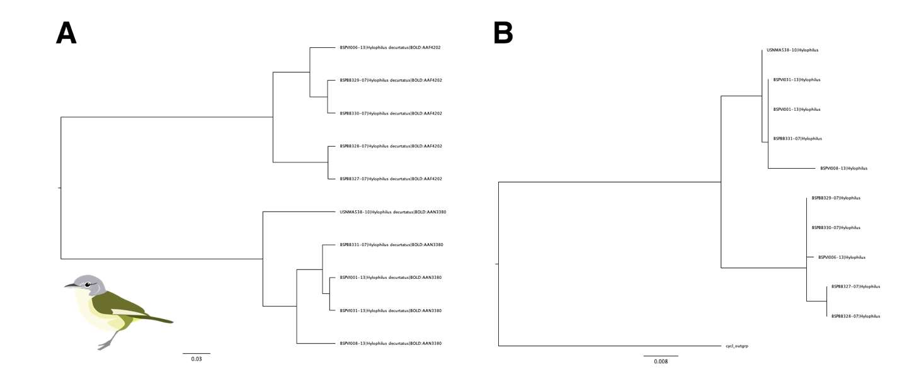
Figure A1.14: COI trees of Pachysylvia decurtata with both A) a NJ tree constructed in MEGA and B) a ML tree constructed in RaxML.
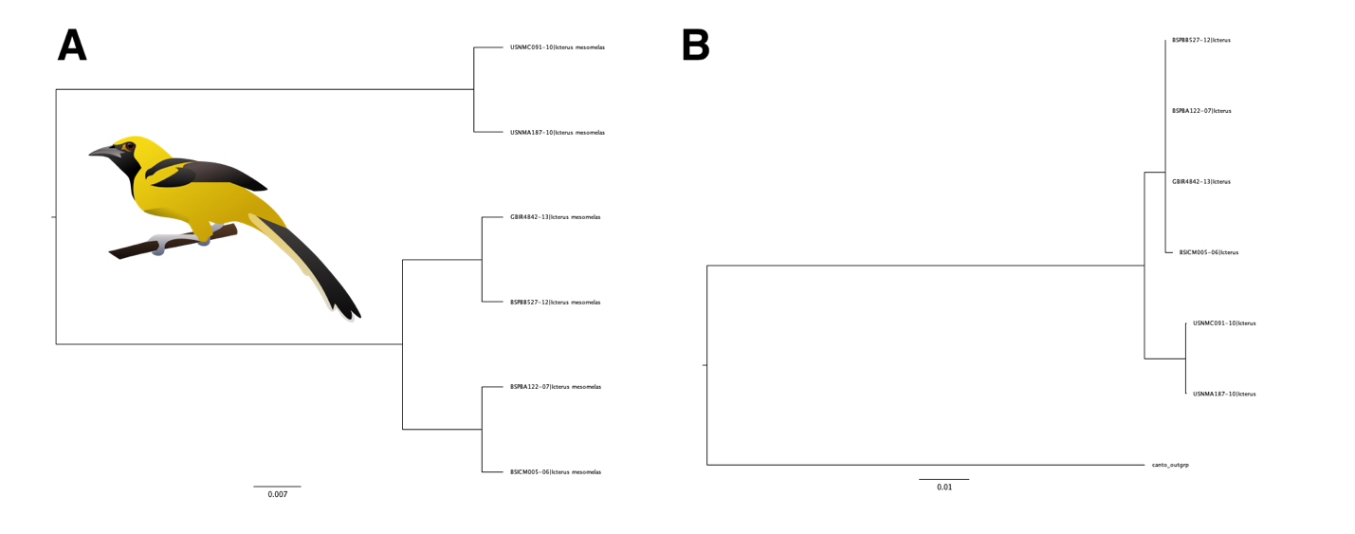
Figure A1.15: COI trees of Icterus mesomelas with both A) a NJ tree constructed in MEGA and B) a ML tree constructed in RaxML.
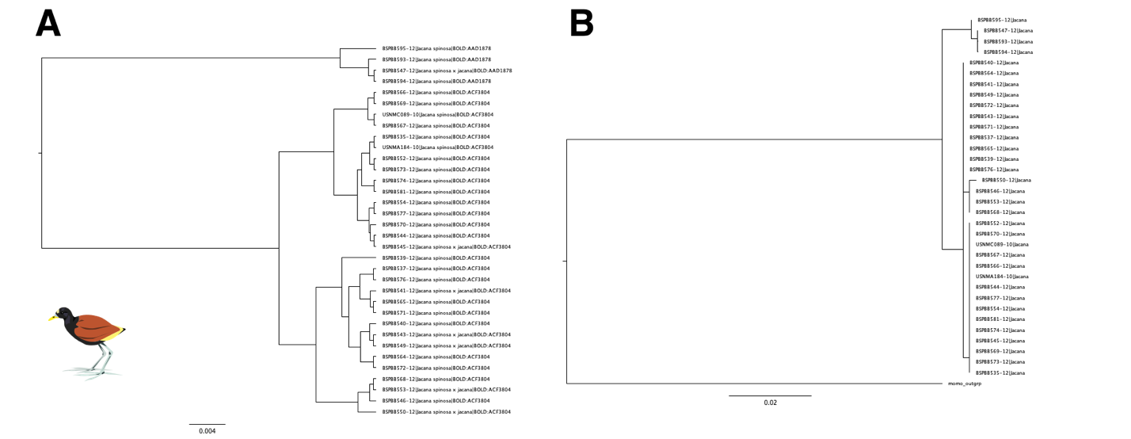

Figure A1.16: COI trees of Jacana spinosa with both A) a NJ tree constructed in MEGA and B) a ML tree constructed in RaxML.
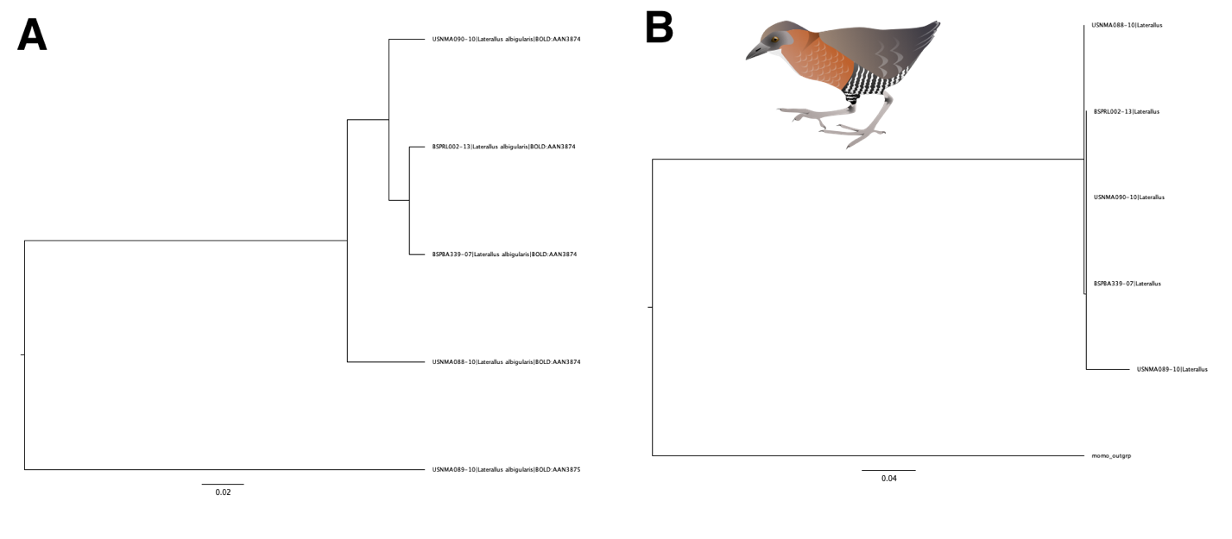

Figure A1.17: COI trees of Laterallus albigularis with both A) a NJ tree constructed in MEGA and B) a ML tree constructed in RaxML.
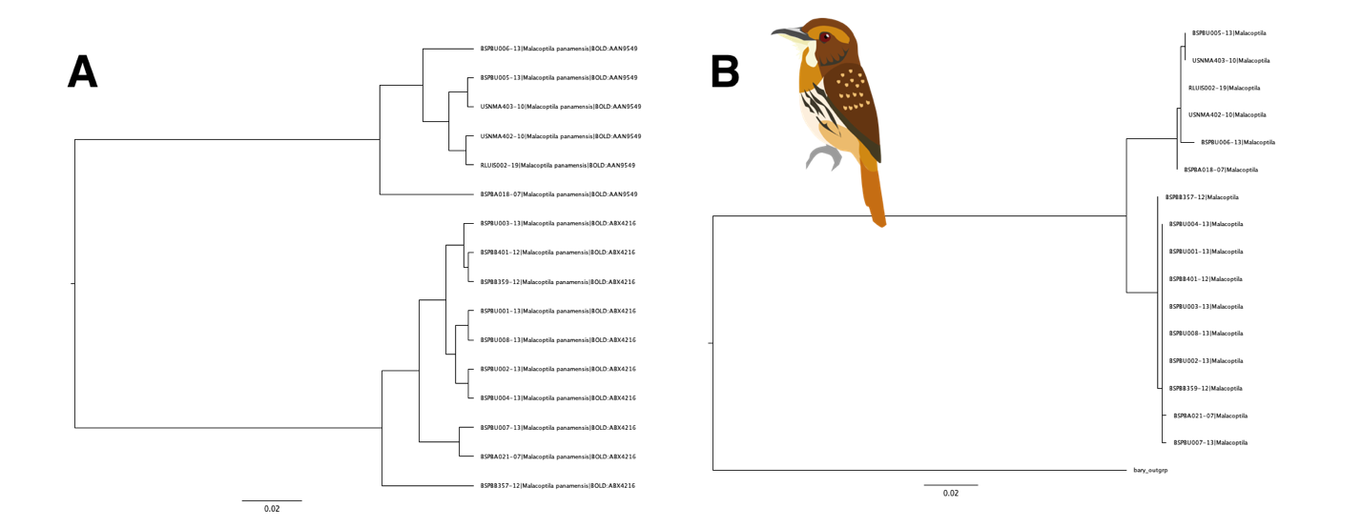
Figure A1.18: COI trees of Malacoptila panamensis with both A) a NJ tree constructed in MEGA and B) a ML tree constructed in RaxML.

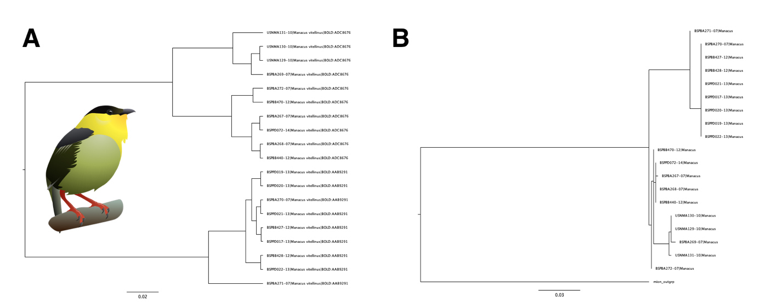

Figure A1.19: COI trees of Manacus vitellinus with both A) a NJ tree constructed in MEGA and B) a ML tree constructed in RaxML.
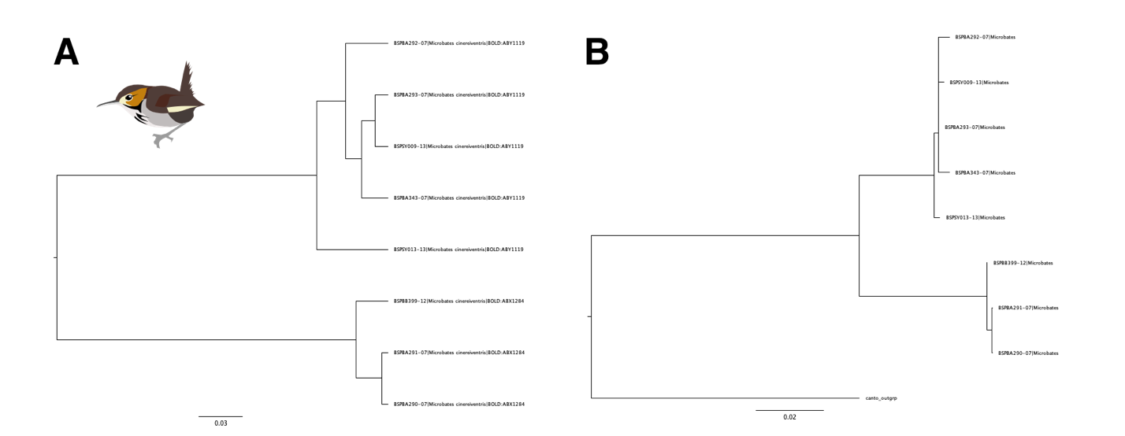
Figure A1.20: COI trees of Microbates cinereiventris with both A) a NJ tree constructed in MEGA and B) a ML tree constructed in RaxML.
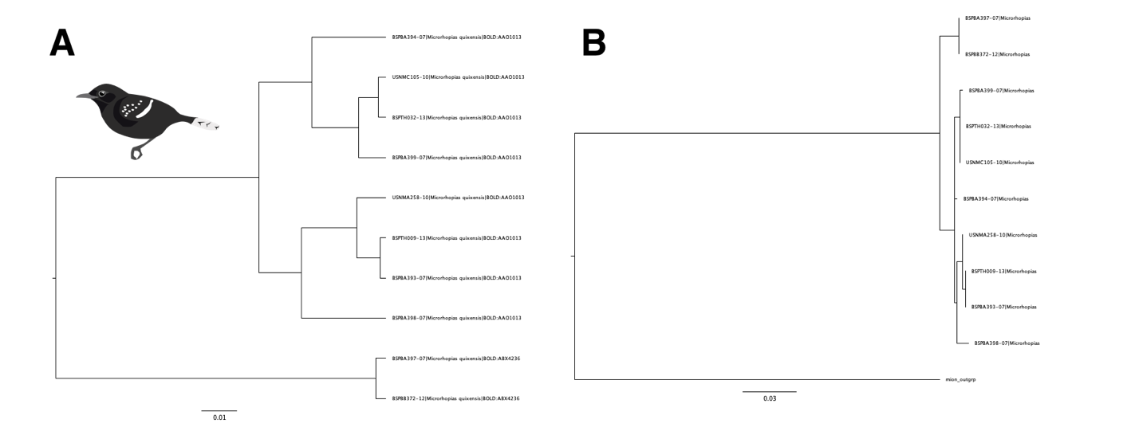
Figure A1.21: COI trees of Microrhopias quixensis with both A) a NJ tree constructed in MEGA and B) a ML tree constructed in RaxML.
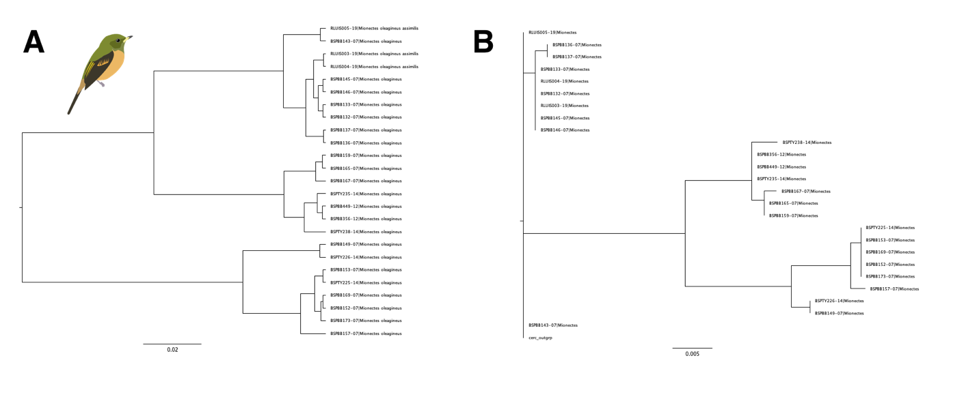

Figure A1.22: COI trees of Mionectes oleagineus with both A) a NJ tree constructed in MEGA and B) a ML tree constructed in RaxML.
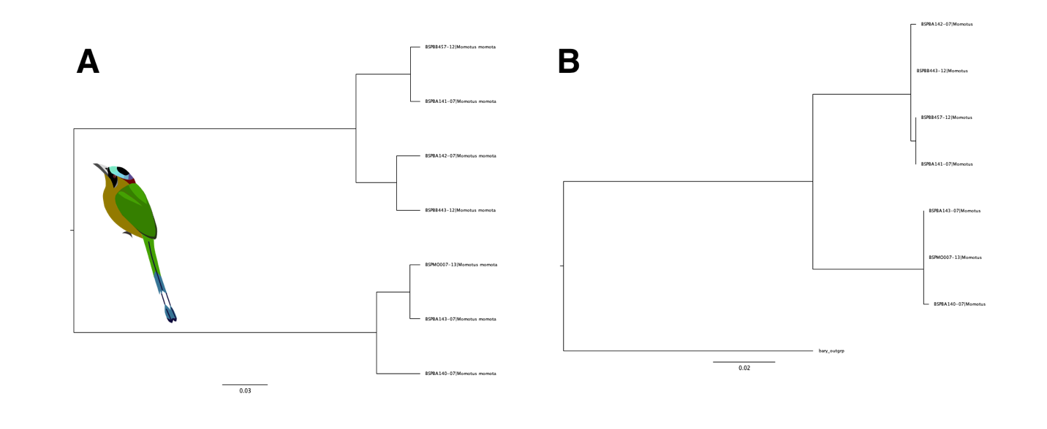
Figure A1.23: COI trees of Momotus momota with both A) a NJ tree constructed in MEGA and B) a ML tree constructed in RaxML.

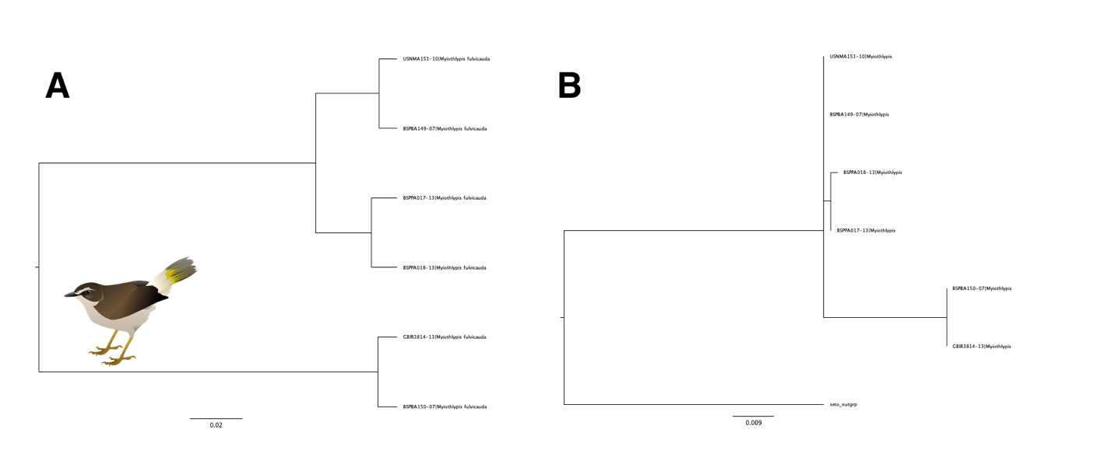

Figure A1.24: COI trees of Myiothlypis fulvicauda with both A) a NJ tree constructed in MEGA and B) a ML tree constructed in RaxML.

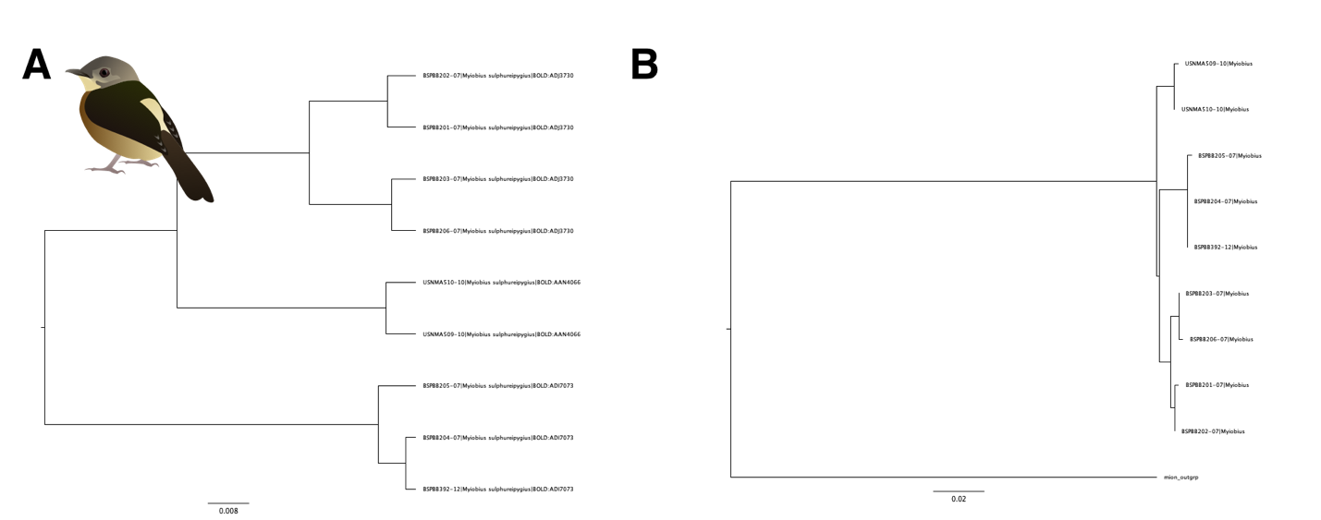

Figure A1.25: COI trees of Myiobius sulphureipygius with both A) a NJ tree constructed in MEGA and B) a ML tree constructed in RaxML.

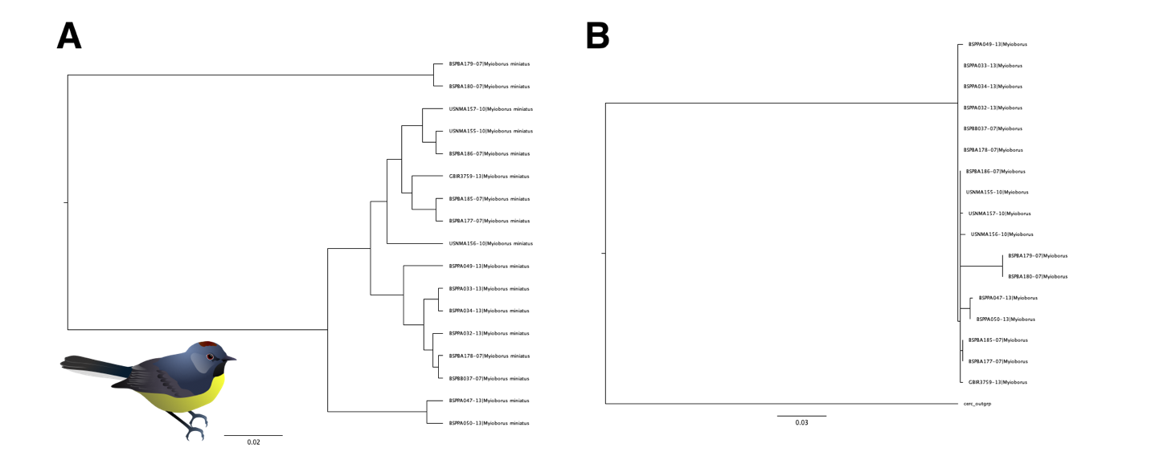

Figure A1.26: COI trees of Myioborus miniatus with both A) a NJ tree constructed in MEGA and B) a ML tree constructed in RaxML.

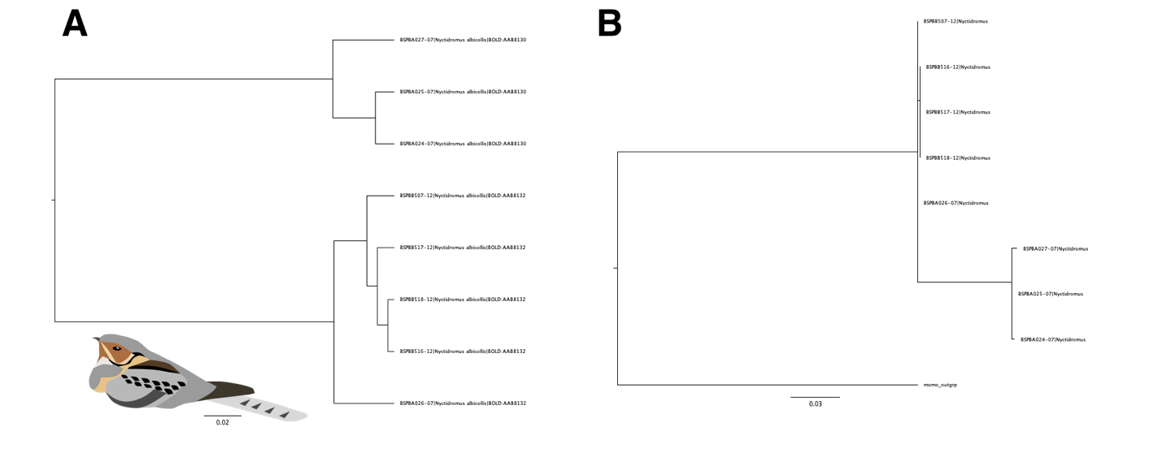

Figure A1.27: COI trees of Nyctidromus albicollis with both A) a NJ tree constructed in MEGA and B) a ML tree constructed in RaxML.
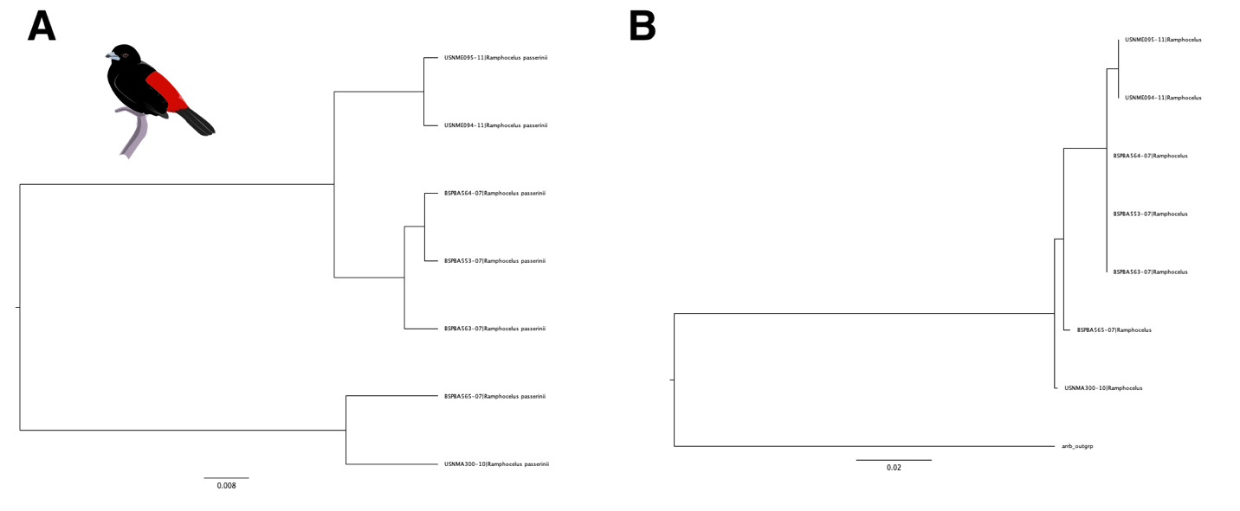

Figure A1.28: COI trees of Ramphocelus flammigerus with both A) a NJ tree constructed in MEGA and B) a ML tree constructed in RaxML.

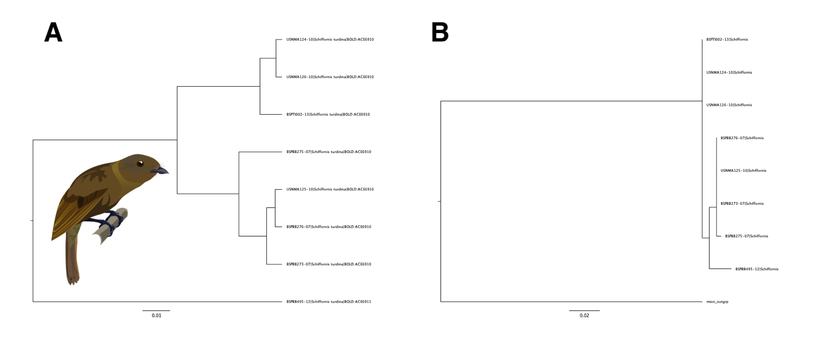

Figure A1.29: COI trees of Schiffornis “turdina” with both A) a NJ tree constructed in MEGA and B) a ML tree constructed in RaxML.
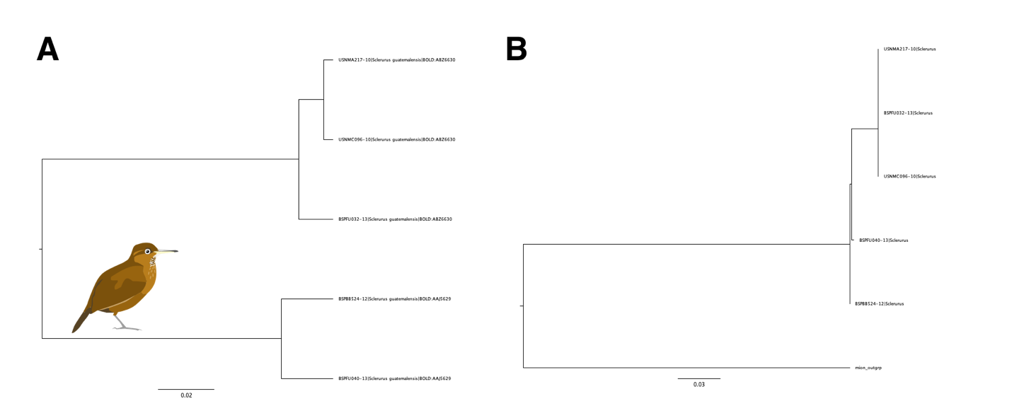

Figure A1.30: COI trees of Sclerurus guatemalensis with both A) a NJ tree constructed in MEGA and B) a ML tree constructed in RaxML.

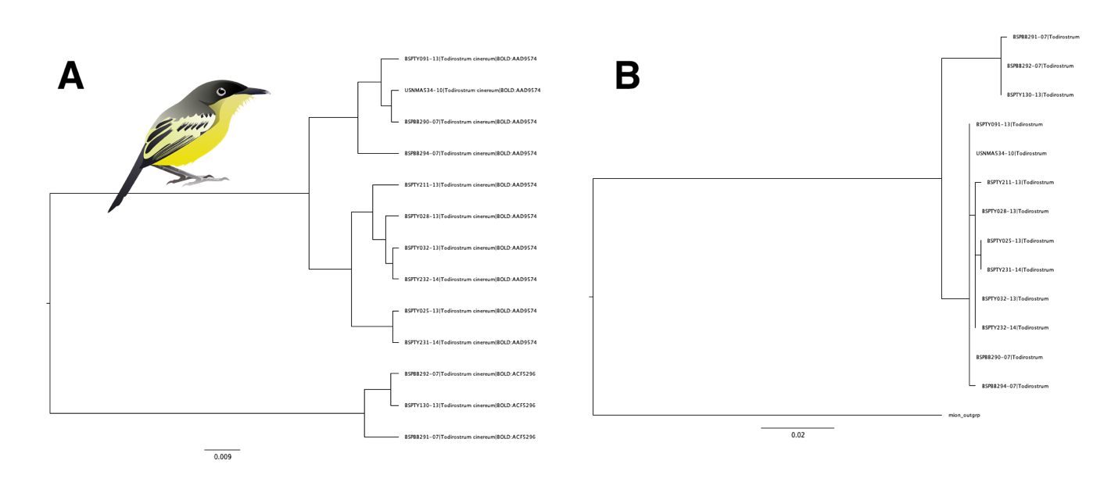
Figure A1.31: COI trees of Todirostrum cinereum with both A) a NJ tree constructed in MEGA and B) a ML tree constructed in RaxML.
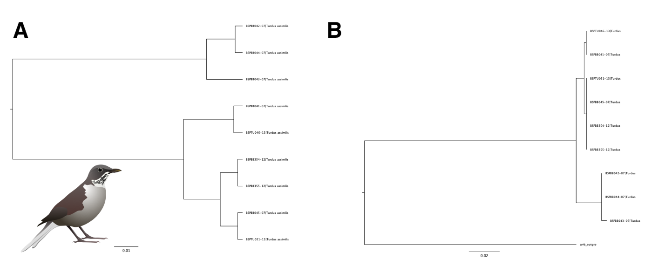
Figure A1.32: COI trees of Turdus assimilis with both A) a NJ tree constructed in MEGA and B) a ML tree constructed in RaxML.
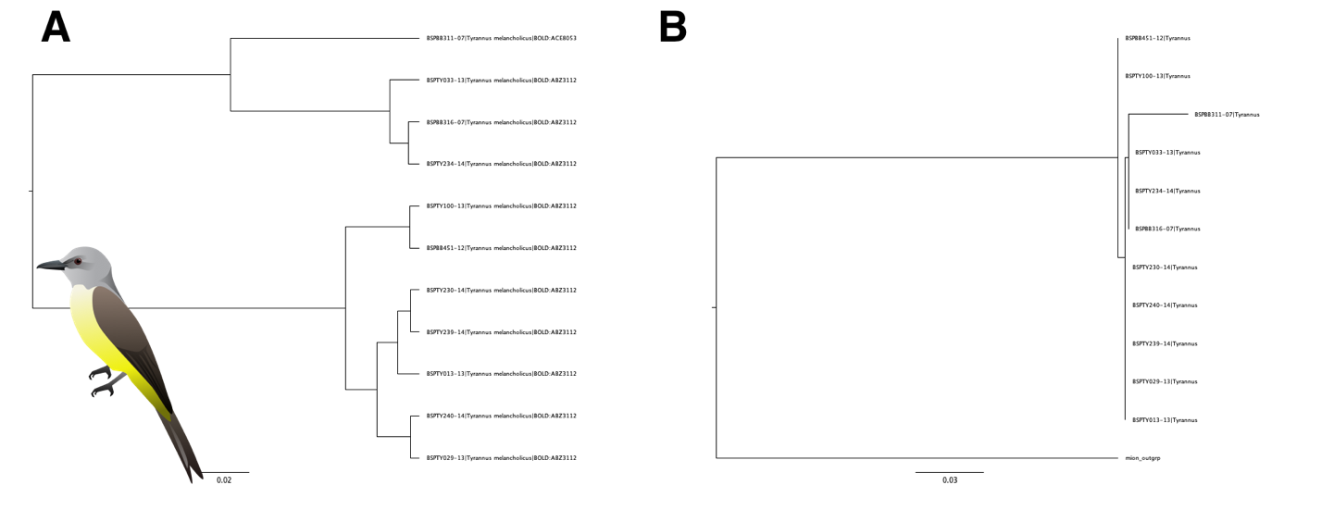
Figure A1.33: COI trees of Tyrannus melancholicus with both A) a NJ tree constructed in MEGA and B) a ML tree constructed in RaxML.

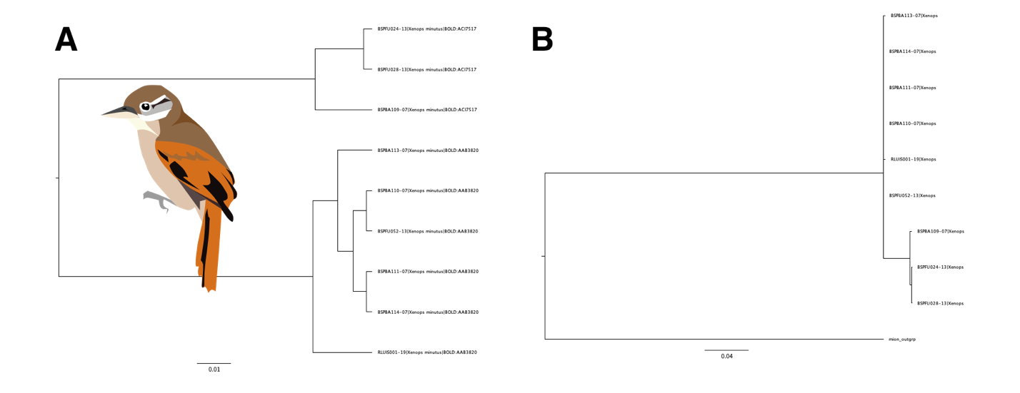

Figure A1.34 COI trees of Xenops minutus with both A) a NJ tree constructed in MEGA and B) a ML tree constructed in RaxML.

Appendix to Chapter 2: Supplementary Tables and Figures
Table A2.1: Sequencing and UCE recovery results. UCE= UCE enriched sample, WGS= unenriched whole genome shotgun library. Museum numbers provided where specimens have been fully cataloged, with field catalog numbers provided for samples which have not been added to museum databases. CUMV: Cornell University Museum of Vertebrates, FMNH: Field Museum of Natural History, STRIBC: Smithsonian Tropical Research Institute Bird Collection, UAM: University of Alaska Museum, UWBM: University of Washington Burke Museum.

Taxon | Museum Number | Catalog Number | Population | Type | Reads (millions) | SRA Accession Number
Arremon aurantiirostris | UWBM93635 |  | Honduras: Copán | WGS | 82.8 | SAMN28920643
Arremon aurantiirostris | UWBM56060 |  | Nicaragua: La Luz | WGS | 120.6 | SAMN28920644
Arremon aurantiirostris | UWBM70031 |  | Nicaragua: La Luz | WGS | 104.4 | SAMN28920645
Arremon aurantiirostris |  | MJM2298 | Panama: Bocas del Toro, Bosque Protector de Palo Seco | WGS | 47.4 | SAMN28920646
Arremon aurantiirostris | STRIBC5367 | MJM2299 | Panama: Bocas del Toro, Bosque Protector de Palo Seco | WGS | 42.8 | SAMN28920647
Arremon aurantiirostris | STRIBC2287 | MJM2930 | Panama: Bocas del Toro, Changuinola | UCE |  | SAMN28920648
Arremon aurantiirostris | STRIBC2266 | MJM4225 | Panama: Bocas del Toro, Changuinola | UCE |  | SAMN28920649
Arremon aurantiirostris |  | JTW288 | Panama: Comarca Ngäbe-Buglé, Cerro Chalite | UCE |  | SAMN28920650
Arremon aurantiirostris | FMNH470780 | GMS2011 | Panama: Bocas del Toro, Bosque Protector de Palo Seco | UCE |  | SAMN28920651
Arremon aurantiirostris |  | JFM022 | Panama: Veraguas, Río Luis | WGS | 72.8 | SAMN28920652
Arremon aurantiirostris |  | JFM037 | Panama: Veraguas, Río Luis | WGS | 203.8 | SAMN28920653
Arremon aurantiirostris |  | JFM044 | Panama: Veraguas, Río Luis | WGS | 40.8 | SAMN28920654
Arremon aurantiirostris |  | JFM047 | Panama: Veraguas, Río Luis | WGS | 126.4 | SAMN28920655
Arremon aurantiirostris | UWBM108325 | JMD114 | Panama: Veraguas, Santa Fé | UCE | 4.68 | SAMN28920656
Arremon aurantiirostris | STRIBC2762 | MJM6862 | Panama: Veraguas, Santa Fé | UCE | 0.42 | SAMN28920657
Arremon aurantiirostris | STRIBC2577 | MJM6871 | Panama: Veraguas, Santa Fé | UCE | 1.12 | SAMN28920658
Arremon aurantiirostris | STRIBC2811 | MJM6932 | Panama: Veraguas, Santa Fé | UCE | 3.35 | SAMN28920659
Arremon aurantiirostris | STRIBC4312 | MJM8129 | Panama: Coclé, La Pintada, Coclesito | UCE | 0.85 | SAMN28920660
Arremon aurantiirostris | STRIBC3568 | MJM8186 | Panama: Coclé, La Pintada, Coclesito | UCE | 4.87 | SAMN28920661
Arremon aurantiirostris | UWBM106601 | GMS1179 | Panama: Colón, Achiote | UCE | 0.60 | SAMN28920662
Arremon aurantiirostris | UWBM106602 | GMS1180 | Panama: Colón, Achiote | UCE | 0.67 | SAMN28920663
Arremon aurantiirostris | STRIBC2810 | MJM6628 | Panama: Coclé, San Juan, Aguas Claras | UCE | 0.73 | SAMN28920664
Arremon aurantiirostris | STRIBC2268 | MJM7004 | Panama: Coclé, San Juan, Aguas Claras | UCE | 3.33 | SAMN28920665
Arremon aurantiirostris | UWBM76885 | RCF2020 | Panama: Panamá, Panama City, confluence of Rios Chagres and Chagrecito | UCE | 0.66 | SAMN28920666
Arremon aurantiirostris | UWBM76954​​ | SMB205 | Panama: Panamá, Panama City, confluence of Rios Chagres and Chagrecito | UCE | 3.96 | SAMN28920667
Arremon aurantiirostris | STRIBC3944 | MJM8562 | Panama: Panama, Chiman, Cerro Chucantí | UCE | 0.96 | SAMN28920668
Arremon aurantiirostris | STRIBC3713 | MJM8563 | Panama: Panama, Chiman, Cerro Chucantí | UCE | 3.20 | SAMN28920669
Arremon aurantiirostris | UAM22809 | MJM1933 | Panama: Darién, Cana | WGS | 64.3 | SAMN28920670
Arremon aurantiirostris | UAM25715 | MJM1949 | Panama: Darién, Cana | UCE | 0.65 | SAMN28920671
Arremon aurantiirostris | UAM22803 | MJM1979 | Panama: Darién, Cana | UCE | 0.75 | SAMN28920672
Arremon aurantiirostris | UAM22807 | MJM2005 | Panama: Darién, Cana | UCE | 0.61 | SAMN28920673
Arremon aurantiirostris | UAM25716 | MJM1931 | Panama: Darién, Cana | UCE | 0.68 | SAMN28920674
Cantorchilus nigricapillus | STRIBC1447 | MJM2656 | Panama: Bocas del Toro, Isla Escudo de Veraguas | WGS | 229.4 | SAMN28920675
Cantorchilus nigricapillus |  | JFM052 | Panama: Veraguas, Río Luis | WGS | 226.8 | SAMN28920676
Cantorchilus nigricapillus |  | JFM053 | Panama: Veraguas, Río Luis | WGS | 40.4 | SAMN28920677
Cantorchilus nigricapillus | STRIBC3992 |  | Panama: Bocas del Toro, Isla Escudo de Veraguas | WGS | 123.6 | SAMN28920678
Cantorchilus nigricapillus | STRIBC3982 |  | Panama: Bocas del Toro, Isla Escudo de Veraguas | WGS | 34.3 | SAMN28920679
Cantorchilus nigricapillus | STRIBC1474 | MJM2759 | Panama: Colón, Achiote | UCE | 3.8 | SAMN28920680
Cantorchilus nigricapillus | STRIBC1476 | MJM4664 | Panama: Colón, Achiote | UCE | 4.0 | SAMN28920681
Cantorchilus nigricapillus |  | PA-TNI472 | Panama: Panamá, Cerro Azul | UCE | 0.50 | SAMN28920682
Cantorchilus nigricapillus | STRIBC4216 |  | Panama: Colón, Santa Isabel, Palenque | WGS | 127.4 | SAMN28920683
Cantorchilus nigricapillus |  | PA-TNI26392 | Panama: Panamá, Serranía de San Blas, west end | UCE | 0.71 | SAMN28920684
Cantorchilus nigricapillus |  | PA-TNI26393 | Panama: Panamá, Serranía de San Blas, west end | UCE | 0.68 | SAMN28920685
Cantorchilus nigricapillus |  | PA-TNI1906 | Panama: Panama, Chiman, Cerro Chucantí | UCE | 0.66 | SAMN28920686
Cantorchilus nigricapillus | PA-TNI666 |  | Panama: Darién, Puerto Piña | WGS | 211.7 | SAMN28920687
Cantorchilus nigricapillus | PA-TNI46569 |  | Panama: Darién, Rancho Frío | WGS | 78.7 | SAMN28920688
Cantorchilus nigricapillus | STRIBC4840 |  | Panama: Darién, Rancho Frío | WGS | 51.9 | SAMN28920689
Cantorchilus nigricapillus | STRIBC4841 |  | Panama: Darién, Rancho Frío | WGS | 96.9 | SAMN28920690
Cantorchilus nigricapillus | UAM25132 | JMM1041 | Panama: Darién, Cana | UCE | 1.00 | SAMN28920691
Cantorchilus nigricapillus | UAM​​31187 | JMM1042 | Panama: Darién, Cana | WGS | 60.1 | SAMN28920692
Cantorchilus nigricapillus | UAM31480 | JMM1043 | Panama: Darién, Cana | WGS | 82.9 | SAMN28920693
Cantorchilus nigricapillus | UAM27613 | KSW4884 | Panama: Darién, Cana | UCE | 0.90 | SAMN28920694
Cantorchilus nigricapillus |  | MJM2125 | Panama: Darién, Cana | UCE | 0.53 | SAMN28920695
Cantorchilus nigricapillus |  | EC-TNI2047 | Ecuador: Pichincha, Mindo | WGS | 189.4 | SAMN28920696
Cantorchilus nigricapillus |  | EC-TNI12053 | Ecuador: Pichincha, Mindo | WGS | 111.0 | SAMN28920697
Cyanocompsa cyanoides | UAM24530 | ABJ481 | Belize: Toledo, Big Falls | UCE | 3.7 | SAMN28920698
Cyanocompsa cyanoides | UAM18351 | ABJ865 | Belize: Toledo, Big Falls | UCE | 0.7 | SAMN28920699
Cyanocompsa cyanoides | UAM15286 | KSW3847 | Belize: Toledo, Big Falls | UCE | 5.0 | SAMN28920700
Cyanocompsa cyanoides | UWBM​​70035 | DAB1176 | Nicaragua: La Luz | WGS | 100.6 | SAMN28920701
Cyanocompsa cyanoides | UWBM56337 | DAB1256 | Nicaragua: La Luz | WGS | 93.6 | SAMN28920702
Cyanocompsa cyanoides | STRIBC2421 | MJM3014 | Panama: Bocas del Toro, Changuinola | UCE | 5.5 | SAMN28920703
Cyanocompsa cyanoides | STRIBC2420 | MJM4149 | Panama: Bocas del Toro, Changuinola | UCE | 5.6 | SAMN28920704
Cyanocompsa cyanoides | STRIBC2422 | MJM3016 | Panama: Bocas del Toro, Changuinola | UCE | 5.0 | SAMN28920705
Cyanocompsa cyanoides | CUMV51040 | IJL04191 | Panama: Bocas del Toro, Chiriquí Grande, Rio La Gloria | UCE | 4.5 | SAMN28920706
Cyanocompsa cyanoides | STRIBC2435 | MJM2337 | Panama: Comarca Ngäbe-Buglé, Cerro Chalite | UCE | 6.0 | SAMN28920707
Cyanocompsa cyanoides | STRIBC2423 | MJM6963 | Panama: Veraguas, Santa Fé | UCE | 5.0 | SAMN28920708
Cyanocompsa cyanoides | UWBM​​111233 | JK04142 | Panama: Veraguas, Santa Fé | UCE | 5.4 | SAMN28920709
Cyanocompsa cyanoides | STRIBC2428 | MJM6699 | Panama: Colón, Achiote | UCE | 4.1 | SAMN28920710
Cyanocompsa cyanoides | STRIBC2438 | MJM6683 | Panama: Colón, Achiote | UCE | 6.1 | SAMN28920711
Cyanocompsa cyanoides | STRIBC3390 | MJM7996 | Panama: Colón, Achiote | UCE | 5.1 | SAMN28920712
Henicorhina leucosticta | UWBM123523 | JK06130 | Panama: Bocas del Toro, Changuinola | UCE | 0.37 | SAMN28920713
Henicorhina leucosticta | UWBM​​123380 | JMD754 | Panama: Bocas del Toro, Changuinola | UCE | 0.44 | SAMN28920714
Henicorhina leucosticta | UWBM123642 | JK06125 | Panama: Bocas del Toro, Changuinola | UCE | 0.58 | SAMN28920715
Henicorhina leucosticta |  | JTW280 | Panama: Comarca Ngäbe-Buglé, Cerro Chalite | UCE | 1.34 | SAMN28920716
Henicorhina leucosticta | UWBM106448 | GMS1021 | Panama: Veraguas, Santa Fé | UCE | 0.88 | SAMN28920717
Henicorhina leucosticta | STRIBC1528 | MJM6908 | Panama: Veraguas, Santa Fé | UCE | 0.54 | SAMN28920718
Henicorhina leucosticta | UWBM​​111225 | JK04134 | Panama: Veraguas, Santa Fé | UCE | 1.12 | SAMN28920719
Henicorhina leucosticta | STRIBC1534 | MJM3373 | Panama: Coclé, La Pintada, El Copé | UCE | 0.35 | SAMN28920720
Henicorhina leucosticta | STRIBC1531 | MJM3463 | Panama: Coclé, La Pintada, El Copé | UCE | 0.57 | SAMN28920721
Henicorhina leucosticta | UAM24660 | MJM1420 | Panama: Colón, Achiote | UCE | 1.11 | SAMN28920722
Henicorhina leucosticta | STRIBC1536 | MJM4504 | Panama: Colón, Achiote | UCE | 0.94 | SAMN28920723
Henicorhina leucosticta | UAM24661 | MJM1044 | Panama: Panamá, Cerro Azul | UCE | 0.32 | SAMN28920724
Henicorhina leucosticta | UAM24580 | JMM907 | Panama: Panamá, Cerro Azul | UCE | 0.61 | SAMN28920725
Henicorhina leucosticta | UAM22726 | MJM696 | Panama: Panamá, Cerro Jefe | UCE | 0.23 | SAMN28920726
Henicorhina leucosticta | UAM22728 | MJM1057 | Panama: Panamá, Cerro Jefe | UCE | 0.92 | SAMN28920727
Henicorhina leucosticta | UWBM107228 | GMS1830 | Panama: Panamá, Lago Bayano | UCE | 0.22 | SAMN28920728
Henicorhina leucosticta | UWBM120908 | JMD657 | Panama: Panama, Chiman, Cerro Chucantí | UCE | 1.04 | SAMN28920729
Henicorhina leucosticta | UWBM​​120904 | GMS1913 | Panama: Panama, Chiman, Cerro Chucantí | UCE | 0.83 | SAMN28920730
Henicorhina leucosticta | FMNH470759 | JMD664 | Panama: Panama, Chiman, Cerro Chucantí | UCE | 0.75 | SAMN28920731
Henicorhina leucosticta | UAM22767 | MJM2114 | Panama: Darién, Cana | UCE | 0.62 | SAMN28920732
Henicorhina leucosticta | UAM22766 | MJM2113 | Panama: Darién, Cana | UCE | 0.53 | SAMN28920733
Henicorhina leucosticta | UAM24008 | MJM2089 | Panama: Darién, Cana | UCE | 0.22 | SAMN28920734
Henicorhina leucosticta | UAM22761 | MJM1987 | Panama: Darién, Cana | UCE | 0.16 | SAMN28920735
Malacoptila panamensis | STRIBC2788 | MJM4404 | Panama: Bocas del Toro, Changuinola | UCE | 5.0 | SAMN28920736
Malacoptila panamensis | STRIBC2786 | MJM4298 | Panama: Bocas del Toro, Changuinola | UCE | 4.4 | SAMN28920737
Malacoptila panamensis | STRIBC0500 | MJM3097 | Panama: Bocas del Toro, Changuinola | UCE | 5.2 | SAMN28920738
Malacoptila panamensis | STRIBC2787 | MJM4308 | Panama: Bocas del Toro, Changuinola | UCE | 4.0 | SAMN28920739
Malacoptila panamensis |  | JTW318 | Panama: Comarca Ngäbe-Buglé, Cerro Chalite | UCE | 2.5 | SAMN28920740
Malacoptila panamensis | STRIBC7888 | JFM074 | Panama: Veraguas, Río Luis | WGS | 81.6 | SAMN28920741
Malacoptila panamensis | UAM20359 | MJM265 | Panama: Coclé, La Pintada, Coclesito | UCE | 4.3 | SAMN28920742
Malacoptila panamensis | STRIBC3597 | MJM8074 | Panama: Coclé, La Pintada, Coclesito | UCE | 5.0 | SAMN28920743
Malacoptila panamensis | UAM20417 | MJM324 | Panama: Coclé, La Pintada, Coclesito | UCE | 5.3 | SAMN28920744
Malacoptila panamensis | STRIBC2564 | MJM2819 | Panama: Colón, Achiote | UCE | 6.4 | SAMN28920745
Malacoptila panamensis | STRIBC2563 | MJM2822 | Panama: Colón, Achiote | UCE | 4.3 | SAMN28920746
Malacoptila panamensis | STRIBC0503 | MJM4485 | Panama: Colón, Achiote | UCE | 5.1 | SAMN28920747
Malacoptila panamensis | STRIBC2908 | MJM7208 | Panama: Colón, Gamboa | UCE | 4.3 | SAMN28920748
Malacoptila panamensis | FMNH470655 | JMD697 | Panama: Panama, Chiman, Cerro Chucantí | UCE | 3.7 | SAMN28920749
Malacoptila panamensis | FMNH470657 | JMD695 | Panama: Panama, Chiman, Cerro Chucantí | UCE | 4.2 | SAMN28920750
Malacoptila panamensis | FMNH470656 | JMD696 | Panama: Panama, Chiman, Cerro Chucantí | UCE | 4.8 | SAMN28920751
Malacoptila panamensis | STRIBC4814 | MJM9375 | Panama: Darién, Rancho Frío | UCE | 4.1 | SAMN28920752
Malacoptila panamensis |  | B17539 | Panama: Darién, Rancho Frío | UCE | 4.4 | SAMN28920753
Malacoptila panamensis | STRIBC4836 | MJM9397 | Panama: Darién, Rancho Frío | UCE | 4.3 | SAMN28920754
Myrmeciza exsul |  | B58101 | Almirante | WGS | 79.3 | SAMN28920755
Myrmeciza exsul | STRIBC 0825 | MJM4263 | Panama: Bocas del Toro, Changuinola | WGS | 105.6 | SAMN28920756
Myrmeciza exsul | STRIBC4141 |  | Panama: Coclé, La Pintada, Coclesito | WGS | 118.3 | SAMN28920757
Myrmeciza exsul | STRIBC0796 |  | Panama: Colón, Achiote | WGS | 55.3 | SAMN28920758
Myrmeciza exsul | STRIBC 2961 | MJM7205 | Panama: Colón, Gamboa | WGS | 59.2 | SAMN28920759
Myrmeciza exsul | STRIBC 3856 | MJM8033 | Panama: Colón, Gamboa | WGS | 49.9 | SAMN28920760
Myrmeciza exsul |  | GKD256 | Panama: Panamá, Panama City, confluence of Rios Chagres and Chagrecito | WGS | 99.4 | SAMN28920761
Myrmeciza exsul |  | RCF2031 | Panama: Panamá, Panama City, confluence of Rios Chagres and Chagrecito | WGS | 145.5 | SAMN28920762
Myrmeciza exsul |  | SMB223 | Panama: Panamá, Panama City, confluence of Rios Chagres and Chagrecito | WGS | 61.0 | SAMN28920763
Myrmeciza exsul |  | MJM0503 | Panama: Panamá, Cerro Azul | WGS | 88.2 | SAMN28920764
Myrmeciza exsul | STRIBC 0799 | MJM5636 | Panama: Panamá, Cerro Azul | WGS | 90.1 | SAMN28920765
Myrmeciza exsul | STRIBC 3921 | MJM8564 | Panama: Panama, Chiman, Cerro Chucantí | WGS | 74.6 | SAMN28920766
Myrmeciza exsul | STRIBC 3742 | MJM8565 | Panama: Panama, Chiman, Cerro Chucantí | WGS | 89.9 | SAMN28920767
Myrmeciza exsul | STRIBC3538 |  | Panama: Darién, Chepigana, Chucanaque, El Salto | WGS | 140.5 | SAMN28920768
Myrmeciza exsul | STRIBC 4140 | MJM9020 | Panama: Comarca Emberá-Wounann, Cémaco, Peña Bijagual | WGS | 96.8 | SAMN28920769
Myrmeciza exsul | STRIBC 4389 | MJM9148 | Panama: Comarca Emberá-Wounann, Cémaco, Peña Bijagual | WGS | 153.8 | SAMN28920770
Myrmeciza exsul |  | MJM985 | Tropic Star | WGS | 77.2 | SAMN28920771
Myrmeciza exsul | STRIBC4835 |  | Panama: Darién, Rancho Frío | WGS | 111.8 | SAMN28920772
Myrmeciza exsul | STRIBC4837 |  | Panama: Darién, Rancho Frío | WGS | 102.7 | SAMN28920773
Myrmeciza exsul | MJM2023 |  | Panama: Darién, Cana | WGS | 46.5 | SAMN28920774
Pachysylvia decurtata | STRIBC1422 | MJM6350 | Panama: Bocas del Toro, Bosque Protector de Palo Seco | UCE | 4.5 | SAMN28920775
Pachysylvia decurtata | STRIBC1423 | B17498 | Panama: Bocas del Toro, Bosque Protector de Palo Seco | UCE | 4.4 | SAMN28920776
Pachysylvia decurtata | UWBM111263 | JK04172 | Panama: Veraguas, Santa Fé | UCE | 4.1 | SAMN28920777
Pachysylvia decurtata | UWBM111255 | JK04164 | Panama: Veraguas, Santa Fé | UCE | 5.2 | SAMN28920778
Pachysylvia decurtata | UWBM106463 | GMS1036 | Panama: Veraguas, Santa Fé | UCE | 4.1 | SAMN28920779
Pachysylvia decurtata | STRIBC1423 | MJM2660 | Panama: Panamá, Cerro Azul | UCE | 5.1 | SAMN28920780
Pachysylvia decurtata | UWBM111193 | JK04100 | Panama: Panamá, Cerro Jefe | UCE | 4.0 | SAMN28920781
Pachysylvia decurtata |  | JMM910 | Panama: Panamá, Cerro Azul | UCE | 4.7 | SAMN28920782
Pachysylvia decurtata | UWBM108154 | GMS983 | Panama: Panamá, Cerro Jefe | UCE | 4.0 | SAMN28920783
Pachysylvia decurtata | STRIBC3764 | MJM8573 | Panama: Panama, Chiman, Cerro Chucantí | UCE | 3.5 | SAMN28920784
Pachysylvia decurtata | UWBM112234 | JK06044 | Panama: Panama, Chiman, Cerro Chucantí | UCE | 3.5 | SAMN28920785
Pachysylvia decurtata | UWBM108897 | JMD719 | Panama: Panama, Chiman, Cerro Chucantí | UCE | 4.6 | SAMN28920786
Pachysylvia decurtata |  | B46582 | Panama: Darién, Rancho Frío | UCE | 4.2 | SAMN28920787
Pachysylvia decurtata |  | B46600 | Panama: Darién, Rancho Frío |  |  | SAMN28920788
Ramphocelus passerinii |  | PA-RPA46461 | Panama: Bocas del Toro, Guabito | WGS | 90.0 | SAMN28920789
Ramphocelus passerinii | STRIBC4562 | MJM4054 | Panama: Bocas del Toro, Changuinola | WGS | 70.8 | SAMN28920790
Ramphocelus passerinii | STRIBC1898 | MJM4007 | Panama: Bocas del Toro, Changuinola | WGS | 71.7 | SAMN28920791
Ramphocelus passerinii | STRIBC1901 | MJM4146 | Panama: Bocas del Toro, Changuinola | WGS | 97.0 | SAMN28920792
Ramphocelus passerinii | STRIBC4629 | MJM4170 | Panama: Bocas del Toro, Changuinola | WGS | 63.9 | SAMN28920793
Ramphocelus passerinii |  | PA-RPA46444 | Panama: Bocas del Toro, Chiriquí Grande | WGS | 98.5 | SAMN28920794
Ramphocelus passerinii |  | PA-RPA46475 | Panama: Bocas del Toro, Chiriquí Grande | WGS | 70.1 | SAMN28920795
Ramphocelus flammigerus | STRIBC3623 | MJM8197 | Panama: Coclé, La Pintada, Coclesito | WGS | 53.6 | SAMN28920796
Ramphocelus flammigerus | STRIBC7345 | MJM8132 | Panama: Coclé, La Pintada, Coclesito | WGS | 134.0 | SAMN28920797
Ramphocelus flammigerus | STRIBC1915 | MJM2437 | Panama: Colón, Achiote | WGS | 89.6 | SAMN28920798
Ramphocelus flammigerus | UWBM106617 | GMS1195 | Panama: Colón, Achiote | WGS | 100.3 | SAMN28920799
Ramphocelus flammigerus | STRIBC1918 | MJM2406 | Panama: Colón, Achiote | WGS | 76.6 | SAMN28920800
Ramphocelus flammigerus | STRIBC4280 | MJM8966 | Panama: Colón, Santa Isabel, Palenque | WGS | 70.2 | SAMN28920801
Ramphocelus flammigerus | STRIBC7584 | MJM8967 | Panama: Colón, Santa Isabel, Palenque | WGS | 77.1 | SAMN28920802
Ramphocelus flammigerus | STRIBC4278 | MJM9030 | Panama: Comarca Emberá-Wounann, Cémaco, Peña Bijagual | WGS | 75.4 | SAMN28920803
Ramphocelus flammigerus | UAM34480 | KSW4857 | Panama: Darién, Cana | WGS |  | SAMN28920804
Ramphocelus flammigerus | UAM31175 | JMM1079 | Panama: Darién, Cana | WGS | 90.5 | SAMN28920805
Ramphocelus flammigerus | UAM25724 | JMM1102 | Panama: Darién, Cana | WGS | 118.5 | SAMN28920806
Schiffornis veraepacis |  | RCF3 | Panama: Bocas del Toro, Changuinola |  | 105.6 | SAMN28920807
Schiffornis veraepacis | STRIBC1223 | MJM3356 | Panama: Coclé, La Pintada, El Copé | WGS | 45.5 | SAMN28920808
Schiffornis veraepacis | STRIBC1224 | MJM3495 | Panama: Coclé, La Pintada, El Copé | WGS | 78.1 | SAMN28920809
Schiffornis veraepacis | UWBM106535 | GMS1112 | Panama: Coclé, El Valle | WGS | 70.8 | SAMN28920810
Schiffornis veraepacis | UWBM76978 | SMB229 | Panama: Panamá, Panama City, confluence of Rios Chagres and Chagrecito | WGS | 72.5 | SAMN28920811
Schiffornis veraepacis | UWBM108416 | JMD208 | Panama: Panamá, Cerro Azul | WGS | 99.4 | SAMN28920812
Schiffornis veraepacis | UWBM108283 | JMD085 | Panama: Panamá, Cerro Azul | WGS | 78.7 | SAMN28920813
Schiffornis stenorhyncha | STRIBC1228 | MJM5753 | Panama: Panamá, Lago Bayano | WGS | 126.8 | SAMN28920814
Schiffornis stenorhyncha | STRIBC4338 |  | Panama: Comarca Emberá-Wounann, Cémaco, Peña Bijagual | WGS | 112.8 | SAMN28920815
Schiffornis stenorhyncha | STRIBC3075 | MJM7345 | Panama: Darién, Chepigana, Aruza Abajo | WGS | 76.2 | SAMN28920816
Schiffornis stenorhyncha | STRIBC3600 | MJM7878 | Panama: Darién, Chepigana, Aruza Abajo | WGS | 105.1 | SAMN28920817
Xenops minutus | STRIBC0576 | MJM2904 | Panama: Bocas del Toro, Changuinola | UCE | 4.5 | SAMN28920818
Xenops minutus | STRIBC0577 | MJM3110 | Panama: Bocas del Toro, Changuinola | UCE | 4.5 | SAMN28920819
Xenops minutus | STRIBC0575 | MJM4121 | Panama: Bocas del Toro, Changuinola | UCE | 7.4 | SAMN28920820
Xenops minutus | STRIB0578 | MJM4374 | Panama: Bocas del Toro, Changuinola | UCE | 4.6 | SAMN28920821
Xenops minutus | STRIBC7889 | JFM012 | Panama: Veraguas, Río Luis | WGS | 77.8 | SAMN28920822
Xenops minutus | STRIBC0579 | MJM3443 | Panama: Coclé, La Pintada, El Copé | UCE | 3.9 | SAMN28920823
Xenops minutus | STRIBC0580 | MJM3525 | Panama: Coclé, La Pintada, El Copé | UCE | 3.6 | SAMN28920824
Xenops minutus | STRIBC0586 | MJM4675 | Panama: Colón, Achiote | UCE | 3.8 | SAMN28920825
Xenops minutus | STRIBC0583 | MJM5323 | Panama: Colón, Achiote | UCE | 4.9 | SAMN28920826
Xenops minutus | STRIBC0584 | MJM5612 | Panama: Panamá, Cerro Azul | UCE | 4.5 | SAMN28920827
Xenops minutus | STRIBC0589 | MJM5646 | Panama: Panamá, Cerro Azul | UCE | 4.5 | SAMN28920828
Xenops minutus | STRIBC0581 | MJM5735 | Panama: Panamá, Lago Bayano | UCE | 5.4 | SAMN28920829
Xenops minutus | UWBM107189 | GMS1758 | Panama: Panamá, Lago Bayano | UCE | 5.3 | SAMN28920830
Xenops minutus | UAM36707 | JMM1012 | Panama: Darién, Cana | UCE | 3.9 | SAMN28920831
Xenops minutus | UAM36654 | KSW4789 | Panama: Darién, Cana | UCE | 4.1 | SAMN28920832
Xenops minutus | UAM36653 | MJM2045 | Panama: Darién, Cana | UCE | 4.2 | SAMN28920643
Xenops minutus | UAM24576 | MJM2051 | Panama: Darién, Cana | UCE | 4.2 | SAMN28920644

Table A2.2: Distances used for clinal analyses. Localities blank if taxon not sampled at that site. For each, the start of the transect is indicated with a bold “0”, with subsequent distances measured from there. All distances in straight-line kilometers.

Location | Coordinates | Arremon | Cantorchilus | Cyanocompsa | Henicorhina | Malacoptila | Myrmeciza | Pachysylvia | Ramphocelus | Schiffornis | Xenops
La Luz, Nicaragua | 13.702, -84.854 | 0 |  | 0
Guabito | 9.4733, -82.565 |  |  |  |  |  |  |  | 0
Rio Changuinola | 9.133, -82.501 | 258.59 | 0 | 258.59 | 0 | 0 | 0 |  | 7.04 | 0 | 0
Almirante | 9.307, -82.423 |  |  |  |  |  | 8.65
Rio La Gloria | 8.9844, -82.233 |  |  | 288.09
Palo Seco | 8.7934, -82.189 | 292.925 |  |  |  |  |  | 0
Chiriquí Grande | 8.7934, -82.18885 |  |  |  |  |  |  |  | 41.37
Cerro Chalite | 8.858611, 82.06055 | 307.04 |  | 307.04 | 48.44 | 48.44
Cayo Agua | 9.155, -82.037 |  | 51.15
Rio Luis | 8.598, -81.206 | 401.03 | 142.54 |  |  | 142.54 |  |  |  |  | 142.54
Santa Fe | 8.56645, -81.191 | 402.69 | 144.41 | 402.69 | 144.41 |  |  | 109.76
Coclesito | 8.77532, -80.54823 | 473.38 |  |  |  | 214.93 | 214.93 |  | 221.83 |  | 214.93
El Copé | 8.6697, -80.593 |  |  |  | 210.33 |  |  |  |  | 209.87
El Valle | 8.633, -80.155 |  |  |  |  |  |  |  |  | 263.49
Achiote | 9.18352, -79.98356 | 535.49 |  | 535.49 | 276.65 | 276.65 | 276.65 |  | 283.68 |  | 276.65
Agua Claras | 9.187, -79.69 | 567.63
Gamboa | 9.16933, -79.7529 |  |  |  |  | 302.01 | 302.01
Cerro Azul | 9.1611, -79.416 |  | 340.04 |  | 340.04 |  | 340.04 | 304.96 |  | 339.30 | 340.04
Cerro Jefe | 9.2333, -79.35 |  |  |  | 347.34 |  |  | 312.25
Palenque | 9.5734, -79.352 |  | 347.10 |  |  |  |  |  | 353.07
Upper Rio Chagres | 9.3875, -79.34317 | 605.93 |  |  |  |  | 348.09 |  |  | 347.34
San Blas | 9.3558, -78.97929 |  | 388.21
Lago Bayano | 9.1564, -78.698 |  |  |  | 419.17 |  |  |  |  | 418.26 | 419.17
Cerro Chucantí | 8.78932, -78.45137 | 704.02 | 445.52 |  | 445.52 | 445.52 | 445.52 | 411.09
Tropic Star Lodge | 7.57, -78.19 |  |  |  |  |  | 475.21
Aruza Abajo | 8.3613, -77. |  |  |  |  |  |  |  |  | 500.64
Puerto Piña | 7.6333, -78.183 |  | 475.95
El Salto | 8.3135, -77.7884 |  |  |  |  |  | 519.48
Rancho Frío | 8.02, -77.732 |  | 525.73 |  |  | 525.73 | 525.73 | 490.25
Cana | 8.02, -77.733 | 783.18 | 525.73 |  | 525.73 |  | 525.73 |  | 531.15 | 524.58 | 525.73
Cémaco | 8.25343, -77.72 |  |  |  |  |  | 527.51 |  | 532.92 | 526.58

Table A2.3: Regression models of mtDNA pairwise divergence vs other parameters. Models where the regression is significant in bold.

Variable | Slope | Adjusted R² | p-value
Cline width | 6.593 | -0.1093 | 0.7451
Cline width variance | -3739 | 0.1698 | 0.1304
Cline center variance | -492.9 | 0.1495 | 0.1467
Proportion total SNPs fixed | 0.02261 | 0.4231 | 0.02479
Proportion autosomal SNPs fixed | 0.2266 | 0.4679 | 0.01746
Proportion Z SNPs fixed | 0.03267 | 0.1058 | 0.1887
Enrichment of fixed Z loci | -0.1811 | -0.08119 | 0.5847

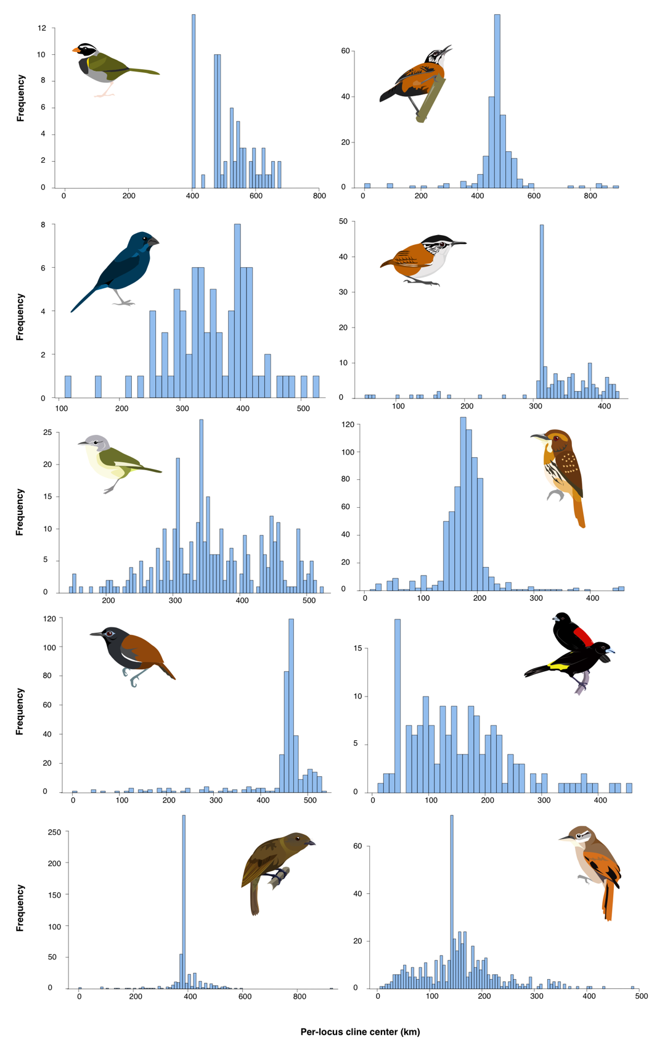
Figure A2.1: Distribution of per-locus geographic cline center estimates fit in HZAR, shown for each study taxon.
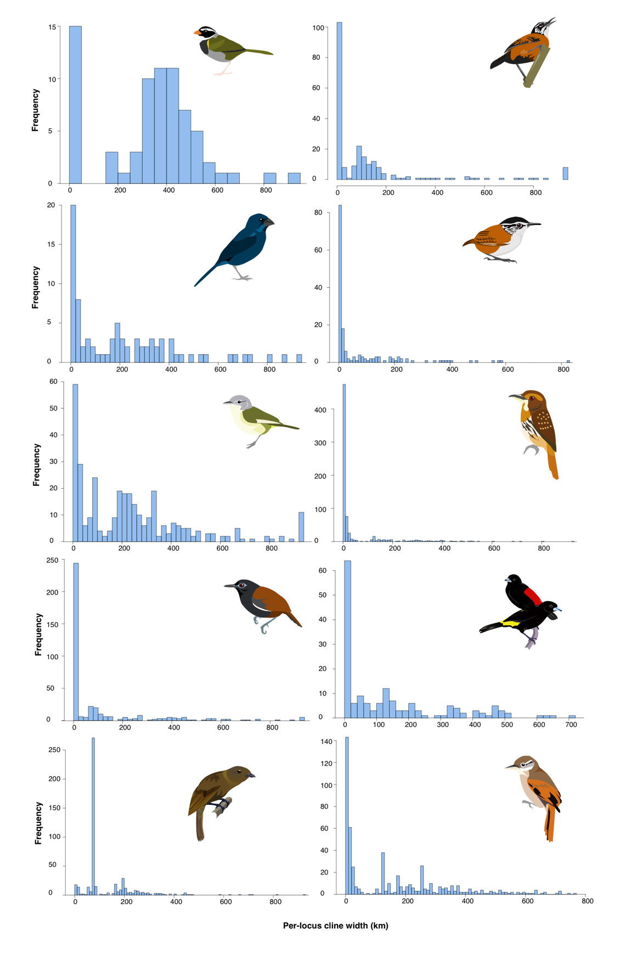

Figure A2.2: Distribution of per-locus geographic cline width estimates fit in HZAR, shown for each study taxon.

Appendix to Chapter 3: Supplemental Methods

Additional variant-calling approaches

Low-coverage data presents additional challenges for accurate identification of variants (Yu and Sun 2013; Lou et al. 2021). Initially, we followed a similar protocol to that used in Chapter 2, using the Genome Analysis ToolKit HaplotypeCaller tool (McKenna et al. 2010). However, on examination, we discovered a major issue with specifically the heterozygotes called by this method. In brief, GATK miscalls many sites that are homozygous for the alternative allele (1/1) as heterozygotes (0/1) when coverage is low. This error is the result of the assumption within the calling method that it is more likely that a site where all reads are the derived allele are the result of missing data rather than evolutionary change. It is difficult to identify these sites outside of the Z chromosome of female birds, which can be identified as errors since heterozygous sites here are impossible. As such, we cannot regard sites in low-coverage data identified with GATK as reliable. An abundance of false heterozygotes is a major issue with any attempts at population genetic analyses, and the use of GATK in such datasets thus should be avoided. This has since also been supported by published findings from other researchers who recently independently observed this and other phenomena, and recommend the use of mpileup in non-model systems by other researchers (Lefouili and Nam 2022).

For this same reason, ANGSD also requires caution when used with data of this nature. Many pipelines which use ANGSD for calling variants based on genotype likelihood (GL) scores use an option within ANGSD to calculate GL with the GATK method. This can result in similar errors to those described above.

Testing filtering strategies

Proper filtering and quality control of NGS data is an important but often under-considered part of bioinformatics pipeline development that can have substantial impacts on results (Shafer et al. 2017; O’Leary et al. 2018; Linck & Battey 2019). I conducted extensive trials of different filtering schema (Table A3.1), which were evaluated on the following criteria:

Did the filter leave enough data (both in number of SNPs and individuals retained) to allow for robust inference? Many analyses perform best with more sites included (Nazareno et al. 2017), one of the main drivers of using genome-wide data to begin with. Datasets failed this criterion if 50% or more of the individuals from one of the six taxa were removed (which for A. aliciae and A. pamela, would be a single individual), as this would lead to questionable results for any inferences on those populations. There was no set boundary for the number of variants, but datasets of under 10,000 SNPs were removed.

Does the filter minimize the biases inherent in low-coverage data? These include particularly the overrepresentation of repetitive regions and higher likelihood of base-calling errors going undetected in low-coverage sites (Lou et al. 2021). Filtering by depth and by missing data may mitigate the influence of both very low and very high coverage sites. Datasets were evaluated as not performing well in this criterion if they had a high proportion of missing data (with 50% missingness leading to discarding the dataset and greater than 30% missingness being deprioritized over more complete datasets). Sites with high coverage (i.e., possible paralogs) were removed and, if the resulting dataset had too few variants to analyze (see criterion 1), the dataset was not considered. Differing levels of filtering for maximum depth were applied to evaluate this metric (Table A3.1).

Does the analysis to be performed with these data require specific thresholds for missingness, linkage, or minor allele frequency? Among the analyses presented here, missing data and linkage are particular issues to be taken into consideration. Specifically, δaδi and STRUCTURE require unlinked data, and perform best when missing data is minimized (i.e., as close to no missing data as possible, as model fitting becomes increasingly challenging with more missing data). However, other analyses, such as window-based analyses, required all SNPs, without MAF or linkage filters. This criterion was therefore evaluated for each specific analysis.

The datasets created in ANGSD did not perform well on points 1 and 2, as they left few variants for analyses and those remaining variants had a high proportion of missing data that did not perform well with the attempted analyses (Table A3.1). Most concerningly, they did not meet the inclusion criteria on a per-individual basis, as they did not include (at minimum) one of the A. aliciae individuals. The samtools datasets performed better on all three of the criteria, even if they were somewhat less rigorous in the second area than ANGSD.

The main choice was then between different levels of missing data in the samtools dataset. In addition to being required by certain analyses, it also can help further mitigate the biases introduced by low-coverage data by removing sites prone to very low coverage and minimize the influence of exceptionally high coverage sites (as these are likely to occur in only a small subset of individuals at any given site and be absent in most). The dataset with no missing data was somewhat small, however, and so the 90% complete set was selected instead as balancing the considerations of criteria 1 and 2.

One point of potential confusion in how filtering by missing data operates is that when applying stricter filters (which can minimize the influence of coverage outlier sites and is necessary for some analyses that handle missing data less well) is that at a certain point, a penalty is incurred for including more individuals, even if the initial number of variants called is higher (see Table A3.1). When these data are filtered to include minimal missing data, eventually the inclusion of more individuals increases the likelihood of any given SNP not meeting the criteria (Figure A3.2). This pattern applies whenever the filtering is stricter than the average missing data rate. You can see that again on Table A3.1, as the outgroup dataset is larger up through a missing data rate of 25%, and only reverses for the 10% and 0% missing datasets. This is a widely observed phenomenon, mostly in low-coverage or reduced-representation data where the missingness rate is high enough to reach the inflection point in normal data-range cut-offs.

Additional tree analyses

The combination of low coverage with low genomic variation further limits which analyses can be performed. In particular, it heightens the difficulty in handling phylogenies when there are high levels of both gene flow and shared ancestral variation. Thus, it is likely unsurprising that our data did not meet the assumptions of some programs.

TreeMix (Pickrell and Pritchard 2012) assumes the data have an underlying tree-like structure, and then infers migration on that tree. This creates issues in cases where significant hybridization has led to violation of this assumption- i.e., the number of admixed populations exceeds the number of unadmixed population, and so both false positives and false negatives will be generated because the background variation within populations is too great to differentiate migration events. As all of our Aglaeactis populations show at least some evidence of admixture (Figure 3.4, Figure 3.6), this assumption is violated. Second, Treemix assumes that migration events are short and singular occurrences (Pickrell and Pritchard 2012), and its developers explicitly warn against its use for modeling continuous migration. Again, our data likely violate this assumption, based on the recovery of continuous migration scenarios as best-fit in two of our pairwise demographic models (Table 3.4). Unsurprisingly given these violations of the method assumptions, we were unable to recover any consistently converging models with this method, in regards to either the underlying topology or the inferred migration events (Figure A3.3).

Questions remained as to how variant calling and filtering would impact downstream analyses. I performed several of these analyses with multiple datasets. In particular, concerns were raised on whether our nuclear tree topology, with its discordance from the mitochondrial tree, could be a result of data processing. IQ-TREE was run with multiple input datasets, with SNPs called with both mpileup and ANGSD. Mpileup datasets recovered consistent topologies (Figure A3.4), regardless of filtering schema, that were practically identical to the one presented in the main paper (Figure 3.2B). This includes data where aggressive two-sided depth filtering (using mean DP minimum of 2 and maximum of 5) was applied to test whether the signal was resulting from repetitive regions not properly excluded. Meanwhile, all ANGSD datasets tested, regardless of filtering, recovered a massive polytomy. This is likely due to the level of information loss incurred in the ANGSD variant calling pipeline versus the mpileup one, and indicates that while filtering is important for minimizing potential biases, overall SNP detection method plays a much stronger role in shaping variation in topology.

Testing for statistical difference in F_{ST} outliers

One question of interest with the observed F_{ST} outliers is if there is a statistically significant difference in the distribution of outliers between comparisons- i.e., if the same regions show elevated divergence in different sets of taxa. Conceptually, one way to do this is to ask if the distribution of values in the dataset are statistically similar. This is commonly attempted with a Mann-Whitney U Test, which is also used to establish statistical significance in distribution of variation between genomic regions. However, while this latter use may not necessarily violate assumptions, such a comparison between two scans of divergence using the same reference genome and, in some cases, the same individuals in the populations under consideration, is likely to due to nonindependence of observations. As a result, I am skeptical of this approach, and there appears to be no consensus from the literature on a statistically sound way to do this precise test.

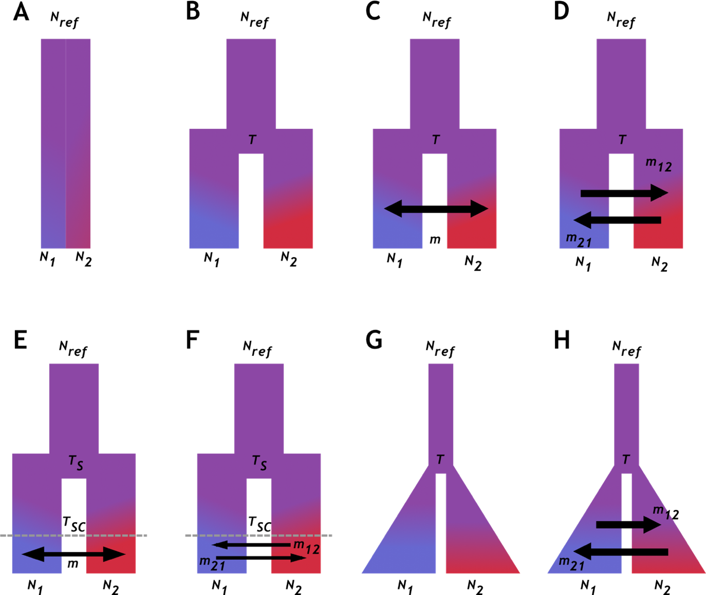

Figure A3.1: Demographic models tested in ẟaẟi. Figure reproduced from (McLaughlin, Faircloth et al. 2020). Models are: (A) neutral model (no divergence), (B) split (divergence) followed by isolation and no migration (gene flow), (C) split-migration (“splitmig”) with unidirectional migration parameter (i.e., roughly similar levels of gene flow in both directions), (D) split-migration with two migration estimates (i.e., asymmetrical gene flow), (E) secondary contact (“SC”) with single migration parameter (i.e., divergence with intermittent gene flow), (F) secondary contact with two migration parameters (i.e., divergence with asymmetric intermittent gene flow), (G) split and isolation with population growth and no gene flow (“island”), and (H) split with migration (gene flow) and population growth (“IM”). Model sequence reflects underlying architecture and then increasing complexity within model family. Single arrows indicate models with gene flow in both directions being roughly equal; double arrows are models with different levels of gene flow in each direction. Models B and G are no-gene-flow models. Rectangles indicate unchanging population sizes; triangles indicate population growth. Colors suggest increasing population differentiation.

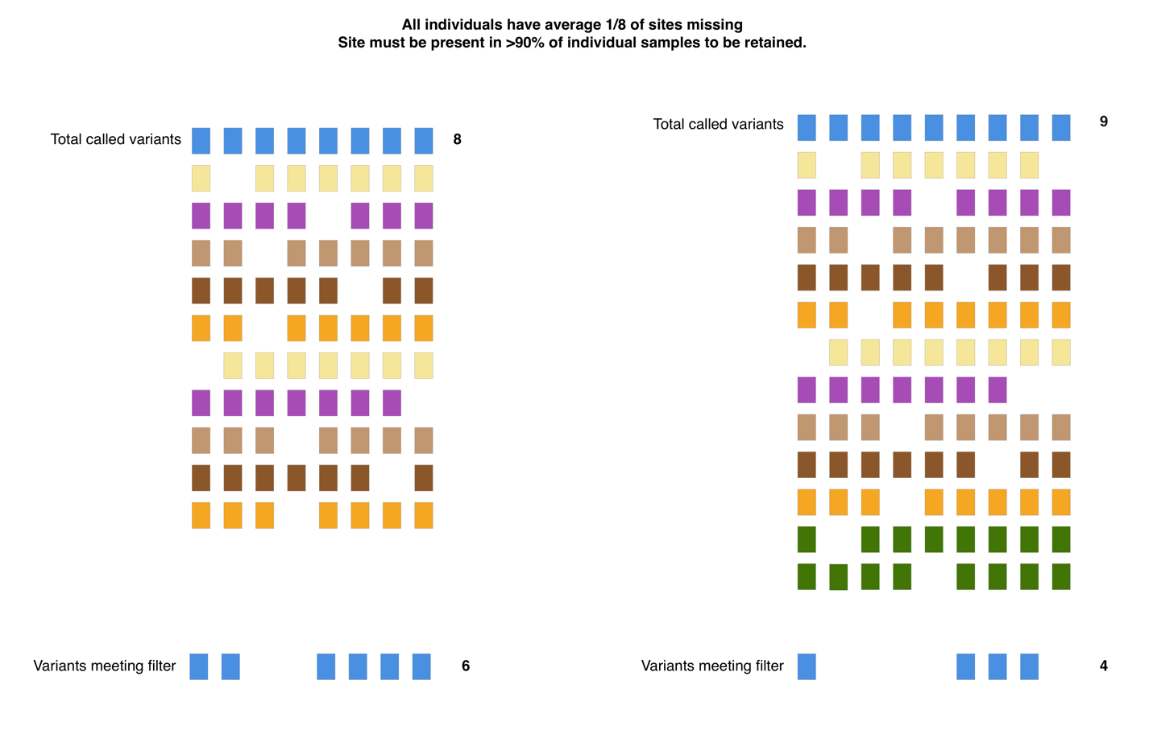

Figure A3.2: Impacts of including more individuals when filtering by missing data. On the left, we see a scenario in which a dataset of ten individuals leads to a total of 8 called SNPs. On average, each individual is missing 1/8 of the sites, and the data are filtered so that a site must be present in 90% or more of individuals to be retained (the level used for most of my datasets). In practice, this means that while one individual can be missing for a site, if two or more are, the site is removed. In this first case, 6 of the initial 8 sites are retained. On the right, two outgroup individuals (green) are added, resulting in 9 total SNPs being called. However, the same error rate and filtering strategy are still applied, and with the additional individuals, fewer sites meet the criteria. Thus, even though the initial pool of variants is larger, only 4 are retained after filtering.
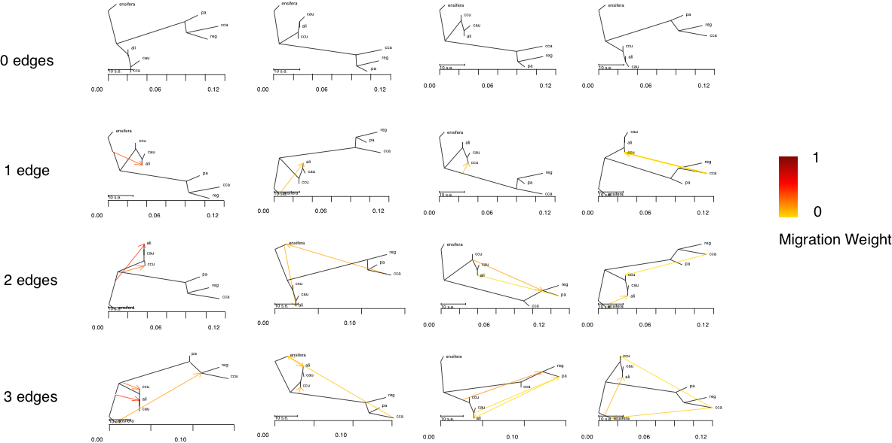

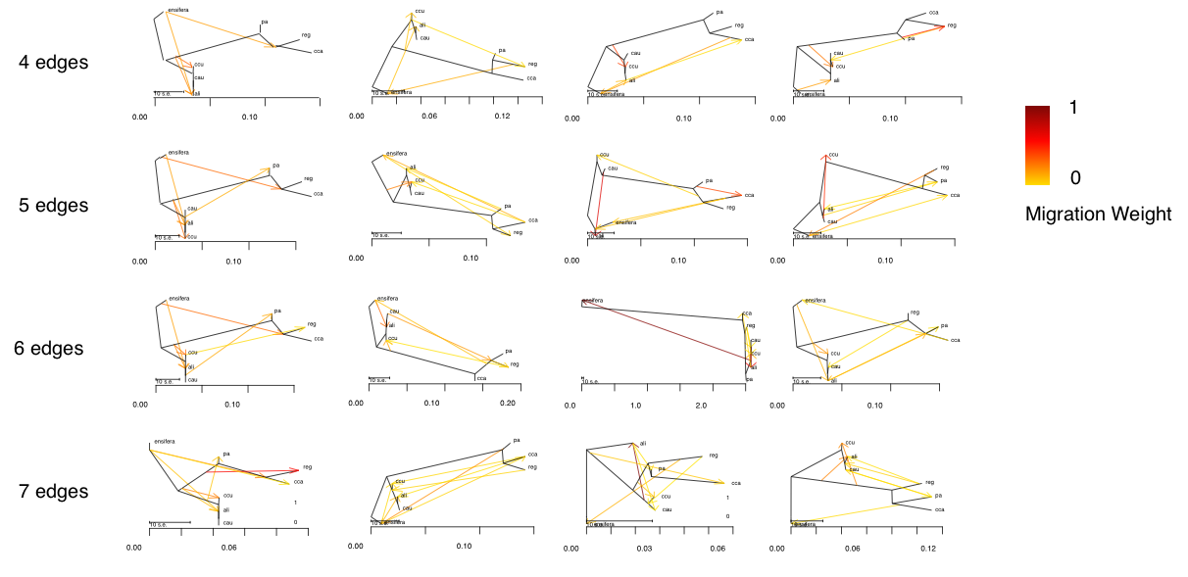

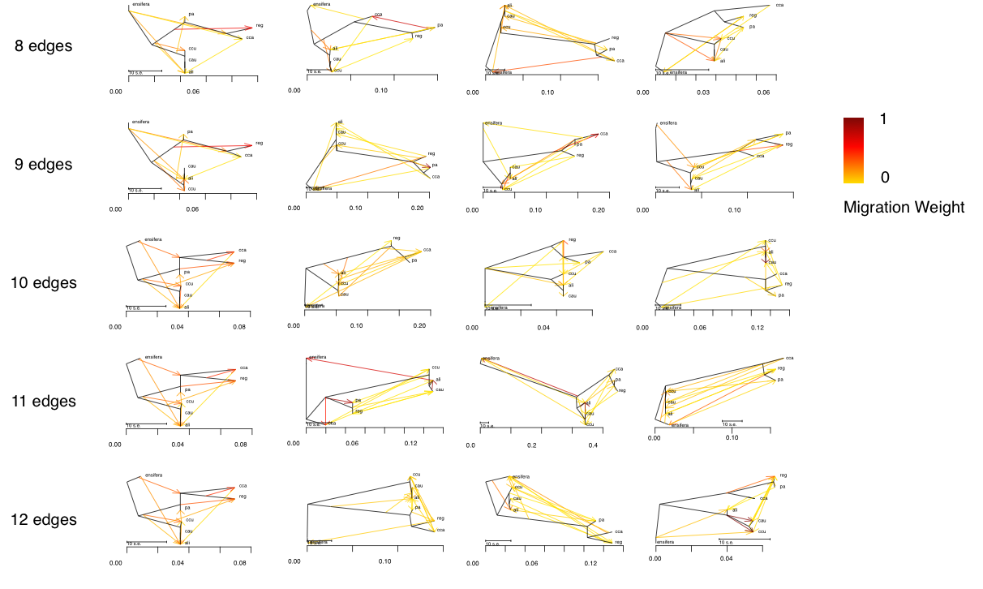

Figure A3.3: A selection of TreeMix results with the large samtools/bcftools dataset (68,451 SNPs), with four different runs to test for 0 to 12 migration events (arranged in columns). Each run was conducted with exactly the same dataset and input parameters, yet produced widely variable results. X-axis shows drift parameter, migration weight indicated by color scale. “al” = A. aliciae, “cau” = A. cu. caumatonota, “cca” = A. ca. castelnaudii, “ccu” = A. cu. cupripennis, “ensifera” = Ensifera ensifera (outgroup), “pa” = A. pamela, “reg” = A. ca. regalis.

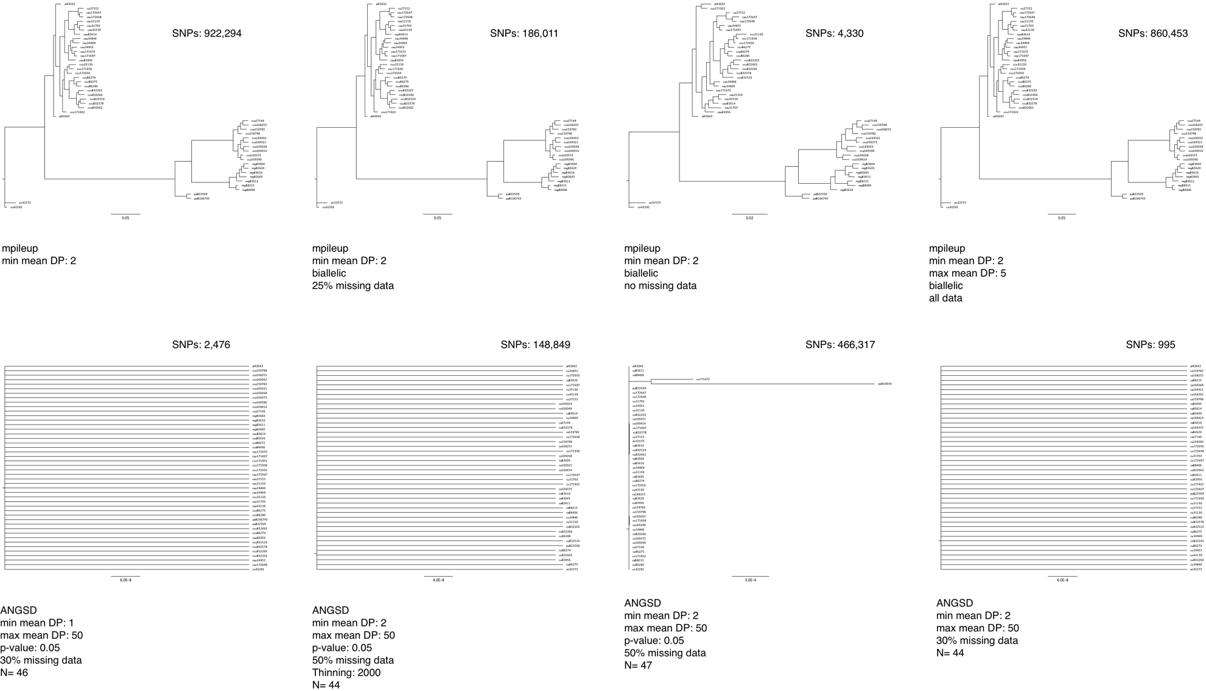

Figure A3.4: Variant IQ-TREE topologies under multiple filtering schema with the same parameters (detailed in the Methods section). The top row shows the almost identical topologies generated by four SNP datasets created with the mpileup/bcftools call pipeline. From left to right, these were: all SNPs with a minimum coverage of 2X; biallelic SNPs with a minimum coverage of 2X present in at least 75% of individuals; biallelic SNPs with at least 2X coverage present in all 48 individuals; and all biallelic SNPs with at least 2X but no more than 5X coverage. The bottom row shows four representative ANGSD SNP datasets, which all recover massive polytomies. From left to right, these datasets are: SNPs with a genotype likelihood meeting a p-value cutoff of 0.05 with between 1X and 50X coverage present in 70% of 46 individuals (two dropped for lack of data); SNPs meeting the p=0.05 cutoff with 2X-50X coverage present in 50% of 44 individuals, thinned to 1 SNP per 2,000 bp; SNPs meeting the p=0.05 cutoff with 2X-50X coverage present in 50% of 47 individuals; and all SNPs (regardless of genotype likelihood) between 2X and 50X in 70% of 44 individuals.

Table A3.1: Number of variants called and retained with various filtering protocols. Please note that the filtering schema differ between programs based on variations in how they do or do not retain quality information in the VCF file output. In the final column, the number of individuals in the dataset is given, and “n=46” in that category indicates the two individuals excluded were not the two outgroup individuals. Not all filtering schema applied for all sets of individuals; indicated with “- “.
Filter | All individuals (n=48) | All Aglaeactis (n=46) | Excluding low-coverage individuals
Samtools/bcftools:
Total called variants | 22,264,196 | 20,337,188
Without indels | 18,131,968 | 17,170,101
Without indels, biallelic only | 18,070,732 | 17,118,339
Without indels, biallelic only, min mean DP = 2 | 893,717 | 803,815
Without indels, biallelic only, min mean DP = 2, no missing data | 4,330 | 5,208
Without indels, biallelic only, min mean DP = 2, max missing data = 10% | 186,011 | 200,975
Without indels, biallelic only, min mean DP = 2, max missing data = 25% | 855,654 | 764,622
Without indels, biallelic only, min mean DP = 2, thinned to 1 SNP per 2000 bp (10% missing) | 68,451 | 71,505
ANGSD:
Unfiltered variants | 41,195,989
GATK, Minimum Q score = 13, min depth= 2, max depth = 50, GL p = 1.0x10⁻⁶ | 3,181,172
GATK, Minimum Q score = 13, min depth= 2, max depth = 50, GL p = 1.0x10⁻⁶, 50% missing data | 466,317
GATK, Minimum Q score = 13, min depth= 2, max depth = 50, GL p = 1.0x10⁻⁶, 50% missing data, 1 SNP per 2000 bp | 148,849 | -
GATK, Minimum Q score = 13, min depth= 2, max depth = 50, GL p = 1.0x10⁻⁶, 40% missing data | - | - | 97,185 (n=45)  71,153 (n=46)  56,983 (n =47)
GATK, Minimum Q score = 13, min depth= 2, max depth = 50, GL p = 1.0x10⁻⁶, 30% missing data | - | - | 995 (n = 45)  1,495 (n=47)
GATK, Minimum Q score = 13, min depth= 2, max depth = 50, GL p = 0.5 | - | - | 6,996,985 (n=47)
GATK, Minimum Q score = 13, min depth= 2, max depth = 50, GL p = 0.5, 25% missing data | - | - | 239 (n =43, no outgroup)  119 (n = 45)
GATK, Minimum Q score = 13, min depth= 1, max depth = 50, GL p = 0.5, 50% missing data | 1,675,969
GATK, Minimum Q score = 13, min depth= 1, max depth = 50, GL p = 0.5, 30% missing data | 2,476
GATK, Minimum Q score = 13, min depth= 1, max depth = 50, GL p = 0.5, 25% missing data | 119
Samtools, Minimum Q score = 13, min depth= 1, max depth = 50, GL p = 0.5
GATK, Minimum Q score = 13, min depth= 1, max depth = 50, GL p = 0.5, 50% missing data | 1,125,609
GATK, Minimum Q score = 13, min depth= 1, max depth = 50, GL p = 0.5, 30% missing data | 1,513

