UNIVERSITY OF OKLAHOMA

GRADUATE COLLEGE

APPROACHES TO BARTÓK’S CONTRASTS: A COLLECTION AND

COMPARISON BY CLARINET ARTISTS

A DOCUMENT

SUBMITTED TO THE GRADUATE FACULTY

in partial fulfillment of the requirements for the

Degree of

DOCTOR OF MUSICAL ARTS

By

MICHAEL ROWE WHITMORE
Norman, Oklahoma
2013

APPROACHES TO BARTÓK’S CONTRASTS: A COLLECTION AND
COMPARISON BY CLARINET ARTISTS

A DOCUMENT APPROVED FOR THE SCHOOL OF MUSIC

BY

______________________
Dr. Irvin Wagner, Co-chair

______________________
Dr. Sarah Ellis, Co-chair

______________________
Dr. Frances Ayres

______________________
Dr. Eugene Enrico

______________________
Dr. Valerie Watts

© Copyright by MICHAEL ROWE WHITMORE 2013
All Rights Reserved.
I dedicate this document to my late mentor and friend, David Etheridge.
Acknowledgements

I would like to thank all of the people who have helped make this project possible.
First I would like to thank the faculty at the University of Oklahoma who served on my doctoral committee: Dr. Irvin Wagner, Dr. Sarah Ellis, Dr. Frances Ayres, Dr. Eugene Enrico, Dr. Valerie Watts, Dr. Michael Abraham, and Dr. Kenneth Stephenson.
I would also like to thank the clarinetists who made this project possible by so generously sharing their knowledge, wisdom, and experience: Elsa Ludewig-Verdehr, David Shifrin, and Jozsef Balogh.
I would like to thank my parents, Stephen and Mary Whitmore, and my brother and sister and their families, my good Christian friend Tony Hutchins, our house full of pets, and especially my wife Shelley for all of their support.
I would like also like to thank all of the dedicated clarinetists with whom I have studied, Jozsef Balogh, David Etheridge, Larry McDonald, David Bell, and Eric Ginsberg, and the many other wonderful teachers I have learned from who don’t happen to play the clarinet very much.

Table of Contents

Chapter 1: Introduction to Study and Background Information………………….…...1

Chapter 2: Elsa Ludewig-Verdehr…………...………………………………………..9

Chapter 3: David Shifrin………………………...…………………………………...53

Chapter 4: Jozsef Balogh………………………….………...…….…………………90

Chapter 5: Summary and Comparison of Interpretations ………………………….116

Bibliography....………...…………………………………..…………………………...123

List of Tables

Table 2.1: “Sebes”, changing meters, mm. 93-98…………………………………35

List of Figures

Figure Page

Fig. 2.1 “Verbunkos”, mm. 1-13………………………………………………..……...12
Fig. 2.2 “Verbunkos”, mm. 11-28, Clarinet in B-flat part….………………………….13
Fig. 2.3 Clarinet Fingerings, “Verbunkos”, mm.18-20, 28, Clarinet in B-flat part...14-15
Fig. 2.4 “Verbunkos”, mm. 36-55. Clarinet in B-flat part……………………..……....16
Fig. 2.5 “Verbunkos”, mm. 57-59…………………………..……………………….....17
Fig. 2.6: “Verbunkos”, mm. 65-72, Clarinet in B-flat part……………………………..18
Fig. 2.7: “Verbunkos”, m. 29……………………………………………………….......19
Fig. 2.8: “Verbunkos”, mm. 71-72…………………………………………………......20
Fig. 2.9a: “Verbunkos”, cadenza for clarinet, Clarinet in B-flat part…………………...22
Fig. 2.9b: “Verbunkos”, mm. 89-93…………………………………………………......23
Fig. 2.9c: “Verbunkos”, mm. 89-93, violin part…………………………………………23
Fig. 2.10: “Verbunkos”, mm. 1-18, Clarinet in B-flat part………………………………25
Fig. 2.11: “Verbunkos”, mm. 19-29, Clarinet in B-flat part……………………………..27
Fig. 2.12: “Verbunkos”, mm. 30-35, B-flat Clarinet part………………………………..27
Fig. 2.13: “Piheno”, mm. 35-41, Clarinet in B-flat part…………………………………29
Fig. 2.14: “Piheno”, mm. 43-51………………………………………………………….30
Fig. 2.15: “Sebes”, mm. 43-48, Clarinet in B-flat part…………………………………..32
Fig. 2.16: “Sebes”, mm. 63-65, Clarinet in B-flat part…………………………………..33
Fig. 2.17: “Sebes”, mm. 69-91,Clarinet in B-flat part……………………………….......34
Fig. 2.18: “Sebes”, mm. 90-103………………………………………………………….36
Fig. 2.19: “Sebes”, altissimo G fingering………………………………………………..37
Fig. 2.20: “Sebes”, mm. 136-144, B-flat Clarinet part…………………………………..39
Fig. 2.21: “Sebes”, mm. 142-148…………………………………………………….40-41
Fig. 2.22: “Sebes”, mm. 151-153, Clarinet in B-flat part……………………………......41
Fig. 2.23: “Sebes”, mm. 164-165…………………………………………………….......42
Fig. 2.24: “Sebes”, D-sharp fingering with left hand B key down……………………...44
Fig. 2.25: mm. 190-209, B-flat Clarinet part……………………………………………45
Fig. 2.26: “Sebes”, end of violin cadenza……………………………………………….46
Fig. 2.27: “Sebes”, mm. 299-305……………………………………………………......48
Fig. 3.1: “Verbunkos”, cadenza for clarinet, and two alternate variations, Clarinet in A part………………………………………………………….60
Fig. 3.2: “Verbunkos”, mm. 17-20, Clarinet in A part…………………………………61
Fig. 3.3: “Verbunkos”, mm. 80-81……………………………………………….…….62
Fig. 3.4: “Verbunkos”, mm. 33-35…………………………………………………......63
Fig. 3.5: “Verbunkos”, mm. 53-55…………………………………………………......64
Fig. 3.6: Clarinet Fingerings for altissimo notes of mm. 49-51 and 80-81, Clarinet in A part………………………………………….……………………66
Fig. 3.7: “Verbunkos”, mm. 85-88 into cadenza for clarinet, Clarinet in A part ………………………………………………………………67
Fig. 3.8: Clarinet Fingerings for altissimo notes, clarinet cadenza……………………..69
Fig. 3.9: “Piheno”, mm. 17-24…………………………………………………………71
Fig. 3.10: “Piheno”, mm. 30-32…………………………………………………………72
Fig. 3.11: “Sebes”, mm. 223-238……………………………………………………......76
Fig. 3.12: “Sebes”, mm. 264-268…………………...…………………………………...77
Fig. 3.13: “Sebes”, mm. 239-247……………………………………………………......78
Fig. 3.14: “Sebes”, mm. 166-168……………………………………………………......81
Fig. 4.1: “Sebes”, mm. 190-199……………………………………………………......98

Abstract

The purpose of this study is to broaden the knowledge of an important modern work in the clarinet repertoire, Contrasts, Sz. 111, for violin, clarinet and piano, by Béla Bartók . The method chosen for this study is the collection of interpretations of Contrasts by clarinet artists whose deep familiarity with the work has been acquired through many years of performing the work. Interpretations have been collected through interviews with the artists. Through the publication and comparison of interpretations by the interview subjects, it is hoped that Contrasts will become more approachable to clarinetists and their musician colleagues who wish to understand and perform the work.

Chapter One

Purpose for the Study

The purpose of this study is pedagogical: to assist clarinetists and clarinet teachers in their understanding of Contrasts, Sz. 111, an important and fascinating composition for violin, clarinet, and piano, by Béla Bartók (1881-1945). Along with Igor Stravinsky and Arnold Schoenberg, Bartók is often referred to as one of the most important pioneers of musical modernism. These composers, and others like them, introduced new conceptions of harmony, rhythm, and melody, and in the process produced music in the first half of the twentieth century which was a radical departure from the practices of Western music that had been developed over hundreds of years. Contrasts was composed at the pinnacle of Bartók’s career as a composer (1938), when he was completing many of his most influential works, such as the Music for Strings, Percussion and Celesta, Sz. 106, String Quartet No. 5, Sz. 102, String Quartet No. 6, Sz. 114, Violin Concerto (No. 2), Sz. 112, and the Sonata for Two Pianos and Percussion, Sz. 110. Studying and playing Contrasts can therefore serve as an important opportunity for clarinetists to achieve an understanding of the mature style of one of the original pioneers of modern music.
Although the work has become increasingly common in recital programs since its premiere in 1940, Contrasts remains a problematic and intimidating work to perform convincingly. The demands of Bartók’s modern idiom pervade the work: constantly varying, chromatic melodic material; dissonant harmony; awkwardly shifting asymmetrical rhythmic patterns; tightly constructed musical forms; aggressive tempos. His thorough exploitation of the capabilities of the instruments are similarly challenging: drastically varying modes of attack and articulation; the use of a very wide compass; explosive changes of timbre, dynamics, texture, tempo and mood; an abundance of his trademark percussive style, which is at times leavened with poignant lyricism. The violin and clarinet parts, in particular, require advanced playing skills.
For those who master the challenges of the playing techniques within Contrasts, there remain important stylistic issues of the work to address as well. One of Bartók’s achievements as an innovator was his gradual development of a musically hybrid style of composition: the merging of elements of the Western Classical tradition in which he was trained as a young musician with the authentic peasant music he devoted his adult life to studying, collecting, and preserving. The greatness of his late works is due in part to the fluency and creativity of this synthesis, of which Contrasts is one example.
Another element which makes Contrasts such an interesting work is how Bartók successfully blends the many historically versatile roles of the clarinet among both Western and non-Western musical traditions. The clarinet is an important instrument in of Western art music, European folklore, Gypsy music, Jewish folklore (Klezmer), and American Jazz. Thus the clarinet is perhaps well-suited to play a leading role in a composition, such as Contrasts, that fuses styles.
The genesis of Contrasts actually reflects the versatility of the clarinet between these cultural traditions. Bartók composed the work upon a commission from the American jazz clarinetist and bandleader Benny Goodman, and the arrangement for the commission was brokered by a Hungarian friend of the composer, the classical violinist Joseph Szigeti. Goodman requested a trio in two movements and of approximately six to seven minutes in length, so that it would fit conveniently onto two sides of a 78 rpm phonograph record. He desired a piece which would feature both the clarinet and violin in the style of Bartók’s Rhapsodies for violin. The result -- a full three-movement work of more than 15 minutes duration -- far exceeded Goodman’s expectations, and became an enduring example of a work inspired by different musical traditions.
In addition, Contrasts is the only work of this great master to use a wind instrument as a substantial, leading voice. Bartók wrote brilliantly for many instruments within his large works for orchestra, but he composed solo pieces only for strings, piano, voice, and percussion, and his substantial chamber music output heavily features strings and piano.
A thorough understanding and confident approach to a mature composition by Bartók is no simple task. This study seeks to make Contrasts more accessible to students and performers of the work. It is also hoped that readers may encounter ideas in this study which will help them approach other challenging works in which they are interested in learning.

Procedures for the Study

The procedures for this study were modeled by those of David Etheridge in his book, Mozart’s Clarinet Concerto, the Clarinetists’ View, and Miles Ishigaki in his dissertation, “A Study of Comparative Interpretations of the Three Pieces for Solo Clarinet by Igor Stravinsky”. In both of these studies, the authors sought to collect and compare interpretations of a major work for the clarinet from specific clarinet artists. Etheridge interviewed eight clarinetists, four from the United States and four from Europe. Ishigaki interviewed four clarinetists, all of whom are from the United States.
By focusing their studies upon the points-of-view of clarinetist artists, the studies by Etheridge and Ishigaki pioneered an area of clarinet study neglected by the published literature: in-depth interpretation of musical works by artist performers. Ishigaki asserts that interpretation is both the most crucial and yet most undocumented step in the process of musical analysis. He convincingly references the writings of Edward Cone, Joseph Kerman, Roger Sessions, and Igor Stravinsky in his arguments. Additional publications by Carter, Giacona, and Brisbois have helped to establish the importance of interpretation by artist performers in clarinet studies. This project is an attempt to build upon their work.
As with the above-mentioned studies, this study involved interviews with outstanding contemporary clarinetists. Each interviewee is an established artist on the clarinet who has an advanced interpretive understanding of Contrasts, and who is willing to share their interpretive ideas for this project. Elsa Ludewig-Verdehr is a soloist, recitalist, Distinguished Professor of Clarinet at Michigan State University; a founding member of the renowned Verdehr Trio; and one of the most highly regarded clarinet pedagogues in the United States. David Shifrin is Professor of Clarinet and Chamber Music at the Yale University School of Music, long-time member of the Lincoln Center Chamber Music Society, Director of the Chamber Music Northwest Festival, and a frequent soloist, recitalist, and recording artist. Jozsef Balogh is retired Principal Clarinet of the Hungarian State Opera and the Hungarian Radio Orchestra, a soloist on both Clarinet and Tarogato, Director of the Hungarian Clarinet Camp, and is also a versatile performer in diverse musical settings, including Klezmer, Hungarian folklore, Western Jazz, and Gypsy music. He appears frequently as a clinician, and has served as Professor of Clarinet at the Franz Liszt Academy in Budapest, and as guest Professor of Clarinet at the University of Oklahoma.
The interview process was kept somewhat standardized in order to collect the most comparable information from each artist. Issues regarding interpretations of the work included but were not limited to the following subtopics: overall philosophy towards the work; preparation of problematic passages; issues of fingering, articulation, and tempi; shaping of phrases and dynamics; the clarinet cadenza; discrepancies between editions and scores; ensemble coordination issues; divisions of movements into sections. The results of each interview are described in detail in separate chapters of the document. The final chapter compares and contrasts the different interpretations and offer closing comments.

Review of Related Literature

The great amount of published literature on Béla Bartók’s life and work is
indicative of his important stature in modern music. The latest edition of the Bartók
Research and Information Guide boasts over 1300 entries. These include a wide range of formal studies, dissertations, books, and articles by scholars of diverse musical expertise.
According to Malcolm Gillies, one of the hallmarks of Bartók’s music is the degree to which scholars have successfully argued for many different analyses of his works. As is true for his many other outstanding works, both analysts and musicologists have found Contrasts to be a very interesting subject. Formal analytical studies of Contrasts include those by Gillies, Janos Karpati, Daphne Leong, John Novak, Jozsef Ujfalussy, Matyas Seiber, Stephen Walsh, and Jack Snavely. Studies which focus upon exploring the influence of folk music in Contrasts include those by Leong, Marta Papp, and Anthony Ritchie. However, because this study focuses upon comparing the ideas of artist clarinetists, musicological issues and structural analysis will not be formally addressed unless specifically mentioned by the interviewees.
A small but noteworthy amount of published literature relates specifically to the interpretive ideas of clarinetists regarding Contrasts. Dennis Prime’s dissertation, “The Clarinet in Selected Works of Béla Bartók and Igor Stravinsky,” devotes one chapter to discussing the author’s ideas on performance problems of the Contrasts. Prime also includes a chapter comparing several recorded versions of the work by notable clarinetists. Similarly, Amanda Walker’s thesis, “Performance Issues in Béla Bartók’s Contrasts,” addresses performance problems in the Contrasts from the point of view of the writer, along with a comparison of several available recordings. An article by Cynthia Folio, “Analysis and Performance: A Study in Contrasts,” focuses on interpretation of the first movement of the work, using historical sources such as Bartók’s sketches, autograph copies, and recordings, including the first recording of the work, in which Bartók performed the piano part in collaboration with Jozsef Szigeti and Benny Goodman. Likewise, an article by Marilyn Garst also analyzes Bartók’s recorded playing of his works in order to inform performer’s interpretations, including the Contrasts. All of these studies have merit, yet beyond comparing recordings of Goodman and others, they do little to explain the actual thinking process behind the interpretive ideas of artist-clarinetists.
Two journal articles provide very interesting background information about the context surrounding the commissioning and composition of Contrasts. These are “The Origin of Bartók’s Contrasts” by Cathy McCormick and “The Evolution of Bartók’s Contrasts” by John Reeks. As is the research discussed above, the work by McCormick and Reeks is fascinating, but of a different focus than this study.
The author found two journal articles which are relevant to the interpretive focus of this dissertation. A brief article from 1990 in the journal, The Clarinet, by clarinetist Charles Stier, contains a helpful list of publishing errors in the clarinet part of the Contrasts. “Masterclass: Contrasts for Violin, Clarinet, and Piano, by Béla Bartók,” by Kenneth Grant, also from The Clarinet, presents the author’s interpretive ideas of the work. Mr. Grant is a highly accomplished American clarinetist and teacher at the Eastman School of Music.

Need for the Study

Contrasts is a substantial work by one of the acknowledged giants of modern

music, as well as being Bartók’s only chamber work to feature the clarinet in a

leading role. While the work has received much attention from scholars in print,

and from performers on stage and in the recording studio, the interpretations of artist

clarinetists remain largely unknown in the published literature. This study is an

attempt to fill that gap. My hope is that clarinetists will be encouraged by the

interpretations of master performers of our instrument to perform and study

Bartók’s wonderful contribution to our repertoire.

Chapter Two

Elsa Ludewig-Verdehr

Both as a performer and teacher of the clarinet, the status of Elsa Ludewig-
Verdehr in clarinet circles is perhaps impossible to exaggerate. She has been one of the most highly regarded clarinetists in the classical music world for decades. In her long career as a performing clarinetist, clinician, and instructor and Distinguished Professor at Michigan State University, she has mentored a countless number of outstanding clarinetists.
Ludewig-Verdehr’s career has been marked by a keen interest in the promotion of new music, particularly as a member of the Verdehr Trio. This ensemble, which she co-founded with her violinist husband, Walter Verdehr, and pianist Gary Kirkpatrick in 1972, has added immensely to the chamber repertoire for the clarinet. Commissioning projects undertaken by the Verdehr Trio over the last forty years have resulted in the addition of over 250 original works for the trio format of clarinet, violin and piano, including pieces by many of the world’s most active classical composers.
The Verdehr Trio has shared many of these works with audiences around the world in annual national and international tours. They have also developed a series of video and audio recordings, known as The Making of a Medium, which documents many of their commissioning projects and includes interviews with the relevant composers and important musicians.
Ludewig-Verdehr studied clarinet with George Waln at the Oberlin
Conservatory of Music, where she earned Bachelor of Music degrees in Education
and Clarinet. She continued her studies at the Eastman School of Music, earning a Master Degree and a Doctor of Musical Arts Degrees, studying with Stanley Hasty. While a student at Eastman, Ludewig-Verdehr performed as a member of the Rochester Philharmonic and was principal clarinet in the Eastman Wind Ensemble under conductor Frederick Fennell. She performed on many of the famous recordings produced by Fennell. Ludewig-Verdehr has also performed as a member of the American Wind Symphony, Lansing Symphony, and the Richards Woodwind Quintet.
Ludewig-Verdehr has appeared as a soloist with the symphonies of Houston,
Lansing, The Grand Teton Festival, and the Eastman Philharmonic, as well as presented solo recitals throughout the US and Canada, including at Carnegie Hall. She has participated in the Tanglewood, Marlboro, and Grand Teton Music Festivals, and performed on tour with the “Music from Marlboro” program. Additional facets of Ludewig-Verdehr’s prolific career include her many appearances as a guest clinician and recording artist. She has recorded for the Crystal, Leonardo, Amadeus, Grenadilla, and Musical Heritage labels.
Ludewig-Verdehr’s interview was characterized by a great thoroughness of
practical suggestions for any clarinetist who is learning and performing Contrasts. These included suggestions of phrasing, balance, articulation; choice of fingerings; changes of style, dynamic, and tempo; correction of misprints in the clarinet part; the use and/or misuse of ritardandi; and occasional departures from the printed score. She very often illustrated her points by the vigorous singing of musical examples. Although her comments were primarily intended for the clarinetist, Ludewig-Verdehr frequently discussed issues that involve the entire ensemble, and that often need to be addressed when rehearsing and performing Contrasts. She often cited two important musical influences: clarinetist Stanley Hasty and violinist Robert Mann.
Ludewig-Verdehr stated that she first performed Contrasts at the Eastman School of Music as part of a recital program while studying for her Doctorate of Musical Arts Degree. She estimated the year as approximately 1960. Although Bartók’s score specifies the use of both Clarinets in A and B-flat, Ludewig-Verdehr has always preferred to perform the work entirely on the Clarinet in B-flat. She feels that the choice of which clarinet to use is a matter for the clarinetist to decide.

Movement I, “Verbunkos”

Ludewig-Verdehr interprets the dramatic opening measures of the first movement in a very specific manner, as shown in fig. 2.1. Referring to the setting of the Hungarian verbunkos dance, wherein army recruiting parties would try to entice peasant villagers into joining the ranks, Ludewig-Verdehr recommends a “very, very rhythmic” playing style for the ensemble, characterized by a “sense of strut” and a “holding back.” In addition, Ludewig-Verdehr prefers the slightly slower and “little heavier” tempo beginning in m. 8, as the score suggests. She also modifies the dynamic of the clarinet entrance from a piano to a more urgent mezzo piano (see fig. 2.1).
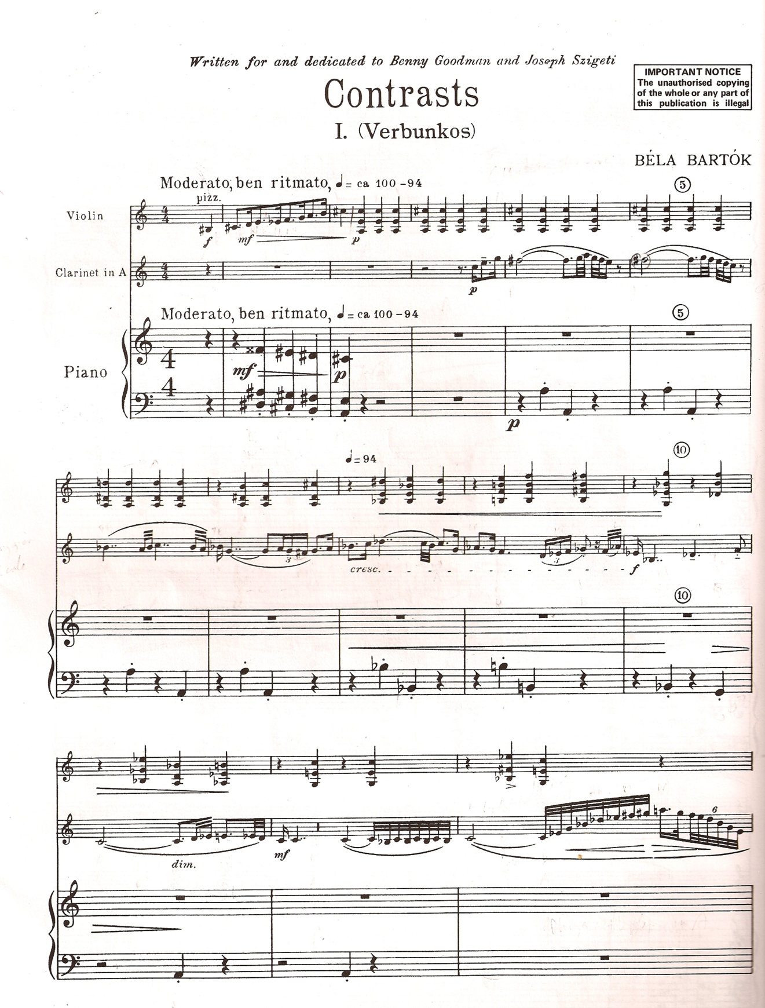

Contrasts, SZ111 by Béla Bartók
© Copyright 1942 by Hawkes & Son (London) Ltd.
Reprinted by Permission.

Figure 2.1: “Verbunkos”, mm. 1-13
After the opening statement of the melody, the clarinet launches into series of brilliant arpeggiated figures in mm. 13-28, shown in fig. 2.2. Ludewig-Verdehr compares these flourishes in the clarinet part to the nimble playing of Czech and Hungarian clarinetists. She describes their vivid playing style as “all over the place…you wonder how they can play that fast.” The goals here, she states, are “fluidity” and “really rhythmic playing.”
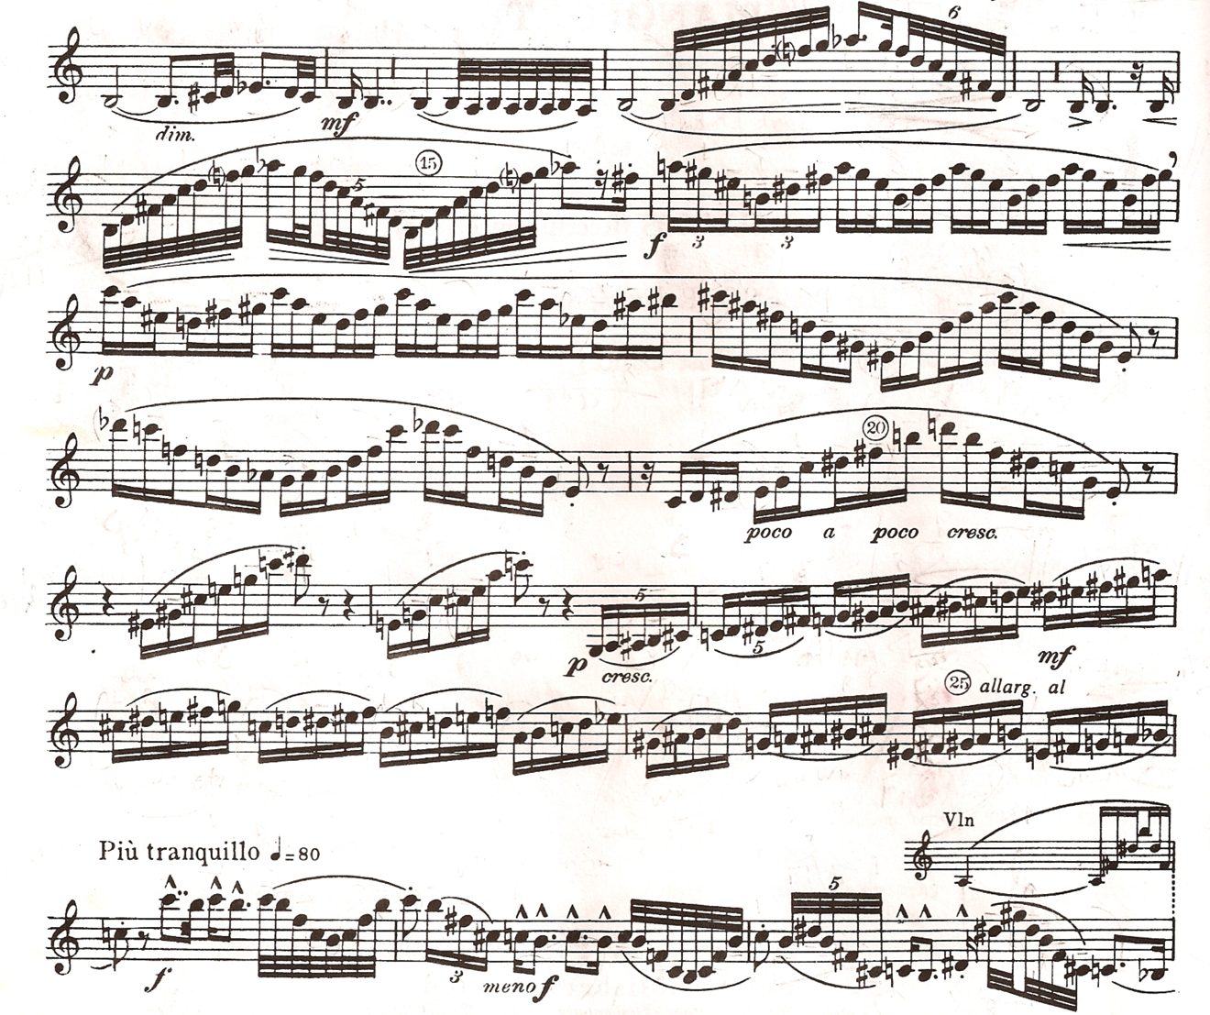

Contrasts, SZ111 by Béla Bartók
© Copyright 1942 by Hawkes & Son (London) Ltd.
Reprinted by Permission.

Figure 2.2: “Verbunkos”, mm. 11-28, Clarinet in B-flat part

Ludewig-Verdehr also offers fingering suggestions in this section (see fig. 2.3). For the A-sharp in m.18 she suggests the using the left hand first finger with the second finger of the right hand. For the D-flat in measure 19, she suggests the “overblown F-sharp”, which would produce a softer sound under the violin melody. In m. 20, Ludewig-Verdehr suggests the option of using the non-conventional open D (no fingers). Again, this fingering would work well in the soft dynamic Bartók has indicated for the clarinet. In m. 28 she suggests one can leave the B key down for the first three notes of the first arpeggio figure, and she uses the “2 and 2” G-sharp in the second arpeggio figure.

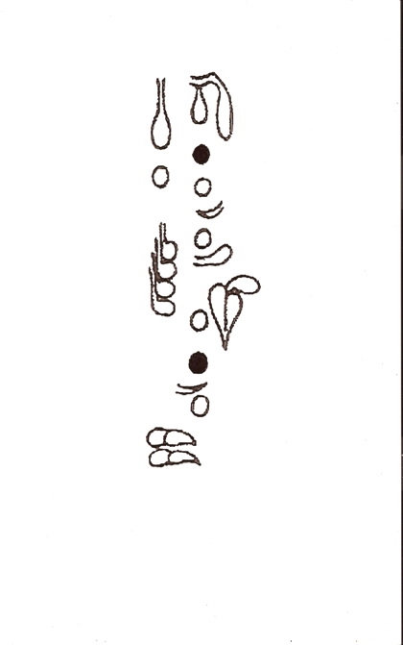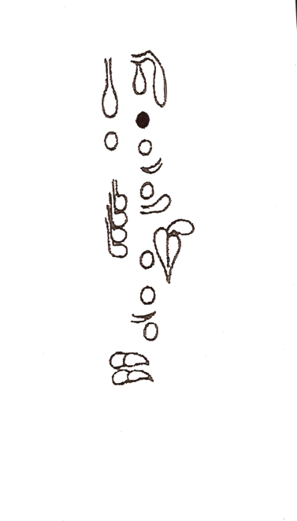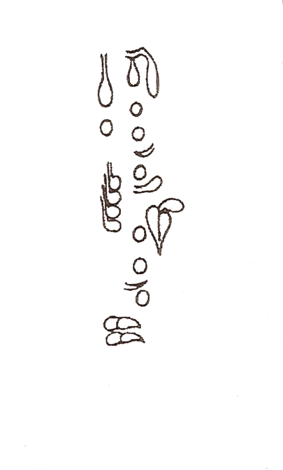

A-sharp D-flat Open D

Figure 2.3: Clarinet Fingerings, “Verbunkos,” mm. 18-20, 28, Clarinet in B-flat part
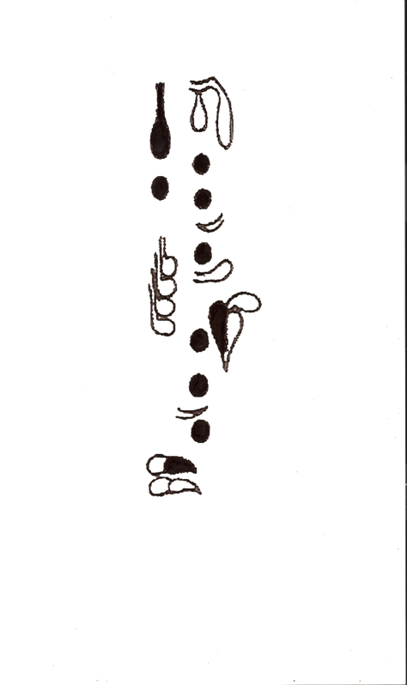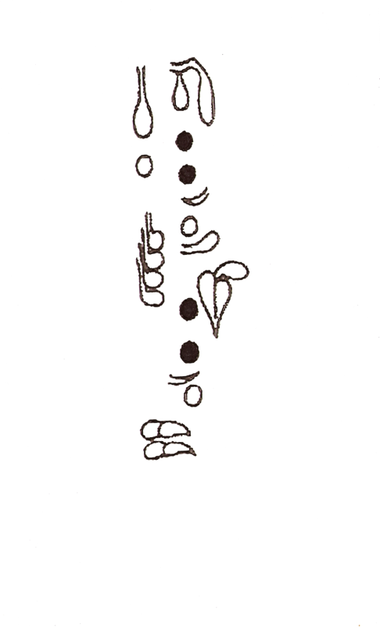
D-Sharp G-sharp

Figure 2.3: Clarinet Fingerings, “Verbunkos,” mm. 18-20, 28, Clarinet in B-flat part (cont.)

Ludewig-Verdehr describes the character of the new melody in the violin at m. 30 as being in contrast to the tune that opens the movement. She states that ensembles often will sometimes not understand this contrast and interpret it in a more “beat-to-beat” style. The melody has a “kind of dreamy” quality, she argues:
It’s just gotta glide. I tell my students sometimes, ‘It’s like a ghost…they don’t have feet’…very horizontal, a measure at a time.

After this new theme is stated, there is a section of very vivid writing for the clarinet and violin, before the original melody returns in m. 57. The clarinet part is shown in fig. 2.4. Ludewig-Verdehr has suggestions involving tempo, balance, and playing style for this section. The accelerando in mm. 43-45, should be played so that “each beat” is a little bit faster, she says. At mm. 45 and 49 Ludewig-Verdehr suggests adjusting the ensemble dynamics for the purposes of balance. Both the clarinet and violin are marked piu forte in m. 45, “but I drop back because the violinist will get all excited if I play too loud there... and then in 49 it’s the clarinet part” which can be more prominent, she states.
One characteristic of this very aggressive section is Bartók’s heavy use of uneven triplet figures within each beat, appearing in either a long-short or short-long rhythmic pattern. As one can see in fig. 2.5, the beat will sometimes begin with a quarter note followed by an eighth note and sometimes vice versa. Ludewig-Verdehr says she prefers to highlight these rhythmic changes in order to “swing it just a little bit.” She then very vigorously punctuates the accented pairs of notes at the end of mm. 53 and 54, as Bartók has marked. As the section finally relaxes to its original tempo in mm. 55 and 56, Ludewig-Verdehr again references the teaching of her teacher, Stanley Hasty, in that “each beat goes slower.”

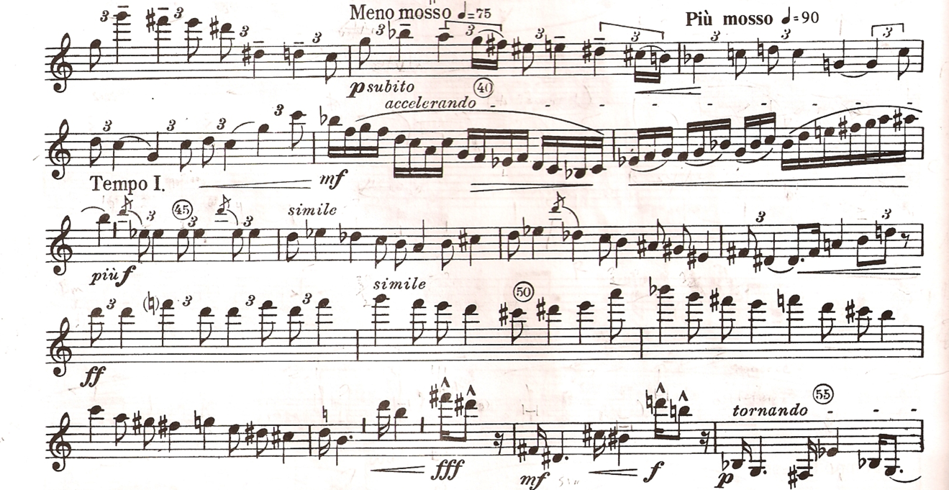
Contrasts, SZ111 by Béla Bartók
© Copyright 1942 by Hawkes & Son (London) Ltd.
Reprinted by Permission.

Figure 2.4: “Verbunkos,” mm. 36-55. Clarinet in B-flat part

Ludewig-Verdehr states that of the opening clarinet motive from m. 3 (shown in fig. 2.1) should be played differently when it returns in m. 57. Whereas at the beginning of the movement Bartok has indicated ben ritmato, here the melody is marked dolce, piano, Tranquillo:
I try to do that very ghostly, and want the violin and the piano, all of us to sound pretty much the same. So the violin is more flautando, the pianist’s got the soft pedal down, so that we’re sort of maybe shimming along at a pianissimo.

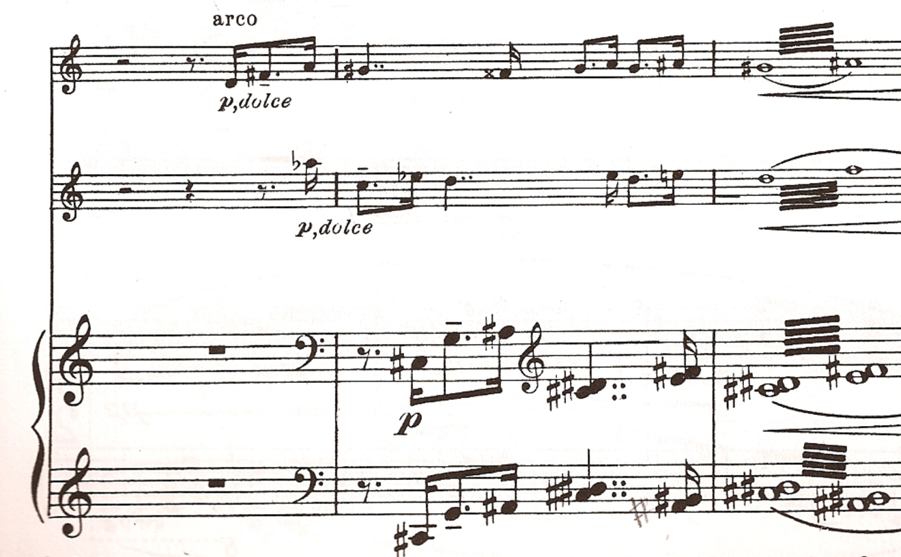

Contrasts, SZ111 by Béla Bartók
© Copyright 1942 by Hawkes & Son (London) Ltd.
Reprinted by Permission.

Figure 2.5: “Verbunkos,” mm. 57-59

In mm. 65-71, as Bartók plays with the dotted eighth-sixteenth note motive further. Ludewig-Verdehr differs slightly from the score in her interpretation. She states, “this is one thing I disagree with Bartók…at 65 I find that a little jaunty, and you know, it says semplice, but I find it almost scherzando.” On the other hand she points out that close examination of the clarinet part, seen in figure 2.6, can discern Bartók’s precise use of rests to vary the melodic line into three parts. As Ludewig-Verdehr states, “See what he’s done here too is to make this incredible merge between smooth, then broken up, then smooth again.” Part one is in mm. 65-66, part two in mm. 67-68, and part three from mm. 68-71.

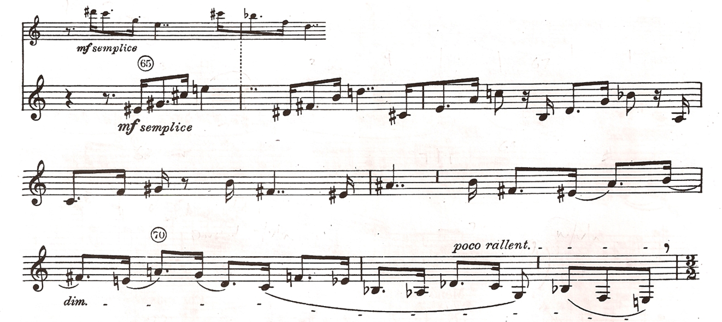

Contrasts, SZ111 by Béla Bartók
© Copyright 1942 by Hawkes & Son (London) Ltd.
Reprinted by Permission.

Figure 2.6: “Verbunkos,” mm. 65-72, Clarinet in B-flat part

Ludewig-Verdehr states that the end of this section is one example of the importance of playing the entire movement with an organic sense of form. The violin and clarinet end the section in m. 71 by playing three successive eighth notes together. She says, “Mostly people play quarter notes” instead of the given eighth notes, and “I believe in the ritard. connecting” to the next section. When explaining this concept, Ludewig-Verdehr references the influence that Robert Mann had on the Verdher Trio’s interpretation of Contrasts during one of his visits to Michigan State University, and she describes two other places in the music where the musicians can unintentionally disrupt the flow of the movement:
And actually one person who pointed this out, Bobby Mann of the Juilliard String Quartet - first violinist. For a while they were in residence at our school. They would come three times a year. Since Bobby was one of the earliest people to play this [Contrasts], we had him coach us. This was probably way back in the 70s.
…He was the one who pointed out to us, “Okay, very nice, but you made three big sections. You took a long time before m. 30 [see fig. 2.7], you took a long time at [57] [see fig. 2.5], you took a long time at 71 [see fig. 2.8], and what you did was break it [the movement] into three parts…And as we began to study it, I began to realize that’s just plain wrong what we do there. Those are three eighth notes at 71, and we always played quarters because everybody else did.

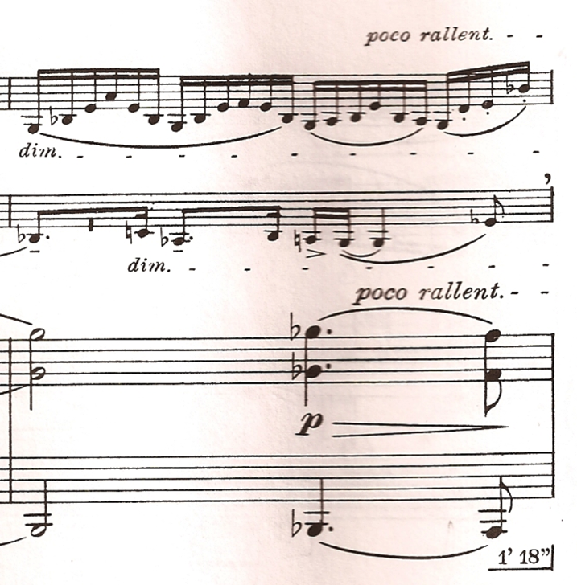

Contrasts, SZ111 by Béla Bartók
© Copyright 1942 by Hawkes & Son (London) Ltd.
Reprinted by Permission.

Figure 2.7: “Verbunkos,” m. 29

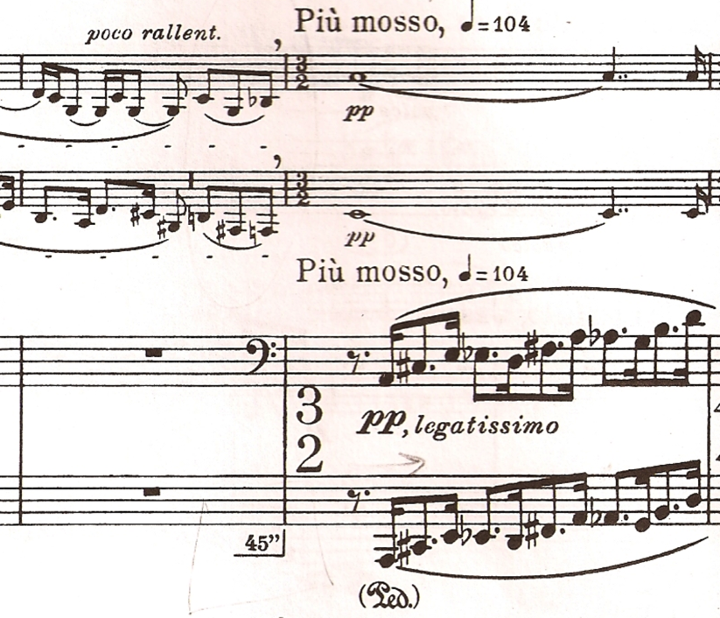
Contrasts, SZ111 by Béla Bartók
© Copyright 1942 by Hawkes & Son (London) Ltd.
Reprinted by Permission.

Figure 2.8: “Verbunkos,” mm 71-72

For the Piu mosso section of mm. 72 – 84, Ludewig-Verdehr describes the phrase structure in a very specific manner. She suggests that the piano should present the leading melodic material in a “really quiet…sneaky…ghostly” manner. When the second phrase, beginning in m. 74, changes to a piano dynamic, Ludewig-Verdehr describes the change as “like you would see on an organ when you jump to a different register, you get a different color.” The third phrase begins at the forte subito in m. 77 and lasts until m. 79. Ludewig-Verdehr warns against playing the phrases too mechanically, emphasizing that the phrases must “hang together.” For mm. 82-85, she recommends continuing to listen for the piano, and for the poco rallentando to be a gradual change until the Tempo I in m. 85.
Ludewig-Verdehr’s suggestions for the famous clarinet cadenza that begins after m. 87 emphasize a musical and rhythmic approach. She prefers to make a small crescendo and diminuendo on the E-sharp half note which ties into the cadenza. She then begins the flourishes “hesitatingly, then a little faster and a little louder,” but avoiding going too fast in order to maintain accuracy. Ludewig-Verdehr also recommends pacing the climb up to the climax of the cadenza through the use of the given articulation and breath accents. For the fermata on the sustained high climax of the cadenza, Ludewig-Verdehr references her use of the B-flat clarinet:
And you see here again on the B-flat [clarinet] that run up to the high A-flat - that’s not so chilling, but up to a high A that can be kind of a bright sound. And so again I prefer that for the B-flat clarinet.

Regarding the winding, articulated, descending passage at the resolution of the cadenza, she is both modest and musical in her approach:
I don’t make it as fast as some people do…and not necessarily because I can’t do it, although I can’t tongue as fast as I used to. I used to be able to just tongue anything. So that wasn’t it, but musically it just worked out that way for me.

She also recommends taking a breath before the descending passage, but to do so “in the time” of the music.
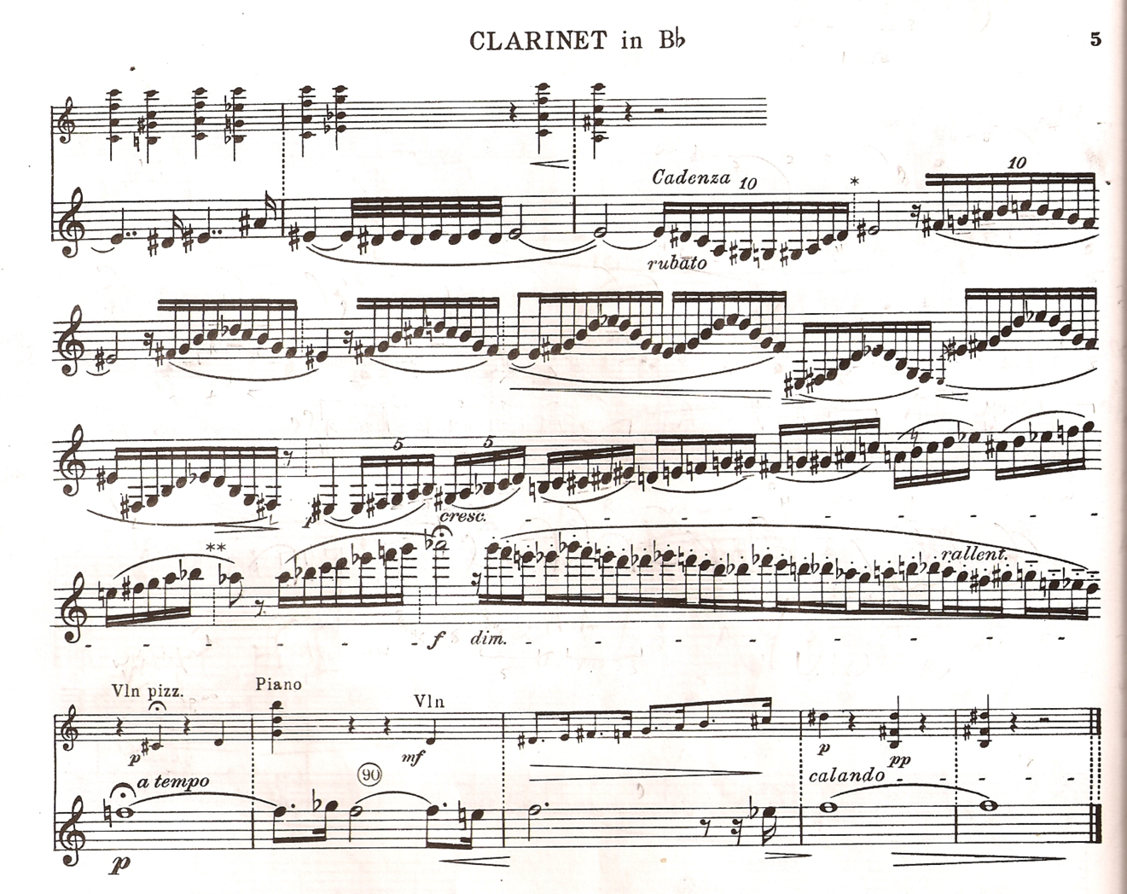

Contrasts, SZ111 by Béla Bartók
© Copyright 1942 by Hawkes & Son (London) Ltd.
Reprinted by Permission.

Figure 2.9a: “Verbunkos,” cadenza for clarinet, Clarinet in B-flat part

The “Verbunkos” movement continues for only five more measures after the clarinet cadenza. Ludewig-Verdehr is quite specific in her interpretation here, however, which recalls the opening of the movement. First, she states that the clarinet must be allowed to hold the fermata on the downbeat of m. 89. She often hears the violinist enter too soon on beat two of that measure.
Ludewig-Verdehr also detects a misprint in measure 89. As a comparison between figures 2.11a, 2.11b, and 2.11c demonstrates, an incorrect cue for the violin exists. The fermata above the quarter note on beat two, found in the clarinet part (shown in fig. 2.11a), is present neither in the piano score (see fig. 2.11b), nor in the violin part (see fig. 2.11c). Instead, an a tempo begins on beat two.

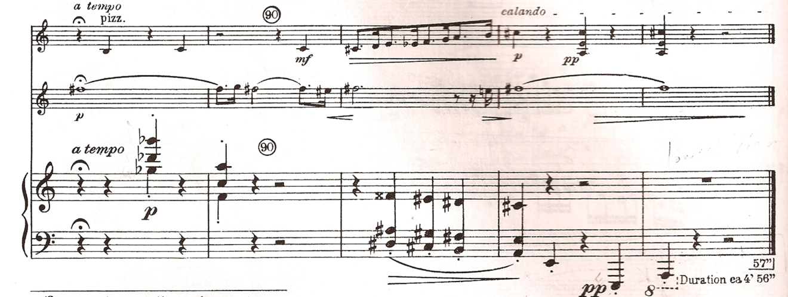

Contrasts, SZ111 by Béla Bartók
© Copyright 1942 by Hawkes & Son (London) Ltd.
Reprinted by Permission.

Figure 2.9b: “Verbunkos,” mm. 89-93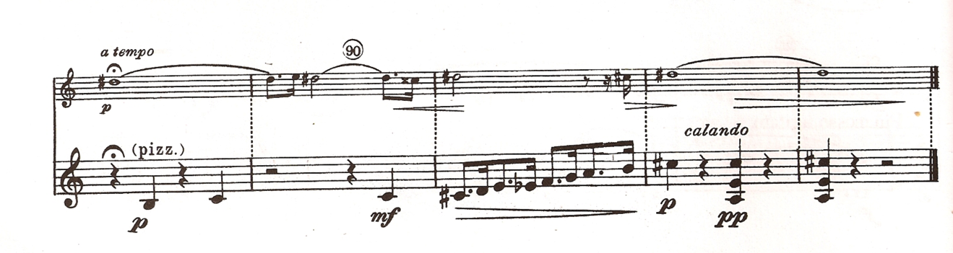

Contrasts, SZ111 by Béla Bartók
© Copyright 1942 by Hawkes & Son (London) Ltd.
Reprinted by Permission.

Figure 2.9c: “Verbunkos,” mm. 89-93, violin part

Ludewig-Verdehr references both Bartók’s specific instructions and one of

Stanley Hasty’s concepts in her approach to the last the last two bars:
Each beat slower, just exactly what he [Bartók] says. And then the clarinet… if you do eight beats and a diminuendo…with each beat getting slower and slower, it works out just perfect. And that’s a Hasty thing too…thinking the inner beat, and ritarding and making it organic.”

Movement II, “Piheno”

As was true for the “Verbunkos”, Ludwig-Verdehr has many ideas to share concerning the “Piheno” movement. She discusses issues such as balance, tone color, phrase structure, tempo changes, dynamic effects, further misprints in the B-flat clarinet part, and the atmosphere of the movement.
The first issue Ludewig-Verdehr addresses in the “Piheno” movement is one of balance. This is due to a discovery the Verdehr Trio made when they first began to practice the movement:
One of the first things we were really surprised at was when the violin plays really soft when the clarinet does, the violin predominates without meaning to. So …we always have the violinist play… flautando, and that way they might match the quality of the soft clarinet a little better.

She likens the clarinet color at the beginning of the movement to a marking that Claude Debussy uses in his Premiere Rhapsodie for Clarinet and Piano. In this wonderful work, Debussy asks for a “doux et penetrant” (sweet but penetrating) tone quality when the clarinet presents the melody at m. 11.
Ludewig-Verdehr suggests three phrases for mm. 1-18, as seen in fig. 2.10. Each phrase has its own corresponding tempo change, and is “…a little louder and a little faster” each time. The first phrase lasts from mm. 1 to 5. The second phrase, mm. 6-10 “… a little more penetrating and a little fuller, and then very definitely [leading] to the pianissimo…” in m 9. The longer third phrase, in mm 11-18, Ludewig-Verdehr suggests as being more singing and open, “a definite contrast” to the pianissimo of mm 9-10. She also states that accurate counting is essential in this section of frequent meter changes.

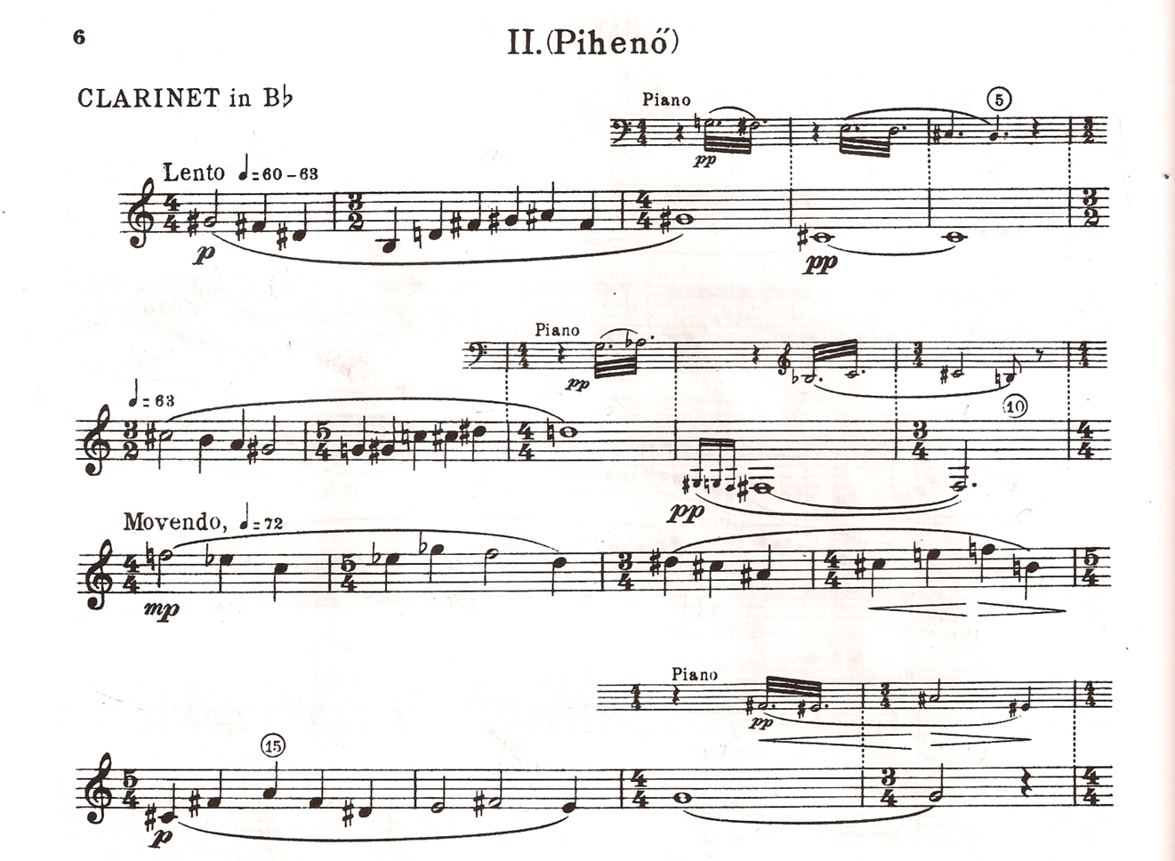

Contrasts, SZ111 by Béla Bartók
© Copyright 1942 by Hawkes & Son (London) Ltd.
Reprinted by Permission.

Figure 2.10: “Piheno,” mm. 1-18, Clarinet in B-flat part

Ludewig-Verdehr points out that the title of the movement means “relaxation,” but argues that the musical content “really seems mysterious, …more misty.” As the “Piheno” movement continues, she emphasizes the dynamic and tempo changes to create this effect. In m. 19, for example, she states that it “is so important to have it really, really, soft and mysterious.” Ludewig-Verdehr also notes the changes in tempo at the movendo in m. 22, at the Piu mosso, agitato in m. 25, and in the return to Tempo I in m. 29.
In the Verdehr Trio she says that they finesse the tempo change at 25 to get the effect they desire. Even though no accelerando marking is present, “we make a little accelerando into m. 25, and I don’t think it hurts.” In order to reinforce the faster tempo at m. 29, Ludewig-Verdehr uses body language to conduct the ensemble. She says she is “always surprised at how much faster 80 [on the metronome] is than I expect…so I give a big beat on the second beat for the piano.” Ludewig-Verdehr also states that she likes to think of the Piu mosso section as beginning with one long four-measure phrase.
In discussing the effect of the tornando al tempo in mm. 28 and 29, Ludewig-Verdehr again references the teaching of Stanley Hasty regarding the use of ritardando:
Hasty was very, very specific about that so often, tornando to a tempo…and people will always make a huge break…going into 29, but it should go right into it… Something that I learned from Hasty years ago…that ritards. shouldn’t be considered such a big holding back that you destroy the tempo. They should basically just hold back and then give way to the new tempo.
(see fig. 2.11)

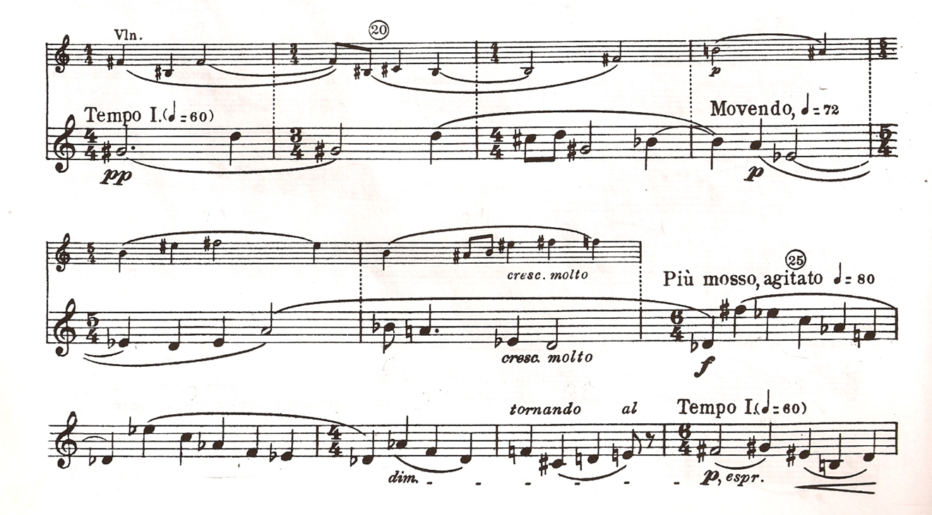
Contrasts, SZ111 by Béla Bartók
© Copyright 1942 by Hawkes & Son (London) Ltd.
Reprinted by Permission.

Figure 2.11: “Piheno,” mm. 19-29, Clarinet in B-flat part

Ludwig-Verdher points out that the Tempo I section beginning in m. 29 is
problematic because of several misprints in the B-flat Clarinet part, as seen in fig. 2.12. She states that the piano melodies beginning on the second beat of both of mm. 30 and 32 must be heard clearly. Therefore, the decrescendo markings at the beginnings of these measures should be shortened to one beat.

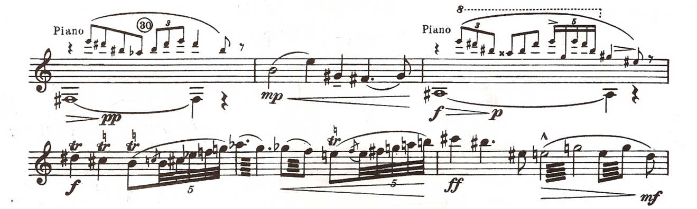

Contrasts, SZ111 by Béla Bartók
© Copyright 1942 by Hawkes & Son (London) Ltd.
Reprinted by Permission.

Figure 2.12: “Piheno,” mm. 30-35, B-flat Clarinet part

Ludwig-Verdehr also points out that some of the trills in the B-flat Clarinet part for this section are incorrect. In measure 37, the G-sharp quarter note on beat five should trill to an A-sharp, and the F-sharp quarter note on beat six should also trill up a whole step to G-sharp.
Ludewig-Verdehr has several suggestions for the intense effects of mm. 33 and 34, seen in fig. 2.12. She adds an articulation to the grace notes in order to give the five-note flourishes a stronger rhythmic sense. The accented beat four in m. 34 is also very important. “You really have to place that beautifully,” she says. The clarinet figures in m. 34 should lead directly to the violin chord on the downbeat of m. 35. Her trio also adds an accelerando to the crescendo in m. 33.
In the section which begins in m. 35 and lasts to m. 45, seen in fig. 2.13, Ludewig-Verdehr makes several points. She suggests two alternate ways of playing the clarinet figures in mm. 35-37. One is to play tranquillo as marked. “Other times it wants to be ‘dancy,’ ” she says, and such an approach “won’t hurt it either.” Ludewig-Verdehr points out that the same problem that exists with the notation from mm. 30 and 32 is present in mm. 41 and 42. “That second beat has to be piano” in m. 41, she says. “We don’t just diminuendo at will.” She also suggests that the musicians should find a way to link the phrases in this section.

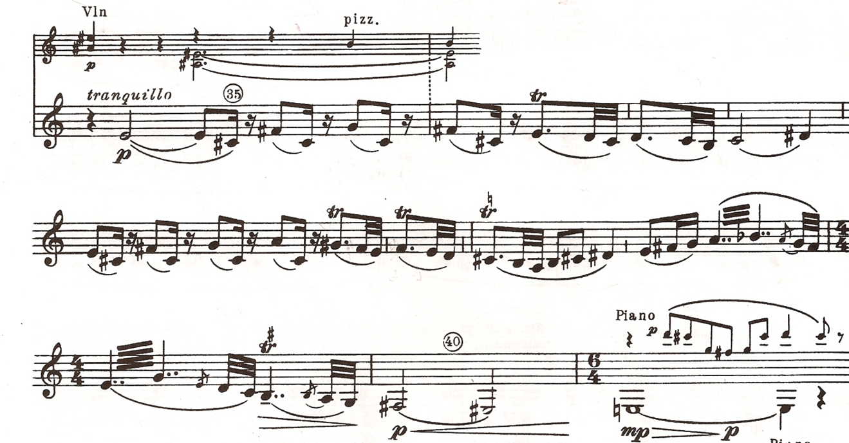

Contrasts, SZ111 by Béla Bartók
© Copyright 1942 by Hawkes & Son (London) Ltd.
Reprinted by Permission.

Figure 2.13: “Piheno,” mm. 35-41, Clarinet in B-flat part

Ludewig-Verdehr has several observations for the quiet conclusion of the “Piheno”, starting at m. 45, in fig. 2.14. Concerning the tempo change in m. 45, she observes, “I never understand why Bartók wants it to go faster there, but he does. It always sounds rushed to me.” Ludewig-Verdehr also describes the important melodic and harmonic material in the piano part: “the piano has the melody the clarinet had at the beginning,” and “beautiful chords.” The dynamic changes and counting are also worth noting in these final measures, Ludewig-Verdehr says. From the piano in m. 45, “then…piu piano, then… pianissimo”, and “if you count it exactly like he says, and diminuendo, it’s twelve beats, it’s really twelve beats.”

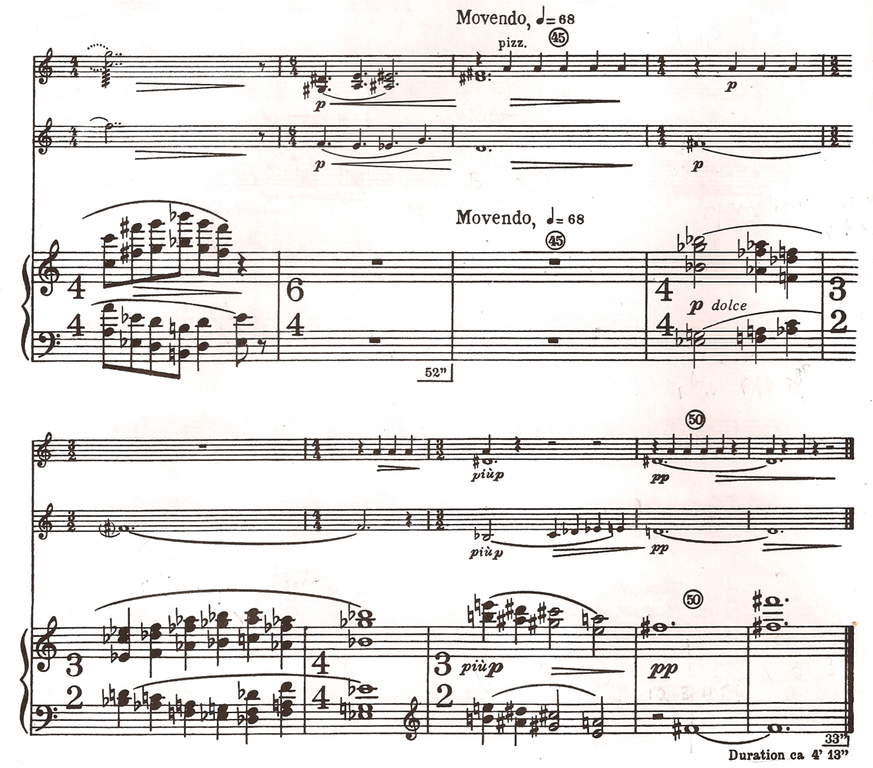

Contrasts, SZ111 by Béla Bartók
© Copyright 1942 by Hawkes & Son (London) Ltd.
Reprinted by Permission.

Fig. 2.14: “Piheno,” mm. 43-51

Ludewig-Verdehr also has a suggestion for the last, disappearing pitch in the
clarinet’s chalumeau register, which is often a bright-sounding C-sharp for the Clarinet in B-flat:
I found a lot of times that if I put down the E key…it just makes it a bit flatter and a little darker.

Movement III, “Sebes”

Ludwig-Verdehr’s comments for the “Sebes” movement cover a wide gamut of interpretive ideas. Her comments primarily focus on the challenges of tempo, and dynamics, articulation, and ensemble coordination.
Regarding the use of the scordatura violin at the opening of the “Sebes” movement, Ludewig-Verdehr says that a high quality instrument is not important. When touring, the Verdher Trio prefers to borrow a violin from a local school or university, preferring a less refined sound than the violin which Walter Verdehr normally uses. She argues, “It’s kind of nice to have a difference of a crass sound there. That’s our opinion anyway.”
Ludewig-Verdehr’s other suggestions regarding the opening eighteen measures concern tempo, articulation, and dynamic changes. Regarding the given metronome marking in the score, she says “140 seems to be a good tempo. It shouldn’t be too fast or too slow, because later it’s going to get faster and faster.” In the violin part, she says “the accents on the second beat of the violin part in mm. 6-8 can be a problem,” because “student violinists often are a little reluctant to do that.” Regarding dynamics and tone color, the change in sound at m. 14 from piano to mezzo forte should be “totally different, and it shouldn’t be ugly, just nice and firm until it tapers off” in m. 17.
At measure 30, immediately after the violinist plays on the downbeat, the score directs the violinist to “Take the other violin, tuned as usual.” The clarinet and piano continue playing for several measures on their own, repeating a four-note, ostinato figure in sixteenth notes. In measure 35, the score offers further instructions, this time referring to the clarinetist and pianist, who are playing the ostinato figure: “May be played several times if necessary.” This “vamp” technique allows the violinist enough time to change instruments.
When asked about coordinating this maneuver with the rest of the ensemble,
Ludewig-Verdehr says that it helps to “have the signal straight” between the ensemble members. In the Verdehr Trio, she says that the violinist (Walter Verdehr) will signal when he is ready to begin playing on the normally tuned violin, and then she will cue the downbeat of measure 35. Some people, she says, give a cue a bar or beat earlier.
Ludewig-Verdehr says that she has always liked the effect of measures mm. 43-48. Shown in fig. 2.15, Bartók builds the tension in the music through successive groups of rising sixteenth notes. Each group begins piano and is marked to increase in volume as the notes ascend. The phrase peaks at the downbeat of m. 48 with two heavily accented eighth notes.

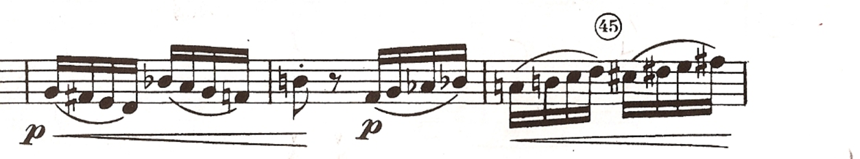

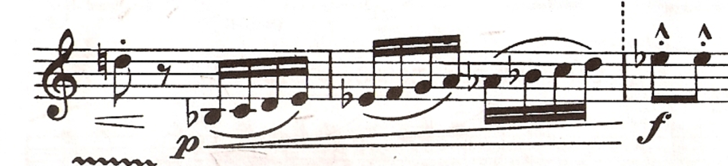

Contrasts, SZ111 by Béla Bartók
© Copyright 1942 by Hawkes & Son (London) Ltd.
Reprinted by Permission.

Figure 2.15: “Sebes,” mm. 43-48, Clarinet in B-flat part

At the Meno vivo section beginning in m. 50, the score indicates a more moderate tempo for nine bars, before returning to the faster Tempo I. Here Ludewig-Verdehr states that her Trio reduces the tempo for only a few measures before they “gradually accelerate” into the Tempo I in m. 59.
After the return to Tempo I, Ludewig-Verdehr comments about a difficult sfortzando articulation in the clarinet part on the last note of m. 64, seen in figure 2.16:
I always feel like when you have…an accent in the piano dynamic, you’re always supposed to sting it…but it shouldn’t be a huge explosion of any type.”

Because that articulation is awkward, however, she will “sometimes just slur into it,” and she again cites the teaching of Stanley Hasty in support of such a change:

You know, that was something Hasty said years ago. He said if you’re just knocking yourself out trying to make it sound connected, why not just let it…The composers can’t know 100 percent what works exactly on every instrument.

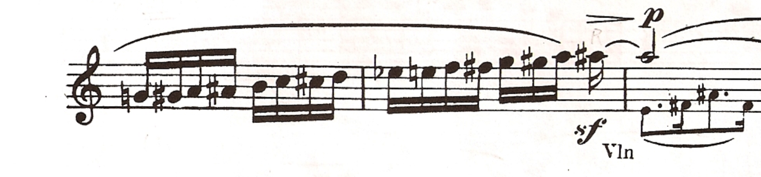
Contrasts, SZ111 by Béla Bartók
© Copyright 1942 by Hawkes & Son (London) Ltd.
Reprinted by Permission.

Figure 2.16: “Sebes,” mm 63-65, Clarinet in B-flat part

Ludewig-Verdehr has several specific comments for the section that begins in m. 65 with a new melody for the violin. She prefers that the difference between the forte and piu forte dynamic levels in mm. 71 and 73 be clear. Ludewig-Verdehr has more suggestions for the clarinetist when the clarinet assumes the melody in m. 75. She acknowledges the presence of the grazioso marking, seen in fig. 2.18, but says she focuses on the “rhythmic” quality of the writing. The theme begins again in 79, but then transforms into heavily syncopated patterns in mm. 81-89. Ludewig-Verdehr states, “ I almost get a little jazzy in there,” and explains her interpretation further by singing the passage in two different ways. In the first rendition of mm. 81-89 she sings the clarinet melody with precise rhythm, but no inflection. In the second version she sings with the same precision, but with a much stronger sense of syncopation.

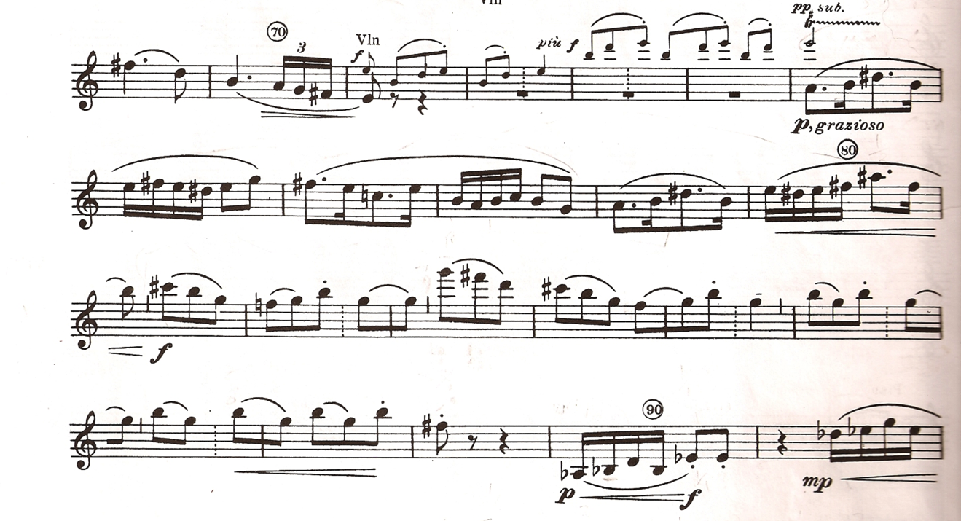
Contrasts, SZ111 by Béla Bartók
© Copyright 1942 by Hawkes & Son (London) Ltd.
Reprinted by Permission.

Figure 2.17: “Sebes,” mm. 69-91, Clarinet in B-flat part

Ludewig-Verdehr also notes the possible influence of Benny Goodman’s playing on her interpretation. She argues that the style of articulation one can hear on his early recording of the work is what the music needs here:

I remember Benny Goodman - it was written for Benny Goodman. So what I said…about articulation becoming phrasing, and phrasing and articulation becoming the musical part, and that’s one of those [places]…Benny plays what I think he [Bartók] had in mind.

Ludewig-Verdehr comments on the rhythmic, ensemble, and dynamic challenges of the section beginning in m. 93. As seen in fig. 2.19, Bartók has inserted several brief metrical changes into the overall duple meter texture. In quick succession, the musicians must negotiate the changes shown in Table 2.1:

Measure | Meter
93 | 5/8
94 | 3/4
95 | 2/4
97 | 3/4
98 | 2/4

Table 2.1: changing meters in “Sebes,” mm. 93-98

Ludewig-Verdehr says the 5/8 meter in m. 93 can cause trouble for the violinist and pianist. “Sometimes I feel like they’re so anxious to make that 5/8, they almost jump into the next” figure, she says. On the other hand, she says that the clarinetist is not the decision-maker here: “whatever they do, we have to go with it.” Because of the sudden drop to the piano, leggero dynamic level in m. 94, Ludewig-Verdehr also suggests the players could insert a space before the subito dynamic change.

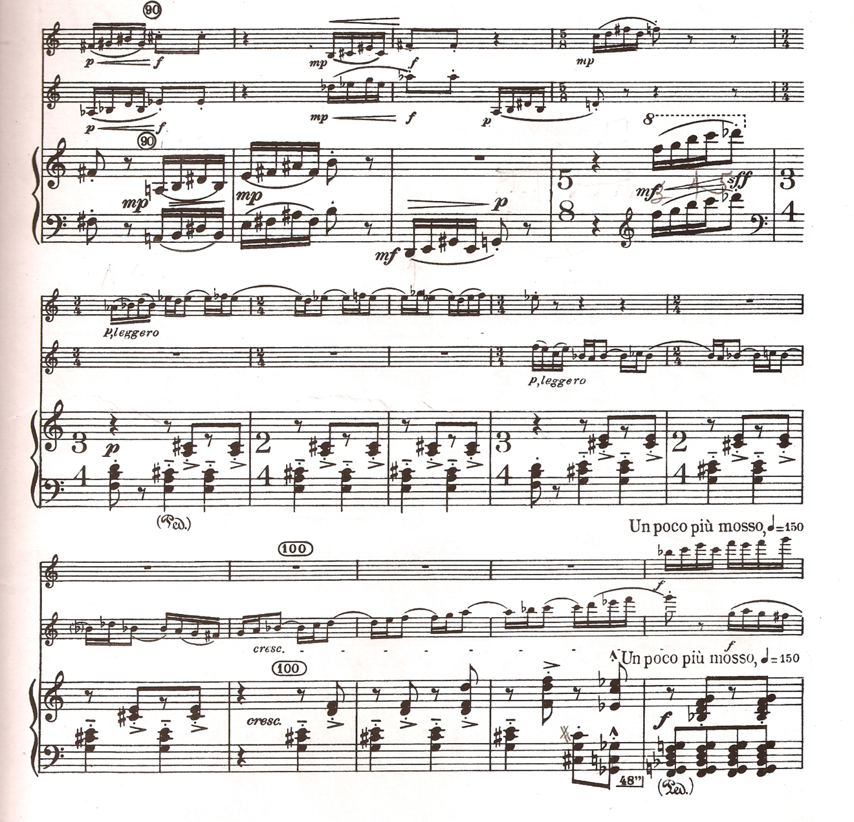

Contrasts, SZ111 by Béla Bartók
© Copyright 1942 by Hawkes & Son (London) Ltd.
Reprinted by Permission.

Figure 2.18: “Sebes,” mm. 90-103

The syncopated figures in mm. 94-102 and elsewhere posed rhythmic problems for Ludewig-Verdehr when she first learned the work. She says, “when I first learned this piece, in m. 97, I had real trouble….” She suggests practicing the passages by ignoring the tied syncopation figures, and tonguing all of the beats instead, as she says in her own words:
So at first I would…put a ‘beat’ on it [articulate the tied note]. Then eventually I did it every measure, and then eventually I got so I did it every two, and eventually I got to where I could do it with no problem…And the more you do it - and you do it with a metronome - it eventually is not a problem. (see fig. 2.19).

Ludewig-Verdehr has several suggestions for the poco piu mosso section beginning in m. 103. The music should jump to another tempo “right away.” The dynamic level is very strong in mm. 112-116. “I really let it go,” she says. “That’s really important there.” The rhythm intensity is also very important in all the parts from m. 115 to the end of the section in m. 131, she states. Her fingering of choice for the altissimo G in this section of the clarinet part is usually the “top fingering,” using the first finger of the left hand (see fig. 2.19).

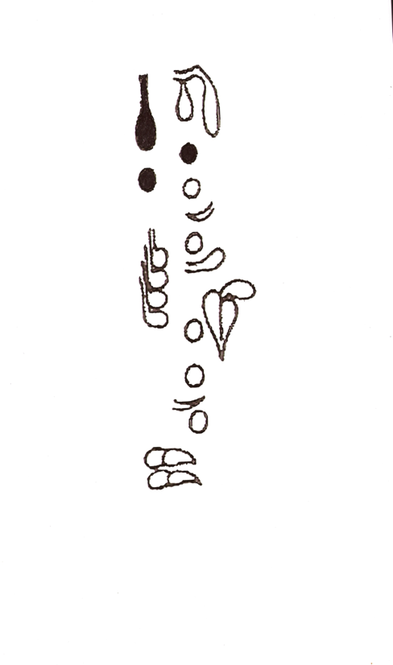
Figure 2.19: “Sebes,” altissimo G fingering

If the “Sebes” can be considered a movement in a three-section format of fast-slow-fast, the author feels the Piu mosso section from mm. 132-168 would be the more lyrical, contrasting interlude to the faster opening and closing sections. On the other hand, the irregular 8/8 + 5/8 meter of the Piu Mosso seems counterintuitive to a more lyrical approach. The music here does have an underlying agitated quality to it, perhaps stemming from the irregular meter and Bartók’s indicated metronome marking of eighth note equals 330.
Ludewig-Verdehr’s ideas for the Piu mosso section beginning in m. 132 include suggestions of dynamic level, rhythm, legato, and ensemble coordination. To help the clarinetist manage the rhythmic challenges of this section, Ludewig-Verdehr suggests carefully counting the recurring half-notes using an eighth-note subdivision.
Although the clarinet is marked to enter in m. 133 at mezzo forte, she introduces the notion of a more gentle, intermediate level, somewhere between mf and mp:
The idea of an “m.” Mezzo forte in this case just seems too much. Mezzo piano would be not enough…but not demanding, not calling for attention.”

She states that she plays “very legato,” and at the end of the clarinet phrase in m. 138, seen in fig. 2.21, she tries to carefully set up the following phrase for the violinist:
I just let it die down, so that I bring the dynamic down to the violin at 138 to the dynamic that he should be playing…I think that really works nicely, but I’m not saying it’s right. It’s just what I do.

Ludewig-Verdehr expresses a fondness for the beauty of the piano, dolce violin melody in m. 139, but also acknowledges that the clarinetist can have trouble with the counting in their accompaniment. She recalls that learning this section was both a matter of careful counting and of becoming accustomed to the violin and piano parts. Ludewig-Verdehr sings the violin part in her head when the violin has the syncopated melody, and listens to the piano when the clarinet inserts its short responses. At the same time, she shifts her counting between a quarter-note pulse and an eighth-note pulse within each measure to keep track of the 8/8 + 5/8 meter:

And so I tell my students to count 1,2,3,4 [quarter notes]…and you can just think, 1,2, 1,2,3 [eighth notes] you get it kind of swinging and it fits right with the piano.”

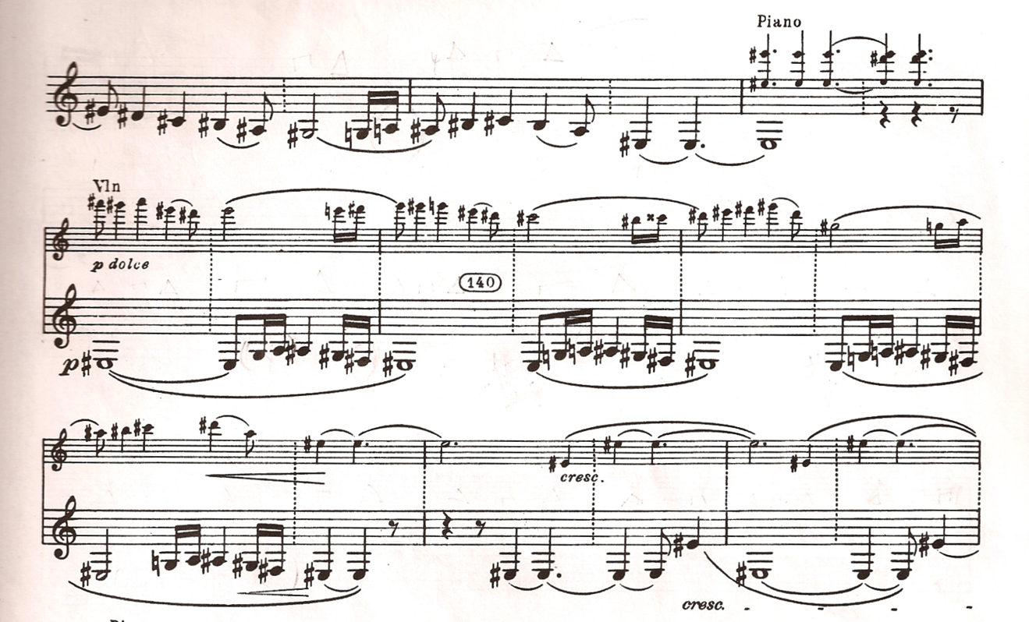

Contrasts, SZ111 by Béla Bartók
© Copyright 1942 by Hawkes & Son (London) Ltd.
Reprinted by Permission.

Figure 2.20: “Sebes,” mm. 136-144, B-flat Clarinet part

Ludewig-Verdehr recalls how she first encountered irregular meters when playing the music of Aaron Copland. While a first-year student at Oberlin she was a member of a ensemble which learned his Sextet for Clarinet, Piano, and String Quartet. The ensemble worked their “tails off” she says, in order to master the 3/8 and 5/8 meter. She expresses a regard for the contemporary wind symphony literature in which so many young wind players are exposed to irregular meters these days.
Ludewig-Verdehr strongly emphasizes the potential effectiveness of the dynamic changes beginning at m. 143 (see fig. 2.22). A gradual crescendo begins in m. 143 and ends with a ringing chord in the piano in m. 147, followed by a sudden drop to softer level in all of the parts:
The crescendo is marked way back at…143…it just crescendos, crescendos, crescendos…That should be really a shattering kind of chord - that’s 147. And then this next lick I think is so important…that it just sounds like when we were talking about a ‘ghost’ before. And everybody’s got to have the same sound, so he’s [violinist] kind of flautando at 148, clarinet just our usual gorgeous melody, melodic, mellow sound that we can get when we play soft, and then the piano. It’s harder for them, but they use the pedal.

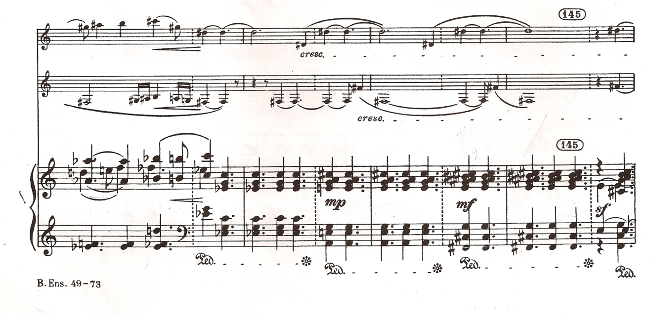
Figure 2.21: “Sebes,” mm. 142-148

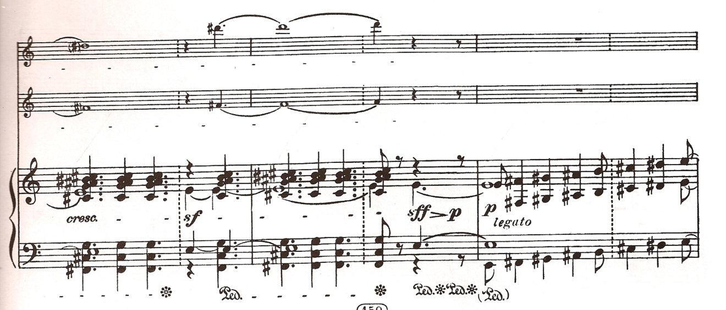

Contrasts, SZ111 by Béla Bartók
© Copyright 1942 by Hawkes & Son (London) Ltd.
Reprinted by Permission.

Figure 2.21: “Sebes,” mm. 142-148 (cont.)

In mm. 151-153, Ludewig-Verdehr once again acknowledges the rhythmic
challenges due to the syncopation combined with the irregular meter. She explains both the need of the clarinetist to learn the music well and to fit the clarinet part in the ensemble, as shown in fig. 2.24:
I don’t know, you just work it out slowly and get it. That is hard. You get so you can do that, and then of course it’s easy once you get there…I think I just fit with the piano…A lot of times I’m just singing the piano part in my head and playing with it, and that’s one of those places.

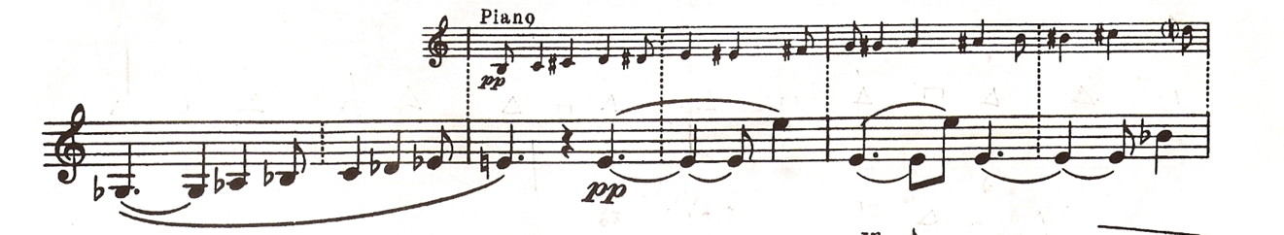

Contrasts, SZ111 by Béla Bartók
© Copyright 1942 by Hawkes & Son (London) Ltd.
Reprinted by Permission.

Figure 2.22: “Sebes,” mm. 151-153, Clarinet in B-flat part

At mm. 156-158, Ludewig-Verdehr notes the successive changes of dynamic level in the violin and clarinet. Measure 159 then begins a longer section of very reduced dynamic that continues until the end of the 8/8 + 5/8 section in m. 168. She fondly describes the writing here as being especially quiet and expressive:
A pianissimo often can be a precious moment in music, and then if you even go beyond that and just create this mood. So I just think that’s a great place.

Ludwig-Verdehr highlights a another special place, this time in the piano, beginning in m. 165, as shown in figure 2.25:

It’s so important at m. 165. The piano has…chords which are just incredible. And the first time I ever heard those we were in Sydney [Australia]. We went to a concert, some group was playing the Bartók, and the pianist pointed those out, and my eyes just bugged out, because I thought…it made such a difference. So the… chords there are just really something.

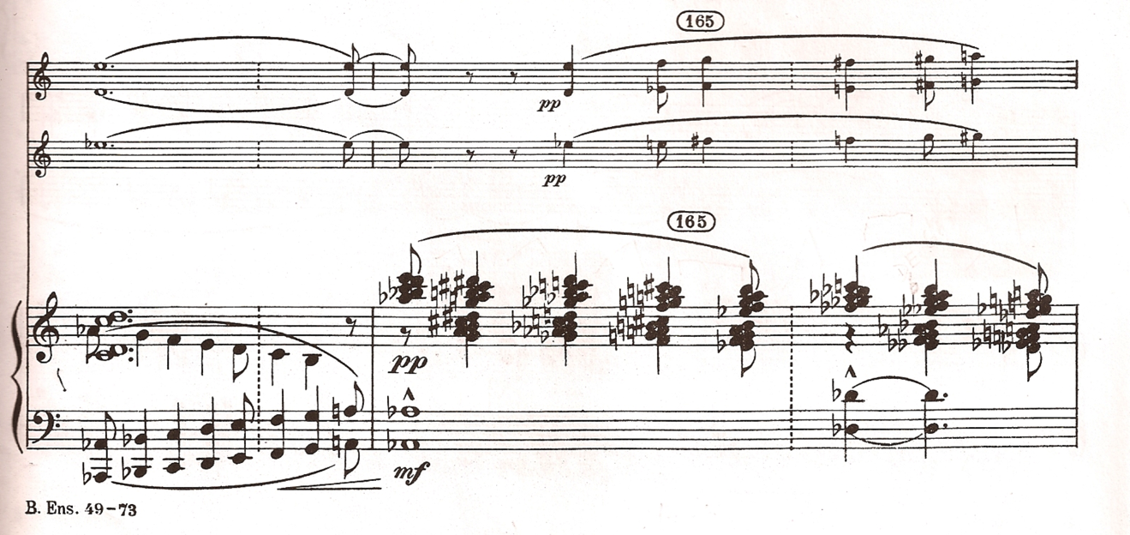

Contrasts, SZ111 by Béla Bartók
© Copyright 1942 by Hawkes & Son (London) Ltd.
Reprinted by Permission.

Figure 2.23: “Sebes,” mm. 164-165

For the return Ludewig-Verdehr finishes her discussion of the 8/8 + 5/8 section by suggesting that “if the ritard[ando] starts a little sooner, it doesn’t hurt, I don’t think.
Of the Tempo I in m. 169 Ludwig-Verdehr notes the immediate change to a leggero style, and some interesting dynamic changes. The dynamic level is marked piano, and Ludwig-Verdehr argues that the violin and clarinet could diminuendo with the descending contour of the writing for the first few bars. However, in m. 177 the players are instructed to increase their dynamics level in stepwise fashion, three measures in a row.
At the Piu Mosso in m. 186, Ludewig-Verdehr has suggestions regarding fingering, dynamic changes, and rhythmic emphasis. She addresses a fingering issue for the ostinato pattern in the clarinet part that lasts for ten bars, beginning in m. 186. She explains that one could economize the clarinet fingering for the passage by leaving the B key down for the D-sharp, and that the slightly-out-of-tune effect on the D-sharp may be even more desirable as well:
I sometimes do the first one or two [ostinatos] lifting the finger, but then after a while maybe I don’t. And in the long run I’ve convinced myself it doesn’t make a lot of difference. It almost sounds better even the less in tune. It sounds better if you don’t hear all that...even if it’s not key noise, it still sounds like ‘tooth and fingers.’
I know clarinet players. It’s sort of a thing of pride among clarinet players whether they lift the finger there or not, but in the long run I think what sounds best is most important. (see fig. 2.24) 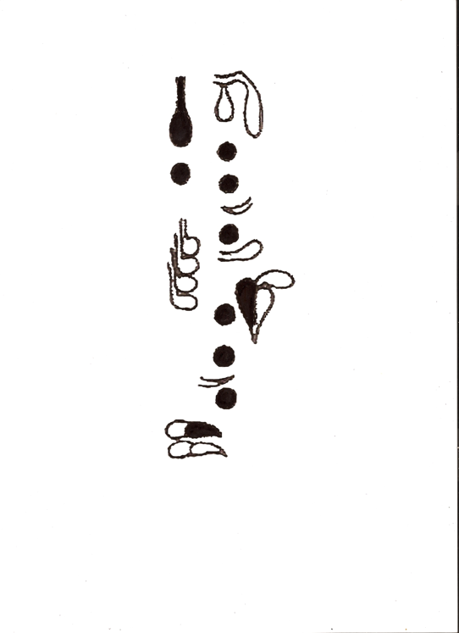

Figure 2.24: D-sharp fingering with left hand B key down

Ludewig-Verdehr emphasizes the very active dynamic changes between mm. 190 and 208, shown in fig. 2.27. She says the music indicates a ‘big jump’ to the stronger mf in m. 190, and that she also likes to add a crescendo leading into m. 204. In mm. 204-207 Ludewig-Verdehr prefers to emphasize the eighth notes before what she calls the sudden “whoops!” return to the piano ostinato figure in mm 208-211.

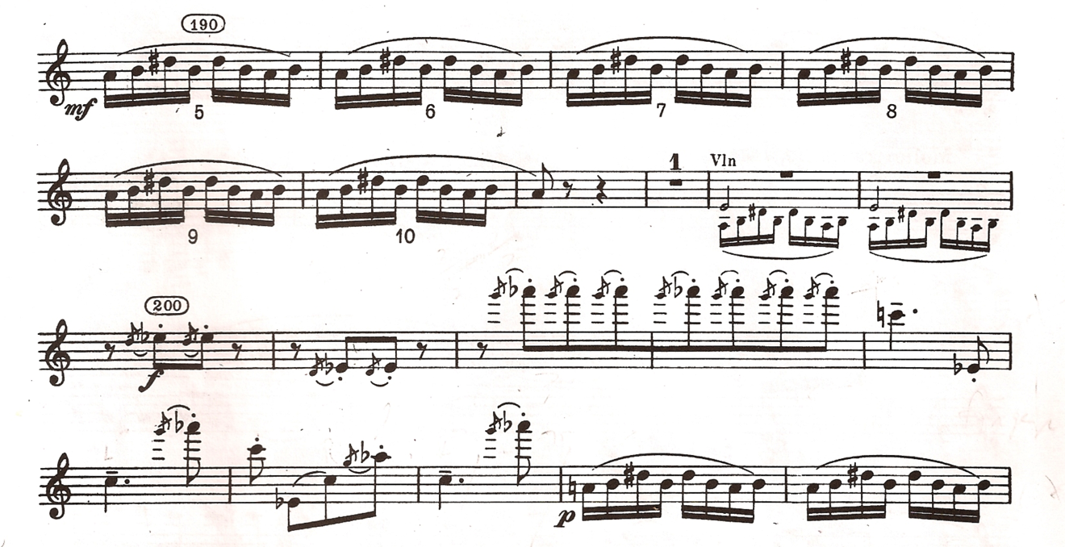

Contrasts, SZ111 by Béla Bartók
© Copyright 1942 by Hawkes & Son (London) Ltd.
Reprinted by Permission.

Figure 2.25: “Sebes,” mm. 190-209, B-flat Clarinet part

The next problem Ludewig-Verdehr addresses is the transition from the violin cadenza and to the Tempo I of m. 214 She has suggestions for ensemble coordination, balance, and articulation in order to manage this section, seen fig. 2.28. Regarding the allargando molto and indicated pause before the Tempo I, she states that the Verdehr Trio does follow the indicated markings, but that they pause “not too much,” and only what the violinist “leads us into.” She says the clarinet should crescendo within the allargando as marked and then assume the lead on the downbeat of m. 214, but only until the second beat of m. 217, where the violin resumes with the primary melodic material for the next four-bar phrase. When the clarinet takes up the melody again four measures later, Ludewig-Verdehr states that she sometimes will use a tongue articulation to help her accent the downbeat of m. 222.
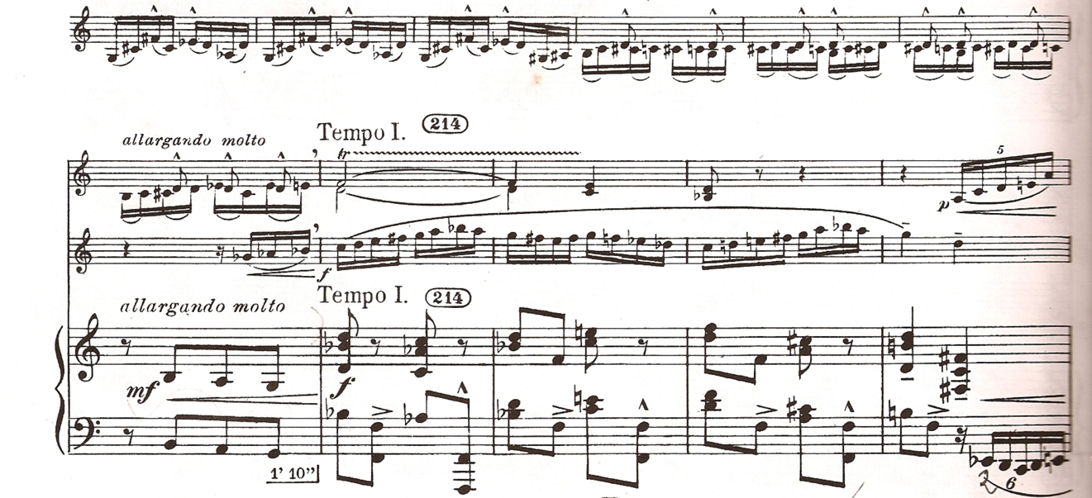

Contrasts, SZ111 by Béla Bartók
© Copyright 1942 by Hawkes & Son (London) Ltd.
Reprinted by Permission.

Figure 2.26: “Sebes,” end of violin cadenza

Ludewig-Verdehr expresses several interpretive ideas about mm. 225-247, a span of music that is almost dizzying in its numerous changes of tempo and color. Beginning in m. 225 with the ritardando to a quasi a tempo (tranquillo), leggiero in m. 226, there follows a poco rallentando to a Meno mosso in m. 230. This tempo is maintained for only four bars before being interrupted by a Molto tranquillo and then an accelerando to Tempo I in m. 238 four measures after that. There are numerous dynamic shifts to go along with the changes of tempo.
For the singing clarinet melody in the four-bar Meno mosso section, Ludewig-Verdehr prefers a less aggressive tempo than the one indicated in the score, describing her choice as more “grazioso.” She also says her Trio will sometimes add an accelerando leading into the Piu mosso of m 248:
I don’t think it’s terrible if it accelerates a little…instead of making it a sudden change, but either way - no big deal.

For the problematic rhythmic patterns in the clarinet part of mm. 241-247, she recommends practicing the figures by removing the ties between note, a method she described previously for mm. 97-102.
The Piu mosso section beginning in m. 248 and lasting until the end of the movement contains some of the most vigorous music in the entire work. Ludewig-Verdehr focuses her comments concerning this climactic last section upon maintaining rhythmic stability and the use of dynamic changes. Some of the dynamic changes she suggests are for reasons of ensemble balance. For instance, in mm. 256-259, she tapers each of the clarinet entrances, so that the violin sixteenth notes can be heard more clearly. Beginning in m. 260, she reduces the level of the clarinet trill to a mp level from the printed forte, , so that the violin and piano will predominate, even though the score does not mandate a change. Bartók’s score is marked to drop the group dynamic level to mf in m. 272, and then to gradually crescendo beginning in m. 280, all of which is important, she says.
Regarding rhythmic stability, Ludewig-Verdehr states that this section is tricky enough to warrant gestures on the part of one of the players:
It’s important here if anyone doesn’t have real secure rhythm someone better be giving the beat…we used to always have trouble. We played this with many different pianists…I have no compunction against starting in [m.] 280 to give a definite beat because everyone is going every which way.

From the Ancora piu mosso, beginning in m. 287 and continuing to the end of the movement, Ludewig-Verdehr addresses issues of dynamics, tempo, and the use of stretto writing, or overlapped imitation. Although the dynamic marking is missing in the clarinet part in m. 291, she says it is important that the ostinato eighth-note patterns in the violin and clarinet be piano. However, the grace-note figures in the clarinet and piano in mm. 288-291 should all be forte.
In mm. 300-306 Ludewig-Verdehr points out the great effect Bartók achieves

through stretto, as seen in fig. 2.29:

And then what’s really sensational down here, let me show you the score. All of these entrances are in a wonderful sort of stretto…So I think that’s really important to point that out, in 300 starting with the clarinet.

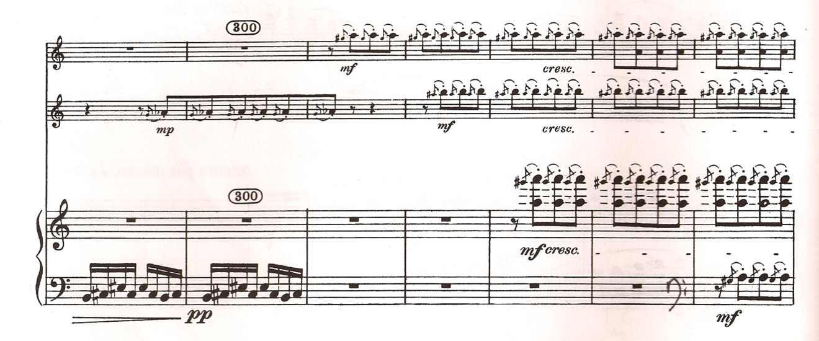

Contrasts, SZ111 by Béla Bartók
© Copyright 1942 by Hawkes & Son (London) Ltd.
Reprinted by Permission.

Figure 2.27: “Sebes,” mm. 299-305

From mm. 307 to 314, Ludewig-Verdehr insists that the rhythm be clear. “Really steady, solid eighth notes,” in mm. 307-312, she says. In m. 314, the moving notes should begin “right on the half beat.”
Ludewig-Verdehr has a flexible approach to the abrupt tempo changes in the final few measures. Bar 312 is marked with a sudden allargando that quickly reverts to Tempo I in m. 313. She feels that the sudden Tempo I in m. 313 can cause the work to end too quickly:
The main thing is you don’t want it to end a little too soon, because then people don’t know ‘Oh is that the end?’ or that didn’t work, or something. So if this is done at tempo, which is 140, I don’t think it always works.

As the reader can surmise, Ludewig-Verdehr has much to discuss in terms of how to approach Bartók’s Contrasts. Her interpretative ideas range in great detail over matters of ensemble balance and coordination, choices of tempo, dynamic markings, and the character of the writing. She frequently refers to the idea of regulating tempo changes in an organic way, something she attributes to her teacher Stanley Hasty. Ludwig-Verdehr also has much to say about how to coordinate the numerous and problematic ensemble issues to be found throughout the piece. Her approach to dynamics is demanding and exploits both the softer and more aggressive aspects of the music. At the same time she is sensitive of the need to achieve proper balance between the three instruments. Finally, Ludwig-Verdehr’s choices to depart at times from the score is evidence of her strong commitment to a convincing interpretation, one that could only come about through a deep familiarity with the work.

Chapter Three

David Shifrin

David Shifrin has been one of the most active and widely admired American

classical clarinetists since he began his professional career in the 1970s. His diverse

career includes roles as a chamber musician, soloist, recitalist, recording artist,

teacher, orchestral musician, music festival director, and sponsor of new works for

the clarinet.

Shifrin’s experience as a chamber musician is perhaps the strongest part of his musical portfolio. At the outset of his interview, Shifrin states that he has “made a career out of playing chamber music.” He has performed in collaboration with such distinguished ensembles and artists as the Guarneri, Tokyo, and Emerson String Quartets, pianists Emanuel Ax and André Watts, and trumpeter Wynton Marsalis. Shifrin has maintained a long association with the Chamber Music Society of Lincoln Center, including serving as its artistic director from 1992 to 2004. He has also served as the artistic director of the Chamber Music Northwest festival in Portland, Oregon since 1981, and has performed regularly at other music festivals, including those of Santa Fe, Seattle, and the OK Mozart Festival. In September 2008, he was appointed the artistic director of the Chamber Music Society of Yale University and Yale University’s annual concert series at Carnegie Hall. Shifrin has also recently formed a chamber ensemble with violinist/violist Ani Kavafian and pianist Andre-Michel Schub. Known as the KSS Trio, the ensemble has performed widely throughout North America.
In addition to his very active chamber music schedule Shifrin has performed
widely as a clarinet soloist and recitalist. His appearances include concerts with many of the best orchestras in the United States, Europe, and Asia. Shifrin has presented solo recitals in many venues, including Alice Tully Hall, Carnegie Hall, and the 92nd Street Y, the Library of Congress in Washington D.C. He has also appeared at conferences of clarinetists, such as the University of Oklahoma Clarinet Symposia.
Shifrin’s extensive discography has received much critical acclaim, including three Grammy Awards. Shifrin’s 1986 recording of the Mozart Clarinet Concerto with the Mostly Mozart Festival Orchestra was named “Record of the Year” by Stereo Review. On this recording he performed the concerto on a specially built basset clarinet, an instrument with an extended lower range for which it is believed the work was originally composed. His most recent recordings include Shifrin plays Schifrin, a collection of clarinet works by composer/conductor Lalo Schifrin, and Shifrin and Friends, a collection of chamber works by Copland, Harke, Kernis, and Zwilich, recorded by musicians of the Chamber Music Northwest festival.
Shifrin has also championed the commissioning and performance of many new compositions which feature the clarinet. These include works by such composers as John Adams, Joan Tower, Ezra Laderman, John Corigliano, Bright Sheng, Peter Schickele, John Harbison, Ellen Taaffe Zwilich, Aaron Jay Kernis, and Christopher Theofanadis.
As an orchestral musician, Shifrin has been featured as Principal Clarinet of such ensembles as the Cleveland Orchestra, the American Symphony Orchestra (under Leopold Stokowski), the Honolulu and Dallas symphonies, the Los Angeles Chamber Orchestra, and the New York Chamber Symphony.
Shifrin has also received notable accolades throughout his career. He is one of only two wind players to have been awarded the Avery Fisher Prize. At the very outset of his career Shifrin won prizes at international competitions in Munich and Geneva. Additionally, he is the recipient of a Solo Recitalists’ Fellowship from the National Endowment for the Arts, and a Distinguished Alumnus Award from the Music Academy of the West.
Shifrin has also been active as a teacher throughout his career. He has served as Instructor of Clarinet on the faculties of the University of Hawaii, Cleveland Institute of Music, University of Michigan, University of Southern California, and the Juilliard School. In 1987 he joined the faculty of the Yale University School of Music, where he is Professor in the Practice of Clarinet and Chamber Music. In 2007, Shifrin was awarded an honorary professorship at China’s Central Conservatory in Beijing.
Shifrin’s clarinet instructors include a number of highly regarded American clarinetists. While a student at the Curtis Institute his clarinet teacher was Anthony Gigliotti, the long-time principal clarinetist of the Philadelphia Orchestra. Other clarinetists with whom he has studied are Mitchell Lurie, Fred Ormand, Robert Marcellus, David Glazer, Herbert Blayman, and James Collis.
While both Ludewig-Verdehr and Shifrin share a great wealth of interpretive ideas in their interviews, there are some important differences. Rather than providing a nearly complete interpretation of the entire work, as Ludwig-Verdehr does, Shifrin’s comments are directed to sections or facets of the music which he finds to be most problematic. To the clarinetist, he consistently emphasizes the responsibility for a very strong sense of rhythm and precise intonation. On several occasions he snaps his fingers to indicate the importance of pulse or sings a musical example in order to highlight the shape of a phrase. Additionally, he offers some helpful options for the fingering of passages in the clarinet’s upper register, and he frequently refers to several important musicians who have influenced his interpretation.
Shifrin also offers suggestions for the entire ensemble. These suggestions include choices the clarinetist and his colleagues can make concerning tempi, musical style, and the specific interpretation of Bartók’s notation. He has numerous ideas for handling precise coordination between ensemble members and on how the markings in the score might reflect the compositional process of the piece. He also encourages the musicians to approach sections of the work or the entire work in consideration of the musical form Bartók has devised.
Shifrin prefaces his interview remarks by describing his approach to Contrasts as one that is “always evolving.” He relates that he began studying the work as a teenager, so that his interpretation has been the result of a nearly life-long association with the work. He first performed the work while a student at the Curtis Institute. Since that time he has continued to play the Contrasts with many different colleagues throughout his career, estimating that he has performed the work with between twelve and fifteen different pianists. He has recorded the work several times, and he continues to perform it frequently at music festivals and on tour with the KSS Trio, playing it multiple times every year.
When asked who has influenced his interpretation of the Contrasts, Shifrin names several sources: recordings he has studied, chamber music collaborators, and one chamber music teacher in particular, Arnold Steinhardt. Steinhardt was the long-time principal violinist of the renowned Guarneri String Quartet and was on the faculty at the Curtis Institute while Shifrin studied there. He coached Shifrin’s student ensemble as they prepared the work, and Shifrin states that Steinhardt “helped enormously.”
Shifrin identifies two commercially available recordings from his youth as the first influences on his conception of the Contrasts: the premiere recording of the work from 1940, with Benny Goodman on clarinet, Jozsef Szigeti playing violin, and Bartók at the piano; and a 1953 recording with Stanley Drucker (clarinet), Robert Mann (violin), and Leonid Hambro (piano). Shifrin describes the 1940 recording as “presumably definitive…more atmospheric” and that he still refers to it for ideas of tempo. The later recording he describes as “more virtuosic and cleaner.”
Shifrin singles out the 1940 recording for added commentary, describing its

“rhapsody interpretation,” and its sense of authority:

There are places…Bartok and Benny Goodman and Szigeti [perform], and you realize…that can’t get any more genuine, authoritative than that.

He also discusses differences he has noticed between the 1940 recording and the printed score. Through his own experience, Shifrin states that he feels he has an understanding of the learning process involved in playing new works, and that the differences between the original recording and score might be due to the newness of the work. Despite those differences Shifrin seems to favor important aspects of interpretation of the premiere recording, as he relates:
You have to realize that the piece was brand new…It would be interesting if they recorded it again after performing it several times. And you know, having had the experience myself of performing so many world premieres, you realize that you learn a lot from the first performance and the first recording, and you’d like to be able go back and do some things over.
And of course if you follow the score and listen…to the Bartók recording you realize that there are things on the recording that are not necessarily in the score and vice versa, and you’d like to be able to ask him what was intended and what wasn’t. But what is there [Shifrin emphasis] is the rhythmic energy…the atmosphere, and the wonderful colors that they make.

Shifrin states that the long association he has enjoyed with Contrasts has

also provided “really formative” playing opportunities with colleagues who have
close ties to the music of Bartók and Hungary. One of these is Gyorgy Sandor, a piano faculty member at the University of Michigan, who had premiered some of the Bartók piano concerti, and who had worked directly with Bartók. Shifrin has also played the work with Peter Frankl, a pianist from Hungary who is a member of the faculty at the Yale School of Music. In addition, Shifrin has performed Contrasts with his former chamber music teacher, Arnold Steinhardt; Steinhardt had at one time studied violin with Jozsef Szigeti in Europe. Shifrin states that he feels these musicians have “some degree of authenticity, authority…in Hungarian music.”
Before discussing specific ideas within each movement, Shifrin takes pains to point out interesting characteristics of the entire work. For example, he states that the roles of the different instruments are worth noting:
I think that one thing is…very clear, that Bartók made it as a rhapsody for the violin and clarinet - really as a vehicle for Szigeti and Benny Goodman - and that the piano part was much more subservient - I should say supportive - as opposed to many of his other chamber works.

Shifrin observes that the clarinet and violin present most of the melodic material, and that Bartok included cadenzas for the clarinet and violin, but not for the piano. On the other hand, Shifrin observes that the role of the instruments change for the Piheno movement. The piano role is “really more central and less accompanying,” in the middle movement. He goes on to say that the piano contributes a great deal to the overall effect of the work:
The color of the piano writing throughout the entire piece is extraordinary. In some ways it’s almost orchestral.

Shifrin also remarks on the important status of Contrasts in the context of the clarinet repertoire. He describes the work as “a central part of the repertory” of the twentieth century for clarinetists. He comments on how Contrasts appears much more commonly on concert programs since the time he began performing the work as a young clarinetist:
It’s striking to me how…even in the 1960s it seemed so avante garde and… difficult, and now as a teacher I coach it several times every year, and it’s just second-nature to students. It’s become a part of the canon and part of the language, and you realize that Bartók was a composer of the previous century.
It’s part of evolution. People can jump higher, run faster, double tongue, circular breathe.

Movement I, “Verbunkos”

Shifrin has a great deal to say about his interpretation of the “Verbunkos,” which is perhaps the weightiest of the three movements for the clarinetist. Among the many issues he discusses are his choices of clarinet and tempi, ensemble coordination, the clarinet cadenza, and fingering combinations for the upper register. In addition, he speculates on the possibility of the collaborative relationship of the Bartók, Szigeti and Goodman, and how their compositional process might have resulted in some of the markings in the score.
To the question of which clarinet he uses in the “Verbunkos” movement, Shifrin states that he has always used his Clarinet in A. He explains that he is not at all rigid about the issue, as he has heard clarinetists perform the work very effectively on the Clarinet in B-flat. Interestingly, however, Shifrin says that he does prefer the timbre of the Clarinet in A:
The one I play off of, when I perform, is the Clarinet in A version, from the earlier edition…Probably because I learned it on A, it just feels more comfortable. I’ve certainly heard a number of people play it on B-flat and it’s very, very convincing either way.
It’s an individual thing, and you know it is interesting that it is on the A. It would be very, very few people in the audience that would really notice whether you played it on A or not…But you know, I like to play it on the A. I like the color.

When asked about having any problems with upper register passages on the A Clarinet, he explains that he has become accustomed to the range the piece requires:
It doesn’t bother me that much. You just get used to it. And especially at this point since I’ve played it for so many decades one way.

He then compares the choice of clarinet in Contrasts to the option clarinetists have when they perform other repertoire, such as the prominent clarinet solos in Prokofiev’s well-known piece for orchestra, Peter and the Wolf:
Kind of like the Prokofiev Peter and the Wolf - some people play it on the B- flat, some people play it on the A. The fast passages lie better on one or the other.

The changes of tempo have become an important element in Mr. Shifrin’s evolving interpretation of the “Verbunkos” movement. Similar to Ludwig-Verdehr, he argues that they are subtle in nature, and as being most effective when they retain a sense of whole for the movement. He describes them in very interesting detail:
I really become more convinced in my thinking…that the tempo changes are pretty subtle…Most groups that I wind up coaching and playing with…I think over-exaggerate the differences in tempos.
You know, in the beginning it indicates this rather ambiguous… moderato tempo, “quarter note =100-94” [on the metronome]…At first I thought maybe you could have the freedom to do it somewhere in that range. But that almost seems like it…starts out with a certain swing to it…and then kind of steadies up where… in bar eight he indicates 94, just a little more ‘held’ as you make the crescendo to the… climax of the phrase…
…And then at the Piu Tranquillo [m. 26] and the Meno Mosso [m 30] that come subsequently, and all the a Tempos, when you rehearse and check with the metronome, you realize that those tempos are not [emphasis by Shifrin] so far apart. They’re degrees, they’re versions of…the overall tempo…the Moderato ben ritmico tempo, than really distinct “fast-slow.”
And so I think keeping in mind…an ‘arch’ for the whole movement - a feeling of tempo - helps the interpretation. So that when you realize… Tranquillo and Meno Mosso are just…a few ticks of the metronome, whatever that percentage would be, from 100 down to 80, a 12% slow down, rather than half tempo.

Shifrin also adds that the steadying of tempo at the end of m. 8 is of practical help for the clarinetist as well:
It also gives yourself a little room for what’s coming in the next few bars where there’s really so many notes in the bar, that you just make sure you’re on the slow side of that range of tempo, 94-100.

Regarding the overall style of the first movement, Shifrin calls to mind the village setting of a verbunkos scene. He also identifies the verbunkos dance as a characteristic style to be found in many of Bartók’s other works:
Yes, you hear that in a lot of other Bartók. You hear it in the orchestral music, and the ballet music, in the string quartets, certainly in the piano music. And sure you get the image of the guys marching around the town, setting up the band, and playing a gather-round…type of music.

As did Ludwig-Verdehr, he notes a bit of jazz-influenced styling as well:

And I’m sure that there’s an element…that’s influenced by Benny Goodman too. It’s not jazz, but…it swings a little bit.

Shifrin offers an intriguing view that Bartók may have relied upon a collaborative relationship with Szigeti and Goodman when he composed the cadenzas for the clarinet and violin. All three versions of the clarinet cadenza are seen in fig. 3.1. The first cadenza utilizes a range of over three octaves, nearly the full range of the instrument, builds to a climax on a sustained, altissimo high A-natural, then cascades down a snake-like, articulated chromatic passage, ending with a held note, before the movement ends five measures later. The first alternate cadenza suggests transposing the lower register passages. The second alternate cadenza suggests peaking the cadenza one octave lower than the original, and then continue playing the rest of the cadenza and the last five bars of the movement down an octave as well. Shifrin cites the cadenza that Benny Goodman played in the 1940 recording as evidence that Bartók was flexible about what the clarinetist would choose to put in the cadenza. In the recording, Goodman plays the first version, but also adds an extra flourish in the middle:
I think that Bartók was somewhat deferential to the…two soloists…If you look at the different versions of the cadenza that are still in the published versions and in the recording…it’s [the recording] kind of a hybrid…You get the impression… that Bartók wrote the piece and then he said, ‘Okay, what do you think we can do with it? And what would you like me to change? Here are some examples.’

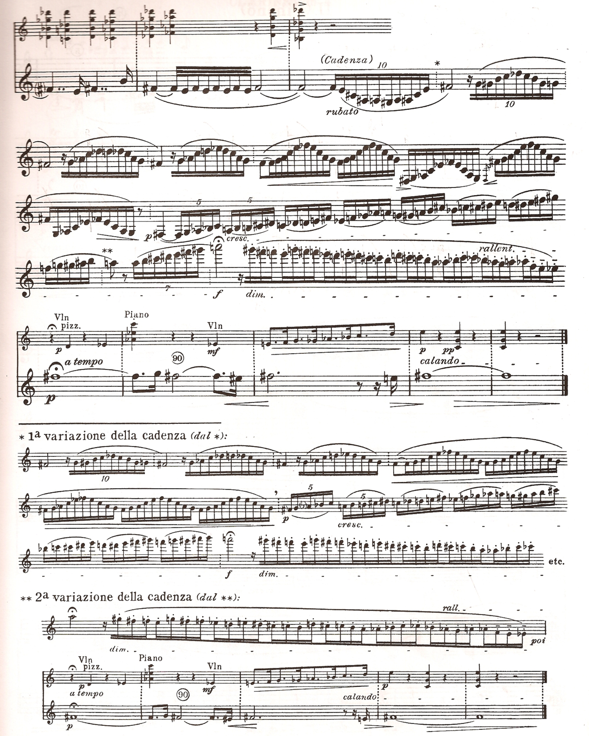

Contrasts, SZ111 by Béla Bartók
© Copyright 1942 by Hawkes & Son (London) Ltd.
Reprinted by Permission.

Figure 3.1: “Verbunkos,” cadenza for clarinet, and two alternate variations, Clarinet in A part

Shifrin has several suggestions regarding ensemble coordination in the first movement. Matching tempos and articulations between ensembles members, he says, is “of course” something to be concerned about. Another problem, which both he and Ludwig-Verdehr identify, is that of achieving the right balance between the instruments, depending upon the context of the music.
Figure 3.2 illustrates a section that is problematic in terms of balance. Here, in mm. 17-19, the violinist begins to softly play a version of the verbunkos melody, in the lowest register. The arpeggiated passages in the higher clarinet’s register and the dissonant chords in the piano could very easily overpower the violin melodic material, as Shifrin explains:
The way it’s written…it’s just an enormous challenge, I think. The violin part can get very covered if you’re not careful. The clarinetist has to be very sensitive to play very softly in some of this passagework, things where the violinist is playing the…verbunkos tune [m. 17-19]. He [Bartók] indicates quite a bit of pedal for the piano, and the danger here too is that there’s this cumulative sound that can cover the… violin. It’s not usually much of a problem to cover the clarinet.

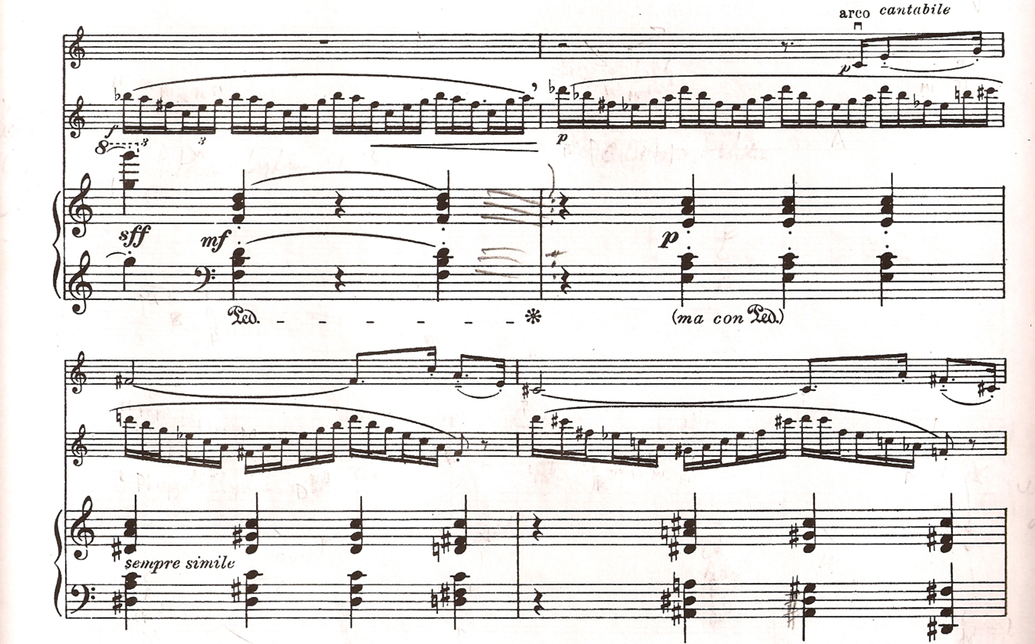

Contrasts, SZ111 by Béla Bartók
© Copyright 1942 by Hawkes & Son (London) Ltd.
Reprinted by Permission.

Figure 3.2: “Verbunkos,” mm. 17-20, Clarinet in A part

Shifrin identifies m. 80 in the first movement, shown in fig. 3.3, as another place that frequently causes coordination problems in an ensemble. Here, the difficulty is due to the entrance of the piano:
The piano starts on the second sixteenth note, and it always sounds like it’s a downbeat…because the melodic line changes one sixteenth note…after the strong beat. So it really, really sounds like…the beat…is a sixteenth note later than it is.

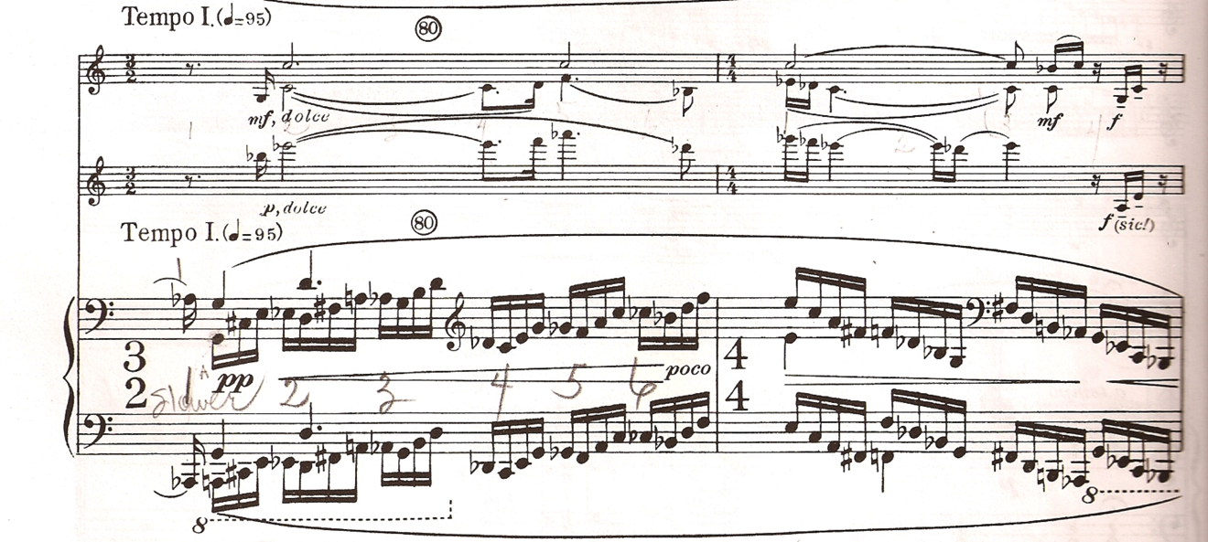

Contrasts, SZ111 by Béla Bartók
© Copyright 1942 by Hawkes & Son (London) Ltd.
Reprinted by Permission.

Figure 3.3: “Verbunkos,” mm. 80-81

As with Ludwig-Verdehr, Shifrin doesn’t always agree with the effectiveness of some of the markings in the score. For example, as shown in m. 34, where the violin plays the melody in a low register, he feels the dynamic markings to be illogical for reasons of balance. Shifrin also notes that the 2002 Corrected Edition of Contrasts did not change the markings either:
The dynamics in these parts too are sometimes an enigma. Particularly…bar 34…where the clarinet has mezzo forte and the violin has mezzo piano. The violin is in a weaker register…It doesn’t make sense for the clarinet to have a louder dynamic than the violin, to me.
Yet when they did…the new edition, that Peter Bartók oversaw, that was one of the first places I looked, and I saw that it…still had that dynamic discrepancy.

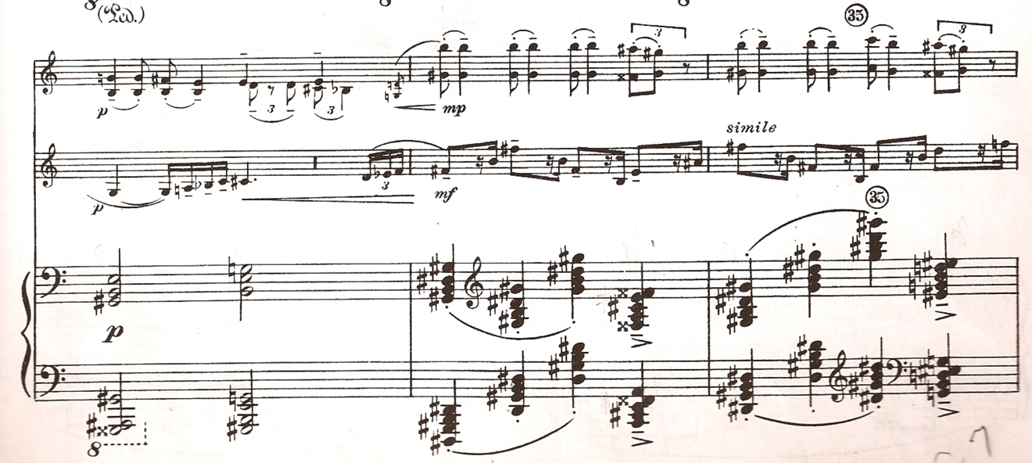

Contrasts, SZ111 by Béla Bartók
© Copyright 1942 by Hawkes & Son (London) Ltd.
Reprinted by Permission.

Figure 3.4: “Verbunkos,” mm. 33-35

Shifrin also speculates at length on the possible reasoning behind several other markings in the “Verbunkos” movement. He proposes the idea that some of these markings may have been added in rehearsals by Bartók, Szigeti, and Goodman in order to make Bartok’s conception of the work clearer to the musicians. For example, Shifrin focuses on the vertical line marking in the clarinet part in mm. 33 that does not appear in the other parts (see fig. 3.4):
I wonder sometimes if a lot of these…may have been put in just during rehearsals as corrective, and…as Bartók’s conception of the work…For instance… the breath mark in the clarinet part but not in the violin part
[m 33], you know, maybe [Shifrin’s emphasis] in the rehearsal, he felt…that Benny Goodman was holding over longer…than Szigeti.
…There are a number of places like that where it’s only in one instrument and not in the other, so you wouldn’t think that it…changes the time for the entire ensemble, but just is an instructive of phrasing and articulation for one of the instruments.

The same marking appears in m. 45, after the quarter note on the downbeat.
Shifrin argues that the reason for this marking is to allow enough time for the articulation of the grace note in the clarinet before the second beat. In m. 53 he speculates that the reason for the second marking in the clarinet part might be a practical need to coordinate with the technical difficulty of the violinist’s part:
Here again, before the fortissimo in bar 53, maybe it’s [the marking] just to clear out the sound so that the violin has the chance to get up there. And of course if you’ve played it a lot you always have to realize the violin has to play double stops on all these notes going up there to fortissimo and change…on two different strings. So the violinist needs some time to get up there. So that might just be the recognition of having that experience in rehearsal.

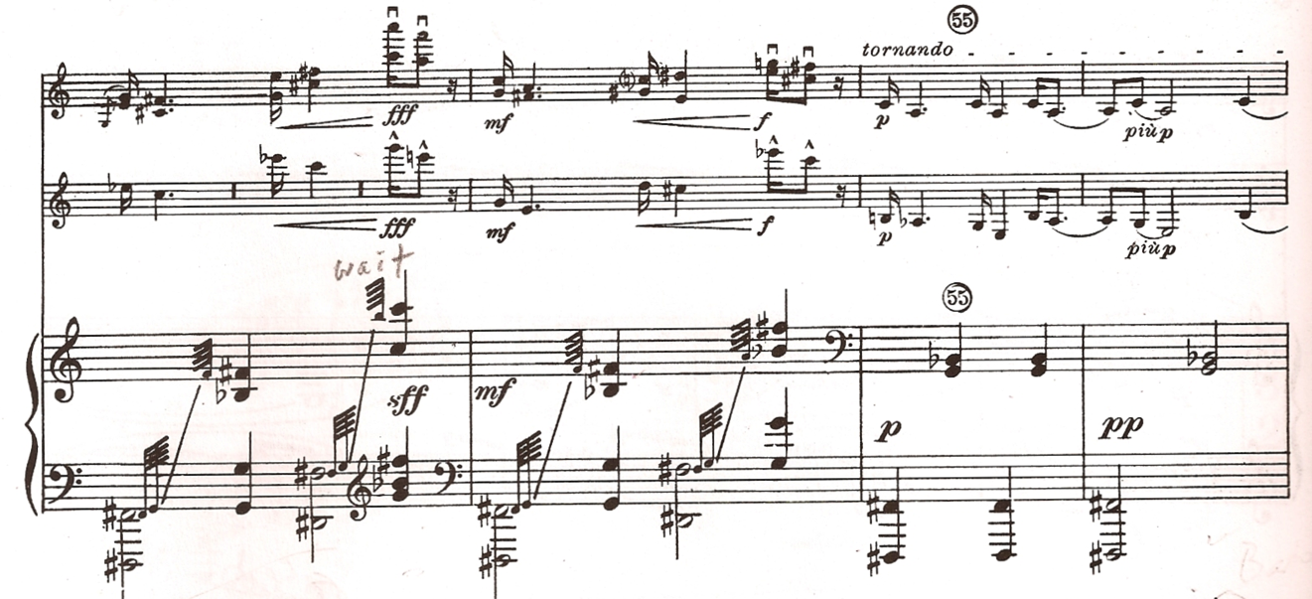
Contrasts, SZ111 by Béla Bartók
© Copyright 1942 by Hawkes & Son (London) Ltd.
Reprinted by Permission.

Figure 3.5: “Verbunkos,” mm. 53-55

Interestingly, Shifrin describes the transition between mm. 54 and 55 as a moment when he feels adding a similar phrase marking in all of the parts could be helpful. While the piano continues to play heavy chords on every beat, the violin and clarinet have swelled to a heavily accented forte chord, with double stops in the violin, and then suddenly drop to a piano dynamic in m 55, as Shifrin says:
There’s so much sound happening, and to make a subito piano you need a little time, especially in a hall with much reverberation.

Shifrin points out that the arrangement of the pages in the violin part can cause problems in m. 57. He states that the clarinetist must wait until the violinist is ready to continue into the following Tranquillo section, even if that means the tornando is more drastic than it should be. He does imply that the problem is minor and can be overcome:
The violin has a page turn there, and the clarinetist always has to wait…You end up making a much bigger ritard[ando], so that you make sure the violin page turn is done before you play. You have to make sure.
Try not to compromise the actual transition too much. But you hear it done that way a lot. I think it’s just because of the pagination. And those things are fixable.

The “Verbunkos” movement has several passages that prominently feature the altissimo range of the clarinet. When asked about choices of fingering in this register, Shifrin has quite a few suggestions. He offers ideas for fingerings that have worked for himself, but stresses the importance of individual experimentation. The goal, he says, is for the clarinetist to find fingering combinations that are both in tune and dependable. The best choices will vary, depending upon on the dynamic level as well as other factors such as mouthpiece, reed, and instrument. Fig. 3.6 shows some of Shifrin’s suggestions for the altissimo clarinet notes of mm. 49-51 and 80-81 when performed on a Clarinet in A.
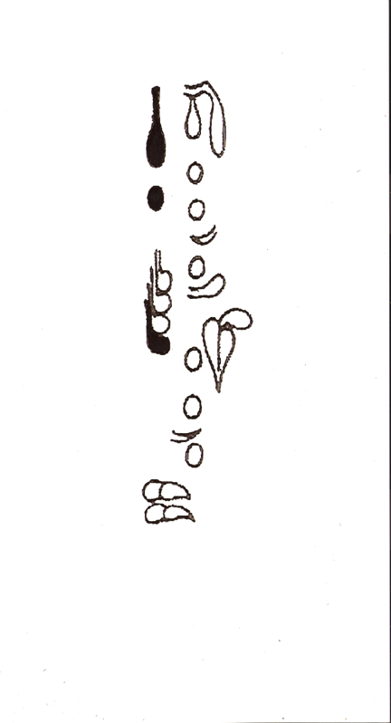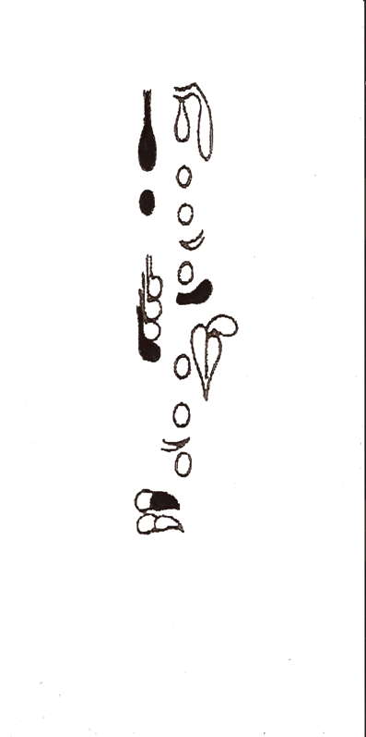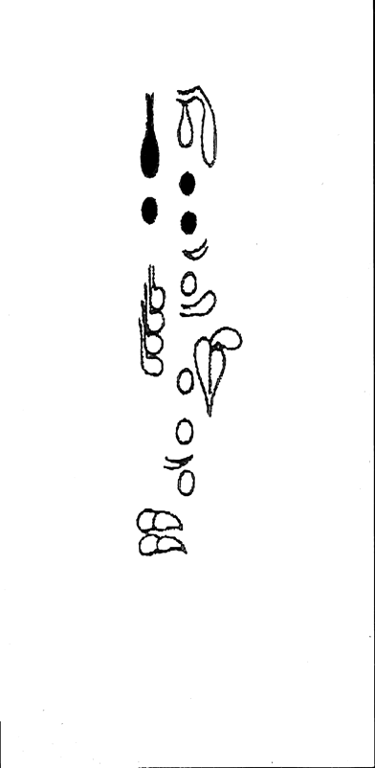
A-flat A-flat: soft dynamic G-flat: overblown B-flat
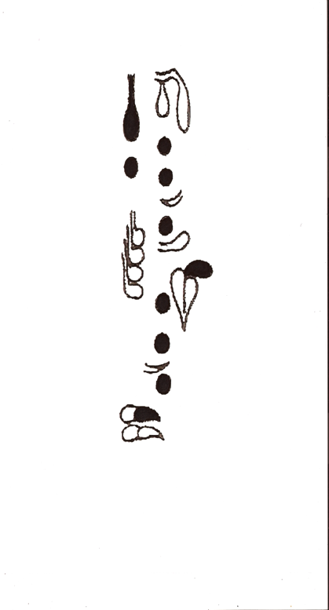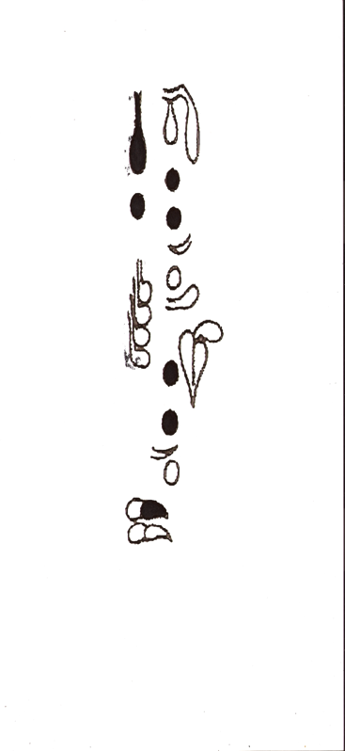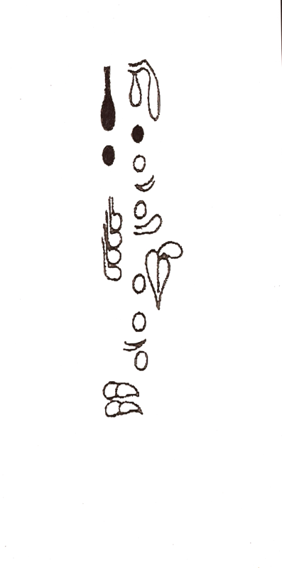
B-flat C-flat G: overblown B

Figure 3.6: Fingerings for altissimo clarinet notes in “Verbunkos,” mm. 49-51, 80-81, Clarinet in A part

The dramatic clarinet cadenza is featured after m. 87, near the very end of the “Verbunkos” movement. As with Ludwig-Verdehr, Shifrin shares his thoughtful interpretation, describing how he coordinates the musical elements of tempo, rhythm, phrasing, and dynamics to get the effects he desires. Again, he also offers a few fingering suggestions.
The first point Shifrin makes regarding the cadenza is that the cadenza begins in m. 85, which is three bars before ‘cadenza’ is actually printed in the music (see fig. 3.9). Marked Tempo I, quarter note = 95, the violin and clarinet quietly recapitulate the musical material from the opening of the movement, this time with the clarinet in its chalumeau register. He states that the Tempo I in mm. 85- 87 should reflect the opening of the movement:
You want to re-capture the tempo of the beginning, and make it clear to any listener that the cadenza starts with a reiteration of the opening melody. Because you hear it played out of tempo sometimes, and I don’t think it’s so convincing…It is a reconstruction of the beginning.
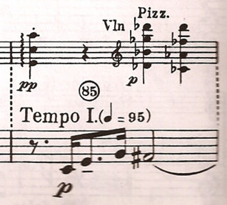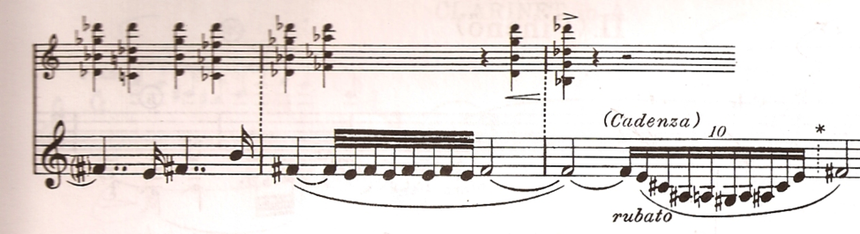
Contrasts, SZ111 by Béla Bartók
© Copyright 1942 by Hawkes & Son (London) Ltd.
Reprinted by Permission.

Figure 3.7: “Verbunkos,” mm. 85-88 into cadenza for clarinet, Clarinet in A part

Shifrin notes that he tries to pace his phrasing, in order to not do too much right away. “The…rubato should not be too drawn-out, because you have a long way to go,” he says. He follows with a detailed and practical discussion of his approach to the rest of the cadenza:
It starts to…elaborate on the melodic material of the opening. I like to still keep some of the energy and then…begin to relax a little more and sound a little more searching… After you actually have series of longer notes that get progressively shorter: a half note, a quarter, then an eighth note with a tie, it starts to agitate. And I use that to accelerate.
And then as you get this diminuendo, maybe take a little more time, start slower again, to build the big run with these quintuplets up to the top. And then just try to follow instructions: forte, diminuendo. The thing to remember is that you come off the long note really big and then when it says diminuendo…it’s a long diminuendo, so…you start with a lot of sound. (see fig. 3.9)

At the end of the cadenza, Shifrin describes an ensemble coordination problem which Ludwig-Verdehr also discusses. The clarinet ends the cadenza in m. 89 holding an F-sharp. The violin and piano then begin playing a tempo on beat two of the measure, but “often that’s a big hole and then it’s played under tempo,” he says (see fig 3.9). Shifrin also adds that he has always used the longest of the three printed versions of the cadenza, and assumes the other two are included to make the cadenza a “little easier.”
Regarding fingerings for the altissimo register that he uses in the cadenza, Shifrin suggests using “overblown” fingerings for the G, G-Sharp, and the A. The A can be “just terribly sharp,” he says. To correct for this, Shifrin suggests keeping the oral cavity open, and voicing the note down.

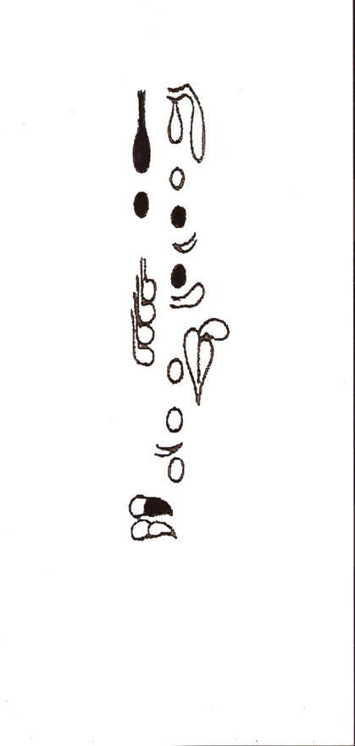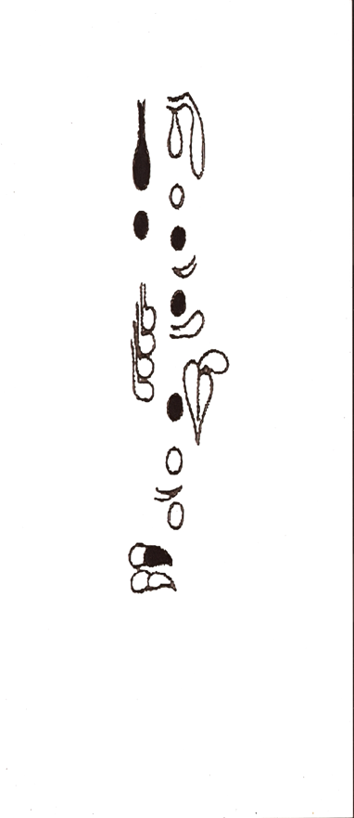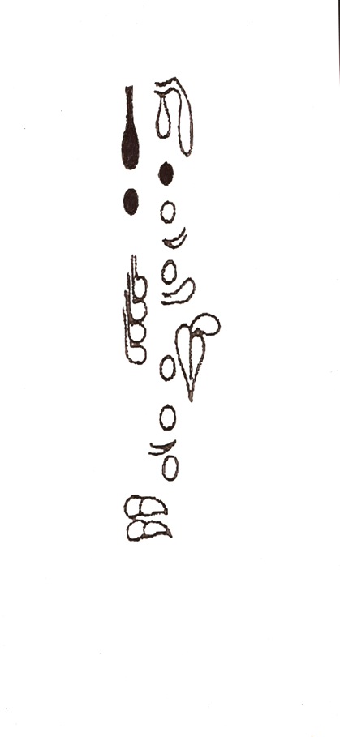
A: overblown E G#: overblown D G: overblown B

Figure 3.8: Fingerings for altissimo notes, “Verbunkos,” clarinet cadenza, Clarinet in A part

Movement II, “Piheno”

Shifrin’s comments concerning the middle movement of Contrasts focus on how much its character differs from that of the two outer movements. He emphasizes the very important role of the piano and Bartók’s evocative use of his signature “nightmusic” texture. He also discusses the contrast between the moods within the movement, the challenge of maintaining the slow tempo, and notes a three-part formal plan to the movement. Shifrin confirms that original title of the work was Rhapsody, and that the Contrasts title derives from its evolution to a three-movement work:
The…anecdote is that…Bartok felt that there needed to be a relaxation between the contention of the two more animated movements. So it’s really a contrast [emphasis Shifrin]. And that’s when the title came in of Contrasts from Rhapsody, which is a two-movement form that he used for…the Rhapsodies for violin and piano.

Shifrin describes the character of the “Piheno” as that of a favorite musical
style of Bartók’s which is evocative of mysterious night sounds:
You know, it’s a typical example of this wonderful ‘nightmusic’ that Bartók is associated with…that…sets an atmosphere, that has all these punctuations …and it’s seemingly still on the surface. But there’s so much going on underneath, that sometimes erupts [emphasis by Shifrin].

When asked about the possibility of irony in the title – which translates as “Relaxation” – in such a mysterious-sounding movement, Shifrin suggests that such a sound could have in fact been “how Bartók felt when he relaxed.”
As Shifrin noted earlier, a key ingredient in the musical character of the second movement is the increased role for the piano. In this point-of-view, he concurs with Ludewig-Verdehr. As an example he refers to m. 19, where the piano accompaniment to the violin and clarinet is very active:
There are places here where certainly the piano drives everything with these duple rhythms and then the clarinet and the violin have these trading off… long lines, quiet…and the piano is the girding…motor underneath, with first the duples and then the triplets. (see fig. 3.9)

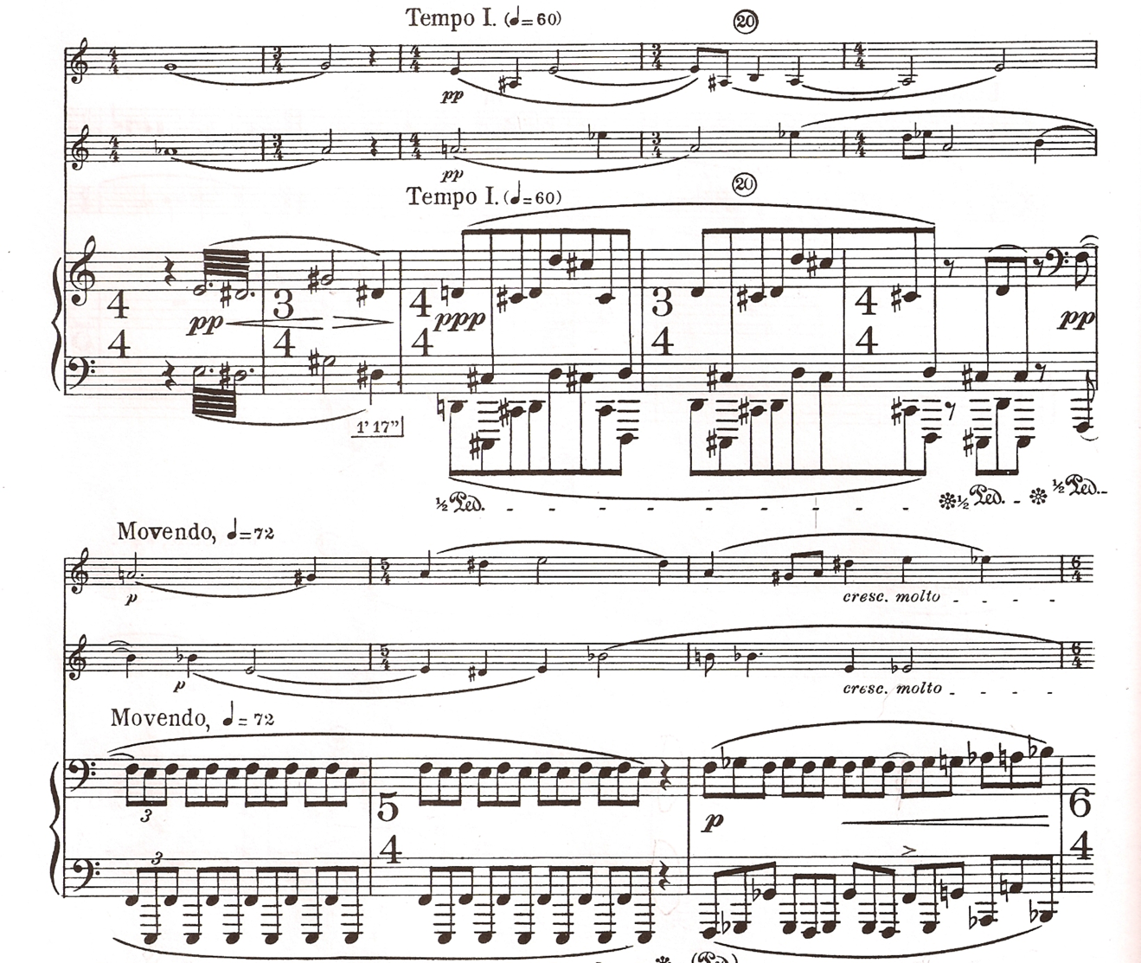

Contrasts, SZ111 by Béla Bartók
© Copyright 1942 by Hawkes & Son (London) Ltd.
Reprinted by Permission.

Figure 3.9: “Piheno,” mm. 17-24

Shifrin describes another important moment for the piano in the “Piheno” movement, where it presents melodic material in mm 30-32, shown in fig. 3.12:
The piano has these wonderful…evocative, Eastern-sounding [melodies] [sings m. 30] where it really features…the piano melodically, and the violin and the clarinet are playing the chords underneath.

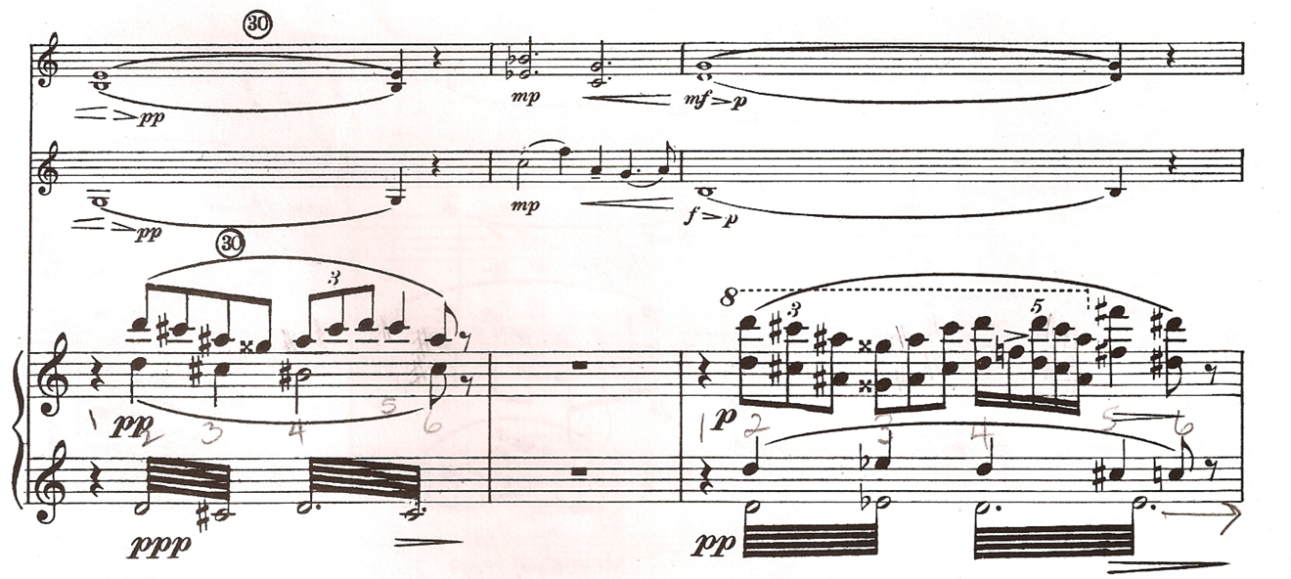

Contrasts, SZ111 by Béla Bartók
© Copyright 1942 by Hawkes & Son (London) Ltd.
Reprinted by Permission.

Figure 3.10: “Piheno,” mm. 30-32

Shifrin remarks that challenges of tempo exist in the “Piheno” much like those in the first movement. The tasks of maintaining the slow tempos and manipulating the subtle tempo changes can be tricky, he says.
It takes a lot of discipline, I have found, in preparing this and performing it so many times and coaching it, to really keep the slow tempos when they’re slow. It says 60 to 63 [on the metronome]: one second to the beat…just really having that suspended sense of time. And then really feel the increase in a subtle way, the movendo [m. 11], similar to the first movement subtle tempos.

In his last comment on the “Piheno,” Shifrin discerns an overall three-part form to the movement in the form of a relaxation-tension-relaxation cycle:
There’s a very clear progression to the climactic moments …in the middle…And then it starts to relax again, and it relaxes again to the end of the movement.

Movement III, “Sebes”

Shifrin’s comments concerning the “Sebes” movement revolve around a number of topics. He discusses issues surrounding Bartók’s use of the second violin in scordatura tuning, as well as his use of two instruments, as indicated in the score. Shifrin explains some of the most vexing problems one can expect regarding coordination between the musicians, which he says are a challenge to even the best-rehearsed ensembles. Once again, as in the first two movements, issues of tempo are important in his comments. These include the need to maintain the overall fast tempo of the movement, as well adjusting to the frequent tempo changes.
Shifrin first addresses the issue of whether the violinist should use the scordatura violin as Bartók prescribes, or simply finger the opening chords without changing instruments. Although he says it’s a simple matter for the violinist to use different fingerings to get the scordatura effect, Shifrin feels that the sound is more authentic when the violinist uses a second violin. He discusses how some violinists manage the change, and also playfully theorizes on Bartók’s motivation for using the extra instrument:
You know, the story that I like to tell, which is just my own fabrication…This is not [Shifrin emphasis] authentic, but you know how clarinetists always change clarinets in the orchestra - the clarinet has an A part and a B-flat part. If you play off the first version [of Contrasts] you know you’re always changing clarinets. So my take on this is that Szigeti didn’t want to feel left out, so Bartók wrote him a part…for changing violins. And it’s great theater too. The audience hears the sound – the startling sound.

Shifrin relates a humorous anecdote about a violinist colleague with a sense
of absolute pitch who found his own unique way to bring off the scordatura section without actually using a mistuned instrument:

I remember Sidney Harth. Sidney Harth was concertmaster of the Chicago Symphony with Reiner, and many others, a well-known conductor. He’s still conducting.
When he was at Yale and on the faculty…we played it together on a faculty concert, and he talked about how he just hated things scordatura, but he has perfect pitch…Just so people would get the visual effect, he would have another violin…(Sidney probably wouldn’t want this in print). He would have it tuned normally and finger it [differently], but he would still do the theatrical thing of changing violins.
There are orchestral things that are like that too. Mahler Fourth is probably most notable in the scordatura violin solo, but if you have perfect pitch, I guess it’s really disconcerting to do that.
And I’ve played it with so many violinists. I’m sure I’ve played it with a lot of violinists with perfect pitch. Ani Kavafian, for instance has perfect pitch, but she’s able to tune the violin this way and do it just fine.

Like the Verdehr Trio, the KSS Trio will borrow a second violin for this section of the piece:
We’ve played the Bartók in so many cities, with Ani Kavafian, Andre Schub and me, and there’s always the arrangement made that somebody shows up to each concert hall an hour beforehand with another violin for that. And we get to meet a lot of people and a lot of instruments that way. And she [Kavafian] always say’s, ‘Don’t bring me your Strad[ivarius]. Find the cheapest, crassest violin you possibly can and that would be fine.’ It gets that rustic quality of sound, the tritones, etc.

Shifrin addresses the problem of changing clarinets in the “Sebes”, which the author feels is one of the more awkward problems in the movement. The clarinetist is directed in the score to begin playing on the Clarinet in B-flat, to swiftly change from the Clarinet in B-flat to the Clarinet in A in mm. 132-133, and then change back to the B-flat instrument at m. 169 for the remainder of the movement. Shifrin describes an ingenious solution to this. He makes the recommended change from the Clarinet B-flat to the Clarinet in A for the section beginning in m. 132. However, Shifrin continues to play on his Clarinet in A when m. 169 arrives, transposing the clarinet part. He finally switches to the B-flat instrument during the lengthy violin cadenza, after m. 211:
I stay on the A clarinet until the violin cadenza, just to not make an abrupt clarinet change. I transpose that and then have the entire thirty-five bars rest to get back to the B-flat during the violin cadenza. That [m. 169 -211] lies just as well on the A clarinet as on the B-flat…So that’s the only deviation from the indication of clarinet that I use, which is in neither of the versions, but I found it expedient.

Shifrin describes the effort required to stay close to the given tempos in the “Sebes” as “very tricky,” similar to the challenges in the “Verbunkos” and “Piheno” movements. For an example, he cites mm. 226-238, shown in fig. 3.11, where the players are requested to negotiate four tempo changes in rapid succession, namely quasi a tempo (tranquillo), poco rallentando, meno mosso, molto tranquillo, accelerando to the Tempo I in m. 238. To make the tempos changes noticeable, Shifrin says, “you almost have to go beyond the tempos that he marks.”
On the other hand, he says too much exaggeration can become a problem. The music can be “stretched beyond recognition.” The musicians should be aware that the tempos changes are “progressive,” he states:
I think it’s fine to go a little bit under [tempo], but the discipline is to not make too much of a ritard[ando] on each of these, so that you’re still 1, 2, 3 distinct steps, before the accelerando back to Tempo I. And making sure that you still have room for the Piu mosso [m. 248] and the ancora piu mosso [m. 287] at the end, which is pretty darn fast.

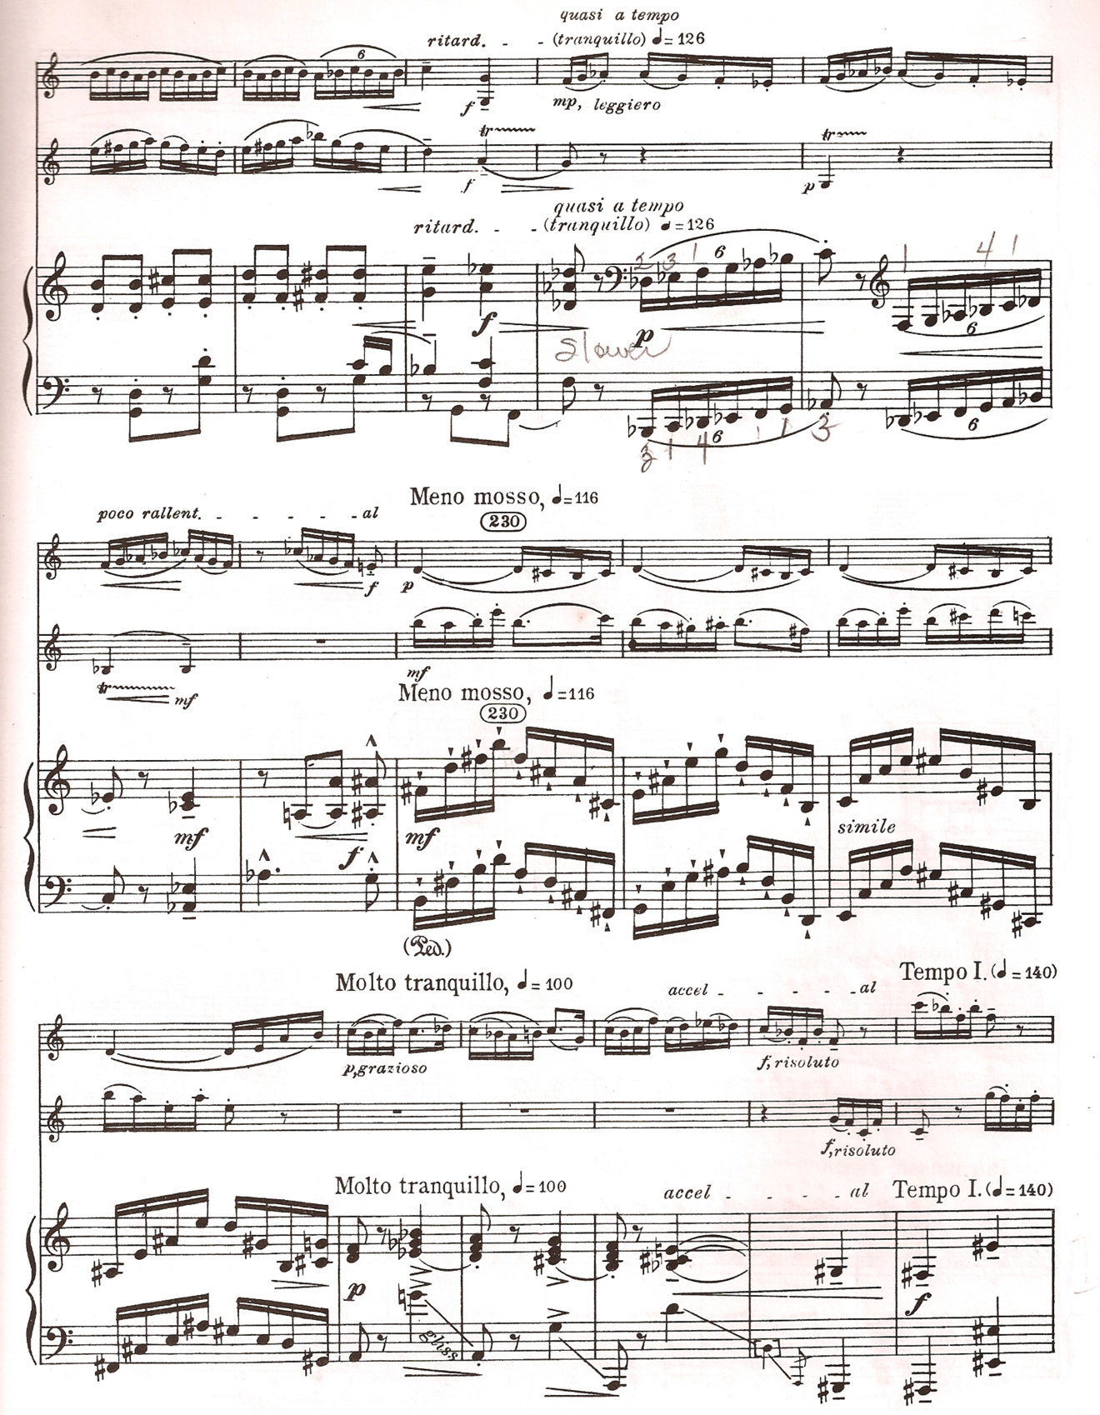

Contrasts, SZ111 by Béla Bartók
© Copyright 1942 by Hawkes & Son (London) Ltd.
Reprinted by Permission.

Fig 3.11: “Sebes,” mm. 223-238

In addressing issues of ensemble balance and coordination for the third
movement, Shifrin has several specific comments. For example, in the quick tempo
shift to allargando in m. 265, followed by a return to a tempo in the very next measure (see fig. 3.14), he observes that the musicians must listen to the leading voices and think in a common pulse:
I think, not doing too much, not overpowering the violin, and then the triplet in the piano is really the defining rhythm. The clarinet and the violin have to link up, but if everybody is feeling the big beat together it should work out fine.

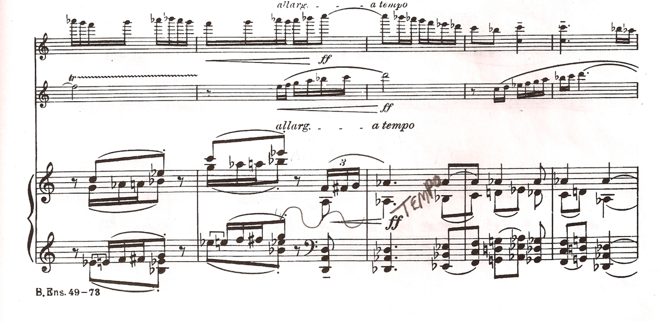
Contrasts, SZ111 by Béla Bartók
© Copyright 1942 by Hawkes & Son (London) Ltd.
Reprinted by Permission.

Figure 3.12: “Sebes,” mm. 264-268

Another potential trouble spot Shifrin identifies is the coordination of the three instruments when the violin finishes its cadenza before m. 214 (see fig. 2.26). The breath marking at the beginning of m. 214 indicates a pause. Shifrin points out that this marking is another instance of the score showing a phrase marking in the only two of the three parts, as the mark is not shown in the piano part. The piano entrance is the key to coordinating the allargando molto, he says.
Shifrin describes several sections in the “Sebes” that are challenging for any ensemble to manage, no matter how familiar one is with the piece. The first of these, shown in fig. 3.15, begins in mm. 241 and moves into the Piu Mosso in m. 248. The violin and clarinet begin playing interlocking figures of eighth and sixteenth notes, and are then joined by the piano. The difficulty is compounded by the tempo change. Shifrin adds that he prefers to abruptly jump to the new tempo, although one could chose to accelerate if they wanted:
The question of whether to play an accelerando to the new tempo, or keeping it absolutely steady and then kick it in to a new gear [sings 241], I don’t like to accelerate but that’s one way…to do it.

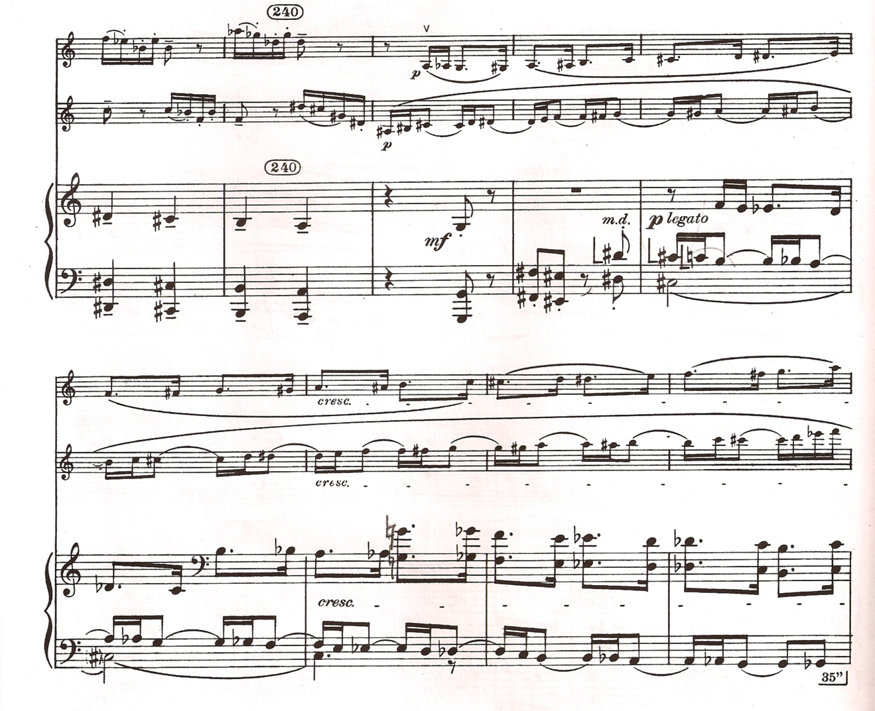
Contrasts, SZ111 by Béla Bartók
© Copyright 1942 by Hawkes & Son (London) Ltd.
Reprinted by Permission.

Figure 3.13: “Sebes,” mm. 239-247

As Ludwig-Verdehr also pointed out, Shifrin describes the very challenging ensemble problem which occurs between mm. 270 and 286. Here a succession of sixteenth-note runs begin in the piano, followed by the clarinet and violin. The texture quickly becomes very dense and contrapuntal between the three instruments. Shifrin describes the complexity of the writing as “really tricky,” and progressing to the point where the players can be unsure whether they are actually playing together until the music suddenly halts at the end of m. 286:
That place, you’re never really sure you’re together until you get to the last three notes. And then you’re always thankful if it’s not 100% together that there’s a break there and the violin is alone. I don’t recall that the original recording is 100% together on that spot, but you get the effect.
Performing it on tour, we [the KSS Trio] play it night after night, and those nights when it’s absolutely together, well – have a big smile.

Another problem area which Shifrin describes in detail is mm. 132-168, in the middle section of the last movement. For this lyrical portion of the movement, a favorite of the author, Bartók shifts to an asymmetrical meter of thirteen eighth notes per measure, before returning to the animated duple meter Tempo I in m. 168. Interestingly, the meter signature in the 1942 edition is organized in groups of eight and five eighth notes, while the 2002 edition organizes the eighth note pulse in alternating groups of three and two eighth notes.
Shifrin describes in detail how he would recommend practicing this section using a metronome. He suggests setting a metronome to establish an eighth-note pulse at 330 beats per minute, while sensing the “big beats” in groups of three and two eighth notes:
Bartók was so explicit on all these different tempi: 330 to the eighth note, which is pretty darn fast; or 25 to the whole bar, which is unbelievably slow.
So the way I would practice this, especially with the kind of metronomes we have now, is to take the 110 to the dotted quarter note and put the subdivision on, so you get that 330 and then feel the big beats, which is just alternating long and short [taps dotted quarter note, quarter note, dotted quarter, etc., while singing the subdivided eighth note] and it starts all over again.

Shifrin adds that the feeling of eight-and-five pulse groupings is a type of dance rhythm that works to group the small beats together. He says that if one internalizes the music this way, we can avoid the need to count every eighth-note pulse:
That’s the eight-plus-five [taps big beats, sings subdivided eighth notes], which is a dance rhythm. You almost see…the step, step, step, step, step, [in alternating groups of three and two pulses] and you start feeling it that way, instead of just 1,2,3,4,5,6,7,8,9,10, 11,12, counting, counting, counting, counting.

Shifrin’s adds further comments for mm. 165-168 of this middle section. Here the piano begins playing the “big beats” at separate times than the violin and clarinet, who play as a unit (see fig. 3.16). If all goes well, notes can be heard changing on each beat of every measure. The middle section then closes with a ritardando as the piano sounds the last eighth note pulse at the end of m. 168:
The violin and the clarinet lock in exactly the same rhythm, while the piano plays alternate eighth notes. So…you get every beat. But you have to know who you’re supposed to be with. That’s another place that no matter how much you rehearse, you really have to pay attention.

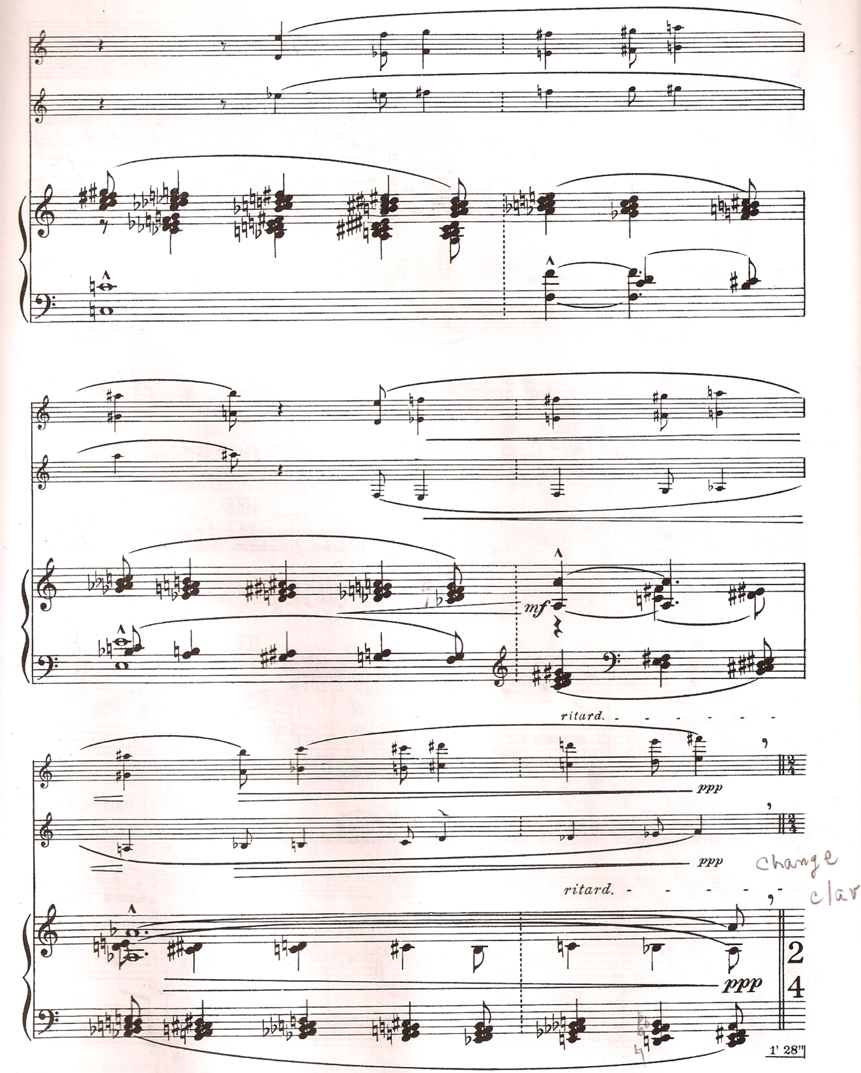

Contrasts, SZ111 by Béla Bartók
© Copyright 1942 by Hawkes & Son (London) Ltd.
Reprinted by Permission.

Figure 3.14: “Sebes,” mm. 166-168

Shifrin briefly remarks on two other common problems with this middle section of the “Sebes” movement. He says that the groups of five pulses will often sound more like six eighth notes, because we are much more accustomed to playing in six-eight meter than five-eight. Also, because of the need to rehearse this section slowly he rarely hears it played at full tempo. But, he says, if a group can really make use of the big beats “it can be done.”
Shifrin sums up his description of the troublesome ensemble problems in the “Sebes” movement by commenting on both their stubbornness, as well as the pleasure of performing Contrasts repeatedly as part of the KSS Trio:
I have to say it is nice to play it many, many times with the same people…it becomes a real repertory piece and, and you have a little more of an idea of what to expect. But the difficult places are still difficult.

Shifrin’s last specific observation concerning the “Sebes” movement refers to a problem of tempo. He states that he often hears the movement played below the given tempo markings. As he indicated for the first movement, Shifrin suggests that the reason for this could be the difficulty people have managing the page turns. He says that he has “worn out the little dog ears” in his clarinet part, and that a cut and paste method could work as well.
Shifrin offers a few general recommendations regarding how the clarinetist might practice the numerous challenging passages in Contrasts. He again stresses the use of a metronome, which he says is “terribly” important. A metronome that subdivides can help even more, as he noted for the middle section of the “Sebes”. Shifrin also advocates practicing passages in different patterns and rhythms to work out the “evenness.” Shifrin emphasizes the idea of problem-solving in learning and performing the work. “There are solutions to these problems,” he says.
Shifrin’s final comments address the question of the unusual title of the work. He observes several lines of reasoning behind the term Bartók chose:
There are lots of takes on what that means. Whether there’s contrasts in the music, there are dynamic contrasts, or contrasts between the fast and the slow, the lively and the serene, but certainly contrasts between the two instruments [clarinet and violin].

In summary, Shifrin’s interview comments reveal both a detailed and nuanced interpretation of Contrasts. He addressed clarinet-centric issues of fingering choices, choice of clarinet, and the approach to the clarinet cadenza in a detailed, yet matter-of-fact way. Shifrin also emphasized the larger musical concepts of authenticity of interpretation, choices of tempo and dynamics, musical effects, ensemble coordination, instrumental color, and the roles of the instruments. It is both interesting and gratifying to hear such an accomplished performer frankly discuss the difficulties of a work which has such an exalted place in the clarinet repertoire.

Chapter Four

Jozsef Balogh

Clarinetist Jozsef Balogh has led a musical career that is marked by the high level of artistry he has attained in a great diversity of musical settings. In addition to establishing a career as a performing clarinet artist in the traditional media of Western music - orchestral clarinetist, chamber music performer, concert band clarinetist, soloist, and recitalist - Balogh has forged a second career through his wide experience in other musical traditions. These include the folk music of his native Hungary, and of Klezmer, Gypsy, and American Jazz traditions. He is an experienced performer and recording artist in the use of both German-system and French-system clarinets, as well as being fluent on both the modern tarogato and alto saxophone. Balogh has also been active as a founder of music ensembles, and as a teacher, composer, arranger, and conductor. It is difficult to imagine many other clarinetists who have undertaken such a wide variety of professional musical roles.

Balogh began his professional playing career with an appointment as Solo
Clarinet with the Hungarian State Opera Orchestra from 1976 to 1985. This was
followed by a position as Principal Clarinet of the Budapest Symphony Orchestra of the Hungarian Radio from 1985 to 1996. He has also served as Principal Clarinet of the Budapest Police Band, Concertmaster of the Budapest Symphonic Band, and Solo Clarinetist for the Bad Wörishofen Symphony in Germany.
In addition to his experience playing in orchestras and concert bands, Balogh has founded and acted as leader for several chamber music groups. These include the Clarsix Ensemble, the Ozon Woodwind Quintet (1996 to 2006), and the Ale Brider Band (1998 to 2007). Two groups Balogh founded are still active: the Judrom Gipsy Klezmer Band; and the Interclarinet Ensemble, a professional clarinet quintet whose other members hold positions in the Vienna Philharmonic Orchestra, Berlin Philharmonic Orchestra, Vienna Radio Symphony Orchestra, and the Augsburg College of Music.
Balogh has been featured as a recitalist and soloist in his native Hungary and
abroad. These include recitals at the Hungarian Cultural Centre in London, England; in Salzburg, Austria; and with the InterClarinet Ensemble at the Budapest Spring Festival. He has appeared as clarinet soloist with the Ferenc Liszt Chamber Orchestra at the Zemplén Art Festival, and as tarogato soloist with State Philharmonic Orchestra of Targu Mures.
Balogh has appeared as a guest recitalist, masterclass presenter, and lecturer for many schools of music in Europe and the United States. In Europe these include
appearances in Domsale, Slovenia; at the Hochschule Für Music Nürnberg-Augsburg in Germany; in London, England, the Royal College of Music and the Guildhall School of Music and Drama. In the United States, he has appeared at the University of North Texas, the University of Kansas, Idaho State University, Utah State University; the University of Oklahoma, and East Central University in Ada, Oklahoma.
Balogh is also very much in demand as a presenter before professional groupsof clarinet enthusiasts. Balogh has presented concerts at no fewer than ten of the annual congresses organized by the International Clarinet Association, both in the United States and Europe. Other events for which he has appeared include those hosted by the 1998 Israel Clarinet Festival in Tel-Aviv; the Clarinet and Saxophone Society of Great Britain in London, 2000; the 2001 SaxFest, in Colchester, England and Single Reed Festival, North Wales; the 2001 and 2004 NERV-Conventie, in Utrecht, Holland; the 2007 Oklahoma Clarinet Symposium; and the 2008 Festival of the Japan Clarinet Society.
Balogh has made numerous recordings. These include discs featuring Gypsy and Yiddish music as well as much of the best chamber music for clarinet by Beethoven, Mozart and Brahms. His solo recording, Contrasts, on the Fontrade label, includes many of the important works for clarinet by Hungarian composers, including those by Bartók, Weiner, and Kokai. Two recordings released by the InterClarinet ensemble feature original works by Balogh.
Balogh has been a leader in pedagogy for the clarinet, both in his native country and abroad. From 1988 to 1992 he was Professor of Clarinet at the Franz Liszt Academy of Music in Budapest. Mr. Balogh was also Clarinet Professor and Director of the Europe Music School in Budapest from 2003-2008. He has been a faculty member for the Béla Bartók Conservatoire, also in Budapest, and for the Academy of Drama and Film in London. Balogh was Artistic Director for the International Clarinet Camp of the Hungarian Clarinet Society for fifteen years, beginning in 1994. In the United States, Balogh was three times a Visiting Clarinet Professor at the University of Oklahoma in Norman: in 1998, 2007, and 2010-2011.
Balogh has served as the Hungarian National Chairperson for the International Clarinet Association from 1989 to the present. He was a founder of the Hungarian Clarinet Society in 1994 and has acted as President since that time. In 1997, Balogh was a founder EuroCass, the European Clarinet and Saxophone Society. In 2002 he originated the Healing Sounds Beethoven Project, which uses the clarinet to teach music to the hearing impaired.
Balogh has also been active as a professional composer and conductor. In
addition to writing for his InterClarinet Ensemble, he has composed music for
productions of two children’s plays at the Theatre Kolibri in Budapest: Max und Moric and Cinderella in Venice. He also composed Hagada Klezmer Symphony, Four Glasses of Wine, which was premiered by the Ale Brider Band in 2004, and numerous pieces for clarinet and clarinet ensemble. In 2001-2002, Balogh served as conductor of the Connelli Circus in Zürich, Switzerland.
Before he began playing the clarinet, Balogh’s first instrument was the accordion, which he played as a young man in wedding bands organized by his musical family. For his formal musical studies, he attended the Franz Liszt Academy of Music in Budapest, studying clarinet with Béla Kovács. He was graduated from the Liszt Academy and went on to earn a Master’s Degree from there in 1979. In 1989, Balogh was selected by Sir George Solti to receive a grant for study abroad. Maestro Solti was then Music Director of the Chicago Symphony, and the award by the Georg Solti Foundation enabled Balogh to travel to the United States and study with the revered American clarinetist, Larry Combs, Principal Clarinet of the Chicago Symphony.
In addition to this study grant, Balogh has earned several other noteworthy
musical honors. In 1974 he won Second Prize at the Concertino International
Competition in Prague, Czechoslovakia. In 1988 Balogh earned first prizes in the
Hungarian Radio National Competition for Woodwind Instruments and the Graz
International Competition, playing with the Danubius String Quartet. In that same year he was the recipient of the Bartók-Pasztory Prize, an annual award in honor of Béla Bartók and his second wife, Ditta Pasztory.
As is the case with Ludewig-Verdehr and Shifrin, Balogh’s interview covers a wide range of issues related to Bartók’s Contrasts, and he often demonstrates passages by singing or whistling to illustrate his comments. However, rather than go into great detail concerning musical ideas specific to sections or musical passages, Balogh prefers to discuss the work primarily in terms of Hungarian and Gypsy musical practices, the social context of verbunkos music, and the legacy of Bartók’s life and music. As a clarinetist with an international career in a variety of musical styles, Balogh speaks at length about issues such as choosing an instrument to record and play Contrasts: a German- or French- system instrument and the Clarinet in B-flat or Clarinet in A. He also speaks freely about other interesting topics, such as the roles of Benny Goodman and Jozsef Szigeti in the genesis of the work, his own personal philosophy about teaching and learning music, and the challenge of presenting modern music to the public. Perhaps the most salient characteristics of his interview are his gregarious nature and the degree to which his Hungarian roots inform his commentary.
Balogh has much to say about the complex historical role of Gypsy musicians in the music of different cultures. He begins by stating that Gypsy culture has historically filled three important roles in the culture of Hungary and elsewhere - blacksmith, horse-breeder, and musician:
Well, the Gypsies were three very important job. The first is the blacksmith …Another is the horse - the horse-maker [horse-breeder]. When in the war, need the horse, and you can sell it…And third is the music business.

Gypsy musicians were versatile in many different styles of music, he says. This was a requirement of their traditional role as musicians-for-hire. They were expected to
provide music for all types of occasions and ethnicities:
You know you go to the village 300 years ago, the Gypsies have to play every time…the Gypsies very good know it.
But sometimes 300 years ago it was very separated, every times. He know for the German. What you know? He know what he can play for the German. Go for the Jewish religion, play the Jewish melody. Play for the Hungarians, play original Hungarian melody…It is very, very important job.

Because bands of Gypsy musicians were used as the original performers of the verbunkos music, the genre sometimes is attributed to their culture. Balogh says this is a misconception. The verbunkos is a Hungarian genre, even though the musicians who performed the music were Gypsies, as he explains:

The Gypsies play the Hungarian music, sometimes is you say “is the Gypsy music”…If I play the Aaron Copland, you don’t say “is the Hungarian music,” that I am Hungarian. Is American music…When the Hungarian Gypsy is play music, and say “It is the Gypsy music” - No.
Gypsies have many, many the kind of the music. Have Yugoslavian Gypsy play the Yugoslavian music. Hungarian Gypsy play the Hungarian. Romanian Gypsy play the Romanian.

Balogh comments that evidence of the strong musical tradition within Gypsy culture can still be seen today in the careers of notable musicians of Gypsy heritage. He cites Chick Corea, Paco de Lucia, and the late Joe Zawinul as examples.
Balogh also mentions that the use of the clarinet in Hungarian folk music
originated with the practices of Gypsy culture rather than with Hungarian musical tradition. The Gypsy instrumental trio is similar in format to that of Contrasts, he says, with the cembalom taking the place of the piano.
In the original Hungarian folk music is not included with the clarinet, but the Hungarian Gypsies use the clarinet…Many times…the Gypsies play for this: cymbalom, clarinet, violin; or cello, cembalom, violin. Or now if you go to Budapest, you can listening cembalom/clarinet duets. The cembalom is sometimes the same sound with the piano - is not so big different.
Maybe this three is two leader and one cymbalist. It’s very good. Have two very famous soloists. Have clarinet player, have violin player, have the cymbalist. And I think and only that the next step, the verbunk music, and the Hungarian music.

Balogh has much to say about how Contrasts is related to the musical customs of Hungary. As mentioned by Shifrin, Bartók’s first version of the work was a two-part composition entitled Rhapsody, which omitted the middle “Piheno” movement. Balogh states that this two-movement version is closely related to a traditional two-part form of Hungarian dance music. In this scheme, the first movement is slow in tempo; the second movement is fast in tempo. The labels for the movements may change, but the slow-fast, two-part principle remains the same, he says:
But you know the first [version of] Contrasts was two parts. It was in two parts, first and the last. It is the old Hungarian dance form.
And the second [version]…he made [a] “Piheno”. “Piheno” is a “relax.” Sometimes it is “Intermezzo”, is separating the first and the second part. We [Hungarians] have …no relaxing dance. The old dance form is two, is two every time.
Yes, the old form was slowly and fast. By time the names are changed: Lassú, verbunk, czárdás - lassu its mean slowly - and the fast named friss or sebes. Only the name changed, the characters are slowly-fast.

To illustrate the idea that the Hungarian terms lassu, csardas and verbunkos evoke a common idea of tempo, Balogh explains that more than one term exists for Western music in three-quarter time. The minuet and waltz share a similar stylistic trait – that of metrical accent on every third beat. He cites well-known examples from the classical repertoire that belong to this stylistic grouping:
Is sometimes it is only one category…Verbunkos, and sometimes the csardas…The style and feeling is [the] same one.
Same with the waltz; you know the waltz. You go to the small village in German or Austria and is the dance. You have the menuet, or say another name, but every time the same family. The Johann Strauss waltz, or the Richard Strauss, Salome dance, is ¾ time. Or same with…the French composer Ravel, La Valse. It’s waltz. Or Tchaikovsky, the Nutcracker, you know. Is the same one.
Is the same in the Hungarian dance, the csardas. Or in Haydn, you know is have the Hungarian Rondo [whistles]. It’s friss dance. It’s same movement.

Balogh also discusses the verbunkos genre in terms of its social meaning. He states that the term is derived from the German word, verbung, which means “recruiting” or “advertisement.” Austrian army officers would recruit foot soldiers by visiting villages thoughout its empire, including those in Hungary. The authentic setting of a verbunkos would include a Gypsy band, a recruiting officer, and some food and drink:
We are speak about for the recruiting, when the Hungarian is recruiting for the army the young people. And come the Gypsies…and the sergeant and “Come, come in to the army” for the young people. Give a small money and drink and eat. We are say is verbunkos, verbunkos-time...

According to Balogh, verbunkos music carries with it an implication of the traditional social and economic hierarchies present in the lives of rural Hungarians. When visiting a village, the army recruiters typically targeted the young men whose future was most likely limited to a lifetime of serfdom:
And sometimes it was not more possibility about, and was the fields. It was the feudalism, you know…The fields, it was for the owner of the count or the big Catholic cardinals. Not too much possibilities about. Go to the army, get the money and sometimes it was okay.

Balogh also describes a very interesting, but darker implication to the verbunkos genre. He describes the repercussions of a young man’s decision when he is making a choice to become a soldier. The man is risking the possibility of death for the reward of freedom from a peasant existence. He is also leaving behind family and friends. The verbunkos was not necessarily a happy going-away party:
But think about, but verbunk is the recruiting dance…It means ‘dance for the death.’ For sometimes if you go to the war, sometimes not many people come back. And who is dancing there…for the money, and sometimes for not too big money, and dancing about for the escape for this place. And go to war, and sometimes he was very sad, and say goodbye for the life…Can dancing about and go to the death, go to the war. Never go back or not…

Balogh even goes as far as suggesting that certain passages in the “Verbunkos” movement in which the tempo or mood is restrained might refer to friends and family for whom a departing soldier has strong feelings. He argues that the alcohol of the verbunkos ritual can act as a catalyst for outpourings of feeling, and he cites the writing in mm. 30 (see fig. 2.4) , 38-39, and 56-58 (see fig. 2.5) as possibly being musical examples of this idea. As Balogh explains, these moments of high emotion alternate with passages or sections where the music would “come back” to a more poised or calm state:
Yes…sometimes is very, very sad…You have to listen and think about for the alcoholic [beverages]. Drink many, many alcoholic [beverages] and sometimes the feeling, the emotion is come through for this one. Sometimes it has the color about his mother, his father, his friend, who leave here…[sings m. 30] is melody have in violin. And often here is come back, and is very, very, real and high [sings mm. 38-39] and come back again. Yeah, yes. It’s very, come back [sings mm. 55-56]. Come back and very slowly [sings Tranquillo mm. 57-58]

To illustrate this point further Balogh draws an analogy between Bartók’s use of the verbunkos in Contrasts and its use by his fellow Hungarian composer and friend, Zoltan Kodaly, in his 1926 folk-opera, Hary Janos:
It is the story in the Hary Janos, the Kodaly…It’s the same story, but Hary is go back, sit, is beginning, sit in the pub, drink and tell the stories: what happened in the Napoleon [wars]. [sings Hary Janos Intermezzo theme]. It is the same.

In addition to discussing the cultural and sociological issues related to Contrasts, Balogh devotes much of his interview to commenting upon the technical issues related to choosing a clarinet on which to perform Contrasts. He goes into great detail discussing the issue of which instrument or instruments to use for the work: the Clarinet in A, the Clarinet in B-flat, or both, as Bartók has indicated in the score.
As is the case with Ludwig-Verdehr, he prefers using his Clarinet in B-flat for the entire work. Balogh’s motivation for this is his desire to continue playing on a warmed-up instrument. He describes a similar problem in playing the well-known symphonic work by Bartók, Concerto for Orchestra, Sz. 116. In the score and parts of this work the clarinetists are asked to change from B-flat to A clarinet before an important duet in the second movement, but Balogh chooses to remain on the warm B-flat instrument he has been playing rather than switch to his cold Clarinet in A:
Many times we are play…the Bartók Concerto, and the Concerto has the excerpt where you use the same technique - we are don’t change [to] the A clarinet.
Is the same problem. The very cold instrument you take, and you have to think about the concert house in Japan - is no heating. You are take very, very cold A Clarinet. Sometimes is a big problem…sometimes is a big problem.

In the context of discussing which instrument to use, Balogh mentions a change between the 1942 and the 2002 editions of Contrasts regarding the publication of parts for Clarinet in A and B-flat. For both editions, the first two movements call for the Clarinet in A; the third movement begins and ends with the Clarinet in B-flat, while a middle section calls for the Clarinet in A. The original 1942 edition conveniently included a transposed part for the Clarinet in B-flat, enabling the clarinetist to play the entire work on the B-flat clarinet if they chose to do so. The 2002 edition, which was supervised in part by Bartók’s son, Peter Bartók, includes no transposed part for the clarinetist. Balogh wonders about the reason for this change:
The first edition, is have the B [B-flat] and A. The new one is not, only one [part]… And why not he use original?…I don’t know why making some new one. The old one was very okay, the old edition.
Peter Bartók was the sound engineer…He was some electric engineer, and he’s making this one. I don’t know which material he find at home or another place. I don’t know where is the manuscript of Bartók.

Balogh offers another possible solution to support the idea of playing the work on one instrument: using a Clarinet in B-flat with an extra, low E-flat key, such as one manufactured years ago by the Selmer company. The lowest note on the standard clarinet is E3. Because the Clarinet in A sounds one semitone lower than the instrument in B-flat, the lowest note on the Clarinet in A is one semitone beyond the range of the standard Clarinet in B-flat. The additional key on the B-flat instrument would allow the clarinetist to negotiate the first and last movements without the need to adjust the writing for the lowest register in the handful of places where Bartók called or the low E. He illustrates this solution by citing a practice of Italian clarinetists, which also eliminates the problems created for the clarinetist by a change of instruments:
And it’s maybe the European tradition. You remember for the old Selmer model: it was the low E-flat [key]. The Italian people is transpose everything - use only one clarinet. And if you think about sometimes it’s not so bad. Is have only one oboe, or only one flute. No B [B-flat] and C flute, and A flute. Play only one, use only one.
And sometimes it was that time, when the Selmer clarinet is born and the Italian people use for this one. It’s normal in orchestra...if you think about, sometimes it’s…not so bad playing, only one clarinet.
Balogh addresses the issue of whether to use a German or French system instrument by discussing a number of ideas related to clarinet design. He describes several topics: the lasting influence of German traditions in Hungarian musical circles, Bartók’s special use of the clarinet, Benny Goodman’s use of the French system clarinet, the qualities of the French and German clarinets, and why he prefers different types of clarinets for particular styles of music.
Balogh was using a German system clarinet when he made his 1997 recording of the Contrasts. The use of a German system clarinet would have been common practice in Hungary until recently, he says, because of the influence of German musical culture in his country for much of its history:
I play the original [recording] in German sound. But, I think about, and in Hungary we have very, very, strong German tradition before the Second World War - everybody play. If I beginning my job in the theater - the oper- one of my colleague play German clarinet, the German system. That time it’s ‘70s.

The primary reason he used a German system clarinet during that time had to do with instrument availability. Balogh has for many years preferred using French system clarinets built by the instrument-maker Frank Hammerschmidt. However, because of a change in instrument design at the company, Mr. Hammerschmidt was unable to produce French system clarinets for three years. As a result, Balogh used German system Hammerschmidt instruments until a French system instrument could be manufactured. During this time he made his recording of Contrasts, as he relates:
I like very much the Frank Hammerschmidt. He made my clarinets before. I use the French clarinet. But after, there was the problem…
And I like following the friendship and I say “Frank, okay I like to use your instrument.” [He] say, “Jozsef, no problem, but I have not now is the French instrument…Now the first two years I have to concentrating about my new form. My new instruments is German instruments. After we will work about the French system. But I need about the time.” I say, “It’s no problem, but I have to play. I don’t like go back to Buffet or another instrument.” He say, “It’s no problem, I give you a German clarinet.” I say, “It’s no problem for me. I can play the German clarinet.”
[It was] that time when I made this [Contrasts] CD, I play in the Radio Symphonic Orchestra. The last three year I play in the Radio Symphonic Orchestra I play the German system.

Balogh explains further that his use of the German system clarinet influenced the music he chose to perform during that time. His repertoire consisted of orchestra and chamber music literature, which he found well-suited to his German clarinet. Balogh found the German system clarinet wasn’t suited to modern music or jazz nearly as well:
And the three years long, I play the German clarinet. Mostly I play in the orchestra…no play Jazz, no solos, no nothing. It was very busy for me…I play in the Radio Orchestra, the classical concert, the Mozart Quintet, many, many chamber music…Fantasiestucke. No modern piece…For the German, it’s sometimes, too much, too much work.
But for example I can play for this…CD…the Peregi Verbunk. I play the German. It’s very good, it’s very OK. But I think about the Contrasts… It’s very good for German clarinet. Very, very nice.

Balogh describes how Bartók’s use of the clarinet differs from the German
Romantic composers who preceded him, or were his contemporaries. He relates how the music of these composers tend to require a consistent tone quality throughout all the registers.
Balogh suggests that Bartók liked to use the tone quality of a certain group of notes that lie between the upper and lower registers of the clarinet for different, expressive purposes. Clarinetists refer to this small set of notes as the “throat tones” or the “throat register.” They lie between the first and second register of the clarinet, and their natural tone quality of the throat tones can be quite nasal or buzzy-sounding. Clarinetists can spend a lot of effort trying to finesse these notes so that their tone quality matches the surrounding registers in much of the music we play. However, Balogh suggests that Bartók may have desired this variable tone quality of the throat tones in his pieces. In order to illustrate this idea, Balogh sings some passages from Bartók’s orchestral works. He also contrasts the sounds of the middle registers of the clarinet and the piano:
And I think the Bartók was very, very good idea. He used the clarinet not same with Richard Strauss and Wagner, and the German Romantics. Bartók use the clarinet just another [way]. He use many times the throat tones. The throat tones, yes. You know is the Bluebeard’s Castle [sings excerpt] or Miraculous Mandarin [sings excerpt]. It is the middle [register].
Sometimes Bartók was the pianist. But on the piano, this sound is located on the middle of the piano, and it’s very good notes. Sometimes the clarinet is not so “good” notes. But maybe Bartók need this sound.

Balogh feels Bartók use of the clarinet in Contrasts is similar to his use of the instrument to represent the sounds of a modern city in the ballet, The Miraculous Mandarin, Sz. 73. He illustrates this idea by describing the loud, urban setting in the ballet and then singing the ostinato motive in the third movement of Contrasts that is similar to a passage in the ballet. Figure 4.1 shows the ostinato:
But it’s not very “nice music”…it is the big town. Same motive we have in The Miraculous Mandarin. Going to the big town, in the city. And it have the many cars, “Toot-Toot! Toot-Toot!” And by Bartók I think it is the big town [sings m 190-194 with “toot” accents on third and fifth notes of each measure]. (see fig. 4.1)

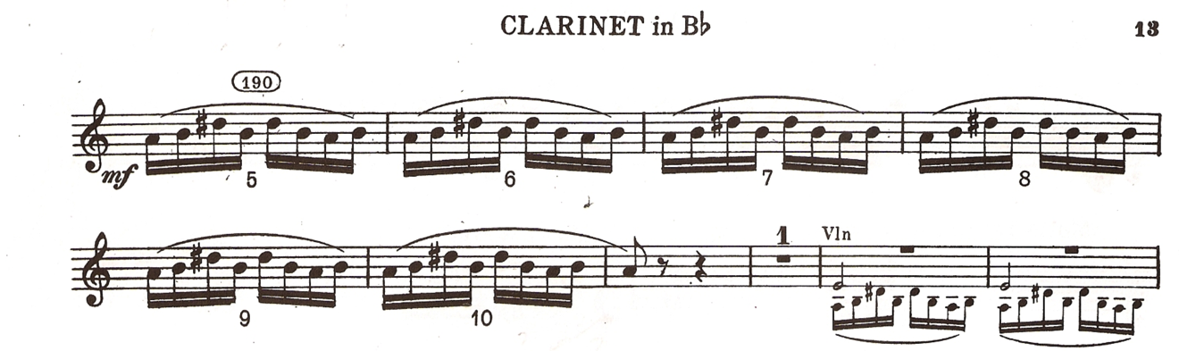

Contrasts, SZ111 by Béla Bartók
© Copyright 1942 by Hawkes & Son (London) Ltd.
Reprinted by Permission.

Figure 4.1: “Sebes,” mm. 190-199

Balogh explains further how the type of clarinet he has chosen to play is related to the style of the music he is playing. For instance, when he made his recording of Hungarian music, playing pieces by Kokai, Weiner, Lendvay, and others, he felt the German clarinet was unsuited to play the jazz-influenced, Lendvay work:
Sometimes it was the question, I was in the half-way. And I say, okay, it’s no problem for me, I can play…the Kokai, I can play for the German clarinet. It’s no problem for me I can play for the Weiner; it’s no problem for me, is okay, good.
But is come the jazzy…Kamillo Lendvay…Respectfully [yours], Mr. Goodman!…Ah, it was not so good for German clarinet. The sound is not so good.
Balogh compares this situation to the way jazz clarinetists historically preferred different types of clarinets as jazz styles developed. Early jazz clarinetists used the Albert system clarinet, which is a predecessor to the modern German clarinet design. But as the newer Swing style of jazz evolved, clarinetists began to prefer the French clarinet:
It happen the same one when you think about when the old Dixieland player use the Albert system-mostly German system. And come the new style and the prominent people was Benny Goodman. He used French clarinet.
Yes, yes, yes. By the Swing [Era] is beginning the current for the French clarinet. Before not too many people play the French clarinet.

Balogh comments on the well-known fact that Bartók first composed Contrasts on a request from Jozsef Szigeti and Benny Goodman. According to Balogh, Szigeti suggested that they contact Bartók, whose two-movement Rhapsodies for Violin and Piano, Sz. 86 and 87, were works which helped him establish a career as a solo violinist. Balogh introduces the idea that Goodman was interested in finding new repertoire as a way to introduce himself to contemporary audiences as an emerging performing artist. Goodman did in fact go on to commission other major new works for the clarinet from Hindemith, Aaron Copland, and Francis Poulenc, among others:
Yes, yes, yes. The first it was, when Szigeti say for Bartók, “I like it you can compose for me,” and Goodman need about for every big composer some piece. Hindemith, Copland, and so and so, and Bartók too.
Szigeti say “When I need for this one, and I like same with the Rhapsody. When before I play the Bartók Violin and Piano Rhapsody.” That time it was very needed for the new piece. Okay, you are the new artist, you need for the new facing [the public].

Movement I, “Verbunkos”

Although Balogh does tend to discuss Contrasts in terms of it’s cultural context and types of clarinets, he addresses a few details within each of its three movements. He explains that the writing in the opening of the first movement of Contrasts displays many characteristics found in verbunkos music. First among these is a very strong sense of pulse, what he describes as a “rhythmical beating” as “with full bow, on a full string chord.” The dotted rhythms, brilliant ornaments, and low register which Bartók uses to present the opening melody are also characteristic of a verbunkos. The tempo fluctuations are “very, very” important as well, he says, concurring with both Ludewig-Verdehr and Shifrin.
When asked about a characteristic of the Hungarian language in which the accent falls on the first syllable of words, Balogh confirms the practice. It is true, “every times,” he says, offering the Hungarian words for “home” and “father” as examples. In musical notation, he says that this concept is represented in dotted rhythms; however, Balogh explained to the author more than once that the actual sound is difficult to notate. He recommends listening to pieces by composers such as Liszt, Kodaly, Weiner, and Kokai in order to understand the proper inflection:
It’s the same rhythm, the Hungarian dotted. You can NOT [Balogh’s emphasis] reading the score and the really rhythm - can't so really writing. But if you hearing many time you can copying! It is a very special marcato and rithm [sic] playing, every where the same!

In discussing the clarinet cadenza towards the end of the first movement, Balogh has several observations. He relates the writing style to Bartók’s handling of the clarinet in music for two of his larger works, the opera Bluebeard’s Castle, Sz. 48, and the again the ballet, The Miraculous Mandarin. He also humorously notes that in Benny Goodman’s recording of the work, Goodman added an extra arpeggiated figure in the cadenza:
I don’t know which variation…he play it two times [laughs]. No problem.

When asked about reasons for the alternate versions of the cadenza available in the published part, Balogh suggests that Bartók included easier versions for some players, or even on Goodman’s request (see fig. 3.1). Similar to Shifrin, Balogh notes that Contrasts has become much more approachable by clarinetists since it was first introduced.
Sometimes the fifty years ago, or I don’t know sixty years ago, it was not so easy. There was about thirty people in the world who can play this, and no more… Now’s everybody can play.

Movement II, “Piheno”

Concerning the second movement, the “Piheno”, Balogh praises the effectiveness of Bartók’s writing. As with Shifrin, he notes that this movement is an example of the“night music” for which Bartók is well-known. Balogh also illustrates the idea with colorful imagery of a night scene in the country:

“Piheno”, yes…you have to read it about for the ‘music of the night.’ It is very, very nice in Bartók.
The nicer music…we are speak about the Hungarian night. Maybe the end of the July or August if you go out in the nature. You listen, the first time nothing. Sit and you say, “Wow, is absolute quiet.” And after twenty minutes you listen about for the many, many animals. Sometimes the bird, sometimes the small animals everywhere. And Bartók is very, very like it - the night.

Balogh also describes a similar example of “night music” in the second movement from Bartók’s Concerto No. 2 for Piano, Sz. 95. Along with the solo piano, the movement utilizes the sounds of celeste, percussion, and harp to achieve the desired effect.
The middle section of the “Piheno” is marked forte. When questioned about the appropriateness of this kind of sound in a night music setting, he explains that in
the context of “night music”, this section is logical:
Yes, but you know we are speak about if you go out in the nature you say, “Wow, it’s very good quiet, everything.” And try one time after the half and hour, you say, “Wow, it’s not quiet. It’s many, many noise”…come the pig, or a deer: Big forte (see fig 2.12).

As Shifrin noted, Balogh firmly believes that the addition of the “Piheno” movement

adds a great deal to the original two-movement work:

The second movement is very, very, different. Now the people is cannot so good listening is a big different. But I think is a big different…And between is have the second movement. Is the same Bartók composition, but is free. Is free music, I think.

Movement III, “Sebes”

Balogh’s comments regarding the third movement of Contrasts are brief. He
describes a section in the “Sebes” where ensemble playing is problematic and again
discusses why he uses the B-flat clarinet for the entire movement. He also explains the meaning of the movement title and the correct pronunciation.
The tricky ensemble passage begins in m. 241, where the clarinet, violin, and
piano share segments of the subdivided beats:
Sometimes is one of the very difficult [places], play together the three. It’s have…the name is the “microsyncopation.” Play together with the piano and the violin in the third movement. I cannot sit so very comfortable. (see fig 3.13)
Regarding the choice of which instrument to use for the “Sebes”, Balogh says thathe dislikes the small amount of time Bartók has allowed for the clarinetist to change between instruments. He considers it “normal” practice among clarinetists to use only the Clarinet in B-flat for the entire movement. So, as is the case with Ludewig-Verdehr, Balogh’s solution to the quick changes between instruments is to ignore them and use his Clarinet in B-flat for the entire movement.
The title of the movement is pronounced “she-besh”, with the accent on the first syllable. Balogh states that “Sebes” is just one of many terms in Hungarian culture to describe fast tempos:
Sebes is the simile for the “fast”…We have about 1,2,3,4,5 words, “the fast”, different kind of the words. The Hungarian language very, very, rich about [this style].

Balogh describes the difficulties he encountered when he first began learning
Contrasts while a student at the Lizst Academy in Budapest as a “nice story”. Because he had no Clarinet in A, he began learning the piece on the B-flat clarinet, but since he had no part for Clarinet in B-flat, he was forced to write out a transposition of the first movement part for Clarinet in A. “It was the big, big job,” he says:
For the first [time], it was a very nice story. If I was the student for the Music Academy and I can studying this one. But I have not A clarinet and I have not B [B-flat] clarinet part. I have to write and I have to transpose the first movement.
I can write it and transpose, but…it was the first meeting and sometimes it was too big piece for me…sometimes I had not too much time.

When asked about influences on his interpretation, Balogh praises his chamber music teacher at the Liszt Academy. He also describes the thorough curriculum of the school, the process of organizing a group to study the work, and a successful result:
I have very, very good chamber teacher, who teach the chamber music. It was just another system in Hungary when have here [in the U.S.]. And we have one hour for the clarinet, the scales and the etudes - the skill class. Another the lesson, another hour in the music to piano. We have one more for the chamber.
And for the diploma…it’s every year, you have the points about – the examination. You have to take it.
And you have a teacher, you have to go the teacher, and you and your colleague or he say for you he have the free capacity, have the very good violin player, very good piano player, you play together. And we play together the first time the Contrasts. Half a year we are playing. It was very big job, but really it’s very good.
I was with Contrasts by professor Lorant Szűcs, modern and romantic mixed trios…

Balogh comments that a better understanding of Contrasts took much more time, after he left the Academy, and became more familiar with Bartok’s music through his works for orchestra. He describes the differences in learning a singular work like Bartók’s Contrasts work to learning the works by a composer who wrote much more solo repertoire for the clarinet - Carl Maria von Weber:
It was not so easy. It’s not so easy. Contrasts - Bartók no another piece. You know we are play the Weber. We have many Weber Concerti, Grande Duo Concertante. We have the Variations about the Theme. We have the Concertino.
Not the Contrasts. After, if I play many Bartók oper, after it will be a little bit cleaner for me. When I play the Bluebeard’s Castle and The Miraculous Mandarin many times, a little bit it was easier and interesting me. Why, which is the person Bartók with the musical Bartók. Yes, is my opinion.
In the Wooden Prince. Well, it is a very, very famous piece about for the clarinet repertoire. It is full of the solos. Is not so easy for a clarinet player.

Balogh takes further pains to describe what he seems to feel is a misconception about learning a work like Contrasts - that it takes more than simply playing the piece for the first time for someone to fully understand he music:

And I said for you it’s big helpfulness when I can play the Bartók pieces, the orchestra pieces. And sometimes…I know who say “The first time, just the time I can understand Bartók and like for me.” It’s not true. I think it’s not true. You have to wait, you have to listen, and you have to work. You have to understand it, and you have to arrived this pieces. Same the Contrasts.

Balogh has further observations regarding the learning process for a demanding piece like Contrasts. He recalls his experience playing in the Hungarian Radio Orchestra, preparing a new program of music every week, in which musicians who have played the music in the past would pass on advice to him by writing on the outside cover of the music. In one case someone wrily suggested that he had work to do for the next week’s concert:
I tell a story and you can understand it. If I work in the Hungarian Radio Orchestra, sometimes in the radio orchestra it was repertoire…Every week we play just a different kind of the program. And the old colleague every times is write on the cover, the notes, the music notes…I find the piece, it was from Dohnanyi…It was the ballet music. And was write it for the first page, ‘Pick up, go home, and practice’ [laughter].

Another comment addresses the preparation he finds necessary when revisitinga work like Contrasts. He has performed the piece a lot, but each time, he says, one must prepare well and re-learn the music thoroughly:

I play many, many times. But if I have to play this one, before two, three weeks ago, I have to practice. And I think is everybody have to practice. You cannot say the first time I studying, or I practice, and after I only a little bit refreshing, and I can play.

In regards to teaching, Balogh describes how he approaches the work and the clarinet. He enjoys teaching from the rich clarinet repertoire by helping students to find a “key” which will help them to unlock each work:
Sometimes, it’s a my opinion. And if I teach I like to do this sometimes: I like to give for my students a key for the music, for the different kind of the music. I teach the pieces, but I cannot teach every piece. But the clarinet repertoire is very rich and I like, I hope for every body can play on the lifelong, for every piece. It’s a tough, possible, but you have to try it.

Balogh implies that his role is to help students discover ways to practice each work, to find one’s “way.” He states that students shouldn’t rely on him to teach them everything, but that if they work hard, he can help them:
How you can practice for this one? How you can. Sometimes, I think it’s everybody and I say my student, I cannot, I cannot teach you the clarinet. If you practice, I can help you when you can play the clarinet.
You have to find how your way to the Contrasts, how your way to the Debussy [Rhapsodie for Clarinet], how you can practice. It’s okay I can help about which is the mainly problems. How you can practice, how you can, go and a little bit nearly coming for these pieces. You have to go for these pieces, play some of the Bartók. It’s not easy, I know. It’s not easy.

Balogh states that knowledge of Bartók’s life helps him understand his work
better. He also feels that comparing the musical languages of Bartók to that of Zoltán Kodály can be useful. Though they were friends, contemporaries, and fellow
Hungarians, and their music was heavily influenced by Hungarian folklore, Bartók was more influenced by musical currents outside of Hungary. Balogh also states that his interpretation is partly a matter of opinion, which evolves as he continues to study:
Yes, sometimes not so easy understand it. Ah, the man Bartók, and the situation. And sometimes that is the very important compass, for me, which direction.
Yes, now it is my opinion. Maybe, maybe I can know something, some new one. And sometimes I say, “Oh yes, okay, I know it’s right.” Or, “Excuse, me Jozsef, you don’t knows right.”
The Bartók is, yes, Bartók was Hungarian composer. But, you know is sometimes is the same. When different, the national and the international. Bartók was a very international composer – “Hungarian” international. Kodály was national.

Balogh states that understanding Hungarian culture is not an easy task. This
difficulty includes the music of Hungary as well, he says, and the musician who performs it has the duty to attempt to both understand it and communicate that understanding to as much of the public as possible:
And sometimes its not so easy for this heritage and you have to play for the publicum [sic]. It very, very important if you play this piece, everybody has to understand this piece, in the publicum - or mostly. It’s not easy. Sometimes it’s not good. You are play, I say, “Okay I was played, it was super.” And the publicum say, “I cannot understand. Which language you use for this one?”
And it is a big question. If you can find the language, this piece, the publicum can understand it. And Bartók use not so easy language, this piece. It’s many…many symbols. Many enigma.

In summary, Balogh’s commentary on Contrasts stem in large part from his Hungarian and international background. His intimate understanding of Hungarian music and culture provides him with insights into Contrasts which the author finds very thought-provoking. The wide range of his musical experience in Classical, Jazz, and Gypsy music are also evident in his interview. Balogh’s rich background of musical experience is also evident in his insightful ideas concerning the uses and limits of both the German and French clarinet design.

Chapter Five

Summary and Comparison of Interpretations

A significant motivation behind this project was a desire to overcome my bewilderment towards much of the modern repertoire in Western Art music. One of my first direct experiences with music of the modern era was hearing David Etheridge perform Contrasts with his faculty colleagues from the University of Oklahoma when I was a teenager. The experience was both riveting and startling to my young ears, and inspired me to organize my own performance of the work years later. My own experience learning the work has been both thrilling and frustrating: thrilling, because the work is so powerful, but frustrating because I felt my lack of understanding the work affected my ability to perform it successfully.
My understanding of the music of another modernist, Igor Stravinsky, has been similarly challenging. The first time I heard the music for Stravinsky’s ballet, The Rite of Spring, was listening to a 33 rpm recording in the Oberlin Music Conservatory library. The music was so disturbing to me that I could only listen to one side of the record. However, I came back the very next day to hear the second half of the work, and I quickly learned to enjoy and appreciate Stravinsky’s music very much. As with Contrasts, performing the music of Stravinsky has been a mixed experience of excitement and frustration.
Many of my musical colleagues have expressed similar feelings in regards to Contrasts. A friend of mine who is an excellent clarinetist and successful university clarinet professor has expressed his frustrations about Contrasts, confessing to me that he didn’t “understand” the work. A pianist with whom I have performed Contrasts and other music (and who, remarkably, has performed Contrasts as a violinist) once described the work to me as “miserably hard” to play.
I have come to conclusion that my frustration with modern music is partly due to a wariness of modern sounds and sensibilities. All of the extremes of much modern music - its distorted sounds, dissonance, atonality, asymmetry, irony or sarcasm - and the disturbing contexts that accompanies much of it can sometimes be difficult for me to overcome in order to enjoy and understand it. I take comfort in the more familiar, warm sounds of much tonal music. The melodies, harmonies, rhythms, forms, and musical contexts of much of tonal music are more comfortable and pleasing to my ear. Dissonance and asymmetry, are present, of course, but they are usually balanced by consonant resolution. Works that do venture into minor keys tend to end in major keys, for example. The music of Brahms and Dvorák is some of the most comforting I can think of in Western music.
My resistance to the modern sounds of the twentieth century is not uncommon. In reading historical accounts of the premieres of new music, particularly that of the Modern Era, one can find many examples of audiences reacting in a hostile manner to new music. In his book, A Lexicon of Musical Invective: Critical Assaults on Composers Since Beethoven’s Time, Nicolas Slonimsky carefully compiled many examples of hostile musical criticism towards works that are now considered classic masterpieces. At the time, these works were ground-breaking, avante garde, and full of innovative practices which were too progressive for many listeners. Slonimsky refers to this pattern of reaction as the “Non-Acceptance of the Unfamiliar”. Even the music of J. S Bach, whom many consider to be the greatest composer in Western music, has its critics. His densely contrapuntal music was, and perhaps still is, considered by some to be “overly elaborate and confused”.
Alex Ross has also addressed this issue in his book The Rest is Noise. He characterizes the “problem” of modern Western music as being one in which composers were trying to find new ways of expressing themselves, and yet by doing so, they were rejecting the ways of the established musical language to the point that they were losing their audience. The same phenomenon took place in American Jazz when modern Jazz (Bebop) was introduced in the 1940s. The music was dry, dissonant, used unfamiliar sounds and harmonies, and the audience for the popular Swing style was alienated by it.
Bartók is considered to be one of the monumental figures of modern music, and he paid the price of initial rejection against much of his music. In his Memoirs, the late maestro Sir Georg Solti recalled a telling anecdote from the 1938 Hungarian premiere of an important work by Bartók, his Sonata for Two Pianos and Percussion. As a young student at the Budapest Academy, he was asked to turn pages for Mrs. Bartók, who was performing one of the piano parts alongside her husband. The famous Swiss maestro Ernest Ansermet was conducting. Solti describes the confused audience reaction and his personal feelings of embarrassment for Bartók:
I have never in my life attended any other concert that had as little success as this one. When the piece ended, most of the audience remained silent; the there were a few perfunctory claps. I felt sad and embarrassed for Bartók.

Two of the artists interviewed for this paper, Shifrin and Balogh, also mentioned the challenge presented by the newness of Bartók’s music. Shifrin described Contrasts as still being considered “difficult” and “avante garde” in the 1960s, at the time he was learning it. Balogh described the problem of presenting new music, even well-performed music, to a public which does not understand the composer’s musical language.
Whether as a performing musician or an audience member, a rudimentary, working knowledge of Bartók’s compositional style can be very helpful to understanding the music, such as his use of modes, variation, and his percussive style of attack. Discussing Contrasts with expert clarinetists who have performed the work for decades is another means of helping students of the work decode its style and overcome the challenges of performance.

Comparison of Artists’ Interpretations
There were notable similarities of approach to Contrasts among all three of the artists interviewed. For instance, when discussing the character of the first movement each made some mention of the intensely rhythmic style of the Verbunkos. They all spoke in admiration of the wonderful texture of sounds Bartók created in the middle movement, which Shifrin and Balogh described as his “Nightmusic” or “Music of the Night.” In addition, they each expressed the view that the clarinet part can be effectively performed on either the Clarinet in B-flat or using both the Clarinet in A and B-flat, as Bartók originally conceived the work. Each artist also referred to Benny Goodman’s interpretation of the work on at least one occasion.
Interestingly, each artist cited the helpful influence of other musicians in learning the work. Ludwig-Verdehr shared some of the challenges she encountered in mastering the clarinet part, her reliance upon the teaching of Stanley Hasty and Robert Mann, and more than one “aha moment” in understanding the piece. In his interview Shifrin described his approach to Contrasts as an “evolving” process, and he went on to credit his chamber music coach, Arnold Steinhardt, and the many other musicians with whom he has played the work for much of his understanding of the piece. Balogh credits his chamber music teacher at the Franz Lizst Academy for his guidance, but he also frankly described his first experience with Contrasts as being too problematic for him to feel comfortable. To a person, each artist cited a somewhat lengthy personal journey towards understanding the work.
Similarities between two interview subjects are plentiful, particularly between Ludwig-Verdehr and Shifrin. They both detected an element of swing to passages in the Verbunkos movement as well, implying that Benny Goodman’s playing might have influenced Bartók’s compositional style. Other common issues both mentioned were numerous problems of ensemble coordination and of balance between instruments. In particular, achieving the best balance between the two leading instruments, the violin and clarinet, was an issue of mutual concern. Both Ludwig-Verdehr’s and Shifrin’s engagement with the score went as far as to question or make subtle changes to the composer’s markings. I was impressed with both the conviction and logic behind their decisions to depart from the score.
Ludwig-Verdehr and Balogh both prefer to use a Clarinet in B-flat for the entire work. Ludewig-Verdehr cited her preference of the B-flat instrument for two reasons: she originally learned the piece using the part for Clarinet in B-flat and she prefers the response in the upper register over that of the Clarinet in A. Balogh’s reason for using the Clarinet in B-flat was a desire to remain playing on a single, warmed-up instrument for the entire work. By playing the entire piece on the B-flat instrument Balogh need not worry about intonation issues that would arise due to playing on an instrument that has been sitting idle and cold when out of the clarinetist’s hands and breath.
Several aspects of the artists’ interpretations were distinctive enough to discuss further. Ludwig-Verdehr was the only artist who noted misprints in the B-flat Clarinet part. She also tended to disagree with Bartók’s markings more than the others, although the changes she recommended were not in any way radical departures from score. Ludwig-Verdehr was also very enthusiastic in highlighting Bartók’s dynamic changes, something which was noticeable in her very vigorous singing of examples.
Shifrin’s interpretation was unique is some notable ways as well. For example, he was the only artist who preferred to use the Clarinet in A for the work. Shifrin even uses the Clarinet in A for a section of the final Sebes movement that Bartók designated for the Clarinet in B-flat, in order to avoid an awkward instrument change. He was also unique in his speculation on the compositional process of the piece, especially in regards to the clarinet cadenza. Although he stated that he has always used the standard cadenza in his performances, he noted that a clarinetist may consider composing their own version, in the same way they might do so for a work by a composer from the common practice period.
Of the three artists, Balogh’s interview is perhaps unique for several reasons. Instead of offering practical suggestions as to how to perform Contrasts, Balogh provided a very rich cultural and social context for the work, and for Bartók’s music in general. His descriptions of the more somber meaning behind the Verbunkos traditions and Bartók’s fondness for “Music of the Night” were very poignant. His commentary on the different types of clarinets and musical traditions was also very impressive. His wide-ranging ideas seem reflective of his rather diverse background as a clarinetist and musician.
In completing this project my regard towards the work of performing artists has grown a great deal. This is especially true for those very experienced artists whose careers have extended over many years and a great many performances. I have developed a much deeper respect for their dedication as interpreters and presenters of music to the public and to their roles as teachers for fellow musicians.
After discussing Contrasts with Ludwig-Verdehr, Shifrin, and Balogh I have a much greater understanding and regard for Béla Bartók as well: the breadth of his work, his evolving style as a composer and artist, his creativity, and his dedication and humanity. This newfound understanding provides a greater context to appreciate his music and music of other modernists.

Bibliography

Websites

“Jozsef Balogh,” World Klarinet Alliance,
http://www.wka-clarinet.org/VIP-Balogh.htm (accessed 7/13/2013)

“Jozsef Balogh,” http://jb.windland.org/ (accessed 7/13/2013)

“David Shifrin,” www.davidshifrin.com/web/home.aspx (accessed 7/17/2013).

“David Shifrin,” Yale University School of Music, music.yale.edu/faculty/shifrin.html (accessed 7/18/2013).

“Kavafian-Schub-Shifrin Trio,” Alliance Artists Management, www.allianceartistmanagement.com/artist.php?id=kss (accessed 7/17/2013).

“The Verdehr Trio,” http://www.verdehr.com/about.htm (accessed September 20, 2012)

Interviews

Jozsef Balogh, interview by author, tape recording, Norman, OK, May 29, 2011.

David Shifrin, interview by author, tape recording, Bartlesville, OK, 16 June, 2010.

Elsa Ludewig-Verdehr, interview by author, tape recording, Norman, OK., 29-30 June, 2009.

Scores

Bartók, Béla. Contrasts for Violin, Clarinet and Piano. London: Boosey and Hawkes,1942.

Bartók, Béla. Contrasts for Violin, Clarinet and Piano (Corrected Edition). Edited by Nelson Dellamaggiore and Peter Bartók. London: Boosey and Hawkes, 2002.

Books

Antokeletz, Elliot, Victoria Fischer, and Benjamin Suchoff, eds. Bartók Perspectives, Man, Composer and Ethnomusicologist, Oxford University Press, Oxford, 2000.

Bartók, Béla. Béla Bartók Essays. Benjamin Suchoff, ed. London: Faber and Faber, 1976.
Etheridge, David. Mozart’s Clarinet Concerto: the Clarinetist’s View. Gretna: Pelican,1983.

Donald J. Grout and Claude Palisca, A History of Western Music, 6th ed., W. W. Norton, 2001.

Gillies, Malcolm, ed. The Bartók Companion, Amadeus Press, Portland Oregon, 1994.

Karpati, Janos. Béla Bartók’s Chamber Music. Trans. Fred Macnicol and Maria Schneider. Pendragon Press, Stuyvesant Press, NY, 1976.

Kroo, Gyorgy. A Guide to Bartók. Trans. Ruth Pataki and Maria Steiner. Hungary: Corvina Press, 1974.

Lampert,Vera, and Laszlo Somfai. The New Grove Dictionary of Music and Musicians: Modern Masters. London: Macmillan, 1980.

Malcolm Gillies. "Bartók, Béla." In Grove Music Online. Oxford Music Online, http://www.oxfordmusiconline.com/subscriber/article/grove/music/40686pg 6 (accessed September 22, 2011).

Mandlebaum, Joel. Béla Bartók. New York: Dover Publications, 1967.

Moreux, Serge. Béla Bartók. London: Harvill Press, 1953.

Simms, Bryan R. Music of the 20th Century: Style and Structure. Schirmer, New York,1986.

Suchoff, Benjamin. Béla Bartók, A Celebration. Scarecrow Press, 2004.

__________. Béla Bartók, A Life and Work. Scarecrow press, 2001.

Stevens, Halsey. The Life and Music of Bartók. Oxford University Press, New York, NY,1972.

Szabolcsi, Bence. A Concise History of Hungarian Music. Trans. Sara Karig and Fred Macnicol. Corvina Press, 1955.

Szigeti, Joseph. With Strings Attached. New York: Alfred Knopf, 1947. Revised and
enlarged. New York: Alfred Knopf, 1967.

Weston, Pamela. “David Shifrin.” Clarinet Virtuosi of Today. Hertfordshire, England: Egon, 1989

____________ “Elsa Ludwig-Verdehr.” Clarinet Virtuosi of Today. Hertfordshire, England: Egon, 1989
Theses and Dissertations

Brisbois, Aaron. “Jean Francaix’s Clarinet Concerto: An Examination of Performance Practices.” DMA document, University of Oklahoma, 2012.

Carter, David. “Concerto for Clarinet by John Corigliano, the Clarinetists View.” DMA document, University of Oklahoma, 2008.

Giacona, Christina. “A Study of Comparative Interpretations by Stanley Drucker, Elsa Ludwig-Verdehr, and John Bruce Yeh of the Clarinet Concerto by Carl Nielsen.” DMA document, University of Oklahoma, 2009.

Ishigaki, Miles. “A Study of Comparative Interpretations of the Three Pieces for Clarinet Solo by Igor Stravinsky.” DMA document, University of Oklahoma, 1988.

Prime, Dennis Gordon. “The Clarinet in Selected Works of Bela Bartók and Igor
Stravinsky.” DMA document, University of Wisconsin-Madison, 1984.

Ritchie, Anthony Damian. “The influence of folk music in three works by Béla Bartók: Sonata no. 1 for violin and piano, Sonata (1926) for piano, and Contrasts for violin, clarinet, and piano.” Ph.D. diss., University of Canterbury, 1986.

Snavely, John Albert. “Benny Goodman's Commissioning of New Works and Their
Significance for Twentieth-century Clarinetists.” DMA document, University of Arizona, 1991.

Walker, Amanda Jane. “Performance Issues in Béla Bartók’s Contrasts.” Master’s
Thesis, University of California, Los Angeles, 1991.

Journal Articles

Bartók, Béla. “The Influence of Peasant Music on Modern Music.” Tempo 14 (Winter 1949-50): 19-24.

Folio, Cynthia. “Analysis and Performance: A Study in Contrasts.” Integral, Vol. 7 (1993): 1-37.

Garst, Marilyn. “How Bartók Performed His Own Compositions.” Tempo, Vol. 155, (December 1985): 15-21.

Gerson Kiwi, Edith. “Béla Bartók - Scholar in Folk Music.” Music & Letters, Vol. 38, no. 2 (April 1957): 149-54.

Grant, Kenneth. “Masterclass: Contrasts for Violin, Clarinet, and Piano, by Béla Bartók.” The Clarinet, Vol. 25, no. 2 (Winter 1998): 8-10.

McCormick, Cathy. “The Origin of Bartók’s Contrasts,” The Clarinet, Vol. 13, no. 1 (Fall 1985): 32-33.

Platt, Mary and Maxine Ramey. “Elsa and Walter Verdehr - A Musical Partnership: 25 Years of the Verdehr Trio.” The Clarinet, Vol. 25, no. 1 (November- December 1997): 68-72.

Platt, Mary and Maxine Ramey. “Elsa and Walter Verdehr - A Musical Partnership: 25 Years of the Verdehr Trio, Part II.” The Clarinet, Vol. 25, no. 2 (February- March 1998): 36-39.

Reeks, John. “The Evolution of Bartók’s Contrasts,” The Clarinet, Vol. 28, no. 3 (June 2001): 56-59.

Stier, Charles. “Editions & Misprints.” The Clarinet, Vol. 18, no. 1 (November- December 1990): 32.

Sound Recordings

Bartók: Contrasts, Mikrokosmos (excerpts), Béla Bartók, Joseph Szigeti, Benny Goodman. Masterworks Portrait: MPK 047676, 1941. Compact disc.

Chamber Music Northwest: Bartók, Contrasts; Messiaen, Quartet for the End of Time. Delos: DE 3043, 1992. Compact disc.

Contrasts - Hungarian Clarinet Music: Bartók, Weiner, Kókai, Lendvay, Gyulai, Gaál, Hidas. Budapesti Klarinét Center: CD BKLC 0198, 1997. Compact disc.

Howat, Roy. Liner notes for recording, Bartók: Sonata for Unaccompanied Violin, Two Rhapsodies, Rumanian Folk Dances, Contrasts. Hyperion: CDA66415, 1990. Compact disc.

The Making of a Medium, Vol. 1, The Verdehr Trio: Music for Violin, Clarinet, and Piano by Mozart, Hovhaness, Frescobaldi, Pasatieri, and Bartók. Crystal Records: CD 741, 1990. Compact disc.

Malcolm Gillies. "Bartók, Béla." In Grove Music Online. Oxford Music Online, http://www.oxfordmusiconline.com/subscriber/article/grove/music/40686pg6 (accessed September 22, 2011).
“The Evolution of Bartok’s Contrasts”, by John Reeks. The Clarinet, Volume 28, No. 3 (June 2001), 56-59.
David Etheridge, Mozart’s Clarinet Concerto: the Clarinetist’s View (Gretna: Pelican, 1983).
Miles Ishigaki, “A Study of Comparative Interpretations of the Three Pieces for Clarinet Solo by Igor Stravinsky.” DMA document, University of Oklahoma, 1988.
Ishigaki, p. 1-4.
David Carter “Concerto for Clarinet by John Corigliano, the Clarinetists’ View.” DMA document, University of Oklahoma, 2008. Christina Giacona, “A Study of Comparative Interpretations by Stanley Drucker, Elsa Ludwig-Verdehr, and John Bruce Yeh of the Clarinet Concerto by Carl Nielsen.” DMA document, University of Oklahoma, 2009. Aaron Brisbois, “Jean Francaix’s Clarinet Concerto: An Examination of Performance Practices.” DMA document, University of Oklahoma, 2012.
Elliott Antokoletz and Paolo Susanni, ed., Bela Bartok: A Research and Information Guide, 3rd ed. (Routledge: New York, 2011)
Gillies, 6.
Dennis Gordon Prime, “The Clarinet in Selected Works of Bela Bartok and Igor Stravinsky,” (DMA document, University of Wisconsin-Madison, 1984).
Amanda Jane Walker, “Performance Issues in Bela Bartok’s Contrasts.” (Master’s Thesis, University of California, Los Angeles, 1991).
Cynthia Folio, “Analysis and Performance: A Study in Contrasts,” Integral 7 (1993): 1-37.
Marilyn Garst, “How Bartok Performed His Own Compositions,” Tempo 155 (December 1985): 15-21.
Cathy McCormick, “The Origin of Bartok’s Contrasts,” The Clarinet, Vol. 13, no. 1 (Fall 1985): 32-33. John Reeks, “The Evolution of Bartok’s Contrasts,” The Clarinet, Vol. 28, no. 3 (June 2001): 56-59.
Charles Stier, “Editions & Misprints,” The Clarinet, Vol. 18, no. 1 (November-December 1990): 32.
Kenneth Grant, “Masterclass: Contrasts for Violin, Clarinet, and Piano, by Bela Bartok”, (The Clarinet, Vol. 25, no. 2, February-March, 1998): 8-10.
Pamela Weston, “Elsa Ludewig-Verdehr,” Clarinet Virtuosi of Today (Hertfordshire, England: Egon, 1989), 183-190.
Verdehr Trio website http://www.verdehr.com/about.htm (accessed September 20, 2012).
Mary Platt, assisted by Maxine Ramey, “Elsa and Walter Verdehr-A Musical Partnership: 25 Years of the Verdehr Trio,” The Clarinet, volume 25, number 1, November-December 1997, 68-72.
Unless otherwise indicated, all quotations and information in this chapter were taken from Elsa-Ludewig-Verdehr, interview by author, Norman, OK, June 29-30, 2009.
Premiere Rhapsodie for Clarinet and Piano by Claude Debussy, Durand, 1910.
Scordatura is defined as “mistuned.” Instead of the usual G, D, A, E tuning, Bartók has specified the violin strings to be tuned to G-sharp, D, A, and E-flat.
Unless otherwise indicated, all quotations and information in this chapter were taken from David Shifrin, interview by author, Bartlesville, OK, June 16, 2010.
David Shifrin www.davidshifrin.com/web/home.aspx (accessed 7/17/2013).
Kavafian-Schub-Shifrin Trio, Alliance Artists Management www.allianceartistmanagement.com/artist.php?id=kss (accessed 7/17/2013).
ibid.
At the time of his interview, Shifrin was preparing another performance of the Mozart Concerto using a basset clarinet at the OK Mozart Festival in Bartlesville, OK.
David Shifrin www.davidshifrin.com/web/home.aspx (accessed 7/17/2013).
ibid.
ibid.
“David Shifrin,” [website] Yale University School of Music, music.yale.edu/faculty/shifrin.html (accessed 7/18/2013).
Pamela Weston, “David Shifrin.” Clarinet Virtuosi of Today. Hertfordshire, England: Egon, 1989, pp 253-258.
A single reed instrument common to southeastern Europe and Turkey.
“Jozsef Balogh,” www.wka-clarinet.org (accessed August 20, 2013).
ibid.
ibid.
ibid.
“Jozsef Balogh,” jb.windland.org (accessed September 9, 2013).
Ibid.
ibid.
ibid.
ibid.
Unless otherwise indicated, all quotations and information in this chapter were taken from Jozsef Balogh, interview by author, Norman, OK, May 29, 2011. The author of this document has studied clarinet with Mr. Balogh. His comments are easily understood when framed appropriately.
3 Chick Corea: American-born jazz keyboardist; Paco de Lucia (1947-): flamenco guitarist; Joe Zawinul (1932-2007): Austrian-born jazz keyboardist with Cannonball Adderley, Miles Davis, and jazz fusion group Weather Report.
In German the term “B” translates to English as “B-flat.” Mr. Balogh uses the German terminology throughout his interview.
There are three place in Contrasts that call for a low E on the Clarinet in A: Movement I, m. 56; Movement III, mm 151 and 167.
The German and French designs for the clarinet have historically differed in important ways, particularly in the bore and fingering systems. The German bore design is more cylindrical and tends to produce a thicker and more sturdy tone quality. The French bore design is slightly more conical towards the bell and is known for its flexibility of tone color. The keywork is different as well. Both the German (Oehler) and French (Boehm) fingering systems have roughly the same number of keys and finger holes, but enough of the fingering combinations are different so as to require some accommodation. Each system tends to play more easily in certain key signatures.
Fantasiestucke, Op. 73, for Clarinet and Piano by Robert Schumann.
Pergei Verbunk for clarinet and piano by Leo Weiner.
Four Hungarian Dances for clarinet and piano, and Quartettino for clarinet, violin, viola, and cello, by Rezso Kokai; Pergei Verbunk and Barndance, for clarinet and piano, by Leo Weiner; Respectfully yours, Mr. Goodman! for clarinet solo, by Kamillo Lendvay.
Sonate for Klarinet and Piano by Paul Hindemith, 1939; Clarinet Concerto by Aaron Copland, 1946; Sonata for Clarinet and Piano by Francis Poulenc, 1963.
E-mail correspondence from Balogh, April 10, 2013.
email correspondence from Balogh, April 4, 2013.
Weber’s works for solo clarinet: 2 concertos, 1 concertino, several works for clarinet and piano, and a Quintet for clarinet and strings.
Erno Dohnanyi (1877-1960), Hungarian pianist, teacher and composer.
A Lexicon of Musical Invective:, Critical Assaults on Composers Since Beethoven’s Time, 2nd ed., Nicholas Slonimsky, University of Washington Press, Seattle and London, 1965.
Donald J. Grout and Claude V. Paulisca, A History of Western Music, 6th ed., W. W. Norton and Co., 2001, 404.
Alex Ross, The Rest is Noise:, Listening to the 20th Century, Farrar, Strauss, Giroux, New York, 2007.
Sir Georg Solti, Memoirs, Alfred A. Knopf, New York, 1997, 36.

