UNIVERSITY OF OKLAHOMA
GRADUATE COLLEGE

RAVENSCROFT (34BV198) BISON SKULL PILES: EXPLORATIONS OF PURPOSE AND MEANING

A THESIS
SUBMITTED TO GRADUATE FACULTY
In the partial fulfillment of the requirements for the
Degree of
MASTER OF ARTS

By
CAITLIN M. BAKER
Norman, Oklahoma
2022
RAVENSCROFT (34BV198) BISON SKULL PILES: EXPLORATIONS OF PURPOSE AND MEANING

A THESIS APPROVED FOR THE
DEPARTMENT OF ANTHROPOLOGY

BY THE COMMITTEE CONSISTING OF:
Dr. Leland C. Bement, Chair

Dr. Bonnie L. Pitblado

Dr. Asa Randall

© Copyright by Caitlin M. Baker 2022
All rights reserved.

ACKNOWLEDGEMENTS
I would like to give thanks to multiple people who have helped me along this path. Dr. Lee Bement, my advisor and mentor, whose PBS documentary, faculty staff photo, and expertise convinced me to attend OU. I hope to one day be as knowledgeable and interesting as he is. My other committee members, Dr. Bonnie Pitblado and Dr. Asa Randall, have offered the best education and advice there is to offer. The Oklahoma Archaeological Survey provided me with the means to attend OU and countless lessons that have improved my knowledge of archaeology. I thank my parents, without whom I would not have discovered my love of learning, archaeology, and science. My brother Benjamin’s constant smile and joy never fails to encourage me through difficult times. JT, my wonderful fiancé, kept me going even when I wanted to quit. He gave me a home, love, and a future. I would also like to extend thanks to all of my friends and family not listed, each of whom helped me through graduate school. Most importantly, I attribute all that I am and all that I have achieved to God. My faith guides me and leads me to a better path.

Table of Contents
ACKNOWLEDGEMENTS iv
LIST OF TABLES vii
LIST OF FIGURES viii
ABSTRACT xiii
CHAPTER ONE: INTRODUCTION 1
CHAPTER TWO: ENVIRONMENTAL BACKGROUND 6
Modern Environment 6
Paleoenvironment 12
The Evolution of the Bison Genus 15
CHAPTER THREE: CULTURAL BACKGROUND OF PALEOINDIAN SOUTHERN PLAINS 23
Paleoindian 23
Late Paleoindian 26
Transition from the Paleoindian Period to the Archaic Period 27
Communal Bison Hunting 28
CHAPTER FOUR: SITE OVERVIEW 34
Initial Excavations 34
2019 Excavation 39
Bull Creek 44
Summary of Findings 44
CHAPTER FIVE: THEORY 49
Subsistence Models 50
Taphonomy 57
CHAPTER SIX: METHODS 59
Research Questions 59
Radiocarbon Dating 59
Taphonomic Methodology 62
Taphonomic Analysis of Bison Skulls 67
Collection and Storage Strategies 67
Sample Preparation 68
CHAPTER SEVEN: RESULTS 70
Bison Analysis 70
Radiocarbon Dates 78
Literature Review of Relevant Sites 82
Potential Explanations for Skull Stack 89
CHAPTER EIGHT: DISCUSSION & CONCLUSIONS 91
Interpreting Ritual at Ravenscroft 91
Future Research Directions 94
Concluding Statements 94
BIBLIOGRAPHY 96

LIST OF TABLES
Chapter Four
Table 4-1: The dates of kill events within RAV I and RAV II. These were determined by a mixture of radiocarbon dating, stratigraphic analysis, and taphonomic analysis (Bement et al. 2012, Larrick et al. 2019, Muhammad 2017)………………………………………………………………...….45
Chapter Six
Table 6-1. Dentition age group and wear (Frison (ed.) 1996)……………………………...……66
Chapter Seven
Table 7-1. Preliminary faunal analysis based on site specimen forms……………………………71
Table 7-2. Table illustrating the results of radiocarbon dating on the skulls………………….…..79

LIST OF FIGURES
Chapter One
Figure 1-1. Project area location (Larrick et al. 2019)…………………………………………...…2
Chapter Two
Figure 2-1. Ravenscroft, facing west…………………………………………………………...….6
Figure 2-2. The relevant Ecoregions for Beaver County (outlined in red) including 25b) Rolling sand Plains, 25e) Canadian/Cimarron high Plains, and 26a) Canadian/Cimarron breaks (Woods et al. 2005)……………………………………………………………………………………………7
Figure 2-3: Skull of Bison latifrons (Image by Jessica Rockeman from Pixabay, accessed 2022)..16
Figure 2-4: A male Bison antiquus skull from the Tedford Farm site in San Patricio, Texas (McDonald 1981)………………………………………………………………………………...17
Figure 2-5: A female Bison bison skull from the Rocky Ford site in South Dakota (McDonald 1981)…………………………………………………………………………………………..…18
Figure 2-6: A female Bison occidentalis skull from the Scottsbluff site in Nebraska (McDonald 1981)……………………………………………………………………………………………..20
Figure 2-7: Bison yearly round as compared to historic Plains hunting cycle (Adapted by Carlson (2015) from Brink (2008), Cooper (2008), and Oliver(1962))………………………………...….22
Chapter Three
Figure 3-1. Clovis point (Frison 1998)……………………………………………………….…..24
Figure 3-2. Folsom point (Frison 1998)…………………………………………………………..25
Figure 3-3. Plainview point (Frison 1998)……………………………………………………..…27
Figure 3-4. Picture taken from above RAV I bone bed, facing west. Arroyo cut visible as a line of bright red soil……………………………………………………………………………………..30
Figure 3-5. The migration patterns of bison based on stable isotopic analysis on the Beaver River complex. The bison skull marks an area where all lithic types have been located, bison were present during late summer/early fall, and arroyos are present (Carlson and Bement 2012)……………...31
Figure 3-6. View of Head-Smashed-In cliff jump (Head-Smashed-In Buffalo Jump World Heritage Site, accessed Oct. 25, 2022)……………………………………………………………………..33
Chapter Four
Figure 4-1. Location of Ravenscroft (Larrick et al. 2019)……………………………………..….35
Figure 4-2. The exposed bonebed during the 2009 excavation (Larrick 2021)……………….…..36
Figure 4-3. Trench opened at RAV II during the 2013 excavation (Muhammad 2017)…………..37
Figure 4-4. Units excavated during the 2013 field school (Muhammad 2017)…………….……..37
Figure 4-5. RAV II units opened during 2015 field school (Muhammad 2017)……………….….38
Figure 4-6. Map of skulls (red) surrounded by other bones (green) prior to 2019 excavation (Larrick et al. 2019)………………………………………………………………………………40
Figure 4-7. An example of “crushing” to remove the brain. A female bison skull from the Glenrock Bison Jump (Frison 1991)………………………………………………………………………..40
Figure 4-8. Map showing the location of each RAV arroyo, the excavation units, and the skull pile (Larrick et al. 2019)………………………………………………………………………………41
Figure 4-9. RAV II Profile map, drawn by Dakota Larrick in 2017…………………………...….43
Figure 4-10. Location of Dakota Quartzite quarry (Taken by author, 2021)………………..…….47
Figure 4-11. Dakota quartzite point recovered from RAV II (Muhammad 2017)………….……..47
Chapter Five
Figure 5-1. A model depicting the dependence on hunting and fishing amongst North American groups (Kelly 2013)…………………………………………………………………………..…..52
Chapter Six
Figure 6-1. Petrosal Samples sent to UGAMS for Radiocarbon Dating and Isotopic Analysis (Bement 2022)………………………………………………………………………………..…..69
Chapter Seven
Figure 7-1. Current map of the Ravenscroft stacked skulls. The skulls are bolded and labeled with their associated radiocarbon dates. Skulls highlighted in red are associated with the first kill event. Skulls highlighted in yellow are associated with the second kill event. Skulls highlighted in blue are associated with the third kill event (Bement 2022)…………………………………………...73
Figure 7-2. BN1056, interior of skull and maxilla………………………………………………..75
Figure 7-3. BN1203, right side of skull, before processing…………………………………….…76
Figure 7-4. A frequency distribution graph depicting the mean width of the anterior M3 cusp (McDonald 1981)…………………………………………………………………………..…….77
Figure 7-5. Calibrated (x-axis) and uncalibrated (y-axis) radiocarbon age ranges for the RAV II skull pile. RAV I radiocarbon age ranges highlighted in red. Calibrated dates derived through CALIB 6.2 and Intcal20 curve (Bement 2022, Larrick 2021)………………………………….…81
Figure 7-6. Cooper skull (Bement 1999)……………………………………………………...….84
Figure 7-7. Sundial Hill Medicine Wheel, Alberta, Canada (Wilson 2005)……………………..86
Figure 7-8. Replica antler pile at National Bison Range, Molese, Montana (Photo by Margaret A. Kennedy, Wilson 2005)…………………………………………………………………………..86
Figure 7-9. Wilson (2005) depicts several examples of Great Plains monuments built to represent the connection between animals and cosmology. Note the bone or antler piles and the pile of skulls, representing the axis mundi………………………………………………………………………88

All photos taken by author unless stated otherwise.

ABSTRACT
Ravenscroft is a late Paleoindian arroyo bison kill located along a tributary of the Canadian River named Bull Creek in the Oklahoma Panhandle. Multiple field seasons eventually identified two stacks of bison skulls at the mouth of the arroyo. All but one of the skulls were missing mandibles. None of the skulls exhibited bashing, suggesting they were not set aside for brain removal. Two arroyos were identified, labeled RAV I and RAV II. Further complicating interpretations of purpose were the returned radiocarbon dates. Included in the piles were skulls representing at least three of the five kill events. These skulls span over 300 years of history, implying a much more complex purpose than subsistence or stockpiling. Through further analysis and comparison with other occurrences of stacked skulls worldwide, this thesis explores the potentially ritualistic aspects of this site and attempts to explain the purpose of the stacked skulls.

CHAPTER ONE: INTRODUCTION
In 2007, collectors in Beaver County, Oklahoma, discovered prehistoric bison bones eroding out of an arroyo. These collectors notified Dr. Lee Bement from the University of Oklahoma, who began a series of excavations and analyses. The site came to be known as Ravenscroft (34BV198). This Late Paleoindian bison kill site revealed an extended use spanning over 300 years, suggesting a strong connection to the people who utilized the landscape (Larrick et al. 2019, Larrick 2021). In this thesis I present a study that investigates a concentration of bison skulls from multiple kill episodes from the late Paleoindian Ravenscroft bison kill site, assess the cranial remains within a traditional subsistence framework (Optimal Foraging Theory and Human Behavioral Ecology), determine them to be anomalous, conduct a literature review to identify other similar occurrences, evaluate the Ravenscroft materials in light of those occurrences, and conclude that the Ravenscroft materials are best considered within a ritual imbued landscape model as presented for the First Nations groups on the northern Plains.
This thesis addresses two primary research questions: what kill events do these skulls belong to, and why were they placed here? To guide this research, I consider the possible explanations for the occurrence of stacked bison skulls in the Ravenscroft II arroyo presented previously by Larrick et al. 2019: Discard, stockpile, commemoration or ritual. If the skulls are the result of discard activity related to butchering and processing decisions, then the skulls should be from a single kill event and display cutmarks related to dismemberment and skinning, bashing to gain access to the brain case to remove the brain, and mandible manipulation to remove the tongue. If the skull pile is the result of stockpiling resources, the pile should be dated to the same kill event. If the skull pile is the result of ritual activity or commemoration of kill events, then the skull pile should contain skulls from multiple kill events. To better understand the possible ritual context of the skulls, I present the results of a literature search for similar handling of skulls and ways that other researchers interpret such occurrences.
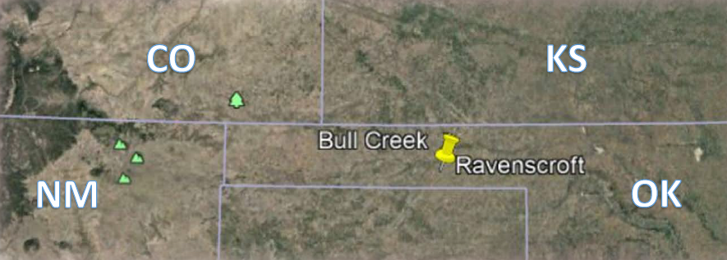
Figure 1-1: Project area location (Larrick et al. 2019)
Chapter two focuses upon the environmental setting of the Bull Creek area, beginning with the modern-day physiography, geology, climate, hydrology, flora, and fauna. Present-day conditions are included to portray the environmental difference between present-day and Paleoindian environments. Paleoclimate, paleoflora, and paleofauna are examined next, with a heavy emphasis placed upon megafauna, and climate changes and flora that provided a hospitable environment for bison. The evolution of the bison genus is next explored, detailing the four primary species of bison that have existed in North America throughout time. Ritual relationships between bison and Native Americans occurred throughout history and across species. Special attention is paid to Bison occidentalis, the species found at the Ravenscroft site. The chapter is wrapped up with a brief discussion of the gestation, maturation, and migration activities of modern-day bison, placing the Ravenscroft site within the context of bison behavior and movement.
Chapter three discusses the cultural background of North America leading up to the Archaic period, focusing particularly upon activities surrounding the utilization of bison. The Paleoindian period is discussed through descriptions of the Clovis and Folsom technological cultures. The Late Paleoindian period is depicted using the Plainview projectile point typology, the only typology found at Ravenscroft so far. The transition from the Paleoindian to Archaic periods is touched upon in order to display the cultural continuity of bison hunting and ritualistic attributes that connect Paleoindians to their descendants, who still shared a religious connection with bison up through the contact period (Wilson 2005). The chapter then focuses upon communal bison hunting, including a description of the transition from a broad less-specific diet to one centered around bison. Common bison hunting techniques such as arroyo traps, cliff jumps, and drive lanes are all examined, concluding with a depiction of communal bison hunting activities that are common throughout Plains Native American groups.
Chapter four depicts a thorough overview of the Ravenscroft site and all research that has been conducted upon it to this date. Initial discovery and excavations are described, beginning in 2007 and continuing throughout 2018. The 2019 excavation, most recent and during which the subject of this study was discovered, is highlighted specifically. A poster concerning the subject of this study was presented in 2019 and is described within this chapter. Following these, an exploration of two theses focused upon Ravenscroft are then conducted (Muhammad 2017, Larrick 2021). A brief description of Ravenscroft’s neighboring and potentially related site of Bull Creek is included so as to better contextualize the cultural history of the surrounding area. Finally, all evaluated artifacts, faunal remains, and radiocarbon dates predating this thesis are described, paying close attention to radiocarbon dates and the projectile point that aided in dating the Ravenscroft site.
Chapter five focuses upon the theories utilized within my study and includes a literature review of sites that share similarities with Ravenscroft. Culture history theory, subsistence models, Optimal Foraging Theory, and Human Behavioral Ecology are all described and evaluated for their use within interpreting discard or stockpile explanations for the Ravenscroft skull stack. The lack of agency within these theories emphasizes the need for ethnographic analogy to explain the ritual and commemorative aspects of Ravenscroft. Bison predation is particularly highlighted, exploring the most important aspects of bison studies including the role of the atlatl, arroyo traps, and an understanding of their migration patterns. Taphonomic analysis and theory are discussed, focusing on the taphonomic aspects that zooarchaeologists look for and identify upon faunal remains.
Chapter six explores the methods that were involved throughout this study. The methodology of faunal analysis is described, including descriptions of questions that faunal analysis can be used to address. The dentition and weathering patterns of bison determined by Todd et al. (1996) at the Mill Iron site is explored, including a table of dentition studies that I used to determine the age of the Ravenscroft specimens. In the following section, entitled bison analysis, I describe the methodological process that I used over the course of my study. The collection and storage strategies that were used for the bison are then described, as well as the preparation of radiocarbon samples taken from each skull. Radiocarbon dating is explored, focusing upon the basic theory and testing process. Finally, the applicability of these methods to both my study and bison studies as a whole is explored.
Chapter seven describes the results of my research. I first describe the faunal analysis results of my analysis of the bones found during the 2019 excavation. I then describe the skull stack in detail, including a map of where each skull was found. Each skull is then individually described, including all information that could be gathered from each skull. The results of the radiocarbon testing are then presented, along with interpretations of what these dates mean. A thorough literature review of similar sites is provided, including descriptions of Jones-Miller, Cooper, Jake Bluff, Badger Hole, Mustatils, and Great Plains antler piles. Potential explanations for the skull stack are then touched upon, outlining all theories that have been suggested thus far.
Chapter eight includes a discussion of how ritual could be interpreted through the skull stack at Ravenscroft. Future research directions within the site and surrounding area are described, as well as how this study could pertain to archaeological research as a whole.

CHAPTER TWO: ENVIRONMENTAL BACKGROUND

Modern Environment

Physiography
Ravenscroft (34BV198) is located in Beaver County in the panhandle of Oklahoma (Figure 2-1). This region is characterized as a portion of the Southern Plains, more specifically as the short-grass plains district of Oklahoma (Blair and Hubbell 1938). It is recognized for its vast sections of short-grass and relatively flat landscape, slightly sloping to the southeast (Blair and Hubbell 1938). The landscape in this area is composed of alluvial material that originally came from the Rocky Mountains, being swept down by streams (Doerr and Morris 1960). This area is also relatively flat, except in areas where erosional activities such as flooding have carved out narrow canyons known as arroyos. Elevation gradually increases from east to west, rising from approximately 457 m to 1,219 m (Blair and Hubbell 1938).
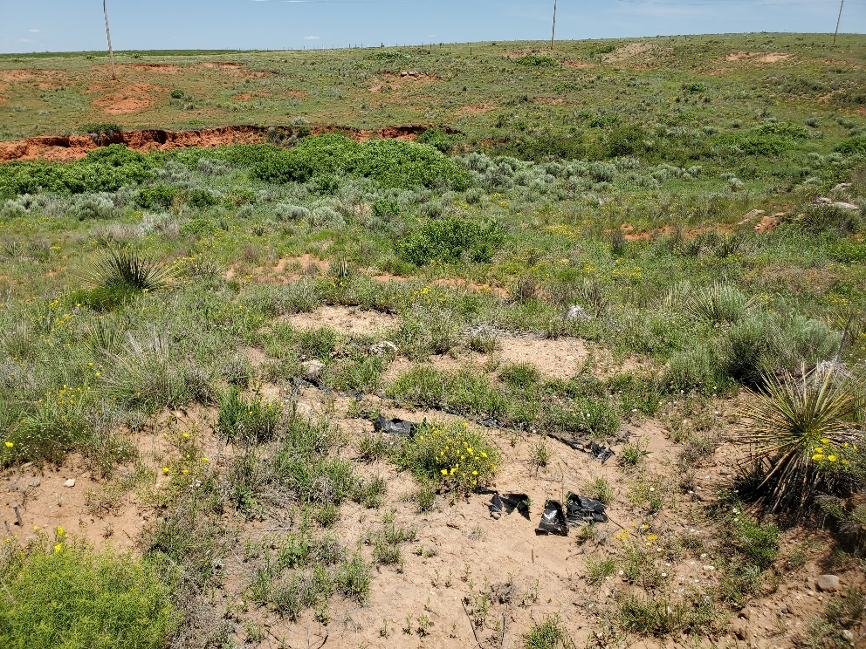
Figure 2-1: Ravenscroft, facing west (Taken by author)
The Oklahoma Forestry Service has designated this area as containing three major environment types: rolling sand plains, the Canadian/Cimarron high plains, and Canadian/Cimarron breaks (Figure 2-2) (Woods et al. 2005). The rolling sand plains are composed of intermixed sand dunes and sandy plains, with poor drainage (Oklahoma Forestry Service, accessed 2022). The Canadian/Cimarron high plains consist of level or rolling plains, seasonal playas and ephemeral streams spread throughout the landscape (Oklahoma Forestry Service, accessed 2022). Streams oftentimes cut into the landscape, creating larger floodplain areas that are lower than the surrounding terraces. The Canadian/Cimarron breaks are described as containing “canyons, hills, escarpments, buttes, and terraces” that are cut by rivers and dunes (Oklahoma Forestry Service, accessed 2022). Springs do exist in these areas, but modern day irrigation techniques have significantly damaged the underground water supply. As such, most streams in these areas are now ephemeral.
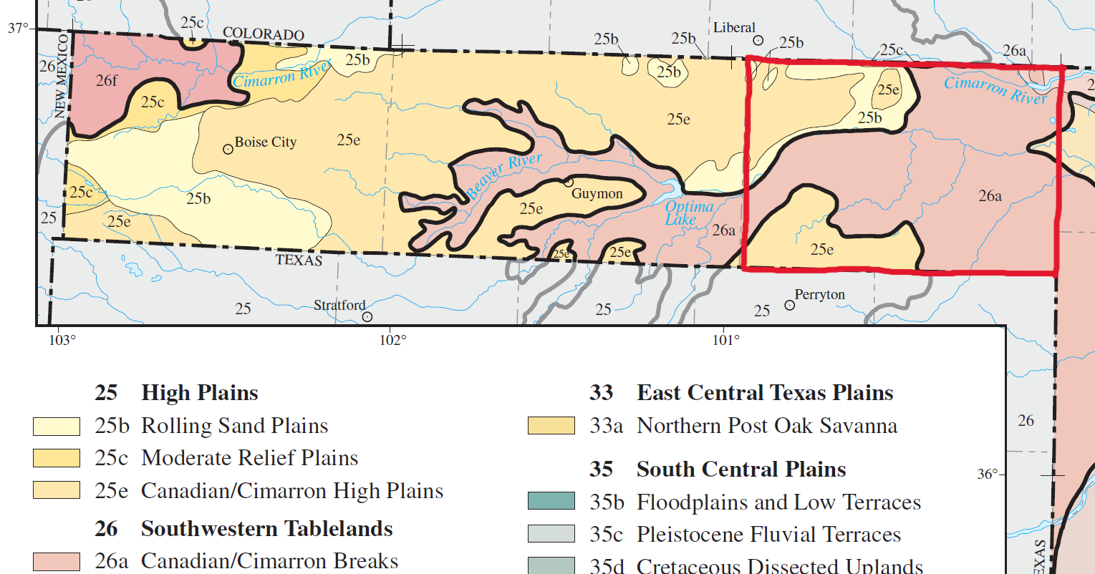
Figure 2-2: The relevant Ecoregions for Beaver County (outlined in red) including 25b) Rolling sand Plains, 25e) Canadian/Cimarron high Plains, and 26a) Canadian/Cimarron breaks (Woods et al. 2005)

Geology
Perhaps the most iconic feature of the southern High Plains are the “Permian red beds”, a layer of iron-rich red soil that was first laid down in the Permian age by an inland sea. These are largely sedimentary rocks, such as shale, sandstone, gypsum, and dolomite (USDA 1962; Brosowske and Bement 1998). The Cloud Chief formation, a large layer of crystalline gypsum, is also present within the red beds (USDA 1962). These red beds are often exposed in areas near streams, rivers, or tributaries, as is the case with Ravenscroft. Two other formations are common across this area, known as the Doxey and Ogallala Formations. The Doxey Formation, also known as the Quartermaster Formation, is composed of red-maroon shale, with siltstone and sandstone interspersed within (Johnson 1978). The Ogallala Formation is the most recent, composed of concreted Tertiary-age sand, gravel, silt, calcareous clay, and caliche (Oklahoma Forestry Service, accessed 2022).
The most recent soils have been deposited throughout the current Quaternary Age. These are sand, silt, and loess deposits that were originally deposited through alluvial activity, and more recently have been affected by eolian erosion (Oklahoma Forestry Service, accessed 2022, USDA 1962). Soil deposits tend to gather in playa basins, whereas flooding events have created arroyos leading from floodplains up into terraces. These arroyos typically expose the Permian red beds, and as such consist of very sandy and silty soil. Over the course of an extended period of time, arroyos will fill back up with soil due to aeolian, colluvial, and alluvial deposition, while areas in between arroyos form into arroyos themselves. This cycle repeats itself, with arroyos cutting and filling across the landscape as the climate fluctuates.

Climate
The southern High Plains have the benefit of experiencing extremes of all seasons and weather. It is far enough north that extreme cold and winter storm events are typical during the winter season, while remaining far enough south that the area still experiences extreme heat during the summer. Springtime brings extreme weather events such as large thunderstorms and tornados, while fall provides a temperamental shift of several frosts and warmer spells interspersed throughout. The interaction between warmer winds coming north from the Gulf of Mexico and cooler weathers coming south from the Northern Plains creates a system of strong winds that persist through most of the year (Johnson and Duchon 1994). Drought is a near constant issue throughout the southern Plains, and as such groundwater is an extremely important asset for residents of this area.
The annual precipitation in this area can vary from 43-56 centimeters, making this area semi-aridic, with some thermic and mesic areas interspersed throughout (Oklahoma Forestry Service, accessed 2022). The mean temperature in the wintertime varies between 18 °F – 46 °F, whereas the average temperature in the summer ranges between 64 °F – 95 °F. It is not uncommon to experience below freezing temperatures in the winter or temperatures exceeding 100 °F in the summer.

Hydrology
The primary rivers running through Beaver County include the Cimarron and Canadian rivers. However, the waterway most relevant to this thesis is the Beaver (Canadian) River and its tributary Bull Creek. Bull Creek, branching from the southern portion of the Beaver River, cuts through a series of terraces, revealing the Permian red beds, Tertiary-age alluvial debris, eolian-deposited sand and silt, and calcareous Ogallala deposits (Gustavson et al. 1991). Due to the semi-arid climate, most streams, springs, and even Bull Creek are ephemeral, and can dry up during times of extreme heat and/or drought. Due to the large amount of grass and thus cattle grazing/ranching in the area, water is in high demand. The majority of modern irrigation draws from the Ogallala aquifer, a vast underground source of freshwater, made up of runoff from the Rocky Mountains that filtered through the ground over millennia (Hornbeck and Keskin 2011). Due to persistent farming and ranching practices, the Ogallala aquifer has become dangerously depleted within recent years. Additionally, global warming has accelerated and worsened the cyclical droughts that take place within this area. These issues may lead to a more arid environment within the next few centuries.

Flora
Grasses flourish in this area, mainly due to the lack of appropriate environments for larger plants like trees. Some common grasses found throughout this area are blue grama (Bouteloua gracilis), buffalograss (Bouteloua dactyloides), sand dropseed (Sporobolus cryptandrus), sand bluestem (Andropogon hallii), sand sagebrush (Artemisia filifolia), little bluestem (Schizachyrium scoparium), wiregrass (Aristida stricta), hairy grama (Bouteloua hirsute), three awn (Aristida genus), and side-oats grama (Bouteloua curtipendula) (Oklahoma Forestry Service, accessed 2022). Trees are typically only found next to rivers, springs, or ephemeral streams, although with the modern-day depletion of the Ogallala aquifer many of these have dried up completely and the trees have died. Bushes and trees that are common to this area include cottonwood (Populus genus), juniper (Juniperus genus), hackberry (Celtis occidentalis), shrubby willows (Salix genus), mulberry (Morus genus), sand-hill plum (Prunus angustifolia), skunkbush (Navarretia squarrosa), and mesquite (Prosopis genus). Bushes and trees often have to compete with the invasive salt cedar (Tamarix genus), a tree that outcompetes many native tree and bush species. Salt cedars populate drastically faster and more efficiently than native species, therefore using up much more water and withholding water from other plant life. After death, the salt cedar salts the surrounding earth, thereby preventing other plants from growing within that area (USDA, accessed 2022).
Yucca (Yucca genus) and various cacti are also commonly found here, primarily the prickly pear cactus (Opuntia ficus-indica), cholla cacti (Cylindropuntia genus), and various species of barrel cacti (Ferocactus and Echinocactus genera) (Bruner 1931). Wildflowers such as basketflowers (Centaurea americana) or members of the Asteraceae family are also common across the landscape. The primary crop species grown in this region include grain sorghum (Sorghum bicolor) and winter wheat (Triticum aestivum), with grain sorghum used as feed for cattle grazing (Oklahoma Forestry Service, accessed 2022).

Fauna
Many species thrive in the semi-arid High Plains. The largest animals present within this area, although very uncommon, include black bear (Ursus americanus) and mountain lion (Puma concolor). Other animals include: coyotes (Canis latrans), bobcats (Lynx rufus), pronghorn (Antilocapra americana), white-tailed deer (Odocoileus virginianus), mule deer (Odocoileus hemionus), raccoon (Procyon lotor), opossum (Didelphus marsupialis), skunk (Mephitidae family), fox (Caninae subfamily), badger (Taxidea taxus), jackrabbits (Lepus californicus), cottontail rabbits (Sylvilagus genus), wild turkey (Meleagris gallopavo), prairie dogs (Cynomys genus), armadillo (Cingulata order), various other rodents (Rodentia order), domesticated cattle (Bos taurus), bison (Bison bison), peccaries (Pecari genus), turtle and tortoise species (Testudines order), snake species (Serpentes order), lizard species (Squamata order), bat species (Chiroptera order), and various bird species (Aves class) (Graham 1947).
Rodents and other burrowing species, such as rabbits or badgers, can cause great damage to sites through bioturbation. This is a common issue with sites located in the southern High Plains and is also present at the Ravenscroft site (Muhammad 2017). Due to the abundance of grass and lack of readily available water, ranching and game hunting make up a large amount of the activities in this region. Deer and pronghorn are typically the targets for hunters, while domesticated cattle take over the landscape. As such, many bison kill sites in this area have been located by hunters/landowners/collectors who have stumbled upon what they thought to be the remains of domesticated cattle (Personal correspondence, Dr. Leland Bement, 2021). Most modern-day bison exist on preserves and within fenced areas, so if bison bone is found, it is typically very old and likely belongs to a nearby site.

Paleoenvironment

Paleoclimate
Ravenscroft was utilized from approximately 9500 – 8800 RCYBP, placing it within the Pleistocene-Holocene transition (Larrick et al. 2019). The late Paleoindian period was a time of great environmental upheaval. Flora, fauna, and humans were adapting from the cooler and wetter environment of the Pleistocene to the warmer and drier climate of the Holocene. During the Pleistocene, what is now the Great Plains was primarily composed of a boreal and mixed forest, with some grassland, present only a small distance away from the Gulf coast (Bryant and Holloway 1985). From 15,000 YBP to 11,000 YBP, the boreal forest retreated north towards Canada, slowly being replaced by a grassland very similar to the one that exists today (Bryant and Holloway 1985). However, a brief cooling period during the Younger Dryas (12,000 YBP) halted the retreat of the forests and provided a brief return to cooler and wetter conditions (Arauza et al. 2016). By the time the first kill event occurred at Ravenscroft approximately 10,000 YBP, the Great Plains grasslands were well established. With the onset of the Holocene, aeolian erosion began to take over the area, creating sand dunes and inhibiting pedogenesis (Arauza et al. 2016). Temperature and aridic conditions continued to rise throughout the Holocene, leading to the modern-day cycle of droughts and more mesic conditions (Arauza et al. 2016).

Paleoflora
Due to the cyclical nature of the southern High Plains weather, the flora varied greatly over the course of the Pleistocene-Holocene transition. Before the Younger Dryas occurred, Arauza et al. (2016) determined from pollen sampling that the Bull Creek area was likely riparian, containing plants such as walnut (Juglans genus), willow (Salix genus), and cattails (Typha latifolia) (Bement et al. 2007). Conditions following this time appear to become drier, as members of the Asteraceae family (sunflower-related) seem to be less prevalent (Arauza et al. 2016, Bement et al. 2007). The end of the Younger Dryas signaled a return to wetter conditions, with more Asteraceae present and sediment showing high organic content as well as ripples in sediment from alluvial activity (Arauza et al. 2016, Bement et al. 2007). This cycle continued to occur throughout the Holocene, with alluvial deposition/erosion as the primary force during wet intervals, and aeolian deposition/erosion being more prevalent in the dry intervals (Arauza et al. 2016).
Phytolith testing at the nearby Bull Creek site revealed a relatively even ratio of C3 and C4 phytoliths from 11,000 – 8,7000 RCYBP (Bement et al. 2007a). C3 phytoliths come from grasses that thrive in cooler environments, whereas C4 phytoliths come from grasses that are found in warmer environments (Pau et al. 2013). These can vary across the landscape based on the season, such as C3 being more prevalent in the fall and winter and C4 being more prevalent in the spring and summer (Carlson and Bement 2014). Stratigraphic testing and radiocarbon dating further supported the generally stable environment of the Bull Creek area, with fall and winter being cooler and wetter while spring and summer were warmer and dryer (Bement et al. 2007a).

Paleofauna
A major shift in fauna occurred during the transition from the Pleistocene to the Holocene. Primary animals that existed in North America during the Pleistocene included many megafaunal species, such as mammoth (Mammathus columbi), mastodon (Mammut americanum), dire wolf (Canis dirus), American lion (Panthera atrox), sabertooth cat (Smilodon fatalis), bison (Bison latifrons/antiquus), ground sloth (Megatherium genus), short-faced bear (Arctodus simus), American cheetah (Miracinonyx trumani), horses (Equus occidentalis), and camels (Camelops genus) (Graham 1947). As conditions warmed and dried, many megafauna underwent a size reduction to compensate for the new environment or went extinct. Animals such as mammoth, mastodon, dire wolf, American lion, sabertooth cat, ground sloth, short-faced bear, American cheetah, horses, and camels all went extinct from the North American continent. The large bison of the Pleistocene were eventually replaced by smaller bison, and bison populations thrived and grew to massive proportions (Lewis et al. 2009). Ravenscroft contains Bison occidentalis, the species directly predating the modern bison species. However, as modern bison, B. occidentalis, and B. antiquus all have evidence of being ritually connected to Native Americans, it is important to outline the continuity of the species (Bement 1999, Wilson 2005). The extinction of other species versus the eventual success of bison may have led to increased supernatural beliefs attributed to bison, as they were comparatively able to outlast many species they once existed alongside.

The Evolution of the Bison Genus

Timeline of Bison Evolution and Similar Species
Bison have continuously held a ritual and religious space within Native American culture, as evidenced by the Cooper skull, Ravenscroft, and protohistoric documentation of the ritual behavior surrounding bison (Bement 1999, Wilson 2005). As such, it is important to outline the evolution of bison species, as it parallels the continued relationship between the Bison genus and humans. The Bison genus originated during the early Pleistocene in the Eurasian continent. Due to the cold environment, bison and other animals grew larger in order to better absorb and store energy. The additional weight and fat also served to keep these animals warm. Bison, a member of the Bovidae family, adapted well to northern climates, allowing them to make the journey across the tundra of the Beringian land bridge and into North America (McDonald 1981). Horns also grew larger and longer, as well as body hair, as a way to increase sexual suitability (McDonald 1981).
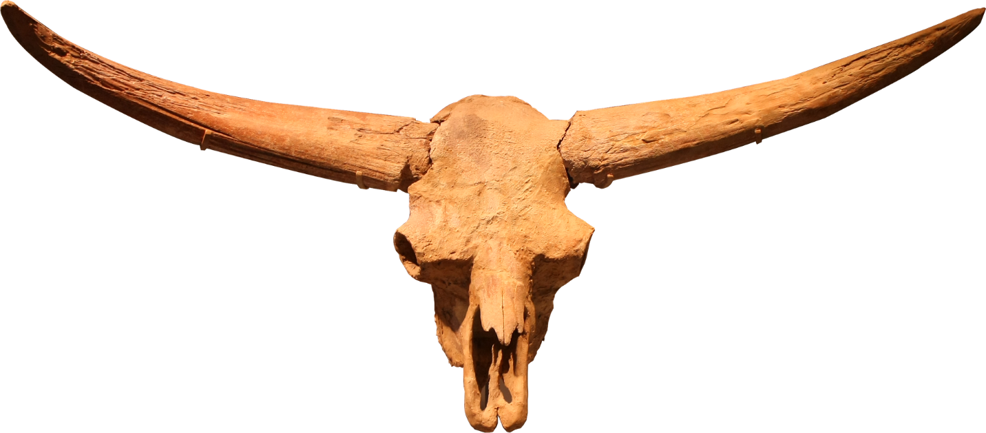
Figure 2-3: Skull of Bison latifrons (Image by Jessica Rockeman from Pixabay, accessed 2022)
Once bison had successfully migrated into North America, they diverged into two species: Bison latifrons and Bison antiquus. Bison latifrons are the largest species of bison to have ever existed on the North American continent (Figure 2-3). Their horns were longer and slenderer than any other bison species and could be as long as 1145 – 2235 mm (McDonald 1981). Latifrons lived in boreal and mixed forests across the continent, likely browsing and grazing ruminant-appropriate foods (McDonald 1981). This species was replaced by a smaller-bodied species during the late Pleistocene (McDonald 1981).
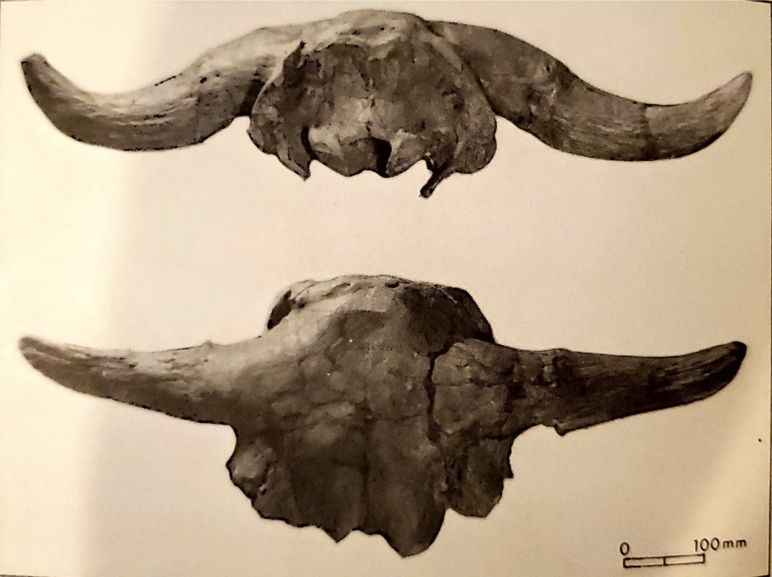
Figure 2-4: A male Bison antiquus skull from the Tedford Farm site in San Patricio, Texas (McDonald 1981)
Bison antiquus first appeared in the late Pleistocene and continued to the mid-Holocene (Figure 2-4). They preferred steppe and savanna environments and were much more widely dispersed across the whole of North America and into northern central America (McDonald 1981). B. antiquus was smaller than B. latifrons, and their horns were much shorter and less curved. Their horns were typically 765 – 1067 mm, almost half the size of B. latifrons horns (McDonald 1981). At approximately 11,000 YBP, B. antiquus made the evolution into B. occidentalis. Due to the importance of B. occidentalis in this thesis, it will be discussed separately in the section below.
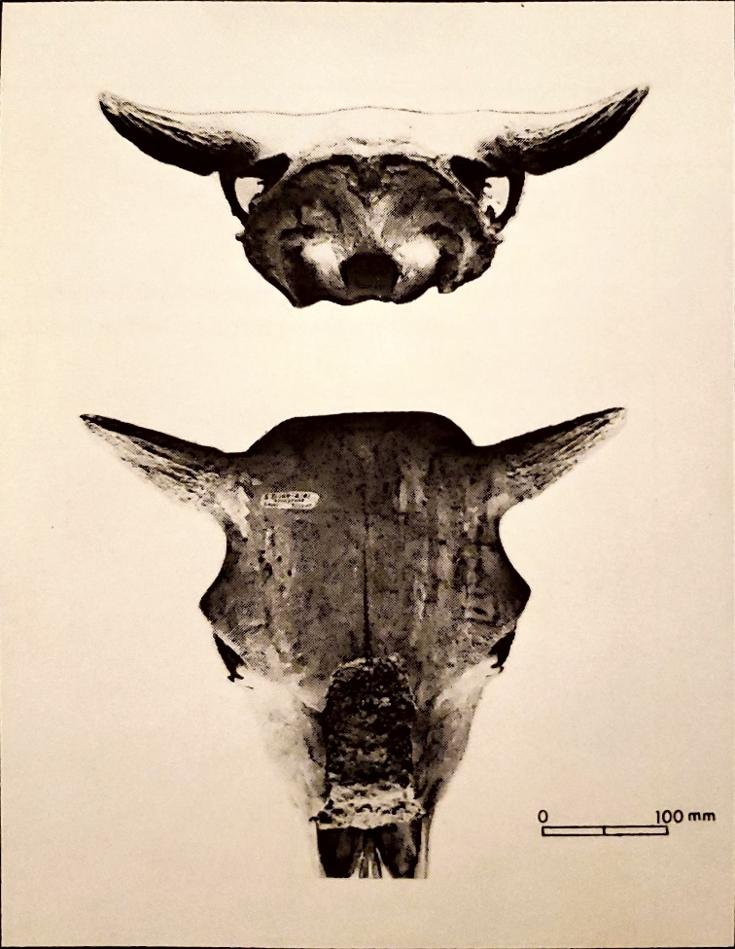
Figure 2-5: A female Bison bison skull from the Rocky Ford site in South Dakota (McDonald 1981)
Following the development and disbursement of Bison occidentalis, Bison bison emerged onto the North American continent (Figure 2-5). These are the modern species of bison that first appeared approximately 5,000 YBP and still exist today (McDonald 1981). These bison are the smallest of all bison species, although still extremely large compared to other North American herbivores and humans. Bison typically inhabit and are adapted to grasslands, making the Great Plains their preferred environment. Their remains are found throughout the Great Plains, from northern Canada all the way to southern Texas (McDonald 1981). Bison bison horns are shorter than all other bison species and are curved upwards at ~65° - 70° (McDonald 1981). Due to political efforts to rid Native Americans of a primary food source in the 1800s, bison were almost hunted to extinction by European-descended settlers paid by the U.S. government (Isenberg 2000). However, conservation practices and interbreeding with domesticated cattle have led to bison preserves and ranching becoming a saving grace for the species.

Discussion of Bison Occidentalis Features
Bison occidentalis is the particular species of bison found at the Ravenscroft site (Figure 2-6). This determination was originally made by Dr. Lee Bement (Personal Correspondence, 2021), and was further supported during my analysis of the skulls excavated from Ravenscroft. B. occidentalis was present in North America from approximately 11,000 YBP to 5,000 YBP (McDonald 1981). As the Ravenscroft site dates to approximately 10,000 YBP – 8,000 YBP, this places the site firmly into the period when Bison occidentalis were the primary bison species in the Americas.
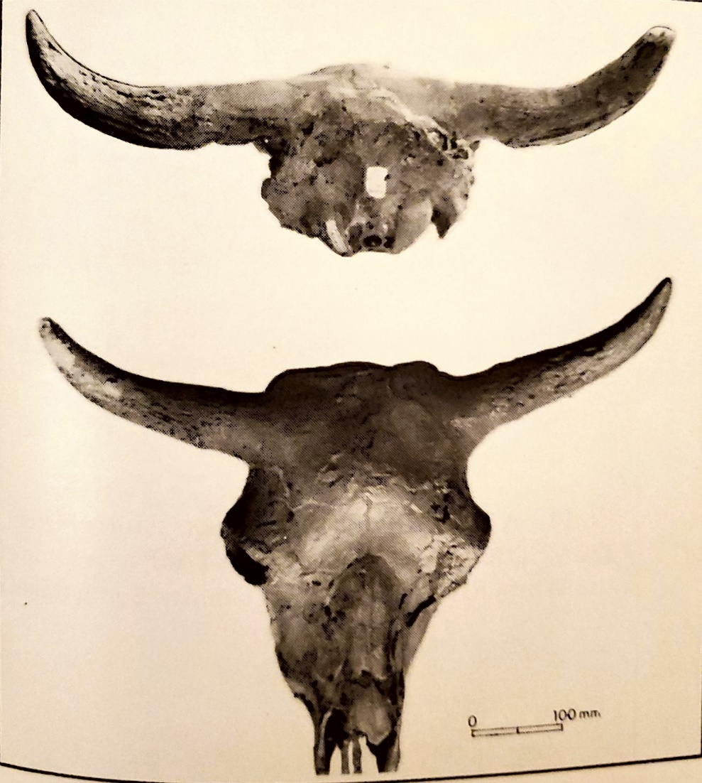
Figure 2-6: A female Bison occidentalis skull from the Scottsbluff site in Nebraska (McDonald 1981)
This species is smaller in size than B. latifrons and B. antiquus, but larger than the contemporary bison species. Their horns are short and compact but show great variability in orientation and angle of curve (McDonald 1981). They generally curved upward, but were less robust than other species, as was their skull overall (McDonald 1981). Because Bison occidentalis and Bison bison are so closely related, paleontologists and zooarchaeologists have the benefit of using modern bison as a way to predict B. occidentalis behavior and physical development.

Gestation, Maturation, and Migration
Modern bison typically experience their rutting season during the summer, carrying the fetuses for 9 months until the spring when they give birth (National Forest Foundation, accessed October 4, 2022). As such, archaeologists would expect to see fetal material present in fall or winter kills. It takes approximately four years for a bison to fully mature, at which time adult bulls (males) will split off into bachelor herds, while cows, calves, and juveniles will stay together (Carlson and Bement 2018). Modern bison experience a lifetime of 15-20 years (National Forest Foundation, accessed October 4, 2022). Assuming the same pattern of maturation and gestation holds true for past species of bison, this cycle can help determine the season of a kill based on the developmental stage of fetal remains.
Migration patterns can be determined through the use of stable isotopic analysis. All organic materials contain carbon, oftentimes in the form of C12, C13 or C14. These carbon isotopes can be passed on through food, making their way up through the food chain. Ruminants (grass eaters) such as bison eat grass containing carbon isotopes, which can then be traced back through the animal’s remains. Two types of grasses are prevalent on the Plains: C3 grasses and C4 grasses. C3 grasses prefer wet and cool environments, whereas C4 grasses are more common in warm and dry environments (Carlson and Bement 2018). As bison travel through different regions, the grass they feed upon may vary according to climatic differences. These differences are then passed along into the bison’s muscles, bone, and teeth. Isotopic analyses performed on the remains can therefore track a bison’s movement across the Plains, suggesting their presence in different areas according to different seasons. Isotopic analyses performed by Dr. Leland Bement and Dr. Kristen Carlson (2013) suggests that bison preferred to head east during the summer and fall, and west during the winter (Figure 2-7). Springs are typically spent in the foothills of the Rocky Mountains for calving (Carlson and Bement 2013). Ravenscroft is placed within the middle of this migration path, suggesting that it may have been a late winter kill as bison were moving from the east to the west across the northern portion of their migration path.
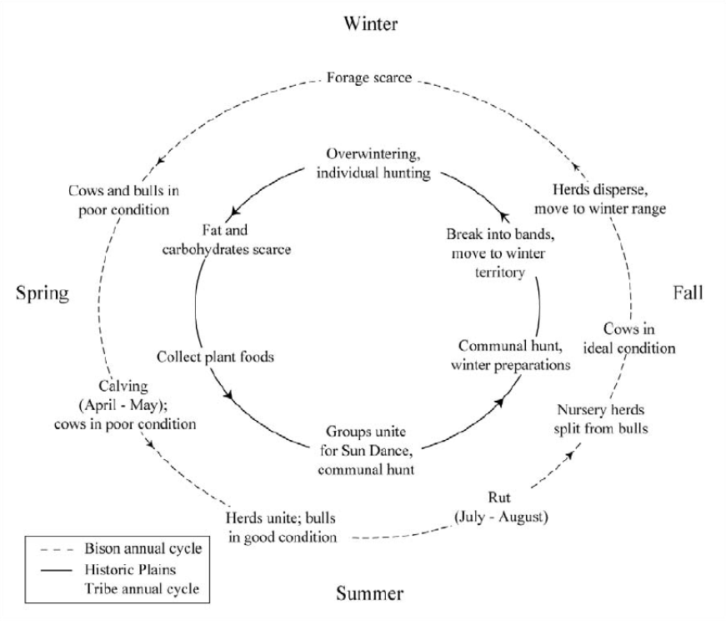
Figure 2-7: Bison yearly round as compared to historic Plains hunting cycle (Adapted by Carlson (2015) from Brink (2008), Cooper (2008), and Oliver(1962))

CHAPTER THREE: CULTURAL BACKGROUND OF PALEOINDIAN SOUTHERN PLAINS
This chapter focuses upon the cultural background most applicable to my research. Clovis and Folsom are included to illustrate and contextualize the cultural history of the area where Ravenscroft is located. Plainview is explored as it is the only technological culture that has been definitively tied to Ravenscroft so far. Due to the lack of other contemporaneous technological styles at the Ravenscroft site, type styles such as Hell Gap or the Cody Complex were excluded from this chapter. The transition from the Paleoindian to Archaic periods is touched upon in order to display the cultural continuity of bison hunting and ritualistic attributes that connect Paleoindians to their descendants, who still shared a religious connection with bison up through the contact period (Wilson 2005). Communal bison hunting is heavily focused upon, discussing the different forms that bison kills can take across the Plains. The different types of bison kills are important to explore, in that they show how religious belief and connection transcends practical boundaries of hunting and subsistence technique.

Paleoindian

Clovis
In the 1930s, a mammoth skeleton was discovered in a gravel pit near Portales, New Mexico (Haynes and Krasinski 1995). This attracted attention from archaeologists and collectors, who soon found a large projectile point in situ with mammoth and bison remains. This was only the second time that definitive proof of humans coexisting with Ice Age megafauna had been found. This particular projectile point was bifacial, lanceolate in shape, featured overshot flaking, and was fluted at the base. It became known as a Clovis point (Figure 3-1) (Frison 1998).
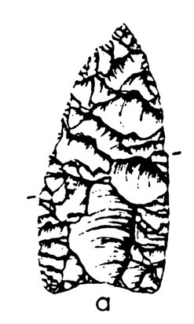
Figure 3-1: Clovis point (Frison 1998)
Clovis is the earliest defined technological culture that appears within the Americas. It dates to approximately 11,500 RCYBP – 10,900 RCYBP, placing it during the Paleoindian period (Waters and Stafford 2007). The Clovis toolkit contains Clovis points, bifacial knives, hammerstones, atlatls, darts, blades and blade cores, and bone rods (Bradley, Collins, and Hemmings 2010; Collins 1999). Due to the wide variety of locations that Clovis points are found in, this suggests that their toolkit was meant to be versatile and to fit multiple types of prey. While some mammoths were occasionally taken down by Paleoindians, it is unlikely that these large terrestrial mammals were their main prey choice. Rather, many flora and fauna were available to them as food sources, and as such Paleoindians were able to remain relatively unspecialized in terms of location and tools (Waguespack and Surovell, 2003).

Folsom
Folsom is defined as the technological culture following Clovis. The Folsom type site, also located in New Mexico, was originally discovered by an African American cowboy named George McJunkin in the 1920s, predating the discovery of the Clovis type site (Frison 1991). While McJunkin unfortunately never lived to see the importance of the Folsom site, American archaeologists felt shock waves when the presence of a Folsom point was discovered in situ with an extinct species of bison. Folsom has been dated to approximately 10,900 YBP – 10,200 YBP, placing it at the terminal Pleistocene/early Holocene (Meltzer 2006). During this time, substantial environmental changes occurred, as the Ice Age ended, and the earth warmed. Many species of megafauna went extinct, forcing Paleoindians to become further specialized in location, diet, and toolkits. Folsom projectile points are bifacial, lanceolate in shape, are smaller than Clovis points, and feature fluting the entire length of the point (Figure 3-2) (Flenniken 1978). Hammerstones, cores, scrapers, drills, atlatls, darts, and bifacial knives were all still part of the Folsom toolkit.
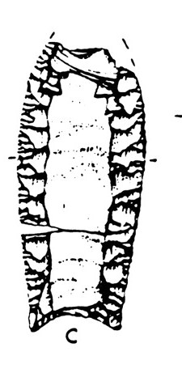
Figure 3-2: Folsom point (Frison 1998)
Folsom is also typically associated with bison kill sites, suggesting to many archaeologists that bison became the central prey choice for Paleoindians during this time (Meltzer 2006). Many arroyo bison kill sites and cliff jumps have been dated to either Folsom or the Late Paleoindian period, further supporting this idea (Sellet 2018). Additionally, bison hunting may have been an important factor in socialization and cultural interaction. These large-scale kills may have been communal hunts, requiring multiple groups to participate (Carlson and Bement 2012). The first signs of ritual associated with bison hunting emerges during this time in the form of a painted bison skull (Bement 1999, 2003).
The drastic change in game animals and populations forced humans to adapt to new hunting targets and techniques. Paleoindians who lived during the Clovis technological age had the benefit of many more varied species being present within the Great Plains area, as well as increased access to water. Their diet was likely very broad, only occasionally targeting large-scale animals like mammoth. As conditions dried and species went extinct, hunting technology adapted. Bison were targeted, and special hunting techniques were developed to specifically target this prey species. As such, they became an extremely important part of life for Native peoples, a relationship that continues into modern day.

Late Paleoindian

Plainview
Plainview is a projectile point type dated to approximately 10,000 YBP – 9,000 YBP, first discovered at a bison kill site in the Texas High Plains (Holliday et al. 2017). Plainview can be found across the Plains, but is frequently identified as Goshen, Midland, or Plainview due to overlapping technological characteristics for these typologies (Haynes and Hill 2017). Goshen and Midland are frequently identified upon bison kill sites in the Northern Plains, whereas Plainview is more commonly associated with bison kill sites in the Southern Plains (Haynes and Hill 2017). These points are bifacial, lanceolate in shape, have concave bases, and feature basal thinning and grinding (Figure 3-3). Importantly, they are not fluted. These points are often associated with bison kill sites, including Ravenscroft and Bull Creek (Muhammad 2017; Carlson and Bement 2017). As such, it is the most relevant projectile point type to this thesis.

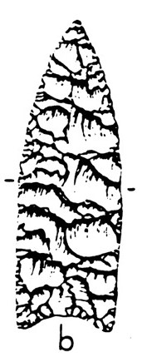
Figure 3-3: Plainview point (Frison 1998)

Transition from the Paleoindian Period to the Archaic Period
Ravenscroft has been firmly dated to the Late Paleoindian Period and as such I chose to focus upon the Paleoindian Period within this chapter. The transition from the Paleoindian to the Archaic is primarily marked by a gradual shift in climate. At approximately 7500 YBP, the Altithermal, a warming period, began (Bement and Brosowske 2001). Technology and culture diversified, and more distinct technological typologies with emphasis on a diversified toolkit and notched projectile points are identified to the Archaic Period (Bement and Carmichael 2003). Indigenous peoples became more sedentary, transitioning to a partially sedentary and partially nomadic lifestyle (Bement and Brosowske 2001). With the rise of plant utilization, ground stone technologies became more prevalent within sites. Bison were still heavily utilized, and the exploitation of arroyo traps and cliff jumps continued (Kornfeld and Larson 2007). Additionally, population increased, and is reflected within the size of sites (Carlson, Domeischel, and Bement 2013).

Communal Bison Hunting

Transition to Bison
Throughout the terminal Pleistocene, Younger Dryas, and early Holocene, the environment and animal populations underwent a drastic transition. Forests receded, giving way to grasses that thrived throughout the region we now know as the Great Plains. Bison, ruminants that depend on grass species, began to expand throughout the plains region and their population blossomed (Meltzer 1999). Clovis technology, geared towards a broader array of large prey animals, was no longer equipped for the smaller and less varied available prey choices. Bison exploitation took over the subsistence practices of Folsom peoples, and the exploitation of bison continued for millennia up through the contact period (Bement and Carlson 2012; Lewis et al. 2010).

Communal Hunting
Communal hunting is the practice of several distinct social groups gathering and participating in the same hunting events. Evidence for this is largely drawn from ethnological examples during the protohistoric period, and from the presence of multiple lithic types and styles at the same site within the same kill event (Carlson and Bement 2012). Communal events were common during the winter, making them particularly applicable to Ravenscroft (Bamforth 1991; Frison 1982).
The vast scale of many of these bison kills also suggests a communal aspect. A size of 50-100 bison was a typical number for prey herds, indicating the need for a group of hunters larger than normal (Gorman 1972). Bement (2003) states that bison kills where more than 5 bison were killed indicates the need for multiple family groups to participate in the kill. The required amount of planning and preparation also indicates a group composed of more than a single family group, as the necessary tools for hunting and processing the bison would need to be prepared beforehand (Bamforth 2011). The number of bison actually butchered from each event could also support multiple groups of people aggregated to conduct a communal kill.
Due to the large size (greater than 5 bison) and repeated use of Ravenscroft, it was likely utilized by a large social group (multiple families) (Bement 2003). This indicates that the large social group may have also been participating in the ritualized stacking of skulls as communal ritual. Ritual and religion serve to connect members of a society through similar beliefs and can also help to organize or assist aspects of a culture (Bowen 2017). Ethnographically, many Plains groups had an immense history of a ritual and religious connection with bison, and artifacts such as bison effigies have been found indicating these beliefs reach far back into prehistory (Verbicky-Todd 1984, Dawe 2021). Most importantly, the emphasis placed upon bison within a people group can act as a social identifier. Specific beliefs held about bison or certain rituals, i.e. skull stacking, could symbolize the larger groups connection to bison and the relationship between each of the smaller groups (Verbicky-Todd 1984). Evaluating examples of this type of communal hunting behavior can help to better determine the purpose of the Ravenscroft stacked skulls.

Arroyo Traps
Arroyo traps, like that at Ravenscroft, were one of the primary hunting techniques used to hunt bison in the Late Paleoindian period. Arroyos are narrow canyons formed in sedimentary rock through flooding events and aeolian erosion (Figure 3-4). Paleoindians would drive herds of bison into an arroyo. Other Paleoindians would stand above along the edge of the arroyo, and rain spears down upon the bison. This would cause the bison to panic, attempt to turn and run out of the arroyo, and stampede. Some bison would be struck by projectile points and die, while others would be trampled by their fellow bison. This technique was extremely efficient, killing hundreds of bison at a time (Frison 2004). Oftentimes, only a few bison on the surface of the arroyo would be butchered, leaving many bison to rot (Wheat 1972).
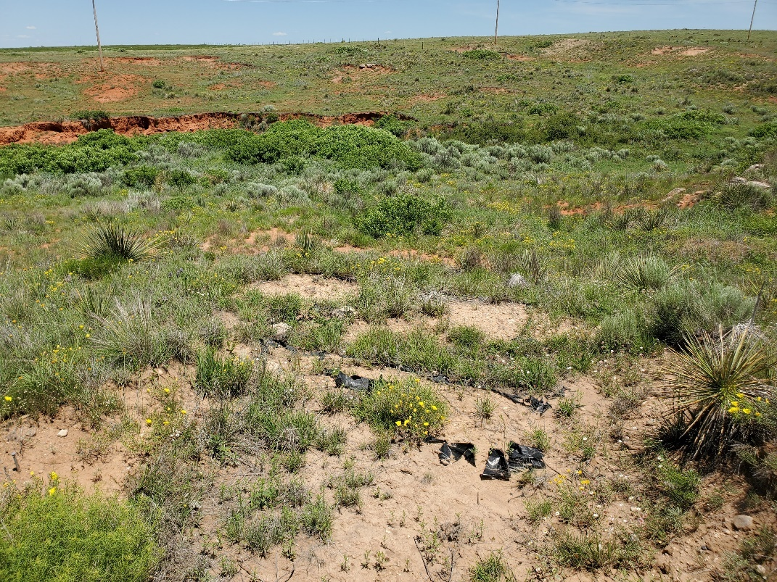
Figure 3-4: Picture taken from above RAV I bone bed, facing west. Modern arroyo cut visible as a line of bright red soil.
Many bison kill sites are found within buried arroyos, that have filled with sediment over time and are just recently eroding again. Arroyo traps are most common on the southern Plains, where sandy soil and flash flooding events create the perfect environment for the formation of arroyos (Carlson and Bement 2012). Bison bones are noticed eroding out of terrace walls and are frequently mistaken for cow bone. Using radiocarbon dating, stable isotope analysis, and taphonomic analysis, the age, migration patterns, and herd composition can all be determined (Figure 3-5). Cow/calf herds are most commonly targeted, and the kills usually align with the migrational positioning of the bison at that time (Carlson and Bement 2012).
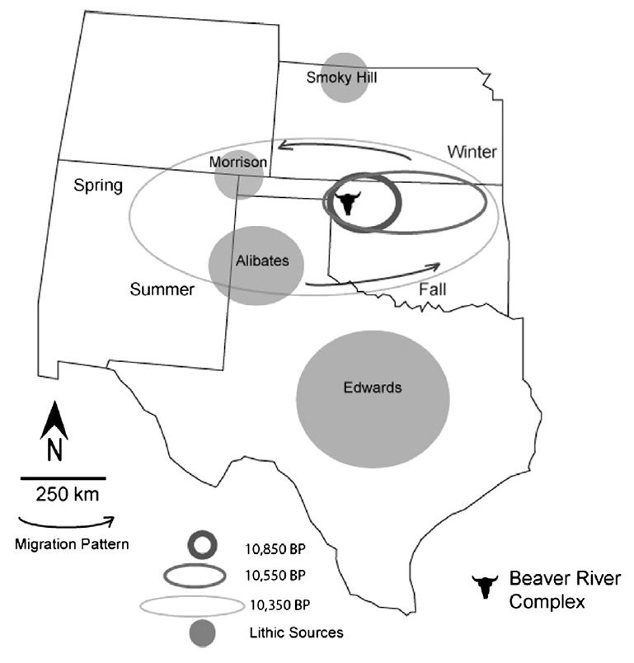
Figure 3-5: The migration patterns of bison based on stable isotopic analysis on the Beaver River complex. The bison skull marks an area where all lithic types have been located, bison were present during late summer/early fall, and arroyos are present (Carlson and Bement 2012)

Cliff Jumps/Drive Lanes
Drive lanes and cliff jumps are primarily found in the Northern Plains, where groups of Paleoindians would gather together to carry out large-scale hunts. Suitable cliffs would be identified beforehand, and cairns marking the drive lane would be stacked along the desired path (Figure 3-6). Paleoindians would find a bison herd in a grazing area and spook them into stampeding. They would then use a combination of the drive lanes and other group members to guide the bison towards the cliff, and eventually driving them off the edge and to their deaths (Carlson and Bement 2012). Upwards of 100 animals, or occasionally even more, would be killed in these activities (Carlson and Bement 2012; Frison 1978). Paleoindians would then butcher the required animals, leaving the rest for scavengers and other predators. This hunting technique requires extensive knowledge of the landscape and planning before the hunt can begin. Additionally, it requires more preparation than arroyo traps, as cairns must be along the route to guide the animals from grazing grounds to an obscure cliff edge (Carlson 2011).

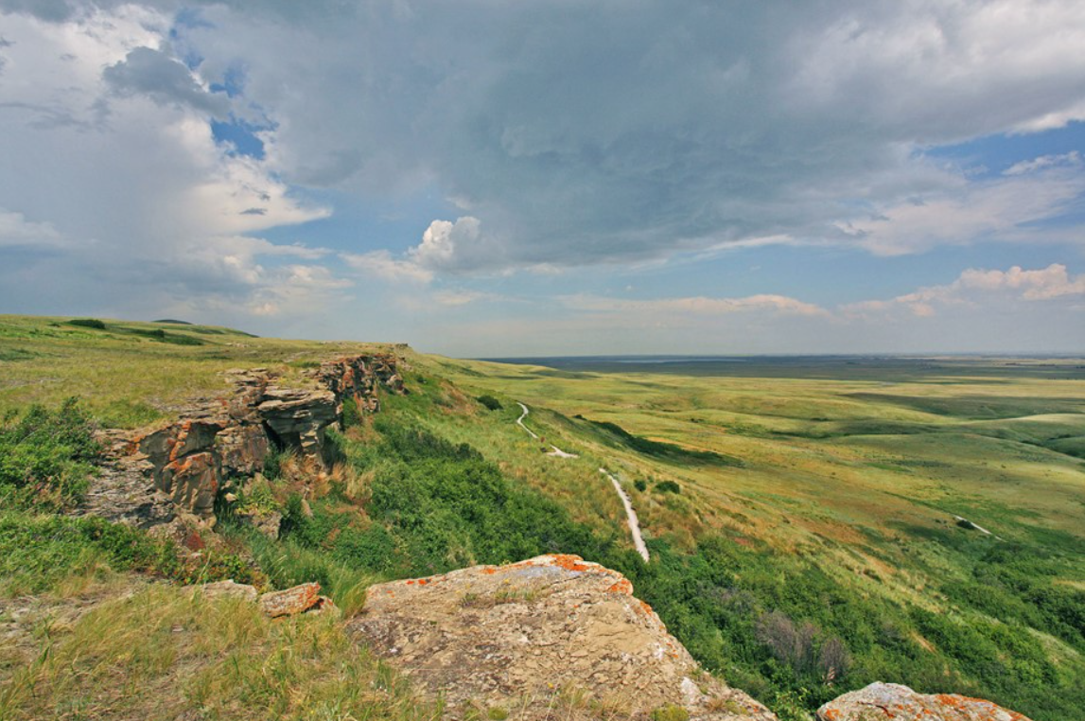
Figure 3-6: View of Head-Smashed-In cliff jump (Head-Smashed-In Buffalo Jump World Heritage Site, accessed Oct. 25, 2022)

CHAPTER FOUR: SITE OVERVIEW
As my research is focused upon a very specific aspect of the Ravenscroft site, a chapter devoted to outlining all information already known is necessary. I begin by stating the process of discovery and excavations that have occurred since the site’s discovery, beginning in 2007 and ending in 2019. Following the most recent excavations in 2019, a poster was presented at the annual Society of American Archaeology conference, centered upon the preliminary analysis of the skulls that my thesis is studying. In 2017, a thesis was published by Faisal Muhammad, presenting the initial taphonomic and cultural analysis of the Ravenscroft site. In 2021, another thesis was published by Dakota Larrick, centered upon a landscape study of the entire Bull Creek area. Following this, I explore the nearby site of Bull Creek, what was found there, and why it may be applicable to the study of Ravenscroft. Finally, I summarize the findings that have currently been made at Ravenscroft, including radiocarbon dates, faunal analysis results, and lithic analysis results.

Initial Excavations
Ravenscroft was first discovered in 2007 in the way that most bison kill sites are found; collectors noticed bison remains eroding out of an arroyo (Figure 4-1). From 2008-2019, multiple excavations were carried out, led by Dr. Leland Bement. Initially, a profile was cut into the exposed area, revealing an arroyo filled with bison bones. A 3x4 m area was then excavated, further uncovering the remains of five butchered bison and some lithic flakes (Muhammad 2017). This first arroyo kill component was named RAV I and yielded three radiocarbon dates for three separate kill events: 7380 ± 50 RCYBP, 8730 ± 20 RCYBP, and 9090 ± 30 RCYBP (Larrick 2021, Muhammad 2017). Geoarchaeological testing was performed to determine the boundaries of the kill site, revealing another 10 m x 2 m area that remained buried (Larrick 2021).
Figure 4-1: Location of Ravenscroft (Larrick et al. 2019)
The following year another excavation was performed as part of the 2009 University of Oklahoma archaeological field school run by Dr. Leland Bement. Five more bison were uncovered, including a 6 month old fetal calf (Figure 4-2). The total MNI of RAV I at this point was ten (Larrick 2021). The presence of a fetal calf indicated that this kill took place during the winter, as evidenced through the mating patterns of modern bison (Berger and Cunningham 1994). Additionally, this also indicates that a cow/calf herd was targeted for this kill, a common practice amongst Paleoindian bison hunters (Larrick 2021). Weathering was extensive, featuring effects such as root etching and rodent gnawing. A second arroyo was also discovered during this process, approximately 10 m east of RAV I (Muhammad 2017). This second component was named RAV II and became the focus for all future excavations.
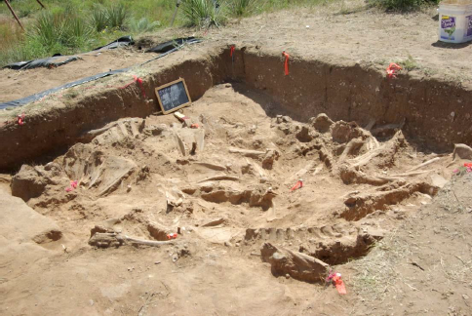
Figure 4-2: The exposed bonebed during the 2009 excavation (Larrick 2021)
Another University of Oklahoma archaeological field school was conducted at the RAV II site in 2013 (Larrick 2021). A profile was cut, extending from the 2009 excavation by another five m and 20 cm across (Larrick 2021) (Figure 4-3). This trench further supported ground penetrating radar, gradiometer, and resistivity imaging in establishing the 5 m x 9 m area that represented the arroyo of RAV II. Based on this data, a 3 m x 3 m area was exposed, along with 5 m x 0.5 m extensions to the trench (Larrick 2021) (Figure 4-4). 500 bison bones were collected, and in combination with the following excavation in 2015 established an MNI of 10 bison (Larrick 2021).
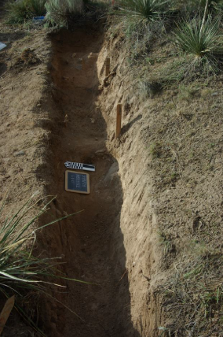
Figure 4-3: Trench opened at RAV II during the 2013 excavation (Muhammad 2017)
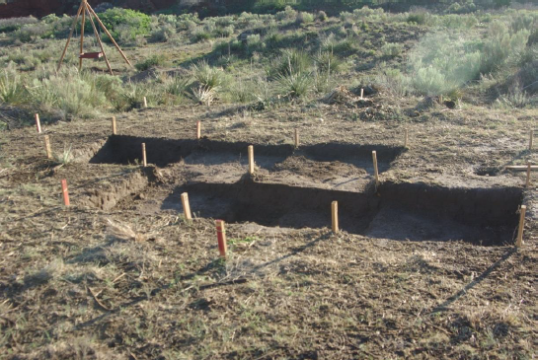
Figure 4-4: Units excavated during the 2013 field school (Muhammad 2017)
A joint field school was conducted on site in 2015, led by Dr. Kristen Carlson at Augustana University and Dr. Lee Bement at the University of Oklahoma. The trench was extended south by 50 cm and the main excavation block was extended 2 m east (Muhammad 2017) (Figure 4-5). An additional 173 bison bones were collected and analyzed, and in combination with the previous 2013 excavation raised the MNI of RAV II to 10 bison (Muhammad 2017). Faisal Muhammad determined in his 2017 thesis that the overall kill event likely consisted of 80-100 animals, and only a small portion had been uncovered so far. The 2015 excavation also discovered a freshwater mussel shell knife, and a projectile point made of Dakota Quartzite (Muhammad 2017).
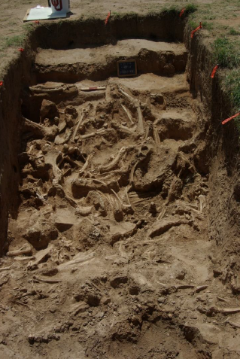
Figure 4-5: RAV II units opened during 2015 field school (Muhammad 2017)
Some bones from the 2015 and 2016 field seasons were left exposed and were not removed until 2017. The next excavation of Ravenscroft did not occur until 2019. Bones from all excavations up to 2019 exhibited differential weathering patterns, root etching, spiral fractures, and one cut mark.

2019 Excavation
In 2019, another field school through the University of Oklahoma and taught by Dr. Bement took place at Ravenscroft. The profile trench was extended further west and led to the discovery of 15 bison skulls stacked into two vertical piles (Larrick 2021). 11 skulls were found in one pile at the western edge of the arroyo mouth, and the remaining four were located in a pile on the eastern edge of the arroyo mouth (Figure 4-6). 8 skulls have been radiocarbon dated to a variety of dates, ranging from approximately 9000 YBP to 9200 YBP (Table 7-2). The majority of these dates align with that of the middle kill event in RAV II, but the uppermost skull dates to the lower kill event in RAV I. Additionally, while some of the mandibles were missing, not all skulls had their mandibles removed. This may suggest that tongue harvesting/butchering was not the primary purpose of these piles. Additionally, the crania were completely intact and lacked any evidence of an attempt to remove the brains, further complicating the reason for the stacks (Figure 4-7).

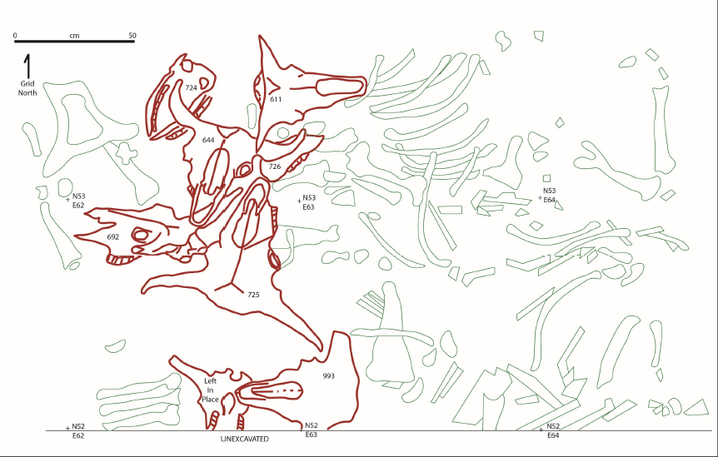
Figure 4-6: Map of skulls (red) surrounded by other bones (green) prior to 2019 excavation (Larrick et al. 2019)
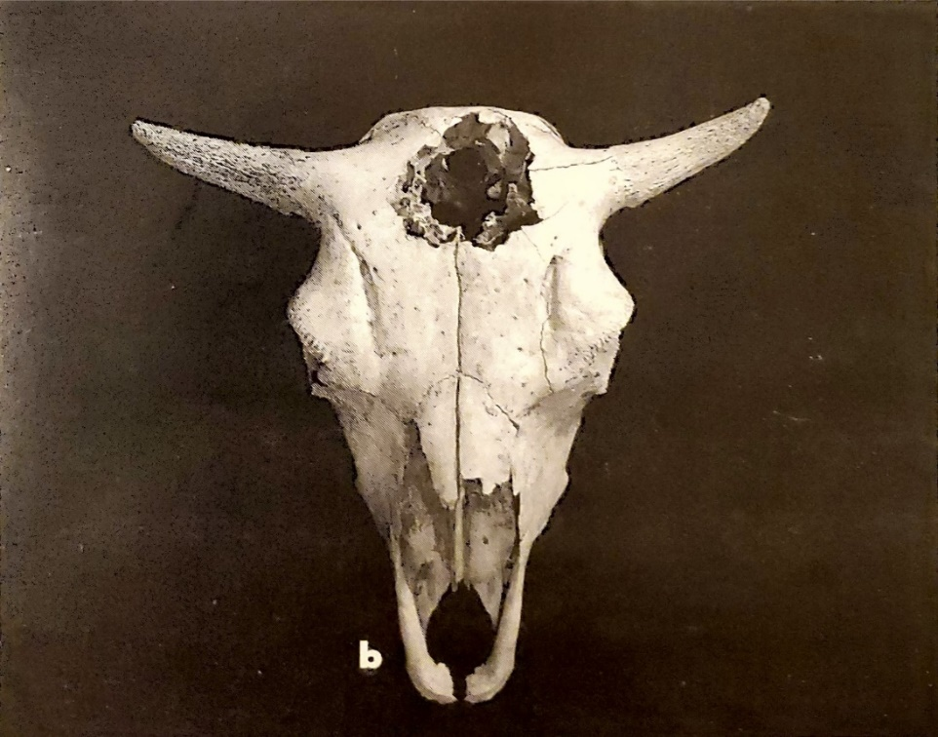
Figure 4-7: An example of “crushing” to remove the brain. A female bison skull from the Glenrock Bison Jump (Frison 1991)
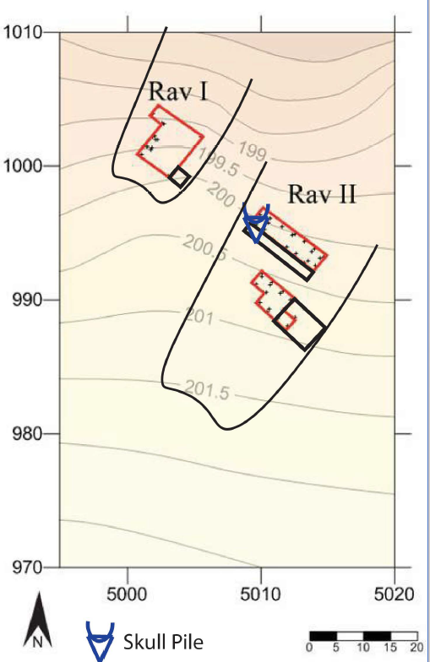
Figure 4-8: Map showing the location of each RAV arroyo, the excavation units, and the skull pile (Larrick et al. 2019)
In 2019, a poster entitled “Discard, Stockpile, or Commemorative Cairn? Interpreting the Bison Skull Pile at the Ravenscroft Late Paleoindian Bison Kill, Oklahoma Panhandle”, was presented at the annual Society for American Archaeology meeting in Albuquerque, NM. Authored by Dakota Larrick, Dr. Kristen Carlson, and Dr. Bement (2019), this poster was the first presented piece to focus upon the bison skull pile specifically, touching upon each potential explanation possible. These explanations included: discard, stockpiling for future use, a commemorative cairn, or a form of Plains ritualism known as “bison calling” (Larrick et al. 2019).
Two previous theses have been written concerning Ravenscroft, with the first being most applicable to my own reseearch. The first was written by Muhammad Faisal in 2017 and focused upon determining whether the site fit the winter kill model. In order to determine this, Muhammad (2017) sent out for radiocarbon dates, dating the site to the late Paleoindian period between 10,000 RCYBP – 8,000 RCYBP. His thesis only included bones from the excavations prior to 2016, as not all remains had been processed and analyzed by that time. He focused heavily upon taphonomic analysis, providing important information about weathering, butchering, and seasonality. Bones were variably weathered, with some suggesting a rapid burial and others nearby exhibiting a much greater rate of decay. This suggests that the remains were unevenly buried at different times. Additionally, root etching was identified as a serious problem. One cut mark was found on a distal tibia, and the lack of subsequent cut marks was attributed to the dulling of knives associated with cutting bone (Johnson and Bement 2009). Spiral fracturing was also found on 25 bones. The presence of fetal remains indicated a winter seasonality, due to the mating patterns of modern-day bison. Muhammad (2017) also focused on lithic analysis, analyzing the one projectile point found within RAV II.

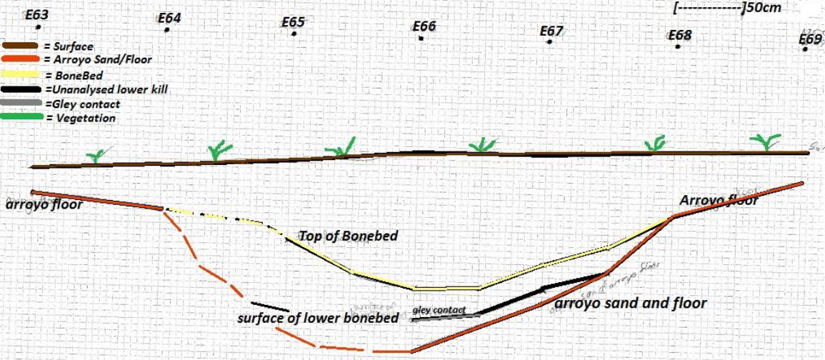
Figure 4-9: RAV II Profile map, drawn by Dakota Larrick in 2017
Based on the taphonomic analysis, butchering evidence, lithic analysis, and radiocarbon dates, Muhammad (2017) concluded that RAV II did indeed fit the winter kill model. Due to the likely large size of the kill site, he hypothesized that these kills were carried out by large social groups. The projectile point found within the site was attributed as either a Frederick/Allen or Plainview type, associating the perpetrators of this kill with those technological cultures. The second previous thesis to be focused upon Ravenscroft is that of Dakota Larrick’s 2021 thesis entitled “Interpreting Land-Use During the Late Paleoindian Bull Creek Occupation on the Southern Plains.” The focus of her thesis was to analyze both Ravenscroft and its neighboring site Bull Creek in order to form a land-use model for the area. The most applicable portion of Larrick’s (2021) research to my own lied in her interpretation of the Bull Creek valley as an extremely successful and plentiful place to reside, and as such groups kept returning to this area for centuries. This supports the continued use of Ravenscroft for over 300 years, as proven by the returned radiocarbon dates in Table 7-2 (See Chapter 7: Results).

Bull Creek
Bull Creek (34BV176) provides an example of a campsite that goes along with the Ravenscroft bison kill site. There are likely many other bison kill, processing, and camp sites similar to both Bull Creek and Ravenscroft nearby, but as these sites are all located on private land, they have not yet been analyzed (Conley 2010, Larrick 2021). This is based upon the high frequency of arroyos in the area, the advantageous and successful environment created by the Bull Creek Valley, and GPR surveys (Conley 2010, Larrick 2021). Bull Creek is located less than 3 km north of Ravenscroft and shares many cultural and environmental similarities with the Ravenscroft site. Bull Creek contains at least four occupations, dating between ~11,588 ± 35 RCYBP – ~9,020 ± 35 RCYBP, consistent with the Paleoindian period (Bement et al. 2022, Larrick 2021). These occupations vary between winter and summer, with bison being primarily sourced in the winter while a much wider variety of subsistence sources were utilized in the summer (Larrick 2021). A late Archaic component has also been found at the site, dating to ~1786 ± 24 RCYBP (Bement et al. 2020b). Larrick (2021) describes 3500 artifacts, eleven postholes, and twelve features located within the site, with the presence of 26 different animal species and multiple plant species found.

Summary of Findings
Radiocarbon dates at Ravenscroft, combined with stratigraphic sequences, have concluded that there were at least five separate kill episodes within the two arroyos. RAV I returned radiocarbon dates of ~8925 ± 30 RCYBP and ~9075 ± 30 RCYBP (Bement et al. 2012). RAV II returned radiocarbon dates of ~9210 ± 30 RCYBP and ~9340 ± 30 RCYBP. (Muhammad 2017). The first kill event in RAV II does not contain enough collagen and has not produced a successful radiocarbon date (Muhammad 2017). These dates are consistent with the late Paleoindian period (Bement et al. 2012). The first radiocarbon date from RAV I was taken from a portion of eroded bone, whereas all other dates were sourced from petrous bones. Because of the dense nature of the petrous, these dates are likely much more accurate and more dependable (See Chapter 7: Results).
RAV I | Kill 2 | 8925 | ± | 30
RAV I | Kill 1 | 9075 | ± | 30
RAV II | Kill 3 | 9210 | ± | 30
RAV II | Kill 2 | 9340 | ± | 30
RAV II | Kill 1 | Undated

Table 4-1: The dates of kill events within RAV I and RAV II. These were determined by a mixture of radiocarbon dating, stratigraphic analysis, and taphonomic analysis (Bement et al. 2012, Larrick et al. 2019, Muhammad 2017)
A total of 673 bones were found prior to the 2016-2019 seasons. Among these bones were articulated halves, disarticulated mandibles, skulls with vertebrae attached, articulated lower limbs, and other disarticulated elements (Muhammad 2017). As mentioned earlier, weathering varied between bones, suggesting that some were exposed while others nearby were not. The superimposition of non-weathered bone above weathered bones aided in identifying the number of kill episodes in the arroyos. Rodent gnawing and root etching were common among bone deterioration. One distal tibia exhibited cut marks, and 25 bones (femurs, tibias, humerii, radii, metatarsals, metacarpals, ribs, scapulae, pelvis) had spiral fractures, indicating they were broken while still green (fresh) (Muhammad 2017). Bison gestation typically occurs from September to May, with calves being born during the spring (Borgreen 2010). Due to the presence of a 6-7 month old fetus, Ravenscroft was determined to be a winter kill site. Additionally, most members of this particular herd were either cows or calves, indicating a preference for cow/calf herds common for late Paleoindian bison kills on the Plains. The bison butchering sequence resulted in front halves and hind halves, with bison cut at mid-torso (Larrick 2021).
Eleven bison skulls were found stacked at the western edge of the arroyo mouth, and 4 stacked on the eastern edge of the arroyo mouth. The majority were missing mandibles, but at least one skull retained theirs, suggesting that perhaps the retrieval of the tongue was not a primary factor in why these skulls were stacked. Furthermore, even if the skulls were partially butchered for their tongues, it is highly abnormal that they would then be stacked vertically. Additionally, OFT and HBE theories (See Chapter 5: Theory) dictate that Native Americans would attempt to get as much use as possible out of the skulls before discarding them. The skulls also dated to several kill events of RAV II, with the exception of the uppermost skull which dated to the kill events in RAV I (Larrick 2021). None of the crania exhibited crushing of the frontal area, implying that they were not stacked for the purpose of later removing their brains (Larrick 2021).
Muhammad (2017) conducted lithic analysis on the single projectile point and four flakes found at Ravenscroft. The projectile point was made of Dakota Quartzite, a material that can be sourced from the far western portion of the Oklahoma panhandle (Figure 4-10).
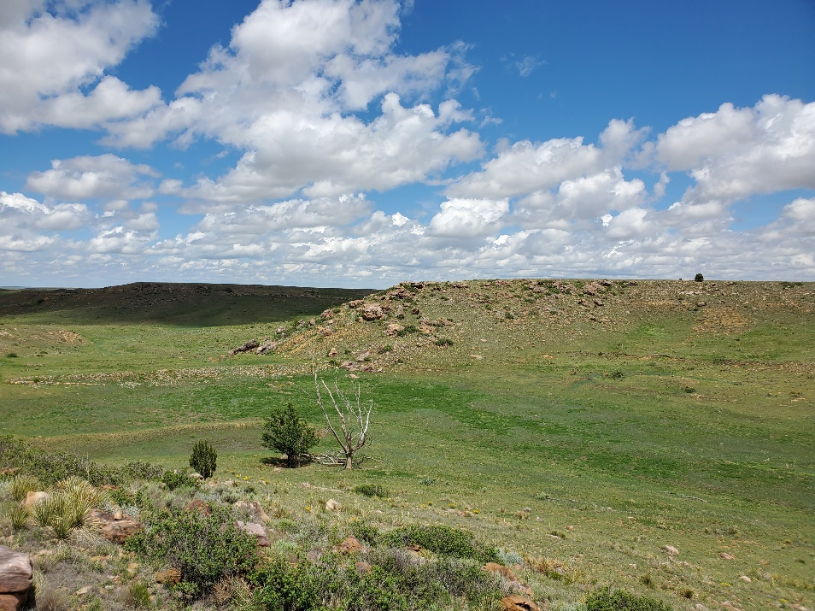
Figure 4-10: Location of Dakota Quartzite quarry (Taken by author, 2021)
It also likely belongs to either the Plainview lithic typology or the Frederick/Allen lithic typology (Figure 4-11) (Muhammad 2017).
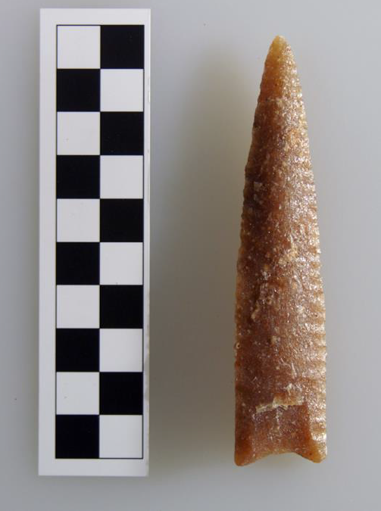
Figure 4-11: Dakota quartzite point recovered from RAV II (Muhammad 2017)

Three of the flakes found at RAV II were made of Alibates chert, while the other was Dakota Quartzite (Muhammad 2017). Muhammad (2017) also determined that three of the flakes were portions of a unifacial knife that featured wear on their edges. The remaining flake was likely discarded during the resharpening process of a lithic tool (Larrick 2021). Larrick (2021) also states that projectile point edge and basal fragments were found within RAV II. Six flakes were found at RAV I, composed of Alibates, quartzite, and white chert (Bement et al. 2012).

CHAPTER FIVE: THEORY
Due to the anomalous nature of the Ravenscroft skull stack, a traditional subsistence framework including Optimal Foraging Theory and Human Behavioral Ecology allowed me to determine that the bison skulls were ritualistic in nature. The focus placed upon predictable and logical subsistence behaviors within these theories does not typically allow for interpretation of behaviors that are not ecologically oriented or driven. If the skulls are the result of discard activity related to butchering and processing decisions, then the skulls should be from a single kill event and display cutmarks related to dismemberment and skinning, bashing to gain access to the brain case to remove the brain, and mandible manipulation to remove the tongue. If the skull pile is the result of stockpiling resources, the pile should be dated to the same kill event. If the skull pile is the result of ritual activity or commemoration of kill events, then the skull pile should contain skulls from multiple kill events.
Taphonomic theory is outlined within this chapter so as evaluate the theoretical backing behind the taphonomic analysis I conducted upon the Ravenscroft skulls. Taphonomy is primarily seen as a methodological approach but is guided by theoretical thoughts upon what can be expected/interpreted through taphonomic analysis. This section largely focuses upon what marks I looked for during the course of my analysis. This includes marks created through injuries that occurred during the life of the animal, injuries that occurred during death, and marks created through the weathering process. Understanding what caused certain marks upon bone is critical to this thesis, in that it allowed me to determine that the Ravenscroft skulls were not butchered or bashed, leading to the interpretation that they were ritual in nature.

Subsistence Models
Perhaps the first subsistence model ever proposed within modern archaeological thought was that of Julian Steward’s 1955 cultural ecology, essentially detailing the environment as a determining factor in the food behaviors of past peoples. Technology, foraging methods, and cultural behavior are all influenced by the environment they exist within, and may vary accordingly (Steward 1955). Cultural ecology is more of a general theory, allowing for much interpretation within its expanse. However, it also suffers from a lack of post-processual thought, in which human agency and influence upon the environment are not evaluated. While culture is heavily influenced by environment, environment can also be influenced and manipulated by culture, and may not be the most deterministic factor in the development of human behavior. A cultural ecological perspective would look at the Ravenscroft skull stack through the idea that the skull-stacking behavior was ecologically driven and subsistence-focused. However, if that were to be true, the skulls should be from a single kill event and display cutmarks related to dismemberment and skinning, bashing to gain access to the brain case to remove the brain, and mandible manipulation to remove the tongue. Given that the skulls were from multiple kill events and did not display evidence of butchering or bashing, cultural ecology can not adequately address the issue of purpose and as such other theories must be explored.
Middle Range Theory is often applied to ecological questions as a way to breach the gap between observable and unobservable cultural factors (Bettinger et al. 2015). Optimal Foraging Theory (OFT) is perhaps the best known model regarding hunter-gatherer subsistence strategies, originally coined by Lewis Binford in his pivotal “Willow Smoke and Dog Tails: Hunter-gatherer Settlement Systems and Archaeological Site Formation” article published in 1980. Binford separated hunter-gatherers into two categories: collectors and foragers. Foragers are described as having seasonal campsites surrounded by designated areas for gathering specific resources. Foragers move the entire camp to the next resource. Conversely, collectors form sub-groups meant to gather a specific resource, and then move to the resource in a specialized camp (Binford 1980). Once collected, the resource is transported back to the base camp. Additionally, collectors often have some sort of storage strategy, allowing for certain resources to be consumed outside of their most available season. Kelly (2013) discusses a very similar and essentially identical theory known as the patch-choice model, in which resources are in patches across the landscape and foragers must choose which patches to exploit.
Optimal Foraging Theory was and is extremely useful for allowing subsistence strategies to be translated into a graphic and mathematical format (Smith 1983). However, many criticisms have been made over the last 40 years. Multiple behaviors can create similar assemblages, confusing interpretations of the reasoning behind them (Randall and Hollenbach 2007). OFT also does not account for or adequately address situations that lay outside of the norm (Randall and Hollenbach 2007). Additionally, Binford made many assumptions about the behavioral choices of past peoples, basing his thoughts on a single group in the Alaskan tundra (Smith 1983). Post-processual archaeologists such as Ian Hodder pointed out the lack of human agency within this theory, leaving out the aspect of choice and other cultural influences on gathering behavior. While it is still in use today, OFT is primarily used as a starting place for evaluating subsistence strategies and combined with other theories so as to better evaluate the full breadth of possibilities. Other models that can be combined with OFT include diet breadth models, patch choice models, marginal value theorems, central place foraging, food storage models, technological investment models, ideal free distribution models, and traveler-processor models (Bettinger et al. 2015). Together, these models attempt to predict and explain prehistoric human’s relationship with their environment and subsistence practices/choices.
Robert Kelly is equally well-known as Lewis Binford for his work in hunter-gatherer subsistence strategies. His crucial book The Foraging Spectrum revolutionized archaeological thought on the topic. Kelly outlines the main factors in determining culturally involved subsistence strategies: environment and diet. The effects of environment and diet on culture are primarily drawn from ethnographical information, which can then be applied to past societies living within similar areas, under similar environmental and technological conditions (Kelly 2013). A graph can then be constructed from the data, creating a visual representation and predictor of subsistence strategies (Figure 5-1).
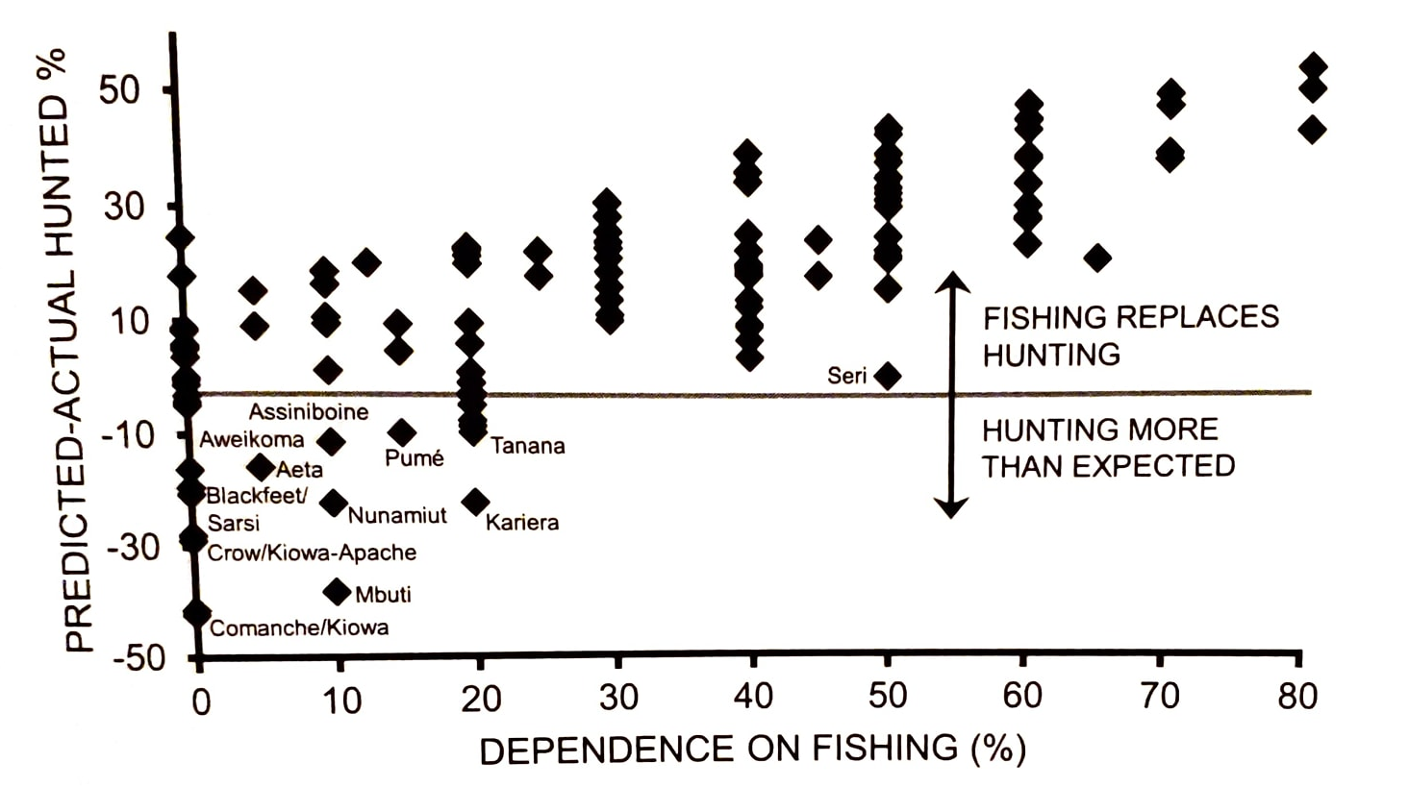
Figure 5-1: A model depicting the dependence on hunting and fishing amongst North American groups (Kelly 2013)
The diet-breadth model, part of the OFT, is addressed by Kelly (2013) and described as predicting whether a hunter-gatherer will take a specific resource. The availability of a resource, location, environmental factors, cultural beliefs, and natural disasters are just some of the many aspects that could affect resource choice within a group (Kelly 2013). However, the primary concern of this model is determining the cost it takes to retrieve a resource versus the return of value one receives from it. For example, a highly nutritious resource may be worth a long trip, whereas a low value resource would not be. This model displays the interaction of needs and risk, where risk determines how far an individual will go to gather something of value (Kelly 2013). This model, while extremely useful, also suffers from the lack of extra-environmental consideration that OFT does. It is virtually impossible to create a graphical and mathematical model that is able to address these issues, so it is always necessary to combine these models with ethnographical information and the understanding that other influences may be more important than risk or nutritional value.
Applying middle range theory to Ravenscroft produced a similar result to that of cultural ecology: Ravenscroft falls well outside of typical behavior seen at bison kill sites, and as such is not addressed very well through this theory suite. K.C. Kraft (2007) determined that a similar communal bison kill site, the Certain Site, was occupied by central place foragers, suggesting that important resources like skulls may be brought back to a semi-permanent base camp. Further evidence should show the skulls are from a single kill event and display cutmarks related to dismemberment and skinning, bashing to gain access to the brain case to remove the brain, and mandible manipulation to remove the tongue. The Ravenscroft skulls lacked evidence of butchering or bashing, belonged to multiple kill events, and were specifically left at the site. As such, middle range theory and optimal foraging theory are not equipped to fully interpret the Ravenscroft skull stacks.
Bruce Winterhalder and Eric Alden Smith are some of the other well-known hunter-gatherer subsistence theorists within archaeology. They pioneered a theory known as Human Behavioral Ecology (HBE), which first arose in the 1970s as a response to OFT and a rising interest in hunter-gatherer subsistence strategies. HBE attempts to approach this topic through the use of graphical and mathematical models, and a strong emphasis on the environment and the theory of evolution. Ethnography is also heavily utilized as a comparison and control factor for developing accurate models (Winterhalder and Smith 2000). They detail two main components of creating an HBE model: models of circumstance and models of mechanism (Winterhalder and Smith 2000). Models of circumstance focus on the cultural factors that influence behavior, whereas models of mechanism regard biologically deterministic factors such as natural selection. This theory differs from OFT in that it specifically addresses cultural characteristics. However, in practice it creates much the same effect: mathematical graphs in which it is difficult to fully grasp the influence of culture on subsistence practices.
Once again, Ravenscroft lies outside the behavior that one would expect to see through the lens of HBE. HBE might attempt to explain this through the relationship between Native Americans and the southern Plains environment. This would require the assumption that people make rational decisions and attempt to use the site to its fullest extent (Randall and Hollenbach 2007). However, the skull stack at Ravenscroft is a highly anomalous occurrence that has not been seen at any other site throughout the entirety of the Great Plains. Additionally, the lack of complete butchering and bashing further contradicts an HBE perspective, exhibiting signs that the perpetrators of these actions did not “fully optimize” the number of useful materials ( i.e., tongue, brains) they could gain from these skulls. Furthermore, the stacking of partially or non-butchered skulls lies outside the realm of rational decision making when seen from an HBE perspective.
While OFT and HBE models can be extremely useful for predicting human behavior, they lack the ability to properly address human agency (Pitblado 2021, Steeves in press). As mathematical models, purely ideological or socio-cultural aspects of human life, like skull-stacking, are unquantifiable and cannot be accounted for within the models. Human agency is described as the ability and practice of human beings making choices, the actual process of which often does not leave behind physical evidence (Hodder and Hutson 2003). It is important to address the socio-cultural aspects that could affect subsistence practices, such as taboo foods that are socially discouraged or ritualized foods that are reserved for specific purposes. Ethnologies of existing hunter gatherer groups or historical records of recent groups are often combined with OFT or HBE models in order to better address the social impacts on subsistence strategies (Winterhalder and Smith 2000). In this case, cultural ecology, OFT, and HBE models all fail to accurately approach the interpretation of the Ravenscroft skull stacks. As such, I turned to ethnographic analogy to better address and interpret the skulls.
Ethnographic Analogy and Interpreting Paleoindian Ritual
The most important topic of discussion relevant to this thesis is that of ritualism itself: what is it and what does it mean? How can we infer ritualism from behavior without over analyzing? Ritualism and religion are defined as behaviors and beliefs that allow humans to make sense of their world (Schielke and Debevec, 2012). These beliefs can be exhibited in any way throughout an individual’s actions, whether obviously ritualistic in nature or not. In terms of Paleoindian studies, ritualism can be hard to detect. Few organic objects remain from so long ago, and the dangers of assuming ritualistic behavior have been especially criticized within recent years (Frison 1998, Sheehan 2004).
Ethnographic analogy, also sometimes referred to as contemporary foraging theory, links observable behavior of modern activity to the materials left behind by similar activities in the past (Sheehan 2004). This requires the use of inference, in which one makes assumptions based upon evidence from similar situations. In the case of ritualism and Ravenscroft, Great Plains groups like the Blackfoot still conducted rituals that left behind similar materials to the Ravenscroft skull stack up through the protohistoric period. However, because the interpretation of ritual is largely based upon inference rather than provable fact, there is much more room for erroneous assumptions to be made (Sheehan 2004). To avoid this, ethnographic analogy is often paired with other theories and models such as OFT and HBE so as to better address questions of purpose. If an assemblage does not fit interpretations suggested by theories based within mathematical models, one must turn to ethnographic analogy. Additionally, as archaeologists learn more about the archaeological record and scientific methods improve, it is important to continue to research these sites, so as to ensure that the ritual interpretation still holds true.
A common interpretation of early ritual behavior is that of hunting magic, in which art was used as a form of sympathetic magic to ensure a successful hunt or to commemorate one (Turpin 1992). Hunting magic descriptions are often applied to petroglyph evidence, but can be extended to shrines, mounds, or other physical representations of animistic beliefs on the physical landscape (McNiven and Feldman 2003). By attributing supernatural powers to the animal and object in question, it is believed that the tie between the two will draw in more prey, leading to a more successful hunt (Turpin 1992). Material artifacts that are often seen as indicative of ritual behavior include red ochre, cached tools made of high quality stone, stone tools too large or small to be used efficiently, carved bone and ivory, musical instruments, and other objects that appear to lack a practical purpose (Frison 1998). As archaeology continues to evolve and scientific methods improve, assemblages that appear to lack practical purpose must continue to be revisited, so as to ensure that new techniques still cannot support explanations outside of ritualistic behavior.

Taphonomy
Taphonomy is the study of ante-, peri-, and post-death processes (Lyman 1994). It involves the careful excavation and processing of bone and examination of faunal remains for cultural or biological evidence that may give insight into lives long past. Evidence of the reason for death may be present on animal remains. Weathering, animal consumption, human butchering and consumption, depositional effects, and excavation processes can all have a physical and visible impact on remains.
The animal’s cause of death and injuries sustained during life can be ascertained from faunal remains. Injuries that occur during an animal’s lifetime, if not mortal wounds, can exhibit signs of healing, such as reformation of bone and the presence of a bone callus. Additionally, bones often reset and heal in an incorrect position, allowing for easy identification of a previous injury. If a human kills a bison using a spear, the point can leave cuts on the bone or even still be present within the bones of the animal. Additionally, butchering marks, such as cuts or scrapes, may also be present. These cut marks differ from the marks left by other carnivores through their appearance. Knife marks are often V-shaped and deep, whereas marks created by carnivore teeth are U-shaped or can resemble puncture wounds. Rodent markings appear as small parallel scrapes on the bone, shallow and visibly different from other animal activity. Humans often broke bones open to access the highly nutritional bone marrow, using hammerstones and anvils to do so. These actions create spiral fractures on the bone, something that rarely occurs naturally or through other animal predation (Abe et al., 2002; Haynes 2010). When reconstructed, if able, the bone also depicts a point of percussion, much like lithic resources exhibit after being flint knapped. Bones can also be crushed by other animals. Bison kill sites often exhibit signs of crushing due to stampeding, as is the case with the famous Cooper site skull (Bement 2003).
Post-depositional processes also take tolls on the remains. A common issue with examining faunal remains is that of root-etching. As a bone is covered in earth, plants grow around the bone, leaving small vine-like markings on the bone. Oftentimes these roots are still visible and present at the time of excavation. The acidity of the soil that bones are deposited in can also erode away the remains, oftentimes destroying or increasing the fragility of bone. Bioturbation is also extremely destructive, involving the underground activity of living animals, such as rodents, worms, or insects. Burrowing animals can burrow directly into the bone’s surrounding matrix, and even through a bone, increasing the likelihood of destruction. Exposure to elements such as rain, wind, or sun after being buried for long amounts of time increases the fragility and likelihood of total destruction of the remains.

CHAPTER SIX: METHODS

Research Questions
I have two primary research questions for this thesis: What kill events do the 2019 skulls date to, and what was the purpose of the stacked skulls? To assess the kill event associations of each skull and the four possible explanations (discard, stockpile, commemoration, or ritual) behind the skull stack’s purpose, I apply the techniques of radiocarbon dating, taphonomy, and literature review to better interpret the true meaning behind the skull stack anomaly. If the skulls are the result of discard activity related to butchering and processing decisions, then the skulls should be from a single kill event and display cutmarks related to dismemberment and skinning, bashing to gain access to the brain case to remove the brain, and mandible manipulation to remove the tongue. To evaluate if the skull pile is the result of stockpiling resources, then the pile should be dated to the same kill event. To evaluate if the skull pile is the result of ritual activity or commemoration of kill events, then the skull pile should contain skulls from multiple kill events.

Radiocarbon Dating
Willard F. Libby first published his book Radiocarbon Dating in 1952, revolutionizing the potential for understanding the full breadth of deep time. Carbon is produced within our atmosphere through the introduction of carbon isotopes by cosmic radiation rays (Hajdas et al. 2021). Plants take in carbon through photosynthesis, and the carbon is introduced into the global carbon cycle (Hajdas et al. 2021). Carbon continues to travel throughout the food chain, entering organisms through the air they breathe and the food they eat. After death, these C¹⁴ molecules begin to decay. C¹⁴ molecules decay at a standard rate, stated as a half-life of 5730 years. Radiocarbon dates are expressed as a number of years ± the years of potential error years ago (ya) before present (BP). Accelerator Mass Spectrometry (AMS) is the primary method used to determine radiocarbon dates and is the one used by the University of Georgia within this study. C12, C13, and C14 are extracted from samples through the process of ionization, in which a sample is passed through several elemental filters to remove unwanted ions such as N14 (Hajdas et al. 2021). AMS samples may be run multiple times, with evaluation of the data occurring after all tests have been run in order to determine the best date (Hajdas et al. 2021).
Sample preparation is another extremely important aspect of radiocarbon dating. Physical processing is the first step, involving both visual and microscopic confirmation that the chosen sample is intact and the most likely to provide an accurate date (Hajdas et al. 2021). In the case of the Ravenscroft skulls, the petrosal elements were the most dense and protected bones, rendering most likely to still contain carbon. To avoid complete destruction of the element, a small portion is typically removed for the purpose of radiocarbon testing (Hajdas et al. 2021). Chemical processing is then utilized to remove contaminants such as sodium bicarbonate, alkalines, or soil carbon (Hajdas et al. 2021). Fourier Transform Infra-Red Spectroscopy is used to identify contaminant elements, and different chemical solutions are then introduced to the sample to remove them (Hajdas et al. 2021). Samples of known age and material older than 100,000 years are used to standardize the dating process. Material older than 100,000 years is deemed as free of modern contamination and is used to recognize materials that do suffer from modern contaminants (Mann 1983, van der Plicht and Hogg 2006, Scott and Cook 2018).
Radiocarbon dates must be processed and corrected before being returned to the client. Ratios of carbon isotopes (C14/C12, C14/C13, C13/C12) are calculated and then normalized to a standard that is corrected for the fractionization of isotopes (δ13C) (Craig 1954). One standard deviation level of a corrected radiocarbon date is 67%, meaning there is a 67% chance that the date is correct (Hajdas et al. 2021). Radiocarbon dates are provided with an error scale, expressed as ± years. One standard deviation typically provides an error scale of ±20-30 years (Santos et al. 2007).
The amount of carbon contained within our atmosphere has not stayed constant. Willis et al. (1960) identified that atmospheric carbon varied approximately 1.5% over the course of 150-200 years. Other researchers continued to discover discrepancies between radiocarbon dating and dendrochronology, further indicating that the carbon in our atmosphere varies (Ralph and Stuckenrath 1960, Stuiver 1961). This created the need for a way to reconcile corrected radiocarbon dates and calibrated calendar year dates. The process of radiocarbon calibration was first designed by comparing the results of radiocarbon dating to dendrochronology, a practice that is still standard to this day (Reimer 2022). Radiocarbon samples are taken from reliably dated tree ring data, the results of which are then plotted upon a line graph, with the x-axis representing age in calendar years and the y-axis representing age in radiocarbon years (Reimer 2022).
As recently as 2022, new methods have been integrated into the calibration process. Bayesian splines involve the combination of calibrated radiocarbon dates to create a chronological model, which allows for the calibration curve to be more closely fitted to the samples and improves the accuracy of calibrated radiocarbon dates (Buck et al. 1991, Ramsey 2009, Reimer 2022). When receiving dates from radiocarbon labs, the results are usually only corrected, as is the case with the radiocarbon results for this study. They must be further analyzed with the use of the IntCal radiocarbon calibration curve to create and understand the calibrated calendar dates.
Radiocarbon dating can only be reliably used up to approximately 50,000 YBP, which is approximately the amount of time it takes carbon to decay to an amount to negligible to test for (Hajda et al. 2021). Some potential drawbacks include the risk of contaminated samples or samples that do not contain enough carbon. Radiocarbon samples can be contaminated through close proximity to a naturally producing carbon source, such as thermal or volcanic vents (Hajdas et al. 2021). Carbon-rich rocks or soil, carbon-rich marine environments, or modern items can all leach carbon into artifacts, further comprising them and inhibiting the likelihood of a successful radiocarbon date (Hajdas et al. 2021). Ravenscroft does not suffer from contamination and has well-established previously published radiocarbon dates for the five kill events and the other 8 skulls that were dated before this study (Bement et al. 2012, Larrick et al. 2019, Larrick 2021, Muhammad 2017). Out of the additional four skulls that I analyzed, skull 34BV198-1203 did not contain enough collagen to provide a reliable date, and as such was removed from consideration.

Taphonomic Methodology
Taphonomy describes both a theoretical and methodological approach, influenced heavily by “harder” sciences such as biology and physiology (Orton 2010). A zooarchaeologist would typically begin their taphonomic approach through the careful identification and sorting of different taxonomic classifications of animals, e.g. reptile from mammal (Hesse 1985). This typically involves the employment of a comparative collection, a selection of skeletons of varying species that allow an archaeologist to identify species and element based on similarities (Lyman 1994). Following this, separate species would be sorted, if able, and then the assemblage would be further segregated by skeletal elements (Chaplin 1971). Non-identifiable fragments are sorted and bagged by size, and quantity is notated for statistical purposes. Once each identifiable fragment has been sorted by species and element, the next step begins the actual quantitative analysis of the faunal assemblage.
Quantitative analysis of faunal assemblages allows for statistical comparisons and techniques to be applied to the data. The primary tools used in this process are Number of Identified Specimens (NISP), Minimum Number of Elements (MNE), Minimum Number of Individuals (MNI), and Minimal Animal Unit (%MAU) (Grayson 1984). The NISP describes the number of individuals belonging to the assemblage that can be confidently identified when analyzed (Lyman 1994). MNI, usually accompanying the NISP, refers to the smallest possible number of each animal classification within the assemblage (Lyman 1994). While the NISP for an assemblage may be 5 deer, the MNI could be much smaller. MNE expresses the number of a specific element, such as a right femur or left pelvis (Grayson 2004). MAU, expressed as a percentage, is derived from the minimum number of individuals that are present in an assemblage overall (Lyman 1994). MNI and MNE may be based on different elements, and as such the larger number must be taken into account when determining the final number of individuals per assemblage. The number of left and right elements of a specific bone, such as the femur, then divided by two, results in the MAU percentage (Grayson 1984). The numerical values derived from each of these tools are then evaluated using statistical analyses, and the results are often described within tables and graphs.
Mapping the location of faunal remains can also help to better understand human activity areas within a site (Enloe et al. 1994). For example, if a portion of a site has primarily butchered skeletal remains, this indicates that this area was used for butchering. This is especially applicable at bison kill sites. This type of site often features a butchering area where bison were partially or completely butchered, with several skeletal elements missing from the bison (Johnson and Bement 2009). Other parts of the kill site, depending on its productivity, may contain many unbutchered bison, indicating that the particular kill event produced an overabundance of resources.

Mill Iron
The Mill Iron site (24CT30) in Montana is a camp and bison butchering site originally discovered in 1979 during a Bureau of Land Management (BLM) survey (Frison 1996). Culturally, this site is attributed to either the Plainview or Goshen cultures, based on projectile point typologies (Frison 1996). This site dates to roughly 11,000 years YBP, approximately 2,000 years before the Ravenscroft site.
Mill Iron shares many similarities with Ravenscroft. Primarily, the bone in each site was extensively weathered due to exposure, and made excavation, recovery, and analysis extremely difficult. Teeth were also intensely depended upon for determination of species and individual related information. Mill Iron was a spring kill, and featured virtually every type of human, environmental, or animal modification possible.
In order to address the issue of weathering, Kreutzer defined six stages of weathering (Frison (ed.) 1996). The first stage is the least weathered and features mostly complete and dense bone elements, and an abundance of phalanges. Stage two is slightly more weathered, and is marked by the presence of phalanges, carpals, tarsals, and long bones. Stage three contains phalanges, carpals, tarsals, long bones, vertebrae, and axial elements. Stage four contains phalanges, carpals, tarsals, long bones, vertebrae, ribs and crania. At this point smaller elements are less present and larger elements begin to dominate the assemblage. Stage five contains primarily ribs, crania, and vertebrae, with decreasing amounts of other elements. Stage six, the most advanced stage of weathering, contains mostly ribs, crania, vertebrae, and upper forelimbs.
The other aspect of the Mill Iron site that I found the most useful to my research is that of the dentition studies. The bison dentition pattern contains 3 incisors, 3 premolars, and 3 molars. Todd et al. defined 14 dental age groups (Table 6-1) (Frison (ed.) 1996).

Group # | Age | M1 | M2 | M3 | Premolars
1 | $$Fetal and Neonate$$ | $$Not fully formed$$ | N/A | $Ν$/A | $$NA$$
2 | $$1.1-1.2 yrs$$ | $$Full wear$$ | Erupting | $$N/A$$ | $$N/A$$
3 | $$2-2.2 yrs$$ | $$Full wear$$ | Fully erupted | $$Erupting$$ | $$N/A$$
4 | $$3-3.2 yrs$$ | $$Full wear$$ | Full wear | $$Mostly erupted$$ | $$P2-3 fully erupted$$
5 | $$4-4.2 yrs$$ | $$Full wear$$ | Full wear | $$Fully erupted$$ | $$P2-3 fully erupted$$
6 | $$4.9-5.2 yrs$$ | $$Full wear$$ | Full wear | $$Full wear$$ | $$P2-4 fully erupted,$$  Moderate wear
7 | $$6-6.2 yrs$$ | $$Full wear$$ | Full wear | $$Full wear$$ | $$P2-4 moderate wear$$
8 | $$7-7.2 yrs$$ | $$Full wear$$ | Full wear | $$Full wear$$ | $$Moderate wear$$
9 | $$8-8.2 yrs$$ | $$Full wear$$ | Full wear | $$Full wear$$ | $$Full wear$$
10 | $$9-9.2 yrs$$ | $$Very worn$$ | Full wear | $$Full wear$$ | $$Full wear$$
11 | $$10-11.2 yrs$$ | $$Very worn$$ | Full wear | $$Full wear$$ | $$Full wear$$
12 | $$10-11.2 yrs$$ | $$Very worn$$ | Full wear | $$Full wear$$ | $$Full wear$$
13 | 12-12.1 yrs | Heavily worn | Moderate wear | Full wear | Full wear
14 | 13-13.1 yrs | Heavily worn | Heavily worn | Moderate ffffwear | Full wear
Table 6-1: Dentition age group and wear (Frison (ed.) 1996)

Taphonomic Analysis of Bison Skulls
Ten skulls had previously been analyzed before this thesis, leaving four that still required a taphonomic analysis as well as radiocarbon testing. Four skulls were analyzed for this project: 34BV198-1056, 34BV198-1203, 34BV198-1603, and 34BV198-1601. Each skull had previously been exposed to the elements and severely sun-bleached, resulting in incredibly fragile and degraded remains. The skulls had originally been excavated during the 2019 excavation and were sprayed with foam to protect them from further degradation. The surrounding matrix was also encased within to further protect the skulls. Because of the extremely poor state of the skulls, rougher methods were used to extract the petrosal elements. Each skull was systematically removed from the foam, while also breaking down the skull into as few pieces as possible. Bamboo picks were used to gently remove sediment from the surface of the bone.
The skulls largely fell apart into pieces as soon as foam and sediment were removed. Large sections of skull that looked particularly fragmented were left within clumps of sediment and then later broken down during the process of water screening. Water screening was the chosen strategy due to the fragmentation. Each skull was completely water screened using a 2mm sieve, and then laid out to dry within the University of Oklahoma’s wet lab. After drying for 2-3 days, the skull elements were transferred onto trays and brought back to the faunal lab for further sorting and storing.

Collection and Storage Strategies
When the skulls were originally excavated, the surrounding matrix was enclosed within foam. Due to this excavation technique, some non-cranial elements (carpals, vertebrae, clavicle) were included within the foam and analyzed during my taphonomic analysis. Following the processing and screening of the skulls and any associated non-cranial elements, bone fragments were then sorted by element and size. Petrosal bones and any identifiable elements, such as cervical vertebrae or carpals, received their own identifying tags and curation-standard bags. The petrous bones were chosen for testing due to their intact nature. The petrous bone is part of the inner ear and represents the strongest bone within the bison skull. Mammals have two petrosal bones, one within each ear. Due to the presence of at least one petrous in each skull, these were chosen over teeth, as not every skull retained the same tooth. Additionally, the petrous was most likely to retain collagen, the necessary component for radiocarbon dating (Carlson et al. 2016).
Larger fragmented elements that were unidentifiable, or simply identified as a larger portion of the skull itself, were bagged together and identified with one collective tag. Smaller fragmented elements and disintegrated bone were also combined into one bag with one identifying tag. Each skull had approximately 3-4 bags of bone associated with them and were kept together on a shelf with other processed skulls from the Ravenscroft site.

Sample Preparation
Radiocarbon and isotopic samples were removed from the left petrosal bones of the Bison skull remains. Six petrosal samples were sent, four of which were processed for this thesis. I removed the samples from the dorsal/distal corner of the petrous using an electronic dremmel (Figure 6-1). These samples were then bagged, labeled, and mailed to the Center for Applied Isotope Studies at the University of Georgia and the radiocarbon laboratory at the University of Pennsylvania for radiocarbon and isotopic analysis. These labs had previously been used for all other dates at Ravenscroft, and as such were chosen for this project to stay consistent (Carlson et al. 2016).
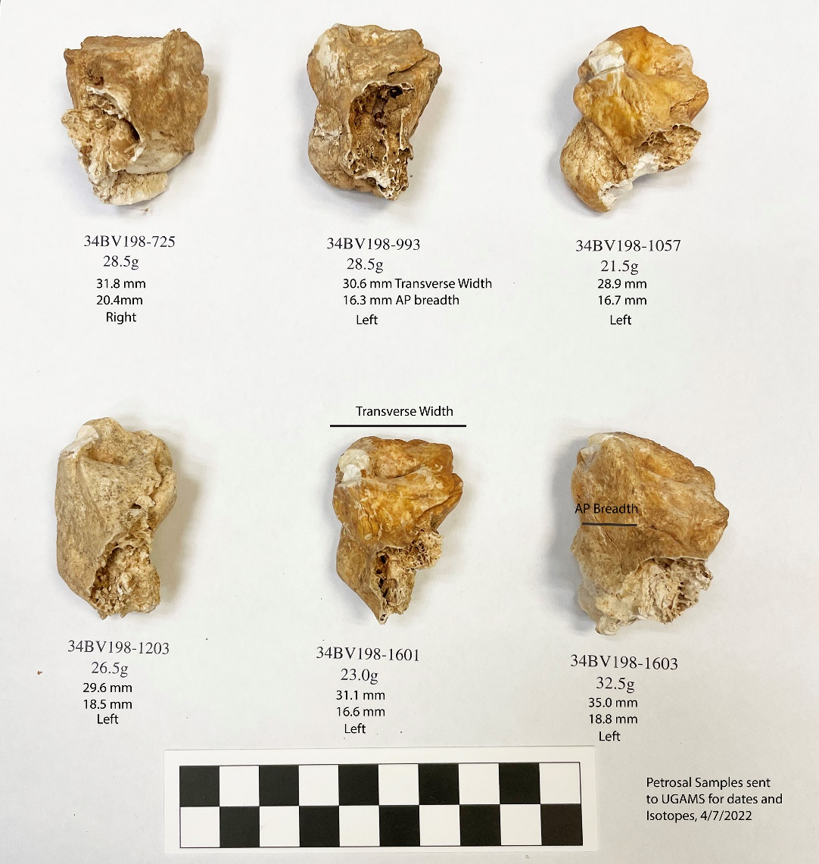
Figure 6-1: Petrosal Samples sent to UGAMS for Radiocarbon Dating and Isotopic Analysis (Bement 2022)

CHAPTER SEVEN: RESULTS
The four possible explanations behind the skull stack’s purpose, include discard, stockpile, commemoration, or ritual. I applied the techniques of radiocarbon dating, taphonomy, and literature review to better interpret the true meaning behind the skull stack anomaly. If the skulls are the result of discard activity related to butchering and processing decisions, then the skulls should be from a single kill event and display cutmarks related to dismemberment and skinning, bashing to gain access to the brain case to remove the brain, and mandible manipulation to remove the tongue. To evaluate if the skull pile is the result of stockpiling resources, then the pile should be dated to the same kill event. To evaluate if the skull pile is the result of ritual activity or commemoration of kill events, then the skull pile should contain skulls from multiple kill events. This chapter displays the results of my research against the expectations outlined within this paragraph, so as to explicitly show the ritual nature of the stack.

Bison Analysis

Faunal Analysis
118 bones were added to the Ravenscroft collection during the 2019 field school, including four more skulls within the skull stacks. Only the skulls have been processed and analyzed. A preliminary count of the 2019 elements is listed in the table below, although may be subject to change after lab analysis (Table 7-1).

Element | Right | Left | Axial/Neutral | MNI | %MAU
Skull |  |  | 4 | 4 | 0.25
Horn Core |  |  | 2 | 1 | 0.5
Mandible | 2 | 2 | 1 | 3 | 0.2
Hyoid |  |  | 4 | 4 | 0.25
Teeth | 4 |  |  | 1 | 1
Centrum |  |  | 1 | 1 | 1
Atlas |  |  | 4 | 4 | 0.25
Axis |  |  | 2 | 2 | 0.5
C. Vertebrae |  |  | 4 | 1 | 0.25
T. Vertebrae |  |  | 25 | 2 | 0.04
L. Vertebrae |  |  | 4 | 1 | 0.25
Un. Vertebrae |  |  | 6
Sacrum |  |  | 1 | 1 | 1
Pelvis |  |  | 2 | 2 | 0.5
Ribs |  |  | 33 | 3 | 0.33
Scapula |  |  | 6 | 3 | 0.17
Femur | 1 |  | 1 | 1 | 0.5
Humerus |  |  | 2 | 1 | 0.5
Radius |  |  | 1 | 1 | 1
Metapodial |  | 1 | 2 | 1 | 0.33
Carpal |  |  | 6 | 1 | 0.17
Phalanges |  |  | 6 | 1 | 0.17
Novicular Cuboid | 1 |  |  | 1 | 1
Unidentified |  |  | 4
Juvenile |  |  | 4
Fetal |  |  | 1 | 1
Table 7-1: Preliminary faunal analysis based on site specimen forms
This analysis is only based upon the elements that were identified in the field. Additional elements may be found/identified after the bones are cleaned and analyzed in the lab. Bones removed in blocks of sediment may contain additional specimens. No analysis for condition of bones or potential butchering evidence of the 2019 specimens has been conducted, and as such I am unable to make any statements concerning the condition of bones outside of the skull stacks. The presence of some juvenile and fetal bones further supports the cow/calf herd identification that was made by Dr. Lee Bement (2009) and subsequent analyses (Muhammad 2017).

Skull Stack (2019)

The skull stack, originally uncovered in 2017, was removed layer by layer, and as such no picture of the skull stack in profile is available. A total of 15 skulls were located within two stacks, eleven in a stack at the western edge of the arroyo mouth, and the remaining four in a stack at the eastern edge of the arroyo mouth (Figure 7-1). As of the excavation in 2017, 7 skulls including BN724, BN611, BN644, BN726, BN692, BN725, and BN993 had been uncovered and removed, with an eighth uncovered but left within the unit. Another six skulls including BN1056, BN1057, BN1603, BN1601, BN1600, and BN1602, were removed in 2019. The stack on the western edge appeared to have fallen over at some point, and therefore resembled two separate piles despite belonging to the same one. My research centered upon four skulls that were uncovered during the 2019 excavation, combining the new information gathered with that previously known so as to better understand the purpose of the stacked skulls.
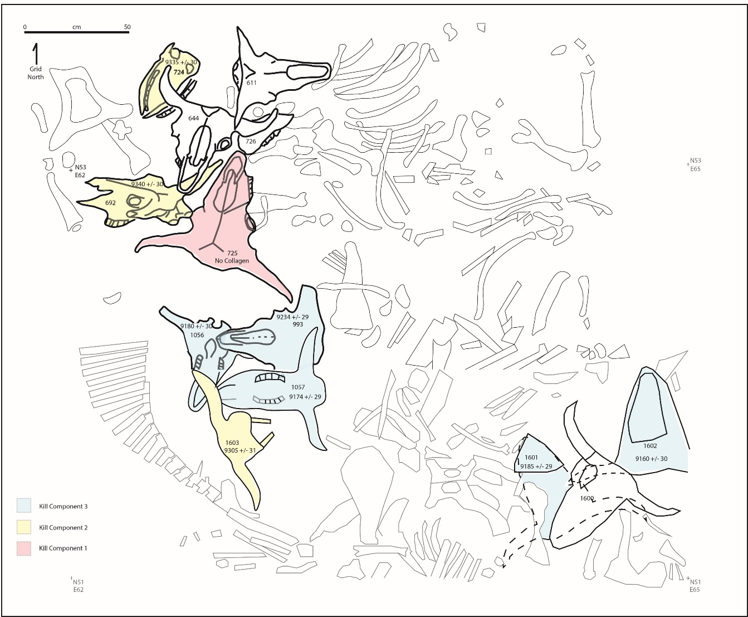
Figure 7-1: Current map of the Ravenscroft stacked skulls. The skulls are bolded and labeled with their associated radiocarbon dates. Skulls highlighted in red are associated with the first kill event. Skulls highlighted in yellow are associated with the second kill event. Skulls highlighted in blue are associated with the third kill event (Bement 2022)

34BV198-1056
BN1056 was the first skull processed and analyzed for this thesis (Figure 7-2). The condition was extremely poor, having been exposed to sunlight and weather for an unknown amount of time. Bison have 3 premolars and 3 molars on their maxilla, and 3 incisors, 1 canine, 3 premolars, and 3 molars on their mandible (McDonald 1981). According to the dentition groups described at the Mill Iron site, after 7.5 years all teeth should be erupted and in full wear (Todd et al. 1996). The M1-M3 molars were present from both sides of the maxilla, making this specimen older than 7 years of age. Additionally, the molars exhibited signs of advanced wear, indicating the specimen was geriatric when killed.
Only the left petrous was present, and as such was selected for radiocarbon testing. 4 carpals were also encased within the foam but were not used for any research in this project. The remnants of the skull were water screened, but due to the poor condition the bone was extremely damaged and crumbled easily. The absence of the mandible and mandibular teeth could suggest that this particular skull was partially butchered, removing the mandibles before the skull was placed on the pile. The brain cavity was still intact, indicating that the brain was not removed. However, due to the fragmentary nature, no conclusive determination could be reached. The horn cores exhibited little to no burr when transitioning into the skull, suggesting this individual was female. Furthermore, the horn core extends from the skull at a relatively shallow angle, also indicating BN1056 was female.
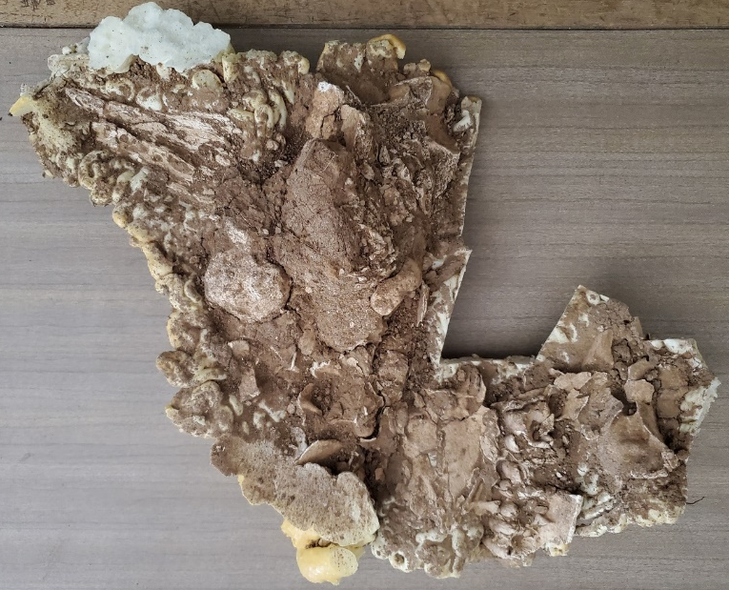
Figure 7-2: BN1056, interior of skull and maxilla

34BV198-1203
BN1203 was the second skull processed and analyzed for this thesis project (Figure 7-3). Like the previous skull, it had been exposed to weathering and sunlight and as such was disintegrating. It was also water screened. BN1203 had all 12 molars, 9 premolars, and 6 incisors. After 7.5 years of age, bison will exhibit all teeth in full wear (Todd et al. 1996). The presence of most maxillary and mandibular teeth, including the incisors and premolars, dates this specimen at over 7 years of age. The advanced wear exhibited on all teeth, including the incisors, indicates this specimen may have been older than 9 years of age. Both petrosal bones were present, but only the left was selected for radiocarbon testing. A portion of the sternum, cervical vertebral fragments, and carpal fragments were also present within the foam covering. These additional bones were not included in the research for this project.
BN1203 had a mandible present and articulated, suggesting it was not butchered. Due to the extensive weathering, I was unable to determine if the skull featured any definitive butchering marks on the bone. The brain cavity was intact and did not exhibit signs of butchering activity. When gendering BN1203, I used the frequency distribution of the maximum width of the anterior cusp of the M3 molar in McDonald’s book on North American Bison (1981) (Figure 7-4). According to McDonald (1981), female B. occidentalis typically had an M3 anterior cusp maximum width of approximately 2.4 cm. BN1203’s M3 anterior cusp maximum width was 2 cm, indicating it was most likely female.
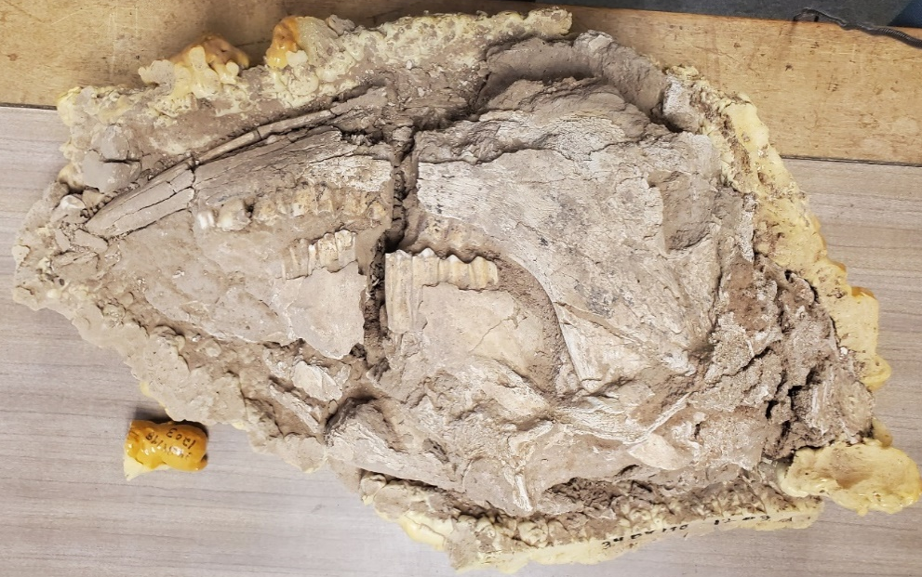
Figure 7-3: BN1203, right side of skull, before processing
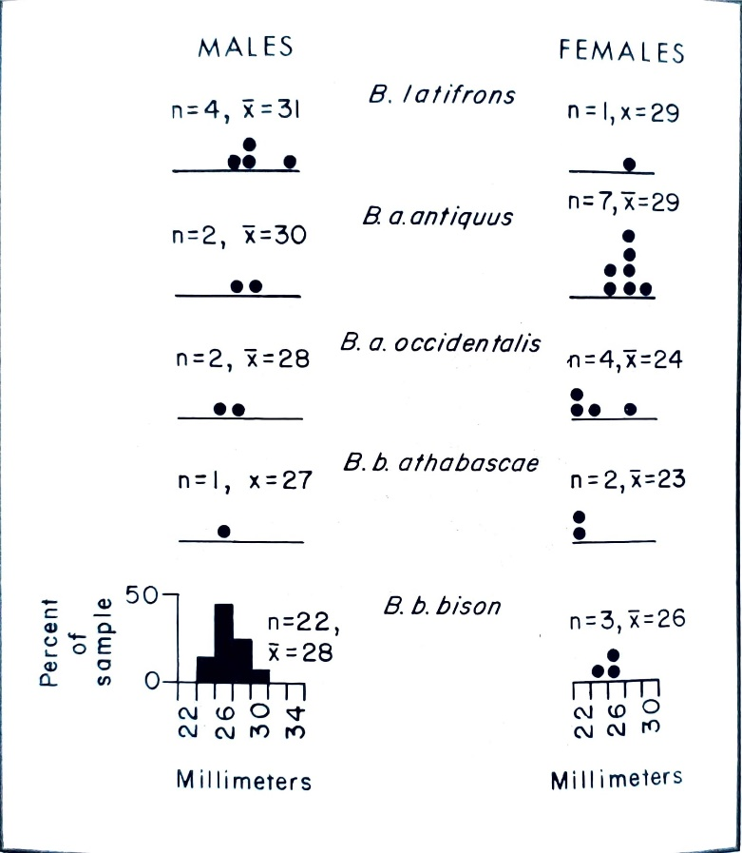
Figure 7-4: A frequency distribution graph depicting the mean width of the anterior M3 cusp (McDonald 1981)

34BV198-1603
Due to the fragile nature of the skull and in an effort to preserve information for future analysis, BN1603 was processed as little as possible. The occipital portion of the skull was removed in order to extract the petrous bones, while the remainder of the skull was left as intact as possible within the foam for future analyses. Both petrosal bones were present and removed. The left petrous was selected for radiocarbon testing. Skull fragments were water screened and were especially delicate. This bison also appeared to be mature and older than 7 years of age due to the presence of M1-M3 molars.

34BV198-1601
Due to the fragile nature of the skull and in an effort to preserve information for future analysis, BN1601 was processed as little as possible. The occipital portion of the skull was removed in order to extract the petrous bones, while the remainder of the skull was left as intact as possible within the foam for future analyses. Both petrosal bones were present and removed. The left petrous was selected for radiocarbon testing. Skull fragments were water screened and were especially delicate. This bison also appeared to be mature and older than 7 years of age due to the presence of M1-M3 molars.

Radiocarbon Dates
The primary methods of analysis used in this thesis were taphonomic analysis and radiocarbon dating. Radiocarbon dating was chosen as not all of the skulls in the skull stack had been dated yet. The addition of these dates further expands and deepens the knowledge we can gain from these stacks.

Site Name | Site No. | Bone No. | Element | δ13C | δ15N | %C | %N | C:N atomic | UCIAMS | 14C | ± | 1 Sig. | CAL BP | Occ Group
Ravenscroft II |  | 725 | petrous |  |  |  |  |  |  |  |  |  | NO Collagen | 1 | skull pile
Ravenscroft II | 34BV198 | LB692 | petrous | -9.0 | 10.8 | 13.41 | 4.68 | 3.38 | 136072 | 9340 | ± | 30 | 10,504-10,641 | 2 | skull pile
Ravenscroft II | 34BV198 | LB724 | petrous | -8.2 | 10.2 | 22.48 | 7.96 | 3.30 | 136077 | 9335 | ± | 30 | 10,503-10,579 | 2 | skull pile
Ravenscroft II | 34BV198 | 1603* | petrous | -9.6 | 11.6 | 14.64 | 5.05 | 3.38 | A58624 | 9305 | ± | 31 | 10,438-10,568 | 2 | skull pile
Ravenscroft II | 34BV198 | 993 | petrous | -8.9 | 12.0 | 25.48 | 8.81 | 3.37 | A58620 | 9234 | ± | 29 | 10,300-10,492 | 3 | skull pile
Ravenscroft II | 34BV198 | 1056* | petrous |  |  |  |  |  |  | 9180 |  | 30 | 10,249-10,375 | 3 | skull pile
Ravenscroft II | 34BV198 | 1057 | petrous | -10.3 | 12.3 | 27.68 | 9.63 | 3.35 | A58621 | 9174 | ± | 29 | 10,248-10,373 | 3 | skull pile
Ravenscroft II | 34BV198 | 1601* | petrous | -10.2 | 10.1 | 26.71 | 9.29 | 3.35 | A58623 | 9185 | ± | 29 | 10,252-10,376 | 3 | skull pile
Ravenscroft II | 34BV198 | 1602 | petrous | -12.06 | 11.8 |  |  | 3.43 | A52326 | 9160 |  | 30 | 10,243-10,369 | 3 | skull pile
Ravenscroft II | 34BV198 | 1374 | petrous | -8.3 | 11.7 |  |  | 2.90 | A31639 | 9113 | ± | 31 | 10,228-10,279 | 4 | skull pile
Ravenscroft I | 34BV198 | LB26 | femur | -10.3 | 11.5 | 21.24 | 7.47 | 3.32 | 136076 | 9075 | ± | 30 | 10,215-10,245 | 4
Ravenscroft I | 34BV198 | BN136 | petrous | -8.1 | 11.1 | nr | nr | 3.42 | 78134 | 9090 | ± | 30 | 10,220-10,250 | 4
Ravenscroft I | 34BV198 | LB-55-2 | petrous | -8.7 | 10.8 | 17.52 | 6.08 | 3.37 | 136070 | 8925 | ± | 30 | 9959-10,182 | 5
Table 7-2: Table illustrating the results of radiocarbon dating on the skull pile; Bone numbers marked with an asterisk were analyzed as part of this study (Bement 2022)

Four out of the six radiocarbon samples returned accurate dates (Table 7-2). All accurate dates were previously corrected by the University of Georgia AMS lab. In order for a radiocarbon sample to still be considered accurate, the ration of C:N isotopes must fall between 2.9 and 3.6, the levels found within modern bison bones (Carlson and Bement 2018). Collagen, a protein found in bones and teeth, is a primary source of carbon and was the targeted material within this study (DeNiro and Epstein 1978, Ramsey 2008). Skulls BN725 and BN1203 contained no collagen, rendering them unable to be dated through radiocarbon methods. The figure below illustrates the full breadth of the skull stacks timeline, depicting all radiocarbon dates that have been received from this feature so far (Figure 7-5). The corrected radiocarbon dates of the skull pile range from approximately 9113 RCYBP to 9335 RCYBP, a span of ~222 years. When applied to a CALIB 6.2 and Intcal20 calibration curve, the Ravenscroft skull stack ranges from approximately 10,200 calBP to 10,700 calBP, over 500 years of history. Assuming the general human lifetime would be ~50 years, Ravenscroft would require the presence of ten generations of people. The timespan of Ravenscroft likely spans much further, as the lowest bonebed in RAV II cannot be dated because the bones do not contain any collagen. However, without further excavation and testing this cannot be confirmed.
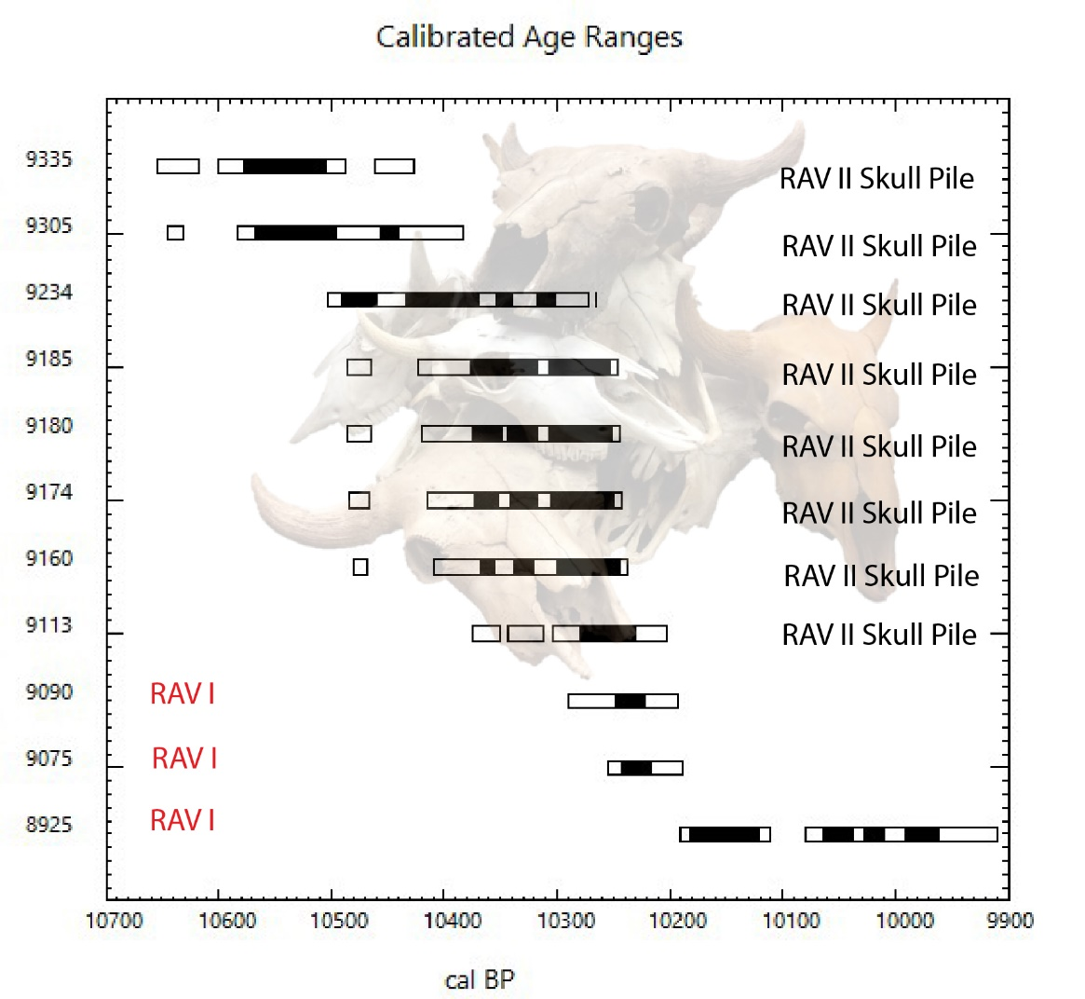
Figure 7-5: Calibrated (x-axis) and uncalibrated (y-axis) radiocarbon age ranges for the RAV II skull pile. RAV I radiocarbon age ranges highlighted in red. Calibrated dates derived through CALIB 6.2 and Intcal20 curve (Bement 2022; Larrick 2021)

Literature Review of Relevant Sites

Jones-Miller
Jones-Miller is a Hell Gap site that was originally excavated in the mid-1970s in Colorado (Stanford 1978). Nearly 300 disarticulated Bison antiquus were found alongside a hill, and included several Hell Gap points (Stanford 1978). Most skulls were removed from the site, and the ones that remained were heavily butchered. The site contains multiple kill episodes, likely taking place over several different seasons as well as years. The faunal assemblage was also primarily comprised of females and calves, supporting the trend of Paleoindian bison kills targeting nursery herds. Stanford (1978) suggested that Jones-Miller may have actually been an example of a bison “pound” site, in which wooden corrals were built to trap bison within. He mentions that wood would most likely not have left any physical evidence, and therefore would not be found during excavations.
Jones-Miller exhibits interesting ritualistic aspects. A central post mold was located within the site, but the mold was too shallow to have supported any weight. Stanford (1978) infers that its purpose was therefore not functional but symbolic. A bone flute, a small projectile point, and the remains of a dog were found next to the post mold (Stanford 1978). A nearby hearth was later located, containing red and yellow ochre, materials that are often associated with ritual activity. An ethnographic review of other bison pound sites revealed a common ritual behavior associated with these sites (Arthur 1974). The central pole was known as a “medicine pole”, and offerings were placed around it (Stanford 1978). Hearth features would be built outside the pound entrance, where ceremonies would be conducted (Stanford 1978). This evidence of ritualism at a type of bison kill site is important to include in the study of Ravenscroft in order to fully understand the forms that ritualism might take.

Cooper, Jake Bluff, and Badger Hole
Cooper, Jake Bluff, and Badger Hole are perhaps the most applicable sites to compare to Ravenscroft, due to their close proximity, similarity in site structure, and evidence of ritualism. Each of these sites is a bison kill site, located in arroyos within 3 km of one another. They are each located along the Beaver River in Harper County, next to Ravenscroft’s county Beaver. Each site contains summer/fall kills, differing from Ravenscroft’s winter kill.
Jake Bluff is the oldest site in this group, a Clovis site dating back to approximately 10,821 ± 17 RCYBP (Bement and Carter 2010). Cooper is the second oldest site, comprised of three kill episodes that took place during the late summer and early fall (Johnson and Bement 2009). Radiocarbon dating placed the kills from ca. 10,600 to 10,500 RCYBP, placing the site within the time scheme for Folsom (Carlson, 2015). Badger Hole, the youngest site, dates to 10,300 ± 30 RCYBP, also consistent with Folsom (Bement et al. 2012).
The preservation at these three sites was particularly good, as the bones had been previously mistaken as cow bones and left undisturbed (Personal correspondence with Dr. Leland Bement, 2022). Additionally, these arroyos were especially narrow, allowing for a deep build-up of bison remains and better protection of deeper deposits from weathering. Cooper is particularly significant in that it features some of the earliest evidence for art in North America. The Cooper skull was a partially crushed bison cranium located at the entrance to the Cooper arroyo. It features a lightning bolt, and 3-4 lines drawn/carved into the skull in red ochre (Figure 7-6). This has been interpreted as a form of hunting magic, in which the skull was painted and placed at the mouth of the arroyo prior to the second kill event (Bement 1999). Over the course of the second kill event, stampeding bison trampled the skull, resulting in the crushed portion of the cranium. The use of red ochre is also particularly significant, in that it is typically associated with ritualistic or religious activities (Bement 1999).
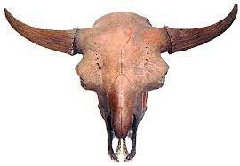
Figure 7-6: Cooper skull (Bement 1999)

Mustatils
Located in Saudi Arabia, mustatils are prehistoric rectilinear monuments signifying religious beliefs (Thomas et al. 2020). These monuments look like rectangles from above and are comprised of several sections: courtyard, a head, long walls, a base, circular cells, and orthostats (Thomas et al. 2020). Local stone was stacked to create these structures, without the aid of mortar or another binding element. Similar to the usage of kivas in the Southwest of North America, mustatils sometimes contain ritualistic entrances (ceremonially blocked off or “decommissioned”) or funerary objects/structures (Thomas et al. 2020). Several mustatils also exhibit secondary constructions shaped in an “I”.
Thomas et al. (2020) found the presence of circular cells particularly significant, as over half the known mustatils exhibited these constructions near their base. These circular cells also often contained orthostats/stone pillars and blocked passageways. The mustatils themselves often occupied high areas of topography, allowing for better line-of-sight of the surrounding landscape (Thomas et al. 2020). Additionally, mustatils tend to be grouped relatively close together. Entranceways, when excavated, yielded cranial faunal remains from cattle, sheep, goats, and gazelle. These remains were also positioned around a central stone and were interpreted by Thomas et al. (2020) as some sort of religious offering. These remains were radiocarbon dated and resulted in the approximate date range of 6000-5000 B.C. or 7950 – 6950 YBP. Charcoal has also been radiocarbon dated and resulted in a similar date (Thomas et al. 2020).
The high proportion of cattle remains to other species suggests particular importance was placed upon these animals. Due to the arid nature of Arabia, pastoralism is a very common practice, and certainly was so in 6000 B.C. (McCorriston et al. 2012). Dependence upon these animals for survival could convey a religious or ritualistic aspect to them, making them useful in a more social role. Additionally, the rectangular nature of the mustatils makes them resemble western pastures, suggesting that perhaps these monuments were meant to separate and designate ownership of specific herds (Thomas et al. 2020).
Great Plains Antler Piles
Wilson (2005) discusses the religious beliefs and ritual activities that have guided many Great Plains groups, such as the Blackfoot, Tsuu t’ina, Crow, Atsina, Assiniboin, Dakota, Arapaho, Plains Cree, and Plains Ojibwe. These examples focused upon activities that occurred throughout the Northwestern Plains, with oral history describing a use of these religious beliefs far back into history (Wilson 2005). These activities were also documented by European colonists and early archaeologists and continue to be constructed/utilized today (Wilson 2005). The centre and axis were important symbols within Great Plains ideology, signifying a connection between indigenous peoples and the Creator. Monuments and shrines, such as the Sundial Hill Medicine Wheel in Alberta, were constructed for this purpose (Figure 7-7). Monuments often consisted of a central cairn, made of stones or animal remains, surrounded by two circles of stones with a path leading to the center (Figure 7-8).
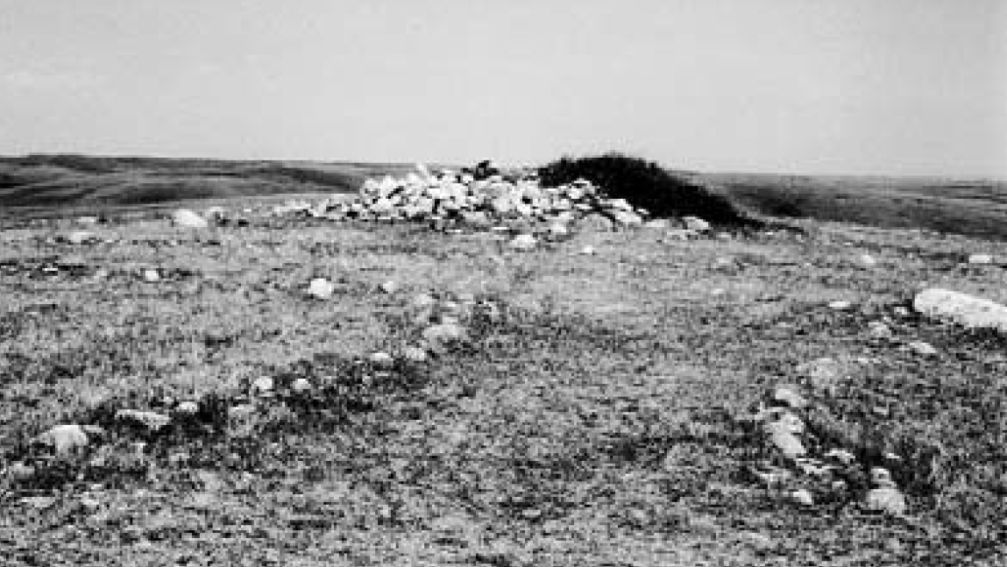
Figure 7-7: Sundial Hill Medicine wheel, Alberta, Canada (Wilson 2005)
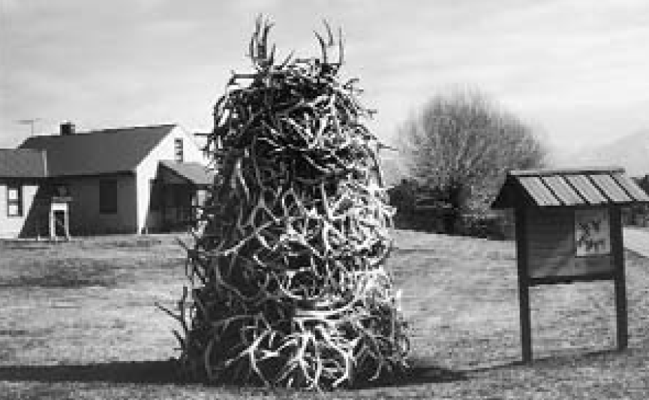
Figure 7-8: Replica antler pile at National Bison Range, Molese, Montana (Photo by Margaret A. Kennedy, Wilson 2005)
Wilson (2005) sees these antler piles and related structures as representative of the connection indigenous peoples drew between cosmology and animal ritualistic behavior. Wilson (2005) also explains another meaning, in which animals are attributed human aspects, seen as distant relatives of humans, and share a future together. Brown (1997) details Ogalala Sioux beliefs in which the hunting and killing of an animal offends its spirit and rituals must be carried out afterwards to restore “cosmic balance”. This could be expressed as offerings or monuments built with the animal’s remains (Furst 1974). It was important to continue with the upkeep of ritual and monumentalism, so as to avoid angering animal spirits (Wilson 2005). The various symbols and monuments that could represent this relationship are detailed in the figure below (Figure 7-9).
Ravenscroft fits well within this scope of Great Plains ideology and cosmology. According to Figure 7-9, a pile of skulls such as that at Ravenscroft could be symbolic of the axis mundi, a closed cosmogramic circle, or a combination of meanings (Wilson 2005). The axis mundi is the “World Pillar”, where the pile of skulls connects the Native American group that created the monument to the Creator (Wilson 2005). Native Americans continued to visit and renew this connection to the Creator as they added to the Ravenscroft skull stack. Wilson (2005) also notes the importance of performance and the understanding of cyclical time. The act of placing new skulls upon the stack may have served a similar purpose, continuing to attribute power to the site over time as it accumulated more skulls. Additionally, it may have renewed the relationship between the creators of the skull stack, the location, the bison, and the Creator (Wilson 2005). Maintaining these relationships was extremely important to these people, as evidenced by their continued use of the site for over 300 years.
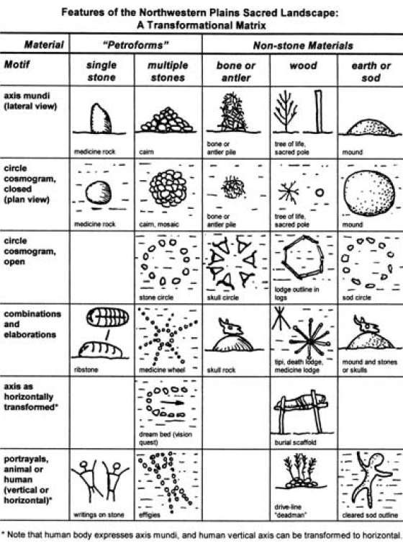
Figure 7-9: Wilson (2005) depicts several examples of Great Plains monuments built to represent the connection between animals and cosmology. Note the bone or antler piles and the pile of skulls, representing the axis mundi.

Potential Explanations for Skull Stack
The first hypothesis for any stack of bones would be a butchering or stockpile technique (Larrick et al. 2021). These hypotheses can typically be confirmed through taphonomic analysis, where cut marks and spiral fractures could be detected. Skulls in particular would be expected to exhibit cut marks along the mastoid bone, and to be missing their mandibles. Tongues are highly nutritious and were highly sought after. The mandible would be cut off in order to remove this muscle. Bison brains were also a very important resource for Native Americans. Brains are used in the hide tanning process. If the brains were harvested, the frontal portion of the skull would be crushed or “bashed” in, creating an obvious hole through which the brain was removed.
The Ravenscroft skulls are mostly missing their mandibles, except one. This complicates the interpretation process of the stack. Were the other skulls harvested for their tongues first, and then placed in a ritualistic stack? Or were the mandibles removed for another reason? The lack of skull bashing makes the stockpile explanation unlikely, and as such other reasons must be explored.
Another explanation that has been suggested is a commemorative cairn. The numerous kill events, advantageous environment and location, and likely large size of the Ravenscroft bonebed suggests that Ravenscroft was a very successful area to conduct a bison kill in. Additionally, the placement of the skull stacks at the entrance of the arroyo could indicate a desire for observation of the skulls, much like a trophy. This is a harder hypothesis to support/disprove, because of its highly social and cultural nature that wouldn’t necessarily leave behind physical evidence. Moreover, the mixture of skulls from multiple kills over centuries may indicate that these people were commemorating their return to this location. It could also be a way of finding this location over and over again, like a trail marker. This hypothesis required a review of literature to determine whether this was a likely explanation. How are commemorative activities recorded in history? These can be hard to determine, as the artifacts that best preserve, such as lithics, may not be what was used to commemorate. Furthermore, the social aspect of bison hunting may have also influenced the construction of this stack. Ritualism is further explored in the next chapter.

CHAPTER EIGHT: DISCUSSION & CONCLUSIONS
In the chapters above I presented a study to investigate the abnormal occurrence of a stack of bison skulls uncovered in the excavations at the late Paleoindian age Ravenscroft bison kill site in the Oklahoma panhandle. To guide this research I considered the possible explanations that the pile of skulls was the result of discard, stockpiling, commemoration, or ritual. To evaluate the discard and stockpile explanations I applied the methods of radiocarbon dating and taphonomy. The results of these analyses did not support the possibility that the skull pile was due to discard after butchery and processing or the result of stockpiling the skulls for future processing. Both of these explanations would require the skulls be from a single kill event. The results of radiocarbon dating indicated the skulls represented at least three of the five kill events in the two Ravenscroft arroyos. To evaluate the possibility that the bison skulls resulted from ritual activity to commemorate the kills or area I conducted a literature review that resulted in documenting several instances of skulls and other animal remains suggesting ritual stacking. The ethnographic construct presented by Wilson (2005) to explain ritual landscapes among First Nation groups on the Northern Plains provided one possible way to view the Ravenscroft skull pile. Within Wilson’s construct, the Ravenscroft skull pile represents the axis mundi, or “World Pillar”, connecting Native Americans to the Creator.

Interpreting Ritual at Ravenscroft
A common theme throughout all of the previously listed sites is the importance placed upon crania. Each time, skulls are regarded in a special manner compared to other skeletal elements, whether for ritualistic reasons or subsistence practices. Among bison kill sites, the absence of skulls is often the most telling (Personal correspondence, Dr. Leland Bement, 2022). Skulls were taken elsewhere to be further processed. Mandibles were removed so that the nutritional tongue could be accessed, and occasionally the frontal portion of the skull was removed to reach the brain. The brain was frequently used in the tanning process, making it a valuable resource for Native Americans (Schultz 1992).
The element of stacking sets Ravenscroft apart from most bison kill sites. However, Mustatils illustrates a similar phenomenon and provides some potential interpretations. In this case ritualism was interpreted as the primary drive behind the symbolic behavior. The mustatils featured bovine sacrifices, likely denoting the importance of the cow in their pastoralist culture. One could infer that the display of bison skulls in Ravenscroft may have served a similar purpose; bison were a large part of life, and therefore were attributed ritualistic significance. Jones-Miller represents another version of ritualism at a bison kill site. Skeletal elements were so heavily butchered that almost none remained articulated. Furthermore, while most skulls were missing, the few that were left were thoroughly processed. However, extensive evidence of ritualism was present. A central “medicine pole”, combined with a bone flute, a small projectile point, canid remains, and a hearth containing red and yellow ochre were found at Jones-Miller, showing evidence of a rich ritualistic connection. Combined with ethnographic accounts of ritual behavior at bison pound sites allows insight into the relationship between bison and indigenous populations.
Another common factor between these sites is the placement of the crania. The mustatil bovine sacrifices were placed within entrances of the mustatils. Does this denote ritual, or perhaps a form of ownership? In the case of the mustatils, Thomas et al. (2020) suggest both may be accurate. Likewise, this may be the case at Ravenscroft. The skull stacks could be both ritual and commemorative, designating this area as a particular group’s kill area.

Cooper provides an excellent example of hunting magic. The Cooper skull, placed at the knick of an arroyo just prior to a hunt, exhibited highly intentional placement and ritual belief as indicated by the red ochre paintings (Bement 1999). The Ravenscroft skulls may have served a very similar purpose. The skulls belonged to at least three successful kill events, perhaps suggesting a belief that as more successful kills occurred over time the more “luck” was attributed to the site. This could indicate why people kept returning to this one particular area, as well as why so many skulls were placed in the mouth of the RAV II arroyo.
The antler and skull piles found across the Great Plains add another interesting dynamic to the interpretation of the skull stack. According to Fig. 4.6, the skull pile could represent the axis mundi, or pillar of the world, or some combination of multiple ritual meanings. Additionally, as it was a monument, Wilson’s (2005) suggestion of the necessary maintenance of monuments could explain why people continued to return and add onto the stack. It could have represented a peace offering to the bison that were killed during each event, with the monument continuing to hold importance for over 300 years.
Mill Iron is important to illustrate the expected state of bison kill sites. The most common target are nursery herds, and they are frequently driven into arroyo traps. Skulls are typically either missing from the assemblage or heavily butchered. Likewise, Jake Bluff and Badger Hole embody similar aspects. Cooper begins to explore the more ritualistic side of bison kills, with unmistakable evidence of a more social aspect to these subsistence practices. Jones-Miller also offers insight into a ritualistic bison kill site, in which a wide variety of physical evidence is available for interpretation. Mustatils form the closest comparison, with the addition of bovid skulls placed in entrances, with clear signs of sacrificial and religious intent. Reviewing these pieces of literature allows one to more fully understand the breadth of where Ravenscroft stands in the archaeological record, and to better interpret the meaning of the stacked skulls.

Future Research Directions
Many research opportunities continue to exist within the Ravenscroft site. Primarily, an additional 80-100 animals could be within the arroyos, perhaps containing many more cultural materials that could shed further light on ritual purposes (Muhammad 2017). Projectile points, bone tools, red ochre, or other ritually associated items could be hidden within. Additionally, further faunal analysis would aid in demonstrating the array of activities that occurred at Ravenscroft.
Another intriguing direction for research would be to investigate the connection between Ravenscroft and its neighboring site of Bull Creek. While these sites have contemporaneous usage periods, nothing definitively links the two together. It would be interesting to conduct GPR surveys at paleoarroyos in between the two sites. There are likely several bison kill sites or camp sites yet to be found within the area, as it seems to have been an advantageous living area during the Late Paleoindian period. Furthermore, trace element analysis and isotopic analysis could be utilized on the bison remains from both sites. Continuing to examine the migration patterns of prehistoric bison could bolster current interpretations of paleoclimate and palaeoflora conditions, aiding in our understanding of ancient humans’ place within their environment.

Concluding Statements
Throughout this thesis, I have attempted to answer two primary questions: What kill event did these skulls belong to, and why were they placed there? The 2019 skulls all belonged to kill events within the RAV II arroyo, dating to at least two separate kill events as indicated by radiocarbon testing (See Chapter 7: Results). I believe the most likely and most supported answer to the second questions is that of ritual. Plains Native American groups have long been known for their communal bison hunts, in which many groups would come together for a time of social harmony. As primarily small nomadic groups, large social gatherings were necessary at times to ensure that intermarriage did not occur (Hofman 1994). Additionally, different groups may have gathered certain food items or crafts that were not available to others, and as such could trade with one another for a more prosperous existence (Hofman 1984). Religious or ritual belief in the ability of these skulls to potentially call more bison to this successful kill site, or to signify ownership of the arroyo, could have influenced the residents to place these skulls in their pattern. The varied radiocarbon dates only further support the importance this site must have held for groups throughout the centuries. It is clear that the Bull Creek region has much more to offer archaeology and will provide a much deeper understanding of Late Paleoindians on the southern Plains.

BIBLIOGRAPHY
Abe, Yoshiko, Curtis W. Marean, Peter J. Nilssen, Zelalem Assefa, and Elizabeth C. Stone
2002 The Analysis of Cutmarks on Archaeofauna: A Review and Critique of Quantification Procedures, and a New Image-Analysis GIS Approach. American Antiquity 67(4):643-663.

Adovasio, James M., Jack Donahue, and Robert Stuckenrath
1990 The Meadowcroft Rockshelter Radiocarbon Chronology 1975-1990. American Antiquity 55(2):348-354.

Agenbroad, Larry D.
1978 Cody Knives and the Cody Complex in Plains Prehistory: A reassessment. Plains Anthropologist 23(80):159-162.
1978 The Hudson-Meng Site: An Alberta Bison Kill in the Nebraska High Plains. Plains Anthropologist 23(82):128-131.

Ahler, Stanley A., and Phil R. Geib
2000 Why Flute? Folsom Point Design and Adaptation. Journal of Archaeological Science 27:799-820.

Ahler, Stanley A., and Marvin Kay (ed.)
2007 Plains Village Archaeology: Bison-Hunting Farmers in the Central and Northern Plains. The University of Utah Press, Salt Lake City, Utah.

Albanese, John P.
1978 Paleotopography and Bison Traps. Plains Anthropologist 23(82):58-62.

Arauza, Hanna M., Alexander R. Simms, Leland C. Bement, Brian J. Carter, Travis Conley, Ammanuel Woldergauy, William C. Johnson, and Priyank Jaiswal
2016 Geomorphic and sedimentary responses of the Bull Creek Valley (Southern High Plains, USA) to Pleistocene and Holocene environmental change. Quaternary Research 85:118-132.

Arnold, Jeanne E.
1996 The Archaeology of Complex Hunter-Gatherers. Journal of Archaeological Method and Theory 3(2):77-126.

Arthur, George W.
1975 An Introduction to the Ecology of Early Historic Communal Bison Hunting: Among the Northern Plains Indians. Archaeological Survey of Canadian Paper (No. 37) National Museums of Canada.
1978 A Re-Analysis of the Early Historic Plains Indian Bison Drives. Plains Anthropologist 23(82):236-242.

Baker, Richard G., Glen G. Fredlund, Rolfe D. Mandel, and E. A. Bettis III
2000 Holocene environments of the central Great Plains: multi-proxy evidence from alluvial sequences, southeastern Nebraska. Quaternary International 67:75-88.

Bamforth, Douglas B.
1991 Flintknapping Skill, Communal Hunting, and Paleoindian Projectile Point Typology. Plains Anthropologist 36(137):309-322.
2002 High-Tech Foragers? Folsom and Later Paleoindian Technology on the Great Plains. Journal of World Prehistory 16(1):55-98.
2011 Origin Stories, Archaeological Evidence, and Post-Clovis Paleoindian Bison Hunting on the Great Plains. American Antiquity 76(1):24-40.

Bedard, Jean Newman
1978 A Technique for Sex Determination of Mature Bison Metapodials. Plains Anthropologist 23(82):40-43.

Bednark, Robert G.
2010 ‘Aurignacians’ and the cave bear. In Ecce-Homo, pp. 11-20. Vydala Agentura Krigi.

Behrensmeyer, Anna K.
1978 Taphonomic and Ecologic Information from Bone Weathering. Paleobiology 4(2):150-162.

Bell, Robert E., and David A. Barreis
1951 Bulletin of the Texas Archaeological and Paleontological Society. Society at Lubbock, Texas, 22.

Bement, Leland C.
1999 Bison Hunting at Cooper Site: Where Lightning Bolts Drew Thundering Herds. University of Oklahoma Press: Norman, OK.
2003 Constructing the Cooper Model of Folsom Bison Kills on the Southern Plains. Great Plains Research 13(1):27-41.
2009 Clovis Sites, Gut Piles, and Environmental Reconstructions in Northwest Oklahoma. Plains Anthropologist 54(212):325-331.

Bement, Leland C., and Casey R. Carmichael
2003 From Top to Bottom: Pedestrian Survey of the Black Mesa Region Cimarron County, Oklahoma. Submitted to Oklahoma Archaeological Survey, Archaeological Resource Survey Report No. 48.

Bement, Leland C., Brian J. Carter, R.A. Varney, Linda Scott Cummings, and J. Byron Sudbury
2007 Paleo-environmental reconstruction and bio-stratigraphy, Oklahoma Panhandle, USA. Quaternary International 169-170:39-50.

Bement, Leland C., and Brian J. Carter
2010 Jake Bluff: Clovis Bison Hunting on the Southern Plains of North America. American Antiquity 75(4):907-933.

Bement, Leland C., and Scott Brosowske
2001 Streams in No Man’s Land: A Cultural Resource Survey in Beaver and Texas Counties, Oklahoma. Submitted to Oklahoma Archaeological Survey.

Bement, Leland C., Brian J. Carter, PollyAnna Jelley, Kristen Carlson, and Scott Fine
2012 Badger Hole: Towards Defining a Folsom Bison Hunting Complex along the Beaver River, Oklahoma. Plains Anthropologist 57(221):53-62.

Berger, Joel, and Carol Cunningham
1994 Bison: Mating and Conservation in Small Populations: Methods and Cases in Conservation Science Series. Edited by Mary C. Pearl. Columbia University Press, New York, U.S.

Bettis III, E. Arthur, and Rolfe D. Mandel
2002 The Effects of Temporal and Spatial Patterns of Holocene Erosion and Alluviation on the Archaeological Record of the Central and Eastern Great Plains, USA. Geoarchaeology: An International Journal 17(2):141-154.

Bettinger, Robert L., Raven Garvey, and Shannon Tushingham (ed.)
2015 Hunter-Gatherers: Archaeological and Evolutionary Theory. 2nd ed. Springer, New York.

Binford, Lewis R.
1980 Willow Smoke and Dogs’ Tails: Hunter-Gatherer Settlement systems and Archaeological Site Formation. American Antiquity 45(1):4-20.

Blair, William F., and Theodore H. Hubbell
1938 The Biotic Districts of Oklahoma. The American Midland Naturalist 20(2):425-454.

Borchert, Jean L.
1989 Parallel-oblique flaked projectile points | Angostura, Lusk, Frederick, James Allen? Master’s Thesis, Department of Anthropology, University of Montana, Missoula, MT.

Borgreen, Michael J.
2010 The Reproductive Performance of Bison at the National Bison Range. Masters Thesis, Department of Animal and Range Sciences, Montana State University, Bozeman, MT.

Bowen, John
2017 Religions in Practice: An Approach to the Anthropology of Religion. Routledge, Abingdon, Oxon, U.K.

Bradley, Bruce A., Michael B. Collins, and Andrew Hemmings
2010 Clovis Technology. International Monographs in Prehistory, Archaeologically Series 17. Ann Arbor.

Bradley, Bruce A., and Dennis J. Stanford
1987 Appendix 2. The Claypool Study. Academic Press.

Brink, Jack
2008 Imagining Head-Smashed-In: Aboriginal buffalo hunting on the northern Plains. Athabasca University Press.

Broughton, Jack M., and Shawn D. Miller
2016 Zooarchaeology and Field Ecology: A Photographic Atlas. The University of Utah Press, Salt Lake City, Utah.

Brosowske, Scott D., and Leland C. Bement
1998 Pedestrian Survey of Playa Lake Environments in Beaver and Texas Counties, Oklahoma. Oklahoma Archaeological Survey, No. 61. Norman, OK

Brown, Joseph E.
1997 Animals of the Soul: Sacred Animals of the Ogalala Sioux. PhD Dissertation, Rockport, Massachusetts.

Bruner, William E.
1931 The Vegetation of Oklahoma. Ecological Monographs 1(2):99-188.

Brunswig, Robert, and Bonnie L. Pitblado (ed.)
2007 Paleoindian Archaeology: From the Dent Site to the Rocky Mountains. University Press of Colorado, Boulder, Colorado.

Bryant, Vaughn M., and Richard G. Holloway
1985 Pollen Records of Late-Quaternary North American Sediments. American Association of Stratigraphic Palynologists Foundation. Austin, TX.

Buchanan, Briggs, and Marcus J. Hamilton
2021 Scaling Laws of Paleoindian Projectile Point Design. Journal of Archaeological Method and Theory 28:580-602.

Buck, Caitlin E., James B. Kenworthy, Cliff D. Litton, and Adrian F. Smith
1991 Combining archaeological and radiocarbon information: a Bayesian approach to calibration. Antiquity 65(249):808-821.

Buehler, Kent J.
1997 Getting Over the Hump: Some Concluding Remarks on Southern Plains Bison Procurement/Utilization Studies. Plains Anthropologist 42(159):173-182.

Burley, David
1985 Contributions to Plain Prehistory. Archaeological Survey of Alberta. Occasional Paper, No. 26. Alberta Culture Historical Resources Division.

Byers, David A.
2001 The Hell Gap Site Locality II Agate Basin Faunal Assemblage: A Study of Paleoindian Faunal Resource Exploitation. Masters thesis, Department of Anthropology, University of Wyoming, Laramie, WY.
2002 Paleoindian Fat-Seeking Behavior: Evidence from the Hell Gap Site, Locality II Agate Basin Faunal Assemblage. Plains Anthropologist 47(183):359-377.

Carlson, Kristen, and Leland C. Bement
2012 Organization of bison hunting at the Pleistocene/Holocene transition on the Plains of North America. Quaternary International 297:93-99.
2017 The Bull Creek Site: Late Paleoindian Encampment in the Oklahoma Panhandle. In: Plainview: The Enigmatic Paleoindian Artifact Style of the Great Plains, edited by Vance T. Holliday, Eileen Johnson, and Ruthann Knudson, pp. 122-144. University of Utah Press, Salt Lake City.
2018 The Development of Paleoindian Large-Scale Bison Kills: An Isotopic Comparison. In The Archaeology of the Large-Scale Manipulation of Prey, pp. 135-160.

Carlson, Kristen, Leland C. Bement, Brian Carter, and Scott Hammerstedt
2013 Ravenscroft II: Imaging and Geoarchaeology of a Late Paleoindian Oklahoma Bison Kill. Presented at the Annual Plains Anthropological Society Meeting.

Carlson, Kristen
2015 The Development of Paleoindian Communal Bison Kills: A Comparison of Northern to Southern Plains Arroyo Traps. PhD dissertation, Department of Anthropology, University of Oklahoma, Norman, OK.

Carlson, Kristen, Brendan J. Culleton, Douglas J. Kennett, and Leland C. Bement
2016 Tightening Chronology of Paleoindian Bison Kill Sites on the Northern and Southern Plains. PaleoAmerica DOI: 10.1080/20555563.2016.1171961, accessed 2022.

Carlson, Kristen, Leland C. Bement, Brian J. Carter, Brendan J. Culleton, and Douglas J. Kennett
2018 A Younger Dryas signature in bison bone stable isotopes from the southern Plains of North America. Journal of Archaeological Science: Reports 21:1259-1265.

Carlson, Paul H.
2005 Deep Time and the Texas High Plains: History and Geology. Texas Tech University Press, Lubbock, Texas.

Carr, Philip J. (ed.)
1994 The Organization of North American Prehistoric Chipped Stone Tool Technologies. International Monographs in Prehistory, Archaeological Series 7.

Chang, Jen-Hu
1968 Climate and Agriculture: An Ecological Survey. Aldine Publishing Company, Chicago, Illinois.

Chaplin, Raymond E.
1971 The Study of Animal Bones from Archaeological Sites. Seminar Press: London and New York.

Christenson, Scott C., and David L. Parkhurst
1987 Ground-water Quality Assessment of the Central Oklahoma Aquifer, Oklahoma: Project Description. USGS Report 87-235.

Collins, Michael B.
1999 Clovis Blade Technology. University of Texas Press, Austin.

Cooper, Judith
2008 Bison Hunting and Late Prehistoric Human Subsistence Economies in the Great Plains. Unpublished Dissertation. Southern Methodist University, Dallas, Texas.

Conley, Travis O.
2010 Buried Soils of Late Pleistocene to Holocene Ages Accented in Stacked Soil Sequences from the Southern High Plains of the Oklahoma Panhandle. Master’s thesis, Department of Plant and Soil Sciences, Oklahoma State University, Stillwater, OK.

Craig, Harmon
1954 Carbon 13 in plants and the relationships between carbon 13 and carbon 14 variations in nature. The journal of geology 62(2):115-149.

Dale, Vincent
1973 A Collection of Reports Relating to the Panhandle Aspect of the Southern High Plains. Oklahoma Anthropological Survey, 20(9).

Davis, E. Mott
2019 The Culture History of the Central Great Plains Prior to the Introduction of Pottery. Edited by Ruthann Knudson and Don G. Wyckoff. Mammoth Run Publishing, Sterling, Colorado.

Dawe, Bob
2021 Evidence of the Practice of Ritual Birthing Imparted to Carved Bison Effigies in the Northern Plains. Paper presented at the 78th Annual Plains Anthropological Conference, Boulder, Colorado.

DeNiro, Michael J., and Samuel Epstein
1978 Influence of diet on the distribution of carbon isotopes in animals. Geochimica et Cosmochimica Acta. 42:495-506.

Dillehay, Tom D., and David J. Meltzer
1991 The First Americans: Search and Research. CRC Press, Boca Raton.

Dobney, Keith, and Kevin Reilly
1988 A method for archaeological animal bones: the use of diagnostic zones. Circaea 5(2):79-96.

Doerr, Arthur H., and John W. Morris
1960 The Oklahoma Panhandle – A Cross Section of the Southern High Plains. Economic Geography 36(1):70-88.

Enloe, James G., Francine David, and Timothy S. Hare
1994 Patterns of Faunal Processing at Section 27 of Pincevent: The Use of Spatial Analysis and Ethnoarchaeological Data in the Interpretation of Archaeological Site Structure. Journal of Anthropological Archaeology 13:105-124.

Fiedel, Stuart J.
1999 Older Than We Thought: Implications of Corrected Dates for Paleoindians. American Antiquity 64(1):95-115.

Firestone, R. B., A. West, J. P. Kennett, L. Becker, T. E. Bunch, Z. S. Revay, P. H. Schultz, T. Belgya, D. J. Kennett, J. M. Erlandson, O. J. Dickenson, A. C. Goodyear, R. S. Harris, G. A. Howard, J. B. Kloosterman, P. Lechler, P. A. Mayewski, J. Montgomery, R. Poreda, T. Darrah, S. S. Que Hee, A. R. Smith, A. Stich, W. Topping, J. H. Wittke, and W. S. Wolbach
2007 Evidence for an extraterrestrial impact 12,900 years ago that contributed to the megafaunal extinctions and the Younger Dryas cooling. PNAS 104(41):16016-16021.

Fladmark, Knut R.
1979 Routes: Alternate Migration Corridors for Early Man in North America. American Antiquity 44(1):55-69.

Flenniken, J. Jeffrey
1978 Reevaluatioon of the Lindenmeier Folsom: a replication experiment in lithic technology. American Antiquity 43(3):473-480.

Forbis, Richard G.
1978 Some Facets of Communal Hunting. Plains Anthropologist 23(82):3-8.

Fredlund, Glen G., and Larry T. Tieszen
1994 Modern Phytolith Assemblages from the North American Great Plains. Journal of Biogeography 21(3):321-335.

Frison, George C., Michael Wilson, and Diane J. Wilson
1976 Fossil Bison and Artifacts from an Early Altithermal Period Arroyo Trap in Wyoming. American Antiquity 41(1):28-57.

Frison, George C.
1978 Animal Population Studies and Cultural Inference. Plains Anthropologist 23(82):44-52.
1991 Prehistoric Hunters of the High Plains. 2nd ed. Academic Press, Inc., San Diego.
1998 Paleoindian large mammal hunters on the plains of North America. PNAS 95(24):14576-14583.
2004 Survival by Hunting. University of California Press, Berkeley, California.

Frison, George C. (ed.)
1996 The Mill Iron Site. University of New Mexico Press, Albuquerque.

Furst, Peter T.
1974 The Roots and Continuities of Shamanism. In Stones, Bones, and Skin: Ritual and Shamanistic Art, ed. A. T. Brodzky, R. Danesewich, and N. Johnson, pp. 1-28, ArtsCanada, Toronto.

Gilbert, B. Miles
1990 Mammalian Osteology. Missouri Archaeological Society, Inc.

Gorman, Frederick
1972 The Clovis Hunter: An Alternate View of their Environment and Ecology. In Contemporary Archaeology, edited by Mark P. Leone, pp. 206-221. Southern Illinois University Press, Carbondale.

Graham, Russell W.
1947 FAUNMAP: a database documenting Late Quaternary distributions of mammal species in the United States. Illinois State Museum scientific papers 25.

Graves, Adam C.
2010 Investigating Resource Structure and Human Mobility: An Example from Folsom-Aged Bison Kill Sites on the U.S. Southern Great Plains. PhD dissertation, Department of Anthropology, University of Oklahoma, Norman, OK.

Grayson, Donald K.
1984 Quantitative Zooarchaeology: Topics in the Analysis of Archaeological Faunas. Academic Press, Inc., Orlando.
2016 Giant Sloths and Sabertooth Cats: Extinct Mammals and the Archaeology of the Ice Age Great Basin. The University of Utah Press, Salt Lake City.

Grayson, Donald K., and David J. Meltzer
2002 Clovis Hunting and Large Mammal Extinction: A Critical Review of the Evidence. Journal of World Prehistory 16(4):313-359.

Grayson, Donald K., and Carol J. Frey
2004 Measuring Skeletal Part Representation in Archaeological Faunas. Journal of Taphonomy 2(1):27-42.

Green, Debra K.
2002 Landscape Evolution and Prehistoric Bison Hunting Strategies on the Southern Plains. Masters Thesis, University of Oklahoma, Norman, OK.

Gustavson, T. C., R. W. Baumgardner Jr., S. C. Caran, V. T. Holliday, H. H. Mehnert, J. M. O’Neill, and C. C. Reeves Jr.
1991 Quaternary geology of the southern Great Plains and an adjacent segment of the Rolling Plains. In Quaternary Nonglacial Geology, edited by R. B. Morrison, pp. 477-501. Conterminous United States, Vol K-2, Geological Society, The Geology of North America, Boulder.

Hajdas, I., P. Ascough, M. H. Garnett, S. J. Fallon, C. L. Pearson, G. Quarta, K. L. Spaulding, H. Yamaguchi, and M. Yoneda
2021 Radiocarbon dating. Nature Reviews Methods Primers 1(62).

Hall, Stephen A.
1988 Environment and Archaeology of the Central Osage Plains. Plains Anthropologist 33(120):203-218.

Haynes Jr., C. Vance
1995 Geochronology of Paleoenvironmental Change, Clovis Type Site, Blackwater Draw, New Mexico. Geoarchaeology: An International Journal 10(5):317-388.

Haynes, Gary
2002 The catastrophic extinction of North American mammoths and mastodonts. World Archaeology 33(3):391-416.

Haynes, Gary and Matthew Hill
2017 Plainview-Goshen-Midland typological problems. In Plainview: The Enigmatic Artifact Style of the Great Plains. Edited by Vance T. Holliday and Eileen Johnson, pp. 249-273. University of Utah Press, Salt Lake City, UT.

Haynes, Gary and Kathryn E. Krasinski
2010 Taphonomic fieldwork in southern Africa and its application in studies of the earliest peopling of North America. Journal of Taphonomy 8(2-3):181-202.

Head-Smashed-In Buffalo Jump World Heritage Site. Electronic document, https://seevirtual360.com/themes/52/VirtualTour.aspx?listingID=5027, accessed October 25, 2022.

Hesse, Brian, and Paula Wapnish
1985 Animal Bone Archaeology: From Objectives to Analysis. University of Alabama-Birmingham and Smithsonian Institution, Taraxacum, Washington.

Hillson, Simon
1992 Mammal Bones and Teeth. University College London Institute of Archaeology.

Hodder, Ian, and Scott Hutson
2003 Agency and Practice. In Reading the past: Current approaches to interpretation in archaeology, 3rd ed., pp.90-105. Cambridge University Press, Cambridge, UK.

Hofman, Jack L.
1984 Hunter-gatherers in the Nashville Basin of Tennessee, 8000-5000 B.P. Tennessee Anthropologist 129-192.
1994 Paleoindian Aggregations on the Great Plains. Journal of Anthropological Archaeology 13:341-370.

Holliday, Vance T.
1989 Middle Holocene Drought on the Southern High Plains. Quaternary Research 31:74-82.
2000 The Evolution of Paleoindian Geochronology and Typology on the Great Plains. Geoarchaeology: An International Journal 15(3):227-290.
2001 Quaternary Geoscience in Archaeology. Earth Sciences and Archaeology 3-35.

Holliday, Vance T., Eileen Johnson, and Ruthann Knudson (ed.)
2017 Plainview: The Enigmatic Paleoindian Artifact Style of the Great Plains. The University of Utah Press, Salt Lake City, Utah.

Hornbeck, Richard, and Pinar Keskin
2011 Farming the Ogallala Aquifer: Short-run and long-run impacts of groundwater access. Unpublished, http://cbey. research. yale. edu/uploads/Ogallala_Feb2011. pdf. 2011 Feb. Accessed November 2022.

Ioannidou, Evangelia
2003 Taphonomy of Animal Bones: Species, Sex, Age, and Breed Variability of Sheep, Cattle and Pig Bone Density. Journal of Archaeological Science 30:355-365.

Irby, Lynn R., and James E. Knight (Ed.)
1998 Bison Ecology and Management in North America. Montana State University, Bozeman, MT.

Irwin-Williams, Cynthia, Henry Irwin, George Agogino, and C. Vance Haynes
1973 Hell Gap: Paleo-Indian Occupation on the High Plains. Plains Anthropologist 18(59):240-253.

Isenberg, Andrew C.
2000 The Destruction of the Bison: An Environmental History, 1750 – 1920. Cambridge University Press, Cambridge, UK.

Johnson, Eileen
1978 Paleo-Indian Bison Procurement and Butchering Patterns on the Llano Estacado. Plains Anthropologist 23(82):96-105.

Johnson, Eileen (ed.)
1995 Ancient Peoples and Landscapes. Museum of Texas Tech University, Lubbock, Texas.

Johnson, Eileen, and Leland C. Bement
2009 Bison butchery at Cooper, a Folsom site on the Southern Plains. Journal of Archaeological Science 36:1430-1446.

Johnson, Howard L. and Claude E. Duchon
1994 Atlas of Oklahoma Climate. University of Oklahoma Press, Norman, OK.

Johnson, Kenneth S.
1978 Stratigraphy and Mineral Resources of Guadalupian and Ochoan Rocks in the Texas Panhandle and Western Oklahoma. Oklahoma Geological Survey, University of Oklahoma, Norman, OK.

Kehoe, Thomas F.
1978 Paleo-Indian Bison Drives: Feasibility Studies. Plains Anthropologist 23(82):79-83.

Kelly, Robert L.
1992 Mobility/Sedentism: Concepts, Archaeological Measures, and Effects. Annual Review of Anthropology 21:43-66.
2013 The Lifeways of Hunter-Gatherers: The Foraging Spectrum. Cambridge University Press, Cambridge, U.K.

Kelly, Robert L., and Lawrence C. Todd
1988 Coming into the Country: Early Paleoindian Hunting and Mobility. American Antiquity 53(2):231-244.

Keyser, James D., and David S. Whitley
2006 Sympathetic Magic in Western North America Rock Art. American Antiquity 71(1):3-26.

Knudson, Ruthann
1983 Organizational Variability in Late Paleo-indian Assemblages. Reports of Investigations, No. 60. Laboratory of Anthropology, Washington State University, Pullman.

Kornfeld, Marcel, and Bruce B. Huckell
2016 Stones, Bones, and Profiles: Exploring Archaeological Context, Early American Hunter-Gatherers, and Bison. University Press of Colorado, Boulder, Colorado.

Kornfeld, Marcel, and Mary L. Larson
2007 Bonebeds and other myths: Paleoindian to Archaic transition on North American Great Plains and Rocky Mountains. Quaternary International 191:18-33.

Kornfeld, Marcel, George C. Frison, and Mary Lou Larson
2010 Prehistoric Hunter-Gatherers of the High Plains and Rockies. 3rd ed. Left Coast Press, Inc., Walnut Creek, California.

Kraft, Kenneth C.
2005 Southern Plains Hunter-Gatherer Adaptations During the Late Archaic: A Study in Optimal Foraging. PhD Dissertation, University of Oklahoma, Norman, Oklahoma.

LaBelle, Jason M.
2010 Reoccupation of Place: Late Paleoindian Land Use Strategies in the Central Plains. In Exploring Variability in Early Holocene Hunter-Gatherer Lifeways, edited by S. Hurst and J. L. Hofman, pp. 37-72. University of Kansas Publications in Anthropology, Topeka, KS.

Larrick, Dakota, Kristen Carlson, and Leland C. Bement
2019 Discard, Stockpile, or Commemorative Cairn? Interpreting the Bison Skull Pile at the Ravenscroft Late Paleoindian Bison Kill, Oklahoma Panhandle. Poster presented at the 84th SAA Annual Meeting, Albuquerque.

Larrick, Dakota
2021 Interpreting Land-Use During the Late Paleoindian Bull Creek Occupation on the Southern Plains. Master’s Thesis, Department of Anthropology, University of Oklahoma, Norman, OK.

Lewis, Patrick J., Eileen Johnson, Briggs Buchanan, and Steven E. Churchill
2010 The impact of changing grasslands on Late Quaternary bison of the Southern Plains. Quaternary International 217:117-130.

Leyden, Jeremy J., Leonard I. Wassenaar, Keith A. Hobson, and Ernest G. Walker
2006 Stable Hydrogen Isotopes of Bison Bone Collagen as a Proxy for Holocene Climate on the Northern Great Plains. Paleogeography, Paleoclimatology, Paleoecology 239:87-99.

Libby, Willard F.
1952 Radiocarbon Dating. The University of Chicago Press, Chicago, Illinois.

Lyman, R. Lee
1985 Bone Frequencies: Differential Transport, In Situ Destruction, and the MGUI. Journal of Archaeological Science 12:221-236.
1994 Vertebrate Taphonomy. Cambridge University Press, Cambridge, U. K.
2010 What Taphonomy Is, What It Isn’t, and Why Taphonomists Should Care about the Difference. Journal of Taphonomy 8(1):1-16.

Lynch, Elizabeth
2022 Ground in Stone: Landscape, Social Identity, and Ritual Space on the High Plains. Lexington Books, Lanham.

Mandel, Rolfe D.
2008 Buried Paleoindian-age landscapes in stream valleys of the central high plains, USA. Geomorphology 101:342-361.

Mann, William B.
1983 An International Reference Material for Radiocarbon Dating. Radiocarbon 25(2):519-527.

Marean, Curtis W.
1991 Measuring the Post-depositional Destruction of Bone in Archaeological Assemblages. Journal of Archaeological Science 18:677-694.

McCorriston, Joy, Michael Harrower, Louise Martin, and Eric Oches
2012 Cattle cults of the Arabian Neolithic and early territorial societies. American Anthropologist 114(1):45-63.

McDonald, Jerry N.
1981 North American Bison: Their Classification and Evolution. University of California Press, Berkeley.

McNiven, Ian J. and Ricky Feldman
2003 Ritually orchestrated seascapes: hunting magic and dugong bone mounds in Torres Strait, NE Australia. Cambridge Archaeological Journal 13(2):169-194.

Meltzer, David J.
1999 Human Responses to Middle Holocene (Altithermal) Climates on the North American Great Plains. Quaternary Research 52:404-416.
2006 Folsom: New Archaeological Investigations of a Classic Paleoindian Bison Kill. University of California Press, Berkeley.

Morlan, Richard E.
1994 Bison Bone Fragmentation and Survivorship: a Comparative Method. Journal of Archaeological Science 21:797-807.

Muhammad, Faisal S.
2017 The Ravenscroft II Site: A Late Paleoindian Winter Bison Kill Event in the Oklahoma Panhandle. Master’s Thesis, Department of Anthropology, University of Oklahoma, Norman, OK.

Niven, Laura B., and Matthew G. Hill
1998 Season of Bison Mortality at Three Plains Archaic Kill Sites in Wyoming. Plains Anthropologist 43(163):5-26.

Nowell, April
2006 From A Paleolithic Art to Pleistocene Visual Cultures (introduction to two Special Issues on ‘Advances in the Study of Pleistocene Imagery and Symbol Use’). Journal of Archaeological Method and Theory 13(4):239-249. DOI: 10.1007/s10816-006-9020-2, accessed October 28, 2022.

Oliver, Symmes C.
1962 Ecology and Cultural Continuity as Contributing Factors in the Social Organization of the Plains Indians. University of California Publications in American Archaeology and Ethnology 48(1):1-90.

Olsen, Stanley J.
1979 Osteology for the Archaeologist. Papers of the Peabody Museum of Archaeology and Ethnology, Harvard University 56(3-5).

Orton, David C.
2010 Taphonomy and Interpretation: An Analytical Framework for Social Zooarchaeology. International Journal of Osteoarchaeology DOI: 10.1002/oa.1212, accessed 2022.

O’Shea, Lauren E.
2012 Southern Plains Bison mtDNA and What It Says About the Past. Master’s Thesis, University of Oklahoma, Norman, Oklahoma.

Pau, Stephanie, Erika J. Edwards, and Christopher J. Still
2013 Improving our understanding of environmental controls on the distribution of C3 and C4 grasses. Global Change Biology 19:184-196.

Phillips, Philip, and Gordon R. Willey
1953 Method and Theory in American Archaeology: An Operational Basis for Culture-Historical Integration. American Anthropologist 55(5):615-633.

Pitblado, Bonnie L.
2003 Late Paleoindian Occupation of the Southern Rocky Mountains: Early Holocene Projectile Points and Land Use in the High Country. University Press of Colorado, Boulder, Colorado.

Pitblado, Bonnie L., and Robert H. Brunswig (ed.)
2007 Paleoindian Archaeology: From the Dent Site to the Rocky Mountains. University Press of Colorado, Boulder, CO.
2022 On Rehumanizing Pleistocene People of the Western Hemisphere. American Antiquity 87(2):217-235.

Pluciennik, Mark
2001 Archaeology, Anthropology, and Subsistence. Royal Anthropology Institute 7:741-758.

Prown, Jules D.
1982 Mind in Matter: An Introduction to Material Culture Method and Theory. Winterthur Portfolio, The Henry Francis du Pont Winterthur Museum.

Quigg, J. Michael
1978 Winter Bison Procurement in Southwestern Alberta. Plains Anthropologist 23(82):53-57.

Ralph, Elizabeth K. and Robert Stuckenrath
1960 Carbon-14 measurements of known age samples. Nature 188(4746):185-187.

Ramos-Berrios, Alanis, and Leland C. Bement
2021 They Walked a Crooked Creek: Pedestrian Survey in NE Beaver County, Oklahoma. Oklahoma Archaeological Survey. The University of Oklahoma, Research Series No. 7, Project No. 20-401.

Ramsey, C. Bronk
2008 Radiocarbon Dating: Revolutions in Understanding. Archaeometry 50(2):249-275.
2009 Bayesian Analysis of Radiocarbon Dates. Radiocarbon 51:337-360.

Randall, Asa R. and Kandace D. Hollenbach
2007 Ethnography, Analogy, and the Reconstruction of Paleoindian Lifeways. In Foragers of the Terminal Pleistocene in North America, edited by Renee B. Walker and Boyce N. Driskell, pp. 203-225. University of Nebraska Press, Lincoln, NE.

Reeves, Brian O. K.
1978 Head-Smashed-In: 5500 Years of Bison Jumping in the Alberta Plains. Plains Anthropologist 23(82):151-174.

Reher, Charles A.
1978 Buffalo Population and Other Deterministic Factors in A Model of Adaptive Process On the Shortgrass Plains. Plains Anthropologist 23(82):23-29.

Reimer, Paula J.
2022 Evolution of Radiocarbon Calibration. Radiocarbon 64(3):523-539.

Rowe, Matthew J.
2016 The Casper Site: A Hell Gap Bison Kill on the High Plains. Plains Anthropologist 61(239):275-277.

Santos, G. M., R. B. Moore, J. R. Southon, S. Griffin, E. Hinger, and D. Zhang
2007 AMS C-14 sample preparation at the KCCAMS/UCI facility: Status report and performance of small samples. Radiocarbon 49(2):255-269.

Scheiber, Laura L., and Bonnie J. Clark (ed.)
2008 Archaeological Landscapes on the High Plains. University Press of Colorado, Boulder, Colorado.

Schmitt, Dave N., and Karen D. Lupo
1995 On Mammalian Taphonomy, Taxonomic Diversity, and Measuring Subsistence Data in Zooarchaeology. American Antiquity 60(3):496-514.

Schielke, Samuli, and Liza Debevec (eds)
2012 Ordinary Lives and Grand Schemes: An Anthropology of Everyday Religion. Berghahn Books, New York.

Schiffer, Michael B.
1983 Toward the Identification of Formation Processes. American Antiquity 48(4):675-706.

Schultz, Jack M.
1992 The Use-Wear Generated by Processing Bison Hides. Plains Anthropologist 37(141):333-351.

Scott, E. Marian, Philip Naysmith, and Gordon T. Cook
2018 Why do we need 14C inter-comparisons?: The Glasgow-14C inter-comparison series, a reflection over 30 years. Quaternary Geochronology 43:72-82.

Sellet, Frederic, Erick Robinson
2018 My Flute is Bigger Than Yours: Nature and Causes of Technological Changes on the American Great Plains at the End of the Pleistocene. In Lithic Technological Organization and Paleoenvironmental Change, edited by E. Robinson and F. Sellet, pp. 263-279. Springer International Publishing.

Sheehan, Michael S.
2004 Ethnographic Models, Archaeological Data, and the Applicability of Modern Foraging Theory. In Hunter-Gatherers in History, Archaeology, and Anthropology, edited by Alan Barnard, pp. 163-174. Berg, Oxford, UK.

Sisson, Septimus, and James D. Grossman
1975 The Anatomy of the Domestic Animals: Volume 1. 5th ed. W. B. Saunders Company, Philadelphia.

Smith, Eric Alden
1983 Anthropological Applications of Optimal Foraging Theory: A Critical Review. Current Anthropology 24(5):625-651.

Speth, John D.
1983 Bison Kills and Bone Counts: Decision Making by Ancient Hunters. University of Chicago Press, Chicago and London.
2020 Paleoindian Bison Hunting on the North American Great Plains – Two Critical Nutritional Constraints. PaleoAnthropology 74-97.

Stanford, Dennis J.
1978 The Jones-Miller Site: An Example of Hell Gap Bison Procurement Strategy. Plains Anthropologist 23(82):90-97.

Steeves, Paulette F. C.
2023 The Indigenous Paleolithic of the Western Hemisphere. University of Nebraska Press, Lincoln, NE, in press.

Steward, Julian H.
1955 Theory and application in a social science. Ethnohistory 2(4):292-302.

Stuiver, Minze
1961 Variations in radiocarbon concentration and sunspot activity. Journal of Geophysical Research 66:273-276.

Surovell, Todd A., Joshua R. Boyd, C. Vance Haynes Jr., and Gregory W. L. Hodgins
2016 On the Dating of the Folsom Complex and its Correlation with the Younger Dryas, the End of Clovis, and Megafaunal Extinction. PaleoAmerica.

Tankersley, Kenneth B., Kevin O. Tankersley, Nelson R. Shaffer, Marc D. Hess, John S. Benz, F. Rudolf Turner, Michael D. Stafford, George M. Zeimens, and George C. Frison
1995 They Have A Rock That Bleeds: Sunrise Red Ochre and its Early Paleoindian Occurrence at the Hell Gap Site, Wyoming. Plains Anthropologist 40(152):185-194.

Thomas, Hugh, Melissa A. Kennedy, Matthew Dalton, Jane McMahon, David Boyer, and Rebecca Repper
2021 The mustatils: cult and monumentality in Neolithic north-western Arabia. Antiquity 95(381):605-626.

Turpin, Solveig A.
1992 Hunting Camps and Hunting Magic: Petroglyphs of the Eldorado Divide, West Texas. North American Archaeologist 13(4):295-316.

USDA
1962 Soil Survey Beaver County, Oklahoma. 159(11).
2014 Keys to Soil Taxonomy. NRCS, 12th ed.

USFS
The Ecoregions of Oklahoma.

Van der Plicht, Johannes and Alan Hogg
2006 A note on reporting radiocarbon. Quaternary Geochronology 1(4):237-240.

Verbicky-Todd, Eleanor
1984 Communal Buffalo Hunting Among the Plains Indians: An Ethnographic and Historic Review. Alberta Culture, Historical Resources Division.

Waguespack, Nicole M., and Todd A. Surovell
2003 Clovis Hunting Strategies, or How to Make Out on Plentiful Resources. American Antiquity 68(2):333-352.

Walde, Dale
2006 Bison Breeding Characteristics and Interpretation of Archaeological Seasonality Revisited. International Journal of Osteoarchaeology 16:481-492.

Waters, Michael R. and Thomas W. Stafford Jr.
2007 Redefining the Age of Clovis: Implications for the Peopling of the Americas. Science 315:1122-1126.

Webb, Walter Prescott
1931 The Great Plains. University of Nebraska Press, Lincoln, Nebraska.

Wendland, Wayne M.
1978 Holocene Man in North America: The Ecological Setting and Climatic Background. Plains Anthropologist 23(82):273-288.

Wendorf, Fred, and James J. Hester (ed.)
1975 Late Pleistocene Environments of the Southern High Plains. Fort Burgwin Research Center, No. 9. Southern Methodist University, Dallas, TX.

Wheat, Joe Ben
1967 A Paleo-Indian Bison Kill. Scientific American 216(1):44-53.
1972 The Olsen-Chubbuck Site: A Paleo-Indian Bison Kill. Memoir No. 26. Society for American Archaeology, Washington, D.C.
1978 Olsen-Chubbuck and Jurgens Sites: Four Aspects of Paleo-Indian Bison Economy. Plains Anthropologist 23(82):84-89.

Whittaker, William E., and James G. Enloe
2000 Bison dentition studies revisited: Resolving ambiguity between archaeological and modern control samples. Archaeozoologia 11:113-120.

Willis, E. H., Henrik Tauber, and K. O. Munich
1960 Variations in the atmospheric radiocarbon concentration over the past 1300 years. Radiocarbon 2:1-4.

Wilson, Michael
1978 Archaeological Kill Site Populations and the Holocene Evolution of the Genus Bison. Plains Anthropologist 23(82):9-22.
2005 The “Placing” of Identity in Nomadic Societies: Aboriginal Landscapes of the Northwestern Plains of North America. Material History Review 62:7-19.

Winterhalder, Bruce, and Eric Alden Smith
2000 Analyzing Adaptive Strategies: Human Behavioral Ecology at Twenty-Five. Evolutionary Anthropology 51-72.

Winterhalder, Bruce, and Eric Alden Smith (ed.)
1981 Hunter-Gatherer Foraging Strategies: Ethnographic and Archaeological Analyses. The University of Chicago Press, Chicago, Illinois.

Winterhalder, Bruce
2001 The behavioral ecology of hunter-gatherers. In Hunter-Gatherers: an interdisciplinary perspective, edited by C. Panter-Brick, R. H. Layton, and P. Rowley-Conwy, pp. 12-38. Cambridge University Press, Cambridge.

Wood, W. Raymond
1991 Ecology and Great Plains Studies. Review of Archaeology 12(2):30-34.

Woods, A. J., J. M. Omernik, D. R. Butler, J. G. Ford, J. E. Henley, B. W. Hoagland, D. S. Arndt, and B. C. Moran
2005 Ecoregions of Oklahoma (color poster with map, descriptive text, summary tables, and photographs):Reston, Virginia, U.S. Geological Survey (map scale 1:1,250,000).
2005 Summary Table: Characteristics of the Ecoregions of Oklahoma (color poster with descriptive text, and summary tables):Reston, Virginia, U.S. Geological Survey.

1985 Vertebrate Paleoecology of the Paleowest. University of Texas Press, Austin, TX.
Quaternary Mammalia in the Great Plains

