UNIVERSITY OF OKLAHOMA
GRADUATE COLLEGE

OCTET IN E-FLAT MAJOR, OP. 20 BY FELIX MENDELSSOHN-BARTHOLDY (1809-1847): A TRANSCRIPTION FOR DOUBLE WIND QUINTET

A DISSERTATION
SUBMITTED TO THE GRADUATE FACULTY
in partial fulfillment of the requirements for the
Degree of
DOCTOR OF MUSICAL ARTS

By
Daniel James Harbaugh
Norman, Oklahoma
2022

OCTET IN E-FLAT MAJOR, OP. 20 BY FELIX MENDELSSOHN-BARTHOLDY (1809-1847): A TRANSCRIPTION FOR DOUBLE WIND QUINTET

A DISSERTATION PROPOSAL APPROVED FOR THE
WEITZENHOFFER FAMILY COLLEGE OF FINE ARTS

BY THE COMMITTEE CONSISTING OF

Dr. Marvin Lamb, Chair
Dr. Shanti Simon, Co-Chair
Dr. William Wakefield
Dr. Kash Barker, Graduate College Representative

© Copyright by DANIEL JAMES HARBAUGH 2022
All Rights Reserved
Acknowledgements
First, I would like to give my deepest gratitude to my committee: Dr. Marvin Lamb, Dr. Shanti Simon, Dr. William Wakefield, and Dr. Kash Barker. Your guidance and mentorship throughout the totality of this degree program has made an immeasurable impact on how I think about and process music, and by extension, life. If I have just a portion of the impact on others that you have had on my life, I will undoubtedly have had a career well served.
Second, I need to acknowledge Dr. Michael Hancock. Thank you for helping me begin my journey at OU. Thank you for challenging me every step of the way and pushing me past where I only thought I could achieve. Thank you sincerely for your continued mentorship.
Next, thank you Brian Britt and Dr. Brian Wolfe for your leadership, encouragement, and musicianship that are put on display every day. I cannot be appreciative enough of the examples you are when it comes to being inspirational and passionate leaders for OU and its students.
My sincerest thank you to my current colleague, Dr. Kevin Baker. I firmly believe God brings people into your lives in necessary, yet often unexpected ways. Although we have been colleagues for a short time, I can undoubtedly say that I would not have reached the finish line without your daily encouragement, perspective, and your superior editing abilities.
A heartfelt thank you to my parents, Bill and Lynn Harbaugh for your constant support, encouragement, and love throughout my entire life. You may have questioned some of the paths that I have taken at times, but the knowledge that you always have been and remain my biggest cheerleaders regardless of the path has always been a source of strength. Also, thank you to my mother and father in-law, Joe and Connie Stokes. Your encouragement and support throughout this process has been immeasurable.
Finally, I need to thank my family for the trust, support, and love through each step of this journey. Amanda, Charlotte, and William, there are not words that can fully explain how appreciative I am of the path you have allowed me to pursue. The sacrifices that you have given are too numerous to count. Amanda, I will sing to the mountaintops that you have been the true hero of our family throughout this season of life (and I am certain will remain that way far beyond this season). Thank you from the bottom of my heart. I love you all.

Table of Contents

Acknowledgements……………………………………………………………………………...iv
Abstract……………………………………………………………………………………...….vii
List of Figures………………………………………………………………………………….viii
Chapter 1 – Introduction…………………………………………………………………..……1
Chapter 2 – Need, Considerations, and Purpose………………………………………...…….3
Need for Transcription and Study…………………………………………………...….…3
Transcription Considerations………………………………………………………..….…4
Purpose………………………………………………………………………………...…12
Chapter 3 – Review of Related Literature………………………………………………….…13
Biographical Information………………………………………………………………...13
Historical Context………………………………………………………………………..15
Orchestration Resources…………………………………………………………………16
Analyses of Octet and Nocturno………………………………………………………………...19
General Orchestration Techniques Used by Mendelssohn………………………………23
Original Scores…………………………………………………………………………...27
Chapter 4 – Transcription Process/Considerations………………………………………..…28
Analysis of Mendelssohn Orchestration Techniques for Winds………………………....28
Transcription General Techniques……………………………………………………….33
Movement 1 – Allegro moderato ma con fuoco…………………………………………34
Movement 2 – Andante…………………………………………………………………..47
Movement 3 – Allegro leggierissimo……………………………………………………55
Movement 4 – Presto…………………………………………………………………….65
Chapter 5 – Summary, Conclusions, and Recommendations for Further Study………..…77
Summary and Conclusions………………………………………………………………77
Recommendations for Further Study…………………………………………………….78
Appendix A – Transcription of Octet in E-Flat Major, Op. 20 – Felix Mendelssohn…….....80
Movement 1 – Allegro moderato ma con fuoco………………………………………....81
Movement 2 – Andante…………………………………………………………….......163
Movement 3 – Allegro leggierissimo…………………………………………………..193
Movement 4 – Presto…………………………………………………………..……….236
Bibliography……………………………………………………………………..…………….317

Abstract
Felix Mendelssohn’s Octet in E-flat Major, Op. 20 is widely considered to be a canonic work within chamber string repertoire. Composed when Mendelssohn was just sixteen years old, the Octet was described as “a different kind of art” by contemporary Louis Spohr because of its use of eight independent parts coming together in a collaborative nature rather than approaching the work as two quartets in an antiphonal setting. Knowing that Mendelssohn himself arranged a portion of this work for full orchestra, it is not a leap for this work to be transcribed in other capacities.
Octet in E-flat Major, Op. 20 lends itself very well to a transcription utilizing a double woodwind quintet in the same collaborative nature for which Mendelssohn originally conceived the piece. With only two original compositions exclusively for winds and only a small percentage of the works in his canon previously transcribed or arranged for winds, this transcription lends an additional opportunity for winds players to experience Mendelssohn. Every effort was made to retain the original intent and maintain compositional integrity with Mendelssohn’s efforts. Adjustments to voicing due to registration, chord voicings due to personnel and instrument limitations, and slight rhythm alterations due to instrument facility were the primary deviations from the composer’s efforts.

List of Figures

Figure 2.1 Mvt. 2 m. 46-47 – Mendelssohn Octet – Original Orchestration for Strings……..…...8
Figure 2.2 Mvt. 2 m. 46-47 – Proposed Harbaugh Transcription of Octet..………………………9
Figure 2.3 Sample of Rhythmic Notation Consideration………………………………………...10
Figure 4.1 m. 27-29 – Flute Register in Scherzo………………………………………………...29
Figure 4.2 m. 20-21 – Coupled Sixteenth and Thirty-Second Notes…………………………….30
Figure 4.3 Mvt. 1 m. 7-8 – Flute 1 and Clarinet 1 Melodic Jointure…………………………….35
Figure 4.4 Mvt. 1 m. 20-21 – Flute Register Displacement………………………………..……36
Figure 4.5 Mvt. 1 m. 21-22 – Quartet Call and Response……………………………………….37
Figure 4.6 Mvt. 1 m. 79-80 – Melodic and Transitional Material……………………………….38
Figure 4.7 Mvt. 1 m. 88-89 – Sixteenth Note Passage Range Solutions……………………...…39
Figure 4.8 Mvt. 1 m. 102-105 – Flute 1 and Clarinet 1 Melodic Range Solution……………….40
Figure 4.9 Mvt. 1 m. 128-131 – Flute 8va Optional……………………………………………..40
Figure 4.10 Mvt. 1 m. 142-143 – Rhythmic Notation and Articulation Alterations…………….42
Figure 4.11 Mvt. 1 m. 172 – Oboe and Horn Rhythmic Alteration……...…………………...….43
Figure 4.12 Mvt. 1 m. 213-216 – Violin II Transcribed to Oboe 1…………………………...…43
Figure 4.13 Mvt. 1 m. 219-220 – Octave Displacement in Multiple Instruments…… …………44
Figure 4.14 Mvt. 1 m. 262-266 – Flute 1/Clarinet 2 Melodic Amalgamation………..………….46
Figure 4.15 Mvt. 2 m. 1-4 – Orchestration Effecting m. 2 Tone Color…………..……….……..48
Figure 4.16 Mvt. 2 m. 11 – Horn Articulation…………………………………………….….….49
Figure 4.17 Mvt. 2 m. 19-20 – Orchestration Effecting Articulation and Texture.………….…..50
Figure 4.18 Mvt. 2 m. 27-29 – Transcription Results of Violin Parts……………………….…..51
Figure 4.19 Mvt. 2 m. 41-42 – Octave Displacement in Flute Descending Lines………….……52
Figure 4.20 Mvt. 2 m. 54-56 – Results of Adjustments due to Range and Difficulty……….…..53
Figure 4.21 Mvt. 2 m. 68-69 – Flute Register vs. Texture………………………………………54
Figure 4.22 Mvt. 2 m. 73-76 – Use of Clarinet 1………………………………………..….……55
Figure 4.23 Mvt. 3 m. 18-20 – Option for Thirty-Second Note Passages……………………….57
Figure 4.24 Mvt. 3 m. 37-40 – Trill, Range, and Articulation Considerations……………….….59
Figure 4.25 Mvt. 3 m. 47-50 – Tremolo Translations and Octave Adjustments…………..…….60
Figure 4.26 Mvt. 3 m. 100 – C Major Chord Voicing…………………………………….……..61
Figure 4.27 Mvt. 3 m. 107-108 – Horn 2 Rescored Without Ornamentation………………..…..62
Figure 4.28 Mvt. 3 m. 115-118 – Upper Woodwind Range and Tessitura Solutions………...…63
Figure 4.29 Mvt. 3 m. 211-220 – Flute and Clarinet Combined Melodic Line………..….……..64
Figure 4.30 Mvt. 3 m. 229-232 – Staccato Addition and Flute/Oboe Note Removal……...……65
Figure 4.31 Mvt. 4 m. 43-44 – Melodic and Harmonic Distribution…………………….………67
Figure 4.32 Mvt. 4 m. 63-64 – Melodic and Accompanimental Transcription………………….68
Figure 4.33 Mvt. 4 m. 79-80 – Flute and Oboe Double the Melody……………...……………..69
Figure 4.34 Mvt. 4 m. 204-205 – Horn 1 and 2 Scored to Avoid Large Leaps…………….……70
Figure 4.35 Mvt. 4 m. 243-244 – Orchestration of A Major⁷ Chord…………………...………..71
Figure 4.36 Mvt. 4 m. 303-304 – Orchestration of D minor Chord…………………….……….72
Figure 4.37 Mvt. 4 m. 324-327 – Removal of Notes to Facilitate Leaps or Transitions…...……74
Figure 4.38 Mvt. 4 m. 407-413 – Flute and Clarinet Chordal Distribution..………….…………75
Figure 4.39 Mvt. 4 m. 428-429 – Orchestration of Chords in Final Two Measures………….…76

Chapter 1 - Introduction

Jakob Ludwig Felix Mendelssohn-Bartholdy (1809-1847) was a German composer who while short lived, contributed extensive musical repertoire, including “five symphonies, numerous other orchestral, stage, and chamber works, and hundreds of vocal works ranging from solo song to large scale choral works” during his nearly quarter-century of compositional activity. His Octet in E-flat Major, Op.20 (1825), composed when he was just sixteen years old, is now considered a canonic work for string chamber ensembles. The Octet was composed one year after his Symphony No. 1 in C minor (1824) and one year after the original edition of his Nocturno (1824), which would be rewritten in 1826 after losing the original score. He eventually rescored it for 23 winds in 1838 and re-named it Overture for Winds, Op. 24. The Overture stands as his earliest original chamber work for winds. It is the first of only two wind chamber works found in the totality of his known repertoire. Additionally, the Octet was composed one year prior to the Overture to A Midsummer Night’s Dream, Op. 21 (1826).
Although the string quartet was a popular genre during this time, Mendelssohn’s use of a double string quartet was quite original. Louis Spohr composed his Double Quartet in D minor, Op. 65 two years earlier in 1823. Although the instrumentation was the same, Spohr approached the scoring of his work in a significantly different manner. Louis Spohr conceived his work as antiphonal in nature, describing his own work as “two choirs.” Mendelssohn’s Octet was described by Spohr as “Collaborative” between all eight instruments and he praised the work as “a different kind of art.” Also unique in the composition is Mendelssohn’s structuring of this work with a four-movement symphonic form rather than as a smaller scale work that would have normally been seen from chamber string literature in this time period. Additionally, this work reflects the expressivity that became the trademark of the Romantic Era.
One element of that expressivity came from the interest that people of the time period showed in the mysterious and supernatural and the rejection of industrialism and to emotional subjectivity. Felix Mendelssohn showed those interests as well and the writings of poets such as William Shakespeare and Johann Wolfgang von Goethe heavily influenced Mendelssohn throughout his lifetime. In point of fact, the inspiration for the third movement (Scherzo) of the Octet came from a verse in Goethe’s poem Faust:

Wisps of cloud and mist
Are lit from above
Breeze in the foliage and wind in the reeds
And all is scattered

Mendelssohn surely must have achieved the expression of those ideals, for his sister, Fanny Mendelssohn Hensel wrote:

“The whole piece is to be played staccato and pianissimo… the trills passing away with the quickness of lightening… one feels so neat to the world of spirits, carried away in the air, half inclined to snatch up a broomstick and follow the ariel procession… and at the end… all has vanished.”

Her description aptly describes what the concept of the sounds and images were that her brother was expressing in the music. Those concepts and this music are important for us to place in the libraries of our musicians as we seek to teach, study, inspire and grow.

Chapter 2 – Need, Considerations, and Purpose

Need for Transcription and Study
The centerpiece of this dissertation will be a transcription of Mendelssohn’s Octet in E-flat Major, Op. 20 (1825). The Octet, originally composed as a double string quartet, will be transcribed into a work for a double woodwind quintet. Additionally, this project will place this work in the context of Mendelssohn’s life and career, discussing its structure, form, and purpose, as well as strategies, techniques, and musical considerations used throughout the transcription process.
This dissertation will include information about orchestration techniques used by Mendelssohn in Overture for Winds, Op.24, his only early work written exclusively for winds. As noted above, this work was originally composed just one year prior to the Octet (1824) and reconstructed from memory in 1826 after the loss of the original score. The 1824 and 1826 versions were titled as Nocturno and were composed for eleven instruments. Overture for Winds, Op. 24 came about as a rescoring of the Nocturno for 23 winds in 1838.
According to the Wind Repertory Project online database, there are only sixteen works available for groups consisting exclusively of wind players to experience Mendelssohn. These works are accessible through means of 23 transcriptions/arrangements, five of which are transcriptions of his Overture for Winds, Op. 24. This represents approximately 2.1% of Mendelssohn’s total output as compositions available for winds. This project will not only add to the minimal repertoire available for wind performers to experience Mendelssohn, but it will also provide a view into the orchestration techniques for winds he used early in his career.
Finally, as we are currently in the midst of a worldwide pandemic, there has been a necessary emphasis in the wind community on programming chamber literature to minimize the number of performers on each piece and create a safer performing environment. I would be remiss if I did not acknowledge that the drive to add a significant work to the chamber wind repertoire was not at least partially influenced by the catastrophic worldwide event currently in our midst.

Transcription Considerations
Before delving into considerations for selecting Mendelssohn’s Octet, the initial thought process led to question the worthiness of creating a transcription. In his two-part article published in December 1944 and January 1945 titled Arrangements Have Been Made, Guy Warrack questions whether arrangements should be made at all and why one should arrange rather than just conceive of a new work. Warrack believes that “the best answer is the simple one: ‘Why Not.’” Warrack also states how he is grateful for additions to the repertory “inasmuch as they have acquainted me with many fine works which I almost certainly would not have known otherwise.” Specifically, he used George Frederic Handel’s Firework Music (1749) as an example. The original score was “written for forty trumpets, twenty horns, sixteen oboes, sixteen bassoons, eight pairs of kettle-drums, twelve side-drums and flutes and fifes.” Warrack puts arrangements in perspective as he asks the question, “How many of us would know it (Handel’s Water Music and Firework Music) if the purists had their way and the music had to be played exactly how Handel wrote it?”
Upon the initial listening of the Octet, a work for woodwind quintet was immediately envisioned. Realizing that the original work is an octet, one must recognize the inherent struggle required for a woodwind quintet to cover all parts while conveying the depth of sound desired by Mendelssohn. Wanting to justify the necessity for transcription of this work and knowing that a double woodwind quintet was indeed the instrumentation for which I wanted to proceed, I considered several options in instrumentation.
The first consideration was the validity of straying from Mendelssohn’s use of an octet (double quartet) to the proposed use of a ten-voice woodwind quintet. The string quartet and woodwind quintet are both standard instrumentations used in both academia and professional venues, although Mendelssohn used a double quartet as his chosen instrumentation where each of the eight parts in the Octet maintain a level of independence. The degree of independence found in the Octet allows the possibility of many instrumentations. The double woodwind quintet was chosen because it provides the instrumentation that will best translate Mendelssohn’s intent.
Before fully committing to the double woodwind quintet, it was considered to only use eight of the ten possible instruments available. Upon reflection, the justification could not be found to leave out access to a specific tone color in order to maintain the original concept of an octet. Another consideration was the ability of string instruments to create long melodic lines without break due to their lack of need to breathe. Using a double woodwind quintet will allow trading off in melodic and harmonic lines between players and thus allow the long melodic lines to remain in existence while considering physical limitations of wind performers.
Further, it was considered whether Mendelssohn himself would approve of his work being transcribed. When taking on a piece that is in the canon for string chamber works, considering the composer is of great importance. Mendelssohn himself used the third movement of this piece and re-orchestrated it for use in one of his own symphonies. He also wrote this in a year of his Nocturno, which used a similar instrumentation to the double woodwind quintet (his Overture used one less flute with the addition of trumpets and bass horn).
A significant consideration in the project will be how to accurately notate the work to preserve and interpret Mendelssohn’s intent. Specific and abundant marking of dynamics will be used throughout the piece in order to help the melodic content come through in an appropriate manner – especially in the flute part. Seen in Figure 2.1 is the dynamics that Mendelssohn provided in his original work. Early in his compositional output, Mendelssohn notated very general dynamics and left a majority of the contrast up to the performers, which was a common practice of the day. As Mendelssohn matured as a composer, he notated many more dynamics to assure his intent, at times with purposeful redundancy. The approach taken would not be a departure from anything Mendelssohn would do if he edited the work himself. Additionally, Mendelssohn’s original manuscript will be consulted, which has been made available online and is physically housed by the Library of Congress.
The intent is to leave the key signature as E-flat Major. It is an interesting choice of key for a string work as sharp key signatures tend to be more prominent in string works. E-flat Major lends itself well to wind instruments, so there is no need at all to change the tonality.
Another consideration in this transcription will be instrument range. In order to accommodate for the wider ranges of the string instruments, the original lines will need to be divides between the wind instruments. The intent is to keep melodic ideas in one instrument type, but there will be times that I will need to pass harmonic lines back and forth between voices. One example of this can be found in measures 46 and 47 of the second movement sample. In the original work, there are ascending and descending sixteenth note passages in Violin II and III, as well as in both viola parts. Assigning the violin parts to oboe or flute and the viola parts to clarinet creates issues with instruments being incapable of performing the required lower notes. Dividing these parts between flute and clarinet in such a way that, although dropping into their lower range at times, best achieves Mendelssohn’s original intent with winds.

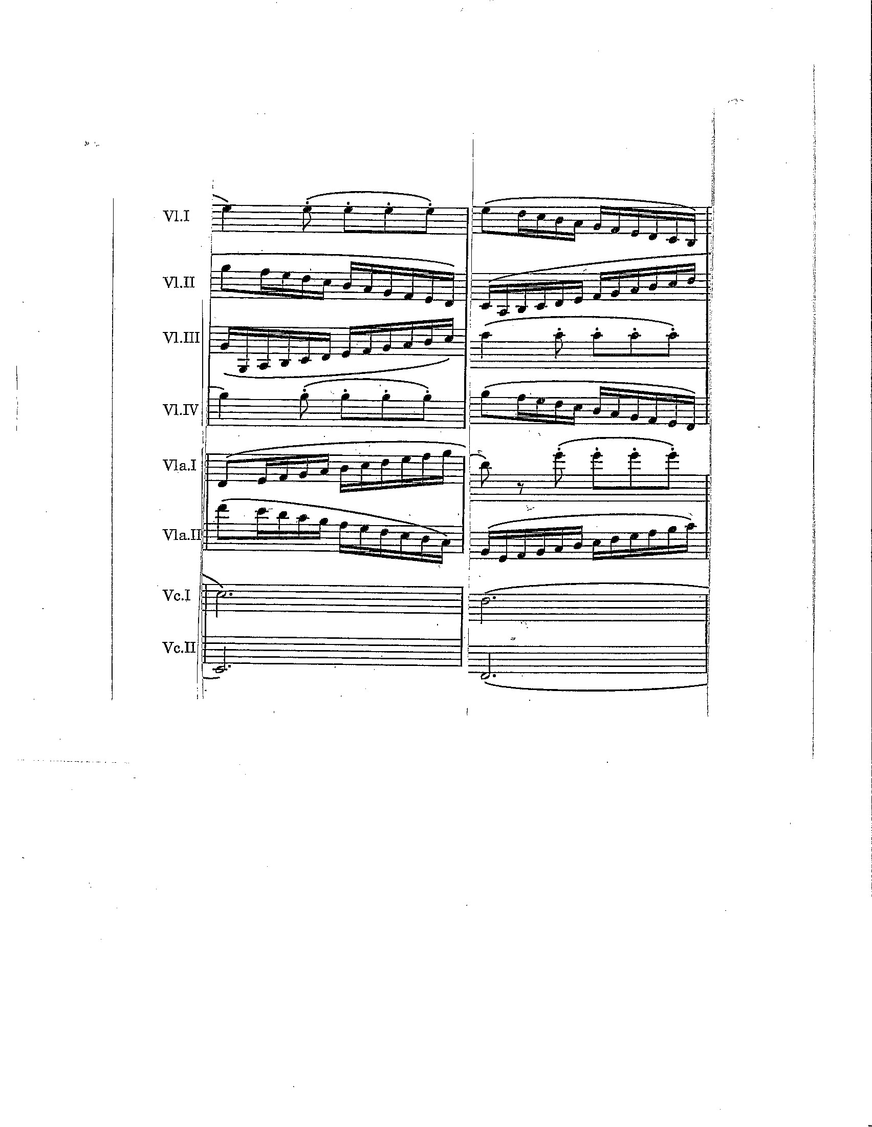
Figure 2.1 Mvt. 2 m. 46-47 – Mendelssohn Octet – Original Orchestration for Strings

Figure 2.2 Mvt. 2 m. 46-47 – Proposed Harbaugh Transcription of Octet

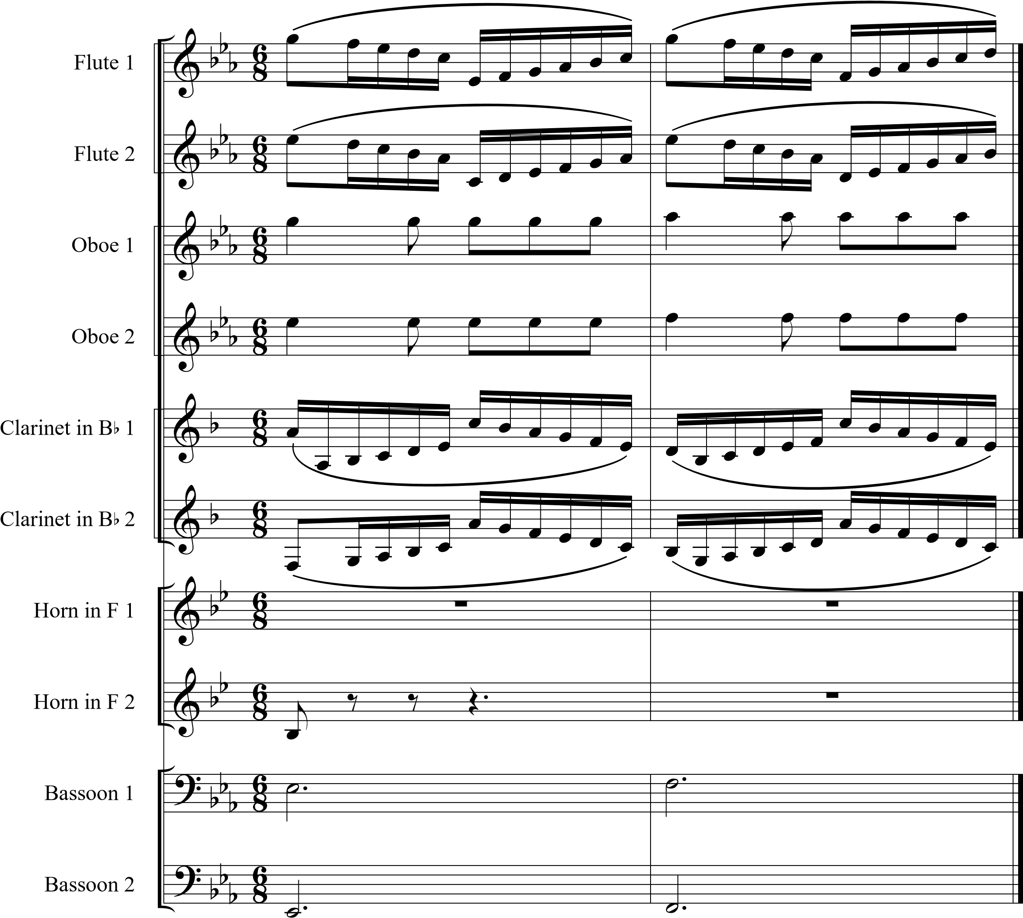

Another challenge to orchestrating winds is the ability to articulate at fast tempos. Solutions must be considered throughout, especially in the third and fourth movements. With every articulation notated, one must consider if it changes the effect of the overall work. In a few places, adding a slur can work. In other places, consideration will be given to splitting rhythms between like instruments (1e+ in one instrument and 1 +a in its counterpart – see Figure 2.3). The overall tempo of each movement must also be considered. Since recordings can be found using a wide array of tempi, suggesting a tempo range for each movement will be necessary and appreciated by most performers. The transcription is intended for advanced performers and therefore a range of acceptable tempi for each movement will allow room for individual interpretation while still achieving Mendelssohn’s intent.

Figure 2.3 Sample of Rhythmic Notation Consideration
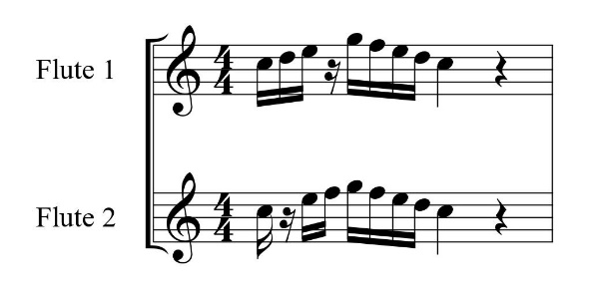

Finally, consideration was given to whether this is a piece that will be publishable and will be performed. The quality of Mendelssohn’s writing has made this a pillar in the chamber string repertoire. Quality transcriptions of this nature are quickly accepted in the wind community. Coupled with the fact that we are in a time where chamber works are prevalent due to being in a pandemic, this work could be immediately publishable and should find play with many of the top ensembles in our field. I recognize that certain movements will be more accessible than others and could possibly stand alone, but for a complete performance of this piece, endurance will be a factor. This element may limit complete performances to upper echelon ensembles. Additionally, this work is in the public domain and therefore publishers should find it an appealing project for the performers and the consuming public.

Purpose

The purpose of this study is to create a transcription of the four-movement of Octet in E-flat Major, Op. 20 by Felix Mendelssohn-Bartholdy for double wind quintet. The intended outcomes will be as follows:
- To bring a core piece of string chamber literature to the wind idiom.
- To discuss orchestration techniques used by Mendelssohn in his Overture for Winds, Op. 24 and Scherzo in G minor. These techniques will affect the scoring in the transcription in order to make the work as authentic as possible.
- To create additional opportunities for wind performers to experience a significant work by Mendelssohn beyond his Overture for Winds, Op. 24.
- To add a significant work to the wind chamber repertoire in a time when chamber music is at the center of performance opportunities due to the ongoing pandemic.

Chapter 3 – Review of Related Literature

In order to fully address all of the necessary information needed to create an authentic transcription of Mendelssohn’s Octet in E-flat Major, Op. 20 for double wind quintet, the background research is separated into six categories. Each of these give either the overarching perspective needed to create a viable transcription or they speak directly to a technique that is needed to complete the transcription. These six categories of literature review will each be addressed individually and are as follows: biographical information about Mendelssohn; Mendelssohn and his work in historical context; analysis of general techniques used by Mendelssohn in his works; analysis specifically of Mendelssohn’s Octet in E-flat Major, Op. 20 and his Overture for Winds, Op. 24; general orchestration techniques; and scores of original works.

Biographical Information
It is well documented that Mendelssohn had his family roots in the Jewish faith and that he later converted to Lutheranism. He reflected both his roots and his personal faith through the hyphenation of his last name – Mendelssohn-Bartholdy. In his 2017 thesis, Gregg Lewis Brandon wrote of the statement of personal faith that Mendelssohn crafted as part of his conversion. Brandon noted that the completion of this personal faith document was dated on September 27, 1825, which was in a month of the completion of the Octet. Although his faith clearly had impact, some scholars disagree with the degree of impact on his compositions. Leon Botstein’s 2009 article Mendelssohn as a Jew: Revisiting Controversy on the Occasion of the Composer’s 200th Birthday, allows us to look at the possibility that his faith may not have had as much to do with his compositions at all.
Musicologist Dr. Michael Cooper, in his publication titled Knowing Mendelssohn: A Challenge from the Primary Sources, notes that the knowledge of influence of Mendelssohn’s faith in his music may have been muted due to an “increasingly anti-Semitic Europe” in the latter half of the nineteenth century. Even though Mendelssohn was once considered the heir apparent to the German legacies of Haydn, Mozart, and Beethoven, he became a “whipping-boy in the revolutionary fervor” that was growing in Europe after his death.
For further perspective on how the Octet fit into the greater canon of Mendelssohn or the influence that the Octet and other early works contributed to his later musical contributions, one can look to three additional documents that clearly show his path and growth as a musician. First, in the text of A Mendelssohn Miscellany by noted Mendelssohn scholar R. Larry Todd, one sees early genius in his musicianship, including the declaration by German Composer Carl Frederich Zelter that Mendelssohn was a “mature musician and in the brotherhood of Bach, Mozart, and Haydn.” This declaration by Zelter occurred in 1824, which was when Mendelssohn was only 15 years old and prior to the composition of the Octet and the Overture to A Midsummer Night’s Dream.
Christopher Crier’s 1994 The Rehabilitation of Mendelssohn discusses how Mendelssohn’s output and musicianship fits in the context of other compositions and composers in the first half of the nineteenth century. He proposes that the new technology of recording devices being developed in Europe around this time led to the fame Mendelssohn experienced in his lifetime. Finally, in the dissertation of Princeton graduate Dr. Lisa Tkalych, entitled Felix Mendelssohn as a Romantic Conductor, the author makes a case for how the influence of Mendelssohn became a bridge between the Classical and Romantic Eras.

Historical Context
Although the modern concept of the wind band did not come to fruition until 1952, the idea of using wind instruments is long and complex. In his book, A New History of Wind Music, prominent conductor and wind band historian Dr. David Whitwell writes of Mendelssohn’s use of wind instruments and the influence on later generations. Whitwell leads us to an understanding of Mendelssohn’s impact in regard to use of wind instruments in his non-orchestral compositions, as well as patterns in instrument choices in his compositions that would support the use of a double woodwind quintet rather than, for example, a double brass quintet.
Interestingly, Whitwell further states that Mendelssohn appeared to be sensitive to extremely loud noises throughout his career. Mendelssohn commented in reference to a Cherubini opera about how the “thunder-clap effects (were) score(d) as if instruments were nothing and effect everything.” Additionally, Mendelssohn referred to the “three or four trombones blasting away at you as if the human ear could stand anything.” Mendelssohn was also extremely conscious of the still primitive state of brass instruments during his lifetime. He stated:

“The E-flat for the horns and trumpets I put down trusting luck, and hoping Providence would show the players in some way to do it; if they have new contrivances for it, so much the better.”

In addition to an output of wind works for small ensembles that often included piano and voice, Mendelssohn did compose two works exclusively for winds. His 1824 composition Overture for Winds, Op. 24 is his earliest work in this idiom and was later followed by a funeral march, Trauer-Marsch (1836).

Orchestration Resources
Arthur Clappé’s The Principles of Wind-Band Transcription (1921) offers several concepts that have withstood the test of time. This century-old resource still provides several specific techniques used in many modern transcriptions. In contrast, several passages quickly date the text, such as the use of instruments such as the contra sarrusaphone, which is no longer considered standard in modern wind band instrumentation. Clappé suggests sharing scaler and arpeggiated passages between either common instruments such as clarinet family members, or between multiple instruments. Clappé uses the example of an ascending passage connecting the bass clarinet with the soprano clarinet. He also suggests that the scale could have been “extended lower by contra-bass clarinet, contra bassoon, or (the aforementioned) contra sarrusophone, or higher by flute or piccolo.”
In Chapter 12 of The Technique of Orchestration by Kent Kennan, much is discussed about scoring for woodwind instruments. Kennan offers a specific chart that lays out the effectiveness and frequency of doubling woodwinds voices in unison, doubling at the octave and the use of three instruments in multiple octaves. He also provides useful comments that are directed towards the tone quality achieved with many combinations of instruments.
Although Frank Erickson’s Arranging for the Concert Band lends examples that are primarily geared towards orchestrating the large ensemble, there are aspects of this source that benefit arranging for a wind chamber ensemble. The early portion of his book describes useful registers for each instrument, as well as briefly addressing quality of tone for each example. A late chapter delving in to transitioning string parts, titled “Transcribing – From the Orchestra,” says to “consider the orchestra score as a general basis for the band piece, maintaining as much of the essence of the original as possible.”
Consideration of blend between instruments is a concern that bears addressing from orchestrators and performers alike. This directly impacts certain aspects of how this transcription of the Octet should be approached. In the study published in 2017, Blending Between Bassoon and Horn Players: An Analysis of Timbral Adjustments During Musical Performance, co-authors Sven-Amin Lembke, Scott Levine, and Stephen McAdams state how much control the composer has over clarifying blend issues versus how adjustments made by individual performers play into the creation of a homogenous sound from these two instruments. Their results show that “assigning roles to performers yielded the clearest effects for timbral adjustments relating to blend.” This information speaks to how performers do have control over blend not only by simply deciding which instrument will play louder, especially in unison passages, but by varying dynamics throughout the arrangement in order to show which voices should be dominant. In this way, an orchestrator too has the ability to influence ensemble timbre in a clear manner through dynamic control.
In her Master’s Thesis, Roxanne Haskill provides basic methods for transcribing string works to winds. Phrasing, along with bowing and articulation, are two sections in this document that provide suggestions for a transcription consistent with the composer’s intent. Consideration must be given to how breathing in wind players can affect the intended musical phrase. Planned scattered breathing in long phrases should be considered, as well as simply allowing the performer to develop their own interpretation. This is especially true when no phrase markings are available in the original work. Additionally, Haskill presents examples of syllabic placements for wind players that directly relate to specific articulations found in string parts.
Above all, the transcriber’s duty is to give due thought and consideration to the re-creation of the composer’s original intent. Richard Crocker’s A History of Musical Style places the early works of Mendelssohn in context of his career output, as well as in context of his contemporaries. Crocker describes his early works as “tender, wistful, whimsical, or spritely.” When discussing composer intent, these descriptors properly state the emotions that should be conveyed throughout the transcription of the Octet. The need to consider composer intent is also echoed by Dr. Timothy Shade in his DMA essay titled, A Process for Transcribing Orchestral Works for Wind Band: Andre Previn’s “Sallie Chisum Remembers Billy the Kid.” Shade states that “The transcriber’s goal is to make the music sound as close to the original as possible in another ensemble by representing the composer’s original intent with regard to sonority and timbre.”

Analyses of Octet and Nocturno
In Benedict Taylor’s article, Music History and Self-Conciousness in Mendelssohn’s Octet Op. 20, he “approaches the Octet from the standpoint of its cyclic formal design.” The Octet shows that it is a transitional work from the Classical Era to the Romantic Era. Taylor wrote:

“In its recall of past music, the Octet’s large-scale cyclic trajectory may be understood to constitute a form of musical self-consciousness-the music’s apparent ability to reflect on its own history. Previous themes are heard returning in later stages of the work as if they were memories arising from in the consciousness of the music, a process prefigured in several of Beethoven’s cyclic designs, including those of the Ninth Symphony, the Piano Sonata, Op. 101, and the Cello and Piano Sonata, Op. 102, no. 1.”

Throughout this article, Taylor shows connection of form through thematic analysis, demonstrating the importance of the Octet in the body of Mendelssohn’s works, and discussing the influence of Goethe and Shakespeare on Mendelssohn. Taylor closes this article by stating that “The Octet is not only ‘the first work of Mendelssohn’s maturity,’ but also the first work in which his historical attitude is encapsulated in the music’s actual structure.”
In his PhD dissertation titled The Early Works of Mendelssohn: A Study in the Romantic Sonata Style, Dr. Gregory Vitercik encompasses much more than just a simple discussion on sonata form and its relation to the Mendelssohn Octet, which occurs at length in the third chapter. In the first chapter, he addresses what he calls “The Mendelssohn Problem.” Vitercik writes about how many historians discount the early works of Mendelssohn and describe this stage of his compositional output as “youthful spontaneity.” Through this document, Vitercik uses the Mendelssohn Octet as a vehicle to dispel the misnomer of this unfair label and show specific examples of how the early works of Mendelssohn, and specifically the Octet, are “unquestionable masterpieces.” The thematic analysis provided by Vitercik in the third chapter undoubtedly provides direction for the ultimate goal of an authentic transcription.
Although not as in depth as the Vitercik dissertation, W. Gilles Whittaker’s 1933 article, simply titled Mendelssohn’s Octet, does propose the question, “could Mendelssohn have composed this work later in his career?” He believes that the youthfulness that many thought to be a detriment could have been the true driving force behind its genius. Whittaker states that “In the handling of eight parts here there is no mere filling up, not halting, no marking time, no needless doubling. They proceed as if difficulties did not exist.” He gives several specific examples throughout the remainder of the article with regards to the treatment of thematic material. In Whitaker’s estimation, most young composers are “apt to think more in themes than of the possibilities of their treatment.”
David Damschroder’s book, Harmony in Mendelssohn and Schumann, is a text that focuses on the creation of harmonic analysis through the perspective of the listener and hosts a chapter that compliments the documents written by Gregory Vitercik and Benedict Taylor. The text examines the harmonic language used by the two composers more than their thematic material. In the ninth chapter of Damschroder’s book, Mendelssohn: Octet in E-flat Major (op. 20), movement 1: In Response to Greg Vitercik and Benedict Taylor, he states how “Vitercik offers an array of analyses (of) graphs in the Schenkerian sense… Even if his and my examples contrast visually, readers should be able to correlate the two easily.” Damschroder also says of Taylor’s article that “Though considerations of harmony (my chapter’s focus) are not at the center of his purview, his exploration of the exposition offers many ideas that should be intriguing to ponder in juxtaposition with my reading.”
Dr. R. Larry Todd (Duke University) is considered one of the preeminent Mendelssohn scholars in the United States today. His PhD dissertation, entitled The Instrumental Music of Felix Mendelssohn-Bartholdy: Selected Studies Based on Primary Sources, provides a great deal of insight not only toward the melodic and harmonic structure of the Octet, but also toward much of the output of Mendelssohn’s early years, both published and unpublished. These works demonstrate some of the influences in his formative years including examples of how Mendelssohn modeled the classical works of Haydn and Mozart.
Although not a formal structural analysis of Mendelssohn’s Octet, a video lecture provided by the Library of Congress offers a great deal of perspective on this work from the standpoint of form. The lecture, titled Revisiting Mendelssohn’s Octet, is presented by Dr. R. Larry Todd. In this lecture, he discusses the form and influences that led to the composition of the Octet, as well as how this work influenced his later works. At the 1:16:00 mark, Todd discusses the use of 8-part counterpoint, Faustian influence by providing listening examples from the final movement where Mendelssohn quotes G.F. Handel’s Messiah and intertwines the borrowed material with a recapitulation of the scherzo movement.
Felix Mendelssohn’s Nocturno/Overture, Opus 24: A Study in Context, Composition, and Performance by Dr. Kevin Geraldi is a resource that speaks directly to the structure of a wind work that was composed by Mendelssohn just one year prior to his Octet. Geraldi provides valuable insights into the instrumentation and harmonic structure found in Mendelssohn’s Nocturno. These insights give context to the orchestration techniques Mendelssohn chose to use in compositions for winds at this stage in his career and will directly influence orchestration decisions for the transcription.
In his Master’s thesis titled Formal Procedures in Three Works for String Chamber Ensemble by Felix Mendelssohn-Bartholdy, George Austin first provides multiple maps to illustrate the use of sonata form in the first and third movements of the Octet, as well as two other works later in his career. Additionally, Austin provides analysis of the scherzo in these three works. In the Octet, Austin shows how it serves as “a point of departure for the established third movement form.”
In her article On Microscopic Hearing: Fairy Magic, Natural Science, and the Scherzo fantastique, Francesca Brittan studies specific examples from the third movement of the Octet. Through these examples, she attempts to define how that movement became, as Fanny Mendelssohn called it, “ethereal, fanciful, and spirit-like.” Brittan defines the root of what makes Mendelssohn’s aesthetic different from his predecessors as the “element of contrast,” which can be seen when “delicate textures quickly give way to contrasting material: fortissimo explosions, tuneful homophonic themes, and tutti passages.” The analyses Austin and Brittan provide lead to deeper understandings of form and style of the Octet. The analyses provide perspective necessary to maintain the intended spirit of the Octet during the process of transcription.

General Orchestration Techniques Used by Mendelssohn
While literature review revealed no direct analysis of the Octet or Nocturno, several documents reviewed address these topics more generally in his other compositions and establish much of the material that will be discussed in Chapter three. They establish the melodic and harmonic language, as well as patterns in orchestration techniques, used by Mendelssohn. Whether it is Mendelssohn’s use of Sonata form, analysis of his piano works, or a brief look at the chamber works of Fanny Mendelssohn Hensel that were directly influenced by her brother, each one of these sources speak to who he was as a composer.
Mendelssohn scholar Dr. R. Larry Todd provides insight into Mendelssohn and his compositional style in his early years. From the Composer’s Workshop: Two Little-Known Fugues by Mendelssohn provides an opportunity to look at other works of Mendelssohn composed concurrently with the masterpieces of his teenage years. Todd states that “the Octet and Overture (“A Midsummer Night’s Dream”) may be placed in their proper critical context, not as isolated examples of artistic and technical perfection, but as works created during an especially fertile period…” This article provides the opportunity to examine “Mendelssohn’s response to and assimilation of Beethoven’s influence” as well as Mendelssohn’s “abiding interest in counterpoint and Bach.”
In Dr. Robin Garvin’s PhD Dissertation, Romantic Irony in the String Quartets of Felix Mendelssohn Bartholdy and Robert Schumann, the Octet is not specifically referenced, but it does study two works that Mendelssohn composed contemporaneously with the Octet; the String Quartet in A Minor, Op. 13 and the String Quartet in E-flat major, Op. 12. If a paradox exists in Mendelssohn’s quartets, there could be reason to believe that something of note could exist between his double quartet. Also, the knowledge that these works were both composed in two years of the Octet and the latter is composed in the same key, raises the idea that influences found in other works could possibly exist in the Octet. For example, the use of baroque and classical techniques and materials in the final movement of the Octet could similarly be considered a paradox under her premise.
The Influence of Different Structural Features on Felt Musical Tension in Two Piano Pieces by Mozart and Mendelssohn by authors Moritz Lehne, Martin Rohrmeier, Donald Gollman, and Stefan Koelsch analyzes tension and resolution in piano works of the afore-mentioned composers. In this study, the authors attributed “Tension Ratings” as measurement for “different features on subjectively experienced musical tension. Modifications included versions without dynamics and without agogics as well as versions in which the music was reduced to its melodic, harmonic, or outer voice components.” Although contrast in dynamics, which results in experiencing music to its full potential, is ultimately up to the performers, the results of this study will influence the transcription’s indicated markings, dynamic and otherwise, throughout the work to maximize intended musical effect.
In his PhD dissertation, The Smoothing-Over of Formal Junctures as a Style Element in Mendelssohn’s Instrumental Music, Dr. Erez Rapoport writes about multiple aspects of Mendelssohn’s compositional style including the recapitulation in sonata form and the linking of multi-movement works. As this project focuses on the transcription of a multi-movement work, it is important to understand the formal structure of all aspects of the work. In reference to the overall tonality of Mendelssohn multi-movement works, Dr. Rapoport writes that “Mendelssohn sometimes attempted to create a sort of inclusive tonal unity in his multi-movement compositions, not withstanding the fact that the individual movements also make sense as complete tonal structures.” Dr. Rapoport does provide specific examples of the overall tonal plan found in two early Mendelssohn string quartets. The Octet was composed in two years of these quartets. Analysis of the tonal structure and orchestration techniques in these works helps lead to a deeper understanding of the Octet, thus leading to a transcription showing a higher level of authenticity.
Thomas Schmidt-Beste analyzed the use of dynamics in Mendelssohn’s symphonies in his 2014 article, Preventative and Cautionary Dynamics in the Symphonies of Mendelssohn and his Time. Close examination of the Mendelssohn Octet score reveals repetition of dynamics, especially pianissimo, in certain phrases Schmidt-Beste addressed. Using Mendelssohn’s Third Symphony as an example. Schmidt-Beste states:

Mendelssohn thus uses his dynamic markings to counteract the implied progression of the musical phrase, to restrain the orchestra from shaping the musical phrase, and to foil the expectations of the audience. Furthermore, the suppressed tension of the forced pianissimo enhances the contrast with the fortissimo. The use of this increase of tension and contrast by what might be called ‘preventative’ dynamic markings become even more striking.”

Although Schmidt-Beste’s analysis is specific to this feature’s use in the Mendelssohn symphonies, there is no reason to doubt that Mendelssohn uses this technique elsewhere in his works. As the transcription proceeds, the consideration of dynamic contrast and the reemphasis thereof to create restraint and contrast in a performance is vital to its authenticity.

Original Scores
The published and manuscript scores to Mendelssohn’s Octet in E-flat Major, Op. 20 are the only direct source material for the transcription. The original manuscript exists in the online archives of the Library of Congress. All other scores that are analyzed in this project are being examined in order to inform the orchestration decisions used throughout the transcription.
Other Mendelssohn works utilized for orchestration choices are his Overture for Winds, Op. 24, which is one of two original works for winds and Scherzo in G minor, the orchestral transcription that Mendelssohn created as an alternate third movement to the Symphony No. 1. Additionally, I will be examining other transcriptions between strings and winds including the scores to Wolfgang Amadeus Mozart’s Serenade for Winds in C minor, K. 388 into his String Quintet No. 2, K. 406/516b. Although Mozart’s Serenade was composed first, these works are quality examples from that general era and can be referenced when considering the techniques needed to adapt orchestrations of wind and string chamber music.

Chapter 4 – Transcription Process/Considerations

Analysis of Early Mendelssohn Orchestration Techniques for Winds
Mendelssohn’s early works are full of wind orchestration techniques derived from Classical masters preceding him. Well-known as a student of great composers like Mozart, Haydn and Beethoven, Mendelssohn was aware of their practices in orchestration and adopted many of these techniques in his works while developing his own voice. In particular, the Scherzo in G minor and Overture for Winds, Op. 24 utilize specific techniques that can be directly applied to this transcription of the Octet, Op. 20.
The Scherzo in G minor is an arrangement of the third movement of the Octet for full orchestra by Mendelssohn. He transcribed this movement as an alternate third movement to his first symphony. The Scherzo in G minor offers insight into how Mendelssohn’s approach to instrumentation, frequency of use, tessitura, articulation, and idiomatic rhythmic writing for wind instruments.
The wind instrumentation for the Scherzo in G minor is two Flutes, two Oboes, two Clarinets, two Bassoons, two Horns, two Trumpets, and Timpani. Minus the trumpets and timpani, this instrumentation directly equals the double woodwind quintet used in the transcription of the Octet for winds. Mendelssohn may not have specifically conceived scoring the Scherzo as a double woodwind quintet plus trumpet and timpani, but that is exactly what he ended up doing. Flute, oboe, clarinet, and bassoon were all utilized either independently with melodic material or were found to be in unison with strings supporting the melody. Trumpet was the least utilized instrument in this transcription and primarily was used in unison, thirds, sixths, and octaves for providing harmonic support. Trumpet was not used in a melodic capacity in Mendelssohn’s arrangement. Also, following norms for the time period, timpani only used notes that support the tonic and the dominant chords in G minor, which are the notes G2 and D3.
With the exception of the flute parts, each wind instrument was scored primarily in its midrange throughout the Scherzo, which allows for maximum control of dynamic range and tone color. Mendelssohn often took the flute into the extremes of its range, especially in the low range of the instrument. The first flute part is scored as high as A6 and D4 and E4 are used multiple times throughout this transcription in both the first and second flute parts. Additionally, C4 can be found for the duration of measure 29 in the second flute part (See Figure 4.1). Each of these instances are found at either a piano or pianissimo dynamic. This shows that Mendelssohn not only recognized the difficulty of projection at that range, but also was keenly aware of the tone color added by flutes in their breathy, whispy low register. Additionally, with few exceptions, the flute parts are scored in either unison or in octaves.

Figure 4.1 m. 27-29 – Flute Register in Scherzo
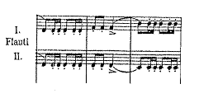

In the wind parts of the Scherzo, Mendelssohn does not push the rhythmic limits of the individual instruments. He does include metered tremolos in the second flute part in measures 83-89 and trills into grace notes in the first flute and first clarinet parts throughout measures 152-164. The most notable rhythmic occurrence occurs in measure 20 where Mendelssohn overlaps sixteenth notes in the flute part with thirty-second notes in the violin part (See Figure 4.2). This shows Mendelssohn’s willingness to allow similar rhythmic ideas to exist simultaneously in a manner that is consistent with the technical ability of each player and instrument as long as the intent is not affected.

Figure 4.2 m. 20-21 – Coupled Sixteenth and Thirty-Second Notes
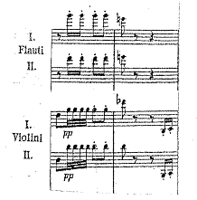

In 1824, Mendelssohn composed a work for chamber winds known as Nocturno. This work would be rewritten in 1826 after losing the original score. He rescored it for 23 winds in 1838 and re-named it Overture for Winds, Op. 24. The Octet in E-flat Major, Op.20 was composed one year after the original Nocturno and one year prior to the writing of Nocturno. The Overture for Winds stands as his earliest original work for winds and it is the first of only two wind chamber works found in the totality of his known repertoire. With the Overture having been composed by Mendelssohn in a year of the Octet, insight is provided to multiple techniques used by Mendelssohn in context of a work exclusively for winds.
Although the true instrumentation of the Nocturno (1824) is not fully known, the accepted instrumentation for it is the wind octet containing two Clarinets in C, two Oboes, two Bassoons, and two Horns in F, along with an added Flute, Trumpet, and English Bass Horn for eleven parts in total. When Mendelssohn rewrote the piece in 1826, he more than doubled the original instrumentation by adding two Clarinets in F, two Bassett Horns, two Horns in C, one Contrabassoon, one Trumpet in C, three Trombones, and Percussion for a total of 24 parts. The instrumentation conceived in the Overture shows a strong lean toward instruments found either in the woodwind family or in the context of the traditional instrumentation of the woodwind quintet. Mendelssohn scored the Overture for one Piccolo, one Flute, two Clarinets in F, two Clarinets in C, two Oboes, two Bassett Horns, two Bassoons, one Contrabassoon, one English Bass Horn, two Horns in F, two Horns in C, two Trumpets in C, one Alto Trombone, one Tenor Trombone, one Bass Trombone, and two Percussion parts that include Tambourine, Triangle, Snare Drum, and Cymbals.
Even with the addition of brass instruments to the Overture, Mendelssohn still chooses to primarily keep the melodic content in the woodwind voices. Unlike his Scherzo arrangement, the Horns have an opportunity to serve as the melody as well (measures 26-36). Even with their addition to the Overture, trumpets and trombones primarily provide harmonic and rhythmic support. It could be argued that the trumpet does provide melodic content during a fanfarelike arpeggiation from measures 220-222, but that part is doubled by the Clarinet in C. Based on conductor or performer preference, the choice could be made to shift the balance of that line towards the Clarinet thus negating the Trumpet being considered the prime melodic contributor for those three measures. As a general technique, Mendelssohn does score many of the melodic lines either at octaves in an instrument group or in unison between varying instrument types.
Mendelssohn’s scoring provides evidence that he realized that wind players cannot sustain melismatic passages like their string counterparts due to a finite amount of air that performers can utilize. One piece of evidence can be found in measures 108-111 in the Overture. Mendelssohn creates slurred arpeggiated chords that transition between similar instrument after two beats. An example of this is found in the Clarinet in C part in measure 109. Clarinet 1 part performs sixteenth notes throughout the first two beats of the measure while Clarinet 2 part performs sixteenth notes throughout the final two beats. Second, the use of simultaneously ascending and descending sixteenth note lines occurs in measure 161 of the Overture. Rather than all lines moving in one direction, this creates textural interest and an increase in tension in the shape of the line. Both the ascending and descending scale patterns are diatonic in nature. These two techniques are similar in application to the second movement of this transcription of the Octet, which was discussed on page 7 and shown in Figures 2.1 and 2.2 on pages 8 and 9 in Chapter 2.
Mendelssohn is precise about the articulation and dynamic choices throughout the Overture. Consistent with other Mendelssohn works from this time period, he uses the markings sf, sfp, and fp to create accent and emphasis. Only in measures 108-111, 187-192, 196-198, and 220-223 does the marking of an accent appear at all. Additionally, Mendelssohn’s use of staccato markings are plentiful throughout the work. A majority of the staccato markings are associated with eighth notes in the Allegro Vivace portion of the Overture, but he notably includes staccatos during sixteenth note passages in measures 88 and 92 in the flute and certain clarinet parts. At the marked 152 beats per minute, these passages prove to be difficult while single tonguing.

Transcription General Techniques
Throughout the creation of the transcription of Mendelssohn’s Octet in E-flat Major, Op.20 from double string quartet to double woodwind quintet, the goal is to both transcribe the work in a manner that retains the character of the original work and to strongly consider techniques used by Mendelssohn himself in order to maintain its authenticity. As this description of all four movements of the transcription proceeds, consistent attempts were made to follow the general principles listed below:
- The original key signature was maintained in all movements.
- In general, the bassoon parts are transcribed directly from the cello and the horn parts are transferred directly from the viola. This is due to the range of each wind instrument fitting in the general range of the respective string instruments. The horn does diverge from the viola part more often than the bassoon diverges from the cello part and when necessary, the clarinets take over the viola lines. Flute and oboe parts tend to be written based on the four violin parts. Clarinet is utilized in a variety of roles because of its wide range. The clarinet parts include segments from all four violin parts, both viola parts, and the cello 1 part at certain points of this transcription.
- Adjustment to original dynamic markings have been a necessity throughout to assure proper melodic and harmonic lines are presented authentically.
- Segments of the original Octet that utilize all eight players at forte and fortissimo dynamic levels utilize all ten players in the transcription. The extra instruments are utilized in the construct of the existing chord structure. Segments utilizing a thin texture with minimal instruments are served by the same number or performers, unless tessitura of the passage requires an extra instrument.
- Mendelssohn’s work contains no rehearsal markings. Consequently, letters have been added throughout facilitating ease of rehearsals.
- Anything diverging from these principles will be presented and described in this section and the following three sections of the document.

Movement 1 – Andante moderato ma con fuoco
The beginning of the first movement brought three necessary adjustments when transcribing the Octet. The first quandary came when addressing the range of the opening melody in the Violin I part. Between measures 1-8, the Violin I part is written as low as G3 and as high as A6. To compensate this wide range, the decision was made to utilize both the Flute 1 and Clarinet 1 in creating the melodic line. In measures 1-3, each statement begins on the and of beat two. As transcribed, Clarinet 1 performs the first four eighth notes of the melody, Flute 1 joins on beat 4 and finishes the final notes of the melodic figure. In measures 4 and 8, the melodic figure does continue on where the clarinet resumes the melodic line on beat four and concludes the melodic idea with sixteenth notes leading to beat 1 of the following measures (See Figure 4.3).

Figure 4.3 Mvt. 1 m. 7-8 – Flute 1 and Clarinet 1 Melodic Jointure
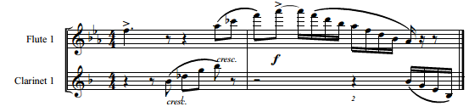

The second item requiring compromise was originally found in measures 1-9 of the Violin II, III, and IV, and Cello I parts. The metered trills could not be maintained in their original state due to range issues in the woodwind instruments. All three Violin parts contain G3 and B-flat3, outside of the range of flutes or oboes. While maintaining the original chord structure, the three violin parts were rewritten in the accepted range for flutes and oboes.
The final change came in the form of dynamic control. The melody is marked starting at a mezzo forte and crescendos to a forte in measure 4. The Bassoon 2, Horn, and Clarinet 2 parts are notated as piano with crescendo to mezzo forte in measure 4. The metered trill parts of Flute 2, Oboe, and Bassoon 1 are all notated as pianissimo with crescendo to mezzo piano in the fourth measure.
In measure 9, the Bassoons gain the melodic content, and therefore, marked at mezzo forte. In measure 10, the sforzando is maintained from the original string markings in the Flute, Horn, and Bassoons. In the Oboe and Clarinet parts, the transcription uses a forte piano followed by a decrescendo to pianissimo. Additionally, the Flute parts have a mezzo piano marking on the and of beat two for purposes of ensemble balance.
In measure 12, the melodic line dynamic was raised to a mezzo forte rather than the original marking of piano. This measure of the melody is doubled between both the flute and horns. Measure 20 had to be adjusted due to a range issue. Originally, the Violin I and II have a descending sixteenth note scale that begins on B-flat5 and ends on G3. Flutes cannot play a G3. In order to compensate, starting on the third beat of the measure, the Flute part was displaced up one octave from A4 to A5. The scale continues to descend from the A5, with the Flute 1 and 2 parts now ending on G4 on the downbeat of measure 21 (See Figure 4.4).

Figure 4.4 Mvt. 1 m. 20-21 – Flute Register Displacement
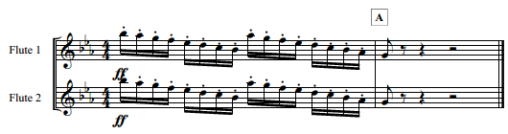

Measures 21-37 is the first time all players are not performing simultaneously. Mendelssohn divided the octet into two string quartets and utilized them in a call and response manner. The transcription also utilizes two quartets throughout this sixteen measure passage. Oboe 1, Clarinet 1, Horn 1, and Bassoon 1 are included in the first quartet with the second quartet being comprised of Flute 2, Oboe 2, Horn 2, and Bassoon 2 (See Figure 4.5). The Clarinet 2 rejoins in measure 35 and Flute 1 rejoins as the original melody returns in measure 37. In measure 22, the eighth note B-flat on beat one of the Horn 1 part had to be lowered by an octave. This change is needed because of a combination of range and dynamics. Horn can reach a B-flat 5, but it is difficult to do so at an ensemble dynamic level of piano in a unison passage while maintaining ensemble balance.

Figure 4.5 Mvt. 1 m. 21-22 – Quartet Call and Response
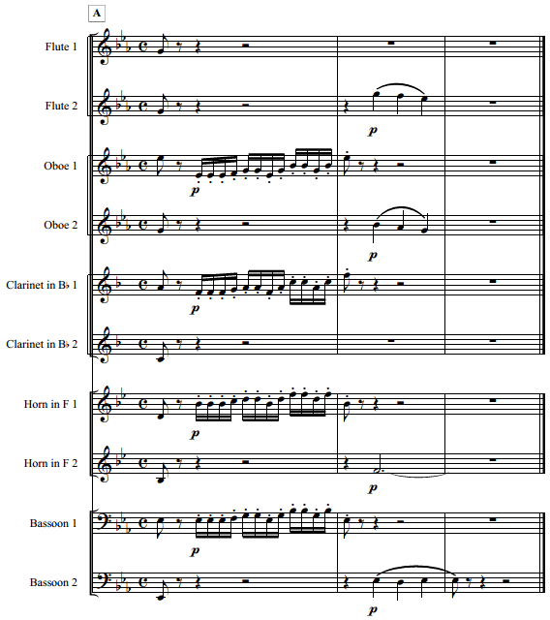

Measures 37-47 are similar to the beginning of this movement in that the main melody is divided between Clarinet 1 and Flute 1. All adaptations that occurred earlier in the work also apply to this segment as well. In measure 48, Flute 1 and 2 have their dynamic adjusted from piano to mezzo piano in order to facilitate a better level of ensemble balance with the rhythmic energy projected by the horns. This grouping of measures does crescendo to an ensemble forte on beat 3 of measure 50. To continue to maintain proper ensemble balance, mezzo forte is utilized in the Oboe 2 and Clarinet 1 and 2 parts.
Starting in measure 59, Mendelssohn utilized four instruments playing whole notes. This transcription does utilize six instruments, which fills out the ensemble sound. A piano dynamic level is maintained until a crescendo begins in measure 61. Additionally, the Flute 1 part is marked at mezzo piano in order that the melodic content can be properly heard in context with the rest of the ensemble. Originally, the ensemble arrived at a forte dynamic level on the downbeat of measure 63. For purposes of ensemble balance, Flute 2, Oboe 1 and 2, Clarinet 1 and 2, and Horn 1 and 2 remain at a mezzo forte at this juncture.
In the phrase leading to measure 80, the melodic content is found contained in the Oboe 2 part. In measure 80, a passage occurs that would force the oboe out of range, as it starts on B3. This segment is placed in the Clarinet 1 part as illustrated in Figure 4.6. As this one measure is transitional material, the lack of continuity with the Oboe 2 part minimizes any disruption with timbral change. Due to massive tessitura shifts in the Cello parts in the original Octet during measures 84-86, the Cello I part can be found in Bassoon 2 and the Cello II part can be found in Bassoon 1. This allows the bassoons to stay in a more consistent register.

Figure 4.6 Mvt. 1 m. 79-80 – Melodic and Transitional Material
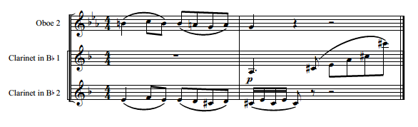

The passage from measures 88-101 was challenging to transcribe. This musical idea combined several individual lines in the Violin parts that descended below C4, string parts that utilized large leaps, and sixteenth note passages that passed between voices and in some cases, overlapped other sixteenth note passages. With the exception of measures 88 and 89, all of the staccato sixteenth note passages were able to be contained in the Flute and Oboe parts. The staccato sixteenth note passage starting on beat two of measure 88 is found in Clarinet 1 with the passage starting on the fourth beat of the same measure being found in Horn 1. Both are necessities due to range concerns.

Figure 4.7 Mvt. 1 m. 88-89 – Sixteenth Note Passage Range Solutions
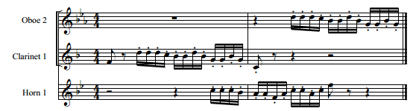

The challenge in transcribing measures 102-108 is once again due to range. In the original work, Violin III and IV, all Violas, and all Cellos perform fortissimo whole notes while Violin I has melodic content ranging from G3 to A6. In this transcription, Flute 1 begins the melody starting on the downbeat of measure 102. Clarinet 1 joins the melody in unison on beat three of measure 103. Flute 1 and Clarinet 1 act in unison until the fourth beat of measure 104 on a D4. Clarinet 1 continues with the melody through measure 105 (See Figure 4.8). On the downbeat of measure 106, Flute 1 rejoins in unison. Both parts remain in unison with the melody through the downbeat of measure 111.

Figure 4.8 Mvt. 1 m. 102-105 – Flute 1 and Clarinet 1 Melodic Range Solution
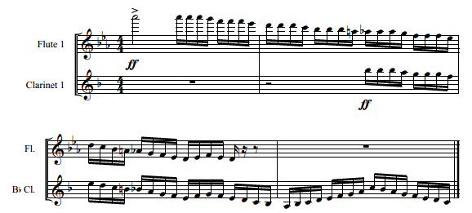

Measure 113 contained two necessary adjustments due to concerns of ensemble balance. While the melody, originally contained in the Cello parts, is maintained at the original forte dynamic level in the bassoons, but the whole notes are also doubled at the octave by both flutes in the transcription. The flutes are marked at the original forte and should not compete in texture due to the rhythmic activity and melodic interest with the bassoons. The sixteenth notes found in all other voices are reduced to a mezzo piano on beat two of measure 113. All voices increase by one dynamic level in measure 122. In measures 129-131, the original Violin 1 part ascends to an E-flat7. To reflect Mendelssohn’s original scoring of the Octet, the Flute 1 part is marked as “8va Optional (See Figure 4.9).” This is marked as such because although many high level players can play in that register, it is difficult to tune with the ensemble and may not be ultimately necessary to translate the original intent.

Figure 4.9 Mvt. 1 m. 128-131 – Flute 8va Optional
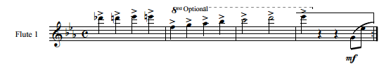
Measure 132 is the second ending. At this juncture, dynamics once again had to be adjusted in accompaniment parts located in both Oboes, Clarinet 2, and both Horns. The original marking is at forte, where these parts have been adjusted to mezzo forte. Due to a range issue, measures 136-138 combine the melody between Clarinet 1 and Flute 1 by applying the same methodology used at the beginning of the movement. This grouping of measures also adjusts in dynamic markings based on the need for balance in the ensemble. Flute 2 and Oboe 1 are marked at mezzo piano while Oboe 2 and Clarinet 2 are marked at mezzo forte.
Measures 142-159 utilized two decisions to allow Mendelssohn’s intent to come to fruition. The first is a change in rhythmic notation. In measures 142, 144, 146, 148, and 150, The original rhythm in the Violin I and II, Viola I, and Cello II is marked as a half note followed by a double-dotted quarter note and a sixteenth note. In the transcription, a half note followed by a quarter note tied to a dotted eighth note and sixteenth note is found. Although the rhythm sounds exactly the same, modern literature would be more likely to have the changed rhythm depicted. Next, measures 143, 145, 147, 149, 151, and 153-166 all originally have three quarter notes with accents, staccatos, and slurs all found in each measure. The exceptions to this are the accents are no longer found starting at measure 156 and measure 166 only has two quarter notes. To allow wind players to achieve a similar sound in the transcription, the accents are left on all notes but the staccatos and slurs are removed (See Figure 4.10). When the accents are no longer used starting in measure 156, quarter notes with no articulation markings occur in the transcription.

Figure 4.10 Mvt. 1 m. 142-143 – Rhythmic Notation and Articulation Alterations
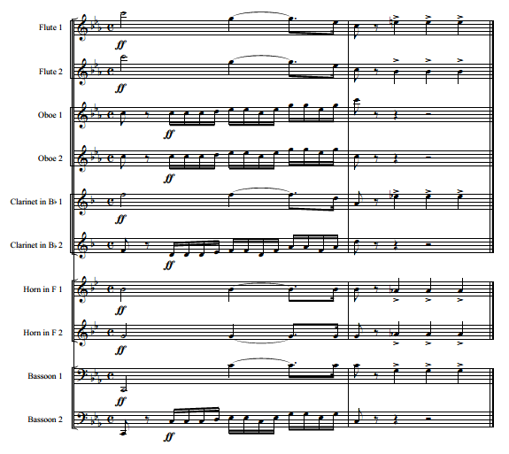

Beginning in measure 169, Violin I and Viola I perform a duet a sixth part from each other. In the transcription this duet is performed by Oboe 1 and Horn 1. On the downbeat of measure 172, the Violin I part shows an eighth note followed by an eighth rest where the Viola 1 part shows a quarter note. The transcription reflects an eighth note followed by an eighth rest in the Oboe 1 and Horn 1 parts. The melodic and harmonic lines are in unison rhythm through measure 172 and afterwards. This change allows full rhythmic continuity between the two parts (See Figure 4.11). Additionally, the eighth note and eighth rest combination are reflected in a similar passage in measure 175.

Figure 4.11 Mvt. 1 m. 172 – Oboe and Horn Rhythmic Alteration
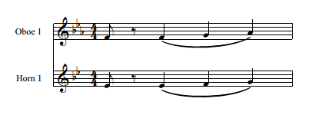

The B-flat in the Oboe 1 part is written 8va from the original part found in Violin II in measures 191-200. This is due to the Oboe and its inability to play in the original register. On the downbeat of measure 200, the Cello I part is marked with an eighth note release after a series of tied whole notes. Violin I, II, III, and both Violas show a quarter note release on the downbeat of measure 200. The transcription reflects all parts releasing to a quarter note to obtain rhythmic continuity.
During measures 209-212, Mendelssohn marked a crescendo in all parts at various times as part of a crescendo from mezzo forte to forte. Once again, for the sake of uniformity across all parts the transcription reflects the crescendo beginning at the earliest note possible for each instrument near the beginning of measure 210. In measure 213, the Violin II part shows repeated B-flat3 starting on the and of beat three. That pitch is maintained through the and of beat two in measure 216. Due to the lack of range below C4 on an oboe, the Oboe 1 part will perform that segment using B-flat4 rather than B-flat3 (See Figure 4.12).

Figure 4.12 Mvt. 1 m. 213-216 – Violin II Transcribed to Oboe 2
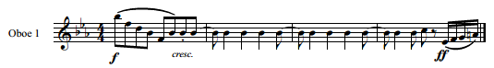
Beginning in measure 213, Mendelssohn composed a series of slurred sixteenth notes that start in the Cello I. Other instruments join in beginning with the Viola II in measure 214, followed by Cello II in measure 215, Viola I on beat 3 in measure 215, and all Violins on beat 3 in measure 216. This is in unison at various octaves and lasts until the downbeat of measure 221. The range varies throughout this passage. Adjustments in octave had to be made for this to be consistently in range for all instruments. In order to make the octave leaps plausible for all instruments, a sixteenth note would be eliminated to facilitate the leap. One such example is found in measure 219 in the Oboe 2. During the sixteenth notes in the third beat, A3 can be found in the original work. For the Oboe 2 to be able to perform this passage, the second sixteenth note in beat 2 was eliminated (E-flat4). The Oboe 2 then reenters on the and of beat two on D5 and thus performs that portion of the melismatic figure in the instruments idiomatic range one octave higher than intended (See Figure 4.13). Similar adjustments are made at different points in Flute 2, Oboe 1, and Horn 1 in measure 219, and Oboe 1 and 2 in measure 220.

Figure 4.13 Mvt. 1 m. 219-220 – Octave Displacement in Multiple Instruments
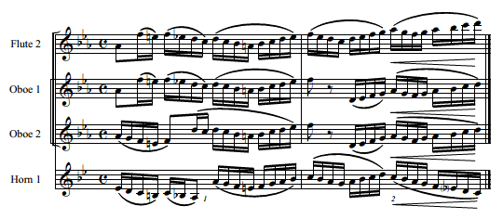
Measures 221-231 is a recapitulation of the first eleven measures of this movement. All changes that apply in measures 1-11 also apply to this segment. Between measures 232-234, several notes originally found in the Violin IV part extend below C4, once again taking them out of range for an oboe. Affecting only the Oboe 2 part, any note that was originally below C4 was raised up one octave in order to assure it is in the natural range of the oboe. Also beginning at measure 232, another adjustment in dynamic marking is necessary. The oscillating sixteenth notes found in all Oboe and Clarinet parts are now marked at pianissimo rather than piano. Additionally, a forte piano followed by a decrescendo is utilized in the same fashion as measures 10 and 11.
In measure 238, a forte piano is now found in the Oboe 1 part. This is followed by a diminuendo marking in measure 240. The forte piano in measure 238 aligns with the Bassoon 2 part and the diminuendo is originally found in all other parts. This again provides consistency in markings and interpretation for all parts. A crescendo was added to all parts starting on the downbeat of measure 261. The crescendo previously started in various points and now provides for consistency in interpretation.
Like previous passages, the need to pass melodic content between Flute 1 and Clarinet 2 due to issues of instrument range is again a necessity in the content between measures 262-269. The original passage begins on the downbeat of measure 262 on A-flat6 in the Violin 1 part. This passage descends to G3 by the downbeat of measure 265, where it once again begins to ascend in range. The transcription utilizes the Flute 1 from the beginning of the passage in measure 262 through the third beat of measure 264 on a D4. At this juncture, Clarinet 2 joins Flute 1 on beat three of 264 and continues the passage without Flute 1 until the downbeat of measure 266 (See Figure 4.14). Flute 1 then restarts the passage on G4 and continues the passage without Clarinet 2 through its completion on the downbeat of measure 269.

Figure 4.14 Mvt. 1 m. 262-266 – Flute 1/Clarinet 2 Melodic Amalgamation
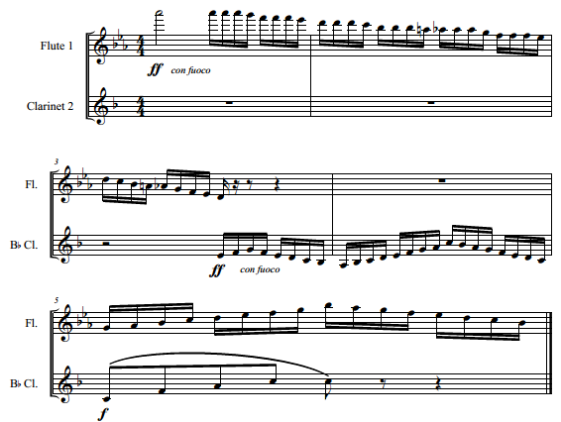

Similar to measure 113, the original Violin I part is doubled in Flute 1 and 2 at the octave, providing more depth of sound against a thickly scored instrumentation. Additionally, to help with balance issues that will likely occur, all Oboe, Clarinet, and Horn parts have been marked at mezzo piano rather than the original forte. This dynamic shift is also reflected in measure 280 as all instruments increase their dynamic from either forte to fortissimo or mezzo piano to mezzo forte.
Measures 299-323 close this first movement. Although no dynamic changes occur from the original work throughout these final moments, a minimal number of adjustments to voicing in chords did need to occur. Each of these is due to either revoicing during chords that had to be changed due to range issues or adding voices in chords due to transcribing the work from 8 instruments to 10 instruments. In all instances, no chord or rhythm was changed, and the root of each chord remained true to the original.
Movement 2 – Andante
The second movement begins with Horn 1 and 2 performing the original Viola parts. The second measure diverges slightly from the original. Mendelssohn had the melody continue in the Viola I. In this transcription, Clarinet 2 performs the melody in harmony with Bassoon 1. The reason for this shift in color is due to the leap in the third measure. In the original work, the final note for Viola I in measure 2 is E-flat3. This is followed by an A-flat4 on the downbeat of measure 3. This leap of a perfect twelfth is much easier to keep consistent on a clarinet rather than on a horn. Additionally, the D4 that appears in Horn 1 is not in the original work. This was added for three purposes. First, the addition of the dotted half note matches rhythmically what is already occurring in Horn 2. Second, D4 fits in the chord structure and remains a perfect fourth above Horn 2. Finally, D4 is the note that would have been played to start the melodic content in measure 2. By sustaining this note, Clarinet 2 enters slightly underneath the Horn 1 sound and grow, thus creating a smoother transition of tone color from Horn 1 to Clarinet 2 (See Figure 4.15).

Figure 4.15 Mvt. 2 m. 1-4 – Orchestration Effecting m. 2 Tone Color
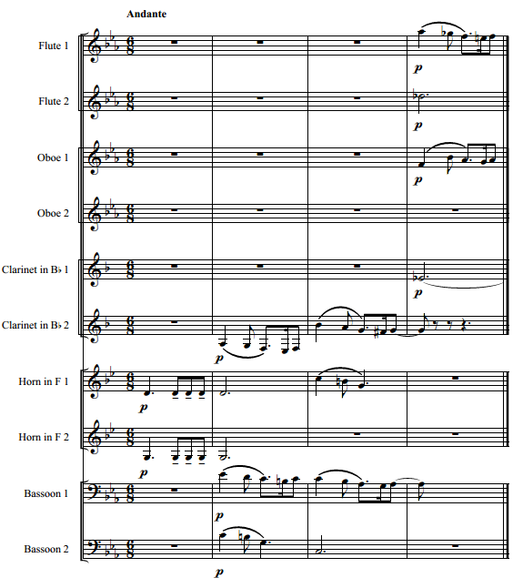

Both Viola parts in measure 11 from beat four through six show a staccato marking underneath a slur, showing slight articulation at the beginning of each eighth note while still each note needs to be connecting each note. On the same segment in the transcription, the eighth notes in both Horn parts are marked with a tenuto, also showing the needed length of the individual note while assuring an articulated beginning to each note which might not occur under a slur (See Figure 4.16).

Figure 4.16 Mvt. 2 m. 11 – Horn Articulation
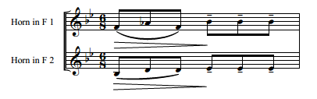
Measure 19 brings both a texture and rhythmic shift in the second movement. Sixteenth note triplets can be heard in Clarinet 2, Horn 1 and 2, and Bassoon 1. Many of these sixteenth note triplets occur in the original as multiple repeated notes on one line. These have a staccato and a slur over each note. The transcription does not include any articulation markings at all in the instances of repeated notes. Staccato would imply space between notes and use of tenuto would create too legato of a feel. A firm, but not pointed, articulation is the intent for each note.
An additional shift in expected instrumentation also occurs at measure 19. Originally, the melody in this segment was composed as a duet in unison between Violin I and Cello I. The Cello I part does not translate well directly to Bassoon 1 as it goes to the extreme of the high end of the bassoon register. Due to the register issue, Clarinet 1 became the choice to be in duet with Flute 1 through measure 19 and the first half of measure 20. Additionally, for reasons of the content conceivably getting lost in the texture, the Violin II part starting on beat four of measure 19 is scored in the transcription between Flute 2 and Oboe 1 in unison starting on G5 and Oboe 2 doubling at the octave and starting on G4 (See Figure 4.17).

Figure 4.17 Mvt. 2 m. 19-20 – Orchestration Effecting Articulation and Texture
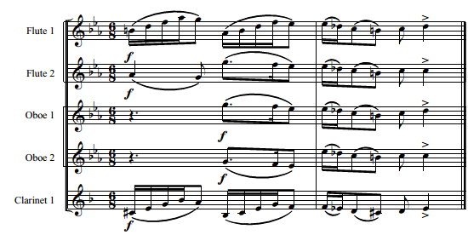

In measures 27-29, Mendelssohn scored six instruments in unison (Violin II and III, Viola I and II, and Cello I and II) and two additional instruments adding two ascending sixteenth notes four separate times, creating rhythmic and harmonic interest (Violin I and IV). Even with ten instruments available for the transcription, only five instruments are available to play the primary unison melodic content (Clarinet 1, Horn 1 and 2, and Bassoon 1 and 2). Violin I and IV had five notes necessary to complete each chord found in the two ascending sixteenth note passages. These short passages are scored utilizing Flute 1 and 2, Oboe 1 and 2, and Clarinet 2. The tessitura distance between low instruments and high instruments provide enough space for balance even with all instruments marked at a fortissimo (See Figure 4.18).

Figure 4.18 Mvt. 2 m. 27-29 – Transcription Results of Violin Parts
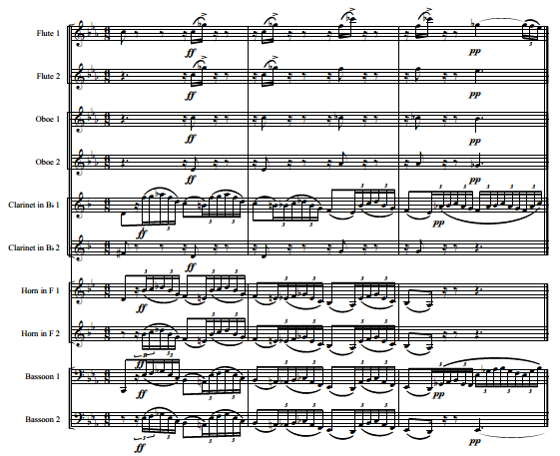

Measures 41-48 are marked with ascending and descending scale passages that outline and affirm tonality. Originally, these passages occur in all string parts except Cello I and II. As transcribed, these passages primarily are shared in Flute 1 and 2 and Clarinet 1 and 2, with the main melody and harmony appearing in Oboe 1 and 2. Illustrated in Figures 2.1 and 2.2, the proposed voicing in the flute parts is an issue because of acceptable instrument ranges. Passing portions of scale patterns between the flute and clarinet is a necessity. To avoid the flutes from becoming lost in the texture due to range issues, the choice was made to create octave leaps in the Flute 1 and 2 parts (See Figure 4.19). During these passages, neither Horn 1 or 2 is playing, Bassoon 1 and 2 are sustaining dotted half notes to establish and maintain tonality, and the lowest note found in Oboe 1 and 2 is E-flat5. Even with Mendelssohn’s penchant for scoring both Flute 1 and 2 down to C4, D4 and E-flat4 in his Scherzo in G minor, the flute scoring became necessary due to texture.

Figure 4.19 Mvt. 2 m. 41-42 – Octave Displacement in Flute Descending Lines
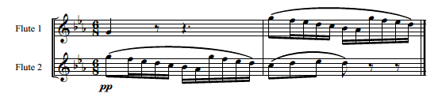

Measures 54-60 proved to be a section where the primary goals and techniques for transcription set forth earlier in this chapter could not be applied. Range, technical abilities, and ensemble balance and blend are at the forefront of the decision process when transcribing the Octet. Especially through measure 58, the overall tessitura is low. This causes range issues using Flute 1 and 2 and Oboe 1 and 2. Mendelssohn also utilized combinations of colors between Viola and Cello. Finally, many of the arpeggiations can be performed in Horn 1 and 2, but they ultimately will be more consistently accurate if performed by Clarinet 1 or 2 or Bassoon 1.
In measures 54 and 55, the Violin III and IV and Viola I parts are combined and appear in Horn 1 and 2. Without needing any octave change, this placed both parts in the middle of their accepted range. If the original Viola II part would have been placed in either Horn 1 or 2, that would have caused an octave leap at the beginning of measure 55 in the middle of a series of sixteenth note triplets. Although playable by high level musicians, the ease of placing the sixteenth note triplets with Clarinet 2 for measure 54 and then passing off the musical line to Bassoon 1 in measure 55 leaves less room for error. In measure 56, Mendelssohn composed slurred sixteenth note arpeggiated triplets in Viola I and Cello I. These parts are in unison and are in the warm chalumeau register of Clarinet 1 and 2 (See Figure 4.20).

Figure 4.20 Mvt. 2 m. 54-56 – Results of Adjustments due to Range and Difficulty
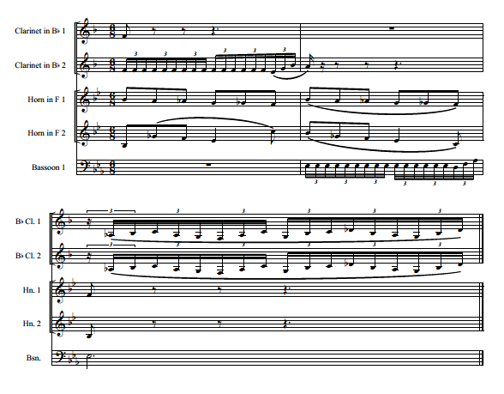

Measures 68-75 had several moments that once again diverged from the guidelines set forth previously in the chapter. First, the transcribed measure 68 scores Flute 1 and 2 on F-sharp4 and D4, respectively. Because of the register, flutes might have difficulty projecting at an acceptable level. However, only two of four instruments perform at this juncture. Additionally, as other instruments enter and the texture thickens, the register of Flute 1 and 2 does ascend in range. Finally, based on Mendelssohn’s own scoring style at this point of his career, he was not
afraid to write for flute in this register against a full complement of other instruments (See Figure 4.21).
Figure 4.21 Mvt. 2 m. 68-69 – Flute Register vs. Texture
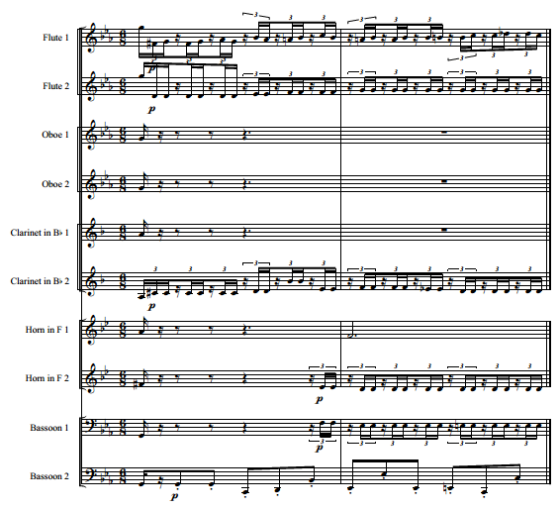

At measure 68, Mendelssohn scores the bass line with Cello I and the upbeat sixteenth notes in Violin I, II, and III. In measures 69-70, Viola I and II join them in the upbeat sixteenth notes while Violin IV plays a legato melody starting on B-flat3. The original plan for the transcription would have dictated that Bassoon 1 perform the Cello I line, Horn 1 and 2 perform the Viola I and II parts, and Clarinet 1 or 2 perform the legato melody as it starts on a note outside the range of either of the upper woodwind instruments. Instead, Bassoon 2 performs the Cello I part with Horn 2 and Bassoon 1 playing the Viola I and II parts respectively. This allows Horn 1 to enter in measure 69 with the legato melody. Not utilizing Clarinet 1 also allows the performer to briefly rest prior to their re-entry with the melodic line in measure 73, which was originally scored for Violin I. To avoid transitioning between flute and clarinet in the middle of a solo due to range, this use of Clarinet 1 allows for a smoother transition into measures 73-75 and thus, a smoother transition to the reprisal of measure 41 at measure 76 (See Figure 4.22). Measure 76 until the final notes of this movement in measure 102 contain material and conceptualization of scoring that is previously used in the movement.

Figure 4.22 Mvt. 2 m. 73-76 – Use of Clarinet 1
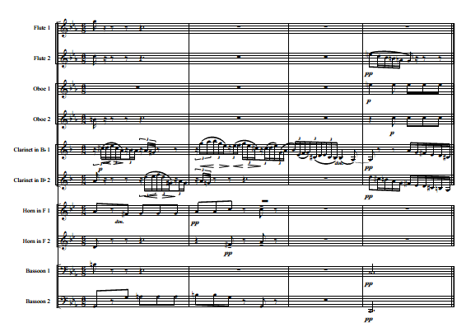

Movement 3 – Allegro leggierissimo
The third and fourth movements both present issues of tempo from Mendelssohn’s Octet to this transcription. These issues arise because of the requirements of double tonguing, which is not standard technique on all wind instruments. String players can articulate faster than wind players because of physical limitations. Accepted tempo for the original Octet begins around 132 beats per minute. The marking for the third movement of the transcription will be a minimum of 120 beats per minute. This will allow flexibility for ensembles that can go at a faster tempo to do so, but will still guide performers to choose a reasonable pace.
The downbeat of measure 17 originally has an inconsistent articulation marking between multiple instruments. Violin I and II and Cello II all have an eighth note. Violin III has an eighth note with a staccato, while Viola II has a sixteenth note. For the purposes of the transcription, all instruments have a sixteenth note on the downbeat of measure 17.
Measures 18, 20, and 22 all have four thirty-second notes spread between multiple instruments. Acknowledging that this is more difficult to execute on some instruments than others, there is a note in the score that gives the option for a performer to perform sixteenth notes rather than thirty-second notes (See Figure 4.23). This decision can be on a performer-by-performer basis. As previously discussed in this chapter, Mendelssohn scored sixteenth notes in flute while strings performed thirty-second notes in his own arrangement of this movement. This sets a precedent by Mendelssohn that both can occur simultaneously.

Figure 4.23 Mvt. 3 m. 18-20 – Option for Thirty-Second Note Passages
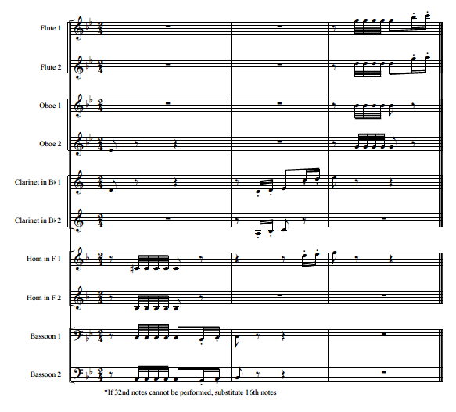

At measure 24, a dynamic marking of mezzo piano was added exclusively in the Flute 1 part of the transcription. This change allows for the melodic content to be better in balance with the totality of the ensemble. Additionally, the Oboe 1 part has a change in dynamic marking for the same purpose in measure 33. At this juncture, Oboe 1 has a piano dynamic marking to better signal its accompanimental role to Flute 1. The Oboe 1 part was originally voiced in the Violin IV part.
Measures 37-42 addresses three separate issues in translating string works to winds. First, the Violin III and IV parts had trills that span the duration of these six measures. The Violin III part is doubled between Horn 1 and Clarinet 2, while the Violin IV part is scored with Horn 2. Recognizing that a clarinet can trill with more ease than a horn, the trill exclusively appears in only the Clarinet 2 part. Clarinet 2 provides the effect of the trill while the horn parts are able to produce the structural stability of the chords. Second, the Violin II part is a series of accompanimental arpeggiations spanning from A3 to D6. Considering a flute or oboe cannot produce the entirety of that range, the Violin II part has been scored in a manner that the Flute 2 and Clarinet 1 share the necessary notes. This is similar to the opening statements of the first movement between Flute 1 and Clarinet 1. Third, the articulations found in the melodic line of Violin I was inconsistent in itself. Measures 37, 39, and 41 all had a similar pattern featuring two sets of rhythms consisting of an eighth note followed by two sixteenth notes. Measure 37 and 41 have staccatos over each of these notes while measure 39 has a slur marked over the staccato notes. In the transcription, the slur has been removed and each of the three measures are now consistently articulated (See Figure 4.24).

Figure 4.24 Mvt. 3 m. 37-40 – Trill, Range, and Articulation Considerations
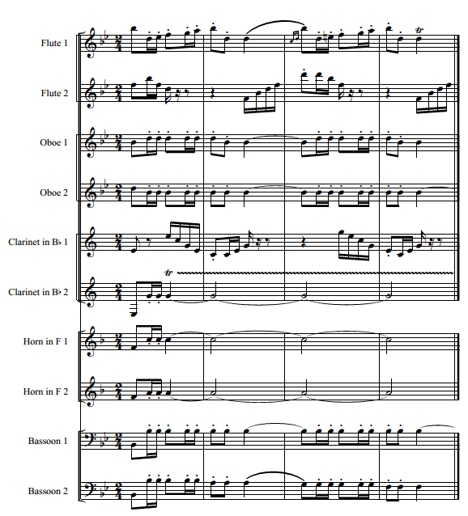

Measures 43-54 once again had three major adjustments needed for this string version to properly translate to winds. First, due to five of the eight parts in the original work performing tremolos, including one found in the Violin IV part descending as low as A3 which is out of the range of an oboe, the choice was made to score the effect into the Flute 2, Clarinet 1 and 2, and Bassoon 1 parts. Rather than placing the Violin IV part in one instrument, the notes found in that tremolo are adapted to sustained pitches in Horn 1 and 2. Second, as stated before, Bassoon 1 is performing tremolos throughout this passage. The choice was made to place the Cello I part found between measures 49-52 with Horn 1. This passage is scored one octave higher than originally written, as the lowest note found in the Cello I part is D2. Finally, the overall Violin I part translates well to Flute 1 during this passage, with the exception of one note. In measure 47, the A3 originally found on the and of beat 1 in the Violin I part appears in the transcribed Flute 1 part as A4, as A3 is outside the range of a flute (See Figure 4.25).

Figure 4.25 Mvt. 3 m. 47-50 – Tremolo Translations and Octave Adjustments
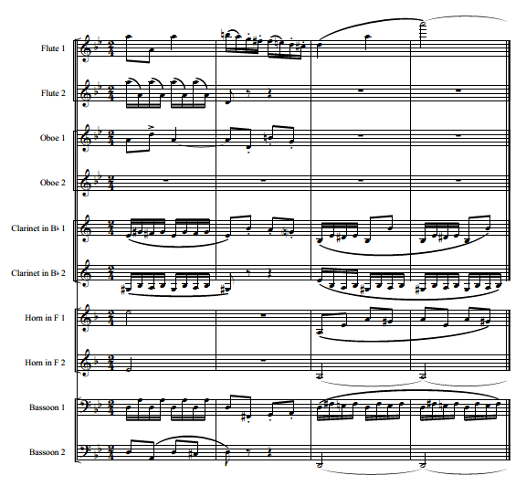

Throughout measures 65 through the downbeats of measures 69 and 72 (measure 69 being the beginning of the first ending and measure 72 being the beginning of the second ending), Mendelssohn scored all notes as a sixteenth note followed by a sixteenth rest. In the transcription these rhythms are now notated as eighth notes with a staccato on each note. This rhythmic change is also intertwined with multiple instruments in measures 74-75, 78-79, 83-87, and 90-95.
String instruments have the ability to play multiple notes at one time, where wind instruments can only perform one note at a time. The downbeat of measure 100 had fifteen notes scored between six individual instruments by Mendelssohn. The notes combined to form a C Major chord. As the compliment of wind instruments offered in a double woodwind quintet could not perform a literal translation due to less than fifteen instruments being available, an even distribution of notes in the C Major chord to all instruments became the initial priority, followed by voicing concerns caused by notes directly following the chord. Adjustments in voicing of chords similar to measure 100 also occur at measures 104, 108, and 112 (See Figure 4.26).

Figure 4.26 Mvt. 3 m. 100 – C Major Chord Voicing
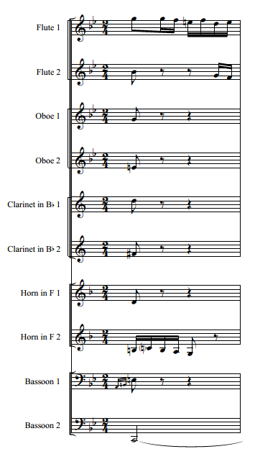

Measures 96-115, marked as rehearsal letter F in the transcription, feature a series of trills and grace notes found in multiple voices. In this section, two adjustments from the original markings occur in the transcription. First, starting in measure 107 and ending on the downbeat of measure 108 there is an eighth note with a trill followed by a grace note that is leading to another eighth note. This can be originally found in the Cello II voice. Both the trill and grace notes have been removed in its rescoring into the Horn 2 part. Removal of the trill is because of a combination of the speed of the passage and Horn 2 being in the lower portion of its register. The grace notes are removed because of the leap of a fourth that occurs between the last grace note and the downbeat of measure 108 (See Figure 4.27). The clarity of the primary notes without the ornamentation is of greater need than what the ornamentation provide for the listener. Second, the trill originally in the Viola II part on the and of beat two in measure 112 was marked with a flat sign. The flat sign removal is due to redundancy with the existing key signature.

Figure 4.27 Mvt. 3 m. 107-108 – Horn 2 Rescored Without Ornamentation
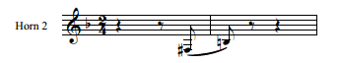

The original Violin I part between measures 116 and 119 has large leaps and has a range between B-flat3 and E-flat6. The leaps are first in the staff, then above the staff, then back in the staff, and then below the staff. The pattern repeats twice. To avoid large leaps with one wind instrument and to also acknowledge the tone difference that occurs in different registers of the violin, the transcription reflects Flute 1 playing the notes above the staff, Oboe 1 playing the notes in the staff, and Clarinet 1 playing the notes below the staff (See Figure 4.28). A similar occurrence is echoed in measures 114-115 where Mendelssohn scored the notes above the staff with Violin I, the notes contained in the staff in Violin II, and the notes below the staff with Violin III.

Figure 4.28 Mvt. 3 m. 115-118 – Upper Woodwind Range and Tessitura Solutions
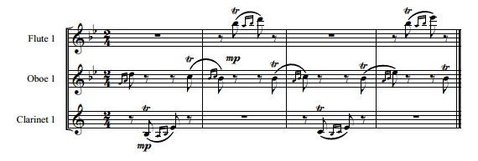

Measure 138 has a dynamic change in the Flute 2 voice of the transcription. Changing from pianissimo to mezzo piano is necessary as Flute 2 performs the melodic content needing to stand out for ensemble balance. In measure 149, a slur was added to Flute 1 between F-sharp5 and G5. This did not appear in the Violin I part originally, but is needed consistency with several other parts composed throughout the movement. On the downbeat of measure 156 in the Violin II part, there is a G3 notated in the original score. For purposes of that note not being accessible with the range of a flute, the note appears as a G4 in the Flute 2 part of the transcription.
Beginning in measure 211, using sixteenth notes, Mendelssohn composed a descending scale pattern for three measures followed by a combination of an ascending scale in thirds with an interjection of a descending triad in every other measure. This pattern, from measure 211 to its conclusion on the downbeat of measure 220, exclusively appears in Violin I. With concerns of sustaining breath for an extended amount of time, combined with the use of a three and a half octave range, the transcription scored a combination of Flute 1, Flute 2, and Clarinet 1 in order to form a continuous musical line. Each instrument performs a section of the passage that extends no longer than three measures (See Figure 4.29).

Figure 4.29 Mvt. 3 m. 211-220 – Flute and Clarinet Combined Melodic Line
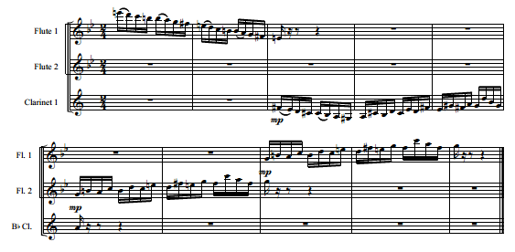

The final segment of this movement closes with two adjustments from Mendelssohn’s original scoring. First, with the exception of the Flute 1 part in measures 242-243, all notes are originally scored as a sixteenth note followed by a sixteenth rest. This is in the same manner as segments previously discussed in measures 65-95. As with the previous section, all notes appear in the transcription as an eighth note marked with a staccato. Also, the and of beat one in measure 231 is omitted in Flute 1 and 2 and Oboe 1 and 2 due to the notes outside of the range of those instruments. As all instruments are unison at this juncture, the omitted note appears in six other voices. Thus, the original intent is retained (See Figure 4.30).

Figure 4.30 Mvt. 3 m. 229-232 – Staccato Addition and Flute/Oboe Note Removal
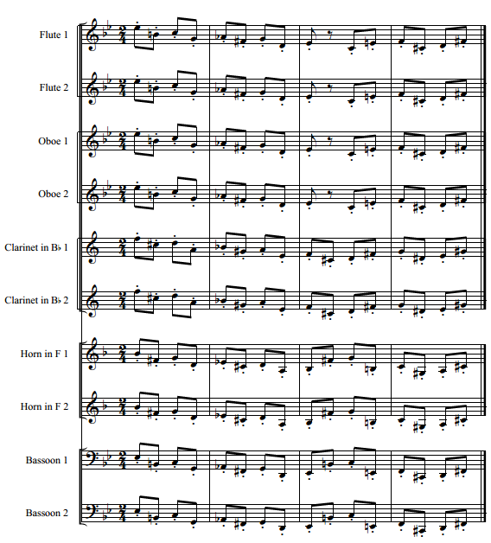

Movement 4 – Presto
The largest factor inhibiting the performance of the fourth movement is selecting a tempo that wind players can comfortably perform all aspects without losing the integrity of the movement. The suggested tempo for this movement in cut time will be half note equals minimum 60 beats per minute. Notes will be added encouraging performers to perform the movement as fast as possible. This will allow performers flexibility in their own interpretation of tempo while maintaining a spritely style and pacing.
The first eight measures of this fourth movement are in line with the orchestration techniques offered earlier in this chapter. Cello I and II are transcribed directly to Bassoon 1 and 2. In measure 9 the choice was made to transcribe Viola II into Clarinet 2 rather than Horn 1 or 2. The singular factor that led to this decision is the ability of the reed sound of the clarinet to be a closer match in tone to the bassoon than that of the horn. Horn 1 and 2 do not enter until measure 23 as part of a cadence leading to an E-flat major chord on the down beat of measure 25.
At measure 25, Horn 1 and 2 reinforce the Bassoon 1 and 2 part with eighth notes on B-flat (Sounding as E-flat). Bassoon 1 is scored performing an E-flat3 along with Horn 2. Bassoon 2 is scored one octave below and Horn 1 is scored one octave above. An additional adjustment in the transcribing process comes following the ensemble unison melody from measures 33-42. Originally Mendelssohn scored Violin I-IV playing eighth notes on B-flat in multiple octave while Viola I and II and Cello I and II continue through measure 48 with the melody. To echo that equal divide, Flute 1 and 2, Oboe 1 and 2, and Clarinet 1 play the unison notes in multiple octaves, while Clarinet 2, Horn 1 and 2, and Bassoon 1 and 2 continue with the melodic content (See Figure 4.31).

Figure 4.31 Mvt. 4 m. 43-44 – Melodic and Harmonic Distribution
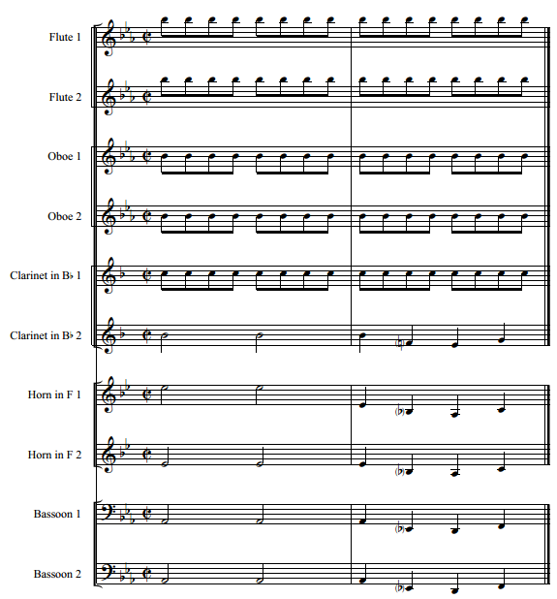

In measure 63, Mendelssohn composed Violin III and IV, Viola I and II, and Cello I and II as accompanimental parts with Violin II being the only melodic line. For purposes of ensemble balance in the transcription, Flute 2 and Oboe 1 perform the melody in unison, while only five voices, rather than the original six, play the accompaniment (See Figure 4.32).

Figure 4.32 Mvt. 4 m. 63-64 – Melodic and Accompanimental Transcription
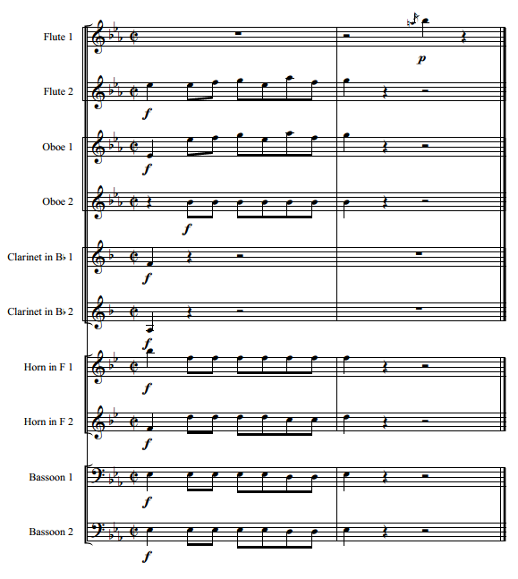

Measure 79 is one example of an area that, even though Mendelssohn would write flute parts low in their range amidst thick scoring, the choice was made to double Flute 1 with Oboe 1 for added volume. The ensemble is scored to be at a piano dynamic and Flute 1 alone would likely get lost among the combination of other instruments scored in the same range (See Figure 4.33).

Figure 4.33 Mvt. 4 m. 79-80 – Flute and Oboe Double the Melody
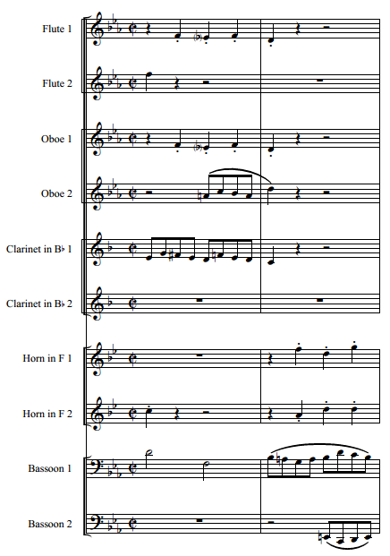

In measure 90, Violin II is marked with a staccato on beat 1. As this part is transcribed to Flute 2, the staccato has been removed, creating consistency between both the other instrument with the same rhythm in unison during measures 89-90 and with similar rhythmic ideas that occur in the following three measures. The staccato appearing in the Violin II part, which is also transcribed to Flute 2, is similarly removed in measure 93.
In Mendelssohn’s original work, measures 99-136 are marked at either a piano or pianissimo dynamic level and are thinly orchestrated. The transcription makes no such change since, just as in the original work, there is no full complement of instruments scored again until measure 137. The succeeding phrase starting at measure 137 and ending on the downbeat of measure 145 follows the exact dynamic shaping as Mendelssohn’s original.
The downbeat of the Violin I part in measure 193 is quarter note B-flat3. As that line is transcribed to Flute 1, it has been scored to an attainable B-flat4. Similarly, Horn 1 has an E-flat5 and Horn 2 has a C5 in its part for the second note of measure 204. These notes are originally scored one octave lower, which is still in the range of a horn (See Figure 4.34). The choice to write these notes one octave higher is for the purpose of avoiding the large leap that would have occurred otherwise on the downbeat of measure 205. Measure 205 through the downbeat of measure 213 are marked at a fortissimo dynamic. In order for the half notes originally found in Violin I to consistently be heard through the texture, Flute 1 and 2 are both scored to split the Violin I part in octaves for strengthening the impact.

Figure 4.34 Mvt. 4 m. 204-205 – Horn 1 and 2 Scored to Avoid Large Leaps
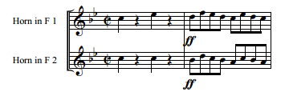

The downbeat of measure 243 presents a challenge in transcribing the string part to wind instruments due to the ability for string instruments to play more than one note at a time. Mendelssohn scored an A Major⁷ chord with fourteen notes spread across seven instruments. The only instrument that originally does not perform in this chord is Violin IV, which is silent on the downbeat and then proceeds to perform eighth notes over the next four measures. With nine wind instruments available and several of the fourteen notes doubled, only E4 is omitted. E5 does appear with Flute 2 (See Figure 4.35). This trend of more notes than instruments available occurs every four measures between 243 and 259.

Figure 4.35 Mvt. 4 m. 243-244 – Orchestration of A Major⁷ Chord
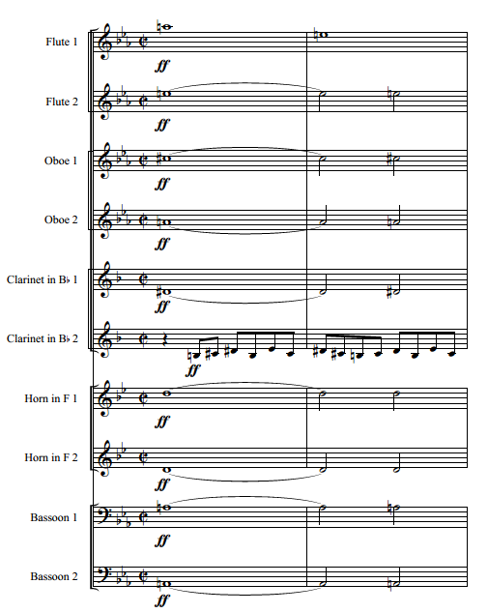

Violin I and Violin II are scored in measure 271 as G3 and B-flat3, respectively. The G3 is scored as a G4 in both the Flute 1 and 2 parts, while the B-flat3 can be found one octave higher in the Oboe 1 part. Additionally, Clarinet 1 is still able to perform the B-flat3 in its original octave in unison at the octave with Oboe 1. In the original work during measures 276-289, accents are inconsistently used on half notes, dotted half notes, and whole notes. The transcription utilizes accents consistently on all half, dotted half, and whole notes throughout this segment to achieve consistent style from all wind instruments with the same rhythms.
Similar to measure 243, measure 303 begins a series of five half notes creating a D minor chord. These chords are originally voiced with the Violin I, II, III, and IV parts, as well as Viola I. These five instruments combine to perform eight notes in this chord. However, in the transcription, only seven instruments are available. Four of the original eight notes are D. The D’s span over three octaves. A D4 was removed from the original voicing and the other 7 notes are transcribed in their original octaves utilizing Flute 1 and 2, Oboe 1 and 2, Clarinet 1 and 2, and Horn 1 (See Figure 4.36).

Figure 4.36 Mvt. 4 m. 303-304 – Orchestration of D minor Chord
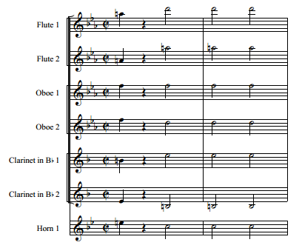

Beginning in measure 313, the Viola I part is transcribed to Clarinet 1 and 2 and is performed at the octave through measure 320. Similarly, Viola II is transcribed to Horn 1 and 2 and is performed in unison until the final half note of measure 320, where they are scored at the octave. These changes are necessary to both maintain the fortissimo dynamic prescribed originally by Mendelssohn as well as for balance, as this will reenforce lines that would have otherwise been lost in the texture. Also, in this musical segment, Violin I performs a G3 whole note in measure 316 and a quarter note A-flat3 on the downbeat of measure 319. This part is transposed to Flute 1 one octave higher due to instrument range concerns.
From measure 321 until the downbeat of measure 327, multiple modifications occur in the course of transcription. At the beginning of the section, six instruments originally perform a unison eighth note melismatic figure with two instruments (Violin I and II) adding half notes in octaves, all at a fortissimo dynamic. By measure 325, all instruments are playing the unison melismatic figure. Having ten instruments available in the transcription, the choice was made to have seven instruments perform the unison melismatic figure and three instruments perform the half notes in octaves (Flute 1 and 2 and Oboe 2). Flute 2 and Oboe 2 double the lower octave. In some cases in this segment, the long melismatic line takes instruments out of their natural range. Due to this, octave displacements are needed. Horn 2 and Clarinet 2 each have an eighth note removed in order to facilitate an octave leap more easily in measure 324, as does Oboe 1 and 2 in measure 325 and Horn 1 in measure 326. Clarinet 1 also has an eighth note removed and an octave leap added in measure 326. This occurs not because of range, but due to the need for a smooth transition into a run of eighth notes in measure 327 (See Figure 4.37).

Figure 4.37 Mvt. 4 m. 324-327 – Removal of Notes to Facilitate Leaps or Transitions
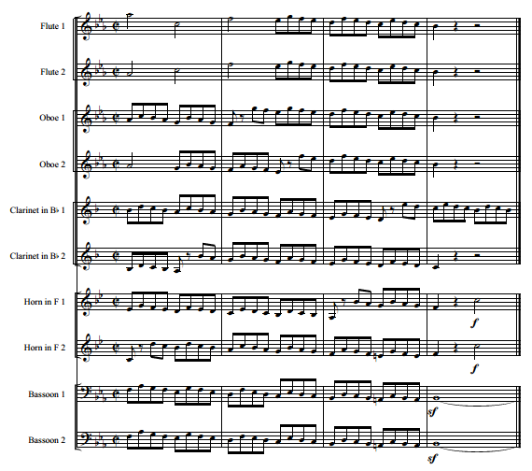

Measures 357-360 required two octave adjustments. First, the trill lasting for all of measure 357-358, originally scored in Violin I starting on a D-flat4, is found in Flute 2 starting on D-flat5. Because of the natural range of the flute, performing a trill starting on D-flat4 is much more difficult to facilitate than a trill staring one octave higher. Additionally, the half notes originally found in Viola I and II in measures 359-360 are scored in the Horn 1 and 2 parts one octave lower than originally written. This change allows both Horn parts to be in a more comfortable register rather than in the extreme upper register.
Two other octave transpositions occur in measures 377-378 and 382. Both involve an A-flat3 that appear in the transcription as A-flat4. First, the A-flat3 in question appears in measure 377-378 originally in the Violin III part. The tied whole notes appear in the transcription in Flute 2 and Oboe 2. Horn 1 still maintains the A-flat in its original octave. Next, the A-flat3 that originally is scored in Violin III appears in the transcription as A-flat4 in Flute 2.
Once again, Mendelssohn scored nine pitches throughout measures 388-390. With only eight wind instruments available to perform these nine pitches, the B-flat3 originally scored with Viola II does not appear in the transcription. The B-flat does appear one octave higher in the Clarinet 1 part. Similarly in measure 392, the C-flat4 found originally in Violin III does not appear in the transcription. However, this pitch can be found one octave lower with Bassoon 1. Finally in measure 396, the D-flat4 that is scored with Viola II is not found in the transcription. This pitch is still found one octave higher in Flute 2.
From the pickup to measure 404 through the downbeat of measure 407, Clarinet 1 is doubling the Flute 1 one octave lower for reenforcing the melody against a thick overall texture. This part is originally found in the Violin II. Starting with the anacrusis to measure 408, Clarinet 1 is scored playing the part originally found in Violin IV, which is a harmonizes with Flute 1. At this point, Clarinet 2 begins to double the Flute 1 part one octave lower and continues this practice through the downbeat of measure 413 (See Figure 4.38).

Figure 4.38 Mvt. 4 m. 407-413 – Flute and Clarinet Chordal Distribution
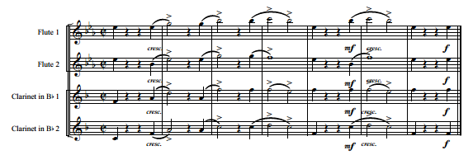

The final adjustments in the transcribing process occur in measures 428-429, which are the penultimate and final measures of the work. These two measures consist of a combined three E-flat Major chords. The first E-flat Major chord has seventeen notes consisting of eight individual pitches as part of the voicing with the highest note being G5, whereas the second chord also has seventeen notes consisting of nine individual pitches, and its highest note is B-flat5. The final chord has thirteen notes consisting of eight individual pitches with the highest note being E-flat5. Each of these chords has E-flat2 as its lowest pitch. Maintaining the integrity of the highest and lowest notes, each chord still maintains the same number of individual pitches, but instead are spread between ten notes due to the limitations of wind instruments only being able to play one note at a time (See Figure 4.39).

Figure 4.39 Mvt. 4 m. 428-429 – Orchestration of Chords in Final Two Measures
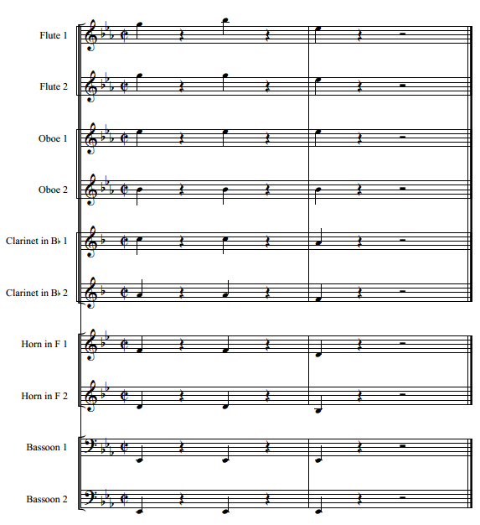
Chapter 5 – Summary, Conclusions, and Recommendations for Further Study

Summary and Conclusions
The transcription of Felix Mendelssohn’s Octet in E-flat Major, Op.20 provides an opportunity for wind players to experience first-hand a canonic work from the chamber string genre. Since Mendelssohn composed a work for chamber winds during this same compositional time-frame and the fact that he scored an orchestral arrangement of the third movement of the Octet, there is ample evidence of Mendelssohn’s approach to wind orchestration. With those examples as models for this project, there can be a high level of confidence in the authenticity of the approaches used to create this transcription. The value of the transcription is heightened further as an addition to the wind repertoire since The Octet can now provide experiential access and not merely theoretical study in classical era style as well as aspects that firmly look towards the future of romanticism.
When the process of this transcription began, tone color and the replication of long musical lines were the principal concerns in its construction. As this transcription developed, the realization that much more consideration of issues such as the replication of double stops, tremolos, the translation of spiccato to winds and overall tempo as it relates to the ability to execute articulations would need to be considered. While tone color still played a major factor in every decision that was made, the realization that it could not be the primary factor in several decisions became apparent at an early stage. This transcription of the Octet combines careful thought regarding what can be physically executed by top performers along with providing some optional considerations in moments where the overall intent of the work will not be affected by a change in rhythm or articulation that would make it more accessible to less skilled players who would benefit from experiencing this work. The goal was to bring this work to a whole new group of performers and to make that group as large and inclusive as possible while still maintaining the integrity of the original composition.

Recommendations for Further Study
The development of this transcription and the reasons for doing so give rise to thoughts of other gems of the repertoire of this era that would benefit modern performers if they were transcribed. While there are many composers whose works could be included in this list, fully realizing Mendelssohn’s contributions into transcription and manageable performance settings is not yet complete.
Performances and documents containing analysis and study of Mendelssohn’s Overture for Winds, Op. 24 (1824/1826), his earliest work originally for winds, are plentiful. His other original work for winds, Trauermarsch, Op. 103 (1836), suffers from a lack of study and common performance. A study of this work could contain harmonic analysis, a comparison of orchestration techniques used between the two original works, comparisons to other later works in his career, influences found in this work from other contemporary composers, and placing this piece in context of other works for harmoniemusik to further enhance historical context for the wind band.
Although Mendelssohn was only alive for a comparatively short time, he has a lengthy catalogue of works and very few of these pieces have been transcribed for winds to perform. Mendelssohn’s ability to make long, beautiful melodies that are quite accessible to listeners, his colorful and creative tone colors, his technical demands and the need for wind players to experience this style of musical creativity are all worth further effort on the part of scholars and arrangers. Transcribing a greater number of Mendelssohn works can provide opportunities for wind players at a multitude of experience levels to experience the genius behind his compositions while advancing wind playing.

Appendix A – Transcription of Octet in E-Flat Major, Op. 20 – Felix Mendelssohn

Felix Mendelssohn

Octet, Op. 20

Transcribed for Double Woodwind Quintet
by
Daniel J. Harbaugh

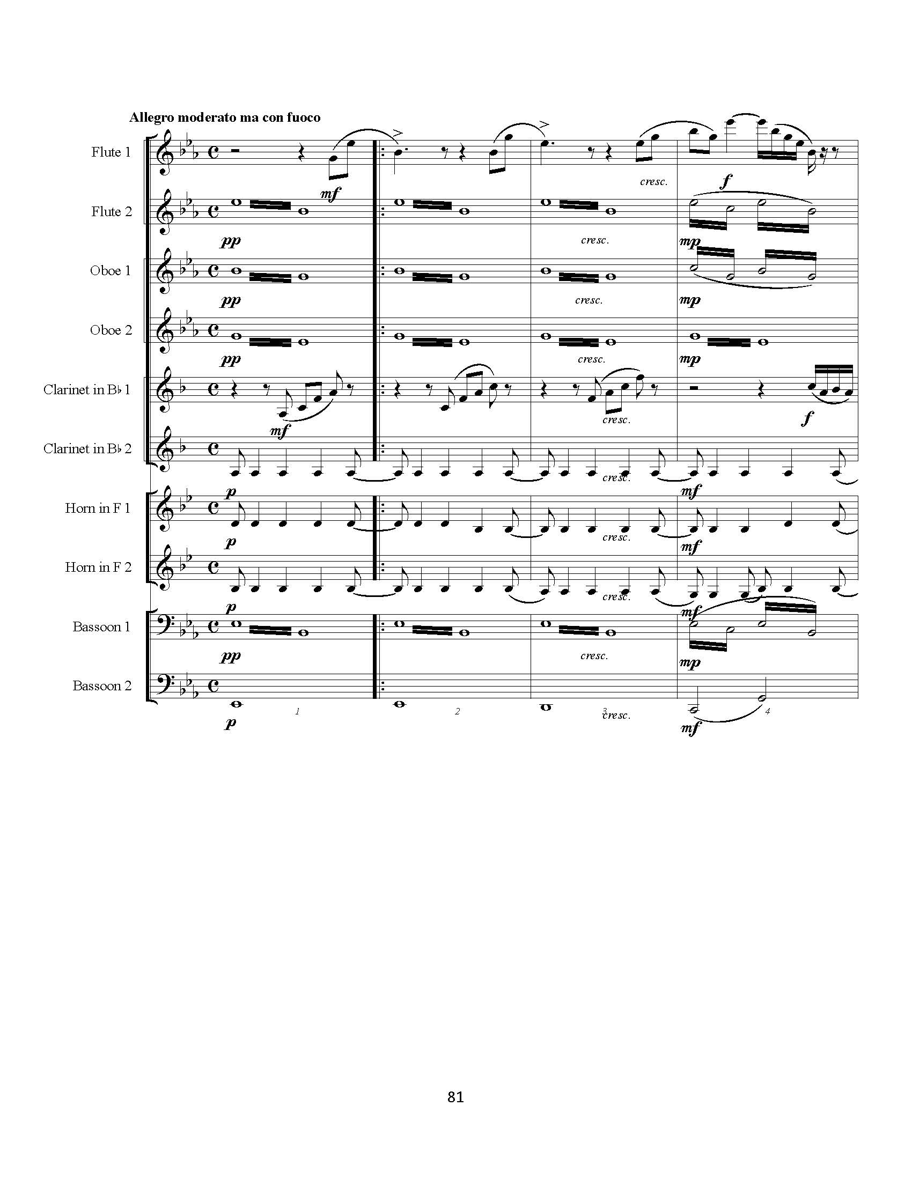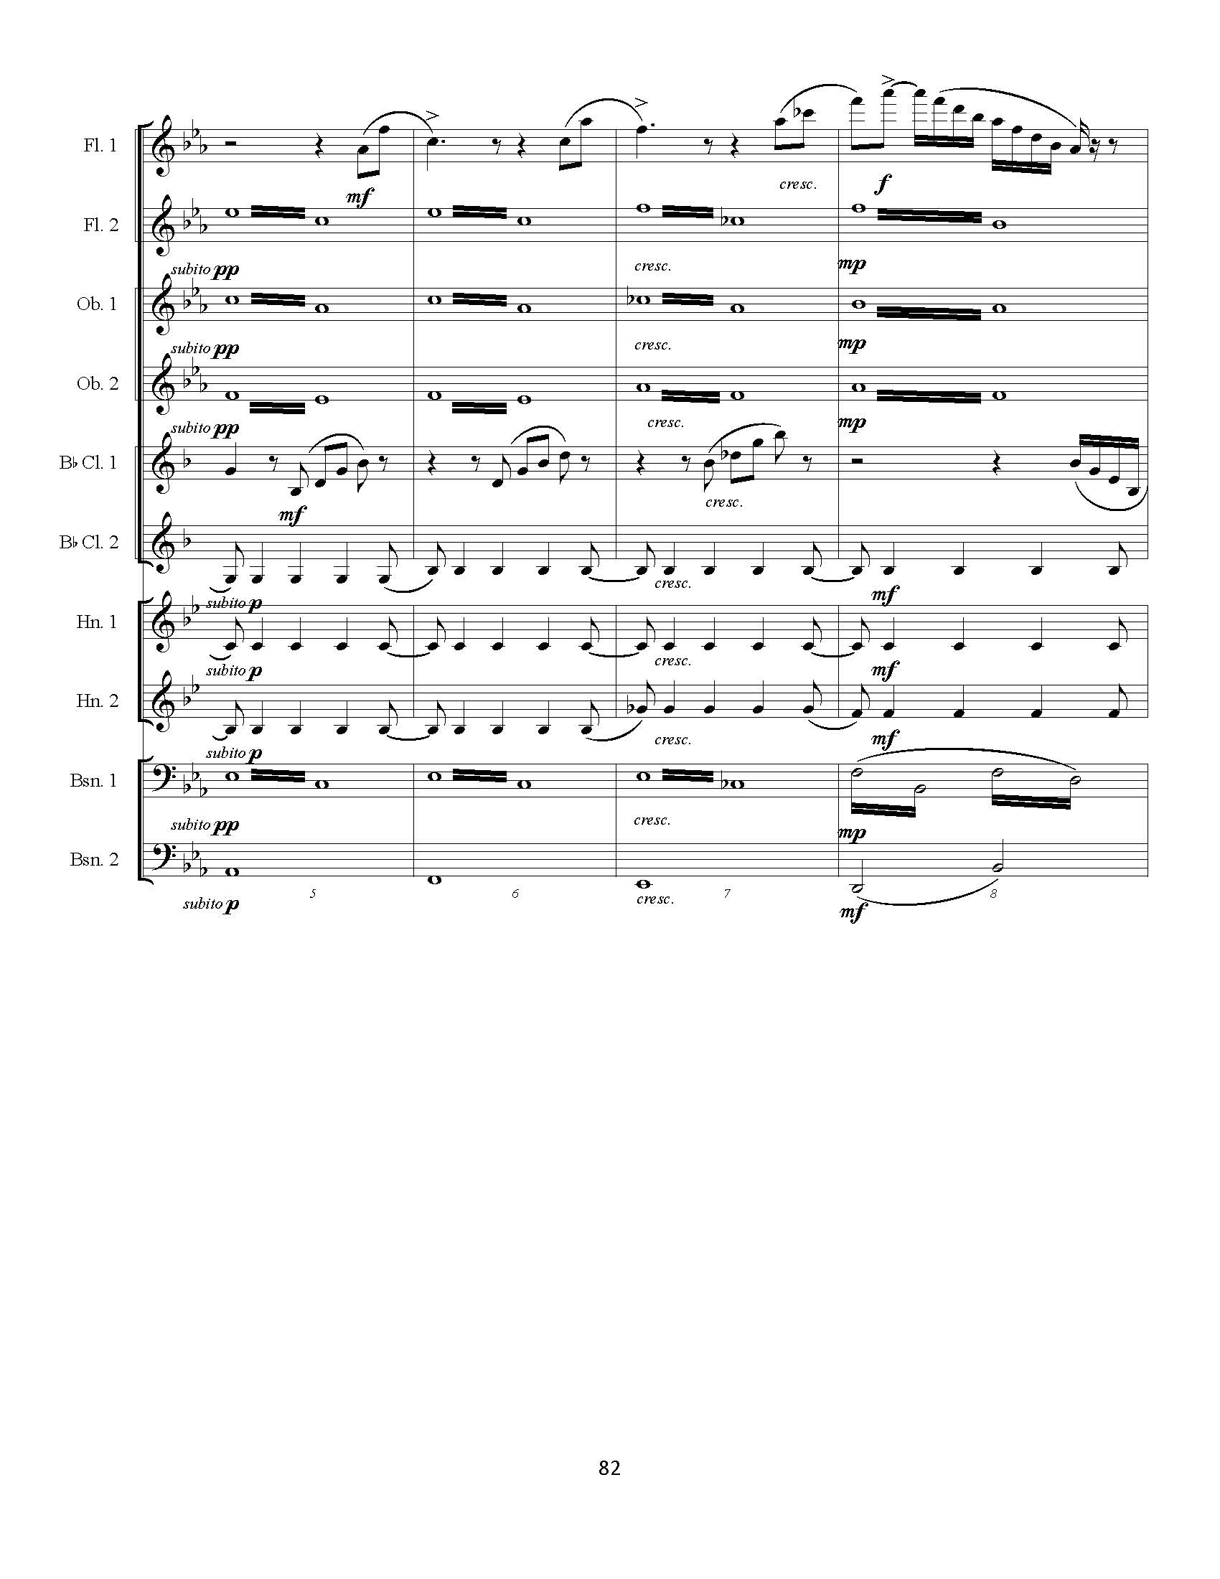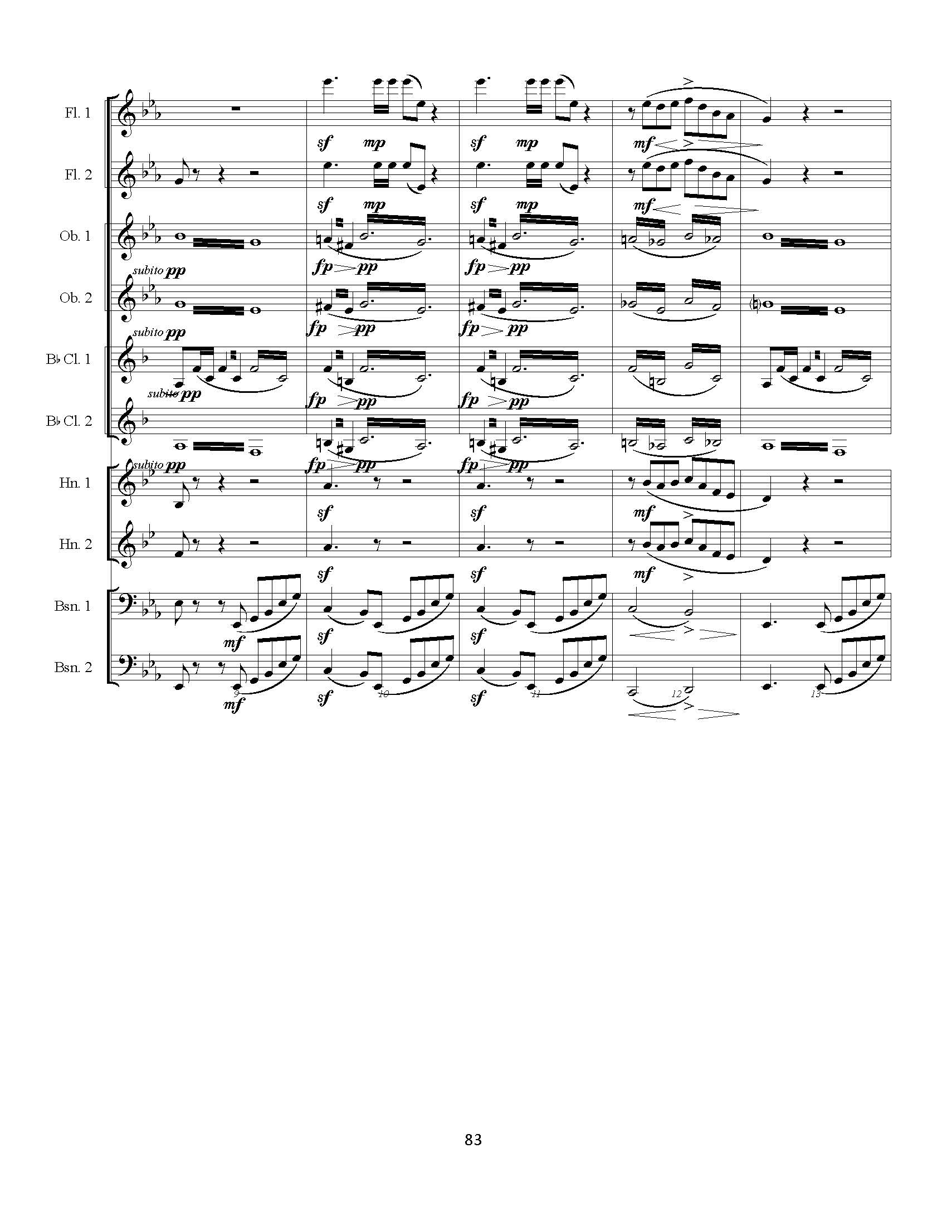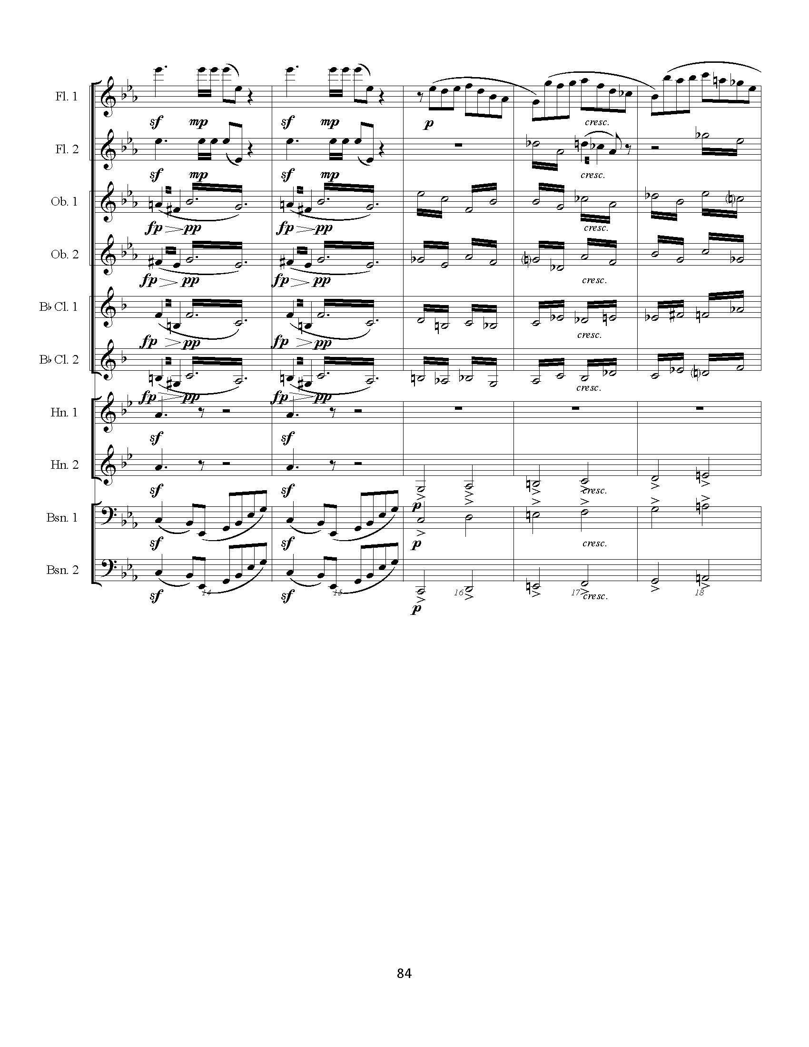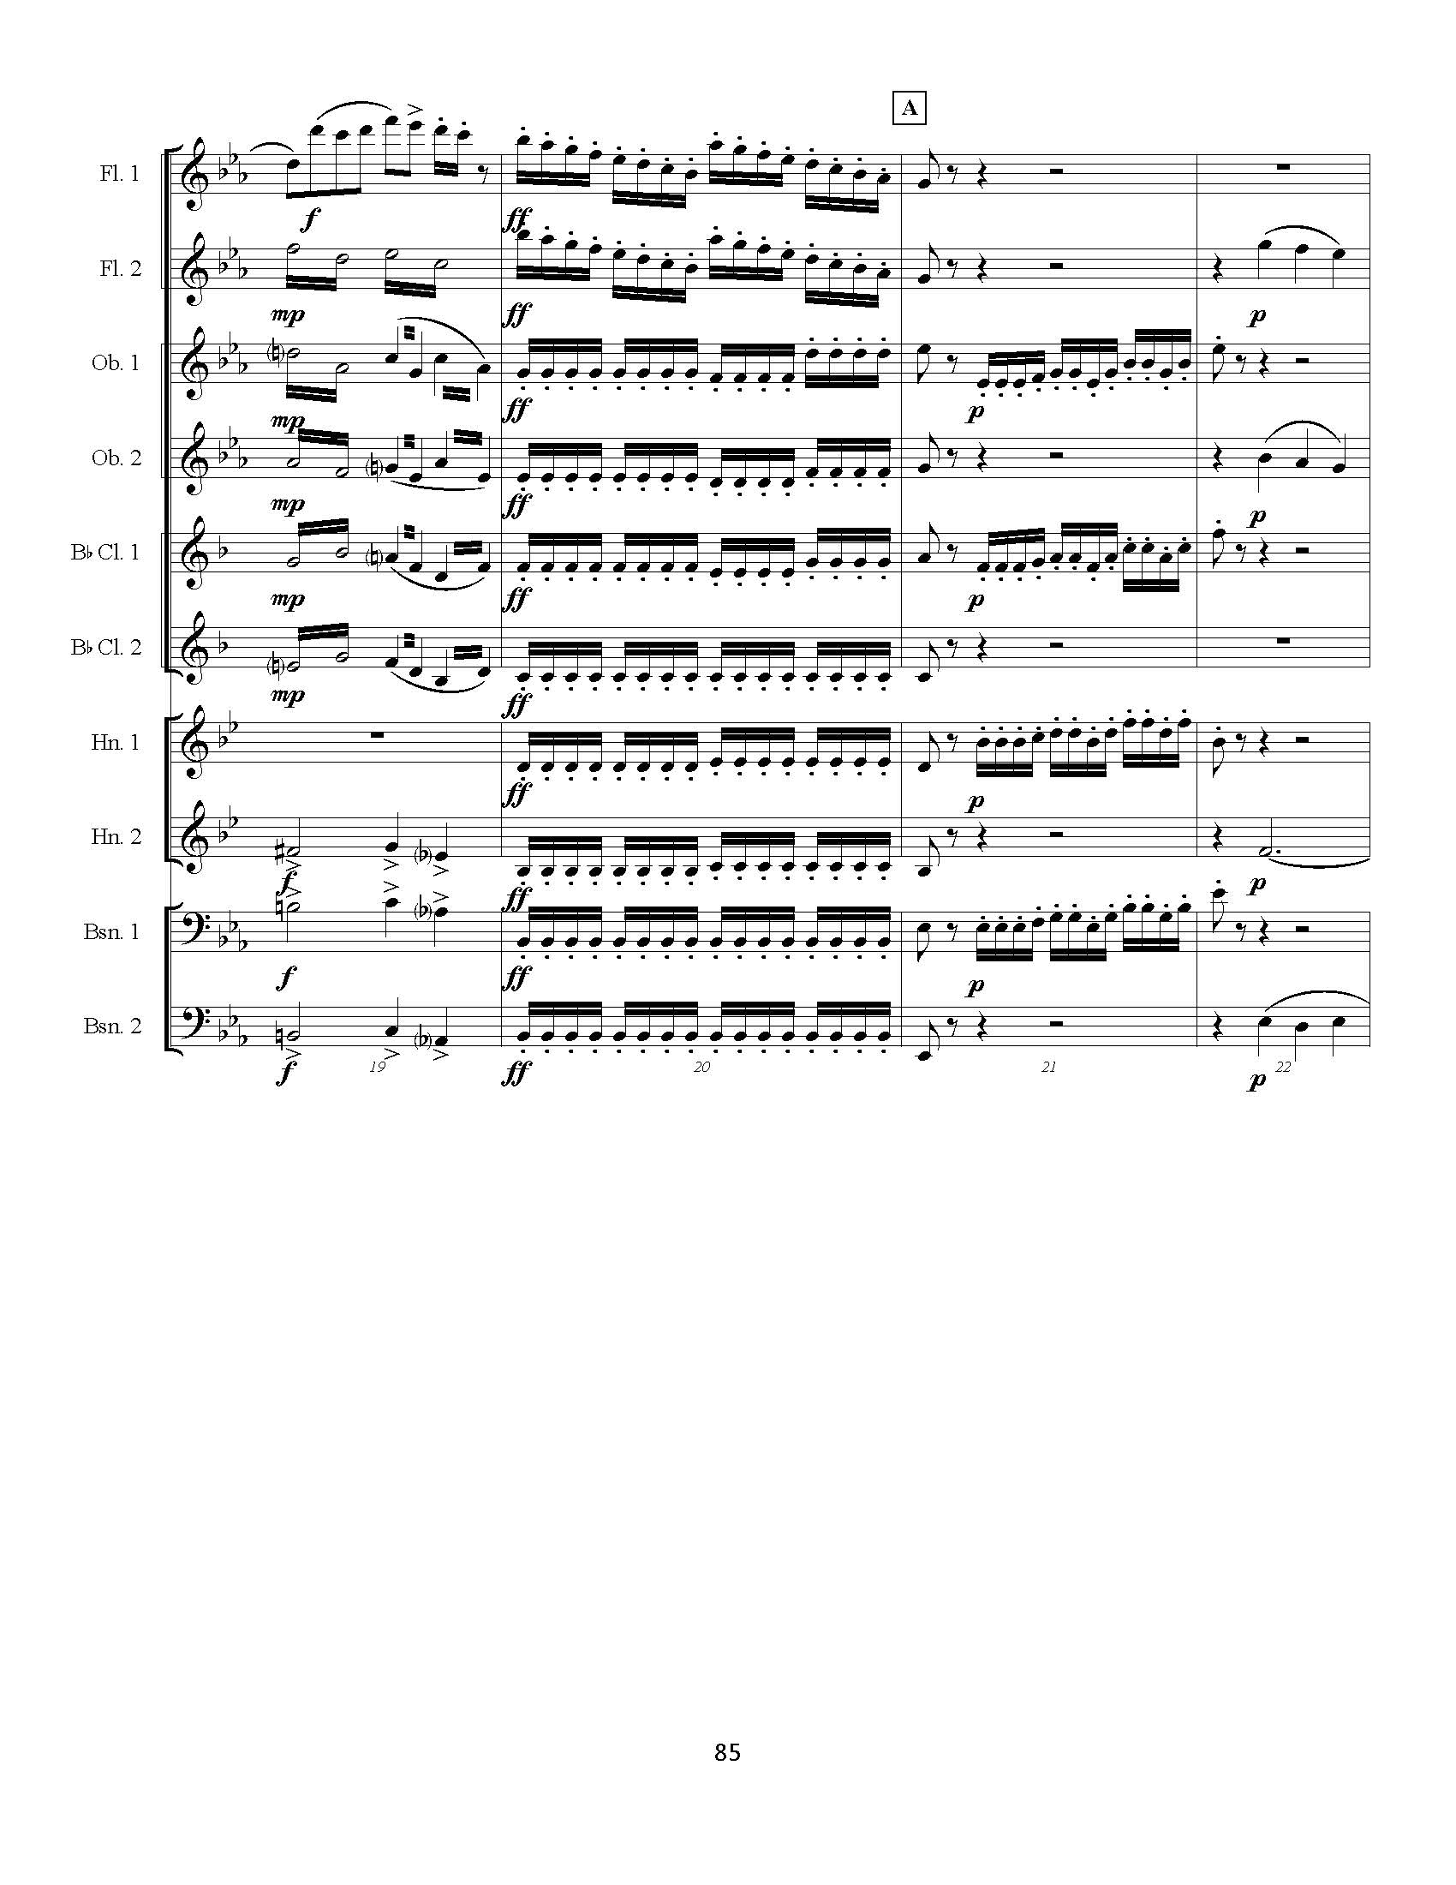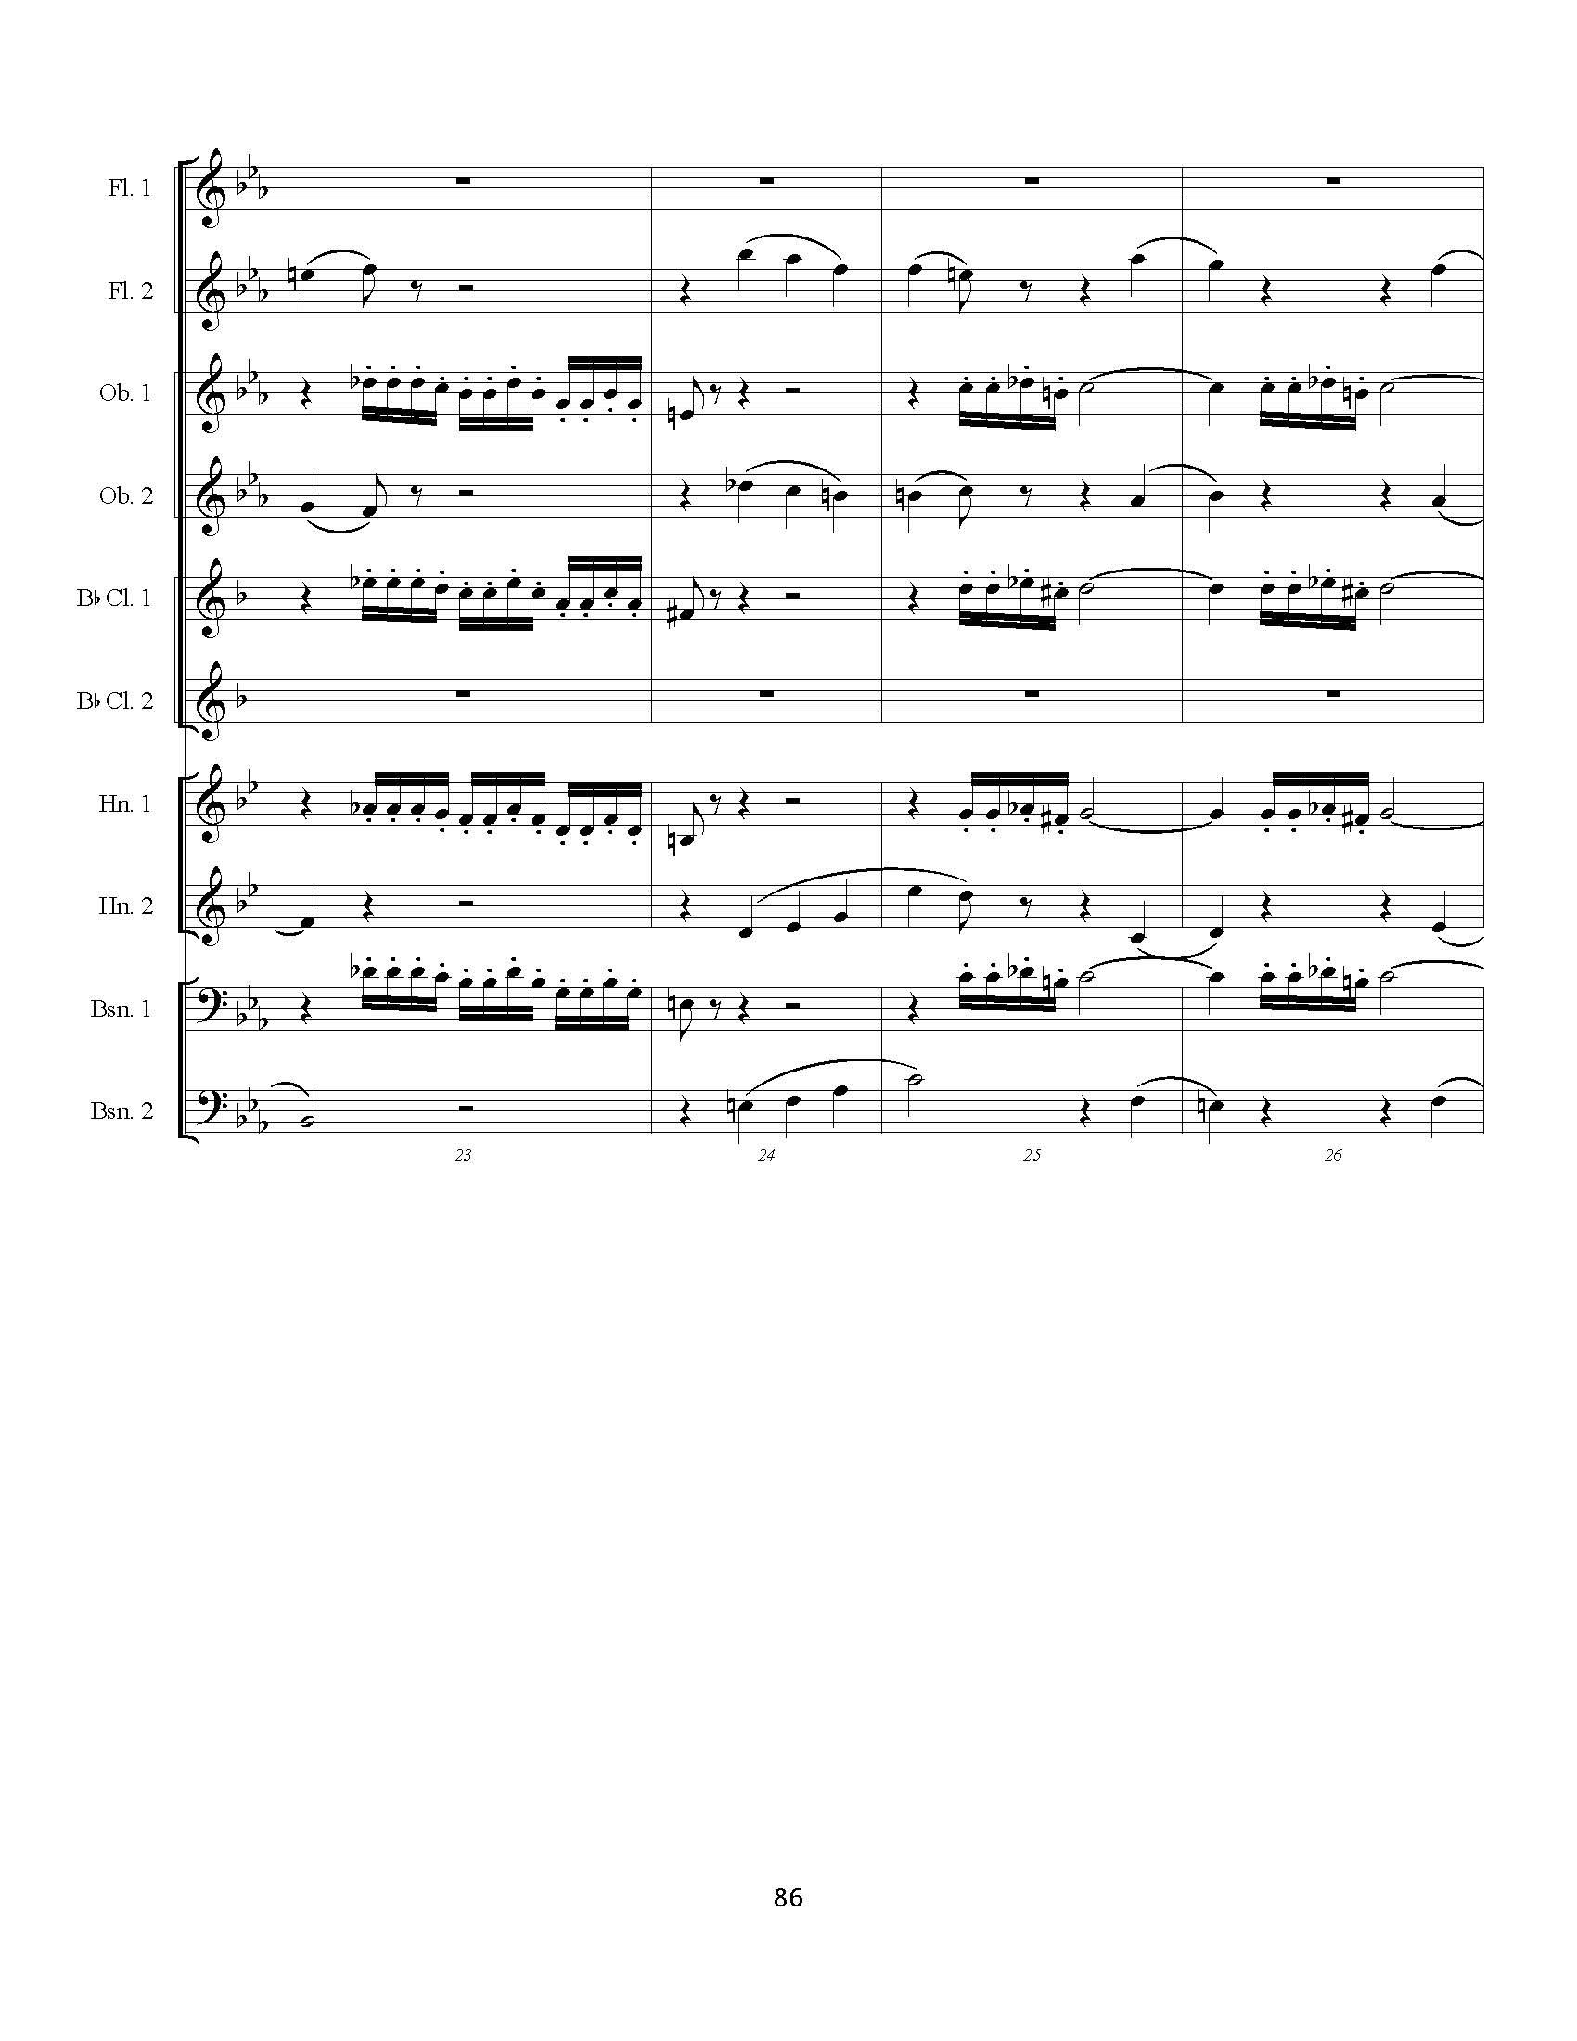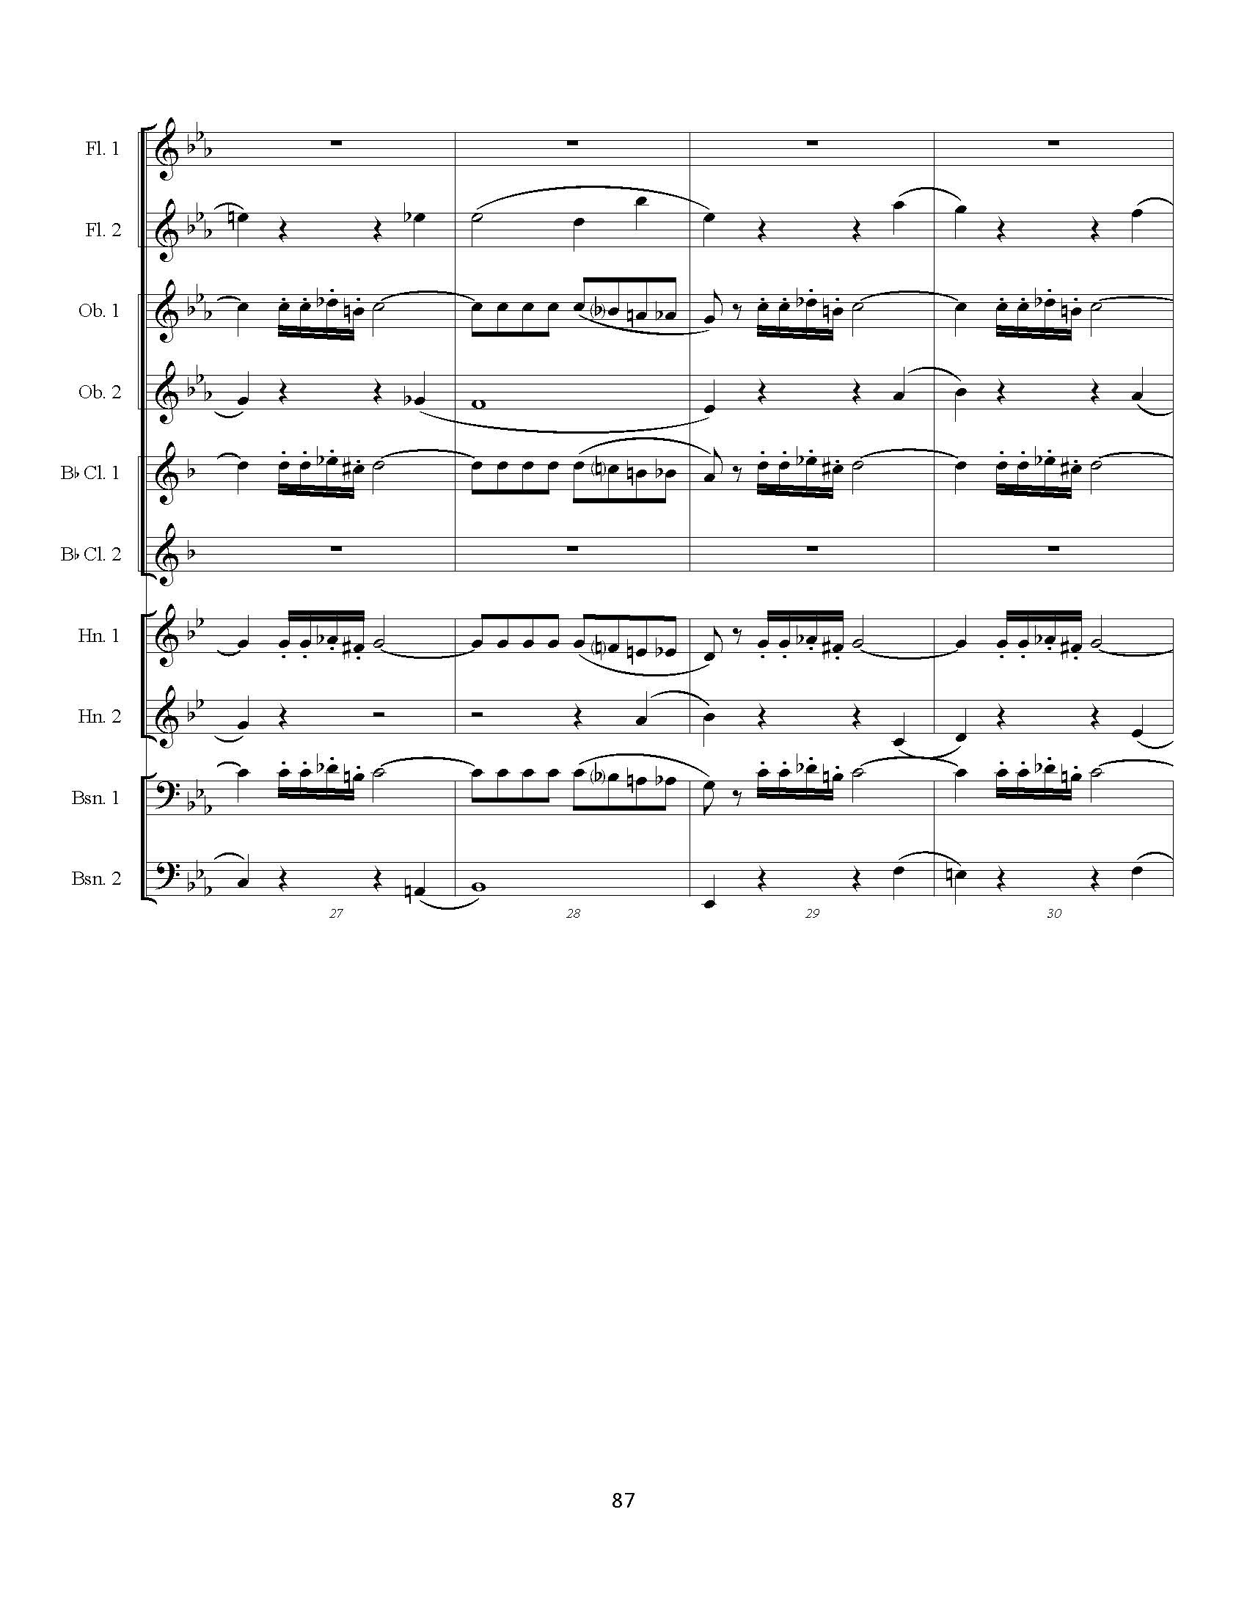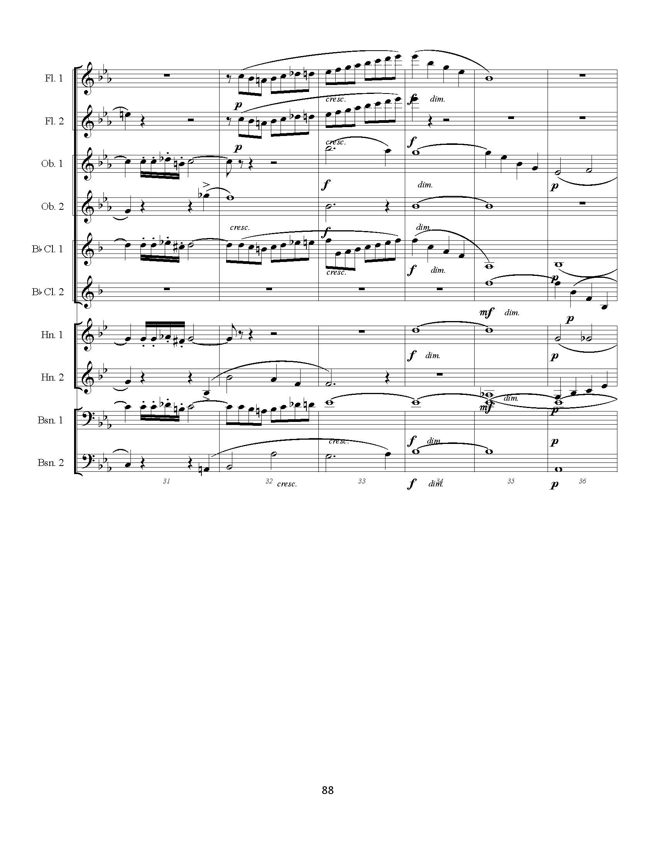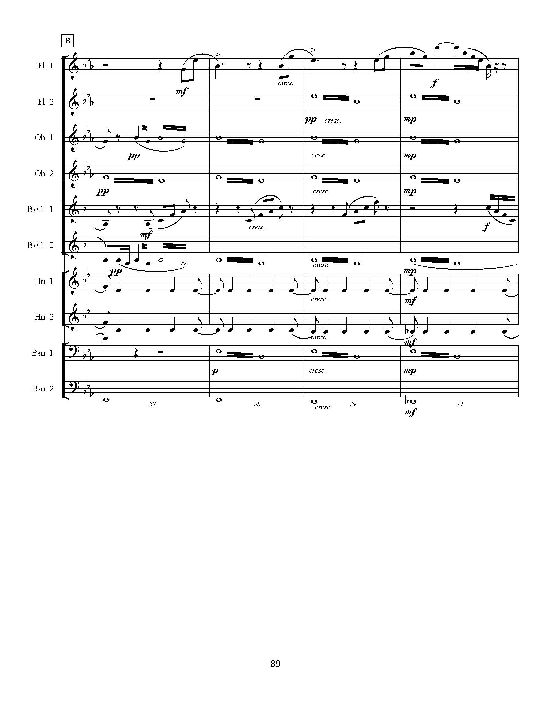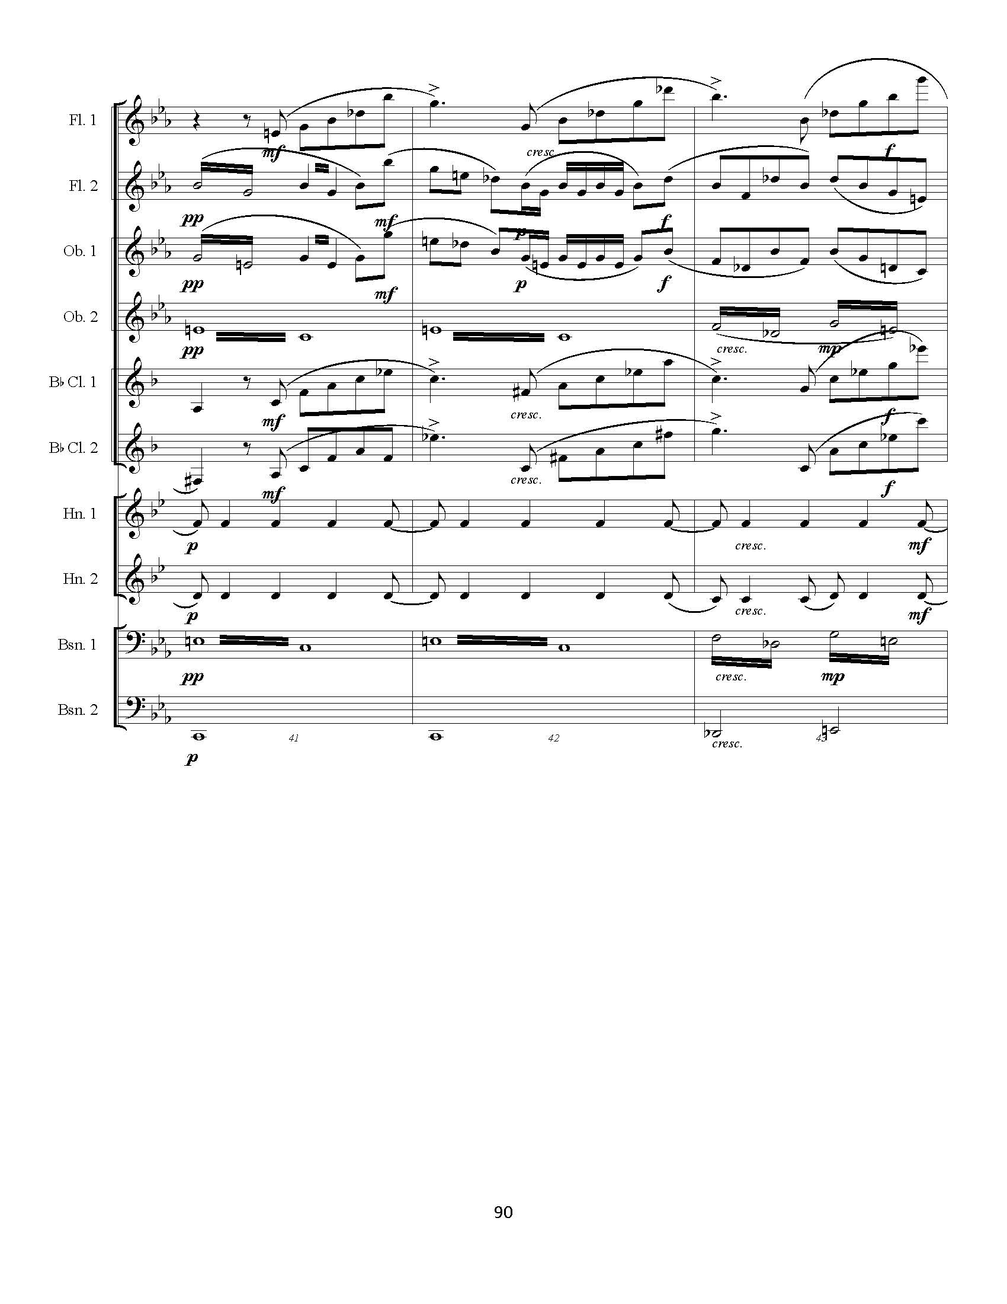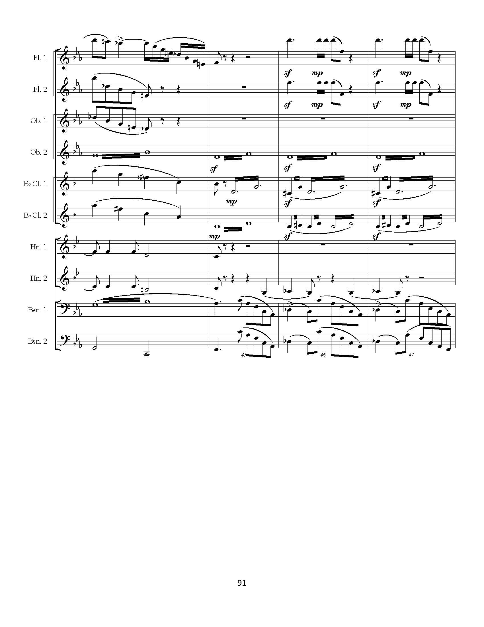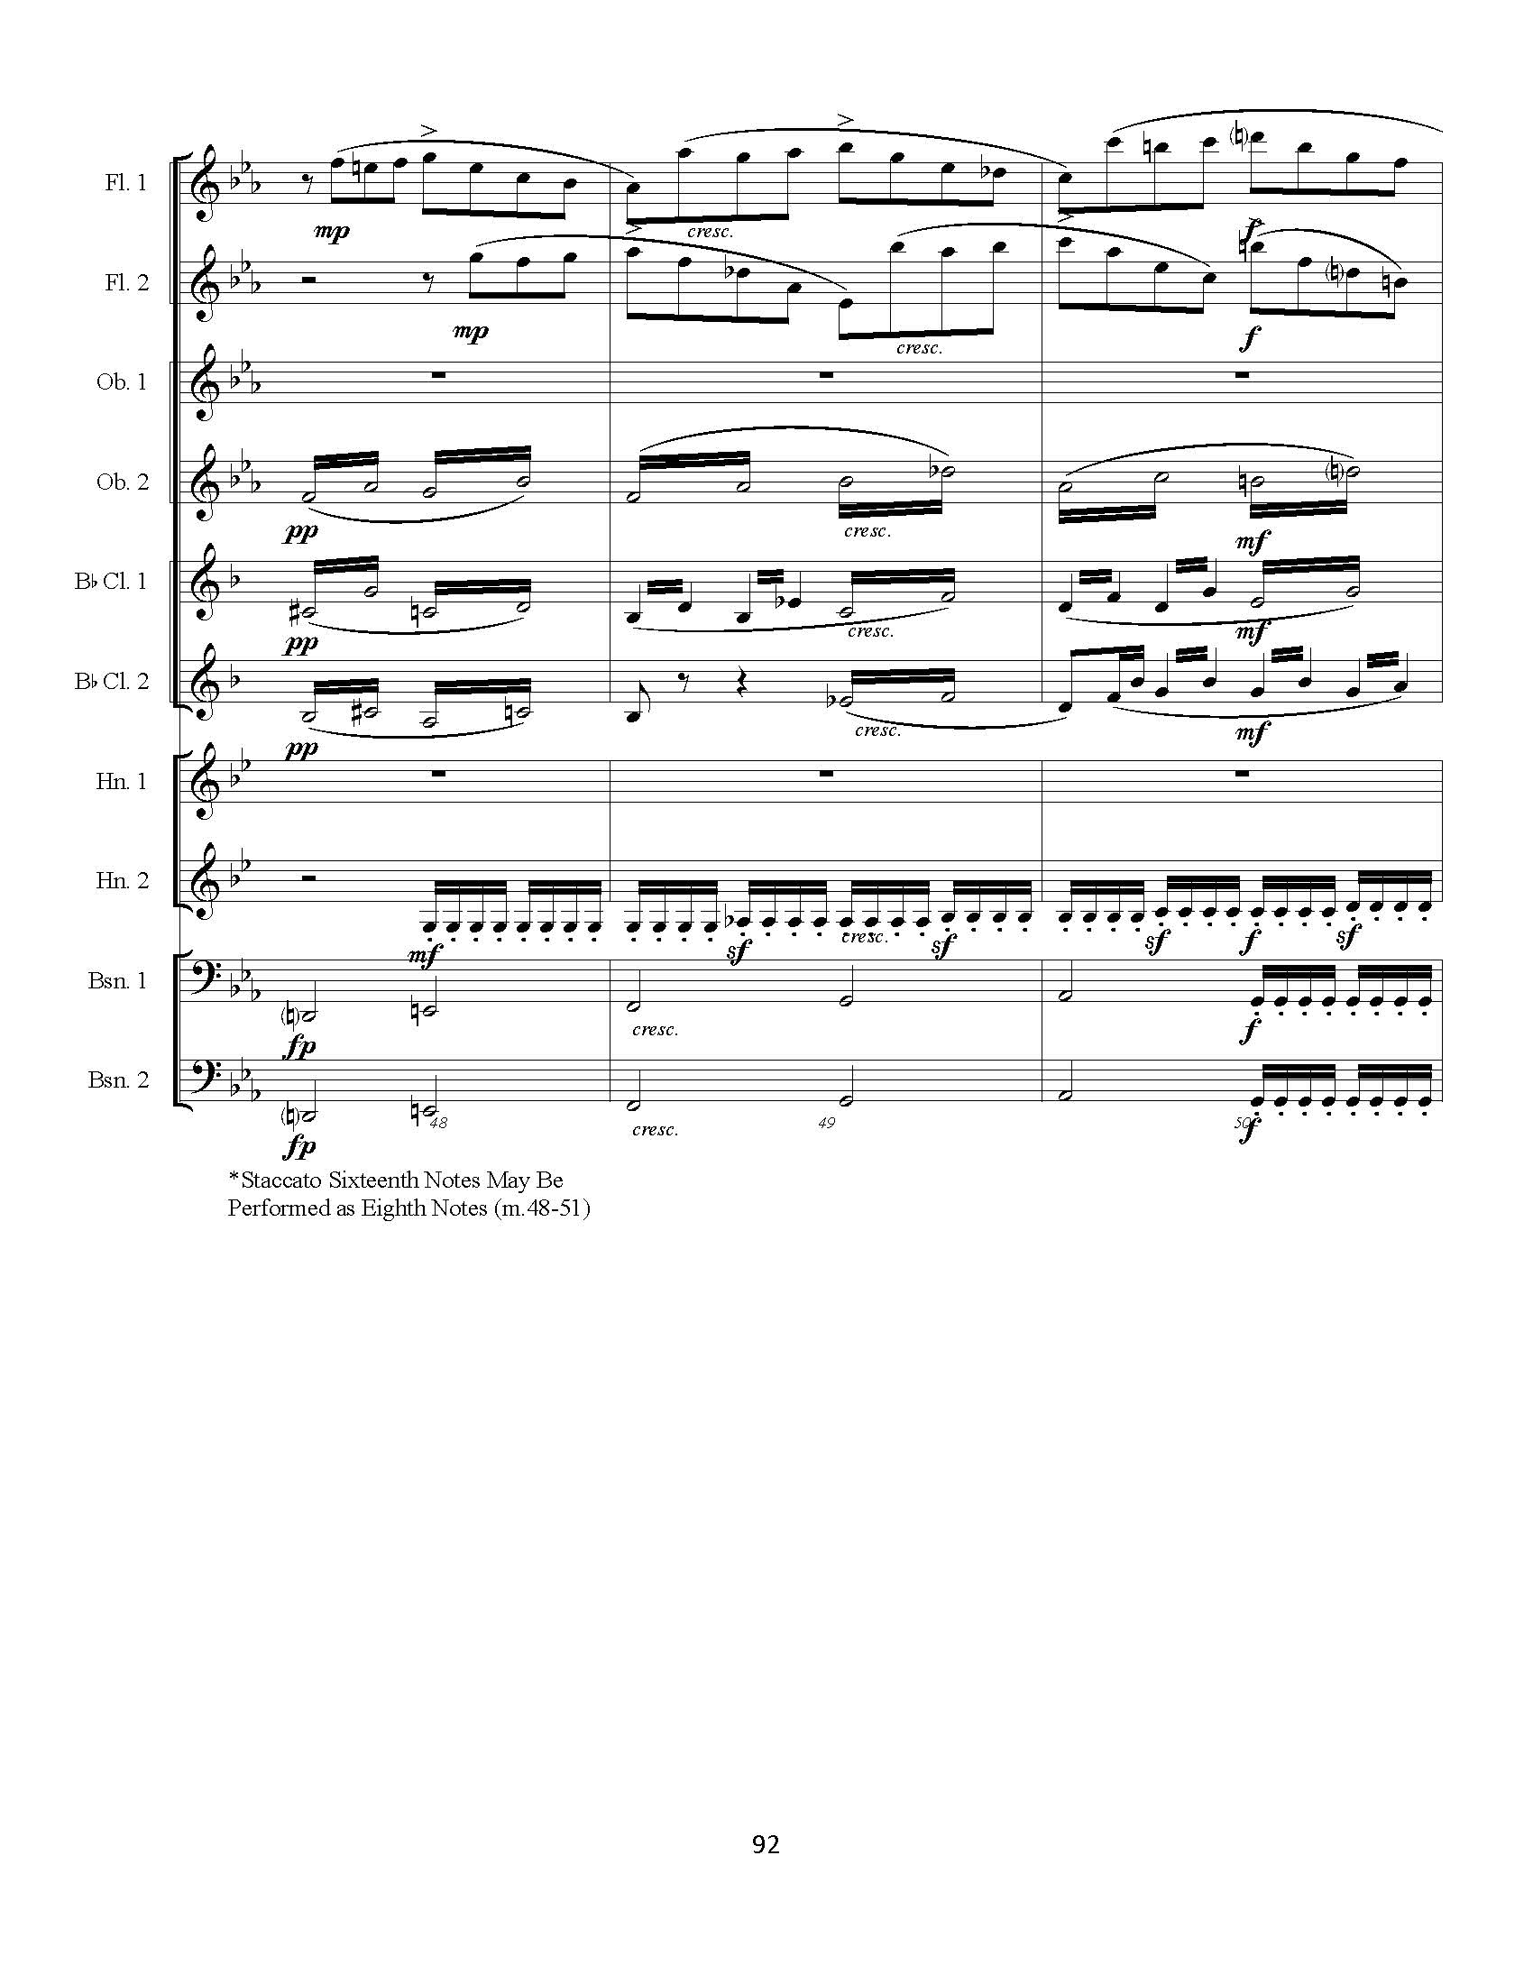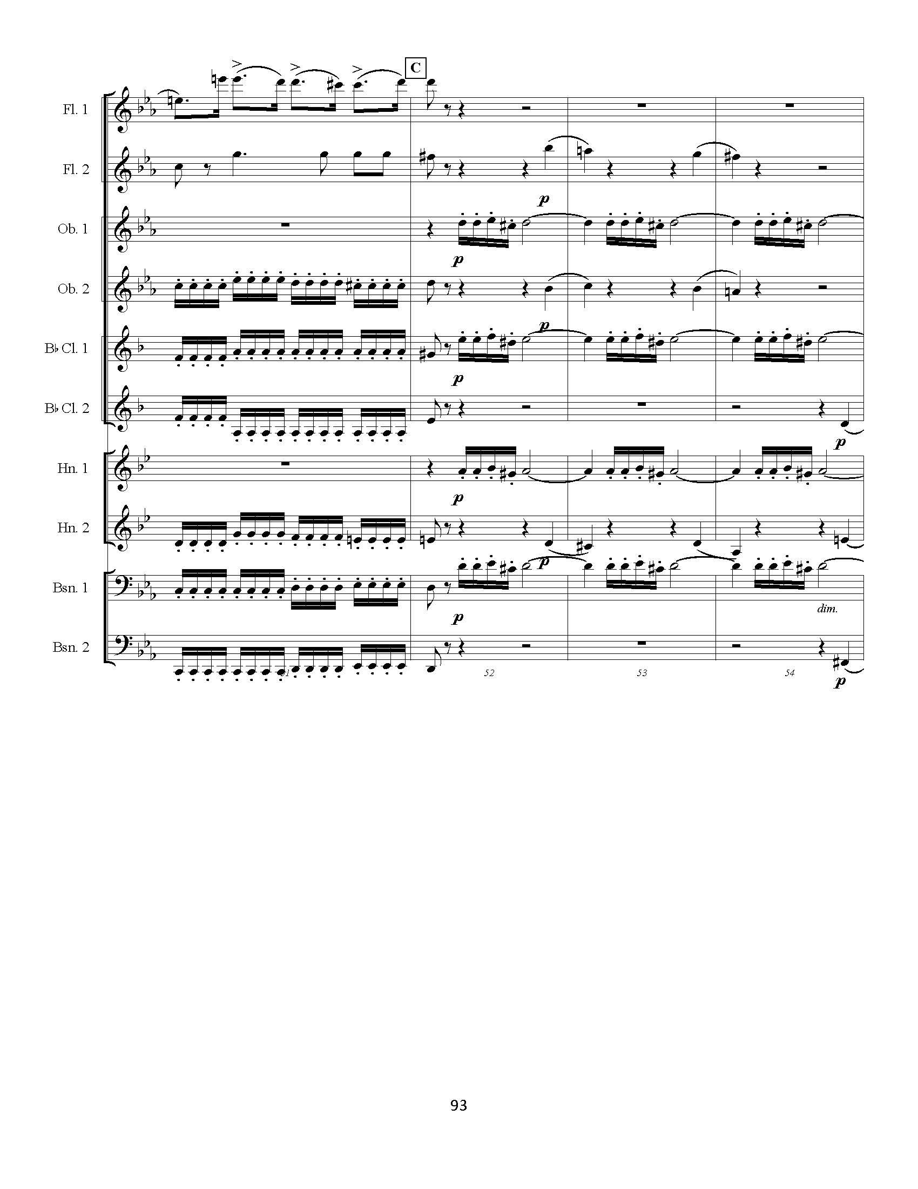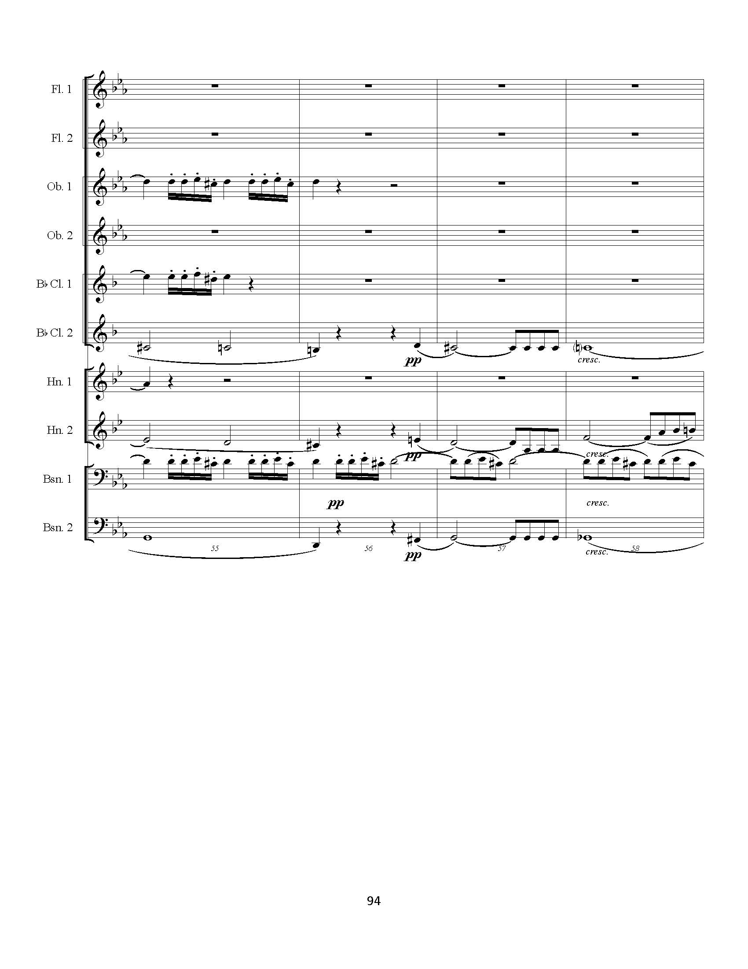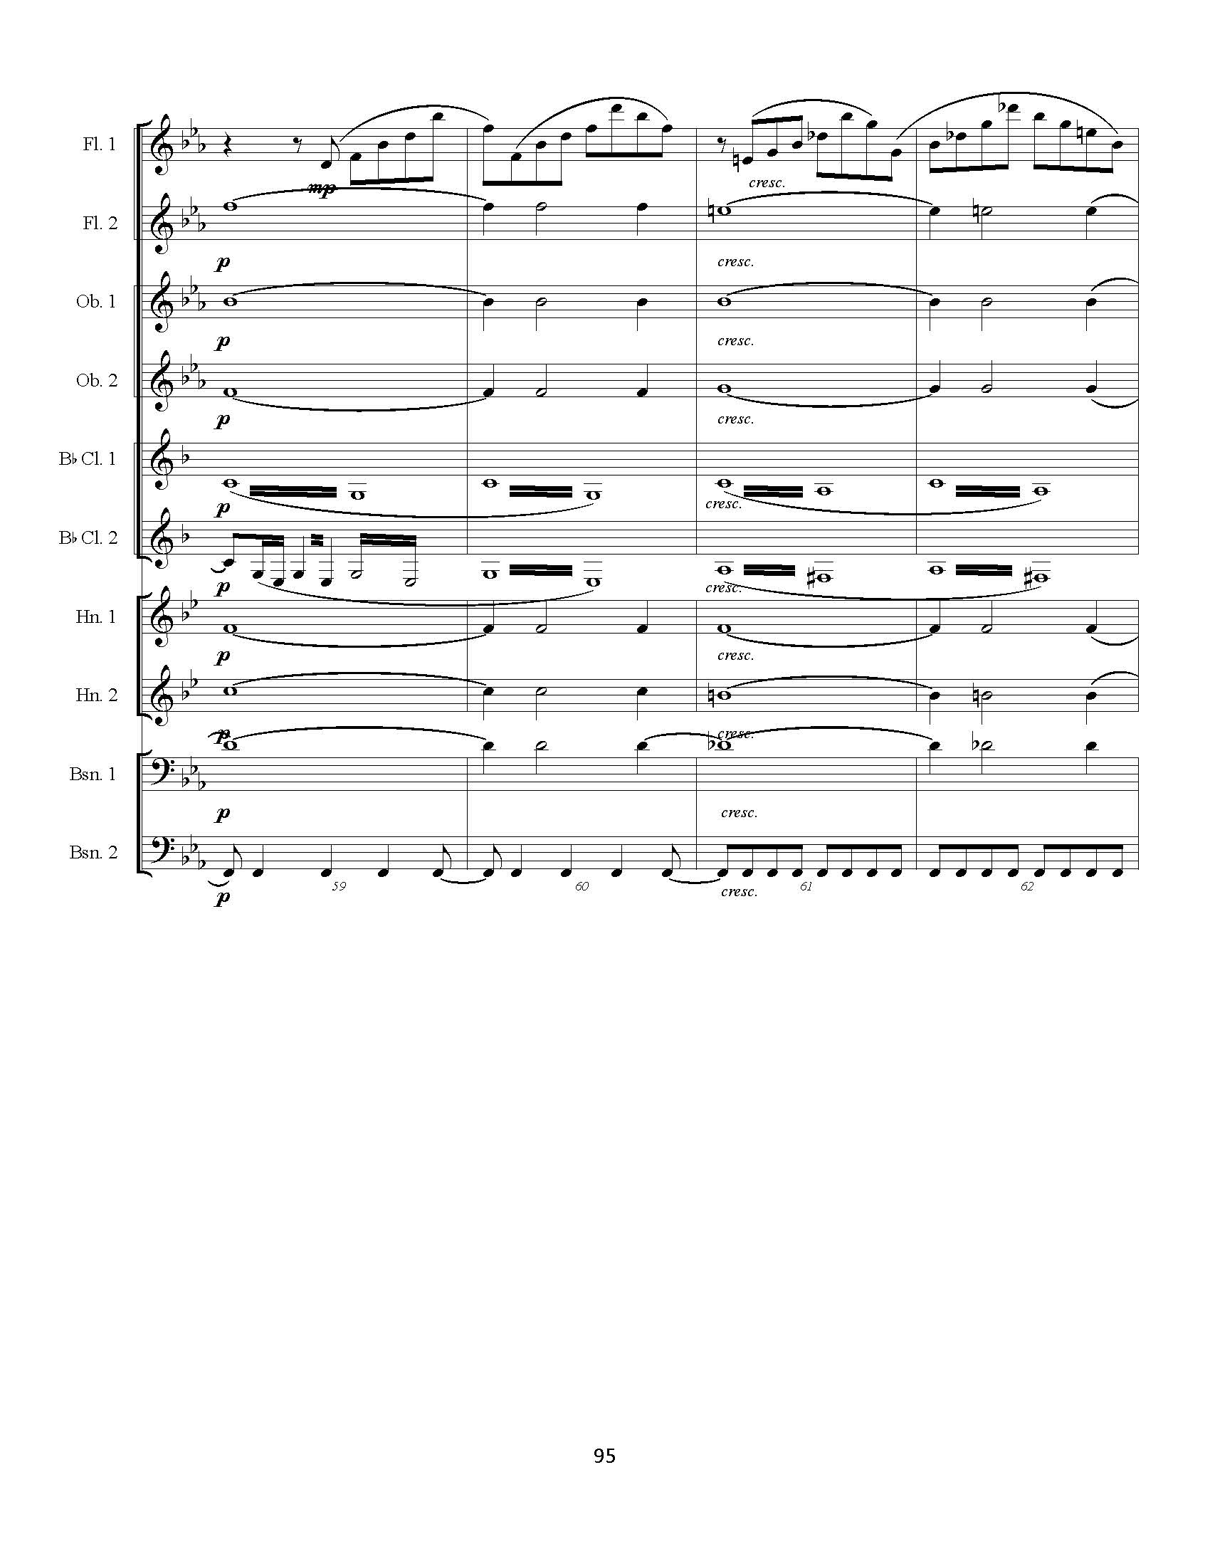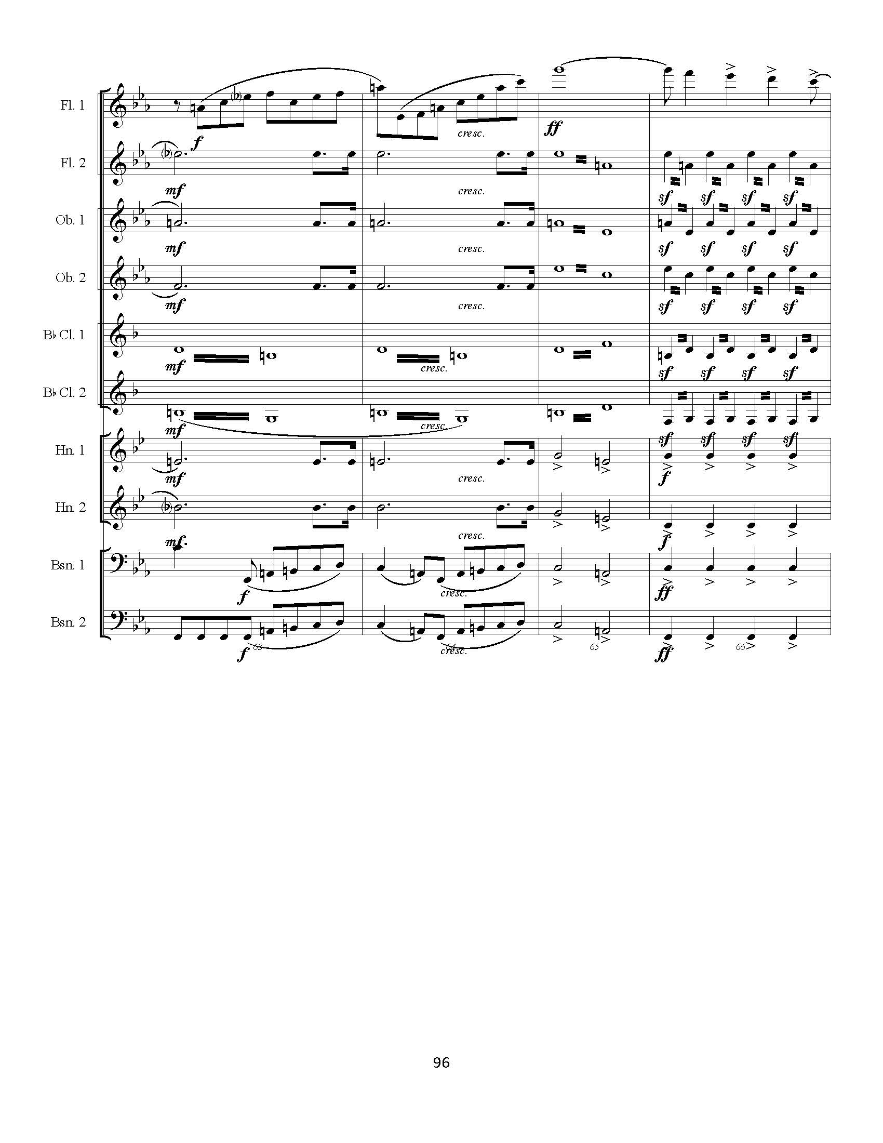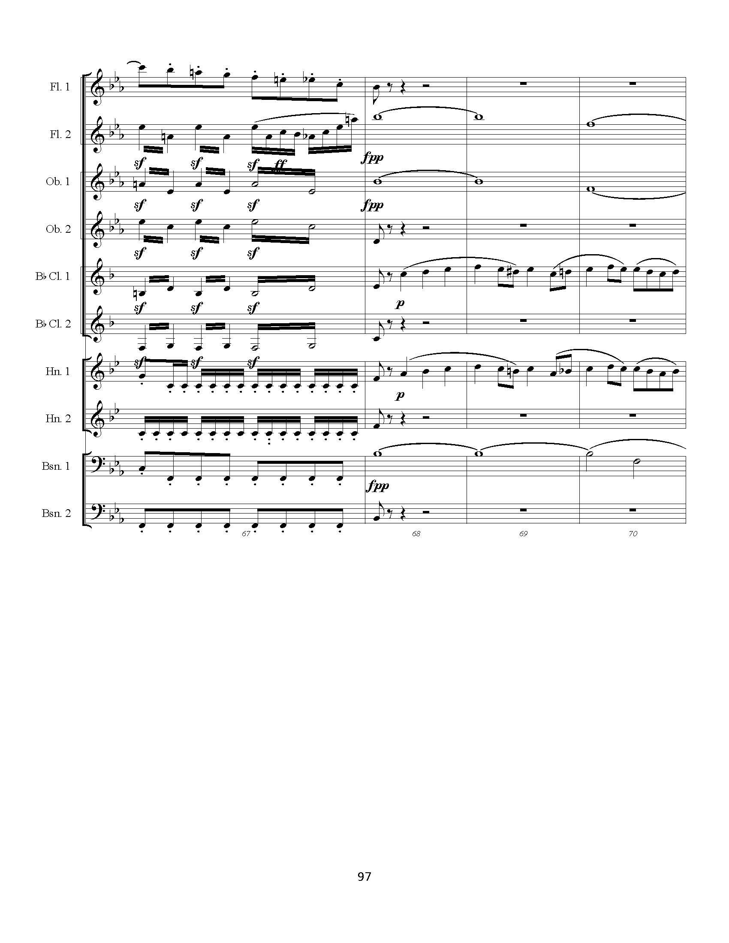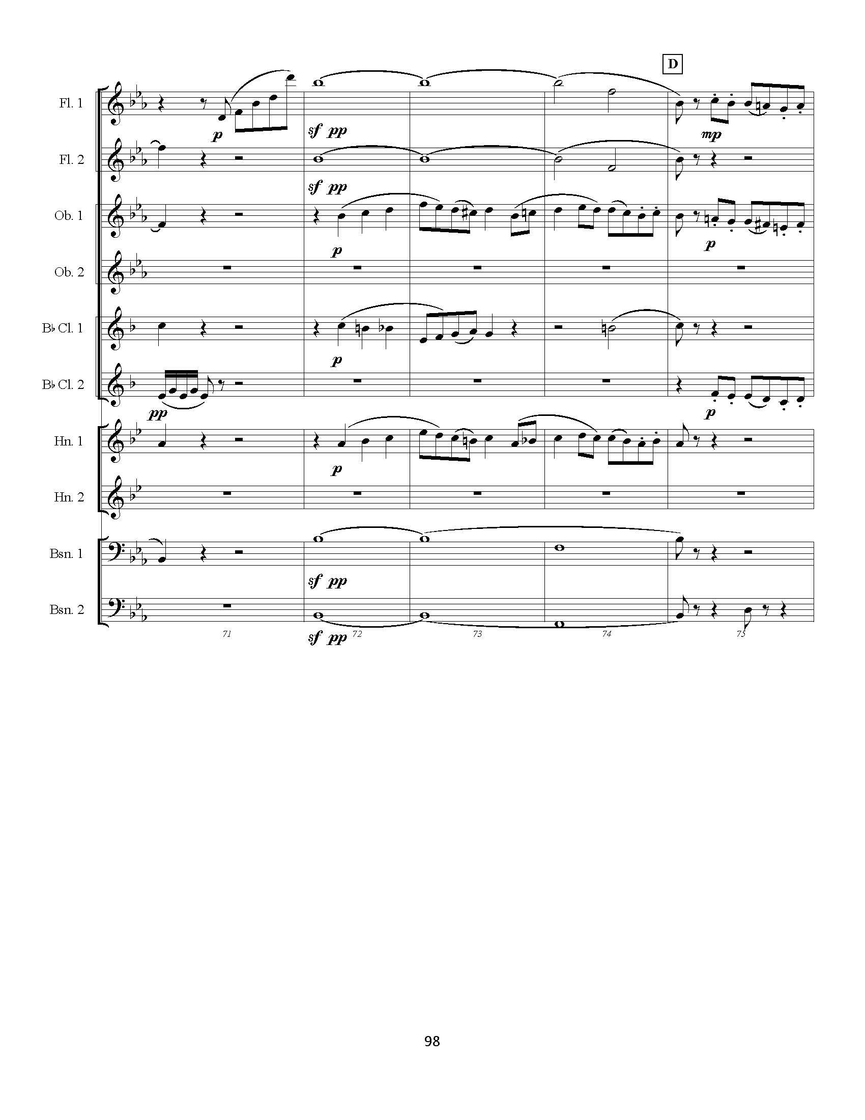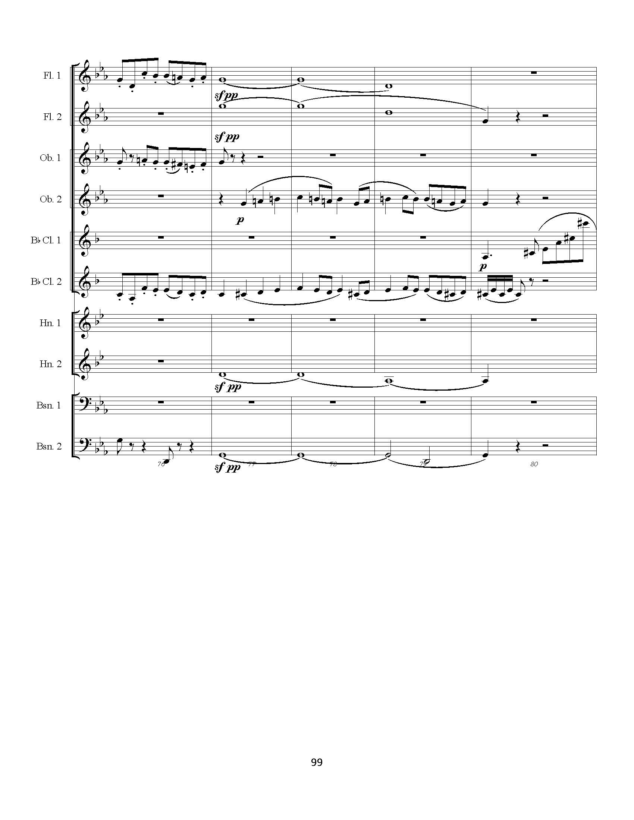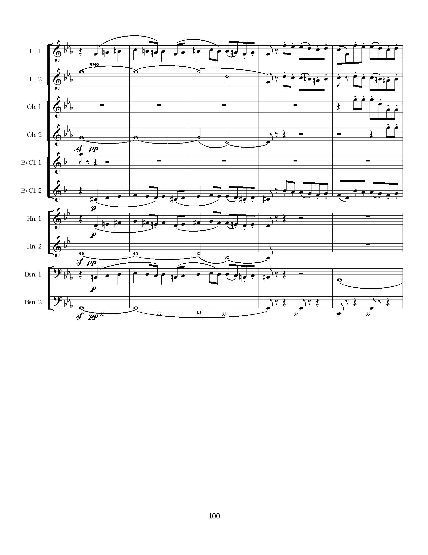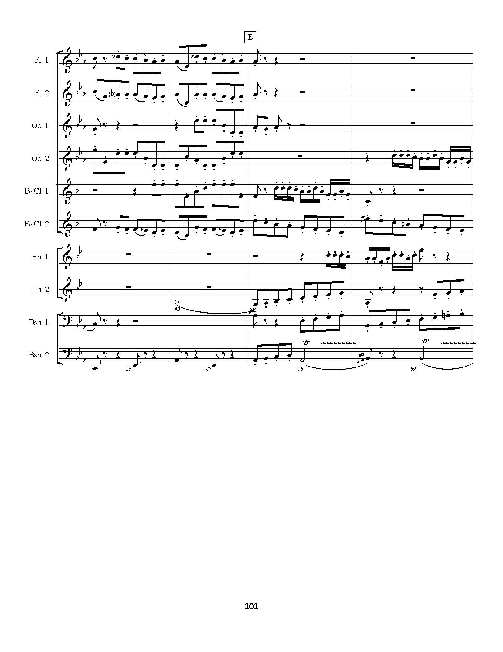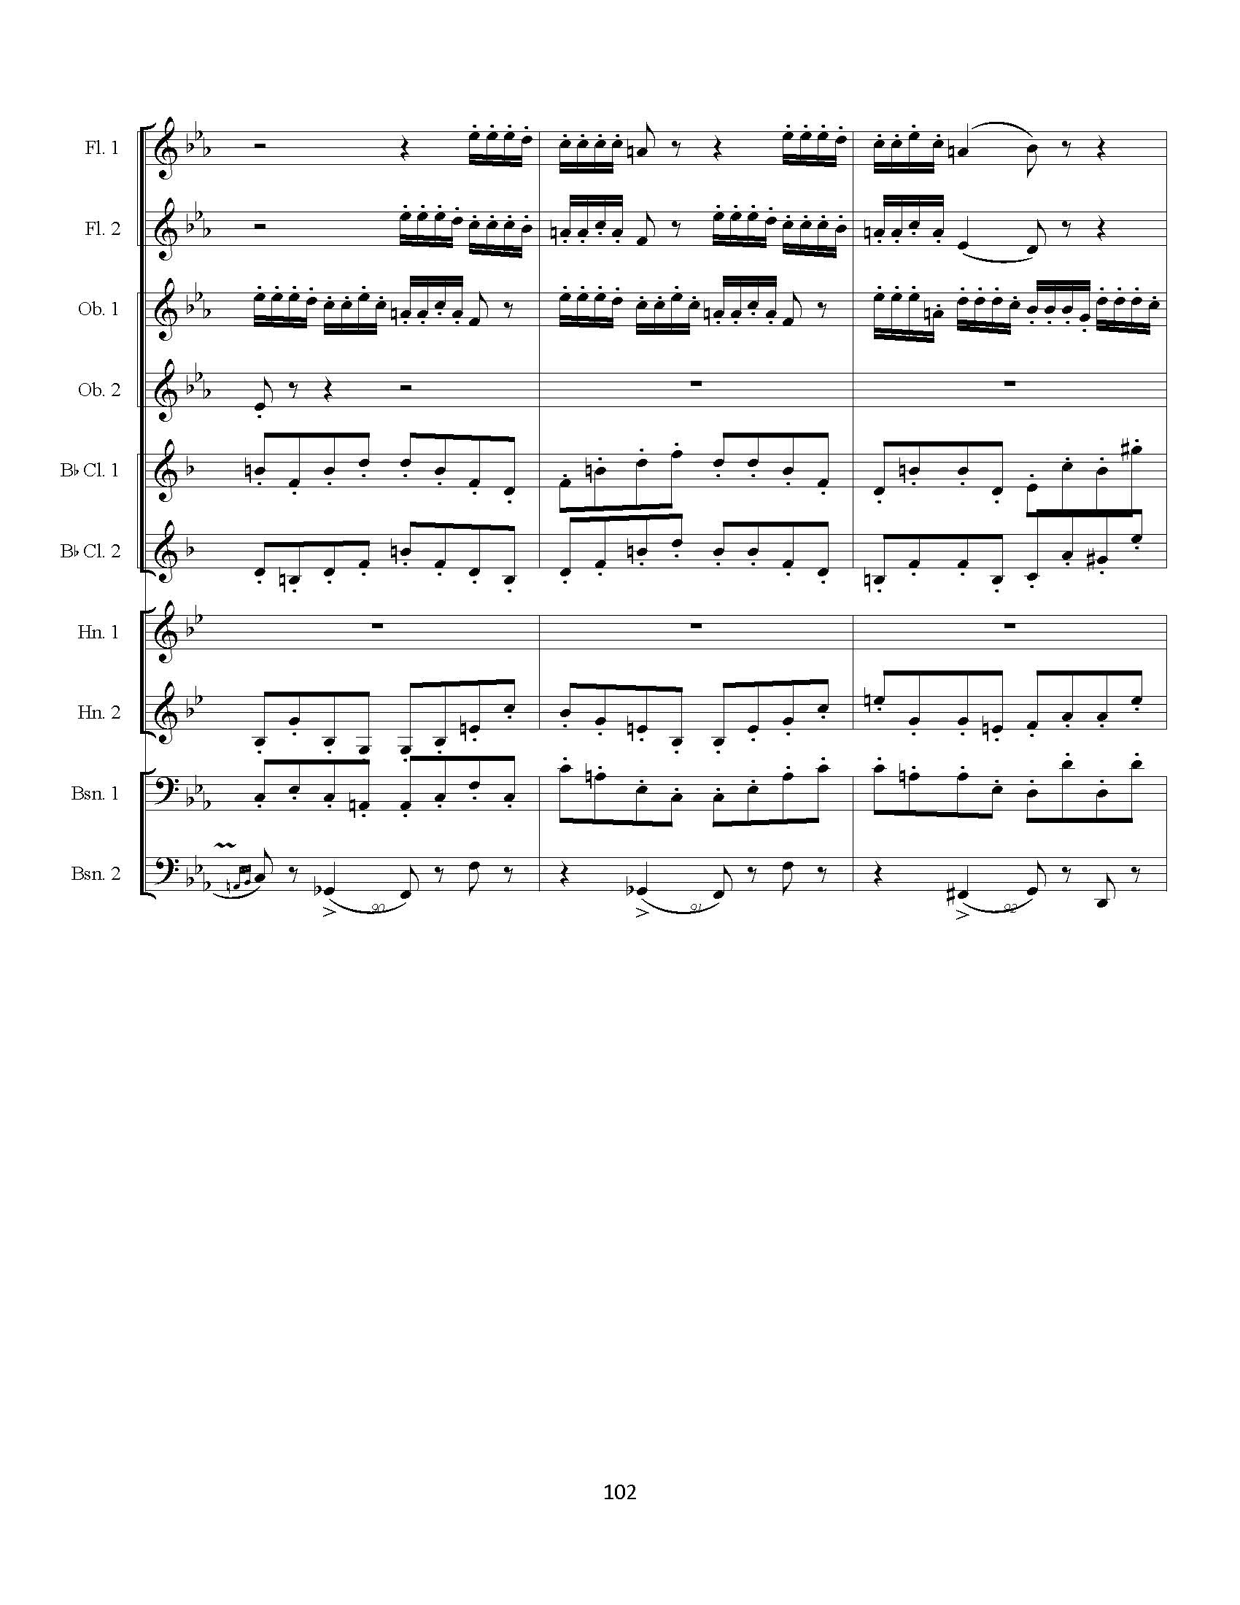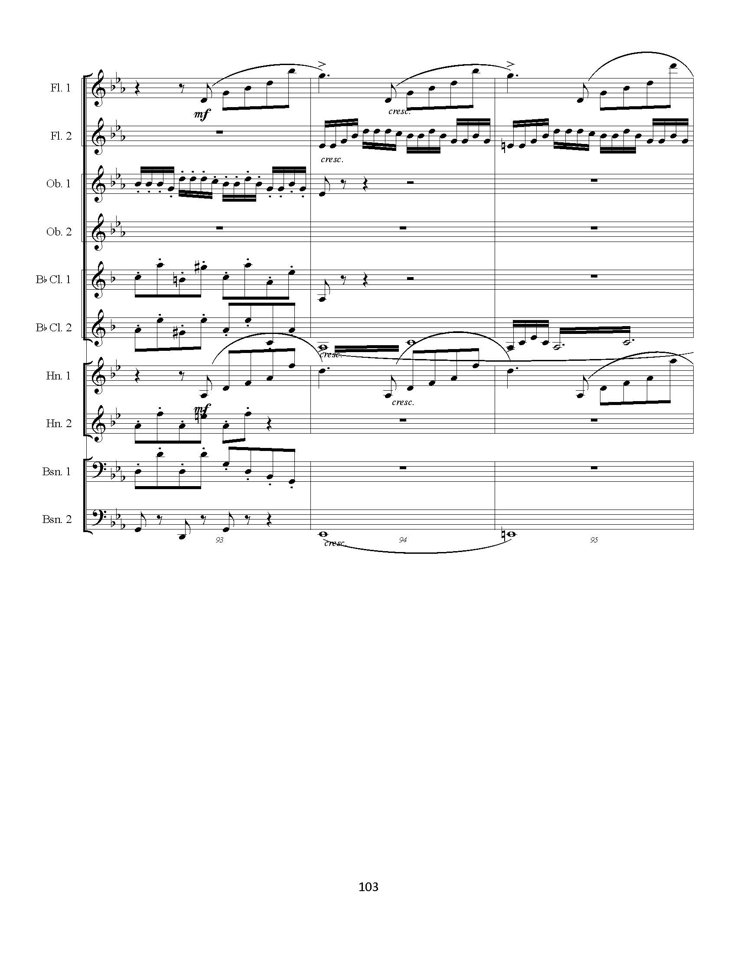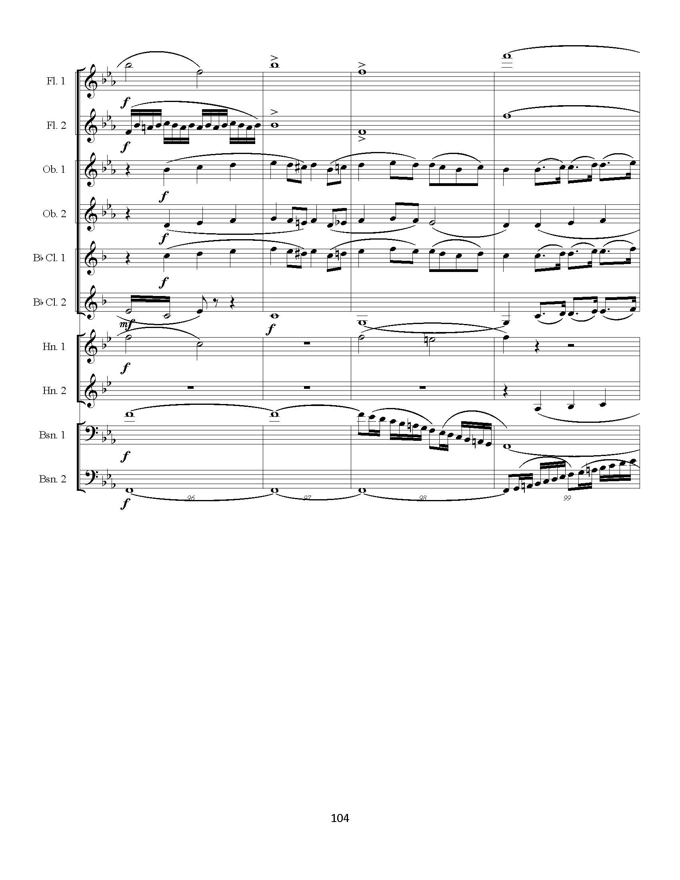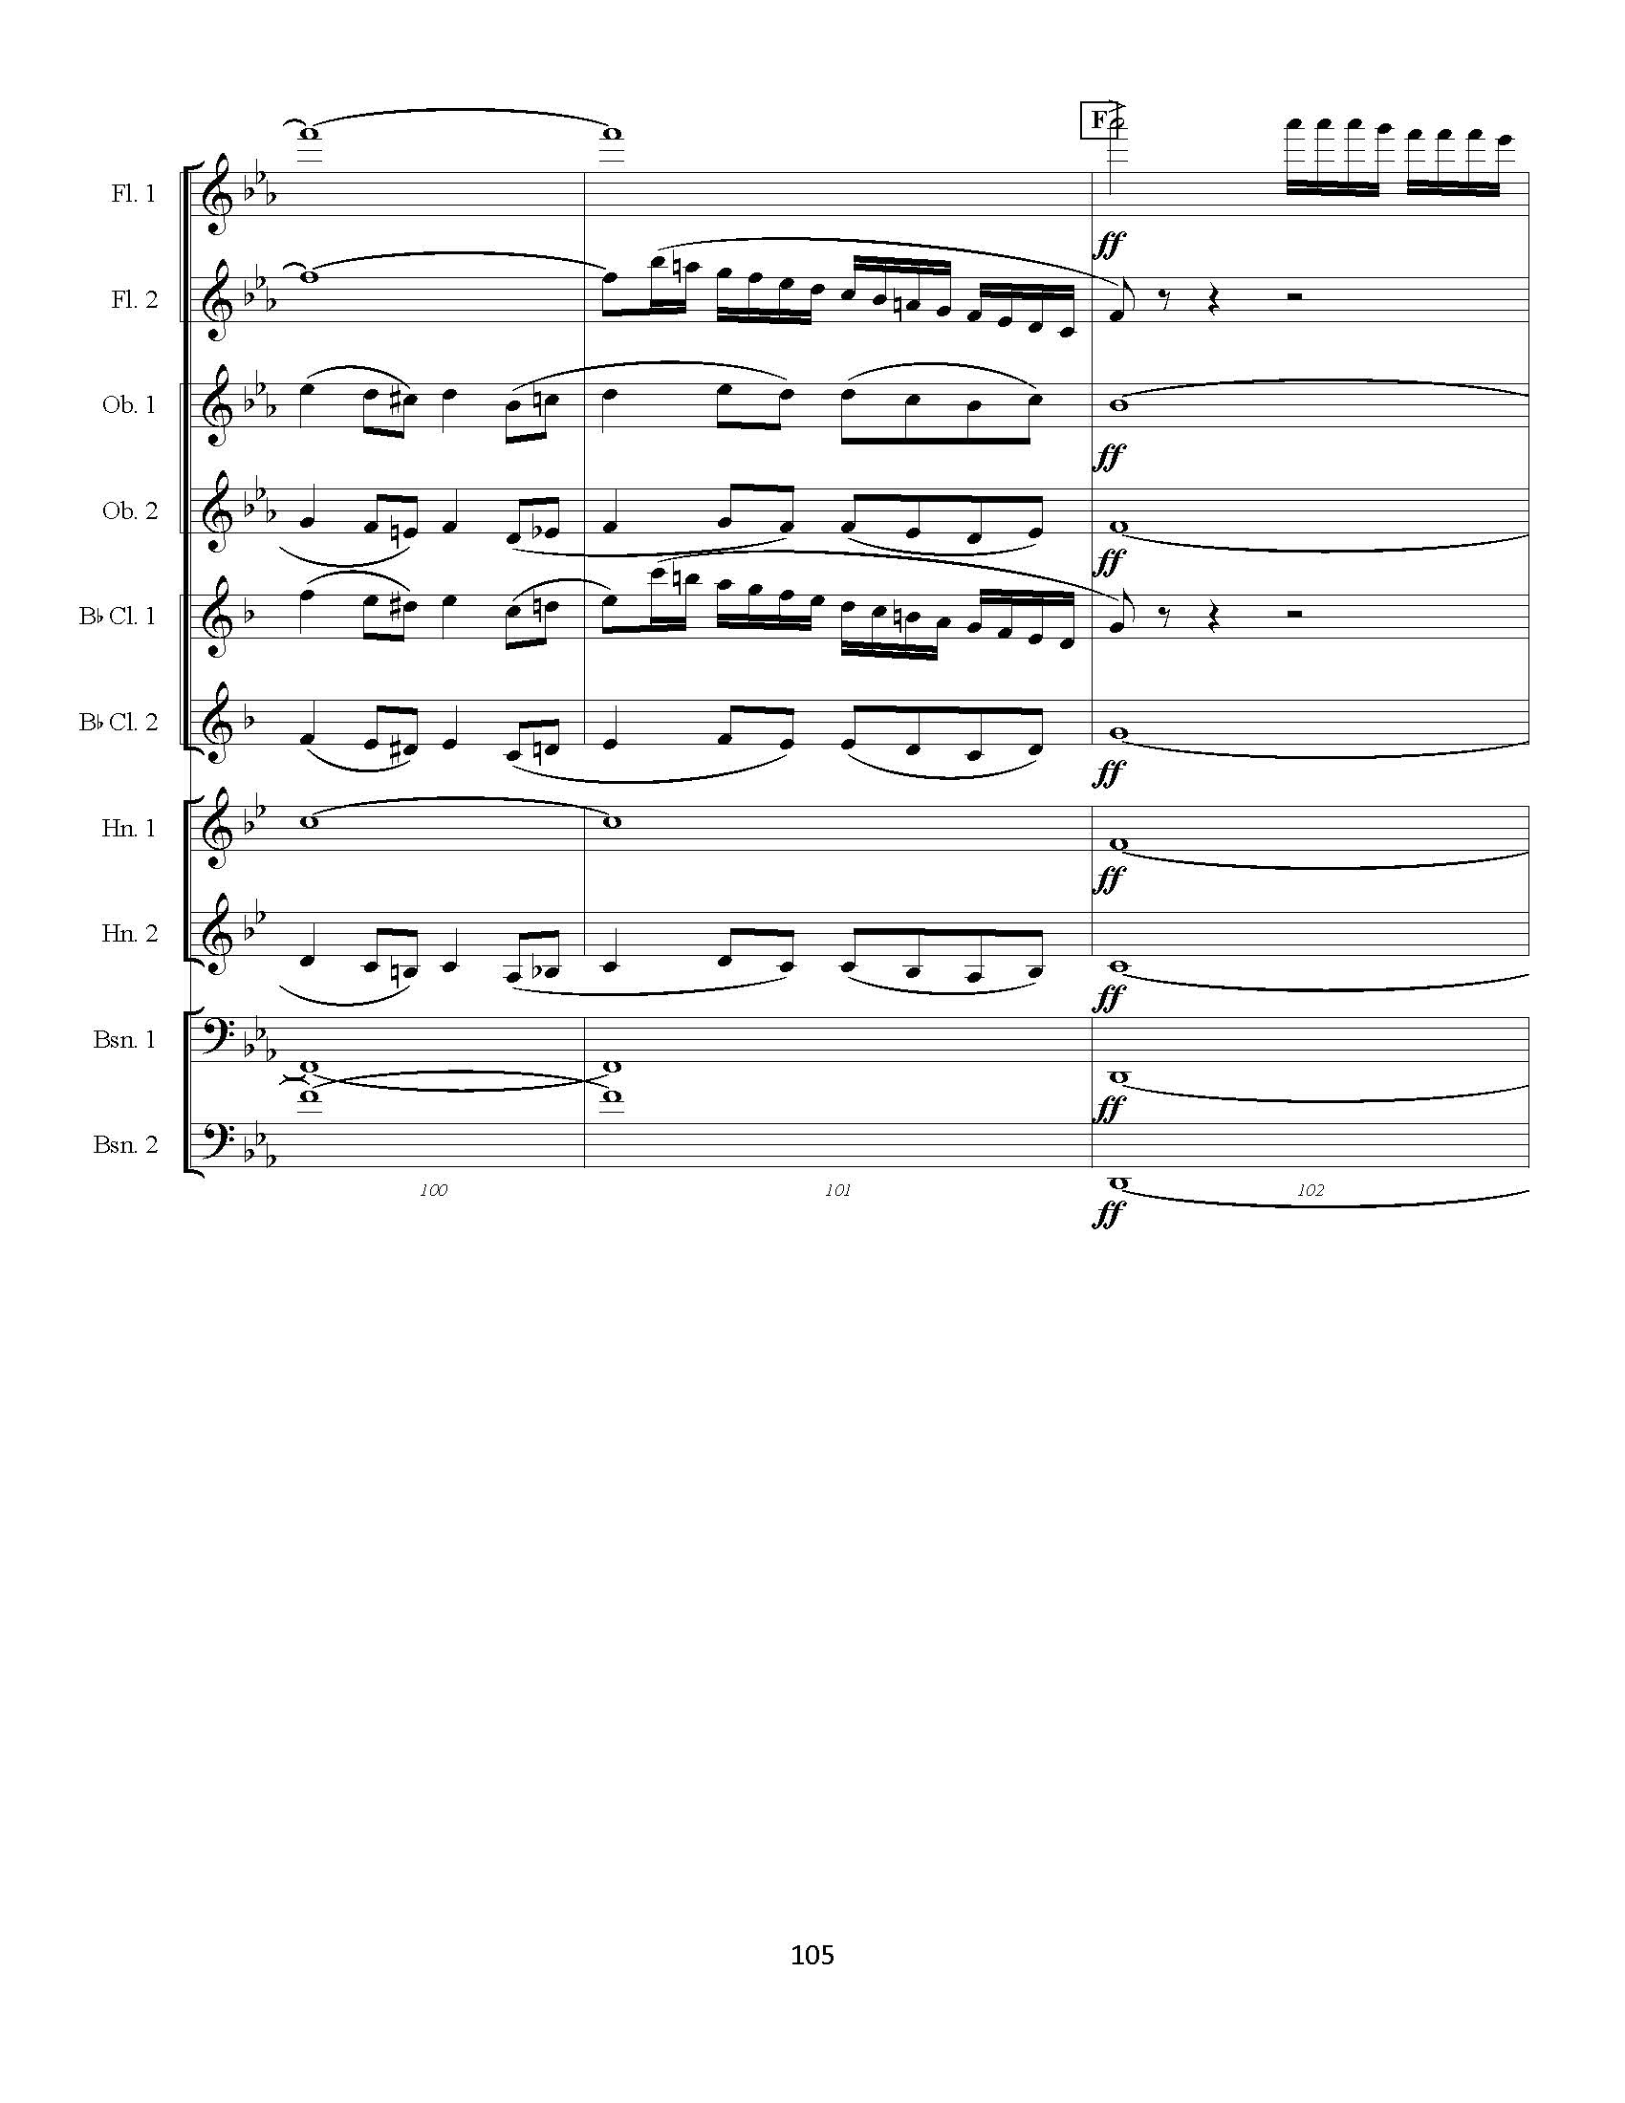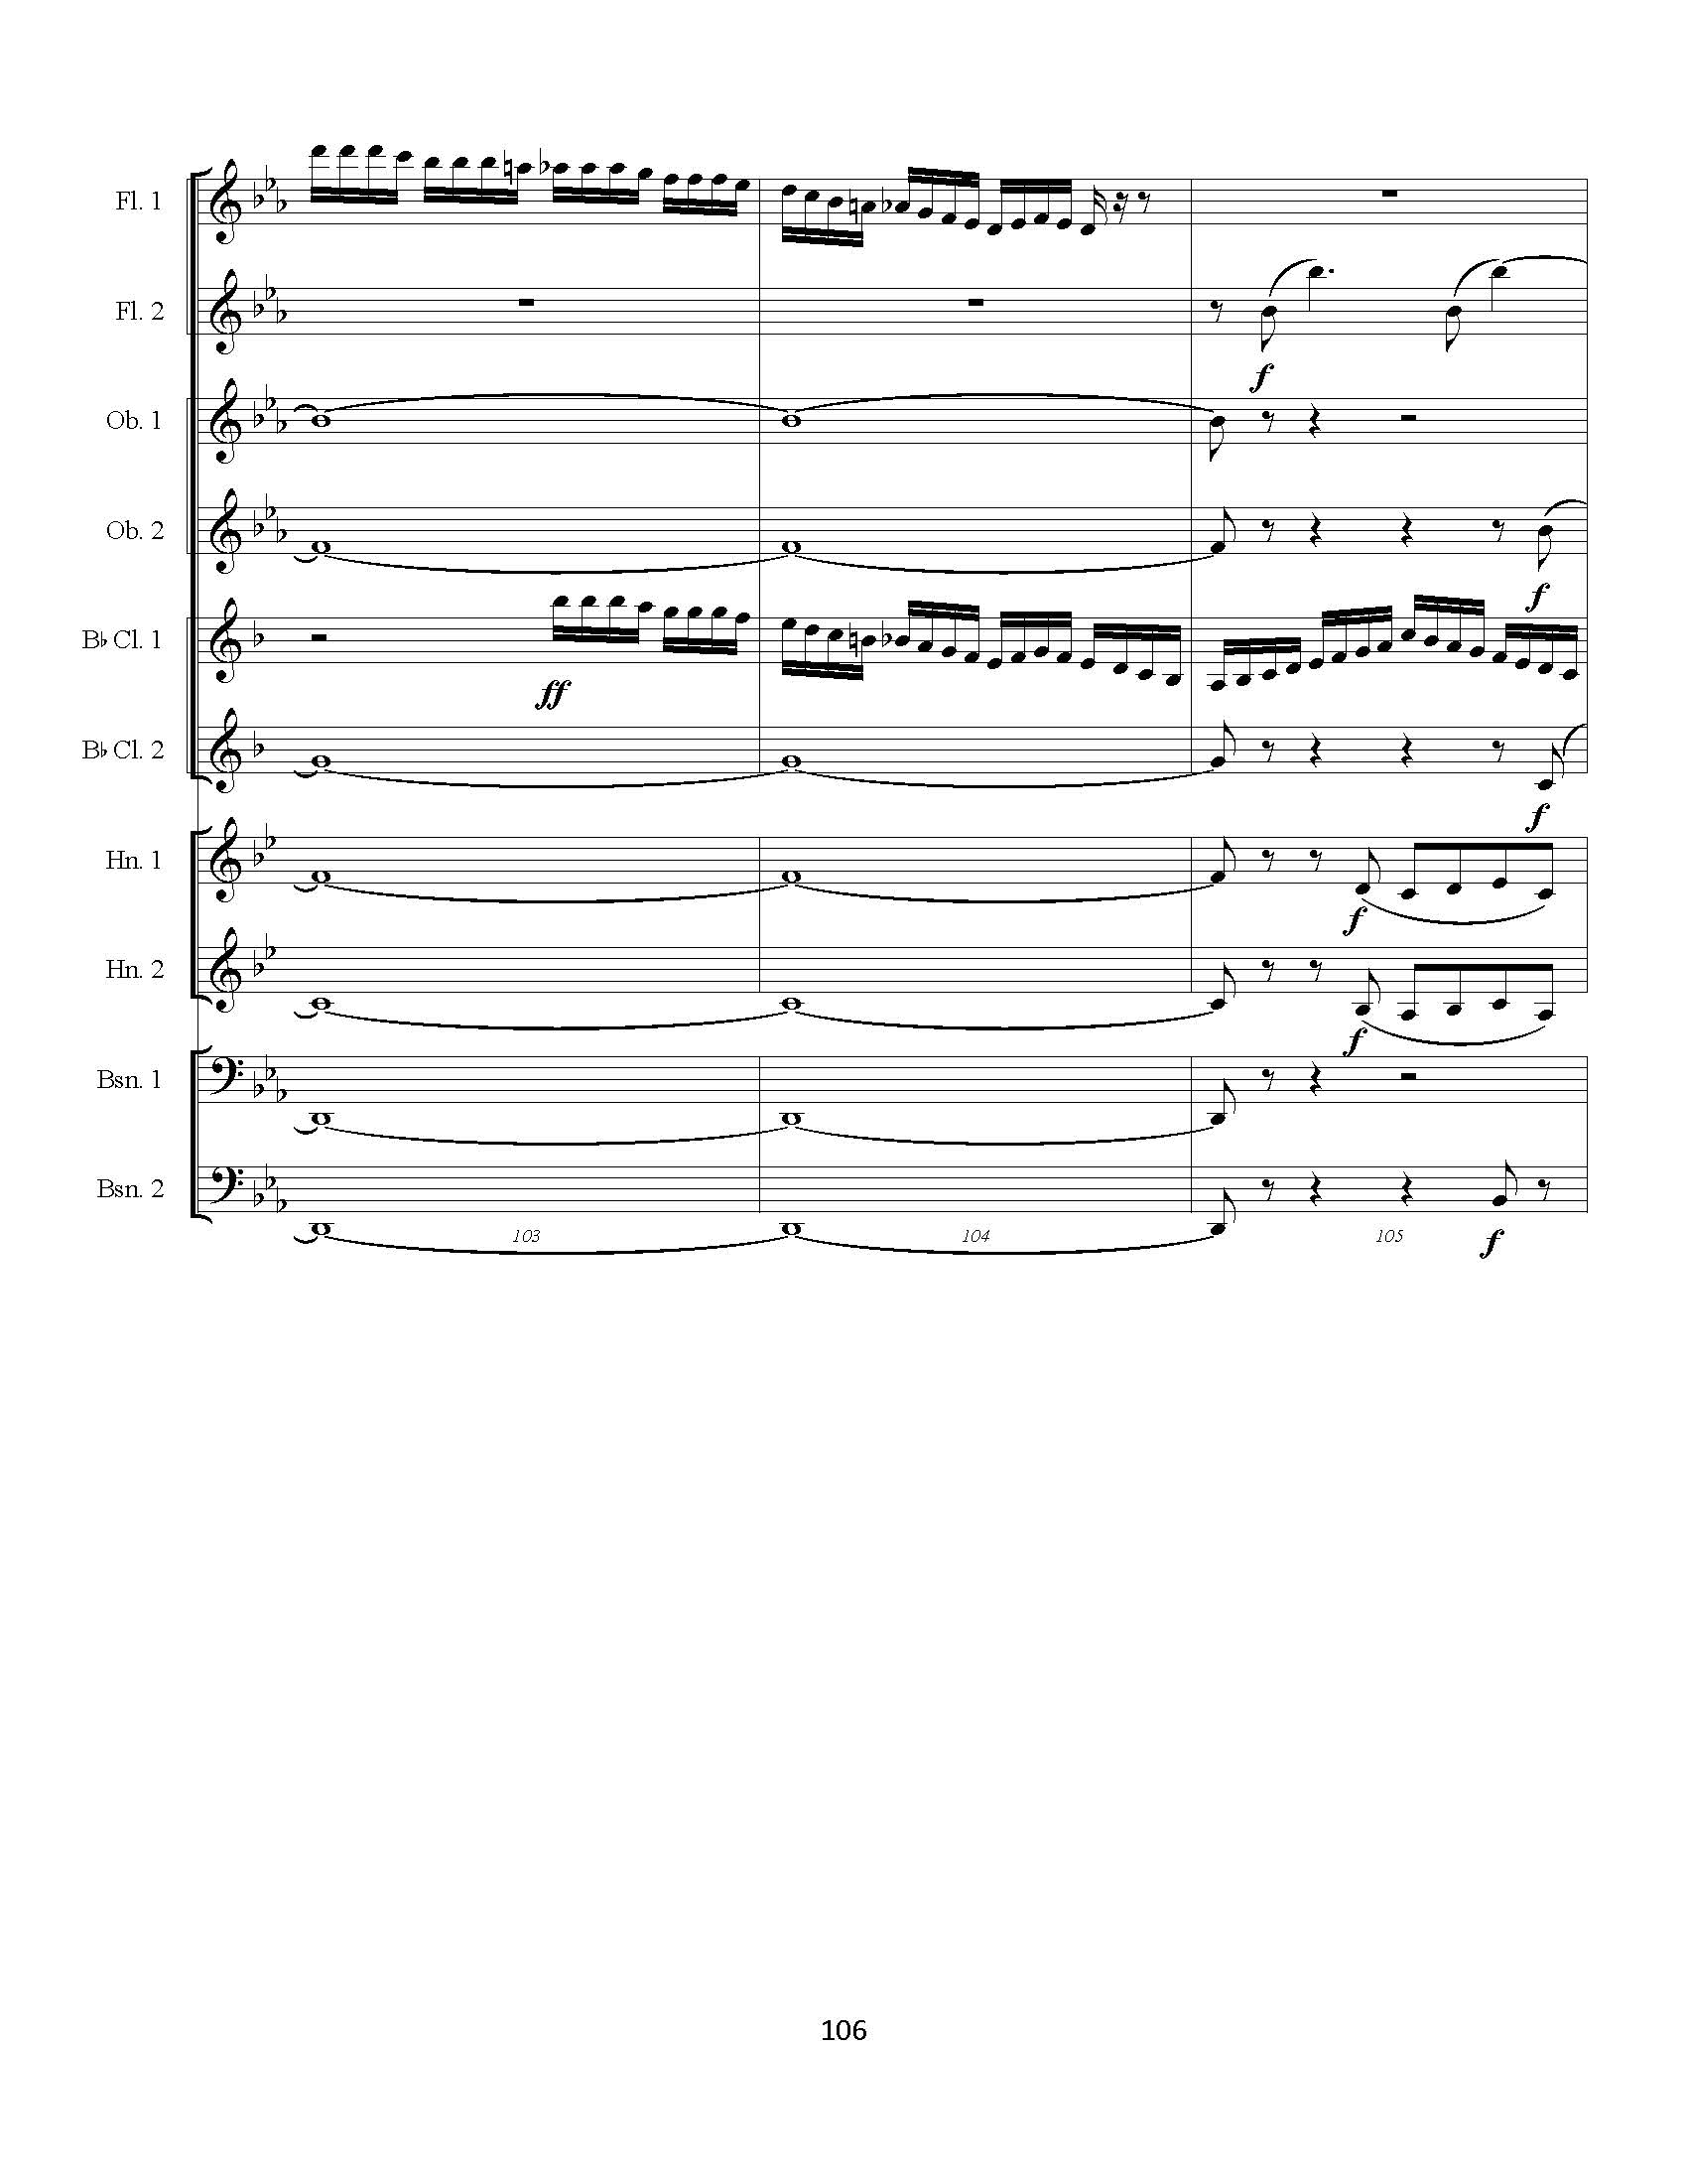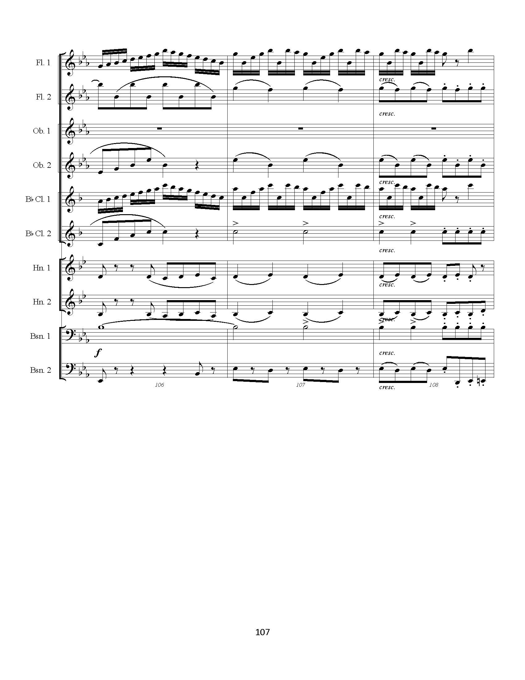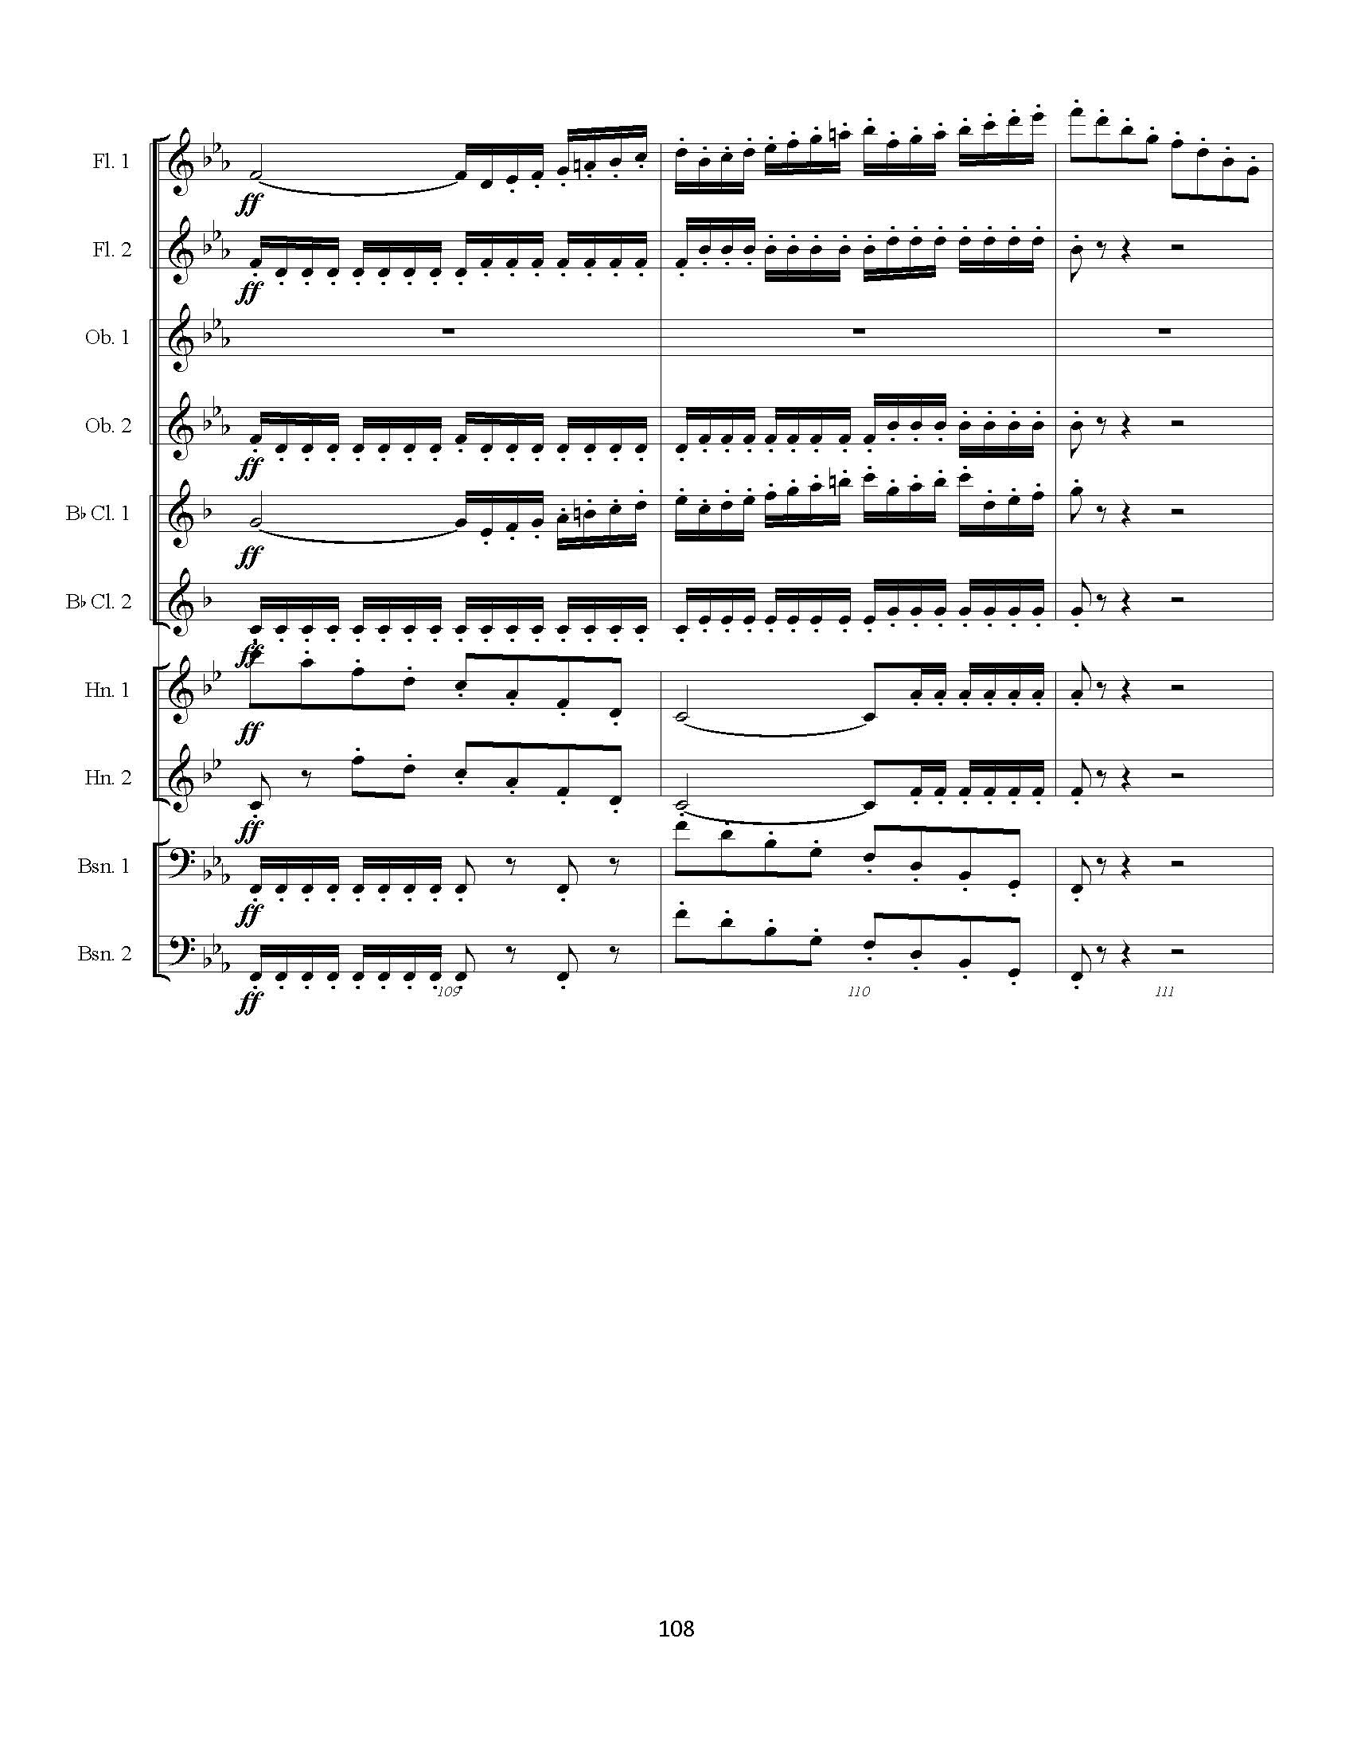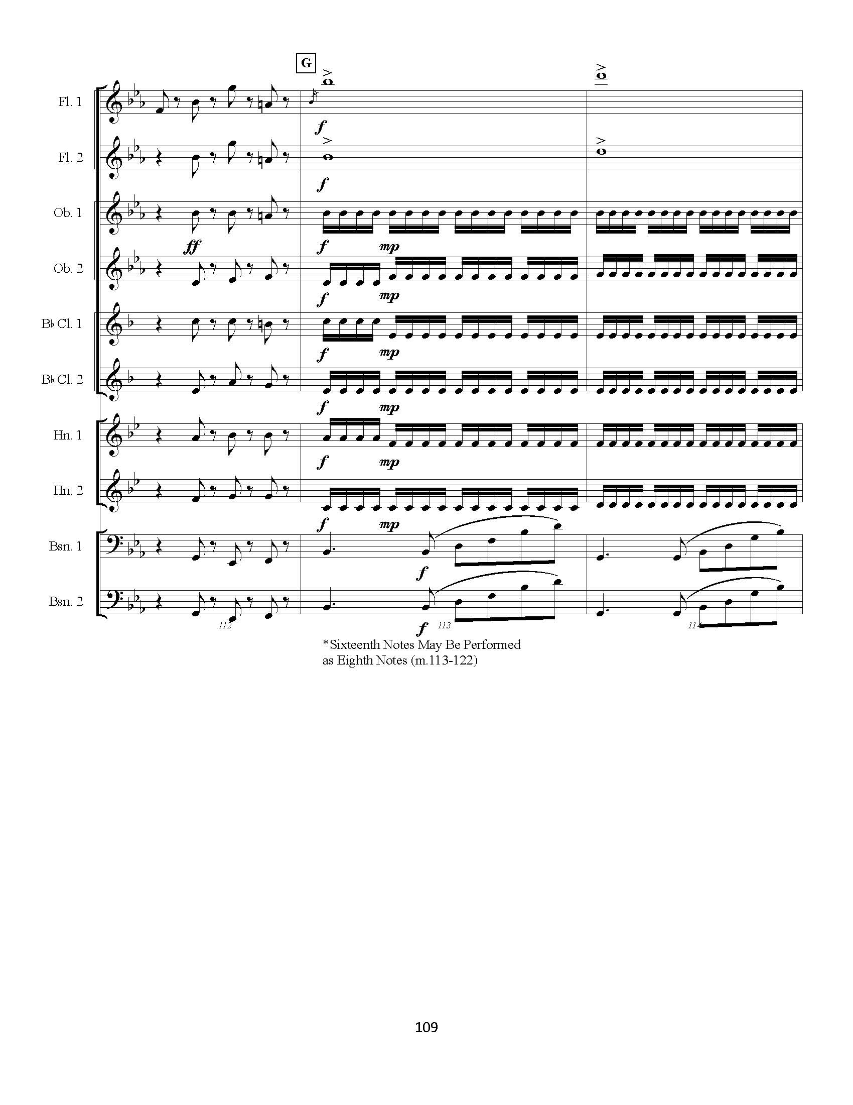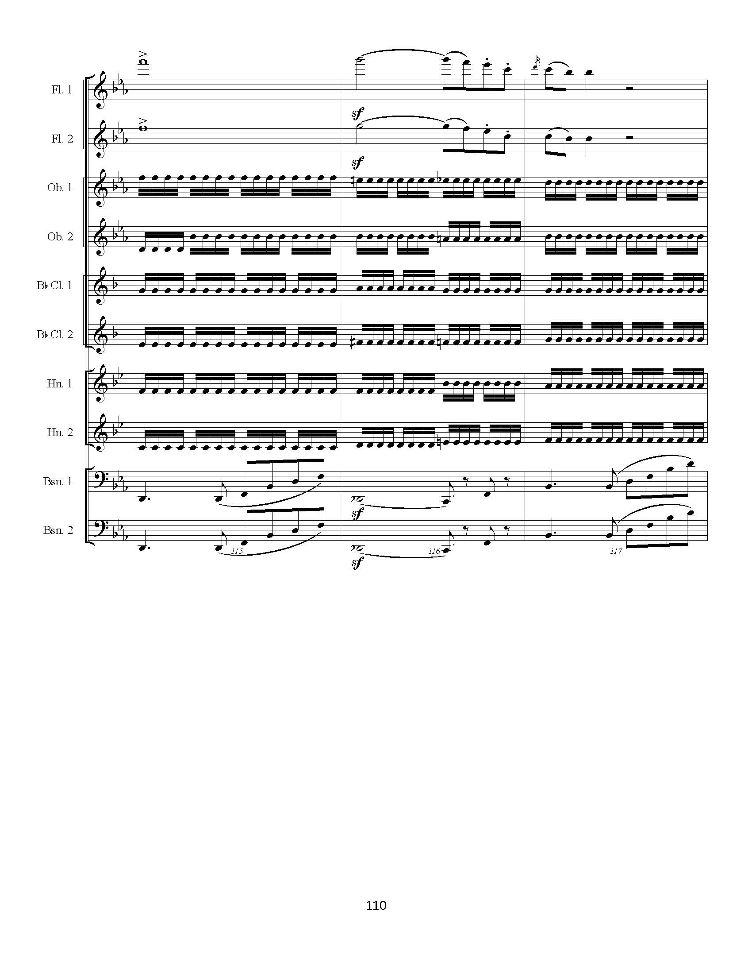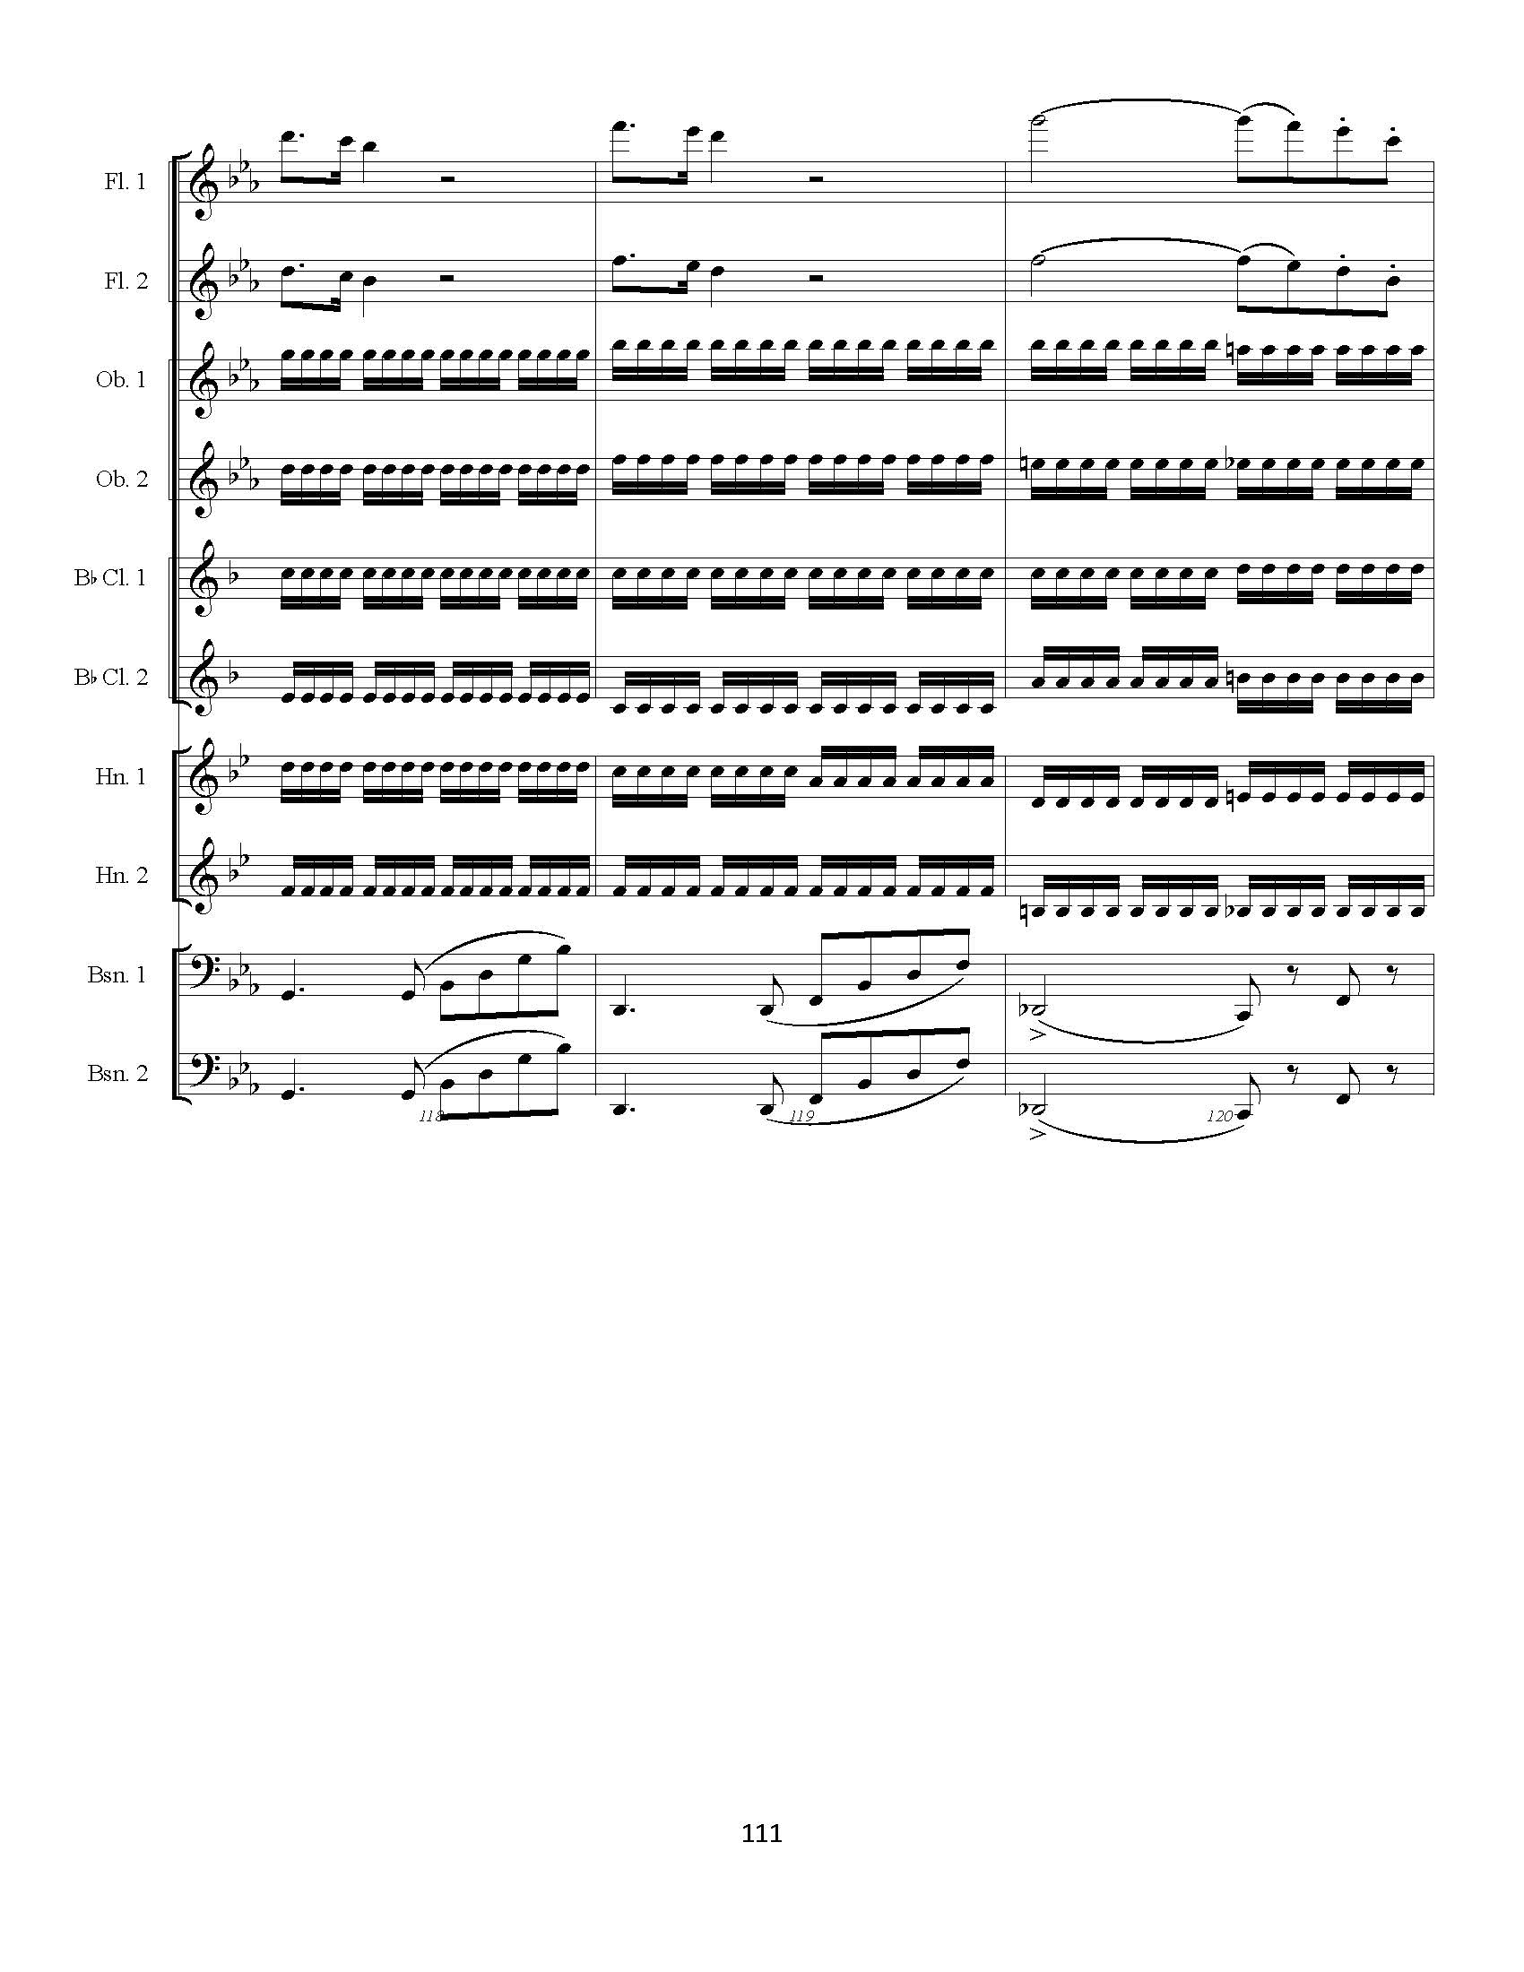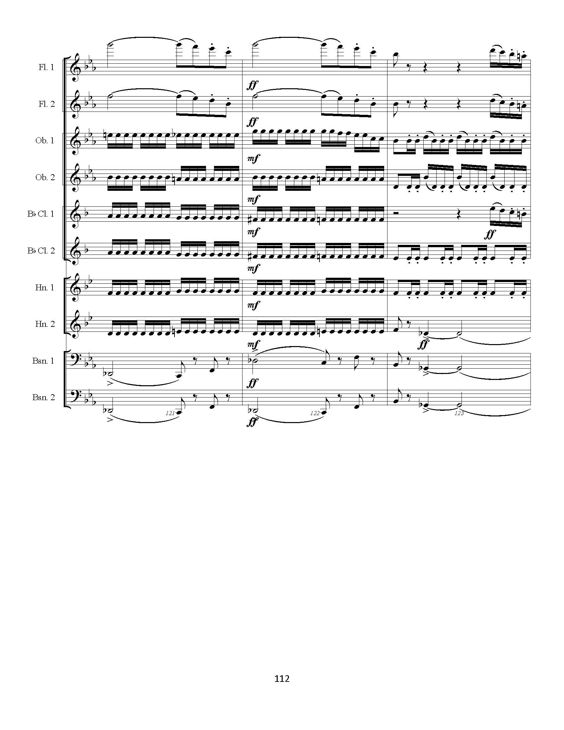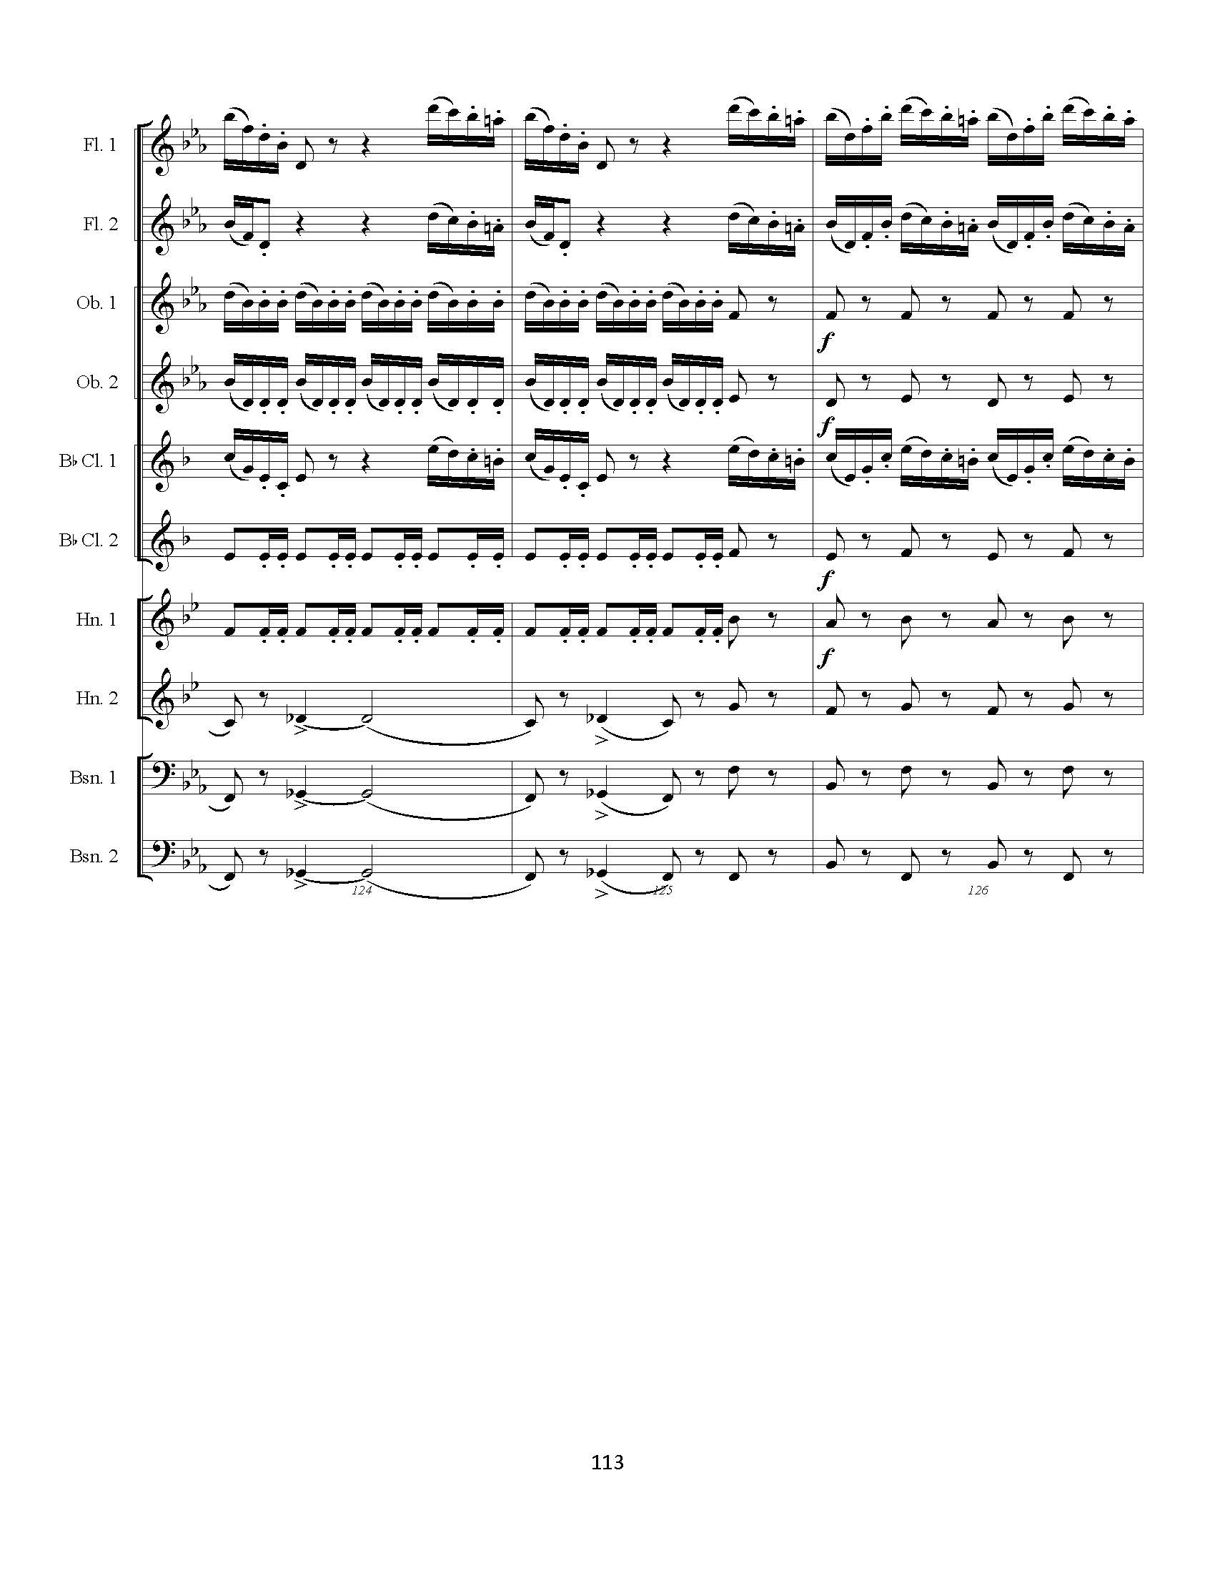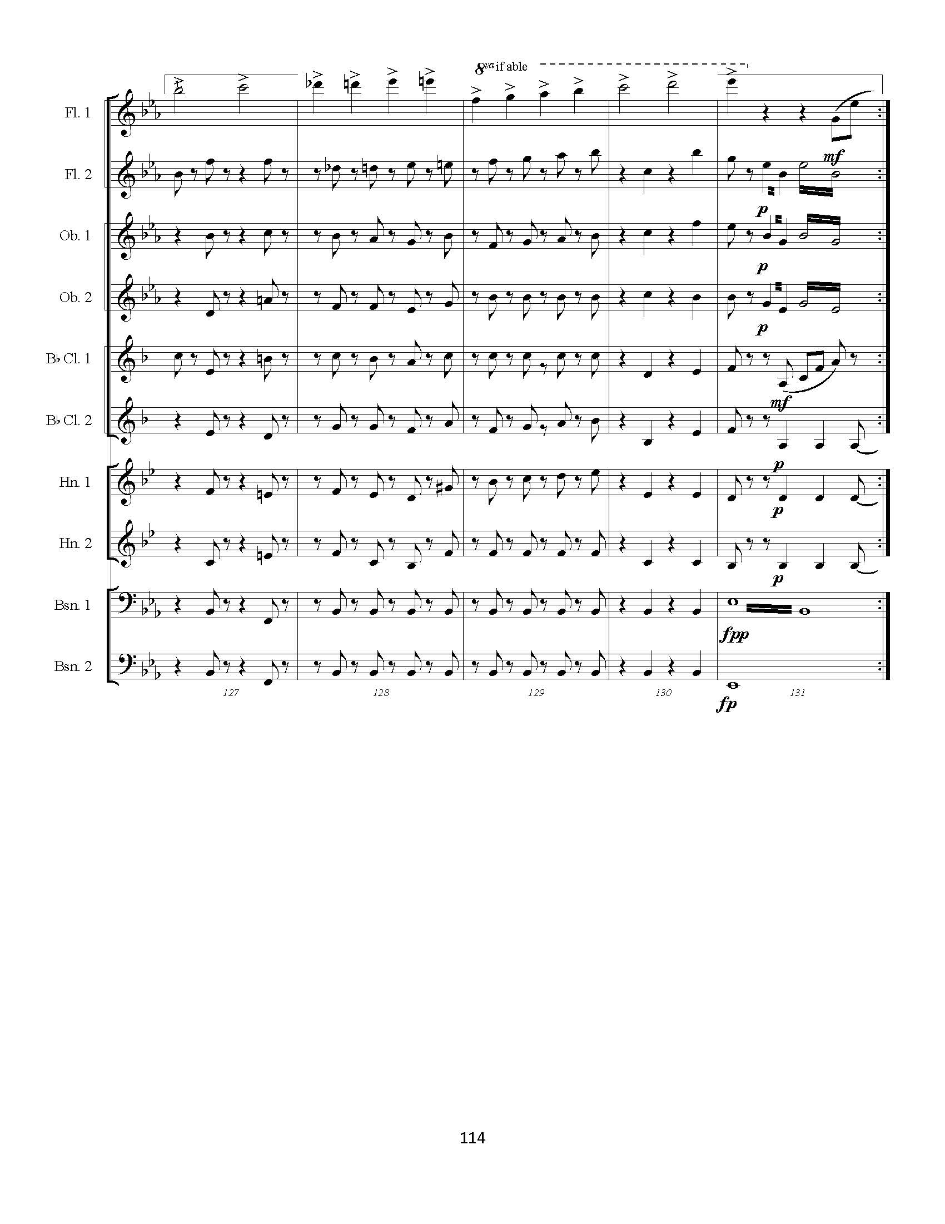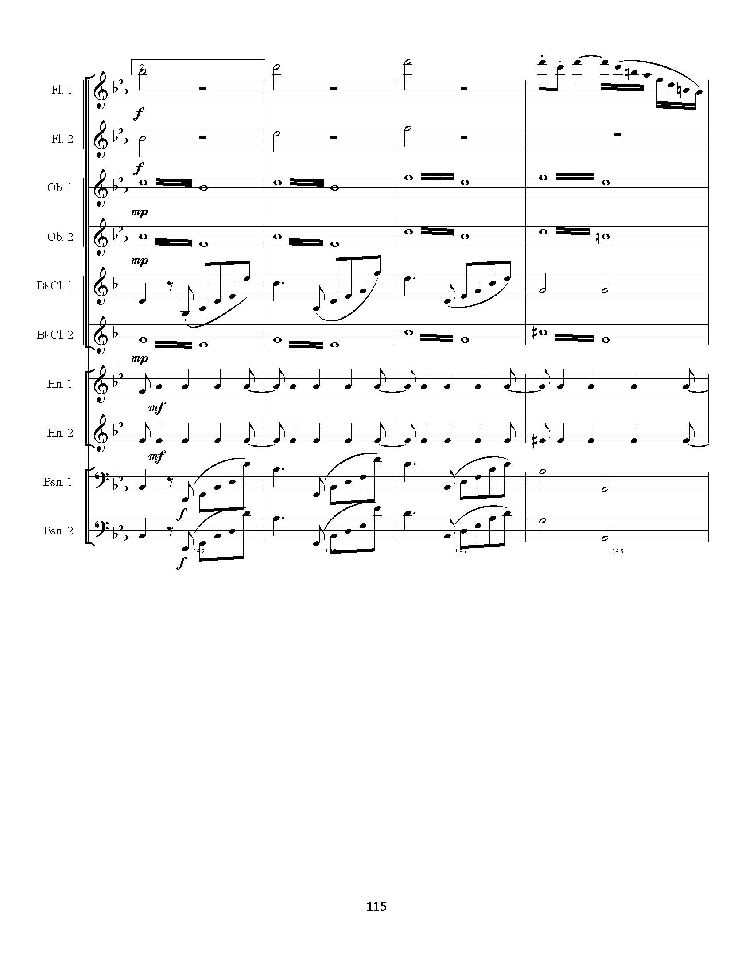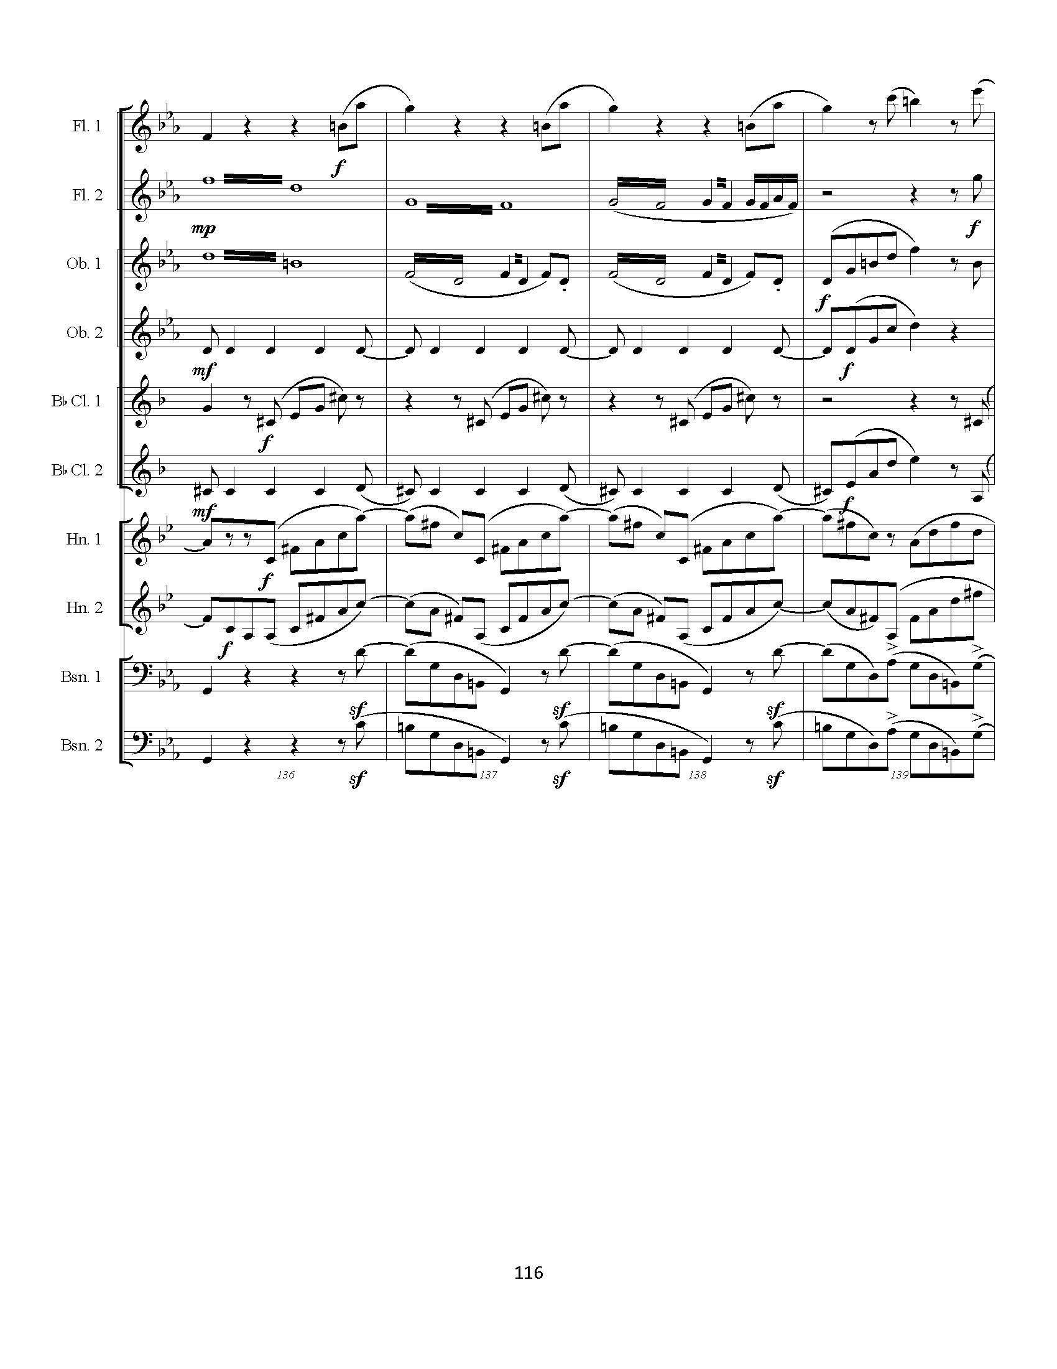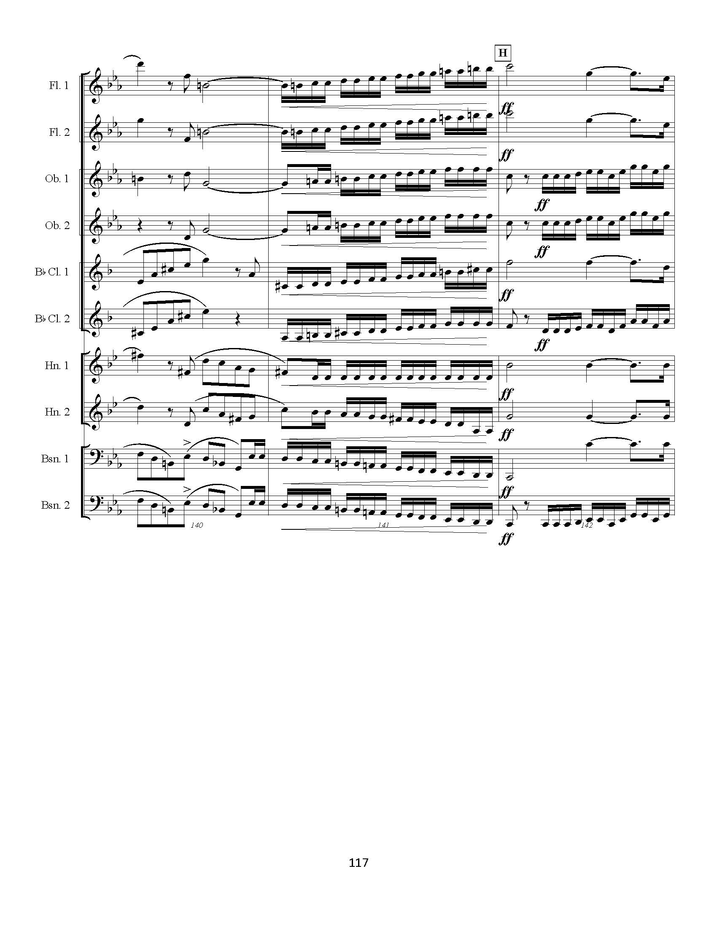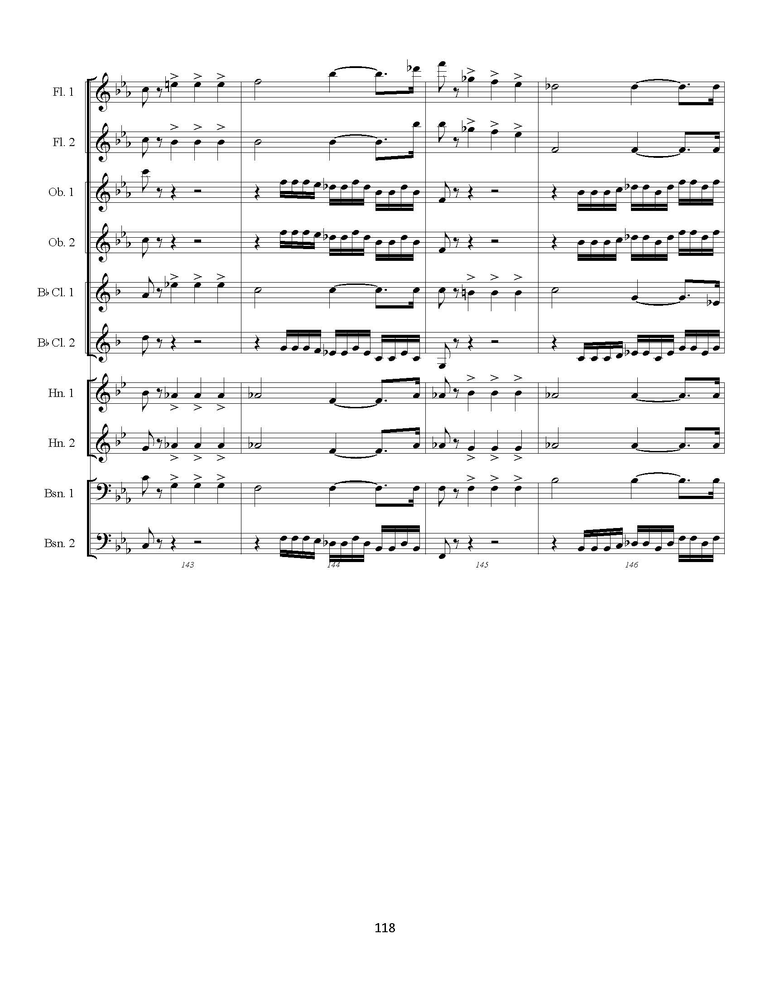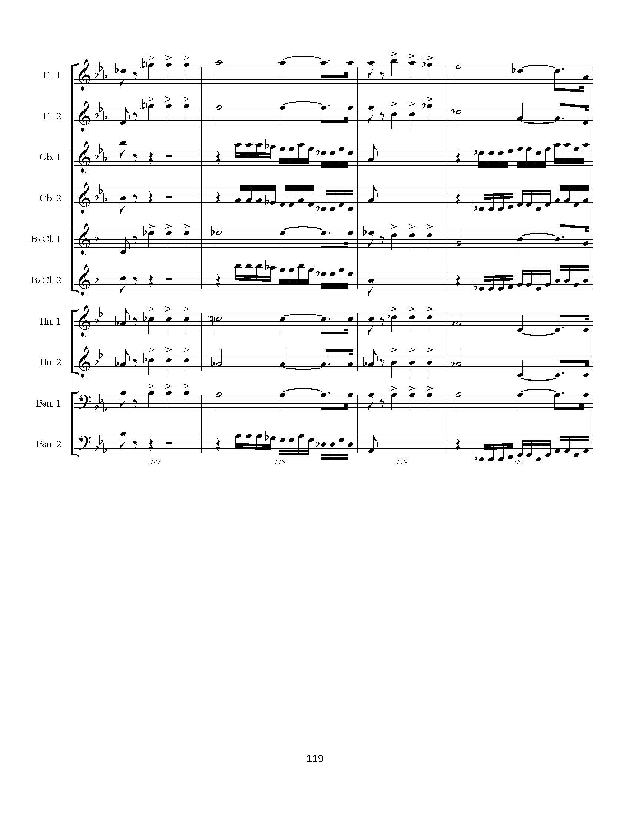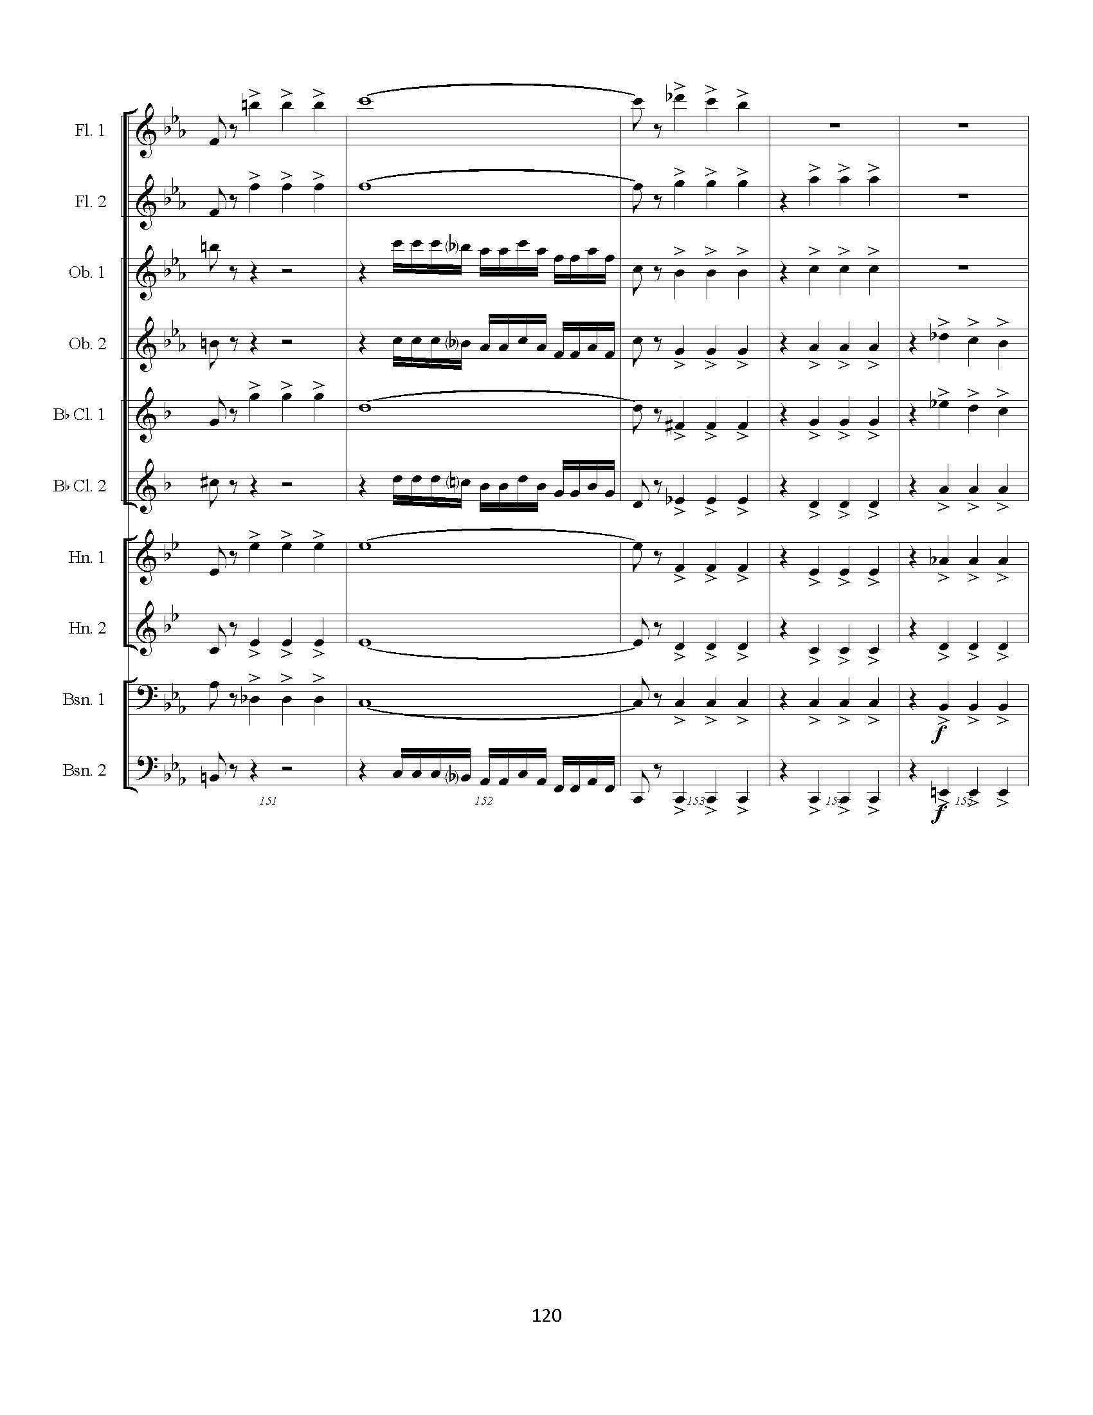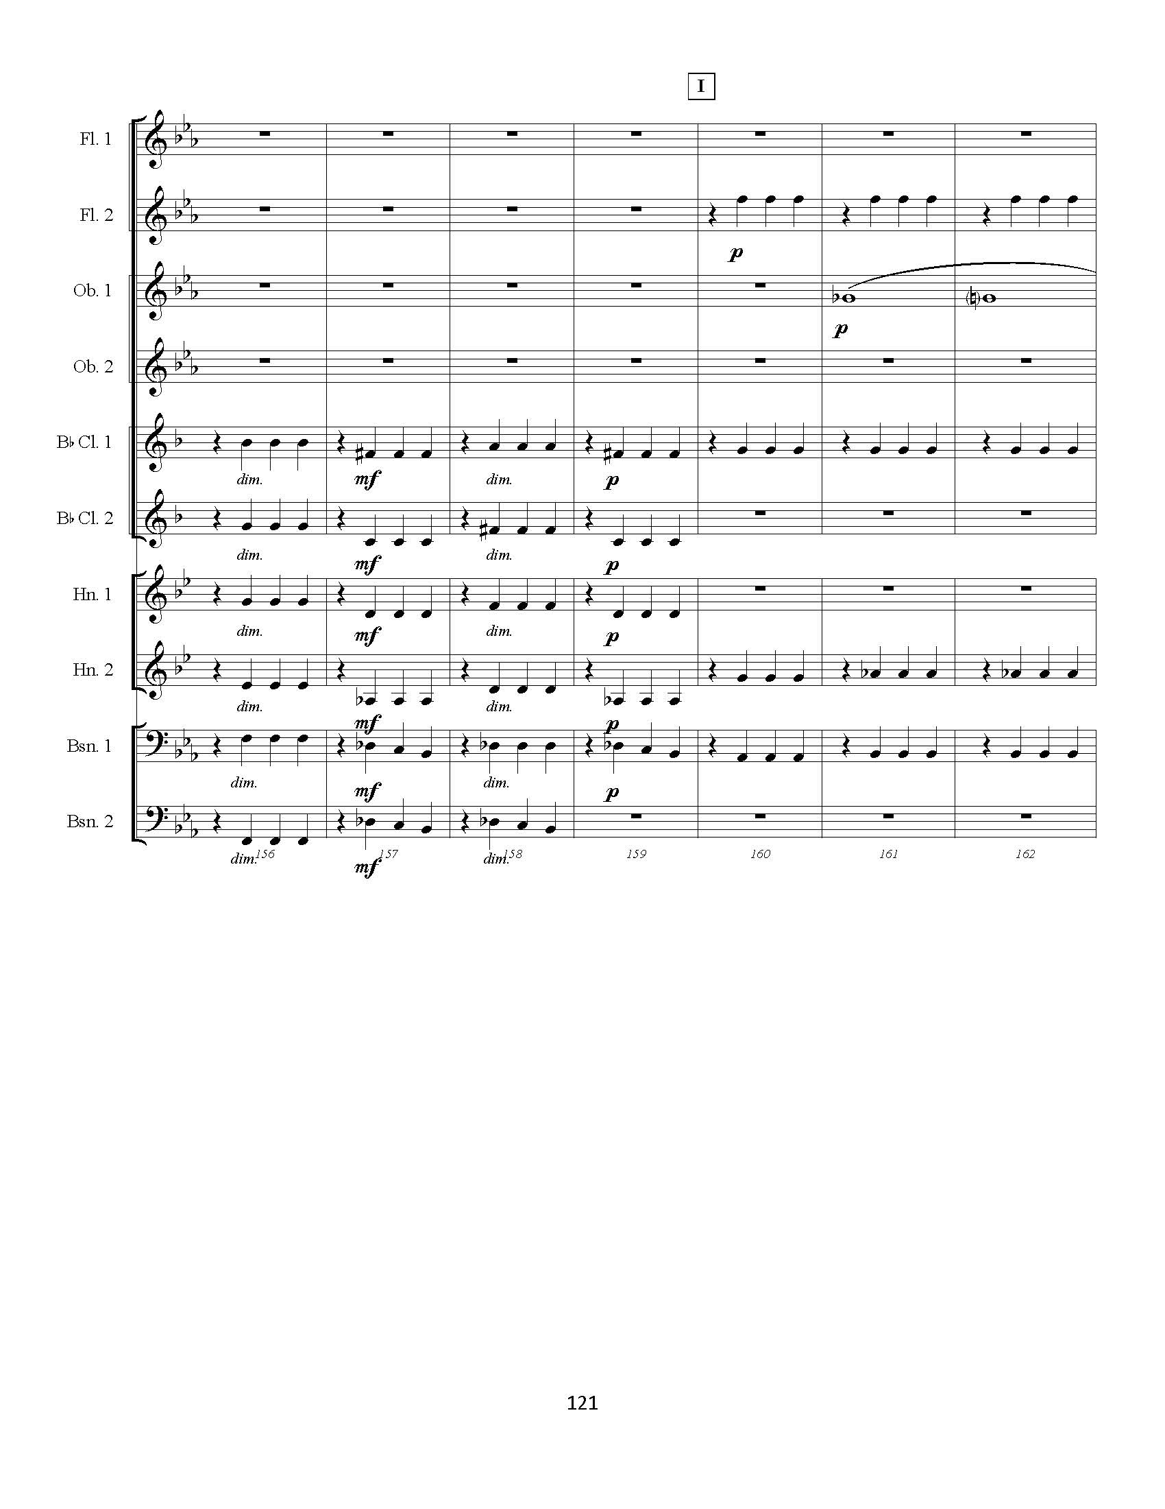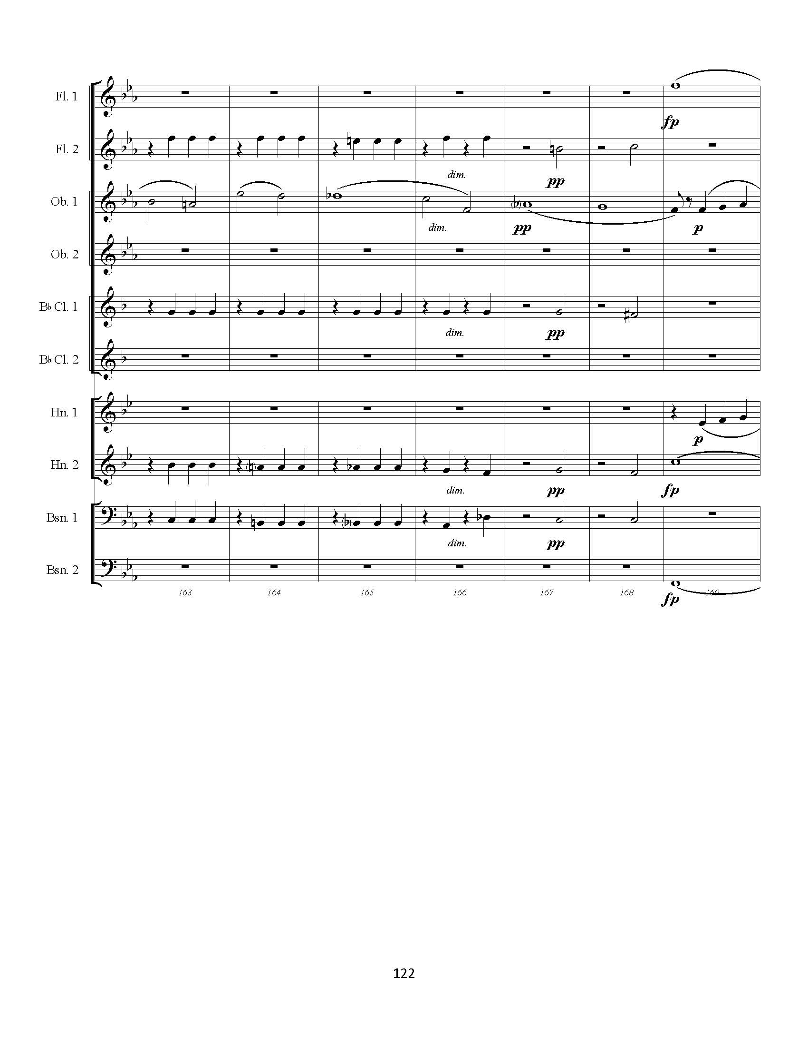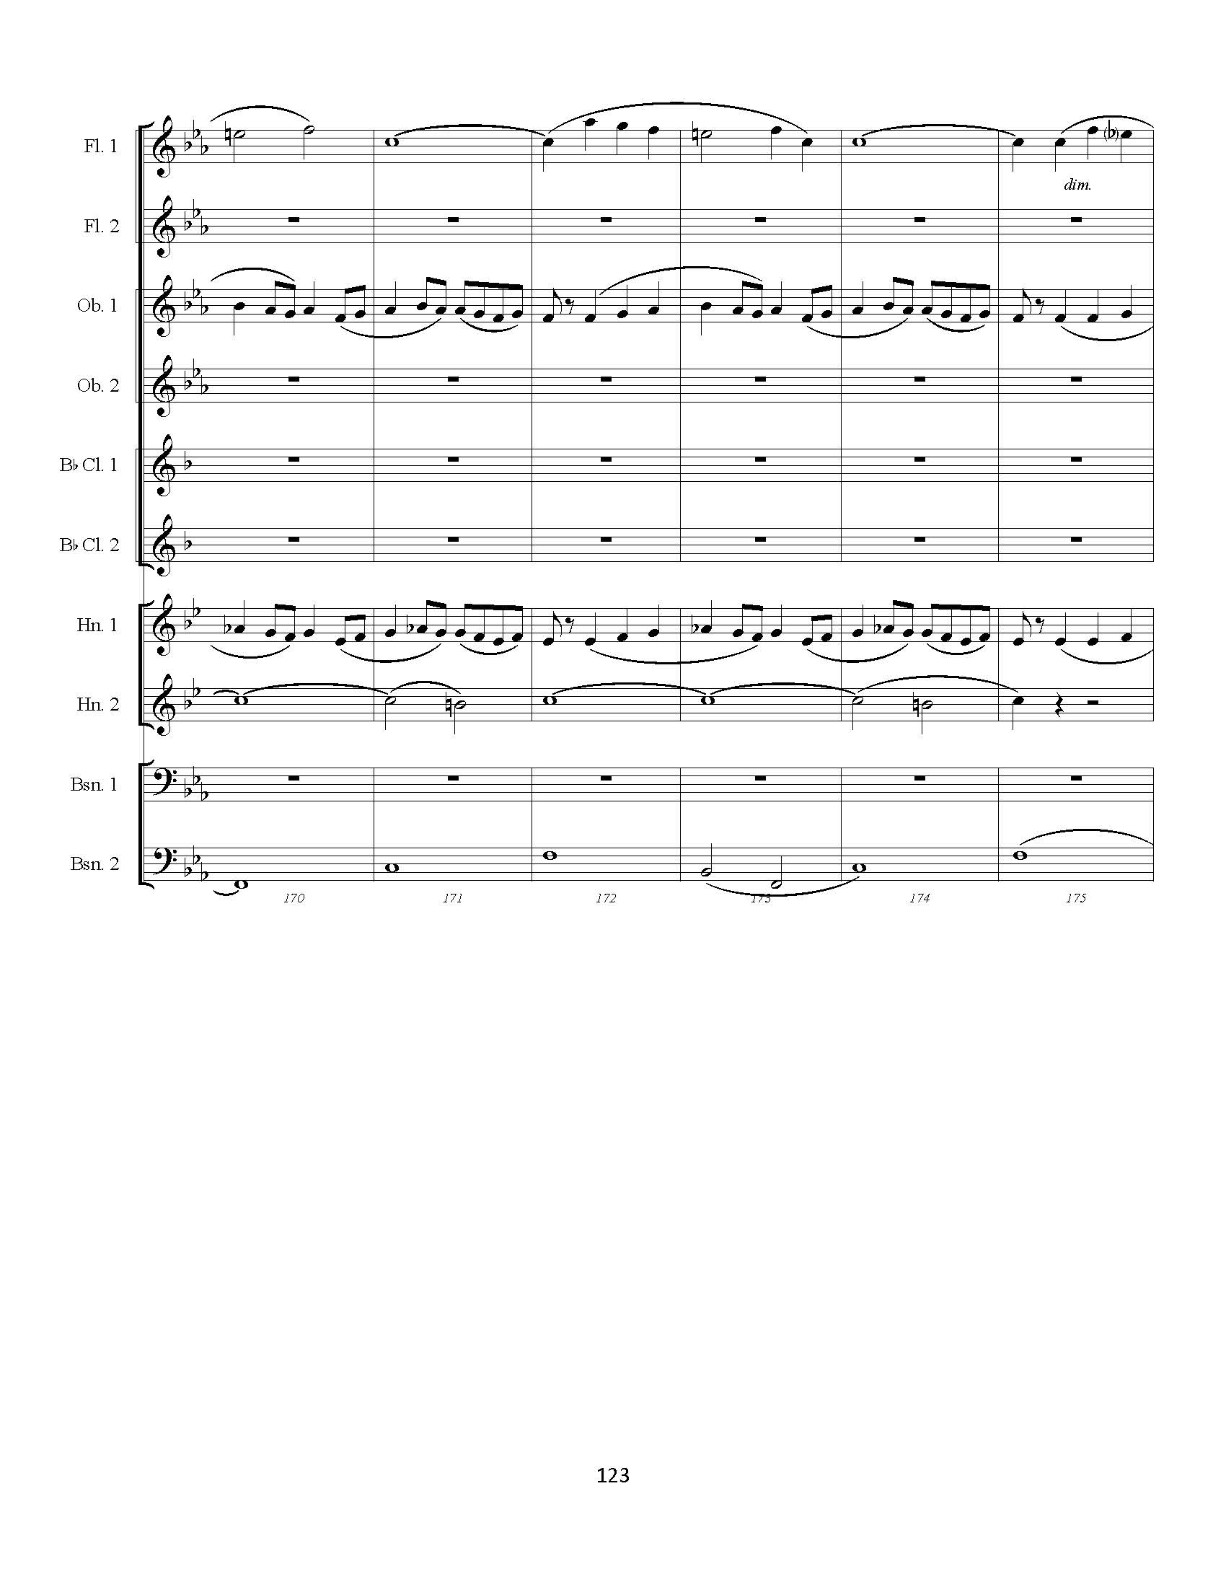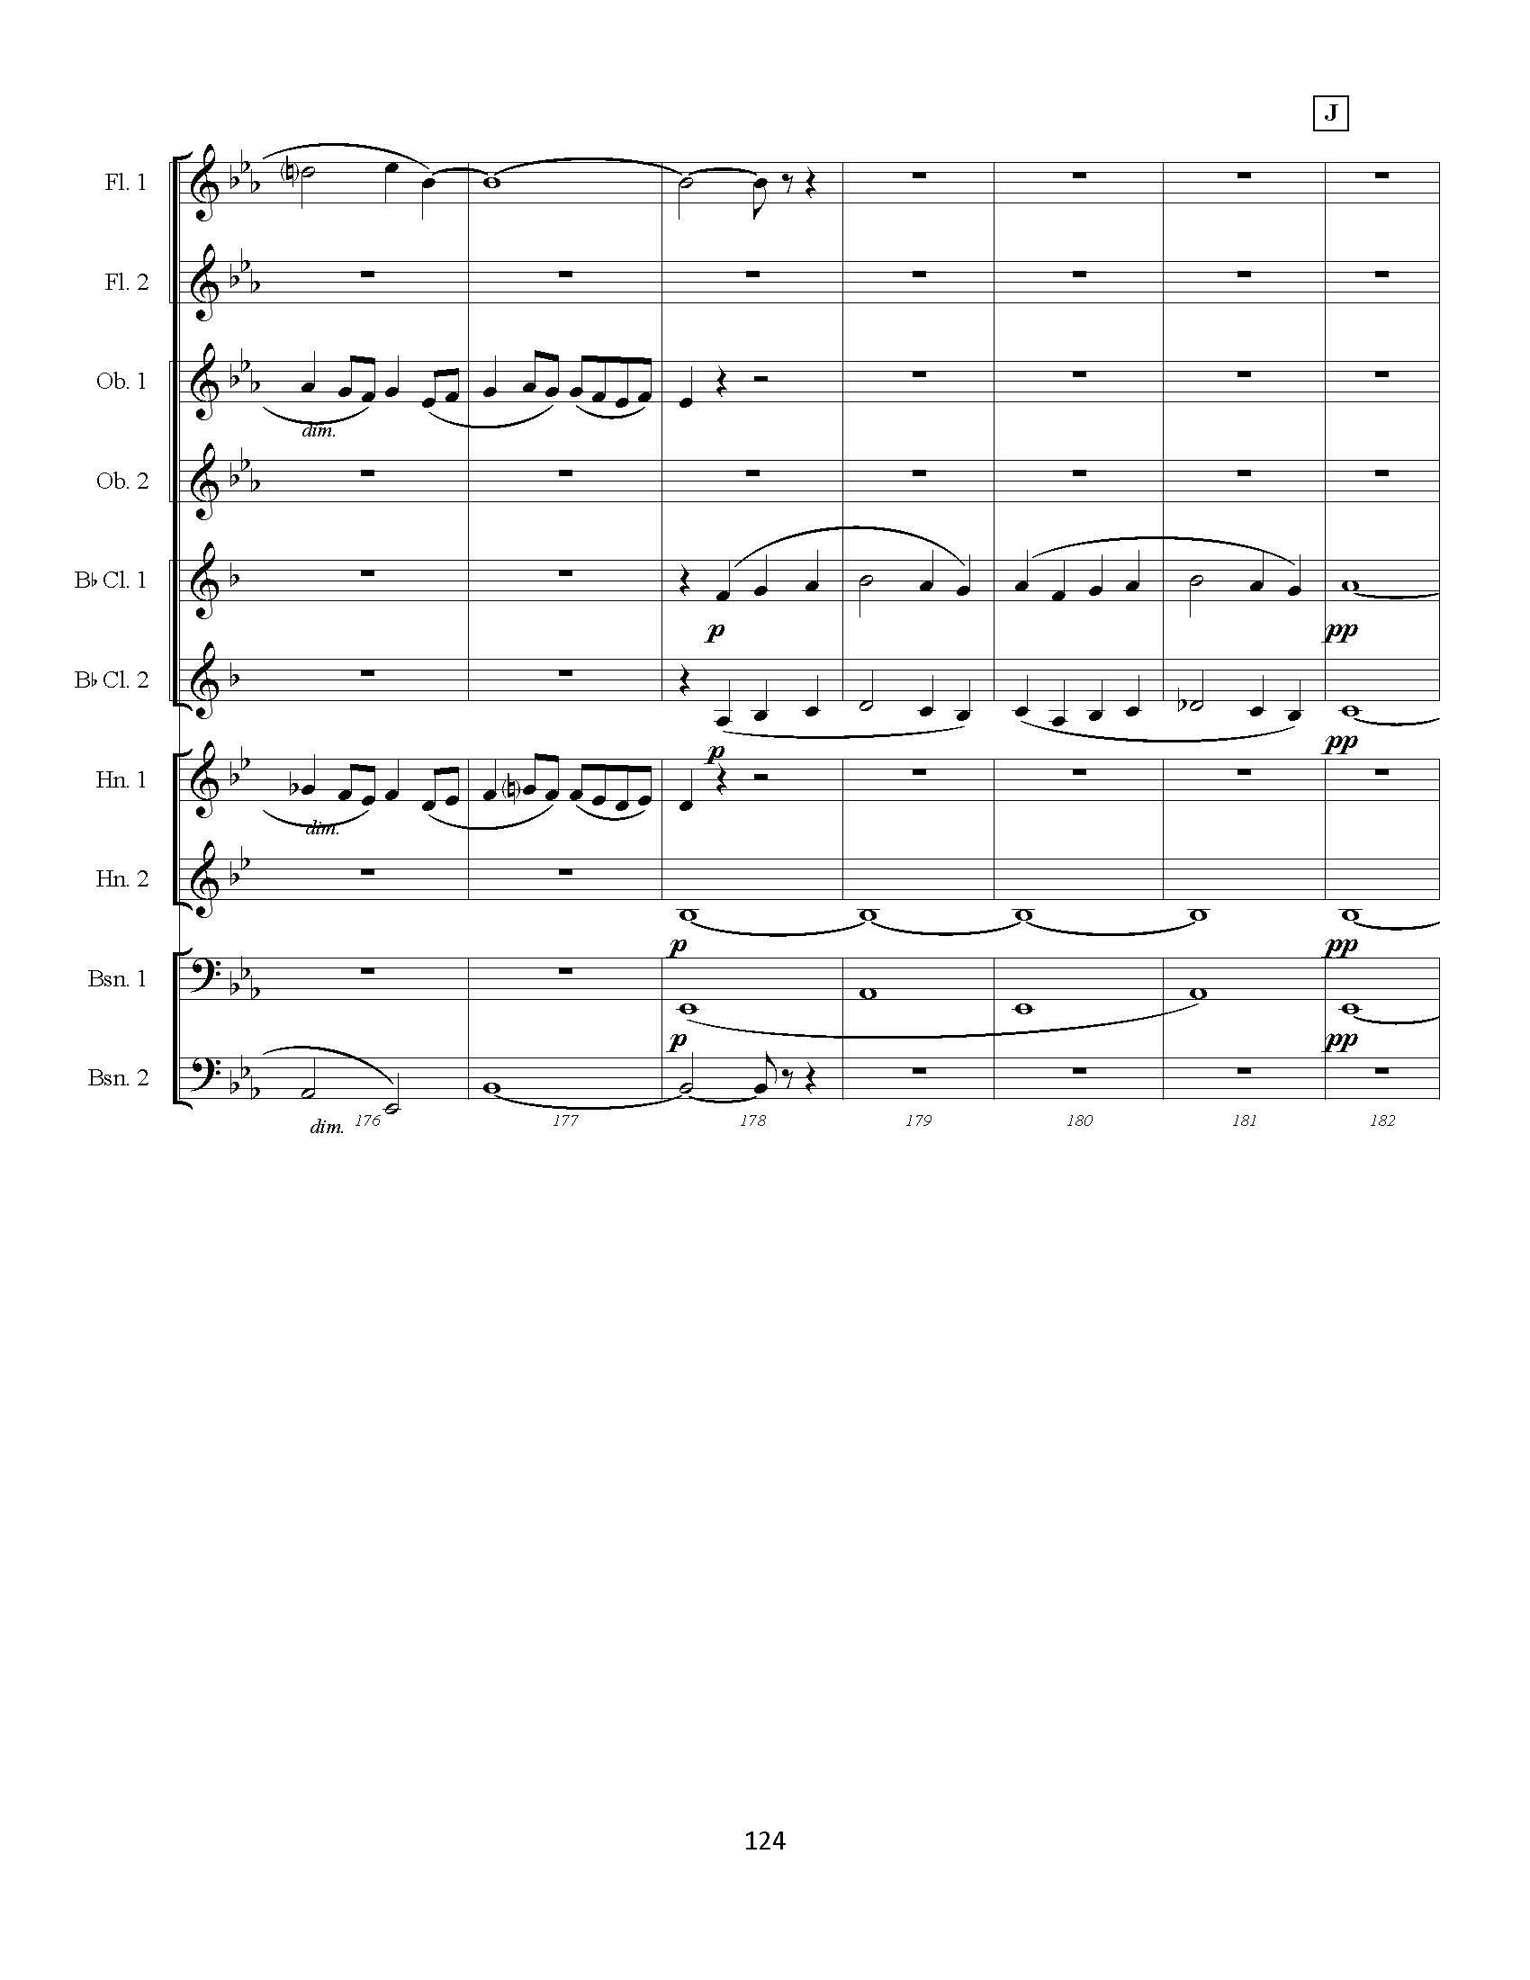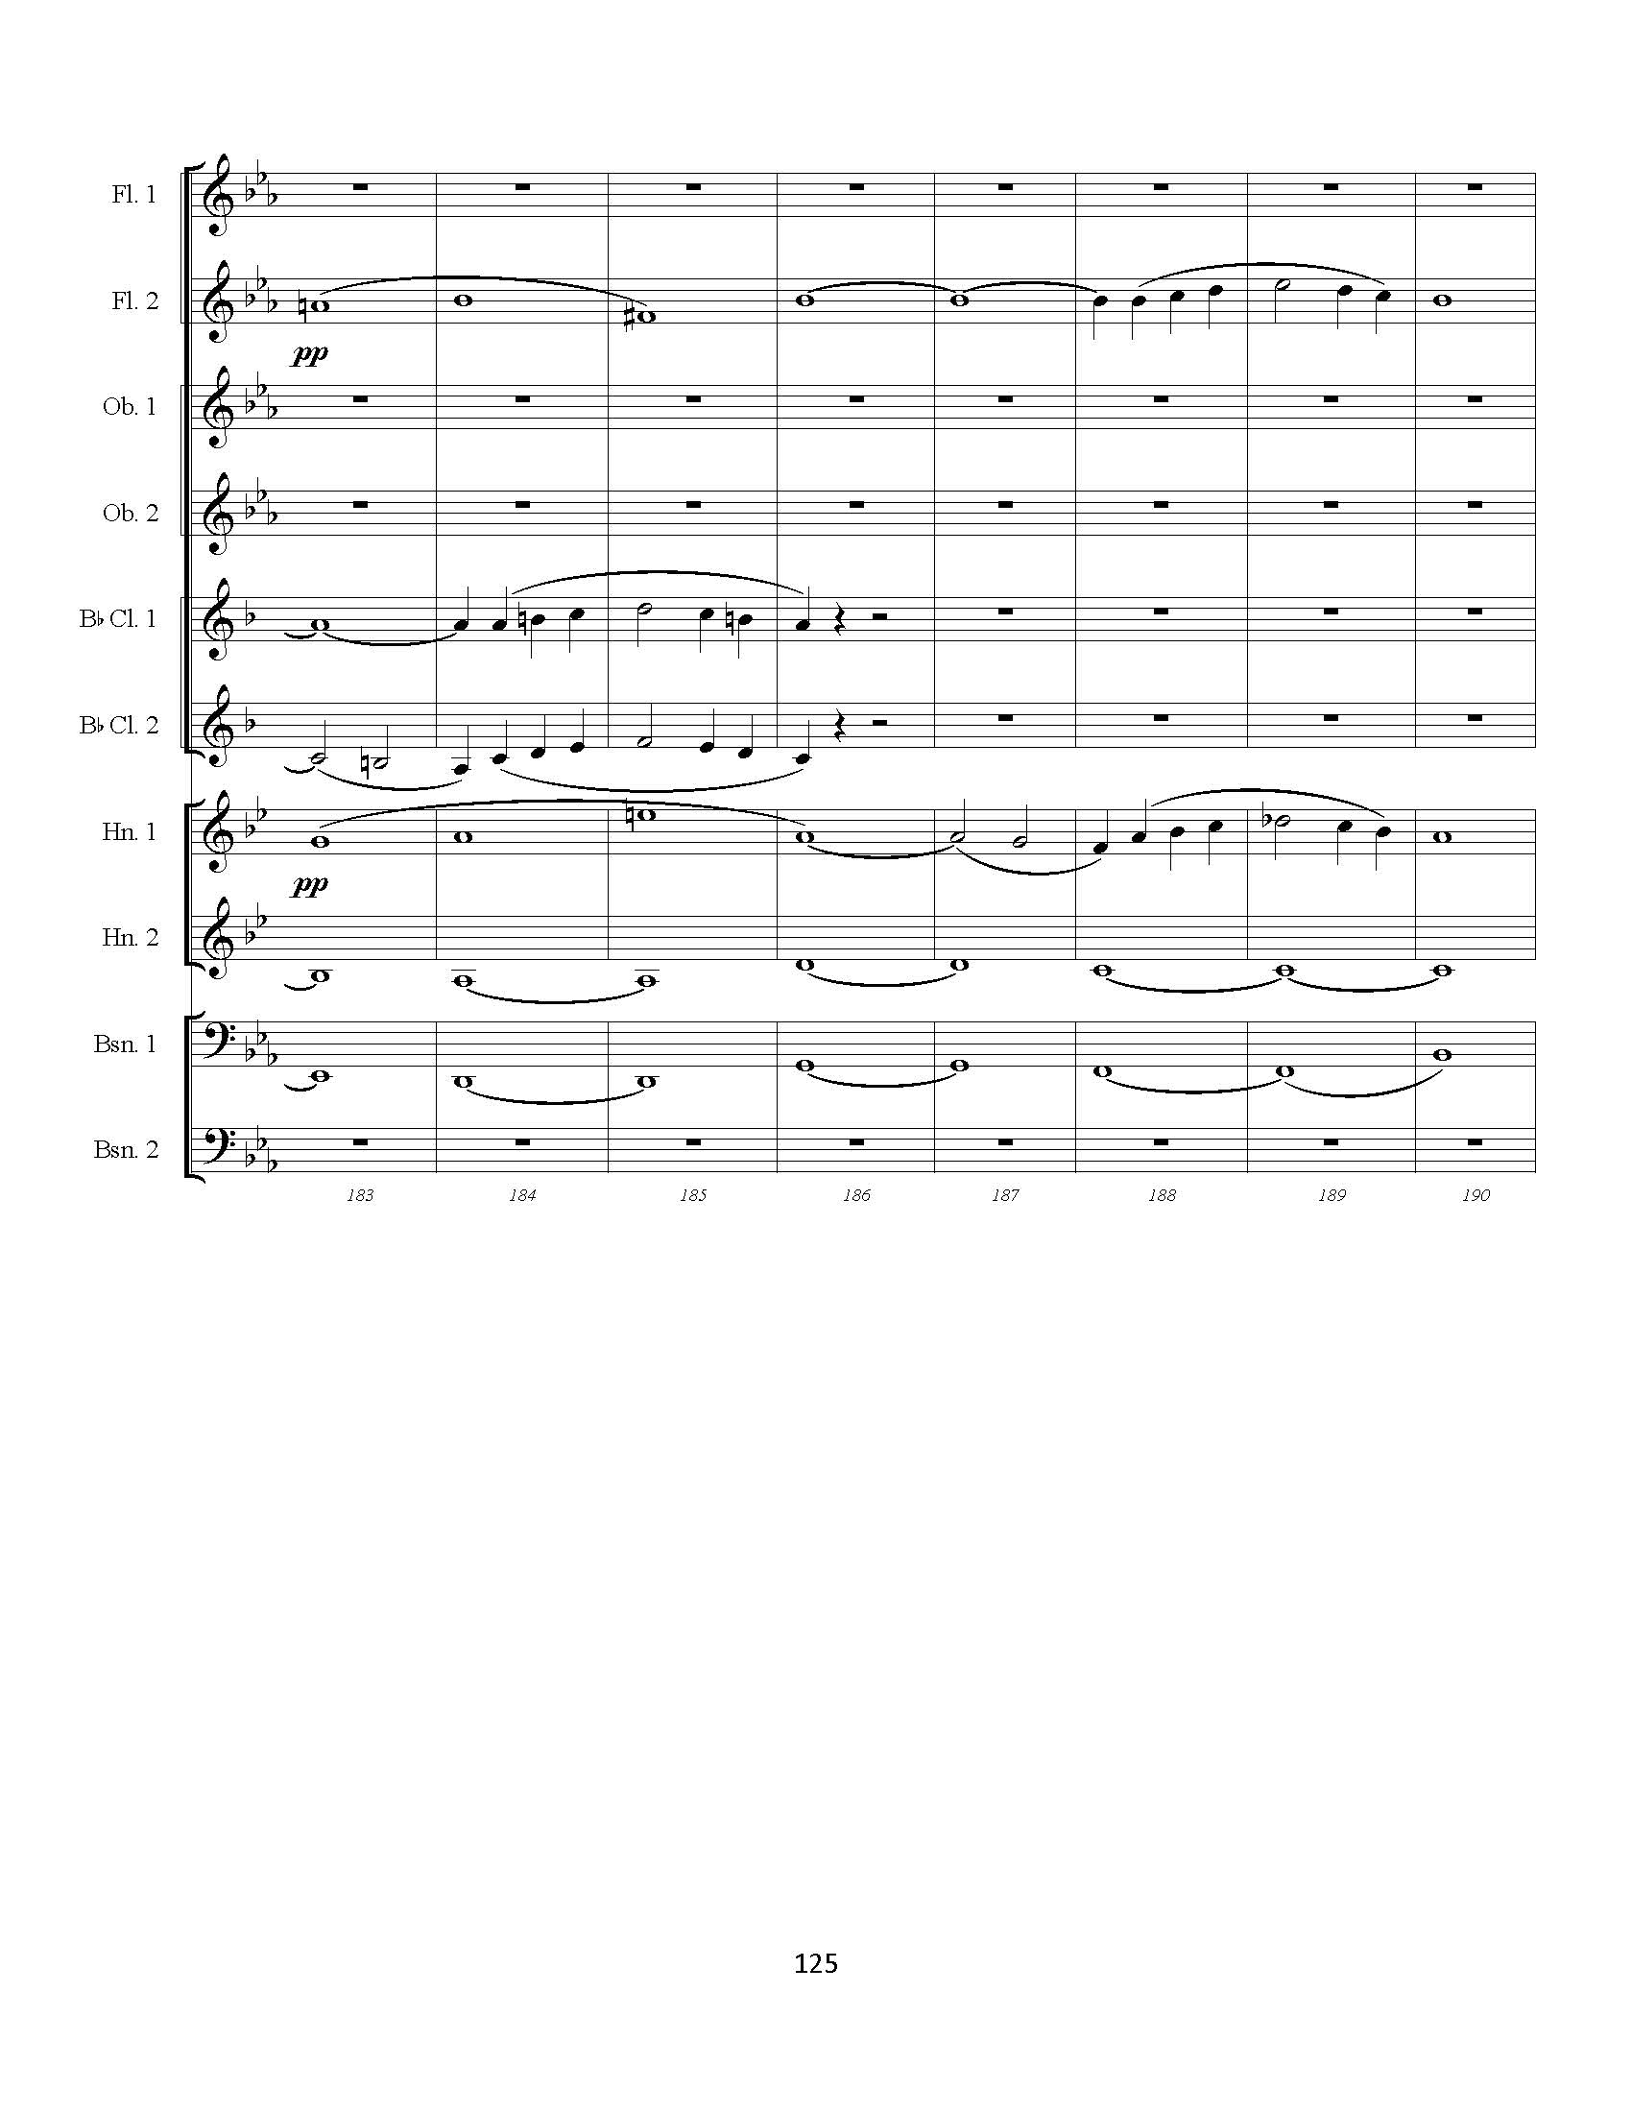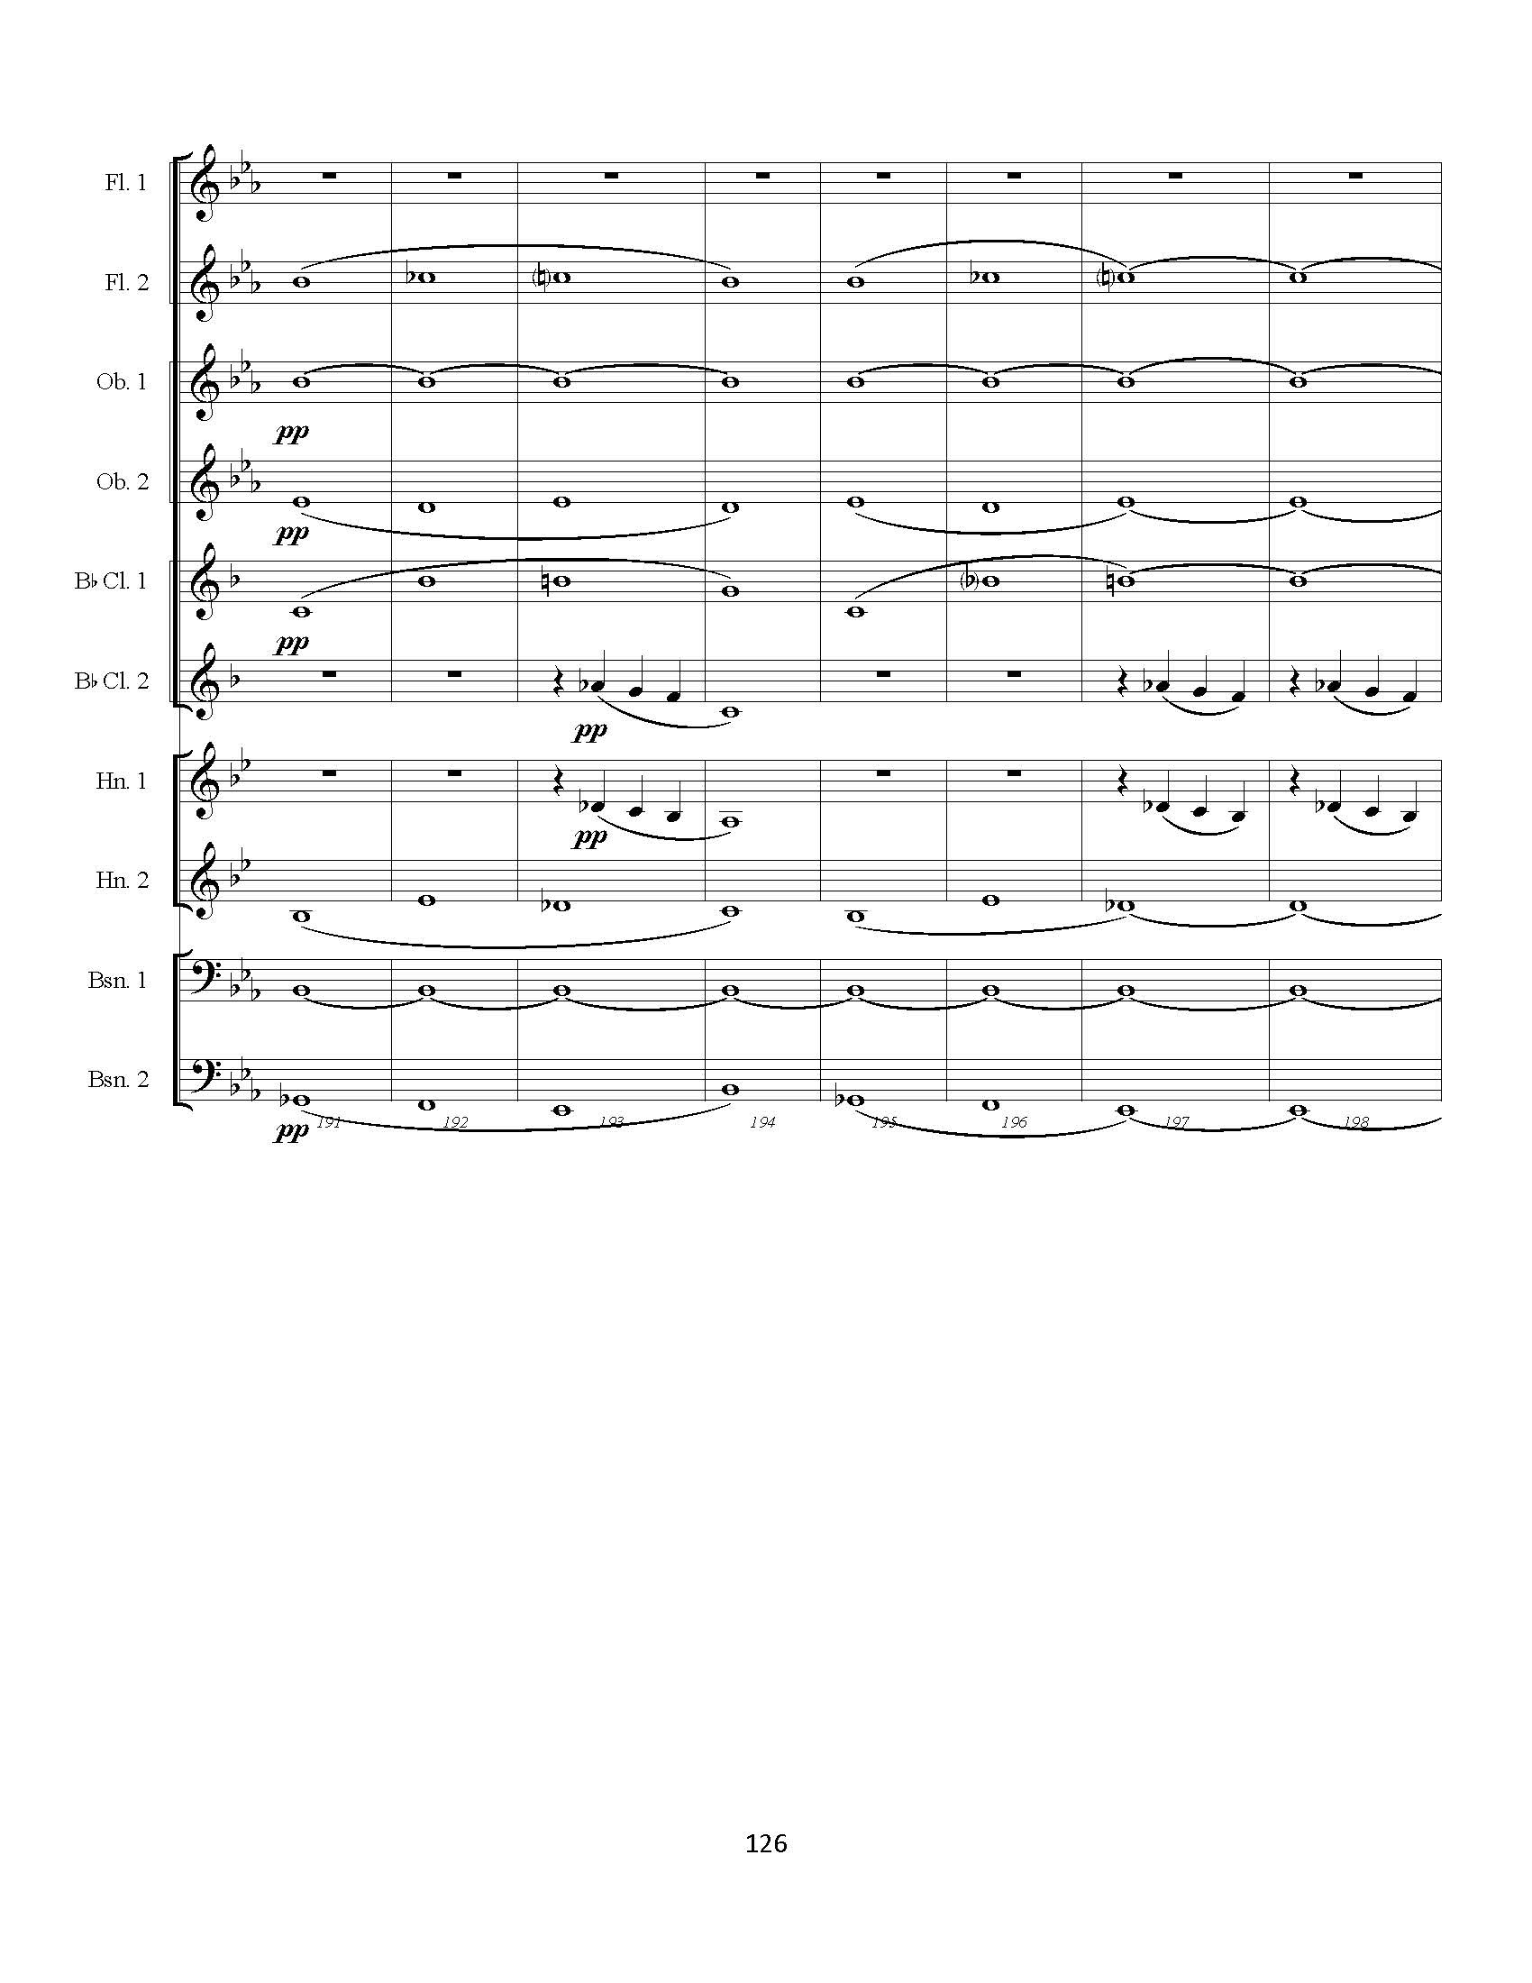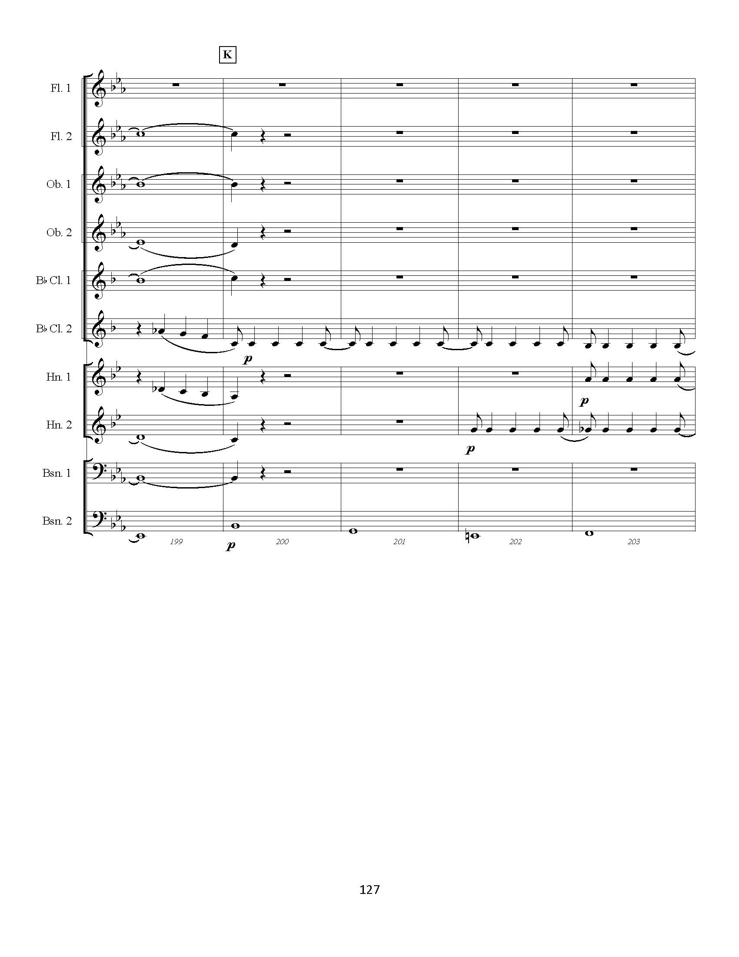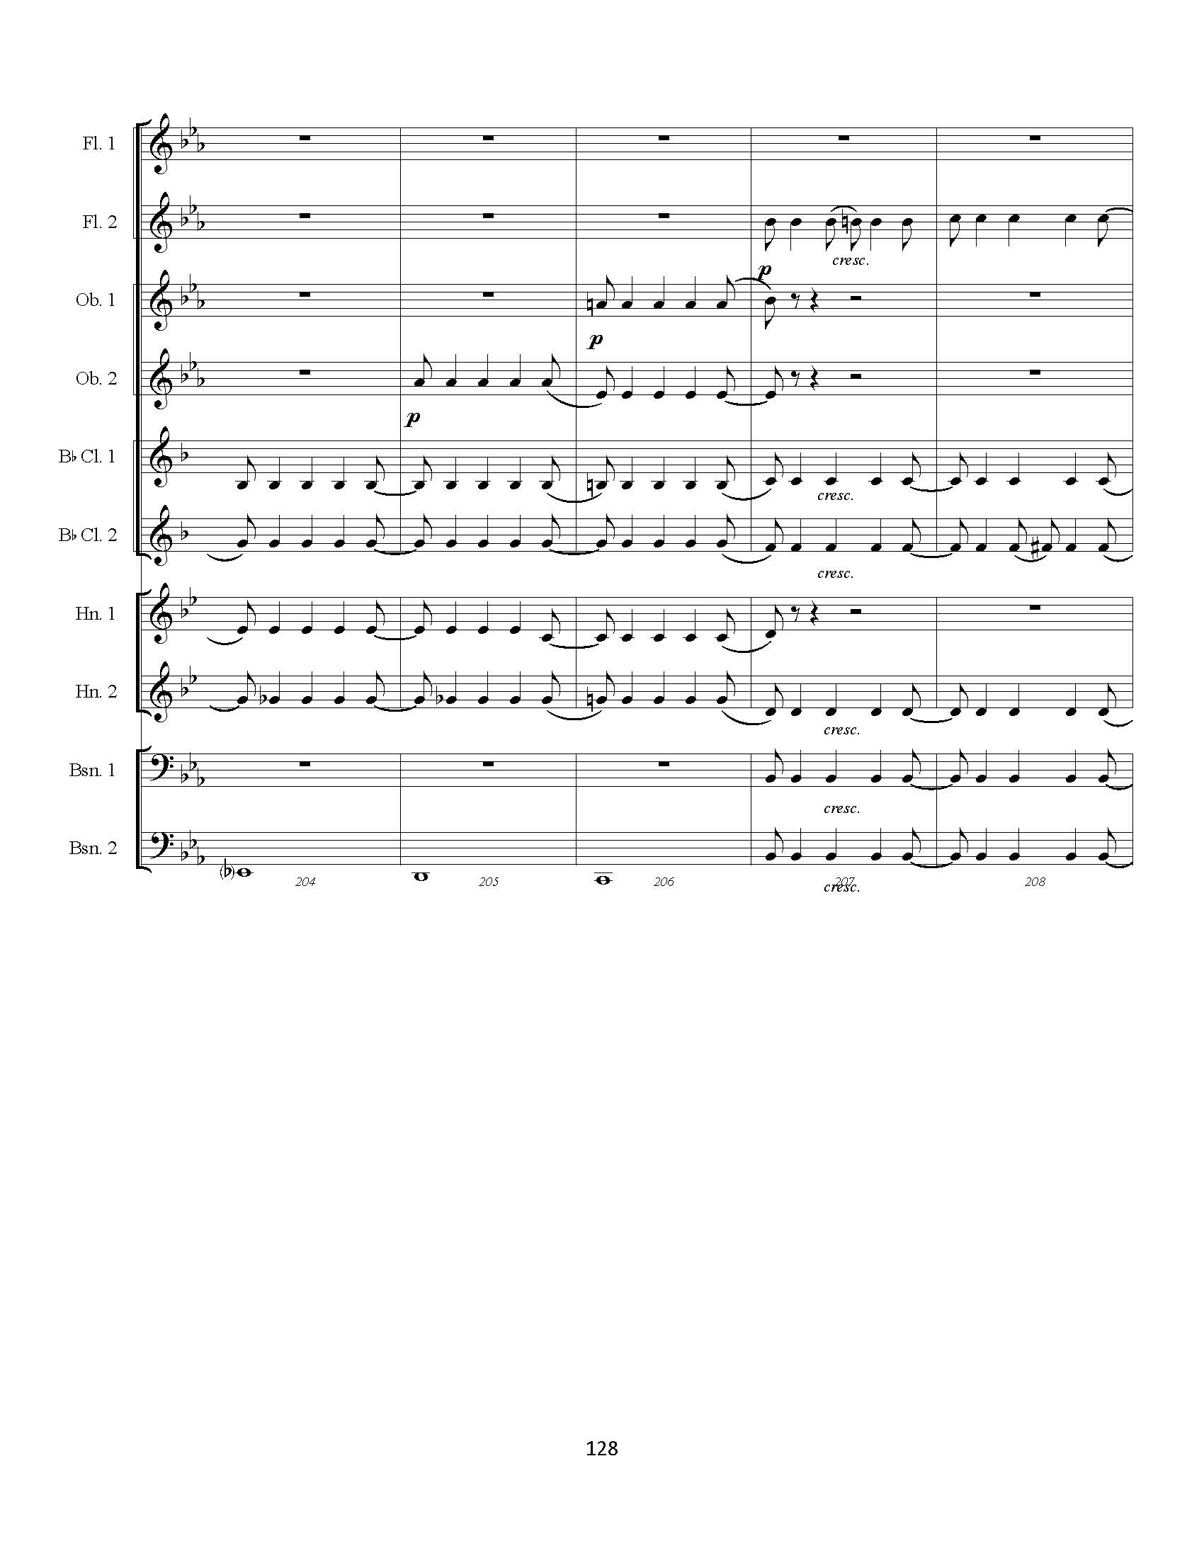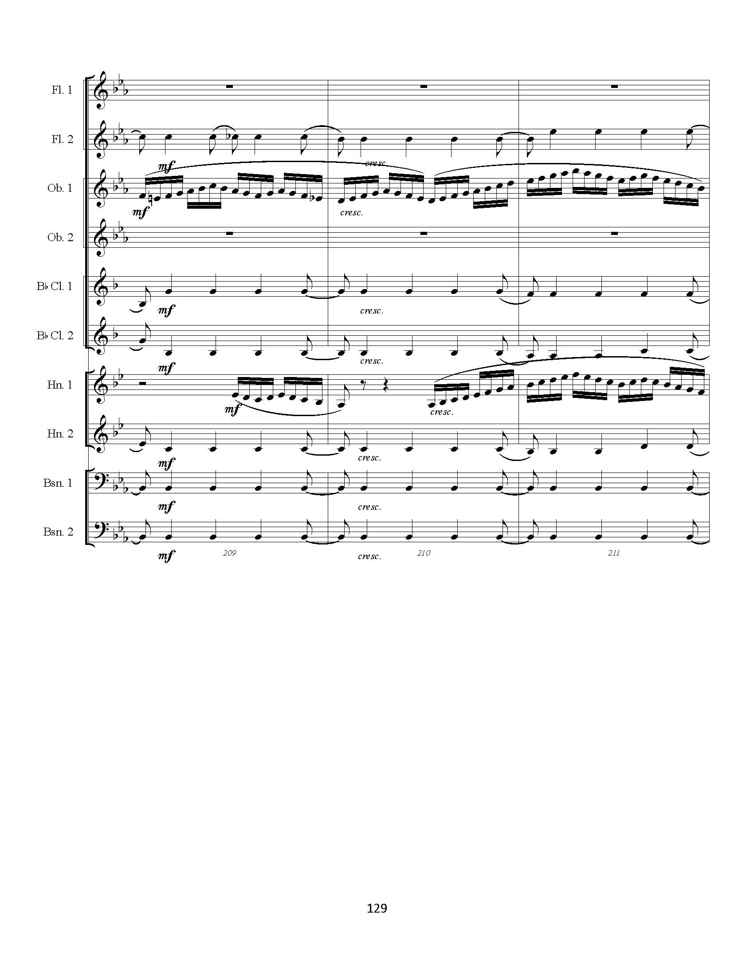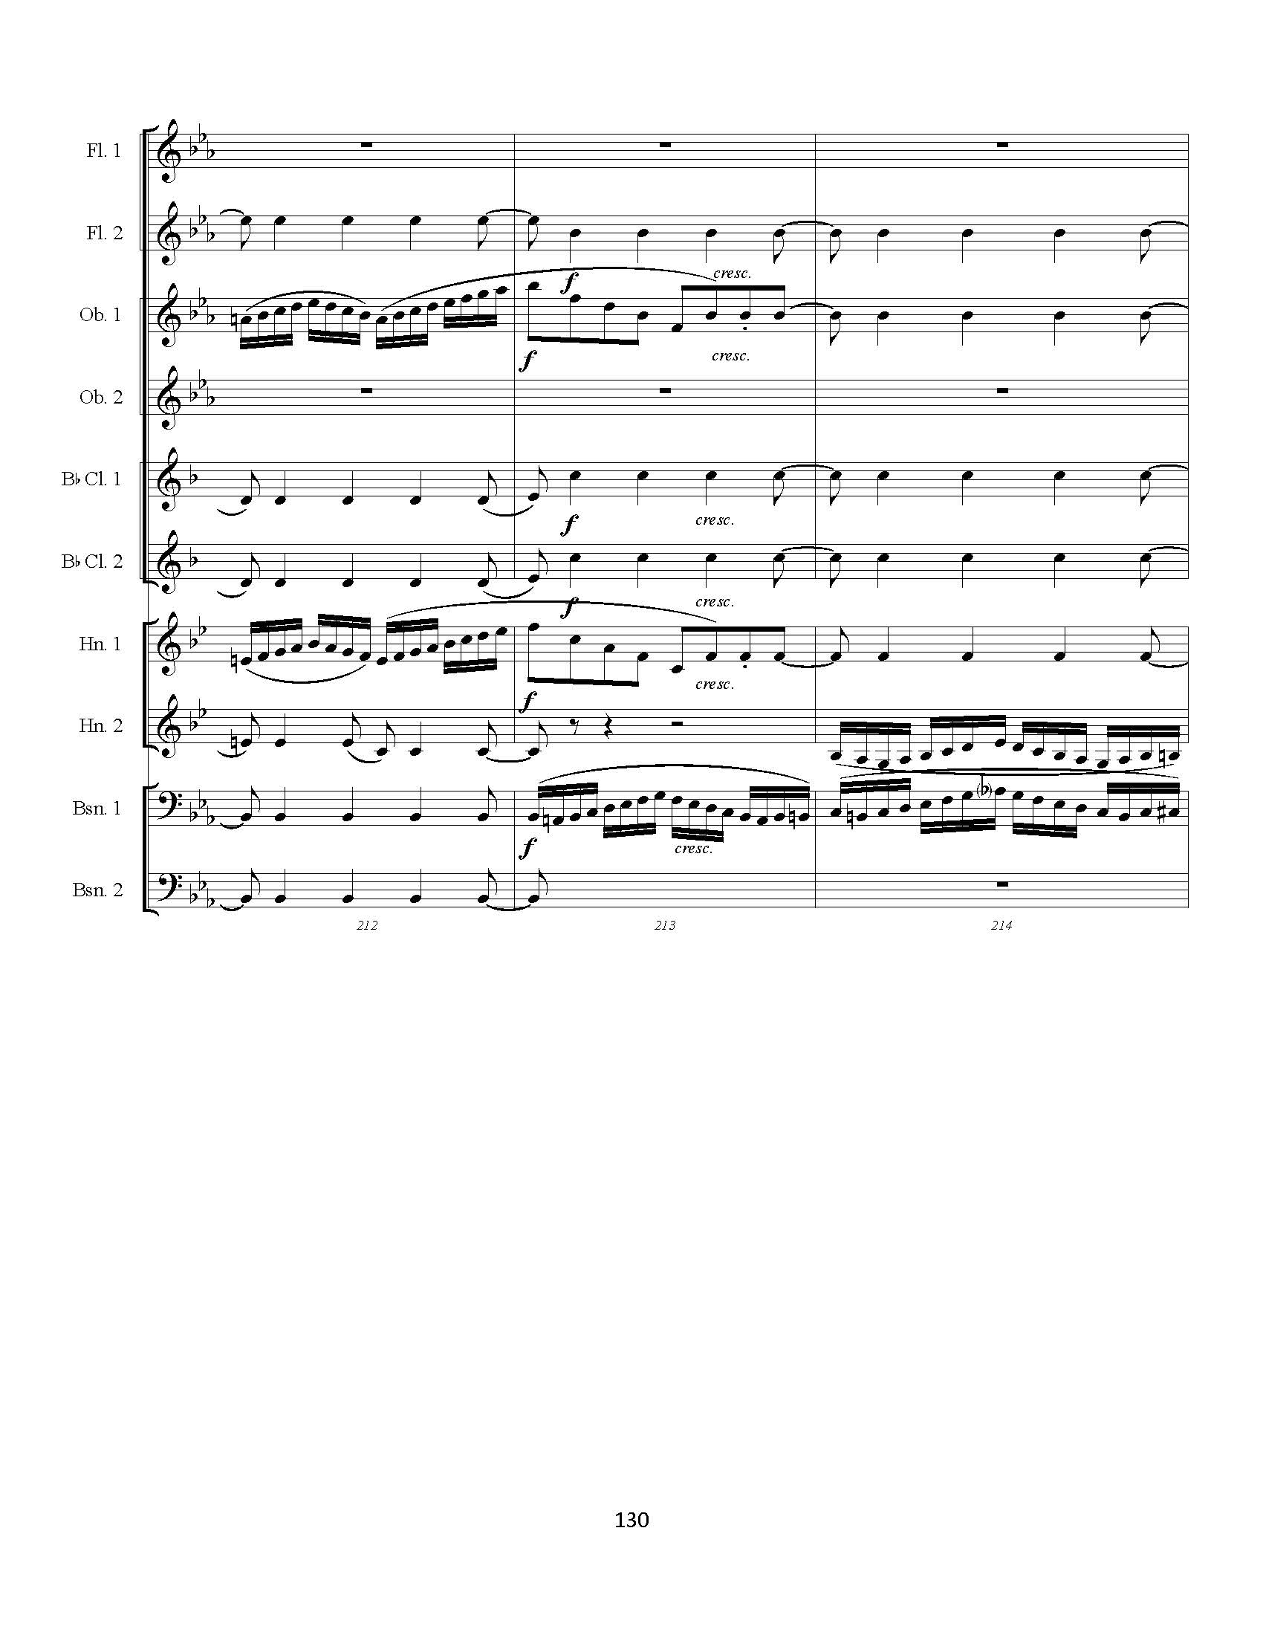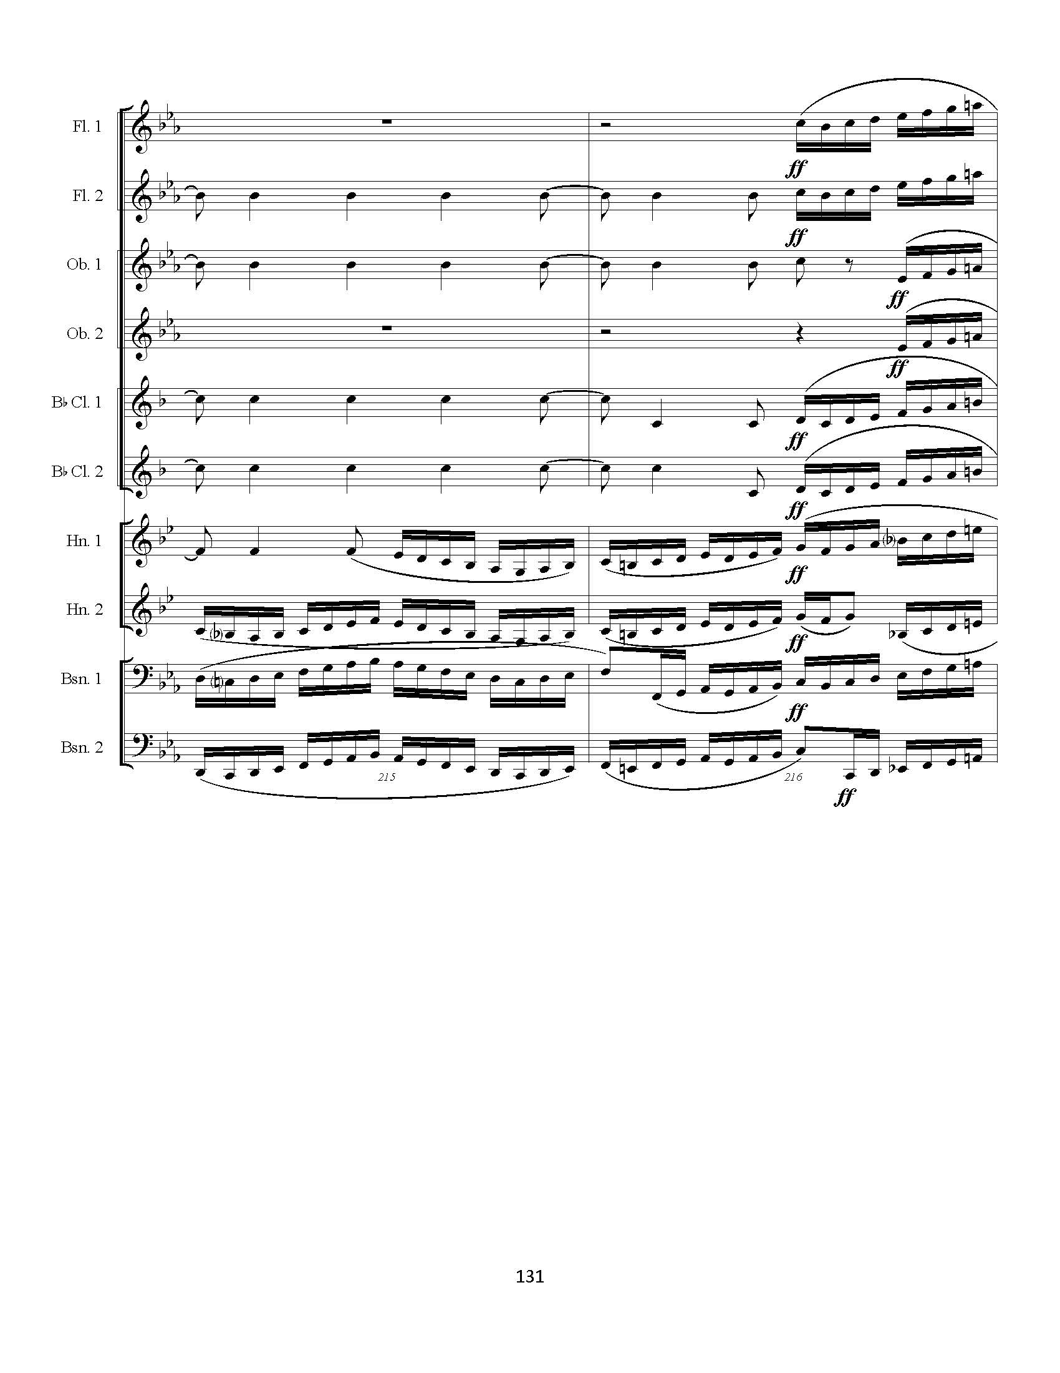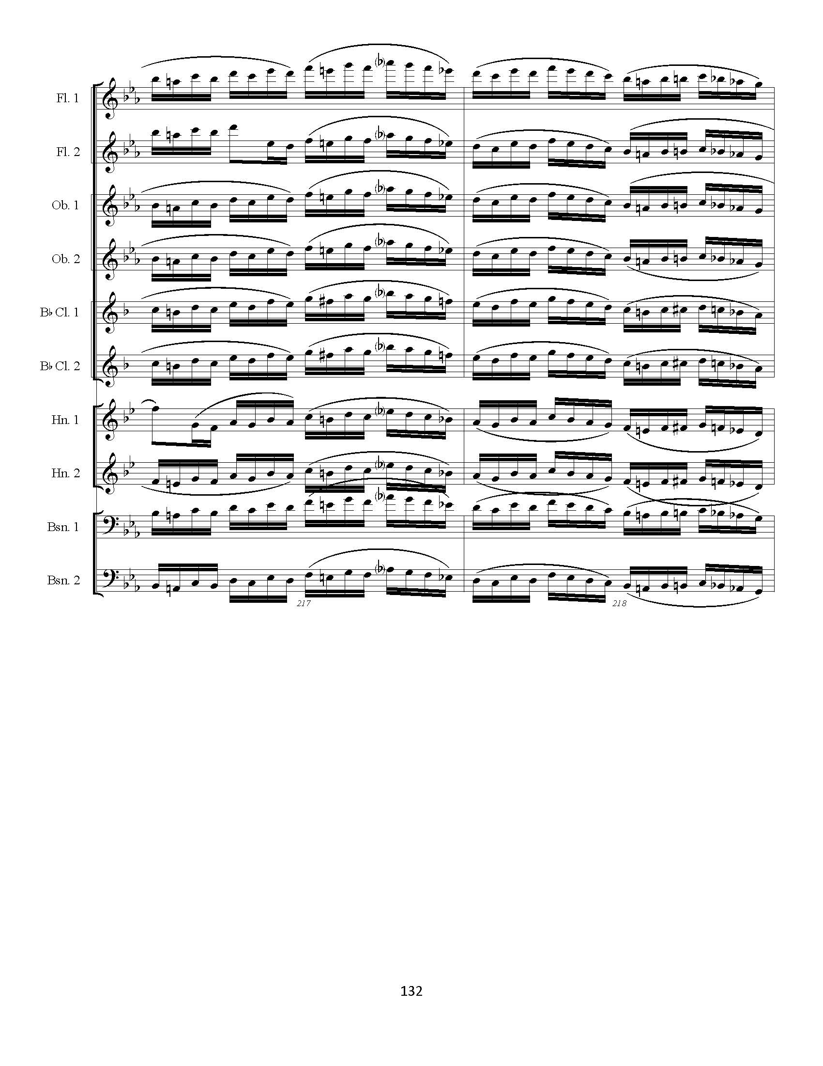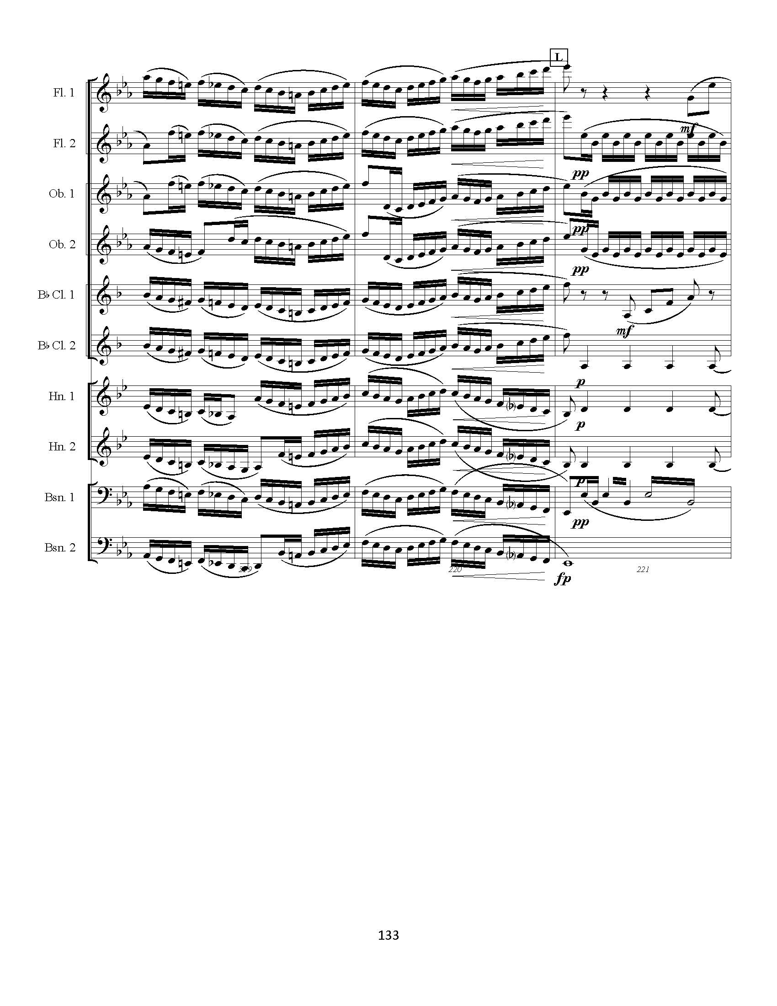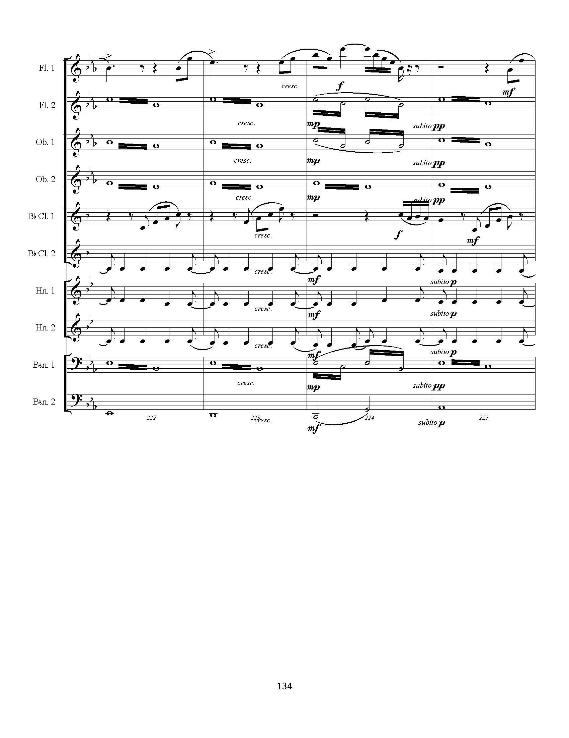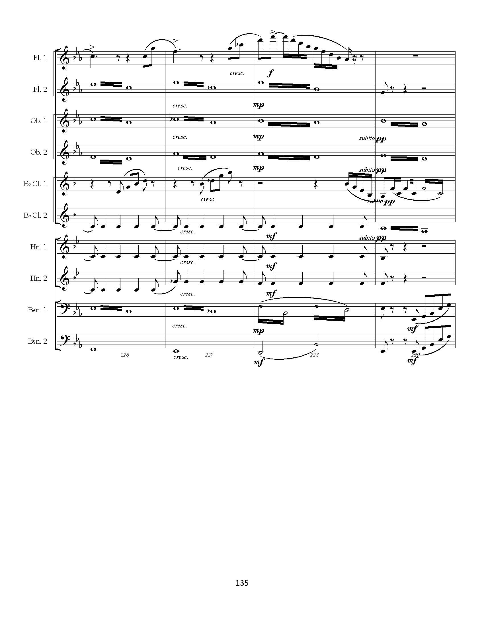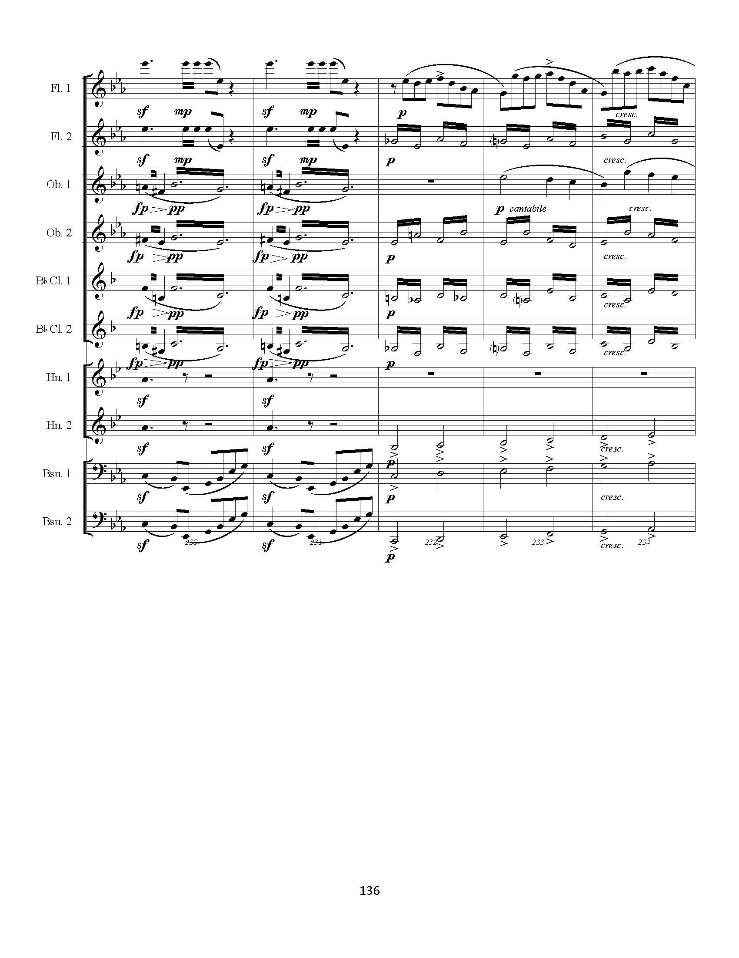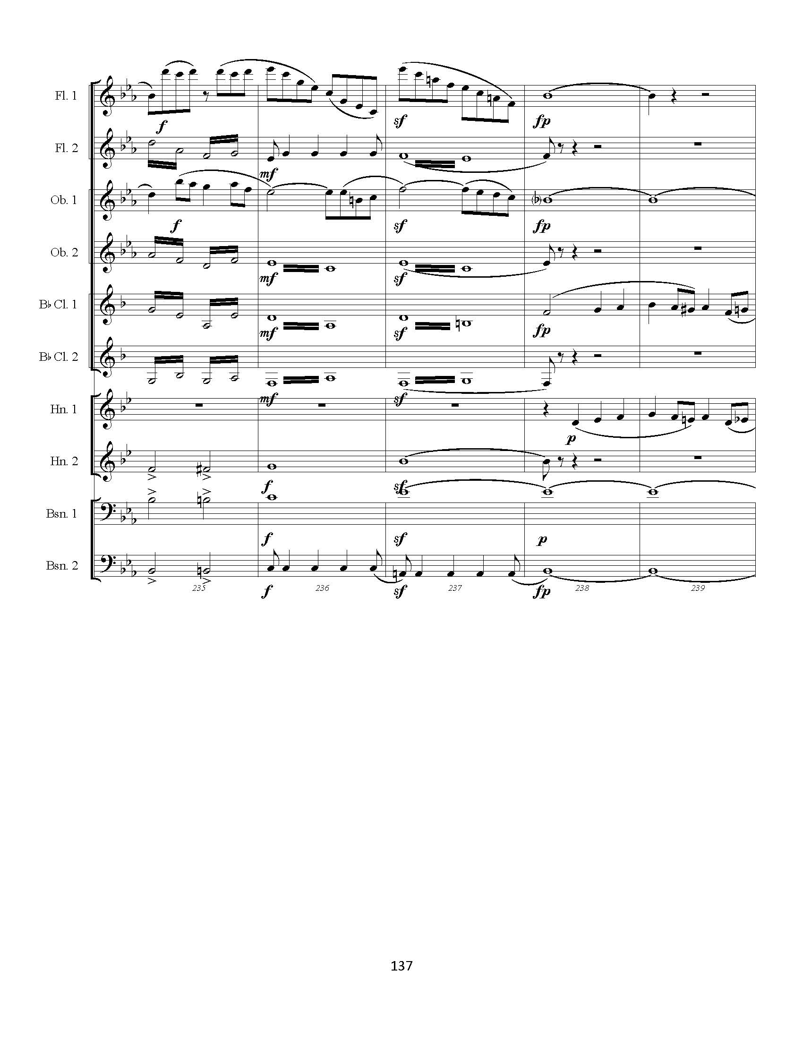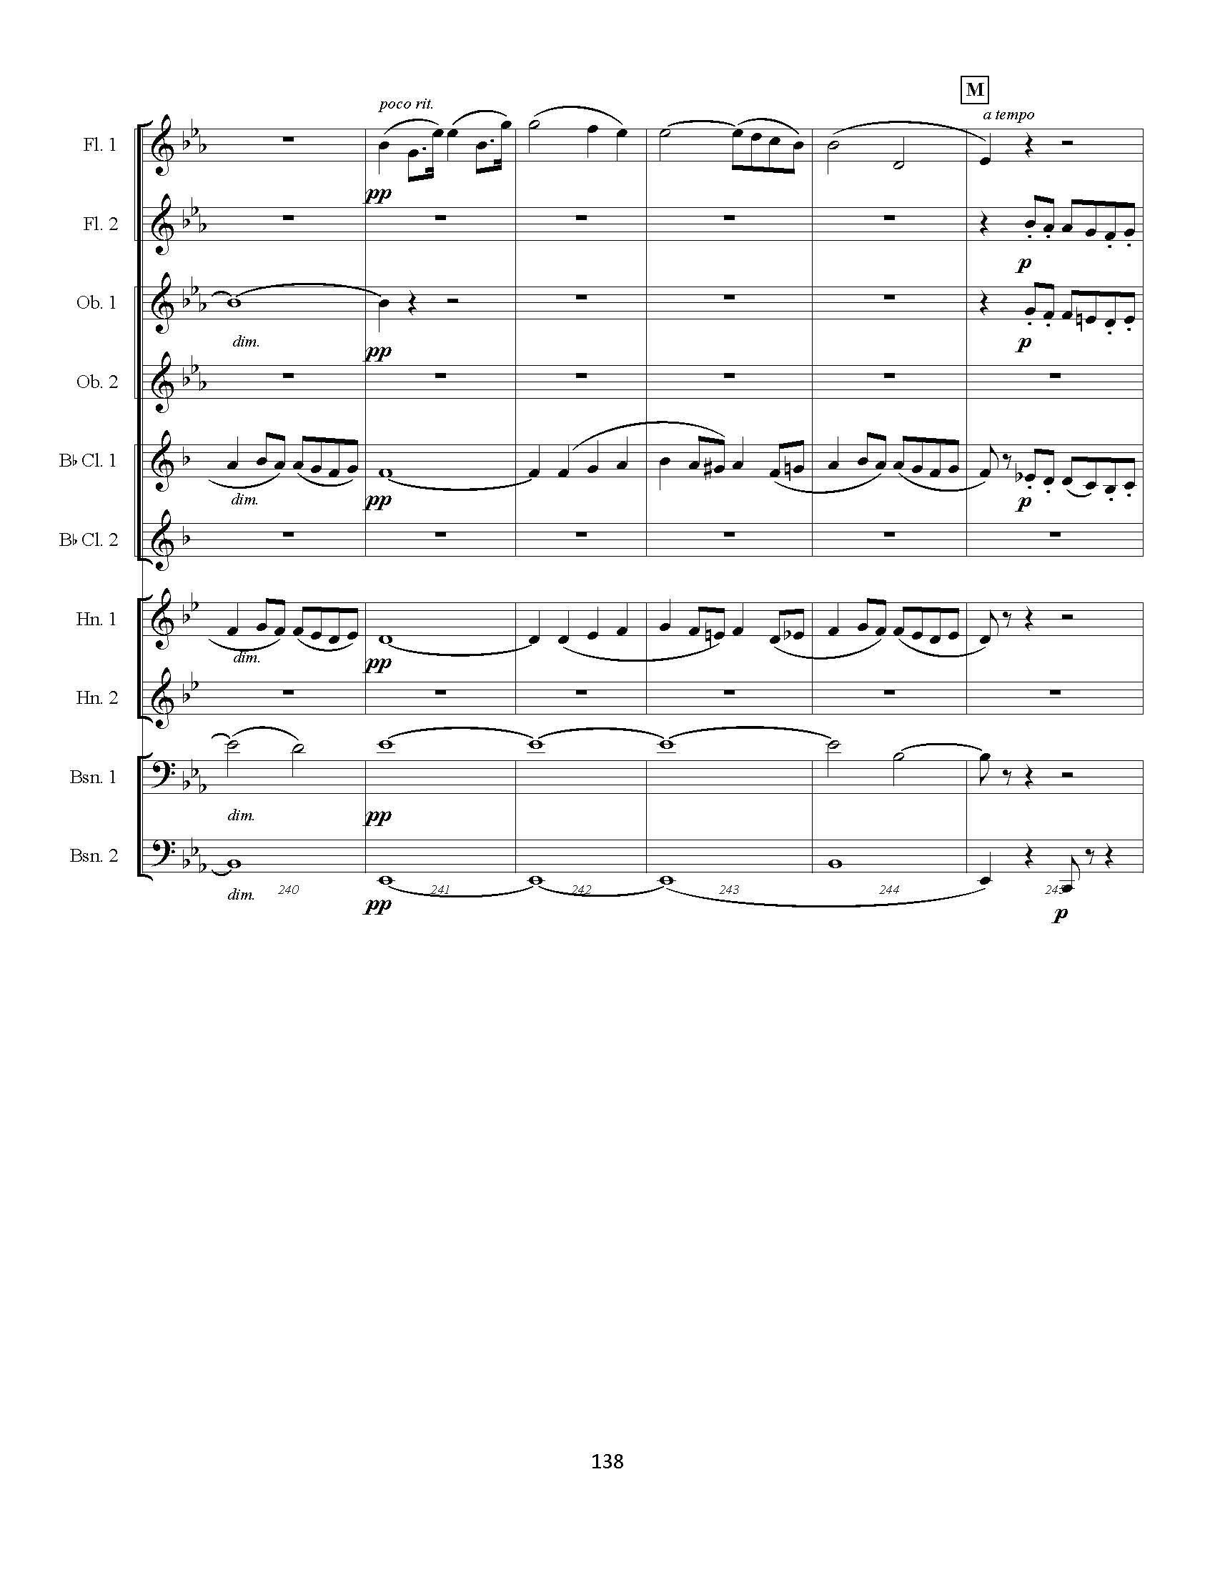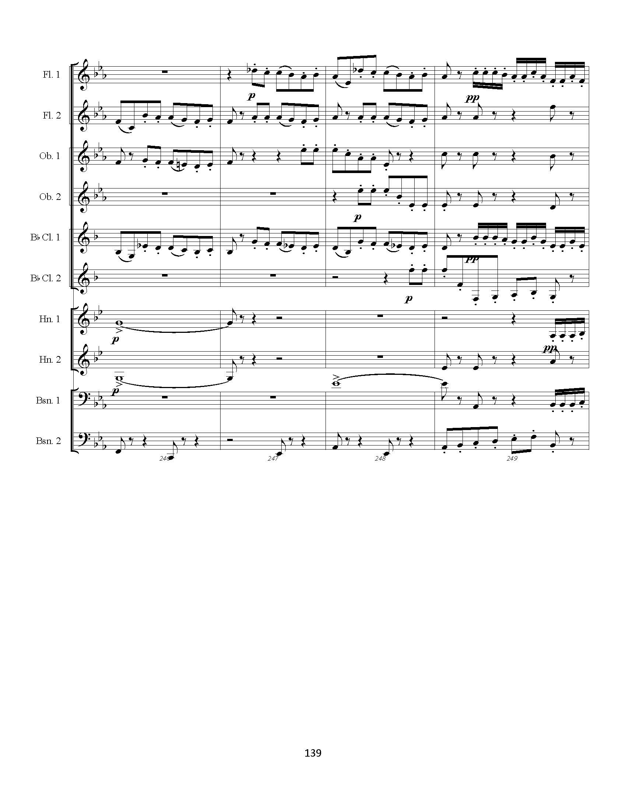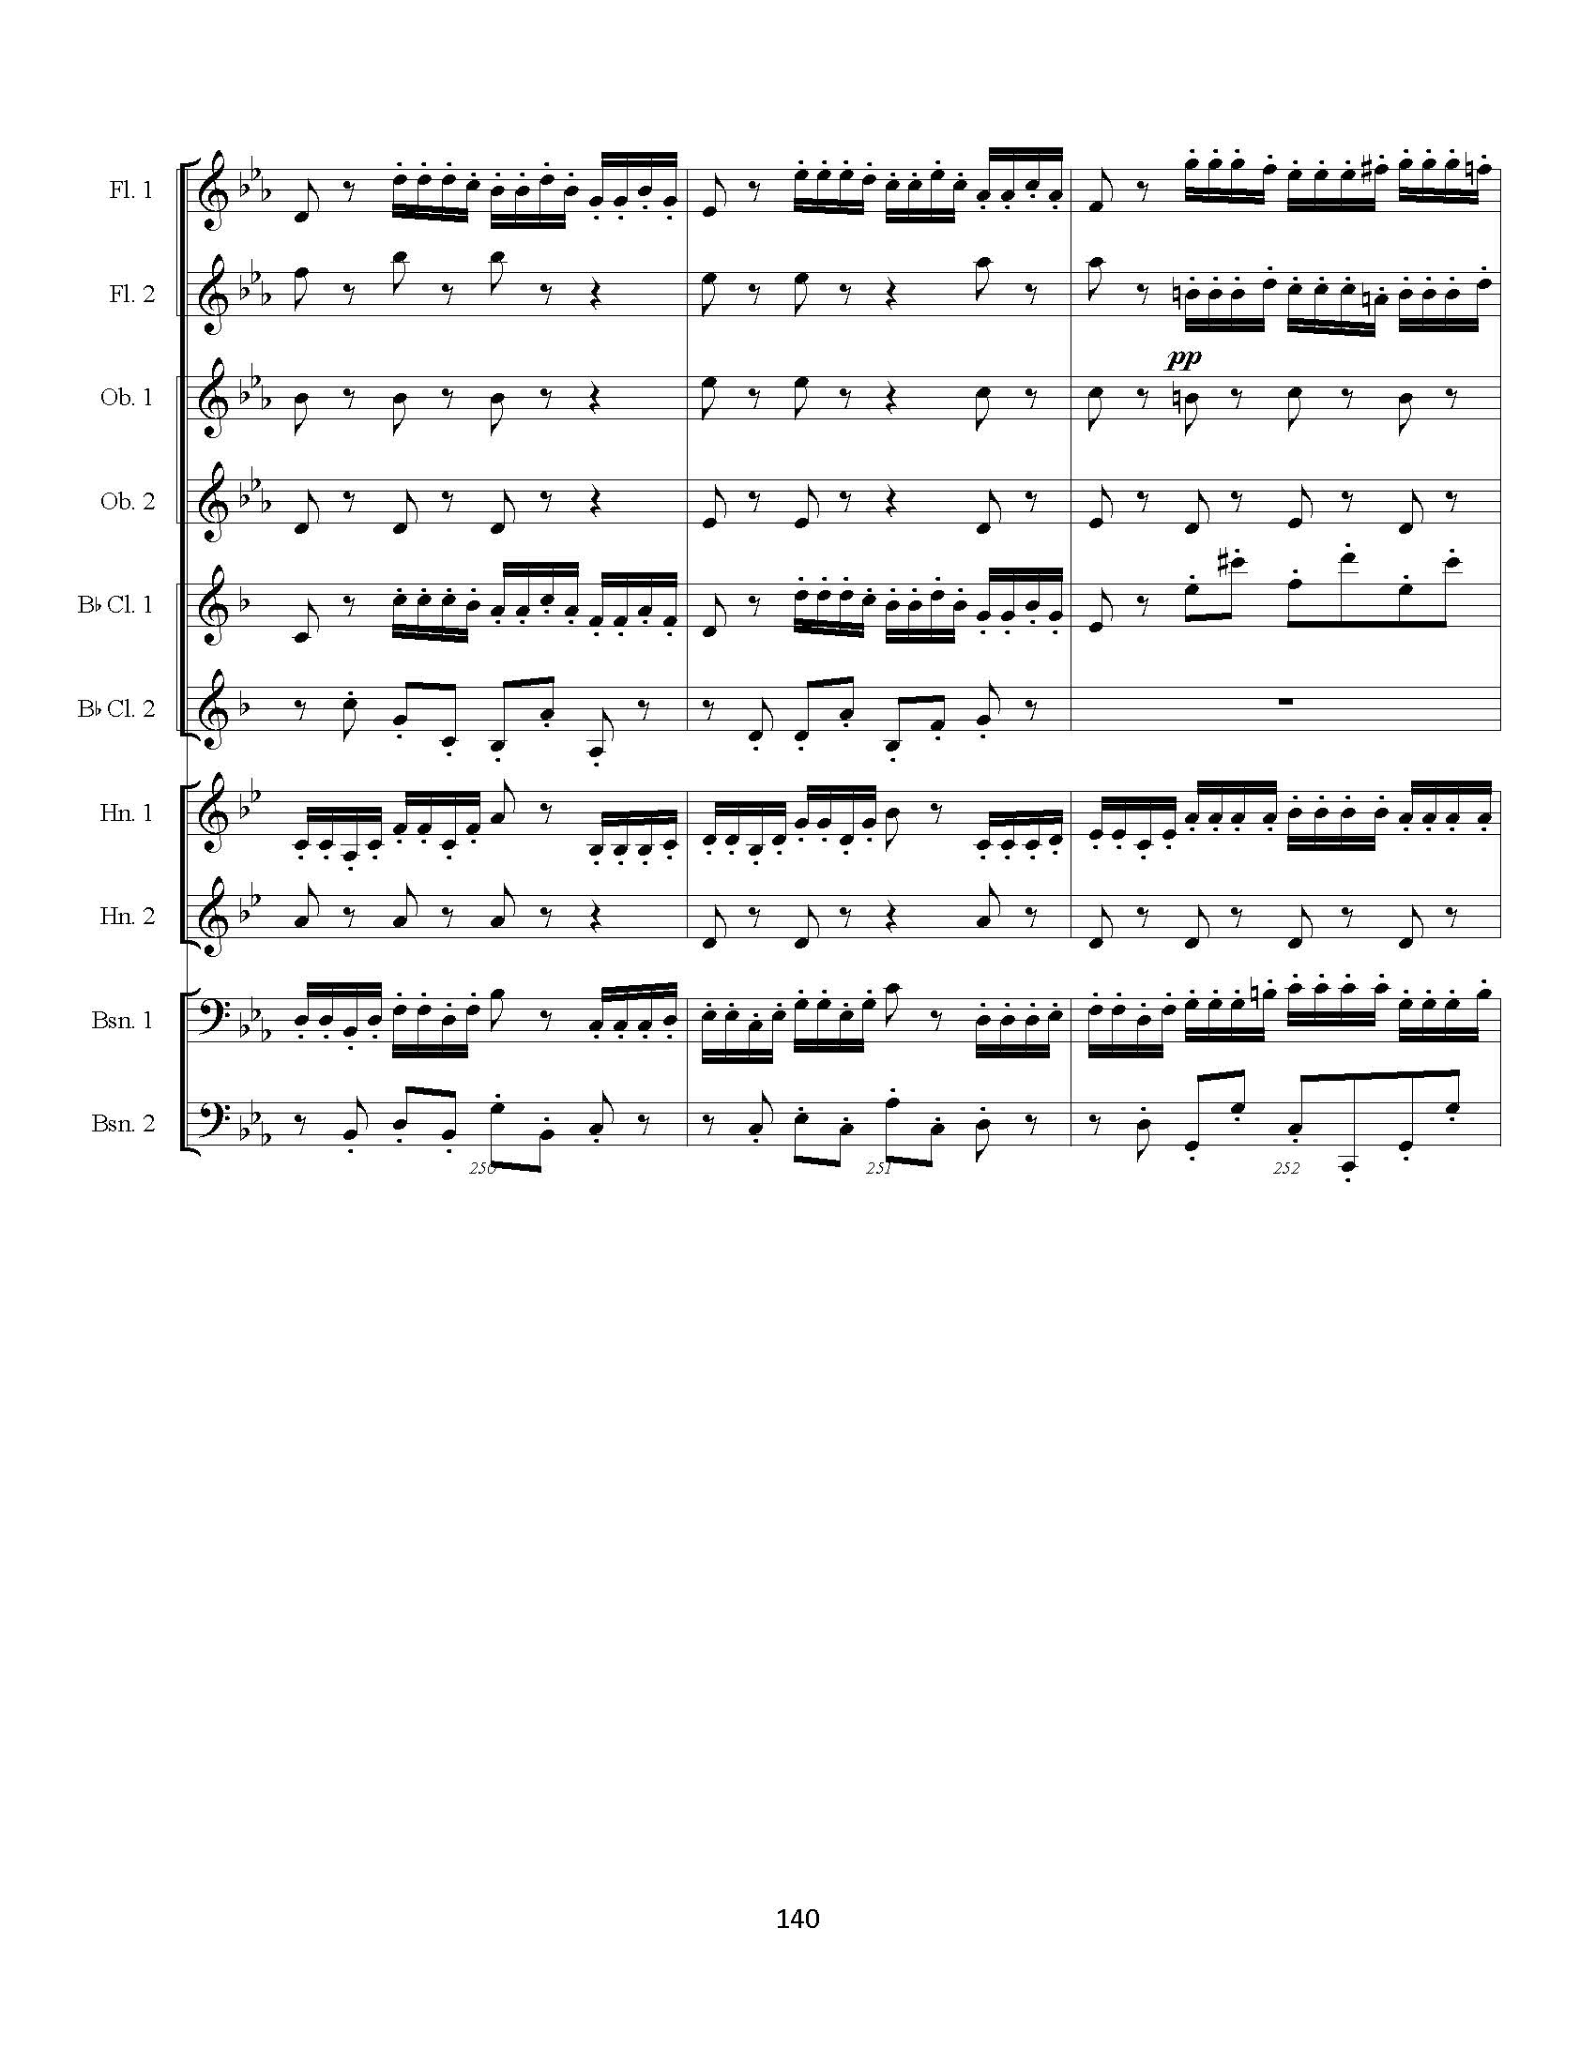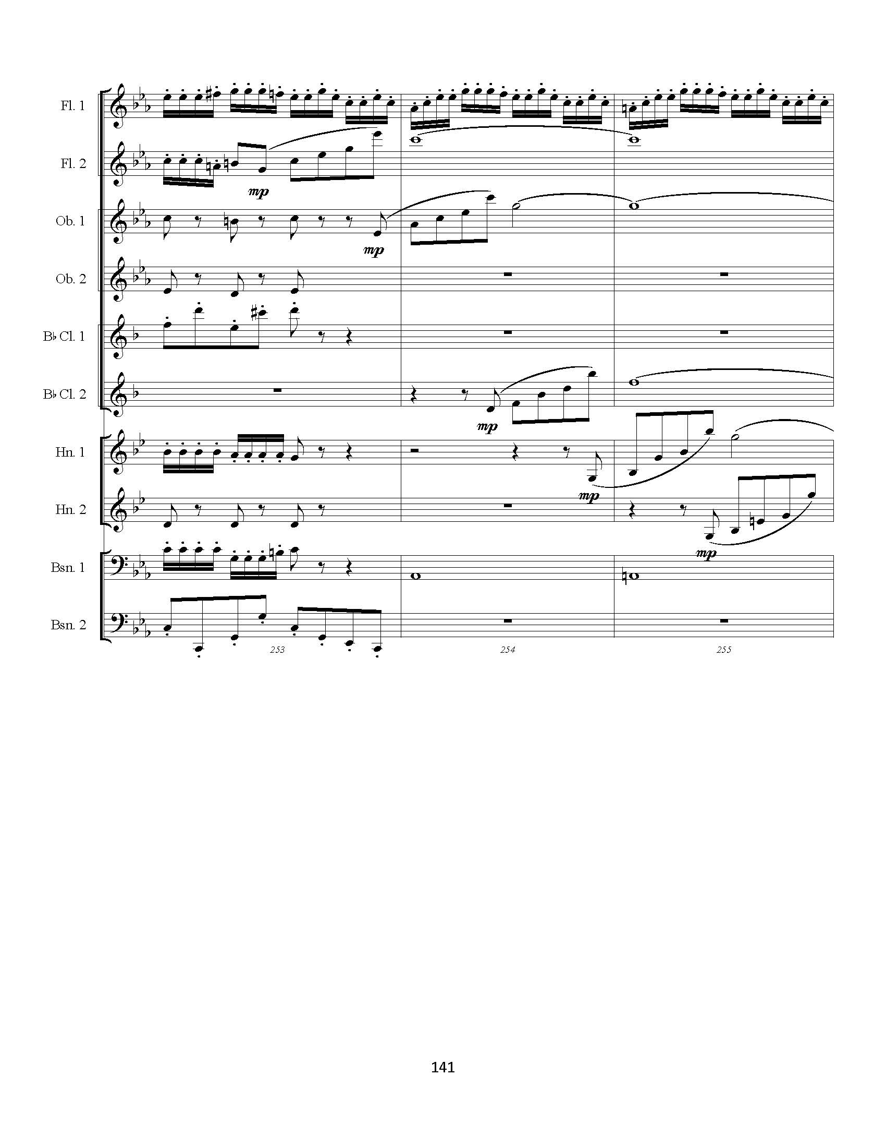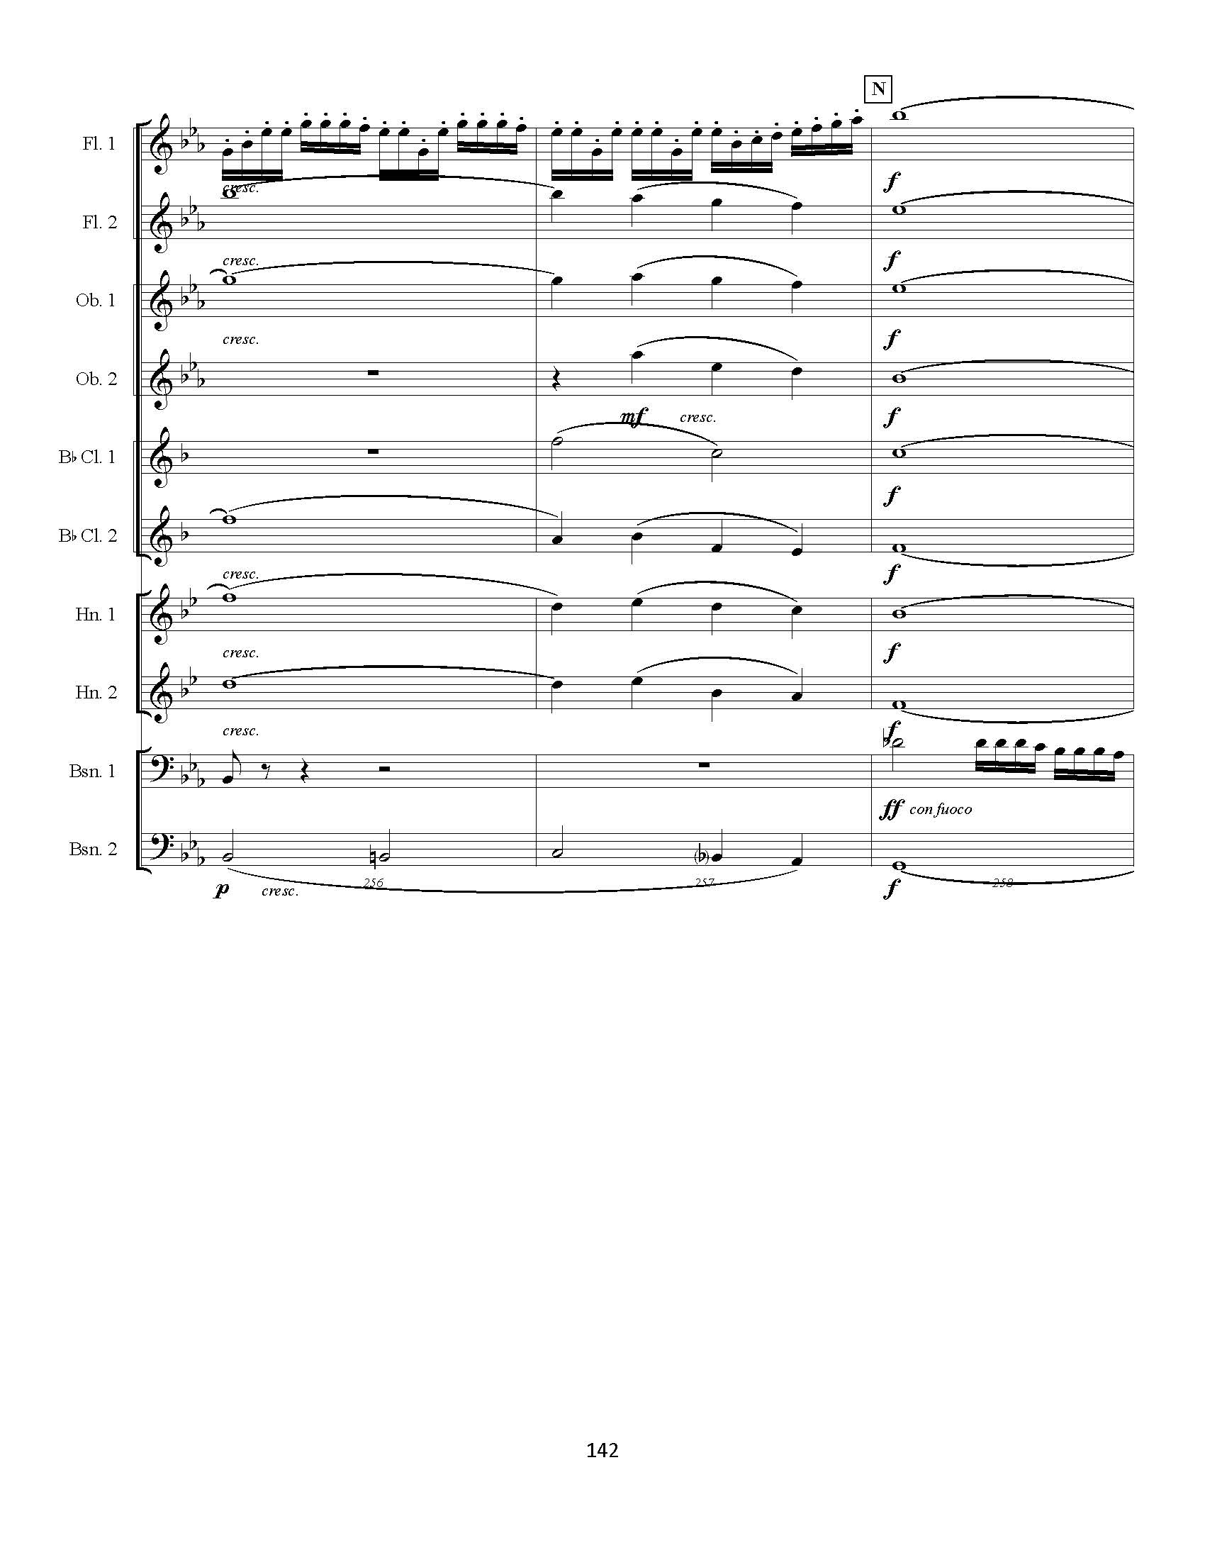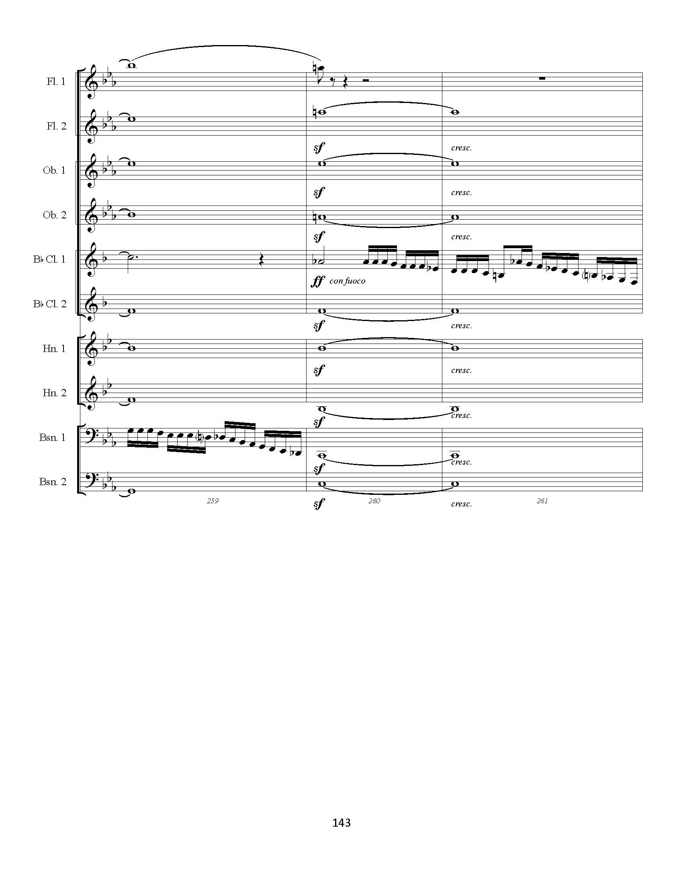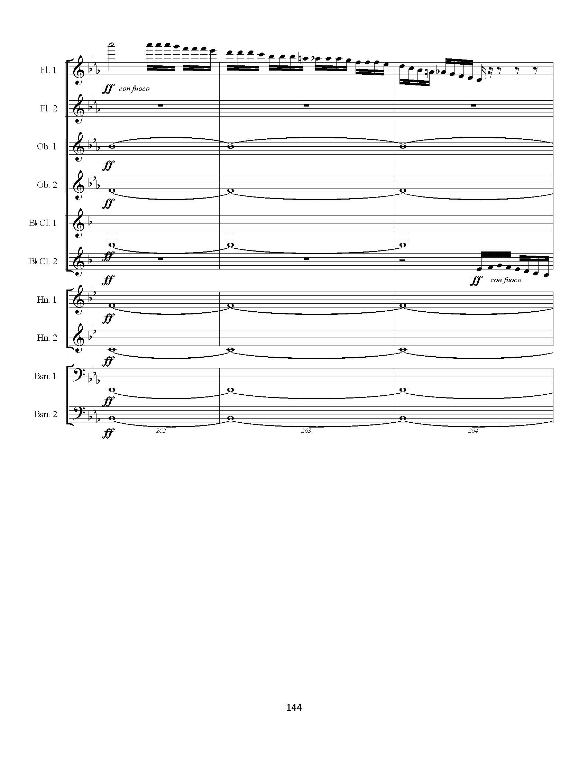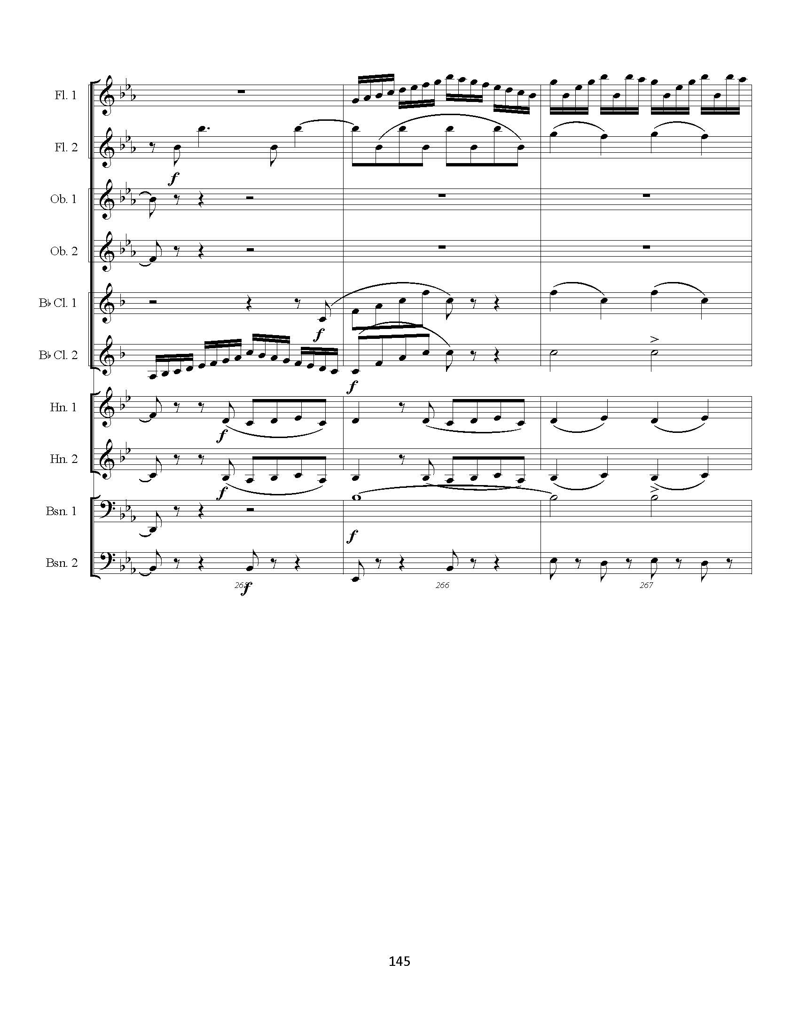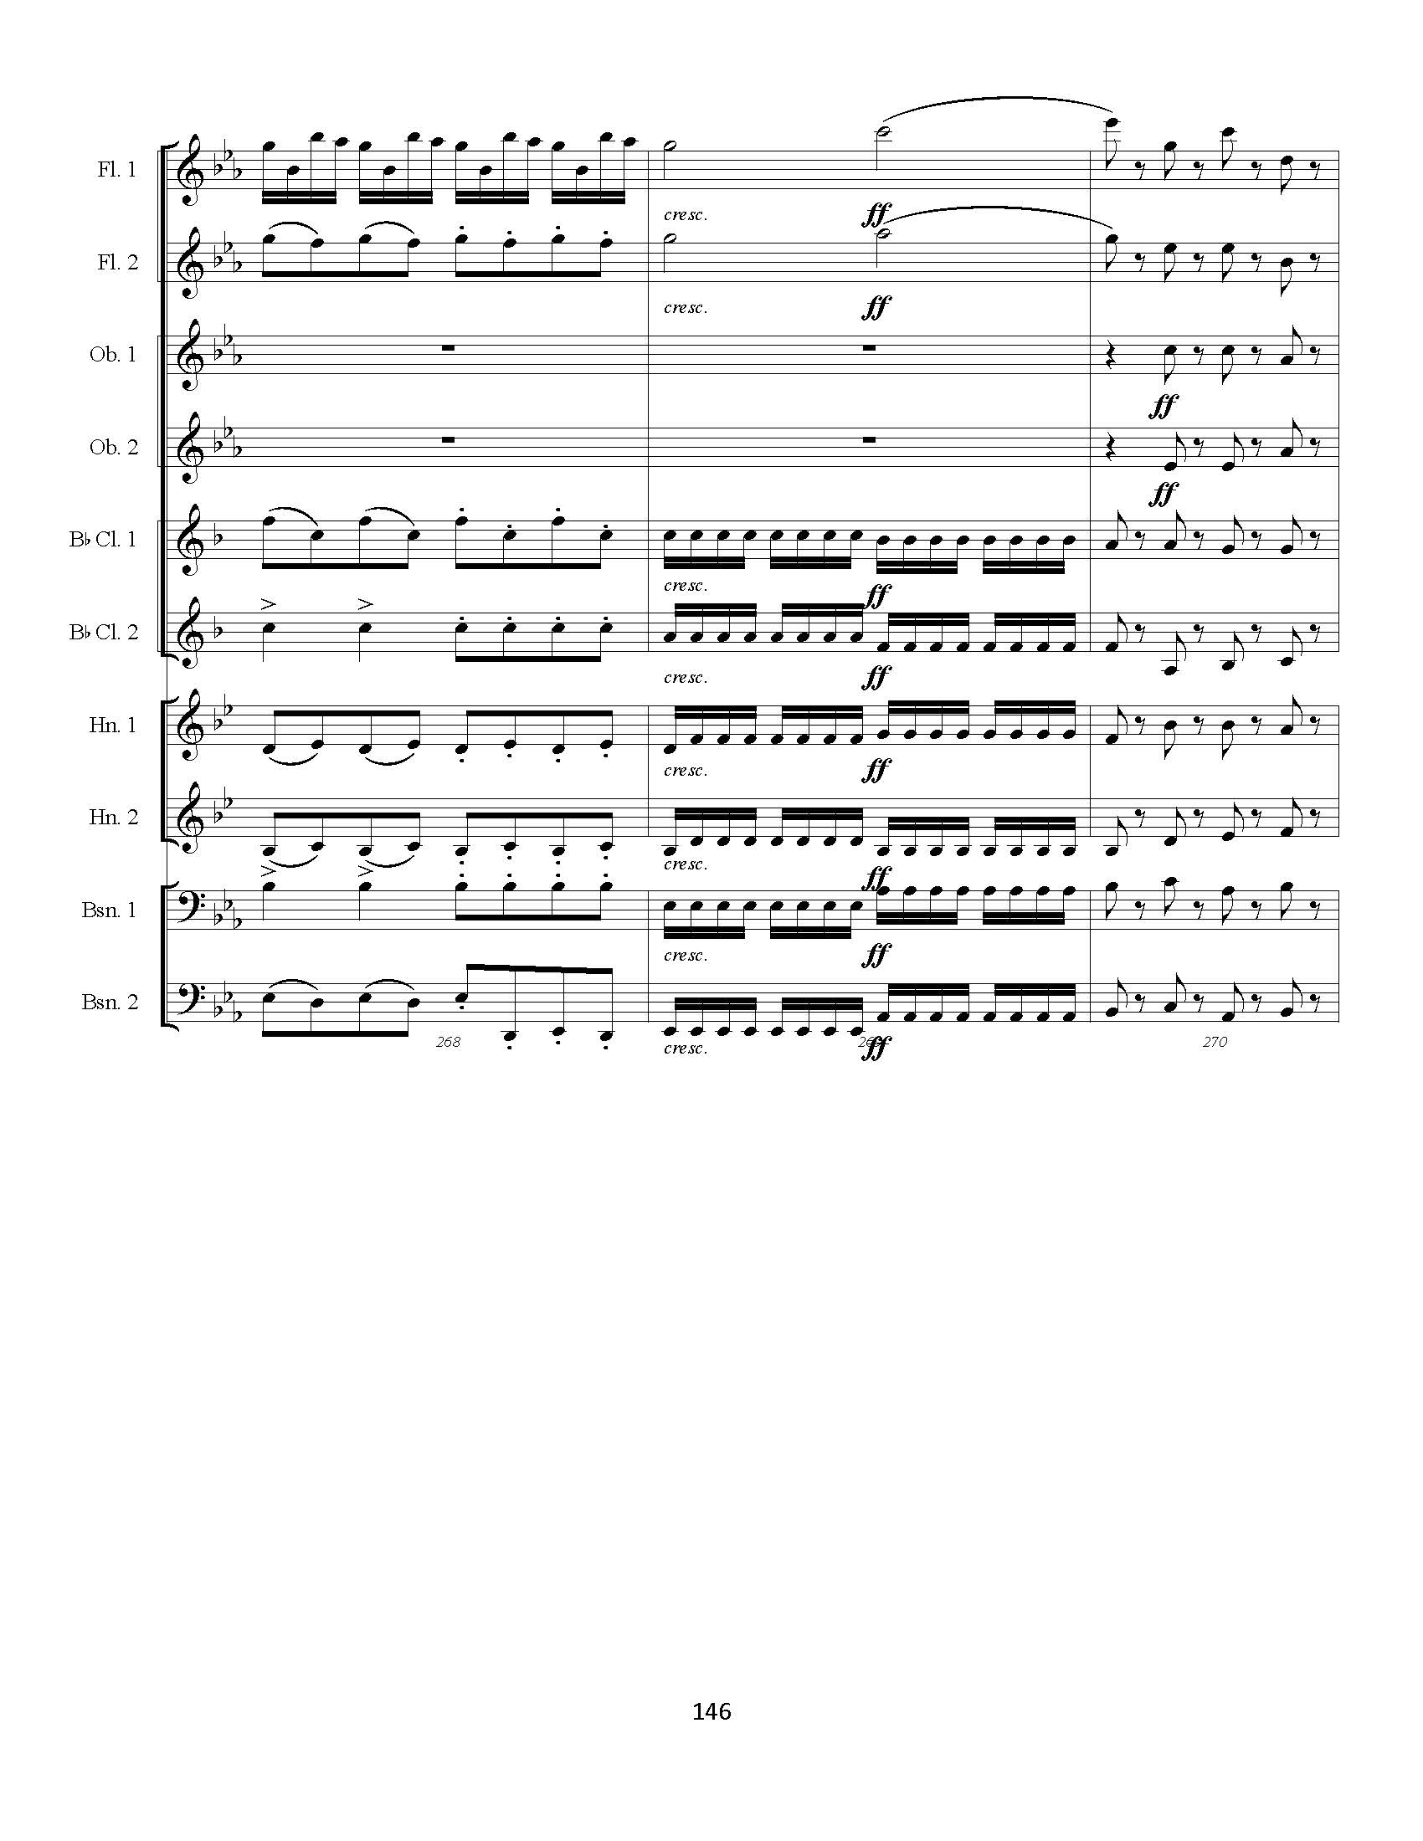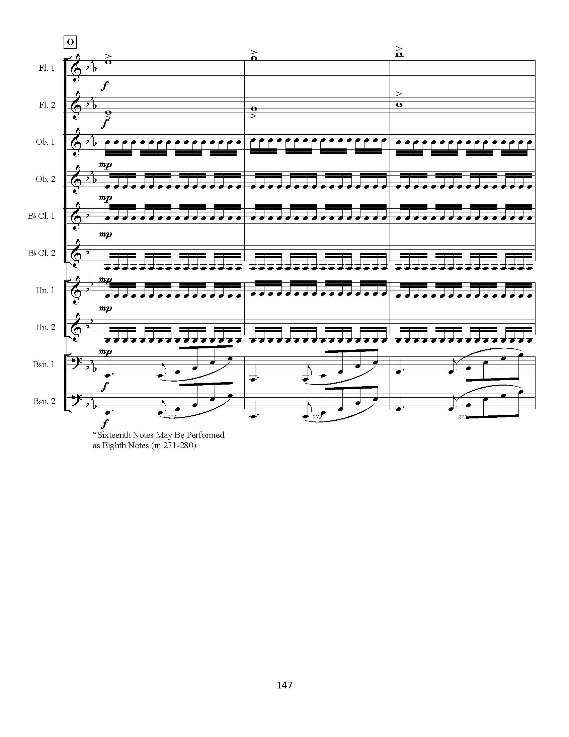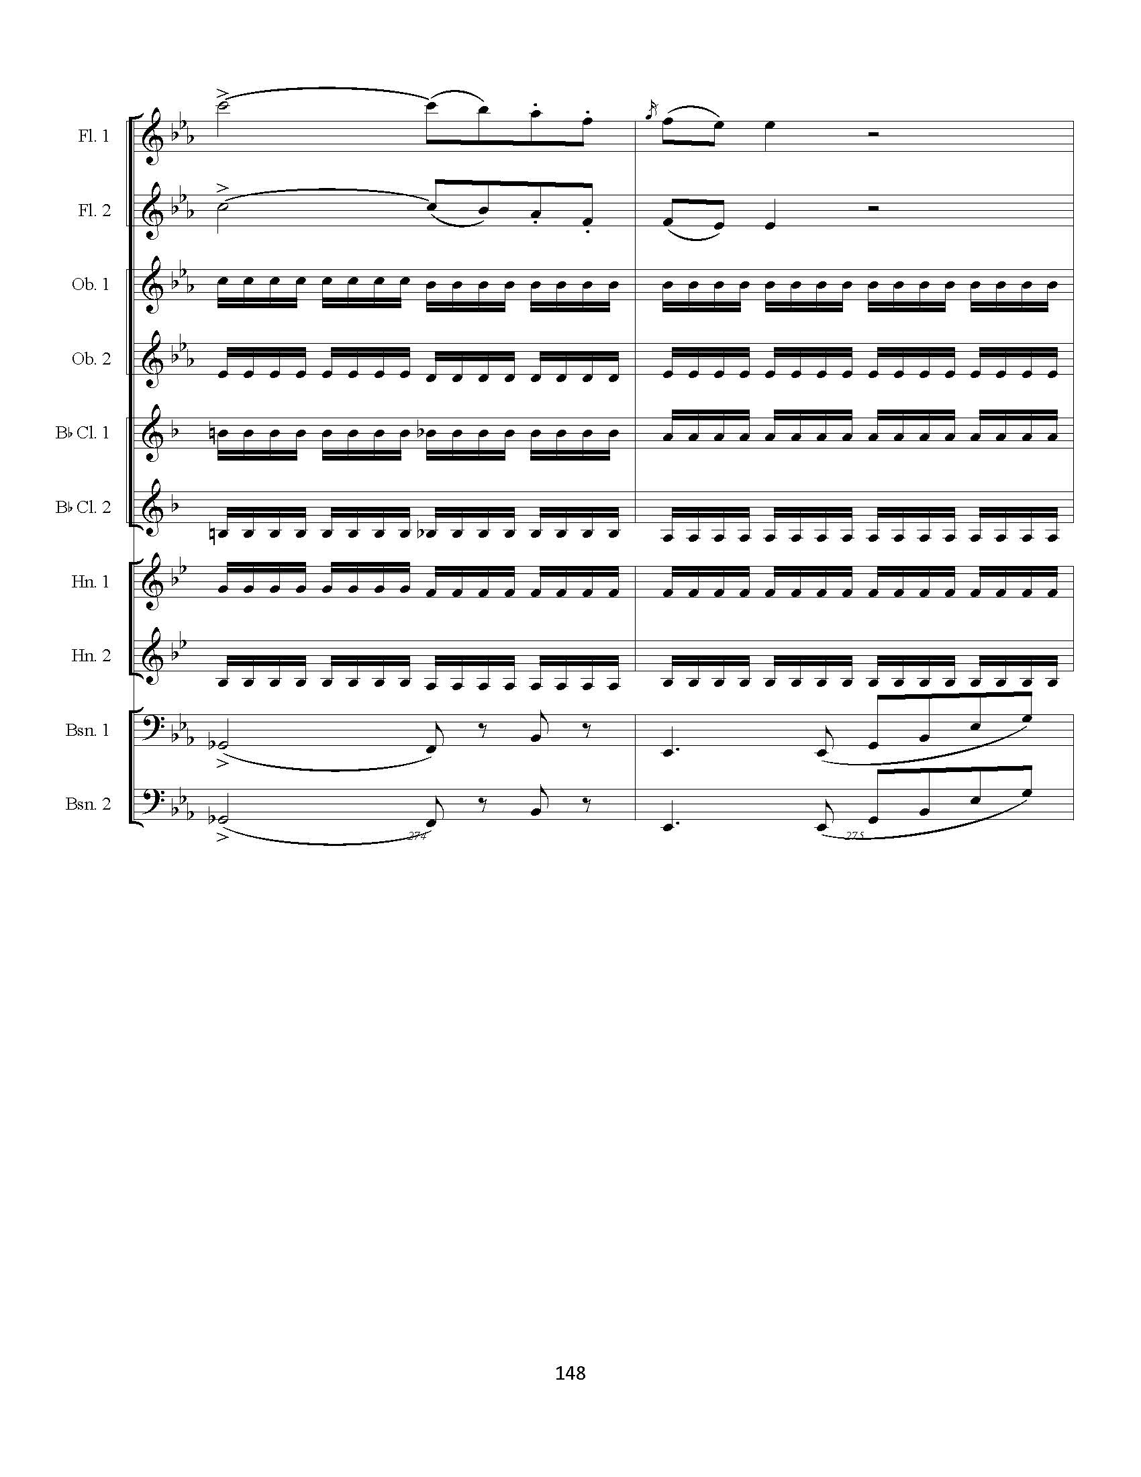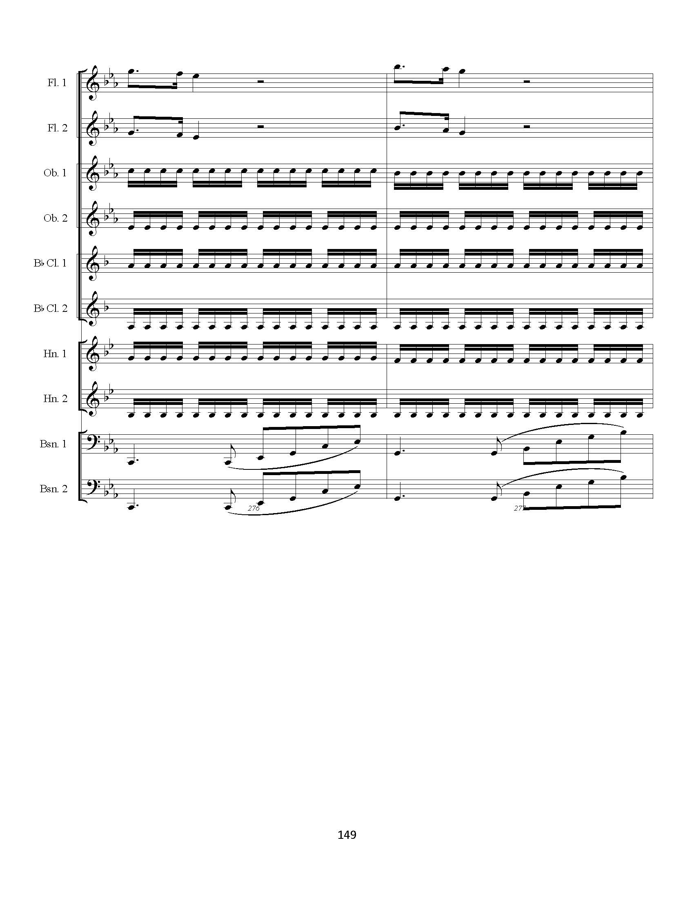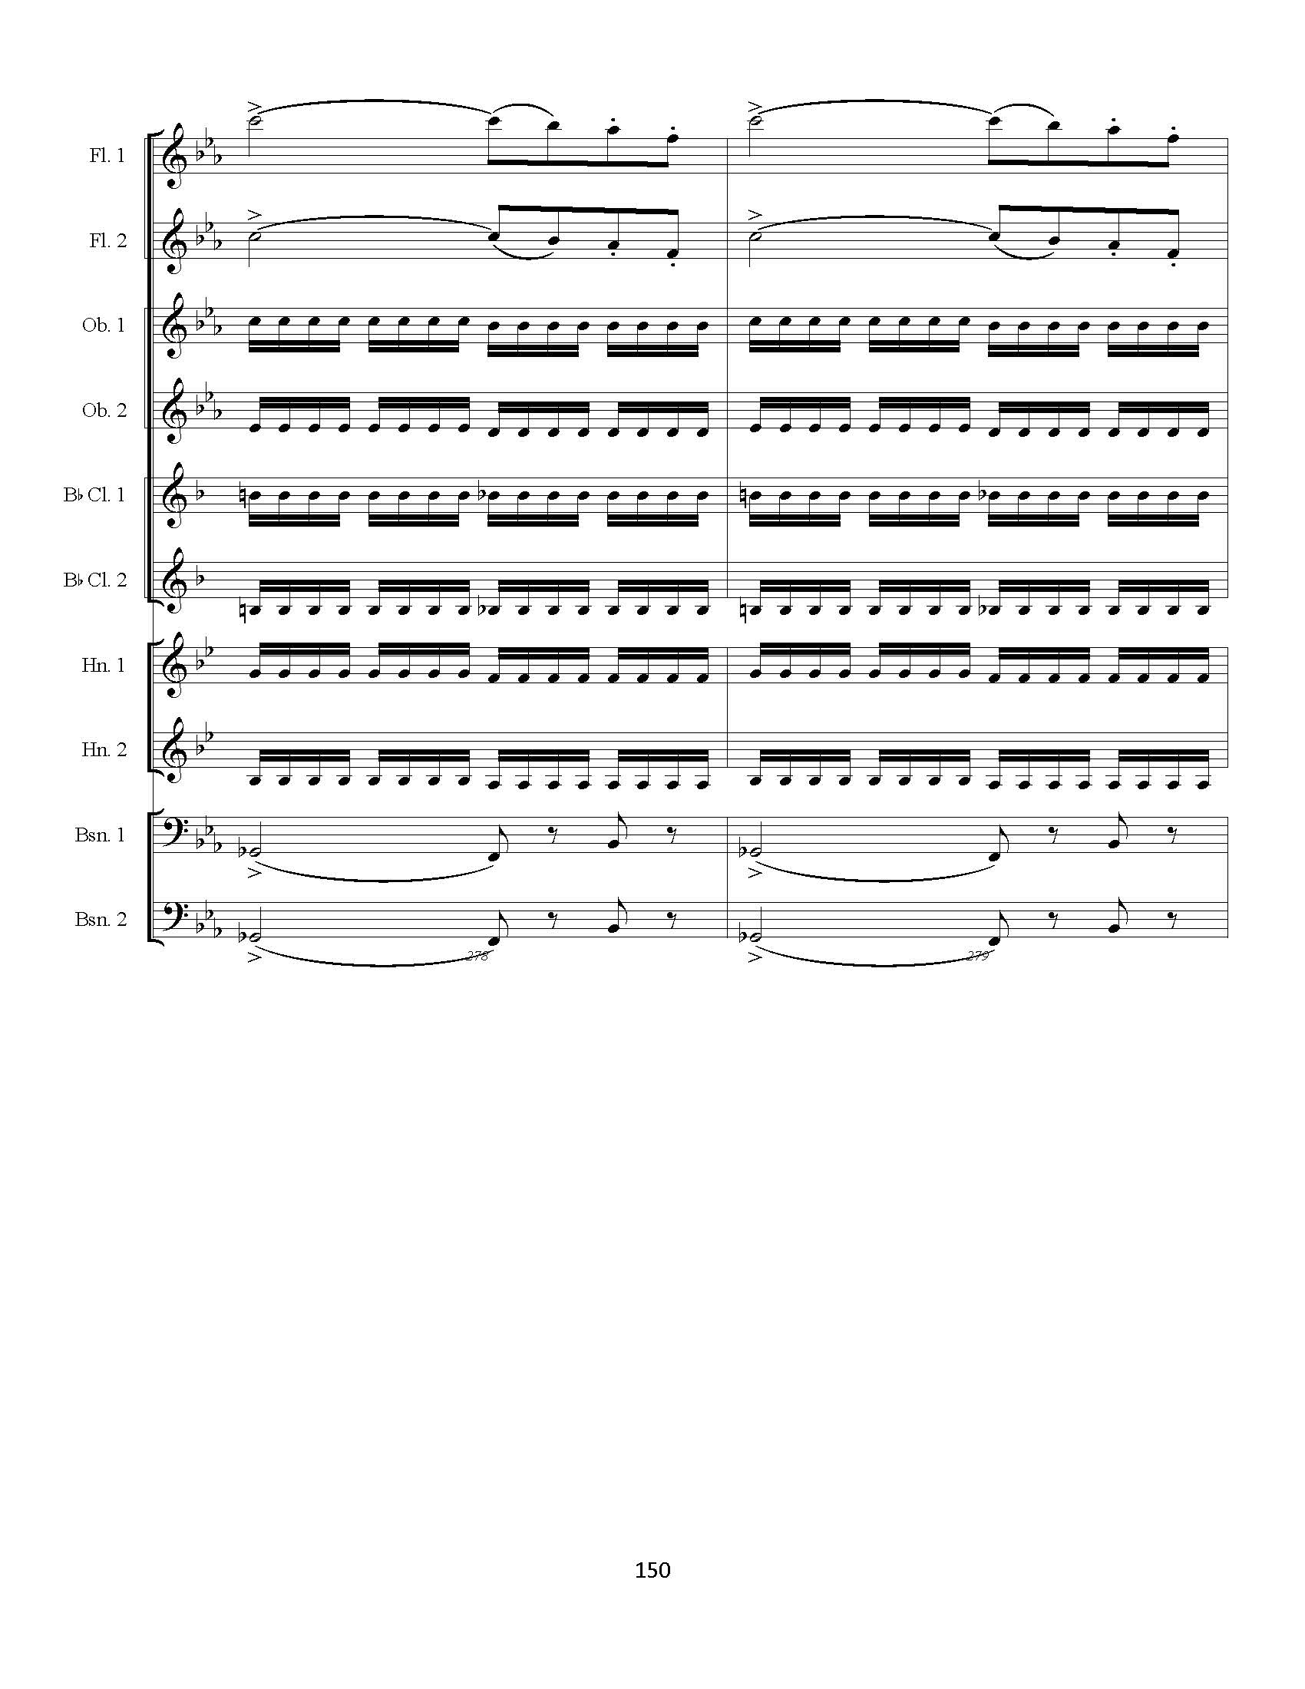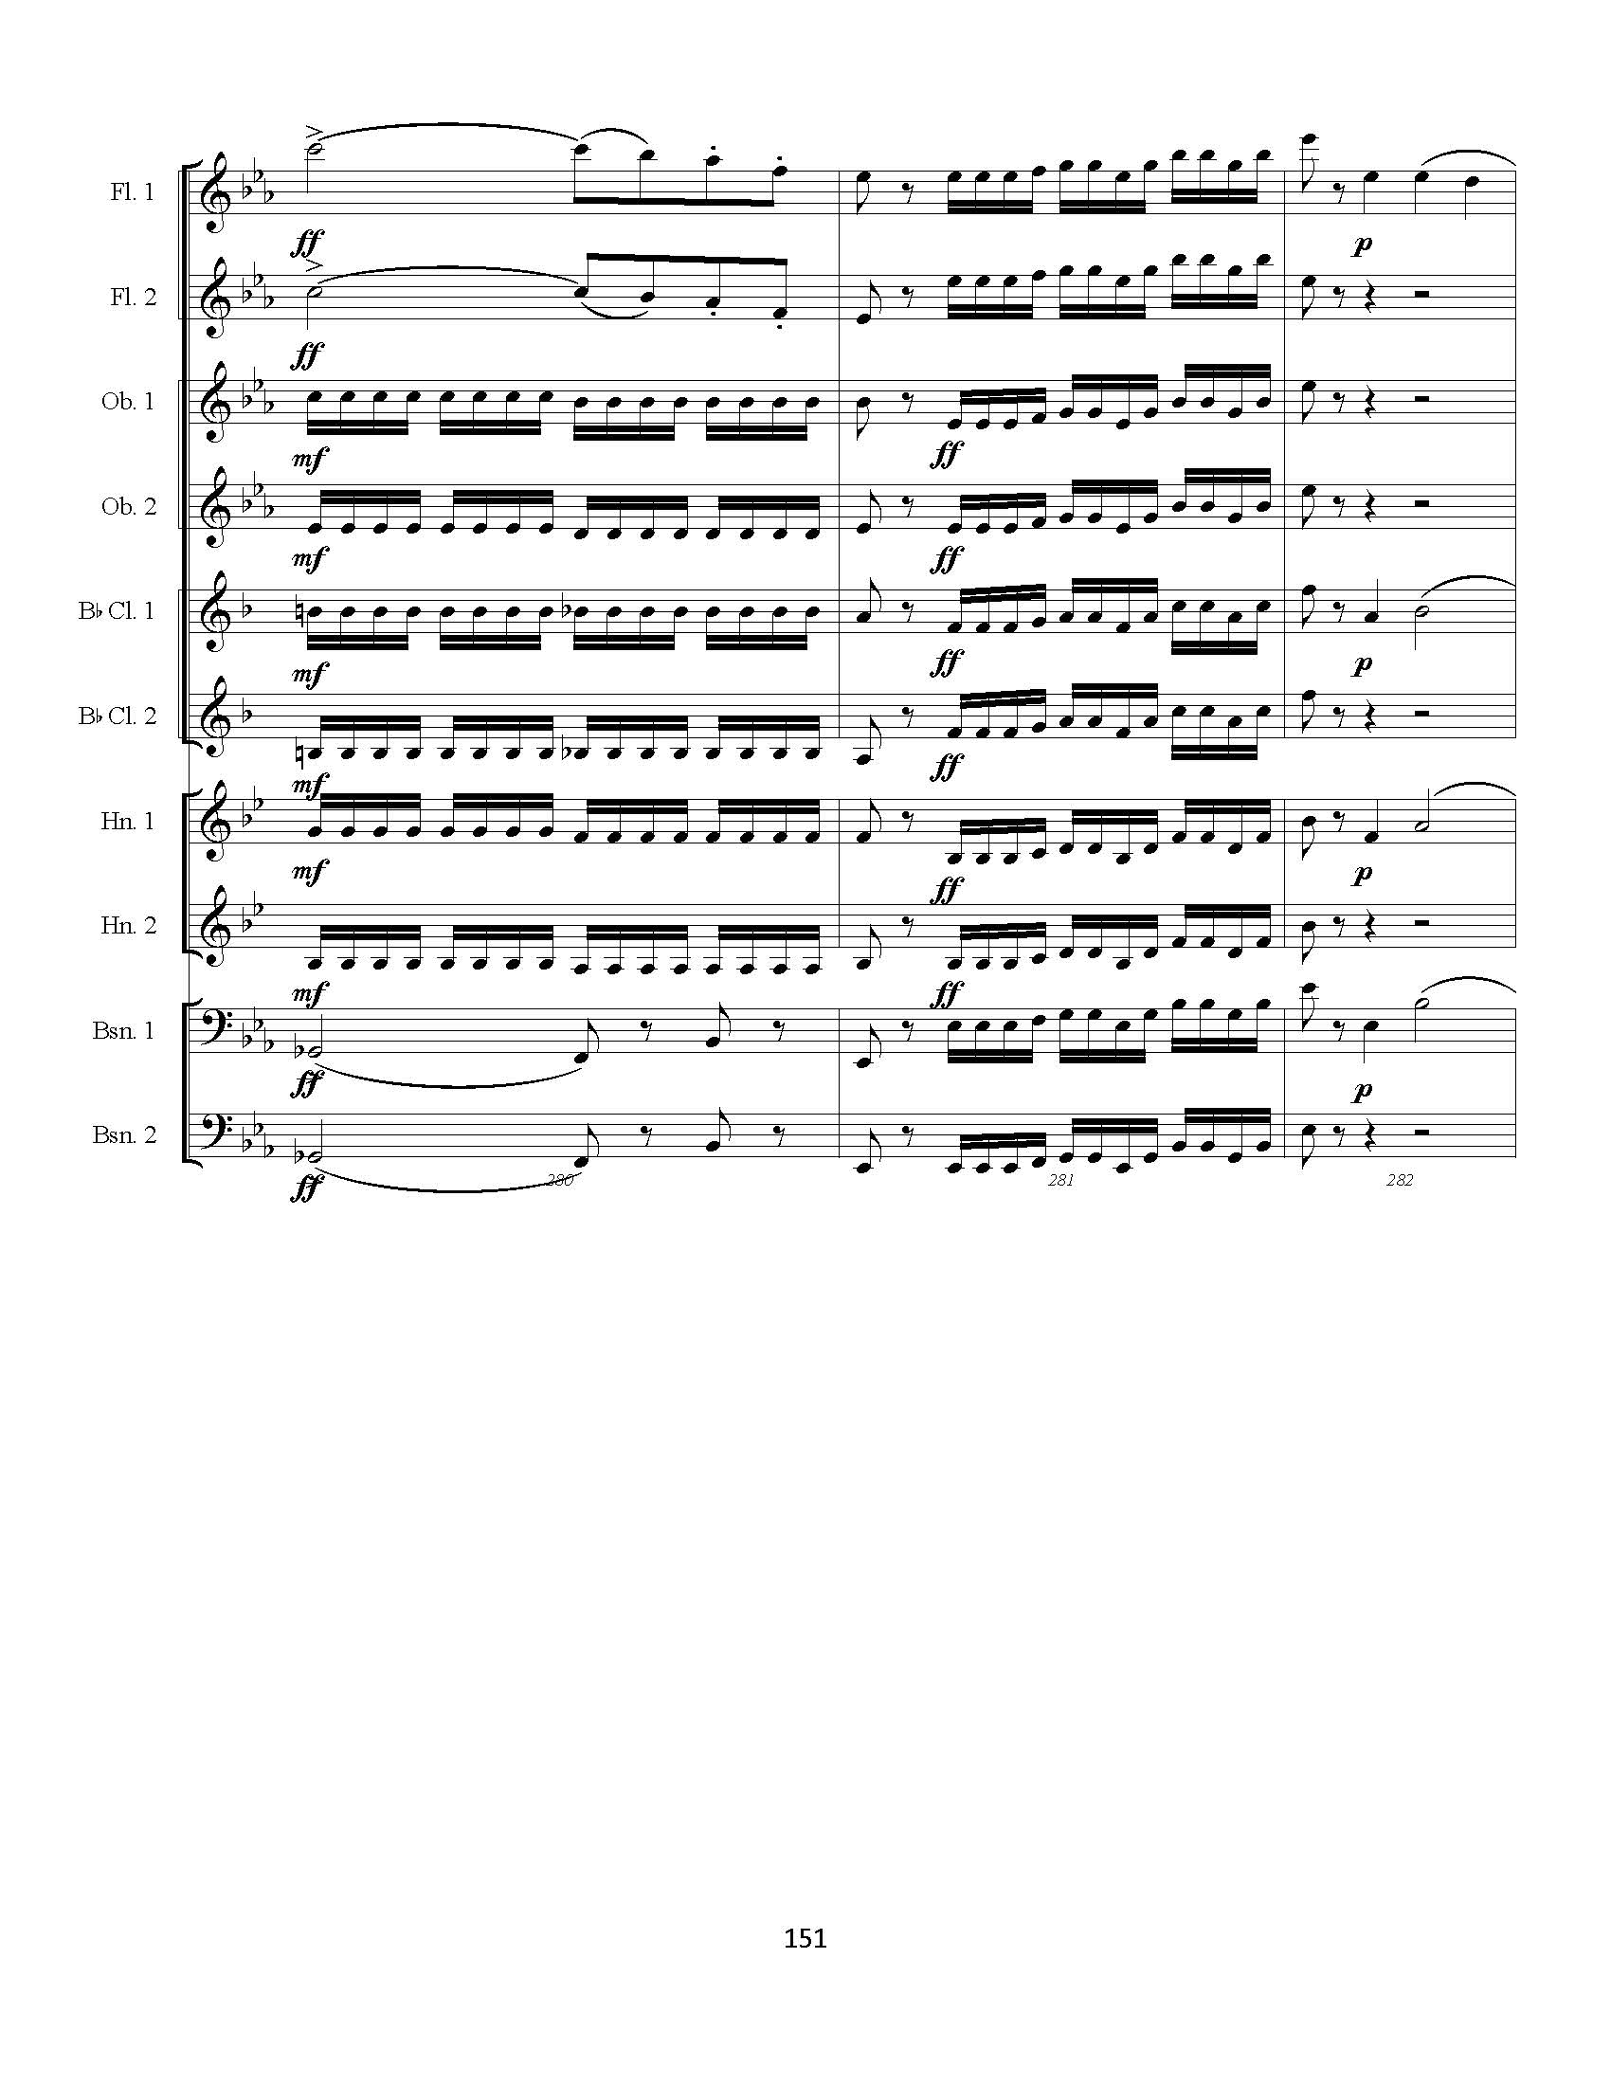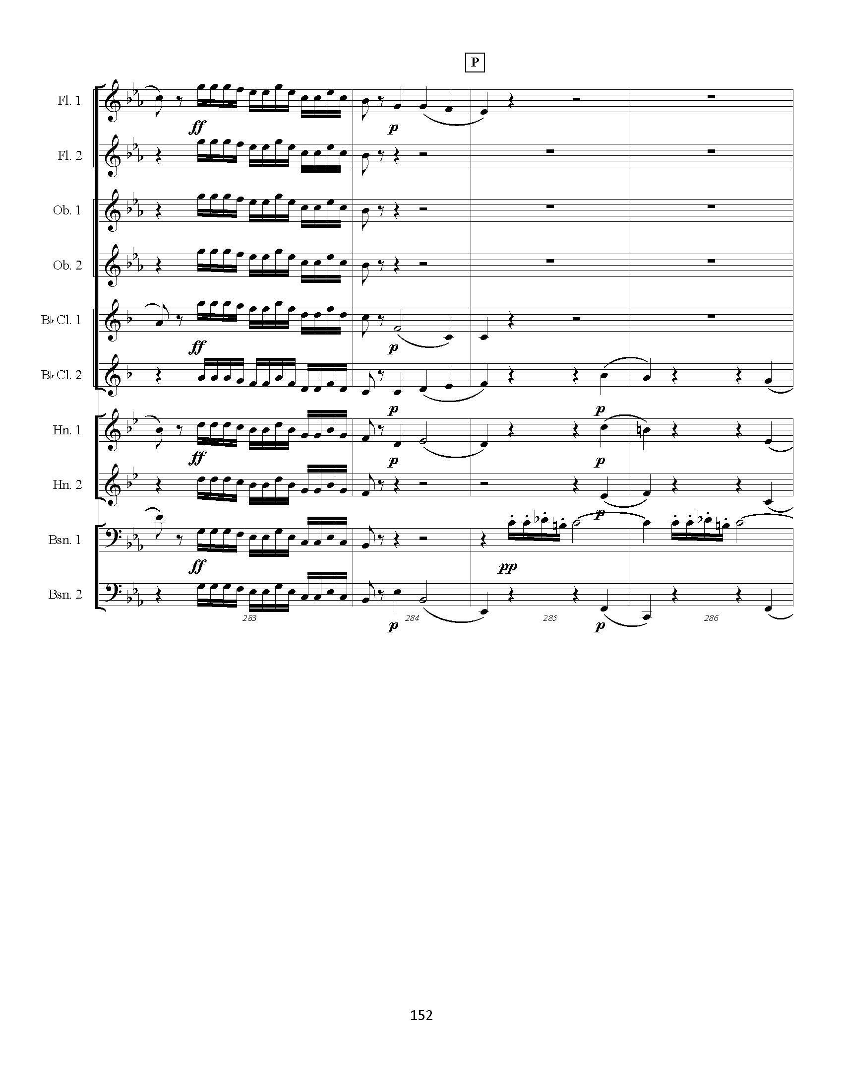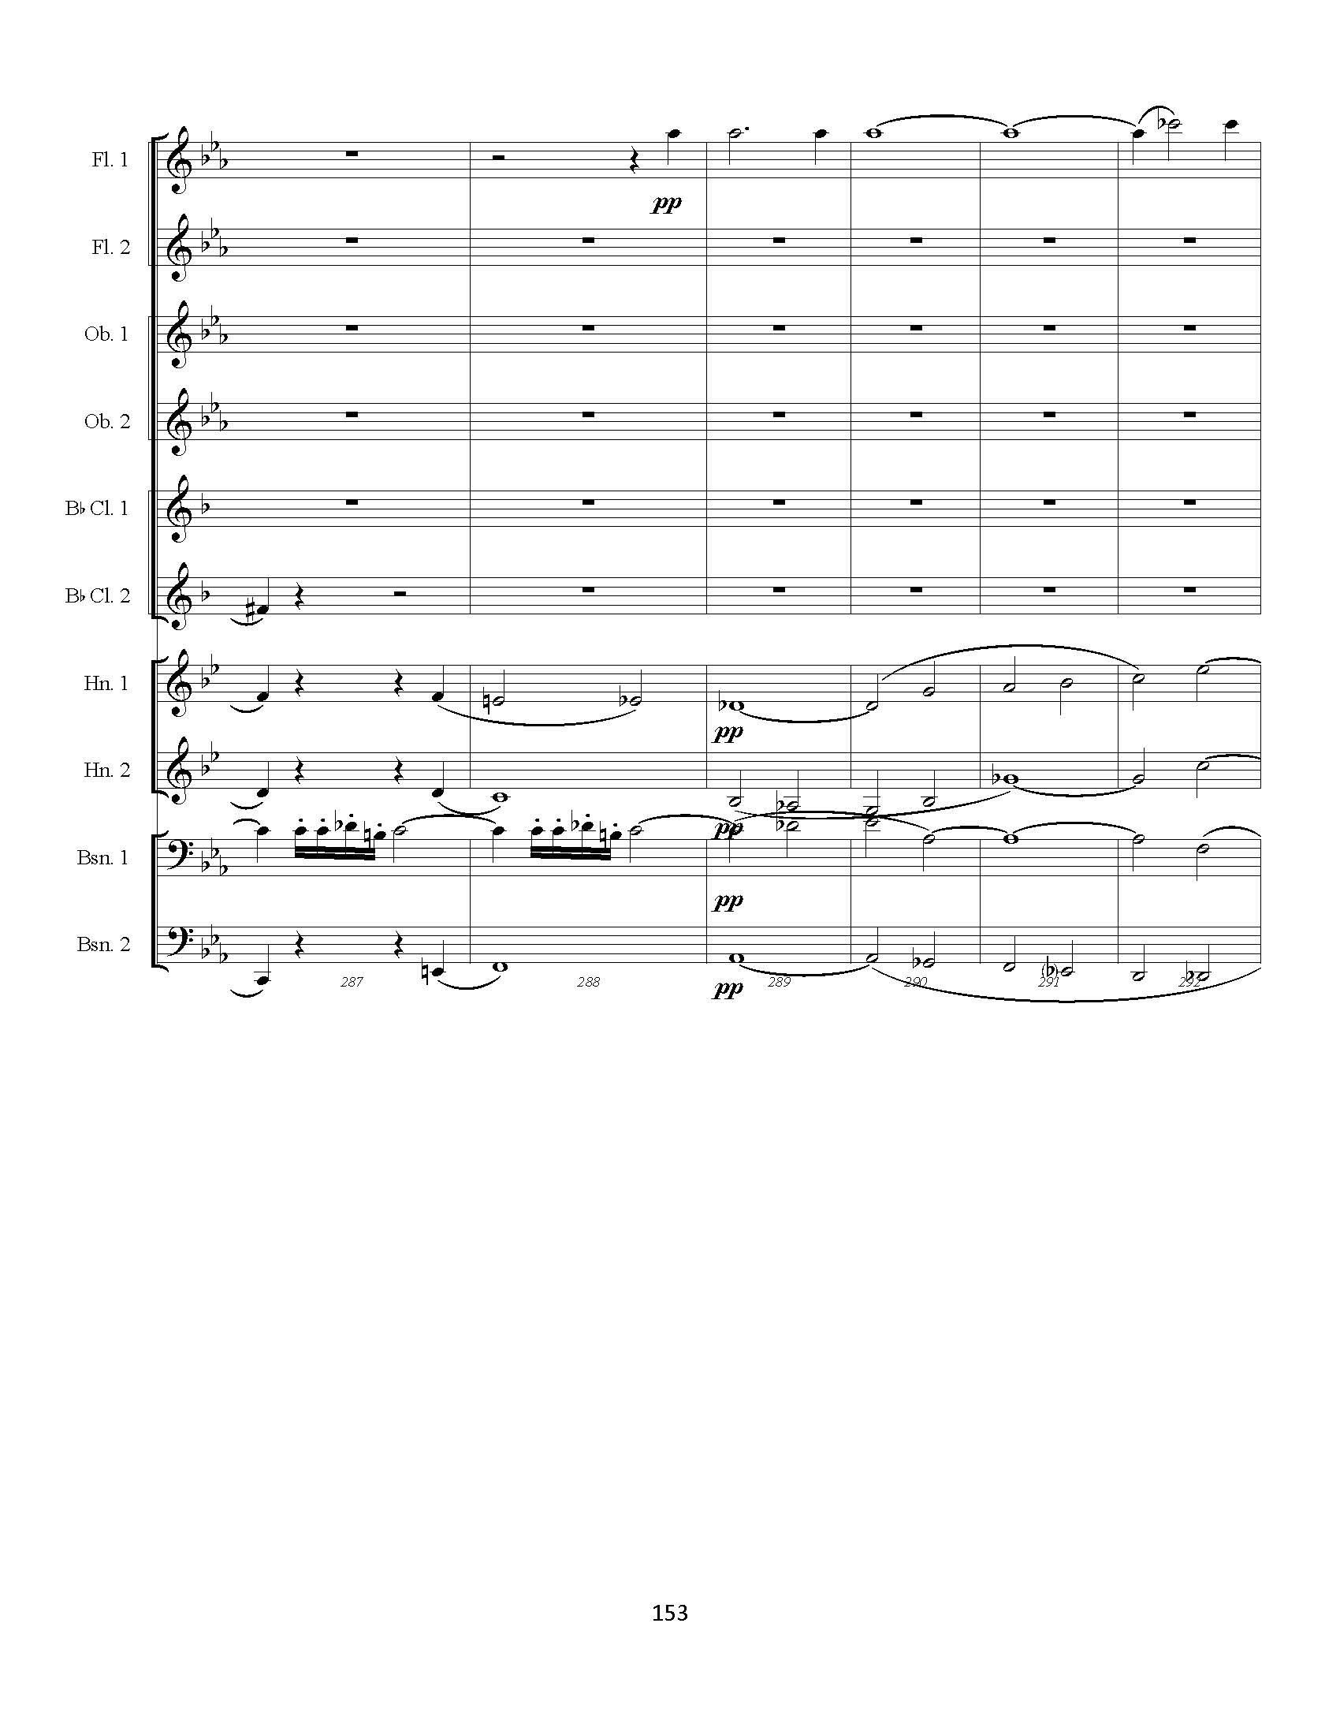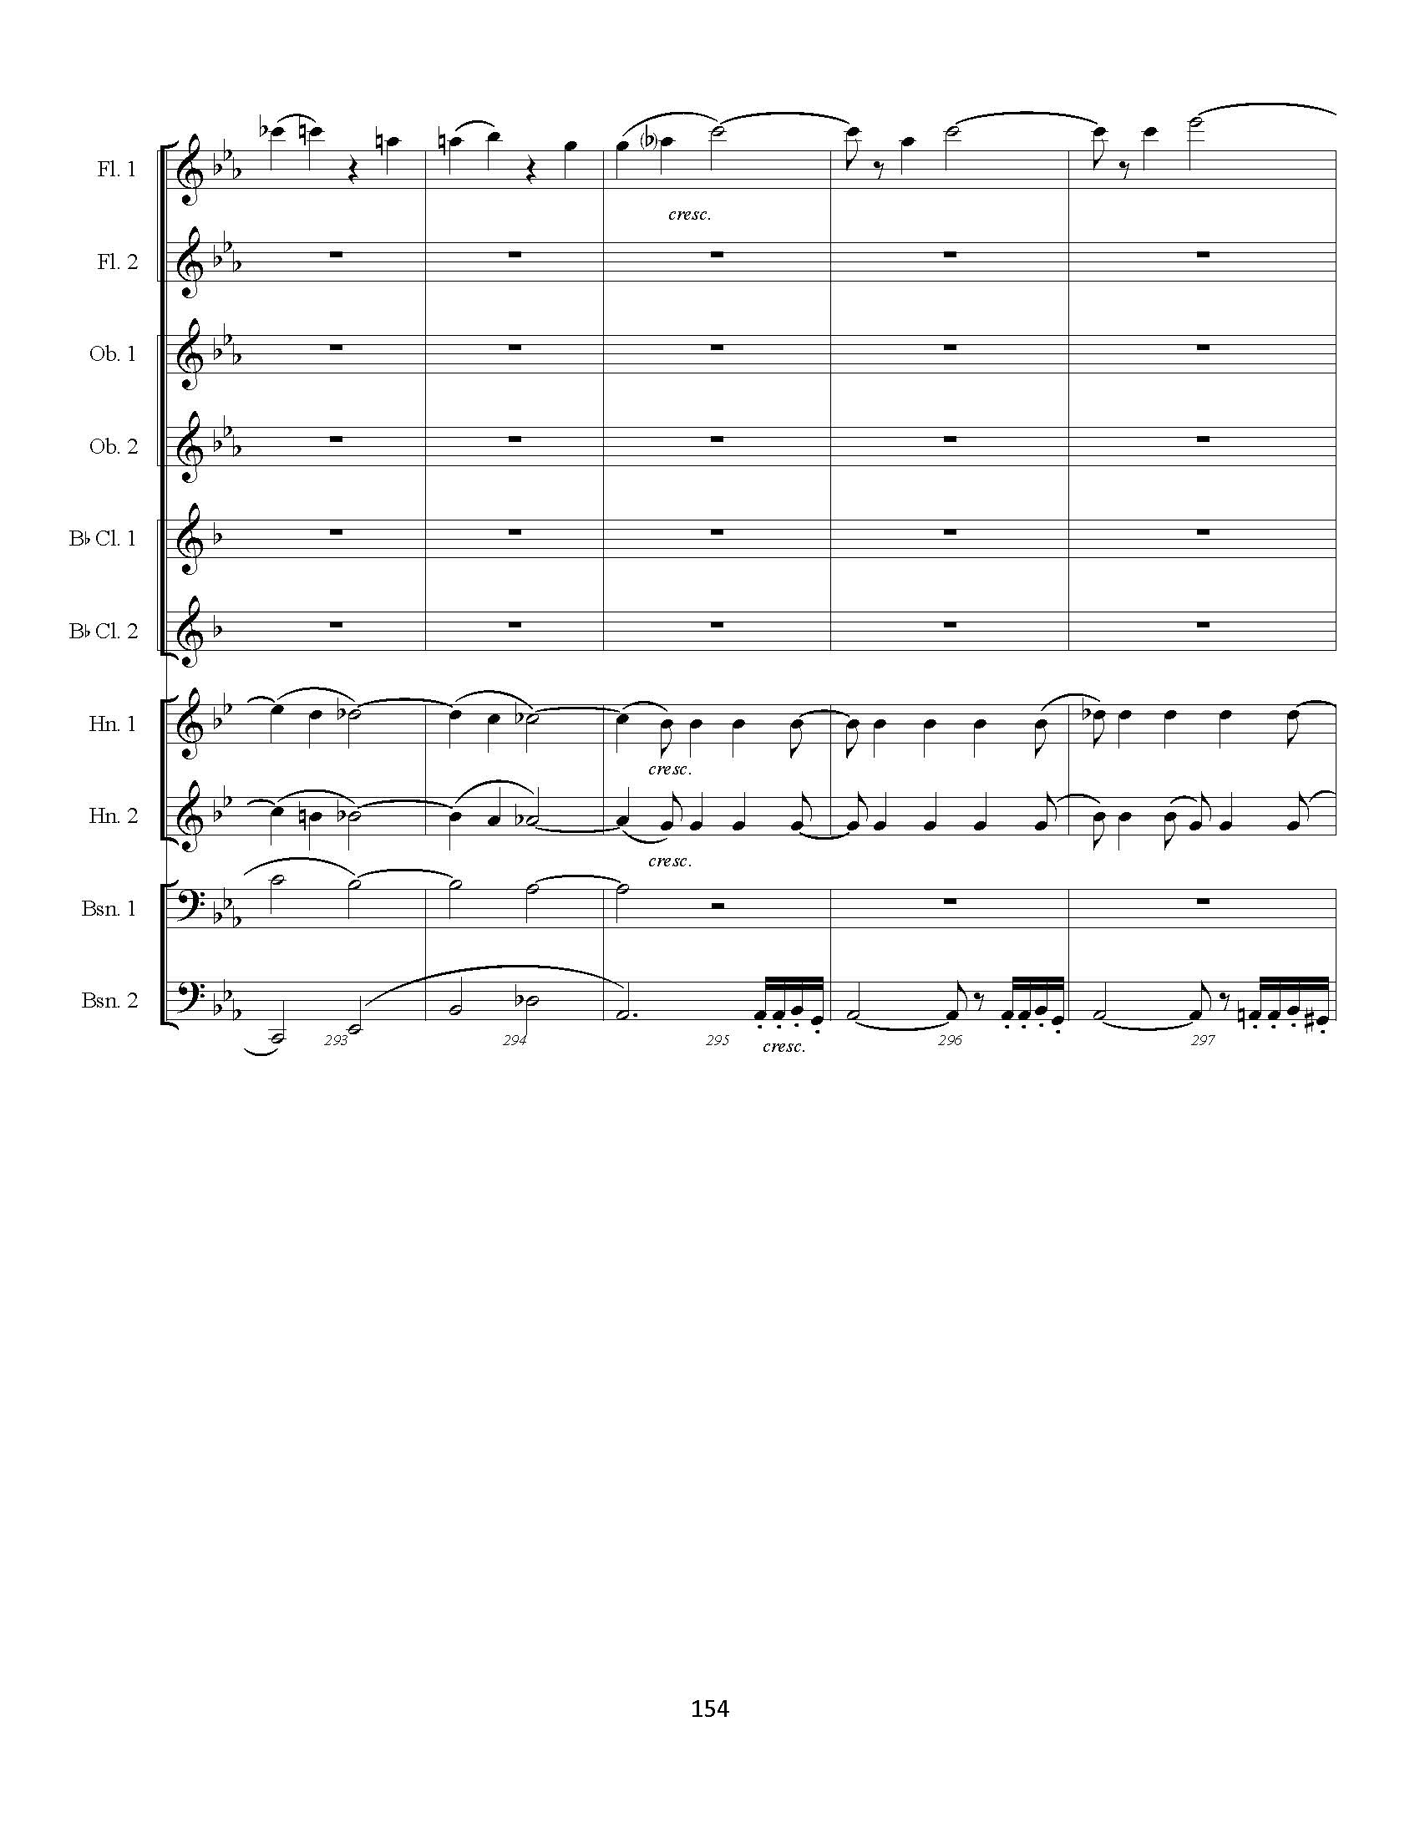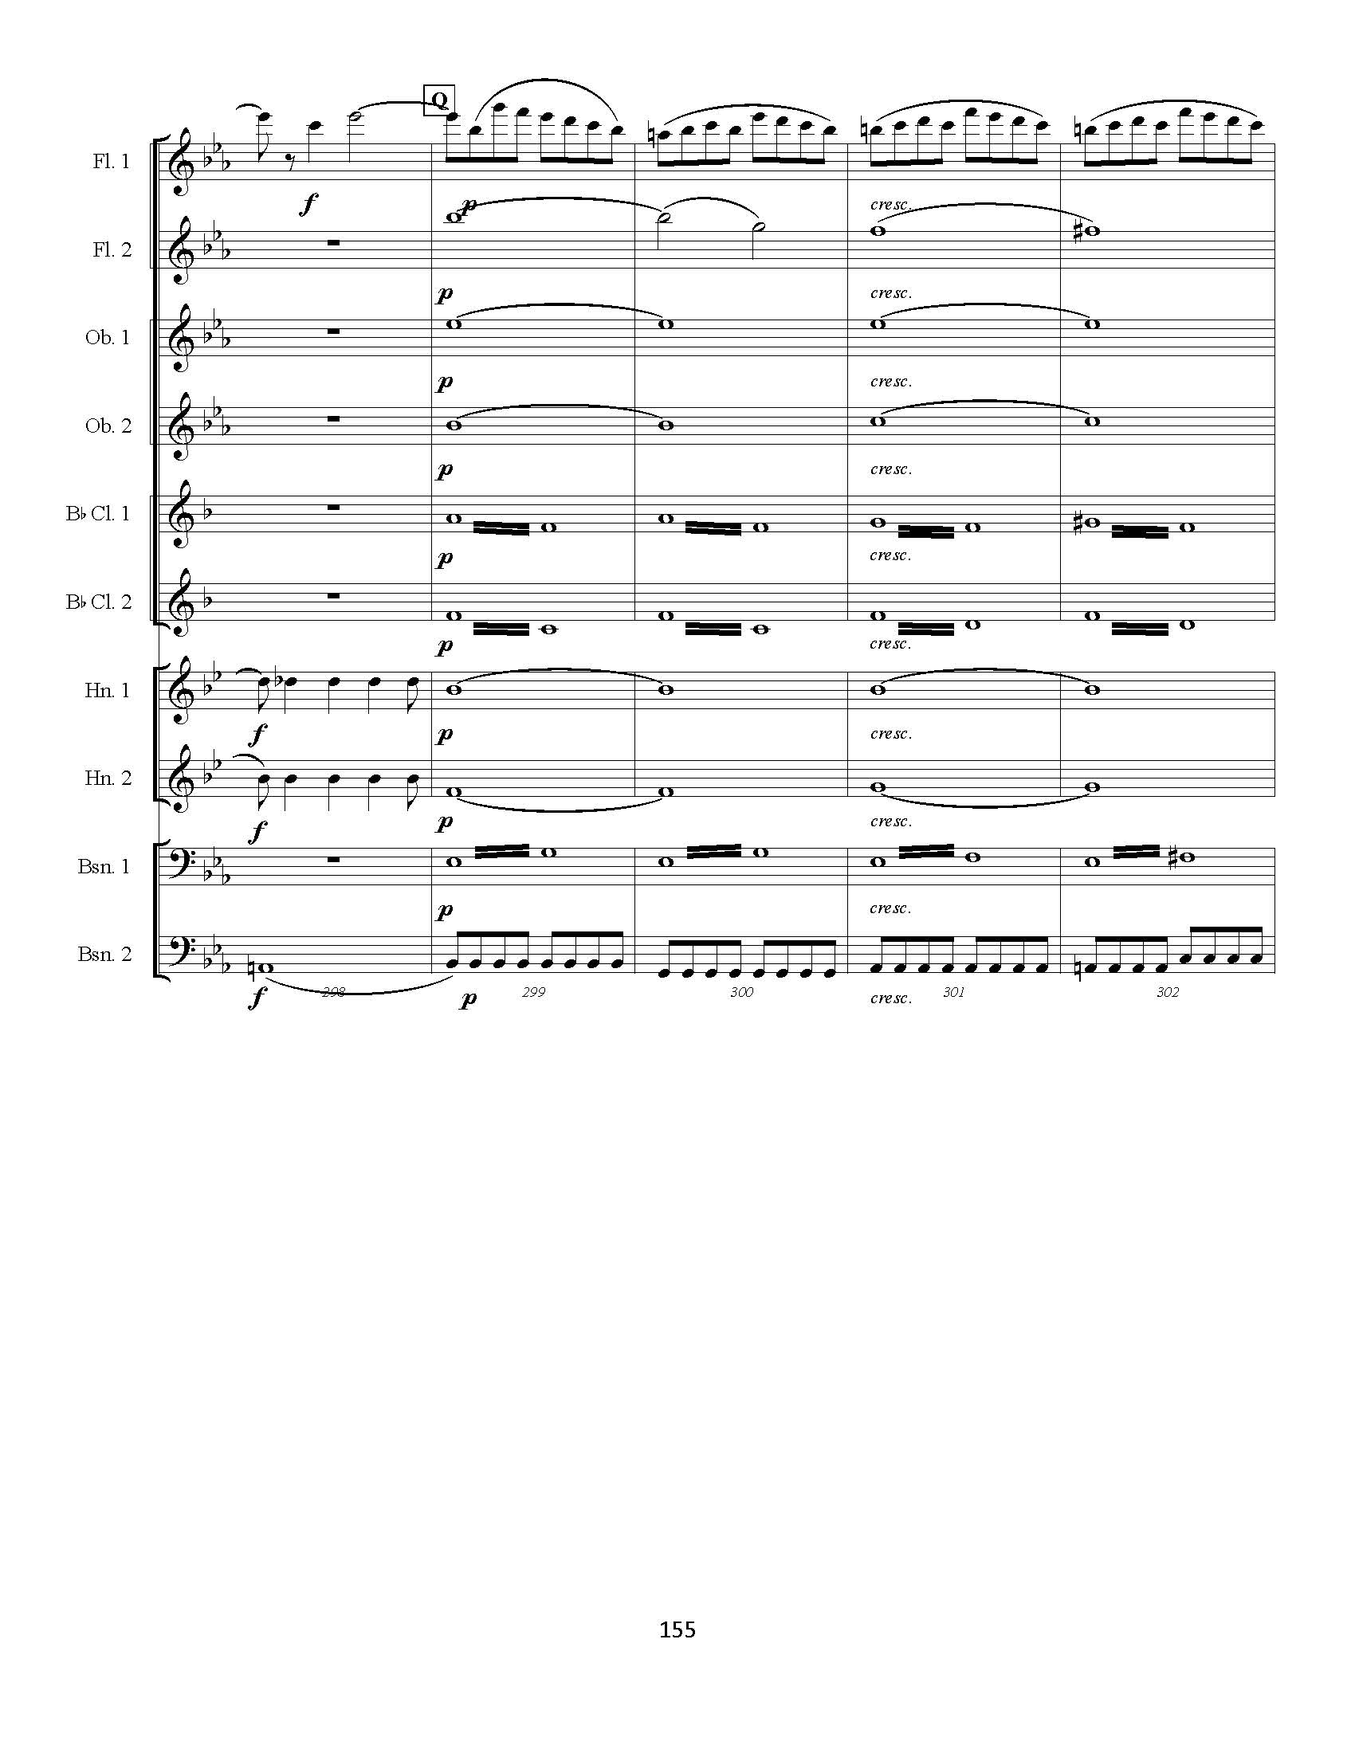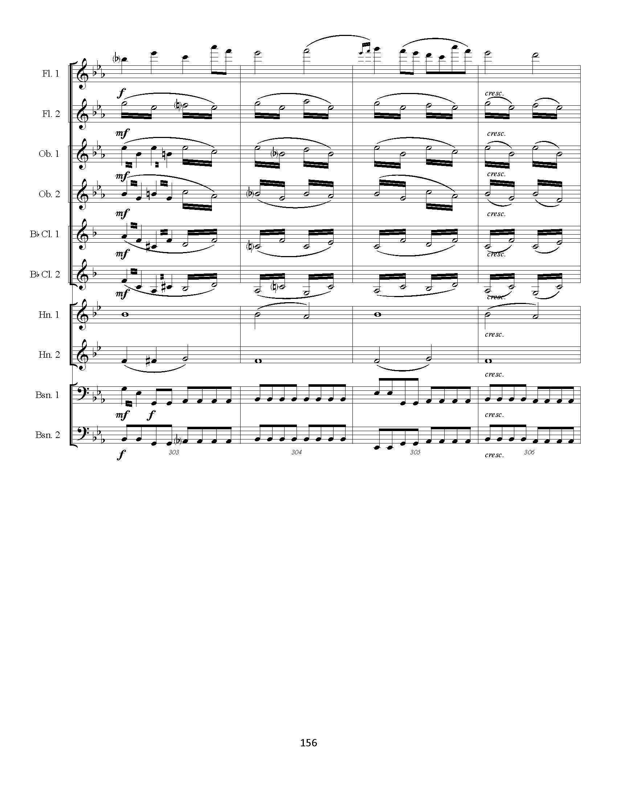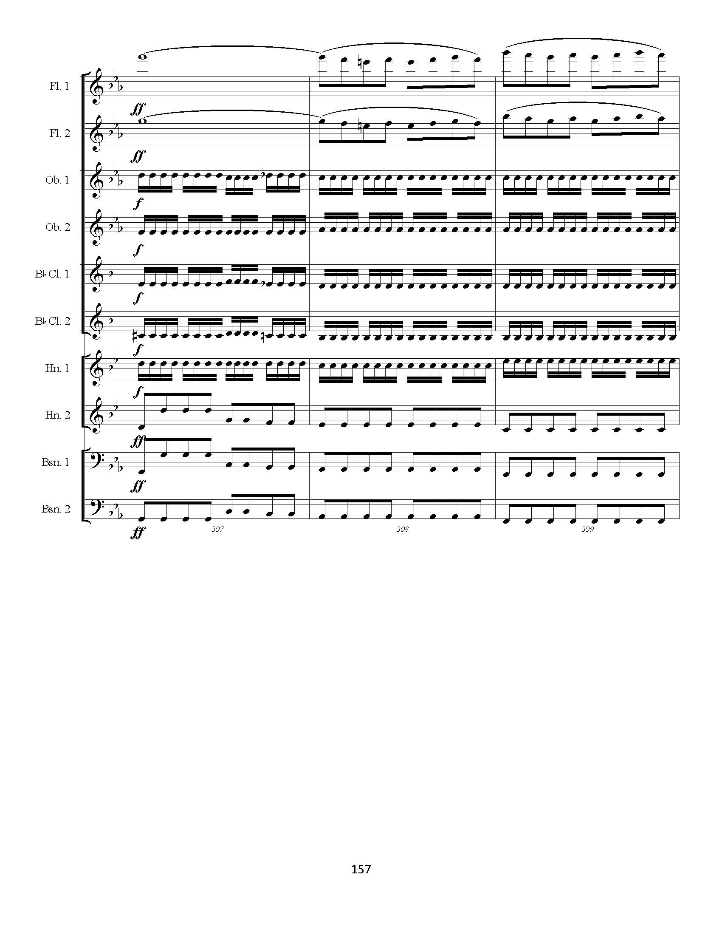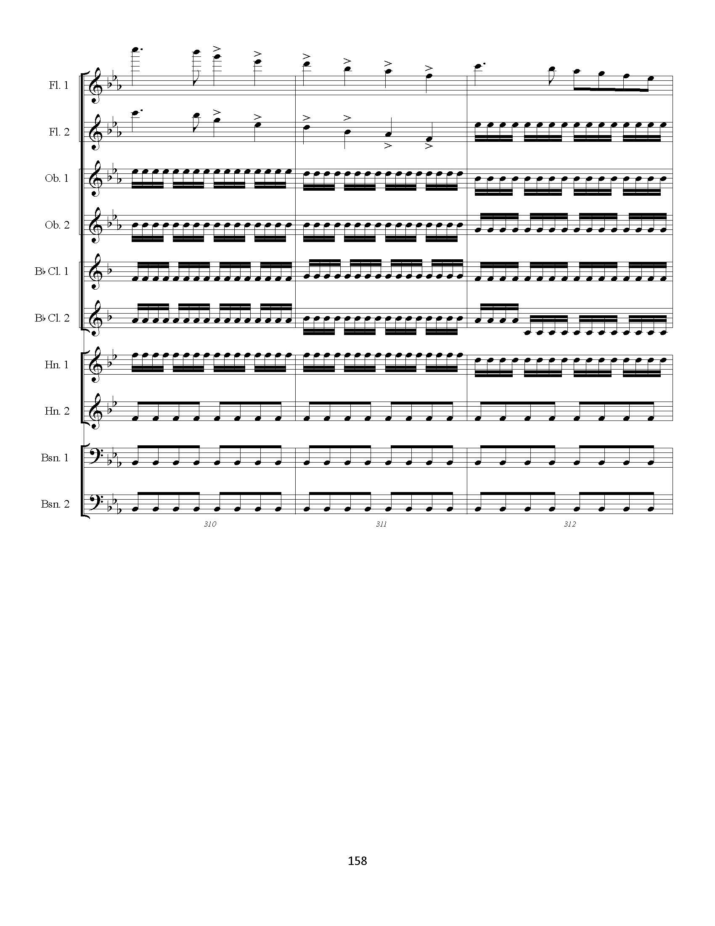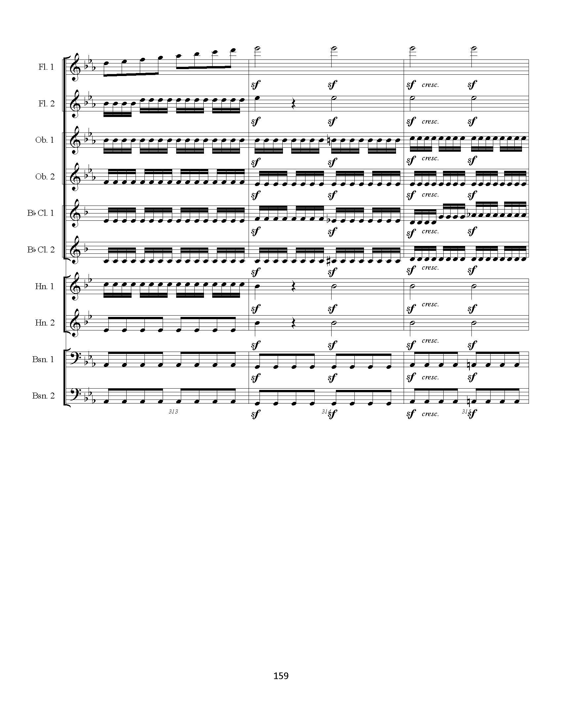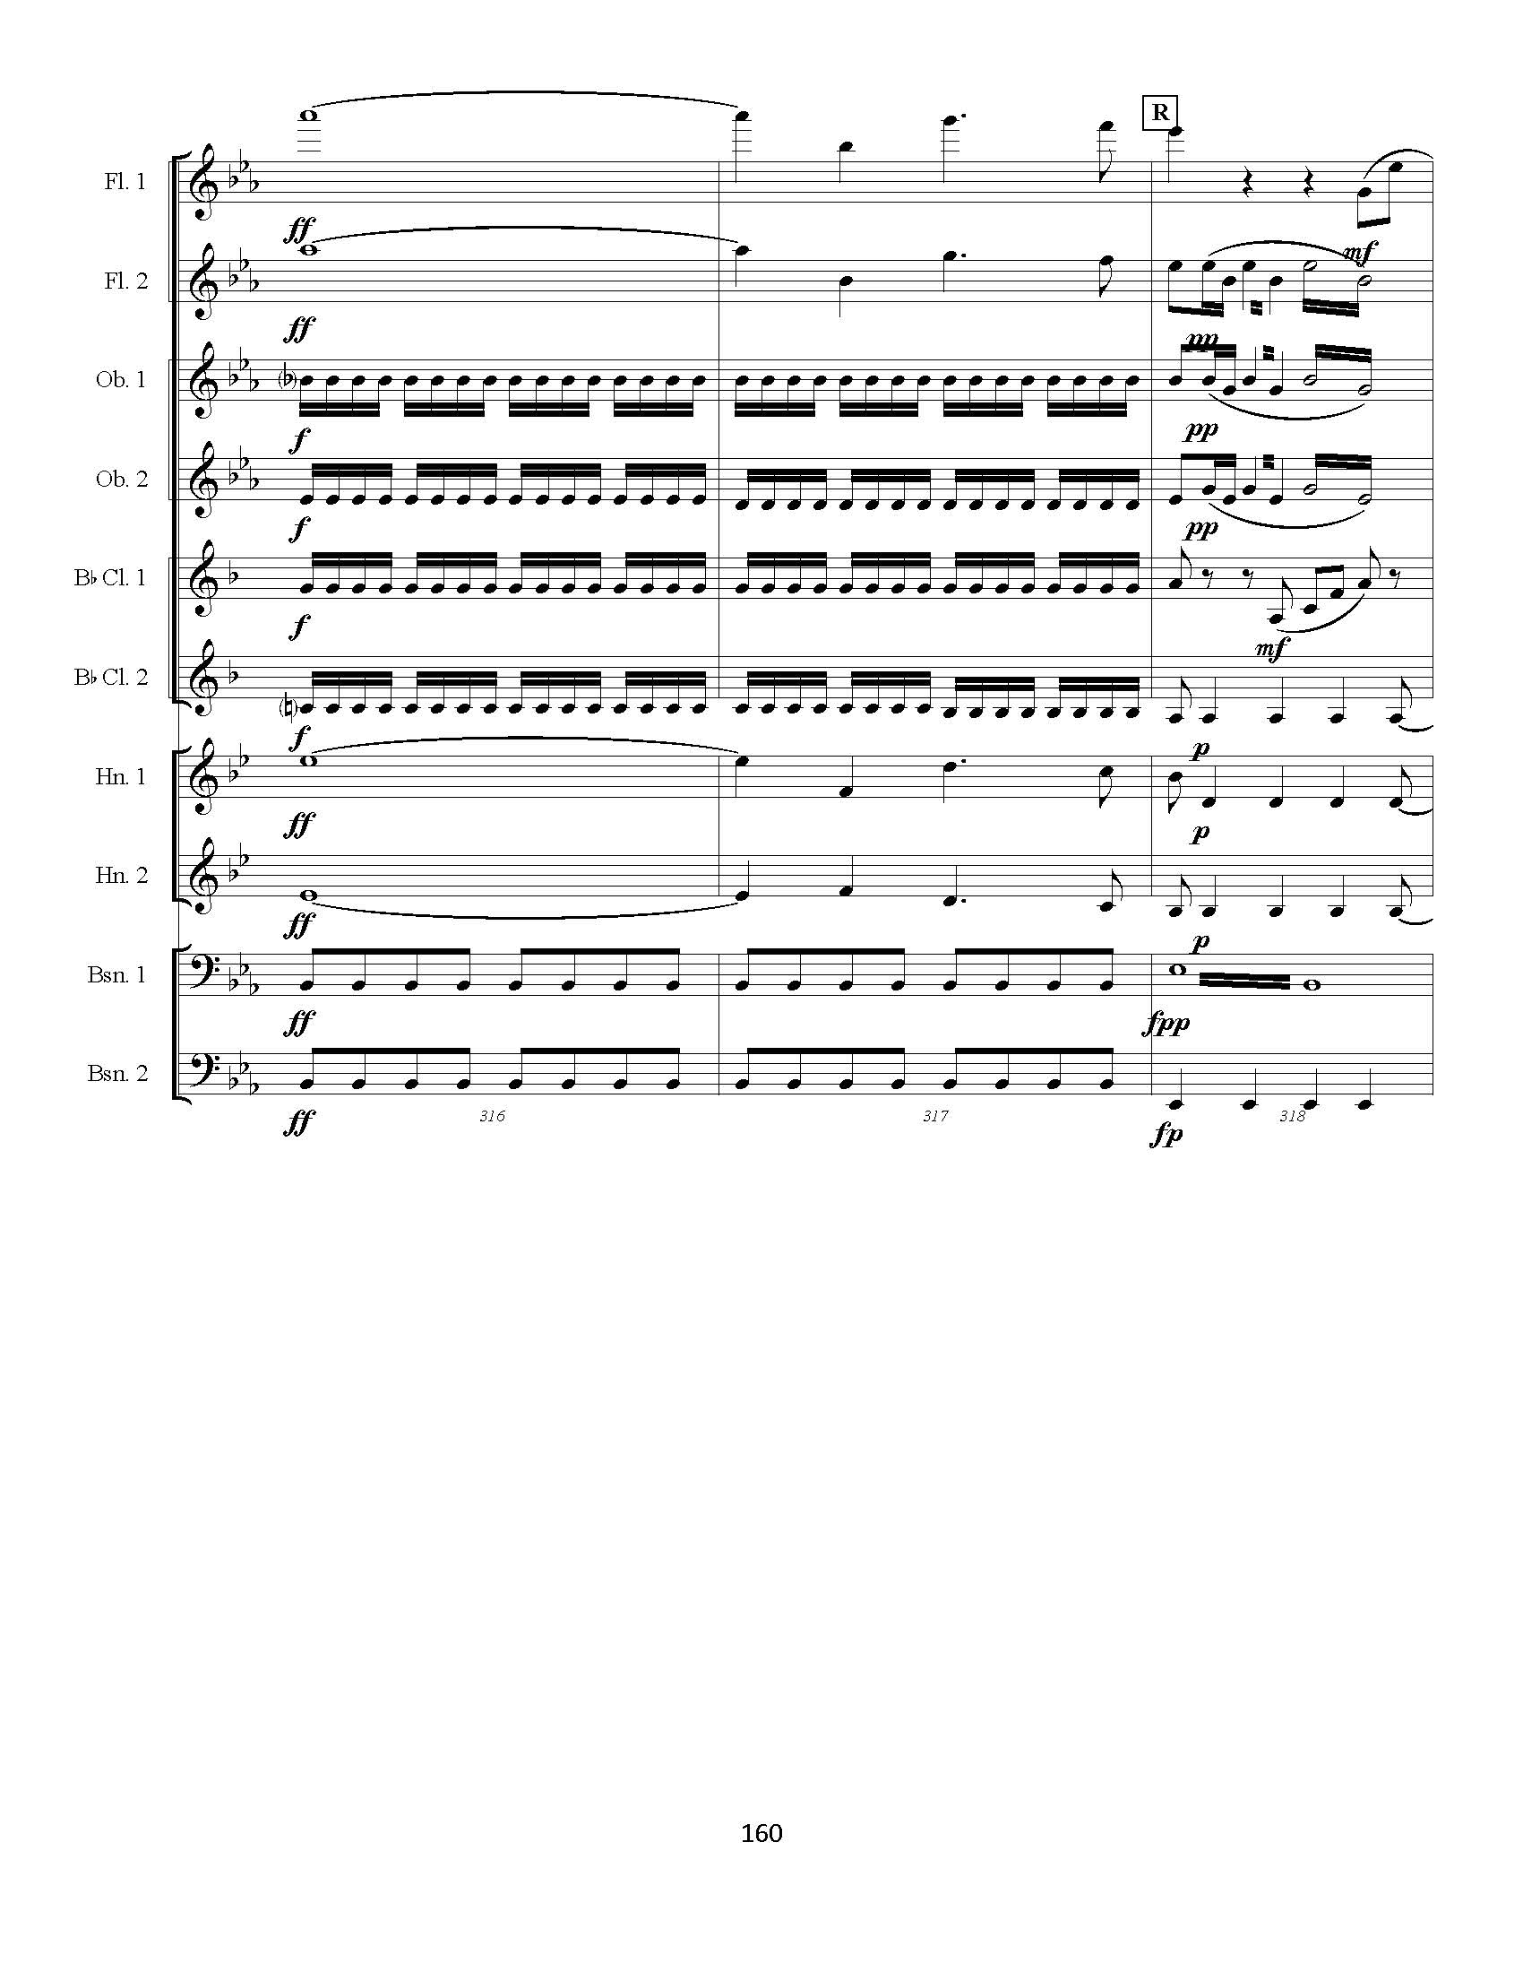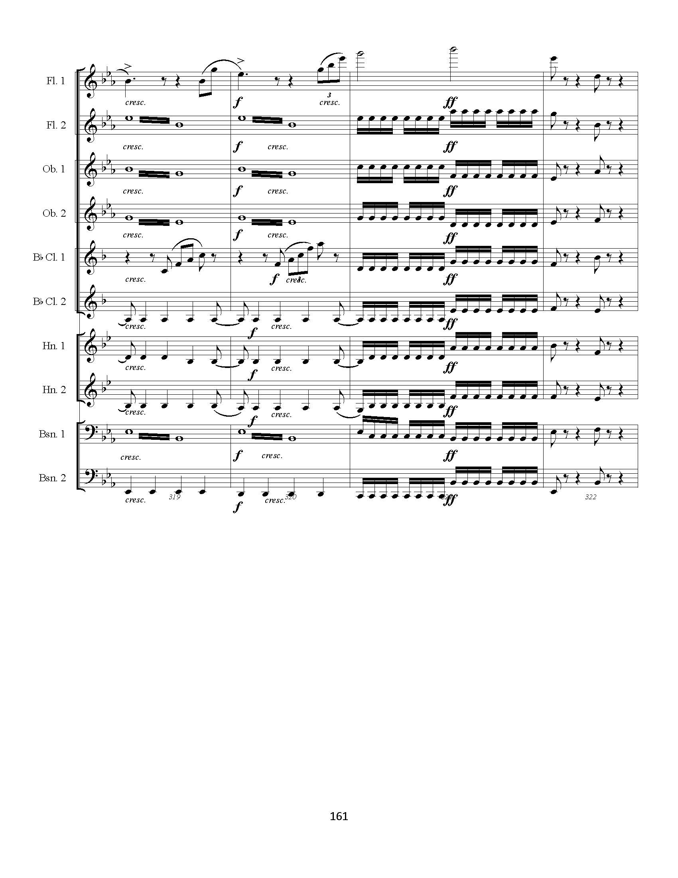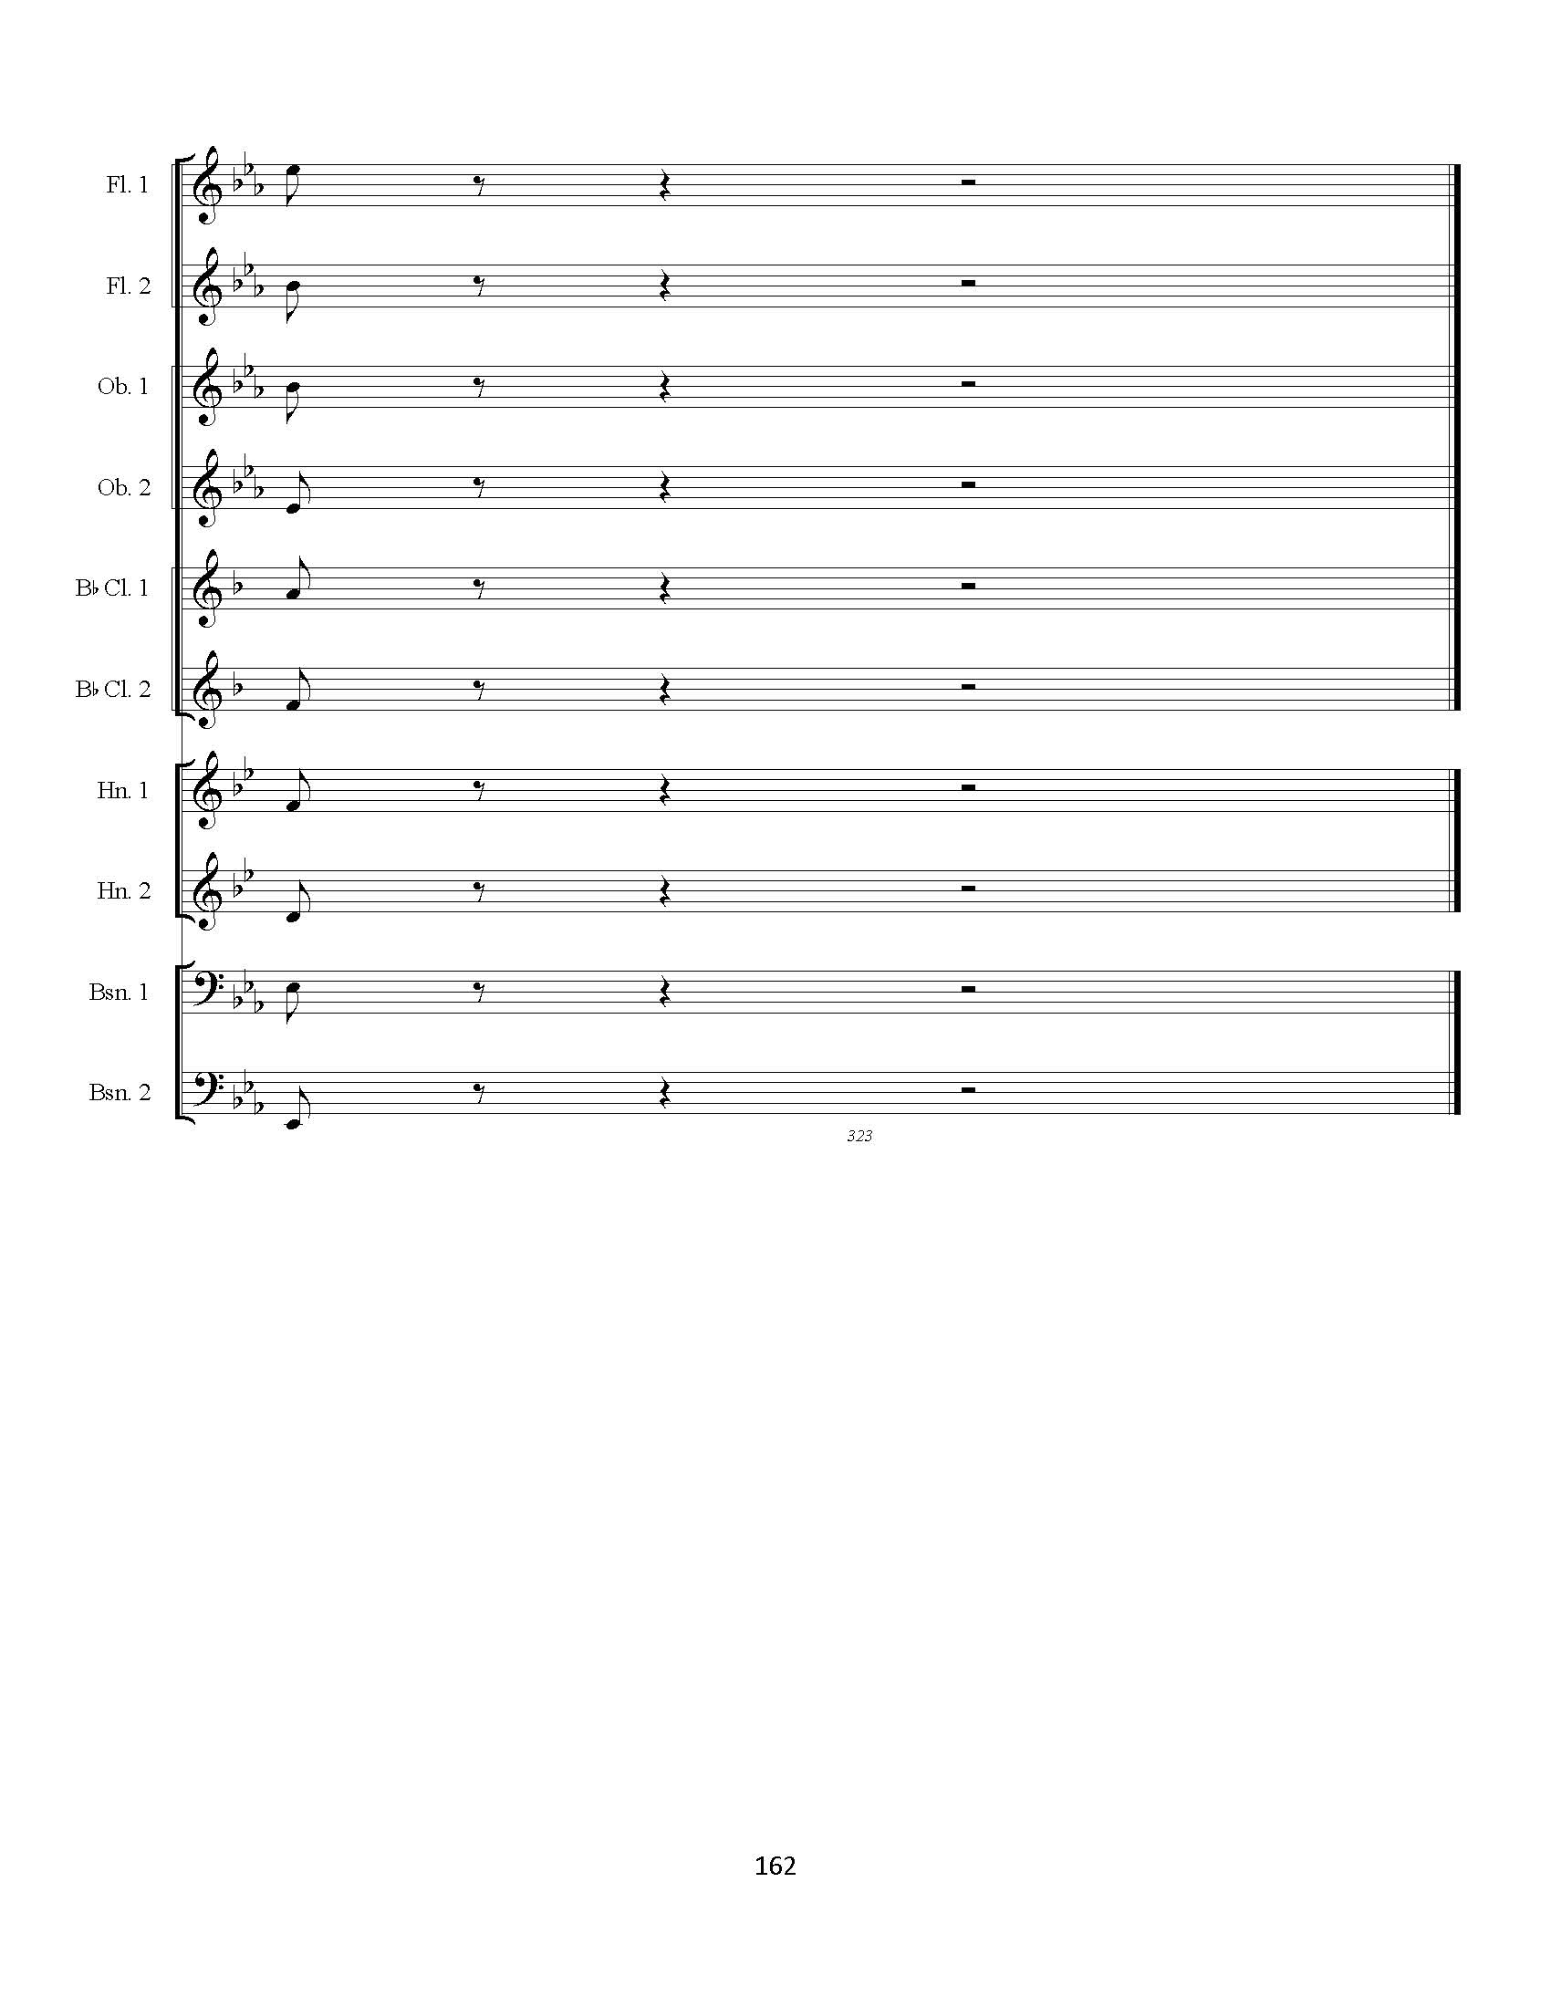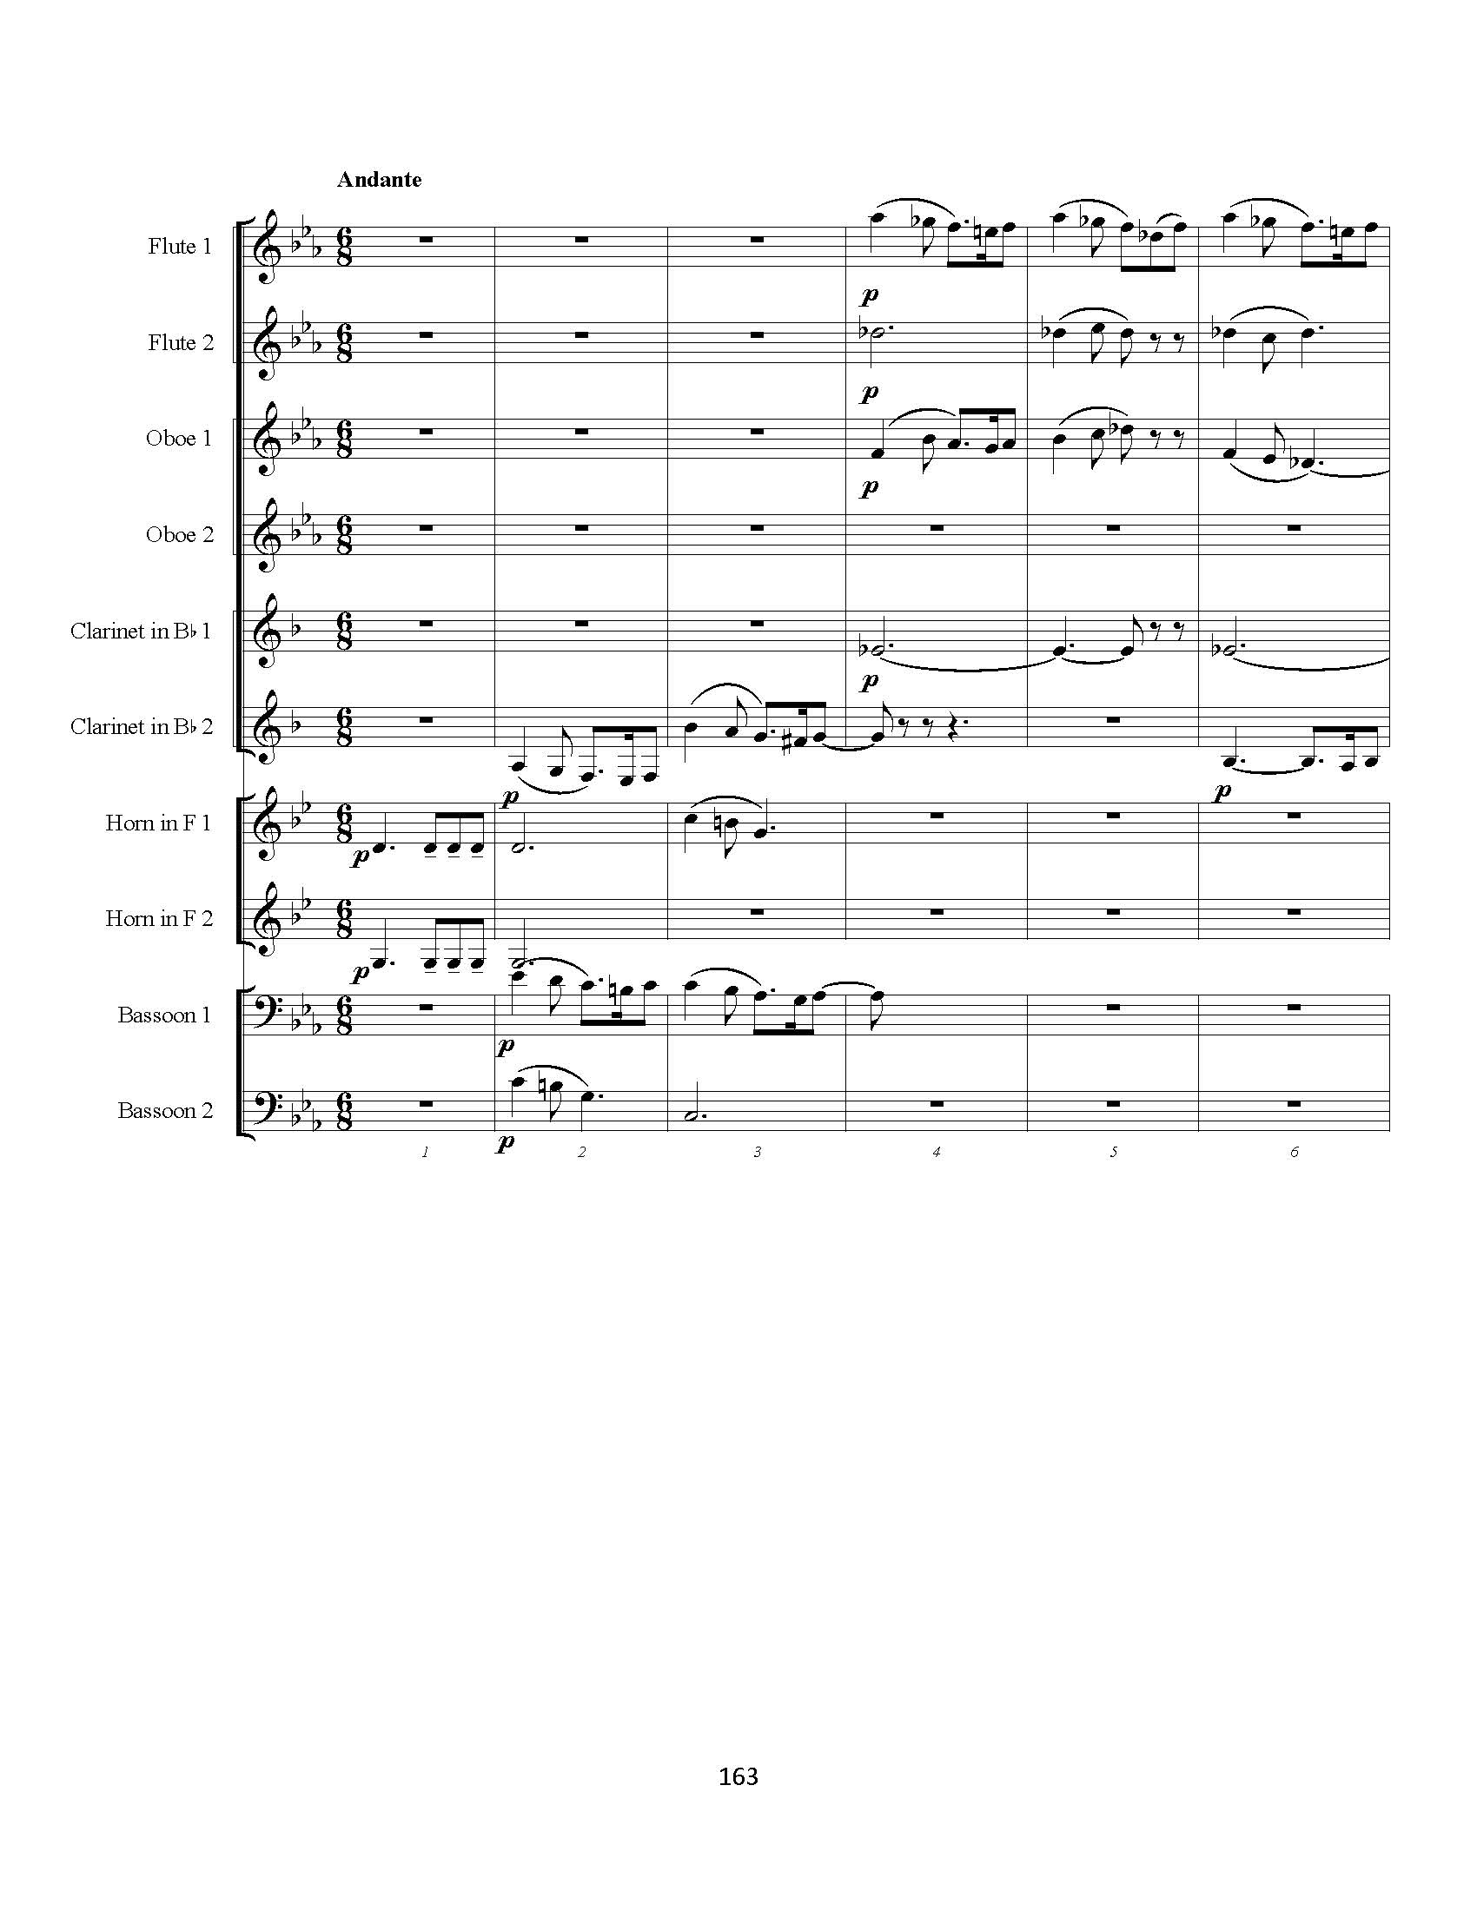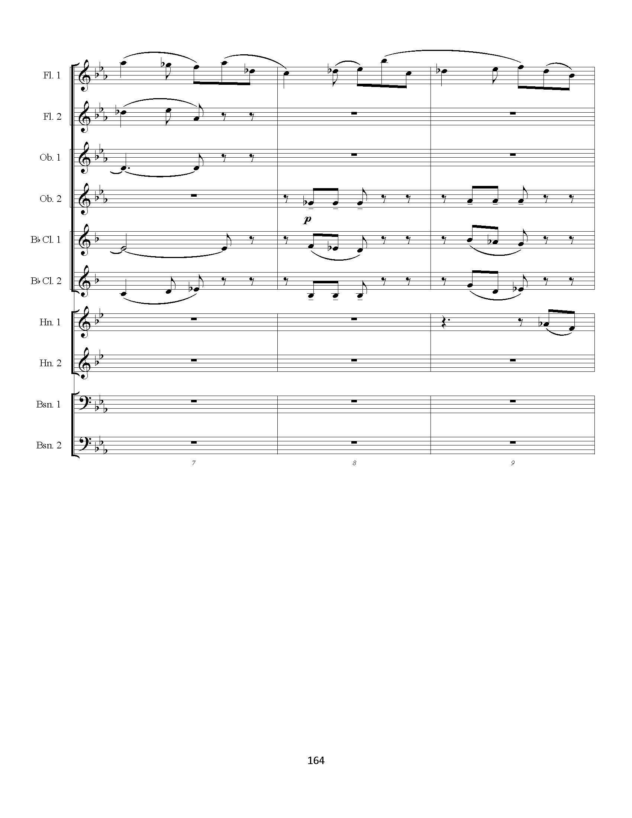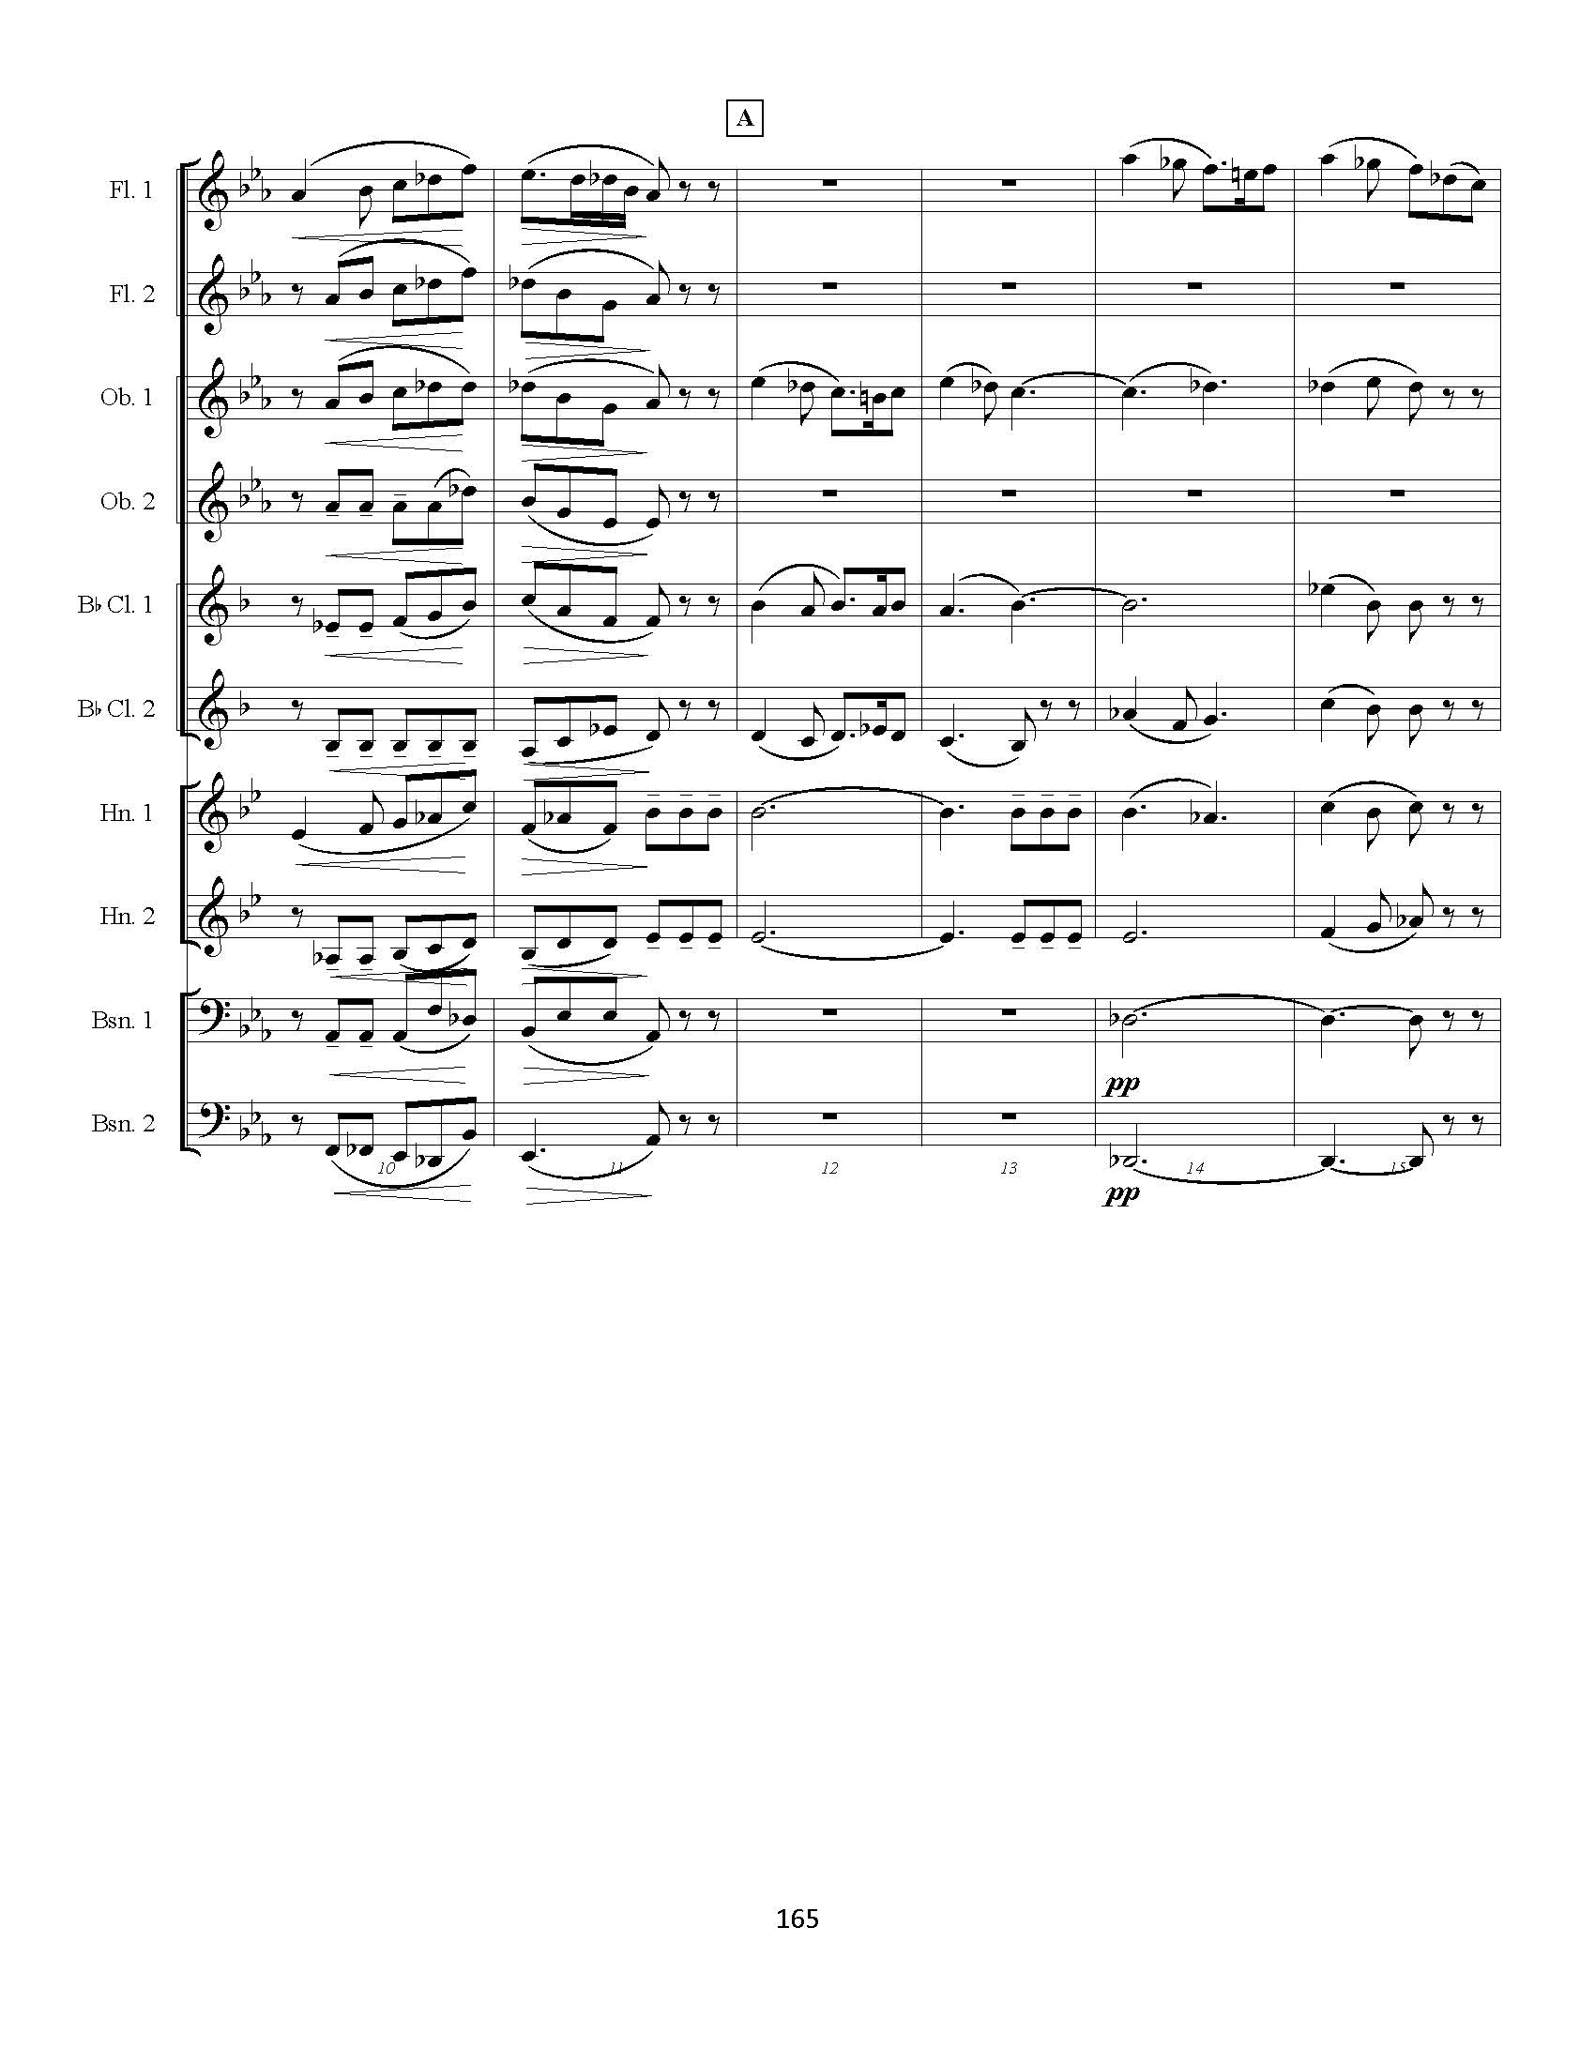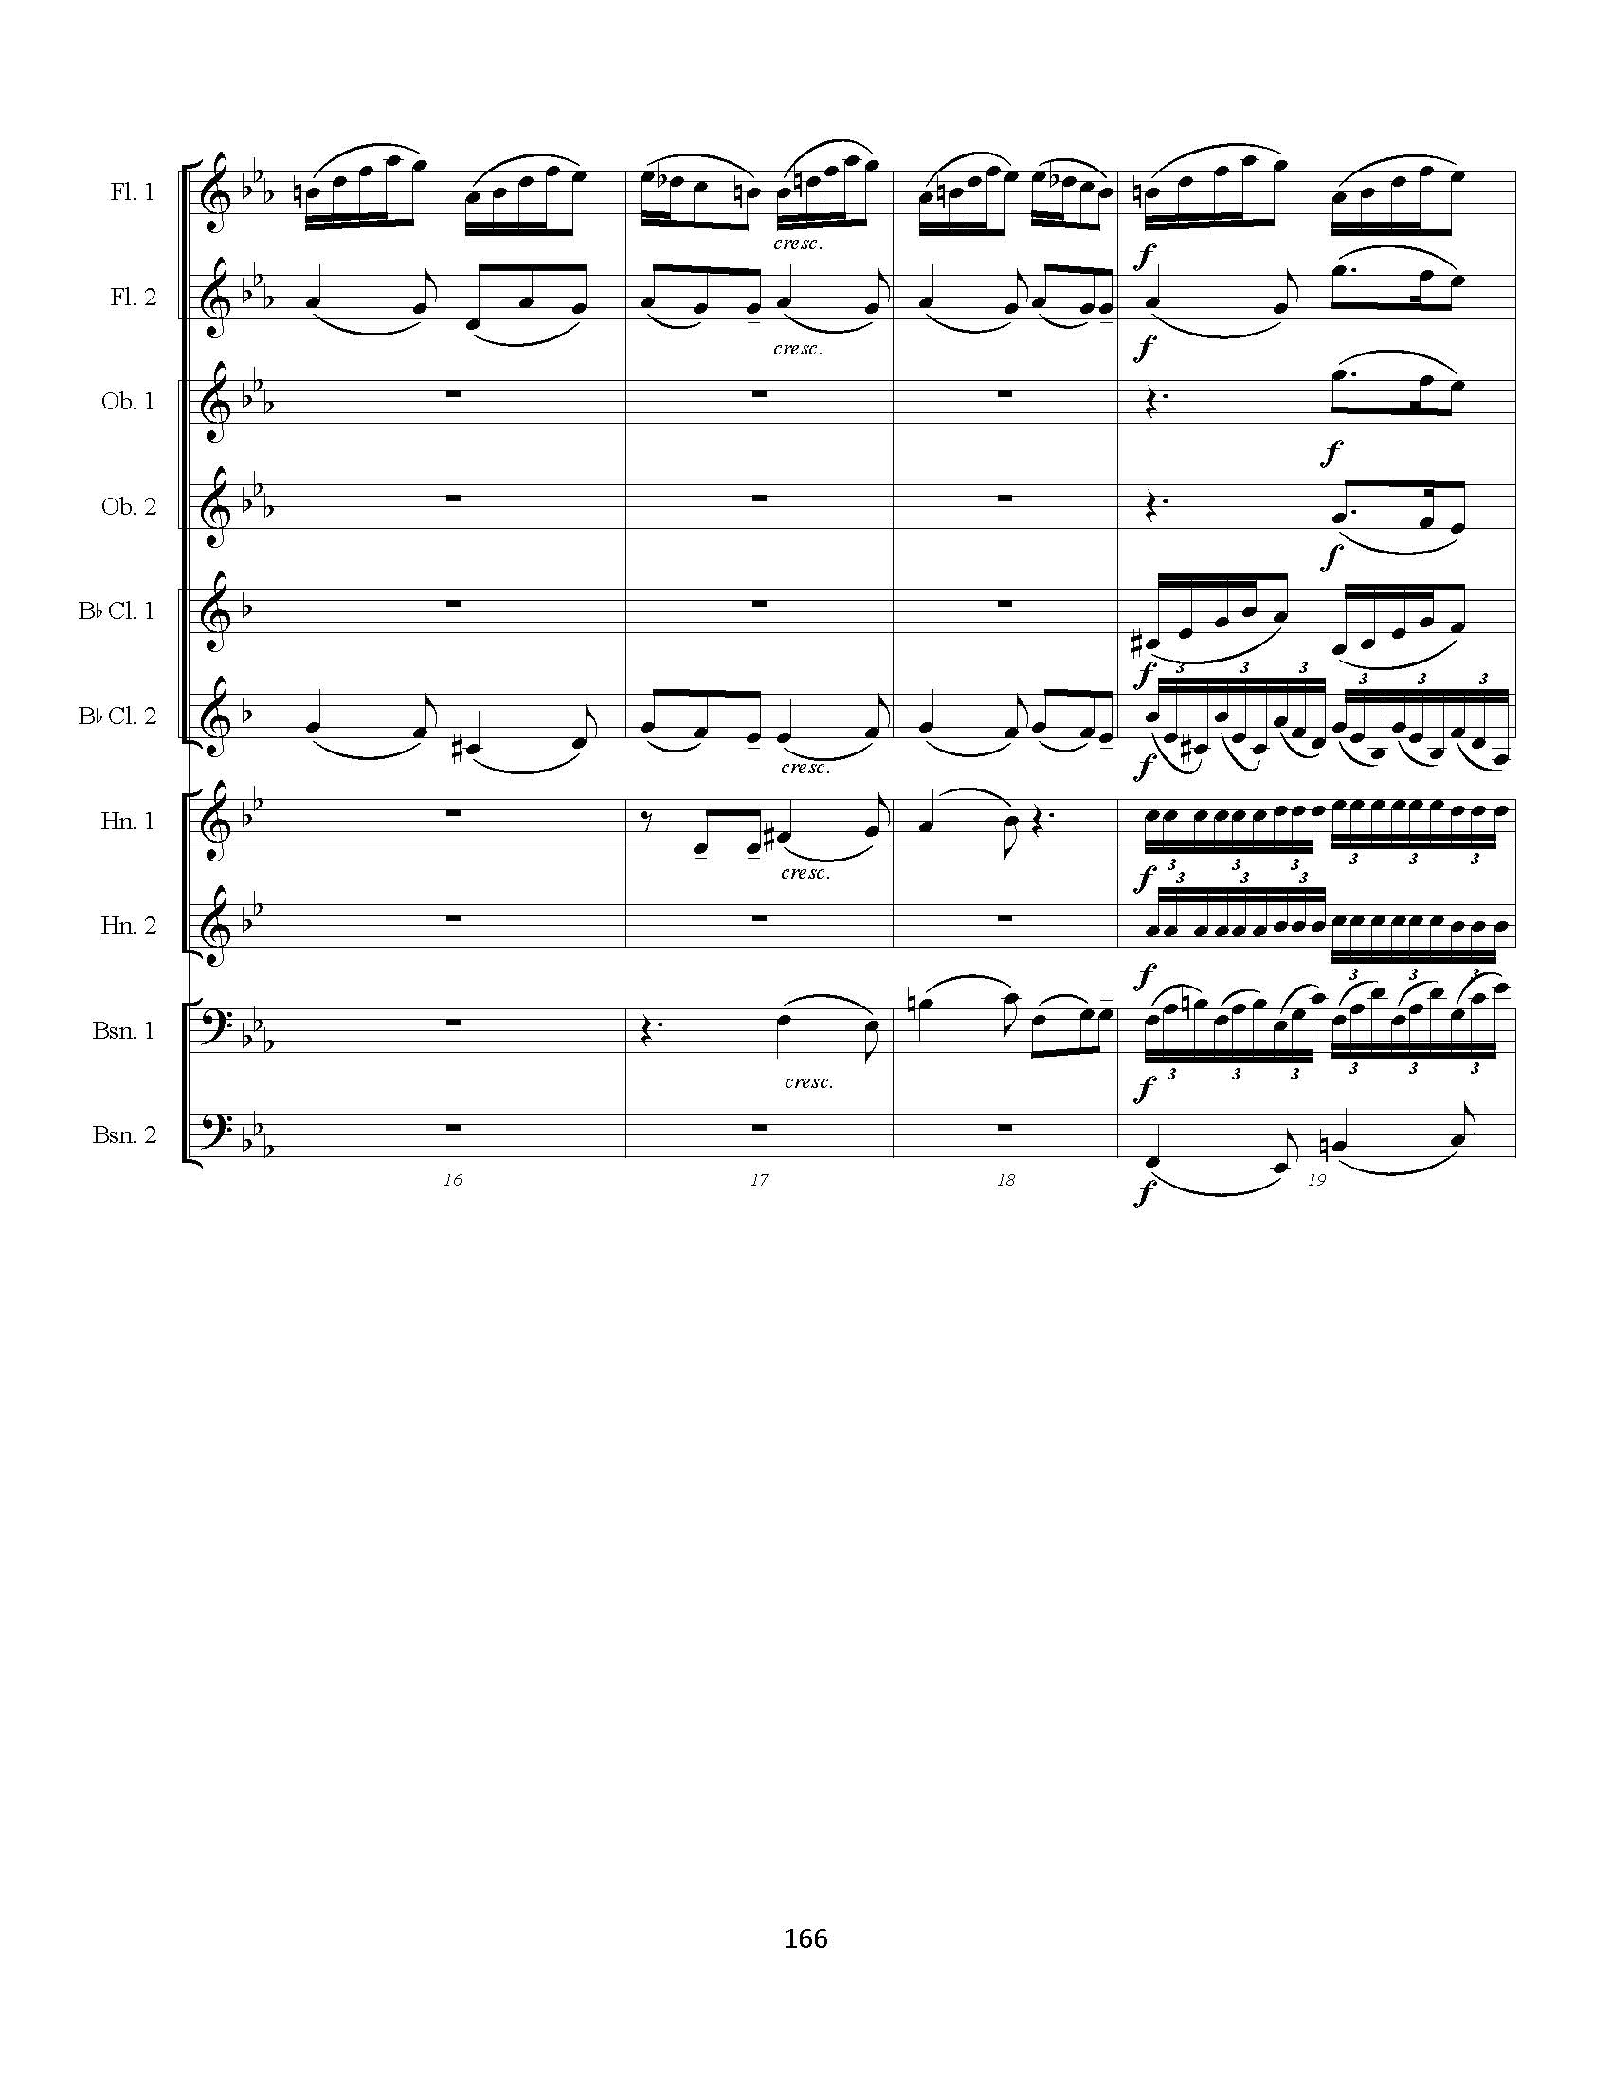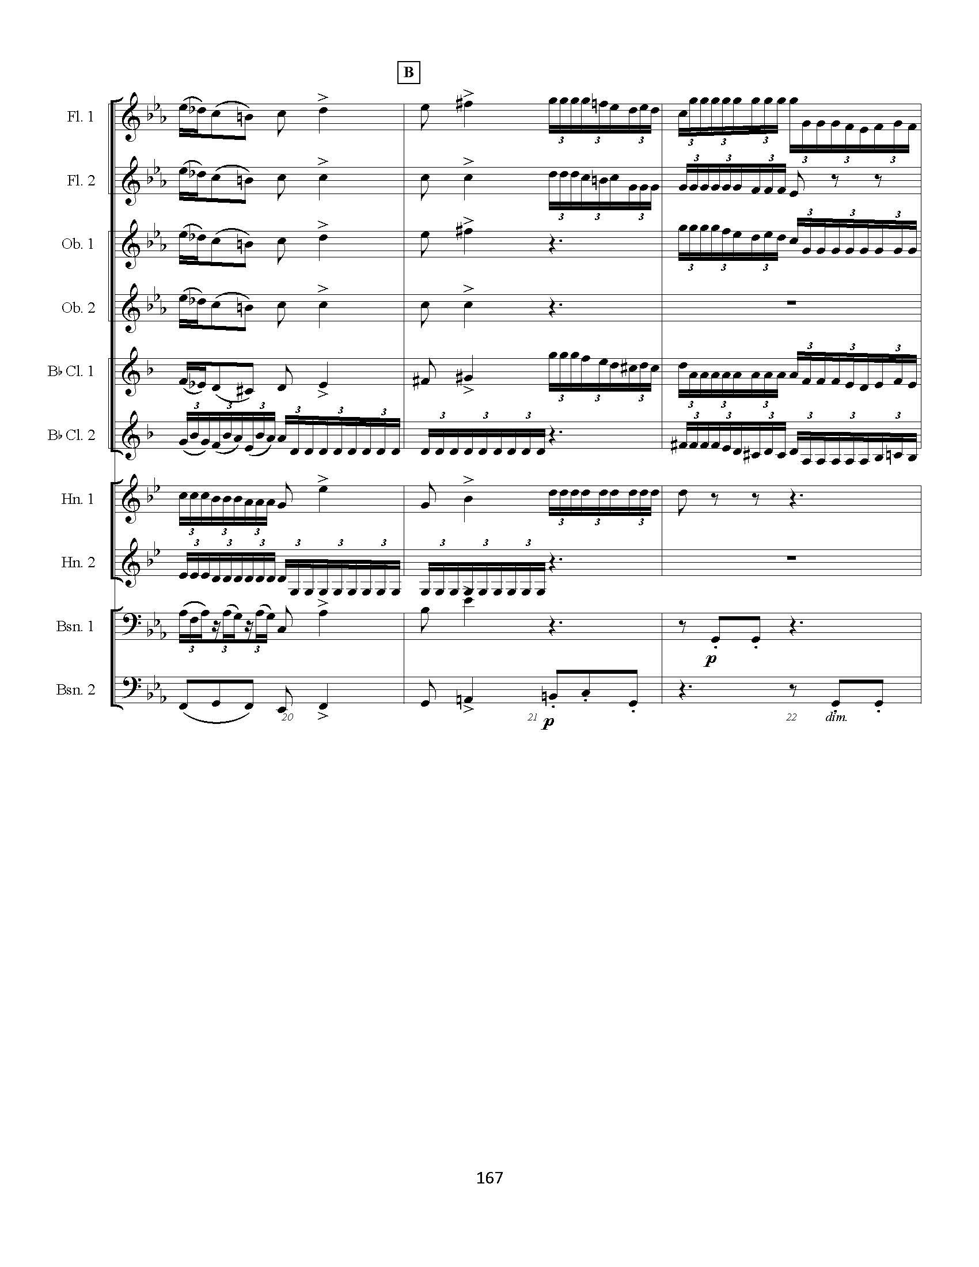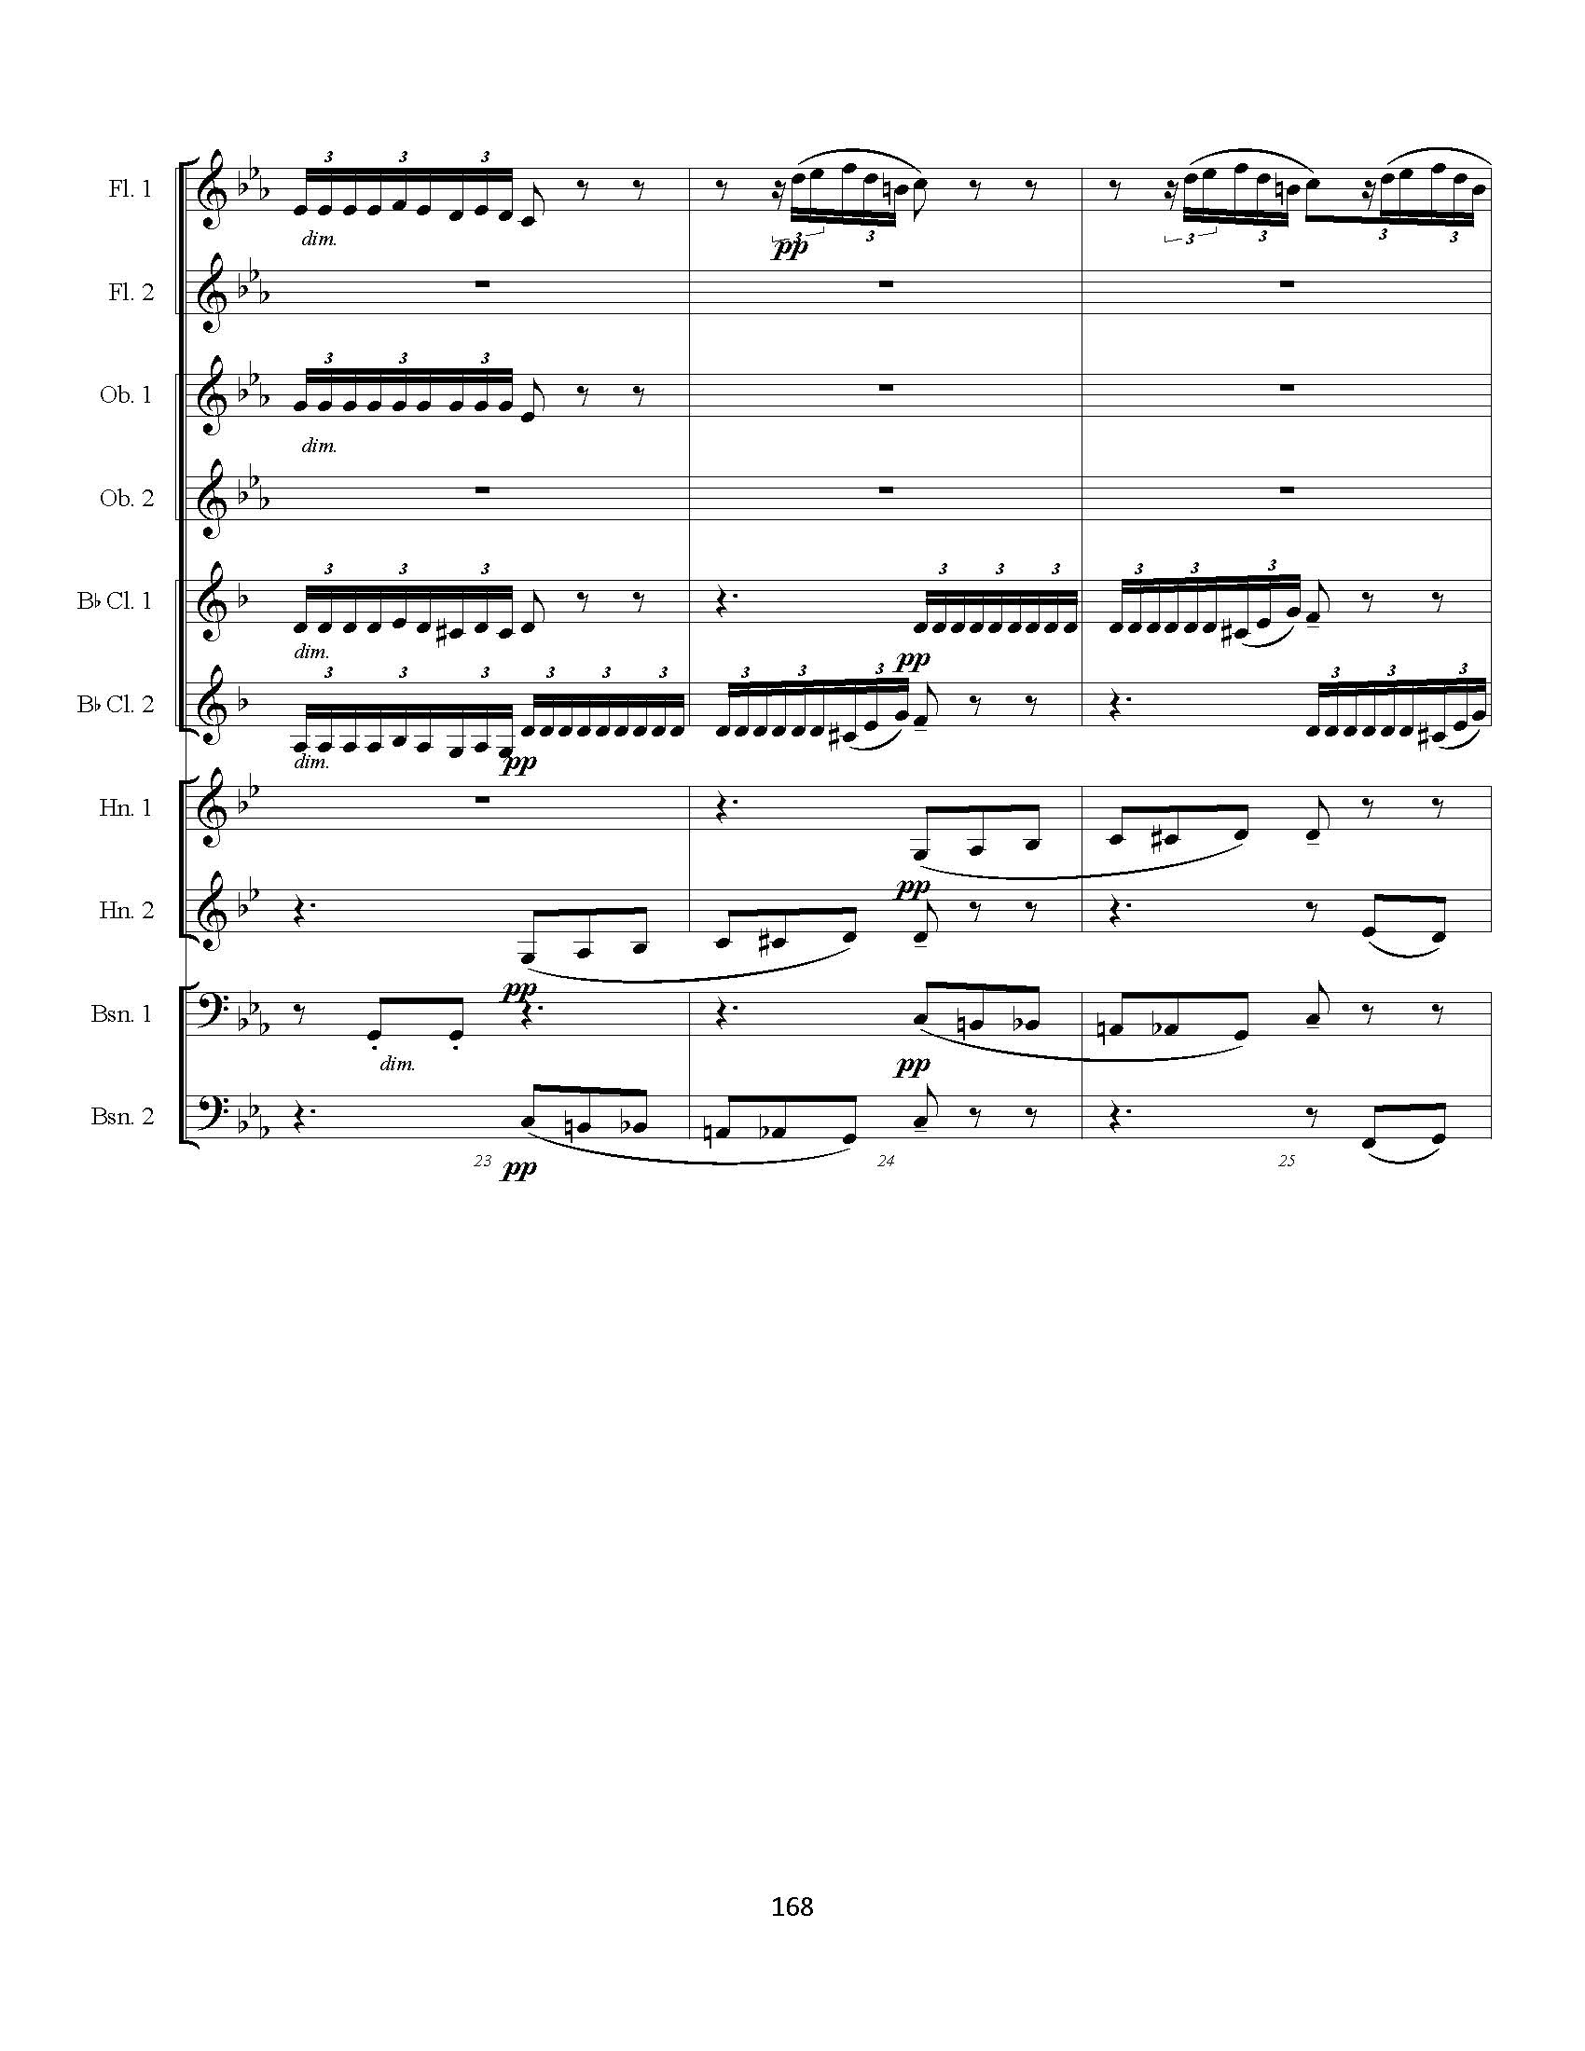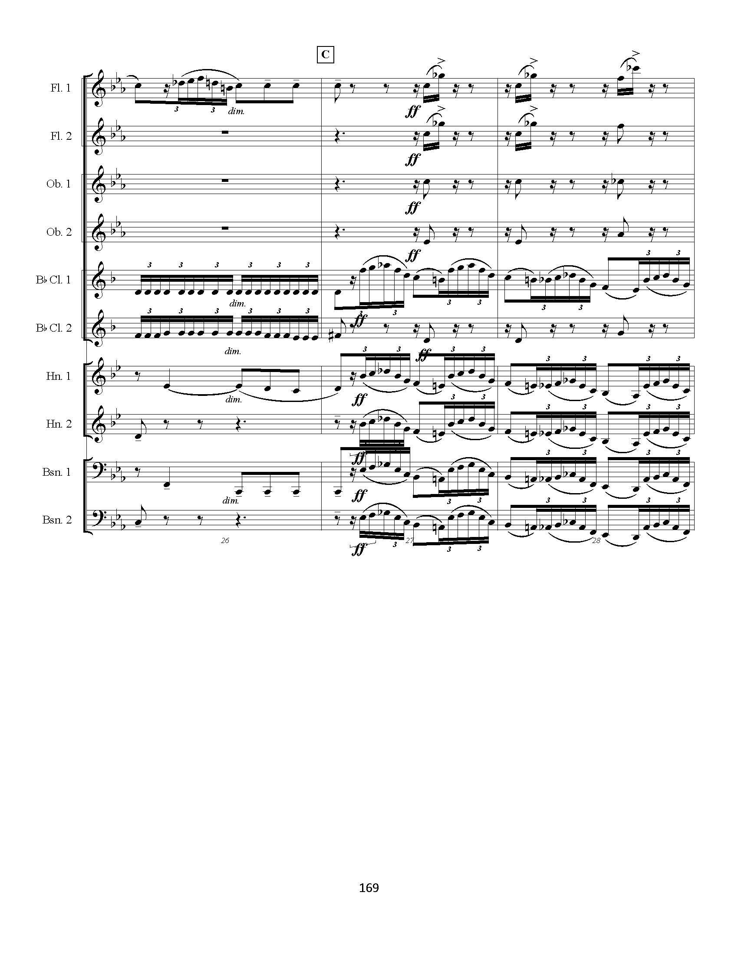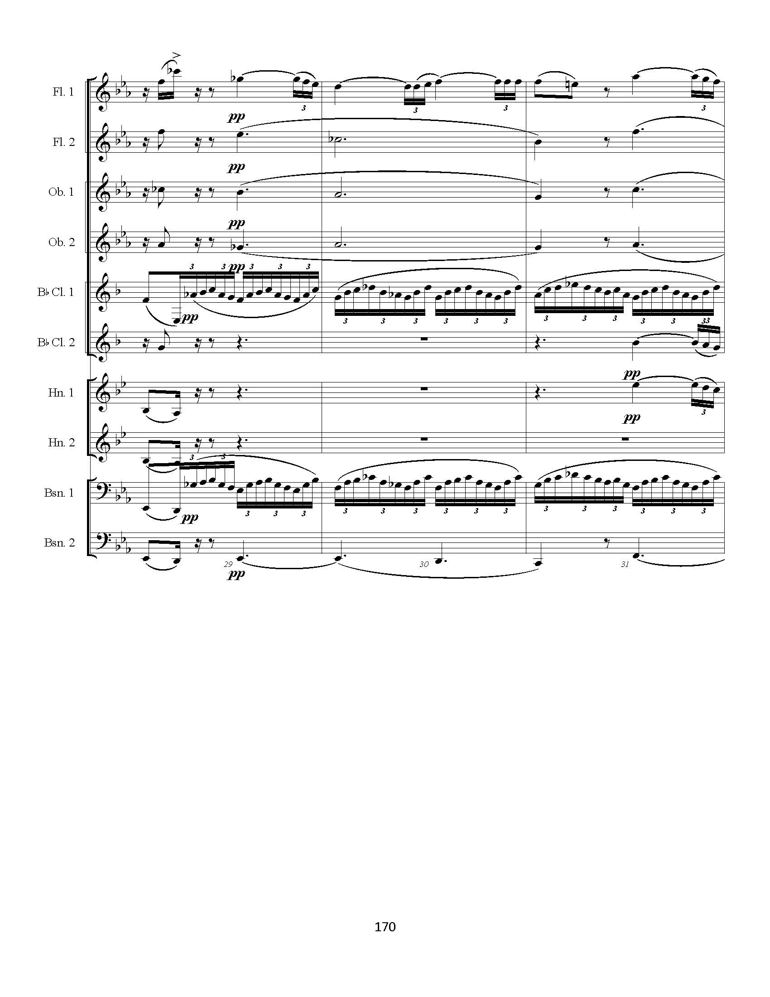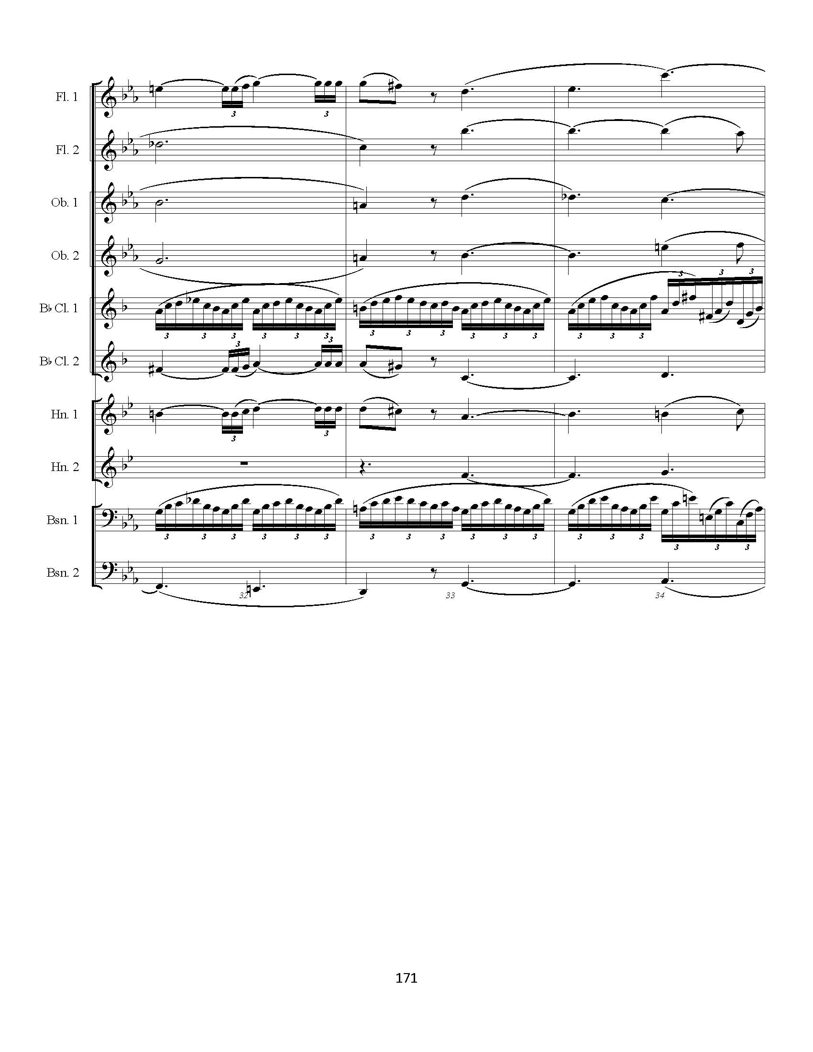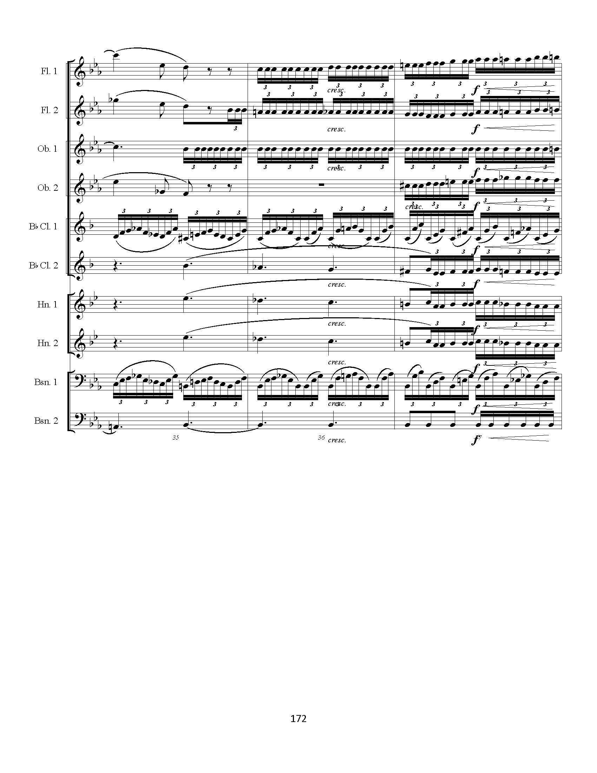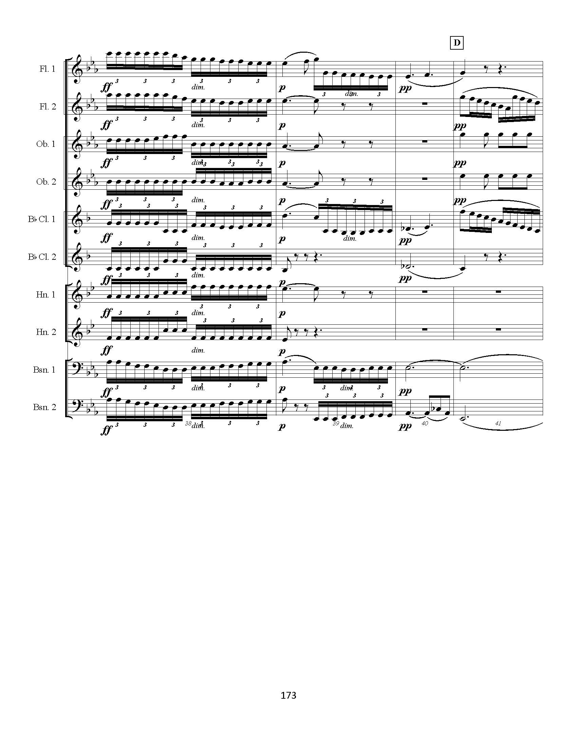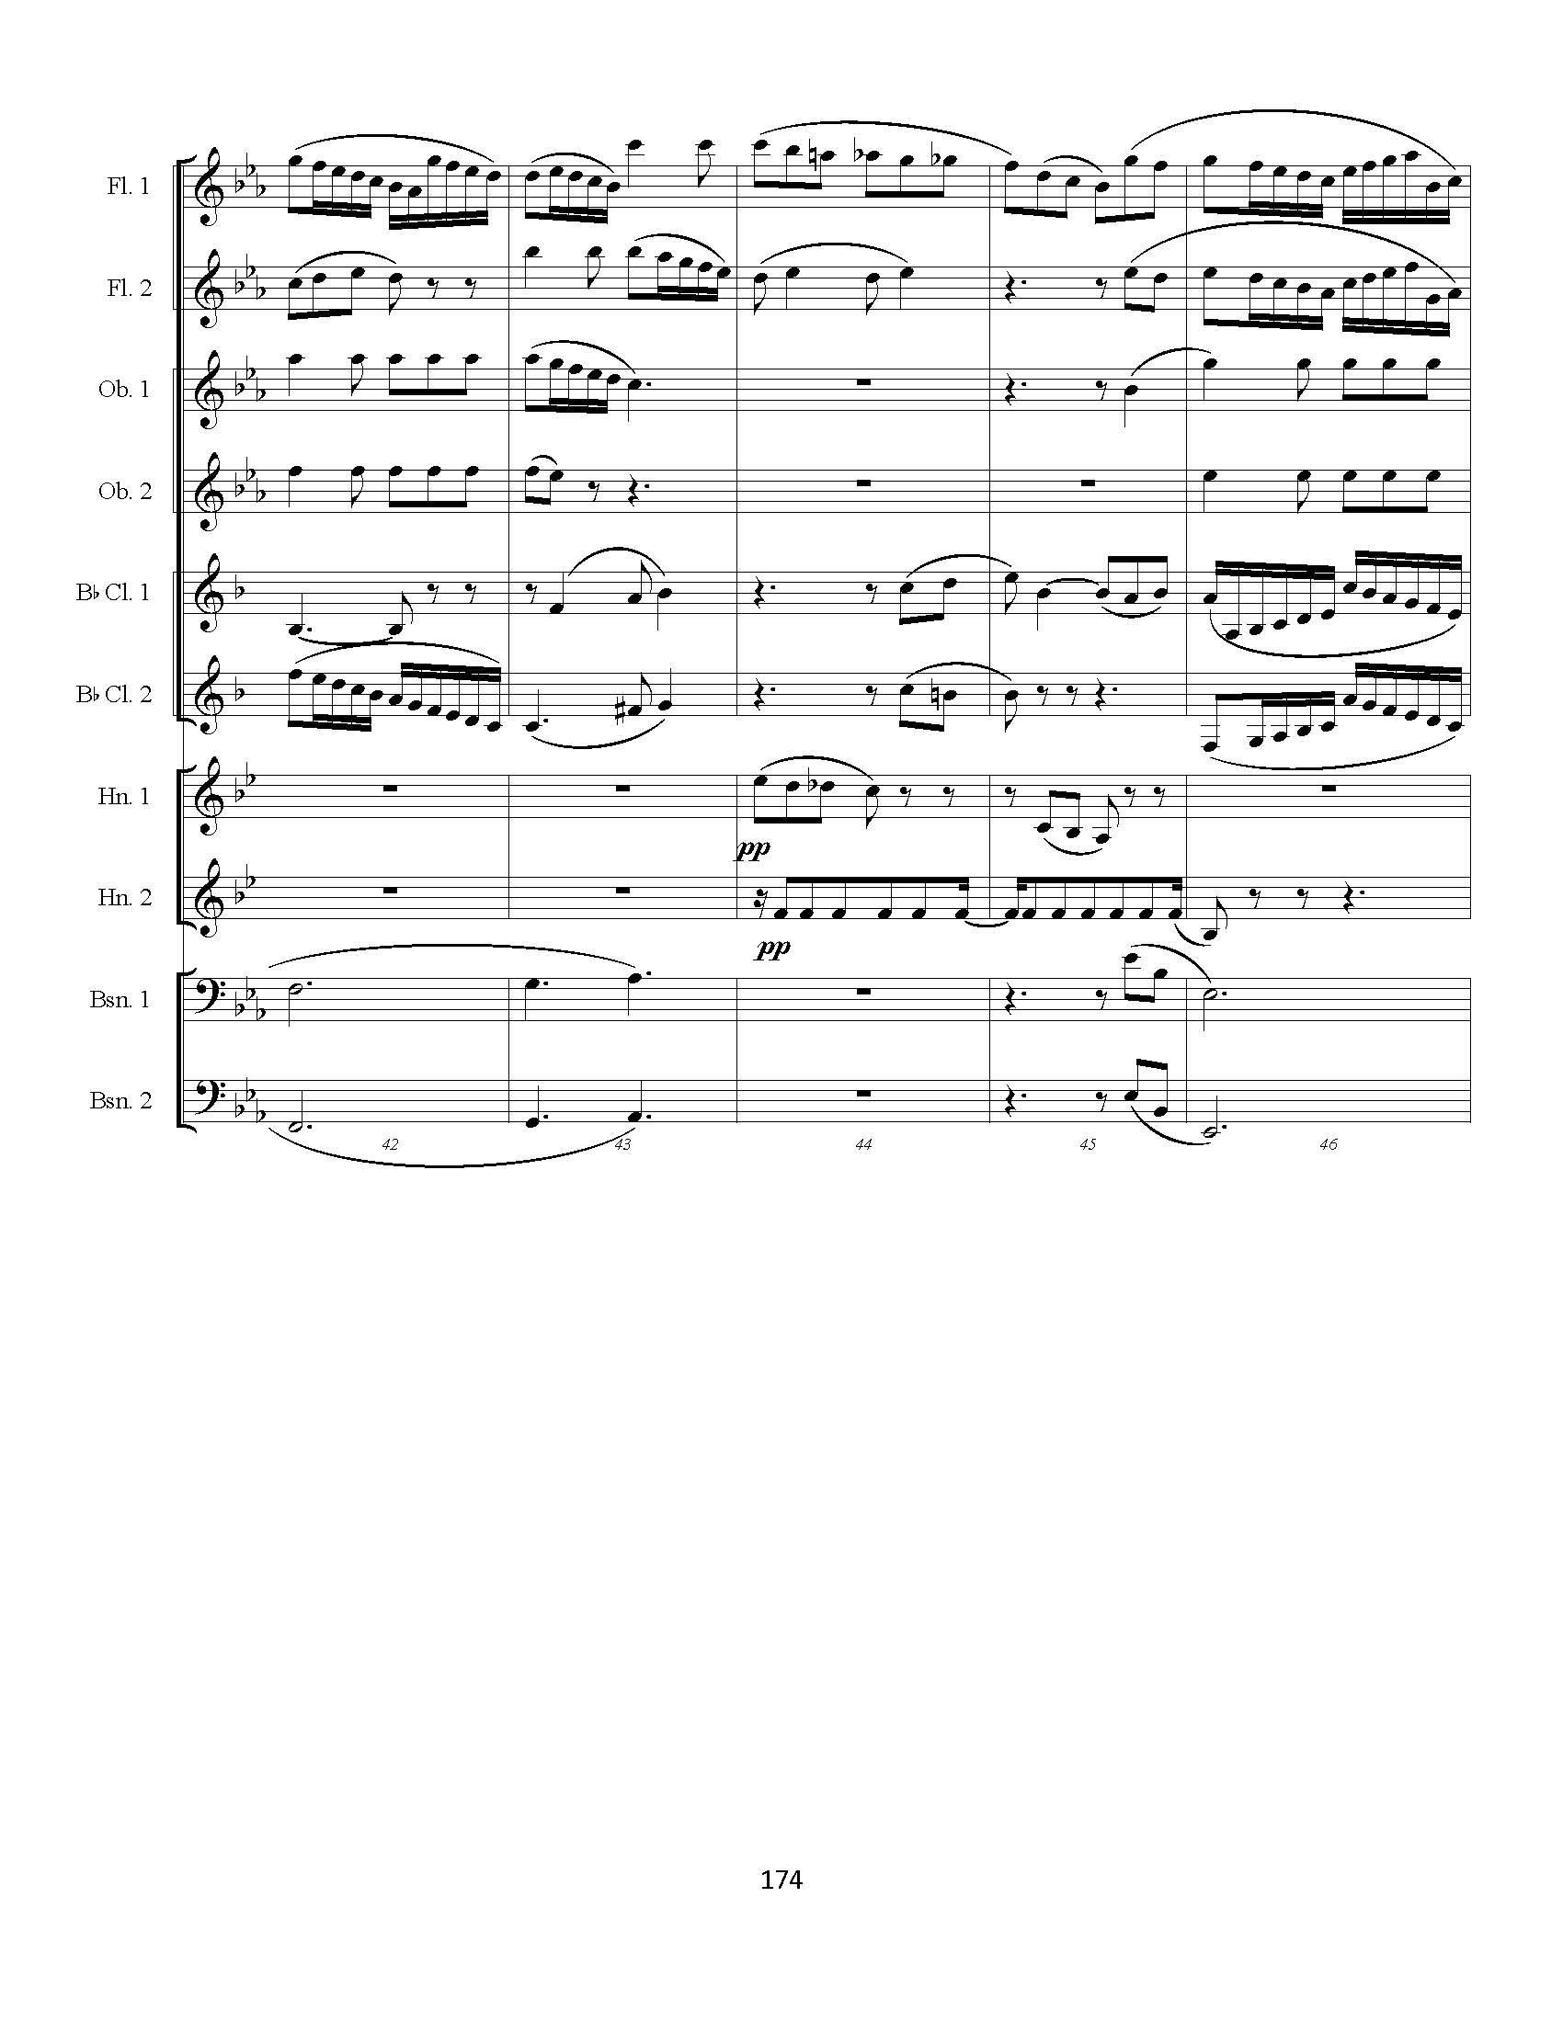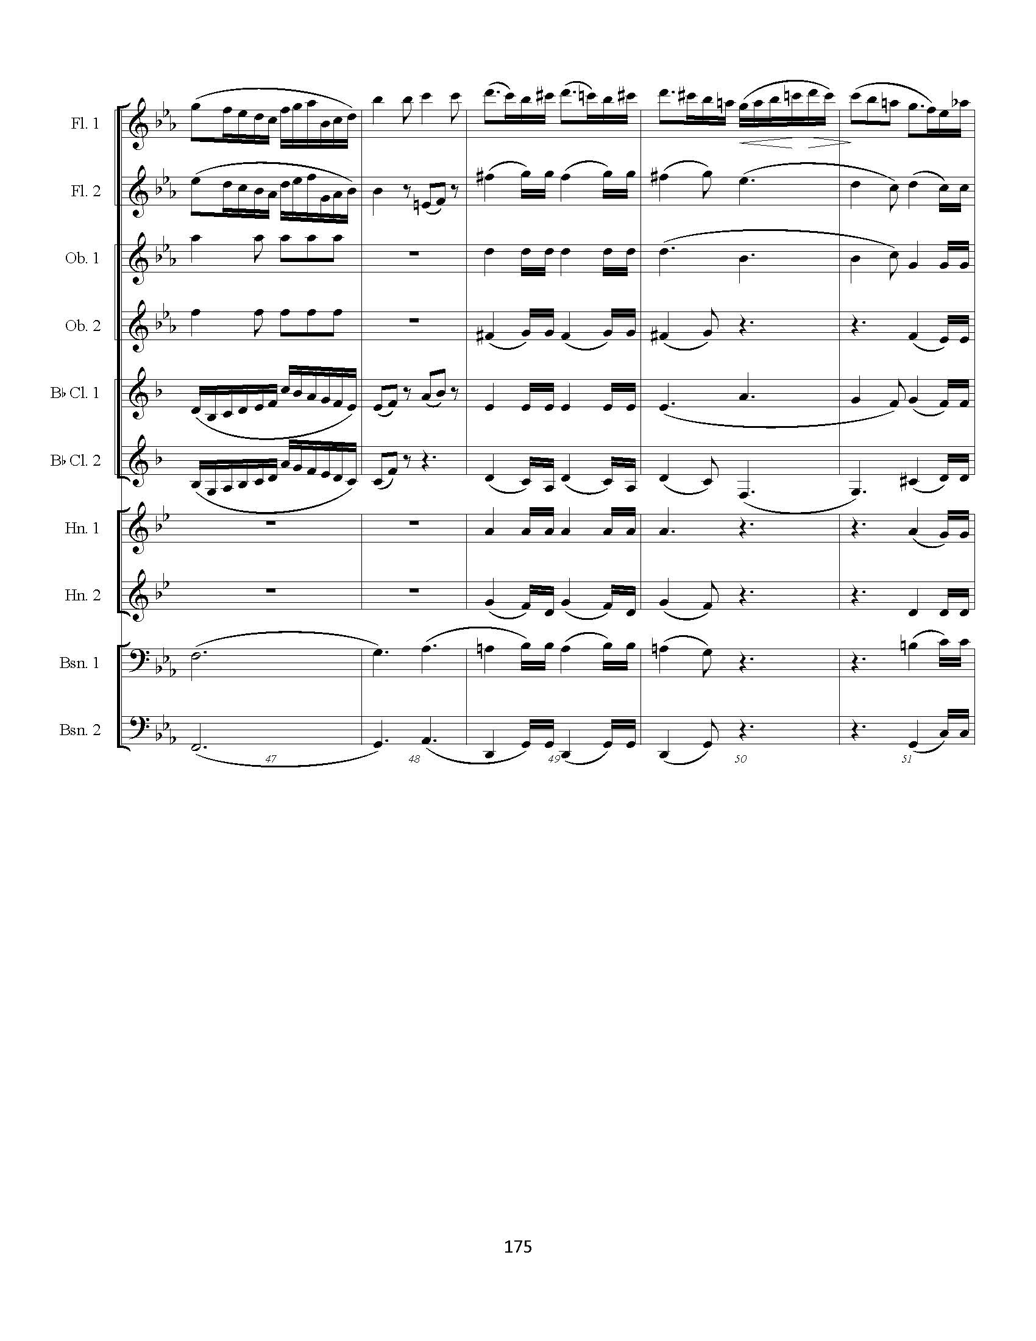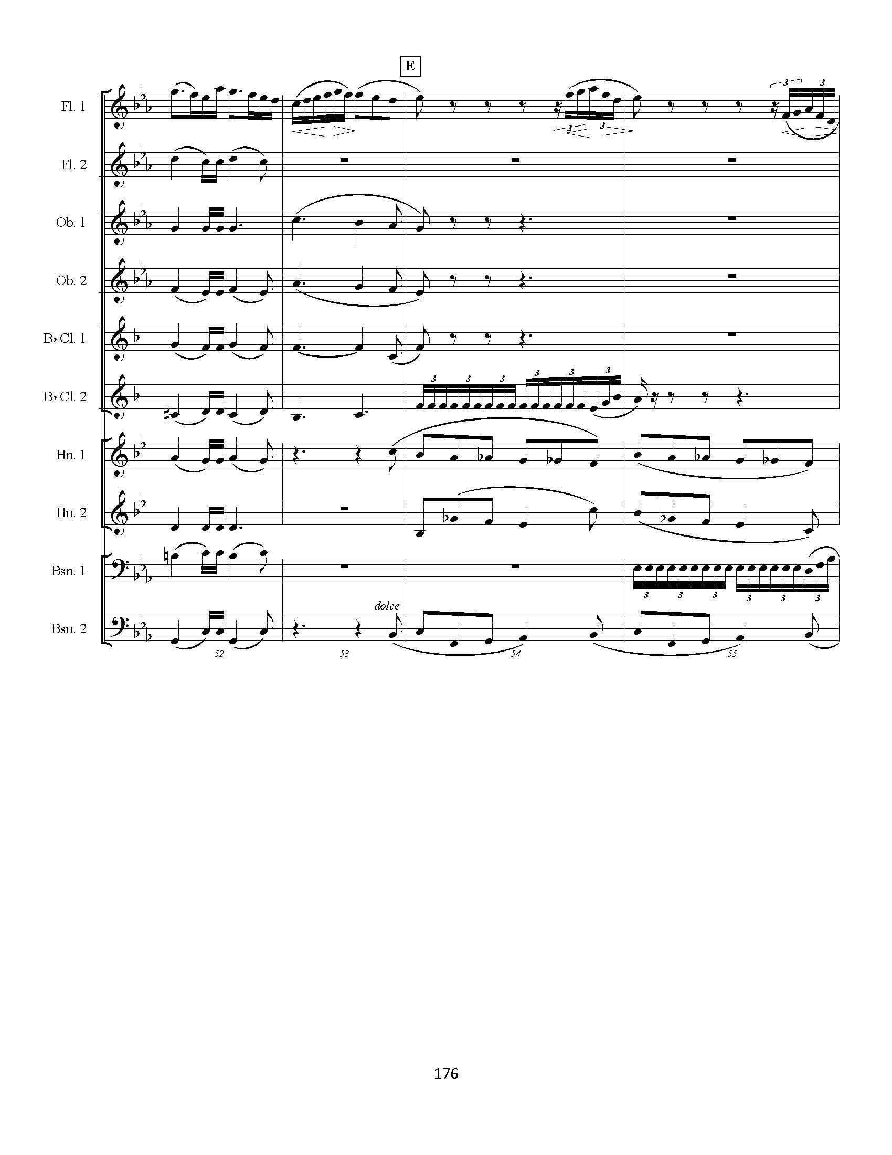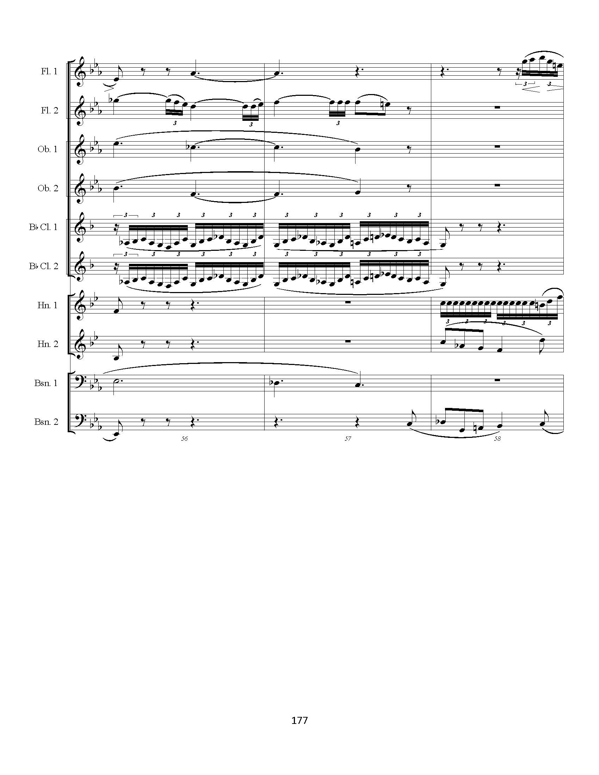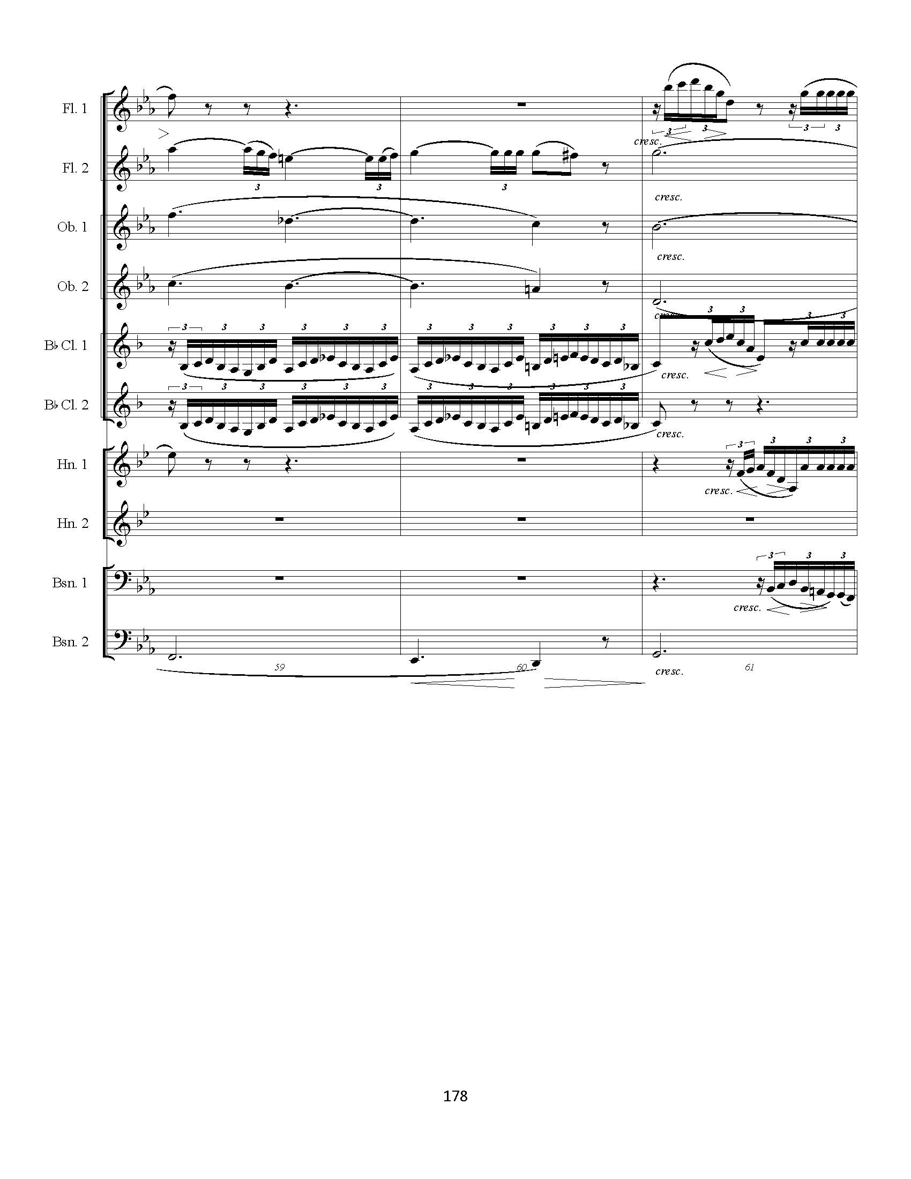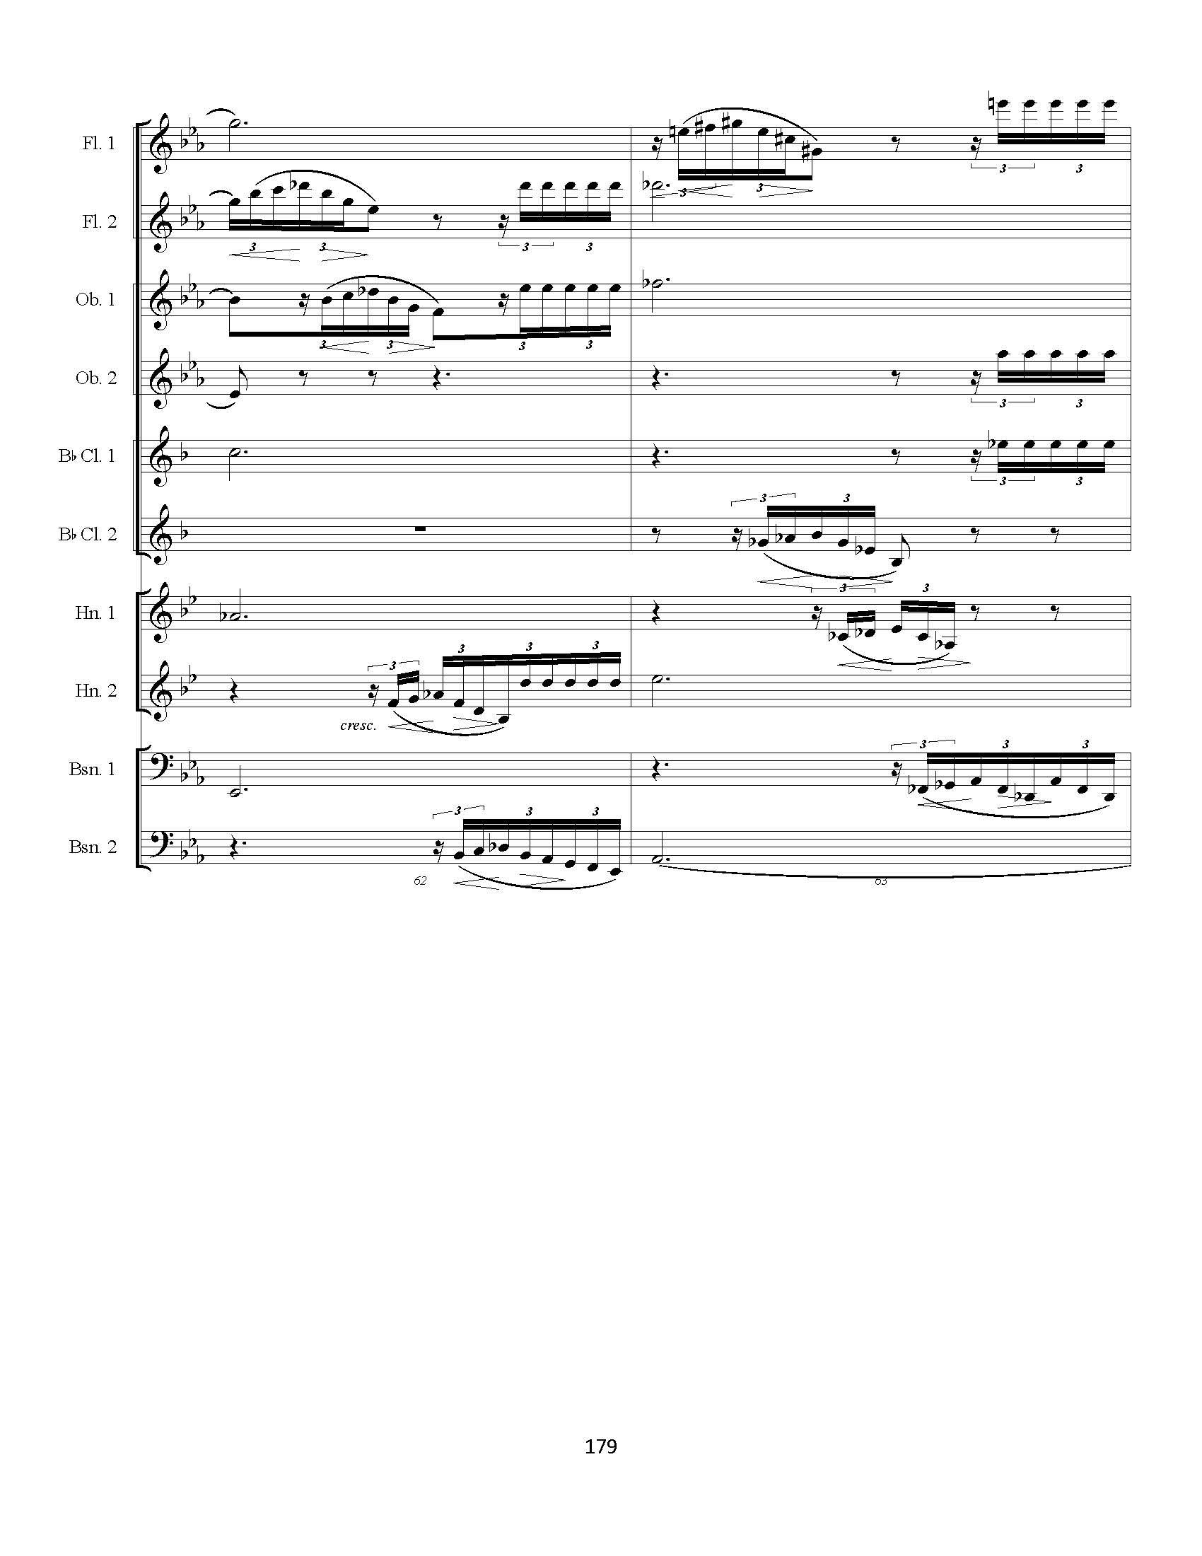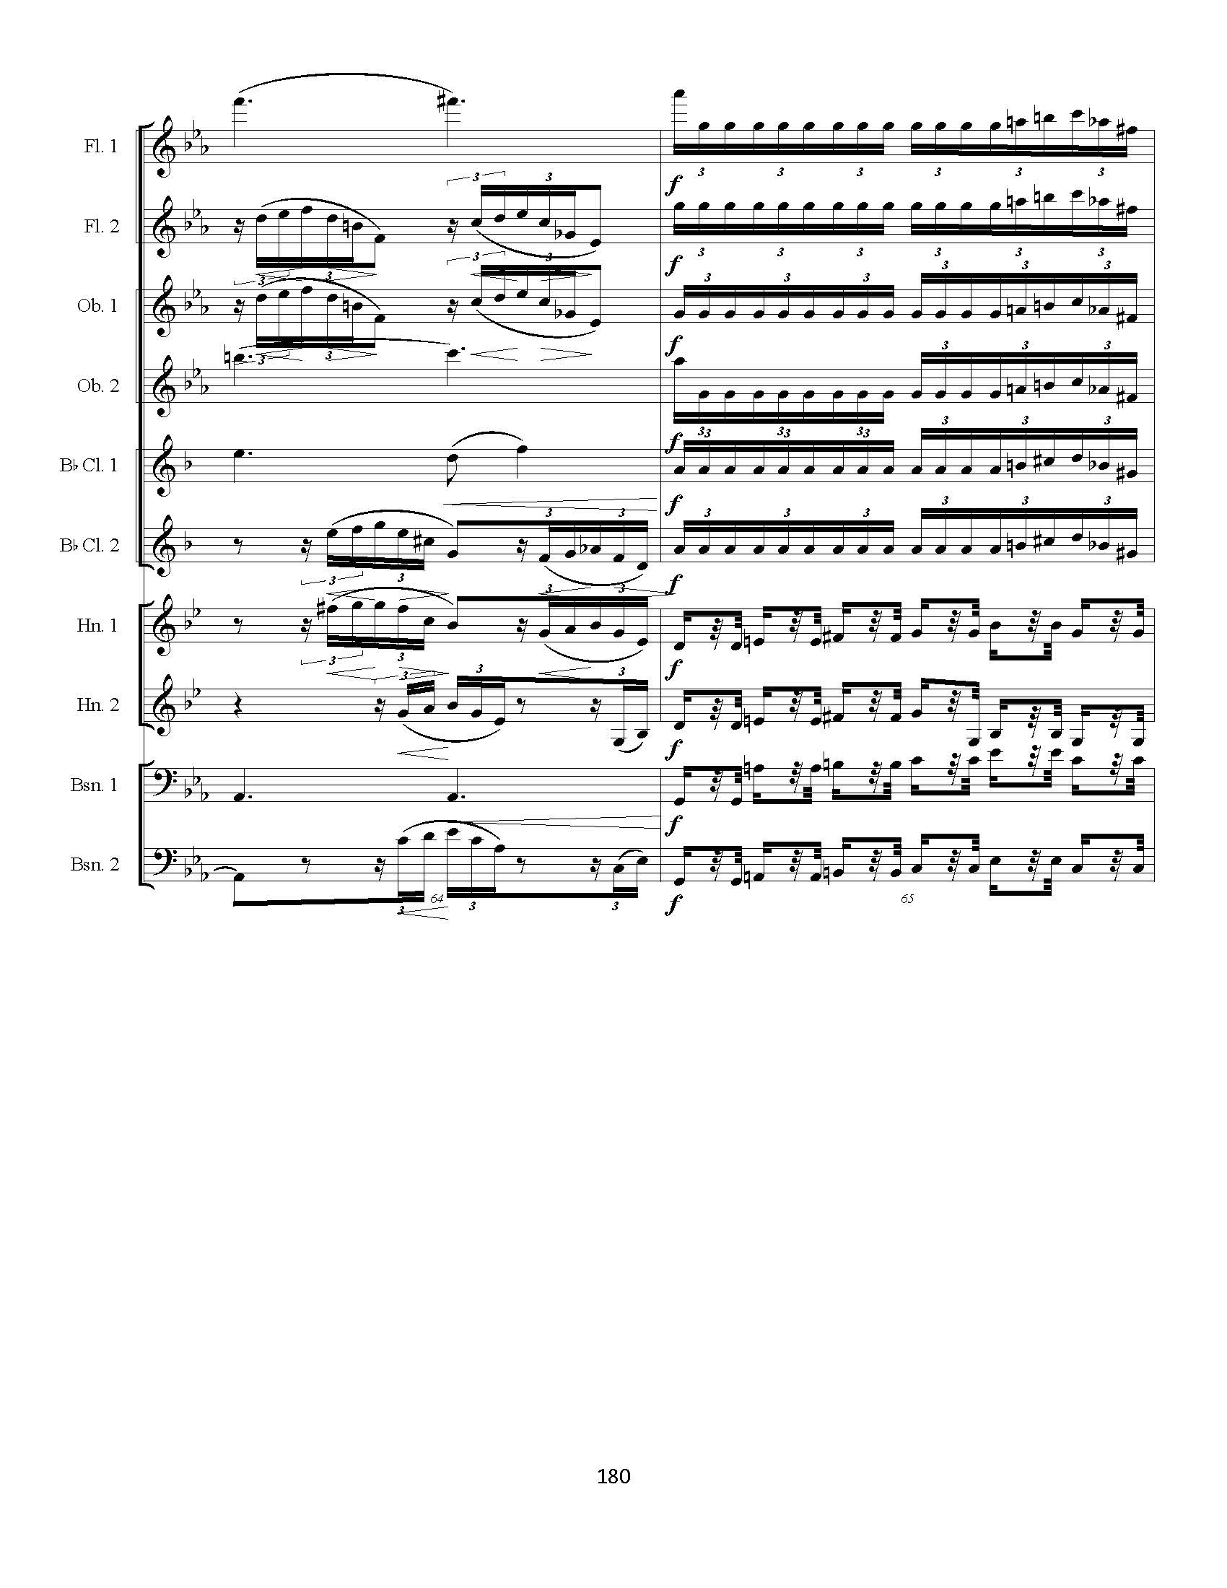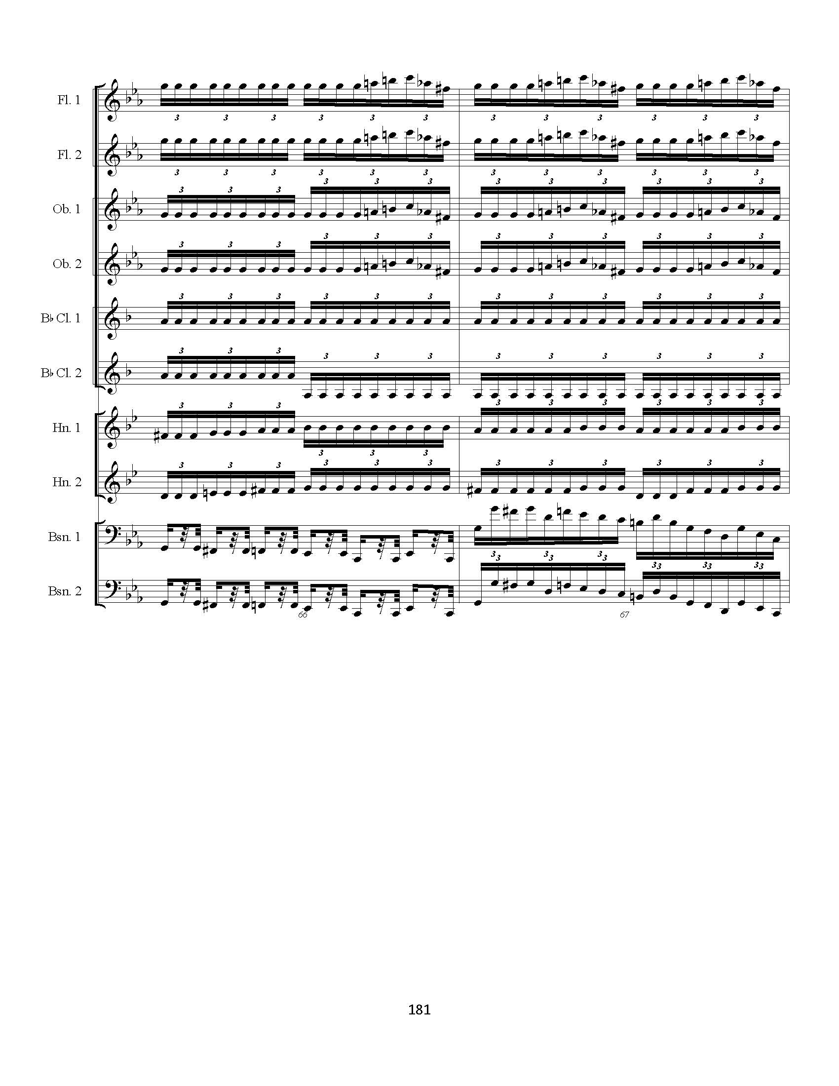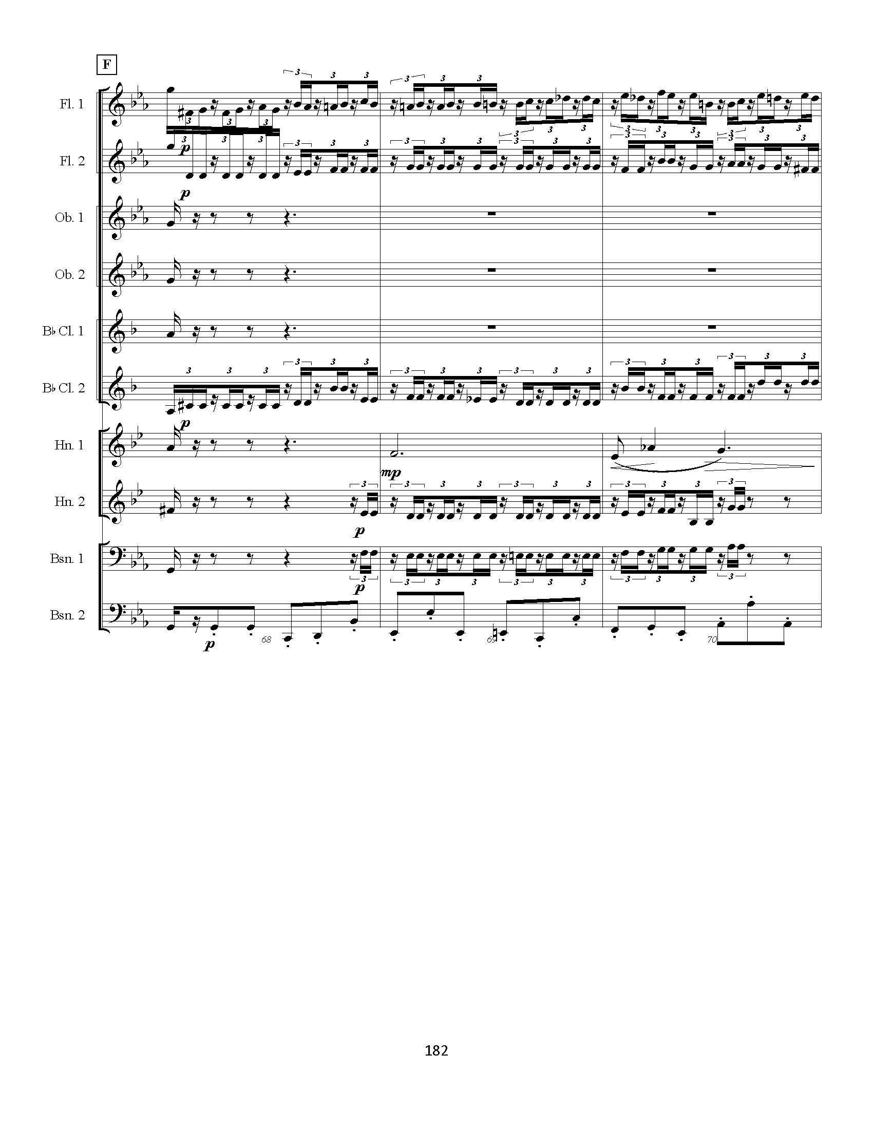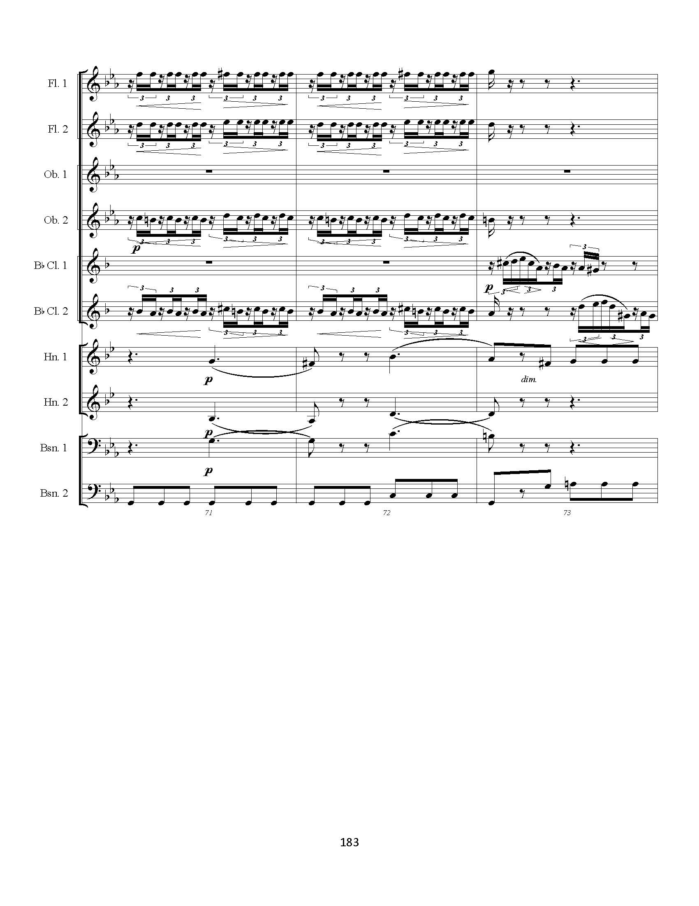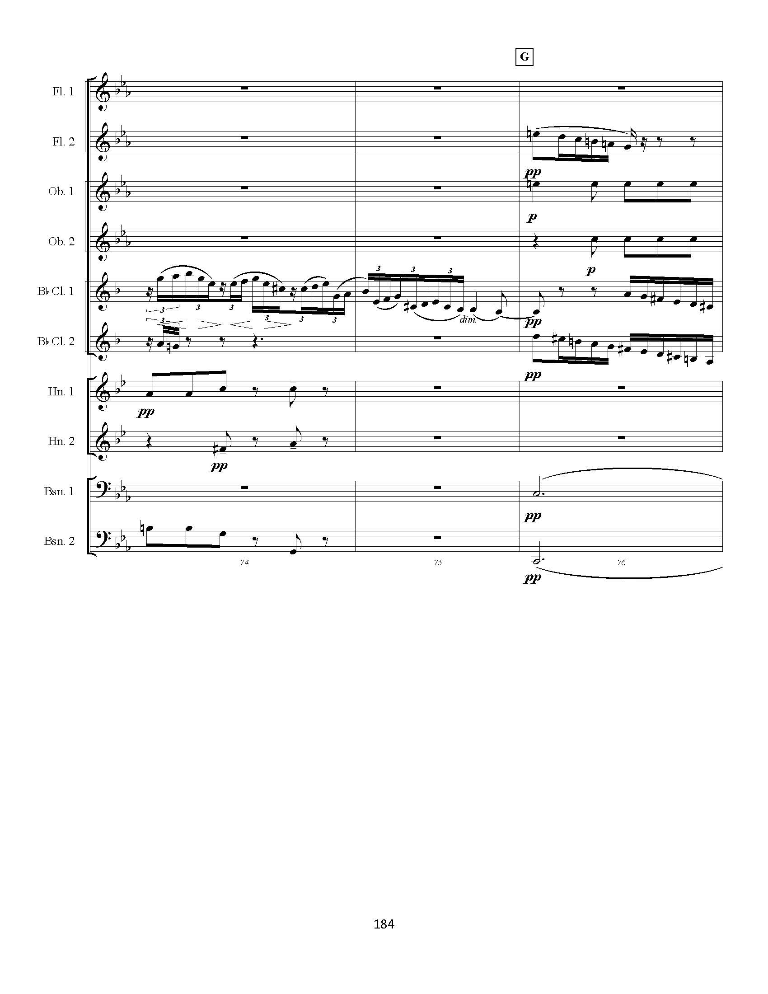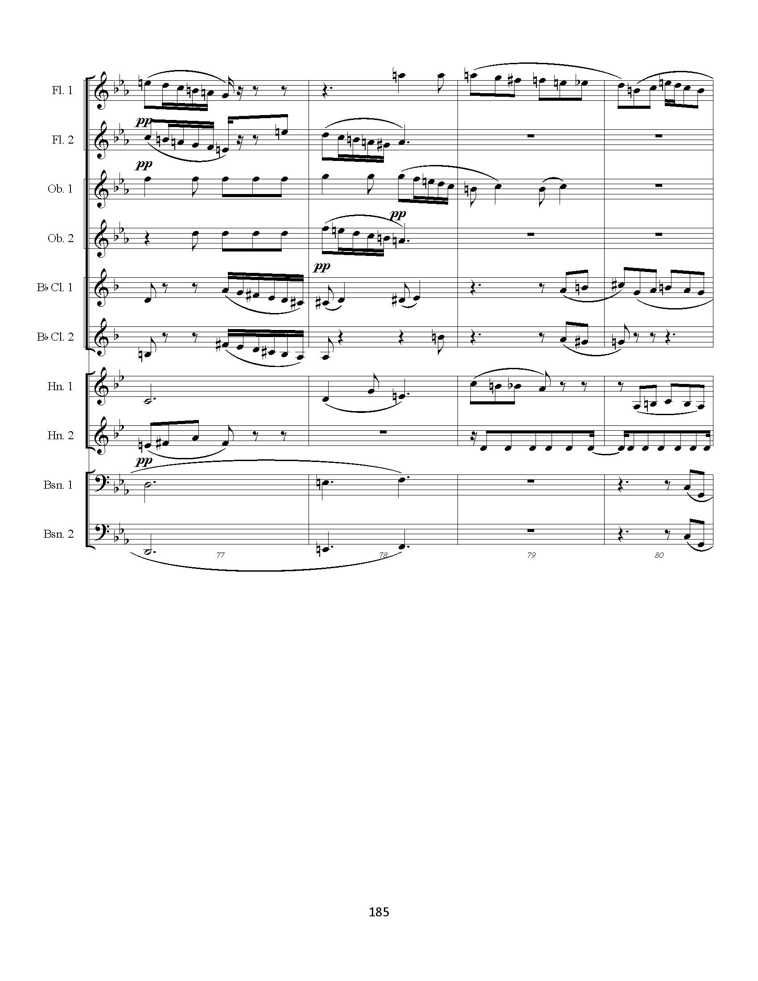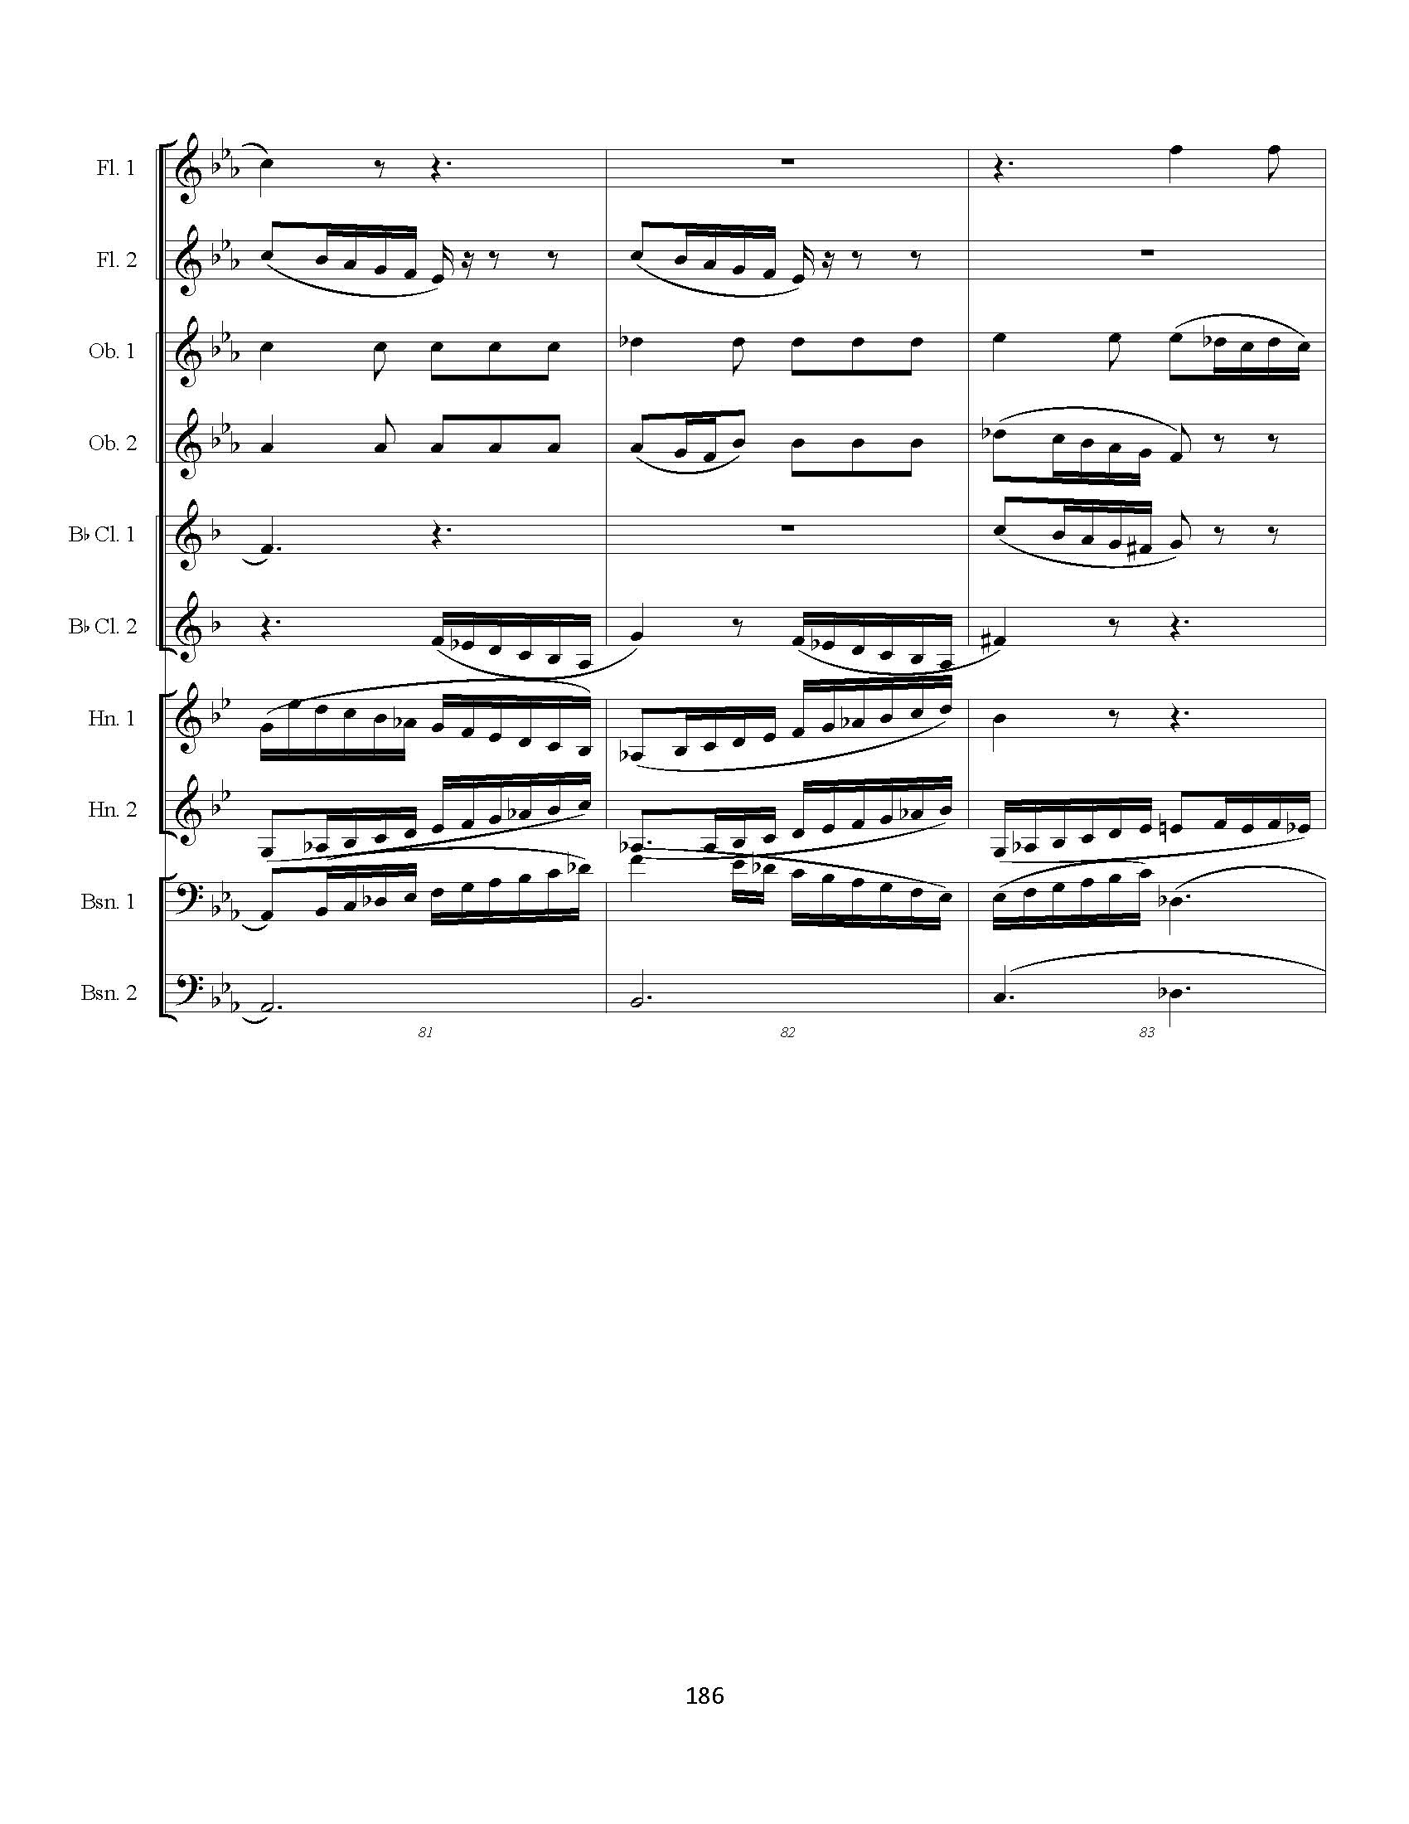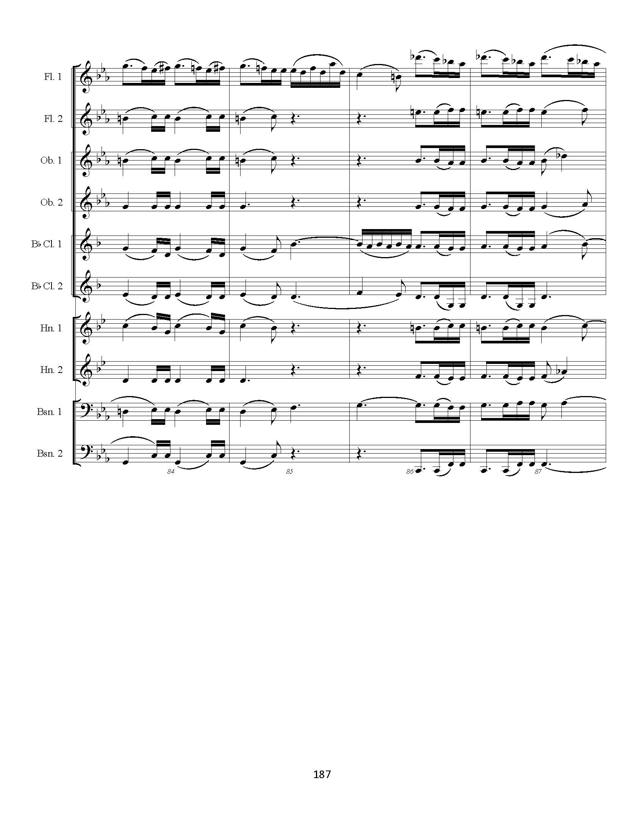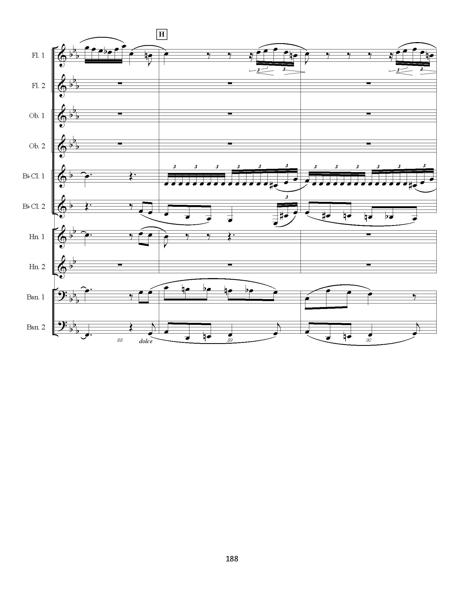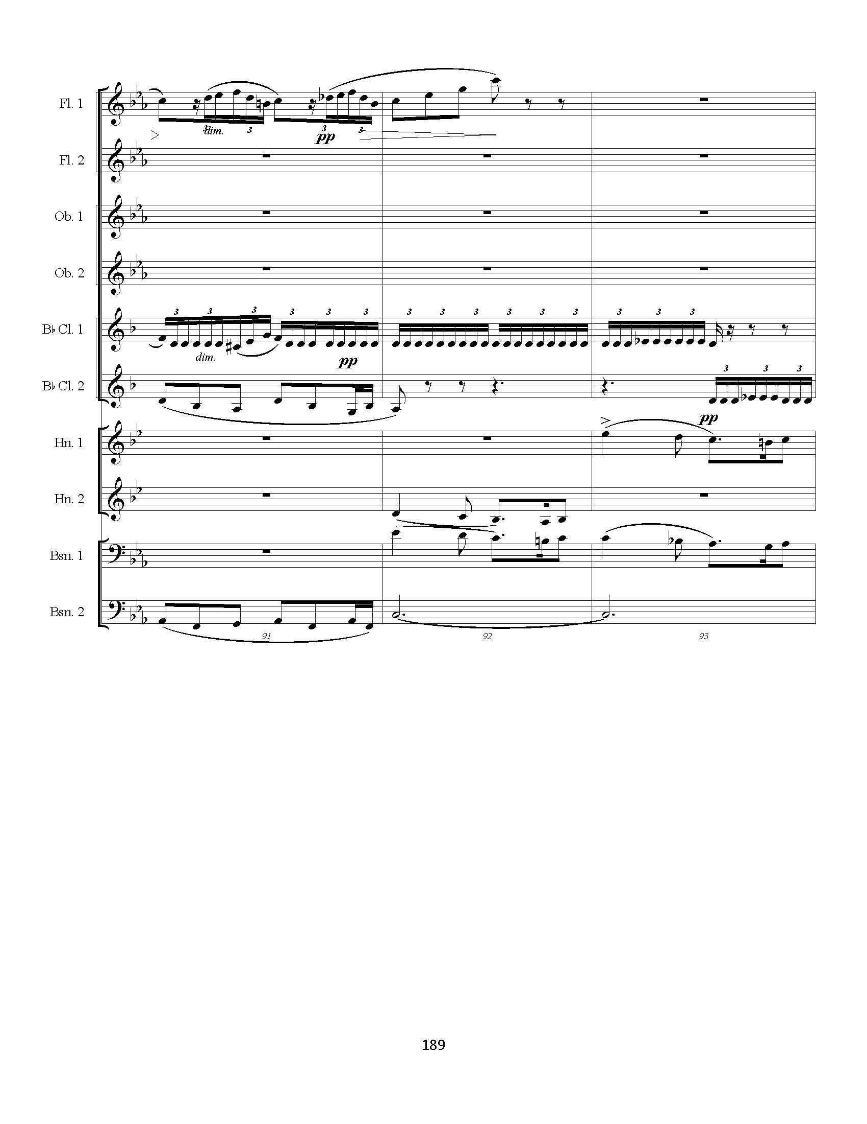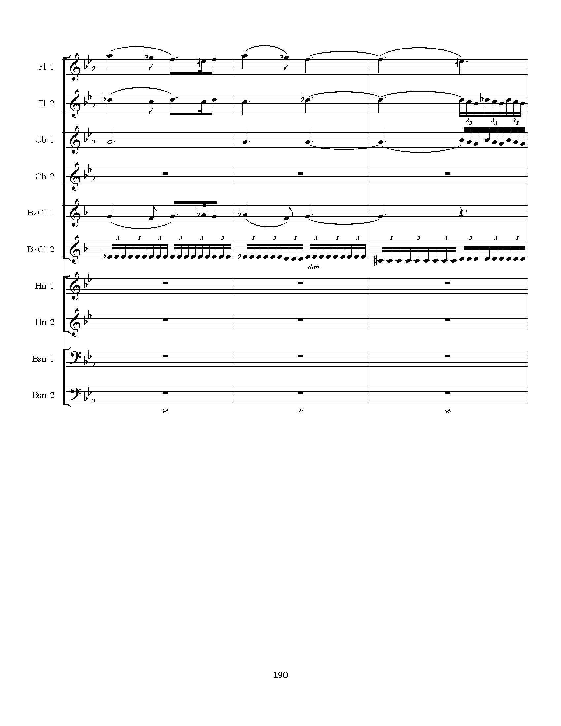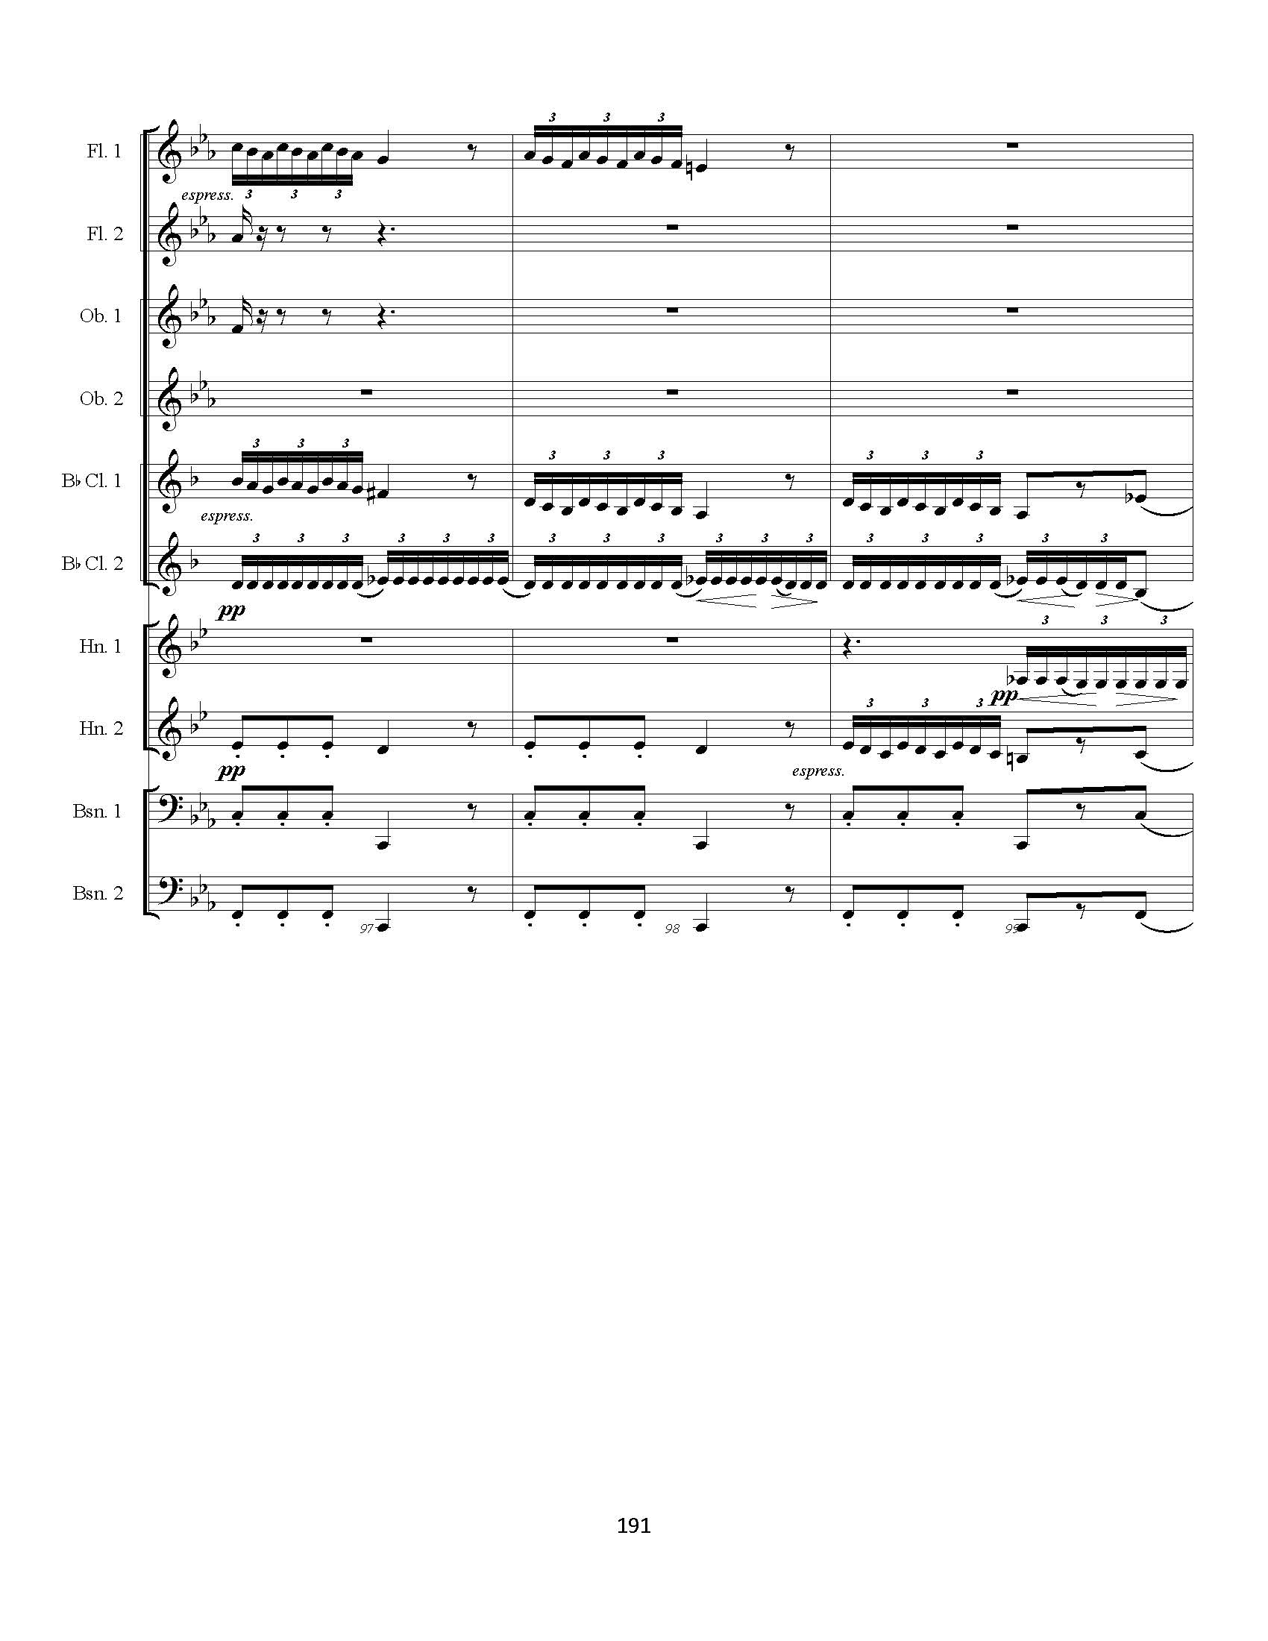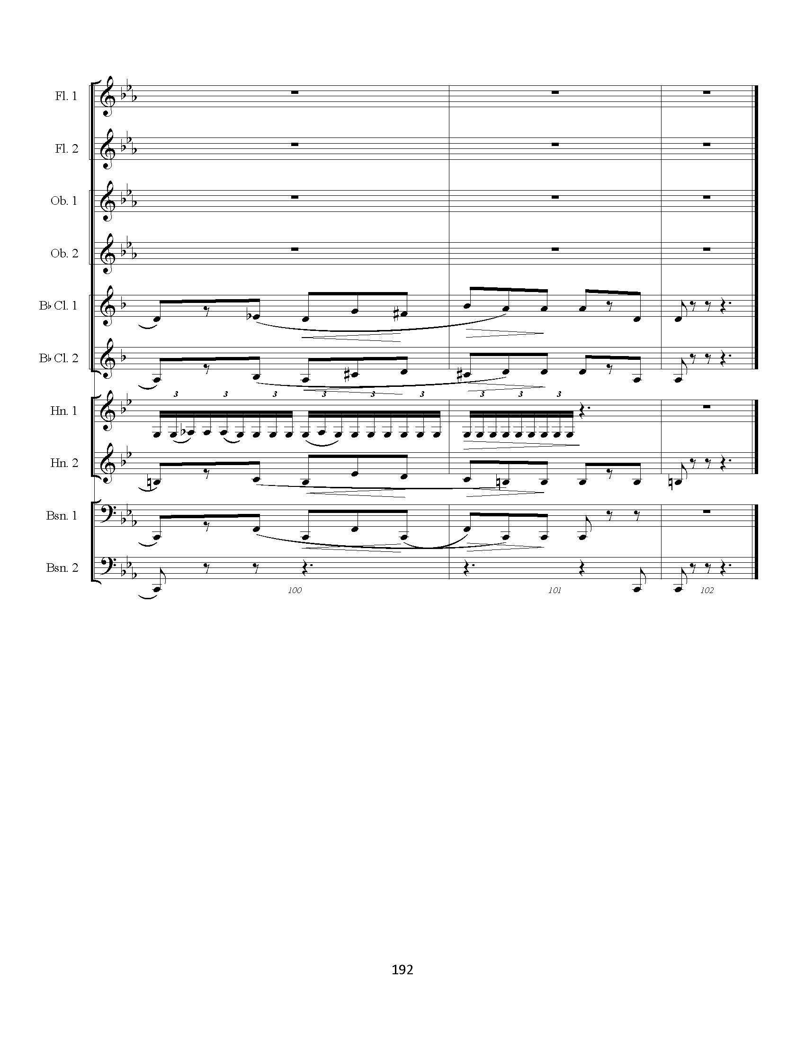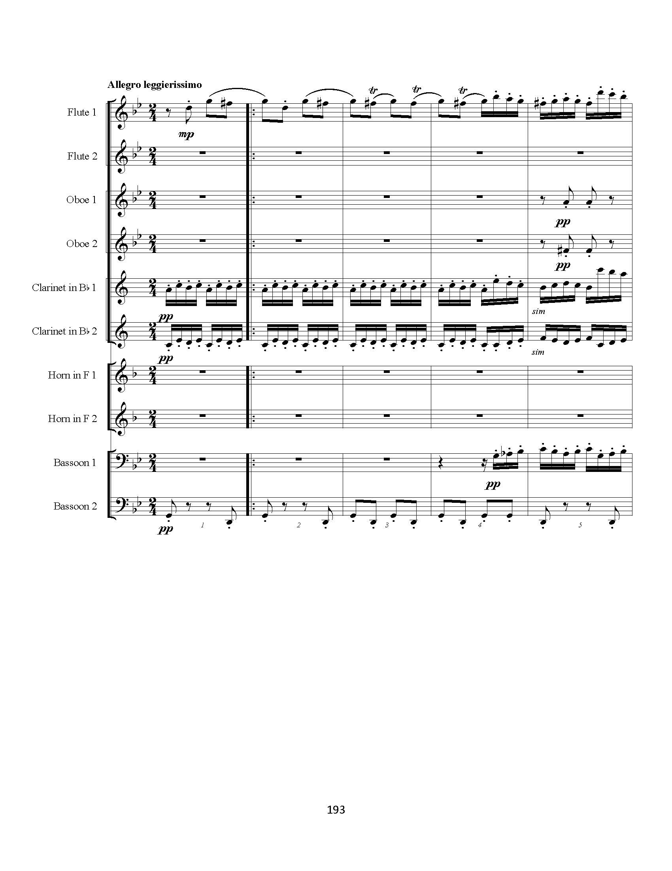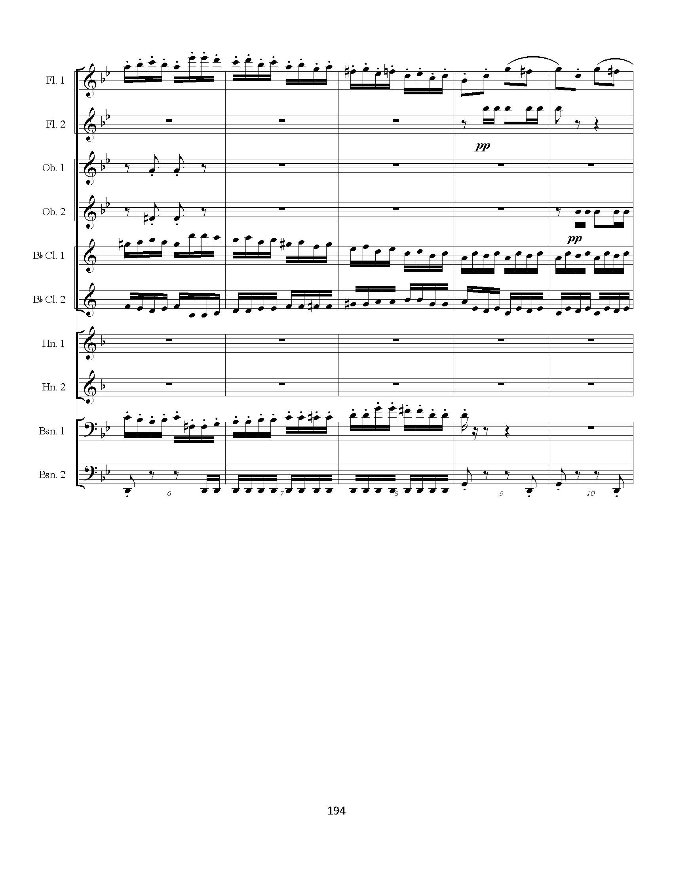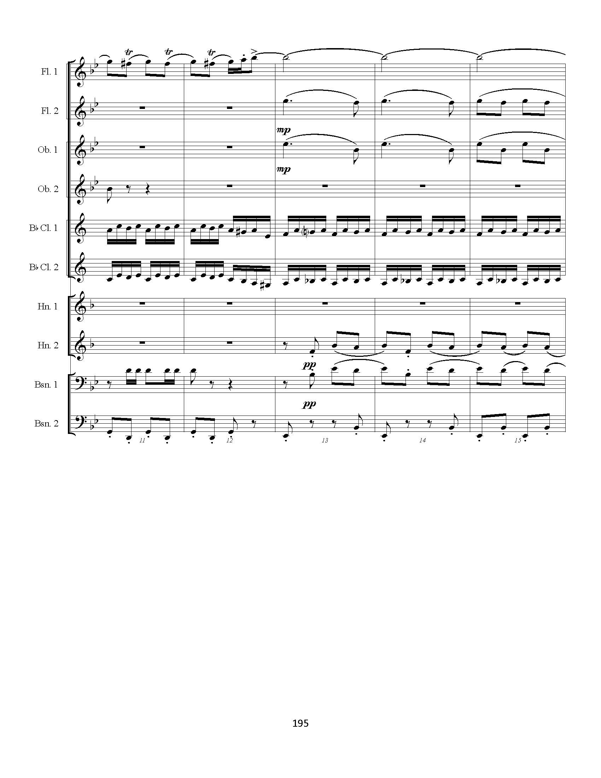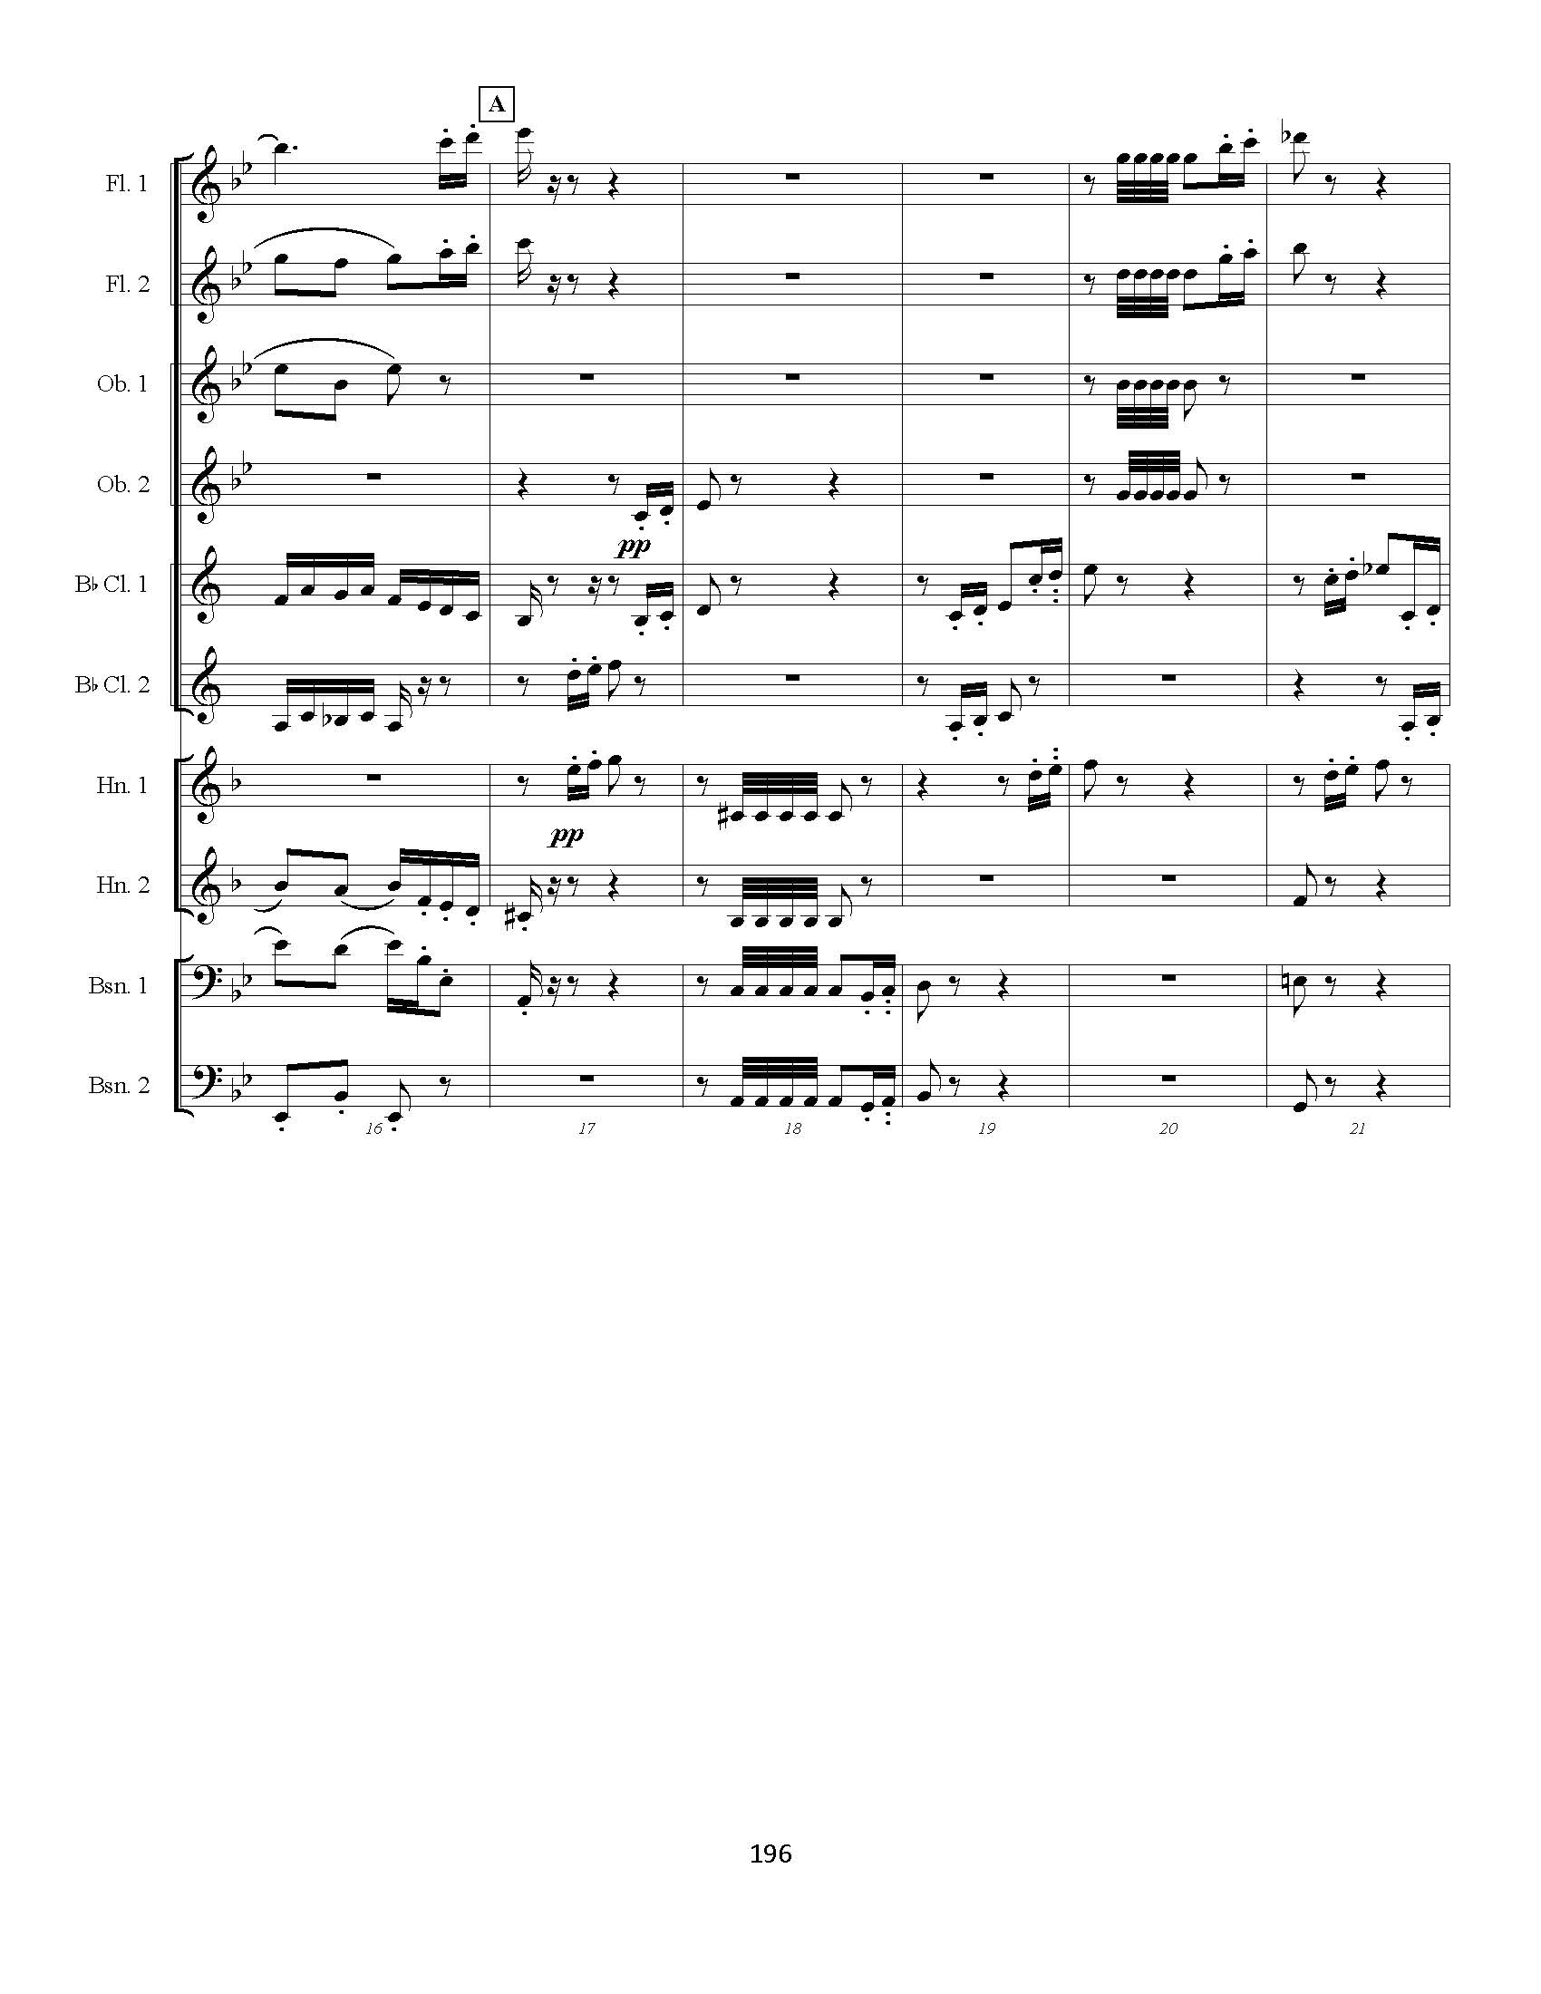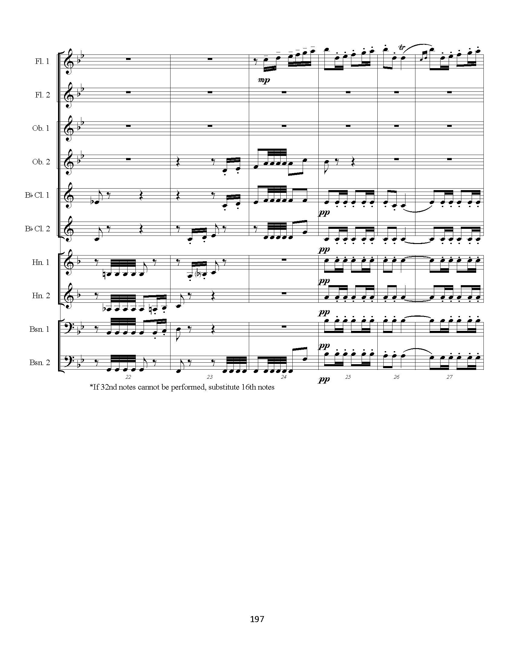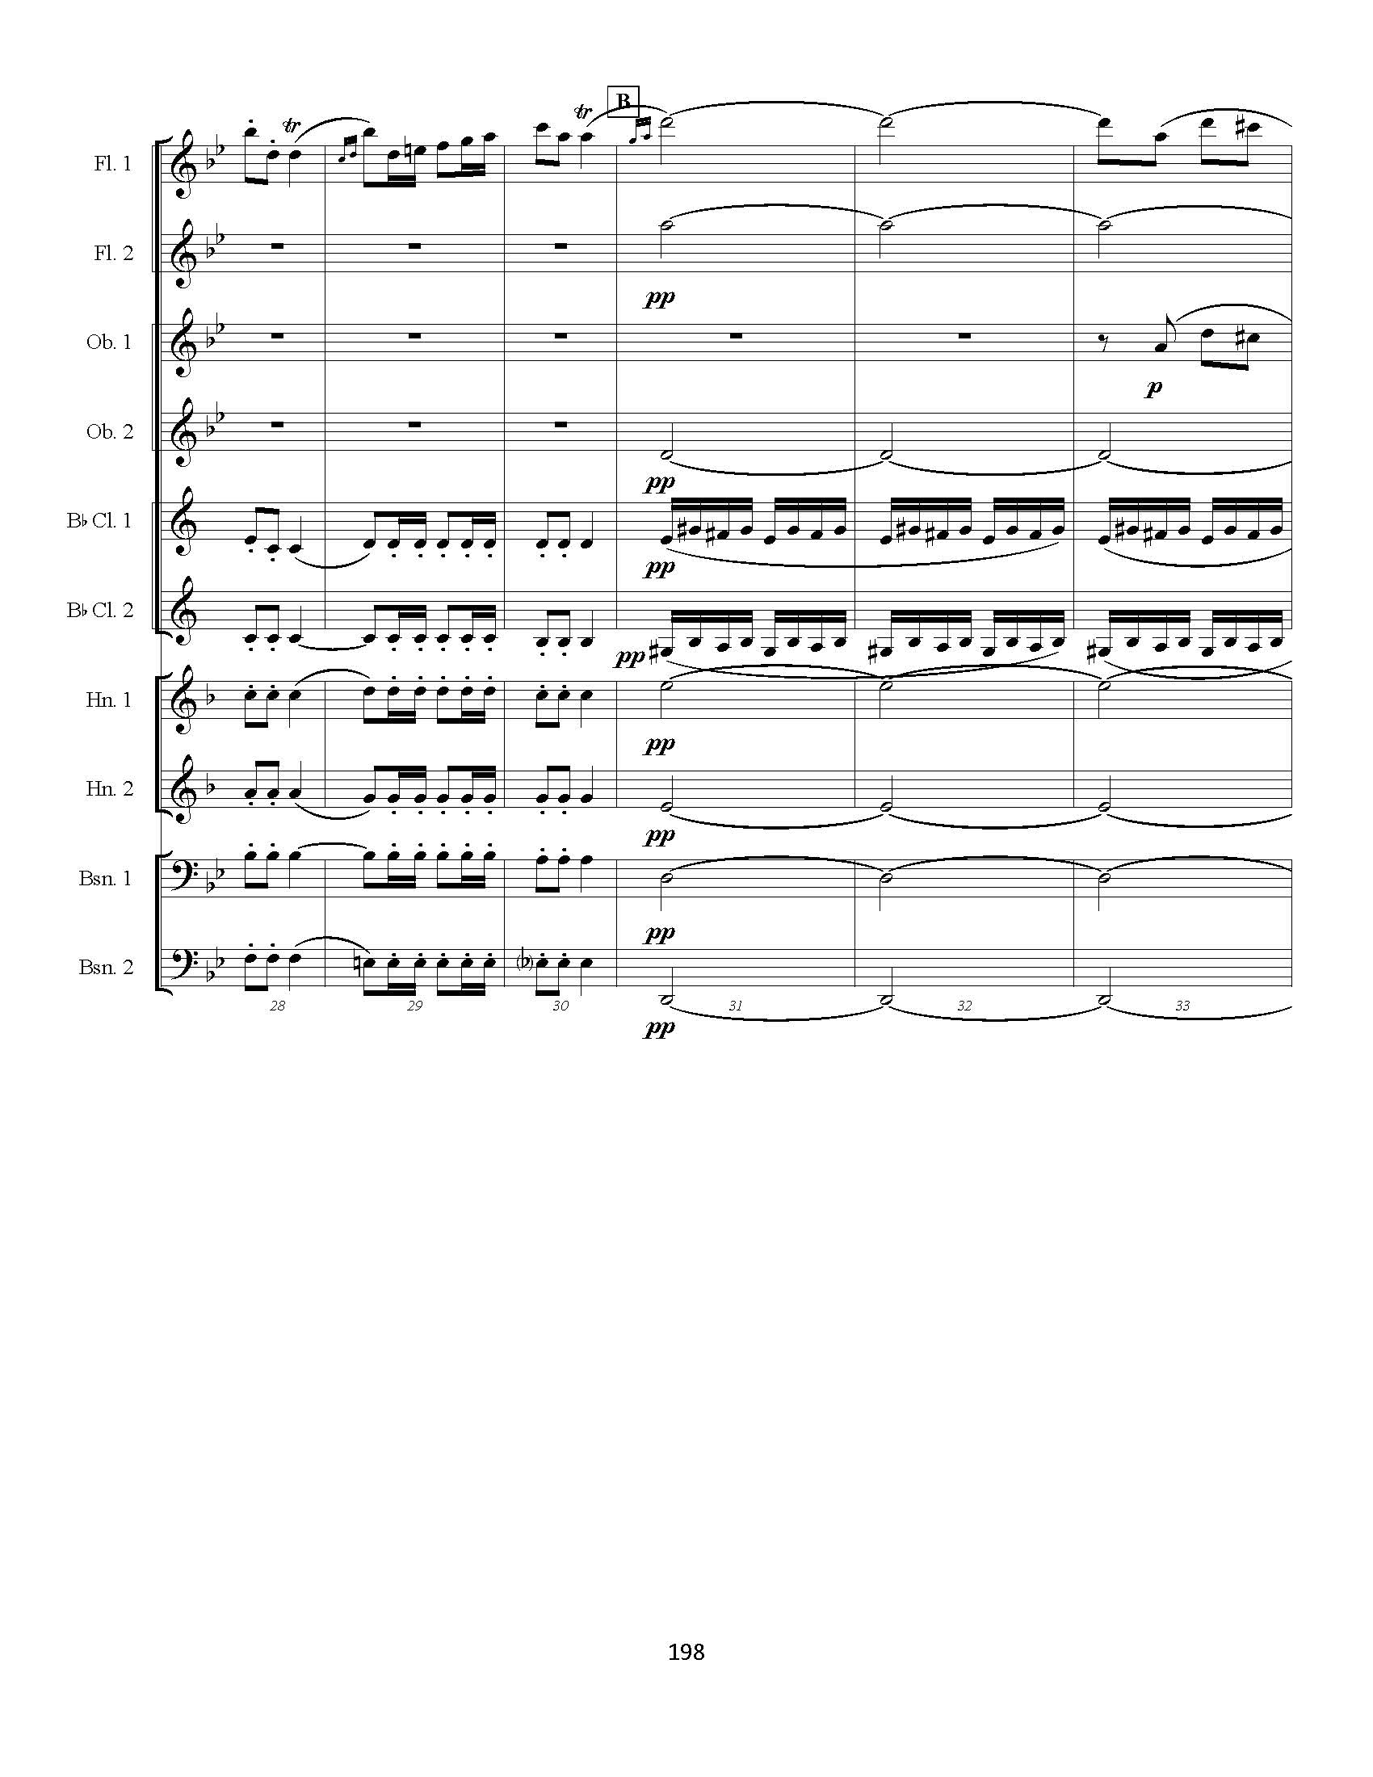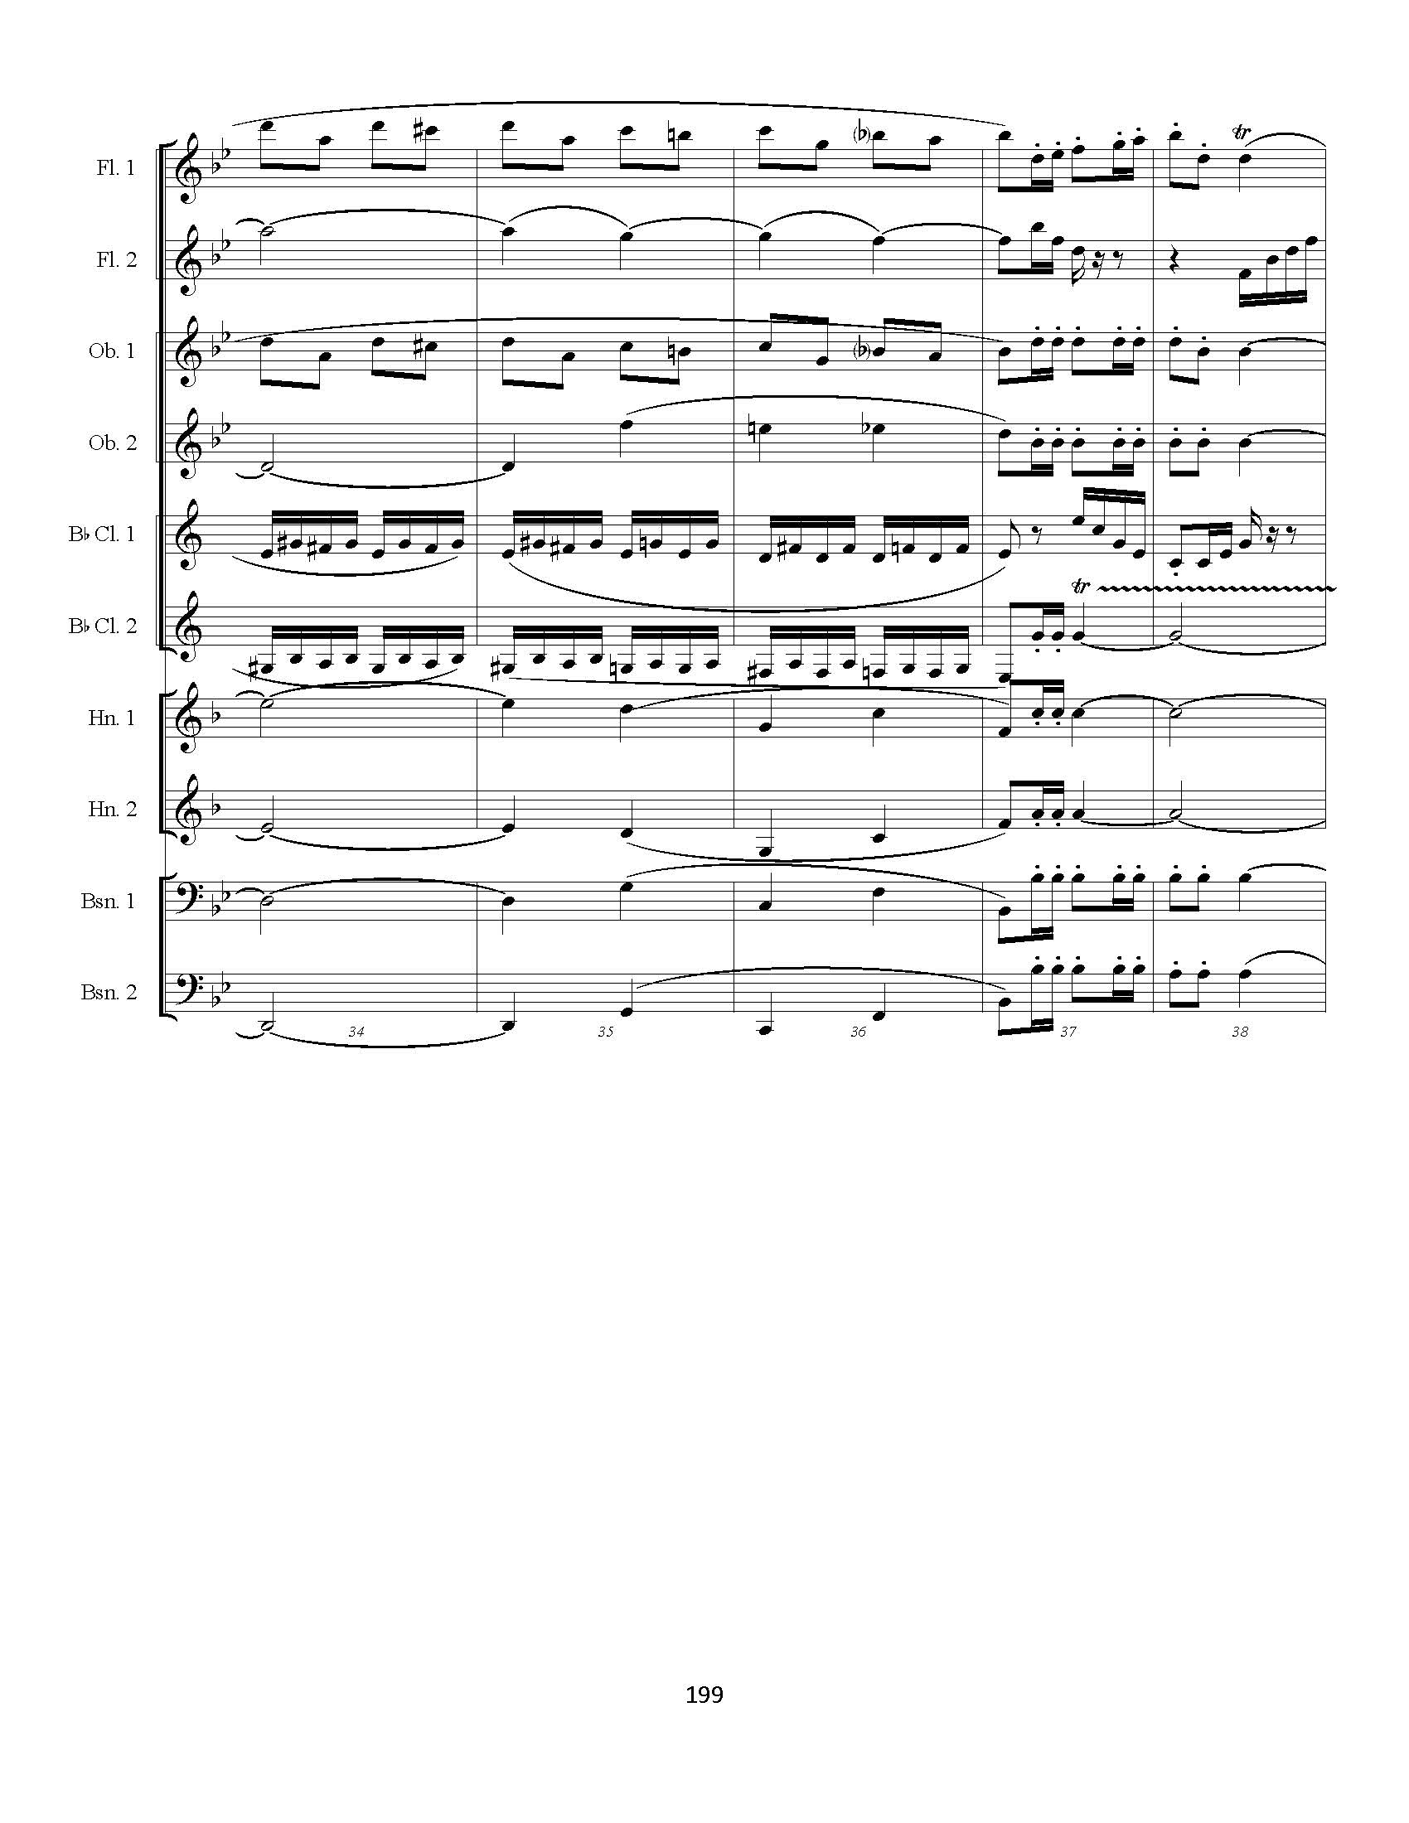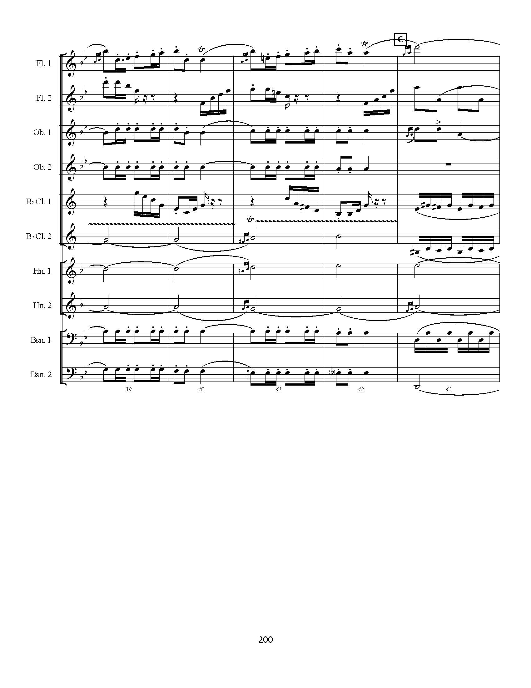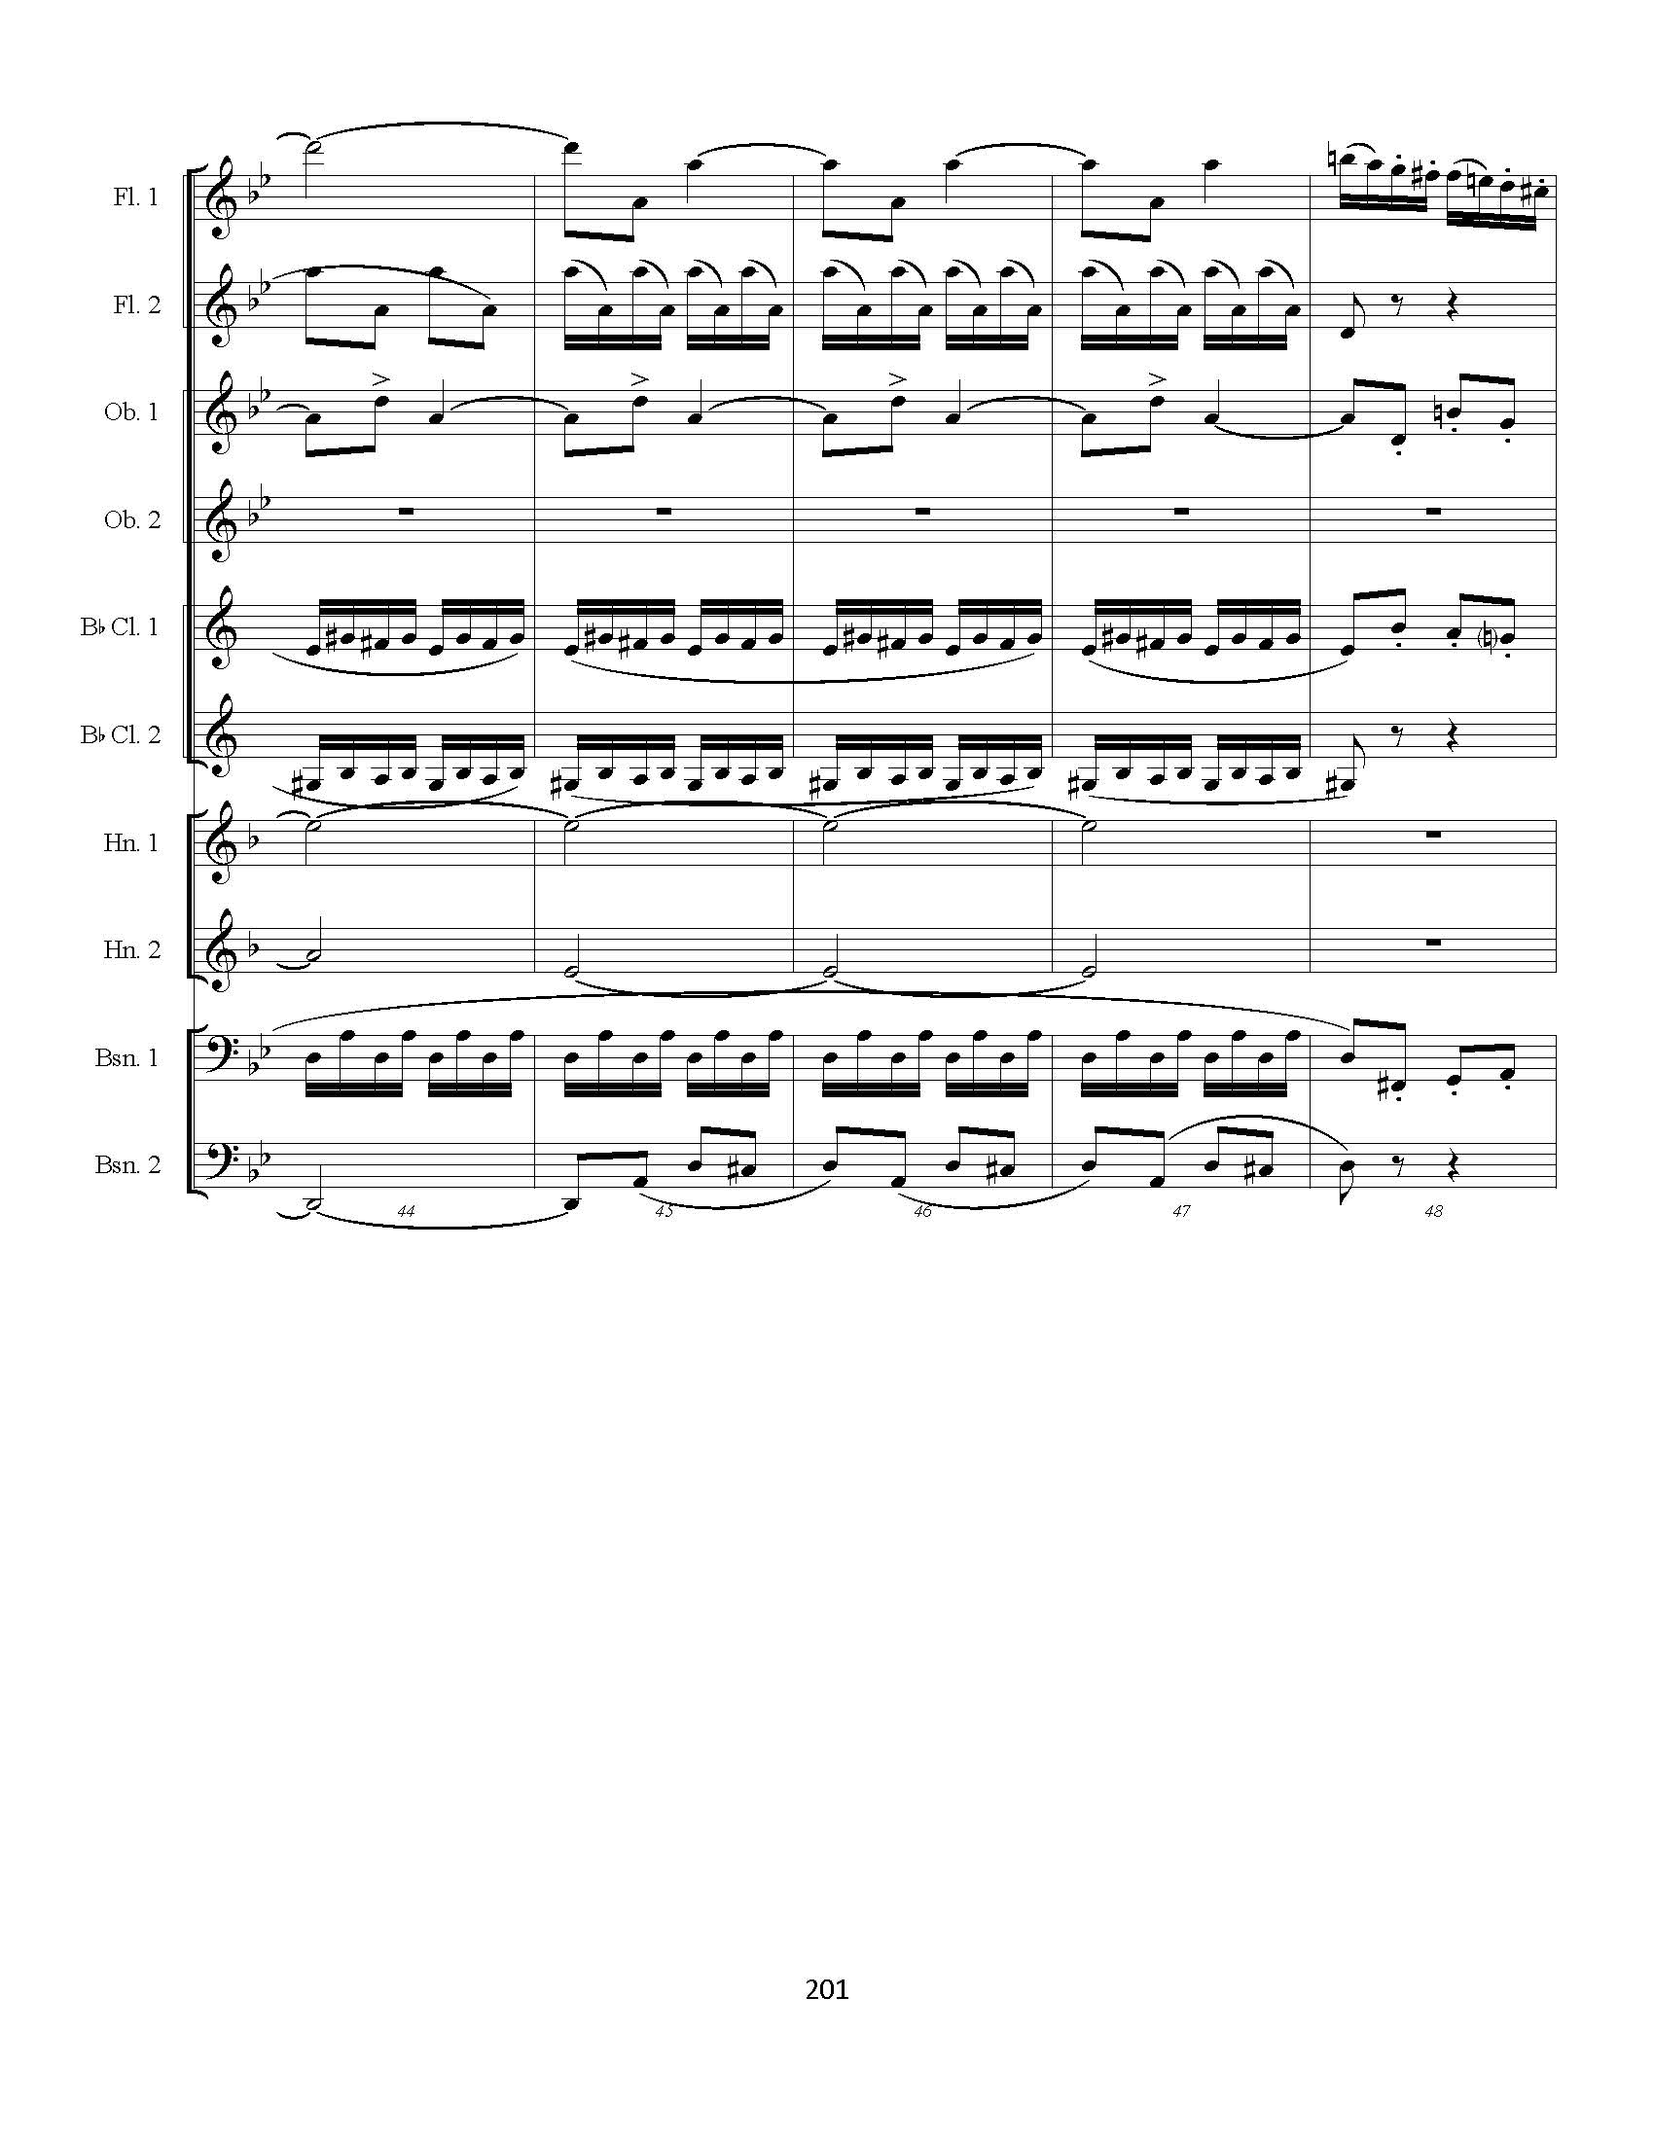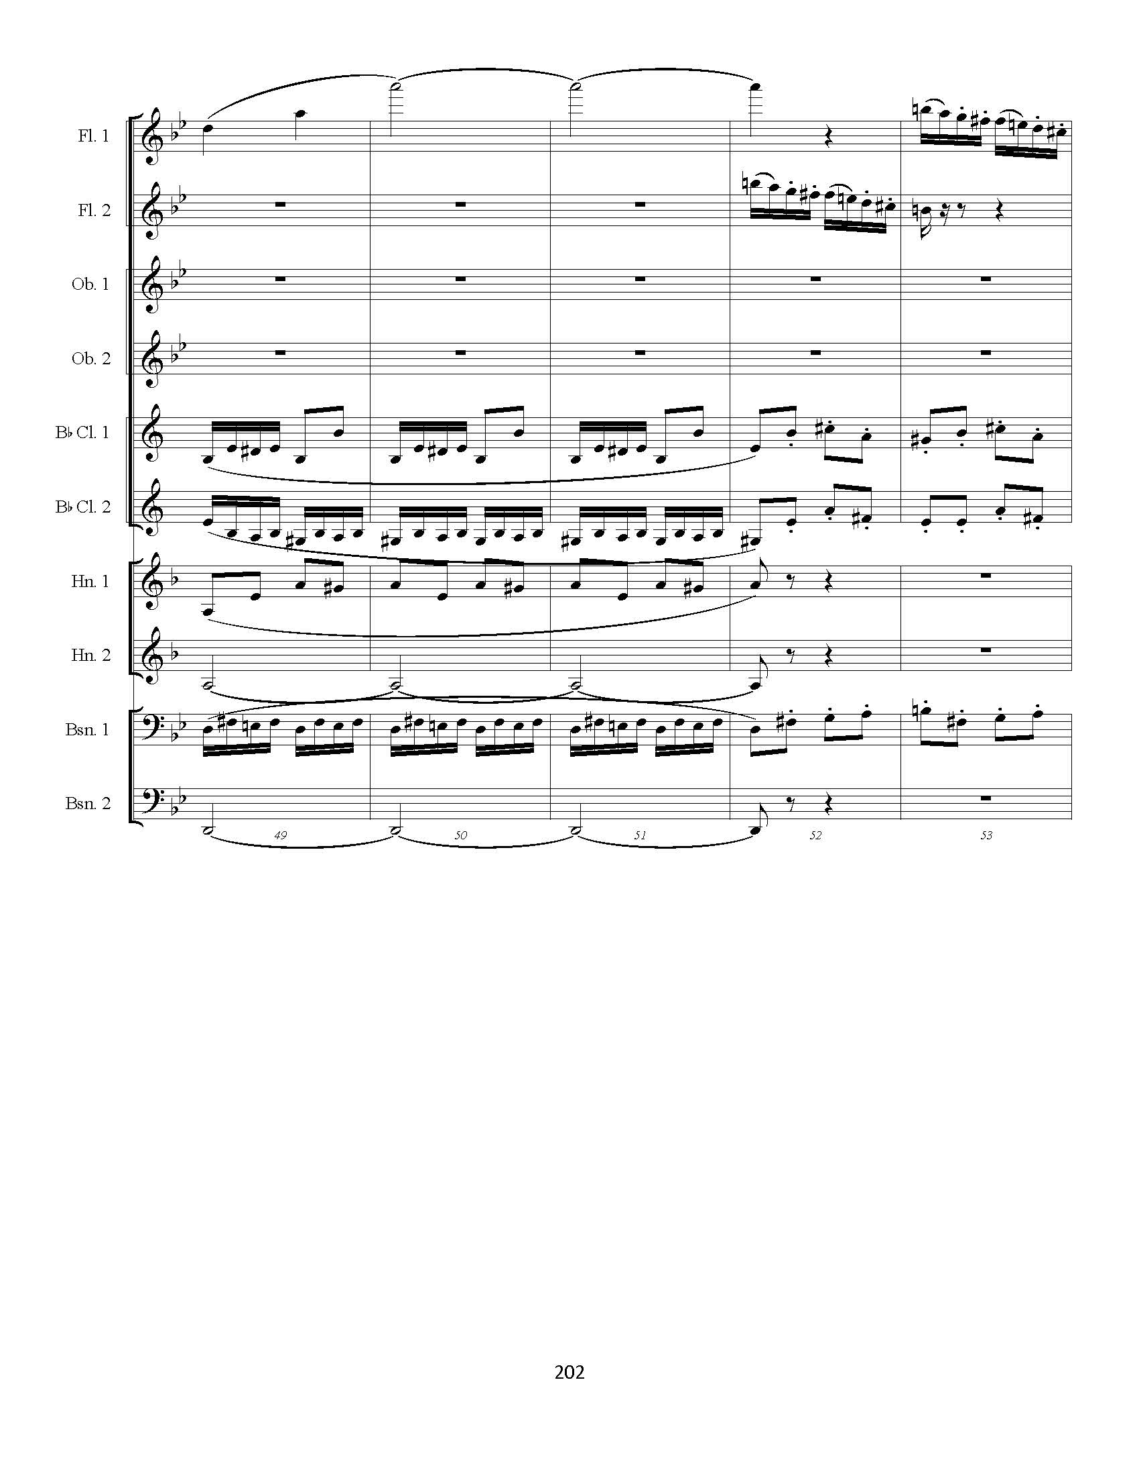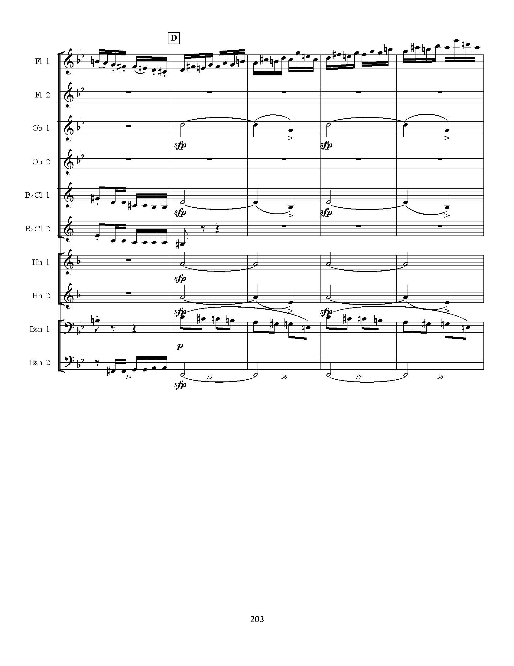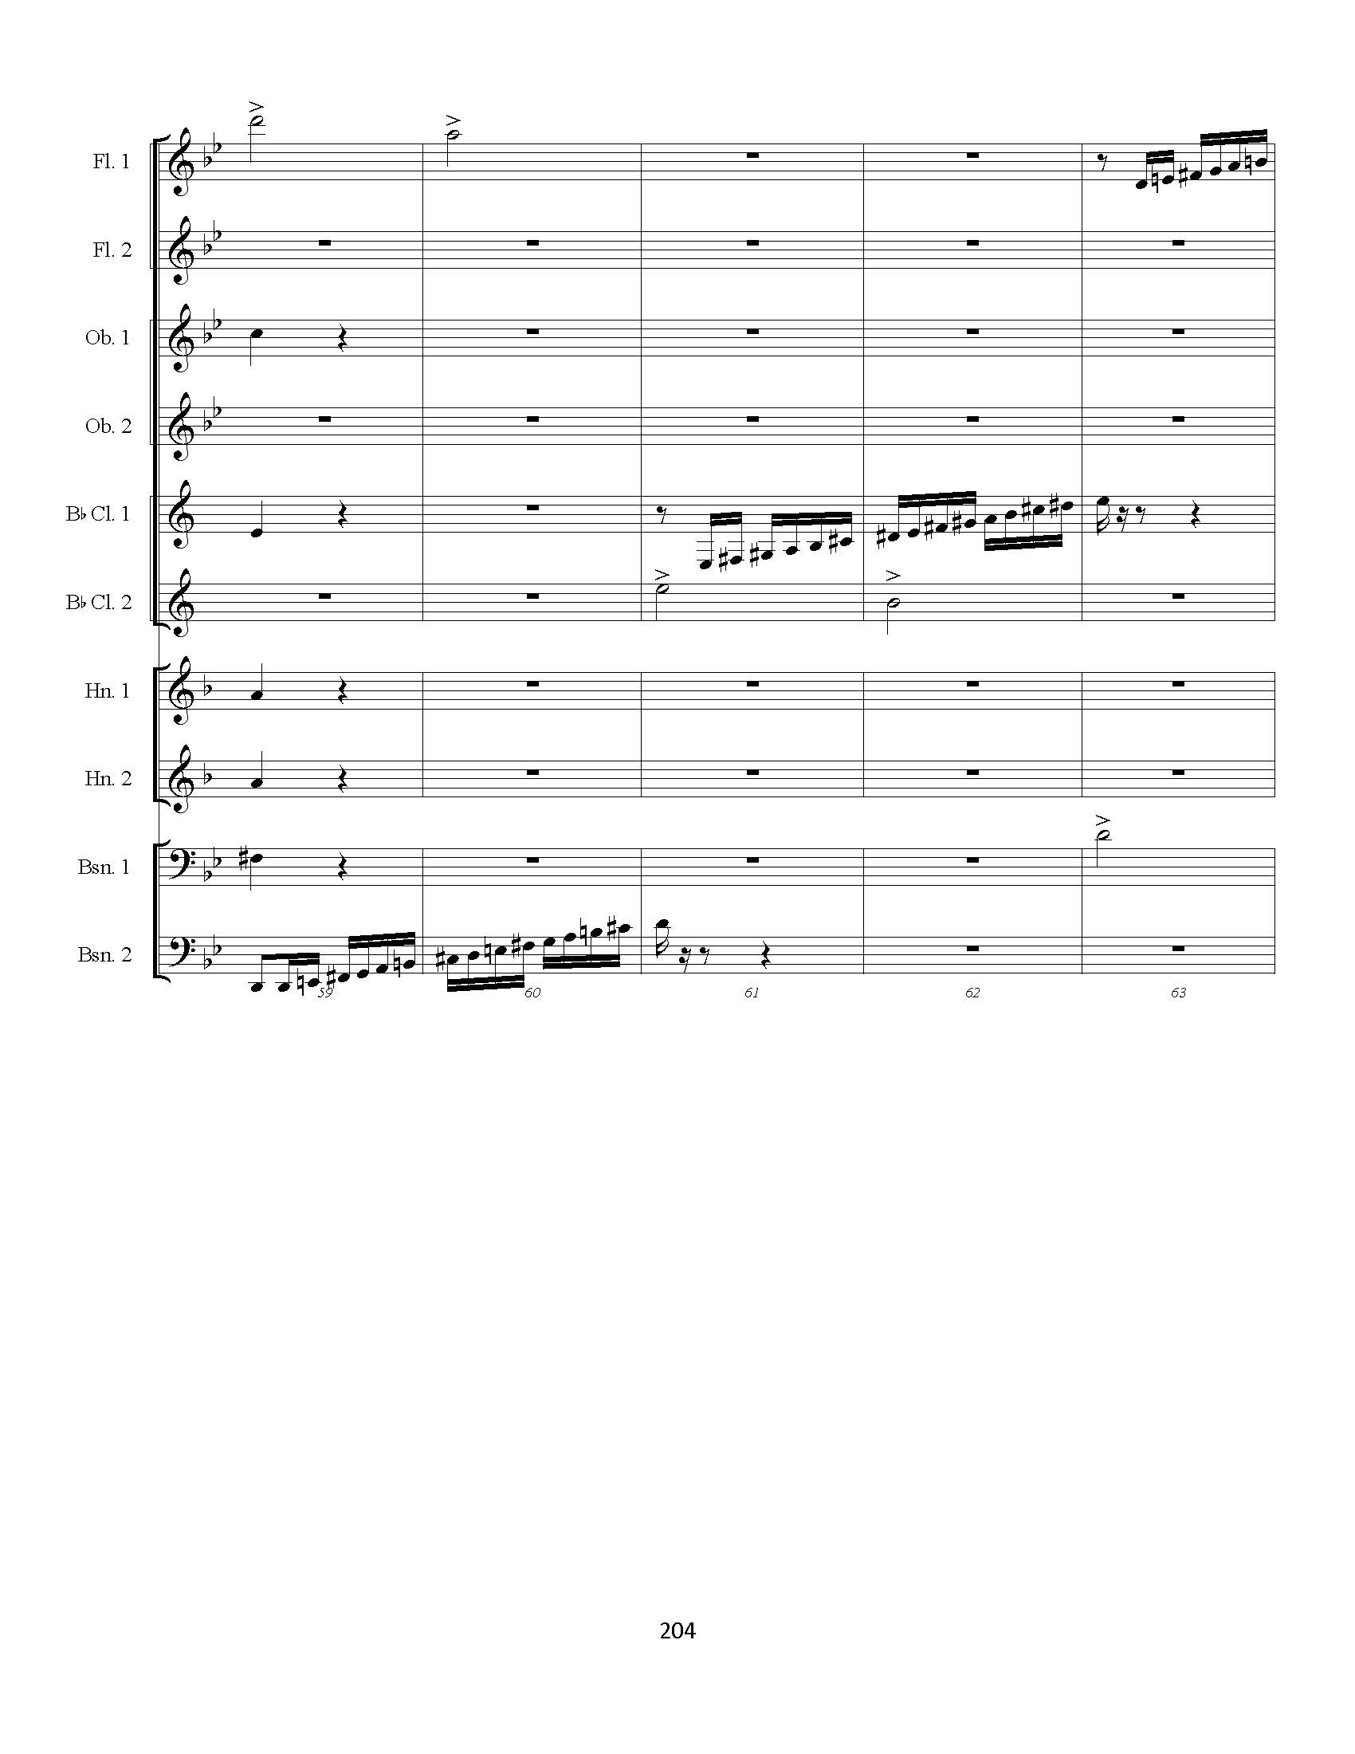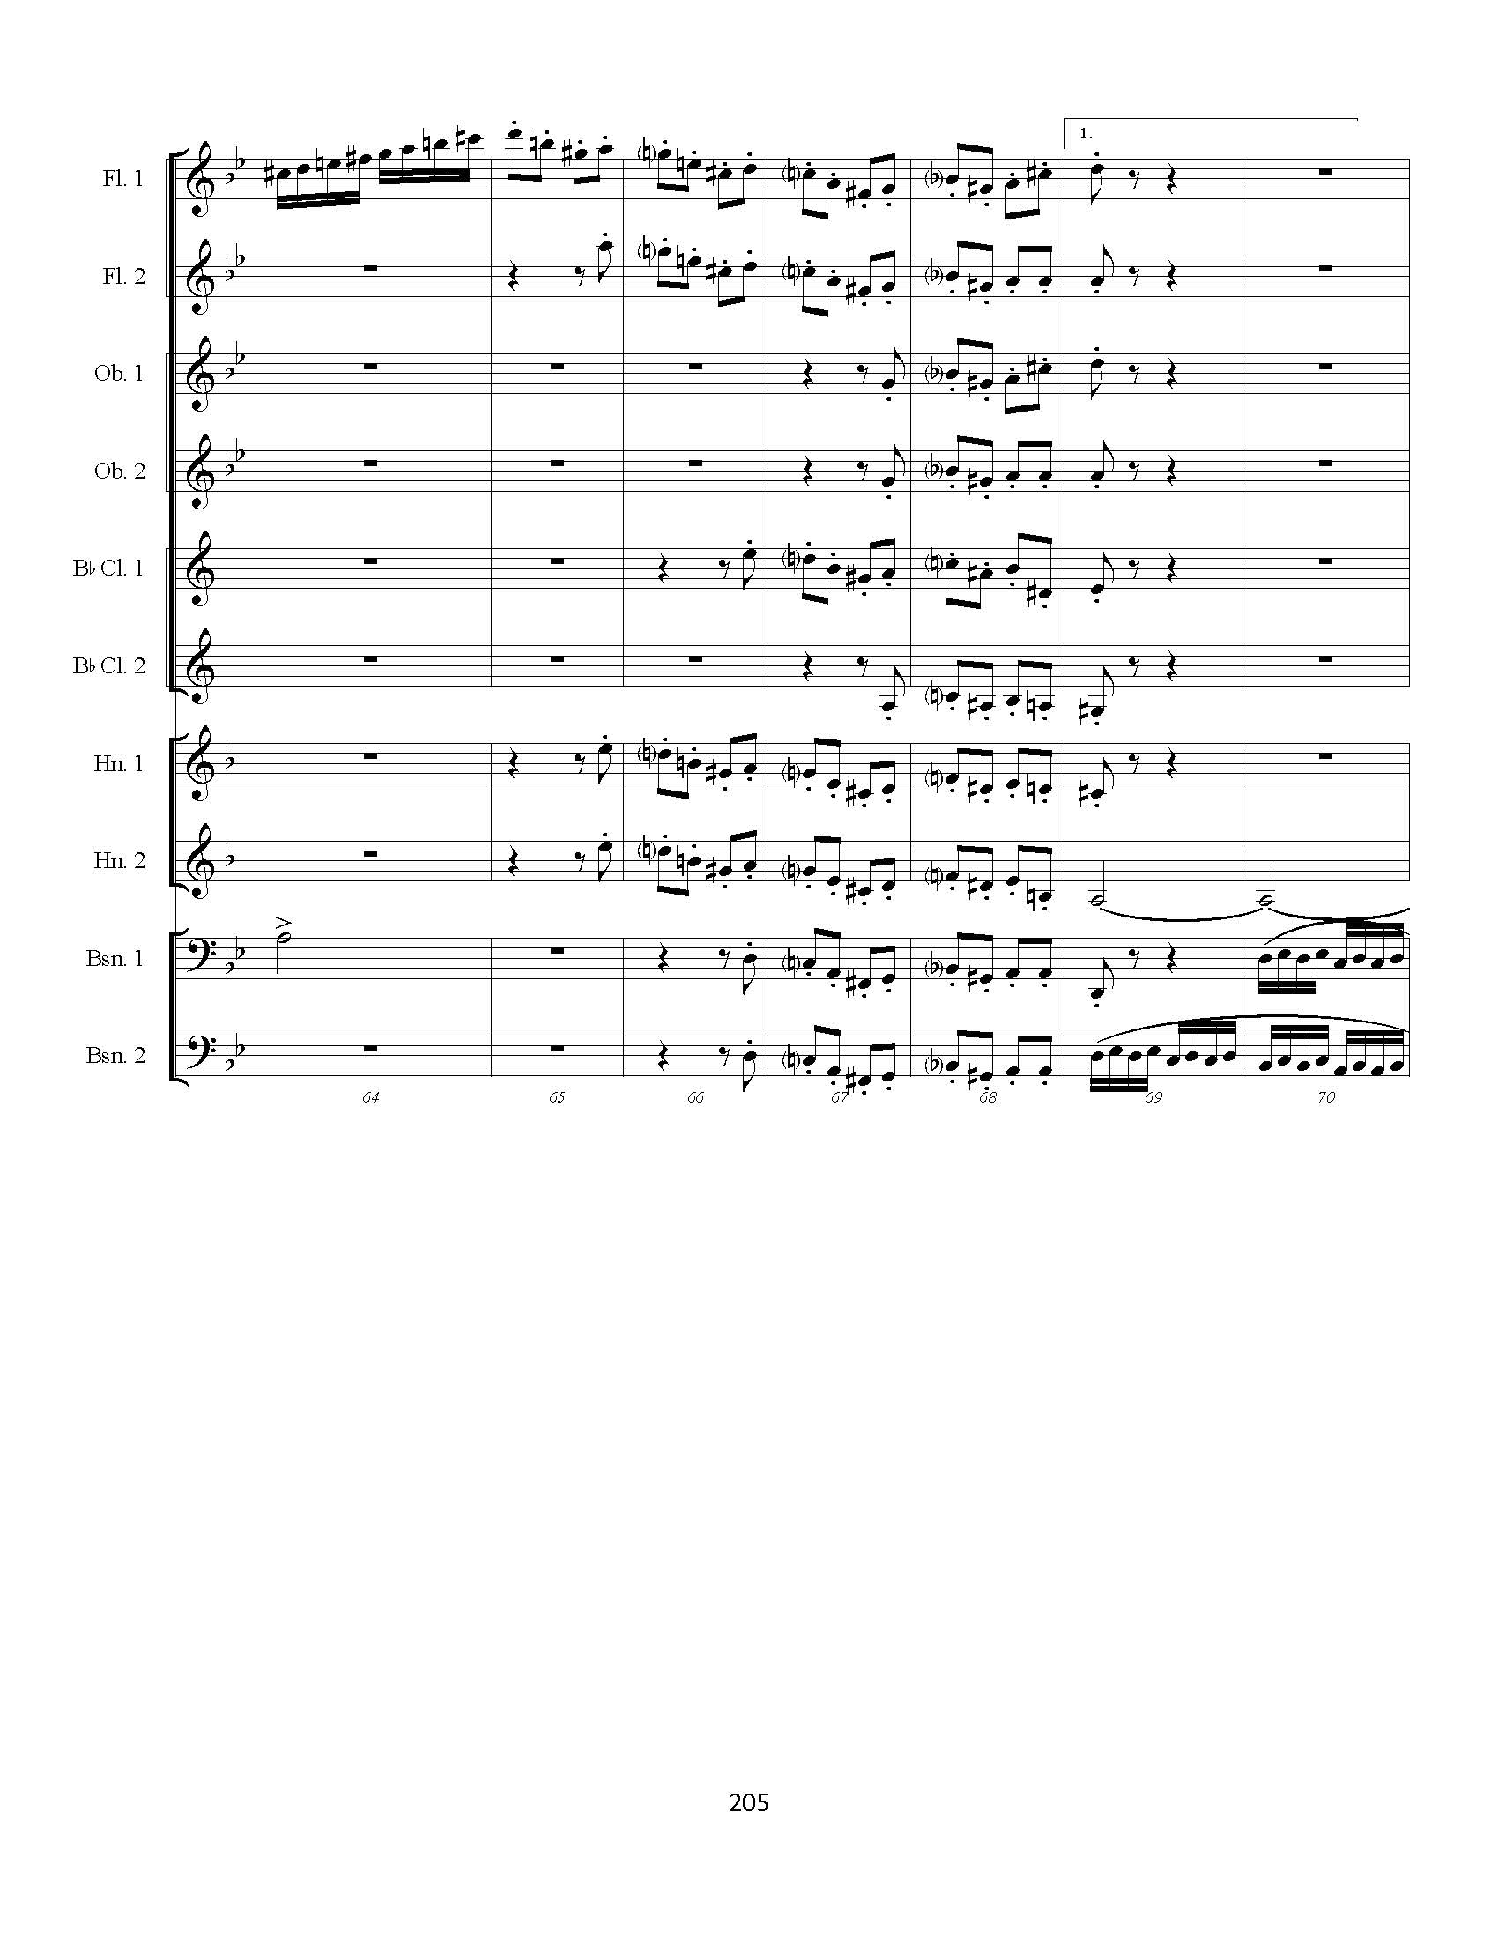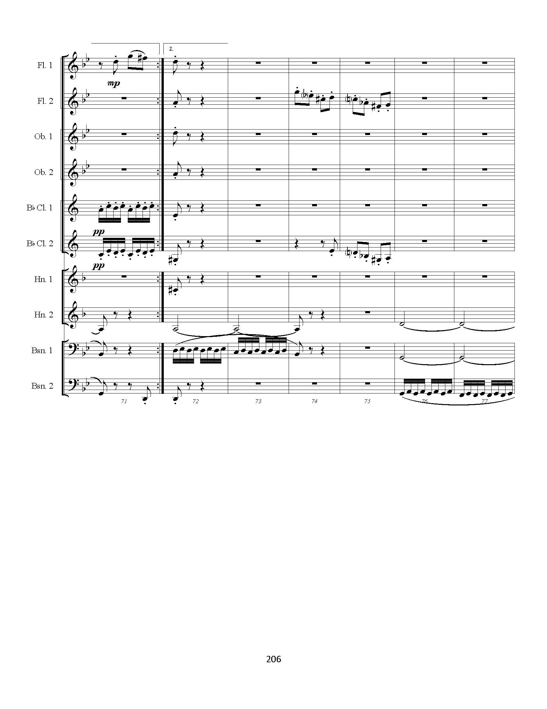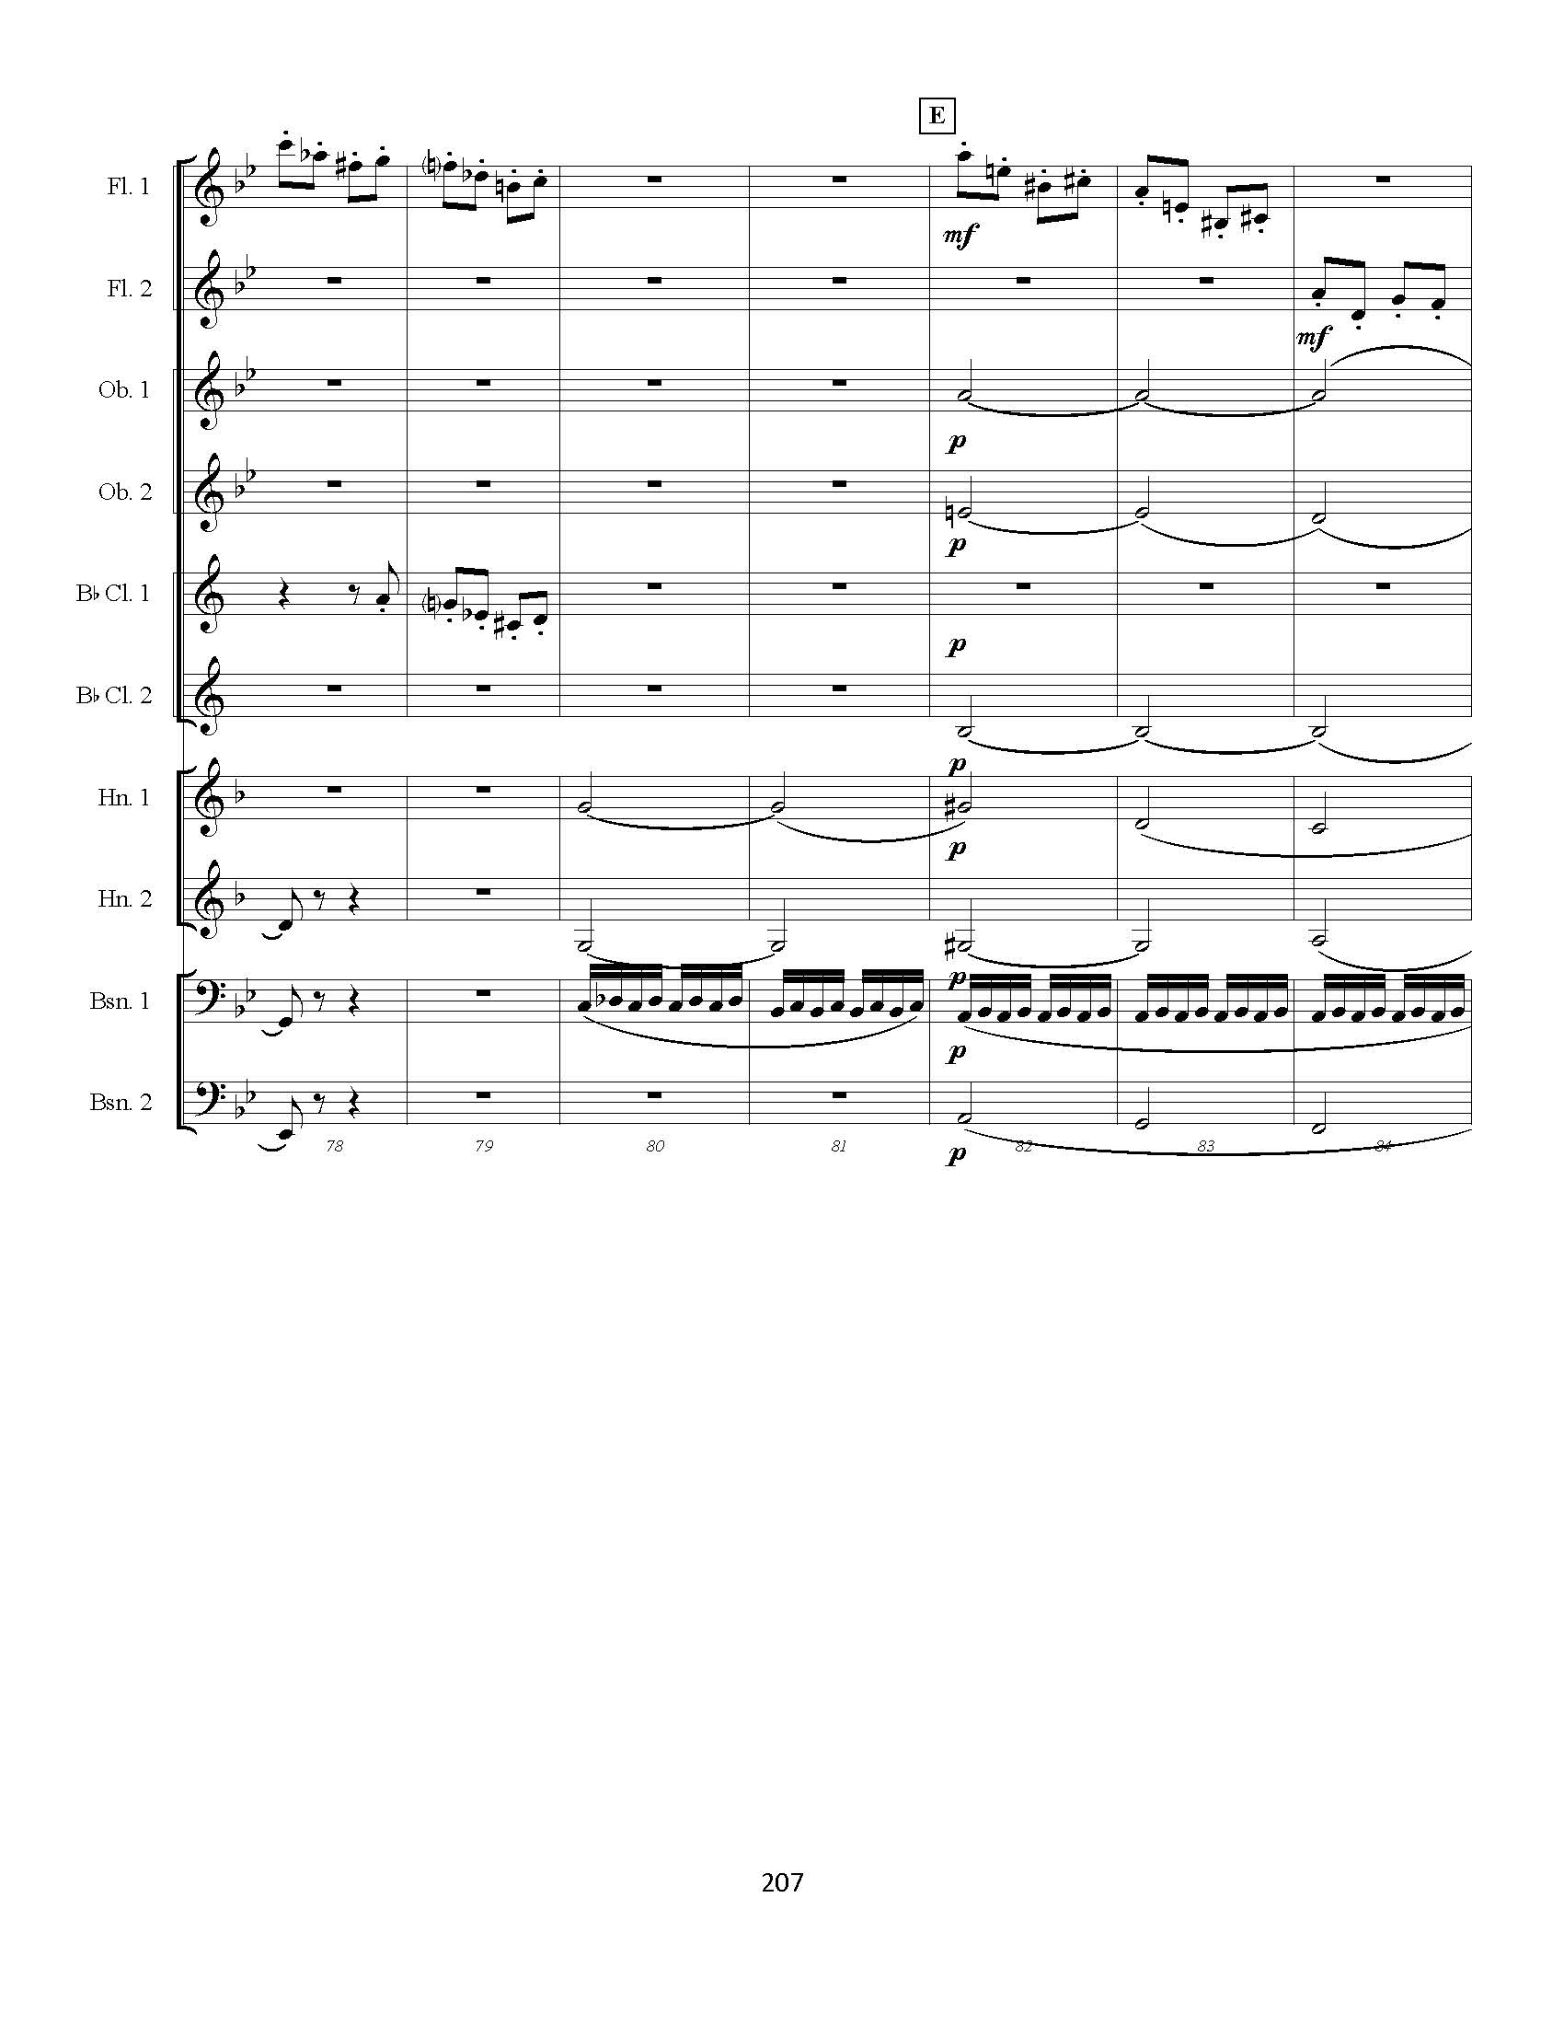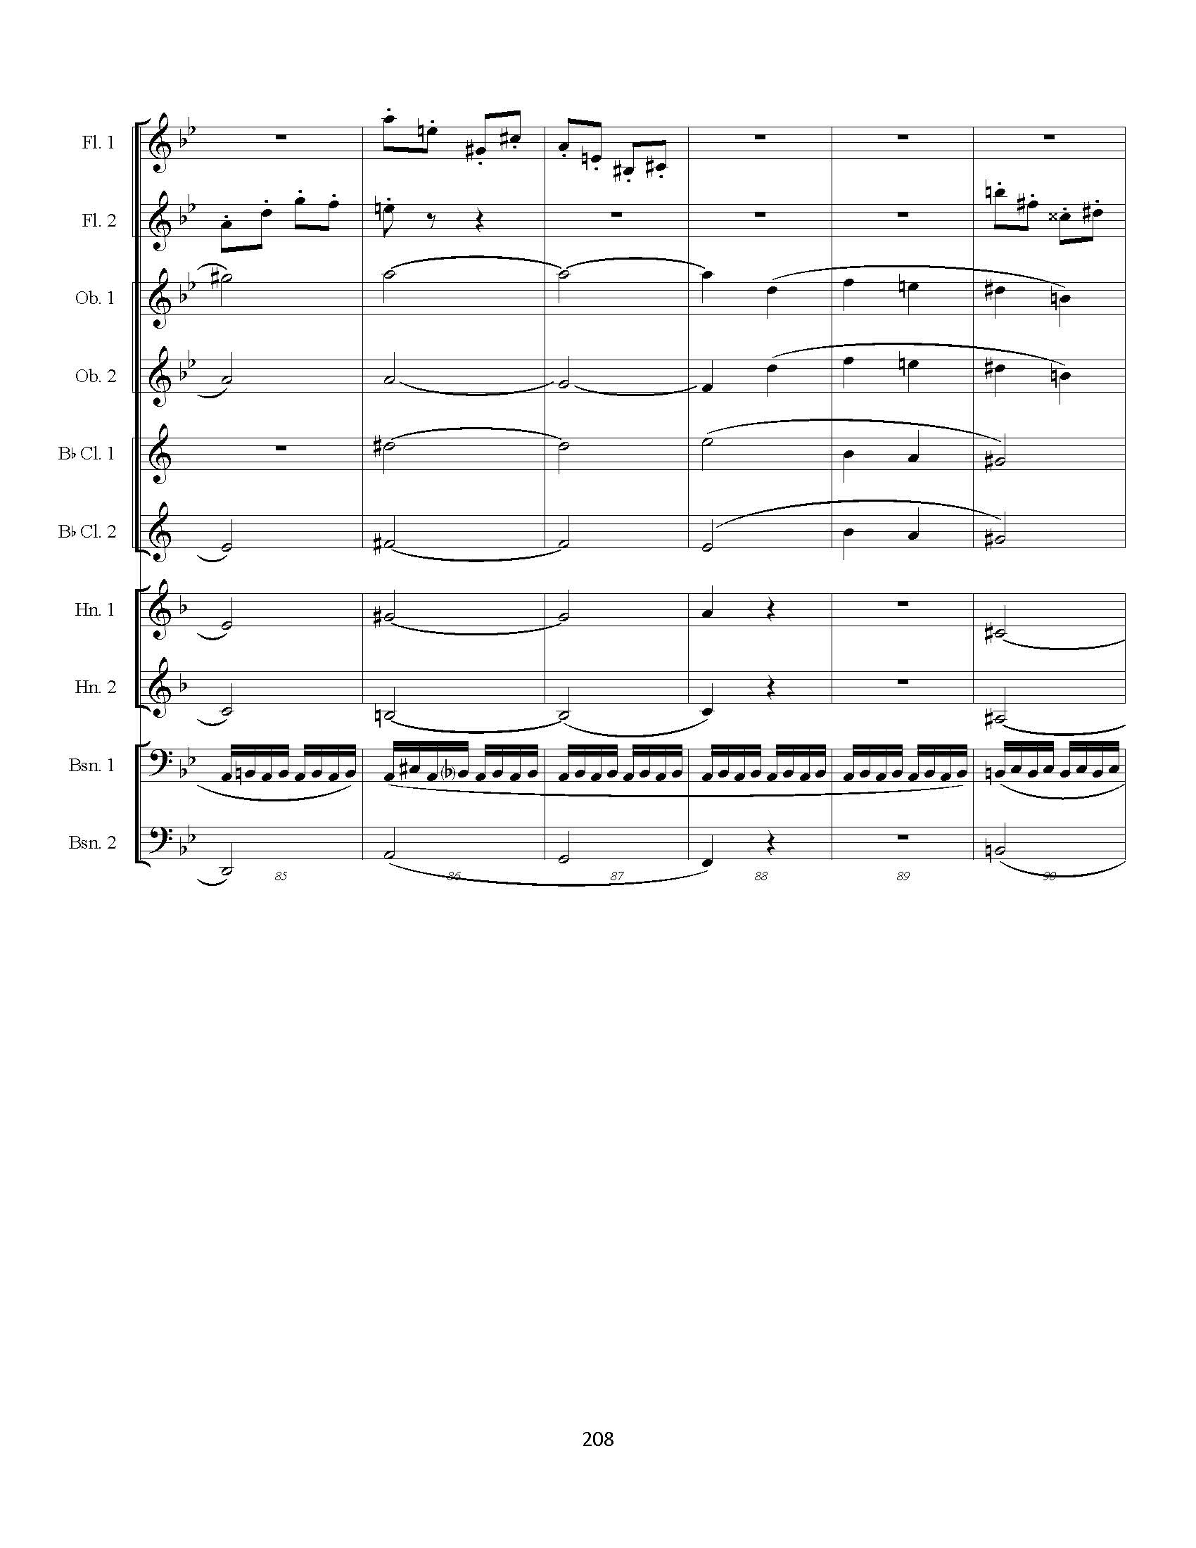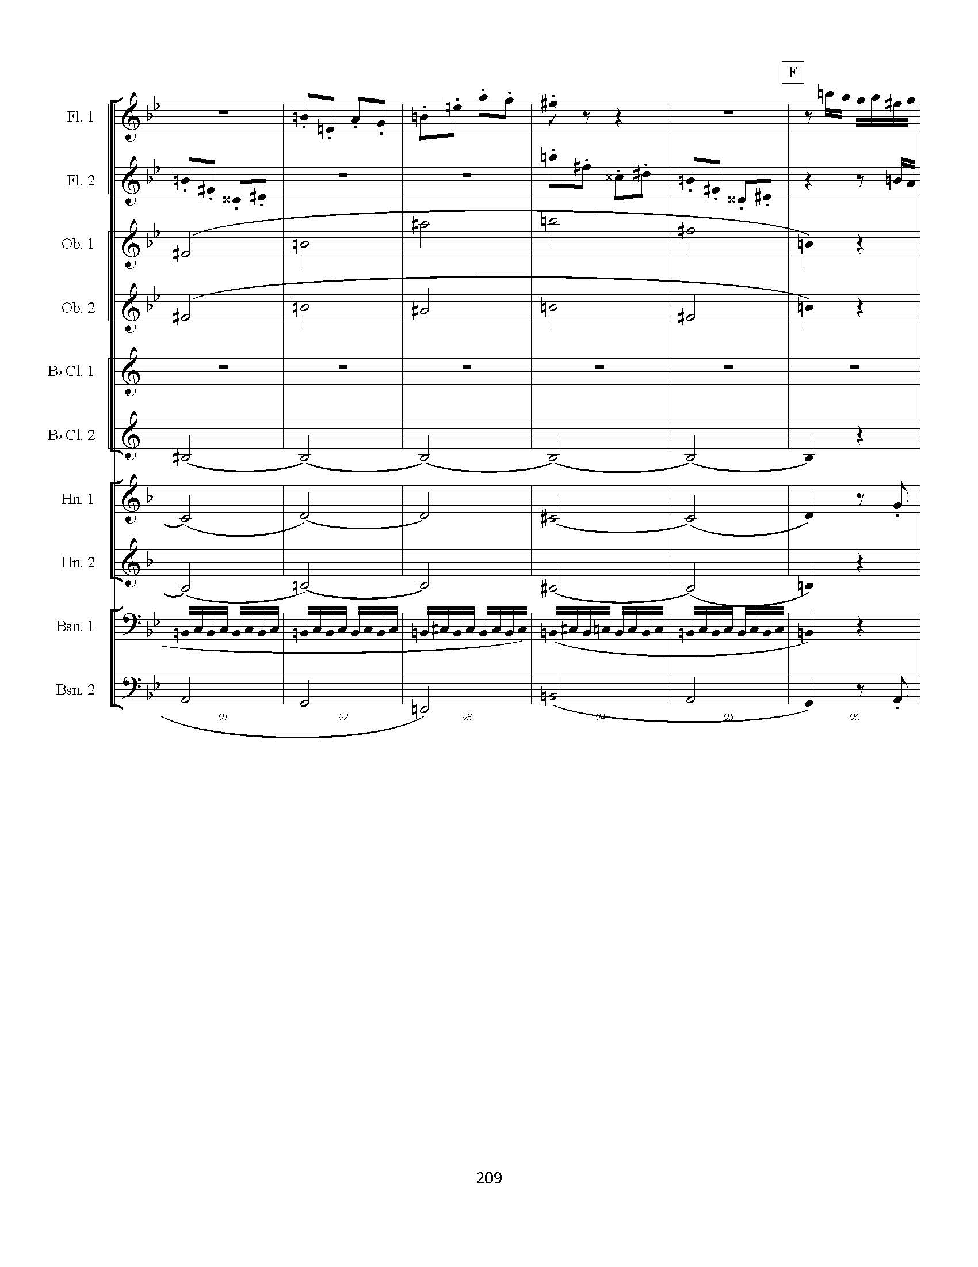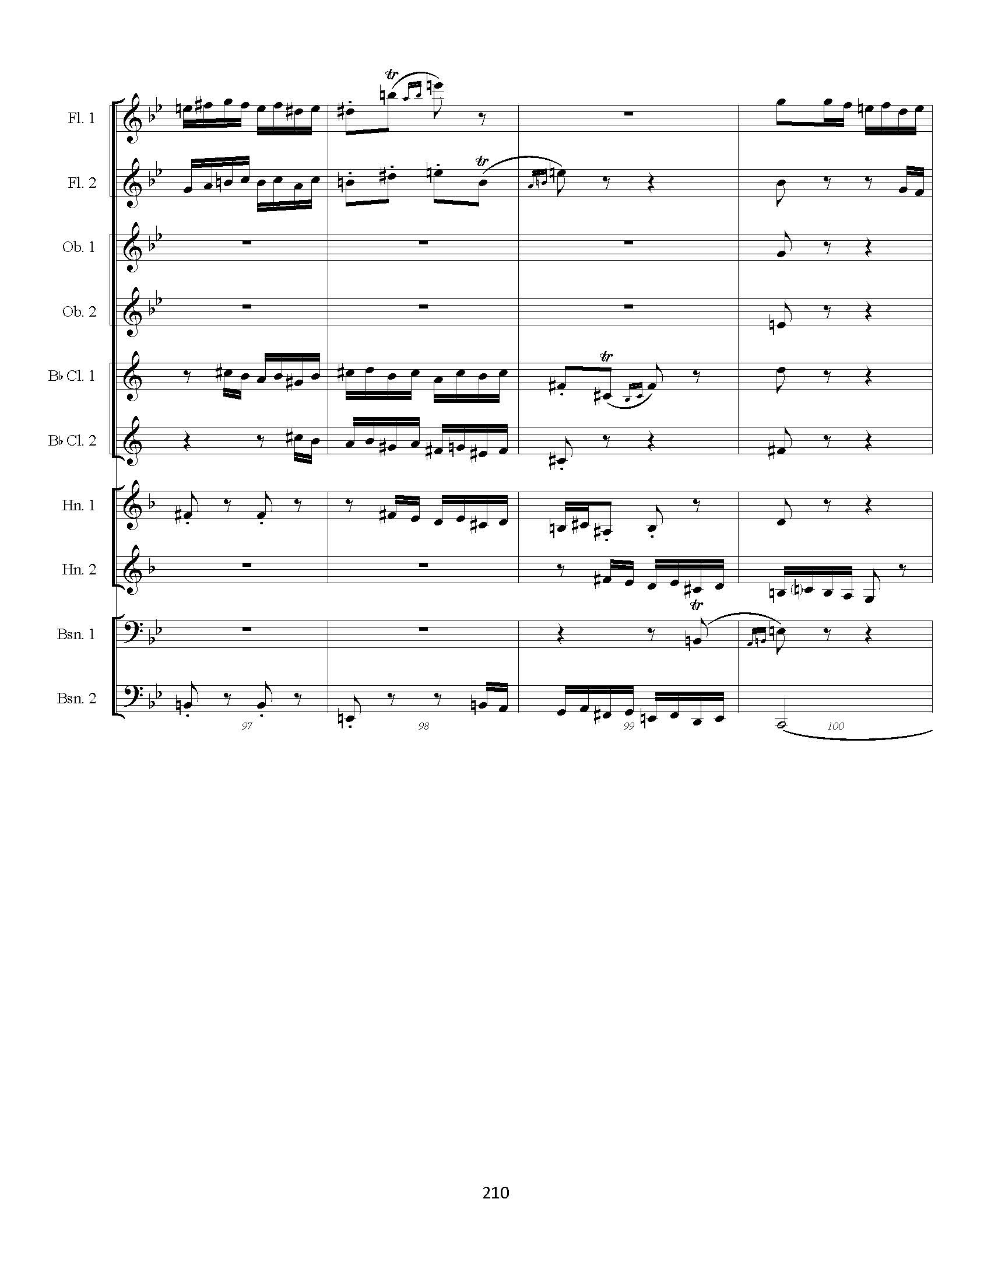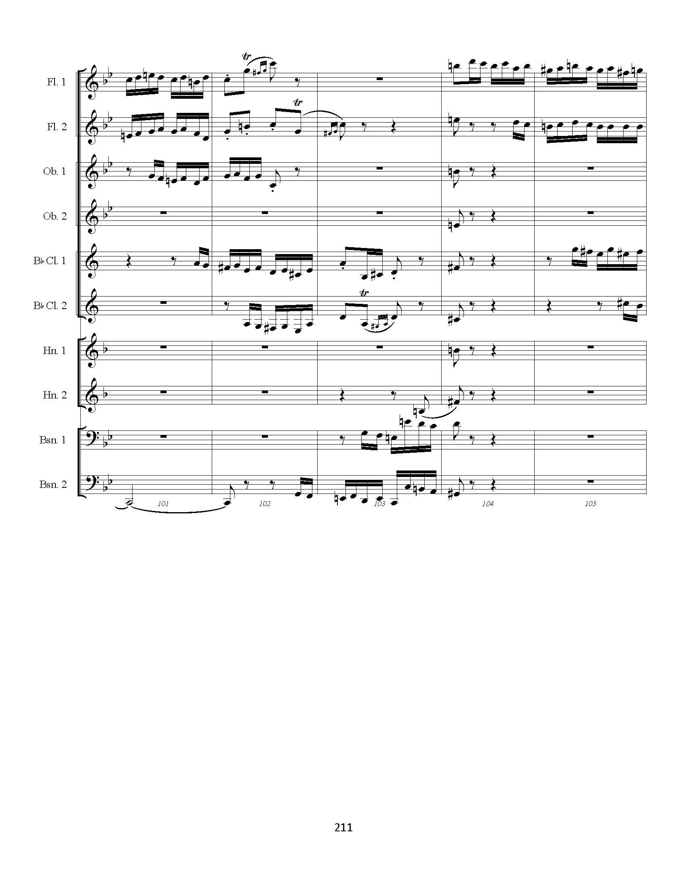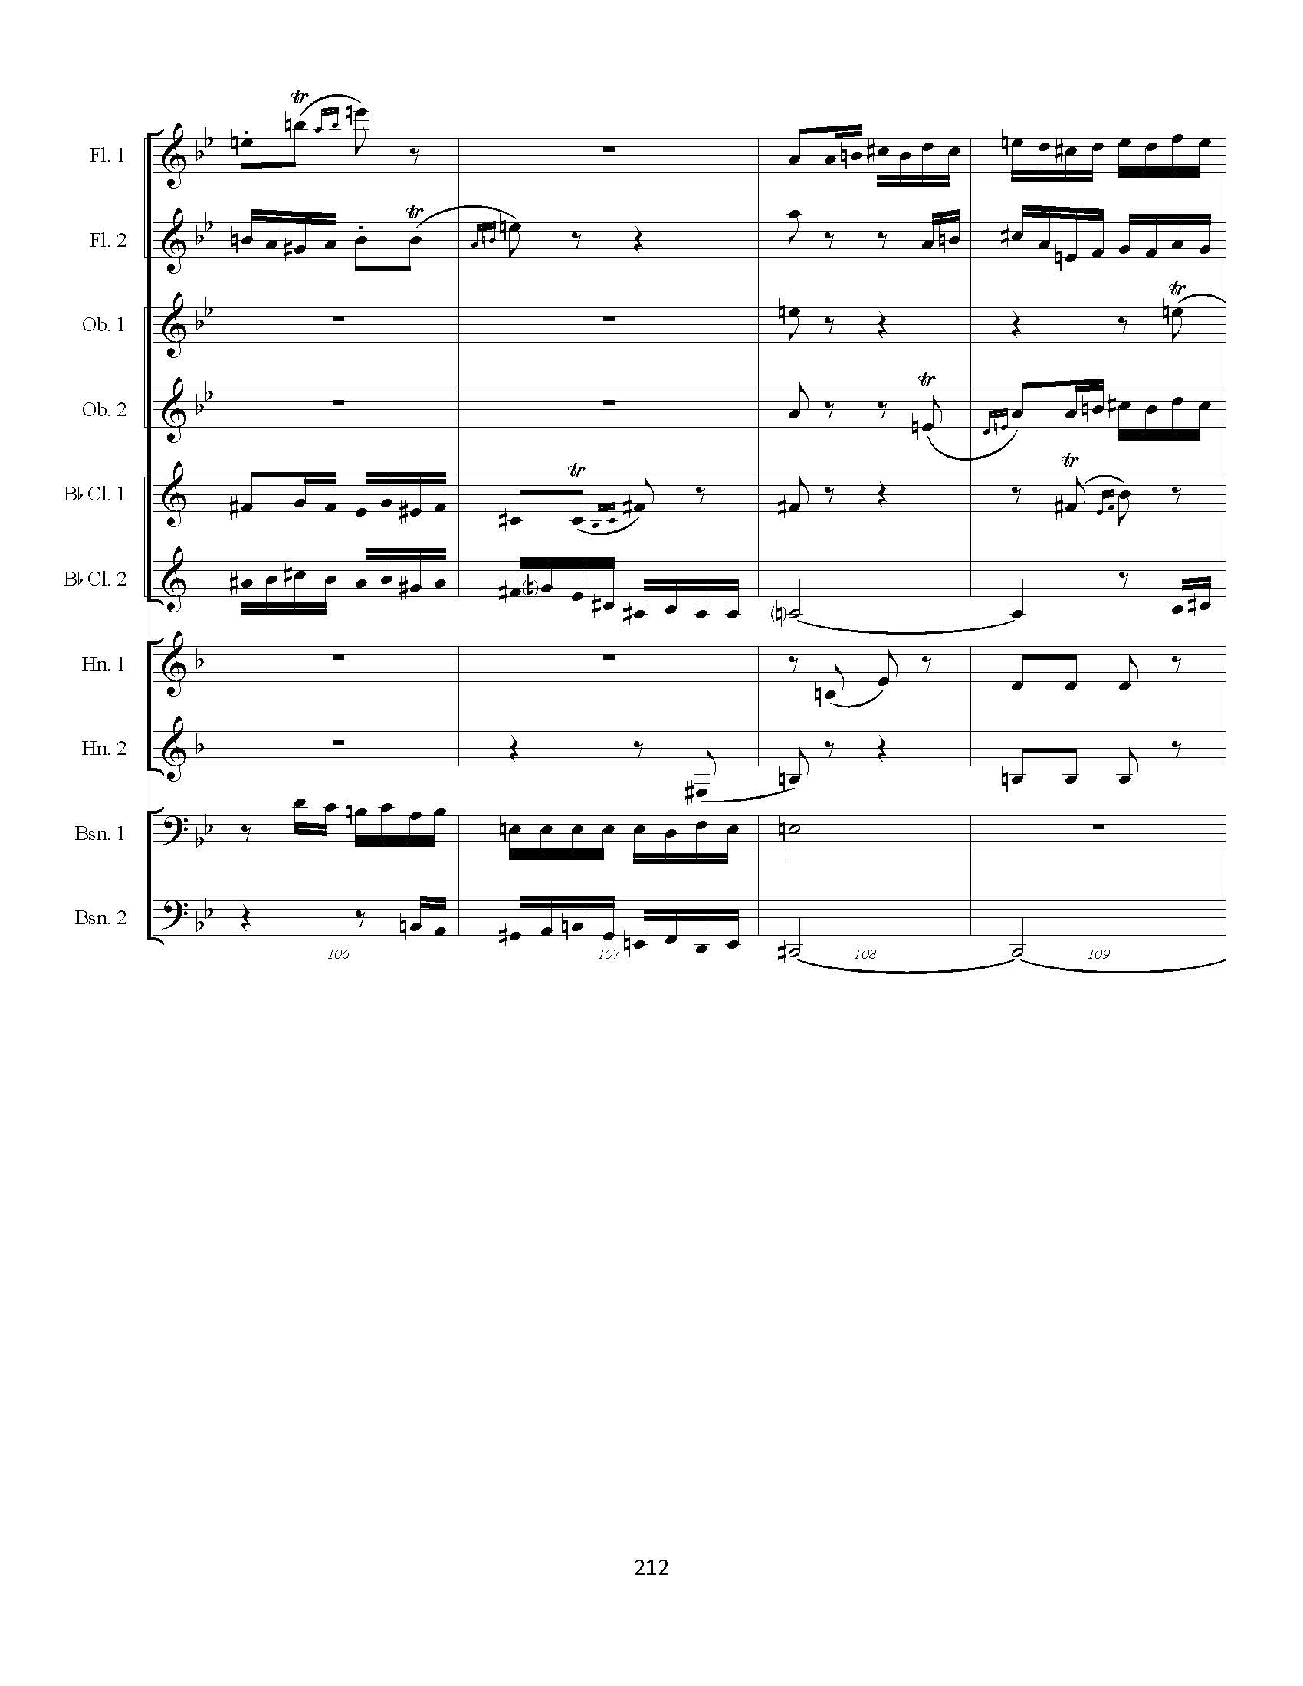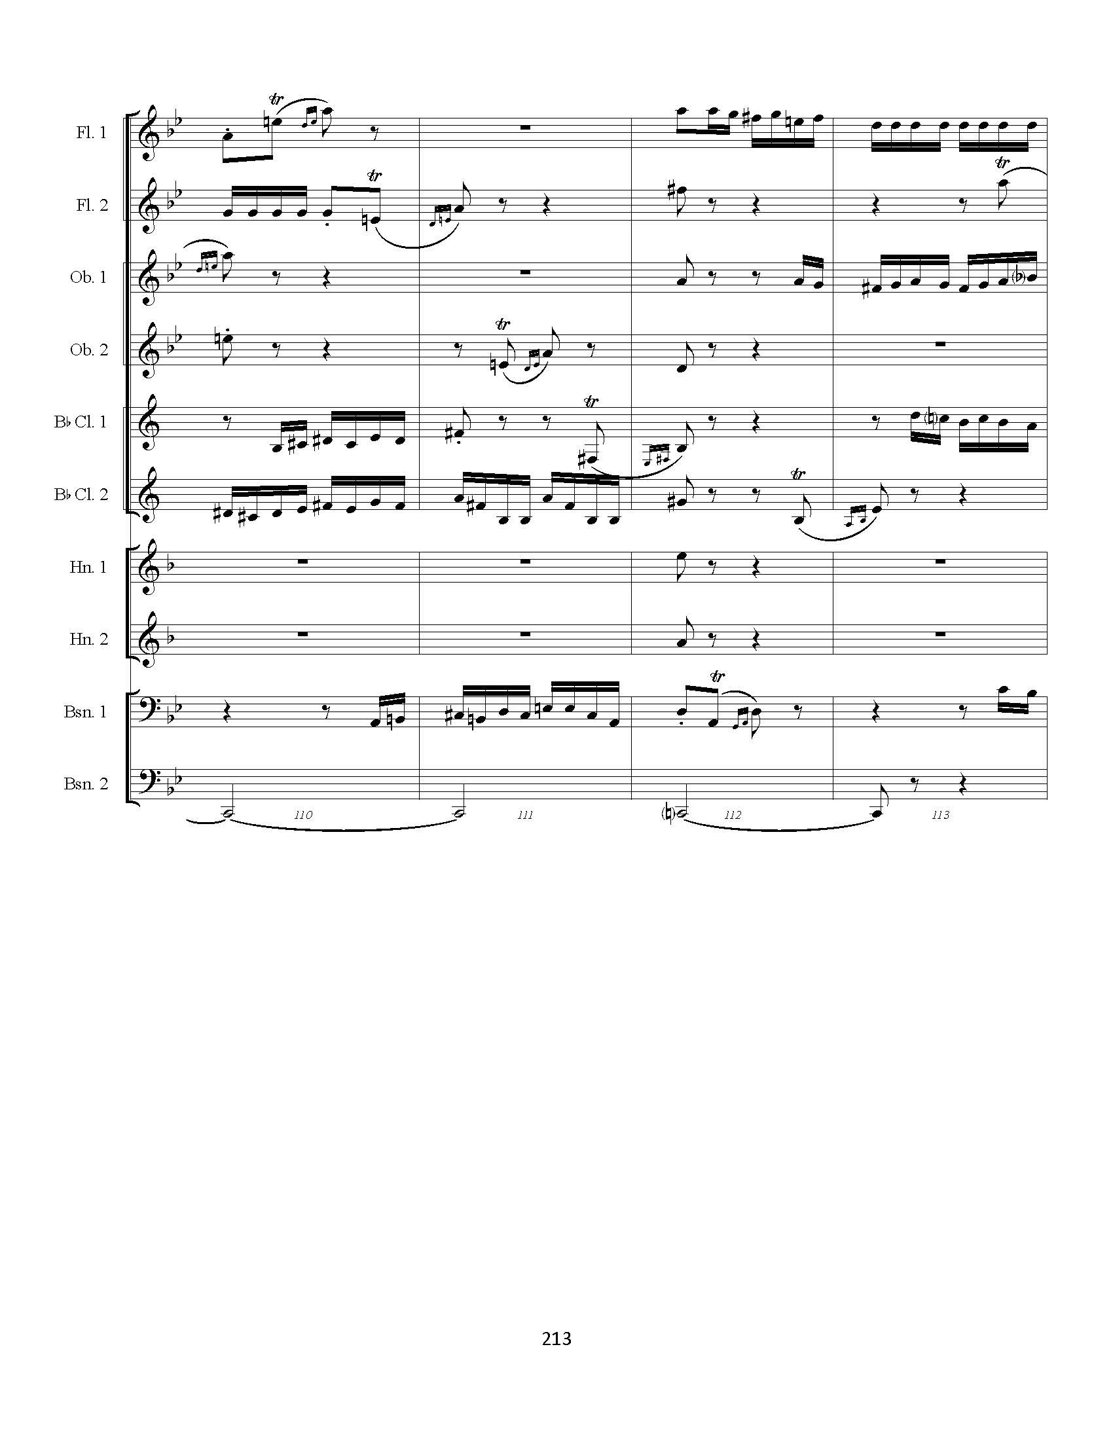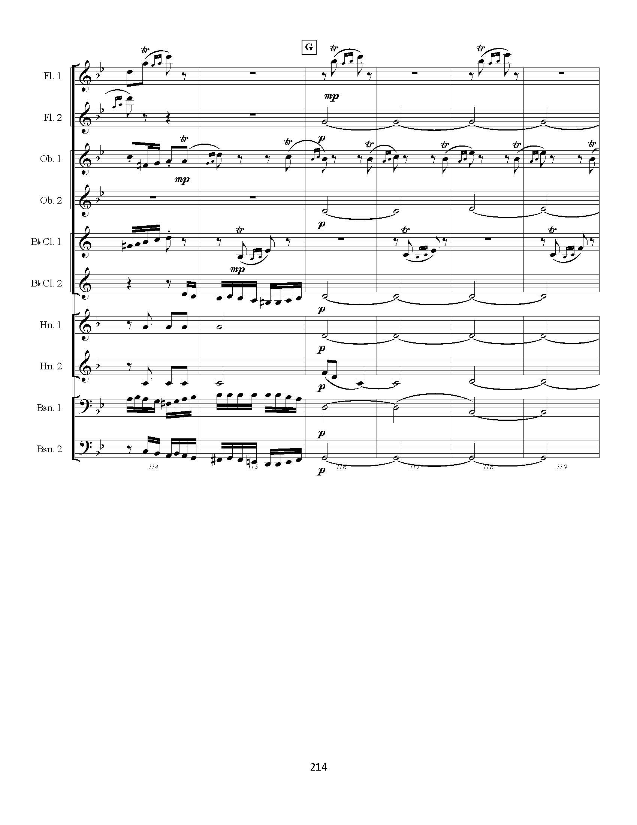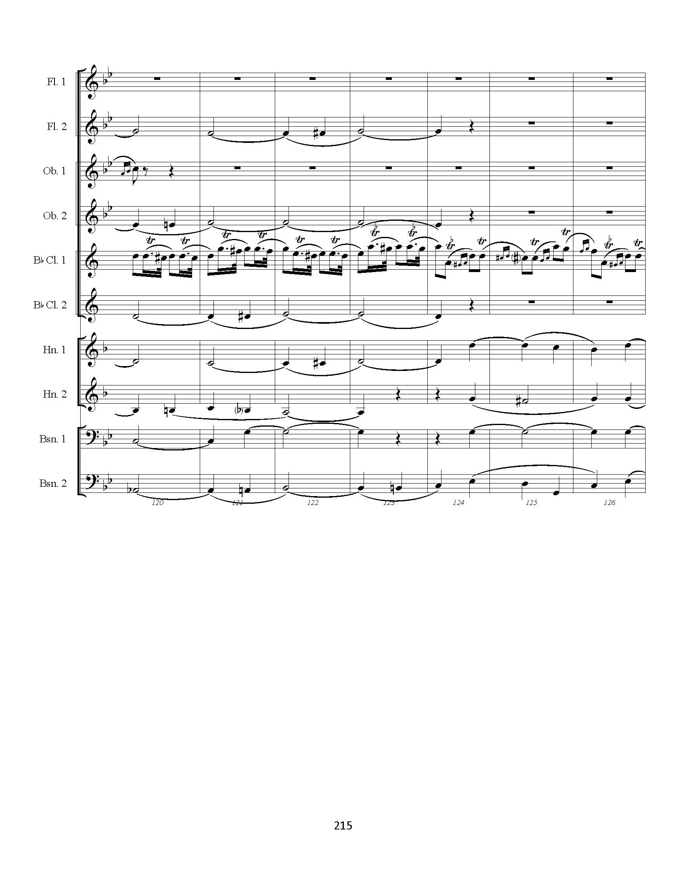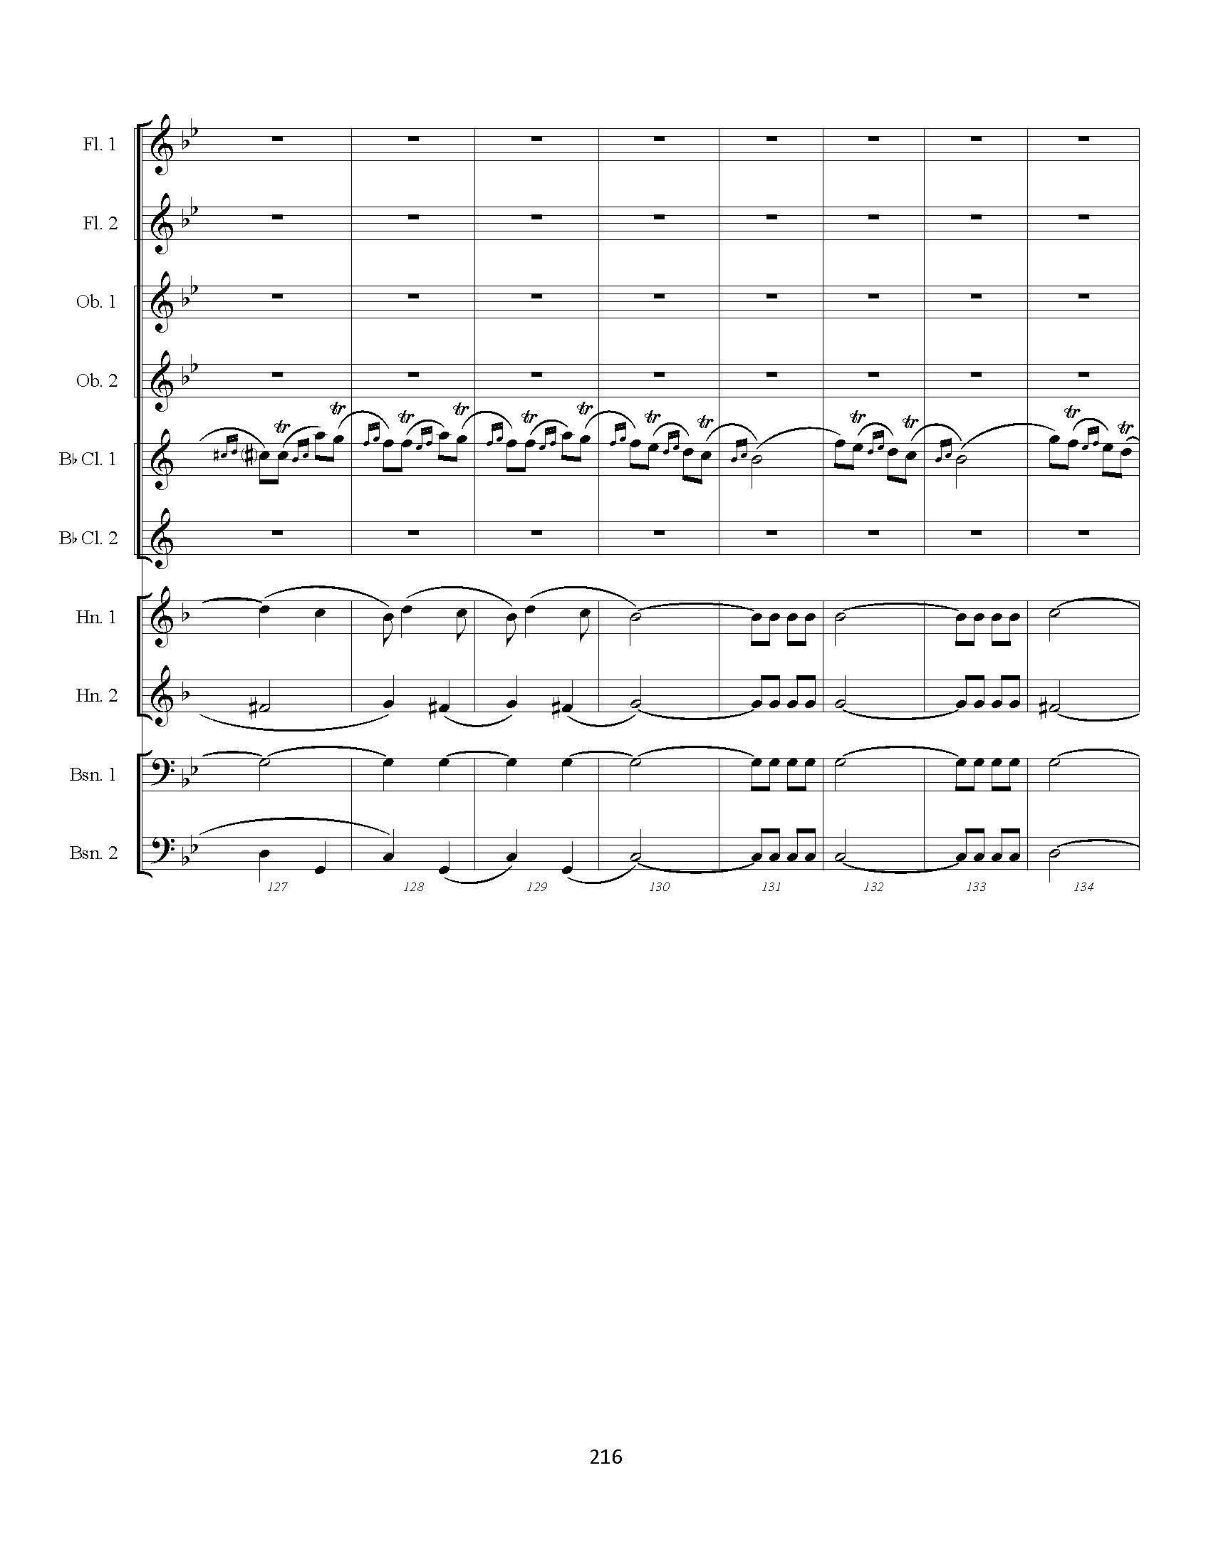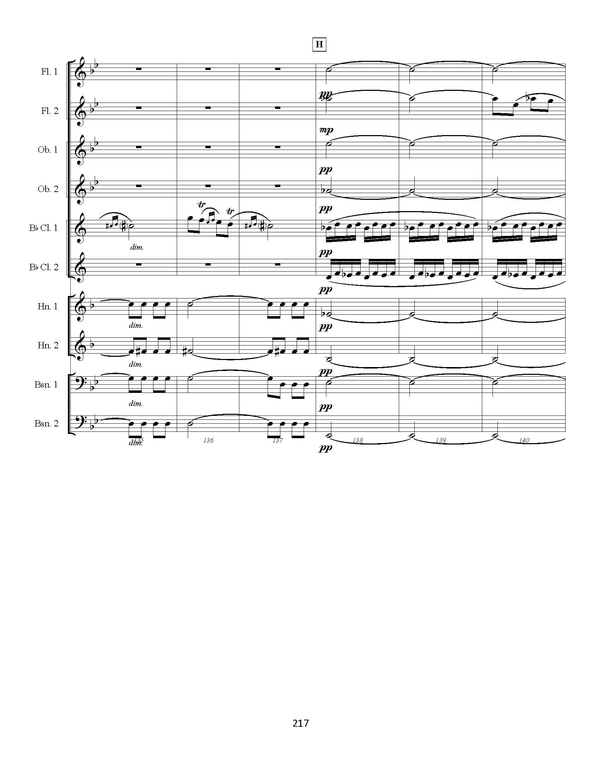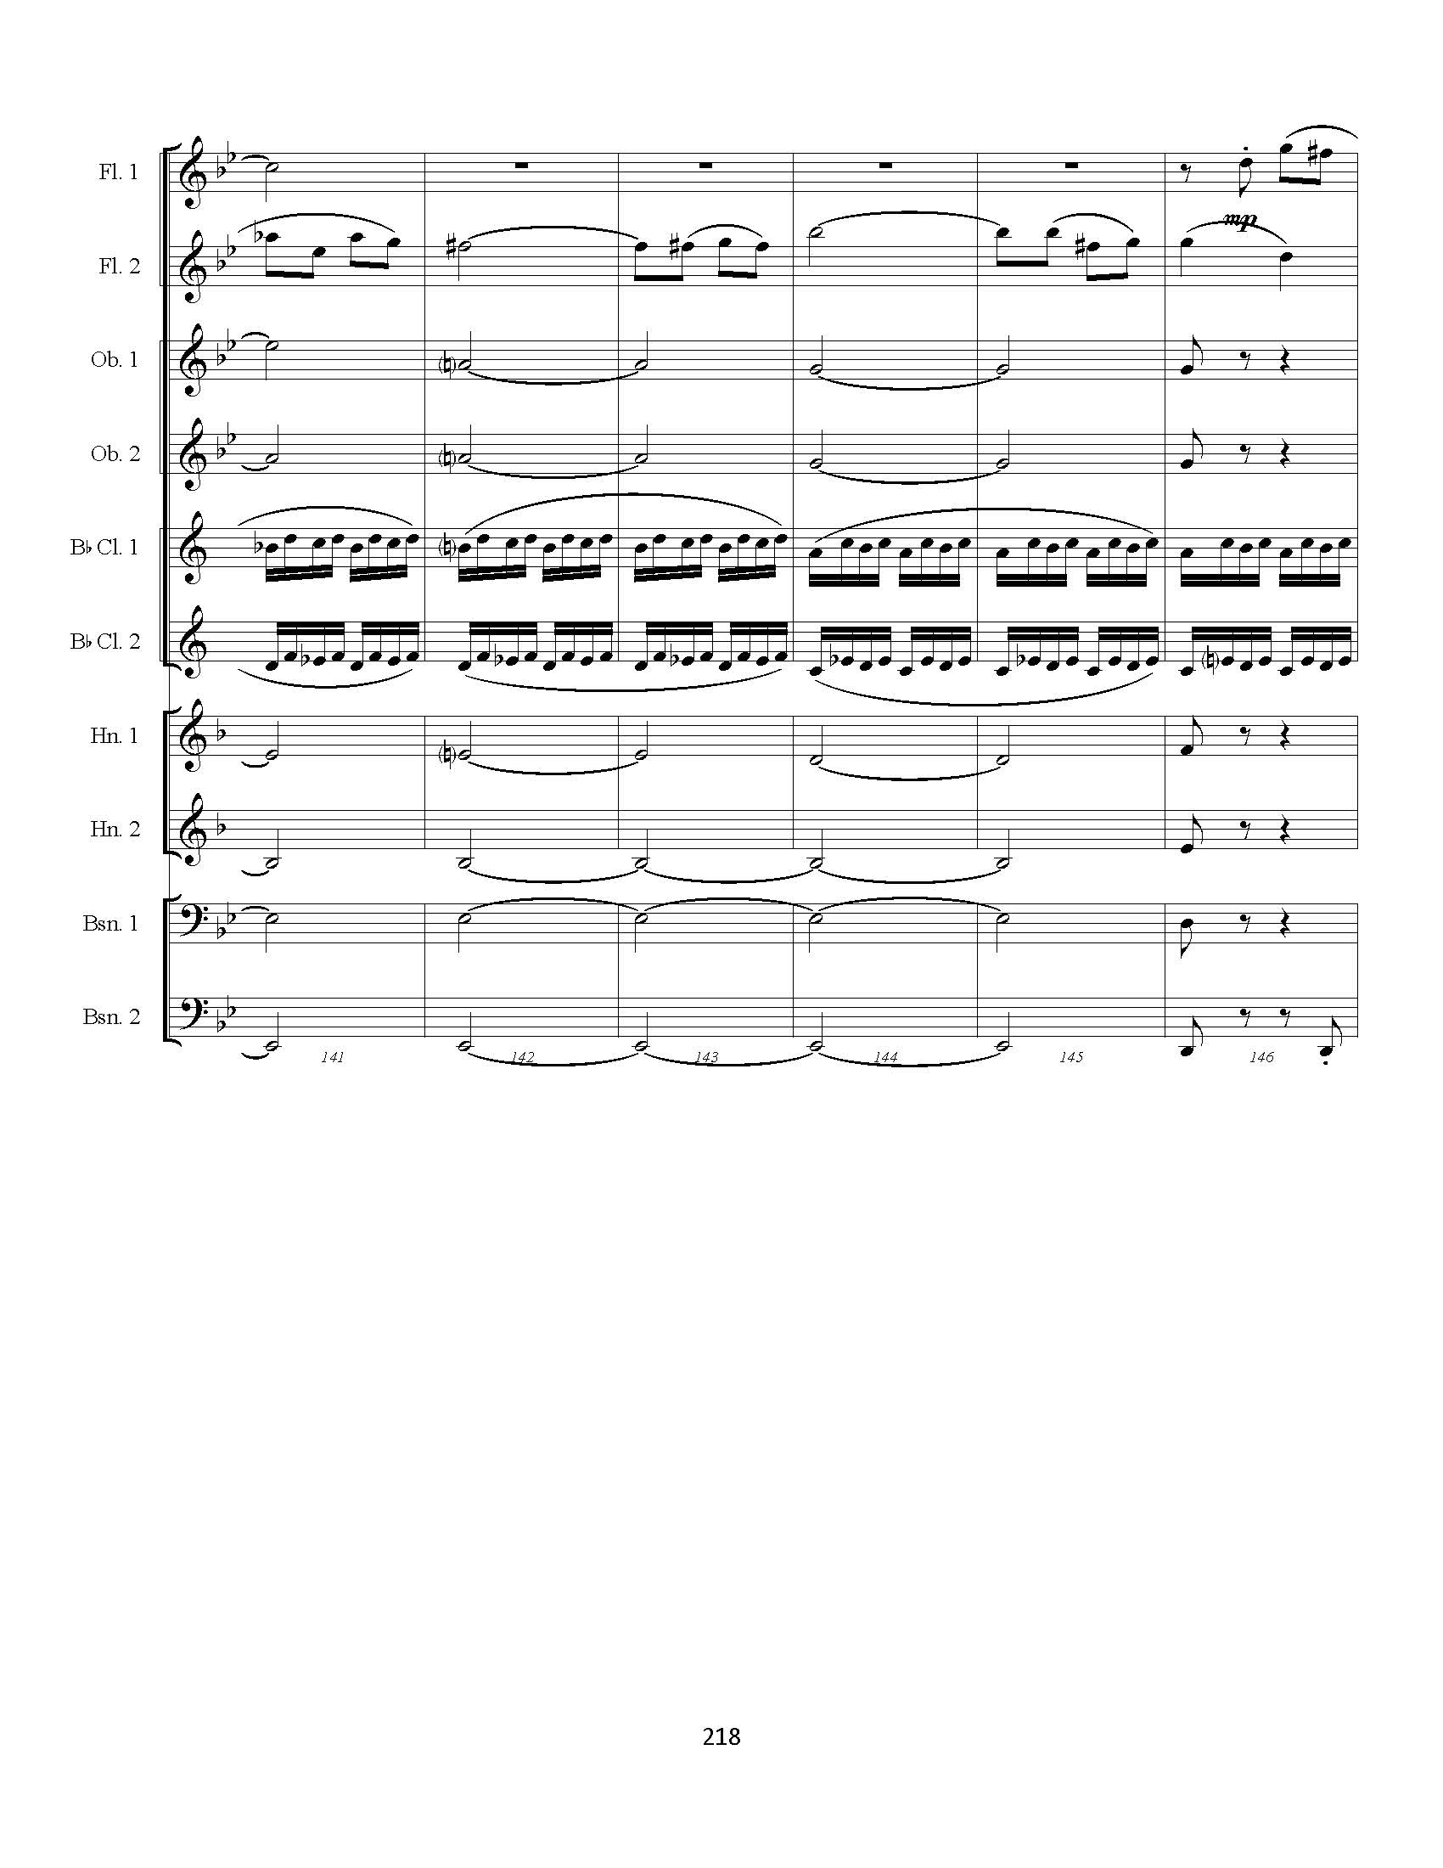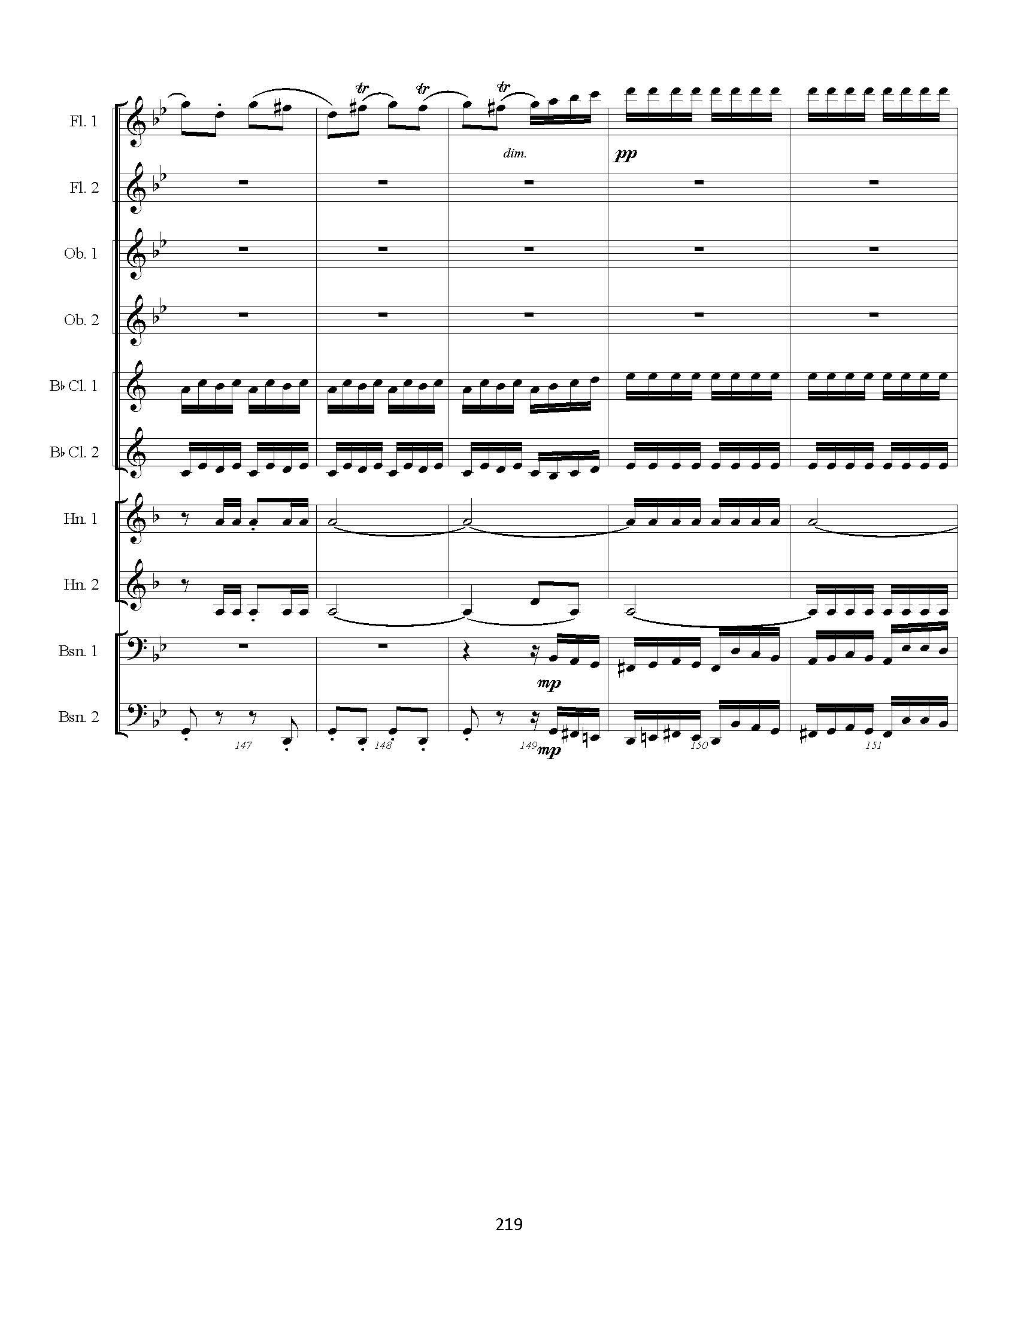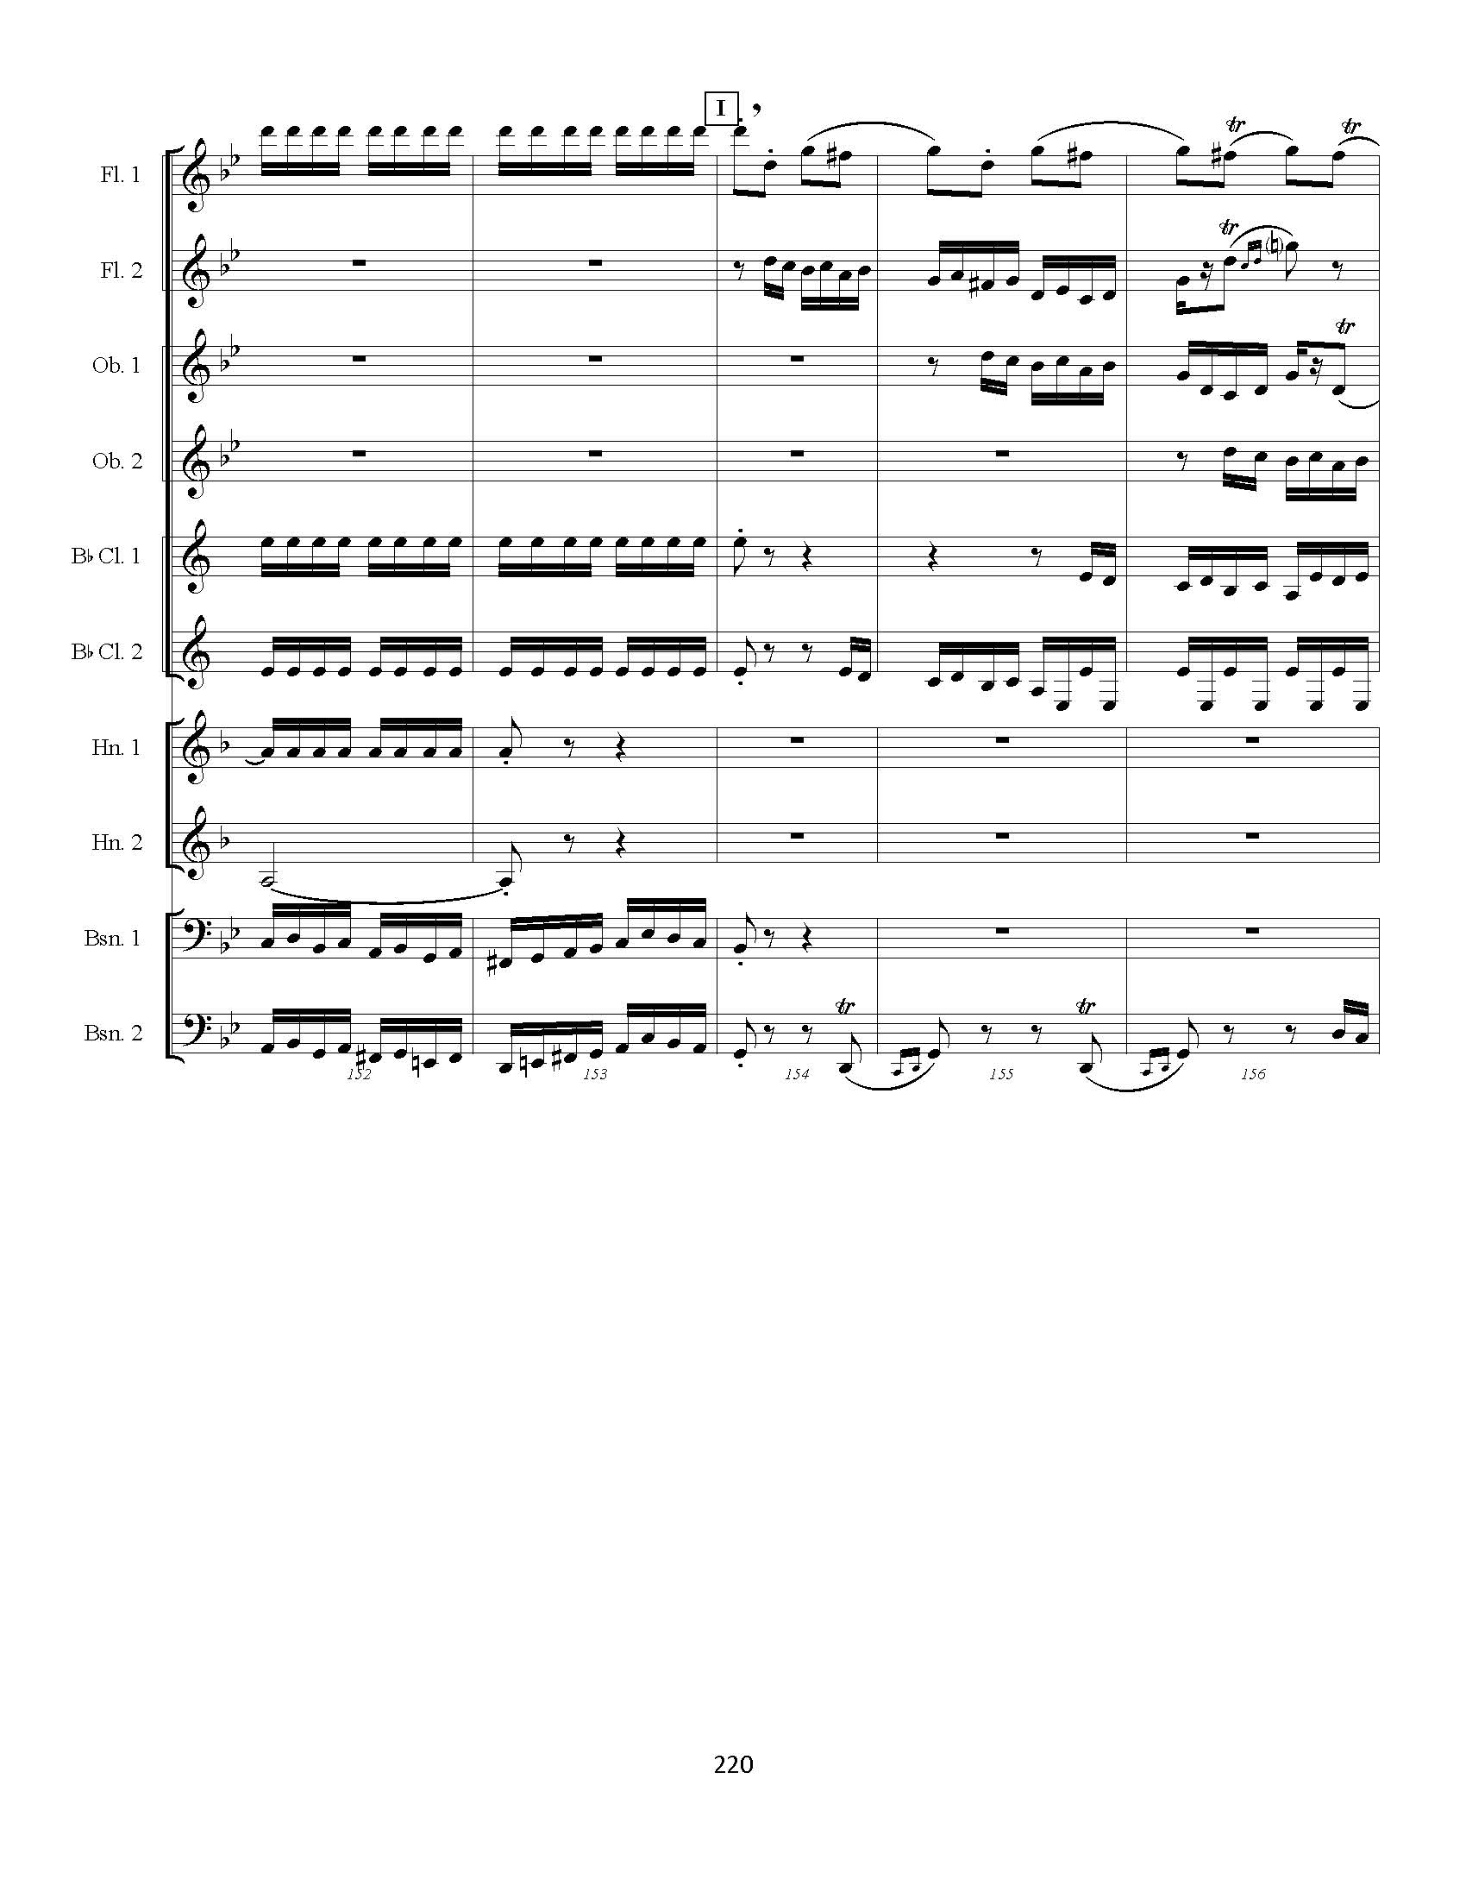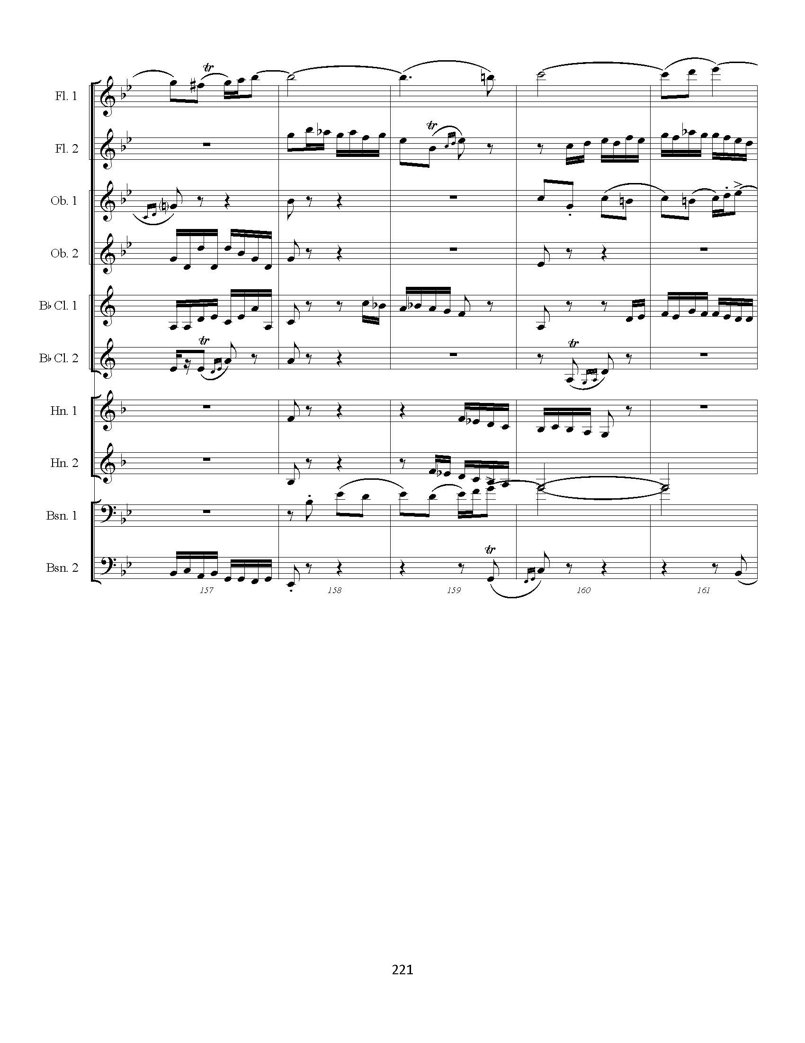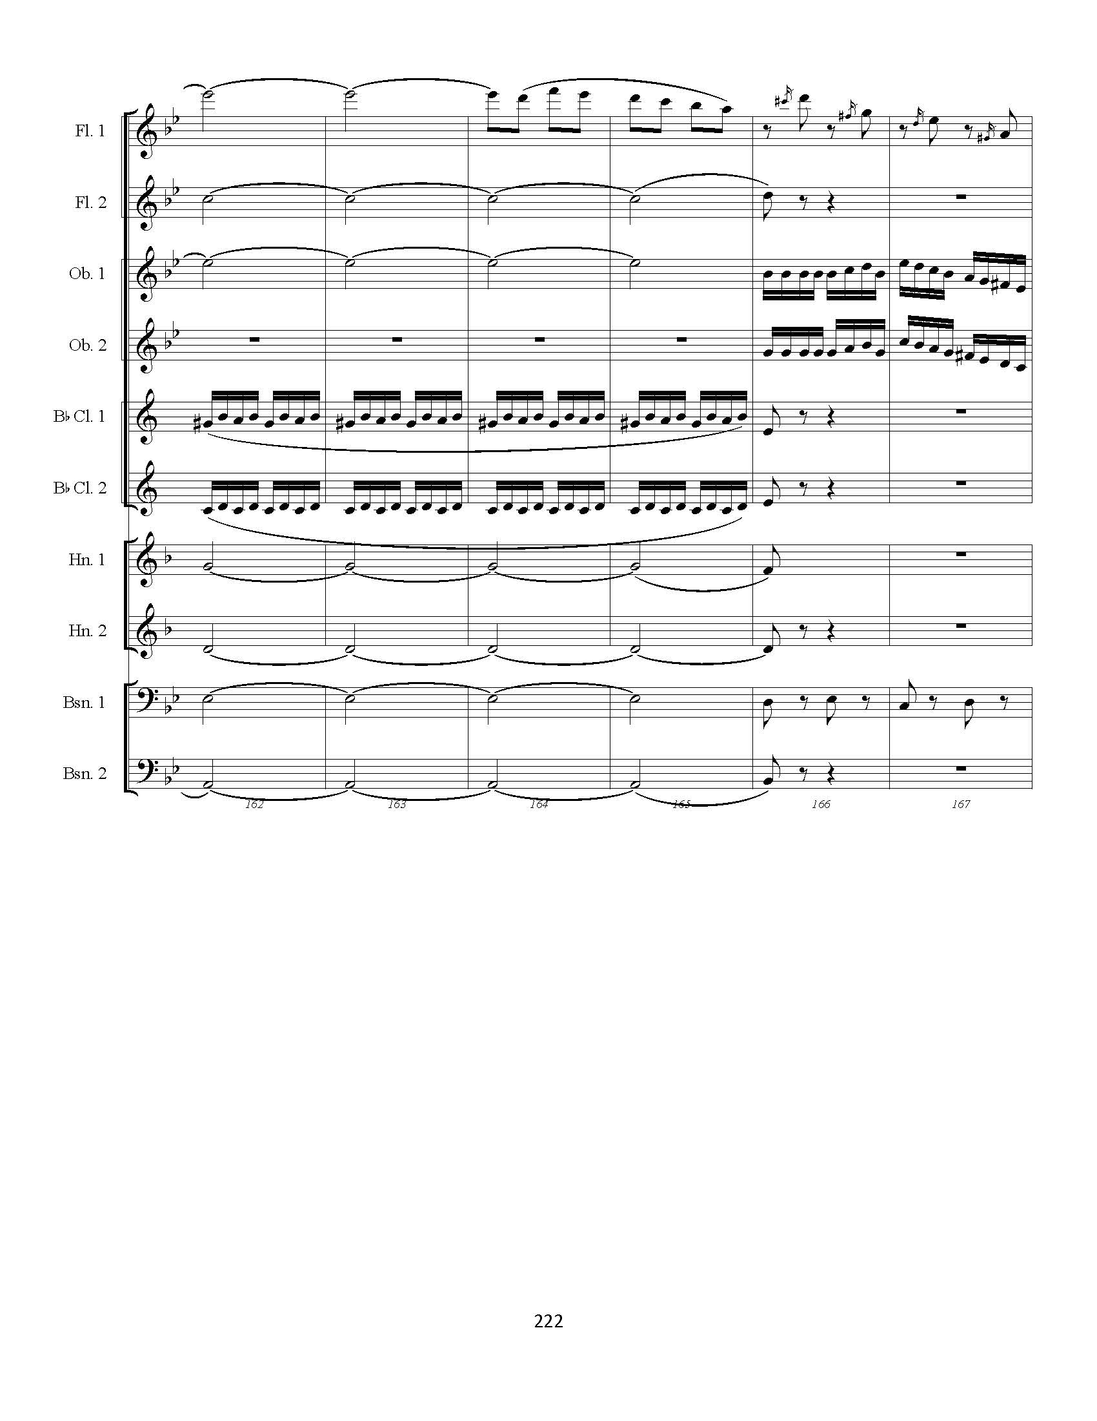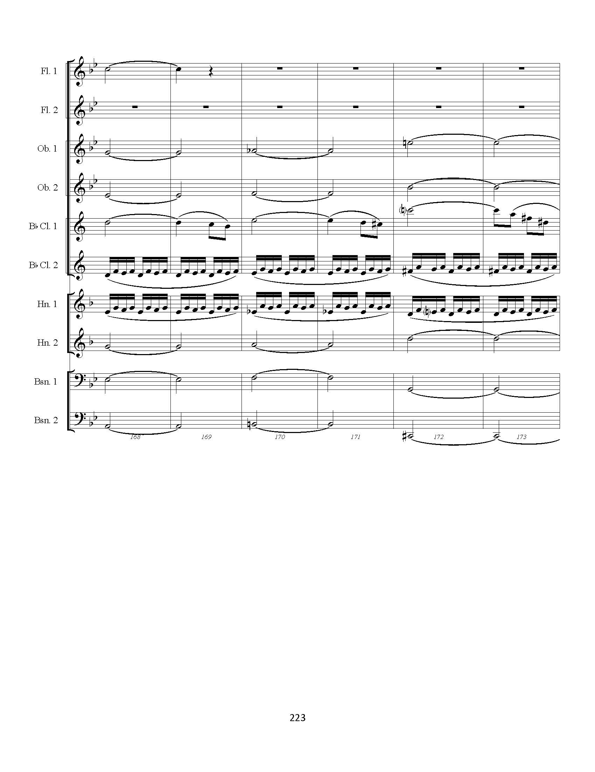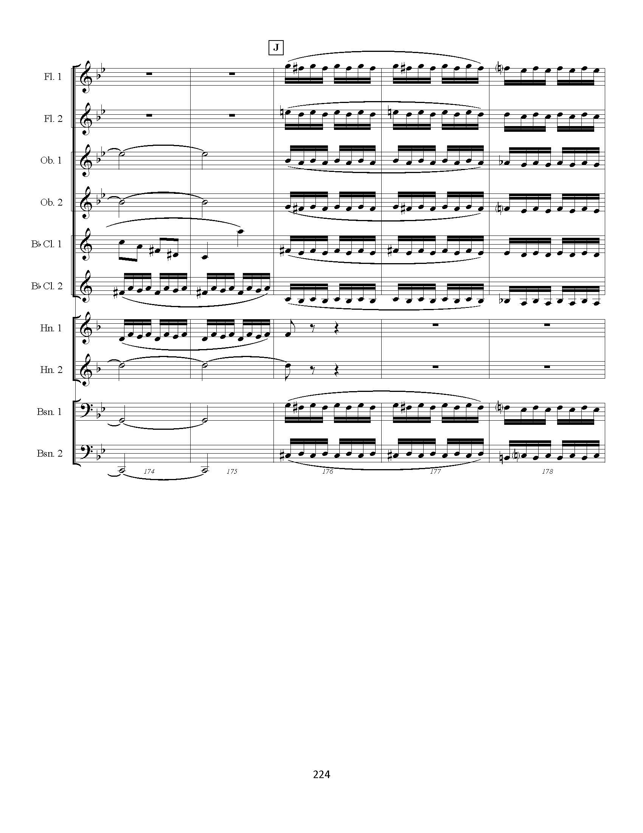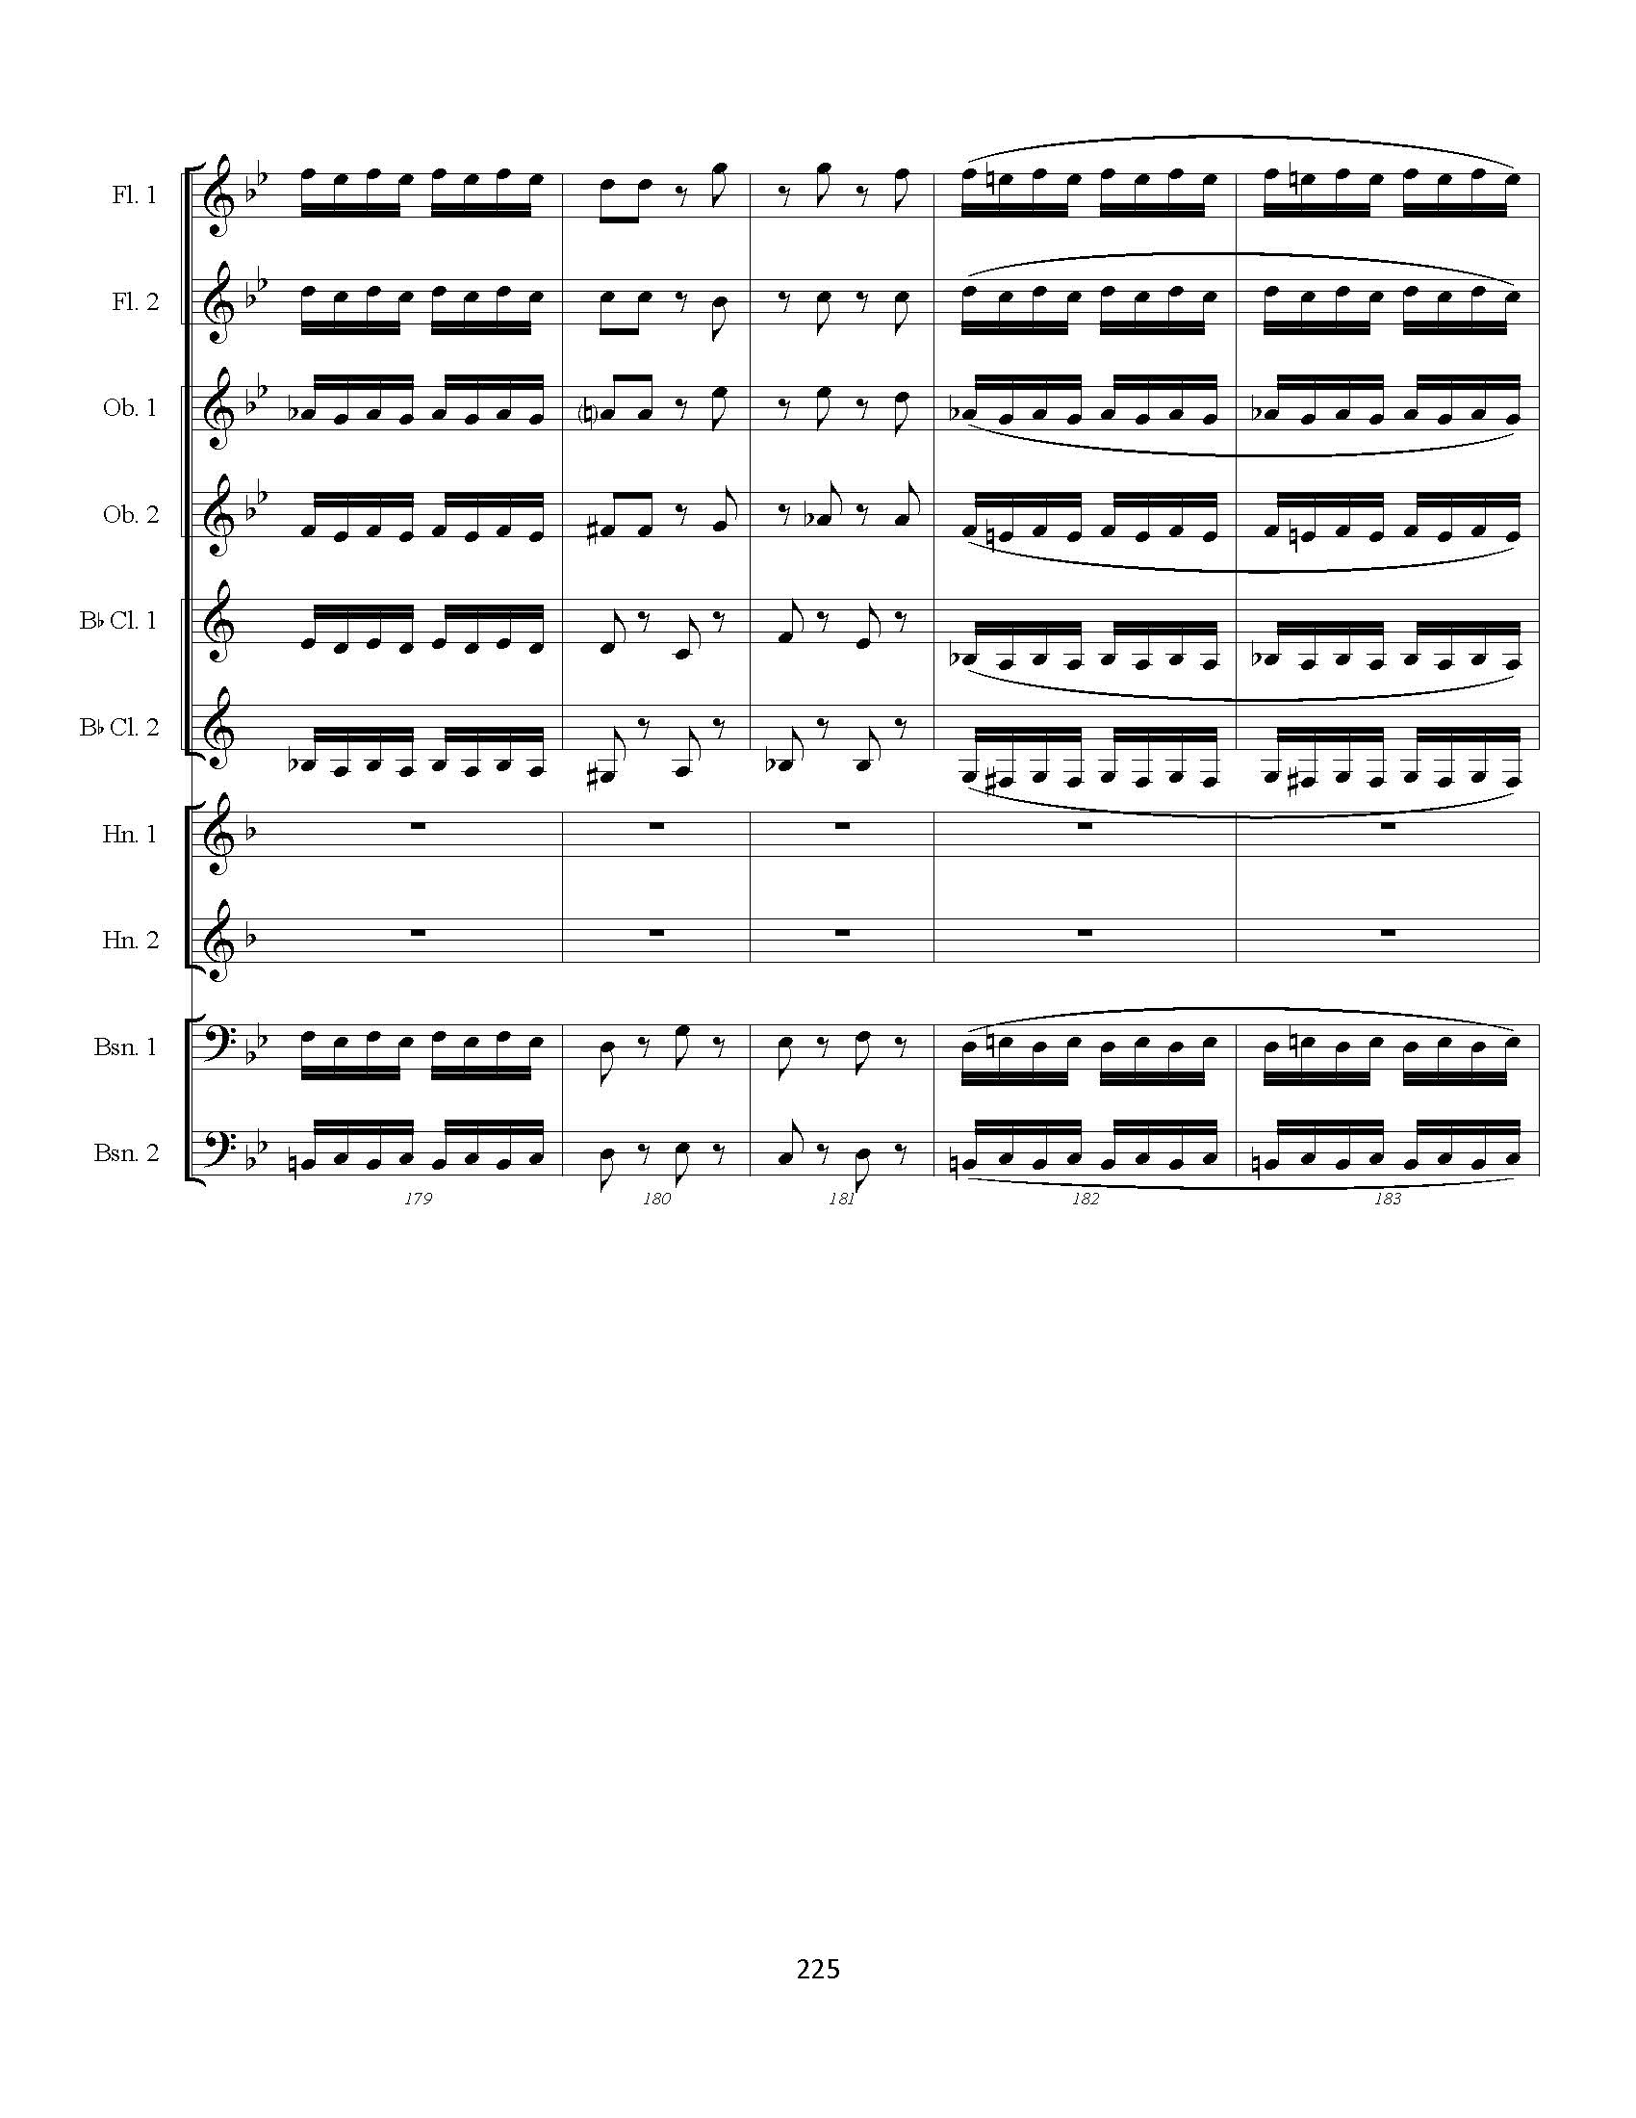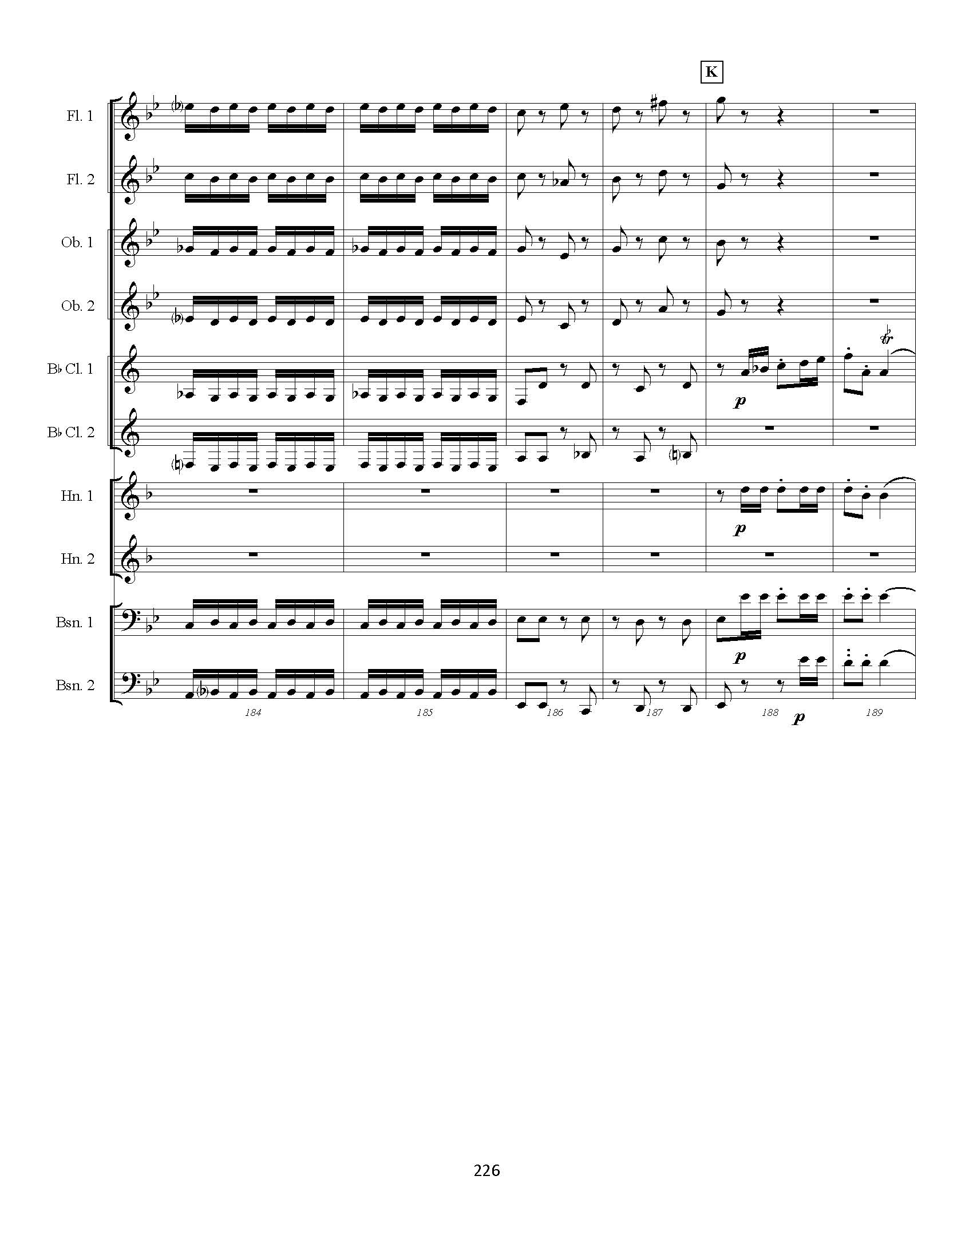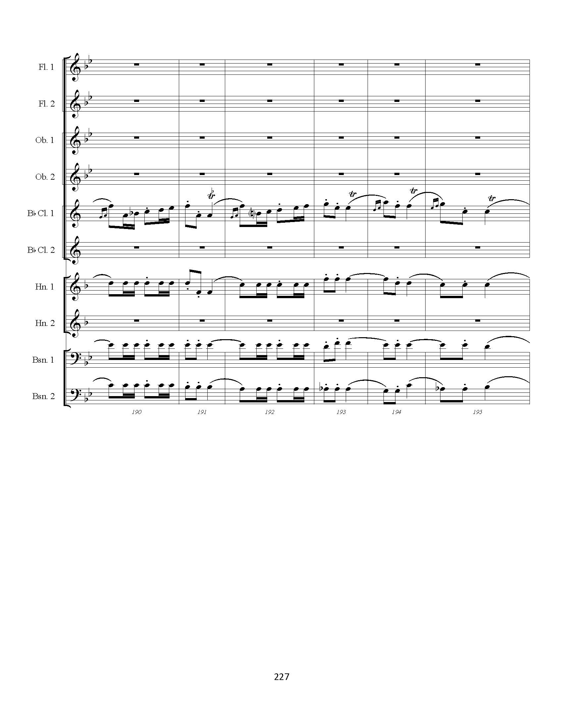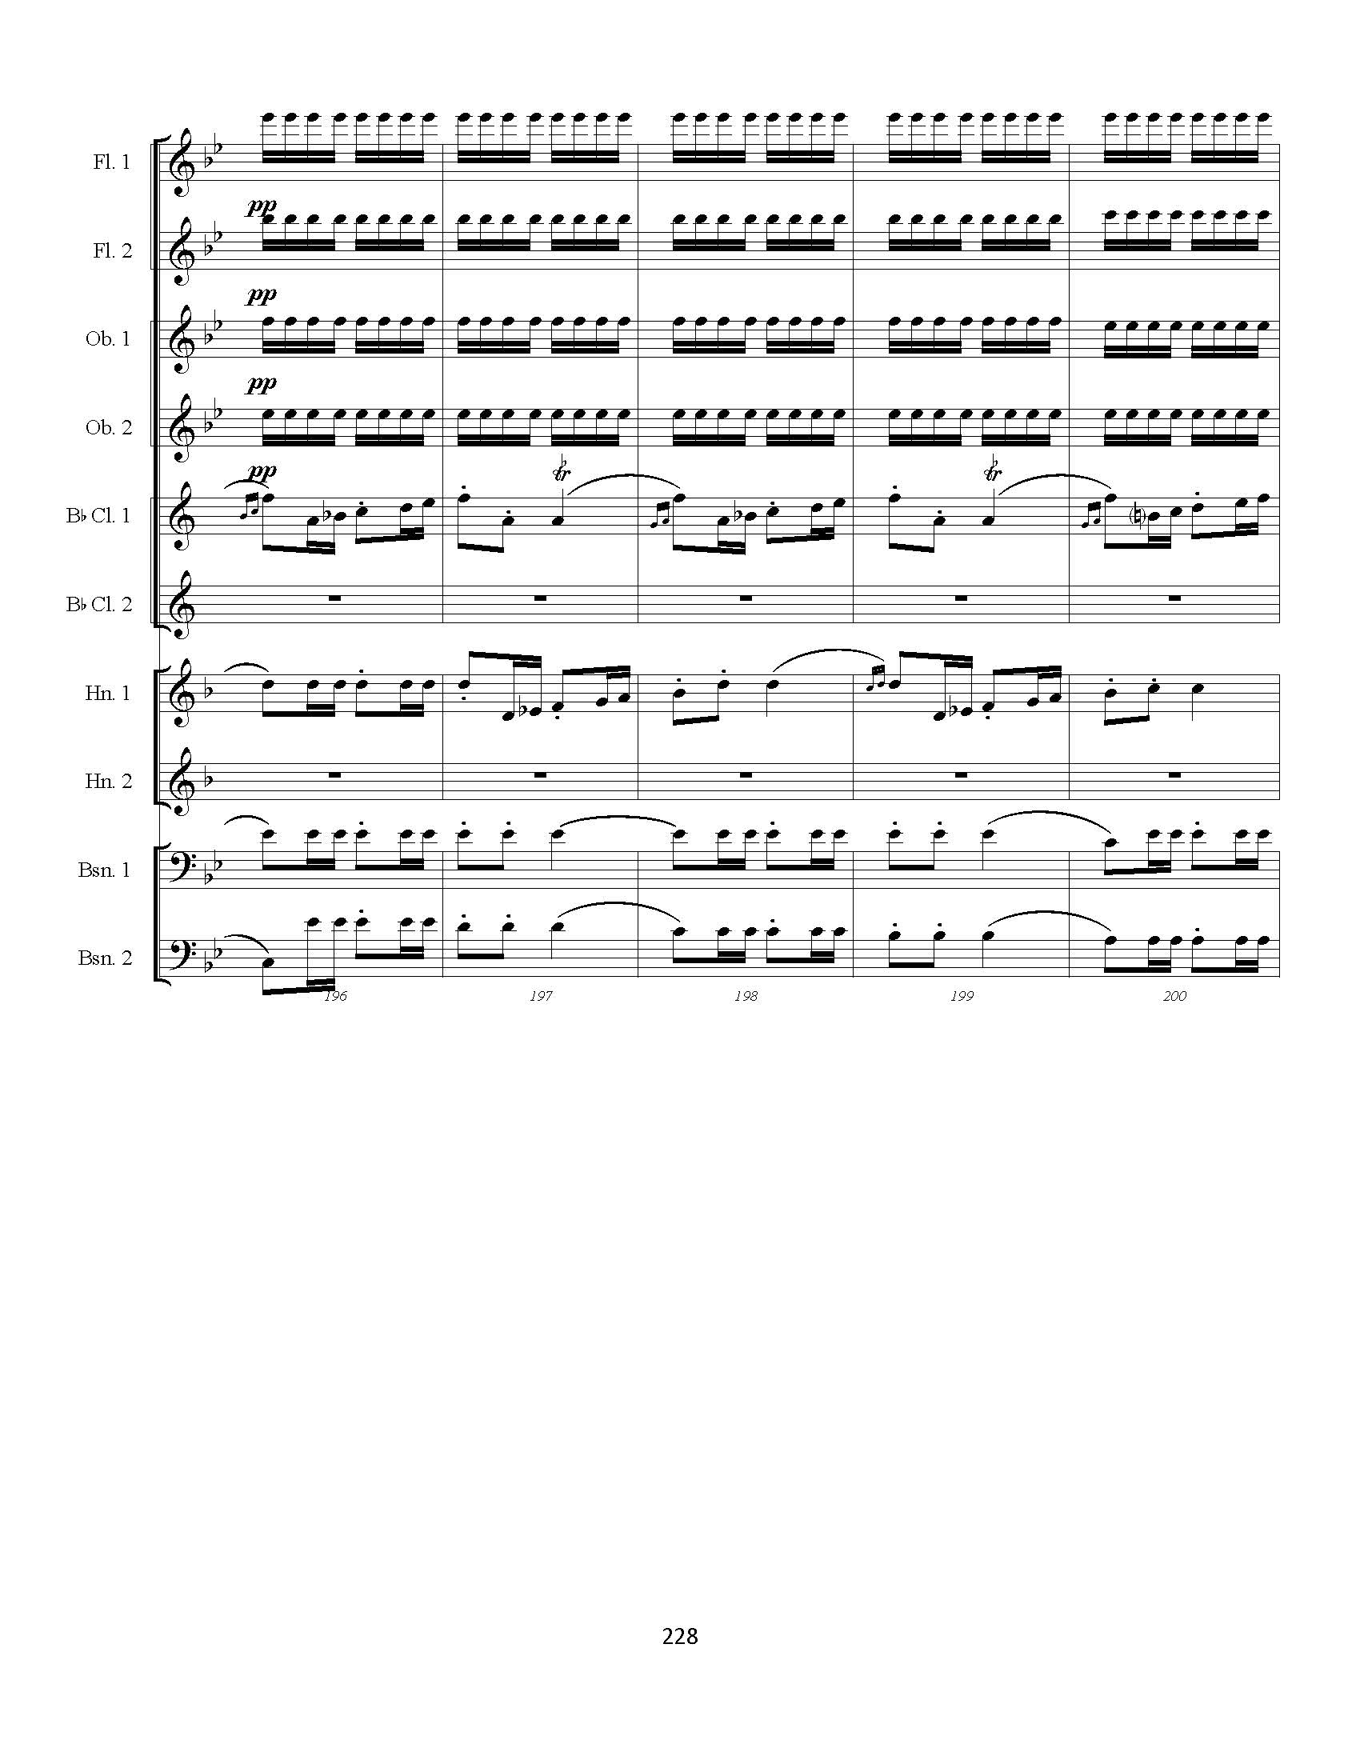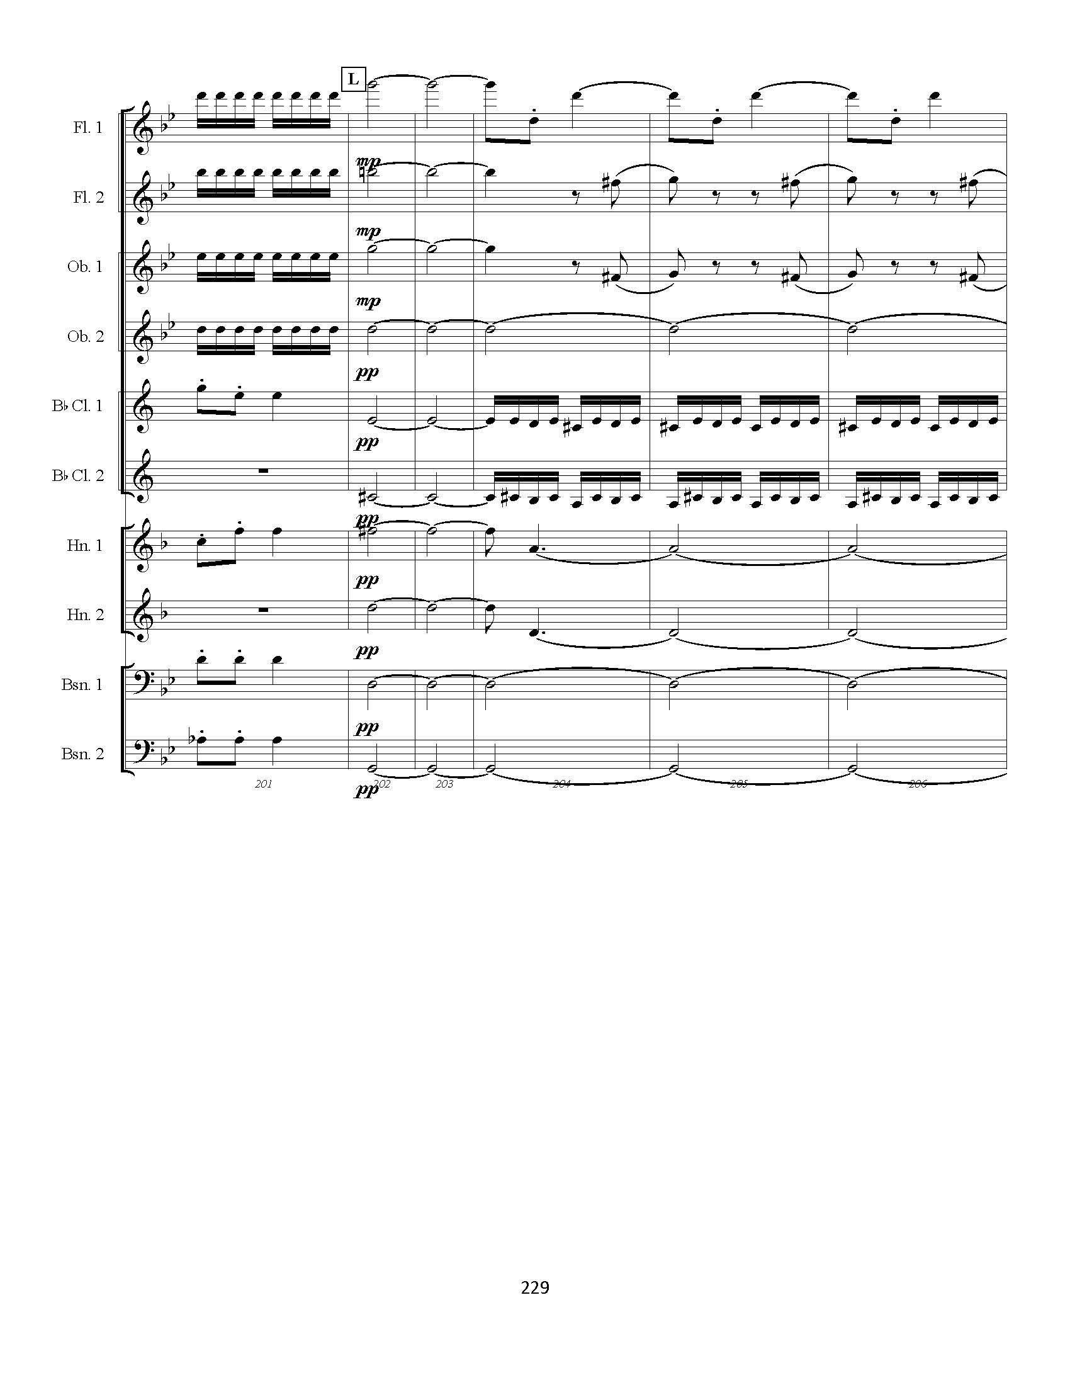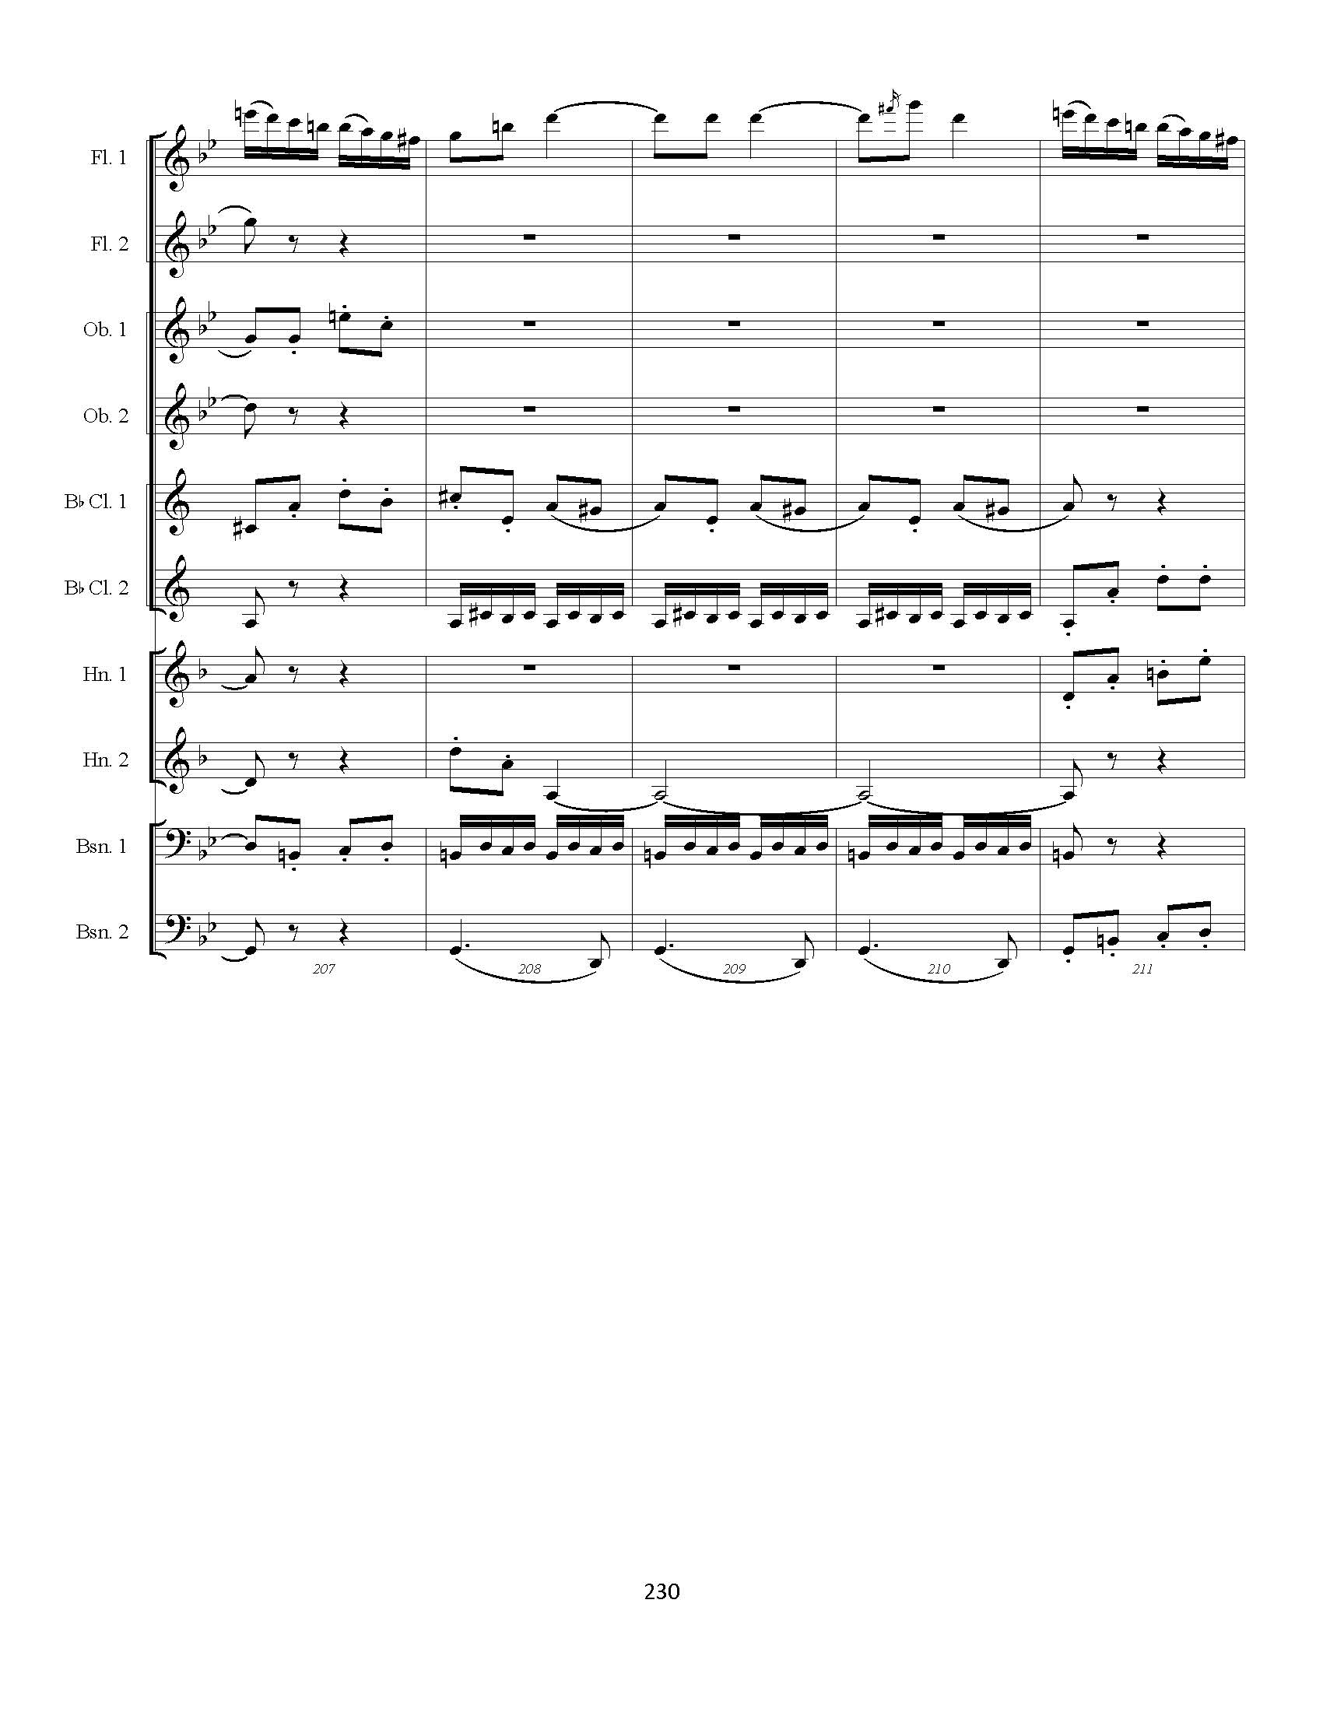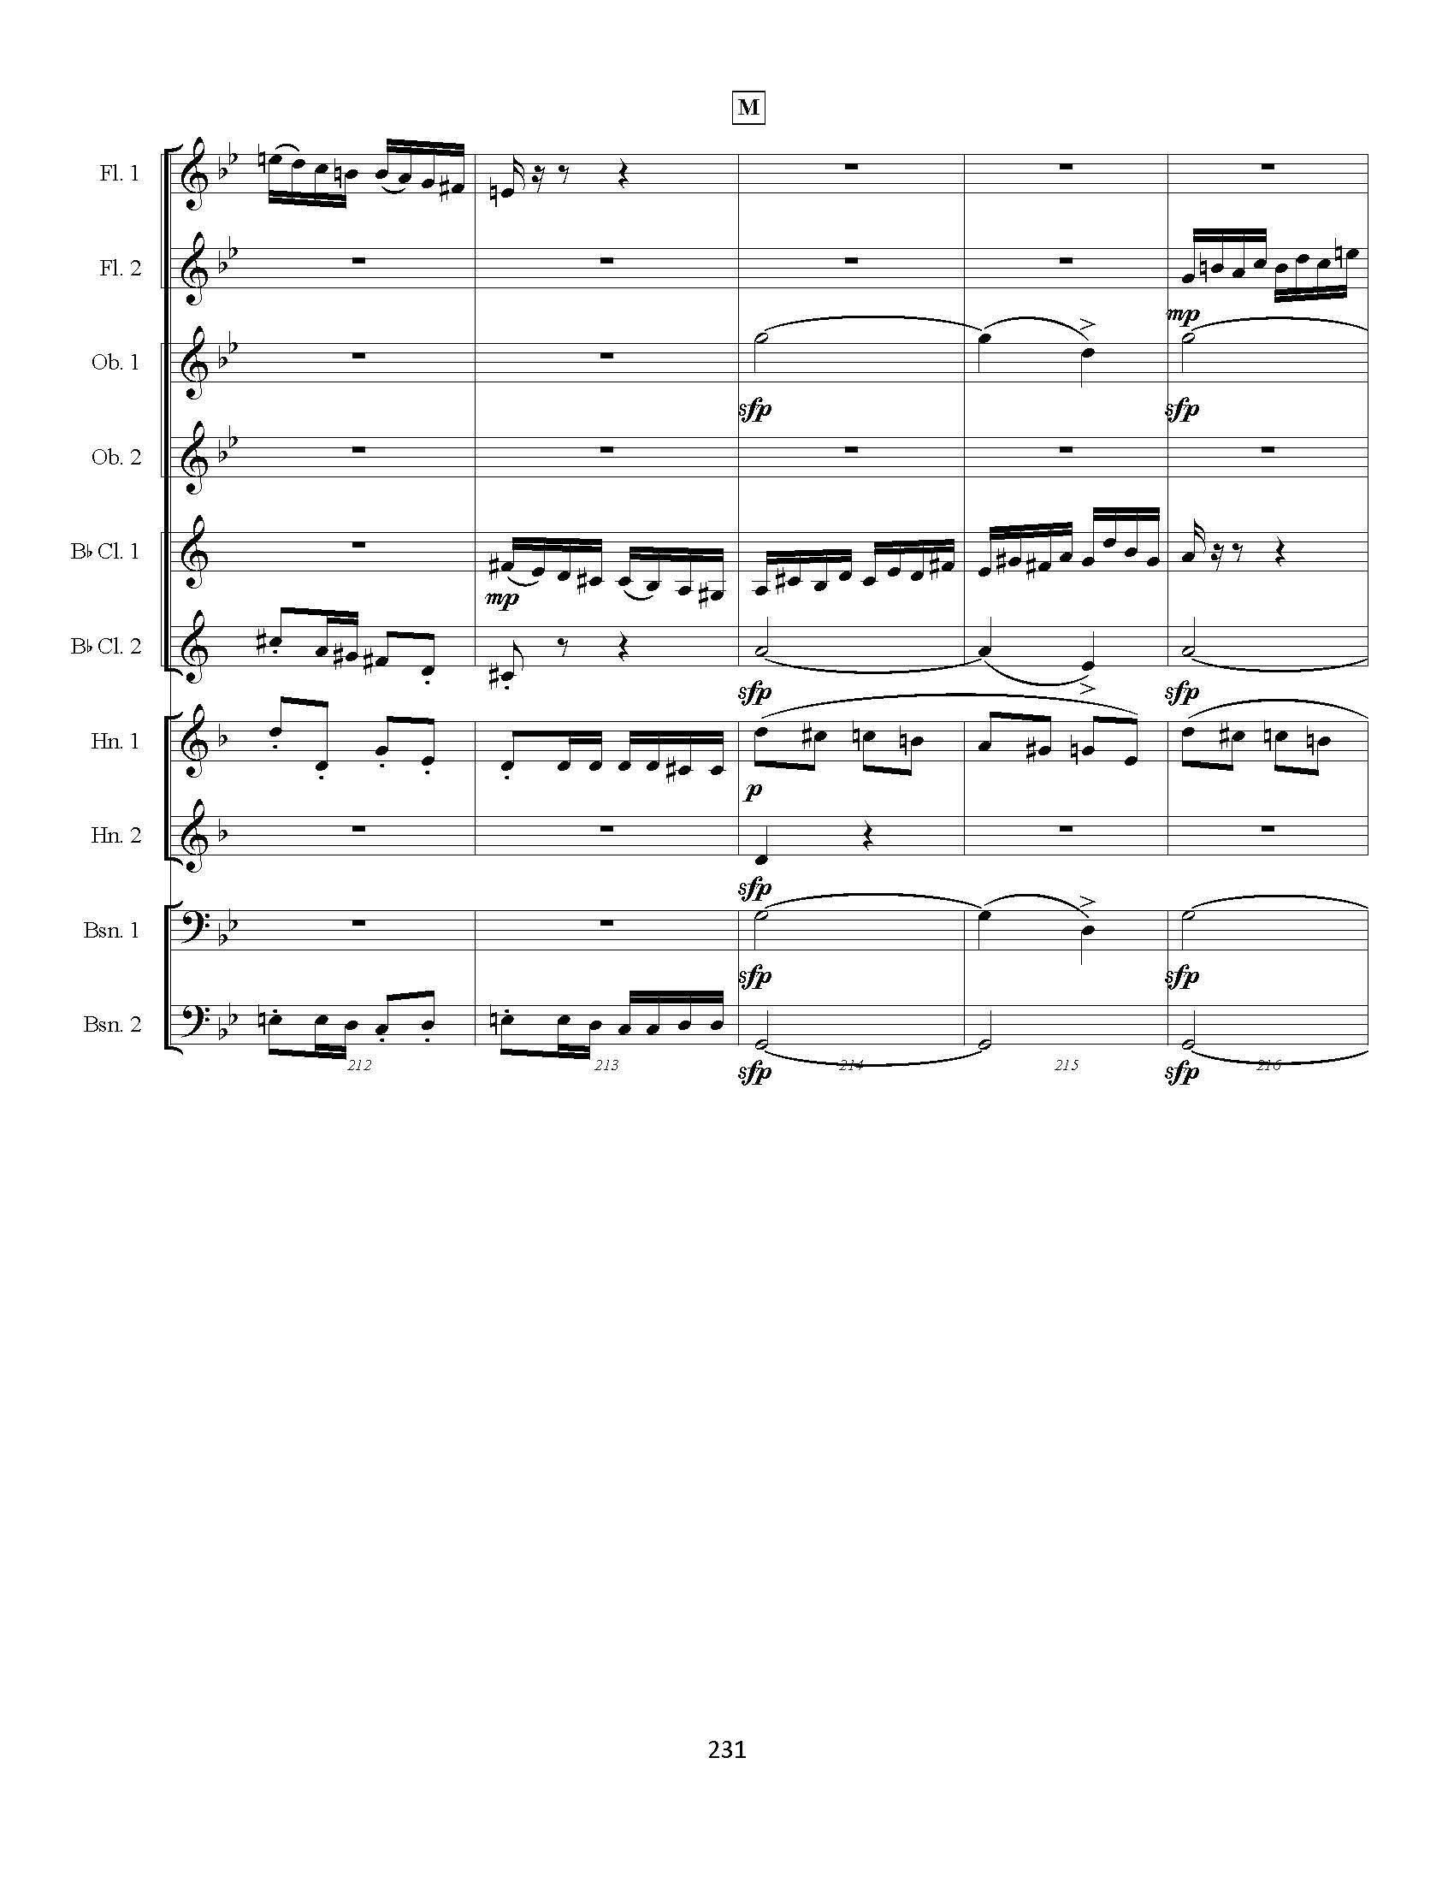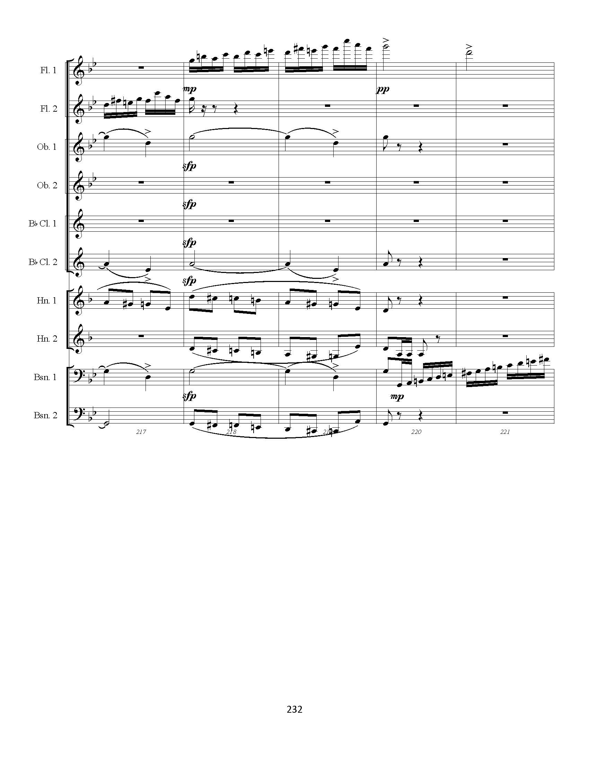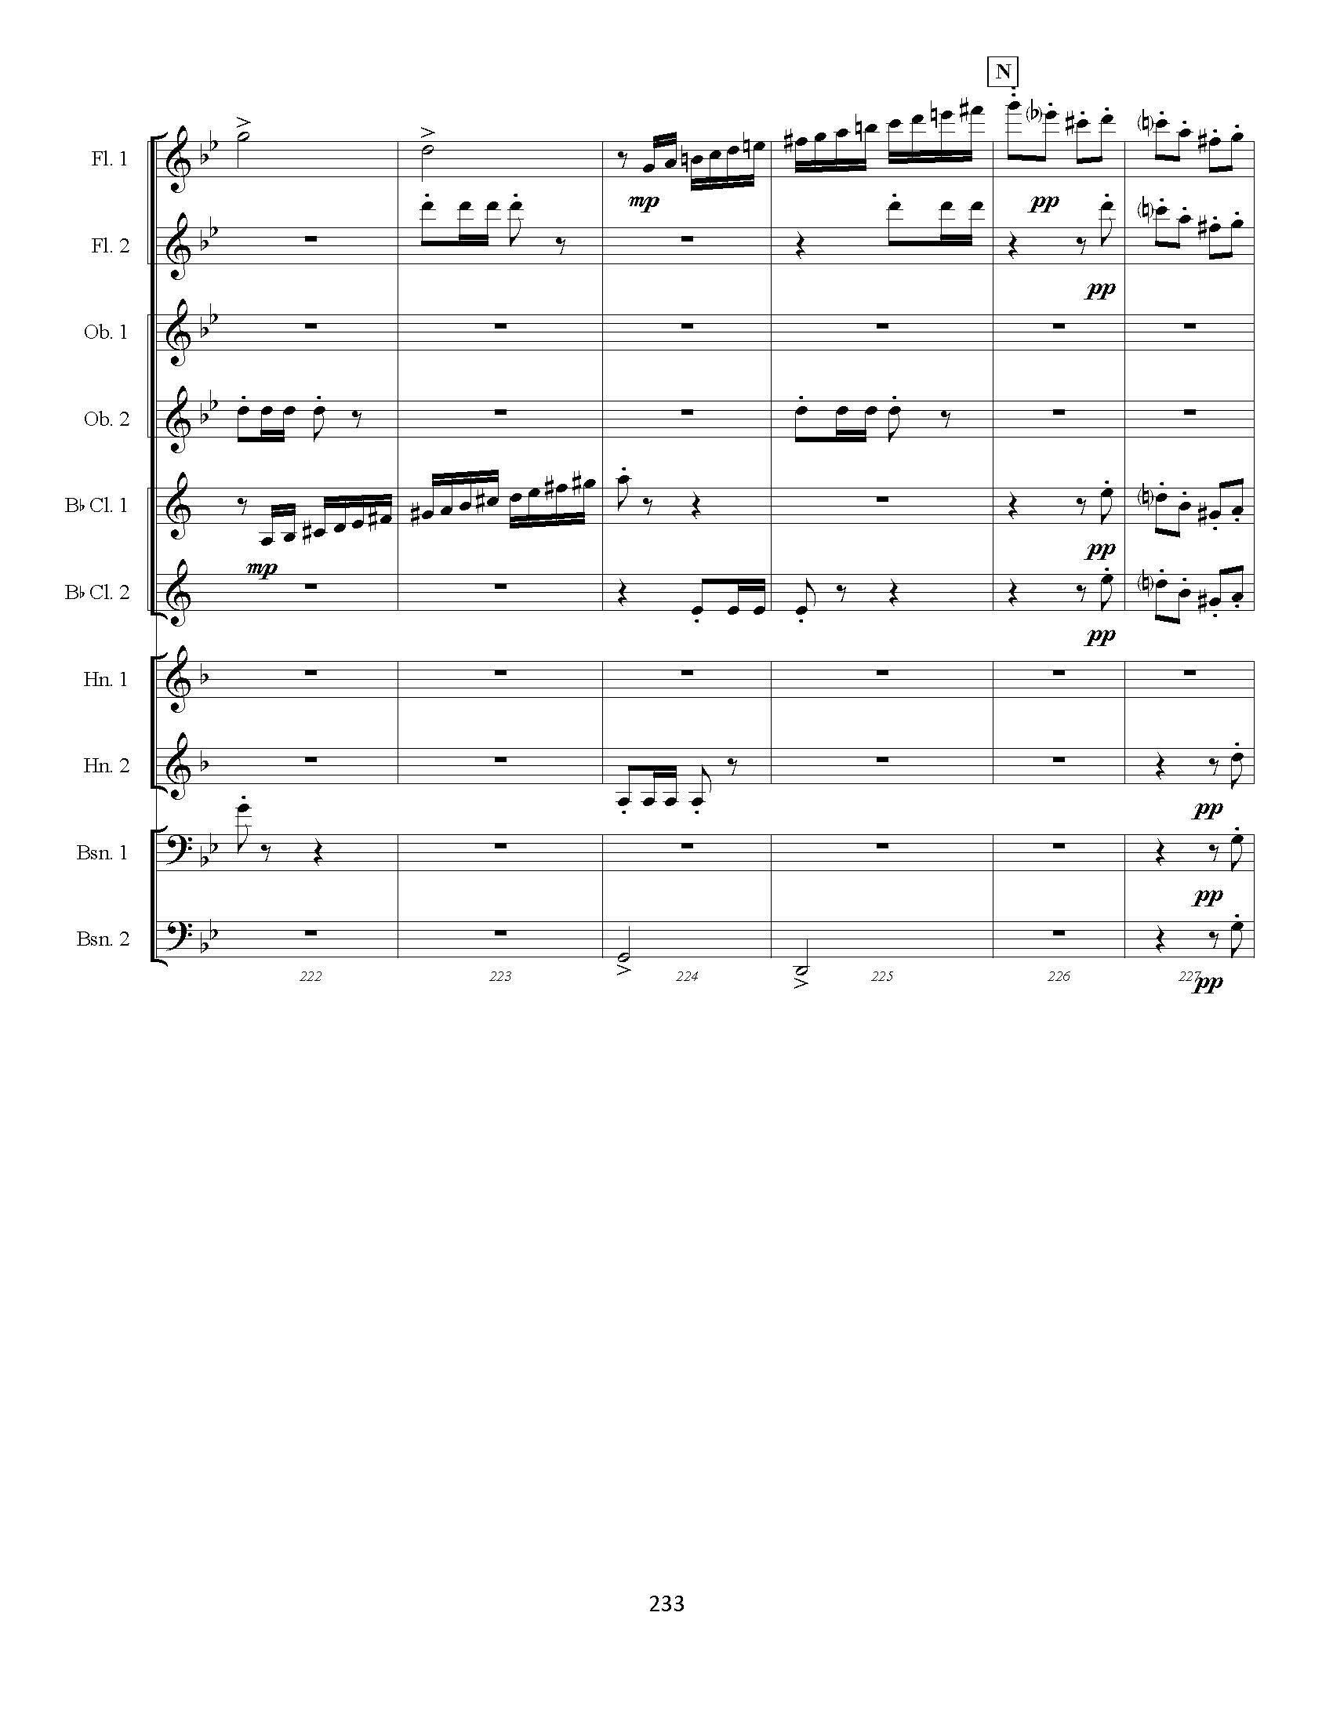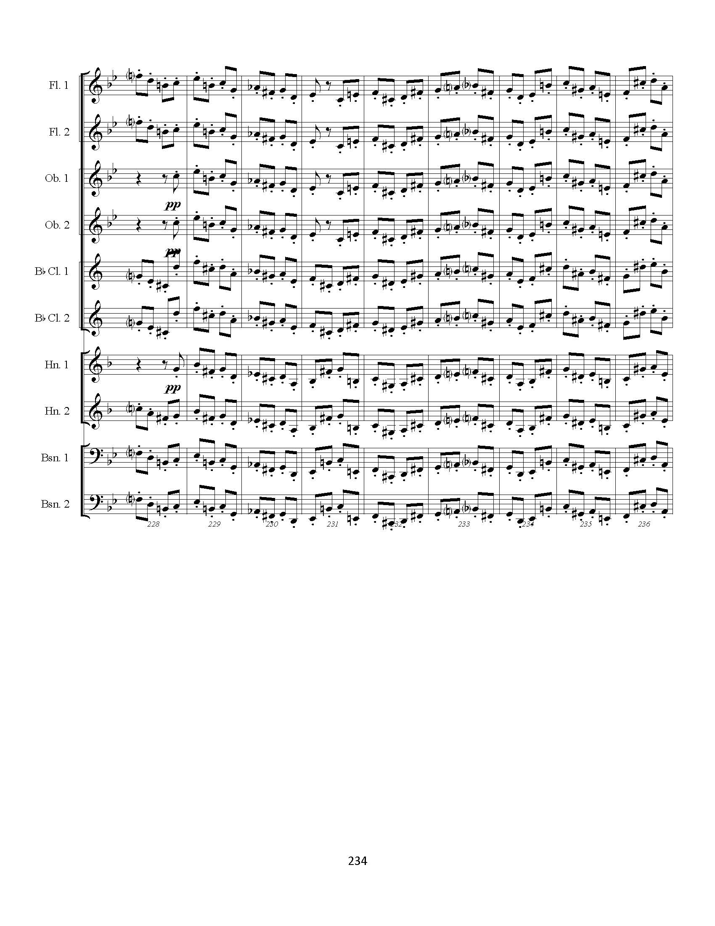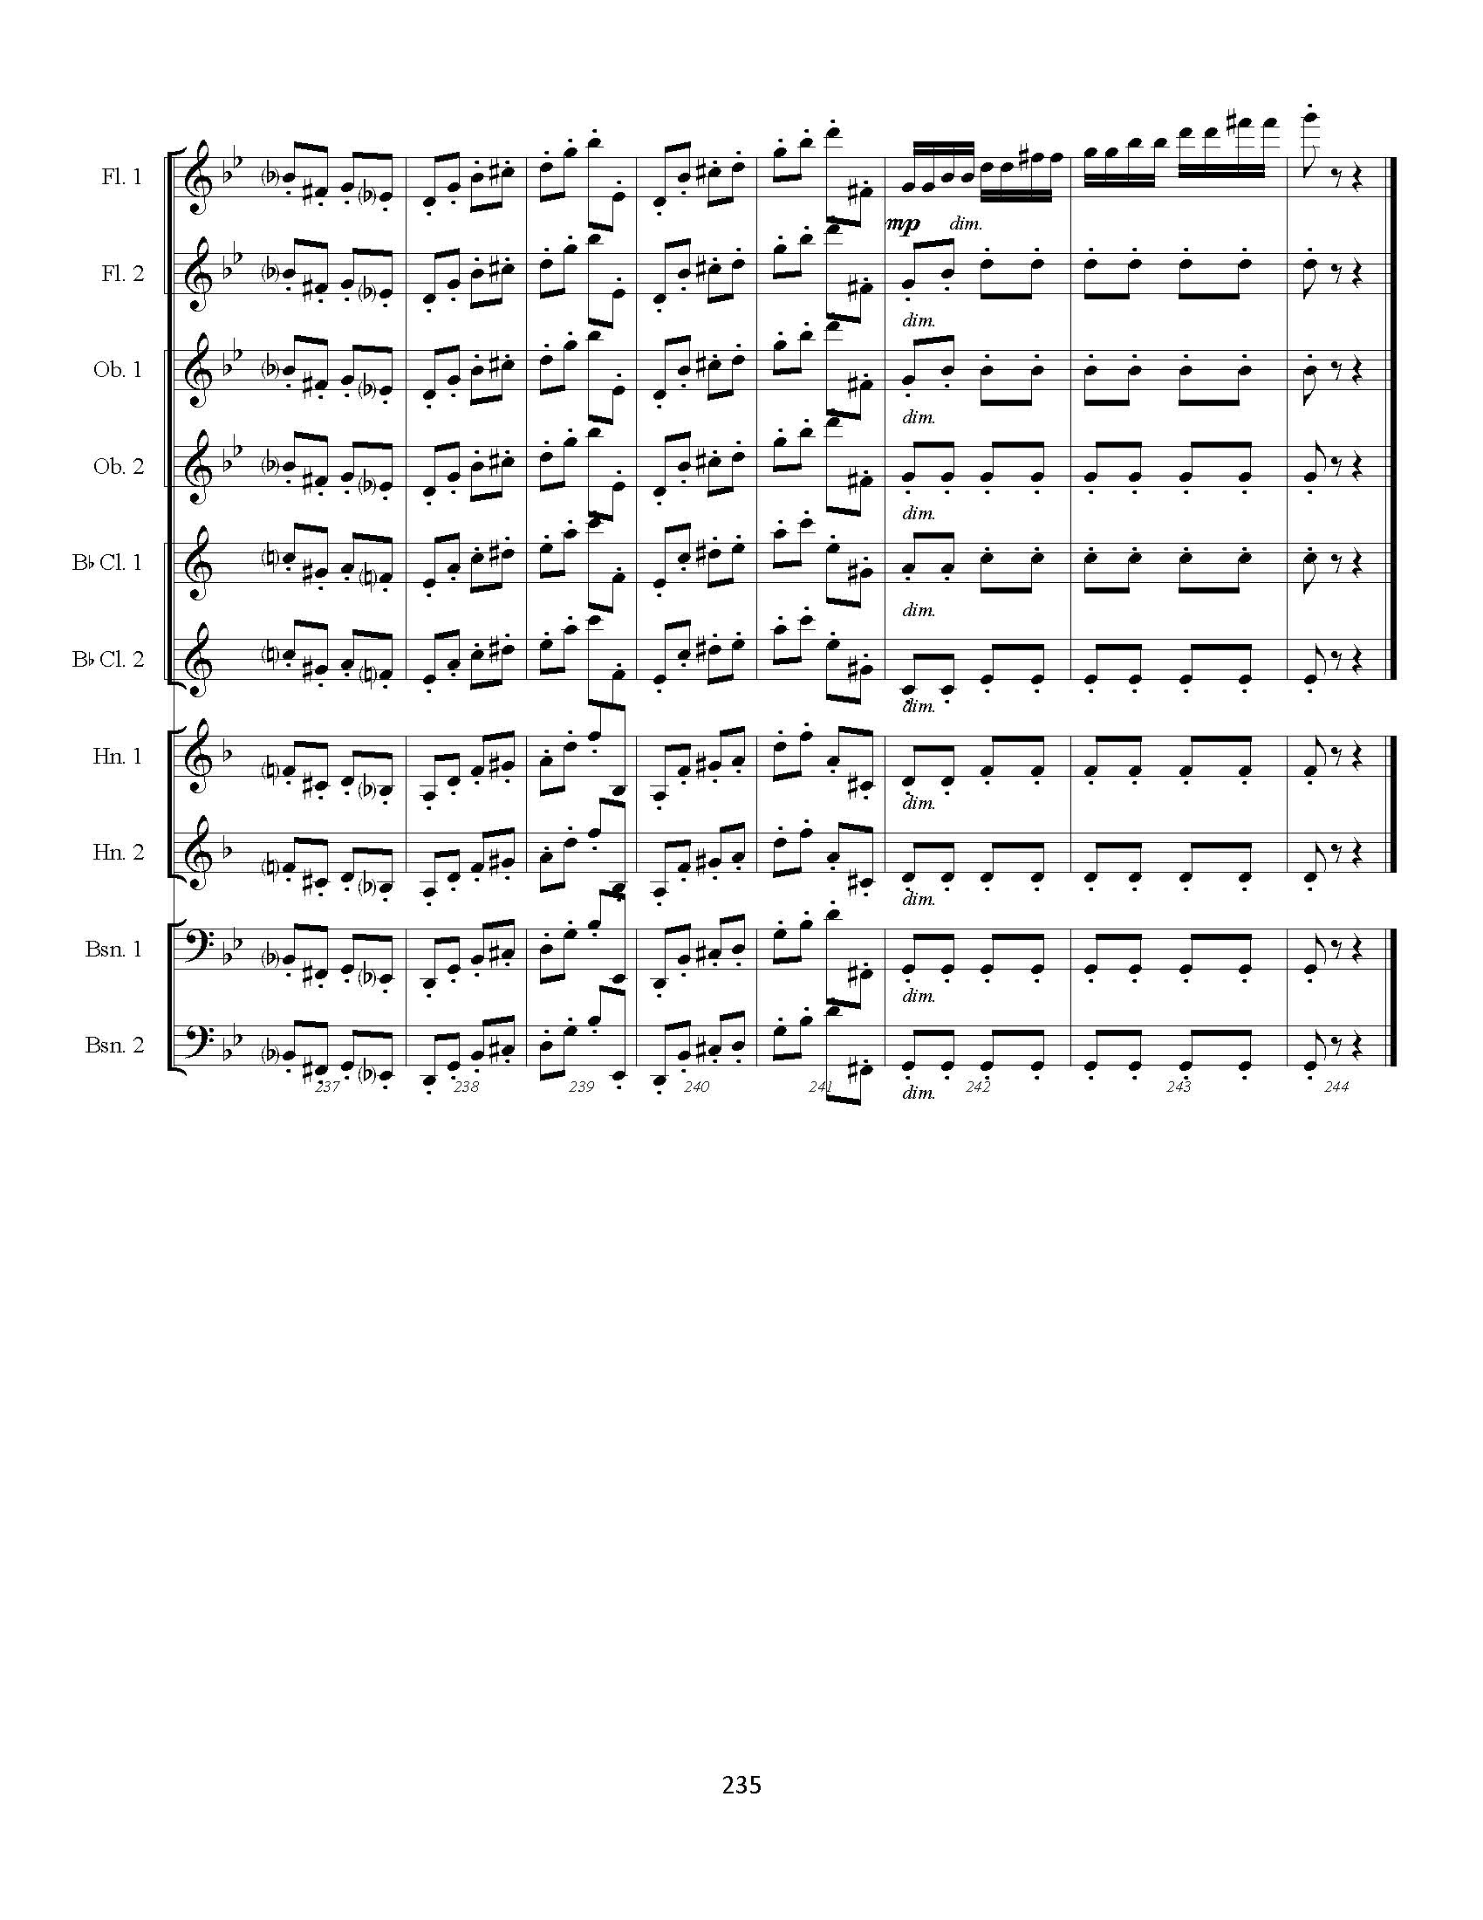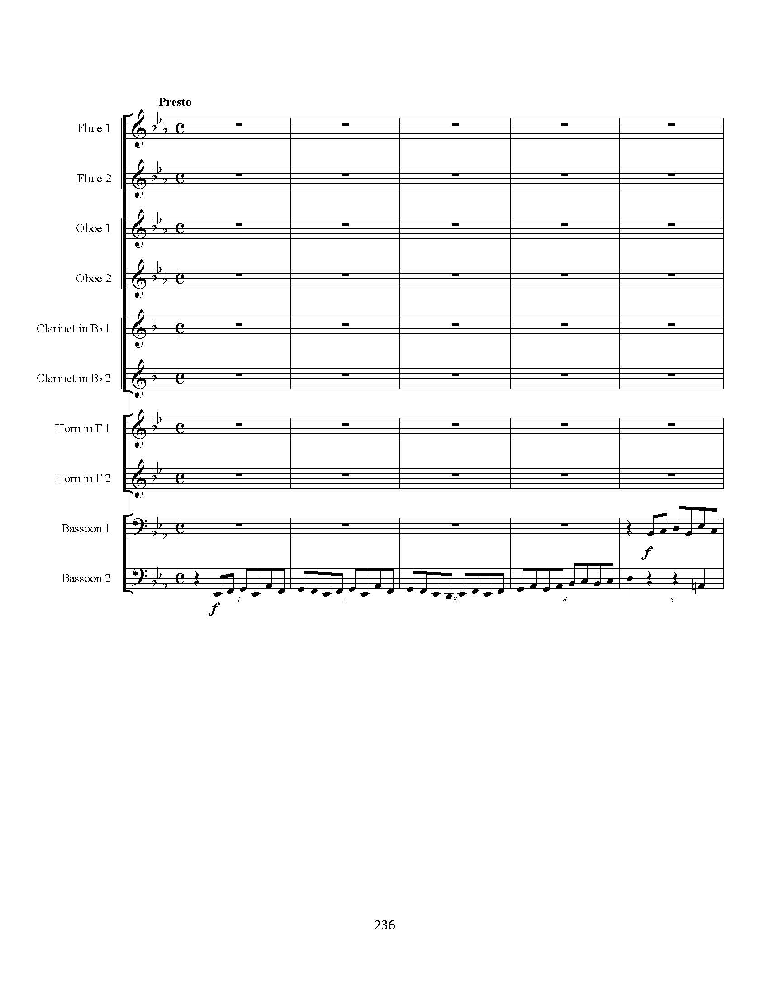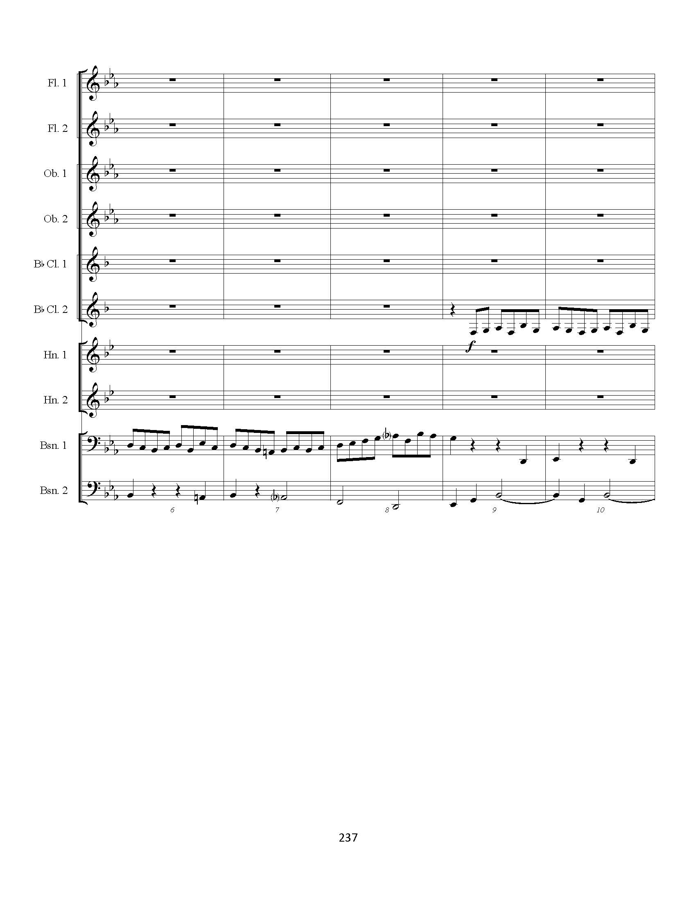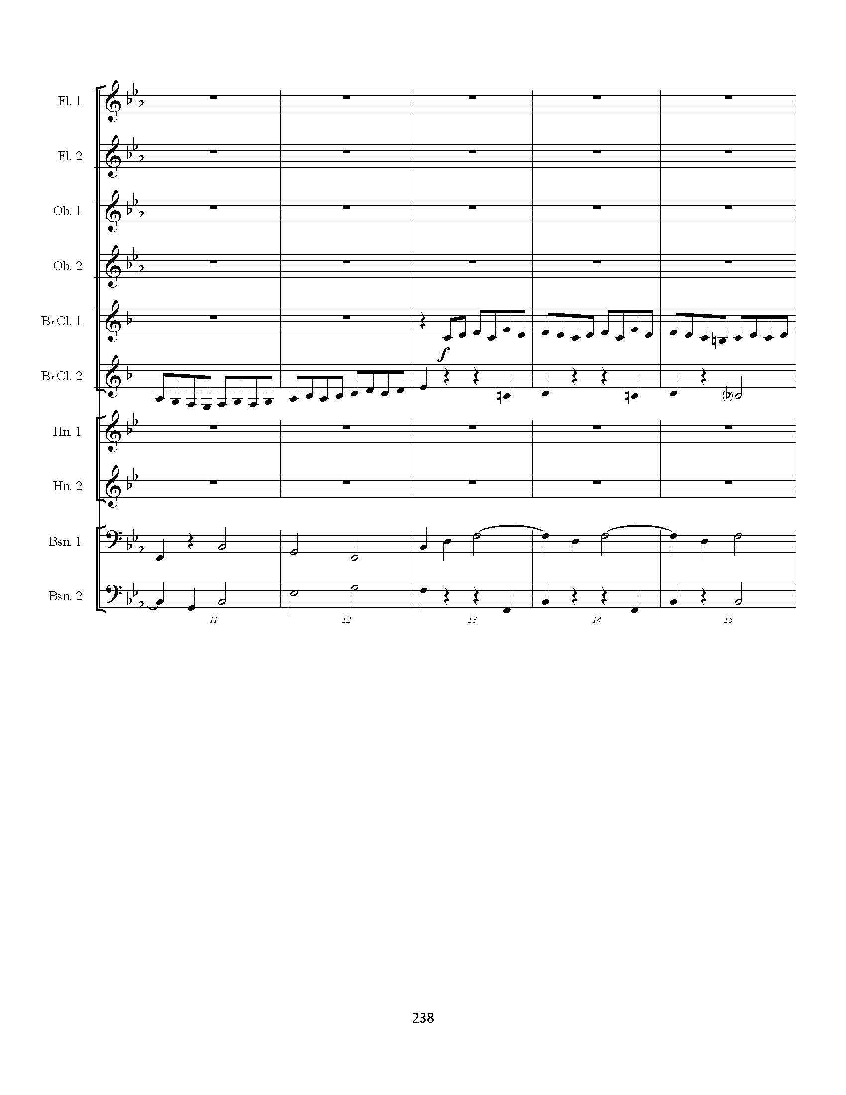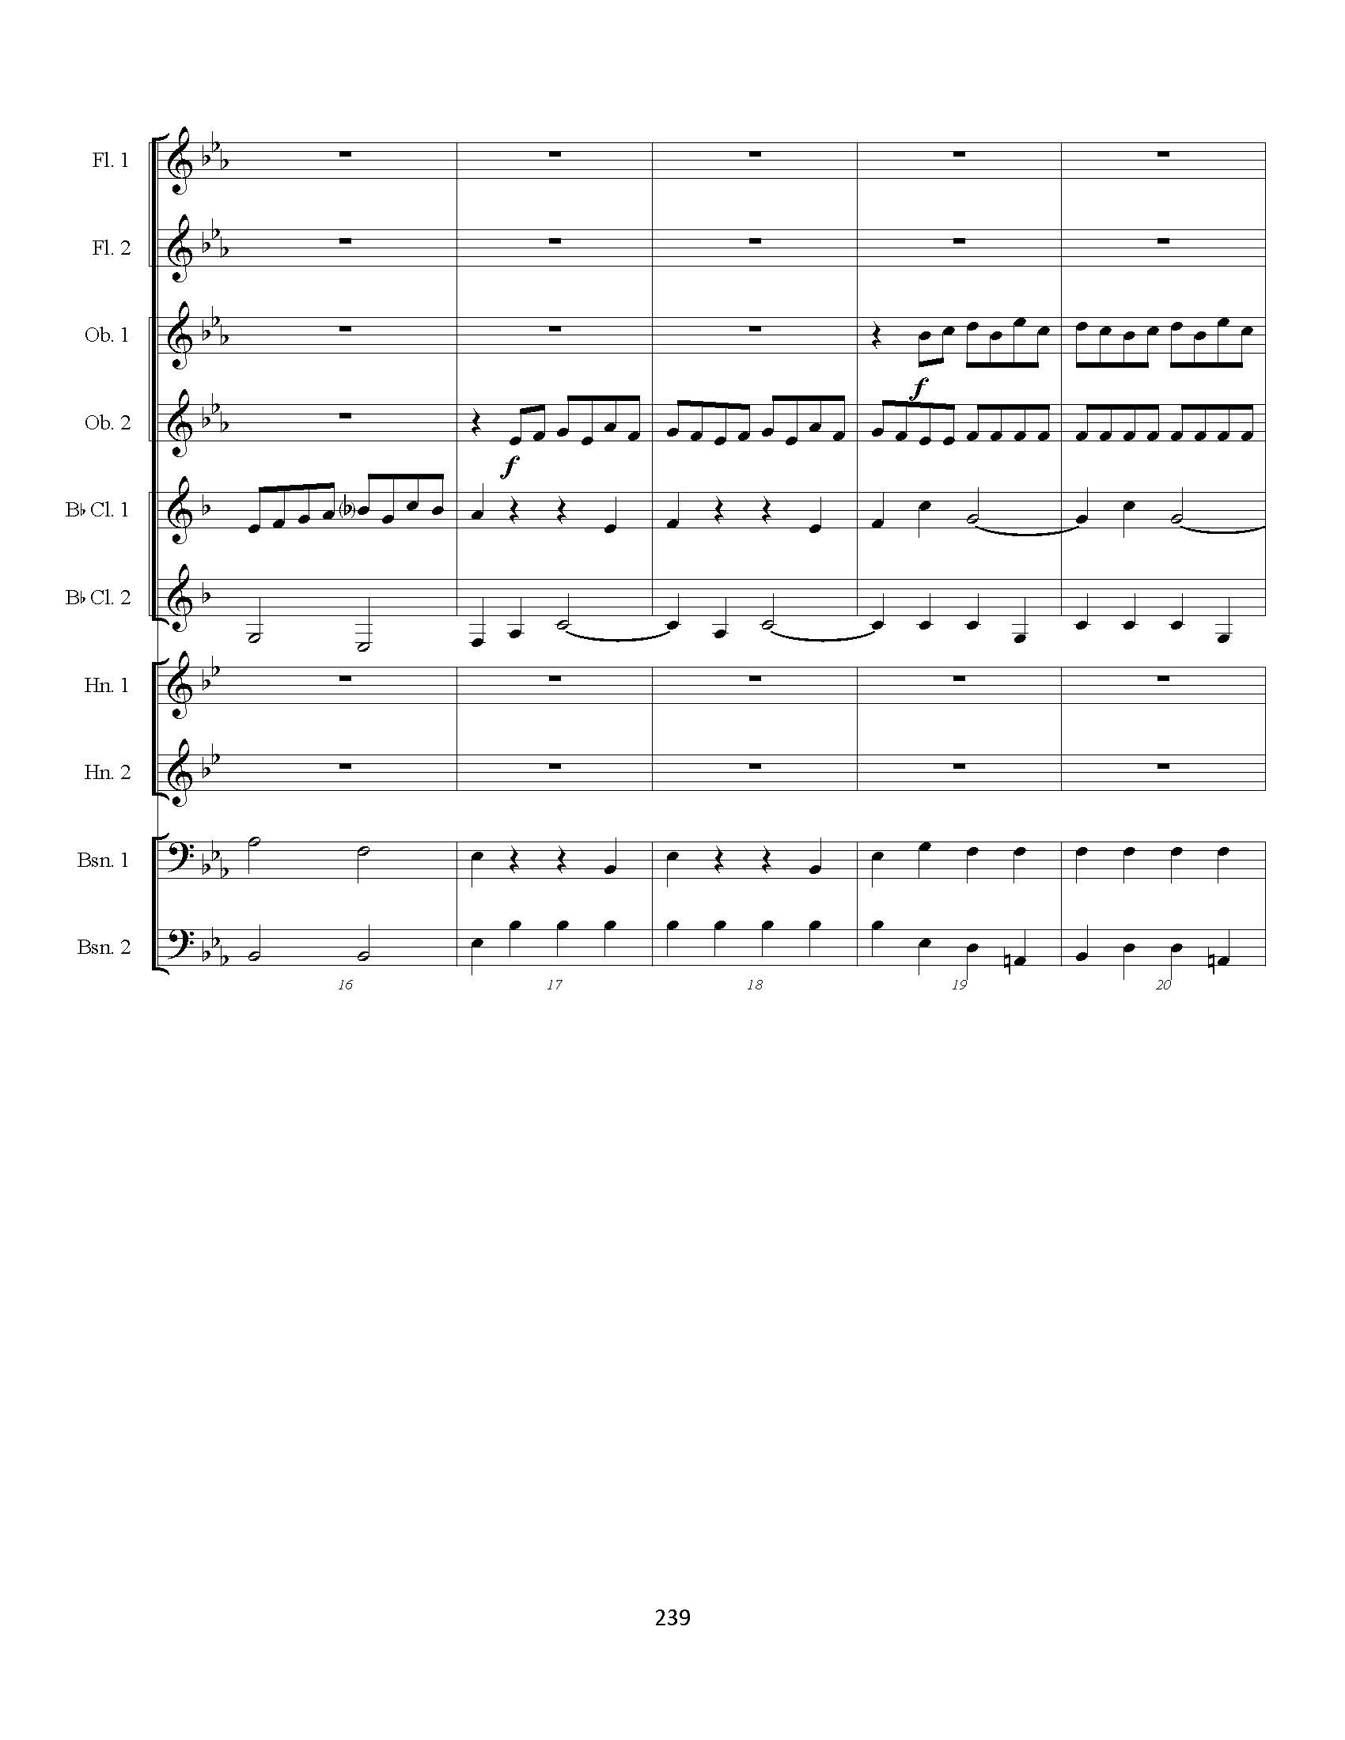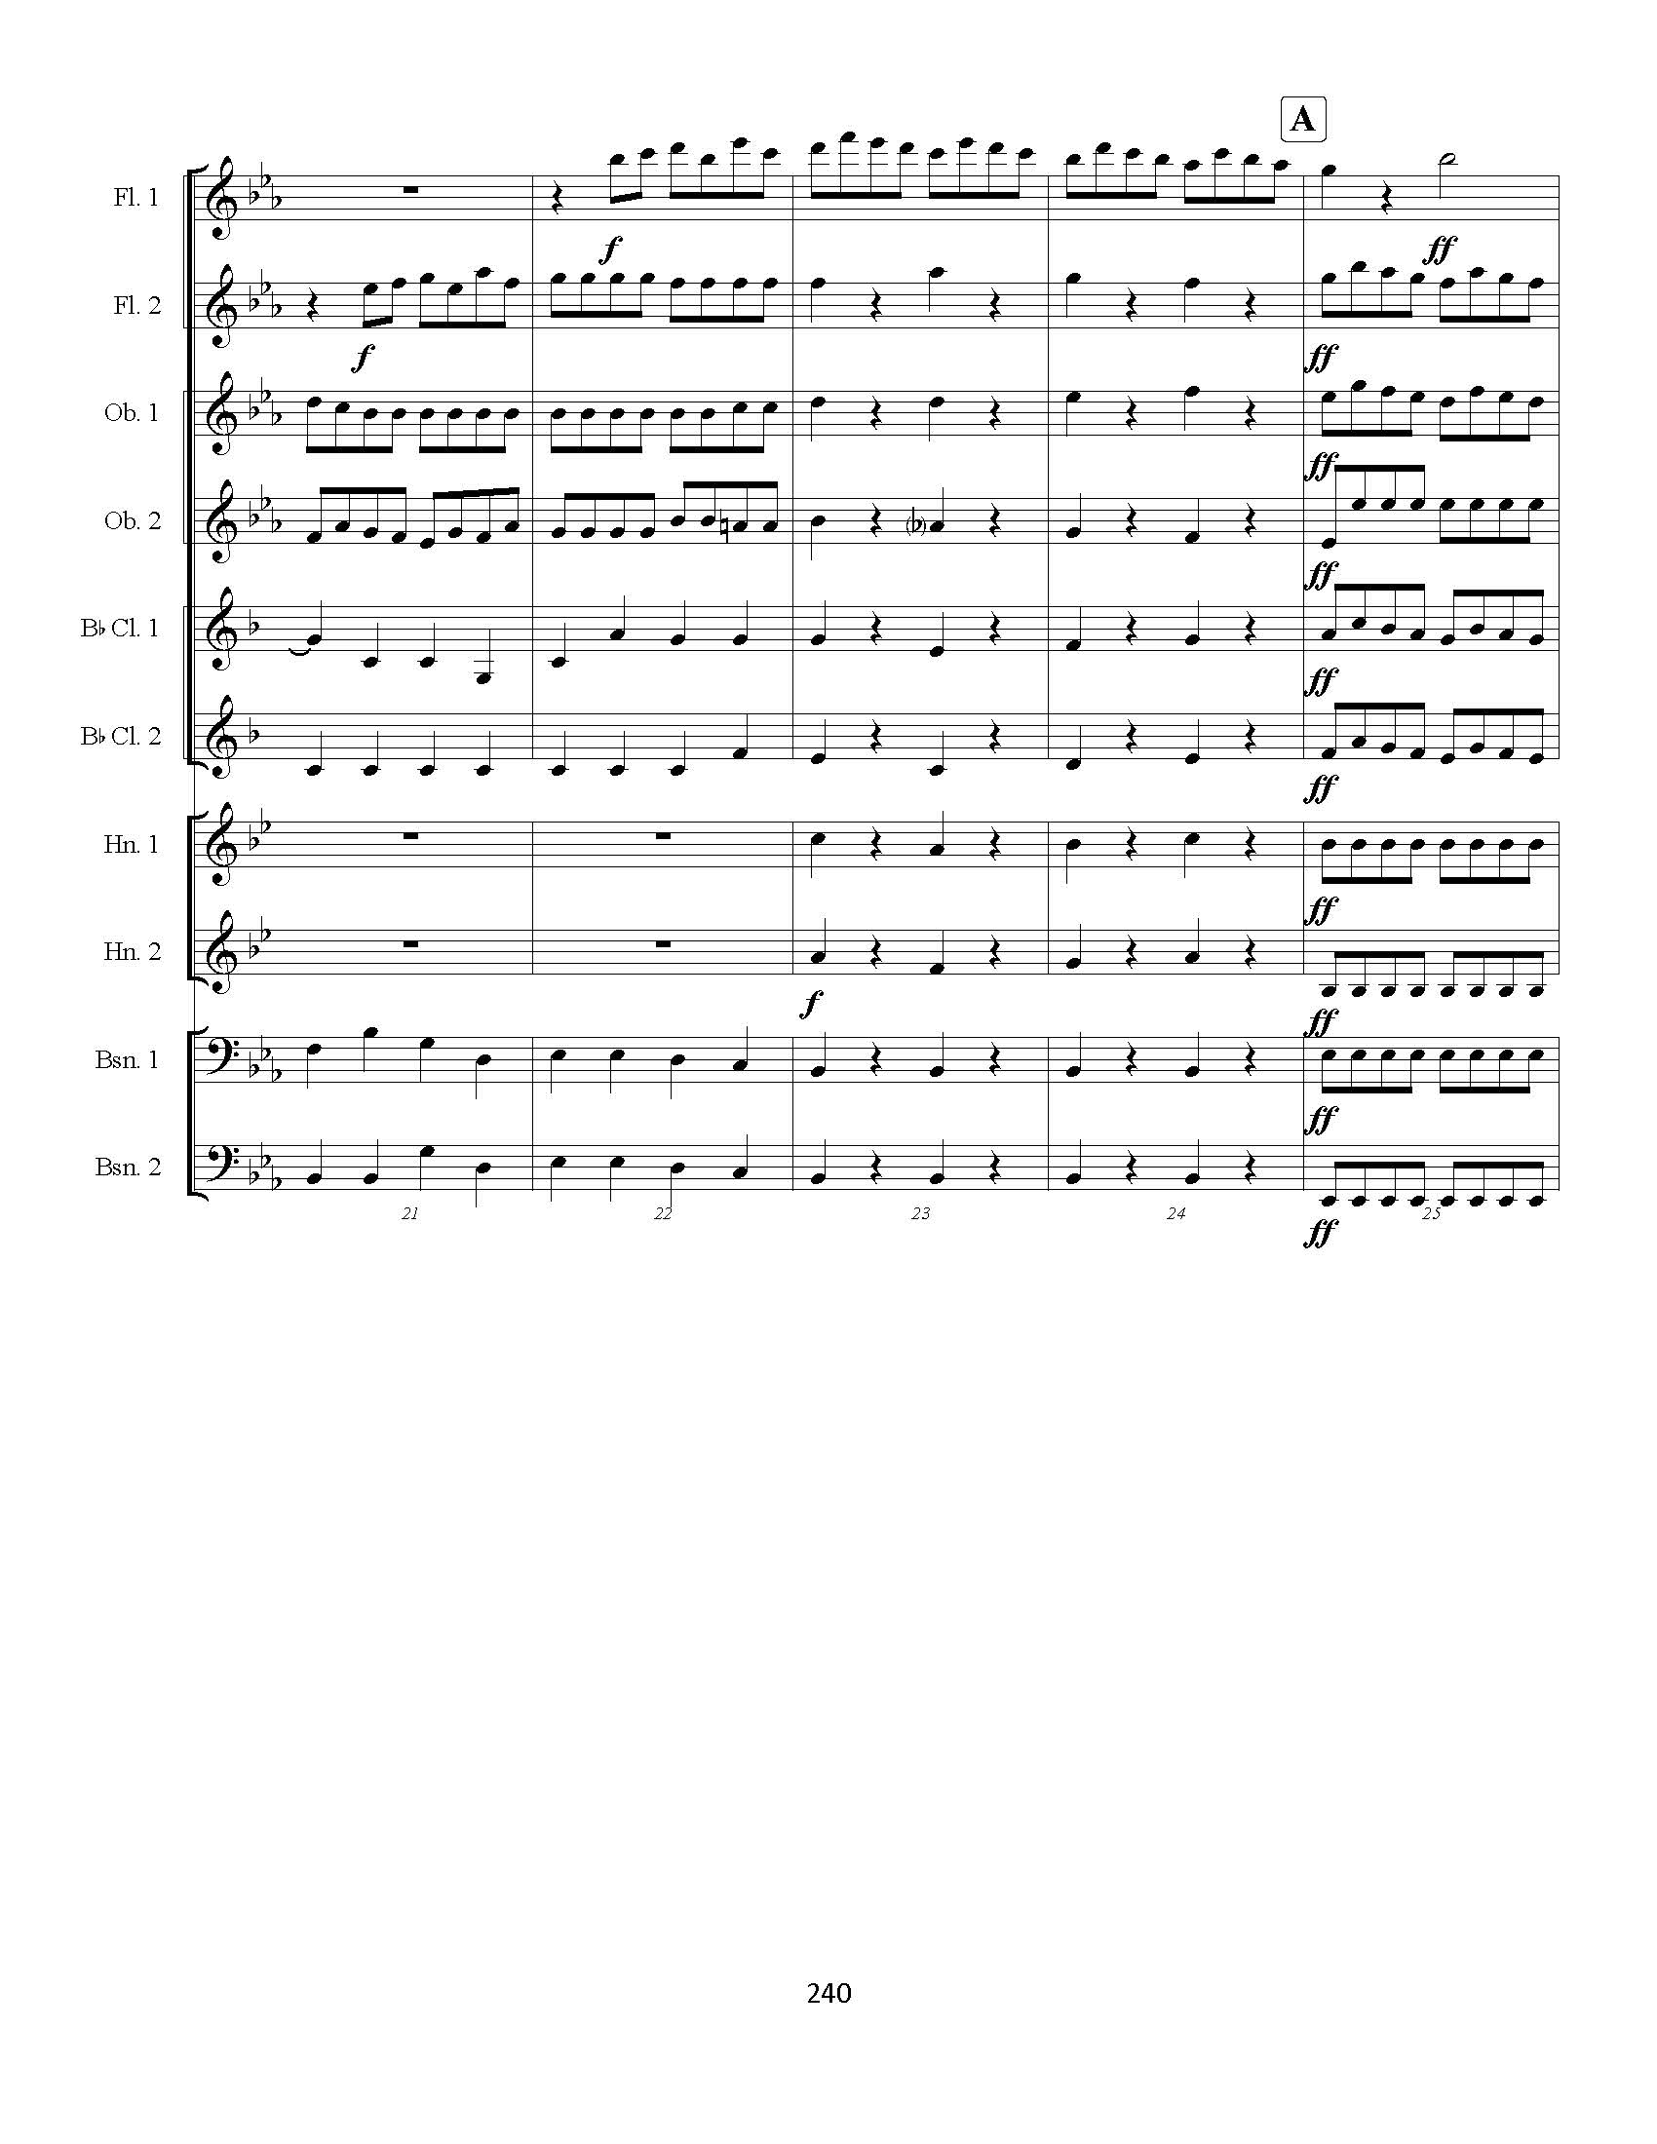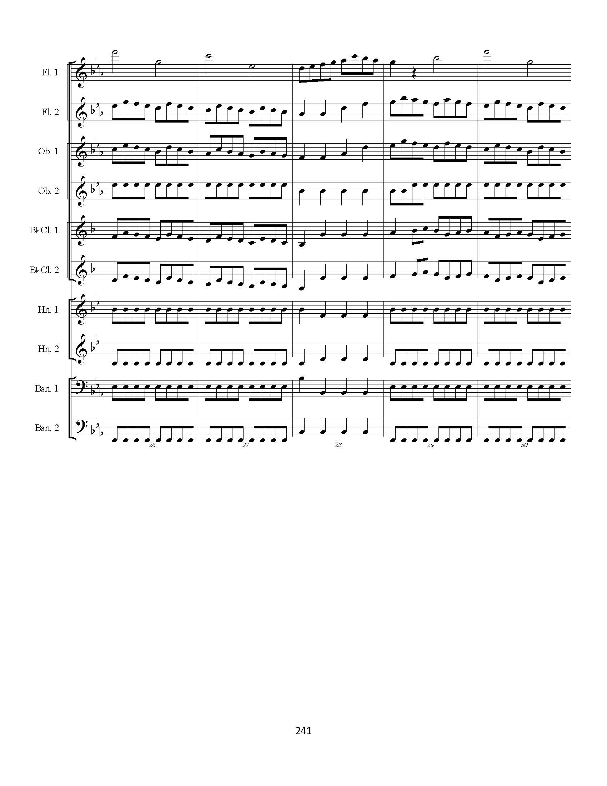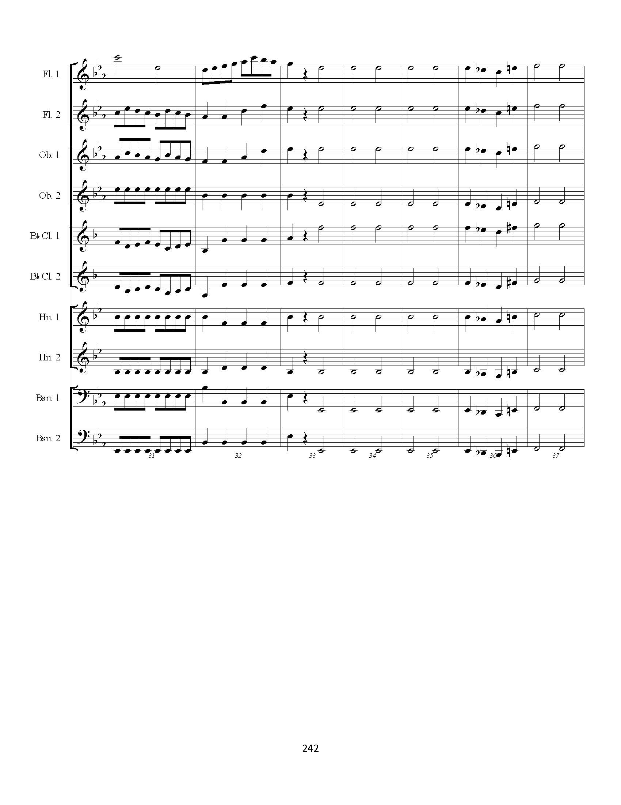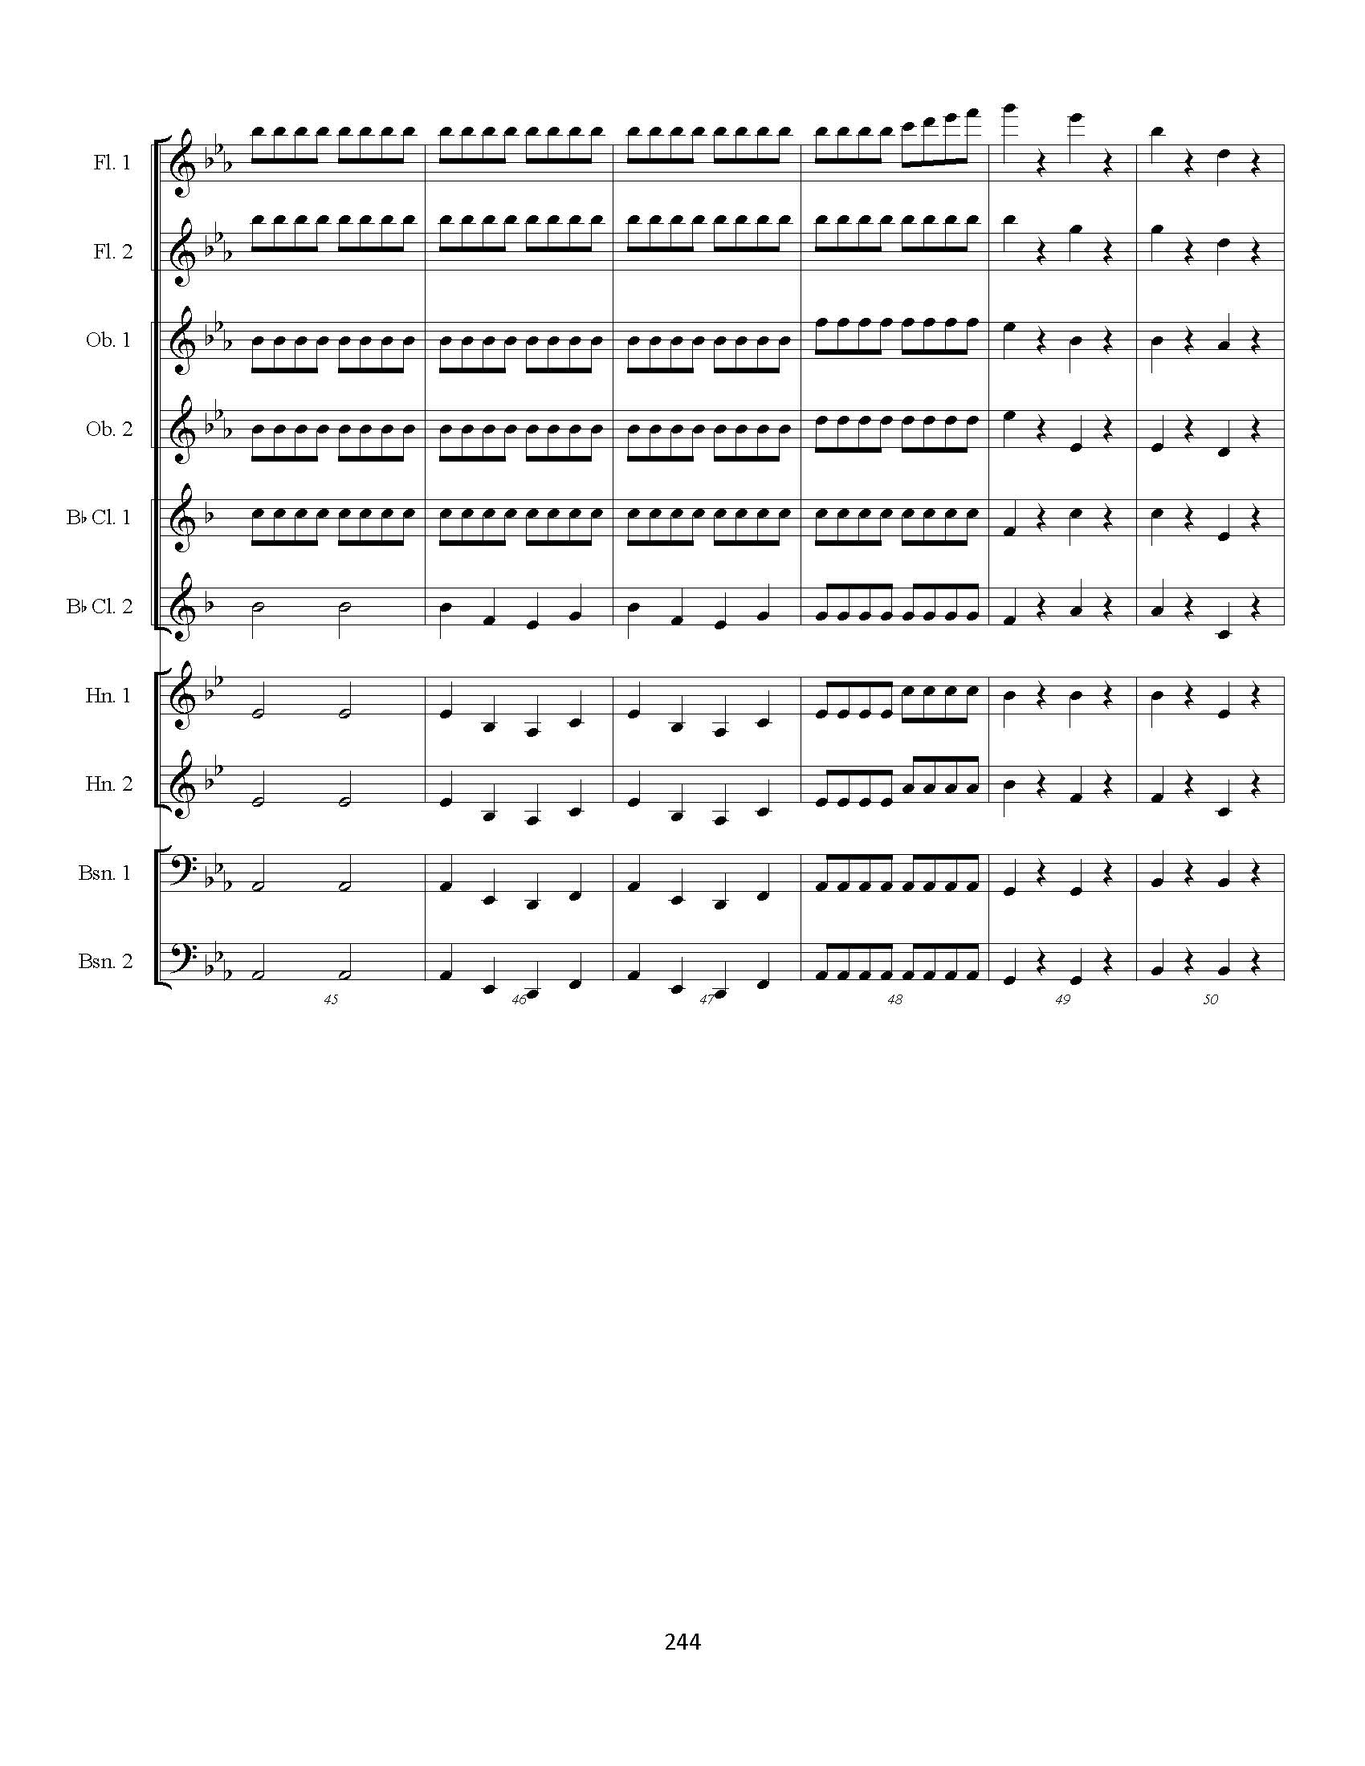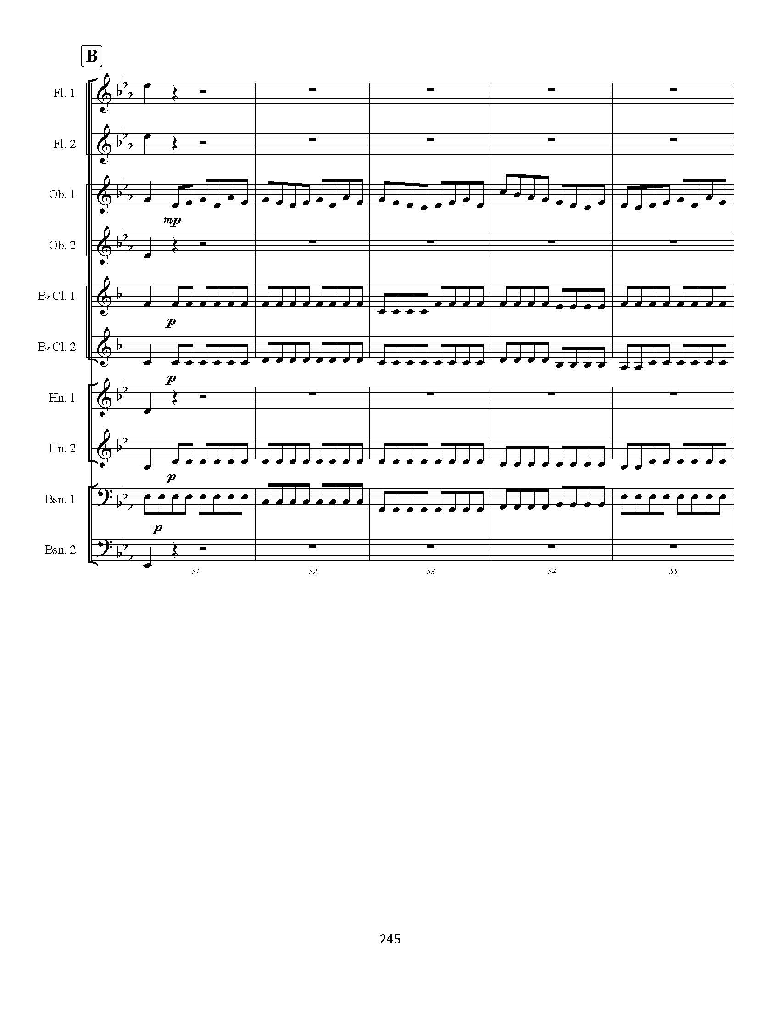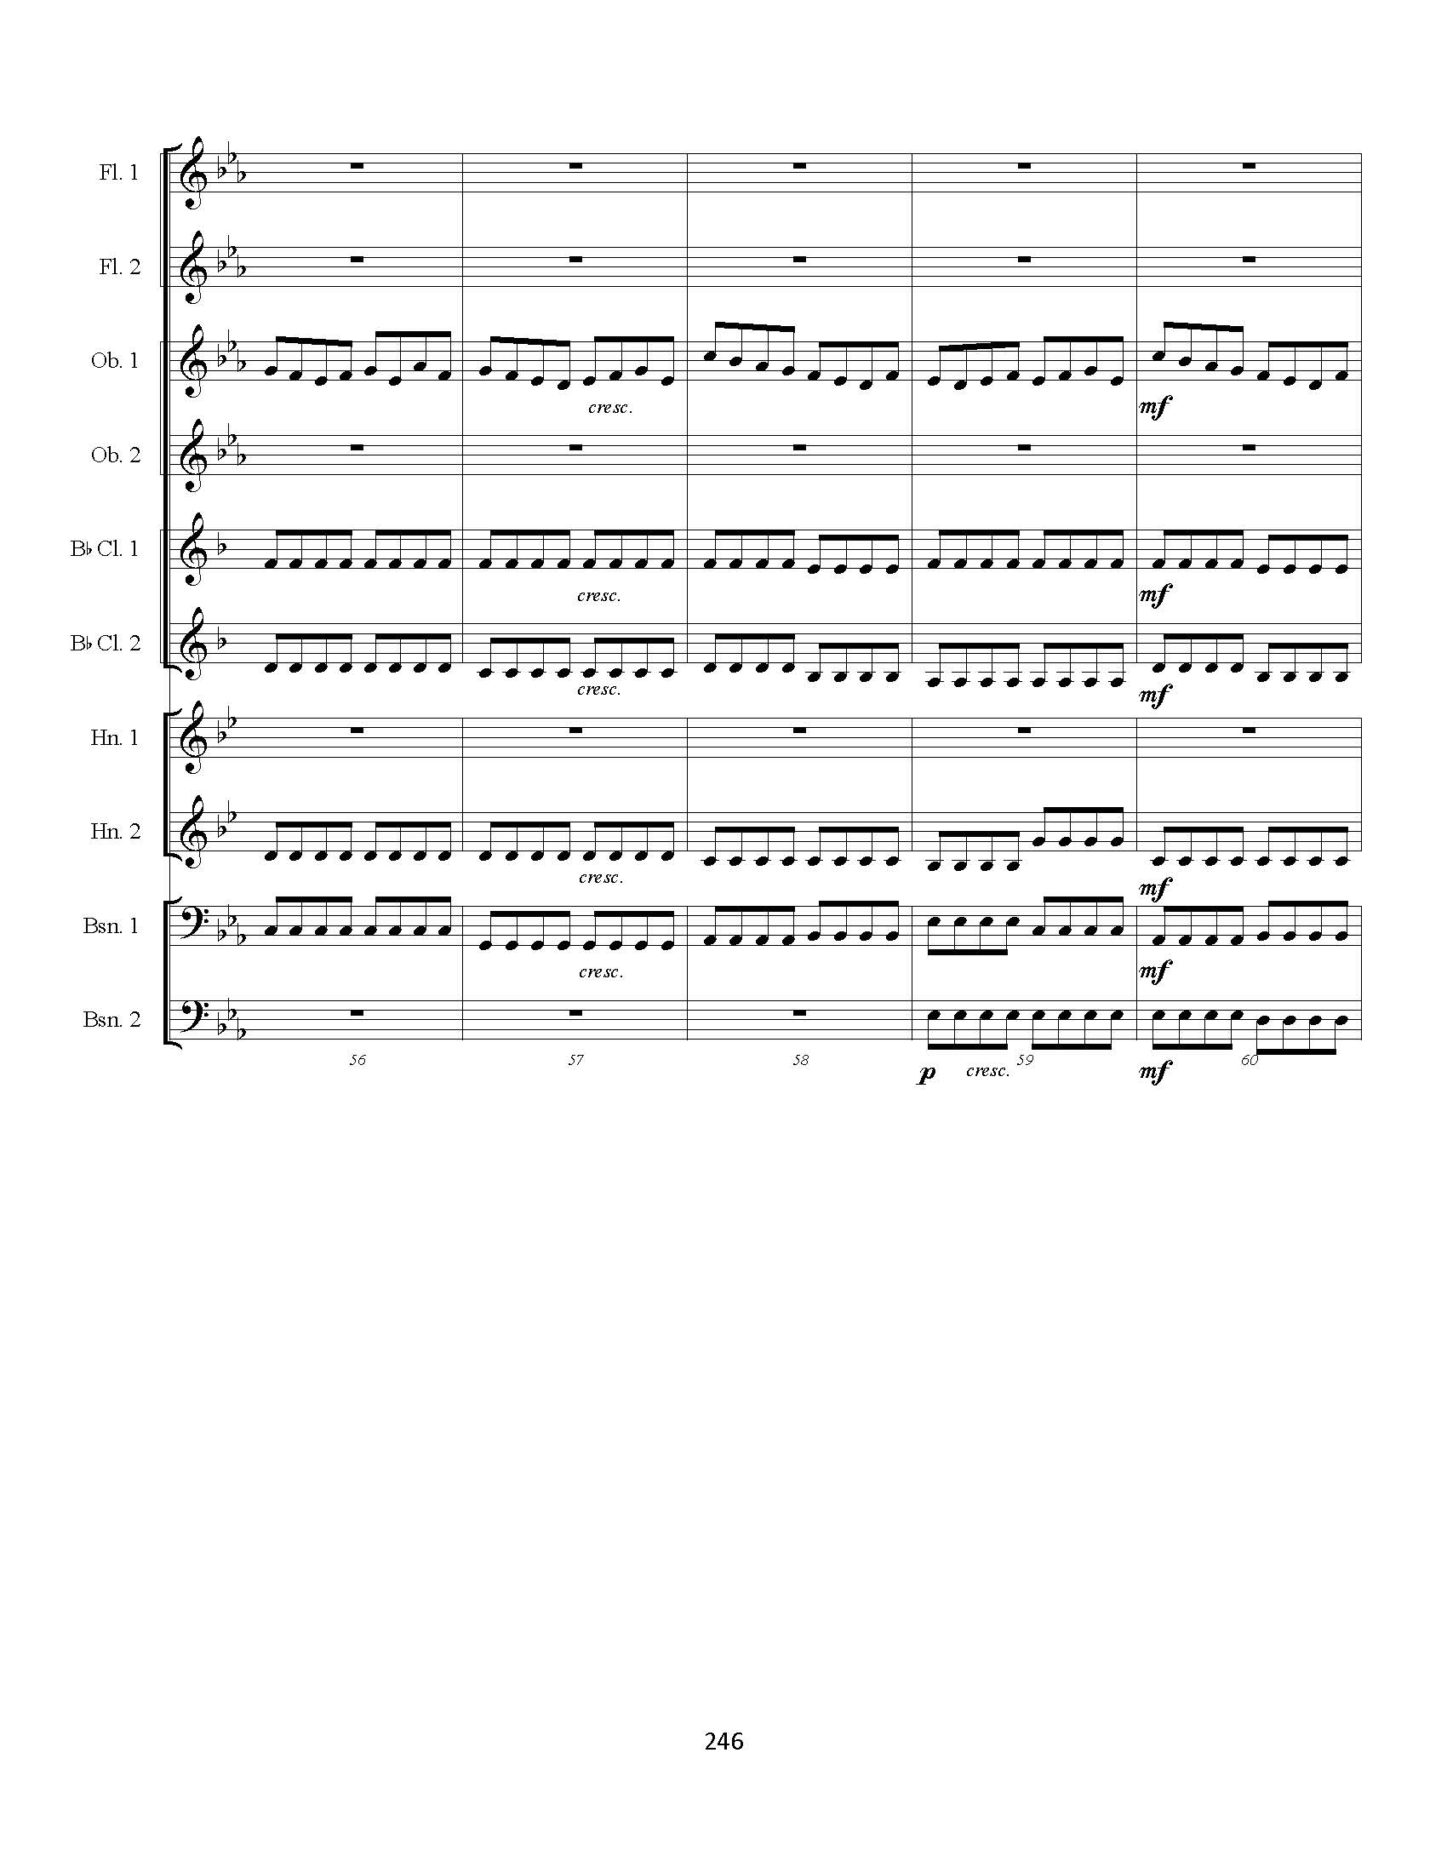

Bibliography

Austin, George Clifford Everard. “Formal procedures in Three Works for String Chamber
Ensemble by Felix Mendelssohn-Bartholdy.” Master’s thesis, University of British
Columbia, 1982. ProQuest Dissertations & Theses Global.

Battisti, Frank L. The Winds of Change. Galesville, MD: Meredith Music Publications, 2002.

Botstein, Leon. "Notes from the Editor: Mendelssohn as Jew: Revisiting Controversy on the
Occasion of the Composer's 200th Birthday." The Musical Quarterly 92, no. 1/2 (Spring-
Summer 2009): 1-8, accessed December 18, 2020, JSTOR, https://www.jstor.org/stable/27751851.

Brandon, Gregg Lewis. “Mendelssohn’s Public Statement of Faith: Lobgesang as Christian
Witness.” Master’s thesis, University of Arizona, 2017. ProQuest Dissertations & Theses
Global.

Brittan, Francesca. "On Microscopic Hearing: Fairy Magic, Natural Science, and the Scherzo
fantastique." Journal of the American Musicological Society 64, no. 3 (Fall 2011): 527
600, accessed February 25, 2021, JSTOR,
https://www.jstor.org/stable/10.1525/jams.2011.64.3.527.

Clappé, Arthur. The Principles of Wind-Band Transcription. New York: Carl Fischer, 1921.
Accessed April 2, 2021, IMSLP, https://ks4.imslp.net/files/imglnks/usimg/f/f2/IMSLP342487-SIBLEY1802.23094.4d7e-39087011182062text.pdf

Cooper, John Michael. "Knowing Mendelssohn: A Challenge from the Primary
Sources." Music Library Association Notes 61, no. 1 (September 2004): 35-95,
accessed December 18, 2020, JSTOR, https://www.jstor.org/stable/4487302.

Crocker, Richard L. A History of Musical Style. 2nd ed. New York: Dover Publications, Inc.,
1986.

Damschroder, David. Harmony in Mendelssohn and Schumann. Cambridge, United Kingdom:
Cambridge University Press, 2018.

Erickson, Frank. Arranging for the Concert Band. Van Nuys, CA: Belwin-Mills Publishing
Corporation and Alfred Publishing Co., Inc., 1983.

“Felix Mendelssohn-Bartholdy,” Wind Repertory Project, accessed December 29. 2021,
https://www.windrep.org/Felix_Mendelssohn_Bartholdy

Garvin, Robin Wildstein. “Romantic Irony in the String Quartets of Felix Mendelssohn
Bartholdy and Robert Schumann.” PhD diss., Florida State University, 2008. ProQuest
Dissertations & Theses Global.

Geraldi, Kevin M. "Felix Mendelssohn's Nocturno/Overture, Opus 24: A Study in Context,
Composition, and Performance." Journal of Band Research 44, no. 2 (2009): 13-44, 53-55.

Grier, Christopher. "The Rehabilitation of Mendelssohn [with Discussion]." Royal Society for the
Encouragement of Arts, Manufactures, and Commerce 142, no. 5455 (December 1994):
43-48, accessed December 18, 2020, JSTOR, https://www.jstor.org/stable/41351989.

Haskill, Roxanne. “Orchestral Transcriptions as Performed by Wind Bands.” Master’s thesis,
University of Massachusetts, Lowell, 1996. ProQuest Dissertations & Theses Global.

Kennan, Kent W. The Technique of Orchestration. 2nd ed. Englewood Cliffs, NJ: Prentice-Hall,
Inc., 1970.

Keller, James M. Program Notes for San Francisco Symphony Orchestra. Accessed May 11,
2022. https://www.sfsymphony.org/Data/Event-Data/Program-Notes/M/Mendelssohn-
Octet-in-E-flat-major-for-Strings-Opus

Lehne, Moritz, Martin Rohrmeier, Donald Gollmann, and Stefan Koelsch. "The Influence of
Different Structural Features on Felt Musical Tension in Two Piano Pieces by Mozart
and Mendelssohn." Music Perception: An Interdisciplinary Journal 31, no. 2 (December
2013): 171-85, accessed February 25. 2021, JSTOR,
https://www.jstor.org/stable/10.1525/mp.2013.31.2.171.

Lembke, Sven-Amin, Scott Levine, and Stephen McAdams. "Blending Between Bassoon and
Horn Players: An Analysis of Timbral Adjustments During Musical Performance" Music
Perception: An Interdisciplinary Journal 35, no. 2 (December 2017): 144-64, accessed
February 25. 2021, JSTOR, https://www.jstor.org/stable/10.2307/26417388.

Library of Congress. n.d. “Felix Mendelssohn: Octet in E-flat major, op. 20, for strings.”
Accessed June 3, 2021. https://www.loc.gov/item/ihas.2001564344/.

Mendelssohn, Felix. Octet in E-flat Major. Felix Mendelssohn Complete Chamber Music for
Strings. New York: Dover Publications, 1978, accessed October 3, 2020, IMSLP,
https://ks4.imslp.net/files/imglnks/usimg/9/95/IMSLP10980-Mendelssohn_-_Octet.pdf

Mendelssohn, Felix. Scherzo in G minor from the Octet Op. 20. Edwardsville, IL: Serenissima
Music, Inc, 2021.

Mendelssohn, Felix. Overture fur Harmoniemusik. accessed October 3, 2020, IMSLP,
https://ks.imslp.info/files/imglnks/usimg/3/31/IMSLP467369-PMLP63686-Mendelssohn,_Ouvertu-re_fu-r_Harmoniemusik_(18242638).pdf.

Mendelssohn-Bartholdy, Felix, and Library of Congress. Octet, violins 4, violas, violoncellos op.
20, E-flat major., monographic, 1825. Notated Music. https://www.loc.gov/item/2008561124/.

Moscheles, Felix. Letters of Felix Mendelssohn to Ignaz and Charlotte Moscheles. London:
Trübner and Co, 1888.

Mozart, Wolfgang Amadeus. Quintet in C Minor, K. 406. Accessed March 29, 2021, IMSLP,
https://ks.imslp.info/files/imglnks/usimg/7/7c/IMSLP01921-Mozart_-_String_Quintet_No.2_Score.pdf

Mozart, Wolfgang Amadeus. Serenade in C Minor. Kassel, Germany: Bärenreiter, 1979.

Posner, Howard. Program Notes for Los Angeles Philharmonic. Kent Nagano, conductor.
Thursday, November 16, 1995. Accessed April 4, 2022.
https://www.hollywoodbowl.com/musicdb/pieces/2584/overture-for-harmoniemusik-op-24

Rapoport, Erez. “The Smoothing-Over of Formal Junctures as a Style Element in Mendelssohn’s
Instrumental Music.” PhD diss., The City University of New York, 2004. ProQuest
Dissertations & Theses Global.

Schmidt-Beste, Thomas. "Preventive and Cautionary Dynamics in the Symphonies of
Mendelssohn and his Time." The Journal of Musicology 31, no. 1 (Winter 2014): 43-90,
accessed December 19, 2020, JSTOR, https://www.jstor.org/stable/10.4525/jm.2014.31.1.43.

Shade, Timothy M. “A Process for Transcribing Orchestral Works for Wind Band: Andre
Previn’s Sallie Chisum Remembers Billy the Kid.” DMA essay, University of Miami,
2016. ProQuest Dissertations & Theses Global.

Taylor, Benedict. "Musical History and Self-Consciousness in Mendelssohn's Octet Op.
20." 19th-Century Music 32, no. 2 (Fall 2008): 131-59, accessed March 6, 2021,
JSTOR, https://www.jstor.org/stable/10.1525/ncm.2008.32.2.131.

Tkalych, Lisa Diane Snyder. “Felix Mendelssohn as Romantic Conductor.” PhD diss., Princeton
University, 2019. ProQuest Dissertations & Theses Global.

Todd, R. Larry. 2016. “Revisiting Mendelssohn’s Octet.” Produced by Library of Congress.
Video. https://www.loc.gov/item/webcast-7448/.

Todd, R. Larry. "A Mendelssohn Miscellany." Music and Letters 71, no. 1 (February 1990): 52
64, accessed November 14, 2020, JSTOR, https://www.jstor.org/stable/735767.

Todd, R. Larry. "From the Composer's Workshop: Two Little-Known Fugues by
Mendelssohn." The Musical Times 131, no. 1766 (April 1990): 183-87, accessed
November 14, 2020, JSTOR, https://www.jstor.org/stable/966257.

Todd, Ralph Larry. “The Instrumental Music of Felix Mendelssohn-Bartholdy: Selected Studies
Based on Primary Sources.” PhD diss., Yale University, 1979. ProQuest Dissertations &
Theses Global.

Vitercik, Gregory John. “The Early Works of Felix Mendelssohn: A Study in the Romantic
Sonata Style.” PhD diss., State University of New York at Stony Brook, 1985. ProQuest Dissertations & Theses Global.

Warrack, Guy. "Arrangements Have Been Made." The Musical Times 85, no. 1222 (December
1944): 361-64, accessed March 30, 2021, JSTOR, https://www.jstor.org/stable/922335.

Warrack, Guy. "Arrangements Have Been Made (Concluded)." The Musical Times 86, no. 1223
(January 1945): 12-14, accessed March 30, 2021, JSTOR,
https://www.jstor.org/stable/935948.

Whitwell, David. A New History of Wind Music. Evanston, IL: The Instrumentalist Company,
1980.

Whittaker, W. Gillies. "Mendelssohn's Octet." The Musical Times 74, no. 1082 (April 1933):
322-25, accessed November 15, 2020, JSTOR, https://www.jstor.org/stable/920315.

Library of Congress. n.d. “Felix Mendelssohn: Octet in E-flat major, op. 20, for strings.”
Ibid.
Library of Congress. n.d. “Felix Mendelssohn: Octet in E-flat major, op. 20, for strings.”
Ibid.
“Felix Mendelssohn-Bartholdy,” Wind Repertory Project.
Warrack, Guy. "Arrangements Have Been Made." The Musical Times 85, no. 1222 (December 1944). 361.
Ibid.
Ibid., 364.
Warrack, Guy. "Arrangements Have Been Made." The Musical Times 85, no. 1222 (December 1944). 364.
Mendelssohn, Felix. Overture fur Harmoniemusik.
Schmidt-Beste, Thomas. "Preventive and Cautionary Dynamics in the Symphonies of Mendelssohn and his Time." The Journal of Musicology 31, no. 1 (Winter 2014). 46.
Mendelssohn-Bartholdy, Felix, and Library of Congress. Octet, violins 4, violas, violoncellos op. 20, E-flat major., monographic, 1825.
Mendelssohn, Felix. Octet in E-flat Major. Felix Mendelssohn Complete Chamber Music for Strings. New York: Dover Publications, 1978.
Brandon, Gregg Lewis. “Mendelssohn’s Public Statement of Faith: Lobgesang as Christian Witness.” Master’s thesis, University of Arizona, 2017. 21.
Botstein, Leon. "Notes from the Editor: Mendelssohn as Jew: Revisiting Controversy on the Occasion of the Composer's 200th Birthday." The Musical Quarterly 92, no. 1/2 (Spring- Summer 2009). 2.
Cooper, John Michael. "Knowing Mendelssohn: A Challenge from the Primary Sources." Music Library Association Notes 61, no. 1 (September 2004). 37.
Ibid.
Todd, R. Larry. "A Mendelssohn Miscellany." Music and Letters 71, no. 1 (February 1990). 52.
Ibid.
Grier, Christopher. "The Rehabilitation of Mendelssohn [with Discussion]." Royal Society for the Encouragement of Arts, Manufactures, and Commerce 142, no. 5455 (December 1994). 45.
Battisti, Frank L. The Winds of Change. 53.
Whitwell, David. A New History of Wind Music. 26.
Moscheles, Felix. Letters of Felix Mendelssohn to Ignaz and Charlotte Moscheles. 97.
Whitwell, David. A New History of Wind Music. 26.
Ibid.
Ibid.
Ibid., 27.
Clappé, Arthur. The Principles of Wind-Band Transcription. 78.
Clappé, Arthur. The Principles of Wind-Band Transcription. 74.
Ibid., 78.
Kennan, Kent W. The Technique of Orchestration. 192.
Erickson, Frank. Arranging for the Concert Band. 134.
Lembke, Sven-Amin, Scott Levine, and Stephen McAdams. "Blending Between Bassoon and Horn Players: An Analysis of Timbral Adjustments During Musical Performance" Music Perception: An Interdisciplinary Journal 35, no. 2 (December 2017). 160.
Haskill, Roxanne. “Orchestral Transcriptions as Performed by Wind Bands.” Master’s thesis, University of Massachusetts, Lowell, 1996. 60.
Ibid., 65.
Crocker, Richard L. A History of Musical Style. 438.
Shade, Timothy M. “A Process for Transcribing Orchestral Works for Wind Band: Andre Previn’s Sallie Chisum Remembers Billy the Kid.” DMA essay, University of Miami, 2016. 14.
Taylor, Benedict. "Musical History and Self-Consciousness in Mendelssohn's Octet Op. 20." 19th-Century Music 32, no. 2 (Fall 2008). 132.
Ibid., 133.
Taylor, Benedict. "Musical History and Self-Consciousness in Mendelssohn's Octet Op. 20." 19th-Century Music 32, no. 2 (Fall 2008). 159.
Vitercik, Gregory John. “The Early Works of Felix Mendelssohn: A Study in the Romantic Sonata Style.” PhD diss., State University of New York at Stony Brook, 1985. 1.
Ibid., 6.
Ibid., 119.
Whittaker, W. Gillies. "Mendelssohn's Octet." The Musical Times 74, no. 1082 (April 1933). 323.
Ibid.
Damschroder, David. Harmony in Mendelssohn and Schumann. 81.
Ibid.
Todd, Ralph Larry. “The Instrumental Music of Felix Mendelssohn-Bartholdy: Selected Studies Based on Primary Sources.” PhD diss., Yale University, 1979. 256-293.
Todd, Ralph Larry. “The Instrumental Music of Felix Mendelssohn-Bartholdy: Selected Studies Based on Primary Sources.” PhD diss., Yale University, 1979. 171.
Todd, R. Larry. 2016. “Revisiting Mendelssohn’s Octet.” 1:16:00-1:23:00
Austin, George Clifford Everard. “Formal procedures in Three Works for String Chamber Ensemble by Felix Mendelssohn-Bartholdy.” Master’s thesis, University of British Columbia, 1982. 41.
Brittan, Francesca. "On Microscopic Hearing: Fairy Magic, Natural Science, and the Scherzo fantastique." Journal of the American Musicological Society 64, no. 3 (Fall 2011). 527.
Ibid., 537.
Todd, R. Larry. "From the Composer's Workshop: Two Little-Known Fugues by Mendelssohn." The Musical Times 131, no. 1766 (April 1990). 183.
Ibid.
Lehne, Moritz, Martin Rohrmeier, Donald Gollmann, and Stefan Koelsch. "The Influence of Different Structural Features on Felt Musical Tension in Two Piano Pieces by Mozart and Mendelssohn." Music Perception: An Interdisciplinary Journal 31, no. 2 (December 2013). 171.
Rapoport, Erez. “The Smoothing-Over of Formal Junctures as a Style Element in Mendelssohn’s Instrumental Music.” PhD diss., The City University of New York, 2004. 247.
Ibid., 249-256.
Schmidt-Beste, Thomas. "Preventive and Cautionary Dynamics in the Symphonies of Mendelssohn and his Time." The Journal of Musicology 31, no. 1 (Winter 2014). 46.
Keller, James M. Program Notes for San Francisco Symphony Orchestra.
Mendelssohn, Felix. Scherzo in G minor from the Octet Op. 20. Edwardsville, IL: Serenissima Music, Inc, 2021.
Ibid., 5.
Mendelssohn, Felix. Scherzo in G minor from the Octet Op. 20. Edwardsville, IL: Serenissima Music, Inc, 2021. 4.
Posner, Howard. Program Notes for Los Angeles Philharmonic. Kent Nagano, conductor. Thursday, November 16, 1995.
Mendelssohn, Felix. Overture fur Harmoniemusik. 3.
Mendelssohn, Felix. Overture fur Harmoniemusik. 32.
Ibid., 14.
Mendelssohn, Felix. Overture fur Harmoniemusik. 10.

