UNIVERSITY OF OKLAHOMA

GRADUATE COLLEGE

The Effects of Professional Development on Transition Plan Components

A DISSERTATION

SUBMITTED TO THE GRADUATE FACULTY

in partial fulfillment of the requirements for the

Degree of

DOCTOR OF PHILOSOPHY

By

Malarie E. Deardorff
Norman, Oklahoma
2020
The Effects of Professional Development on Transition Plan Components

A DISSERTATION APPROVED FOR THE
DEPARTMENT OF EDUCATIONAL PSYCHOLOGY

BY THE COMMITTEE CONSISTING OF

Dr. Kendra Williams-Diehm, Chair

Dr. Aiyana Henry

Dr. Howard Crowson

Dr. Corey Peltier

© Copyright by Malarie E. Deardorff 2020
All Rights Reserved.
Dedication

To my husband, my parents, and my daughters.
Acknowledgements

I am going to try my best thank my family members, friends, colleagues, and mentors—but these written words will not begin to capture my immense gratitude and appreciation for these individuals.

Aaron—my husband. You encouraged me. You supported me. The last five years have been extremely challenging and exhausting, but you were with me every step of the way. I could not do life without you, nor would I ever want to. You helped me ‘better’ myself. Live and Let Live.

Preslie and Cambrie—my daughters. I hope I made you proud. I hope you will forgive me for being so busy. You are my world. I would not be successful without you. You made the time I was not at work or doing school stuff the absolute best.

Malcolm and Sandi—my parents. It has been a long journey. If you had not begun advocating for me in kindergarten, I would not be finishing a dissertation today. You loved me and supported me the whole way. Thank you.

Kendra—my mentor and boss. You helped me thrive instead of just survive my doctoral program. The last two years at the ZC have been the best. I love what I do, and I am forever thankful you gave me the chance from the beginning, coming in as a Sooner Scholar to now as your assistant director. Thank you.

Zarrow Center Crew—my friends. You were the best part of the doctoral program and my move to Norman. We had many tears, but so many more laughs. Belkis—you supported me, loved me, and helped me finish my dissertation. I hope to one day, very soon, return that favor. Tracy—from day one at the ZC you were my person. You helped me love myself. I will miss you. Mindy—thank you for being my friend, counselor, and giving me hugs when I needed them. You are never allowed to leave me. Joshua—I will miss you dearly. Your laugh got me through some dark days. Heather—Our road-trips were awesome. You let me be me. My dissertation would not be completed without you. Donna—you are the heart and soul of the ZC. You are my editor, my colleague, and most importantly my friend. Thank you.

My mentors. I have had many mentors over the last four years. Their support and guidance are invaluable. Dr. Martin—I learned most of what I know about transition and doctoral studies from you. You made me a better student from day one. Dr. McConnell—you introduced me to professional development which is my passion now. You made me a better writer and researcher. Dr. Henry—your unwavering support has helped me through the last two years of my doctoral journey. You were there for me in some tough times and also happy times. Dr. Crowson—your love of stats is contagious, and I am so thankful for your support on my dissertation. Dr. Peltier—your support and mentoring have helped me with my dissertation and beyond. Dr. Heddy—you provided guidance and support even though you were not on my committee during the last year. Dr. Prince, Dr. Mitchell, Dr. Landmark—although you are not at OU, you have supported me from a distance. Thank you.

Oklahoma State Department of Education and Lori Chesnut—thank you for the opportunity to improve professional development practices in transition through our partnership. Lori—I am so excited to see what the future holds. You have been so supportive, and I really appreciate the time you took to look over my surveys and presentations. Thank you.

Friends and family—I believe there are too many to mention individually, but your love and support have helped me successfully complete the doctoral program. Thank you.

Table of Contents
ACKNOWLEDGEMENTS……………………………………………………………………….v
LIST OF TABLES………………………………………………………………………………..x
LIST OF FIGURES……………………………………………………………………….……..xi
ABSTRACT……………………………………………………………………………………..xii
CHAPTER 1: INTRODUCTION………………………………………………………………...1
Problem Statement………………………………………………………………………..1
Significance of Study……………………………………………………………………..2
Research Questions……………………………………………………………………….6
Proposed Study…………………………………………………………………………...7
CHAPTER 2: LITERATURE REVIEW………………………………………………………...10
Special Education Overview…………………………………………………….……….10
Transition Overview………………………………………………………….………….10
Legal Implications…………………………………………………………..…………...13
Free Appropriate Public Education………………………………….…………….……..13
Transition and the Courts……………………………………………………...…………16
Compliance of Transition Plans………………………………………………………….18
Barriers to Appropriate Transition Planning……………………………………….…….21
Teacher Preparation in Transition………………………………………………….…….22
Preservice Transition Preparation……………………………………………….……….23
In-Service Transition Preparation………………………………………………..………26
Summary of Preparation in Transition……………………………………………...……28
Gaps in Literature……………………………………………………………….…….…28
Stepping-Up Intervention……………………………………………………………..…30
Conclusion………………………………………………………………….………........37
CHAPTER 3: METHODOLOGY……………………………………………………………….38
Research Questions………………………………………………………………………38
Method…………………………………………………………………………………...39
Research Design……………………………………………………………………….…39
Participants……………………………………………………………………………….39
Professional Development Trainings…………………………………………………….45
Stepping-Up Intervention Training………………………………………………………48
Comparison Training…………………………………………………………………….50
Dependent Measures……………………………………………………………………..55
Data Analysis…………………………………………………………………………….59
CHAPTER 4: RESULTS………………………………………………………………………...62
Training Characteristics………………………………………………………………….62
Correlation Among Sub Scores………………………………………………………….62
Brief Results Summary……………………………………………………...………..….63
Research Question One…………………………………………………………………..65
Research Question Two………………………………………………………………….66
Research Question Three………………………………………………………………...68
Research Question Four…………………………………………………………….……69
Summary of Results……………………………………………………………………...71
CHAPTER 5: DISCUSSION…………………………………………………………………….72
Research Question One…………………………………………………………………..73
Research Question Two………………………………………………………………….77
Research Question Three………………………………………………………………...80
Research Question Four………………………………………………………………….82
Summary…………………………………………………………………………………84
Limitations……………………………………………………………………………….86
Sampling and Selection…………………………………………………………….…….87
Testing……………………………………………………………………………………88
Attrition…………………………………………………………………………….…….88
Multiple Treatment Interference…………………………………………………………89
Implications………………………………………………………………………………89
Implications for Future Research………………………………………………………...90
Implications for Practice…………………………………………………………………91
Future Directions………………………………………………………………………...93
Conclusion……………………………………………………………………………….93
REFERENCES…………………………………………………………………………….…….95
APPENDIX A: PRESENTATION SLIDES FOR STEPPING-UP INTERVENTION….……106
APPENDIX B: PRESENTATION SLIDES FOR COMPARISION TRAINING…………….143
APPENDIX C: TRANSITION PLANNING ASSESSMENT………………….……………..169

List of Tables

- Participant Demographics………………………………………………………………..13
- Similarities and Differences of the Trainings……………………………………..……..45
- Means and Standard Deviations for Transition Planning Assessment…………………..62
- Pearson’s Correlation Amongst Score Types……………………………………………65

List of Figures

1. Stepping-Up Intervention Development Graphic……………………………………………..31
2. Stepping-Up Intervention Framework Graphic……………………………………………….34
3. Stepping-Up Intervention Framework Graphic in Presentation………………………………47
4. Checklist for Grading Fill-in-the-Blank Questions……………………………………………48
5. Profile Plots of Mean Total Scores for Comparison and Intervention Trainings……………..64
6. Profile Plots of Mean Multiple Choice Scores for Comparison and Intervention Training..…67
7. Profile Plots of Mean Discrimination Scores for Comparison and Intervention Trainings…...68
8. Profile Plots of Mean Fill-in-the-Blank Scores for Comparison and Intervention Trainings…70
9. Representation of Depths and Levels of Knowledge for Transition Planning Assessment…..75

Abstract
The Individuals with Disabilities Education Act (IDEA; 2004) requires special educators and school districts to write individualized education programs for students with disabilities to provide them a free appropriate public education. IDEA (2004) mandates transition planning to begin for students with disabilities when a student reaches the age of 16, or before based upon need. Many special educators leave their teacher education programs with little to no preparation in transition planning which could ultimately interfere with the student’s federally mandated right to a free appropriate public education. Since teachers are not receiving adequate training in transition in their undergraduate programs, in-service professional development training is a way to help teachers gain the knowledge and skills needed to write compliant transition plans. Currently, little research exists exploring the effects of professional development on transition planning. Using a comparison group design, this study examined the effects of professional development on transition planning, and more specifically, the changes in knowledge and skills gained from the professional development training. Results of this study indicated the effectiveness of professional development on teacher knowledge of best practices in transition planning. In addition, results indicated the intervention, Stepping-Up, yielded increased scores in discriminating between compliant and noncompliant postsecondary and annual transition goals, and the creation of compliant transition plan components. Implications are discussed regarding the need for time-effective and quality professional development in transition planning and the continued need to explore the effects of professional development on actual transition planning practices.

Chapter 1
Introduction
Problem Statement
Beginning in 1990, the Individuals with Disabilities in Education Act (IDEA) mandated Transition planning to occur within the student’s individualized education program (IEP) for secondary students with disabilities beginning at age 16 (IDEA, 1990; Turnbull et al., 2009). The transition mandate in IDEA has changed two times since 1990 with revisions in 1997 and 2004. IDEA (2004) mandates transition planning to begin by age 16 or before if deemed necessary by the IEP team. Many states require transition planning to begin before the age 16. Transition planning per IDEA (2004) includes three major components postsecondary goals, annual IEP goals related to transition needs, and transition services including a course of study. While transition planning has been included in the IEP for secondary age students for 30 years, the lack of teacher preparation in transition (Anderson et al., 2003; Morningstar et al., 2018) and teacher knowledge of transition planning (Plotner et al., 2016) limits teachers’ ability to write compliant and quality transition plans for students with disabilities.
The large majority of special educators leave their preservice teacher preparation programs without adequate transition knowledge to develop transition plans for their students. In fact, only 35% of teacher preparation programs require a dedicated course in transition (Williams-Diehm et al., 2018), and many teachers leave their alma maters with little to no transition education embedded in other special education coursework (Anderson et al., 2003; Morningstar et al., 2018). In addition, many special educators note their lack of satisfaction with their transition competencies, which ultimately influences their levels of preparedness to write and implement transition plans and instruct transition skills (Morningstar & Benitez, 2013; Morningstar et al., 2018).
Recent compliance reports indicate teachers are not creating compliant and quality transition plans for students with disabilities (Landmark & Zhang, 2012; Powers et al., 2005) These reports over the last two decades show the potential for numerous violations, including procedural requirements outlined in the Individuals with Disabilities Education Act (2004; Grigal et al., 1997; Landmark & Zhang, 2012). These violations could potentially result in due process hearings and court cases over denying students their right to a Free and Appropriate Public Education (FAPE; Prince et al., 2013). The most recent ruling over the meaning of appropriateness with FAPE per Endrew F. v. Douglas County School District (2017) provides serious implications for teachers to create appropriate transition plans, specifically postsecondary and transition goals (hereafter Endrew). The ruling over the Endrew case requires schools to show students are making reasonable and calculated progress toward goals (e.g., transition-related goals) in order to provide students with disabilities FAPE (Prince et al., 2018). Since preservice preparation programs are not adequately preparing teachers in transition competencies (Anderson et al., 2003; Morningstar et al., 2018), in-service professional development is a potential way to help teachers gain transition knowledge and help prevent potential interference with the FAPE provision by instructing teachers to create compliant and quality transition plans.
Significance of Study
Special educators and other related educational professionals have been required to plan for the transition from school to post school for students with disabilities for 30 years with the first mandates beginning in 1990. However, in recent years (2004 and beyond) the standards-based education movement has required many teacher preparation programs to focus solely on academics (Morningstar et al., 2012), leaving little room for teachers to plan for and teach important functional skills.
Despite the call in 2003 for comprehensive transition preparation from the Division on Career Development and Transition of the Council for Exceptional Children, many teachers leave their preservice teacher preparation programs with limited knowledge of transition planning and processes (Blalock et al., 2003). Sadly, teacher preparation in transition has changed little in the last two decades (Anderson et al., 2003; Morningstar et al., 2018). Anderson et al. (2003) reported less than half of special education teachers received less than one course or received little to no transition embedded in coursework. Unfortunately, recent studies reported similar findings (Morningstar et al., 2018; Plotner et al., 2016). In a syllabi review of higher education institutions with special education certification, Williams-Diehm et al. (2018) reported only 35% of programs require a transition course. These results indicate a lack of preservice personnel preparation of teachers in special education. This lack of preparedness in secondary special educators could be responsible for dismal postsecondary outcomes experienced by individuals with disabilities (Blancett, 2001; Knott & Asselin, 1999; Morningstar & Benitez, 2013; Wolfe et al., 1998).
Overall, many teachers felt dissatisfied with their transition preparation (Benitez et al., 2013; Plotner et al., 2016). In fact, Plotner et al. (2016) reported 73% of teachers stated they did not gain knowledge from their university preparation program on transition. Teachers also report dissatisfaction with the amount and quality of professional development in transition (Anderson et al., 2003; Morningstar et al., 2018). In a more positive finding, educator’s preparedness is significantly impacted by coursework and professional development in transition (Morningstar & Benitez, 2013; Morningstar et al., 2018). According to Blalock et al. (2003) there are two options to prepare teachers to create and implement effective transition planning: (a) assigning transition-only coursework to preservice training teacher preparation programs, or (b) providing professional development to in-service and preservice teachers on transition topics. As indicated, preservice programs are not providing adequate training for teachers in transition, indicating a need for professional development to occur at the in-service level.
Current research pinpoints three studies on the impact of professional development in transition (Holzberg et al., 2018). Two studies researched the effects of professional development on teachers’ ability to write compliant and quality transition plan components (Doren et al., 2012; Flannery et al., 2015). These studies used a pretest/posttest design without a control group and coded several IEPs per participant before and after training. In the first study, Doren et al. (2012) targeted postsecondary goal writing and found significant improvements in that area. The second study broadened their target to several transition planning components, including postsecondary goals, annual transition goals, coordinated activities, course of study, and present levels of performance. Their results indicated teachers significantly increased compliance in all but one component, annual transition goals. Flannery et al. (2015) noted many teachers described using specific techniques to build the transition plan, but they did not include information in the student’s transition plan — indicating a gap in teacher knowledge and application of knowledge. Both studies lacked several key features, including a control group and a way to gauge teacher knowledge pre/post. In addition, while researchers discussed some of the features of the professional development that was provided, researchers did not use a specific framework to support either training, nor did they follow suggested best practices on providing professional development.
The lack of research indicating the effectiveness of professional development in transition illuminates a gap in the current literature. In addition, current research does not indicate the level of teacher knowledge prior to and after professional development training in transition topics. Therefore, a need exists to determine the effects of professional development in transition on teacher knowledge of transition competencies, particularly in the areas of transition planning and assessment.
There is some guidance within the special education literature on how to best provide professional development in transition (Benitez et al., 2009; Dunst & Trivette, 2009; Holzberg et al., 2018). Hozlberg and colleagues’ (2018) review of effective professional development across special education content delivery indicated several core elements, including active participant engagement with coaching and follow up opportunities, content-specific focus, addresses issues facing educators at work, and satisfactory length, to be powerful. Other suggestions for best practices in adult learning and providing professional development include using the Participatory Adult Learning Strategy (PALS; Dunst & Trivette, 2009), which seeks to actively engage learners using a four-phase model: introduce materials prior to training, participant practice and evaluation of learning, informed understanding with time for reflection, and active learner involvement throughout the entire training.
Transition scholars also reported several techniques to best provide professional development to in-service and preservice teachers. Benitez et al. (2009) suggested allowing teachers to evaluate transition plan components, specifically, their own; to practice writing transition plans, and to seek help from others in developing the plan. May et al. (2018) indicated the effective use of service-learning projects for students who participated in university preparation programs. These service-learning projects centered around providing transition services, administering transition assessments, and creating transition plans, which allowed students to gain a proficient or accomplished understanding of core transition competencies. In addition, this service-learning project enabled students to feel higher levels of confidence on pre/post self-assessments, particularly in the areas of developing plans and using assessments. This suggests pre-service teachers gained knowledge and skills in transition competencies through case studies and actual practice administering transition assessments and writing IEPs, which could be mimicked in in-service trainings.
Lastly, exploring the literature within special education leads to behavior analytic techniques for effective instruction, including using direct instruction, in particular, the “I do, we do, you do” method (Burnes & Yssledyke, 2009). The behavior analytic literature also suggests providing numerous opportunities to respond and using examples and nonexamples (Simonsen et al., 2008; Thompson et al., 2017). Considering the suggestions for best practice in providing professional development and effective instructional practices within applied behavior analysis, I created a professional development framework to teach educators how to create compliant and quality transition plans using transition assessment results.
Research Questions
Research questions were:
- Do participants in the Stepping-Up intervention exhibit significantly greater gains from pre- to post- transition planning assessment scores than those in a comparison group?
- Do participants in the Stepping-Up intervention exhibit significantly greater gains from pre- to post- multiple choice scores of the transition planning assessment than those in a comparison group?
- Do participants in the Stepping-Up intervention exhibit significantly greater gains from pre- to post- discrimination scores of the transition planning assessment than those in a comparison group?
- Do participants in the Stepping-Up intervention exhibit significantly greater gains from pre- to post- fill-in-the-blanks scores of the transition planning assessment than those in a comparison group?
Proposed Study
Current research illuminates a gap for a comprehensive and universal professional development framework to increase transition knowledge to guide teachers in writing quality, compliant transition plans through compliance reviews (Gaumer-Erickson et al., 2014; Grigal et al., 1997; Landmark & Zhang, 2012), case law decisions (Petcu et al., 2014; Prince et al., 2014), inferior postsecondary outcomes for students with disabilities (Newman et al., 2009), and lack of in-service/preservice training for secondary special educators (Anderson et al., 2003; Benítez et al., 2009; Morningstar et al., 2018). Therefore, I proposed a study on the effectiveness of professional development on teacher knowledge and skills in transition planning components using a comparison group. The comparison group received a professional development training in transition.
The Oklahoma State Department of Education contracted with the Zarrow Center for Learning Enrichment at the University of Oklahoma to provide 16 professional development trainings on transition topics for the 2019-2020 school year. These topics included (a) transition assessments for students with mild to moderate disabilities, (b) transition planning for students with significant support needs, (c) using EdPlan to create meaningful transition plans (Stepping up Transition), and (d) student involvement in the IEP. Trainings were provided in four different cities (Lawton, Oklahoma City, Owasso and Enid) to encourage teachers from across the state to attend without extensive travel requirements. Each training allowed for up to 150 participants to attend. My proposed study focused on gaining data from two of the four training types (eight trainings total): the transition assessments for students with mild to moderate disabilities and using EdPlan to create meaningful transition plans.
I used a comparison group research design. Due to the inability to randomly assign groups to control or intervention, this research design was quasi-experimental. There were two groups, intervention and comparison, both of which received professional development. Data were collected pre/post in both trainings using the same knowledge assessment. To ensure the assessment instrument used to assess teacher knowledge of transition planning in the designated training groups was appropriate, the assessment was (a) vetted by professionals in the field, (b) pilot tested with several groups of individuals, and (c) reviewed by the Oklahoma State Department of Oklahoma’s transition representative. I used specific data analysis techniques to determine the effectiveness of each professional development to compare the effectiveness between the two training conditions and to determine if any demographic information, including location, years of teaching experience, and primary teaching assignment, impacted the assessment results.
The assessment developed targeted knowledge and skills directly related to the creation of the transition plan. The assessment had three parts: (a) seven multiple-choice questions over best practice requirements of transition plans, (b) four discrimination of compliant (yes/no) postsecondary goals and annual transition goals, and (c) five fill-in-the-blank questions for a postsecondary goal, two annual transition goals, and a coordinated activity.
I hypothesized, based upon existing research on the effectiveness of professional development to improve and increase quality and compliance of transition plans (Doren et al., 2012; Flannery et al., 2015) and increased preparedness (Benitez et al., 2009; Morningstar & Benitez, 2013), that the intervention training would significantly increase teacher knowledge of transition planning components. In particular, I hypothesized the training “using Edplan to create meaningful transition plans,” using my universal framework for writing quality and compliant transition plans titled Stepping-Up Transition, would be effective at increasing teacher knowledge and skills in identifying best practice, identifying compliant transition planning components, and writing compliant transition planning components.

Chapter 2
Review of Literature
Special Education Overview
The Individuals with Disabilities Education Act (IDEA; 2004) promises children with disabilities a free appropriate public education (FAPE) through federal legislation. The initial law allocating educational rights to children with disabilities, the Education of the Handicapped Act, was enacted in 1970. The concept of FAPE was introduced in 1975, with an amendment to the initial law which also changed the name to The Education for all Handicapped Children Act (EAHCA; Yell et al., 2017). The intent of EAHCA was to provide students with disabilities an education similar to their counterparts without disabilities, spurred in part by the civil rights movement (Gerber, 2017; Yell et al., 2017). EAHCA was the precursor to IDEA in 1990 and has been revised and amended several times since its first enactment, with the most recent revision in 2004 (Turnbull et al., 2009). Despite this almost 45 year old call for the rightful treatment and education of children with disabilities, dismal in-school (Wagner et al., 2006) and post-school outcomes (Blackorby & Wagner, 1996; Newman et al., 2009) still exist—calling into question teaching practices perpetuated by school districts, administrators, and teachers. While there have been increases in positive postsecondary outcomes of individuals with disabilities, these rates remain significantly lower than those of their peers without disabilities (Newman et al., 2009).
Transition Overview
Dismal post-school outcomes of individuals with disabilities prompted scholars and educational professionals to call for comprehensive planning to support the transition from high school to post-school outcomes (Newman et al., 2009). Preparing students with disabilities for the transition to adulthood is supported through transition planning mandated by federal legislation. First introduced in IDEA 1990, transition planning is currently mandated within the Individuals with Disabilities Act (IDEA; 2004) to begin by the age of 16—however, many states have adopted stricter regulations to begin transition planning as young as 13 (Suk et al., 2019). A call for comprehensive transition planning began decades before it was first mentioned in federal educational laws (i.e., P.L. 94-142, IDEA 1997, IDEA 2004).
Madeline Will and the Office of Special Education Programs issued a school-to-work bridge model in 1984 in an attempt to increase employment rates of individuals with disabilities after high school. At that time, unemployment rates for individuals with disabilities were very high, sometimes hovering around 88% (Wehmen et al., 1985). The bridge model (Will, 1984) supported employment outcomes for students with disabilities in high school through three special service plans: no services, time-limited services, and on-going services. Will’s (1984) model was later improved upon by Halpern (1985) who extended supports from employment-only to residential living and social and interpersonal networks. In addition, Halpern (1985) recognized all students received generic supports from high school to the transition to employment; therefore, the term “no services” was changed to “generic services”. Lastly, Halpern (1985) noted the services provided in high school to students with disabilities contributed to their overall community adjustment.
A few years later, federal laws adopted transition planning as a mandated practice for individuals with disabilities in PL 94-142, sometimes referred to as IDEA 1990. IDEA (1990) embraced the outcome-oriented process of Will’s (1984) and Halpern’s (1985) models and identified supports for the movement of students with disabilities toward postsecondary activities in education/training, employment, independent living, and community participation. Currently, IDEA (1990) has been reauthorized with revisions to the law occurring in 1997 and 2004. IDEA (2004) made a few changes to the transition planning definition, most notably in the change from an outcome-oriented to a results-oriented process to improve both academic and functional performance of students with disabilities in the same identified transition areas (Turnbull et al., 2009).
Transition Defined
Most recently, Rowe et al. (2014) used a Delphi study to operationalize and define evidence-based predictors of postsecondary success. Rowe and her colleagues have provided the most comprehensive definition of secondary transition. “A transition program prepares students to move from secondary settings to adult life, utilizing comprehensive transition planning and education that creates individualized opportunities, services, and supports to help students achieve their post-school goals in education/training, employment, and independent living” (Rowe et al., 2014, p. 11). Hence, transition education encompasses planning for a student’s life after high school through meaningful planning, experiences, and instruction provided by educational stakeholders during secondary school.
In addition to the transition definition, explanation of transition services, and mandated transition components within IDEA (2004), transition is an integral part of the overall purpose of special education. IDEA (2004) states the first purpose of special education is “to ensure that all children with disabilities have available to them a free appropriate public education (FAPE) that emphasizes special education and related services designed to meet their unique needs to prepare them for further education, employment, and independent living” (20 U.S.C. 1400,(1a)).
Postsecondary outcomes of further education, employment, and independent living are the cornerstone of this purpose—emphasizing the importance of transition within IDEA. This also indicates FAPE is provided to help students prepare for their postsecondary lives. Before diving into litigation over FAPE in regard to transition planning, it is important to discuss the implications of FAPE and the evolution of the FAPE definition.
Legal Implications
Free Appropriate Public Education (FAPE)
A free appropriate public education (FAPE) must be provided to all children with disabilities. “Free” refers to the education being provided at no cost to the child or family (Turnbull et al., 2009). This also includes the zero-reject mandate—allowing all children with disabilities regardless of severity to receive an education through public schools (IDEA, 2004). Appropriate is slightly more difficult to define and has been at the heart of numerous court cases (Aron, 2005; Petcu et al., 2014; Prince et al., 2014; Yell & Drasgow, 2000). The first Supreme Court ruling over FAPE occurred with Board of Education v. Rowley, 1982 (hereafter Rowley, 1982). Rowley (1982) required the U.S. Supreme Court to decide how “appropriate” should be defined within confounds of IDEA (Rowley, 1982; Prince et al., 2009; Turnbull et al., 2009). The two-part description of “appropriate” within Rowley (1982) includes (a) outlined procedures within IDEA and (b) a benefit standard. Outlined procedures include the child’s right to a non-discriminatory evaluation, development of an individualized education program (IEP), least restrictive environment (LRE) placement, parental rights, and parental safeguards (Rowley, 1982; Turnbull et al., 2009). Thus, “appropriate” should be individually described in the child’s IEP to include special education services, supports, and accommodations as well as present levels of academic and functional performance, LRE, goals and objectives, and related services (Turnbull et al., 2009).
The benefit standard refers to the progression of skills, meaning students need to be making progress in the skills targeted by evaluations and on-going assessments as outlined in the child’s IEP (Rowley, 1982; Aron, 2005). The term “benefit” is highly contested across the special education field with several courts’ decisions resulting in varying definitions (Aron, 2005; Prince et al., 2018). Following Rowley (1982), several district courts determined the level of “benefit” ranges from meaningful to adequate to some (Aron, 2005; Prince et al., 2018), leaving many school districts and states left to interpret and provide FAPE differently (Aron, 2005). Basically, what constitutes FAPE for one student differs from another (Prince et al., 2018).
In 2017, the U.S. Supreme Court ruled again on FAPE in Endrew F. v. Douglas County School District (hereafter Endrew, 2017). The Endrew (2017) ruling determined a child with a disability “must make progress appropriate in light of the child’s circumstances.” In other words, students must make progress in skills they need rather than just providing trivial benefits (Endrew (2017); Prince et al., 2018). The Endrew (2017) decision overruled Rowley (1982) and increased the benefit standard from minimal or just above no progress to “reasonably calculated progress” (Endrew (2017); Prince et al., 2018). The Endrew (2017) ruling prompts school districts to plan for further advancement in both academic and functional performance (Prince et al., 2018).
The definition of FAPE has evolved over the last 45 years, setting a higher quality precedent for educating children with disabilities (Prince et al., 2018; Zirkel, 2017). Therefore, students should be benefitting from the instruction and services provided by schools as demonstrated through progress monitoring. This benefit occurs beginning with IEP development and implementation of research-based practices known to increase student academic and functional performance (Prince et al., 2018).
The Endrew (2017) decision reinforced the need to develop effective and appropriate IEPs including transition plans (Prince et al., 2018). Prince et al. (2018) reviewed case law decisions revolving around transition planning and FAPE to determine several recommendations for transition plans and IEPs. In particular, Prince et al. (2018) recommended IEP teams should adhere to specific IEP requirements, including (a) using assessments to make educational decisions; (b) creating meaningful, appropriate annual goals for academics and functional skills; (c) addressing student’s targeted needs through related and special education services; and (d) conducting progress monitoring to report progress to the IEP team and parents.
Since the meaning of FAPE within IDEA has evolved over the last several decades, it is difficult to determine the extent to which FAPE has been provided to students with disabilities in regard to the benefit standard (Zirkel, 2017). While procedural requirements including the creation and implementation of the IEP are easier identified and ruled on in court cases, numerous disputes have occurred over the benefit standard within FAPE. Procedural requirements within IEPs are typically reviewed with guidance from several indicators within IDEA. IDEA (2004) mandates 20 indicators for state performance (20 U.S.C. 1421(a)(15)(A)(iii)). Most of these indicators revolve around academic requirements and procedural safeguards, but several have implications for functional performance of students.
Four of the 20 indicators within IDEA (2004) directly address transition: Indicators 1, 2, 13, and 14. Indicators 1 and 2 require districts to report graduation and dropout rates of students with disabilities on IEPs, respectively. Indicator 13 focuses on the use of age-appropriate transition assessments and postsecondary goals (Leconte & Neubert, 2013). Other important aspects of Indicator 13 include annual transition goals, transition services, and student involvement in the IEP (National Technical Assistance Center on Transition, 2012). In addition to Indicator 13, which addresses compliance of the IEP transition plans, Indicator 14 requires schools to report student outcomes in post-school education/training and employment one year after students graduate from high school (Gaumer-Erickson et al., 2014). Thus, the connection between compliant transition plans and postsecondary outcomes is solidified in federal law—providing FAPE to students with disabilities begins with compliant IEPs with special attention to transition plans to further postsecondary outcomes of students with disabilities. Transition mandates and the changing definition of FAPE ultimately resulted in numerous court cases in regard to transition planning.
Transition and the Courts
There are several court cases resulting from a violation of FAPE in regard to transition planning. Several court cases between 2004 and 2013 ruled school districts denied FAPE to students based on transition planning and service requirements (Prince et al., 2013). Below, I describe seven cases in more detail to explain the reasoning FAPE was denied to students based upon transition services and planning.
- The district court ruled the Black River Fall School District (2004) denied a student FAPE in regard to the benefit standard as the school did not monitor progress in transition skills which would provide the student with skills needed for postsecondary education and employment (Etscheidt, 2006; Prince et al., 2014).
- The School district of Philadelphia v. Deborah A. (2011) ruling found the school district did not provide appropriate goals and transition services including independent living and employment. The school district was ordered to provide compensatory education for the student for two years as the student was denied FAPE.
- The court ruling of District of Columbia Pub. School, 111 LRP 26012 (2011) determined the school district did not use appropriate transition assessments to measure student abilities and level of functioning, thus postsecondary goals were not appropriate (as cited in Prince et al., 2013). As a result, the student was denied FAPE.
- The Carrie I. v. Department of Education, State of Hawaii (2012) ruling found Carrie’s son’s transition goals were vague and impersonal. Additionally, age-appropriate transition assessments were not administered or used to create individualized transition goals. Transition services were also inappropriate. The court ruled the student was denied FAPE.
- In Gibson v. Forest Hills School District Board of Education (2013), the court ruled the school district did not provide the student with FAPE as a result of failing to adequately address the student’s postsecondary future—the student’s interests and preferences were not accounted for in transition planning.
- In Jefferson County Board of Education v. Lolita S. (2013), the student was denied FAPE due to inappropriate postsecondary goals and transition services. The school district did not use appropriate transition assessments and the assessments that were used produced inappropriate, vague results. Also, there was no evidence transition goals were updated annually.
These cases outline the serious nature of inadequate transition planning leading to possible FAPE violations. If age-appropriate transition assessments are not used and progress is not monitored to ensure students are making reasonable progress toward goals, school districts could be held liable for the denial of FAPE (Prince et al., 2013; Prince et al., 2014). In addition, if transition plans, particularly postsecondary goals, are not created with student interests and preferences, this could result in a FAPE violation.
In a review of due process hearings and court cases between 2005 and 2013, Petcu et al. (2014) found violations occurred in the following components (a) lack of student involvement in the IEP, (b) lack of transition assessments used to develop the plan gauging students strengths and interests, (c) delay in developing the transition plan, (d) lack of parent involvement in transition plan creation, (e) poor postsecondary goals, (f) inappropriate transition services identified or provided, and (g) lack of age-appropriate transition assessments used to develop the transition plan. Similarly, Prince et al. (2014) discovered transition plans which included the use of multiple age-appropriate transition assessments, individualized plans created upon student strengths and interests with corresponding postsecondary goals, evidence of student participation in the IEP meeting, and progress monitoring toward goal progress prevailed in court cases. These two reviews (Petcu et al., 2014; Prince et al., 2014) outlined the necessary components transition plans must have to provide transition age youth with FAPE.
Noncompliance of transition components mandated by IDEA (2004) resulted in a violation of FAPE by not adequately addressing student needs through special education and related services and not planning for future functional performance (Petcu et al., 2014; Prince et al., 2014; Prince et al., 2018). The number of court cases cannot account for all violations of FAPE within transition planning. Therefore, to potentially account for other violations of FAPE, further exploration of compliance and quality of transition plans is warranted.
Compliance of Transition Plans
Ideally, well-written, quality, compliant transition components in the IEP will lead to better instruction in transition skills and, hopefully, greater postsecondary outcomes. The more compliant transition components are in the IEP, the more likely students will receive appropriate transition instruction (Landmark & Zhang, 2012). Students who receive adequate and appropriate transition services attain more positive postschool outcomes (Landmark & Zhang, 2012; Mazzotti et al., 2013; Test et al. 2009). Furthermore, students who receive satisfactory transition services are more likely to be employed, to go college, and to live independent lives (Mazzotti et al., 2013; Test et al., 2009). Appropriate transition planning is also a positive predictor of postsecondary education enrollment (Erickson et al., 2014). Thus, the correlation between quality, compliant transition plans and better outcomes is established (Gaumer-Erickson et al., 2014; Grigal et al., 1997; Landmark & Zhang, 2012; Test et al., 2009).
In recent years, several researchers have explored the quality and compliance of transition planning in secondary settings (Gaumer-Erickson et al., 2014; Grigal et al., 1997; Landmark & Zhang, 2012; Powers et al. 2005). The compliance and quality of transition plans varied across studies depending on the geographic location, date, and measures used to determine quality; however, each study highlighted the need for greater teacher understanding of transition planning and federal mandates.
Compliance rates for the transition components of the IEP have increased over the last several years (Gaumer-Erickson et al., 2014; Grigal et al., 1997; Landmark & Zhang 2013); however, the results of compliance reviews revealed transition plans have not been appropriately developed to help students make meaningful progress in functional transition skills (Gaumer-Erickson et al., 2014; Landmark & Zhang, 2012). Specifically, many plans violated the IDEA mandate to use age-appropriate transition assessments (Prince et al., 2014). This ultimately affected FAPE because plans were not created based on assessment results, goals were not individualized to student needs, appropriate services were not provided to meet their needs, and progress monitoring on skills did not show proof of the benefit standard set forth by Endrew (2017) and seen in other case law decisions. Although compliance does not guarantee students will attain postsecondary goals, it does set a minimum standard for school districts (Landmark & Zhang, 2013). The following sections will provide a look at transition compliance beginning in 1997 to show the progression of transition planning throughout the last two decades.
The first compliance reviews indicated most transition plans were compliant but lacked quality and evidence of best practice (Grigal et al., 1997; Powers et al., 2005). Grigal et al. (1997) and Powers et al. (2005) discovered while a majority postsecondary goals met requirements for compliance, they lacked details and quality. In addition, transition plans lacked evidence of being updated annually. Between those two compliance reviews, the inclusion of postsecondary goals increased, but the quality of goals did not improve. Everson and colleagues (2001) found many transition plans included post-school outcomes, but many plans did not include timelines or action steps. In fact, fewer than 10% of transition plans were either detailed or adequate. While Powers et al. (2005) indicated an increase in quality, fewer than 40% of transition plans were detailed or adequate. Similarly, the poor quality of postsecondary goals had resulted in FAPE litigation (e.g., Carrie I.v. Department of Education, State of Hawaii, 2012; Jefferson County Board of Education v. Lolita S., 2013).
In another review of compliance and quality several years later, Landmark and Zhang (2012) found low percentages of full compliance amongst transition components including postsecondary goals, annual goals, and transition services. They noted about three-fourths of the transition plans were not linked to a student’s postsecondary aspirations or aligned with individual student strengths, needs, preferences, and interests as mandated in IDEA (2004). In addition, only 41.5% of the IEPs analyzed were fully compliant; many lacked the inclusion of transition goals and services aligned with the student’s chosen postsecondary goals. A lack of assessments to appropriately gauge student interests and preferences is a violation of FAPE, as established in Carrie I. v. Department of Education, State of Hawaii (2012). In addition, not tailoring postsecondary goals and annual transition goals to the youth’s specific transition needs and interests also violates FAPE (e.g., Black River Fall School District 40, Carrie I. v. Department of Education, 2012).
Prince et al. (2014) concluded that a noncompliant or poor quality transition component may not be a direct violation of FAPE if other portions of the IEP promoted student growth in transition skills—however, having quality transition plans can help “avoid procedural and service-delivery violations that result in a denial of FAPE” (as cited in Prince et al., 2014, p. 46; Prince et al., 2013). The compliance and quality reviews over the last two decades show that while many plans met compliance mandates, a larger percentage of plans lacked quality and did not address student interests, preferences, strengths, and limitations through transition assessment (Gaumer-Erickson et al., 2014; Grigal et al., 1997; Landmark & Zhang, 2012; Prince et al., 2013; Prince et al., 2014).
Barriers to Appropriate Transition Planning
The lack of preservice and in-service training account for the largest barrier to implementing appropriate transition planning and practices (Benitez et al., 2009; Lubbers et al., 2008; Mazzotti & Plotner, 2016). Training helps prepare teachers to use effective transition planning strategies; however, teacher preparation in transition has changed little over the last two decades (Anderson et al., 2003; Morningstar et al., 2018). Special educators, as well as other educational stakeholders, rely on their teacher preparation programs to gain knowledge and skills related to transition; however, preservice training may not be adequately preparing teachers to effectively implement transition practices (Lubbers et al., 2008; Mazzotti & Plotner, 2016). Mazzotti and Plotner (2016) found most special educators did not gain knowledge about secondary transition in their educator preparation program.
Since teacher preparation programs may fail to prepare teachers in the area of transition, professional development is needed to fill in gaps of knowledge in transition (Benitez et al., 2019; Morningstar et al., 2018). However, numerous studies show teachers are dissatisfied with their level of in-service training in transition competencies (Benitez et al., 2009; Morningstar et al., 2018; Plotner et al., 2016). When it comes to implementing transition planning and practices, Morningstar and Benitez (2013) determined training matters. Special educators receive much of their training on the job through professional development or from colleagues, especially in transition practices (Pham, 2012; Plotner et al., 2016). However, little to no evidence exists on the effects of professional development on teacher knowledge in transition. Through the review of current and past research on transition preparation and professional development in transition over the last two decades, highlighted by the need for additional training through compliance reviews and case law decisions, I will illuminate the need for a comprehensive professional development framework for writing compliant and quality transition service plans.
Teacher Preparation in Transition
Many educators have reported completing their preservice teacher preparation programs without a class devoted to transition planning (Williams-Diehm et al., 2018). In addition, a majority of educators reported a lack of satisfaction in their preservice training in transition (Mazotti & Plotner, 2016). Therefore, educators could potentially be contributing to poor transition outcomes of students due to their lack of knowledge in transition planning. Numerous case law decisions have indicated poor transition planning violated the IDEA (2004) provision for a free appropriate public education (FAPE). Lastly, several compliance reviews pointed to an overwhelming number of transition plans that did not meet compliance measures set forth in IDEA with Indicator 13. Additionally, an even smaller number of transition plan components met appropriate quality standards.
Preservice Transition Preparation
The level of preparedness of preservice teachers impacts the implementation of transition practices (Benitez et al., 2009; Knott & Asselin, 1999; Lubbers et al., 2008; Morningstar et al., 2018). Over the last three decades, research determined educators view transition competencies as important (Anderson et al., 2003; Knott &Asselin, 1999; Morningstar et al., 2018); however, the amount of time spent implementing these transition practices did not match the level of importance given by teachers (Benitez et al., 2009; Morningstar & Benitez, 2013; Morningstar et al., 2018). Thus, if teachers are not prepared in transition competencies, they are less likely to teach transition knowledge and skills to their students.
Overall, teachers felt dissatisfied with their transition preparation (Benitez et al., 2013; Plotner et al., 2016). Plotner et al. (2016) found that 73% of teachers reported they did not gain knowledge from their university preparation program on transition. The level of preparedness was significantly impacted by coursework and professional development in transition (Morningstar & Benitez, 2013; Morningstar et al., 2018). Despite their lack of preparedness in transition competencies in general (Plotner et al., 2018), teachers felt more prepared in the area of transition planning than other transition competencies. Morningstar et al. (2018) explored the perceptions university and college faculty members had related to their graduating students’ preparedness. They felt their students’ preparedness in planning and strategies for transition was higher than in the area of transition assessment. The topic of transition assessment is covered in university and college preparation programs (Williams-Diehm et al., 2108); although, fewer than half covered transition assessment through a class project or activity. Similarly, IEP transition development was covered by most programs (83%); however, the coverage was split between lecture (54%) and activities (58%). Lectures or readings were the most common method of transition content delivery (Morningstar et al., 2018; Williams-Diehm et al., 2018). The lack of hands-on practice with transition assessment and IEP development could fuel a disconnect between teacher preparedness and implementation of best practices for transition.
The type of university preparation in transition matters as well. Teachers who received at least one course solely devoted to transition were more likely to feel prepared than others who had transition content covered within one or more courses (Benitez et al., 2013; Knott & Asselin, 1999; Morningstar et al., 2013). Sadly, most teachers do not receive one or more courses devoted to transition alone (Anderson et al., 2003; Morningstar et al., 2018), and only about 35% of universities have a devoted course in transition (Williams-Diehm et al., 2018). Similarly, Pham (2012) results, indicated only about 14% of special educators received information about transition through college coursework. This indicated a large number of special educators are leaving their alma-maters without a course in transition. Ultimately, teachers are not provided with enough knowledge and skills to implement transition practices (Anderson et al., 2003; Morningstar et al., 2018).
While years of teaching did not yield differences in perceived transition preparedness, having differing teaching responsibilities did (Knott & Asselin, 1999; Morningstar & Benitez, 2013; Pham, 2012). Teachers whose sole responsibility was providing transition services ranked their knowledge of transition higher than did other special educators. In addition, having a transition specialist certification showed marked increases in transition knowledge (Morningstar & Benitez, 2013). Teachers who taught students with intellectual disabilities ranked their knowledge of transition competencies as higher than teachers who taught other disability categories (Benitez et al., 2009; Morningstar & Benitez, 2013). Teachers who were direct transition service providers were more likely to use evidence-based practices in transition than were other special educators (Plotner et al., 2016). Along the same lines, faculty rated their students’ transition knowledge as higher if the program had a faculty member specializing in transition; they also rated transition as having greater importance in these programs (Morningstar et al., 2018).
Special educators, as well as other educational stakeholders, rely on their teacher preparation programs to gain knowledge and skills related to transition; however, preservice training may not be adequately preparing teachers to effectively implement transition practices (Lubbers et al., 2008). Teachers who receive formal training in transition practices are more likely to implement interventions and services; thus, teachers who are unprepared and have no training may be contributing to poor outcomes experienced by students with disabilities post high school. The more prepared teachers are in transition, the more likely they are to implement the practices in transition (Benitez et al., 2008; Knott & Asselin, 1999; Lubbers et al., 2008; Morningstar & Benitez, 2013). “Transition supports and services will not be implemented unless teachers know and understand them” (Lubbers et al., 2008, p. 290).
University preparation programs are not the only ways teachers gain knowledge about transition (Pham, 2012). Pham (2012) found a small percentage of teachers also learned about transition through professional development and even fewer through professional conferences. Most secondary special educators claimed they never or seldomly were provided with training in transition evidence-based practices—the same group of respondents noted they were also dissatisfied with the training they did receive (Plotner et al., 2016). Most general educators do not receive training in transition either (Wolfe et al., 1998), leaving the majority of transition responsibilities resting on the shoulders of special educators. However, Li et al. (2009) suggested transition is a team effort and special educators should not be solely responsible for transition planning and services.
In-Service Transition Preparation
The call for comprehensive effective professional development is highlighted by the lack of transition coursework in teacher preparation programs. If teachers are not adequately prepared in preservice programs, teachers need to receive professional development to fill in the gaps. A research to practice gap is evident in transition best practices, especially with transition planning practices. However, the most effective way to provide professional development in transition is relatively unknown (Lubbers et al., 2008; Morningstar & Benitez, 2013; Plotner et al., 2018). “Regrettably, transition professional development is often illustrated by a lack of clear policies as well as limited system for planning, delivering, and evaluating its impact” (Morningstar & Benitez, 2013, p. 61).
Only two studies exist on the evaluation of the effectiveness of professional development in transition (Doren et al., 2012; Flannery et al., 2015). Both studies found positive effects of professional development on teacher creation of transition planning components. The two studies varied in the targeted components, length of professional development, grading procedures, and data analysis processes.
Doren et al. (2012) implemented professional development in transition to examine the effects on quality of postsecondary goals. Prior to training and after training, researchers collected IEP documents and graded the quality of postsecondary goals on an 8-point Likert scale. Doren et al. (2012) provided secondary special educators several trainings spread over an academic school year, resulting in about six meetings (four half-day trainings, two 90-minute trainings) totaling about 19 hours of training. Using hierarchical linear modeling, Doren et al. (2012) determined the professional development increased teacher creation of quality goals in postsecondary education/training and employment goals; however, the postsecondary goals were not consistently rated at the highest levels of the grading scale. Doren et al. (2012) determined IEP documents may not actually reflect the practices teachers used to create postsecondary goals. Also, the quality of postsecondary education goals was better than the postsecondary employment goals.
Flannery et al. (2015) explored the effects of professional development on the creation of several transition components, including postsecondary goals, course of study, present levels of performance, and annual goals. The researchers implemented a two-day professional development training and collected five sample IEPs from teachers pre/post training. They graded the transition components on a researcher-created coding scheme and used t-tests to analyze the results. Flannery et al. (2015) determined that professional development improved the inclusion and quality of transition components in postsecondary goals, course of study, and present levels. Results were not statistically significant for improvements in annual transition goals, and Flannery et al. (2015) noted teachers still struggled making goals measurable, behavior specific, and providing criterion for performance.
Professional development increased the compliance and quality of several transition components, including postsecondary goals, course of study, and present levels of performance (Doren et al., 2012; Flannery et al., 2015). Despite differences in the amount of time for the trainings provided, teachers showed application of their increased knowledge to create quality and compliant postsecondary goals in education/training and employment. Flannery et al. (2015) targeted postsecondary goals and three other areas of the transition planning components (i.e. course of study, annual transition goals, and present levels of performance). Unfortunately, the professional development did not improve the quality of annual transition goals.
The results of both the Doren et al. (2012) and the Flannery et al. (2015) studies on the effectiveness of professional development on creation of quality and compliant transition components are promising; however, some limitations of the studies exist. In particular, both studies lacked control groups to show experimental control. The results infer teacher knowledge of creating quality and compliant components increased through the improved quality and compliance in IEP documents; however, there is not a clear measure to separate the knowledge and application of the information learned through professional development. In other words, teachers could have “known” some of the information prior to trainings, but not incorporated the knowledge into the IEP documents as teachers did after trainings.
Summary of Preparation in Transition
The lack of preservice instruction and in-service training in transition as noted within the literature highlights a critical need for both. Specifically, the training in these areas should incorporate methods to ensure their effectiveness. There is an obvious lack of in-service professional development designed to increase teacher creation of quality and compliant transition components. In addition, the literature on preservice teacher knowledge and in-service teacher knowledge of transition components indicate the need for effective professional development to be occurring at both levels.
Gaps in Literature
Despite an almost three decades old call for transition planning for students with disabilities (IDEA, 1990), educators lack the knowledge and training to create appropriate, compliant, and quality transition services plans within the individualized education program (IEP). The literature reviewed and synthesized in the sections above indicate that a lack of teacher knowledge in transition planning leads to noncompliant and poor quality transition plans, which potentially interferes with providing FAPE to students with disabilities (Prince et al., 2014). Preservice teacher preparation programs do not provide teachers with knowledge and skills in transition competencies, and many educators leave their teacher preparation programs underprepared to create and implement quality transition plans (Anderson et al., 2001; Morningstar et al., 2018).
Teacher deficits in transition planning knowledge need to be addressed (a) in teacher preparation programs and (b) through in-service professional development training. To help current special educators and case managers, we must address the lack of knowledge in transition planning through in-service professional development. With only two studies (i.e., Doren et al., 2012; Flannery et al., 2015) conducted showing the effectiveness of professional development in transition, the best way to provide and instruct educators on writing compliant and quality transition plans is largely unknown. However, some information can be gained from the two studies and other best practices in professional development for educators on other topics.
A framework should be designed around current literature supporting best practices in adult learning (Dunst & Trivette, 2009) and effective professional development in transition (Doren et al., 2015; Flannery et al., 2012; Holzberg et al., 2018) to increase teacher knowledge of transition planning components. In addition, the framework should focus on key elements of transition planning using best practices and guidance from literature (Benítez et al., 2009; deFur, 2003; Morningstar & Benítez, 2013; Morningstar et al., 2018). The framework should address commonly found noncompliant elements of transition planning components per case law decisions (Pectu et al., 2014; Prince et al., 2014). Lastly, instructional effectiveness can be increased through implementing practices supported by behavior analysis (Burnes & Ysseldyke, 2009; Cooper et al., 2009; Simonsen et al., 2008).
Stepping-Up Intervention
I designed Stepping-Up intervention to teach educators how to systematically use transition assessments to guide the creation of compliant and quality mandated transition planning components. Currently, there is not a universal framework to instruct preservice or in-service teachers how to build the transition plan. Since transition assessments must guide the creation of mandated transition components per IDEA (Martin & McConnell, 2018; Martin & Pulos, 2018), a framework is needed to guide educators in using the assessment results appropriately to create compliant postsecondary goals, annual transition goals, coordinated activities, course of study, and present levels of performance. The Stepping-Up intervention framework was originally developed in 2016 and has gone through several revisions after being used to instruct preservice and in-service teachers in 2017-2018 on how to use transition assessment results to guide the creation of the transition plan. In the last few months (September 2019-October 2019), the Stepping-Up intervention has been vetted by professionals in the field and used in professional development trainings. The Stepping-Up intervention (see Figure 1) was designed based upon six elements residing in education and special education literature: best practices in delivering professional development, behavior analytic techniques, case law recommendations, best practices in writing transition plan components, IDEA (2004) mandates, and Indicator 13. In the next sections, I explain each of these elements in detail.
Figure 1
Stepping-Up Intervention Development Graphic
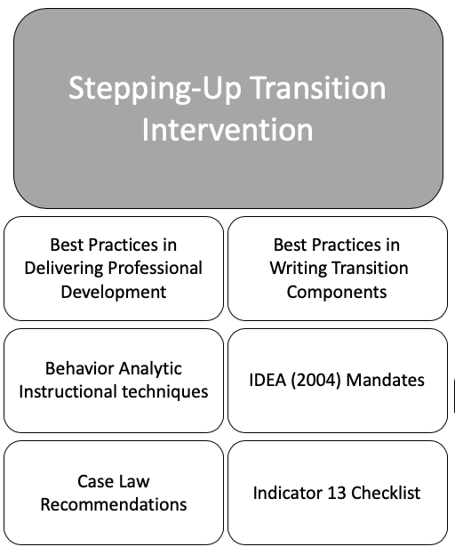
Best Practice in Delivering Professional Development
To develop the Stepping-Up Transition intervention framework, I consulted an evidence-based approach for adult learning using Participatory Adult Learning Strategy (PALS; Dunst & Trivette, 2009). Dunst and Trivette (2009) suggested professional development should include a 4-phase model to actively engage adult learners: (a) introduction to materials prior to professional development, (b) participant practice and evaluation of learned information, (c) informed understanding with reflection, and (d) active learner involvement throughout the entire process. Accordingly, my participants were provided an article to read prior to the training and access to the presentation. During the training, participants were provided with numerous opportunities to practice the strategies taught and to evaluate transition components. Participants had personal white boards so the researcher could employ choral responding strategies. The researcher provided critical thinking questions throughout the presentation that allowed for participant reflection. Active learner involvement was encouraged throughout the entire presentation with numerous opportunities to respond and practice during each step of the framework.
In addition, I considered numerous suggestions from scholars in the transition professional development field when designing the Stepping-Up intervention (Benítez et al., 2009; deFur, 2003; Morningstar & Benítez, 2013; Morningstar et al., 2018). For example, Stepping-Up Transition aligns with guidance from Benitez et al. (2009) on provisions of professional development in transition to instruct teachers how to evaluate their own transition plans and to provide teachers with opportunities to practice writing transition plan components. Teachers were also encouraged to seek help developing plan components from other professionals when needed until mastery was reached.
Behavior Analytic Techniques
The development of the Stepping-Up intervention followed instructional guidelines of applied behavior analysis, including provision of numerous opportunities to respond, behavior specific and nonspecific praise, examples and nonexamples, goal writing strategies, error correction procedures, and stimulus prompting (Cooper et al., 2007; Simonsen et al., 2008). While adult education literature does not explicitly state these instructional methods as evidence-based practices, I assume if these techniques are effective at increasing engagement and appropriate behaviors for school-age students, they will do the same with adults in that they are related to effective instruction.
In addition, the delivery of the framework follows an explicit teaching strategy supported by applied behavior analysis—unofficially referred to as the I Do, We Do, You Do method. This method is highlighted in direct instruction practices (Burnes & Yessledyke, 2009). Direct instruction involves instructor-directed learning with sequentially structured materials with high levels of participant responding (Burns & Ysseldyke, 2009). This method allowed the researcher to model the correct strategy and to provide opportunities for group and individual practice—increasing opportunities to respond. Providing numerous opportunities to respond during instruction is an evidence-based practice (Simonsen et al., 2008).
During the Stepping-Up intervention, the researcher provided examples and nonexamples of transition plan components to help participants discriminate between noncompliant, compliant, and quality/compliant components. This strategy of providing examples and non-examples is an effective practice used to refine skills in adults (Thompson et al., 2017). In behavior analysis, there is an emphasis on the need to create goals which have a condition, behavior, and criterion for performance (Cooper et al., 2007), thus, when creating annual transition goals, participants learned how to apply this goal-writing technique. Goals identify a specific target behavior, provide the situation in which they will be accomplished, and set target mastery levels (Cohrs et al., 2016). The researcher used behavior analytic strategies for error correction. The participants were given numerous opportunities to respond, and the potential for making errors was present. The researcher followed guidance on error correction procedures within applied behavior analysis. Error correction is an evidence-based classroom management procedure (Simonsen et al., 2008). This procedure “involves the correction of student errors by repeating a learning trial, having the student practice correct performance, or giving the student additional work” (Cooper et al., 2007, p. 298). To teach new skills, I implemented the use of stimulus prompting as another behavior analytic strategy (Cooper et al., 2007)—this included use of visual supports (Wong et al., 2014). The materials were presented in a sequential format following a stair-step process. At each step of the process, the visual prompt accompanied the instruction (see Figure 2 below).
Figure 2
Stepping-Up Framework Graphic

Transition Interest Inventories and Exploration Tools
Student-Selected Postsecondary Goals
Transition Skills Assessments
Annual Transition Goals
Coordinated Activities

Best Practice in Transition Planning
Coordinated Activities
The Stepping-Up intervention illustrates several best practice recommendations in transition. Best practices for transition planning include (a) basing the transition plan on age-appropriate transition assessments (Martin & Pulos, 2018; Mazzotti et al., 2009; Morningstar & Clevenna-Deane, 2018; Neubert & LeConte, 2013), (b) using Indicator 13 from IDEA (2004) and the Indicator 13 checklist (NSSTAC, 2012) to guide the development and evaluation of the transition plan (Doren et al., 2012; Mazzotti et al., 2009), (c) aligning transition components (Mazzotti et al., 2009), and (d) using triangulated transition goals (Peterson et al., 2013). LeConte and Neubert (2013) noted that IDEA (2004) does not explicitly state what age-appropriate transition assessment means, but it is implied the transition assessment should take into account the chronological and developmental age of the youth when giving the assessment and using its results to plan. Next, based upon current literature, scholars recommend using Indicator 13 and the Indicator 13 Checklist (NSSTAC, 2012) as guidance for planning and to be used as a method for evaluating transition plans (Doren et al., 2012; Mazzotti et al., 2009). Mazzotti et al. (2009) recommended focusing on the alignment of postsecondary goals with transition services and annual transition goals.
Lastly, Peterson et al. (2013) suggested triangulating IEP transition goals. Triangulating transition goals requires the use of transition assessments to identify postsecondary goals, then identifying gaps in student skills and knowledge. Next, the gap in knowledge should be linked to state academic standards. Peterson et al. (2013) stated the “triangulated annual goal should, at a minimum, include an observable behavior (action), a condition, and a criteria (measurement)” (p. 51). This is also referred to in the literature as SMART goals (specific, measurable, actions, realistic and relevant, and time-limited). This format echoes the behavior analytic goal writing format.
Individuals with Disabilities Education Act (IDEA; 2004)
The Stepping-Up intervention supports federal mandates found in IDEA (2004). Federal requirements within IDEA (2004) mandate the use of transition assessments to determine measurable postsecondary goals related to education/training, employment, and independent living (Neubert & LeConte, 2013). In addition, transition services including a course of study are required to assist students in accomplishing their postsecondary goals. Indicator 13 of IDEA (2004) requires numerous components in the transition plan to be based upon age-appropriate transition assessments, including course of study, postsecondary goals, transition services, annual transition goals, and the identification of student interests, strengths, needs, preferences, and present levels of academic and functional performance (Morningstar & Clevenna-Deane, 2018; Neubert & LeConte, 2013). The Stepping-Up intervention encourages the use of age-appropriate transition assessments and instructs how to use the results to guide the creation of the mandated transition components.
Case Law Recommendations
Stepping-Up Transition was designed to help participants avoid commonly found transition planning compliance errors illustrated in case law decisions. In a review of case law decisions related to transition from 2012-2013, Prince et al. (2014) provided several recommendations for transition planning. These recommendations center around transition assessments, the creation of transition goals, and student involvement in transition planning and the IEP process.
First, Prince et al. (2014) recommended the use of multiple transition assessments, including at least one measure having reliability and validity evidence. Second, information gained from the transition assessments and information about the student’s skills and interests should be incorporated into the plan and used to make practical transition goals. In addition, planning should detail how the student will accomplish their transition goals. Other considerations residing in case law are the commonly found compliance violations of transition planning from Petcu et al. (2014): (a) student involvement, (b) use of transition assessments to guide plan development, (c) onset of transition planning, (d) parental involvement, (e) postsecondary goals, (f) transition services, and (g) age-appropriateness of transition assessments.
Indicator 13
Lastly, the Stepping-Up framework follows guidance from the Indicator 13 checklist (NSSTAC, 2012) to guide the creation of writing compliant transition services pages of the IEP. Using the checklist as a guide, teachers will engage in evaluating transition plans by referencing the Indicator 13 Checklist (NSSTAC, 2012). Specifically, teachers will evaluate goals based upon the evidence identified in the transition assessment results noted in the transition plan. Additionally, the intervention instructs teachers on how to use transition assessment results to create goals and services that guide the overall creation of compliant and quality transition services plans.
Conclusion
The introduction of a new framework based on best practices in professional development and using literature to guide the creation of materials and instruction, Stepping-Up Transition should increase teacher knowledge in transition planning components. To determine the overall effectiveness of the Stepping-Up framework, I will compare educator knowledge with pre/post testing to a more traditional professional development training in transition as a control. For the past two years, the Zarrow Center for Learning Enrichment has provided training to teachers across the state using an informational model of professional development. This model focused on providing an extensive amount of information on a variety of available transition assessments to teachers with minimal practice creating transition components from transition assessment results. Thus, this will serve as the comparison group.

Chapter 3
Methodology
The purpose of this study is to examine the effectiveness of professional development on teacher knowledge of multiple transition planning components. More specifically, I explored if differences in the knowledge acquired occurred as a result of different types of professional development. Data were collected at eight professional development trainings held across the state of Oklahoma that focused on transition-related topics. Four sessions for each type of training were conducted: (a) transition assessments for students with mild to moderate disabilities, and (b) using EdPlan to create meaningful transition plans. The second training for the remainder of the manuscript is referred to as “Stepping-Up” intervention. Stepping-Up served as the intervention training, and the transition assessment training serves as the comparison training.
Research Questions
Research questions were
- Do participants in the Stepping-Up intervention exhibit significantly greater gains from pre- to post- transition planning assessment scores than those in a comparison group?
- Do participants in the Stepping-Up intervention exhibit significantly greater gains from pre- to post- multiple choice scores of the transition planning assessment than those in a comparison group?
- Do participants in the Stepping-Up intervention exhibit significantly greater gains from pre- to post- discrimination scores of the transition planning assessment than those in a comparison group?
- Do participants in the Stepping-Up intervention exhibit significantly greater gains from pre- to post- fill-in-the-blanks scores of the transition planning assessment than those in a comparison group?
Method
The following sections outline the methods for my research study: (a) research design, (b) participants, (c) intervention and comparison conditions, (d) dependent measures, and (e) data analysis techniques.
Research Design
I used convenience sampling to conduct an intervention/comparison group training with pre/post design to explore the effects of the professional development trainings. Current research exploring the effects of professional development on transition components within the IEP have used pretest-posttest designs without comparison groups (Doren et al., 2018; Flannery et al., 2015). To examine the effectiveness of the professional development models, the first training served as a comparison training to account for threats to internal validity (Campbell & Stanley, 1963; see Appendix A for more information on threats to validity). The rationale for providing the “comparison ” group with a training was primarily because evidence exists in professional development literature that regardless of the professional development provided practices may improve (Fishman et al., 2013; Powers et al., 2000). Therefore, to account for the presence of any intervention improving practice, the comparison training also received an intervention instead of typical practices in school (i.e., no training).
Participants
Participants were (a) IEP case managers for transition age youth, and/or (b) educators who wrote transition service plans for those students within the state of Oklahoma. Participants were recruited from eight trainings conducted in partnership with the Zarrow Center for Learning Enrichment and the Oklahoma State Department of Oklahoma. Data were collected at eight trainings: (a) four trainings on transition assessments (e.g., comparison group) and (b) four trainings using the professional development framework “Stepping-Up Transition” (e.g., intervention group). Since the availability of participants was limited to those who attended the trainings, convenience sampling techniques were used.
Accounting for the possibility that some of the same participants attended both trainings, and some attendees might not agree to participate, the number of participants for each training is estimated at 20. Therefore, with eight trainings and about 18 participants attending and participating in the study, a total of 140 participant responses were collected. According to Onwuegbuzie et al. (2004), intervention designs in social sciences should have at least 21 participants per group. Current research exploring the effects of professional development on quality and compliance of transition planning used pre/posttest designs without comparison groups (Doren et al., 2018; Flannery et al., 2015). Flannery et al. (2015) had 18 participants, while Doren et al. (2018) had 27 teachers, making the range of participants was 18-27. Thus, the 140 participants collected in my study meets social science standards for intervention designs and exceeds numbers of participants in existing literature.
The total number of responses gained from the assessment during the professional development trainings was 140; however, there were three duplicates (n = 6) identified which meant a participant attended both trainings and filled out the corresponding assessment and were thus removed from analysis. Of the total number of responses (n = 134), 58.20% (n = 78) took part in the comparison group and 41.80% (n = 56) in the intervention group. This left the final number of responders at 134. All eight trainings were held in a southern state. There were four different training locations; locations one (n = 56, 41.80%) and two (n = 38, 28.40%) made up the majority of the responses and were held in large cities. Trainings three (n = 23, 17.0%) and four (n = 17, 12.70%) were in much smaller cities; thus, the number in attendance and who provided responses varied among the four locations.
Identifier
The anonymity of the participants was important to the Oklahoma State Department of Education, and they requested participants not provide their names or emails; therefore, an identifier was needed to create a way to track data pre/post and between trainings. With guidance from the Institutional Review Board at The University of Oklahoma, the following identifier algorithm was used.
- What shoe size do you wear? (ex: size 9 = 09; size 12 = 12)
- First two letters of your favorite color? (ex: Blue = bl)
- How many brothers do you have? (ex: 2 brothers = 02)
- How many sisters do you have? (ex: 1 sister = 01)
- First letter of the city where you were born? (ex: Boston = B)
Participant Demographics
Demographics of participants were gathered as a part of the dependent measure knowledge assessment pre-test. These demographics included primary teaching assignments, race, ethnicity, years taught, geographic area, age range taught, gender, and number of professional development trainings in transition provided by the Zarrow Center for Learning Enrichment.
The first portion of the assessment sought participant demographic information with eight questions: primary teaching assignment, age of students served, years of teaching experience, gender, race, ethnicity, highest level of education completed, and number of past Zarrow Center trainings attended. The majority of participants were female (n = 125, 93.30%), white (n = 107, 79.90%), and non-Hispanic (n = 128, 95.50%). Years of experience was widely distributed, but the largest percentage of respondents had taught 15 years or more (n = 51, 38.10%). Most of the participants taught middle school (n = 42, 31.10%) or high school (n = 73, 54.50%). Respondents most likely taught in resource settings (n = 35, 26.10%) or self-contained classroom settings (n = 29, 21.60%). The highest level of education completed was evenly distributed between bachelor’s degrees (n = 69, 51.50%) and master’s degrees (n = 63, 47.00%). Many of the participants had never attended a training from the Zarrow Center (n = 41, 30.60%) or had only attended one training in the past (n = 43, 32.10%). Lastly, most participants served students in rural environments (n = 63, 47%). For participant demographic information, see Table 1 below.
Table 1
Participant Demographics
Question |  | n | %
Primary Teaching Assignment
 | Paraprofessional | 1 | 0.70
 | Case Manager Only | 7 | 5.20
 | Co-Teaching | 21 | 15.70
 | Lab | 19 | 14.20
 | Resource | 35 | 26.10
 | Self-Contained | 29 | 21.60
 | Administrator | 17 | 12.70
 | General Educator | 5 | 3.70
Age of Population Served
 | Administrator Only | 5 | 3.70
 | Elementary | 12 | 9.00
 | Middle School | 42 | 31.30
 | High School | 73 | 54.50
 | Transition Program | 2 | 1.50
Years of Experience
 | 0-3 Years | 28 | 20.90
 | 4-7 Years | 25 | 18.70
 | 8-11 Years | 16 | 11.90
 | 12-15 Years | 14 | 10.40
 | 15 Years Plus | 51 | 38.10
Gender
 | Male | 7 | 5.20
 | Female | 125 | 93.30
 | Non-Binary | 2 | 1.50
Race
 | White | 107 | 79.90
 | Black | 6 | 4.50
 | American Indian or Alaska Native | 8 | 6.00
 | Asian | 1 | 0.70
 | Two or More Races | 12 | 9.00
Ethnicity
 | Hispanic/Latino | 6 | 4.50
 | Non-Hispanic/Latino | 128 | 95.50
Highest Level of Education
 | Bachelors | 69 | 51.10
 | Masters | 63 | 47.00
 | Professional Degree | 2 | 1.50
 | Doctoral Degree | 0 | 0.00
Past Zarrow Center Trainings Attended
 | Zero | 41 | 30.60
 | One | 43 | 32.10
 | Two | 12 | 9.00
 | Three | 14 | 10.40
 | Four | 8 | 6.00
 | Five or More | 16 | 11.90
Area Population Served
 | Urban | 39 | 29.10
 | Suburban | 32 | 23.90
 | Rural | 47 | 47.00

Incentives
Participant incentives included three $10 gift cards for Amazon, Dollar General, Sprouts, or Starbucks for three randomly chosen individuals who completed both pre/post assessments. After participants completed the pre-assessment and post-assessment, they used a QR code to put their first and last name into a Qualtrics survey. This system relied on the “honor” system, where participants were only to put their names in if they completed both assessments. At the end of the training, using a random number generator, the participant’s name which corresponded with the generated number were called to come pick out a gift card.
Professional Development Trainings
History of Zarrow Center Professional Development Trainings
The Zarrow Center has provided training to teachers across Oklahoma for the last three years; however, concerns over the effectiveness of the trainings has recently been questioned. With some anecdotal investigation by looking through the participant assessment accounts, we determined the trainings might not be influencing teacher behaviors. Also, participant feedback in evaluation surveys showed the trainings provided too much information in one sitting. The previous trainings covered information on numerous transition topics within one seven-hour training, without great detail on any one topic. These trainings were not developed using best practice suggestions for adult learning or professional development (Desimone, 2009). They provided limited opportunities for participants to respond to questions posed by the presenters. Usually, participant engagement was facilitated by offering time for attendees to ask questions. There were a few opportunities provided to practice skills learned in trainings, reflect on information, and receive feedback from presenters; however, these were not meaningfully planned. In addition, information or materials were not provided prior to trainings.
These past trainings failed to comply with current best practice recommendations for professional development—however, they mimicked many other outdated professional development frameworks. Historically, professional development trainings were designed to disseminate information to attendees with little to no context of the population of students (Lang & Fox, 2004; Sexton et al., 1996). In addition, many of the professional development trainings contained disconnected topics and were perceived as “thrown-together” (Lang & Fox, 2004; Sexton et al., 1996). According to Moffett (2000), the lack of continuity and direct links to educators’ daily teaching of typical professional developments were reasons many attendees did not adopt or change their practices. These ineffective trainings usually focused on what practices they should do rather than how to do it (Houchins et al., 2011; Odom, 2009).
Based upon feedback and information regarding best practice in providing professional development, the past professional development training model provided by the Zarrow Center needed to change. Therefore, while I can say the changes made to these trainings might increase teacher knowledge, data from the last three years were not available to compare with the trainings held this year (i.e. Stepping-Up intervention, and comparison). However, I compared two similar professional developments in transition topics in regard to quality, duration, and general information.
My participants attended training under two possible conditions: Stepping-Up intervention and/or comparison professional development. For a clear representation of the similarities and differences between the trainings see Table 2 below. These will be discussed at length in the following sections.
Table 2
Similarities and Differences Between the Trainings
Information Covered | Comparison | Intervention
Prior Materials Sent | X | X
IDEA Purpose | X | X
IDEA Transition Regulations | X | X
State Transition Regulations | X | X
Research Statements about Better Transition Plans = Better Services = Better Outcomes | X | X
Transition Plan Compliance Statistics |  | X
Ice Breaker | X | X
Importance of Transition Assessments | X | X
Best Practice Recommendations: Annually, +2 Assessments, and 1 Formal Assessment | X | X
Best Practice Recommendations: Skills and Interests, Tailored to Needs, Practical Goals |  | X
Formal vs. Informal Assessments | X | X
Indicator 13 Checklist |  | X
Fluff Scale | X | X
Present Levels of Performance |  | X
Course of Study |  | X
Postsecondary Education Options | X | X
Coordinated Set of Activities Handout | X | X
Postsecondary Education Assessments | X
Employment Options | X | X
Interest Inventories | X | X
Skills Assessments | X | X
Employment Assessments | X
Independent Living Options | X | X
Independent Living Assessments | X
Creating a Transition Battery Building | X | X
Transition Battery Practice | X
Stepping-Up Transition Framework |  | X
Postsecondary Goals Instruction |  | X
Annual Goal Instruction |  | X
Coordinated Activity Instruction |  | X
Case Studies |  | X
Screen Shots of Assessments and Results | X | X
Presentation Highlight Handout | X | X
Fast Finishers Handout |  | X
White Board/Marker/Eraser | X | X
Number of Presenters | 2 | 1

Stepping-Up Intervention Training
Participants in the intervention training received a one-day training with data collection over an average of 3.5 hour period in each training for the intervention. The first 30-45 minutes centered around special education laws and mandates. The next portion, during hours two to three and a half, participants were introduced to the Stepping-Up Transition framework and how to use the framework, followed by explicit examples and numerous opportunities to practice using the framework with provided transition results. For a copy of the PowerPoint presentation slides for the Stepping-Up Intervention see Appendix A. Once the content slides were vetted and edited by the Zarrow Center Staff, they were not changed throughout the entirety of the study.
Stepping-Up Intervention was developed based upon best practice in delivering professional development (Benítez et al., 2009; deFur, 2003; Dunst & Trivette, 2009; Morningstar & Benítez, 2013; Morningstar et al., 2018 ), behavior analytic instructional techniques (Cooper et al., 2007), current literature on writing transition plans (Martin & Pulos, 2018; Mazzotti et al., 2009; Morningstar & Clevanna-Deane, 2018; Neubert & Leconte, 2013; Peterson et al., 2013), IDEA (2004) mandates, recommendations from case law (Petcu et al. 2014; Prince et al., 2014) and the Indicator 13 checklist (NSTTAC, 2012). For additional specific information on the development of the Stepping-Up intervention framework, refer to Chapter Two.
Stepping-Up Intervention uses a PowerPoint presentation to display information. The framework centers around a visual representation of a staircase used to show the development of writing transition plans using transition assessment results (see Stepping-Up Intervention Framework in Figure 3 below). The organization of the staircase guides special educators through the transition assessment process and shows them how to utilize the assessment results to write postsecondary goals, annual transition goals, and coordinated activities. The stairs also highlight the importance of alignment between the transition components (goals and activities), showing the foundation as the postsecondary goals, which lead to the development of specific annual goals and coordinated activities to support attaining the postsecondary goals.
Figure 3
Stepping Up Intervention Framework

Coordinated Activities
Annual Transition Goals
Transition Skills Assessments
Student-Selected Postsecondary Goals
Transition Interest Inventories and Exploration Tools

The training followed instructional guidelines of direct instruction (Burns & Ysseldyke, 2009) and used the “I do, We do, You do” method, or explicit instructional techniques. I instructed and provided background knowledge in transition planning components, showed explicit models for using the strategy, provided opportunities to use the strategy together as a group, and finally, provided the opportunity for participants to practice using the strategy individually. High quality training materials were created using Edplan (Oklahoma’s IEP writing software program) and screen shots of completed transition assessment results. The training provided examples and non-examples of quality and compliant transition components. The training provided numerous opportunities for participants to respond as a group and individually. Learners were actively involved throughout the training with numerous opportunities to respond and the use of choral responding through personal white boards.
Comparison Training
Participants who attended the comparison training received professional development on using appropriate transition assessments and creating a transition assessment battery. This training was provided by two presenters, me and one other transition expert at the Zarrow Center. The comparison was also a one-day training, and data were collected during a 3.5 hour time period. The transition assessment training was designed to be an informative training. The first 30-45 minutes of the training provided participants with relevant information on special education law and transition planning best practices. The rest of the training, during hours two to three and a half, participants were provided examples and information on the variety of transition assessments and how to choose appropriate assessments to create a transition assessment battery. For a copy of the PowerPoint presentation slides for the comparison training, see Appendix B. Once the content slides were vetted and edited by the Zarrow Center Staff, they were not changed throughout the entirety of the study.
The comparison training provided examples of several transition assessments in education/training, employment, and independent living areas. The coverage included (but was not limited to) assessments like Landmark College Guide to College Readiness, TAGG, Employability Life Skills Inventory, Transition Planning Inventory-2, Brigance Transition Inventory, Career Clusters, O*Net My Next Move, Picture Interest Inventory, Career One-Stop, OK College Start, OK Career Guide, Life Skills Inventory, and Casey Life Skills.
The presenters used a PowerPoint presentation to provide participants with visual representations of the information, including graphics, screenshots, and pictures of blank and scored transition assessments. The presenters facilitated discussions by asking questions to engage learners in the training and to provide opportunities to respond and ask questions. The training also focused on recommendations for best practices in transition planning from Prince et al. (2014), which included (a) using more than one assessment, (b) updating transition assessments annually, and (c) using at least one formal assessment. Therefore, during the description of each transition assessment presenters noted age appropriateness, discussed briefly the validity and reliability evidence, and provided how the information gained was useful for the transition process.
The comparison training followed the same evidence-based approach for adult learning using PALS (Dunst & Trivette, 2009) as the intervention training. Presenters tasked participants with creating a transition battery for case study students and asked them to reflect on examples and nonexamples of the best ways to use transition assessments to create a transition assessment battery. Learners were actively involved throughout the training with numerous opportunities to respond and the use of choral responding through personal white boards.
Similarities
The comparison and intervention trainings were similar in several ways. The trainings were designed to be equal in quality. For instance, the trainings both followed guidelines of the Participatory Adult Learning Strategy (PALS; Dunst & Trivette, 2009). The PALS strategy includes a 4-phase model to actively engage adult learners, including (a) introduction to materials prior to professional development, (b) participant practice and evaluation of learned information, (c) informed understanding with reflection, and (d) active learner involvement throughout the entire process.
Prior Materials and Information. Participants were provided reading materials and information prior to the trainings via email. Participants in the comparison training received three resources, including an informal/formal transition assessment chart, a research article explaining the constructs of one of the main transition assessments discussed (McConnell et al., 2012), and the Indicator 13 checklist (NSTTAC, 2012). Participants in the intervention training received identical materials with the informal/formal transition assessment chart and the Indicator 13 checklist.
Opportunities to Practice and Evaluate Performance. Both trainings provided participants with numerous opportunities to practice strategies learned in the training and to evaluate their knowledge. In the comparison training, participants were provided with an activity in the closing of the presentation which allowed them to create a transition battery for students using a case study examples for four different students. In the intervention training, participants practiced creating transition components (i.e., postsecondary goals, annual transition goals, coordinated activities) using transition assessment results.
Relevant Information. In each training, the presenter provided relevant information backed by research. In addition, for each opportunity to respond, participants were given a nod or thumbs up for correct answers, and they were redirected if answers were incorrect.
Opportunities to Respond. In both conditions, participants were given numerous opportunities to respond through choral and individual responses when prompted by the presenter. Participants in both trainings were given a white board, a marker, and an eraser to answer questions and provide responses. In addition, the presenter provided participants in both trainings with materials, resources, and a copy of the presentation PowerPoint on a USB drive.
Presentation of Materials. The presentation of materials for both presentations was similar. Both trainings used PowerPoint presentations with screen shots of assessments and results, along with research-based information. The comparison training presentation was 105 slides, and the intervention training contained 145 slides; however, the duration of the trainings was equivalent. Materials provided during the training were also alike in format. Both trainings included a transition highlights handout with important slides included and a USB with additional resources, including the full copy of the presentation.
The presenter(s) provided similar information in both trainings including IDEA purpose; IDEA transition mandates; state transition mandates; the postsecondary “fluff” scale; coordinated activity booklet; postsecondary education, employment, and independent living options; best practice recommendations (i.e., annual administration of transition assessments, use of two or more transition assessments in a transition battery, and using at least one formal assessment); informal and formal transition assessment comparison; building transition battery graphic; and the difference between skills assessments and interest inventories. The trainings also utilized similar tools, including a) an ice breaker activity, (b) importance of transition assessments statements, (c) screen shots of transition assessments and their results, and (d) research statements about the importance of transition planning.
Differences
There were a few notable differences between the trainings. First, the content provided at the training was different. The comparison training focused on transition assessments, while the intervention training focused on transition planning components using transition assessment results. While information was provided on transition assessments in both trainings, the information was presented differently. The main difference arises with the specific intervention used in the intervention training called “Stepping-Up.” The Stepping-Up intervention provides explicit instruction and practice in creating postsecondary goals, annual transition goals, and coordinated activities. Also, information on how to create a course of study and present level of performance was provided only in the intervention training. The Indicator 13 checklist was provided to participants prior to both trainings but was only discussed and used during the intervention training.
While both trainings allowed participants to practice skills learned in the training using case studies, they were practicing different skills. The comparison training practiced creating a transition battery based upon a case study. The intervention training practiced writing transition components using a case study with directed transition assessment results provided. Both skills were modeled using explicit instruction (i.e., “I do, We do, You do” method)—however, the intervention training used this method throughout the whole training, and the comparison training used this method once during the closing practice activity. Participants in the comparison training reflected on each covered transition assessment by rating the assessment on a 1-5 scale. The presenter encouraged participants to explain their ratings as well. In the intervention training, the presenter encouraged participants to share information from their own practice and experience and to connect information learned to their current placements. Lastly, the comparison training had two presenters providing information while the intervention group only had one. I was the main presenter and led all trainings.
Dependent Measures
The dependent measure consisted of a researcher-created assessment of transition planning. The following sections explain the assessment instrument in detail, including a description of the validity and/or reliability of the instrument.
Transition Planning Assessment
Using a researcher-created instrument, participants’ knowledge and skills of the transition planning process were assessed. The transition planning assessment was created in the online survey program Qualtrics and consisted of (a) one consent question, (b) one question to establish an identifier, (c) eight demographic questions, (d) seven multiple-choice questions on transition planning best practices, (e) four transition plan components in which participants indicated if an item was compliant or noncompliant, and (f) four fill-in-the-blank questions to write transition planning components.
Content Validity
According to the American Educational Research Association, American Psychological Association, and the National Council on Measurement in Education (2014) the positive correlation between the content of an assessment and the construct the assessment is meant to measure supports the validity of an instrument. The seven multiple-choice questions were created based upon consultation of current literature (i.e., Pectu et al., 2014; Prince et al., 2014) to facilitate content validity (Drost, 2011). Four of the questions relate to the findings of Pectu et al. (2014) that potentially troublesome transition components for quality and compliance include (1) use of transition assessment, (2) postsecondary goals, (3) transition services, and (4) age appropriateness transition assessments. The next three questions were developed based upon findings of Prince et al. (2014) to indicate best practice for transition plans, including annually updated transition assessments, administering more than one transition assessment yearly, and using a formalized assessment.
The discrimination of compliant component questions was based upon transition literature on best practices for writing transition planning components (Mazzotti et al., 2014; Neubert & LeConte, 2014; Peterson et al., 2014). These best practice recommendations include (a) alignment of goals and services, (b) transition goals as SMART goals, and (c) identification of student needs, strengths, interest, and preferences. This section of questions required participants to indicate if an annual transition goal or postsecondary goal was compliant or non-compliant.
The last section of the assessment contained fill-in-the-blank questions. This prompted participants to write one compliant postsecondary goal, two compliant annual transition goals, and one compliant coordinated activity. All questions were graded as correct or incorrect. The fill-in-the-blank questions did not have an exact right or wrong answer, so they were graded using a checklist. If all checklist requirements were met, the questions were marked as correct. The requirements for postsecondary goals were (a) must occur after high school, and (b) must answer where the student will learn or work after high school. The requirement for annual transition goals included a condition, a specific behavior, and a criterion. In addition, one fill-in-the-blank question provided a scenario for the participant to create an annual goal—in this case another requirement was added to include a behavior focused on disability awareness. A compliant coordinated activity was identified as a specific activity and something the student “does”. The full assessment is provided in Appendix C, and the checklist requirement for correct answers for the fill-in-the-blank questions is in Figure 4 below.
Figure 4
Checklist for Fill-in-the-Blank Questions
Check for “Yes” | Requirement
Postsecondary Goal
 | Occurs after high school
 | Must identify where the student will learn or work
 | If all yes, one point is earned.
Annual Transition Goal (for Daisy)
 | Condition (when, how, under what circumstances)
 | Specific Behavior (not vague like “socially appropriate”)
 | Criteria for mastery (3 out of 4 trials, 90% accuracy, a number of trials needed)
 | Must be disability awareness related
 | If all yes, one point is earned.
Annual Transition Goal (for any student)
 | Condition (when, how, under what circumstances)
 | Specific Behavior (not vague like “socially appropriate”)
 | Criteria for mastery (3 out of 4 trials, 90% accuracy, a number of trials needed)
 | If all yes, one point is earned.
Coordinated Activity for Independent Living
 | Must be an activity or service (not a statement like “living alone”)
 | Related to Independent living
 | If all yes, one point is earned.
*If all requirements are met for each transition component, respondents earn 1 point with a total of 4 points.
Face Validity
Several iterations of the assessment were made. The first version of the survey was sent to a transition scholar and associate professor at the University of Oklahoma. Once gaining their feedback and revisions, changes were made and another round of revisions was conducted as a group. Next, the third iteration of the assessment was sent to the Oklahoma State Department of Education’s special education program specialist for review, and changes were made based upon her feedback. Lastly, the survey was piloted with a group of practitioners. They provided feedback on the questions, and the pilot led to the removal of one question.
Data Analysis
Four scores were computed—one score for each section (multiple-choice, compliance/noncompliance, and fill-in-the-blank), and a total score that combined all three areas together. Scores were reported as scales. The multiple choice questions were scored as correct or incorrect and provided one point per question. The fill-in-the-blanks were graded as correct or incorrect. All questions were weighted equally. A total score of 15 points was possible with 7 points for multiple choice, 4 points for compliance, and 4 points for fill-in-the-blank portions.
To answer the research questions, SPSS (a statistical analysis software) was used to conduct a repeated measures multivariate analysis of variance (MANOVA; Tabachnick & Fidell, 2013). Using the repeated measures MANOVA, I determined if the posttest total scores were significantly higher than the pretest scores for both the comparison and intervention groups. Next, a correlational analysis was conducted to determine the relation amongst the three sets of scores (multiple-choice, compliance, and fill-in-the-blank). Descriptive statistics were obtained to determine the mean and standard deviation of the demographic information and total number of participants per group.
Reporting for Repeated Measures MANOVA
After running the repeated Measures MANOVA, Box’s Test of Equality of Covariance Matrices and Wilk’s Lambda were reported. Box’s Test indicates if the assumption of equality of covariance matrices was met. Wilk’s Lambda is used to indicate the effect of time and group membership.
Attrition
Participating in the assessment was on a voluntary basis, and respondents were allowed to stop participating at any moment. In the comparison training, 23 participants took part in the pre-assessment and not the post- for an attrition rate of 28.82%. For the intervention training 13 respondents took part in the pre-assessment, but not the post-, making the attrition rate 18.06%. These rates are in line with the suggestions provided by Gersten et al. (2005), since they did not exceed 30%.
Missing Data
Missing data only occurred in the fill-in-the-blank section of the assessment—respondents were required to enter a response or it was counted as incomplete. This also impacted the total score; if respondents failed to complete any portion of the assessment, their total scores were reflected as incomplete/missing. To determine if missing data was “missing completely at random,” Little’s Test of Missing Data (MCAR; Tabachnick & Fidell, 2013) was conducted for pre/post fill-in-the-blank portions of the assessment results. The pre-assessment fill-in-the-blank missing data was 2.90% and missing post data was 7.0%. These results were not statistically significant (p = .11); therefore, the missing data was missing completely at random (Tabachnick & Fidell, 2013). The combined percentages of pre- and post-assessment missing data were 4.95%. Tabachnick and Fidell (2013) stated missing data of less than five percent was not a serious issue, and “almost any procedure for handling missing values yields a similar result” (p. 63).
Interrater reliability
To grade the fill-in-the-blank questions, which asked participants to write specific transition components, trial-by-trial interobserver agreement was employed for intercoder reliability (Cooper et al., 2007). This method divides the number of trials (items) in agreement by the total number of trials (items). According to Cooper et al. (2007), this is a more conservative and meaningful method of interobserver agreement. Agreements above 80% are acceptable (Cooper et al., 2007). Cooper et al. (2007) recommended having at least 25% of responses graded by another scorer. Scorers should be blind to examinees to prevent bias in reviews (Gersten et al., 2005).
A fellow colleague, also an expert in transition, scored the fill-in-the-blank responses for pre- and post-assessments for both the comparison and intervention groups. For the comparison groups’ fill-in-the-blank responses, she scored 52.00% (n = 528) of the total fill-in-the-blank responses with an agreement rate of 91.40%. For the intervention groups’ fill-in-the-blank responses, the outside coder scored 76.20% (n = 436) of the total number of scores with an agreement rate of 92.20%. The percentage of responses coded and the agreement rate reached both exceeded recommendations by Cooper et al. (2007). After the initial agreement rates were calculated, I met with the outside coder to discuss disagreements and reach 100% agreement on each participant’s response.

Chapter 4
Results
The effects of professional development on teacher knowledge and skills in transition planning have yet to be explored using a comparison group training. This study sought to fill the gap of literature by providing evidence professional development positively impacts teacher knowledge and skills in transition planning. Specifically, this study aimed to explore the effects of a professional development framework, Stepping-Up, to increase knowledge and skills in identifying best practice of transition planning, identifying compliant transition planning components, and writing compliant transition plan components. Thus, this study explored the effects of professional development using a comparison and intervention group.
Training Characteristics
Each training, intervention and comparison, ranged from 3.25-3.75 hours in all four locations. The comparison training had an average of 43 (range 37 to 50) opportunities to respond with a mean of 27 choral responses and 16 individual responses. The intervention training had an average of 89 (range 36 to 113) opportunities to respond with a mean of 40 choral responses and 73 individual responses.
Correlation Among Transition Planning Assessment Sub-Scores
The total scores based upon the type of training were statistically significant; however, a correlational analysis amongst the three score types was needed to determine the relationship among the sub-scores for the combining of the scores into a total overall score (Field, 2009). I ran a correlational analysis to compare the three score types to each other (multiple choice, compliance, and fill-in-the-blank). Pearson’s Correlation showed only a small positive relation amongst the pre- and post-measures in the three subset scores. The relation between pre- and post-assessment within the same score type were correlated as a medium positive relationship, but this was most likely attributed to the scores being measured on the same type of task. For more details on the Pearson’s Correlation, see Table 4. The results of the Pearson’s Correlation analysis indicated the need to run separate repeated measures ANOVA analyses for each score type.
Table 4
Pearson’s Correlation Amongst Score Types
 | Pre  Multiple Choice | Pre Compliance | Pre Fill-in-the-blank | Post Multiple Choice | Post Discrimination | Post Fill-in-the-blank
Pre Multiple Choice | 1.00 | .14 | .21 | .382 | -.07 | .06
Pre Compliance | .13 | 1.00 | .20 | .14 | .40 | .26
Pre Fill-in-the-blank | .21 | .20 | 1.00 | .04 | .18 | .38
Post Multiple Choice | .38 | .14 | .04 | 1.00 | -.02 | .03
Post Discrimination | -.07 | .40 | .17 | -.02 | 1.00 | .43
Post Fill-in-the-blank | .06 | .26 | .38 | .03 | .43 | 1.00
Note. Pearson correlations are provided by each score type. Values of +/-.1 small, +/- .3 is medium, and +/- .5 is large (Field, 2009).
Results Summary
The means and standard deviations of pre- and post-assessments for the four scores (i.e., total, multiple choice, compliance, and fill-in-the-blank) are shown for the comparison, intervention, and total combined groups in Table 3 below.
Table 3
Mean and Standard Deviation for Total, Multiple Choice, Compliance, and Fill-in-the-Blank Scores for Pre- and Post-Assessments by Type of Training and Combined
Type of Training |  | Mean | Standard Deviation
Pre Total Score | Comparison | 9.40 | 2.17
Pre Total Score | Intervention | 9.51 | 2.08
Pre Total Score | Total | 9.44 | 2.13
Post Total Score | Comparison | 10.59 | 1.83
Post Total Score | Intervention | 12.26** | 2.01
Post Total Score | Total | 11.32 | 2.08
Pre Multiple Choice Score | Comparison | 5.59 | 1.18
Pre Multiple Choice Score | Intervention | 5.52 | 1.22
Pre Multiple Choice Score | Total | 5.56 | 1.19
Post Multiple Choice Score | Comparison | 6.36 | 0.64
Post Multiple Choice Score | Intervention | 6.07 | .81
Post Multiple Choice Score | Total | 6.24 | .73
Pre Discrimination Score | Comparison | 2.72 | .95
Pre Discrimination Score | Intervention | 2.91 | .79
Pre Discrimination Score | Total | 2.80 | .89
Post Discrimination Score | Comparison | 2.92 | .91
Post Discrimination Score | Intervention | 3.62** | .62
Post Discrimination Score | Total | 3.22 | .87
Pre Fill-in-the-blank Score | Comparison | 1.12 | 1.05
Pre Fill-in-the-blank Score | Intervention | 1.07 | 1.02
Pre Fill-in-the-blank Score | Total | 1.10 | 1.03
Post Fill-in-the-blank Score | Comparison | 1.30 | 1.18
Post Fill-in-the-blank Score | Intervention | 2.56** | 1.28
Post Fill-in-the-blank Score | Total | 1.85 | 1.37
Note. ** denotes statistically significant mean scores at the p value threshold of .001.
Research Question One
To answer the first overarching research question, “Do participants in the Stepping-Up intervention exhibit significantly greater gains from pre- to post- transition planning assessment scores than those in a comparison group?” a repeated measures MANOVA was used to determine if differences in overall achievement scores were the result of time and type of training.
Total Score Results
A one-within (time) and one-between (intervention group) repeated measures MANOVA was performed to test whether scores on the transition planning assessment changed over time and whether change might be moderated by intervention group. Box’s test was nonsignificant (p = .660), indicating the assumption of equality of covariance matrices was met. The main effect of time was statistically significant [Wilk’s Lambda=.53, F (1, 121) = 107.23, p < .001]. Using Cohen’s (1988) benchmarks for judging effect size [η²=.01 (small), η²=.06 (medium), η²=.14 (large), the effect size for time was large (η²=.47). The effect of time is qualified by a significant effect of time and type of training [Wilk’s Lambda=.87, F (1, 121) = 17.79, p < .001]. The effect size for the interaction was large (η²=.13).
Pre-assessment scores did not differ between the comparison and intervention trainings (p = .77; intervention M = 9.51, SD = 2.08; comparison M = 9.40, SD = 2.17), but results demonstrated a significant difference (p < .001) in the post-assessment scores (intervention M = 12.26, SD = 2.01; Comparison M = 10.59, SD = 1.84). Therefore, participants in the Stepping-Up intervention exhibited significantly greater gains on the transition planning assessment than those in the comparison group did. Figure 5 below shows scores from the pre- and post-assessment on a graph for the comparison (blue) and intervention (red). The dots indicate the means, and the bars represent the lower and upper bounds of 95% confidence intervals.
Figure 5
Profile Plot of Mean Total Scores for Comparison and Intervention Trainings between Time 1 and 2
Research Question Two
A repeated measures MANOVA was also used to answer research question two, “Do participants in the Stepping-Up intervention exhibit significantly greater gains from pre- to post- multiple-choice scores of the transition planning assessment than those in a comparison group?”

Multiple Choice Results
A one-within (time) and one-between (intervention group) repeated measures MANOVA was performed to test whether scores on the transition planning assessment changed over time and whether change might be moderated by intervention group. Box’s test was nonsignificant (p = .135), indicating the assumption of equality of covariance matrices was met. The main effect of time was significant with [Wilk’s Lambda = .75, F (1, 132) = 44.37, p < .001]. The effect size was large with η²= .252 (Cohen, 1988). The effect size related to the type of training was not significant [Wilk’s Lambda= .009, F (1, 132) = 1.18, p = .28]. This means while both groups significantly increased their multiple choice scores over time (pre-/post-assessment), it did not matter which type of training they received. Pre-assessment multiple choice scores did not significantly differ (p = .78) between the intervention (M = 5.52, SD = 1.22) and comparison groups (M = 5.59, SD = 1.18). Post-assessment multiple choice scores also did not differ significantly (p = .732) between the intervention (M = 6.07, SD= .81) and comparison (M = 6.36, SD = .64) groups. Thus, participants in the Stepping-Up intervention did not exhibit significantly greater gains on the multiple choice portion of the transition planning assessment than those in the comparison. Figure 6 below shows scores from the pre- and post-assessment on a graph for the comparison (blue) and intervention (red). The dots indicate the means, and the bars represent the lower and upper bounds of 95% confidence interval.
Figure 6
Profile Plot of Multiple Choice Scores of Comparison and Intervention Training Means
Research Question Three
A repeated measures MANOVA was used to answer research question three, “Do participants in the Stepping-Up intervention exhibit significantly greater gains from pre- to post- discrimination scores of the transition planning assessment than those in a comparison group?”
Discrimination Results
A one-within (time) and one-between (intervention group) repeated measures MANOVA was performed to test whether scores on the transition planning assessment changed over time and whether change might be moderated by intervention group. Box’s test was nonsignificant (p = .018), indicating the assumption of equality of covariance matrices was met. The main effect of time was significant [Wilk’s Lambda = .81, F (1, 132) = 31.32, p < .001] with a large effect size (η²= .192). This effect is qualified by a significant time and type of training [Wilk’s Lambda = .932, F (1, 132) = 9.60, p = .002] with a moderate effect size of η²= .068. Pre-discrimination scores (intervention M = 2.91 SD = .79; comparison M = 2.72, SD = .95) were not statistically different by type of training (p = .22), but post-discrimination scores (intervention M = 3.63, SD .62; comparison M = 2.92, SD = .91) were statistically significant with type of training (p < .001). Therefore, participants in the Stepping-Up intervention exhibited significantly greater gains in discrimination scores on the transition planning assessment than those in the comparison group. Figure 7 below shows scores from the pre- and post-assessment on a graph for the comparison (blue) and intervention (red). The dots indicate the means, and the bars represent the lower and upper bounds of 95% confidence interval.
Figure 7
Profile Plot for Mean Discrimination Scores Intervention and Comparison Scores
Research Question Four
A repeated measures ANOVA was used to answer research question four, “Do participants in the Stepping-Up intervention exhibit significantly greater gains from pre- to post- fill-in-the-blanks scores of the transition planning assessment than those in a comparison group?”
Fill-in-the-Blank Results
A one-within (time) and one-between (intervention group) repeated measures MANOVA was performed to test whether scores on the transition planning assessment changed over time and whether change might be moderated by intervention group. Box’s test was nonsignificant (p = .97), indicating the assumption of equality of covariance matrices was met. The main effect of time was significant [Wilk’s Lambda= .65, F (1, 121) = 64.65, p < .001] with a large effect size (η²=.39). This effect is qualified by a significant time and type of training [Wilk’s Lambda= .76, F (1, 121) = 38.44, p < .001] with a large effect size (η²= .24). Pre-assessment fill-in-the-blank scores (intervention M = 1.06, SD = 1.03; comparison M =1.10, SD = 1.04) were not statistically different by type of training (p = .834), but post-assessment fill-in-the-blank scores (intervention M = 2.60, SD = 1.25; comparison M =1.30, SD = 1.18) were statistically significant with type of training (p < .001). Therefore, participants in the Stepping-Up intervention exhibited significantly greater gains in fill-in-the-blank scores of the transition planning assessment than those in the comparison group did. Figure 7 below shows scores from the pre- and post-assessment on a graph for the comparison (blue) and intervention (red). The dots indicate the means, and the bars represent the lower and upper bounds of 95% confidence intervals.
Figure 7
Profile Plot of Fill-in-the-blank Mean Scores for Comparison and Intervention
Summary of Results
Participants in the Stepping-Up intervention had significantly greater gains from pre- to post-transition planning assessment scores than the comparison group. In alignment with the research questions, the three other scores (multiple choice, discrimination, and fill-in-the-blank) were analyzed separately. Participants in the Stepping-Up intervention had significantly greater gains on the discrimination and fill-in-the-blank scores of the transition planning assessment than the comparison group. However, there was no significant effect between the Stepping-Up intervention and the comparison training on the multiple choice portion of the assessment.

Chapter 5
Discussion
Limited research exists on the effectiveness of professional development in special education, in particular, research on professional development surrounding transition planning. Special educators and other education professionals write IEPs for students with disabilities under the guidance of IDEA (2004) and follow mandates set forth in the law and its indicators. Indicator 13 (NSTTAC, 2012) provides specific guidance on compliance standards for transition plans. Recent reviews of transition plans across the US indicated many transition plans do not meet IDEA’s specific compliance criteria of Indicator 13 and further, lack even basic quality features (Gaumer-Erickson et al., 2014; Landmark & Zhang, 2012). Many educators have not received instruction or training on creating compliant and quality transition plans during their teacher preparation programs (Anderson et al., 2001; Morningstar et al., 2018; Williams-Diehm et al., 2018), leaving individual school districts and state departments of education to provide in-service professional development training on transition. However, many educators have noted their lack of satisfaction with their professional development in transition (Benitez et al., 2009; Morningstar et al., 2018; Plotner et al., 2016).
Little research exists on the effects of professional development on transition (Doren et al., 2012; Flannery et al., 2015). Doren et al. (2012) explored the effectiveness of professional development on postsecondary goals within the transition plan of the IEP. They determined that professional development training yielded improvements in compliance and quality of postsecondary goals. Transition plans have more than just postsecondary goals; they include numerous components which are also outlined in IDEA (2004) and Indicator 13. Several years later, Flannery et al. (2015) elevated their exploration of the effects of professional development on building compliant and quality transition plans by including analysis on transition plan components, including annual transition goals, course of study, and present levels of performance. Flannery et al. (2015) found professional development improved postsecondary goals, courses of study, and present levels of performance, but not annual transition goals within the transition plan. These findings are important to the field of special education and more specifically transition. However, they represent a starting point for exploring the effectiveness of professional development in transition planning for one main reason—neither of the studies (i.e., Doren et al., 2012; Flannery et al., 2015) utilized comparison groups to control for confounding variables.
A need existed to determine the effectiveness of professional development training on teacher creation of transition plan components using a comparison group. In the sections below, I explain the results of my study exploring the effectiveness of professional development on transition plan components using a comparison group. I explain the limitations of my study which, in turn, helped inform the last section of this chapter discussing implications for future research and future practice.
Research Question One
Do participants in the Stepping-Up intervention exhibit significantly greater gains from pre- to post- transition planning assessment scores than those in a comparison group?
Participants in the Stepping-Up intervention exhibited significantly greater gains from the pre- and post- transition planning assessment scores than those in the comparison group did. However, the intervention and comparison groups both increased their scores to a statistically significant level. The effect size was much larger for the intervention group, and post-assessment mean scores were statistically different (intervention was higher than comparison), but the total score may not have been the most appropriate measure of knowledge and skills. The inappropriateness of the total score was due mostly to the three different question types (i.e., multiple choice, compliance, and fill-in-the-blank) not showing a notable positive correlation to each other. The lack of strong positive correlation indicates the performance on one section did not predict scores on another. For example, a participant could score the highest score (7.0) on the multiple choice questions, which would indicate they had knowledge of best practices of transition planning, but when asked to apply knowledge of best practice, they often could not discriminate between compliant and noncompliant annual/postsecondary goals and/or create compliant transition components for the fill-in-the-blank questions. This may be the result of participants being asked to use different depths of knowledge to answer the three different types of questions (i.e., multiple choice, compliance, and fill-in-the-blank).
The depth of knowledge theory highlights the difference between shallow and deep understanding as well as the difference between knowledge acquisition and action (Bennet & Bennet, 2008). This mimics Bloom’s Taxonomy’s (Krathwohl, 2002) of levels of cognitive complexity, starting with remembering and moving through to the higher levels of understanding, applying, analyzing, evaluating, and creating. Figure 9 below provides a graphic representation of Bloom’s Taxonomy and includes labels to show the depth of knowledge of each type of question asked in the transition planning assessment from my study.

Figure 9
Representation of Level and Depth of Knowledge in Regard to the Transition Planning Assessment Question Types
Increasing in Cognitive Complexity and Depth of Knowledge
Fill-in-the-blank
Questions
Discrimination Questions
Multiple Choice Questions

Note. *Adapted from Krathwohl (2002).
The multiple choice questions required participants to recall information. Bennet and Bennet (2008) stated explicit knowledge “is the process of calling up information (patterns) and processes (patterns in time) from memory that can be described accurately in words and/or visuals…” (p. 407). In Bloom’s Taxonomy (Krathwohl, 2002) this is equivalent to remembering and understanding. Therefore, answering the multiple choice questions is an easier task or a skill of lower complexity (Krathwohl, 2002; Bennet & Bennet, 2008).
Next, the discrimination questions asked participants to use their knowledge and discriminate between provided characteristics of annual transition goals and postsecondary goals. This skill, according to Bennet and Bennet (2008), represents a “process and action part of knowledge” (p. 407), thus, creating a deeper level of knowledge and understanding (Bennet & Bennet, 2008). Within Bloom’s Taxonomy (Krathwohl, 2002) this would include applying and analyzing—indicating the discrimination questions required an increased depth of knowledge and was a more complex skill than the multiple choice section did.
The final section of fill-in-the-blank questions required participants to apply their knowledge and create two annual transition goals, a postsecondary goal, and a coordinated activity with little information to prompt responses. The ability to create responses for the fill-in-the-blank questions required participants to have learned the information through knowledge and action (Bennet & Bennet, 2008). Creating responses for fill-in-the-blank questions required responders to participate in the highest levels of Bloom’s Taxonomy of evaluating and creating (Krathwohl, 2002). Therefore, the fill-in-the-blank questions were the most complex and required the deepest level of understanding to answer correctly in comparison to the multiple choice and discrimination questions. Since the three portions required a different level of knowledge and were different in complexity, the following three research questions refer to participant achievement on each of the sub-scores, which indicate the level of understanding, application of knowledge, and learning information in different ways.
Over the last 20 years, scholars have criticized ineffective professional development practices (Houchins et al., 2011; Moffett, 2000), noting the piece-meal approach to providing only information to teachers to increase their knowledge of what to do, but not how to do it. Past trainings held by the Zarrow Center fell victim to this same structure. However, improvements made to both the comparison and intervention trainings highlighted in this study show participants not only learned the information (i.e., multiple choice questions), but also increased their skills in applying the knowledge of how to implement (i.e., discrimination and fill-in-the-blank), and even more so in the Stepping-Up intervention group. This study shows the implications of restructuring the historical framework of professional development and elevating it to follow best practice recommendations will increase participant knowledge and skills, which is the ultimate goal of professional development.
Summary. Comparing the results of my study to those of current research (i.e., Doren et al., 2012; Flannery et al., 2015) is potentially inappropriate because the dependent measures slightly differ. Doren et al. (2012) and Flannery et al. (2015) graded different components of a transition plan of the IEP. Doren et al. (2012) only analyzed postsecondary goal quality and compliance. Flannery et al. (2015) analyzed postsecondary goals, annual goals, course of study, and present levels of performance for quality and compliance. The analysis of postsecondary goals and annual transition goals best relate to the fill-in-the-blank portion of my results; therefore, those results are compared in the discussion for research question four.
Research Question Two
Do participants in the Stepping-Up intervention exhibit significantly greater gains from the pre- to post- multiple choice scores of the transition planning assessment than those in a comparison group?
Participants in the Stepping-Up intervention did not exhibit significantly greater gains from pre- to post- multiple choice scores of the transition planning assessment than those in the comparison group. This section required participants to choose correct answers based upon their knowledge of best practice in transition planning. Both groups of training participants significantly improved their scores from Time 1 to Time 2 on the multiple choice portion. In fact, the comparison group’s effect size (η² =.21) was much larger than the intervention (η² = .09). This could indicate a need to meaningfully incorporate parts of the comparison training on best practices in transition into the intervention training. The comparison training was designed to be informative and provide information on transition best practices. However, the post-assessment multiple choice means were not significantly different between the intervention and comparison groups. Thus, while the comparison group increased slightly in their pre-/post- scores, post-scores were not statistically significantly different between the comparison and intervention groups. The highest score participants could receive on the multiple choice section was 7.0 points and both means were above 6.0 points—meaning most responders missed one question on the post-assessment.
Upon further examination, there were two questions missed most often for both trainings pre- and post-assessment. The first question was
Donna is an 8th grade student with a specific learning disability in math. She wants to attend a postsecondary education environment, but she is unsure where she wants to attend. Her strengths include reading comprehension, self-awareness, and written expression skills. When asked, what do you want to be when you grow up, Donna says she wants to be a lawyer. The best postsecondary goal for postsecondary education/training goal for Donna would be…”
(a) Donna will complete all necessary credits towards graduation and receive a B in her algebra I class,
(b) After graduating from high school, Donna will attend a four year university,
(c) Upon exiting high school, Donna will work as an office manager of a finance or business company,
(d) After graduating from high school, Donna will attend the university of Texas and pursue a degree in business/finance.
Answer choice “b” was correct, and many respondents chose “c” or “d”. The reason answer choice “b” is correct relates to the instruction of the “fluff scale” which was covered in both the intervention and comparison training. Donna is only an 8th grader, indicating the need for a broad postsecondary goal. She expressed interest in college, and to be a lawyer she would need to attend a four year college. Donna has the academic abilities so far to attend college. Choice “c” was incorrect because Donna is an individual who should probably attend some-type of college or postsecondary education environment. In the question, Donna also indicated her interest in attending a postsecondary education program. Lastly, answer choice “d” was incorrect because it is too specific and does not relate to Donna’s expressed interest. Choice “a” was incorrect because it is an annual transition goal.
The second commonly missed question was “Transition assessments inform which part of the transition plan…Check all that apply”. There were eight different choices: Needs, Preferences, Strengths, Interests, Course of Study, Postsecondary Goals, Annual Transition Goals, and Coordinated Activities. In order to answer the question correctly, respondents had to check all eight provided options. Many participants only chose a few of the choices provided. This question seemed to be more difficult than the other multiple choice questions as it actually relied on participants to remember all the components rather than just recognize correct information. Participants would have ideally gained this information in either training. Gathering this anecdotal information on the most missed questions could indicate that those two questions were inappropriate. In the future, these questions should be vetted and changed to improve the quality of the assessment.
How does knowledge of best practice relate to application of best practice? Prince et al. (2014) and Pectu et al. (2014) found several common violations in transition plans and the transition planning process through case law and compliance reviews. Many transition plans were found to be in violation due to the lack or inappropriate use of transition assessments (Prince et al., 2014). Based upon results of this training, teachers in both the comparison and intervention groups grew in their knowledge of best practice recommendations in regard to transition assessment use. As indicated earlier, however, the acquisition of knowledge does not guarantee the application of knowledge (i.e., Bloom’s Taxonomy; Krathwohl, 2002). Therefore, while teacher knowledge of best practice increased, it may not directly result in the creation of compliant transition plans or transition planning components. Doren et al. (2012) determined transition plans within the IEP may not actually reflect practices teachers used to create quality and compliant postsecondary goals. Through follow-up interviews after their initial intervention, Doren et al. (2012) concluded many of their participants used best practice recommendations on the use of transition assessments to create postsecondary goals in the post-assessment, but these practices were not explicitly seen in the actual transition plan. Results could be similar with my study as I will not have a way to determine the effects of participants’ knowledge on their actual practice. For instance, my study found very small correlations between the post-multiple choice scores and post-fill-in-the-blank scores with Pearson’s correlation being small at .03, indicating participants may have the knowledge of best practice, but lack the ability to apply it.
Research Question Three
Do participants in the Stepping-Up intervention exhibit significantly greater gains from pre- to post- discrimination scores of the transition planning assessment than those in a comparison group?
Participants in the Stepping-Up intervention exhibited significantly greater gains from pre to post- discrimination scores of the transition planning assessment than those in a comparison group. The main reason the compliant/ noncompliant section was included in the assessment was to determine if teachers recognized many of the commonly found noncompliant postsecondary and annual transition goals within transition plans. IDEA (2004) states postsecondary goals should occur after high school. Per the Indicator 13 checklist (NSTTAC, 2012), the postsecondary goal section asks, “does the postsecondary goal occur after high school?” Two of the four questions asked in the discrimination section were on postsecondary goals, where participants discriminated between a postsecondary goal that occurred after high school and one that occurred during high school. This assessed the participants understanding of IDEA (2004) in regard to postsecondary goals. Questions three and four contained annual transition goals, one compliant and one noncompliant. In order to discriminate between the compliant and noncompliant annual transition goal, participants needed to apply their knowledge of annual transition goals needing to have three items: behavior, condition, and criterion.
Flannery et al. (2015) graded postsecondary goals with their first criteria as occurring after high school (i.e., school services), and found that professional development increased the “after services” quality of postsecondary goals. Similar to those (Flannery et al., 2015) results, the Stepping-Up intervention increased participants ability to discriminate between compliant and noncompliant postsecondary goals. However, Flannery et al. (2015) did not find significant growth in their participants’ abilities to write compliant annual goals. In my study, participants in the Stepping-Up intervention scored a post-assessment mean score of 3.62, meaning most of the participants were able to discriminate between compliant postsecondary goals and annual transition goals.
Serious implications of creating noncompliant postsecondary goals exist—District of Columbia Pub. School, 111 LRP 26012 (2001) ruled in favor of the student and parents, stating the student was denied FAPE due to inappropriate postsecondary goals (Prince et al., 2012). Several other court cases outlined in Prince et al. (2012) also cited the lack of appropriate postsecondary goals and annual transition goals (e.g. Jefferson County Board of Education v. Lolita S., 2013) which ruled in favor of the families and required schools to provide compensatory education to students. In addition, Landmark and Zhang (2012) found approximately three-fourths of transition plans in their review did not have adequate postsecondary and annual transition goals. The first step in the ability to write compliant postsecondary goals and annual transition goals begins with discriminating between examples and nonexamples, which indicates participants in the Stepping-Up intervention group potentially acquired the knowledge and skills to avoid writing noncompliant postsecondary and annual transition goals within transition plans for the students they serve.
Research Question Four

Do participants in the Stepping-Up intervention exhibit significantly greater gains from pre- to post- fill-in-the-blanks scores of the transition planning assessment than those in a comparison group?
Participants in the Stepping-Up intervention exhibited significantly greater gains from pre- to post- fill-in-the-blank scores of the transition planning assessment than those in a comparison group. In this section participants were asked to write one annual transition goal with a prompt, one annual transition goal for employment without a prompt, one education or employment postsecondary goal without a prompt, and one coordinated activity for independent living without a prompt. This mimics the skill of writing transition plan components within the IEP on postsecondary goals, annual transition goals, and coordinated activities. On this section, respondents could score up to 4.0 points. The comparison and intervention pre-assessment revealed that on average respondents answered one question correctly (Comparison M = 1.12; Intervention M = 1.07). The post- scores means were significantly different (Comparison M = 1.30; Intervention M = 2.57) with the Stepping-Up intervention group answering about two and half questions correctly on average. Further analysis is needed to determine which component (postsecondary goal, annual transition goal, or coordinated activity) was answered correctly. However, the increase in scores for the fill-in-the-blank portion is similar to the results found in Doren et al. (2012) and Flannery et al. (2015)—the participants’ ability to write compliant transition plan components increased. The fill-in-the-blank scores represent the highest depth of knowledge in evaluating and creating transition plan components (i.e., Bloom’s Taxonomy; Krathwohl, 2002). Therefore, the differences in fill-in-the-blank scores between the Stepping-Up intervention and comparison trainings show the largest impact. This area also represents the lowest scores in the pre- and post-assessments of both trainings.
Many compliance issues revolve around the creation of compliant postsecondary goals (Powers et al., 2005). Poor quality of postsecondary goals has even resulted in litigation (e.g., Carrie I. v. Department of Education, State of Hawaii, 2012; Jefferson County Board of Education v. Lolita S., 2013). Landmark and Zhang (2012) found transition plans lacked the inclusion of annual transition goals and coordinated activities. This could be due to a lack of educators’ understanding of what the components are and/or how to create them. The results of this study showed improvements in the ability to create transition plan components; however, one of the biggest questions that still persists is whether the results of the study lend themselves to writing quality and compliant transition plan components within the IEP for their students. In addition, further research within this data set could highlight (1) which plan components increased from the training and which did not, and (2) which components exceeded compliance standards to become quality.
Summary

Overall, participants in the Stepping-Up intervention exhibited significantly greater gains from pre- to post- transition planning assessment scores than the comparison training did. There were no differences on pre-assessment scores for any sub-test. The Stepping-Up intervention yielded statistically significant gains in the total, compliance, and fill-in-the-blank scores. These results were also statistically different from the post-assessment scores of the comparison group. As far as the multiple choice scores, both the intervention and comparison training significantly improved scores on the multiple choice section, but the scores were not statistically different at post-assessment for each group. These results are promising in showing the effects of professional development on transition knowledge and skills and help to fill in the gap in existing literature. Interestingly, there was a weak positive correlation between the discrimination scores and fill-in-the-blank scores. This means while educators may be able to discriminate between compliant and noncompliant postsecondary and annual transition goals, this knowledge is not translating to creating compliant goals. There were only four questions in both sections; in future research, the number of questions should be increased to further explore the dynamic between discrimination and creation of compliant goals. In addition, exploring the connection to actual transition plans within IEPs, similar to the two existing studies on professional development in transition (i.e., Doren et al., 2012; Flannery et al., 2015) would strengthen the findings of this study.
The results of my study show improvements in knowledge and skills in as little as three and a half hours. According to Desimone (2009), a specific duration of professional development has not been established in the education field; however, more pertinent than length are the content and opportunities for participants to practice and respond during the trainings. Many educators note time-constraints and the inability to take time off to attend as a consistent barrier to professional development (Boulden et al., 2019; Lind, 2007). This could potentially be the issue with special educators as well. In planning the topics for professional development trainings in transition with the state department of education for this study, there was not an option to hold more than a one-day training because teachers would be unable to take off more than one day for professional development per quarter (personal communication, April 2019, L. Chesnut). This indicates the need for professional development practices to be condensed and time-effective, while also being elevated to meet best practice recommendations for quality training.
I believe the impact of professional development on transition plans is important. One could argue, given the results of the total score analysis, that only the intervention training is needed for participants to gain information and knowledge they need to appropriately construct transition plans. One could also argue that either training could be used since both increased their scores significantly. However, the trainings provided different information. While some of the information provided was similar, the way it was presented was different. This brings into question, was whether I was comparing “apples” to “oranges” with the trainings. I would argue if the comparison group received no training or no intervention, as in many other research studies, this could translate to inadequate transition plan development for their students and would therefore be unethical. Current research has established that regardless of the topic of professional development, practices improve (Fishman et al., 2013; Powers et al., 2000). The comparison group in my study helps to highlight this improvement of practice regardless of the professional development offered—making it more difficult to show a statistical difference in post-assessment scores than if the comparison group received no training. Even though there are current studies showing the impacts of professional development on transition planning, my study is novel and marks a beginning point for research involving professional development and comparison groups within special education, and more specifically within the area of transition.
Limitations
There are several limitations to this study, including threats to internal and external validity; however, I attempted to address many of the threats to internal and external validity through the design and implementation of the trainings. First, I created both trainings to be equal in duration and quality. In addition, the comparison and intervention trainings were provided in the same location in each city. Fidelity of the trainings was ensured by using the same materials and presentation for the respective training. The same protocols were used for each training. For example, there were two presenters for the comparison group, and each presenter covered the same materials and presentation slides each training. Also, on the presentation slides there were written prompts to use “I do, we do, you do.” That way the presenter was asking participants to respond at the same time frames training and to respond in the same manner (i.e., choral or individual). The same time frames were provided between pre- and post- assessments for the intervention and comparison training. While the intent was to provide equal numbers of opportunities to respond, the intervention training had almost double the opportunities to respond. The introduction of a comparison group helped control for many extraneous variables not accounted for in previous research on the effects of professional development (Flannery et al., 2015).
In addition to the intervention/comparison design, participants were able to choose which trainings they wanted to attend and whether or not would participate in the assessment, which lowered the threat of resentful demoralization and selection bias. Also, to counteract interaction effects, responses from participants who attended both the comparison training and then the intervention training and chose to participate in the assessment during both trainings were removed before final data analysis. To minimize testing threats, the transition planning assessment did not change (pre-/post) throughout the data collection process. Despite these efforts, some limitations still existed, including internal threats such as sampling, assessment, selection, and attrition, and external threats such as selection bias, preassessment sensitization, researcher bias, and multiple treatment interference.
Sampling and Selection
The contract with the state department of education to hold the trainings did not allow me to randomly select participants for the comparison and intervention trainings. Instead, I used convenience sampling. Convenience sampling is used frequently in special education research due in part to small populations compared to the overall general population (Emerson, 2015). I also did not have permission to use random assignment in this study because the trainings were provided in partnership with the State Department of Education. Therefore, there was not a system in place to account for the history of trainees’ past experiences, as participation in the trainings was voluntary and there was not a way to screen participants to ensure equal groups. To account for these threats, statistical methods were used to determine group equality, including Levene’s Test of Equal Variances and ANOVAs to determine if pre-assessment means were not statistically different. These methods showed equality between groups despite the inability to randomly assign participants to groups. Demographic information was also collected to ensure a representative sample or to allow results to be restricted to the sample assessed (Martella et al., 2013).
Testing
The trainings and subsequent assessments pre-/post took place within a one-day training. Participants took the pre- and post-assessment within a 3.5-5 hour period, which could have led to a testing threat. Within the confounds of the one-day professional development training, I could not determine any other way to ensure participants were taking the assessment at the same time pre-/post without introducing numerous other validity threats to results (e.g., maturation). The time constraints also introduced pre-assessment sensitization. Pre- and post-assessments had the same questions, but questions were reordered to help address this threat. In the future, questions could be worded differently with the same intent behind the question in pre- and post- versions, and the researchers might try providing a pre-assessment within a few days of the training and post- assessment right after the training to lengthen the time between pre- and post-assessments.
Attrition
There was a higher rate of attrition for the comparison group than the Stepping-Up intervention group. This was most likely due to the comparison group trainings having a larger number of attendees on average. Attrition rates for both groups were below the suggestions of 30% (Gersten et al., 2005) with the intervention at 18.08% and comparison at 28.82%, but there was a difference of 10% between the groups. The differences between intervention and comparison attrition rates in combination with the overall rate of attrition may be potentially troublesome (What Works Clearinghouse, 2014); therefore, caution should be used when interpreting the overall results in regard to the attrition rates. Participant incentives to complete pre- and post- assessments were advertised and provided at each training; perhaps these incentives need to be increased in the future to help with attrition.
Researcher Bias
The main presenter of both trainings was the head researcher and was not blind to the condition or hypothesis of the study—therefore, a threat of potential researcher bias exists as a limitation. To counteract this threat, a second presenter was added to provide the comparison group trainings as an intentional strategy to help minimize the main researcher’s bias in providing that training. In addition, providing professional development trainings for Oklahoma educators was the majority of the main presenter’s daily job through a contract with the state department of education. In other words, the main presenter/researcher’s future job security depended on the quality of the presentation and information provided in all trainings. In future trainings, evaluation data from participants should be collected to show equivalence of quality in the trainings.
Multiple Treatment Interference
The presenters gave numerous opportunities to respond in both trainings; however, despite best efforts to ensure both trainings received relatively the same amount, the intervention group received more opportunities to respond and practice skills learned. This may have been due to the nature of the intervention itself, but it is important to note this could have impacted the post-assessment scores. Research currently supports that providing more opportunities to respond increases performance (Simonsen et al., 2008); thus, the effects of multiple treatments must be illuminated as a possible threat to the external validity of the study.
Implications
Implications for Future Research
While I employed numerous strategies to ensure fidelity of the trainings (4 comparison, 4 intervention), there could have been more rigorous methods used. With the limitations noted above and more experience holding numerous large group trainings, I have several suggestions to note for future research. First, a pre-assessment should probably occur a few days prior to the training. This offers time for the researcher or instructor to gear instruction toward needs identified in the assessment. Next, condensing the transition planning assessment to only focus on discrimination and fill-in-the-blank postsecondary goals, annual transition goals, and coordinated activities would be best to determine skills acquired during the professional development. The discrimination and fill-in-the-blank sections should be increased to include at least 8 questions for each section. On the fill-in-the-blank questions, there should be an option added for “I don’t know, or I am unsure” to address the amount of missing data in that area. In the current form of the online assessment, respondents must enter a character for each blank to count as a completed response, and it would not be possible to know if the respondent did not want to finish the survey or did not know the answer. I believe many of the respondents would exit the survey instead of entering a character resulting in an “incomplete survey.”
Results from this study are promising to show teacher knowledge and skills in transition planning can increase from professional development, in particular from using an explicit framework like the Stepping-Up intervention. In addition, results from this study will be used to inform future versions of the transition planning assessment and guide the framework/instruction of the trainings to focus more on creating and evaluating to meet deeper levels of knowledge, as outlined in Bloom’s Taxonomy. There are a few large differences between the results of my study and the two others exploring the effects of professional development on transition planning (i.e., Doren et al., 2012; Flannery et al., 2015). Doren et al. (2012) and Flannery et al. (2015) did not include a comparison group to control for extraneous variables. However, those studies did show the impact of professional development on actual transition plans within the IEP. Perhaps in future research, intervention effects can be accounted for using actual transition plans with a comparison group.
Even though my study did not review participants’ transition plans, the information gained from this study is useful to guide future professional development and research on the effectiveness of the professional development in transition. First, professional development trainings designed to provide information on a topic with limited participant practice (i.e., comparison training) may help attendees gain knowledge about the topic but may not help them actually apply the knowledge learned. Trainings designed to increase participant practice and provide numerous examples did not take longer than the traditional method used with the comparison group and yielded greater achievement scores in knowledge and skills.
Implications for Practice
In some ways, the findings of my study indicate the researcher’s (i.e., my) ability to provide an effective training. This offers a starting point of the effectiveness of the Stepping-Up intervention. However, what would be more meaningful to the transition field as a whole would be the intervention’s transferability. Allowing another researcher to provide the Stepping-Up intervention training and collect data would strengthen the findings from this study. If results were replicated with another presenter, this would suggest transferability and generalization of effects of the Stepping-Up intervention and its corresponding framework (Martella et al., 2013 and could potentially be used across the field of special education for in-service training. In addition, using the improved transition planning assessment as indicated in the paragraph above with pre-service teachers would also strengthen the generalizability of the Stepping-Up intervention. The Stepping-Up framework could be used in pre-service teacher preparation programs, even those that do not have a course dedicated to transition as it can be embedded in other special education coursework.
The Stepping-Up intervention could also be used in “train the trainer” professional development models to determine if the results can be replicated and then serve as a model for districts training their own teachers.
Despite the decades-old call to improve professional development practices to instruct educators how to implement better practices, many trainings do not excel past providing a wide array of surface-level information. While best practice recommends trainings become more interactive and provide time for practice and reflection (Desimone, 2009; Dunst & Trivitte, 2009), the only way we will actually know these practices lead to changes and improvements in the participant’s classroom practices is through experimental research. This study shows the Stepping-Up intervention is effective at increasing educator knowledge and skills in transition planning. The Stepping-Up intervention is a framework designed to explicitly instruct how to improve transition plans for students rather than just provide information to teachers about how it should be done. The framework guides the presenter to elevate their presentation of materials through prompts to provide opportunities to respond.
The results of this study imply that after participating in the Stepping-Up intervention, educators have the knowledge and skills to build compliant transition plans; however, who is holding educators accountable for creating compliant transition plans? As noted previously, many special educators do not have extensive knowledge in transition planning, meaning special education administrations may lack the knowledge to ensure transition plans in their district are compliant. In addition, school administrators who serve as the local education agency designee, who are also required to uphold IDEA (2004) mandates, may also lack the knowledge and skills to ensure compliant transition plans are created by their employees. Thus, administrators may also need the Stepping-Up intervention or a modified version of the intervention to facilitate change in their schools’ and districts’ transition plans for students with disabilities.
Future Directions
To understand the fill-in-the-blank answers, a more robust analysis of the responses is needed. Using the grading rubric, I could code each response to indicate what part of the statement was correct and what part was incorrect. The new coding would highlight patterns of unlearned information to use to improve future trainings. In addition, this could help align the findings of this study to research relating to writing quality and compliant postsecondary and annual transition goals. To echo established research by Doren et al. (2012), further analysis using a hierarchical linear model might provide another aspect of the findings. Further, data analysis could look at demographic information collected to determine if specific demographics impacted assessment scores.
Conclusion
In conclusion, the Stepping-Up intervention increased teacher’s knowledge of transition best practices, their ability to discriminate between compliant and noncompliant transition components, and their ability to create compliant transition plan components. The increased knowledge and skills in transition planning will help educators in creating compliant transition plans for their students by avoiding common compliance violations outlined in case law (Pectu et al., 2015; Prince et al., 2014). In addition, these educators will have the knowledge and skills to write compliant transition plan components, which could ultimately help them avoid interfering with the provision of FAPE for their students. Therefore, as I say at most of the professional development trainings I provide, “Good plans equal good services equal good postsecondary outcomes” (personal communication, April 2020, M. Deardorff).

References
American Educational Research Association, American Psychological Association, & National Council on Measurement in Education. (2014). Standards for educational and psychological testing. Washington, DC: American Educational Research Association.
Anderson, D., Kleinhammer-Tramill, P. J., Morningstar, M., Lehmann, J., Bassett, D., Kholer, P.,…Wehmeyer, M., (2003). What’s happening in personnel preparation in transition? A national survey. Career Development for Exceptional Individuals, 26(2), 145-160. https://doi.org/10.1177/088572880302600204
Aron, L. (2005). Too much or not enough: How have the circuit courts defined a free appropriate public education after Rowley? Suffolk University Law Review, 39(1), 1-25.
Benítez, D., Morningstar, M., & Frey, B. (2009). A multistate survey of special education teachers’ perceptions of their transition competencies. Career Development for Exceptional Individuals, 32(1), 6-16. https://doi.org/10.1177/0885728808323945
Bennet, D., & Bennet, A. (2008). The depth of knowledge: Surface, shallow or deep? The Journal of Information and Knowledge Management Systems, 38, 406-421. https://doi.org/10.1108/03055720810917679
Blackorby, J., & Wagner, M. (1996). Longitudinal postschool outcomes of youth with disabilities: Findings from the National Longitudinal Transition Study. Exceptional Children, 62(5), 399-414. https://doi.org/10.1177/001440299606200502
Black River Falls School District, 40 IDELR 163 (SEA WI 2004).

Blalock, G., Kochhar-Bryant, C. A., Test, D. W., Kohler, P., White, W., Lehmann, J.,…Patton, J. (2003). The need for comprehensive personnel preparation in transition and career development: A position statement of the division on career development and transition. Career Development for Exceptional Individuals, 26(2), 207-226. https://doi.org/10.1177/088572880302600207
Blanchett, W. J. (2001). Importance of teacher transition competencies as rated by special educators. Teacher Education and Special Education, 24(1), 3-12. https://doi.org/10.1177/088840640102400103
Board of Education of the Hendrick Hudson Central School District v. Rowley, 458 U.S. 176 (1982).
Boulden, D. C., Pellegrino, L., & Gerakios, J. (2019). Career growth through action research: Outcomes from a structured professional development appropriate for in-service school librarians. Research Journal of the American Association of School Librarians, 22, 1-22.
Burnes, M. K. (2009). Reported prevalence of evidence-based instructional practices in special education. The Journal of Special Education, 43, 3-11. https://doi.org/10.1177/0022466908315563
Cameto, R., Levine, P., & Wagner, M. (2005). Transition planning for youth with disabilities: A special topic report of findings from the national longitudinal transition study-2. Menlo Park, CA: SRI International.
Campbell, D. T., & Stanley, J. C. (1963). Experimental and quasi-experimental designs for research. Boston: Houghton Mifflin Company.
Cohen, J. (1988). Statistical power analysis for the behavioural sciences (2nd ed.). New York: Academic Press.
Council for Exceptional Children. (2013). Specialty set: CEC advanced special education transition specialist. Arlington, VA: Author.
Cooper, J., Heron, T., & Heward, W. (2007). Applied Behavior Analysis (2nd ed.). Upper Saddle River, NJ: Pearson.
deFur, S. (2003). IEP transition planning-from compliance to quality. Exceptionality, 11(2), 115-128. https://doi.org/10.1207/S15327035EX1102_06
Desimone, L. M. (2009). Improving impact studies of teachers’ professional development: Toward better conceptualizations and measures. Educational Researcher, 38(3), 181-199. https://doi.org/10.3102/0013189X08331140
Doren, B., Flannery, K. B., Lombardi, A., Kato, M. (2012). The impact of professional development and student and teacher characteristics on the quality of postsecondary goals. Remedial and Special Education, 34(4), 215-224. https://doi.org/10.1177/0741932512468037
Drost, E. (2011). Validity and reliability in social science research. Education Research and Perspectives, 38, 105-123.
Dunst, C. J., & Trivette, C. M. (2009). Let’s be PALS: An evidence-based approach to professional development. Infants & Young Children, 22(3),164-176. https://doi.org/10.1097/IYC.0b013e3181abe169
Emerson, R. W. (2015). Convenience sampling, random sampling, and snowball sampling: How does sampling affect validity in research. Journal of Visual Impairment, 109, 164-166.
Endrew F. v. Douglas County School District RE-I, 137 S. Ct. 988 (2017).
Etscheidt, S. K. (2006) Progress monitoring: Legal issues and recommendations for the IEP teams. TEACHING Exceptional Children, 38(3), 56-60.
Everson, J., Zhang, D., & Guillory, J. (2001). A statewide investigation of individualized transition plans in Louisiana, Career Development for Exceptional Individuals, 24(1), 37-49. https://doi.org/10.1177/088572880102400104
Flannery, K. B., Lombardi, A., & Kato, M. (2015). The impact of professional development on the quality of the transition components of the IEPs. Career Development and Transition for Exceptional Individuals, 38(1), 14-24. https://doi.org/10.1177/2165143413489727
Fishman, B., Konstantopoulous, S., Kubistskey, B, Vath, R., Park, G., Johnson, H., & Edelson, D. C. (2013). Comparing the impact of online and face-to-face professional development in context of curriculum implementation. Journal of Teacher Education, 64(5), 426-438. https://doi.org/10.1177/0022487113494413
Gaumer-Erickson, A., Noonan, P., Brussow, J., & Gilpin, B. (2014). The impact of IDEA indicator 13 compliance on postsecondary outcomes. Career Development and Transition for Exceptional Individuals, 37(3), 161-167. https://doi.org/10.1177/2165143413481497
Gerber, M. M. (2017). A history of special education. In. J. Kauffman, D. Hallahan, & P. Pullen (eds.), Handbook of special education (pp. 3-15). New York: Routledge.
Gersten, R., Fuchs, L., Compton, D., Coyne, M., Greenwood, C., & Innocenti, M. (2005). Quality indicators for group experimental and quasi-experimental research in special education. Exceptional Children, 71(2), 149-164. https://doi.org/10.1177/001440290507100202
Grigal, M., Test, D., Beattie, J., & Wood, W. (1997). An evaluation of transition components of individualized education programs. Exceptional Children, 63(3), 357-372. https://doi.org/10.1177/001440299708300305
Halpern, A. (1994). The transition of youth with disabilities to adult life: A position statement of the Division on Career Development and Transition, The Council for Exceptional Children. Career Development for Exceptional Individuals, 17, 117-124.
Houchins, D., Shippen, M., & Murphy, K. (2011). Evidence-based professional development considerations along the school-to-prison pipeline. Teacher Education and Special Education, 35(4), 271-293. https://doi.org/10.1177/08884064144412396
Individuals with Disabilities Education Improvement Act of 1990 20 U.S.C. § 1400 et seq. (1990).
Individuals with Disabilities Education Improvement Act of 2004, 20 U.S.C. § 1400 et seq. (2004).
Johnson., J. R., & Rusch, F. R. (1993). Secondary special education and transition services recommendations for future research and demonstration. Career Development for Exceptional Individuals, 16(1), 1-18. https://doi.org/10.1177/088572889301600101
Knott, L., & Asselin, S. (1999). Transition competencies: Perceptions of secondary special education teachers. Teacher Education and Special Education, 22(1), 55-65. https://doi.org/10.1177/088840649902200106
Kochhar-Bryant, C. A., & Bassett, D. S. (2002). Challenge and promise in aligning transition and standards-based education. In C. A. Kochhar-Bryant & D. S. Bassett (eds.), aligning transition and standards-based education: Issues and strategies (pp. 1-23). Arlington, VA: Council for Exceptional Children.
Kohler, P. D. (1996). A taxonomy for transition programming: Linking research and practice. Champaign, IL: Transition Research Institute, University of Illinois.
Krathwohl, D. R. (2002). A revision of Bloom’s Taxonomy: An overview. Theory Into Practice, 41, 212-218. https://doi.org/10.1207/215430421tip4104
Landmark, L., & Zhang, D. (2012). Compliance and practices in transition planning: A review of individualized education program documents. Remedial and Special Education, 34(2), 113-125. https://doi.org/10.1177/0741932511431831
Lang, M. & Fox, L. (2004). Breaking with tradition: Providing effective professional development for instructional personnel supporting students with severe disabilities. Teacher Education and Special Education, 27(2), 163-173. https://doi.org/10.1177/088840640402700207
Lazzeroff, K. C. (2013). A study of teachers’ perceptions of school-level factors affect transition services (Doctoral dissertation). The University of North Carolina, Greensboro, NC.
Li, J. L., Bassett, D. S., & Hutchinson, S. R. (2009). Secondary special educators’ transition involvement. Journal of Intellectual & Developmental Disability, 34(2),163-172. https://doi.org/10.1080/13668250902849113
Lind, V. R. (2007). High quality professional development: An investigation of the supports for and barriers to professional development in arts education. International Journal of Education & the Arts, 8(2), 1-18.
Lomax, R. G., & Hahs-Vaughn, D. L. (2012). An introduction to statistical concepts (3rd ed.). New York: Routledge.
Lubbers, J., Repetto, J., & McGorray, S. (2008). Perceptions of transition barriers, practices, and solutions in Florida. Remedial and Special Education, 29(5), 280-292. https://doi.org/10.1177/0741932507313016
Martella, R. C., Nelson, J. R., Morgan, R. L., & Marchand-Martella, N. E. (2013). Understanding and interpreting educational research. New York: The Guildford Press.
Mazzotti, V. L., & Plotner, A. J. (2016). Implementing secondary transition evidence-based practices: A multi-state survey of transition service providers. Career Development and Transition for Exceptional Individuals, 39(1), 12-22. https://doi.org/10.1177/2165143414544360
Mazzotti, V. L., Rowe, D. A., Cameto, R., Test, D. W., & Morningstar, M. E. (2013). Identifying and promoting transition evidence-based practices and predictors of success: A position paper of the Division on Career Development and Transition. Career Development and Transition for Exceptional Individuals, 36(3), 140-151. https://doi.org/10.1177/2165143413503365
Mazzotti, V., Test, D., & Mustian, A. (2014). Secondary transition evidence-based practices and predictors: Implications for policymakers. Journal of Disability Policy Studies, 25(1), 5-18. https://doi.org/10.1177/0888406512474022
Moffett, C. (2000). Sustaining change: The answer are blowing in the wind. Educational Leadership, 57(7), 35-38.
Morningstar, M., & Benítez, D., (2013). Teacher training matters: The results of a multistate survey of secondary special educators regarding transition from school to adulthood. Teacher Education and Special Education, 36(1), 51-64. https://doi.org/10.1177/0888406412474022
Morningstar, M., Hirano, K., Roberts-Dahm, L. D., Teo, N., & Kleinhammer-Tramill, J. (2018). Examining the status of transition-focused content within educator preparation programs. Career Development and Transition for Exceptional Individuals, 41(1), 4-15. https://doi.org/10.1177/2165143417741477
Morningstar, M., Bassett, D. S., Kochhar-Bryant, C., Cashman, J., & Wehmeyer, M. (2012). Aligning transition services with secondary education reform: A position statement of the Division on Career Development and Transition. Career Development and Transition for Exceptional Individuals, 35(3), 132-142. https://doi.org/10.1177/2165143412454915
National Secondary Transition Technical Assistance Center. (2012). Indicator 13 checklist. Charlotte, NC: NSTTAC.
Neubert, D. A., & Leconte, P. J. (2013). Age-appropriate transition assessment: The position of the Division on Career Development and Transition. Career Development and Transition for Exceptional Individuals, 36(2), 72-83. https://doi.org/10.1177/2165143413487768
Newman, L., Wagner, M., Cameto, R., & Knokey, A. (2009). The post-high school outcomes of youth with disabilities up to 4 years after high school. A report of findings from the national longitudinal transition study-2. Menlo Park, CA: SRI International.
Onwuegbuzie, A. J., & Collins, K. M. (2007). A typology of mixed methods sampling designs in social science research. The Qualitative Report, 12(2), 281-316.
Petcu, S. D., Yell, M. L., Cholewicki, J. M., & Plotner, A. J. (2014). Issue of policy and law in transition services: Implications from special education leaders. Journal of Special Education Leadership, 27(2), 66-75.
Pham, Y. K. (2012). An exploratory survey of transition teaching practices: Results from a national sample. Career Development and Transition for Exceptional Individuals, 36(3), 163-173. https://doi.org/10.1177/21651434124646516
Plotner, A. J., Mazzotti, V. L., Rose, C. A., & Carlson-Britting, K. B. (2016). Factors associated with enhanced knowledge and use of secondary transition evidence-based practices. Teacher Education and Special Education, 39(1), 28-46. https://doi.org/10.1177/0888406415599430
Porter, A. C., Garet, M. S., Desimone, L., Yoon, K. S., &Birman, B. F. (2000). Does Professional development change teaching practice? Results from a three-year study of the effects of Eisenhower and other professional development teaching practice. Washington, DC: U.S. Department of Education.
Powers, K., Gil-Kashiwabara, Geenen, S., Powers, L., Balandran, J., & Palmer, C. (2005). Mandates and effective transition planning practices reflected in IEPs. Career Development for Exceptional Individuals, 28(1), 47-59.
https://doi.org/10.1177/08857288050280010701
Prince, Katsiyannis, A., & Farmer, J. (2013). Postsecondary transition under IDEA 2004: A legal update. Intervention in School and Clinic, 48(5), 286-293. https://doi.org/10.1177/1053451212472233
Prince, A. M., Plotner, A. J., & Yell, M. L. (2014). Postsecondary transition and the courts: An update. Journal of Disability Policy Studies, 25(1), 41-47. https://doi.org/10.1177/1044207314530469
Prince, A. M., Yell, M. L., & Katsiyannis, A. (2018). Endrew F. v. Douglas County School District (2017): The U.S. Supreme Court and special education. Intervention in School and Clinic, 53(5), 321-324. https://doi.org/10.1177/1053451217736867
Rowe, D. A., Alverson, C. Y., Unruh, D. K., Fowler, C. H., Kellems, R., & Test, D. W. (2014). A Delphi study to operationalize evidence-based predictors in secondary transition. Career Development and Transition for Exceptional Individuals, 1(1), 1-14. https://doi.org/10.1177/2165143414526429
Simonsen, B., Fairbanks, S., Briesch, A., Myers, D., & Sugai, G. (2008). Evidence-based practices in classroom management: Considerations for research to practice. Education and Treatment of Children, 31(3), 351-380.
School District of Philadelphia v. Deborah A., 111 LRP 25598 (3d cir). (2011).
Tabachnick, B. G., & Fidell, L. S. (2013). Using multivariate statistics (6th ed.). Upper Saddle River, NJ: Pearson.
Test, D. W., Mazzotti, V. L, Mastian, A. L., Folwer, C. H., Kortering, L., & Kholer, P. (2009). Evidence-based secondary transition predictors for improving postschool outcomes for students with disabilities. Career Development for Exceptional Individuals, 32(3), 160-181. https://doi.org/10.1177/0885728809346960
Turnbull, R., Huerta, N., & Stowe, M. (2009). The Individuals with Disabilities Education Act as amended in 2004 (2nd ed.). Boston: Pearson.
Virginia, S. and Milton M. ex rel. Rachael M. V. Department of Education, State of Hawaii, 47 IDELR 42 (2007).
Wagner, M., Newman, L., Cameto, R., & Levine., P. (2005). After high school: A first look at the postschool experiences of youth with disabilities. A report from the National Longitudinal Transition Study-2. Menlo Park, CA: SRI International.
Wagner, M., Newman, L., Cameto, R., & Levine, P. (2006). The academic achievement and functional performance of youth with disabilities. A report from the National Longitudinal Transition Study-2. Menlo Park, CA: SRI International.
What Works Clearinghouse. (2014). Assessing attrition bias—addendum (Version 3.0). Washington, DC: U.S. Department of Education, Institute of Education Sciences.
Williams-Diehm, K., Rowe, D., Johnson, M., & Guilmeus, J. (2018). A systematic analysis of transition coursework required for special education licensure. Career Development and Transition for Exceptional Individuals, 4(1), 16-26. https://doi.org/10.1177/2165143417742404
Wolfe, P., Boone, R., & Blanchett, W. (1998). Regular and special educators’ perceptions of transition competencies. Career Development for Exceptional Individuals, 21(1), 87-106. https://doi.org/10.1177/088572889802100108

Appendix A
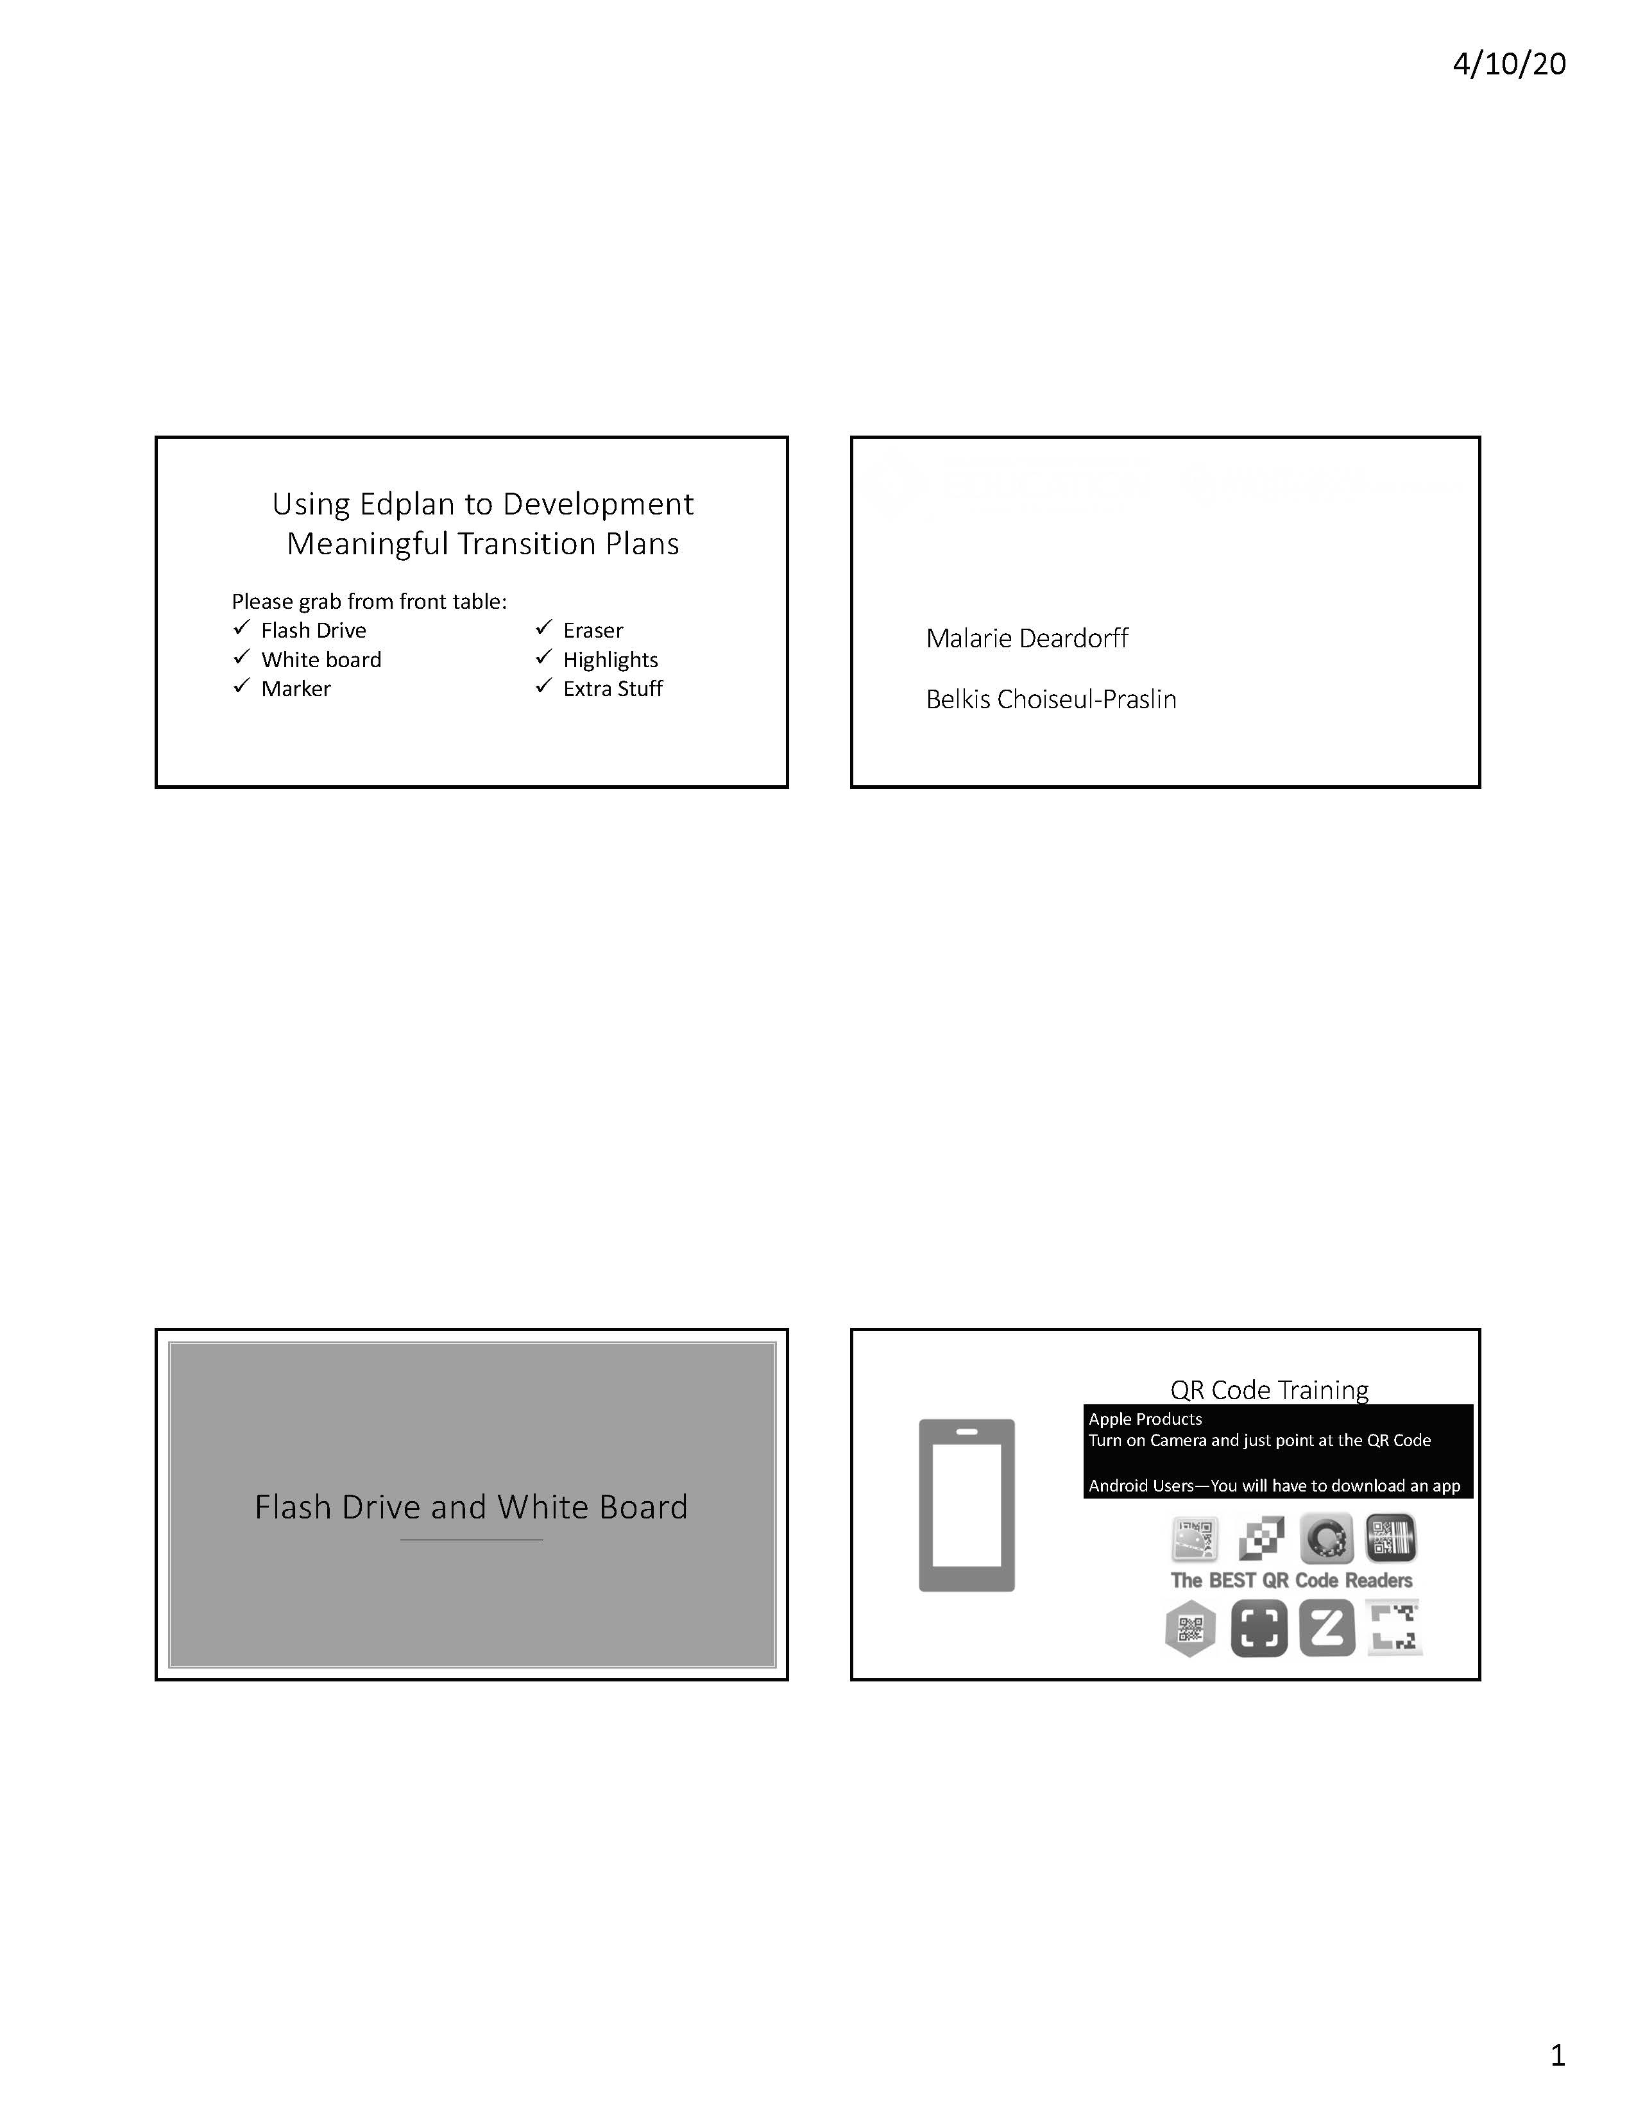
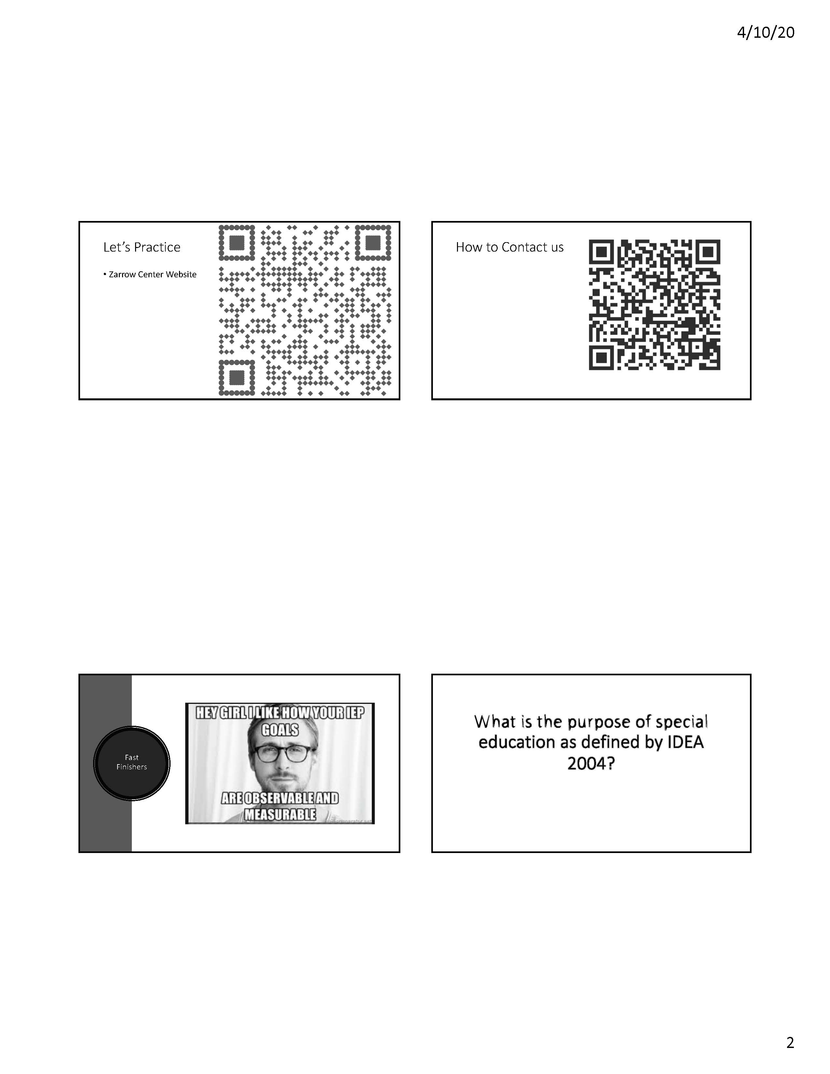

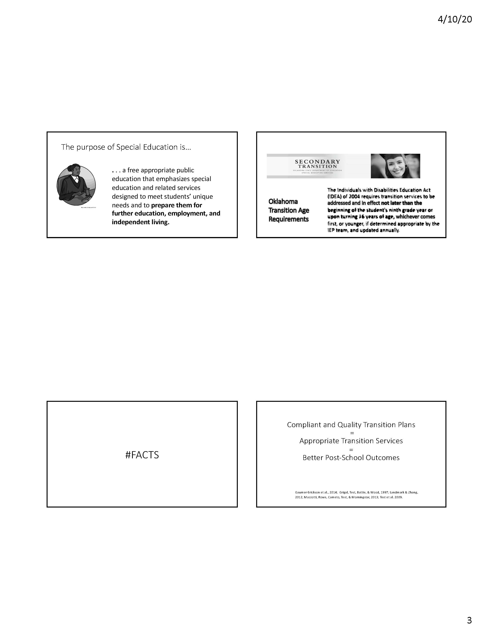

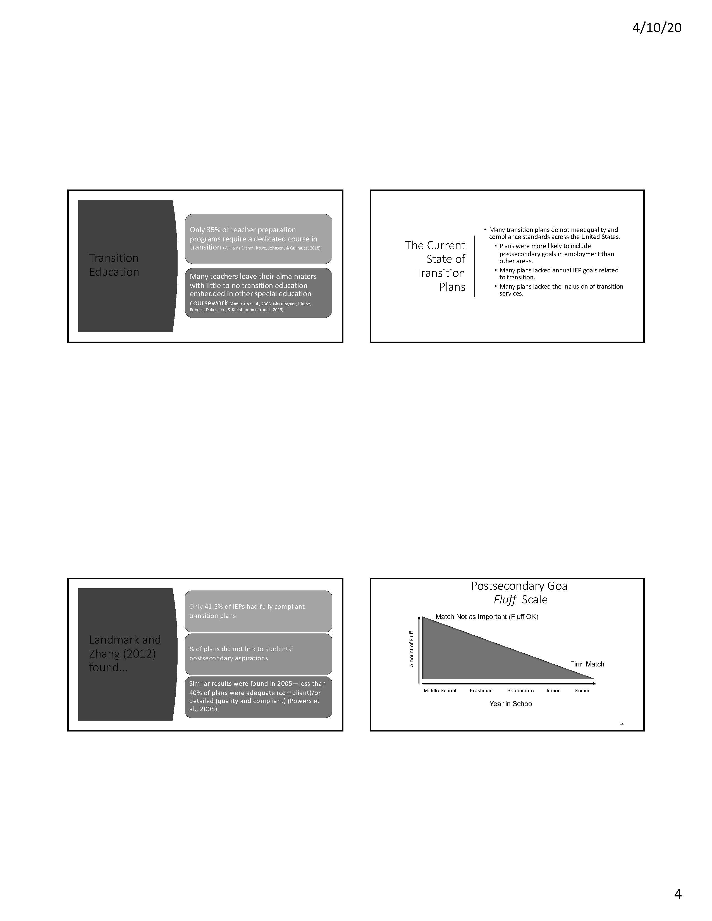

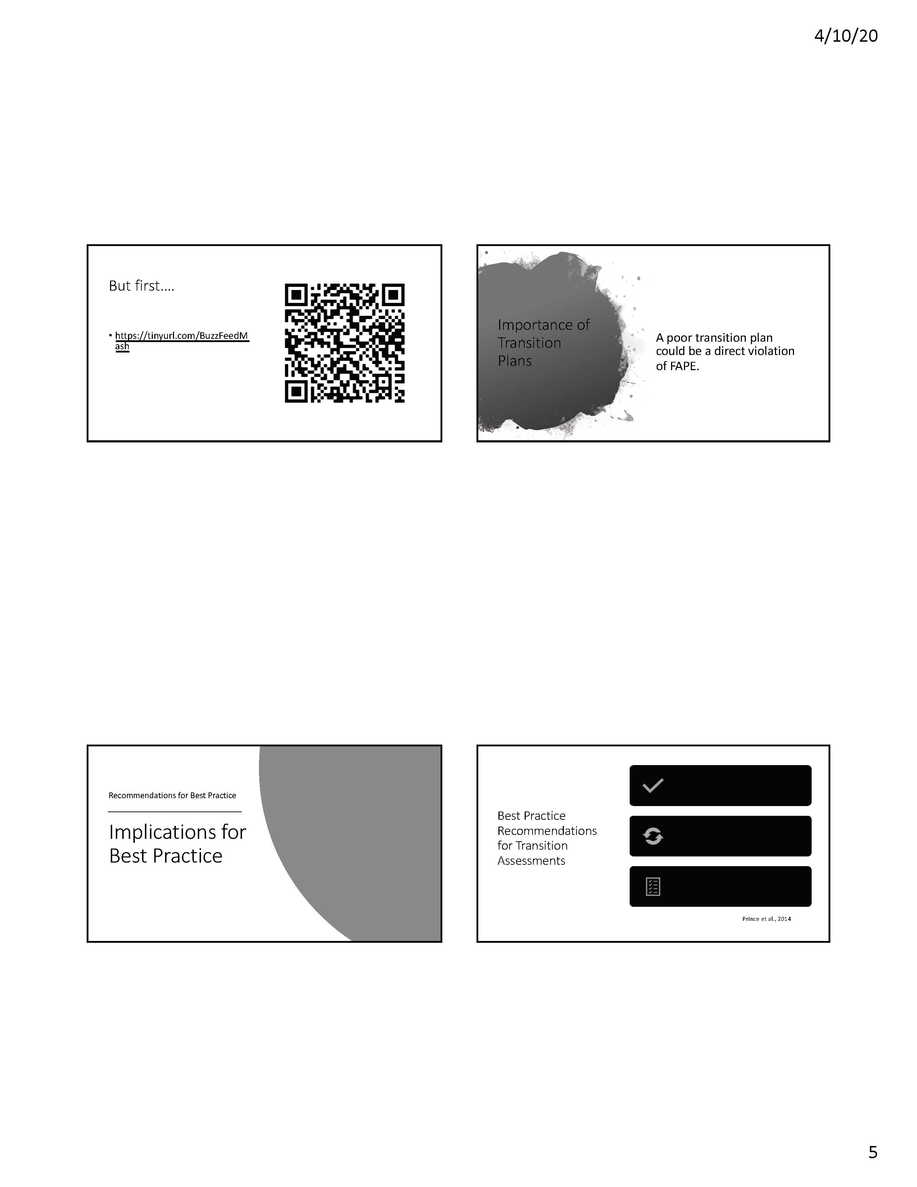

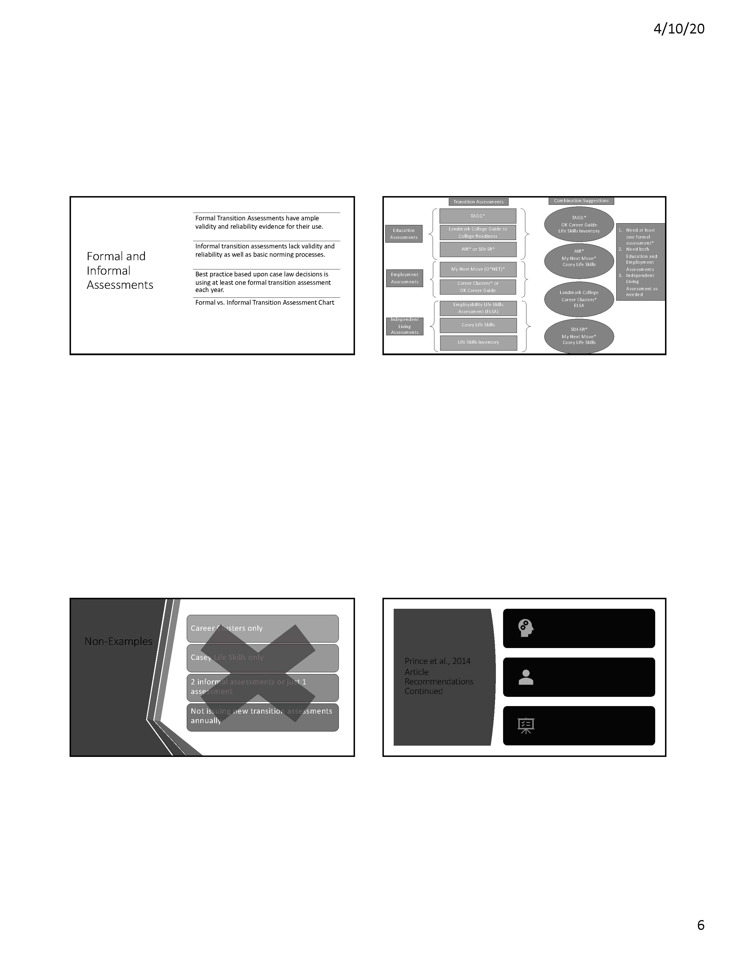

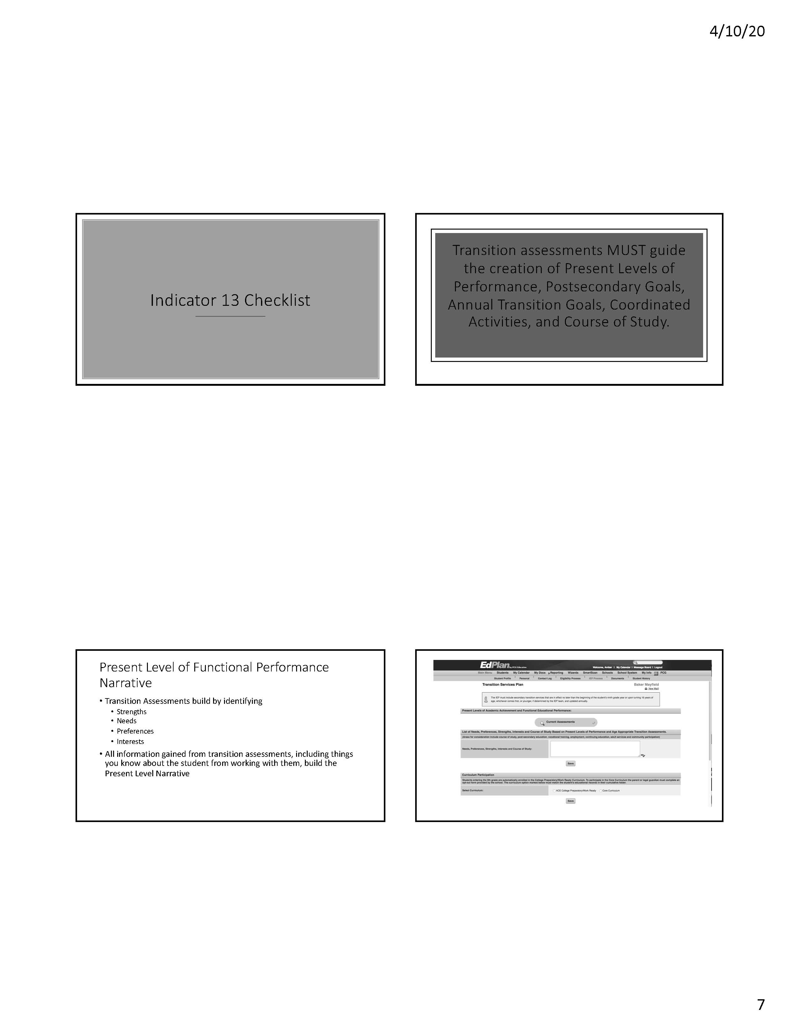

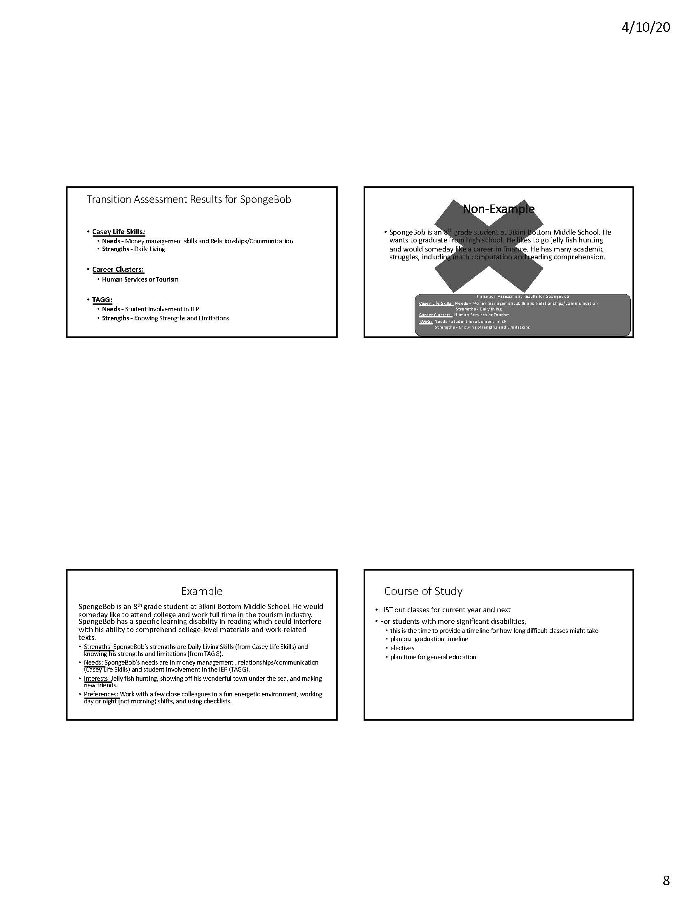

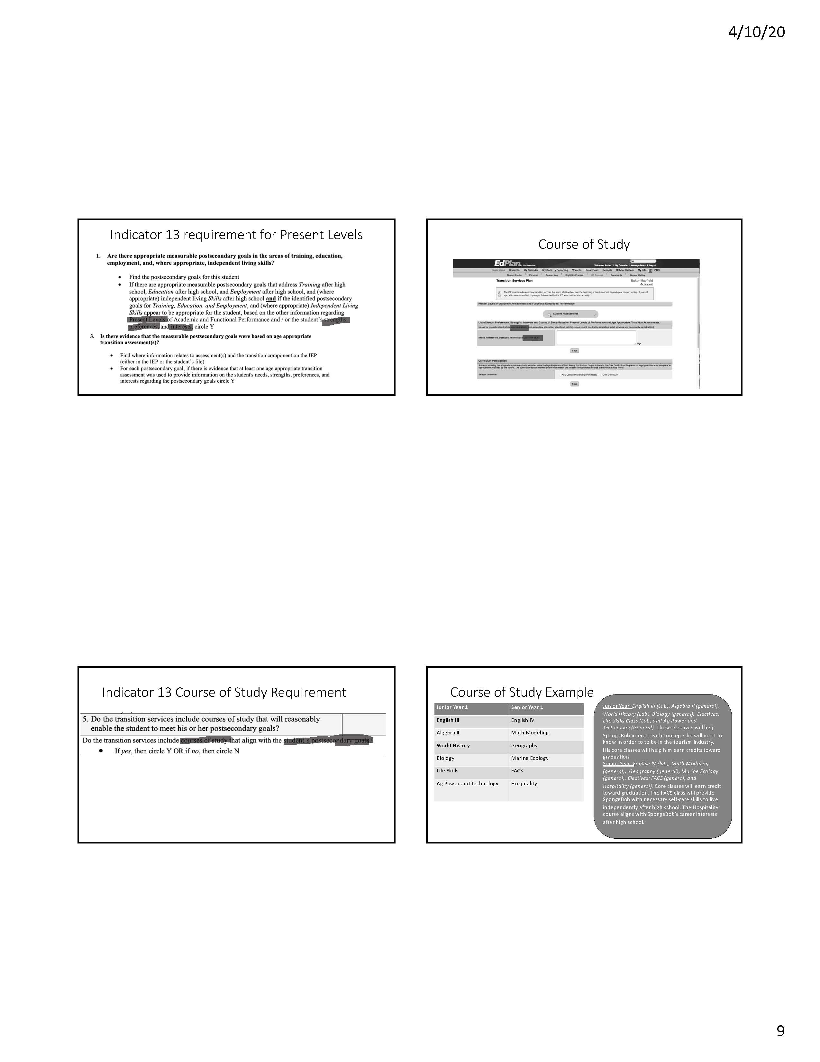

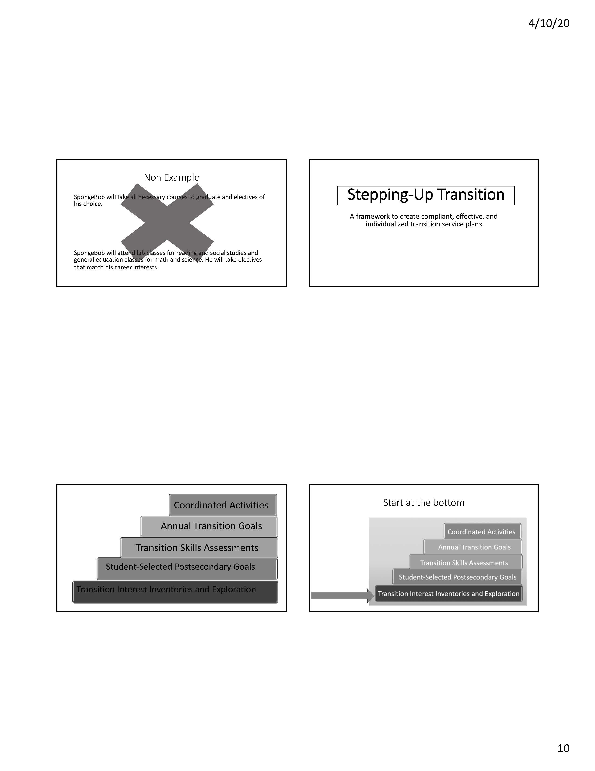

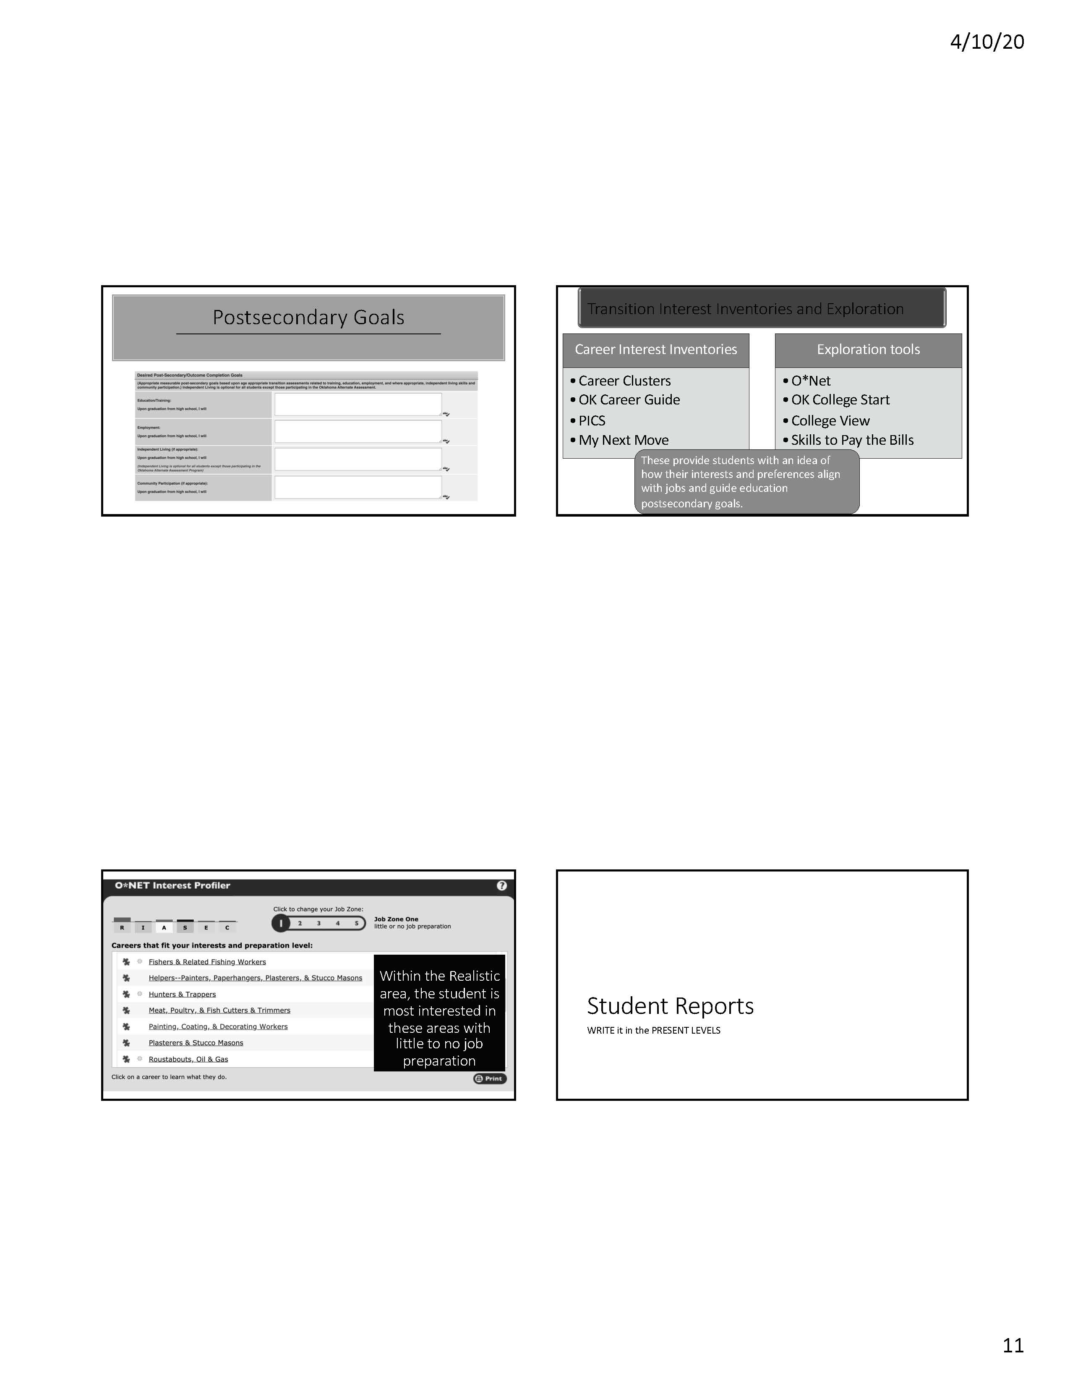

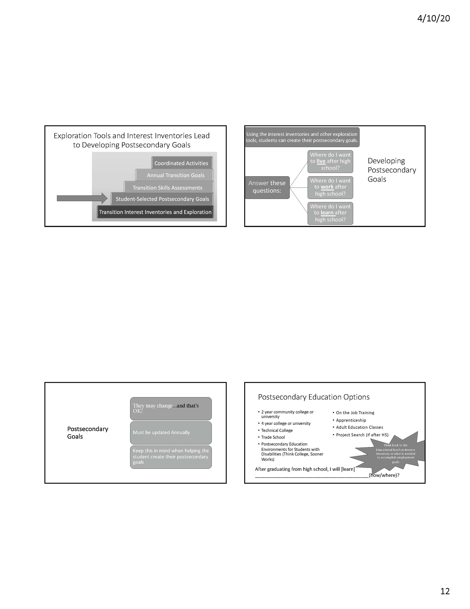

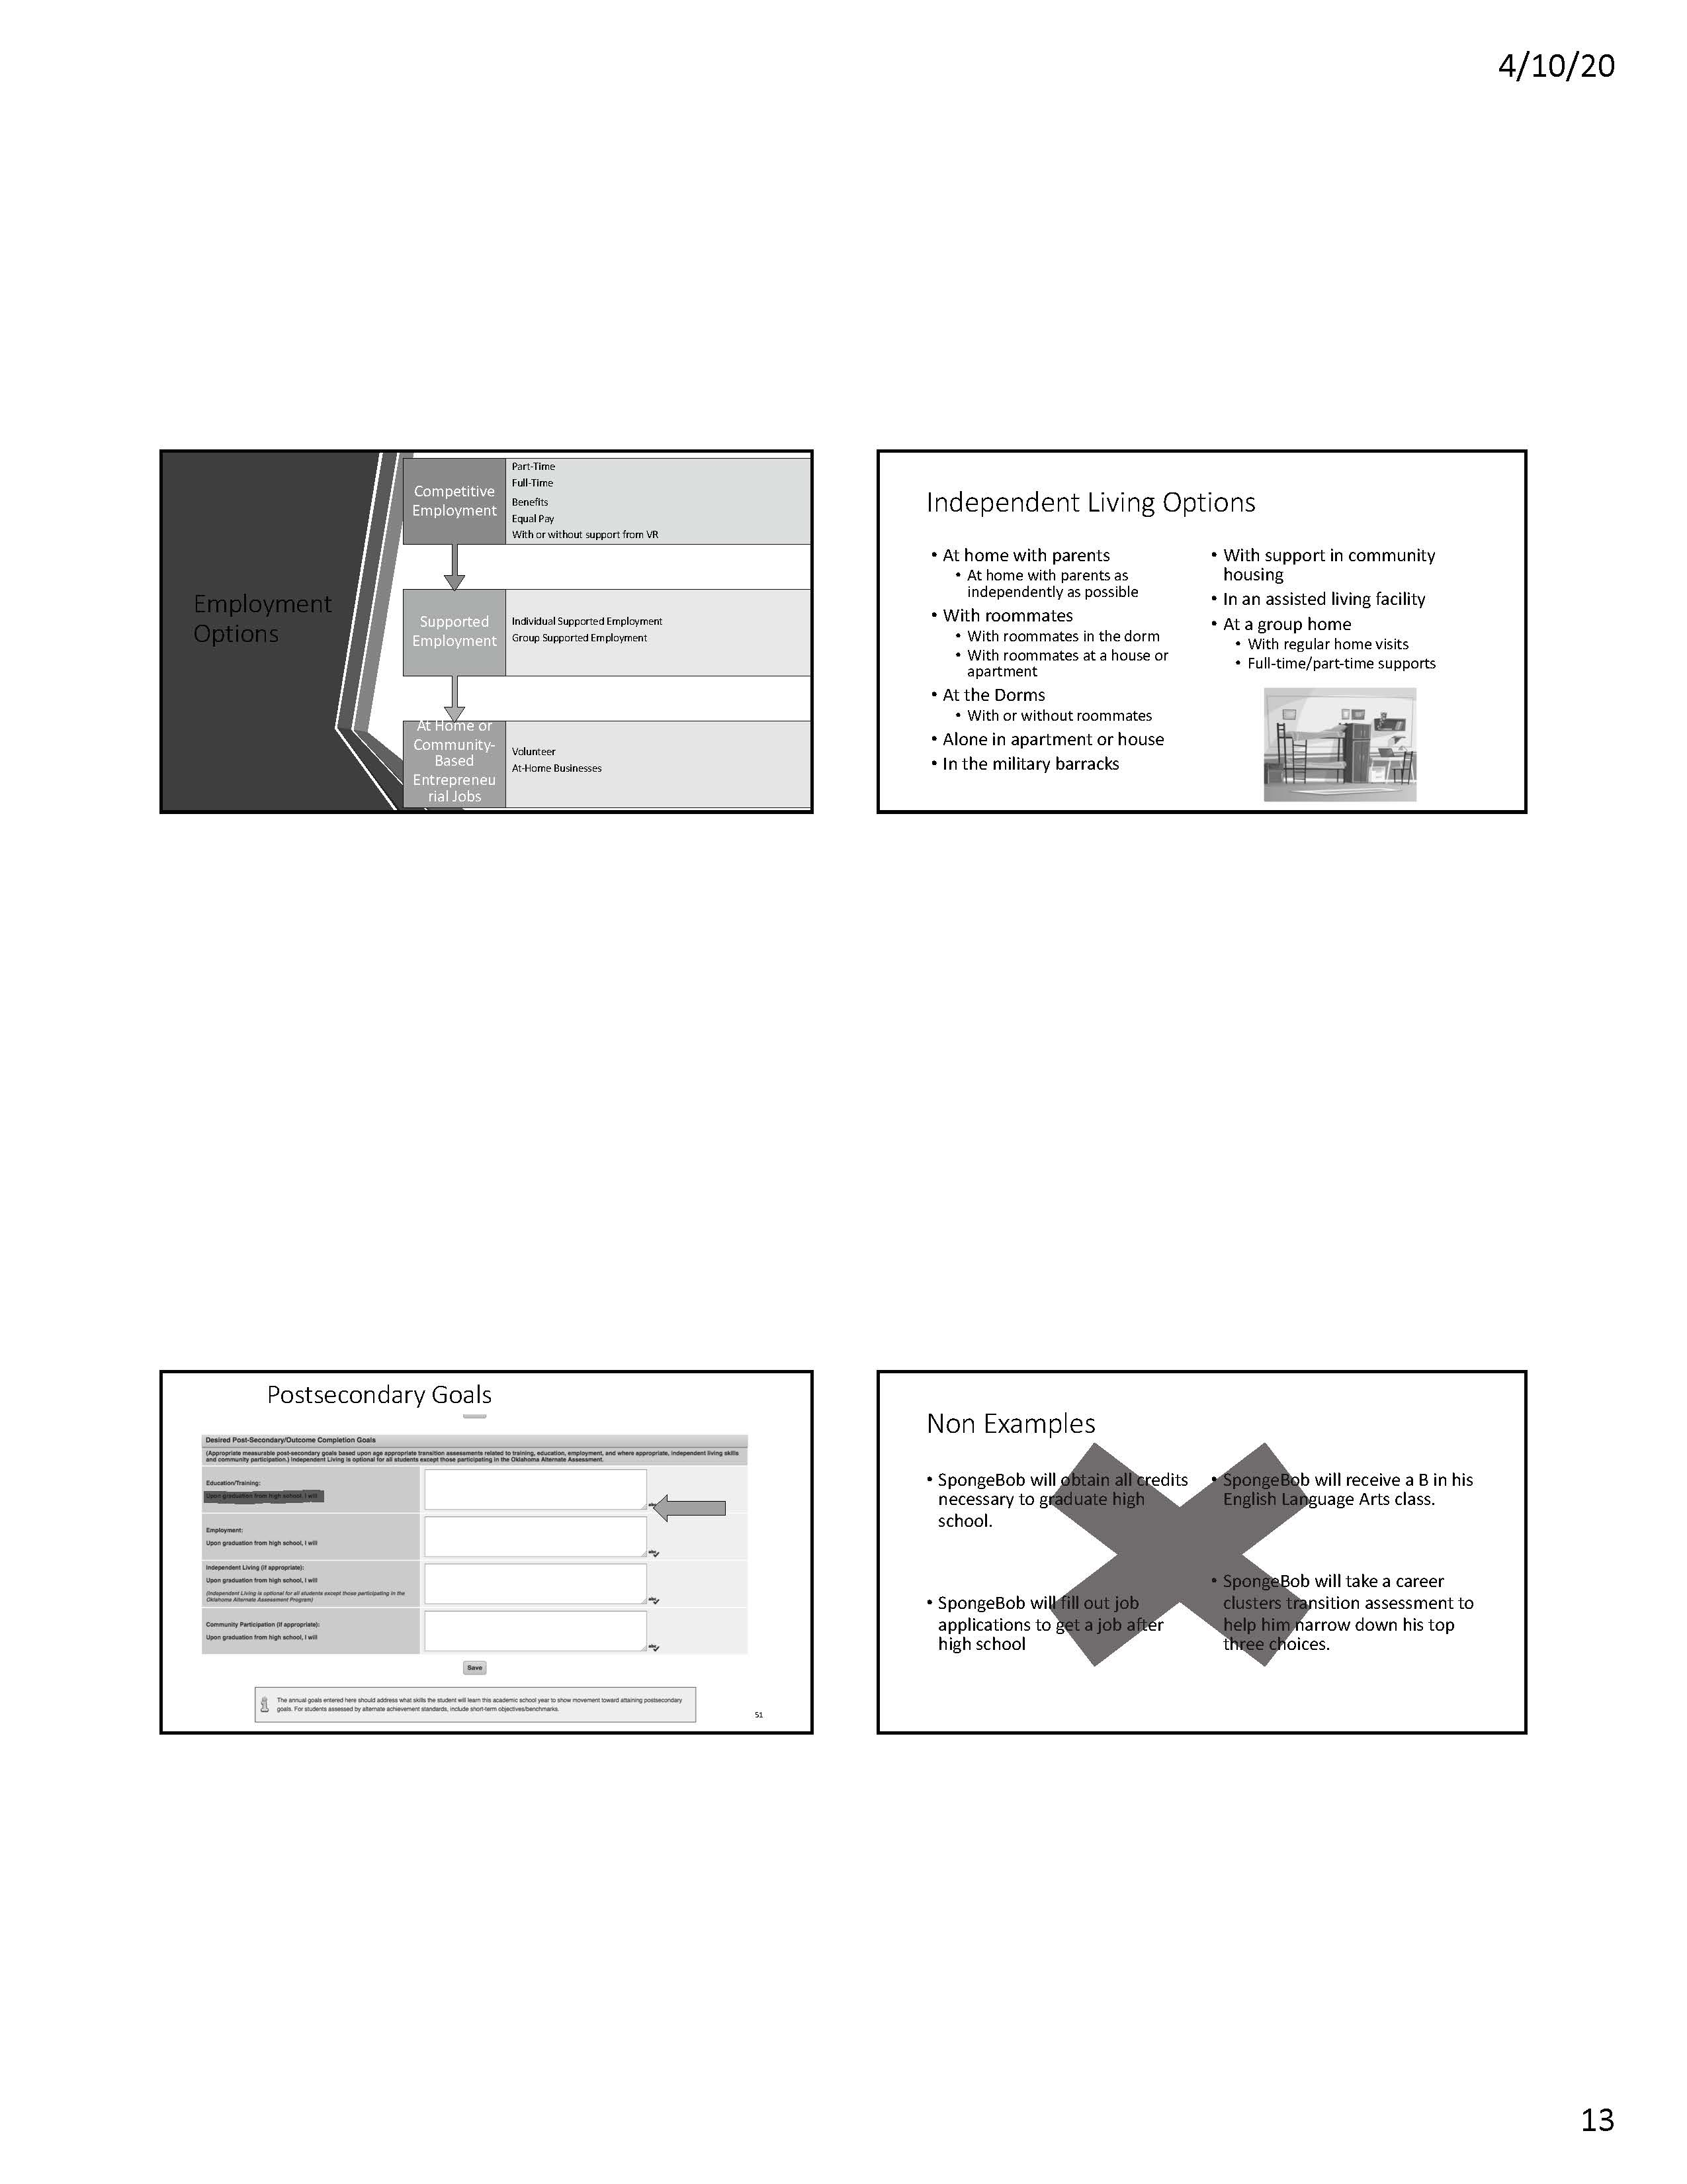

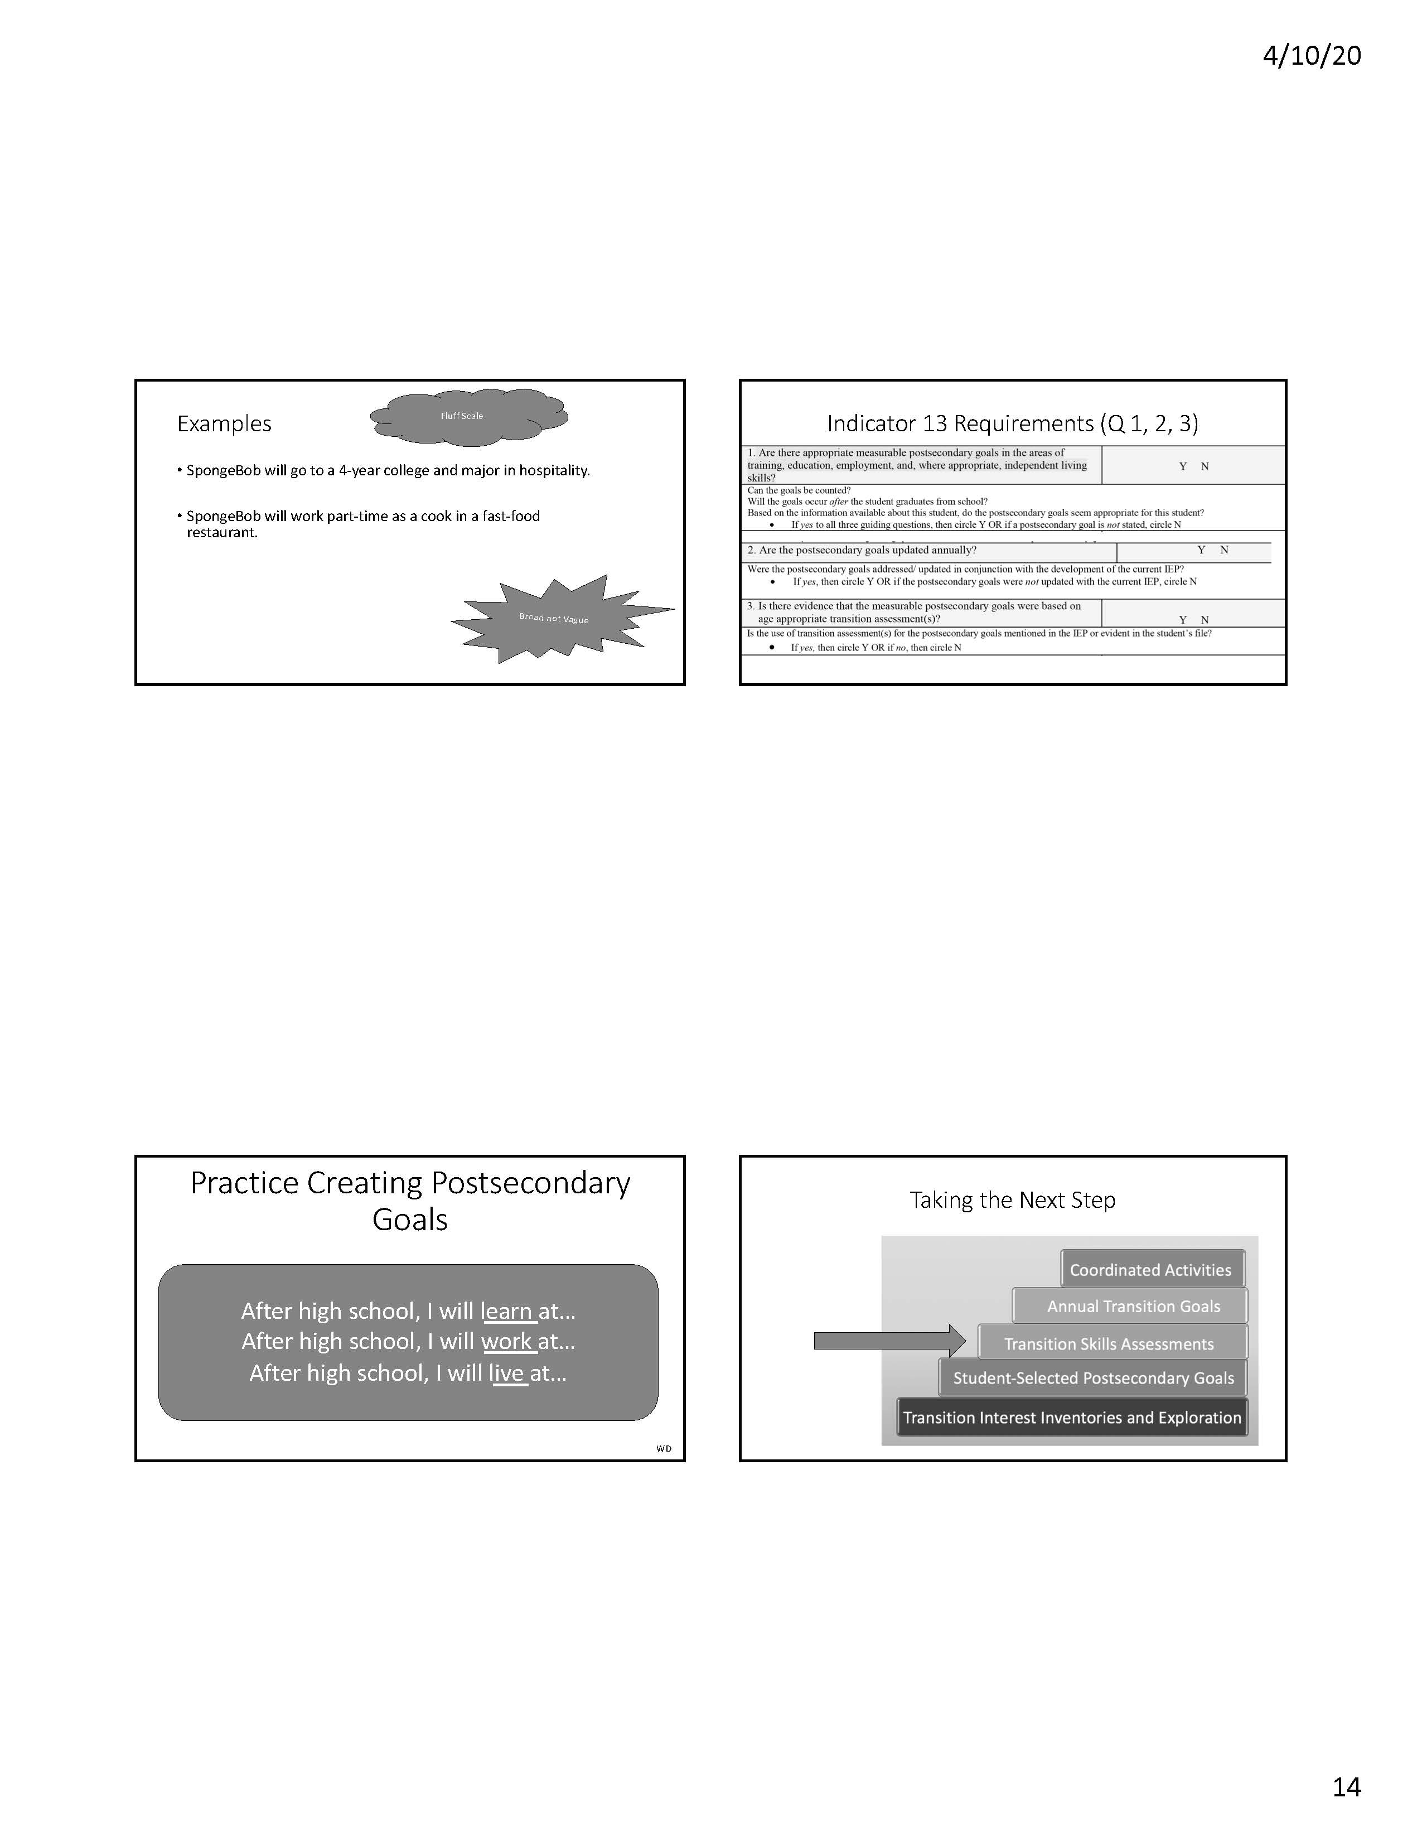

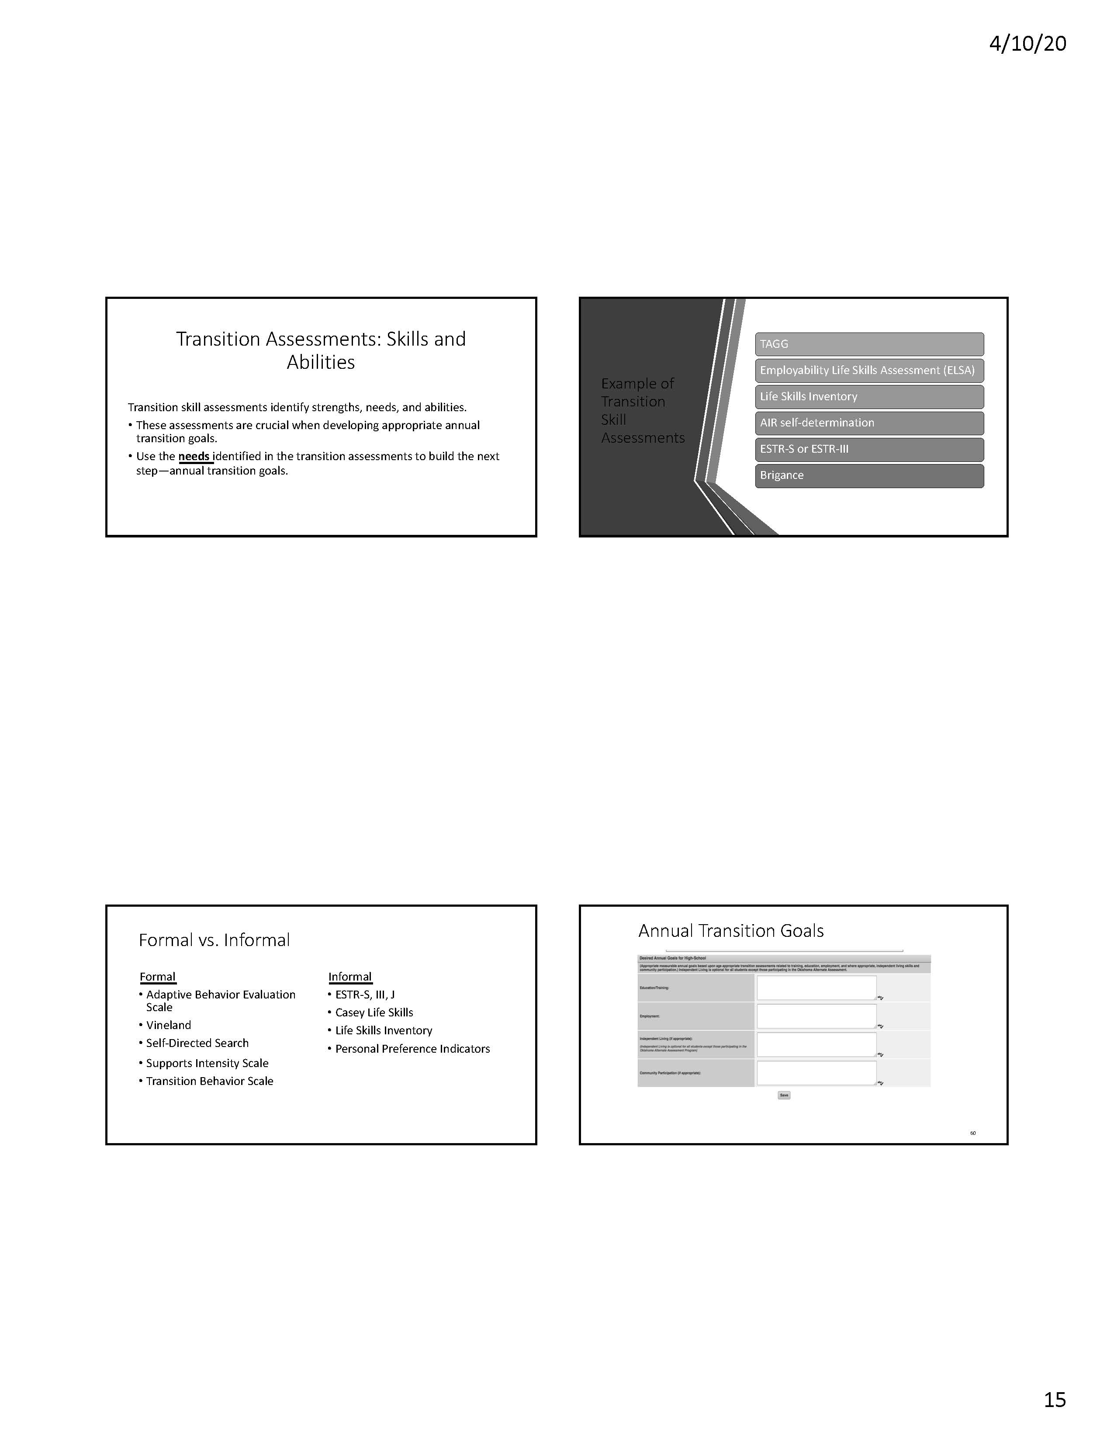

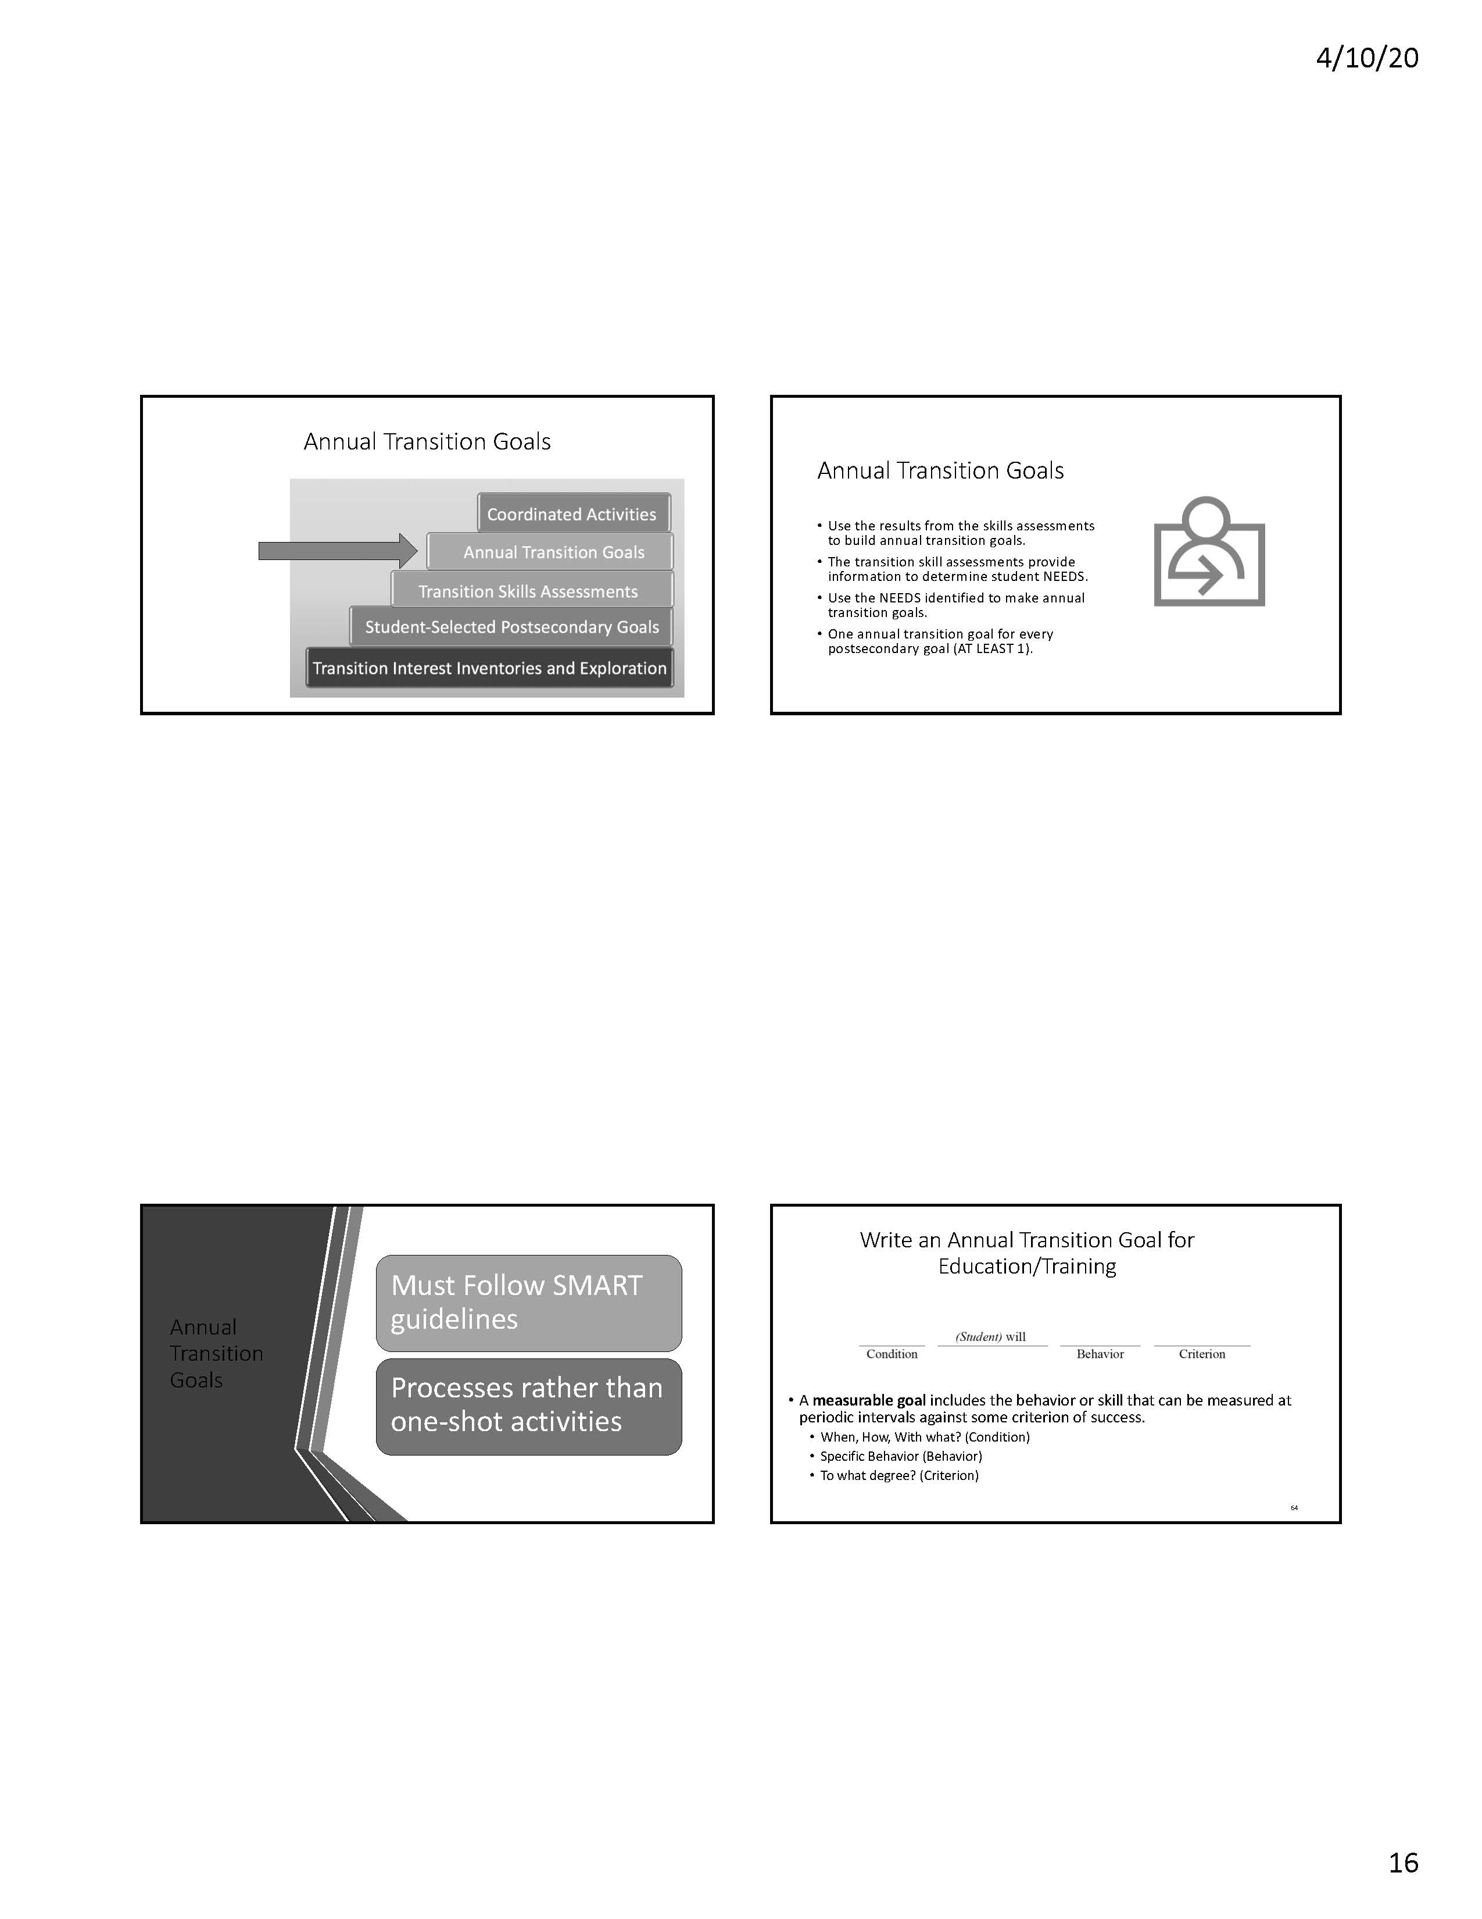
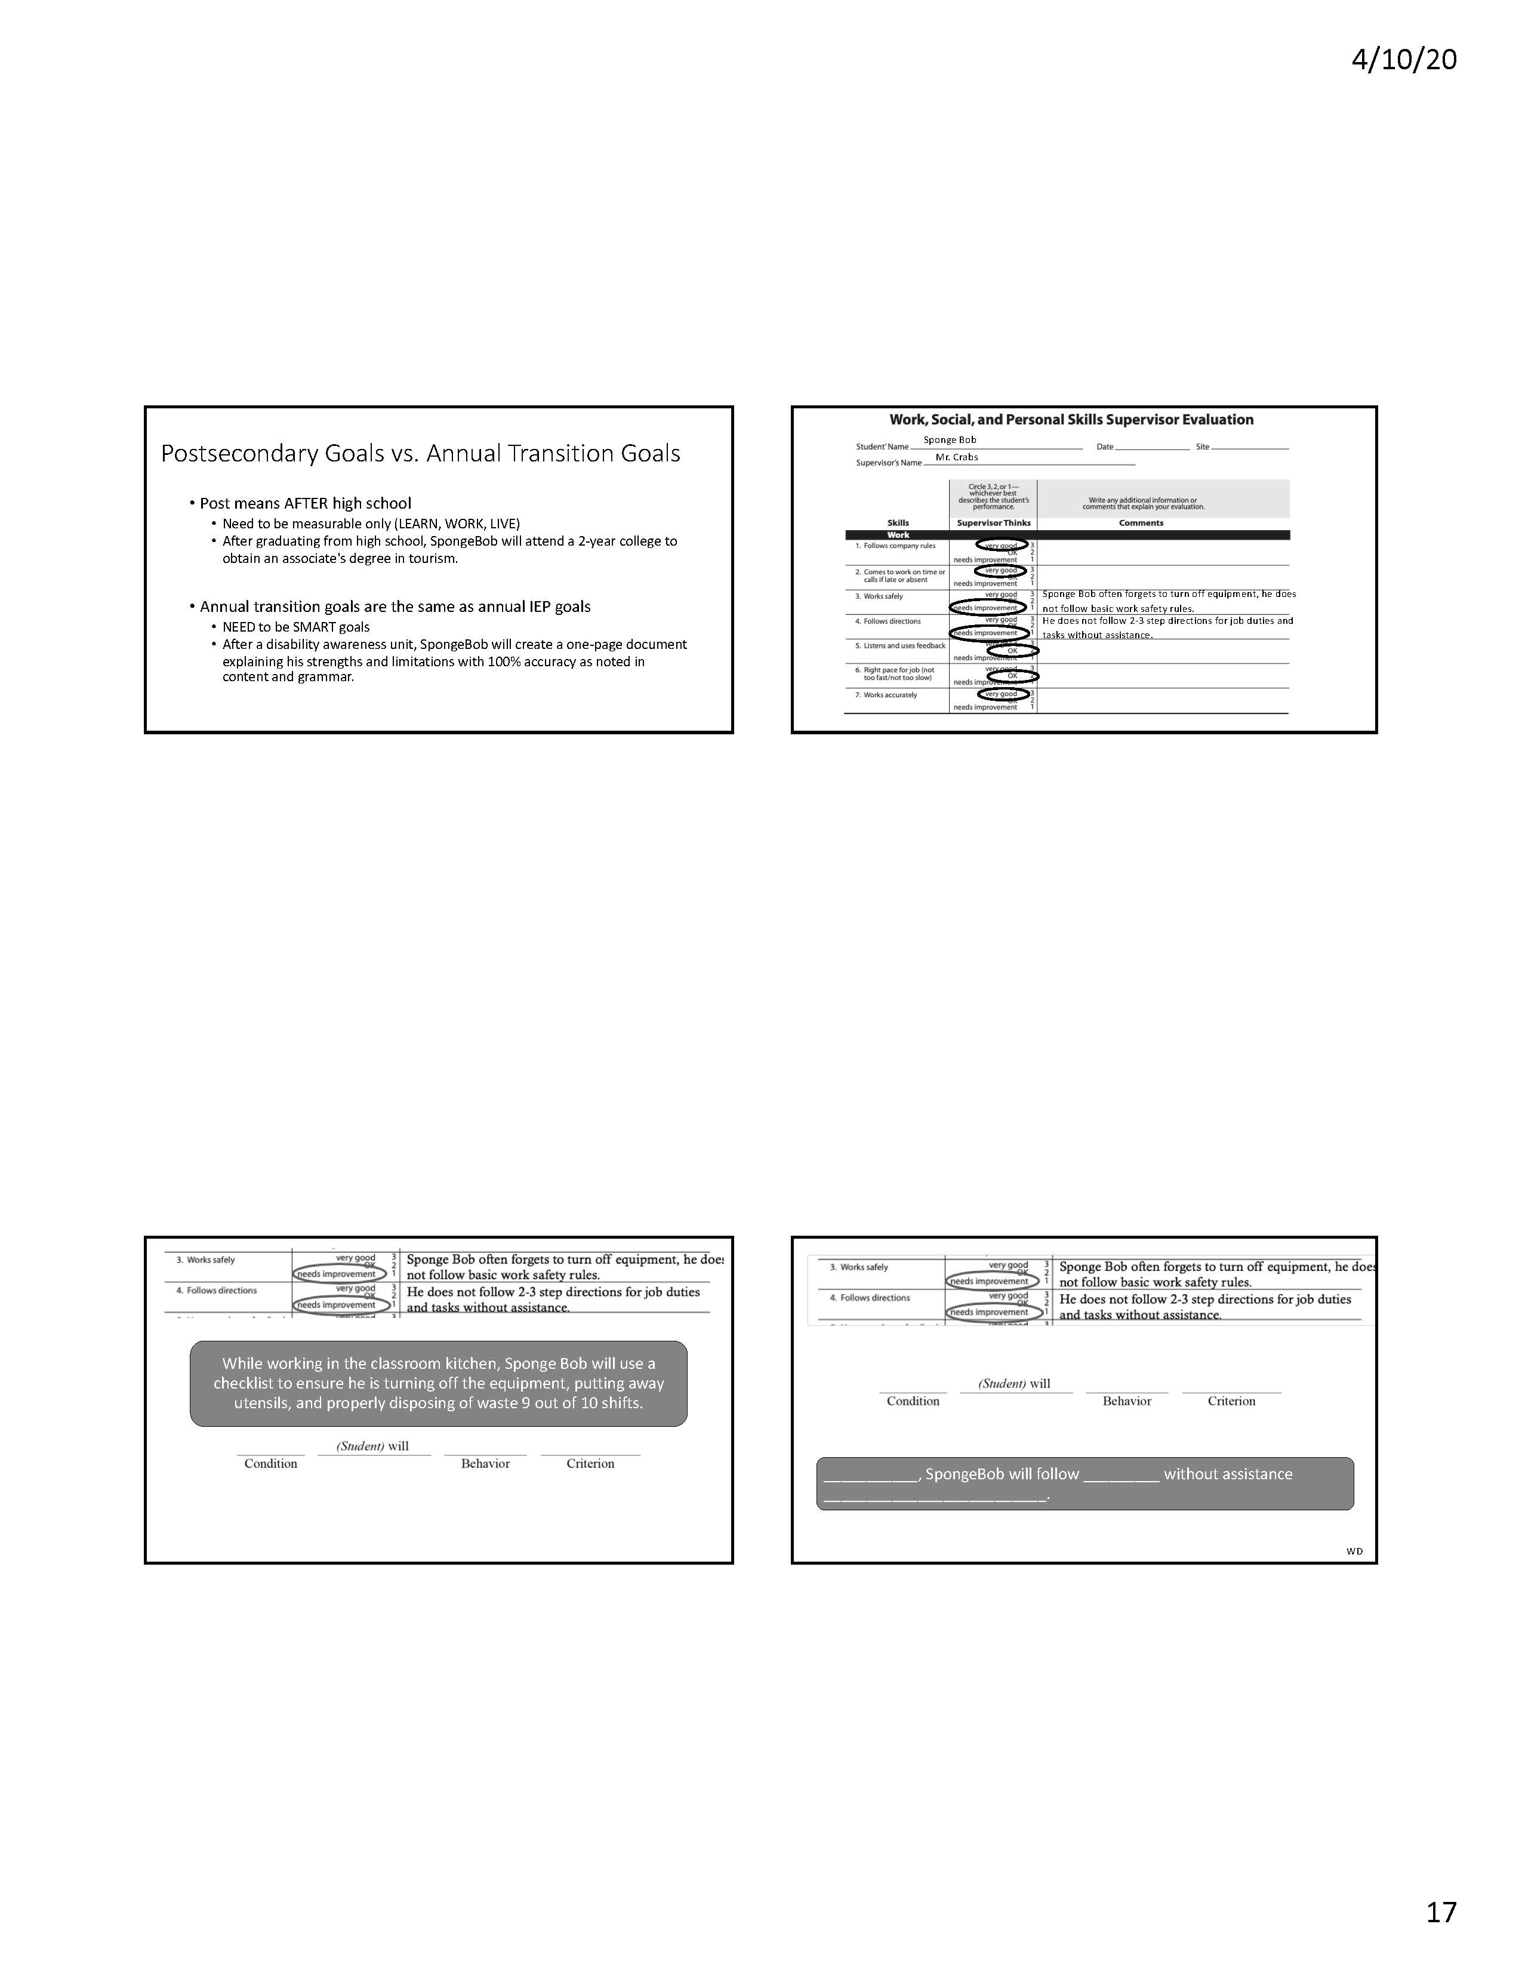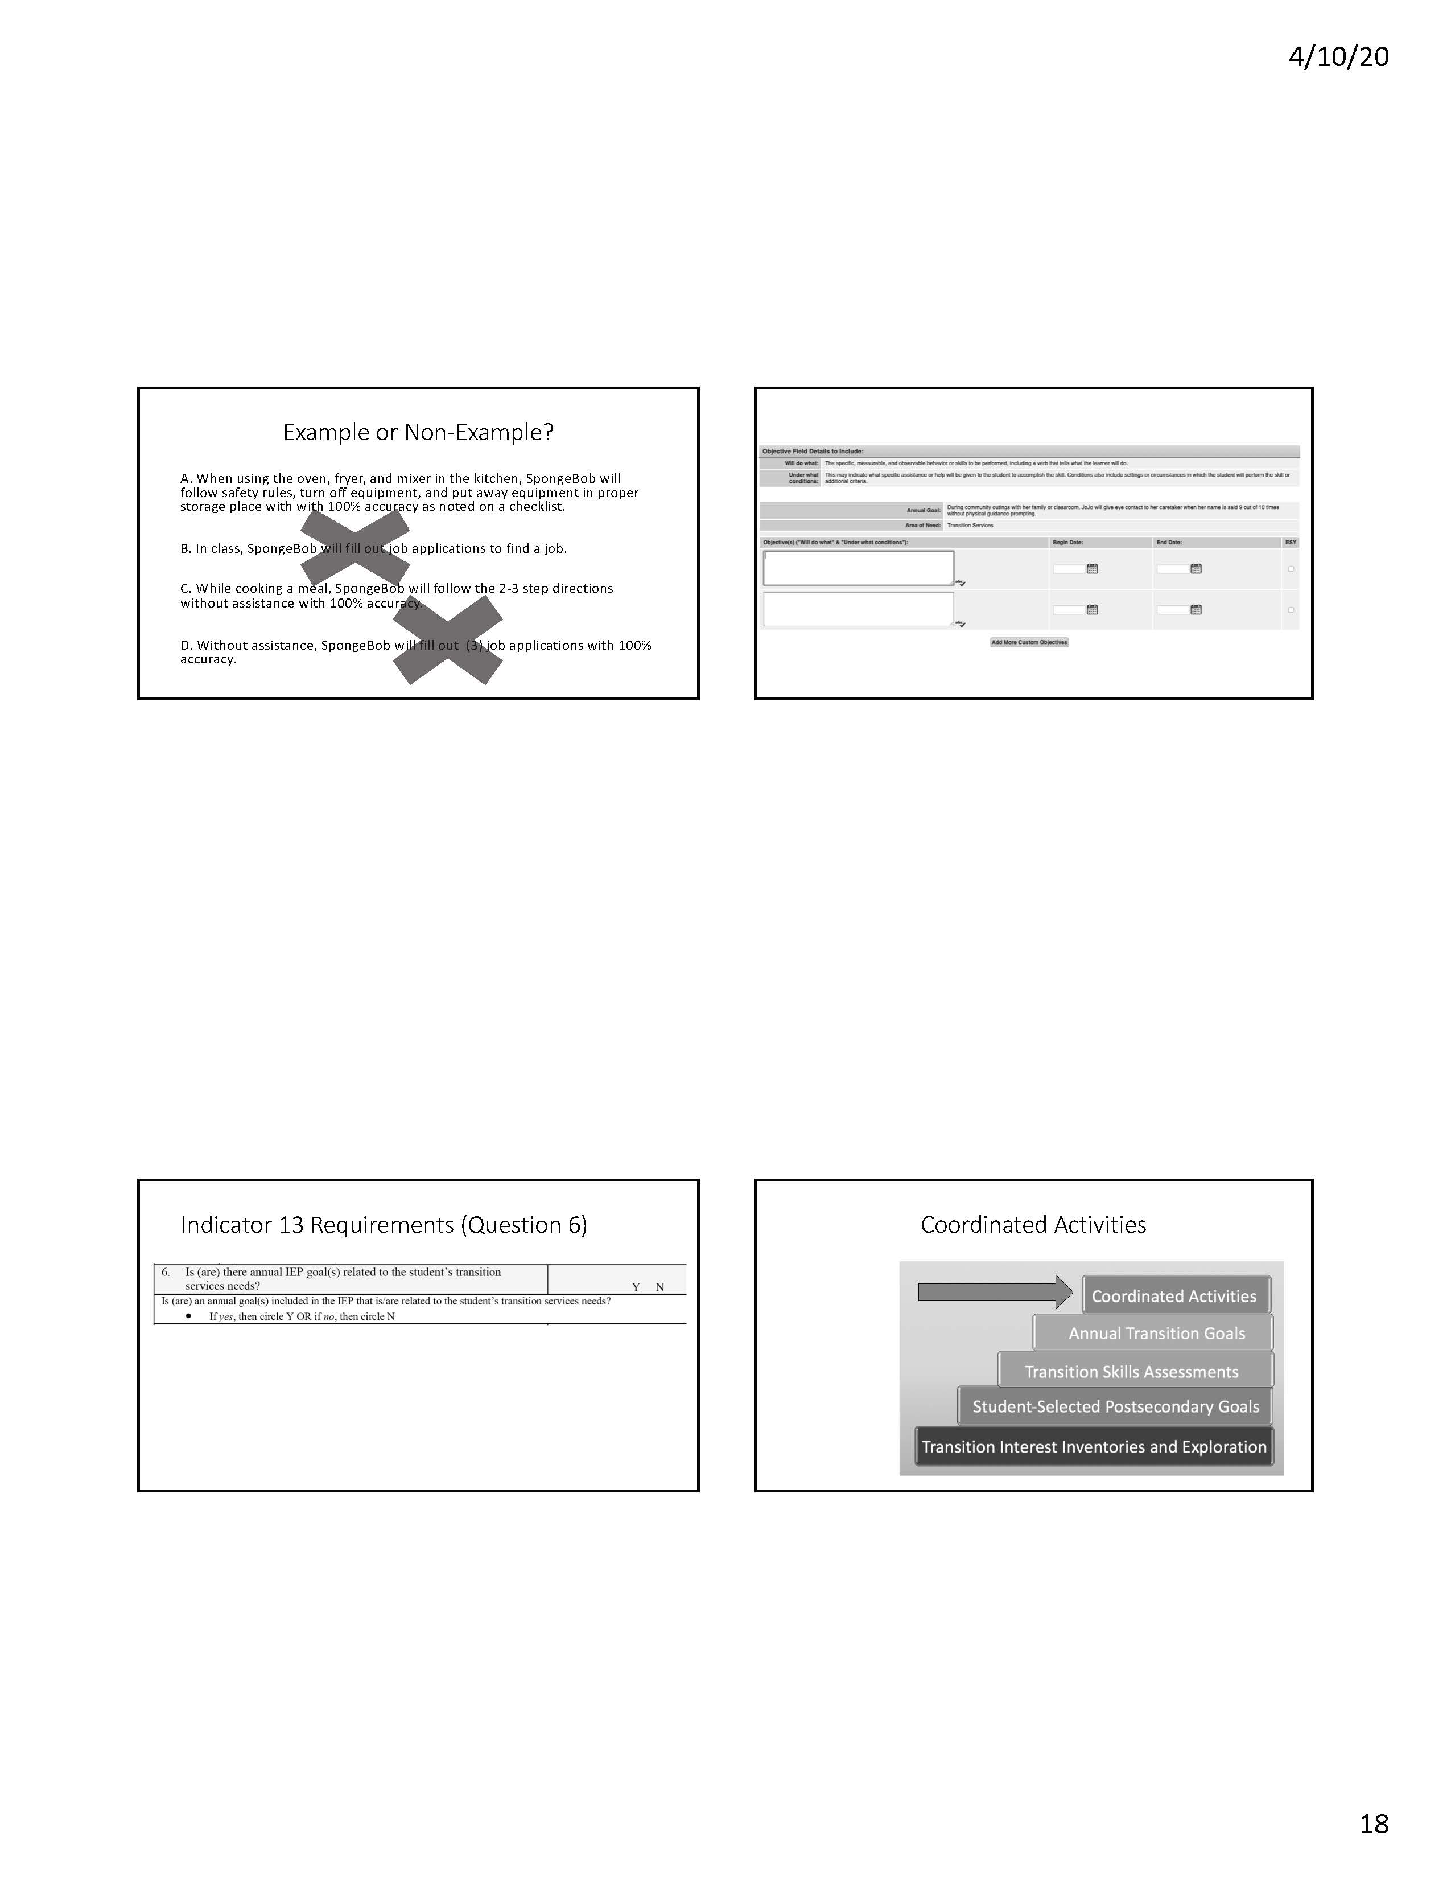

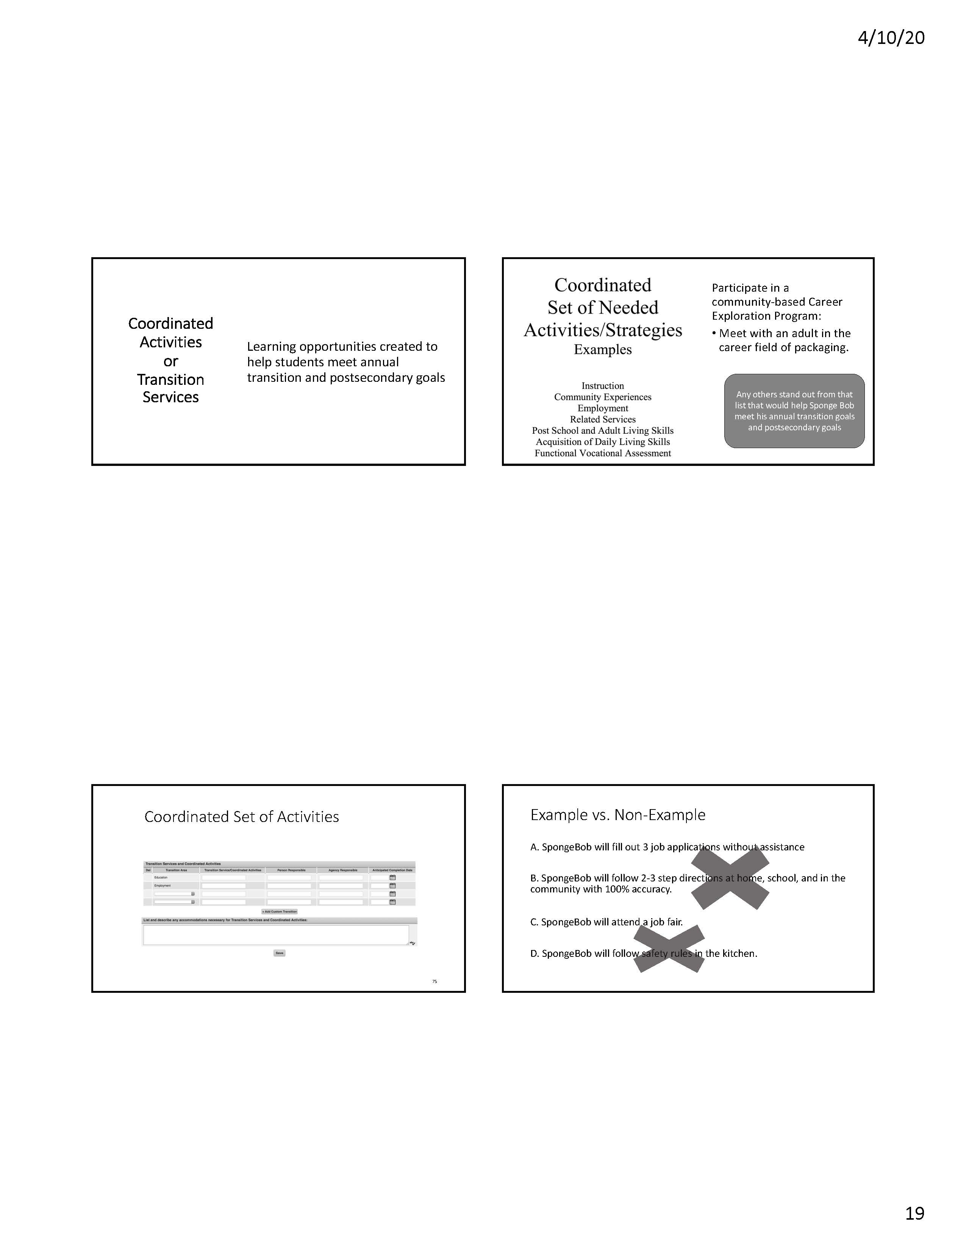
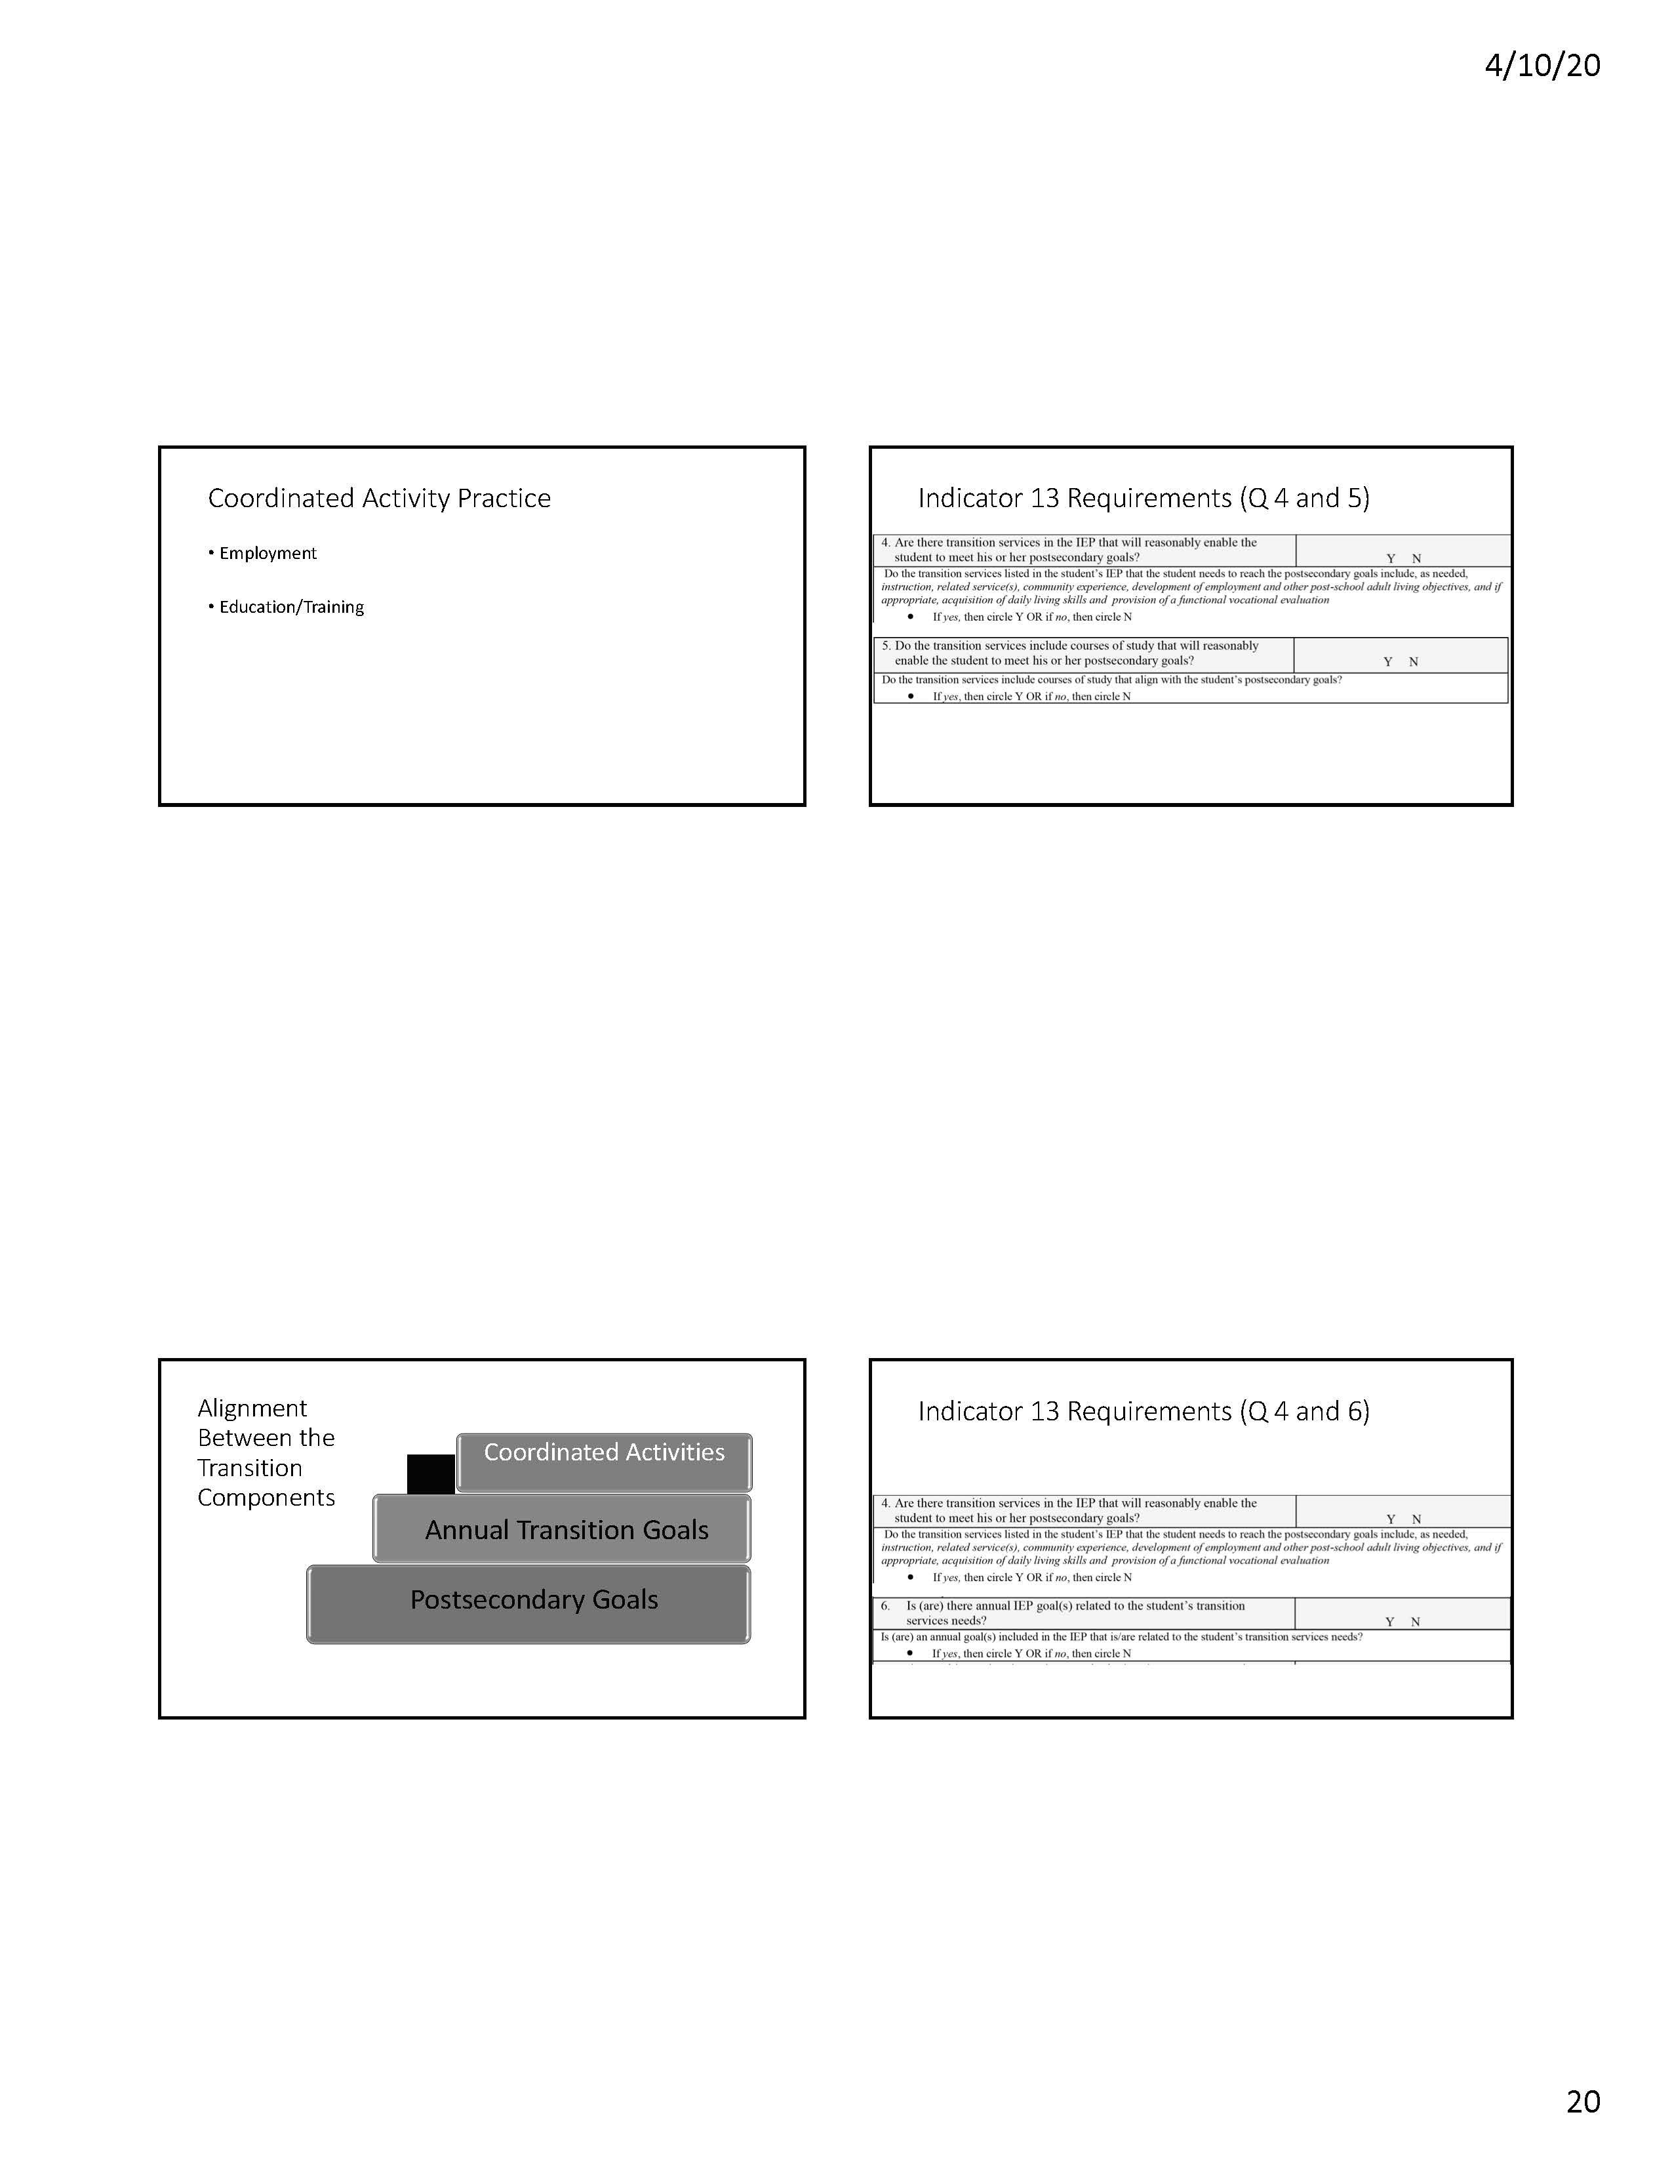

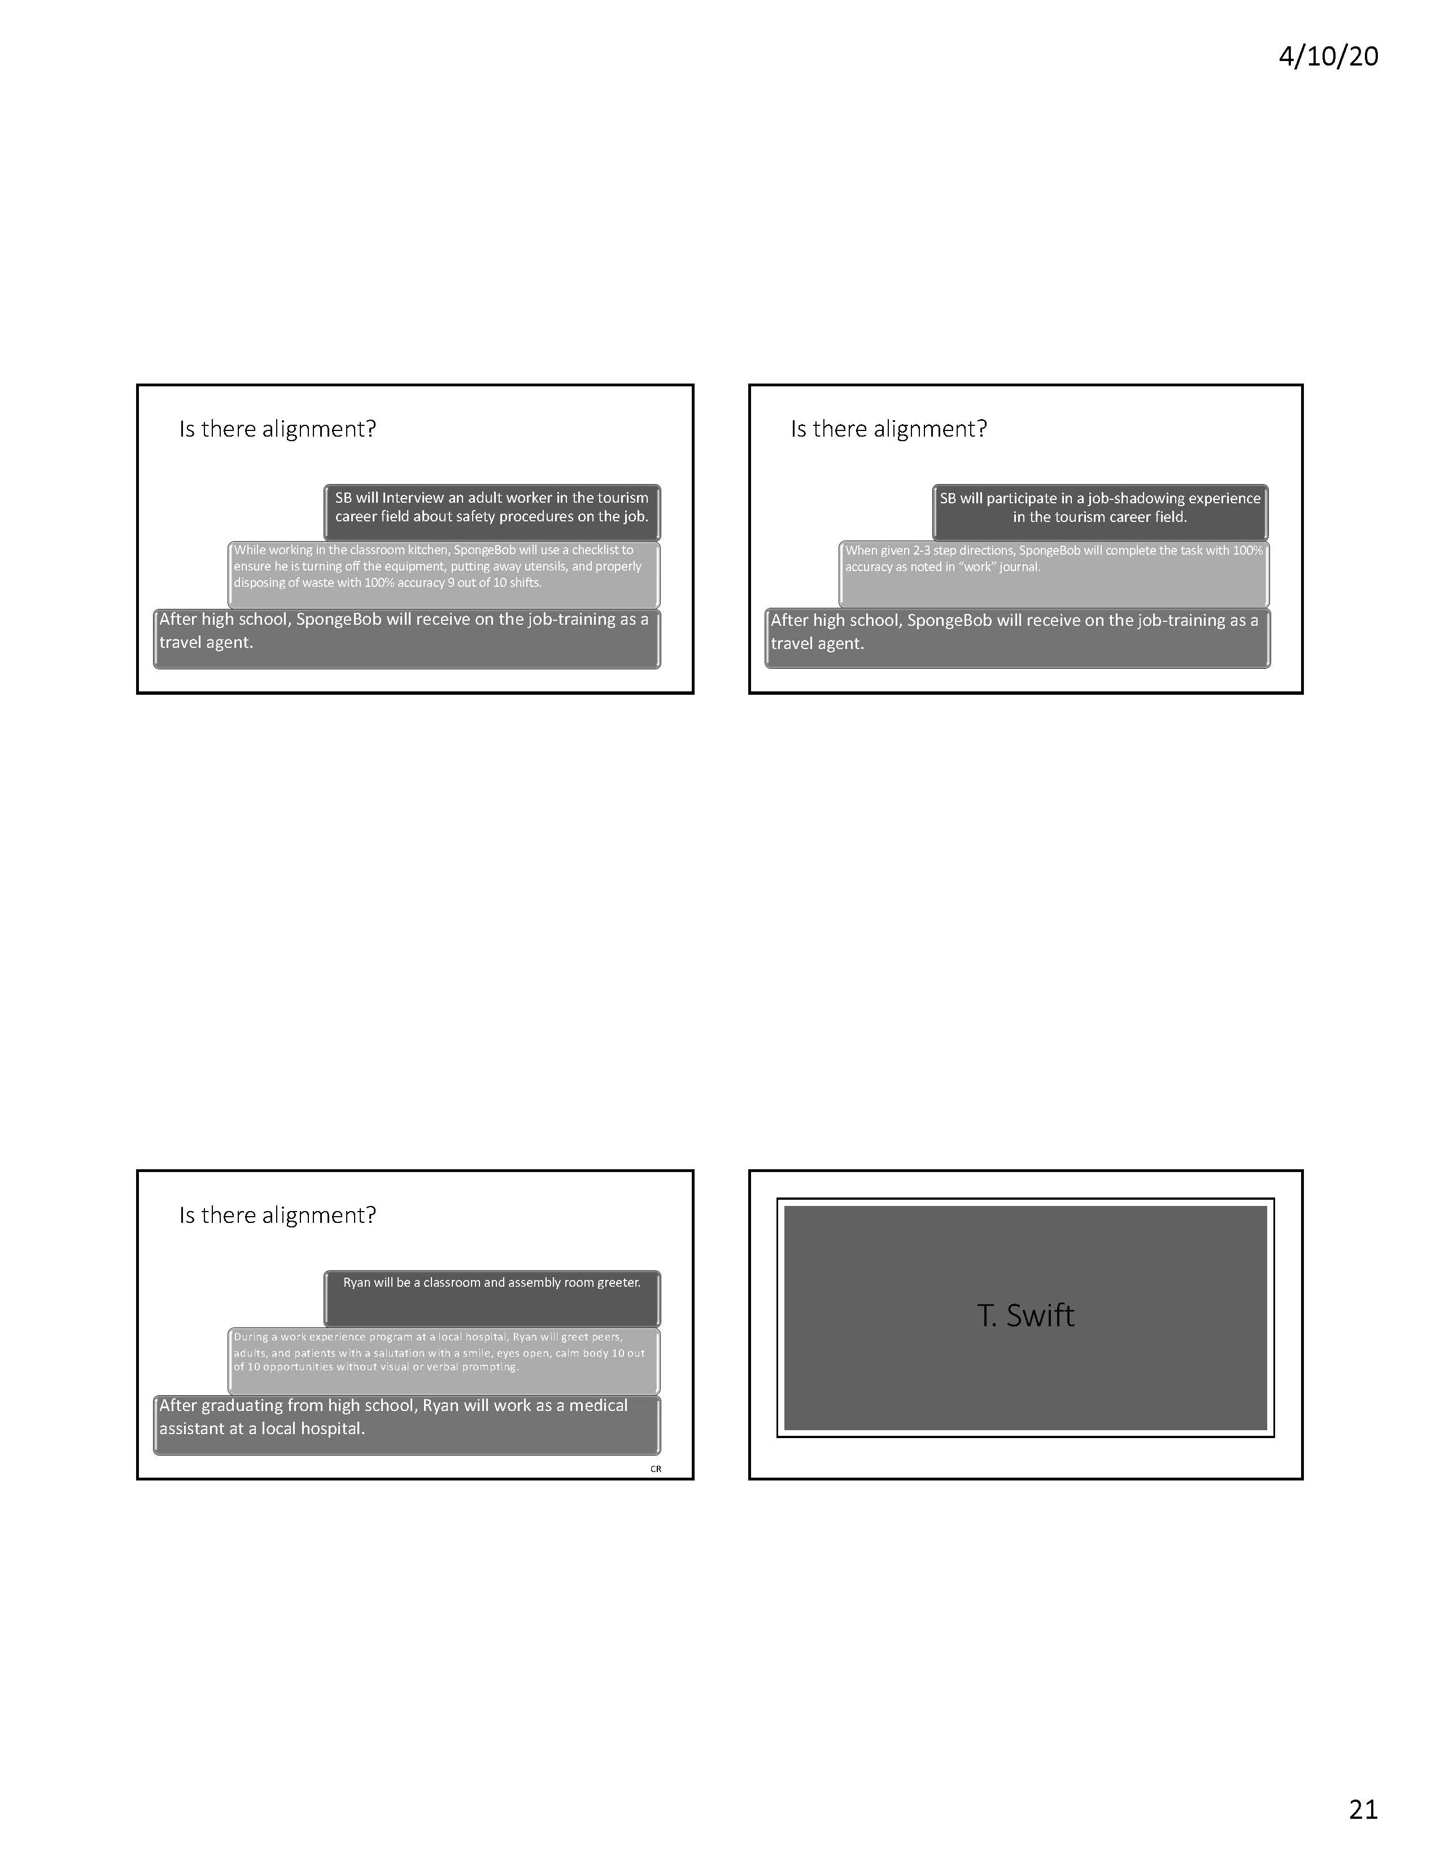

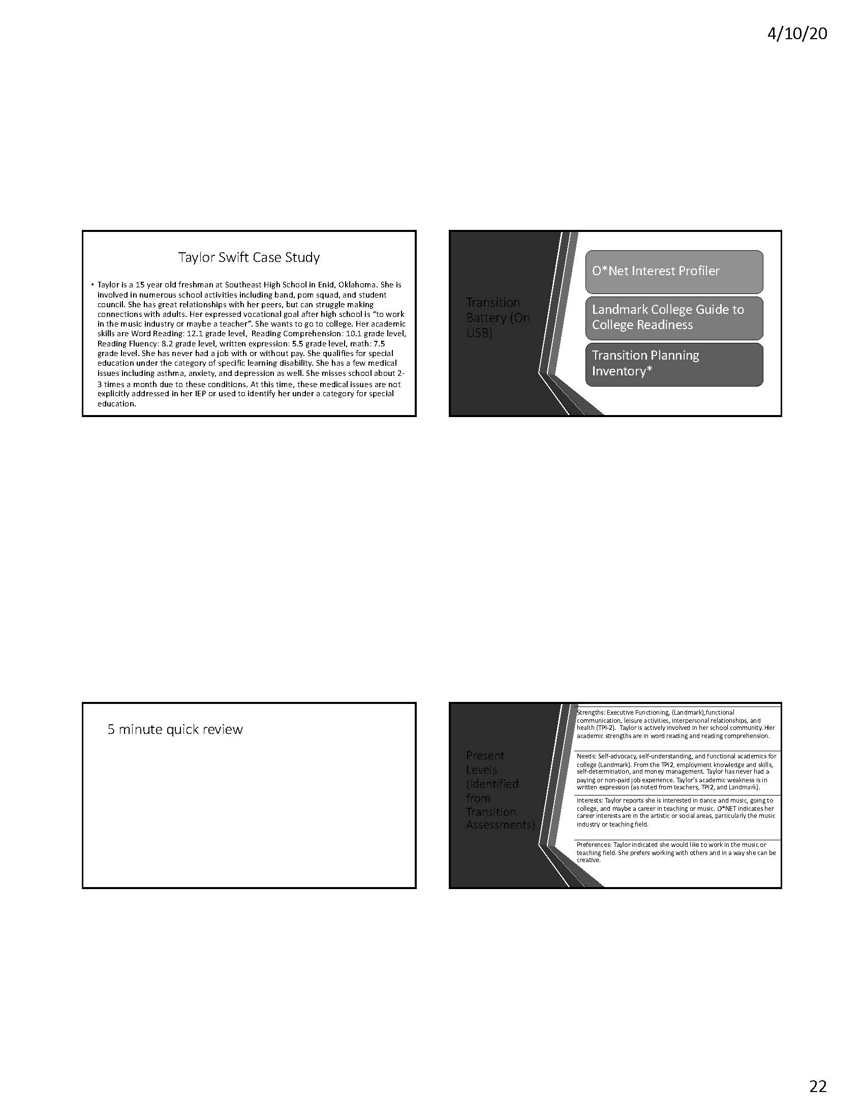

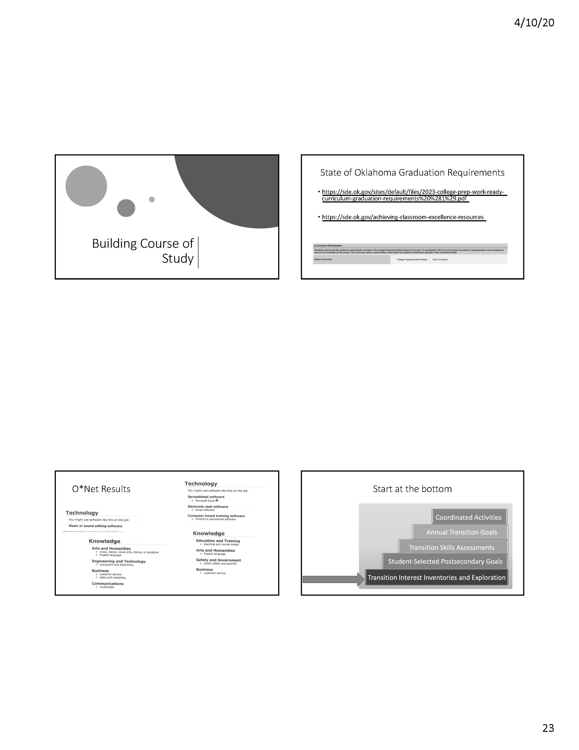

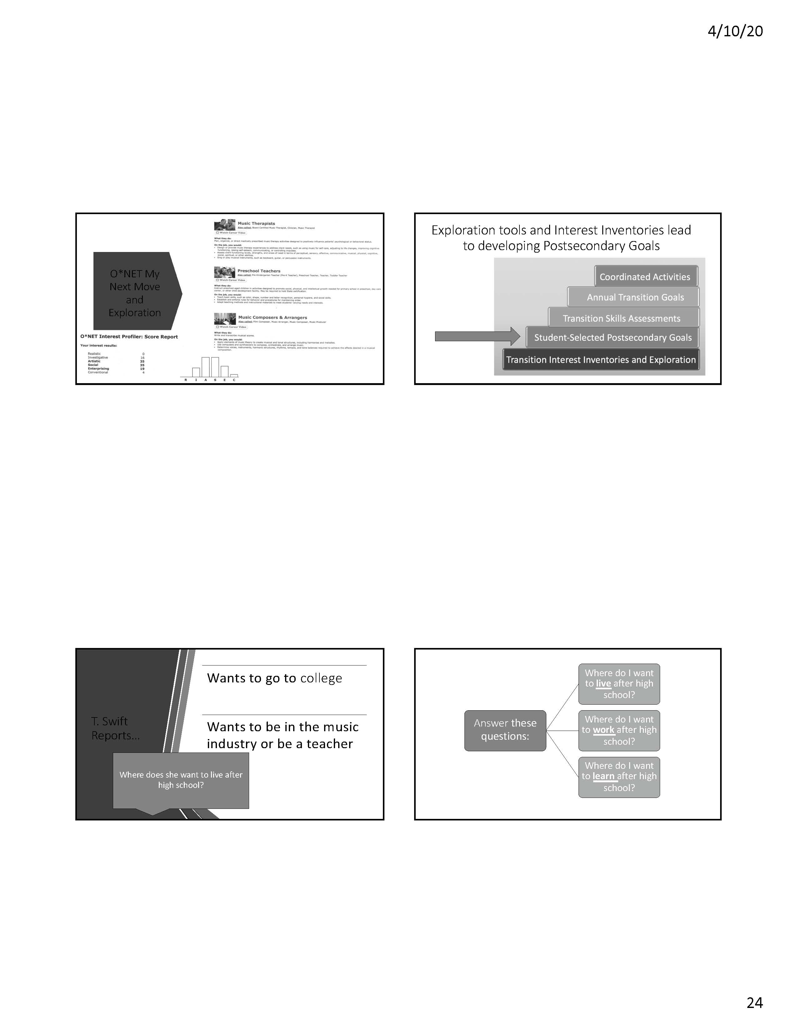

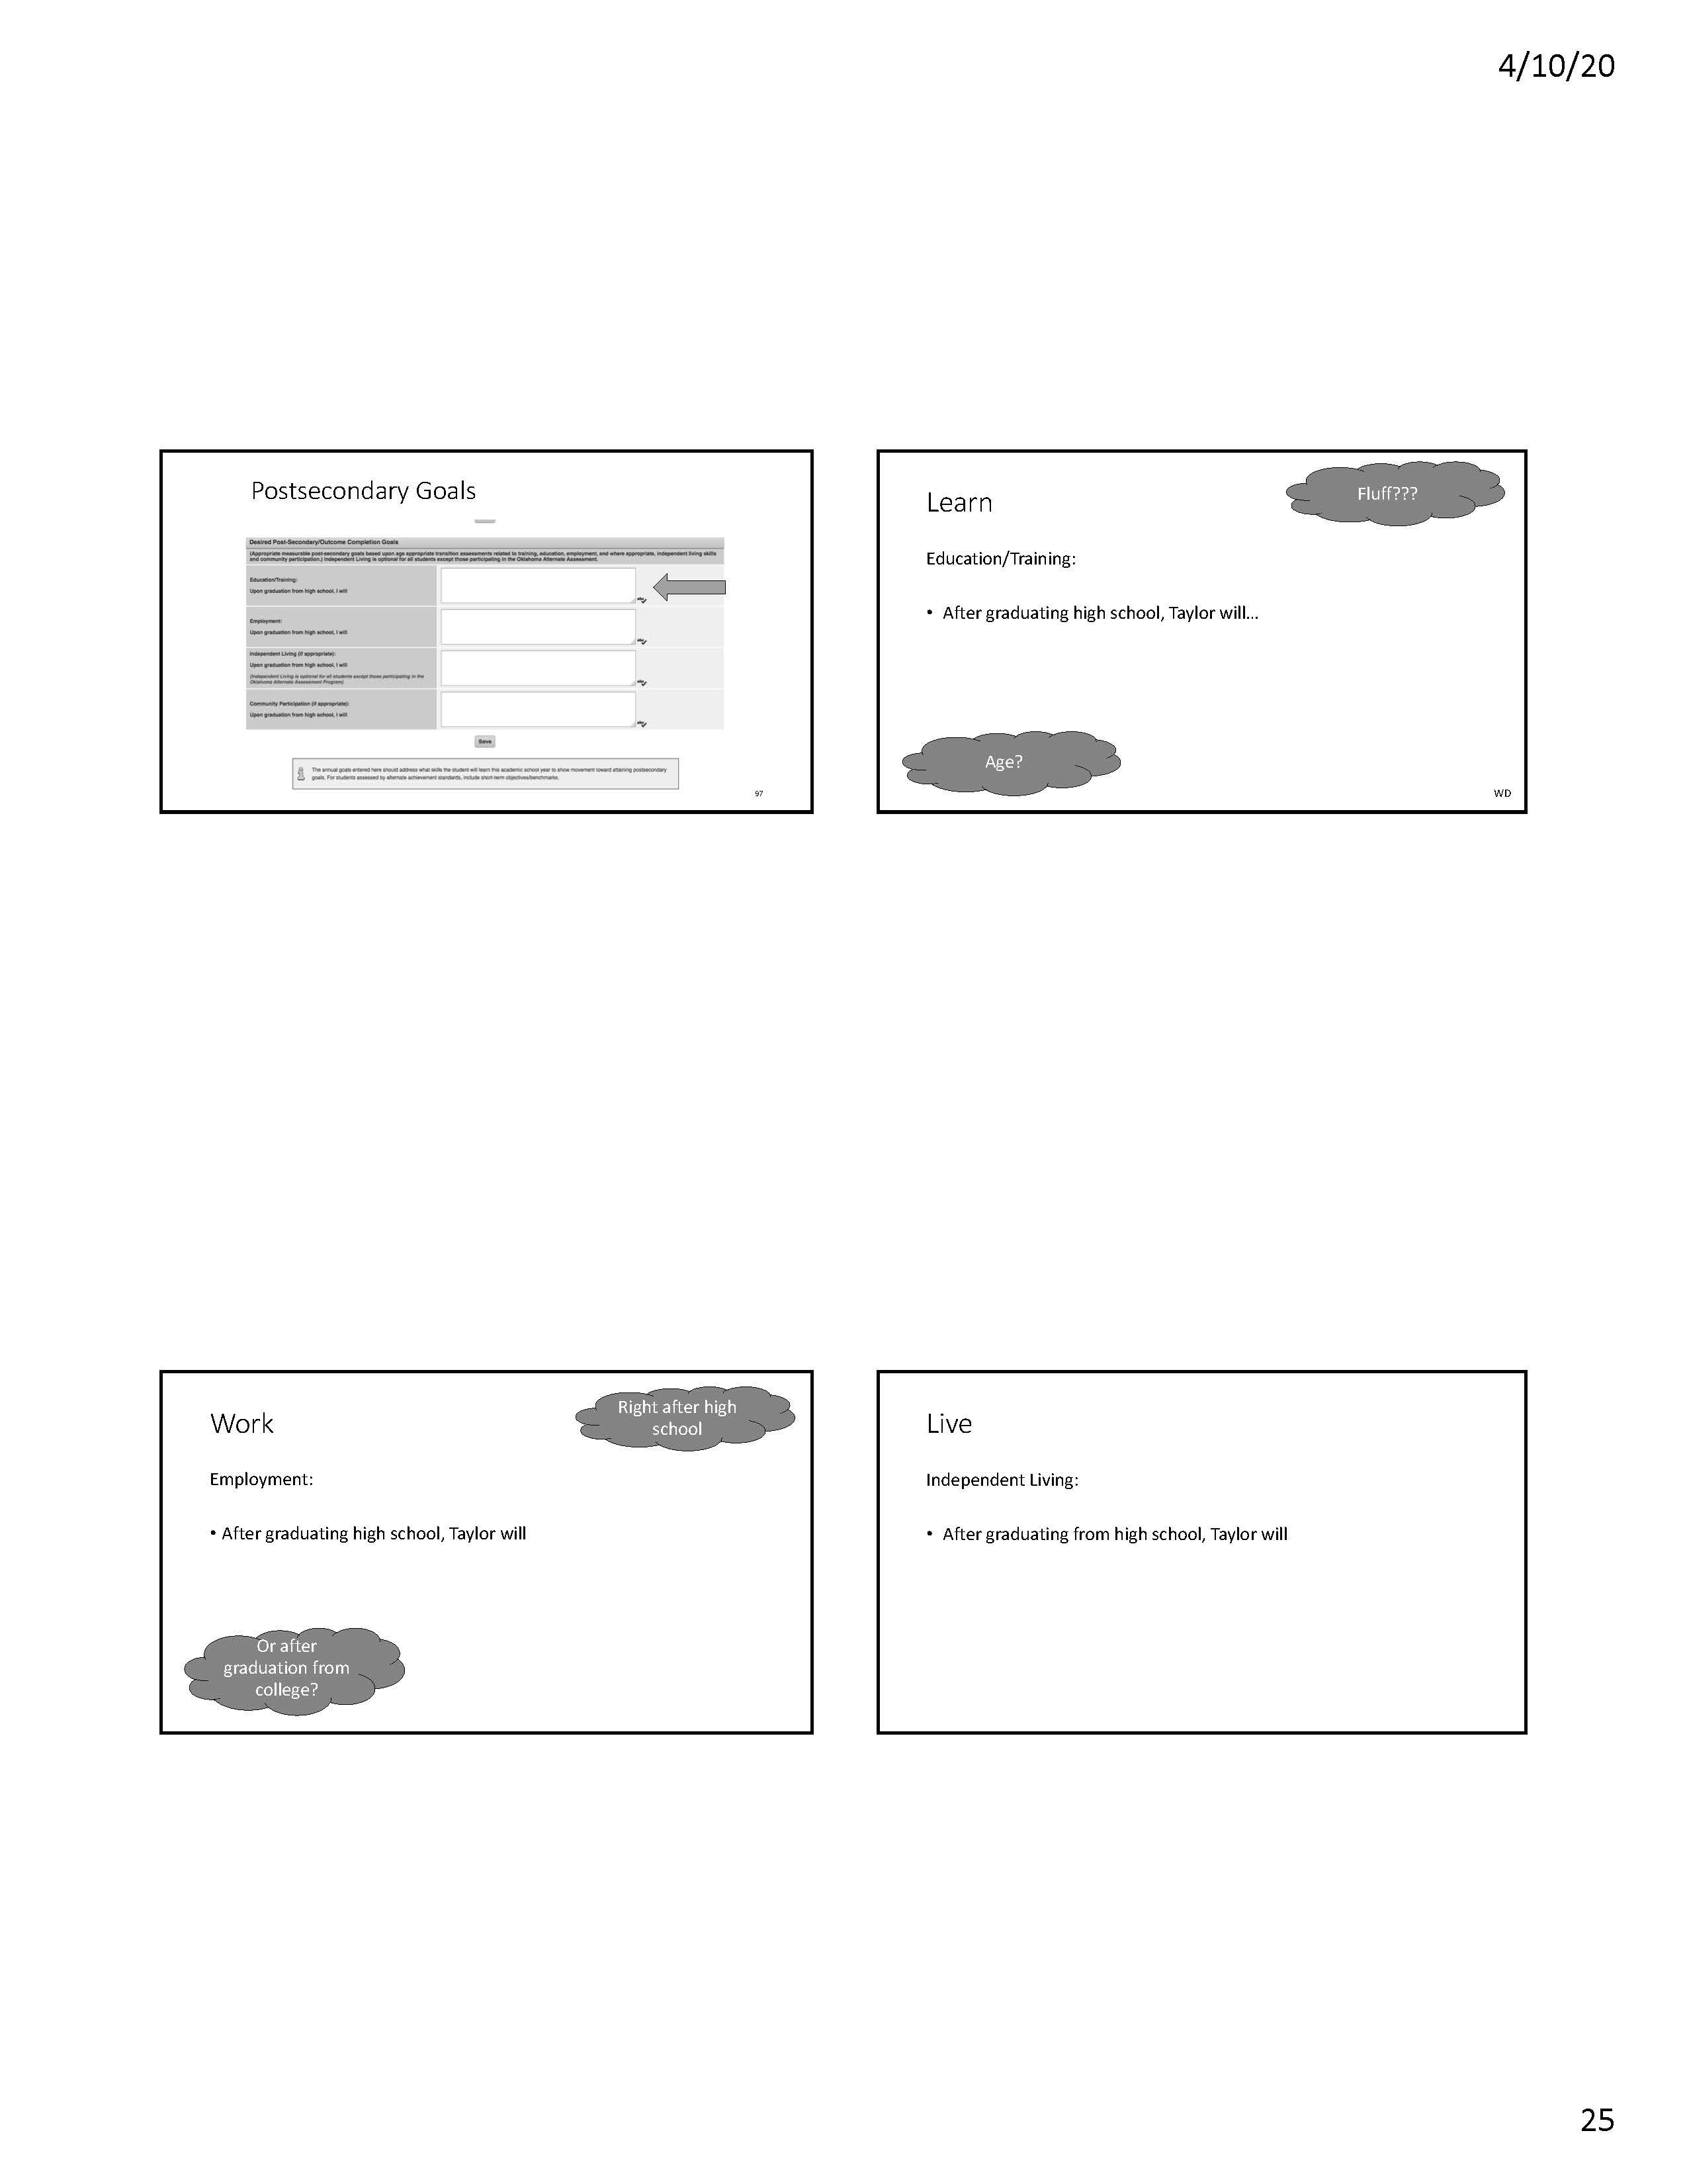

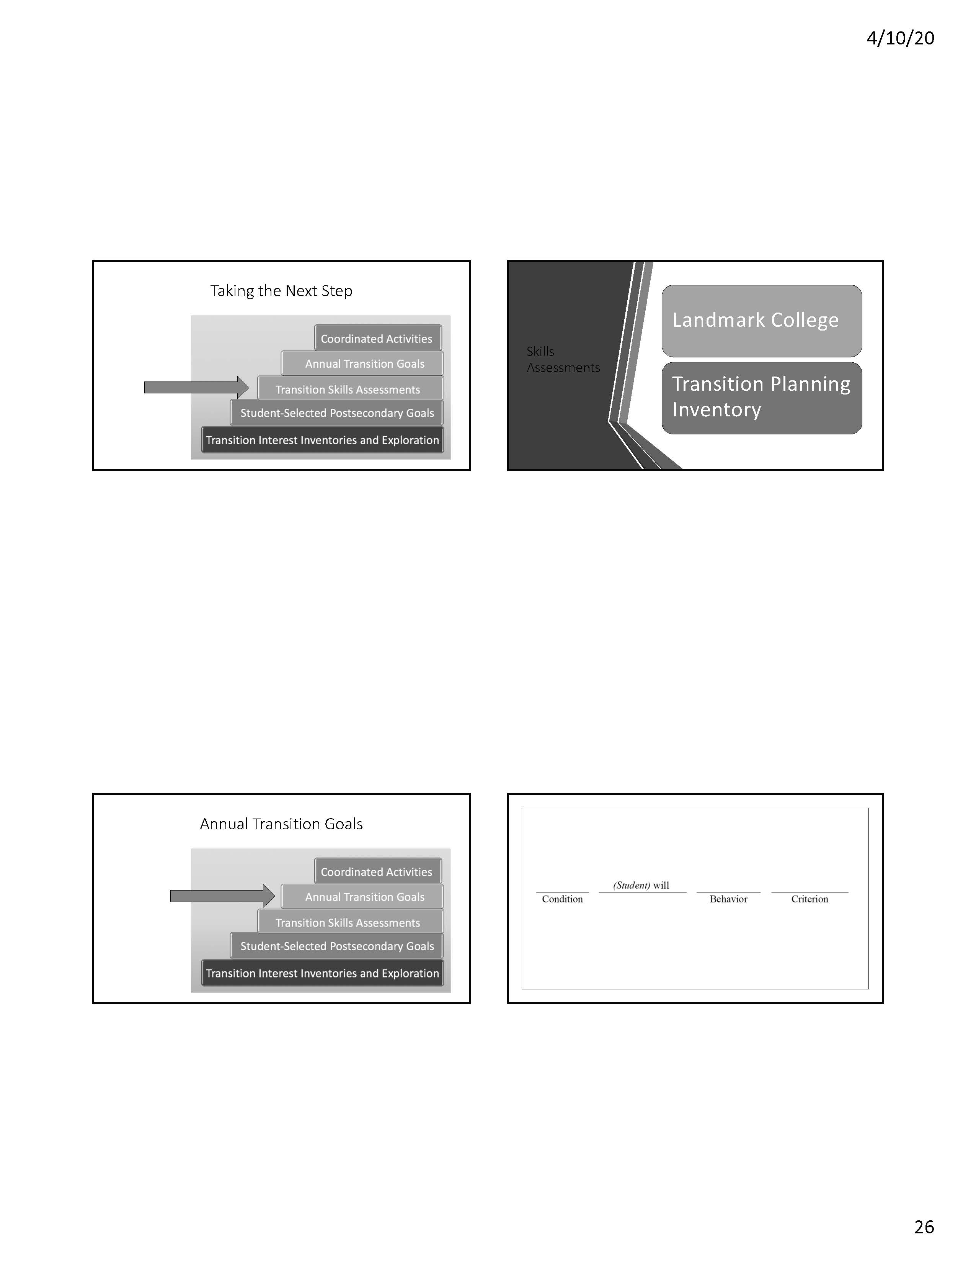
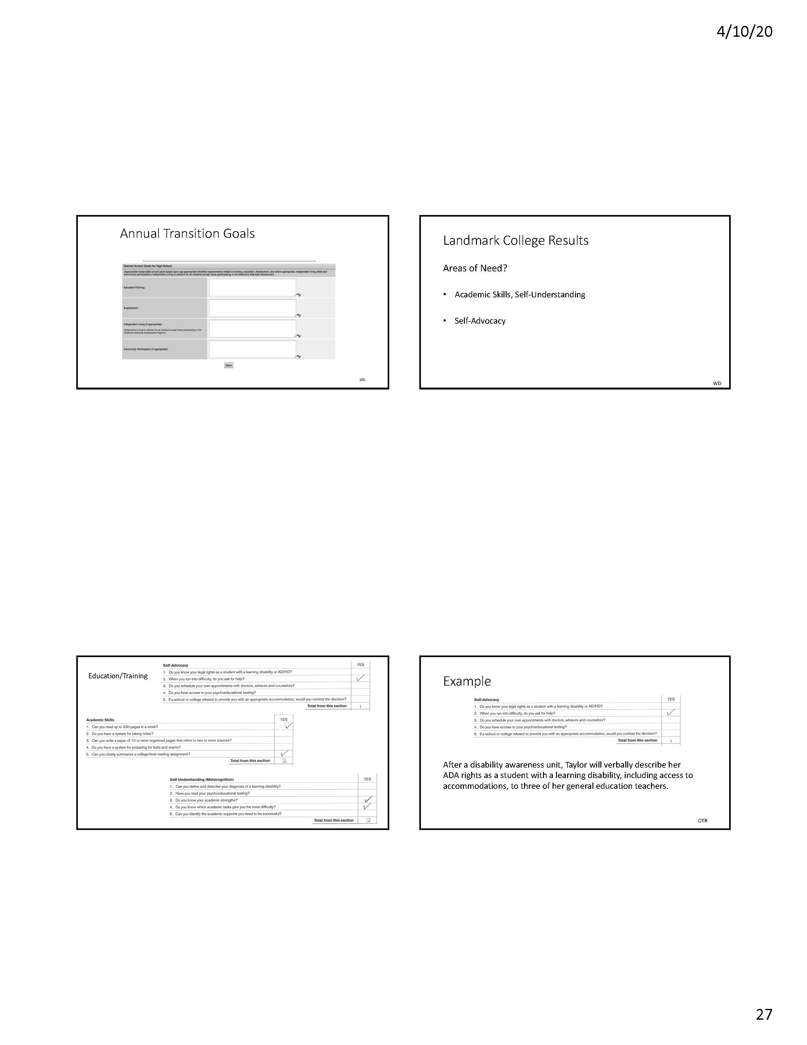

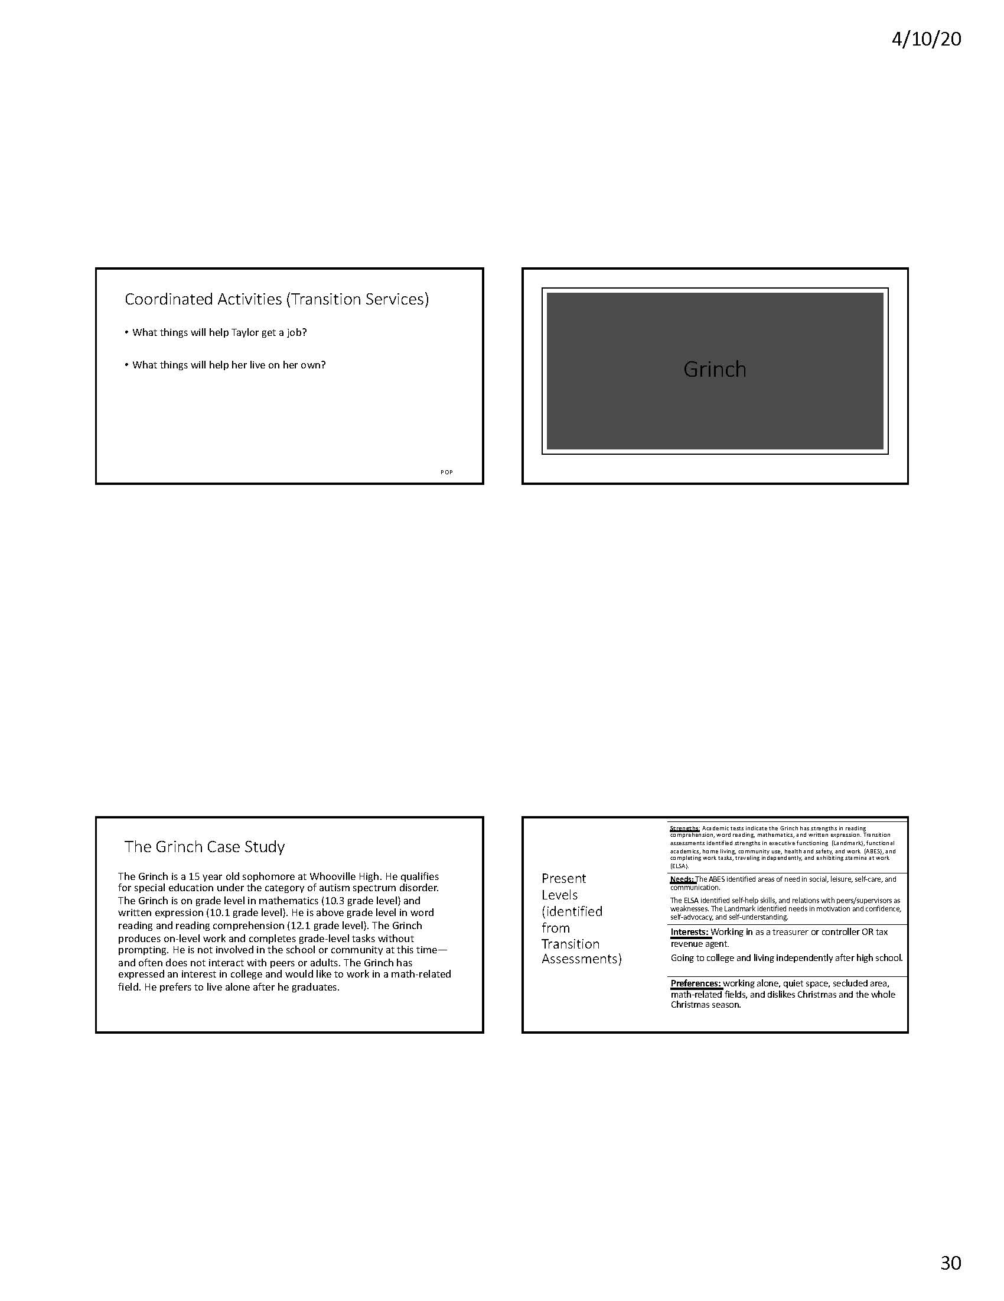

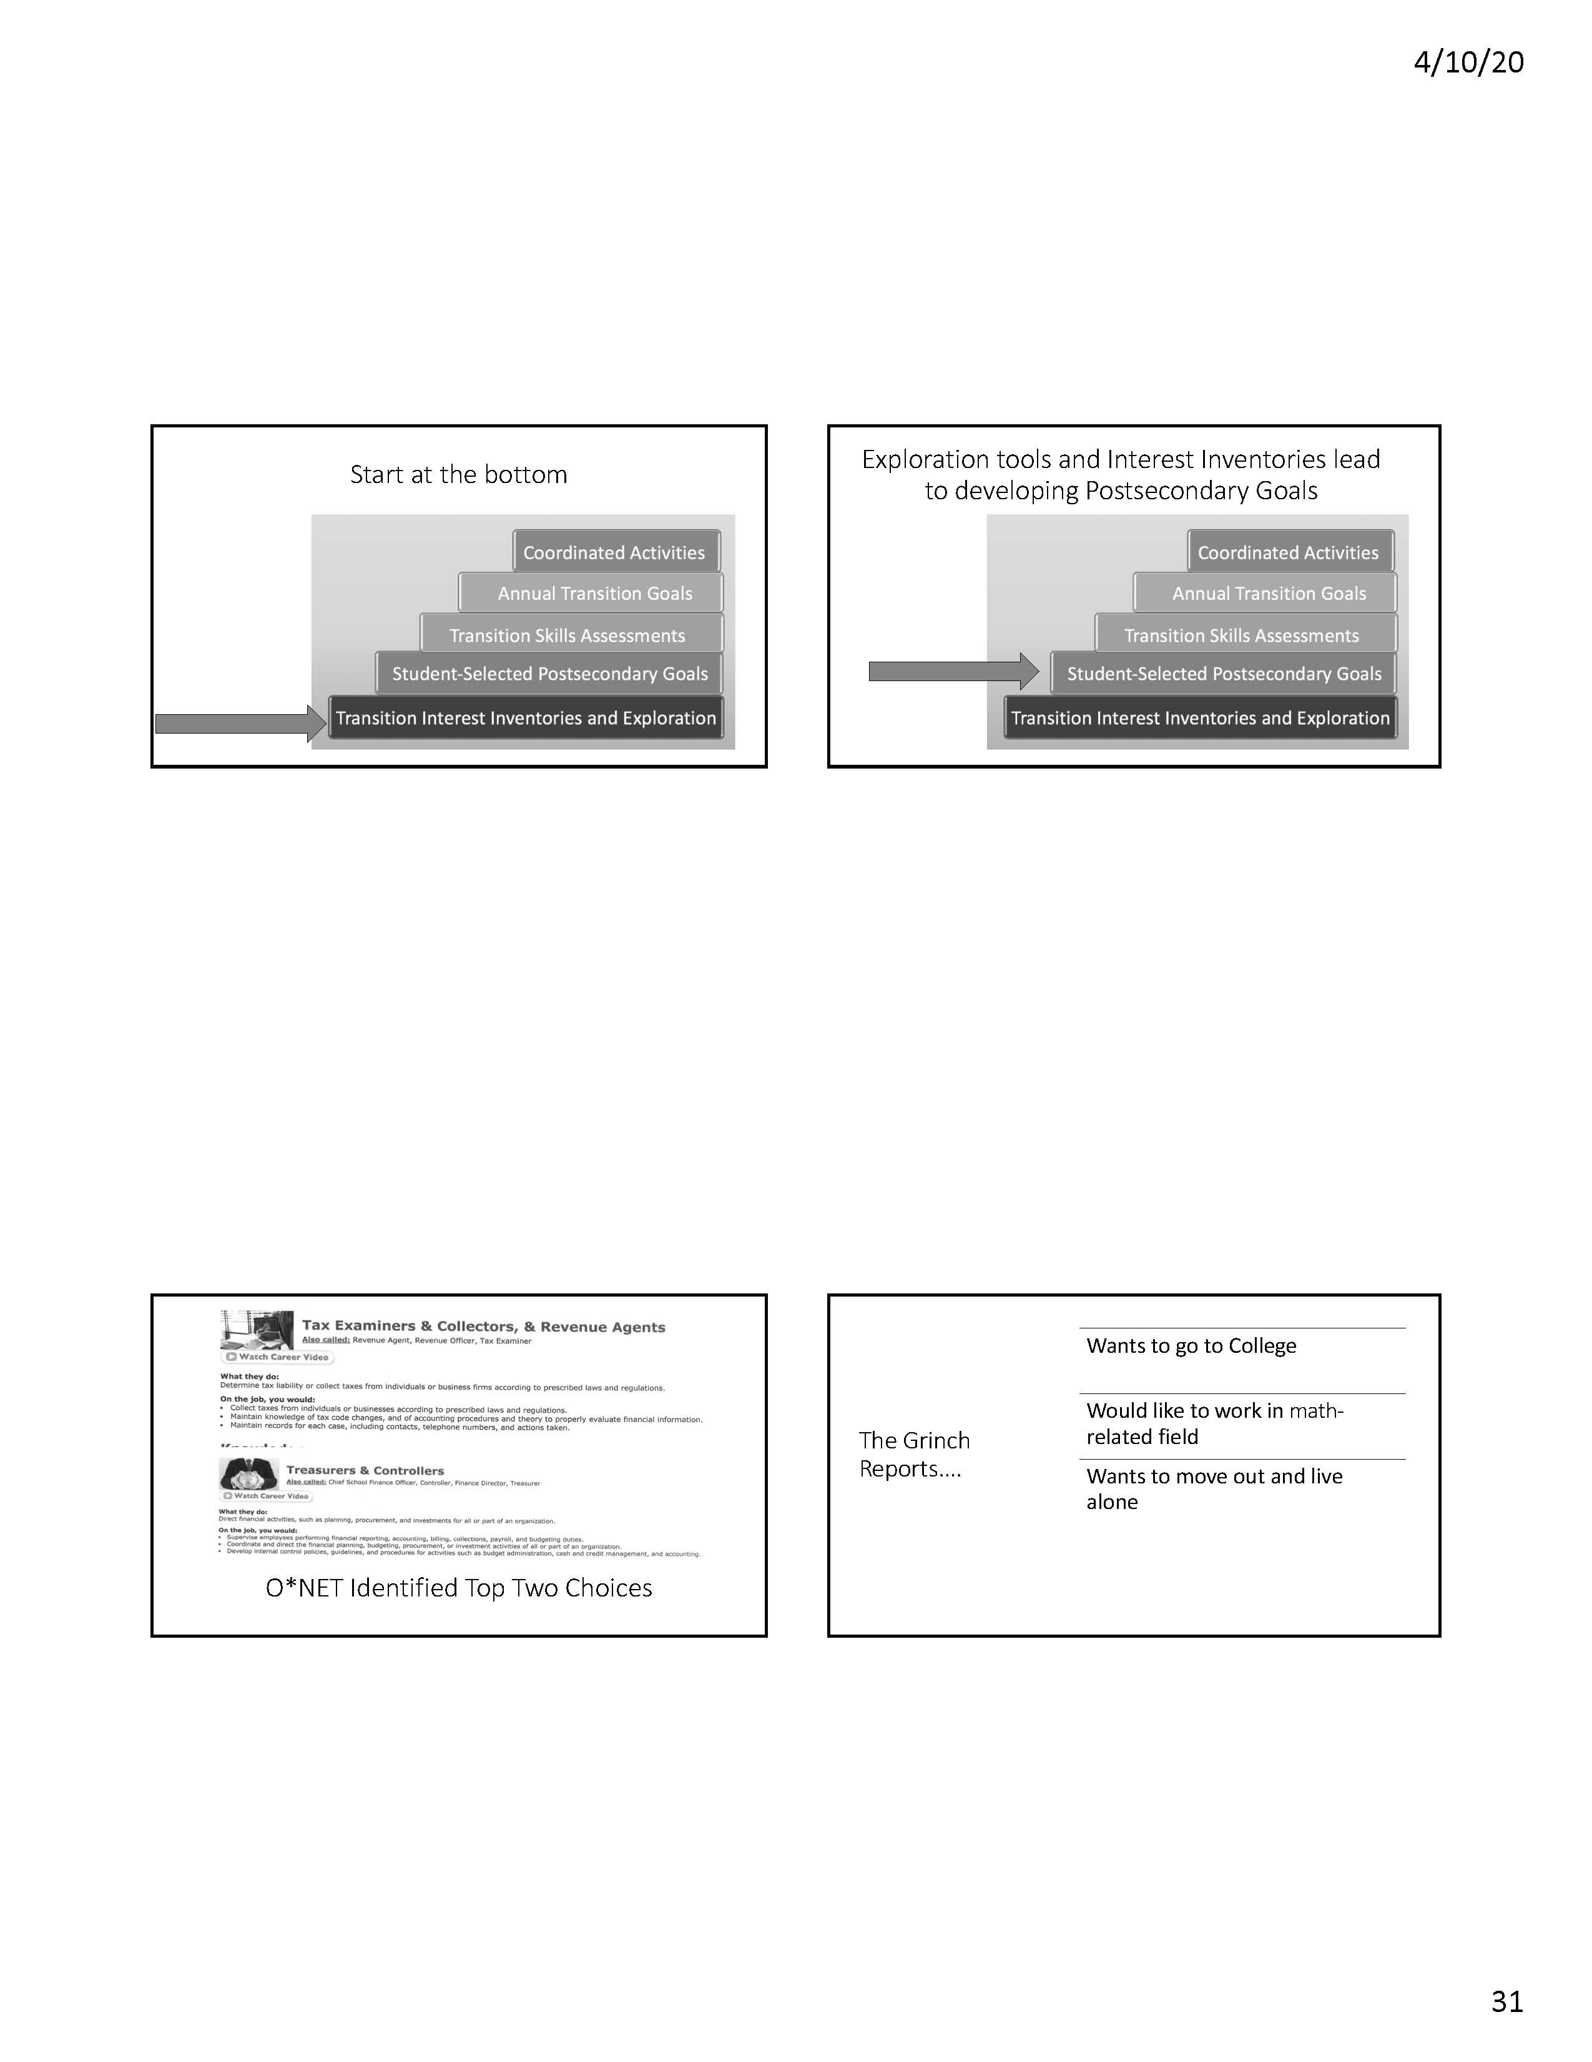

*Note Stepping-Up Intervention stopped after first slide of this page.
Appendix B

Appendix C

