UNIVERSITY OF OKLAHOMA
GRADUATE COLLEGE

THE INFLUENCE OF THE PRESEASON TRAINING PHASE ON ENDOCRINE BIOMARKERS AND NEUROMUSCULAR PERFORMANCE IN COLLEGIATE BASKETBALL PLAYERS

A THESIS
SUBMITTED TO THE GRADUATE FACULTY
in partial fulfillment of the requirements for the
Degree of
MASTER OF SCIENCE

By
KELDON MICHAEL PEAK
Norman, Oklahoma
2022
THE INFLUENCE OF THE PRESEASON TRAINING PHASE ON ENDOCRINE BIOMARKERS AND NEUROMUSCULAR PERFORMANCE IN COLLEGIATE BASKETBALL PLAYERS

A THESIS APPROVED FOR THE
DEPARTMENT OF HEALTH AND EXERCISE SCIENCE

BY THE COMMITTEE CONSISTING OF

Dr. Michael Bemben

Dr. Debra Bemben

Dr. Daniel Larson

Dr. Aaron Heishman

© Copyright by KELDON MICHAEL PEAK 2022
All Rights Reserved

Acknowledgements
I am so blessed to have been able to collaborate or be supported by those who surrounded this process. First, I would like to thank my academic mentor and committee chair, Dr. Michael Bemben, whose pushed me to always want to do more and his mentorship has been vital during this time. Also, the autonomy you allowed in this pursuit and the impact our student athletes will benefit from is very appreciated. This opportunity not only developed me as a scientist and researcher, but also as an applied performance practitioner.
Thank you to the rest of my committee, Dr. Debra Bemben, Dr. Daniel Larson, and Dr. Aaron Heishman for the support and guidance you have provided throughout this process. The unique insights throughout the project, as well as the knowledge in the classroom and wisdom through experiences to develop myself and the completion of this project has had such a large impact.
I have also been very fortunate to have Dr. Aaron Heishman as a very close mentor through this academic process as well as the applied setting. You have displayed an unbelievable
competitiveness and drive to always do more. I am very grateful for the relationship we have built over the past few years and am looking forward to continue learning from you.
Another great mentor has been Coach Bryce Daub in the applied setting, academics, and life advice. You have guided and supported me in many different ways and provided countless opportunities for me to grow. I have been lucky to be exposed to an elite level of training and gain valuable experience. I am forever grateful for the willingness and commitment you have demonstrated to developing myself as a young professional.
To my parents, Candi and Donnie Peak, and brothers, Byron and Quinton Peak, I am so thankful for your support and encouragement during this process. The values all of you have instilled in me throughout my childhood and as a young adult have prepared me to achieve anything in life. The discipline, determination, and competitiveness all of you have exhibited have always been able to provide me with any opportunity and has shown me to always put forth everything you have. I would never have been able to complete this without all of your sacrifices and lessons through life. Again, I am so thankful to have you all in my life.
Finally, to Raelyn for being the most supportive, patient, and loving through this entire process. I am so blessed to have you in my life and caring for me with all the sacrifices you have made and still are making. Your ability to constantly show up for me and even hold me to a higher standard is truly remarkable. You always are pushing me and wanting the absolute best for me. I am truly lucky to have you and words cannot describe what you mean to me and I am just so thankful for you and I couldn’t have done any of this without you.

Table of Contents
Acknowledgements iv
List of Tables xi
List of Figures xii
Abstract xiii
Chapter I: Introduction 1
Purpose of the Study 5
Research Questions 5
Research Hypotheses 5
Significance of the Study 6
Delimitations 6
Limitations 7
Assumptions 7
Operational Definitions 7
List of Abbreviations 11
Chapter II: Review of Literature 13
Training Strain vs Recovery Continuum 13
Monitoring Athlete Training Loads 14
External Training Load 14
Internal Training Load 18
Endocrine Responses to Training 20
Testosterone 21
Cortisol 22
T:C Ratio 23
Collection Techniques 24
Acute Endocrine Responses 24
Longitudinal Endocrine Responses 25
Assessment of Neuromuscular Performance 26
Countermovement Jump 26
Monitoring Neuromuscular Responses with the Countermovement Jump 26
Summary 28
Chapter III: Methodology 29
Study Design 29
Participants 30
Inclusion Criteria 30
Exclusion Criteria 31
Questionnaires and Documentation 31
Informed Consent 31
Health Insurance Portability and Accountability Act 31
Anthropometric Measurements and Familiarization 31
External Load Monitoring of Sport Specific Training Exposures 32
Internal Load Monitoring of Sport Specific Training Exposures 33
Countermovement Jump Testing 33
Endocrine Measures 34
Dietary Restrictions 36
Statistical Analyses 36
Chapter IV: Results and Discussion 38
Results 38
Participant Anthropometrics 38
Training Loads During the Preseason Training Phase 38
External Training Load 38
Internal Training Load 42
Countermovement Jump (CMJ) Results 44
CMJ Performance Results Relative to Body Mass 48
Endocrine Response Results 49
Testosterone 50
Cortisol 50
Testosterone:Cortisol Ratio 51
Discussion 58
External Training Load 58
Internal Training Load 59
Countermovement Jump 60
Countermovement Jump Relative to Body Mass 60
Endocrine Responses 61
Chapter V: Conclusion 65
Research Questions 65
Research Question 1 65
Hypothesis 1 65
Research Question 2 65
Hypothesis 2 66
Research Question 3 66
Hypothesis 3 67
Research Question 4 67
Hypothesis 4 67
Practical Significance 67
Suggestions for Future Research 68
References 69
Appendices 87
Appendix A: IRB Approval Letter 87
Appendix B: Informed Consent 89
Appendix C: HIPAA 91
Appendix D: Oklahoma Men’s Basketball Letter of Support 94
Appendix E: Rating of Perceived Exertion Chart 95
Appendix F: Salivary Collection 96

List of Tables
Table 1. Differences in External Training Load through the Preseason. 40
Table 2. Differences in Internal Training Load through the Preseason. 43
Table 3. Countermovement Jump Descriptive Statistics. 47
Table 4. Countermovement Jump Descriptive Statistics Relative to Body Mass. 49
Table 5. Endocrine Baseline Measurements. 53
Table 6. Endocrine Responses throughout the Preseason. 54
Table 7. Absolute Change Scores in Endocrine Responses throughout the Preseason. 56
Table 8. Percent Change Scores in Endocrine Responses throughout the Preseason. 57

List of Figures
Figure 1. Diagrammatic Representation of the Research Design. 30
Figure 2. Inertial Measurement Unit (IMU) Placement. 32
Figure 3. Differences in Duration of Training Between Week 39
Figure 4. Differences in External Training Loads between Week 41
Figure 5. Differences in Objective Internal Training Loads Between Week 42
Figure 6. Differences in Subjective Internal Training Loads Between Week 43
Figure 7. Differences in Countermovement Jump Performance Between Weeks 44
Figure 8. Differences in Countermovement Jump Performance Between Weeks 45
Figure 9. Differences in Countermovement Jump Performance Between Weeks 46
Figure 10. Endocrine Baseline Assessments 53
Figure 11. Endocrine Responses Across Time 54
Figure 12. Individual Endocrine Responses Across Time 55
Figure 13. Endocrine Absolute Changes Across Time 56
Figure 14. Endocrine Relative Changes Across Time 57

Abstract
Introduction: Elite athletes undergo vigorous training in the effort to initiate physiological responses that over time accumulate to cause positive adaptation, which result in improvements in physical performance. The training stimuli elicit responses from the endocrine and neuromuscular systems that play a part in adaptations and states of recovery. Approaches have been used to monitor the status of the athletes including observing changes in biochemical markers or neuromuscular performance. The preseason is thought to be very strenuous on the players in that they are in the midst of academic stressors as well as the physically taxing nature of the sport in parallel with energy system development and resistance training in preparation to build the resiliency for the duration of the season. Monitoring biochemical markers in conjunction with neuromuscular performance may provide useful information for the evaluation of recovery and strain of the athlete. Coupling the measurements of testosterone (T) and cortisol (C) for hormonal analyses and a sport specific performance test may enhance capacities as a performance practitioner to adjust training sessions in the attempt to enable optimal recovery and positive adaptations. Purpose: The primary purpose of this study was to evaluate changes in biochemical markers, specifically Testosterone and Cortisol, and the Testosterone:Cortisol (T:C) ratio, as well as neuromuscular performance over the course of the preseason. Methods: This retrospective study included 15 male NCAA Division I basketball players that participated in sport specific training sessions in the preseason training phase. Participants provided written informed consent for their data to be included in the analyses, de-identified data was given to the research team by the athlete performance staff for analysis. Participants provided a salivary sample on a day of no activity that served as the baseline assessment sample. Prior to practice, participants provided a salivary sample used to assess T, C, and T:C ratio as well as performed 3 CMJs on a dual cell force platform to evaluate neuromuscular performance. Following practice, participants provided another salivary sample and performed 3 more CMJs. Participants returned at the end of the preseason training phase four weeks later where they repeated the activities prior to practice and at the conclusion of practice. The eTL of each practice was captured through IMU devices and iTL was assessed through HR monitors and RPE scales. Statistical Analyses: Data normality was confirmed through the Shapiro-Wilk test statistic. The data was also tested for sphericity through Mauchly’s test to confirm variance in differences were similar between groups. If the data indicated the assumption of sphericity is violated through Mauchly’s Test of Sphericity, then the Greenhouse-Geisser correction was used to combat the violation. A paired t-test was used to evaluate the within subject differences in eTL parameters as well as iTL parameters across time. A two-way (Week [Week 1, Week 4] × Time [Pre-Practice, Post-Practice]) repeated measures (RM) analysis of variance (ANOVA) was used to examine Week and Time main effects and the interaction between week and time in CMJ variables. Additionally, the two-way RM ANOVA was used the evaluate the salivary endocrine measures. Statistical significance was set at p ≤ 0.05. If a significant interaction was determined, a Bonferroni post hoc analysis was performed to isolate simple main effects. When comparing two groups, Cohen’s d (d) effect sizes were utilized and interpreted as trivial (0 – 0.19), small (0.20 – 0.49), medium (0.50 – 0.79), and large (≥ 0.80). The intra- and inter-assay reliability of the hormone assay duplicates were evaluated using the coefficient of variation (CV%). Results: While not practically significant, the only significant difference seen in eTL was Duration, otherwise there were no significant differences observed in eTL or iTL between weeks. There were significant differences in CMJ variables, including EccMF, ConcPF, and Body Mass. For EccMF and Body Mass, the average of the Pre values from Week 1 and Week 4 were significantly lower than the average of the Post values from Week 1 and Week 4. In addition, ConcPF displayed a significant increase from Pre to Post in Week 1 but not in Week 4. However, when the CMJ performances were made relative to Body Mass, no significant differences were exhibited. No significant differences emerged in comparison across the Baseline Assessment and Pre values to examine the influence of an anticipatory effect. Although, T and C both displayed an increase in concentration of the average of the Pre values from Week 1 and Week 4 to the Post values from Week 1 and Week 4. Furthermore, C presented a significant increase from Pre to Post in Week 1, however, this was not apparent in Week 4. Moreover, the absolute change in C levels from Pre to Post in Week 1 was significantly higher than the absolute change produced in Week 4. The T:C ratio showed a significant increase from Week 1 Post to Week 4 Post. Also, the T:C ratio absolute and relative change experienced from Pre to Post in Week 1 was significantly lower than the absolute and relative change from Pre to Post in Week 4. Conclusion: These findings suggest neuromuscular performance remains unaltered over a single training exposure as well as throughout the preseason training phase in relation to body mass. Additionally, the cortisol response following four weeks of the preseason training phase showed to be blunted with the testosterone response unchanged resulting in a more anabolic state while examining the T:C ratio. Therefore, monitoring of physiological status may be of interest to gain insight of whether or not an individual is approaching concerning levels.

Chapter I: Introduction
Elite athletes undergo vigorous training in the effort to initiate physiological responses that over time accumulate to cause positive adaptation, which result in improvements in physical performance (Smith, 2003). For example, basketball is a dynamic sport involving anaerobic capacities such as reactionary explosiveness, strength, and with the intermittent nature of the sport an aerobic capacity for recovery between bouts as well (T. Edwards et al., 2018; Montgomery et al., 2010; Schelling & Torres, 2016; Stojanović et al., 2018). In preparation for the demands throughout the lengthy season, athletes undergo strenuous training sessions, which primarily include sport specific practice sessions, but also include sessions directed at enhancing strength and energy system performance. The intensity and duration of the sessions will fluctuate throughout the year, as well as the emphases of both the physical and skill components for the athletes. Training responses are thought to coincide with the general adaptation syndrome (GAS) model described by Hans Selye (Selye, 1950). Each stressor acts as the stimulus generated throughout the various training sessions, and will initiate the first step within the GAS model, the alarm stage. In this stage there is a perturbation from resting levels in the physiological areas being stressed that leads to a bout of suppression in performance. This stage is followed by the resistance stage, where if there is enough resources and time are available for recovery to take place, the athlete will resist the deficit associated with the suppression of performance and will return towards baseline levels again. The organism attempts to develop adaptations to ensure if the stimulus is encountered again, that it will be less of a deviation from baseline. If a large enough stimulus is received and the time for recovery is sufficient then there can even be positive improvements in performance that supersede original baseline levels, known as the stage of supercompensation. In contrast, if the stimuli is too large or there is not enough time and resources for recovery to take place then the stage of exhaustion can be reached where performance becomes compromised. This GAS model introduces the concept of a dose-response format in that the magnitude of each stimuli, thought of in terms of the volume, intensity, and duration as it related to exercise, will impose a demand on the systems, where depending on the magnitude of the stimulus, can determine the rate of recovery and magnitude of adaptation, albeit where supercompensation or exhaustion may occur.
The training stimuli elicit responses from the endocrine and neuromuscular systems that play a part in adaptations and states of recovery. Approaches have been used to monitor the status of the athletes including observing changes in biochemical markers or neuromuscular performance. Biochemical changes reflecting alterations in homeostatic function may help allude to athletes’ positions in the recovery-adaptation continuum. A majority of the studies seeking to monitor the endocrine responses have used serum or plasma, but recently more studies have shown that collection of saliva shows to be a non-invasive method that correlates well with blood values, representing the biologically active portion of the hormone (Baxendale et al., 1982; Gozansky et al., 2005; Johnson & Joplin, 1987; Lippi et al., 2009; Papacosta & Nassis, 2011; Rantonen et al., 2000). This allows for a large collection of samples to be collected with minimal time expenditure, medical training, and interference of the athletes training schedules (Gaviglio & Cook, 2014; Papacosta & Nassis, 2011). The biochemical markers that have been of interest in describing that state of metabolism of an individual are Testosterone (T) and Cortisol (C) due to the anabolic and catabolic effects and processes of each that may relate to the current position of the athlete on the recovery-adaptation continuum. Testosterone (T), an androgenic steroid hormone, is involved in the support of protein synthesis as well as muscular strength, therefore is thought to be associated with the state of anabolism (Kraemer, 1988; Kraemer et al., 2020; Kraemer & Ratamess, 2005). In contrast, Cortisol (C) is a glucocorticoid steroid hormone that is typically seen to be responsive to physical and psychological stressors and is associated with the state of catabolism (Kraemer & Ratamess, 2005). Together, both of these hormones are anticipated to react to human competition from the associations with T and aggression and social status and C with the various stressors encountered within sport. The magnitude of responses of these hormones have been shown to be indicative of the intensity as well as the duration of the training sessions (Hackney & Lane, 2015). Assessment for these two hormones coupled together create the anabolic:catabolic balance known as the T:C ratio (Andre et al., 2018; Kraemer, 1988; Kraemer et al., 2009). The balance in each of these hormones may help determine the effects of training or stressors encountered and if sufficient recovery has allowed for positive adaptation to occur within the individuals. With prolonged imbalances of hormonal secretion persists then potentials for detrimental effects on performance can be reached (Kraemer & Ratamess, 2005). In particular, elite athletes participating in sport are important to focus on in order to allow adaptations to occur over training phases and sufficient recovery from each stimulus to keep from reaching states of overtraining. For example, basketball undergoes various training phases in relation to the construct of their season schedule. Previous research has focused on longitudinal evidence across the entire collegiate basketball season (Andre et al., 2018) but limited evidence have specifically examined acute changes in hormone concentrations of a single basketball session or chronically over the course of an isolated training phase, such as the preseason. The preseason is thought to be very strenuous on the players in that they are in the midst of academic stressors as well as the physically taxing nature of the sport in parallel with energy system development and resistance training in preparation to build the resiliency for the duration of the season.
Management and the assessment of the training stimuli and the effects of previous sessions or over the course of a training phase in order to allow recovery or observe adaptation has been very popular recently. This has been shown through the use of both force plates and biomarkers. The countermovement jump (CMJ) is a frequently used applied performance measure that allows for the assessment of neuromuscular changes in response to acute training sessions as well as tracking over the course of a training phase. This method is widely used due to the ease of the athlete to perform as well as time efficiency. The testing is commonly utilized in the attempt to observe changes in neuromuscular performance that may relay information of fatigue or even improvements over time. Previous literature has shown a relationship exists between chronically elevated Cortisol concentrations and diminished CMJ performance (Balsalobre-Fernández et al., 2014). Limited evidence exists over collecting and assessing the biochemical markers in an anticipated reflection of the recovery state of the athlete in parallel with performance data gathered from the CMJ over acute bouts of basketball specific training sessions and over the preseason training phase.
Monitoring biochemical makers in conjunction with neuromuscular performance may provide useful information for the evaluation of recovery and strain of the athlete. Coupling measurements of hormonal analyses and a sport specific performance test may enhance capacities as a performance practitioner to adjust training sessions in the attempt to enable optimal recovery and positive adaptations. Therefore, the purpose of this retrospective study was to examine acute and chronic measurements of salivary biochemical markers and neuromuscular performance in elite male NCAA Division I basketball players over the course of the preseason.

Purpose of the Study
The primary purpose of this study was to evaluate changes in biochemical markers, specifically salivary T and C, and the T:C ratio, as well as neuromuscular performance over the course of the preseason.

Research Questions
- Are there significant differences in salivary Testosterone, salivary Cortisol, or salivary Testosterone:Cortisol ratio pre- and post- basketball practice sessions?
- Are there significant differences in salivary Testosterone, salivary Cortisol, or salivary Testosterone:Cortisol ratio pre- and post- basketball preseason training phase?
- Are there significant differences in countermovement jump performance pre- and post- basketball specific training session?
- Are there significant differences in countermovement jump performance pre- and post- basketball preseason training phase?

Research Hypotheses
- It was hypothesized that there would be a significant increase in salivary Cortisol following both basketball sessions in accordance with previous literature (Arruda et al., 2014). Additionally, no significant differences would exist within salivary Testosterone and salivary Testosterone:Cortisol ratio after each basketball specific training session similarly reported by (Andre et al., 2018; Hoffman et al., 1999).
- It was hypothesized that there would be a significant increase in salivary Testosterone:Cortisol ratio, a significant decrease in salivary Cortisol concentration, and no differences would exist within salivary Testosterone concentrations following the preseason training phase in parallel with (Andre et al., 2018).
- It was hypothesized that there would be significant decreases in countermovement jump performance from pre- to post- basketball specific training sessions.
- It was hypothesized that there would be significant increases in countermovement jump performance from pre- to post- of the preseason training phase.

Significance of the Study
Monitoring and assessing endocrine responses and neuromuscular performance over the course of acute bouts in basketball specific training sessions as well as the preseason training phase can provide insight into the physiological status of athletes during the specific training phase. This will help to emphasize the incorporation or enhancement of periodization schemes being used to allow for either stronger stimuli or better assembly for a reduction in volume. Therefore, assessing performance data while interpreting endocrine responses can provide useful information in the evaluation of the magnitude of stimulus imposed within the training phase, while also examining the recovery windows. The culmination of this information will assist in optimizing the appropriate stress placed upon the athletes which can ultimately lead to avoiding over or under-training.

Delimitations
- The participants were members of the Men’s Basketball squad at the University of Oklahoma.
- Participants were between 18 and 25 years of age.
- Participants were free of recent musculoskeletal injury.
- Basketball training sessions were performed in the team setting to maximize ecological validity.

Limitations
- Participants enrolled in this retrospective study were of a convenience sample of collegiate basketball players at the University of Oklahoma.
- These results are only generalizable to men’s collegiate basketball players.
- Dietary compliance was not controlled outside of the testing environment.

Assumptions
- Participants gave maximal effort on countermovement testing.
- Participants maintained normal dietary intake governed by the team’s sport dietician.
- Participants only consumed water 60 minutes prior to all salivary sample collection.

Operational Definitions
- Concentric Mean Force [N] (ConcMF): Mean force during the concentric phase (A. Heishman, Daub, et al., 2020; A. Heishman et al., 2019).
- Concentric Mean Power [W] (ConcMP): Mean power during the concentric phase (A. Heishman, Daub, et al., 2020; A. Heishman et al., 2019).
- Concentric Peak Force [N] (ConcPF): Greatest force achieved during the concentric phase (A. Heishman, Daub, et al., 2020; A. Heishman et al., 2019).
- Contraction Time [ms] (CT): Duration from jump initiation to take-off (A. Heishman, Daub, et al., 2020).
- Cortisol (C): A steroid hormone of the glucocorticoid family that represents the state of catabolism and is associated with decreases in protein synthesis and increases in protein degradation (Kraemer & Ratamess, 2005).
- Countermovement Jump (CMJ): A form of vertical jump in which the participant starts tall and drops to a self-selected depth before maximally vertically displacing in the air (A. Heishman, Daub, et al., 2020).
- Eccentric Mean Braking Force [N] (EccMBF): Mean force during the eccentric braking phase from minimum force to zero velocity at the end of the eccentric phase (A. Heishman, Daub, et al., 2020).
- Eccentric Mean Deceleration Force [N] (EccMDecF): Mean force during the eccentric braking phase from minimum force to zero velocity (A. Heishman, Daub, et al., 2020).
- Eccentric Mean Force [N] (EccMF): Mean force during the eccentric phase from start of movement to zero velocity (A. Heishman, Daub, et al., 2020).
- Eccentric Mean Power [W] (EccMP): Mean power during the eccentric phase from start of movement to zero velocity (A. Heishman, Daub, et al., 2020).
- Eccentric Peak Force [N] (EccPF): Greatest force achieved during the eccentric phase (A. Heishman, Daub, et al., 2020).
- Eccentric Peak Power [W] (EccPP): Greatest power achieved during the eccentric phase (A. Heishman, Daub, et al., 2020).
- External training load (eTL): Referred to as the quantification of work completed by the athlete through their coordination of mechanics and locomotion as mechanical stress and is measured independent of the internal responses (Halson, 2014; A. Heishman et al., 2018).
- Flight Time [ms] (FT): Time spent in the air from jump take-off to landing (A. Heishman, Daub, et al., 2020).
- Flight Time:Contraction Time (FT:CT): The ratio of Flight Time (FT), defined as the time spent in air from jump take-off to landing, and a process variable, Contraction Time (CT), defined as the duration (ms) from jump initiation (start of movement) to take-off, in an attempt to evaluate the athlete’s jumping strategy (A. Heishman, Daub, et al., 2020; A. Heishman et al., 2019).
- Force at Zero Velocity [N] (F@0V): Force exerted at concentric onset (A. Heishman, Daub, et al., 2020).
- Inertial Measurement Unit (IMU): Microsensor incorporating an accelerometer, a gyroscope, and a magnetometer used to measure athlete movement and activity (A. Heishman, Miller, et al., 2020; A. Heishman, Peak, et al., 2020).
- Inertial Movement Analysis™ (IMA): instant one-step movement effort; distinct acceleration micro-movement events generated during sudden explosive movement bouts, such as accelerations, decelerations, and change of direction (CoD) movements and expressed as the number of occurrences (counts) (A. Heishman, Miller, et al., 2020; Holme, 2015).
- Internal training load (iTL): The relative biological response to a stimuli inflicted on the athlete (Halson, 2014; A. Heishman et al., 2018).
- Jump Height [cm] (JH): Maximal jump height computed using flight time methodology (A. Heishman, Daub, et al., 2020; A. Heishman et al., 2019).
- Peak Power [W] (PP): Greatest power achieved (A. Heishman, Daub, et al., 2020; A. Heishman et al., 2019).
- PlayerLoad™ (PL): Known as the square root of the sum of accelerations of the squared instantaneous rate of change in all orthogonal planes and divided by 100 to account for the scaling factor (Boyd et al., 2011).
- PlayerLoad^{1D-FWD} (PL^{1D-FWD}): PlayerLoad only accumulated in the anteroposterior plane of motion (A. Heishman, Peak, et al., 2020).
- PlayerLoad^{1D-SIDE} (PL^{1D-SIDE}): PlayerLoad only accumulated in the mediolateral plane of motion (A. Heishman, Peak, et al., 2020).
- PlayerLoad^{1D-UP} (PL^{1D-UP}): PlayerLoad only accumulated in the vertical plane of motion (A. Heishman, Peak, et al., 2020).
- PlayerLoad^{2D} (PL^{2D}): a formula variation of PlayerLoad™ which omits the vertical vector and only including the two dimensions of mediolateral and anteroposterior vectors and is expressed in arbitrary units (au) (A. Heishman, Miller, et al., 2020; A. Heishman, Peak, et al., 2020).
- Rating of Perceived Exertion (RPE): Athlete’s perception of the training session intensity, on a scale of 1 to 10 (Foster et al., 2001).
- Reactive Strength Index Modified [m•s⁻¹] (RSI_{mod}): Jump height (calculated from flight time) divided by contraction time (A. Heishman, Daub, et al., 2020; A. Heishman et al., 2019).
- Session Rating of Perceived Exertion (sRPE): The athlete’s perception of the training session intensity (scale 1-10), multiplied by the duration of the session.
- Testosterone (T): A steroid hormone in the androgen family that represents the state of anabolism and is associated with increases in protein synthesis and decreases in protein degradation (Kraemer & Ratamess, 2005).
- Testosterone:Cortisol (T:C) Ratio: The processes of anabolism and catabolism which reflect metabolism (Kraemer & Ratamess, 2005).

List of Abbreviations
C = Cortisol
Conc = Concentric
CT = Contraction Time
CMJ = Countermovement Jump
Ecc = Eccentric
eTL = External Training Load
FT = Flight Time
FT:CT = Flight Time:Contraction Time Ratio
IMA = Inertial Movement Analysis™
IMU = Inertial Measurement Unit
iTL = Internal Training Load
JH = Jump Height
PL = PlayerLoad™
PL^{1D-FWD} = PlayerLoad^{1D-FWD}
PL^{1D-SIDE} = PlayerLoad^{1D-SIDE}
PL^{1D-UP} = PlayerLoad^{1D-UP}
PL^{2D} = PlayerLoad^{2D}
RPE = Rating of Perceived Exertion
RSI_{Mod} = Reactive Strength Index-Modified
sRPE = Session Rating of Perceived Exertion
T = Testosterone
T:C = Testosterone:Cortisol Ratio

Chapter II: Review of Literature
The purpose of this retrospective investigation was to evaluate changes in endocrine responses across the preseason, which was investigated by understanding changes in the acute endocrine adaptive response to a bout of sport specific basketball practice, as well as changes in resting levels across the preseason. The compendium of this literature review investigates previous research on the importance in balancing the imposed stressors on elite athletes and their recovery. This may be enhanced through monitoring external and internal training loads to the imposed demands. Being able to monitor endocrine responses and neuromuscular performance in conjunction may be able to help provide insight into the metabolic states and potential fatigue the athletes are experiencing. The search was performed through search engines such as SportDiscus, PubMed, Medline (EBSCO), and Google Scholar. Some keywords or phrases entered were “endocrine response”, “neuromuscular performance”, and “training load”.

Training Strain vs Recovery Continuum
The balance between imposing demands of athletes in order to optimize the generation of positive adaptations and resist states of fatigue or in extreme cases, overtraining is vital to the health, well-being, and performance of athletes. A stimulus resulting in a certain degree of fatigue is a necessity to bring about adaptations to drive enhancements within performance (Noakes, 2000). This is in line with the General Adaptation Syndrome (GAS) model. The GAS model is the common reference of adaptive responses to training stimuli (Selye, 1950). The model follows a systemic three phase response starting with the alarm reaction stage elicited by a stimulus from stress or a nocuous agent, typically characterized by a training stimulus in sports, resulting in diminishments of physiological status (Cunanan et al., 2018; Selye, 1936). Following, the resistance stage will be represented by the body attempting to restore resting levels while producing positive adaptations to avoid suppression in homeostasis (Selye, 1937, 1950). Furthermore, enhancements within the physiological status is known as supercompensation, which can lead to additional positive adaptations and performances (Cunanan et al., 2018; Selye, 1950). Unfortunately, if the stress or nocuous agents imposed is too great to handle then the resistance stage will be unable to keep the physiological status from diminishing leading to the stage of exhaustion instead of supercompensation and maladaptation to potentially occur (Cunanan et al., 2018; Nimmo & Ekblom, 2007; Selye, 1936). Being able to monitor the components of training as well as the responses to training stimuli could be useful in determining their position within the adaptation-recovery continuum. This can be done through management of training loads in conjunction with assessing changes in endocrine biomarkers.

Monitoring Athlete Training Loads
The incorporation of athlete monitoring tools are becoming increasingly popular in team sports in the effort to quantify the amount of workload accumulated. The ability to track the biomechanical and physiological stress imposed through the training sessions can help to manage or inform the potential risks of injury or states trending towards overtraining. Therefore, being able to quantify the imposed demands and the responses can help to relay information of the athlete’s dose-response to the session. Additionally, longitudinal interpretation of the data can help determine whether there are positive or negative adaptations occurring relating to the effectiveness of the training (Akubat et al., 2014). However, due to the nature of basketball team sport play being reactive and intermittent, quantifying training loads during training sessions is challenging.

External Training Load
External training load (eTL) is referred to as the quantification of the work completed by the athlete through their coordination of mechanics and locomotion as mechanical stress and is measured independent of the internal responses to express the quantity of training completed (Halson, 2014; A. Heishman et al., 2018; A. Heishman, Peak, et al., 2020). This quantification provides the ability to examine dose-response relationships and allow for the manipulation and planning of training loads to elicit a desired response, as well as potentially reduce the risks of injury, illness, and non-functional overreaching (Halson, 2014; A. Heishman et al., 2018).
A number of different methods and technologies exist for monitoring eTL, but contemporary analyses within team sports originated with the use of time-motion analysis (TMA). Despite the ability to capture movement pattern with this instrument, the analysis becomes time-consuming leading to limitations in efficacy to complete for large teams (Halson, 2014). Advancement within technology have allowed for new methods to be presented, such as Global Positioning Systems (GPS), or even more recently, Local Positioning Systems (LPS). The GPS is able to collect three-dimensional activity, spatial context, and provide real-time analysis (Chambers et al., 2015; Cummins et al., 2013; Dellaserra et al., 2014; Malone et al., 2017). Unfortunately, GPS monitoring is unable to be used indoors due to signaling interference and has been shown to have a reduction in accuracy when the playing area space is limited (Duffield et al., 2010). Consequently, the LPS has grown to be an attractive option with the ability to monitor indoor sports, yet there are limitations, such as the limited mobility and transportation of the system across venues, as well as large inherent cost of the system (Chambers et al., 2015; Halson, 2014; A. Heishman et al., 2018; A. Heishman, Peak, et al., 2020; Holme, 2015). Thus, with all of the shortcomings described with the GPS and LPS, development of alternative strategies have then been implemented to capture objective measures of eTL in indoor sports (Chambers et al., 2015; A. Heishman et al., 2018; A. Heishman, Peak, et al., 2020; Polglaze et al., 2015).
An additional indoor sport monitoring tool to quantify the eTL of athletes that has been seen as a more practical and convenient option are inertial measurement units (IMU) in forms of wearable microsensors (A. Heishman et al., 2018). The athletes have the microsensor securely placed on the backside of the individual, proximal to their center of mass in a tightly fitted supportive garment during activity as to not interfere with any of the athlete’s movements (Fox et al., 2018; A. Heishman et al., 2018). The IMUs are typically composed of a triaxial accelerometer, magnetometer, and gyroscope working to capture the magnitude and direction of the athlete’s movements in all three orthogonal planes (Chambers et al., 2015; Holme, 2015). The accelerometer is able to detect the intensity of linear accelerations in measurements of G-forces (Yang & Hsu, 2010). The gyroscope is coupled with the accelerometer, which allows for angular velocities to be measured through the detection of orientation (Yang & Hsu, 2010). Despite the classification of a magnetometer not technically being a microsensor, it is often included in microsensors in order to enhance the orientation by detection of the true magnetic north (Holme, 2015).
Often times, these systems are commercially available for team sports with a supportive software that contains proprietary algorithms that are able to develop workload measurements from the transformation of the raw inertial data recorded during movement from the athlete. A common measurement found within the applied setting is PlayerLoadTM (PL), expressed in arbitrary units (au), due to this parameter being able to capture an overall amount of movement completed by the athletes and thought to be an indicator of training volume of the training session. PL is calculated as the square root of the sum of accelerations of the squared instantaneous rate of change in acceleration in each of the orthogonal planes and divided by 100 to account for the scaling factor (Boyd et al., 2011). The PL formula is represented with the mathematical equation as follows:
$$PlayerLoad™=\sqrt{\frac{(a_{Y1}-a_{Y-1})^{2}+{(a}_{X1}-a_{X-1})^{2}+{(a}_{Z1}-a_{Z-1})^{2}}{100}}$$
Note: a_{Y} = anteroposterior acceleration; a_{X} = mediolateral acceleration; a_{Z} = vertical acceleration.
Several competing manufacturers distributing these IMUs have similarities in the computations of these variables. Catapult systems (Catapult Innovations, Melborne, VIC, Australia), however, are able to reach sampling rates of 100 Hz allowing for enhanced sensitivity compared to traditional GPS data that is merely collected at 10 Hz (Boyd et al., 2011; Chambers et al., 2015; A. Heishman et al., 2018; A. Heishman, Peak, et al., 2020). Also, Catapult systems have been shown to display strong validity and reliability in variables that are able to quantify the eTL, while also providing real-time feedback (Boyd et al., 2011; A. Heishman, Peak, et al., 2020). For example, previous literature have observed relationships between distance traveled and PL in several team sports (Gallo et al., 2015; A. Heishman, Peak, et al., 2020; Polglaze et al., 2015). The work done by Heishman et al. (2020), displays an almost perfect correlation in the distance traveled and PL in a sample of elite basketball players indicating a measure of the volume of work experienced (A. Heishman, Peak, et al., 2020). The intensity of the training session is able to be distinguished by dividing the PL by the duration to represent PlayerLoadTM per minute (PL/min) and exhibit the work rate experienced.
The incorporation of all load vectors from all orthogonal planes (mediolateral, anteroposterior, and vertical) make up the PL metric. Interestingly, the vertical component (PL^{1D-UP}) has shown to contribute as much as 50-60% of load accumulated, whereas mediolateral (PL^{1D-SIDE}) and anteroposterior (PL^{1D-FWD}) vectors have shown to only contribute 20-25% of accumulated load (Barrett et al., 2014). Further, omitting one of the vectors and only including 2-dimensions but is sampled and calculated the same way as PL gives the variable of PlayerLoadTM 2D (PL^{2D}). Hence, identifying or excluding certain vectors may be able to magnify specific eTL demands.
Moreover, distinct acceleration micro-movement events generated through explosive bouts, such as accelerations, decelerations, change of direction movements, commonly performed during team sport activities is known as an Inertial Movement AnalysisTM (IMA) within the Catapult systems and are expressed as count data (ct) (A. Heishman, Miller, et al., 2020; Holme, 2015). The magnitude of these movement are able to be characterized within specific intensity bands, including low (1.5 to 2.5 m·s⁻¹), medium (2.5 to 3.5 m·s⁻¹), and high (> 3.5 m·s⁻¹) intensities (A. Heishman, Miller, et al., 2020).

Internal Training Load
The quantification of internal training load (iTL) is known as the relative biological response to a stimuli inflicted on the athlete (Halson, 2014; A. Heishman et al., 2018). One way to assess the iTL is through perceptual interpretations (Halson, 2014). A common method is done through ratings or perceived exertion (RPE), where the athletes are asked how difficult or intense the training session was based on a scale usually numbered 1-10 and typically at the cessation of activity (Halson, 2014). The convenient and inexpensive use of gathering iTL through these perceptual measures makes this an attractive method, especially while displaying a strong association with internal parameters such as heart rate as well as eTL indices (Borresen & Ian Lambert, 2009; Halson, 2014; McLaren et al., 2018). Additionally, the perceptual iTL for the entire session can be accounted for through the use the session RPE (sRPE) strategy, proposed by Foster et al. (2001), by multiplying the RPE subjective measure (scaled 1-10) by the duration of the training session (in minutes).
Although, a linear relationship exists between the physiological parameters of heart rate (HR) and oxygen consumption, so the ability to monitor the HR throughout the duration of the training session is an attractive option in team sports (Achten & Jeukendrup, 2003). The dose-response relationship between the work completed and internal response through HR monitoring may offer greater insight by identifying greater responses in HR than expected for a training session suggesting that the athlete may not be recovered and reaching states of fatigue or nonfunctional overreaching (Berkelmans et al., 2018; Halson, 2014). Thus, the quantification of iTL intensity through HR monitoring can help to design and strategically implement specific stimuli that mimic sport-specific metabolic demands to optimize the physical capacities of the athletes (Berkelmans et al., 2018).
Measurement of the training sessions’ HR data and the durations spent within varying zones of intensity can be implemented within the Training Impulse (TRIMP) model. The TRIMP value, expressed in (au), is designed to follow the curvilinear trend of blood lactate concentrations as the intensity is increased (Morton et al., 1990). The computation of this training load metric accounts for the duration of the training session as well as the HR prior, during, and maximal value achieved. The TRIMP equation is as follows:
$$Banister^{'}s TRIMP=Training Duration\left(mins\right) X \left(∆HR ratio\right)e^{b\left(∆HR ratio\right)}$$
Note: b = sex factor (female = 1.67; males = 1.92); e= base of the natural logarithm (constant of 2.712); HR ratio = (HR_{exercise} -HR_{rest})/ HR_{max} – HR_{rest}), with HR_{exercise} meaning HR during the training session, HR_{Rest} meaning HR at rest pre-exercise, and HR_{max} meaning HR during maximal exercise testing.

This TRIMP model has been utilized within the basketball setting in the attempt to assess relationships that it may have with the eTL. For example, Scanlan et al. (2014) described a positive correlation between TRIMP values and eTL capture through accelerometers. Additionally, Heishman et al. (2018) identified significant (p < 0.001) differences between high and low PlayerLoad™ paralleled the significant differences seen within the TRIMP values (A. Heishman et al., 2018; Scanlan et al., 2014). Similarly, Aoki et al. (2017) found that internal load may be influenced more so by the volume of work, whereas the external load may be influenced greater by the intensity of the exercise (Aoki et al., 2017). Despite the correlation, both methods of monitoring are capable of providing useful independent information from the training stimulus. Although the addition of another monitoring tool could prove to be useful, some limitations that can effect HR monitoring have shown be through emotions, hydration, nutrition, and environmental factors (Berkelmans et al., 2018). The intensity of the training session can be characterized by dividing the TRIMP by the duration to represent TRIMP per minute (TRIMP/Min) and exhibit the internal response experienced.

Endocrine Responses to Training
The endocrine system is greatly involved in the maintenance and regulation of balancing several physiological systems. The effort to improve aspects relating to health and performance is often done through a disruption in homeostasis from a stressor in the form of exercise (Hackney & Lane, 2015). Acute endocrine responses from training sessions occur due to a variety of different reasons but have been shown to usually be proportional to intensities of the session. Chronic exposures are dependent upon the intensity, duration, and frequency and can result in positive physiological adaptations, however, stagnation from insufficient stimulus or maladaptation from excessive work completed may lead to non-functional overreaching, and eventually overtraining (Angeli et al., 2004; Hackney & Lane, 2015; Kraemer & Ratamess, 2005). Therefore, monitoring hormonal responses to training responses as well as through a training phase may provide practitioners insight into the physiological adjustments of the athletes.

Testosterone
Testosterone (T) is an androgenic steroid hormone that is mainly controlled and regulated by the hypothalamic-pituitary axis and is thought to possess abilities of anabolism (Fry & Kraemer, 1997). Systemic T can be taken up through either membrane bound or cytoplasmic androgen receptors which stimulates myocellular signaling through various pathways including the mammalian target of rapamycin (mTOR) for alterations in gene expression, cell proliferation, autophagy, fiber type, and other mechanisms incorporated in the regulation of skeletal muscle (Gharahdaghi et al., 2021). T has been commonly thought to be an indicator of anabolic status due to the relationship in increases in concentration and increases in protein synthesis and decreases in protein degradation. Furthermore, effects on bone, connective tissue, and neural tissue development has shown to be increased leading to muscular strength, power, endurance, and growth within a dose-dependent manner (Gharahdaghi et al., 2021; Kraemer & Ratamess, 2005). Additionally, T displays support to anabolism indirectly through stimulating the secretion of other anabolic hormones (Fry & Kraemer, 1997; Kraemer & Ratamess, 2005). Interestingly, with improvements in training status, it has be shown that the T response after a bout of exercise is enhanced (Pliauga et al., 2015). Additionally, engagement in exercise incorporating more muscle mass has found to produce a higher T response (Kraemer & Ratamess, 2005). This is similar in that an increase in load or number of sets completed within resistance training has been shown to enhance the magnitude of the T response (Kraemer & Ratamess, 2005). Although the common perception of increases in T come from resistance training, maximal endurance exercise has also induced increases in T but suggest that duration and intensity may be key in this response (Hackney, 1989; Hackney & Lane, 2015). Previous literature has found that the T concentrations within a cohort of collegiate male basketball players ranged from 0.37 – 0.69 nmol/L (Andre et al., 2018).

Cortisol
Cortisol (C) is a glucocorticoid steroid hormone released from the adrenal cortex of the hypothalamic-pituitary adrenal (HPA) axis (Kraemer & Ratamess, 2005; Papacosta & Nassis, 2011). C is the primary catabolic hormone typically seen to be responsive to physical and psychological stressors and associated with increases in protein degradation, decreases in protein synthesis, stimulation of lipolysis in adipose tissue, and inhibition of the inflammatory and immunological processes (Kraemer & Ratamess, 2005). Increases in C have been shown following acute bouts of resistance training as well as a correlation with increases in blood lactate levels, indicating that the intensity of a training session may influence the magnitude of a C response (Kraemer & Ratamess, 2005). Additionally, elevations within C responses were also observed when the number of sets was increased or the rest period was shortened during resistance exercise leading to a higher overall amount of stress placed on the individual (Hackney & Lane, 2015; Kraemer et al., 2020; Kraemer & Ratamess, 2005). Support was also found in Kindermann et al. findings of increases in C post-exercise following high-intensity aerobic exercise of approximately 75% of maximal oxygen uptake indicating the duration and intensity contributed to the increases in C (Kindermann et al., 1982). The increases in C following acute training sessions may be a reflection of metabolic stress, tissue regeneration, or even emotional stress leading to stimulation of the sympatho-adrenal response, whereas chronic disruptions in homeostasis of C levels could interfere with protein metabolism (Casto & Edwards, 2016; Kindermann et al., 1982; Kraemer & Ratamess, 2005). Moreover, following acute exercise there is an increased tissue sensitivity to glucocorticoids to help counteract inflammatory responses, cytokine synthesis, and muscle damage, however, when chronically exposed, there is a potential adaptation of the HPA axis that could result in altered sensitivity to C (Kraemer et al., 2020). These increases have been shown to be consistent and as early as immediately post-exercise lasting to 15 minutes post-exercise of a submaximal cycling protocol for 30 minutes at 75% of VO_{2max} (O’Connor & Corrigan, 1987). Whereas, chronic training may help to alleviate the spike in C levels from an acute bout of exercise by decreasing the C levels resulting in no deviation from resting levels (Halson & Jeukendrup, 2004; Urhausen et al., 1995; Viru & Viru, 2004). Additionally, chronic intermittent exposures to glucocorticoids appear to aid in sarcolemmal repair and muscular recovery and performance (Kraemer et al., 2020). Previous literature has found that the C concentrations within a cohort of collegiate male basketball players ranged from 6.9 – 20.3 nmol/L (Andre et al., 2018).

T:C Ratio
Assessment for the two hormones, Testosterone and Cortisol, coupled together create the anabolic:catabolic balance known as the Testosterone:Cortisol (T:C) ratio (Andre et al., 2018; Halson & Jeukendrup, 2004; Kraemer, 1988; Kraemer et al., 2009; Kraemer & Ratamess, 2005). An increase in T, decrease in C, or a combination of the two processes would infer a state of anabolism, whereas the decrease of T, increase in C, or the combination of those two processes would infer the state of catabolism (Kraemer & Ratamess, 2005; Viru & Viru, 2004). Additionally, the integrated anabolic and catabolic mechanisms of these hormones could have the ability to influence skeletal muscle performance (Kraemer et al., 2020). The chronic elevation in stress without sufficient recovery periods can potentially lead to diminished T:C ratios and a 30% reduction in this ratio has been thought to be the threshold to a state of overtraining (Adlercreutz et al., 1986; Meeusen et al., 2004, 2013; Viru & Viru, 2004). This balance between the two hormones competing for the glucocorticoid binding site helps to determine whether the individual will be experiencing anabolic or catabolic actions (Mayer & Rosen, 1977).

Collection Techniques
A majority of the studies seeking to monitor the endocrine responses have used serum or plasma, but recently more studies have shown that collection of saliva shows to be a non-invasive method that correlates well with blood values (Baxendale et al., 1982; Johnson & Joplin, 1987). This method allows for large quantities of samples to be collected in a minimal amount of time (Andre et al., 2018; Cormack, Newton, McGuigan, et al., 2008; Rowell et al., 2018). Additionally, acceptable salivary samples have been through passive drool or absorption through a cotton swab allowing minimal training to perform and collect (Papacosta & Nassis, 2011). Sal-T and sal-C have also been shown to be independent of salivary flow rate and are within equilibrium with blood concentrations within five minutes (O’Connor & Corrigan, 1987; Vining & McGinley, 1987). The salivary samples of T have been shown to have a high positive correlation to blood concentrations of T, therefore has been proposed as a valid indicator of T concentrations within the blood (Baxendale et al., 1982; Papacosta & Nassis, 2011). Likewise, a salivary sample of C represents the biologically active blood C (Gozansky et al., 2005).

Acute Endocrine Responses
Minimal research has been conducted to explore the acute responses of T, C, and T:C ratio following basketball training sessions. Elevations within C levels have been displayed pre- to post- sessions of basketball and training (Chatzinikolaou et al., 2014; Gonzalez-Bono et al., 1999; Moreira et al., 2014). C levels have also been shown to vary based on the level of intensity through difficulty in competing with the opponent. For example, Arruda et al. findings exhibit at all levels of intensity there was an increase in C, yet at a difficulty of hard, there was a greater increase compared to all other difficulties (Arruda et al., 2017). Additionally, in a study done by Wahl et al., although there were greater increases in C when performing high intensity interval training (HIIT) compared to a higher volume less intense aerobic training session, the subsequent measure of T after sufficient recovery had been achieved had exceeded the values that had been produced in the high volume less intense exercise (Wahl et al., 2013). Additionally, Heishman Dissertation, 2020 found that in a cohort of intercollegiate male basketball players, T and C increased following a sport specific training session of basketball that returned to baseline after 24 hours, resulting in no change of T/C ratio. Interestingly, the increases in T may enhance aerobic adaptations from stimulating erythropoietin (Shahidi, 2001) as well as potentially increasing lactate transport through enhancements in the monocarboxylate transporter proteins (Enoki et al., 2006). Furthermore, variability in C responses has been seen with prolonged exercise (Viru et al., 1992; Viru & Viru, 2004).

Longitudinal Endocrine Responses
Most of the literature surrounding the responses in endocrine markers, specifically T and C focus on longitudinal alterations over the course of a season instead of an acute exposure to a training stimulus. The chronic adaptations shown within males of the resting levels of T appear to increase at rest (Häkkinen et al., 1998; Kraemer et al., 1998) and during exercise (Kraemer et al., 1998). Over a 4 week preseason training phase in a sample of 10 professional basketball players, T, C, and the T:C ratio was measured resulting in an increase in C levels, yet no changes found in T or the T:C ratio (Hoffman et al., 1999). In agreeance, He et al. reported increases in sal-C in the training phase leading up to competition (He et al., 2010). The findings of Andre et al. displayed an increase in sal-C levels during the preseason phase in elite Division I basketball players, despite no changes in sal-T or T:C ratio (Andre et al., 2018). Furthermore, C levels over the course of a season in professional basketball players fluctuated with the T:C ratio diminished by the end of the season (Martínez et al., 2010). Likewise, Schelling et al. found C levels remaining constant while a reduction in T was obtained leading to a decrease in T:C ratio (Schelling et al., 2015).

Assessment of Neuromuscular Performance

Countermovement Jump
A common test utilized to measure neuromuscular function in the effort to evaluate performance based indices in elite athletic settings has been shown to be the countermovement jump (CMJ) (Halson, 2014; A. Heishman, Daub, et al., 2020). The incorporation of this test may be useful in monitoring changes in performance in response to training. The CMJ test incorporates variables relating to lower extremity functionality without creating further fatigue and is a component of the game of basketball. The muscle action performed in the CMJ is the stretch-shortening cycle (SSC), specifically the slow-SSC (>250 milliseconds) (Gathercole et al., 2015; Komi, 2000; Martinez, 2016). The SSC is characterized by three main phases consisting of a pre-activation phase, active braking phase, and shortening phase. These phases consist of the eccentric, and amortization muscle actions expressing the elastic properties and storage of energy that is released within the concentric muscle action, thereby increasing the amount of force and power production (Komi, 2000). The CMJ test has shown high inter-day and intra-day reliability, and specifically in basketball a reduction in variability, enhancing the reliability, was shown with the CMJ performed with hands on hips to isolate the lower extremity functioning (A. Heishman, Daub, et al., 2020).

Monitoring Neuromuscular Responses with the Countermovement Jump
Evaluations of neuromuscular changes have been assessed through the use of the CMJ test following training sessions. Jump height (JH) is a very common variable recorded and has consistently been shown to decrease following basketball activity. For example, a decrease in JH was reported from Pliauga et al. (2015) from pre- to 24 and 48 hours post-game simulation, which supports the findings of Chatzinikolau et al. (2014) with JH decreased 48 hours post-game (Chatzinikolaou et al., 2014; Pliauga et al., 2015). Interestingly, the CMJ performance has been shown to be affected with an association with increases in training loads in basketball athletes. Cruz et al. found that with increases in training loads there was a subsequent decrease in JH in a sample of 10 female national level players (Cruz et al., 2018). Similarly, within the preseason training phase, Heishman et al. (2018) found an association with increases in eTL and decreases in CMJ JH 24 hours following a training session (A. Heishman et al., 2018). This was also seen again over the course of the preseason training phase by Heishman et al. (2017) with decreases in JH speculated to be from the elevated training loads commonly seen within the preseason (A. D. Heishman et al., 2017). Additionally, Ferioli et al. found a similar decrease in performance over the preparatory period with increases in training loads negatively correlating to a decrease in peak power output (r² = -0.53) in basketball player at the professional and semi-professional level (Ferioli et al., 2018). These data suggest that there is a relationship with increases in training load and a subsequent alteration in CMJ performance highlighting the concept of a dose-response relationship.
In contrast, no differences were seen in JH in the work by Heishman et al. (2020), but decreases in the flight time to contraction time ratio (FT:CT) during the preseason training phase of collegiate male basketball players with increases in PL/min (A. Heishman, Daub, et al., 2020). The reduction in the FT:CT but no change in JH may stem from an alteration within the movement strategy by the athlete to achieve a maximal jump height through an increase in the duration in the contraction phase (Gathercole et al., 2015; A. Heishman, Daub, et al., 2020). This finding may suggest the assessment of FT:CT could be a more sensitive variable to neuromuscular alterations.

Summary
Quantifying the training loads through both external and internal monitoring may offer a unique opportunity to help track and anticipate performances that can be assessed through CMJ performances. Tracking these changes chronically over a training phase in conjunction with endocrine biomarkers may help to identify responses to acute training sessions as well as the response to either the adaptation or maladaptation that may occur over a training phase. Previous literature has focused mainly on the responses through endocrine biomarkers and neuromuscular performance to competitions, yet the preseason training phase is still to be explored. Moreover, the training loads during the preseason may be able to be manipulated to a greater magnitude.

Chapter III: Methodology
The purpose of this study was to evaluate changes in endocrine responses across the course of the preseason, which was investigated by understanding changes in the acute endocrine response to a bout of sport specific basketball practice, as well as changes in resting levels across the preseason.

Study Design
A retrospective study design was used to examine endocrine responses following an acute bout of a sport specific training session and over the course of the preseason training phase in a cohort of NCAA Division I men’s intercollegiate basketball players at the University of Oklahoma. Internal training load (iTL) and external training load (eTL) tracked during the first week of the preseason training phase and during the last week of the preseason training phase, as well as salivary samples obtained pre- and post-sport specific training sessions were included in the analyses. After participants provided written informed consent for their data to be included in the analyses, de-identified data was given to the research team by the athlete performance staff for analysis. As depicted in Figure 1., data was provided from a total of 5 time points: Time point 1 – participants provided a salivary sample on a day of no activity that served as the baseline assessment sample; Time point 2 – one week later a pre-practice salivary sample and countermovement jump (CMJ) testing followed by a sport-specific training session in the form of a team practice was collected; Time point 3 – post-practice salivary sample and CMJ testing. Time points 4 and 5 included data collected in parallel to Time points 2 and 3, but occurred after the four-weeks of the preseason training phase. Specifically, these time points included: Time point 4 – pre-practice salivary sample and CMJ testing followed by a sport-specific training session in the form of a team practice that resembled the eTL demands in time point 2; and finally time point 5 – a post-practice salivary sample and CMJ testing.
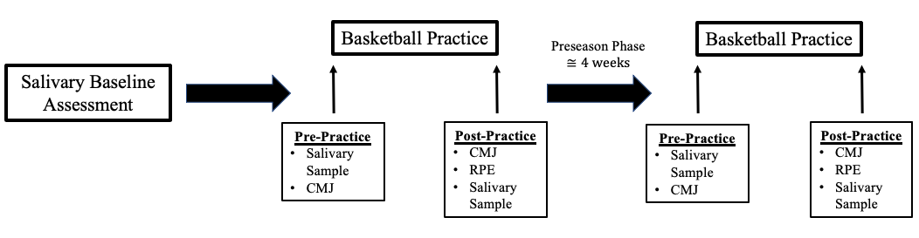
Figure 1. Diagrammatic Representation of the Research Design.

Time point 1 served as a baseline assessment sample that helped to identify any influences of an anticipatory change in salivary hormone responses for the activity in time points 2, 3, 4, and 5 (Hayes et al., 2015). The variables of interest were all collected at the same time of day to limit the influence of diurnal variations of hormones (Kraemer & Ratamess, 2005) as well as CMJ performance alterations (A. D. Heishman et al., 2017). Each participant consented to the release of their individual de-identified data to the research team and were informed of the inherent risks and benefits from this retrospective study. All participants were assured that their decision to allow the use of their data in the analysis would have no impact on their status on the team.

Participants
A convenience sample of 15 NCAA Division I male collegiate basketball players from the University of Oklahoma Men’s Basketball program were included in this study.

Inclusion Criteria
- Participants included were men between the ages of 18 and 25 years of age that are current members of the University of Oklahoma Men’s Basketball Program.
- Participants included males free of any musculoskeletal injuries at the time of testing and healthy for participation.

Exclusion Criteria
- Individuals who are not part of the University of Oklahoma Men’s Basketball Program.
- Participants that have experienced a restriction in their participation in team training or practice sessions at the time of testing.
- Participants not fully cleared to participate in team practices or training.

Questionnaires and Documentation

Informed Consent
Informed written consent was provided to each participant prior to releasing their de-identified data to the research team in this retrospective study. Additionally, each participant was informed of the inherent risk and benefits of the retrospective study prior to disclosing any de-identified data. The investigation was approved by the Institutional Review Board at the University of Oklahoma.

Health Insurance Portability and Accountability Act
The Health Insurance Portability and Accountability Act (HIPAA) informed the participant of the potential use of protected health information acquired during the investigation.

Anthropometric Measurements and Familiarization
Body height and weight were measured during Visit 1. Body height was measured using a wall mounted stadiometer with the participant’s back to the wall, heels together, shoes off, head looking forward at a 90-degree angle, and a deep inhalation following for recording of a value to the nearest centimeter. Body weight was measured to the nearest 0.1kg with the ForceDecks Dual Force Plate Systems (Vald, Newstead, Queensland, Australia), while wearing basketball shoes. In addition, participants were provided verbal instructions as well as a visual demonstration of the CMJ procedure and process of providing a salivary sample and underwent familiarization of each procedure prior to testing.

External Load Monitoring of Sport Specific Training Exposures
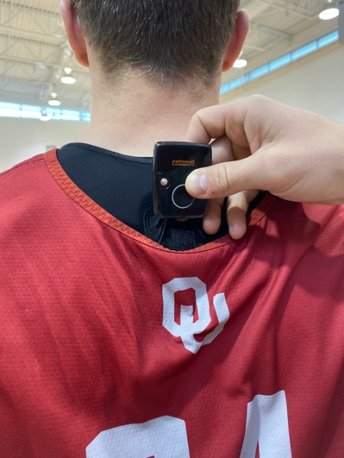
Participants wore a supportive garment fitted with the appropriate size that secured the Catapult Sport OptimEye T6 Inertial Movement Unit (IMU) (Catapult Innovations, Melborne, VIC, Australia), for the quantification of the mechanical load of the practice session to be analyzed via the Catapult Software (Openfield, Catapult, Innovations, Melborne, VIC, Australia). In order to mitigate the influence on accelerometer loads, the garment was placed on each subject as tight as possible without impeding movement (McLean et al., 2018), and the IMU was worn in a pocket between the scapulae of the supportive harness depicted in Figure 2.
Figure 2. Inertial Measurement Unit (IMU) Placement.

In parallel to previous methods (A. Heishman et al., 2018), data collection began the instant the athletes began practice. A “Live” feedback was provided throughout the session and assessment of the variables of interest was performed throughout the duration of the practice. The data was then analyzed through the Catapult software (Openfield, Catapult, Innovations, Melborne, VIC, Australia).

Internal Load Monitoring of Sport Specific Training Exposures
The FirstBeat SPORT heart rate monitor (FirstBeat SPORT, Jyvaskyla Finland) was worn by all participants throughout the duration of practice to assess the internal response from the sport specific training session. It was positioned in line with the xiphoid process of the sternum and securely tightened around their torso by an elastic strap. The monitoring started and ended in conjunction with the Catapult software.
Additionally, at the end of the training exposure, each participant gave a rating of perceived exertion (RPE) describing how difficult they felt the training was based on a scale numbered 0-10, with 0 representing no exertion and 10 describing maximal (Foster et al., 2001). Each value was obtained in isolation from the rest of the participants to mitigate any influence from others and recorded to the nearest half digit. Session-RPE (sRPE) was then be gathered by multiplying the value by the duration of practice (Casamichana et al., 2013).

Countermovement Jump Testing
The CMJ was performed on the ForceDecks Dual Force Plate Systems (Vald, Newstead, Queensland, Australia), with a sample rate of 1000Hz. In line with previous work (A. Heishman, Daub, et al., 2020; A. Heishman et al., 2018; A. Heishman, Peak, et al., 2021), prior to each test participants underwent a standardized warm-up including dynamic stretching and locomotion including a series of skips performed linearly and laterally. The intensities of the movements performed gradually increased throughout to ensure the participants are prepared for the maximal CMJs. The warm-up was not performed after participating in the practice session in order to limit the additional load accumulation (A. Heishman, Daub, et al., 2020; A. D. Heishman et al., 2017).
The performance of the CMJ was done by instructing the participant to stand tall with their feet shoulder width apart and their hands on their hips. The participant obtained an equal weight distribution on the force plates displayed by the Vald software. Once calibrated with an equal weight distribution, the participants were instructed to lower themselves to a self-selected depth for their CMJ and propel themselves off the force plates into the air while keeping their hands on their hips and in a controlled manner to land in an athletic position back on the force plates. This was followed by another CMJ performance after a clear 3 second reset was exhibited for a total of 3 trials. If there was any excessive knee bend while mid-air, the participants’ hands came off their hips, or the participant didn’t land on the cell or lost balance on the landing, then the CMJ was ruled invalid and repeated. Participants were encouraged to jump as high and as fast as possible to promote a maximal effort during each trial. Instructions as well as encouragement across all participants were kept the same to limit the impact on performance of the CMJ (Young et al., 1995). During each visit, to maintain ecological validity, the participant wore practice attire and basketball shoes during testing and were required to wear the same pair of shoes during each testing session (A. Heishman, Peak, et al., 2021). Furthermore, a maximal effort during each jump attempt was promoted through verbal encouragement.

Endocrine Measures
Samples of saliva were utilized instead of serum allowing for the collection of multiple samples in a less invasive manner (Andre et al., 2018). The collection of saliva to measure Testosterone (T) and Cortisol (C) has also been shown to be reliable and correlates well with values measured in serum (Andre et al., 2018; Baxendale et al., 1982). All samples were collected at the same time of day between all subjects in a rested state, prior to practice. Baseline and Pre samples were collected between 1330 hours and 1400 hours, while Post samples were collected between 1600 hours and 1630 hours. Participants were instructed to not brush their teeth at least 60 minutes before providing the sample, or consume any food or drinks besides water to help mitigate the effects of food (Gibson et al., 1999). Before collection, participants rinsed their mouth with water and sat quietly for at least 5 minutes to help reduce the auditory influence on hormonal release (Fleming et al., 2002). Next, the participants provided an unstimulated sample of approximately 2 mL of saliva through a passive drool through the Saliva Collection aid (exclusively from Salimetrics, State College, PA) into the SalivaBio’s 2mL cryovial. The samples were put in a freezer immediately at or below -80 degrees Celsius and stored within cryostorage containers. Both hormones, T and C, were analyzed at Salimetrics’ SalivaLab (Carlsbad, CA) using assays for both T and C.
T concentrations were determined through the Salimetrics Salivary Testosterone Assay Kits without any alterations to Salimetrics’ SalivaLab (Carlsbad, CA) protocol. Samples were thawed to room temperature, vortexed, and centrifuged for 15 minutes at approximately 3,000 RPM (1,500 x g) immediately before performing the assay. The sample test volume was set at 25 μl of saliva using an enzyme-linked immunosorbent assay (ELISA) with a sensitivity lower limit of 1 pg/mL and standard curve range of 6.1 – 600 pg/mL.
C concentrations were determined through the Salimetrics Salivary Cortisol Assay Kits without any alterations to Salimetrics’ SalivaLab (Carlsbad, CA) protocol. Samples were thawed to room temperature, vortexed, and centrifuged for 15 minutes at approximately 3,000 RPM (1,500 x g) immediately before performing the assay. The sample test volume was set at 25 μl of saliva using an ELISA with a sensitivity lower limit of 0.007 pg/dL and standard curve range of 0.012 – 3.0 pg/dL.

Dietary Restrictions
Athletes were instructed to maintain their normal dietary intake, prescribed by the team’s sport’s dietician. The participants were instructed to refrain from consuming any food, stimulants, or fluids, besides water, 1 hour prior to data collection. Additionally, only water was available for consumption on test days as to not interfere with salivary sampling.

Statistical Analyses
Data was analyzed using SPSS, Version 28 (SPSS Inc., Chicago, IL). Descriptive statistics were reported as Mean ± SD, unless otherwise stated. Initially, data normality was confirmed through the Shapiro-Wilk test statistic. The data was also tested for sphericity through Mauchly’s test to confirm variance in differences were similar between groups. If the data indicated the assumption of sphericity was violated through Mauchly’s Test of Sphericity, then the Greenhouse-Geisser correction was used to combat the violation.
A paired t-test was used to evaluate the within subject differences in eTL parameters, including PL, PL/min, PL^{2D}, PL^{1D-FWD}, PL^{1D-SIDE}, PL^{1D-UP}, IMA High, IMA Medium, IMA Low, Jumps, and Duration, as well as iTL parameters, including Average HR, TRIMP, TRIMP/Min, RPE, and sRPE across time. Additionally, a two-way (Week [Week 1, Week 4] × Time [Pre-Practice, Post-Practice]) repeated measures (RM) analysis of variance (ANOVA) was used to examine Week and Time main effects and the interaction between week and time in the following CMJ variables: ConcMF, ConcMP, ConcPF, CT, EccMBF, EccMDecF, EccMF, EccMP, EccPF, EccPP, FT, FT:CT, F@0V, JH, PP, RSI_{Mod}, and Weight. Additionally, the two-way RM ANOVA was used the evaluate the salivary endocrine measures, including T, C, and T:C ratio. Statistical significance was set at p ≤ 0.05. If a significant interaction was determined, a Bonferroni post hoc analysis was performed to isolate simple main effects. When comparing two groups, Cohen’s d (d) effect sizes were utilized and interpreted as trivial (0 – 0.19), small (0.20 – 0.49), medium (0.50 – 0.79), and large (≥ 0.80) (Cohen, 1992). The intra- and inter-assay reliability of the hormone assay duplicates were evaluated using the coefficient of variation (CV%).

Chapter IV: Results and Discussion

Results

Participant Anthropometrics
Data was provided from 15 male Division I NCAA collegiate basketball players (n = 15; age = 21.1 ± 1.7 years, height = 196.6 ± 9.1 cm, body mass = 92.7 ± 10.1 kg) in this retrospective study. However, of the 15 participants, a mix of different participants missed a variety of time points within the variables of interest with only 14 participants included in eTL data, 13 in salivary endocrine measures data, 13 in CMJ data, 14 in the subjective iTL data, and 11 in the objective iTL data.

Training Loads During the Preseason Training Phase
External Training Load:
Data from 14 participants were included in the eTL data analysis, as one participant was excluded due to missing data. Descriptive statistics and the results for the comparison between Week 1 and Week 4 of the preseason training phase in parameters involving eTL of the sport specific training sessions are outlined in Table 1. As presented in Figure 3, there was a significant difference (p < 0.001, d = 4.57) detected in Duration with Week 1 (112.5 (0.02)) exhibiting a shorter training session than Week 4 (135.4 (0.02)).

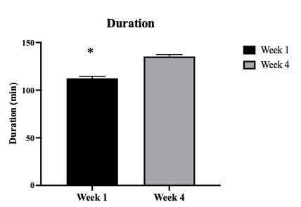
Figure 3. Differences in Duration of Training Between Week

Note: Data presented as Mean (Standard Error); * = Significant Difference between week, set at p ≤ 0.05.

There were no significant differences detected across time for any of the other eTL variables, including: PL (Week 1 = 510.8 (39.1); Week 4 = 523.0 (42.0), p = 0.746, d = 0.08), PL/min (Week 1 = 4.4 (0.3); Week 4 = 4.1 (0.3), p = 0.192, d =0.30), PL^{2D} (Week 1 = 336.3 (27.3); Week 4 = 350.4 (27.7), p = 0.579, d = 0.14), PL^{1D-FWD} (Week 1 = 207.2 (17.9); Week 4 = 212.1 (17.1), p = 0.757, d = 0.07), PL^{1D-SIDE} (Week 1 = 221.0 (17.2); Week 4 = 234.2 (18.3), p = 0.433, d = 0.20), PL^{1D-UP} (Week 1 = 326.5 (24.1); Week 4 = 327.5 (27.1), p = 0.965, d = 0.01), IMA High (Week 1 = 55.9 (6.8); Week 4 = 61.6 (10.2), p = 0.448, d = 0.18), IMA Medium (Week 1 = 119.6 (11.0); Week 4 = 125.9 (19.8), p = 0.732, d = 0.10), IMA Low (Week 1 = 446.2 (45.8); Week 4 = 478.1 (67.0), p = 0.550, d = 0.15), and Jumps (Week 1 = 70.7 (8.9); Week 4 = 61.5 (10.6), p = 0.164, d = 0.25).

Table 1. Differences in External Training Load through the Preseason.
Variable (n = 14) | Week 1 | Week 4 | p-value | Effect (d)
Duration (min) | 112.5 (0.02)* | 135.4 (0.02) | < 0.001 | 4.57
PL (au) | 510.8 (39.1) | 523.0 (42.0) | 0.746 | 0.08
PL/min (au/min) | 4.4 (0.3) | 4.1 (0.3) | 0.192 | 0.30
PL^{2D} (au) | 336.3 (27.3) | 350.4 (27.7) | 0.579 | 0.14
PL^{1D-FWD} (au) | 207.2 (17.9) | 212.1 (17.1) | 0.757 | 0.07
PL^{1D-SIDE} (au) | 221.0 (17.2) | 234.2 (18.3) | 0.433 | 0.20
PL^{1D-UP} (au) | 326.5 (24.1) | 327.5 (27.1) | 0.965 | 0.01
IMA High (cts) | 55.9 (6.8) | 61.6 (10.2) | 0.448 | 0.18
IMA Medium (cts) | 119.6 (11.0) | 125.9 (19.8) | 0.732 | 0.10
IMA Low (cts) | 446.2 (45.8) | 478.1 (67.0) | 0.550 | 0.15
Jumps (cts) | 70.7 (8.9) | 61.5 (10.6) | 0.164 | 0.25
Data presented as Mean (Standard Error). PL = PlayerLoadTM; PL/min = PlayerLoadTM per minute; PL^{2D} = 2-Dimensional PlayerLoadTM; PL^{1D-FWD} = 1-Dimensional PlayerLoadTM Forward; PL^{1D-SIDE} = 1-Dimensional PlayerLoadTM Side; PL^{1D-UP} = 1-Dimensional PlayerLoadTM Up; IMA_High = High Intensity (> 3.5 m•s⁻¹) Inertial Movement AnalysisTM events; IMA_Medium = Medium Intensity (2.5 to 3.5 m•s⁻¹) Inertial Movement AnalysisTM events; IMA_Low = Low Intensity (1.5 to 2.5 m•s⁻¹) Inertial Movement AnalysisTM events; Jumps = Total number of Jump events (including High, Medium, and Low intensities); au = arbitrary units; cts = counts; * = statistically significant, set at p ≤ 0.05; d = Cohen’s d, interpreted as trivial (0–0.19), small (0.20–0.49), medium (0.50–0.79), and large (≥ 0.80).

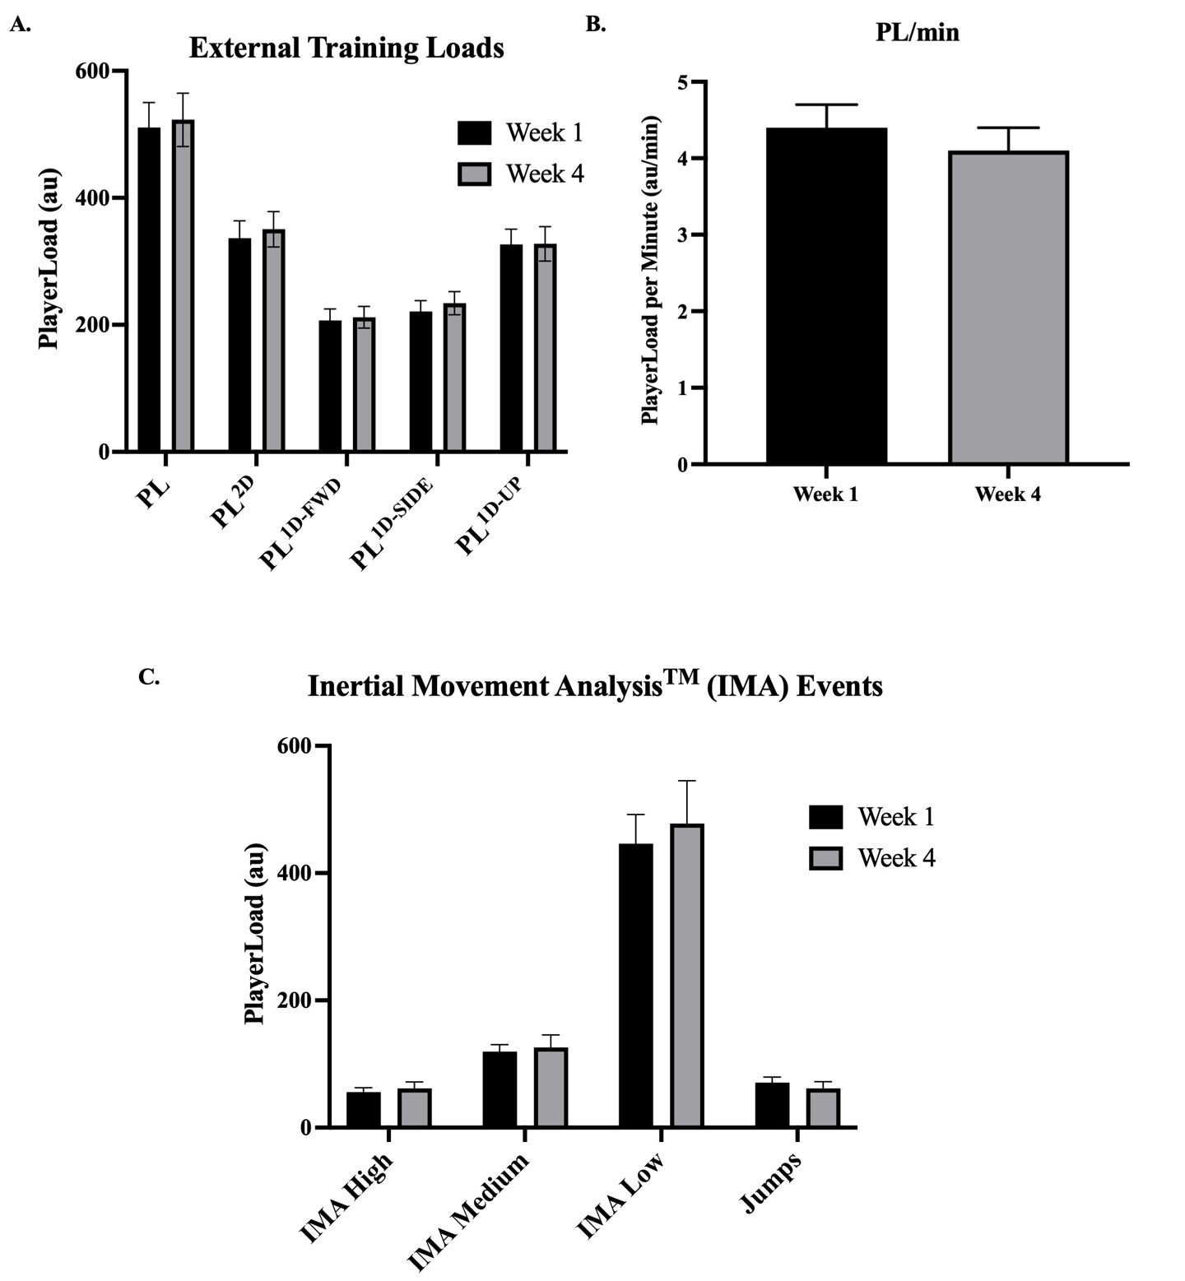
Figure 4. Differences in External Training Loads between Week

Note: Data presented as Mean (Standard Error); A. = External Traing Load variables; B. = PlayerLoad per Minute; C. = Inertial Movement Analysis (IMA) Events; au = arbitrary units; * = Significant difference between week, set at p ≤ 0.05.

Internal Training Load:
Data from 11 participants were included in the objective iTL analysis, as four participants were excluded due to missing time points and 14 were included in the subjective iTL analysis due to one participant being excluded for missing time points. The iTL results and descriptive statistics from Week 1 and Week 4 of the preseason training phase are presented in Table 2. As presented in Figure 5, there were no significant differences detected across time for any of the objective iTL variables, including Average HR (Week 1 = 126.0 (5.3); Week 4 = 120.5 (5.4), p = 0.303, d = 0.31), TRIMP (Week 1 = 109.4 (16.7); Week 4 = 104.8 (17.5), p = 0.793, d = 0.08), and TRIMP/Min (Week 1 = 1.0 (0.1); Week 4 = 0.8 (0.1), p = 0.330, d = 0.27).
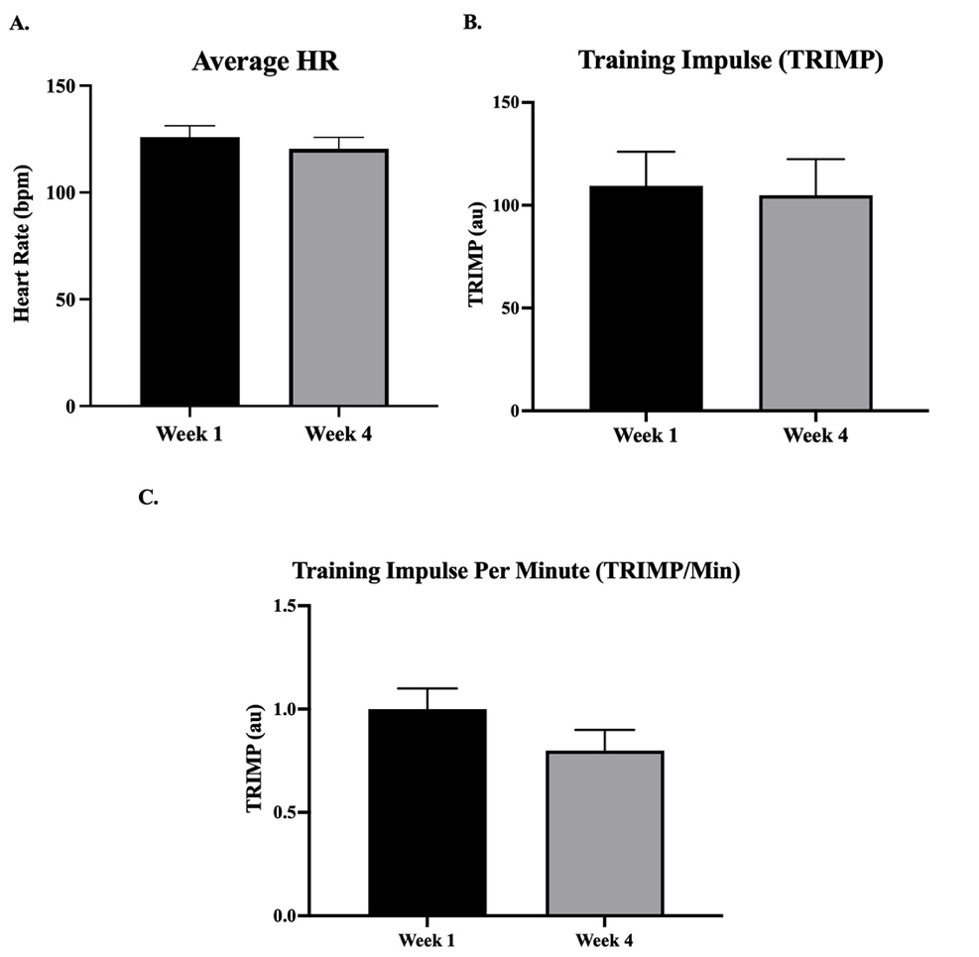
Figure 5. Differences in Objective Internal Training Loads Between Week

Note: Data presented as Mean (Standard Error); A. = Average Heart Rate; B. = Training Impulse (TRIMP); C. = TRIMP per Minute (TRIMP/Min); au = arbitrary units; * Significant difference between weeks, set at p ≤ 0.05.
Additionally, no significant differences were presented within the subjective iTL variables, including RPE (Week 1 = 5.8 (0.5); Week 4 = 6.0 (0.7), p = 0.718, d = 0.10) and sRPE (Week 1 = 646.9 (55.9); Week 4 = 807.1 (88.2), p = 0.056, d = 0.58).

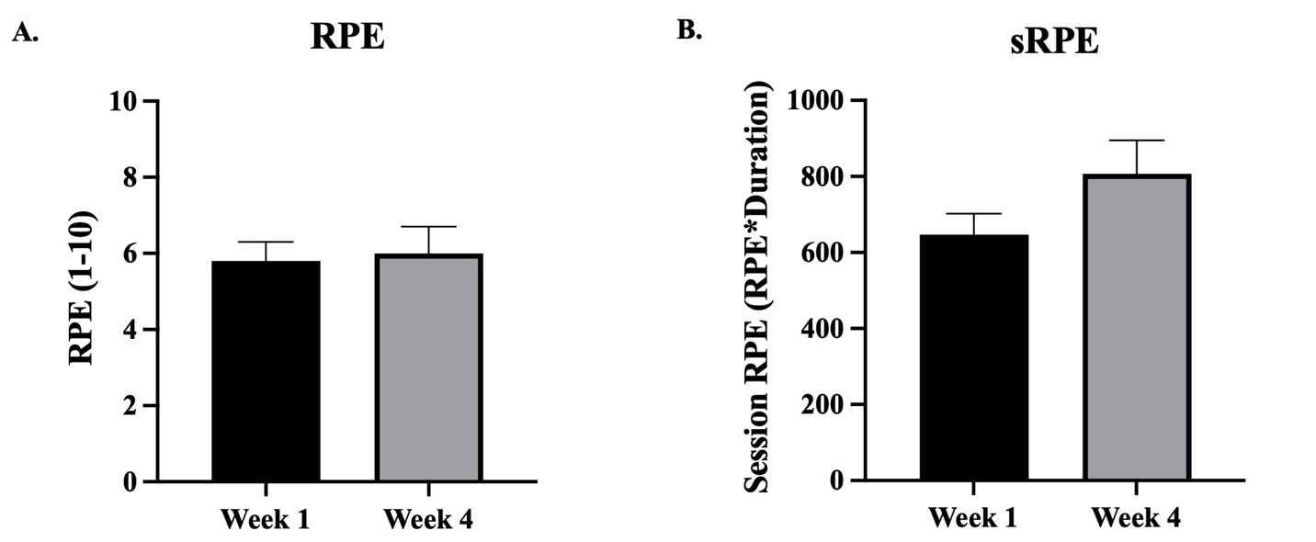
Figure 6. Differences in Subjective Internal Training Loads Between Week

Note: Data presented as Mean (Standard Error); A. Rating of Perceived Exertion (RPE); B. = Session Rating of Perceived Exertion (sRPE); * = Significant difference between weeks, set at p ≤ 0.05.

Table 2. Differences in Internal Training Load through the Preseason.
Variable | n = | Week 1 | Week 4 | p-value | Effect (d)
Average HR (bpm) | 11 | 126.0 (5.3) | 120.5 (5.4) | 0.303 | 0.31
TRIMP (au) | 11 | 109.4 (16.7) | 104.8 (17.5) | 0.793 | 0.08
TRIMP/Min (au) | 11 | 1.0 (0.1) | 0.8 (0.1) | 0.330 | 0.27
RPE | 14 | 5.8 (0.5) | 6.0 (0.7) | 0.718 | 0.10
sRPE | 14 | 646.9 (55.9) | 807.1 (88.2) | 0.056 | 0.58
Data presented as Mean (Standard Error). HR = Heart Rate; TRIMP = Training Impulse; RPE = Rating of Perceived Exertion; sRPE = Session Rating of Perceived Exertion; statistical significance set at p ≤ 0.05; d = Cohen’s d, interpreted as trivial (0–0.19), small (0.20–0.49), medium (0.50–0.79), and large (≥ 0.80).

Countermovement Jump (CMJ) Results
Data from 13 participants were included in the CMJ analysis, as two participants were excluded due to missing time points. The overall descriptive statistics of the CMJ variables are outlined in Table 3. When examining the CMJ variables there were no significant Week main effects detected across time within any of the variables, including ConcMF (p = 0.512), ConcMP (p = 0.624), ConcPF (p = 0.364), CT (p = 0.924), EccMBF (p = 0.242,), EccMDecF (p = 0.740), EccMF (p = 0.807) EccMP (p = 0.788), EccPF (p = 0.355), EccPP (p = 0.929), FT (p = 0.903), FT:CT (p = 0.884), F@0V (p = 0.345), JH (p = 0.891), PP (p = 0.790), RSI_{Mod} (p = 0.470), and Body Mass (p = 0.838).
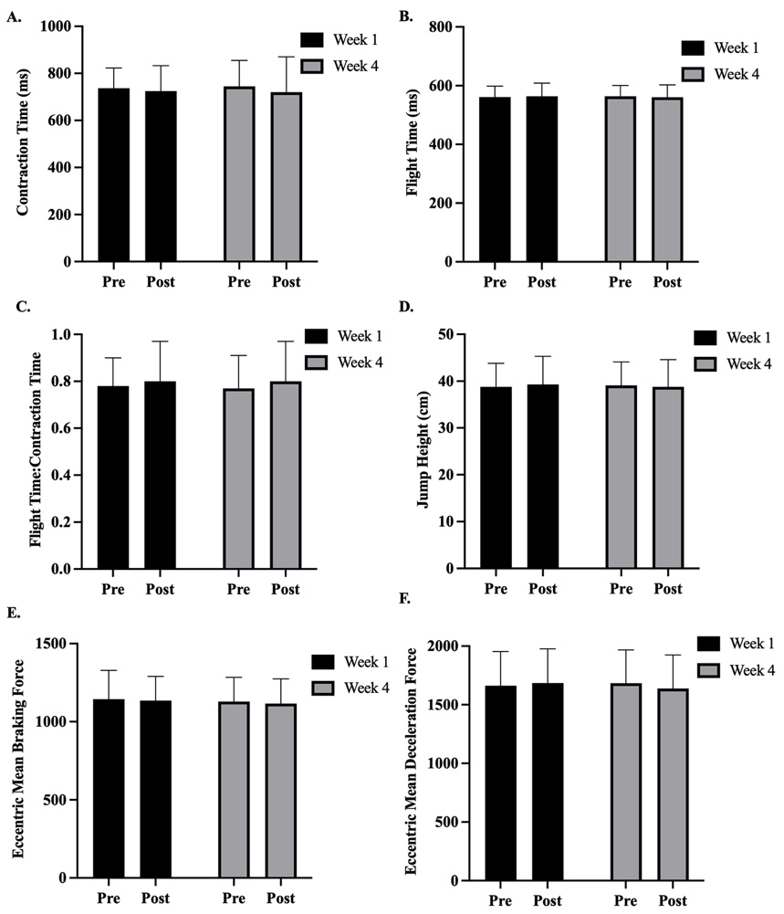
Figure 7. Differences in Countermovement Jump Performance Between Weeks

Note: Data presented as Mean ± Standard Deviation; Pre = Pre-Practice; Post = Post-Practice; * = Significant difference between weeks, set at p ≤ 0.05.
However, there were significant Time main effects for EccMF (p = 0.025) and Body Mass (p = 0.020) revealing significant differences between the average of Pre values from Week 1 and Week 4 and the average of Post values from Week 1 and Week 4. Post hoc pairwise comparisons revealed significant differences in EccMF (p = 0.025) between the average of Week 1 and Week 4 Pre (906.3 (29.0), d = 0.06) values and the average of Week 1 and Week 4 Post (905.4 (27.1), d = 0.08) values, as well as in Body Mass (p = 0.020) between the average of Week 1 and Week 4 Pre (92.27 (2.95), d = 0.06) values and the average of Week 1 and Week 4 Post (92.19 (2.77), d = 0.08) values. No other variables expressed a main effect for Time, including ConcMF (p = 0.561), ConcMP (p = 0.704), ConcPF (p = 168), CT (p = 0.200), EccMBF (p = 0.457), EccMDecF (p = 0.653), EccMP (p = 0.061), EccPF (p = 0.250), EccPP (p = 0.389), FT (p = 0.952), FT:CT (p = 0.098), F@0V (p = 0.266), JH (p = 0.947), PP (p = 0.128), RSI_{Mod} (p = 0.192).
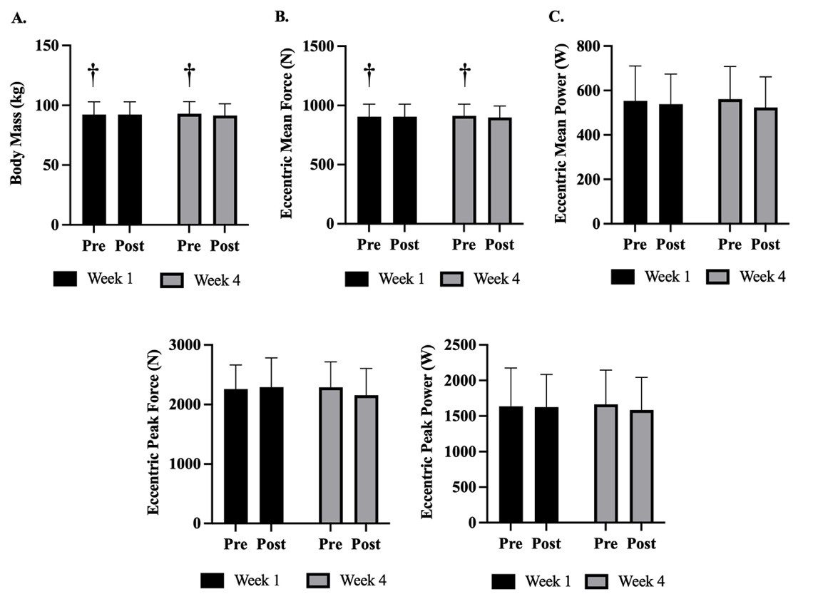
Figure 8. Differences in Countermovement Jump Performance Between Weeks

Note: Data presented as Mean ± Standard Deviation; Pre = Pre-Practice; Post = Post-Practice; * = Significant difference between weeks, set at p ≤ 0.05; † = Average of Week 1 and Week 4 Pre significantly different than average of Week 1 and Week 4 Post.
Moreover, there was a significant Week × Time interactions in ConcPF (p = 0.039). Post hoc pairwise comparisons revealed significant differences (p = 0.042, d = 0.27) between Pre (2398.4 ± 420.7)) and Post (2519.9 ± 480.2) in Week 1 but not in Week 4 (Pre = 2459.8 ± 420.2; Post = 2487.8 ± 505.4, p = 0.627, d = 0.06). However, no other CMJ variables displayed a significant Week × Time interaction, including ConcMF (p = 0.070), ConcMP (p = 0.057), CT (p = 0.658), EccMBF (p = 0.824), EccMDecF (p = 0.171), EccMF (p = 0.070), EccMP (p = 0.144), EccPF (p = 0.073), EccPP (p = 0.416), FT (p = 0.289), FT:CT (p = 0.999), F@0V (p = 0.075), JH (p = 0.290), PP (p = 0.087), RSI_{Mod} (p = 0.476), and Body Mass (p = 0.063).
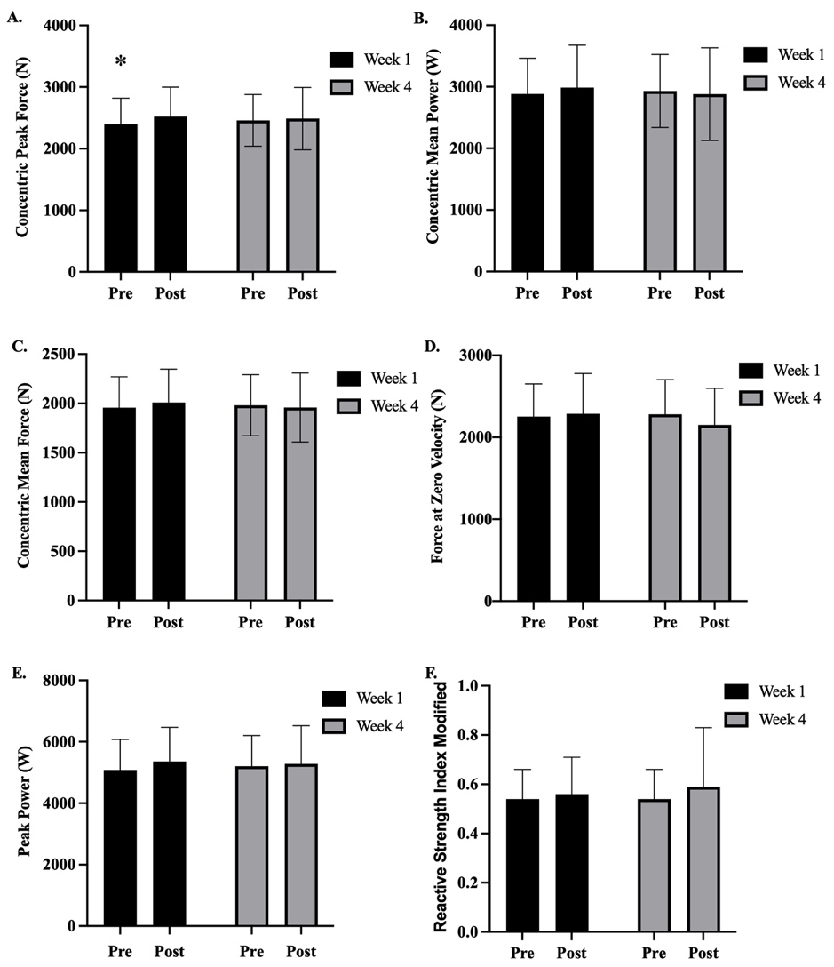
Figure 9. Differences in Countermovement Jump Performance Between Weeks

Note: Mean presented as Mean ± Standard Deviation; Pre = Pre-Practice; Post = Post-Practice; * = Significant difference between weeks, set at p ≤ 0.05.

Table 3. Countermovement Jump Descriptive Statistics.
 | Week 1 |  | Week 4 |  | Pre to Post Effect (d) |  | Week 1 to Week 4 Effect (d)
Variable  (n = 13) | Pre | Post | Pre | Post | Week 1 | Week 4 | Pre to Pre | Post to Post
ConcMF (N) | 1954.7 ± 313.0 | 2007.5 ± 337.8 | 1981.4 ± 308.8 | 1957.4 ± 349.8 | 0.16 | 0.07 | 0.09 | 0.15
ConcMP (W) | 2882.5 ± 579.5 | 2986.8 ± 689.8 | 2931.8 ± 592.8 | 2880.5 ± 752.2 | 0.16 | 0.08 | 0.08 | 0.15
ConcPF (N) | 2398.4 ± 420.7* | 2519.9 ± 480.2 | 2459.8 ± 420.2 | 2487.8 ± 505.4 | 0.27 | 0.06 | 0.15 | 0.07
CT (ms) | 737.1 ± 86.1 | 724.9 ± 107.9 | 744.7 ± 110.0 | 720.2 ± 149.8 | 0.12 | 0.19 | 0.08 | 0.04
EccMBF (N) | 1143.9 ± 184.3 | 1134.9 ± 155.0 | 1129.7 ± 154.5 | 1116.5 ± 157.4 | 0.05 | 0.08 | 0.08 | 0.12
EccMDecF (N) | 1662.0 ± 291.8 | 1685.0 ± 292.1 | 1684.2 ± 282.5 | 1638.6 ± 286.2 | 0.08 | 0.16 | 0.08 | 0.16
EccMF (N) | 906.2 ± 104.8† | 906.4 ± 104.7 | 912.4 ± 99.1† | 898.4 ± 96.8 | 0.00 | 0.14 | 0.06 | 0.08
EccMP (W) | 553.4 ± 156.3 | 538.4 ± 135.6 | 561.2 ± 146.8 | 523.4 ± 138.0 | 0.10 | 0.27 | 0.05 | 0.11
EccPF (N) | 2258.6 ± 404.1 | 2291.2 ± 492.6 | 2288.8 ± 425.0 | 2156.6 ± 447.6 | 0.07 | 0.30 | 0.07 | 0.29
EccPP (W) | 1637.8 ± 535.3 | 1625.7 ± 458.1 | 1665.0 ± 479.0 | 1584.0 ± 459.3 | 0.02 | 0.17 | 0.05 | 0.09
FT (ms) | 561.4 ± 37.5 | 564.2 ± 44.7 | 563.9 ± 36.7 | 560.6 ± 42.5 | 0.07 | 0.08 | 0.07 | 0.08
FT:CT | 0.78 ± 0.12 | 0.80 ± 0.17 | 0.77 ± 0.14 | 0.80 ± 0.17 | 0.17 | 0.16 | 0.02 | 0.01
F@0V (N) | 2252.8 ± 400.5 | 2286.8 ± 491.3 | 2280.9 ± 424.1 | 2151.6 ± 446.4 | 0.08 | 0.30 | 0.07 | 0.29
JH (cm) | 38.8 ± 5.0 | 39.3 ± 6.0 | 39.1 ± 5.0 | 38.8 ± 5.8 | 0.08 | 0.07 | 0.07 | 0.08
PP (W) | 5080.3 ± 992.2 | 5361.5 ± 1108.0 | 5205.3 ± 998.5 | 5277.1 ± 1247.5 | 0.27 | 0.06 | 0.13 | 0.07
RSI_{Mod} (m/s) | 0.54 ± 0.12 | 0.56 ± 0.15 | 0.54 ± 0.12 | 0.59 ± 0.24 | 0.17 | 0.25 | 0.02 | 0.14
Body Mass (kg) | 92.26 ± 10.65† | 92.27 ± 10.68 | 92.92 ± 10.12† | 91.46 ± 9.88 | 0.00 | 0.15 | 0.06 | 0.08
Data presented as Mean ± Standard Deviation. Conc = Concentric; MF = Mean Force; MP = Mean Power; PF = Peak Force; CT = Contraction Time; Ecc = Eccentric; MBF = Mean Braking Force; MDecF = Mean Deceleration Force; PP = Peak Power; FT = Flight Time; F@0V = Force at Zero Velocity; JH = Jump Height; RSI_{Mod} = Reactive Strength Index Modified; kg = kilograms; m = meters; ms = milliseconds; N = Newtons; W = Watts; Pre = Pre-Practice; Post = Post-Practice; d = Cohen’s; * = Significant difference between weeks; † = Average of Week 1 and Week 4 Pre significantly different than average of Week 1 and Week 4 Post; d, interpreted as trivial (0–0.19), small (0.20–0.49), medium (0.50–0.79), and large (≥ 0.80).

CMJ Performance Results Relative to Body Mass
The overall descriptive statistics of the CMJ variables relative to Body Mass are outlined in Table 4. There were no significant main effects of Week detected in any of the variables relative to Body Mass in the CMJs, including ConcMF (p = 0.481), ConcMP (p = 0.612), ConcPF (p = 0.448), EccMBF (p = 0.216), EccMDecF (p = 0.765), EccMF (p = 0.481), EccMP (p = 0.832), EccPF (p = 0.382), EccPP (p = 0.959), F@0V (p = 0.373), and PP (p = 0.771).
Additionally, there were no significant main effects of Time presented in any of the CMJ variables relative to Body Mass, including ConcMF (p = 0.206), ConcMP (p = 0.460), ConcPF (p = 0.091), EccMBF (p = 0.946), EccMDecF (p = 0.831), EccMF (p = 0.181), EccMP (p = 0.108), EccPF (p = 0.459), EccPP (p = 0.581), F@0V (p = 0.485), and PP (p = 0.062).
Furthermore, no significant Week × Time interactions were exhibited in any of the CMJ variables relative to Body Mass, including ConcMF (p = 0.127), ConcMP (p = 0.134), ConcPF (p = 0.141), EccMBF (p = 0.603), EccMDecF (p = 0.358), EccMF (p = 0.751), EccMP (p = 0.358), EccPF (p = 0.139), EccPP (p = 0.548), F@0V (p = 0.142), and PP (p = 0.237).

Table 4. Countermovement Jump Descriptive Statistics Relative to Body Mass.
 | Week 1 |  | Week 4 |  | Pre to Post Effect (d) |  | Week 1 to Week 4 Effect (d)
Variable  (n = 13) | Pre | Post | Pre | Post | Week 1 | Week 4 | Pre to Pre | Post to Post
ConcMF (N/kg) | 21.2 ± 2.6 | 21.8 ± 3.1 | 21.4 ± 2.7 | 21.4 ± 3.1 | 0.21 | 0.02 | 0.06 | 0.13
ConcMP (W/kg) | 31.3 ± 5.4 | 32.5 ± 7.2 | 31.6 ± 6.0 | 31.5 ± 7.7 | 0.19 | 0.01 | 0.06 | 0.13
ConcPF (N/kg) | 26.1 ± 3.9 | 27.4 ± 5.0 | 26.5 ± 4.0 | 27.2 ± 4.92 | 0.30 | 0.15 | 0.12 | 0.04
EccMBF (N/kg) | 12.4 ± 0.9 | 12.3 ± 0.7 | 12.1 ± 0.6 | 12.2 ± 0.7 | 0.08 | 0.07 | 0.28 | 0.15
EccMDecF (N/kg) | 18.0 ± 2.1 | 18.3 ± 2.6 | 18.1 ± 2.3 | 17.9 ± 2.3 | 0.14 | 0.09 | 0.07 | 0.16
EccMF (N/kg) | 9.8 ± 0.01 | 9.8 ± 0.01 | 9.8 ± 0.01 | 9.8 ± 0.01 | 0.29 | 0.32 | 0.33 | 0.07
EccMP (W/kg) | 6.0 ± 1.3 | 5.8 ± 1.1 | 6.0 ± 1.2 | 5.7 ± 1.2 | 0.12 | 0.26 | 0.05 | 0.10
EccPF (N/kg) | 24.5 ± 3.7 | 25.0 ± 5.5 | 24.7 ± 4.4 | 23.6 ± 4.4 | 0.10 | 0.25 | 0.05 | 0.27
EccPP (W/kg) | 17.6 ± 4.7 | 17.5 ± 4.1 | 17.8 ± 4.1 | 17.2 ± 4.1 | 0.00 | 0.14 | 0.06 | 0.08
F@0V (N/kg) | 24.5 ± 3.7 | 24.9 ± 5.5 | 24.7 ± 4.5 | 23.6 ± 4.4 | 0.10 | 0.24 | 0.05 | 0.27
PP (W/kg) | 55.0 ± 8.2 | 58.1 ± 10.5 | 55.9 ± 8.6 | 57.6 ± 12.1 | 0.33 | 0.16 | 0.11 | 0.04
Data presented as Mean ± Standard Deviation. Conc = Concentric; MF = Mean Force; MP = Mean Power; PF = Peak Force; Ecc = Eccentric; MBF = Mean Braking Force; MDecF = Mean Deceleration Force; PP = Peak Power; F@0V = Force at Zero Velocity; kg = kilograms; m = meters; ms = milliseconds; N = Newtons; W = Watts; Pre = Pre-Practice; Post = Post-Practice; d = Cohen’s d, interpreted as trivial (0–0.19), small (0.20–0.49), medium (0.50–0.79), and large (≥ 0.80).

Endocrine Response Results
Samples from 13 participants were included in the endocrine analysis, as two participants were excluded due to missing time points. The Testosterone assay presented an average intra-assay coefficient of variation (CV) of 4.60% and an average inter-assay CV of 9.85%, while the Cortisol assay had an average intra-assay CV of 4.60% and average inter-assay CV of 6.00%. Additionally, all values for the assays exhibited to be within the expected ranges of 6.1 – 600 pg/mL for T and 0.012 – 3.0 pg/dL for C for young adult males.

Testosterone:
As outlined in Table 5 and displayed in Figure 10, there were no significant differences (p = 0.086) for T in any of the Pre (Week 1 = 145.8 (22.1) pg/mL; Week 4 = 128.1 (9.0) pg/mL) values or Baseline Assessment (176.8 (18.4) pg/mL) values across time. There was also no significant Week × Time interaction (p = 0.374), nor significant main effect of Week (p = 0.117).
However, there was a significant Time main effect (p = 0.13). Post hoc pairwise comparisons revealed a significant increase in T between the average of Week 1 and Week 4 Pre (137.0 (14.7) pg/mL, d = 0.29) values and the average of Week 1 and Week 4 Post (197.7 (21.6) pg/mL, d = 0.49) values, displayed in Table 6. Individual T responses across both weeks are displayed in Figure 12.
Descriptive statistics for the absolute change in T are outlined in Table 7. There was no significant difference (p = 0.374) in the absolute change in concentration from Pre to Post in Week 1 (75.7 ± 124.7 pg/mL) in comparison to the changes depicted from Pre to Post in Week 4 (45.8 ± 52.3 pg/mL).
Descriptive statistics for the percent change in T are outlined in Table 8. When examining the percent change, there were no significant (p = 0.350) differences from Pre to Post in Week 1 (65.2 ± 104.0 pg/mL) compared to changes observed from Pre to Post in Week 4 (37.9 ± 39.7 pg/mL).
Cortisol:
As presented in Table 5 and exhibited in Figure 10, there were no significant differences for C (p = 0.282) in any of the Pre (Week 1 = 0.146 (0.017) pg/dL; Week 4 = 0.188 (0.032) pg/dL) values or Baseline Assessment (0.214 (0.033) pg/dL) values across time. There was also no significant main effect of Week (p = 0.276).
However, there was a significant main effect of Time (p = 0.021). Post hoc pairwise comparisons revealed significant increase in C between the average of Week 1 and Week 4 Pre (0.167 (0.022) pg/dL, d = 0.45) values and the average of Week 1 and Week 4 Post (0.309 (0.046) pg/dL, d = 0.62) values, displayed in Table 6.
Moreover, there was a significant Week × Time interaction (p = 0.050). Post hoc pairwise comparisons revealed a significant (p = 0.008, d = 1.27) increase between Pre (0.146 (0.017) pg/dL) and Post (0.376 (0.069) pg/dL) in Week 1 but not in Week 4 (Pre = 0.188 (0.032) pg/dL; Post = 0.242 (0.049) pg/dL; p = 0.401, d = 0.36), outlined in Table 6. Individual C responses across both weeks are displayed in Figure 12.
Descriptive statistics for the absolute change in C are outlined in Table 7. There was a significant difference (p = 0.050) in the absolute change in concentration from Pre to Post in Week 1 (0.230 ± 0.261 pg/dL) in comparison to the changes depicted from Pre to Post in Week 4 (0.054 ± 0.221 pg/dL).
Descriptive statistics for the percent change in C are outlined in Table 8. When examining the percent change, there were no significant (p = 0.080) differences from Pre to Post in Week 1 (206.9 ± 252.5 pg/dL) compared to changes observed from Pre to Post in Week 4 (70.9 ± 158.7 pg/dL).
Testosterone:Cortisol Ratio:
As presented in Table 5 and demonstrated in Figure 10, there were no significant differences for T:C (p = 0.471) in any of the Pre (Week 1 = 1109.1 (149.8); Week 4 = 894.4 (118.2)) values or Baseline Assessment (949.8 (147.6)) values across time. There was no Week main effect (p = 0.657), nor Time main effect (p = 0.577) for changes exhibited over the preseason in T:C.
However, there was a significant Week × Time interaction (p = 0.036). Post hoc pairwise comparisons revealed a significant (p = 0.033, d = 0.46) increase from the Post value in Week 1 (Post = 739.0 (154.3)) to the Post value in Week 4 (Post = 1047.8 (216.7)), outlined in Table 6 and Figure 11. The individual T:C ratios across both weeks are displayed in Figure 12.
Descriptive statistics for the absolute change in T:C are outlined in Table 7. There was a significant increase (p = 0.036) in the absolute change in concentrations from Pre to Post in Week 1 (- 370.2 ± 707.0) in comparison to the changes depicted from Pre to Post in Week 4 (153.4 ± 865.6).
Descriptive statistics for the percent change in T:C are outlined in Table 8. When examining the percent change, there was a significant (p = 0.012) increase from Pre to Post in Week 1 (- 25.8 ± 54.3) compared to changes observed from Pre to Post in Week 4 (45.2 ± 101.3).

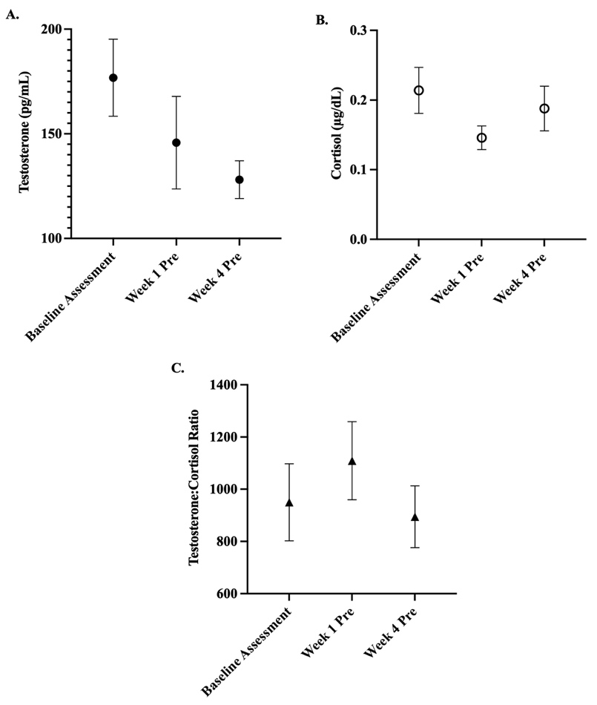
Figure 10. Endocrine Baseline Assessments

Note: Data presented as Mean (Standard Error); Pre = Pre-Practice; * = Significant difference, set at p ≤ 0.05.
Table 5. Endocrine Baseline Measurements.
 |  | Week 1 | Week 4
Variable | Baseline Assessment | Pre | Pre | p-value
T (pg/mL) | 176.8 (18.4) | 145.8 (22.1) | 128.1 (9.0) | 0.086
C (µg/dL) | 0.214 (0.033) | 0.146 (0.017) | 0.188 (0.032) | 0.282
T:C | 949.8 (147.6) | 1109.1 (149.8) | 894.4 (118.2) | 0.471
Data presented as Mean (Standard Error). Pre = Pre-Practice; Post = Post-Practice; T = Testosterone; C = Cortisol; T:C = Testosterone to Cortisol Ratio; pg/mL = picograms per milliliter; µg/dL = micrograms per deciliter; statistical significance set at p ≤ 0.05
Figure 11. Endocrine Responses Across Time

Note: Data presented as Mean (Standard Error); Pre = Pre-Practice; Post = Post-Practice; * = Week 1 Pre significantly different than Post; † = Average of Week 1 and Week 4 Pre significantly different than average of Week 1 and Week 4 Post; ˇ = Week 1 Post is significantly different than Week 4 Post

Table 6. Endocrine Responses throughout the Preseason.
 | Week 1 |  | Week 4 |  | Pre to Post Effect (d) |  | Week 1 to Week 4 Effect (d)
Variable | Pre | Post | Pre | Post | Week 1 | Week 4 | Pre to Pre | Post to Post
T (pg/mL) | 145.8 (22.1)† | 221.5 (34.1) | 128.1 (9.0) † | 173.9 (16.5) | 0.73 | 0.96 | 0.29 | 0.49
C (µg/dL) | 0.146 (0.017)*† | 0.376 (0.069) | 0.188 (0.032)† | 0.242 (0.049) | 1.27 | 0.36 | 0.45 | 0.62
T:C | 1109.1 (149.8) | 739.0 (154.3)ˇ | 894.4 (118.2) | 1047.8 (216.7) | 0.68 | 0.24 | 0.44 | 0.46
Data presented as Mean (Standard Error). Pre = Pre-Practice; Post = Post-Practice; T = Testosterone; C = Cortisol; T:C = Testosterone to Cortisol Ratio; pg/mL = picograms per milliliter; µg/dL = micrograms per deciliter; statistical significance set at p ≤ 0.05; * = Week 1 Pre significantly different than Post; † = Average of Week 1 and Week 4 Pre significantly different than average of Week 1 and Week 4 Post; ˇ = Week 1 Post is significantly different than Week 4 Post; d = Cohen’s d, interpreted as trivial (0–0.19), small (0.20–0.49), medium (0.50–0.79), and large (≥ 0.80).
Figure 12. Individual Endocrine Responses Across Time

Note: Data presented as Mean; Pre = Pre-Practice; Post = Post-Practice.
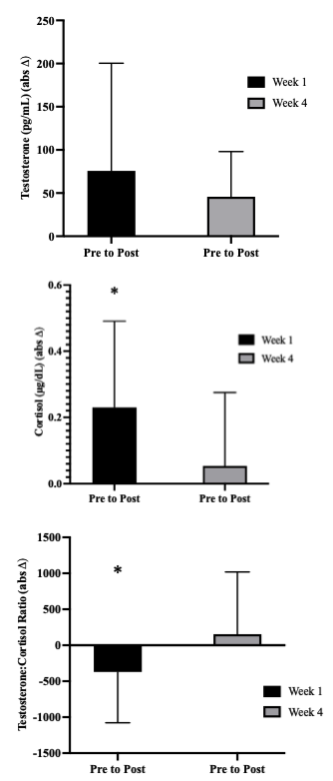
Figure 13. Endocrine Absolute Changes Across Time

Note: Data presented as Mean (Standard Error); Pre = Pre-Practice; Post = Post-Practice; absΔ = absolute change; * = Week 1 significantly different than Week 4, set at p ≤ 0.05.

Table 7. Absolute Change Scores in Endocrine Responses throughout the Preseason.
 | Week 1 | Week 4 | Week 1 to Week 4 | Week 1 to Week 4
Variable | Δ₁ = Pre to Post | Δ₁ = Pre to Post | Δ₁ = Pre to Pre | Δ₁ = Post to Post
T (pg/mL) (absΔ) | 75.7 ± 124.7 | 45.8 ± 52.3 | - 17.7 ± 59.0 | - 47.7 ± 114.4
C (µg/dL) (absΔ) | 0.230 ± 0.261* | 0.054 ± 0.221 | 0.042 ± 0.090 | - 0.135 ± 0.278
T:C (absΔ) | - 370.2 ± 707.0* | 153.4 ± 865.6 | - 214.8 ± 617.6 | 308.8 ± 463.4
Data presented as Mean ± Standard Deviation. Pre = Pre-Practice; Post = Post-Practice; T = Testosterone; C = Cortisol; T:C = Testosterone to Cortisol Ratio; pg/mL = picograms per milliliter; µg/dL = micrograms per deciliter; absΔ = absolute change; statistical significance set at p ≤ 0.05; * = Week 1 significantly different than Week 4
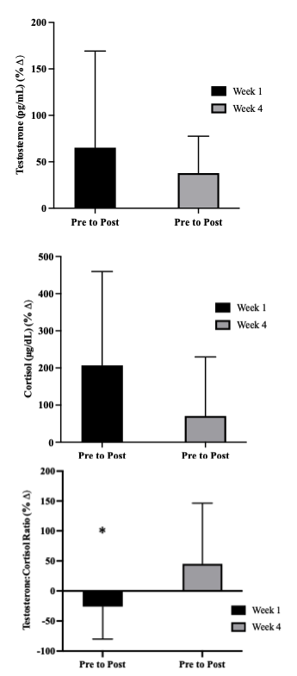
Figure 14. Endocrine Relative Changes Across Time

Note: Data presented as Mean (Standard Error); Pre = Pre-Practice; Post = Post-Practice; %Δ = percent change; * = significantly different than Week 4, set at p ≤ 0.05.

Table 8. Percent Change Scores in Endocrine Responses throughout the Preseason.
 | Week 1 | Week 4 | Week 1 to Week 4 | Week 1 to Week 4
Variable | Δ₁ = Pre to Post | Δ₁ = Pre to Post | Δ₁ = Pre to Pre | Δ₁ = Post to Post
T (pg/mL) (%Δ) | 65.2 ± 104.0 | 37.9 ± 39.7 | - 5.0 ± 18.5 | - 11.7 ± 27.3
C (µg/dL) (%Δ) | 206.9 ± 252.5 | 70.9 ± 158.7 | 40.6 ± 106.4 | - 29.1 ± 41.7
T:C (%Δ) | - 25.8 ± 54.3* | 45.2 ± 101.3 | - 12.7 ± 38.7 | 50.1 ± 73.8
Data presented as Mean ± Standard Deviation. Pre = Pre-Practice; Post = Post-Practice; T = Testosterone; C = Cortisol; T:C = Testosterone to Cortisol Ratio; pg/mL = picograms per milliliter; µg/dL = micrograms per deciliter; %Δ = percent change; statistical significance set at p ≤ 0.05; * = significantly different than Week 4

Discussion
The primary purpose of this retrospective study was to evaluate elite male NCAA Division I basketball players’ endocrine responses and neuromuscular performance to sport training sessions as well as over the course of the preseason.
The key findings of this retrospective study were 1) there were no significant differences observed across time for either eTL or iTL; 2) there were significant decreases in EccMF and Body Mass from the average of Week 1 and Week 4 Pre to the average of Week 1 and Week 4 Post and ConcPF displayed an increase from Pre to Post in Week 1 but not in Week 4; 3) there were no significant differences in CMJ performance across time when made relative to Body Mass; 4) there were no differences in T or C or the T:C ratio across any of the baseline values; 5) T displayed a significant increase from the average of Week 1 and Week 4 Pre to the average of Week 1 and Week 4 Post; 6) C displayed a significant increase from the average of Week 1 and Week 4 Pre to the average of Week 1 and Week 4 Post; 7) C displayed a significant increase from Pre to Post in Week 1 but not in Week 4, while also exhibiting a greater absolute change in concentration in Week 1 but not in Week 4; 8) the absolute and relative change in the T:C ratio was significantly greater in Week 4 compared to Week 1; and 9) there was a significant increase in the T:C ratio from Week 1 Post to Week 4 Post.

External Training Load
Despite the intentions to create similar external training load demands within the sport specific training sessions in each testing exposure, there was a statistically significant difference in Duration. The difference detected likely does not display sufficient efficacy since the variability within the data is so minimal that the approximate value of 23 minutes reached statistical significance. Therefore, while establishing statistical significance, the pertinence of this difference provides little to no influence due to the difference potentially being expressed from players participating in additional individual training before and after the times of practice.
The practice eTL demands are characterized by the types of drills instructed through the sport coaches based on their evaluation of which sport specific skills need attention for improvement. Fortunately for the purpose of this study, the remaining variables measuring eTL did not display any statistically significant differences. Although no differences existed between weeks, further investigation across years of the preseason phase may help to describe undulations in eTL experienced from each year. The present study in comparison with previous literature utilizing similar monitoring systems corresponds with the reported eTL in collegiate basketball players during the preseason training phase (A. Heishman et al., 2018). However, other data has shown greater eTL demands in the preseason than the present study (A. Heishman, Miller, et al., 2020). Despite the inability to control for drills employed, this allowed for enhanced ecological validity and enhanced insight into the physiological status of the players through neuromuscular and endocrinological assessments and the their responses to a very similar physical training demand of the team.

Internal Training Load
In conjunction with no differences seen in any of the eTL besides the Duration of the training session, there were no differences across Weeks in either subjective (RPE and sRPE) or objective (HR response) methods of measuring Internal Training Load (iTL). Conveniently, previous research has shown to describe an association between eTL and the iTL response within basketball (A. Heishman et al., 2018; Scanlan et al., 2014; Svilar et al., 2018). The lack of differences in either variable provides verification that both training sessions captured in Week 1 and Week 4 were of similar physiological demands and perceived physical demands. Thus, insight into the physiological status of the players on the recovery-adaptation continuum is enhanced by achieving similar training loads and evaluating the responses to each.

Countermovement Jump
The present study observed a significant decrease in EccMF and Body Mass from the average of Week 1 and Week 4 Pre to the average of Week 1 and Week 4 Post. The decrease in Body Mass in Week 4 was the last week prior to the competitive season beginning. The decline in Body Mass likely from loss of body water through sweating coincide with the findings of Heishman et al., displaying longitudinal dehydration among collegiate basketball players and describing further dehydration as the competitive season begins (A. Heishman, Daub, et al., 2021). Consequently, the significant decrease in EccMF may also be attributable to the fluctuations within Body Mass. Additionally, ConcPF displayed an increase from Pre to Post in Week 1 but not in Week 4. Although, the difference in Body Mass was shown to decrease from Pre to Post in the average of both weeks of testing, in Week 1 Body Mass actually exhibited a slight increase which could help to explain the increase in ConcPF. Hence, the ability to move more mass at a faster acceleration would produce a greater force achieved.
Furthermore, of the 17 CMJ variables, there were 6 that displayed an effect from Pre to Post in either Week 1 or Week 4. ConcPF and PP both presented a small effect in Week 1 from Pre to Post. EccMP, EccPF, F@0V, and RSI_{Mod} all showed small effects in Week 4 from Pre to Post. In addition, EccPF and F@0V both displayed a small effect from Week 1 Post to Week 4 Post, while all others displayed a trivial effect across all time points (d < 0.20).

Countermovement Jump Relative to Body Mass
Overall, there were no significant differences in CMJ performance across time when made relative to Body Mass. Albeit, 8 of the 11 CMJ variables displayed a small effect from Pre to Post in either Week 1 or Week 4. ConcMF, ConcPF, EccMF, and PP all showed to have a small effect in Week 1 from Pre to Post. Furthermore, EccMF, EccMP, EccPF, and F@0V all displayed a small effect from Pre to Post in Week 4. In addition, EccMBF and EccMF presented a small effect from Week 1 Pre to Week 4 Pre as well as EccPF and F@0V exhibiting a small effect from Week 1 Post to Week 4 Post. However, statistical significance of the eccentric variables may not have been reached due to the large variability seen in some of the eccentric measures of the CMJ (A. Heishman, Daub, et al., 2020).

Endocrine Responses
The Pre values obtained prior to the sport specific training were not significantly different than the Baseline Assessment taken on the same day of the week on a different week and at the same time as the Pre values but did not precede any physical training. This helps to verify that there were no anticipatory effects on the endocrine response prior to any sport specific training sessions and the changes reflect the magnitude of change stimulated by the training (Hayes et al., 2015).
T levels significantly increased from the average of Week 1 and Week 4 Pre values to the average of Week 1 and Week 4 Post values, yet there was no change exhibited from Pre to Post within the same week in parallel with some literature (Cormack, Newton, & McGuigan, 2008; D. Edwards et al., 2006; Rowell et al., 2017; Silva et al., 2013; Sparkes et al., 2018). Conflicting results also exist in previous studies reporting diminished T levels involving team sport (Romagnoli et al., 2006; West et al., 2014). In addition, T displayed a medium effect size from Pre to Post in Week 1, yet in Week 4 we observed a large effect size from Pre to Post. The result of an enhanced T response suggests that the players have an improved training status (Pliauga et al., 2015). Further, there could be other adaptations of enhanced synthesis, storage, or transport mechanisms such as regulation of the receptor concentrations (Gharahdaghi et al., 2021; Kraemer et al., 2020). Moreover, these findings are in agreement with Heishman (2020) that found increases in T for intercollegiate male basketball players following practice regardless of the varying eTL demands. However, these findings could also be due to the fluctuations in Body Mass significantly decreasing in Week 4 indicating that there may have been dehydration leading to higher concentrations of the hormone detected. Other mechanisms could also be at play including secretion rate, metabolic clearance rate, dietary status, or simply the large hormonal variability within individuals.
C levels significantly increased from the average of Week 1 and Week 4 Pre values to the average of Week 1 and Week 4 Post values. In addition, C exhibited a significant increase from Pre to Post in Week 1 congruent with well documented findings in the basketball literature (Arruda et al., 2014, 2017; Chatzinikolaou et al., 2014; Gonzalez-Bono et al., 1999; Moreira et al., 2012). However, this difference did not appear in Week 4. Furthermore, C showed a large effect from Pre to Post in Week 1, whereas in Week 4 C only presented a small effect from Pre to Post. These results were also reflected in the absolute changes in C concentrations from Pre to Post in Week 1 being significantly greater than concentrations seen in Week 4. C is known to be a stress hormone, that increases in response to training demands within team sport athletes (Filaire et al., 2003; Rowell et al., 2017) and has been shown to increase proportionally with exercise intensity (Hackney & Lane, 2015; Hill et al., 2008; Viru et al., 1992; Viru & Viru, 2004). However, it appears that chronic intermittent exposure to stressful physical situations that release cortisol allows the individual to adapt and display an inactivation of cortisol into cortisone allowing for anabolic processes to be expressed at a higher level (Kraemer et al., 2020). Also, individual training history seems to modulate the magnitude of a endocrine response (Davies & Few, 1973) helping to explain the greater C concentrations within the first week following the training exposure compared to the fourth week alluding to a greater training state following the preseason training phase. Therefore, following four weeks of training and observing a reduction in the C response displays training adaptations that minimized the relative intensity of the training sessions resulting in a reduced stress response experienced in Week 4 compared to Week 1 all while expressing a similar training demand in both weeks.
In conjunction with the individual responses seen from T and C, we observed a significant increase in absolute and relative changes of the T:C ratio from Week 1 to Week 4. The medium effect of the T:C ratio in Week 1 described a diminishing catabolic balance compared to the start of the sport specific training session, whereas in Week 4 there was a small effect establishing a greater anabolic balance compared to the start of the session in Week 4. Also, there was a significantly greater T:C ratio expressed in Week 4 Post than what was presented in Week 1 Post, while also displaying a small effect. The significant elevation in T:C ratio following a training exposure after four weeks of preseason training suggests that the players were in an anabolic state (Coutts et al., 2007) and support the findings of Schelling et al., 2015, that displayed a significant decrease in C, significant increase in the T:C ratio, and no change in T levels across the preseason (Schelling et al., 2015). These results exhibiting this response demonstrates that the players may be able to maintain an anabolic physiological status through the extensive and intensive phase of the preseason. However, the T:C ratio is not indicative of physical sport specific capabilities and should not be used as a monitoring tool for performance, rather it is a monitoring tool for the physiological status of the players and can help to determine signs of inadequate recovery potentially leading to nonfunctional overreaching or worse, overtraining (Coutts et al., 2007; Rowell et al., 2018).
However, despite the response displaying differences across time, limitations exist that may help to explain some of the findings. For example, there was a difference within Body Mass detected from the Pre values of Week 1 and Week 4 compared to the Post values of Week 1 and Week 4 which could result in a heightened concentration of the hormones due to a more dehydrated state causing hemoconcentration of the hormones. Additionally, other biological variables that could impact endocrine responses including emotional strain, dietary status outside of the testing environment, and training regimes outside of normal practices were not recorded. Furthermore, technical errors that may have went undetected could have included environmental conditions on days of testing or correcting for hemoconcentration. These limitations are acknowledged by the authors and will be considered when in the practically applied setting.

Chapter V: Conclusion
The primary purpose of this retrospective study was to evaluate endocrine responses and neuromuscular performance to similar training demands of acute bouts of sport specific training within the preseason as well as over the entire training phase of the preseason in a cohort of elite male NCAA Division I basketball players.

Research Questions
Research Question 1: Are there significant differences in salivary Testosterone, salivary Cortisol, or salivary Testosterone:Cortisol ratio pre- and post- basketball sessions?
There was a significant increase observed in C levels from Pre to Post in Week 1 but not found in Week 4.
Hypothesis 1: It was hypothesized that there would be a significant increase in salivary Cortisol following both basketball sessions in accordance with previous literature (Arruda et al., 2014). Additionally, no significant differences would exist within salivary Testosterone and salivary Testosterone:Cortisol ratio after each basketball specific training session similarly reported by (Andre et al., 2018; Hoffman et al., 1999).
We will accept Hypothesis 1, since there was a significant increase in salivary Cortisol following a basketball session in Week 1 compared to Week 4, indicating a significant time effect. Additionally, salivary Testosterone and salivary Testosterone:Cortisol ratio remained the same following the basketball specific training sessions.
Research Question 2: Are there significant differences in salivary Testosterone, salivary Cortisol, or salivary Testosterone:Cortisol ratio pre- and post- basketball preseason training phase?
There were significant differences across the preseason training phase in salivary Testosterone, salivary Cortisol, and salivary Testosterone ratio. Salivary Testosterone and salivary Cortisol exhibited a significant increase in the average of the Pre values of Week 1 and Week 4 compared to the average of the Post values of Week 1 and Week 4. Additionally, salivary Cortisol displayed a difference in the absolute change expressed in Week 1 from Pre to Post was significantly higher than the absolute change in Week 4. Moreover, the absolute and relative change in the T:C ratio in Week 1 from Pre to Post was significantly lower than Week 4. Also, the Post T:C ratio produced in Week 1 was significantly lower than Week 4 Post.
Hypothesis 2: It was hypothesized that there would be a significant increase in salivary Testosterone:Cortisol ratio, a significant decrease in salivary Cortisol concentration, and no differences would exist within salivary Testosterone concentrations following the preseason training phase in parallel with (Andre et al., 2018).
We will reject Hypothesis 2, since there was only a significant increase in the salivary Testosterone:Cortisol ratio in the absolute and relative changes and the Post values from Week 1 to Week 4. Plus, salivary Cortisol only displayed a significant reduction in the absolute change from Week 1 to Week 4, otherwise it remained unchanged in Week 4 compared to Week 1. Lastly, salivary Testosterone exhibited a significant increase from the average Pre values of Week 1 and Week 4 to the Post values of Week 1 and Week 4, nevertheless no other differences were detected.
Research Question 3: Are there significant differences in countermovement jump performance pre- and post- basketball specific training session?
There was a significant difference in ConcPF exhibiting an increase in Week 1 from Pre to Post but not in Week 4. However, when made relative to Body Mass, no significant differences were detected in any CMJ variables.
Hypothesis 3: It was hypothesized that there would be significant decreases in countermovement jump performance from pre- to post- basketball specific training sessions.
We will reject Hypothesis 3, that CMJ performance would be influenced from Pre to Post basketball specific training sessions since we did not observe any differences when made relative to Body Mass.
Research Question 4: Are there significant differences in countermovement jump performance pre- and post- basketball preseason training phase?
There was a significant difference in EccMF and Body Mass displayed in the average of the Pre values in Week 1 and Week 4 compared to the average of the Post values of Week 1 and Week 4. However, when made relative to Body Mass, no significant differences were detected in any CMJ variables.
Hypothesis 4: It was hypothesized that there would be significant increases in countermovement jump performance from pre- to post- of the preseason training phase.
We will reject Hypothesis 4, that CMJ performance would be influenced from Pre to Post of the preseason training phase since we did not observe any differences when made relative to Body Mass.

Practical Significance
The findings from the present study offer several practically relevant takeaways. Neuromuscular performance after made relative to the players’ body mass did not seem to be influenced after a sport specific training session, nor over the course of the entire preseason. Additionally, the cortisol response following four weeks of the preseason training phase showed to be blunted with the testosterone response unchanged resulting in a more anabolic state while examining the T:C ratio. Therefore, monitoring of physiological status may be of interest to gain insight of whether or not an individual is approaching concerning levels. In fact, long-term monitoring, such as across training phases, may be more useful than the acute measurements following training sessions due to the ability to observe the changes in the hormonal changes reflective of anabolic and catabolic balances and neuromuscular changes, while also collecting and accounting for the influence of the accumulation of eTL and iTL.

Suggestions for Future Research
Future studies should include additional data collection points of 24 hours post sport specific training session as well as including a sample of elite intercollegiate women’s basketball players while controlling for menstrual cycle or any other type of birth control being utilized. Furthermore, future investigations should also record hydration and incorporate psychological and recovery questionnaires to account for other influences on physiological status. Finally, future research should explore these same variables and acute and chronic responses throughout the course of the entire competitive season and postseason

References
Achten, J., & Jeukendrup, A. E. (2003). Heart rate monitoring: Applications and limitations. Sports Medicine, 33(7), 517–538. https://doi.org/10.2165/00007256-200333070-00004
Adlercreutz, H., Härkönen, M., Kuoppasalmi, K., Näveri, H., Huhtaniemi, I., Tikkanen, H., Remes, K., Dessypris, A., & Karvonen, J. (1986). Effect of training on plasma anabolic and catabolic steroid hormones and their response during physical exercise. International Journal of Sports Medicine, 07(S 1), S27–S28. https://doi.org/10.1055/s-2008-1025798
Akubat, I., Barrett, S., & Abt, G. (2014). Integrating the internal and external training loads in soccer. International Journal of Sports Physiology and Performance, 9(3), 457–462. https://doi.org/10.1123/ijspp.2012-0347
Andre, M. J., Fry, A. C., Luebbers, P. E., Hudy, A., Dietz, P. R., & Cain, G. J. (2018). Weekly salivary biomarkers across a season for elite men collegiate basketball players. International Journal of Exercise Science, 11(6), 439–451.
Angeli, A., Minetto, M., Dovio, A., & Paccotti, P. (2004). The overtraining syndrome in athletes: A stress-related disorder. Journal of Endocrinological Investigation, 27(6), 603–612. https://doi.org/10.1007/BF03347487
Aoki, M. S., Ronda, L. T., Marcelino, P. R., Drago, G., Carling, C., Bradley, P. S., & Moreira, A. (2017). Monitoring training loads in professional basketball players engaged in a periodized training program. Journal of Strength and Conditioning Research, 31(2), 348–358. https://doi.org/10.1519/JSC.0000000000001507
Arruda, A. F. S., Aoki, M. S., Freitas, C. G., Drago, G., Oliveira, R., Crewther, B. T., & Moreira, A. (2014). Influence of competition playing venue on the hormonal responses, state anxiety and perception of effort in elite basketball athletes. Physiology & Behavior, 130, 1–5. https://doi.org/10.1016/j.physbeh.2014.03.007
Arruda, A. F. S., Aoki, M. S., Paludo, A. C., & Moreira, A. (2017). Salivary steroid response and competitive anxiety in elite basketball players: Effect of opponent level. Physiology & Behavior, 177, 291–296. https://doi.org/10.1016/j.physbeh.2017.05.017
Balsalobre-Fernández, C., Tejero-González, C. M., & del Campo-Vecino, J. (2014). Relationships between training load, salivary cortisol responses and performance during season training in middle and long distance runners. PLOS ONE, 9(8), e106066. https://doi.org/10.1371/journal.pone.0106066
Barrett, S., Midgley, A., & Lovell, R. (2014). PlayerLoadTM: Reliability, convergent validity, and influence of unit position during treadmill running. International Journal of Sports Physiology and Performance, 9(6), 945–952. https://doi.org/10.1123/ijspp.2013-0418
Baxendale, P. M., Jacobs, H. S., & James, V. H. T. (1982). Salivary testosterone: Relationship to unbound plasma testosterone in normal and hyperandrogenic women. Clinical Endocrinology, 16(6), 595–603. https://doi.org/10.1111/j.1365-2265.1982.tb03176.x
Berkelmans, D. M., Dalbo, V. J., Kean, C. O., Milanović, Z., Stojanović, E., Stojiljković, N., & Scanlan, A. T. (2018). Heart rate monitoring in basketball: Applications, player responses, and practical recommendations. Journal of Strength and Conditioning Research, 32(8), 2383–2399. https://doi.org/10.1519/JSC.0000000000002194
Borresen, J., & Ian Lambert, M. (2009). The quantification of training load, the training response and the effect on performance: Sports Medicine, 39(9), 779–795. https://doi.org/10.2165/11317780-000000000-00000
Boyd, L. J., Ball, K., & Aughey, R. J. (2011). The reliability of minimaxx accelerometers for measuring physical activity in australian football. International Journal of Sports Physiology and Performance, 6(3), 311–321. https://doi.org/10.1123/ijspp.6.3.311
Casamichana, D., Castellano, J., Calleja-Gonzalez, J., San Román, J., & Castagna, C. (2013). Relationship between indicators of training load in soccer players. Journal of Strength and Conditioning Research, 27(2), 369–374. https://doi.org/10.1519/JSC.0b013e3182548af1
Casto, K. V., & Edwards, D. A. (2016). Testosterone, cortisol, and human competition. Hormones and Behavior, 82, 21–37. https://doi.org/10.1016/j.yhbeh.2016.04.004
Chambers, R., Gabbett, T. J., Cole, M. H., & Beard, A. (2015). The use of wearable microsensors to quantify sport-specific movements. Sports Medicine, 45(7), 1065–1081. https://doi.org/10.1007/s40279-015-0332-9
Chatzinikolaou, A., Draganidis, D., Avloniti, A., Karipidis, A., Jamurtas, A. Z., Skevaki, C. L., Tsoukas, D., Sovatzidis, A., Theodorou, A., Kambas, A., Papassotiriou, I., Taxildaris, K., & Fatouros, I. (2014). The microcycle of inflammation and performance changes after a basketball match. Journal of Sports Sciences, 32(9), 870–882. https://doi.org/10.1080/02640414.2013.865251
Cohen, J. (1992). A power primer. Psychological Bulletin, 112(1), 155–159. https://doi.org/10.1037//0033-2909.112.1.155
Cormack, S. J., Newton, R. U., & McGuigan, M. R. (2008). Neuromuscular and endocrine responses of elite players to an australian rules football match. International Journal of Sports Physiology and Performance, 3(3), 359–374. https://doi.org/10.1123/ijspp.3.3.359
Cormack, S. J., Newton, R. U., McGuigan, M. R., & Doyle, T. L. A. (2008). Reliability of Measures Obtained During Single and Repeated Countermovement Jumps. International Journal of Sports Physiology and Performance, 3(2), 131–144. https://doi.org/10.1123/ijspp.3.2.131
Coutts, A., Reaburn, P., Piva, T., & Murphy, A. (2007). Changes in Selected Biochemical, Muscular Strength, Power, and Endurance Measures during Deliberate Overreaching and Tapering in Rugby League Players. International Journal of Sports Medicine, 28(2), 116–124. https://doi.org/10.1055/s-2006-924145
Cruz, I. de F., Pereira, L. A., Kobal, R., Kitamura, K., Cedra, C., Loturco, I., & Cal Abad, C. C. (2018). Perceived training load and jumping responses following nine weeks of a competitive period in young female basketball players. PeerJ, 6, e5225. https://doi.org/10.7717/peerj.5225
Cummins, C., Orr, R., O’Connor, H., & West, C. (2013). Global positioning systems (gps) and microtechnology sensors in team sports: A systematic review. Sports Medicine, 43(10), 1025–1042. https://doi.org/10.1007/s40279-013-0069-2
Cunanan, A. J., DeWeese, B. H., Wagle, J. P., Carroll, K. M., Sausaman, R., Hornsby, W. G., Haff, G. G., Triplett, N. T., Pierce, K. C., & Stone, M. H. (2018). The general adaptation syndrome: A foundation for the concept of periodization. Sports Medicine, 48(4), 787–797. https://doi.org/10.1007/s40279-017-0855-3
Davies, C. T., & Few, J. D. (1973). Effects of exercise on adrenocortical function. Journal of Applied Physiology, 35(6), 887–891. https://doi.org/10.1152/jappl.1973.35.6.887
Dellaserra, C. L., Gao, Y., & Ransdell, L. (2014). Use of integrated technology in team sports: A review of opportunities, challenges, and future directions for athletes. Journal of Strength and Conditioning Research, 28(2), 556–573.
Duffield, R., Reid, M., Baker, J., & Spratford, W. (2010). Accuracy and reliability of gps devices for measurement of movement patterns in confined spaces for court-based sports. Journal of Science and Medicine in Sport, 13(5), 523–525. https://doi.org/10.1016/j.jsams.2009.07.003
Edwards, D., Wetzel, K., & Wyner, D. (2006). Intercollegiate soccer: Saliva cortisol and testosterone are elevated during competition, and testosterone is related to status and social connectedness with teammates. Physiology & Behavior, 87(1), 135–143. https://doi.org/10.1016/j.physbeh.2005.09.007
Edwards, T., Spiteri, T., Piggott, B., Bonhotal, J., Haff, G. G., & Joyce, C. (2018). Monitoring and managing fatigue in basketball. Sports, 6(1), 19. https://doi.org/10.3390/sports6010019
Enoki, T., Yoshida, Y., Lally, J., Hatta, H., & Bonen, A. (2006). Testosterone increases lactate transport, monocarboxylate transporter (mct) 1 and mct4 in rat skeletal muscle: Testosterone and mct1 and 4. The Journal of Physiology, 577(1), 433–443. https://doi.org/10.1113/jphysiol.2006.115436
Ferioli, D., Bosio, A., Bilsborough, J. C., La Torre, A., Tornaghi, M., & Rampinini, E. (2018). The preparation period in basketball: Training load and neuromuscular adaptations. International Journal of Sports Physiology and Performance, 13(8), 991–999. https://doi.org/10.1123/ijspp.2017-0434
Filaire, E., Lac, G., & Pequignot, J.-M. (2003). Biological, Hormonal, and Psychological Parameters in Professional Soccer Players Throughout a Competitive Season. Perceptual and Motor Skills, 97, 1061–1072.
Fleming, A. S., Corter, C., Stallings, J., & Steiner, M. (2002). Testosterone and prolactin are associated with emotional responses to infant cries in new fathers. Hormones and Behavior, 42(4), 399–413. https://doi.org/10.1006/hbeh.2002.1840
Foster, C., Florhaug, J. A., Franklin, J., Gottschall, L., Hrovatin, L. A., Parker, S., Doleshal, P., & Dodge, C. (2001). A new approach to monitoring exercise training: Journal of Strength and Conditioning Research, 15(1), 109–115. https://doi.org/10.1519/00124278-200102000-00019
Fox, J. L., Stanton, R., & Scanlan, A. T. (2018). A comparison of training and competition demands in semiprofessional male basketball players. Research Quarterly for Exercise and Sport, 89(1), 103–111. https://doi.org/10.1080/02701367.2017.1410693
Fry, A. C., & Kraemer, W. J. (1997). Resistance exercise overtraining and overreaching: Neuroendocrine responses. Sports Medicine, 23(2), 106–129. https://doi.org/10.2165/00007256-199723020-00004
Gallo, T., Cormack, S., Gabbett, T., Williams, M., & Lorenzen, C. (2015). Characteristics impacting on session rating of perceived exertion training load in australian footballers. Journal of Sports Sciences, 33(5), 467–475. https://doi.org/10.1080/02640414.2014.947311
Gathercole, R., Sporer, B., Stellingwerff, T., & Sleivert, G. (2015). Alternative countermovement-jump analysis to quantify acute neuromuscular fatigue. International Journal of Sports Physiology and Performance, 10(1), 84–92. https://doi.org/10.1123/ijspp.2013-0413
Gaviglio, C. M., & Cook, C. J. (2014). Relationship between midweek training measures of testosterone and cortisol concentrations and game outcome in professional rugby union matches. Journal of Strength and Conditioning Research, 28(12), 3447–3452. https://doi.org/10.1519/JSC.0000000000000574
Gharahdaghi, N., Phillips, B. E., Szewczyk, N. J., Smith, K., Wilkinson, D. J., & Atherton, P. J. (2021). Links between testosterone, oestrogen, and the growth hormone/insulin-like growth factor axis and resistance exercise muscle adaptations. Frontiers in Physiology, 11, 621226. https://doi.org/10.3389/fphys.2020.621226
Gibson, E. L., Checkley, S., Papadopoulos, A., Poon, L., Daley, S., & Wardle, J. (1999). Increased salivary cortisol reliably induced by a protein-rich midday meal. Psychosomatic Medicine, 61(2), 214–224. https://doi.org/10.1097/00006842-199903000-00014
Gonzalez-Bono, E., Salvador, A., Serrano, M. A., & Ricarte, J. (1999). Testosterone, cortisol, and mood in a sports team competition. Hormones and Behavior, 35(1), 55–62. https://doi.org/10.1006/hbeh.1998.1496
Gozansky, W. S., Lynn, J. S., Laudenslager, M. L., & Kohrt, W. M. (2005). Salivary cortisol determined by enzyme immunoassay is preferable to serum total cortisol for assessment of dynamic hypothalamic-pituitary-adrenal axis activity. Clinical Endocrinology, 63(3), 336–341. https://doi.org/10.1111/j.1365-2265.2005.02349.x
Hackney, A. C. (1989). Endurance training and testosterone levels: Sports Medicine, 8(2), 117–127. https://doi.org/10.2165/00007256-198908020-00004
Hackney, A. C., & Lane, A. R. (2015). Exercise and the regulation of endocrine hormones. In Progress in Molecular Biology and Translational Science (Vol. 135, pp. 293–311). Elsevier. https://doi.org/10.1016/bs.pmbts.2015.07.001
Häkkinen, K., Pakarinen, A., Newton, R. U., & Kraemer, W. J. (1998). Acute hormone responses to heavy resistance lower and upper extremity exercise in young versus old men. European Journal of Applied Physiology, 77(4), 312–319. https://doi.org/10.1007/s004210050339
Halson, S. L. (2014). Monitoring training load to understand fatigue in athletes. Sports Medicine, 44(S2), 139–147. https://doi.org/10.1007/s40279-014-0253-z
Halson, S. L., & Jeukendrup, A. E. (2004). Does overtraining exist?: An analysis of overreaching and overtraining research. Sports Medicine, 34(14), 967–981. https://doi.org/10.2165/00007256-200434140-00003
Hayes, L. D., Grace, F. M., Baker, J. S., & Sculthorpe, N. (2015). Exercise-induced responses in salivary testosterone, cortisol, and their ratios in men: A meta-analysis. Sports Medicine, 45(5), 713–726. https://doi.org/10.1007/s40279-015-0306-y
He, C.-S., Tsai, M.-L., Ko, M.-H., Chang, C.-K., & Fang, S.-H. (2010). Relationships among salivary immunoglobulin a, lactoferrin and cortisol in basketball players during a basketball season. European Journal of Applied Physiology, 110(5), 989–995. https://doi.org/10.1007/s00421-010-1574-8
Heishman, A., Curtis, M., Saliba, E., Hornett, R., Malin, S., & Weltman, A. (2018). Noninvasive assessment of internal and external player load: Implications for optimizing athletic performance. Journal of Strength and Conditioning Research, 32(5), 1280–1287. https://doi.org/10.1519/JSC.0000000000002413
Heishman, A. D., Curtis, M. A., Saliba, E. N., Hornett, R. J., Malin, S. K., & Weltman, A. L. (2017). Comparing Performance During Morning vs. Afternoon Training Sessions in Intercollegiate Basketball Players: Journal of Strength and Conditioning Research, 31(6), 1557–1562. https://doi.org/10.1519/JSC.0000000000001882
Heishman, A., Daub, B., Miller, R., Brown, B., Freitas, E., & Bemben, M. (2019). Countermovement jump inter-limb asymmetries in collegiate basketball players. Sports, 7(5), 103. https://doi.org/10.3390/sports7050103
Heishman, A., Daub, B., Miller, R., Freitas, E., & Bemben, M. (2021). Longitudinal hydration assessment in collegiate basketball players over various training phases. Journal of Strength and Conditioning Research, 35(4), 1089–1094. https://doi.org/10.1519/JSC.0000000000002845
Heishman, A., Daub, B., Miller, R., Freitas, E., Frantz, B., & Bemben, M. (2020). Countermovement jump reliability performed with and without an arm swing in ncaa division 1 intercollegiate basketball players. Journal of Strength and Conditioning Research, 34(2), 546–558. https://doi.org/10.1519/JSC.0000000000002812
Heishman, A., Miller, R., Freitas, E., Brown, B., Daub, B., & Bemben, M. (2020). Monitoring external training loads and neuromuscular performance for division 1 basketball players over the pre-season. Medicine & Science in Sports & Exercise, 51(6S), 35–35. https://doi.org/10.1249/01.mss.0000560595.64671.b6
Heishman, A., Peak, K., Daub, B., Miller, R., & Freitas, E. (2021). Does footwear influence countermovement jump parameters used to assess performance in collegiate basketball players? International Journal of Kinesiology and Sports Science, 9(2), 14. https://doi.org/10.7575/aiac.ijkss.v.9n.2p.14
Heishman, A., Peak, K., Miller, R., Brown, B., Daub, B., Freitas, E., & Bemben, M. (2020). Associations between two athlete monitoring systems used to quantify external training loads in basketball players. Sports, 8(3), 33. https://doi.org/10.3390/sports8030033
Hill, E. E., Zack, E., Battaglini, C., Viru, M., Viru, A., & Hackney, A. C. (2008). Exercise and circulating cortisol levels: The intensity threshold effect. Journal of Endocrinological Investigation, 31(7), 587–591. https://doi.org/10.1007/BF03345606
Hoffman, J. R., Epstein, S., Yarom, Y., Zigel, L., & Einbinder, M. (1999). Hormonal and biochemical changes in elite basketball players during a 4-week training camp. The Journal of Strength & Conditioning Research, 13(3), 280–285.
Holme, B. (2015). Wearable microsensor technology to measure physical activity demands in handball: A reliability study of inertial movement analysis and player load. Norwegian School of Sport Sciences, Olso. /paper/Wearable-microsensor-technology-to-measure-physical-Holme/80af29628bc86bfaecea9c350efe0524c98cabca
Johnson, S. G., & Joplin, F. (1987). Direct assay for testosterone in saliva: Relationship with a direct serum free testosterone assay. Clinica Chimica Acta, 309–318.
Kindermann, W., Schnabel, A., Schmitt, W. M., Biro, G., Cassens, J., & Weber, F. (1982). Catecholamines, growth hormone, cortisol, insulin, and sex hormones in anaerobic and aerobic exercise. European Journal of Applied Physiology and Occupational Physiology, 49(3), 389–399. https://doi.org/10.1007/BF00441300
Komi, P. V. (2000). Stretch-shortening cycle: A powerful model to study normal and fatigued muscle. Journal of Biomechanics, 33(10), 1197–1206. https://doi.org/10.1016/S0021-9290(00)00064-6
Kraemer, W. J. (1988). Endocrine responses to resistance exercise. Medicine and Science in Sports and Exercise, 20(5 Suppl), S152-157. https://doi.org/10.1249/00005768-198810001-00011
Kraemer, W. J., Hagerman, F. C., Fry, A. C., Nindl, B. C., Volek, S., & Newton, R. U. (1998). The effects of short-term resistance training on endocrine function in men and women. European Journal of Applied Physiology, 78, 69–76.
Kraemer, W. J., & Ratamess, N. A. (2005). Hormonal responses and adaptations to resistance exercise and training: Sports Medicine, 35(4), 339–361. https://doi.org/10.2165/00007256-200535040-00004
Kraemer, W. J., Ratamess, N. A., Hymer, W. C., Nindl, B. C., & Fragala, M. S. (2020). Growth hormone(s), testosterone, insulin-like growth factors, and cortisol: Roles and integration for cellular development and growth with exercise. Frontiers in Endocrinology, 11, 33. https://doi.org/10.3389/fendo.2020.00033
Kraemer, W. J., Spiering, B. A., Volek, J. S., Martin, G. J., Howard, R. L., Ratamess, N. A., Hatfield, D. L., Vingren, J. L., Ho, J. Y., Fragala, M. S., Thomas, G. A., French, D. N., Anderson, J. M., Häkkinen, K., & Maresh, C. M. (2009). Recovery from a national collegiate athletic association division I football game: Muscle damage and hormonal status. Journal of Strength and Conditioning Research, 23(1), 2–10. https://doi.org/10.1519/JSC.0b013e31819306f2
Lippi, G., De Vita, F., Salvagno, G. L., Gelati, M., Montagnana, M., & Guidi, G. C. (2009). Measurement of morning saliva cortisol in athletes. Clinical Biochemistry, 42(9), 904–906. https://doi.org/10.1016/j.clinbiochem.2009.02.012
Malone, J. J., Lovell, R., Varley, M. C., & Coutts, A. J. (2017). Unpacking the black box: Applications and considerations for using gps devices in sport. International Journal of Sports Physiology and Performance, 12(s2), S2-18-S2-26. https://doi.org/10.1123/ijspp.2016-0236
Martínez, A. C., Seco Calvo, J., Tur Marí, J. A., Abecia Inchaurregui, L. C., Orella, E. E., & Biescas, A. P. (2010). Testosterone and cortisol changes in professional basketball players through a season competition. Journal of Strength and Conditioning Research, 24(4), 1102–1108. https://doi.org/10.1519/JSC.0b013e3181ce2423
Martinez, D. B. (2016). The use of reactive strength index, reactive strength index modified, and flight time:contraction time as monitoring tools. Journal of Australian Strength and Conditioning, 24(5), 37–41.
Mayer, M., & Rosen, F. (1977). Interaction of glucocorticoids and androgens with skeletal muscle. Metabolism, 26(8), 937–962. https://doi.org/10.1016/0026-0495(77)90013-0
McLaren, S. J., Macpherson, T. W., Coutts, A. J., Hurst, C., Spears, I. R., & Weston, M. (2018). The relationships between internal and external measures of training load and intensity in team sports: A meta-analysis. Sports Medicine, 48(3), 641–658. https://doi.org/10.1007/s40279-017-0830-z
McLean, B. D., Cummins, C., Conlan, G., Duthie, G., & Coutts, A. J. (2018). The fit matters: Influence of accelerometer fitting and training drill demands on load measures in rugby league players. International Journal of Sports Physiology and Performance, 13(8), 1083–1089. https://doi.org/10.1123/ijspp.2017-0729
Meeusen, R., Duclos, M., Foster, C., Fry, A., Gleeson, M., Nieman, D., Raglin, J., Rietjens, G., Steinacker, J., & Urhausen, A. (2013). Prevention, diagnosis and treatment of the overtraining syndrome: Joint consensus statement of the european college of sport science (ecss) and the american college of sports medicine (acsm). European Journal of Sport Science, 13(1), 1–24. https://doi.org/10.1080/17461391.2012.730061
Meeusen, R., Piacentini, M. F., Busschaert, B., Buyse, L., De Schutter, G., & Stray-Gundersen, J. (2004). Hormonal responses in athletes: The use of a two bout exercise protocol to detect subtle differences in (over)training status. European Journal of Applied Physiology, 91(2–3), 140–146. https://doi.org/10.1007/s00421-003-0940-1
Montgomery, P. G., Pyne, D. B., & Minahan, C. L. (2010). The physical and physiological demands of basketball training and competition. International Journal of Sports Physiology and Performance, 5(1), 75–86. https://doi.org/10.1123/ijspp.5.1.75
Moreira, A., Crewther, B., Freitas, C. G., Arruda, A. F. S., Costa, E. C., & Aoki, M. S. (2012). Session rpe and salivary immune-endocrine responses to simulated and official basketball matches in elite young male athletes. The Journal of Sports Medicine and Physical Fitness, 52(6), 7.
Moreira, A., Nosaka, K., Nunes, J. A., Viveiros, L., Jamurtas, A. Z., & Aoki, M. S. (2014). Changes in muscle damage markers in female basketball players. Biology of Sport, 31(1), 3–7. https://doi.org/10.5604/20831862.1083272
Morton, R. H., Fitz-Clarke, J. R., & Banister, E. W. (1990). Modeling human performance in running. Journal of Applied Physiology, 69(3), 1171–1177. https://doi.org/10.1152/jappl.1990.69.3.1171
Nimmo, M. A., & Ekblom, B. (2007). Fatigue and illness in athletes. Journal of Sports Sciences, 25(S1), S93–S102. https://doi.org/10.1080/02640410701607379
Noakes, T. D. (2000). Physiological models to understand exercise fatigue and the adaptations that predict or enhance athletic performance: Physiological models to study exercise. Scandinavian Journal of Medicine & Science in Sports, 10(3), 123–145. https://doi.org/10.1034/j.1600-0838.2000.010003123.x
O’Connor, P. J., & Corrigan, D. L. (1987). Influence of short-term cycling on salivary cortisol levels. Medicine & Science in Sports & Exercise, 19(3), 224–228.
Papacosta, E., & Nassis, G. P. (2011). Saliva as a tool for monitoring steroid, peptide and immune markers in sport and exercise science. Journal of Science and Medicine in Sport, 14(5), 424–434. https://doi.org/10.1016/j.jsams.2011.03.004
Pliauga, V., Kamandulis, S., Dargevičiūtė, G., Jaszczanin, J., Klizienė, I., Stanislovaitienė, J., & Stanislovaitis, A. (2015). The effect of a simulated basketball game on players’ sprint and jump performance, temperature and muscle damage. Journal of Human Kinetics, 46(1), 167–175. https://doi.org/10.1515/hukin-2015-0045
Polglaze, T., Dawson, B., Hiscock, D. J., & Peeling, P. (2015). A comparative analysis of accelerometer and time–motion data in elite men’s hockey training and competition. International Journal of Sports Physiology and Performance, 10(4), 446–451. https://doi.org/10.1123/ijspp.2014-0233
Rantonen, P. J. F., Penttilä, I., Meurman, J. H., Savolainen, K., Närvänen, S., & Helenius, T. (2000). Growth hormone and cortisol in serum and saliva. Acta Odontologica Scandinavica, 58(6), 299–303. https://doi.org/10.1080/00016350050217163
Romagnoli, M., Sanchis-Gomar, F., Alis, R., Risso-Ballester, J., Bosio, A., Graziani, R., & Rampinini, E. (2006). Changes in muscle damage, inflammation, and fatigue-related parameters in young elite soccer players after a match. The Journal of Sports Medicine and Physical Fitness, 56(10), 1198–1205.
Rowell, A. E., Aughey, R. J., Hopkins, W. G., Esmaeili, A., Lazarus, B. H., & Cormack, S. J. (2018). Effects of training and competition load on neuromuscular recovery, testosterone, cortisol, and match performance during a season of professional football. Frontiers in Physiology, 9, 668. https://doi.org/10.3389/fphys.2018.00668
Rowell, A. E., Aughey, R. J., Hopkins, W. G., Stewart, A. M., & Cormack, S. J. (2017). Identification of Sensitive Measures of Recovery After External Load From Football Match Play. International Journal of Sports Physiology and Performance, 12(7), 969–976. https://doi.org/10.1123/ijspp.2016-0522
Scanlan, A. T., Wen, N., Tucker, P. S., & Dalbo, V. J. (2014). The relationships between internal and external training load models during basketball training. Journal of Strength and Conditioning Research, 28(9), 2397–2405. https://doi.org/10.1519/JSC.0000000000000458
Schelling, X., Lez, J. C.-G., Torres-Ronda, L., & Terrados, N. S. (2015). Using testosterone and cortisol as biomarker for training individualization in eleite basketball: A 4-year follow-up study. Journal of Strength and Conditioning Research, 29(2), 368–378.
Schelling, X., & Torres, L. (2016). Accelerometer load profiles for basketball-specific drills in elite players. Journal of Sports Science and Medicine, 15, 585–591.
Selye, H. (1936). A syndrome produced by diverse nocuous agents. Nature, 138(3479), 32–32. https://doi.org/10.1038/138032a0
Selye, H. (1937). Studies on adaptation. Endocrinology, 21(2), 169–188. https://doi.org/10.1210/endo-21-2-169
Selye, H. (1950). Stress and the general adaptation syndrome. British Medical Journal, 1383–1392.
Shahidi, N. (2001). A review of the chemistry, biological action, and clinical applications of anabolic-androgenic steroids. Clinical Therapeutics, 23(9), 1355–1390. https://doi.org/10.1016/S0149-2918(01)80114-4
Silva, J. R., Ascensão, A., Marques, F., Seabra, A., Rebelo, A., & Magalhães, J. (2013). Neuromuscular function, hormonal and redox status and muscle damage of professional soccer players after a high-level competitive match. European Journal of Applied Physiology, 113(9), 2193–2201. https://doi.org/10.1007/s00421-013-2633-8
Smith, D. J. (2003). A framework for understanding the training process leading to elite performance. Sports Medicine, 33(15), 1103–1126. https://doi.org/10.2165/00007256-200333150-00003
Sparkes, W., Turner, A., Weston, M., Russell, M., Johnston, M., & Kilduff, L. (2018). Neuromuscular, Biochemical, Endocrine, and Mood Responses to Small-Sided Games’ Training in Professional Soccer. Journal of Strength and Conditioning Research, 32(9), 2569–2576. https://doi.org/10.1519/JSC.0000000000002424
Stojanović, E., Stojiljković, N., Scanlan, A. T., Dalbo, V. J., Berkelmans, D. M., & Milanović, Z. (2018). The activity demands and physiological responses encountered during basketball match-play: A systematic review. Sports Medicine, 48(1), 111–135. https://doi.org/10.1007/s40279-017-0794-z
Svilar, L., Castellano, J., & Jukić, I. (2018). Load monitoring system in top-level basketball team: Relationship between external and internal training load. Kinesiology, 50(1), 25–33. https://doi.org/10.26582/k.50.1.4
Urhausen, A., Gabriel, H., & Kindermann, W. (1995). Blood hormones as markers of training stress and overtraining. Sports Medicine, 20(4), 251–276. https://doi.org/10.2165/00007256-199520040-00004
Vining, R. F., & McGinley, R. A. (1987). The measurement of hormones in saliva: Possibilities and pitfalls. Journal of Steroid Biochemistry, 27(1–3), 81–94. https://doi.org/10.1016/0022-4731(87)90297-4
Viru, A., Karelson, K., & Smirnova, T. (1992). Stability and variability in hormonal responses to prolonged exercise. International Journal of Sports Medicine, 13, 230–235.
Viru, A., & Viru, M. (2004). Cortisol—Essential adaptation hormone in exercise. International Journal of Sports Medicine, 25(6), 461–464. https://doi.org/10.1055/s-2004-821068
Wahl, P., Mathes, S., Köhler, K., Achtzehn, S., Bloch, W., & Mester, J. (2013). Acute metabolic, hormonal, and psychological responses to different endurance training protocols. Hormone and Metabolic Research, 45(11), 827–833. https://doi.org/10.1055/s-0033-1347242
West, D. J., Finn, C. V., Cunningham, D. J., Shearer, D. A., Jones, M. R., Harrington, B. J., Crewther, B. T., Cook, C. J., & Kilduff, L. P. (2014). Neuromuscular Function, Hormonal, and Mood Responses to a Professional Rugby Union Match. Journal of Strength and Conditioning Research, 28(1), 194–200. https://doi.org/10.1519/JSC.0b013e318291b726
Yang, C.-C., & Hsu, Y.-L. (2010). A review of accelerometry-based wearable motion detectors for physical activity monitoring. Sensors, 10(8), 7772–7788. https://doi.org/10.3390/s100807772
Young, W. B., Pryor, J. F., & Wilson, G. J. (1995). Effect of instructions on characteristics of countermovement and drop jump performance. The Journal of Strength & Conditioning Research, 9(4), 232–236.

Appendices

Appendix A: IRB Approval Letter
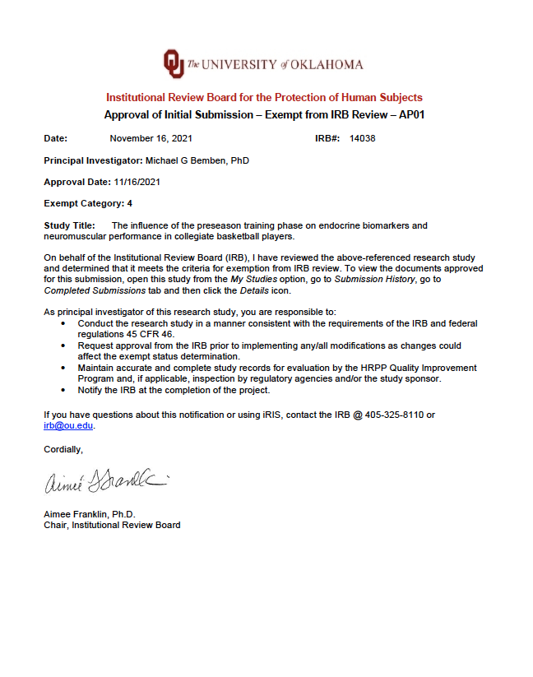

Appendix B: Informed Consent

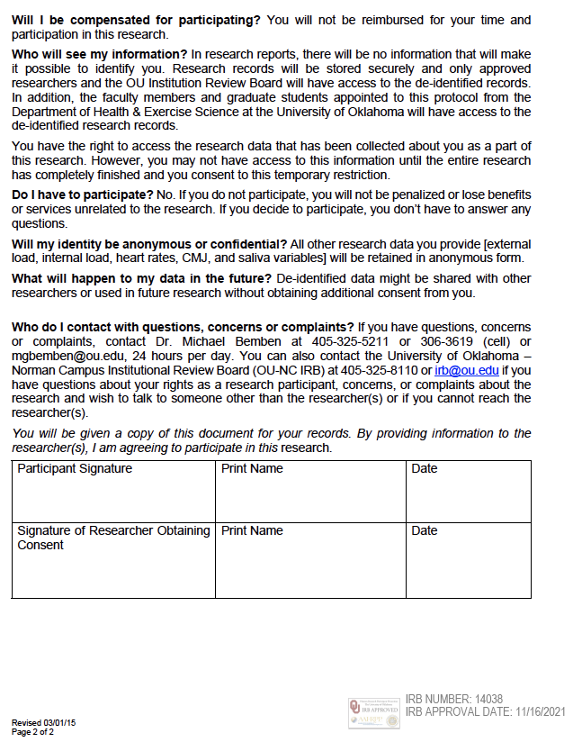

Appendix C: HIPAA
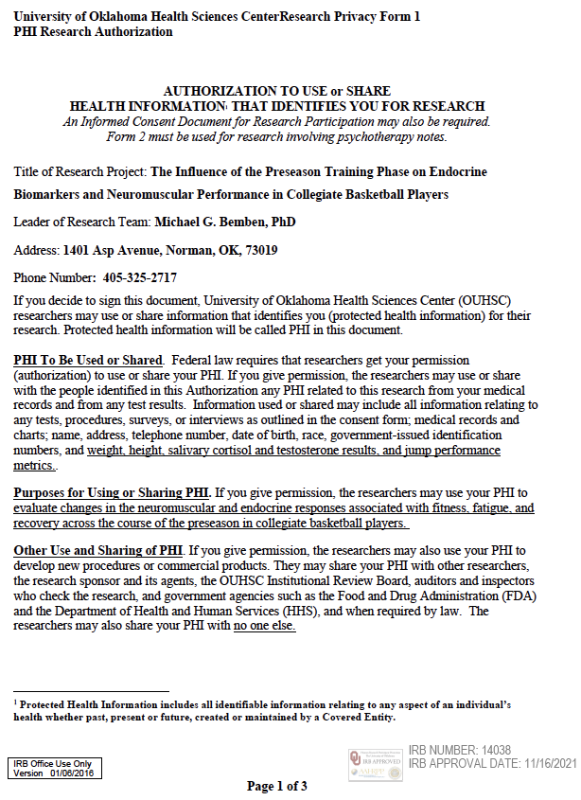
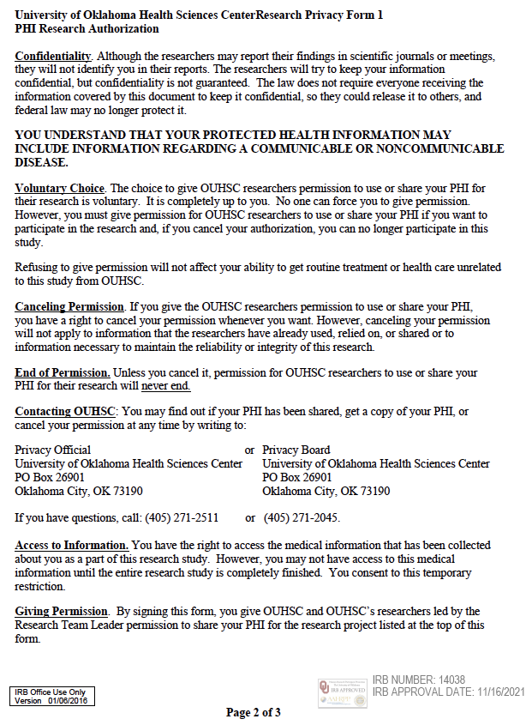

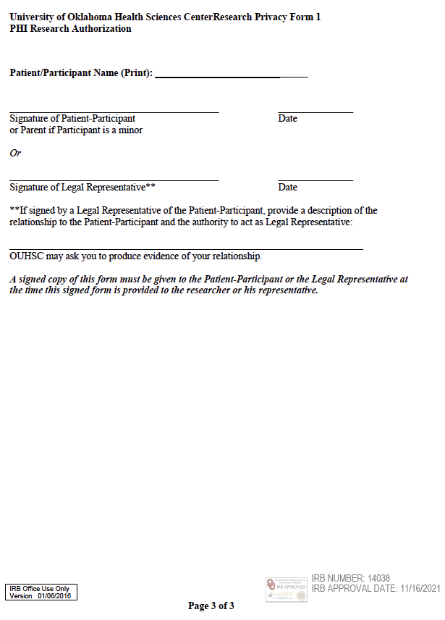

Appendix D: Oklahoma Men’s Basketball Letter of Support
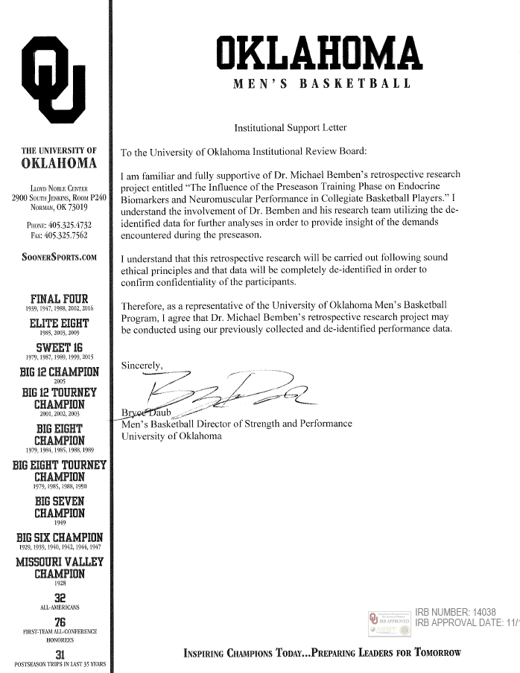

Appendix E: Rating of Perceived Exertion Chart

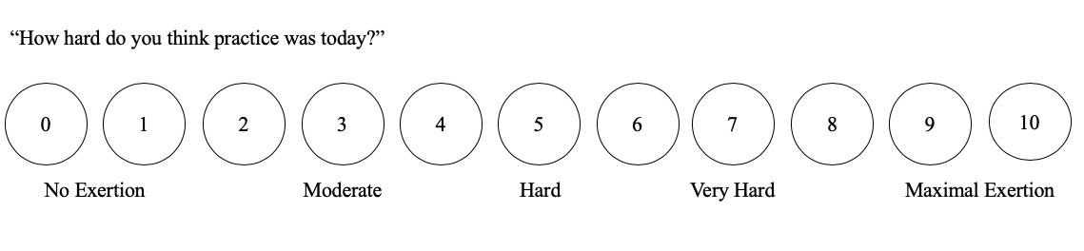

Appendix F: Salivary Collection

