University of Oklahoma

Graduate College

THE EFFECT OF A 12-WEEK THEORY BASED INTERVENTION ON PHYSICAL ACTIVITY LEVEL, SEDENTARY TIME, EXERCISE SELF-EFFICACY, PERCEIVED BARRIERS TO EXERCISE, AND CARDIOVASCULAR DISEASE RISKS

A Dissertation

submitted to the Graduate Faculty

in partial fulfillment of the requirements for the

Degree of

DOCTOR OF PHILOSOPHY

By

GHADAH ALSHUWAIYER
Norman, Oklahoma
2014

THE EFFECT OF A 12-WEEK THEORY BASED INTERVENTION ON PHYSICAL ACTIVITY LEVEL, SEDENTARY SITTING TIME, EXERCISE SELF-EFFICACY, PERCEIVED BARRIERS TO EXERCISE, AND CARDIOVASCULAR DISEASE RISKS

A DISSERTATION APPROVED FOR THE
DEPARTMENT OF HEALTH AND EXERCISE SCIENCE

By

______________________________
Dr. E. Laurette Taylor, Chair

______________________________
Dr. Craig Hofford

______________________________
Dr. Paul Branscum

______________________________
Dr. Allen Knehans

______________________________
Dr. Howard Crowson

© Copyright by GHADAH ALSHUWAIYER 2014
All Rights Reserved.

Acknowledgments

First and foremost, I would like to thank the omnipresent god for giving me the strength to finish this journey despite my desire to give up so many times. So, thank you Lord!

My deepest acknowledgments are also to numerous people who have challenged me and motivated to excel and succeed. I would like to send special thanks to my advisor, Dr. E. Laurette Taylor, for guiding me on this path during my time at the University of Oklahoma. She has been my inspiration as I tried to overcome all the obstacles while completing my dissertation. I must honestly say that I would not be here today without her encouragement and support.

I also would like to express my thanks to my committee members, who devoted their time to help me with my dissertation and to consistently provide a valuable input to make it the best possible. To Dr. Craig Hofford, the first person I met during my first visit to the Health and Exercise Science Department. I am so appreciative for his warm welcome that day and for showing me that this could be my second home away from home. To Dr. Paul Branscum, my sincere appreciation to him for taking the time to personally answer my questions regarding research, statistics, and job opportunities. To Dr. Allen Knehans, I owe my deepest gratitude to him for answering my questions regarding nutrition and for helping me find a place to meet with my participants at the Health Science Center. To Dr. Howard Crowson, my appreciation to him for guiding me through the maze of statistics. His assistance has helped me develop a better understanding of different solutions to various statistical problems.
I must also thank my colleagues and lab members at the university of Oklahoma: Merrill Funk, for inspiring me and for being the best colleague a person can work with every day. Shannon Gwin and Mary Camero, for their assistance in data collection. Dannielle Ayers, for her friendship that I will cherish for the rest of my life.
Hearty “BIG” thanks to my number one fan “my family”. To my mother, Latifa, who raised me to become the woman that I am today. To my father, Ibrahim, who taught me that hard work always pays off. To my grandparents, who encouraged me everyday to do the right thing. To my sweet siblings (Ghida, Abdulmajeed, and Abdulelah), who fill my heart with love and joy.
I also offer my highest regards to David Widrick, for showing me the true meaning of commitment and dedication. I thank him for his advice and ultimate support. Last but not the least, I offer my thanks to all of those who supported me in any respect during the completion of my dissertation.

Table of Contents
I. Introduction………...…………………………………………………………1
Purpose of the Study…………………………………………………….........4
Research Questions…………………………………………………………...5
Hypotheses……………………………………………………………………6
Significance of the Study…………………………...……….………………12
Delimitations………………………………………………………….……..15
Limitations…………………………………………...……………...………16
Assumptions………………………………………...……………………....17
Operational Definitions……………………………………...…………..….17
II. Review of Literature………………………………..…………………….....21
Physical Activity…………………………………………………………….22
Definition of Physical Activity…………………………………...……..22
Physical Activity Recommendations……………………………………22
Prevalence of Physical Activity………………………………………....23
Benefits of Physical Activity…………………………………...….……24
Physical Activity and Blood Pressure………………………….….25
Physical Activity and Dyslipidemia ………………………………30
Physical Activity and Obesity…………………...………………..35
Physical Activity and Type 2 Diabetes……………………………41
Other Benefits of Physical Activity ………………...…………….43
Antecedents to Physical Activity Behavior…………………………..…….46
Social Cognitive Determinants………………………..………………..48
Health Behavior Interventions Based on Social Cognitive Theory……..51
Perceived Barriers……………………………………………………….53
Interventions Aimed at Minimizing Perceived Barriers to Exercise…....56
Sedentary Behavior………………………………………………………….57
Definition of Sedentary Behavior ……………………………...…….…57
Prevalence of Sedentary Behavior………………………………………58
Risks of Sedentary Behavior…………………………………...……….60
Strategies to Lower Sedentary Behavior……………………………......62
Antecedents and Interventions to Sedentary Behavior………………..…….62
Study Design………………………………………………………………...67
Duration……………………………………………………..…...….…..67
Distance…………………………………………………………….…...68
Pace……………………………………………………………………...68
Instrumentation/Measurement………….…....………..……………….……69
Summary.........................................................................................................71
III Methodology………………………………………………………..…….....74
Participants…………………………………………………...…………......74
Research Design……………………………………………………..……...76
Instrumentation………………………………………..……………….........77
Height………………………………………………...………................78
Weight and Body Composition……………………………………........78
Blood Pressure……………………………….……………...……..........79
Resting Heart Rate……………………………………………………....79
Waist-To-Hip Ratio…………………………………………...…...........80
Blood Sample………………………………………………………........80
CVD Risk Assessment…………………………………………………..80
International Physical Activity Questionnaire………………………......81
Pedometer ………………………………………………………............82
Accelerometer…………………………………..………………….........83
Break Log…………………………………………………..……...........85
Food Frequency Questionnaire……………………………………….....85
Self-Efficacy ………………………………………………………........86
Perceived Barriers to Exercise………………………………………......89
Exit Interview……………….………………………..............................90
Other Instruments ……………………………..……………………......90
Instrument Reliability and Validity................................................................91
Intervention…………………………………..…….......................................93
Procedures…………………………………..…….........................................95
Process Evaluation…………………………………………………...….…..98
Data Analysis………………………………………………………………..99
IV Results……………………………………………………………………...100
Overview of Variables…………………………………………………......100
Subject Characteristics and Descriptive Statistics………………………....103
Process Evaluation …………………………………………………..….…108
Equality of Study Groups………………………..………………...………116
Normality Assumption……………………………………………………..118
Study Results………………………………………………………..……..121
Behavioral Variables……………………………………………..…....121
Average Steps/day………………………………………..…….….121
Total MET-Minute/week...………………………………………...125
Average Time in MVPA…………………………………………...125
Average Sedentary Time…………………………………………..128
Average Number of Breaks/day - Logs……………………..……..129
Average Number of Breaks/day - Accelerometer …………...…....130
Psychosocial Variables…………………………...……………............130
Exercise Self-efficacy…………………...........................................131
Walking Self-efficacy…………………...........................................133
Sedentary Behavior Self-efficacy…………….................................133
Barriers to Exercise ……………………..........................................134
Clinical Variables……………………...................................................135
Body Fat Percentage…………………….........................................135
Waist-to-Hip Ratio……………………............................................138
Systolic Blood Pressure……………………....................................139
Diastolic Blood Pressure……………………...................................140
Resting Heart Rate…………………………....................................141
Total Cholesterol …….……………………....................................141
LDL-C……………………………………………………………...143
HDL-C……………………………………………...……………...146
Triglyceride………………………………………………………...148
Cholesterol Ratio……………………………………………...…...148
Blood Glucose……………………………………………...……...149
CVD Risks……………………………………………...…….........150
Relationship Between Self-efficacy, Physical Activity, and Sedentary Behavior……………………………………………………………………151
Walking Self-Efficacy And Physical Activity Level……………....151
Sedentary Behavior Self-efficacy and Sedentary Behavior…….….151
V Discussion, Conclusions, And Recommendations………...…………........155
Discussion of the Results……………………………………………....155
Conclusions…………………………………………………………….170
Limitations…………………………………………….…….…………176
Recommendations for Health Promotion Practice………………...…..179
Recommendations for Future Research………………………………..180
Summary ………………………………………..……………………..182
References………………………………………..………………………...184
Appendices……………………………………………………...………....216
A: Framingham Risk Assessment …………………………….….........216
B: International Physical Activity Questionnaire ……………………..219
C: Break Log: Walking-Only Group………………………….…...…..224
D: Activity Log: Walking-Plus Group…………………….….……….225
E: Food Frequency Questionnaire…………………….………...……..226
F: Exercise Confidence Survey…………………….…….….………...228
G: Walking Confidence Survey………………………….….…..…......229
H: Sedentary Behavior Confidence Survey…………………….…...…230
I: Barriers Scale………………………………………….….….…...…231
J: Exit Interview……………………………………………………..…232
K: Contact Information Sheet………………………………………….233
L: Health History Form………………………………………………..234
M: Demographic Data Questionnaire……………………………...…..236
N: Eligibility Criteria Form………………………………………...….237
O: Activity Log: Walking-Only Group………………………...……...238
P: Phone Call Scripts……………………………………….…...……..239
Q: Weekly Emails: Walking-Only Group………………………….....240
R: Weekly Emails: Walking-Plus Group ………………………...…...247
S: Recruitment Email……………………………………….………….255
T: Advertisement Flyer………………………………….………….….256
U: Medical Clearance………………………………….……………....257
V: Informed Consent………………………………….…………….....259
W: HIPAA Form..………………………………….….……………….263
X: Program Description…………….………………….………….…...266
Y: IRB Approval Letter………………………………………………..268
Z: Data Set….………………………………………………………….269

List of Tables
Table 1: Overview of Behavioral Variables…………………………………...…..101
Table 2: Overview of Psychosocial Variables………………………………...…...101
Table 3: Overview of Clinical Variables……………………………………......…102
Table 4: Demographics…………………………………………………...………..105
Table 5: Blood Pressure Medications……………………………………………...106
Table 6: Cholesterol Medications……………………………………………….…107
Table 7: Descriptives for Height and Body Composition Variables ……………...107
Table 8: Descriptives for Cardiovascular Health Variables ……………….....…...107
Table 9: Descriptives for Behavioral Variables……………………………………108
Table 10: Descriptives for Psychosocial Variables………………..........................108
Table 11: Group Comparisons of Baseline Body Composition Variables…….......116
Table 12: Group Comparisons of Baseline Cardiovascular Health Variables…….117
Table 13: Group Comparisons of Baseline Behavioral Variables ………………...118
Table 14: Group Comparisons of Baseline Psychosocial Variables………………118
Table 15: Shapiro-Wilk test (S-W(P-value)) ……………………………………...120
Table 16: Physical Activity and Sedentary Behavior Variables at Pre- Mid- and Post-test, and at 3-Month Follow-Up ………………………………………......122
Table 17: Psychosocial Variables at Pre- and Post-Test, and at 3-Month Follow-Up………………………………………………………………………...132
Table 18: Body Composition and Cardiovascular Variables at Pre- and Post-Test, and at 3-Month Follow-Up…………………………………………...……136
Table 19: Regression Model for Walking Self-efficacy as a Predictor of Physical Activity Level (Adjusted R² =0.232)………………………………………153
Table 20: Regression Model for Sedentary Behavior Self-efficacy as a Predictor of Sedentary Behavior (Adjusted R² =-0.37)…………………………………154

List of Charts
Chart 1: Total Number of Participants…………………………………………….104
Chart 2: Changes in Average Number of Step Counts Across Time……………...124
Chart 3: Between Group Differences in Number of Step Counts (Mean ± SD)…..124
Chart 4: Change in Average Time in Moderate-Vigorous Intensity Physical Activity Across Time……………………………………………………………….127
Chart 5: Between Group Differences in Moderate-Vigorous Intensity Physical Activity (Mean ± SD)……………………………………………………..127
Chart 6: Changes in Body Fat Percentage Across Time…………………………..137
Chart 7: Between Group Differences in Body Fat Percentage (Mean ± SD)……..138
Chart 8: Changes in Total Cholesterol Levels Across Time……………………...143
Chart 9: Between Group Differences in Total Cholesterol Levels (Mean ± SD)…143
Chart 10: Changes in LDL-C Levels Across Time……………………………......145
Chart 11: Between Group Differences in in LDL-C Levels (Mean ± SD)………..145
Chart 12: Changes in HDL-C Levels Across Time……………………………….147
Chart 13: Between Group Differences in in HDL-C Levels (Mean ± SD)……….147

Abstract
Purpose: The study assessed the impact of a 12-week walking intervention on physical activity (PA) level, sedentary time (ST), and cardiovascular disease (CVD) risks among inactive adults with dyslipidemia. Methods: Faculty and staff at the University of Oklahoma (age=40-64 years) were randomly assigned to either a Walking-Plus (WP) or Walking-Only (WO) group. Both groups engaged in progressive walking (50-60% of maximum heart rate) for 30 to 60 min/day over 12 weeks. All participants were given pedometers and asked to record steps/day. They were encouraged to accumulate at least 10,000 steps/day. In addition, the WP group was instructed to interrupt sedentary time (ST) every 30 minutes for ≥2 minutes. Lipid profiles, PA, and ST were measured at pre- and post-intervention, and at 3-month follow-up. PA and ST were also assessed at week 6 of the intervention. Results: 21 participants began the study with 15 subjects completing all testing sessions (WP=7; WO=8). Daily step count (F (3,36)=16.91, p= 0.00) and moderate-vigorous intensity PA (F (3,39)=10.98, p= 0.00) improved over time in both groups. LDL-C (F (2,24)=3.63, p=0.042) and total cholesterol [F (2,26)=3.636, p=0.041) levels increased over time in both groups, which was opposite of the predicted effect. HDL-C significantly improved over time (F (2,26)=6.273, p=0.006) and between groups (F (1, 13)=9.39, p=0.009), but no significant time X group interaction (F (2,26)=0.319, p=0.729) was observed. The WP group had higher mean levels for HDL-C (51.6±12.1) at baseline compared to WO (40.6± 5.9) group. Conclusion: PA and HDL-C improved in both groups, as expected. However, no between group differences were found in ST or clinical outcomes. This could be due to small sample size, variation in blood collection methods, or the impact of weather changes on activity level. Low compliance with the program was also observed. The WP group reported that tracking sedentary breaks was difficult and frustrating, and the experience discouraged them from participation in walking as well as in attempts to increase breaks in sedentary time.

Chapter 1

Introduction
Cardiovascular disease (CVD) is the leading cause of mortality^{1,2} and the main contributor to morbidity and disability in the United States.² In 2010, this disease accounted for 595,444 deaths in the United States with a death rate of 192.9 per 100,000.¹ The State of Oklahoma has the third highest death rate among states, with a CVD mortality rate of 322 per 100,000 Oklahomans.² One in two women and two in three men who are 40 years of age are considered at higher risk for CVD.³ The onset of the first cardiovascular incident differs between men and women. Three per 1000 men have their first cardiovascular incidents between the ages of 35 and 44 years, whereas the first cardiovascular event for women typically occurs 10 years later in life.² This large gap in years decreases as both males and females advance in age.²
With every CVD diagnosis, both the direct and indirect costs associated with the disease continue to rise. These costs are linked to hospital and physicians’ visits, medication costs, homecare, other healthcare services, and loss of productivity.² In 2008, the estimated direct and indirect cost of CVD in the U.S. was $297.7 billion.² By 2010, the cost of this disease significantly increased to $503.2 billion³ and by 2030, it is projected that costs will rise to a staggering $834 billion.²
Cardiovascular disease is a chronic disease that is characterized as a slow and progressing condition.⁴ Non-modifiable risk factors of CVD include gender, heredity, family history, ethnic origin, and age.⁵ Modifiable risk factors include obesity, elevated blood pressure, dyslipidemia, metabolic syndrome, diabetes mellitus, physical inactivity, sedentary behavior, smoking, and unhealthy diet.^{2,4, 6-8} Because of the wide range of associated risk factors, early prevention efforts are essential in reducing CVD risks⁴ as well as reducing the total cost of the disease. Specifically, lifestyle modifications have the potential to improve cardiovascular health and lower the risk of the disease.⁸ A large body of evidence recognizes the importance of physical activity and healthy eating habits in preventing CVD.^{6, 9-13} The current recommendation by the U.S. Department of Health and Human Services (HHS) states that 150 minutes/week of moderate intensity physical activity, 75 minutes per week of vigorous intensity activities, or an equivalent combination of both types of activity are essential to improving and maintaining overall health.¹⁴ Furthermore, the Department of Health and Human Services (DHHS) and the U.S. Department of Agriculture (USDA) recommend following the 2010 dietary guidelines for Americans. These guidelines primarily focus on weight management by: 1) reducing calorie intake and increasing caloric expenditure; 2) consuming smaller portions of saturated fat, trans fat, sodium, and cholesterol; 3) consuming whole-grain and fiber foods in larger quantities; 4) and making healthy food choices and sustaining healthy habits.¹³ In addition to physical activity and dietary changes, reducing sedentary behavior, such as prolonged sitting time, also has been shown to have a positive effect on CVD risk reduction.⁶ Sedentary behavior is, in fact, a distinct concept when compared to physical inactivity.¹⁵ Currently, there are no recommendations for limiting total sedentary time. However, many researchers have suggested numerous strategies that can be effective in reducing time spent in sedentary pursuits.^{15,16-18} These strategies focus on breaking-up the total sedentary time during waking hours.^{19,20}
The most common physical activity practiced among the U.S. adults is walking, which is classified as a moderate-intensity physical activity.^{21,22} In particular, overweight and obese adults are more likely to engage in walking than vigorous and/or more strenuous activities.²³ However, only four in ten adults in the United States engage in walking as part of their leisure-time activities.²⁴ Therefore, walking programs are highly recommended to increase physical activity levels and lower CVD risks among adults. In addition, targeting sedentary behavior is also important in reducing CVD risks. Adults in the United States spend approximately 7.7 hours of waking time in sedentary activities each day.²⁵ It also has been reported that U.S. adults spend more of their waking time in sedentary sitting than any other sedentary activity.²⁶ Therefore, it is important to breakup sitting time as a strategy to reduce total sedentary time. Unfortunately, most studies in the literature have focused only on increasing physical activity levels. Up to this time, there have been no sufficient studies that examined the combined effect of walking and reduced sedentary behavior. This current study was an attempt to assess the effect of walking alone when compared to the effect of walking and reduced sedentary behavior.
Many health promotion theories have been proposed to explain the reasons behind human actions or lack of actions in modifying lifestyle. Numerous psychosocial determinants have been identified that enable or inhibit participation in physical activity. Social Cognitive Theory (SCT), for instance, is a widely used theory in the field of health promotion.²⁷ Many studies have examined the influence of social cognitive constructs on health behaviors.^{28, 29, 30, 31, 32} Other studies have utilized the constructs of SCT in their interventions to facilitate an increase in physical activity behavior.^{33,34,35} Of these constructs, self-efficacy is one of the most commonly used determinants to predict and influence physical activity.^{28,29,30,31,32} The Health Belief Model (HBM), on the other hand, is infrequently used to predict changes in the physical activity behavior^{36,37, 38,39} or as the foundation for physical activity interventions⁴⁰ as compared to Social Cognitive Theory. However, perceived barriers to exercise (an HBM construct) is used in a modest number of studies to predict participation in physical activity.^{36,37,38,39} Some researchers have suggested that reducing the perception of barriers could influence the relationship between self-efficacy and physical activity behavior.^{41,42} In this current study, both exercise self-efficacy and perceived barriers to exercise were targeted as determinants of physical activity behavior.
Purpose of the Study
The purpose of this study was to examine the impact of a 12-week theory-based intervention on physical activity level and sedentary time among inactive adults aged 40-64 years who had been diagnosed with dyslipidemia. The participants in this study were randomly assigned to one of two groups:
- Walking-Only: These participants were instructed only to increase their physical activity level through walking.
- Walking-Plus: These participants were instructed to increase their physical activity level through walking and decrease total sedentary sitting time.
This study assessed changes in self-efficacy and perceived barriers to exercise. It also assessed the impact of self-efficacy on physical activity and sedentary behavior among this specific target population. In addition, the study also investigated the impact of increased physical activity on CVD risk factors including high blood pressure, overweight and obesity, and dyslipidemia.
Research Questions
The following questions were investigated in this study:
RQ1: By the end of the intervention, was there a significant difference in physical activity level (i.e., average steps/day, total MET-Minute/week, average time in moderate-vigorous intensity physical activity) based on intervention group membership?
RQ2: By the end of the intervention, was there a significant difference in sedentary time (i.e., average sedentary time and average number of breaks/day) based on intervention group membership?
RQ3: By the end of the intervention, were there significant differences in exercise, walking, and sedentary behavior self-efficacy based on intervention group membership?
RQ4: By the end of the intervention, was there a significant difference in perceived barriers to exercise based on intervention group membership?
RQ5: By the end of the intervention, was there a significant difference in body fat percentage based on intervention group membership?
RQ6: By the end of the intervention, was there a significant difference in waist-to-hip ratio based on intervention group membership?
RQ7: By the end of the intervention, was there a significant difference in blood pressure based on intervention group membership?
RQ8: By the end of the intervention, was there a significant difference in resting heart rate based on intervention group membership?
RQ9: By the end of the intervention, was there a significant difference in serum cholesterol based on intervention group membership?
RQ10: By the end of the intervention, was there a significant difference in blood glucose based on intervention group membership?
RQ11: By the end of the intervention, was there a significant difference in CVD risk score based on intervention group membership?
RQ12: Did changes in antecedents of behavior at post-test (walking and sedentary behavior self-efficacies) predict changes in physical activity (time in moderate-vigorous intensity physical activity) and sedentary behavior (sedentary time)?
Hypotheses
For the purpose of this study, following null and research hypotheses were made:
H₀1: There will be no difference in changes in average steps/day from pre-intervention to post-intervention based on participation in the Walking-Plus when compared to the Walking-Only group.
H_{R}1: Participants in the Walking-Plus group will have a significantly greater increase in average steps/day when compared to the Walking-Only group.
H₀2: There will be no difference in changes in total MET-Minute/week from pre-intervention to post-intervention based on participation in the Walking-Plus when compared to the Walking-Only group.
H_{R}2: Participants in the Walking-Plus group will have a significantly greater increase in total MET-Minute/week when compared to the Walking-Only group.
H₀3: There will be no difference in changes in average time in in moderate-vigorous intensity physical activity (MVPA) from pre-intervention to post-intervention based on participation in the Walking-Plus when compared to the Walking-Only group.
H_{R}3: Participants in the Walking-Plus group will have a significantly greater increase in average time in moderate-vigorous intensity physical activity (MVPA) when compared to the Walking-Only group.
H₀4: There will be no difference in changes in average sedentary time from pre-intervention to post-intervention based on participation in the Walking-Plus when compared to the Walking-Only group.
H_{R}4: Participants in the Walking-Plus group will have a significantly greater reduction in average sedentary time when compared to the Walking-Only group.
H₀5: There will be no difference in changes in average number of breaks/day from pre-intervention to post-intervention based on participation in the Walking-Plus when compared to the Walking-Only group.
H_{R}5: Participants in the Walking-Plus group will have a significantly greater increase in the average number of breaks/day when compared to the Walking-Only group.
H₀6: There will be no difference in changes in exercise self-efficacy from pre-intervention to post-intervention based on participation in the Walking-Plus when compared to the Walking-Only group.
H_{R}6: Participants in the Walking-Plus group will have a significantly greater improvement in exercise self-efficacy when compared to the Walking-Only group.
H₀7: There will be no difference in changes in walking self-efficacy from pre-intervention to post-intervention based on participation in the Walking-Plus when compared to the Walking-Only group.
H_{R}7: Participants in the Walking-Plus group will have a significantly greater improvement in walking self-efficacy when compared to the Walking-Only group.
H₀8: There will be no difference in changes in sedentary behavior self-efficacy from pre-intervention to post-intervention based on participation in the Walking-Plus when compared to the Walking-Only group.
H_{R}8: Participants in the Walking-Plus group will have a significantly greater improvement in sedentary behavior self-efficacy when compared to the Walking-Only group.
H₀9: There will be no difference in changes in perceived barriers to exercise from pre-intervention to post-intervention based on participation in the Walking-Plus when compared to the Walking-Only group.
H_{R}9: Participants in the Walking-Plus group will have a significantly greater reduction in perceived barriers to exercise when compared to the Walking-Only group.
H₀10: There will be no difference in changes in body fat percentage from pre-intervention to post-intervention based on participation in the Walking-Plus when compared to the Walking-Only group.
H_{R}10: Participants in the Walking-Plus group will have a significantly greater reduction in body fat percentage when compared to the Walking-Only group.
H₀11: There will be no difference in changes in waist-to-hip ratio (WHR) from pre-intervention to post-intervention based on participation in the Walking-Plus when compared to the Walking-Only group.
H_{R}11: Participants in the Walking-Plus group will have a significantly greater reduction in waist-to-hip ratio (WHR) when compared to the Walking-Only group.
H₀12: There will be no difference in changes in systolic blood pressure (SBP) from pre-intervention to post-intervention based on participation in the Walking-Plus when compared to the Walking-Only group.
H_{R}12: Participants in the Walking-Plus group will have a significantly greater reduction in systolic blood pressure (SBP) when compared to the Walking-Only group.
H₀13: There will be no difference in changes in diastolic blood pressure (DBP) from pre-intervention to post-intervention based on participation in the Walking-Plus when compared to the Walking-Only group.
H_{R}13: Participants in the Walking-Plus group will have a significantly greater reduction in diastolic blood pressure (DBP) when compared to the Walking-Only group.
H₀14: There will be no difference in changes in resting heart rate (RHR) from pre-intervention to post-intervention based on participation in the Walking-Plus when compared to the Walking-Only group.
H_{R}14: Participants in the Walking-Plus group will have a significantly greater reduction in resting heart rate (RHR) when compared to the Walking-Only group.
H₀15: There will be no difference in changes in total cholesterol (TC) from pre-intervention to post-intervention based on participation in the Walking-Plus when compared to the Walking-Only group.
H_{R}15: Participants in the Walking-Plus group will have a significantly greater reduction in total cholesterol (TC) when compared to the Walking-Only group.
H₀16: There will be no difference in changes in low-density lipoprotein-cholesterol (LDL-C) from pre-intervention to post-intervention based on participation in the Walking-Plus when compared to the Walking-Only group.
H_{R}16: Participants in the Walking-Plus group will have a significantly greater reduction in low-density lipoprotein-cholesterol (LDL-C) when compared to the Walking-Only group.
H₀17: There will be no difference in changes in high-density lipoprotein cholesterol (HDL-C) from pre-intervention to post-intervention based on participation in the Walking-Plus when compared to the Walking-Only group.
H_{R}17: Participants in the Walking-Plus group will have a significantly greater increase in high-density lipoprotein cholesterol (HDL-C) when compared to the Walking-Only group.
H₀18: There will be no difference in changes in triglyceride (Trig) from pre-intervention to post-intervention based on participation in the Walking-Plus when compared to the Walking-Only group.
H_{R}18: Participants in the Walking-Plus group will have a significantly greater reduction in triglyceride (Trig) when compared to the Walking-Only group.
H₀19: There will be no difference in changes in cholesterol ratio from pre-intervention to post-intervention based on participation in the Walking-Plus when compared to the Walking-Only group.
H_{R}19: Participants in the Walking-Plus group will have a significantly greater reduction in cholesterol ratio when compared to the Walking-Only group.
H₀20: There will be no difference in changes in blood glucose from pre-intervention to post-intervention based on participation in the Walking-Plus when compared to the Walking-Only group.
H_{R}20: Participants in the Walking-Plus group will have a significantly greater reduction in blood glucose when compared to the Walking-Only group.
H₀21: There will be no difference in changes in CVD risk score from pre-intervention to post-intervention based on participation in the Walking-Plus when compared to the Walking-Only group.
H_{R}21: Participants in the Walking-Plus group will have a significantly greater reduction in CVD risk score when compared to the Walking-Only group.
H₀22: Walking self-efficacy will not predict physical activity level (time in moderate-vigorous intensity physical activity).
H_{R}22: Walking self-efficacy will predict physical activity level (time in moderate-vigorous intensity physical activity).
H₀23: Sedentary behavior self-efficacy will not predict sedentary behavior (sedentary time).
H_{R}23: Sedentary behavior self-efficacy will predict sedentary behavior (sedentary time).
Significance of the Study
The high rates of CVD incidence and prevalence are quite troubling.² As these rates increase over the years for this killer disease, the associated financial costs will continue to rise as well,^{2,3} placing a greater burden on the U.S. economy. Although lifestyle modifications including increasing physical activity are well known to prevent and decrease the risks of this disease, ^{6,8-13} there are still 26.9% of U.S. adults aged 45-64 years who do not participate in any leisure time physical activities.⁴³ In Oklahoma, the percentage of physical inactivity is above the national average.⁴⁴ Approximately 32.3% of individuals between 45-54 years and 37.5% of individuals aged 55-64 years are physically inactive.⁴⁴ The majority of Oklahomans do not meet the recommended levels of regular physical activity. These numbers emphasize the importance of promoting physical activity among inactive individuals residing in Oklahoma.
Additionally, some individuals are meeting the recommended amount of physical activity of 150 minutes on most days of the week but are spending the rest of their waking time in sedentary activities such as sitting, watching television, playing video games, and automobile driving.^{15,26,45} Therefore, while they are meeting the current government physical activity recommendations, they are still at risk for developing CVD. In the United States, there are approximately 32.5% of men and 31.1% of women who spend 4 hours a day or more in leisure time sedentary pursuits.⁴⁶ Therefore, it is very important to not only increase physical activity level but also decrease sedentary time, especially total sitting time.
The majority of interventions that have been described in the literature were intended to increase physical activity level only. Very few interventions have been developed to decrease sedentary sitting time and increase physical activity level at the same time. Most of previous physical activity interventions, and especially walking regimens, were predominantly implemented among women for ≥10 weeks in duration.⁴⁷⁻⁵¹ These interventions noted significant improvements in major risk factors for CVD such as blood pressure, glucose level, and self-reported diabetes mellitus.^{47,52,53} Modest changes in overweight and obesity risks were observed after physical activity interventions compared to multifaceted lifestyle interventions that incorporated physical activity and dietary changes.^{54,55} Changes in dyslipidemia, however, were inconsistent across interventions.⁵⁶ These findings revealed the need to conduct a study that examines the changes in CVD risk factors among inactive men and women with dyslipidemia after 12 weeks of intervention. In addition, the results of prior studies suggest the need to compare the impact of two different intervention approaches (i.e., increasing physical activity only vs. increasing physical activity and decreasing sedentary time) on main CVD risk factors.
Delivering physical activity interventions that do not specifically target antecedent factors that influence levels of physical activity and sedentary behavior may not facilitate physical activity change and, subsequently, may not result in reduction in CVD risks. Addressing significant antecedents that influence the target population is very important in effectively promoting lifestyle modification.²⁸ Self-efficacy, for instance, has been identified as a main predictor of many health behaviors including physical activity and reduction of sedentary behavior.^{15,28,57} Perceived barriers have also served as a predictor of physical activity.⁵⁷ Some research has suggested that perception of barriers to physical activity (PA) could influence PA self-efficacy⁴². This may be important to consider when developing interventions since a number of studies have documented the beneficial effect of self-efficacy-based strategies on modification in physical activity and sedentary behavior.^{17,33,34} Therefore, previous research supports the need to target the barriers to physical activity behavior and to enhance exercise self-efficacy in order to effectively promote and increase physical activity behavior.
The proposed study involved a 12-week theory-based intervention. Two approaches were used to deliver the intervention. The Walking-Only approach included progressive walking and weekly informational messages that related to increasing physical activity level only. The Walking-Plus approach incorporated progressive walking, recommendations to decrease sitting time, and weekly informational messages that related to increasing physical activity and decreasing sedentary behaviors. This study assessed the impact of these approaches on CVD risks in inactive individuals with dyslipidemia. The findings from this intervention will improve understanding of psychosocial determinants associated with modifying physical inactivity behavior and limiting sedentary sitting time.
Delimitations
This study was delimited by the following:
- The study population included faculty and staff between the ages of 40 and 64 years old from the University of Oklahoma.
- Participants were at high risk for developing CVD disease by having the following risk factors: a) inactive lifestyle (i.e., <30 minutes of exercise 5 times per week), and b) a confirmed diagnosis of dyslipidemia.
- Participants were excluded if they were non-ambulatory or reported a history of any medical conditions or injuries that would make walking impossible or unsafe.
- Participants were excluded if they had a pacemaker or were diagnosed with diabetes, heart disease, or stroke.
- Participants were excluded if they were pregnant or planning to get pregnant.
- Outcome measures included:
  - Waist: hip ratio,
  - Percentage of body fat,
  - Blood pressure (systolic and diastolic),
  - Resting heart rate,
  - Lipid profile (TC, LDL-C, HDL-C, Trig),
  - Blood glucose,
  - Framingham Risk Score,
  - Physical activity level,
  - Sedentary sitting time,
  - Exercise self-efficacy,
  - Walking self-efficacy,
  - Sedentary behavior self-efficacy, and
  - Perceived barriers to exercise.
Limitations
Possible limitations of this study include:
- Participation in this study was voluntary. This recruitment approach restricts the generalizability of the findings to similar target groups in similar populations.
- The walking pattern was self-monitored by participants, so there was the possibility that participants did not comply with the prescribed program.
- Data, including daily step count, walk duration, physical activity level, food frequency, self-efficacy, and perceived barriers were all self-report.
- There was the possibility of inaccurate reporting during data collection.
Assumptions
The following assumptions were made:
- Study procedures and questionnaires were clear and easy to understand by participants.
- Participants honestly responded during data collection.
- Participants provided accurate responses to all items in the questionnaires.
- Participants adhered to the prescribed regimen.
- Participants maintained their dietary habits throughout the study.
Operational Definitions
The following are definitions of terms that were used in this study:
- Cardiovascular disease (CVD): the diagnosis of one the following conditions: peripheral artery disease, coronary heart disease, heart failure, or cerebrovascular events.⁵⁸
- CVD Risk Score: measured by the Framingham 10-year Risk Score, which considers the following risk factors: age, HDL cholesterol, total cholesterol, systolic blood pressure (treated and untreated), smoking, and diabetic status.⁵⁸
- Elevated CVD risk: The presence of more that two risk factors such as age (≥ 50 years for men; ≥ 55 years for women), body mass index (BMI) ≥ 27 kg/m², smoking, hypertension, abnormal lipid profile, lack of physical activity, or family history of CVD.^{59, 3} In the current study, elevated CVD risk is established by inactive lifestyle (i.e., <30 minutes of exercise 5 times per week) and confirmed diagnosis of dyslipidemia.
- Physical Activity: any bodily movement caused by muscle contractions, which resulted in energy expenditure.⁶⁰ Physical activity was assessed using pedometer, accelerometer, and a self-report questionnaire.
- Leisure-time physical activity: any type of activities or exercises such as aerobics, running, walking, or gardening.^{61,43}
- Physically inactive: Not following the general recommendation for physical activity which includes 150 minutes of moderate intensity exercise or 75 minutes of vigorous intensity exercise per week for the previous three months.¹⁴
- Metabolic equivalent (MET): a unit used to measure energy expenditure of an activity in relationship to the amount of energy expended during rest, with 1 MET representing resting energy expenditure.¹⁴ Light activities, for example, are defined as activities that require 1.1 METs to 2.9 METs.¹⁴ Water aerobics, general gardening, and brisk walking at 3 miles per hour are examples of moderate-intensity activities that require 3 METs to 5.9 METs.¹⁴ Vigorous-intensity activities like jogging, running, or heavy gardening require more than 6 METs. ¹⁴ To see substantial benefits in health, it is recommended that an individual have 500 to 1,000 MET-minutes of activity per week.¹⁴ Activities greater than 1,000 MET-minute/week are associated with increased health benefits in individuals.¹⁴
- Sedentary behavior: insufficient physical movements or light-intensity activities, which are equivalent to <1.5 METs.⁶² Sedentary individuals engage in prolonged time of sedentary activities such as sitting, television viewing, video games playing, computer use, automobile commuting, reading, elevator use, and eating.^{15,26,45} Sedentary behavior was assessed using an accelerometer and self-report instruments.
- Overweight: a person with body mass index (BMI) between 25 and 29.9 kg/m².⁶³
- Obese: a person with the body mass index (BMI) ≥30 kg/m².⁶³
- Hypertension: a diagnosis of systolic blood pressure greater than 140 mmHg and diastolic blood pressure greater than 90 mmHg.⁶⁴
- Dyslipidemia: diagnosis of total cholesterol greater than 240 mg/dL, triglyceride greater than 200 mg/dL, LDL-C of 160 mg/dL or greater, and/or HDL-C less than 40 mg/dL.⁶⁵
- Self-efficacy: a person’s perception regarding his or her ability to control a health habit.⁶⁶ Exercise self-efficacy indicates the individual’s perception about his/her ability to successfully engage in an exercise regime. Walking self-efficacy refers to an individual’s perception about his/her ability to successfully engage in walking. Sedentary behavior self-efficacy refers to the individual’s perception about his/her ability to successfully decrease sedentary activates and break-up sedentary time. These three types of self-efficacy were assessed using a self-report questionnaire.
- Perceived barriers: personal perception about the presence of impediments in one’s life that can adversely effect the implementation of the recommended actions.⁶⁷ In this study, perceived barriers refer to personal perceptions about the presence of obstacles that can adversely effect involvement in walking activity. The perception of different barriers to exercise was assessed using a self-report survey.
- Healthy Sooners Program: A program that focuses on various activities that encourage employees at the University of Oklahoma to lead a healthy lifestyle and make conscious choices related to health and wellness.⁶⁸

Chapter 2
Review Of Literature
Cardiovascular disease is the most common chronic disease that causes death and leads to long-term disability. Over 82 million adults in the United States have at least one type of CVD.² Individuals who receive a confirmed diagnosis of peripheral artery disease, coronary heart disease, heart failure, or cerebrovascular events are identified as CVD patients.⁵⁸ The growing number of individuals with that disease contributes directly to increased spending on healthcare services and indirectly to loss of workplace productivity.² Therefore, implementation of early preventive intervention is highly recommended to lower expenditures as well as to decrease disease incidence and prevalence especially among those at higher risk for CVD.
Since physical activity is an effective lifestyle modification that can reduce risk and prevent CVD, this review will discuss physical activity and its impact on CVD risk factors. The review will also focus on exercise self-efficacy and physical activity barriers that influence physical activity behaviors. Additionally, this review will assess relevant literature that addresses the variation in walking intervention designs in terms of distance, pace, and duration. Furthermore, since sedentary behavior is considered a modifiable factor that can increase CVD risks, this chapter will also examine this behavior among adults, including different proposed strategies and interventions to limit sedentary time. Finally, this chapter will review different physical activity and sedentary behavior instruments and CVD risk measurements.

Physical Activity
Definition of Physical Activity
Physical activity is defined as any bodily movement that leads to an increase in energy expenditure as a result of multiple muscular contractions.⁶⁰ The intensities of physical activities can be classified into light, moderate, and vigorous activities based on the levels of energy expenditure.¹⁴ Energy expenditure is measured by metabolic equivalent (MET) units, which is the amount of energy expended during rest.¹⁴ Light activities, for example, are defined as activities that require 1.1 METs to 2.9 METs.¹⁴ Water aerobics, general gardening, and brisk walking at 3 miles per hour are examples of moderate-intensity activities that require 3 METs to 5.9 METs.¹⁴ Vigorous-intensity activities like jogging, running, or heavy gardening require more than 6 METs. ¹⁴
Physical Activity Recommendations
In 2008, the U.S. Department of Health and Human Services (HHS) released the current physical activity guidelines for children and adolescents, adults, and older adults.¹⁴ Children and adolescents between 7 and 17 years should engage in 60 minutes or more of activities daily, which incorporate moderate-intensity activities, vigorous-intensity aerobic activities, and strengthening and stretching exercises.¹⁴ Both strengthening and flexibility (stretching) exercises are recommended to be performed three days a week.¹⁴
All Adults aged 18 to 64 should participate in 150 minutes a week of moderate-intensity activities, 75 minutes of vigorous-intensity activities, or are equal combination of both types of aerobic activities.¹⁴ These activities can be performed daily in three 10-minute short bouts or in one long bout of 30 minutes.¹⁴ Adults should also include muscle-strengthening exercises in at least two days of the week.¹⁴ On the other hand, older adults should engage in 150-minute weekly aerobic activities that are moderate in intensity, only if their physical conditions allow.¹⁴ The primary goals of activities for older adults are to improve gait and maintain balance in order to minimize the rate of falls and physical injuries.¹⁴ Therefore, flexibility and balance exercises are highly recommended for older adults.¹⁴
Prevalence of Physical Activity
According to the Centers for Disease Control and Prevention (CDC), 25.4% of U.S. adults do not participate in any leisure-time physical activities.⁶¹ The percentages of inactive individuals differed between age groups. As individuals advance in age, less leisure-time activities are reported. Almost 19% of young individuals aged 18-24 years, 22.5% adults aged 25-43 years, 24% of adults aged 35-44 years, 26.9% of adults aged 45-64 years, and 32.7% of older adults over the age of 65 years reported no leisure-time activities.⁴³ In addition, different ethnic groups reported substantial differences in terms of engaging in leisure-time activities. More Hispanics (34.6%) reported no leisure-time activities when compared to whites (22.2%) and African-Americans (31.9%).⁴³ Furthermore, the numbers of individuals who reported no leisure-time activities demonstrated a significant decrease related to educational level.⁴³ Approximately 42.3% of individuals with less than a high school diploma reported no leisure-time physical activities.⁴³ On contrast, only 15.4% of college graduate reported no activities.⁴³
Oklahoma, specifically, is nationally ranked as the 49th state due to the lack of physical activity reported.⁴⁴ In 2009, Oklahoma recorded above the national average percentage of individuals that engaged in no activities. Nearly 31.4% of individuals reported no physical activity at all.⁴⁴ In particular, females (33.9%) were less active compared to males (28.7%).⁴⁴ In addition, and consistent with the national statistics, older individuals reported higher physical inactivity than younger individuals. Almost 26% of individuals aged 35-44 years and 32.3%, of individuals aged 45-54 years reported no physical activity.⁴⁴ Individuals between the ages of 55 and 64 years (37.5%) and individuals older than 65 years (39.4%) also reported physical inactivity.⁴⁴ Similar to the national data, high numbers of individuals in Oklahoma with less than high school diploma (54.1%) were physically inactive when compare to those who earned a college degree (19.1%).⁴⁴
Benefits of Physical Activity
Numerous studies have examined the deleterious outcomes resulting from a lack of physical activity. For example, some of these stated an increased risk of many health conditions that are associated with physical inactivity. Many researchers linked increasing physical activity to numerous health benefits. Physical activity is associated with a decreased number of premature deaths.¹⁴ An increase in physical activity was also related to the reductions in the risks of many chronic diseases such as osteoporosis,^{14,69} heart disease,^{6,12,14,70} stroke,¹⁴ type 2 diabetes,^{14,71} and obesity.⁷² There is also a correlation between higher physical activity level and improvement in mental health.^{14,73} Most health benefits are observed when following a moderate-intensity physical activity regimen such as brisk walking.¹⁴ Yet, just four out ten U.S. adults actually participate in walking as part of their leisure-time activity.²⁴
The following section focuses on physical activity as a preventive measure against cardiovascular events and disease progression. In specific, cardiovascular risk factors such as high blood pressure, dyslipidemia, overweight and obesity, and type 2 diabetes are examined.
Physical Activity and Blood Pressure
The classification of blood pressure is determined based on the average of multiple readings of blood pressure in the sitting position at different times.⁷⁴ Normal blood pressure is classified when systolic blood pressure is less than 120 mmHg and diastolic blood pressure is less than 80 mmHg.⁷⁴ An individual with systolic blood pressure of 120-130 mmHg and diastolic blood pressure of 80-89 is diagnosed with high blood pressure or prehypertension.⁷⁴ A confirmed diagnosis of stage 1 hypertension is made when systolic blood pressure reading is between 140 and 159 mmHg and/or diastolic blood pressure reading is between 90 and 99.⁷⁴ Systolic blood pressure of 160 mmHg or greater and/or diastolic blood pressure of 100 mmHg or greater is classified as stage 2 hypertension.⁷⁴
As individuals grow older, the risk of developing hypertension increases.⁷⁴ Almost 50% of individuals aged 60-69 years are diagnosed with high blood pressure.⁷⁵ The relative risk of developing CVD increases by more than twofold when high blood pressure is present.⁷⁶ A meta- analysis of 61 observational studies revealed that a minimum reduction in blood pressure by 2-mmHg was associated with 10% reduction in stroke mortality and 7% reduction in heart disease mortality among one million adults aged 40-69 years.⁷⁷
Numerous studies have shown that walking is an effective approach in reducing the levels of blood pressure.^{47,78-83} Seals et al⁴⁷ examined the effectiveness of a 12 week walking program on women with high blood pressure (130-159/85-99 mmHg).⁴⁷ In the first two weeks (i.e., phase one), postmenopausal women were instructed to complete 30-minutes of daily walking for 3-4 times per week at heart rate reserve (HRR) of 50% (i.e., resting heart rate + 50% of [maximal heart rate - resting heart rate]).⁴⁷ During the remaining 10 weeks (i.e., phase two), women were asked to increase their walking time to 45 minutes per day for 4-5 times per week at HRR of 60%-70%.⁴⁷ By the end of 12 weeks, women walked on average 44± 2 minutes on 3.2± 0.2 days per week at 69 + 1% of HRR.⁴⁷ As women complied with the program, reduction in blood pressure was observed.⁴⁷ Both systolic and diastolic blood pressures decreased by 10 mmHg and 7 mmHg; respectively.⁴⁷
When comparing two walking patterns that were consistent with the 2004 physical activity recommendations (i.e., 20–60 minutes of activities on 3–5 days/ week at 55– 90% of estimated maximum heart rate), Murtagh et al.⁷⁸ found no improvement in blood pressure among inactive women after 12 weeks. In this study, the participants engaged in three days a week of treadmill brisk walking in one continuous session of 20 minutes a day or two intermittent sessions of 10 minutes each.⁷⁸ Murphy et al.,⁸³ on the other hand, found significant improvement in diastolic blood pressure only among inactive individuals who engaged in two different walking approaches for 12 weeks each at 70%-80% of predicted HR_{max}.⁸³ The short walking approach consisted of three 10-minute sessions per day.⁸³ The long approach included one long walking session of 30 minutes per day.⁸³ All participants engaged in both walking approaches, by starting one walking approach and following it by the other walking approach in two weeks interval.⁸³ By the end of the study, diastolic blood pressure decreased significantly after both walking approaches.⁸³ The participants showed significant reduction in diastolic blood pressure by 1.4 mmHg and 1.5 mmHg after short and long walking approaches, respectively.⁸³ Similarly, Elley et al.⁸¹ reported no differences between long and short bout walking in terms of changes in blood pressure. Participants in this randomized crossover study were diagnosed with hypertension.⁸¹ For 12 days, the participants engaged in daily walking for 40 minutes in one bout, four 10-minute short bouts, or no walking at all.⁸¹ Each approach lasted four days with 10 days washout period between them.⁸¹ By the end of the study, the long bout approach was associated with significant reduction in systolic and diastolic blood pressure by 7.5/4.0 mmHg.⁸¹ The short bout approach reduced blood pressure by 7.3/5.4 mmHg.⁸¹
Pedometer-based walking interventions that were implemented to allow individuals reach their daily step goal regardless of walking pace have shown substantial benefits on blood pressure. A study in 2001 investigated the efficiency of pedometer- based intervention consistent with ACSM-CDC physical activity recommendations in lowering blood pressure.⁷⁹ Postmenopausal women with stage one hypertension were instructed to increase their daily steps equivalent to a walking distance 3 km/day.⁷⁹ To capture the daily step counts, a Yamax SW- 200 pedometer was provided to each participant.⁷⁹ At the first week, all women were instructed to walk 1.4 km/ day above their baseline activity level.⁷⁹ To ensure no decline in participants’ physical activity levels, a distance of 0.5 km/day was added each week until week three.⁷⁹ The women subsequently were allowed to choose any physical activity approach that would allow them to accumulate their daily steps.⁷⁹ The dietary habits were maintained throughout the study.⁷⁹ After 24-weeks of walking, women showed a significant increase in their daily step counts by 4300 steps/ day from baseline; an equivalent to a walking distance of 2.9± 0.2 km/ day.⁷⁹ The recorded average daily steps were 9700±400 steps/day.⁷⁹ However, although there was significant increase in physical activity level, only a significant reduction in systolic blood pressure by (11 mmHg) was reported.⁷⁹
In 2003, the effectiveness of accumulating 10,000 steps daily was investigated among sedentary, overweight women.⁸⁰ During the 8-week period, all women received Yamax SW- 200 pedometers and were instructed to maintain current dietary habits.⁸⁰ The systolic and diastolic blood pressure dropped by 8 mmHg and 5 mmHg, retrospectively, as the average daily steps for women increased by the end of this intervention from 4491 steps/day to 9213 steps/day.⁸⁰ Hultguist et al.,⁸² on the other hand, found reductions in both systolic and diastolic blood pressure among middle-aged inactive women when compared walking recommendations.⁸² The women were randomly recruited in to a 10k or 30-minute groups.⁸² In the 10k group, the women walked 10,000 steps during a brisk walking activity.⁸² The women in 30-minute group were instructed to walk 30 minutes per day.⁸² All walking activities were completed in four weeks.⁸² A Yamax Digiwalker DW-200 provided was provided for each participant during a study period.⁸² Study results indicated a significant difference in step counts between the two groups.⁸² The 10k and 30-minute groups accumulated an average of 10,159 ±292 steps and 8270 ±354 steps, respectively.⁸² Compared to a baseline measurement, only the women in the 10k group showed a significant increase in daily step counts.⁸² When blood pressure was assessed, all women showed reductions in blood pressure.⁸² Women who accumulated 10,000 steps a day had significant reductions in both systolic and diastolic blood pressure by 2 mmHg.⁸² On contrast, women who completed the 30-minute daily walk showed decreases in systolic blood pressure (4 mmHg) and diastolic blood pressure (3 mmHg).⁸²
Combining physical activity and diet have also been shown to lower high blood pressure. Yet, the magnitude of improvement for blood pressure in a multifaceted intervention does not differ than exercise only or diet only interventions among inactive adults with high blood pressure, stage 1 or stage 2 hypertension.⁸⁴ The 12-week of lifestyle modification intervention consisting of dietary education and counseling, which focuses on calorie restriction, as well as aerobic exercises that include walking for 30-45 minutes a day at 60%-85% of HR_{max} on 3 to 5 days/ week, had a positive effect on lowering blood pressure by 12.5 ± 6.3/7.9 ± 4.3 mmHg.⁸⁴
Significant improvement in blood pressure was also observed with the dash diet accompanied by treadmill brisk walking or cycling on ergometer for 30 to 45 minutes at 50%-75% of HR_{max} 3 days a week.⁸⁵ The average reduction in systolic and diastolic blood pressure for obese hypertensive individuals, who followed the program, were 12.1 and 6.6 mmHg; respectively.⁸⁵ Similarly, the PREMIER trial documented a 53% risk reduction of hypertension after six months of behavioral intervention plus dash diet.⁸⁶ The trial consisted of three approaches: a) advice only, b) behavioral intervention, or c) behavioral intervention plus dash diet.⁸⁶ The advice approach provided one 30-minute individual session focusing on factors that effect hypertension.⁸⁶ On the other hand, weekly physical activities (i.e., 180 minute/ week) were the main components in the behavioral intervention approach.⁸⁶ The behavioral intervention plus dash diet included 180-minute/ week of physical activities along with15 Ib weight reduction plan, and sodium and alcohol limit restrictions.⁸⁶ Six months post trial, blood pressure decreased by 10.5/3.8 mmHg, 10.5/5.5 mmHg, and 11.1/6.6 mmHg after following the advice approach, behavioral intervention, and behavioral intervention plus dash diet; respectively.⁸⁶
Physical Activity and Dyslipidemia
Dyslipidemia is a condition characterized by abnormal levels of total cholesterol, low-density lipoprotein cholesterol (LDL-C), high-density lipoprotein cholesterol (HDL-C), or triglyceride.⁸⁷ A total cholesterol value below 200 mg/dL is considered desirable. Any total cholesterol value between 200 and 239 mg/dL is recognized as borderline high level.⁸⁷ Values of 240 mg/dL or greater are identified as high total cholesterol levels.⁸⁷ In terms of LDL-C and HDL-C values, healthcare professionals recommend that individuals keep their LDL-C below 130 mg/dL and HDL-C above 40 mg/dL. An optimal LDL-C level is below 100 mg/dL and for HDL-C is above 60 mg/dL. LDL-C levels are identified as near or above optimal if any obtained value is between 100 and 129 mg/dL.⁸⁷ Borderline high, high, and very high LDL-C is confirmed if values are between 130-159 mg/dL, 160-189 mg/dL, or greater than 190 mg/dL, respectively.⁸⁷ Low HDL-C is established with a value less than 40 mg/dL. Normal serum triglyceride value is recognized as below 150 mg/dL.⁸⁷ The borderline high triglyceride value ranges between 150 and 199 mg/dL.⁸⁷ Values between 200-499 mg/dL and above 500 mg/dL are noted as high triglyceride and very high triglyceride, respectively.⁸⁷ Total cholesterol/ HDL-C ratio is also an indicative to CVD risks. Higher ratio indicates high risk for CVD. The ideal ratio is 5:1.⁸⁸
The 2005-2006 NHANES data revealed that 65% of men and 70% of women were diagnosed with hyperlipidemia.^{2,89} Almost 16% of individuals had total cholesterol level of 240 mg/dL or greater.^{2,89} Another three cohort studies showed that high blood cholesterol among other major risk factors is associated with 90% of coronary heart disease (CHD) cases.^{2,90} Almost 24% reduction of CHD mortality rate is attributed to lowering total cholesterol values.^{2,91}
In the literature, many studies investigated the effectiveness of physical activity in improving lipid profile. Yet, there are inconclusive results in the magnitude of effects of physical activity on cholesterol levels.⁵⁶ In specific, a 2001 meta-analysis noted the lack of evidence of the beneficial effect of physical activity on triglycerides.^{92,93}
Hardman and Hudson⁹⁴ tested the hypothesis that progressive walking intervention would improve serum lipid and lipoprotein levels in sedentary women. Middle-aged sedentary women were instructed to walk briskly for 180 minutes in the first and second week then progress to 315 minutes by week 9 to week 12.⁹⁴ By the end of 12 weeks, the average walking time increased from 187±6 minutes in each of the first two weeks to 292±7minutes during each of the last 6 weeks.⁹⁴ The women also showed an increase in HDL-C by 2.32 mg/dL.⁹⁴ No other significant changes were reported in lipid variables. Similarly, other studies agreed that walking had complementary effects on HDL-C level.^{48,95,96} However, the 2001 meta-analysis indicated a need for additional trials to confirm the association between physical activity and HDL-C changes.^{92,93} Keller and Trevino⁴⁸ compared the physiological effects of two walking frequencies at the same intensity and duration. Overweight premenopausal Mexican American women who were previously inactive were instructed to walk 3 times/week for 30-minutes daily at 50% of heart rate reserve (HRR= resting heart rate + 50% of [maximal heart rate - resting heart rate]) or 5 time/week at the same intensity and duration.⁴⁸ By the end of 24 weeks, women in the 3 times/week group walked an average of 3.55 miles (5.7 km) in 88 minutes/ week.⁴⁸ The 5 times/week group completed an average distance of 3.19 miles (5.13 km) in 85 minutes/week.⁴⁸ Only women who engaged in the 3-day walk showed significant increase in HDL-C by (4 mg/ dL), a significant decrease in total cholesterol (9 mg/dL), and a significant reduction in LDL-C (9 mg/dL).⁴⁸ However, Ready et al⁹⁵ revealed significant reductions in total cholesterol (-11.58 mg/ dL), triglycerides values (-10.63 mg/dL), and total cholesterol/HDL-C ratio (-0.13 mg/dL) in hyperlipidemic postmenopausal women who walked an hour a day at 60% HRR in five days per week for 16 weeks. An additional 12-month follow-up period was established to observe women compliance after the initial intervention as well as changes in cholesterol levels.⁹⁶ The findings indicated that half of the women maintained their walking activity for 160 to 240 minutes weekly, 30% of women continued to walk less than 240 minutes per week, while 20% of women stopped walking.⁹⁶ The significant reduction in total cholesterol was only observed among women who sustained physical activity level during the follow-up period.⁹⁶
On contrast, some physical activity interventions failed to record any favorable changes in serum cholesterol.^{97,98} According to Santiago et al.,⁹⁷ inactive eumenorrheic women with hyperlipidemia were instructed to walk 3 miles on the treadmill at 72% maximal heart rate on 3 days a week for 40 weeks period. The study findings showed an improvement in aerobic fitness (VO2_{max}) but no changes in cholesterol values (i.e., triglyceride, HDL-C, LDL-C, or total cholesterol).⁹⁷ Similarly, Hinkleman and Nieman⁹⁸ assessed the efficiency of 45-minute of brisk walking at 60%-64% of VO2_{max} on five days/week. After 15 weeks, overweight women did not show any beneficial changes in their LDL-C, triglycerides, HDL-C, or total cholesterol levels.⁹⁸
Lifestyle modification interventions consist of diet and physical activity affecting lipid variables. A 2005 review by Varady and Jones suggested that the changes in LDL-C and total cholesterol are attributed to low saturated fat diet, while changes in HDL-C and triglyceride are attributed to physical activities.⁹³ Stefanick et al⁹⁹ tested the hypotheses that the improvement in HDL-C level results from an exercise regimen whereas reduction in LDL-C is related to the National Cholesterol Education Program (NCEP)⁸⁷ Step 2 diet. Men (age= 30-64) and postmenopausal women (age=45-64) with dyslipidemia in this 12-month study were randomly assigned to one of the following groups: diet only, exercise only, diet and exercise, and control group.⁹⁹ The diet group as well as the diet and exercise group received dietary recommendations based on the NCEP Step 2 program along with individual counseling with a dietitian at the first 12 weeks.⁹⁹ Eight group lectures (i.e., 60 minute/each) were also provided for the remaining duration of the study.⁹⁹ On the other hand, the exercise group and the diet and exercise group were instructed to participate in 60-minute of supervised aerobic exercises on 3 days of the week until the seventh month.⁹⁹ Following the seventh month, a10-mile brisk walk was added to the regimen.⁹⁹ By the end of the program, only the diet and exercise group reported significant decrease in LDL-C (Men= 20 mg/dL; women = 14.5 mg/dL) and total cholesterol (Men=20.6 mg/dL; women =17.5 mg/dL ).⁹⁹ HDL-C also increased in the exercise group compared to the other group. However, that increase was not significant.⁹⁹
Additionally, the NCEP I diet (i.e., 1200 to 1300 kcal/day), complemented by 45-minutes of weekly nutritional lectures and progressive walking on five days of week for 20 to 40 minutes a day at 60-80% of maximum heart rate (MHR), produced significant reductions in total cholesterol, triglyceride and LDL-C.¹⁰⁰ Sedentary overweight females, who followed the approach for 12 weeks were able to accumulate an average walking distance of 4.33±0.08 km in each session.¹⁰⁰ The women were also able to reduce their total cholesterol by 24.74 mg/dL, triglyceride by 22.14 mg/dL, and LDL-C by 20.49 mg/mg/dL.¹⁰⁰ No changes in HDL-C were noticed after this 12-week intervention.¹⁰⁰ Another calorie restrictive diet (i.e., 1200-1500 kcal/day) accompanied by 30-minute of weekly individual counseling, 60 minutes of weekly group sessions, and progressive walking for 20-50 minutes/day at 40-70% of HR reserve in 3-6 days of the week, produced an average reduction in triglyceride by 77.3 mg/dL among overweight inactive women with hypertriglyceridemia after 12 weeks of investigation.¹⁰¹
Other trials using the combination of hypocaloric diet and walking have also demonstrated improvement in some lipid variables. Hypocaloric diet (250– 350 kcal/day deficit) along with three days /a week of 30 to 45 minutes walk at 50–60% HR reserve showed favorable alteration in cholesterol values among sedentary, overweight, postmenopausal women after 6 months of participation.¹⁰² In specific, African American women showed a significant reduction in triglyceride (-9.74 mg/dL) and increase in HDL-C (3.48 mg/dL).¹⁰² On the other hand, Caucasian women displayed reductions in total cholesterol (-5.41 mg/dL), LDL-C (-5.41 mg/dL), and triglyceride (18.60 mg/dL); as well as an improvement in HDL-C (2.7 mg/dL).¹⁰² An identical intervention with similar population (i.e., sedentary overweight postmenopausal women) revealed a 19% reduction in triglyceride and 7% increase in HDL-cholesterol levels.¹⁰³ The levels of total cholesterol and LDL-cholesterol remained unchanged after 6 months of intervention.¹⁰³
Physical Activity and Obesity
The World Heath Organization (WHO) identified obesity as a serious disease that poses many negative consequences on health.¹⁰⁴ The classification of obesity is determined based on the values of body mass index (BMI).¹⁰⁴ Although BMI does not take in consideration fat distribution, it is still being used to categorize overweight and obesity.¹⁰⁴ Adults with BMI between 18.5 and 24.9 kg/m² are given normal body weight status. Overweight adults have BMIs between 25 and 29.9 kg/m² whereas obese adults report a BMI of 30 kg/m² or greater.¹⁰⁴ Obesity can further be categorized to class I obesity (30-34.99 kg/m²), class II (35-39.99 kg/m²), and class III (≥40 kg/m²).¹⁰⁴
Overweight and obesity are recognized as main and independent predictors to morbidity and mortality from cardiovascular disease.^{2,104} Unfortunately, almost 68.8% of adult population in the U.S is either overweight or obese. ^{2,105} The greater risks of CVD are associated with excess fat, particularly visceral fat, in the abdominal area.^{106,107} The morbidity data showed an increase in CVD risk by 21% and 46% among overweight and obese men; respectively.^{2,108} The CVD risks among women, on the other hand, increase by 20% if women are overweight and 64% if women are obese.^{2,108} Additionally, in 2004, 13% percent of CVD mortality was mediated by obesity.^{2,109}
To lower the prevalence rate of overweight and obese individuals, the American College of Sports Medicine emphasized the importance of physical activity as an important approach to increasing energy expenditure.¹¹⁰ Thus, energy expenditure is necessary for body weight management.¹¹⁰ Many observational studies confirmed the inverse relationship between physical activity and obesity.¹¹¹⁻¹¹³ Higher physical activity levels assessed by the number of steps taken was found to be associated with lower BMI scores.^{112,113} Thus, slim individuals tend to walk more in comparison with overweight or obese individuals.¹¹¹⁻¹¹³ In a 2008 cross-sectional study, lower step counts were discovered among individuals with greater BMI.¹¹³ Individuals with BMI lower than 25 kg/m² reported average steps of 7029 per day.¹¹³ Conversely, average steps of 5813 and 4618 were reported by overweight (25 kg/m² ≤ BMI >30 kg/m²) and obese individuals (BMI ≥30 kg/m²); respectively.¹¹³
Additionally, Thompson et al.¹¹² conducted a cross sectional study to examine the impact of walking on obesity based on their average daily step counts for women (i.e., <6,000; 6,000-9,999; and ≥ 10,000). The woman were instructed to wear a Digi-Walker pedometer for 7 days after laboratory measurements that included height, weight, body fat percentage (%BF), waist circumference, and hip circumference.¹¹² The researchers reported a significant inverse relationship between average daily steps and BMI (r=-0.417), percent body fat (r=-0.713), waist and hip circumferences (r=-0.616, -0.278; respectively), and waist-to-hip ratio (r=-0.652).¹¹² Thus, healthier body compositions were observed among women who walked more steps per day.¹¹² However, only women who achieved ≥10,000 steps per day had an acceptable average score of BMI (i.e., 23.6 kg/m²).¹¹² Similarly, Hornbuckle et al.¹¹¹ found better body compositions among African American women between the ages of 40 and 62, who accumulated more walking per day (i.e., average steps/day).¹¹¹ The average count of steps per day in this cross sectional study was negatively correlated with BMI, percent body fat, and waist and hip circumferences.¹¹¹
A meta analysis of nine pedometer-based walking interventions ranging in duration from four weeks to one year showed a modest loss in body weight.⁵⁴ The pedometer-based walking interventions produced an average weekly weight loss of approximately 0.05 kg.⁵⁴ Although the reduction rate was considered modest, sustaining pedometer interventions for many years can producer further weight loss.⁵⁴ In addition, a supervised walking intervention, 20-40 minutes for four days per week during a 10-week period at 75%-80% of maximal heart rate (HR_{max}), presented significant weight changes among overweight women.¹¹⁴ The intervention resulted in an increase in total lean body weight by 0.6 kg and reductions in body fat of 1.1%, and total body mass of 0.8 kg.¹¹⁴
When comparing two different brisk walking durations (Short vs. long bouts) among inactive women, an average reduction in body weight of 1.7 kg was noted after the short bout walk only.⁴⁹ The short bout approach incorporated 10-minute walks, three times per day; whereas the long bout approach included 30-minute daily walk.⁴⁹ Both approaches were completed 5 days of the week at 70%-80% of HR_{max}, the speed ranged between 3.5 mph and 4.0 mph for 10 weeks.⁴⁹ The findings showed no difference in total brisk walking time between women who utilized the different approaches.⁴⁹ The short-bout walkers completed 1298 ± 114 minutes of walking whereas the long-bout walkers accumulated 1316 ± 111 minutes of walking.⁴⁹ On contrast, Serwe et al.¹¹⁵ stated that sedentary women who engaged in one continuous walking session (i.e., long bout) for 8 weeks revealed a significant decrease in hip circumferences of 2.6 cm when compared to women in the control group (-0.05 cm) and the short bout group (-1.4 cm). The long bout walk was completed in one continuous session of 30 minutes daily; whereas, the short bout walks were completed three times per day for 10–minutes each.¹¹⁵ Participants in both intervention groups were encouraged to walk five times per week at 60%–70% HRR.¹¹⁵ All participants were instructed to monitor their daily walking steps after they were assigned to Omron healthcare pedometers.¹¹⁵ Both groups demonstrated significant increases in their daily step counts.¹¹⁵ However, no difference was recorded between groups for their average daily steps.¹¹⁵ The long bout group accumulated an average of 8171 steps/ day and the short bout group completed 7788 steps/ day.¹¹⁵
Other studies suggested the lack of strong evidence that physical activity alone is an effective approach for weight loss.^{54,55,116} Modest reduction in body fat was observed after physical activity without diet.⁵⁴ Some researchers proposed a combination of exercise and diet for greater reduction in body fat as well as maintenance of weight loss.⁵⁵ An average reduction of 1.9 kg in abdominal fat (i.e., subcutaneous and visceral fat) was recorded among obese men who followed a 12-week diet and physical activity regimen.⁵⁵ Only about 1.5 kg reduction in abdominal fat was noted between men who were a prescribed dietary regimen only (i.e., calorie reduction by 700 kcal/day).⁵⁵ Obese men who engaged in treadmill walking only at 80% of HR_{max} had less reduction in total abdominal fat when compared to those who completed diet only and diet and physical activity regimens.⁵⁵
On contrast, another study¹¹⁷ recruited overweight inactive individuals to test the effectiveness of 20 weeks of high-intensity exercise plus diet, low-intensity plus diet and diet only interventions. A hypocaloric diet consisting of weekly calorie deficit of 2800 Kcal was prescribed to all participants.¹¹⁷ Additionally, the high-intensity exercise plus diet intervention included a 30-minute treadmill walk at 70–75% HRR (i.e., resting heart rate + 70-75% of [maximal heart rate - resting heart rate]).¹¹⁷ On the other hand, the low intensity plus diet incorporated 20 to 55 minute of treadmill walking at 45–50% HRR (i.e., resting heart rate + 45-50% of [maximal heart rate - resting heart rate]).¹¹⁷ The findings showed similar improvements in body weight, fat mass, and body fat percentage among all participants.¹¹⁷ The diet only approach decreased body weight by 10.4 kg, fat mass by 7 kg, and percent of body fat by 2.8%.¹¹⁷ The participants who completed the low-intensity exercise plus diet showed reductions in body weight, fat mass, and body fat percentage by 10.9 kg, 8 kg, and 4.2%, respectively.¹¹⁷ The high-intensity exercise plus diet produced 8.8 kg decrease in body weight, 7 kg decline fat mass, and 3.5% reduction in body fat percentage.¹¹⁷
Adding a weekly educational nutrition and exercise group sessions to walking and low energy diet program could increase the reduction rate in obesity.¹¹⁸ Fogelholm et al.¹¹⁸ assigned obese, postmenopausal women into either a control group or one of the two walking groups plus low energy diet and nutritional lectures. The researchers prescribed a 12- week low energy diet with nutritional lectures to women in the intervention groups.¹¹⁸ Subsequently, during a 40- week maintenance phase, women were instructed to walk 2-3 hours or 4-6 hours weekly corresponding to an energy expenditure of 4.2 MJ/week or 8.4 MJ/week; respectively. The maintenance phase also included weekly educational exercise group sessions. The findings showed significant reductions in body weight (2.7 kg), fat mass (2.3 kg), and waist circumference (2.2 cm) among obese postmenopausal women in walking (i.e., 4.2 MJ/week) plus low energy diet and nutritional and exercise lectures program after 12- week period.¹¹⁸ The other walking (i.e., 4.2 MJ/week) plus diet/ nutritional and exercise lectures group showed reductions in body weight by 2.6 kg, fat mass by 1.7 kg, and waist circumference by 2.6 cm post participation as well.¹¹⁸ After 2- year follow-up period, only the walking (i.e., 4.2 MJ/week) plus low energy diet/nutritional and exercise lectures group gained back less body weight and less increase in waist circumference by 3.5 kg and 3.8cm; respectively.¹¹⁸
Physical Activity and Type 2 Diabetes
Type 2 diabetes is a metabolic disease that can be associated with other CVD risk factors such as dyslipidemia, obesity or hypertension.^{56,119} This disorder is characterized by impaired glucose tolerance, which contributes to the development of CHD or stroke ^{2,56}. The diagnosis of diabetes is confirmed by either fasting plasma glucose test (FPG) or oral glucose tolerance test (OGTT).¹²⁰ Individuals with FPG results greater than 126 mg/dl (7.0 mmol/l) or OGTT results greater than 200 mg/dl (11.1 mmol/l) receive the diagnosis of diabetes.¹²⁰ The 2005–2008 NHANES data indicated that 81.5 million adults over the age of 20 years were pre-diabetic and 18.3 million adults were diabetic.² Additionally, the prevalence of this disease seems to be slightly higher in men (11.8%) than women (10.8%) who are over the age of 20 years.² It is projected by NHANES/NCHS studies that prevalence of this disease will increase from 5.6% in 2000 to 12% by 2050.²
A robust body of evidence links regular physical activity to lower risks of diabetes. In 2006, the Diabetes Prevention Project found 44% risk reduction in diabetes among individuals who met the current recommendations for moderate-intensity physical activity.^{2,52} Other study by Kriska et al¹²¹ reported 34% risk reduction in diabetes among Pima Indian men and 25% to 30% among Pima Indian women who engaged in 30-minute of daily brisk walking. Similarly, the findings of 5-year follow-up study of the Women's Health Initiative showed a significant reduction in diabetes risk, ranging between 13% and 26%, among postmenopausal women who walked regularly.⁵³ Another follow-up study revealed that postmenopausal women (age= 55-69) who engaged in moderate-intensity activities on 4 days or more per week revealed 27% reduction in diabetes risk.¹²² On the other hand, 36% risk reduction was observed among those who engaged in vigorous-intensity aerobic activities on ≥4 days per week.¹²²
Other studies focused on the importance of walking interventions in producing positive changes in glucose tolerance.^{50,80} Swartz et al.⁸⁰ reported 11% reduction in 2-hour postload glucose levels among middle aged, sedentary women who were instructed to accumulate 10,000 steps per day for eight consecutive weeks. This intervention was a primarily unsupervised, pedometer-based intervention that did not incorporate any changes in dietary habits.⁸⁰ A Yamax SW- 200 pedometer was provided to all participants to record changes in physical activity level.⁸⁰ The average total daily steps by the end of the study was 9213 steps; a significant increase from baseline.⁸⁰
Another study by Walker et al.⁵⁰ reported that postmenopausal women with type 2 diabetes had a significant decrease in fasting blood glucose by 1.05 mmol/l relative to normoglycemic women. All women were instructed to engage in self-paced walking for 60 minutes per day, five days per week, for 12 weeks.⁵⁰ Both diabetic and normoglycemic women also revealed significant decline in HbA1c by 0.59% and 0.2%, respectively.⁵⁰ All women also showed a significant decrease in time to complete 1.6- km walking test compared to their baseline walking time.⁵⁰
The effect of lifestyle modification on diabetes prevention was well documented in the literature. Both diet and physical activity interventions were proven to decrease the risks of diabetes as well as reverse the progression of the disease.¹²³ The incidence rate of type 2 diabetes over a 6-year period showed a significant reduction by 46.0% following a combination of diet (i.e., 10-15% protein, 55-65% carbohydrate, and 25-30% fat) and physical activity (i.e., 30 minutes of mild-intensity, 20 minutes of moderate-intensity, 10 minutes of strenuous-intensity, or 5 minutes of very strenuous-intensity activities).¹²⁴ In comparison, the diet only approach was able to decrease the incidence of type 2 diabetes by 43.8%, whereas the physical activity only approach was capable of lowering the incidence rate by 41.1%.¹²⁴ Along with the decrease in diabetes risks, physical activity and diet-plus-physical activity approaches also induced an increase in the average physical activity levels represented by units per day.¹²⁴ Additionally, Individuals on diabetes medications across five studies demonstrated a significant decline in fasting glucose post participation in a dietary and physical activity interventions.^{123,125-129} The estimated average decline in fasting glucose level was 33.5 mg/dl.¹²³ Thus, the numbers of individuals on oral hypoglycemic medications or insulin therapy decreased by 73.59% and 56.42%; respectively.¹²³
Other Benefits of Physical Activity
Another main predictor the CVD mortality risk is elevated resting heart rate.¹³⁰ A 40 Years Follow-Up study of the Original Whitehall Study assessed the relationship between physical activity, resting heart rate, and mortality rate among British men between the ages of 40 to 69 years at the time of enrollment.¹³¹ This prospective, cohort study noted an inverse relationship between physical activity and death rate and a direct relationship between resting heart rate and mortality rate.¹³¹ After adjusting to other variables such as socioeconomic status, smoking, and obesity, a modest increase in death rate from all causes was found among men who had high resting heart rate and who reported walking at a slower place.¹³¹ Another follow-up study after 33 years revealed an association between the risks of CVD mortality and resting heart rate.¹³² Healthy individuals from the Copenhagen City Heart Study with elevated resting heart rate showed greater mortality risks from CVD among those who were current or previous smokers when compared to non-smokers.¹³²
Physical activity is able to produce favorable changes in many physiological variables. However, there is little evidence that physical activity alone can improve resting heart rate.^{79,80,115} An 8-week pedometer-based intervention that focused on accumulating 10,000 steps a day produced a significant increase in daily step count (i.e., average daily steps=9213) but no significant change in resting heart rate among overweight inactive individuals.⁸⁰ Similarly no changes in resting heart rate were supported among sedentary women who increased their daily step counts after performing one long session of 30 minutes of daily brisk walking or performing three, 10-minute short sessions of brisk walking a day.¹¹⁵ These women performed brisk walking five times a week at 60%–70% HRR for eight consecutive weeks.¹¹⁵ The daily steps increased to 8171 steps among the long bout walkers and to 7788 among the short bout walkers as compared to their baseline step count.¹¹⁵ Another 24- week intervention of progressive daily walking (i.e., 3 km) showed a significant increase in daily step count from baseline by 4300 steps among postmenopausal women with stage one hypertension, but no changes were recorded in resting heart rate.⁷⁹
On the other hand, the combination of dietary and walking approaches did show significant reductions in resting heart rate.⁵¹ Davenport et al.⁵¹ conducted 16-week lifestyle interventions among sedentary, overweight women. The subjects were allocated in three groups: nutrition plus low-intensity exercise, nutrition plus moderate-intensity exercise, or the controls.⁵¹ The dietary components in the two groups consisted of total daily energy intake of 7520-8360 kJ.d⁻¹.⁵¹ The physical activity component incorporated walking at 30% HR reserve (i.e., low-intensity exercise), or at 70% HR reserve (i.e., moderate-intensity exercise).⁵¹ The walking was completed on 3 or more days of the week for 25- 45 minutes/ a session.⁵¹ As a result, the daily step counts increased significantly in both nutrition plus exercise groups (i.e., ≥10,000 steps) during the exercise days.⁵¹ The daily step count was below the 8,000 steps in the non-exercise days for both groups.⁵¹ Along with changes in step counts, the resting heart rate significantly decreased by 15 beats/minute in the nutrition plus moderate-intensity exercise group and by 13 beats/minute in the nutrition plus low-intensity exercise group.⁵¹
An education-only study that emphasized the importance of rising physical activity level and increasing nutritional knowledge also produced substantial reductions in resting heart rate among their participants.¹³³ During four weeks, the researchers offered four nutritional lectures every week that primarily focused on increasing consumption of plant-based foods.¹³³ Participants were also encouraged to progressively perform 30 minutes a day of walking during the four weeks.¹³³ Walk4Life Life Stepper pedometer was offered to all participants to record their physical activity levels.¹³³ The findings showed an increase in total steps by 30%.¹³³ This increase in step counts was supported by an average reduction in heart rate at rest of 2.83 beats/minute.¹³³
Antecedents to Physical Activity Behaviors
The health benefits associated with physical activity are well- known.^{6,9-12} Yet, in the United States, only four out of ten adult individuals incorporate walking in to their leisure-time activities.²⁴ For this reason, it is very important to understand the psychosocial factors that either influence or inhabit individuals’ adoption of physical activity behavior. Many health behavior theories in health promotion and education were developed for this purpose. Social Cognitive Theory and Health Belief Model, for instance, are the two health-related behavioral theories that are used frequently in the literature.²⁷
Albert Bandura developed one of the most prominent theories in health promotion, the Social Cognitive Theory.⁶⁶ This theory identifies a set of determinants that affect health-related behavior.^{27,66} Self-efficacy is one of the important determinants in Social Cognitive Theory; self-efficacy is defined as a person’s perceived ability to control the person’s own health habits.⁶⁶ A second determinant in the theory is referred to as outcome expectations. This determinant identifies the anticipated outcomes that maybe produced by adopting the suggested behavior.⁶⁶ These outcomes can be enjoyable or aversive behavioral affects resulting from the behavior.⁶⁶ Costs and benefits of the behavior can also be recognized as anticipated outcomes.⁶⁶ Social outcomes linked to interpersonal relationships such as approval and disapproval of the behavior can also be identified as another set of anticipated outcomes.⁶⁶ The last set of outcomes can be positive or negative self-evaluative reactions to overall health or the specific behavior. These reactions are capable of increasing self-satisfaction or dissatisfaction and regulating an individual’s behavior.⁶⁶ The third determinant in social cognitive theory is personal goal setting that can provide personal guidance and incentives toward changing or maintaining health habits.⁶⁶ These goals can be established for long-term personal change or to help in increasing effort and guidance as well as reinforcing the new behavior in the short-run.⁶⁶ The last determinants are perceived facilitators and barriers that either ease or inhibit personal change of health habits.⁶⁶
Hochbaum, Kegels and Rosenstock, on the other hand, developed the Health Belief Model, in the early 1950’s.^{67,134} The early version of this theory consisted of four dimensions or constructs called perceived susceptibility, perceived severity, perceived benefits, and perceived barriers.⁶⁷ Two additional constructs (i.e., cues to action and self-efficacy) were later added to the model.¹³⁴ Perceived susceptibility represents the individual’s perception of personal vulnerability or the probability of developing an illness.⁶⁷ Perceived severity, similar to perceived susceptibility, refers to the individual’s perception about the seriousness of developing an illness or the seriousness of the symptoms associated with the disease and its complications, if developed.⁶⁷ The theory also states that the person assesses the severity of the condition based on social consequences (such as social interaction and work conditions) or physical/medical consequences (such as pain and disability) that can result from this illness.⁶⁷ Perceived benefits and perceived barriers refer to the person’s perception about the effectiveness of proposed actions in influencing health risks and producing favorable outcomes as well as his/her perception about the presence of impediments that can negatively impact embracing the proposed actions.⁶⁷ The fifth construct (i.e., cues to action) includes any reminders or social support that increase a person’s responsiveness toward a particular health action or motivation to comply.²⁷ Self-efficacy infers to person’s belief or confidence in one’s ability to complete an action or engage in health behavior.²⁷ For the purpose of this study, the following sections mainly address self-efficacy and perceived barriers. The subheadings also review different physical activity interventions that have applied both theories.
Social Cognitive Determinants
To promote healthy lifestyle and lower the risks of chronic vascular diseases, researchers accentuated the need to address the influence of social cognitive antecedents on lifestyle modifications.²⁸ Limited number of studies assessed the relationship of social cognitive determinants and lifestyle changes based on age, gender, and the types of chronic diseases. It was shown that older individuals in Taiwan, for instance, had higher self- efficacy toward beneficial lifestyle modifications.²⁹ On the contrary, Unites States older women displayed low level of self-efficacy in the presence of functional limitations.³² With respects to different types of chronic diseases, changes in self-efficacy were moderated by the presence of CVD or diabetes.³³ Grace et al⁵⁹ stated that the efficacy for participation in general a daily physical activity was higher among Ontario residents with CVD compared to those with diabetes. Additionally, diabetic individuals residing in Ontario, Canada exhibited low efficacy toward moderate and high intensities physical activities compared to individuals with CVD or individuals with neither conditions.⁵⁹
Numerous of studies were initiated to understand the relationship between social cognitive determinants and changes in lifestyle. In 2010, Sassen et al²⁸ studied the effect of motivational and social cognitive determinants on the intention to participate in physical activities or physical fitness program. The findings showed that self-efficacy among police departments’ employees in the Netherlands was a main predictor for both physical activity behavior as well as intention to preform 60-minutes of physically activities.²⁸ In specific, employees with high self-efficacy level and positive intention were more likely to participate in any physical activities.²⁸ Additionally, employees, who had at least one cardiovascular risk factor, (51.8%) reported being currently active.²⁸ These employees with one or more risk factors for CVD (50.4%) revealed their intentions to participate in physical activity behavior.²⁸ Among those employees with positive intention to be physically active, 39.9% and 11.9% reported current active and inactive lifestyles; respectively.²⁸ On the other hand, 10.5% of employees with low intention to participate in activities were currently active and 37.7% were inactive.²⁸
Another cross-sectional study found similar results among coronary artery disease (CAD) patients aged 20 years or older from northern Taiwan.²⁹ Chiou et al.²⁹ studied the factors that impact lifestyle modifications; which ultimately help decrease the risks of CVD. Most participants in this study were men (74.4%) with hypertension (60.3%) and also diagnosed with two-vessel CAD (43.6%) for no more than 5 years (51.3%).²⁹ After data analysis, CAD patients’ responses indicated a high self-efficacy toward accomplishing any given task as well as behavior modifications such as diet, physical activity, and taking medications.²⁹ Specifically, high self-efficacy was reported by among CAD patients who were currently making healthier lifestyle changes to lower modifiable risk factors for CVD (e.g., stress, drinking alcohol, and physical inactivity).²⁹
Three other researches by Collins et al.³⁰, Tavares et al.³¹ and McAuley et al.³² were consistent with previous studies revealing that self-efficacy remains the strongest predictor for physical activity behavior. High exercise self-efficacy among older diabetic individuals with peripheral arterial disease was correlated with improved walking performance showed on treadmill test and the 6-minute walking test.³⁰ Similarly, during another 24-month study, advanced physical function performance remains associated with high exercise self-efficacy among American women aged 59– 84 years.³² Additionally, Tavares et al.³¹ stated that environmental factors (i.e., access to exercise facilities) had no effect on physical activity behavior among women in Alberta, Canada; who were participating in preexisting study that assess the effect of 3-month lifestyle modification intervention (i.e., physical activity and diet). Yet, during six months of intervention, researchers confirmed that self-efficacy and social support were primarily the main predictors for different types of physical activity of daily living (PADL) such as household chores, work-time activities, and leisure-time activities.³¹ Tavares et al³¹ additionally indicated the importance of assessing women’s readiness for behavioral modification by recognizing physical activity barriers especially those associated with physical environment.
Health Behavior Interventions Based on Social Cognitive Theory
Researchers proposed in order to have an effective prevention program for chronic diseases such as diabetes and CVD, it is very important to incorporate cognition enhancing approach as well as health behavior modifications in the program.³³ Many theory-based interventions in the literature, specifically those based on social cognitive theory, were conducted to assess their impact on physical activity behavior.³³ These studies were allocated using EBSCO and Google search engines. The following keywords were used to identify the studies: social cognitive theory, walking, physical activity, and self-efficacy. Luszczynska and Tryburcy,³³ for instance, examined the effectiveness of self-efficacy intervention, on physical activity level, exercise frequency, and self-efficacy beliefs about reorganizing life activities, dealing with laziness, and exercising. All participants in the experimental group with diabetes/CVD (n=17) and without diabetes/CVD (n= 83) received an intervention that focused on the significance of sustaining a high self-efficacy and the importance of self-efficacy for reaching established goals.³³ The intervention also offered multiple strategies toward increasing self-efficacy and also provided the participants with their personal score in self-efficacy measure and their scores compared to average for the entire sample.³³ On the other hand, all participants in the control group with diabetes/CVD (n= 17) and without diabetes/CVD (n= 70) only received messages that discussed the benefits of maintaining healthy lifestyle and the importance of having a good and strong social support.³³ The findings of this 6-month study revealed that participants with CVD/diabetes had greater benefits from the intervention.³³ Significant increase in exercise level was reported among all participants with CVD/diabetes in the experimental group relative to those in the control group.³³ Additionally, the changes in exercise level were mediated by self-efficacy; as it’s significantly change after the intervention among participants with CVD/diabetes.³³ For participants without CVD or diabetes, the changes in self-efficacy and exercises were predicted by group assignment; however, they were not significant.³³ Furthermore, self-efficacy changes had no impact exercise level among those without the diseases.³³
Similar to previous intervention, a 12-week community-based intervention produced a significant reduction in CVD risks among overweight inactive women (age≥ 40 years) in Arkansas and Kansas by increasing self-efficacy for physical activity behavior and incorporating changes in dietary habits.³⁴ Women in this randomized controlled trial were assigned into an intervention or control group.³⁴ The StrongWomen-healthy hearts program consisted of 24 sessions lasted for 60 minutes each.³⁴ All sessions included 30 minutes of moderate to vigorous aerobic exercise and training on dietary modifications.³⁴ The findings revealed significant reductions in energy intake and anthropometric measurements (i.e., body weight and waist circumference) for intervention group relative to the control group.³⁴ These changes in body weight and waist circumference were attributed to changes in self-efficacy.³⁴ Additionally, the reported increase in self-efficacy for dietary modification and physical activity behaviors was accompanied by an increase in physical activity levels.³⁴
Limited studies in the literature have actually discussed the sustainability of different interventions that aimed to lower CVD risks.³⁵ One study by Smith-Dijulio & Anderson³⁵ was conducted to assess the efficiency of Women’s Wellness Program (WWP) five years post implementation and to also determine the role of self-efficacy on health behaviors. The WWP comprised of exercise component that focused on strengthening, aerobics, and pelvic floor exercises.¹³⁵ It also included dietary component that promoted higher consumptions of fruit and vegetable, increase intake of calcium supplement, and decrease consumption of saturated fat.¹³⁵ Educational materials containing advisory messages about smoking cessation and higher water intake were also sent to all participants.¹³⁵ Smith-Dijulio & Anderson³⁵ found that 74% of women in both groups reported making physical activity changes whereas 86% of women reported modifying their eating habits.³⁵ In addition, 84% of women showed an increase in exercise levels.³⁵ The most practiced exercise among 50% women was walking activity.³⁵ On the other hand, 98% of women made healthier food choices for their diet.³⁵ Higher consumptions of fruits, vegetables, whole grains, and nuts as well as lower intakes of fat and carbohydrates were the most dietary modifications made by women.³⁵ Healthy eating significantly changed 5-year post the program.³⁵ However, no changes were observed in exercise self-efficacy.³⁵ Moreover, both groups revealed the same self-efficacy levels that were essential for maintaining exercise and dietary change behaviors.³⁵
Perceived Barriers
Researchers identified perceived barriers determinant as another main predicator for any given health behavior.^{57,136,137} The number of studies on perceived barriers to physical activity has grown in recent years.¹³⁸ Yet, the volume of such literature is still modest.³⁶ Most researches that discussed perceived barriers and self-efficacy suggested that perceived barriers mediate the effect of self-efficacy on physical activity behavior.^{41,42} Therefore, it is very important to recognize all factors that discourage or impede individuals from engaging in physical activity.
Perceived barriers can be identified as internal barriers; which are personal impediments that negatively influence physical activity level such as tiredness or health issues.^{41,139} Many individuals in several studies had identified these personal barriers.^{36,138} In 1995, a trained correspondent from the Australian Bureau of Statistics interviewed a randomly selected sample of individuals (age≥ 60 years) as part of the Annual Population Survey Monitor.³⁶ Older Australians were asked to identify three or more barriers to physical activity behavior.³⁶ It was found that 48% percent of men and 62% of women were inactive.³⁶ Advanced age, lack of time, poor health, existing injury or disability, sufficient current activities, and not the type of person that engage or enjoy exercise were the most reported barriers among inactive older adults.³⁶ On the other hand, Active adults only reported poor health and sufficient current activities as barriers to more physical activity participation.³⁶
On the other hand, interpersonal factors such as family role and social support can serve as barriers to an active lifestyle especially among minority populations.¹³⁸ Environmental barriers that are beyond the person’s control such as weather and transportation can also influence healthy behaviors.^{41,140} In 2010, Cerin et al used 2003-2004 data from Physical Activities in Localities and Community Environments (PLACE) study in Adelaide, Australia.³⁷ The purpose was to assesse leisure-time activities including walking as well as perceived barriers to physical activities including personal, interpersonal, and environmental impediments among individuals aged 20 to 65 years.³⁷ The findings revealed that lack of participation in leisure-time physical activities was associated with personal, interpersonal, and environmental barriers.³⁷ Examples of these barriers were lack of skills and knowledge, lack of motivation, lack of time, poor health conditions, concerns about physical appearance, unavailability of exercise facilities, weather conditions, and lack of social support.³⁷ Additionally, all previous barriers except weather conditions were recognized as predictors to nonparticipation in recreational walking activity.³⁷
Another study was also conducted in Hispanic community in south Texas to determine physical activity level and understand perceived barriers to exercise among this specific population.³⁸ In this study, Bautista et al found that 67.6% of Hispanic population was insufficiently active.³⁸ These inactive individuals identified many factors as main barriers to participation in exercises.³⁸ The most frequently reported barriers were lack of self-discipline, lack of interest, lack of time, lack of knowledge, lack of enjoyment, tiredness, inaccessibility to safe and convenient exercise facilities, absence of child-care facilities, and unavailability of proper exercise equipment.³⁸ For women, in specific, self-discipline (12.8 %) and absence of child-care facilities (8.6%) were the most important barriers to physical activity behavior.³⁸
Cultural barriers are also recognized as factors that could discourage individuals from engaging in physical activity behavior.¹³⁸ Garcia¹⁴¹ stated that all cultures have the ability to influence individuals’ views and interactions with the rest of the word. Therefore, cultural laws and traditions can serve as promoters or inhibitors to health behaviors including physical activity.¹⁴¹ In 2011, cross-sectional study was conducted in rural and urban areas in Al-Hassa, Saudi Arabia to assess physical activity patterns and perceived barriers to leisure-time activities among adult individuals.³⁹ Amin et al found 52% of adults aged 18-64 years were participating in sufficient amount of physical activities.³⁹ Specifically, 21% of Saudis participated in an adequate amount of leisure-time activities including walking on five or more days of the week.³⁹ When the researchers asked about the perceived barriers to leisure-time activities, 60% of the participants, particularly women, reported cultural barriers including traditions and customs such as being a female, family’s approval, and social restrictions.³⁹ Similarly, older adults with low physical activity levels identified social restrictions as a main barrier to engage in activities.³⁹ Saudis also mentioned other factors such as personal, interpersonal, and environmental factors as impediments to physical activities.³⁹ For example, weather (65.9%), absence of appropriate exercise facilities (55.4%), time constraint (44.7%), absence of exercise buddy (29.1%), lack of financial support (28.8%), and lack of interest (20%).³⁹
Interventions Aimed At Minimizing Perceived Barriers To Exercise
There is very limited body in the literature that actually discusses various interventions based on health belief model. Thus, few interventions exist that designed to change adults’ perceptions toward barriers to physical activity. In 2007, one study examined the effectiveness of six- month intervention aimed at lowering environmental barriers to physical activity behavior in an African American community.⁴⁰ A convenience sample comprised of low-income women aged 18 -64 years was used for this study.⁴⁰ The intervention incorporated six weekly sessions consisted of low aerobic activity class, hip-hop dancing class, two neighborhood walks, and an individual exercise and weight training sessions at implementation site (i.e., church-sponsored community center).⁴⁰ The neighborhood walks were initiated with one community resident and one registered nurse.⁴⁰ Children were encouraged to attend all activities.⁴⁰ Additionally, child-care was provided for mothers with young children at the community center.⁴⁰ Women also participated in health fair and trips to stores for shopping, walking and learning how to read food labels.⁴⁰ Four-hour weekly calls were also made by registered nurses to all women to provide information about general health and physical activity as well as encouragement to continue being active.⁴⁰ Information about physical activity was also delivered to women through three mailed newsletters.⁴⁰ The researchers concluded that providing a safe and easily accessible environment to perform physical activities did not guarantee positive changes in physical activity level or lower perceptions of barriers.⁴⁰ The findings revealed no changes in the number of steps per day or in the mean MET scores.⁴⁰ Women identified several personal, interpersonal, and environmental barriers to exercises.⁴⁰ Younger women identified the lack of accessible, affordable and safe exercise facilities as barriers to physical activity.⁴⁰ As women advance in age, stress along with work and family responsibilities were frequently identified as barriers.⁴⁰ Older women reported poor health, depression, loneliness, and grief as important impediments to exercising.⁴⁰ After six-month of intervention, these perceived barriers remained the same over time.⁴⁰
Sedentary Behavior
Definition of Sedentary Behavior
Very often people mistakenly refer to sedentary behavior by physical inactivity behavior. Sedentary behavior is completely different concept than physical inactivity behavior.¹⁵ Sedentary behavior is defined as the lack of movements or activities that are light in intensity, which can be equivalent to <1.5 METs.⁶² Low levels of metabolic energy expenditure always accompany all behaviors that are classified as sedentary.^{15,26} Adults very often spent so much time sitting; therefore, sitting is classified as the most common sedentary behavior.²⁶ Thus, simpler definition of sedentary behavior is too much siting time as appose to too little exercise, which denotes physical inactivity.¹⁵ Activities such as television viewing, video games playing, automobile commuting, reading, computer use, elevator use, and eating are also recognized as activities that correlate to sedentary behavior.^{15,45}
Researchers suggested that individuals can be identified as sedentary even though they meet the recommended amount of daily physical activity.²⁶ These individuals can be referred to as active couch potato or exercising couch potato.²⁶ In the hypothetical scenario by Hamilton et al²⁶, the terms “active couch potato or exercising couch potato” are given to individuals who sleep 8 hour/day and spend the rest of the waking time sitting during eating, driving the car, working on computer, reading, and watching television; even though they engage in 45-minute of daily brisk walking every morning.
Prevalence of Sedentary Behavior
The U.S. population spends so much time in behaviors that are sedentary in nature and mostly associated with low levels of energy expenditure.²⁵ Among the participants who completed the 2003– 2004 National Health and Nutrition Examination Survey (NHANES), older adolescents and adults aged 60 years and older were identified as the most sedentary individuals.²⁵ In this study, the sedentary time, for the participants who completed the survey, was measured objectively using Actigraph accelerometer.²⁵ All participants (n= 6,329) aged 6 years and older were instructed to wear the accelerometer for 7 days.²⁵ Participants had to provide activity data for at least 10-hour in one day of accelerometer wear; otherwise, they were excluded.²⁵ The overall results showed that the participants spent approximately 7.7 hours of waking time in a monitored day in sedentary activities, which was equivalent to 54.9% of their monitored time.²⁵ Among the most sedentary age groups (i.e., older adolescents and adults aged ≥60 years), 60% of the waking time was spent on sedentary activities.²⁵
Additionally, females were generally more sedentary than males with 7.70 hour/day spent in sedentary behavior compared to 7.63 hour/day for males.²⁵ In specific, for 6-39 age group, females were more sedentary than males.²⁵ Between 40-59 years of age, males and females spent similar time in sedentary pursuits.²⁵ After 60 years of age, males engaged in more sedentary activities than females.²⁵ When compared sedentary behavior across different racial groups, Mexican-American adults revealed less sedentary behavior than other ethnical groups.²⁵ Mexican-American adults spent 7.18 hour/day in sedentary behavior compared to 7.74 hours/day and 7.61 hour/day among non-Hispanic Whites and non-Hispanic Blacks, respectively.²⁵
Another data for sedentary behavior were collected using the National Health and Nutrition Examination Survey (NHANES) between 2003-2006.⁴⁶ Leisure time sedentary behavior for U.S. adults (men=1868; women=1688) was quantified using a self-report television viewing and computer usage.⁴⁶ It was found that 32.5% of men and 31.1% of women spent 4 hours or more daily in leisure time sedentary behavior.⁴⁶ In specific, 39.6% of men with metabolic syndrome and 28.7% of men without metabolic syndrome reported participating in ≥4 hours /day of leisure time sedentary behavior.⁴⁶ Higher number of women with metabolic syndrome (42%) also reported leisure time sedentary behavior for 4 hours or more per day compared to those without metabolic syndrome (25.8%).⁴⁶
Risks of Sedentary Behavior
Higher levels of sedentary behavior is associated with increased risk of many health conditions such as diabetes,^{7,142} CVD,^{7,6} obesity,^{7,143} gallstone disease,^{7,144} mental disorders,^{7,145} and cancer including endometrial,^{7,146} ovarian,^{7,147} and colon^{7,148} cancers. In the Health Professional's 10 year Follow-up Study (HPFS), men aged 40 to 75 years, who spent an average of more than 40 hour/week in television viewing, showed a greater risk in developing diabetes (Relative Risk (RR)= 2.87) compared to those who spent 0-1, 2-10, 11-20, and 21-40 hours weekly in television viewing (RRs= 0.00, 1.66, 1.64, 2.16, respectively).¹⁴² Another follow-up study for women aged 50-79 years, who participated in the Women’s Health Initiative Observational Study, revealed an inverse correlation between energy expenditure and the risks of CVD.⁶ Women who fall in the lowest quintile of weekly energy expenditure, assessed by metabolic equivalents (the MET score), had a greater increase in risks of coronary event (Age-adjusted RR= 1.00) compared to those who fall in the highest quintile of energy expenditure (Age-adjusted RR= 0.47).⁶ Weight gain is also correlated to higher levels of sedentary behavior. Six-year follow-up study was initiated among adults who participated in the Atherosclerosis Risk in Communities (ARIC) Study to assess the relationship between television exposure and body weight changes as measured by BMI.¹⁴³ A positive cross-sectional correlation was recorded between higher televisions viewing time and weight changes at baseline (OR=1.43, 95% CI: 1.29, 1.58) and at follow-up (OR=1.16, 95% CI: 1.05, 1.27).¹⁴³
Sedentary behavior is also linked to increased risk of all- cause mortality as well as CVD mortality.^{7,149} According to the Australian Diabetes, Obesity and Lifestyle Study (AusDiab), there was 11% increase in all-cause mortality and 18% increase in CVD mortality with every 1-hour increase in television viewing.¹⁴⁹ In this study, 8800 adults aged 20 years and over were asked to report the time spent in television or videos viewing in the past 7 days.¹⁴⁹ During the follow-up period of 6.6 years, a 46% risk increase in all-cause mortality was recorded among adults who spent 4 hours or more per day in television viewing in comparison to those who spent less than 2 hours per day.¹⁴⁹ In addition, there was an 80% increase in CVD mortality risk among adults who viewed television for ≥4 hours daily compared to who spent <2 hours daily in television viewing.¹⁴⁹
Similarly, the results of another 12-year follow-up study revealed a direct positive association between sitting time and all cause and CVD mortality.¹⁵⁰ Participants (age=18-90) who spent almost all the time of the day sitting (Hazard ratio= 1.54) had a greater risk in all cause mortality compared to those who spent none of the time, one fourth of the time, half of the time, and three fourths of the time in sitting (Hazard ratio=1.00, 1.00, 1.11, and 1.36, respectively).¹⁵⁰ The risk of CVD mortality was also higher among adults who were sitting in almost all of time ((Hazard ratio= 1.54) relative those who spent none of the time, one fourth of the time, half of the time, or three fourths of the time in sitting (Hazard ratio=1.00, 1.01, 1.22, and 1.47, respectively).¹⁵⁰
Strategies to Lower Sedentary Behavior
There are no official sets of guidelines established to lower sedentary behavior among adults similar to the guidelines established to increase physical activity behavior. However, many researchers proposed strategies to reduce engagement in sedentary pursuits during walking hours such as sitting, automobile driving, television exposure, video games playing, computer use, reading, elevator use, and eating.¹⁵⁻¹⁸ These strategies primarily focus on breaking up and decreasing prolonged sedentary time.^{20, 19} Some of the suggested strategies include standing instead of sitting when watching television, talking on the phone, socializing, reading, or working on hobbies; parking the car away from the target destination and walking; limit computer use; splitting-up household chores in order to complete in longer time; multitasking; walking to desired destination instead of making a phone call; drinking more water to force getting up and going to the toilet often; and utilizing family and friends as reminder to get up and get moving.^{17,18}
Antecedents and Interventions to Sedentary Behavior
Many intrapersonal, social, and environmental factors act as determinants that influence the individual’s choice toward selecting sedentary-related activity.¹⁵ Individual’s lifestyle preference, motivation, self-efficacy toward change, negative perception of active lifestyle, and positive perception of sedentary behaviors are some of the intrapersonal determinants that effect sedentary-related choices.¹⁵ Other interpersonal and environmental determinants include social norms; social support; modeling; social climate; cultural norms; neighborhood safety; neighborhood walkability; neighborhood facilities; weather; and home, school, work, and recreation environments that either promote or inhabit sedentary behaviors.¹⁵ However, there are few researches that extensively studied the relationship between sedentary behaviors and previous determinants. One study in 2011 assessed intrapersonal, social, and environmental influences on sedentary behavior among women aged 18-45 years with depressive symptoms from low-income neighborhoods.¹⁸ A semi-constructed telephone interviews were conducted with women to recognize all influences to sedentary behavior and record all suggested strategies to limit sedentary behavior time.¹⁸ The key influences identified by women were depressive symptoms, weather, childhood television viewing habits, and the impact of children. Women stated that watching television was a good distraction from the negative emotions and thoughts associated with depression.¹⁸ Women also recognized that childhood television habits had an impact on their current habits as well.¹⁸ Women with young children, on the other hand, reported having children had definitely affected the amount of time spent in watching television.¹⁸ Finally, women reported only one environmental influence, which was weather status (i.e., rainy or sunny) that had an impact on whether they feel guilty for watching televisions.¹⁸ When women asked about potential strategies to decrease sedentary behavior, women reported 6 physical activity related strategies and 2 non-physical activity strategies.¹⁸ The proposed strategies were multitasking such as watching television and completing household chores, standing as apposed to sitting while watching television, family and friends support to increase motivation to exercise, availability of childcare to allow free time to exercise, access to exercise facilities that have longer opening hours as well as classes that offer different exercise lessons such as Yoga or Pilates, access to facilities or classes that only available for women, access to updated information about all the available exercise facilities and physical activity classes in the neighborhood, and awareness raising of physical activity benefits on mental and physical health.¹⁸
There are insufficient interventions currently exist that aimed to lower total sedentary time relative to interventions that were designed to promote physical activity behaviors. Owen et al¹⁵ suggested the use of self-efficacy construct from social cognitive theory to guide sedentary behavior interventions. Strategies that increase self-efficacy include self-monitoring by tracking the total sedentary time in a daily log and setting attainable and realistic goals to lower sedentary time such as limit television exposure to 2 hours per day or break sitting time by standing during television advertisements.¹⁵ Owen et al also suggested providing reinforcements through rewards to keep the individuals motivated to continue decreasing sedentary- related activities.¹⁵ In 2011, Gardiner et al¹⁷ conducted a pre-experimental study to test the effectiveness of theory based intervention aimed to lower sedentary time for ambulatory adults aged 60 years and over. All participants who reported spending 2 hours or more daily in television viewing were giving accelerometers to assess sedentary time, breaks, and active time during waking hours in 6 days before and 6 days after the intervention.¹⁷ Constructs from social cognitive and behavioral choice theories including self efficacy through goal setting; self-control through of goal setting and self-monitoring of sedentary periods; outcome expectancies through identifying barriers and benefıts of lowering sedentary periods; reinforcement by providing rewards for changing sedentary behavior; and preference by finding fun non-sedentary activities were employed to tailor aspects of the intervention.¹⁷ The intervention consisted of a 45-minute of face-to-face consultation with each participant.¹⁷ In each consultation session, the participants received analysis and feedback of their sedentary time for the previous day of the session.¹⁷ Each participant’s sedentary time was also compared to the average Australian and the results of the comparison were explained to the participants.¹⁷ The participants were encourages to set-up attainable and realistic goals and self- monitor these goals though specific tracker provided to the participants upon request.¹⁷ Behaviorally specific plan was developed for each participant for changing sedentary behavior.¹⁷ Multiple strategies were also suggested to lower sedentary time.¹⁷ The results of this intervention showed a 3.2% reduction in sedentary time, 2.2% increase in light-intensity physical activity, and 1% increase in moderate-to-vigorous intensity physical activity.¹⁷ The participants also increased the number of breaks in sedentary time by 4 breaks each day.¹⁷ The significant reduction in sedentary time was observed after 10:00am with a significant increase in number of breaks recorded between 7:00pm-9:00pm.¹⁷
A short-term significant reduction in sedentary behavior was found a among type 2 diabetes patients (age= 35 -75 years) who followed an intervention based on cognitive-behavioral therapy, the Diabetes Prevention Program, the First Step Program (FSP), and Motivational Interviewing.¹⁶ The participants were randomized into the intervention group or the control group.¹⁶ All groups received accelerometer (Actigraph, model 7164) and pedometer (Yamax DigiWalker SW200) to quantify and assess changes in physical activity level and sedentary behavior on five consecutive days at baseline, at 12 weeks, and one-year follow-up.¹⁶ In the intervention group, the participants received five 90-minute cognitive-behavioral sessions within 12 weeks.¹⁶ The sessions initially started with motivational interviewing phase.¹⁶ The following sessions focused on strengthening participants’ commitment to lifestyle change and establishing plan for lifestyle modification.¹⁶ As motivational approach to continue changing the old lifestyle and increasing physical activity, the participants were asked to keep the pedometers and were instructed to record the total daily steps in a pedometer diary.¹⁶ In each session, the progress in physical activity was discussed and new goals for the coming days were established.¹⁶ In the last sessions, emphasizes were placed on previous achievements and developing a plan for maintaining new the lifestyle and continue increasing physical activity level.¹⁶ A booster session was offered 6 months post the initial intervention and focused on reviewing the individual progress, utilizing social support, and preventing relapse.¹⁶ The control group, on the other hand, received only informational messages regarding the risks of sedentary behavior and the benefits of physical activity.¹⁶ Additionally, the control participants were not allowed to keep the pedometers throughout the duration of intervention.¹⁶ The findings revealed significant increase in the total steps per day by more than 2000 steps/day among the intervention group compared to the control group at 12-weeks.¹⁶ The intervention group also decreased their sedentary time by ≥1 hour daily relative to the control group.¹⁶ At one-year follow-up, the changes in physical activity level remained significant; however, sedentary behavior increased again to previous baseline level.¹⁶ In addition, no significant changes were recorded in BMI, weight, blood pressure, cholesterol and HbA1c that were actually attributed to the intervention.¹⁶
Study Design
The literature suggested the design of walking intervention is capable of influencing the magnitude of change in clinical outcomes.¹⁵¹ Well-established study designs might produce favorable changes in the targeted behavior. Thus, the differences in walking duration, distance, and pace in intervention determine the amount of reductions in CVD risks.¹⁵¹
Duration
Reviewed studies exposed an inverse correlation between the duration of walking and CVD risk development.¹⁵¹⁻¹⁵³ According to the Women’s Health Study, the greatest reduction in CVD risks (52%) was discovered among women who engaged in more than two hours of daily walking per week.¹⁵³ A 51% reduction in CVD risk was reported among women who engaged in 60 minutes to 90 minutes of walking per week.¹⁵³ Whereas, women who engaged in less than 60 minutes per week of walking were able to lower their risks of CVD by 14% only.¹⁵³ In terms of mortality and hospitalization rates, community-dwellers who performed four hours or more of walking activity per week for four to five years revealed higher reductions in their hospitalization rate by 69% and mortality rate by 73% in comparison to older men and women who performed 60 minutes or less of walking activity per week.¹⁵²
Distance
Similar to walking duration, negative dose-response relationship also exists between CVD risks and distance completed in daily walk.^{151,154-156} Researchers conducted a 12- year follow-up study to assess the correlation between walking and mortality rate among men (age= 61-81 years) who participated in the Honolulu Heart Program.¹⁵⁴ The study showed lower mortality rate between men who walked more than 2 miles daily.¹⁵⁴ Another 2-4 follow-up study was conducted on elderly men enrolled to Honolulu Heart Program between 1991 and 1993.¹⁵⁵ The findings revealed significant reduction in the CHD risks among elderly men who completed 1.5 miles walk per day compared to men who walked between 0.25 and 1.5 miles every day.¹⁵⁵ Smith et al¹⁵⁶ also found that a 50% reduction in mortality risks of CVD among adults with type 2 diabetes who engaged in more than one mile walk per day. Additionally the risks of CVD mortality increased among diabetic older adults who completed less than 1.5 mile walk per day.¹⁵⁶
Pace
Numerous studies illustrated that walking pace was linked to CVD risks and events^{6, 157, 151,153} whether walking has structured or unstructured pattern.¹⁵⁸ In Health Professionals’ Follow-up Study, walking at very brisk pace (i.e., >4 mph) produced 50% reduction in fetal and non-fetal CHD risks.¹⁵⁷ However, brisk (i.e, 3-4 mph) and normal pace (i.e., 2-3 mph) walks were associated with 40% and 26% reductions in CHD risks, respectively.¹⁵⁷ Similarly, the Women’s Health Initiative Observational Study documented a strong inverse relationship between walking pace and relative risks of CVD.⁷ Women who reported walking pace of more than 4 mph, 3-4 mph, and 2-3 mph had relative risks of CVD events of 0.58, 0.76 and 0.86; retrospectively.⁶ Additionally, the 2001 Women’s Health Study showed 50% decline in CHD risks corresponding to a walking pace of 3 mph (4.8 km h⁻¹ ) or more.¹⁵³ Walking paces of <2 mph and 2-2.9 mph were linked to lower reductions in CHD risks relative to >3 mph walk pace.¹⁵³
Instrumentation/ Measurement
Numerous instruments are established to calculate the risks of CHD.¹⁵⁹⁻¹⁶¹ However, few tools are existed to predict general risk score for CVD.⁵⁸ For CVD risk stratification, Framingham risk score is a well-documented tool to estimate individuals overall risk score for CVD for the next 10 years.⁵⁸ This measurement tool was established in the Framingham Heart Study, which was primarily conducted to determine the risks of coronary heart disease, peripheral vascular disease, heart failure, and cerebrovascular disease among men and women.⁵⁸ The overall score is calculated in clinical settings based on obtained information for age, smoking status, diabetes diagnosis, total cholesterol level, HDL-C level, and systolic blood pressure value if treated or untreated with medication.⁵⁸ This measurement tool can also predict the heart age/vascular age; an age calculation in the presence of the same risks factors in which CVD risk score is transformed to an estimated age but with no other risk factors has been added.⁵⁸ In the absence of laboratory data, Framingham risk score can be predicted using BMI as an alternative for HDL-C and total cholesterol.⁵⁸
To measure physical activity level, many tools are currently available to assess not only the quality but also the quantity of physical activities.^{162,163} Subjective inexpensive tools (i.e., self-report) are widely used to measure physical activity due to the ability to provide rich information for larger population.^{162,163} Yet, self-report measures can provide inaccurate estimation of physical activity level.¹⁶² Other direct measurements such as direct observation, pedometer, and heart rate monitors, accelerometer, and doubly labeled water are considered more reliable tools in detecting changes in physical activity, energy expenditure, and physical fitness.^{162,164,165} However, these objective tools are often costly, involve specialized training, and require intensive time for collecting information.¹⁶²
Pedometers are small, accurate, easy to use, durable, and reasonably inexpensive devices that provide an estimate to the number of steps.^{162,164} Great volume of researches in the literature used pedometers to assess the level of physical activity.^{79,80,111-113} More recently, researchers also started using pedometers as motivational tool to increase physical activity level.¹⁶⁶⁻¹⁶⁸ The results from 32 studies that utilized pedometer-based interventions revealed a moderate improvement in physical activity level.^{168,169} An average increase of 2000 steps/day was reported across these studies.¹⁶⁹ Additionally, this meta-analysis revealed greater increase in physical activity level using interventions that focused on accumulating 10,000 steps/day relative to other interventions that had personalized physical activity goals or required individuals to record steps in daily step logs.^{168,169}
Similarly to physical activity, sedentary behavior can be assessed via direct observation as well as using self-reported and device-based measures such as accelerometer, the Intelligent Device for Energy Expenditure and Activity (IDEEA) monitor, and the activPAL activity monitor.^{170,171} However, there is no single instrument currently exist that has all the following characteristics: a) reliable and valid, b) low in cost, c) distinguish between different sedentary activities, and d) produces easily interpreted data.¹⁷⁰ Therefore, up to date, Actigraph accelerometers regardless of their high cost and data interpretation difficulties¹⁶² are still the most used device-based instruments especially in population-based studies to assess sedentary behavior.¹⁷⁰ Cutoff values less than 100 counts per minute on accelerometer during the waking time indicate sedentary behaviors.¹⁷²
Summary
CVD is a disease affecting many individuals in the United States. This disease is caused by many risk factors including physical inactivity; therefore, it is necessary to initiate an early prevention plan to decrease its risks. Lifestyle modifications including increasing physical activity have proven to slow the progression of the disease and diminish its risk factors. Brisk Walking, in specific, is a common type of physical activity among U.S. adults. However, only four out ten individuals participate in walking as part of their leisure-time activity. Walking has shown to positively modify the major risks factors associated with the disease such as high blood pressure, overweight and obesity, and diabetes mellitus. With respect to dyslipidemia, the nature of relationship between walking and serum lipid profile is still unclear.
Many walking interventions were capable of producing favorable clinical outcomes. Reductions in risk factors were particularly significant post participation in pedometer-based programs. Walking, however, should be completed at faster pace for extended duration to cover longer distance in order record greater reductions in CVD risks. In addition, multifaceted interventions that combined walking and dietary approaches have yielded positive results. Yet, the magnitude of change from combination interventions in all risk factors, except obesity, did not actually differ from walking only programs. Based on the evidence, the effect of walking on obese individuals with dyslipidemia should be assessed.
Numerous studies looked at the effect of ≥10-week interventions on risk factors of CVD. The majority of interventions noted significant reduction in CVD risks. In addition, most studies whether they were walking only or walking plus diet have recruited great proportions of women in their interventions. Thus, fewer researchers have actually looked at CVD risks for both men and women. Therefore, this current study examines the effectiveness of 12-week walking program on CVD risks factors for adult men and women.
Furthermore, understanding antecedents to health behaviors is very important to determine how these psychosocial factors enable or inhabit physical activity behavior. Determinants from social cognitive theory are widely used in the literature. In specific, it was confirmed in many studies that self-efficacy is the strongest predictor for physical activity behavior among adults. Self-efficacy based interventions have also produced greater improvements in physical activity behavior and CVD risks. Health belief model, on the other hand, was uncommonly mentioned in health promotion studies. Thus, perceived barriers to physical activity were infrequently assessed; hence, very few interventions were established to overcome these barriers. Most researches suggested that perceived barriers has a mediating effect on the relationship between self-efficacy and physical activity behavior. That is why in this study, the other objective is to assess exercise self-efficacy and identify all factors that impede men and women from participating in physical activity behavior.
A growing number of researches started examining sedentary behavior as a contributing factor to increasing CVD risk and CVD mortality. A larger number of U.S. Adults spend the majority of their waking time in sedentary pursuits such as sitting and watching television. Some individuals also meet the recommended daily amount of physical activity but they also spend the rest of their waking time in sedentary activities; consequently, they are still referred to as sedentary or active sedentary. Unfortunately, there are no sets of standard guidelines established to lower sedentary behavior. However, there are some strategies proposed in the literature to reduce sedentary time. Additionally, there are many intrapersonal, social, and environmental factors that influence sedentary behavior. The majority of these determinants are similar to those that affect physical activity. However, there are limited numbers of studies that actually examine these influences or test the feasibility of interventions aimed to lower the actual sedentary behavior. Therefore, this study will assess sedentary behavior, specifically sitting time, and propose strategies to lower such behavior.

Chapter 3
Methodology
The main objective of this study was to assess the effectiveness of a 12-week, theory-based walking intervention among inactive individual, 40-64 years oldwith dyslipidemia. The study compared the effect of two different intervention approaches: a) a progressive walking regimen along with weekly motivational messages to increase physical activity level (i.e., Walking-Only) and b) a progressive walking regimen combined with a recommendation to decrease sitting time and weekly motivational messages to increase physical activity level and to decrease sedentary behavior (i.e., Walking-Plus). This study was conducted to measure the influence of these interventions on major risk factors for CVD. In addition, this study was designed to evaluate the changes in self-efficacy and perceived barriers to exercise related to the study participants. The methods that were used to conduct this study are presented in this chapter including a description of study participants, research design, instrumentation, study intervention, data collection procedures, and data analysis.
Participants
Male and female faculty and staff (n=21) between the ages of 40 and 64 years old at the University of Oklahoma were recruited for this study. Participation in this study was voluntary. Each participant was randomly assigned to the Walking-Only or the Walking-Plus group. The sample size was determined using the G*Power software with a repeated measures ANOVA, within-between interaction, as the main statistical test for calculation.¹⁷³ Based on the effect sizes from two previous 12-week walking interventions^{94,174} and one 24-week walking intervention,⁴⁸ a total sample size of 12, 26, or 44 would be required to achieve a power of 0.8 based on the effect sizes of these studies. These calculations were based on changes in total cholesterol values. Another sample size calculation was based on other walking interventions that ranged from 8 weeks to 24 weeks^{79,80,115} and yielded large effect sizes for change in walking step counts per day. A sample size of 4 participants was determined based on the effect size of these studies. Based on moderately conservative estimate based on step count changes, the total sample size in this study needed to exceed 12 participants in order to adjust for possible attrition rate. Therefore, the goal was to recruit approximately 15 participants in each group.
Participants were recruited through mass e-mails sent to faculty and staff members by the University of Oklahoma Healthy Sooners program. Potential participants spoke with the researcher to determine eligibility for participation. To qualify, participants had to meet the primary criteria for inclusion:
- Inactive lifestyle (less than 30 minutes of physical activity per week), and
- elevated level of total cholesterol (> 200 mg/dL), LDL-C (> 160 mg/dL), or triglycerides (>150 mg/dL) for the last 12 months.
Participants with high blood pressure (i.e., systolic > 130 mmHg or diastolic > 90 mmHg), those who were overweight or obese (BMI ≥ 25 kg/m²), and those who reported a family history of CVD and diabetes were also included as long as they met the primary criteria for inclusion. A confirmed diagnosis of diabetes, stroke, or heart disease excluded the subjects from participation. Subjects who had a pacemaker or who were pregnant or trying to get pregnant, were also excluded. Non-ambulatory subjects and subjects who reported previous or current medical conditions and physical injuries that would interfere with walking or make walking unsafe were also excluded.
Research Design
This was a 24- week study in which all participants were tested three times throughout the study. Participants were asked to complete study measurements before and after the 12-week intervention. Since most individuals relapse to their prior behavioral levels/patterns within 3-6 months, the participants were asked to return again and complete the measurements at a 3-month follow-up. Before the pre-testing session, each participant was randomly assigned to the Walking-Only or Walking-Plus group. The participants in each group were instructed to comply with the intervention approach designated to that group for 12 consecutive weeks. The independent variable for the study was the intervention approach, which was determined by group membership. The dependent variables included physical activity level (step counts/day; MET minutes; and minutes/day in moderate-vigorous intensity activities), sedentary behavior (minute/day in sedentary activity, and number of interruption in sedentary behavior), self-efficacy (exercise, walking, and sedentary behavior), perceived barriers to exercise, and a number of associated clinical measures that are associated with increased CVD risk (i.e., blood pressure, glucose level, waist-to-hip ratio, percentage of body fat, resting heart rate, CVD risk score, and lipid profile).
There were possible threats to the internal and external validity of study. Possible threats to internal validity included testing effect, statistical regression, instrumentation, selection bias, and history. Threats to external validity included possible lack of representativeness of the sample to population. Many strategies were implemented to avoid and minimize such threats. To lower threats to internal validity, a comparison group, which received instructions to increase physical activity only, was used in the study. Also, participants were randomly assigned to one of the two study groups. Data collection was conducted under the same conditions using the same instruments across the time points except for collection of blood samples. Some participants failed to attend the first health screening. Therefore, there were sent to either Goddard Health Center or OU Physician’s Building-Oklahoma City to get their blood samples taken. To ensure accuracy in results, the second and third collections of blood samples for these participants were also done at these centers. Some participants also missed the second health screening due to severe weather issues. Those participants got their blood samples gathered at one of these centers.
In addition, since certain CVD risks such as cholesterol, glucose, and blood pressure are influenced by dietary changes, a Food Frequency Questionnaire was administered at pre-, post-, and 3-month follow-up to ensure stability of dietary habits throughout the study. As an attempt to decrease the threats to external validity, men and women from different ethnic groups were encouraged to participate in this study. However, the findings from this study cannot be generalized to U.S population since participation in this study was voluntary and limited to faculty and staff between the ages of 40 to 64 years at the University of Oklahoma.
Instrumentation
Several instruments were used to assess study variables. Eight of these instruments were questionnaires. A description of the instruments that were used to measure study variables follows below:
Height
A tape measure was used to measure the height of each participant. Before the measurement, the participants were asked to remove their shoes and to stand facing forward and looking straight ahead. The participant then was instructed to take a deep breath and hold it until the measurement was completed.
Weight and Body Composition
Weight and body composition were assessed using a bioelectrical impedance analysis (BIA) device. This instrument has the ability to provide an estimate for body fat percentage and the proportion for lean soft tissue. The Tanita BC-418 model that was used in this study [Tanita Corp., Tokyo, Japan] has two stainless-steel footpad electrodes and handgrip electrodes on both sides of the machine.¹⁷⁵ This model, when compared to dual-energy x-ray absorptiometry (DXA), displayed valid measurements.¹⁷⁵ The correlation between these methods ranged between r=0.79 and 0.85 for body fat percentage and between r= 0.942 and 0.986 for lean soft tissue estimation.¹⁷⁵
The participants completed the measurements during the health screening. To control for hydration, all participants were asked to fast 12 hours (i.e., no food or liquid) before the health screening. Prior to the measurement, the required participant information (i.e., gender, height) was entered in the device. Additionally, an additional two pounds was added to body weight to compensate for estimated clothing weight. The goal for the percentage of fat loss was set at 20%. The participants were instructed to remove shoes and socks prior to stepping on the footpad electrodes. Subsequently, while holding the handgrip electrodes, the participants were instructed to keep the arms straight down at their sides and away from the body until the measurement is done. All measurements were completed under a constant wave of 50 kHz set by the manufacturer.¹⁷⁵
Blood Pressure
Blood pressure was measured in the sitting position. An automated blood pressure monitor [Omron HEM-780] was used to measure blood pressure. The cuff of the monitor was secured around the upper part of the dominant arm while each participant was comfortably seated during the measurement. Blood pressure was measured and recoded twice with a one-minute rest interval between measures. The average of two measurements was used for data analysis. The Omron HEM-780 is considered a valid instrument when compared to mercury reference sphygmomanometer.¹⁷⁶ Two observers took nine blood pressure measurements while alternating between instruments. The differences between the two instruments were 0.75± 6.5mmHg for systolic and 1.33 ± 5mmHg for diastolic pressures.¹⁷⁶
Resting Heart Rate
Participants were seated while measuring resting heart rate. Resting heart rate was assessed while measuring blood pressure using the automated blood pressure monitor [The Omron HEM-780]. Similar to blood pressure, two recordings of resting heart rate were taken with a one-minute rest interval between measures. The average of two measurements was used for data analysis.
Waist-To-Hip Ratio
A tape measure was used for determining waist and hip circumferences. To measure waist circumference, the tape was placed at the midpoint between the lower part of the last rib and the top section of iliac crest.^{177,178} For hip circumference, the measurement was taken from the widest diameter of the buttocks.¹⁷⁷
Blood Sample
Blood samples were collected using a finger prick method to measure blood glucose and cholesterol levels. A trained phlebotomist who was associated with the Healthy Sooners Program collected the blood and provided blood analysis for lipid profile and serum glucose. All participants were instructed to fast for 12 hours prior to providing a sample of blood. All blood samples were collected using universal precautions and following precautionary guidelines and policies. Participants who failed to attend the health screening were sent to either Goddard Health Center (the University of Oklahoma -Norman) or the OU Physician’s Building (the OU-HSC center) to get their blood samples drawn. Both sites followed the standardized blood collection procedures set at each of these health centers. Participants, who got their blood samples collected at these centers for pre-measurements, were instructed to go to the same centers for post and 3-month measurements.
CVD Risk Assessment
To predict CVD risk level, a score for CVD risks was calculated using the Framingham Risk Assessment Clinical Model (See Appendix A).⁵⁸ The Framingham Risk Assessment Model is commonly used and is highly predictive for CVD risk for the next 10 years in both men and women between the ages of 30 and 74 years.⁵⁸ This multivariate clinical model gives a total score for CVD risk, percentage of risk, and heart age for each participant based on his/her gender and other clinically pertinent parameters.⁵⁸ To utilize this model, certain data were gathered about the participants including: age, smoking status, diabetes diagnosis, total cholesterol level, HDL-C level, and the value of treated or untreated systolic blood pressure.⁵⁸ Designated points were assigned to these data that have been sorted in two categories.⁵⁸ Next, these points were added together to represent a total score that has a corresponding risk percentage.⁵⁸ A heart age was also estimated using the total score for CVD risk.⁵⁸
International Physical Activity Questionnaire
The long version of the International Physical Activity Questionnaire ¹⁷⁹ was used to assess self-reported physical activity level and, specifically, to quantify participants’ moderate and vigorous activities, amount of walking, and sedentary sitting time during the previous seven days.¹⁸⁰ (See Appendix B) This self-administered instrument is comprised of 27 items that assess the time spent in sitting position as well as the frequencies and durations of transportation activities, activities related to the job, recreational activities, and activities involved in housework and family responsibilities.¹⁸⁰ Weekly physical activity level was estimated as MET (i.e., metabolic equivalent) energy expenditure for moderate and vigorous activities and walking behavior.¹⁸¹ MET levels assigned to these three categories of activity are 8 METs/minute for vigorous intensity activity, 4.0 METs/minute for moderate intensity activity, and 3.3 METs/minute for walking.¹⁷⁹ The weighted MET-minutes per week was calculated for each of the three categories.¹⁷⁹ The weekly MET-minutes for each category was estimated by multiplying the duration of activity, frequency of activity, and predetermined MET intensity.¹⁷⁹ The total METs was calculated by adding the MET-minutes calculated for all the three activity domains.¹⁷⁹ Total sitting time was calculated by adding the time spent in sitting during weekdays and weekend days. To see substantial benefits in health, it is recommended that an individual have 500 to 1,000 MET-minutes of activity per week.¹⁴ Activities greater than 1,000 MET-minute/week are essential with increased health benefits in individuals.¹⁴
The reliability and validity of this instrument was established in 14 centers from 12 countries.¹⁸¹ The long version of the IPAQ exhibited high test-rest reliability (Spearman’s ρ clustered =0.8) when conducted over a 3 to 7 day period.¹⁸¹ The IPAQ also revealed fair to moderate criterion validity when compared with activity data measured by accelerometry.¹⁸¹
Pedometer
A pedometer (Yamax Digi-Walker SW-200, Accusplit, CA) was used along with the IPAQ to assess physical activity levels. Each participant received a pedometer to estimate daily step count. The pedometer was also utilized as a self-monitoring and motivational tool to encourage participants to accumulate 10,000 steps a day. Studies have shown that the Yamax Digi-Walker SW series pedometers are valid class of pedometers for measurement purposes.¹⁸² Specifically, the SW-200 model was found to be an accurate tool for measurement of daily steps taken during free-living physical activities and, therefore, is a suitable instrument for most research purposes.¹⁸³
Daily step count was measured at four times (i.e., pre-test, 6-weeks on middle of the intervention, post-test, and 3-month follow-up). The participants were asked to wear the pedometer for seven continuous days. All participants were instructed to wear the pedometers on the right side of the body in line with the center of the right leg. They were asked to begin wearing the pedometer first thing in the morning and to remove before going to bed. The pedometer was calibrated in the first morning of each measurement week by setting the pedometer to zero and walking 20 normal steps. If the recorded steps deviated from the actual steps, the participants was asked to move the pedometer around on the front right waistline and repeat the calibration procedure until 20 steps were recorded. The pedometer was reset each time. Then, each participant was asked to place a sticker over the side of the pedometer to prevent opening during measurement periods, except during the 6-week measurement since the participants were using the pedometer to track daily walking steps as a component of the intervention.
During the 12-week intervention, the participants were instructed to wear the pedometers every day. The participants were also asked to calibrate the pedometers every morning. The calibrated steps, the daily step count, and the time spent in walking were recorded in a daily activity log. The average weekly steps were used to determine physical activity level for each week of the intervention.
Accelerometry
The Actigraph GT1M accelerometer was used to measure the physical activity level and the sedentary behavior. Studies have shown that the Actigraph GT1M accelerometer is a valid and reliable tool for directly measuring physical activity.^{184,185} When compared to energy expenditure, accelerometer count data has yielded an acceptable validity (r= 0.77) for walking activity.¹⁸⁴ The Actigraph GT1M showed a good reliability with intraclass correlation coefficient values that ranged between 0.62 and 0.80.¹⁸⁵
In this study, the participants were asked to wear the accelerometer during the same seven days that the pedometers were worn for the four times of measurements (i.e., pre-testing, middle of the intervention, post-testing, and 3-month follow-up). The participants were asked to wear the accelerometer on the right side of the body at the waist position that is midline over the iliac crest. The following data were gathered from the accelerometer: average minutes per day in moderate-vigorous intensity physical activity, average minutes per day of sedentary activity, and the number of interruptions in sedentary time. A break in sedentary behavior is defined as the time between the beginning of one sedentary bout and the end of the previous bout.
The Actigraph GT1M software (ActiLife) was used to analyze all accelerometry data. Before analyzing the data, criteria for wear time were established. For wear time to be considered valid, the device had to be worn for a minimum of 10 hours/day²⁵ for at least 4 days.^{170,186} Freedson cutpoints¹⁸⁷ were used to determine the type and intensity of participants’ activities. These cutpoints are widely used in the literature.¹⁸⁷⁻¹⁹¹ Cut points less than 99 counts/minute indicate sedentary activities. Counts ranging between 100 and 759 counts/minute indicate a light intensity of physical activity.¹⁸⁷ For lifestyle physical activity, the counts range between 760 and 1951 counts/minute.¹⁸⁷ This type of activity has a greater intensity than light activities but lesser intensity than moderate activities. Moderate, vigorous, and very vigorous intensity activities were determined using the following cut points: 1952-5724 counts/minute, 5725-9498 counts/minute, and >9499 counts/minute, respectively.¹⁸⁷ These cut points values were established using a uniaxial ActiGraph accelerometer (Model 7164).¹⁸⁷ When the data measured by the ActiGraph 7164 was compared to data obtained using the Actigraph GT1M used in this study, generated outputs were not statistically different.¹⁸⁸
Break Log
To assess sedentary behavior, both groups were instructed to track the number of interruptions (i.e., breaks) in the time spent sitting. Each break had to be an interruption of ≥2 minutes from sedentary activities (e.g., watching TV, computer time, sitting). They were instructed to record breaks that involved at least 2 minutes of continuous, moderate intensity walking (not including going to the bathroom, getting a drink, etc.). Participants in the Walking-Only group were given a log to track the number of breaks before, mid, and after the program as well as at 3-month follow-up. (See Appendix C) On comparison, participants in Walking-Plus group recorded their number of breaks in their weekly activity log. (See Appendix D)
Food Frequency Questionnaire
To ensure that dietary habits remained the same throughout the study, a Food Frequency Questionnaire (FFQ) was administered before and after the program and at the 3-month follow-up (See Appendix E). The purpose was to evaluate participants’ eating patterns over the previous 7 days. This self-report instrument consists of 14 items that track participants’ frequency of consumption of cheese, red meat, fish, French fries, salted pies, pizza and sandwiches, nuts, fruits and fruit juice, raw/cooked vegetables including salad and vegetable soup, and pastries including cakes and sweet pies. This questionnaire also assesses the frequency of using butter, cream, oil, margarine, and salad dressing. When compared to a 7-day dietary history, this FFQ demonstrated an acceptable validity with Spearman correlation coefficients that ranged between 0.47 and 0.63.¹⁹² The FFQ revealed strong test-retest reliability with an average value of 0.81 as assessed by intraclass correlation coefficient within a 15 day interval.¹⁹²
Self-Efficacy
Many behavioral theories describe self-efficacy as a determinant that has the ability explain many health behaviors. In specific, self-efficacy is recognized as a strong predictor of physical activity behavior³² and sedentary behavior¹⁵. Bandura defined self-efficacy in social cognitive theory as an individual’s perception concerning his/her ability to successfully execute a specific behavior or set of related behaviors.⁶⁶ In this study, all participants completed three self-efficacy surveys: the Exercise Confidence Survey, Walking Confidence Survey, and Sedentary Behavior Confidence Survey. The Exercise Confidence Survey was created by Dr. James Sallis in 1988 (See Appendix F). This 12-item survey measured participants’ confidence in their ability to keep themselves motivated to consistently stick to a physical activity regimen, resist relapse, and/or find a time to engage in physical activity for the next six months.¹⁹³ The survey contains items that assess the participants’ confidence in their ability to adhere to the program after a long exhausting day at work, when feeling depressed or going through tough times, when facing time consuming social obligations, when having household chores to attend to, when family or work require more time, and when exercising with others who either perform the activities at a slow or faster pace.^{193, 194} The survey also assesses how confident the participants are in their ability to engage in at least 30-minutes of activity three times per week, to attend a social gathering only after exercising, to get up early every day to exercise, and to spend less time in reading or studying in favor of exercising.^{193,194}
The responses for all 12 items range between 1 and 5 on a Likert scale, with 1 indicating “I know I cannot”, 3 indicating “Maybe I can”, and 5 indicating “I know I can”.^{193,194} A response option “does not apply” is included in the survey and were given an “8” for scoring.^{193,194} However, all “does not apply” responses were treated as missing values.^{193,194} The scores on this scale range between 12-60 points.^{193,194} Higher scores on this survey indicate high self-efficacy.^{193,194} This instrument is deemed valid and reliable.¹⁹³ The internal consistency for items related to resisting relapse and finding time to exercise were r=.85 and .83, respectively.¹⁹³ The test-retest reliability of the instrument was established as r=.68.¹⁹³
The Walking Confidence Survey (Appendix G) is a12-item survey that was used to assess participants’ confidence in their ability to keep themselves motivated to regularly walk, resist setbacks, and/or find a time to engage in walking for the next six months. Similar to Exercise Confidence Survey, this survey consists of items that evaluate the participants’ confidence in their ability to follow a walking program after a long tiring day at work, when depressed or going through tough times, when having social obligations that are time consuming, when having household chores that require their attention, when family or work demand more time, walking with others who either walk at slow or faster pace. The survey also includes an item that evaluates the confidence of the participants in their ability to walk, jog, swim, or perform other continuous activities for at least 30-minute in each activity for three times per week. Other items in this survey assess the participants’ confidence to attend a social gathering only after walking, to get up early every day to walk, and to spend less time in reading or studying in order to walk.
The last survey is the Sedentary Behavior Confidence Survey (Appendix H). This survey is comprised of 12 items that assess the participant’s confidence in reducing the sedentary time. In the survey, the participants were asked about their confidence to: 1) make a clear commitment to take a break from sedentary behavior (i.e., standing up, taking a walk, getting a drink, going to the bathroom) for at least 2 minutes every half hour; 2) take a break every half hour even during an exhausting day at work; 3) continue to take a break every half hour even though friends remain in the same sitting position all day; 4) get up and take a break even when feeling depressed; 5) get up every half hour when going through stressful life change (e.g., divorce, death in the family, moving); 6) get up every half hour when the family environment does not make it easy; 7) get up every half hour when having household chores that require sitting; 8) take a break every half hour even when having an excessive demands at work; 9) stand up and taken a break every half hour when friends or family are all sedentary; 10) stand or take a break while sitting on the couch and watching favorite TV show or movie; 11) engage in something fun only after taking breaks in sitting time throughout the day; and 12) read or study less in order to take a break in sedentary time.
The Walking Confidence Survey and Sedentary Behavior Confidence Survey are both scored similarly to the Exercise Confidence Survey. In each survey, the responses for the items range from 1 to 5 on the Likert scale with 1 indicating “I know I cannot”, 3 indicating “Maybe I can”, and 5 indicating “I know I can”. Participants can also respond to any item with “does not apply.” This response is given 8 points for scoring. All “does not apply” responses were treated as missing values. The scores on these scales range between 12- 60 points. Higher scores on these surveys indicate high self-efficacy.
Perceived Barriers to Exercise
Participants’ perception about barriers toward exercising was assessed using barriers items from the Exercise Benefits/Barriers Scales (EBBS). The 14 items in the barriers scale are classified into four categories including exercise milieu, time expenditure, physical exertion, and family discouragement.¹⁹⁵ (See Appendix I) Participants noted their degree of agreement to the following barriers related to exercise milieu: a) exercise facility is far away; b) operation schedule for the facility is inconvenient; c) few locations available that are suitable for exercising; d) costly to exercise, e) too embarrassed to exercise; f) exercise outfits look funny; g) lack of support and encouragement from family and spouse; h) time consuming; i) interfere with time set for family responsibilities and social interaction with family members; j) exercise is tiring and fatiguing; and k) exercise requires strenuous effort.¹⁹⁵ In this survey, the responses vary from strongly agree to strongly disagree on a 4-point Likert scale.¹⁹⁵ The total scores on this scale range between 14 and 56 points, with higher scores indicating higher perception of barriers to exercise.¹⁹⁵
Initial evaluation of the barriers scale showed an acceptable reliability.¹⁹⁵ The internal consistency of the 14-items yielded a Cronbach's alpha of 0.866.¹⁹⁵ Test-retest reliability over a 2-week interval was established as r = 0.772.¹⁹⁵ To determine construct validity, factor analysis has been used and the scale was deemed valid.¹⁹⁵
Exist Interview
After the end of the intervention, exit interviews were initiated with all participants (Appendix J). In this interview, the participants were asked whether the program was enjoyable or not and whether they joined any exercise groups or started a diet during the program. The participants were also asked to indicate any factors that positively or negatively influenced their engagement in the walking program and to identify the strengths and weaknesses of this program. Finally, the participants were asked if they had any suggestions on how to improve the program.
Other Instruments
The participants filled out a contact information sheet (Appendix K). This sheet contained participant contact information including name, phone number, and e-mail address, primary care physician’s name and phone number, and an emergency contact name and phone number. All participants also completed a Health History form (Appendix L). This form assessed participant’s current health status and reported previous and existing medical conditions or physical limitations. Participants noted any medications taken regularly as well as physical activity classes or groups enrolled in at the time of completing this form. All participants were instructed to complete a demographic data questionnaire (See Appendix M). This form provided information about age, gender, ethnicity, marital status, current smoking status, highest educational level, and annual household income. In addition, the eligibility criteria form was administered to the participants (See Appendix N). The form listed criteria that determined whether the participants were eligible for inclusion in the study. The participants circled “yes” or “no” for the following primary inclusion criteria: a) sedentary lifestyle (i.e., <30 minutes of physical activity per week); and b) high cholesterol levels (i.e., total cholesterol > 200 mg/dL, LDL-C > 160 mg/dL, or triglyceride>150 mg/dL). To be included in the study, the participants had to meet the two primary inclusion criteria. The participants were also asked about other secondary criteria for inclusion such as family history of CVD or diabetes, high blood pressure (i.e., systolic > 130 mmHg or diastolic > 90 mmHg), and overweight or obese status (i.e., BMI ≥ 25 kg/m²). Each participant also was instructed to respond to the following exclusion criteria questions: a) is the participant currently diagnosed with diabetes, stroke, or heart disease; b) does the participant have a pacemaker; c) is the participant pregnant or trying to get pregnant; and d) is the participant non-ambulatory or has previous or current medical conditions and physical injuries that would limit him or her from walking. All individuals, who met the inclusion criteria, were required to obtain medical clearance by their personal physician in order to participate.
Instrument Reliability and Validity
Walking Confidence Scale and Sedentary Behavior Confidence Scale are self-report surveys that were created based on a valid and reliable tool (i.e., Exercise Confidence Scale) for use in this study.^{193,194} To establish reliability for each survey, Cronbach's alpha¹⁹⁶ was used to provide an estimate of internal consistency between items in each survey. Acceptable values of alpha range between 0.70 and 0.95.¹⁹⁷⁻²⁰⁰ A total of 22 and 23 participants completed the Walking Confidence and the Sedentary Behavior Confidence Scales. Assessment of Cronbach’s alpha indicated that the both were reliable tools, with an alpha coefficient of 0.89 for the Walking Confidence Scale and an alpha coefficient of 0.91 for the Sedentary Behavior Confidence Scale.
Concurrent criterion-related validity was also assessed using the Pearson Product Moment Correlation Coefficient (r). To establish validity of the two instruments, 20 participants completed the surveys. Scores from the Walking and Sedentary Behavior Confidence Scales were correlated with the reported scores from the criterion instrument (i.e., Exercise Confidence Scale). The values of the Pearson Product Moment Correlation Coefficient (r) range from -1 to -1.²⁰¹ In general, coefficient values of 0.5-0.7 are considered low in terms of validity.²⁰² Coefficient values of 0.7-0.8 indicate moderate association between the two instruments.²⁰² Whereas, coefficient values above 0.9 are considered high and indicate strong association between the instruments.²⁰² The scores on the Walking Confidence Scale were highly and significantly correlated with scores from the Exercise Confidence Scale (r = 0.93, P = 0.00). However, the correlation between the scores on the Sedentary Behavior Confidence Scale and the Exercise Confidence Scale was lower, but still significant (r = 0.56, P = 0.01).

Intervention
The interventions used in this study utilized strategies based on constructs of the social cognitive theory and were primarily developed to positively impact two distinct areas of behavioral risk by facilitating: a) an increase in physical activity level; and b) a decrease in total sitting time. The participants were randomly assigned to the Walking-Only or Walking-Plus groups. In the first 12-weeks of the study, both groups were instructed to engage in self-paced progressive brisk walking at 50-60% of maximal heart rate (based on 220-age) leading to slight shortness of breath or mild onset of sweating. To increase participants’ self-efficacy to exercise, a daily walking time goal was set for each week. In the first three weeks of the intervention, the participants were asked to walk 25 to 30 minutes/day. The participants then gradually increased their walking time to 40 minutes by the sixth week. By week 9, the participants were instructed to reach 50 minutes of brisk walking every day. In the last three weeks of the intervention, participants were asked to walk briskly for 60 minutes daily. This daily walking regimen was to be completed either in one session (e.g., 60 continuous minutes) or multiple sessions with a minimum of 10 minutes/bout. The goal for all participants was to reach and/or exceed 10,000 steps a day. A pedometer was provided as a motivational tool and as an instrument to monitor daily step counts. Every week, participants in both groups were instructed to record their daily walking time and daily step count in activity logs (Appendix O). Weekly reminders were sent to all participants to submit their activity logs. In addition, phone calls were initiated every two weeks with participants to report their progress, answer any questions or concerns, discuss any struggles they faced throughout the intervention, and to discuss successful strategies (Appendix P). Facebook pages were also available to all participants. Based on group assignment, the participants were allowed access to one of the two pages. The pages provided a discussion forum for participants to ask questions and share information and strategies they used to overcome barriers to walking with other participants. The participants also received weekly motivational messages via e-mails that were designed to increase their self-efficacy to exercise. Overall, the messages focused on: (1) motivating the participants to stick to the program and keep walking; (2) setting goals to achieve and exceed the 10,000 steps/day; (3) choosing small rewards when goals are reached; and (4) finding and utilizing social support. These messages are adapted from those delivered in a previous study.²⁰³ (Appendices Q and R)
Additionally, the Walking-Plus group received specific recommendations to change sedentary sitting behavior. The participants were instructed to break-up their sitting time for at least two minutes by standing and moving around every 30 minutes. The participants were also instructed not to exceed 2 hours in the same sedentary sitting position. They were also asked to track their number of breaks and record them in their weekly activity log. (Appendix D) Additional strategies to limit total sedentary time were provided every week via e-mails to each participant in the Walking-Plus group. These strategies were designed to assist in reducing sedentary time related to different situations including watching television, computer use, reading, transportation, participation in hobbies, socializing, household activities, and general daily activities. These strategies were modeled after those used in the Gardiner et al¹⁷ study. (Appendix R).
Procedures
The University of Oklahoma (OU) Healthy Sooners Program sponsored this study. Prior to enrollment, Healthy Sooners sent a mass recruitment e-mail (Appendix S) to the faculty and staff at the University of Oklahoma along with a recruitment flyer (Appendix T). Individuals who were interested in participation were contacted via telephone or e-mail to determine their eligibility to participate in the study. If participants met the criteria, they were sent a medical clearance form (Appendix U) via email and were asked to obtain permission from their physicians to participate in the walking program. After obtaining medical clearance, potential participants were scheduled for the first session. During this session, the intervention was explained to potential participants. After answering questions from the participants regarding the study, the participants were asked to complete an eligibility criteria form, the informed consent document (Appendix V), the HIPAA form (Appendix W), and a contact information sheet. The participants were also asked to complete a series of online surveys at their convenience prior to their next visits. These surveys included the demographics data questionnaire, health history form, Exercise Confidence Survey, Walking Confidence Survey, Sedentary Behavior Confidence Survey, food frequency questionnaire, the International Physical Activity Questionnaire, and a barrier scale. These surveys were accessed by through email that was sent to the participant and contained the links for each questionnaire. The email also included the participant’s study ID code so that they could record the provided code on all surveys. Participants were reminded to use the same code for pre-test, post-test, and follow-up measurements. Finally before leaving the first session, a 30- minute orientation session was scheduled with all participants to provide instructions in how to use the pedometer and accelerometer correctly. The participants received a pedometer as an incentive for participation in this study.
During this orientation meeting, the participants received a Yamax SW-200 pedometer and an Actigraph GT1M accelerometer. They were instructed in the correct placement of the pedometer and the accelerometer as well as in how to calibrate the pedometer. The participants were asked to wear both devices for seven days during all waking hours and to take them off only for sleep and water activities including baths and showers. During these seven days, the participants were asked to calibrate the pedometer on the first day of the measurement period then seal it with a sticker to ensure to that they wouldn't be able to read the number of steps taken, which could motivate them to increase their walking level above normal levels. After the seven days, the devices were collected from the participants to record physical activity level and sedentary time data.
A follow-up appointment was made for all participants to complete the pre-testing measurements. The participants gathered at a reserved room at OU- Health Science Center or OU-Norman campuses depending on which was more convenient for them. During this session, a phlebotomist who was associated with the Healthy Sooners program gathered blood samples from the participants. Each participant was provided with a data collection sheet that had his/her ID code. The sheet was given to the phlebotomist to record results from the blood analysis. The phlebotomist later returned the data sheet to the research team. The participants were also provided with a copy of blood sample results upon request. In addition, participants had their resting heart rate; blood pressure; height; weight; body composition; and waist and hip circumference measurements assessed. Subsequently, an intervention orientation was scheduled with all participants. During this meeting, the pedometers were returned to the participants and the intervention was explained to each based on their respective group membership. Both groups received a program description sheet to remind them of their target goals for each week (Appendix X).
After 12 weeks, the participants were contacted again for post-testing measurements. Participants were asked to complete all measurements similar to pre-testing including the online surveys with the exceptions of the contact information sheet, the demographic data questionnaire, and eligibility criteria, the informed consent, and the HIPAA forms. Next, the participants were asked to repeat physical activity and sedentary time measurements for seven days. They were again instructed in the correct placement of pedometer and accelerometer as well as calibration of the pedometer at this time. Following the seventh measurement day, both devices were returned to the research team for analysis. Subsequently, a follow-up meeting was scheduled to complete the remaining measurements including blood work and measurement of resting heart rate, blood pressure, height, weight, body composition, and waist and hip circumferences. After completion of all post-testing, an exist interview was conducted with each participant. In addition, the participants were given a pedometer as a compensation for their participation in this study. Each participant was also asked to maintain his or her newly gained habits that were developed during the walking program. At 3–month follow-up after the intervention, participants were contacted to return and repeat the same testing procedures as the post-test.
Physical activity and sedentary behaviors were also measured in the middle of the program. The participants were asked to wear the pedometer and accelerometer for seven days similar to pre-testing, post-testing, and 3-month follow-up. However, the pedometer remained un-blinded since the participants were actually in the middle of the program and were required to record their daily step counts during that time frame.
Process Evaluation
To ensure that the program was conducted as planned, information was gathered and recorded continuously related to the participants and their performances in the program. The following were tracked during the study: 1) submission rate of weekly logs,; 2) response rate to weekly motivational emails; 3) response rate to phone calls; 4) participation rate on Facebook pages; 5) number of pedometers utilized in the program; and 6) average wearing time of the accelerometer. The results of the process evaluation also included the participants’ thoughts, ideas, and suggestions that were obtained during the exit interview. Additional information regarding whether they joined new exercise programs or started a diet plan during the program was gathered to ensure compliance with the program. Positive and negative factors that impacted their participation in this intervention were also identified.

Data Analysis
All data was entered into and analyzed using SPSS version 18 (SPSS, Inc., Chicago, IL). The descriptive statistics including demographics, physical activity level, and total sitting time were calculated. This descriptive data were presented as percentages for categorical data, and as means and standard deviations for continuous data. Independent t-tests were conducted to determine equality of study groups at baseline for all study variables. A Chi-square test also was used to determine whether the proportion of participants taking medications for high blood pressure and cholesterol were statistically different at each testing period. To answer study questions, multiple repeated measure ANOVAs were used. The analyses compared the changes in physical activity level, sedentary time, exercise self- efficacy, perceived barrier to exercise, and clinical outcomes (i.e., blood glucose level, blood pressure, waist-to-hip ratio, body fat percentage, resting heart rate, lipid profile, and CVD risk score) for each participant at pre-intervention, post-intervention and 3-month follow-up. The analyses also assessed differences between study groups in all outcome variables. Multiple pairwise comparisons were conducted as follow-up tests if the results of repeated measure ANOVAs were significant. Simple linear regression analysis was used to determine if walking self-efficacy predicted changes in physical activity level (i.e., time in moderate-vigorous intensity physical activity) at post-test. It also was used to determine if sedentary behavior self-efficacy predicted changes in post-test sedentary behavior (i.e., sedentary time). For all analyses, the critical alpha was determined at 0.05.

Chapter 4
Results
The purpose of this study was to examine the effectiveness of a 12-week intervention on physical activity level and sedentary time among inactive adults aged 40-64 years with dyslipidemia. This study was also designed to investigate the impact of this intervention on CVD risk factors. Furthermore, the study was conducted to assess the impact of self-efficacy and perceived barriers to exercise on physical activity among this specific target population. This chapter is arranged to discuss the following:
- Overview of the variables
- Subject characteristics and Descriptive statistics
- Process evaluation results
- Equality of study groups at baseline
- Study results
  - Behavioral variables
  - Psychosocial variables
  - Clinical outcomes
Overview of Variables
All study variables are listed in tables 1, 2, and 3. Table 1 includes the names of behavioral variables, the behavioral domain of each variable, instruments used to measure each variable, and the recommended threshold for achieving health benefits for each variable. Similarly, Table 2 lists the names of psychosocial variables, surveys used to assess these variables, and the measurement scale for each. Table 3 lists all clinical variables (i.e., body composition, and cardiovascular health), assessment methods, and the normal ranges for each variable.
Table 1: Overview of Behavioral Variables
Variable Name | Behavioral  Domain | Instrument | Recommendation
Average Steps/Day | Physical activity level | Pedometer | ≤10,000¹⁴
Total MET-minutes/week | Physical activity level | International Physical Activity Questionnaire | 500-1000¹⁴
Average Number of Breaks/Day-Log | Sedentary behavior | Logs Entry (Self report) | N/A
Average Number of Breaks/Day- Accelerometer | Sedentary behavior | Accelerometer | N/A
Average Sedentary Time (minutes/day) | Sedentary behavior | Accelerometer | N/A
Average MVPA Time (minutes/day) | Physical activity level | Accelerometer | 150 minute/week of moderate intensity activity or 75 minute/week of vigorous intensity activity¹⁴

Table 2: Overview of Psychosocial Variables
Variable Name | Survey | Score Range
Exercise Self-efficacy | Exercise Confidence Survey | 12=Low score  60=High score
Walking Self-efficacy | Walking Confidence Survey | 12=Low score  60=High score
Sedentary Behavior Self-efficacy | Sedentary Behavior Confidence Survey | 12=Low score  60=High score
Barriers to Exercise | Barrier Scale | 14=Low score  56= High score

Table 3: Overview of Clinical Variables
Variable Name | Measurement Method | Normal Range
Weight (kg) | Tanita BIA device | N/A
Body Fat Percentage (%) | Tanita BIA device | Women:  Acceptable= 25-31%; obese=≥32%  Men:  Acceptable= 18-24%; obese=≥25%²⁰⁴
Waist-to-Hip Ratio (cm) | Tape measure | Obese women= ≥0.85 cm  Obese men= ≥0.90 cm²⁰⁵
Systolic Blood Pressure (mmHg) | Automated blood pressure device (Omron HEM-780) | 90-120
Diastolic Blood Pressure (mmHg) | Automated blood pressure device (Omron HEM-780) | 60-80
Resting Heart Rate (beats/min) | Automated blood pressure device (Omron HEM-780) | 60-100
Total Cholesterol (mg/dL) | Finger-prick procedure | <200
LDL-C (mg/dL) | Finger-prick procedure | <160
HDL-C (mg/dL) | Finger-prick procedure | >40
Triglyceride (mg/dL) | Finger-prick procedure | <150
Cholesterol Ratio (mg/dL) | Total cholesterol/HDL | Ideal= 5:1
Blood Glucose (mg/dL) | Finger-prick procedure | 60-100
CVD Risks (%) | Framingham Risk Assessment Tool | Low risk=<1%  High risk= >30%⁵⁸

Subject Characteristics & Descriptive Statistics
After sending the recruitment mass email to faculty and staff, 88 potential participants showed interest in this study. From the 88 participants, only 24 met the inclusion criteria. Of that 24, 21 participants completed the pre-testing measurements (Walking-Plus=11; Walking-Only=10). By the end of the intervention, 18 participants had completed the post-testing measurements (Walking-Plus=9; Walking-Only=9). By the 3-month follow-up, 15 participants had completed the measurements (Walking-Plus=7; Walking-Only=8). Chart 1 shows the number of participants who participated in the study in each group.
In general, this study had a 28.6% attrition rate. Three participants dropped out during the first 6 weeks of the program due to physical injury; new job responsibilities, and a loss of interest in the program. At 3-month follow-up, 3 additional participants did not complete the measurements. One participant was not able to attend the 3-month testing session due to work responsibilities. The remaining two participants did not respond to the 3-month follow-up emails. Therefore, reasons for their absence from the last testing session remain unknown.
The majority of the participants were married white females, who graduated from college and had an annual income of $50,000-$75,000. The average age for the entire sample was 53.35 years. Table 4 reports participants’ age, sex, ethnicity, marital status, annual income, and educational level.

Chart 1: Total Number of Participants

Table 4: Demographics
 | Totalª  (N=21) |  | Walking-Plus^{b} (N=11) |  | Walking-Only^{c}  (N=10)
Age (years)^{d} | 53.35±5.87 |  | 54±6.01 |  | 52.70±5.98
 | N | % | N | % | n | %
Sex
Male | 5 | 23.8 | 2 | 18.2 | 3 | 30
Female | 16 | 76.2 | 9 | 81.8 | 7 | 70
Race
White | 14 | 66.7 | 6 | 45.5 | 8 | 80
Black | 4 | 19.0 | 2 | 18.2 | 2 | 20
Asian | 1 | 4.8 | 1 | 9.1 | 0 | 0
Pacific Islander | 0 | 0 | 0 | 0 | 0 | 0
American Indian | 0 | 0 | 0 | 0 | 0 | 0
Hispanic | 1 | 4.8 | 1 | 9.1 | 0 | 0
Marital status
Married | 14 | 66.7 | 7 | 63.6 | 7 | 70
Divorced | 3 | 14.3 | 1 | 9.1 | 2 | 20
Widowed | 1 | 4.8 | 1 | 9.1 | 0 | 0
Separated | 0 | 0 | 0 | 0 | 0 | 0
Never married | 2 | 9.5 | 1 | 9.1 | 1 | 10
Member of an unmarried couple | 0 | 0 | 0 | 0 | 0 | 0
Annual family income ($)
Less than $20,000 | 0 | 0 | 0 | 0 | 0 | 0
20,000-25,000 | 1 | 4.8 | 0 | 0 | 1 | 10
25,000-35,000 | 3 | 14.3 | 1 | 9.1 | 2 | 20
35,000-50,000 | 2 | 9.5 | 1 | 9.1 | 1 | 10
50,000-75,000 | 8 | 83.1 | 5 | 45.5 | 3 | 30
75,000+ | 6 | 28.6 | 3 | 9.1 | 3 | 30
Education Level
Kindergarten or less | 0 | 0 | 0 | 0 | 0 | 0
Elementary school | 0 | 0 | 0 | 0 | 0 | 0
Some high school | 0 | 0 | 0 | 0 | 0 | 0
High school graduate | 1 | 4.8 | 0 | 0 | 1 | 10
Some college | 9 | 42.9 | 4 | 36.4 | 5 | 50
College graduate | 10 | 47.6 | 6 | 54.5 | 4 | 40
ª may not equal 21 due to missing data points.
^{b} n may not equal 11 due to missing data points.
^{c} n may not equal 10 due to missing data points.
^{d} Mean ± SD

Tables 5 & 6 summarize the number of participants who reported taking cholesterol and blood pressure medications. Prior to the intervention, approximately 52% and 19% of the sample reported taking blood pressure medications and cholesterol medications, respectively. Chi-square results indicate that there was no difference in the proportion of participants who did and did not take medications for high blood pressure and cholesterol.
The additional tables report the means and standard deviations for the following variables: height and body composition (Table 7), cardiovascular health (Table 8), behavioral (Table 9), and psychosocial variables (Table 10).
Table 5: Blood Pressure Medications
 | Totalª  (N=21) |  | Walking-Plus^{b}  (N=11) |  | Walking-Only^{c}  (N=10) |  | P-value
 | N | % | N | % | N | %
Medications- Pre |  |  |  |  |  |  | 0.123
Yes | 11 | 52.4 | 4 | 36.4 | 7 | 70
No | 10 | 47.6 | 7 | 63.6 | 3 | 30
Medications- Post |  |  |  |  |  |  | 0.341
Yes | 9 | 42.9 | 3 | 27.3 | 6 | 60
No | 7 | 33.3 | 4 | 36.4 | 3 | 30
Medications- 3-month Follow-up |  |  |  |  |  |  | 0.809
Yes | 3 | 14.3 | 2 | 18.2 | 1 | 10
No | 4 | 19 | 3 | 27.3 | 1 | 10
ª may not equal 21 due to missing data points.
^{b} n may not equal 11 due to missing data points.
^{c} n may not equal 10 due to missing data points.

Table 6: Cholesterol Medications
 | Totalª  (N=21) |  | Walking-Plus^{b}  (N=11) |  | Walking-Only^{c}  (N=10) |  | P-value
 | N | % | N | % | N | %
Medications- Pre |  |  |  |  |  |  | 0.314
Yes | 4 | 19 | 3 | 27.3 | 1 | 10
No | 17 | 81 | 8 | 72.7 | 9 | 90
Medications-Post |  |  |  |  |  |  | 0.849
Yes | 2 | 9.5 | 1 | 9.1 | 1 | 10
No | 14 | 66.7 | 6 | 54.5 | 8 | 80
Medications- 3-month Follow-up |  |  |  |  |  |  | 0.290
Yes | 2 | 9.5 | 2 | 18.2 | -- | --
No | 5 | 23.8 | 3 | 27.3 | 2 | 20
ª may not equal 21 due to missing data points.
^{b} n may not equal 11 due to missing data points.
^{c} n may not equal 10 due to missing data points.
Table 7: Descriptives for Height and Body Composition Variables (Mean ± SD)
 | Walking-Plus  (N=11) | Walking-Only  (N=10)
Height (cm) | 163.0 ± 9.6 | 172.4 ± 12.1
Weight (kg) | 73 ± 12.2 | 96.3 ± 19.3
Body Fat Percentage (%) | 35.3 ± 8.4 | 39.8 ± 11.3
Waist-to-Hip Ratio (cm) | 0.82 ± 0.1 | 0.86 ± 0.1

Table 8: Descriptives for Cardiovascular Health Variables (Mean ± SD)
 | Walking-Plus  (N=11) | Walking-Only  (N=10)
Systolic Blood Pressure (mmHg) | 116.6 ± 11.3 | 121.9 ± 14.1
Diastolic Blood Pressure (mmHg) | 80.8 ± 9.5 | 79.1 ± 15.3
Resting Heart Rate (beats/min) | 74.9 ± 7.9 | 69.7 ± 13.1
Total Cholesterol (mg/dL) | 207.5 ± 16.1 | 207.9 ± 57.4
LDL-C (mg/dL) | 124.3 ± 32.3 | 125.2 ± 44.2
HDL-C (mg/dL) | 49.8 ± 12.3 | 41.6 ± 5.6
Triglyceride (mg/dL) | 143.1 ± 65.4 | 193.9 ±150.4
Cholesterol Ratio (mg/dL) | 4.4 ± 1.2 | 5.1 ± 1.4
Blood Glucose (mg/dL) | 92.8 ± 6.6 | 89.2 ± 7.8
CVD Risks (%) | 5.9±4.4 | 10.8±9.7

Table 9: Descriptives for Behavioral Variables (Mean ± SD)
 | Walking-Plus  (N=11) | Walking-Only  (N=10)
Average Steps/Day | 6310.2±1943.4 | 4637.4±2085.7
Total MET-minutes/week | 2051.3±2302.0 | 1435.6±956.6
Average Number of Breaks/Day-Log | 5.9 ± 4.5 | 6 ± 5.3
Average Number of Breaks/Day- Accelerometer | 13.3±2.4 | 14.9±2.8
Average Sedentary Time (minutes/day) | 621.8±62.6 | 628.3±57.8
Average MVPA Time (minutes/day) | 26.4±12.1 | 19.4±13.1

Table 10: Descriptives for Psychosocial Variables (Mean ± SD)
 | Walking-Plus  (N=11) | Walking-Only  (N=10)
Exercise Self-efficacy | 50.2±5.5 | 51.6±6.8
Walking Self-efficacy | 41.2±4.8 | 51.8±7.8
Sedentary Behavior Self-efficacy | 54±5.0 | 53±5
Barriers to Exercise | 30.3±5.0 | 29±5.8

Process Evaluation
During the implementation of the program, a record was kept to track participants’ compliance with program recommendations. The following was obtained about each participant: 1) submission rate of weekly logs; 2) survey completion; 3) response rate to weekly motivational emails; 4) response rate to phone calls; 5) participation rate on Facebook pages; 6) number of pedometers utilized in the program; and 7) average wearing time of the accelerometer. At the end of the intervention, the participant’ thoughts, ideas, and suggestions were gathered by means of an exit interview. The participants also identified factors that positively or negatively impacted their participation. Additional information regarding joining new exercise programs or starting a diet plan during the program was also gathered.
In general, the participants showed low compliance with the program. The participants were asked to complete online surveys 3 times throughout the study. For pre-test surveys, all participants except two (90.5%) completed the surveys. These two participants were from the Walking-Plus group. For the post-test surveys, only 72.2% of the sample completed the surveys. The Walking-Plus group (77.8%) showed better compliance in completing the post-test surveys compared to the Walking-Only group (66.7%). For the 3-month follow-up, only 46.7% completed the surveys. Again members of the Walking-Plus (71.4%) were more compliant in completing the surveys compared to the Walking-Only group (25%). For activity log submission, about half of participants (52.4%) in the entire sample submitted their activity logs every week. The logs’ average submission rate for the entire sample was 9 logs during 12 weeks. It also seems that the participants (54.5%) in the Walking-Plus group showed better compliance in weekly log submission compared to the Walking-Only group (50%).
In addition, the participants received weekly motivational emails. The participants were asked respond to these emails to confirm email delivery and to rate their progress in the program. About 42.9% of the participants of the entire sample opened all the received emails and only 19% responded to all them. The average response rate to the weekly motivational emails was approximately 7 responses during the entire program. To be more specific, 60% of the participants in the Walking-Only group opened the motivational emails and only 20% of the participants responded to all of them. On the hand, 27.3% % of the participants in the Walking-Plus group opened the motivational emails and only 18% responded to them.
For phone calls (every two weeks), the average response rate was 3 calls out 5 calls throughout the program. Only 4 participants (19%) from the entire sample answered all the phone calls and discussed their progress and concerns. More specifically, approximately 40% of the Walking-Only group responded to all the 5 calls; whereas, 45.5% of the Walking-Plus group answered 4 out of 5 calls. The previous findings for the log submission rate and the response rates for motivational email and phone call reveal that even though the Walking-Plus group showed a better compliance for log submission, the Walking-Only group had better phone communication with the researcher throughout the program.
All participants during the entire program had direct access to a Facebook page that was specifically designed for each group. From the Walking-Plus group, 4 participants joined the Facebook page while only 3 participants from the Walking-Only group agreed to join their page. In general, there was a low participation rate on both pages. The highest participation rate was from one participant in Walking-Plus group with a total of 11 posts on her assigned Facebook page. On Walking-Only page, the highest number of posts was by one participant with a total of 8 posts throughout the program.
Another record that was kept was the number of pedometers distributed to all participants. Each participant was given a pedometer at the beginning of the program with a total of 21 pedometers for the entire sample. Some participants requested a new pedometer during the program for multiple reasons: a) pedometer malfunction (n=5); b) lost pedometer (n=7); or c) physical damage to the pedometer (n=3). Thus, total number of additional pedometers distributed among the participants was 15 pedometers.
Finally, average wearing time of the accelerometer was recorded for each participant at each testing point (i.e., pre, mid, post, and 3-month follow-up to measurement). Past physical activity research has suggested that minimum wear time for the accelerometer is 10 hours/day²⁵ for 4 days.^{170,186} To ensure compliance from the participants, all participants were requested to wear the accelerometer for 7 days as previously mentioned in the Methodology section. However, not all participants complied with wearing the device for the requested time period. Some participants reported that they simply forgot to wear the device for that period. Other participants stated that they left the device at work and could not get access until the next business day. Other reasons mentioned for not wearing the device included engagement in social functions and traveling during the accelerometry data collection period. In general, the average wearing time for the device was similar across the testing periods.
For the entire sample, that data suggested that there was less compliance for the accelerometer wearing time during the pre-testing and 3 month follow-up periods among all participants. The average wearing time for the accelerometer was 5 days during the pre-testing period, 5.5 days during the mid-testing period, 5.6 days during the post-testing period, and 5.3 days during the 3-month follow-up period. Approximately 80.9% of the participants wore the device for 10 hours or more a day during pre-testing. At the mid-test and post-test periods, 89.4% and 88.8% of participants complied with ≥10 hours/day of device wear time, respectively. For the 3-month follow-up, only 80% kept the device on for ≥10 hours/day. When comparing the groups in terms of average wearing time of the device, the Walking-Plus group (pre-=5.5 days, mid=6.1 days, post-=6.1 days, 3-month follow-up=5.9 days) showed more compliance when compared to the Walking-Only group (pre-=4.5 days, mid-=4.9 days, post-=5 days, 3-month follow-up=4.8 days). In addition, 90.9% (pre-), 100% (mid-), 88.8% (post-), and 85.7% (3-month follow-up) of participants in the Walking-Plus group wore the accelerometer for a minimum of 10 hours/day. In contrast, 70% (pre-), 80% (mid-), 88.8% (post-), and 87.5% (3-month follow-up) of Walking-Only group participants kept the device on for ≥10 hours/day.
From those who completed the program, only 14 individuals participated in the exit interview. From those participants, only 3 reported joining another exercise program during the intervention. Two participants joined Zumba classes and one participant completed a 10-day exercise program at a YMCA. One participant reported starting a Full Plate Diet plan. However, all participants stated that they were trying to be more conscious of the food they consumed. Their focus was on increasing fruit and vegetable consumption and limiting trans fat intake. One participant (#26) stated: “During the study I watched closely my intake, and made necessary changes by eating more vegetables, salads, less fried food, and more baked & broiled.”
All participants who completed the exit interview stated that they enjoyed participating in this program. One participant (#13), in particular, said: “YES! Absolutely! I feel like I really got a lot out of this program. It was fun, it was hard at times, but I did see results and that’s what has kept me going through it all.” Another participant also added that although he enjoyed the program, it got boring when approaching the end of the program, specifically, when exceeding 40 minutes of daily walking time.
The participants also mentioned some factors that positively impacted their engagement in the current program including obtaining positive outcomes (i.e., losing weight) and increasing family participation in this program. The participants also identified other factors that impacted the level of participation and commitment to this study. The most commonly reported factor was the weather. The study was conducted during the winter and spring seasons. During the program, there were days that were very windy, cold, and rainy. Also, tornado season started near the end of the program. The tornados that hit the Oklahoma City metropolitan area seriously impacted some of the participants, which negatively influenced their participation in their daily walking regimen. Other factors that negatively effected participants’ engagement in this walking intervention were time and work commitments. Participants stated that their work demanded high time commitment and, therefore, made it difficult to either take breaks from their sedentary sitting times or to find time to complete their daily walking routines. Other participants also stated that family obligations affected their participation the program. One participant explained that his parent was having health problems and was admitted to the hospital during this intervention. Another participant mentioned that she separated from her husband at the middle of the program and that effected her walking routine for the remaining weeks. This participant (#13) elaborated:
“At about week 7 of this study, I asked my husband to move out of our house. It was a very hard decision, but I believe that it was the right decision to make. As you might expect, this decision did affect my remaining 5 weeks of the study. For the first 7 weeks of the study, I was able to get some early morning walking time in before work, twice a week. This really helped me reach some really high total step numbers on the earlier walking logs. After that point, the remaining 5 weeks became impossible for me to get those much anticipated and cherished early morning walks.”

The participants also identified some strengths and weaknesses related to this intervention. Some of the reported strengths were: simplicity of the program; friendliness of program’s staff; established weekly goals for walking duration; and ease of using log-sheets. One participant also added another strength, which was the ability to complete the walking routine anywhere. Others appreciated the accountability that the program established. One participant (#10) said: “I’m held accountable (with the sheets I sent every week) and not left to my own bad habits.” Motivation was another strength of the program identified by the participants. Keeping a close contact with the participants seemed to increase their motivation to be become more physically active. One participant (#07) reported that “The personal interaction with you every week and the face-to-face meetings during the program” were strengths of the program.
On contrast, the participants discussed multiple weaknesses of program. Two participants, in particular, stated that wearing both the pedometer and/or accelerator was difficult. One participant (#14) explained: “I suppose one of the weaknesses would be that the equipment began to be experienced as a burden. Sort of like for people who are on 'home arrest'.” Another significant perceived weakness of the program was asking the participants to take breaks from sedentary sitting time every 30 minutes. One participant (#03) stated this added stress to daily life: “The only weakness is asking someone to promise to get up every 30 minutes to walk for two minutes. I know in the overall scheme, this is not much time, but when you are trying to concentrate on your job, or pay attention to someone, it is too disruptive.” Another weakness of the program included the difficulty in reaching 60 minutes/day of walking as compared to reaching 30-40 minutes/day. Others also added that walking only did not achieve significant changes on health outcomes and therefore it needs to be combined with other lifestyle modification methods (e.g., diet). One participant (#04) explained: “Walking is just not enough. To help reach health outcomes, we need exercise, diet changes, work routine changes, and outside pressure to change personal habits.” After reviewing the reported weaknesses, it is clear that these factors seemed to serve as barriers to adherence to program guidelines.
Numerous suggestions to improve the program were also reported during the exit interview. Most participants wanted to have a diet plan added to this program or other methods that focus on work and personal life routines. Other suggestions were related to methods of breaking up sedentary behavior. One participant proposed keeping the daily evening walking routine and eliminating the 2-minute break every 30 minutes, then replacing the recommended breaks with a 6-10 minute walk during morning and afternoon breaks and a 20+ minute walk during the lunch break. Other suggestions included offering inexpensive tangible incentives throughout the program (e.g., six-pack of water every week, $5.00 gift card if the participants reached the weekly goal six times, and fruit or healthy breakfast bar on meeting days when devices were picked-up or dropped-off). Other participants suggested providing some visual and chart representation for their progress throughout the program. This might increase the participants’ motivation to continue in this program. One participant, who did not join the Facebook page, also suggested sending bi-monthly healthy lifestyle tips, articles, or video links from WebMD, Dr. Oz, CNN, MSNBC…etc. to remind and encourage the participants to maintain a healthy lifestyle.
Equality of study groups
Multiple independent t-tests were conducted at baseline for behavioral, psychosocial, and clinical variables to determine whether there were significant between-group differences in mean values of all study variables. Table 11 reports between group differences for body composition at baseline.
Table 11: Group Comparisons of Baseline Body Composition Variables (Mean ± SD)
 | Walking-Plus  (N=11) | Walking-Only  (N=10) | P-value
Weight (kg) | 73 ± 12.72 | 96.25 ± 19.30 | 0.004*
Body Fat Percentage (%) | 35.29 ± 8.4 | 39.76 ± 11.28 | 0.313
Waist-to-Hip Ratio (cm) | 0.82 ± 0.085 | 0.86 ± 0.089 | 0.272
*P<0.05, significant difference between Walking-Plus and Walking-Only groups.

Since the participants were randomly assigned to each group, it was expected that their baseline characteristics would be equivalent. The results of analyses revealed no significant differences between groups at baseline in the other two body composition variables, body fat percentage and waist-to-hip ratio. However, the average weight for participants was different between groups. Two of the participants in the Walking-Only group weighted over 120kg.
Table 12 reports between groups differences for cardiovascular health variables at baseline. Again since random assignment was utilized to determine each participant’s group, it was expected that the groups’ baseline data would be equivalent. In the case of cardiovascular health variables, no significant differences were found between groups.
Table 12: Group Comparisons of Baseline Cardiovascular Health Variables (Mean ± SD)
 | Walking-Plusª  (N=11) | Walking-Only^{b}  (N=10) | P-value
Systolic Blood Pressure (mmHg) | 73 ± 12.7 | 96.3 ± 19.3 | 0.359
Diastolic Blood Pressure (mmHg) | 35.3 ± 8.4 | 39.8 ± 11.3 | 0.751
Resting Heart Rate (beats/min) | 0.82 ± 0.085 | 0.86 ± 0.089 | 0.281
Total Cholesterol (mg/dL) | 116.6 ± 11.3 | 121.9± 14.1 | 0.981
LDL-C (mg/dL) | 80.8 ± 9.5 | 79.1 ± 15.3 | 0.956
HDL-C (mg/dL) | 74.9 ± 7.9 | 69.7 ± 13.1 | 0.068
Triglyceride (mg/dL) | 207.5 ± 16.1 | 207.9 ± 57.4 | 0.320
Cholesterol Ratio (mg/dL) | 124.3 ± 32.3 | 125.2 ± 44.2 | 0.251
Blood Glucose (mg/dL) | 49.8 ± 12.3 | 41.6 ± 5.6 | 0.263
CVD Risks (%) | 143.1 ± 65.4 | 193.9 ±150.4 | 0.168
ª n may not equal 11 due to missing data points.
^{b} n may not equal 10 due to missing data points.
Table 13 reports between groups differences for behavioral variables at baseline. Again, it was expected to find no differences would exist between because of random group assignment for all participants. The analyses for all behavioral variables revealed no significant differences between groups. Table 14 reports group comparisons for psychosocial variables at baseline. The independent t-test analyses showed no significant differences in the mean scores between groups.
Table 13: Group Comparisons of Baseline Behavioral Variables (Mean ± SD)
 | Walking-Plusª  (N=11) | Walking-Only^{b}  (N=10) | P-value
Average Steps/Day | 6310.2±1943.4 | 4637.4±2085.7 | 0.072
Total MET-minutes/week | 2051.3±2302 | 1435.6±956.6 | 0.442
Average Number of Breaks/Day-Log | 5.9 ± 4.5 | 6.03 ± 5.3 | 0.974
Average Number of Breaks/Day- Accelerometer | 13.3±2.4 | 14.9±2.8 | 0.171
Average Sedentary Time (minutes/day) | 621.8±62.6 | 628.3±57.8 | 0.813
Average MVPA Time (minutes/day) | 26.4±12.1 | 19.4±13.1 | 0.882
ª n may not equal 11 due to missing data points; ^{b} n may not equal 10 due to missing data points.

Table 14: Group Comparisons of Baseline Psychosocial Variables (Mean ± SD)
 | Walking-Plusª  (N=11) | Walking-Only^{b}  (N=10) | P-value
Exercise Self-efficacy | 50.2±5.5 | 51.6±6.8 | 0.618
Walking self-efficacy | 41.2±4.8 | 51.8±7.8 | 0.838
Sedentary Behavior Self-efficacy | 54±5.0 | 53±5 | 0.752
Barriers to Exercise | 30.3±5.02 | 29±5.8 | 0.595
ª n may not equal 11 due to missing data points.
^{b} n may not equal 10 due to missing data points.
Normality Assumption
Shapiro-Wilk (S-W) test was used to validate the assumption of normality. It is considered the most powerful normality test when compared to other tests (e.g., Kolmogorov-Smirnov and Anderson-Darling tests).²⁰⁶⁻²⁰⁸ Statistically significant results from this test indicate that the data prints were not normally distributed. Current data showed non-normal distribution for the following variables:
- LDL-C at post-testing measurement (p=0.004).
- HDL-C at post-testing (p=0.032) and 3-month follow-up (p=0.001) measurements.
- Triglyceride at all three measurements (i.e., pre-test, post-test, 3-month follow-up, p=0.000; respectively)
- Systolic blood pressure at post-test (p=0.019) and 3-month follow-up (0.018) tests.
- Average step counts at mid-test (p=0.007).
- Average sedentary time at 3-month follow-up measurements (p=0.000)
- Average time in MVPA at post-test measurement (p=0.012)
- Total MET-minutes/week at all three measurements (pre-test; p=0.023, post-test; p=0.048, 3-month follow-up; p=0.002)
- Average number of breaks (i.e., accelerometer) at 3-month follow-up (p=0.003)
- Average number of breaks (i.e., logs) at 3-month follow-up (p=0.009)
According to the Glass, Peckham, and Sanders,²⁰⁹ the violation of normality assumption has a minimal impact on the level of statistical significance. Therefore, no future actions were taken to transform data. The results of Shapiro-Wilk are shown in Table 15.

Table 15: Shapiro-Wilk test (S-W(P-value))
 | Pre | Mid | Post | 3-month
Exercise Self-efficacy | 0.9(0.234) | NA | 0.9(0.866) | 0.9 (0.285)
Walking Self-efficacy | 0.8(0.06) | NA | 0.9(0.351) | 0.9(0.508)
Sedentary Behavior Self-efficacy | 0.9(0.18) | NA | 1(0.887) | 0.9(0.242)
Barriers to Exercise | 0.9(0.382) | NA | 0.9(0.515) | 0.9(0.665)
Total Cholesterol | 0.9(0.186) | NA | 0.9(0.084) | 0.9(0.434)
LDL-C | 0.9(0.143) | NA | 0.8(0.004)* | 1(0.669)
HDL-C | 0.9(0.232) | NA | 0.9(0.032)* | 0.8(0.001)*
Triglyceride | 0.7(0.00)* | NA | 0.7(0.00)* | 0.7(0.00)*
Cholesterol Ratio | 0.9(0.453) | NA | 0.9(0.084) | 0.9(0.139)
Blood Glucose | 0.9(0.149) | NA | 0.9(0.412) | 0.9(0.076)
Resting Heart Rate | 0.9(0.144) | NA | 0.9(0.509) | 0.9(0.061)
Systolic Blood Pressure | 0.9(0.348) | NA | 0.9(0.019)* | 0.9(0.018)*
Diastolic Blood Pressure | 1(0.647) | NA | 0.9(0.055) | 0.9(0.434)
Body Fat Percentage | 1(0.838) | NA | 1(0.812) | 0.9(0.579)
CVD Risks | 0.9(0.135) | NA | 0.9(0.271) | 0.8(0.051)
Waist-to-Hip Ratio | 0.9(0.445) | NA | 0.9(0.345) | 1(0.983)
Average Steps/Day | 1(1.000) | 0.8(0.007)* | 1(0.554) | 1(0.751)
Average sedentary Time | 1(0.726) | 0.9(0.172) | 1(0.636) | 0.5(0.00)
Average MVPA Time | 1(0.759) | 0.9(0.343) | 0.8(0.012)* | 0.9(0.365)
Total MET-Minutes/Week | 0.8(0.023)* | NA | 0.8(0.048)* | 0.7(0.002)*
Average number of breaks/Day- Accelerometer | 1(0.730) | 0.9(0.584) | 0.9(0.491) | 0.8(0.003)*
Average Number of breaks/Day-Log | 0.9(0.294) | 1(0.947) | 0.9(0.588) | 0.8(0.009)*
*p<0.05 statistically significant
Study Results
In this section, multiple data analyses are presented in attempt to answer 22 research hypotheses mentioned in Chapter 1. These research hypotheses fall into four categories: those related to (1) differences in behavioral variables; (2) differences in psychosocial variables; (3) differences in clinical outcomes; and (4) relationships between psychosocial and behavioral variables. The results and discussion for the research hypotheses in each category are presented in this section.
Prior to data analyses, an assessment for participants’ dietary intakes was conducted using a food frequency questionnaire to assess dietary stability throughout the program. In general, all participants maintained the same dietary habits throughout the intervention. However, there was a slight tendency to increase consumption of fruits and vegetables. Some participants also reported replacing margarine in their diet with other butter substitutes like olive oil, canola oil, and “I Can't believe It's Not Butter.”
Behavioral Variables
This section addresses results for six research hypotheses related to physical activity and sedentary behavior. Table 16 presents the results for between group comparisons of physical activity level and sedentary time.
Average Steps/Day:
H_{R}1: Participants in the Walking-Plus group will have a significantly greater increase in average steps/day when compared to the Walking-Only group.
- The Mauchly's Test of Sphericity was conducted to assess whether the variance of the difference scores in a within-subjects design was equal in all the groups.
Table 16: Physical Activity And Sedentary Behavior Variables at Pre- Mid- and Post-test, and at 3-Month Follow-Up (Mean ± SD). | Sig (p.)^{e} |  | 0.110 | 0.153 | 0.877 | 0.158† | 0.288† | 0.738 | ª n may not equal 11 due to missing data points; ^{b} n may not equal 10 due to missing data points; ^{c} significance for the main effect (time); ^{d} significance for the main effect (group); ^{e} significance for group X time effect; † p-value after Greenhouse-Geisser correction; *p<0.05, significant difference over time
 | Sig (p.)^{d} |  | 0.395 | 0.614 | 0.646 | 0.124 | 0.109 | 0.689
 | Sig (p.)^{c} |  | 0.000* | 0.078 | 0.284 | 0.365† | 0.486† | 0.000*
 | Walking-Only^{b} (N=10) | 3-month follow-up | 6430.0  ±  2177.0 | 7.9  ±  7.8 | 2588.3  ±  2335.2 | 12.8  ±  5.5 | 539.6  ±  220.8 | 34.1  ±  26.2
 | Walking-Only^{b} (N=10) | Post | 9861.8  ±  3455.3 | 10.1  ±  6.4 | 4061.3  ±  2243.3 | 16.4  ±  1.4 | 637.8  ±  45.9 | 43.6  ±  33
 | Walking-Only^{b} (N=10) | Mid | 8227.8  ±  3686.7 | 9.14  ±  8.2 | NA | 14.4  ±  2.3 | 591.4  ±  50.7 | 40.4  ±  25.4
 | Walking-Only^{b} (N=10) | Pre | 5139.8  ±  1802.2 | 5.9  ±  5.6 | 1977.5  ±  1743 | 15.9  ±  1.2 | 611.7  ±  40.1 | 20.2  ±  14.8
 | Walking-Plusª (N=11) | 3-month follow-up | 7871.7  ±  1511.6 | 5.6  ±  2.7 | 4578.9  ±  6166.1 | 14.4  ±  2.8 | 659.9  ±  49.7 | 35  ±  9.2
 | Walking-Plusª (N=11) | Post | 9033.7  ±  2732.4 | 7.3  ±  5.5 | 6002.7  ±  4116.5 | 13.8  ±  3.4 | 648.7  ±  33.7 | 44.3  ±  14.1
 | Walking-Plusª (N=11) | Mid | 10580.8  ±  1242.2 | 6.7  ±  4.9 | NA | 12.7  ±  2.1 | 633.9  ±  64.1 | 50.2  ±  17.1
 | Walking-Plusª (N=11) | Pre | 6052.0  ±  1411.2 | 6.9  ±  5.5 | 2460.8  ±  3184.8 | 13  ±  2.6 | 619.4  ±  50.9 | 23.8  ±  8.2
 | (P) Pedometer  (L) Logs  (S) Survey  (A) Accelerometer |  | Average Steps/Day  (P) | Average Number of Breaks/Day  (L) | Total MET-Minutes/Week  (S) | Average Number of Breaks/Day  (A) | Average Sedentary Time (minute/day)  (A) | Average MVPA Time (minute/day)  (A)

The results indicated no violation in the sphericity assumption [χ²(5)= 9.61, p = 0.088]. Therefore, the sphericity assumed in the tests of within-subject effects was reported. The main effect of time on step count was statistically significant [F (3, 36)=16.91, p=0.000, partial eta squared = 0.585; power =1.00]. The main effect of groups was not statistically significant [F (1, 12)=0.779, p=0.395, partial eta squared = 0.061; power =0.129]. On the other hand, no significant results were observed for step count X group interaction effect [F (3, 36)=0.2.16, p=0.11, partial eta squared = 0.152; power =0.504].
- The difference in step count over time produced a large effect size (i.e., “partial eta squared”: small ≈ 0.01, medium ≈ 0.06, large ≈ 0.14).²¹⁰ For group effect and time X group interaction, the produced effect sizes were medium (i.e. group effect), and large (i.e., time X group interaction). In addition, the power was adequate to see significant changes over time but was not sufficient to detect such effect between groups or on time X group interaction (i.e., desirable power ≥0.8).²¹⁰
- Multiple pairwise comparisons using Bonferroni post hoc tests were conducted among the means for step counts in pre-test, mid-test, post-test, and 3-month follow-up. There were significant differences in the means for step counts between pre-test and mid-testing (p=0.000), pre-test and post-test (p=0.001), and mid-test and 3-month follow-up (p=0.49). Average step counts/day at mid-testing were significantly higher than at pre-testing measurement. They also were significantly higher at post-test as compared to the pre-test measurement. However, Average Step Counts/day at 3-month follow-up were significantly lower than at mid-testing measurement. (Chart 2. & 3.)
Chart 2: Changes in Average Number of Step Counts Across Time.

Chart 3: Between Group Differences in Number of Step Counts (Mean ± SD).

Total MET-Minutes/Week:
H_{R}2: Participants in the Walking-Plus group will have a significantly greater increase in total MET-Minute/week when compared to the Walking-Only group.
- Mauchly's Test of Sphericity indicated that the sphericity assumption was not violated [χ²(2)= 2.027, p = 0.363]. Thus, the results of sphericity assumed in the tests of within-subject effects were reported. The main effect of time for total MET-Minute/week revealed no significant results [F (2, 10)=1.43, p=0.284, partial eta squared = 0.222; power =0.238]. The main effect of groups was not statistically significant [F (1, 5)=0.238, p=0.646, partial eta squared = 0.045; power =0.069]. In addition, no significant results were observed for total MET-Minute/week X group interaction effect [F (2, 10)=0.133, p=0.877, partial eta squared = 0.026; power =0.065].
- The produced effect size in main effect for time was large (i.e., “partial eta squared”: small ≈ 0.01, medium ≈ 0.06, large ≈ 0.14).²¹⁰ For group effect and time X group interaction, the produced effect sizes were small. In addition, the power was not sufficient to detect such effect over time, between groups, or on time X group interaction (i.e., desirable power ≥0.8).²¹⁰
- The multiple pairwise comparisons using Bonferroni post hoc tests were not conducted since the tests of within-subject effects yielded no significant results.
Average Time in MVPA:
H_{R}3: Participants in the Walking-Plus group will have a significantly greater increase in average time in moderate-vigorous intensity physical activity (MVPA) when compared to the Walking-Only group.
- Mauchly's Test of Sphericity indicated that the sphericity assumption was not violated [χ²(5)= 4.541, p = 0.476]. Thus, the results of sphericity assumed in the tests of within-subject effects were reported. No significant interaction was found between group and average time in MVPA [F (3, 39)=0.422 p=0.738, partial eta squared = 0.031; power =0.126]. The main effect of groups was not statistically significant [F (1, 13)=0.167, p=0.689, partial eta squared = 0.013; power =0.067]. However, the main effect of time on average time in MVPA was significant [F (3, 39)=10.986 p=0.000, partial eta squared = 0.458; power =0.998].
- The difference in MVPA over time produced a large effect size (i.e., “partial eta squared”: small ≈ 0.01, medium ≈ 0.06, large ≈ 0.14).²¹⁰ For group effect and time X group interaction, the produced effect sizes were small. In addition, the power was adequate to see significant changes over time but was not sufficient to detect such effect between groups or on time X group interaction (i.e., desirable power ≥0.8).²¹⁰
- The pairwise comparisons using Bonferroni post hoc tests revealed significant differences in the means for average time in MVPA between pre-test and mid-test (p=0.000), and pre-test and post-test (p=0.004) only. The average time in MVPA at mid-test was significantly higher than at pre-test measurement. It was also significantly higher at post-test than at pre-test period. (Chart 4. & 5.)
Chart 4: Change in Average Time in Moderate-Vigorous Intensity Physical Activity Across Time.

Chart 5: Between Group Differences in Moderate-Vigorous Intensity Physical Activity (Mean ± SD).

Average Sedentary Time:
H_{R}4: Participants in the Walking-Plus group will have a significantly greater reduction in average sedentary time when compared to the Walking-Only group.
- Mauchly's Test of Sphericity indicated that the sphericity assumption was violated [χ²(5)= 25.52, p = 0.000]. This means that variance of the difference scores in average time in sedentary activities within-subjects design were not equal in all the groups leading to the increase in risk of Type I error. To eliminate this problem, the Greenhouse-Geisser correction was applied.^{211,212} Greenhouse-Geisser correction was selected because it is considered to be more conservative than the Huynh-Feldt and lower-bound corrections.²¹¹ It was found that there was no significant time main effect [F (1.35, 17.54)=0.625, p=0.486, partial eta squared = 0.046; power =0.125]. Group main effect was also not significant [F (1, 13)=2.967, p=0.109, partial eta squared = 0.186; power =0.358]. No significant interaction (average sedentary time X group) was also found [F (1.35, 17.54)=1.281, p=0.288, partial eta squared = 0.09; power =0.208].
- The produced effect size in main effect for group was large (i.e., “partial eta squared”: small ≈ 0.01, medium ≈ 0.06, large ≈ 0.14).²¹⁰ For time effect and time X group interaction, the produced effect sizes were small (i.e., time effect) and medium (i.e., interaction). In addition, the power was not sufficient to detect such effect over time, between groups, or on time X group interaction (i.e., desirable power ≥0.8).²¹⁰
- The multiple pairwise comparisons using Bonferroni post hoc tests were not conducted since the tests of within-subject effects yielded no significant results.
Average Number of Breaks/Day-Logs:
H_{R}5: Participants in the Walking-Plus group will have a significantly greater increase in the average number of breaks/day when compared to the Walking-Only group.
- Mauchly's Test of Sphericity indicated that the sphericity assumption was not violated [χ²(5)= 8.327, p = 0.141]. Therefore, the results of sphericity assumed in the tests of within-subject effects were reported. The main effect of time on average number of breaks/day was not significant [F (3, 36)=2.46, p=0.078, partial eta squared = 0.170; power =0.563]. The main effect of groups was also not significant [F (1, 12)=0.268, p=0.614, partial eta squared = 0.022; power =0.077]. In addition, the interaction between groups and average number of breaks/day was not significant [F (3, 36)=1866, p=0.153, partial eta squared = 0.135; power =0.443]
- The produced effect size in main effect for group was small (i.e., “partial eta squared”: small ≈ 0.01, medium ≈ 0.06, large ≈ 0.14).²¹⁰ For time effect and time X group interaction, the produced effect sizes were large. In addition, the power was not sufficient to detect such effect over time, between groups, or on time X group interaction (i.e., desirable power ≥0.8).²¹⁰
- The multiple pairwise comparisons using Bonferroni post hoc tests were not conducted since no significant results were obtained from the tests within-subject effects.
Average Number of Breaks/Day- Accelerometer:
H_{R}5: Participants in the Walking-Plus group will have a significantly greater increase in the average number of breaks/day when compared to the Walking-Only group.
- Mauchly's Test of Sphericity indicated that the sphericity assumption was violated [χ²(5)= 14.891, p = 0.011]. This means that variance of the difference scores in the average number of breaks within-subjects design were not equal in all the groups leading to the increase in risk of Type I error. To eliminate this problem, the conservative Greenhouse-Geisser correction had been applied.^{211,212} It was found that there was no significant time main effect [F (1.81, 23.56)=0.1.034, p=0.365, partial eta squared = 0.074; power =0.201]. The main effect of groups was also not significant [F (1, 13)=2.703, p=0.124, partial eta squared = 0.172; power =0.331]. No significant interaction (average number of breaks X group) was found [F (1.81, 23.56)=2.025, p=0.158, partial eta squared = 0.135; power =0.359].
- The produced effect size in main effect for time was medium (i.e., “partial eta squared”: small ≈ 0.01, medium ≈ 0.06, large ≈ 0.14).²¹⁰ For group effect and time X group interaction, the produced effect sizes were large. In addition, the power was not sufficient to detect such effect over time, between groups, or on time X group interaction (i.e., desirable power ≥0.8).²¹⁰
- The multiple pairwise comparisons using Bonferroni post hoc tests were not conducted since the tests of within-subject effects yielded no significant results.
Psychosocial Variables
This section addresses four research hypotheses related to the corresponding four psychosocial variables. Table 17 presents the results of group comparisons for self-efficacy and barriers to exercise variables.
Exercise Self-efficacy:
H_{R}6: Participants in the Walking-Plus group will have a significantly greater improvement in exercise self-efficacy when compared to the Walking-Only group.
- Mauchly's Test of Sphericity indicated that the sphericity assumption [χ²(2)= 4.5, p = 0.105] was met. Thus, the results of sphericity assumed in the tests of within-subject effects were reported. It was found that there was no significant time main effect [F (2,10)=2.84, p=0.106, partial eta squared = 0.362; power =0.433]. No significant interaction (exercise self-efficacy X group) was found [F (2,10)=1.39, p=0.291, partial eta squared = 0.219; power =0.233]. The main effect of groups was also not significant [F (1, 5)=0.485, p=0.517, partial eta squared = 0.088; power =0.088].
- The produced effect size in main effect for group was medium (i.e., “partial eta squared”: small ≈ 0.01, medium ≈ 0.06, large ≈ 0.14).²¹⁰ For time effect and time X group interaction, the produced effect sizes were large. In addition, the power was not sufficient to detect such effect over time, between groups, or on time X group interaction (i.e., desirable power ≥0.8).²¹⁰
- The multiple pairwise comparisons using Bonferroni post hoc tests were not conducted since the tests of within-subject effects yielded no significant results.

Table 17: Psychosocial Variables at Pre- and Post-Test, and at 3-Month Follow-Up (Mean ± SD). | Sig (p.)^{e} |  | 0.291 | 0.366† | 0.759 | 0.293 | ª n may not equal 11 due to missing data points; ^{b} n may not equal 10 due to missing data points; ^{c} significance for the main effect (time); ^{d} significance for the main effect (group); ^{e} significance for groupXtime effect; † p-value after Greenhouse-Geisser correction
 | Sig (p.)^{d} |  | 0.517 | 0.805 | 0.495 | 0.596
 | Sig (p.)^{c} |  | 0.106 | 0.199† | 0.105 | 0.943
 | Walking-Only^{b} (N=10) | 3-month follow-up | 47.5±17.7 | 45.5±20.5 | 53.5±9.2 | 32±0
 | Walking-Only^{b} (N=10) | Post | 44.5±4.9 | 44.5±7.8 | 53.5±9.2 | 33±4.2
 | Walking-Only^{b} (N=10) | Pre | 60±0 | 60±0 | 57.5±3.5 | 27.5±12
 | Walking-Plusª (N=11) | 3-month follow-up | 44.6±7.8 | 43.6±10.6 | 50±7.1 | 26.8±7.7
 | Walking-Plusª (N=11) | Post | 49.4±3.4 | 51.8±4.3 | 53.5.4±9.2 | 27.6±2.3
 | Walking-Plusª (N=11) | Pre | 50.6±6.5 | 51.6±6.8 | 53.2±6.3 | 30.2±7.3
 |  |  | Exercise Self-efficacy | Walking Self-efficacy | Sedentary Behavior Self-efficacy | Barrier to Exercise

Walking Self-efficacy:
H_{R}7: Participants in the Walking-Plus group will have a significantly greater improvement in walking self-efficacy when compared to the Walking-Only group.
- Mauchly's Test of Sphericity indicated that the sphericity assumption was violated χ²(2)= 6.66, p = 0.036. Therefore, the Greenhouse-Geisser correction was used.^{211,212} It was found that there was no significant time main effect [F (1.104, 5.52)=2.151, p=0.199, partial eta squared = 0.301; power =0.34] or interaction between walking self-efficacy X group [F (1.104, 5.52)=1.014, p=0.366, partial eta squared = 0.169; power =0.137]. The main effect of groups was also not significant [F (1, 5)=0.068, p=0.805, partial eta squared = 0.013; power =0.055].
- The produced effect size in main effect for group was small (i.e., “partial eta squared”: small ≈ 0.01, medium ≈ 0.06, large ≈ 0.14).²¹⁰ For time effect and time X group interaction, the produced effect sizes were large. In addition, the power was not sufficient to detect such effect over time, between groups, or on time X group interaction (i.e., desirable power ≥0.8).²¹⁰
- The multiple pairwise comparisons using Bonferroni post hoc tests were not conducted since the tests of within-subject effects yielded no significant results.
Sedentary Behavior Self-efficacy:
H_{R}8: Participants in the Walking-Plus group will have a significantly greater improvement in sedentary behavior self-efficacy when compared to the Walking-Only group.
- Mauchly's Test of Sphericity indicated that the sphericity assumption [χ²(2)= 0.154, p = 0.926] was met. Thus, the results of sphericity assumed in the tests of within-subject effects were reported. The main effect of time on sedentary behavior self-efficacy showed no significant results [F (2, 10)=2.848, p=0.105, partial eta squared = 0.363; power =0.434]. The main effect of groups was also not significant [F (1, 5)=4.892, p=0.078, partial eta squared = 0.495; power =0.433]. Sedentary behavior self-efficacy X group interaction was also not significant [F (2, 10)=0.283, p=0.759, partial eta squared = 0.054; power =0.083]
- The produced effect size in time X group interaction was almost medium (i.e., “partial eta squared”: small ≈ 0.01, medium ≈ 0.06, large ≈ 0.14).²¹⁰ For time and group effects, the produced effect sizes were large. In addition, the power was not sufficient to detect such effect over time, between groups, or on time X group interaction (i.e., desirable power ≥0.8).²¹⁰
- The multiple pairwise comparisons using Bonferroni post hoc tests were not conducted since the tests of within-subject effects yielded no significant results.
Barriers to Exercise:
H_{R}9: Participants in the Walking-Plus group will have a significantly greater reduction in perceived barriers to exercise when compared to the Walking-Only group.
- Mauchly's Test of Sphericity indicated that the sphericity assumption [χ²(2)= 1.669, p = 0.434] was met. Thus, the results of sphericity assumed in the tests of within-subject effects were reported. The main effect of time on barriers to exercise was not statistically significant [F (2, 10)=0.059, p=0.943, partial eta squared = 0.012; power =0.057]. The main effect of groups was also not significant [F (1, 5)=0.32, p=0.596, partial eta squared = 0.022; power =0.077]. The interaction for groups and barriers to exercise was also not significant as well [F (2, 10)=1.391, p=0.293, partial eta squared = 0.218; power =0.232].
- The produced effect size in time X group interaction was large (i.e., “partial eta squared”: small ≈ 0.01, medium ≈ 0.06, large ≈ 0.14).²¹⁰ For time and group effects, the produced effect sizes were small. In addition, the power was not sufficient to detect such effect over time, between groups, or on time X group interaction (i.e., desirable power ≥0.8).²¹⁰
- The multiple pairwise comparisons using Bonferroni post hoc tests were not conducted due to the lack of significance in the tests of within-subject effects.
Clinical Variables
This section discusses the findings for each clinical research hypotheses. Table 18 presents the results of group comparisons for clinical variables.
Body Fat Percentage:
H_{R}10: Participants in the Walking-Plus group will have a significantly greater reduction in body fat percentage when compared to the Walking-Only group.
- Mauchly's Test of Sphericity indicated that the sphericity assumption [χ²(2)= 3.5, p = 0.174] was met. Thus, the results of sphericity assumed in the tests of within-subject effects were reported. The main effect of time on body fat percentage was significant [F (2, 26)=3.591, p=0.042, partial eta squared = 0.216; power =0.613]. The main effect of groups was not significant [F (1, 13)=0.804, p=0.386, partial eta squared = 0.058; power =0.132]. The interaction of groups

Table 18: Body Composition and Cardiovascular Variables at Pre- and Post-Test, and at 3-Month Follow-Up (Mean ± SD). | Sig (p.)^{e} |  | 0.936 | 0.663† | 0.465 | 0.738 | 0.643 | 0.358 | 0.505 | 0.729 | 0.171 | 0.357 | 0.08 | 0.056 | ª n may not equal 11 due to missing data points; ^{b} n may not equal 10 due to missing data points; ^{c} significance for the main effect (time); ^{d} significance for the main effect (group); ^{e} significance for groupXtime effect; † p-value after Greenhouse-Geisser correction; *P<0.05, significant difference over time; **P<0.05, significant difference between groups
 | Sig (p.)^{d} |  | 0.386 | 0.092 | 0.333 | 0.624 | 0.088 | 0.701 | 0.495 | 0.009** | 0.44 | 0.065 | 0.5 | 0.306
 | Sig (p.)^{c} |  | 0.042* | 0.303† | 0.433 | 0.149 | 0.066 | 0.041* | 0.042* | 0.006* | 0.368 | 0.352 | 0.618 | 0.099
 | Walking-Only^{b} (N=10) | 3-month follow-up | 37.5±11.7 | 0.89±0.06 | 126.5±22.2 | 80.3±17.7 | 63.6±3.5 | 218.3±55.4 | 138.1±43.3 | 44±3.1 | 174.8±151.3 | 4.9±1.4 | 92.6±11 | 12.4±12.9
 | Walking-Only^{b} (N=10) | Post | 38.2±11 | 0.93±0.14 | 123.6±23.5 | 84.8±15.2 | 66.6±10.9 | 251.3±81.3 | 167±71.3 | 45.1±3.9 | 205.1±173.9 | 5.5±1.8 | 90± 7.5 | 11.5±9.7
 | Walking-Only^{b} (N=10) | Pre | 38.7±11.9 | 0.87±0.1 | 122.2±14.9 | 78.6±13.7 | 70 ± 14.6 | 216.8±60.9 | 136.3±42.3 | 40.6± 5.9 | 191.63±170.03 | 5.3±1.4 | 89.7 ± 7.3 | 18.1±16.05
 | Walking-Plusª (N=11) | 3-month follow-up | 32.1±11.6 | 0.82±0.05 | 115±8.8 | 75.3±8.9 | 69.5±5.9 | 222± 42.7 | 138.3±33 | 56.8±13.02 | 134.29±84.6 | 4±0.9 | 90.4± 7.7 | 6.2±2.9
 | Walking-Plusª (N=11) | Post | 33.2±10.3 | 0.84±0.1 | 121.6±15.1 | 81.3± 8.9 | 76.6±9 | 226.1±25.7 | 143.4±13.2 | 58.7±10.6 | 119.8±72.3 | 3.9±0.7 | 96.1± 4.6 | 8.4±5.2
 | Walking-Plusª (N=11) | Pre | 33.6±10.1 | 0.82±0.08 | 112.7±11.8 | 78±10.9 | 75.4 ±7.97 | 208.7±15.5 | 117.7±37.8 | 51.6±12.1 | 159.1±70.9 | 4.3 ±1.17 | 93.2 ± 8.2 | 7.1±6.2
 |  |  | Body Fat Percentage (%) | Waist-to-Hip Ratio (cm) | Systolic Blood Pressure (mmHg) | Diastolic Blood Pressure (mmHg) | Resting Heart Rate (beats/min) | Total Cholesterol (mg/dL) | LDL-C (mg/dL) | HDL-C (mg/dL) | Triglyceride (mg/dL) | Cholesterol Ratio (mg/dL) | Blood Glucose (mg/dL) | CVD Risks (%)
and body fat percentage was not significant [F (2, 26)=0.066, p=0.936, partial eta squared = 0.005; power =0.059].
- The difference in body fat percentage over time produced a large effect size (i.e., “partial eta squared”: small ≈ 0.01, medium ≈ 0.06, large ≈ 0.14).²¹⁰ For group effect and time X group interaction, the produced effect sizes were small (i.e. interaction), and medium (i.e., group effect). On the other hand, the power was not adequate to detect significant changes between groups or on time X group interaction (i.e., desirable power ≥0.8).²¹⁰
- There were significant results obtained from the tests of within-subject effects. Multiple pairwise comparisons using Bonferroni post hoc tests were conducted. The results revealed no significant differences in the means for body fat percentage between pre-testing and post-testing or pre-testing and 3-month follow-up. (Chart 6. & 7.)
Chart 6: Changes in Body Fat Percentage Across Time.

Chart 7: Between Group Differences in Body Fat Percentage (Mean ± SD).

Waist-to-Hip Ratio
H_{R}11: Participants in the Walking-Plus group will have a significantly greater reduction in waist-to-hip ratio (WHR) when compared to the Walking-Only group.
- Mauchly's Test of Sphericity indicated that the sphericity assumption was not met [χ²(2)= 6.87, p = 0.032]. Consequently, Greenhouse-Geisser correction had been applied.^{211,212} It was found that there was no significant time main effect on waist-to-hip ratio [F (1.393, 18.107)=1.219, p=0.303, partial eta squared = 0.086; power =0.203]. The main effect of groups was also not significant [F (1, 13)=3.31, p=0.092, partial eta squared = 0.203; power =0.393]. No significant interaction (waist-to-hip ratio X group) was found [F (1.393, 18.107)=0.303, p=0.663, partial eta squared = 0.023; power =0.086].
- The produced effect size in main effect for group was large (i.e., “partial eta squared”: small ≈ 0.01, medium ≈ 0.06, large ≈ 0.14).²¹⁰ For time effect and time X group interaction, the produced effect sizes were small (i.e., interaction) and medium (i.e., time effect). In addition, the power was not sufficient to detect such effect over time, between groups, or on time X group interaction (i.e., desirable power ≥0.8).²¹⁰
- The multiple pairwise comparisons using Bonferroni post hoc tests were not conducted due to the lack of significance in the tests of within-subject effects.
Systolic Blood Pressure
H_{R}12: Participants in the Walking-Plus group will have a significantly greater reduction in systolic blood pressure (SBP) when compared to the Walking-Only group.
- Mauchly's Test of Sphericity indicated that the sphericity assumption was not violated [χ²(2)= 6.438, p = 0.295]. Thus, the results of sphericity assumed in the tests of within-subject effects were reported. No significant interaction was found between group and systolic blood pressure [F (2,26)=0.789, p=0.447, partial eta squared = 0.057; power =0.170]. In addition, he main effect of time on systolic blood pressure was not significant [F (2,26)=0.865, p=0.433, partial eta squared = 0.062; power =0.182]. The main effect of groups was also not significant [F (1, 13)=1.01, p=0.333, partial eta squared = 0.072; power =0.154].
- The produced effect size in group effect, time effect, and time X group interaction medium (i.e., “partial eta squared”: small ≈ 0.01, medium ≈ 0.06, large ≈ 0.14).²¹⁰ In addition, the power was not sufficient to detect such effect over time, between groups, or on time X group interaction (i.e., desirable power ≥0.8).²¹⁰
- Pairwise comparisons using Bonferroni post hoc tests were not conducted due to lack of significance in the tests of within-subject effects.
Diastolic Blood Pressure:
H_{R}13: Participants in the Walking-Plus group will have a significantly greater reduction in diastolic blood pressure (DBP) when compared to the Walking-Only group.
- Mauchly's Test of Sphericity indicated that the sphericity assumption was not violated [χ²(2)= 3.645, p = 0.162]. Thus, the results of sphericity assumed in the tests of within-subject effects were reported. The main effect of time on diastolic blood pressure was not statistically significant [F (2,26)=2.052, p=0.149, partial eta squared = 0.136; power =0.384]. The main effect of groups was also not significant [F (1, 13)=0.251, p=0.624, partial eta squared = 0.019; power =0.075]. In addition, no significant diastolic blood pressure X group interaction was found [F (2,26)=0.307, p=0.738, partial eta squared = 0.023; power =0.094].
- The produced effect size in main effect for time was large (i.e., “partial eta squared”: small ≈ 0.01, medium ≈ 0.06, large ≈ 0.14).²¹⁰ For group effect and time X group interaction, the produced effect sizes were small. In addition, the power was not sufficient to detect such effect over time, between groups, or on time X group interaction (i.e., desirable power ≥0.8).²¹⁰
- The multiple pairwise comparisons using Bonferroni post hoc tests were not conducted due to the lack of significance in the tests of within-subject effects.
Resting Heart Rate
H_{R}14: Participants in the Walking-Plus group will have a significantly greater reduction in resting heart rate (RHR) when compared to the Walking-Only group.
- Mauchly's Test of Sphericity indicated that the sphericity assumption was not violated [χ²(2)= 0.569, p = 0.752]. Thus, the results of sphericity assumed in the tests of within-subject effects were reported. The test revealed no significant main effect of time on resting heart rate [F (2,26)=3.031, p=0.066, partial eta squared = 0.189; power =0.537]. The main effect of groups was also not significant [F (1, 13)=3.41, p=0.088, partial eta squared = 0.208; power =0.402]. In addition, the interaction between group and resting heart rate was also not significant [F (2,26)=0.449, p=0.643, partial eta squared = 0.033; power =0.115].
- The produced effect size in time X group interaction was small (i.e., “partial eta squared”: small ≈ 0.01, medium ≈ 0.06, large ≈ 0.14).²¹⁰ For time and group effects, the produced effect sizes were large. In addition, the power was not sufficient to detect such effect over time, between groups, or on time X group interaction (i.e., desirable power ≥0.8).²¹⁰
- The multiple pairwise comparisons using Bonferroni post hoc tests were not conducted due to the lack of significance in the tests of within-subject effects.
Total cholesterol
H_{R}15: Participants in the Walking-Plus group will have a significantly greater reduction in total cholesterol (TC) when compared to the Walking-Only group.
- Mauchly's Test of Sphericity indicated that the sphericity assumption [χ²(2)= 1.978, p = 0.372] was not violated. Thus, the results of sphericity assumed in the tests of within-subject effects were reported. The main effect of time on total cholesterol was significant [F (2,26)=3.636, p=0.041, partial eta squared = 0.219; power =0.619]. The main effect of groups was not significant [F (1, 13)=0.154, p=0.701, partial eta squared = 0.012; power =0.065]. In addition, no significant interaction was found between group and total cholesterol [F (2,26)=1.069, p=0.358, partial eta squared = 0.076; power =0.217].
- The difference in total cholesterol over time produced a large effect size (i.e., “partial eta squared”: small ≈ 0.01, medium ≈ 0.06, large ≈ 0.14).²¹⁰ For group effect and time X group interaction, the produced effect sizes were small (i.e. group effect), and medium (i.e., time X group interaction). In addition, the power was not adequate to detect significant changes between groups or on time X group interaction (i.e., desirable power ≥0.8).²¹⁰
- The pairwise comparisons using Bonferroni post hoc tests revealed significant differences in the means for total cholesterol between pre-test and post-test (p=0.033) only. Total cholesterol at post-testing was significantly higher than at the pre-test time period. (Chart 8. & 9.)

Chart 8: Changes in Total Cholesterol Levels Across Time.

Chart 9: Between Group Differences in Total Cholesterol Levels (Mean ± SD).

LDL-C
H_{R}16: Participants in the Walking-Plus group will have a significantly greater reduction in low-density lipoprotein-cholesterol (LDL-C) when compared to the Walking-Only group.
- Mauchly's Test of Sphericity indicated that the sphericity assumption was not violated [χ²(2)= 0.254, p = 0.881]. Thus, the results of sphericity assumed in the tests of within-subject effects were reported. The main effect of time on LDL-C was statistically significant [F (2,24)=3.63, p=0.042, partial eta squared = 0.232; power =0.614]. The main effect of groups was not significant [F (1, 12)=0.495, p=0.495, partial eta squared = 0.04; power =0.099]. In addition, the interaction between group and LDL-C was not significant [F (2,24)=0.703, p=0.505, partial eta squared = 0.055; power =0.155].
- The difference in LDL-C over time produced a large effect size (i.e., “partial eta squared”: small ≈ 0.01, medium ≈ 0.06, large ≈ 0.14).²¹⁰ For group effect and time X group interaction, the produced effect sizes were small (i.e. group effect), and medium (i.e., time X group interaction). In addition, the power was not adequate to see significant changes between groups or on time X group interaction (i.e., desirable power ≥0.8).²¹⁰
- The results of the tests of within-subject effects for the main effect of time were significant. Therefore, the results of pairwise comparisons using Bonferroni post hoc tests were examined. It was noted that there were significant differences in the means for LDL-C between pre-test and post-test (p=0.041) only. The levels for LDL-C at post-test were significantly higher than at pre-test time period. (Chart 10. & 11.)

Chart 10: Changes in LDL-C Levels Across Time.

Chart 11: Between Group Differences in LDL-C Levels (Mean ± SD).

HDL-C
H_{R}17: Participants in the Walking-Plus group will have a significantly greater increase in high-density lipoprotein cholesterol (HDL-C) when compared to the Walking-Only group.
- Mauchly's Test of Sphericity indicated that the sphericity assumption was not violated [χ²(2)= 2.66, p = 0.265]. Thus, the results of sphericity assumed in the tests of within-subject effects were reported. There was a significant main effect of time on HDL-C [F (2,26)=6.273, p=0.006, partial eta squared = 0.325; power =0.858]. The main effect of groups was also significant [F (1, 13)=9.39, p=0.009, partial eta squared = 0.419; power =0.808]. However, the interaction between group and HDL-C was not significant [F (2,26)=0.319, p=0.729, partial eta squared = 0.024; power =0.095].
- The difference in HDL-C over time and between groups produced large effect sizes (i.e., “partial eta squared”: small ≈ 0.01, medium ≈ 0.06, large ≈ 0.14).²¹⁰ For time X group interaction, the produced effect size was small. In addition, the power was adequate to see significant changes for main effects (i.e., time and groups) but was not sufficient to detect such effect for time X group interaction (i.e., desirable power ≥0.8).²¹⁰
- Using Bonferroni post hoc tests, the findings of the pairwise comparisons revealed significant differences in the means for HDL-C between pre-testing and post-testing (p=0.031) only. The levels for HDL-C at post-testing were significantly higher than at pre-testing time period. Follow-up independent t-tests were conducted between groups for all three-time measurements. There were statistically significant differences between groups at pre-testing [t(13)=2.283, p=0.04], post-testing [t(13)=3.402, p=0.005], and 3-month follow-up[t(13)=2.719, p=0.018]. Overall, Walking-Plus groups had significantly higher HDL-C levels compared to Walking-Only group. (Chart 12. & 13.)
Chart 12: Changes in HDL-C Levels Across Time.

Chart 13: Between Group Differences in HDL-C Levels (Mean ± SD).

Triglyceride
H_{R}18: Participants in the Walking-Plus group will have a significantly greater reduction in triglyceride (Trig) when compared to the Walking-Only group.
- Mauchly's Test of Sphericity indicated that the sphericity assumption was not violated [χ²(2)= 0.287, p = 0.866]. Thus, the results of sphericity assumed in the tests of within-subject effects were reported. The main effect of time on triglyceride was not significant [F (2,26)=1.038, p=0.368, partial eta squared = 0.074; power =0.211]. The main effect of groups was also not significant [F (1, 13)=0.635, p=0.44, partial eta squared = 0.047; power =0.115]. In addition, the interaction between group and triglyceride was not significant [F (2,26)=1.895, p=0.171, partial eta squared = 0.127; power =0.357].
- The produced effect size in time X group interaction was large (i.e., “partial eta squared”: small ≈ 0.01, medium ≈ 0.06, large ≈ 0.14).²¹⁰ For time and group effects, the produced effect sizes were small (i.e., group) and medium (i.e., time). In addition, the power was not sufficient to detect such effect over time, between groups, or on time X group interaction (i.e., desirable power ≥0.8).²¹⁰
- Pairwise comparisons results using Bonferroni post hoc tests were not examined due to the absence of significance in the tests of within-subject effects.
Cholesterol Ratio
H_{R}19: Participants in the Walking-Plus group will have a significantly greater reduction in cholesterol ratio when compared to the Walking-Only group.
- Mauchly's Test of Sphericity indicated that the sphericity assumption was not violated [χ²(2)= 1.281, p = 0.527]. Thus, the results of sphericity assumed in the tests of within-subject effects were reported. The main effect of time on cholesterol ratio was not statistically significant [F (2,26)=1.087, p=0.352, partial eta squared = 0.077; power =0.22]. The main effect of groups was also not significant [F (1, 13)=4.076, p=0.065, partial eta squared = 0.239; power =0.464]. In addition, the interaction between group and cholesterol ratio was not significant [F (2,26)=1.071, p=0.357, partial eta squared = 0.076; power =0.217].
- The produced effect size in main effect for group was large (i.e., “partial eta squared”: small ≈ 0.01, medium ≈ 0.06, large ≈ 0.14).²¹⁰ For time effect and time X group interaction, the produced effect sizes were medium. In addition, the power was not sufficient to detect such effect over time, between groups, or on time X group interaction (i.e., desirable power ≥0.8).²¹⁰
- Due to the lack of significance in tests of within-subject effects, pairwise comparisons findings using Bonferroni post hoc tests were not examined.
Blood Glucose
H_{R}20: Participants in the Walking-Plus group will have a significantly greater reduction in blood glucose when compared to the Walking-Only group.
- Mauchly's Test of Sphericity indicated that the sphericity assumption was not violated [χ²(2)= 1.019, p = 0.601]. Thus, the results of sphericity assumed in the tests of within-subject effects were reported. The main effect of time on glucose was not statistically significant [F (2,26)=0.49, p=0.618, partial eta squared = 0.036; power =0.122]. The main effect of groups was also not significant [F (1, 13)=0.482, p=0.5, partial eta squared = 0.036; power =0.099]. In addition, the interaction between group and glucose was not significant [F (2,26)=2.787, p=0.08, partial eta squared = 0.177; power =0.501].
- The produced effect size in time X group interaction was large (i.e., “partial eta squared”: small ≈ 0.01, medium ≈ 0.06, large ≈ 0.14).²¹⁰ For time and group effects, the produced effect sizes were small. In addition, the power was not sufficient to detect such effect over time, between groups, or on time X group interaction (i.e., desirable power ≥0.8).²¹⁰
- The multiple pairwise comparisons using Bonferroni post hoc tests were not conducted due to the lack of significance in the tests of within-subject effects.
CVD Risks
H_{R}21: Participants in the Walking-Plus group will have a significantly greater reduction in CVD risk score compared to the Walking-Only group.
- Mauchly's Test of Sphericity indicated that the sphericity assumption was met [χ²(2)= 0.254, p = 0.881]. Thus, the results of sphericity assumed in the tests of within-subject effects were reported. The main effect of time on CVD risks was not statistically significant [F (2,10)=2.941, p=0.099, partial eta squared = 0.37; power =0.446]. The main effect of groups was also not significant [F (1, 5)=1.301, p=0.306, partial eta squared = 0.206; power =0.154]. In addition, the interaction between group and CVD risks was not significant [F (2,10)=3.913, p=0.056, partial eta squared = 0.439; power =0.565].
- The produced effect size in time effect, group effect, and time X group interaction were large (i.e., “partial eta squared”: small ≈ 0.01, medium ≈ 0.06, large ≈ 0.14).²¹⁰. In addition, the power was not sufficient to detect such effect over time, between groups, or on time X group interaction (i.e., desirable power ≥0.8).²¹⁰
- Multiple pairwise comparisons using Bonferroni post hoc tests were not conducted since no significant results obtained from the tests of within-subject effects.
Relationship Between Self-efficacy, Physical Activity, and Sedentary Behavior
The last research question aimed to determine if different antecedents to behavior would predict changes in physical activity level and sedentary behavior at the end of the intervention (i.e., post-test). In specific, would walking self-efficacy (Walking Confidence Scale score) predict changes in average time in moderate- vigorous intensity activity and sedentary behavior self-efficacy (Sedentary Behavior Confidence Scale score) predict changes in sedentary time.
Walking Self-efficacy and Physical Activity Level
H_{R}22: Walking self-efficacy will predict physical activity level (time in moderate-vigorous intensity physical activity).
Table 19 summarizes the simple linear regression results for walking self-efficacy as a predictor of physical activity level (i.e., time in moderate-vigorous intensity physical activity) for all participants. Walking self-efficacy was a significant predictor of physical activity level (p=0.046). This model had an adjusted R² of .232 indicating that 23.2% of the variance in average time in moderate-vigorous intensity physical activity was accounted for by walking self-efficacy.
Sedentary Behavior Self-efficacy and Sedentary Behavior
H_{R}23: Sedentary behavior self-efficacy will predict sedentary behavior (sedentary time).
Table 20 summarizes the simple linear regression results for sedentary behavior self-efficacy as a predictor of sedentary behavior (i.e., sedentary time for all participants. Sedentary behavior self-efficacy was not a significant predictor of sedentary time (p=0.476).

Table 19: Regression Model for Walking Self-efficacy as a Predictor of Physical Activity Level (Adjusted R² =0.232). | Sig (p.) | 0.006 | 0.046* | ª n may not equal to 21  *P<0.05, significant difference over time
 | t | 3.303 | -2.221
 | Standardized Coefficients Beta | NA | -0.54
 | Standard Error | 42.589 | 0.832
 | Unstandardized Coefficient | 140.727 | -1.847
 | Source | Constant | Walking Self-efficacy^{(a)}

Table 20: Regression Model for Sedentary Behavior Self-efficacy as a Predictor of Sedentary Behavior (Adjusted R² =-0.37) | Sig (p.) | 0.000 | 0.476 | ª n may not equal to 21
 | t | 8.809 | 0.736 | ª n may not equal to 21
 | Standardized Coefficients Beta | NA | 0.208 | ª n may not equal to 21
 | Standard Error | 66.914 | 1.335 | ª n may not equal to 21
 | Unstandardized Coefficient | 589.412 | 0.983 | ª n may not equal to 21
 | Source | Constant | Sedentary Behavior Self-efficacy^{(a)} | ª n may not equal to 21
Chapter 5
Discussion, Conclusions, and Recommendations
The purpose of this study was to examine the effectiveness of a 12-week theory-based intervention on physical activity level and sedentary time among inactive adults aged 40-64 years who had been diagnosed with dyslipidemia. This study also sought to investigate the impact of this intervention on CVD risk factors including blood pressure, overweight and obesity, and dyslipidemia. Additionally, the study assessed changes in self-efficacy and perceived barriers to exercise among this specific target population. It also examined whether self-efficacy (i.e., walking and sedentary behavior self-efficacy) serves a main predictor for physical activity level and sedentary behavior. In this section, discussion of the results, conclusions and limitations are discussed. Recommendations for health promotion practice and future research are also addressed.
Discussion of the Results
This study was expected to report significant differences between groups for all variables after participation in this intervention. However, after the intervention was completed, significant differences were recorded over time for only the following: average step counts, average time in MVPA, body fat percentage, total cholesterol, LDL-C, and HDL-C. HDL-C levels were also significantly higher among participants in Walking-Plus group at all times of measurements compared to the Walking-Only group. However, no time-group interaction was recorded for HDL-C.
Study results for the behavioral variables revealed that the intervention was successful in producing a significant increase over time in physical activity level when assessed by objective instruments (i.e., pedometer and accelerometer). By the end of 12-week program, the participants accumulated more step counts/day and increased the time they spent in MVPA. However, when a self-report instrument was used, the study failed to detect statistically significant differences over time in total MET-minute/week. This suggests that subjective instruments (i.e., self-report) are less reliable in detecting changes in physical activity level compared to objective instruments. Therefore, self-report measures should not be used alone when assessing physical activity level. Additionally, no significant changes between groups were observed for any of the three variables. This might be due to the fact that participants in both groups received the same physical activity instructions to engage in a progressive walking regimen and to increase their step counts to ≥10,000 steps/day.
Existing literature found similar results to this current study.^{17,49,79,80,82} Murphy and Hardman⁴⁹ recruited inactive women to examine the effect of two different brisk walking durations (short vs. long bouts). The study hypothesized that there are no differences between these walking durations.⁴⁹ The short bout approach focused on implementing a10-minute walk for three times per day, whereas the long bout approach included a single 30-minute daily walk.⁴⁹ Both approaches were completed 5 days of the week at 70%-80% of HR_{max} for 10 weeks.⁴⁹ The findings indicated that 88.2% of women in the short-bout group and 91.3% in the long-bout group completed the prescribed total time for walking. However, no difference was identified in total brisk walking time between the women who utilized the different approaches.⁴⁹ The short-bout walkers completed 1298 ± 114 minutes of walking/week whereas the long-bout walkers accumulated 1316 ± 111 minutes of walking/week. Current participants in both groups completed the walking regimens in short and long bouts, which may also explain the non-significant difference between groups in physical activity level.
Another study by Swartz et al.⁸⁰ also noted a significant increase in physical activity level among middle aged, sedentary women. The participants in this pedometer-based study were instructed to accumulate 10,000 steps per day for eight consecutive weeks.⁸⁰ The average total daily steps by the end of the study was 9213 steps, which was a significant increase from baseline.⁸⁰ Current participants were successful in increasing step counts when instructed to reach and exceed 10,000 steps/day.
The results for other behavioral variables such as sedentary time and number of breaks/day were not statistically different from pre- to post-intervention. Additionally, there were no significant differences between groups for these two variables. The participants of this study, who were university faculty and staff, have occupations that require prolonged uninterrupted sedentary time. The participants in the Walking-Plus group, who received strategies to change sedentary behavior, had large but not significant increases in their sedentary time throughout the program and at 3-month follow-up. On the other hand, participants in the Walking-Only group seemed more successful in reducing sedentary time by the 3-month follow-up even though they did not receive instruction to change their sedentary behavior.
This suggests that the participants in the Walking-Plus group perhaps did not fully understand the difference between increasing physical activity level and decreasing sedentary time and the benefits associated with both strategies. This may explain why the current study found no significant reduction in sedentary behavior or in the number of breaks in sedentary time.
In addition, participants in the Walking-Plus group stated the strategies implemented to reduce sedentary time were disruptive and difficult to achieve, which may also explain the lack of favorable changes in participants’ sedentary behavior in that group. Another possible explanation for the lack of significant changes in sedentary behavior is the rigidity of the proposed strategy to reduce sedentary time. Participants were asked to move around for at least 2 minutes every 30 minutes. They were not given the opportunity to choose from different strategies that might be more flexible and could fit more with their daily schedule. Research related to self-determination theory (SDT) suggests that each individual has 3 psychological needs (i.e., autonomy, competence, relatedness) that have an effect on goal-directed behavior, psychological development, and well-being.²¹³ Autonomy, in specific, refers to human’s need to have the ability to control behaviors and choose from different actions that are volitional rather than having behavior controlled or mandated.²¹⁴ Researchers suggested that when individuals act with autonomy, they could better utilize available resources and information to help direct their actions and achieve their goals.²¹⁴ Current participants in the Walking-Plus group perhaps perceived a lack of autonomy when following the proposed strategy to decrease sedentary time. If given the opportunity to implement personal strategies to accomplish the goal of breaking up sedentary time using a self-determined time frame, they may have been more successful. Thus, the participants’ perception of lack of autonomy may have impacted their motivation to reduce sedentary time, and subsequently influenced the results.
A previous pre-experimental study that implemented similar strategies to change sedentary behavior found that these strategies were effective in reducing sedentary time. ¹⁷ This study recruited ambulatory adults aged 60 years and over, who reported spending 2 hours or more daily in television viewing.¹⁷ The participants were given accelerometers to assess sedentary time, breaks, and active time during waking hours on 6 days before and 6 days after implementation of these strategies.¹⁷ The results reported a significant decrease in sedentary time (3.2%) and an increase in number of breaks in sedentary time (+ 4 breaks) each day.¹⁷ The significant reduction in sedentary time was observed after 10:00am with a significant increase in number of breaks recorded between 7:00pm-9:00pm.¹⁷ The study also reported a significant increase in moderate-to-vigorous intensity physical activity by 1%. These results suggests that it might be helpful to focus on decreasing sedentary time only when changes in physical activity level and sedentary time are desired.
No significant changes in psychosocial variables (i.e., perceived self-efficacy and perceived barriers to exercise) were identified in the study. Prior to the intervention, the participants displayed high self-efficacy and moderate perception to different barriers to exercise. By the end of the intervention, self-efficacy scores slightly decreased but remained high among all participants. On the other hand, scores on the barrier to exerciser scale have declined by the end of the intervention among the Walking-Plus participants, whereas, an increase over time was seen in the scores for the Walking-Only participants. Overall scores on that scale, however, remained at a moderate range.
Low compliance among the participants in terms of completing the surveys might have impacted the results for these psychosocial variables. In addition, during the exit interview, participants identified multiple factors that might have influenced their perceptions of self-efficacy and barriers to exercise even though these results were not statistically significant. These factors included weather changes, family obligations, and time and work commitments.
Current literature showed similar results for psychosocial variables. For example, Speck et al. ⁴⁰ provided similar results regarding perceived barriers to exercise.⁴⁰ This study examined the effectiveness of a six-month intervention aimed at lowering environmental barriers to physical activity in an African American community.⁴⁰ The intervention incorporated physical activity classes, participation in health fairs and trips to stores, and educational opportunities via phone calls and mailed newsletters.⁴⁰ After six-month of intervention, participants’ perception of barriers to exercise remained the same over time.⁴⁰ Consequently, there were no changes in physical activity levels.⁴⁰
Regarding self-efficacy variables, most studies in the literature examined exercise self-efficacy.^{33, 34, 35} There were limited studies that specifically assessed self-efficacy for walking or sedentary behaviors.²¹⁵ Smith-Dijulio & Anderson³⁵ reported results that were consistent with this current study as related to exercise self-efficacy. The authors assessed the role of self-efficacy on different health behaviors (i.e., exercise and dietary changes) after five years of implementing the Women’s Wellness Program (WWP).³⁵ Their findings revealed no changes in exercise self-efficacy.³⁵ Another study by Focht et al.²¹⁵ that examined walking self-efficacy did not support the current results of this study. Focht et al.²¹⁵ examined the effects of 18-month exercise and dietary weight loss interventions among overweight, inactive older adults with knee osteoarthritis (OA). The authors also assessed changes in stair-climbing and walking self-efficacy before and after the intervention. ²¹⁵ Older adults were randomly assigned to an exercise (i.e., 60 minutes of aerobic and resistance training exercises), dietary weight loss (i.e., average weight loss of 5% in18 months), exercise + dietary weight loss, or control group. ²¹⁵ This study found a significant increase in walking self-efficacy in the exercise alone and exercise + dietary weight loss groups compared to the control group. ²¹⁵ It is very important to mention though that Focht et al.²¹⁵ assessed self-efficacy for completing a 6-minute walk task, but not for daily walking as in this current study.
The current study also assessed whether self-efficacy variables (i.e., walking and sedentary break) could predict changes in physical activity level and sedentary time. The results revealed that walking self-efficacy was the main predictor for physical activity level (i.e., time of moderate-vigorous intensity activity). On the other hand, sedentary break self-efficacy failed to predict changes in sedentary time among all participants despite the high scores on that scale. Previous similar studies mainly addressed important predictors to physical activity level. Current results regarding walking self-efficacy are consistent with existing literature. Collins et al.³⁰, Tavares et al.³¹ and McAuley et al.³² state that self-efficacy remains the strongest predictor for physical activity behavior. For example, high exercise self-efficacy among older diabetic individuals with peripheral arterial disease was correlated with better walking performance on a treadmill test and the 6-minute walking test.³⁰ Similarly, another 24-month study revealed that high exercise self-efficacy was associated with high physical function performance among American women aged 59– 84 years.³² Additionally, Tavares et al.³¹ stated that self-efficacy was the main predictor for different types of physical activity of daily living (PADL) such as household chores, work-time activities, and leisure-time activities among women in Alberta, Canada. The women were participating in a study that assessed the effect of a 3-month lifestyle modification intervention (i.e., physical activity and diet).³¹
Since there was significant increase in physical activity level (i.e., step counts, average time in MVPA), improvements in clinical outcomes were expected. However, current results revealed no between group differences for the clinical variables, except for HDL-C. This might be due to the variations in walking bouts between participants. Some participants preferred taking multiple short bouts with a minimum of 10 minutes/each; whereas, other preferred engaging in one long walking bout/day.
In the literature, numerous studies reported an inverse relationship between physical activity and body composition.¹¹¹⁻¹¹³ Thompson and colleagues¹¹² showed that adults who accumulate more than 10,000 steps/day had lower percentage of body fat and a better waist-to-hip ratio than those who accumulated fewer steps per day. Similarly, Hornbuckle et al.¹¹¹ found that the average step count per day correlated inversely with BMI, percent body fat, and waist-to-hip ratio. The findings of this study are consistent with results from these previous studies for percentage of body fat. However, the changes in body fat percentage were modest among the participants. This might be associated with the lower-intensity level of walking activity in the current study. All participants were asked to walk at 50%-60% of maximal heart rate (HR_{max}). Walking at a higher intensity may be needed to record greater reduction in body fat percentage. One study presented significant weight changes among overweight women when walking was completed at 75%-80% of maximal heart rate (HR_{max}).¹¹⁴ The women engaged in 20-40 minutes of walking for four days per week during a 10-week period. ¹¹⁴ The intervention resulted in an increase in total lean body weight by 0.6 kg and reductions in body fat of 1.1% and in total body mass of 0.8 kg.¹¹⁴ This current study also used bioimpedance analysis (BIA) to assess body composition. The device has a typical error that can range between 1.68% and 6.28% when assessing body fat percentage.^{216,217} Therefore, using this device may have resulted in measurement error that had a negative impact on current results of body fat percentage.
One study⁷⁸ in the literature provided another justifications for recording minimum changes to no changes at all in body fat percentage. In this study, the authors examined the effect of short (10 minutes/2 times) and long bouts (20 minutes/one time) brisk walking (3 days/week) on CVD risks.⁷⁸ After 12 weeks of walking, no significant changes were found in body mass index, body fat, or waist and hip circumferences.⁷⁸ The authors of this study⁷⁸ and another study²¹⁸ suggested the main benefit of physical activity is preventing weight gain compared to promoting weight loss. Therefore, maintaining body composition throughout an intervention is considered important especially if using normal weight individuals. Body fat percentage in this current study, however, slightly decreased at 3-month follow-up compared to baseline results. On the other hand, despite the non-significant results, hip-to-waist ratio slightly increased in walking-Plus group and decreased in Walking-Only group.
The literature also indicated that physical activity interventions can lead to improvements in cardiovascular health outcomes including blood pressure^{47,79-83} and fasting blood glucose^{50,80}. Unfortunately, the current study found no significant over time or between group differences for these variables. Also, consistent with previous studies,^{79,80,115} no significant between group differences were observed for resting heart rate. Blood pressure and resting heart rate measurements were done using an automated device that sometimes failed to give any readings for blood pressure and heart rate. Due to that, multiple attempts were initiated until two readings were recorded. This malfunction might have had an influence on the results of this study.
For lipid profile, significant changes were only seen over time for total cholesterol, LDL-C and HDL-C. All participants had higher total cholesterol, LDL-C, and HDL-C levels immediately after the intervention compared to baseline levels. It is also important to mention that there were missing LDL-C results for one participant. The participant had very high total cholesterol and triglyceride levels, therefore, the LDL-C could not be computed. In addition, Walking-Plus group had higher mean levels for HDL-C at pre-testing, post-testing, and 3-month follow-up compared to the Walking-Only group. However, the null hypothesis related to HDL-C cannot be rejected for three reasons: 1) Walking –Plus group had higher HDL-C levels at pre-test compared to the Walking-Only group; 2) the interaction between time and group effects was absent; and 3) the patterns of improvement in HDL-C levels were similar in both groups. These noticeable changes in lipid profile, especially in total cholesterol, might be linked to high HDL-C levels and LDL-C levels. Total cholesterol directly assesses all cholesterol molecules in the bloodstream including LDL-C, HDL-C, and very low-density lipoproteins (VLDL).⁸⁷ Therefore, an increase in one of these molecules can lead to an increase in total cholesterol level.
These findings for total cholesterol^{48,94-96} and LDL-C⁴⁸ are in agreement with other studies that have failed to observe sustainable positive changes in cholesterol levels, except for HDL-C, as an outcome of walking. For example, Keller and Trevino⁴⁸ compared the physiological effects of two walking frequencies at the same intensity and duration. Overweight premenopausal Mexican American women who were previously inactive were instructed to walk 3 times/week for 30-minutes daily at 50% of heart rate reserve (HRR= resting heart rate + 50% of [maximal heart rate - resting heart rate]) or 5 time/week at the same intensity and duration.⁴⁸ By the end of 24 weeks, women who engaged in walking for 3-days/week showed a significant increase in HDL-C by (4 mg/ dL), a significant decrease in total cholesterol (9 mg/dL), and a significant reduction in LDL-C (9 mg/dL).⁴⁸ On the other hand, women who walked 5-days/week had a decrease in their HDL-C (4 mg/dl) and an increase in their total cholesterol (3 mg/dL), and LDL-C (6 mg/dL).⁴⁸ The authors attributed the poor results among 5-day walk group to the lack of adherence to the program.⁴⁸ They suggested that the 3-day walk group was able to sustain the walking duration at their assigned intensity but the 5-day walk group failed to achieve that.⁴⁸
Varady and Jones⁹³ also stated that changes in LDL-C and total cholesterol are attributed to low saturated fat diet, while changes in HDL-C and triglyceride are attributed to physical activity level. Albright et al.⁵⁶ also added that the effect of walking interventions on lipid profile may be inconsistent between studies because of variations in the duration and or intensity of walking bouts (long vs. short). Participants in this study used a combination of long and short walking bout approaches, which might have had an influence on their cholesterol results. A combination of dietary approach and physical activity regimen might be more successful in producing positive impacts on in cholesterol levels. Stefanick and others,⁹⁹ for instance, found significant changes LDL-C and total cholesterol following a diet and exercise program. Men and postmenopausal women with dyslipidemia were randomly assigned to diet only, exercise only, diet and exercise, or control group.⁹⁹ Dietary recommendations, based on the National Cholesterol Education Program (NCEP) Step 2 diet, along with individual dietary counseling were provided to the diet group and the diet and exercise group for the first 12 weeks.⁹⁹ Eight hourly group lectures were also provided for the remaining duration of the study.⁹⁹ The exercise group and the diet and exercise group participated in 60-minutes of supervised aerobic exercise, 3 days/week until the seventh month.⁹⁹ A10-mile brisk walk was added to the regimen following the seventh month.⁹⁹ After 12 months in the program, the diet and exercise group reported significant decreases in LDL-C (Men= 20 mg/dL; women = 14.5 mg/dL) and total cholesterol (Men=20.6 mg/dL; women =17.5 mg/dL ).⁹⁹ HDL-C levels increased in the exercise group compared to the other groups. However, that increase was not significant. ⁹⁹
Another study also suggested that changes in LDL-C levels can be associated with acute mental stress.²¹⁹ The authors hypnotized that induced acute-stress could cause changes in lipid concentrations.²¹⁹ In this study, middle-aged men and women were asked to complete moderately stressful behavioral tasks using the computer.²¹⁹ The tasks included matching the color of printed word with one of four names of colors displayed in incorrect colors on the computer screen.²¹⁹ The behavioral tasks also included mirror tracing that involved tracking a star seen in the mirror image with metal stylus.²¹⁹ The results revealed significant changes in LDL-C levels after stress testing session.²¹⁹ The average increase in LDL-C was 0.13±0.24 mmol/L.²¹⁹ Participants at this current study likely were under significant stress during the post-test period because of extreme weather changes. Post-test health screenings for participants were completed the day of and day after the tornado that hit Moore, OK, killing a number of people including children and resulting in widespred destruction of homes and personal property. Participants were emotionally disturbed, particularly Norman participants, who came to the health screening the day after the tornado. Clearly, this level of stress is substantively more significant than the levels induced during the study described previously, suggesting that this unexpected event may have caused a level of distress in participant that could have negatively impacted their LDL-C levels.
Current results for lipid profile and fasting glucose may also be influenced by the variation in blood sample collection method. Blood samples for all participants were collected using a finger-prick method. However, some participants did not attend the health screenings. Three participants missed the first health screening. Consequently, these participants were sent to either Goddard Health Center or OU Physician’s laboratory to get their blood drawn following the standardized blood collection procedures set at each of these health centers. To minimize variation in results, these participants were also sent to the same health centers for the post-test and 3-month follow-up assessments of blood glucose and lipid panel. Two participants failed to show up for Norman’s post intervention health screening. Post intervention health screenings were done in Oklahoma City and Norman on the day of and the day after the tornado that hit Moore. Those two participants were not able to leave Moore that day, therefore, their blood was drawn at Goddard Health Services within two weeks of the scheduled health screening.
Changes over time for CVD risk scores were not significant. The differences between groups for CVD risks were also not significant. However, it was noticed that the Walking-Only group had higher CVD risk scores compared to Walking-Plus group. Because CVD risk calculations depend on multiple factors including systolic blood pressure and total cholesterol levels, these levels might have influenced the scores for Walking-Only group. Higher total cholesterol levels were noted among participants in the Walking-Only groups at pre and post intervention. Compared to the Walking-Plus group, the results of systolic blood pressure among participants in the Walking-Only group were also high throughout the study even though the majority reported taking blood pressure medications.
Additionally, the study lacked sufficient power to detect any significant main and interaction effects based on participation in the intervention in most cases, especially for between group effects. This seems very reasonable given the fact that this current study has a small sample size. The magnitude of the time effect of this intervention on all variables (i.e., effect size) were generally small to medium, except for average step counts, exercise self-efficacy, walking self-efficacy, barriers to exercise, blood glucose, and CVD risks. For these variables, the program produced strong effect sizes even when no significant results were observed because of the small sample size. Additionally, the study lacked sufficient power to detect significant effects over time for most variables. However, variables such as total cholesterol, LDL-C, and body fat percentage significantly changed over time despite the fact that the study was underpowered for these variables. The detection of significant changes in these variables is attributed to larger effect sizes. Other variables (e.g., number of breaks/day from the logs, exercise self-efficacy, walking self-efficacy, sedentary behavior self-efficacy, resting heart rate, and CVD risks) had large effect sizes but low power, which signifies the need to have a larger sample size in order to detect changes over time for these variables.
Similarly, the magnitude of the group effect of this intervention on all variables (i.e., effect size) was generally small to medium, except for average sedentary time, number of breaks/day from the accelerometer, sedentary behavior self-efficacy, waist-to-hip ratio, resting heart rate, HDL-C, Cholesterol ratio, and CVD risks. All these variables, except HDL-C, detected no significant changes due to the lack of sufficient power. This also suggests the need for larger sample sizes.
Finally, this study did not utilize the randomized- control design. Current participants were randomly assigned to either a Walking-Only or Walking-Plus group. The walking-Only participants were instructed to engage in daily walking regimen only. Walking alone is proven to be effective to lower CVD risks.50,47,48,78,80, 95,96,111, 114,115 It is also considered a standard preventive care for CVD.² Therefore, in this study, the Walking-Only group was treated as the standard of care/control group.²²⁰ In addition, recruitment can be difficult when a group of participants is offered no intervention. Therefore, it was important to ensure that all participants received some type of care to help improve their wellbeing. This was critical to obtaining an adequate sample size and motivating the participants to stay in the program.²²⁰
Conclusions
Overall, this intervention was effective in increasing physical activity level throughout the study. The study also revealed that walking self-efficacy, immediately after the intervention, was an important predictor to physical activity level. In addition, it was noticed that increasing walking was effective in reducing some CVD risks including an improvement in HDL-C levels and a reduction in body fat percentage. It can also be concluded that there was no additional benefit associated with incorporating strategies to lower sedentary time.
Multiple conclusions were drawn from the current findings. Each conclusion is addressed as it relates to the designated null hypothesis. All null hypotheses related to physical activity level were accepted:
H₀1: There was no difference in change in average steps/day from pre-intervention to post-intervention based on participation in the Walking-Plus versus the Walking-Only group.
H₀2: There was no difference in change in total MET-Minute/week from pre-intervention to post-intervention based on participation in the Walking-Plus versus the Walking-Only group.
H₀3: There was no difference in change in average time in in moderate-vigorous intensity physical activity (MVPA) from pre-intervention to post-intervention based on participation in the Walking-Plus versus the Walking-Only group.
H₀4: There was no difference in change in average sedentary time from pre-intervention to post-intervention based on participation in the Walking-Plus versus the Walking-Only group.
H₀5: There was no difference in change in average number of breaks/day from pre-intervention to post-intervention based on participation in the Walking-Plus versus the Walking-Only group.
Members of the total sample were successful in improving their physical activity level as shown by significant improvements in their daily step counts and time spent in moderate-vigorous intensity activity. However, no significant differences were detected between groups possibly due to receiving similar physical activity regimen. Additionally, no positive changes were seen in sedentary habits. The strategies implemented to lower sedentary time seem to be ineffective and difficult to maintain among working white-collar individuals.
For psychosocial variables, currents findings supported the following null hypotheses:
H₀6: There was no difference in change in exercise self-efficacy from pre-intervention to post-intervention based on participation in the Walking-Plus versus the Walking-Only group.
H₀7: There was no difference in change in walking self-efficacy from pre-intervention to post-intervention based on participation in the Walking-Plus versus the Walking-Only group.
H₀8: There was no difference in change in sedentary behavior self-efficacy from pre-intervention to post-intervention based on participation in the Walking-Plus versus the Walking-Only group.
H₀9: There was no difference in change in perceived barriers to exercise from pre-intervention to post-intervention based on participation in the Walking-Plus versus the Walking-Only group.
The participants’ perceived self-efficacy to exercise, walking, and sedentary behavior were similar at baseline. The participants in both groups displayed lower scores in self-efficacy (exercise, walking, and sedentary behavior) by the 3-month follow-up. However, the reductions in theses scores were not significant. These decreases in self-efficacy may be related to participant perceptions that maintaining a regular walking regimen was difficult because of a variety of barriers related to time constraints and work demands. Likewise with barriers to exercise, both groups’ perception toward exercise barriers was similar at baseline. Both groups had moderate mean scores on barriers to exercise scale with no significant differences found between groups. However, it was noticed that mean perceived barriers to exercise scores were slightly higher among participants in the Walking-Only group at 3-month follow-up when compared to those in the Walking-Plus group. From these results it can be concluded that the current intervention had no positive impact on perceived self-efficacy or barriers to exercise. This is surprising since self-efficacy is considered to be a necessary precursor to behavior change and there were significant improvements in some of the physical activity measures.
The current results for change in clinical variables (body fat percentage, waist-to-hip ratio, blood pressure, resting heart rate, lipid panel, blood glucose, and CVD risks) supported the following null hypotheses:
H_{R}10: There was no difference in change in body fat percentage from pre-intervention to post-intervention based on participation in the Walking-Plus versus the Walking-Only group.
H₀11: There was no difference in change in waist-to-hip ratio (WHR) from pre-intervention to post-intervention based on participation in the Walking-Plus versus the Walking-Only group.
H₀12: There was no difference in change in systolic blood pressure (SBP) from pre-intervention to post-intervention based on participation in the Walking-Plus versus the Walking-Only group.
H₀13: There was no difference in change in diastolic blood pressure (DBP) from pre-intervention to post-intervention based on participation in the Walking-Plus versus the Walking-Only group.
H₀14: There was no difference in change in resting heart rate (RHR) from pre-intervention to post-intervention based on participation in the Walking-Plus versus the Walking-Only group.
H₀15: There was no difference in change in total cholesterol (TC) from pre-intervention to post-intervention based on participation in the Walking-Plus versus the Walking-Only group.
H₀16: There was no difference in change in low-density lipoprotein-cholesterol (LDL-C) from pre-intervention to post-intervention based on participation in the Walking-Plus versus the Walking-Only group.
H₀17: There was no difference in change in high-density lipoprotein cholesterol (HDL-C) from pre-intervention to post-intervention based on participation in the Walking-Plus versus the Walking-Only group.
H₀18: There was no difference in change in triglyceride (Trig) from pre-intervention to post-intervention based on participation in the Walking-Plus versus the Walking-Only group.
H₀19: There was no difference in change in cholesterol ratio from pre-intervention to post-intervention based on participation in the Walking-Plus versus the Walking-Only group.
H₀20: There was no difference in change in glucose from pre-intervention to post-intervention based on participation in the Walking-Plus versus the Walking-Only group.
H₀21: There was no difference in change in CVD risk score from pre-intervention to post-intervention based on participation in the Walking-Plus versus the Walking-Only group.
However, there were significant changes over time for the total sample in several clinical outcomes including: % body fat percentage, total cholesterol, LDL-C and HDL-C. A favorable increase occurred in HDL-C in the whole sample, especially at the end of the program. Walking-Plus participants showed higher HDL-C levels at the end of the program and 3-month follow-up compared to the Walking-Only group; but they also had higher HDL-C levels at baseline. However, both groups displayed the similar pattern of improvements throughout the study. This might be due to having similar exercise components in both groups. Total cholesterol level adversely increased in both groups after participation in this program. The highest increase was seen immediately after the program was over. This could be related to noticeable increase in HDL-C levels and LDL-C levels. The increase in LDL-C levels might also be associated with the acute mental stress that participants were struggling with as result of unanticipated weather events. In addition, a significant but minimal reduction in body fat percentage was observed at 3-month follow-up. Therefore, it can be concluded that increasing physical activity with or without decreasing sedentary behavior can lead to improvement in body fat percentage and HDL-C, but it also may lead to unfavorable increase total cholesterol and LDL-C levels.
The following null hypotheses related to the relationship between changes in significant antecedents of behavior (walking and sedentary behavior self-efficacies) immediately after the intervention and changes in physical activity and sedentary behavior were tested:
H₀22: Walking self-efficacy did not predict physical activity level (time in moderate-vigorous intensity physical activity).
H₀23: Sedentary behavior self-efficacy did not predict sedentary behavior (sedentary time).
The first hypothesis regarding walking self-efficacy was rejected. The regression analysis revealed that walking self-efficacy significantly predicted changes in physical activity level, which was represented by the average time in moderate-vigorous intensity physical activity. On the other hand, sedentary behavior self-efficacy failed to predict changes in sedentary behavior (i.e., sedentary time). Therefore, the second hypothesis was accepted.
Limitations
Several limitations may have affected the results of this study. First, this study had a small sample size. Prior to the beginning of the study, the goal was set to recruit a total of 30 participants. A large number of individuals were interested in participation; however, only 21 met study inclusion criteria and attended the first health screening. Also, a number of individuals either dropped-out in the middle of the study or failed to complete the last testing session, which negatively impacted our final sample size.
Second, changes in weather throughout the intervention also may have influenced the findings. Many participants stated that changes in weather negatively impacted their participation in this 12-week intervention, which started in the middle of winter season and ended during the spring season. In addition, some participants were not able to attend the post-intervention health screening, which was conducted during the tornado season (i.e., Moore tornado May, 2013). The remaining participants were able to attend but were emotionally disturbed. Therefore, it was assumed that the results for all participants for this screening were influenced by this event. Third, two different blood sample collection methods were used in this study. As stated earlier, a finger-prick method was chosen to be the method to examine all blood specimens. However, two participants failed to attend the scheduled health screenings due to the weather conditions. Therefore, they were sent to two different health centers for blood analysis as an emergency accommodation. These centers did not use the same blood collection procedure that was utilized for most participants in this study. Consequently, current findings for blood glucose and lipid panel may be inconsistent between participants because of differences in blood collection techniques.
Fourth, in general, participants showed low compliance with program instructions in terms of providing feedback and completion of self-report tools. Only half of the participants only submitted their logs every week. Some participants in the Walking-Only group also failed to submit their break logs during pre-, mid-, post- and 3-month follow-up assessments of sedentary behavior. Some participants were also unsuccessful in completing all of the online surveys for pre-, post-, and 3-month follow-up time periods. The participants were also unsuccessful in wearing the accelerometer for the entire week during physical activity and sedentary assessments. Therefore, this study had many points of missing data for most participants.
Fifth, physical activity and sedentary behavior were assessed using self-reported measures including the IPAQ and physical activity logs (i.e., weekly logs and break logs). With any subjective instrument, participants may fail to provide accurate information about their exact activity levels. Some participants tend to either overestimate or underestimate their current activity status. Therefore, reported data from these instruments may be less reliable for drawing an affirmative conclusion about physical activity and sedentary behavior than a direct measure of activity.
Sixth, as previously mentioned in chapter 2, Social Cognitive Theory is widely used in the literature and considered a helpful framework for health promotion interventions. The theory suggests that human behavior is a result of an interaction between three main factors: behavioral, personal, and the environmental factors (i.e., reciprocal determinism). The theory, however, is very broad and testing for each construct can be cumbersome. It can also be difficult to determine which strategy is responsible for the behavior change if all constructs were utilized to develop these strategies. Therefore, the current study primarily focused on the following constructs: self-efficacy, self-control, and reinforcement.
Lastly, multiple repeated measure ANOVAs were used to determine the significance of the results, which could increased the risks of type I error. Research suggested using Bonferroni adjustments to control for type I error inflation.²²¹ This current study, however, did not use Bonferroni adjustments. With multiple statistical tests of analysis, Bonferroni adjustments can impose a stringent alpha that could possibly inflate type II error for these tests.²²¹
Recommendations For Health Promotion Practice
This study implemented a relatively inexpensive program to limit sedentary behaviors and/or promote physical activity. This program has the potential to be replicated in other settings in the community with a few minor changes. To make the program more successful, it might be effective to include members of participants’ social networks. More specific, it would be important to invite the entire family of the participants to join the program and provide additional encouragement and support. In order to reach more participants and deliver educational information regarding physical activity, it might also be significant to use other means of social communications in addition to Facebook such as text messages, twitter, and email.
Compliance with program instructions was a major issue in this program. Many participants failed to complete all the online surveys. So, an alternative approach should be used (i.e., paper and pencil approach) to ensure having a complete set of responses on the surveys. Another compliance issue was related to weekly submission of the logs. Many participants failed to submit their activity logs every week. Therefore, it might be helpful to develop an internet webpage or cellphone application that can be available 24/7 to all participants. This could make the log submission process easy and more efficient. It also may be helpful to incorporate graph builders in this webpage/application that can use step counts to provide visual evidence for participants’ daily progress and increase their motivation to continue in the program. A goal setting function also could be incorporated in the webpage/application. This could calculate participants’ average daily step counts from the previous week and setup their daily goals for the following week.
Additionally, dissatisfaction with motion sensors (i.e., pedometer and accelerometer) was another issue in this study. The devices seemed be inconvenient and uncomfortable wear around the waist. Alternative devices should be considered such as “fitbit” and “Jawbone UP24” devices, which are worn around the wrist. These devices can connect to smartphones through wireless technology to help track activity level, keep motivation high, and help achieve desired goals.
Recommendations For Future Research
There is limited research that has addressed increasing physical activity and decreasing sedentary behavior among individuals at risks for CVD. Additionally, there are still inconclusive results about the effectiveness of physical activity interventions among individuals with dyslipidemia. This study revealed a substantial increase in physical activity level among all participants that led to significant increase in HDL-C, but also was accompanied by an unfavorable increase in LDL-C and total cholesterol. These results indicate that the approach that was used to increase physical activity level and decrease sedentary behavior might not be sufficient or appropriate to facilitate significant changes in these two lipid components among this target population. To record significant improvement specifically in lipid profile, it might be helpful to add to the existing program educational dietary recommendations that are based on the National Cholesterol Education Program (NCEP)⁸⁷ Step 2 diet. Furthermore, individualized counseling with a dietitian might help promote healthy eating and ultimately alter cholesterol levels. A higher intensity of exercise may also be necessary to facilitate adequate changes in weight/body fat, which may mediate LDL-C and total cholesterol levels.
The length of the future interventions might also be modified. Future studies should exceed 12 weeks in duration to determine if there is an effective dose of activities for significant positive changes. In future research, it also is recommended that there be an increase in the level of interactions between study facilitators and participants by using social media and other means of technological communications. This might help increase various behavioral self-efficacies and motivation toward adherence to program recommendations.
Future research that addresses sedentary behavior among a similar population should find an alternative approach to limit sedentary activities. For example, instead of breaking-up sedentary time every 30 minutes for at least 2 minutes, the focus should be on trying to take a break every hour for at least 5 minutes. This will allow individuals to meet work demands and reduce sedentary time as well. Other strategies include replacing the chair at work with an exercise ball to strengthen the body’s muscles and keep the body engaged. It might be helpful also to replace sitting work stations with standing work stations to lower the time spent in sitting time. Likewise, some of the new activity monitors that are now available (i.e., UP24) have the ability to provide notification (i.e., a vibration to the wrist) when sedentary time has exceeded a designated length of time. These types of devices can provide an active prompt, so that the individual is not constantly distracted by trying to keep up with a break schedule.
Finally, current participants reported involving family members with their daily walking regimens. This may have impacted on their participation and commitment to the program. Therefore, future research that addresses different antecedents to physical activity among a similar population should also consider assessing social support as an independent antecedent to physical activity.
Summary
In summary, this study validates the need for more research focused on increasing physical activity and decreasing sedentary behavior among individuals with dyslipidemia. Although this study did not report significant improvements in all the variables studied, the intervention seemed to be successful in improving physical activity levels, which led to improvements in HDL-C levels among all participants. This improvement in physical activity level can be attributed to numerous factors such as incentives (i.e., pedometers), established goals for walking durations, and continuous/frequent communication between the researcher and participants. This study, on the other hand, did not appear to be effective in decreasing sedentary time or producing additional physiological benefits resulting related to a reduction in sedentary time. The approach used in this study to increase the number of interruptions in sedentary time seemed to be disruptive and difficult for current participants, who had demanding jobs, primarily desk jobs. Additionally, the participants did not seem to fully understand the difference between the applied approach to increase physical activity level and decrease sedentary time. Nevertheless, more interventions are needed to determine the effectiveness of this approach among these and other populations (e.g., community dwelling adults or stay-at-home parent).

References
1. Murphy SL, Xu J, Kochanek KD. National Vital Statistics Reports. Deaths: Preliminary Data for 2010. Vol 60(4):2012.
2. Roger VL, Go AS, Lloyd-Jones DM, et al. Heart disease and stroke statistics--2012 update: a report from the American Heart Association. Circulation. Jan 3 2012;125(1):e2-e220.
3. Lloyd-Jones D, Adams RJ, Brown TM, et al. Heart disease and stroke statistics--2010 update: a report from the American Heart Association. Circulation. Feb 23 2010;121(7):e46-e215.
4. Mozaffadan D, Fried L, Burke G, Fitzpatrick A, Siscovick DS. Lifestyles of older adults: can we influence cardiovascular risk in older adults? The American journal of geriatric cardiology. May-Jun 2004;13(3):153-160.
5. Poulter N. Global risk of cardiovascular disease. Heart. May 2003;89 Suppl 2:ii2-5; discussion ii35-37.
6. Manson JE, Greenland P, LaCroix AZ, et al. Walking compared with vigorous exercise for the prevention of cardiovascular events in women. The New England journal of medicine. Sep 5 2002;347(10):716-725.
7. Thorp AA, Owen N, Neuhaus M, Dunstan DW. Sedentary behaviors and subsequent health outcomes in adults a systematic review of longitudinal studies, 1996-2011. Am J Prev Med. Aug 2011;41(2):207-215.
8. Tuckey M, Dollard M, Saebel J, Berry N. Negative workplace behavior: temporal associations with cardiovascular outcomes and psychological health problems in Australian police. Stress & Health. 2010;26(5):372-381.
9. Lichtenstein AH, Appel LJ, Brands M, et al. Diet and lifestyle recommendations revision 2006: a scientific statement from the American Heart Association Nutrition Committee. Circulation. Jul 4 2006;114(1):82-96.
10. Pereira RF, Franz NJ. Prevention and treatment of cardiovascular disease in people with diabetes through lifestyle modification: current evidence-based recommendations. Diabetes Spectrum. 2008;21:189-193.
11. Sassen B, Cornelissen V, Kiers H, Wittink H, Kok G, Vanhees L. Physical fitness matters more than physical activity in controlling cardiovascular disease risk factors. European journal of cardiovascular prevention and rehabilitation : official journal of the European Society of Cardiology, Working Groups on Epidemiology & Prevention and Cardiac Rehabilitation and Exercise Physiology. 2009;16(6):677-683.
12. Sofi F, Capalbo A, Cesari F, Abbate R, Gensini GF. Physical activity during leisure time and primary prevention of coronary heart disease: an updated meta-analysis of cohort studies. European journal of cardiovascular prevention and rehabilitation : official journal of the European Society of Cardiology, Working Groups on Epidemiology & Prevention and Cardiac Rehabilitation and Exercise Physiology. Jun 2008;15(3):247-257.
13. United States. Dept. of Health and Human Services., United States. Dept. of Agriculture., United States. Dietary Guidelines Advisory Committee. Dietary guidelines for Americans, 2010. 7th ed. Washington, D.C.: G.P.O.; 2010.
14. United States. Dept. of Health and Human Services. 2008 physical activity guidelines for Americans. Washington, DC: USDHHS;2008.
15. Owen N, Sugiyama T, Eakin EE, Gardiner PA, Tremblay MS, Sallis JF. Adults' sedentary behavior determinants and interventions. Am J Prev Med. Aug 2011;41(2):189-196.
16. De Greef K, Deforche B, Tudor-Locke C, De Bourdeaudhuij I. A cognitive-behavioural pedometer-based group intervention on physical activity and sedentary behaviour in individuals with type 2 diabetes. Health Educ Res. Oct 2010;25(5):724-736.
17. Gardiner PA, Eakin EG, Healy GN, Owen N. Feasibility of reducing older adults' sedentary time. Am J Prev Med. Aug 2011;41(2):174-177.
18. Megan T, Kylie B, Jo S. Perceived influences on and strategies to reduce sedentary behavior in disadvantaged women experiencing depressive symptoms: A qualitative study. Mental Health and Physical Activity.4:95-102.
19. Healy GN, Wijndaele K, Dunstan DW, et al. Objectively measured sedentary time, physical activity, and metabolic risk: the Australian Diabetes, Obesity and Lifestyle Study (AusDiab). Diabetes care. Feb 2008;31(2):369-371.
20. Owen N, Healy GN, Matthews CE, Dunstan DW. Too much sitting: the population health science of sedentary behavior. Exercise and sport sciences reviews. Jul 2010;38(3):105-113.
21. Simpson ME, Serial M, Galuska DA, Gillespie C, Donehoo R, Macera C, et al. . Walking trends among U.S. adults: The Behavioral Risk Factor Surveillance System, 1997–2000. Am J Prev Med. 2003; 25(2):95-100.
22. Eyler AA, Brownson RC, Bacak SJ, Housemann RA. The epidemiology of walking for physical activity in the United States. Medicine and science in sports and exercise. Sep 2003;35(9):1529-1536.
23. Erlichman J, Kerbey AL, James WP. Physical activity and its impact on health outcomes. Paper 2: Prevention of unhealthy weight gain and obesity by physical activity: an analysis of the evidence. Obesity reviews : an official journal of the International Association for the Study of Obesity. Nov 2002;3(4):273-287.
24. Rafferty AP, Reeves MJ, McGee HB, Pivarnik JM. Physical activity patterns among walkers and compliance with public health recommendations. Med Sci Sports Exerc. 2002;;34(8):1255-1261.
25. Matthews CE, Chen KY, Freedson PS, et al. Amount of time spent in sedentary behaviors in the United States, 2003-2004. American journal of epidemiology. Apr 1 2008;167(7):875-881.
26. Hamilton MT, Healy GN, Dunstan DW, Zderic TW, Owen N. Too little exercise and too much sitting: Inactivity physiology and the need for new recommendations on sedentary behavior. CURRENT CARDIOVASCULAR RISK REPORTS. 2008;2(4):292-298.
27. Noar S, Zimmerman R. Health Behavior Theory and Cumulative Knowledge regarding Health Behaviors: Are We Moving in the Right Direction? Health Educ Res. June 1, 2005; 20(3):275-290.
28. Sassen B, Kok G, Schaalma H, Kiers H, Vanhees L. Cardiovascular risk profile: cross-sectional analysis of motivational determinants, physical fitness and physical activity. BMC public health. 2010;10:592.
29. Chiou AF, Wang HL, Chan P, Ding YA, Hsu KL, Kao HL. Factors associated with behavior modification for cardiovascular risk factors in patients with coronary artery disease in northern Taiwan. The journal of nursing research : JNR. Sep 2009;17(3):221-230.
30. Collins TC, Lunos S, Ahluwalia JS. Self-efficacy is associated with walking ability in persons with diabetes mellitus and peripheral arterial disease. Vasc Med. 2010;15(3):189-195.
31. Tavares LS, Plotnikoff RC, Loucaides C. Social-cognitive theories for predicting physical activity behaviors of employed women with and without young children. Psychol Health Med. 2009;14(2):129-142.
32. McAuley E, Morris KS, Doerksen SE, et al. Effects of change in physical activity on physical function limitations in older women: mediating roles of physical function performance and self-efficacy. J Am Geriatr Soc. 2007;55(12):1967-1973.
33. Luszczynska A, Tryburcy M. Effects of a Self-Efficacy Intervention on Exercise: The Moderating Role of Diabetes and Cardiovascular Diseases. Applied Psychology: An International Review. 2008;57(4):644-659.
34. Folta SC, Lichtenstein AH, Seguin RA, Goldberg JP, Kuder JF, Nelson ME. The StrongWomen-Healthy Hearts program: reducing cardiovascular disease risk factors in rural sedentary, overweight, and obese midlife and older women. American journal of public health. Jul 2009;99(7):1271-1277.
35. Smith-DiJulio K, Anderson D. Sustainability of a multimodal intervention to promote lifestyle factors associated with the prevention of cardiovascular disease in midlife Australian women: a 5-year follow-up. Health care for women international. Dec 2009;30(12):1111-1130.
36. Booth ML, Bauman A, Owen N. Perceived Barriers to Physical Activity Among Older Australians. Journal of Aging & Physical Activity. 2002;10(3):271-280.
37. Cerin E, Leslie E, Sugiyama T, Owen N. Perceived Barriers to Leisure-Time Physical Activity in Adults: An Ecological Perspective. Journal of Physical Activity & Health. 2010;7(4):451-459.
38. Bautista L, Reininger B, Gay JL, Barroso CS, McCormick JB. Perceived Barriers to Exercise in Hispanic Adults by Level of Activity. Journal of Physical Activity & Health. 2011;8(7):916-925.
39. Amin TT, Suleman W, Ali A, Gamal A, Al Wehedy A. Pattern, Prevalence, and Perceived Personal Barriers Toward Physical Activity Among Adult Saudis in Al-Hassa, KSA. Journal of Physical Activity & Health. 2011;8(6):775-784.
40. Speck BJ, Hines-Martin V, Stetson BA, Looney SW. An environmental intervention aimed at increasing physical activity levels in low-income women. Journal of Cardiovascular Nursing. 2007;22(4):263-271.
41. Ayotte BJ, Margrett JA, Hicks-Patrick J. Physical activity in middle-aged and young-old adults: the roles of self-efficacy, barriers, outcome expectancies, self-regulatory behaviors and social support. Journal of Health Psychology. 2010;15(2):173-185.
42. Rovniak LS, Anderson ES, Winett RA, Stephens RS. Social cognitive determinants of physical activity in young adults: A prospective structural equation analysis. ANNALS OF BEHAVIORAL MEDICINE. 2002;24(2):149-156.
43. Centers For Disease Control and Prevention. 2001-2008 U.S. Physical Activity Statistics: State Comparison by Demographics. http://apps.nccd.cdc.gov/PASurveillance/DemoCompareV.asp?ErrorMsg=2&Year=2008&State=1&CI=&Cat=. Accessed May 19, 2012.
44. Oklahoma State Department of Health. 2011 state of the state’s health report. http://www.ok.gov/health/pub/boh/state/index.html. Accessed May 19, 2012.
45. Owen N, Leslie E, Salmon J, Fotheringham MJ. Environmental determinants of physical activity and sedentary behavior. Exercise and sport sciences reviews. Oct 2000;28(4):153-158.
46. Susan BS, Sarah MC, Timothy SC, et al. Leisure Time Sedentary Behavior, Occupational/Domestic Physical Activity, and Metabolic Syndrome in U.S. Men and Women. Metabolic Syndrome & Related Disorders. 2009;7(6):529.
47. Seals DR, Silverman HG, Reiling MJ, Davy KP. Effect of regular aerobic exercise on elevated blood pressure in postmenopausal women. The American journal of cardiology. Jul 1 1997;80(1):49-55.
48. Keller C, Trevino RP. Effects of two frequencies of walking on cardiovascular risk factor reduction in Mexican American women. Research in nursing & health. Oct 2001;24(5):390-401.
49. Murphy MH, Hardman AE. Training effects of short and long bouts of brisk walking in sedentary women. Medicine and science in sports and exercise. Jan 1998;30(1):152-157.
50. Walker KZ, Piers LS, Putt RS, Jones JA, O'Dea K. Effects of regular walking on cardiovascular risk factors and body composition in normoglycemic women and women with type 2 diabetes. Diabetes care. Apr 1999;22(4):555-561.
51. Davenport MH, Giroux I, Sopper MM, Mottola MF. Postpartum exercise regardless of intensity improves chronic disease risk factors. Medicine and science in sports and exercise. Jun 2011;43(6):951-958.
52. Hamman RF, Wing RR, Edelstein SL, et al. Effect of weight loss with lifestyle intervention on risk of diabetes. Diabetes care. Sep 2006;29(9):2102-2107.
53. Hsia J, Wu L, Allen C, et al. Physical activity and diabetes risk in postmenopausal women. Am J Prev Med. Jan 2005;28(1):19-25.
54. Richardson CR, Newton TL, Abraham JJ, Sen A, Jimbo M, Swartz AM. A meta-analysis of pedometer-based walking interventions and weight loss. Annals of family medicine. Jan-Feb 2008;6(1):69-77.
55. Ross R, Dagnone D, Jones PJ, et al. Reduction in obesity and related comorbid conditions after diet-induced weight loss or exercise-induced weight loss in men. A randomized, controlled trial. Annals of internal medicine. Jul 18 2000;133(2):92-103.
56. Albright C, Thomoson DL. The effectiveness of walking in preventive cardiovascular disease in women: a review of the current literature. J Womens Health. 2006;15(3):271- 280
57. Stutts WC. Physical activity determinants in adults. Perceived benefits, barriers, and self efficacy. AAOHN journal : official journal of the American Association of Occupational Health Nurses. Nov 2002;50(11):499-507.
58. D'Agostino RB, Vasan RS, Pencina MJ, et al. General cardiovascular risk profile for use in primary care - The Framingham Heart Study. Circulation. 2008;117(6):743-753.
59. Grace SL, Barry-Bianchi S, Stewart DE, Rukholm E, Nolan RP. Physical activity behavior, motivational readiness and self-efficacy among Ontarians with cardiovascular disease and diabetes. Journal of Behavioral Medicine. 2007;30(1):21-29.
60. President's Council on Physical Fitness and Sports WDC, Centers for Disease Control and Prevention AGA. Physical Activity and Health. A Report of the Surgeon General. 1996.
61. Centers for Disease Control and Prevention. 2001-2008 U.S. Physical Activity Statistics: State Statistics. http://apps.nccd.cdc.gov/PASurveillance/StateSumV.asp Accessed May 19, 2012.
62. Rhodes RE, Mark RS, Temmel CP. Adult sedentary behavior: a systematic review. Am J Prev Med. Mar 2012;42(3):e3-28.
63. William BK, Peter WFW, Byung HoN, Ralph BDA. Risk stratification of obesity as a coronary risk factor. The American journal of cardiology.90:697-701.
64. Carretero OA, Oparil S. Essential hypertension. Part I: definition and etiology. Circulation. Jan 25 2000;101(3):329-335.
65. Bays HE, Chapman RH, Fox KM, Grandy S. Comparison of self-reported survey (SHIELD) versus NHANES data in estimating prevalence of dyslipidemia. Current medical research and opinion. Apr 2008;24(4):1179-1186.
66. Bandura A. Health promotion by social cognitive means. Health education & behavior : the official publication of the Society for Public Health Education. Apr 2004;31(2):143-164.
67. Janz NK, Becker MH. The Health Belief Model: a decade later. Health education quarterly. Spring 1984;11(1):1-47.
68. University of Oklahoma. Healthy Sooners. 2014; http://healthysooners.ouhsc.edu.
69. Vuori IM. Dose-response of physical activity and low back pain, osteoarthritis, and osteoporosis. Medicine and science in sports and exercise. Jun 2001;33(6 Suppl):S551-586; discussion 609-510.
70. Thompson PD, Buchner D, Pina IL, et al. Exercise and physical activity in the prevention and treatment of atherosclerotic cardiovascular disease: a statement from the Council on Clinical Cardiology (Subcommittee on Exercise, Rehabilitation, and Prevention) and the Council on Nutrition, Physical Activity, and Metabolism (Subcommittee on Physical Activity). Circulation. Jun 24 2003;107(24):3109-3116.
71. Knowler WC, Barrett-Connor E, Fowler SE, et al. Reduction in the incidence of type 2 diabetes with lifestyle intervention or metformin. The New England journal of medicine. Feb 7 2002;346(6):393-403.
72. Wing RR, Hill JO. Successful weight loss maintenance. Annual review of nutrition. 2001;21:323-341.
73. Strawbridge WJ, Deleger S, Roberts RE, Kaplan GA. Physical activity reduces the risk of subsequent depression for older adults. American journal of epidemiology. Aug 15 2002;156(4):328-334.
74. National Institutes of Health. The Seventh Report of the Joint National Committee on Prevention, Detection, Evaluation, and Treatment of High Blood Pressure. Bethesda (MD)2004.
75. Burt VL, Whelton P, Roccella EJ, et al. Prevalence of hypertension in the US adult population. Results from the Third National Health and Nutrition Examination Survey, 1988-1991. Hypertension. Mar 1995;25(3):305-313.
76. Vasan RS, Larson MG, Leip EP, et al. Impact of high-normal blood pressure on the risk of cardiovascular disease. The New England journal of medicine. Nov 1 2001;345(18):1291-1297.
77. Lewington S, Clarke R, Qizilbash N, Peto R, Collins R. Age-specific relevance of usual blood pressure to vascular mortality: a meta-analysis of individual data for one million adults in 61 prospective studies. Lancet. Dec 14 2002;360(9349):1903-1913.
78. Murtagh EM, Boreham CA, Nevill A, Hare LG, Murphy MH. The effects of 60 minutes of brisk walking per week, accumulated in two different patterns, on cardiovascular risk. Preventive medicine. Jul 2005;41(1):92-97.
79. Moreau KL, Degarmo R, Langley J, et al. Increasing daily walking lowers blood pressure in postmenopausal women. Medicine and science in sports and exercise. Nov 2001;33(11):1825-1831.
80. Swartz AM, Strath SJ, Bassett DR, et al. Increasing daily walking improves glucose tolerance in overweight women. Preventive medicine. Oct 2003;37(4):356-362.
81. Elley R, Bagrie E, Arroll B. Do snacks of exercise lower blood pressure? A randomised crossover trial. The New Zealand Medical Journal. 2006;119(1235):U1996-U1996.
82. Hultquist CN, Albright C, Thompson DL. Comparison of walking recommendations in previously inactive women. Medicine & Science in Sports & Exercise. 2005;37(4):676-683.
83. Murphy M, Nevill A, Neville C, Biddle S, Hardman A. Accumulating brisk walking for fitness, cardiovascular risk, and psychological health. Medicine & Science in Sports & Exercise. 2002;34(9):1468-1474.
84. Gordon NF, Scott CB, Levine BD. Comparison of single versus multiple lifestyle interventions: are the antihypertensive effects of exercise training and diet-induced weight loss additive? The American journal of cardiology. Mar 15 1997;79(6):763-767.
85. Miller ER, 3rd, Erlinger TP, Young DR, et al. Results of the Diet, Exercise, and Weight Loss Intervention Trial (DEW-IT). Hypertension. Nov 2002;40(5):612-618.
86. Appel LJ, Champagne CM, Harsha DW, et al. Effects of comprehensive lifestyle modification on blood pressure control: main results of the PREMIER clinical trial. JAMA : the journal of the American Medical Association. Apr 23-30 2003;289(16):2083-2093.
87. National Cholesterol Education Program (NCEP) Expert Panel on Detection Evaluation and Treatment of High Blood Cholesterol in Adults (Adult Treatment Panel III). Third Report of the National Cholesterol Education Program (NCEP) Expert Panel on Detection, Evaluation, and Treatment of High Blood Cholesterol in Adults (Adult Treatment Panel III) final report. Circulation. Dec 17 2002;106(25):3143-3421.
88. American Heart Association. What your cholesterol levels mean. 2012. Accessed 12/18, 2013.
89. Schober SE, Carroll MD, Lacher DA, Hirsch RDfHaNES. High serum total cholesterol: an indicator for monitoring cholesterol lowering efforts: US adults, 2005–2006. Hyattsville, MD2007.
90. Greenland P, Knoll MD, Stamler J, et al. Major risk factors as antecedents of fatal and nonfatal coronary heart disease events. JAMA: Journal of the American Medical Association. 2003;290(7):891-897.
91. Ford ES, Ajani UA, Croft JB, et al. Explaining the decrease in U.S. deaths from coronary disease, 1980-2000. The New England journal of medicine. Jun 7 2007;356(23):2388-2398.
92. Leon AS, Sanchez OA. Response of blood lipids to exercise training alone or combined with dietary intervention. Medicine and science in sports and exercise. Jun 2001;33(6 Suppl):S502-515; discussion S528-509.
93. Varady KA, Jones PJ. Combination diet and exercise interventions for the treatment of dyslipidemia: an effective preliminary strategy to lower cholesterol levels? The Journal of nutrition. Aug 2005;135(8):1829-1835.
94. Hardman AE, Hudson A. Brisk walking and serum lipid and lipoprotein variables in previously sedentary women--effect of 12 weeks of regular brisk walking followed by 12 weeks of detraining. British journal of sports medicine. Dec 1994;28(4):261-266.
95. Ready AE, Drinkwater DT, Ducas J, Fitzpatrick DW, Brereton DG, Oades SC. Walking program reduces elevated cholesterol in women postmenopause. The Canadian journal of cardiology. Nov 1995;11(10):905-912.
96. Ready AE. Walking program maintenance in women with elevated serum cholesterol. Behav Med. Spring 1996;22(1):23-31.
97. Santiago MC, Leon AS, Serfass RC. Failure of 40 weeks of brisk walking to alter blood lipids in normolipemic women. Canadian journal of applied physiology = Revue canadienne de physiologie appliquee. Dec 1995;20(4):417-428.
98. Hinkleman LL, Nieman DC. The effects of a walking program on body composition and serum lipids and lipoproteins in overweight women. The Journal of sports medicine and physical fitness. Mar 1993;33(1):49-58.
99. Stefanick ML, Mackey S, Sheehan M, Ellsworth N, Haskell WL, Wood PD. Effects of diet and exercise in men and postmenopausal women with low levels of HDL cholesterol and high levels of LDL cholesterol. The New England journal of medicine. Jul 2 1998;339(1):12-20.
100. Nieman DC, Brock DW, Butterworth D, Utter AC, Nieman CC. Reducing diet and/or exercise training decreases the lipid and lipoprotein risk factors of moderately obese women. Journal of the American College of Nutrition. Aug 2002;21(4):344-350.
101. Lee MR, Kim WS. The effects of brisk walking versus brisk walking plus diet on triglycerides and apolipoprotein B levels in middle-aged overweight/obese women with high triglyceride levels. Taehan Kanho Hakhoe chi. Dec 2006;36(8):1352-1358.
102. Nicklas BJ, Dennis KE, Berman DM, Sorkin J, Ryan AS, Goldberg AP. Lifestyle intervention of hypocaloric dieting and walking reduces abdominal obesity and improves coronary heart disease risk factors in obese, postmenopausal, African-American and Caucasian women. The journals of gerontology. Series A, Biological sciences and medical sciences. Feb 2003;58(2):181-189.
103. Ryan AS, Nicklas BJ, Berman DM, Dennis KE. Dietary restriction and walking reduce fat deposition in the midthigh in obese older women. The American journal of clinical nutrition. Sep 2000;72(3):708-713.
104. World Health Organization. Obesity: Preventing and Managing the Glohal Epidemic. Geneva2000.
105. Flegal KM, Carroll MD, Kit BK, Ogden CL. Prevalence of Obesity and Trends in the Distribution of Body Mass Index Among US Adults, 1999-2010. JAMA-JOURNAL OF THE AMERICAN MEDICAL ASSOCIATION. 2012;307(5):491-497.
106. Despres JP, Moorjani S, Lupien PJ, Tremblay A, Nadeau A, Bouchard C. Regional distribution of body fat, plasma lipoproteins, and cardiovascular disease. Arteriosclerosis. Jul-Aug 1990;10(4):497-511.
107. Despres JP, Lemieux S, Lamarche B, et al. The insulin resistance-dyslipidemia syndrome: contribution of visceral obesity and therapeutic implications. Ini J Obes Relat Metah Disord. 1995;19(Suppl l):S76-S86.
108. Wilson PWF, D'Agostino RB, Sullivan L, Parise H, Kannel WB. Overweight and obesity as determinants of cardiovascular risk: the Framingham experience. Archives of Internal Medicine. 2002;162(16):1867-1872.
109. Flegal KM, Graubard BI, Williamson DF, Gail MH. Cause-specific excess deaths associated with underweight, overweight, and obesity. JAMA : the journal of the American Medical Association. Nov 7 2007;298(17):2028-2037.
110. Jakicic JM, Clark K, Coleman E, et al. ACSM position stand on the appropriate intervention strategies for weight loss and prevention of weight regain for adults. Vol 332001:2145.
111. Hornbuckle LM, Bassett DR, Jr., Thompson DL. Pedometer-determined walking and body composition variables in African-American women. Medicine and science in sports and exercise. Jun 2005;37(6):1069-1074.
112. Thompson DL, Rakow J, Perdue SM. Relationship between accumulated walking and body composition in middle-aged women. Medicine and science in sports and exercise. 2004;36(5):911-914.
113. Tudor-Locke C, Ham SA, Macera CA, et al. Descriptive epidemiology of pedometer-determined physical activity. Medicine and science in sports and exercise. Sep 2004;36(9):1567-1573.
114. Bergman EA, Boyungs JC. Indoor walking program increases lean body composition in older women. Journal of the American Dietetic Association. Nov 1991;91(11):1433-1435.
115. Serwe KM, Swartz AM, Hart TL, Strath SJ. Effectiveness of long and short bout walking on increasing physical activity in women. J Womens Health (Larchmt). Feb 2011;20(2):247-253.
116. Schulz LO, Schoeller DA. A compilation of total daily energy expenditures and body weights in healthy adults. The American journal of clinical nutrition. Nov 1994;60(5):676-681.
117. You T, Murphy KM, Lyles MF, Demons JL, Lenchik L, Nicklas BJ. Addition of aerobic exercise to dietary weight loss preferentially reduces abdominal adipocyte size. Int J Obes (Lond). Aug 2006;30(8):1211-1216.
118. Fogelholm M, Kukkonen-Harjula K, Nenonen A, Pasanen M. Effects of walking training on weight maintenance after a very-low-energy diet in premenopausal obese women: a randomized controlled trial. Arch Intern Med. Jul 24 2000;160(14):2177-2184.
119. American Diabetes Association. Diagnosis and classification of diabetes mellitus. Diabetes care. Jan 2012;35 Suppl 1:S64-71.
120. The expert committee on the diagnosis and classification of diabetes mellitus. Report of the expert committee on the diagnosis and classification of diabetes mellitus. Diabetes care. Jan 2003;26 Suppl 1:S5-20.
121. Kriska AM, Saremi A, Hanson RL, et al. Physical activity, obesity, and the incidence of type 2 diabetes in a high-risk population. American journal of epidemiology. Oct 1 2003;158(7):669-675.
122. Folsom AR, Kushi LH, Hong CP. Physical activity and incident diabetes mellitus in postmenopausal women. American journal of public health. Jan 2000;90(1):134-138.
123. Roberts CK, Barnard RJ. Effects of exercise and diet on chronic disease. J Appl Physiol. Jan 2005;98(1):3-30.
124. Pan XR, Li GW, Hu YH, et al. Effects of diet and exercise in preventing NIDDM in people with impaired glucose tolerance. The Da Qing IGT and Diabetes Study. Diabetes care. Apr 1997;20(4):537-544.
125. Bazzano LA, He J, Ogden LG, et al. Fruit and vegetable intake and risk of cardiovascular disease in US adults: the first National Health and Nutrition Examination Survey Epidemiologic Follow-up Study. The American journal of clinical nutrition. Jul 2002;76(1):93-99.
126. Beard CM, Barnard RJ, Robbins DC, Ordovas JM, Schaefer EJ. Effects of diet and exercise on qualitative and quantitative measures of LDL and its susceptibility to oxidation. Arteriosclerosis, thrombosis, and vascular biology. Feb 1996;16(2):201-207.
127. Bennett PH. Type 2 diabetes among the Pima Indians of Arizona: An epidemic attributable to environmental change? NUTRITION REVIEWS. 1999;57(5):S51-S54.
128. Bingham SA, Day NE, Luben R, et al. Dietary fibre in food and protection against colorectal cancer in the European Prospective Investigation into Cancer and Nutrition (EPIC): an observational study. Lancet. 2003;361(9368):1496-1501.
129. Blair SN, Goodyear NN, Gibbons LW, Cooper KH. Physical fitness and incidence of hypertension in healthy normotensive men and women. JAMA : the journal of the American Medical Association. Jul 27 1984;252(4):487-490.
130. Marie Therese C, Erkki V, Tinna L, Anne J, Alexandra D, Ian MG. Clinical Investigation: Elevated resting heart rate is an independent risk factor for cardiovascular disease in healthy men and women. American Heart Journal.159:612-619.e613.
131. Batty GD, Shipley MJ, Kivimaki M, Marmot M, Davey Smith G. Walking pace, leisure time physical activity, and resting heart rate in relation to disease-specific mortality in London: 40 years follow-up of the original Whitehall study. An update of our work with professor Jerry N. Morris (1910-2009). Annals of epidemiology. Sep 2010;20(9):661-669.
132. Jensen MT, Marott JL, Jensen GB. Elevated resting heart rate is associated with greater risk of cardiovascular and all-cause mortality in current and former smokers. International journal of cardiology. 2011;151(2):148-154.
133. Aldana SG, Greenlaw RL, Diehl HA, et al. Effects of an intensive diet and physical activity modification program on the health risks of adults. Journal of the American Dietetic Association. Mar 2005;105(3):371-381.
134. Carron AV, Hausenblas HA, Estabrooks PA. The Psychology of Physical Activity. New York: McGraw Hill; 2003.
135. Anderson D, Mizzari K, Kain V, Webster J. The effects of a multimodal intervention trial to promote lifestyle factors associated with the prevention of cardiovascular disease in menopausal and postmenopausal Australian women. Health care for women international. Mar 2006;27(3):238-253.
136. Janz NK. The Health Belief Model in understanding cardiovascular risk factor reduction behaviors. Cardio-vascular nursing. Nov-Dec 1988;24(6):39-41.
137. Pate RR, Pratt M, Blair SN, et al. Physical activity and public health: a recommendation from the Centers for Disease Control and Prevention and the American College of Sports Medicine. JAMA: Journal of the American Medical Association. 1995;273(5):402-407.
138. Mathews AE, Laditka SB, Laditka JN, et al. Older adults' perceived physical activity enablers and barriers: a multicultural perspective. Journal of aging and physical activity. Apr 2010;18(2):119-140.
139. McSweeney JC, Coon S. Women's inhibitors and facilitators associated with making behavioral changes after myocardial infarction. Medsurg nursing : official journal of the Academy of Medical-Surgical Nurses. Feb 2004;13(1):49-56.
140. Salmon J, Owen N, Crawford D, Bauman A, Sallis JF. Physical activity and sedentary behavior: a population-based study of barriers, enjoyment, and preference. Health psychology : official journal of the Division of Health Psychology, American Psychological Association. Mar 2003;22(2):178-188.
141. Garcia A. Is health promotion relevant across cultures and the socioeconomic spectrum? FAMILY & COMMUNITY HEALTH. 2006;29(1):20S-27S.
142. Hu FB, Leitzmann MF, Stampfer MJ, Colditz GA, Willett WC, Rimm EB. Physical activity and television watching in relation to risk for type 2 diabetes mellitus in men. Arch Intern Med. Jun 25 2001;161(12):1542-1548.
143. Meyer AM, Evenson KR, Couper DJ, Stevens J, Pereria MA, Heiss G. Television, physical activity, diet, and body weight status: the ARIC cohort. The international journal of behavioral nutrition and physical activity. 2008;5:68.
144. Leitzmann MF, Giovannucci EL, Rimm EB, et al. The relation of physical activity to risk for symptomatic gallstone disease in men. Annals of internal medicine. Mar 15 1998;128(6):417-425.
145. Sanchez-Villegas A, Ara I, Guillen-Grima F, Bes-Rastrollo M, Varo-Cenarruzabeitia JJ, Martinez-Gonzalez MA. Physical activity, sedentary index, and mental disorders in the SUN cohort study. Medicine and science in sports and exercise. May 2008;40(5):827-834.
146. Gierach GL, Chang SC, Brinton LA, et al. Physical activity, sedentary behavior, and endometrial cancer risk in the NIH-AARP Diet and Health Study. International journal of cancer. Journal international du cancer. May 1 2009;124(9):2139-2147.
147. Patel AV, Rodriguez C, Pavluck AL, Thun MJ, Calle EE. Recreational physical activity and sedentary behavior in relation to ovarian cancer risk in a large cohort of US women. American journal of epidemiology. Apr 15 2006;163(8):709-716.
148. Howard RA, Freedman DM, Park Y, Hollenbeck A, Schatzkin A, Leitzmann MF. Physical activity, sedentary behavior, and the risk of colon and rectal cancer in the NIH-AARP Diet and Health Study. Cancer causes & control : CCC. Nov 2008;19(9):939-953.
149. Dunstan DW, Barr EL, Healy GN, et al. Television viewing time and mortality: the Australian Diabetes, Obesity and Lifestyle Study (AusDiab). Circulation. Jan 26 2010;121(3):384-391.
150. Katzmarzyk PT, Church TS, Craig CL, Bouchard C. Sitting Time and Mortality from All Causes, Cardiovascular Disease, and Cancer. Medicine & Science in Sports & Exercise. 2009;41(5):998-1005.
151. Boone-Heinonen J, Evenson KR, Taber DR, Gordon-Larsen P. Walking for prevention of cardiovascular disease in men and women: a systematic review of observational studies. Obesity reviews : an official journal of the International Association for the Study of Obesity. Mar 2009;10(2):204-217.
152. LaCroix A, Leveille S, Hecht J, Grothaus L, Wagner E. Does walking decrease the risk of cardiovascular disease hospitalizations and death in older adults. Vol 441996.
153. Lee IM, Rexrode KM, Cook NR, Manson JE, Buring JE. Physical activity and coronary heart disease in women: is "no pain, no gain" passe? JAMA : the journal of the American Medical Association. Mar 21 2001;285(11):1447-1454.
154. Hakim AA, Petrovitch H, Burchfiel CM, et al. Effects of walking on mortality among nonsmoking retired men. New England Journal of Medicine. 1998;338(2):94-99.
155. Hakim AA, Curb JD, Petrovitch H, et al. Effects of walking on coronary heart disease in elderly men: the Honolulu Heart Program. Circulation. Jul 6 1999;100(1):9-13.
156. Smith TC, Wingard DL, Smith B, Kritz-Silverstein D, Barrett-Connor E. Walking decreased risk of cardiovascular disease mortality in older adults with diabetes. Journal of clinical epidemiology. Mar 2007;60(3):309-317.
157. Tanasescu M, Leitzmann MF, Rimm EB, Willett WC, Stampfer MJ, Hu FB. Exercise type and intensity in relation to coronary heart disease in men. JAMA : the journal of the American Medical Association. Oct 23-30 2002;288(16):1994-2000.
158. Davey Smith G, Shipley MJ, Batty GD, Morris JN, Marmot M. Physical activity and cause-specific mortality in the Whitehall study. Public health. Sep 2000;114(5):308-315.
159. Assmann G, Cullen P, Schulte H. Simple scoring scheme for calculating the risk of acute coronary events based on the 10-year follow-up of the prospective cardiovascular Munster (PROCAM) study. Circulation. Jan 22 2002;105(3):310-315.
160. Ferrario M, Chiodini P, Chambless LE, et al. Prediction of coronary events in a low incidence population. Assessing accuracy of the CUORE Cohort Study prediction equation. International journal of epidemiology. Apr 2005;34(2):413-421.
161. Zhang XF, Attia J, D'Este C, Yu XH, Wu XG. A risk score predicted coronary heart disease and stroke in a Chinese cohort. Journal of clinical epidemiology. Sep 2005;58(9):951-958.
162. Prince SA, Adamo KB, Hamel ME, Hardt J, Gorber SC, Tremblay M. A comparison of direct versus self-report measures for assessing physical activity in adults: a systematic review. The international journal of behavioral nutrition and physical activity. 2008;5:56.
163. Tudor-Locke C, Williams JE, Reis JP, Pluto D. Utility of pedometers for assessing physical activity: construct validity. Sports Med. 2004;34(5):281-291.
164. Kriska AM, Caspersen CJ. Introduction to a collection of physical activity questionnaires. Vol 291997:5-9.
165. McNamara E, Hudson Z, Taylor SJ. Measuring activity levels of young people: the validity of pedometers. British medical bulletin. 2010;95:121-137.
166. Clarke KK, Freeland-Graves J, Klohe-Lehman DM, Milani TJ, Nuss HJ, Laffrey S. Promotion of physical activity in low-income mothers using pedometers. Journal of the American Dietetic Association. 2007;107(6):962-967.
167. Gardner PJ, Campagna PD. Pedometers as measurement tools and motivational devices: new insights for researchers and practitioners. Health Promotion Practice. 2011;12(1):55-62.
168. Murtagh EM, Murphy MH, Boone-Heinonen J. Walking: the first steps in cardiovascular disease prevention. Current opinion in cardiology. Sep 2010;25(5):490-496.
169. Kang M, Marshall SJ, Barreira TV, Lee JO. Effect of pedometer-based physical activity interventions: a meta-analysis. Research quarterly for exercise and sport. Sep 2009;80(3):648-655.
170. Healy GN, Clark BK, Winkler EA, Gardiner PA, Brown WJ, Matthews CE. Measurement of adults' sedentary time in population-based studies. Am J Prev Med. Aug 2011;41(2):216-227.
171. Hart TL, McClain JJ, Tudor-Locke C. Controlled and Free-Living Evaluation of Objective Measures of Sedentary and Active Behaviors. Journal of Physical Activity & Health. 2011;8(6):848-857.
172. Ekelund U, Griffin SJ, Wareham NJ. Physical activity and metabolic risk in individuals with a family history of type 2 diabetes. Diabetes care. Feb 2007;30(2):337-342.
173. Erdfelder E, Faul F, Buchner A. G*Power. http://www.psycho.uni-duesseldorf.de/aap/projects/gpower/. Accessed July, 12, 2012.
174. Shephard JN. The effect of a 12-week walking program based on social cognitive theory and health belief model on physical activity levels, self-regulatory efficacy, and CVD risk / by Jordan Nicole Shephard. 2010.; 2010.
175. Pietrobelli A, Rubiano F, St-Onge MP, Heymsfield SB. New bioimpedance analysis system: improved phenotyping with whole-body analysis. European journal of clinical nutrition. Nov 2004;58(11):1479-1484.
176. Coleman A, Steel S, Freeman P, de Greeff A, Shennan A. Validation of the Omron M7 (HEM-780-E) oscillometric blood pressure monitoring device according to the British Hypertension Society protocol. Blood Pressure Monitoring. 2008;13(1):49-54.
177. World Health Organization. WHO STEPwise approach to surveillance. Geneva, Switzerland2008.
178. World Health Organization. Waist Circumference and Waist–Hip Ratio: Report of a WHO Expert Consultation Geneva, 8–11 December 2008. Geneva, Switzerland2011.
179. IPAQ. Guidelines for data processing and analysis of the international physical activity questionnaire (IPAQ). 2005; http://www.ipaq.ki.se/. Accessed June 9, 2012.
180. International Consensus Group for the Development of an International Physical Activity Questionnaire. International Physical Activity Questionnaire. 2002.
181. Craig CL, Marshall AL, Sjostrom M, et al. International physical activity questionnaire: 12-country reliability and validity. Medicine and science in sports and exercise. Aug 2003;35(8):1381-1395.
182. de Blok BM, de Greef MH, ten Hacken NH, Sprenger SR, Postema K, Wempe JB. The effects of a lifestyle physical activity counseling program with feedback of a pedometer during pulmonary rehabilitation in patients with COPD: a pilot study. Patient education and counseling. Apr 2006;61(1):48-55.
183. Schneider PL, Crouter SE, Bassett DR. Pedometer measures of free-living physical activity: comparison of 13 models. Medicine and science in sports and exercise. Feb 2004;36(2):331-335.
184. Hendelman D, Miller K, Baggett C, Debold E, Freedson P. Validity of accelerometry for the assessment of moderate intensity physical activity in the field. Medicine and science in sports and exercise. Sep 2000;32(9 Suppl):S442-449.
185. Welk GJ, Schaben JA, Morrow JR, Jr. Reliability of accelerometry-based activity monitors: a generalizability study. Medicine and science in sports and exercise. Sep 2004;36(9):1637-1645.
186. Healy GN, Matthews CE, Dunstan DW, Winkler EA, Owen N. Sedentary time and cardio-metabolic biomarkers in US adults: NHANES 2003-06. European heart journal. Mar 2011;32(5):590-597.
187. Freedson PS, Melanson E, Sirard J. Calibration of the Computer Science and Applications, Inc. accelerometer. Medicine and science in sports and exercise. May 1998;30(5):777-781.
188. John D, Tyo B, Bassett DR. Comparison of Four ActiGraph Accelerometers during Walking and Running. Medicine and science in sports and exercise. Feb 2010;42(2):368-374.
189. Kozey SL, Staudenmayer JW, Troiano RP, Freedson PS. Comparison of the ActiGraph 7164 and the ActiGraph GT1M during self-paced locomotion. Medicine and science in sports and exercise. May 2010;42(5):971-976.
190. McClain JJ, Craig CL, Sisson SB, Tudor-Locke C. Comparison of Lifecorder EX and ActiGraph accelerometers under free-living conditions. Applied physiology, nutrition, and metabolism = Physiologie appliquee, nutrition et metabolisme. Aug 2007;32(4):753-761.
191. Vanhelst J, Mikulovic J, Bui-Xuan G, et al. Comparison of two ActiGraph accelerometer generations in the assessment of physical activity in free living conditions. BMC research notes. 2012;5:187.
192. Laviolle B, Froger-Bompas C, Guillo P, et al. Relative validity and reproducibility of a 14-item semi-quantitative food frequency questionnaire for cardiovascular prevention. European journal of cardiovascular prevention and rehabilitation : official journal of the European Society of Cardiology, Working Groups on Epidemiology & Prevention and Cardiac Rehabilitation and Exercise Physiology. Dec 2005;12(6):587-595.
193. Sallis JF, Pinski RB, Grossman RM, Patterson TL, Nader PR. The development of self-efficacy scales for health-related diet and exercise behaviors. Health Education Research. 1988;3(3):283-292.
194. Sallis JF. self-efficacy for exercise behavior: survey and scoring. http://sallis.ucsd.edu/measures.html. Accessed June 10, 2012.
195. Sechrist KR, Walker SN, Pender NJ. Development and psychometric evaluation of the exercise benefits/barriers scale. Research in nursing & health. Dec 1987;10(6):357-365.
196. Cronbach L. Coefficient alpha and the internal ture of tests. Psychomerika. Psychomerika. 1951;16:297-334.
197. Bland J, Altman D. Statistics notes: Cronbach's alpha. BMJ. 1997;214:275.
198. Graham J. Congeneric and (Essentially) Tau-Equivalent estimates of score reliability: what they are and how to use them. Educational Psychological Measurement. 2006;66:930-944.
199. Nunnally J, Bernstein L. Psychometric theory. New York: McGraw-Hill Higher, INC; 1994.
200. Tavakol M, Dennick R. Making sense of Cronbach’s alpha. International Journal of Medical Education. 2011;2:53-55.
201. Di lorio CK. MEASUREMENT IN HEALTH BEHAVIOR. San Francisco, CA: Jossey-Bass; 2005.
202. Vincent WJ. Statistics in Kinesiology. 3rd ed. ed. Champaign, IL: Human Kinetics; 2005.
203. Dinger M, Heesch K, Cipriani G, Qualls M. Comparison of two email-delivered pedometer-based interventions to promote walking among insufficiently active women. Journal of Science & Medicine in Sport. 2007;10(5):297-302.
204. AC. E. Ace Lifestyle & Weight Management Consultant Manual, The Ultimate Resource for Fitness Professionals. American Council on Exercise; 2009.
205. World Health Organization. Waist circumference and waist–hip ratio: report of a WHO expert consultation. Geneva: World Health Organization; 2008.
206. Razali NM, Wah YB. Power comparisons of Shapiro-Wilk, Kolmogorov-Smirnov, Lilliefors and Anderson-Darling tests. J Stat Model Analytics. 2011;2(1):21-33.
207. Mendes M, Pala A. Type I Error Rate and Power of Three Normality Tests. Pakistan J Info Tech. 2003;2(2):135-139.
208. Keskin S. Comparison of Several Univariate Normality Tests Regarding Type I Error Rate and Power of the Test in Simulation Based Small Samples. J App Sci Res. 2006; 2(5):296-300.
209. Glass GV, Peckham PD, Sanders JR. Consequences of Failure to Meet Assumptions Underlying the Fixed Effects Analyses of Variance and Covariance. Rev. Educ. Res. 1972;42:237-288.
210. Cohen J. Statistical power analysis for the behavioral sciences. 2nd ed. Hillsdale, N.J.: L. Erlbaum Associates; 1988.
211. Jaccard J, Ackerman L. Repeated M easures Analysis of Means in Clinical Research. Journal of Consulting and Clinical Psychology. 1985;53(3):426-428.
212. Geisser S, Greenhouse S. An Extension of Box's Results on the Use of the F Distribution in Multivariate Analysis. Annals of Mathematical Statistics. 1958;29:885-891.
213. Deci EL, Ryan RM. The “what” and “why” of goal pursuits: Human needs and the self-determination of behavior. . Psychological Inquiry. 2000;11: 227-268.
214. Ryan RM, Lynch MF, Vansteenkiste M, Deci, E.L. . Motivation and Autonomy in Counseling, Psychotherapy, and Behavior Change: A Look at Theory and Practice Counseling Psychologist. 2011;39(2):193-260.
215. Focht BC, Rejeski WJ, Ambrosius WT, Katula JA, Messier SP. Exercise, self-efficacy, and mobility performance in overweight and obese older adults with knee osteoarthritis. Arthritis and rheumatism. Oct 15 2005;53(5):659-665.
216. van Marken Lichtenbelt WD, Hartgens F, Vollaard NB, Ebbing S, Kuipers H. Body composition changes in bodybuilders: a method comparison. Medicine and science in sports and exercise. Mar 2004;36(3):490-497.
217. Kelly JS, Metcalfe J. Validity and Reliability of Body Composition Analysis Using the Tanita BC418-MA. Journal of Exercise Physiology. 2012;15(6):74-83.
218. DiPietro L. Physical activity in the prevention of obesity: current evidence and research issues. Medicine and science in sports and exercise. Nov 1999;31(11 Suppl):S542-546.
219. Steptoe A, Brydon L. Associations between acute lipid Stress responses and fasting lipid levels 3 years later. Health Psychology. 2005;24(6):601-607.
220. Friedman LM, Furberg CD, Demets DL. Fundamentals of clinical Trials. 4th ed. ed. New York, NY: Springer Science and Business Media; 2010.
221. Perneger TV. What's wrong with Bonferroni adjustments. BMJ. Apr 18 1998;316(7139):1236-1238.

Appendices
Appendix A- Framingham Risk Assessment
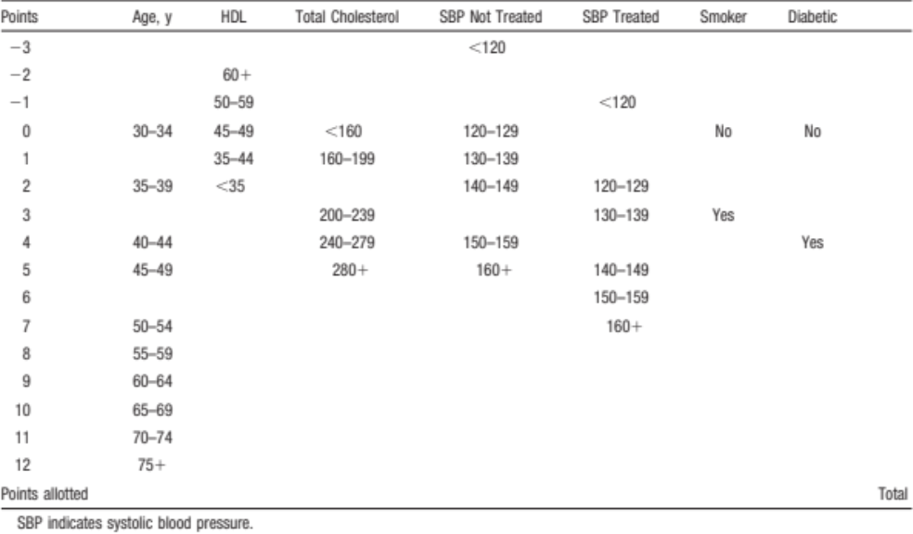
Table- CVD Points for Women

Table- CVD Risk for Women
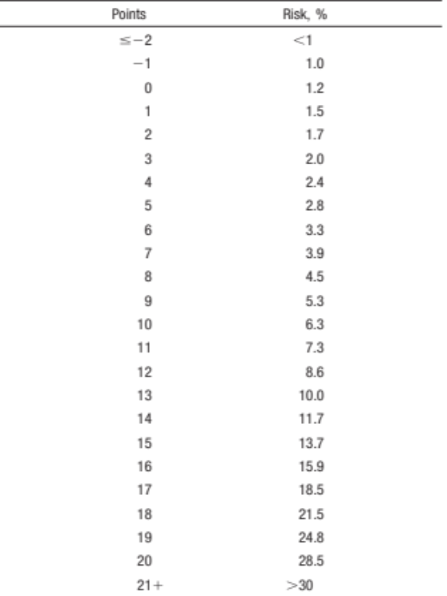

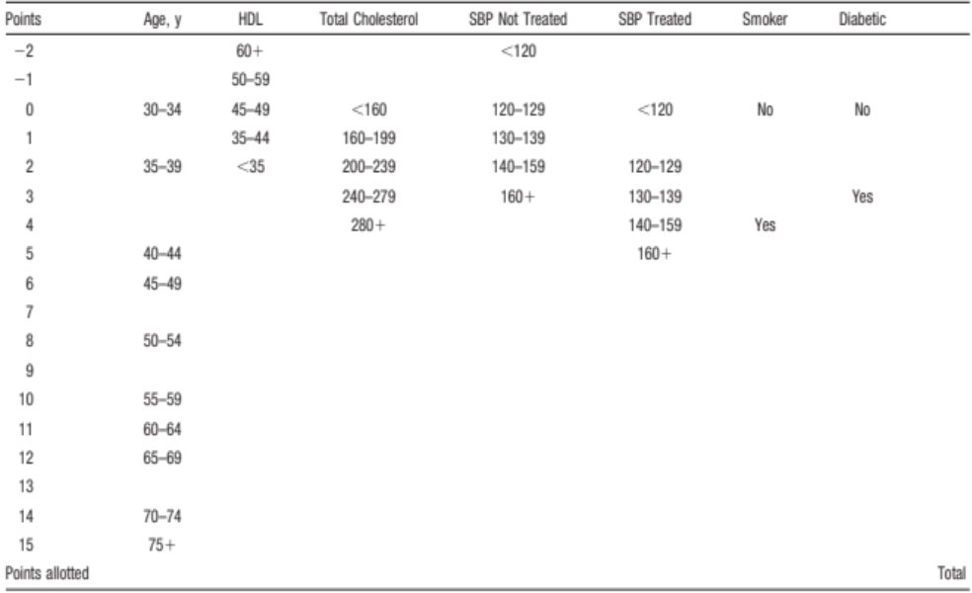
Table- CVD Points for Men

Table- CVD Risk for Men
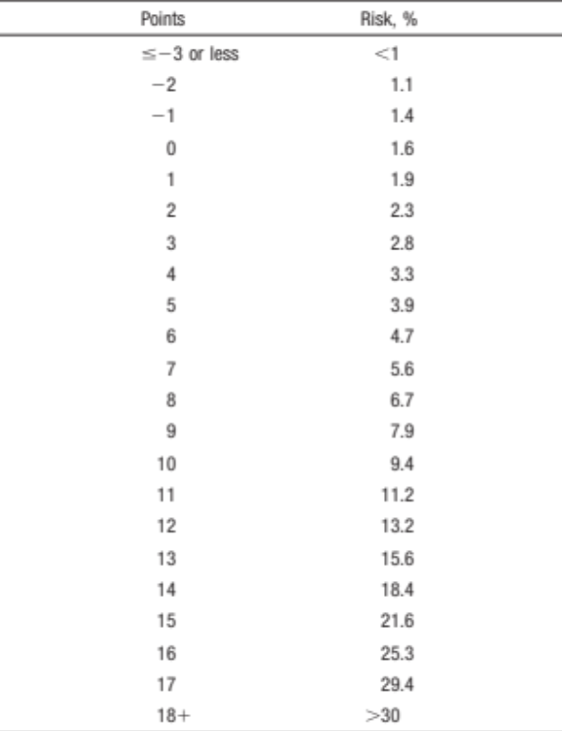

Table- Heart Age/Vascular Age for Women
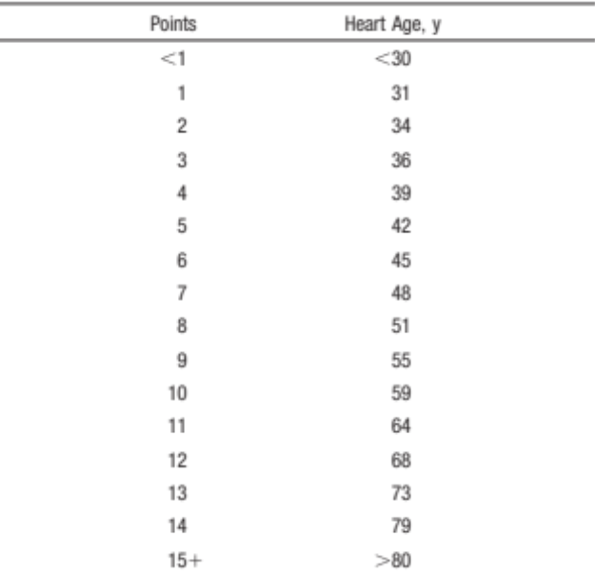

Table- Heart Age/Vascular Age for Men
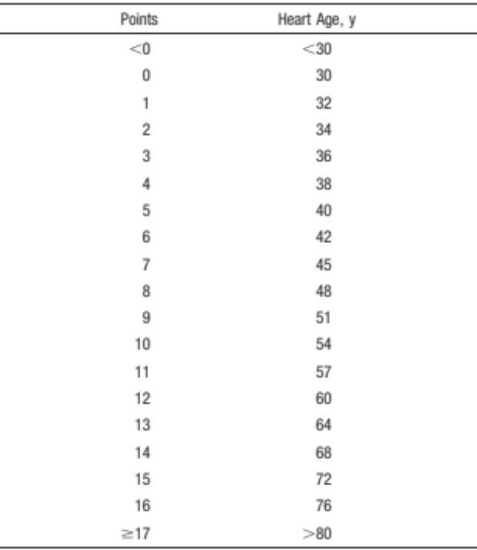

Appendix B- International Physical Activity Questionnaire
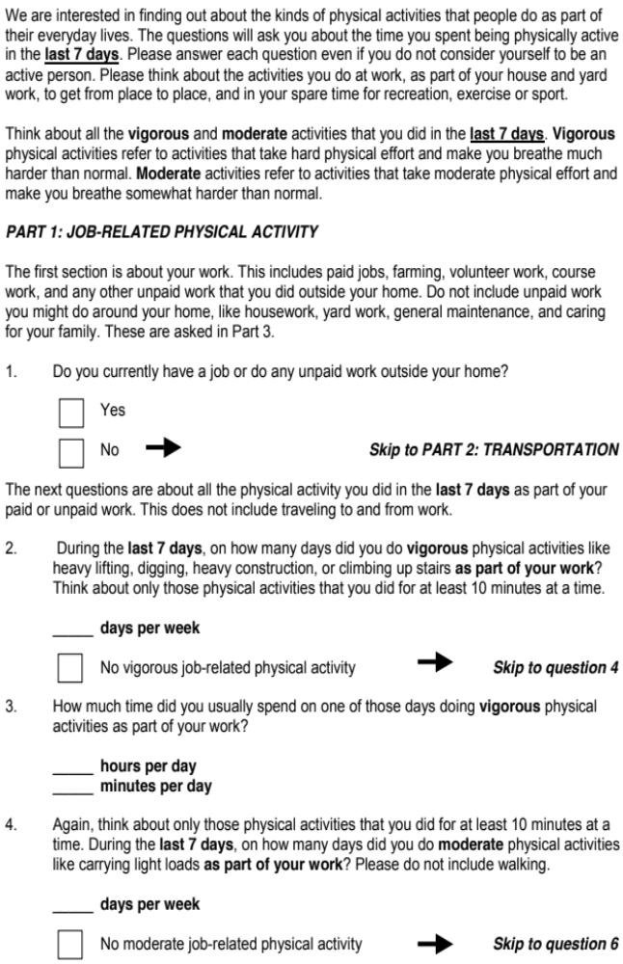
I.D#________ Pre_____ Post ______ Follow-up_____
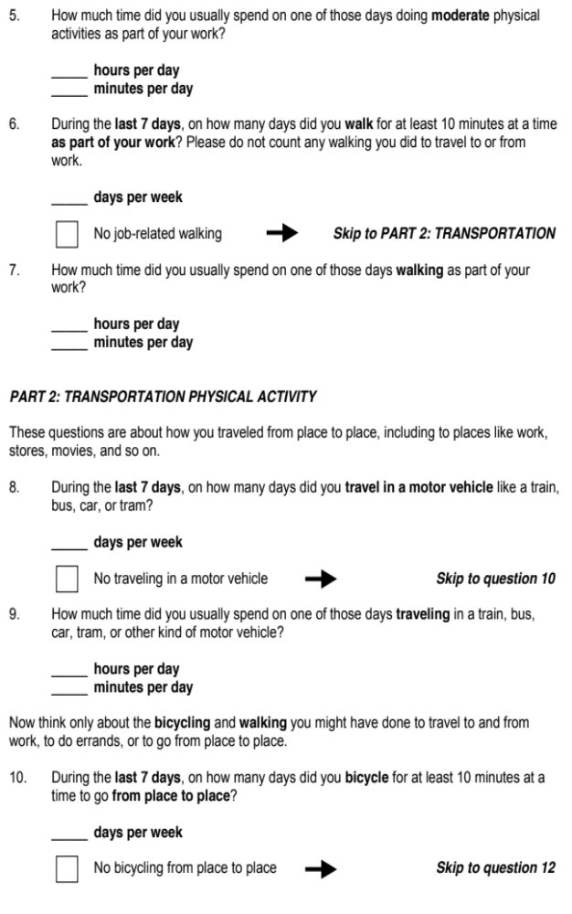

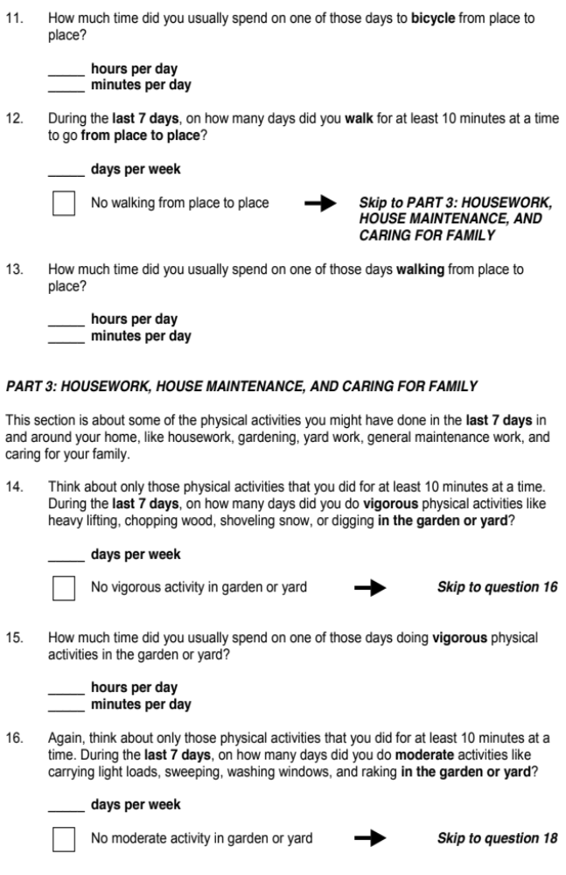
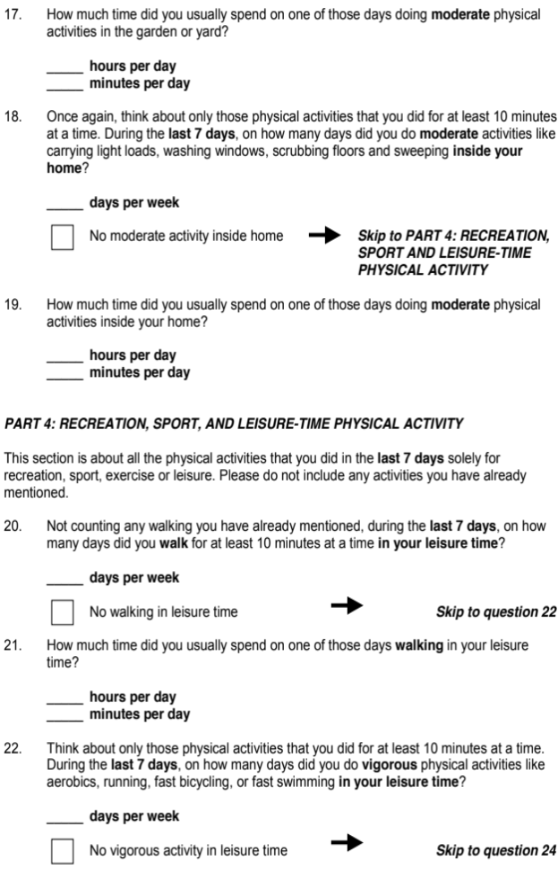
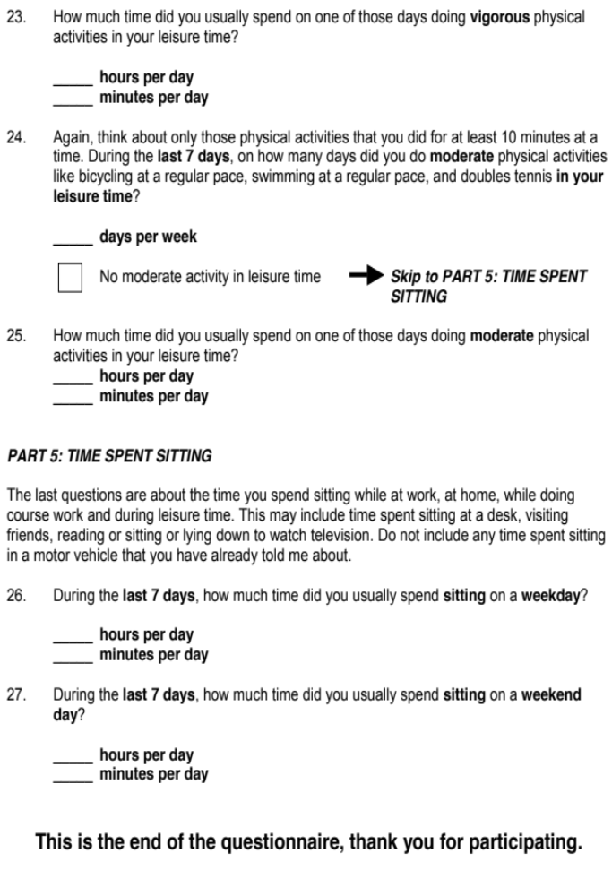

Appendix C- Break Log
Walking-Only Group

Study ID Number_____ Pre_____ Post______ 3-month______ 6-month_____

Make sure you fill out the table below every day. Make a mark every time you take a break, which is at least a 2 minutes break for every half hour where you are sedentary (watching TV, computer time, sitting). Record the total sitting hours.
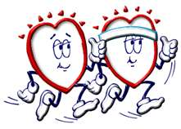

Day | 2min. breaks/ 30 mins. | Sitting hours | Comments
1

2

3

4

5

6

7

* If you did not wear your pedometer/ accelerometer at any time during a day, write “Did not wear from (time of day) to (time of day)” or “Did not wear at all” in the “Comments” section.
* If you have questions, comments or concerns, please contact Ghadah at the Department of Health and Exercise Sciences University of Oklahoma Norman Campus at 405-919-0437 or Ghadah.i.alshuwaiyer-1@ou.edu.

Appendix D- Activity Log
Walking-Plus Group

Study ID Number_____ Activity Data Sheet for Week ______

Make sure you fill out the table below every day. Record the time you that you have the pedometer on and the time you take it off. Write the calibrated steps for every single day. Make sure that record the total steps and the total walking time completed for each day. Additionally, you should take at least a 2 minute break (stand up or walk around) for every hour where you are sedentary (watching TV, computer time, sitting, NOT standing). Mark every time you take a break.
Remember, your goal is to reach the predetermined walking time for every week.

Day | Time  On  (am/pm) | Time  Off  (am/pm) | Calib.  Steps | Total Steps | Total Walking Time | 2min. breaks/ 30 mins. | Sitting hours | Comments
1

2

3

4

5

6

7

*Reset your pedometer at the end of each day.
* If you did not wear your pedometer at any time during a day, write “Did not wear from (time of day) to (time of day)” or “Did not wear at all” in the “Comments” section.
* If you exercise in a form other than walking, your pedometer may not reflect the amount of activity you did. If you do an activity that you do not feel is accurately measured with a pedometer (biking, for example), please indicate what you did in the “Comments” section.
* If you have questions, comments or concerns, please contact Ghadah at the Department of Health and Exercise Sciences University of Oklahoma Norman Campus at 405-919-0437 or Ghadah.i.alshuwaiyer-1@ou.edu.

Appendix E- Food Frequency Questionnaire
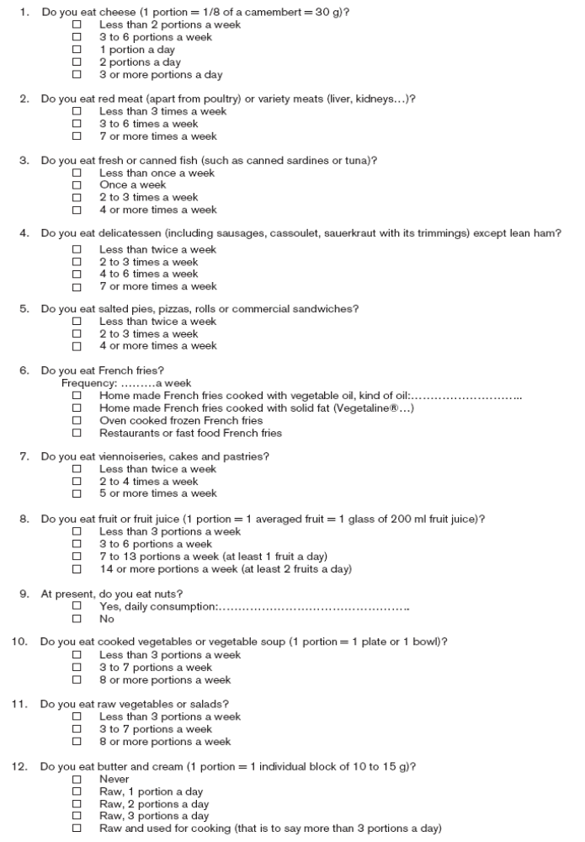
I.D.# _______ Pre_____ Post ______ Follow-up_____

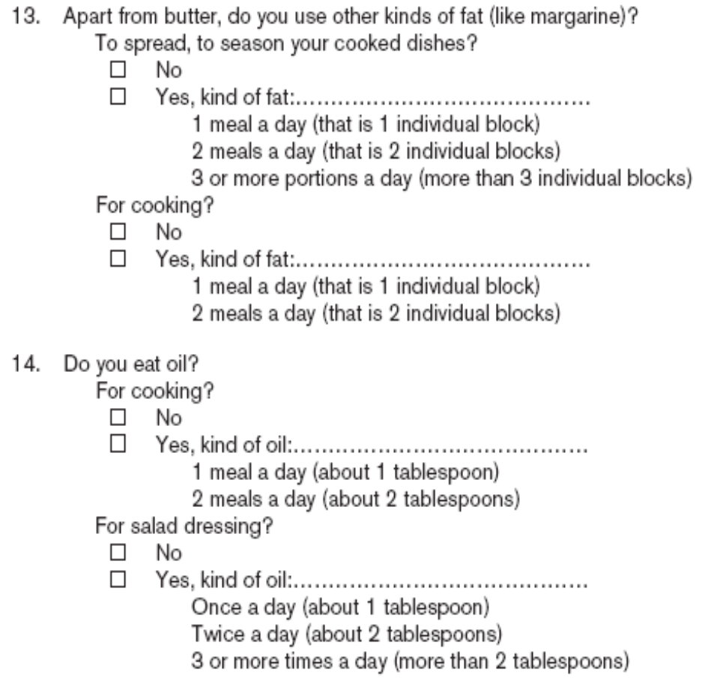

Appendix F- Exercise Confidence Survey
I.D#________ Pre_____ Post ______ Follow-up_____
Below is a list of things people might do while trying to increase or continue regular exercise. We are interested in exercises like running, swimming, brisk walking, bicycle riding, or aerobics classes.
Whether you exercise or not, please rate how confident you are that you could really motivate yourself to do things like these consistently, for at least six months.
Please circle one number for each question. How sure are you that you can do these things?

 |  | I Know I cannot |  |  | Maybe I can |  |  | I Know I can | Does not apply
- Get up early, even on weekends, to exercise. | 1 |  | 2 |  | 3 | 4 |  | 5 |  | (8)
- Stick to your exercise program after a long, tiring day at work. | 1 |  | 2 |  | 3 | 4 |  | 5 |  | (8)
- Exercise even though you are feeling depressed. | 1 |  | 2 |  | 3 | 4 |  | 5 |  | (8)
- Set aside time for a physical activity program; that is, walking, jogging, swimming, biking, or other continuous activities for at least 30 minutes, 3 times per week. | 1 |  | 2 |  | 3 | 4 |  | 5 |  | (8)
- Continue to exercise with others even though they seem too fast or too slow for you. | 1 |  | 2 |  | 3 | 4 |  | 5 |  | (8)
- Stick to your exercise program when undergoing a stressful life change (e.g., divorce, death in the family, moving). | 1 |  | 2 |  | 3 | 4 |  | 5 |  | (8)
- Attend a party only after exercising. | 1 |  | 2 |  | 3 | 4 |  | 5 |  | (8)
- Stick to your exercise program when your family is demanding more time from you. | 1 |  | 2 |  | 3 | 4 |  | 5 |  | (8)
- Stick to your exercise program when you have household chores to attend to. | 1 |  | 2 |  | 3 | 4 |  | 5 |  | (8)
- Stick to your exercise program even when you have excessive demands at work. | 1 |  | 2 |  | 3 | 4 |  | 5 |  | (8)
- Stick to your exercise program when social obligations are very time consuming. | 1 |  | 2 |  | 3 | 4 |  | 5 |  | (8)
- Read or study less in order to exercise more. | 1 |  | 2 |  | 3 | 4 |  | 5 |  | (8)

Appendix G- Walking Confidence Survey
I.D#________ Pre_____ Post ______ Follow-up_____
Below is a list of things people might do while trying to increase or continue walking. We are interested in planned and unplanned walking in bouts of at least 10 minutes. Whether you walk vigorously or not, please rate how confident you are that you could really motivate yourself to do things like these consistently, for at least six months.
Please circle one number for each question. How sure are you that you can do these things?

 |  | I Know I cannot |  |  | Maybe I can |  | I Know I can |  | Does not apply
- Get up early, even on weekends, to walk. | 1 |  | 2 |  | 3 | 4 |  | 5 |  | (8)
- Stick to your walking program after a long, tiring day at work. | 1 |  | 2 |  | 3 | 4 |  | 5 |  | (8)
- Walk even though you are feeling depressed. | 1 |  | 2 |  | 3 | 4 |  | 5 |  | (8)
- Set aside time for a physical activity program; that is walking, jogging, swimming, biking, or other continuous activities for at least 30 minutes, 3 times per week. | 1 |  | 2 |  | 3 | 4 |  | 5 |  | (8)
- Continue to walk with others even though they seem too fast or too slow for you. | 1 |  | 2 |  | 3 | 4 |  | 5 |  | (8)
- Stick to your walking program when undergoing a stressful life change (e.g., divorce, death in the family, moving). | 1 |  | 2 |  | 3 | 4 |  | 5 |  | (8)
- Attend a party only after walking. | 1 |  | 2 |  | 3 | 4 |  | 5 |  | (8)
- Stick to your walking program when your family is demanding more time from you. | 1 |  | 2 |  | 3 | 4 |  | 5 |  | (8)
- Stick to your walking program when you have household chores to attend to. | 1 |  | 2 |  | 3 | 4 |  | 5 |  | (8)
- Stick to your walking program even when you have excessive demands at work. | 1 |  | 2 |  | 3 | 4 |  | 5 |  | (8)
- Stick to your walking program when social obligations are very time consuming. | 1 |  | 2 |  | 3 | 4 |  | 5 |  | (8)
- Read or study less in order to get more walking. | 1 |  | 2 |  | 3 | 4 |  | 5 |  | (8)

Appendix H- Sedentary Behavior Confidence Survey

Below is a list of things people might do while trying to increase or continue taking breaks to interrupt sedentary time. We are interested in planned and unplanned breaks of at least 2 minutes for every half hour of sedentary time (i.e., sitting, watching TV, sitting in a vehicle, sitting at a desk or computer).
Whether you interrupt your breaks or not, please rate how confident you are that you could really motivate yourself to do things like these consistently, for at least six months.
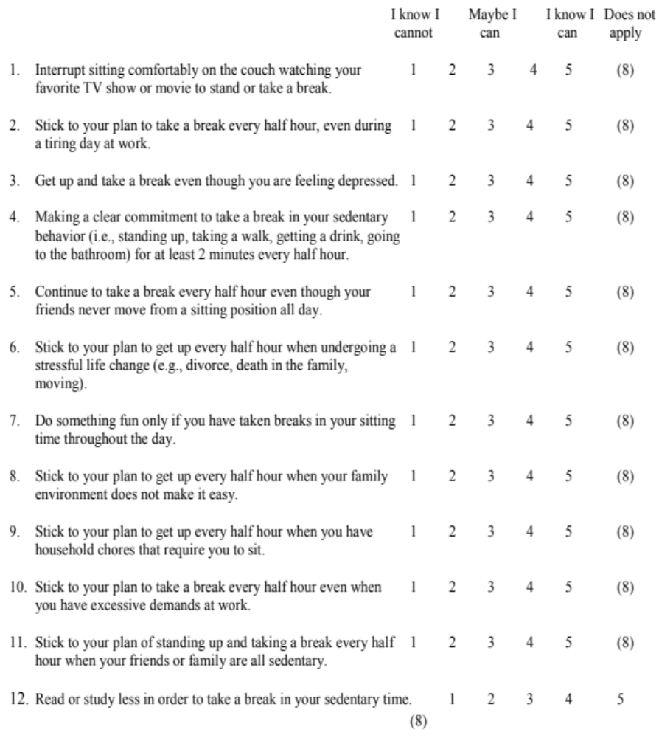
Please circle one number for each question. How sure are you that you can do these things?

Appendix I- Barriers Scale
I.D#________ Pre_____ Post ______ Follow-up_____
DIRECTIONS: Below are statements that relate to ideas about exercise. Please indicate the degree to which you agree or disagree with the statements by circling SA for strongly agree, A for agree, D for disagree, or SD for strongly disagree.
 | Strongly agree | Agree | Disagree | Strongly disagree
- Exercising takes too much of my time. | SA | A | D | SD
- Exercise tires me | SA | A | D | SD
- Places for me to exercise are too far away | SA | A | D | SD
- I am too embarrassed to exercise. | SA | A | D | SD
- It costs too much to exercise. | SA | A | D | SD
- Exercise facilities do not have convenient schedules for me. | SA | A | D | SD
- I am fatigued by exercise. | SA | A | D | SD
- My spouse (or significant other) does not encourage exercising. | SA | A | D | SD
- Exercise takes too much time from family relationships | SA | A | D | SD
- I think people in exercise clothes look funny | SA | A | D | SD
- My family members do not encourage me to exercise | SA | A | D | SD
- Exercise takes too much time from my family responsibilities | SA | A | D | SD
- Exercise is hard work for me | SA | A | D | SD
- There are too few places for me to exercise | SA | A | D | SD

Appendix J- Exist Interview

Here are some examples of exist interview questions:
- Did you enjoy the program?
- Were there any factors that might positively or negatively have influenced your engagement in the walking program? For example, weather
- Did you join any exercise groups or start a diet during the program?
- In your opinion, what are the strengths of this program?
- In your opinion, what are the weaknesses of this program?
- Any suggestions in how to improve the program?

Appendix K- Contact Information Sheet

Contact Information:
Please complete the following information. This information will be stored separately from all research data and will only be used to contact you about research related activities.
Name: _______________________________ Date:______________
Phone: ___________________ E-mail:_______________________________
Primary Care Physician (Name): _____________________ Phone:________________
Emergency Contact (Name): ______________________ Phone:__________________

Appendix L- Health History Form
Functional Performance Laboratory
Department of Health & Exercise Science - University of Oklahoma
ID#: __________________________ Date: __________________________
Gender M F Age: __________________________

Please consider each question and answer carefully.

1. In general how would you describe your current, overall state of health?
a. Excellent b. Good
c. Fair d. Poor

2. Do you currently have any of the following have been diagnosed by health professional?
a. Heart trouble i. Diabetes
b. Chronic asthma or bronchitis j. Foot problem
c. High blood pressure k. Arthritis
d. Back problem l. severe arthritis
e. Cataract or other vision disorder m. Other health problems
f. Osteoporosis Specify____________
g. Parkinsons
h. Stroke

3. Are you currently limited in the type or amount of physical activity (work or leisure) you can do because of injury, illness or disability?
a. No
b. Yes, because of temporary illness (example: flu or fracture)
Please specify: __________________________
c. Yes, because of long term illness, injury or disability (example: arthritis, diabetes, heart disease, back problem)
Please specify: ___________________________

4. Has a physician ever said you have a heart condition and you should only do physical activity recommended by a physician?
a. Yes b. No

5. When you are physically active, do you feel pain in your chest?
a. Yes b. No

6. Do you ever lose you consciousness or do you lose your balance because of dizziness?
a. Yes b. No

7. Do you have a joint or bone problem that may be made worse by a change in your physical activity?
a. Yes b. No

8. Has your doctor ever told you that you should limit lifting or stair climbing?
a. Yes b. No

9. Has your physician prescribed medication for blood pressure or a heart condition?
a. Yes b. No

10. Are you currently enrolled in any other physical activity classes or groups?
a. No
b. Yes, What type: _____________________________
Number of times per week: ____________________

11. Are currently taking any prescribed medications?
- No
- Yes, Please list all your medications:
Medications Purpose Duration of administration

- Are currently taking any nutritional supplements?
- No
- Yes, Please list all your supplements:
Supplements Duration of administration

I have read these items carefully and answered all questions truthfully
Participants Signature: _______________________________
Date: ____________________

Appendix M- Demographic Data Questionnaire
I.D#________
Please answer the following questions honestly and to the best of your ability.
- What is your current age? _____

- What is your gender?
  - Male
  - Female

- What do you perceive to be your ethnicity? (Check all that apply)
  - White
  - Black or African American
  - Asian
  - Native Hawaiian or Other Pacific Islander
  - American Indian or Native Alaskan
  - Hispanic or Latino

- What is your annual household income from all sources?
  - Less than $10,000
  - $10,000 to less than $15,000
  - $15,000 to less than $20,000
  - $20,000 to less than $25,000
  - $25,000 to less than $35,000
  - $35,000 to less than $50,000
  - $50,000 to less than $75,000
  - $75,000 or more

- What is the highest grade or year of school you completed?
  - Never attended school or only attended kindergarten
  - Grades 1-8 (elementary)
  - Grades 9-11 (some high school)
  - Grade 12 or GED (High school graduate)
  - College 1 year to 3 years (some college)
  - College 4 years or more (college graduate)

- What is your marital status?
  - Married
  - Divorced
  - Widowed
  - Separated
  - Never married
  - Member of an unmarried couple

- Do you currently smoke?
  - Yes
  - No

Appendix N- Eligibility Criteria Form

Name ________________________ I.D.#____________
Please circle Y or N to the following:

Primary inclusion criteria- in order to be eligible to participate, subject must meet the two primary criteria for inclusion.

Y N Insufficient level of physical activity (<30 min. exercise 5 days/week)
Y N High cholesterol (Total Cholesterol > 200, LDL-C > 160, triglyceride>150 mg/dL)

Secondary inclusion criteria

Y N Family history of diabetes and/or CVD
Y N High blood pressure (systolic > 130 or diastolic > 90)
Y N BMI ≥ 25 kg/m² (criteria for overweight)

Exclusion Criteria:

Y N Diagnosed with diabetes, heart disease, or stroke
Y N Have a pacemaker
Y N Pregnant or planning to get pregnant
Y N Non-ambulatory or has previous or current medical conditions/physical injuries that would limit you from walking

Appendix O- Activity Log
Walking-Only Group

Study ID Number_____ Activity Data Sheet for Week ______

Make sure you fill out the table below every day. Record the time you that you have the pedometer on and the time you take it off. Write the calibrated steps for every single day. Make sure that record the total steps and the total walking time completed for each day.
Remember, your goal is to reach the predetermined walking time for every week.

Day | Time  On  (am/pm) | Time  Off  (am/pm) | Calib.  Steps | Total Steps | Total Walking Time | Comments
1

2

3

4

5

6

7

*Reset your pedometer at the end of each day.
* If you did not wear your pedometer at any time during a day, write “Did not wear from (time of day) to (time of day)” or “Did not wear at all” in the “Comments” section.
* If you exercise in a form other than walking, your pedometer may not reflect the amount of activity you did. If you do an activity that you do not feel is accurately measured with a pedometer (biking, for example), please indicate what you did in the “Comments” section.
* If you have questions, comments or concerns, please contact Ghadah at the Department of Health and Exercise Sciences University of Oklahoma Norman Campus at 405-919-0437 or Ghadah.i.alshuwaiyer-1@ou.edu.

Appendix P- Phone Call Scripts
(Starting week 2 then every other week after that)

- “How is the program going for you so far?”

- “Do you have any struggles/successful strategies?”

- –Briefly go over the concepts in the messages from the emails in the past 2 weeks.

- –Motivational comment. For example: “You have done well so far… keep up the good work!”

Appendix Q- Weekly Emails
Walking-Only Group E-mails
Hello___________!
As part of the walking program you are participating in, you will be receiving weekly emails from me. I hope you will be able to use the tips I include each week. Thank you so much for your participation! Have a great week and don’t forget to fill out your Activity Log this week!

- Physical Activity: It can be helpful to set goals about choosing physical activity instead of another activity (like watching TV). An example would be to set a goal of substituting a short walk for your least favorite TV show. It may be helpful to set a specific time and/or a place each day that you are able to walk.

What strategy could you use next week to be successful in reaching your walking goal?

Please e-mail your response back to me as soon as you are able. Thank you so much for your participation! Have a wonderful week!

Ghadah Alshuwaiyer

Week 2
Hello_____________!

I hope your week went well last week. Make sure you turn in the Activity Log from last week. Have a great week and don’t forget to fill out your Activity Log this week!

- Physical Activity: When you are trying to achieve your weekly goals for walking time, choose a specific time that you feel confident that you can achieve but try to make an improvement from what you are doing now to reach the specified goal. Remember, the overall goal is to get 10,000 steps per day as soon as possible.

Were you successful in achieving last week’s goal?

Unsuccessful 1 2 3 4 5 Successful

If successful, what strategies did you use to reach your goal?

If unsuccessful, what strategy could you use next week to be more successful in reaching your walking goal?

Please e-mail your response back to me as soon as you are able. Thank you so much for your participation! Have a wonderful week!

Ghadah Alshuwaiyer

Week 3
Hello_________!

I hope your week went well last week. Make sure you turn in the Activity Log from last week. Have a great week and don’t forget to fill out your Activity Log this week!

- Physical Activity: When you reach your daily goal for walking time for this week, choose a small reward for yourself that you will do or get if you achieve your goal every day. The reward can be something that you go buy like that book you have been wanting to read or something that is free like a nice bubble bath.

Were you successful in achieving last week’s goal?

Unsuccessful 1 2 3 4 5 Successful

If successful, what strategies did you use to reach your goal?

If unsuccessful, what strategy could you use next week to be more successful in reaching your walking goal?

Please e-mail your response back to me as soon as you are able. Thank you so much for your participation! Have a wonderful week!

Ghadah Alshuwaiyer

Week 4
Hello_______!

I hope your week went well last week. Make sure you turn in the Step Log from last week. Have a great week and don’t forget to fill out your activity Log this week!

- Physical Activity: Remember to be getting those steps in EVERY DAY! Keep on improving! Invite a friend or family member on a walk with you. It will give you somebody to talk to. Who knows, it may become a routine for both of you!

Were you successful in achieving last week’s goal?

Unsuccessful 1 2 3 4 5 Successful

If successful, what strategies did you use to reach your goal?

If unsuccessful, what strategy could you use next week to be more successful in reaching your walking goal?

Please e-mail your response back to me as soon as you are able. Thank you so much for your participation! Have a wonderful week!

Ghadah Alshuwaiyer
Week 5
Hello_______!

I hope your week went well last week. Make sure you turn in the Activity Log from last week. Have a great week and don’t forget to fill out your Activity Log this week!

- Physical Activity: You have passed the four-week mark and are still working hard! When the weeks get difficult and you don’t think you can finish, look at your past weeks and remember your best week yet! Keep moving no matter what!

Were you successful in achieving last week’s goal?

Unsuccessful 1 2 3 4 5 Successful

If successful, what strategies did you use to reach your goal?

If unsuccessful, what strategy could you use next week to be more successful in reaching your walking goal?

Please e-mail your response back to me as soon as you are able. Thank you so much for your participation! Have a wonderful week!

Ghadah Alshuwaiyer

Week 6
Hello_______!

I hope your week went well last week. Make sure you turn in the Activity Log from last week. Have a great week and don’t forget to fill out your Activity Log this week!

- Physical Activity: Look at how far you have come! You have gone for well over half of the program now and are still doing GREAT! Keep sticking with your walking just as you have been doing for the past month! Keep up the good work!

Were you successful in achieving last week’s goal?

Unsuccessful 1 2 3 4 5 Successful

If successful, what strategies did you use to reach your goal?

If unsuccessful, what strategy could you use next week to be more successful in reaching your walking goal?

Please e-mail your response back to me as soon as you are able. Thank you so much for your participation! Have a wonderful week!

Ghadah Alshuwaiyer
Week 7
Hello_______!

I hope your week went well last week. Make sure you turn in the Activity Log from last week. Have a great week and don’t forget to fill out your Activity Log this week!

- Physical Activity: Don’t compare your walking to other people. Instead, compete with yourself. Do better this week than you did last week. Do better today than you did yesterday!

Were you successful in achieving last week’s goal?

Unsuccessful 1 2 3 4 5 Successful

If successful, what strategies did you use to reach your goal?

If unsuccessful, what strategy could you use next week to be more successful in reaching your walking goal?

Please e-mail your response back to me as soon as you are able. Thank you so much for your participation! Have a wonderful week!

Ghadah Alshuwaiyer

Week 8
Hello_______!

I hope your week went well last week. Make sure you turn in the Activity Log from last week. Have a great week and don’t forget to fill out your Activity Log this week!

- Physical Activity: Although walking is considered such a great form of exercise due to its ease and flexibility, any exercise program is difficult to begin and maintain. I say, you have accomplished something great by starting this program and I encourage you to continue your journey!

Were you successful in achieving last week’s goal?

Unsuccessful 1 2 3 4 5 Successful

If successful, what strategies did you use to reach your goal?

If unsuccessful, what strategy could you use next week to be more successful in reaching your walking goal?

Please e-mail your response back to me as soon as you are able. Thank you so much for your participation! Have a wonderful week!

Ghadah Alshuwaiyer

Week 9
Hello_______!

I hope your week went well last week. Make sure you turn in the Activity Log from last week. Have a great week and don’t forget to fill out your Activity Log this week!

- Physical Activity: Think ahead as this program nears its end. Schedule your walking into your day and set goals for when you have walked 3, 5, 10 or even 20 days in a row.

Were you successful in achieving last week’s goal?

Unsuccessful 1 2 3 4 5 Successful

If successful, what strategies did you use to reach your goal?

If unsuccessful, what strategy could you use next week to be more successful in reaching your walking goal?

Please e-mail your response back to me as soon as you are able. Thank you so much for your participation! Have a wonderful week!

Ghadah Alshuwaiyer

Week 10

Hello_______!

I hope your week went well last week. Make sure you turn in the Activity Log from last week. Have a great week and don’t forget to fill out your Activity Log this week!

- Physical Activity: Remember; don’t compare your walking to other people. Instead, compete with yourself.

Were you successful in achieving last week’s goal?

Unsuccessful 1 2 3 4 5 Successful

If successful, what strategies did you use to reach your goal?

If unsuccessful, what strategy could you use next week to be more successful in reaching your walking goal?

Please e-mail your response back to me as soon as you are able. Thank you so much for your participation! Have a wonderful week!

Ghadah Alshuwaiyer
Week 11

Hello_______!

I hope your week went well last week. Make sure you turn in the Activity Log from last week. Have a great week and don’t forget to fill out your Activity Log this week!

- Physical Activity: Although walking is considered such a great form of exercise due to its ease and flexibility, any exercise program is difficult to begin and maintain. I say, you have accomplished something great by starting this program and I encourage you to continue your journey!

Were you successful in achieving last week’s goal?

Unsuccessful 1 2 3 4 5 Successful

If successful, what strategies did you use to reach your goal?

If unsuccessful, what strategy could you use next week to be more successful in reaching your walking goal?

Please e-mail your response back to me as soon as you are able. Thank you so much for your participation! Have a wonderful week!

Ghadah Alshuwaiyer

Week 12
Hello_______!

I hope your week went well last week. Make sure you turn in the Activity Log from last week. Have a great week and don’t forget to fill out your Activity Log this week!

- Physical Activity: You are now starting your last week and you have accomplished something great. Even though you may or may not have achieved the goals you set in the beginning, you are still reading these emails, which means you still care about your fitness journey.

Were you successful in achieving last week’s goal?

Unsuccessful 1 2 3 4 5 Successful

If successful, what strategies did you use to reach your goal?

If unsuccessful, what strategy could you use next week to be more successful in reaching your walking goal?

Please e-mail your response back to me as soon as you are able. Thank you so much for your participation! Have a wonderful week!
Ghadah Alshuwaiyer

Appendix R- Weekly Emails
Walking-Plus Group E-mails

Week 1
Hello___________!

As part of the walking program you are participating in, you will be receiving weekly emails from me. I hope you will be able to use the tips I include each week. Thank you so much for your participation! Have a great week and don’t forget to fill out your Activity Log this week!

- Physical Activity: It can be helpful to set goals about choosing physical activity instead of another activity (like watching TV). An example would be to set a goal of substituting a short walk for your least favorite TV show. It may be helpful to set a specific time and/or a place each day that you are able to walk.

- Watching TV: When watching the TV, try putting the remote next to the TV so you would get up. Try also standing up during advertisement breaks. Try also doing some household chores such as folding the laundry, doing some ironing, and sorting files while watching TV.

What strategy could you use next week to be successful in reaching your walking goal?

Please e-mail your response back to me as soon as you are able. Thank you so much for your participation! Have a wonderful week!

Ghadah Alshuwaiyer

Week 2
Hello_____________!

I hope your week went well last week. Make sure you turn in the Activity Log from last week. Have a great week and don’t forget to fill out your Activity Log this week!

- Physical Activity: When you are trying to achieve your weekly goals for walking time, choose a specific time that you feel confident that you can achieve but try to make an improvement from what you are doing now to reach the specified goal. Remember, the overall goal is to get 10,000 steps per day as soon as possible.

- Computer Use: When you are using the computer, try setting an alarm to remind you to move after a specified period of time. You can also start a load of washing so that you have to get up rather than “losing time’’ when on the computer. It is also helpful to avoid playing play games on computer.

Were you successful in achieving last week’s goal?

Unsuccessful 1 2 3 4 5 Successful

If successful, what strategies did you use to reach your goal?

If unsuccessful, what strategy could you use next week to be more successful in reaching your walking goal?

Please e-mail your response back to me as soon as you are able. Thank you so much for your participation! Have a wonderful week!

Ghadah Alshuwaiyer

Week 3
Hello_________!

I hope your week went well last week. Make sure you turn in the Activity Log from last week. Have a great week and don’t forget to fill out your Activity Log this week!

- Physical Activity: When you reach your daily goal for walking time for this week, choose a small reward for yourself that you will do or get if you achieve your goal every day. The reward can be something that you go buy like that book you have been wanting to read or something that is free like a nice bubble bath.

- Reading: When you are sitting reading, try standing up after you have finished a chapter, or a section of the newspaper. Try standing up while reading the mail as well.

Were you successful in achieving last week’s goal?

Unsuccessful 1 2 3 4 5 Successful

If successful, what strategies did you use to reach your goal?

If unsuccessful, what strategy could you use next week to be more successful in reaching your walking goal?

Please e-mail your response back to me as soon as you are able. Thank you so much for your participation! Have a wonderful week!

Ghadah Alshuwaiyer

Week 4
Hello_______!

I hope your week went well last week. Make sure you turn in the Step Log from last week. Have a great week and don’t forget to fill out your activity Log this week!

- Physical Activity: Remember to be getting those steps in EVERY DAY! Keep on improving! Invite a friend or family member on a walk with you. It will give you somebody to talk to. Who knows, it may become a routine for both of you!

- Socializing: When socializing, stand up and get refreshments for other members of friendship group instead of waiting for them to serve you. Tell your friends and family as well about the study so they can remind you to get up and move.

Were you successful in achieving last week’s goal?

Unsuccessful 1 2 3 4 5 Successful

If successful, what strategies did you use to reach your goal?

If unsuccessful, what strategy could you use next week to be more successful in reaching your walking goal?

Please e-mail your response back to me as soon as you are able. Thank you so much for your participation! Have a wonderful week!

Ghadah Alshuwaiyer

Week 5
Hello_______!

I hope your week went well last week. Make sure you turn in the Activity Log from last week. Have a great week and don’t forget to fill out your Activity Log this week!

- Physical Activity: You have passed the four-week mark and are still working hard! When the weeks get difficult and you don’t think you can finish, look at your past weeks and remember your best week yet! Keep moving no matter what!

- Socializing: Do not forget to stand up while talking on the telephone. It is also better to walk to visit neighbor instead of calling them on the telephone.

Were you successful in achieving last week’s goal?

Unsuccessful 1 2 3 4 5 Successful

If successful, what strategies did you use to reach your goal?

If unsuccessful, what strategy could you use next week to be more successful in reaching your walking goal?

Please e-mail your response back to me as soon as you are able. Thank you so much for your participation! Have a wonderful week!

Ghadah Alshuwaiyer

Week 6
Hello_______!

I hope your week went well last week. Make sure you turn in the Activity Log from last week. Have a great week and don’t forget to fill out your Activity Log this week!

- Physical Activity: Look at how far you have come! You have gone for well over half of the program now and are still doing GREAT! Keep sticking with your walking just as you have been doing for the past month! Keep up the good work!

- Transport: When commuting, try standing up while waiting for the bus to arrive. It is also helpful to park your car further away from the entrance of the shopping center or any desired destination.

Were you successful in achieving last week’s goal?

Unsuccessful 1 2 3 4 5 Successful

If successful, what strategies did you use to reach your goal?

If unsuccessful, what strategy could you use next week to be more successful in reaching your walking goal?

Please e-mail your response back to me as soon as you are able. Thank you so much for your participation! Have a wonderful week!

Ghadah Alshuwaiyer

Week 7
Hello_______!

I hope your week went well last week. Make sure you turn in the Activity Log from last week. Have a great week and don’t forget to fill out your Activity Log this week!

- Physical Activity: Don’t compare your walking to other people. Instead, compete with yourself. Do better this week than you did last week. Do better today than you did yesterday!

- Household Activities: When doing household chores, try splitting-up these chores and extending the time it takes to complete each task (e.g., put away each item of ironing after completion, make multiple trips to the line to hang out the washing). Try also using your free time to do the chores that you have been avoiding (e.g., sorting through clothes to donate to charity).

Were you successful in achieving last week’s goal?

Unsuccessful 1 2 3 4 5 Successful

If successful, what strategies did you use to reach your goal?

If unsuccessful, what strategy could you use next week to be more successful in reaching your walking goal?

Please e-mail your response back to me as soon as you are able. Thank you so much for your participation! Have a wonderful week!

Ghadah Alshuwaiyer

Week 8
Hello_______!

I hope your week went well last week. Make sure you turn in the Activity Log from last week. Have a great week and don’t forget to fill out your Activity Log this week!

- Physical Activity: Although walking is considered such a great form of exercise due to its ease and flexibility, any exercise program is difficult to begin and maintain. I say, you have accomplished something great by starting this program and I encourage you to continue your journey!
- Hobbies: When you are busy having fun in playing puzzles or busy doing crafts like cutting fabric for quilting or at easel to paint, try interrupting these hobbies by standing up and moving around. When listening to music as well, try walking around or dancing. Just make it a habit!

Were you successful in achieving last week’s goal?

Unsuccessful 1 2 3 4 5 Successful

If successful, what strategies did you use to reach your goal?

If unsuccessful, what strategy could you use next week to be more successful in reaching your walking goal?

Please e-mail your response back to me as soon as you are able. Thank you so much for your participation! Have a wonderful week!

Ghadah Alshuwaiyer

Week 9
Hello_______!

I hope your week went well last week. Make sure you turn in the Activity Log from last week. Have a great week and don’t forget to fill out your Activity Log this week!
- Physical Activity: Think ahead as this program nears its end. Schedule your walking into your day and set goals for when you have walked 3, 5, 10 or even 20 days in a row.
- General Activities: Make sure that you drink more water so that you have to get up to go to toilet more often or drink from a smaller glass so that you have to get up more often to refill it.

Were you successful in achieving last week’s goal?

Unsuccessful 1 2 3 4 5 Successful

If successful, what strategies did you use to reach your goal?

If unsuccessful, what strategy could you use next week to be more successful in reaching your walking goal?

Please e-mail your response back to me as soon as you are able. Thank you so much for your participation! Have a wonderful week!

Ghadah Alshuwaiyer

Week 10

Hello_______!

I hope your week went well last week. Make sure you turn in the Activity Log from last week. Have a great week and don’t forget to fill out your Activity Log this week!

- Physical Activity: Remember; don’t compare your walking to other people. Instead, compete with yourself.

- Hobbies: When listening to music as well, try walking around or dancing. Just make it a habit!

Were you successful in achieving last week’s goal?

Unsuccessful 1 2 3 4 5 Successful

If successful, what strategies did you use to reach your goal?

If unsuccessful, what strategy could you use next week to be more successful in reaching your walking goal?

Please e-mail your response back to me as soon as you are able. Thank you so much for your participation! Have a wonderful week!

Ghadah Alshuwaiyer

Week 11

Hello_______!

I hope your week went well last week. Make sure you turn in the Activity Log from last week. Have a great week and don’t forget to fill out your Activity Log this week!

- Physical Activity: Although walking is considered such a great form of exercise due to its ease and flexibility, any exercise program is difficult to begin and maintain. I say, you have accomplished something great by starting this program and I encourage you to continue your journey!

- Household Activities: When doing household chores, try using your free time to do the chores that you have been avoiding (e.g., sorting through clothes to donate to charity).

Were you successful in achieving last week’s goal?

Unsuccessful 1 2 3 4 5 Successful

If successful, what strategies did you use to reach your goal?

If unsuccessful, what strategy could you use next week to be more successful in reaching your walking goal?

Please e-mail your response back to me as soon as you are able. Thank you so much for your participation! Have a wonderful week!

Ghadah Alshuwaiyer
Week 12
Hello_______!

I hope your week went well last week. Make sure you turn in the Activity Log from last week. Have a great week and don’t forget to fill out your Activity Log this week!

- Physical Activity: You are now starting your last week and you have accomplished something great. Even though you may or may not have achieved the goals you set in the beginning, you are still reading these emails, which means you still care about your fitness journey.

- General Activities: Do not forget to put commonly used items (e.g., reading glasses) out of reach so you would have to get off the couch to retrieve them. Try also walking to the movies to compensate for the extra sitting time.

Were you successful in achieving last week’s goal?

Unsuccessful 1 2 3 4 5 Successful

If successful, what strategies did you use to reach your goal?

If unsuccessful, what strategy could you use next week to be more successful in reaching your walking goal?

Please e-mail your response back to me as soon as you are able. Thank you so much for your participation! Have a wonderful week!

Ghadah Alshuwaiyer


Appendix S- Recruitment E-mail

Appendix T- Advertisement flyer
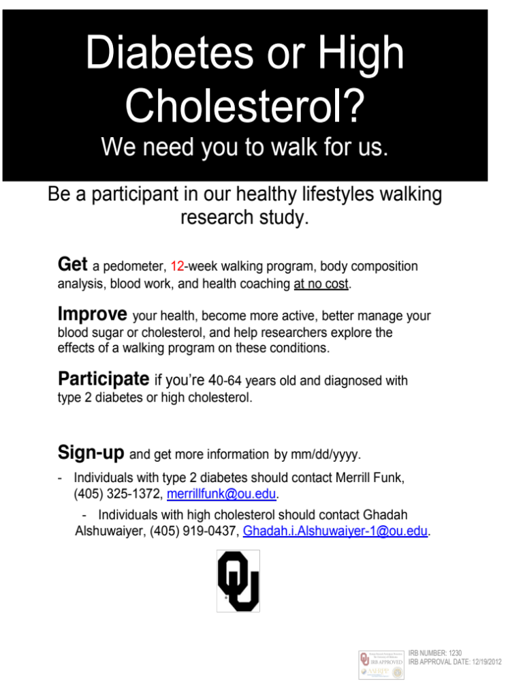

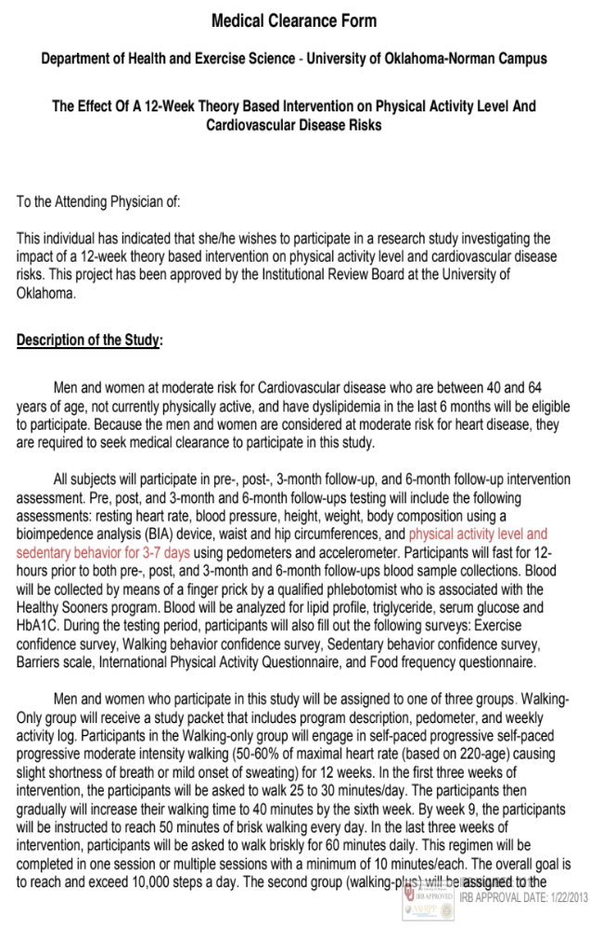
Appendix U- Medical Clearance
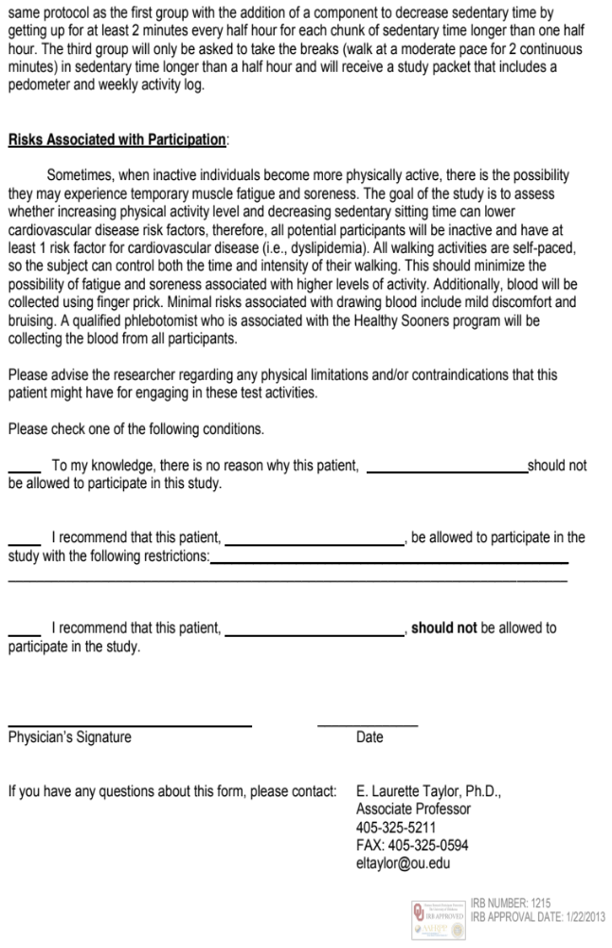
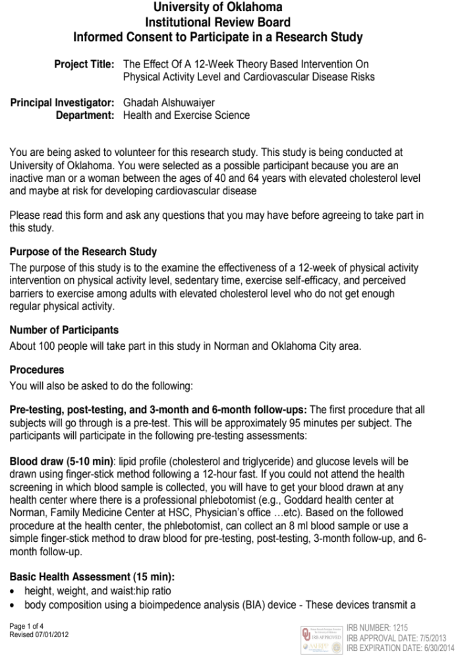
Appendix V- Informed Consent

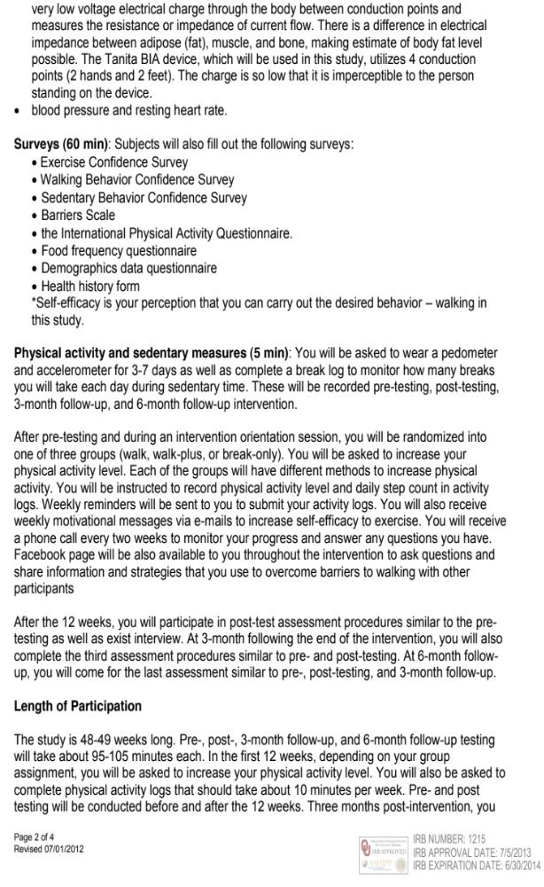

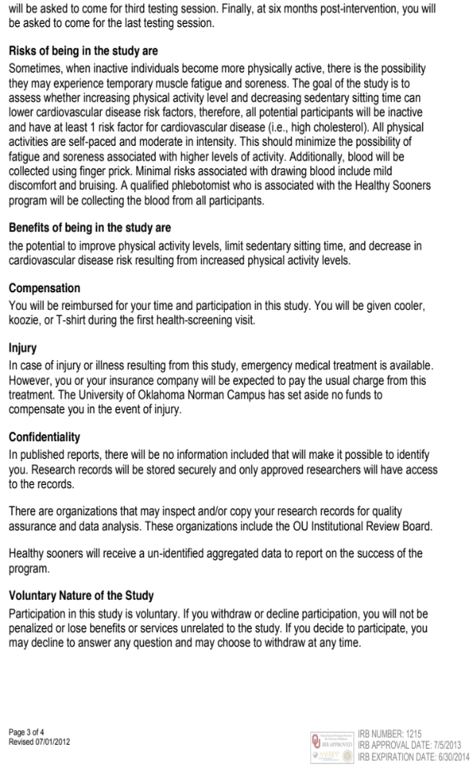


Appendix W- HIPAA Form
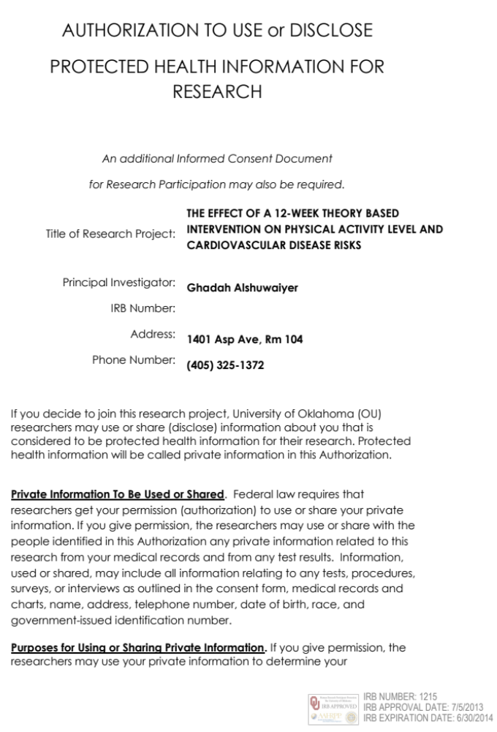


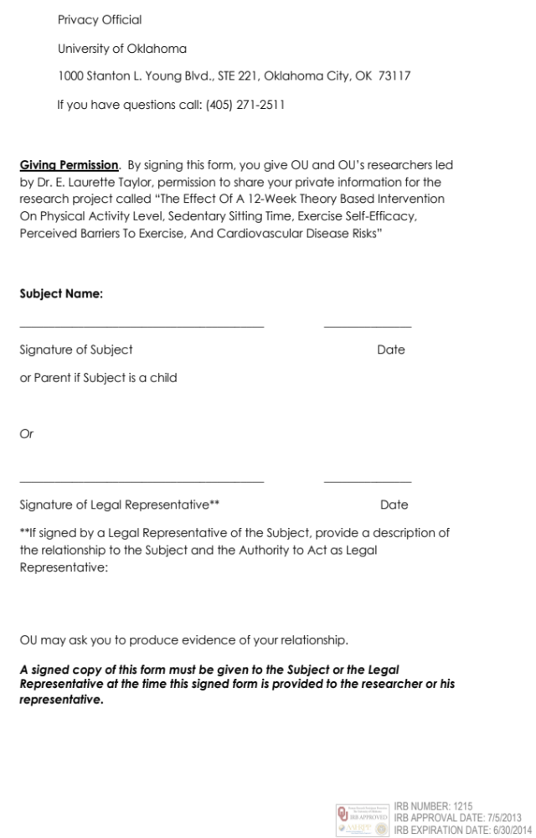

Appendix X- Program Description
(Sources: AHA)
Week One
GOAL: 25-30 minutes of walking every day
Week Two
GOAL: 25-30 minutes of walking every day
Week Three
GOAL: 25-30 minutes of walking every day
Week Four
GOAL: gradually increase to 40 minutes of walking every day
Week Five
GOAL: gradually increase to 40 minutes of walking every day
Week Six
GOAL: gradually increase to 40 minutes of walking every day
Week Seven
GOAL: gradually increase to 50 minutes of walking every day
Week Eight
GOAL: gradually increase to 50 minutes of walking every day
Week Nine
GOAL: gradually increase to 50 minutes of walking every day
Week Ten
GOAL: gradually increase to 60 minutes of walking every day
Week Eleven
GOAL: gradually increase to 60 minutes of walking every day
Week Twelve
GOAL: gradually increase to 60 minutes of walking every day

Appendix Y- IRB Approval Letter


Appendix Z- Data Set
ID | Group | Age | Gender | Ethnicity | Income | Education | Marital  status
1 | 2 | 54 | 2 | 1 | 7 | 6 | 1
2 | 1 | 57 | 1 | 1 | 7 | 6 | 1
3 | 1 | 51 | 2 | 1 | 7 | 5 | 3
4 | 2 | 48 | 1 | 1 | 7 | 6 | 1
5 | 2 | 60 | 1 | 1 | 7 | 4 | 1
6 | 1 | 58 | 2 | 1 | 8 | 6 | 1
7 | 1 | 61 | 2 | 1 | 8 | 5 | 1
10 | 2 | 58 | 2 | 1 | 4 | 5 | 1
12 | 2 | 40 | 1 | 1 | 8 | 6 | 1
13 | 1 | 44 | 2 | 1 | 7 | 5 | 1
14 | 1 | 59 | 2 | 1 | 6 | 6 | 5
15 | 2 | 58 | 2 | 1 | 8 | 6 | 1
18 | 2 | 49 | 2 | 1 | 5 | 5 | 2
19 | 2 | 51 | 2 | 2 | 5 | 5 | 2
20 | 1 | . | 2 | . | . | . | .
21 | 1 | 55 | 2 | 6 | 5 | 5 | 1
22 | 1 | 53 | 2 | 2 | 7 | 6 | 1
23 | 1 | 58 | 2 | 2 | 7 | 6 | 2
24 | 2 | 53 | 2 | 1 | 8 | 5 | 1
26 | 2 | 56 | 2 | 2 | 6 | 5 | 5
28 | 1 | 44 | 1 | 3 | 8 | 6 | 1

ID | TC1 | LDL1 | HDL1 | Trig1 | CR1 | Gluc1 | SBP1 | DBP1
1 | 202 | 140 | 40 | 111 | 5.1 | 87 | 117.6 | 76
2 | 211 | 135 | 36 | 199 | 5.9 | 87 | 128 | 87
3 | 195 | 123 | 49 | 114 | 4 | 91 | 108 | 68
4 | 180 | 115 | 41 | 119 | 4.4 | 98 | 120 | 79.5
5 | 244 | 155 | 45 | 225 | 5.5 | 82 | 135 | 92
6 | 234 | 154 | 53 | 137 | 4.4 | 90 | 117 | 87
7 | 237 | 140 | 48 | 243 | 4.9 | 110 | 123 | 89
10 | 118 | 75 | 29 | 74 | 4.1 | 91 | 120 | 72
12 | 209 | 141 | 42 | 131 | 5 | 88 | 108 | 69
13 | 216 | 122 | 62 | 159 | 3.5 | 94 | 118 | 87
14 | 191 | 118 | 62 | 51 | 3.1 | 90 | 96 | 72
15 | 190 | 116 | 48 | 132 | 4 | 83 | 109 | 72
18 | 189 | 109 | 44 | 180 | 4.3 | 96 | 131 | 101
19 | 156 | 64 | 47 | 226 | 3.3 | 78 | 110 | 61
20 | 199 | 133 | 32 | 171 | 6.1 | 92 | 122 | 88
21 | 193 | 111 | 63 | 98 | 3.1 | 95 | 133 | 86
22 | 195 | 145 | 39 | 54 | 4.9 | 91 | 122 | 82
23 | 200 | 36 | 66 | 235 | 3 | 85 | 100 | 61
24 | 276 | 212 | 36 | 142 | 7.8 | 86 | 115 | 63
26 | 315 | . | 44 | 599 | 7.15 | 103 | 153 | 105
28 | 211 | 150 | 38 | 113 | 5.5 | 96 | 116 | 82

ID | BFP1 | Weight1 | Height | WC1 | HC1 | SC1 | AccelSedMins1
1 | 39.8 | 79.1 | 160.02 | 93.5 | 115.5 | 2300.166667 | 647.291667
2 | 32.6 | 85.45 | 175.26 | 101 | 104 | 4714.6 | 716.2
3 | 35.5 | 75.9 | 167.64 | 82 | 110 | 6894.28 | 622.821429
4 | 28.4 | 93.62 | 176.53 | 109 | 108 | 5270.42 | 601.9375
5 | 38.6 | 138.43 | 196.5 | 127 | 133.5 | 3624.42 | 676.178571
6 | 37.5 | 74.84 | 168.91 | 99 | 103 | 3066.85 | 567.428571
7 | 42.7 | 80.64 | 163.83 | 96.5 | 112.5 | 6234.42 | 616.75
10 | 54 | 124.19 | 167.64 | 136 | 146 | 4964.4 | 546.95
12 | 15.3 | 86 | 190.5 | 86 | 120 | 6035.85 | 578.916667
13 | 46.1 | 94.25 | 160.02 | 105.41 | 125.22 | 7716.42 | 577.428571
14 | 30.9 | 51.6 | 157.48 | 72.5 | 96 | 4008.28 | 637.541667
15 | 42.6 | 82.73 | 167.64 | 93 | 114.5 | 8518.42 | 624.035714
18 | 51.2 | 92.98 | 170.18 | 118 | 135 | 850 | 756.9375
19 | 37.1 | 86.13 | 169.54 | 93 | 117 | 4405.5 | 632.375
20 | 42.8 | 78.19 | 172.72 | 84.5 | 108 | 7217.28 | 617.321429
21 | 34.4 | 64.59 | 157.48 | 79 | 99 | 8546.85 | 753.75
22 | 38 | 77.29 | 141.6 | 79 | 110 | 4931.71 | 565.375
23 | 33.2 | 55.88 | 157.48 | 71 | 95.5 | 6743.85 | 607.928571
24 | 43.4 | 87.9 | 162.56 | 93 | 115 | 4977.71 | 597.0625
26 | 47.2 | 91.44 | 163 | 114.3 | 124.46 | 5426.71 | 620.928571
28 | 14.5 | 64.41 | 170.18 | 80.01 | 95.25 | 9337.6 | 556.875

ID | AccelMVPAMins1 | IPAQTotal1 | ExSE1 | WalkSE1 | SedSE1 | BS1 | TC2
1 | 21.041667 | 367.5 | 45 | 44 | 42 | 33 | 201
2 | 30.2 | 3210 | 59 | 58 | 58 | 32 | 243
3 | 11.607143 | 7737 | 50 | 54 | 56 | 30 | 221
4 | 28.9375 | 745 | 60 | 60 | 55 | 19 | 204
5 | 4.178571 | 3210 | 60 | 60 | 60 | 36 | 311
6 | 15.035714 | 1005 | 49 | 48 | 50 | 31 | .
7 | 21.0625 | 670 | 50 | 53 | 59 | 34 | 244
10 | 11.05 | 973 | 56 | 58 | 56 | 34 | 151
12 | 48.416667 | 2043 | 51 | 51 | 60 | 32 | 230
13 | 35.214286 | 342 | 53 | 53 | 48 | 40 | 257
14 | 20.291667 | 345 | 41 | 40 | 45 | 20 | 208
15 | 27.428571 | 1231.5 | 51 | 52 | 50 | 29 | 202
18 | 15.9375 | 2805 | 38 | 35 | 44 | 32 | .
19 | 16.5 | 1497 | 48 | 49 | 50 | 26 | 213
20 | 16.392857 | 508.5 | 53 | 53 | 51 | 27 | 196
21 | 46.214286 | 3790.5 | 56 | 52 | 54 | 27 | 222
22 | 46.291667 | 702 | . | . | 59 | 31 | .
23 | 18.678571 | 852 | 48 | 52 | 54 | 28 | 229
24 | 15.9375 | 701 | 55 | 57 | 58 | 20 | 396
26 | 4.75 | 783 | 52 | 52 | 57 | 29 | 315
28 | 29.791667 | 3402 | 43 | 49 | 60 | 33 | 181

ID | LDL2 | HDL2 | Trig2 | CR2 | Gluc2 | RHR2 | SBP2 | DBP2
1 | 141 | 42 | 89 | 4.7 | 89 | 66 | 122 | 80
2 | 152 | 52 | 193 | 4.7 | 90 | 81 | 138 | 83
3 | 147 | 57 | 82 | 3.9 | 99 | 69 | 128 | 84
4 | 134 | 42 | 138 | 4.8 | 89 | 51 | 120 | 82
5 | 212 | 47 | 259 | 6.6 | 89 | 77 | 114 | 91
6 | . | . | . | . | . | . | . | .
7 | 148 | 50 | 231 | 4.9 | 103 | 74 | 125 | 87
10 | 80 | 52 | 97 | 2.9 | 100 | 66 | 108 | 73
12 | 168 | 40 | 110 | 5.7 | 78 | 62 | 114 | 70
13 | 161 | 65 | 153 | 4 | 93 | 89 | 127 | 91
14 | 135 | 59 | 73 | 3.5 | 99 | 82 | 98 | 71
15 | 133 | 48 | 101 | 4.2 | 86 | 62 | 105 | 74
18 | . | . | . | . | . | . | . | .
19 | 104 | 88 | 105 | 2.4 | 78 | 64 | 120 | 84
20 | 112 | 54 | 152 | 3.7 | 95 | 80 | 115 | 78
21 | 138 | 53 | 155 | 4 | 84 | 73 | 115 | 73
22 | . | . | . | . | . | . | . | .
23 | 141 | 79 | 47 | 2.9 | 92 | 79 | 103 | 67
24 | 301 | 45 | 245 | 8.7 | 88 | 62 | 127 | 91
26 | . | 45 | 602 | 7 | 101 | 87 | 179 | 117
28 | 120 | 49 | 60 | 3.6 | 97 | 62 | 132 | 86

ID | BFP2 | WC2 | HC2 | SC2 | AccelSedMins2 | AccelMVPAMins2
1 | 38.6 | 93 | 113 | 4245.4 | 665.208333 | 27.041667
2 | 33 | 110.49 | 105.41 | 9965.28 | 668 | 67.357143
3 | 37 | 81 | 109 | 13449.42857 | 604.571429 | 57.035714
4 | 30.5 | 106.5 | 109 | 10113.85714 | 557.8125 | 70.9375
5 | 37.7 | 123 | 131.5 | 9518 | 608.875 | 30.541667
6 | . | . | . | . | . | .
7 | 42.9 | 89 | 109 | 9418 | 649.75 | 43.964286
10 | 54.8 | 138.43 | 144.78 | 6340.57 | 653.041667 | 18.666667
12 | 16.9 | 80 | 105 | 14105.28571 | 655.958333 | 114.166667
13 | 45.4 | 92.5 | 121 | 9038.285714 | 639.535714 | 46.678571
14 | 28.2 | 72.39 | 91.44 | 6591.857143 | 704.75 | 32.714286
15 | 40.9 | 113.03 | 93.34 | 13746.85714 | 657.285714 | 36.142857
18 | . | . | . | . | . | .
19 | 38.3 | 92.71 | 114.3 | 8518.428571 | 607.1 | 15.65
20 | 40.7 | 90.17 | 107.95 | . | 629.785714 | 23.607143
21 | 33 | 83.82 | 101.6 | 6707.285714 | 612.785714 | 55.25
22 | . | . | . | . | . | .
23 | 30.9 | 80.01 | 92.3 | 5739.166667 | 614.964286 | 33.964286
24 | 41.5 | 93.98 | 113.03 | 12106.85714 | 600.178571 | 34.607143
26 | 45 | 114.3 | 123.19 | 8717.75 | 704.25 | 16.916667
28 | 14.7 | 81.28 | 95.75 | . | 659.392857 | 28.464286

ID |  | ExSE2 | WalkSE2 | SedSE2 | BS2 | SCmid | AcelSedMinsMid
1 |  | . | . | . | . | 1326 | 639.285714
2 |  | 50 | 54 | 55 | 31 | 10773.71429 | 630.928571
3 |  | 47 | 50 | 41 | 28 | 12271.57143 | 613.083333
4 |  | 41 | 39 | 47 | 36 | 9178.142857 | 541.142857
5 |  | 48 | 50 | 60 | 30 | 8340.142857 | 525.714286
6 |  | . | . | . | . | . | .
7 |  | 52 | 56 | 35 | 26 | 10117 | 764.178571
10 |  | 58 | 60 | 59 | 30 | 4325.714286 | 568.5
12 |  | 45 | 45 | 51 | 27 | 11463.71429 | 593.535714
13 |  | 53 | 54 | 48 | 28 | 10957 | 568.321429
14 |  | 45 | 45 | 48 | 25 | 10876.5 | 585.041667
15 |  | 47 | 49 | 46 | 24 | 11679.14286 | 678.666667
18 |  | . | . | . | . | . | 704.6875
19 |  | . | . | . | . | 5119.6 | 505.5
20 |  | . | . | . | . | 5359.5 | 613.541667
21 |  | 41 | 36 | 33 | 21 | 12050.28571 | 677.833333
22 |  | . | . | . | . | . | .
23 |  | 57 | 58 | 53 | 21 | 8488.857143 | 622.166667
24 |  | 55 | 54 | 56 | 22 | 11224.33333 | 611.333333
26 |  | 60 | 60 | 60 | 29 | 8284.833333 | 573.375
28 |  | . | . | . | . | . | 653.928571

ID | AccelMVPAMinsMid | TC3 | LDL3 | HDL3 | Trig3 | CR3 | Gluc3
1 | 25.892857 | 202 | 132 | 50 | 102 | 4 | 87
2 | 76.464286 | 154 | 81 | 45 | 143 | 3.4 | 84
3 | 34.458333 | 218 | 140 | 51 | 137 | 4.3 | 95
4 | 58.892857 | 142 | 82 | 45 | 70 | 3.1 | 84
5 | 26.178571 | 289 | 204 | 45 | 200 | 6.5 | 89
6 | . | . | . | . | . | . | .
7 | 56.928571 | 259 | 151 | 45 | 312 | 5.7 | 100
10 | 28.15 | 161 | 97 | 46 | 90 | 3.5 | 112
12 | 90 | 225 | 150 | 42 | 163 | 5.3 | 90
13 | 62.928571 | 287 | 191 | 72 | 118 | 4 | 92
14 | 48.083333 | 202 | 122 | 59 | 103 | 3.4 | 81
15 | 25.833333 | 186 | 123 | 41 | 112 | 4.5 | 83
18 | 13 | . | . | . | . | . | .
19 | 28.1 | . | . | . | . | . | .
20 | 27.791667 | . | . | . | . | . | .
21 | 59.791667 | . | . | . | . | . | .
22 | . | . | . | . | . | . | .
23 | 45.75 | 228 | 138 | 77 | 66 | 3 | 83
24 | 54.708333 | 254 | 179 | 41 | 126 | 6 | 88
26 | 13.166667 | 287 | . | 42 | 535 | 6.83 | 108
28 | 25.928571 | 206 | 145 | 49 | 61 | 4.2 | 98

ID | RHR3 | SBP | DBP3 | BFP3 | WC3 | HC3 | SC3
1 | 63 | 129 | 88 | 38.7 | 100.33 | 115.57 | 4007.857143
2 | 66 | 129 | 86 | 34.2 | 92 | 105.5 | 5169.857143
3 | 68 | 104 | 68 | 36.8 | 79.5 | 109.5 | 9275.142857
4 | 63 | 116 | 78 | 26 | 99 | 101 | 11001
5 | 68 | 106 | 76 | 38.4 | 121 | 132 | 5026.333333
6 | . | . | . | . | . | . | .
7 | 74 | 112 | 77 | 42.4 | 89 | 109 | 8055.714286
10 | 67 | 108 | 56 | 55.3 | 127.5 | 147 | 5603.714286
12 | 63 | 105 | 62 | 16.7 | 86 | 106 | 7512.142857
13 | 67 | 114 | 79 | 45.5 | 104.14 | 124.46 | 7831.857143
14 | 81 | 125 | 85 | 25.1 | 73.66 | 91.44 | 9301.333333
15 | 60 | 135 | 78 | 37.5 | 92.71 | 111.76 | 7123.4
18 | . | . | . | . | . | . | .
19 | . | . | . | . | . | . | .
20 | . | . | . | . | . | . | .
21 | . | . | . | . | . | . | .
22 | . | . | . | . | . | . | .
23 | 64.5 | 110 | 69 | 29.6 | 74.93 | 90.17 | 7596
24 | 58 | 146 | 91 | 42.4 | 101.6 | 114.3 | 6164
26 | 67 | 167 | 113 | 44.7 | 111.7 | 119.38 | 5001.714286
28 | 66 | 111 | 63 | 11 | 73.66 | 87.63 | 10525.71429

ID | AccelSedMins3 | AccelMVPAMins3 | IPAQTotalMET3 | ExSE3 | WalkSE3
1 | 607.583333 | 29.083333 | . | . | .
2 | 717.708333 | 36.833333 | 819 | 57 | 56
3 | 696.333333 | 28.541667 | 15355.5 | 42 | 48
4 | 613.416667 | 83.041667 | 4239.5 | 60 | 60
5 | 0 | 0 | 937 | 35 | 31
6 | . | . | . | . | .
7 | 693.11 | 25.607143 | 1656 | 38 | 37
10 | 607.607143 | 39.11 | . | . | .
12 | 622.083333 | 58.541667 | . | . | .
13 | 622.416667 | 41.875 | 4095 | 39 | 29
14 | 614.392857 | 50.964286 | 969 | 47 | 48
15 | 596.375 | 18.6875 | . | . | .
18 | . | . | . | . | .
19 | . | . | . | . | .
20 | . | . | . | . | .
21 | . | . | . | . | .
22 | . | . | . | . | .
23 | 590.035714 | 26.571429 | . | . | .
24 | 574.214286 | 27.75 | . | . | .
26 | 695.25 | 16.25 | . | . | .
28 | 685.708333 | 34.541667 | . | . | .

ID | SedSE3 | BS3 | AvgNumBreak_Pre | AvgNumBreak_Mid
1 | . | . | 0.142857 | 2.571429
2 | 46 | 30 | 14 | 13.26
3 | 23 | 28 | 12.285714 | 11.77
4 | 55 | 32 | 4.428571 | 8.571429
5 | 45 | 32 | 7.142857 | 6.285714
6 | . | . | 1.714286 | .
7 | 40 | 22 | 3.571429 | 3.61
10 | . | . | 5.571429 | 12.285714
12 | . | . | 6.571429 | 5.571429
13 | 41 | 37 | 8.571429 | 0.98
14 | 44 | 17 | 3.428571 | 7.29
15 | . | . | 5.142857 | 7.428571
18 | . | . | . | .
19 | . | . | 6.714286 | .
20 | . | . | 5 | .
21 | . | . | 4.428571 | 3.39
22 | . | . | . | .
23 | . | . | 0 | 3.06
24 | . | . | 0.285714 | 2.571429
26 | . | . | 18.285714 | 27.857143
28 | . | . | 6.571429 | .

ID | AvgNumBreak_Post | AvgNumBreak_3month | cholesterolMed_Pre
1 | 7.285714 | 0.285714 | 2
2 | 15.42 | 8.57 | 2
3 | 12.43 | 8.142857 | 2
4 | 7.285714 | 9 | 2
5 | 5.428571 | 4.285714 | 2
6 | . | . | 2
7 | 4.57 | 4.571429 | 1
10 | 15.857143 | 10 | 2
12 | 5.142857 | 4.14 | 2
13 | 1.71 | 1.142857 | 2
14 | 6.71 | 5.285714 | 2
15 | 9 | 7.28 | 2
18 | . | . | 2
19 | . | . | 2
20 | . | . | 1
21 | 3.38 | . | 2
22 | . | . | 1
23 | 3.07 | 6 | 2
24 | 7.142857 | 3.142857 | 1
26 | 23.571429 | 25.714286 | 2
28 | . | 15.714286 | 2

ID | cholesterolMed_Post | cholesterolMed_3month | BPMed_Pre | BPMed_Post
1 | 2 | . | 1 | 1
2 | 2 | 1 | 2 | 2
3 | 2 | 2 | 1 | 1
4 | 2 | 2 | 2 | 2
5 | 2 | 2 | 1 | 1
6 | . | . | 2 | .
7 | 1 | 1 | 1 | 1
10 | 1 | . | 1 | 1
12 | 2 | . | 2 | 2
13 | 2 | 2 | 2 | 2
14 | 2 | 2 | 2 | 2
15 | 2 | . | 1 | 1
18 | . | . | 1 | .
19 | 2 | . | 1 | 1
20 | . | . | 1 | .
21 | 2 | . | 1 | 1
22 | . | . | 2 | .
23 | 2 | . | 2 | 2
24 | 2 | . | 2 | 2
26 | 2 | . | 1 | 1
28 | . | . | 2 | .

ID | BPMed_3month | WHRatio1 | WHRatio2 | WHRatio3
1 | . | 0.809524 | 0.823009 | 0.868132
2 | 2 | 0.971154 | 1.048193 | 0.872038
3 | 1 | 0.745455 | 0.743119 | 0.726027
4 | 2 | 1.009259 | 0.977064 | 0.980198
5 | 1 | 0.951311 | 0.935361 | 0.916667
6 | . | 0.961165 | . | .
7 | 1 | 0.857778 | 0.816514 | 0.816514
10 | . | 0.931507 | 0.95614 | 0.867347
12 | . | 0.716667 | 0.761905 | 0.811321
13 | 2 | 0.841798 | 0.764463 | 0.836735
14 | 2 | 0.755208 | 0.791667 | 0.805556
15 | . | 0.812227 | 1.210949 | 0.829545
18 | . | 0.874074 | . | .
19 | . | 0.794872 | 0.811111 | .
20 | . | 0.782407 | 0.835294 | .
21 | . | 0.79798 | 0.825 | .
22 | . | 0.718182 | . | .
23 | . | 0.743455 | 0.866847 | 0.830986
24 | . | 0.808696 | 0.831461 | 0.888889
26 | . | 0.918367 | 0.927835 | 0.935668
28 | . | 0.84 | 0.848877 | 0.84058

ID | AccelAvgNumBreak_Mid |  | AccelAvgNumBreak_Pre |  | AccelAvgNumBreak_Post
1 | 14.857143 | 17.166667 |  | 16.666667
2 | 10.142857 | 12.8 |  | 10
3 | 13 | 15 |  | 14.857143
4 | 14.571429 | 16 |  | 16.75
5 | 12.571429 | 17.857143 |  | 16
6 | . | 12.428571 |  | .
7 | 15.285714 | 9.5 |  | 9.428571
10 | 13.6 | 15.2 |  | 15.833333
12 | 12.857143 | 14.166667 |  | 15.833333
13 | 9.857143 | 11.428571 |  | 14.571429
14 | 12.333333 | 17 |  | 19.285714
15 | 19.666667 | 15.857143 |  | 17.714286
18 | 16.75 | 13.5 |  | .
19 | 8.6 | 7.75 |  | 7.4
20 | 12.166667 | 13.142857 |  | 11.428571
21 | 15.333333 | 17.285714 |  | 15
22 | . | 12 |  | .
23 | 15 | 14.285714 |  | 15.285714
24 | 13.833333 | 15.25 |  | 13.857143
26 | 13.333333 | 16.285714 |  | 18.5
28 | 13 | 11.166667 |  | 13

ID | CVDrisk1 | CVDrisk2 | CVDrisk3 | ResponseRate_MotivationalEmail
1 | 6.3 | 6.3 | . | 9
2 | 15.6 | 15.6 | 9.4 | 12
3 | 3.9 | 7.3 | 4.5 | 10
4 | 6.7 | 4.7 | 3.3 | 12
5 | 29.4 | 18.4 | 21.6 | 12
6 | 5.3 | . | . | 1
7 | 11.7 | 11.7 | 8.6 | 4
10 | 8.6 | 3.3 | . | 11
12 | 6.7 | 4.7 | . | 10
13 | 1.7 | 3.3 | 2.4 | 11
14 | 2.4 | 3.9 | 6.3 | 12
15 | 4.5 | 6.3 | . | 11
18 | 6.3 | . | . | 0
19 | 5.3 | 10 | . | 0
20 | . | . | . | 1
21 | 6.3 | 5.3 | . | 6
22 | 5.3 | . | . | 3
23 | 3.3 | 3.3 | . | 5
24 | 5.3 | 8.6 | . | 7
26 | 28.5 | 28.5 | . | 8
28 | 3.9 | . | . | 0

ID | OpenRae_MotivationalEmail |  | SubmissionRate_Logs |  | ResponseRate_Calls
1 |  | 8 |  | 10 |  | 3
2 | 12 |  | 12 |  | 3
3 | 10 |  | 12 |  | 3
4 | 12 |  | 12 |  | 4
5 | 12 |  | 12 |  | 5
6 | 2 |  | 1 |  | 0
7 | 12 |  | 12 |  | 3
10 | 12 |  | 12 |  | 3
12 | 12 |  | 11 |  | 5
13 | 11 |  | 12 |  | 4
14 | 12 |  | 12 |  | 4
15 | 11 |  | 12 |  | 5
18 | 0 |  | 1 |  | 3
19 | 10 |  | 10 |  | 3
20 | 2 |  | 11 |  | 4
21 | 11 |  | 12 |  | 4
22 | 4 |  | 2 |  | 0
23 | 11 |  | 10 |  | 4
24 | 12 |  | 12 |  | 3
26 | 12 |  | 11 |  | 5
28 | 9 |  | 4 |  | 3

ID | SurveyCompletiomPre | SurveyCompletiomPost | SurveyCompletiom3month
1 | 1 | 0 | 0
2 | 1 | 1 | 1
3 | 1 | 1 | 1
4 | 1 | 1 | 1
5 | 1 | 1 | 1
6 | 1 | . | .
7 | 1 | 1 | 1
10 | 1 | 0 | 0
12 | 1 | 1 | 0
13 | 1 | 1 | 1
14 | 1 | 1 | 1
15 | 1 | 1 | 0
18 | 1 | . | .
19 | 1 | 0 | 0
20 | 0 | 0 | 0
21 | 1 | 1 | 0
22 | 0 | . | .
23 | 1 | 1 | 0
24 | 1 | 1 | 0
26 | 1 | 1 | 0
28 | 1 | 0 | 0

