University of Oklahoma

Graduate College

Seasonal and Climatic Model of Lesser Prairie-Chicken Demographics

A thesis

submitted to the Graduate Faculty

in partial fulfillment of the requirements for the

Degree of

Master of Science

By

Nathaniel de angelis
Norman, Oklahoma
2017

Seasonal and Climatic Model of Lesser Prairie-Chicken Demographics

A thesis approved for the
Department of Biology

By

______________________________
Dr. Michael Patten, Chair

______________________________
Dr. Eli Bridge

______________________________
Dr. Jeffrey Kelly

© Copyright by Nathaniel de angelis 2017
All Rights Reserved.

Acknowledgements
I would first like to thank my advisor, Dr. Michael Patten. Your guidance, support, and encouragement over the last three years have been invaluable to the completion of this project and to my growth as a profession. To. Dr. Eli Bridge, thank you for your expertise and input on the nuances of radio tracking. To Dr. Jeffrey Kelly and Dr. John P. Masly, thank you for your guidance in the demographic analysis and statistical programs used to create my model. Your uncanny talents for pointing out a missing parenthesis have saved me countless hours of unneeded re-coding. To the past and present members of the Patten lab who have seen this project evolve, thank you for your time, feedback, laughter, and friendship. To the various administrative members of the University of Oklahoma Department of Biology and Graduate College, thank you for your willingness to assist me throughout my time at OU. I could not have asked for a more helpful group of mentors and peers to help me through this endeavor. And finally, words cannot express my gratitude and debt to my loved ones for all they have done for me. Mom and dad, thank you for instilling in me a deep appreciation of my education and a love for the natural world, and thank you for the countless opportunities you’ve given me throughout my life. Joey and Katherine, thank you for always being there and reminding me to notice the small joys in life. And to my wonderful wife, thank you Alexa for your constant encouragement and support, endless well of patience, and unwavering love. Without the guidance, friendship, laughter, and love of the people in my life none of this would have been possible.

Table of Contents

Acknowledgements iv
List of Tables vii
List of Figures viii
Abstract ix
Chapter 1 1
Introduction 1
Conservation History of the Lesser Prairie-Chicken 1
Climate Change and an Unfortunate Priairie Grouse 3
Current Models and Difficulties of Models the Lesser Prairie-Chicken 7
Methods 8
Data Collection and Creation of Model 8
Seasonality Simulation 11
Results 12
Scenario One: No Seasonal Variation 12
Scenario Two: Seasonal Variation 13
Scenario Three: Manipulation of Summer and Winter Type Frequencies 14
Scenario Four: Can Good Winters Offset Losses From Bad 15
Scenario Five: Two-Sided Change in Seasonal Extremes 16
Discussion 17
Broad Observations 17
Variation in Seasonal Conditions 18
Influence of Summer and Winter Conditions on Population Sustainainabilty 20
Conclusions 21
References 25
Appendix A: Tables and Figures 28

List of Tables
Table 1. Explanation of input variables used in the R code for the seasonal model 28
Table 2. Explanation of output variables provided by the seasonal model 29
Table 3. Explanation of graphs and figures generated by the seasonal model 30
Table 4. The major output variables of Scenario One: No Seasonal Variation and Scenario Two: Seasonal Variation. In Scenario One, all season types used the same vital rates as a regular season and in Scenario Two, vitals rates for different seasons types (Harsh, Bad, Regular, Good, and Amazing) were altered to reflect real-world climate scenarios. This incorporated field data on the lesser prairie-chicken collected from Northwestern Oklahoma from 1999-2012 models the population for 25 years. The starting population had to be inflated 10x to 13120 individuals to achieve an approximately 50% probability of extirpation and 50% probability survival. These rates can be considered as the control when analyzing other scenarios. 31

Table 5. The major output variables from Scenario Five: Two-Sided Change in Seasonal Extremes. Displays from left to right the model output as the frequency of regular seasons was decreased and the frequency of all other season types was increased. As variation away from the mean increases the standard deviation of final population size increases 32

List of Figures
Figure 1. Histogram of final population sizes in a run of 1000 trials from Scenario One: No Seasonal Variation. The final population was calculated after 25 years (50 seasons). In the event that the final population size was greater than 250,000 individuals the trial was pooled into the 250,000 individual bin. This run shows that if current demographic trends and climatic conditions continue the lesser prairie-chicken population decreases in most trials. 33

Figure 2. Example of the summer season type graph created by the model. This figure is always created from the final trial of the run. In this particular run, the final trial experienced a period of good summers from years 6 to 9, followed by a harsh summer and a period of bad summers in year 10 to 13. 34

Figure 3. Graph of several measures of population size by year produced by the model. During the trials it is expected for the population to oscillate as shown because the population always loses individuals in the winter and nearly always gains individuals in the summer. The figure shows the mean, harmonic mean, and median for each season over 25 years for 1000 trials. This graph was created from a run of Scenario 1: No Seasonal Variation. 35

Figure 4. Histogram of final population sizes in a run of 1000 trials from Scenario Two: Seasonal Variation. The final population was calculated after 25 years (50 seasons). In the event that the final population size was greater than 250,000 individuals the trial was pooled into the 250,000 individual bin. This run shows that with the addition of seasonality the final size of the lesser prairie-chicken population is much more variable at year 25. 36

Figure 5. Proportion of trials falling below the extirpation threshold for runs of 1000 trials. Each run varied the frequencies of summer season types. The figure shows that summer conditions have a substantial effect on the sustainability of the lesser prairie-chicken population, and even a mild deviation away from the current mean season type could have a substantial impact on population size. 37

Figure 6. Proportion of trials falling below the extirpation threshold for runs of 1000 trials. Each run varied the frequencies of winter season types. The results show that while winter season type does have an impact on extirpation rates the effect is not as pronounced as the effect of varying summer season type. 38

Figure 7. Proportion of trials falling below the extirpation threshold for runs of 1000 trials. Each run varied the frequencies of summer and winter season types. These results show that no increase in favorable winter conditions is sufficient to counter even a mild increase in unfavorable summer conditions. 39

Abstract
The lesser prairie-chicken (Tympanuchus pallidicinctus) has suffered substantial losses in both population number and occupied range over the last century. Although the species has been the focus of range-wide conservation efforts, human activities such as agriculture and energy development continue to pose a threat to remaining populations. Potential changes in long-term weather patterns resulting from climate change will create new conservation challenges for lesser-prairie chickens in the coming decades. Investigating, describing, and predicting these impacts is essential to protecting the species and guiding management decisions. My work examines the effect of varying climate conditions on lesser prairie-chicken populations by means of a season-based demographic model.
By incorporating seasonality into the model, I found that the lesser prairie-chicken population in Oklahoma is likely not large enough to survive an increase in unfavorable climatic conditions. The probability of extirpation was very sensitive to climatic extremes and small increases in the frequency of drought conditions during summer months led to a nearly 50% increase in failure to meet sustainable population levels. Both positive and negative changes to climatic conditions during summer months had a more profound impact than changes to winter conditions. No level of increase in positive winter conditions was enough to counter the negative effects of even a mild increase in negative summer conditions. Scenarios modelling deviation away from average climatic conditions showed higher variation in final population size than scenarios with fewer extreme seasons. These results show that the lesser prairie-chicken is at risk of succumbing to environmental changes produced by climate change. Management efforts should focus on projects that increase nest success and decrease re-nesting attempts by adult females. Examples of potentially beneficial actions include placing mesh covers in or around known nesting sites to provide shelter and spraying scents near known nests that repel mammals and prevent depredation of nests.

Keywords: lesser prairie-chicken, climate change, seasonality

Chapter 1
Introduction
Conservation History of the Lesser Prairie-Chicken
The lesser prairie-chicken (Tympanuchus pallidicinctus) once inhabited a large range that included much of the Southern Great Plains region. As recently as the early 1900s large populations of lesser prairie-chickens were found across areas of Texas, New Mexico, Oklahoma, Kansas, and Colorado (Grisham 2014). This seemingly inconspicuous prairie grouse exhibits light brown and grey plumage that blends with the sand shinnery oak and sagebrush lands it prefers to inhabit. It is a low-flying species that generally spends time on or near the ground and rarely stray far from the location in which they were hatched (Boal and Haukos 2016). Despite their unremarkable first impression, closer observation reveals many fascinating ecological traits that lead to this species’ pivotal role in the conservation of the Southern Great Plains region. Bird enthusiasts travel from across the country to see the elaborate mating displays performs by male lesser prairie-chickens during the lekking season. The species also serves as an umbrella species for the great plains region and an icon of the heated debate between those who wish to conserve the natural value of the plains and those who see the economic and energy opportunities that the region can provide (Larsson et al 2013). Although the fascinating story of the lesser prairie-chicken has often remained in the shadows of more publicly appealing species across the country such as the American bison (Bison bison) and the California condor (Gymnogyps californianus), protecting and understanding this species, its history, and its population dynamics is essential to the preservation efforts of the great plains region.
The lesser prairie-chicken was first described in the mid-1800s. In the initial decades after its discovery the species was noted to have an abundant population and was widely enjoyed as a game bird across its range. Since the early 1900s the lesser prairie-chicken has experienced massive population decline, largely as a result of human activities (Hagen et al. 2004). An ever-increasing percentage of the unspoiled prairie habitat populated by the grouse has been converted to agricultural land and permanent cattle pastures. As this trend continued, the quantity and quality of habitable land available to the lesser prairie-chicken declined. This practice also created the conditions that exacerbated the damage done during the Dust Bowl between 1933 and 1939 (Rodgers 2016). By the 1940s, habitat loss combined with the extraordinarily poor environment of the Dust Bowl had caused lesser prairie-chickens to fall from a plentifully abundant species to one facing extirpation across much of its range. Even in the few states where the species was not considered in danger of extirpation the population numbers had dropped from hundreds of thousands of individuals to less than twenty thousand.
Since that time, government efforts such as criminalizing the hunting of the species and dedicated conservation plans to protect the species and the habitat in which it resides have shown mixed results. Recent studies estimated that the species occupied range had decreased by 92% and the number of individuals had decreased by 97% (Rodgers 2016). Although such estimates vary due to uncertainty about the population’s historical size, estimates consistently place lesser-prairie-chicken population and range estimates at or below 10% of their assumed historical peaks (Bell et al. 2007, Hagen et al. 2004, Patten et al. 2005).
In recent years the situation has grown more dire, with extreme weather casting more pressing concern over the future of the species. One factor looming over conservation efforts is the impending consequences of climate change on the Southern Great Plains region (Grisham et al. 2013). Since 2013, the population size has hovered around 17,600 individuals (Garton et al. 2016). Given the prairie-chicken population decline during the ecological crisis of the Dust Bowl, it is reasonable to expect that the severe weather patterns brought on by climate change could severely hinder lesser prairie-chicken population growth and undercut conservation efforts. As such, it is important to both understand how climate change will affect lesser prairie-chicken habitat and to create models that project lesser prairie-chicken population fluctuations under various climate change scenarios. This project aims to describe the impact of climate change on the lesser prairie-chicken population but also hopes to provide a methodology and flexible model for investigating the effect of climate change on the population dynamics of any vulnerable species.

Climate Change and an Unfortunate Prairie Grouse
Climate change has a wide array of ecological impacts for every species. For at-risk species, investigating, describing, and predicting these impacts is essential to protecting the population. The impacts of climate on the entire biotic and abiotic system around the species must be considered along with any behavioral patterns that the organism relies upon. For the lesser prairie-chicken, this means the impacts of climate change must be considered with regards to predicted weather patterns, changes to the food web, changes in plant cover, and changes in annual behaviors and life history traits.
Unfortunately for the lesser prairie-chicken the outlook for the great plains region is one of the most dismal on the North American continent (Diffenbaugh et al. 2008). While the coastal regions may be buffered by their proximity oceans, central continental regions are forecast to experience noticeably increased seasonality even in mild carbon dioxide emission scenarios (Portman et al. 2009). In practical terms, this means that the grouse’s habitat states of Texas, New Mexico, Oklahoma, Kansas, and Colorado are predicted to experience increasingly frequent drought conditions and extreme temperatures in summers (Cook et al. 2015, Grisham et al. 2016). The region is also predicted to experience colder winters with a higher probability of severe weather events such as ice storms that have occasionally devastated the region (Grisham et al. 2016). In addition to an increase in frequency, the magnitude of these events is expected to rise (Ross et al. 2016). Summers will likely display record-breaking bouts of high temperatures that show a longer duration than historical hot spells (IPCC 2013, Grisham et al. 2016). Likewise, the ice storms of harsh winters will show an increase in duration and spatial extent.
Extremely hot temperatures affect lesser prairie-chickens in both the mortality rates of adult lesser prairie-chickens and the hatch rates of their eggs. During periods of intense heat and drought lesser prairie-chickens may overheat or dehydrate as sources of water become less available. High temperatures also lower reproduction attempts because most lek sites are in exposed areas and during periods of hot weather lesser prairie-chickens will prefer to remain in covered areas to help them thermoregulate (Larsson et al. 2013). Likewise, the eggs are susceptible to overheating and may fail to properly incubate, decreasing the number of hatchlings for the year (McEwen et al. 1969). Hens may also abandon nests if temperatures become too extreme (Grisham et al. 2014). If a hen fails to produce a single successful chick from her first nesting attempt, she is likely to attempt a second nest later in the summer. These seconds nests have lower probability of success that the first nesting attempt and are the source of additional energy expenditures and mortality risks for the adult hen. As summer conditions worsen, re-nesting attempts and their associated mortality increase (Pitman et al. 2005).
Because the lesser prairie-chicken is a non-migratory bird, extreme winters have detrimental effects. During their year-round stay in the Southern Great Plains, cold temperatures and extreme events such as ice storms can increase mortality at all levels (Zhang et al. 2016). In addition to the straightforward relationship between extreme events and mortality, there is a subtler pattern that must be considered. The overall deviation from the current average season coupled with the increasing frequency of undesirable years has the effect of decreasing the mild years experienced by the region. The lesser prairie-chicken is a “boom-or-bust” species, or a species that often offsets several years of decline with an occasional year of notable growth (Boal and Haukos 2016). Those years of growth require a variety of factors, a major one being mild weather patterns that allow for bountiful seeds and insects as well as high survival of chicks. Years of the mild and productive summers that the lesser prairie-chicken relies on to recover its population will become increasingly less frequent as they are replaced by much less favorable weather patterns in the coming decades (Grisham et al. 2016, Cook et al. 2015).
These changes must be viewed through the lens of the ecosystem in which the lesser prairie-chicken resides. As climate change influences the prairie habitat on which the birds reside, vegetation is expected to undergo a series of transformations. It is possible that the shrubs and small trees that the lesser prairie-chicken uses for nesting cover will bloom earlier but also quickly lose their leaves under the stress of increased temperatures (Grisham et al. 2016). A nesting site that appears secure and promising at the beginning of the nesting season may suddenly wither and fail to provide adequate cover. A portion of lesser prairie-chickens may fall into the perceptual trap of choosing an ultimately poor site based on good early summer appearances (Patten and Kelly 2010). This makes the hen and eggs vulnerable to overheating and predation. Increased temperatures will require the hens to travel further in search of suitable food and water, leaving the nests exposed for greater periods of time and increasing the risk of depredation.
These factors combine to increase the annual risk of mortality for the lesser prairie-chicken. Life history theory states that an increase in mortality often has profound impacts on the life history strategy of the organism (Heppell et al. 2000). As annual mortality increases and longevity decreases, it is expected that individuals that can increase fecundity per breeding attempt will have a selective advantage (Saether and Bakke 2000). This tradeoff between fecundity and longevity can already be inferred in the lesser prairie-chicken by viewing variation among populations in different states. In states such as Texas where the hens can expect a shorter lifespan, the average annual clutch size is higher than in states such as Kansas. In Kansas the hens have a slightly longer lifespan, which appears to be offset by the decreased annual nest size eggs per hen (Grisham et al. 2014, Jamison 2000, Patten et al. 2005). Unfortunately, this increase in the number of eggs laid does not necessarily correspond to a population density of adults as the survivorship of eggs and chicks is very low (Hagen 2003). This difference in regional life history traits can be used to make predictions about potential climate change adaptions for lesser prairie-chicken populations. If climate change causes an increase an arid conditions across the Southern Great Plains, it is possible that the species will respond to the increased adult mortality by increasing clutch size, which in turn increases the proportion of nests that suffer from total clutch loss.

Current Models and Difficulties of Modelling the Lesser Prairie-Chicken
Although there are models that have attempted to project the population dynamics of the lesser prairie-chicken, few of them have considered the differences in seasonality. Most models approach lesser prairie-chicken populations on an annual basis (Hagen 2003, Jamison 2000). This method is suitable for the intents of the researchers but was inadequate to address my questions about the influences of seasonal variation. Models that do account for seasonality often divided prairie-chickens in two or three life stages. These stages of Yearling and Adult or Juvenile, Adult, and Older Adult present their own analytical challenges. One major challenge for several of these models is that documentation about survivorship of the Yearling/Juvenile stage is sorely lacking. This problem was especially apparent at the time of the publication of previous models, which resulted in models where up to one-half of the stages are largely speculative due to insufficient information. Information about the survivorship of individuals in their first year has improved in the last half decade but this remains an area of lesser prairie-chicken demographics that is poorly understood and requires more data collection.
I present a model that attempts to address these concerns and create an accurate projection of the lesser prairie-chicken population by incorporating field data collected by field technicians employed by the University of Oklahoma. The goals of this project were as follows:
1) To use real world data to project the change in Oklahoma’s lesser prairie-chicken over 25 years under current climatic conditions.
2) To estimate what conditions would be required for the population to be sustainable.
3) To investigate the different influences of changes in summer and winter conditions on the stability of the lesser prairie-chicken population.
4) To look at the combined influence of changes in summer and winter conditions on the stability of the lesser prairie-chicken population.
5) To inform policy and conservation decisions using the output generated by the model.

Methods
Data Collection and Creation of Model
The model was created in Microsoft Excel 2016, R version 3.3.0, and RStudio 0.99.902 using field data collected by field technicians in northwestern Oklahoma. Individuals were captured using walk-in funnel traps placed on lek locations during the spring months of 1999-2009. At the first time of capture birds were fitted with very high frequency (VHF) radio transmitters and colored bands that were used to identify them in subsequent captures. At each capture researchers recorded the location, sex, and age of the bird along with physical traits such as health, diameter of the eighth and ninth calamus, and body mass. If the age was not recorded by the field technicians the ratio of the eighth and ninth calamus was used to age the individual. After the first capture individuals could be detected through VHF tracking methods or through additional captures. If it was discovered that an individual had died then that was noted and the cause of death was recorded (Wolfe et al. 2007).
To maintain the best possible demographic data for the model, certain individuals from the collected data were excluded from the final demographic analysis. Only individuals present for at least three seasons (just over 1 year, as they could die early in the first season) were included in an effort to avoid including individuals passing through or that were only recorded as deceased. If there was not adequate data to determine the age of the individual or an indication that the data may be inaccurate (birds living more than eight years or reversing in age, possibly due to inaccurate age recording or misidentification) then the bird was not included in the demographic analysis. Birds that had substantial data for their first season (more than five tracking points) but did not survive for three seasons may have been included if a corpse was found. In total, 400 male and female individuals met the criteria for inclusion in the model.
The lifespan of each individual was approximated using the age of first capture and age at death. For individuals where no corpse was recovered the last recorded date of contact was treated as the age of death. The group consisted of 101 females and 299 males. Kaplan-Meier curves were created to test the feasibility of combining the sexes into a single group. Although males and females have moderately diverging life histories, analysis did not reveal a significant difference. As such, males and females were combined into a single group and all treated as “female” for the sake of the model. This was done in an effort to increase the sample size and because data for some seasons consisted entirely of male individuals. These 400 individuals were combined and treated as a cohort to establish the parameters for starting population and mortality rates for each season. These mortality rates were treated as mortality under current climatic conditions. The model is a post-breeding demographic model in which population numbers for each season account for recruitment and mortality for that period.
The areas of the model that are taken from the literature rather than taken from the data are fecundity rates and juvenile survivorship. The parameters for fecundity rates under current climatic conditions were estimated previous studies. This is not treated as the number of eggs laid but rather as the number of offspring that are expected to survive into the third season. The result is that in the model fecundity resembles a measure of recruitment, but differs in that the major consideration is survivorship to a certain age rather than to strict reproductive capacity. This interpretation of fecundity was necessary due to the variation in literature estimates of juvenile survivorship. Rather than attempting to establish rates of eggs laid and rates of mortality for the first summer and winter, the problem was circumvented by inputting survivorship rates of the first two seasons as 1 and making fecundity reflect the number of individuals that reach their second year. The model does not reflect that a higher fecundity rate would be offset by high juvenile mortality for real-world populations but rather skips this step while simulating the eventual results as accurately as possible in the second year.
The data collected from the 400 individuals was used to create an age-structured population. An individual from the field data known to survive for three summers was represented as a hatchling, 1st summer, and second summer individual in the starting population of the model. This gave a starting population of 1312 individuals. Initial results showed that the starting population of 1312, which already likely overestimates the population size of lesser prairie-chickens at the study site, was not large enough to be stable for the duration of the simulation even under regular conditions. To compensate the initial starting population was amplified by ten to test the effects of seasonality.

Seasonality Simulation
Seasonality was simulated by altering the mortality and fecundity rates for each demographic stage based on predicted effects from the literature. Summer and winter seasons are divided into five potential types: harsh, bad, regular, good, and amazing. Regular summers and winters represent the average year calculated from the collected field data and have not been altered. Amazing summers represent boom years, with substantially improved fecundity, lowered re-nesting probability, and higher survivorship of every demographic. Inversely a harsh summer would represent a bust year that may be brought on by a drought. Such a year would show increased re-nesting probability, higher mortality in breeding stages, and lack of resources causes lower fecundity and higher mortality of older individuals. Good and bad seasons represent a midpoint between a regular season and these extremes. A harsh winter represents a year where an event such as an ice storm has occurred, causing increased mortality across all demographic stages.
These season types are chosen from a normal random number generation ranging from 0 to 1. To simulate real world weather patterns, an instance of one season type increases the probability that the next year will be of the same season type. If the current year is a harsh summer, the next year has an increased probability of being a harsh summer or a bad summer. Summer and winter season types are chosen independently of one another.
For modelling various scenarios, the frequencies of the different categories of seasons were changed according to standard percentages. A major change indicated in the results represented a 10% increase or decrease in the extreme season type (harsh or amazing) and a 15% increase or decrease in the intermediate season type (good or bad). A moderate change represented a 10% change to extreme season type and a 5% change to intermediate season type. A mild change represented a 3% change in extreme season type and 2% change in intermediate season type. An explanation of the model variables can be found in Tables 1-3.

Results
Scenario One: No Seasonal Variation
First, as a proof-of-functionality exercise, the model was used to simulate the lesser prairie-chicken population using the mortality rates obtained from field data and fecundity rates obtained from the literature. For this scenario, mortality vectors for summer season types (ASB, GSB, RSB, BSB, and HSB) were identical and mortality rates for winter season types (AWB, GWB, RWB, BWB, and HWB) were identical. The extirpation rate was set at 10,000 individuals. I ran the model multiple times to ensure consistency and reliability. After multiple runs the model consistently provided results that shows the proportion of trials falling below the extirpation threshold did not vary by more than 3%. Explanations for all abbreviations can be found in Table 1.
The model output indicated that with no variation in season type the majority of trials showed a decline (Table 4). 519 of 1000 trials produced a final population below the extirpation threshold and 165 trials decreased to below 4,000 individuals. Without seasonality allowing for boom and bust years, the final population only rarely managed to break above 50,000 individuals and fell to zero much less frequently than in trials with seasonality. Under stable conditions, variation in final population size is reduced. This rate of around 50% extirpation was used as a baseline for comparison to other scenarios.

Scenario Two: Seasonal Variation
Once it was established that the model could be run using real-world prairie-chicken demographic information, the model input was altered to include variation in survivorship based on the type of season selected. HSB and HWB represented unfavorable seasons and ASB and AWB represent favorable seasons, with other season types representing intermediates between the two extremes.
With the addition of seasonal variation the trials showed much higher variation in final population size but little change in the proportion of trials falling below the extirpation threshold (Table 4). The mean showed a sharp increase due to a portion of the trials reaching levels as high as 250,000 individuals. Other means of central tendency, such as the median and proportion of trials falling below the extirpation rate, showed little change from Scenario One. Trials with a series of two or three sequential boom summers (ASB) near the beginning of the trial nearly always managed to break away and reach a population size above the extirpation threshold.

Scenario Three: Manipulation of Summer and Winter Type Frequencies
To investigate the different impact of summer and winter conditions on the lesser prairie-chicken population, each season was manipulated independently in an effort to isolate their differing effects. Summer seasons effect both survivorship and fecundity, whereas winter seasons impact only survivorship. This analysis was performed to see if these different areas of impact had a different magnitude of effect on the population, perhaps providing an indication of where conservation efforts should be focused throughout the year.
A “major” increase is defined in the model as a 10% increase in the frequency of extreme seasons and a 15% increase in the frequency of moderate seasons. A “moderate” increase is defined as a 10% increase in the frequency of extreme seasons and a 5% increase in the frequency of moderate seasons. A “mild” increase is defined as a 3% increase in the frequency of extreme seasons and a 5% increase in the frequency of moderate seasons. These scenarios were implemented by altering rates used to pick the subsequent season based on the season type of the current season. This allowed for an increase in the desired season type in a way that also tended to increase the duration of drought periods or wet periods. The “no change” scenario was a re-run of Scenario Two as described above. In the summer manipulation runs, the winter conditions were left the same as Scenario Two and vice versa for the winter manipulation trials.
It was found that summer season type conditions had a more pronounced influence on the population than winter season type conditions (Figures 5 and 6). A major increase in unfavorable summer conditions caused the population to fall below the extirpation threshold in 93.2% of trials. Conversely, a major increase in the frequency of favorable summer conditions had an overwhelmingly beneficial effect on the sustainability of the population and decreased the probability of extirpation to 3.1%. The population was extremely sensitive to any one-sided change in summer season type and a mild increase in favorable conditions decreased the likelihood of extirpation from 50.1% to 19.0%. A mild increase in unfavorable conditions increased the likelihood extirpation by nearly 50% from 501 to 730 trials out of 1000.
Winter showed a similar pattern with a decreased magnitude for all equivalent runs. A major increase in unfavorable winter conditions increased the probability of extirpation from 50.6% to 68.4%. An major increase in favorable winter conditions also had a smaller effect than a major increase in favorable summer conditions, only decreasing the probability of extirpation to 33.4%.

Scenario Four: Can Good Winters Offset Losses From Bad Summers?
These runs were carried out to investigate the combined effects of summer and winter variation. This was done to test the popular climate change denialist claim that any decrease in environmental suitability observed in summer months will be offset by an increase in survivorship and productivity in winter months. Runs were conducted beginning with the most severe increase in unfavorable summer conditions and favorable winter conditions were gradually added. Once the most extreme increase in positive winter conditions was reached, it was apparent that the improvement in winter conditions was having little effect to mitigate the damage done by harsh summers. With a major increase in unfavorable summer conditions and a major increase in favorable winter conditions 86.9% of trials still fell below the extirpation threshold. At this point the harshness of the summers was gradually decreased to investigate at what point a major increase in favorable winter conditions could compensate for summer losses. It was found that even with a mild increase in unfavorable summer conditions a major increase in favorable winter conditions was not enough to bring the extirpation rate below 50%. In the best-case scenario for unfavorable summers and favorable winters the proportion of trials falling below the extirpation rate was 57.1% (Figure 7).

Scenario Five: Two-Sided Change in Seasonal Extremes
The final aspect of climate change addressed by the model is the prediction that regions in the middle of continents, such as northwestern Oklahoma, will experience fewer average seasons and more extreme seasons. In terms of the model, this was represented by decreasing the frequency that a RSB and RWB season types were chosen and increasing the tendency for the model to deviate into the more extreme seasons. While this did statistically increase the chance that drought periods and wet periods would display a longer duration, it also increased the likelihood that the climate conditions would jump from an extreme drought period into a wet period. It was found that decreasing the chance of regular seasons increased the standard deviation of final population size (Table 5). This standard deviation is likely understated because the model rounds down populations that exceed 250,000 individuals to 250,000. As the extreme seasonality increases the proportion of trials failing to meet the extirpation threshold increases, but not to the extent that it did in scenarios that increase the frequency of unfavorable summers. The more important effect of this scenario is the sharp increase in the proportion of trials that fail completely or rise sharply and the decrease of intermediate final population sizes. Under this scenario populations are much less stable and predictable, which would complicate conservation efforts.

Discussion
Broad Observations
The results of the model highlight several important trends for the lesser prairie-chicken population. The first is a coincidental observation that the actual population had to be manually multiplied by 10 and increased to around 13,000 individuals (all of whom are capable of reproduction in the model) before projections using real-world data and fecundity rates approached 50% sustainability out of 1000 trials. In 2014, the total number of lesser prairie-chickens in the southern Great Plains was less than 45,000 individuals spread across 5 states. The only state with a population exceeding 13,000 individuals was Kansas. Oklahoma, Texas, and Colorado hosted populations below 3,000 individuals and New Mexico contained a population just exceeding 6,000 individuals (Haukos and Boal 2016). This means it is likely that populations in Texas, Colorado, and Oklahoma are not sustainable even under current climatic conditions and states with a larger population, such as New Mexico, will only be sustainable if climate conditions do not worsen. This is a strong indicator that across most their range efforts should be made to conserve the lesser prairie-chicken and bolster their numbers before negative climate conditions have a chance to further impact the prairie. If nothing is done, the species will likely spend a few years declining and recovering before a single drought or series of years with poor reproductive output drives the species to extirpation across areas of its range.
The second observation is the power of fecundity rates in the model. A global change of 1% in fecundity rates, which translates to a 1% increase or decrease in the number of eggs that develop into breeding adults, often has the power to bolster or decimate the population. The model was by far most sensitive to primary fecundity rates (egg1 and egg1sd) and second most sensitive to re-nesting fecundity rates (egg2 and egg2sd). Small changes in these areas had large impacts on the model output and account for the massive deviation in the proportion of trials reaching extirpation in summer manipulation scenarios compared to winter manipulation scenarios. A related area is the mortality rate of young adults. As the condition of summer worsens, more young adults may be forced to engage in re-nesting activities. This process demands a large energy expenditure for the hen and decreases her chances of survival (Pitman et al. 2006). When considering conservation strategies, the area that should be focused on is increasing the proportion of nests in the initial nesting period that have at least one successful egg. This strategy simultaneously addresses the issues of increasing fecundity rates and decreasing re-nesting rates.

Variation in Seasonal Conditions
Adding variation to the seasons of the prairie has several impacts on the lesser prairie-chicken population, as shown in scenarios 1 and 5. As the trials progress from minimal variation to moderate levels of variation, the proportion of trials failing to meet the extirpation threshold remains relatively constant. The output factors that change between the trial are the mean, median, and standard deviation of the final population size. This indicates that although variation around the mean seems to increase similarly in direction, the magnitude of that change in variation increases vastly more as the seasons become less consistent. Some populations quickly drop to extirpation whereas others manage to take advantage of a few good years to reach sustainable levels. This trend continues until extreme seasonality begins to outweigh regular years, in which case populations that experience a decline early on are unlikely to recover as they were in more moderate variation scenarios. From this result it can be inferred that as seasonality increases across the plains, the lesser prairie-chicken population will become less stable and more likely to experience sudden crashes that it cannot recover from. Population levels that were sustainable under scenarios with less variation are no longer adequate to protect the species from extirpation should an increased probability of unfavorable seasons allow for an extended drought occur, a circumstance forecast for the Southern Great Plains (Cook et al. 2015). This increased frequency of extirpation occurs even if the probability of boom years also increases, because the years of high reproductive output are not enough to protect the population from crashes.
For populations of lesser prairie-chickens to thrive, they require stability coupled with enough favorable years to bolster their population numbers. But it is important to consider that this may vary across different portions of the species’ range. The survivorship and fecundity rates in the model were calculated using field data and literature about lesser prairie-chickens in northwestern Oklahoma. Populations of lesser prairie-chickens in Kansas may be less bound by the ecological rules governing a “boom or bust” species. In Kansas, adults typically do not suffer from high mortality and as a result the number of eggs per nest is lower than in Oklahoma (Cartwright et al. 2014, Hagen 2003, Wolfe et al. 2016). It is possible, and research into the subject should be conducted, that in regions such as Kansas the variation of fecundity is less substantial than in Oklahoma during conditions of favorable and unfavorable weather. This would allow for a more stable population that is less bound by the sudden jumps and crashes seen in the Oklahoma population.

Impact of Summer and Winter Conditions on Sustainability of the Lesser Prairie-Chicken Population
The model shows that variation in the favorability of summer conditions causes a much larger variation in the proportion of trials falling below the extirpation (0.031-0.932) threshold than variation in the favorability of winter conditions (0.334-0.684). This occurs because in addition to variation in mortality, summer conditions cause a variation in reproductive output that is not found in winter seasons. The most optimistic increases in winter conditions were not enough to fully mitigate even a mild decrease in the favorability of summer conditions. This further supports the assertion that conservation efforts should be focused on the summer processes of nesting events and adult survivorship (Pruett 2011, Hagen 2014). Intervention in extreme cases, such as devastating ice storms, will still be beneficial to the population but will not have the same impact as intervention that increases the proportion if nest success in the first nesting event.
Scenario 4 also provides insight into the popular claim among climate change denialists that any increase in negative summer conditions will be offset by an increase in positive winter conditions, which has been refuted elsewhere (Staddon 2014). The biological argument against this claim, that winters have less of an effect on populations that do not breed year-round, is supported by the model. Although it should be recognized this pattern may have be less prominent in species that breed year-round, the impact on species with summer breeding events is disproportionally influenced by summer conditions. This counter is further reinforced by the conclusion that even a mild increase in negative summer conditions is more than enough to offset a major increase in positive winter conditions. From this, policymakers should take that the ecological differences in summer and winter demographic changes make them difficult to compare directly and it should not be so simply assumed that one can easily offset the other.

Conclusions
It is my hope that this model and its premise can be used to investigate the effects of seasonality on other species of interest. It is currently applicable to any species that has seven or less life stages, with each stage being divided by summer and winter demographic rates. One caveat is that the model is designed for a species that reproduces in the summer months, and reproductive parameters for winter months would need to be added for any species that reproduces year round. The model is flexible in its ability to take multiple scenarios, population sizes, fecundity rates, mortality rates, and up to five different seasonal conditions for each summers and winter. Any species and population for which the numbers and rates for mortality and fecundity can be calculated by season can be input into the model with minimal alterations to the base code.
The lesser prairie-chicken is a species with a rich ecological history and an iconic place in the natural history of the Southern Great Plains. Its past population has been decimated by anthropogenic events such as agricultural development and ecological disasters like the Dust Bowl. This species once boasting millions of individuals now struggles to maintain a stable population and should be categorized as a conservation priority by the scientific community and by policymakers.
The area that conservation efforts can make the most difference is increasing the nest success of the first reproductive event in the summer. If a hen produces a nest with at least one successful chick, then she will not re-nest. Secondary reproductive events in a season are less likely to be successful than primary reproductive events due to harsher condition in the late summer and an increased risk of predation (Pitman 2005). These high-risk secondary reproductive events can be mitigated if the first nests are protected, which will become increasingly important as climate conditions become less favorable across the plains. Some factors that place initial nests at risk are depredation by mammals and a change in the condition of the nesting location (Patten et al. 2005, Wolfe et al. 2007). A nest site that appears cool and protected in the early summer may become less favorable if the conditions suddenly turn more drought-like and the vegetation shading and providing visual cover for the nest begins to dry up. Nests will also be left unprotected if poor conditions cause the hen to travel further distances in search of food and water.
My suggestions for countering these effects are largely speculative at this stage, but as climate change increases the frequency of nest site deterioration several options present themselves. Several of these options would also benefit the lesser prairie-chicken population even under the circumstance that climate conditions miraculously improve.
First, in an effort to prevent mammalian depredation of nests, it may be possible to treat known nest sites with an odor that deters mammals. This is unlikely to negatively affect the lesser prairie-chicken hen or nest as most avian species have poorly developed olfactory senses. But it is likely that any method capable of decreasing mammalian predation will decrease instances of total clutch loss, preventing the hen from being forced to engage in secondary nesting behaviors.
Secondly, to counter the deterioration of nesting conditions, it may be possible to provide camouflaged mesh cover that adds visual obscurity to nesting sites and protect the nest even in the deterioration of the surrounding vegetation. Such a cover would need to be capable of keeping the nests and hens in conditions where they are capable of sufficient thermoregulation. This would likely pose challenges, such as convincing the hen that the site is suitable despite the anthropogenic structure and deterring mammals away from the cover sites. But if successful it would decrease the proportion of nests lost to thermoregulation difficulties or simply lost due to exposure.
Any other approach that decreases nest loss is also worth investigating, as it may have a profound impact on lesser prairie-chicken fecundity and survivorship. Eventually it may also allow for an alteration in the life history strategy of Oklahoma populations and allow them to behave more similarly to the more stable Kansas populations.
References
Bell, L., Pitman, J., Patten M., Wolfe, D., Sherrod, S., and Fuhlendorf, S., 2007. Juvenile Lesser Prairie-Chicken Growth and Development in Southeastern New Mexico. The Wilson Journal of Ornithology. 119(3):386-391

Boal, C. W. and D. A. Haukos. 2016. The Lesser Prairie-Chicken: a brief introduction to the grouse of the Southern Great Plains. Pp 1-11 in D. A. Haukos and C. W. Boal (editors), Ecology and conservation of Lesser Prairie-Chickens. Studies in Avian Biology (no. 48) CRC Press, Boca Raton, FL

Cartwright, S., Nicoll, M., Jones, C., Tatayah, V., and Norris, K., 2014. Anthropogenic Natal Environmental Effects on Life Histories in a Wild Bird Population. Current Biology. 24: 536-540

Cook, B., Ault, T., and Smerdon, J., 2015. Unprecedented 21st century drought risk in the American Southwest and Central Plains. Scientific Advances. Vol. 1, no. 1, e1400082

Diffenbaugh, N., Giorgi, F., and Pal, J., 2008. Climate change hotspots in the United States. Geophysical Research Letters. Vol. 35, L16709

Garton, E. O., C. A. Hagen, G. M. Beauprez, S. C. Kyle, J. C. Pitman D. D. Schoeling, and W. E. Van Pelt. 2016. Population dynamics of the Lesser Prairie-Chicken. Pp 49-76 in D. A. Haukos and C. W. Boal (editors), Ecology and conservation of Lesser Prairie-Chickens. Studies in Avian Biology (no. 48) CRC Press, Boca Raton, FL

Grisham, B., Boal, C., Haukos, D., Davis, D., Boydston, K., Dixon, C., and Heck, W., 2013. The Predicted Influence of Climate Change on Lesser 6d5xcPrairie-Chicken Reproductive Parameters. PLOS ONE

Grisham, B., Borsdorf, P., Boal, C., and Boydston, K., 2014. Nesting Ecology and Nest Survival of Lesser Prairie-Chickens on the Southern High Plains of Texas. The Journal of Wildlife Management. 78(5):857-866

Grisham, B. A., Godar, A. J., and Griffin, C. P., 2016. Climate Change. Pp. 221-242 in D. A. Haukos and C. W. Boal (editors), Ecology and conservation of Lesser Prairie-Chickens. Studies in Avian Biology (no. 48) CRC Press, Boca Raton, FL

Hagen, C., 2003. A Demographic Analysis of Lesser Prairie-Chicken Populations in Southwestern Kansas: Survival, Population Viability, and Habitat Use. Thesis Submitted to Kansas State University.

Hagen, C., Jamison, B., Giesen, K., and Riley T., 2014. Guidelines for managing lesser prairie-chicken populations and their habitats. Wildlife Society Bulletin. 32(1):69-82

Heppell, S., Caswell, H., and Crowder, L., 2000. Life Histories and Elasticity Patterns: Perturbation Analysis for Species with MinimalDemographic Data. Ecology. 81(3): Pp 654-665

IPCC, 2013: Climate Change 2013: The Physical Science Basis. Contribution of Working Group I to the Fifth Assessment Report of the Intergovernmental Panel on Climate Change [Stocker, T.F., D. Qin, G.-K. Plattner, M. Tignor, S.K. Allen, J. Boschung, A. Nauels, Y. Xia, V. Bex and P.M. Midgley (eds.)]. Cambridge University Press, Cambridge, United Kingdom and New York, NY, USA, 1535 pp, doi:10.1017/CBO9781107415324.

Jamison, B., 2000. Lesser Prairie-Chicken Chick Survival, Adult Survival, and Habitat Selection and Movements of Males in Fragmented Rangelands of Southwestern Kansas. Thesis submitted to Kansas State University.

Larsson, L., Pruett, C., Wolfe, D., and Patten, M., 2013. Fine-Scale Selection of Habitat by the Lesser Prairie-Chicken. The Southwestern Naturalist. 58(2):135-149

McEwen, L., Knapp, D., Hilliard, E., 1969. Propagation of Prairie Grouse in Captivity. The Journal of Wildlife Management. 33(2): 276-283

Patten, M., Wolfe, D., Shochat, E., and Sherrod, K., 2005. Habitat fragmentation, rapid evolution and population persistence. Evolutionary Ecology Research. 7:235-249

Patten, M., Wolfe, D., Shochat, E., and Sherrod, K., 2005. Effects of microhabitat and microclimate selection on adult survivorship of the lesser prairie-chicken. Journal of Wildlife Management. 69(3): 1270-1278

Patten. M., and Kelly, J., 2010. Habitat Selection and the perceptual trap. Ecological Applications. 20(8): Pp. 2148–2156

Pitman, J., Hagen, C., Jamison, B., Robel, R., Loughin, T., and Applegate, R., 2005. Location and Success of Lesser Prairie-Chicken Nests in Relation to Vegetation and Human Disturbance. Journal of Wildlife Management. 69(3): 1259-1269

Pitman, J., Hagen, C., Jamison, B., Robel, R., Loughin, T., and Applegate, R., 2006. Nesting Ecology of Lesser Prairie-Chickens in Sand Sagebrush Prairie of Southwestern Kansas. The Wilson Jurnal of Ornithology. 118(1):23-35

Portmann, R., Solomon, S., and Hegerl, G., 2009. Spatial and seasonal patterns in climate change, temperatures, and precipitation across the United States. PNAS. Vol. 106, No. 18. Pp. 7324-7329

Pruett, C., Johnson, J., Larsson, L., Wolfe, D., and Patten, M., 2011. Low Effective Population Size and Survivorship in a Grassland Grouse. Conservation Genetics. 12: 1205-1214

Rodgers, R. D., 2016. A history of Lesser Prairie-Chickens. Pp. 15-38 in D. A. Haukos and C. W. Boal (editors), Ecology and conservation of Lesser Prairie-Chickens. Studies in Avian Biology (no. 48) CRC Press, Boca Raton, FL

Ross, B., Haukos, D., Hagen C., and Pitman J., 2016. The relative contribution of climate to changes in lesser prairie-chicken abundance. Ecosphere 7(6): e01323. 10.1002/ecs2.1323

Saether, B., and Bakke, O., 2000. Avian Life History Variation and Contribution of Demographic Traits to the Population Growth Rate. Ecology. 81(3): Pp. 642–653

Staddon, P., Montgomery, H., and Depledge, M., 2014. Climate Warming will not Decrease Winter Mortality. Nature Climate Change. 4: 190-194

Wolfe, D., Patten, M., Schochat, E., Pruett, C., and Sherrod, S., 2007. Causes and Patterns of Mortality in Lesser Prairie-chickens Tympanuchus pallidicinctus and Implications for Management. Wildlife Biology. 13(sp1):95-104

Wolfe, D., Larrson, L., and Patten, M., 2016. The Lesser Prairie-Chicken in the Mixed-Grass Prairie ecoregion of Oklahoma, Kansas, and Texas. Pp. 299-314 in D. A. Haukos and C. W. Boal (editors), Ecology and conservation of Lesser Prairie-Chickens. Studies in Avian Biology (no. 48) CRC Press, Boca Raton, FL

Zhang, O., Hong, Y., Zou, F., Zhang, M., Lee, T., Song, X., and Rao, J., 2016. Avian responses to an extreme ice storm are determined by a combination of functional traits, behavioural adaptations and habitat modifications. Scientific Reports. 6:22344.

Appendix A: Tables and Figures
Explanation of Model Variables
Table 1 – Explanation of input variables used in the R code for the seasonal model.
Variable Name | Explanation
BREAKBASESUMMER | A vector of zeros. Used between years as a placeholder for calculating the probability distribution of the next summer type.
BREAKBASEWINTER | A vector of zeros. Used between years as a placeholder for calculating the probability distribution of the next summer type.
BREAKBASESTART | A vector used to calculate the season type of the first summer season and first winter season.
BREAK[#][season]  Example: BREAK1SUMMER | Initially 0.0. Used to prime the dividing points in vectors that determine the probability distribution of the next season’s type.
HSB, BSB, RSB, GSB, ASB,  HWB, BWB, RWB, GWB, AWB | The different base vectors for season type. Stands for [Harsh, Bad, Regular, Great, or Amazing] [Summer or Winter] Base. When a season type is selected as the current season type, this vector is used as the probability distribution in selecting the next season’s type.
egg1 , egg1sd | The mean and standard deviation of the first reproduction event in a summer. Represents the number of offspring per female that can be expected to reach their second summer from the first nesting attempt. For non-egg-laying species these can be treated as juvenile survivorship.
egg2 , egg2sd | The mean and standard deviation of the second reproduction event in a summer, should a female’s first nesting attempt fail and she attempt to re-nest. Can be input as 0 and 0 for species with one reproductive event.
#Vectors for each season type | A vector of the survivorship (followed by the standard deviation of survivorship) as a proportion of the current season for each demographic stage of each season type. Also incorporates the fecundity rate.
STARTPOPS1-STARTPOPW7 | The initial starting population at each demographic stage, with S1 representing individuals who hatched that summer, S2 representing individuals who are one year old, and so on. Initial population should only go into summer stages (S stages).
NUMBTRIAL | The number of times the model runs the simulation for the given parameters. The model can handle around 10000 trials before crashing most computers, but the recommended number to run is 1000 trials.
EXTIRPATIONLIMIT | The number below which the population is no longer considered sustainable. Used at the end of the model’s calculations to determine viability.

Table 2 – Explanation of output variables provided by the seasonal model.
Variable Name | Explanation
STARTPOP | Total number of individuals in the starting population.
POPULATION | A matrix of the total population size of each season of each trial, with the rows representing each season for 25 years (1-50) and the columns representing the trial.
POPULATIONMATRIX | Shows every demographic stage of a single trial for 50 seasons. Only records the last trial performed by the model.
SUMMERMATRIX | Shows the frequency of summer season types for each trial, with 1 being a harsh summer and 5 being an amazing summer.
WINTERMATRIX | Shows the frequency of winter season types for each trial, with 1 being a harsh winter and 5 being an amazing winter. SUMMERMATRIX and WINTERMATRIX are good for seeing the impact of seasons on individual trials.
SUMMERFREQUENCIES | A vector displaying the frequency of each season type, in order of harsh summers to amazing summers.
WINTERFREQUENCIES | A vector displaying the frequency of each season type, in order of harsh winters to amazing winters.

Table 3 – Explanation of graphs and figures generated by the seasonal model.
Figure Name | Explanation
“Prairie Chicken Population” | A line graph that displays the total population size for each season for each trial. Useful for runs where NUMBTRIAL is lower than around 20 trials. At more than 50 trials the graph becomes largely indecipherable.
“Average Population Size” | A line graph that displays various indicators of the average population size across all trials. Includes the mean, harmonic mean, and median for each season.
“Type of Summer Seasons for Final Trial | A line graph that shows the progression of summer types for the last trial in the run.
Type of Winter Seasons for Final Trial” | A line graph that shows the progression of winter types for the last trial in the run.
“Frequency of Final Populations” | A histogram of the population size after 25 years under the given conditions. If the population size is greater than 250000 at season 50 then the population is pooled into the 250000 category.

Results and Model Output

Table 4 – The major output variables of Scenario One: No Seasonal Variation and Scenario Two: Seasonal Variation. In Scenario One, all season types used the same vital rates as a regular season and in Scenario Two, vitals rates for different seasons types (Harsh, Bad, Regular, Good, and Amazing) were altered to reflect real-world climate scenarios. This incorporated field data on the lesser prairie-chicken collected from Northwestern Oklahoma from 1999-2012 models the population for 25 years. The starting population had to be inflated 10x to 13120 individuals to achieve an approximately 50% probability of extirpation and 50% probability survival. These rates can be considered as the control when analyzing other scenarios.

Trial | Output Variable | Result
Scenario One: No Seasonal Variation | Percentage of trials below extirpation threshold | 51.9%
Scenario One: No Seasonal Variation | Mean final population size | 12169 individuals
Scenario One: No Seasonal Variation | Median final population size | 9672 individuals
Scenario One: No Seasonal Variation | Standard Deviation in final population size | 9439 individuals
Scenario Two: Implementation of Seasonal Variation | Percentage of trials below extirpation threshold | 51.4%
Scenario Two: Implementation of Seasonal Variation | Mean final population size | 27250 individuals
Scenario Two: Implementation of Seasonal Variation | Median final population size | 9612 individuals
Scenario Two: Implementation of Seasonal Variation | Standard Deviation in final population size | 45885 individuals

Table 5 – The major output variables from Scenario Five: Two-Sided Change in Seasonal Extremes. Displays from left to right the model output as the frequency of regular seasons was decreased and the frequency of all other season types was increased. As variation away from the mean increases the standard deviation of final population size increases.

Scenario | Decrease in moderate and extreme seasons | No change in climatic conditions | Increase in moderate and extreme seasons
Percentage of trials below extirpation threshold | 52.7% | 51.1% | 62.3%
Mean final population size | 20672 individuals | 24936 individuals | 24548 individuals
Median final population size | 9134 individuals | 9546 individuals | 5281 individuals
Standard Deviation in final population size | 33040 individuals | 42346 individuals | 48598 individuals

Figure 1 – Histogram of final population sizes in a run of 1000 trials from Scenario One: No Seasonal Variation. The final population was calculated after 25 years (50 seasons). In the event that the final population size was greater than 250,000 individuals the trial was pooled into the 250,000 individual bin. This run shows that if current demographic trends and climatic conditions continue the lesser prairie-chicken population decreases in most trials.

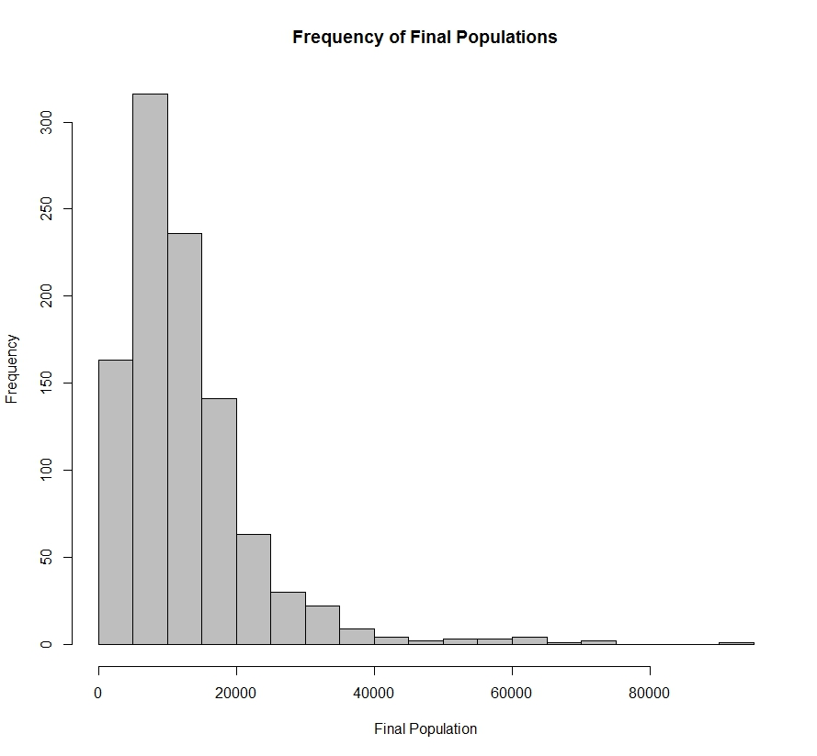

Figure 2 - Example of the summer season type graph created by the model. This figure is always created from the final trial of the run. In this particular run, the final trial experienced a period of good summers from years 6 to 9, followed by a harsh summer and a period of bad summers in year 10 to 13.

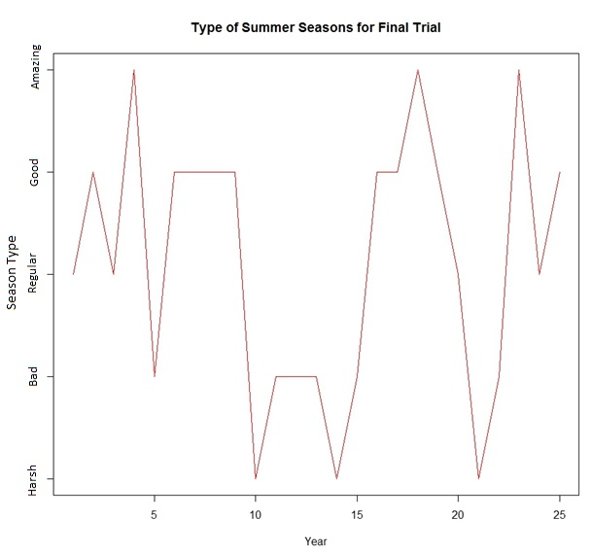

Figure 3 – Graph of several measures of population size by year produced by the model. During the trials it is expected for the population to oscillate as shown because the population always loses individuals in the winter and nearly always gains individuals in the summer. The figure shows the mean, harmonic mean, and median for each season over 25 years for 1000 trials. This graph was created from a run of Scenario 1: No Seasonal Variation.

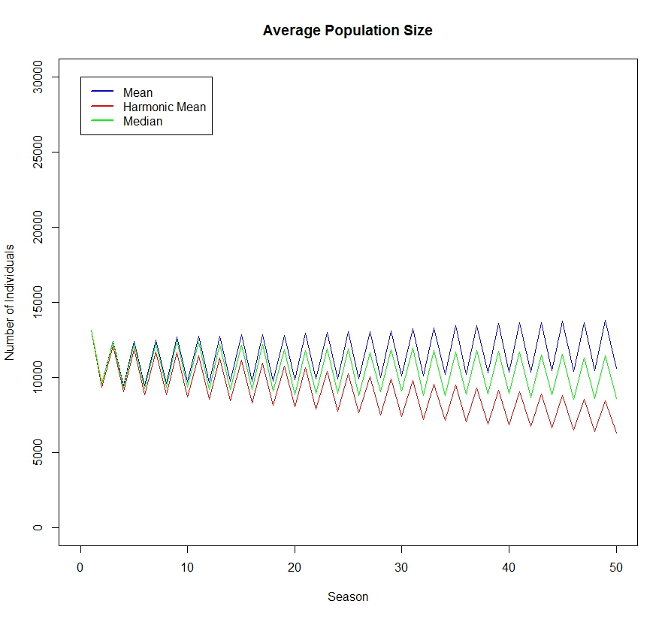

Figure 4 - Histogram of final population sizes in a run of 1000 trials from Scenario Two: Seasonal Variation. The final population was calculated after 25 years (50 seasons). In the event that the final population size was greater than 250,000 individuals the trial was pooled into the 250,000 individual bin. This run shows that with the addition of seasonality the final size of the lesser prairie-chicken population is much more variable at year 25.

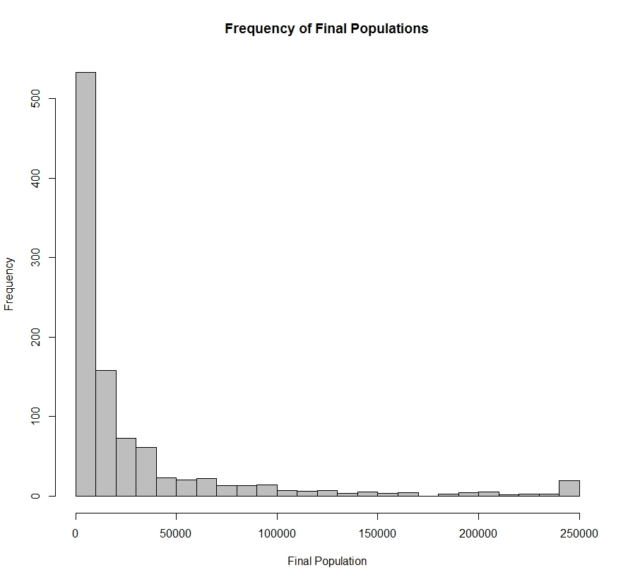

Figure 5 - Proportion of trials falling below the extirpation threshold for runs of 1000 trials. Each run varied the frequencies of summer season types. The figure shows that summer conditions have a substantial effect on the sustainability of the lesser prairie-chicken population, and even a mild deviation away from the current mean season type could have a substantial impact on population size.

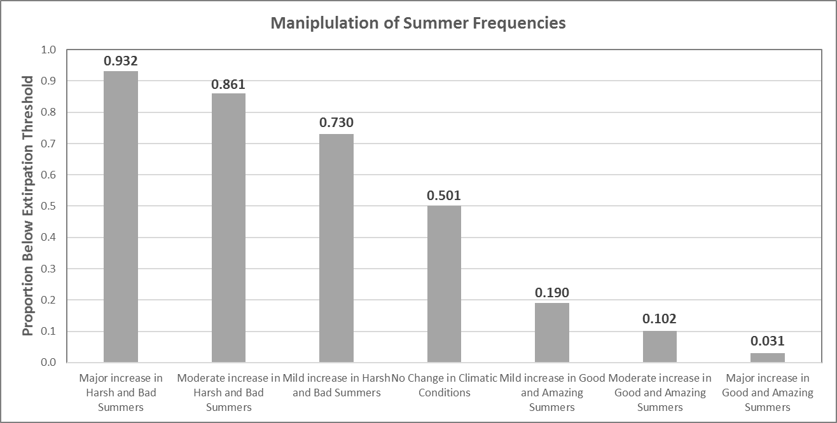

Figure 6 - Proportion of trials falling below the extirpation threshold for runs of 1000 trials. Each run varied the frequencies of winter season types. The results show that while winter season type does have an impact on extirpation rates the effect is not as pronounced as the effect of varying summer season type.

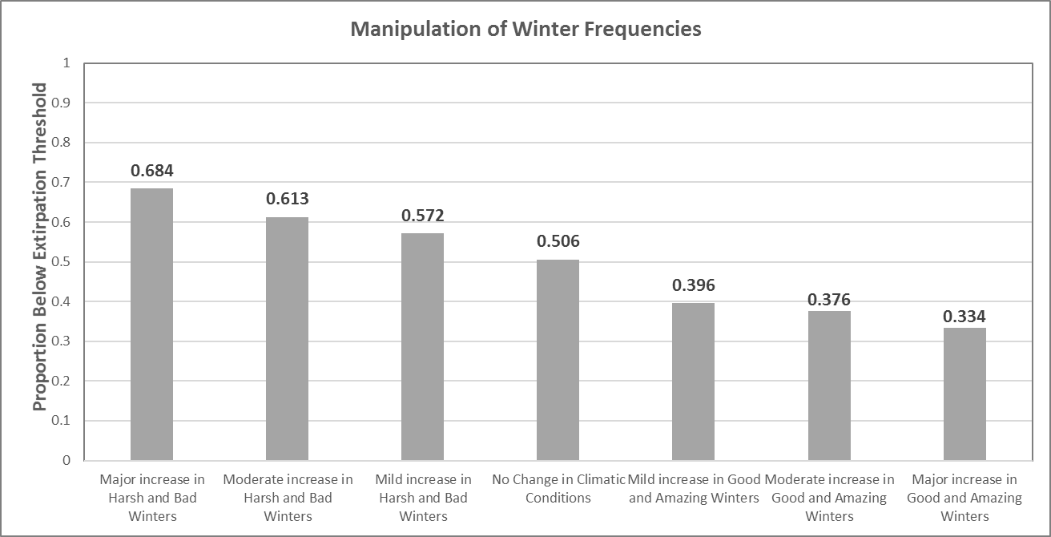

Figure 7 - Proportion of trials falling below the extirpation threshold for runs of 1000 trials. Each run varied the frequencies of summer and winter season types. These results show that no increase in favorable winter conditions is sufficient to counter even a mild increase in unfavorable summer conditions.

