UNIVERSITY OF OKLAHOMA
GRADUATE COLLEGE

EXPERIMENTAL INVESTIGATIONS OF THE EFFECT OF OIL BASED MUD (OBM) CONTAMINATION ON LONG-TERM INTEGRITY OF API CEMENTS

A THESIS
SUBMITTED TO THE GRADUATE FACULTY
in partial fulfillment of the requirements for the
Degree of
MASTER OF SCIENCE

By
NACHIKET ARBAD
Norman, Oklahoma
2020

EXPERIMENTAL INVESTIGATIONS OF THE EFFECT OF OIL BASED MUD (OBM) CONTAMINATION ON LONG-TERM INTEGRITY OF API CEMENTS

A THESIS APPROVED FOR THE
MEWBOURNE SCHOOL OF PETROLEUM AND GEOLOGICAL ENGINEERING

BY THE COMMITTEE CONSISTING OF

Dr. Catalin Teodoriu, Chair

Dr. Ramadan Ahmed

Dr. Hamidreza Karami

Dr. Mahmood Amani

© Copyright by NACHIKET ARBAD 2020
All Rights Reserved.

ACKNOWLEDGEMENTS
Firstly, I would like to express my deepest gratitude and appreciation toward my research advisor and thesis committee chair Dr. Catalin Teodoriu for his constant support, motivation, and guidance during my master’s. Thank you for providing me the opportunity to work on this project in the Wellbore Integrity Laboratory at the University of Oklahoma. I have gained immense knowledge from your courses and publications which has helped me become a competent researcher. For this, I am deeply indebted to you.
I would also like to thank Dr. Ramadan Ahmed and Dr. Hamidreza Karami for their continued support and guidance throughout my master’s journey. Thank you for investing your time in my work by serving as committee members. I would also like to thank Dr. Mahmood Amani for his guidance and support which helped us publish our results in several publications. This research work was made in part possible by a National Priorities Research Program grant from the Qatar National Research Fund (a member of The Qatar Foundation). I would like to thank to Central Plains Cement Company for their support with cement materials.
I would like to thank Dr. Opeyemi Bello and Fernando Rincon for being co-authors on few publications and also helping me with my experiments. I would like to thank fellow lab mates - Saket, Aditya, Cameron, Jerry, Taylor, Hussain, Jake. To, Lavinia.
Special thanks to Piyush Srivastava, Ph.D. and Emanuel Marsis, Ph.D. for their guidance and support during my internship with Baker Hughes. I highly appreciate the moral and emotional support provided by Sanchay, Deepankar, Rohan, Ashutosh, Ashish, Nabe, Soham, Helena, Michael, Mi Chin, Raymos, Neha, Kartika, Autumn, and Payton. To my friends from India for their continuous support – Rutu, Sejal, Prerna, Gaurav, Tomar, Nikhil, Shrinath, Srujal, Sanjana, Mayur. Thank you.
Finally, my family members for their unconditional love and support.
Boomer Sooner! Nachiket Arbad, Class of 2020.

TABLE OF CONTENTS

ACKNOWLEDGEMENTS iv
TABLE OF CONTENTS v
LIST OF TABLES vii
LIST OF FIGURES ix
LIST OF EQUATIONS xii
ABSTRACT xiii
CHAPTER 1: INTRODUCTION 1
1.1 Research Motivation 1
1.2 Objectives 4
1.3 OBM & API Cements – Overview 4
CHAPTER 2: LITERATURE REVIEW 7
2.1 Identification and Attempts to Solve the Problem 7
2.2 Effect of OBM Components on Strength Reduction 17
2.3 Investigation of Reason for Strength Reduction 20
2.4 Attempts to Develop Correlations 25
2.5 Summary 29
CHAPTER 3: MATERIALS & METHODS 32
3.1 Methodology 32
3.2 Sample Preparation 33
3.2.1 Mold Preparation 33
3.2.2 Cement 33
3.2.3 OBM 34
3.2.4 Slurry Recipe 34
3.2.5 Mixing Procedure 35
3.2.6 Curing Process 36
3.3 Sample Approval 37
3.3.1 Sample Quality Control Process 37
3.3.2 Density Measurement 37
3.4 Non- Destructive Tests 38
3.5 Destructive Tests 39
3.6 Data Analysis 40
3.7 Sample Matrix & Nomenclature 40
CHAPTER 4: RESULTS & DATA ANALYSIS 42
4.1 Sample Quality Control Analysis 42
4.2 Density Analysis 43
4.3 Destructive Test Analysis 44
4.4 Non-Destructive Test Analysis 50
4.5 Regression Analysis 52
4.6 Error Sensitivity Analysis 56
4.7 UCA Calibration Curves for Low OBM Contamination 58
4.8 Effect of Temperature on Curing Results 61
4.9 Summary 63
CHAPTER 5: CONCLUSIONS 66
CHAPTER 6: RECOMMENDATIONS 67
REFERENCES 68
APPENDICES 72
Appendix A: Literature Review Summary 72
Appendix B: Error Sensitivity Analysis for Correlations 75
Error Sensitivity Analysis for C25 Samples 75
Error Sensitivity Analysis for C75 Samples 77
Error Sensitivity Analysis for H25 Samples 79
Error Sensitivity Analysis for H75 Samples 81

LIST OF TABLES
Table 1: Strength reduction for OBM Cont. & Spacer Cont. Cement Slurries (Morris et al. 1973) 8
Table 2: Strength reduction for OBM Contaminated Cement Slurries (Harder et al. 1992) 9
Table 3: Composition of Cement Slurries tested by Aughenbaugh et al. 2014 11
Table 4: Strength reduction based on destructive testing adapted from Aughenbaugh et al. 2014 14
Table 5: Strength reduction based on non-destructive testing adapted from Aughenbaugh et al. 2014 15
Table 6: Strength Reduction for OBM Contaminated Cement Slurries (Salehi et al. 2016) 15
Table 7: Strength reduction for OBM contaminated cement slurries (Katende et al. 2020) 17
Table 8: Composition of OBM used in laboratory investigation by Harder et al. 1993 17
Table 9: Strength, Porosity, Permeability results from Li et al. 2016 19
Table 10: Strength reduction for OBM contaminated cement slurries (Li et al. 2016) 20
Table 11: Strength Reduction for OBM Contaminated Cement Slurries (Li et al. 2015) 23
Table 12: Nomenclature of samples (Soares et al. 2017) 24
Table 13: Strength reduction for OBM contaminated cement slurries (Soares et al. 2017) 25
Table 14: Strength Reduction for OBM Contaminated Cement Slurries (Vipulanandan et al. 2014) 27
Table 15: Correlations obtained for Class C cement (Olteanu et al. 2020) 28
Table 16: Cement Recipe - Composition 35
Table 17: Nomenclature – Cement Samples 40
Table 18: Legend for All Sample Matrix 40
Table 19: C25 Sample Matrix 41
Table 20: C75 Sample Matrix 41
Table 21: H25 Sample Matrix 41
Table 22: H75 Sample Matrix 41
Table 23: Percent Strength Reduction for OBM Contaminated C25 Samples 63
Table 24: Percent Strength Reduction for OBM Contaminated C75 Samples 63
Table 25: Percent Strength Reduction for OBM Contaminated H25 Samples 63
Table 26: Percent Strength Reduction for OBM Contaminated H75 Samples 63
Table 27: UCS vs Curing Time Correlations – Class C Samples 64
Table 28: UCS vs Curing Time Correlations – Class H 64
Table 29: UCS vs UPV Correlations – Class C 64
Table 30: UCS vs UPV Correlations – Class H 65

A 1: Summary of case studies presented in literature review section 72

LIST OF FIGURES
Figure 1: 1-day Compressive Strength results with OBM & Spacer contamination adapted from Morris et al. 1973 8
Figure 2: Effect of ENP Surfactant on Strength Development of OBM Contaminated Cement Slurry (Harder et al. 1992) 10
Figure 3: Strength of Field SBM Contaminated Cement Slurries w.r.t neat slurries cured for 2 day (Aughenbaugh et al. 2014) 12
Figure 4: 2-day strength of neat slurries contaminated with inert silica sand (Aughenbaugh et al. 2014) 12
Figure 5a, 5b, 5c, 5d: UCA Strength development for C1, H1, H2, L1 contaminated with SBM, respectively (Aughenbaugh et al. 2014) 13
Figure 6: 2 days compressive strength results taken from Salehi et al. 2016 16
Figure 7: 30 day’s compressive strength results taken from Katende et al. 2020 16
Figure 8: 1-day Compressive Strength for different OBM mixtures taken from Harder et. al. 1993 18
Figure 9: Strength development with 20% Mud Contamination adapted from Harder et. al. 1993 18
Figure 10: SEM results from Li et. al .2016 20
Figure 11: 1,3,7 days Compressive Strength results taken from Li et al. 2015 21
Figure 12: 1 day Compressive and Bonding strength results taken from Li et al. 2015 22
Figure 13: Hydration process for OBM contaminated cement slurries taken from Li et al. 2015 22
Figure 14: Water migration process in contaminated cement slurries taken from Li et al. 2015 23
Figure 15: 1 Day compressive strength results taken from Soares et al. 2017 24
Figure 16: Initial electrical resistivity of Cement Samples adapted from Vipulanandan et al. 2014 26
Figure 17: 1, 7, 28 days Compressive Strength for OBM contaminated Cement slurries taken from Vipulanandan et al. 2014 26
Figure 18: UCS vs Time taken from Olteanu et al. 2020 28
Figure 19: UPV vs Time taken from Olteanu et al. 2020 28
Figure 20: UCS vs UPV (Romanowski et al. 2018) 30
Figure 21: Graphic comparison of UCS vs UPV correlations (Romanowski et al. 2018) 31
Figure 22: Experimental methodology 32
Figure 23: 2” Cube Mold by Humboldt 33
Figure 24: Digital Weighing scales and OFITE Model 20 Constant Speed Blender (OFITE Manual) 36
Figure 25: Length & Width Measurements of Cement Samples 37
Figure 26: Density Measurement 38
Figure 27: ProceqTM Ultrasonic device, PosiTectorTM Ultrasonic couplant, Calibration Rod 38
Figure 28: Test Mark Compressive Strength Test Machine 39
Figure 29: Sample Quality Control for Class C Samples 42
Figure 30: Sample Quality Control for Class H Samples 43
Figure 31: Bulk Density of H25 Samples 43
Figure 32: Specific Gravity of Class H Cement Samples 44
Figure 33: Average UCS – C25 Samples 45
Figure 34: Average UCS – H25 Samples 46
Figure 35: Average UCS – C75 Samples 46
Figure 36: Average UCS – H75 Samples 47
Figure 37: Average UCS vs %OBM Contamination – C25 Samples 48
Figure 38: Average UCS vs %OBM Contamination – H25 Samples 48
Figure 39: Average UCS vs %OBM Contamination – C75 Samples 49
Figure 40: Average UCS vs %OBM Contamination – H75 Samples 49
Figure 41: Average UPV - C25 Samples 50
Figure 42: Average UPV - H25 Samples 50
Figure 43: Average UPV – C75 Samples 51
Figure 44: Average UPV – H75 Samples 51
Figure 45: UCS vs Age – C25 Samples 52
Figure 46: UCS vs Age – H25 Samples 52
Figure 47: UCS vs Age – C75 Samples 53
Figure 48: UCS vs Age – H75 Samples 53
Figure 49: UCS vs UPV – C25 Samples 54
Figure 50: UCS vs UPV – H25 Samples 54
Figure 51: UCS vs UPV – C75 Samples 55
Figure 52: UCS vs UPV – H75 Samples 55
Figure 53: Error Sensitivity analysis of Correlations developed for 3.2%OBM C25 Samples 56
Figure 54: Error Sensitivity analysis of Correlations developed for 3.2%OBM H25 Samples 56
Figure 55: Error Sensitivity analysis of Correlations developed for 3.2%OBM C75 Samples 57
Figure 56: Error Sensitivity analysis of Correlations developed for 3.2%OBM H75 Samples 57
Figure 57: Calibration Curves for UCA – Class C 58
Figure 58: Calibration Curves for UCA – Class H 59
Figure 59: Error Sensitivity Analysis - UCA Calibration Curves C25 59
Figure 60: Error Sensitivity Analysis - UCA Calibration Curves C75 60
Figure 61: Error Sensitivity Analysis - UCA Calibration Curves H25 60
Figure 62: Error Sensitivity Analysis - UCA Calibration Curves H75 60
Figure 63: Effect of temperature on cement hydration after Elkhadiri et al. 2009 61
Figure 64: UCS Development – C25 vs C75 (0%OBM & 0.8%OBM Contaminated Samples) 62
Figure 65: Long Term Strength – C25 Samples 62

B 1: Error Sensitivity analysis of Correlations developed for 0%OBM C25 Samples 75
B 2: Error Sensitivity analysis of Correlations developed for 0.8%OBM C25 Samples 75
B 3: Error Sensitivity analysis of Correlations developed for 1.6%OBM C25 Samples 76
B 4: Error Sensitivity analysis of Correlations developed for 3.2%OBM C25 Samples 76
B 5: Error Sensitivity analysis of Correlations developed for 6.3%OBM C25 Samples 77
B 6: Error Sensitivity analysis of Correlations developed for 0%OBM C75 Samples 77
B 7: Error Sensitivity analysis of Correlations developed for 0.8%OBM C75 Samples 78
B 8: Error Sensitivity analysis of Correlations developed for 3.2%OBM C75 Samples 78
B 9: Error Sensitivity analysis of Correlations developed for 0%OBM H25 Samples 79
B 10: Error Sensitivity analysis of Correlations developed for 0.8%OBM H25 Samples 79
B 11: Error Sensitivity analysis of Correlations developed for 1.6%OBM H25 Samples 80
B 12: Error Sensitivity analysis of Correlations developed for 3.2%OBM H25 Samples 80
B 13: Error Sensitivity analysis of Correlations developed for 6.3%OBM H25 Samples 81
B 14: Error Sensitivity analysis of Correlations developed for 0%OBM H75 Samples 81
B 15: Error Sensitivity analysis of Correlations developed for 0.8%OBM H75 Samples 82
B 16: Error Sensitivity analysis of Correlations developed for 3.2%OBM H75 Samples 82

LIST OF EQUATIONS
Equation 1: For Calculating %OBM Contamination 34
Equation 2: Bulk density of Samples 38
Equation 3: UCS Calculation 39

ABSTRACT
Well construction, well abandonment, and restoration of well integrity are the reasons at a broad level why cementing jobs are performed. During the well construction phase, the primary objective of the cementing job is to replace the drilling mud in the annulus with pure cement. Intermixing of the drilling mud and the cement slurry produces an unpumpable mixture, especially in the case of Oil-Based Mud (OBM). The displacement efficiency of spacers and pre-flushes used to displace the drilling mud is never 100%, thus cement slurries are contaminated with drilling mud. Recently, several research groups have performed studies to understand the strength development phenomenon of OBM contaminated cement slurries. A detailed review of these studies illustrates several shortcomings like variations in sample preparation, focus on the high amount of OBM contamination, lack of documentation of experimental procedures, focus on early curing time, and so on.
The primary aim of this study was to develop a standard laboratory experimental procedure for understanding the strength development of OBM contaminated cement slurries and develop a reliable dataset for future references. The study focused on the effect of low OBM contaminations ranging from 0.8% to 6.3% (by volume) on API Class C & H cement samples cured from a minimum of 4 hours to a maximum of 1 year at room temperature (25℃) and elevated temperature of 75℃. Destructive tests to measure the uniaxial compressive strength (UCS) and non-destructive tests to measure the ultrasonic pulse velocity (UPV) were performed on 362 contaminated as well as neat cement samples. Results obtained from these tests showed a detrimental effect on the strength of cement samples even with such low OBM contaminations. Correlations for predicting the long-term strength of OBM contaminated cement slurries were developed using the test results. These correlations developed would help the operators in better estimation of the strength developed by the OBM contaminated cement slurries. In other words, a more accurate prediction of cement wellbore integrity.

CHAPTER 1: INTRODUCTION

Research Motivation
The catastrophic events faced by the Oil and Gas industry in the past depict the importance of maintaining the integrity of the well. Over the past decades, the oil and gas industry raised concerns regarding industry standards and recommended industry practices. Several industry standards, guidelines, and practices were revised to ensure the well integrity is maintained throughout the life cycle of the well. Well barriers prevent the uncontrolled flow of formation fluids both within and out of the well. Drilling mud acts as the most crucial physical well barrier during the operational phase of the well life cycle while cement is critical during the construction, operational, intervention, and abandonment phases (ISO, 2015, 2013). It is critical to identify, evaluate, and monitor the well barriers to ensure well integrity (Kiran et al., 2017).
The basic purpose of casing cementation is to provide the necessary structural assistance to casings & liners along with other purposes like zonal isolation and corrosion inhibition. The primary cementing operations aim to replace the drilling mud present behind the casing with pure cement slurry. Displacing drilling mud with cement slurry causes contamination of the cement slurry with drilling mud and forms an unpumpable mixture. Such contamination also hinders the cement hydration process and affects the mechanical and rheological properties of the cement slurry. This was the primary reason for 50% of cement job failures while setting open-hole cement plugs (Beach and Goins, 1957). Laboratory investigations were performed to understand this phenomenon and the addition of activated charcoal to the cement partially counteracted this critical well integrity problem (Morgan and Dumbauld, 1952). Spacers are pumped to avoid intermixing of cement slurry and drilling mud. Flushes or pre-flushes are pumped ahead of spacers and cement slurry to improve the mud displacement efficiency and reduce the contamination of cement slurry with drilling mud (Bourgoyne et al., 1984; Rabia, 2002; Sweatman et al., 2015).
In 1973, laboratory testing of compatibility between the several OBM mixtures, spacer systems, and cement slurries was performed and the best combinations were successfully used in the field (Morris et al., 1973). The reduction in compressive strength of the cement slurry (cured for 24 hours at 193.33℃) due to contamination with 10% OBM and 10% spacer was 57% and 0.2% respectively. Similarly, at 50% OBM contamination the strength reduction was 98% and for 50% spacer contamination the reduction was 93%. Clearly, OBM contamination proved to be more harmful as compared to spacer contamination.
In another study, it was found that the plugging operations in OBM needed a minimum of two to three attempts due to incompetent kick-off plug. Deterioration in the strength of the kick-off plug was caused due to OBM contamination of cement slurries. Depending upon the OBM contamination the wait-on cement (WOC) time to achieve the desired compressive strength varied greatly. In other words, increasing OBM contamination increased the WOC time and/or the number of kick-off plug attempts. The addition of 1% ethoxylated nonylphenols (ENP) surfactants to the cement slurries increased the compressive strength and greatly reduced the WOC time. Plugging operations in OBM were successful in their first attempt for a three well program saving the cost involved for extra plugging attempts because of the addition of 1% ENP surfactants to cement slurries. The reduction in compressive strength of the cement slurry (cured for 24 hours at 93℃) due to contamination with 10% and 40% OBM was 24% and 79% respectively. Similarly, with the addition of 2% ENP surfactants reduction in strength was 23% for 10% OBM contamination and 57% for 40% OBM contamination (Harder et al., 1992).
Findings from the previous study motivated Harder et al., 1993 to perform another study which analyzed the reduction in the strength of OBM contaminated cement slurries with respect to 4 different types of OBM prepared in the laboratory with combinations of two base oils (mineral oil and diesel oil) and two primary emulsifiers (alkanol amide and standard fatty acid). The objective of this study was to understand and optimize the OBM chemistry with respect to the cementing operation. The reduction in the cement strength was less when mineral oil was the base oil as compared to diesel oil. Similarly, greater strength was observed when alkanol amide was the primary emulsifier as compared to standard fatty acid (Harder et al., 1993). These were the first few studies performed to understand the effect of OBM contamination of cement slurries.
The usage of OBM along with the technological advancements found its application in horizontal drilling and Deepwater drilling. Case studies revealed the added benefits of using OBM instead of WBM solved several critical drilling challenges (Chambers et al., 2000; Emadi et al., 2015; Fleming et al., 2019; Fossum et al., 2007; Harold et al., 2015; Kabanov et al., 2014; Sheer et al., 2019; Sinha et al., 2017). As the usage of OBM gained popularity, researchers reexamined the mud-cement interaction to improve their understanding about the strength development of OBM contaminated cement slurries (Aughenbaugh et al., 2014; Katende et al., 2020; Li et al., 2015, 2016; Salehi et al., 2016; Soares et al., 2017; Vipulanandan et al., 2014).
A detailed review by Arbad and Teodoriu, 2020 addresses the shortcomings of the laboratory experiments performed in this decade by distinct research groups on OBM contamination of cement slurries. Interestingly, on comparison of these studies, the following points were noted –
- Studies focused on high OBM contamination ranging from a minimum of 5% to a maximum of 95%.
- Cement slurries had some additives like bentonite, dispersants, retarders, etc., in other words, the effect of OBM contamination on pure cement was not evaluated.
- Most studies focused on shorter curing time (less than 3 days), in other words, long-term effects were not studied.
This study is designed to address the points mentioned above.

Objectives
This research effort includes evaluating the strength development of API Class C & Class H cements contaminated with OBM cured at atmospheric conditions and elevated temperature of 75℃. The focus is on effect of low OBM contamination on strength development of cement slurries. The objectives of this study are listed below:
- Develop standard experimental procedures to evaluate the strength development of OBM contaminated cement slurries.
- Evaluate the effect of time on strength development of neat API Class C & H cement slurries for creating an experimental reference.
- Evaluate the effect of OBM contamination on the strength development of API cement slurries (Class C & H).
- Evaluate the effect of temperature on strength development of both neat and OBM contaminated cement slurries (Class C & H).
- Evaluate the effect of time on the ultrasonic response of neat API Class C & H cement slurries for creating an experimental reference.
- Evaluate the effect of OBM contamination on the ultrasonic response of both API Class C & H cement slurries.
- Evaluate the effect of temperature on the ultrasonic response of neat as well as OBM contaminated API Class C & H cement slurries.
- Develop a reliable dataset for future references.
- Develop accurate correlations between UCS, UPV, and time for both neat and OBM contaminated cement slurries.
OBM contaminated cement slurries refers to slurries contaminated with 0.8%, 1.6%, 3.2%, and 6.3% OBM by volume of total cement slurry.

OBM & API Cements – Overview
The type of drilling fluid used for drilling a well depends on various factors such as the geological formation to be drilled, the temperature, pressure, depth, and formation evaluation procedure to be used, the environmental and ecological impact, costs, etc. Similarly, the type of API cement used depends on the depth range, rheological properties required, wellbore conditions, costs, and so on. OBM consists of oil/diesel in the continuous phase with a percentage of water in the dispersed phase. Additives are added to achieve the desired drilling fluid properties. The base of the OBM is usually diesel or mineral oil, with the former being more toxic than mineral oil systems. The toxicity of OBM is reduced by lowering the aromatics in diesel/mineral oil. Emulsifiers help in maintaining a stable water-in-oil emulsion under downhole conditions. Using OBM instead of water-based mud (WBM) has several pros and cons associated with it (Bourgoyne et al., 1984; Rabia, 2002; Scott et al., 2015).
Case histories have justified that the usage of OBM instead of WBM eliminates several drilling problems (Chambers et al., 2000; Emadi et al., 2015; Fleming et al., 2019; Fossum et al., 2007; Harold et al., 2015; Kabanov et al., 2014; Sheer et al., 2019; Sinha et al., 2017). The productivity index of long, horizontal open-hole gravel packed wells in West Africa improved three times when drilled with OBM compared to those drilled with WBM (Chambers et al., 2000). A multilateral well was drilled in the Aasgard field (a high-temperature reservoir in Norway) using low-solid OBM which saved 37 days of budget time (Fossum et al., 2007). Special OBM was designed and used for drilling exploration and appraisal wells for a major operator in the North Sea, where the expected reservoir pressure and temperature were 1700 psi and 204.33℃, respectively. The designed mud system provided the required thermal stability, consistency in properties, and compatibility with the wireline programs (Kabanov et al., 2014). Laboratory experiments on shale oil core samples from the Eagle Ford field were carried out to understand the effect of OBM and WBM on shale oil properties and the swelling properties of the formation (Emadi et al., 2015). Laboratory and field results (Gudrun Field) shows OBM can be used as a cost-effective and less-damaging perforation fluid for fields with High Pressure and High Temperature (HPHT) conditions (Fleming et al., 2019). Severe drilling problems, like lost circulation into weak zones and wellbore stability issues, can be eliminated by using OBM and Managed Pressure Drilling techniques (Harold et al., 2015). The case history of Southeast Kuwait fields shows a successful application of OBM with a 60:40 oil-water ratio reduces the environmental impact compared to previously drilled wells with 80:20 oil-water ratio OBM (Sheer et al., 2019). An economic analysis of large fields (approx. 500 wells) using the holistic approach (Sinha et al., 2017) proves that using OBM is better than using WBM.
The success of any drilling project depends on the compatibility of drilling fluid with the spacer and oil well cement (Budiawan et al., 2014; Dupriest et al., 2012; Patel et al., 1999; Schumacher et al., 1996; Scott et al., 2015; Sweatman et al., 2015). Due to the oil-wetting characteristics of OBM, displacing OBM becomes a critical operation before cementing. The spacer must be uniquely designed to displace the drilling fluid from the annulus and leave it water-wet (Patel et al., 1999). It is highly recommended to test the compatibility of the drilling fluid with the spacer and oil well cement before field application. It helps to overcome the challenges and prevent remedial cementing operations (Schumacher et al., 1996). It is difficult to displace 100% mud from the annulus using the spacer. The drilling fluid left behind mixes with the cement and contaminates it.
It is evident that the contamination of oil well cement with OBM causes well integrity issues and there is a need to better understand the effect of this contamination. Research studies (Aughenbaugh et al., 2014; Li et al., 2015, 2016; Olteanu and Teodoriu, 2020; Soares et al., 2017; Vipulanandan et al., 2014) have been carried out in recent years to evaluate and quantify the effect of OBM contamination on strength development of oil well cement. A summary of these recent studies is presented in the following section, followed by critical analyses and discussions of the same.

CHAPTER 2: LITERATURE REVIEW
In recent years, research was carried out to discover the mechanism behind changes in the mechanical and rheological properties of OBM contaminated cement slurries. Modern research methodologies and equipment have allowed scientists to look in detail at the OBM and cement interaction. A decade ago, research was mainly focused on optimizing the spacer fluid program to reduce the OBM contamination and/or look for additives to improve the compatibility between OBM and cement slurries. For simplicity reasons, the case studies are grouped into following categories based on their objectives -
- Identification and attempts to solve the problem
- Effect of OBM components on strength reduction
- Investigation of the reason for strength reduction
- Attempts to develop Correlations

Identification and Attempts to Solve the Problem
In 1973, laboratory experiments were performed to find out the best spacer fluid system to be used in the field for wells drilled with OBM. It was also noted that the mixing of OBM with cement slurries forms an unpumpable mixture which causes serious problems. Screening tests, pumping time tests, compressive strength tests, surface wettability, and fluid loss tests were performed on several spacer systems. Figure 1 shows the results of compressive strength tests for cement slurries contaminated with both OBM and oil-based spacer system cured for one day at 193.33℃.
Amongst the spacer systems tested in this study, it was seen that the oil-based spacer system with some additives was most compatible with the OBM and cement slurries. Also, with the addition of necessary additives, it leaves the surface of pipe water wet which helps in better bonding of the cement with the casing.
Table 1 shows the percentage compressive strength reduction as compared to neat cement slurries with increasing OBM and Spacer contaminations cured for 1 day at 193.33℃.

Figure 1: 1-day Compressive Strength results with OBM & Spacer contamination adapted from Morris et al. 1973
OBM contamination has a more detrimental effect than spacer contamination. The field application of the proposed spacer system developed in this study showed satisfactory results with a variety of downhole conditions, cement slurries, and OBM (Morris et al., 1973). It is interesting to note the authors have failed to report the details of the cement slurry and OBM used for laboratory testing.
Table 1: Strength reduction for OBM Cont. & Spacer Cont. Cement Slurries (Morris et al. 1973)
Amount of Contamination (%) | Strength Reduction for Spacer Cont. Cement Slurry (%) | Strength Reduction for OBM Cont. Cement Slurry (%)
10 | 0.2 | 57
20 | 54 | 90
35 | 85 | 95
50 | 93 | 98

The setting of cement plugs in wells drilled with OBM required several attempts which were costly and time-consuming. The number of attempts required for establishing a competent kick-off plug for side-tracking the wells drilled with OBM was directly proportional to the amount of OBM contamination of cement slurry. Laboratory tests were conducted to find the solution for this deterioration in the strength of the cement plug due to OBM contamination.
The mechanical and rheological properties of cement slurries contaminated with several OBM’s were measured. Based on the previous field experiences, the use of ethoxylated nonylphenols (ENP) as an additive to counter the effect of OBM contamination was investigated in the laboratory. The tests were performed to find the optimum amount of ENP to be used for the best results. Table 2 shows the reduction in the strength of OBM contaminated cement slurry cured for 1 day at 93℃ BHST with respect to neat slurries.
Table 2: Strength reduction for OBM Contaminated Cement Slurries (Harder et al. 1992)
Amount of OBM Contamination (%) | Strength Reduction for OBM Contaminated Cement Slurry (%)
10 | 24
20 | 49
40 | 79

The strength development of OBM contaminated cement slurries with ENP as additive were tested for varying concentration (0.5% to 2%). Figure 2 shows the strength development of 20% OBM contaminated cement slurry with 2% ENP surfactant (Test A) and 20% OBM contaminated cement slurry (Test B), respectively. The test temperature for the results shown in figure 2 was 93℃. The best results were obtained with 1% ENP concentration and the number of attempts required to set the plug was reduced significantly.

Figure 2: Effect of ENP Surfactant on Strength Development of OBM Contaminated Cement Slurry (Harder et al. 1992)

The authors reported that the wait-on cement time for the same amount of OBM contamination differed based on the type of OBM. In other words, the chemistry/ composition of the OBM effects the strength development of cement (Harder et al., 1992). The authors did not document the details of the cement slurries and OBMs used in these tests. Ultrasonic Cement Analyzer (UCA) is a great instrument for describing the cement strength evolution (Abdulrazzaq et al., 2017; Garnier et al., 2007; Goodwin, 1992; McDaniel et al., 2014; RAO et al., 1982; Reddy et al., 2005) which was used in this study.
The objective of the study carried out by Aughenbaugh et al., 2014 was to quantify the effects of contamination of various cement slurries with synthetic-based mud (SBM) and look for additives to reduce the effect of contamination. This research was/is divided into multiple phases and these were the objectives of the first phase. API RP 10A recommendations were followed for preparing and mixing cement slurries in this study. The composition of cement slurries tested in this study is shown in Table 3.
Table 3: Composition of Cement Slurries tested by Aughenbaugh et al. 2014
Slurry Name | Composition
H-1 | API Class H-1 and tap water
H-2 | API Class H-2 and tap water
C-1 | API Class C and tap water
L-1 | Lightweight cement and tap water
S-1 | Blast furnace slag and alkaline activating solution
DW-H-2 | API Class H-2 and Tap water and Additives

The above cement slurries were contaminated (5%, 10%, and 15% by volume) by replacing part of the cement slurries with field SBM (11.6 ppg; 70/30 invert emulsion–oil/CaCl₂), laboratory-formulated SBM (Lab-SBM), and silica sand. Slurries were contaminated with silica sand to test the effect of a reduction in cement contents. A drill press and a paint stirrer were used to mix the contaminants and the cement slurries. Samples were cured for 48 hours and destructive as well as non-destructive tests (UCA) were performed to obtain the compressive strength values (samples cured at 76.67℃ and 3000 psi).
Figure 3 shows the percentage reduction in compressive strength of field SBM-contaminated cement slurries with respect to neat cement slurries and figure 4 shows the 48-hour compressive strength of silica sand contaminated cement slurries (0% to 15%). The results obtained from silica sand contamination tests proved that the decrease in compressive strength due to contamination with field SBM is because of chemical interaction and not due to the dilution of cement content.

Figure 3: Strength of Field SBM Contaminated Cement Slurries w.r.t neat slurries cured for 2 day (Aughenbaugh et al. 2014)

Figure 4: 2-day strength of neat slurries contaminated with inert silica sand (Aughenbaugh et al. 2014)

It was noted that the time required for strength development was constant, irrespective of the percentage of contamination. Figure 5a, 5b, 5c, 5d shows the UCA results for C1, H1, H2, L1 cement slurries contaminated with SBM, respectively.

Figure 5a, 5b, 5c, 5d: UCA Strength development for C1, H1, H2, L1 contaminated with SBM, respectively (Aughenbaugh et al. 2014)

Lab-SBMs were prepared (in the laboratory) in two different ways to detect which component was responsible for the decrease in compressive strength of contaminated cement slurries: Lab-SBM with the same composition as the field SBM and Lab-SBM (no brine) where brine was replaced with an equal volume of freshwater. Lab-SBM and field SBM showed similar results of compressive strength, which were less than the Lab-SBM (no brine) compressive strength values. This test proved that brine affects the compressive strength negatively and the reason for lower compressive strength values for SBM-contaminated cement slurries could be due to the osmosis of the water from cement slurries to SBM.
Compressive strength values obtained for the slag-based cement slurry contaminated with SBM were least affected compared to other cement slurries tested in this study. Several additives were added to SBM-contaminated cement slurries to compensate for the reduction in strength. The only additive that improved the strength was alkali when added at 10% of the weight of SBM. These were the findings from Aughenbaugh et al., 2014.
This study performed both destructive and non-destructive tests to measure the absolute strength reduction in the presence of SBM. Table 4 & 5 shows the reduction in strength of C1, H1, H2, L1, and DW H2 cement slurries contaminated with 5%, 10%, 15% SBM as per the destructive test and non-destructive test results, respectively. The strength reduction is with respect to the strength developed by neat cement slurries. On comparing table 4 & 5, it is interesting to note that the results obtained from UCA testing that is the non-destructive testing are less as compared to results obtained from destructive testing
Table 4: Strength reduction based on destructive testing adapted from Aughenbaugh et al. 2014
SBM Contamination (%) | Strength Reduction for SBM Contaminated Cement Slurry based on Destructive Testing (%)
SBM Contamination (%) | C1 | H1 | H2 | L1 | DW H2
5 | 43 | 42 | 72 | 79 | 8
10 | 62 | 64 | 87 | 87 | 34
15 | 75 | 63 | 83 | 89 | 54

Table 5: Strength reduction based on non-destructive testing adapted from Aughenbaugh et al. 2014
SBM Contamination (%) | Strength Reduction for SBM Contaminated Cement Slurry from Non-Destructive Testing - UCA (%)
SBM Contamination (%) | C1 | H1 | H2 | L1 | DW H2
5 | 19 | 31 | 45 | 45 | 23
10 | 44 | 56 | 82 | 76 | 30
15 | 63 | 61 | 86 | 79 | 51

This means that compressive strength results obtained from UCA can be misleading and destructive tests should be performed to measure the absolute strength developed by cement slurries.
A widespread literature review about the application of geopolymer cement slurries in the oil and gas industry was done by Salehi et al., 2016. Laboratory experiments were performed to determine the effect of various factors on the strength development of the same. The effect of OBM contamination on strength development of both neat Class H cement slurry and Class F Fly ash geopolymer mixture were tested. The cement slurries were contaminated by replacing 5% and 10% mass of the cement slurries with OBM. Three samples each for both 5% and 10% OBM contaminated Class H cement slurry and geopolymer mixture were cured at 65°C for two days. Figure 6 shows the results acquired in this study.
The effect of OBM contamination on geopolymer mixture is less as compared to widely used Class H cement. The percentage reduction in the strength as compared to the neat slurries acquired from this study is tabulated in table 6.
Table 6: Strength Reduction for OBM Contaminated Cement Slurries (Salehi et al. 2016)
Amount of OBM Contamination (%) | Strength Reduction for Class H (%) | Strength Reduction for Geopolymer Mixture (%)
5 | 35 | 5
10 | 88 | 25

Figure 6: 2 days compressive strength results taken from Salehi et al. 2016

The most recent study to evaluate the effect of OBM contamination on Class H cement slurry was performed to measure the UCS, porosity, and permeability. Microstructural analysis using the SEM and energy dispersive spectroscopy was also performed to quantify the ability of OBM contaminated cement slurries to provide zonal isolation (Katende et al., 2020). Class H cement slurry with 2% bentonite was contaminated with 5%, 10%, and 30% OBM by volume of cement. The samples were cured for a minimum of 30 days at 60°C and ambient pressure. Figure 7 shows the compressive strength results of this study.

Figure 7: 30 day’s compressive strength results taken from Katende et al. 2020

The results of strength reduction due to OBM contamination are shown in table 7.
Table 7: Strength reduction for OBM contaminated cement slurries (Katende et al. 2020)
Amount of OBM contamination (%) | Strength Reduction for Class H Slurry (%)
5 | 1
10 | 25
30 | 73

Effect of OBM Components on Strength Reduction
Based on the findings from their previous study, Harder et al., 1993 extended their study to understand how the composition and chemistry of OBM affect cement performance. They carried out laboratory experiments on 17 ppg density Class H Portland cement consisting of fluid loss additives (FLA) and friction reducers (FR) designed for 93℃. The cement slurry was contaminated (10%, 20%, 30%) with four different types of OBM, which were prepared in the lab with combinations of two base oils (diesel and mineral oil) and two emulsifiers (standard fatty acid and alkanolamide). Table 8 shows the composition of the OBMs used in this study.
Table 8: Composition of OBM used in laboratory investigation by Harder et al. 1993
OBM | Base Oil | Primary Emulsifier
Mud 1 | Mineral Oil | Alkanolamide
Mud 2 | Mineral Oil | Standard Fatty Acid
Mud 3 | Diesel Oil | Alkanolamide
Mud 4 | Diesel Oil | Standard Fatty Acid

Figure 8 shows the one-day compressive strength results obtained by performing a non-destructive test on the contaminated cement samples measured using the Ultrasonic Cement Analyzer (UCA). The authors have failed to document the results for neat cement slurries which makes it difficult to find the percentage reduction in the strength due to OBM contamination. Figure 9 shows the development of compressive strength for 20% contamination of cement slurry with Muds 3 and 4.

Figure 8: 1-day Compressive Strength for different OBM mixtures taken from Harder et. al. 1993

Figure 9: Strength development with 20% Mud Contamination adapted from Harder et. al. 1993
Based on the two base oils used in the study, diesel oil had a more adverse effect on the compressive strength compared to mineral oil. On comparing the two-primary emulsifiers, the presence of alkanolamide showed better strength development compared to standard fatty acid (calcium soap) (Harder et al., 1993).
An extensive study was performed by Li et al., 2016 to find out the effect of OBM and its components on the rheological properties, mechanical properties, porosity and permeability of cement slurries. An Ultrasonic Cement Analyzer (UCA), X-ray diffraction (XRD), Thermogravimetry (TG), a Scanning Electronic Microscope (SEM) and Fourier Transform Infrared Spectroscopy (FTIR) were used in this study.
The cement slurry used in this study consisted of API Class G cement, 2% anti-gas migration agent, 25% silicon powder, 5% filtrate reducer, 1% dispersant, 2% retarder and 0.2% defoaming agent. The above cement slurry was contaminated (0%, 5%, 25% and 50%) with diesel-based drilling fluid. The cement samples were cured for 2 days at 135°C and 3002.281 psi. With the increase in contamination, the compressive strength and bonding strength decreased, while porosity and permeability increased (Table 9). An increase in porosity and permeability was confirmed by SEM tests (Figure 10).
Table 9: Strength, Porosity, Permeability results from Li et al. 2016
OBM Contamination (%) | Compressive Strength (MPa) | Bonding Strength (MPa) | Porosity % | Permeability (mD)
0 | 17.2 | 3.4 | 11.2 | 0.04
5 | 13.5 | 2.2 | 16.8 | 0.19
25 | 4.1 | 0.7 | 32.1 | 0.41
50 | 0 | 0 | - | -

Furthermore, the effects of contamination of cement slurry with different components of OBM was also studied. The compressive strength was reduced to zero when cement slurries were contaminated with 50% emulsion and 50% diesel, respectively. The reduction in compressive strength values for different contaminations of primary emulsifier, secondary emulsifier, and organic clay was much less compared to the effect seen with diesel and emulsion contaminations.

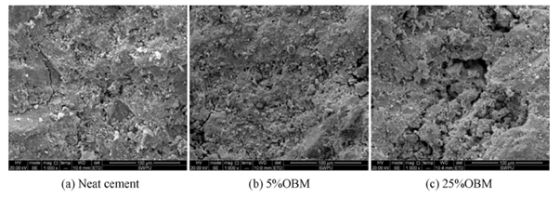

Figure 10: SEM results from Li et. al .2016

Li et al., 2016 concluded that OBM does not hinder the hydration process of contaminated cement slurries. An increase in contamination of OBM causes an increase in lubrication and porosity of the contaminated cement slurries, thereby decreasing the strength of the hydrated samples. Table 10 shows the percent strength reduction of OBM contaminated cement slurries as compared to neat cement slurries.
Table 10: Strength reduction for OBM contaminated cement slurries (Li et al. 2016)
Amount of OBM Contamination (%) | Strength Reduction for OBM Contaminated Cement Slurry (%)
Amount of OBM Contamination (%) | Compressive Strength (%) | Bonding strength (%)
5 | 22 | 35
25 | 76 | 79
50 | 100 | 100

Investigation of Reason for Strength Reduction
An extensive study was carried out by Li et al., 2015 at the microscopic level to understand the mechanism of OBM contamination of oil well cement. The hydration process of contaminated cement slurries was studied using X-ray diffraction (XRD), Scanning Electron Microscope (SEM), Environmental Scanning Electron Microscope (ESEM), Thermogravimetry (TG) and Energy Dispersive Spectrometer (EDS). The changes in rheological properties and mechanical properties of contaminated cement slurries were quantified first and then the mechanisms behind them were studied.
The cement slurries used in this study were mixed based on API recommendations, which consist of API Class G cement, free water control additives, water, dispersant, etc. These slurries were contaminated with 0%, 5%, 25%, and 50% UDM-2 system diesel-based drilling fluid (85/15 invert emulsion) by replacing volume of cement slurry with equal volume of mud. Compressive strength was measured by performing destructive tests on contaminated cement slurries cured in a water bath at 93°C for 1, 3 and 7 days. Microstructure analyses of 5% and 25% contaminated cement slurries were discussed in the paper. Figure 11 shows the results obtained for the compressive strength developed by 0% to 50% diesel-based drilling fluid contaminated cement slurries after curing for 1, 3, 7 days at 199.4ºF. Similarly, the compressive and bonding strength for diesel-based drilling fluid contaminated cement slurries cured for 1 day at 93°C are displayed in figure 12.

Figure 11: 1,3,7 days Compressive Strength results taken from Li et al. 2015

Figure 12: 1 day Compressive and Bonding strength results taken from Li et al. 2015

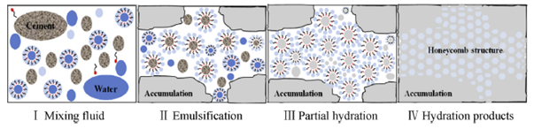
XRD test results confirmed the reason for the decrease in strength. OBM hinders the hydration reaction without interacting chemically. Incomplete hydration of the contaminated samples leads to the formation of a honeycomb structure. Figure 13 shows the general process of hydration of contaminated cement slurries.

Figure 13: Hydration process for OBM contaminated cement slurries taken from Li et al. 2015

Demulsification and osmotic pressure changed the rheological properties of contaminated cement slurries. Figure 14 shows the process of water migration in OBM-contaminated cement slurries.
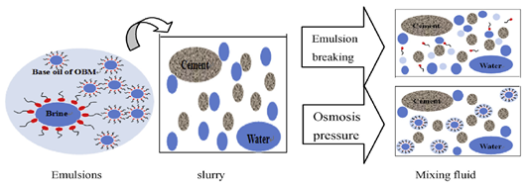

Figure 14: Water migration process in contaminated cement slurries taken from Li et al. 2015

This study also proved that the addition of surfactants to contaminated cement slurries improves the mechanical and rheological properties. Table 11 shows the compressive strength reduction based on this study. For 50% OBM contamination the strength reduction was 100%.
Table 11: Strength Reduction for OBM Contaminated Cement Slurries (Li et al. 2015)
Amount of OBM Contamination (%) | Strength Reduction for OBM Contaminated Cement Slurry (%)
Amount of OBM Contamination (%) | 1 day | 3 days | 7 days
5 | 33 | 32 | 32
25 | 85 | 85 | 84
50 | 100 | 100 | 100

Soares et al., 2017 conducted a study on contaminated cement samples to determine the rheological properties, mechanical properties and slurry sedimentation testing followed by evaluation of the hydrated samples using XRD and SEM. The reference cement slurry (RS) consists of API Class G cement, water, antifoam, dispersant, fluid loss control and retarder which weighed 15 ppg. Two different OBMs (10 ppg, 63/37 invert emulsion) were formulated—one with a wetting agent (DF) and another without a wetting agent (DF *). The sample names and their corresponding contaminations are presented in Table 12. The samples were cured for 1 day at 49°C. They were demolded 45 min earlier followed by 30 min cooling under flowing water and destructive tests were carried out to determine the compressive strength values.
Table 12: Nomenclature of samples (Soares et al. 2017)
Sample Name | RS/DF (%) | Sample Name | RS/DF * (%)
S95/05 | 95/05 | S95/05 * | 95/05
S75/25 | 75/25 | S75/25 * | 75/25
S50/50 | 50/50 | S50/50 * | 50/50
S25/75 | 25/75 | S25/75 * | 25/75
S05/95 | 05/95 | S05/95 * | 05/95
*samples marked are without wetting agent
Samples with 50% contamination were still in the slurry phase even after curing time, which is consistent with the values published in the previous literature. A reduction in compressive strength was more pronounced in the presence of the wetting agent compared to without the wetting agent (figure 15).

Figure 15: 1 Day compressive strength results taken from Soares et al. 2017
The yield point and plastic viscosity increased with the increase in contamination. Microcavities in the hydrated samples increased with an increase in OBM contamination, causing the compressive strength to decrease. The strength reduction for several samples as compared to the RS is presented in table 13.
Table 13: Strength reduction for OBM contaminated cement slurries (Soares et al. 2017)
Sample Name | Compressive Strength Reduction w.r.t RS (%)
S95/05 | 7
S95/05* | 23
S75/25 | 49
S75/25* | 59

Attempts to Develop Correlations

The study carried out by Vipulanandan et al., 2014 tried to find out the correlation between the piezoelectric properties, rheological properties, and mechanical properties of modified API Class H cement. The sensing properties of cement slurries were improved by adding conductive fillers (0.1% by the weight of cement). The modified cement slurries were contaminated (0.1%, 1%, and 3% by the weight of cement) with vegetable oil-based drilling fluid (75/25 invert emulsion). Cylindrical samples (2” diameter and 4” height) with two conductive wires 5 cm apart were cured for 28 days at room temperature. The densities of the modified cement slurries were measured using a standard mud balance cup; rheological properties were tested using the rotational viscometer at ambient pressure and temperature for 3 to 600 rpm range. A standard API Resistive meter was used to measure the electrical resistivity and destructive test for measurements of compressive strength, which were performed using a hydraulic compression machine for 1, 7, and 28 days cured samples.
The author proposed a hyperbole model to predict the shear strain rate vs. shear stress. This proposed model was fitted with laboratory results and produced better results compared to the Herschel–Bulkley model and Bingham plastic model. It was also observed (Figure 16) that the initial electrical resistivity of the modified cement slurries increased with the increase in contamination. The waiting on cement time could be calculated by monitoring the changes in the electrical resistivity of the cement slurries.

Figure 16: Initial electrical resistivity of Cement Samples adapted from Vipulanandan et al. 2014
The compressive strength (Figure 17) of the samples tested in this study showed a similar trend of decreases in strength with increases in contamination.

Figure 17: 1, 7, 28 days Compressive Strength for OBM contaminated Cement slurries taken from Vipulanandan et al. 2014

The correlation between the electrical resistivity and compressive strength of samples tested in this study for different curing ages was found to be linear in nature. The percentage reduction in strength of OBM contaminated cement samples when compared to neat slurries are tabulated below in table 14.
Table 14: Strength Reduction for OBM Contaminated Cement Slurries (Vipulanandan et al. 2014)
Amount of OBM Contamination (%) | Strength Reduction for OBM Contaminated Cement Slurry (%)
Amount of OBM Contamination (%) | 1 day | 7 days | 28 days
0.1 | 39 | 8 | 23
1 | 63 | 13 | 32
3 | 77 | 33 | 39

This study focused on the effect of low OBM contamination and longer curing time on the strength development of OBM contaminated cement slurry as compared to the previous studies. The experiments were performed at room temperature and the effect of temperature was not taken into consideration. It is evident that even at low OBM contamination of 3%, the reduction in the strength of cement slurry cured for 28 days at room temperature is 39%.

Performing the non-destructive tests to measure the compressive strength of cement has gained popularity in recent years. To simulate the poor-quality wellbore cleaning, cement slurries were contaminated with OBM and ultrasonic pulse velocity was measured. Olteanu and Teodoriu, 2020 study aimed to check the trustworthiness of ultrasonic measurements in the presence of OBM. API Class C cement was contaminated with 40 ml OBM and cured for up to 21 days at room temperature (20°C). The results obtained for over 200 tests for UCS and UPV are shown in Figure 18 & 19, respectively.
The contaminated cement slurries behave better than uncontaminated cement slurries during the initial hours of curing. This can mislead the engineer and consider the poor-quality cement job as a success.
The authors also presented the correlations of Unconfined Compressive Strength (UCS) vs. Ultrasonic Pulse Velocity (UPV) for contaminated, uncontaminated, and uncontaminated–thermal cycles (table 15). The thermal cycle tests were carried out in a pre-heated water bath at 60°C for 8 h/day.
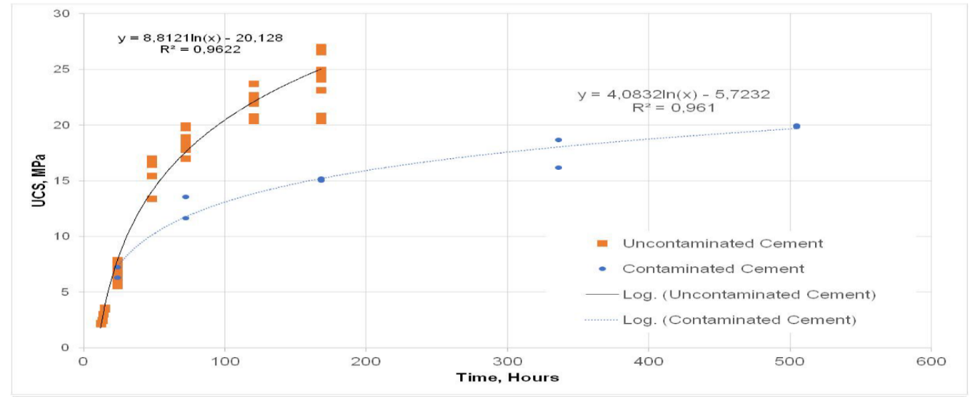

Figure 18: UCS vs Time taken from Olteanu et al. 2020
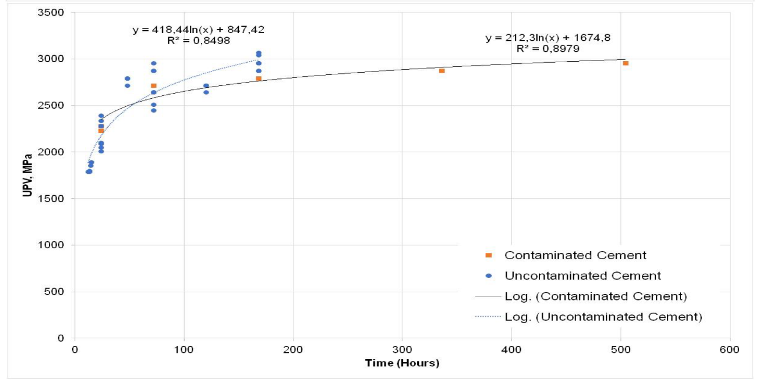

Figure 19: UPV vs Time taken from Olteanu et al. 2020
Table 15: Correlations obtained for Class C cement (Olteanu et al. 2020)
Correlation | Equation | R²
UCS vs. UPV (uncontaminated) | Y = 0.1392e^{0.0018×} | 0.9115
UCS vs. UPV (contaminated) | Y = 0.2094e^{0.0015×} | 0.9758
UCS vs. UPV (uncontaminated–thermal cycles) | Y = 0.2879e^{0.0016×} | 0.9856

This is the only study that looks at the long-term effect of OBM contamination on strength development of cement slurries and provides correlations. Only drawback is that the experiments were performed at room temperature.

Summary
The objective of the abovementioned case studies was to understand the effect of OBM on the mechanical and rheological properties of cement slurries and/or to understand the mechanism behind the reduction in mechanical and rheological properties of cement slurries contaminated with OBM. Upon comparing these studies, differences in the sample preparation methods and testing procedure of the samples are evident. The type of API cement, additives, type and amount of OBM contamination, curing time, curing temperature and pressure differs from one group to another.
Inadequate information on sample preparations is evident in the literature - few research groups have not mentioned whether the OBM contamination is by weight of cement or by volume of cement. Moreover, others have not mentioned if the OBM is added to standard cement slurry compositions or if OBM is replaced by equal volumes of cement slurry. Few groups follow the API 10D recommendations to prepare the 2″ × 2″ samples for measuring the UCS, others have not specified the dimensions of the samples. Also, many groups have not specified the number of samples prepared and tested to prove the accuracy of their UCS results.
It can be seen from studies carried out two decades ago that the OBM composition hinders the mechanical properties of cement slurries. Inadequate information about the OBM used in the study makes the results obtained from the study invalid for comparison. It is seen that the reduction in the mechanical properties depend on the testing temperature and pressure for a given class of cement and curing time. Differences in the composition of OBM used along with the differences in curing time, temperature and pressure makes it difficult to compare and validate the results obtained by different research groups.
In study performed by Aughenbaugh et al., 2014, it is also seen that for the same class of cement (H-1 and H-2) under the same testing conditions and the same OBM contamination, different results were obtained and the reason for this is unclear. Furthermore, the long-term effect on the mechanical properties of contaminated slurries is examined by very few research groups. The limitation with long-term tests is to maintain the same pressure and (elevated) temperature over a longer duration. Research has been done on the rheological properties, but due to inadequate information provided in the literature, it becomes difficult to draw conclusions.
Romanowski et al., 2018 have presented destructive and non-destructive tests carried out to determine the relationship between the unconfined compressive strength (UCS) and the ultrasonic pulse velocity (UPV) in the presence of additives. Three cement compositions tested in this study were API Class G cement, API Class G cement and 4% Bentonite, and API Class G cement and 10% Bentonite. The prepared samples were cured at atmospheric pressure and temperature for 1, 3, 7, 21, 30, 40, 70 and 150 days. Figure 20 shows the results obtained in this study and Figure 21 shows the comparison of the correlations obtained in this study with the previous work done on the same topic. Similar to the findings of Olteanu and Teodoriu, 2020, Romanowski et al., 2018 specifically indicated that additives may change the UPV vs. UCS response and, thus, if the correlation equation is not known, the results of various researchers cannot be compared accurately.
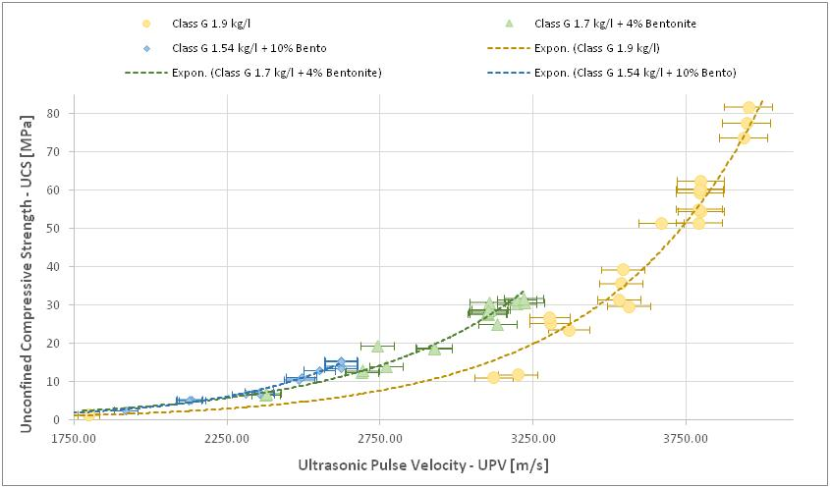

Figure 20: UCS vs UPV (Romanowski et al. 2018)

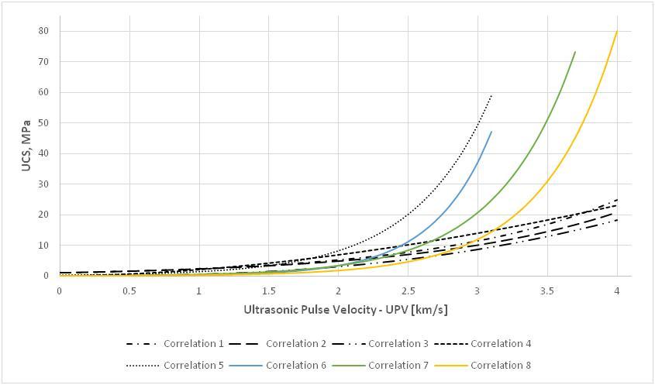

Figure 21: Graphic comparison of UCS vs UPV correlations (Romanowski et al. 2018)

A lot of effort has been undertaken recently to understand the mechanism of changes in mechanical and rheological properties of OBM-contaminated cement slurries. Shortcomings like the lack of standardization in testing methods for OBM-contaminated cement slurries and inadequate information provided in the literature made it difficult to compare the results. It is evident that the mechanical properties of cement slurries decrease with an increase in contamination. However, the reduction in mechanical properties is different for the same classes of cement in similar conditions. The data found in the literature show that oil contamination may alter the cement mechanical properties by up to 50% if even a small amount of contaminant is trapped in the cement. This could have a catastrophic impact on well integrity.
Note: Refer Appendix A for tabulated comparison of the 11 case studies mentioned in this chapter.

CHAPTER 3: MATERIALS & METHODS
This section summarizes the experimental methodology and the materials used in this study.

Methodology
Figure 22 shows the steps involved in this study. The first step is to prepare the samples following the API guidelines. Once the samples are prepared, density measurement and dimensional analysis are carried out to check the consistency of the samples prepared. If the samples are within the acceptable range, the non- destructive, as well as destructive tests, are performed to measure the UPV and UCS, respectively. The samples are prepared again if they are not in the acceptable range to ensure a reliable dataset for future references.

Figure 22: Experimental methodology

The details of each step are discussed in the following subsections.

Sample Preparation

Mold Preparation
3-gang parallel stainless steel 2” cube molds (figure 23) supporting ASTM C109, AASHTO T71, and AASHTO T106 standards were used for preparing the cement samples. The base plate is detachable and consists of stud threads. Molds are fitted with angles that attach to the stud threads (Humboldt Catalog, 2020). These cubes were lightly greased with dope to ensure the easy removal of cement samples from the molds.
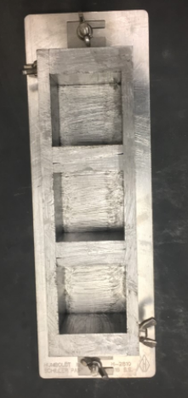
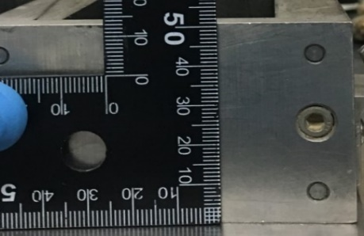
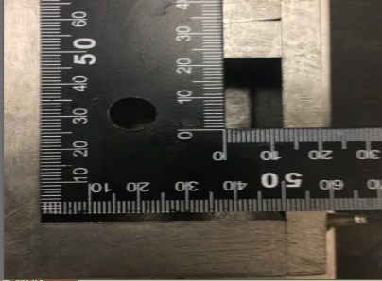
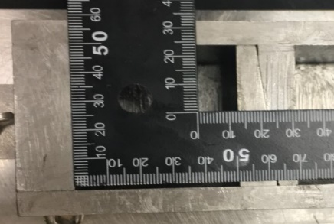

Figure 23: 2” Cube Mold by Humboldt

Cement
This study was extensively carried out on API Class C and H cement slurries. The cement types were purchased from a vendor in Tulsa. Class H cement is widely used in the industry and find its applications in several harsh conditions like deepwater drilling environments, HPHT drilling, etc. Class C cement is generally used in shallow wells as well as in underground storage applications, especially when drilling through salt.

OBM
OBM which acts as a contaminant in this study was obtained from a local operator in Oklahoma. The composition of 8.4 ppg OBM was as follows: Diesel oil (73%), Water (19.6%), and Solids (7.4%). Petro-Mul was used as the primary emulsifier in combination with Petro-wet as the secondary emulsifier (Petro-Mul Primary Emulsifier - Datasheet, n.d.). The amount of OBM contaminations tested in this study are 0.8%, 1.6%, 3.2%, and 6.3%. This percentage is calculated with respect to the total volume of the cement slurry (equation 1).

Equation 1: For Calculating %OBM Contamination
$$\% OBM Contamination= \frac{Volume of OBM *100}{ Total volume of recipe}$$

The reason for studying the effect of low OBM contaminations on the strength development of API cement slurries is that the mud displacement efficiency is never 100% even after the application of best industry practices (Dupriest et al., 2012; Sweatman et al., 2015). When water-based drilling muds are in use, small quantities of oil-based products are used to improve lubrication properties. They will be however found in small amounts during the cementing process.

Slurry Recipe
In this research study, a total of 10 different recipes of OBM contaminated Class C and Class H cement slurries were tested. Distilled water was used for slurry preparation. Cement slurry with 0% OBM contamination refers to neat cement slurries which act as a reference point to understand the behavior of OBM contaminated cement samples. The detailed composition of each recipe is shown in table 16 which includes the weight of cement (M_{c}), the weight of water (M_{w}), the weight of OBM (W_{OBM}), the total weight of slurry (M_{Total}), the volume of OBM (V_{OBM}), the total volume of slurry (V_{Total}), etc. Digital weighing scales were used to accurately measure the weight of cement, water, and OBM. Slurries were contaminated with OBM using a 5 ml scoop i.e. 0.8% OBM contaminated slurries consist of 1 scoop or 5 ml OBM, 1.6% OBM contaminated slurries consist of 2 scoops or 10 ml OBM, and so on.
Table 16: Cement Recipe - Composition
Slurry Name | M_{c} (gms) | M_{w} (gms) | M_{OBM} (gms) | M_{Total} (gms) | V_{Cement+Water} (ml) | V_{OBM} (ml) | V_{Total} (ml) | Density (SG)
Class C + 0% OBM | 683 | 382.48 | 0 | 1065.48 | 600 | 0 | 600 | 1.776
Class C + 0.8% OBM | 683 | 382.48 | 6 | 1071.48 | 600 | 5 | 605 | 1.771
Class C + 1.6% OBM | 683 | 382.48 | 12 | 1077.48 | 600 | 10 | 610 | 1.766
Class C + 3.2% OBM | 683 | 382.48 | 24 | 1089.48 | 600 | 20 | 620 | 1.757
Class C + 6.3% OBM | 683 | 382.48 | 48 | 1113.48 | 600 | 40 | 640 | 1.740
Class H + 0% OBM | 860.26 | 326.9 | 0 | 1187.16 | 600 | 0 | 600 | 1.979
Class H + 0.8% OBM | 860.26 | 326.9 | 6 | 1193.16 | 600 | 5 | 605 | 1.972
Class H + 1.6% OBM | 860.26 | 326.9 | 12 | 1199.16 | 600 | 10 | 610 | 1.966
Class H + 3.2% OBM | 860.26 | 326.9 | 24 | 1211.16 | 600 | 20 | 620 | 1.953
Class H + 6.3% OBM | 860.26 | 326.9 | 48 | 1235.16 | 600 | 40 | 640 | 1.930

Mixing Procedure
The slurries were prepared following the API 10B: Recommended Practice for Testing Well Cements, 2000. OFITE - Model 20 Constant Speed Blender which conforms to API Specifications (OFITE, 2018) is used in this study. The functionality of the blender was tested prior to mixing all cement slurries. The procedure for preparing neat Class C cement slurry is as follows. 382.48 grams of distilled water was poured in the mixing cup and 683 grams of Class C cement was taken in a container as shown in figure 24. According to API Specifications, the cement must be added to the mixing cup with distilled water within the first 15 seconds when the motor of the blender runs at a constant rotational speed of 4000 RPM. Three samples of 2” dimensions can be prepared from one mix.
A small modification was made to prepare the OBM Contaminated cement slurries. The amount of OBM specified in table 16 was mixed with distilled water prior to testing the functionality of the blender mixer. This is done to simulate downhole conditions. The cement has a higher density than the mud which is used for drilling the hole section. When cement displaces the mud, some of the slurry bypasses the lighter mud and two fluid columns of different densities are formed. They will mix together to form a mixture of uniform density (Beach and Goins, 1957).
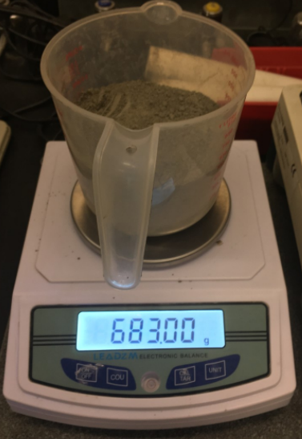
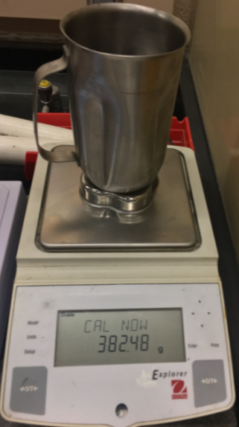
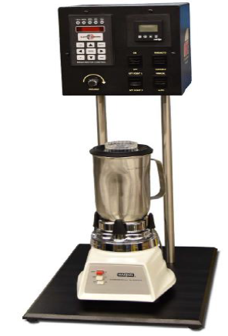

Figure 24: Digital Weighing scales and OFITE Model 20 Constant Speed Blender (OFITE Manual)

Curing Process
The cement slurry prepared following the API guidelines was poured into the lightly greased molds with constant speed till they were half-filled. The molds were gently tapped to remove the trapped air bubbles (if any), followed by pouring the remaining slurries till it reaches the top of the molds. The molds were then placed in water baths filled with distilled water to cure at two different curing temperatures of 25℃ and 75℃. The system was not pressurized or in other words, samples were cured at ambient pressure. PrecisionTM Thermo Scientific water baths were used to cure the samples at elevated temperatures.
The number of wells that need to be permanently abandoned is increasing every year. In the coming decade, more than 2000 wells will be permanently abandoned alone in the North Sea. In offshore wells, ‘Surface Plug’ is a mandatory barrier to prevent any potential leakage to the environment as per the NORSOK D-010 standard (Vrålstad et al., 2019). The results obtained from the samples cured at room temperature can act as a reliable reference to determine the strength of these surface plugs.

Sample Approval

Sample Quality Control Process
Cement samples were carefully removed from the molds once they were cured. Pittsburgh digital caliper was used to measure the length and width of the prepared cement samples. Three readings each of length (L1, L2, and L3) and width (W1, W2, and W3) were taken as shown in figure 25. The average of the three readings was used for calculations of UCS to get accurate readings (Romanowski et al., 2018).
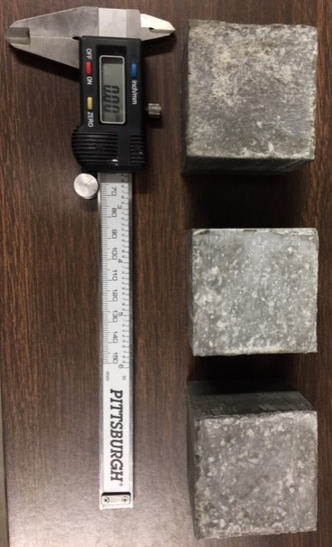
L1
L2
L3
W1
W2
W3

Figure 25: Length & Width Measurements of Cement Samples

As 2” molds were used to prepare the samples, the dimensions of the samples are expected to be 2” (50.8 mm) with an error margin of ±0.2 mm. The samples were rejected and prepared again if the dimensions were greater than 51 mm and/or less than 50.6 mm which ensured the consistency in sample preparation.

Density Measurement
The density of the cement samples is measured by applying the Buoyancy method – Archimedes’ principle. Prior to performing any tests on the samples, the weight of the samples in air (A) and in water (B) was measured using the automatic density balance as shown in figure 26. This was then used to calculate the bulk density of the samples using the formula given in equation 2 where D_{w} is density of water and D_{a} is density of air. This data will be helpful in eliminating the outliers or anomalies.
Equation 2: Bulk density of Samples
$$Bulk Density of Samples = \frac{A*(D_{w}-D_{a}) }{A-B}+ D_{a}$$
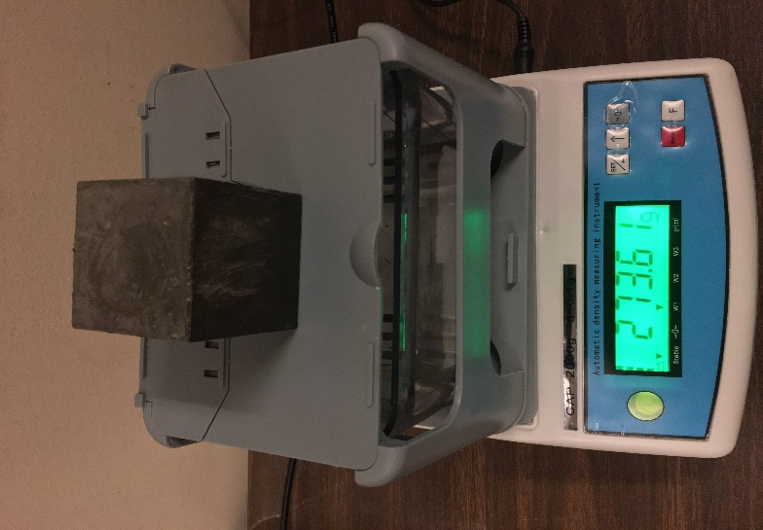
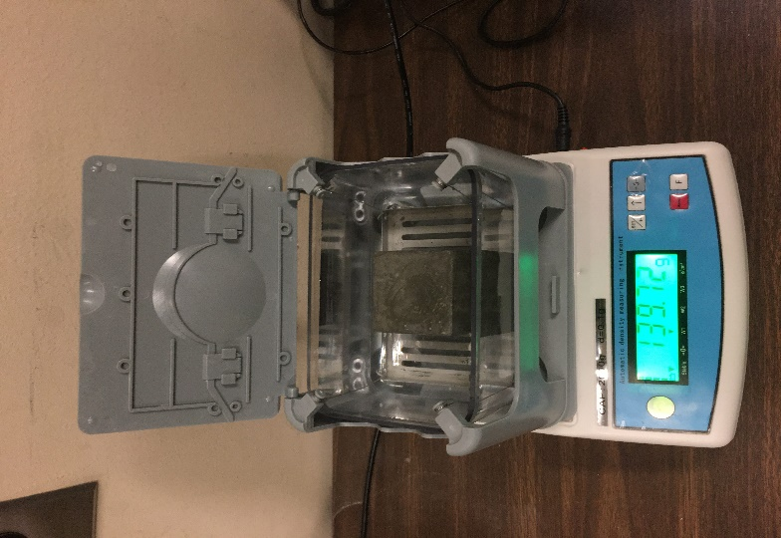

Figure 26: Density Measurement

Non- Destructive Tests
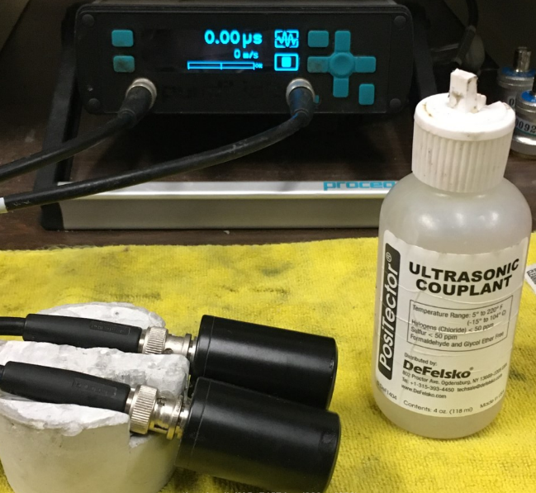
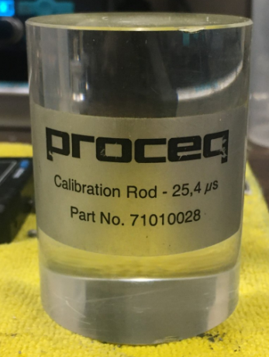
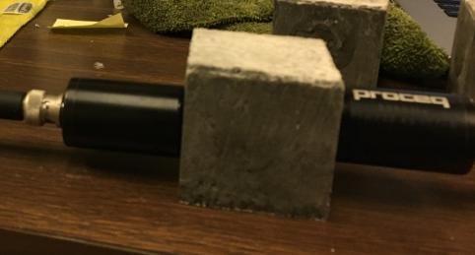
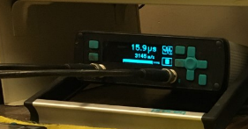

Figure 27: ProceqTM Ultrasonic device, PosiTectorTM Ultrasonic couplant, Calibration Rod
Non-destructive tests were performed using the ProceqTM Ultrasonic device which has an accuracy of ± 2%. PosiTectorTM Ultrasonic couplant was applied to both the transducers to measure the UPV values. Every time prior to measuring the UPV values the system was calibrated using the calibration rod (figure 27).

Destructive Tests
Destructive tests were performed using the Test Mark Compressive Strength test machine once the UPV values were measured. Cement samples were placed between the plates as shown in figure 28. Dimensions of the cement samples were entered using the digital screen and load is applied uniaxial on the cement samples. The device calculates the UCS with an accuracy of ± 0.5% and displays it directly on the screen.
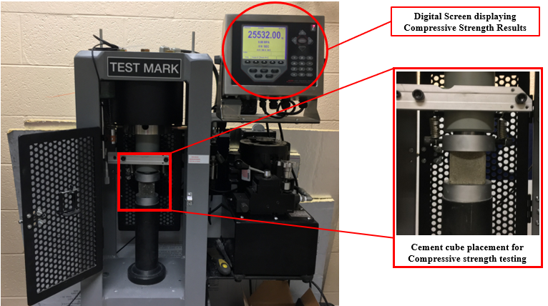

Figure 28: Test Mark Compressive Strength Test Machine

The UCS is calculated based on the equation 3 which is as follows –

Equation 3: UCS Calculation
$$UCS= \frac{Maximum Force Applied }{Area in complete contact with the load bearing plate of the load frame}$$

Data Analysis
The data obtained from the experiments were tabulated on MS-Excel workbooks. Data Analysis add-in feature was used to perform the regression analysis. The results acquired and the correlations developed from this study are presented in chapter 4.

Sample Matrix & Nomenclature
The variation of time, temperature and OBM contamination was evaluated on Class C & H cement samples. Table 17 shows the nomenclature used for the discussions and formal analysis of the dataset. For example, 0% OBM C25 Samples refers to Class C samples with 0% OBM contamination cured at 25℃.
Table 17: Nomenclature – Cement Samples
Nomenclature | Description
C25 | Class C Samples cured at 25℃
C75 | Class C Samples cured at 75℃
H25 | Class H Samples cured at 25℃
H75 | Class H Samples cured at 75℃
0% OBM | 0% OBM Contamination by volume of slurry
0.8% OBM | 0.8% OBM Contamination by volume of slurry
1.6% OBM | 1.6% OBM Contamination by volume of slurry
3.2% OBM | 3.2% OBM Contamination by volume of slurry
6.3% OBM | 6.3% OBM Contamination by volume of slurry

Sample matrix refers to the number of samples prepared for each variation in time, temperature and OBM contamination on Class C & H cement samples. The color coding followed by sample matrix is listed in table 18.
Table 18: Legend for All Sample Matrix
Legend for All Sample Matrix
Successfully Tested
Did not Develop Enough Strength
Did not Prepare

Table 19, 20, 21, 22 shows the sample matrix i.e. the number of samples prepared for Class C & H samples based on their curing conditions.
Table 19: C25 Sample Matrix
C25 Sample Matrix
Type/Duration | 0.33 Day | 1 Day | 3 Days | 7 Days | 14 Days | 28 Days | 184 Days | 384 Days
0%OBM C25 | 3 | 22 | 9 | 6 | 3 | 3 | 3 | 6
0.8%OBM C25 | 3 | 6 | 3 | 3 | 3 | 3 | 3 | 3
1.6%OBM C25 | 3 | 3 | 3 | 3 | 3 |  | 3 | 3
3.2%OBM C25 | 3 | 3 | 3 | 3 | 3 |  | 3 | 3
6.3%OBM C25 | 3 | 3 | 3 | 3 | 3 |  | 3 | 3

Table 20: C75 Sample Matrix
C75 Sample Matrix
Type/Duration | 0.17 Day | 0.25 Day | 0.33 Day | 1 Day | 3 Days | 7 Days | 28 Days
0%OBM C75 | 3 | 3 | 3 | 19 | 3 | 9 | 3
0.8%OBM C75 | 3 | 6 | 3 | 3 | 3 | 3 | 3
3.2%OBM C75 | 3 | 3 | 3 | 3 | 3 | 3

Table 21: H25 Sample Matrix
H25 Sample Matrix
Type/Duration | 1Day | 3 Days | 7 Days | 14 Days | 28 Days
0%OBM H25 | 3 | 3 | 6 | 3 | 3
0.8%OBM H25 | 3 | 3 | 3 | 3 | 3
1.6%OBM H25 | 3 | 3 | 3 | 3 | 3
3.2%OBM H25 | 3 | 3 | 3 | 3 | 3
6.3%OBM H25 | 3 | 3 | 3 | 3 | 3

Table 22: H75 Sample Matrix
H75 Sample Matrix
Type/Duration | 0.17 Day | 0.25 Day | 0.33 Day | 1 Day | 3 Days | 7 Days
0%OBM H75 | 3 | 3 | 3 | 3 | 3 | 3
0.8%OBM H75 | 3 | 3 | 3 | 3 | 3 | 3
3.2%OBM H75 | 3 | 3 | 3 | 3 | 3 | 3

CHAPTER 4: RESULTS & DATA ANALYSIS
A total of 362 samples were prepared, cured, and tested by following the procedures mentioned in the previous chapter. The results from these tests are presented in this chapter.

Sample Quality Control Analysis
UCS measured by the compression test machine is calculated by dividing the maximum applied force on the cement sample by the area of the cement sample. As the UCS depends on the area of the cement samples, any error in measurement of the sample dimension will lead to an inaccurate reading of the UCS. Hence, the sample quality control analysis minimizes the error translation in UCS measurement and acts as an important step before performing any test on the samples.
Figure 29 shows the box and whisker plots for the length and width of 184 Class C cement samples. Similarly, figure 30 shows the sample quality control results for 166 Class H cement samples. The median for length and width of Class C samples is around 50.9 mm whereas the median for length and width of Class H samples is between 50.85 to 50.9 mm.

Figure 29: Sample Quality Control for Class C Samples

Figure 30: Sample Quality Control for Class H Samples
The number of outliers is less than 2% of the total samples prepared i.e. fewer than 10 samples were rejected and prepared again based on their dimensions. This can be seen from figure 29 and 30. The dots lying outside of the green boxes are the outliers which were rejected.

Density Analysis
Figure 31 illustrates the box and whisker plots for the bulk density of H25 samples.

Figure 31: Bulk Density of H25 Samples

Similarly, figure 32 shows the box and whisker plots for the bulk density of H75 samples. As expected, it is evident that as the OBM contamination increases the density of the cement samples decreases.

Figure 32: Specific Gravity of Class H Cement Samples

Destructive Test Analysis
The experiment was divided into four phases. The first phase of the experiment was to prepare C25 samples for all OBM contaminations (0%, 0.8%, 1.6%, 3.2%, and 6.3%) and cure them for 8 hours, 1, 3, 7, 14 days. As mentioned in section 3.2.5, three samples for each curing condition were prepared and tested. The results presented in sections 4.3 and 4.4 are the average values of the UCS and the UPV for the three samples cured at each condition. This is done to understand the general trend of the results. However, for the regression analysis in section 4.5, the actual values are used and not these average values. Figure 33 shows the average UCS values for phase one tests.
The OBM contaminated C25 samples did not develop enough strength for the tests to be performed on them after 8 hours of curing. The average UCS of the 0%OBM C25 samples after 8 hours of curing was 1.13 MPa. For the early curing time of 1 day, there is not much difference between the average UCS of the contaminated and uncontaminated C25 samples. However, the detrimental effect of OBM contamination is visible as the curing time increases. The reduction in strength of 6.3%OBM C25 samples with respect to 0%OBM C25 samples after 14 days of curing was 40%. The results obtained from phase one tests are similar to results published by Olteanu and Teodoriu, 2020.

Figure 33: Average UCS – C25 Samples

Phase two of the study involved repeating the same experiments for H25 Samples. Figure 34 shows the results from the phase 2 tests. For the early curing time of 1 to 7 days, some of the OBM contaminated H25 samples showed better results as compared to the 0%OBM H25 samples. The strength reduction for 0.8%OBM H25, 1.6%OBM H25, 3.2% OBM H25, 6.3%OBM H25 samples with respect to 0%OBM H25 samples for 28 days of curing was 13%, 11%, 17%, 31%, respectively.
The early curing time results are contradictory to the results published by Vipulanandan et al., 2014 for similar curing conditions. However, the 28-day curing results are similar to the findings of this study. Vipulanandan et al., 2014 reported 25% and 35% UCS reduction after 28 days of curing for 0.1% and 3% OBM contaminated Class H cement slurries, respectively.

Figure 34: Average UCS – H25 Samples
After a detailed analysis of the phase one and two results, it was decided to evaluate the effect of 0%OBM, 0.8% OBM, and 3.2%OBM contaminations at elevated temperatures of 75℃ as similar results were obtained for 0.8% & 1.6% OBM contamination. Another reason for doing this was the availability of OBM and wanted to use the same OBM for the entire study. So, phase three of the study involved preparation and testing of C75 samples for 0%OBM, 0.8% OBM, and 3.2%OBM contaminations cured for 0.17, 0.25, 0.33, 1, 3, 7 days. Figure 35 displays the phase three test results. As higher curing temperature accelerates the hydration reaction, it was possible to measure the UCS for early curing time of 4, 6, 8 hours.

Figure 35: Average UCS – C75 Samples
The harmful effect of OBM contamination on the strength development of API cement was clearly evident at an elevated temperature of 75℃. The strength reduction for 3.2%OBM C75 samples with respect to 0%OBM C75 samples was 52% for 1 day curing and 30% for 4 hours curing. However, the early curing results for 0.8% OBM C75 samples showed an increase in strength by 6% as compared to 0%OBM C75 samples cured for 8 hours. Aughenbaugh et al., 2014 reported 43% strength reduction for C1 slurry cured for 2 days at 76.67℃.
Phase four of the study focused on evaluating the effect of elevated temperature on OBM contaminated Class H slurries. 0%OBM H75, 0.8%OBM H75, and 3.2%OBM H75 samples were prepared and cured for 0.17, 0.25, 0.33, 1, 3, 7 days. Figure 36 shows the results of phase four tests.

Figure 36: Average UCS – H75 Samples
The strength reduction was 39% for 3.2%OBM H75 samples cured for 7 days as compared to 0%OBM H75 samples and 26% for 4 hours curing. Salehi et al., 2016 reported 35% and 88% strength reduction for 5% and 10% OBM contaminated Class H slurries cured for 2 days at 65°C, respectively. Aughenbaugh et al., 2014 stated 31% and 45% strength reduction for H1 & H2 slurry cured for 2 days at 76.67℃, respectively. Findings from this study suggest 27% and 33% strength reduction for 3.2%OBM H75 samples when compared to 0%OBM H75 samples.
For better visualization of the effect of OBM contamination on strength development, figures 37, 38, 39, 40 show the average UCS vs %OBM contamination charts of C25, H25, C75, H75 samples, respectively.

Figure 37: Average UCS vs %OBM Contamination – C25 Samples

Figure 38: Average UCS vs %OBM Contamination – H25 Samples

Figure 39: Average UCS vs %OBM Contamination – C75 Samples

Figure 40: Average UCS vs %OBM Contamination – H75 Samples
The importance of understanding the long-term effect of OBM contamination on cement integrity is visible from figures 37, 38, 39, 40. The early curing time strength development results of OBM contaminated cement slurries can be misleading. Further, more research studies focusing on the strength development of low OBM contaminated cement slurries should be performed to better understand the phenomenon.

Non-Destructive Test Analysis
Once the well is cemented, the strength of the cement cannot be measured using the destructive tests. Non-destructive tests or the ultrasonic measurements of cement gained popularity in the oil and gas industry to understand the strength development of the cement samples. Reliable correlations between the UCS and ultrasonic response are necessary to predict the strength developed by the cement. Figure 41, 42, 43, 44 shows the average UPV values for C25, H25, C75, H75 samples, respectively.

Figure 41: Average UPV - C25 Samples

Figure 42: Average UPV - H25 Samples

Figure 43: Average UPV – C75 Samples

Figure 44: Average UPV – H75 Samples
On comparing the UPV response for all the samples, the uncertainty in the UPV response as noted by Olteanu and Teodoriu, 2020 is clearly visible. For the early curing time, the contaminated C75 samples showed better UPV response than the neat C75 samples. This is contradictory to the UCS responses for the same samples. This uncertainty in ultrasonic measurements can be the reason for the huge difference in strength reduction obtained from UCA results and destructive test results reported by Aughenbaugh et al., 2014 (table 5 & 6).

Regression Analysis
The UCS values were plotted against the curing duration for all the samples tested in this study. Figures 45, 46, 47, 48 show the UCS values for C25, H25, C75, H75 samples, respectively. Data analysis add-in of MS-excel was used for curved fitting and regression analysis. The logarithmic trend line was best fit for UCS vs age plots. R² coefficients were greater than 0.9 for C25 and H25 correlations.

Figure 45: UCS vs Age – C25 Samples

Figure 46: UCS vs Age – H25 Samples

Figure 47: UCS vs Age – C75 Samples

Figure 48: UCS vs Age – H75 Samples

Figures 49, 50, 51, 52 displays the UPV vs UCS trends for C25, H25, C75, H75 samples, respectively. The exponential trend line was best fitted with R² coefficients were greater than 0.9 for all samples except for 0.8%OBM C75 samples where it was greater than 0.8.

Figure 49: UCS vs UPV – C25 Samples

Figure 50: UCS vs UPV – H25 Samples

Figure 51: UCS vs UPV – C75 Samples

Figure 52: UCS vs UPV – H75 Samples
Correlations developed in this study for the low OBM contaminated cement samples are the first ones to be published. As these correlations are developed after widespread testing of samples, they are more accurate than the ones published by Olteanu and Teodoriu, 2020.

Error Sensitivity Analysis
The error sensitivity analysis of the developed correlations was performed by plotting the calculated UCS values against the measured UCS values. The UCS values were calculated using both the correlations – UCS vs Age, UCS vs UPV. Figures 53, 54, 55, 56 present the error sensitivity analysis for C25, H25, C75, H75 samples contaminated with 3.2%OBM.

Figure 53: Error Sensitivity analysis of Correlations developed for 3.2%OBM C25 Samples

Figure 54: Error Sensitivity analysis of Correlations developed for 3.2%OBM H25 Samples

Figure 55: Error Sensitivity analysis of Correlations developed for 3.2%OBM C75 Samples

Figure 56: Error Sensitivity analysis of Correlations developed for 3.2%OBM H75 Samples

1v1 line acts as a visual reference to understand the UCS prediction using the developed correlations. If the points lie above the line, then the correlation overestimates the UCS values. Similarly, if the points lie below the 1v1 line then the correlation underestimates the UCS values.
Note: Refer to Appendix B for error sensitivity analysis for all the correlations developed in this study.

UCA Calibration Curves for Low OBM Contamination
All the samples tested in this study were divided into two categories based on their contamination i.e. neat samples and OBM contaminated samples. Regression analysis was performed to develop 1 correlation (UCS vs UPV) for the all the OBM contaminated samples cured at the same temperature. Figure 57 & 58 shows the UCS vs UPV response for neat as well as OBM contaminated Class C and Class H samples, respectively.

Figure 57: Calibration Curves for UCA – Class C

The R² coefficient for the novel calibration curves developed in this study are greater than 0.9 except for OBM contaminated C75 samples. The error sensitivity analysis for these calibration curves are presented in figures 59, 60, 61, 62. It is evident that for OBM contaminated class C samples these calibration curves overestimates the UCS values for both the curing conditions of 25ºC and 75ºC while the UCS values for neat class C samples are underestimated. On the other hand, the UCS values for both neat and OBM contaminated Class H samples are underestimated by this calibration curves for both the curing conditions of 25ºC and 75ºC.

Figure 58: Calibration Curves for UCA – Class H

Figure 59: Error Sensitivity Analysis - UCA Calibration Curves C25

Figure 60: Error Sensitivity Analysis - UCA Calibration Curves C75

Figure 61: Error Sensitivity Analysis - UCA Calibration Curves H25

Figure 62: Error Sensitivity Analysis - UCA Calibration Curves H75

Effect of Temperature on Curing Results
Elkhadiri et al., 2009 performed a detailed study to evaluate the effect of temperature on curing time and cement hydration. The study was performed on two types of Spanish cements cured for 2, 7, 15, and 28 days at temperatures ranging from 4℃ to 85℃. The study concluded that the early age hydration rate increases with an increase in curing temperature, but it decreases the long-term integrity of the cement samples. Figure 63 shows the strength development of the two Spanish cements at 22℃ to 85℃.

Figure 63: Effect of temperature on cement hydration after Elkhadiri et al. 2009
Similar results were found in this study when we compare the results for C25 and C75 samples. Figure 64 shows the strength development for 0%OBM, 0.8% OBM contaminated C25, and C75 samples cured for 28 days. It is observed that C25 cement samples continue to develop strength even after 28 days of curing whereas the C75 samples have high strength for shorter curing time and it decreases as the curing time increases. The effect of temperature on strength development makes it difficult to quantify the strength reduction by OBM contamination alone. Laboratory tests must be performed on OBM contaminated cement slurries based on the temperature profile of the well. This provide a better prediction of the cement strength.

Figure 64: UCS Development – C25 vs C75 (0%OBM & 0.8%OBM Contaminated Samples)
The decision was made to cure the C25 samples for a longer curing time of 6 months and 1 year to witness the increase in the strength of contaminated as well as uncontaminated cement slurries. Figure 65 shows the long-term strength development results for C25 samples. The strength remains constant or declines after 6 months of curing for C25 samples.

Figure 65: Long Term Strength – C25 Samples

Summary
The summary of percentage strength reduction for OBM contaminated C25, C75, H25, H75 samples with respect to neat cement samples are provided in tables 18,19,20,21, respectively.
Table 23: Percent Strength Reduction for OBM Contaminated C25 Samples
 | 1 Day | 3 Days | 7 Days | 14 Days | 28 Days | 184 Days | 384 Days
0.8%OBM C25 | 6% | 31% | 7% | 21% | 11% | 11% | 26%
1.6%OBM C25 | 8% | 27% | 15% | 22% | - | 31% | 40%
3.2%OBM C25 | 16% | 26% | 22% | 33% | 36% | 33% | 40%
6.3%OBM C25 | 16% | 33% | 28% | 40% | - | 34% | 42%

Table 24: Percent Strength Reduction for OBM Contaminated C75 Samples
 | 0.17 Day | 0.25 Day | 0.33 Day | 1 Day | 3 Days | 7 Days
0.8%OBM C75 | 16% | 1% | -6% | 35% | 38% | 40%
3.2%OBM C75 | 30% | 36% | 27% | 52% | 52% | 55%

Table 25: Percent Strength Reduction for OBM Contaminated H25 Samples
 | 1 Day | 3 Day | 7 Day | 14 day | 28 day
0.8%OBM H25 | 15% | 26% | -2% | 5% | 13%
1.6%OBM H25 | -13% | 0% | -6% | 10% | 11%
3.2%OBM H25 | -14% | 3% | 5% | 10% | 17%
6.3%OBM H25 | -13% | 13% | 10% | 24% | 31%

Table 26: Percent Strength Reduction for OBM Contaminated H75 Samples
 | 0.17 Day | 0.25 Day | 0.33 Day | 1 Day | 3 Days | 7 Days
0.8%OBM H75 | 7% | 14% | 6% | 15% | 12% | 23%
3.2%OBM H75 | 26% | 29% | 28% | 27% | 33% | 39%

The correlations for the strength development of OBM contaminated and neat cement slurries developed in this study are presented in tables 22, 23. The units for UCS and time in these correlations are MPa and Days.
The major contribution of this study is the UCS vs UPV correlations developed for the cement slurries tested in the study. These novel correlations are presented in tables 24 & 25. UCS in these correlations is in MPa and UPV is in m/sec.
Table 27: UCS vs Curing Time Correlations – Class C Samples
Slurry Type | UCS (MPa) & Curing time t (day) - Correlations | R² Value
0%OBM C25 | UCS = 9.7067*ln(t)+ 9.6815 | 0.9645
0.8%OBM C25 | UCS = 7.9187*ln(t)+ 8.1474 | 0.9888
1.6%OBM C25 | UCS = 7.6331*ln(t)+ 8.1258 | 0.9964
3.2%OBM C25 | UCS = 6.3547*ln(t)+ 8.2657 | 0.9676
6.3%OBM C25 | UCS = 5.4365*ln(t)+ 8.1344 | 0.9719
0%OBM C75 | UCS = 5.1721*ln(t)+ 21.199 | 0.8733
0.8%OBM C75 | UCS = 2.1971*ln(t)+ 14.294 | 0.7272
3.2%OBM C75 | UCS = 1.8537*ln(t)+ 10.539 | 0.8006

Table 28: UCS vs Curing Time Correlations – Class H
Slurry Type | UCS (MPa) & Curing time t (day) - Correlations | R² Value
0%OBM H25 | UCS = 14.485*ln(t)+ 11.275 | 0.9313
0.8%OBM H25 | UCS = 13.837*ln(t)+ 9.4726 | 0.9879
1.6%OBM H25 | UCS = 12.104*ln(t)+ 14.958 | 0.9549
3.2%OBM H25 | UCS = 11.326*ln(t)+ 14.728 | 0.94
6.3%OBM H25 | UCS = 8.6835*ln(t)+ 15.138 | 0.9194
0%OBM H75 | UCS = 13.707*ln(t)+ 35.247 | 0.9535
0.8%OBM H75 | UCS = 11.156*ln(t)+ 30.161 | 0.9288
3.2%OBM H75 | UCS = 8.3624*ln(t)+ 23.729 | 0.887

Table 29: UCS vs UPV Correlations – Class C
Slurry Type | UCS (MPa) & UPV (m/sec) - Correlations | R² Value
0%OBM C25 | UCS = 0.0842*e^(0.0019*UPV) | 0.9162
0.8%OBM C25 | UCS = 0.5847*e^(0.0012*UPV) | 0.9345
1.6%OBM C25 | UCS = 0.7105*e^(0.0011*UPV) | 0.9316
3.2%OBM C25 | UCS = 0.8952*e^(0.001*UPV) | 0.9363
6.3%OBM C25 | UCS = 0.8768*e^(0.001*UPV) | 0.9466
0%OBM C75 | UCS = 0.0773*e^(0.002*UPV) | 0.9065
0.8%OBM C75 | UCS = 0.3574*e^(0.0015*UPV) | 0.8521
3.2%OBM C75 | UCS = 0.1683*e^(0.0017*UPV) | 0.9244

Table 30: UCS vs UPV Correlations – Class H
Slurry Type | UCS (MPa) & UPV (m/sec) - Correlations | R² Value
0%OBM H25 | UCS = 0.299*e^(0.0014*UPV) | 0.9907
0.8%OBM H25 | UCS = 0.2591*e^(0.0015*UPV) | 0.9935
1.6%OBM H25 | UCS = 0.3597*e^(0.0014*UPV) | 0.9969
3.2%OBM H25 | UCS = 0.3189*e^(0.0014*UPV) | 0.9904
6.3%OBM H25 | UCS = 0.2721*e^(0.0015*UPV) | 0.9869
0%OBM H75 | UCS = 0.0773*e^(0.002*UPV) | 0.9065
0.8%OBM H75 | UCS = 0.1679*e^(0.0017*UPV) | 0.9806
3.2%OBM H75 | UCS = 0.1667*e^(0.0017*UPV) | 0.9927

CHAPTER 5: CONCLUSIONS
This study focused on evaluating the effect of low OBM contamination on long-term strength development of API Class C and H cement slurries cured at atmospheric conditions and elevated temperature of 75℃.
- A standard experimental procedure was developed and documented for laboratory testing of OBM contaminated cement slurries.
- The newly developed standard experimental procedure was followed to prepare, cure, and test a total of 359 samples.
- A reliable dataset of mechanical properties of OBM contaminated cement slurries was established for future references.
- The detrimental effect of temperature and low OBM contamination on strength development of Class C & H cement slurries was evaluated.
- The strength reduction as compared to neat cement slurries for -
  - 0.8% OBM C75 samples was 40% after 7 days of curing.
  - 3.2% OBM C75 samples was 55% after 7 days of curing.
  - 0.8% OBM H75 samples was 23% after 7 days of curing.
  - 3.2% OBM H75 samples was 39% after 7 days of curing.
- The strength reduction as compared to neat cement slurries for
  - 0.8% OBM C25 samples was 26% after 364 days of curing.
  - 1.6% OBM C25 samples was 40% after 364 days of curing.
  - 3.2% OBM C25 samples was 40% after 364 days of curing.
  - 6.3% OBM C25 samples was 42% after 364 days of curing.
- Novel correlations for UCS vs Age & UCS vs UPV were developed for both neat as well as OBM contaminated Class C & Class H cement slurries which show the importance of ultrasonic calibration curves for each cement additive or contaminant.
- UCA calibration curves for low OBM contamination are proposed.

CHAPTER 6: RECOMMENDATIONS
The novel correlations developed in this study can be used by the operators to predict the accurate strength of the cement sheath. It is recommended to test the strength development of OBM contaminated cement slurries in the laboratory using the testing procedures mentioned in this study. Also, the curing temperature plays a critical role in the strength development of both contaminated and uncontaminated cement slurries. Higher curing temperature gives higher early strength, but the long-term strength is highly compromised. So, it is advisable to test the cement slurries at a range of temperatures based on the expected temperature profile for the well. This will help in the accurate prediction of the cement wellbore integrity for the entire life cycle of the well.
The negative values in tables 19 & 20 indicate the strength for OBM contaminated cement slurries was greater than the strength developed by respective neat cement slurries. The reason for this is unclear and needs to be further investigated. Similar ambiguity was reported by Aughenbaugh et al., 2014 where the strength reduction was different for two Class H OBM contaminated cement slurries tested under the same conditions, by the same research group.
It is recommended to perform the destructive tests for measuring the accurate UCS values as the values acquired from UCA can be misleading (Aughenbaugh et al., 2014). Additionally, it is recommended to use the UCS vs UPV calibration curves developed in this study to calibrate the UCA for low OBM contamination.
Further research in this direction can be continued by extending the study –
- By performing the tests on other API Cements
- By varying the curing temperature
- By varying the curing pressure
- By varying the OBM type, density, etc.

REFERENCES
Abdulrazzaq, W., AlBuraikan, R., Savari, S., Whitfill, D.L., 2017. New methodology to evaluate the performance of chemical sealant loss circulation materials. Soc. Pet. Eng. - SPE Kuwait Oil Gas Show Conf. 2017. https://doi.org/10.2118/187598-ms
API 10B: Recommended Practice for Testing Well Cements, 2000.
Arbad, N., Teodoriu, C., 2020. A Review of Recent Research on Contamination of Oil Well Cement with Oil-based Drilling Fluid and the Need of New and Accurate Correlations. ChemEngineering 4, 28. https://doi.org/10.3390/chemengineering4020028
Aughenbaugh, K., Nair, S., Cowan, M., Van Oort, E., 2014. Contamination of deepwater well cementations by synthetic-based drilling fluids. Soc. Pet. Eng. - SPE Deep. Drill. Complet. Conf. 2014 767–777. https://doi.org/10.2118/170325-ms
Beach, H.J., Goins, W.C., 1957. A Method of Protecting Cements Against the Harmful Effects Of Mud Contamination. Trans. AIME 210, 148–152. https://doi.org/10.2118/679-g
Bourgoyne, A., Millheim, K., Chenevert, M., 1984. Applied Drilling Engineering.pdf.
Budiawan, A., Farahani, H.S., Anugrah, A., Brandl, A., 2014. Innovative Cement Spacer Improves Well Cementing Integrity - 60 Case 1–16.
Chambers, M.R., International, M., Services, D., Hebert, D.B., Shuchart, C.E., 2000. SPE 58743 Successful Application of Oil-based Drilling Fluids in Subsea Horizontal , Gravel-Packed Wells in West Africa.
Dupriest, F., Hutchison, I., Van Oort, E., Armstrong, N., 2012. Drilling Practices, in: IADC Drilling Manual. Houston, TX, pp. 1–497.
Elkhadiri, I., Elkhadiri, M., Puertas, F., 2009. Effect of curing temperature on cement hydration. Ceram. - Silikaty 53, 65–75.
Emadi, H., Soliman, M., Heinze, L., Moghaddam, R., Samuel, R., 2015. An Experimental Study of the Swelling Properties of Unconventional Shale-Oil Rock Samples Using both Water-Based and Oil-Based Muds and Effects of Invasion on Rock Mechanical Properties.
Fleming, N., Karunakaran, M., Hireche, S., 2019. Qualification and Implementation of Oil-Based Mud as a Cost-Effective and Low-Damaging Perforation Fluid for Gudrun Case History 7–9.
Fossum, P. V, Zwaag, C. Van Der, Taugbøl, K., Mjaaland, S., Sletfjerding, E., Høgstøl, H., Olsen, P.A., M-i, S., 2007. SPE 107754 Design and Utilization of Low Solids OBM for Aasgard Reservoir Drilling and Completion.
Garnier, A., Fraboulet, B., Bois, A., 2007. OTC 18754 Characterization of C ement S ystems to E nsure C ement S heath I ntegrity 1–11.
Goodwin, K.J., 1992. Guidelines for ultrasonic cement-sheath evaluation. SPE Prod. Eng. 7, 280–284. https://doi.org/10.2118/19538-PA
Harder, C., Carpenter, R., Wilson, W., Freeman, E., Payne, H., 1992. Surfactant/Cement Blends Improve Plugging Operations in Oil-Base Muds. https://doi.org/10.2523/23928-ms
Harder, C.A., Carpenter, R.B., Freeman, E.R., Brookey, T.E., Gandy, R.G., 1993. Optimization of oil-base mud chemistry for cementing. Proc. 1993 SPE Int. Symp. Oilf. Chem. 329–338. https://doi.org/10.2523/25183-ms
Harold, M., Pe, E.I.I.I., Partners, N.E., 2015. Case Study : Using Managed Pressure Drilling and Oil Based Mud to Efficiently Drill an Extremely Thick and Highly Fractured Carbonate Sequence Under an Extremely Thick and Highly Sensitive Laminated Shale.
Humboldt Catalog, 2020.
ISO, 2015. DRAFT INTERNATIONAL STANDARD ISO / DIS 16530-1 Petroleum and natural gas industries — Well integrity — Part 1 : Life cycle governance 2015.
ISO, 2013. TECHNICAL SPECIFICATION ISO/TS 16530-2 Well integrity — Part 2 : Well integrity for the operational phase 2013.
Kabanov, M., Telford, E., Gray, C., Hughes, B., 2014. Designing and Running a Special Oil-Based Mud for a North Sea HPHT Campaign Planning the Wells.
Katende, A., Lu, Y., Bunger, A., Radonjic, M., 2020. Experimental quantification of the effect of oil based drilling fluid contamination on properties of wellbore cement. J. Nat. Gas Sci. Eng. 79, 103328. https://doi.org/10.1016/j.jngse.2020.103328
Kiran, R., Teodoriu, C., Dadmohammadi, Y., Nygaard, R., Wood, D., Mokhtari, M., Salehi, S., 2017. Identification and evaluation of well integrity and causes of failure of well integrity barriers (A review). J. Nat. Gas Sci. Eng. 45, 511–526. https://doi.org/10.1016/j.jngse.2017.05.009
Li, M., Ou, H., Li, Z., Gu, T., Liu, H., Guo, X., 2015. Contamination of cement slurries with diesel-based drilling fluids in a shale gas well. J. Nat. Gas Sci. Eng. 27, 1312–1320. https://doi.org/10.1016/j.jngse.2015.08.010
Li, Z., Liu, H., Guo, X., Ou, H., Gu, T., 2016. Contamination of cement slurries with oil based mud and its components in cementing operations. J. Nat. Gas Sci. Eng. 29, 160–168. https://doi.org/10.1016/j.jngse.2016.01.003
McDaniel, J., Watters, L., Shadravan, A., 2014. Cernent sheath durability: Increasing cement sheath integrity to reduce gas migration in the marcellus shale play. Soc. Pet. Eng. - SPE Hydraul. Fract. Technol. Conf. 2014 904–916. https://doi.org/10.2118/0515-0129-jpt
Morgan, B.E., Dumbauld, G.K., 1952. Use of Activated Charcoal in Cement To Combat Effects of Contamination by Drilling Muds. J. Pet. Technol. 4, 225–232. https://doi.org/10.2118/952225-g
Morris, E.F., Aime, M., Motley, H.R., Div, D., Chemical, D., 1973. Oi I Base Spacer System Wells Containing Oil for Use in Cementing ‘ Base Drilling Muds.
OFITE, 2018. Model 20 Constant Speed Blender.
Olteanu, A., Teodoriu, C., 2020. Uncertainty in ultrasonic measurements of oil-based mud contaminated cement. Mater. Today Commun. 22, 100783. https://doi.org/10.1016/j.mtcomm.2019.100783
Patel, A.D., Wilson, J.M., Loughridge, B.W., Services, H.E., 1999. SPE 50726 Impact of Synthetic-Based Drilling Fluids on Oilwell Cementing Operations.
Petro-Mul Primary Emulsifier - Datasheet, n.d.
Rabia, H., 2002. Well Engineering & Construction Hussain Rabia 1 to 789.
RAO, P.P., SUTTON, D.L., CHILDS, J.D., CUNNINGHAM, W.C., 1982. Ultrasonic Device for Nondestructive Testing of Oilwell Cements At Elevated Temperatures and Pressures. Jpt J Pet Technol V 34, 2611–2616. https://doi.org/10.2118/9283-pa
Reddy, B.R., Santra, A., McMechan, D., Gray, D., Brenneis, C., Dunn, R., 2005. Cement mechanical property measurements under wellbore conditions. SPE Annu. Tech. Conf. Proc. 9–12.
Romanowski, N., Ichim, A., Teodoriu, C., 2018. Investigations on Oilwell Cement Strength Response to Ultrasonic Measurements in the Presence of Additives1. J. Sol. Energy Eng. Trans. ASME 140, 1–7. https://doi.org/10.1115/1.4039316
Salehi, S., Khattak, M.J., Rizvi, H., Karbalaei, S.F., Kiran, R., 2016. Sensitivity analysis of fly ash geopolymer cement slurries: Implications for oil and gas wells cementing applications. J. Nat. Gas Sci. Eng. 37, 116–125. https://doi.org/10.1016/j.jngse.2016.11.025
Schumacher, J.P., Bell, R.W., Morrison, S.E., Chan, A.F., Wydrinski, R., 1996. Improved Primary Cement Jobs through the use of unique spacer design technology: Gulf of Mexico Case History Study, in: SPE Annual Technical Conference Proceedings. Denver, Colorado, pp. 727–737.
Scott, P., Broussard, P., Freeman, M., Growcock, F., Bland, R., 2015. Drilling fluids Manual :12th Edition.
Sheer, S., Alotaibi, A., Gadhiya, K., Hughes, B., Al-khaldy, M., Abhijit, D., Al-failkawi, K., Al-saadi, D., Al-saeedi, A., Hamed, A., Al-azmi, F., 2019. SPE-198582-MS The Dynamics of Drilling with Oil-Based Mud, 60:40 Oil-Water Ratio – Case History in South East Kuwait Fields.
Sinha, P., Kumar, V., Prabhakaran, T., Katre, A., Patel, M., Doodraj, S., 2017. A More Holistic Approach to Determine Economics of Using Synthetic Oil Based Mud over Water Based Mud System in Onshore Development Drilling Onshore drilling history in Rajasthan.
Soares, A.A., Freitas, J.C. de O., Melo, D.M. de A., Braga, R.M., Amaral-Machado, L., Silva Santos, P.H., Soares, L.W.O., 2017. Cement slurry contamination with oil-based drilling fluids. J. Pet. Sci. Eng. 158, 433–440. https://doi.org/10.1016/j.petrol.2017.08.064
Sweatman, R., Baker, H.K., Badalamenti, A., Benge, G., Bone, L., Eid, R., Kutchko, B., La Fleur, K.K., Morgan, G., Mueller, D., Pickett, S., Sanchez, A., Stiles, D., 2015. Cementing, in: IADC Drilling Manual. Houston, TX, pp. 1–1463. https://doi.org/10.1155/2015/725341
Vipulanandan, C., Heidari, M., Qu, Q., Farzam, H., Pappas, J.M., 2014. Behavior of piezoresistive smart cement contaminated with oil based drilling mud. Proc. Annu. Offshore Technol. Conf. 2, 1360–1373. https://doi.org/10.4043/25200-ms
Vrålstad, T., Saasen, A., Fjær, E., Øia, T., Ytrehus, J.D., Khalifeh, M., 2019. Plug & abandonment of offshore wells: Ensuring long-term well integrity and cost-efficiency. J. Pet. Sci. Eng. 173, 478–491. https://doi.org/10.1016/j.petrol.2018.10.049

APPENDICES

Appendix A: Literature Review Summary
A 1: Summary of case studies presented in literature review section
Authors | Cement | Additives | OBM Details | Amount of OBM | Curing Duration | Curing Conditions | Results Related to Strength
Morris et. al. 1973 | NA | NA | NA | 0%, 10%, 20%, 35%, 50% | 1 day | 193.33℃ | OBM contamination has a more detrimental effect than spacer contamination. For 10% Spacer and OBM contamination strength reduction was 0.2% & 57%, respectively. Similarly, for 50% Spacer & OBM contamination strength reduction was 93% and 98%, respectively.
Harder et. al. 1992 | NA | ENP Surfactant | NA | 0%, 10%, 20%, 40% | 1, 4 days | 93℃ | For 10% and 40% OBM contamination strength reduction was 24% & 79%, respectively. Addition of 1% ENP showed better strength development & reduced the number of attempts required to set kick-off plug.
Harder et. al. 1993 | API Class H (Slurry density—17 ppg) | Fluid loss additive and friction reducers | Four types of OBM formulated with combinations of base oil (Diesel oil and Mineral oil) and primary emulsifier (Alkanolamide and Calcium Soap). | 10%, 20%, 30% | 1, 3 days | 93℃ | Diesel oil had a more adverse effects on the compressive strength compared to mineral oil. The presence of alkanolamide showed better strength development compared to standard fatty acid (calcium soap).
Aughenbaugh et. al. 2014 | - API Class H (H-1 and H-2)  - API Class C  - L-1  - S-1  - DW-H-2 | - Alkaline activating solution for S-1  - Dispersant, bonding agent, anti-static agent, anti-foam agent and free water control additive for DW-H-2 | - Field SBM (11.6 ppg; 70/30 invert emulsion –Oil/CaCl2)  - Lab-SBM (with brine)  - Lab-SBM (without brine)  - Silica sand | 0%, 5%, 10%, 15% | 2 days | 76.67℃ and 3000 psi | UCS reduction rate was 40% for C-1 and H-1 and for L-1 it was 80% at 5% contamination. While at 15% contamination reduction in C-1 was 25%, H-1 was 38% and L-1 was 90%. UCS remained same with 10% error margin for different contamination of silica. Brine affects the compressive strength negatively. For DW-H-2 at 5% contamination reduction is 5% while at 15% contamination reduction is 50%.
Vipulanandan et. al. 2014 | API Class H | 0.1% (BWOC) conductive fillers | Vegetable oil-based mud (75/25 invert emulsion) with 1% chemical surfactant | 0%, 0.1%, 1%, 3% | 1, 7, 28 days | Ambient Conditions | UCS reduction rate for 1 day of curing with 0.1% and 3% contamination is 40% and 75% respectively. Similarly, UCS reduction rate for 28 days of curing with 0.1% and 3% contamination is 25% and 35% respectively.
Li et. al. 2015 | API Class G | - Free water control additives  - Water  - Dispersant, etc | UDM-2 system diesel-based drilling fluid (85/15 invert emulsion) | 0%, 5%, 25%, 50% | 1, 3, 7 days | 93°C | UCS reduction rate for 1, 3, 7 days of curing with 5% contamination is 33.17%, 32.46% and 31.75% respectively. At 25% contamination it is 85.15%, 84.56% and 83.95% for 1,3,7 days of curing respectively reduced to 0 for 50% contamination
Salehi et. al. 2016 | API Class H and Class F Fly ash geopolymer mixture | - | NA | 0%, 5%, 10% | 2 days | 65°C | For 10% OBM contamination, the strength reduction for Class H & geopolymer mixture were 88% & 25%, respectively.
Li et. al. 2016 | API Class G | - 2% anti-gas migration agent  - 25% silicon power  - 5% filtrate reducer  - 1% dispersant  - 2% retarder  - 0.2% defoaming agent | VERSACLEAN system diesel-based drilling fluid | 0%, 5%, 25%, 50% | 2 days | 135°C and 3002.281 psi | UCS and bonding strength reduced by 76% and 79% for 25% contamination respectively; and reduced to 0 for 50% contamination.
Soares et. al. 2017 | API Class G (Slurry Density—15 ppg) | - Antifoam  - Dispersant  - Fluid loss control  - Retarder | - OBM and DF*  - OBM and DF  - 10 ppg, Oil/Water Invert Emulsion (63/37)  *without wetting agent | 0%, 5%, 25%, 50%, 75%, 95% | 1 day | 49°C | For 5% and 25% contamination (comparing DF* vs. DF), UCS reduction was 15% and 25%. UCS reduced to 0 for 50% contamination
Olteanu et. al. 2020 | API Class C (Slurry Density—14.77 ppg) | - | NA | 0, 40 mL | 8 h to 50 days | 20 °C &  60°C thermal cycles 8 h/day | 50% reduction in UCS of OBM contaminated slurries after curing for 14 days. Developed UCS vs UPV correlations.
Katende et. al. 2020 | API Class H 16.4 ppg | 2% Bentonite | Energy Dispersive Spectroscopy details of OBM in the paper. | 0%, 5%, 10%, 30% | 30 days | 60°C and ambient pressure | For 5% and 30% contamination, UCS reduction was 1% and 73%, respectively.

Appendix B: Error Sensitivity Analysis for Correlations

Error Sensitivity Analysis for C25 Samples

B 1: Error Sensitivity analysis of Correlations developed for 0%OBM C25 Samples

B 2: Error Sensitivity analysis of Correlations developed for 0.8%OBM C25 Samples

B 3: Error Sensitivity analysis of Correlations developed for 1.6%OBM C25 Samples

B 4: Error Sensitivity analysis of Correlations developed for 3.2%OBM C25 Samples

B 5: Error Sensitivity analysis of Correlations developed for 6.3%OBM C25 Samples

Error Sensitivity Analysis for C75 Samples

B 6: Error Sensitivity analysis of Correlations developed for 0%OBM C75 Samples

B 7: Error Sensitivity analysis of Correlations developed for 0.8%OBM C75 Samples

B 8: Error Sensitivity analysis of Correlations developed for 3.2%OBM C75 Samples

Error Sensitivity Analysis for H25 Samples

B 9: Error Sensitivity analysis of Correlations developed for 0%OBM H25 Samples

B 10: Error Sensitivity analysis of Correlations developed for 0.8%OBM H25 Samples

B 11: Error Sensitivity analysis of Correlations developed for 1.6%OBM H25 Samples

B 12: Error Sensitivity analysis of Correlations developed for 3.2%OBM H25 Samples

B 13: Error Sensitivity analysis of Correlations developed for 6.3%OBM H25 Samples

Error Sensitivity Analysis for H75 Samples

B 14: Error Sensitivity analysis of Correlations developed for 0%OBM H75 Samples

B 15: Error Sensitivity analysis of Correlations developed for 0.8%OBM H75 Samples

B 16: Error Sensitivity analysis of Correlations developed for 3.2%OBM H75 Samples

