UNIVERSITY OF OKLAHOMA
GRADUATE COLLEGE

SELECTED EXAMPLES OF THE CRUSADER STYLE ICONS IN THE FRED JONES JR. MUSEUM OF ART

A THESIS SUBMITTED TO THE GRADUATE FACULTY
in Partial Fulfillment of the Requirements for the Degree

MASTER OF ARTS IN ART HISTORY

By
SPENCER GRANT
NORMAN, OKLAHOMA
2022

SELECTED EXAMPLES OF THE CRUSADER STYLE ICONS IN THE FRED JONES JR MUSEUM OF ART

A THESIS APPROVED FOR THE SCHOOL OF VISUAL ARTS

BY THE COMMITTEE CONSISTING OF

Dr. Rozmeri Basic, Chair

Dr. Allison Palmer

Dr. Konstantinos Karathanasis

© 2022
SPENCER LEE GRANT
All Rights Reserved.
Abstract
Before Constantinople fell in 1453, Byzantine-style iconography had been experiencing massive shifts in not only production, but also in manufacturing quantity and personal use. Two such pieces reminiscent of this shift are displayed in the Fred Jones Jr. Museum of Art as part of the Ambassador George Crews and Cecilia DeGoyler McGhee Collection of Icons at the Fred Jones Jr. Museum of art at The University of Oklahoma at Norman. These two works, Virgin and Child, Virgin of Consolation (Madonna della Consolazione) and The Virgin as the Life-Giving Spring are representative of the aforementioned variables, namely the effects of Crusaders and their art on the iconological canon, the emergence and prevalence of icons hailing from the Greek Ionian islands, and the influence of private patronage on thematic matter and function. By creating a historiographical timeline focusing on the influence of these variables of style, I identify the icons in the FJJMC as derivates of the works being manufactured around the thirteenth to fifteenth centuries.

Acknowledgements
I would most of all like to thank Dr. Rozmeri Basic for starting me down the road of Byzantine studies in Art History, beginning with a Byzantine Icons class, and for encouraging me to stay on that road. I also thank Dr. Scott Fitzgerald Johnson for his Presidential Dream Course “Syrian Christianity,” which sparked my interest in Late Antiquity and Christian art from the Levant. To my committee, Dr. Allison Palmer and Dr. Konstantinos Karanathasis, I appreciate your time and constructive criticism in helping me refine my research.
And to my wife, Tylar Rose Grant, I appreciate your endless support for my academic endeavors, and your theological knowledge and rapport we’ve shared finishing graduate school together.

Table of Contents
Abstract______________________________________________________________iv
Acknowledgements_____________________________________________________v
Table of Contents______________________________________________________vi
List of Figures________________________________________________________vii
Introduction___________________________________________________________1
Chapter One. Crusader Art _______________________________________________4
-Richard the Lionheart and Cyprus
-The Fourth Crusade and the Latin Kingdom in Constantinople (1204-1261)
- Hybrid Icons and a New Style in Italy
Chapter Two. Icon of the Virgin and Child/Madonna della Consolazione__________14
- Description and Analysis
- Crete and Ionian Islands: Veneto-Cretan Style
Chapter 3. Icon of the Virgin as the Life-Giving Spring________________________27
- Description and Analysis
- Resurgence of the Virgin Cult in the Ottoman Empire in the Eighteenth Century
Conclusion __________________________________________________________40
Figures _____________________________________________________________43
Bibliography_________________________________________________________59

List of Figures
Figure 1: Virgin and Child (Madonna della Consolazione). 17th Century, Greece, Ionian Islands, Egg Tempera on Panel, 11 3/8 x 9 ¼ in., Fred Jones Jr. Museum of Art, Norman, Oklahoma (Photo: Author)
Figure 1a: Virgin and Child (Madonna della Consolazione). 17th Century, Greece, Ionian Islands, Egg Tempera on Panel, 11 3/8 x 9 ¼ in., Fred Jones Jr. Museum of Art, Norman, Oklahoma, Detail of Virgin (Photo: Author)
Figure 1b: Virgin and Child (Madonna della Consolazione). 17th Century, Greece, Ionian Islands, Egg Tempera on Panel, 11 3/8 x 9 ¼ in., Fred Jones Jr. Museum of Art, Norman, Oklahoma, Detail of Christ (Photo: Author)
Figure 1c: Virgin and Child (Madonna della Consolazione). 17th Century, Greece, Ionian Islands, Egg Tempera on Panel, 11 3/8 x 9 ¼ in., Fred Jones Jr. Museum of Art, Norman, Oklahoma, Detail, Back of the Icon (Photo: Author)
Figure 2: The Virgin as the Life-Giving-Spring. Early 19th Century, Greece, Egg Tempera on Panel, 16 x 21 ½ in., Fred Jones Jr. Museum of Art, Norman, Oklahoma (Photo: Author)
Figure 2a: The Virgin as the Life-Giving-Spring. Early 19th Century, Greece, Egg Tempera on Panel, 16 x 21 ½ in., Fred Jones Jr. Museum of Art, Norman, Oklahoma, Detail of Right Wing (Photo: Author)
Figure 2b: The Virgin as the Life-Giving-Spring. Early 19th Century, Greece, Egg Tempera on Panel, 16 x 21 ½ in., Fred Jones Jr. Museum of Art, Norman, Oklahoma (Photo: Author)
Figure 2c: The Virgin as the Life-Giving-Spring. Early 19th Century, Greece, Egg Tempera on Panel, 16 x 21 ½ in., Fred Jones Jr. Museum of Art, Norman, Oklahoma, Detail of the Fountain with the Virgin and Child (Photo: Author)
Figure 2d: The Virgin as the Life-Giving-Spring. Early 19th Century, Greece, Egg Tempera on Panel, 16 x 21 ½ in., Fred Jones Jr. Museum of Art, Norman, Oklahoma, Detail of the Pool with the Faithful Bathing (Photo: Author)
Figure 2e: The Virgin as the Life-Giving-Spring. Early 19th Century, Greece, Egg Tempera on Panel, 16 x 21 ½ in., Fred Jones Jr. Museum of Art, Norman, Oklahoma, Detail of Notes, Back (Photo: Author)
Figure 3: Madre della Consolazione. Second Half of the 15th Century, Egg Tempera on Panel, 14 ½ x 10 ¾ in., Museum of Russian Icons, Clinton, Massachusetts (Photo: https://www.wga.hu/html_m/t/tsafouri/madre1.html)
Figure 4: Panagia the Font of Life. 14th Century, Mosaic, Monastery of Christ at Chora, Istanbul, Turkey (Photo: Constantine Cavarnos, Guide to Byzantine Iconography Vol. II, Boston: Holy Transfiguration Monastery, 2001, p. 112)
Figure 5: The Mother of God of the Life-Giving Spring. c. 1700, Egg Tempera on Panel (Photo: Konrad Onasch and Annemarie Schnieper, Icons: The Fascination and the Reality, New York: Riverside Book Company, 1995, p. 175)
Figure 6: The Mother of the God of the Life-Giving Spring of Balikli. 19th Century, Egg Tempera on Panel (Photo: Photo: Konrad Onasch and Annemarie Schnieper, Icons: The Fascination and the Reality, New York: Riverside Book Company, 1995, p. 175)
Figure 7: Monastery of Zoodochos Peges, Istanbul, Turkey, Exterior (Photo: https://en.wikipedia.org/wiki/Church_of_St._Mary_of_the_Spring_%28Istanbul%29)
Figure 8: Monastery of Zoodochos Peges, Interior of Healing Water Pool (Photo: https://commons.wikimedia.org/wiki/File:Church_of_St._Mary_of_the_Spring_9123.jpg)

Introduction
In 1453 the city of Constantinople fell to invading Ottoman forces, signaling the end of the Eastern Roman Empire and Roman hegemony in the world. The word “Byzantine” is often used to refer to something that is slogging, disinteresting, and full of tedious machinations, secrets, and general complications. This is of course a biased representation, and indeed an unfair pigeonholing of an entire epoch, with outcomes which not only shaped the course of world history, but also that of art history. Even well before the fall of the city of Constantinople, Byzantine-style icons had already been undergoing artistic and stylistic swerves, due to a myriad of reasons. This thesis seeks to explore reconsidering two examples within the Fred Jones Jr. Museum of Art on The University of Oklahoma Campus’ Ambassador George Crews and Cecilia DeGoyler McGee Collection: Virgin and Child, Virgin of Consolation (Madonna della Consolazione) (Figure 1), and The Virgin as the Life-Giving Spring (Figure 2). The two represent artistic evolutions of iconic standards, and due to their provenance, directly correlate with important events and stylistic swerves relevant to post-Byzantine iconography.
The icon of Virgin and Child is a seventeenth century work executed in egg tempera on panel, with a brilliant, gilded background that spills out onto the border. The composition consists of two figures, with the Virgin in regal red and blue robes, her hair covered and with Christ in her right hand, meeting the gaze of the Child. Two Greek initials, “MP” and “OY” flank the figures in the upper register on either side. Christ blesses with his right hand and holds two objects in his left hand, a golden orb and an open scroll, and there are Greek initials of his name “IC” “XC” in red letters on the right-hand side above his head. Inside his halo there are initials Ὁ ὬΝ. Christ’s robe is delicately but richly decorated with gilded linear folds and has the same color palette as his mother. The overall impression is elegance and sophistication of the entire composition.
The second work is nineteenth century icon from the Collection, is The Virgin as the Life-Giving Spring, egg tempera on panel (Figure 2). The composition in this icon is much busier, including its form as a triptych with different categories of depicted individuals: holy warriors, church fathers, Christian royalties, saints, angels, archangels, and ordinary folks. The center image features an iconographic archetype of the “Life-Giving Source,” hearkening to a physical place with legendary healing properties. All around the brilliant white stone fountain, soldiers and sick, as well as robed dignitaries, all flock to its waters to receive the magical benefits. At the center towards the top, the Virgin and Christ half figures are on a spout of water seemingly, with angels flanking their sides in green and red robes. Another detail is the use of linear perspective with the presumably walls of Constantinople framing the lush green landscape with horse riders amongst elegant trees. The overall impression of the composition is the strong contrast between the crowded, hectic activities depicted in the central panel, and the frontally portrayed holy figures on each of the wings.
The goal in re-assessing the provenance and history of these two Byzantine-style works is partly due to calls to action from Byzantinist Robin Cormack, who wonders “has the new art history reached early Christian and Byzantine studies?” Cormack’s brief article titled “New Art History' vs. 'Old History': writing art history” serves as a rallying point for the necessity of re-examining Byzantine art with more modern methodologies. A large part of the impetus of this thesis is dedicated to answering Cormack’s questions of what happens if we look beyond simple attribution as the end-goal of Byzantine art, and instead consider issues of author and patron in the grander context of understanding the art, as well as its societal value and perception by other societies. The history of Byzantine studies has indeed been one of simple attribution, and so my goal is to re-situate these two works into their proper contexts, starting with re-classification of what constitutes a work of Crusader art, followed by an exploration definition of Crusader art and its relevance. This will be followed by analysis of both individual icons. Within these analyses, the primary onus will be on constructing a historiography featuring events which contributed to the evolution of these two specific iconographic archetypes, such as the development of the Veneto-Cretan style, and the cycles of the cult of the Virgin. The progress of that evolution will also be mentioned, as well as provenance, distinguishing features, and how they all culminate in said Virgin and Spring icons.

Chapter One: Crusader Art
These icons are the stylistic evolutions of traditional Byzantine iconography, though to simply call them just “icons” would not be true. In answering a call by scholar Jaroslav Folda, I seek to re-evaluate and redefine these icons as being works of Crusader Art, a unique hybrid style of East and West. Crusader art can be loosely defined as work that was commissioned by the Crusaders in the Levant from around the eleventh to thirteenth centuries. While we have this working definition of what Crusader art is, the rest of the scholarship surrounding the genre is insufficient when it comes to identifying not only which works are Crusader art, but how the style itself evolved and how we can track its influence on other styles. One of the more important attributions that Folda gives Crusader art is its ties to the Byzantine artistic tradition, and multicultural richness. Folda is a staunch voice for the necessity of further exploration of the applicability of Crusader art, stating that the discipline has not changed much since it was introduced by French scholars in the nineteenth century. Crusader art is relevant to the discussion of the two icons from the FJJMC not only for general context, but for creation of a historiography for the icons as well. While the Crusader art genre can be useful in connecting stylistic archetypes (for example, the diptych of Virgin and Child Kykkotissa on the right wing), it can also be used to provide a more accurate historical context for our FJJMC icon of the Virgin and Child. The gold on the Sinai icon of Mary, according to Folda, is representative of how the icon might appear in candlelight, which was likely to have been the intended effect of the gold in the FJJMC Virgin.
Richard the Lionheart and the Invasion of Cyprus (1157-1199)
One of the major events that caused the direction of Byzantine-style art and Crusader art to swerve was an ill-fated venture of King Richard the Lionheart. On April 10, 1191, the royal fleet of England left Messina, meaning to rendezvous at Crete. While Richard had one destination in mind, due to natural causes, he was forced to take care of a few loose ends first. A storm on Good Friday, April 12, scattered his ships, and though most reached Crete eventually, twenty-five of them were recorded missing, including one treasure ship and another holding important dignitaries. This contact between two groups, Cypriot Greeks and Western European (English) Crusaders, was important for a several reasons. One was that the islands ruler, the self-style Byzantine Emperor Isaac Comenenus (1184-1191), who was sent to govern Cyprus, but had decided to seize and consolidate power instead, often relying on dubious allies such as the famous Muslim warrior Saladin. That Cyprus has already been under pseudo-Byzantine rule for a time is important, as it would likely tell us that Byzantine-style icon production on the island was already underway. Richard’s arrival and subsequent actions then gain the utmost importance in this context. Another noteworthy occurrence (and expected) was that Richard, upon finding out that Isaac not only held his men hostage but growled and said “pah!” to his envoy sent ashore, decided to conquer the island, and subjugate the lords who were there at the time. As a friend of Saladin, Isaac was certainly no friend to the Crusaders, and they surely knew this as they descended upon the island, completely routing the Cypriot forces. The most important takeaway from this crash-landing and subsequent takeover by Richard is the introduction of more “Latin” style production, called maniera latina, into what had been a predominantly Byzantine (Eastern) diaspora. With the establishment of a Latin holding on Cyprus, the Crusaders sailing operations were now bolstered, as it was a supremely strategic point of entrance to the other Latin kingdoms of Outremer. Richard’s adventure off-course furthered the progress of Crusader art by allowing Eastern and Western iconographic styles to combine, but also served as a launching-off point for further Latin aggression against the Eastern Romans. One way this would be accomplished was the amount of loot that Richard gained from his invasion of Cyprus, which is well recounted by many historians, but can generally be summed up as a substantial amount. The riches and resources provided by the island were not Richard’s forever, nor were the English the only Western European forces interested in what the island had to offer. Hugh of Lusignan (1163-1219), Guy of Lusignan’s nephew, was a part of Richard’s army, with the Lusignan’s being from Aquitaine. With the establishment of Latin rule in Cyprus, the island was assumed to belong to the Crusaders, and was a vasal of the other Latin kingdom in Jerusalem, and therefore obligated to assist whoever controlled Jerusalem itself. Overall, the creation of what was a “Latin Kingdom” in Cyprus was to become the blueprint going forward for what the various Crusader factions hoped to accomplish in the East.

The Latin Kingdom in Constantinople (1204-1261)
Richard’s addition of the wealth of Cyprus to his Crusader aspirations certainly served as a model for future Crusading aspirations of others, the most impactful being in the Latin occupation of Constantinople in 1204-1261. The siege and subsequent Latin takeover of Constantinople brought the struggle between the Western European church and the Eastern Orthodox church front and center. Called a furtum sacrum by some, the Western Europeans of the Fourth Crusade that subjugated Constantinople and established a new Latin kingdom were still part of a large number who were frantic after the disastrous Crusader defeat at the Battle of Hattin in 1187. The city of Constantinople, therefore, stood as a looting-ground in waiting for the fervent Crusaders. Marilyn Stokstad calls the city a museum in and of itself due to the staggering number of icons that resided there before the Latin takeover. The Byzantines, while sympathetic to their Christian allies, also knew that there had to be a level of political recognition for the infidels as well, as they saw it, a view the Crusaders certainly did not share, with the Byzantines considering the various holy wars at times too costly and dangerous.
Amongst all the powers that stormed Constantinople in 1203-4, the most pre-eminent and impactful of them all in terms of continuing the Byzantine-style iconographic tradition was the Republic of Venice. After the dust had settled, Venice sought to immediately pick up where the Byzantines had left off, and even after the fall of the city once and for all in 1453, the Venetians saw themselves as the heirs of the Byzantines, more so than they ever considered themselves truly allies. That the Venetians saw themselves as successors in a spiritual and physical sense to the Byzantines is hard to deny. The Virgin was seen by the Byzantines as a warrior saint, one who protected the city and led troops into battle, and so the Venetians claimed her as their own after 1204, looting some notable relics and icons of the Virgin that still stands in Venice today. The Virgin Nicopeia, also called Madonna Nicopeia, is the name of the specific icon which was looted from Constantinople by the Venetians, and its role as a votive icon has not changed much since it was re-situated into the Church of San Marco in Venice.
That Mary was seen as a warrior saint by the Byzantines, and then consequently as one by the Crusaders, is an excellent example of how the notion of Crusader art is applicable to Byzantine-styled icons, and how the two are more closely connected. Beyond being a great example, it also asks an important question: if Crusaders appropriated and integrated the iconography of the Virgin Mary into their own cultural lexicon, are icons of the Virgin after 1204 considered works of Crusader art? I argue that events during the Crusades, specifically the Fourth Crusade marked a shift in the attitudes towards the iconography of the Virgin as a whole, and that the icons from the FJJMC are indeed stylistically evolved from and impacted by events in their history such as Richard’s conquest of Cyprus and the establishment of Latin Kingdoms in Constantinople. The interplay between the Latin kingdom and their besiegement and consequent subjugation of Constantinople, in addition to Venice’s role as interlocuter and transmitter of Byzantine art throughout Italy, is critically important to this argument. It is a notion which has been touched upon by some such as Anthi Androniku, phrasing it as the “Cyprus question,” noting the absence of scholarly explanation of how obvious Cypriot-influence was in Christian art of Southern Italy. The initial impact of Richard on Cyprus, with the following consolidation of the island as a Crusader outpost, and Venice’s conquest and spreading of loot from Constantinople, should be seen as major swerves that contributed to the creation of a new hybrid style of icons, one that combined traditional (Byzantine) iconography with the Western European styles.
Hybrid Icons and a New Style in Italy
Contrary to propaganda from the time and popular modern belief, the Italian Renaissance of the fifteenth century was not a spontaneous moment. As we have mentioned, due to the events of the Fourth Crusade, a staggering amount of Byzantine art had flooded Western Europe, largely due to the diligent looting of the Venetians, who were highly instrumental and essential to the success of the Crusades. Still, it is a masterful deception that has stayed mostly intact to this day that the Italians were not in any way influenced by Byzantine (read: Greek) art in any way. It was Vasari who began using the term maniera greca, or Greek manner, to differentiate between what was allegedly occurring in Italian art and the stagnation, or holding pattern, of Greek art. Though the term maniera greca is useful in modern scholarship for classification of works and discussions of provenance, it was initially a propagandistic term. As Wollesen notes, the entire idea of maniera greca was a purposefully devised tale, filled with pseudo-historical anecdotes, all to highlight the genius of artists such as Giotto, and to contrast that with the more rigid “Greek” manner, or Byzantine, in this case. Still others take an even harsher approach, and seemingly subscribe to this notion of Italo-supremacy. Ernst Kitzinger states that the triumphs of Duccio, Giotto, and other artists of the Dugento, were achieved in the teeth of, rather than with the help of the “alien intrusion” of Greek art. Even further problems arise considering the grafting on of maniera to increasingly uncategorical definitions. To define something solely based on its location (e.g. maniera cypria) ignores the impact Crusader art had on art production on Cyprus. Specifically, those categorizations ignore the continuous flow of people between the Crusader controlled city of Acre and Cyprus prior to the fall of Acre in 1291.
This is all to say that there was a fair amount of ambivalence regarding religion and art between the Latin West and Orthodox East, as evinced by the events of the Fourth Crusade. Italians wasted no time in producing their own propagandistic historiography regarding Christian art, beginning with the venerable Vasari, who likely coined the term maniera greca not as a descriptor, but more as a detractor. The fact of the matter is that art history has not been kind to the influence of Byzantine art on Italian art, with scholars often doing their best to minimize the influence of the Byzantines and maximize the natural genius and divinely-inspired gifts of Italian painters. Two of the most famous originators of Italian religious art, Duccio and Giotto were deemed to have achieved victory in the Dugento in the teeth of the Greeks, who have been labeled by some as a blight, an alien intrusion, and overall minimized and othered to discredit the influence of Byzantine art on Italian religious art. Some art historians, such as Kurt Weitzman, assume that there was not sufficient flow of Greek-Byzantine icons into the Latin West to have given traction to such a stylistic swerve as maniera greca, positing this assumption based on surviving icons today from the thirteenth century, eschewing the historical precedent of the Fourth Crusade entirely in favor of instead focusing on the ability of artists to travel between Crusader states which were occupied by Latins as the way in which this art form would have spread. As Wolleseen points out, this perspective would rely heavily on the Byzantinist-faux-pax of attempting to focus on individual artists, which is next to impossible, as the individual artist in Byzantine art was often left entirely anonymous. Furthermore, Folda echoes these sentiments, expressing that what Weitzman “ironically” calls Crusader art is what may have at least partially transmitted Byzantine artistic knowledge, style, etc. to Italy and the rest of the Medieval world from the Mediterranean.

Chapter Two: Icon of the Virgin and Child/ Madonna della Consolazione
Description and Analysis
The icon is 11 and 3/8inches tall, with a width of 9 and ¼ inches, with the image itself contained within a border 5 and a half by 7 inches (Figure 1). The icon is entirely covered in gold leaf, though we can assume that the icon has had a rough journey and was perhaps handled carelessly, as there are many scratches on the surface. The other element that immediately is noticeable is the presence of a punching element, there is a border of small circular holes punched into the wood around the frame, all similar size. What is more is there are also patterned revetments on either side of the Virgin’s head, and above it, in groups of four (rhomboid shape), and there are visible outlines of halos punched around the heads of the Virgin and the Christ Child (Figure 1 a). In some areas, there has been traces of clay in layers to hold the gold leaf, though they are damaged. Some of the wood sap is also visible, appearing to have bunched up. The panel can therefore be inferred to be a wood with high sap, possibly a pine or fir. The icon has visible glue spots in attempts to hold it together, and the top corners are cracked, almost as if it has been dropped before. Another major aspect of the icon to note is the curvature of the whole panel. The border really is only a framing device in that it is the same color as the gold leaf on the middle, and due to the mechanical nature of the scratching, it can be assumed that this icon was even pre-distressed.
Upon further examination, the composition of the figures and the detail ascribed to them is remarkable compared to the shattered state of the rest of the icon. The Virgin looks away from the Child, not meeting his gaze directly, though everything else about her is perfectly executed, with the folds on the robes being one of the most impressive aspects. The rudimentary nature of the rest of the icon suggests that this could be from a workshop where an apprentice had a hand in constructing the icon and decorating it with basic elements, but the contrast between the figures themselves and the shoddiness of the rest of the icon lend to the belief that a master was responsible for them. The back of the icon is completely covered with black sealant of wooden material. A stamp, which has been mostly rubbed away, is present in the bottom right corner. The back of the icon is also instrumental in revealing the provenance, as it has a label affixed with white wooden pushpins describing it as hailing from the Ionian Islands. What is more is the Ex Libris affixed, mentioning the donor, George Crews McGhee, ambassador to Turkey. This particular Ex Libris also has a modern print of conquering sultan Mehmed II attached with modern plastic white pins (Figure 1 c).
Upon further examination, the composition of the figures and the detail ascribed to them is remarkable compared to the shattered state of the rest of the icon. The Virgin looks away from the Child, not meeting his gaze directly, with a rather sad expression, while the face of Christ is sweet and comforting. Both figures and visible parts of their bodies are modeled with dramatic light and dark shadows giving the impression of the solidity of forms but lacking naturalistic elements as typical for Byzantine convention.
The Virgin herself wears a Venetian red and golden-trimmed maphorion, over the dark blue dress underneath, and her cloak is clasped over her chest in the Western fashion. On the upper left and right corners of the composition are the Greek initials “MP” and “OY,” denoting the subject as the Mother of God, also bearing the same red and gold palette as the Virgin’s robes. The Christ Child is wrapped in similarly ornate golden robes and is gazing directly at the Virgin. He holds an orb and an open scroll in his left hand, and his feet are visible underneath his robe (Figure 1 b). The Child’s robes are less detailed than the Virgin’s robes, which have clear detail of folds that have even been highlighted to show more shadows. The Christ also has the Greek letters “IC XC,” the first and last letters for Jesus and Christ, on the right side of his halo. Inside the halo are red initials which stand for “who HE is” (Ὁ ὬΝ).

Analysis of the FJJMC Madre della Consolazione
Though our Virgin della Consolazione is a later archetype, its development most likely hails from the most prominent of the Virgin iconographic archetypes, that of the Virgin Hodegetria. This is the most well-known and far reaching of all the icons of Theotokos, with one source claiming boldly that it conquered the medieval world. Depictions of the mother of God are one of the most prime examples of the fusion of Eastern and Western Christian art to depict a subject, with semantics and style undergoing exchange between the Latin West and Byzantine East. The origins of the Hodegetria icon are actually out of the middle east, with the first known example being brought back to Constantinople from Jerusalem in the fifth-century by the sister-in-law of Emperor Theodosius II. The Hodegetria is immediately recognizable for its composition: usually a half figure with only the upper portion of her body being visible, with attention being channeled from her to the Christ Child with first her head being inclined towards the Child. The question of semantics still remains, which is how did we get to “Madonna” from the “Virgin?”
The answer is far more nuanced than simply semantical in nature. Due to the events of the Fourth Crusade, Byzantine icons had been piling up in Venice from the thirteenth-century on, and even afterwards, after the fall of Constantinople to the Ottomans, they were arriving from Crete. The main focus and port of entry was into Italy, however, as far as this thesis is concerned, and Venice played the largest role in introducing Byzantine-style icons into Italy. An important thing to note is that the proliferation of images of the Virgin (Madonnas) was not spontaneous and was hitherto not extant conceptually until the introduction via the East. As Hans Belting puts it, “Prior to the Renaissance no Western theory of the image had been evolved.” Belting tells us that the Eastern image in the West was more of an idea than a fact, enabling the subject matter to be attached indiscriminately to Western products. It is easily assumable, therefore, that the iconographic stereotype of the Virgin Hodegetria made its way into Italy via Venetian looting of Constantinople. This notion is lent more credibility when considering Mary within the context of both Byzantium and Venice. During the Fourth Crusade, the Venetians seized the official icon of Mary from a Byzantine general’s chariot. The Venetians acknowledged the power of the Theotokos as defender of the city of Constantinople and sought to co-opt it to defend their own. The importance of the Virgin as a symbol of power cannot be overstated; at one point during 1204 there was open conflict between Venetians regarding the icon, with two separate parties representing the church and the state vying for the authoritative nature the icon would bestow upon its owner. The entrance of the Virgin into popular iconography through Southern Italy also correlates with the upswing of Marian miracles throughout Europe in the eleventh and twelfth centuries. Once the Virgin arrived, she was immediately subjected to renovations and re-imaginings.
Still, it is from Italy that we experience a shift in iconographic archetypes, as well as a transformation in the perception of the Virgin herself. While the Hodegetria and the theme of Theotokos in general was of a stern protector of cities and object of devotion, representing rigid Byzantine ecclesiastical and imperial hierarchy, the Madonna of the West was almost the exact opposite. The iconography of the Madonna was meant to be approachable, tender even, and instead of pointing towards the Christ Child as a metaphor of showing the way, instead the child simply becomes an object of devotion in and of itself. This is one of the many changes that the Virgin endured throughout history. Though the semantical origin of the shift to Madonna hails from Italy, the iconographic archetype of Madre della Consolazione comes to us from Crete specifically. The style in which the icon is executed is known as the Italo-Cretan style, referring to the combination of Byzantine-style Eastern themes, as well as those which were beginning to proliferate in Italy. Some of the first examples of the archetype by Cretan painter Nikolas Tzafoures are stylistic predecessors of the FJJMC Virgin. One such icon, found in the Museum of Russian icons in Clinton, Massachusetts, bears strikingly similar details to the FJJMC icon, one of the first Madre types of icons, the Icon with the Madre della Consolazione (Figure 3). The FJJMC Virgin bears many identical and identifiable aspects which allow for its re-classification as a Madonna or Madre. Another corresponding detail between the FJJMC Virgin and other della Consolazione icons is the Christ Child. Here he is seen as an iconographical anomaly, as instead of holding either a scroll (open or closed) or a golden orb, he holds both (Fig. 1 b). These were not usually together, and the scroll was considered the de facto object for the Christ Child to hold, not the orb. That the Christ Child holds both objects is not only unusual and rare, but it also serves to link the FJJMC icon to the archetype of Madre della Consolazione. The scroll reads “The Spirit of the Lord Gid is upon me; because the Lord hath anointed me” Other details, such as the lowered hands and Greek lettering on the upper left and right corners also correspond to the Consolazione archetype. Glen Peers notes that regarding Cretan icons, there is often a divergence between icon and frame. While the FJJMC Virgin does not have as pronounced a differentiation between frame and composition, this does correspond with some features that could be considered divergent. As previously noted, the use of hole-punching in uniformity, along with what appear to be pre-distressed scratch marks on the frame, as well as peeling of paint and even cracking of the frame itself, speak to a deliberate separation between frame and subject matter. In addition, Peers notes that the exaggerated details on frames can signify ambivalence over active things, with the frame acting as a dead zone between frame and icon, as a diffuser between the viewer and the icon itself. The hole-punching revetments could have been used to add an element of value to the icon. Cormack mentions the noted prevalence of revetments on icons after the iconoclastic period of Byzantine history, and certainly around the eleventh century. What is more is that it is known that the addition of revetments of precious materials onto icons quickly became a way of increasing their overall value. When examining the FJJMC Virgin, the roughness of the revetments is apparent, and appear to be a hasty addition to increase the value. An important link to why this process of adding revetment is Western and crusader-based art can be seen when examining a thirteenth century icon with Saint George and the Mytilene youth.
The legend of the Mytilene boy, a young Saracen rescued by Saint George, has roots in Cretan mythology. What’s more is the context of the icon overall; that silver-gesso style was not only a popular Western taste of the time, but that the primary function was to increase the value of the work. This supports the notion that the revetments on our FJJMC Virgin were hasty additions to increase the value of the work overall. The notion that this is inherent in Crusader-style icons is supported by Cormack, who assigns its provenance to having been painted in the Holy Land during the Crusades. This is also supportive overall of the notion that the FJJMC Virgin was executed with the Crusader art style in mind. With the FJJMC Virgin being dated to the seventeenth century, we can closely, within a span of barely over one hundred years, connect it to Tzafoures’ initial icons and their stylistic similarities. It is not a stretch to say that the FJJMC Virgin is a direct stylistic derivate of those initial Madre della Consolazione icons which began to appear towards the end of the 15th century. It is from Crete that the Madre della Consolazione archetype emerges around the fourteenth or fifteenth century, coinciding with and lending to the rising popularity of International Gothic style in European Medieval painting around the same time, up until about the 17th century.
Crete and Ionian Islands: Veneto-Cretan Style
Just as important as the Venetian link to Cyprus, the island of Crete also served as a major point of contact between the East and West concerning Byzantine-style religious art. After the Ottoman conquest of Constantinople, it is largely agreed that the artistic center of the Eastern Orthodox world was repositioned from the shores of the Bosporus to the coasts of Crete. This can be seen as direct evidence that the Byzantine-style art emerging from Crete was highly influential on the rest of Europe, much in the same way the initial haul of art by the Venetians from the Fourth Crusade impacted the proliferation of Madonna archetypes. The Venetians were also the most heavily involved with Crete, as they were the first major colonizers of the island. Venice sent 152 colonists to Crete in 1211 to subsume the population, turning the Greek capital of Chandax to Candia, and installed a variety of Latin churches. The Venetians, who had only very recently helped to invade Constantinople, brought with them to the island the fervor of the cult of the Virgin. Above all, though they were indeed colonizing the island, Venetians cared about continuity of Byzantine artistic tradition, and veneration and exaltation iconography of the Virgin was the just the method to maintain hegemony between the Greeks and Latins on the island.
The island of Crete had nothing less than an industry surrounding its production of Byzantine-style icons. With an organized market which disseminated icons throughout the Mediterranean world and in Northern Europe, as well as an increasingly intersectional relationship between patrons and painters, Crete was indeed the center of painting after the fall of Constantinople The details of who exactly comprised the painters and the patrons is readily available, due to the excellent archival work of the Venetians. Primarily, Greek and Italian merchants were the driving forces behind demand for icon production, as they acted as an intermediary between the Cretan artists and Western markets, even sharing a collective aesthetic taste, reminiscent of later artistic movements in the twentieth century. A sizeable amount of remaining contracts that exist were facilitated by this group, about fifteen percent. The Venetians, after subsuming Constantinople for a time, wanted to rush the icons from Crete out into the markets as well, with icons reportedly being manufactured en masse. Evidence of these mass orders exists as well, with a vast number being commissioned in 1497 by a Venetian dealer from a Cretan painter, and also from Flanders, and we have May of the next year as a specific time when the Western markets had been well saturated by Cretan icons. Of course, the fervent desire for images of the Virgin fits directly into this period, as her likeness was one of the most frequently requested. An order for seven-hundred icons of the Virgin was placed in 1499 by a Venetian dealer and a Peloponnesians dealer, who themselves were dealing with three separate painters living in Candia. What’s more is the details requested for individual patrons; whether something would be in the Greek or Latin manner, pre-determined models (like those by Tzafouris), and even how the garment of the Virgin would look. This specificity of the demands about details of the composition of the Virgin makes the FJJMC Virgin all the more important. The efficacy with which the order was executed and delivery fulfilled is also astonishing, with the icons being produced and delivered in the span of forty days. As is evident in this anecdote, the systems of artistic enterprise and exchange were complex regarding the Veneto-Cretan period of icon production.
The Ionian islands, which were also under Venetian rule, represent a whole epoch of post-Byzantine art, a time when the Byzantine style was still being kept alive, though it had decidedly shifted due to influence by Western artistic practices. Venice represented not only the inevitable encroachment of the West, but also offered safety as the Byzantine empire was crumbling due to the oncoming onslaught of Ottomans. Islands such as Corfu, recognizing the encroaching doom of the Byzantines, even asked for annexation into the Venetian state, proving the dire nature the islands, which were centers of post-Byzantine art production. Just as important as Venice’s dealings with Crete were, Venice also consolidated power both socially and artistically in the Ionian islands. Just as on Crete, the Venetians, though primarily Western and Catholic, still allowed the islands inhabitants to maintain Orthodox beliefs and lifestyles, which would have contributed to the intermingling of stylistic qualities regarding art production. The council of 150 ruled the island of Corfu was composed of Greeks and Latins, creating a close oligarchy that was balanced towards both sides. The intersectionality between Catholic and Orthodox cannot be overstated, as both saw themselves as direct successors to the Byzantines, and often still took place in a ritualistic lifestyle in both the secular and religious spheres. Corfu was a bounteous place at the time of its transition to Venetian rule, with the chronicler Villehardouin exclaiming that it was “very rich and plenteous.” Other islands in the Ionian sphere were not as specifically under direct Venetian rule, with some such as Paxo being ruled by pirate barons.
More than anything, the Ionian islands represented the deliberate need felt by both the East and West to have a more open dialogue with trade and religious life, but also with art. Corfu was just as essential as Crete in integrating Western techniques into icon production. In fact, we can firmly see the Ionian islands as being the final stage of Byzantine-style or post-Byzantine style icon production. After Crete was subsumed by the Ottomans in 1669, many artists took refuge in the Ionian islands. The icon production on the Ionian islands, and specifically Corfu, was part of the trend towards secular art, as artists were becoming more free to experiment and implement Western techniques and untether themselves from making art specifically for churches. The Heptanese school of art emerged from Corfu, headlined by artists such as Panagiotis Doxaras and his son, Nikolaus Doxaras. The Heptanese school, in the words of Dr. Anathasios Christou, bridge the gap between what he calls the Byzantine tradition with modern Greek art. For the purposes of this thesis, we will agree, but also state its overall importance in the furthering of the stylistic evolution. The same pushes to integrate the Western Catholic Gothic style that were occurring in Crete were also occurring in Corfu, with further efforts to secularize art. The Byzantine tradition on one hand was being continued, but the tradition was also experiencing changes. Ultimately, while both of the icons from the FJJMC are from Crete, Corfu and the rest of the Ionian islands represent another theater of artistic change and development that picked up where the Cretan Renaissance had left off and continued to refine the style which Byzantium had birthed.

Chapter 3: Icon of the Virgin as the Life-Giving Spring
Description and Analysis
The Virgin as the Life-Giving Spring is an egg tempera panel triptych from the nineteenth century, and measures 16 inches in height, with the central column measuring 11 and a half inches in width, and with both wings open, measuring 21 and a half inches in width (Figure 2). The wings of the triptych, when closed, appear to be sealed with the modern wooden sealant used on the Virgin and Child icon. The doors are also poorly crafted as their size is not identical, with the left side being slightly larger. They do not close all the way properly when attempting to do so. Another feature of the doors is there are two nail marks in roughly the same spot on each door, lending credence to the notion of the doors being nailed open at one point in the icon’s history. The wood of the icon is also warped to an extent on the sides, not allowing a true fit for either panel.
The color palette of the triptych is varied due to slight hints of pink, and there is evidence of red paint underneath the blue crossed pattern at the top and bottom of the central panel. This is one of the first evidences in this icon of revisionism by a potential later patron, another being the selection of characters for the side panels. Featuring an archangel (likely Michael, the commander) in the upper left wing, followed by three church fathers, and then Saint George slaying the dragon on the bottom, with the corresponding side and featured characters being St. John the Baptist (prodomos), Emperor Constantine the Great and Empress Helen side by side with Saint Nicholas, and finally Saint Demetrios at the bottom slaying the enemy. The addition of the Saints George and Demetrios, two of the most widely popular warrior saints, as well as the featuring of Saint Nicholas on the left with the church fathers, tells us that these were haphazard additions which reflected less the knowledge of the Orthodoxy and more just a feature of the most popular figures, with seemingly little planning or organization of them. Saints George and Demetrios are also popular holy warriors for pilgrims, which gives this triptych Crusader art ties, as the size of the icon denotes portability for use on the go, but also for pilgrimage of the icon itself. The icon could travel with pilgrims, depicts a site of pilgrimage, and depicts Saints who are known to protect travelers. There is a deliberate pattern present in which saints have been included in the triptych; the patron must have known what they were doing upon commissioning it, at the very least perhaps being someone who could have been chronically ill, hence the symbolism of the healing waters.
On many of the soldiers in the icon, both Roman and saintly, there is a variety of gilded details, making the figures in gold stand out more than the figures who are not golden. Upon closer examination of the other figures, their overall style of execution of the soldiers, as the citizens and gentry depicted by the fountain are dissimilar to the soldiers in composition, with the first being more maniera latina than the second, which appear more maniera greca. Upon closer examination, the gold leaf figures also appear to have crude, light brush strokes to add detail to them, though it appears gaudy in comparison to even the difference in the Virgin and Child robes and outer proportions of the icon. Additional notable details are found on two notes attached to the back, which is also covered in black sealant like the back of the doors. The first note is in cursive writing and denotes the icon as belonging to the “church of the fish next to seven walls,” which is referencing the Monastery of the Mother of God at the Spring, otherwise known as Zoödochos Pege in Istanbul (Figure 2 d). This note is incredibly important, as it provides direct provenance of the icon which is not mentioned anywhere else. It also makes the icon itself considerably more valuable both to scholars and potential collectors in the past as it is directly from the source its inspiration. What is additionally interesting is that the handwritten note says 17th century (end of), yet the typed and placard on the back, attached with modern white pins, identifies it as 19th century (Figure 2 d).
Analysis of the Spring Icon
Regarding the figures on the wings, we see that many of them bear a strong connection to pilgrimage and travel and safety, as well as to Christian iconography in general. The three church fathers on the middle panel of the left wing are (from left to right) Saint Basil the Great, Saint Gregory of Naziansus, and Saint John Chrysotom. Saint Basil is important to the pilgrimage commentary, as he was born in Cesarea, but studied in Constantinople and Athens, and also lived monastically in Egypt, Palestine, Syria, and Mesopotamia. Saint Basil’s travels in pursuit of knowledge connect him to the theme of pilgrimage. Saint Gregory of Naziansus, also called Gregory the Theologian, intersected with Saint Basil, and is distinguishable by his beard. Saint John Chrysostom, called “golden mouth” for his eloquence when speaking, was a hermit, priest, and ultimately the Patriarch of Constantinople in 398. Next to Emperor Constantine and Empress Helen (the first Christian rulers of the Byzantine empire) is Saint Nicholas, one of the most important saints in Orthodoxy. Nicholas fits into the overall iconography of this Spring icon due to his position in developing Orthodox theology at the Council of Nicaea in 325, as well as having the Virgin and Christ appear to him while he was in jail. His appearance here matches the standardized appearance in Orthodox iconography, with his right-hand giving benediction and left covered, holding the gospel, and he wears an omophorion over his church robes. Saint Nicholas’ presence with Emperor Constantine and Empress Helen completes a trinity of sorts of individuals who played a massive role in shaping early Christian theology, so it is logical for them to be included in the Spring icon. Saint Demetrios’ inclusion is highly sensible as well; as a warrior saint, his popularity is eclipsed only by Saint George, and he was likely included due to his defense of the city of Thessaloniki, making him an ideal saint for a traveler’s portable triptych (Figure 2 b). The same can be said with the inclusion of Saint George, and though he is seen slaying a dragon here, he is most likely included in this pilgrim’s icon due to his involvement in saving a young boy, thus lending protection to travelers and pilgrims alike. Continuing the theme of warriors is the inclusion of the archangel Michael, one of the most powerful angels, whose name means “he who is like god (Figure 2 a).” Though sometimes included holding a scale with the image of Christ to denote Christ as the final judge of all human souls, here he holds a blue orb. The inclusion of one of the greatest holy warriors was likely meant to fortify the icon and the traveler who bore it even more. Saint John the Baptist’s inclusion is fairly straightforward: as prodormos, he prepares the way for Jesus, and in this way with his inclusion on the triptych, he prepares the way for the owner or travelers (Figure 2 b). He is shown here winged, to symbolize a cosmic dimension to his body, and he holds his own head in a bowl in his left hand, while his wings can be seen to variate in color slightly between gray and blue and green. Every figure on the two wings of this triptych were deliberately included due to their relevance in protecting travelers or innocents, or their overall role to the safety of the faithful.
The revisionism inherent in the Spring icon is useful for many of the arguments I am making in this thesis, namely that it was directly affected by stylistic shifts in iconographic traditions. Constantine Cavarnos rather succinctly answers a question posed regarding the stylistic changes about this particular iconic archetype, noting that there is an original prototype (called a font icon rather than a spring icon) and then more elaborate and complicated versions discussed by other scholars. However, for the sake of this thesis, the “other” type Cavarnos refers to is useful for us, as it helps determine provenance and dating more accordingly. Cavarnos references some of the earliest depictions of the Virgin as a font in the Monastery of Christ at Chora, Constantinople, hailing from the fourteenth century (Figure 4 Panagia the Font of Life). Though the artist chose mosaic as his medium, the archetype for later Spring icons is here, with the focus, as Cavarnos notes, on the Virgin and Child themselves. He refers to the second type as being unduly complex, which is not something within the Byzantine artistical canon that was common. This would match up at least initially with our busy Spring icon, with all its gentry, lords, ladies, priests, angels, and various other holy figures. Another thing of note is the reference against a famous primary source for iconographers in Dionysius of Fourna ascribing the version in his Painter’s Manual (completed in 1730-34) as being one of those which is unduly complex, and too far from the original iconographic archetype. While the Virgin and Christ are present in the Spring, the sentiments of Cavarnos are true in that they are not the focal points of the work, that despite the “undue complexity,” the springs themselves are the focus. Dionysius of Fourna is widely believed to have been active sometime during the eighteenth century, and thus would fit the timeline of being a relevant primary source for locating via historiography a more exact date of provenance for the Spring icon. The evolution in this iconic archetype can be seen in later centuries in examples such as the The Mother of God of the Life-Giving Spring icon from the seventeenth century (Figure 6). The Virgin is adorned in garb more appropriate to shifting power dynamics, with her Venetian red cloak, though she does not wear a clasp as some of the Madre-style virgins do. The Virgin is oversized compared to other figures in the icon, and there is a clear denotation that she is the font, as the fountainheads spray water from her fountain down into a collecting area, where various figures are gathered to receive the blessing of the Virgin’s waters. One man even has a demon depicted coming out of his, hammering home the idea of the power of these springs. As is obvious, the Virgin is the dominant figure in this icon, and located centrally within it, corresponding still to the original ideal archetype as described by Cavarnos. Later iconography of the Virgin Spring finally reveals to us the shift Cavarnos mentions, and much closer compositionally to the FJJMC icon. One example of the aforementioned stylistic changes can be observed in the nineteenth century Spring icon (Figure 6). Here we find many similarities to our FJJMC icon, most notable the increased business (to use Cavarnos’ word for it), with a whole throng of people, some even dressed explicitly for bathing. There is also a wider range of subjects in the icon, with some old, some young, and a visible social diaspora (clothed church fathers and semi-clothed citizens). There even appears to be a small portable baptistry in the lower left hand, which reveals the functionality of the springs was not the spring itself (getting in the springs themselves appears out of the question), but the waters, and ultimately the source. In keeping with the stylistic evolution of the icon, there is a visible background of the walls of Constantinople, and the Virgin’s position has shifted to be further from the ground; she is no longer the central figure of the composition drawing the viewer’s gaze, and the overall importance seems to be trending more towards the spring itself and the figures interacting with it (Figure 2 e).
Several oddities of the icon can now be explained, the first being the iconographic type itself. The discrepancy between the original archetype and its evolution into what Dionysius of Fourna describes is apparent in the Spring icon when considering the stylistic evolutions mentioned, namely an overall busier composition, with the focus shifting more to the healing properties of the water, and less the Virgin being the font from which everything comes. This corresponds to the FJJMC icon, as the Virgin and Child are not the centerpieces of the work (Figure 2 d). The second notable detail is the overlap between the shifting of Font icons to Spring icons and the renewed focus on revetment as an accessory for private use.
One can reasonably assume that our FJJMC icon is the product of iconographic evolution, but also of private patronage and taste, given the sporadic additions of gold leaf on specific figures. The third important observation is that there is a precedent of upgrading or decorating icons after creation with adding revetments. These elements tell us that our FJJMC Spring icon is the result of not only iconographic stereotypes evolving based on external variables, but also coincides with several periods of stylistic change specifically pertaining to its features, like the gilded embellishment, and perhaps personal choice of selected holy figures, which we can assume might have been an addition later, a sentiment supported by the conflicting dates listed on the back of the icon itself.

Resurgence of the Virgin Cult in the Ottoman Empire in the Eighteenth Century
Just as the ancient Greeks did, Christians attributed miraculous qualities of water to certain springs, and these springs were given an ecclesiastical role due to their association with divine power. The iconic type of the Virgin Spring, as mentioned earlier, initially featured the Virgin as the focal point, often in the middle of the icon, demanding attention. However, the icon stereotype shifted from the Virgin being the centerpiece to the focus being more predominantly on the water itself. This wasn’t for naught, and though the Virgin, from a compositional standpoint, was minimized, the cult of Zoodochos Pege and its contemporary cults and their subsequent rebirths were virginal cults which are centered around the healing waters that shrines or churches were built (and have been rebuilt) upon. The springs were known as hagiasmata, with some of the most significant ones being the Monastery of Zoodochos Pege, Blachernai, and Hodegon. For the purposes of this thesis, the Monastery of Zoodochos Pege is the most significant, mainly due to its ties to our FJJMC Spring icon. The Monastery of the Mother of God was located outside the gates of Constantinople by the landward facing wall, by the Selymbria gate, and is described as being idyllic, with dense vegetation, including flowering plants and cypress trees (Figure 2 c). The legend of the spring and its healing powers were enhanced by eyewitness accounts of powerful and well-known Byzantines, especially emperors. Emperor Leo I (457-74) witnessed a blind man cured with water from the source, and later, Emperor Justinian I (527-565) claimed the spring cured his gallstones. While anyone could have espoused the healing properties of the springs, these two emperors lent it a legitimacy in the eyes of the public due to their powerful station. The Virginal cult’s precedence over Byzantine public life was renewed after the cessation of the Latin occupation in 1282, and the miracles, which had also ceased during that time, began again when the city was firmly back in control of the Orthodox Greeks. The annulment by Emperor Andronicus II Paleologus assisted in this, and it was during his reign that the fest day of Zoodochos Pege became a prominent celebration on the first Friday after Easter. That the cult of Zoodochos Pege had become essential to Byzantine identity at this point is unquestionable, especially when considering the influence of the Virgin overall on the city to the point where the Venetians co-opted her as a patron saint of their city.
There are several questions which remain, however, namely, why did the cult of the Zoodochos Pege receive yet another surge well after the fall of Constantinople? During the eighteenth century, it is noted that the cult of the Virgin experienced an upsurge, despite the building which covered the hagiasma of Zoodochos Pege being destroyed after Constantinople fell. Due to the holy healing nature of the springs, it is not unfathomable to posit that an upsurge of disease, famine, or other natural disasters could have caused a resurgence of a cult whose primary focus was healing. Islamic historian Yaron Ayalon’s monocle Natural Disasters in the Ottoman Empire Plague, Famine, and Other Misfortunes is useful in pinpointing some of these potential causes of resurgence. There were several plagues in close historical proximity to the resurgence of the Virginal cult, namely one on Crete in 1730, one in modern day Gaziantep in 1729, and another in Tirnova from 1720-21. It is not hard to imagine that the cult of the Virgin, which sources place as resurging around 1727, as being influenced by plagues which were occurring in the area around Istanbul. Additionally, there is a report of a plague of locusts attacking the city of Aleppo in 1729, an event of almost biblical proportions. And though the fall of Constantinople and its subsequent conversion to a center of Islam represented the sea change occurring in the (formerly Anatolian) region, the presence of Christians and their charitable acts towards each other could have had a role in the resurgence of the Virginal cult as well. There was a definite European presence in the Ottoman empire after the fall of Constantinople, and these Christians, predominantly British and French, were notable in their efforts to provide aid to other Christians. There is evidence in the journal of Thomas Dawes, the almoner of the British Levant Company, of the alms he distributed and their recipients in the 1760’s, and before that, of French Jesuits who assisted with care of citizens during a plague in Aleppo in 1719. These are all notable occurrences that could have assisted in the resurgence of the Cult of the Virgin, and more specifically of the Zoodochos Pege, as by 1833, the church had been reconstructed (Figure 8). The reconstruction of the monastery of Zoodochos Pege speaks to the continued staying power of the cult around it, and it is likely that this resurgence was aided by a need for healing after the natural disasters which had recently occurred. The fact that it was rebuilt is the final piece of evidence that the resurgence of the cult was significant enough to reconstruct the monastery. This timeline also intersects with the provenance of the FJJMC Spring icon; its being from the first half of the nineteenth century means that it was likely made during the time of the resurgence of the Virginal cult. This is a precise fit for the icon and its provenance can be further exacted through this notion. I therefore assert that the Spring icon in the FJJMC is not only a multifunctional work of art designed for a private patron (and made in Crete), but that it was also the product of an intense revival of the Zoodochos Pege life-giving source cult. This icon itself, along with other contemporary icons, was likely a catalyst for the rebuilding of the Monastery of Zoodochos Pege.

Conclusion
The two icons in the FJJMC, Virgin and Child, Virgin of Consolation (Madonna della Consolazione) and The Virgin as the Life-Giving Spring, are more than their simple attribution of “Byzantine icons” suggests. Both are in fact multi-functional works with roots in the Crusader art style, representing an artistic shift in both traditional Byzantine iconography and style. The aforementioned shift was due to events such as the subjugation of Cyprus by Richard the Lionhearted, which set up a Latin stronghold in the East, and brought Western Europe into further contention with the East. The shift was also due to the Latin occupation of Constantinople, which inevitably flooded the West with Byzantine art, including icons, setting a precedent for what the future of Christian art would look like. The exploration and definition of Crusader art and its connection to these icons is in part an acknowledgement of Jaroslav Folda’s sentiment that not much has changed in the discourse of this particular subject since its inception. Additionally, this thesis is in part a response to Robin Cormack’s question of if Byzantine art can be viewed through the lens of “new” Art History; by re-situating these icons in a new historiography and re-classifying them as more than simply names and dates, Cormack’s question is answered with a resounding yes.
Most important is creating a historiography to situate these two icons in that does justice to not only their stylistic origins but cross-references similar examples and combs through chronologies to discern the intersections of utility and to determine the overall necessity for them. The Madonna della Consolazione is clearly tied to several important events and movements, traceable all the way back to Latin expansion in Outremer and the Fourth Crusade, as the liberation of icons from Constantinople flooded Italy with Byzantine-style icons, which led not only to the Italian Renaissance later on, but also to the development of Venetian late Gothic style, which the Venetians carried directly with them when they colonized Crete. That particular island also happens to be the origin of the Madonna della Consolazione icon type, and it is unquestionable that the FJJMC example is a stylistic derivative of the same icons which Nikolas Tzafouris and his colleagues were producing on it in the fifteenth century. The icon deserves recognition as part of an iconic type which catapulted the Virgin to new status as the Madonna in Italy, and was not simply an invention of artists of the Dugento. In this way the provenance of the icon overall can be posited to be a Cretan stylistic evolution of the early Madre types.
Furthermore, the Virgin as the Life-Giving Spring is the culmination of an even grander chain of events and stylistic evolution. Drawing from commentaries on the stereotype by sources such as Cavarnos, we can see that the “Fountain Madonna” or “Life-Giving Source” goes through a variety of stylistic changes as it evolves from being primarily centered on the Virgin in the early fourteenth century to, by the time the FJJMC icon was created, shifting focus more to the holy spring and the healing properties bestowed on them by the Virgin. Aided by studies in Ottoman history regarding disease and natural disasters, I correlate natural famines and plagues which occurred roughly around the start of the eighteenth century with a resurgence of the cult of the Virgin in the Ottoman empire, and subsequent reconstruction of the Monastery of Zoodochos Pege. This upsurge in cult activity, caused by famines, allows us to place the FJJMC Virgin more accurately in a new historiography that highlights the variables that allowed the iconic type of the Life-Giving Source to evolve into the work now in the FJJMC. This thesis reframes both icons from the FJJMC in new historiographies that accentuate their stylistic evolution and necessary reclassification as more than just simply dates on the timeline of history.

Illustrations

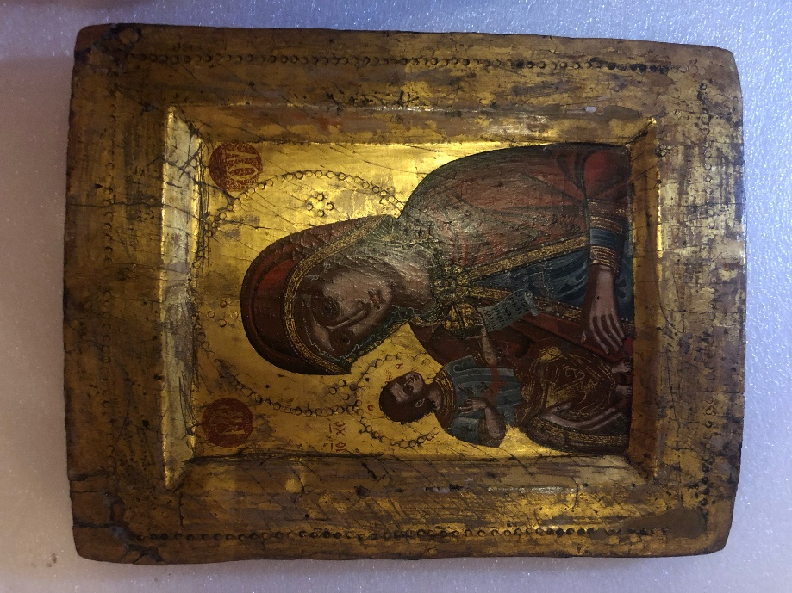

Figure 1. Virgin and Child (Madonna della Consolazione). 17th Century, Greece, Ionian Islands, Egg Tempera on Panel, 11 3/8 x 9 ¼ in., Fred Jones Jr. Museum of Art, Norman, Oklahoma (Photo: Author)

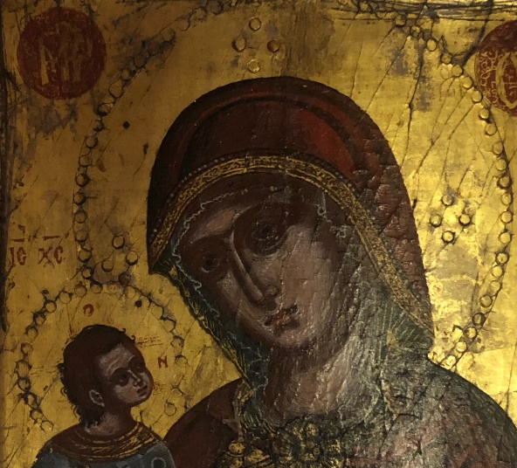

Figure 1 a. Virgin and Child (Madonna della Consolazione). 17th century, Greece, Ionian Islands, Egg Tempera on Panel, 11 3/8 x 9 ¼ in., Fred Jones Jr. Museum of Art, Norman, Oklahoma, Detail of Virgin (Photo: Author)

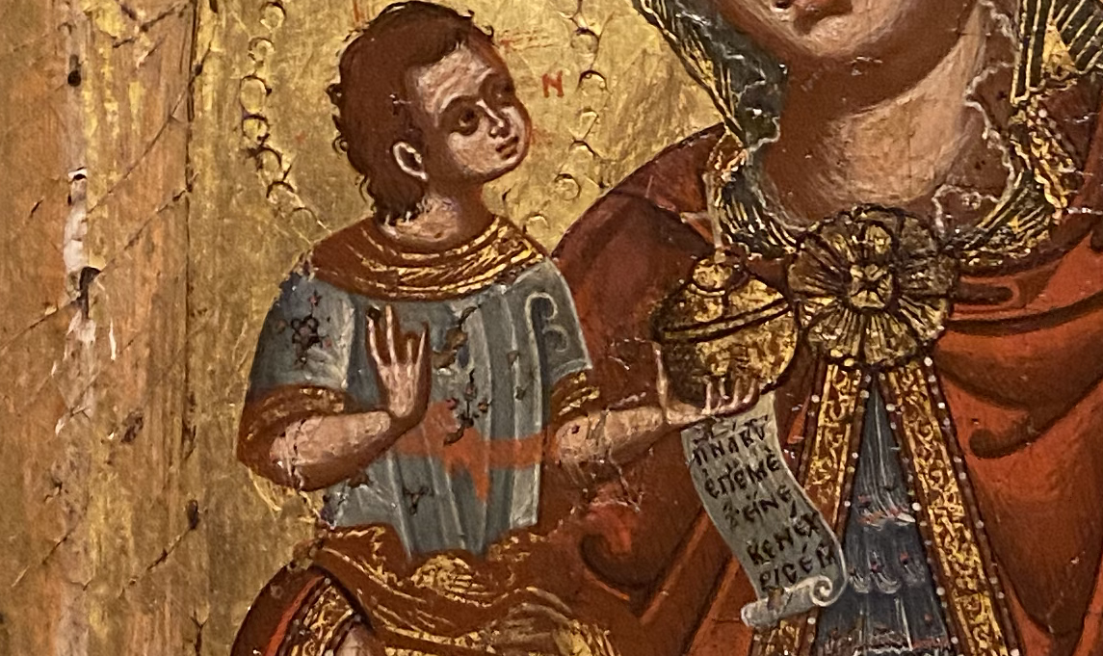

Figure 1 b. Virgin and Child (Madonna della Consolazione). 17th century, Greece, Ionian Islands, Egg Tempera on Panel, 11 3/8 x 9 ¼ in., Fred Jones Jr. Museum of Art, Norman, Oklahoma, Detail of Christ (Photo: Author)

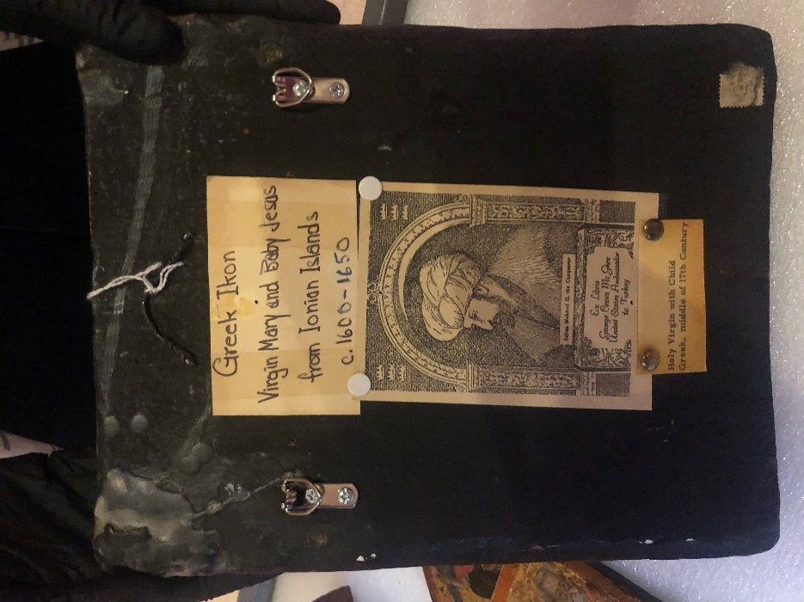

Figure 1 c. Virgin and Child (Madonna della Consolazione). 17th century, Greece, Ionian Islands, Egg Tempera on Panel, 11 3/8 x 9 ¼ in., Fred Jones Jr. Museum of Art, Norman, Oklahoma, Detail, Back of the Icon (Photo: Author)
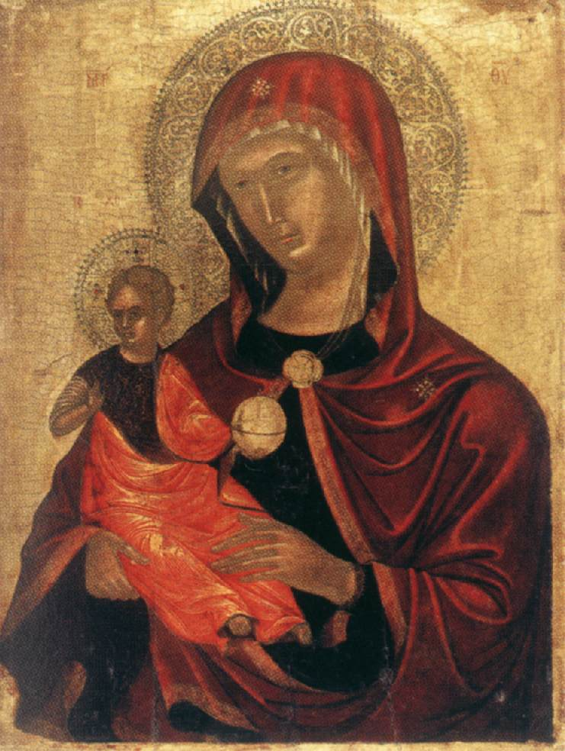

Figure 3. Madre della Consolazione. Second Half of the 15th Century, Egg Tempera on Panel, 14 ½ x 10 ¾ in., Museum of Russian Icons, Clinton, Massachusetts (Photo: https://www.wga.hu/html_m/t/tsafouri/madre1.html)

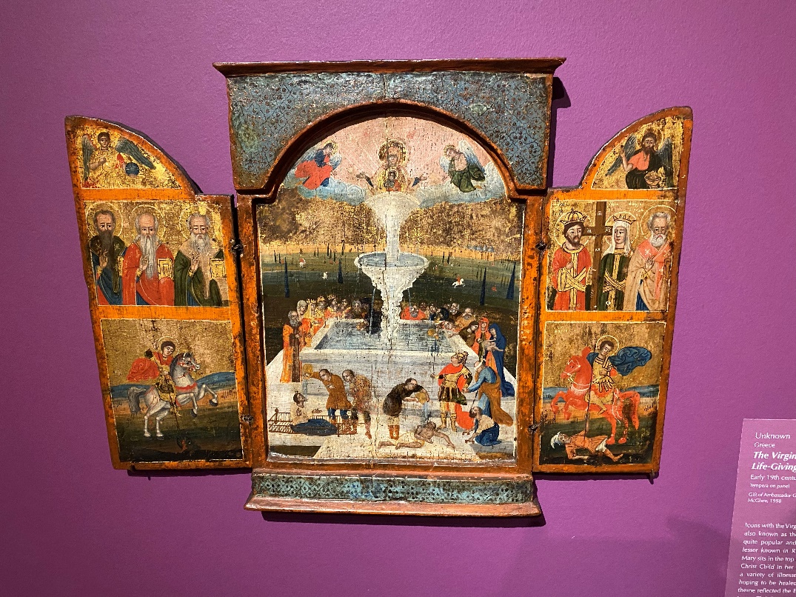

Figure 2. The Virgin as the Life-Giving-Spring. Early 19th century, Greece, Egg Tempera on Panel, 16 x 21 ½ in., Fred Jones Jr. Museum of Art, Norman, Oklahoma (Photo: Author)

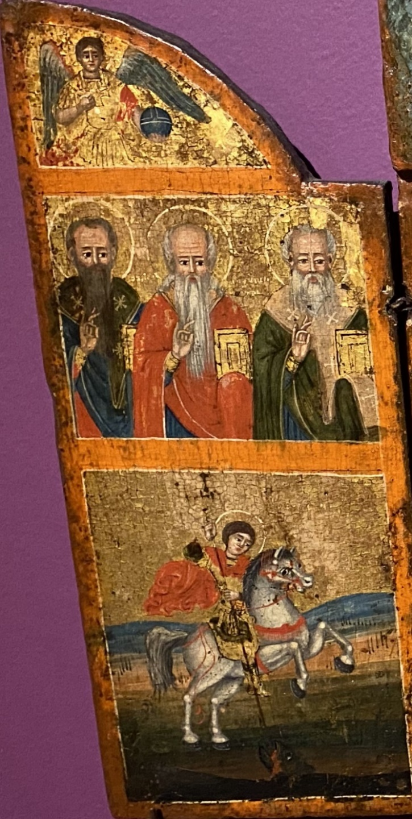

Figure 2 a. The Virgin as the Life-Giving-Spring. Early 19th century, Greece, Egg Tempera on Panel, 16 x 21 ½ in., Fred Jones Jr. Museum of Art, Norman, Oklahoma, Detail of Right Wing (Photo: Author)

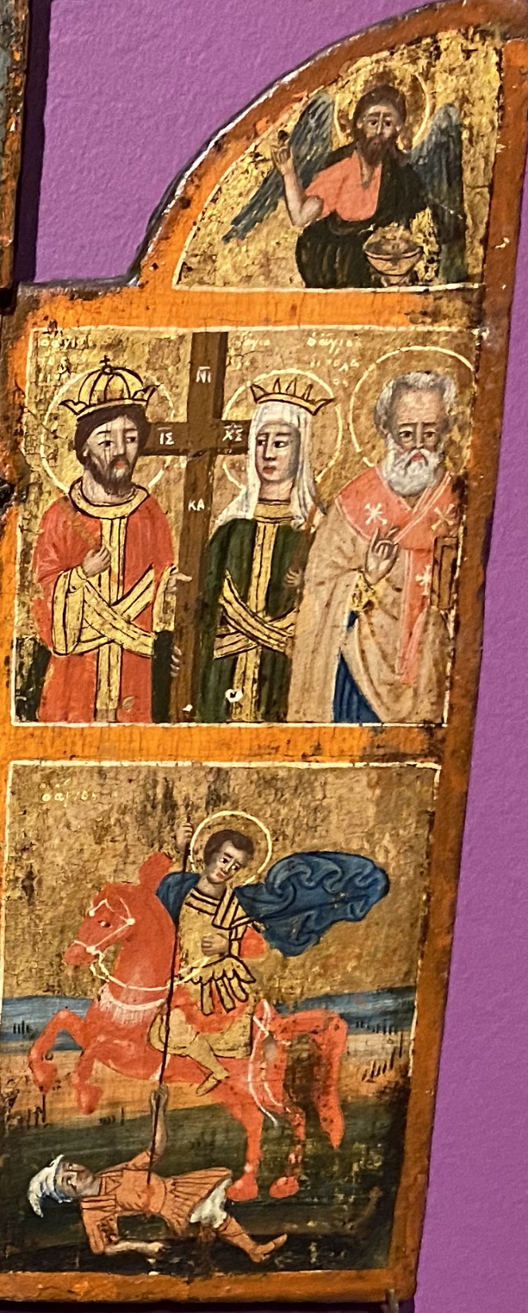

Figure 2 b. The Virgin as the Life-Giving-Spring. Early 19th century, Greece, Egg Tempera on Panel, 16 x 21 ½ in., Fred Jones Jr. Museum of Art, Norman, Oklahoma (Photo: Author)
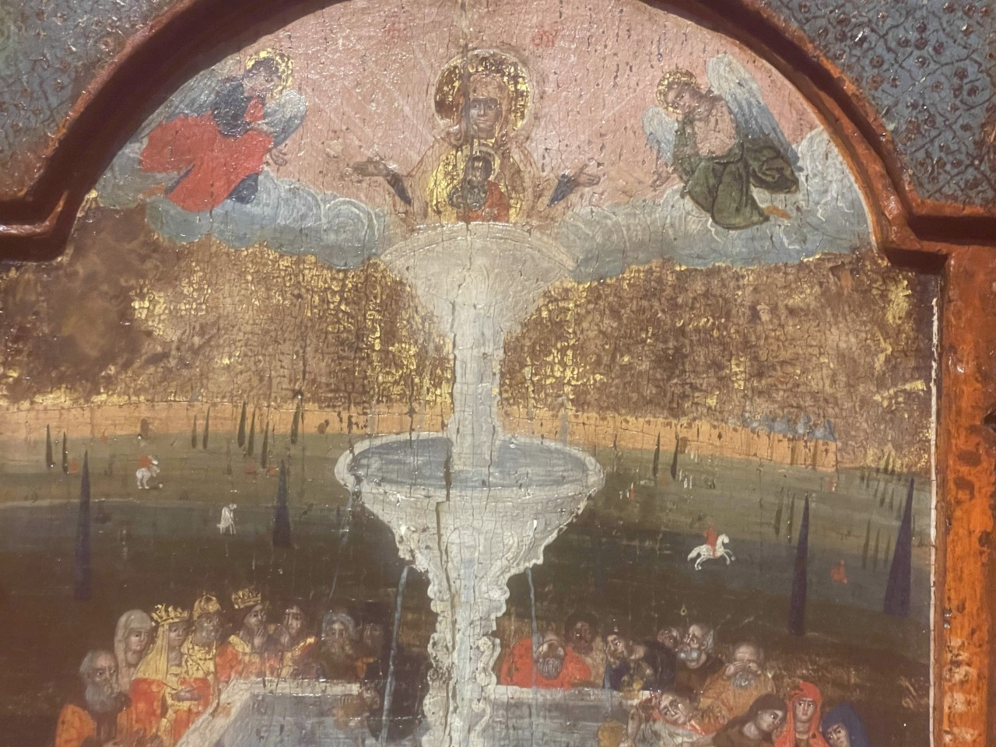

Figure 2 c. The Virgin as the Life-Giving-Spring. Early 19th century, Greece, Egg Tempera on Panel, 16 x 21 ½ in., Fred Jones Jr. Museum of Art, Norman, Oklahoma, Detail of the Fountain with the Virgin and Child (Photo: Author)

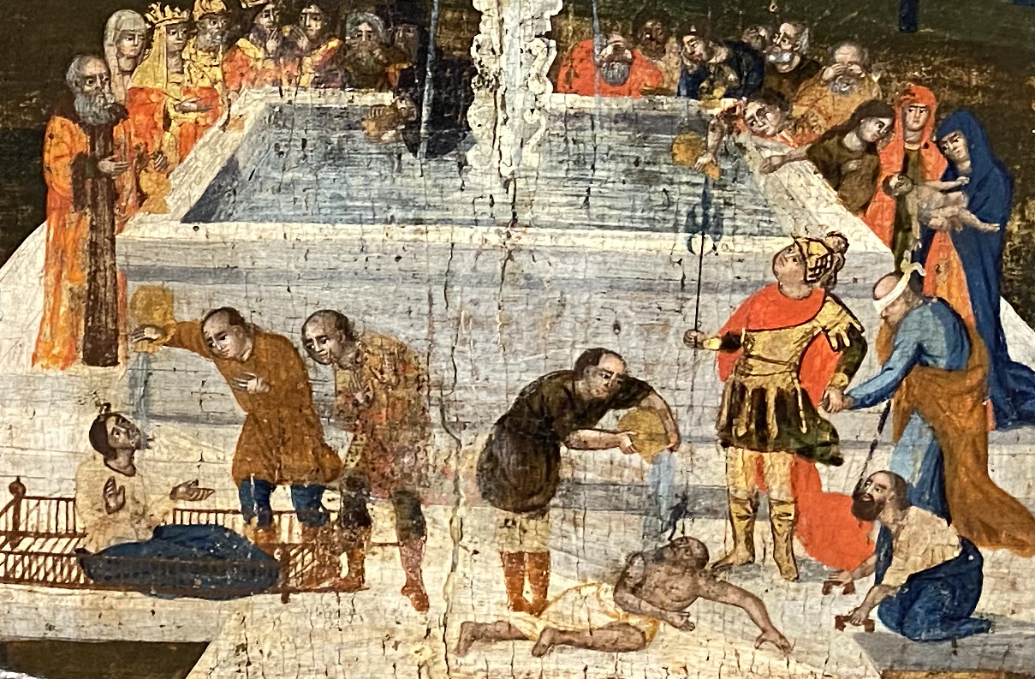

Figure 2 d. The Virgin as the Life-Giving-Spring. Early 19th century, Greece, Egg Tempera on Panel, 16 x 21 ½ in., Fred Jones Jr. Museum of Art, Norman, Oklahoma, Detail of the Pool with the Faithful Bathing (Photo: Author)

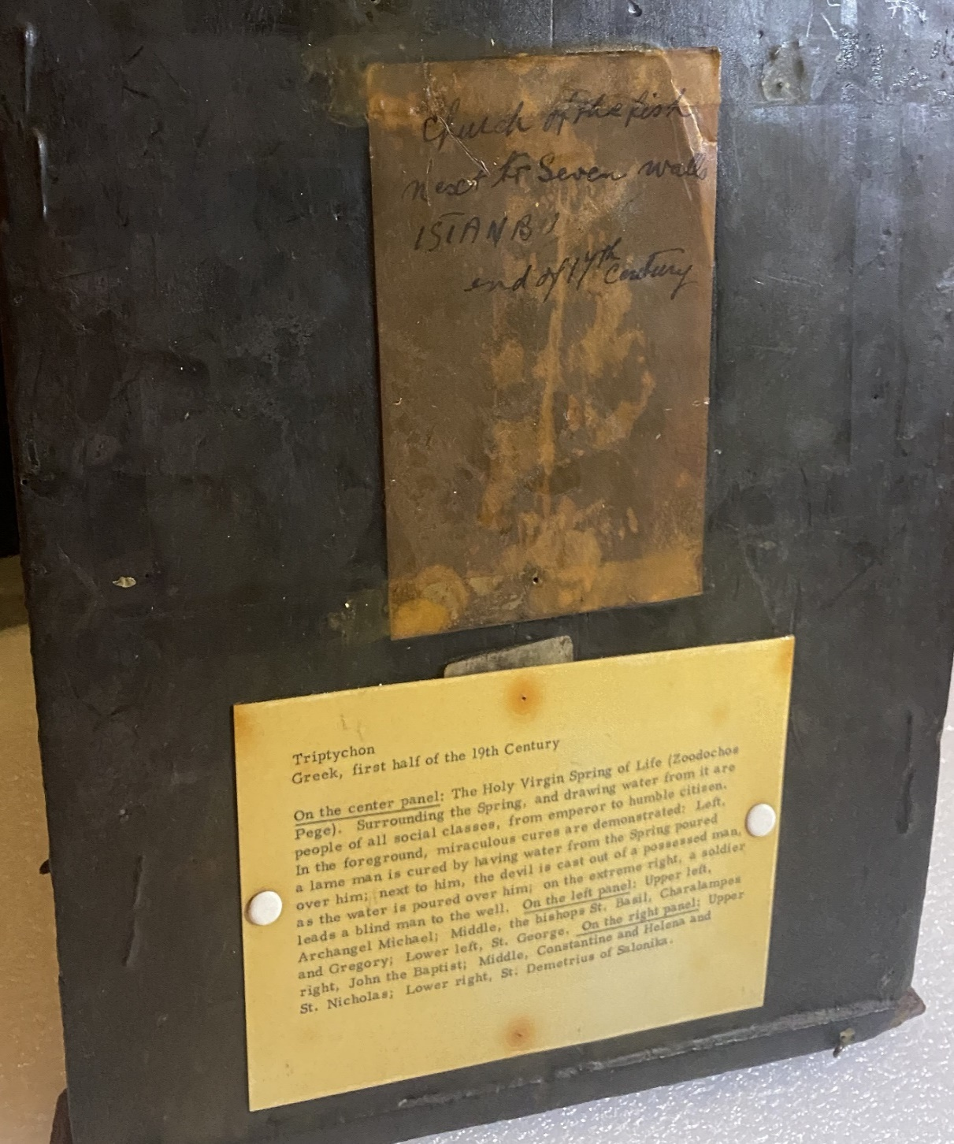

Figure 2 e. The Virgin as the Life-Giving-Spring. Early 19th century, Greece, Egg Tempera on Panel, 16 x 21 ½ in., Fred Jones Jr. Museum of Art, Norman, Oklahoma, Detail of Notes, back (Photo: Author)
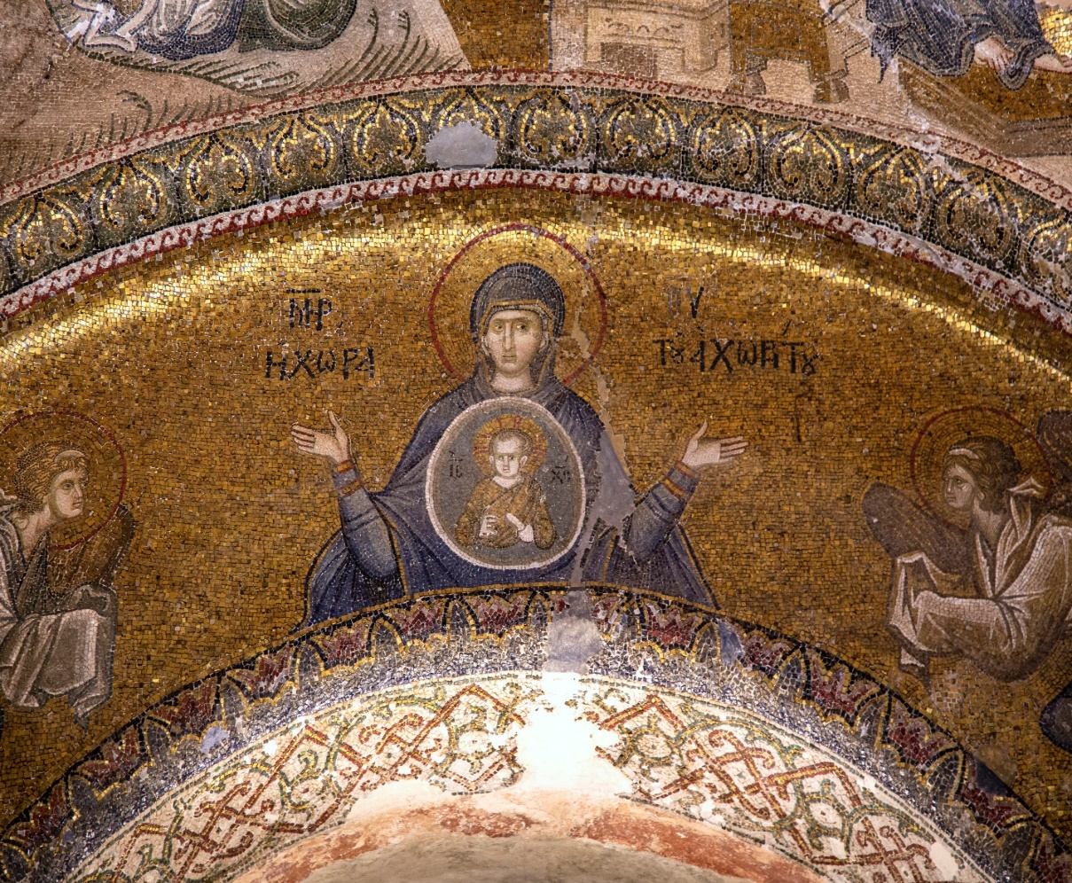

Figure 4. Panagia the Font of Life. 14th Century, Mosaic, Monastery of Christ at Chora, Istanbul, Turkey (Photo: https://smarthistory.org/picturing-salvation/)

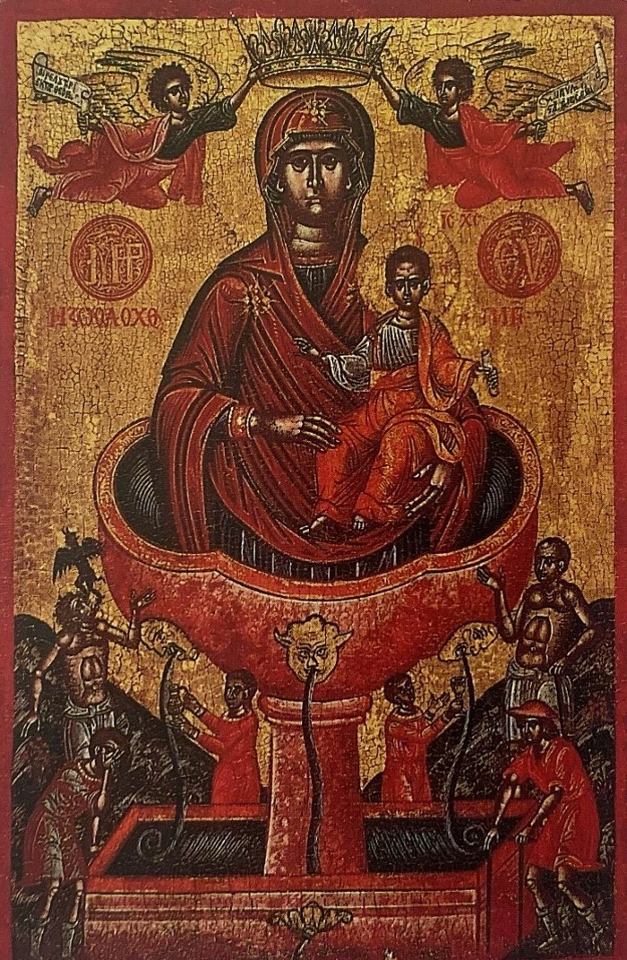

Figure 5. The Mother of God of the Life-Giving Spring. c. 1700, Egg Tempera on Panel (Photo: Konrad Onasch and Annemarie Schnieper, Icons: The Fascination and the Reality, New York: Riverside Book Company, 1995, p. 175)

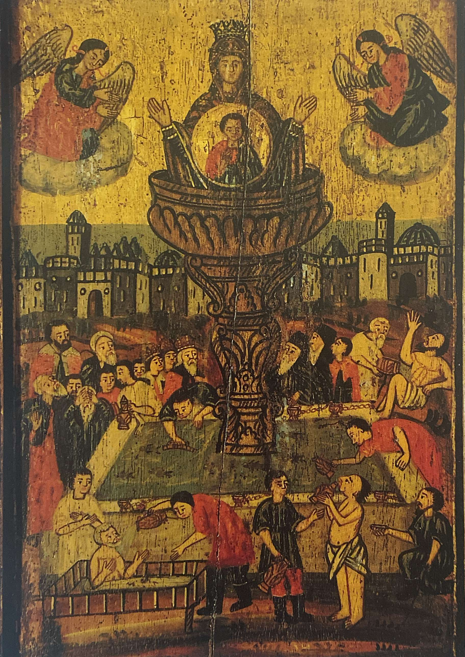

Figure 6. The Mother of the God of the Life-Giving Spring of Balikli. 19th Century, Egg Tempera on Panel (Photo: Photo: Konrad Onasch and Annemarie Schnieper, Icons: The Fascination and the Reality, New York: Riverside Book Company, 1995, p. 175)
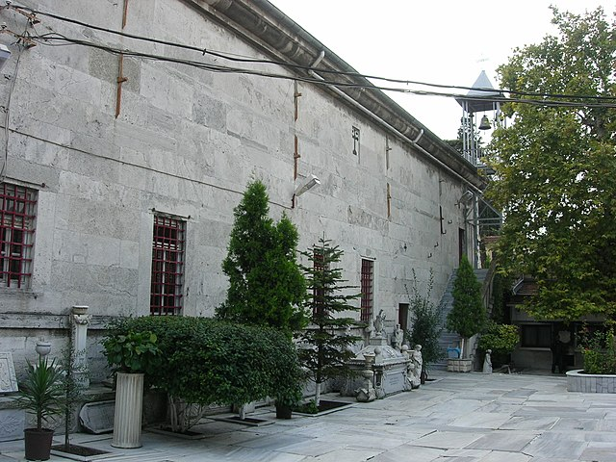

Figure 7. Monastery of Zoodochos Peges, Istanbul, Turkey, Exterior (Photo: https://en.wikipedia.org/wiki/Church_of_St._Mary_of_the_Spring_%28Istanbul%29)

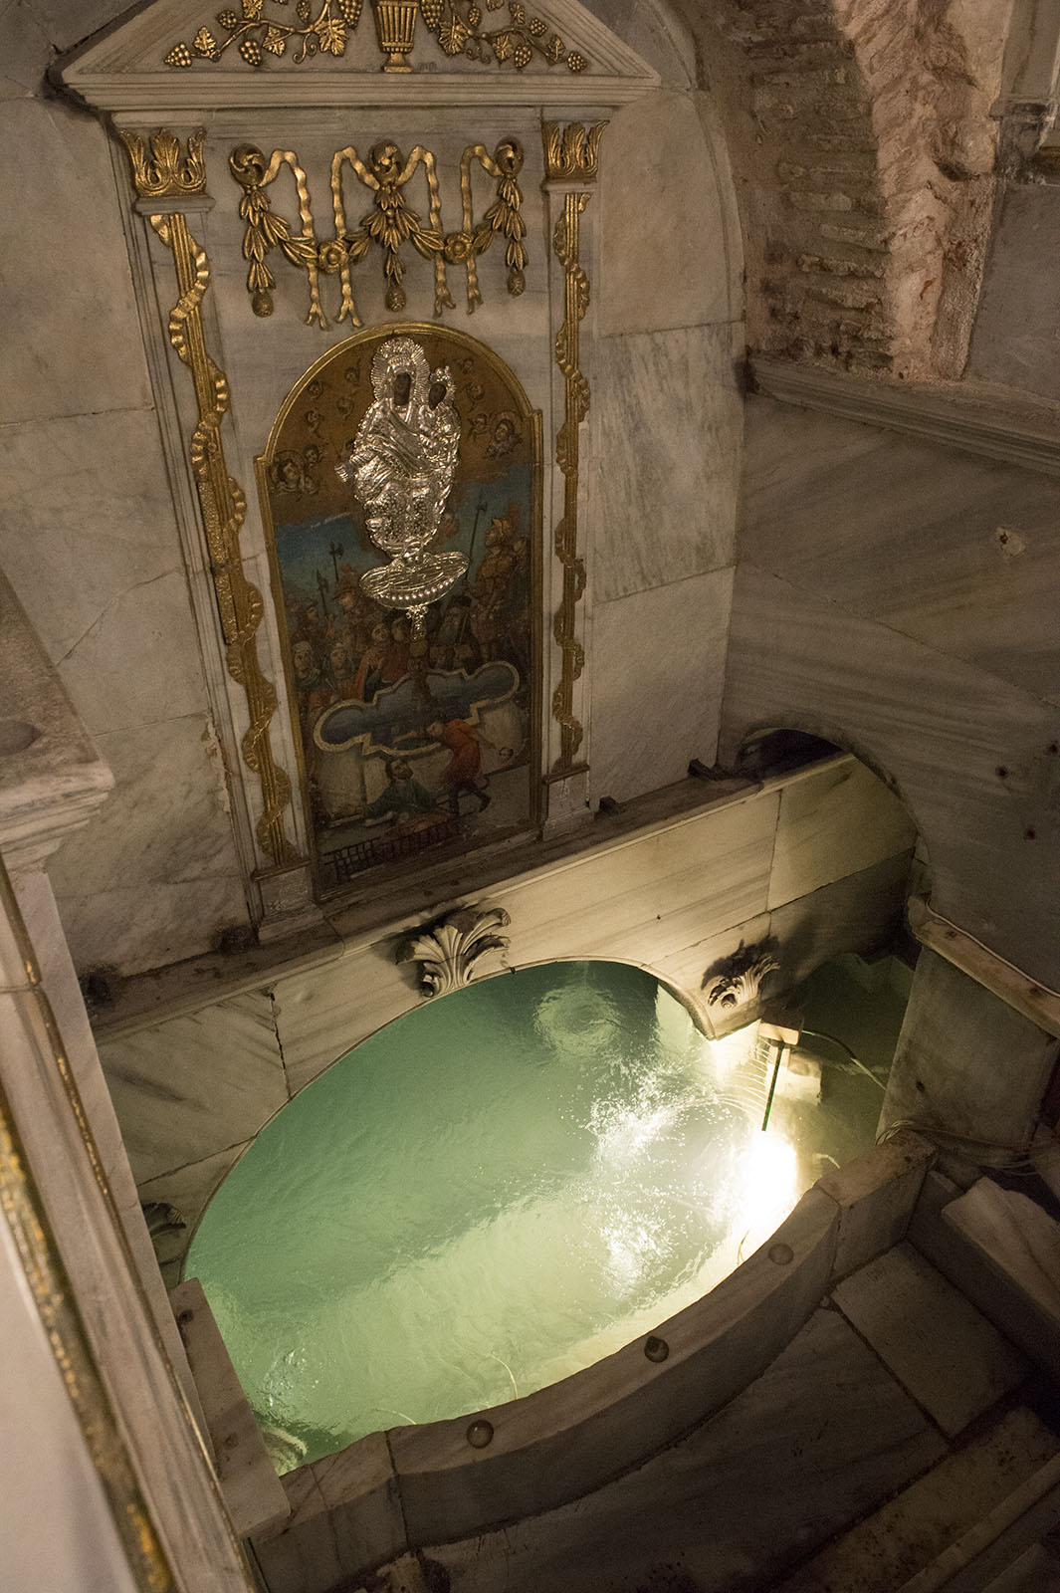

Figure 8. Monastery of Zoodochos Peges, Interior of Healing Water Pool (Photo: https://commons.wikimedia.org/wiki/File:Church_of_St._Mary_of_the_Spring_9123.jpg)

Bibliography
Acheimastou-Potamianou, Myrtali, ed., From Byzantium to El Greco: Greek Frescoes and Icons, Athens: Greek Ministry of Culture and Byzantine Museum of Athens, 1987.
Andronikou, Anthi, “Southern Italy, Cyprus, and the Holy Land: A Tale of Parallel Aesthetics?” The Art Bulletin, Vol. 99, No. 3, (2017): 6-29.
Ayalon, Yaron, Natural Disasters in the Ottoman Empire: Plague, Famine, and Other Misfortunes, New York: Cambridge University Press, 2015.
Birrell, Jean and Flori, Jean, “Cyprus and Acre,” Richard the Lionheart: King and Knight. Edinburgh: Edinburgh University Press, 1999.
Belting, Hans, and Jephcott, Edmund, Likeness and Presence: A History of the Image Before the Era of Art. Chicago: The University of Chicago Press, 1994.
Cavarnos, Constantine, Guide to Byzantine Iconography, Vol. II, Boston: Holy Transfiguration Monastery, 2001.
Chondrogiannis, Dr. Stamatios Th. “Venetian Period: 1386-1797,” The Antivuoiniotissa Museum, 2022. https://www.antivouniotissamuseum.gr/en/corfuxmhistorical-overview- xm/143-2010-10-06-18-35-59.
Christou, Dr. Athanasios, “Introduction Art in the Ionian Islands.” Pinakothiki of Kekrya in the Palace of St. Michael and St. George, Corfu City, Island Corfu, Ionian Island, Greece. Accessed 11/10/2022. https://artcorfu.gr/en/introduction-art-in- the-ionian-islands/.
Cormack, Robin, ‘New Art History’ vs ‘Old History’: Writing Art History, Byzantine and Modern Greek Studies, 10 (1986): 223-32.
Cormack, Robin, Icons, Cambridge: Harvard University Press, 2007.
Dale, E.A. Thomas, “Cultural Hybridity in Medieval Venice,” in San Marco, Byzantium, and the Myths of Venice, edited by Henry Maguire and Robert S. Nelson, Washington D.C: Dumbarton Oaks Research Library and Collection, 2010.
Dionysius of Fourna and Hetherington, Paul, The ‘Painter’s Manual’ of Dionysius of Fourna, Torrance: Oakwood Publications, 1996.
Doumas, Alexandra, On Water in Byzantium. Athens: The Hellenic Ministry of Culture, Directorate of Byzantine and Postbyzantine Monuments, Section of Museums, 2000.
Evans, Helen C., Byzantium: Faith and Power (1261-1557), New York: The Metropolitan Museum of Art, 2004.
Folda, Jaroslav, Crusader Art: The Art of the Crusades in the Holy Land, 1099-1291. Hampshire: Lund Humphries, 2008.
Furber, Elizabeth Chapin, “The Kingdom of Cyprus, 1191-1291,” A History of The Crusades, Volume 2: The Later Crusades, 1189-1311, edited by Robert Lee Wolff and Harry W. Hazard, Philadelphia: University of Pennsylvania Press, (1962): 599-629.
Georgeopoulou, Maria, “Late Medieval Crete and Venice: An Appropriation of Byzantine Heritage,” The Art Bulletin, Vol. 77, No. 3 (1955): 479-96.
Haustein-Bartsch, Eva and Wolf, Norbert. Icons. Cologne: Taschen, Germany, 2008.
Oxford Dictionaries, s.v. “Byzantine,” accessed on 15th August 2022, https://www.oxfordlearnersdictionaries.com/us/definition/american_englis h/byzantine#:~:text=byzantine%20(formal)%20(of%20an,the%20Oxford %20Advanced%20Learner's%20Dictionary.
Onasch, Konrad and Schnieper, Annemarie, Icons: The Fascination and the Reality, New York: Riverside Book Company, 1995.
Peers, Glenn, Barber, Charles, Caffey, Stephen. Byzantine Things in the World. New Haven: Yale University Press, 2013.
Runciman, Steven, The Fall of Constantinople 1453. Cambridge: Cambridge University Press, 1965.
Spratt, Emily L., “Towards a Definition of “Post-Byzantine” Art: The Angleton Collection at the Princeton University Art Museum.” Records of the Art Museum, Princeton University Vol. 71/72, (2012): 2-19.
Stokstad, Marilyn, Medieval Art. New York: Harper and Row Publishers, 1986.
Tradigo, Alfredo. Icons and Saints of the Eastern Orthodox Church. Los Angeles: J. Paul Getty Museum, 2006.
Tyerman, Christopher, God’s War: A New History of the Crusades, London: Penguin Books, 2006.
Tzafouris, Nicholas. Icon with the Madre della Consolazione. 15th Century, Icon. Museum of Russian Icons. https://www.museumofrussianicons.org/madre- della- consolazione/.
Kurt Weitzman, “Crusader Icons and la Maniera Greca,” in Il Medio Oriente e L’Occidente Nell’arte del XIII secolo: Atti del XXIV Congresso Internazionale do Storia dell’Arte C.I.H.A, edited by H. Belting, Bologna: Clueb Editrice, 1982: 71-7.
Wollesen, Jens T, Acre or Cyprus? A New Approach to Crusader Painting Around 1300, Berlin: Akademie Verlag, 2013.
Vassilaki, Maria, “Images of the Mother of God, Perceptions of the Theotokos in Byzantium,” Hants: Ashgate Publications, 2005.

Oxford Dictionaries, s.v. “Byzantine,” accessed on 15th August 2022, https://www.oxfordlearnersdictionaries.com/us/definition/american_english/byzantine#:~:text=byzantine%20(formal)%20(of%20an,the%20Oxford%20Advanced%20Learner's%20Dictionary. The connotation of the word is widely viewed as negative. To say something is “Byzantine” in nature is usually a term of derision, at best. Something seemingly as simple as this is just one of the many obstacles that Byzantine studies has had to overcome.
George McGhee Crews graduated from The University of Oklahoma in 1933. After becoming a Rhodes Scholar at Oxford, he was eventually made ambassador to Turkey from 1951-52 and helped their NATO bid, staying with his wife at a restored Ottoman villa in Alanya.
Alfredo Tradigo, Icons and Saints of the Eastern Orthodox Church. (Los Angeles: J. Paul Getty Museum, 2006), pg. 193.
Robin Cormack, ‘New Art History’ vs ‘Old History’: Writing Art History, Byzantine and Modern Greek Studies, 10 (1986), pgs. 223-32. Cormack also speaks to how the Western academic habit of wanting to categorize everything has been more of a disservice than anything to Byzantine studies as it ignores many deeper questions and attributes of Byzantine style art such as provenance, votive nature, etc., eschewing them in favor of name-date format of easy organization.
Cormack, ‘New Art History’ vs ‘Old History’: Writing Art History,” pg. 224.
Jaroslav Folda, Crusader Art: The Art of the Crusades in the Holy Land, 1099-1291. (Hampshire: Lund Humphries, 2008), pg.12. Folda loosely gives several definitions throughout the intro portions of Crusader Art, but this while this isn’t an all-encompassing definition itself, is important in the dates it provides, as it intersects with a couple notable moments which affected the direction of Byzantine-style icons and their development overall.
Jens T. Wollesen, Acre or Cyprus? A New Approach to Crusader Painting Around 1300, (Berlin: Akademie Verlag, 2013), pg. 10. Folda’s acknowledgement of the Byzantine roots of Crusader art is perhaps understated given the context of the rest of the attributions they give (Levantine character, Western European, etc.), but it remains important for the purposes of this thesis to place the Byzantine influence first and foremost when considering the various confluences which made Crusader art possible in the first place.
Wolleseen, Acre or Cyprus? A New Approach to Crusader Painting Around 1300, pg. 13.
This acronym will be used to from here on refer to the “Fred Jones Jr. Museum Collection.”
Jaroslav Folda, Crusader Art: The Art of the Crusades in the Holy Land, 1099-1291, pg. 157. The other side of the diptych features Saint Procopius, a warrior saint, and the diptych itself is a perfect example of what Crusader art was: a combination of the religious and the warlike.
Folda, Crusader Art: The Art of the Crusades in the Holy Land, 1099-1291, pg. 157.
Jean Birrell and Jean Flori, “Cyprus and Acre,” Richard the Lionheart: King and Knight. (Edinburgh University Press, 1999), pg. 113.
13 Jean Birrell and Jean Flori, “Cyprus and Acre,” Richard the Lionheart: King and Knight. (Edinburgh University Press, 1999), pg. 113.
Jean Birrell and Jean Flori, “Cyprus and Acre,” Richard the Lionheart: King and Knight. (Edinburgh University Press, 1999), pg. 115.
Birrell and Flori, “Cyprus and Acre,” Richard the Lionheart: King and Knight, pgs. 114-15.
Birrell and Flori, “Cyprus and Acre,” Richard the Lionheart: King and Knight, pg. 119. Several things to note, the first being that after Richard, the island eventually was sold to Crusaders, namely to King of Jerusalem, Guy Lusignan, who was a major rival of France at the time. Outremer is a term that refers to lands “beyond the sea,” the word’s origin being French.
Elizabeth Chapin Furber, “The Kingdom of Cyprus, 1191-1291,” A History of The Crusades, Vol. 2: The Later Crusades, 1189-1311, edited by Robert Lee Wolff and Harry W. Hazard, (University of Pennsylvania Press, 1962), pg. 601. It is also mentioned that Richard gained enough loot as it were to afford to be more generous in his rewards to his own troops, and to hire more knights to join him. In this way Richard’s takeover is a crucial example of Latinizing forces from the West interacting with the Byzantine East.
Jean Birrell and Jean Flori, “Cyprus and Acre,” Richard the Lionheart: King and Knight. (Edinburgh University Press, 1999), pg. 116. The importance of the Lusignan’s was a point of French interest in Cyprus, as Richard allying with them was considered an affront to France at the time.
Christopher Tyerman, God’s War: A New History of the Crusades, (London: Penguin Books, 2006), pg. 725. This was pre-empted by the Lombard War several decades afterwards, inserting German influence into the management of Cyprus as well.
Jaroslav Folda, Crusader Art: The Art of the Crusades in the Holy Land, 1099-1291. (Hampshire: Lund Humphries, 2008), pg. 83. The battle of Hattin was lost by the Crusaders against Saladin, the most important takeaway being the loss of the True Cross, thus causing religious turmoil at home in Europe, and (presumably) creating a fervor for new holy relics and prizes.
Marilyn Stokstad, Medieval Art. (New York: Harper and Row Publishers, 1986), pg. 158. Though obviously metaphorical, it is truly staggering to realize how much of Constantinople was permanently altered by the Latin takeover of 1204.
Steven Runciman, The Fall of Constantinople 1453, (Cambridge: Cambridge University Press, 1965), pg. 2. The Byzantines had far more political experience dealing with Muslims in the East than the Western European Crusaders did, and generally were concerned about how the Western Europeans would handle diplomatic matters.
Thomas E.A. Dale, “Cultural Hybridity in Medieval Venice,” in San Marco, Byzantium, and the Myths of Venice, edited by Henry Maguire and Robert S. Nelson, (Washington D.C: Dumbarton Oaks Research Library and Collection, 2010), pg. 152. The Venetians continued to pursue things which had previously been within the Byzantine domain, such as exploring relations with the emerging Islamic kingdoms in the East. Additionally, the Venetians set about integrating not just Byzantine art into their own diaspora, but also Hellenistic sculpture, such as the infamous bronze horses on the West façade.
Hans Belting, and Edmund Jephcott, Likeness and Presence: A History of the Image Before the Era of Art. (Chicago: The University of Chicago Press, 1994), pg. 332.
Helen C. Evans, Byzantium: Faith and Power (1261-1557), (New York: The Metropolitan Museum of Art, 2004), pg. 493.
Anthi Andronikou, “Southern Italy, Cyprus, and the Holy Land: A Tale of Parallel Aesthetics?” The Art Bulletin, Vol. 99, No. 3, (2017), pg. 7.
Jens T Wollesen, Acre or Cyprus? A New Approach to Crusader Painting Around 1300, (Berlin: Akademie Verlag, 2013), pg. 14.
Jens T Wollesen, Acre or Cyprus? A New Approach to Crusader Painting Around 1300, (Berlin: Akademie Verlag, 2013), pg. 13.
Wollesen, Acre or Cyprus? A New Approach to Crusader Painting Around 1300, pg. 13. The spitefulness show in this statement is an overall sentiment that I wish to address within this thesis, namely the provenance of east/west hybrid styles which emerged due to the Fourth crusade and were subsequently massively influential on Italian Renaissance art going forward. The lack of clarity and scholastic authority on the influences of Byzantine-style art and Crusader art on Italian art is one of the main focal points of this thesis.
Wollesen, Acre or Cyprus? A New Approach to Crusader Painting Around 1300, pg. 18-10. Specifically, the coining of the term maniera cypria, serves to homogenize the sphere containing Crusader art, Byzantine art, and Cypriot art without acknowledging individual contributions. For example, a label such as maniera cypria ignores the Crusader influence on the island of Cyprus, presuming instead that all Cypriot art is instead just a variant of Byzantine mainland art. The true issue is that lack of acknowledgement of all these separate styles forming a new, more homogeneous hybrid style.
Wollesen, Acre or Cyprus? A New Approach to Crusader Painting Around 1300, pgs. 52-3.
Meaning of course “Greek manner,” a clear separation between what had come before (Eastern Orthodox Christian art) and what was currently artistically viable, which was Western/Italian variations on those Eastern themes.
33 Jens T Wollesen, Acre or Cyprus? A New Approach to Crusader Painting Around 1300, (Berlin: Akademie Verlag, 2013), pg. 14.
From the 12th and 13th centuries, respectively, overlapping nicely with the influx of Byzantine loot from the Venetian looting of Constantinople in the Fourth Crusade.
Wollesen, Acre or Cyprus? A New Approach to Crusader Painting Around 1300, pgs. 13-14.
See Kurt Weitzman, “Crusader Icons and la Maniera Greca,” in Il Medio Oriente e L’Occidente Nell’arte del XIII secolo: Atti del XXIV Congresso Internazionale do Storia dell’Arte C.I.H.A, edited by H. Belting, Bologna: Clueb Editrice, 1982: 71-7.
Wolleseen, Acre or Cyprus? A New Approach to Crusader Painting Around 1300, pg. 15.
Wolleseen, Acre or Cyprus? A New Approach to Crusader Painting Around 1300, pg. 17.
Jens T. Wolleseen, Acre or Cyprus? A New Approach to Crusader Painting Around 1300,” (Berlin Akademie Verlag: 2013), pg. 18. Wolleseen is analyzing various variations of the Maniera greca in the opening chapter here, with the emphasis being on mischaracterizing Byzantine art’s influence on the West and on Italy. This is a central argument to this thesis, as it provides correlating condemnation of the idea that Byzantine art had little to no influence on Italian art, and that it was instead simply the Italians travelling abroad and bringing back ideas.
Eva Haustein-Bartsch and Norbert Wolf. Icons. (Cologne: Taschen, 2008), pg. 44.
Theotokos meaning “mother of god,” and Hodegetria meaning “she who shows the way.”
Alfredo Tradigo. Icons and Saints of the Eastern Orthodox Church. (Los Angeles: J. Paul Getty Museum, 2006), pg. 169. This is referring to subject matter outside the scope of this thesis, such as its spread from Greece to Russia, but also to places as far-reaching as China and Ethiopia.
Tradigo. Icons and Saints of the Eastern Orthodox Church, pg. 169.
Tradigo. Icons and Saints of the Eastern Orthodox Church, pgs. 170-71.
Hans Belting and Jephcott Edmond. Likeness and Presence: A History of the Image Before the Era of Art. (Chicago: The University of Chicago Press, 1994), pg. 337.
Referring to the Italian Renaissance of the 14th century.
Hans Belting and Jephcott Edmond. Likeness and Presence: A History of the Image Before The Era of Art. (Chicago: The University of Chicago Press, 1994), pg. 351.
Belting and Edmond. Likeness and Presence: A History of the Image Before The Era of Art, pg. 332.
Belting and Edmond. Likeness and Presence: A History of the Image Before The Era of Art, pg. 351.
Hans Belting and Jephcott Edmond. Likeness and Presence: A History of the Image Before The Era of Art. (Chicago: The University of Chicago Press, 1994), pg. 332.
Maria Vassilaki, Images of the Mother of God, Perceptions of the Theotokos in Byzantium, (Aldershot: Ashgate Pubishing, 2005), pg. 116.
Hans Belting and Jephcott Edmond. Likeness and Presence: A History of the Image Before the Era of Art. (Chicago: The University of Chicago Press, 1994), pg. 23.
Belting and Edmond. Likeness and Presence: A History of the Image Before the Era of Art, pg. 23.
Eva Haustein-Bartsch and Norbert Wolf. Icons. (Cologne: Taschen, 2008), pg. 44. The icon was hitherto unknown up to the 15th century.
Eva Haustein-Bartsch and Norbert Wolf. Icons. (Cologne: Taschen, 2008), pg. 44. Though there is little known about Nikolas, we do know he died in 1500, and was Cretan. His first recorded mention in history is in 1487 in Candia (Heraklion). Tzafoures represents a departure from previous generations of iconographers, as we only know who he is and can attribute works to him due to the fact that he signed his name on several.
Eva Haustein-Bartsch and Norbert Wolf. Icons. (Cologne: Taschen, 2008), pg. 44.
Haustein-Bartsch and Wolf. Icons, pg. 44.
Glenn Peers, Charles Barber, and Stephen Caffey. Byzantine Things in the World. (New Haven: Yale University Press, 2013), pg. 46.
Glenn Peers, Charles Barber, and Stephen Caffey. Byzantine Things in the World. (New Haven: Yale University Press, 2013). pg. 46.
Robin Cormack, Icons. (Harvard University Press, Cambridge Massachusetts, 2007), pg. 36.
Robin Cormack, Icons, (Harvard University Press, Cambridge Massachusetts, 2007), pg. 69.
Cormack, Icons, pg. 70.
Cormack, Icons, pg. 69.
Robin Cormack, Icons, (Harvard University Press, Cambridge Massachusetts, 2007), pg. 71.
Cormack, Icons, pg. 71.
Emily L. Spratt, “Towards a Definition of “Post-Byzantine” Art: The Angleton Collection at the Princeton University Art Museum.” Records of the Art Museum, Princeton University, 71/72, (2012), pg. 3.
Maria Georgeopoulou, “Late Medieval Crete and Venice: An Appropriation of Byzantine Heritage,” The Art Bulletin, Vol. 77, No. 3, pg. 480.
See pages 17-18 re: importance of the Virgin to Venetians.
Georgeopoulou, “Late Medieval Crete and Venice: An Appropriation of Byzantine Heritage,” pg. 480.
Georgeopoulou, “Late Medieval Crete and Venice: An Appropriation of Byzantine Heritage,” pg. 487.
Dr. Myrtali Acheimastou-Potaminaou, “From Byzantium to El Greco: Greek Frescoes and Icons,” (Athens: Greek Ministry of Culture and Byzantine Museum of Athens, 1987), pg. 51.
Acheimastou-Potaminaou, From Byzantium to El Greco: Greek Frescoes and Icons, pg. 51. The Venetian state archives are cited in the previously cited book as a place with archival records which are relevant to dealings with Crete.
Acheimastou-Potaminaou, From Byzantium to El Greco: Greek Frescoes and Icons, pg. 51.
Acheimastou-Potaminaou, From Byzantium to El Greco: Greek Frescoes and Icons, pg. 51.
Acheimastou-Potaminaou, From Byzantium to El Greco: Greek Frescoes and Icons, pg. 51.
Dr. Myrtali Acheimastou-Potaminaou, From Byzantium to El Greco: Greek Frescoes and Icons, (Athens: Greek Ministry of Culture and Byzantine Museum of Athens, 1987), pg. 52.
Acheimastou-Potaminaou, From Byzantium to El Greco: Greek Frescoes and Icons, pg. 52.
Dr. Stamatios Th. Chondrogiannis. “Venetian Period: 1386-1797,” The Antivuoiniotissa Museum, 2022. https://www.antivouniotissamuseum.gr/en/corfuxmhistorical-overview-xm/143-2010-10-06-18-35-59.
William Miller, “The Ionian Islands Under Venetian Rule,” The English Historical Review, Vol 18, No. 70, (April 1903.), pg. 216.
Dr. Stamatios Th. Chondrogiannis. “Venetian Period: 1386-1797,” The Antivuoiniotissa Museum, 2022. https://www.antivouniotissamuseum.gr/en/corfuxmhistorical-overview-xm/143-2010-10-06-18-35-59.
Maria Georgeopoulou, “Late Medieval Crete and Venice: An Appropriation of Byzantine Heritage,” The Art Bulletin, Vol. 77, No. 3, pg. 209.
Dr. Myrtali Acheimastou-Potaminaou, “From Byzantium to El Greco: Greek Frescoes and Icons,” (Athens: Greek Ministry of Culture and Byzantine Museum of Athens, 1987), pg. 212.
Dr. Athanasios Christou, “Introduction Art in the Ionian Islands.” Pinakhotek of Kekryra in the Palace of St. Michael and St. George, Corfu City, Island Corfu, Ionian Island, Greece. Accessed 11/10/2022. https://artcorfu.gr/en/introduction-art-in-the-ionian-islands/.
Christou, “Introduction Art in the Ionian Islands.
Dr. Athanasios Christou, “Introduction Art in the Ionian Islands.” Pinakhotek of Kekryra in the Palace of St. Michael and St. George, Corfu City, Island Corfu, Ionian Island, Greece. Accessed 11/10/2022. https://artcorfu.gr/en/introduction-art-in-the-ionian-islands/.
Dr. Athanasios Christou, “Introduction Art in the Ionian Islands.” Pinakhotek of Kekryra in the Palace of St. Michael and St. George, Corfu City, Island Corfu, Ionian Island, Greece. Accessed 11/10/2022. https://artcorfu.gr/en/introduction-art-in-the-ionian-islands/.
Christou, “Introduction Art in the Ionian Islands.
Christou, “Introduction Art in the Ionian Islands.
Meaning three-parts.
Alfredo Tradigo. Icons and Saints of the Eastern Orthodox Church. (Los Angeles: J. Paul Getty Museum, 2006), pg. 115. This iconographic archetype of Saint John is called “prodromos” referring to one that has come before, paving the way for Christ. Saint John is one of the most heavily features and privileged subjects of Byzantine style iconography next to Christ himself.
Alfredo Tradigo. Icons and Saints of the Eastern Orthodox Church. (Los Angeles: J Paul Getty Museum, 2006), pg. 310.
Tradigo. Icons and Saints of the Eastern Orthodox Church., pg. 311.
Tradigo. Icons and Saints of the Eastern Orthodox Church., pg. 311.
Tradigo. Icons and Saints of the Eastern Orthodox Church., pg. 308.
Alfredo Tradigo. Icons and Saints of the Eastern Orthodox Church. (Los Angeles: J Paul Getty Museum, 2006), pg. 308.
Tradigo. Icons and Saints of the Eastern Orthodox Church., pg. 272.
Tradigo. Icons and Saints of the Eastern Orthodox Church., pg. 46.
Tradigo. Icons and Saints of the Eastern Orthodox Church., pg. 46.
The earliest font icons are regarded as being from the 14th century.
Constantine Cavarnos, Guide to Byzantine Iconography Vol. II, (Boston: Holy Transfiguration Monastery, 2001), pg. 112.
Cavarnos, Guide to Byzantine Iconography Vol. II, pg. 113.
Cavarnos, Guide to Byzantine Iconography Vol. II, pg. 113.
Dionysius of Fourna and Paul Hetherington, The ‘Painter’s Manual’ of Dionysius of Fourna, (Oakwood Publications: Torrance), pg. 50. If we assume the FJJMC Spring icon is originally 19th century, this dates it one century after when Dionysius was alive and practicing as an iconographer. This means that the Spring icon was ostensibly a similar (but evolved) iconographic archetype that Dionysius was describing. Dionysius describes the Life-Giving Font icon, which is not far off from our Life-Giving Spring in name.
According to Cavarnos, pgs. 112-13.
Alexandra Doumas, On Water in Byzantium. (Athens: The Hellenic Ministry of Culture, Directorate of Byzantine and Postbyzantine Monuments, Section of Museums, 2000), pg. 98.
See pgs. 28-30 for more on Cavarnos’ notions on the evolution of the font style icon.
Doumas, On Water in Byzantium, pg. 98.
Alexandra Doumas, On Water in Byzantium. (Athens: The Hellenic Ministry of Culture, Directorate of Byzantine and Postbyzantine Monuments, Section of Museums, 2000), pg. 98.
Doumas, On Water in Byzantium, pg. 98.
Doumas, On Water in Byzantium, pg. 98.
Alexandra Doumas, On Water in Byzantium. (Athens: The Hellenic Ministry of Culture, Directorate of Byzantine and Postbyzantine Monuments, Section of Museums, 2000), pg. 99.
Yaron Ayalon, Natural Disasters in the Ottoman Empire: Plague, Famine, and Other Misfortunes, (New York: Cambridge University Press, 2015), pgs. 81, 87, 150.
Ayalon, Natural Disasters in the Ottoman Empire: Plague, Famine, and Other Misfortunes, pg. 86.
Yaron Ayalon, Natural Disasters in the Ottoman Empire: Plague, Famine, and Other Misfortunes, (Cambridge University Press, New York, NY, 2015), pg. 131.
Alexandra Doumas, On Water in Byzantium. (Athens: The Hellenic Ministry of Culture, Directorate of Byzantine and Postbyzantine Monuments, Section of Museums, 2000), pg. 98.

