UNIVERSITY OF OKLAHOMA

GRADUATE COLLEGE

THE RHETORIC OF CROWDFUNDING: A SOCIAL MOVEMENT

FRAMING PERSPECTIVE

A DISSERTATION

SUBMITTED TO THE GRADUATE FACULTY

in partial fulfillment of the requirements for the

Degree of

DOCTOR OF PHILOSOPHY

By

AARON FRANCIS MCKENNY
Norman, Oklahoma
2014

THE RHETORIC OF CROWDFUNDING: A SOCIAL MOVEMENT FRAMING PERSPECTIVE

A DISSERTATION APPROVED FOR THE
MICHAEL F. PRICE COLLEGE OF BUSINESS

BY

______________________________
Dr. Jeremy C. Short, Chair

______________________________
Dr. Lowell W. Busenitz

______________________________
Dr. Mark P. Sharfman

______________________________
Dr. Mark C. Bolino

______________________________
Dr. Matthew L. Jensen

© Copyright by AARON FRANCIS MCKENNY 2014
All Rights Reserved.
This dissertation is dedicated to my parents, John and Sharmin M^{c}Kenny, and to my sister, Macy M^{c}Kenny. I am sure it is somewhat anticlimactic to have a dissertation dedicated to you, but there is no way that I could have done any of this without your support, love, inspiration, and a lot of patience along the way. Thank you for everything you have done, are doing, and will do to help me grow as a scholar and a man.

ACKNOWLEDGEMENTS

First, I would like to thank my chair, mentor, and friend, Jeremy Short. Jeremy, your contributions to my doctoral and professional training are unparalleled. I cannot thank you enough for giving so much of your time and patience, encouraging my intellectual development, and creating opportunities for me to develop as a scholar. I am forever indebted for your tutelage and look forward to a continued professional and personal friendship going forward. Second, I would like to thank Mark Bolino, Lowell Busenitz, Tyge Payne, Matt Jensen, Mark Sharfman for their guidance and support throughout my doctoral training. Third, I would like to thank the faculty at each of the University of Oklahoma and Texas Tech University for recognizing and developing the scholar in me and inviting me into your communities. Fourth, I would like to thank my doctoral student colleagues at both institutions for their camaraderie, intellectual engagement, and support. Finally, I would like to thank the University of Oklahoma and the OU Management and Entrepreneurship department for helping defray the cost of transcribing the video data used in this dissertation.
The pursuit of a doctoral education is not a particularly leisurely endeavor; however, with the support of family and friends it has been enjoyable. My family provides me with unwavering love and support; I would not be here today without them. Thank you also to the extended Short Family for being a second family and for your support throughout the process. Finally, my thanks go out to my coauthors and friends, in particular Tom Allison, Kelly Davis, Tyge Payne, and Miles Zachary for their support along the way.
TABLE OF CONTENTS
ACKNOWLEDGEMENTS | iv
TABLE OF CONTENTS | v
LIST OF TABLES | vi
LIST OF FIGURES | vii
ABSTRACT | viii
CHAPTER 1. INTRODUCTION | 1
CHAPTER 2. LITERATURE REVIEW AND HYPOTHESES | 9
CHAPTER 3. METHODS | 36
CHAPTER 4. RESULTS | 51
CHAPTER 5. POST HOC ANALYSES | 56
CHAPTER 6. DISCUSSION | 69
CHAPTER 7. CONCLUSION | 84
REFERENCES | 85
APPENDIX A. IRB REVIEW OUTCOME | 99

LIST OF TABLES
TABLE 1. SAMPLE DESCRIPTION | 38
TABLE 2. DESCRIPTIVE STATISTICS AND CORRELATIONS | 48
TABLE 3. GLS REGRESSION RESULTS – FUNDS RAISED | 52
TABLE 4. GLS REGRESSION RESULTS – PERCENT FUNDED | 57
TABLE 5. MULTILEVEL LOGIT RESULTS – PROJECT SUCCESS | 59
TABLE 6. THE MODERATING EFFECT OF INDUSTRY RHETORIC GROUPS | 61
TABLE 7. RESULTS FOR ALTERNATIVE INDUSTRY RHETORIC SPECIFICATION | 66
TABLE 8. HYPOTHESIS TEST FINDINGS | 68
TABLE 9. FRAMING RHETORIC IN CROWDFUNDING INVESTMENT PROFILES | 80

LIST OF FIGURES

FIGURE 1. MAJOR STEPS IN CROWDFUNDING | 16
FIGURE 2. THEORETICAL MODEL | 35
FIGURE 3. THE MODERATING EFFECT OF INDUSTRY RHETORIC ON THE SOLUTION RHETORIC-PROJECT SUCCESS RELATIONSHIP | 62
FIGURE 4. THE MODERATING EFFECT OF INDUSTRY RHETORIC ON THE SOLUTION RHETORIC-PERCENT FUNDED RELATIONSHIP | 63

ABSTRACT

Crowdfunding has emerged as a popular funding option for entrepreneurs who cannot or choose not to raise funds through traditional venture funding channels. Drawing from research on social movements, this dissertation examines how the rhetoric used in crowdfunding investment narratives influences the likelihood of receiving funds from individual investors. Specifically, I draw from frame theory to examine how the use of rhetoric associated with diagnostic, prognostic, and motivational framing influence the performance of crowdfunding campaigns. I also draw from the literature on frame resonance to examine the effect of industry rhetoric on the efficacy of framing rhetoric. Frame theory suggests that explicitly identifying the problem and solution, using rhetoric that conveys the urgency and severity of the problem, and conveying the efficacy of both the individual investors and the campaign, will lead to improved crowdfunding performance. Frame theory also suggests that the use of industry rhetoric and adversarial rhetoric will moderate the effects of framing rhetoric on crowdfunding performance. The findings indicate that problem, solution, and efficacy rhetoric each positively influence crowdfunding performance, but that linking, severity and urgency rhetoric do not. The findings do not support the moderating role of industry or adversarial rhetoric on the efficacy of framing rhetoric.

CHAPTER 1. INTRODUCTION

Resource acquisition is central to building and sustaining a viable business (Dierickx and Cool, 1989; Maritan and Petaraf, 2011; Martens, Jennings, and Jennings, 2007; Ployhart, Weekley, and Ramsey, 2009). In strategic management, securing strategic tangible and intangible resources is linked to the development of sustainable competitive advantages and superior firm performance (Barney, 1991; Crook et al., 2008). In entrepreneurship, resource acquisition can influence venture launch, survival, performance, and growth (Cassar, 2004; Cumming, Pandes, and Robinson, 2013; Freear and Wetzel, 1990).
Financial resources are particularly important to entrepreneurs because they provide a buffer for the firm in dynamic environments and enable new companies to pursue capital-intensive resources and strategies (Cooper, Gimeno-Gascon, and Woo, 1994). Unfortunately, securing financial resources is difficult for entrepreneurs because they must rely on resource providers with whom they have little legitimacy (Stinchcombe, 1965; Singh, Tucker, and House, 1986). Nascent ventures also introduce considerable information asymmetries between the entrepreneur and potential investor and uncertainty about venture viability, making them a risky investment for traditional sources of capital (Gompers and Lerner, 2004; Shane and Cable, 2002). Ventures outside of the high growth industries generally favored by venture capitalists and angel investors have a particularly hard time soliciting funds from these traditional sources of early-stage capital. As a result, many entrepreneurs attempt to raise funds from small individual investors including family or friends to meet their early-stage resource needs (Berger and Udell, 1998; Bygrave et al., 2003).
One innovative mechanism for raising a large amount of funds from small investors is crowdfunding (Mollick, 2014). Crowdfunding is the pooling of financial resources from a group of investors to aid a project established by an individual or organization (Ordanini, 2009). Examples of crowdfunding can be traced back to 1885, when Joseph Pulitzer raised over $100,000 from 160,000 readers of his New York World newspaper to complete the underfunded Statue of Liberty (National Park Service, 2013). However, the emergence of crowdfunding companies such as Kickstarter, Indiegogo, and Fundable has led to the rapid proliferation of crowdfunding as a mechanism for entrepreneurial fundraising. As a result, in 2012, crowdfunding websites raised $2.7 billion for over one million campaigns, an 81 percent increase in funding over 2011 (Massolution, 2013).
The promise of crowdfunding for encouraging entrepreneurship has led to legislation facilitating the use of crowdfunding in entrepreneurship worldwide (Massolution, 2013). When Kickstarter, one of the most popular crowdfunding platforms in use, was launched in 2009, crowdfunding where ownership in the firm is provided as compensation to the investor was not legal in several countries, including the United States (Massolution, 2013). In the United States, the 2012 JOBS Act cleared the way for crowdfunding as a way of raising equity financing (Mollick, 2014). However, the Securities and Exchange Commission must approve rules governing equity-based crowdfunding transactions before the Act takes effect. In 2013, the Securities and Exchange Commission implemented rules governing Title II of the JOBS Act, allowing accredited investors to engage in equity crowdfunding (Caldbeck, 2014). However, the SEC has not yet formalized the rules governing Title III of the JOBS Act, which would allow casual investors to participate in equity crowdfunding (Caldbeck, 2014). As a result, most individuals are not yet able to engage in equity-based crowdfunding. In its absence, crowdfunding where investors are compensated through the provision of the product or some other reward is currently the dominant model of Crowdfunding in the United States (Mollick, 2014).
Most modern crowdfunding platforms leverage the power of online visibility to increase the number of individuals that view the investment opportunity (Ordanini et al., 2011). Campaign creators develop crowdfunding investment narratives to convey key information about the project to these potential individual investors. The contents of these narratives are vital to the success of crowdfunding campaigns because investors on Internet-based crowdfunding platforms may not interact with the campaign creator directly before making an investment decision. Management scholars have begun to examine how the contents of crowdfunding narratives influence fundraising outcomes. However, existing studies examining the rhetorical antecedents of crowdfunding performance have examined crowdfunded microlending, where small loans are made to individuals living in desperate poverty (i.e., Allison, Davis et al., 2014; Allison, McKenny, and Short, 2014). While these studies demonstrate the importance of crowdfunding narratives, the microlending context limits the generalizability to the broader population of potential entrepreneurs who would use crowdfunding to finance new ventures. This presents a gap between what we presently know and what we should know about the influence of rhetoric on investor decision making.
The social movement literature provides a valuable lens for examining how the rhetorical content of crowdfunding investment narratives influences crowdfunding performance. Crowdfunding campaigns are similar to social movement organizations in several ways. First, both social movement organizations and crowdfunding campaigns attempt to acquire and consolidate resources from a large number of individuals and organizations who may or may not directly benefit from the success of the campaign (e.g., Cress and Snow, 1996; McCarthy and Zald, 1977). Second, the use of rhetoric plays a central role in resource mobilization in both social movement organizations and crowdfunding campaigns (e.g., Allison, McKenny et al., 2014; Benford and Snow, 2000). Finally, social movements and crowdfunding both share a common outcome, the creation of new ventures (e.g., Greve, Pozner, and Rao, 2006; Sine and Lee, 2009; Weber, Heinze, and DeSoucey, 2008).
The similarity of crowdfunding campaigns to social movement organizations suggests that theories explaining how social movements solicit participation and resources may be helpful in understanding the motivation of individuals to contribute to crowdfunding campaigns. Frame theory is one useful theoretical perspective commonly used to explain how rhetoric influences social movement outcomes (e.g., McVeigh, Myers, and Sikkink, 2004; Pedriana, 2006). Frames are defined as interpretive schemas that help individuals to make sense of objects and events that occur around them (e.g., Benford and Snow, 2000; Goffman, 1974). Frame theory suggests that individuals will be more likely to participate in a social movement when their interests are aligned with the goals of the social movement (Snow et al., 1986). Thus to solicit participation, social movement organizations strategically use rhetoric to align individuals’ frames with those of the social movement (e.g., Pedriana, 2006; Snow et al., 1986).
Frame theory has also played an important role in the management literature (Cornelissen and Werner, 2014). At the organizational level, managers use framing to facilitate institutional change (e.g., Misangyi, Weaver, and Elms, 2008) and solicit the support of stakeholders in times of strategic change (e.g., Fiss and Zajac, 2006). Frame theory has also been used to examine intraorganizational phenomena, such as how strategic decisions are made under uncertainty (e.g., Kaplan, 2008) and how leaders create a shared vision and solicit action from followers (e.g., Den Hartog and Verburg, 1997).
Frame theory identifies three core framing tasks used to align the frames of the individual with the organization soliciting action: diagnostic, prognostic, and motivational framing (Benford and Snow, 2000; Snow and Benford, 1988). Diagnostic framing is concerned with the identification of problems and specification of who is to blame for the problem (Cress and Snow, 2000; Snow and Benford, 1988). Prognostic framing communicates what must be done to alleviate the problem (Cress and Snow, 2000; Snow and Benford, 1988). Motivational framing calls for individuals to take action and contribute to the cause (Benford, 1993; Snow and Benford, 1988). Thus, when social movement organizations can influence an individual to recognize the problem the organization is trying to address, attribute blame to the same cause, agree on an appropriate course of action, and feel an impetus to take action now, the individual is more likely to do so (Cress and Snow, 2000).
Frame theory also suggests that the efficacy of framing activities can vary based on contextual factors (Babb, 1996; Benford and Snow, 2000). One key factor influencing the resonance of a frame with individuals is credibility (Snow and Benford, 1988). If individuals believe that the espoused frame is consistent with their experiences and is articulated by someone they deem to be credible, they are more likely to be influenced by the frame (Benford and Snow, 2000).
Viewing crowdfunding campaigns as analogous to social movement organizations, in this dissertation I apply frame theory to assess how rhetoric in crowdfunding investment profiles will influence funds raised from investors. I examine how using rhetoric associated with the three core framing tasks: diagnostic framing, prognostic framing, and motivational framing influences crowdfunding performance. I also examine how rhetoric influencing the perceived credibility of the campaign creator influences the effect of diagnostic and prognostic framing on crowdfunding performance.
Through examining the role of framing rhetoric on crowdfunding performance, this dissertation offers three key contributions to the management, entrepreneurship, and social movement literatures. First, this dissertation outlines the crowdfunding process and explains how the similarities between crowdfunding and social movements can be exploited to build theory around crowdfunding phenomena. Specifically, I draw from frame theory to suggest that rhetoric associated with diagnostic, prognostic, and motivational framing will influence crowdfunding performance (cf. Benford and Snow, 2000; Snow and Benford, 1988).
Second, I draw from the frame resonance literature to explain how industry rhetoric will influence the effectiveness of diagnostic and prognostic framing (cf. Babb, 1996; Snow and Benford, 1988). Frame resonance suggests that the effectiveness of framing may vary based on how well-received the message is to the receiver. One factor that increases frame resonance is credibility (Benford and Snow, 2000). In moderation, industry rhetoric can be used to signal experience in an industry, suggesting that this may be an important factor that moderates the framing rhetoric-crowdfunding performance relationship.
Finally, this dissertation contributes to the social movement literature by considering how diagnostic framing in expressive social movements may have a different effect on resource mobilization than in traditional social movements. In traditional social movements, a key attribute of diagnostic framing is that it clearly establishes who is responsible for the social ill addressed by the movement in an adversarial manner (Gamson, 1992). This builds identity and solidarity among the in-group participating in the movement, but can alienate previously indifferent bystanders and spur the adversary into action against the movement (McVeigh et al., 2004). This can be valuable in traditional social movements where the goal is to change social order, frequently involving unifying against an institutional actor. However, expressive social movements do not aim to change existing social order and are characterized by the coalescence of a group around key expressive values, goals, and behavior, rather than by taking action against an institution (Blumer, 1939). Thus in expressive social movements, adversarial diagnostic framing may still alienate bystanders, yet the movement participants have less to benefit from the increased solidarity, decreasing the effectiveness of the diagnostic framing.
Dissertation organization
This dissertation proceeds as follows. In chapter two (Literature Review and Hypotheses), I review the entrepreneurial finance literature focusing on the various sources of venture financing and describing the crowdfunding phenomenon. I then introduce the social movement literature and outline the similarities between crowdfunding and expressive social movements. I then draw from frame theory to develop ten hypotheses relating the rhetoric used in crowdfunding investment profiles to the performance of crowdfunding campaigns. In chapter three (Methods), I outline my dissertation context, sample, and variable operationalization. In chapter four (Results), I outline the statistical analyses that are used to test my hypotheses and present the findings of these analyses. In chapter five (Post Hoc Analyses), I present the results of additional tests examining the relationship between framing rhetoric and crowdfunding performance using alternative variable operationalizations. I conclude with chapters six (Discussion) and seven (Conclusion) where I outline the contributions of the dissertation’s findings, identify limitations of this dissertation, and highlight areas for further research.

CHAPTER 2. LITERATURE REVIEW AND HYPOTHESES

Financial resources are vital to the launch, survival, performance, and growth of entrepreneurial ventures (Cassar, 2004; Cooper et al., 1994; Cumming et al., 2013). Given the expense of launching and developing a new venture, many entrepreneurs require external funding to thrive (Cumming et al., 2013). However, due to the high-risk nature of entrepreneurial ventures and information asymmetries between entrepreneurs and external investors, the range of funding options is considerably smaller to entrepreneurial ventures than to established firms (e.g., Denis, 2004).
There are two broad categories of external funding available to entrepreneurs: equity and debt. Equity financing in entrepreneurship generally comes from venture capital, business angels, and corporate investment (e.g., Dushnitsky and Lenox, 2006; Maxwell, Jeffrey, and Levesque, 2011; Shane and Cable, 2002). Debt financing is harder for early-stage new ventures to secure; however, when entrepreneurs are able to secure debt financing it is frequently through banks (e.g., Binks and Ennew, 1997; Howorth and Moro, 2006).
Venture capital firms provide an important investment vehicle for institutional and wealthy individual investors to invest in the equity of a portfolio of new ventures (Gompers and Lerner, 2004; Li and Zahra, 2012). In 2010, 2,749 ventures received a sum of $22 billion dollars in venture capital investment (National Venture Capital Association, 2013). However, outside of a small number of high-growth industries, the number of ventures receiving venture capital is diminished (e.g., National Venture Capital Association, 2013; Puri and Zarutskie, 2012).
Business angels are private investors that provide entrepreneurs with early-stage funding in return for an equity stake in the venture (Maxwell et al., 2011). In 2012, 67,030 ventures received a sum of $22.9 billion dollars in angel investment (Sohl, 2013). At early stages of new venture launch, new ventures tend to depend more on business angels for funding than venture capitalists because venture capital firms tend to be more risk averse and frequently invest in ventures after they have already received angel investment (Madill, Haines, and Riding, 2005; Sapienza, Manigart, and Vermeir, 1996). However, historically, only 15% of entrepreneurs who seek angel investment will receive it, and as with venture capital, a large number of these ventures come from a small number of industries (Sohl, 2013).
A smaller source of equity financing available to entrepreneurs is corporate venture capital (e.g., Dushnitsky and Lenox, 2006; Dushnitsky and Shapira, 2010). In corporate venture capital, minority equity investments are made in new ventures by existing companies rather than individuals or an independent venture capital firm (Dushnitsky and Shapira, 2010). For instance, Intel has a venture capital arm called Intel Capital that invests in innovative technology-based ventures. Considerably less is known about the size of the corporate venture capital industry than angel investment and independent venture capital (Denis, 2004). However, the corporate venture capital industry is generally thought to be considerably smaller than the independent venture capital industry (Dushnitsky and Lenox, 2006; Denis, 2004).
Traditional sources of entrepreneurial equity financing also contribute to the success of their portfolio firms beyond the provision of funding (Hsu, 2004). Venture capitalists facilitate the recruitment of professional CEOs (Hellman and Puri, 2002), innovation (Sapienza, 1992), provide business advice and mentorship (Sapienza et al., 1996), and frequently lead to subsequent firm growth (Engel and Keilbach, 2007). In addition to their provision of financial resources, angel investors also help with the recruitment of new managers, aid in the development of firm strategy, provide access to a broader professional network, and provide new ideas to entrepreneurs (Ardichvili et al., 2002; Harrison and Mason, 1992). Corporate venture capital firms can offer a wide range of nonfinancial benefits owing to their activity in the industry, such as providing access to new customers, technologies, facilities, and distribution channels that might otherwise be unavailable to the entrepreneur (Dushnitsky, 2006).
Unlike equity financing, debt financing has a limited upside on investment because it receives repayment of principal and interest rather than ownership in the firm. If a firm defaults on a loan and the collateral is not sufficient to cover the debt, debt-holders have a considerable default risk exposure. As debt investors, banks tend to be more conservative in their investments, making it more difficult for entrepreneurs to raise debt financing (cf. Denis, 2004). However, some governments offer to secure small business loans, reducing the risk to the bank and facilitating investment in new ventures (e.g., Patzelt and Shepherd, 2009). In the United States, small business loans are guaranteed by the Small Business Administration, which in 2011 supported $30.5 billion in loans for over 61,000 small businesses (SBA, 2011).
Between equity and debt investors, traditional sources of financial resources provide funds to fewer than 67,000 companies in the United States every year. However, according to the Small Business Administration, over 500,000 new businesses are launched in the United States every year (SBA, 2012). As a result, the vast majority of new ventures are unlikely to receive funding from any traditional source of entrepreneurial finance. Indeed, research has treated access to financial resources as a barrier to entry (e.g., Cetorelli and Strahan, 2006). As a result, many entrepreneurs must pursue alternative sources of financing, frequently through the solicitation of informal investors such as friends, family, or other individuals who may be interested in the venture (e.g., Berger and Udell, 1998; Bygrave et al., 2003).
The crowdfunding alternative
Crowdfunding is emerging as an innovative alternative to fundraising from traditional sources of financial capital. Crowdfunding is a means of fundraising where a group of investors contributes money into a pool to fund a project being pursued by an individual or organization (Ordanini, 2009). Most modern crowdfunding platforms present investment opportunities on a webpage, giving entrepreneurs access to a large number of potential investors who may be inaccessible otherwise (Mollick, 2014). Thus, rather than drawing a large sum of resources from relatively few investors, as with traditional entrepreneurial fundraising, crowdfunding enables entrepreneurs to achieve the same outcome by reaching out for small investments from a large number of individuals (Ordanini et al., 2011).
The power of crowdfunding to facilitate investment in entrepreneurial ventures can be seen in the funding of Valdis Story: Abyssal City, a video game created by Endless Fluff Games (Moya and Ramsey, 2012). In 2012, Endless Fluff sought $8,000 to complete the development of the game and secure high quality sound and music for the game. By the end of their 30-day campaign, they had raised over $49,000 dollars from 2,505 backers for the game. On average, each backer provided only $20 to the campaign, but the large number of backers helped Endless Fluff raise over six times their funding target.
Ventures seeking larger investments may also benefit from crowdfunding. In 2011, software developer Chris Granger asked for $200,000 to hire a team to help him complete a piece of software called “Light Table” (Granger, 2012). Over his 45-day campaign, Granger was able to raise $316,720 from 7,317 backers to complete the project, constituting an average of $43 investment per backer.
There are presently over 450 crowdfunding platforms worldwide (Massolution, 2013). Each crowdfunding platform follows a different process; however, most platforms use one of five basic models: donation-based, reward-based, pre-purchase-based, loan-based, or equity-based models (e.g., Bradford, 2012). I outline the steps common to many crowdfunding platforms and summarize these steps in Figure 1.
The process generally begins with the creation of a crowdfunding investment profile by the campaign creator (Step 1). This profile typically includes the amount of funds requested as well as a narrative written by the campaign creator outlining the details of the project being supported by the campaign (e.g., Allison, McKenny et al., 2014). Because potential investors need not interact directly with a campaign creator before making the investment decision, the contents of these profiles are vital to the success of crowdfunding campaigns.
After the entrepreneur creates the crowdfunding investment profile, the crowdfunding platform posts the profile to the web site (Step 2). This enables individual investors who either browse or search through campaigns on the site. Upon viewing a campaign, the individual investor is presented with the contents of the crowdfunding investment profile, enabling them to evaluate whether they will invest in the campaign (Step 3).
If no investors choose to invest in the campaign, no funds are given to the entrepreneur and the project ends unsuccessfully (Step 4a). If investors do choose to invest in the campaign, the invested money is earmarked for the campaign while the campaign is open pending the contributions by other investors (Step 4b). Most platforms place a cap on the duration for which each campaign will be active on the site (e.g., 1-60 days on Kickstarter.com; Kickstarter, 2013a). If the campaign is fully funded during this time, the crowdfunding site will disburse the funds to the entrepreneur, typically taking a portion of the funds raised (Step 5b – e.g., 5% on Kickstarter.com; Kickstarter, 2013a). There are two common methods for handling failed campaigns. In a success-contingent model, partially funded campaigns are closed and the funds that had been allocated to the campaign are returned to the individual investors (Step 5a – e.g., Kickstarter.com, Kiva.com). In a committed-funds model, the campaign creator is given the funds that were committed to the campaign (Step 5b – e.g., Indiegogo.com).
The process for each crowdfunding platform may diverge significantly after funds are disbursed to campaign creators. In equity-based crowdfunding, the investor receives equity in the venture (Step 6a). Reward-based and pre-purchase-based crowdfunding models are closely related. In both models, the campaign creator renders goods or services to the investors (Step 6b). The difference is that in the pre-purchase model, investors receive the focal product or service associated with the campaign. The reward-based model provides investors with other goods or services, such as recognition on the campaign creator’s website or an invitation to an exclusive product launch party. In donation-based crowdfunding, the campaign creator is not required to compensate the investor (Step 6c). Finally, in loan-based crowdfunding, the campaign creator is responsible for repaying the loan within a certain period of time (Step 6d).
Beyond the acquisition of financial resources, crowdfunding can return market-based nonfinancial benefits to entrepreneurs as well. For instance, crowdfunding can be a valuable platform for advertising and market testing to identify whether there is demand for the entrepreneur’s product or service (Mollick, 2014). Crowdfunding can also be a vehicle for entrepreneurs to engage with future customers regarding the customers’ needs and desires relating to the product or service design. However, despite these advantages, crowdfunding does not provide the considerable ancillary services enjoyed by portfolio firms of traditional equity financing (Mollick, 2014).

FIGURE 1. MAJOR STEPS IN CROWDFUNDING
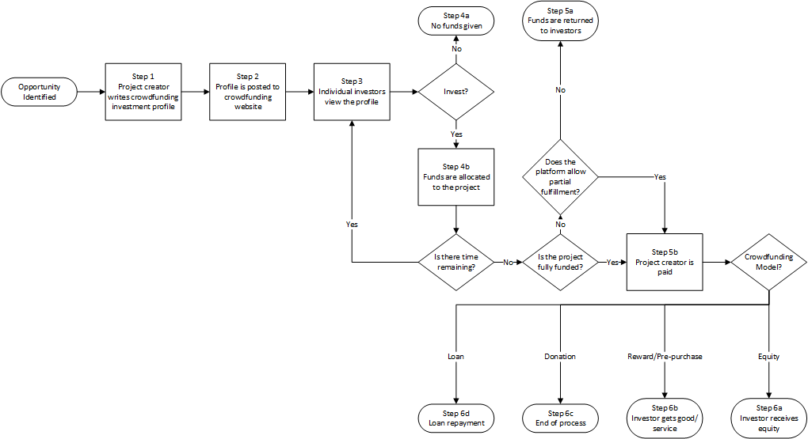

Crowdfunding campaigns and social movement organizations
The characteristics of crowdfunding that differentiate it from traditional sources of entrepreneurial finance align it closely with another crowd-based phenomenon: social movements. Social movements are broadly defined by collective action purposively undertaken to accomplish a social goal (e.g., Rucht, 1999; Greve et al., 2006). Most research in this area has examined movements where a societal change is the ultimate goal of the organization, such as the civil rights movement or the war on poverty (e.g., Andrews, 2001; Davenport, Soule, and Armstrong, 2011). However, not all social movements aim to change social institutions.
Expressive social movements are defined as collective action where a social problem or unrest is resolved through expressive behavior rather than the desire to change existing social institutions (Blumer, 1939). For example, fashion movements are expressive social movements (Blumer, 1939; 1969). A fashion movement might begin with an elite social class trying to differentiate itself through wearing different clothing than the lower classes (Blumer, 1939). The fashion then trickles down through the lower classes as they attempt to emulate the style of the upper class (Blumer, 1939). For example, in the modern fashion industry, the most prominent fashion designers cater their products to elite classes (Sproles, 1981). The ideas of these designers are then incorporated into the designs of less esteemed designers that disseminate the fashion to lower classes (Sproles, 1981).
Fashion movements can also take place through the leadership of creative individuals through collective selection (Blumer, 1969; Sproles, 1981). In the collective selection view of fashion movements, styles from different creative leaders compete to become the newest fashion, but only those that reflect consumers’ tastes succeed (Sproles, 1981). In the management literature, the collective selection view of fashion has been used to explain the emergence of management fashions such as quality circles (e.g., Abrahamson, 1996). Quality circles were introduced by fashion setters in the early 1980s and quickly garnered the favor of over 90% of the Fortune 500 companies (Abrahamson, 1996; Lawler and Mohrman, 1985). This rapid adoption reflected the belief that this practice would improve business performance through employee involvement. However, by 1987 over 80% of the Fortune 500 companies who once used quality circles had discontinued their use, marking the end of the fashion (Abrahamson, 1996; Castorina and Wood, 1988).
Crowdfunding resembles the collective selection view of fashion movements. In crowdfunding, campaign creators present an innovative product or service that they believe potential investors would value, with the hope that they would contribute financially to its creation. If the product or service resonates with investors, they provide the entrepreneur with funding and receive the product or some alternative reward linked to the product in return. For example, Pebble Technologies presented investors with an innovative way to customize watches to interact with smartphone apps (Pebble Technologies, 2012). This innovation advanced the wearable computing trend that had been growing with the recent introduction of the Fitbit and Google Glass (e.g., Belopotosky, 2009; Bilton, 2012). The alignment of the Pebble watch with consumers’ interest in wearable devices led over 68,000 investors to contribute to the campaign.
Expressive social movements also differ from traditional social movements in that the participants in expressive social movements may not develop a collective identity. Frequency of exchange between members of a group is a salient aspect of developing a collective identity (Flynn, 2005; Lawler and Yoon, 1993). In fashion movements, the participants in the movement do not organize before acting in a way that would develop collective identity (Blumer, 1939). Similarly, in crowdfunding the individual investors are unlikely to interact with each other on a regular basis. As a result, the investors in a campaign are unlikely to develop a collective identity.
Within each social movement, one or more social movement organizations are created to facilitate the acquisition of resources (McCarthy and Zald, 1977). While these organizations frequently cooperate in the pursuit of the movement’s goals, they also compete with each other for resources (Soule and King, 2008). Similarly, crowdfunding platforms create a marketplace for projects within each industry (e.g., publishing, technology). Since potential investors have limited resources to invest in crowdfunding campaigns, projects within each industry must compete for the resources of investors who are interested in projects within that industry.
The members of each social movement organization are vital to the organization’s survival and the pursuit of organizational goals (Edwards and McCarthy, 2004). However, social movement organizations frequently rely on non-members for resources (Cress and Snow, 1996; McCarthy and Zald, 1977). For example, in the late 1990’s, college students gave of their time to participate in protests against sweatshops even though they did not directly benefit from their elimination (Van Dyke, Dixon, and Carlon, 2007). This is similar to the crowdfunding model, where external investors provide the bulk of the capital raised. Indeed, because crowdfunding platforms frequently charge a fee on the amount money raised, it would be inefficient for campaign creators to contribute to their own crowdfunding campaigns.
In sum, crowdfunding campaigns are similar to expressive social movement organizations in several ways. Both phenomena involve the engagement of external resource providers who may not directly benefit from the success of the campaign to resolve perceived problems. These similarities suggest that the two phenomena may also be similar in how leaders of each acquire resources. Thus, while crowdfunding campaigns are not social movement organizations, theories regarding the resource mobilization of social movement organizations may help to understand how entrepreneurs solicit resources through crowdfunding.
Social movement framing
A key way that social movements solicit resources is through strategic communications with stakeholders (e.g., Benford and Snow, 2000; Stewart, Smith, and Denton, 2012). Social movement scholars frequently use frame theory to examine how social movement organizations use communications strategically to convince these individuals to contribute to the movement (Benford and Snow, 2000; Cress and Snow, 2000). Frames are socially constructed mental schemas that help individuals to interpret and create meaning regarding events that happen around them (Goffman, 1974). Frame theory suggests that when the articulated frame of a social movement organization and the ideals and values of an individual are congruent, the individual will be more likely to contribute to the organization (Snow et al., 1986). Thus, a key activity for social movement organization leaders is aligning the frames of the individual and the organization (Morris and Staggenborg, 2004).
The alignment of frames is an important activity in many aspects of business leadership as well (Cornelissen and Werner, 2014). For instance, communicating changes to stakeholders is a key factor in the successful implementation of major strategic changes (Smircich, 1983). However, the way leaders frame the strategic change influences stakeholders’ receptiveness to the change. Specifically, frame theory suggests that leaders who align stakeholder frames by positioning the strategic change as trying to balance the divergent needs of many stakeholders tend to outperform those who acquiesce to a shareholder-first framing (Fiss and Zajac, 2006).
When organizational leaders attempt to change their institutional environments, frame alignment provides an important means for legitimating new institutional logics (Misangyi et al., 2008). For example, organizations can work to unseat corrupt institutional logics by identifying the sources of the corruption, presenting the legal reforms that will resolve the problem, and motivating others to take action (Misangyi et al., 2008). While institutional entrepreneurs use framing to remove corrupt institutional logics, dominant institutional actors may use similar framing techniques to attempt to maintain the status quo (Misangyi et al., 2008).
Frame alignment is also important for managing decision-making and leadership within organizations. Frame theory suggests that organizational decision making under uncertainty can be viewed as framing contests, where coalitions in management maintain a different view of the problem to be resolved and the appropriate course of action (Kaplan, 2008). While the misalignment of the decision frames among the management coalitions lengthens the decision-making process, it can also improve decision making by ensuring that several different aspects of the decision are considered before action is taken (Kaplan, 2008). Once a decision is reached, frame alignment between leaders and their followers is important to the creation of a shared vision for the organization and inspiring followers to act (e.g., Den Hartog and Verburg, 1997; Fairhurst and Sarr, 1996).
Discursive processes are central to the development, articulation, and alignment of frames (Benford and Snow, 2000; Gamson, 1992). For example, social movement leaders can strategically use language to draw attention to or create linkages between events associated with the movement to influence how the individual views the social movement (e.g., Stewart et al., 2012). In social movements, this discourse may occur in a number of occasions such as protest speeches, communications through the media, or directly during conversations with constituents and adherents to the movement. This enables an on-going frame adjustment process where the movement leader can adjust the rhetoric used over time. However, in crowdfunding, individual investors may decide whether or not to invest based on the crowdfunding investment profile without direct interaction with the campaign creator. This heightens the importance of using rhetoric that accurately aligns the frames of the entrepreneur and the investor in the crowdfunding investment profile.
There are three core framing tasks that facilitate individuals’ agreement with the aims of the social movement organization and encourage them to take action (Snow and Benford, 1988; Wilson, 1973). First, diagnostic framing directs individuals’ attention to a problem and identifies the source of the problem. Second, prognostic framing outlines the proposed solution to the problem. Finally, motivational framing encourages individuals to take action in support of the frame articulator.
Diagnostic framing. Diagnostic framing involves identifying and drawing attention to a problem and the sources of the problem (Snow and Benford, 1988). Without engaging in diagnostic framing, the social movement organization and potential resource providers may have different views regarding the nature and causes of the problem. Alternatively, the resource provider may not be aware of the problem at all. For instance, in the U.S.-Central American peace movement, missionaries highlighted the suffering of Central Americans and the murders of noted church workers in Central America to U.S. church congregations to make North Americans aware of the violence taking place (e.g., Nepstad, 1997). If the North Americans were not made aware of the violence in Central America or did not perceive it to be a problem, it is unlikely that they would take action to eliminate the problem.
In crowdfunding, campaign creators can engage in diagnostic framing by explicitly identifying the problem or need addressed by the project in the crowdfunding investment profile. This aligns the interests of the campaign creator and investor in two ways. First, explicit identification of the problem informs the investor that the problem exists if they were not previously aware of the problem. Second, describing the problem in the crowdfunding investment profile makes it more likely that the potential investor will view the problem as being salient. If the potential investor is aware of the problem being addressed by the campaign creator and views the problem as salient, the diagnostic framing has aligned the interests of the campaign creator and investor, making it more likely that the investor will contribute to the campaign. Thus, I suggest:
Hypothesis 1. The presence of problem-related rhetoric is positively associated with crowdfunding performance.
In social movements where the social order is being challenged, diagnostic framing is adversarial (Gamson, 1992). That is, diagnostic framing frequently establishes an in-group reflecting the supporters of the movement and a stigmatized out-group that has been blamed for causing the problem (Gamson, 1992). For instance, white supremacist social movement organizations have used diagnostic framing to create a homogeneous in-group and ascribed blame to non-whites for perceived problems experienced by the in-group (e.g., McVeigh et al., 2004). Similarly, the Occupy Wall Street movement identified the richest one percent of society and the financial sector as being the cause of the economic problems suffered by the less wealthy (e.g., Gabler, 2012).
The benefits of adversarial diagnostic framing from creating solidarity within the in-group are often accompanied by a reduction in the number of individuals who would consider providing resources to the organization. Identifying adversaries turns away neutral bystanders and can polarize the ‘opposition’ (McVeigh et al., 2004). In doing so, the stigmatized out-group may respond with counterframing, a discursive framing action aimed at discounting or neutralizing the framing efforts of the movement (Benford, 1987; Zuo and Benford, 1995). However, on balance, research in this area suggests that not identifying adversaries results in reduced support from supporters (e.g., Cress and Snow, 2000). This suggests that up to a point, the use of adversarial rhetoric will strengthen the relationship between the identification of a problem and the receipt of resources from supporters of the social movement by creating a sense of collective identity.
In expressive social movements, the collective identity and solidarity benefits of adversarial rhetoric may not outweigh the costs. As in traditional social movements, adversarial framing in expressive social movements is likely to alienate outsiders, making them less likely to contribute resources to the movement (e.g., McVeigh et al., 2004). However, since expressive social movements result in expressive behavior rather than collective action against an oppressive third party, the solidarity returns to identifying adversaries may be small. Rather, expressive social movements may build solidarity in other, more constructive ways. For instance, in religious movements, the repetition of shared rituals and beliefs with other like-minded individuals is a key source of solidarity (Blumer, 1939). Further, rather than viewing outsiders as adversaries, religious movements frequently identify them as individuals who might be convinced to join the movement (Blumer, 1939). In sum, this suggests that in expressive social movements adversarial rhetoric may actually weaken the relationship between the identification of a problem and the receipt of resources from supporters of the social movement by alienating outsiders.
The threat of alienating outsiders is particularly salient to crowdfunding campaigns. Crowdfunding is concerned with soliciting funds from individuals beyond the founding team. Thus, it is unlikely that the solidarity benefits accruing to the founding team from identifying adversaries will influence crowdfunding investor decision making. However, if crowdfunding investment profiles use rhetoric that alienates outsiders, this reduces the likelihood that individuals will respond to the identification of a problem by funding the campaign. In sum, this suggests that in crowdfunding adversarial rhetoric weakens the relationship between the identification of a problem and crowdfunding performance. Stated formally:
Hypothesis 2. Adversarial rhetoric negatively moderates the relationship between problem-related rhetoric and crowdfunding performance.
Prognostic framing. The second core framing task is prognostic framing. Prognostic framing involves communicating how the social movement organization proposes to resolve the problem identified in the diagnostic framing process (Snow and Benford, 1988). For example, in 2005, two teenagers were electrocuted and another was injured when they made contact with a high-voltage electrical substation while being pursued by French police (Snow, Vliegenthart, and Corrigall-Brown, 2007). As a result, riots broke out in the suburbs of Paris wherein 2,888 individuals were arrested, 126 police officers were injured, and 8,973 vehicles were burned (Snow et al., 2007). Most diagnostic framing placed the blame for the riots on the youth and their socioeconomic condition (Snow et al., 2007). Several prognostic frames were used to propose solutions to these issues, including improving housing conditions in French suburbs and improving the parenting of French children (Snow et al., 2007). Beyond providing a high-level recommended course of action, effective prognostic framing communicates the specific goals being pursued by the social movement organization and identifies how these goals are being pursued (Cress and Snow, 2000).
Within a social movement, prognostic framing is one of the key differentiators among social movement organizations (Benford and Snow, 2000). For instance, green movement organizations might share the depleting ozone layer as a problem to be resolved and attribute this to human deforestation activity. However, the proposed solution and tactics used by these organizations may range from lobbying for firms to be more environmentally conscious (Sustainable Forestry Initiative; Sasser et al., 2006) to spiking trees and the sabotage of logging equipment (Earth First!; Elsbach and Sutton, 1992).
Prognostic framing is also a key differentiating factor among crowdfunding campaigns. When two or more campaigns attempt to address the same or similar problems, the proposed solution and plan of action is likely to become a particularly salient decision-making criterion. Providing details regarding the solution and the plan of action provides the investor with the campaign creator’s vision for the future where the problem has been resolved. This enables the investor to align their vision of the solution with the campaign creator’s, increasing the likelihood of investment.
Prognostic framing may also serve a utilitarian purpose in addition to aligning the vision of the campaign creator and investor. Previous research suggests that investors’ attributions of entrepreneurs’ preparedness influences their likelihood of funding the entrepreneur (Chen, Yao, and Kotha, 2009). Business plans and the entrepreneur’s presentation of the business plan provide key inputs for stakeholders (Honig and Karlsson, 2004). For instance, investors use the business plan and accompanying presentation to assess the preparedness of an entrepreneur and the viability of their idea (Chen et al., 2009; Mason and Stark, 2004). However, crowdfunding campaign creators have not traditionally posted formal business plans outlining the details of a business concept to the crowdfunding investment profile. In absence of these documents, potential investors may use the solution and plans outlined in the investment profile to assess the preparedness of the entrepreneur and the quality of their business concept. Accordingly, I posit:
Hypothesis 3. The presence of solution-related rhetoric is positively associated with crowdfunding performance.
In the social movement literature, the fit between diagnostic and prognostic framing is suggested to influence the ability of social movement organizations to mobilize resources (e.g., Gerhards and Rucht, 1992). Specifically, individuals are more likely to commit resources to social movement organizations when the prognostic framing proposes solutions that clearly and directly resolve the problems raised through diagnostic framing (e.g., Gerhards and Rucht, 1992). For crowdfunding campaigns, this suggests that when an investor perceives that the identified problem and proposed solution are aligned, they are more likely to fund the campaign. Rhetorically, campaign creators can encourage investors to perceive that the problem and solution are aligned by explicitly describing how the solution resolves the problem. Put formally:
Hypothesis 4. The presence of rhetoric linking the proposed solution to the identified problem is positively associated with crowdfunding performance.
Motivational framing. The final core framing task is motivational framing. Motivational framing involves soliciting individuals to take action in support of the social movement (Snow and Benford, 1988). Where diagnostic and prognostic framing are principally used by social movements to rally support for their viewpoints, motivational framing directly solicits action and participation from individuals (Benford and Snow, 2000; Klandermans, 1984). Benford (1993b) identified four generic motivational vocabularies used in the US nuclear disarmament movement: severity, urgency, efficacy, and propriety. Of these, the severity, urgency, and efficacy vocabularies are most likely to influence crowdfunding performance.
Severity rhetoric in the US nuclear disarmament movement highlighted the size of the threat that nuclear weapons posed to the world (Benford, 1993a). Emphasizing the severity of the problem being addressed by a social movement encourages individuals to view the problem as more salient than those pursued by other social movement organizations (Benford, 1993a). If a resource provider views a problem as significant, they are more likely to feel compelled to take action to alleviate the problem.
In crowdfunding, each website presents campaigns spanning multiple industries and addressing a myriad of problems (e.g., Kickstarter, 2013b). Using severity rhetoric in crowdfunding investment profiles highlights the importance of the problem being addressed by the project to potential investors. Given that each investor has limited resources to provide to crowdfunding campaigns, this suggests that campaigns that use severity rhetoric in their crowdfunding investment profile will tend to attract greater investment. Thus, I propose:
Hypothesis 5a. Severity rhetoric is positively associated with crowdfunding performance.
Urgency rhetoric highlights the immediate threat posed by the problem addressed by a social movement (Benford, 1993a). In the U.S. nuclear disarmament movement, this was famously communicated by the doomsday clock, reminding individuals how near the world was to war involving nuclear weapons (Benford, 1993a). Severe problems that are not an immediate threat may not be addressed by resource providers, who may believe that addressing the problem can be postponed until a later date in favor of addressing more urgent problems in the present. For crowdfunding, this suggests that highlighting the urgency of the problem addressed by a project will encourage investors to act quickly and fund the campaign before funding campaigns addressing less urgent problems. Put formally:
Hypothesis 5b. Urgency rhetoric is positively associated with crowdfunding performance.
Efficacy rhetoric encourages individuals to contribute to a social movement by letting them know that their contributions to the movement will make a difference (Benford, 1993a). Efficacy rhetoric may influence an individual’s willingness to contribute on two levels. First, individuals want to know that they are contributing to a social movement organization that is likely to succeed in the alleviation of the problem (Klandermans, 1984). Thus, rhetoric emphasizing the efficacy of the social movement in enacting change is more likely to receive resources. Second, individuals want to know that their contribution will make a difference in the attainment of the social movement organization’s goals (Oberschall, 1980). Thus, rhetoric that emphasizes the importance of the resource providers’ contributions to the movement will increase the likelihood that they contribute to the social movement organization.
Investors are likely to share this concern regarding the efficacy of their contributions to crowdfunding campaigns. With the exception of donation-based crowdfunding, investors expect to be compensated for their investment either financially or through the receipt of goods and services. The receipt and value of this compensation is frequently dependent on the campaign creator successfully developing the new product or service. For instance, in pre-purchase-based crowdfunding, investors expect to receive the product underlying the project they funded (Bradford, 2012). However, if the product development is not successful, the investor would never receive compensation for their investment. Efficacy rhetoric communicating the campaign creator’s confidence can allay concerns regarding the viability of the project, encouraging investment. Thus, using efficacy rhetoric to communicate how investors’ funds will contribute to the successful development of the new product or service encourages investors to provide funds to the campaign. Accordingly, I posit:
Hypothesis 5c. Efficacy rhetoric is positively associated with crowdfunding performance.
Credibility. Two narratives that include similar diagnostic, prognostic, and motivational framing rhetoric may differ in their ability to solicit the commitment of resources to social movements (Benford and Snow, 2000). Social movement scholars attribute this disparity to the effects of frame resonance (e.g., Babb, 1996; Snow and Benford, 1988). Frame resonance suggests that contextual factors influence the way individuals respond to framing such that some frames are more effective than others (Snow and Benford, 1988).
The credibility of the frame articulator plays an important role in encouraging frame resonance (Benford and Snow, 2000). Thus, when framing is articulated by individuals who are deemed to be credible, resource providers are more likely to act on behalf of the movement (e.g., Druckman, 2001). In the crowdfunding context, this suggests that the framing by campaign creators who convey credibility to potential investors will draw more resources than those who do not.
The perceived credibility of an individual is influenced by others’ beliefs that they have expertise that is relevant to the matter at hand (Lupia, 2002; O’Reilly and Roberts, 1976). Since crowdfunding profiles are frequently categorized into industries, campaign creators can influence their perceived expertise through how they communicate their experience in that industry (e.g., Hartelius, 2010). This is supported by research in entrepreneurial finance suggesting that the entrepreneur’s level of experience is salient to investor decision-making (Zacharakis and Meyer, 2000).
One way to communicate experience in an industry is to use rhetoric consistent with the industry vernacular. Industries frequently develop vocabularies and shared meanings that facilitate communication between individuals within the industry (e.g., Lengnick-Hall and Lengnick-Hall, 1988). For example, in the insurance industry the word ‘premium’ carries a different meaning than in its use in colloquial English. By using industry vernacular, campaign creators signal their familiarity with the industry.
While industry rhetoric can signal experience and familiarity with an industry, if used in excess, industry rhetoric can hamper communication by alienating non-industry readers and making narratives more difficult to read (e.g., Brown, Braskamp, and Newman, 1978; Hallenstein, 1978). Thus, if framing narratives contain too much industry rhetoric, the frames become less likely to resonate with potential investors which decreases the efficacy of the frames to solicit resource investment.
The moderating effect of industry rhetoric is most likely to affect the efficacy of diagnostic and prognostic framing in crowdfunding. The purpose of diagnostic and prognostic framing is to build consensus regarding the nature of the problem and the appropriate course of action (Benford and Snow, 2000; Klandermans, 1984). Industry rhetoric facilitates these framing tasks by suggesting that the frame articulator has experience that makes them more likely to accurately diagnose the problem and identify effective solutions that will eliminate the problem. Overall, this suggests that the use of industry rhetoric will have a nonlinear moderating effect on the relationships of diagnostic framing and prognostic framing with crowdfunding performance such that the relationships are strongest at intermediate levels of industry rhetoric. Formally,
Hypothesis 6a. The relationship between the presence of problem-related rhetoric and crowdfunding performance is strongest under intermediate levels of industry rhetoric, but is comparatively weaker under low or high levels of industry rhetoric.
Hypothesis 6b. The relationship between the presence of solution-related rhetoric and crowdfunding performance is strongest under intermediate levels of industry rhetoric, but is comparatively weaker under low or high levels of industry rhetoric.
Hypothesis 6c. The relationship between the presence of rhetoric linking the proposed solution to the identified problem and crowdfunding performance is strongest under intermediate levels of industry rhetoric, but is comparatively weaker under low or high levels of industry rhetoric.
Overall, frame theory suggests that rhetoric associated with diagnostic, prognostic, and motivational framing will be positively related to crowdfunding performance. However, unlike with traditional social movements, adversarial rhetoric will weaken the relationship between problem-related rhetoric and crowdfunding performance. Finally, frame resonance suggests that the use of industry rhetoric will moderate diagnostic and prognostic framing’s relationships with crowdfunding in a curvilinear manner, such that a moderate amount of industry rhetoric strengthens these relationships. A graphical depiction of the theoretical model is presented in Figure 2.

FIGURE 2. THEORETICAL MODEL
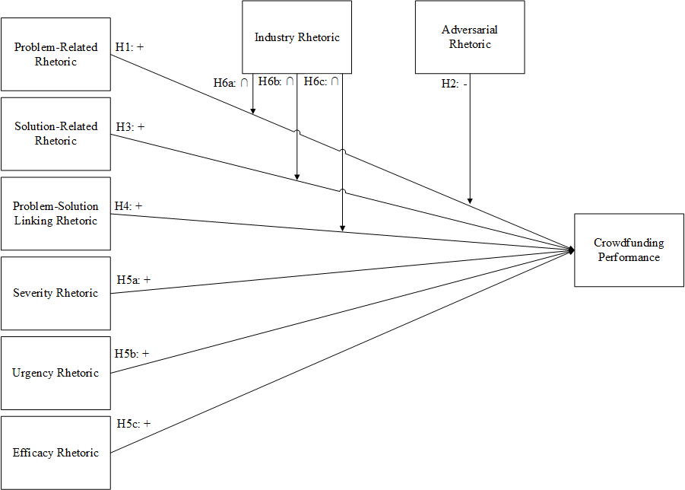

CHAPTER 3. METHODS

Sample description
To examine the role of framing rhetoric on crowdfunding performance, I collected crowdfunding campaign data from Kickstarter.com. Kickstarter is a crowdfunding platform that has provided over $666 million to more than 43,000 successfully funded campaigns to date, making it one of the top two crowdfunding websites by volume (Kickstarter, 2013c; Lev-Ram and Wagner, 2013).
I drew my sample from a list of 45,815 crowdfunding campaigns that were created before June 2, 2012 (Pi, 2012). This timeframe maximizes comparability to other recent examinations of crowdfunding phenomena that use the same sampling frame (i.e., Mollick, 2014). The list of 45,815 campaigns does not reflect a census of Kickstarter campaigns on June 2, 2012; however, on April 30, 2012 there were nearly 50,000 campaigns on Kickstarter (Wortham, 2012). This suggests that my sampling frame captured approximately 91 percent of campaigns created over the three-year period. From the list of 45,815 campaigns, I selected 900 campaigns at random with replacement for collection. From these 900 campaigns, I eliminated two suspended campaigns, three canceled campaigns, and three statistical outliers to arrive at a final usable sample of 892 campaigns.
The final sample included crowdfunding campaigns from eight industries when classified by 2-digit NAICS code. Table 1 breaks down the sample by industry. The Kickstarter platform emphasizes the funding of creative projects (Kickstarter, 2013d). As a result, the sampled campaigns clustered in two industries. Arts, entertainment, and recreation industries (NAICS 71) which includes musicians, dance companies, and theatre production companies, comprised the majority with 55%. Information industries (NAICS 51) which includes software and film production companies comprised 30% of the sample. This distribution is representative of the current overall population of over 141,000 Kickstarter projects, where over 53% of projects are associated with arts, entertainment, and recreation (NAICS 71), 24% of projects are associated with information industries (NAICS 51) and the remaining are distributed among other fashion, game, food, design and technology industries (Kickstarter, 2014).
Dependent variable
The dependent construct in this dissertation is crowdfunding performance. The venture funding literature has relied on continuous measures for investment performance to capture the amount of money invested in an entrepreneurial firm (e.g., Jeng and Wells, 2000; Walske and Zacharakis, 2012). To increase comparability with this literature, I operationalize crowdfunding performance as Amount Funded – capturing the amount of money committed to the campaign by investors. Kickstarter does not allow partial fulfilment of incompletely funded campaigns. Thus, the money allocated to unsuccessful campaigns is returned to investors rather than disbursed to campaign creators. To provide a consistent measure of crowdfunding performance across both successful and unsuccessful campaigns, I record the crowdfunding performance of unsuccessful ventures as if they received the money previously allocated to their campaigns. Crowdfunding performance data was collected from the crowdfunding investment profile of each campaign.

TABLE 1. SAMPLE DESCRIPTION

Independent variables
This dissertation centers on how framing rhetoric used in crowdfunding narratives influences crowdfunding performance. Recent studies have examined the influence of rhetoric on crowdfunding performance by measuring this rhetoric in the crowdfunding investment profiles provided by the campaign creators (e.g., Allison, McKenny et al., 2014). Crowdfunding investment profiles on Kickstarter can have two distinct narratives. All Kickstarter profiles have a written narrative where the campaign creator describes the campaign. Many Kickstarter profiles also have a video narrative to complement the written narrative, enabling the creator to appeal to potential investors for funds using richer media and demonstrate the proposed product or service. The contents of these narratives are determined entirely by the campaign creators; however, they frequently include a description of the product or service, the motivation for the project, timelines, information about the project team, benefits to investors, and how funding would be used.
In this dissertation, I measure framing rhetoric in both the written and video narratives from Kickstarter crowdfunding investment profiles. Written narratives were collected manually from the 892 crowdfunding campaign websites. Video narratives were transcribed verbatim from the videos on the crowdfunding campaign websites (cf. Druskat and Wheeler, 2003; Simons, 1993).
I use content analysis to measure framing rhetoric in these written and transcribed video narratives. Content analysis is a collection of techniques that enable scholars to examine organizational phenomena based on the textual content of organizational and entrepreneurial narratives (e.g., Duriau, Reger, and Pfarrer, 2007; Short and Palmer, 2008). Organizational scholars have relied on content analytic techniques to examine both crowdfunding (e.g., Allison, McKenny et al., 2014) and social movement (e.g., King, 2008) phenomena.
There are two broad forms of content analysis: computerized and manual (Rosenberg, Schnurr, and Oxman, 1990; Short and Palmer, 2008). In computerized content analyses, a computer is used to analyze the text of the narrative using a set of strict predefined rules with artificial intelligence systems or pre-defined dictionaries to identify the presence of textual information of interest to the researcher (Rosenberg et al., 1990; Short and Palmer, 2008). Computerized content analysis is valuable in its ability to analyze a large number of narratives in a short time with near perfect reliability (Duriau et al., 2007). These systems are particularly valuable for capturing features of the language that are reflected in word choice, such as optimism and tangibility (Hart, 2001; Pennebaker, Mehl, and Niederhoffer, 2003). However, despite advances in artificial intelligence systems, most computerized content analysis packages struggle with the complexities of language use in context.
In manual content analyses, one or more human coders establish guidelines for measuring the presence and prevalence of variables in the texts (Neuendorff, 2002). While manual content analysis is much slower and generally has lower reliability than computerized content analysis, it enables a richer understanding of the message being articulated by the text producer (Neuendorff, 2002; Weber, 1990). In this dissertation, I conduct a manual content analysis using NVivo 9 (QSR International, 2010) to measure the framing rhetoric variables. Manual content analysis is most appropriate for this dissertation for two reasons. First, because the subject of each crowdfunding campaign is different, the construction of predefined dictionaries associated with the potential problems and solutions campaign creators is impractical. Second, the hypotheses presented in this dissertation concern themes of the message that may not manifest in words typically associated with the variable being measured. For example, a computer coding the phrase “incidence of drunk driving accidents has increased exponentially over the past five years” may not identify that a problem has been specified. This is because none of the words on their own would generally be interpreted as identifying a problem, unlike a phrase like “people looking down at their cellphones while driving has become a big problem” which could be identified by the presence of the word “problem”. By contrast, a manual coder can more easily consider the phrase as a whole and the context in which it is being presented to understand the first phrase is an example of problem-related rhetoric.
Hypothesis 1 suggests that the presence of problem-related rhetoric influences crowdfunding performance. If the crowdfunding campaign creator identifies the problem to be addressed, this alerts the investor to the problem and provides them with the opportunity to align their frame with the campaign creator’s frame. For example, one profile highlighted the problem that “[c]hildhood obesity is responsible for causing an explosion of long term diseases in young children, including heard disease and diabetes (Welch, 2011)”. However, repeatedly highlighting the problem is unlikely to influence frame alignment. If the individual had already aligned their frame, they are in agreement with the campaign creator regarding the problem and repetition of the problem is unnecessary. If the individual had not aligned their frame, they disagreed with the campaign creator regarding the problem and mere repetition of the campaign creator’s view is unlikely to change their mind. Accordingly, I operationalize problem-related rhetoric as a dichotomous variable. If either narrative from the crowdfunding investment profile explicitly identifies the problem to be addressed, problem-related rhetoric will be assigned a one. If no problem is identified, problem-related rhetoric will be assigned a zero.
Hypothesis 2 suggests that adversarial rhetoric moderates the relationship between problem-related rhetoric and crowdfunding performance. Adversarial rhetoric is coded as a discrete count variable at the clause level. That is, every clause that includes rhetoric that antagonizes, attacks, or assigns fault to another party in the crowdfunding investment profile increments the adversarial rhetoric score by one. For example, one profile stated, “all along the way large financial institutions, insurance companies, and other corrupt institutions screw you along the way” (Salameh, 2012). Because this clause antagonizes financial institutions and insurance companies, the adversarial rhetoric score for this crowdfunding investment profile would increase by one.
Hypothesis 3 suggests that the presence of solution-related rhetoric influences crowdfunding performance. If the crowdfunding campaign creator identifies a solution to the previously identified problem, this alerts the investor to the solution and provides them with the opportunity to align their frame with the campaign creator’s frame. For example, one profile highlighted the solution “the bottle will be a more durable, 100% safe, and completely biodegradable alternative to conventional plastic bottles (Leadam, 2012)”. As with problem-related rhetoric, repeatedly highlighting the solution is unlikely to influence frame alignment. Accordingly, I operationalize solution-related rhetoric as a dichotomous variable. If the crowdfunding investment profile explicitly identifies the solution to the problem, solution-related rhetoric is assigned a one. If no solution is identified, solution-related rhetoric is assigned a zero.
Hypothesis 4 suggests that the presence of rhetoric linking the solution to the problem (linking rhetoric) influences crowdfunding performance. If the crowdfunding campaign creator describes how the solution addresses the problem, this provides the investor with the campaign creator’s vision for how the problem will be resolved by the implementation of the proposed solution, making it more likely that the investor will view the problem and solution as linked. For example, one profile noted that film festivals would be “a great way to get our message to huge amounts of people in concentrated areas (Bollinger and Surowicz, 2011)”, indicating how the creation of a documentary would actually help increase awareness of cerebral palsy through its being played at these festivals. As with problem- and solution-related rhetoric, repeatedly outlining how the proposed solution will address the problem is unlikely to influence frame alignment. Accordingly, I will operationalize linking rhetoric as a dichotomous variable. If the crowdfunding investment profile explicitly outlines how the proposed solution will address the problem, linking rhetoric is assigned a one. If no attempt was made to link the solution to the problem, linking rhetoric is assigned a zero.
Hypothesis 5a suggests that the use of severity rhetoric influences crowdfunding performance. Severity rhetoric is coded as a discrete count variable at the clause level. That is, every clause that includes rhetoric that emphasizes the size of the problem being addressed by the project in the crowdfunding investment profile will increment the severity rhetoric score by one. For example, one profile stated (emphasis added) “The quality of water in Gaza has been eroded creating a severe health hazard to which children are most vulnerable (Break The Silence Arts, 2011)”. Because the second and last clauses indicate the scale of the problem, the severity rhetoric score for this crowdfunding investment profile would increase by two.
Hypothesis 5b suggests that the use of urgency rhetoric influences crowdfunding performance. Urgency rhetoric is coded as a discrete count variable at the clause level. That is, every clause that includes rhetoric that emphasizes the time-sensitive nature of the problem being addressed by the project in the crowdfunding investment profile will increment the urgency rhetoric score by one. For example, one profile stated (emphasis added) “DEFEND JOSHUA TREE. Before it's [sic] too late (Babcock, 2011)” Because the last clause indicates the time-sensitive nature of the problem, the urgency rhetoric score for this crowdfunding investment profile would increase by one.
Hypothesis 5c suggests that the use of efficacy rhetoric influences crowdfunding performance. Efficacy rhetoric is coded as a discrete count variable at the clause level. That is, every clause that includes rhetoric emphasizing the impact the investors’ funds will have on the project in the crowdfunding investment profile will increment the efficacy rhetoric score by 1. For example, one profile stated (emphasis added) “This sounds like a lot of money, but your assistance will help (Coburn, 2012)”. Because the second clause highlights the impact investors will have on the project, the efficacy rhetoric score for this crowdfunding investment profile would increase by 1.
Hypotheses 6a-6c suggest that the use of industry rhetoric moderates the relationships between problem-related rhetoric, solution-related rhetoric, and linking rhetoric with crowdfunding performance. Industry rhetoric is coded as a discrete count variable at the clause level. That is, every clause that includes rhetoric associated with the project’s industry will increment the industry rhetoric score by 1. For example, one profile stated (emphasis added) “If you own a SLR or DSLR camera this is something you have wanted (Stevenson, 2011)”. Because the clause includes language that is specific to the photography industry, the industry rhetoric score for this crowdfunding investment profile would increase by 1.
Control variables
In launching a Kickstarter crowdfunding campaign, the creator has considerable control over the structure of the campaign, the contents of the campaign narrative, and the selection of the specific project being pitched. I control for factors in each of these three areas to mitigate the influence of confounding factors arising from these campaign design decisions and success criteria.
The first three control variables eliminate confounding factors arising from the structure of the crowdfunding campaign. A key decision in the structure of the campaign is the funding target. I include funding target as a control because this is set by the campaign creator based on the funds needed to successfully bring the project to completion. In Kickstarter, once the funding target has been met, the campaign creator becomes liable for the delivery upon the products or services listed as rewards to the investor because the campaign has provided the creator with sufficient funds to complete the proposed project (Kickstarter, 2013a). However, when potential investors perceive that the campaign creator has sufficient funds to complete the proposed project, frame theory suggests that they will be less likely to contribute because their contribution to the success of the campaign is diminished – the campaign creator already has sufficient resources to alleviate the problem that they have identified using the proposed solution. This suggests that campaigns with low funding targets will tend to raise fewer funds than campaigns with higher funding targets.
In addition to the funding target of the campaign, the project success is also likely to influence an individual’s likelihood of investing. Framing rhetoric is unlikely to be effective in soliciting investments to campaigns that are already successful regardless of the funding target that determined that the campaign was successful. Project success is measured as a dichotomous indicator. A value of 1 indicates that the funds raised by the campaign were equal to, or in excess of, their funding target at the end of the campaign. A value of 0 indicates that the funds raised by the campaign were less than the funding target at the end of the campaign.
The campaign creator selects the duration of the campaign during its creation. Campaigns on Kickstarter can last between one and 60 days at the discretion of the campaign creator (Kickstarter, 2013d). Research in crowdfunding suggests that shorter campaigns tend to be more successful than longer campaigns because this creates a sense of urgency in potential investors that is not felt as strongly in longer campaigns (Kickstarter, 2013d; cf. Mollick, 2014). This is consistent with marketing research suggesting that creating a sense of urgency can induce people to make impulsive buying decisions (Bayley and Nancarrow, 1998). Thus, I include project duration as a control variable measured as the number of days the campaign lasted.
The next five control variables concern the contents of the campaign narrative. While few studies have examined the influence of the crowdfunding investment narratives on crowdfunding performance, one recent study found that five aspects of political rhetoric influences crowdfunding performance (i.e., Allison, McKenny et al., 2014). Specifically, they found that accomplishment, blame, present concern, tenacity, and variety rhetoric influenced the speed with which crowdfunded microloans are funded. To control for these forms of political rhetoric, I will use DICTION 6 (Hart, 2010), a computer-aided text analysis tool, to measure each of the five variables (cf. Allison, McKenny et al., 2014).
The last control variable concerns the nature of the project being pitched. Previous studies examining the antecedents of crowdfunding performance have found that the industry sector of the firm influences crowdfunding performance (e.g., Allison, McKenny et al., 2014). To control for industry sector effects, I mapped each of the thirteen categories used by Kickstarter to differentiate products and services onto two-digit NAICS codes (cf. Allison, McKenny et al., 2014). I use NAICS rather than SIC codes because accounting research suggests that NAICS provides a cleaner classification for industries (Krishnan and Press, 2003).
Table 2 presents a correlation matrix for all variables used in this dissertation. This table also presents the means and standard deviations for these variables.

TABLE 2. DESCRIPTIVE STATISTICS AND CORRELATIONS
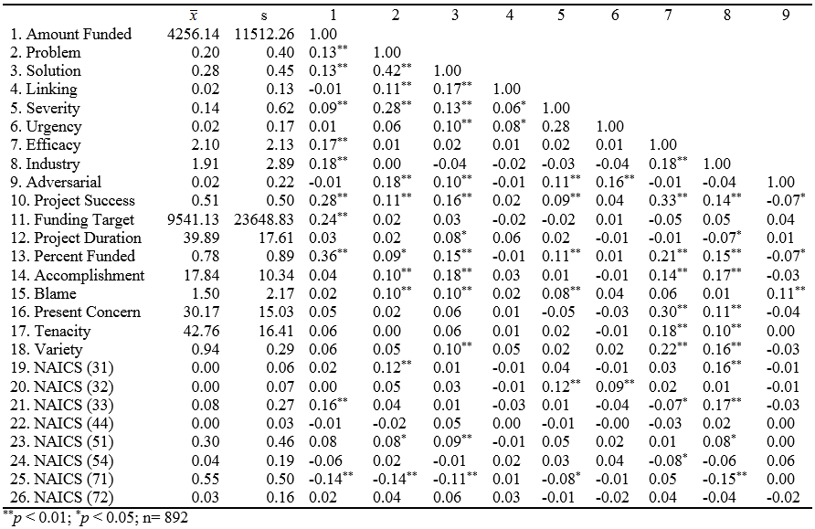
TABLE 2. DESCRIPTIVE STATISTICS AND CORRELATIONS (CONTINUED)
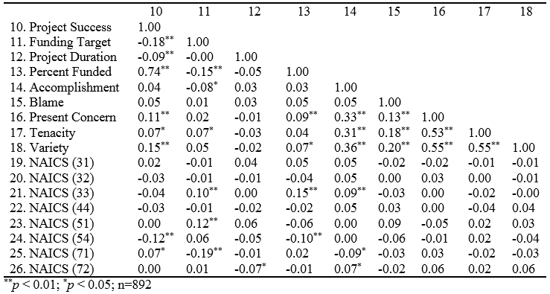

TABLE 2. DESCRIPTIVE STATISTICS AND CORRELATIONS (CONTINUED)
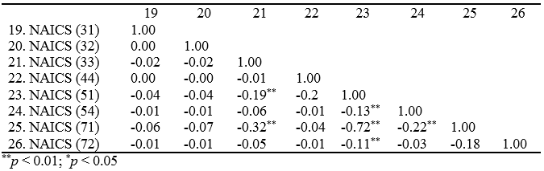

CHAPTER 4. RESULTS
The results of my analysis are presented in Table 3. To examine the effect of framing rhetoric on crowdfunding performance I employed generalized least squares regression with random effects. The nested nature of crowdfunding campaigns within industries violates the independence of residuals assumption of ordinary least squares regression (cf., Hair et al., 2010). Generalized least squares regression with random effects enabled me to systematically account for industry-level differences in the relationships being tested (Short et al., 2006). This technique has been similarly used in other studies looking at entrepreneurial financing activities to correct for the nesting of data (e.g., Baum and Silverman, 2004; Matusik, George, and Heeley, 2006). Fixed effects models may be used with industry-nested data when industry-level factors can be shown to be uncorrelated with the explanatory variables using a Hausman (1978) specification test. I was unable to reject the null hypothesis that industry-level factors are uncorrelated with my independent variables, thus a random effects model was appropriate.
Model 1 regressed the amount of funds raised on control variables. I found that several control variables predicted fundraising outcomes. The funding target (β = 0.15; p < 0.05) and success of the crowdfunding campaign (β = 7798.22; p < 0.01) were both positively related to the amount of funds raised. Tenacious rhetoric from the political rhetoric literature was also positively related to funds raised (β = 16.27; p < 0.01).

TABLE 3. GLS REGRESSION RESULTS – FUNDS RAISED
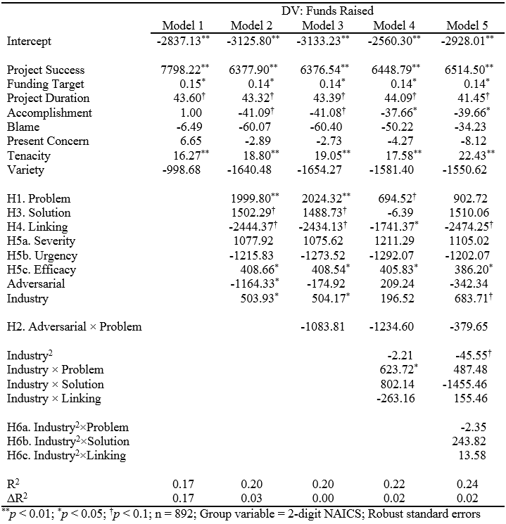

In model 2, I added the direct effects of the six forms of framing rhetoric as well as the direct effects of adversarial and industry rhetoric. Hypothesis 1 predicted a positive relationship between problem-related rhetoric and crowdfunding performance. I found that problem-related rhetoric had a positive and significant relationship with the amount of funds raised (β = 1999.80; p < 0.01), supporting hypothesis 1. Hypothesis 3 predicted a positive relationship between solution-related rhetoric and crowdfunding performance. I found that solution-related rhetoric had a positive, but insignificant relationship with the amount of funds raised (β = 1502.29; p < 0.10). Therefore, hypothesis 3 was not supported. Hypothesis 4 predicted a positive relationship between rhetoric linking the proposed solution to the identified problem and crowdfunding performance. I found that linking rhetoric was not significantly related to the amount of funds raised (β = -2444.37; p < 0.10). Therefore, hypothesis 4 was not supported.
Hypotheses 5a-5c were concerned with the direct effect of motivational framing on crowdfunding performance. Hypothesis 5a predicted a positive relationship between severity rhetoric and crowdfunding performance. I found that severity rhetoric was not significantly related to the amount of funds raised (β = 1077.95; p > 0.10). Therefore, hypothesis 5a was not supported. Hypothesis 5b predicted a positive relationship between urgency rhetoric and crowdfunding performance. I found that urgency rhetoric was not significantly related to the amount of funds raised (β = -1215.83; p > 0.10). Therefore, hypothesis 5b was not supported. Hypothesis 5c predicted a positive relationship between efficacy rhetoric and crowdfunding performance. I found that efficacy rhetoric had a positive and significant relationship with the amount of funds raised (β = 408.66; p < 0.05), supporting hypothesis 5c.
In addition to the hypothesis-related direct effects, I found significant direct relationships between crowdfunding performance and both adversarial and industry rhetoric. Adversarial rhetoric was negatively associated with the amount of funds raised (β = -1164.33; p < 0.05). Industry rhetoric was positively associated with the amount of funds raised (β = 503.93; p < 0.05).
In model 3, I added the multiplicative interaction between adversarial rhetoric and problem-related rhetoric. This enables me to test hypothesis 2, which predicts that adversarial rhetoric will negatively moderate the relationship between problem-related rhetoric and crowdfunding performance. However, the interaction effect was not significant (β = -1083.81; p > 0.10) and hypothesis 2 was not supported.
In model 4, I added the two-way multiplicative interactions among industry, problem, solution, and linking rhetoric to serve as a baseline for testing the non-linear moderation hypotheses. I found that the relationship of the interaction of industry and problem rhetoric with the amount of funds raised was positive and significant (β = 623.72; p < 0.05). In model 5, I added the three way interactions to test Hypotheses 6a – 6c, which predicted that the relationships of problem, solution, and linking rhetoric with crowdfunding performance would be moderated by industry rhetoric such that the relationships would be strongest at intermediate levels of industry rhetoric. Hypothesis 6a, concerning the moderation of the problem rhetoric-fundraising relationship was not supported (β = -2.35; p > 0.10). Hypothesis 6b, concerning the moderation of the solution rhetoric-fundraising relationship was not supported (β = 243.82; p > 0.10). Finally, hypothesis 6c, concerning the moderation of the linking rhetoric-fundraising relationship was not supported (β = 13.58; p > 0.10).
My primary analyses supported hypotheses 1 and 5c. Hypothesis 1 posited a positive relationship between problem-related rhetoric and crowdfunding performance. Hypothesis 5c posited a positive relationship between efficacy rhetoric and crowdfunding performance. The remaining eight hypotheses were not supported.

CHAPTER 5. POST HOC ANALYSES

In my primary analyses, I used funds raised to identify the rhetorical determinants of crowdfunding performance. However, the diversity of crowdfunding models and platforms increases the complexity of crowdfunding performance. On Kickstarter, campaign creators set their own fundraising goals for the crowdfunding campaign (Kickstarter, 2013a). If over the course of the campaign, this goal is not met, the amount of funds raised becomes immaterial when the funds are returned to the investors at the end of the campaign (Kickstarter, 2013b). To capture these other aspects of crowdfunding performance I conducted two additional post hoc analyses using two alternative operationalizations of firm performance.
The investment required to complete a project will vary from campaign to campaign. For instance, within the movie production industry, an entrepreneur filming a cinematic short will need considerably less funding than one producing a feature film. Measuring crowdfunding as funds raised is agnostic to these project-level differences. To capture this nuanced aspect of crowdfunding performance, the first post hoc analysis tests my hypotheses using the percent funded at the time the campaign ends at the dependent variable. As with the primary analyses, I used generalized least squares regression with random effects for the post hoc analysis. The results of this analysis are presented in Table 4.

TABLE 4. GLS REGRESSION RESULTS – PERCENT FUNDED
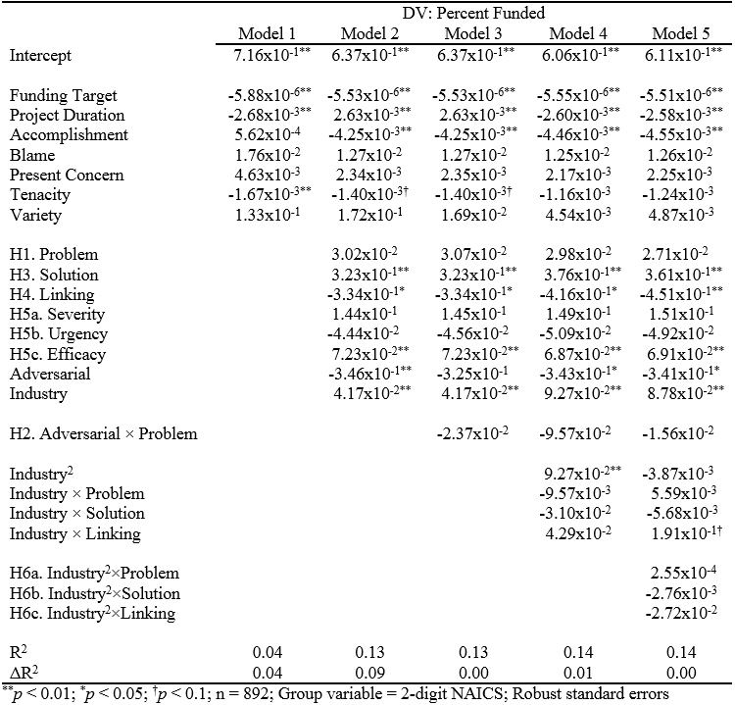

The results using a percentage dependent variable presents a distinct, but complementary view of the influence of framing rhetoric on crowdfunding performance. Hypothesis 1, concerning the direct effect of problem-related rhetoric on crowdfunding performance was not supported using the percent funded performance measure (β = 3.02x10⁻²; p > 0.10). However, hypothesis 2, concerning the direct effect of solution-related rhetoric on crowdfunding performance, gained support (β = 3.23x10⁻¹; p < 0.01). Hypothesis 5c, concerning the direct effect of efficacy rhetoric on crowdfunding performance remained significant with the percent funded performance measure (β = 7.23x10⁻²; p < 0.01).
Broadly, frame theory suggests that individuals are motivated to contribute to a crowdfunding campaign to reduce or eliminate a perceived problem. As such, when the campaign reaches its fundraising goal, the investment decision criteria is likely to change since the individual’s investment is no longer needed for the project to be successful and for the problem to be eliminated. Nevertheless, many crowdfunding platforms enable campaigns to continue collecting funds after the goal has been met (e.g., Kickstarter, Indiegogo). This suggests that the relationship between framing rhetoric and crowdfunding performance may differ based on the current performance of the campaign. To address this possibility, the second post hoc analysis tests my hypotheses using a dichotomous project success measure as the dependent variable. I used a multilevel logit regression for the post hoc analysis. The results of this analysis are presented in Table 5.

TABLE 5. MULTILEVEL LOGIT RESULTS – PROJECT SUCCESS
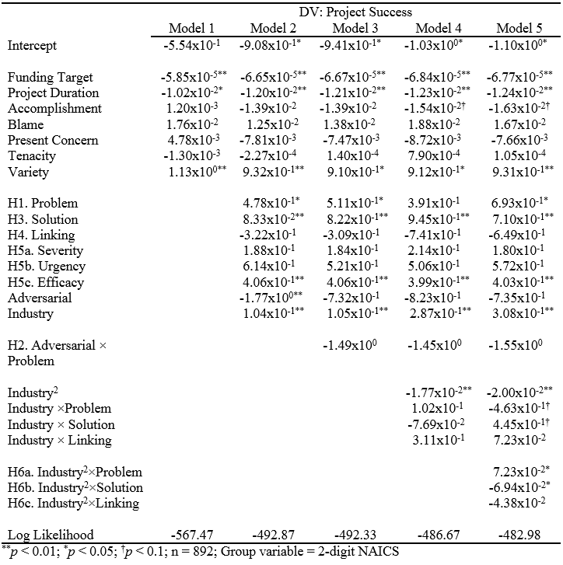

The results using a dichotomous project success dependent variable is supportive of both previous analyses. Hypothesis 1, concerning the direct effect of problem-related rhetoric on crowdfunding performance, was supported (β = 4.78x10⁻¹; p < 0.05). Hypothesis 2, concerning the direct effect of solution-related rhetoric on crowdfunding performance, was supported (β = 8.33x10⁻²; p < 0.01). Hypothesis 5c, concerning the direct effect of efficacy rhetoric on crowdfunding performance, was supported (β = 4.06x10⁻¹; p < 0.01). In addition to supporting the findings of the two previous analyses, this analysis also found a significant nonlinear moderating effect of industry rhetoric on the solution rhetoric-crowdfunding performance relationship (β = -6.94x10⁻²; p < 0.05), supporting hypothesis 6b.
Frame theory suggests that the credibility of the frame articulator can influence the efficacy of the framing activity (Snow and Benford, 1988). In hypotheses 6a, 6b, and 6c, I examine the influence that industry rhetoric, the vernacular used to facilitate communication within an industry, has on crowdfunding performance. To better understand the non-linear moderating effect of industry rhetoric on the relationship between framing rhetoric and crowdfunding performance, I conducted a post hoc test where projects were split into three groups based on the amount of industry rhetoric used. The regression analyses for each measure of firm performance were replicated with group membership replacing the industry rhetoric variable. The results of this analysis are presented in Table 6.

TABLE 6. THE MODERATING EFFECT OF INDUSTRY RHETORIC GROUPS
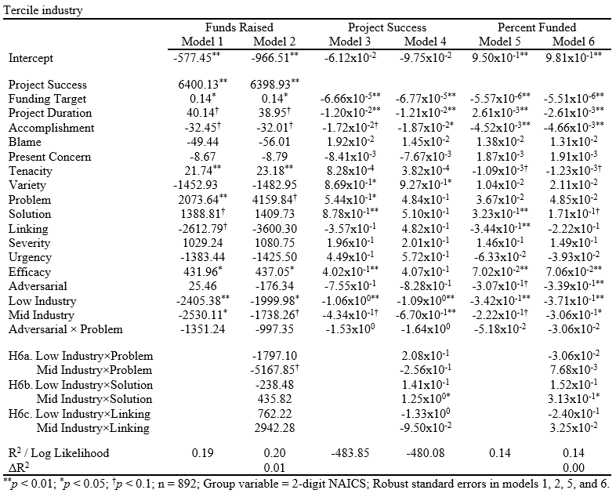
FIGURE 3. THE MODERATING EFFECT OF INDUSTRY RHETORIC ON THE SOLUTION RHETORIC-PROJECT SUCCESS RELATIONSHIP
FIGURE 4. THE MODERATING EFFECT OF INDUSTRY RHETORIC ON THE SOLUTION RHETORIC-PERCENT FUNDED RELATIONSHIP
These analyses provide additional evidence that industry rhetoric does not moderate the relationship of either problem or linking rhetoric with crowdfunding performance. However, it provides support for moderation of the solution-rhetoric to crowdfunding performance relationship when using project success or percent funded as a performance measure. In both cases the relationship between solution-related rhetoric and firm performance was not significantly different between the groups that were high and low in industry rhetoric. However, there was a positive moderating effect in the group that used a moderate amount of industry rhetoric. These relationships can be seen graphically in Figures 3 and 4.
Industry vernacular provides an indirect approach to communicating experience or expertise in an industry. However, many crowdfunding profiles contain rhetoric that provides a direct claim to legitimacy within an industry by speaking to their experience in the industry, awards won for past products, or testimonials from well-known individuals within the industry. For example, film production campaigns frequently highlighted that their film had been accepted to well-known film festivals such as the Sundance, Cannes, or South-by-Southwest film festivals. If directly highlighting the campaign creator’s experience or expertise in the industry influences their perceived credibility in the eyes of investors, frame theory suggests that this would be reflected through a moderating effect on the relationship between framing activities and crowdfunding performance (cf. Snow and Benford, 1988). However, unlike with industry vernacular, the use of higher levels of this industry credentialing rhetoric is not likely to be perceived as ‘jargon’. Thus, I expect the moderation effect for this alternative industry rhetoric specification to be linear and positive rather than being strongest at intermediate levels of industry rhetoric.
To identify the moderating effect of this more direct form of industry rhetoric on the framing-crowdfunding performance relationship, I ran each of the analyses again, replacing the measure of industry vernacular with the measure of industry credentialing rhetoric. The results of this analysis are presented in Table 6. Because this post hoc analysis is concerned only with the effect of industry rhetoric, models 1, 3, and 5 each reflect model 3 from their respective previous analyses, where control variables, direct effects, and the adversarial rhetoric-problem rhetoric interaction have already been added. The ΔR² for models 1 and 5 in Table 6 compare the R² value of this model with that of their equivalent (model 3) from their respective previous analyses. For instance, the ΔR² for Model 5 is -0.01, suggesting that this model explains one percent less variance in the funding percentage than its equivalent using industry vernacular (Table 4, model 3).

TABLE 7. RESULTS FOR ALTERNATIVE INDUSTRY RHETORIC SPECIFICATION
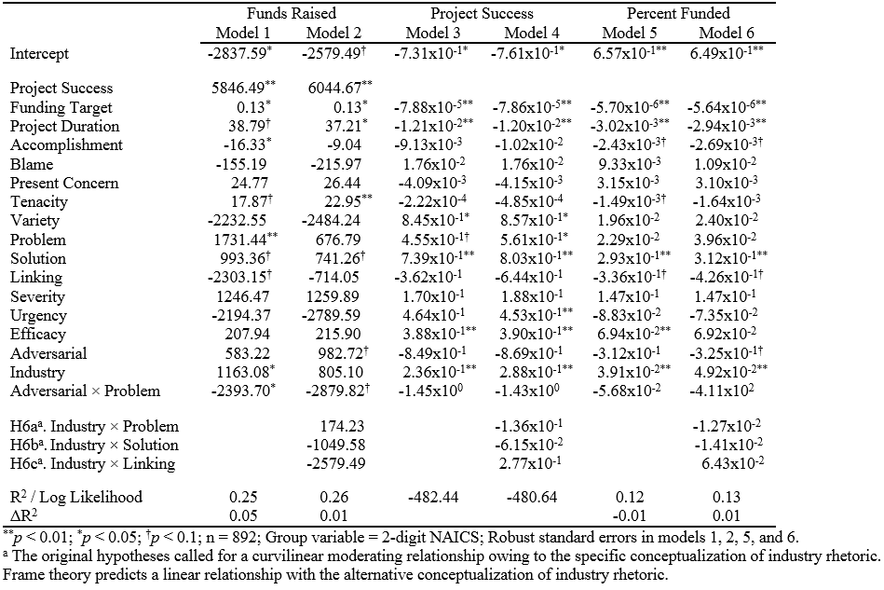

The results of this analysis suggest that industry credentialing rhetoric has a positive direct relationship with total funds raised (β = 1163.08; p < 0.05), project success (β = 2.36x10⁻¹; p < 0.01), and percent funded (β = 3.91x10⁻²; p < 0.01). However, there were no significant interactions of industry credentialing rhetoric with problem, solution, or linking rhetoric.
The post hoc analyses provide complementary insights into the effects of framing rhetoric on crowdfunding performance. In the primary analyses, problem-related rhetoric and efficacy rhetoric were positively related to the amount of funds raised. The effect of efficacy rhetoric on crowdfunding performance was also significant for both percent funded and project success measures of crowdfunding performance. Problem-related rhetoric was only significantly related to the success of the campaign. Solution-related rhetoric was not significantly related to crowdfunding performance in the primary analyses; however, it was related to both percent funded and project success metrics in the post hoc analyses. The moderating role of industry vernacular on the solution rhetoric-crowdfunding performance relationship was not significant in the primary analyses. However, it was significantly related to project success both when it was modeled continuously and when it was modeled in three quantiles (low, mid, and high). It was also significantly related to percent funded when it was modeled in three quantiles. None of the other hypotheses were supported in any analysis. Table 7 presents a summary of the hypothesis-related findings.

TABLE 8. HYPOTHESIS TEST FINDINGS
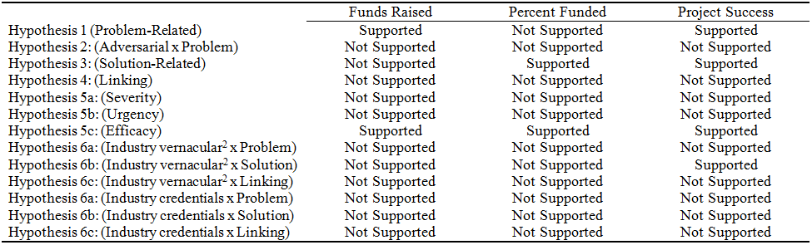

CHAPTER 6. DISCUSSION

The difficulty of obtaining traditional financing has led many entrepreneurs to turn to alternative sources of capital to fund the launch of new ventures (e.g., Berger and Udell, 1998; Bygrave et al., 2003). Crowdfunding, the pooling of financial resources from a group of investors to aid a campaign established by an individual or organization, has emerged as an increasingly popular means of raising funds (Massolution, 2013; Mollick, 2014). In modern crowdfunding, entrepreneurs rely on crowdfunding investment narratives to encourage these investors to contribute to their campaigns (e.g., Allison, Davis et al., 2014; Allison, McKenny et al., 2014). As a result, the language used in these narratives can influence crowdfunding performance.
This dissertation examined the influence of framing rhetoric in crowdfunding investment profiles on campaign performance. In doing so, I make several key contributions to the management, entrepreneurship, and social movement literatures. The first contribution of this dissertation is to draw from social movement theory to explain how the rhetoric of entrepreneurs influences their ability to acquire critical resources. In contrast to traditional sources of entrepreneurial finance, crowdfunding generally involves the solicitation of small investments from a greater number of investors to facilitate the pursuit of a common goal (Mollick, 2014). Similarly, social movement organizations generally rely on the contributions of many different resource providers in their pursuit of a common goal (McCarthy and Zald, 1977). The similarity of crowdfunding campaigns to social movement organizations suggests that theories of resource mobilization in the social movement literature might be valuable in identifying key antecedents of crowdfunding performance.
Frame theory suggests that the alignment of diagnostic, prognostic and motivational frames increases the likelihood that the individual will participate in the movement (Snow et al., 1986). The findings support several key predictions of frame theory. Specifically, I found that using problem- and solution-related rhetoric in the crowdfunding investment profile generally leads to improved crowdfunding performance. I also found that language indicating the efficacy of the individual investor or the venture was associated with higher crowdfunding performance.
The second contribution of this dissertation is to use the concept of frame resonance to examine the role of credibility-building rhetoric in resource acquisition (cf. Babb, 1996; Snow and Benford, 1988). Specifically, I examine how the use of industry rhetoric influences the relationship between framing rhetoric and crowdfunding performance. I found that industry rhetoric moderated the solution-related rhetoric-project success relationship as hypothesized. However, when an alternative measure of industry rhetoric was used, the moderating relationship was not significant.
Broadly, these findings suggest that credibility-building rhetoric may not moderate the framing rhetoric-crowdfunding performance relationship. However, the findings indicate that both measures of industry rhetoric have a robust, positive, direct effect on crowdfunding performance. This finding is consistent with research in traditional entrepreneurial finance where the background of the entrepreneur has been found to play an important role in the decision to invest in a venture (e.g., Hsu, 2007; MacMillan, Siegel, and Narasimha, 1985)
The final contribution of this dissertation is to provide initial evidence regarding the boundary conditions of returns to adversarial diagnostic framing. The social movement literature indicates that diagnostic framing is necessarily adversarial to build collective identity and solidarity among the movement participants against the cause of the social ill (Gamson, 1992; McVeigh et al., 2004). However, the nature of expressive social movements suggests that adversarial framing may be counterproductive. I found that using adversarial rhetoric neither strengthened nor weakened the relationship between diagnostic framing and crowdfunding performance.
While adversarial rhetoric did not play a moderating role in the diagnostic framing-crowdfunding performance relationship, it directly and negatively influenced the crowdfunding performance. Overall, these findings present a complementary view of the role of adversarial rhetoric in crowdfunding campaigns. In contrast to the use of diagnostic framing in social movements, the identification of a problem in crowdfunding campaigns does not need to be accompanied by adversarial rhetoric directed at the source of the problem (cf. Gamson, 1992). Indeed, the use of any adversarial language appears to hurt the performance of the campaign regardless of whether a problem was identified at all.
Limitations
The contributions of this dissertation should be understood in light of the limitations. First, this study relies on a sample drawn from Kickstarter.com. Kickstarter.com is a valuable sampling frame because it have provided over $666 million to more than 43,000 successfully funded campaigns to date, making it one of the top two crowdfunding websites by volume (Kickstarter, 2013c; Lev-Ram and Wagner, 2013). However, Kickstarter only provides reward- and pre-purchase-based crowdfunding and is just one of over 450 crowdfunding platforms worldwide (Massolution, 2013). Thus, extrapolating the findings from this dissertation to other contexts should be done with discretion. To assess the generalizability of these findings to other contexts, future research might conduct a comparative analysis to identify the influence of platform or crowdfunding mode on the efficacy of framing rhetoric.
Second, this study relied on the manual content analysis of actual past crowdfunding campaigns. While using archival data from past campaigns preserves the generalizability to the real world, it is more difficult to control for exogenous factors (Fromkin and Streufert, 1976). In this case, a salient exogenous factor may be the subjective appraisal of each project. Some projects may be seen as more appealing than others for reasons idiosyncratic to the individual investor. These factors cannot be captured by archival research given publicly available data. However, future research might use policy capture/conjoint analysis methods to isolate the effects of framing rhetoric on crowdfunding performance while holding the other details of the project constant. These methods have been used in other studies concerning investor evaluations of entrepreneurial ventures (e.g., Matusik et al., 2008).
Finally, while eight 2-digit industry sectors were present in the data, nearly 85% of the crowdfunding campaigns centered on two sectors: Information (NAICS: 51) and Arts, Entertainment, and Recreation (NAICS: 71). Industry-level factors were statistically controlled for by grouping on the industry sector and allowing for random effects. However, the remaining six industries were underrepresented and many other industries were not present in the data. Future research might build from this dissertation to examine the industry-level effects on both the framing of crowdfunding campaigns and its relationship to crowdfunding performance.
Implications for theory building
There are several similarities between crowdfunding campaigns and social movement organizations. In both social movements and crowdfunding, rhetoric plays a pivotal role in acquiring resources from a large number of providers to facilitate the pursuit of a goal valued by both resource provider and recipient (cf. Allison, Davis et al., 2014; Snow et al., 1986; McCarthy and Zald, 1977). This dissertation found that several aspects of social movement frame theory were upheld in the crowdfunding context. This suggests that social movements may provide a valuable analog for theory building regarding crowdfunding phenomena.
This dissertation drew from frame theory to examine how rhetoric associated with the three core framing tasks influences crowdfunding performance. In doing so, I draw from frame resonance research examining the credibility of the frame articulator (e.g., Snow and Benford, 1988). However, the frame theory literature also suggests that the narrative fidelity, or the cultural relevance, of the frame can influence the resonance of the frame (Benford and Snow, 2000; Fisher, 1984). In crowdfunding research, this may provide new insight into the geographic clustering of certain types of crowdfunding projects (cf. Mollick, 2014).
In addition to frame theory, the social movement literature uses a number of alternative theories to explain why some social movement organizations are better able to acquire resources than others. Resource mobilization theory provides a valuable theory from which to examine crowdfunding resource acquisition because it suggests that individuals may be influenced to contribute, in part, by the relative costs and benefits of doing so (McCarthy and Zald, 1977). This provides a valuable framework through which to examine how the reward structure of reward-based crowdfunding influences fundraising outcomes.
The findings of this dissertation also hold theoretical implications for the literature examining the role of legitimacy in entrepreneurial resource acquisition. One way that entrepreneurs seek to gain legitimacy from external stakeholders is through rhetorical theorizing, or the identification of a problem and presentation of a possible solution to the problem (Ruebottom, 2013; cf. Greenwood, Suddaby, and Hinings, 2002). I found that both problem- and solution-related rhetoric positively influenced crowdfunding outcomes. This suggests that perceptions of legitimacy may play a role in an individual’s decision to invest in a crowdfunding campaign.
Opportunities for future empirical research
The management literature on crowdfunding phenomena is in its nascency. To date, only four articles on the topic have been published in top management and entrepreneurship journals (i.e., Allison, Davis et al., 2014; Allison, McKenny et al., 2014; Belleflamme, Lambert, and Schwienbacher, 2014; Mollick, 2014). This dissertation joins these articles in calling for and opening new lines of inquiry regarding this important source of entrepreneurial finance.
The findings of this dissertation contribute to the literature examining the importance of entrepreneurial narratives to crowdfunding performance (e.g., Allison, Davis et al., 2014). I find that problem-related, solution-related, and efficacy rhetoric are positively associated with crowdfunding performance. Future research might examine how other types of rhetoric influence crowdfunding success. For example, in crowdfunding, presenting the identified problem and solution may indicate that the entrepreneur understands their market’s needs and is using this information to develop solutions that create superior customer value, a central tenet of market orientation (Jaworksi and Kohli, 1993; Kohli and Jaworski, 1990). As a result, firm market orientation is generally associated with improved firm performance (e.g., Hult, Ketchen, and Slater, 2005). To provide a more direct examination of whether investors in crowdfunding campaigns value market-oriented ventures, future research might use computer-aided text analysis to measure the use of market-oriented rhetoric in crowdfunding investment profiles and examine its relationship with crowdfunding performance.
Traditional, social, and cultural entrepreneurs use crowdfunding to launch new ventures (Mollick, 2014). The organizational identity literature suggests that traditional ventures are driven by economically oriented identities and social ventures are driven by both economically- and socially-oriented identities (Stevens, Moray, and Bruneel, 2014). These identity differences may be reflected in their narratives by the use of different forms of language (Moss et al., 2011). Future research might examine how the rhetoric among traditional, social, and cultural ventures differs in crowdfunding narratives and how these differences influence fundraising outcomes. For example, future research might use content analysis to examine whether referring to contributors of the campaign using words generally associated with a social identity such as “donor” or “benefactor” influences crowdfunding performance differently among traditional, social, and cultural ventures.
The hypotheses relating to the direct effects of urgency and severity rhetoric on crowdfunding performance, as well as the moderating role of adversarial rhetoric, were not supported. However, summary statistics indicate that these forms of rhetoric had a low rate of occurrence in the sample. Adversarial rhetoric was present in 14 campaigns (2%), urgency rhetoric was present in 20 campaigns (2%), and severity rhetoric was present in 66 campaigns (7%). Low base rates of occurrence increases the possibility that the analyses were not able to capture the effects of these forms of rhetoric. While these forms of rhetoric may not be common, frame theory suggests that they may play an important role in the success of crowdfunding campaigns when they are used (Benford and Snow, 2000). Previous entrepreneurial finance research has used policy capture methods to identify how founding team characteristics influence investor decision making by having investors evaluate different venture descriptions where the characteristics have been manipulated (e.g., Matusik et al., 2008). Researchers might use a similar approach by manipulating the rhetoric used in the narratives read by investors to provide a more conclusive examination of how adversarial, urgency, and severity rhetoric influence crowdfunding performance.
This dissertation examined the role that the narrative component of the crowdfunding investment profile had on crowdfunding performance. However, some information about the campaign creator is also included in the crowdfunding investment profile. Research on entrepreneurial finance suggests that the management team of a new venture is a key determinant of venture performance (Siegel, Siegel, and MacMillan, 1993). A salient challenge for entrepreneurial resource acquisition is the agency cost created by information asymmetry between the entrepreneur and investors (Gompers and Lerner, 2004). One way that investors manage agency costs is through monitoring (Eisenhardt, 1989). This suggests that campaign creators that are easy to monitor will be able to raise funds more easily than those that are difficult to monitor. To test this, future studies might examine the role of celebrity in crowdfunding performance. Since celebrities are heavily publicized in the mass media, potential investors will be more able to monitor the activities of celebrities than other individual campaign creators.
Ventures seeking crowdfunding capital benefit from the exposure of their campaign details to as many potential investors as possible because each investor generally donates a relatively small amount of money (Allison, McKenny et al., 2014). However, this exposure also opens the door for competitive action by industry competitors. The awareness-motivation-capability model of competitive dynamics (i.e., Chen, 1996) suggests that highly successful campaigns might be particularly vulnerable to competitive action. This study found that problem- and solution-related rhetoric led to improved crowdfunding performance. This suggests that investors value the presentation of justification for why a venture should be launched in addition to the product or service details. However, by providing this information, competitors will also become aware of the venture and their identified market opportunity. Similarly, the success of a campaign using pre-purchase and rewards-based crowdfunding can be a good indicator of the product’s market viability (Mollick, 2014). However, project success further increases the visibility of the venture and provides free market viability information to competitors, providing motivation for them to act because the risk is lower (Lieberman and Montgomery, 1988; 1998). Finally, older incumbent firms are likely to have access to more resources than the entrepreneurial venture making them more capable of taking action (Singh et al., 1986; Stinchcombe, 1965). Together, this suggests that when a crowdfunding campaign in an established industry is successful, industry competitors are likely to be aware of the venture, motivated to take action, and capable of doing so, making competitive action likely (cf., Chen, Su, and Tsai, 2007). To test this, a future study might examine the relationship between crowdfunding campaign success and imitative competitive action by an incumbent.
The language used by entrepreneurs in entrepreneurial narratives can be viewed as signals to external stakeholders (Payne et al., 2013). Signaling theory generally contends that signals must be costly (Connelly et al., 2011). In traditional venture funding mechanisms, investors conduct due diligence to verify the honesty of these signals. However, in crowdfunding, the decreased interaction between entrepreneur and investor makes the transaction less transparent and due diligence more difficult. For example, many campaign profiles did not include the entrepreneur’s full name. Despite this relative opacity, this dissertation finds that crowdfunding campaign creators signal industry expertise and experience through industry rhetoric and that this influences crowdfunding performance. This suggests that investors may engage in a cost-benefit analysis regarding the verification of signals.
Implications for practice
The findings of this study also provide prescriptive implications for practitioners. For crowdfunding campaign creators, this dissertation highlights the importance of the contents of crowdfunding investment narratives. Specifically, I show that explicitly identifying the problem to be addressed by the project, identifying the solution to the problem, and reinforcing the perceived efficacy of the investor encourages investment in the campaign. This is complementary to guidance in the popular press that emphasizes the importance of the project description, status, video, and rewards (e.g., Hendricks, 2013; Huffington Post, 2013; Kickstarter, 2013a).
Examples of how these forms of framing rhetoric have previously been used in crowdfunding profiles are presented in Table 8. Simser (2012) exemplifies the use of both problem- and solution-related rhetoric in their campaign to create a smartphone app that would help home gardeners sell excess produce by connecting them with local shoppers. In this project the product is the app, but the solution is to provide a new distribution channel to home gardeners. Lewandowski and Lewandowski (2012) and WaxFactory (2012) each highlight different aspects of efficacy rhetoric. Lewandowski
TABLE 9. FRAMING RHETORIC IN CROWDFUNDING INVESTMENT PROFILES
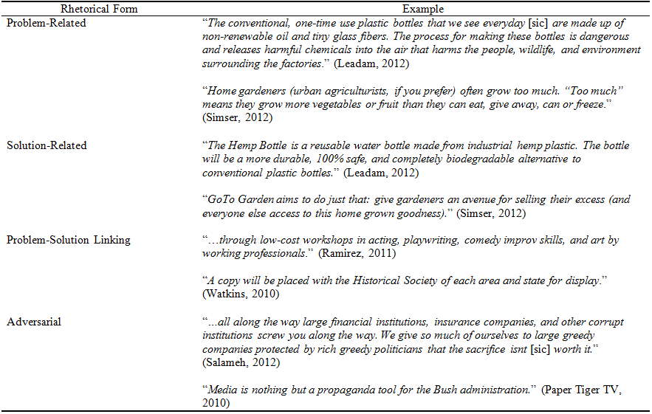
TABLE 9. FRAMING RHETORIC IN CROWDFUNDING INVESTMENT PROFILES (CONTINUED)
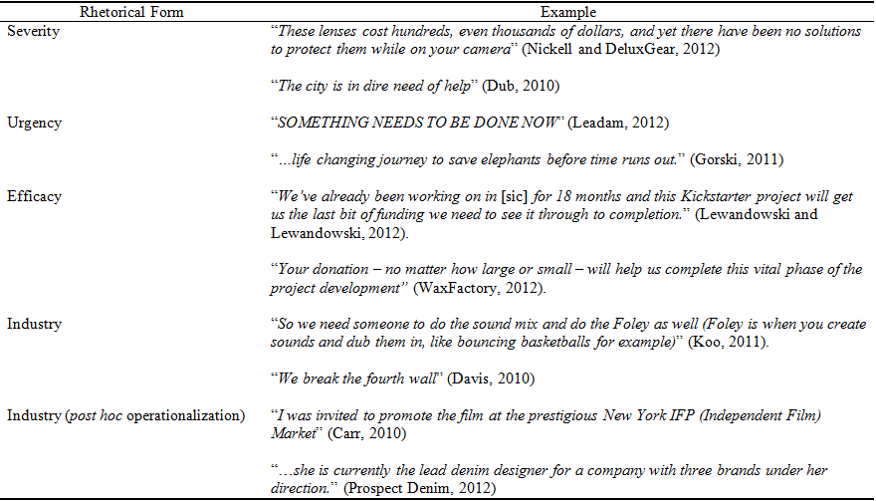

and Lewandowski (2012) communicates that if the campaign is successful, the project team will be successful in accomplishing its goal. Wax Factory (2012) communicates the efficacy of each individual’s investment, noting that their contribution will be helpful regardless of the size of the contribution. By using similar forms of rhetoric in their crowdfunding profiles, campaign creators can increase the likelihood of launching a successful campaign.
This guidance is particularly salient to cultural entrepreneurs such as dance companies, musicians, and photographers. The Kickstarter platform caters to the launch of creative and innovative projects (Kickstarter, 2013d). As a result, over 53% of campaigns launched on Kickstarter are associated with arts, entertainment, and recreation (Kickstarter, 2014). However, many of these campaigns begin with the implicit assumption that people want to purchase art for its own sake. Nevertheless, the relationship between framing rhetoric and crowdfunding performance holds even when controlling for industry-level effects, suggesting that those cultural entrepreneurs that explicitly identify why their art is needed (e.g., because classical music is underappreciated by today’s youth; Bridge the Gap Chamber Players, 2011) will tend to outperform those that do not.
This dissertation also has implications for companies that own crowdfunding platforms. Most crowdfunding platforms make money by taking a fee from the amount of money raised by campaigns (e.g., Kickstarter, Indiegogo, Rockethub). As a result, the antecedents of crowdfunding campaign performance indirectly influence the performance of these platforms. This study suggests that by soliciting the creation of campaigns that address problems and encouraging campaign creators who would not otherwise use framing rhetoric to do so would increase the crowdfunding platform performance.

CHAPTER 7. CONCLUSION

This dissertation suggests that how entrepreneurs frame their crowdfunding campaigns significantly influences the performance of their project. In particular, by explicitly identifying a problem, the proposed solution, and reinforcing a sense of efficacy, crowdfunding campaign creators can increase their campaign’s performance. For management scholars, this demonstrates the value of drawing from social movement theories to examine crowdfunding phenomena and the importance of framing rhetoric to organizational resource acquisition. For practitioners, this suggests that the most successful crowdfunding campaigns not only describe the product or service being developed; they also frame the product or service as providing a solution to a problem.

REFERENCES
Abrahamson E. 1996. Management fashion. Academy of Management Review 21: 254-285.

Allison TH, Davis BC, Short JC, Webb JW. 2014. Crowdfunding in a prosocial microlending environment: examining the role of intrinsic versus extrinsic cues. Entrepreneurship: Theory and Practice. doi: 10.1111/etap.12108.

Allison TH, McKenny AF, Short JC. 2014. The effect of entrepreneurial rhetoric on microlending investment: an examination of the warm-glow effect. Journal of Business Venturing 28: 690-707.

Andrews KT. 2001. Social movements and policy implementation: the Mississippi civil rights movement and the war on poverty, 1965 to 1971. American Sociological Review 66: 71-95.

Ardichvili A, Cardozo RN, Tune K. Reinach J. 2002. The role angel investors in the assembly of non-financial resources of new ventures: cultural framework and empirical evidence. Journal of Enterprising Culture 10: 39-65.

Babb S. 1996. “A true American system of finance”: frame resonance in the U.S. labor movement, 1866 to 1886. American Sociological Review 61: 1033-1052.

Babcock J. 2011. Defend Joshua Tree T-Shirt. Accessed on April 1, 2014 at https://www.kickstarter.com/projects/1928918597/defend-joshua-tree-t-shirt.

Barney J. 1991. Firm resources and sustained competitive advantage. Journal of Management 17: 99-120.

Baum JA, Silverman BS. 2004. Picking winners or building them? alliance, intellectual, and human capital as selection criteria in venture financing and performance of biotechnology startups. Journal of Business Venturing 19: 411-436.

Bayley G, Nancarrow C. 1998. Impulse purchasing: a qualitative exploration of the phenomenon. Qualitative Market Research: An International Journal 1: 99-114.

Belopotosky D. 2009. Wearable monitors to help keep you fit. New York Times 3 December. Accessed on April 8, 2014 at http://query.nytimes.com/gst/fullpage.html?res=9907EEDD123DF930A35751C1A96F9C8B63

Benford RD. 1987. Framing Activity, Meaning, and Social Movement Participation: The Nuclear Disarmament Movement. PhD thesis. University of Texas, Austin, 297 pp.

Benford RD. 1993a. Frame disputes within the nuclear disarmament movement. Social Forces 71: 677-701.

Benford RD. 1993b. ‘You could be the hundredth monkey’: collective action frames and vocabularies of motive within the nuclear disarmament movement. The Sociological Quarterly 34: 195–216.

Benford RD, Snow DA. 2000. Framing processes and social movements: an overview and assessment. Annual Review of Sociology 26: 611-639.

Berger AN, Udell GF. 1998. The economics of small business finance: the roles of private equity and debt markets in the financial growth cycle. Journal of Banking and Finance 22: 613-673.

Bilton N. 2012. Behind the Google goggles, virtual reality. New York Times 23 February. Accessed on April 4, 2014 at http://www.nytimes.com/2012/02/23/technology/google-glasses-will-be-powered-by-android.html.

Binks MR, Ennew CT. 1997. Smaller businesses and relationship banking: the impact of participative behavior. Entrepreneurship Theory and Practice 21: 83–92.

Blumer H. 1939. Social movements. In The New Outline of the Principles of Sociology, Park RE (ed). Barnes & Noble, Inc: New York, NY; 199-229.

Blumer H. 1969. Fashion: from class differentiation to collective selection. The Sociological Quarterly 10: 275-291.

Bollinger D, Surowicz K. 2011. The Cohesion Project – Post Production. Accessed on April 1, 2014 at https://www.kickstarter.com/projects/thecohesionproject/the-cohesion-project-post-production.

Bradford CS. 2012. Crowdfunding and the federal securities laws. Columbia Business Law Review 2012: 1-150.

Break The Silence Arts. 2011. The MAIA mural project – clean water for children of Gaza. Accessed on April 1, 2014 at https://www.kickstarter.com/projects/713873328/the-maia-mural-project-clean-water-for-children-of.

Bridge the Gap Chamber Players. 2011. Bridge the Gap Chamber Players’ first season. Accessed on April 13, 2014 at https://www.kickstarter.com/projects/btgchamberplayers/bridge-the-gap-chamber-players-first-season.

Brown RD, Braskamp LA, Newman DL. 1978. Evaluator credibility as a function of report style: do jargon and data make a difference? Evaluation Quarterly 2: 331-341.

Bygrave W, Hay M, Ng E, Reynolds P. 2003. Executive forum: a study of informal
investing in 29 nations composing the Global Entrepreneurship Monitor. Venture Capital 5: 101-116.

Caldbeck R. 2014. 4 ways investing in startups will become easier for you. MarketWatch 17 January. Accessed on April 4, 2014 at http://www.marketwatch.com/story/4-ways-investing-in-startups-will-become-easier-for-you-2014-01-17.

Carr J. 2010. Lucid – feature film. Accessed on April 2, 2014 at https://www.kickstarter.com/projects/1256916887/lucid-feature-film.

Cassar G. 2004. The financing of business start-ups. Journal of Business Venturing 19: 261–283.

Castorina P, Wood B. 1988. Circles in the Fortune 500: why circles fail. Journal for Quality and Participation 11: 40-41.

Cetorelli N, Strahan PE. 2006. Finance as a barrier to entry: bank competition and industry structure in local US markets. Journal of Finance 61: 437-461.

Chen M-J. 1996. Competitor analysis and interfirm rivalry: toward a theoretical integration. Academy of Management Review 21: 100–134.

Chen M-J, Su, K-H, Tsai, W. 2007. Competitive tension: the awareness-motivation-capability perspective Academy of Management Journal 50: 101-118.

Chen X-P, Yao X, Kotha S. 2009. Entrepreneur passion and preparedness in business plan presentations: a persuasion analysis of venture capitalists’ funding decisions. Academy of Management Journal 52: 199-214.

Coburn, A. 2012. Five Points. Accessed on April 1, 2014 at https://www.kickstarter.com/projects/anmatcoburn/five-points.

Connelly BL, Certo ST, Ireland RD, Reutzel CR. 2011. Signaling theory: a review and assessment. Journal of Management 37: 39-67.

Cooper AC, Gimeno-Gascon FJ, Woo CY. 1994. Initial human and financial capital as predictors of new venture performance. Journal of Business Venturing 9: 371-395.

Cornelissen JP, Werner MD. 2014. Putting framing in perspective: a review of framing and frame analysis across the management and organizational literature. The Academy of Management Annals 8: 1-66.

Cress DM, Snow DA. 1996. Mobilization at the margins: resources, benefactors, and the viability of homeless social movement organizations. American Sociological Review 61: 1089-1109.

Cress DM, Snow DA. 2000. The outcomes of homeless mobilization: the influence of organization, disruption, political mediation, and framing. American Journal of Sociology 105: 1063-1104.

Crook TR, Ketchen DJ, Combs JG, Todd SY. 2008. Strategic resources and performance: a meta‐analysis. Strategic Management Journal 29: 1141-1154.

Cumming DJ, Pandes JA, Robinson MJ. 2013. The role of agents in private entrepreneurial finance. Entrepreneurship: Theory and Practice. doi: 10.1111/etap.12043.

Davenport C, Soule SA, Armstrong II DA. 2011. Protesting while black? the differential policing of American activism, 1960 to 1990. American Sociological Review 76: 152-178.

Davis L. 2010. Parson’s Nose free “A Christmas Carol”. Accessed on April 4, 2014 at https://www.kickstarter.com/projects/1510884896/parsons-nose-free-a-christmas-carol.

Den Hartog DN, Verburg RM. 1998. Charisma and rhetoric: communicative techniques of international business leaders. The Leadership Quarterly 8: 355-391.

Denis DJ. 2004. Entrepreneurial finance: an overview of the issues and evidence. Journal of Corporate Finance 10: 301-326.

Dierickx I, Cool K. 1989. Asset stock accumulation and sustainability of competitive advantage. Management Science 35: 1504-1511.

Druckman JN. 2001. On the limits of framing effects: who can frame? Journal of Politics 63: 1041-1066.

Druskat VU, Wheeler JV. 2003. Managing from the boundary: the effective leadership of self-managing work teams. Academy of Management Journal 46: 435–457.

Dub L. 2010. Forgotten America: the Detroit project. Accessed on April 2, 2014 at https://www.kickstarter.com/projects/lindsayd/forgotten-america-the-detroit-project.

Duriau VJ, Reger RK, Pfarrer MD. 2007. A content analysis of the content analysis literature in organization studies: research themes, data sources, and methodological refinements. Organizational Research Methods 10: 5-34.

Dushnitsky G. 2006. Corporate Venture Capital: Past Evidence and Future Directions. Oxford University Press: Oxford, UK.

Dushnitsky G, Lenox MJ. 2006. When does corporate venture capital investment create firm value. Journal of Business Venturing 21: 753-772.

Dushnitsky G, Shapira Z. 2010. Entrepreneurial finance meets organizational reality: comparing investment practices and performance of corporate and independent venture capitalists. Strategic Management Journal 31: 990-1017.

Edwards B, McCarthy JD. 2004. Strategy matters: the contingent value of social capital in the survival of local social movement organizations. Social Forces 83: 621-651.

Eisenhardt KM. 1989. Agency theory: an assessment and review. Academy of Management Review 14: 57-74.

Elsbach KD, Sutton RI. 1992. Acquiring organizational legitimacy through illegitimate actions: a marriage of institutional and impression management theories. Academy of Management Journal 35: 699-738.

Engel D, Keilbach M. 2007. Firm-level implications of early stage venture capital investment—an empirical investigation. Journal of Empirical Finance 14: 150-167.

Fairhurst GT, Sarr RA. 1996. The Art of Framing: Managing the Language of Leadership. Jossey-Bass: San Francisco, CA.

Fisher WR. 1984. Narration as a human communication paradigm: the case of public
moral argument. Communication Monographs. 51:1–23

Fiss PC, Zajac EJ. 2006. The symbolic management of strategic change: sensegiving via framing and decoupling. Academy of Management Journal 49: 1173-1193.

Flynn FJ. 2005. Identity orientations and forms of social exchange in organizations. Academy of Management Review 30: 737-750.

Freear J, Wetzel Jr WE. 1990. Who bankrolls high-tech entrepreneurs? Journal of Business Venturing 5: 77–89.

Fromkin H, Streufert F. 1976 Laboratory experimentation. In Handbook of I/O Psychology, Dunnette M (ed). Rand McNally & Co.: Chicago, IL; 415-465.

Gabler N. 2012. 1% education. The New York Times 22 January: Retrieved from LexisNexis Academic database.

Gamson WA. 1992. Talking Politics. Cambridge University Press, New York, NY.

Gerhards J, Rucht D. 1992. Mesomobilization: organizing and framing in two protest campaigns in West Germany. American Journal of Sociology 98: 555-596.

Goffman E. 1974. Frame Analysis: An Essay on the Organization of the Experience. Harper Colophon: New York, NY.

Gompers P, Lerner J. 2004. The Venture Capital Cycle (2nd ed.). MIT Press: Cambridge, MA.

Gorski T. 2011. How I became an elephant. Accessed on April 13, 2014 at https://www.kickstarter.com/projects/timgorski/how-i-became-an-elephant.

Granger C. 2012. Light Table. Accessed on April 4, 2014 at https://www.kickstarter.com/projects/ibdknox/light-table.

Greenwood R, Suddaby R, Hinings CR. 2002. Theorizing change: the role of professional associations in the transformation of institutional fields. Academy of Management Journal 45: 58–80.

Greve HR, Pozner J, Rao H. 2006. Vox populi: resource partitioning, organizational proliferation, and the cultural impact of the insurgent microradio movement. American Journal of Sociology 112: 802-837.

Hair JH Jr, Black WC, Babin BJ, Anderson RE. 2010. Multivariate Data Analysis (7th ed.). Prentice Hall: Upper Saddle River, NJ.

Hallenstein CB. 1978. Ethical problems of psychological jargon. Professional Psychology 9: 111-116.

Harrison RT, Mason CM. 1992. International perspectives on the supply of informal venture capital. Journal of Business Venturing 7: 459-475.

Hart RP. 2001. Redeveloping DICTION: theoretical considerations. In Theory, Method, and Practice of Computer Content Analysis, West M (ed). Ablex: New York, NY; 26-55.

Hart RP. 2010. DICTION 6.0 Manual. Digitext, Inc., Austin, TX.

Hartelius JE. 2011. The Rhetoric of Expertise. Rowman & Littlefield: New York, NY.

Hausman JA. 1978. Specification tests in econometrics. Econometrica 46: 1251-1271.

Hellmann T, Puri M. 2002. Venture capital and the professionalization of start‐up firms: empirical evidence. The Journal of Finance 57: 169-197.

Hendricks D. 2013. Five essential tips for a successful Kickstarter campaign. Forbes. 11 September. Accessed on April 13, 2014 at http://www.forbes.com/sites/drewhendricks/2013/09/11/five-essential-tips-for-a-successful-kickstarter-campaign/.

Honig B, Karlsson T. 2004. Institutional forces and the written business plan. Journal of Management 30: 29-48.

Howorth C, Moro A. 2006. Trust within entrepreneur bank relationships: insights from Italy. Entrepreneurship Theory and Practice 30: 495-517.

Hsu D. 2004. What do entrepreneurs pay for venture capital affiliation? Journal of Finance 59: 1805–1844.

Hsu DH. 2007. Experienced entrepreneurial founders, organizational capital, and venture capital funding. Research Policy 36: 722-741.

Huffington Post. 2013. 10 ways to run the most successful kickstarter campaign possible. 25 June Accessed on April 13 at http://www.huffingtonpost.com/young-entrepreneur-council/10-ways-to-run-the-most-s_b_3473954.html.

Hult GTM, Ketchen DJ, Slater SF. 2005. Market orientation and performance: an integration of disparate approaches. Strategic Management Journal 26: 1173-1181.

Jaworski BJ, Kohli AK. 1993. Market orientation: antecedents and consequences. Journal of Marketing 57: 53-70.

Jeng LA, Wells PC. 2000. The determinants of venture capital funding: evidence across countries. Journal of Corporate Finance 6: 241-289.

Kaplan S. 2008. Framing contests: strategy making under uncertainty. Organization Science 19: 729-752.

Kickstarter. 2013a. Kickstarter school. Accessed on May 17, 2013 at http://www.kickstarter.com/help/school.

Kickstarter. 2013b. Kickstarter basics: frequently asked questions. Accessed on May 10, 2013 at http://www.kickstarter.com/help/faq/kickstarter+basics.

Kickstarter. 2013c. What is Kickstarter. Accessed on June 10, 2013 at http://www.kickstarter.com/hello?ref=footer.

Kickstarter. 2013d. Creator questions >> frequently asked questions. Accessed on June 16, 2013 at http://www.kickstarter.com/help/faq/creator+questions#GettStar.

Kickstarter. 2014. Kickstarter stats. Accessed on April 8, 2014 at https://www.kickstarter.com/help/stats?ref=help_nav.

King BG. 2008. A political mediation model of corporate response to social movement activism. Administrative Science Quarterly 53: 395-421.

Klandermans B. 1984. Mobilization and participation: social-psychological expansions of resource mobilization theory. American Sociological Review 49: 583–600.

Kohli AK, Jaworski BJ. 1990. Market orientation: The construct, research propositions, and managerial implications. Journal of Marketing 54: 1-18.

Koo R. 2011. Man-child – feature film. Accessed on April 13, 2014 at https://www.kickstarter.com/projects/ryanbkoo/man-child-feature-film.

Krishnan J, Press E. 2003. The North American Industry Classification System and its implications for accounting research. Contemporary Accounting Research
20: 685–717.

Lawler EE, III, Mohrman SA. 1985. Quality circles after the fad. Harvard Business Review 63: 65-71.

Lawler E, Yoon J. 1993. Power and the emergence of commitment behavior in negotiated exchange. American Sociological Review 58: 465-481.

Leadam JD. 2012. Hemp Plastic Water Bottles. Accessed on April 1, 2014 at https://www.kickstarter.com/projects/106166720/hemp-plastic-water-bottles.

Lengnick-Hall CA, Lengnick-Hall ML. 1988. Strategic human resources management: a review of the literature and a proposed typology. Academy of Management Review 13: 454-470.

Lev-Ram M, Wagner K. 2013. Crowdfunding tries to grow up. Accessed on May 13, 2013 at http://money.cnn.com/2013/05/06/leadership/crowdfunding-kickstarter-indiegogo.pr.fortune/index.html.

Lewandowski J, Lewandowski M. 2012. Fist puncher: old school beat `em up. Accessed on April 1, 2014 at https://www.kickstarter.com/projects/928099324/fist-puncher-old-school-beat-em-up.

Li Y, Zahra SA. 2012. Formal institutions, culture, and venture capital activity: a cross-country analysis. Journal of Business Venturing 27: 95-111.

Lieberman MB, Montgomery DB. 1988. First-mover advantages. Strategic Management Journal Summer Special Issue: 41–58.

Lieberman MB, Montgomery DB. 1998. First‐mover (dis) advantages: retrospective and link with the resource‐based view. Strategic Management Journal 19: 1111-1125.

Lupia A. 2002. Who can persuade whom? implications from the nexus of psychology and rational choice theory. In Thinking About Political Psychology, Kuklinski JH (ed). Cambridge University Press: New York, NY; 51-88.

MacMillan IC, Siegel R, Narasimha PN. 1986. Criteria used by venture capitalists to evaluate new venture proposals. Journal of Business Venturing 1: 119-128.

Madill J, Haines G, Riding A. 2005. The role of angels in technology SMEs: a link to venture capital. Venture Capital — An International Journal of Entrepreneurial
Finance 7: 107–129.

Maritan CA, Peteraf MA. 2011. Invited editorial: building a bridge between resource acquisition and resource accumulation. Journal of Management 37: 1374-1389.

Martens ML, Jennings JE, Jennings PD. 2007. Do the stories they tell get them the money they need? the role of entrepreneurial narratives in resource acquisition. Academy of Management Journal 50: 1107-1132.

Mason C, Stark M. 2004. What do investors look for in a business plan?: a comparison of the investment criteria of bankers, venture capitalists and business angels. International Small Business Journal 22: 227-248.

Massolution. 2013. 2013CF: The Crowdfunding Industry Report. Accessed on April 11, 2013 at http://www.crowdsourcing.org/editorial/2013cf-the-crowdfunding-industry-report/25107.

Matusik SF, George JM, Heeley MB. 2008. Values and judgment under uncertainty: evidence from venture capitalist assessments of founders. Strategic Entrepreneurship Journal, 2: 95-115.

Maxwell AL, Jeffrey SA, Lévesque M. 2011. Business angel early stage decision making. Journal of Business Venturing 26: 212-225.

McCarthy JD, Zald MN. 1977. Resource mobilization and social movements: a partial theory. American Journal of Sociology 82: 1212-1241.

McVeigh R, Myers DJ, Sikkink D. 2004. Corn, Klansmen, and Coolidge: structure and framing in social movements. Social Forces 83: 653–690.

Misangyi VF, Weaver GR, Elms H. 2008. Ending corruption: the interplay among institutional logics, resources, and institutional entrepreneurs. Academy of Management Review 33: 750-770.

Mollick E. 2014. The dynamics of crowdfunding: an exploratory study. Journal of Business Venturing 29: 1-16.

Morris AD, Staggenborg S. 2004. Leadership in social movements. In The Blackwell Companion to Social Movements, Snow DA, Soule SA, Kriesi H (eds). Blackwell Publishing: Malden, MA; 171-196.

Moss TW, Short JC, Payne GT, Lumpkin GT. 2011. Dual identities in social ventures: an exploratory study. Entrepreneurship Theory and Practice 35: 805-830.

Moya C, Ramsey C. 2012. Valdis Story: Abyssal City. Accessed on April 8, 2014 at https://www.kickstarter.com/projects/460275866/valdis-story-abyssal-city.

National Park Service. 2013. Joseph Pulitzer – Statue of Liberty National Monument. Accessed on May 09, 2013 at http://www.nps.gov/stli/historyculture/joseph-pulitzer.htm.

National Venture Capital Association. 2013. FAQ. Accessed on June 27, 2013 at http://www.nvca.org/index.php?Itemid=147.

Nepstad SE. 1997. The process of cognitive liberation: cultural synapses, links, and frame contradictions in the U.S.-Central America peace movement. Sociological Inquiry 67: 470-487.

Neuendorf, K. A. 2002. The Content Analysis Guidebook. Sage: Thousand Oaks, CA.

Nickell T, DeluxGear. 2012. Protection for Nikon DX VR, Canon IS, and Sigma DG lenses. Accessed on April 2, 2014 at https://www.kickstarter.com/projects/2011448493/lens-guard-protection-for-dslr-lenses.

Oberschall A. 1980. Loosely structured collective conflict: a theory and an application. In Research in Social Movements, Conflicts, and Change, Vol. 3, Kriesberg L (ed). JAI Press: Greenwich, CT; 45-68.

O’Reilly CA III, Roberts KH. 1976. Relationships among components of credibility and communication behaviors in work units. Journal of Applied Psychology 61: 99-102.

Ordanini A. 2009, Crowd funding: customers as investors. The Wall Street Journal 23 March; r3.

Ordanini A, Miceli L, Pizzetti M, Parasuraman A. 2011. Crowd-funding: transforming customers into investors through innovative service platforms. Journal of Service Management 22: 443-470.

Paper Tiger TV. 2010. Paper Tiger TV investigates Detroit. Accessed on April 2, 2014 at https://www.kickstarter.com/projects/1047989194/paper-tiger-tv-investigates-detroit.

Patzelt H, Shepherd DA. 2009. Strategic entrepreneurship at universities: academic entrepreneurs’ assessment of policy programs. Entrepreneurship: Theory and Practice 33: 319-340.

Payne GT, Moore CB, Bell RG, Zachary MA. 2013. Signaling organizational virtue: an examination of virtue rhetoric, country-level corruption, and performance of foreign IPOs from emerging and developed economies. Strategic Entrepreneurship Journal 7: 230-251.

Pebble Technologies. 2012. Pebble: e-paper watch for iPhone and Android. Accessed on April 4, 2014 at https://www.kickstarter.com/projects/597507018/pebble-e-paper-watch-for-iphone-and-android?ref=live.

Pedriana N. 2006. Framing processes and transformation of the women’s movement of the 1960s. American Journal of Sociology 111: 1718-1761.

Pennebaker J, Mehl M, Niederhoffer K. 2003. Psychological aspects of natural language use: our words, our selves. Annual Review of Psychology 54: 547-577.

Pi J. 2012. Kickstarter failures revealed! What can you learn from Kickstarter failures? Accessed on February 12, 2013 at http://www.appsblogger.com/kickstarter-infographic/.

Ployhart RE, Weekley JA, Ramsey J. 2009. The consequences of human resource stocks and flows: a longitudinal examination of unit service orientation and unit effectiveness. Academy of Management Journal 52: 996-1015.

Prospect Denim. 2012. The next chapter in the great American love story… (tm). Accessed on April 2, 2014 at https://www.kickstarter.com/projects/569984597/the-next-chapter-in-the-great-american-love-story-0.

Puri M, Zarutskie R. 2012. On the life cycle dynamics of venture capital and non venture capital financed firms. The Journal of Finance 67: 2247-2293.

QSR International. 2010. NVivo 9. QSR International: Victoria, Australia.

Ramirez J. 2011. D.O.A – a noir musical. Accessed on April 2, 2014 at https://www.kickstarter.com/projects/2120878946/doa-a-noir-musical.

Rosenberg SD, Schnurr PP, Oxman TE. 1990. Content analysis: a comparison of manual and computerized systems. Journal of Personality Assessment 54: 298-310.

Rucht D. 1999. The transnationalization of social movements: Trends, causes, problems. In Social Movements in a Globalizing World, Della Porta D, Kriesi H, Rucht D (eds). Macmillan: London; 206–222.

Ruebottom T. 2013. The microstructures of rhetorical strategy in social entrepreneurship: building legitimacy through heroes and villains. Journal of Business Venturing 28: 98-116.

Salameh, S. 2012. Beware the Ides of March! Accessed on April 1, 2014 at https://www.kickstarter.com/projects/2132123318/beware-the-ides-of-march.

Sapienza HJ. 1992. When do venture capitalists add value? Journal of Business Venturing 7: 9-27.

Sapienza HJ, Manigart S, Vermeir W. 1996. Venture capitalist governance and value added in four countries. Journal of Business Venturing 11: 439–469.

Sasser EN, Prakash A, Cashore B, Auld G. 2006. Direct targeting as an NGO strategy: examining private authority regimes in the forestry sector. Business and Politics 8: 1-34.

SBA. 2011. Jobs Act Loan Incentives Led to Record SBA Loan Approval Volume, Supporting Over $30 billion in Small Business Lending. Accessed on June 27, 2013 at http://www.sba.gov/about-sba-services/7367/27101.

SBA. 2012. Frequently Asked Questions. Accessed on June 27, 2013 at http://www.sba.gov/sites/default/files/FAQ_Sept_2012.pdf.

Shane S, Cable D. 2002. Network ties, reputation, and the financing of new ventures. Management Science 48: 364-381.

Short JC, Ketchen DJ, Bennett N, du Toit M. 2006. An examination of firm, industry, and time effects on performance using random coefficients modeling. Organizational Research Methods 9: 259-284.

Short JC, Palmer TB. 2008. The application of DICTION to content analysis research in strategic management. Organizational Research Methods 11: 727-752.

Siegel R, Siegel E, Macmillan IC. 1993. Characteristics distinguishing high-growth ventures. Journal of business Venturing 8: 169-180.

Simons T. 1993. Speech patterns and the concept of utility in cognitive maps: the case of integrative bargaining. Academy of Management Journal 36: 139–156.

Simser, S. 2012. GoTo Garden: home gardeners grow it; neighbors buy it. Accessed on April 2, 2014 at https://www.kickstarter.com/projects/2120411224/goto-garden-home-gardeners-grow-it-neighbors-buy-i.

Sine WD, Lee BH. 2009. Tilting at windmills? the environmental movement and the emergence of the U.S. wind energy sector. Administrative Science Quarterly 54: 123-155.

Singh JV, Tucker DJ, House RJ. 1986. Organizational legitimacy and the liability of newness. Administrative Science Quarterly 31: 171-193.

Smircich L. 1983. Organizations as shared meanings. In Organizational Symbolism, Pondy LR, Frost P, Morgan G, Dandridge T (eds). JAI: Greenwich, CT; 55-65.

Snow DA, Benford RD. 1988. Ideology, frame resonance, and participant mobilization. International Social Movement Research 1: 197–218.

Snow DA, Rochford Jr. EB, Worden SK, Benford RD. 1986. Frame alignment processes, micromobilization, and movement participation. American Sociological Review 51: 464-481.

Snow DA, Vliegenthart R, Corrigall-Brown C. 2007. Framing French riots: a comparative study of frame variation. Social Forces 86: 385-415.

Sohl J. 2013. The angel investor market in 2012: a moderating recovery continues. Center for Venture Research. Accessed on June 27, 2013 at http://paulcollege.unh.edu/sites/default/files/2012_analysis_report.pdf.

Soule SA, King BG. 2008. Competition and resource partitioning in three social movement industries. American Journal of Sociology 113: 1568-1610.

Sproles GB. 1981. Analyzing fashion life cycles: principles and perspectives. Journal of Marketing 45: 116-124.

Stevens R, Moray N, Bruneel J. 2014. The social and economic mission of social enterprises: dimensions, measurement, validation, and relation. Entrepreneurship Theory and Practice. doi: 10.1111/etap.12091

Stevenson, M. 2011. Camera Lens Cap Holder. Accessed on April 1, 2014 at https://www.kickstarter.com/projects/293194835/camera-lens-cap-holder.

Stewart CJ, Smith CA, Denton Jr. RE. 2012. Persuasion and Social Movements (6th Ed.) Waveland Press: Long Grove, IL.

Stinchcombe AL. 1965. Organizations and social structure. In Handbook of Organizations, March JG (ed). Rand-McNally: Chicago, IL; 153-193.

Van Dyke N, Dixon M, Carlon H. 2007. Manufacturing dissent: labor revitalization, union summer and student protest. Social Forces 86: 193-214.

Walske J, Zacharakis A. 2012. Keys to fundraising success in nascent venture capital firms. In The Oxford Handbook of Venture Capital, Cumming D (ed). Oxford University Press: Oxford, UK; 130-155.

Watkins L. 2010. Right before our eyes, the disappearing south! Accessed on April 2, 2014 at http://www.kickstarter.com/projects/228186562/right-before-our-eyes-the-disappearing-south.

WaxFactory. 2012. 416 Minutes. Accessed on April 1, 2014 at https://www.kickstarter.com/projects/waxfactory/416-minutes.

Weber RP. 1990. Basic Content Analysis. Sage: Newbury Park, CA.

Weber K, Heinze KL, Desoucey M. 2008. Forage for thought: mobilizing codes for the movement for grass-fed meat and dairy products. Administrative Science Quarterly 53: 529-567.

Welch F. 2011. Blossom – The E-Book at http://www.kickstarter.com/projects/1752225612/blossom-the-e-book.

Wilson J. 1973. Introduction to Social Movements. Prentice-Hall: New York, NY.

Wortham J. 2012. Start-ups look to the crowd. Accessed on February 12, 2013 at http://www.nytimes.com/2012/04/30/technology/kickstarter-sets-off-financing-rush-for-a-watch-not-yet-made.html.

Zacharakis AL, Meyer GD. 2000. The potential of actuarial decision models: can they improve the venture capital investment decision? Journal of Business Venturing 15: 323-346.

Zuo J, Benford RD. 1995. Mobilization processes and the 1989 Chinese democracy movement. The Sociological Quarterly 36: 131–156.

APPENDIX A. IRB REVIEW OUTCOME



