UNIVERSITY OF OKLAHOMA
GRADUATE COLLEGE

LOSING MY POLITICAL MOTIVATION:
TRENDS IN VOTING AND PROTESTING EXPECTATIONS OF
U.S. HIGH SCHOOL SENIORS

A THESIS
SUBMITTED TO THE GRADUATE FACULTY
in partial fulfillment of the requirements for the
Degree of
MASTER OF ARTS

By
BRIA SCHWARTZ
Norman, Oklahoma
2023
LOSING MY POLITICAL MOTIVATION:
TRENDS IN VOTING AND PROTESTING EXPECTATIONS OF
U.S. HIGH SCHOOL SENIORS

A THESIS APPROVED FOR THE
DEPARTMENT OF SOCIOLOGY

BY THE COMMITTEE CONSISTING OF

Dr. Ann Beutel, Chair
Dr. John Leverso
Dr. Stephanie Burge

© Copyright by BRIA SCHWARTZ 2023
All Rights Reserved.

~ Dedicated to future queer first-gen sociologists and social scientists everywhere ~

Acknowledgments
Thank you to my thesis advisor, Dr. Ann Beutel, who has continuously supported me on my thesis and other academic research. I felt like a strong writer before coming to you, but little did I know I had so much room for growth. Without your support and feedback, I could not have made it to this finish line. I would also like to thank my other thesis committee members, Dr. John Leverso and Dr. Stephanie Burge, both for their guidance and support on my thesis and also in my academic career in general. Your expertise has made me incredibly well-rounded as a researcher and academic.
I developed a preliminary version of this paper in my Categorical, Panel, and Advanced Statistical Analyses class, under the guidance of Dr. Cyrus Schleifer. Cy, thank you for your knowledge and guidance. Two big shout-outs to Dr. Mitch Peck and Dr. Christopher Hill for the laughs, patience, and experience I have received thanks to you two. Also, a huge thank you to my cohort, peers, and the entire Department of Sociology who have supported me throughout my time at OU. And to my previous mentors, Dr. Todd Ferguson, Dr. Christine Nix, and Dr. Aida Isela Ramos, I literally would not be here without you, so thank you for everything.
Finally, I would like to thank my parents, Brian and Jami Schwartz, my sister Rylee, and my extended family for their love, encouragement, and continued support. Being a first-generation college and graduate student, I truly could not have made it through these last few years without the resilience and grit you placed within me. I would like to thank my closest friends whom I could always turn to at any step of the way for encouragement, a good coffee, a warm hug, or a stiff drink. And lastly, for Vanessa, thank you for making this process a little more enjoyable.

TABLE OF CONTENTS
Dedication iv
Acknowledgments v
ABSTRACT viii
INTRODUCTION 1
BACKGROUND 3
Voting 3
Protesting 4
Gender Gaps in Expectations of Voting and Protesting 5
Racial-Ethnic Gaps in Expectations of Voting and Protesting 7
CURRENT STUDY 9
DATA & METHODS 9
Data 9
Dependent Variables 11
Key Independent Variables 12
Control Variables 12
Analytical Approach 14
RESULTS 16
Part One 16
Part Two 18
Part Three 21
Part Four 23
DISCUSSION & CONCLUSION 26
Policy Resolutions 28
Conclusion 31
References 32
Table 1 37
Table 2 39
Table 3 40
Table 4 41
Table 5 42
Figure 1 43
Figure 2 43
Figure 3 44
Figure 4 44
Figure 5 45
Figure 6 45
Figure 7 46
Figure 8 46

ABSTRACT
The purpose of this descriptive study is to analyze trends in the political engagement plans of high school seniors from 1976 to 2019. Using the Monitoring the Future dataset, I address the following research questions: Have expectations of voting and protesting changed for U.S. high school seniors over time? If so, do patterns of change vary by gender and racial-ethnic identity? Findings show that voting and protesting expectations have declined for young women and men during the time period. Young women are consistently more likely to expect to vote than young men throughout the period, but it is less significant of a difference over time, suggesting the gap may be closing. While voting expectations have declined over time for all three of the racial-ethnic identity groups in my study, white individuals are more likely to expect to vote over time than Black and Hispanic individuals. A gender gap in protesting that favored young men has declined over time. Results also indicate that expectations of protesting have decreased over time (2005-2019) for young white and Hispanic individuals but not for Black individuals.

Key Words: gender; racial-ethnic identity; U.S. youth; political engagement; voting; protesting

INTRODUCTION
In the last 50 years, the political climate in the United States has been characterized by various kinds of youth political activity. The 1960s was a time period when young people actively engaged in politics via the Civil Rights movement and anti-war political protests (Altbach 1979). Comparably, the youth of the 1970s were more politically apathetic (Altbach 1979), although women’s and gay rights and environmental political movements gained traction during this time (Staggenborg 2021). In the 1990s, Los Angeles erupted into riots following the acquittal of the police officers who brutally beat Rodney King, an intoxicated Black parolee (Medina 2012). This is the first known incident of police brutality towards a Black man that was caught on camera. Additionally, from the late 1970s through the 1990s, economic inequality persisted, and occasional economic recessions occurred (National Bureau of Economic Research 2022).
Youth in the past 20 years have grown up in a post-9/11 America. They have lived through the War on Terror, school shootings, the Great Recession from late 2007 to 2009, and continued racism, homophobia, and xenophobia. They also have lived through political and social events and movements that are highly gendered, including the legalization of gay marriage, the #MeToo movement, the introduction of annual women’s marches, and physical and political attacks on trans men, women, and youth (e.g., Seemiller and Grace 2018). The divisiveness of our current political climate underscores the importance of studying the political engagement of all Americans, especially the youth because they are the future of U.S. democracy (Kiesa et al. 2007). Yet, young adults have historically been less likely to vote than other age groups (U.S. Census Bureau 2015). One reason for this is that young adults in the United States face higher barriers to voting than other age groups (Hill 2020). They often have less information or knowledge about candidates and what propositions are on the ballot, as well as how and where to vote and state policies on voting. Due to their young age, they are less likely to have the ID documentation needed to register to vote and are more likely to have transportation problems that prevent them from making it to the polls. They also have time and scheduling constraints for voting due to school, extra-curriculars, and paid work (Hill 2020).
Research shows that young people are perceived as not interested in political involvement because they are reluctant to vote, join political parties, or trust politicians (Loader, Vromen, and Xenos 2014). But Loader and colleagues (2014) argue that youth disenchantment with politics does not equate to a lack of interest. When young people do get involved in politics, they often engage by attending political protests and boycotts and joining specific social movements or causes that are personally meaningful to them (e.g., climate change or LGBTQ+ rights) (Loader et al. 2014; Norris 2004a; Norris 2004b; Sloam 2014).
My study examines high school seniors’ expectations to vote and to protest between the mid-1970s and the late 2010s. Young people’s expectations for political engagement are important to examine because they reflect the political development of young people (Campbell and Wolbrecht 2020), and expectations are associated with actual engagement (Eckstein, Noack, and Gniewosz 2013). The life course perspective, with the attention it pays to age, cohort, and historical period (Elder, Johnson, and Crosnoe 2003), also underscores the importance of studying young people’s expectations for political engagement over time. Studying an age group, such as 17- and 18-year-olds, over many years is important, because historical events including war, the introduction of new technology, and even pandemics, like COVID-19, may lead to changes over time in the expectations of political engagement to vote and protest within that age group. Because groups of people may be affected differently by sociohistorical factors depending on their gender and race-ethnicity, it also is important to examine whether any changes in expectations for political engagement within an age group vary by gender and race-ethnicity. Using the Monitoring the Future (MTF) dataset for high school seniors from 1976 to 2019, this research will aim to answer the following questions:
- Have expectations of voting and protesting changed for U.S. high school seniors over time?
- If so, do patterns of change vary by gender and racial-ethnic identity?
BACKGROUND
Voting
As of 2020, just two-thirds of the U.S. population of individuals 18 and older were registered to vote in the U.S. (DeSilver 2022). Voting trends differ by age group, educational attainment, literacy levels, knowledge of current political events, and income (e.g., Coley and Sum 2012). The majority of American citizens ages 65 and older identify as extremely or very motivated to vote, while only half of the individuals ages 18 to 29 identify the same way (Schaeffer and Van Green 2022). Political engagement, via voting and political party affiliation especially, peaks at around 30-60 years old (Norris 2004a; Norris 2004b). This is a curvilinear trend, with both young individuals and old individuals participating less (Norris 2004a; Norris 2004b). Youth voter turnout has always been low relative to voter turnout among older people, and it is still declining in most democratic countries (Bastedo 2015; Esser and de Vreese 2007; Galston 2007; Wattenberg 2016; Zhu 2021). In the U.S., voters in the 18 to 24 age group have voted at the lowest rates in every presidential election since the 1960s (Coley and Sum 2012; File 2014; U.S. Census Bureau 2015).
Most data published regarding voting expectations are for individuals ages 18 and older. The data used in this research come from the Monitoring the Future dataset of high school seniors. Because 12th grade MTF data include individuals who may not be old enough to vote yet, research using MTF data tends to look at their expectations for voting and other types of civic and political engagement. Syvertsen et al. (2011) found that MTF seniors remained fairly stable (83-90%) from 1976-2004 regarding their expectations of voting, but Gaby (2017) found that non-voting electoral participation (e.g., working on a political campaign) of MTF seniors decreased overall from 1976 to 2009. Wray-Lake, Arruda, and Schulenberg (2020) used the restricted-access, panel MTF data to look at civic development across the transition to adulthood of the 1976-2003 cohorts of high school seniors. They found that political interest and participation increased steadily during the transition (18-24 years old), then less steeply after. My study adds to this literature because it focuses on voting expectations of high school seniors over a longer time period, 1976-2019. This design allows for trend analysis which can tell us if voting expectations have declined or remained stable.
Protesting
Unlike voting, other forms of political engagement do not come with a legal age requirement, making it valuable to assess 17- and 18-year-olds’ actual and expected non-voting political participation. Some research suggests an increase over time in participation in signing petitions, consumer boycotts, and political demonstrations, all of which can be thought of as forms of protesting, among the general population in the U.S. from the 1980s to the 2000s (Sloam 2014). This rise in engagement is mostly credited to decreasing trust in the government and increasing concern with community issues (Niemi and Klingler 2012; Sloam 2014). But Syvertsen et al. (2011) found that expectations of what they referred to as alternative forms of political engagement, boycotting and protesting, among MTF high school seniors varied somewhat between 1976 and 2004. Research on MTF high school seniors from 1976 to 2015 shows that expectations of protesting peaked in the early 1990s and then steadily declined until 2015 (Kim and McCarthy 2018). Expectations of protesting may have increased in more recent years, especially considering the involvement of youth in political protests, such as the Gen Z-led March for Our Lives protest (Hayek 2021). I will be able to investigate whether expectations have changed over a longer period of time (1976-2019) than previous studies have examined.
Gender Gaps in Voting and Protesting
For women and other less-visible groups, such as people of color, queer folks, and even youth, “the contextual political environment can either stimulate or depress political engagement” (Atkeson 2003:1053). Research has found variation in actual political engagement by gender. Studies show that women are more likely to vote than men (e.g., Laurison, Brown, and Rastogi 2022). The 1980s was a turning point for women and politics when women became more likely to vote in Presidential elections than men (Center for American Women and Politics 2022). Before 1980, men were more likely to vote in Presidential elections than women (Center for American Women and Politics 2022). The gender gap in voting has remained relatively stable since then (Center for American Women and Politics 2022).
Attention to possible gender differences in voting and protesting expectations using the MTF data has been somewhat limited. Syvertsen et al. (2011) and Kim and McCarthy (2018) looked at trends in expected political engagement among MTF high school seniors, but they did not focus on possible differences in expectations of voting and protesting by gender. Gaby (2017) found no gender differences among MTF seniors from 1976-2009 in terms of anticipating participation or having participated in a boycott or a protest. Wray-Lake, Arruda, and Hopkins (2019) found using MTF data that young men had a significantly higher “political voice” compared to young women. “Political voice” was the name given to planning to write to politicians, protest, and boycott or having already done so (Wray-Lake et al. 2019).
Using data from the Family Matters Study, Campbell and Wolbrecht (2020) found that the political mobilization of adolescents ages 15-18 happened in response to the 2016 Presidential election and the political disillusionment that followed. During the 2016 Presidential election, Hillary Clinton, the first woman nominated for the presidency by a major political party, ran against Donald Trump. This election was surrounded by controversy as Clinton won the popular vote, but Trump, who had less political experience than Clinton and was known to make racist and misogynistic comments, won the electoral vote and was elected (Campbell and Wolbrecht 2020). One reaction to Trump’s election was extremely evident among Democratic teenage girls (ages 15-18) in the Family Matters Study, with an increase in their expectations of protesting in the future (Campbell and Wolbrecht 2020). Campbell and Wolbrecht (2020) found that Democrat girls in 2017 were more likely than Republican girls and boys and Democrat boys to expect to participate or have already participated in lawful demonstrations. Actual protesting did increase among women: the day after Donald Trump was inaugurated in 2017, the Women’s March on Washington occurred which included 500,000 participants in Washington D.C., with mini marches popping up in major cities in the U.S. (Hartocollis and Alcindor 2017). This was the start of the Annual Women’s Marches. I look at variations in voting and protesting expectations by gender over 43 years, 1976-2019. This timeframe saw an increase in women’s educational and labor force participation, but also the slowing or stalling of the Gender Revolution (England 2010; England, Privalko, and Levine 2020), which may have contributed to gender variation in expectations for political engagement.
Racial-Ethnic Gaps in Expectations of Voting and Protesting
Studies show that white people are more likely to vote than Black and Hispanic people, relative to their representation in the U.S. population (Coley and Sum 2012; Laurison, Brown, and Rastogi 2022). This is related to lower educational attainment on average for people of color (POC), lower household income, and strict voting laws that are often racist, as well as sexist, classist, ableist, and transphobic (Coley and Sum 2012; Montoya 2018; 2020). In the year 2000, 12.1% of eligible U.S. voters identified as Black. The projections for the 2022 midterm election showed 13.6% of eligible voters identified as Black (Moslimani 2022). According to a recent estimate from the U.S. Census Bureau (2021), this percentage is the same as the percentage of the U.S. population that identifies as Black or African American alone. In the year 2000, 7.4% of eligible U.S. voters identified as Latino. The projections for the 2022 midterm voting showed that 14% of eligible voters identified as Latino (Natarajan and Im 2022), which is less than the percentage of the U.S. population, 18.9%, that identifies as Hispanic or Latino according to a recent estimate (U.S. Census Bureau 2021). These estimates of lower eligibility relative to their representation in the U.S. population suggest that Hispanics and Latinos especially face barriers when it comes to voting.
As with gender, attention to possible racial-ethic differences in voting and protesting expectations using the MTF data has been somewhat limited. Syvertsen et al. (2011) and Kim and McCarthy (2018) looked at trends in expected political engagement among MTF high school seniors, but they did not focus on possible racial-ethnic differences in expectations of voting and protesting. Gaby (2017) found that racial gaps in political participation were relatively stable from 1976 to 2009, with non-whites participating less than whites. Wray-Lake et al. (2019) used the MTF to look at the relationship between race-ethnicity and civic engagement, which they measured in terms of electoral participation (a variable made up of whether they had or planned to vote, give money to a campaign, and work for a campaign) and political voice (a variable made up of whether they had or planned to write to politicians, participate in a lawful demonstration, and boycott). Wray-Lake and colleagues (2019) found lower electoral participation among Black and Hispanic individuals from 1976-2003 compared to white individuals, though Black individuals were not significantly different from whites. Campbell and Wolbrecht (2020) found using two-wave panel data from the Family Matters Study that Black youth in 2016 reported they had voted or expected to vote at similar rates to white youth. In 2017, Black youth were less likely to report that they had voted or expected to vote than white youth, though not significantly so. They also found that Hispanic youth in 2016 were not significantly less likely to report having voted or expecting to vote compared to white youth, and in 2017 they were significantly less likely to report having voted or expecting to vote compared to white youth (Campbell and Wolbrecht 2020).
Wray-Lake and colleagues (2019) found using MTF data that Black and Hispanic individuals did not significantly differ from white individuals in terms of their “political voice” variable. Campbell and Wolbrecht (2020) found that both Black and Hispanic individuals in the Family Matters Study in 2017 were less likely to report that they had participated in or anticipated participating in a lawful demonstration than white individuals. Given that the 21st-century protests have become increasingly multi-racial, multi-ethnic, multi-gender, and multi-cultural (Schram and Fording 2021), there may be less variation in expectations for protesting between white individuals and people of color in recent years. My research is looking at a longer timeframe than Campbell and Wolbrecht (2020) did, thus giving us a fuller understanding of the anticipated political engagement of Black, Hispanic, and white young people across generations.
CURRENT STUDY
Recent polarizing political events serve as reminders that it is important to try to understand the future of American politics. Young people’s voting and protesting expectations are a signal of what their future political participation may look like. Additionally, much of the previous research on political engagement does not consider protesting (i.e., participating in a peaceful political demonstration) by itself; instead, it lumps it in with boycotting and/or other forms of political engagement. It is useful for research to focus on protesting alone in light of the recent popular movements that have led to protests (e.g., March for Our Lives and Women’s Marches).
In this study, I investigate trends in expected political engagement in terms of voting and protesting and how they may vary by gender and race-ethnicity by conducting statistical analyses using data for twelfth graders from the Monitoring the Future (MTF) study for 1976-2019. In the 43 years that this study covers, much has changed in the U.S. from a social and political standpoint. By looking at voting and protesting expectations over time, we can better understand the young people who will one day take charge of our government.
DATA & METHODS
Data
I am using the Monitoring the Future (MTF) dataset from 1976-2019. MTF is an annual, ongoing, cross-sectional, and nationally representative of American public and private 8th, 10th, and 12th graders and explores changes in their behaviors, beliefs, and lifestyles. It is conducted by the University of Michigan’s Institute for Social Research (Miech et al. 2021). I am using the publicly available data from 1976 through 2019 for twelfth graders. Multiple questionnaire forms of the MTF focus on different spheres of life, but every form has the same core sociodemographic and drug use questions. I use data Form 2, which contains questions about political engagement, in my analyses. I use Stata17 for all coding and statistical analyses.
From 1976-2004, the MTF removed all participants who were not Black or white or who fell into more than one racial-ethnic category from the publicly available data. Starting in 2005, the category of Hispanic participants was added to the public use files, but if a participant was in none of those three categories or selected more than one then they were removed from the public use files. For my analyses here, some of my models use the entire dataset from 1976 to 2019 for Black and white individuals only. After appending all years of the data and accounting for missing data using listwise deletion, my total sample for the voting expectation models had roughly 54,000 respondents, with an average of approximately 1,200 respondents each year. My total sample for the protesting expectation models had roughly 61,000 respondents, with approximately 1,400 respondents. Some of my other models are time-limited models that focus specifically on 2005-2019 to get a better understanding of trends for all three racial-ethnic groups (Black, Hispanic, and white). After appending all years of data and accounting for missing data using listwise deletion, my time-limited sample for the voting expectations analyses included roughly 19,000 respondents, with an average of approximately 850 participants each year. For my protesting expectations models there were around 22,000 participants, with an average of approximately 950 participants each year.
Dependent Variables
The MTF collects information on prior and expected political engagement by asking: “Have you ever done, or do you plan to do, the following things (vote in a public election, write to public officials, give money to a political candidate or cause, work in a political campaign, participate in a lawful demonstration, and boycott certain products or stores)?” The answer choices are: (1) probably will not (2) do not know (3) probably will and (4) already done. For my analyses, I will focus on the ‘voting in a public election’ and the ‘participating in a lawful demonstration’ measures. For voting expectations, I recoded the answer responses for do not know (9%) and already voted (7.5%) as missing (i.e., I dropped respondents who did not know about voting or had already voted from the expectations for voting analyses). I dropped respondents from those two categories because I want to isolate those who expect to or do not expect to vote in the future. Due to data limitations, I was not able to recode protesting expectations the same way. I recoded the answer responses for already participated (3.5%) as missing. Because 43% of the sample responded ‘don’t know,’ I chose to combine those answers with the probably will not do this answers. Once recoded, both expectations variables are binary variables with probably will vote or probably will protest coded 1 and probably will not vote or probably will not (or don’t know if they will) protest coded 0. Descriptive statistics for the dependent, independent, and control variables (except survey year) are located in Table 1.
[INSERT TABLE 1 HERE]

Key Independent Variables
The primary indicators in my models are gender and race (race-ethnicity). To measure gender, I use a binary variable where women are represented as 1, and men are represented as 0. Because of data availability issues, I use a binary race variable for all 43 years and focus only on the Black and white respondents from 1976 through 2019. To examine the Hispanic population, I include time-limited models from 2005 through 2019 that include white, Black, and Hispanic youth. White is the comparison group, so it is coded in Stata17 as 1, Black as 2, and Hispanic as 3. I included a continuous variable for the year the survey was administered, with 1976 coded as 0 and 2019 coded as 43.
Control Variables
Prior research on political engagement suggests the following are important to include as control variables: political party affiliation (Mulralidharan and Sung 2016), family household structure and education (Flanagan, Levine, and Settersten 2009), urbanicity (Oberhauser, Krier, and Kusow 2019), region (File 2014), college expectations (Coley and Sum 2012; Flanagan et al. 2009; Sloam 2014), and three government opinion variables that look at whether the government wastes tax money (Niemi and Klingler 2012), whether government officials lie (Niemi and Klingler 2012), and whether the government makes smart decisions (Galston 2007; Mongkuo et al. 2014; Niemi and Klingler 2012; Torney-Purta, Barber, and Richardson 2004). Prior research also suggests religion impacts political ideations (Wald and Calhoun-Brown 2014); however, religious affiliation and importance were removed as questions for MTF respondents in the western region of the U.S., so I could not include them as controls.
Political party affiliation includes Republican (coded 1), Democrat (coded 2), no preference/Independent/third party (coded 3), and do not know/have not decided (coded 4). Family household structure includes neither mother nor father living in the same house as the respondent (coded 0), at least one parent living in the same house (coded 1), and both parents living in the same house (coded 2). Parental education includes both parents having education levels less than college (coded 0), at least one parent having a college degree or higher (coded 1), and both parents having a college degree or higher (coded 2). Urbanicity was determined by MTF’s Standard Metropolitan Statistical Area qualifications which include rural or non-SMSA (coded 0) and urban or SMSA (coded 1). Region was also provided by MTF with Northeast (coded 1), North Central (coded 2), South (coded 3), and West (coded 4). College expectations include individuals who definitely or probably will not attend a 4-year college (coded 0) and definitely or probably will attend a 4-year college (coded 1). The government wasting tax money includes values for little or no tax money is wasted (coded 1), some tax money is wasted (coded 2), and most of the tax money is wasted (coded 3). Whether government officials lie is measured as not a lot of government officials lie (coded 1), some lie (coded 2), and a good deal of government officials lie (coded 3). Whether the government makes smart decisions is measured as almost always (coded 1), often (coded 2), sometimes (coded 3), seldom (coded 4), and never (coded 5). Finally, for my protesting models, voting expectations is used as a control because of the suspected association between the two. It is measured as probably will not (coded 1), do not know (coded 2), probably will do this (coded 3), and already done (coded 4).
Analytical Approach
To answer my research questions, I ran a series of logistic regressions since my dependent variables, expectations of voting and expectations of protesting, are binary. For clarity, I separate my analysis into multiple parts as described below: Part One (Table 2) includes three full-sample (i.e., 1976-2019) models to look at voting trends over time, by gender and by race (Black and white respondents only). Model 1 is an uninteracted logistic regression with gender, race, year, and all controls included. Model 2 includes all the variables from Model 1, in addition to an interaction between gender and year. Model 2 informs us whether the gender gap in voting expectations has diverged or converged over time. Model 3 includes all the variables from Model 1, with the addition of an interaction between race and year. This model informs us whether the racial gap, if any, in voting expectations has diverged or converged over time.
To get a better understanding of the relationship between racial-ethnic identities and 21st-century voting expectations since 2005, in Part Two (Table 3) I have three time-limited (2005-2019) models, which include Black, white, and Hispanic respondents. Model 1 is an uninteracted logistic regression with gender, race-ethnicity, year, and all controls included. Model 2 includes all the variables from Model 1, in addition to an interaction between gender and year. Model 2 informs us of the state of the gender gap in voting expectations during the 21st century. Model 3 also includes all the variables from Model 1, with the addition of an interaction between racial-ethnic identity and year. This model informs us of the state of the racial-ethnic gap in voting expectations during the 21st century, if any.
Similar to voting, I will have three regression models for protesting expectations for 1976-2019 in Part Three (Table 4) of the analysis. Model 1 is an uninteracted logistic regression with gender, race (Black and white respondents only), year, and all controls included. Model 2 includes all the variables from Model 1, in addition to an interaction between gender and year. Model 2 informs us whether the gender gap in protesting expectations has diverged or converged over time. Model 3 also includes all the variables from Model 1, with the addition of an interaction between race and year. This model informs us whether the racial gap, if any, in protesting expectations has diverged or converged over time.
As with voting, to get a better understanding of the relationship between racial-ethnic identities and expectations of protesting since the early 21st century, in Part Four (Table 5) I have three time-limited (2005-2019) models, that include Black, white, and Hispanic respondents. Model 1 is an uninteracted logistic regression with gender, race-ethnicity, year, and all controls included. Model 2 includes all the variables from Model 1, in addition to an interaction between gender and year. Model 2 informs us whether the gender gap in protesting expectations has diverged or converged during the 21st century. Model 3 also includes all the variables from Model 1, with the addition of an interaction between race-ethnicity and year. This model informs us if the racial-ethnic gap in protesting expectations has diverged or converged during the 21st century.

RESULTS
Part One
Table 2 shows the results of the full model logistic regression models presented in logged odds. Model 1 estimates the gender and race effects with year and control variables on expectations of voting in the future. In Model 1, for women, there is a statistically significant positive logged odd of 0.139, meaning they have a higher logged odd of voting than men. For Black participants, there is a statistically significant negative logged odd of 0.749, meaning they have a lower logged odd of voting than white individuals. For year, there is a statistically significant negative logged odd of 0.027. To make the results for these variables clear, I will discuss the effects using predicted probabilities (not shown in the table). Model 1 predicts that in 1976, young women expected to vote at a predicted probability of 97.7%, compared to 97.3% for young men, which is a significant difference of 0.4%, net of other effects (chi-square 8.89; p-value .0029). In 2019, young women expected to vote at a predicted probability of 93.6%, compared to 92.8% for men, a significant difference of 0.8%, net of other effects (chi-square 8.99; p-value .0027). Expectations of voting for men and women significantly declined from 1976 to 2019 (chi-square 149.28; p-value .000; chi-square 143.13; p-value .000, respectively). Model 1 also predicts that 97.8% of white individuals in the sample expected to vote in 1976, compared to 93.8% of white individuals in 2019, net of other effects. This is a significant difference of 4% (chi-square 150.58; p-value .000). In 1976, 95.6% of Black individuals in the sample expected to vote, compared to 88.8% in 2019, a significant decline of 6.8%, net of other effects (chi-square 130.65; p-value .000). The racial gap in voting expectations is significant in 1976 (chi-square 86.97; p-value .000) and continues to stay significant in 2019 (chi-square 93.97; p-value .000). The controls behave as expected.
[INSERT TABLE 2 HERE]
In Model 2 of Table 2 an interaction for gender and year was added to the regression model. Since interpreting coefficients of interacted variables has proven to be problematic, I will compare the predicted probabilities as suggested by Long and Mustillo (2021). In 1976, 97.7% of young women expected to vote, compared to 93.5% in 2019, a significant difference of 4.2% (chi-square 84.4; p-value .000), net of other factors. In 1976, 97.3% of young men expected to vote, compared to 92.9% in 2019, a significant difference of 4.4%, net of other factors (chi-square 88.81; p-value .000). This trend is illustrated in the plots of predicted probabilities shown in Figure 1. Overall, there is a downward trend in the expectations over time for both men and women (1976-2019). Women consistently had higher predicted probabilities of voting expectations than men over time, but the size of the gap appeared to stay fairly constant. The gender gap in predicted probabilities for voting expectations was significant in 1976 (chi-square 4.34; p-value .0372) but is surprisingly not significant in 2019 (chi-square 1.11; p-value .2929). However, this insignificance is likely due to the overlapping confidence intervals that were caused by sample size limitations.
[INSERT FIGURE 1 HERE]
In Model 3 of Table 2 an interaction for race and year was added to the regression (see Table 2 for logged odds). The predicted probabilities are visually represented in Figure 2. They show that predicted probabilities of expectations for both groups declined over time, but they decreased more sharply among white individuals than Black individuals. In 1976, 98% of white participants expected to vote, compared to 93.3% in 2019, a significant difference of 4.7% (chi-square 168.71, p-value .000), net of other factors. In 1976, 93.8% of Black participants expected to vote, compared to 91.7% in 2019, a significant difference of 2.1%, net of other factors (chi-square 4.04; p-value .0444). The gap between white and Black participants was large at the beginning of the time period. The racial gap appears to have closed some over time, but white individuals consistently expected to vote more than Black individuals. The racial gap in predicted probabilities for voting expectations was significant in 1976 and 2019 (chi-square 62.97; p-value .000; chi-square 4.65; p-value .0311, respectively).
[INSERT FIGURE 2 HERE]
Part Two
As noted earlier, Hispanics are not included in the publicly available MTF data until 2005. To better understand the relationship between racial-ethnic identities and voting expectations in the 21st century, I include a series of logistic regressions that are time-limited (2005-2019) and include white, Black, and Hispanic participants. Table 3 shows the results of these models. In Model 1 for women, there is an insignificant positive logged odd of 0.122, meaning women had a higher logged odd of expecting to vote than men, but it is not a significant difference. For Black participants, there is a statistically significant negative logged odd of 0.326, and for Hispanic participants, there is a statistically significant negative logged odd of 0.368. This means that Black and Hispanic individuals had lower logged odds of expecting to vote than white individuals. For year, there is a significant negative logged odd of 0.029. To make the findings for these variables clear, I will discuss their effects using predicted probabilities (not shown in the table). Model 1 predicts that in 2005, 95.1% of young women expected to vote compared to 94.6% of young men, which is an insignificant difference of 0.5%, net of other effects (chi-square 3.4; p-value .0652). In 2019, young women expected to vote at a predicted probability of 93.1%, compared to 92.4% for men, an insignificant difference of 0.7%, net of other effects (chi-square 3.41; p-value .0648). Expectations of voting for young men and women have significantly declined from 2005 to 2019 (men: chi-square 13.87; p-value .0002; women: chi-square 13.81; p-value .0002). Model 1 also predicts that 95.3% of white individuals expected to vote in 2005, compared to 93.4% of white individuals in 2019, net of other effects. This is a significant difference of 1.9% (chi-square 13.72; p-value .0002). In 2005, 93.8% of Black individuals expected to vote, compared to 91.4% in 2019, a significant difference of 2.4%, net of other effects (chi-square 13.21; p-value .0003). In 2005, 93.6% of Hispanic individuals expected to vote, compared to 91.1% in 2019, a significant difference of 2.5%, net of other effects (chi-square 14.04; p-value .0002). The racial-ethnic gap in voting expectations between white participants and participants of color is significant in 2019 (Black: chi-square 8.29; p-value .0040; Hispanic: chi-square 15.7; p-value .0001); however, Black and Hispanic individuals are not significantly different from each other in 2019 (chi-square 0.13; p-value .7194). The control variables behave as expected.
[INSERT TABLE 3 HERE]
In Model 2, an interaction for gender and year was added to the regression model. For interpretation, I again will compare the predicted probabilities as suggested by Long and Mustillo (2021). In 2005, 95.3% of young women are predicted to expect to vote, compared to 92.8% in 2019, a significant difference of 2.5% (chi-square 10.66, p-value .0011), net of other factors. In 2005, 94.3% of young men are predicted to expect to vote, compared to 92.7% in 2019, a significant difference of 1.6%, net of other factors (chi-square 4.27; p-value .000). The predicted probabilities are illustrated in Figure 3. Overall, the plotted predicted probabilities show that there is a decline in voting expectations for young women and men, with women decreasing at a slightly faster rate than men. Women consistently expected to vote more than men during this time, but the gender gap in predicted probabilities for voting expectations is insignificant in 2005 and 2019 (chi-square 3.04; p-value .0813; chi-square .05; p-value .8209, respectively). As shown in the figure, the gender gap narrowed over time.
[INSERT FIGURE 3 HERE]
In Model 3 of Table 3, an interaction between racial-ethnic identity and year was added to the regression. The predicted probabilities associated with this interaction are visually represented in Figure 4. Overall, during this time, voting expectations decreased across the board, with whites decreasing at a slower rate than Black and Hispanic individuals. In 2005, 95.2% of white participants expected to vote, compared to 93.7% in 2019, a significant difference of 1.5% (chi-square 5.35, p-value .0207), net of other factors. In 2005, 94.6% of Black participants expected to vote, compared to 90.3% in 2019, a significant difference of 4.3%, net of other factors (chi-square 5.94; p-value .0148). In 2005, 93.8% of Hispanic participants expected to vote, compared to 91% in 2019, a significant difference of 2.8%, net of other factors (chi-square 4.39; p-value .0362). As the figure shows, white individuals have higher predicted probabilities of voting expectations than Black and Hispanic individuals over time, and until 2014, Black individuals have higher predicted probabilities of expecting to vote than Hispanic individuals. The racial-ethnic gap appears to grow between white individuals and people of color from 2005 to 2019. The racial-ethnic gap in predicted probabilities for voting expectations between white participants and Black individuals is significant in 2019 (chi-square 6.21; p-value .0127). The racial-ethnic gap in predicted probabilities for voting expectations between white and Hispanic participants is also significant in 2019 (chi-square 7.6; p-value .0058), however, the difference in voting expectations between Black and Hispanic individuals is not significant in 2019 (chi-square 0.22; p-value .6388).
[INSERT FIGURE 4 HERE]
Part Three
Table 4 shows the results of the full-sample (1976-2019) logistic regression models on expectations of protesting in the future. Model 1 estimates the gender and race effects (for Black and white respondents only). In Model 1, for women, there is a statistically significant negative logged odd of 0.082, meaning women had a lower logged odd of expecting to protest compared to men. For Black participants, there is a statistically significant positive logged odd of 0.190. This means that Black individuals had a higher logged odd of expecting to protest when compared to white individuals. For year, there is a statistically significant negative logged odd of 0.014. To make these findings plain, I will discuss the effects using predicted probabilities (results not shown in the table). Model 1 predicts that in 1976, young women expected to protest at a predicted probability of 22.2%, compared to 23.6% for young men, which is a significant difference of 1.4%, net of other effects (chi-square 14.56; p-value .0001). In 2019, young women expected to protest at a predicted probability of 13.7%, compared to 14.6% for men, a significant difference of 0.9%, net of other effects (chi-square 14.5; p-value .0001). Expectations of protesting for men and women significantly declined from 1976 to 2019 (men: chi-square 236.79; p-value .000; women: chi-square 234.98; p-value .000). Model 1 also predicts that 22.4% of white individuals expected to protest in 1976, compared to 13.8% of white individuals in 2019, net of other effects. This is a significant difference of 8.6% (chi-square 150.58; p-value .000). In 1976, 25.8% of Black individuals expected to protest, compared to 16.2% in 2019, a significant difference of 9.6%, net of other effects (chi-square 227.73; p-value .000). The racial gap in protesting expectations is significant in 1976 (chi-square 30.33; p-value .000) and continues to stay significant in 2019 (chi-square 29.31; p-value .000). The control variables behave as expected.
[INSERT TABLE 4 HERE]
In Model 2 of Table 4, an interaction for gender and year was added to the regression model. As with the voting expectations models, I will compare the predicted probabilities as suggested by Long and Mustillo (2021). In 1976, 21.8% of young women are predicted to expect to protest, compared to 14% in 2019, a significant difference of 7.8% (chi-square 104.09, p-value .000), net of other factors. In 1976, 23.9% of young men are predicted to expect to protest, compared to 14.3% in 2019, a significant difference of 9.6%, net of other factors (chi-square 158.65; p-value .000). The predicted probability results are illustrated in Figure 5. Overall, there is a sharp negative trend in predicted probabilities of expectations of protesting for both men and women. Men are consistently more likely to expect to protest than women, but the gap narrows over time. The gender gap in predicted probabilities for protesting expectations was significant in 1976 (chi-square 10.35; p-value .0013), but it was not significant in 2019 (chi-square 0.37; p-value .5448).
[INSERT FIGURE 5 HERE]
In Model 3 of Table 4, an interaction for race and year was added to the regression. Figure 6 visually represents the predicted probabilities associated with this interaction. Overall, there has been a decrease over time in predicted probabilities of expectations of protesting for both Black and white individuals, but Black individuals’ expectations of protesting are consistently higher than those of white individuals. In 1976, 22.6% of white participants expected to protest, compared to 13.7% in 2019, a significant difference of 8.9% (chi-square 219.10, p-value .000), net of other factors. In 1976, 25% of Black participants expected to protest, compared to 16.9% in 2019, a significant difference of 8.1%, net of other factors (chi-square 28.43; p-value .000). The racial gap in predicted probabilities is significant and just as evident in 2019 (chi-square 12.59; p-value .0004) as it is in 1976 (chi-square 5.78; p-value .0162).
[INSERT FIGURE 6 HERE]
Part Four
To better understand the relationship between racial-ethnic identities and protesting expectations in the 21st century, I include a series of logistic regressions that are time-limited (2005-2019) for white, Black, and Hispanic participants. Table 5 shows the full results of these models. For women in Model 1, there is a statistically significant negative logged odd of 0.110, meaning there is a lower logged odd of women expecting to protest, compared to men. In Model 1, for Black participants, there is an insignificant positive logged odd of 0.125, and for Hispanic participants, there is an insignificant positive logged odd of 0.088. This means that Black and Hispanic participants have higher logged odds of protesting than white individuals, although those differences are insignificant. For year, there is a significant negative logged odd of 0.013. To make these findings plain, I will discuss the effects using predicted probabilities (results not shown in the table). Model 1 predicts that in 2005, young women expected to protest at a predicted probability of 15.4%, compared to 16.8% for young men, which is a significant difference of 1.4%, net of other effects (chi-square 7.73; p-value .0054). In 2019, young women expected to protest at a predicted probability of 13.2%, compared to 14.4% for men, a significant difference of 1.2%, net of other effects (chi-square 7.74; p-value .0054). Expectations of protesting for young men and women have significantly declined from 2005 to 2019 (men: chi-square 8.41; p-value .0037; women: chi-square 8.43; p-value .0037). Model 1 predicts that 15.7% of white individuals expect to protest in 2005, compared to 13.5% of white individuals in 2019, net of other effects. This is a significant difference of 2.2% (chi-square 8.45; p-value .0036). In 2005, 17.3% of Black individuals expected to protest compared to 14.9% in 2019, a significant difference of 2.4%, net of other effects (chi-square 8.36; p-value .0038). In 2005, 16.8% of Hispanic individuals expected to protest, compared to 14.5% in 2019, a significant difference of 2.3%, net of other effects (chi-square 8.26; p-value .0041). The racial-ethnic gap in predicted probabilities for protesting expectations between white participants and participants of color is insignificant in 2005 (Black: chi-square 3.54; p-value .0600; Hispanic: chi-square 2.11; p-value .1465) and 2019 (Black: chi-square 3.53; p-value .0604; Hispanic: chi-square 2.12; p-value .1454). The racial-ethnic gap in predicted probabilities for protesting expectations between Black and Hispanic participants is also insignificant in 2005 and 2019 (chi-square 0.13; p-value .7198; chi-square 0.23; p-value .6290, respectively). The control variables behave as expected.
[INSERT TABLE 5 HERE]
In Model 2, an interaction for gender and year was added to the regression. Again, I will compare the predicted probabilities as suggested by Long and Mustillo (2021). The predicted probabilities are illustrated in Figure 7. In 2005, 14.9% of young women are predicted to expect to protest, compared to 13.7% in 2019, an insignificant difference of 1.2% (chi-square 1.28; p-value .2582), net of other factors. In 2005, 17.3% of young men are predicted to expect to protest, compared to 13.9% in 2019, a significant difference of 3.4%, net of other factors (chi-square 9.21; p-value .0024). During this time, predicted probabilities of expectations of protesting declined for men but stayed relatively level for women. Men expected to protest more than women consistently, but the gap was almost nonexistent by 2019. The gender gap in predicted probabilities for protesting expectations is significant in 2005 (chi-square 7.32; p-value .0068), but insignificant in 2019 (chi-square 0.04; p-value .8420).
[INSERT FIGURE 7 HERE]
In Model 3 of Table 4, an interaction between racial-ethnic identity and year was added to the regression. Figure 8 visually represents the predicted probabilities associated with this interaction. Predicted probabilities of white and Hispanic expectations of protesting decreased over time, with Hispanic expectations declining more rapidly than white expectations. The figure shows that Black individuals’ predicted probabilities of expectations of protesting increased over this time period and surpassed those of Hispanic individuals in 2011. In 2005, 15.6% of white participants are predicted to expect to protest, compared to 13.6% in 2019, a significant difference of 2% (chi-square 4.82, p-value .0281), net of other factors. In 2005, 15.9% of Black participants are predicted to expect to protest, compared to 16.5% in 2019, an insignificant difference of 0.6%, net of other factors (chi-square 0.06; p-value .8053). In 2005, 18.6% of Hispanic participants are predicted to expect to protest, compared to 13.1% in 2019, a significant difference of 5.5%, net of other factors (chi-square 7.75; p-value .0054). The racial-ethnic gap in predicted probabilities for protesting expectations between white participants and Black individuals is insignificant in 2005 and 2019 (chi-square 0.05; p-value .8221; chi-square 3.26; p-value .0710, respectively). The racial-ethnic gap in protesting expectations between white and Hispanic participants is significant in 2005 (chi-square 4.32; p-value .0378) but not in 2019 (chi-square .21; p-value .6478). The gap in protesting expectations between Black and Hispanic individuals was not significant in 2005 or 2019 (chi-square 2.04; p-value .1533; chi-square 3.60; p-value .0577, respectively).
[INSERT FIGURE 8 HERE]
DISCUSSION & CONCLUSION
Overall, the voting and protesting expectation trends for youth declined from 1976 to 2019. There were more women than men expecting to vote throughout the time period; however, this gender gap is small and is no longer significant by 2019. For voting, a racial-ethnic gap exists throughout the period, with lower expectations for voting for Black and Hispanic than white youth, but this gap has gotten smaller over time. There are significant gaps in 2019 between White and Black voting expectations and White and Hispanic voting expectations; however, the gap between Black and Hispanic individuals is not significant in 2019. For protesting, men are more likely to expect to protest than women, but the gap is closing, and the declines in young men’s and women’s protesting expectations appear to have slowed down. The gender gap in protesting expectations was significant in 1976 but was no longer significant in 2019. A racial-ethnic gap has existed, with more Black youth expecting to protest than white youth. Between 2015 and 2019, Hispanic and white youth protest expectations were on a downward trend, but Black expectations of protesting were not. As of 2019, the gaps between white and Black participants, Black and Hispanic participants, and Hispanic and white participants in protesting expectations were not significant. Although some of the declines in expectations (predicted probabilities) are small (e.g., a difference of a couple of percentage points shown in Figure 3), they are still substantively important. Small declines in voting expectations represent a loss of potential voters, and this could have important ramifications in actual election results, as some recent elections have been decided by narrow margins (Igielnik, Keeter, and Hartig 2021; Swasey and Jin 2020).
My findings align with previous studies concluding that the expectations of voting and protesting have decreased over time. I had expected to find an increase in voting and protesting, especially between 2005 and 2019, for all of my racial-ethnic groups. It is important to note that social movement activity that could have more powerful effects on youth, such as Black Lives Matter, occurred after 2019 (e.g., Staggenborg 2021), the final year of data in my study.
In a recent poll, the Harvard Institute of Politics (2022) found that voting expectations among 18-29-year-olds appear to have increased in the past 20 years. Given the increasing political divisiveness from 2018 on and the turbulent 2020 events of COVID-19 and the #BlackLivesMatter movement, it is not surprising that both the Harvard Institute of Politics (2022) and Knox (2022) expected higher youth voter turnout in 2022. Future research should look at youth voting expectations since 2019. While this research was a trend analysis, future studies should look at voting and protesting expectations in a more explanatory way. Possible theoretical frameworks that could be used in explanatory research are political socialization and intersectionality. Future research should also include triple interactions between gender, racial-ethnic identity, and year.
One limitation of this study is that religious affiliation and importance were removed from the MTF questionnaires for youth in the western region of the US. This is unfortunate because research tells us that religion is a good predictor of political beliefs and engagement (Joireman 2009; Wald and Calhoun-Brown 2014). Another limitation is the way race and ethnicity are handled in MTF. Since Hispanic individuals are not included in the publicly available dataset until 2005, time-limited models had to be used. Additionally, other racial and ethnic groups are never included in the public-use MTF data. It would be interesting to use the restricted-access MTF data to address the same questions in this study because those data include individuals of more racial-ethnic groups, along with other variables, like geocodes, that are not available in the public-use data but could improve trend analyses. Datasets with oversamples of youth from racial-ethnic minority groups would be extremely helpful. Having relatively small numbers of racial-ethnic minority youth, as was the case with the MTF data I used, causes data issues in the analyses with racial-ethnic minority groups that increase standard errors and limit what kinds of analyses can be run
Policy Resolutions
Given the instability of the current political climate in the U.S., this research provides insight into this country’s upcoming population of voters and the future face of American politics. It also provides insights into how motivated youth are to participate in politics. The decline in young people’s voting expectations is concerning because their vote is important and can carry a lot of weight. Elections have become increasingly competitive, with smaller differences determining the election results. Because youth are the least active voting group, their votes have the potential to make a difference in election results (Zhu 2021). This was illustrated in the historic 2020 presidential election when Joe Biden defeated Donald Trump by a 4-point margin in the popular vote, with younger voters showing up in record-breaking numbers and highly favoring Biden (Igielnik et al. 2021). Some possible resolutions for halting the decline in youth expectations of voting are as follows. First, politicians should campaign with the youth in mind. It would be wise to listen to the needs and wants of young voters since they are the future of this country’s government (Flanagan et al. 2009). Second, politicians should become more involved in social media when it comes to campaigning. Young adults are prolific in social media: 46-67% of 18–29-year-olds report getting their news from platforms like Snapchat, TikTok, and Instagram (Pew Research Center 2022). By utilizing social media more when campaigning, politicians will be better able to reach younger populations of voters.
Third, I call for more in-depth education on politics and the importance of political participation, like voting, in K-12 schools and communities. Currently, most American students do not take a government class until their senior year in high school. This is problematic because not every student continues their education through 12th grade, and some become eligible to vote before they even complete their government class if they do stay in high school. Furthermore, most of these classes do not explain the specifics of the voting process and laws regarding voting in their specific state that would better equip students for their first-time voting (Flanagan et al. 2009; Galston 2001). Civic education should also inform people of their right to engage in other forms of political engagement besides voting, including peaceful protest. Many important social movements (e.g., Civil Rights Movement), got their start in the U.S. because of peaceful protests. Students should also be informed of ways to stay safe, should they opt to participate in their First Amendment right to protest. Also, attention needs to be brought to curricular tracking (i.e., ability sorting) in secondary school, specifically regarding Advanced Placement (AP) classes. Although it “does not directly negatively affect civic and political engagement…it is associated with reduced participation in higher education” and affects what classes are taken (Witschge and van de Werfhorst 2020:284). This is problematic because of the advantages that may come from taking an AP government class, as opposed to the “on-level” version. Besides changes in political education in K-12 schools, there should be more community-based efforts to teach citizens of all ages how to vote and what goes into the voting process. This would be especially helpful in disadvantaged communities and should be geared toward people not in college. The diversity of possible participants should be kept in mind when designing the course (Flanagan et al. 2009; Finlay, Flanagan, and Wray-Lake 2011; Swartz et al. 2009), which would likely include “(e)thnic minorities and new immigrants, as well as young people from working-class backgrounds (who) are less likely to complete high school or attend college” (Flanagan et al. 2009:13). It is especially important that those groups of individuals are given the same civic education as those who complete high school and attend college.
Fourth, to address the transportation issues faced by student voters, I would consider making voting day a holiday so that students have time off school to vote. An alternate option would be to have polling stations set up inside high schools and on college campuses so 18-year-old students could vote without missing school, extracurriculars, or jobs (Knox 2022). Additionally, recent research has found that same-day registration laws improve voter turnout among 18-24-year-olds (Grumbach and Hill 2022). Generally speaking, voting should be made more accessible to all eligible citizens, especially those who are usually underrepresented in elections, as it is our constitutional right.
Recently, there has been talk of lowering the minimum voting age to 16 or 17 (Oosterhoff, Wray-Lake, and Hart 2022). Many argue teenagers are not politically mature enough for this responsibility; however, research in developmental psychology shows this is not the case (Oosterhoff et al. 2022). Lowering the national voting age could “improve democratic representation among a developmentally capable group of people that are disproportionately affected by certain social issues” (Oosterhoff et al. 2022:449). Future research should look at peoples’ opinions, especially young people’s opinions, of lowering the voting age.
Finally, strict voting laws in the U.S. are often racist, sexist, classist, ableist, and transphobic (Montoya 2018; 2020). Voting laws should be put in place to enable all U.S. citizens to vote. Mandatory voting (e.g., like in Australia; see Laughland-Booÿ, Skrbiš, and Ghazarian 2018) would ensure that youth engagement for those of legal voting age is high and that everyone’s voices, even the voices of the marginalized, are heard. Until policy reform happens, we must rely on families, schools, friends, churches, clubs, and organizations and utilize social media to help motivate the youth to vote (Andolina et al. 2001).
Conclusion
I performed descriptive analyses to document trends in voting and protesting expectations of U.S. high school seniors from 1976 to 2019. This research shows interesting gender and racial-ethnic patterns that need to be researched further. Research that focuses on youth and their political participation expectations is important because this population represents the future of politics in the United States.

References
Altbach, Philip G. 1979. “From Revolution to Apathy—American Student Activism in the 1970s.” Higher Education 8(6):609–26.
Andolina, Molly W., Krista Jenkins, Cliff Zukin, and Scott Keeter. 2003. “Habits from Home, Lessons from School: Influences on Youth Civic Engagement.” PS: Political Science & Politics 36(2):275–80. doi: 10.1017/S104909650300221X.
Atkeson, Lonna Rae. 2003. “Not All Cues Are Created Equal: The Conditional Impact of Female Candidates on Political Engagement.” The Journal of Politics 65(4):1040–61.
Bastedo, Heather. 2015. “Not ‘One of Us’: Understanding How Non-Engaged Youth Feel about Politics and Political Leadership.” Journal of Youth Studies 18(5):649–65. doi: 10.1080/13676261.2014.992309.
Campbell, David E., and Christina Wolbrecht. 2020. “The Resistance as Role Model: Disillusionment and Protest Among American Adolescents After 2016.” Political Behavior 42(4):1143–68. doi: 10.1007/s11109-019-09537-w.
Center for American Women and Politics (CAWP). 2022. “Gender Differences in Voter Turnout.” Center for American Women and Politics. Retrieved December 7, 2022 (https://cawp.rutgers.edu/facts/voters/gender-differences-voter-turnout#NPGR).
Coley, Richard J., and Andrew Sum. 2012. “Fault Lines in Our Democracy: Civic Knowledge, Voting Behavior, and Civic Engagement in the United States.” Educational Testing Service. Retrieved March 26, 2023 (https://files.eric.ed.gov/fulltext/ED532316.pdf).
DeSilver, Drew. 2022. “Turnout in U.S. Has Soared in Recent Elections but by Some Measures Still Trails That of Many Other Countries.” Pew Research Center. Retrieved December 5, 2022 (https://www.pewresearch.org/fact-tank/2022/11/01/turnout-in-u-s-has-soared-in-recent-elections-but-by-some-measures-still-trails-that-of-many-other-countries/).
Eckstein, Katharina, Peter Noack, and Burkhard Gniewosz. 2013. “Predictors of Intentions to Participate in Politics and Actual Political Behaviors in Young Adulthood.” International Journal of Behavioral Development 37(5):428–35.
Elder, Glen H., Monica Kirkpatrick Johnson, and Robert Crosnoe. 2003. “The Emergence and Development of Life Course Theory.” Pp. 3–19 in Handbook of the Life Course, edited by J. T. Mortimer and M. J. Shanahan. New York: Springer.
England, Paula. 2010. “The Gender Revolution: Uneven and Stalled.” Gender & Society 24(2):149–66. doi: 10.1177/0891243210361475.
England, Paula, Ivan Privalko, and Andrew Levine. 2020. “Has the Gender Revolution Stalled?” The Economic and Social Review 51(4, Winter):463–88.
Esser, Frank, and Claes H. de Vreese. 2007. “Comparing Young Voters’ Political Engagement in the United States and Europe.” American Behavioral Scientist 50(9):1195–1213. doi: 10.1177/0002764207299364.
File, Thom. 2014. “Young-Adult Voting: An Analysis of Presidential Elections: 1964-2012.” Current Population Survey Reports. P20572. Washington, DC: U.S. Census Bureau. Washington, DC.
Finlay, Andrea K., Constance Flanagan, and Laura Wray-Lake. 2011. “Civic Engagement Patterns and Transitions Over 8 Years: The AmeriCorps National Study.” Developmental Psychology 47:1728–43. doi: 10.1037/a0025360.
Flanagan, Constance, Peter Levine, and Richard Settersten. 2009. “Civic Engagement and the Changing Transition to Adulthood.” Center for Information & Research on Civic Learning & Engagement (CIRCLE).
Gaby, Sarah. 2017. “The Civic Engagement Gap(s): Youth Participation and Inequality from 1976 to 2009.” Youth & Society 49(7):923–46.
Galston, William A. 2001. “Political Knowledge, Political Engagement, and Civic Education.” Annual Review of Political Science 4(1):217–34. doi: 10.1146/annurev.polisci.4.1.217.
Galston, William A. 2007. “Civic Knowledge, Civic Education, and Civic Engagement: A Summary of Recent Research.” International Journal of Public Administration 30(6–7):623–42. doi: 10.1080/01900690701215888.
Grumbach, Jacob M., and Charlotte Hill. 2022. “Rock the Registration: Same Day Registration Increases Turnout of Young Voters.” The Journal of Politics 84(1):405–17. doi: 10.1086/714776.
Harvard Institute of Politics. 2022. “Fall 2022 Harvard Youth Poll.” The Institute of Politics at Harvard University. Retrieved December 8, 2022 (https://iop.harvard.edu/fall-2022-harvard-youth-poll).
Hartocollis, Anemona, and Yamiche Alcindor. 2017. “Women’s March Highlights as Huge Crowds Protest Trump: ‘We’re Not Going Away.’” New York Times, January 21.
Hayek, AnneMarie. 2021. Generation We: The Power and Promise of Generation Z. Lioncrest Publishing.
Hill, Charlotte. 2020. “Young People Face Higher Voting Costs and Are Less Informed About State Voting Laws.” Berkeley Institute for Young Americans. Retrieved December 7, 2022 (http://Youngamericans. Berkeley. Edu/Wpcontent/Uploads/2020/08/Hill_BIFYA_Working_Paper_08_08_2020. Pdf).
Igielnik, Ruth, Scott Keeter, and Hannah Hartig. 2021. “Behind Biden’s 2020 Victory.” Pew Research Center. Retrieved March 26, 2023 (https://www.pewresearch.org/politics/2021/06/30/behind-bidens-2020-victory/).
Joireman, Sandra F. 2009. “Introduction.” Pp. 3–14 in Church, State and Citizen: Christian Approaches to Political Engagement, edited by S. F Joireman. New York: Oxford University Press.
Kiesa, Abby, Alexander P. Orlowski, Peter Levine, Deborah Both, Emily Hoban Kirby, Mark Hugo Lopez, and Karlo Barrios Marcelo. 2007. “Millennials Talk Politics: A Study of College Student Political Engagement.” Center for Information & Research on Civic Learning and Engagement (CIRCLE).
Kim, Hyun Woo, and John D. McCarthy. 2018. “Accounting for the Decreasing Willingness of U.S. High School Seniors to Protest, 1976–2015.” Social Currents 5(6):531–49.
Knox, Liam. 2022. “Pushing Their Peers to the Polls.” Inside Higher Ed. Retrieved November 9, 2022 (https://www.insidehighered.com/news/2022/11/08/campus-voting-drives-aim-boost-student-turnout?utm_source=Inside+Higher+Ed&utm_campaign=).
Laughland-Booÿ, Jacqueline, Zlatko Skrbiš, and Zareh Ghazarian. 2018. “The Voting Strategies of Young People: A Conceptual Framework.” Australian Journal of Political Science 53(2):143–59.
Laurison, Daniel, Hana Brown, and Ankit Rastogi. 2022. “Voting Intersections: Race, Class, and Participation in Presidential Elections in the United States 2008–2016.” Sociological Perspectives 65(4):768–89. doi: 10.1177/07311214211059136.
Loader, Brian D., Ariadne Vromen, and Michael A. Xenos. 2014. “Introduction: The Networked Young Citizen: Social Media, Political Participation and Civic Engagement.” Pp. 1–14 in The Networked Young Citizen, edited by B. D. Loader, A. Vromen, and M. A. Xenos. New York: Routledge.
Long, J. Scott, and Sarah A. Mustillo. 2021. “Using Predictions and Marginal Effects to Compare Groups in Regression Models for Binary Outcomes.” Sociological Methods & Research 50(3):1284–1320. doi: 10.1177/0049124118799374.
Medina, Jennifer. 2012. “Rodney King Dies at 47; Police Beating Victim Who Asked ‘Can We All Get Along?’” New York Times, June 17.
Miech, Richard, Lloyd Johnston, Patrick O’Malley, Jerald Bachman, John Schulenberg, and Megan Patrick. 2021. Monitoring the Future National Survey Results on Drug Use, 1975–2020. Vol. 1. Ann Arbor, MI: University of Michigan Institution for Social Research.
Mongkuo, Maurice, Melissa Lyon, M. Beth Hogan, and Gregory DeLone. 2014. “Identifying the Antecedents of Political Engagement Behavior among Young Adult College Students.” Journal of Political Sciences & Public Affairs 2:2–7. doi: 10.4172/2332-0761.1000121.
Montoya, Celeste. 2018. “From Seneca to Shelby: Intersectionality and Women’s Voting Rights.” Pp. 105–27 in 100 Years of the Nineteenth Amendment: An Appraisal of Women’s Political Activism, edited by H. J. McCammon and L. A. Banaszak. New York: Oxford University Press.
Montoya, Celeste. 2020. “Intersectionality and Voting Rights.” PS: Political Science & Politics 53(3):484–89. doi: 10.1017/S104909652000030X.
Moslimani, Mohamad. 2022. “Key Facts about Black Eligible Voters in 2022.” Pew Research Center. Retrieved December 5, 2022 (https://www.pewresearch.org/fact-tank/2022/10/12/key-facts-about-black-eligible-voters-in-2022/).
Muralidharan, Sidharth, and Yongjun Sung. 2016. “Direct and Mediating Effects of Information Efficacy on Voting Behavior: Political Socialization of Young Adults in the 2012 US Presidential Election.” Communication Reports 29(2):100–14.
Natarajan, Anusha, and Carolyne Im. 2022. “Key Facts about Hispanic Eligible Voters in 2022.” Pew Research Center. Retrieved December 5, 2022 (https://www.pewresearch.org/fact-tank/2022/10/12/key-facts-about-hispanic-eligible-voters-in-2022/).
National Bureau of Economic Research. 2022. "Business Cycle Dating." Retrieved March 24, 2023 (https://www.nber.org/research/business-cycle-dating).
Niemi, Richard G., and Jonathan D. Klingler. 2012. “The Development of Political Attitudes and Behaviour Among Young Adults.” Australian Journal of Political Science 47(1):31–54. doi: 10.1080/10361146.2011.643167.
Norris, Pippa. 2004a. “The Evolution of Election Campaigns: Eroding Political Engagement.” University of Otago, New Zealand.
Norris, Pippa. 2004b. “Young People & Political Activism: From the Politics of Loyalties to the Politics of Choice?” University of Southern California.
Oberhauser, Ann M., Daniel Krier, and Abdi M. Kusow. 2019. “Political Moderation and Polarization in the Heartland: Economics, Rurality, and Social Identity in the 2016 U.S. Presidential Election.” The Sociological Quarterly 60(2):224–44. doi: 10.1080/00380253.2019.1580543.
Oosterhoff, Benjamin, Laura Wray-Lake, and Daniel Hart. 2022. “Reconsidering the Minimum Voting Age in the United States.” Perspectives on Psychological Science 17(2):442–51. doi: 10.1177/1745691621994221.
Pew Research Center. 2022. “Social Media and News Fact Sheet.” Pew Research Center. Retrieved March 25, 2023 (https://www.pewresearch.org/journalism/fact-sheet/social-media-and-news-fact-sheet/).
Schaeffer, Katherine, and Ted Van Green. 2022. “Key Facts about U.S. Voter Priorities Ahead of the 2022 Midterm Elections.” Pew Research Center. Retrieved December 5, 2022 (https://www.pewresearch.org/fact-tank/2022/11/03/key-facts-about-u-s-voter-priorities-ahead-of-the-2022-midterm-elections/).
Schram, Sanford F., and Richard C. Fording. 2021. “Racial Liberalism Resurgent: Connecting Multi-Racial Protests and Electoral Politics Today.” The Journal of Race, Ethnicity, and Politics 6(1):97–119. doi: 10.1017/rep.2020.40.
Seemiller, Corey, and Meghan Grace. 2018. Generation Z: A Century in the Making. London and New York: Routledge.
Sloam, James. 2014. “New Voice, Less Equal: The Civic and Political Engagement of Young People in the United States and Europe.” Comparative Political Studies 47(5):663–88.
Staggenborg, Suzanne. 2021. Social Movements. 3rd ed. New York: Oxford University Press.
Swartz, Teresa Toguchi, Amy Blackstone, Christopher Uggen, and Heather McLaughlin. 2009. “Welfare and Citizenship: The Effects of Government Assistance on Young Adults’ Civic Participation.” The Sociological Quarterly 50(4):633–65. doi: 10.1111/j.1533-8525.2009.01154.x.
Swasey, Benjamin, and Connie Hanzhang Jin. 2020. “Narrow Wins in These Key States Powered Biden to The Presidency.” NPR, December 2. Retrieved March 26, 2023 (https://www.npr.org/2020/12/02/940689086/narrow-wins-in-these-key-states-powered-biden-to-the-presidency).
Syvertsen, Amy K., Laura Wray‐Lake, Constance A. Flanagan, D. Wayne Osgood, and Laine Briddell. 2011. “Thirty‐Year Trends in U.S. Adolescents’ Civic Engagement: A Story of Changing Participation and Educational Differences.” Journal of Research on Adolescence 21(3):586–94.
Torney-Purta, Judith, Carolyn Henry Barber, and Wendy Klandl Richardson. 2004. “Trust in Government-Related Institutions and Political Engagement among Adolescents in Six Countries.” Acta Politica 39(4):380–406.
U.S. Census Bureau. 2021. “U.S. Census Bureau QuickFacts: United States.” Census.Gov. Retrieved December 7, 2022 (https://www.census.gov/quickfacts/fact/table/US/PST045221).
U.S. Census Bureau. 2015. “Historical Reported Voting Rates.” Census.Gov. Retrieved March 19, 2023 (https://www.census.gov/library/visualizations/time-series/demo/voting-historical-time-series.html).
Wald, Kenneth D., and Allison Calhoun-Brown. 2014. Religion and Politics in the United States. 7th ed. Lanhman, MD: Rowman & Littlefield.
Wattenberg, Martin P. 2016. Is Voting for Young People? 4th ed. New York: Routledge.
Westbrook, Laurel, and Aliya Saperstein. 2015. “New Categories Are Not Enough: Rethinking the Measurement of Sex and Gender in Social Surveys.” Gender & Society 29(4):534–60. doi: 10.1177/0891243215584758.
Witschge, Jacqueline, and Herman G. van de Werfhorst. 2020. “Curricular Tracking and Civic and Political Engagement: Comparing Adolescents and Young Adults across Education Systems.” Acta Sociologica 63(3):284–302. doi: 10.1177/0001699318818650.
Wray-Lake, Laura, Erin H. Arruda, and David A. Hopkins. 2019. “The Party Goes On: U.S. Young Adults’ Partisanship and Political Engagement Across Age and Historical Time.” American Politics Research 47(6):1358–75. doi: 10.1177/1532673X19849692.
Wray-Lake, Laura, Erin H. Arruda, and John E. Schulenberg. 2020. “Civic Development across the Transition to Adulthood in a National U.S. Sample: Variations by Race/Ethnicity, Parent Education, and Gender.” Developmental Psychology 56(10):1948. doi: 10.1037/dev0001101.
Zhu, Claire. 2021. “A Data-Driven Analysis of Youth Turnout Impact on U.S. Presidential Elections.” APSA Preprints.
Table 1. Descriptive Statistics (Percentages)
 | Voting Models |  | Protesting Models
 | Full Model  1976-2019 | Time-Limited Model  2005-2019 | Full Model  1976-2019 | Time-Limited Model  2005-2019
 | Mean | Mean | Mean | Mean
Dependent Variables
Voting Expectations
Probably Will Not | 4.1% | 6.1%
Plan to Vote | 95.9% | 93.9%
Protesting Expectations
Probably Will Not |  |  | 81.3% | 85%
Plan to Protest |  |  | 18.6% | 15%
Key Independent Variables
Gender
Men | 49.8% | 47.3% | 50.7% | 48.2%
Women | 50.2% | 52.7% | 49.3% | 51.8%
Race-Ethnicity
White | 87.4% | 72.8% | 87.2% | 72.5%
Black | 12.6% | 11.1% | 12.8% | 11.1%
Hispanic |  | 16.1% |  | 16.4%
Control Variables
Political Party
Republican | 31.5% | 26.5% | 31.7% | 26.8%
Democrat | 28.9% | 26.2% | 28% | 24.9%
Third/Ind./No Pref. | 31.7% | 25.9% | 32.1% | 26.4%
Haven’t Decided/Don’t Know | 7.8% | 21.3% | 8.2% | 21.9%
Gov. Wastes Tax $
Little to None Wasted | 6.6% | 6.7% | 6.7% | 6.7%
Some Wasted | 34.7% | 35.5% | 34.3% | 35%
A Lot Wasted | 58.7% | 57.8% | 59% | 58.3%
Gov. People Lie
Not a Lot Lie | 3.6% | 2.9% | 3.7% | 3.1%
Some Lie | 42.7% | 34.6% | 42.7% | 35%
A Lot Lie | 53.7% | 62.5% | 53.6% | 61.9%
Gov. Makes Smart Decisions
Almost Always | 6.2% | 3.5% | 6.1% | 3.6%
Often | 34.2% | 26% | 33.6% | 25.7%
Sometimes | 43.1% | 46.5% | 43.3% | 46.3%
Seldom | 14% | 19.2% | 14.3% | 19.4%
Never | 2.5% | 4.8% | 2.7% | 5%
Parental Education
Both Parents Less Than College | 48.1% | 43.7% | 49.1% | 45.1%
One Parent College | 27.3% | 27.8% | 27% | 27.4%
Both Parents College | 24.6% | 28.6% | 23.9% | 27.5%
Urbanicity
Rural | 22.3% | 19.9% | 22.9% | 20.4%
Urban | 77.7% | 80.1% | 77.1% | 79.6%
Region
Northeast | 22.4% | 21.5% | 21.8% | 20.7%
North Central | 29.2% | 25.4% | 30% | 26.5%
South | 32.6% | 33.8% | 32.8% | 34%
West | 15.9% | 19.3% | 15.4% | 18.8%
College Expectations
Less Than a 4 Year Degree | 22.7% | 13.9% | 24.1% | 15.1%
4 Year Degree or Higher | 77.3% | 86.1% | 75.9% | 84.9
Living Situation
Neither Parents Living in Home | 4.1% | 4.1% | 4.5% | 4.5%
1 Parent Living in Home | 20.2% | 24% | 20.2% | 24%
Both Parents in Home | 75.7% | 71.9% | 75.3% | 71.5%
Voting Expectations (4-Category)
Probably Will Not |  |  | 3.6% | 5.2%
Don’t Know |  |  | 5.9% | 8.3%
Plan to Vote |  |  | 82% | 77.5%
Have Already Voted |  |  | 8.5% | 9.4%
Observations | 54,347 | 18,864 | 60,988 | 22,003
Source: Monitoring the Future 12th grade surveys (1976-2019)

Table 2. Logistic Regression on Expectation of Voting
 | Model 1:  Uninteracted |  |  | Model 2:  Gender x Year |  |  | Model 3:  Race x Year
 | β | SE |  | β | SE |  | β | SE
Key Variables
Gender
Women | 0.139** |  | (.046) | 0.189* |  | (.091) | 0.139** |  | (.046)
Race
Black | -0.749*** |  | (.062) | -0.749*** |  | (.062) | -1.252*** |  | (.113)
Year | -0.027*** |  | (.002) | -0.026*** |  | (.003) | -0.031*** |  | (.002)
Interactions
Gender x Year
Women x Year |  |  |  | -0.002 |  | (.004)
Race x Year
Black x Year |  |  |  |  |  |  | 0.023*** |  | (.004)
Control Variables
Political Party
Democrat | 0.142 |  | (.089) | 0.142 |  | (.089) | 0.147 |  | (.090)
Third/Ind./No Pref. | -1.450*** |  | (.069) | -1.450*** |  | (.069) | -1.459*** |  | (.070)
DK/Undecided | -0.887*** |  | (.095) | -0.883*** |  | (.095) | -0.908*** |  | (.095)
Gov. Wastes Tax $
Some Wasted | -0.025 |  | (.122) | -0.025 |  | (.122) | -0.038 |  | (.122)
A Lot Wasted | -0.264* |  | (.119) | -0.264* |  | (.119) | -0.281* |  | (.119)
Gov. People Lie
Some Lie | 0.494*** |  | (.132) | 0.494*** |  | (.132) | 0.492*** |  | (.132)
A Lot Lie | 0.265* |  | (.132) | 0.266* |  | (.132) | 0.266* |  | (.132)
Gov. Makes Smart Decisions
Often | 0.361** |  | (.125) | 0.360** |  | (.125) | 0.374** |  | (.125)
Sometimes | -0.038 |  | (.121) | -0.039 |  | (.121) | -0.015 |  | (.121)
Seldom | -0.519*** |  | (.126) | -0.520*** |  | (.126) | -0.483*** |  | (.127)
Never | -1.556*** |  | (.139) | -1.557*** |  | (.139) | -1.535*** |  | (.139)
Parental Education
One Parent College | 0.307*** |  | (.056) | 0.306*** |  | (.056) | 0.305*** |  | (.056)
Both Parents College | 0.568*** |  | (.070) | 0.567*** |  | (.070) | 0.576*** |  | (.070)
Urbanicity
Urban | -0.140* |  | (.056) | -0.140* |  | (.056) | -0.144** |  | (.056)
Region
North Central | 0.216*** |  | (.064) | 0.215*** |  | (.064) | 0.206** |  | (.064)
South | 0.099 |  | (.063) | 0.098 |  | (.063) | 0.092 |  | (.063)
West | 0.082 |  | (.077) | 0.082 |  | (.077) | 0.074 |  | (.077)
College Expectations
4 Year or More | 1.137*** |  | (.049) | 1.139*** |  | (.050) | 1.136*** |  | (.049)
Living Situation
1 Parent in Home | 0.452*** |  | (.092) | 0.451*** |  | .092) | 0.444*** |  | (.092)
Both Parents in Home | 0.453*** |  | (.085) | 0.452*** |  | (.085) | 0.446*** |  | (.085)
Intercept | 3.126*** |  | (.205) | 3.105*** |  | (.207) | 3.243*** |  | (.206)
N | 54,347
AIC | 15,407 |  |  | 15,408 |  |  | 15,382
BIC | 15,620 |  |  | 15,631 |  |  | 15,604
Coefficients Presented in Logged Odds.
Reference Categories: Republican (party); Little/no $ wasted (gov. wastes taxes); Not a lot (gov. people lie); almost always (gov. makes smart decisions); Neither parent college (parental education); Rural (urbanicity); Northeast (region); 4-Yr. college not expected (college expectations); Neither parent in home (living situation)
Source: Monitoring the Future (1976-2019)
* p < 0.05, ** p < 0.01, *** p < 0.001

Table 3. Logistic Regression on Expectation of Voting (Time-Limited)
 | Model 1:  Uninteracted |  |  | Model 2:  Gender x Year |  |  | Model 3:  Race x Year
 | β | SE |  | β | SE |  | β | SE
Key Variables
Gender
Women | 0.122 |  | (.066) | 0.616 |  | (.547) | 0.122 |  | (.066)
Race-Ethnicity
Black | -0.326** |  | (.104) | -0.328** |  | (.104) | 0.720 |  | (.836)
Hispanic | -0.368*** |  | (.087) | -0.368*** |  | (.087) | -0.043 |  | (.662)
Year | -0.029*** |  | (.008) | -0.022* |  | (.011) | -0.023* |  | (.010)
Interactions
Gender x Year
Women x Year |  |  |  | -0.014 |  | (.015)
Race-Ethnicity x Year
Black x Year |  |  |  |  |  |  | -0.029 |  | (.023)
Hispanic x Year |  |  |  |  |  |  | -0.009 |  | (.018)
Control Variables
Political Party
Democrat | -0.027 |  | (.137) | -0.024 |  | (.137) | -0.025 |  | (.137)
Third/Ind./No Pref. | -1.588*** |  | (.109) | -1.587*** |  | (.109) | -1.585*** |  | (.109)
DK/Undecided | -1.006*** |  | (.118) | -1.004*** |  | (.118) | -1.002*** |  | (.118)
Gov. Wastes Tax $
Some Wasted | -0.049 |  | (.161) | -0.047 |  | (.161) | -0.049 |  | (.161)
A Lot Wasted | -0.204 |  | (.158) | -0.203 |  | (.158) | -0.206 |  | (.159)
Gov. People Lie
Some Lie | 0.263 |  | (.198) | 0.263 |  | (.198) | 0.264 |  | (.198)
A Lot Lie | 0.255 |  | (.197) | 0.256 |  | (.197) | 0.256 |  | (.197)
Gov. Makes Smart Decisions
Often | 0.686*** |  | (.189) | 0.684*** |  | (.189) | 0.681*** |  | (.189)
Sometimes | 0.507** |  | (.181) | 0.507** |  | (.181) | 0.501** |  | (.181)
Seldom | 0.124 |  | (.188) | 0.124 |  | (.188) | 0.116 |  | (.188)
Never | -1.018*** |  | (.197) | -1.018*** |  | (.197) | -1.019*** |  | (.197)
Parental Education
One Parent College | 0.222** |  | (.078) | 0.221** |  | (.078) | 0.221** |  | (.078)
Both Parents College | 0.611*** |  | (.098) | 0.611*** |  | (.098) | 0.609*** |  | (.098)
Urbanicity
Urban | -0.080 |  | (.083) | -0.080 |  | (.083) | -0.081 |  | (.083)
Region
North Central | 0.202* |  | (.098) | 0.203* |  | (.098) | 0.203* |  | (.098)
South | 0.070 |  | (.090) | 0.070 |  | (.090) | 0.071 |  | (.091)
West | 0.131 |  | (.106) | 0.130 |  | (.106) | 0.131 |  | (.106)
College Expectations
4 Year or More | 1.157*** |  | (.071) | 1.157*** |  | (.071) | 1.159*** |  | (.071)
Living Situation
1 Parent in Home | 0.415** |  | (.130) | 0.416** |  | (.130) | 0.416** |  | (.130)
Both Parents in Home | 0.486*** |  | (.123) | 0.487*** |  | (.123) | 0.487*** |  | (.123)
Intercept | 2.738*** |  | (.397) | 2.493*** |  | (.479) | 2.523*** |  | (.451)
N | 18,864
AIC | 7,323 |  |  | 7,324 |  |  | 7,325
BIC | 7,519 |  |  | 7,528 |  |  | 7,537
Coefficients Presented in Logged Odds.
Reference Categories: white (race-ethnicity); Republican (party); Little/no $ wasted (gov. wastes taxes); Not a lot (gov. people lie); Almost always (gov. makes smart decisions); Neither parent college (parental education); Rural (urbanicity); Northeast (region); 4-Yr. college not expected (college expectations); Neither parent in home (living situation)
Source: Monitoring the Future (2005-2019)
* p < 0.05, ** p < 0.01, *** p < 0.001

Table 4. Logistic Regression on Expectation of Protesting
 | Model 1:  Uninteracted |  |  | Model 2:  Gender x Year |  |  |  | Model 3:  Race x Year
 | β |  | SE |  | β |  | SE |  | β |  | SE
Key Variables
Gender
Women | -0.082*** | (.022) |  | -0.122** |  | (.038) |  | -0.082*** |  | (.022)
Race
Black | 0.190*** | (.033) |  | 0.190*** |  | (.033) |  | 0.140* |  | (.057)
Year | -0.014*** | (.001) |  | -0.015*** |  | (.001) |  | -0.015*** |  | (.001)
Interactions
Gender x Year
Women x Year |  |  |  | 0.002 |  | (.002)
Race x Year
Black x Year |  |  |  |  |  |  |  | 0.003 |  | (.002)
Control Variables
Political Party
Democrat | 0.464*** | (.028) |  | 0.464*** |  | (.028) |  | 0.464*** |  | (.028)
Third/Ind./No Pref. | 0.278*** | (.028) |  | 0.278*** |  | (.028) |  | 0.277*** |  | (.028)
DK/Undecided | -0.486*** | (.057) |  | -0.490*** |  | (.057) |  | -0.488*** |  | (.057)
Gov. Wastes Tax $
Some Wasted | -0.044 | (.047) |  | -0.044 |  | (.047) |  | -0.045 |  | (.047)
A Lot Wasted | 0.053 | (.047) |  | 0.052 |  | (.047) |  | 0.051 |  | (.047)
Gov. People Lie
Some Lie | 0.109 | (.063) |  | 0.109 |  | (.063) |  | 0.109 |  | (.063)
A Lot Lie | 0.335*** | (.064) |  | 0.335*** |  | (.064) |  | 0.336*** |  | (.064)
Gov. Makes Smart Decisions
Often | -0.098* | (.048) |  | -0.097* |  | (.048) |  | -0.097* |  | (.048)
Sometimes | -0.065 | (.048) |  | -0.064 |  | (.048) |  | -0.063 |  | (.048)
Seldom | 0.160** | (.054) |  | 0.161** |  | (.054) |  | 0.163** |  | (.054)
Never | 0.090 | (.082) |  | 0.091 |  | (.082) |  | 0.091 |  | (.083)
Parental Education
One Parent College | 0.091*** | (.026) |  | 0.091*** |  | (.026) |  | 0.091*** |  | (.026)
Both Parents College | 0.298*** | (.027) |  | 0.299*** |  | (.027) |  | 0.299*** |  | (.027)
Urbanicity
Urban | 0.149*** | (.027) |  | 0.149*** |  | (.027) |  | 0.149*** |  | (.027)
Region
North Central | -0.201*** | (.029) |  | -0.201*** |  | (.029) |  | -0.201*** |  | (.029)
South | -0.259*** | (.030) |  | -0.259*** |  | (.030) |  | -0.260*** |  | (.030)
West | -0.100** | (.034) |  | -0.099** |  | (.034) |  | -0.100** |  | (.034)
College Expectations
4 Year or More | 0.519*** | (.029) |  | 0.517*** |  | (.029) |  | 0.519*** |  | (.029)
Living Situation
1 Parent in Home | -0.048 | (.055) |  | -0.048 |  | (.055) |  | -0.048 |  | (.055)
Both Parents in Home | -0.219*** | (.052) |  | -0.218*** |  | (.052) |  | -0.219*** |  | (.052)
Voting Expectations
Don’t Know | 0.121 | (.099) |  | 0.121 |  | (.099) |  | 0.120 |  | (.099)
Probably Will | 0.927*** | (.081) |  | 0.927*** |  | (.081) |  | 0.925*** |  | (.081)
Already Have | 1.349*** | (.086) |  | 1.349*** |  | (.086) |  | 1.348*** |  | (.086)
Intercept | -2.817*** | (.125) |  | -2.798*** |  | (.126) |  | -2.808*** |  | (.125)
N | 60,988
AIC | 56,181 |  |  | 56,182 |  |  |  | 56,182
BIC | 56,425 |  |  | 56,434 |  |  |  | 56,435
Coefficients Presented in Logged Odds.
Reference Categories: Republican (party); Little/no $ wasted (gov. wastes taxes); Not a lot (gov. people lie); almost always (gov. makes smart decisions); Neither parent college (parental education); Rural (urbanicity); Northeast (region); 4-Yr. college not expected (college expectations); Neither parent in home (living situation); Probably won’t (voting expectations)
Source: Monitoring the Future (1976-2019)
* p < 0.05, ** p < 0.01, *** p < 0.001

Table 5. Logistic Regression on Expectation of Protesting (Time-Limited)
 | Model 1: Uninteracted |  |  | Model 2:  Gender x Year |  |  | Model 3:  Race-Ethnicity x Year
 | β | SE |  | β |  | SE |  | β | SE
Key Variables
Gender
Women | -0.110** |  | (.039) | -0.554 | (.322) |  | -0.110** |  |  | (.039)
Race-Ethnicity
Black | 0.125 |  | (.065) | 0.125 | (.065) |  | -0.410 |  |  | (.510)
Hispanic | 0.088 |  | (.059) | 0.087 | (.059) |  | 0.791 |  |  | (.448)
Year | -0.013** |  | (.005) | -0.020** | (.007) |  | -0.012* |  |  | (.005)
Interactions
Gender x Year
Women x Year |  |  |  | 0.013 | (.009)
Race-Ethnicity x Year
Black x Year |  |  |  |  |  |  | 0.015 |  |  | (.014)
Hispanic x Year |  |  |  |  |  |  | -0.020 |  |  | (.012)
Control Variables
Political Party
Democrat | 0.621*** |  | (.054) | 0.620*** | (.054) |  | 0.623*** |  |  | (.054)
Third/Ind./No Pref. | 0.220*** |  | (.056) | 0.219*** | (.056) |  | 0.220*** |  |  | (.056)
DK/Undecided | -0.404*** |  | (.069) | -0.405*** | (.069) |  | -0.403*** |  |  | (.069)
Gov. Wastes Tax $
Some Wasted | -0.087 |  | (.084) | -0.088 | (.084) |  | -0.087 |  |  | (.084)
A Lot Wasted | -0.012 |  | (.084) | -0.013 | (.084) |  | -0.012 |  |  | (.084)
Gov. People Lie
Some Lie | -0.029 |  | (.126) | -0.027 | (.126) |  | -0.025 |  |  | (.127)
A Lot Lie | 0.253* |  | (.126) | 0.254* | (.126) |  | 0.257* |  |  | (.126)
Gov. Makes Smart Decisions
Often | -0.125 |  | (.113) | -0.124 | (.113) |  | -0.127 |  |  | (.113)
Sometimes | -0.087 |  | (.112) | -0.086 | (.112) |  | -0.089 |  |  | (.112)
Seldom | 0.123 |  | (.118) | 0.125 | (.118) |  | 0.121 |  |  | (.118)
Never | -0.013 |  | (.144) | -0.013 | (.144) |  | -0.013 |  |  | (.144)
Parental Education
One Parent College | 0.088 |  | (.049) | 0.088 | (.049) |  | 0.085 |  |  | (.049)
Both Parents College | 0.303*** |  | (.049) | 0.303*** | (.049) |  | 0.300*** |  |  | (.049)
Urbanicity
Urban | 0.077 |  | (.052) | 0.077 | (.052) |  | 0.078 |  |  | (.052)
Region
North Central | -0.167** |  | (.057) | -0.168** | (.057) |  | -0.165** |  |  | (.057)
South | -0.106 |  | (.056) | -0.108 | (.056) |  | -0.103 |  |  | (.056)
West | 0.062 |  | (.061) | 0.063 | (.061) |  | 0.063 |  |  | (.061)
College Expectations
4 Year or More | 0.525*** |  | (.069) | 0.525*** | (.069) |  | 0.527*** |  |  | (.069)
Living Situation
1 Parent in Home | -0.164 |  | (.100) | -0.164 | (.100) |  | -0.164 |  |  | (.100)
Both Parents in Home | -0.286** |  | (.096) | -0.285** | (.096) |  | -0.283** |  |  | (.096)
Voting Expectations
Don’t Know | 0.194 |  | (.182) | 0.193 | (.182) |  | 0.193 |  |  | (.182)
Probably Will | 1.310*** |  | (.149) | 1.310*** | (.149) |  | 1.310*** |  |  | (.149)
Already Have | 1.680*** |  | (.158) | 1.679*** | (.158) |  | 1.681*** |  |  | (.158)
Intercept | -3.068*** |  | (.286) | -2.840*** | (.330) |  | -3.125*** |  |  | (.303)
N | 22,003
AIC | 17,568 |  |  | 17,568 |  |  | 17,567
BIC | 17,792 |  |  | 17,800 |  |  | 17,807
Coefficients Presented in Logged Odds.
Reference Categories: white (race-ethnicity); Republican (party); Little/no $ wasted (gov. wastes taxes); Not a lot (gov. people lie); almost always (gov. makes smart decisions); Neither parent college (parental education); Rural (urbanicity); Northeast (region); 4-Yr. college not expected (college expectations); Neither parents in home (living situation); Probably won’t (voting expectations)
Source: Monitoring the Future (2005-2019)
* p < 0.05, ** p < 0.01, *** p < 0.001

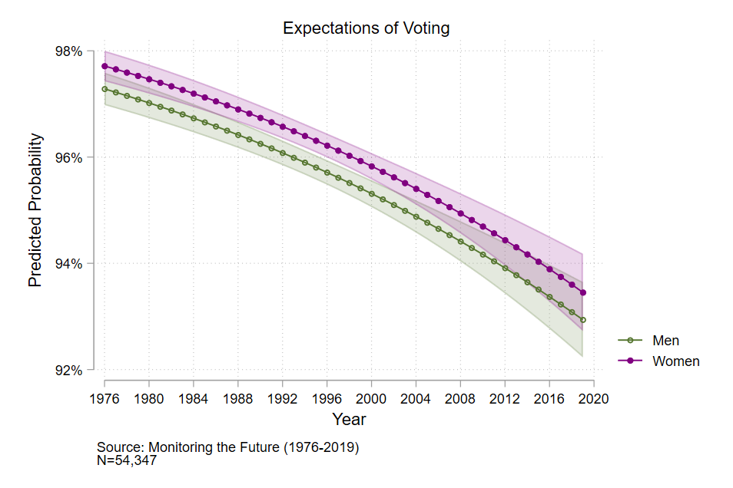
Figure 1. Predicted Probability of Voting Expectations by Gender (Full Model)

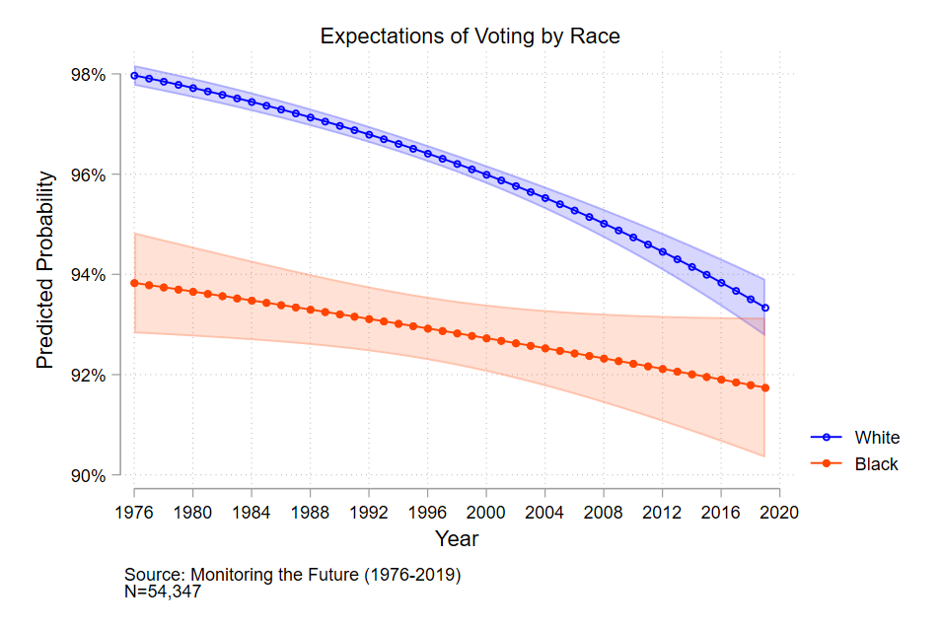
Figure 2. Predicted Probability of Voting Expectations by Race (Full Model)
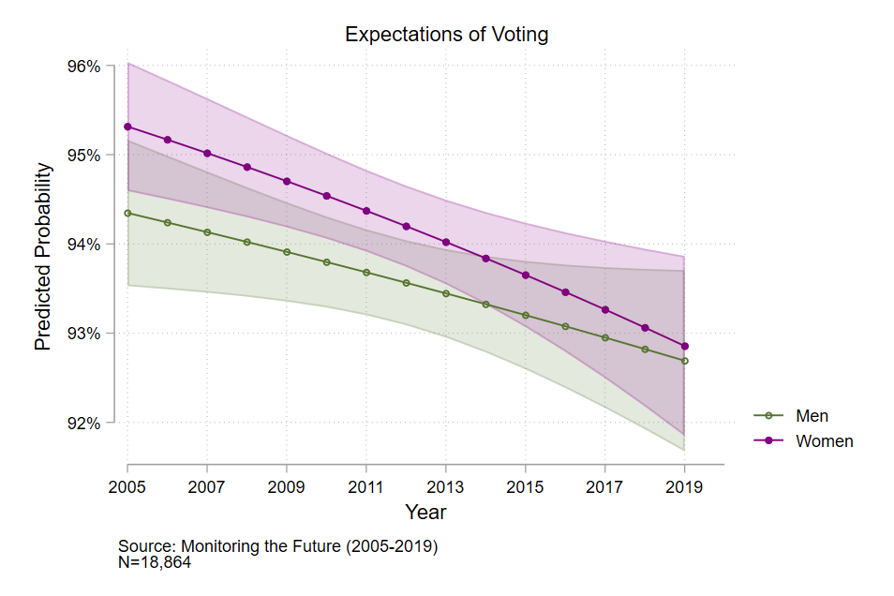
Figure 3. Predicted Probability of Voting Expectations by Gender (Time-Limited Model)

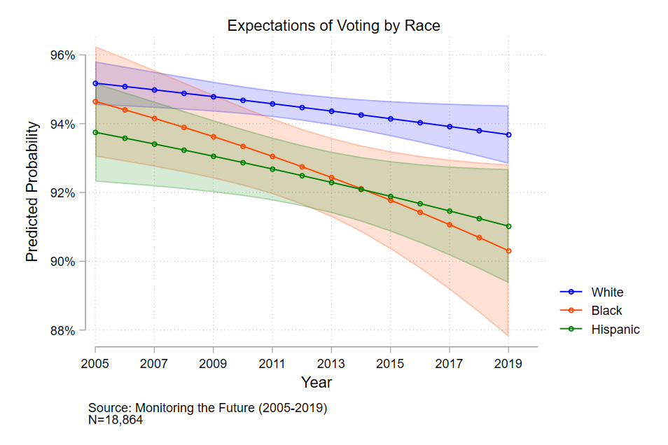
Figure 4. Predicted Probability of Voting Expectations by Racial-Ethnic Identity (Time-Limited Model)
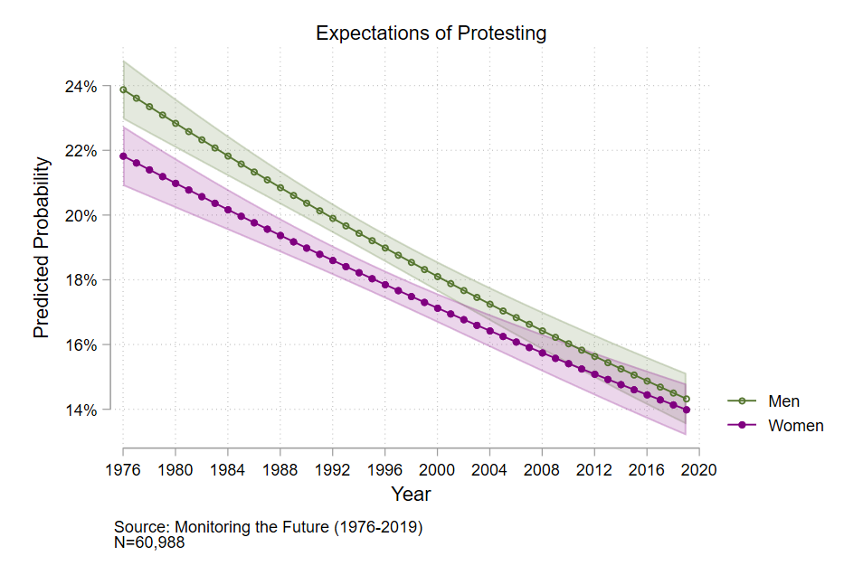
Figure 5. Predicted Probability of Protesting Expectations by Gender (Full Model)

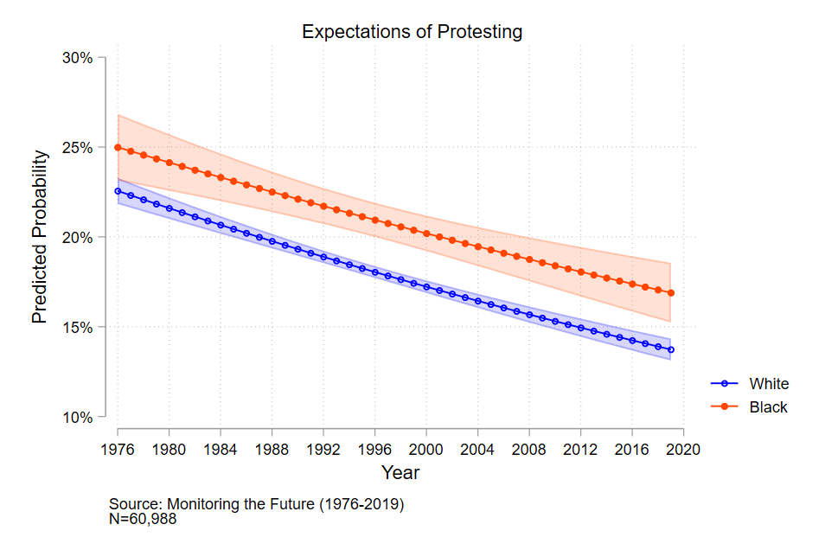
Figure 6. Predicted Probability of Protesting Expectations by Race (Full Model)

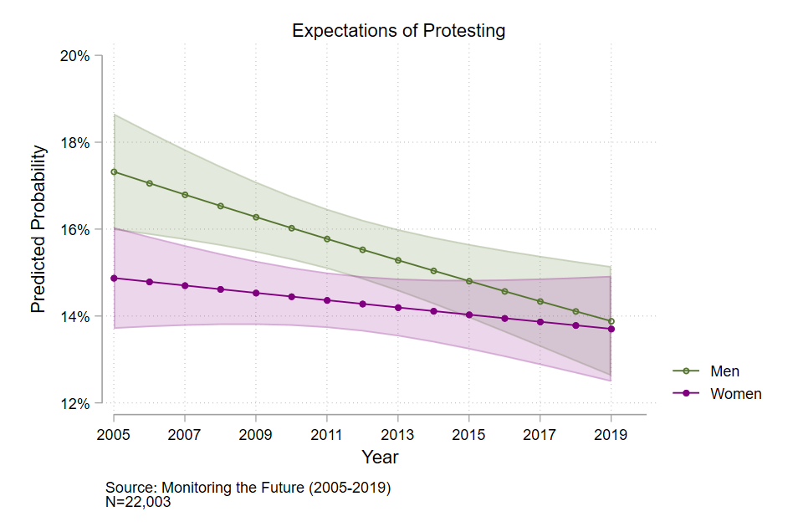
Figure 7. Predicted Probability of Protesting Expectations by Gender (Time-Limited Model)

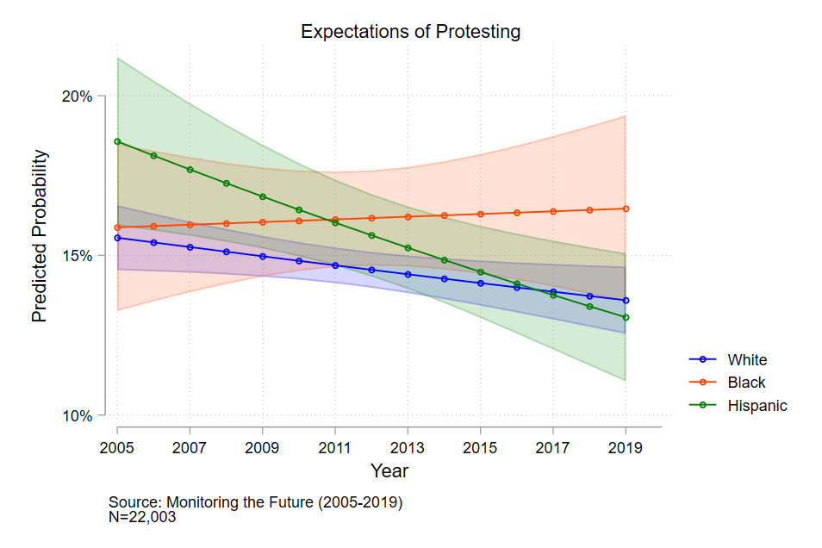
Figure 8. Predicted Probability of Protesting Expectations by Racial-Ethnic Identity (Time-Limited Model)

Monitoring the Future also has a restricted-access longitudinal panel component. This panel dataset was not needed for my study.
Because this is a trend analysis, I will not compare across models, so not having identical samples is not an issue.
I attempted to recode the protesting expectation variable in a variety of ways, but the other variations failed statistical testing.
Due to data limitations, gender is measured with a question regarding the respondent’s sex and is thus measured as binary (Westbrook and Saperstein 2015). This is a common issue, but this dataset is the best option for answering my research questions.
I included a year-squared term during preliminary statistics, but it was insignificant, so I chose not to include it in my analyses.
I combined the three government variables into a scale and used it in my models as a control during preliminary analyses. It did not substantially affect the results.
Preliminary analyses show that including voting expectations as a control does not change the direction or magnitude of the results, and it is substantively the same as not including it as a control. When included, voting expectations for probably will vote and already have voted are statistically significant, so I chose to include voting expectations as a control in the analysis.
I ran t-tests and chi-square tests on the variables to compare how the observed results differ from the expected results. There were significant results, however, the magnitude of the differences was small. Additionally, significant results could be a factor of having a dataset with so many observations (120,900 before listwise deletion).
I use linear hypothesis testing throughout this paper to test whether the predicted probabilities are significantly different.
The MTF data collection in 2020 was interrupted due to COVID-19. More years of MTF data collected after 2020 are needed for updated trend analyses to be run.
I could not include triple interactions in my analyses due to data limitations.

