University of Oklahoma

Graduate College

Game theory application of resilience community road-bridge transportation system

A thesis

submitted to the Graduate Faculty

in partial fulfillment of the requirements for the

Degree of

Master of Science

By

YUNJIE WEN
Norman, Oklahoma
2017

Game theory application of resilience community road-bridge transportation system

A thesis approved for the
Gallogly College of Engineering

By

______________________________
Dr. Charles Nicholson, Chair

______________________________
Dr. Kash Barker

______________________________
Dr. Shima Mohebbi

© Copyright by YUNJIE WEN 2017
All Rights Reserved.

Acknowledgements
This study was advised and supported by Charles Nicholson Ph.D. Thanks are extended to Weili Zhang for providing python code for Stage-wide Decision-Making Framework and to Xianwu Xue Ph.D. for generating the GIS plot for Shelby county network.

Table of Contents
Acknowledgements iv
List of Tables vi
List of Figures vii
Abstract viii
Chapter 1: Introduction 1
Chapter 2: Background 4
2.1 Transportation system performance 4
2.2 Game Setting 5
Chapter 3: Methodology 7
3.1 Performance metrics of network 8
3.2 Game Theory Model Formulation 13
Chapter 4: Numerical Example 18
Chapter 5: Conclusion 30
References 31

List of Tables
Table 1 Service level of bridges 12
Table 2 Summary of formulation 13
Table 3 SRT results from Nash equilibrium solution 20
Table 4 Scenario 1 optimal schedule result 22
Table 5Scenario 2 result 24
Table 6 Scenario 3 result 26
Table 7 Scenario 4 result 28

List of Figures
Figure 1 Stages of resilience 7
Figure 2 Example of IPW 9
Figure 3 Calculation of IPW for each owner 9
Figure 4 Find shortest path based on different owners 10
Figure 5 SRT of network performance 14
Figure 6 Strategic form game 16
Figure 7 Strategic form of a 2-round finitely repeated game 17
Figure 8 Memphis transportation network 19
Figure 9 Optimal repair schedule for recovery of the network 21
Figure 10 Owner 4 shares resources 23
Figure 11 Owner 1 shares resources 25
Figure 12 Neither of owners share resources 27
Figure 13 Comparison of four scenaios result 28

Abstract
This thesis considers the problem of game theory application in resilience-based road-bridge transportation network. Bridges in a community may be owned and maintained by separated entities. These owners may have different and even competing objectives for the recovering the transportation system after disaster. In this work, we assume that each player attempts to minimize the repair time of damaged bridges after hazards happen. The problem is modeled as an N-player nonzero-sum game. Strategic form and sequential form game are designed to demonstrate methodology. A genetic algorithm is applied to the computation of the problem. A dataset with hypothetical road-bridge network with 46 nodes and 26 bridges subjected to a scenario seismic event is used to illustrate the proposed methodology.

Chapter 1: Introduction
In road-bridge transportation systems, bridges are especially vulnerable to disaster (e.g. earthquake, flood, terrorism, etc.). In 2013, there were 607,380 bridges in the United States. These bridges provide access to roads leading to hospitals, police stations, firehouses, etc., or they might be critical to the economic vitality of the community. The Wenchuan earthquake in 2008 damaged 1,657 bridges in China (Zhuang, et al., 2009). Democracy Bridge, which spans the Hondura’s largest river, the Ulua, collapsed in the earthquake in 2009. The bridge is one of two which connect the northern city of San Pedro Sula, Hondura’s second-largest city, with the rest of the country. Determining which bridges in a community are the most important and should be repaired is a basic problem.
However, it turns out that bridges of a transportation system in a community are not all controlled by a single entity. In fact, a portion of in the community might be owned by the federal government, another set of bridges may be owned by the state, and the others may be owned by the county or other local entities. Different entities might make decisions based on their best interests. One can imagine that a finite number of bridges owners repair their bridges based on their unique priorities. In such a situation, these owners may compete for the same resources (e.g. construction workers, repair material) and attempt to minimize the repair time for their own bridges. How to balance the competition among different owners to achieve the best interest for the community is the goal of this paper.
A growing number of literature has been published about mitigating the hazards of transportation system in a community (Murray-Tuite, 2006; Ta et al., 2009; Cox et al., 2011; Frangopol and Bocchini, 2011; Ip and Wang, 2011; Cetinkaya et al., 2015; Zhang and Wang, 2016; Zhang et al., 2017a). To the best of our knowledge, none of these studies has attempted to consider whether the different ownership of bridges in the network impact the final result. These studies are based on the implicit assumption of an existing centralized decision maker with sufficient authority to implement an optimal recovery schedule. The overwhelming majority of roads and bridges are owned and maintained by state and local governments in the US. Federally maintained roads and bridges are generally funded only on federal lands and at federal facilities (like military bases). There are also many local private roads, generally serving remote and insulated residences. In most cases, entities have different priorities and interests regarding the maintenance and repair.
This thesis will focus on repairing bridges owned by different entities during the post-disaster period. As a simplification, we will only consider one competing resource to be shared by multi-owners of transportation components in a community, i.e. available repair crews. This work will extend previous work by Zhang et al., 2017a and Zhang et al., 2017b to adopt both the transportation network performance metric they introduce as well as the overall objective function for decision-making during recovery to handle multiple owners. The result of this study illustrates the application by using game theory to determine an optimal repair schedule for each entity of damaged bridges of a community during post-disaster recovery period.
The remainder of this thesis will be divided into 4 chapters. Chapter 2 summarizes the literature related to the resilience of post-disaster road-bridge transportation. Chapter 3 describes methodology and defines the measures used to apply game theory to the road-bridge network. Chapter 4 discusses the result of the methodology applied to the sample case with different scenarios. Chapter 5 provides conclusions based on the work.

Chapter 2: Background

2.1 Transportation system performance
Current approach for transportation network problems consider sole ownership of transportation components for the decision-making.
Chang and Nojima (2001) proposed three performance measures for transportation system of post-disaster situation: total length of network open, total distance-based accessibility and areal distance-based accessibility. The transportation network used in this paper includes railway lines and highways. The paper provides a quantifiable method to evaluate the performance of a transportation system in the post-disaster stage. However, their approach is from the global perspective and does not allow for unique perspective of different decision makers. Ip and Wang (2011) introduce a quantifiable evaluation approach for resilience. Resilience, defined as the weighted sum of the resilience of all nodes, and friability, defined as the reduction of network resilience resulting from its removal from the network, are discussed to measure the performance of the network. Their approach measuring the network performance is based on the assumption that there is sole decision-maker in the network. Zhang, et al., (2017a) presents two metrics for measuring performance of network: total recovery time(TRT) and the skew of the recovery time trajectory (SRT). A recent research from Zhang, et al., (2017b), develops a stage-wide decision framework for transportation network. This study defines three network metrics, reliability weighted IPW (RIPW), emergency node-weighted IPW (EIPW) and traffic weighted (TIPW), each based on a derivation of the number of independent pathways (IPW) within a roadway system, to measure the performance of a network in term of its robustness, redundancy, and recoverability, respectively (Zhang, et al., 2017). Again, these two approaches assume a centralized authority for making decision. In this paper, we will extend the concept of SRT to multiple owners. Additionally, this is accomplished by the novel contribution of modified TIPW to also be owner specific.
These studies all present quantifiable evaluation approaches for resilience based on the sole ownership of each components of network, but in reality, each component (roadways, bridges, storm drainages, roadways signs, etc.) of transportation network is assigned to specific entities for certain responsibilities (maintenance, repairing, etc.). On other hand, game theory, is set of tools to model interaction between decision makers with conflicting interests. Game theory is used widely in economics, political science and psychology. Now computer scientists and engineers are using it to rethink their work. There are an increasing number of studies to apply game theory in supply chain (Li et al 2013, Mohebbi et al., 2015), cyber security (Backhaus et al., 2013), transportation network (Bell 2000, Bell 2001, Szeto 2011, Wang et., al 2013). So far, there is no researches or studies to apply game theory to road-bridges transportation of resilience. This is the motivation of this study.

2.2 Game Setting
In game theory, a player’s strategy is a complete plan of actions he or she can choose in a given circumstance that might arise within the game. In road-bridges transportation system, different entities controlling the bridges, roads or other components, are players (that are modeled as bridges owners) of this game setting.
In a non-cooperative game, each player $i (i=1…N)$ chooses a strategy $a_{i}$ from a strategy set $A_{i}$, and the payoffs of the game are given by the mapping where $u_{i}\left(a_{1},…a_{N}\right)$ is player $i's$ payoff if strategies$\left(a_{1},…a_{N}\right)$ are played. The standard prediction for what will happen in game us that players will choose Nash equilibrium strategies. Strategies $(a_{1}^{*} …a_{N}^{*})$ constitute a Nash equilibrium if:
$u_{i}\left(a_{1}^{*}, …a_{N}^{*}\right)≥ a_{i}\left(a, …a,a_{i}^{*},a_{i+1}^{*}, …a_{N}^{*}\right), ∀i ∈N$and $a_{i }∈ A_{i}$
A Nash equilibrium is a strategy profile such that no player can be better off by deviating from it, assuming that the other players do not change their strategies. This leads to the situations where only one player changes his own decision while the others stick to their current choices. In this game, the goal for all bridge owners (local, state, federal government and private owners), is to minimize the skewness of total recovery trajectory(SRT), which is the payoff for each player. In order to achieve this goal, all bridges owners have to find a repair schedule, which can give minimum value of SRT.
This game can be formulated as an N players non$-$zero sum, non$-$cooperative and repeated game. Application of this type of game formulation can be found in other fields (Agah et al., 2007, Liang et al., 2012).

Chapter 3: Methodology
There are three stages of resilience according to Zhang et., al 2017b: Mitigation, Emergency response and Recovery, as illustrated in their work and represented here as Figure 1.
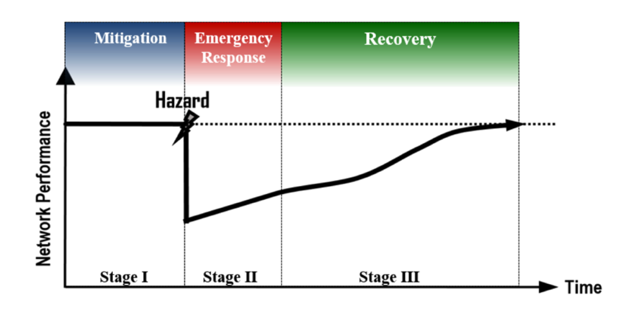
Figure 1 Stages of resilience

Zhang et., al 2017b propose that the various stages of the resilience timeline having distinct performance metrics, objectives and constrains. In stage I, the purpose of mitigation is to “enhance” the community in preparation for a disaster. The community faces the challenge how to allocate the budgets for enhancement. In stage II, the priority for a community is coping with the emergency. In this stage, given the time urgency and life-safety threatening environment, they assume that owners of bridge cooperate with each other to fix the bridges which lead to emergency service such as hospital, firehouse or police station, etc. For stage III, the community focuses on the recovery after disaster and there is no life and death situations. Therefore, bridge owners can repair bridges according to their own agenda. During the recovery stage, the community might face a shortage of construction crews or other resources because of the hazard, which might be worse if different owners compete for limited resources. Given that stage III usually is much longer than stage II, and the urgency is reduced, the various owner may pursue their own best interests. The focus of this paper relates specifically to stage III. This section will elaborate how to find the scheduling solution, which is a repair schedule of damaged bridges, for each owner.
During the post - disaster recovery period, the objective is to restore the transportation system to the pre-disaster condition with minimized total time and maximized efficiency for the transportation system (Zhang et al., 2017). For all bridge owners, the goal of post - disaster is to repair their bridges with maximized efficiency. All bridges within the network has an estimated repair time associated with different degrees of damage. For instance, bridge 515 is slightly damaged, the repair time is 3 days. But if the bridge is completely damaged, the repair time is 678 days.

3.1 Performance metrics of network
A transportation network is described on a undirected graph $G=\left( V,E\right)$where $V=\left\{1,2, …, n\right\}$ is the set of nodes and $E=\{1, 2,…,m\}$ is the set of edges. Each edge presents a road with a maximum of one bridge. A pathway between an origin-destination (O – D) pair usually consists of several edges that represent roads, with or without a bridge, which are connected in series. Two pathways between the same O – D pair are considered as independent pathways (IPW) if they do not share any common road link. Figure 2 presents a pathway between O $-$ D. IPW of this pathway is 1 since edges 1 $-$ 2 and 5$-$6 are shared by both path 1 – 2 – 3 – 5 – 6 and 1 – 2 – 4 – 5 – 6.
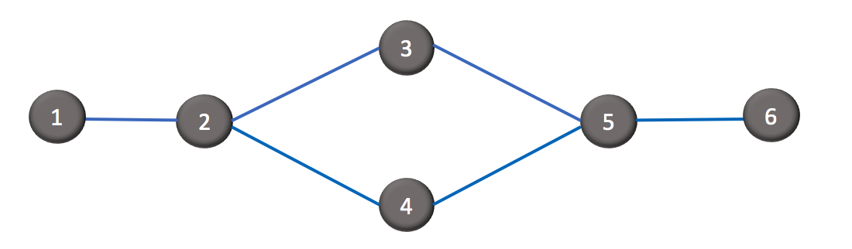
Figure 2 Example of IPW

To identify the IPW among bridge owner in a same pair O$-$D, a binary variable $G_{o}$is introduced. $G_{o}$ (where o is the bridge owner of the network) is defined as an IPW indication for owner o. If owner o owns any of bridges on an independent pathway between O$-$D, the value of $G_{o}$ is 1, otherwise, the value is 0. For example, the 1$-$6 pair in Figure 3, contains two paths from node1 to node 6. We assume that there are maximum one bridges per edge, marked as a or b which indicate owner of the bridge. Owner a owns bridges on the path 1 – 2 – 3 – 5 – 6, therefore $G_{a}=1$. Same calculation applies to owner b, and $G_{b}=1$.
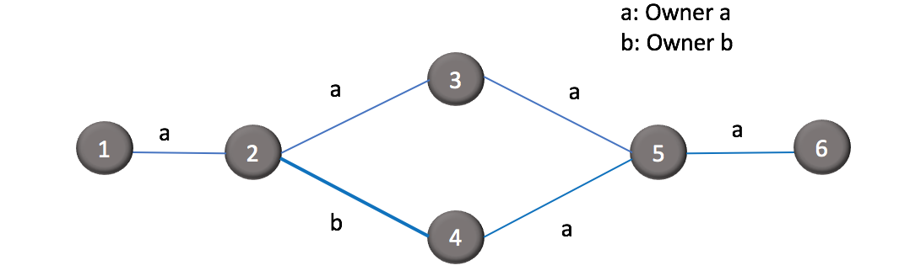
Figure 3 Calculation of IPW for each owner

The identification of IPWs between many O – D pairs is non-unique, depending on the algorithm or process used to search for IPWs. To mitigate this problem, we apply Dijkstra’s algorithm (Skiena, 1990) to search for a succession of shortest independent paths. The justification for the shortest IPW is that people often have a preference to choose the shortest path when traveling. If all edges have the same length for a shortest path search, for example, in Figure 4, the IPW from node 1 to node 5 is 3, which shows three independent pathways between 1 and 5. We assume that each edge has exactly one bridge, which marked in the Figure 4 as a, b and c to denote different bridge owner. One approach to select shortest path for this situation is random selection. However, in order to select the IPW, which incentivizes the bridge owner a to do the repair, the length of edge with bridge owned by owner a will be set as 0.9999. Pathway 1$-$2$-$5 becomes shortest path comparing with 1$-$3$-$ 5 and 1$-$4$-$5. For owner a, IPW is 1 since owner a owns one of the bridges in an independent pathway. Owner b owns one bridge on pathway 1$-$3$-$5, therefore IPW for owner b is 1. For owner c, IPW is 3 since owner c owns bridges on all three pathways 1$-$2$-$5, 1$-$3$-$5 and 1$-$4$-$5.
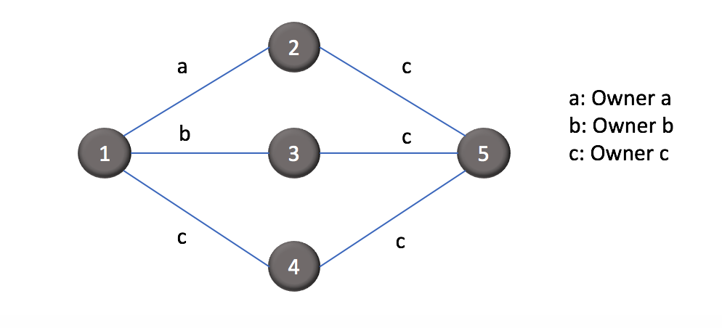
Figure 4 Find shortest path based on different owners

Let $K_{ij}$ denote the total number of IPWs and $P_{ij}^{K}$denote the $k^{th}$ IPW between node $i∈V$and $j ∈V$. An algorithm for computing $K_{ij}$ and $P_{ij}$ between all nodes pairs is introduced in Zhang et al (2016). Let ${IPW}_{i,o}$ denote the average number of IPWs for owner o between node $i∈V$ and all the other n $-$1 nodes, i.e.:
$${IPW}_{i,o}=\frac{1}{n-1}\sum_{j=1}^{n-1}{{G_{o}× K}_{ij}}$$ | (1)

The IPW of network G for owner o is defined as the overall average of all ${IPW}_{i,o}$ values for every node $i∈V$,
$${IPW}_{o}(G)=\frac{1}{n}\sum_{i=1}^{n}{{IPW}_{i,o}}$$ | (2)

The performance metric for long-term recovery proposed by Zhang et al (2017b) is Traffic Weighted IPW, denoted as TIPW. The pre - event average daily traffic (ADT) on roads and bridges are the field measurements routinely maintained by the Federal or State Department of Transportation. TIPW is related to both the average daily traffic (ADT) and the length of the IPW and reflects the relative impact that this pathway has on people’s normal life activities and the local economy. Pathways between any given O –D pair that has the shorter length and carries larger traffic flow contribute more to the network functionality. ADT data is often readily available with federal, state or local bridges owners, or can be estimated using traffic assignment models. $A_{l}$ is defined as the ADT of edge $l ∈ P_{ij}^{k}$. $A_{ij}^{k}$ is the ADT of $P_{ij}^{k}$, which is the minimum ADT of all edges on the pathway, i.e.:
$$A_{ij}^{k}=\min\left\{A_{l}\right|l ∈P_{ij}^{k}\}$$ | (3)

The normalized ADT of the path can be described as:
$$\tilde{A} _{ij}^{k}= \frac{K_{ij}A_{ij}^{k}}{\sum_{p=1}^{K_{ij}}{A_{ij}^{p}}}$$ | (4)

For each edge $l∈E$, the service level is defined as ($1- \frac{d_{l}}{4}$ ) as used in Zhang et al (2016) and described in Table 1. If an edge is completely damaged, the value of $d_{l}$ will be set to 4 and the corresponding service level will be 0. Let $Q_{i,o}$ denote the TIPW of node $i ∈V$ for owner o. $Q_{i,o}$ can be described as:
$$Q_{i,o}=\frac{1}{n-1}\sum_{j=1}^{n-1}{G_{o}\sum_{k=1}^{k_{ij}}{{\tilde{A}}_{ij}^{k}\prod_{∀l∈P_{ij}^{k}}^{ }{(1-\frac{d_{l}}{4}}}})$$ | (5)

TIPW of the network for owner o can be described as:
$$Q_{o}\left(G\right)= \frac{1}{n}\sum_{i}^{n}{Q_{i,o}}$$ | (6)

Table 1 Service level of bridges
$$d_{l}$$ | Description
0 | No damaged
1 | Slight damaged
2 | Moderate damaged
3 | Extensive damaged
4 | Complete damaged

See Table 2 for a summary of all notation discussed in this chapter.

Table 2 Summary of formulation
Notation/Term | Description
G (V, E) | Undirected graph
$V=$ $\left\{ 1,2, …, n\right\}$ | Set of nodes
$$E=\{1, 2,…,m\}$$ | Set of edges
$$G_{o}$$ | Binary variable parameter to differentiate ownership of bridge, o = bridge owner
$$K_{ij}$$ | Total number of IPWs
$$P_{ij}^{K}$$ | $k^{th}$ IPW between node $i∈V$and $j ∈V$
$${IPW}_{i,o}$$ | Independent pathway for owner o between node $i∈V$ and all the other n-1 nodes
$${IPW}_{o}(G)$$ | The IPW of network G for owner o is defined as the overall average of all ${IPW}_{i,o}$
$$A_{l}$$ | ADT of edge $l ∈ P_{ij}^{k}$
$$A_{ij}^{k}$$ | ADT of $P_{ij}^{k}$
$$Q_{i,o}$$ | denote the TIPW of node $i ∈V$ for owner o
$$Q_{o}\left(G\right)$$ | TIPW of the network for owner o

3.2 Game Theory Model Formulation
For each owner, his interest focuses on repairing damaged bridges in order to minimize the SRT. If there is only one owner in the network, the problem can be solved by using optimization. But as we mentioned in Chapter 1, normally there are more than one owner involved to make decision. Game theory is a tool developed to find optimal results for more than one decision maker in the game. We shall employ the following notation:
$I=\{1, ……, N\}$, denoting the set of players,
$S_{i}$= the strategy set of player $i$
$S_{-i}$= the strategy set of all players, except player $i$
$u_{i}$= the payoff function of player $i$
We define that set of player is the bridge owners of the network. Player $i's$ strategy $S_{i}$ is the repair sequence of damaged bridges. For example, player 1 has four damaged bridges and each bridge requires a certain number of days to be restored certain days to the level of pre-event. He has $4!=24$ways to schedule the repair. However, both recovery time and skewness of recovery trajectory might be different in each case. Zhang et al (2017b) explain that total recovery time alone is not sufficient to evaluate the efficiency of the network performance, which is partially encapsulated in the shape of the recovery trajectory. The skewness of recovery trajectory (SRT) apparently is a superior objective performance metric. To find the payoff for each player, we use skewness of recovery trajectory (SRT), defined as centroid of the area below the recovery trajectory as utility function instead of repairing time. In Figure 4, the recovery trajectory is defined from $t_{0}$ to $t_{k}$. The SRT associated with schedules 1 and 2 are marked in Figure 5 as $s_{1}$ and $s_{2}$, respectively. If the recovery were instantaneous, then $s_{1}$ = $s_{2}$ = 0. Schedule 1 and 2 approximately lead to same recovery time, but schedule 1 is more efficient than schedule 2.
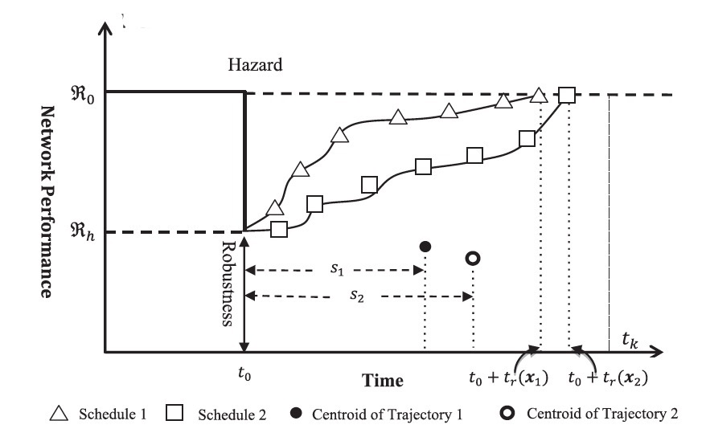
Figure 5 SRT of network performance
The network SRT associated with the scheduling plan, the centroid of the area under the recovery trajectory as shown in Figure 5, can be calculated by Equation (7), which requires the integrals of TIPW, i.e. $Q_{o}\left(t\right)$, as a function of time. As discussed
previously, computing TIPW involves using Dijkstra’s algorithm to search for IPWs for all O$-$D pairs. TIPW is estimated at discrete points in time; consequently, the recovery trajectory (expressed in terms of TIPW) is discretized into step functions. In addition, T = {$t_{0}$ , $t_{1}$, …, $t_{k}$} is set such that $t_{0}$ ≤ $t_{1}$ ≤ … ≤ $t_{k}$ , in which the difference between any adjacent time points is a constant time increment $∆t$. The recovery scheduling problem is to determine an optimal schedule $x=\left\{ x_{1}, x_{2}, ……x_{c}\right\}$ (c = total number of damaged bridges) for the repair of all damaged bridges, where $x$ is the time at which restoration is initiated for bridges such that network SRT are minimized.
The SRT for owner o can then be approximated by:
$$u_{o}\left(x\right)= \frac{\int_{t_{0}}^{t_{0}+ t_{k}}{Q_{o}(t)∙(t - t_{0})dt }}{\int_{t_{0}}^{t_{0}+ t_{k}}{Q_{o}(t)dt }}≈ \frac{\sum_{i=0}^{k}{t_{i}Q_{o}(t_{i}})∆t}{\sum_{i=0}^{k}{Q_{o}(t_{i}})∆t}$$ | (7)

We can form the game as strategic form (or normal form), which is a way to describe a game using a matrix and is the appropriate description of a simultaneous game. The strategic form allows us to quickly analyze each possible outcome of a game. Figure 5 illustrates two players strategic form.

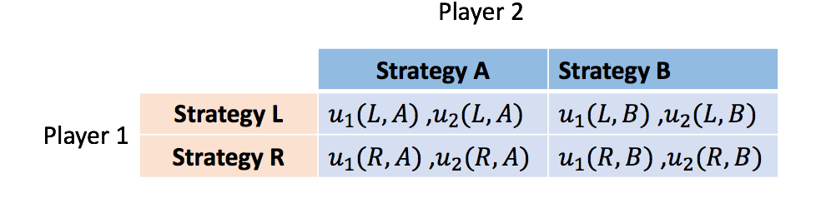
Figure 6 Strategic form game

In Figure 6, if player 1 chooses strategy L and player 2 chooses strategy A, the set of payoffs given by the outcome is $u_{1}(L, A)$ and $u_{2}(L, A)$. The player, use a different schedule sequence as a strategy. If each bridge owner owns more than 2 bridges, the strategies of owners will be more than 2. Finitely repeated game should be considered. Writing down the strategy space for a repeated game is difficult, even if the game is repeated only two rounds. For example, consider the finitely repeated game strategies for Figure 7 to play twice. For player 1, $L_{1}$or $R_{1}$ are two possible moves in round one. For the second round, player 1 can pick whether to go $L_{2}$or $R_{2}$. For the first$-$round strategies are: ($L_{1}, A_{1} ), \left(L_{1} ,B_{1} \right), \left(R_{1} ,A_{1} \right), (R_{1} ,B_{1})$. For the second$-$round, there are16 strategy sets which is illustrated in Figure 6. As we can see, the number of strategies increase rapidly.
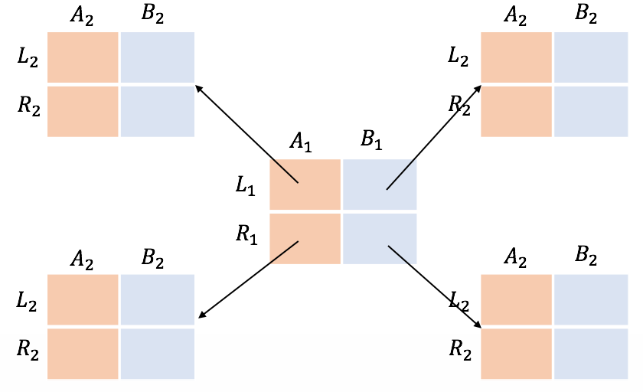
Figure 7 Strategic form of a 2-round finitely repeated game

As long as there is a known, finite end, there will be no change in the equilibrium outcome of a game with unique equilibrium. SRT presents how efficient the repair is, each owner likely accepts the sequence of repair which can generate the minimum SRT. The recent research shows the different sequence of scheduling leads to unique results with high possibility (Zhang et.,al 2017a). Both players can achieve the minimum SRT by a specific repair sequence, and any change from either player, will change SRT. Therefore, the minimum SRTs will be the Nash equilibrium solution for the game.

Chapter 4: Numerical Example
In this chapter, a high – level road-bridge network in Memphis of Shelby county in Tennessee is used for the model introduced in Chapter 3. This network based on interstate highways, contains 34 nodes, 46 edges and 24 bridges. There are two bridge owners in this network, State Highway Agency (Owner 1) and City or Municipal Highway Agency (Owner 4), which are marked in Figure 8. Owner 1 owns 16 bridges and Owner 4 owns 8 bridges.
The chance of a moderate earthquake occurring in the New Madrid Seismic Zone (NMSZ) in the near future is high. Scientists estimate that the probability of a magnitude 6 to 7 earthquake occurring in NMSZ within the next 50 years is higher than 90% (Hildenbrand et al., 1996). Shelby County, TN falls within the New Madrid Seismic Zone (NMSZ). However, most civil infrastructure in the NMSZ were not seismically designed, as opposed to those in frequent earthquake regions (e.g., California, USA or Japan). We consider a scenario earthquake with magnitude Mw equal to 7.7 and the epicenter located at 35.3N and 90.3W (on the New Madrid Fault Line) as proposed in the MAE Center study (Adachi, 2007). A selected ground motion attenuation model (Atkinson and Boore, 1995) is used to estimate the peak ground acceleration at the site of the bridges. The earthquake scenario is simulated as mean realization.
The genetic algorithm is used in this work to identify a near optimal solution with population number 50 and generation number 20.

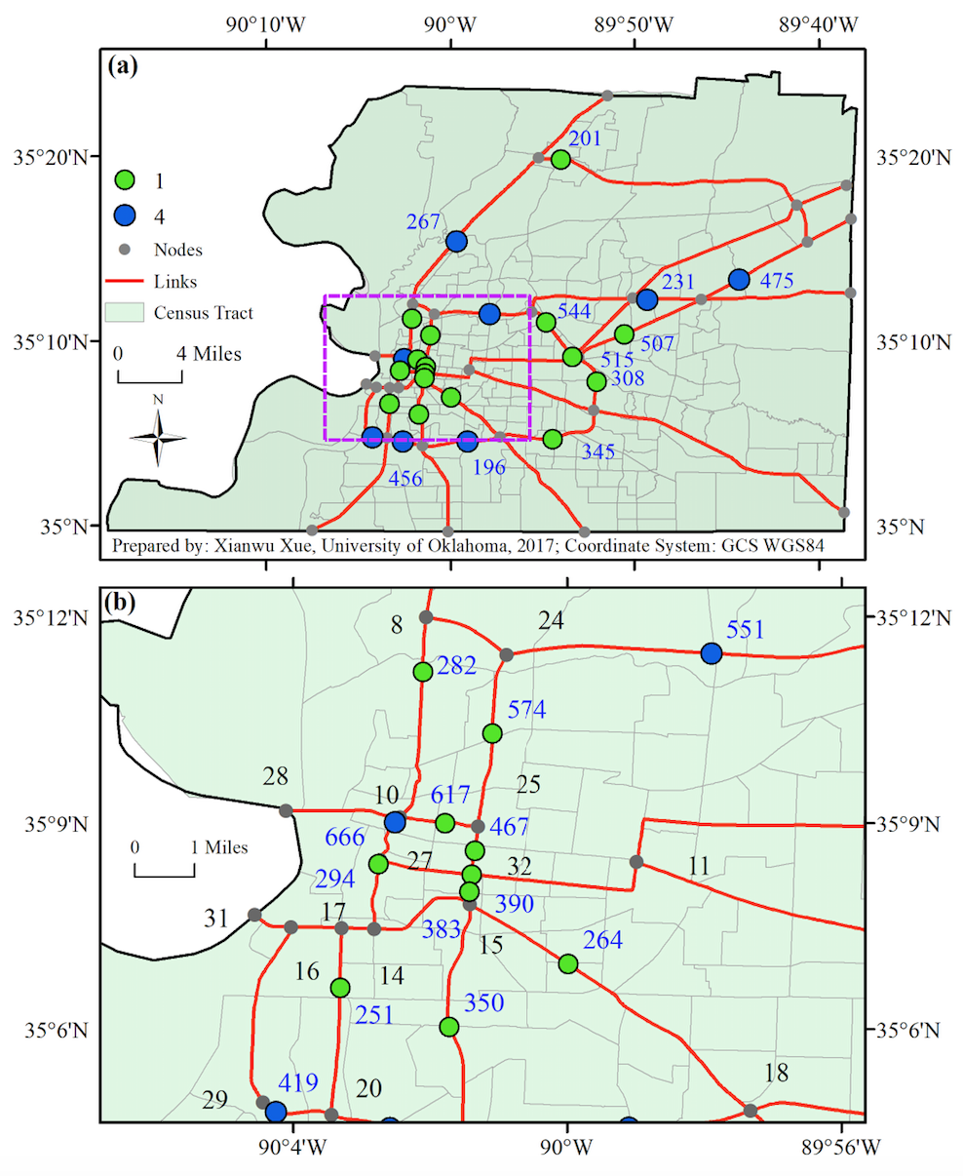
Figure 8 Memphis transportation network

The network performance using TIPW is calculated according to Equation (6). Prior to the earthquake, the overall TIPW for the community is 1.752. After the earthquake happens, the TIPW for owner 1 is 0.5585 and for owner 4 is 0.5550. The problem is to determine the schedule of repairing the 19 damaged bridges (which owner 1 has 12 damaged bridges and owner 4 has 7 to minimize the SRT. The damaged level of bridges ranges includes slight, moderate, extensive and complete. In the recovery stage, for this case study we assume that only 4 bridges can be repaired simultaneously, which means that four available construction crews can do repair work.
Table 3 SRT results from Nash equilibrium solution
TIPW/Owner | Owner 1 | Owner 4
TIPW before earthquake | 1.7558 | 1.7415
TIPW after earthquake | 0.5585 | 0.5550

After earthquake, during the long-term stage III (recovery), we assume that every owner is eager to repair his bridges as soon as possible, but there are only 4 qualified construction crews available during the post-disaster. In order to determine the game theory paradigm, we assume that the bridge owners can distribute the resources evenly between them. Therefore, each owner can have two repair crews to do the work.
First, we use genetic algorithm to search minimum values for both owners as a repeated game. Both owners know that the game is repeated and there is no regulation how to select the bridges. Their primary goal is to find the minimum owner specific SRT. Figure 8 shows the results of the genetic algorithm after searching for a global minimum SRT value without considering of bridge ownership. The SRT values of the repair schedule for both owners are 423.6501 (Owner 1) and 450.9705 (Owner 4). As we can see, there is no certain pattern in the sequence.
After the optimal schedule is revealed to both player, we might consider the following scenarios:
- Both owner agree on the optimal schedule and share the resources. Figure 9 and Table 4 are the result of this scenario.
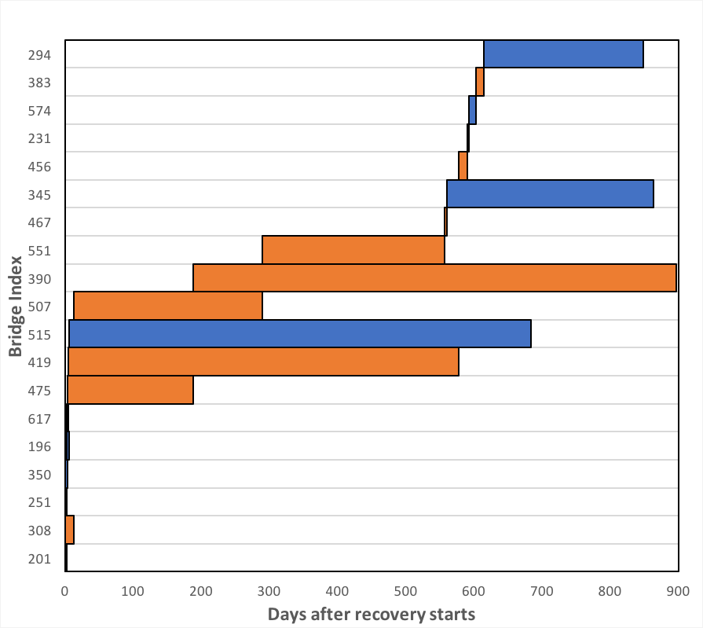

Figure 9 Optimal repair schedule for recovery of the network

Table 4 Scenario 1 optimal schedule result
Bridge ID | Owner | Repair Time | Idle Duration | Resources
201 | 1 | 3 | 0 | crew #1
308 | 1 | 13 | 0 | crew #2
251 | 4 | 3 | 0 | crew #3
350 | 4 | 4 | 0 | crew #4
196 | 4 | 3 | 3 | crew #1
617 | 1 | 2 | 3 | crew #3
475 | 1 | 184 | 4 | crew #4
419 | 1 | 573 | 5 | crew #3
515 | 4 | 678 | 6 | crew #1
507 | 1 | 277 | 13 | crew #2
390 | 1 | 709 | 188 | crew #4
551 | 1 | 267 | 290 | crew #2
467 | 1 | 3 | 557 | crew #2
345 | 4 | 303 | 560 | crew #2
456 | 1 | 12 | 578 | crew #3
231 | 1 | 3 | 590 | crew #3
574 | 4 | 10 | 593 | crew #3
383 | 1 | 12 | 603 | crew #3
294 | 4 | 233 | 615 | crew #3

- Owner 1 does not agree on the optimal schedule and is not willing to share the resources. Owner 4 is willing to share the construction crews. For example, 4 construction crews are evenly distributed between two owners. Owner 1 has crew #1 and crew #2 work on his damaged bridges. And Owner 4 has crew #3 and crew #4 working for Owner 4’s repair. Following the optimal repair schedule, when owner 4’s bridges is the next one on the schedule, but crew #3 and crew #4 both are occupied, owner 1 does not share the idle crews for owner 4. Owner 1’s bridge can move to the next one for repair. Figure 10 and Table 5 are the repair schedule based on this scenario.
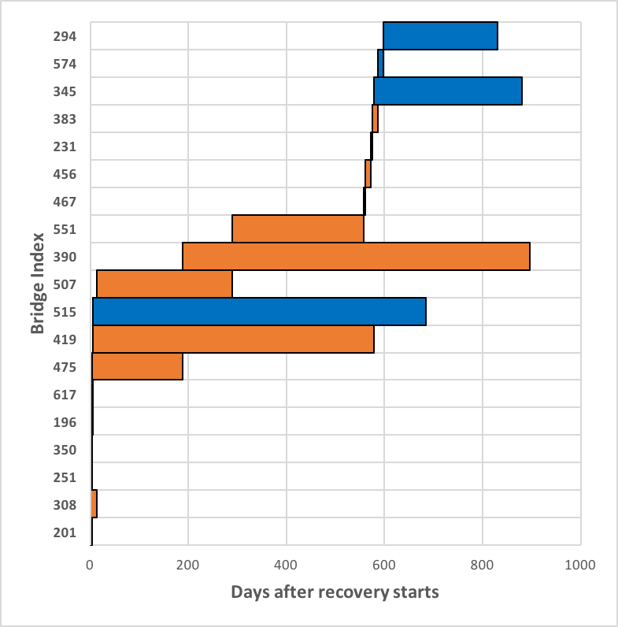
Figure 10 Owner 4 shares resources

Table 5Scenario 2 result
Bridge ID | Owner | Repair Time | Idle Duration | Resource
201 | 1 | 3 | 0 | crew #1
308 | 1 | 13 | 0 | crew #2
251 | 4 | 3 | 0 | crew #3
350 | 4 | 4 | 0 | crew #4
196 | 4 | 3 | 3 | crew #3
617 | 1 | 2 | 3 | crew #1
475 | 1 | 184 | 4 | crew #4
419 | 1 | 573 | 5 | crew #1
515 | 4 | 678 | 6 | crew #3
507 | 1 | 277 | 13 | crew #2
390 | 1 | 709 | 188 | crew #4
551 | 1 | 267 | 290 | crew #2
467 | 1 | 3 | 557 | crew #2
456 | 1 | 12 | 560 | crew #2
231 | 1 | 3 | 572 | crew #2
383 | 1 | 12 | 575 | crew #2
345 | 4 | 303 | 578 | crew #1
574 | 4 | 10 | 587 | crew #2
294 | 4 | 233 | 597 | crew #2

- Owner 4 does not agree on the schedule and is not willing to share the resources. Owner 1 is willing to share the construction crews. When owner 1’s bridges is the next one on the schedule, but crew #1 and crew #2 both are occupied, owner 4 does share the idle crews for owner 1. Owner 4’s bridge can move to the next one for repair.
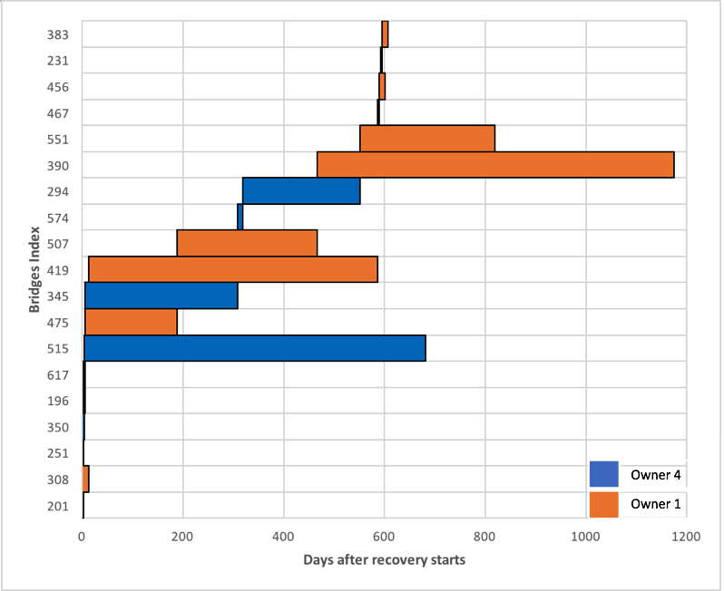
Figure 11 Owner 1 shares resources

Table 6 Scenario 3 result
Bridge ID | Owner | Repair Time | Idle Duration | Resource
201 | 1 | 3 | 0 | crew #1
308 | 1 | 13 | 0 | crew #2
251 | 4 | 3 | 0 | crew #3
350 | 4 | 4 | 0 | crew #4
196 | 4 | 3 | 3 | crew #3
617 | 1 | 2 | 3 | crew #1
515 | 4 | 678 | 4 | crew #4
475 | 1 | 184 | 5 | crew #1
345 | 4 | 303 | 6 | crew #3
419 | 1 | 573 | 13 | crew #2
507 | 1 | 277 | 189 | crew #1
574 | 4 | 10 | 309 | crew #3
294 | 4 | 233 | 319 | crew #3
390 | 1 | 709 | 466 | crew #1
551 | 1 | 267 | 552 | crew#3
467 | 1 | 3 | 586 | crew #2
456 | 1 | 12 | 589 | crew #2
231 | 1 | 3 | 592 | crew #2
383 | 1 | 12 | 595 | crew #2

- Neither owner is not willing to share resources. Under this circumstance, if one owner has no crews available for his next bridges, the other owner can move his bridges up the schedule.

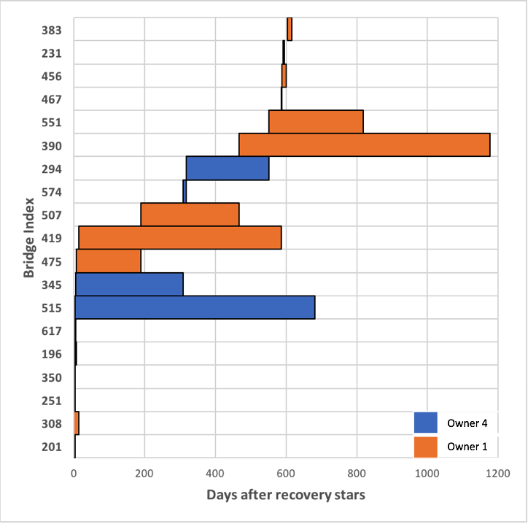
Figure 12 Neither of owners share resources

Table 7 Scenario 4 result
Bridge ID | Owner | Repair Time | Idle Duration | Resource
201 | 1 | 3 | 0 | crew #1
308 | 1 | 13 | 0 | crew #2
251 | 4 | 3 | 0 | crew #3
350 | 4 | 4 | 0 | crew #4
196 | 4 | 3 | 3 | crew #3
617 | 1 | 2 | 3 | crew #1
515 | 4 | 678 | 4 | crew #4
475 | 1 | 184 | 5 | crew #1
345 | 4 | 303 | 6 | crew #3
419 | 1 | 573 | 13 | crew #2
507 | 1 | 277 | 189 | crew #1
574 | 4 | 10 | 309 | crew #3
294 | 4 | 233 | 319 | crew #3
390 | 1 | 709 | 466 | crew #1
551 | 1 | 267 | 552 | crew#3
467 | 1 | 3 | 586 | crew #2
456 | 1 | 12 | 589 | crew #2
231 | 1 | 3 | 592 | crew #2
383 | 1 | 12 | 595 | crew #2

We can use matrix to present these four scenarios:
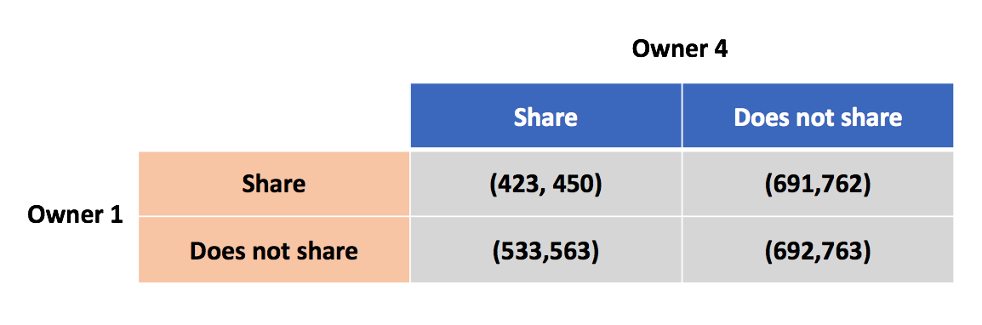
Figure 13 Comparison of four scenaios result

The result from Figure 13, illustrates that only when both owners are willing to share resources, the SRT will be minimum for both owners.
From this result, we can conclude that a non-cooperative and repeated strategic game can be considered for the network involving multiple decision makers. Because different sequence of scheduling leads to unique result, this unique result, SRT is the equilibrium outcome of a game with a unique equilibrium. Decision-makers of the network should schedule and repair the damaged bridges based on sequence with minimum SRT values.

Chapter 5: Conclusion
This study is an exploration on applying game theory on schedule problems of road-bridge transportation network system. Under the assumption, which is that the community is well-funded and there are only certain number of construction crews available for the repairing, we propose that game theory component can be used in the schedule problem in the network involving multiple decision makers. There are three contributions from this study:
First, this study introduces a way to search shortest independent pathway for different decision makers of the network. A binary parameter is used to differentiate the performance metrics, TIPW. This parameter allows bridge owner to measure the performance of pathways which involves their bridges.
Second, the repeated game model is considered to solve the recovery scheduling problem of transportation network for decision-making. Strategic and non-cooperative game was discussed, and the result from game model shows that Nash equilibrium solution can be found.
Finally, this study defines the utility function, SRT for all players in the game. Instead of using recovery time, SRT can present the efficiency of repairing for different decision-maker of the network. This capability will allow the decision-maker to consider the efficiency of repair, not the length of recovery time.
For the future research, the differential game can be considered for dynamic decision-making with more complete information of strategies and reaction between players.

References
Adachi, T. (2007). Impact of cascading failures on performance assessment of civil infrastructure systems. Doctoral dissertation, Georgia Institute of Technology.
Agah, A., Das, S.K. (2007): Preventing attacks in wireless sensor networks: A repeated game theory approach. International Journal of Network Security, Vol.5, No.2, PP.145–153, Sept. 2007.
Atkinson, G. M., Boore, D. M. (1995): Ground-motion relations for eastern North America. Bulletin of the Seismological Society of America, 85(1), 17-30.
Backhaus, S., Bent, R., Bono, J., Lee, R., Tracey, B., Wolpert, D., Xie, D., Yildiz, Y. (2013): Cyber-Physical Security: A Game Theory Model of Humans Interacting Over Control Systems. IEEE Transactions on Smart Grid, Vol.4, No.4, 2013.
Bell, M.G.H. (2000): A game theory approach to measuring the performance reliability of transport networks. Transportation Research, Part B 34 (2000) 533-545.
Bell, M.G.H., Cassir C. (2001): Risk-averse user equilibrium traffic assignment: an application of game theory. Transportation Research, Part B 36 (2002) 671-681
Cetinkaya, E. K., Alenazi, M. J., Peck, A. M., Rohrer, J. P., Sterbenz, J. P. (2015): Multilevel resilience analysis of transportation and communication networks. Telecommunication Systems, 60(4), 515- 537.
Chang, S. E., Nojima, N. (2001): Measuring post-disaster transportation system performance: the 1995 Kobe earthquake in comparative perspective. Transportation research, Part A: policy and practice, 35(6), 475-494.
Cox, A., Prager, F., Rose, A. (2011): Transportation security and the role of resilience: A foundation for operational metrics. Transport policy, 18(2), 307-317.
Frangopol, D. M., Bocchini, P. (2011): Resilience as optimization criterion for the rehabilitation of bridges belonging to a transportation network subject to earthquake. Structures Congress, 2011.
Hildenbrand, T. G., Griscom, A., Van Schmus, W. R., Stuart, W. D. (1996): Quantitative investigations of the Missouri gravity low: A possible expression of a large, Late Precambrian batholith intersecting the New Madrid seismic zone. Geophysical Research: Solid Earth,101(B10), 21921-21942.
Ip, W. H., Wang, D. (2011): Resilience and friability of transportation networks: evaluation, analysis and optimization. IEEE Systems, 5(2), 189-198.
Murray-Tuite, P. M. (2006): A comparison of transportation network resilience under simulated system optimum and user equilibrium conditions. In Proceedings of the 2006 Winter Simulation Conference (pp. 1398-1405). IEEE.
Li, X., Nukala, S., Mohebbi, S. (2013): Game theory methodology for optimizing retailers’ pricing and shelf-space allocation decisions on competing substitutable products. Advanced Manufacturing Technology 68 :375–389.
Liang, X., Xiao, Y. (2012): Game theory for network security. IEEE Communications Surveys & Tutorial, Volume 15, Issue 1, First Quarter 2013.
Mohebbi, S., Li, X. (2015): Coalitional game theory approach to modeling suppliers’ collaboration in supply networks. International Journal of Production Economics, 169: 333-342.
Skiena, S. (1990): Dijkstra's Algorithm. Implementing Discrete Mathematics: Combinatorics and Graph Theory with Mathematica, Reading, MA: Addison-Wesley, 225-227.
Szeto, W.Y. (2011): Cooperative game approaches to measuring network reliability considering paradoxes. Transportation Research Part C 19 (2011) 229-241.
Ta, C., Goodchild, A., Pitera, K. (2009): Structuring a definition of resilience for the freight transportation system. Transportation Research Board, (2097), 19-25.
Wang, J.Y.T., Ehrgott, M., Chen, A. (2013): A bi-objective user equilibrium model of travel time reliability in a road network. Transportation Research Part B 66(2014) 4-15.
Zhang, W., Wang, N. (2016): Resilience-based risk mitigation for road networks. Structural Safety, 62, 57–65.
Zhang, W., Wang, N., Nicholson, C.D. (2017a): Resilience - Based Post - Disaster Recovery Strategies for Community Road-Bridge Networks. Structure and Infrastructure Engineering.
Zhang, W., Wang, N., Nicholson, C.D., Tehrani, M.H. (2017b): A Stage - Wise decision Framework for Transportation Network Resilience Planning (This paper is under review currently).
Zhuang, W., Liu, Z., Jiang, J. (2009): Earthquake - induced damage analysis of highway bridges in Wenchuan Earthquake and Countermeasures [J]. Chinese Journal of Rock Mechanics and Engineering, 7, 013.

